Sphenoidal Sinuses and Spherical Harmonics: Variation and Covariation of the Most Morphologically Diverse and Least Understood Paranasal Sinus

A Dissertation Presented for the
Doctor of Philosophy
Degree
The University of Tennessee, Knoxville

Katharine Grace Josephine Ryan
December 2022
DEDICATION
This dissertation is dedicated to my great grandfather, Genaro Sornoso.
I miss and love you, Grandpa Gerry.
Te extraño y te quiero, bisabuelo.

ACKNOWLEDGEMENTS
Thank you to:
Jax. Thank you for existing, in my life specifically. You are a TREASURE and the bestest boi. Thank you for helping me get to the point of standing here today.
Dr. Auerbach and my doctoral committee for all your guidance and support of my work. Thank you for helping and challenging me and teaching me how to be a better scientist and colleague.
My parents and brother, and all my supportive family. Thank you to mom and dad for being the backbone of my support system, for all your love, and providing me an oasis where I could focus on completing this work. Thank you for believing in me all my life. Also, thank you to Liam for all the cute cat videos and photos. I appreciate you showing your love and support in your own unique ways, and I look forward to celebrating YOUR next big accomplishment with you.
THE BESTEST friends a pal can ask for. J.D., Kimber, and Tati, y’all have been my chosen family here in Knoxville. I love you all so much. While they may not be as frequent from now on, I look forward to all our future adventures together.
My academic big sisters (Angela, Liz, and Kristen). You three not only set the standard and paved the way, you also took the time to lift me up with you. I could not imagine this experience without your guidance and support. I am proud to be a part of such a distinguished legacy of powerful and extremely sardonic women.
My D&D Party for keeping me grounded through the whole process by transporting me into another reality every other Sunday. Fighting Strahd and defending a dissertation are basically the same thing.
My many friends near and far, from Perth to Dayton, from Hong Kong to Brooklyn. To all the great friends I made here in Knoxville. Also many of my friends’ parents, to whom I dedicated all my energy to get them to like me.
The very broken but comfortable couch where I worked and napped most of the year
Evanescence, for being my moody comfort music throughout the process. Just like surviving K-12.
The City of Knoxville, for being such a wonderful place for me to live, study, work, and grow for the past five years. I have had both heartbreak and some of the happiest memories of my life here. I am going to miss this. If I could trap us all in a metaphysical, Groundhog’s Day type time capsule, I would. Too bad that I’m just too excited to see where all of us grow from here.

PREFACE
I first happened upon the sphenoidal sinus while searching for a thesis topic for my MPhil program at the University of Cambridge. Questions about how and why complex morphology is integrated and how different developmental and evolutionary processes are negotiated between traits had long been an interest of mine, especially as it pertains to the anatomy of the human head. This is how I found the new (at the time) publication by Butaric and Maddux (2016) on the maxillary sinus, and how it may mediate the divergent evolutionary selection in size and shape between these two functional matrices (sensu Moss 1997a) by providing a hollow cavity of accommodative space. It was through this lens that I began to think about paranasal sinuses, and what active or passive roles, if any, they had in human evolution and morphological variation. The fact that there is still no consensus on how human paranasal sinuses evolved, function, or even develop made them a fascinating subject for me. However, I could not think of specific sinus-related questions to investigate right away. Still in need of a thesis topic, I continued to dive into the literature, eventually looking into variation of the basicranium and how it accommodates the brain relative to the facial skeleton by how it develops and flexes over early ontogeny. That is when, in an illustration of a sagittally bisected skull, I noticed that in the center of the basicranium, right at the “joint” where it flexes, was a sinus. I immediately returned to the literature and chased after this revelation about the sphenoidal sinus, and I learned that no one has really studied this particular sinus from an evolutionary perspective, and certainly not how it developmentally or evolutionarily interacts with the very important skeletal structure and anatomy that surrounds it. The exploration of such questions would be relevant to both paranasal sinus and basicranium research. That was the spark that initiated six years of my life dedicated to studying this structure between my MPhil and PhD research.
ABSTRACT
Understanding the shape variation of the human sphenoidal sinus is important to several areas of research. This includes clinical investigation (sinus pathology and safe endoscopic endonasal surgical practice) and paranasal sinus evolution (for which there is still no consensus). Yet, the sphenoidal sinus has high morphological variation, prohibiting its quantification through traditional geometric morphometric landmarking methods. The sphenoid body, and thus also the sinus contained within, is located directly at the developmental center of the basicranium in humans, where the three cranial fossae meet at the midline, and adjacent to the three synchondroses which are the sites of cranial base angulation (CBA). It is surrounded by the cavernous sinus (and various vital nerves and blood vessels), endocrine and brain anatomy, and the posterior upper airway.
Despite its prime real estate, there is a paucity of research on the potential anatomical integration of the sphenoidal sinus that could shed light on its interactions with our highly derived craniofacial architecture and how the paranasal sinuses develop. This project investigates how the shape of the sphenoidal sinus covaries with adjacent anatomy using three-dimensional shape data of the sphenoidal sinus quantified for the first time using spherical harmonic shape analyses. Given previous research that suggests paranasal sinuses opportunistically develop in all available space, it is likely that the shape of the sphenoidal sinus is determined by the shape of the sphenoid body in which it forms, and by the anatomy and flexion that determines the shape and orientation of the body itself. However, the shape of the sphenoidal sinus was found to be independent of all these structures, including the body, except for the temporal fossa. This generates new questions about how the sphenoidal sinus relates to neuroanatomy, and calls into question the utility of our paranasal sinus developmental models.
TABLE OF CONTENTS

INTRODUCTION 1
OVERVIEW 2
BACKGROUND AND THEORETICAL FRAMEWORK 5
Morphology, Evolution, and Development: Evo-Devo and Functional Matrix Hypothesis 6
The Evolution of and Hypotheses about Function of Paranasal Sinuses 12
Development of the Craniofacial Skeleton in Homo sapiens 15
Paranasal Sinus Development in Homo sapiens 19
Variation in Paranasal Sinuses in Homo sapiens 21
This Project’s Origins 23
HYPOTHESES AND ANALYTICAL METHODS 24
SIGNIFICANCE OF RESEARCH: 29
WORKS CITED: 32
CHAPTER I 46
ABSTRACT 47
INTRODUCTION 48
BACKGROUND 50
MATERIALS AND METHODS 54
Sample 54
Three-dimensional Surface Mesh Model Building 55
Spherical Harmonic Analyses 55
RESULTS 60
DISCUSSION 71
Sphenoidal Sinus Variation and its Potential Drivers 71
The Application and Limitations of Spherical Harmonics 75
CONCLUSION 77
WORKS CITED 78
CHAPTER II 85
ABSTRACT 86
INTRODUCTION 87
Paranasal sinus variance and covariance with cranial bone 89
Sphenoidal sinus shape variation and hypotheses for this study 91
MATERIALS 94
METHODS 94
Segmentation and spherical harmonic analysis 94
Landmarking of cranial bone 95
Analyses 99
RESULTS 105
DISCUSSION 108
WORKS CITED 115
CHAPTER III 123
ABSTRACT 124
INTRODUCTION 125
MATERIALS 129
METHODS 129
Sinus Segmentation and Shape Quantification 129
Landmarking and morphometric analysis 130
Statistical Analyses 131
RESULTS 140
DISCUSSION 140
WORKS CITED 146
CONCLUSION 151
SUMMARY 152
Overview 152
Hypotheses Revisited 152
EXPLORATION OF FINDINGS 158
Opportunistic Pneumatization Hypothesis, Revisited 158
The Sphenoidal Sinus and the Brain: An Unlikely Duo 159
LIMITATIONS 161
FUTURE DIRECTIONS 163
WORKS CITED 168
VITA 174

LIST OF FIGURES

Figure 1.1 56
Figure 1. 2 59
Figure 1.3 61
Figure 1.4 63
Figure 1.5 64
Figure 1.6 65
Figure 1.7 66
Figure 1.8 68
Figure 1.9 69
Figure 1.10 70
Figure 2.1 96
Figure 2.2 100
Figure 2.3 101
Figure 2.4 102
Figure 2.5 103
Figure 3.1 134
Figure 3.2 135
Figure 3.3 136
Figure 3.4 137

LIST OF TABLES
Table 0.1 25
Table 1.1 58
Table 1.2 61
Table 2.1 97
Table 2.2 106
Table 2.3 107
Table 3.1 132
Table 3.2 139

INTRODUCTION

OVERVIEW
This project will investigate the morphological integration and potential evolutionary relationships among the human cranium’s sphenoidal sinus, basicranial anatomy, and basicranial angulation to better understand the effects of intracranial soft tissue anatomy on the craniofacial skeleton. Decades of research show that the development and evolution of cranial morphology is a product of interactions among traits of the skull; no part of the skull forms or evolves in isolation (Cheverud 1984, Bastir et al. 2009, Zollikofer 2012, Roseman 2016, Schroeder and Ackermann 2017). Questions about what factors influence cranial morphological evolution, and the developmental factors and relationships that shape the cranium throughout ontogeny, have been the primary focus for researchers in recent years. These studies reveal developmental and potential evolutionary interactions between the facial and basicranial bone, as well as the importance of soft tissues in regulating ossification and growth, in shaping cranial variation (Moss and Young 1960, Moss 1997).
Within this context, the paranasal sinuses—especially the sphenoidal sinus located near the center of the cranium—may have an important role in shaping cranial morphology. Paranasal sinuses are air-filled, hollow spaces that grow within the skull, adjacent to the nasal cavity and partially separated from it by thin bone (White et al. 2011). Despite wide study across the fields of anthropology, zoology, and paleontology, and in clinical research, the variation in sinus morphology, and its relationship to overlying skeletal elements, are still not well understood. Researchers have suggested structural and physiological functions for the sinuses, yet many of these hypotheses have been introduced and even tested, but without a clear understanding of how these sinuses vary across intraspecies morphological space. This is largely problematic due to the fact that 1) the developmental processes and selective forces that act on these pneumatized spaces can vary between species, and based on existing phylogenetic trees, it is not clear if all paranasal sinuses in all primates are homologous (Kuykendall and Rae 2008); and 2) we are still working out how the paranasal sinuses develop within a species and how these mechanisms have evolved, especially within the genetically and developmentally integrated context of the whole organism (Zollikofer et al. 2008, Ito et al. 2015). Thus, rather than starting with function-based hypotheses (“why” do sinuses exist), there is more potential in asking how pneumatized spaces evolved and what mechanisms drive their variation (“how” do sinuses exist). This involves examining their relationships with surrounding anatomy, starting with how these traits covary, and ultimately, when placed into an evolutionary model, are integrated. This approach has the benefit of helping us understand the interplay between sinuses and the mechanisms that underly the evolution of the derived craniofacial anatomy of Homo sapiens.
The structural and developmental relationships between the paranasal sinuses and the basicranium are not immediately obvious in human craniofacial morphology. Research on each anatomical feature rarely overlaps (see Lieberman et al. 2000a, Rae and Koppe 2004 for reviews of each); however, skeletal elements within the cranium do not form, function, or change independently, but as part of a complex morphological system (Lieberman 2011). Most studies of sinuses consider those located within the facial skeleton (namely the maxillary and frontal sinuses) and have shown significant morphological relationships between the sinuses and their adjacent skeletal elements (e.g., Butaric 2015). The sphenoidal sinuses, unlike the other three sinus types found in humans, are posterior to the face and form within the sphenoidal body, which lies at the developmental center of the cranial base where the three cranial fossae meet, and directly adjacent to the points of basicranial angulation, as well as adjacent to brain development and expansion (Lieberman 2011).
While human maxillary and frontal sinuses and their role in facial architecture have been well investigated, the sphenoidal sinuses have been rarely studied in a nonclinical context (Raff 2000). Most studies have focused on clinical implications of sinus variation, given sinus’ close proximity to vital blood vessels and nerves, including the internal carotid artery and optic nerve, thus increasing risk when performing functional endoscopic sinus surgery, such as transsphenoidal approaches (Şirikci et al. 2000, Unal et al. 2006, Mamatha et al. 2010). While the non-destructive ability to estimate the volume of endocranial spaces has existed for a while (e.g., Koppe et al. 1999a,b, Witmer and Ridgely 2008, Buck et al. 2019), quantification of three-dimensional (3D) internal paranasal sinus shape can be extremely difficult due to high variance in morphology (Zollikofer et al. 2008) and has only been reliably achieved in human research in a handful of studies on the maxillary sinus (e.g., Maddux and Butaric 2017). The quantification of sphenoidal sinus shape has been especially challenging, given the lack of clearly recognizable features across specimens and frequent pneumatization outside of the sphenoid body (where the sphenoidal sinus primarily forms) into the greater wings and the base of the pterygoid process (Van Alyea 1941). This makes the standard anthropological method of using landmarking for geometric morphometric analysis virtually impossible. What research in frontal and maxillary sinus volume (Buck et al. 2019) and maxillary sinus shape (Maddux and Butaric 2017) have revealed is that paranasal sinus variation in adult humans seems to be primarily driven by the surrounding craniofacial architecture and functional matrices (Márquez 2008, Smith et al. 2010). Whether this also extends to the sphenoidal sinuses, and with which anatomy it may be integrated, has yet to be investigated. Thus, this project will build on the previous sinus research cited above to understand the craniofacial anatomical context for sinus morphology, and for the first time will use non-landmark shape analyses to quantify the sphenoidal sinus to provide novel insights into sinus variation and covariation.

This project investigates three research questions:
- How does the apportionment of volume (3D shape) of the sphenoidal sinus vary across a geographically broad, adult human sample?
- How does the shape of the sphenoidal sinus vary relative to the developmentally and functionally relevant anatomy of the highly evolutionarily derived craniofacial architecture of humans? Is the morphology of the sphenoidal sinus purely a result of opportunistic expansion within the sphenoid (meaning it pneumatizes all the sphenoidal bone), or is its variation independent of overlying bone morphology? Further, does the shape of the sphenoidal sinus covary with the shape of the broader craniofacial anatomy?
- Does the high variation of sphenoidal sinus volume relate to, and potentially influence, its morphological variation? Does this relatively high size diversity complicate the opportunistic pneumatization hypothesis?

BACKGROUND AND THEORETICAL FRAMEWORK
Before addressing the questions that I raise above, some essential background is necessary to provide the context for both the research questions and the interpretations of results from analyses set to address them. As I explore in more detail below, the study of variance and covariance of the shapes of biological traits is a fundamental step toward building models of evolution and development, especially through establishing potential interdependences among those traits. For instance, paranasal sinuses may inherently covary with the surrounding bone that they pneumatize, and as a result likewise covary with bones and spaces that covary with the pneumatized bone. But the reasons for this covariance lie in more fundamental biological theory, namely the ideas of morphological integration and the Functional Matrix Hypothesis, both of which I explore in more detail below. We must also contextualize the variation observed within the evolution of the paranasal sinuses, even when this study does not use methods that explicitly test evolutionary hypotheses. Likewise, as paranasal sinus variation is likely a product of developmental variance, a review of both cranial and sinus formation is necessary to aid in the unpacking of results from analyses in later chapters.

Morphology, Evolution, and Development: Evo-Devo and Functional Matrix Hypothesis
An understanding of the current state of research into the morphological variation and hypothesized function of the paranasal sinuses, along with the developmental and evolutionary sources of cranial variation, are essential in developing the hypotheses on which the proposed study is constructed. Complex traits such as contained within human crania are a product of millions of years of evolutionary history and continuous developmental processes. Evolution and development are deeply connected for several reasons. Development is the process of translation from genes to collective phenomes, which involves complex and highly integrated signaling pathways and local, systemic, and environmental influences (see, for example, Hallgrímsson et al. 2009, Marcucio et al. 2011, Hallgrímsson et al. 2012, Green et al. 2017). These produced phenotypes are the factors on which evolutionary forces act (e.g., selection for a particular variant of a trait). Evolutionary forces then influence the frequency of genes that are inherited that not only code for a trait but also the developmental processes that produced that variant. Thus, not only do traits and the distribution of their associated genes evolve, but also developmental process (Marchini and Rolian 2018). For this reason, researchers must use a holistic developmental framework that incorporates the integrated interactions among traits, tissues, and other factors to produce robust hypotheses, study designs, and interpretations of the study of evolution and variation. This is true even when static traits are what is measured; we must understand that what we observe is an outcome of the evolutionary and developmental processes by which trait variance arises, even if those processes are inherently obscured (Hallgrímsson et al. 2009, Hallgrímsson et al. 2019). These traits are furthermore morphologically integrated as a product of shared development and evolution.
Ideally, morphological integration is investigated using an evolutionary model (Porto et al. 2008, Pavlicev et al. 2009), where the genetic trait variances and the covariances among traits are estimated and used to understand trait nonindependence in evolutionary responses (as established in Cheverud 1982). As these genetic covariance matrices (G-matrices) are difficult to calculate, demanding very high sample sizes and detailed pedigree information, P (phenotype) matrices are used as a proxy, argued to be a proportional and suitable substitute for G-matrices (Cheverud 1988, Roff 1995, Roseman 2012, Sodini et al. 2018). While researchers broadly accept the use of the P-matrix in place of the G-matrix, Hallgrímsson and colleagues (2009) pointed out that a population of clones with no variation (and thus no measurable covariation) would still have underlying genetic covariance, which illustrates how the P-matrix can be a problematic proxy for the G-matrix even if the two are proportional within normal populations.
However, while there are inherent flaws in measuring the variation and covariation of phenotypes (which are patterns, not a measurement of process), when used as a means to understand integration (which is the interaction of a nonlinear set of developmental processes), the study of covariation is important to develop models for evolution and development (Hallgrímsson et al. 2009, Green et al. 2017). This is relevant to my project, as integration is the process by which holistic morphologies, including phenotypic covariances, are produced (Rolian 2009). Genetic covariance structures integration and how it produces morphologies through development, though there is no 1:1 relationship between genetic covariance and integration, nor between integration and phenotypic covariance (Green et al. 2017, Hallgrímsson et al. 2019). Because multiple developmental pathways can produce the same phenotypic covariances (Hallgrímsson et al. 2009), and the same genes can produce different phenotypes because of variable developmental processes (Gonzalez et al. 2011, Green et al. 2017, Conith et al. 2021), the P-matrix cannot always be reliably used to give insight about developmental processes. This, in essence, is the palimpsest issue that Hallgrímsson and colleagues (2009) describe in their pivotal paper. Therefore, ultimately, studies of the outcomes of developmental processes (adult phenotypes) cannot give us direct insight into the nuances of the multiple, complex developmental processes and integration that produced them. However, studying the adult morphology is an important step for identifying robust hypotheses which will inform the ultimate goal of better understanding paranasal sinus evolution and development. It is for this reason that this study will focus on variation and covariation of traits, and not invoke morphological integration as a framework of interpretation.
Within this context, then, it is important to understand what aspects of morphology are likely to covary with the sphenoidal paranasal sinus and its adjacent or associated structures. Like other parts of the body (e.g., Rolian 2009, Savell et al. 2016, Agosto and Auerbach 2021), the human head is an amalgamation of non-discreet traits that have co-evolved and are co-dependent in development. In the case of the head, researchers have documented an interaction between soft and hard tissues (e.g., Smith et al. 2010, Cummings et al. 2012, DeLeon et al. 2016), such that the production and function of some tissues drive the production and variation of others. This is the foundation to Moss’s Functional Matrix Hypothesis (FMH), which posits that the development of skeletal elements is secondary to and primarily driven by their associated nonskeletal soft tissues (organs, cells, and function/loading). These skeletal units and their associated soft tissues and functions are referred to as functional matrices (Moss and Young 1960, Moss 1977a). This hypothesis has since been expanded upon to incorporate the role of certain functions on skeletal development, both biomechanical (Moss 1977a) and otherwise (Adameyko and Fried 2016), as well as cellular networks (Moss 1977b) and intercellular/intertissue signaling (Nie 2005, Rot et al. 2014).
A FMH framework, even while having been expanded on and complicated and challenged by research in recent decades, continues to be a foundation to how human and non-human cranial evolution and development is studied (Kyrkanides et al. 2008, Esteve-Altava and Rasskin-Gutman 2014). While researchers have shown that the bony architecture of the cranium is a product of morphological integration (e.g., developmental covariation) among bony elements, the FMH also argues that researchers cannot study variation or covariation of the craniofacial skeleton without also considering the soft tissues and functional matrices that likely shape these integrated skeletal elements. For this reason, while I do not consider soft tissues or developmental data in this study, Moss’s Functional Matrix Hypothesis is a key concept underlying this project. My hypotheses, presented after this review, are formulated based on known soft tissue relationships within human crania: the sphenoid body interfaces with the dura mater, the cavernous sinus and several cranial nerves and vessels, pituitary gland, and internal mucosa of the sphenoidal sinus and the nasopharynx. This stated, I note here that the broader research context of soft tissue developmental covariation with the cranium is beyond the scope of my research—though this research does address the implications of our findings to soft-hard tissue relationships in the discussion section of each chapter.
Evo-devo and FMH frameworks are necessary for developing questions and interpretations when investigating morphological variation, especially if the bony skeleton is all that is available, as soft tissues connect and distribute forces across multiple bones (Currey 2002) and may even act as a mechanism for the transmission of forces between load-sharing bones (e.g., as with the tibia and fibula in humans [Goh et al. 1992, Auerbach et al. 2017]). Loading across bones, as mediated through the soft tissues, changes with differences in relative distance and angulation as occur in different types of activities. These nuanced shifts in biomechanical loading and function, which can only be assessed when both soft tissues and hard tissues are considered, will influence the performance, development, remodeling, and evolution of those collective traits. However, there are also instances in which this relationship between tissues can be misleading. Soft tissues differentially influence hard tissues, and despite FMH do not produce a 1:1 response (Esteve-Altava and Rasskin-Gutman 2014). Thus, signals of soft tissue evolution and variation may appear in some hard tissue traits but not others. For example, some aspects of how the brain develops may not be detectable in an endocast or the basicranial morphology, or may influence one part of the basicranial shape through signal-driven remodeling but not the other—and by extension may have differential evolutionary relationships for the amount of indirect selection and restraint between traits (Esteve-Altava and Rasskin-Gutman 2014, Aristide et al. 2015). By placing the development and variation in the brain into both an integration and FMH context, researchers can better develop models for how the soft tissues of the meninges and intracranial space influence the surrounding braincase in ways that are detectable and quantifiable. The same can be extended to the interpretation of all aspects of hard tissue anatomy that interface with soft tissues as they develop and function, including the paranasal sinuses.
The paranasal sinuses in humans (the maxillary, sphenoidal, frontal, and ethmoidal) are uniquely situated deep within the craniofacial skeleton where they contribute on nearly all sides to multiple functional matrices (soft-hard tissue interactive interfaces) at once (Márquez 2008, Smith et al. 2010), with the exception perhaps of the frontal sinus, which only contributes to the neurocranium, one of the largest and most vital functional matrices in humans and other mammals. Variation in adjacent functional matrices limit and shape the development of the paranasal sinuses (Zollikofer et al 2008, Smith et al. 2010, Maddux and Butaric 2017). In addition, the relative “free” space of the sinuses may provide more flexibility in variation in the morphology and function of these matrices as well as their ability to respond to selective forces (Maddux and Butaric 2017, Buck et al. 2019). Thus, in terms of understanding the developmental integration of the paranasal sinuses with the soft and hard tissues of the head that seem to be primary drivers in their formation and variation (Márquez 2008), a FMH framework is necessary.
The paranasal sinuses themselves are also their own functional matrices. The formation of their bony morphology is a product of interactions with the developing nasal capsule cartilage during their initial evaginations in their primary pneumatization stage (Márquez et al 2014). These evaginations are formed by respiratory epithelium that invades the splanchnocranium, inciting the removal of bone to make way for this expansion that continue to form up into the late teens in humans (Márquez et al. 2014). Thus, in addition to being externally lined with various soft tissues, these features are also internally lined with highly vascularized epithelial tissue (Drettner and Aust 1974, Rae and Koppe 2004).The relative impact of these soft tissue both internal and external are still largely unknown, and given their major physiological functions (Rae and Koppe 2004, Lundberg 2008) may be the key to determining the evolutionary origins and developmental role within the larger craniofacial architecture.

The Evolution of and Hypotheses about Function of Paranasal Sinuses
Evolution of the paranasal sinuses remains one of the unresolved frontiers of study in primate evolution (Takahashi 1983, Márquez 2008). Paranasal sinuses and homologous structures exist in a wide array of species, extinct hominins (Zollikofer et al. 2008, Godinho and O’Higgins 2018, Buck et al. 2019), extinct primates (Rossie et al. 2002, Kuykendall and Rae 2008, Ríos 2010), and extant primates (Preuschoft et al. 2002, Rae and Koppe 2004, Ito et al. 2015), as well as several bird, reptile, and dinosaur taxa (Witmer and Ridgely 2008). The maxillary and sphenoidal sinuses are present in all extant apes, whereas the ethmoidal and frontal sinuses are only in African apes and humans. The mechanisms that drive the evolution of paranasal sinuses are still not well understood, including how and why their expression varies within and between species, and why they appeared, disappeared, and sometimes reappeared in different phylogenetic lineages (Koppe et al.1996, Rae and Koppe 2004, Kuykendall and Rae 2008, Márquez 2008), often independent of one another. Because of this unpredictability, the distribution of sinuses in extant species is limited in its usefulness in reconstructing past phylogenetic distributions in extinct species, thus underlying the use of paleontological data (Rossie et al. 2002). While these comparative studies between the fossil specimens and extant species are very informative, and perhaps one of the best ways to study the evolution of a trait (Zollikofer et al. 2008), there are still significant limits to doing so, starting with the fact that insufficient samples exist to investigate intrapopulation diversity, delineate clear phylogenetic relationships, or understand the development of these traits.
There are several structural and biomechanical functional hypotheses involving paranasal sinuses that have been proposed and investigated over the years. These hypotheses include a possible biomechanical advantage in the distribution of masticatory forces across the “thin-walled shells” of the paranasal sinuses (Preuschoft et al. 2002). Simulations showed that infilling these pneumatized spaces with spongy bone increases the weight of the skull at a higher rate than increasing in the strength of the bone and resistance to forces (Preuschoft et al 2002). This also led Preuschoft and colleagues (2002) to argue that paranasal sinuses may have an important role in weight reduction of the head, though simulations by Witmer and Ridgely (2008) that included the total estimated weight of soft tissues as well found this relative difference to be negligible, and they propose instead that this difference may have more to do with the metabolic costs of having a larger or smaller quantity of spongey bone within those spaces. A simulation of an infilled frontal sinus in Homo heidelbergensis found no different in strain vectors or deformation in a frontal bone with or without a sinus, and thus there seemed to be no biomechanical advantage (Godinho and O’Higgins 2018). However, what the same study did find is that the frontal bone overall had very low strain relative to the rest of the skull, lending some support to the hypothesis that, regardless is sinuses provide a biomechanical advantage, differential loading on regions of the skull may be what permits certain bones to pneumatize (Godinho and O’Higgins 2018).
This research does not aim to identify a “true” function of the paranasal sinuses, especially since centuries of research has yet to produce a consensus. It is fully possible paranasal sinuses do not have a singular function beyond minor nitric oxide production and possibly increased blood flow for brain cooling (Rae and Koppe 2004). In addition, too much focus on “function” may lead to adaptationist hypotheses that are continuously being discredited by researchers today (e.g., Gould and Lewontin 1979, Grabowski and Roseman 2015, Roseman and Auerbach 2015, Savell et al. 2016, Buck et al. 2019, Unger et al. 2021, Savell et al. in press). Biological science has for a long time struggled with the problem of adaptationism. The issue still makes appearances today, even after the landmark paper by Gould and Lewontin in 1979 which challenged the field on this issue, marking a shift away from adaptationist hypotheses in evolutionary research. As Gould and Lewontin laid out in their paper, the problem with assuming adaptation in all traits is just that—it is an assumption made to fit a “just so story,” an a priori justification not based on data or observation, and often generating untestable hypotheses (1979). The fact is, not all traits are adaptations, and those that may be adaptations need to be carefully tested and interpreted. Some traits are “spandrels,” trait which during development and over evolutionary time are shaped by and vary in response to the formation and variation of adjacent, functionally, genetically, and/or developmentally constrained traits (Gould and Lewontin 1979). Thus, there is a difference between selection for a trait, in which a trait will be directly selected for (though still influences the traits around it due to correlation), and selection of a trait, in which a trait (i.e., a spandrel) is indirectly carried by the selection for another trait that it constrains. We must also be mindful of not assuming all traits are spandrels either: correlation between traits does not always produce a strong constraint that generates spandrels. As researchers in biological disciplines, we need to be wary of falling into the traps of adaptationist thinking and hypotheses, be mindful of forming evidence-based hypotheses, and be prepared to test potential cases of adaptation against non-adaptive evolutionary processes and models. This research is intended to contribute fundamental information about trait variation, which is fundamental to a larger body of work that aims to investigate the holistic developmental and evolutionary (evo-devo) processes of traits, what influences them, how those processes influence each other, and how they interact with that in the rest of the organism. Through this, and importantly by incorporating the many types of data and approaches, we begin to get a clearer, larger, more holistic picture of trait evolution within and across diverse taxa.

Development of the Craniofacial Skeleton in Homo sapiens
Within the framework of functional matrices and morphological integration, and given hypotheses about evolution while avoiding adaptationist thinking, I intend to examine sphenoidal sinus morphological variation and its relationship with the morphology of the cranial base (basicranium) and the facial skeleton. As noted above, the developmental trajectory of the shape of the neurocranium, especially the basicranium, is in direct response to the expanding brain (Nie 2005, Adameyko and Fried 2016, Bruner et al. 2019). The midline morphology and lateral morphology of the basicranium are semi-independent of each other, with the former contributing to cranial base angulation response to encephalization, and the latter responding to changes in the shape and orientation of the face (Lieberman et al. 2008, Neaux et al. 2019). As the basicranium also contains major growth centers in its synchondroses, its development is also responsible for influencing facial growth (Nie 2005, Smith et al. 2017). As the sphenoidal sinus is adjacent to this space, I hypothesize that it too may influence basicranial shape and craniofacial morphology.
One of the most defining features of humans as a species is our extraordinarily larger brain size relative to body size (Ruff et al. 1997, Lieberman 2011). Though not all aspects of the cranium, such as cranial sutures, are driven by interfacing or spatial pressures with the expanding brain (Esteve-Altava and Rasskin-Gutman 2014), neuroanatomy and especially encephalization has downstream effects on the deeply integrated and compensatory evolution and development of the human craniofacial skeleton (Moss 1997a, Bruner et al. 2014, Adameyko and Fried 2016).
Perhaps most obviously, the developmental trajectory of the shape of the neurocranium is in direct response to the expanding brain (Bruner et al. 2019). An ontogenetic comparative anatomy study between perinatal/postnatal chimpanzees and humans revealed that the developmental trajectory of human endocranial shape is uniquely distinguished by a perinatal “globularization” phase that contributes to many of the craniofacial features unique to humans even when compared to similarly large-brained Pleistocene species of Homo (Neubauer et al. 2010). The primary divergence in endocranial shape trajectories between the observed apes occurred in early ontogeny when brain growth rates were the most rapid and before the cranial bones fully ossified, thus lending support to the hypotheses that brain growth is the primary driver of neurocranial shape changes throughout development and that interspecies difference in neurocranial evolution are directly linked to differences in brain anatomy (Neubauer et al. 2010). The exact mechanisms of brain-neurocranium regulation are still being elucidated, but several non-exclusive mechanisms include the expression of growth signaling genes from the dura mater as the expanding brain presses the encasing tissue into direct contact with the cranium, as well as the mechanical force of the expansion itself possibly stimulating growth factors in both the neurocranium and basicranium (Nie 2005).
The basicranium sits directly under the brain and must carry its weight in addition to providing foramina pathways for the various vital connecting cranial nerves, blood vessels, venous sinuses, midbrain and medulla oblongata, the pituitary gland, among other structures (Nie 2005, Adameyko and Fried 2016). For this reason, the basicranium is more tightly genetically controlled and constrained because even minor alterations can be extremely deleterious to the organism, which may also necessitate the endochondral ossification (cartilage models that are shaped first then ossified) (Nie 2005) and reaching adult size before the rest of the craniofacial skeleton (Lieberman et al. 2008). It has thus been argued that the basicranium, with its keystone location holding the brain and connecting the neurocranium with the facial skeleton, and with the exception to the brain itself, is centrally embedded within the cranial integration structure and has primacy in craniofacial development (Şirikci et al. 2000, Bastir et al. 2008, Lieberman et al. 2008 Bastir and Rosas 2009, Neaux et al. 2019, Ryan et al. 2019). Using experimental mice models, it has been shown that the majority (87%) of basicranial angulation can be explained by brain size, dimensions of the neurocranium, and the size of the face (Lieberman et al. 2008). When broken down, different parts of the basicranium, namely the midline morphology and lateral morphology, are semi-independent of each other, with the former contributing to cranial base angulation response to encephalization, and the latter responding to changes in the shape and orientation of the face (Neaux et al. 2019).
The basicranium also contains major growth centers in its synchondroses, which are the major sites of both cranial base angulation (which is the most flexed of all primates, again to accommodate the enlarged brain) and the continued growth of the anterior basicranium that contains the enlarged frontal lobe (Smith et al. 2017), and that is more responsible for influencing facial growth than the semi-independent posterior basicranium (Nie 2005). Indeed, the prespheno-septal synchondrosis that normally contributes to the elongation of the face in many mammals seems to also contribute to facial height, including a relatively taller midface, in anthropoid primates (Smith et al 2017). In addition to the influences of the bascranium, the expanding brain also is associated with facial changes, including the enlarged frontal lobe producing a taller frontal bone that is anteriorly shifted to above the zygomatics, as well as lateral expansion of the temporal lobes contributing to the appearance of posterior lamina in humans (DeLeon et al. 2016). The frontal bone, then, directly contributes as the anterior portion of the neurocranium. Thus, just as all three of these craniofacial regions are deeply interconnected in their development, they are also directly and indirectly (through integrated morphology) imposed upon by our expanded brains and should always be jointly considered while studying craniofacial development and evolution, even when the brain itself is not the focus of the research.

Paranasal Sinus Development in Homo sapiens
Given the more global understanding of basicranial development summarized above, we turn our attention to paranasal sinus development. Paranasal sinuses in humans emerge from the cartilaginous nasal capsule, each one starting as a diverticulation of the epithelium that lines the nasal cavity, invading the surrounding bone. Through a process called pneumatization, those pockets grow as osteoclasts migrate out of the middle and superior nasal meatuses, removing bone as they go, followed then by the expanding mucosal epithelium which also line the entire sinuses (Rae and Koppe 2004). Unlike the ethmoidal and maxillary sinuses, which are present at birth (Towbin and Dunbar 1982), the sphenoidal sinus begins development in infancy around age two to seven months, and are visible around age 2, reaching maturation from 10-17 years (Charsoula et al. 2011). Given their position within the body of the sphenoid, and their long period of development, it is possible that the sphenoidal sinus is influenced by the growth and development of the basicranium (especially secondary cranial base angulation and continued development of the lateral portions) and facial skeleton throughout primary growth through its interactions with the overlying sphenoid bone.
Little is known about the specific genetic mechanisms that underlie this growth. Twin studies indicate that there is less genetic than epigenetic influence on paranasal sinus formation in humans (Chaiyasate et al. 2007). However, some research has found evidence for intrinsic, independent genetic factors that drive the development and variation of maxillary sinuses, at least in hybrid macaques (Ito et al. 2015).
Competing hypotheses for the developmental and evolutionary origins of the paranasal sinuses have emerged within the past decade in clinical and anatomical literature based on the growing evidence that the formation of the sphenoidal, maxillary and frontal sinuses is entirely dependent on the conversion of red marrow to fatty yellow marrow—a normal process that occurs throughout the human skeleton over the course of development and with aging, in which the blood-cell producing red marrow is replaced through osteometabolic processes into a fatty yellow marrow (Aoki et al. 1989, Scuderi et al. 1993, Kuntzler and Jankowski 2014). Jankowski and colleagues (2016) posit that the development of these three sinuses—which are more likely to have partial or full arrested pneumatization—is not only driven by but originates from bone metabolism and marrow conversion that is the necessary determinate step for those sinuses to form (unlike the ethmoid). In this hypothesis, the frontal, maxillary, and sphenoidal sinuses form by primary bone cavitation, in which the sinus is centripetally formed by the gas (including largely nitric oxide) produced by the bone marrow involution and its subsequent evacuation, with the ostia connecting it to the nasopharyngeal complex serving as “chimneys” (Kuntzler and Jankowski 2014). Unlike the other sinuses, the ethmoid sinus does not require marrow conversion and is almost never fully arrested (Kuntzler and Jankowski 2014). It is thus hypothesized that the sphenoidal, frontal, and maxillary sinuses have a separate developmental origin from the ethmoid complex that starts and completes its development much earlier than the other sinuses. For the sphenoidal sinus, this red to yellow conversion process begins from the anterior sphenoid body and moves posteriorly, which is consistent with observed development patterns (Babyn et al. 1998, Anusha et al. 2014). Regardless of the developmental origin, the marrow conversion is evidently an important part of or precursor to the process and should be considered as researchers build models and interpret results relating to sinus pneumatization and variation.

Variation in Paranasal Sinuses in Homo sapiens
Studies among humans have revealed fundamental information about sexual polymorphism, population history, and potential correlations of morphological variation with ecogeographic factors (Franciscus and Long 1991, Katz et al. 2016, Savell et al. 2016, Savell et al. in press). While differences in paranasal sinus shape between sexes likely varies among anthropoids (Rae and Koppe 2004), research shows that sinus volume does not cluster in a sexually polymorphic manner when scaled to centroid size (Butaric et al. 2010, Ryan et al. in prep). This is consistent with most human sexual polymorphic craniofacial variation being allometric in nature and negligible once the data are scaled (Rosas and Bastir 2002, von Cramon-Taubadel 2009, Gonzalez et al. 2011). Whether paranasal sinus morphology covaries with population history—the neutral evolution and selection that have contributed to interpopulation variance—has yet to be clarified. Quantitative genetic analyses are one approach to address this knowledge gap; studies determining if paranasal sinus size or shape correlate to neutral genetic variation on global and regional scales have yet to have been conducted.
There is some evidence that paranasal sinus variation correlates with changes in latitude and climate/temperature (Márquez 2008, Maddux and Butaric 2017), which may be indicative with a thermoregulation function and associated selection. However, this variation may also be an indirect response through the surrounding craniofacial architecture, which has been shown to limit sinus growth (Smith et al. 2010) and largely correlate (Maddux and Butaric 2017), and may be climatically driven or confounded by population history (Roseman and Auerbach 2015, Katz et al. 2016). In addition, one of the primary thermoregulation hypotheses for the sinuses participating in conditioning cold, dry air has little support (see Márquez 2008 for review), with most of the conditioning already occurring and the air exchange between sinus and nasal cavity negligible in terms of that role (Rae and Koppe 2004, Xiong et al. 2008, Saied et al. 2012).
While the paranasal sinuses are likely not functionally involved with conditioning air during respiration, one thermoregulation hypothesis supported by research is that blood flow in the paranasal sinus epithelium has an important role in regulating brain temperature (Rae and Koppe 2004), and so interactions between the intracranial space and sinuses may influence sinus morphology. Blood flow in the paranasal sinus epithelium has been shown to be greater than in other major tissues such as muscle, brain, and the liver, and surpassed only by the kidneys and lungs (Drettner and Aust 1974). While it is well understood that epithelial tissue largely drives the development of paranasal sinuses (Koppe et al 1999a, Márquez et al. 2014), it is still not entirely understood how this developmental relationship drives sinus variation.
What researchers do know about paranasal sinus epithelium is that it does have a physiological function with the production of nitric oxide (Rae and Koppe 2004), a pluripotent gaseous messenger (“aerocrine hormone”) produced both in sinuses and the nasal cavity involved in a host of physiological processes, including stimulating mucociliary activity and direct pathogen growth inhibition properties that thus is part of an immune defense in the upper respiratory tract, as well as local vasodilation which when inhaled and brought to the lungs increases pulmonary oxygen uptake (Lundberg 2008). While variation in this function as well as the shape of the drainage systems is understood in terms of variation in pathogenesis (Márquez et al. 2014), evolutionary relationships and how nitric oxide functionality influences the shape and size of the paranasal sinus (if at all) still needs further investigation. It may be that, in humans at least, paranasal sinus variation is completely stochastic and/or the product of selection on a covarying set of traits but not sinus morphology (i.e., indirect selection). Thus, we may glean a deeper understanding of paranasal sinus development, function, and evolution by focusing on the associated soft tissues instead.
It is important to note that the primary function of the sinuses is not necessarily their direct effect on physiology or mechanics. Whether or not paranasal sinuses have independent developmental trajectories or are simply opportunistic (Witmer 1997), sinuses may passively function as “zones of accommodation” by providing a spatial buffer between functional matrices within the tightly packed head (Moss 1997). Such passive function enables developmental units within the cranium to vary and function, and possibly evolve, with greater semi-independence due to the literal “free space” between them. Analysis of morphological integration versus semi-independence in the maxillary sinuses have provided some limited support for this hypothesis short of ontogenetic and experimental data (Maddux and Butaric 2017, Buck et al. 2019). My study builds on this recent evidence to examine sphenoidal sinus variation, using the analysis of integration and evolvability in the broader context reviewed above.

This Project’s Origins
This dissertation builds on my prior research conducted as part of my MPhil (Ryan 2017). This project investigated the relationship between sphenoidal sinus volume and the shape and angulation of the basicranium in Homo sapiens. While previous research has shown that cranial base angulation is associated with sphenoidal sinus size variation, the influence of the relative size, shape, and orientation of the cerebral lobes, as represented by variation of the anterior, middle, and posterior cranial fossae respectively, had not been explored. I measured sinus volumes and landmarked cranial fossae in a sample of 45 CT scans of adult human crania and used geometric morphometric and regression analyses to compare variation in the shape of these regions with variation of the sphenoidal sinus volume.
The results of my thesis supported previous findings of a relationship between basicranial angulation (and thus brain development trajectory) and sphenoidal sinus volume, but this was not related to the lateral expansion or shape of the posterior brain. Rather, my results suggested that the sphenoidal sinuses may be influenced to a limited amount by the shape and relative position of the anterior fossa. I concluded that the morphological effects of the highly encephalized crania of humans and the volume of the sphenoidal sinus are related, but how the sinus influences the shape is unclear.

HYPOTHESES AND ANALYTICAL METHODS
From the above context, I argue that researchers cannot study variation or covariation of the craniofacial skeleton without considering the soft tissues and functional matrices that likely shape these morphologically integrated skeletal elements. As outlined in the research questions, I investigate morphological variation in the shape of the sphenoidal sinus among adult human crania. While adult crania do not reflect the developmental processes that yielded their morphology, they do present the ontogenetic outcomes and thus may indicate where traits have been developmentally integrated. Under this logic, I present below the hypotheses that I seek to address for each research question. To address these questions, I use a sample of 60 human crania that have been CT scanned and acquired from various institutions, as listed in Table 0.1.

Q1: How does the 3D shape of the sphenoidal sinus vary across a broad, adult human sample?
Table 0.1 Sample of CT scans of human crania used in this dissertation.

Geographic Origin | Sample Size | Collection/Archive
Tibet | n=20 | London Natural History Museum and Harvard Peabody Museum
Peru Highlands | n=25 | Harvard Peabody Museum
Austria | n=11 | National Museum of Natural History (Smithsonian Institution)
Netherlands II | n=2 | NESPOS
Germany | n=4 | NESPOS
Norway/Sweden | n=4 | NESPOS

Hypotheses
As I outline above, prior research suggests that paranasal sinuses opportunistically pneumatize the bones in which they form (e.g., Witmer 1997, Sherwood 1999, Witmer 1999, Márquez 2008, Zollikofer et al. 2008, Godinho and O’Higgins 2018). If this is correct, then the overall greatest sphenoidal sinus shape variance will follow the greatest dimensional variation of the sphenoid body. I predict that the greatest variation will likely relate to shortening (supero-inferior direction) and supero-posterior rotation of the sinus space, which covaries with the cranial base angulation. I also hypothesize that the sinus variance likely involves inferior expansion of the sinus space, which is hypothesized to be due to variation of local functional matrices surrounding the sphenoid body and/or due to the influence of the epithelial tissue expansion within the sinus. Should the primary sinus shape changes not follow the variation in sphenoid body shape, this may indicate that the sphenoidal sinus may in fact not opportunistically pneumatize as previously thought. This will be further tested in addressing the second question of this project.

Q2: How does the shape of the sphenoidal sinus vary relative to the developmentally and functionally relevant anatomy of the highly derived craniofacial architecture of humans? Is the morphology of the sphenoidal sinus purely a result of opportunistic expansion within the sphenoid (meaning it pneumatizes all the sphenoidal bone), is its variation independent of overlying bone morphology? Further, does the shape of the sphenoidal sinus covary with the shape of the broader craniofacial anatomy?

Hypotheses
In this part of my study, I will look at covariance of the sphenoidal sinus with the sphenoid and with surrounding bony architecture. Primarily, I predict that while the shape of the sphenoidal sinus will highly covary with the shape of the sphenoid body in which it pneumatizes. This would be consistent with the hypothesis that the sinuses opportunistically pneumatize (Witmer 1999), though it likewise suggests that the growth of the sphenoid body is in part a product of the functional matrix formed by the sphenoidal sinus and its feedback with its surrounding bone. While I predict the internal morphology will reflect the external morphology, this may not necessarily be the case. Should there be significant non-conformity, this may indicate that sinuses vary stochastically, are restrained by some other part of anatomy, and/or have a semi-independent developmental trajectory. I also hypothesize sinus shape will correlate to cranial base angle (CBA), given that sphenoidal sinus volume correlated with CBA in my thesis. Specifically, I anticipate it will covary with the angulation that occurs on the axis located just above the sphenoidal body at the location of a major site of bone growth, the spheno-ethmoid synchondrosis (SES). This angulation and its effects on basicranial and overall head morphology are secondary and a result of the variation in size and shape of the brain, which, as I reviewed in brief above, decades of evidence has pointed to as the primary driver of the derived craniofacial morphologies in humans. Finally, under the Functional Matrix Hypothesis, I hypothesize that the sphenoidal sinus shape will covary with that of the shape of the sella turcica, the development of which is closely coordinated with that of the pituitary gland while also forming the roof of the sphenoidal sinus. Relatedly, I hypothesize the lateral shape of the basicranium, specifically the middle cranial fossa, will covary with sphenoidal sinus morphology. As I noted above, in my thesis I found a minor relationship between the shape of the anterior cranial fossa (which is inferior to the frontal lobe) and the sphenoidal sinus volume, but not the middle fossa. However, the greater wings of the sphenoid contribute to the middle fossa and, therefore, the body of the sphenoid should covary with the fossa. If the sinus covaries with the body of the sphenoid, then it should covary with the fossa. Finally, if there is support for the FMH, then the sphenoid body should lie at the interface between functional matrices formed by the sinus and by the posterior nasopharynx; I predict these will also covary should they both influence the shape of the sphenoid bone.

Q3: Does the high variation of sphenoidal sinus volume relate to and potentially influence its morphological variation? Does this relatively high size diversity complicate the opportunistic pneumatization hypothesis?

Hypotheses
Butaric and Maddux (2016) found that volume significantly influences the shape of the maxillary sinus, and I hypothesize that the differential pneumatization in the sphenoidal sinus also correlates with differences in shape. In other words, there may an allometric relationship between the sphenoid sinus shape and its size, more than what has been observed in the maxillary sinus (Butaric and Maddux 2016). I expect to find significant correlation between shape and size variation of the sinus. Under the opportunistic pneumatization model, sphenoidal sinuses form in all of the available space in the sphenoid body in which all the volume of the bone was available to be pneumatized.

SIGNIFICANCE OF RESEARCH:
This study will contribute to current knowledge about cranial variation among recent humans, and the potential for cranial spaces to influence that variance. In this context, the variation of paranasal sinus morphology is an important and often overlooked element that underlies the variation of human cranial morphology. Despite the multitude of studies conducted to document paranasal sinus size, variation, and development, knowledge of the covariance of the paranasal sinuses with overall cranial morphology remains limited. Specifically, with the location of the sphenoidal sinus within the developmental center of the basicranium, a better understanding of the sphenoidal sinus’ role and relationship may provide supporting or complicating evidence to major hypotheses of human evolution related to pneumatization, cranial base angulation, and cranial encephalization. I aim to produce a fuller picture of human craniofacial variation and build further evidence of the nonindependence of these traits, which will help shape how we investigate cranial evolution among humans, primates, and hominins moving forward. As I argue throughout this introduction, measuring and understanding paranasal sinus variation is key to the production of more robust hypotheses about the evolutionary and developmental processes that produce this variation and gives us the tools to test them.
The novel application of spherical harmonics to quantify paranasal sinus morphology is potentially transformative. There is limited precedent for using this approach (Shen et al. 2009, Curtis and Van Valkenburgh 2014, Styner et al. 2009, Ege et al. 2020) in comparative morphology, and using these studies as a foundation, I advocate its use to better represent the complexities of three-dimensional shapes that are difficult to quantify using geometric landmarks. Such approaches may be applied beyond sinus morphology to better quantify shape variation throughout the skeleton, and potentially soft tissues. Moreover, its use in conjunction with other methods of quantifying shape (namely, geometric morphometrics) provides new avenues for examining morphological integration and trait covariance between spaces and the bones that are adjacent to them. In this respect, this study sets up a novel approach, eventually, to studying evolvability, which sheds light on past evolution of the cranium in a more complete model than used to date. In this respect, my study results would open new avenues of research into the ontogeny of paranasal sinus morphology and help refine the questions in developmental studies of the cranium that seek to identify specific genetic changes driving interspecific (and populational intraspecific) differences. Such approaches further the call for better alignment of evolutionary, developmental, and genetic approaches within biological anthropology (von Cramon-Taubadel 2019), as well as the application of results from this philosophy to other fields.
Results from this study have implications beyond human evolution. Extensive focus in clinical research into the paranasal sinuses reflects the prevalence of sinus-related conditions, including sinusitis and related infections (Yune et al. 1975, Pérez-Piñas et al. 2000, Kazkayasi et al. 2005, Beule 2011, Gibelli et al. 2018). Even more telling, the majority of the literature I found concerning attempts to better understand and categorize sphenoidal sinus shape and size variation was in clinical journals—especially those pertaining to radiology and surgery (e.g. Earwaker 1993, Tomovic et al. 2013). Many researchers emphasize the importance of understanding sinus variation and its correlates with surrounding structures to develop safer surgical practices that rely on the sphenoidal sinus to access deep intracranial structures (Şirikci et al. 2000, Kayalioglu et al. 2000, Kazkayasi et al. 2005, Unal et al. 2006, Hewaidi and Omami 2008, Mamatha et al. 2010, Tomovic et al. 2013, Deng et al. 2015, Rennie et al. 2017). The methods used in my study have relevance to this literature, as my study may demonstrate how certain craniofacial morphological relationships could correlate and be developmentally involved with a range of variation in paranasal sinus morphology. Such relationships may better help predict and find treatment options for clinical conditions related to sinus shape. Understanding distribution of the extent of pneumatization in a population is also important for diagnostics, as it is relatively common for medical practitioners to mistake a benign, arrested sphenoidal sinus for a much more severe pathology (Lewin et al. 1999, Duignan and Wood 2021, Harouna et al. 2021). Being able to measure and assess this variation also enables us to test for physiological and biomechanical correlates that may prohibit or enable pneumatization—thereby clarifying osteometabolic processes that may interact with the function of local intracranial and systemic function and may play roles in different pathophysiologies. This research sets up a foundation for translatable research that advances our ability to diagnose, treat, and plan safer surgical approaches relating to the paranasal sinuses.

WORKS CITED:
Adameyko, I., & Fried, K. (2016). The Nervous System Orchestrates and Integrates Craniofacial Development: A Review. Frontiers in Physiology, 7. https://doi.org/10.3389/fphys.2016.00049
Anusha, B., Baharudin, A., Philip, R., Harvinder, S., & Shaffie, B. M. (2014). Anatomical variations of the sphenoid sinus and its adjacent structures: A review of existing literature. Surgical and Radiologic Anatomy, 36(5), 419–427. https://doi.org/10.1007/s00276-013-1214-1
Aoki, S., Dillon, W. P., Barkovich, A. J., & Norman, D. (1989). Marrow conversion before pneumatization of the sphenoid sinus: Assessment with MR imaging. Radiology, 172(2), 373–375. https://doi.org/10.1148/radiology.172.2.2748818
Babyn, P. S., Ranson, M., & McCarville, M. E. (1998). Normal Bone Marrow: Signal Characteristics and Fatty Conversion. Magnetic Resonance Imaging Clinics of North America, 6(3), 473–495. https://doi.org/10.1016/S1064-9689(21)00233-6
Bastir, M., & Rosas, A. (2009). Mosaic Evolution of the Basicranium in Homo and its Relation to Modular Development. Evolutionary Biology, 36(1), 57–70. https://doi.org/10.1007/s11692-008-9037-4
Beule, A. G. (2011). Physiology and pathophysiology of respiratory mucosa of the nose and the paranasal sinuses. GMS Current Topics in Otorhinolaryngology, Head and Neck Surgery, 9. https://doi.org/10.3205/cto000071
Bolstad, G. H., Hansen, T. F., Pélabon, C., Falahati-Anbaran, M., Pérez-Barrales, R., & Armbruster, W. S. (2014). Genetic constraints predict evolutionary divergence in Dalechampia blossoms. Philosophical Transactions of the Royal Society B: Biological Sciences, 369(1649), 20130255. https://doi.org/10.1098/rstb.2013.0255
Bruner, E., de la CuÃ©tara, J. M., Masters, M., Amano, H., & Ogihara, N. (2014). Functional craniology and brain evolution: From paleontology to biomedicine. Frontiers in Neuroanatomy, 8. https://doi.org/10.3389/fnana.2014.00019
Buck, L. T., Stringer, C. B., MacLarnon, A. M., & Rae, T. C. (2019). Variation in Paranasal Pneumatisation between Mid-Late Pleistocene Hominins. Bulletins et Mémoires de La Société d’Anthropologie de Paris, 31(1–2), 14–33. https://doi.org/10.3166/bmsap-2019-0056
Butaric, L. N. (2015). Differential Scaling Patterns in Maxillary Sinus Volume and Nasal Cavity Breadth Among Modern Humans: Maxillary Sinus and Nasal Cavity Scaling. The Anatomical Record, 298(10), 1710–1721. https://doi.org/10.1002/ar.23182
Butaric, L. N., McCarthy, R. C., & Broadfield, D. C. (2010). A preliminary 3D computed tomography study of the human maxillary sinus and nasal cavity. American Journal of Physical Anthropology, 143(3), 426–436. https://doi.org/10.1002/ajpa.21331
Chaiyasate, S., Baron, I., & Clement, P. (2007). Analysis of paranasal sinus development and anatomical variations: A CT genetic study in twins. Clinical Otolaryngology, 32(2), 93–97.
Charsoula, A. & et al. (2011). Age-related CT appearance of sphenoid sinus in infants and children. http://posterng.netkey.at/esr/viewing/index.php?module=viewing_poster&pi=108125
Cheverud, J. M. (1988). A Comparison of Genetic and Phenotypic Correlations. Evolution, 42(5), 958–968. https://doi.org/10.1111/j.1558-5646.1988.tb02514.x
Cheverud, J. M. (1996). Developmental Integration and the Evolution of Pleiotropy. American Zoologist, 36(1), 44–50. https://doi.org/10.1093/icb/36.1.44
Cheverud, J. M., Routman, E. J., & Irschick, D. J. (1997). Pleiotropic Effects of Individual Gene Loci on Mandibular Morphology. Evolution, 51(6), 2006–2016. https://doi.org/10.1111/j.1558-5646.1997.tb05122.x
Conith, A. J., Hope, S. A., Chhouk, B. H., & Albertson, R. C. (2021). Weak genetic signal for phenotypic integration implicates developmental processes as major regulators of trait covariation. Molecular Ecology, 30(2), 464–480. https://doi.org/10.1111/mec.15748
Cummings, J. R., Muchlinski, M. N., Kirk, E. C., Rehorek, S. J., DeLeon, V. B., & Smith, T. D. (2012). Eye size at birth in prosimian primates: life history correlates and growth patterns. PLoS One, 7(5), e36097.
Cunningham, C., Scheuer, L., & Black, S. (2000). Developmental Juvenile Osteology. Academic Press.
Currey JD. 2002. Bones: Structure and Mechanics. Princeton: Princeton University Press.
Curtis, A. A., & Van Valkenburgh, B. (2014). Beyond the Sniffer: Frontal Sinuses in Carnivora: Carnivoran Frontal Sinuses. The Anatomical Record, 297(11), 2047–2064. https://doi.org/10.1002/ar.23025
Deng, X., Chen, S., Bai, Y., Song, W., Chen, Y., Li, D., Han, H., & Liu, B. (2015). Vascular Complications of Intercavernous Sinuses during Transsphenoidal Surgery: An Anatomical Analysis Based on Autopsy and Magnetic Resonance Venography. PLOS ONE, 10(12), e0144771. https://doi.org/10.1371/journal.pone.0144771
DeLeon, V. B., Smith, T. D., & Rosenberger, A. L. (2016). Ontogeny of the Postorbital Region in Tarsiers and Other Primates: Postorbital Ontogeny in Primates. The Anatomical Record, 299(12), 1631–1645. https://doi.org/10.1002/ar.23476
Drettner, B., & Aust, R. (1974). Plethysmographic Studies of the Blood Flow in the Mucosa of the Human Maxillary Sinus. Acta Oto-Laryngologica, 78(1–6), 259–263. https://doi.org/10.3109/00016487409126353
Duignan, M., & Wood, A. (2021). Arrested pneumatization of the skull base: An under-recognized skull base anomaly. ANZ Journal of Surgery, 91(1–2), E69–E71. https://doi.org/10.1111/ans.16118
Earwaker, J. (1993). Anatomic variants in sinonasal CT. Radiographics, 13(2), 381–415.
Ege, Y. C., Foth, C., Baum, D., Wirkner, C. S., & Richter, S. (2020). Adapting spherical-harmonics-based geometric morphometrics (SPHARM) for 3D images containing large cavity openings using ambient occlusion: A study with hermit crab claw shape variability. Zoomorphology, 139(3), 421–432. https://doi.org/10.1007/s00435-020-00488-z
Ege, Y., Foth, C., Baum, D., Wirkner, C. S., & Richter, S. (2020). Making spherical-harmonics-based Geometric Morphometrics (SPHARM) approachable for 3D images containing large cavity openings using Ambient Occlusion—A study using hermit crab claw shape variability. https://opus4.kobv.de/opus4-zib/frontdoor/index/index/docId/7774
Ejindu, V., Hine, A., Mashayekhi, M., Shorvon, P., & Misra, R. (2007). Musculoskeletal Manifestations of Sickle Cell Disease1. Radiographics : A Review Publication of the Radiological Society of North America, Inc, 27, 1005–1021. https://doi.org/10.1148/rg.274065142
Enlow, D. H. (1990). Facial growth. WB Saunders Company.
Esteve-Altava, B., & Rasskin-Gutman, D. (2014). Beyond the functional matrix hypothesis: A network null model of human skull growth for the formation of bone articulations. Journal of Anatomy, 225(3), 306–316. https://doi.org/10.1111/joa.12212
Franciscus RG, Long JC. 1991. Variation in human nasal heightand breadth. Am J Phys Anthropol 85:419–427.
Gibelli, D. M., Cellina, M., Gibelli, S., Schiavo, P., Oliva, A. G., Termine, G., Ferrario, V. F., Dolci, C., & Sforza, C. (2018). Can Volumetric and Morphological Variants of Sphenoid Sinuses Influence Sinuses Opacification? The Journal of Craniofacial Surgery, 29(8), 2344–2347. https://doi.org/10.1097/SCS.0000000000004797
Godinho, R. M., & O’Higgins, P. (2018). The biomechanical significance of the frontal sinus in Kabwe 1 (Homo heidelbergensis). Journal of Human Evolution, 114, 141–153. https://doi.org/10.1016/j.jhevol.2017.10.007
Goh, J. C., Mech, A. M., Lee, E. H., Ang, E. J., Bayon, P., & Pho, R. W. (1992). Biomechanical study on the load-bearing characteristics of the fibula and the effects of fibular resection. Clinical Orthopaedics and Related Research, 279, 223–228.
Gonzalez, P. N., Hallgrimsson, B., & Oyhenart, E. E. (2011). Developmental plasticity in covariance structure of the skull: effects of prenatal stress. Journal of Anatomy, 218(2), 243–257. https://doi.org/10.1111/j.1469-7580.2010.01326.x
Grabowski MW, Roseman CC. 2015. Complex and changing patterns of natural selection explain the evolution of the human hip. J Hum Evol 85:94-110.
Green, R. M., Fish, J. L., Young, N. M., Smith, F. J., Roberts, B., Dolan, K., Choi, I., Leach, C. L., Gordon, P., Cheverud, J. M., Roseman, C. C., Williams, T. J., Marcucio, R. S., & Hallgrímsson, B. (2017). Developmental nonlinearity drives phenotypic robustness. Nature Communications, 8(1), 1970. https://doi.org/10.1038/s41467-017-02037-7
Hallgrimsson B, Green RM, Katz DC, Fish JL, Bernier FP, Roseman CC, Young NM, Cheverud JM, Marcucio RS. 2019. The developmental-genetics of canalization. Sem Cell Dev Biol 88:67-79.
Hallgrimsson B, Jamniczky HA, Young NM, Rolian C, Schmitt-Ott U, Marcucio RS. 2012. The generation of variation and the developmental basis for evolutionary novelty. J Exp Zool 318B:501-517.
Hallgrímsson, B., Jamniczky, H., Young, N. M., Rolian, C., Parsons, T. E., Boughner, J. C., & Marcucio, R. S. (2009). Deciphering the Palimpsest: Studying the Relationship Between Morphological Integration and Phenotypic Covariation. Evolutionary Biology, 36(4), 355–376. https://doi.org/10.1007/s11692-009-9076-5
Hansen, T. F., & Houle, D. (2008). Measuring and comparing evolvability and constraint in multivariate characters. Journal of Evolutionary Biology, 21(5), 1201–1219. https://doi.org/10.1111/j.1420-9101.2008.01573.x
Harouna, M. S., Achta, F., Aghrib, F., Boussa, T., Belgadir, H., & Elbenna, N. (2021). Arrested pneumatization of sinus sphenoid, revealed by hypo-acusis: A case report. Annals of Medicine and Surgery, 71, 102939. https://doi.org/10.1016/j.amsu.2021.102939
Herisson, F., Frodermann, V., Courties, G., Rohde, D., Sun, Y., Vandoorne, K., Wojtkiewicz, G. R., Masson, G. S., Vinegoni, C., Kim, J., Kim, D.-E., Weissleder, R., Swirski, F. K., Moskowitz, M. A., & Nahrendorf, M. (2018). Direct vascular channels connect skull bone marrow and the brain surface enabling myeloid cell migration. Nature Neuroscience, 21(9), 1209–1217. https://doi.org/10.1038/s41593-018-0213-2
Hewaidi, G. H., & Omami, G. M. (2008). Anatomic variation of sphenoid sinus and related structures in Libyan population: CT scan study. Libyan Journal of Medicine, 3(3), 1–9.
Ito, T., Kawamoto, Y., Hamada, Y., & Nishimura, T. D. (2015). Maxillary sinus variation in hybrid macaques: Implications for the genetic basis of craniofacial pneumatization. Biological Journal of the Linnean Society, 115(2), 333–347.
Ito, T., Nishimura, T. D., Hamada, Y., & Takai, M. (2015). Contribution of the maxillary sinus to the modularity and variability of nasal cavity shape in Japanese macaques. Primates, 56(1), 11–19. https://doi.org/10.1007/s10329-014-0440-4
Jankowski, R., Nguyen, D. T., Poussel, M., Chenuel, B., Gallet, P., & Rumeau, C. (2016). Sinusology. European Annals of Otorhinolaryngology, Head and Neck Diseases, 133(4), 263–268. https://doi.org/10.1016/j.anorl.2016.05.011
Katz DC, Grote MN, Weaver TD. 2016. A mixed model for the relationship between climate and human cranial form. Am J Phys Anthropol 160:593-603.
Kayalioglu, G., Oyar, O., & Govsa, F. (2000). Nasal cavity and paranasal sinus bony variations: A computed tomographic study. Rhinology, 38(3), 108–113.
Kazkayasi, M., Karadeniz, Y., & Arikan, O. K. (2005). Anatomic variations of the sphenoid sinus on computed tomography. Rhinology, 43(2), 109–114.
Klingenberg, C. P. (2011). MorphoJ: An integrated software package for geometric morphometrics. Molecular Ecology Resources, 11(2), 353–357.
Koppe, T., Inoue, Y., Hiraki, Y., & Nagai, H. (1996). The Pneumatization of the Facial Skeleton in the Japanese Macaque (Macaca fuscata). Anthropological Science, 104(1), 31–41.
Koppe, T., Nagai, H., & Rae, T. C. (1999). Factors in the evolution of the primate pneumatic cavities: Possible roles of the paranasal sinuses. The Paranasal Sinuses of Higher Primates. Berlin: Quintessence. p, 151–175.
Koppe, Thomas, Rae, T. C., & Swindler, D. R. (1999). Influence of craniofacial morphology on primate paranasal pneumatization. Annals of Anatomy - Anatomischer Anzeiger, 181(1), 77–80. https://doi.org/10.1016/S0940-9602(99)80097-1
Kosinski, P. D., Croal, P. L., Leung, J., Williams, S., Odame, I., Hare, G. M. T., Shroff, M., & Kassner, A. (2017). The severity of anaemia depletes cerebrovascular dilatory reserve in children with sickle cell disease: A quantitative magnetic resonance imaging study. British Journal of Haematology, 176(2), 280–287. https://doi.org/10.1111/bjh.14424
Kuntzler, S., & Jankowski, R. (2014). Arrested pneumatization: Witness of paranasal sinuses development? European Annals of Otorhinolaryngology, Head and Neck Diseases, 131(3), 167–170. https://doi.org/10.1016/j.anorl.2013.01.008
Kuykendall, K. L., & Rae, T. C. (2008). Presence of the maxillary sinus in fossil Colobinae (Cercopithecoides williamsi) from South Africa. The Anatomical Record, 291(11), 1499–1505.
Lewin, J. S., Curtin, H. D., Eelkema, E., & Obuchowski, N. (1999). Benign expansile lesions of the sphenoid sinus: Differentiation from normal asymmetry of the lateral recesses. American Journal of Neuroradiology, 20(3), 461–466.
Lieberman, D. (2011). The Evolution of the Human Head. Harvard University Press.
Lieberman, D. E., Hallgrímsson, B., Liu, W., Parsons, T. E., & Jamniczky, H. A. (2008). Spatial packing, cranial base angulation, and craniofacial shape variation in the mammalian skull: Testing a new model using mice. Journal of Anatomy, 212(6), 720–735. https://doi.org/10.1111/j.1469-7580.2008.00900.x
Lieberman, D. E., Pearson, O. M., & Mowbray, K. M. (2000). Basicranial influence on overall cranial shape. Journal of Human Evolution, 38(2), 291–315. https://doi.org/10.1006/jhev.1999.0335
Lieberman, D. E., Ross, C. F., & Ravosa, M. J. (2000). The primate cranial base: Ontogeny, function, and integration. American Journal of Physical Anthropology, 113(S31), 117–169.
Lundberg, J. O. (2008). Nitric Oxide and the Paranasal Sinuses. The Anatomical Record: Advances in Integrative Anatomy and Evolutionary Biology, 291(11), 1479–1484. https://doi.org/10.1002/ar.20782
Maddux, S. D., & Butaric, L. N. (2017). Zygomaticomaxillary Morphology and Maxillary Sinus Form and Function: How Spatial Constraints Influence Pneumatization Patterns among Modern Humans: ZYGOMATICOMAXILLARY MORPHOLOGY AND THE MAXILLARY SINUS. The Anatomical Record, 300(1), 209–225. https://doi.org/10.1002/ar.23447
Małkiewicz, A., & Dziedzic, M. (2012). Bone marrow reconversion – imaging of physiological changes in bone marrow. Polish Journal of Radiology, 77(4), 45–50.
Mamatha, H., Saraswathi, G., & Prasanna, L. C. (2010). Variations of sphenoid sinus and their impact on related neurovascular structures. Current Neurobiology, 1(2). http://www.alliedacademies.org/abstract/variations-of-sphenoid-sinus-and-their-impact-on-related-neurovascular-structures-1662.html
Marchini, M., & Rolian, C. (2018). Artificial selection sheds light on developmental mechanisms of limb elongation: DEVELOPMENTAL MECHANISMS OF LIMB ELONGATION. Evolution, 72(4), 825–837. https://doi.org/10.1111/evo.13447
Marcucio RS, Young NM, Hu D, Hallgrímsson B. 2011. Mechanisms that underlie co-variation of the brain and face. Genesis 49:177-189.
Márquez, S. (2008). The Paranasal Sinuses: The Last Frontier in Craniofacial Biology. The Anatomical Record: Advances in Integrative Anatomy and Evolutionary Biology, 291(11), 1350–1361. https://doi.org/10.1002/ar.20791
Márquez, S., Lawson, W., Schaefer, S. D., Pagano, A. S., Papaxanthos, M., Delman, B. N., & Laitman, J. T. (2014). Anatomy of the Nose and Paranasal Sinuses. In C. C. Chang, G. A. Incaudo, & M. E. Gershwin (Eds.), Diseases of the Sinuses: A Comprehensive Textbook of Diagnosis and Treatment (pp. 3–44). Springer. https://doi.org/10.1007/978-1-4939-0265-1_1
Mazzitelli, J. A., Smyth, L. C. D., Cross, K. A., Dykstra, T., Sun, J., Du, S., Mamuladze, T., Smirnov, I., Rustenhoven, J., & Kipnis, J. (2022). Cerebrospinal fluid regulates skull bone marrow niches via direct access through dural channels. Nature Neuroscience, 25(5), 555–560. https://doi.org/10.1038/s41593-022-01029-1
Moss, M. L. (1997a). The functional matrix hypothesis revisited. 1. The role of mechanotransduction. American Journal of Orthodontics and Dentofacial Orthopedics, 112(1), 8–11.
Moss, M. L. (1997b). The functional matrix hypothesis revisited. 2. The role of an osseous connected cellular network. American Journal of Orthodontics and Dentofacial Orthopedics, 112(2), 221–226. https://doi.org/10.1016/S0889-5406(97)70249-X
Moss, M. L., & Young, R. W. (1960). A functional approach to craniology. American Journal of Physical Anthropology, 18(4), 281–292.
Neaux, D., Wroe, S., Ledogar, J. A., Heins Ledogar, S., & Sansalone, G. (2019). Morphological integration affects the evolution of midline cranial base, lateral basicranium, and face across primates. American Journal of Physical Anthropology, 170(1), 37–47. https://doi.org/10.1002/ajpa.23899
Neubauer, S., Gunz, P., & Hublin, J.-J. (2010). Endocranial shape changes during growth in chimpanzees and humans: A morphometric analysis of unique and shared aspects. Journal of Human Evolution, 59(5), 555–566. https://doi.org/10.1016/j.jhevol.2010.06.011
Nie, X. (2005). Cranial base in craniofacial development: Developmental features, influence on facial growth, anomaly, and molecular basis. Acta Odontologica Scandinavica, 63(3), 127–135. https://doi.org/10.1080/00016350510019847
Paggi, J. M. (n.d.). Support for the Spandrel Hypothesis in Artificially Modified Skulls. 3.
Pavlicev M, Cheverud JM, Wagner GP. 2009. Measuring morphological integration using eigenvalue variance. Evol Biol 36:157-170.
Pérez-Piñas, I., Sabate, J., Carmona, A., Catalina-Herrera, C., & Jiménez-Castelanos, J. (2000). Anatomical variations in the human paranasal sinus region studied by CT. Journal of Anatomy, 197(2), 221–227.
Porto, A., Oliveira, F. B., Shirai, L. T., Conto, V., & Marroig, G. (2008). The Evolution of Modularity in the Mammalian Skull I: Morphological Integration Patterns and Magnitudes. Evolutionary Biology, 36(1), 118–135. https://doi.org/10.1007/s11692-008-9038-3
Prabhu, A. V., & Branstetter, B. F. (2016). The CT Prevalence of Arrested Pneumatization of the Sphenoid Sinus in Patients with Sickle Cell Disease. American Journal of Neuroradiology, 37(10), 1916–1919. https://doi.org/10.3174/ajnr.A4801
Preuschoft, H., Witte, H., & Witzel, U. (2002). Pneumatized Spaces, Sinuses and Spongy Bones in the Skulls of Primates. Anthropologischer Anzeiger, 60(1), 67–79. https://doi.org/10.2307/29542345
Rae, T. C., & Koppe, T. (2004). Holes in the head: Evolutionary interpretations of the paranasal sinuses in catarrhines. Evolutionary Anthropology: Issues, News, and Reviews, 13(6), 211–223. https://doi.org/10.1002/evan.20036
Raff, R. A. (2000). Evo-devo: The evolution of a new discipline. Nature Reviews. Genetics, 1(1), 74–79. https://doi.org/10.1038/35049594
Rennie, C., Haffajee, M. R., & Satyapal, K. S. (2017). The Morphology of the Sphenoid Air Sinus from Childhood to Early Adulthood (1 to 25 years) Utilizing 3D Reconstructed Images. International Journal of Morphology, 35(4), 1261–1269. https://doi.org/10.4067/S0717-95022017000401261
Ríos, M. P. de los. (2010). Maxillary and frontal sinuses in Eurasian Miocene hominoids: Phylogenetic implications. Cidaris. https://www.academia.edu/1812918/Maxillary_and_frontal_sinuses_in_Eurasian_Miocene_hominoids_phylogenetic_implications
Roff, D. A. (1995). The estimation of genetic correlations from phenotypic correlations: A test of Cheverud’s conjecture. Heredity, 74(5), 481–490.
Rohlf, F. J., & Corti, M. (2000). Use of two-block partial least-squares to study covariation in shape. Systematic Biology, 49(4), 740–753.
Rolian, C. (2014). Genes, development, and evolvability in primate evolution: Genes, Development, and Evolvability in Primate Evolution. Evolutionary Anthropology: Issues, News, and Reviews, 23(3), 93–104. https://doi.org/10.1002/evan.21409
Roseman, Charles C. (2012). The soundness of the Cheverud Conjecture and its implications for the study of human evolution. American Journal of Physical Anthropology, 147, 252–252.
Roseman, Charles C., & Auerbach, B. M. (2015). Ecogeography, genetics, and the evolution of human body form. Journal of Human Evolution, 78, 80–90. https://doi.org/10.1016/j.jhevol.2014.07.006
Rosenberg, N. A., Mahajan, S., Ramachandran, S., Zhao, C., Pritchard, J. K., & Feldman, M. W. (2005). Clines, Clusters, and the Effect of Study Design on the Inference of Human Population Structure. PLOS Genetics, 1(6), e70. https://doi.org/10.1371/journal.pgen.0010070
Rossie, J. B., Simons, E. L., Gauld, S. C., & Rasmussen, D. T. (2002). Paranasal sinus anatomy of Aegyptopithecus: Implications for hominoid origins. Proceedings of the National Academy of Sciences, 99(12), 8454–8456.
Rot, I., Mardesic-Brakus, S., Costain, W. J., Saraga-Babic, M., & Kablar, B. (2014). Role of skeletal muscle in mandible development. Histology and Histopathology, 18.
Ruff CB, Trinkaus E, Holliday TW. 1997. Body mass and encephalization in Pleistocene Homo. Nature 387:173–176.
Ryan, K. G. J., Auerbach, B., & Butaric, L. (2019). Modularity and Integration of the Sphenoid Body in Human Cranial Variation: The Confluence of Functional Matrices. The FASEB Journal, 33(S1), 612.20-612.20. https://doi.org/10.1096/fasebj.2019.33.1_supplement.612.20
Saied, H., Abaida, E., Osman, A., Khaleel, A., Omari, A., & Avrunin, O. (2012). The Role of Paranasal Sinuses in the Aerodynamics of the Nasal Cavities. In International Journal of Life Science and Medical Research (Vol. 2). https://doi.org/10.5963/LSMR0203004
Savell, K. R. R. (2020). Evolvability in human postcranial traits across ecogeographic regions. American Journal of Physical Anthropology, 172(1), 110–122. https://doi.org/10.1002/ajpa.24004
Savell KRR, Katz DC, Weaver TD, & Auerbach BM. In press. Mixed models for the relationship between latitude, temperature, and human postcranial evolution. American Journal of Biological Anthropology.
Scuderi, A. J., Harnsberger, H. R., & Boyer, R. S. (1993). Pneumatization of the paranasal sinuses: Normal features of importance to the accurate interpretation of CT scans and MR images. AJR. American Journal of Roentgenology, 160(5), 1101–1104.
Sherwood, R. J. (1999). Pneumatic processes in the temporal bone of chimpanzee (Pan troglodytes) and gorilla (Gorilla gorilla). Journal of Morphology, 241(2), 127–137. https://doi.org/10.1002/(SICI)1097-4687(199908)241:2<127::AID-JMOR3>3.0.CO;2-P
Şirikci, A., Bayazıt, Y. A., Bayram, M., Mumbuc, S., Güngör, K., & Kanlıkama, M. (2000). Variations of sphenoid and related structures. European Radiology, 10(5), 844–848.
Smith, T. D., McMahon, M. J., Millen, M. E., Llera, C., Engel, S. M., Li, L., Bhatnagar, K. P., Burrows, A. M., Zumpano, M. P., & DeLeon, V. B. (2017). Growth and Development at the Sphenoethmoidal Junction in Perinatal Primates. The Anatomical Record, 300(12), 2115–2137. https://doi.org/10.1002/ar.23630
Smith, T. D., Rossie, J. B., Cooper, G. M., Carmody, K. A., Schmieg, R. M., Bonar, C. J., Mooney, M. P., & Siegel, M. I. (2010). The Maxillary Sinus in Three Genera of New World Monkeys: Factors That Constrain Secondary Pneumatization. The Anatomical Record: Advances in Integrative Anatomy and Evolutionary Biology, 293(1), 91–107. https://doi.org/10.1002/ar.21017
Sodini, S. M., Kemper, K. E., Wray, N. R., & Trzaskowski, M. (2018). Comparison of genotypic and phenotypic correlations: Cheverud’s conjecture in humans. Genetics, 209(3), 941–948.
Styner, M., Oguz, I., Xu, S., Brechbühler, C., Pantazis, D., Levitt, J. J., Shenton, M. E., & Gerig, G. (2006). Framework for the Statistical Shape Analysis of Brain Structures using SPHARM-PDM. The Insight Journal, 1071, 242–250.
Takahashi, R. (1983). The Formation of the Human Paranasal Sinuses (Vol. 408). Almqvist & Wiksell.
Tomovic, S., Esmaeili, A., Chan, N., Shukla, P., Choudhry, O., Liu, J., & Eloy, J. (2013). High-Resolution Computed Tomography Analysis of Variations of the Sphenoid Sinus. Journal of Neurological Surgery Part B: Skull Base, 74(02), 082–090. https://doi.org/10.1055/s-0033-1333619
Towbin, R., & Dunbar, J. S. (1982). The paranasal sinuses in childhood. Radiographics, 2(2), 253–279.
Unal, B., Bademci, G., Bilgili, Y. K., Batay, F., & Avci, E. (2006). Risky anatomic variations of sphenoid sinus for surgery. Surgical and Radiologic Anatomy, 28(2), 195–201. https://doi.org/10.1007/s00276-005-0073-9
Van Alyea, O. E. (1941). Sphenoid sinus: Anatomic study, with consideration of the clinical significance of the structural characteristics of the sphenoid sinus. Archives of Otolaryngology, 34(2), 225–253.
von Cramon-Taubadel, N. (2019). Multivariate morphometrics, quantitative genetics, and neutral theory: Developing a “modern synthesis” for primate evolutionary morphology. Evolutionary Anthropology: Issues, News, and Reviews, 28(1), 21–33. https://doi.org/10.1002/evan.21761
White, T. D., Black, M. T., & Folkens, P. A. (2012). Human osteology (3rd ed). Academic Press.
Whitehead, M. T., Smitthimedhin, A., Webb, J., Mahdi, E. S., Khademian, Z. P., Carpenter, J. L., & Abraham, A. (2018). Cerebral Blood Flow and Marrow Diffusion Alterations in Children with Sickle Cell Anemia after Bone Marrow Transplantation and Transfusion. American Journal of Neuroradiology, 39(11), 2132–2139. https://doi.org/10.3174/ajnr.A5830
WITMER, L. (1999). The phylogenetic history of paranasal air sinuses. The Paranasal Sinuses of Higher Primates : Development, Function, and Evolution. https://ci.nii.ac.jp/naid/10017633301/
Witmer, L. M. (1997). The Evolution of the Antorbital Cavity of Archosaurs: A Study in Soft-Tissue Reconstruction in the Fossil Record with an Analysis of the Function of Pneumaticity. Journal of Vertebrate Paleontology, 17(sup001), 1–76. https://doi.org/10.1080/02724634.1997.10011027
Witmer, L. M., & Ridgely, R. C. (2008). The Paranasal Air Sinuses of Predatory and Armored Dinosaurs (Archosauria: Theropoda and Ankylosauria) and Their Contribution to Cephalic Structure. The Anatomical Record, 291(11), 1362–1388. https://doi.org/10.1002/ar.20794
Xiong, G.-X., Zhan, J.-M., Jiang, H.-Y., Li, J.-F., Rong, L.-W., & Xu, G. (2008). Computational Fluid Dynamics Simulation of Airflow in the Normal Nasal Cavity and Paranasal Sinuses. American Journal of Rhinology, 22(5), 477–482. https://doi.org/10.2500/ajr.2008.22.3211
Yune, H. Y., HOLDEN, R. W., & SMITH, J. A. (1975). Normal variations and lesions of the sphenoid sinus. American Journal of Roentgenology, 124(1), 129–138.
Zollikofer, C. P. E., Ponce De LeÓn, M. S., Schmitz, R. W., & Stringer, C. B. (2008). New Insights Into Mid-Late Pleistocene Fossil Hominin Paranasal Sinus Morphology. The Anatomical Record: Advances in Integrative Anatomy and Evolutionary Biology, 291(11), 1506–1516. https://doi.org/10.1002/ar.20779
Zollikofer, C. P. E., & Weissmann, J. D. (2008). A Morphogenetic Model of Cranial Pneumatization Based on the Invasive Tissue Hypothesis. The Anatomical Record: Advances in Integrative Anatomy and Evolutionary Biology, 291(11), 1446–1454. https://doi.org/10.1002/ar.20784

CHAPTER I
Novel Quantification of Sphenoidal Sinus Three-Dimensional Shape Variation in H. Sapiens

A version of this chapter will be submitted for review and publication in Anatomical Record by authors Katharine G.J. Ryan, Adam D. Sylvester, Lauren N. Butaric, and Benjamin M. Auerbach. All data collection, analyses, and writing of the article completed by the primary author (K. Ryan). Co-authors contributed general advisement on background and methods, and provided feedback and edits of the article.

ABSTRACT
Understanding the apportionment of variation in the shape of the human sphenoidal sinus is important to several areas of research. This includes clinical investigation (sinus pathology and safe endoscopic endonasal surgical practice), basicranial anatomy development (with the sinus at epicenter of primary angulation and where the three cranial fossae meet), and paranasal sinus evolution (for which there is still no consensus). Yet, as the sphenoidal sinus has high morphological variation, its quantification through the application of traditional geometric morphometric landmarking is limited. In this study we quantify three-dimensional (3D) shape of the sphenoidal sinuses using weighted spherical harmonic shape analysis (SPAHRM) to explore variation in sinus morphology. The use of weighted spherical harmonics for complex shape analysis produces coefficients that preserve morphological information and can be used to identify the distribution of variance. We obtained sphenoidal sinus 3D models through the segmentation of 60 human cranial CT scans and used principal component analysis (PCA) on the spherical harmonic coefficients to quantify ad visualize the organization of shape variation. The PCA 3D reconstructed models suggest that sphenoidal sinus variation is driven by the extent of pneumatization from anterior to posterior, asymmetry between the left and right lobes of the sinus, and the secondary pneumatization into the pterygoid processes. Our results corroborate previously qualitative descriptions of shape variation. The findings of this study also help establish robust, evidence-based hypotheses on how the sphenoidal sinus may interact with craniofacial anatomy in development.

INTRODUCTION
Paranasal sinuses in humans and non-human primates constitute varied spaces within the cranium formed through the process of pneumatization, in which, it is hypothesized that, the epithelial lining of the nasal cavity signals osteoclastic activity in the maxillae, ethmoid, frontal, and sphenoid bones (Towbin and Dunbar 1982, Witmer 1999, Rae and Koppe 2004, Smith et al. 2010). This activity carves out hollow spaces until the pneumatization ceases, either through unknown molecular signaling or ultimately constrained by the boundaries of the bone that potentially are the source of signaling (Smith et al. 2010). Differentially processes in the timing and/or nature of the signaling and/or bony boundaries ultimately leads to variation in both among and within species in the shape of paranasal sinuses and extent of pneumatization that occurs, if they form at all (Nambiar et al. 1999, Welker et al. 2008, Prabhu and Branstetter 2016).
Documentation of 3D shape variation is an essential step toward a more complete understanding of the functional anatomy, development, and evolution of traits (Hallgrímsson and Hall 2005, Klingenberg 2005, Hallgrimsson et al. 2009, Hallgrimsson et al. 2012, Agosto and Auerbach 2021). However, sphenoidal sinus 3D shape variation has yet to be quantified due to the limitations of their highly variable structures lacking reliably consistent traits across individuals for Cartesian 3D surface landmarking (Bookstein 1991), which is one of the most used methods in geometric morphometric research (Mitteroecker et al. 2013). Variation of sinus shape may be hypothesized to reflect variation in pneumatization, which in turn, as noted above, is a product of both regulatory signaling of osteoclast activity and constraints imposed by maintaining sufficient bone in elements of the cranium (Moss 1997a, Zollikofer and Weissmann 2008). While all the paranasal sinuses are located adjacent to multiple deep cranial structures, the sphenoidal sinus is unique in its location within the sphenoid, a bone that helps form the neurocranial base and support for the deep face, and so are anatomically adjacent to major neurovasculature (e.g., the cavernous dural venous sinuses and siphon of the internal carotid artery), the pituitary gland, and the nasopharynx. While researchers have been successful in quantifying the major dimensions and general shapes of the maxillary sinus (Butaric and Maddux 2016, Buck et al. 2019) and frontal sinus (Christensen 2005, Buck et al. 2019) using different geometric morphometric methods, the utility of these methods do not necessarily extend to all traits with much higher complexity and variation of shape, such as the sphenoidal sinus (Rahmati et al. 2016, Ştokovíc et al. 2016, Harnouna et al. 2021). In this study, we use heretofore unused methods for human paranasal sinus research (weighted spherical harmonic analysis) to describe the shape variation in the sphenoidal sinus within a sample of human crania. We hypothesize that the major shape variation of the sphenoidal sinus, assuming that it opportunistically pneumatizes the body of the sphenoid and adjacent structures (Márquez 2008), to be determined by the shape of those skeletal elements, and so the greatest variation in the sinus morphology should coincide with the planes of those elements as outlined below.

BACKGROUND
There remains a lack of consensus on what evolutionary forces have motivated the evolution of the paranasal sinuses in primates or what primary function they may have or, in the case of taxa where they are not present in descendant species, once had (Blaney 1990, Rae and Koppe 2004, Márquez 2008, Smith et al. 2010). All hominoids maintain four sets of sinuses while other primates have only two, the maxillary and sphenoidal sinuses (Rae and Koppe 2004). In contrast, the paranasal sinuses disappeared altogether among most extant cercopithecoids and their common ancestors, with the maxillary sinuses reappearing in a few branches of the clade, including the extinct Cercopithecoides williamsi and extant macaques (Koppe et al.1996, Rae and Koppe 2004, Kuykendall and Rae 2008, Márquez 2008). Researchers do not know yet why these sinuses reappeared in certain cercopith taxa, nor the combination of evolutionary mechanisms that have led to their loss or gain across phylogenetic lineages. Paranasal sinus research has been saturated with adaptationist hypotheses (Gould and Lewontin 1979, Wagner 1984) related to their evolutionary origin and purpose (Márquez 2008), including sinuses functioning as floating devices (Rhys Evans 1992), as air conditioning for the head (Gannon et al. 1997), or, more recently proposed, as sources of nitric oxide used for immunological purposes (Güçlü et al. 2012). Many of these hypotheses have either been quickly contradicted or simply cannot be tested (Rae and Koppe 2004). Such questions may be best assessed using comparative phylogenetic methods (e.g., Uyeda and Harmon 2014) or explicit evolutionary models (e.g., Katz et al. 2016; Savell et al., in press), which are beyond the scope of this study. Rather than being concerned with the processes by which paranasal sinuses exist, we are interested in quantifying the paranasal sinuses within their anatomical context.
As noted above, variation in the shape and size of paranasal sinuses interspecifically may be a product of evolutionary change, but intraspecific variation is due to developmental variance. Although there is no consensus on what causes the sinuses to start and stop pneumatizing, it has been shown the sinuses are somehow programmed to pneumatize opportunistically —i.e. deterministically develop in all available bone until a certain threshold of thinness or structural integrity is reached in the sinus walls (Witmer 1997, Zollikofer et al. 2008, Smith et al. 2010). What this potential threshold may be or how it signals to the sinus to stop pneumatizing is unclear. Within this context, the sphenoidal sinus forms primarily within the sphenoid body, sometimes with additional pneumatization into the lateral greater wings, and posteriorly up to the boundary of the spheno-occipital synchondrosis (Anusha et al. 2014). It often forms with left and right lobes that tend to have high rates of asymmetry in both shape and size, and are separated by a partial septum often centered in the sagittal (rather than parasagittal) plane, sometimes with the addition of secondary lateral septa (Anusha et al. 2014). Secondary and even tertiary lobes and extensions may also divert from the primary sinus bodies. Other times, the sinus develops as a singular globular unit without septa or clear delineation between a left or right sinus, which normally occurs in smaller sinuses (Anusha et al. 2014). While researchers have provided these general descriptions of the shape of the sphenoidal sinus, none have successfully quantified the shape outside of defining the overall volume of the sinus (Ryan et al. 2019), in part because the sphenoidal sinus variation precludes easy identification of homologous landmarks for landmark-based geometric morphometrics.
Researchers have extensively worked to describe paranasal sinus shape and size variation between and within species (see Márquez 2008 for review). Such approaches include qualitative descriptions and sorting sinuses into types (Anusha et al. 2014), measurements of volume using sand (Pondé et al. 2008), and 2D measurements and shape analyses, such as with elliptical Fourier analysis, for individuation analysis in forensic applications (Christensen 2005, Cox et al. 2009). With advances in non-destructive imaging technology, such as computed tomography (CT) and magnetic resonance imaging (MRI) scans, researchers in recent years have moved toward generating three-dimensional endocast models of the paranasal sinuses (Wang et al. 2010, Buck et al. 2019, Singh et al. 2021). These surface models make it possible to more accurately measure sinus volume and opened new possibilities for 3D morphological research. Butaric and Maddux (2016), for example, developed a Type-II and III (Bookstein 1991) landmark set for measuring the 3D shape variation of human maxillary sinuses. Similar landmark sets have since been applied to other taxa such as mid-Pleistocene hominins (Buck et al. 2019).
Given immense amount of variation in the sphenoidal sinus shape (Ryan et al. 2019), landmarking methods, even Type II and III landmarks, cannot be reliably placed on sphenoidal sinus endocasts. An alternative method that has become more popular in morphological research in the past two decades is spherical harmonic analyses—in essence, a 3D extension of the Elliptical Fourier Descriptor (EFD) used to describe linear contours in 2D space (see Gerig et al. 2001, Shen et al. 2009). Spherical harmonic analysis produces X, Y, and Z coefficients that define the shape space for an object; these are not landmarks in Euclidean space, but rather exist in frequency space and collectively describe the deformations on a unit sphere to produce the entire shape, rather than positions on the shape. When multiple shape surfaces go through spherical harmonic analysis, they are first registered and approximately aligned using Generalized Procrustes analysis, ordinating all the objects in a high-dimensional phenotypic space that describes the differences among them. The coefficients for each object, as quantitative representations of their 3D shapes, can then be compared to each other using principal components (PC) analysis to describe and visualize the primary axes of variation within this space. Therefore, while we cannot quantify specific positions on the shape surface with spherical harmonic coefficients, as can be done with landmarks, we can compare and describe the variation of the whole surface model of a complex genus zero object (meaning the object has no holes, such as a torus) that requires only a very small set of landmarks for registration. This, thus, makes this method an ideal candidate to quantify and visualize, for the first time, the 3D shape variance of human sphenoidal sinuses—as well as in future research on other morphologies that share their high level of shape diversity.
The first author has previously conducted research to describe the variation of the sphenoid body and the broader cranium, using landmark geometric morphometrics and PC analysis (Ryan et al. 2019). The first PC visually indicated that most sphenoid body variation encompasses an anteroposterior shortening and counterclockwise rotation on the mediolateral axis co-occurring with increased cranial base angle (CBA). This potential relationship shown between CBA and the sphenoid body shape is consistent with previous findings that CBA has a significant effect on variation in sphenoidal sinus volume (Ryan et al. 2018). When CBA does not vary in the second PC, shape change mostly occurs in an anterosuperior expansion of the lesser sphenoid wing and an inferior expansion of the sphenoid body. We hypothesize that the PCs of the sphenoidal sinus shape will mirror these major shape changes of the body. Specifically, assuming the sphenoidal sinus opportunistically pneumatizes to fill the internal structure of the sphenoid bone, we expect the greatest variation in sphenoidal sinus shape to occur along a mediolateral (M-L) axis, as some sinuses remain restricted to the sphenoidal body while others extend into the alisphenoid (greater wings), with the second major axis of variation relating to the extent of pneumatization toward the clivus of the occipital bone.

MATERIALS AND METHODS

Sample
The analyses for this research used digital CT scans of adult human crania to build surface models of both the craniofacial skeleton and the sphenoidal sinus. The CT or Micro-CT scans used in this research were taken from crania of archaeological remains recovered from Peru (Harvard Peabody Museum; n = 25), Nepal (Natural History Museum, London; n = 16), Austria (NESPOS Society e.V.; n = 10), and a combination of other Western European countries (NESPOS Society e.V.; n = 9). The CT scans were made at a voxel size of .33 to .37mm, and Micro-CT scans (taken for the Peruvian and Nepali groups) were obtained at a resolution of .11³ to .12³mm voxels. With permission from the institutions that house these open access digital archives, these scans were provided by Dr. Lauren Butaric. Only crania from adults were used, determined using spheno-occipital synchondrosis fusion (Shirley and Jantz 2011). Individuals with damage to the walls of the sphenoidal sinus were excluded from this study as well. After applying exclusionary criteria, a sample of 60 individuals were selected for this research. Since this research is not investigating population affinities, we consider our sample as a broad representation of human intraspecific variation. In addition, previous research has shown no clustering occurs in sinus size with respect to sex (Rennie et al. 2017, Ryan et al. 2018), and, thus, all individuals were pooled as a single sample, regardless of estimated sex.

Three-dimensional Surface Mesh Model Building
The primary author (KR) created 3D cranial models in Avizo Lite (Thermo Fisher Scientific, 2019) using the built-in, automatic density threshold tool from each CT or micro-CT scan in our sample. Assessment of the isosurface visualization of these models confirmed the suitability of crania for this project (no broken structures or absent sinuses), including fusion of the spheno-occipital synchondrosis to confirm all individuals were adults. KR also used the segmentation tool in Avizo Lite to make sinus endocast surface meshes for the sphenoidal paranasal sinus. The latter was accomplished by selecting the area of the sinus for each sagittal-oriented 2D slice between the lateral-most extensions of the sinus. The automatic combination of these selections into a single 3D object was then exported into a surface mesh STL file. These mesh files were then imported into the program Geomagic Wrap (3D Systems Corporation, 2021) where the any holes (either in the surface mesh or as a non-genus-zero shape), spikes, or other errors in the surface were removed using the “Mesh Doctor” function. The meshes were then standardized to 30,000 surface triangles across all sinus models using Geomagic’s decimate feature and saved as STL files in preparation to be uploaded into Matlab (The Math Works, Inc., 2022). An example of a completed sphenoidal sinus surface model is shown in Figure 1.1.

Spherical Harmonic Analyses
As noted in the Introduction, we use weighted spherical harmonics to quantify variation in sphenoidal sinus morphology. We use the version of this method developed by Shen and colleagues (2009), which has been coded as a tool in Matlab, SPHARM (version 1.4) (McPeek et al. 2008). SPHARM removes the need for a large set of landmarks to capture variation of

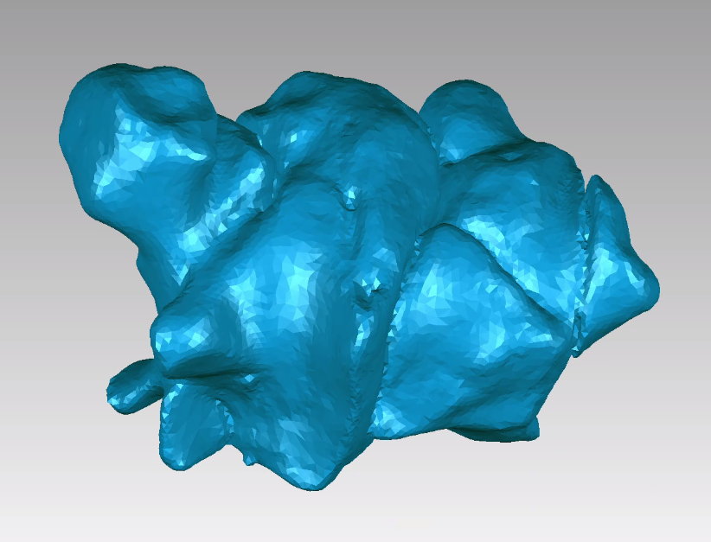

Figure 1.1 An anterior view of a sphenoidal sinus surface mesh model that is ready for SPHARM analysis.

different parts of a genus-zero 3D shape by instead parameterizing the entire triangular surface mesh onto a sphere. This process gives three (x, y, and z) angular parameters (θ, φ) that can be expressed in Fourier spherical harmonic (SPHARM) functions and independently decomposed per each spherical harmonic, forming a linear system that can be solved with least squares fitting. This produces vector values called SPHARM coefficients, which approximate the entire input 3D shape and can be used to represent that shape in quantitative analysis and calculate a 3D reconstruction of the original surface model.
To obtain spherical harmonic coefficients, the simplified surface mesh STL files for each sphenoidal sinus were transformed into a smoothed, resized, and aligned model then examined under spherical harmonic analysis (McPeek et al. 2008). As each STL surface file must be aligned in 3D space (Shen et al. 2009), four homologous midline orientation landmarks were
chosen (see Table 1.1 and Figure 1.2) on the sphenoid body to represent the spatial orientation of the sinus within. Given variation in sinus shape that precludes the placement of homologous landmarks on a sphenoidal sinus, it is more appropriate to use sphenoid bone to align the sinuses. After aligning the models using the orientation landmarks, we resized the surface models using centroid size and used the surface smoothing algorithm built into the SPHARM software (McPeek et al. 2008). Once the smoothed models were created, they were ready to undergo SPHARM analyses.
Spherical harmonic analysis may be performed using different degrees, where each degree corresponds with the application of higher order spherical harmonics. A higher degree of harmonics provides greater detail capture in a spherical harmonic representation of 3D shape—i.e., model reconstructions of the original input surface models that are calculated from the
Table 1.1: The 4 midline landmarks on the sphenoidal sinus body chosen to align the sphenoidal sinus models in 3D space. See Figure 2 for a visualization of their placement.

Landmark | Name | Description
1 | Posterior midcribriform | Posterior-most point of the cribriform plate in the midline. (Bastir et al. 2011)
2 | Tuberculum sellae | The midline point on the tuberculum sellae.
3 | Hormion | Most posterior midline point on the vomer underneath the basicranium. (White et al. 2012)
4 | Inferior sphenoid rostrum | The most inferior point on the anterior surface of the sphenoid rostrum.

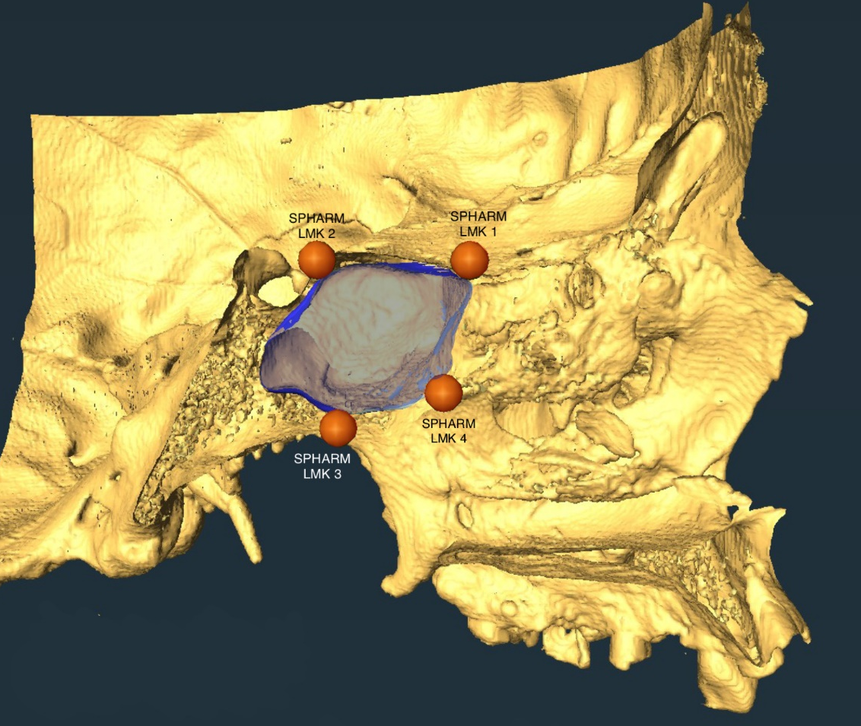

Figure 1.2 Four landmarks on the sphenoidal body in the midline used to align the sinuses within the same 3D space relative to the surrounding craniofacial skeleton. The sphenoidal sinus in this sagittal view is highlighted in blue.

SPHARM numerical output, spherical harmonic coefficients. These are complex numbers for each of the three spatial dimensions (X,Y,Z). With more degrees to better capture shape complexity in spherical harmonic model reconstruction, the number of coefficients also increases. We set the initial analysis for 18 degrees, which is the default set for SPHARM, though we also performed an analysis of 40 degrees—the more degrees included, the more coefficients produced and the more detailed the reconstruction of the original model (Shen et al. 2009)—to check for any differences in our findings (see Supporting Information). There were no differences between the two sets of analyses.
Following the spherical harmonic modeling of all 60 sphenoidal sinuses, we performed principal components analyses (PCA) on a covariance matrix of the coefficients using the same SPHARM program that performed the spherical harmonic analyses. As PCA reduces the dimensionality of data along the eigenvectors of the covariance matrix, it is the most ideal method for ascertaining where shape variance occurs within sphenoidal sinuses. We extracted the first five components and generated eigenmode 3D surface models for the first three components. These surface models represent the shape at +2 standard deviations (SD) for each component and allow visualization of maximum variation along each component. PC plots between PC1, PC2, and PC3 were rendered to visually show their relative variance in R Studio (R Core Team 2021). Eigenvalues and percent of variance are reported in Table 1.2.

RESULTS
The average model obtained from all the sphenoidal sinuses, calculated from the SPHARM data, is shown in Figure 1.3. The average sinus is elongated laterally, tapering

Figure 1.3 Model of average sinus shape, three views. Left is lateral-right view (top of model is superior), middle is an anterior view (top of model is superior), right is a superior view (top of model is anterior).

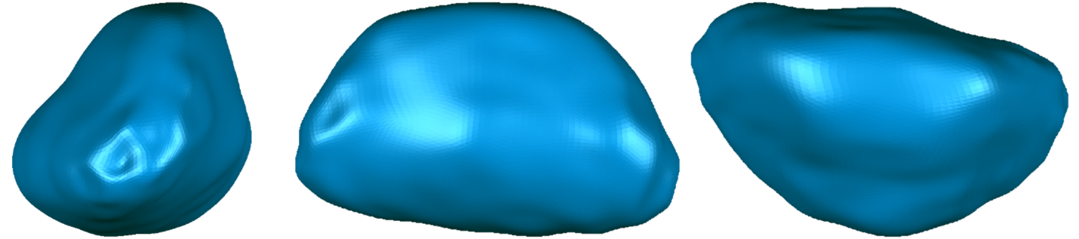
Table 1.2: PCA Output from SPHARM. Eigenvalues and percent of variance of the three components examined in this study are presented. The total variance was 0.0001269938.

Principal Component | Eigenvalue | Percent of Variance
PC1 | 0.0000386599 | 30.44%
PC2 | 0.0000322567 | 25.40%
PC3 | 0.0000088851 | 7.00%

inferolateral and anteriorly. We note that sinus shape broadly appears congruent with the general shape of the sphenoidal body.
The eigenvalues for the PCA and percent of variance explained are reported in Table 1.3. The first three components, which are visualized, represent roughly 70% of the overall variance (31.3%, 19.6%, and 17.3%, respectively). These eigenmode surface models are shown in Figures 1.4-1.6. Anterior, lateral, and superior views are shown for each of the first three PCs for the ±2 SDs on the PC plane, as well as the mean at position 0. Figures 1.4 represents the first component, Figure 1.5 shows the second component, and Figures 1.6 displays the third component. In Figure 1.7, the ±2 SDs are superimposed in these figures to aid in visualization of variance along each axis.
Along the first principal component (PC1) (Figure 1.4), the greatest variation is in the anteroposterior (A-P) plane. These models represent about one third of the total 3D shape variation of the sphenoidal sinus sample. PC1 thus indicates that sphenoidal sinus variance is
greatest between linearity in the M-L plane (SD 2) and greater globularity that occurs as the A-P plane expands (SD -2). The SD -2 eigenmode also shows septation is more visible with more A-P expansion. The SD 2 eigenmode shows that as sinuses widen along the M-L component, they are ellipsoid and have “pinched” lateral ends. In contrast, variance in shape along principal component two (PC2) (Figure 1.5) is primarily characterized by a linear elongation of the sinus (-2 SD) versus a more globular sinus (+2 SD). Along PC2, there is also evidence for asymmetry characterized by rotation of the sinus on a superior-inferior (S-I) axis from a superior view relative to a mean position of the elongated axis matching up with the M-L axis (SD 0). The -2 SD is rotated clockwise, whereas +2 is rotated counter-clockwise. For both, the volume is

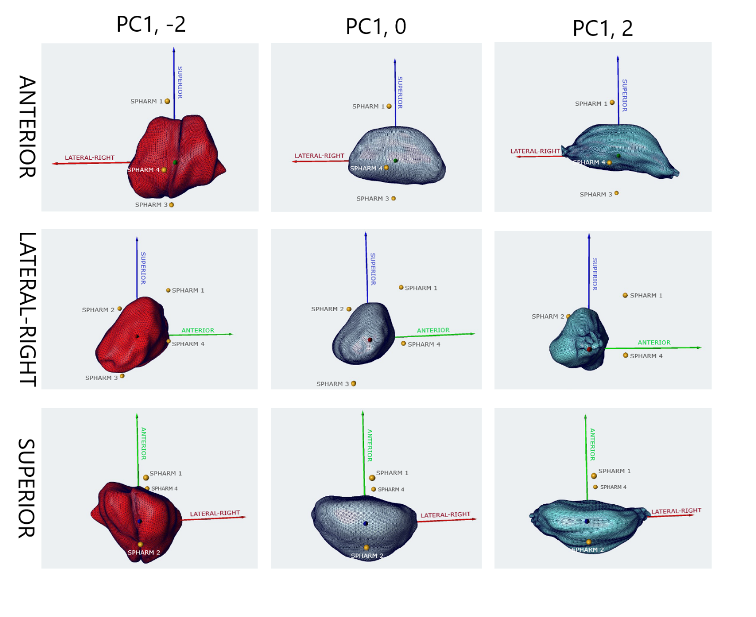
Figure 1.4 Eigenmode models for PC1. Each column represents a different SD on the PC1 axis (SD ±2 and the mean at 0), and each row represents a different view (anterior, lateral-right, and superior). Each image has both labeled arrows and the SPHARM 1-4 landmarks (see Table 1.1 and Figure 1.2) to help indicate the orientations of each model within anatomical space.

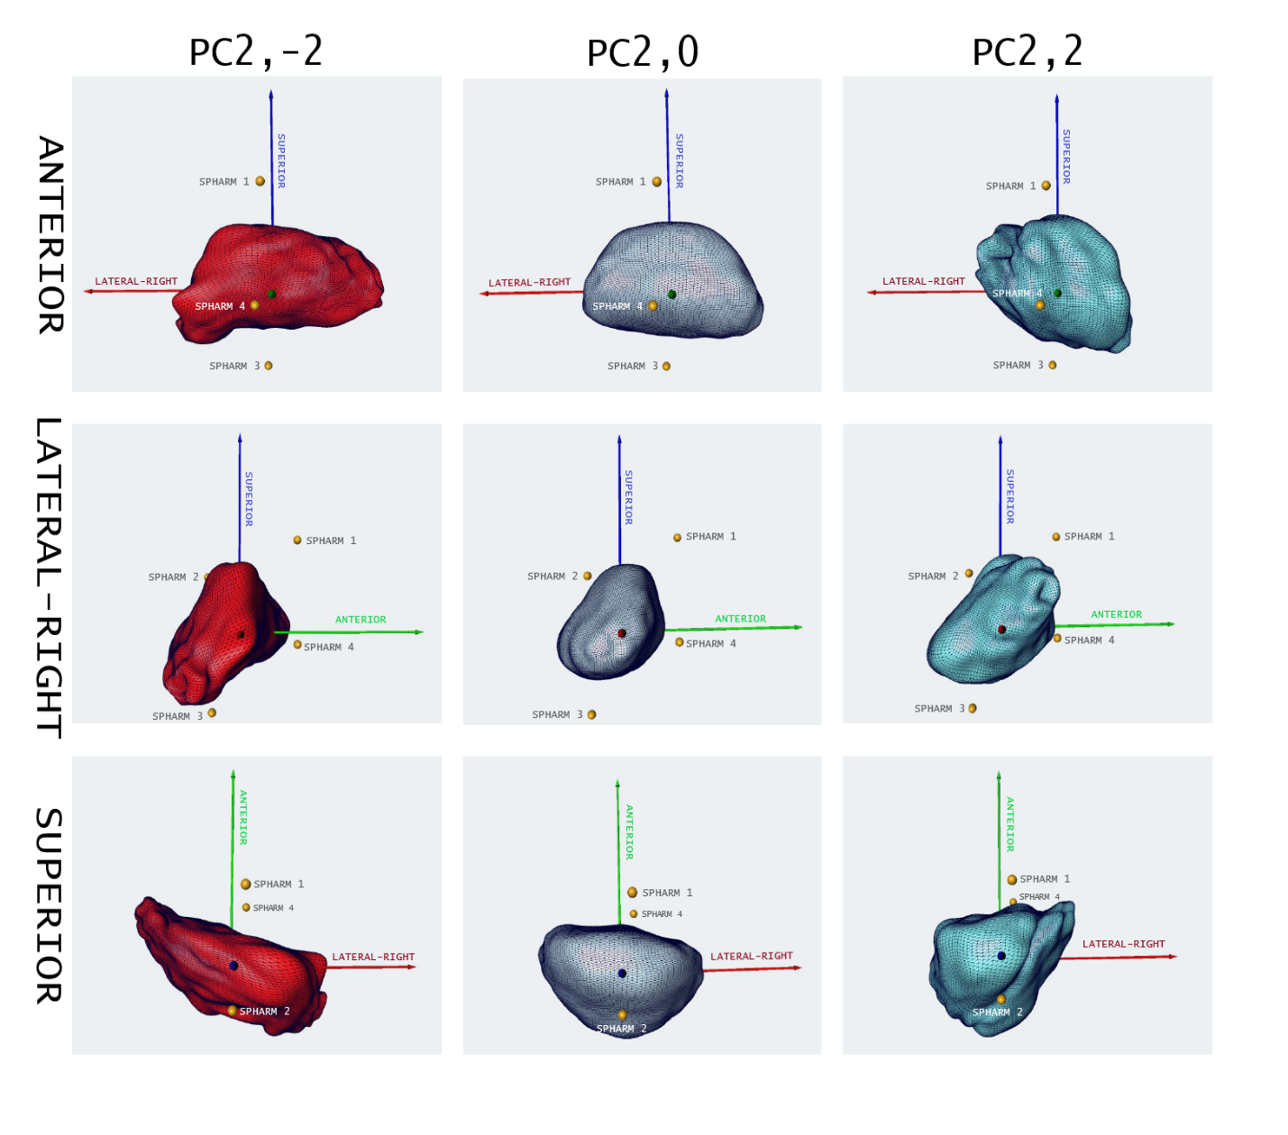
Figure 1.5 Eigenmode models for PC2. Each column represents a different SD on the PC1 axis (SD ±2 and the mean at 0), and each row represents a different view (anterior, lateral-right, and superior). Each image has both labeled arrows and the SPHARM 1-4 landmarks (see Table 1.1 and Figure 1.2) to help indicate the orientations of each model within anatomical space.

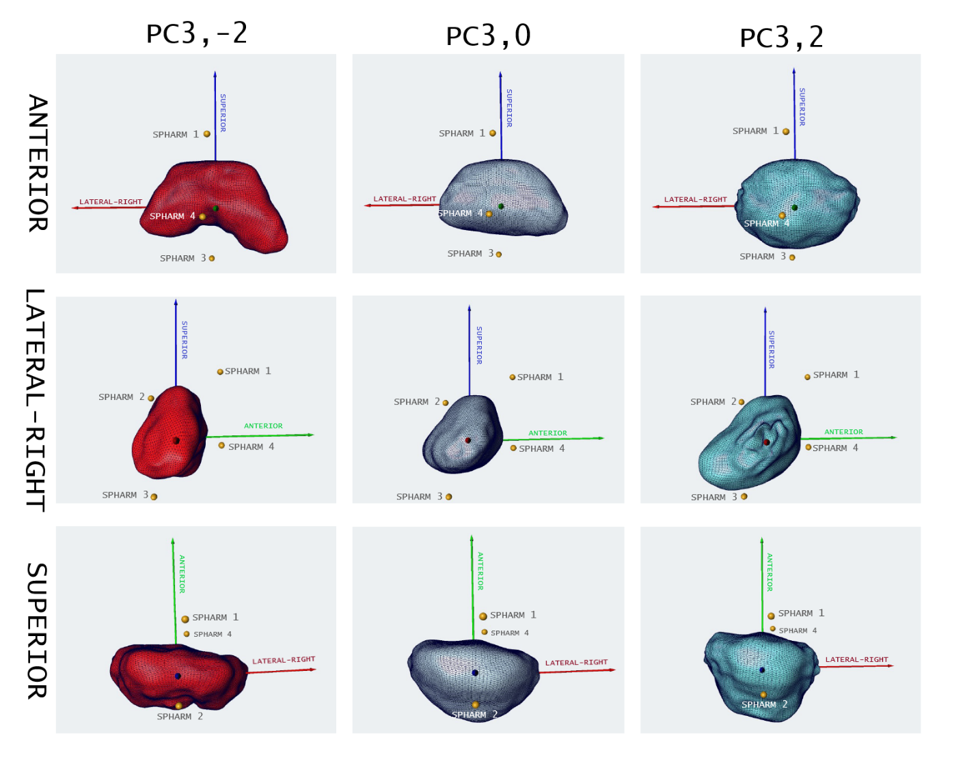

Figure 1.6 Eigenmode models for PC3. Each column represents a different SD on the PC1 axis (SD ±2 and the mean at 0), and each row represents a different view (anterior, lateral-right, and superior). Each image has both labeled arrows and the SPHARM 1-4 landmarks (see Table 1.1 and Figure 1.2) to help indicate the orientations of each model within anatomical space.

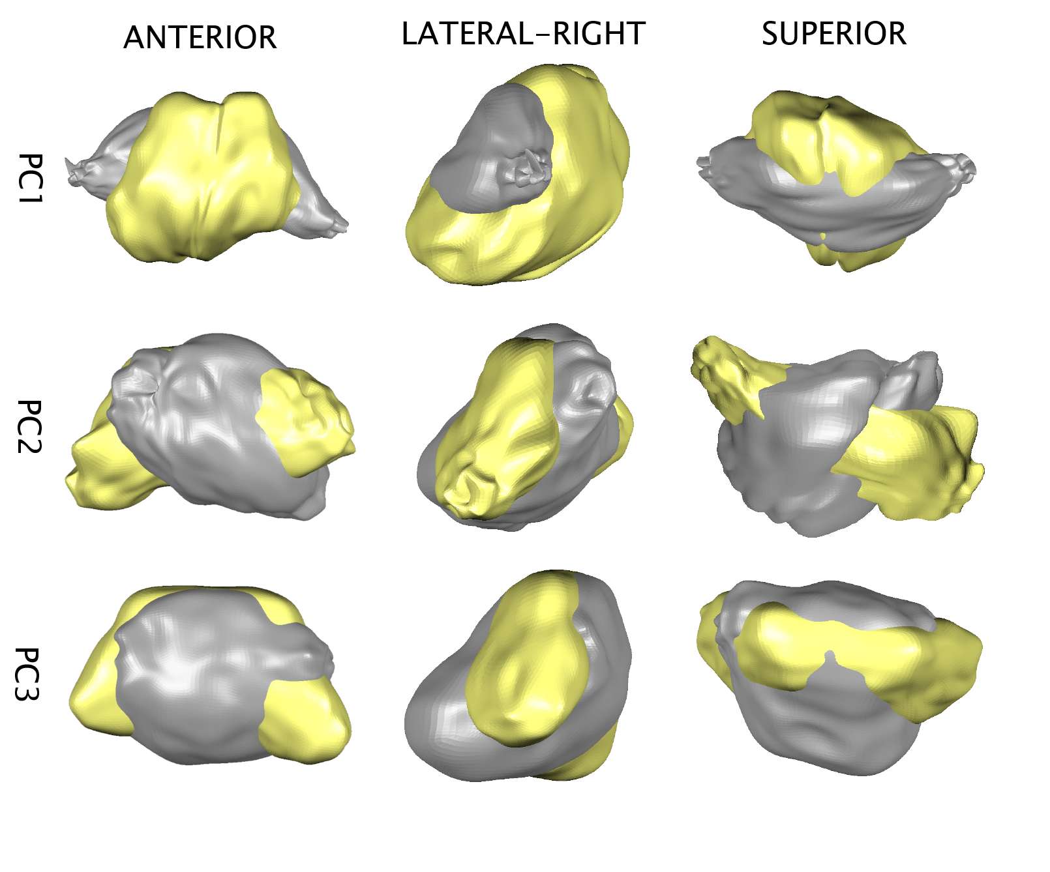
Figure 1.7 PC1-3 eigenvalue ±2 standard deviations overlapping for anterior, lateral-right, and superior views. For the anterior view (column 1), the top of the models is superior. For lateral-right view (column 2), the right side of the model is anterior. For the superior view (column 3), the top of the model is superior. Yellow is SD -2, gray is SD 2.

asymmetrically distributed, with the more posteriorly oriented ends holding more of the volume than the anteriorly oriented ends.
The third component (PC3) as shown in Figure 1.6 presents two distinct shapes: the +2 SD sinus is overall more globular with posterior expansion in the A-P plane, whereas -2 SD is shorter and more linear in that same plane. The -2 SD sinus axis incorporates concavity in the anterior and inferior facing surfaces, with the lateral, elongated axis of the sinus pointing almost completely inferiorly, giving it an overall “horseshoe” shape.
The PC plot between PC1 and PC2 (Figure 1.8) shows a likely correlation between the two shape changes. Meanwhile, plots between PC1 and PC3 (Figure 1.9) and PC2 and PC3 (Figure 1.10) show no apparent association.

DISCUSSION
As a first description of shape variation in the human sphenoidal sinus, our results show that the characterization of sphenoidal sinus shape variation is similar to the major shape changes observed from a PCA of the sphenoid body. This provides preliminary evidence supporting that the shape (or at least, the major dimensions) of the sphenoidal sinus mirrors that of its surrounding bone. The first three principal components all reflect elongation of the sinus and its reorientation with respect to the extent of pneumatization—that is, all demonstrated variation in A-P expansion that aligns with the direction of pneumatization from the anterior sphenoidal body wall back towards the clivus (Babyn et al. 1998), While this is not unexpected under a model of opportunistic pneumatization (Whitmer 1997, Márquez 2008), it nonetheless reinforces that variation in the shape of the sphenoidal paranasal sinus is perhaps controlled by signaling for
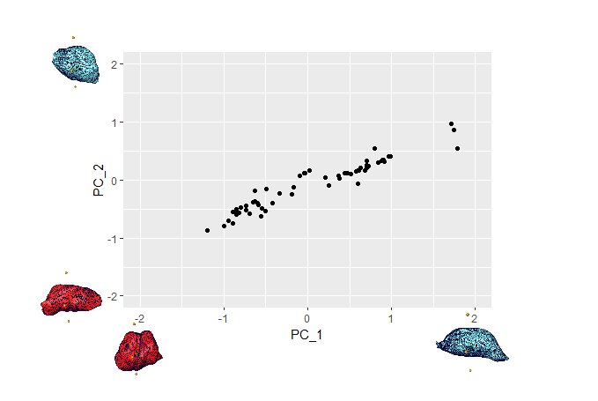
Figure 1.8 PC plot between PC1 (x) and PC2 (y) between -2 and 2 SD for both axes.

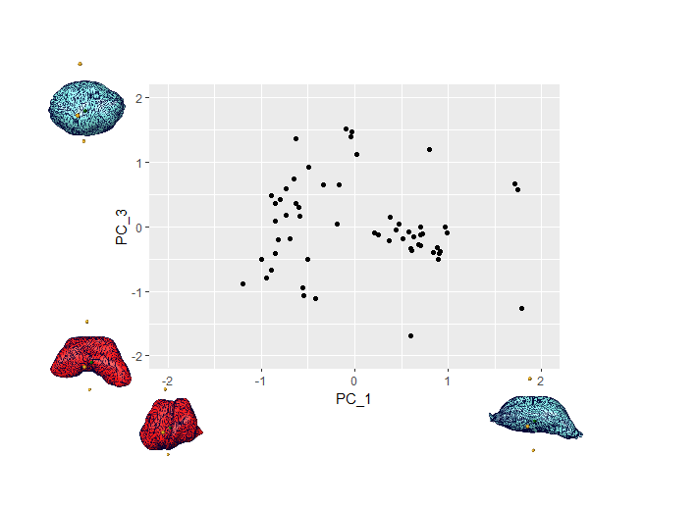
Figure 1.9 PC plot between PC1 (x) and PC3 (y) between -2 and 2 SD for both axes.

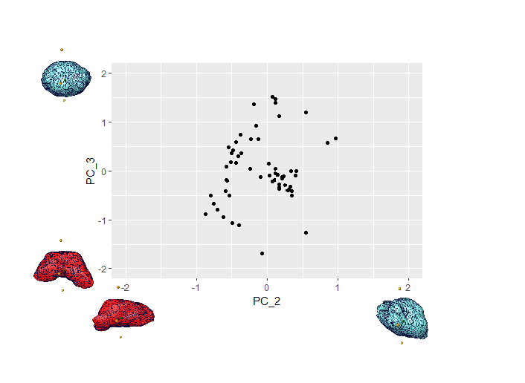
Figure 1.10 PC plot between PC2 (x) and PC3 (y) between -2 and 2 SD for both axes.

pneumatization that varies individually but nonetheless follows a broad pattern across human populations. We consider the variation in shape and its relationship with overall basicranial morphology in more detail below.

Sphenoidal Sinus Variation and its Potential Drivers
The variation in PC1 involves variation in the A-P axis in relative expansion. Sinuses that are more A-P truncated have greater M-L breadth (PC1, SD 2). This may potentially reflect pneumatization of the sphenoidal sinus into the greater wings (alisphenoid), as well as a potential correlate of continued anterior expansion (PC1, SD -2) of the anterior cranial fossa (ACF), both considered in more detail below. The linear clustering in the PC plot between PC1 and PC2 suggests an association between the two. With increased A-P pneumatization and septation (PC1, SD -2), the sphenoid sinuses appear to have a more linear shape (PC2, SD -2), while sinuses with less pneumatization and less-to-no septation (PC1, SD 2) tend to be more globular (PC2, SD 2).
Based on the variation of shape in PC1, we posit that much of the shape variation of the sphenoidal sinus reflects the amount of pneumatization from the ostia in the posterior nasal cavity towards the sella turcica and clivus (Scuderi et al. 1993, Anusha et al. 2014). We would therefore assume that sphenoidal sinus shape may correlate with sinus volume, or the shape variation may cluster between more partially and more fully pneumatized sinuses relative to the volume of bone of the sphenoidal body that can be pneumatized. Previous qualitative research has described two of the major “types” of sphenoidal sinus shape, presellar and sellar (Wang et al. 2010, Anusha et al. 2014, Štoković et al. 2016). The former is any sphenoidal sinus that remains anterior, not going beyond a vertical plane that passes through the tuberculum sellae (i.e. remains anterior to the sella turcica), and instead pneumatizes more laterally, though rarely into sphenoid structures adjacent to the body (Wang et al. 2009). The latter classification is a sphenoidal sinus that extends posteriorly past the vertical plane passing through tuberculum sellae and is both described and defined by its relationship in dimensions and shape with the sella turcica (Wang et al. 2010). PC1, as well as the association between PC1 and PC2, appear to reflect these descriptive categorizations of sphenoidal sinus pneumatization. As we scaled all the sphenoidal sinuses in our sample by centroid size, this shape variation does not directly reflect overall volume, though it may be influenced by it. Future research should investigate the relationship between sphenoidal sinus volume and shape and how it relates to the process of pneumatization.
As mentioned above, the major variation in A-P expansion shown in PC1 may also be explained by A-P expansion of the ACF that is contemporaneous to sphenoidal sinus development. After birth, the ACF primarily develops and expands anteriorly during the neural growth phase (esp. that of the frontal lobe), in a period of postnatal elongation, also contributing to anterior extension (i.e., prognathism) of the face (Enlow 1990). The spheno-ethmoid synchondrosis lies directly above sphenoidal sinus and separates the ACF from the other fossae on the sphenoid body. This cartilaginous joint remains active in elongation in the midline up until about ages 6-8, serving as a growth site where the ethmomaxillary complex moves away from the middle cranial fossa in anterior, lateral, and inferior directions (Lieberman et al. 2000a). Towards the end of this phase, the ACF has achieved 95% of its adult length (Lieberman et al. 1999), around the same time that the sphenoidal sinus in some individuals achieves its full adult size—though in other individuals, this pneumatization continues into the early to late teens (Towbin and Dunbar 1982, Charsoula et al. 2011, Anusha et al. 2014). Previous research found a small but significant association between variation in the shape of the ACF and variation of the sphenoidal sinus volume (Ryan et al. 2017). This A-P and M-L variation of the sphenoidal sinus may also reflect changes in dimensions of the sella turcica to accommodate variation of the pituitary gland and cavernous sinus (Anusha et al. 2014), and the presence/absence of different intercavernous sinuses (Deng et al. 2015), both of which would impact the amount of available bone to be pneumatized in the sphenoidal body. The relationship between the sphenoidal sinus and sella turcica shape and relative facial prognathism should be further investigated.
We also note that in examining PC1, greater globularity of sinus shape is also associated with septation. Sinuses with less A-P expansion do not share this midline delimitation. This is consistent with qualitative observations that larger and more posteriorly pneumatized sinuses have a more defined midline septum demarcating a “left” and “right” sinus, sometimes with additional accessory septa, while smaller and less developed sinuses tend to lack septal divisions (Singh et al. 2021). The more globular model also has a more defined anterior “wall” with greater extension in the S-I plane. This may reflect changes in the dimensions of the posterior nasopharyngeal complex that makes up the anterior wall of the sphenoid body (Anusha et al. 2014).
The PC2 eigenmode models show differences in how the sinus volume is bilaterally distributed between the left and right sphenoidal sinuses. Asymmetrical distribution of volume from the left versus right sphenoidal sinuses (which form two lobes of a continuous cavity) has been frequently observed (Lewin et al. 1999, Anusha et al. 2014). Larger sinuses also tend to have more posterior and inferior pneumatization into the clivus (Anusha et al. 2014), and, thus, differences in left versus right sinus volume would also be associated with differences in inferoposterior expansion. Given the amount of central neural anatomy that surrounds and shapes the sphenoidal bone (Lieberman 2011), including especially the temporal lobes, it is possible that a combination of spatial accommodation and cerebral hemispheric dominance may drive this high rate of asymmetry in the left and right sphenoidal sinuses, similar as observed in the frontal sinuses (Kanat et al. 2015). Temporal lobe shape, as represented by the middle cranial fossae in the endobasicranium, should be investigated in comparison to sphenoidal sinus shape variation.
Finally, we note in the Results that PC3 shows a unique “horseshoe” shaped model that differs from all the other eigenmode models that are either ellipsoid or globular. We posit that this divergence is not an indicator of pneumatization patterns within the primary sphenoid body, but in secondary structures around the body. The sphenoid sinus is known to pneumatize to different amounts into the greater wings, clinoid process, and pterygoid process (Anusha et al. 2014, Rahmati et al. 2016). Due to the inferior orientation of the two lateral ends of the model, it appears that PC3 is representing variation due to the extent of pneumatization into the pterygoid processes. Important anatomy associated with superior cranial nerves and ophthalmic vessels are located in in the lateral sellar space, and the pneumatization of the pterygoid process coincides with protrusions into the sinus space by the optic and pterygoid canals and foramen rotundum (Rahmati et al 2016). As we note about sinus volume and shape of the intracranial fossae above, such relationships between variation in sinus shape and the morphology of the lateral sellar space should be further investigated.

The Application and Limitations of Spherical Harmonics
In their general paper on spherical harmonics, Shen and colleagues (2009) concluded by noting that there are still advancements to be made with spherical harmonic-based 3D shape analyses. The method has been effectively applied in clinical and comparative anatomy research (e.g. Gerig et al. 2001, Styner et al. 2006, Chung et al. 2007, Cong et al. 2014), including on paranasal sinuses in canids (Carter and Van Valkenburgh 2014). In expanding the usage of spherical harmonics, our research tests the application of this method to addressing shapes of high variance, as the sphenoidal sinuses have been argued to be the most varied cavity in the human body (Štoković et al. 2016). In doing so, while our analysis provides novel information about the variation in the shape of the sphenoidal sinus, we found potential limits in applying SPHARM. Areas that have higher amounts of information (e.g., a spike or a protrusion) will inherently have lower resolution in harmonic deformations than surfaces that have more gradual shape transitions. Given the observed high variation of the sphenoidal sinuses, which often include small invaginations from the larger lobes (e.g. as seen in Figure 1.1), we posit this is the source of the bilateral pinched structures on several of the eigenmode surface models of PC1-3, which we believe to be artifacts from the registration process in SPHARM. It is extremely unlikely, especially based on qualitative observations of the sphenoidal sinus morphology and variation, that these pinched structures represent real morphology of the sinus (Wang et al. 2010, Anusha et al. 2014, Štoković et al. 2016). This may be supported by the immensely small eigenvalues from the PCA analysis. While eigenvalue magnitudes do not reflect the amount of variance, they can be an indicator of high correlation among data, which can be an artifact of surface alignment, or they can represent a high amount of “noise”—highly localized, non-smooth surface shape variation (Söhn et al. 2005, Wang and Bangham 2006).
It is unclear if our findings from this research are impacted by highly localized variation in individual sinuses and the apparent incomplete ability of SPHARM to represent it. This cannot be assessed at this time because this is the first ever 3D quantification of the sphenoidal sinuses—there are no comparable shape data. Future research should focus on replicating these analyses with larger samples and alternate geometric morphometric methods to compare their utility, and to garner additional detail and perspectives on the shape variation that different kinds of methods can provide. Alternate versions of SPHARM itself are hosted on different platforms and/or with different coding—e.g. SPHARM-MAT (another Matlab operated SPHARM toolbox) and SPHARM-PDM (now primarily operated as an extension in 3DSlicer)—should also be compared. In the long term, morphological researchers should aim to collaborate on developing an improved SPHARM or similar function that both preserves the local variation through parametrization and also adequately assesses and represents it.
We must also consider the potential impact of using landmarks on the sphenoidal body to orient the sphenoidal sinus shapes. Since the sinuses themselves lack consistent and reliable points of shape correspondence, the sphenoid body was instead used to roughly align them within anatomical space relative to the craniofacial skeleton, with additional alignment through the rotation of the coefficients themselves within SPHARM. While this is helpful when comparing the sinuses to other structures of the head (all aligned with the same set of landmarks), it may not represent the optimal correspondence for the sinuses themselves. Paniagua and colleagues (2012) developed a version of SPHARM-PDM that combines it with an entropy-based particle systems 3D shape analysis approach. This adapted method computes correspondence by treating surfaces as discrete, dynamic sets of particles (points) across multiple surface models, optimizing the landmark-based parameterization correspondence achieved in SPHARM. However, such methods divorce the shape variation of the sinuses from anatomical planes, and so impact the interpretation of sinus shape variation with respect to surrounding bony anatomy and other cranial spaces. For this reason, we opted to examine the variation in sphenoidal sinus shape with respect to surrounding cranial anatomy, though we recognize that such an approach does impose some limits on the description of sphenoidal sinus shape variation.

CONCLUSION
Overall, our analysis presents the first complete representation of human sphenoidal sinus morphological variation. As we demonstrate, much of the variation in sinus shape appears to be a product of different amounts of pneumatization, which affect the presence of septa, globularity of the sinus shape, asymmetry between sinus lobes, and extension beyond the sphenoid body. Our analysis also demonstrates the utility and some limitations to the use of spherical harmonics to quantify and represent genus-zero shapes of high variance. We conclude that shape variation of the sphenoidal sinus has similarities to the known shape variation of surrounding sphenoid body, as well as that of adjacent spaces (e.g., the sella turcica, middle cranial fossae, and the nasopharynx). This preliminarily supports an argument that the sphenoidal sinus shape is largely determined by surrounding bony anatomy.

WORKS CITED
Agosto E.R. & Auerbach B.M. (2021) Evolvability and constraint in the primate basicranium, shoulder, and hip and the importance of multi-trait evolution. Evolutionary Biology 48: 221-232.
Anusha, B., Baharudin, A., Philip, R., Harvinder, S., & Shaffie, B. M. (2014). Anatomical variations of the sphenoid sinus and its adjacent structures: A review of existing literature. Surgical and Radiologic Anatomy, 36(5), 419–427. https://doi.org/10.1007/s00276-013-1214-1
Blaney, S. P. A. (1990). Why paranasal sinuses? The Journal of Laryngology & Otology, 104(09), 690–693. https://doi.org/10.1017/S0022215100113635
Bookstein, F. L. (1991). Morphometric tools for landmark data: Geometry and biology. Cambridge University Press.
Buck, L. T., Stringer, C. B., MacLarnon, A. M., & Rae, T. C. (2019). Variation in Paranasal Pneumatisation between Mid-Late Pleistocene Hominins. Bulletins et Mémoires de La Société d’Anthropologie de Paris, 31(1–2), 14–33. https://doi.org/10.3166/bmsap-2019-0056
Butaric, L. N., & Maddux, S. D. (2016). Morphological Covariation between the Maxillary Sinus and Midfacial Skeleton among Sub-Saharan and Circumpolar Modern Humans: Maxillary Sinus Shape in Humans. American Journal of Physical Anthropology, 160(3), 483–497. https://doi.org/10.1002/ajpa.22986
Charsoula, A. & et al. (2011). Age-related CT appearance of sphenoid sinus in infants and children. http://posterng.netkey.at/esr/viewing/index.php?module=viewing_poster&pi=108125
Christensen, A. M. (2005). Assessing the variation in individual frontal sinus outlines. American Journal of Physical Anthropology, 127(3), 291–295. https://doi.org/10.1002/ajpa.20116
Chung, M., Dalton, K., Shen, L., Evans, A., & Davidson, R. (2007). Weighted Fourier Series Representation and Its Application to Quantifying the Amount of Gray Matter. Medical Imaging, IEEE Transactions On, 26, 566–581. https://doi.org/10.1109/TMI.2007.892519
Cong, S., Rizkalla, M., Du, E. Y., West, J., Risacher, S., Saykin, A., & Shen, L. (2014). Building a Surface Atlas of Hippocampal Subfields from MRI Scans using FreeSurfer, FIRST and SPHARM. The ... Midwest Symposium on Circuits and Systems Conference Proceedings : MWSCAS. Midwest Symposium on Circuits and Systems, 2014, 813–816. https://doi.org/10.1109/MWSCAS.2014.6908539
Cox, M., Malcolm, M., & Fairgrieve, S. I. (2009). A New Digital Method for the Objective Comparison of Frontal Sinuses for Identification*. Journal of Forensic Sciences, 54(4), 761–772. https://doi.org/10.1111/j.1556-4029.2009.01075.x
Curtis, A. A., & Valkenburgh, B. V. (2014). Beyond the Sniffer: Frontal Sinuses in Carnivora. The Anatomical Record, 297(11), 2047–2064. https://doi.org/10.1002/ar.23025
Deng, X., Chen, S., Bai, Y., Song, W., Chen, Y., Li, D., Han, H., & Liu, B. (2015). Vascular Complications of Intercavernous Sinuses during Transsphenoidal Surgery: An Anatomical Analysis Based on Autopsy and Magnetic Resonance Venography. PLOS ONE, 10(12), e0144771. https://doi.org/10.1371/journal.pone.0144771
Enlow, D. H. (1990). Facial growth. WB Saunders Company.
Evans, P. H. R. (1992). The paranasal sinuses and other enigmas: An aquatic evolutionary theory. The Journal of Laryngology & Otology, 106(3), 214–225.
Gannon, P. J., Doyle, W. J., Ganjian, E., Marquez, S., Gnoy, A., Gabrielle, H. S., & Lawson, W. (1997). Maxillary sinus mucosal blood flow during nasal vs tracheal respiration. Archives of Otolaryngology–Head & Neck Surgery, 123(12), 1336–1340.
Gerig, G., Styner, M., Jones, D., Weinberger, D., & Lieberman, J. (2001). Shape analysis of brain ventricles using SPHARM. Proceedings IEEE Workshop on Mathematical Methods in Biomedical Image Analysis (MMBIA 2001), 171–178. https://doi.org/10.1109/MMBIA.2001.991731
Gould, S. J., & Lewontin, R. C. (1979). The Spandrels of San Marco and the Panglossian Paradigm: A Critique of the Adaptationist Programme. Proceedings of the Royal Society of London. Series B, Biological Sciences, 205(1161), 581–598.
Güçlü O, Uludağ A, Akçali A, Tekin K, Erdoğan H, Silan F, Dereköy FS (2012) Does the maxillary sinus have a triggering role in nasal nitric oxide synthesis? Rhinology 50(4):402–407
Hallgrímsson B, Hall BK. 2005. Variation and variability: central concepts in biology. In (B Hallgrimsson and BK Hall, eds.): Variation: A Central Concept in Biology. New York: Elsevier. pp.1-8.
Hallgrímsson, B., Jamniczky, H., Young, N.M., Rolian, C., Parsons, E.T., Boughner, J.C., Marcucio, R.S., 2009. Deciphering the palimpsest: Studying the relationship between morphological integration and phenotypic covariation. Evol. Biol. 36, 355-376.
Hallgrímsson B, Jamniczky HA, Young NM, Rolian C, Schmidt-Ott U, Marcucio R. 2012. The Generation of Variation and the Developmental Basis for Evolutionary Novelty. J Exp Zoology Part B Mol Dev Evol 318:501–517.
Kanat, A., Yazar, U., Ozdemir, B., Coskun, Z., & Erdivanli, O. (2015). Frontal sinus asymmetry: Is it an effect of cranial asymmetry? X-ray analysis of 469 normal adult human frontal sinus. Journal of Neurosciences in Rural Practice, 6(4), 511. https://doi.org/10.4103/0976-3147.168436
Katz DC, Grote MN, Weaver TD. 2016. A mixed model for the relationship between climate and human cranial form. Am J Phys Anthropol 160(4):593-603.
Klingenberg CP. 2005. Developmental constraints, modules, and evolvability. In (B Hallgrimsson and BK Hall, eds.): Variation: A Central Concept in Biology. New York: Elsevier. pp. 219-248.
Koppe, T., Inoue, Y., Hiraki, Y., & NAGAI, H. (1996). The Pneumatization of the Facial Skeleton in the Japanese Macaque (Macaca fuscata). Anthropological Science, 104(1), 31–41.
Kuykendall, K. L., & Rae, T. C. (2008). Presence of the Maxillary Sinus in Fossil Colobinae ( Cercopithecoides williamsi ) from South Africa. The Anatomical Record: Advances in Integrative Anatomy and Evolutionary Biology, 291(11), 1499–1505. https://doi.org/10.1002/ar.20780
Lewin, J. S., Curtin, H. D., Eelkema, E., & Obuchowski, N. (1999). Benign expansile lesions of the sphenoid sinus: Differentiation from normal asymmetry of the lateral recesses. American Journal of Neuroradiology, 20(3), 461–466.
Lieberman, D. (2011). The Evolution of the Human Head. Harvard University Press.
Lieberman, D. E., & McCarthy, R. C. (1999). The ontogeny of cranial base angulation in humans and chimpanzees and its implications for reconstructing pharyngeal dimensions. Journal of Human Evolution, 36(5), 487–517.
Lieberman, D. E., Pearson, O. M., & Mowbray, K. M. (2000). Basicranial influence on overall cranial shape. Journal of Human Evolution, 38(2), 291–315. https://doi.org/10.1006/jhev.1999.0335
Lieberman, D. E., Ross, C. F., & Ravosa, M. J. (2000). The primate cranial base: Ontogeny, function, and integration. American Journal of Physical Anthropology, 113(S31), 117–169.
Márquez, S. (2008). The Paranasal Sinuses: The Last Frontier in Craniofacial Biology. The Anatomical Record: Advances in Integrative Anatomy and Evolutionary Biology, 291(11), 1350–1361. https://doi.org/10.1002/ar.20791
McPeek, M. A., Shen, L., Torrey, J. Z., & Farid, H. (2008). The Tempo and Mode of Three‐Dimensional Morphological Evolution in Male Reproductive Structures. The American Naturalist, 171(5), E158–E178. https://doi.org/10.1086/587076
Nambiar, P., Naidu, M. D. K., & Subramaniam, K. (1999). Anatomical variability of the frontal sinuses and their application in forensic identification. Clinical Anatomy, 12(1), 16–19. https://doi.org/10.1002/(SICI)1098-2353(1999)12:1<16::AID-CA3>3.0.CO;2-D
Paniagua, B., Bompard, L., Cates, J., Whitaker, R., Datar, M., Vachet, C., & Styner, M. (2012). Combined SPHARM-PDM and entropy-based particle systems shape analysis framework. 8317, 83170L. https://doi.org/10.1117/12.911228
Pondé, J. M., Nonato Andrade, R., Maldonado Via, J., Metzger, P., & Teles, A. C. (2008). Anatomical Variations of the Frontal Sinus. International Journal of Morphology, 26(4). https://doi.org/10.4067/S0717-95022008000400003
Rae, T. C., & Koppe, T. (2004). Holes in the head: Evolutionary interpretations of the paranasal sinuses in catarrhines. Evolutionary Anthropology: Issues, News, and Reviews, 13(6), 211–223. https://doi.org/10.1002/evan.20036
Rahmati, A., Ghafari, R., & AnjomShoa, M. (2016). Normal Variations of Sphenoid Sinus and the Adjacent Structures Detected in Cone Beam Computed Tomography. Journal of Dentistry, 17(1), 32–37.
Rennie, C., Haffajee, M. R., & Satyapal, K. S. (2017). The Morphology of the Sphenoid Air Sinus from Childhood to Early Adulthood (1 to 25 years) Utilizing 3D Reconstructed Images. International Journal of Morphology, 35(4), 1261–1269. https://doi.org/10.4067/S0717-95022017000401261
Ryan, K. G. J., Auerbach, B., & Butaric, L. (2019). Modularity and Integration of the Sphenoid Body in Human Cranial Variation: The Confluence of Functional Matrices. The FASEB Journal, 33(S1), 612.20-612.20. https://doi.org/10.1096/fasebj.2019.33.1_supplement.612.20
Ryan, K. G., Stock, J. T., & Buck, L. T. (2018). Sphenoidal Sinuses and Spatial Compromise in Basicranial Modular Development and Evolution. AMERICAN JOURNAL OF PHYSICAL ANTHROPOLOGY, 165, 235–235.
Savell KRR, Katz DC, Weaver TD, Auerbach BM. In press. Mixed models for the relationship between latitude, temperature & human postcranial form. Am J Biol Anthropol.
Scuderi, A. J., Harnsberger, H. R., & Boyer, R. S. (1993). Pneumatization of the paranasal sinuses: Normal features of importance to the accurate interpretation of CT scans and MR images. AJR. American Journal of Roentgenology, 160(5), 1101–1104.
Shen, L., Cong, S., & Inlow, M. (2017). Chapter 13—Statistical Shape Analysis for Brain Structures. In G. Zheng, S. Li, & G. Székely (Eds.), Statistical Shape and Deformation Analysis (pp. 351–378). Academic Press. https://doi.org/10.1016/B978-0-12-810493-4.00016-X
Shen, L., Farid, H., & McPeek, M. A. (2009). Modeling Three-Dimensional Morphological Structures Using Spherical Harmonics. Evolution, 63(4), 1003–1016. https://doi.org/10.1111/j.1558-5646.2008.00557.x
Shen, L., Kim, S., & Saykin, A. J. (2009). Fourier method for large-scale surface modeling and registration. Computers & Graphics, 33(3), 299–311. https://doi.org/10.1016/j.cag.2009.03.002
Shirley, N. R., & Jantz, R. L. (2011). Spheno-occipital synchondrosis fusion in modern Americans. Journal of Forensic Sciences, 56(3), 580–585. https://doi.org/10.1111/j.1556-4029.2011.01705.x
Singh, P., Hung, K., Ajmera, D. H., Yeung, A. W. K., von Arx, T., & Bornstein, M. M. (2021). Morphometric characteristics of the sphenoid sinus and potential influencing factors: A retrospective assessment using cone beam computed tomography (CBCT). Anatomical Science International, 96(4), 544–555. https://doi.org/10.1007/s12565-021-00622-x
Smith, T. D., Rossie, J. B., Cooper, G. M., Carmody, K. A., Schmieg, R. M., Bonar, C. J., Mooney, M. P., & Siegel, M. I. (2010). The Maxillary Sinus in Three Genera of New World Monkeys: Factors That Constrain Secondary Pneumatization. The Anatomical Record: Advances in Integrative Anatomy and Evolutionary Biology, 293(1), 91–107. https://doi.org/10.1002/ar.21017
Söhn, M., Birkner, M., Yan, D., & Alber, M. (2005). Modelling individual geometric variation based on dominant eigenmodes of organ deformation: Implementation and evaluation. Physics in Medicine and Biology, 50(24), 5893–5908. https://doi.org/10.1088/0031-9155/50/24/009
Štoković, N., Trkulja, V., Dumić-Čule, I., Čuković-Bagić, I., Lauc, T., Vukičević, S., & Grgurević, L. (2016). Sphenoid sinus types, dimensions and relationship with surrounding structures. Annals of Anatomy - Anatomischer Anzeiger, 203, 69–76. https://doi.org/10.1016/j.aanat.2015.02.013
Styner, M., Oguz, I., Xu, S., Brechbühler, C., Pantazis, D., Levitt, J. J., Shenton, M. E., & Gerig, G. (2006). Framework for the Statistical Shape Analysis of Brain Structures using SPHARM-PDM. The Insight Journal, 1071, 242–250.
Towbin, R., & Dunbar, J. S. (1982). The paranasal sinuses in childhood. Radiographics, 2(2), 253–279.
Uyeda JC, Harmon LJ. 2014. A Novel Bayesian Method for Inferring and Interpreting the Dynamics of Adaptive Landscapes from Phylogenetic Comparative Data. Syst Biol 63:902-918.
Wagner, G. P. (1984). On the eigenvalue distribution of genetic and phenotypic dispersion matrices: Evidence for a nonrandom organization of quantitative character variation. Journal of Mathematical Biology, 21(1), 77–95.
Wang, B., & Bangham, J. (2006). PCA Based Shape Descriptors for Shape Retrieval and The Evaluations. 2006 International Conference on Computational Intelligence and Security, 1401–1406. https://doi.org/10.1109/ICCIAS.2006.295291
Wang, J., Bidari, S., Inoue, K., Yang, H., & Rhoton, A. (2010). Extensions of the Sphenoid Sinus. Neurosurgery, 66(4), 797–816. https://doi.org/10.1227/01.NEU.0000367619.24800.B1
Welker, K. M., DeLone, D. R., Lane, J. I., & Gilbertson, J. R. (2008). Arrested Pneumatization of the Skull Base: Imaging Characteristics. American Journal of Roentgenology, 190(6), 1691–1696. https://doi.org/10.2214/AJR.07.3131
WITMER, L. (1999). The phylogenetic history of paranasal air sinuses. The Paranasal Sinuses of Higher Primates : Development, Function, and Evolution. https://ci.nii.ac.jp/naid/10017633301/
Witmer, L. M. (1997). The Evolution of the Antorbital Cavity of Archosaurs: A Study in Soft-Tissue Reconstruction in the Fossil Record with an Analysis of the Function of Pneumaticity. Memoir. Society of Vertebrate Paleontology, 3, 1. https://doi.org/10.2307/3889342
Zollikofer, C. P. E., & Weissmann, J. D. (2008). A Morphogenetic Model of Cranial Pneumatization Based on the Invasive Tissue Hypothesis. The Anatomical Record: Advances in Integrative Anatomy and Evolutionary Biology, 291(11), 1446–1454. https://doi.org/10.1002/ar.20784

CHAPTER II
Covariance of Sphenoidal Sinus Morphology with Endocranial Anatomy

A version of this chapter will be submitted for review and publication in the American Journal for Biological Anthropology (AJBA) by authors Katharine G.J. Ryan, Adam D. Sylvester, Lauren N. Butaric, and Benjamin M. Auerbach. All data collection, analyses, and writing of the article completed by the primary author (K. Ryan). Co-authors contributed general advisement on background and methods, and provided feedback and edits of the article.

ABSTRACT
In this study we examine the covariance of sphenoidal sinus shape with adjacent cranial anatomy using three-dimensional shape data. The sinus develops within the sphenoid body, located at the developmental center of the basicranium in humans and adjacent to the cranial elements that form cranial base angulation. The sphenoid body itself is surrounded by the cavernous sinus (and several other vital nerves and blood vessels), endocrine and brain anatomy, and the posterior upper airway. We hypothesize the shape of the sphenoid and sphenoidal sinus should covary if the sinus opportunistically pneumatizes the bone, and that sphenoidal morphology mutually influences and is influenced by adjacent bones and spaces. CT scans of 60 adult human crania were virtually segmented and five cranial regions were landmarked, in addition to quantifying a surface model of sphenoidal sinuses using spherical harmonic coefficients. Results of two-block partial least squares analysis indicates the shape of the sphenoidal sinus is independent of all these structures, including the body, except for the middle cranial fossa. Sphenoid body shape significantly covaries with the middle cranial fossa and nasopharynx. These results collectively suggest that the sphenoidal sinus does not opportunistically pneumatize the sphenoid body in all cases and exhibits independent variation in shape. They also support prior research that has shown high morphological variation in the shape of the sphenoidal sinus. We conclude the sphenoidal sinus may form through processes that are different from other paranasal sinuses (namely the maxillary sinus).

INTRODUCTION
While researchers continue to debate the functional roles and evolutionary origins of paranasal sinuses (Blaney 1990, Rae and Koppe 2004, Márquez 2008, Smith et al. 2010), there is broad agreement that sinuses pneumatize within developmentally and evolutionarily critical locations within the cranium (Towbin and Dunbar 1982, Witmer 1999, Rae and Koppe 2004, Smith et al. 2010). The sphenoid bone, which is pneumatized by the sphenoidal sinus, is located at the developmental epicenter of the basicranium, connecting it with the neurocranium and facial skeleton, and lies adjacent to the three cartilaginous joints of cranial bones where primary cranial base angulation occurs (Bruner and Ripani 2008, Lieberman 2011). Vitally important anatomy also surrounds and likely shapes the sphenoid body, including the temporal lobes of the brain, the pituitary gland, siphons of the internal carotid arteries, cavernous dural venous sinuses (and adjacent cranial nerves), and the epithelial mucosa of the respiratory tract (Singh et al. 2021).
Both during individual development and through responses to evolutionary processes, skeletal elements within the cranium do not form, function, or change independently, but as part of a complex morphological system (Cheverud 1982, Bastir and Rosas 2005, Hallgrímsson et al. 2009, Lieberman 2011, Klingenberg 2014, Melo et al. 2016), much as many elements of the skeleton share evolutionary and developmental relationships (Rolian 2014, Agosto and Auerbach 2021, Unger et al. 2021, Agosto and Auerbach, in press, Young et al., in press). This is equally the case for spaces created by and inside these skeletal elements. Paranasal sinuses inherently are limited by the skeletal elements they pneumatize (Whitmer 1997, Zollikofer and Weissmann 2008); their variation is likely therefore a reflection of the amount of bone that is remodeled through pneumatization, as individuals vary in the volume and shape of paranasal sinuses, and the general variation and covariation of cranial elements.
In this study, we investigate potential contributors of variation by examining the covariance of the sphenoidal paranasal sinus with adjacent cranial bone and spaces. As we demonstrated in a previous study (Ryan et al., Chapter II), variation in sphenoidal sinus shape appears to share similarities with the variation of the sphenoid body, suggesting a potential covariant relationship. We hypothesize that the shape of the sphenoidal sinus, after accounting for size, will therefore covary with aspects of the sphenoidal body, as well as adjacent cranial spaces, namely the sella turcica, anterior and middle crania fossae, and nasopharynx. The sphenoidal body has previously been demonstrated to covary with these aspects of cranial shape in primates and other mammals (Jamniczky and Hallgrimsson 2009, Barbieto-Andrés et al. 2015, Kolatorowicz 2015, Wheat 2015), and previous research on the maxillary sinus has shown significant shape covariation with not only the surrounding bone but also the midfacial skeletal elements that covary with the maxilla (Butaric and Maddux 2016). Should the sphenoidal sinus reflect the same level of anatomical interaction as other sinuses, we should expect that high covariance of the shape of the sphenoidal sinus with the sphenoidal body should also lead to high covariance with surrounding morphology. It is hypothesized that low covariation of the sinus with these aspects of cranial morphology would indicate much of the variation in sphenoidal sinus shape is a product of degree of pneumatization.

Paranasal sinus variance and covariance with cranial bone
Most studies of paranasal sinuses consider those located within the facial skeleton (namely the maxillary and frontal sinuses) and have shown significant morphological relationships between the sinuses and their adjacent skeletal elements (e.g., Butaric 2015). Butaric and Maddux (2016) examined how the maxillary sinuses are distributed in the overall midface, testing midfacial and maxillary sinus morphology for covariation. Their results showed morphological covariation among these traits and little independence, and suggests that the formation of the maxillary sinus highly interacts with the growth and developmental patterns of surrounding skeletal units. This supports research that suggested the final forms of the sinuses are more akin to Gouldean spandrels (Gould and Lewontin 1979); that is, the shapes of the paranasal sinuses may be a product of responses to evolution in surrounding skeletal elements, though evolutionary modeling (e.g., following Hansen and Houle 2008) would be necessary to ascertain this.
It is widely hypothesized that the paranasal sinuses opportunistically pneumatize (Witmer 1997, Zollikofer et al. 2008, Smith et al. 2010), where sinuses form through osteoclastic activity that removes all available trabecular bone and yellow bone marrow within cranial bones (Harouna et al. 2021). Thus, the shapes of the paranasal sinuses would be limited by the shape of the surrounding bone. The shape of that bone itself is determined by other skeletal elements (both adjacent and nonadjacent), the functional demands placed on the skeleton, and interfacing soft tissues (Moss and Young 1960, Moss and Salentijin 1969, Cheverud 1982, Cheverud 1995, Moss 1997, Profico et al. 2017, Agosto and Auerbach, in press).
Based on this hypothesis, assuming the sphenoidal sinus pneumatizes all available bone in the body of the sphenoid, we would expect that the shape of the sphenoidal sinus would strongly covary with the shape of the structures that are developmentally integrated with the sphenoid body. Previous research has found a relationship between the primary flexion of the cranial base as measured through the cranial base angle (CBA) in adult human samples and the size of the sphenoidal sinus, denoting a relationship between one of the most important evolutionarily derived features of our species and the paranasal sinuses (Koppe et al. 1999, Ryan et al. 2018). Also, as we note above, in addition to the CBA (representing overall brain expansion and development), there are other key structures that surround the sphenoidal body. The middle cranial fossa (MCF) is superior and directly lateral to the sphenoidal body (Anusha et al. 2014). The roof of the sphenoid sinus/body for post-sellar paranasal sinuses is formed by the sella turcica, which holds the pituitary gland and intercavernous sinuses sitting just below the internal carotid arteries and optic chiasm (Deng et al. 2015, Singh et al 2021). The cavernous sinuses and temporal lobes sit on the lateral walls of the body. The anterior/inferior wall of the sphenoid body forms the roof of the nasopharynx and is lined both externally and internally (when a sinus is present) with epithelial mucosa (Anusha et al. 2014). By quantifying and describing these relationships, whether they may be closely covariant or relatively independent, we may gain important insight to build robust hypotheses on the active or passive interactions the sphenoidal sinuses may have in overall craniofacial development and evolution. We also gather further evidence on how each set of paranasal sinuses may have unique developmental determinates that may explain their differential phylogenesis among primates (Koppe et al.1996, Rae and Koppe 2004, Kuykendall and Rae 2008, Márquez 2008).

Sphenoidal sinus shape variation and hypotheses for this study
Despite the general, qualitative understanding of its shape variation and development, we know astonishingly little about the sphenoidal sinus, including how it is potentially integrated among the important anatomy it interacts with during development. Quantification of the variation of the sphenoidal sinus is essential toward understanding the developmental and evolutionary processes that produce said variation. Our previous paper (Ryan et al., Chapter II) explored the variation of the shape of the sphenoidal sinus on its own, using a principal component analysis (PCA) performed on weighted spherical harmonic coefficients. These coefficients quantify the shape deformations of sinus morphology on a spheroid (Shen et al. 2009), and thus may be used to describe variation in shape when run through a PCA. The findings from that paper will help us further specify the hypotheses about how we expect adjacent cranial features to covary with the sphenoidal sinus.
The first principal component showed that the sinuses vary primarily in the anterior-posterior (A-P) direction. This may reflect shape changes of the overlying sphenoid body in response to changes in the transverse dimensions of the sella turcica due to differences in its contents (Deng et al. 2014), or M-L expansion of Homo sapiens’ relatively enlarged and anteriorly extended temporal lobes (Bastir et al. 2008). We thus predict that both the shapes of the temporal fossa (representing the lateral sellar compartment and temporal lobe) and the sella turcica (pituitary gland and intercavernous sinuses) will significantly covary with that of the sphenoidal sinus, based on the opportunistic pneumatization hypothesis (Witmer 1997, Zollikofer et al. 2008, Smith et al. 2010) and the findings of previous research with the maxillary sinuses (Butaric and Maddux 2016, Buck et al. 2019) In addition, the anterior-inferior expansion may signal an influence of the nasopharyngeal space on the sphenoidal body, and so we will investigate this space anterior to the sphenoid as well.
The second principal component is primarily characterized by rotation on the S-I axis from a neutral M-L orientation with globularity of the sinus asymmetrically distributed, with the ends more posteriorly oriented holding more of the volume than the anteriorly oriented ends. We posit this is likely a signal of high asymmetry in both shape and size between the left and right sphenoidal sinuses, which has already been noted in previous research (Anusha et al. 2014, Rennie et al. 2017). Larger sphenoidal sinuses tend to have post-sellar shapes that extend more posteriorly towards the clivus (Wang et al. 2010, Anusha et al. 2014, Štoković et al. 2016), which may explain the rotation and posterior distribution of volume seen in the models. Asymmetry seems to be a major source of variation in the sphenoidal sinuses, although is outside the scope of this paper. Future research should consider the relationship between the amount of asymmetry and other anatomical and physiological factors that may have cause one sinus to have stopped pneumatization sooner than the other and/or allometrically develop. In addition, the second principal component also showed rotation on a M-L axis. This may indicate that the shape of the sinus is associated with changes in the sphenoidal cranial base angle. This is consistent with previous findings (Ryan et al. 2018) that the sphenoidal sinus volume has a strong correlation with CBA, thus denoting a relationship between the paranasal sinuses and neuroanatomy. For this reason, we will also examine the covariance of the sphenoidal sinus with CBA
Finally, we posit that the third principal component of our prior study reflects variation due to the pneumatization of secondary structures around the sphenoid body. The sphenoid sinus is known to pneumatize to variable extents beyond the sphenoid body itself, including into the greater wings, clinoid process, and pterygoid process (Anusha et al. 2014, Rahmati et al. 2016). Due to the inferior orientation of the two lateral ends of the model, it appears that this component represents variation due to the extent of pneumatization into the pterygoid processes. We thus explore this relationship in this study.
Given their separate developmental origins (White et al. 2012), we will assess the amount of covariation between the orbit and the sphenoidal body and sinus, with the expectation that they will not have significant covariation. This will serve as a kind of outgroup comparison, showing that only features we expect to have strong developmental covariance will have a strong covariation, though this is not always the case given the palimpsest model (see Hallgrimsson et al. 2009). The only structure that we may expect the orbit to covary with would be the posterior nasal cavity, given that the floor of the former serves as the roof of the latter, and their shared developmental origin of the midfacial skeleton (Enlow 1990). We also do not anticipate the temporal fossa covarying with either facial cavity, again given their relatively separate developmental origins (Lieberman 2011).

MATERIALS
We used CT and Micro-CT scans taken from 60 adult humans recovered from archaeological contexts in Peru (housed at the Harvard Peabody Museum), Nepal (housed at the Natural History Museum in London), Austria (curated by NESPOS), and other European countries (also curated by NESPOS). Details about the scans, including their resolution, may be found in Ryan et al. (Chapter II). We examined spheno-occipital synchondrosis fusion to determine if individuals are adults following Shirley and Jantz (2011). Individuals with highly arrested or truncated sphenoidal sinus pneumatization were excluded from this study. These scans were provided by Dr. Lauren Butaric with permission of curating institutions. All individuals were pooled regardless of estimated sex or population, as prior research has shown no clustering in sinus size by sex (Rennie et al. 2017, Ryan et al. 2018), and we are interested in encapsuling broad human variation regardless of population history or geographic differences.

METHODS

Segmentation and spherical harmonic analysis
One of us (KR) segmented all crania and sinus endocasts virtually using Avizo Lite (Thermo Fisher Scientific, 2019). Segmentation of cranial bone was accomplished through the use of density thresholding and visual inspection of individual DICOM slices to ensure any soft tissue or scan artifacts were excluded. These segmented cranial models were then used to place landmarks for morphometric analysis (see “Landmarking” below). To create endocast surface models of the sphenoidal sinus, the area of the sinus was manually selected on every sagittally-oriented slide between the lateral-most extensions of the sinus, which were then combined into a single 3D object and exported as a surface mesh. Mesh files of the endocasts were simplified and standardized to 30,000 isometric surface triangles in the program Geomagic Wrap (3D Systems Corporation, 2021) after holes and defects in the surfaces were removed. Standardization of the surface triangles allowed shape to be maintained while decreasing the computational burden of performing the weighted spherical harmonic analysis in Matlab (The Math Works, Inc., 2020).
Sphenoidal sinuses are irregularly shaped such that standard homologous landmarks cannot be placed on their surfaces. As explained in more detail in Ryan et al. (Chapter II), we used weighted spherical harmonic analysis to quantify the shape of the sphenoidal sinus models. We used SPHARM (v. 1.4) in Matlab (McPeek et al. 2008) to extract the spherical harmonic coefficients that describe the shape of the sinuses, which were placed into standardized orientation using four midline landmarks (Figure 2.1 and SPHENOID 1-4 in Table 2.1) on the sphenoid body to represent the spatial orientation of the sinus within. Spherical harmonic coefficients are complex numbers for each of the three spatial dimensions (X,Y,Z), and represent the shape deformations of a unit sphere in order to recreate the original input shape (Shen et al. 2009). As we explain in Ryan et al. (Chapter II), we chose 18 degrees of harmonics to describe the shape of the sphenoidal sinuses, as these provided nearly identical results as a greater number of harmonic degrees. This process was performed for each sphenoidal sinus endocast model.

Landmarking of cranial bone
KR placed seven sets of landmarks on each three-dimensional model made from our sample of 60 crania. All landmarking was performed in Avizo Lite; landmarks were placed and the

Figure 2.1 Four landmarks on the sphenoidal body in the midline used to align the sinuses within the same 3D space relative to the surrounding craniofacial skeleton. The sphenoidal sinus in this sagittal view is highlighted in blue.

Table 2.1: Landmarks used in this study by region of the cranium under analysis. Note that landmark numbers correspond with those depicted in Figures 2.1-2.5.
Region | Landmark Number | Landmark Name | Description | Source
Sphenoid body | SPHARM 1 | Posterior midcribriform | Posterior-most point of the cribriform plate in the midline | Bastir et al. 2011b
Sphenoid body | SPHARM 2 | Tuberculum sellae | The midline point on the tuberculum sellae | Originally defined.
Sphenoid body | SPHARM 3 | Hormion | Most posterior midline point on the vomer underneath the basicranium | White et al. 2012
Sphenoid body | SPHARM 4 | Inferior sphenoid rostrum | The most inferior point on the anterior ridge of the sphenoid rostrum | Originally defined.
Sella turcica | SELLA 1 | Tuberculum sellae | The midline point on the tuberculum sellae | Originally defined.
Sella turcica | SELLA 2 | Sella | Inferior most point of the sella turcica in the midline, usually at the base of the posterior sellar wall | Bruner and Ripani 2008
Sella turcica | SELLA 3 | Dorsum sellae | Superior-most point of the dorsum sellae in the midline | Bruner and Ripani 2008
Sella turcica | SELLA 4 | Left base of dorsum sellae | Lateral-most point at the base of dorsum sellae/the posterior sellar wall | Originally defined.
Sella turcica | SELLA 5 | Right base of dorsum sellae | Lateral-most point at the base of dorsum sellae/the posterior sellar wall | Originally defined.
Posterior nasopharynx | P. NASAL 1 | Nasion | Midline point where the two nasal bones and the frontal intersect | White et al. 2012
Posterior nasopharynx | P. NASAL 2 | Posterior Crista Galli | Posterior most point of the base of crista galli where it becomes flush with the cribriform plate | Originally defined.
Posterior nasopharynx | P. NASAL 3 | Alveolon | The point on the median palatine suture, the posterior most point if the palatine palate in the midline | White et al. 2012
Table 2.1 continued
Region | Landmark Number | Landmark Name | Description | Source
Posterior nasopharynx | P. NASAL 4 | Greater Palatine Foramen | Lateral-most internal edge of the foramen (taken on left side)
Posterior nasopharynx | P. NASAL 5 | Hormion | Most posterior midline point on the vomer underneath the basicranium | White et al. 2012
Temporal fossa/middle cranial fossa  (all taken on left side) | T. FOSSA 1 | Foramen lacerum | Medial internal edge of the foramen | Originally defined.
 | T. FOSSA 2 | Petro-parietal junction | Base of the petrous pyramid on the endocranial wall | Bruner and Ripani 2008
 | T. FOSSA 3 | Foramen rotundum | Medial internal edge of the foramen. | Originally defined.
 | T. FOSSA 4 | Lateral superior orbital fissure | Lateral-most internal edge of the fissure | Originally defined.
 | T. FOSSA 5 | Pterion | The frontal, temporal, parietal, and sphenoid meet on the side of the vault | White et al. 2012
 | T. FOSSA 6 | Foramen spinosum | Medial internal edge of the foramen
Orbit  (all taken on left side) | ORBIT 1 | Frontomalare orbitale | The point where the frontozygomatic suture crosses the inner orbital rim | White et al. 2012
Orbit  (all taken on left side) | ORBIT 2 | Lacrimale | The point where the posterior lacrimal crest meets the frontolacrimal suture | White et al. 2012
Orbit  (all taken on left side) | ORBIT 3 | Zygoorbitale | The point where the orbital rim intersects the zygomaticomaxillary suture | White et al. 2012
Orbit  (all taken on left side) | ORBIT 4 | Inferior superior orbital fissure | Inferior-most internal edge of the fissure. | Originally defined.
Orbit  (all taken on left side) | ORBIT 5 | Anterior inferior orbital fissure | Anterior-most internal edge of the fissure | Originally defined.
Basicranial angle  (not pictured) | CBA 1 | Posterior mid-cribriform | Posterior-most point of the cribriform plate in the midline | Bastir et al. 2011b
Basicranial angle  (not pictured) | CBA 2 | Tuberculum sellae | The midline point on the tuberculum sellae | Originally defined.
Basicranial angle  (not pictured) | CBA 3 | Basion | The midline point on the anterior margin of the foramen magnum | White et al. 2012

coordinate matrices for each were exported for analysis in R (R Core Team 2021). A total of # landmarks were placed, with five sets of four to six landmarks each were taken to represent the shape of the different regions of the craniofacial skeleton under study: the midsagittal landmarks demarcating the orientation of the sphenoid body, sella turcica, posterior nasopharynx, middle cranial fossa, and orbit. In addition, three landmarks were used to capture the angle of the cranial base (CBA). The midsagittal landmarks and sella turcica landmarks were combined to represent the sphenoid body. All paired non-midline landmarks were taken on the left side. Landmarks are listed in Table 2.1 and depicted in Figures 2.1-2.5. Landmark placement was evaluated for intraobserver error by KR. Landmarks were placed on three crania three times over a period of three days between each set. A repeated measures ANOVA indicates an intraobserver error of 2.17 (p = 0.604), and so the data are deemed consistent.

Analyses
All statistical analyses for this study were performed in R (R Core Team 2021). The four sets of landmarks for spaces adjacent to the sphenoid body underwent “simultaneous” (Klingenberg 2009) Procrustes fit analysis using the four midsagittal landmarks (SPHARM 1-4 on Table 2.1) for alignment to make both shape and orientation directly comparable between the SPHARM coefficients and the landmark data. This was performed using the package ‘Morpho’ (Schlager 2017).

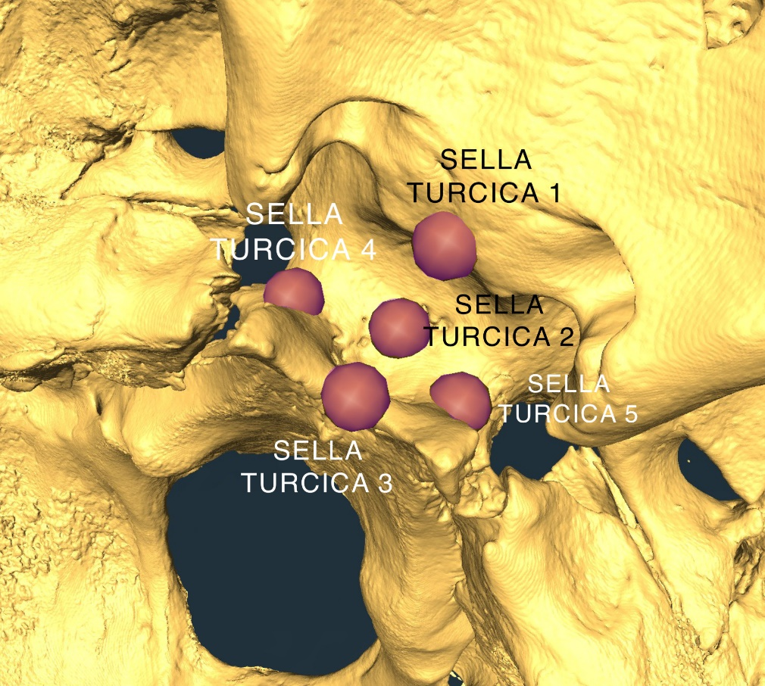
Figure 2.2 Five landmarks capturing the shape of the sella turcica, where the pituitary gland and intercavernous sinuses are located.

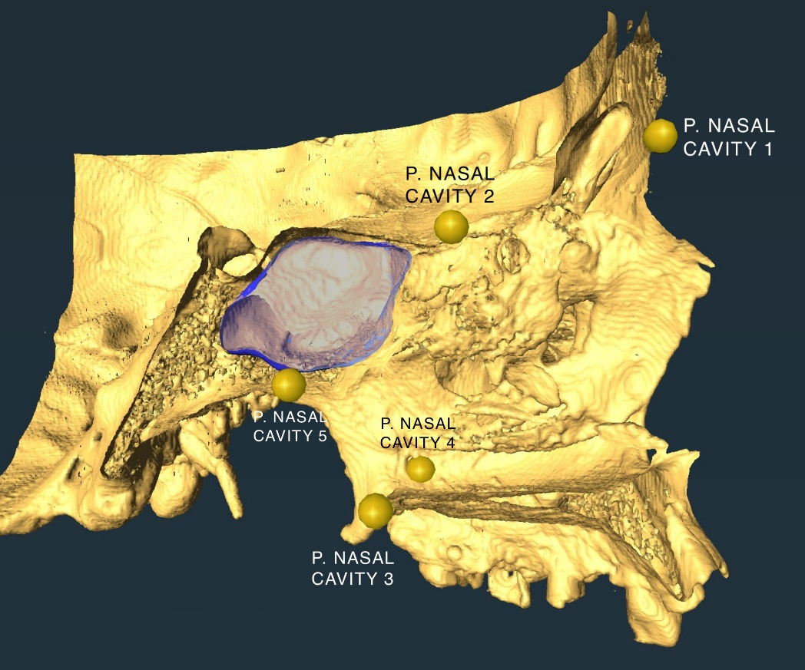
Figure 2.3 Five landmarks representing the shape of the posterior nasal cavity. The sphenoidal sinus in this sagittal view is highlighted in blue.

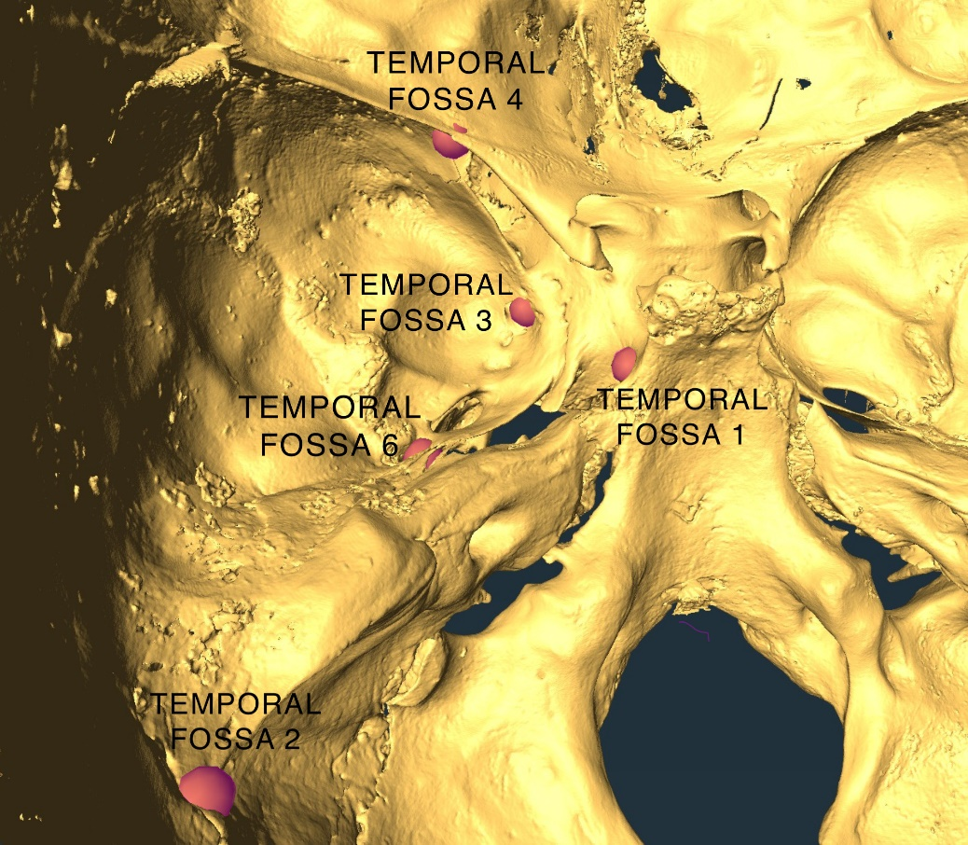
Figure 2.4: Five of the six landmarks representing the shape and dimensions of the left temporal fossa. Temporal Fossa 5 (Table 2.1) is on the external cranial vault representing the lateral expansion of the fossa, chosen for its reliability as a Type-I landmark.

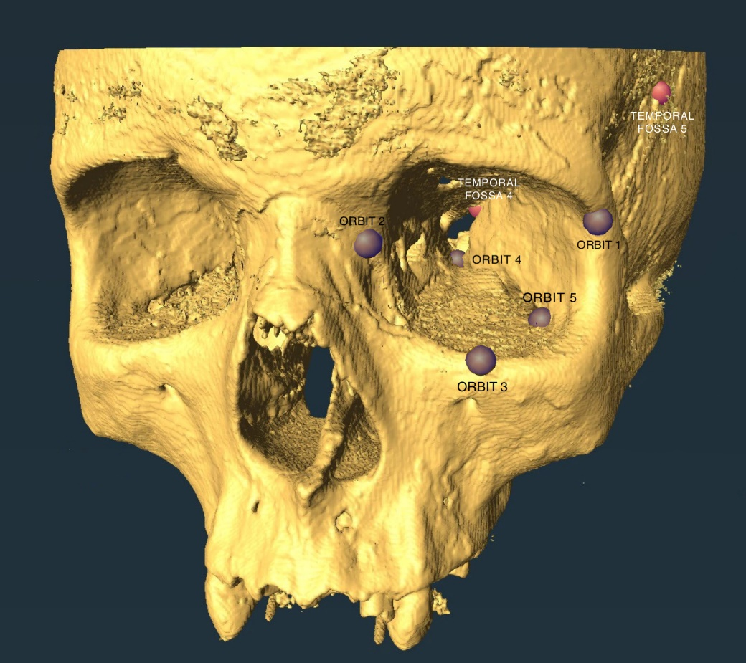
Figure 2.5: The five landmarks representing the shape and depth of the left orbit. Temporal Fossa 5 (Table 2.1) is also shown here.

Landmarks not part of the landmark set being assessed were removed from the aligned set for all subsequent analyses. For comparison, a “separate fit” (Klingenberg 2009) was also performed used the Procrustes fit function in ‘geomorph’ (Adams et al. 2021, Baken et al. 2021), in which there were no shared orientation landmarks between the sets, and all landmark sets for aligned and fit independently of one another. Results from comparisons using the separate-fit data therefor only represents covariation in shape, as well as effects from potential differences between scaling of regions with the cranium (see Discussion below), and not relative orientation (Klingenberg 2009).
To examine the covariance of each spatial set of landmarks (e.g., sella turcica, orbit) we again used the ‘Geomorph’ package (Adams et al. 2021, Baken et al. 2021) to calculate two-block partial least squares (2B-PLS) between the SPHARM coefficients for the sphenoid sinus and cranial landmark sets, as well as between landmark sets for the cranial regions. This method measures the maximum covariation between two symmetrical matrices, in which neither “block” of data is assumed to be the dependent versus independent variable—i.e. we do not assume which side is the cause of the covariation (Rohlf and Corti 2000). The significance for covariation is measured using permutation tests, producing a p-value. We set at our critical alpha at p=0.05. The r-PLS value is the measure of correlation, with values closest to 1 and -1 indicating stronger positive and negative correlation, respectively, and values closer to zero indicate a weaker correlation. The CBA for each crania was calculated as the arc-cosine of the Euclidean distances of the midline landmarks along the cranial base (Table 1), and were tested for covariation with the SPHARM coefficients using a linear model.
It is important to note that SPHARM coefficients are complex numbers. For comparison to non-complex number data, these complex values can be converted to real numbers by taking the absolute value (modulus), thereby preserving both the real and imaginary components (Shen, personal communication). Previous researchers used only the real component of the complex number, arguing that the imaginary components were small enough in value to be negligible (McPeek et al. 2008, Curtis and Van Valkenburgh 2014).

RESULTS
Results of the 2B-PLS for regions of the cranium that were Procrustes transformed with orientation landmarks on the sphenoid body are reported in Table 2.2, and results are reported in Table 2.3 of the separate fit of these regions, where their landmarks were Procrustes transformed without including orientation with respect to the sphenoid body. Our analyses indicate that the sphenoidal sinus is generally independent with respect to bony morphology of the cranium, while the sphenoid body has some covariance with other regions. In both sets of results, the sphenoid body and sphenoidal paranasal sinus are strikingly independent of one another, with an r-PLS of 0.389 (p=0.157). Including orientation, the morphology of the sphenoidal sinus likewise does not significantly covary with any other region of the cranium (Table 2.2). However, comparing shape alone, the sphenoidal sinus does significantly covary with the shape of the middle cranial fossa (r-PLS=0.520, p=0.007). This contrasts with the other regions of the cranium, where the sinus has r-PLS values between approximately 0.35 for the sella turcica and for the posterior nasopharynx, and 0.27 for the orbit (Table 2.3). In contrast, the shape of the sphenoid body significantly covaries with the posterior nasopharynx (Tables 2.2 and 2.3) and, when
Table 2.2: Results of two-block partial least squares analysis of covariance between sphenoidal sinus or sphenoid body with other regions of the cranium (see Table 2.1). The critical alpha for all analyses is p = 0.05. Bold text indicates significant results.

Cranial Region 1 | Cranial Region 2 | r-PLS | p-value
Sphenoidal sinus | Sphenoid body | 0.389 | 0.157
Sphenoidal sinus | Sella turcica | 0.377 | 0.165
Sphenoidal sinus | Posterior nasopharynx | 0.339 | 0.259
Sphenoidal sinus | Middle cranial fossa | 0.329 | 0.215
Sphenoidal sinus | Orbit | 0.336 | 0.178
Sphenoid body | Posterior nasopharynx | 0.694 | <0.001
Sphenoid body | Middle cranial fossa | 0.987 | <0.001
Sphenoid body | Orbit | 0.197 | 0.650
Sella turcica | Posterior nasopharynx | 0.545 | <0.001
Sella turcica | Middle cranial fossa | 0.987 | <0.001
Sella turcica | Orbit | 0.197 | 0.674
Posterior nasopharynx | Middle cranial fossa | 0.147 | 0.897
Posterior nasopharynx | Orbit | 0.272 | 0.238
Middle cranial fossa | Orbit | 0.088 | 0.669

Table 2.3: Results of two-block partial least squares analysis of covariance between sphenoidal sinus or sphenoid body with other regions of the cranium (see Table 2.1) from separate-fit Procrustes coordinates. The critical alpha for all analyses is p = 0.05. Bold text indicates significant results.

Cranial Region 1 | Cranial Region 2 | r-PLS | p-value
Sphenoidal sinus | Sphenoid body | 0.479 | 0.175
Sphenoidal sinus | Sella turcica | 0.345 | 0.655
Sphenoidal sinus | Posterior nasopharynx | 0.457 | 0.127
Sphenoidal sinus | Middle cranial fossa | 0.520 | 0.007
Sphenoidal sinus | Orbit | 0.267 | 0.742
Sphenoid body | Posterior nasopharynx | 0.762 | <0.001
Sphenoid body | Middle cranial fossa | 0.465 | 0.283
Sphenoid body | Orbit | 0.448 | 0.3
Sella turcica | Posterior nasopharynx | 0.548 | 0.048
Sella turcica | Middle cranial fossa | 0.465 | 0.123
Sella turcica | Orbit | 0.353 | 0.509
Posterior nasopharynx | Middle cranial fossa | 0.497 | 0.068
Posterior nasopharynx | Orbit | 0.401 | 0.290
Middle cranial fossa | Orbit | 0.221 | 0.975

including orientation, the middle cranial fossa (Table 2.2). This latter result may be driven by the shape of the sella turcica, the landmarks for which are included in the shape of the sphenoid body, and which also significantly covaries in shape with the posterior nasopharynx and middle cranial fossa (Table 2.2 and 2.3). All other regions of the cranium do not have significant covariance. From a linear model, there is no significant covariation between the calculated CBA and the sphenoidal sinus shape (p=0.956, r²=0.008).

DISCUSSION
The principal goal of this study was to examine whether the sphenoidal paranasal sinus covaries with the shape of the sphenoid body, and if this covariance carries over to the morphology of adjacent cranial regions. We hypothesized that if the paranasal sinuses opportunistically pneumatize all available cancellous bone (Whitmer 1997, Zollikofer et al. 2008, Smith et al. 2010), then the shape of the sphenoidal sinus and sphenoid body should significantly covary. Contrary to this expectation, we fail to support this hypothesis, instead demonstrating that while there is some correlation in shape between the sinus and the body, these two aspects of morphology are statistically independent. While this does not preclude the possibility that the sphenoidal sinus parallels aspects of the shape of the sphenoid body, it does suggest that the sinus morphology does not mirror the shape of the surrounding bone.
We also hypothesized a secondary level of integration with the bony features (representing soft anatomy) of the craniofacial functional matrices (sensu Moss and Young 1960) that were hypothesized to influence the shape of the sphenoidal body—and by extension, should the body and sinus also be integrated, also influence the sinus. Evidence that suggests this kind of integration was observed between the facial skeleton, maxillary bone, and maxillary sinus (Butaric and Maddux 2016), and we posited a similar pattern for the sphenoidal sinus. However, no such correlation was found between the sphenoidal sinus and the anatomy we confirmed to correlate with the sphenoidal body. Among those anatomical structures, we do find that the sphenoid body significantly covaries with the posterior nasopharynx and middle cranial fossa, but only when orientation is preserved in the Procrustes transposition in the case of the latter. Thus, we largely corroborate prior studies that have shown integration between aspects of the sphenoid bone and adjacent regions of the cranium (e.g., Jamniczky and Hallgrímsson 2009, Kolatorowicz 2015).
Given these results, it was unexpected to observe the sphenoidal sinus has a significant covariance with the middle cranial fossa (r-PLS=0.520, Table 3) when only shape and not shape and orientation are considered, while the sphenoid body and middle fossa significantly covary (r-PLS=0.987, Table 2) when including orientation in their Procrustes transformations. That the middle fossa and sphenoid body (including the sella turcica) covaried supports the findings of Bastir and colleagues (2008) that the anterior-laterally expanded temporal lobes of the human brain largely influence the shape of the middle cranial fossa in the midline. That both the sella turcica and sphenoidal body covary with the posterior nasopharynx provides further evidence of the middle cranial fossa interacting with both neuroendocrine anatomy and the midfacial skeleton in development (Bastir et al. 2008). As expected, the orbits only covaried with the nasopharynx, both comprising functional units within the integrated facial skeleton (Bastir and Rosas 2013). The middle cranial fossa also does not covary with either the nasopharynx or orbit, which is consistent with their relatively independent developmental origins (e.g., von Cramon-Taubadel 2011). However, it should be noted that previous research has found significant covariant relationships between the lateral basicranium and the facial skeleton in humans (Bastir and Rosas 2006) and nonhuman primates (Neaux et al. 2019), in addition to the midline basicranium where the CBA occurs as the basicranium connects to the facial skeleton through the sphenoid bone (Lieberman 2011). These disparities in findings may be a result of differences in landmark sets, and that our set focused solely on the shape of the middle cranial fossa and not the entire lateral basicranium from posterior to anterior cranial fossae. We conclude that the influence of the temporal lobes and cavernous sinuses on cranial morphology, following Moss’s functional matrices, are likely independent of the soft tissue influences on the morphology of the orbit and nasopharynx, even though the basicranium and facial skeleton are still integrated structures.
Beyond the middle cranial fossa, no additional set of landmarks or the calculated CBA significantly covaried with sphenoidal sinus shape. There are several potential explanations to these findings that must be further investigated. First, these findings may suggest that the sphenoidal sinuses do not pneumatize to the same deterministic extent as the maxillary and frontal sinuses, i.e., to the point of showing strong covariation with the anatomy that shapes the bone in which it forms. This would mean that the sphenoidal sinus may have greater relative independence to adjacent anatomy compared to that of the maxillary sinus (Butaric and Maddux 2016).
It may also be that the sphenoidal sinus has unique localized biological factors that determine and potentially inhibits pneumatization compared with other paranasal sinuses, such as the maxillary sinus. After all, the sphenoidal sinus is the only paranasal sinus that forms in the basicranium and in an endochondrally ossified bone (Enlow 1990, White et al. 2011). It has also been observed that the sphenoidal sinus widely varies in the extent to which it pneumatizes (Harnouna et al. 2021). This seems to be largely due to the variation in the amount of the red marrow in the sphenoid body that is converted to yellow marrow over the course of adolescence and early adulthood, a process that is a necessary precursor to sphenoidal sinus pneumatization (Kuntzler and Jankowski 2014, Rennie et al. 2017, Harouna et al. 2021). Indeed, we have previously observed our sample to be diverse in both shape and size (Ryan et al., Chapter II). Such differences in development could explain why the sphenoidal sinuses, along with the maxillary sinuses, are more conserved across primates compared to the ethmoidal and frontal sinuses (Rae and Koppe 2004). Samples that provide longitudinal data about the ontogeny of sinus pneumatization, as well as comparative primate samples for phylogenetic analysis, will be required to investigate these hypotheses further.
Butaric and Maddux (2016) found that volume significantly influences the shape of the maxillary sinus, and we hypothesize, based on our results, that the differential pneumatization in the sphenoidal sinus also correlates with differences in shape. If we excluded smaller sinuses that do not have post-sellar extension (Wang et al. 2010, Anusha et al. 2014, Štoković et al. 2016), then it is possible that covariation between the sinus, the sinus body, and regions covarying with the sphenoid body would be significant. In such a case, those sinuses would have all formed in all available space in the sphenoid body in which all the volume of the bone was available to be pneumatized. Given that the sinus manifests only after red marrow in the sphenoid body is converted to yellow (fatty) marrow, it may be possible to test this hypothesis by comparing the sinus shape to that of converted marrow in addition to the overall volume of bone that may become hollowed. The ability to build models that differentiate between types of bone and marrow in a large sample, while potentially demanding, would be necessary to assess this hypothesis.
The differences in results reported in Tables 2 and 3, based on inclusion or exclusion of orientation landmarks during Procrustes transformation, requires additional consideration. While the four sphenoid landmarks used to orient all regions during Procrustes transformations were removed during the 2B-PLS analysis for each region, the inclusion of these landmarks affects the scaling and orientation of each of the cranial regions (Rholf and Slice 1990, von Cramon-Taubadel et al. 2007), such that landmarks that are placed farther away from these common orientation landmarks could lead to differences in scaling of different regions. At the same time, such transformation places all regions in the same three-dimensional orientation as the sphenoidal sinus models represented by spherical harmonic coefficients. Thus, we consider the results of the “separate fit” approach to be more conservative in representing each cranial region’s shape irrespective of scaling, though allometry within each part of the cranium could yield differences in scaling within each region (e.g., the middle cranial fossa may scale differently than the sella turcica to overall cranial size). Thus, Table 2 results force the morphology to occupy a similar shape space, but if landmarks far from the four sphenoid orientation landmarks have high variation, then the generalized Procrustes transformation will result in an inflation of measurement error in the variance for those aspects of cranial morphology. That our results largely agree between Tables 2 and 3, with the notable high covariance between the sella turcica with the middle cranial fossa and between the posterior nasopharynx and orbit, gives us confidence that this scaling effect is not driving most of the results we present.
We must also consider that our shape data for the sphenoidal sinuses in humans are the first of their kind, with no precedence to compare them to different methods of quantification used for other sinuses (e.g., Butaric 2015). As we discussed in Ryan et al. (Chapter II), it is possible that, while spherical harmonic coefficients describe aspects of shape variation for complex morphologies, these still are not equivalent to three-dimensional landmark data in representing the apportionment of that variance (Curtis and Van Valkenburgh 2014). This points to a need to replicate the methods we use herein and further explore the variation of the paranasal sinus morphologies using different, creative approaches to quantifying the most complex shape diversity in the human body (Štoković et al. 2016).
Thus, while our study addresses questions about the covariance of the sphenoidal sinus with the shape of the sphenoid and adjacent regions of the cranium, many questions about the formation and variation of the sphenoidal sinus in comparison with other paranasal sinuses and spaces that interface with soft tissues (e.g., the nasopharynx or cranial fossae) remain. Measuring and understanding paranasal sinus shape variation with respect to well-documented cranial bone variation is key to producing more robust hypotheses about the mechanisms responsible for shaping the sinuses. Our hypotheses on the interactions of soft tissue and bony anatomy around the sphenoid bone with the sphenoidal sinus were generally not supported by our results, though we were able to establish a relationship between the middle cranial fossa and the nasopharynx with the shape of the sphenoidal body. It remains unknown if the low covariation between the sphenoidal sinus and the sphenoid body is a manifestation of differential pneumatization or true independence of the sphenoidal sinus from the shape of the sphenoid bone. Nevertheless, our results indicate that not all paranasal sinuses opportunistically pneumatize the skeletal elements in which they form. While this is an unexpected outcome, it suggests many productive avenues of future research to better establish the sources of and apportionment of sphenoidal sinus variation in the human cranium.

WORKS CITED
Adams, D. C., M. L. Collyer, A. Kaliontzopoulou, and E.K. Baken. 2021. Geomorph: Software for geometric morphometric analyses. R package version 4.0. https://cran.r-project.org/package=geomorph.
Agosto, E. R., & Auerbach, B. M. (2021b). Evolvability and constraint in the primate basicranium, shoulder, and hip and the importance of multi-trait evolution. Evolutionary Biology, 48(2), 221-232.
Agosto, E. R., & Auerbach, B. M. (in press). Morphological integration and evolutionary potential of the primate shoulder: variation among taxa and implications for genetic covariances with the basicranium, pelvis, and arm. Journal of Human Evolution.
Anusha, B., Baharudin, A., Philip, R., Harvinder, S., & Shaffie, B. M. (2014). Anatomical variations of the sphenoid sinus and its adjacent structures: A review of existing literature. Surgical and Radiologic Anatomy, 36(5), 419–427. https://doi.org/10.1007/s00276-013-1214-1
Baken, E. K., M. L. Collyer, A. Kaliontzopoulou, and D. C. Adams. 2021. gmShiny and geomorph v4.0: new graphical interface and enhanced analytics for a comprehensive morphometric experience. Methods in Ecology and Evolution. Submitted.
Barbieto-Andrés J, Ventrice F, Anzelmo M, Pucciarelli HM, Sardi ML. Developmental covariation of human vault and base throughout postnatal ontogeny. Annals of Anatomy 197:59-66.
Bastir, M., & Rosas, A. (2006). Correlated variation between the lateral basicranium and the face: A geometric morphometric study in different human groups. Archives of Oral Biology, 51(9), 814–824. https://doi.org/10.1016/j.archoralbio.2006.03.009
Bastir, M., & Rosas, A. (2013). Cranial airways and the integration between the inner and outer facial skeleton in humans. American Journal of Physical Anthropology, 152(2), 287–293. https://doi.org/10.1002/ajpa.22359
Bastir, M., Rosas, A., Gunz, P., Peña-Melian, A., Manzi, G., Harvati, K., Kruszynski, R., Stringer, C., & Hublin, J.-J. (2011). Evolution of the base of the brain in highly encephalized human species. Nature Communications, 2(1), 588. https://doi.org/10.1038/ncomms1593
Bastir, M., Rosas, A., Lieberman, D. E., & O’Higgins, P. (2008). Middle Cranial Fossa Anatomy and the Origin of Modern Humans. The Anatomical Record, 291(2), 130–140. https://doi.org/10.1002/ar.20636
Blaney, S. P. A. (1990). Why paranasal sinuses? The Journal of Laryngology & Otology, 104(09), 690–693. https://doi.org/10.1017/S0022215100113635
Bruner, E., & Ripani, M. (2008). A quantitative and descriptive approach to morphological variation of the endocranial base in modern humans. American Journal of Physical Anthropology, 137(1), 30–40. https://doi.org/10.1002/ajpa.20837
Buck, L. T., Stringer, C. B., MacLarnon, A. M., & Rae, T. C. (2019). Variation in Paranasal Pneumatisation between Mid-Late Pleistocene Hominins. Bulletins et Mémoires de La Société d’Anthropologie de Paris, 31(1–2), 14–33. https://doi.org/10.3166/bmsap-2019-0056
Butaric, L. N. (2015). Differential Scaling Patterns in Maxillary Sinus Volume and Nasal Cavity Breadth Among Modern Humans: MAXILLARY SINUS AND NASAL CAVITY SCALING. The Anatomical Record, 298(10), 1710–1721. https://doi.org/10.1002/ar.23182
Butaric, L. N., & Maddux, S. D. (2016). Morphological Covariation between the Maxillary Sinus and Midfacial Skeleton among Sub-Saharan and Circumpolar Modern Humans: Maxillary Sinus Shape in Humans. American Journal of Physical Anthropology, 160(3), 483–497. https://doi.org/10.1002/ajpa.22986
Cheverud JM. 1982. Phenotypic, genetic, and environmental morphological integration in the cranium. Evolution 36:499-516.
Cheverud JM. 1995. Morphological integration in the saddle-back tamarin (Saguinus fuscicollis) cranium. Am Naturalist 145:63-89.
Curtis, A. A., & Valkenburgh, B. V. (2014). Beyond the Sniffer: Frontal Sinuses in Carnivora. The Anatomical Record, 297(11), 2047–2064. https://doi.org/10.1002/ar.23025
Deng, X., Chen, S., Bai, Y., Song, W., Chen, Y., Li, D., Han, H., & Liu, B. (2015). Vascular Complications of Intercavernous Sinuses during Transsphenoidal Surgery: An Anatomical Analysis Based on Autopsy and Magnetic Resonance Venography. PLOS ONE, 10(12), e0144771. https://doi.org/10.1371/journal.pone.0144771
Enlow, D. H. (1990). Facial growth. WB Saunders Company.
Gould, S. J., & Lewontin, R. C. (1979). The Spandrels of San Marco and the Panglossian Paradigm: A Critique of the Adaptationist Programme. Proceedings of the Royal Society of London. Series B, Biological Sciences, 205(1161), 581–598.
Hallgrimsson, B., Jamniczky, H., Young, N. M., Rolian, C., Parsons, T., Boughner, J., & Marcucio, R. (2009). Deciphering the palimpsest: studying the relationship between morpological integration and phenotypic covariation. Evolutionary Biology, 36(4).
Harouna, M. S., Achta, F., Aghrib, F., Boussa, T., Belgadir, H., & Elbenna, N. (2021). Arrested pneumatization of sinus sphenoid, revealed by hypo-acusis: A case report. Annals of Medicine and Surgery, 71, 102939. https://doi.org/10.1016/j.amsu.2021.102939
Jamniczky, H. A., & Hallgrímsson, B. (2009). A Comparison of Covariance Structure in Wild and Laboratory Muroid Crania. Evolution, 63(6), 1540–1556. https://doi.org/10.1111/j.1558-5646.2009.00651.x
Klingenberg, C. P. (2009). Morphometric integration and modularity in configurations of landmarks: Tools for evaluating a priori hypotheses. Evolution & Development, 11(4), 405–421. https://doi.org/10.1111/j.1525-142X.2009.00347.x
Klingenberg CP. 2014. Studying morphological integration and modularity at multiple levels: concepts and analysis. Phil Trans R Soc B 369:20130249.
Kolatorowicz A. 2015. Patterns of morphological integration in modern human crania: Evaluating hypotheses of modularity using geometric morphometrics. Unpublished doctoral dissertation. Columbus: The Ohio State University.
Koppe, T., Inoue, Y., Hiraki, Y., & NAGAI, H. (1996). The Pneumatization of the Facial Skeleton in the Japanese Macaque (Macaca fuscata). Anthropological Science, 104(1), 31–41.
Koppe, T., Nagai, H., & Rae, T. C. (1999). Factors in the evolution of the primate pneumatic cavities: Possible roles of the paranasal sinuses. The Paranasal Sinuses of Higher Primates. Berlin: Quintessence. p, 151–175.
Kuntzler, S., & Jankowski, R. (2014). Arrested pneumatization: Witness of paranasal sinuses development? European Annals of Otorhinolaryngology, Head and Neck Diseases, 131(3), 167–170. https://doi.org/10.1016/j.anorl.2013.01.008
Kuykendall, K. L., & Rae, T. C. (2008). Presence of the maxillary sinus in fossil Colobinae (Cercopithecoides williamsi) from South Africa. The Anatomical Record, 291(11), 1499–1505.
Lieberman, D. (2011). The Evolution of the Human Head. Harvard University Press.
Márquez, S. (2008). The Paranasal Sinuses: The Last Frontier in Craniofacial Biology. The Anatomical Record: Advances in Integrative Anatomy and Evolutionary Biology, 291(11), 1350–1361. https://doi.org/10.1002/ar.20791
The Math Works, Inc. (2020). MATLAB (Version 2020a) [Computer software]. https://www.mathworks.com/
McPeek, M. A., Shen, L., Torrey, J. Z., & Farid, H. (2008). The Tempo and Mode of Three‐Dimensional Morphological Evolution in Male Reproductive Structures. The American Naturalist, 171(5), E158–E178. https://doi.org/10.1086/587076
Melo D, Porto A, Cheverud JM, Marroig G. 2016. Modularity: genes, development, and evolution. Annu Rev Ecol Evol Syst 47:463-486.
Moss, M. L. (1997). The functional matrix hypothesis revisited. 1. The role of mechanotransduction. American Journal of Orthodontics and Dentofacial Orthopedics, 112(1), 8–11.
Moss, M. L., & Salentijn, L. (1969). The primary role of functional matrices in facial growth. American Journal of Orthodontics, 55(6), 566–577.
Moss, M. L., & Young, R. W. (1960). A functional approach to craniology. American Journal of Physical Anthropology, 18(4), 281–292.
Neaux, D., Wroe, S., Ledogar, J. A., Heins Ledogar, S., & Sansalone, G. (2019). Morphological integration affects the evolution of midline cranial base, lateral basicranium, and face across primates. American Journal of Physical Anthropology, 170(1), 37–47. https://doi.org/10.1002/ajpa.23899
Profico A, Piras P, Buzi C, Di Vincenzo F, Lattarini F, Melchionna M, Veneziano A, Raia P, Manzi P. 2017. The evolution of cranial base and face in Cercopithecoidea and Hominoidea: Modularity and morphological integration. Am J Primatol 79:e22721.
R Core Team (2021). R: A language and environment for statistical computing. R Foundation for Statistical Computing, Vienna, Austria. URL https://www.R-project.org/.
Rae, T. C., & Koppe, T. (2004). Holes in the head: Evolutionary interpretations of the paranasal sinuses in catarrhines. Evolutionary Anthropology: Issues, News, and Reviews, 13(6), 211–223. https://doi.org/10.1002/evan.20036
Rahmati, A., Ghafari, R., & AnjomShoa, M. (2016). Normal Variations of Sphenoid Sinus and the Adjacent Structures Detected in Cone Beam Computed Tomography. Journal of Dentistry, 17(1), 32–37.
Rennie, C., Haffajee, M. R., & Satyapal, K. S. (2017). The Morphology of the Sphenoid Air Sinus from Childhood to Early Adulthood (1 to 25 years) Utilizing 3D Reconstructed Images. International Journal of Morphology, 35(4), 1261–1269. https://doi.org/10.4067/S0717-95022017000401261
Rohlf, F. J., & Corti, M. (2000). Use of two-block partial least-squares to study covariation in shape. Systematic Biology, 49(4), 740–753.
Rholf FJ, Slice D. 1990. Extensions of the Procrustes method for the optimal superimposition of landmarks. Syst Zool 39:40-59.
Rolian C. 2014. Genes, development, and evolvability in primate evolution. Evol Anth 23:93-104.
Ryan, K. G., Stock, J. T., & Buck, L. T. (2018). Sphenoidal Sinuses and Spatial Compromise in Basicranial Modular Development and Evolution. AMERICAN JOURNAL OF PHYSICAL ANTHROPOLOGY, 165, 235–235.
Schlager S (2017). “Morpho and Rvcg - Shape Analysis in R.” In Zheng G, Li S, Szekely G (eds.), Statistical Shape and Deformation Analysis, 217-256. Academic Press. ISBN 9780128104934.
Shen, L., Farid, H., & McPeek, M. A. (2009). Modeling Three-Dimensional Morphological Structures Using Spherical Harmonics. Evolution, 63(4), 1003–1016. https://doi.org/10.1111/j.1558-5646.2008.00557.x
Shirley, N. R., & Jantz, R. L. (2011). Spheno-occipital synchondrosis fusion in modern Americans. Journal of Forensic Sciences, 56(3), 580–585. https://doi.org/10.1111/j.1556-4029.2011.01705.x
Singh, P., Hung, K., Ajmera, D. H., Yeung, A. W. K., von Arx, T., & Bornstein, M. M. (2021). Morphometric characteristics of the sphenoid sinus and potential influencing factors: A retrospective assessment using cone beam computed tomography (CBCT). Anatomical Science International, 96(4), 544–555. https://doi.org/10.1007/s12565-021-00622-x
Smith, T. D., Rossie, J. B., Cooper, G. M., Carmody, K. A., Schmieg, R. M., Bonar, C. J., Mooney, M. P., & Siegel, M. I. (2010). The Maxillary Sinus in Three Genera of New World Monkeys: Factors That Constrain Secondary Pneumatization. The Anatomical Record: Advances in Integrative Anatomy and Evolutionary Biology, 293(1), 91–107. https://doi.org/10.1002/ar.21017
Štoković, N., Trkulja, V., Dumić-Čule, I., Čuković-Bagić, I., Lauc, T., Vukičević, S., & Grgurević, L. (2016). Sphenoid sinus types, dimensions and relationship with surrounding structures. Annals of Anatomy - Anatomischer Anzeiger, 203, 69–76. https://doi.org/10.1016/j.aanat.2015.02.013
Towbin, R., & Dunbar, J. S. (1982). The paranasal sinuses in childhood. Radiographics, 2(2), 253–279.
Unger, C. M., Devine, J., Hallgrímsson, B., & Rolian, C. (2021). Selection for increased tibia length in mice alters skull shape through parallel changes in developmental mechanisms. Elife, 10, e67612.
von Cramon-Taubadel N, Frazier BC, Lahr MM. 2007. The problem of assessing landmark error in geometric morphometrics: theory, method, and modifications. Am J Phys Anthropol 134:24-35.
von Cramon-Taubadel, N. (2011). The relative efficacy of functional and developmental cranial modules for reconstructing global human population history. American Journal of Physical Anthropology, 146(1), 83–93. https://doi.org/10.1002/ajpa.21550
Wang, J., Bidari, S., Inoue, K., Yang, H., & Rhoton, A. (2010). Extensions of the Sphenoid SinusA New Classification. Neurosurgery, 66(4), 797–816. https://doi.org/10.1227/01.NEU.0000367619.24800.B1
Wheat A. 2015. Investigating Postnatal Ontogeny in the Craniofacial Complex of Human Juveniles. Unpublished doctoral dissertation. Knoxville: The University of Tennessee.
White, T. D., Black, M. T., & Folkens, P. A. (2012). Human osteology (3rd ed). Academic Press.
WITMER, L. (1999). The phylogenetic history of paranasal air sinuses. The Paranasal Sinuses of Higher Primates : Development, Function, and Evolution. https://ci.nii.ac.jp/naid/10017633301/
Witmer, L. M. (1997). The Evolution of the Antorbital Cavity of Archosaurs: A Study in Soft-Tissue Reconstruction in the Fossil Record with an Analysis of the Function of Pneumaticity. Memoir. Society of Vertebrate Paleontology, 3, 1. https://doi.org/10.2307/3889342
Young M, Richard D, Grabowski M, Auerbach BM, Muthuirulan P, Kharker V, Kurki HK, Betti L, Birkenstock L, Lewton K, & Capellini TD. (in press). The developmental impacts of natural selection on human pelvic morphology. Science Advances.
Zollikofer, C. P. E., & Weissmann, J. D. (2008). A Morphogenetic Model of Cranial Pneumatization Based on the Invasive Tissue Hypothesis. The Anatomical Record: Advances in Integrative Anatomy and Evolutionary Biology, 291(11), 1446–1454. https://doi.org/10.1002/ar.20784

- CHAPTER III
Relationship Between Volume and Shape of the Sphenoidal Sinuses

Solo authorship (Katharine Ryan). Anticipated submission for review and publication in the American Journal for Biological Anthropology (AJBA).

ABSTRACT
Previous research has shown that, unlike the maxillary sinuses, the shape of the sphenoidal sinuses does not significantly covary with the bone that surrounds it, the sphenoidal body, even though it does covary with the middle cranial fossa (MCF) that covaries also with the body. These findings may indicate the sphenoidal sinus has unique developmental influences, yet it has also been observed that the sphenoidal sinus is highly variable in its size. It may be that the signals of covariation with the sphenoidal sinus that suggest integration are lost due to an allometric relationship between sinus size and shape. Procrustes ANOVA and two-block partial least squares (2B-PLS) analyses were run to test for correlation between sinus volume (and volume relative to sphenoid body centroid size) and shape. Subsamples of individuals with sinuses above versus those below the average sinus size were also compared for group differences in shape using permutation testing. Finally, those subsamples of sinus shape were also re-tested with 2B-PLS analyses for covariation with the sphenoidal body and other adjacent anatomy. Findings suggest that there is no allometric relationship between the sphenoidal sinus shape and size, nor significant differences in shape between a sample of smaller versus larger sinuses. However, when only larger sinuses were tested, a significant covariation was found between the sinus and sphenoid body, but not any other structure. Thus, even in a size-skewed sample, evidence suggests differences in how integrated the sphenoidal sinus is with surrounding bony architecture compared to the maxillary sinus.

INTRODUCTION
Pneumatization of cranial bones by paranasal sinuses varies intraspecifically, where the degree of bone hollowing ranges in volume and shape (Rae and Koppe 2004, Márquez 2008). This variation suggests that sinuses, especially the sphenoidal sinus, do not always pneumatize all available cancellous bone; models of this complete pneumatization, in which final paranasal sinus form is determined by the size and shape of the bone itself, is referred to as opportunistic (Witmer 1997, Zollikofer and Weissmann 2008, Smith et al. 2010). Prior studies by myself and colleagues (Ryan et al., Chapter II; Ryan et al., Chapter III) demonstrated that shape variation of the human sphenoidal sinus, while paralleling major dimensional and orientation changes of the sphenoid, may be largely independent of sphenoid morphology, which argues that the sphenoidal sinus may not opportunistically pneumatize. The lack of opportunistic pneumatization in the sphenoidal sinus may, in part, relate to the observed high amount of variation in the shape of the sphenoidal sinus (Harouna et al. 2021). Whether this variation is a product of prematurely arrested pneumatization, perhaps due to pathology or other environmental factors, or is simply part of diversity in form resulting from variation in signaling and regulation of sinus development is unclear. In this paper, I examine the relationship between shape variation in the human sphenoidal sinus and its degree of pneumatization as a first step in addressing this question.
Researchers have hypothesized that all paranasal sinuses form from an evagination of invasive epithelial tissue from the nasal cavity or ethmoid air cells (Zollikofer and Weissmann 2008, Jankowski et al. 2016), though more recent hypotheses have proposed the sphenoidal, frontal, and maxillary sinuses have a separate developmental origin from the ethmoid complex (Kuntzler and Jankowski 2014). Jankowski and colleagues (2016) instead posited that the development of these other three sinuses—which are more likely to have partial or full arrested pneumatization—is not only driven by, but originates from, bone metabolism and marrow conversion that is the necessary determinate step for those sinuses to form (unlike the ethmoid). According to this hypotheses, the frontal, maxillary, and sphenoidal sinuses form by primary bone cavitation, in which the sinus is centripetally formed by the gas (including largely nitric oxide) produced by the bone marrow involution and its subsequent evacuation, with the ostia connecting it to the nasopharyngeal complex serving as “chimneys” (Kuntzler and Jankowski 2014). Indeed, this red to yellow conversion process begins from the anterior sphenoid body and moves posteriorly (Goldman-Yassen et al. 2021), which is consistent with the development patterns that have been observed (Anusha et al. 2014). Between these competing models of development and the observed disparities in sinus size, this complicates the prevailing invasive tissue (Zollikofer and Weissmann 2008) and opportunistic pneumatization (Witmer 1997) hypotheses.
In a prior study (Ryan et al., Chapter II), the authors found a sizeable (40%) portion of the overall shape variation of the sphenoidal sinus associated with the extent to which the sphenoidal sinus extended posteriorly from the anterior aspect of the sphenoid body, where pneumatization for this sinus initiates. This is consistent with previous research that suggests the sphenoidal sinus, among all the paranasal sinuses, has the most size variation (Harouna et al. 2021). One possible explanation for this variation, as noted above, could be a product of the amount of red marrow in the sphenoid body that is converted to yellow marrow over the course of primary development, as it is only after this process that the sphenoidal sinus begins to remove trabecular bone and fatty marrow to form an epithelial-lined cavity (Aoki et al. 1989, Scuderi et al. 1993, Kuntzler and Jankowski 2014). Indeed, it has been observed that in a sample of patients with sickle cell anemia, who have higher rates of arrested marrow conversion or reconversion (i.e., they have more hematopoietic red marrow than individuals without sickle cell) that compensates for abnormal heme production (Whitehead et al. 2018), cases of highly arrested or absent sphenoidal sinuses are significantly higher than a sample from the same population without the disease (Prabhu and Branstetter 2016). Radiographic research has shown that the partially arrested pneumatization may be caused by incomplete erythropoietic marrow regression and replacement, while complete absence may happen in cases where the marrow was converted, but for some reason no aeration or subsequent cavitation occurred (Jankowski et al. 2016). There is anecdotal evidence that pathologies related to arrested pneumatization may be related to poor or absent air circulation between the sinus and the airways, with the symptoms being resolved after the cavity was endoscopically opened (Duignan and Wood 2020). Thus, the ability for the gases produced in the sinus to vent through the ostia may have an important role in sinus development and should be further investigated. Still, there is yet a consensus on the exact mechanisms and origins of pneumatization of the different paranasal sinuses.
With colleagues (Ryan et al., Chapter III), I have previously reported evidence that the shape of the sphenoid sinus does not significantly covary with the morphology of the bone that surrounds it based on two-block partial least squares analysis (r-PLS=0.389). This was contrary to our expectations based on an opportunistic pneumatization model for how the sphenoidal sinus interacts with the sphenoid body. Furthermore, the preponderance of our prior results demonstrated independence of the sphenoidal sinus but not the sphenoid body in the morphology of bony anatomy within which the sphenoid interacts during development (Bruner and Ripani 2008, Lieberman 2011, Anusha et al. 2014, Deng et al. 2015, Singh et al. 2021); the shape of the sphenoidal sinus does not significantly covary with any of the anatomical features that we have shown covary with the body itself (Ryan et al., Chapter II) or with sinus volume (Ryan et al. 2018). This is potential evidence that the sphenoidal sinus has some unique developmental qualities and interactions that cause its form to be buffered from its surrounding bony anatomy. In contrast, the maxillary sinus covaries both with the maxillary bone and midfacial skeleton (Butaric and Maddux 2016), indicating there may be differences in both the process and degree to which these two sinuses opportunistically pneumatize. In such a case, this would complicate how researchers conceptualize sinus development in humans and what biological and environmental factors influence this process, as well as how to measure and test for these factors.
Given previous observations that sphenoidal sinuses that extend past the sella turcica are larger and qualitatively appear to approximate the shape of the surrounding bone better than smaller pre-sellar sinuses (Wang et al. 2010, Anusha et al. 2014, Štoković et al. 2016), Ryan et al. (Chapter II) hypothesized that this finding may be due to variation in the extent to which the sphenoidal sinus pneumatizes relative to the size of the bone in which it forms. This in turn indicates there may an allometric relationship between the sphenoid sinus shape and its size, more than what has been observed in the maxillary sinus (Butaric and Maddux 2016). If allometry is influencing findings by colleagues and myself, I would expect to find significant correlation between shape and size variation of the sinus, as well as distinct differences in shape between a sample of larger sinus and a sample of smaller sinuses. In addition, I would expect the low covariance between the shape of the sphenoid sinus and sphenoid body is due to inclusion of individuals with sinuses below-average in volume (relative to sphenoid body centroid size). Finally, this in turn would suggest that individuals with larger sphenoidal sinuses relative to the size of the sphenoid body should likewise have significant covariance with the morphology of adjacent cranial regions. The aim of this paper, then, is to address whether the patterns of low covariation between the sphenoidal sinus and bony anatomy of the cranium is a product of arrested pneumatization, and implications for differences in formation among the paranasal sinuses.

MATERIALS
A sample of crania from 60 adult humans were selected for this research, all CT or Micro-CT scans of archaeological remains recovered from Peru (Peabody Museum), Nepal (NHM), Austria (NESPOS), and an assortment of other European countries (NESPOS). See Ryan et al. (Introduction) for a full population breakdown and description of the sample. Dr. Lauren Butaric supplied the scans with permission from the institutions that house their open access digital archives. All individuals regardless of estimated sex or population origin were pooled as a broad, intraspecific sample.

METHODS

Sinus Segmentation and Shape Quantification
Following the same protocol outlined in Ryan et al. (Chapter I), sinus endocast surface meshes were made using a built-in segmentation tool in Avizo Lite (Thermo Fisher Scientific, 2019). The area of the sinus was manually segmented slice by slice in a sagittal orientation of the crania and combined into a 3D surface model exported as a mesh. All sinus model meshes were then edited to ensure that they were genus-zero shapes (e.g., without discontinuous holes) in Meshmixer 3.5 (Autodesk, 2018), and simplified to a standardized number of surface triangles in Geomagic Wrap (3D Systems Corporation, 2021). To quantify the morphology of the sinuses, which have an irregular shape that cannot be quantified using homologous Euclidean landmarks, I used weighted spherical harmonics as described in more detail in Ryan et al. (Chapter I). Weighted spherical harmonic coefficients were obtained by analyzing the standardized surface meshes of the sinuses with the SPHARM (v 1.4) program in Matlab (The Math Works, Inc., 2020), which performed Procrustes registration on the models using four orientation landmarks (the SPHENOID landmarks in Table 1) and quantified their overall shape variation as SPHARM coefficients (McPeek et al. 2008). These coefficients are comparable to geometric morphometric landmark data and may be used to assess covariance of sinuses with other cranial region morphologies represented by standard Euclidean landmarks (see Curtis and Van Valkenburgh 2014, Ryan et al., Chapter II).

Landmarking and morphometric analysis
In addition to segmentation of sphenoidal sinuses, I also created virtual models of the bony crania in the sample using the same segmentation and mesh creation tools (using automatic density-based thresholding) in Avizo Lite. Seven sets of landmarks were taken from each three-dimensional virtual model made from the sample of 60 CT scans of human crania. I performed landmarking in Avizo Lite and exported coordinate data for analysis in R (R Core Team 2021). Four sets of landmarks were chosen to represent the shape of different regions of the craniofacial skeleton (sphenoid body, sella turcica, posterior nasopharynx, and the middle cranial fossa). Landmarks descriptions are in Table 3.1 and depicted in Figures 3.1-3.4. All paired non-midline landmarks were taken on the left side.
As noted above, four orientation landmarks were placed on the midsagittal plane of the sphenoid body (Figure 3.4) and used to Procrustes register both sinuses and the landmark sets to make both shape and orientation directly comparable between the SPHARM shape data of the sinus and the craniofacial landmark data, as well as between the craniofacial landmark sets. This was performed in R Studio using the package ‘Morpho’ (Schlager 2017). As the orientation landmarks were not part of the landmark sets of each cranial region assessed (i.e., middle cranial fossa, sella tucica, and posterior nasopharynx), they were removed from the landmark sets analyzed for these regions in subsequent analyses. Shape and scale were also observed on their own with a separate-fit Procrustes alignment in which all landmark sets were registered independently (Klingenberg 2009). This was performed in R Studio using the package ‘geomorph’ (Adams et al. 2021, Baken et al. 2021). This allows a comparison of the results when orientation is or is not included, the latter being a more conservative estimate of covariation of shape (Ryan et al., Chapter II).

Statistical Analyses
All statistical analyses were performed in R. The ‘geomorph’ package (Adams et al. 2021, Baken et al. 2021) was used to perform a two-block partial least squares (2B-PLS) between the spherical harmonic coefficients and landmark sets (Rohlf and Corti 2000). The
Table 3.1: Landmarks used in this study by region of the cranium under analysis. Note that landmark numbers correspond with those depicted in Figures 3.1-3.4.

Region | Landmark Number | Landmark Name | Description | Source
Sphenoid body | SPHARM 1 | Posterior midcribriform | Posterior-most point of the cribriform plate in the midline | Bastir et al. 2011b
Sphenoid body | SPHARM 2 | Tuberculum sellae | The midline point on the tuberculum sellae | Originally defined.
Sphenoid body | SPHARM 3 | Hormion | Most posterior midline point on the vomer underneath the basicranium | White et al. 2012
Sphenoid body | SPHARM 4 | Inferior sphenoid rostrum | The most inferior point on the anterior ridge of the sphenoid rostrum | Originally defined.
Sella turcica | SELLA 1 | Tuberculum sellae | The midline point on the tuberculum sellae | Originally defined.
Sella turcica | SELLA 2 | Sella | Inferior most point of the sella turcica in the midline, usually at the base of the posterior sellar wall | Bruner and Ripani 2008
Sella turcica | SELLA 3 | Dorsum sellae | Superior-most point of the dorsum sellae in the midline | Bruner and Ripani 2008
Sella turcica | SELLA 4 | Left base of dorsum sellae | Lateral-most point at the base of dorsum sellae/the posterior sellar wall | Originally defined.
Sella turcica | SELLA 5 | Right base of dorsum sellae | Lateral-most point at the base of dorsum sellae/the posterior sellar wall | Originally defined.
Posterior nasopharynx | P. NASAL 1 | Nasion | Midline point where the two nasal bones and the frontal intersect | White et al. 2012
Posterior nasopharynx | P. NASAL 2 | Posterior Crista Galli | Posterior most point of the base of crista galli where it becomes flush with the cribriform plate | Originally defined.
Posterior nasopharynx | P. NASAL 3 | Alveolon | The point on the median palatine suture, the posterior most point if the palatine palate in the midline | White et al. 2012
Posterior nasopharynx | P. NASAL 4 | Greater Palatine Foramen | Lateral-most internal edge of the foramen (taken on left side)
Posterior nasopharynx | P. NASAL 5 | Hormion | Most posterior midline point on the vomer underneath the basicranium | White et al. 2012

Table 3.1 continued

Region | Landmark Number | Landmark Name | Description | Source
Middle cranial fossa/temporal fossa  (all taken on left side) | T. FOSSA 1 | Foramen lacerum | Medial internal edge of the foramen | Originally defined.
 | T. FOSSA 2 | Petro-parietal junction | Base of the petrous pyramid on the endocranial wall | Bruner and Ripani 2008
 | T. FOSSA 3 | Foramen rotundum | Medial internal edge of the foramen. | Originally defined.
 | T. FOSSA 4 | Lateral superior orbital fissure | Lateral-most internal edge of the fissure | Originally defined.
 | T. FOSSA 5 | Pterion | The frontal, temporal, parietal, and sphenoid meet on the side of the vault | White et al. 2012
 | T. FOSSA 6 | Foramen spinosum | Medial internal edge of the foramen
Orbit  (all taken on left side) | ORBIT 1 | Frontomalare orbitale | The point where the frontozygomatic suture crosses the inner orbital rim | White et al. 2012
Orbit  (all taken on left side) | ORBIT 2 | Lacrimale | The point where the posterior lacrimal crest meets the frontolacrimal suture | White et al. 2012
Orbit  (all taken on left side) | ORBIT 3 | Zygoorbitale | The point where the orbital rim intersects the zygomaticomaxillary suture | White et al. 2012
Orbit  (all taken on left side) | ORBIT 4 | Inferior superior orbital fissure | Inferior-most internal edge of the fissure. | Originally defined.
Orbit  (all taken on left side) | ORBIT 5 | Anterior inferior orbital fissure | Anterior-most internal edge of the fissure | Originally defined.
Basicranial angle  (not pictured) | CBA 1 | Posterior mid-cribriform | Posterior-most point of the cribriform plate in the midline | Bastir et al. 2011b
Basicranial angle  (not pictured) | CBA 2 | Tuberculum sellae | The midline point on the tuberculum sellae | Originally defined.
Basicranial angle  (not pictured) | CBA 3 | Basion | The midline point on the anterior margin of the foramen magnum | White et al. 2012

Figure 3.1: Five landmarks capturing the shape of the sella turcica, where the pituitary gland and intercavernous sinuses are located.

Figure 3.2: Five landmarks representing the shape of the posterior nasal cavity. The sphenoidal sinus in this sagittal view is highlighted in blue.

Figure 3.3: Five of the six landmarks representing the shape and dimensions of the left temporal fossa. Temporal Fossa 5 (Table 3.1) is on the external cranial vault representing the lateral expansion of the fossa, chosen for its reliability as a Type-I landmark.

Figure 3.4: Four landmarks on the sphenoidal body in the midline used to align the sinuses within the same 3D space relative to the surrounding craniofacial skeleton. The sphenoidal sinus in this sagittal view is highlighted in blue.

significance for covariation (indicated by a correlation value, r-PLS) is measured using permutation tests, producing a p-value. The critical alpha for all analyses is 0.05. To test for an allometric relationship between the sphenoidal sinus’s size and shape, both a Procrustes ANOVA (procD.lm) and a 2B-PLS (two.b.pls) analyses were performed using the ‘geomorph’ package in R Studio (Adams et al. 2021, Baken et al. 2021). The spherical harmonic coefficients were compared with the raw volume values of each sinus, as well as the proportion of volume versus centroid size (sinus volume divided by sphenoid body centroid).
Our sample of 60 individuals was then divided into two subsamples, those who have sinuses above and below the average sinus volume relative to sphenoid body centroid size, henceforth referred to as the “Large” and “Small” groups. Summary statistics for the sphenoid sinus volume data for the total sample, as well as the “Large” and “Small” subsets are reported in Table 3.2. Differences between the two groups were assessed through permutation tests using the permudist function from the ‘Morpho’ package (Schlager 2017) that compare the distance between two group means to distances calculated from random group assignments. Since n=30 for each subsample, I reduced the number of harmonic coefficients representing sinus shape included in the analyses per individual from 40 to 20 for comparisons between the coefficients and landmarks. The spherical harmonic shape data were compared to the sphenoid body, sella turcica, posterior nasopharynx, and middle cranial fossa landmark sets, as well as bony regions, using 2B-PLS for each size group. The sphenoid body and sella turcica share many of the same landmarks as the latter forms the roof of the former, and thus these two were not compared.

Table 3.2: Summary statistics of the sphenoidal sinus volume data.

Total | n | mean | sd* | median | trimmed mean | mad^{ǂ}
Total | 60 | 8159.88 | 3880.39 | 7846.92 | 7943.35 | 4508.19
Total | min | max | range | skew | kurtosis | se§
Total | 400.62 | 18710.41 | 18309.79 | 0.46 | -0.34 | 509.52
“Small” | n | mean | sd* | median | trimmed mean | mad^{ǂ}
“Small” | 30 | 5020.18 | 1735.89 | 5246.41 | 5059.85 | 1931.6
“Small” | min | max | range | skew | kurtosis | se§
“Small” | 400.62 | 8846.32 | 8445.7 | -0.27 | 0.21 | 322.35
“Large” | n | mean | sd* | median | trimmed mean | mad^{ǂ}
“Large” | 30 | 11299.58 | 2686.96 | 11006.89 | 11068.9 | 2656.09
“Large” | min | max | range | skew | kurtosis | se§
“Large” | 7723.92 | 18710.41 | 10986.49 | 0.87 | 0.2 | 498.96

*standard deviation ^{ǂ}median absolute deviation §standard error

RESULTS
There is no statistical relationship between sinus shape and volume; neither the Procrustes ANOVA (p=0.328. r²=0.019) nor the 2B-PLS (p=0.26, r-PLS=0.312) between the spherical harmonic coefficients representing sinus shape and raw sinus volume data showed significant correlation. Similarly, the Procrustes ANOVA (p=0.19, r²=0.025) and 2B-PLS (p=0.33, r-PLS=0.299) show no significant results between the sinus shape and the volume relative to body centroid size. The comparison of spherical harmonic coefficients between the Large and Small sinus groups was also non-significant (p=0.182, dist=0.003). Results of the 2B-PLS analyses comparing sinus shape with cranial bony regions are presented in Table 3.3 and Table 3.4. Those Procrustes transformed with sphenoid landmarks are presented in Table 3.3, and those without transformation with orientation landmarks in Table 3.4. As shown in Table 3.3, sphenoid sinus shape of the Large group significantly covaries the sphenoid body, while sinus shape of the Small group do not covary with sphenoid body shape. All cranial regions in Table 3.4 have moderate covariance (r-PLS>0.5) with both sphenoidal sinus groups, though none are significant, likely due to reduced statistical power.

DISCUSSION
The analyses failed to show an allometric relationship between sphenoidal sinus volume and shape. Not only did the volume not correlate with the shape, but when comparing a subset of sphenoidal sinuses below the average volume (relative to centroid size of the sphenoid body) and another above the average, there was no significant group difference. These findings indicate that the shape variation of the sphenoidal sinuses is not driven by size variation. Therefore, it is

Table 3.3: Results of 2B-PLS analyses between each craniofacial region from the Procrustes coordinates with shared sphenoid orientation landmarks, using the above average (Large) and below average (Small) sample subsets. Bold text indicates significant covariance.
 |  | Large |  | Small
Cranial Region 1 | Cranial Region 2 | r-PLS | p-value | r-PLS | p-value
Sphenoidal sinus | Sphenoid body | 0.628 | 0.003 | 0.276 | 0.811
Sphenoidal sinus | Sella turcica | 0.288 | 0.851 | 0.412 | 0.523
Sphenoidal sinus | Posterior nasopharynx | 0.486 | 0.104 | 0.390 | 0.604
Sphenoidal sinus | Middle cranial fossa | 0.303 | 0.635 | 0.373 | 0.436
Sphenoid body | Posterior nasopharynx | 0.347 | 0.320 | 0.405 | 0.172
Sphenoid body | Middle cranial fossa | 0.116 | 0.818 | 0.143 | 0.705

Table 3.4: Results of 2B-PLS analyses between each craniofacial region from the separate-fit Procrustes coordinates, using the above average (Large) and below average (Small) sample subsets.
 |  | Large |  | Small
Cranial Region 1 | Cranial Region 2 | r-PLS | p-value | r-PLS | p-value
Sphenoidal sinus | Sphenoid body | 0.548 | 0.593 | 0.588 | 0.217
Sphenoidal sinus | Sella turcica | 0.613 | 0.056 | 0.484 | 0.455
Sphenoidal sinus | Posterior nasopharynx | 0.520 | 0.480 | 0.451 | 0.639
Sphenoidal sinus | Middle cranial fossa | 0.592 | 0.059 | 0.585 | 0.117
Sphenoid body | Posterior nasopharynx | 0.647 | 0.694 | 0.661 | 0.178
Sphenoid body | Middle cranial fossa | 0.583 | 0.100 | 0.561 | 0.143

unlikely that previous findings by Ryan et al. (Chapter II) of no significant covariation between the sphenoidal sinus and the sphenoid body, and those structures that covary with the body itself, are due to size diversity.
However, there is a significant covariation in the shape of the Large sinus group with sphenoid body shape, as Ryan et al. (Chapter II) had originally hypothesized. The smaller-than-average sphenoidal sinuses, in contrast, do not covary in shape with the sphenoid body. Thus, volume of the sinus is not unimportant, as these results clearly indicate that the Large sinus group consists of more pneumatized spaces, which take on the shape of the surrounding bone as
posited by the opportunistic pneumatization hypothesis (Witmer 1997). Yet reaching this opportunistic threshold size has not occurred in half of the sample, and thus does not represent the sample’s average sinus. Though the sample size is limited, I hypothesize that it is unlikely that the majority of sinuses failing to reach this threshold are atypical or pathological variants.
In addition, neither the Large or Small groups of sinuses significantly covary with any of the other cranial regions, though the middle cranial fossa and posterior nasopharynx were shown previously to significantly covary in the full sample with the sphenoid body (Ryan et al., Chapter II). This may indicate that even in cases where the sinus has more completely pneumatized the sphenoid body, the sphenoidal sinus does not have the same kind of multilevel integration as the maxillary sinus suggested by previous findings (Butaric and Maddux 2016), and perhaps even has a weaker covariation with its bone compared to other sinuses. It is worth noting that in both the Procrustes transformation approaches used, the sinus shape in the Large group has a moderate, non-significant correlation with the shape of the posterior nasopharynx. These results indicate that the shape of the posterior nasopharynx may covary with the adjacent pneumatizing spaces, albeit subtly in the case of the sphenoidal sinus as it more fully expands within the sphenoid body. I also noted in the Results that both sinus size groups have moderate correlations with the shapes of other regions of the cranium Procrustes transformed without sphenoid orientation landmarks, though this is likely driven by underlying effects of size on these regions; although they are scaled through Procrustes transformations, there may be latent covariance among the centroids of the cranial regions with sphenoidal sinus shape when orientation landmarks are not included in their transformation.
Based on these results, it appears that the sphenoid sinus only sometimes opportunistically pneumatizes the entire bony space of the sphenoid body, similar to the maxillary sinus (Butaric and Maddux 2016) and the frontal sinus (Sardi et al. 2018). However, it would be inappropriate to treat half or more of our sample as having sinuses that are anomalous, resulted from pathological conditions, or that exhibit prematurely arrested pneumatization. This assumes that the sinuses should always pneumatize to the fullest extent within the cortical bounds of the bone, which is the very question under investigation here and not a given for all paranasal sinuses. As researchers have not established the mechanism or competing factors that cause this process to cease at different stages under nonpathological conditions (Smith et al. 2010), it is not possible to identify the appearance of “normal” versus “abnormal” pneumatization. It is important to keep in mind that this cavity is considered to have the most varied morphology in the human body, not just in shape but also size (Harouna et al. 2021), and thus it would seem that the variance observed in this study’s sample in fact fits the norm. Thus, future research should not exclude smaller sphenoid sinuses from analyses.
Overall, the results of this study, paired with those reported previously (Ryan et al., Chapter I; Ryan et al., Chapter II), suggest a need to reconsider the use of a single model to describe the development of most of the paranasal sinuses. The opportunistic pneumatization hypothesis (often associated with Zollikofer and Weissmann’s 2008 invasive tissue hypothesis) posits that the final shape and size of sinuses is determined by the bone in which it forms because the sinus typically pneumatizes all available bone (Witmer 1997). However, the results reported here question the definition of “available” bone. Previously, researchers defined this to be the entire cancellous compartment of the bone (Zollikofer and Weissmann 2008), though this may be refined and attenuated by incorporating the effects of bone metabolism on paranasal sinus development, which in turn may provide useful nuances to developmental models to better describe and assess variation in formation among the paranasal sinuses. Regardless of whether the sinuses are primarily formed by an evagination and centrifugal expansion of epithelial tissue from the nasopharyngeal and ethmoid complexes (Zollikofer and Weissmann 2008), or by fat involution and aeration causing centripetal bone cavitation (Jankowski et al. 2016), the formation of the sphenoidal, frontal, and maxillary sinuses is dependent on the conversion of red to yellow marrow. Therefore, only a portion of cancellous bone is available to be pneumatized, and this will vary as a result of multiple factors over the course of development (Małkiewicz and Dziedzic 2012). To update the opportunistic pneumatization hypothesis, paranasal sinuses (except for the ethmoid) pneumatize all available fatty marrow within their housed cranial bones, and their final forms are determined by the shape of the boundary of that tissue—which may sometimes reflect the shape of the bone itself, but only when the majority of the cancellous bone is appropriately transformed and capable of undergoing remodeling and removal. As suggested in Ryan et al. (Chapter II), it is important that future work attempts to test the extent of pneumatization relative to the borders of the fatty marrow, and not of the external cortical boundary. Studying the variation of the sphenoidal sinus through this informed model may help achieve a clearer understanding of how sinuses form and diversify, as well as how they integrate with craniofacial anatomy. It may also help identify the sources of similarities between the different sets of paranasal sinuses in development and evolution. Future research should also consider comparing the extent of correlation between the sphenoidal sinus and bone with that of the maxillary and frontal sinuses and bones using comparable spherical harmonic methods. Differences in the amount of correlation may indicate differences in the sinus-bone developmental relationship and sensitivities to arrested pneumatization between the different pairs of sinuses, as well as potential variation in the conversion of marrow among bones of the cranium.
A limitation of this paper’s findings is inherent in the small sample size of 60, which is made even smaller dividing it into two groups of 30. This small sample size likely explains why the craniofacial features that covary with the sphenoid body in the entire sample are not significantly covarying herein when sinus size groups are considered (Tables 3.2 and 3.3). It will be important to see if these findings are replicable with a larger sample size. A larger sample would allow the identification of the range of sinus diversity and opportunities to assess the distribution and clustering for more than two subgroups. Nevertheless, this study presents novel findings about the factors that may be motivating morphological variation in the shape and size of the sphenoidal paranasal sinus, and encourages researchers to consider that different processes may be at work in shaping this variation across the paranasal sinuses of the human cranium.

WORKS CITED
Adams, D. C., M. L. Collyer, A. Kaliontzopoulou, and E.K. Baken. 2021. Geomorph: Software for geometric morphometric analyses. R package version 4.0. https://cran.r-project.org/package=geomorph.
Anusha, B., Baharudin, A., Philip, R., Harvinder, S., & Shaffie, B. M. (2014). Anatomical variations of the sphenoid sinus and its adjacent structures: A review of existing literature. Surgical and Radiologic Anatomy, 36(5), 419–427. https://doi.org/10.1007/s00276-013-1214-1
Aoki, S., Dillon, W. P., Barkovich, A. J., & Norman, D. (1989). Marrow conversion before pneumatization of the sphenoid sinus: Assessment with MR imaging. Radiology, 172(2), 373–375. https://doi.org/10.1148/radiology.172.2.2748818
Baken, E. K., M. L. Collyer, A. Kaliontzopoulou, and D. C. Adams. 2021. gmShiny and geomorph v4.0: new graphical interface and enhanced analytics for a comprehensive morphometric experience. Methods in Ecology and Evolution. Submitted.
Babyn, P. S., Ranson, M., & McCarville, M. E. (1998). Normal Bone Marrow: Signal Characteristics and Fatty Conversion. Magnetic Resonance Imaging Clinics of North America, 6(3), 473–495. https://doi.org/10.1016/S1064-9689(21)00233-6
Bastir, M., Rosas, A., Gunz, P., Peña-Melian, A., Manzi, G., Harvati, K., Kruszynski, R., Stringer, C., & Hublin, J.-J. (2011). Evolution of the base of the brain in highly encephalized human species. Nature Communications, 2(1), 588. https://doi.org/10.1038/ncomms1593
Bruner, E., & Ripani, M. (2008). A quantitative and descriptive approach to morphological variation of the endocranial base in modern humans. American Journal of Physical Anthropology, 137(1), 30–40. https://doi.org/10.1002/ajpa.20837
Butaric, L. N., & Maddux, S. D. (2016). Morphological Covariation between the Maxillary Sinus and Midfacial Skeleton among Sub-Saharan and Circumpolar Modern Humans: Maxillary Sinus Shape in Humans. American Journal of Physical Anthropology, 160(3), 483–497. https://doi.org/10.1002/ajpa.22986
Curtis, A. A., & Valkenburgh, B. V. (2014). Beyond the Sniffer: Frontal Sinuses in Carnivora. The Anatomical Record, 297(11), 2047–2064. https://doi.org/10.1002/ar.23025
Deng, X., Chen, S., Bai, Y., Song, W., Chen, Y., Li, D., Han, H., & Liu, B. (2015). Vascular Complications of Intercavernous Sinuses during Transsphenoidal Surgery: An Anatomical Analysis Based on Autopsy and Magnetic Resonance Venography. PLOS ONE, 10(12), e0144771. https://doi.org/10.1371/journal.pone.0144771
Duignan, M., & Wood, A. (2021). Arrested pneumatization of the skull base: An under-recognized skull base anomaly. ANZ Journal of Surgery, 91(1–2), E69–E71. https://doi.org/10.1111/ans.16118
Felix, V., & Veerasigamani, N. (2017). Unilateral Absence of Ethmoid Sinus and Nasal Turbinates: A Rare Case Report. Journal of Clinical and Diagnostic Research : JCDR, 11(4), MD01–MD02. https://doi.org/10.7860/JCDR/2017/24479.9511
Goldman-Yassen, A. E., Meda, K., & Kadom, N. (2021). Paranasal sinus development and implications for imaging. Pediatric Radiology, 51(7), 1134–1148. https://doi.org/10.1007/s00247-020-04859-y
Harouna, M. S., Achta, F., Aghrib, F., Boussa, T., Belgadir, H., & Elbenna, N. (2021). Arrested pneumatization of sinus sphenoid, revealed by hypo-acusis: A case report. Annals of Medicine and Surgery, 71, 102939. https://doi.org/10.1016/j.amsu.2021.102939
Jankowski, R., Nguyen, D. T., Poussel, M., Chenuel, B., Gallet, P., & Rumeau, C. (2016). Sinusology. European Annals of Otorhinolaryngology, Head and Neck Diseases, 133(4), 263–268. https://doi.org/10.1016/j.anorl.2016.05.011
Kuntzler, S., & Jankowski, R. (2014). Arrested pneumatization: Witness of paranasal sinuses development? European Annals of Otorhinolaryngology, Head and Neck Diseases, 131(3), 167–170. https://doi.org/10.1016/j.anorl.2013.01.008
Lieberman, D. (2011). The Evolution of the Human Head. Harvard University Press.
Małkiewicz, A., & Dziedzic, M. (2012). Bone marrow reconversion – imaging of physiological changes in bone marrow. Polish Journal of Radiology, 77(4), 45–50.
The Math Works, Inc. (2020). MATLAB (Version 2020a) [Computer software]. https://www.mathworks.com/
McPeek, M. A., Shen, L., Torrey, J. Z., & Farid, H. (2008). The Tempo and Mode of Three‐Dimensional Morphological Evolution in Male Reproductive Structures. The American Naturalist, 171(5), E158–E178. https://doi.org/10.1086/587076
Prabhu, A. V., & Branstetter, B. F. (2016). The CT Prevalence of Arrested Pneumatization of the Sphenoid Sinus in Patients with Sickle Cell Disease. American Journal of Neuroradiology, 37(10), 1916–1919. https://doi.org/10.3174/ajnr.A4801
R Core Team (2021). R: A language and environment for statistical computing. R Foundation for Statistical Computing, Vienna, Austria. URL https://www.R-project.org/.
Rennie, C., Haffajee, M. R., & Satyapal, K. S. (2017). The Morphology of the Sphenoid Air Sinus from Childhood to Early Adulthood (1 to 25 years) Utilizing 3D Reconstructed Images. International Journal of Morphology, 35(4), 1261–1269. https://doi.org/10.4067/S0717-95022017000401261
Ryan, K. G., Stock, J. T., & Buck, L. T. (2018). Sphenoidal Sinuses and Spatial Compromise in Basicranial Modular Development and Evolution. AMERICAN JOURNAL OF PHYSICAL ANTHROPOLOGY, 165, 235–235.
Sardi, M. L., Joosten, G. G., Pandiani, C. D., Gould, M. M., Anzelmo, M., & Ventrice, F. (2018). Frontal sinus ontogeny and covariation with bone structures in a modern human population. Journal of Morphology, 279(7), 871–882. https://doi.org/10.1002/jmor.20817
Schlager S (2017). “Morpho and Rvcg - Shape Analysis in R.” In Zheng G, Li S, Szekely G (eds.), Statistical Shape and Deformation Analysis, 217-256. Academic Press. ISBN 9780128104934.
Scuderi, A. J., Harnsberger, H. R., & Boyer, R. S. (1993). Pneumatization of the paranasal sinuses: Normal features of importance to the accurate interpretation of CT scans and MR images. AJR. American Journal of Roentgenology, 160(5), 1101–1104.
Shen, L., Farid, H., & McPeek, M. A. (2009). Modeling Three-Dimensional Morphological Structures Using Spherical Harmonics. Evolution, 63(4), 1003–1016. https://doi.org/10.1111/j.1558-5646.2008.00557.x
Shirley, N. R., & Jantz, R. L. (2011). Spheno-occipital synchondrosis fusion in modern Americans. Journal of Forensic Sciences, 56(3), 580–585. https://doi.org/10.1111/j.1556-4029.2011.01705.x
Singh, P., Hung, K., Ajmera, D. H., Yeung, A. W. K., von Arx, T., & Bornstein, M. M. (2021). Morphometric characteristics of the sphenoid sinus and potential influencing factors: A retrospective assessment using cone beam computed tomography (CBCT). Anatomical Science International, 96(4), 544–555. https://doi.org/10.1007/s12565-021-00622-x
Smith, T. D., Rossie, J. B., Cooper, G. M., Carmody, K. A., Schmieg, R. M., Bonar, C. J., Mooney, M. P., & Siegel, M. I. (2010). The Maxillary Sinus in Three Genera of New World Monkeys: Factors That Constrain Secondary Pneumatization. The Anatomical Record: Advances in Integrative Anatomy and Evolutionary Biology, 293(1), 91–107. https://doi.org/10.1002/ar.21017
Štoković, N., Trkulja, V., Dumić-Čule, I., Čuković-Bagić, I., Lauc, T., Vukičević, S., & Grgurević, L. (2016). Sphenoid sinus types, dimensions and relationship with surrounding structures. Annals of Anatomy - Anatomischer Anzeiger, 203, 69–76. https://doi.org/10.1016/j.aanat.2015.02.013
Wang, J., Bidari, S., Inoue, K., Yang, H., & Rhoton, A. (2010). Extensions of the Sphenoid Sinus. Neurosurgery, 66(4), 797–816. https://doi.org/10.1227/01.NEU.0000367619.24800.B1
White, T. D., Black, M. T., & Folkens, P. A. (2012). Human osteology (3rd ed). Academic Press.
Whitehead, M. T., Smitthimedhin, A., Webb, J., Mahdi, E. S., Khademian, Z. P., Carpenter, J. L., & Abraham, A. (2018). Cerebral Blood Flow and Marrow Diffusion Alterations in Children with Sickle Cell Anemia after Bone Marrow Transplantation and Transfusion. American Journal of Neuroradiology, 39(11), 2132–2139. https://doi.org/10.3174/ajnr.A5830
Witmer, L. M. (1997). The Evolution of the Antorbital Cavity of Archosaurs: A Study in Soft-Tissue Reconstruction in the Fossil Record with an Analysis of the Function of Pneumaticity. Memoir. Society of Vertebrate Paleontology, 3, 1. https://doi.org/10.2307/3889342
Zollikofer, C. P. E., & Weissmann, J. D. (2008). A Morphogenetic Model of Cranial Pneumatization Based on the Invasive Tissue Hypothesis. The Anatomical Record: Advances in Integrative Anatomy and Evolutionary Biology, 291(11), 1446–1454. https://doi.org/10.1002/ar.20784

CONCLUSION

SUMMARY

Overview
My doctoral research directly follows up on my MPhil work, in which I investigated the relationship between basicranial shape (specifically that of the three cranial fossae and the cranial base angle or CBA) and variation in sphenoidal sinus volume. For the first time, the shape of the sphenoidal sinus was quantified in three-dimensions and described using principal components analysis. I was able to investigate the relationships between the shape, not just volume, of the sphenoidal sinus and adjacent anatomy. Rather than just looking at bone morphology that represents the influence of the brain, I also compared the morphology of functional matrices (Moss and Young 1960, Moss 1997a) that are locally shaped by anatomical structures and directly surround the sphenoidal body. Lastly, I investigated whether there is an allometric relationship between the sphenoidal sinus’ shape and its volume, and how much sinus size makes a difference on the analyses comparing sinus shape to craniofacial anatomy. My findings are summarized below in context of the questions and hypotheses posed in Chapter 1.

Hypotheses Revisited
This project investigated three primary research questions on sphenoidal sinus shape:
- How does the apportionment of volume (3D shape) of the sphenoidal sinus vary across a broad, adult human sample?
I hypothesized that, assuming sphenoidal sinuses opportunistically pneumatize the sphenoid body, that the greatest amount of dimensional and shape variation of the sphenoidal sinus would echo that of the sphenoid body. My previous findings from a principal components analysis (PCA, see Chapters I and II for detailed explanation of method) showed that the greatest amount of variation of the sphenoid body relates to changes in the anterior-posterior (A-P) length and the superior-inferior (S-I) height for principal component (PC) one. This was accompanied by rotation on a medial-lateral (M-L) axis in a clockwise direction from a lateral-right view, which I hypothesized to be associated with variation of the cranial base angle from the spheno-ethmoidal synchondrosis. For the sphenoidal sinus, I anticipate its greatest sources of variation to reflect the same dimensional and orientation changes. Secondary and tertiary (PC2 and PC3) variation of the sphenoid body is defined by increased anterior-superior globularity, followed by inferior-posterior expansion. I hypothesize that the sphenoidal sinus may also demonstrate these shape changes.
In Chapter I, I used spherical harmonic shape analysis to quantify the shape of the sphenoidal sinuses, producing numeric data called spherical harmonic coefficients that describe and can be used to reconstruct the original three-dimensional (3D) surface shape. These data were used in a PCA to measure and visualize the shape changes that represent the greatest amount of variation between the sinuses. The findings from this paper largely supported my hypothesis and predictions. The largest percentage of sphenoidal sinus variation was defined by an inverse relationship between A-P length and M-L width. Greater A-P length is associated with septation, whereas shorter A-P length and greater M-L width is associated with increased globularity. PC1 for the sphenoidal sinuses echo the same dimensional changes associated with the PC1 of the sphenoid body—with additional information that longer (A-P) sinuses tend to have septation. This evidence supports the hypothesis that the shape of the sphenoidal sinus (at least globally) is determined by that of the surrounding bone due to opportunistic pneumatization (Witmer 1997).
PC2 of the sphenoidal sinus shows variation due to rotation on a S-I axis—since my prior research on the sphenoid body did not take lateral data, only midline landmarks, the two cannot be compared. However, PC3 showed variation in the shape of the inferior-posterior side of the sinus that is consistent with the lengthening observed in the same area of the body. The sinus showed additional shape changes—with one end of the PC3 axis showing overall inferior-posterior extension, likely reflecting how much of the clivus is pneumatized, and the other showing extension in the same direction of only the bilateral ends of the sinus, making a shape resembling a horseshoe or a C rotated ninety degrees clockwise. The latter likely is associated with a relatively common variant in which the pterygoid processes are also pneumatized, forming localized extensions of the sinus in the same direction as the PC3 shape change (Anusha et al. 2014, Rahmati et al. 2016).
- How does the shape of the sphenoidal sinus vary relative to the developmentally and functionally relevant anatomy of the highly derived craniofacial architecture of humans?
  - Is the morphology of the sphenoidal sinus purely a result of opportunistic expansion within the sphenoid (meaning it pneumatizes all the sphenoidal bone), or is its variation independent of overlying bone morphology?
  - Further, does the shape of the sphenoidal sinus covary with the shape of the broader craniofacial anatomy?
I hypothesized that the dimensional changes of both the sphenoid body and sinus observed in Chapter I are associated with shape and dimensional changes of the middle cranial fossa and the posterior nasopharynx. The brain has primacy in influencing the shape of the craniofacial skeleton, with the wider and more forward-projecting temporal lobes derived in humans determining the shape of the middle cranial fossae (Moss and Young 1960, Moss 1997a, Bastir and Rosas 2008). The sphenoid bone encompasses the anterior expansions of the temporal lobes with its greater wings, and separates the lobes medially with the body—mediated by the cavernous sinuses in the lateral sellar compartments (Bastir and Rosas 2008, Deng et al. 2014). Thus, it is likely that both A-P length and M-L width are driven by the spatial demands of this viscera.
Meanwhile, the anterior wall of the sphenoid body/sinus forms part of another functional matrix, the posterior wall of the nasopharyngeal respiratory airway. The structure of the turbinates (conchae) within the nasal cavity are important for the epithelial function of warming cold air to an optimal temperature for respiration (Xiong et al. 2008). The functional and spatial demands of this soft-tissue/hard-tissue interface likely influences the height of the posterior nasal cavity, including the vomer and perpendicular plate of the ethmoid which both interface with the sphenoid rostrum on the anterior face of the sphenoid body.
I hypothesized that the shape of the sinus will significantly covary with the sphenoid body and that anatomy which influences it described above—as informed by how the maxillary sinus relates to midfacial anatomy (Butaric and Maddux 2016). In addition, the sella turcica is a bony feature that entirely makes up the roof of both the sphenoid body and sinus. Based on the functional matrix hypothesis (Moss and Young 1960, Moss 1997a), is likely shaped by the spatial demands of the pituitary gland and intercavernous sinuses that sit within the space. Thus, I also predicted that the shape of the sinus will significantly covary with this subregion of the body that is a highly localized functional matrix.
By and large, my findings in Chapter II did not support my hypotheses—and by extension, did not support the opportunistic pneumatization hypotheses (Witmer 1997). While indeed, the functional matrices (the posterior nasopharynx and the middle cranial fossa) surrounding the sphenoid body influenced its shape and that of the sella turcica as predicted, neither the body nor matrices shapes covaried with the sinus shape. There was one exception—the middle cranial fossa, when only shape and not relative orientation was considered, did covary with the sphenoid sinus. Interestingly, in this same separate-fit (Klingenberg 2009) analysis, the middle cranial fossa and sphenoid body covariation lost significance. This may indicate a relationship between central nervous system viscera and the sinus that is independent of the sphenoid body itself. However, I posit that it is more likely that how we model and test for opportunistic pneumatization may need adjustment. I explore both hypotheses in greater detail later in the chapter. Regardless, the relationship between the sphenoidal sinus and adjacent viscera is not consistent with that of the maxillary sinus, providing evidence that the paranasal sinuses do not all share the same developmental processes and influences within their local contexts.
- Does the high variation of sphenoidal sinus volume relate to and potentially influence its morphological variation? Does this relatively high size diversity complicate the opportunistic pneumatization hypothesis?
An allometric relationship was observed between the size and shape of the maxillary sinus (Butaric and Maddux 2016), and I posited that the sphenoidal sinus may show a similar relationship which may also explain the findings in Chapter II. It is possible that the lack of significant covariation between the sphenoidal sinus and the sphenoid body (and the other adjacent features) may be an artifact of inconsistent pneumatization, with sinuses only reflecting the shape of surrounding bone when it has achieved a certain size, while smaller sinuses vary more stochastically. In addition to allometry when comparing shape with size (in which the former would correlate with the latter), I also hypothesized that above-average sized sinuses will significantly differ in shape from below-average sized sinuses. Finally, should allometry indeed contribute to the findings in Chapter II, I predicted that when only large sinuses are compared to surrounding features, they will achieve significant covariation.
These hypotheses were not supported by the results, which showed no correlation between sinus size and shape, no group mean difference between small and large sinuses. The only exception was that the subsample of larger sinuses did indeed reach significance in its shape covariation with that of the sphenoid body—albeit only when both shape and orientation are compared. Thus, it is apparent that sphenoidal shape is only determined by that of the surrounding bone when it is sufficiently pneumatized—which does not represent the average size of the sinus, and are still not significantly different in shape from the smaller sinuses. Those that fail to reach the prerequisite size are likely not anomalous, since the entire lower sized half of the sample were not sufficiently large, and the data did not show any outliers in the distribution. Thus, this does not support the hypothesis that the sphenoidal sinus is programmed to opportunistically pneumatize all available cancellous bone (Zollikofer and Wiessmann 2008). However, it may be that the sinus is programmed to pneumatize all bone that can be pneumatized, i.e. fatty yellow marrow, which may vary in how much is converted from red marrow in the sphenoid bone relative to the maxillary and frontal bones (Aoki et al. 1989, Kuntzler and Jankowski 2014, Jankowski et al. 2016, Rennie et al. 2017, Harouna et al. 2021).

EXPLORATION OF FINDINGS

Opportunistic Pneumatization Hypothesis, Revisited
One thing has been made clear from the totality of this project: the sphenoidal sinus does not behave the same way as the other paranasal sinuses, especially the maxillary sinus (Butaric and Maddux 2016). It is also inconsistent with the major hypotheses of paranasal sinus development, the opportunistic pneumatization hypothesis (Witmer 1997) and invasive tissue hypothesis (Zollikofer and Weissmann 2008). On average, the sphenoidal sinus does not pneumatize to its greatest volumetric extent (from all available intracortical bone) (Ryan, Chapter III). It also does it covary with the bony morphology that surrounds it except when they are above-average size (Ryan, Chapter II), and even then, not to the same extent as that of the maxillary sinus among the midfacial skeleton (Butaric and Maddux 2016). Does this mean this sinus is genetically programmed differently from the other sinuses? Does it have local environmental factors and constraints during development that keeps it from achieving the same patterns seen in the maxillary sinus? Or, does the model for how we understand paranasal sinus development and variation need adjustment? Multiple things can be true, and the first two questions should be thoroughly investigated. However, I also argue that regardless of the answer to those questions, the opportunistic pneumatization hypothesis should be revisited.
Over the past several decades, more and more evidence has emerged that in order for pneumatization to occur for the sphenoidal, maxillary, and frontal sinuses, an osteometabolic process must first occur in which the marrow of the sinus’ respective bones is covered from red haemopoietic marrow to fatty yellow marrow (Aoki et al. 1989, Kuntzler and Jankowski 2014, Jankowski et al. 2016, Rennie et al. 2017, Harouna et al. 2021). Scans have shown that places in the bone where this conversion did not take place (or possibly reconversion), the sinus did not pneumatize into that area (Jankowski et al. 2016). In light of this, all available bone for pneumatization in the opportunistic pneumatization or invasive tissue hypotheses should specify its definition from all cancellous bone to all bone in which the necessary marrow conversion common in postnatal ontogeny has occurred (Babyn et al. 1998). With this shift in the definition, it may be that, for these three sets of sinuses at least, they do share the same developmental patterns more than the data from this project suggests.

The Sphenoidal Sinus and the Brain: An Unlikely Duo
Given this relationship between the paranasal sinuses and marrow, I am now interested in marrow composition and activity within the head and what may cause it to vary. Herisson and colleagues (2018) investigated whether there is preferential cell recruitment from the hemopoietic system for brain injury between skull marrow and that of the tibia. They found special dural channel system between the craniofacial bone marrow and the cerebrospinal viscera, direct pathways between the craniofacial marrow and the meninges that they posit function to provide an immediate and dynamic response to CNS injury. Indeed, they demonstrated that skull-derived myeloid cells in mice are preferentially recruited over those derived from postcranial bone (Herisson et al. 2018). Myeloid cells produced by craniofacial marrow migrate towards inflamed cerebral viscera through microscopic, ossified, vascular channels that directly connect the bone marrow cavities to the dura (Herisson et al. 2018, Mazitelli et al. 2022). Mazitelli and colleagues (2022) showed that these immune cells are recruited from the CNS by cerebrospinal fluid signaling proteins to travel through this dural channels to immediately access the cerebral viscera, showing a unique neuroimmune regulatory relationship between the CNS, cerebrospinal fluid, and craniofacial bone marrow. Their experimental research with mice suggests that these signaling factors derived from the cerebrospinal fluid may dynamically shape the phenotype and physiology of craniofacial marrow composition over the course of a lifetime (Mazitelli et al 2022). It should be noted that this myelopoiesis and immune interaction with the CNS is also associated with visceral injury and long-term pathology, such as Alzheimer’s disease (Courties et al. 2014, Herisson et al. 2018). Thus, careful regulation of this system, presumably by this neuroimmune signaling pathway, is necessary.
While this research on neuroimmune communication and integration is still in its nascent stages, it is clear that craniofacial marrow has unique functional properties compared to postcranial anatomy, whilst also being the only marrow that pneumatizes in mammals, the exception being the hyoid bone in howler monkeys (Farmer 2006). Meanwhile, postcranial pneumatization commonly occurred throughout dinosaur and pterosaur taxa and extant avians (Farmer 2006). Could, then, there be a relationship between bone marrow regulation and composition, the central nervous system, and the paranasal sinuses? It is indeed possible that the evolution and function of the paranasal sinuses is directly or indirectly related to brain physiology and not just physical structure. At least among primates, it may be that paranasal sinus composition is associated with differential physiological demands relating to blood flow and the neuroimmune activity of different taxa. This may be a driver of the sinuses’ spotty phylogenetic pattern (e.g. Rossie et al. 2002; Rossie 2005, 2006), which may also be independent of the development and function of these cavities and how or why they initially evolved.
We must tread carefully not to go chasing after big adaptationist explanations, as it is just as likely that the paranasal sinuses have no function and/or no selective forces acting on them whatsoever. Future research should follow the evidence, which does link sinus to bone marrow and bone marrow to neuroimmune function. Whether these two chains of relationships intersect and significantly impact one another should not be assumed. Only as more evidence is gathered on bone marrow and each of its relationships with sinuses and cerebral viscera, and a plausible mechanism that functionally connects all three is identified, we may begin to build and investigate this hypothesis against a null of no association. I will posit here in my dissertation, however, that if the paranasal sinuses (and specifically the sphenoidal sinus) do have a function, I believe evidence is beginning to point to it being physiological in nature, rather than structural or biomechanical. Beyond developing safer sinus surgical approaches from a better understand of the shape, or how shape influences sinus drainage and sinusitis incidence, I am particularly interested in exploring whether the osteometabolic processes of sinus development itself interacts with local and systemic physiology and pathophysiology.

LIMITATIONS
One limitation of this project, especially in the third paper with intrasample comparisons, is the relatively small sample size. While the original sample was not inadequate, this work would benefit from greater power in our statistical analyses that would provide more robust, clearer results. I would want to, at a minimum, double the sample from n=60 to n=120, and include more global populations that reflect a broad range of craniofacial diversity. This may include making original CT or micro-CT scans rather than relying solely on open-source digital archives. Regardless, any collection must first be vetted for ethical origin and curation of human remains and their associated data before they can be considered.
Additionally, the application of spherical harmonics is limited relative to that of traditional landmark-based geometric morphometrics in that spherical harmonic coefficients can only describe variation of the 3D genus-zero surface as a whole, and not specific regions or features on that surface. Landmarks, on the other hand, represent specific features of morphology within 3D space (though has its own limitations in terms of relying on consistent, conserved traits within and between species for comparison). While we can describe the greatest sources of variation between the sphenoidal sinuses and interpret this within anatomical context, we cannot yet assess or describe which aspects of the sinus covary with other morphologies from spherical harmonic coefficients.
Finally, harkening back to Hallgrímsson’s palimpsest problem described in Chapter 1, it must be noted that we are making developmental interpretations from an adult sample (Hallgrímsson et al. 2009). While covariation, or lack thereof, does highly suggest the extent of developmental interaction between traits (integration), that which is found within an adult sample may be a product of overlapping processes that obfuscate the actual developmental activity that was coordinated between anatomical structures. It must be noted that the sum of this project is a necessary first step in trying to understand how the sphenoidal sinus influences or is influenced by adjacent anatomy by providing evidence for robust hypotheses that may guide future research using ontogenetic and experimental model species data.

FUTURE DIRECTIONS
While many future research directions were proposed in the previous two sections, in this section I will provide more specific examples of research questions as well as additional directions not previously mentioned. In terms of the application of spherical harmonic shape analysis, in Chapter I, I discussed how there is still room for improvement of the method as it applies to highly variable anatomy such as the sphenoidal sinus. One of my co-authors [BA] and I are already collaborating with the Shen Lab at UPenn to improve the amount of detail preserved during the registration process of SPHARM in order to account for highly localized shape variation (such as when the sphenoidal sinus pneumatizes structures of the sphenoid outside of the body). By making spherical harmonic shape analysis more robust in its precision and utility for diverse anatomy, and making it openly accessible and user-friendly, we can help advance how researchers measure and test hypotheses related to complex morphology.
Further clarification on sinus developmental mechanisms is also needed, especially regarding why only yellow marrow is able to pneumatize and not red marrow. Jankowski (2016) argues that the developmental origin of these cavities may be more related to this osteometabolic process of marrow conversion itself than nasopharyngeal development or function. This may be a neat explanation for the conversion prerequisite. Yet, if this is not the case and the sinuses form by invasive tissue from the nasopharyngeal or ethmoid complexes (Zollikofer and Weissmann 2008) or by some other means, then what signals for these specific bones to pneumatize only after conversion to yellow marrow? Is this a result of targeted signaling (only occurring after conversion takes place), or does some feature of red marrow prevent the process (continuous signaling has no effect until conversion)? Paranasal sinus diversity may be an accident of developmental mechanism limitations, and/or relate to a functional relationship between marrow activity and the physiological demands of endocranial viscera—especially the central nervous system, as discussed earlier in this chapter.
Future paranasal sinus research should investigate this marrow conversion process within the craniofacial skeleton, whether/how the process or composition impacts physiology and function within the local endocranial environment, and how that may relate back to sinus diversity. Clarifying these relationships may clue us in to additional functions and the evolutionary origins of the paranasal sinuses. Does intraspecific marrow composition and how it relates to different endocranial metabolic demands between individuals (especially relating to pathology) correlate with sinus shape and/or size? Do closely related taxa—species with a paranasal sinus compared with species without that same sinus—show differences in their craniofacial marrow composition and endocranial metabolic demands that could relate to their presence versus absence? It should also be noted that for the ethmoidal sinus (which is actually a collection of air cells), its lack of a marrow conversion requirement, extremely low rates of arrestment, and its much earlier appearance in utero suggest that this complex may have a highly conserved developmental and evolutionary origin that is relatively independent of the other three sinuses (Kuntzler and Jankowski 2014). Comparisons between different sinuses within individuals, in developmental and phylogenetic relationships, may also help elucidate their function and evolution.
Quantitative frameworks are also important for investigating and simulating evolutionary models of phenotypic and genetic variation. Cranial variation has been shown to largely be explained by neutral genetic process, and thus it has been argued that human craniofacial data can be productively employed as a proxy for neutral genetic data in archaeological contexts (Betti et al. 2010, Von Cramon-Taubadel 2014b). Methods thus developed for the study of gene flow on allele frequency data can be extended to quantitative phenotypic traits given a large enough sample size (Relethford and Blangero 1990). Trait selection in such analyses is still important, given that different regions of the craniofacial skeleton vary in the extent they fit a neutral microevolutionary model (Von Cramon-Taubadel and Lycett 2008, Von Cramon-Taubadel 2014b). Phenotypes do not always correlate with genotypes because the coded genes are filtered through developmental process that can produce multiple phenotypes depending on environmental and other epigenetic influences, thus creating a certain amount of plasticity that can vary between traits (Von Cramon-Taubadel 2014b). In addition, the variation of particular traits are not always genetically neutral and can be subject to evolutionary forces such as selection, or indirectly influences through nearby or developmentally integrated structures that constrain its variation or pull it along other selective trajectories (Von Cramon-Taubadel and Lycett 2008, Betti et al. 2010, Relethford 2010). With combined genetic and phenotypic data of a large, geographically diverse sample, we can test to see if global sinus variation corresponds to neutral evolutionary forces and population history—or if it diverges possibly due to selective forces or high rates of plasticity (Novembre and Di Rienzo 2009). If this can be done for sphenoidal sinus or other paranasal sinus shape data, this could provide greater insight into the microevolution of paranasal sinuses in humans, which might give us some hints as to the macroevolutionary processes that produced these traits in our evolutionary lineage.
The human head is an amalgamation of non-discreet traits that have co-evolved and are co-dependent in development—that is, the production and function of tissues drive that of others, and vice versa (Moss 1997, Enlow 1990, Lieberman 2011). To account for whether or not indirect selection or constraint is acting on the shape of the sphenoidal sinuses, we will have to develop a way to use spherical harmonic coefficients within integration and evolvability analyses. Integration and evolvability measure the relative independence of trait responses to selection. Morphological integration is a process of developmental and functional interactions between genetically covarying traits (Cheverud 1997, Zelditch et al. 2009). Integrated traits are more genetically covariant with each other than with other traits and thus can constrain one another’s ability to vary in a population. Integration is considered one type of measure of evolvability, the ability of a trait to respond to selective forces while working against the constraints of covarying traits (Hansen and Houle 2008). Traits with high evolvability mean they are more semi-independent, and so they have a low integration, while low evolvability indicates higher integration between the traits. This is calculated using three main variables: genetic trait covariance (G), selection gradient vectors, and the vector of the change in a set of traits due to evolution (Cheverud 1997, Hansen and Houle 2008). While the third variable can be more easily measured, the first two can be more of a challenge. The selection gradient acting on a population is often unknown and difficult to measure, since it is difficult to distinguish between a response to selective forces versus other phenomena, and the semi-independence of traits makes it difficult to know their heritability. Researchers overcome this by exploring potential responses to selection using simulated permutations of multiple selective pressures (Rolian 2014, Savell et al. 2016). Evolvability statistics do not test for natural selection--rather, they simulate how traits would vary relative to each other when subjected to permutations of random directional selection, based on the magnitude of their integration. While these types of studies do not reveal how traits evolved, they are important for providing better guidance about how underlying genetic covariation may drive evolution as well as models of how these traits may have evolved (Savell et al. 2016, Savell 2020, Agosto and Auerbach 2021).

WORKS CITED
Agosto, E. R., & Auerbach, B. M. (n.d.). Evolvability and constraint in the primate basicranium, shoulder, and hip and the importance of multi-trait evolution. 31.
Agosto, E. R., & Auerbach, B. M. (2021). Evolvability and constraint in the primate basicranium, shoulder, and hip and the importance of multi-trait evolution. Evolutionary Biology, 48(2), 221–232.
Anusha, B., Baharudin, A., Philip, R., Harvinder, S., & Shaffie, B. M. (2014). Anatomical variations of the sphenoid sinus and its adjacent structures: A review of existing literature. Surgical and Radiologic Anatomy, 36(5), 419–427. https://doi.org/10.1007/s00276-013-1214-1
Aoki, S., Dillon, W. P., Barkovich, A. J., & Norman, D. (1989). Marrow conversion before pneumatization of the sphenoid sinus: Assessment with MR imaging. Radiology, 172(2), 373–375. https://doi.org/10.1148/radiology.172.2.2748818
Babyn, P. S., Ranson, M., & McCarville, M. E. (1998). Normal Bone Marrow: Signal Characteristics and Fatty Conversion. Magnetic Resonance Imaging Clinics of North America, 6(3), 473–495. https://doi.org/10.1016/S1064-9689(21)00233-6
Bastir, M., & Rosas, A. (2009). Mosaic Evolution of the Basicranium in Homo and its Relation to Modular Development. Evolutionary Biology, 36(1), 57–70. https://doi.org/10.1007/s11692-008-9037-4
Bastir, M., Rosas, A., Lieberman, D. E., & O’Higgins, P. (2008). Middle Cranial Fossa Anatomy and the Origin of Modern Humans. The Anatomical Record, 291(2), 130–140. https://doi.org/10.1002/ar.20636
Betti, L., Balloux, F., Hanihara, T., & Manica, A. (2010). The relative role of drift and selection in shaping the human skull. American Journal of Physical Anthropology, 141(1), 76–82. https://doi.org/10.1002/ajpa.21115
Beule, A. G. (2011). Physiology and pathophysiology of respiratory mucosa of the nose and the paranasal sinuses. GMS Current Topics in Otorhinolaryngology, Head and Neck Surgery, 9, Doc07. https://doi.org/10.3205/cto000071
Butaric, L. N., & Maddux, S. D. (2016). Morphological Covariation between the Maxillary Sinus and Midfacial Skeleton among Sub-Saharan and Circumpolar Modern Humans: Maxillary Sinus Shape in Humans. American Journal of Physical Anthropology, 160(3), 483–497. https://doi.org/10.1002/ajpa.22986
Cheverud, J. M., Routman, E. J., & Irschick, D. J. (1997). Pleiotropic Effects of Individual Gene Loci on Mandibular Morphology. Evolution, 51(6), 2006–2016. https://doi.org/10.1111/j.1558-5646.1997.tb05122.x
Courties, G., Moskowitz, M. A., & Nahrendorf, M. (2014). The Innate Immune System After Ischemic Injury: Lessons to Be Learned From the Heart and Brain. JAMA Neurology, 71(2), 233–236. https://doi.org/10.1001/jamaneurol.2013.5026
Deng, X., Chen, S., Bai, Y., Song, W., Chen, Y., Li, D., Han, H., & Liu, B. (2015). Vascular Complications of Intercavernous Sinuses during Transsphenoidal Surgery: An Anatomical Analysis Based on Autopsy and Magnetic Resonance Venography. PLOS ONE, 10(12), e0144771. https://doi.org/10.1371/journal.pone.0144771
Enlow, D. H. (1990). Facial growth. WB Saunders Company.
Esteve-Altava, B., & Rasskin-Gutman, D. (2014). Beyond the functional matrix hypothesis: A network null model of human skull growth for the formation of bone articulations. Journal of Anatomy, 225(3), 306–316. https://doi.org/10.1111/joa.12212
Farmer, C. G. (2006). On the origin of avian air sacs. Respiratory Physiology & Neurobiology, 154(1), 89–106. https://doi.org/10.1016/j.resp.2006.04.014
Hallgrímsson, B., Jamniczky, H., Young, N. M., Rolian, C., Parsons, T. E., Boughner, J. C., & Marcucio, R. S. (2009). Deciphering the Palimpsest: Studying the Relationship Between Morphological Integration and Phenotypic Covariation. Evolutionary Biology, 36(4), 355–376. https://doi.org/10.1007/s11692-009-9076-5
Hansen, T. F., & Houle, D. (2008). Measuring and comparing evolvability and constraint in multivariate characters. Journal of Evolutionary Biology, 21(5), 1201–1219. https://doi.org/10.1111/j.1420-9101.2008.01573.x
Harouna, M. S., Achta, F., Aghrib, F., Boussa, T., Belgadir, H., & Elbenna, N. (2021). Arrested pneumatization of sinus sphenoid, revealed by hypo-acusis: A case report. Annals of Medicine and Surgery, 71, 102939. https://doi.org/10.1016/j.amsu.2021.102939
Herisson, F., Frodermann, V., Courties, G., Rohde, D., Sun, Y., Vandoorne, K., Wojtkiewicz, G. R., Masson, G. S., Vinegoni, C., Kim, J., Kim, D.-E., Weissleder, R., Swirski, F. K., Moskowitz, M. A., & Nahrendorf, M. (2018). Direct vascular channels connect skull bone marrow and the brain surface enabling myeloid cell migration. Nature Neuroscience, 21(9), 1209–1217. https://doi.org/10.1038/s41593-018-0213-2
Jankowski, R., Nguyen, D. T., Poussel, M., Chenuel, B., Gallet, P., & Rumeau, C. (2016). Sinusology. European Annals of Otorhinolaryngology, Head and Neck Diseases, 133(4), 263–268. https://doi.org/10.1016/j.anorl.2016.05.011
Klingenberg, C. P. (2009). Morphometric integration and modularity in configurations of landmarks: Tools for evaluating a priori hypotheses. Evolution & Development, 11(4), 405–421. https://doi.org/10.1111/j.1525-142X.2009.00347.x
Kuntzler, S., & Jankowski, R. (2014). Arrested pneumatization: Witness of paranasal sinuses development? European Annals of Otorhinolaryngology, Head and Neck Diseases, 131(3), 167–170. https://doi.org/10.1016/j.anorl.2013.01.008
Lieberman, D. (2011). The Evolution of the Human Head. Harvard University Press.
Małkiewicz, A., & Dziedzic, M. (2012). Bone marrow reconversion – imaging of physiological changes in bone marrow. Polish Journal of Radiology, 77(4), 45–50.
Marchini, M., & Rolian, C. (2018). Artificial selection sheds light on developmental mechanisms of limb elongation: DEVELOPMENTAL MECHANISMS OF LIMB ELONGATION. Evolution, 72(4), 825–837. https://doi.org/10.1111/evo.13447
Mazzitelli, J. A., Smyth, L. C. D., Cross, K. A., Dykstra, T., Sun, J., Du, S., Mamuladze, T., Smirnov, I., Rustenhoven, J., & Kipnis, J. (2022). Cerebrospinal fluid regulates skull bone marrow niches via direct access through dural channels. Nature Neuroscience, 25(5), 555–560. https://doi.org/10.1038/s41593-022-01029-1
Moss, M. L. (1997). The functional matrix hypothesis revisited. 1. The role of mechanotransduction. American Journal of Orthodontics and Dentofacial Orthopedics, 112(1), 8–11.
Moss, M. L., & Young, R. W. (1960). A functional approach to craniology. American Journal of Physical Anthropology, 18(4), 281–292.
Neaux, D., Wroe, S., Ledogar, J. A., Heins Ledogar, S., & Sansalone, G. (2019). Morphological integration affects the evolution of midline cranial base, lateral basicranium, and face across primates. American Journal of Physical Anthropology, 170(1), 37–47. https://doi.org/10.1002/ajpa.23899
Novembre, J., & Di Rienzo, A. (2009). Spatial patterns of variation due to natural selection in humans. Nature Reviews. Genetics, 10(11), 745–755. https://doi.org/10.1038/nrg2632
Rahmati, A., Ghafari, R., & AnjomShoa, M. (2016). Normal Variations of Sphenoid Sinus and the Adjacent Structures Detected in Cone Beam Computed Tomography. Journal of Dentistry, 17(1), 32–37.
Relethford, J. H. (2010). Population-specific deviations of global human craniometric variation from a neutral model. American Journal of Physical Anthropology, 142(1), 105–111. https://doi.org/10.1002/ajpa.21207
Relethford, J. H., & Blangero, J. (1990). Detection of differential gene flow from patterns of quantitative variation. Human Biology, 5–25.
Rennie, C., Haffajee, M. R., & Satyapal, K. S. (2017). The Morphology of the Sphenoid Air Sinus from Childhood to Early Adulthood (1 to 25 years) Utilizing 3D Reconstructed Images. International Journal of Morphology, 35(4), 1261–1269. https://doi.org/10.4067/S0717-95022017000401261
Rolian, C. (2014). Genes, development, and evolvability in primate evolution: Genes, Development, and Evolvability in Primate Evolution. Evolutionary Anthropology: Issues, News, and Reviews, 23(3), 93–104. https://doi.org/10.1002/evan.21409
Rossie, J. B. (2005). Anatomy of the nasal cavity and paranasal sinuses inAegyptopithecus and early Miocene African catarrhines. American Journal of Physical Anthropology, 126(3), 250–267. https://doi.org/10.1002/ajpa.20139
Rossie, J. B. (2006). Ontogeny and homology of the paranasal sinuses in Platyrrhini (Mammalia: Primates). Journal of Morphology, 267(1), 1–40. https://doi.org/10.1002/jmor.10263
Rossie, J. B., Simons, E. L., Gauld, S. C., & Rasmussen, D. T. (2002). Paranasal sinus anatomy of Aegyptopithecus: Implications for hominoid origins. Proceedings of the National Academy of Sciences, 99(12), 8454–8456.
Ryan, K. G. J., Auerbach, B., & Butaric, L. (2019). Modularity and Integration of the Sphenoid Body in Human Cranial Variation: The Confluence of Functional Matrices. The FASEB Journal, 33(S1), 612.20-612.20. https://doi.org/10.1096/fasebj.2019.33.1_supplement.612.20
Saied, H., Abaida, E., Osman, A., Khaleel, A., Omari, A., & Avrunin, O. (2012). The Role of Paranasal Sinuses in the Aerodynamics of the Nasal Cavities. In International Journal of Life Science and Medical Research (Vol. 2). https://doi.org/10.5963/LSMR0203004
Savell, K. R. R. (2020). Evolvability in human postcranial traits across ecogeographic regions. American Journal of Physical Anthropology, 172(1), 110–122. https://doi.org/10.1002/ajpa.24004
Savell, K. R. R., Auerbach, B. M., & Roseman, C. C. (2016). Constraint, natural selection, and the evolution of human body form. Proceedings of the National Academy of Sciences, 113(34), 9492–9497. https://doi.org/10.1073/pnas.1603632113
von Cramon-Taubadel, N. (2014). Evolutionary insights into global patterns of human cranial diversity: Population history, climatic and dietary effects. J. Anthropol. Sci, 92(4). http://www.isita-org.com/jass/contents/2013vol91/voncromon/24038629.pdf
von Cramon-Taubadel, N., & Lycett, S. J. (2008). Brief Communication: Human cranial variation fits iterative founder effect model with African origin. American Journal of Physical Anthropology, 136(1), 108–113. https://doi.org/10.1002/ajpa.20775
Witmer, L. M. (1997). The Evolution of the Antorbital Cavity of Archosaurs: A Study in Soft-Tissue Reconstruction in the Fossil Record with an Analysis of the Function of Pneumaticity. Memoir. Society of Vertebrate Paleontology, 3, 1. https://doi.org/10.2307/3889342
Xiong, G.-X., Zhan, J.-M., Jiang, H.-Y., Li, J.-F., Rong, L.-W., & Xu, G. (2008). Computational Fluid Dynamics Simulation of Airflow in the Normal Nasal Cavity and Paranasal Sinuses. American Journal of Rhinology, 22(5), 477–482. https://doi.org/10.2500/ajr.2008.22.3211
Zelditch, M. L., Wood, A. R., & Swiderski, D. L. (2009). Building Developmental Integration into Functional Systems: Function-Induced Integration of Mandibular Shape. Evolutionary Biology, 36(1), 71–87. https://doi.org/10.1007/s11692-008-9034-7
Zollikofer, C. P. E., & Weissmann, J. D. (2008). A Morphogenetic Model of Cranial Pneumatization Based on the Invasive Tissue Hypothesis. The Anatomical Record: Advances in Integrative Anatomy and Evolutionary Biology, 291(11), 1446–1454. https://doi.org/10.1002/ar.20784

VITA
Majoring in anthropology (and a minor in creative writing), Katharine G. J. Ryan graduated magna cum laude with a Bachelor of Arts (BA) degree with high honors from New York University. During her time at NYU, she was an intern for the public programs and anthropology departments of the American Museum of Natural History, and completed a field program with the Unidentified Persons Project in San Bernardino, California. She completed an honors thesis under the supervision of Dr. Susan Antón and her postdoc mentor Dr. Marisa Macias. After graduation in May 2016, she enrolled as a Master of Philosophy (MPhil) degree program at the University of Cambridge in biological anthropological science as part of the PAVE research group, and completed a MPhil dissertation under the supervision of Dr. Jay Stock and her postdoc mentor Dr. Laura Buck. She defended and earned her degree in October 2017, when she was already conditionally enrolled in the Doctor of Philosophy (PhD) program at the University of Tennessee – Knoxville in the Department of Anthropology. She was recruited to the program with the Dean’s Top 100 fellowship by Dr. Benjamin Auerbach, and learned from both him and her peers in the Osteometric Variation Analysis Laboratory (OVAL). During her enrollment from 2017 to 2022, she became an American Association for Biological Anthropology (AABA) IDEAS Scholar, and received competitive rankings on her NSF grant applications. She presented her research to international audiences at the AABA annual meetings, as well as at the American Association for Anatomy (AAA) annual meetings at the Experimental Biology conference. In 2022, she was a AAA Student/Postdoc Platform Award Finalist. In 2021, she spearheaded an undergraduate teaching assistant (UTA) program for the high-enrollment undergraduate human anatomy course to promote overall student success and equitable student retainment in rigorous STEAM courses. She defended her PhD dissertation on sphenoidal sinus variation in July 2022.

