A comparative health and safety analysis of electric-assist and regular bicycles in an on-campus bicycle sharing system.

A Dissertation Presented

for the

Doctor of Philosophy Degree

Brian Casey Langford

University of Tennessee

Civil and Environmental Engineering

July 2013

Acknowledgements

This dissertation is dedicated to everyone who helped me through the long process of finishing my graduate education:

My fiancé, Gillian Walshe

My parents, Jeff and Janelle Langford

My committee: Dr. Chris Cherry, Dr. Eugene Fitzhugh, Dr. Lee Han, and Dr. Stephen Richards

And the support staff at UTK in building the e-bike sharing system and with data collection from Dr. Stacey Worley, David Smith, Larry Roberts, Dr. David Bassett, and the many students who have contributed to this effort.

Abstract

Table of Contents
1.6.1 Kiosk Transaction Logs 16
1.6.2 GPS Data 18
1.6.3 E-Bike Battery Monitoring 19
1.6.4 Torque Sensor 20
1.8 Analysis Methods 22
1.8.1 GPS/GIS Trip Analysis 22
1.8.1.1 Assessment of Bike-Share Influence 27
1.8.2 Health 27
1.8.2.1 Bicycle Physics 28
1.8.2.2 Effects on Physical Health 30
1.8.2.3 Exposure to Air Pollutants 31
2.2 E-bike Sharing at UTK 36
2.3 Unique Challenges 37
2.4 System Design 38
2.5 Operational concept 42
2.6 System Performance 44
2.7 User Surveys 47
2.8 User perspectives 55
2.9 Challenges 58
2.10 Conclusions and Next steps 60
2.11 Acknowledgements 63
Abstract 65
3.1 Introduction 66
3.1.1 Literature Review 66
3.2 Methods 66
3.3 Results 66
3.3.1 Analysis of Users and Trip Characteristics 66
3.3.2 User Behaviors on Greenways and Shared Use Facilities 66
3.3.3 User Behaviors on Roadway Segments 66
3.3.4 User Behaviors at Stop-Controlled Intersections 66
3.3.5 User Behaviors at Signalized Intersections 67
3.4 Discussion 67
3.5 Conclusions 67
3.6 Acknoledgements 67
Abstract 68
4.1 Introduction 68
4.2 Background and Literature Review 68
4.3 Methods 68
4.3.1 User Participation 68
4.3.2 Technologies Used 68
4.3.3 Lab Testing 68
4.3.4 Field Testing 68
4.3.5 Post Activity Surveys 69
4.4 Results 69
4.5 Discussion 69
4.6 Conclusions 69
4.7 Aknowledgements 69

List of Tables
Table 1: Recorded Kiosk Data 8
Table 2: Recorded GPS Data 9
Table 3: Benefits Associated with Varying Levels of Physical Activity 16

List of Figures
Figure 1: Frequency of Use During Initial Months of Pilot 7
Figure 2: Average Number of Users per Weekday 8
Figure 3: Schematic of GPS Data Analysis 12
Figure 4: Typical Position Error Estimates During a Trip 13

Chapter 1: Introduction

Electric bicycles (e-bikes) have begun to emerge as a new transportation option in recent years and have some advantages over regular bicycles in that they reduce the effort required by the rider, thereby promoting greater travel distances. The e-bikes considered in this proposed study offer this advantage through an electric motor, which provides some level of assistance to the user based on the amount of effort provided by the user. Both modes require some level of effort on the part of the user, providing some benefit in terms of physical activity, and both modes operate very similarly with differences in performance.

At the same time, another relatively new transportation option, bicycle sharing, has taken a foothold in many places (insert a reference to DC, paris, spain, china…). Bicycle sharing systems offer a healthy, sustainable, alternative transportation choice, particularly for short trips. Furthermore, the initiation of such systems has shown to promote a modal shift, particularly from passive transportation modes [1, 2]. Such a shift has impact to both the system users and indirectly to the surrounding community.

The unique combination of bicycle sharing with e-bikes in North America’s first electric bicycle sharing system provides the opportunity to analyze the effect of both electric and regular bicycles on user health in a holistic manner with emphasis on implications to user safety, physical health, and exposure to air pollution. Additionally, it gives an opportunity to understand the impact of the system as a whole on the surrounding community, in this case students, faculty, and staff at the University of Tennessee.

1.1 Background

Active transportation has many benefits to the user and to the community. An increased number of cycling or walking trips promotes improved public health and helps to reduce the risk of chronic diseases such as obesity and hypertension. These modes can also reduce costs such as congestion, parking costs, energy consumption, and greenhouse gas emissions [3]. Improvements in air quality as a result of increased active transportation and thereby a reduction in motorized transportation offer community wide health benefits. An increase in non-motorized transportation reduces the amount of land needed for roadways and parking facilities, which also promotes environmental benefits such as preserving open space. Furthermore, non-motorized active transportation provides an inexpensive option for many trips in areas suitable to walking and cycling.

However, as the number of non-motorized trips increases, so does the amount of interaction with other transportation modes, which could lead to negative safety impacts. According to the Bureau of Transportation Statistics [4], 4,654 pedestrians and 698 cyclists were killed in traffic crashes in 2007. In the United States, cyclists are 12 times more likely to be killed in an accident than a driver of an automobile [5]. Considering the relatively low modal split for these two modes, an increase in the amount of non-motorized traffic could result in a staggering number of fatalities for pedestrians and cyclists unless measures are taken to improve safety for these users.

1.2 Safety

The impacts of bicycling on safety and health have been investigated by many studies, although comprehensive analysis of the combined impact of these parameters is not often considered. Leden et al. [6] developed a model to estimate safety risk for bicyclists based on speed data and expert evaluations of various components such as initial vehicle speed and risk of collision. The bicyclist intersection safety index developed by Carter et al. [7] also incorporated expert opinion of several situations through the form of safety ratings. This study also analyzed video footage of various intersections and modeled safety risk based on observed avoidance maneuvers, without which a crash would likely have occurred. A bicycle network analysis tool for comparing perceived safety for bicycles on various facilities was developed by Klobucar and Fricker [8]. One common thread amongst these models is the inclusion of user or expert perception about the safety of the facilities in question.

Other studies have investigated bicycle-related crashes at intersections. Wang et al. [9] modeled collision risk between bicycles and automobiles at signalized intersections, and Schepers et al. [10] modeled bicycle-automobile collisions at unsignalized intersections. These models highlight the role of intersection geometry and, at signalized intersections, the role of phasing on collision risk.

The behavior of the cyclists themselves, for instance route choice, speed, and other behaviors, also has a large influence on safety. By relating route information of bicyclists to facility attributes in a geographic information system (GIS), Aultman-Hall et al. [11] studied the exposure of cyclists on roadways, on off-road paths, and on sidewalks, finding that the relative rates for falls or injuries was least on roadways, followed by off-road paths, and lastly by sidewalks. A study of bicycle users in Brazil found that, while most cyclists, over 95%, agree they should respect traffic rules, a significant number of them violate basic traffic safety laws such as running red lights or riding the wrong direction on the street [12]. That study found that violating traffic rules as well as riding seven days per week, as opposed to riding fewer days each week, increases the risk of an accident. An Australian study shows that most crashes involving adult cyclist occur in the roadway, primarily at intersections; however, for adolescents, most crashes involve a cyclist entering the roadway from a sidewalk and crashing with an automobile [13].

Educational efforts to curb dangerous or risky cycling behavior are not always successful. In one study, over 1,000 individuals in Brazil were invited to meetings, which included educational material covering bicycling safety in traffic, distribution of a safety kit, and bicycle maintenance as necessary. Many cyclists did not attend, and there was no observed effect from the meetings on either the number of accidents or near-accidents [14]. Futhermore, a study of adolescents, age 13 to 18, in the Netherlands shows that not only do they often violate traffic rules while cycling, many of them are aware that they are conducting risky cycling behavior [15].

The issue of safety is particularly important because of the vulnerability of users of active transportation. In China, for instance, although the total number of deaths resulting from traffic crashes and the number of regular bicycle related deaths has decreased, the number of casualties resulting from crashes involving e-bikes has risen. This is also true for non-fatal injury cases. As the number of injury cases involving regular bicycles has decreased, the number of injury cases for e-bikes has risen [16]. This shift could be explained by the number of people shifting from regular bicycles to e-bikes.

1.3 Physical Activity

Travel by bicycle or e-bike are types of active transportation as they require energy input from the user. The impact of active transportation on physical health has also been explored by many authors. Use of active transportation modes results in a number of benefits such as reduced likelihood of obesity, reduced risk of cardiovascular disease, reduced likelihood of diabetes [17, 18]. Those who use active transportation modes for at least some part of their commute are also shown to engage in other physical activities for exercise and recreation [19]. Furthermore, involvement in moderate or high levels of physical activity has been shown to increase life expectancy and have other positive benefits such as increasing the number of years lived without cardiovascular disease [20-22]. Even in populations of smokers, higher levels of physical activity result in more years of life expectancy as well as more years of life without disability [21].

In terms of energy expenditure, the standard metabolic equivalent (MET) is an estimate of the amount of oxygen the body uses during an activity and is equal to 3.5ml O₂ consumed/kg/min or 1 kcal/kg/hr. A value of 1 MET represents the energy used while at rest. A value of 3 to 6 MET represents the energy used in a moderate intensity activity, and a value greater than 6 MET represents the energy used in a vigorous intensity activity.

In a study with 18 otherwise sedentary participants, Gojanovic et al. [23] studied a typical commute by the modes of walking, bicycle, e-bike on a moderate assist level, and e-bike on a high assist level. All trips by all participants yielded a MET value of at least 3.0 MET, corresponding to a moderate intensity level. 72% or of walking trips, 47.1% of trips by e-bike on high assist, 88.2% or trips by e-bike on moderate assist, and 100% of biking trips resulted in greater than 6.0 MET, corresponding to vigorous activity; however there was no significant difference in average MET for trips made by walking and by e-bike with high assist.

1.4 Exposure to Air Pollutants

Another component of the overall health risk to bicyclists is exposure to harmful pollutants in air. Particulate matter (PM) air pollution levels, as a result of having an effect on the cardiorespiratory system, also have an influence on life expectancy [24]. PM levels would thus have an impact on life expectancy for bicyclists, who are directly exposed to air pollution. An increase in the number of trips made by bicycle would potentially reduce these pollution levels and have a positive benefit in terms of life expectancy. A reduction in inhalable PM levels of 10 micrograms per cubic meter (µg/m³) has been shown to increase life expectancy by 0.61 years [25].

Bicycle users have been shown to have ventilation rates between 2.1 and 2.3 times higher than those using passive transportation modes due to more physical exertion during travel [26, 27]. A study comparing PM levels while driving and cycling the same routes showed PM levels 11 percent higher in car than during cycling, with significant variability in exposure between routes [28].

Hankey et al. [29] indicates that the benefits of increased physical activity received through increased active transportation could be offset by the harmful impacts of exposure to poor air quality. This is contradictory, however, to findings from de Hartog et al. [30]. His study indicates that the benefits from increased physical activity through active transportation outweigh the impacts of air pollution and safety. A study by Rojas-Rueda et al. on Bicing in Barcelona, Spain, used similar methods and concluded similar results for that system [31].

1.5 On-campus Bike Sharing

An on-campus electric bicycle sharing pilot program at the University of Tennessee presents a unique opportunity to study both bikes and e-bikes and expand on the body of knowledge in the areas of safety and health as related to these modes. Currently, the bike-share program consists of seven e-bikes and three regular bikes, located at a singular station. Use of the system is available to registered users, who are selected from university students, faculty, and staff who volunteer to participate in the project. Presently, there are approximately 40 users of the system, with more likely to be added. Figure 1 depicts the system use over the initial months of the pilot project. Although there are periods of heavy use, average daily use during weekdays is only approximately 3 users and less than 1 user per day on weekends. Figure 2 depicts the typical number of users for each weekday. Additional e-bikes and regular bikes will enter the system, as will additional users, upon installation of a second station.

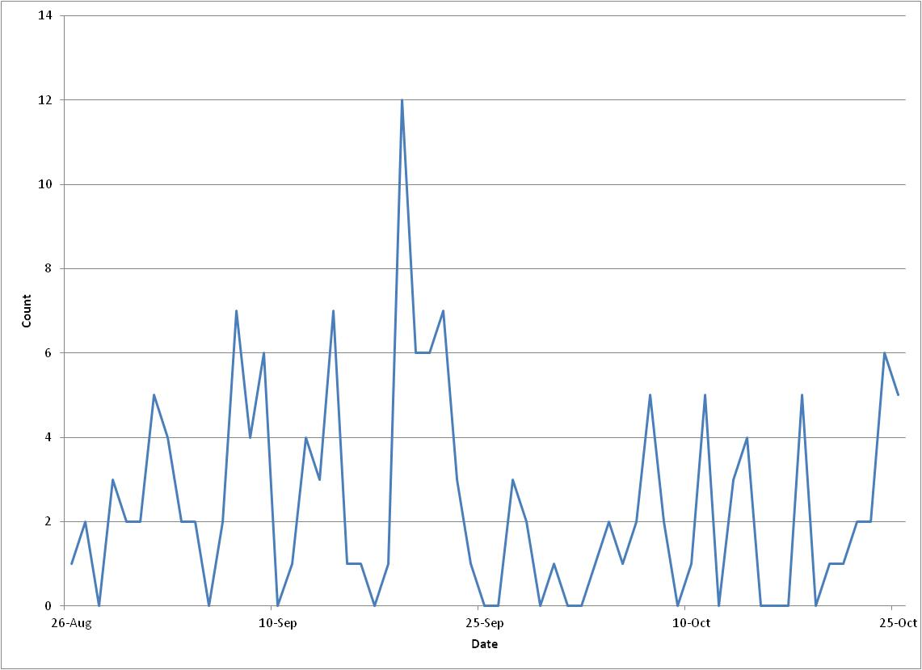

Figure 1: Frequency of Use During Initial Months of Pilot

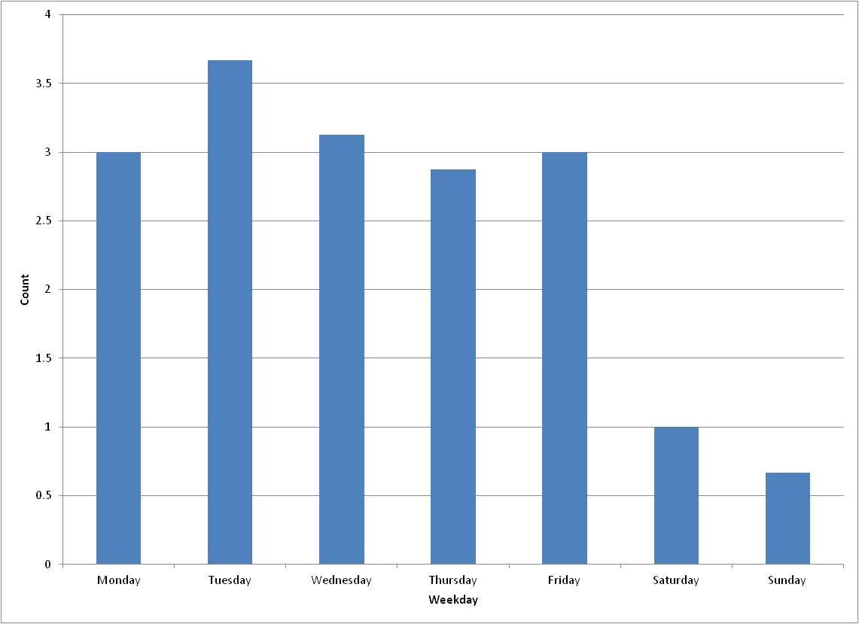

Figure 2: Average Number of Users per Weekday

1.6 Data Sources

Data collected through a variety of measures provides details for each trip by each user in the pilot program. This includes detailed transaction logs, global positioning system (GPS) data collected from the bikes, sensors to monitor battery power used during e-bike trips, and sensors to provide a measurement of pedaling force on the e-bikes. This information provides a source for analyzing system use and demand but also user behavior and performance while operating the bikes.

1.6.1 Kiosk Transaction Logs

The bike-share system is an automated process, allowing users to quickly select a bike for use or return a bike after use. Each transaction at the station kiosk, successful or not, is recorded automatically to a text file, which is used by the system software for a number of purposes during system operation. In addition, however, the kiosk log files provide detailed data about each transaction including date and time of transaction, referenced user data, selected bicycle, and other information regarding the specific transaction. An outline of the data recorded for each transaction is shown in Table 1.

Table 1: Recorded Kiosk Data
Data Field | Values or Value Types
Date | Date of transaction recorded in MM/DD/YYYY format.
Time | Time of transaction recorded in HH:MM:SS (AM/PM) format.
Transaction Type | 0 - Failed Transaction , 1 - Regular Bike Checkout, 2- Regular Bike Return, 3 - E-Bike Checkout, 4 - E-Bike Return.
User ID | User ID recorded.
User Type | 0 - Normal user, 1 - Administrator.
User First Name | References and records user first name.
User Last Name | References and records user last name.
Valid User? | 1 - Yes, 0 - No.
Bad ID Number? | 1 - Yes, 0 - No.
Scan ID Timeout? | 1 - Yes, 0 - No.
Transaction Cancelled? | 1 - Yes, 0 - No.
Bike Not in Rack? | 1 - Yes, 0 - No.
Vended? | 1 - Yes, 0 - No.
Scan ID Cancelled? | 1 - Yes, 0 - No.
Vend Timeout? | 1 - Yes, 0 - No.
Battery Not in Rack? | 1 - Yes, 0 - No.
Bike Slot | Records location on bike rack of bike vended or returned.
Bike ID | Records ID of bike vended or returned.
Battry Slot | Records location in battery rack of battery vended or returned.
Battery ID | Records ID of battery vended or returned.

1.6.2 GPS Data

In addition to transaction data recorded at the station kiosk, each bicycle in the system, e-bikes and regular bikes, is outfitted with equipment to receive and record GPS data. Table 2 details the National Marine Electronics Association (NMEA) sentences that are recorded for each bicycle type and the data that is obtained from those sentences, relevant to this work. All NMEA sentences are recorded for each position at a rate of one position fix per second.

Table 2: Recorded GPS Data
NMEA Sentences Recorded |  | Pertinent Data Recorded
Regular Bicycles | Electric Bicycles | Pertinent Data Recorded
GPGGA | GPGGA | UTC Time
GPGSA | GPGSA | UTC Date
GPGSV | PGRMF | Latitude (DDMM.MMMM)
GPVTG | PGRME | Longitude (DDDMM.MMMM)
PGRMB | PGRMV | HDOP (xx.x)
PGRME |  | VDOP (xx.x)
PGRMF |  | PDOP (xx.x)
PGRMV |  | Altitude (xxxx.x m) MSL
PGRMM |  | Fix type (none/2D/3D)
GPGLL |  | Est. horizontal position error (xxx.x m)
PGRMID |  | Est. vertical position error (xxx.x m)
 |  | Est. total position error (xxx.x m)
 |  | Speed over ground (kph, xxxx)
 |  | True E velocity (xxx.x m/s)
 |  | True N velocity (xxx.x m/s)
 |  | Up velocity (xxx.x m/s)

1.6.3 E-Bike Battery Monitoring

Each e-bike is powered by a 24 volt (V) / 10 ampere-hour (Ah) lithium-ion battery, which connects in the rear of the bike and supplies power to an electric motor. As users apply force to the pedals to propel the e-bike, the e-bike’s electric motor supplies an additional amount of power to assist the user and help propel the e-bike. The amount of additional power supplied through the motor is dependent on that supplied by the user.

Using hardware installed on the e-bikes to monitor current drawn from the batteries and the charge state of the battery, the power supplied by the battery at a given time is calculated using Equation 1.

$P_{B}=V_{B}×I$ (1)

Where V_{B} is the battery voltage at the current charge state, I is the measured current, and P_{B} is the resulting power applied by the battery. The additional power used to propel the bike is supplied by the user.

1.6.4 Torque Sensor

A torque sensor is used to monitor the force supplied by the user and provides a direct reading of the force on the e-bike’s chain. This reading is in volts, but the change in voltage reading on the sensor corresponds to a proportional change in the force applied to the chain. Each torque sensor reads 1.5V under zero load and must be calibrated, using methods provided by the bike manufacturer, to ensure accurate and consistent readings. Given the measured force on the chain, torque and the force applied by the rider are calculated using Equation 2.

$τ=F_{C}×R_{C}=F_{R}×R_{P}$ (2)

Where τ is the torque, F_{C} is the measured force on the chain, R_{C} is the radius around which the chain is tightened, F_{R} is the force applied by the rider, and R_{p} is the radius of the crank arm or the radius around which the pedal rotates.

An additional sensor installed on one bike will measure the speed at which the crank arm rotates. With this additional measurement, the power supplied by the user is then calculated based using Equation 3.

$P_{R}=τ×ω_{CR}$ (3)

Where ω_{CR} is the measured speed of the crank arm and P_{R} is the power generated by the user. This measurement will provide a baseline for verification of, or adjustment to, power calculations based on physics equations. To prevent sensor failure or inaccurate sensor readings due to accumulation of dirt or debris, this sensor will be monitored weekly and replaced as necessary.

1.7 Research Questions

The focus of this proposed research is to address the following question: As compared to regular bicycles in a bike-share system, do e-bikes promote greater physical health for the user population and do they reduce risk to user safety?

To address that research question, the following questions will be addressed:
- Do the benefits of travel by e-bike promote users to follow safer riding behavior, or are they more likely to engage in behavior that presents safety risks?
  - Do the benefits of travel by e-bike promote users to travel more on the roadway, or in bike lanes where available, and less on sidewalks or other less desirable travel paths?
  - Are e-bike riders more likely to make detours to travel in the correct direction of travel on a one-way street network?
  - Are e-bike users less likely to run red lights or stop signs?
  - Do e-bike riders travel faster?
  - Do e-bikes promote users to travel more on greenways, or bicycle paths, or more on roadways in mixed traffic conditions as these behaviors could have impacts to user safety [32-36]?
- Does the availability of the bicycle sharing system, itself, and the associated, required safety education promote safer riding behavior for users?
- Do e-bikes promote less physical activity, as a result of a reduction in effort and time of activity, than regular bikes?
- How does the choice of e-bike or regular bike impact the effect on life expectancy?
- How does the choice between these modes impact the risk of activity related diseases?
- How does exposure to harmful air pollutants differ between modes, and how does this impact user health?

1.8 Analysis Methods

1.8.1 GPS/GIS Trip Analysis

The proposed analysis of safety considers rider behavior while operating either an e-bike or regular bike. Since the two modes offer different performance characteristics, users of the two modes may exhibit different behaviors. As mentioned above, travel speed, route choice, adherence to traffic laws, and other behaviors have effect on user safety. The proposed research will utilize GPS data collected as part of the on-campus electric bike share project to evaluate relative safety of users of the two modes. Moreover, since this is a shared system, we will be able to observe how single individual behavior varies between bicycle types, since individuals will be able to choose different bikes for each trip.

Parameters collected from GPS on each bike are presented in Table 2. Based on timestamp values associated with each GPS data point collected, the GPS trip data will be matched to user information recorded at the kiosk, allowing analysis of each trip on a user-by-user basis. The data processing step will extract the relevant data from the recorded NMEA sentences and create a new data string for each data point collected, including user demographic information. Data is are then imported into geographic information system (GIS) software, ArcGIS, and overlaid on a detailed street network of the University of Tennessee and surround area in Knoxville, Tennessee. Figure 3: Schematic of GPS Data AnalysisFigure 3 summarizes this procedure.

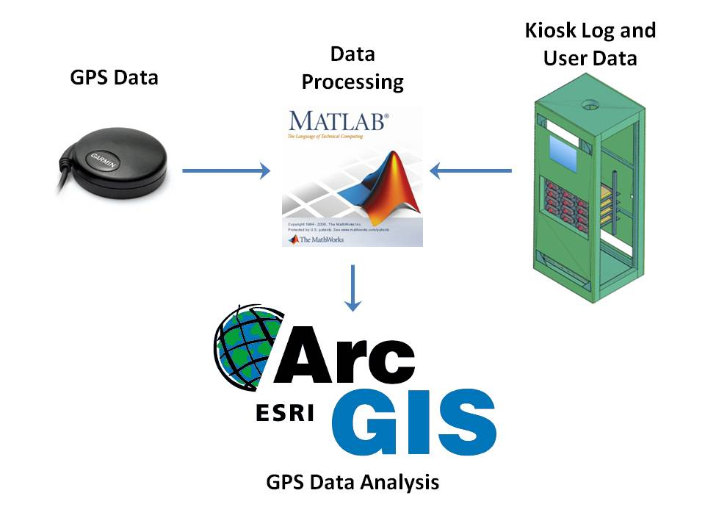

Figure 3: Schematic of GPS Data Analysis

Data are filtered based on (1) periods of actual e-bike or regular bike use and (2) dilution of precision values (HDOP, VDOP, PDOP). GPS data collection for e-bike trips only occurs when the e-bike is turned on since the battery powering the motor also powers the GPS receiver and other hardware; however, data collection on regular bikes is continuous as the GPS receiver and hardware are powered by separate batteries and must always be turned on. Periods of bike use are recorded in the kiosk log data along with the corresponding user and bicycle. Periods when the bike is not in use or when the bike is stationary for long periods of time, due to being parked at the end of a trip, are filtered out of the dataset prior to processing.

High dilution of precision values indicate unreliable GPS data, typically corresponding to a lack of satellite fixes on the receiver. Bicycles at the station are located under a canopy and are surrounded by several tall buildings, preventing low DOP values at startup. Furthermore, at origins with e-bikes, satellite fix is not likely to occur immediately, resulting in unreliable data. DOP is also represented in position error estimates. Figure 4 shows an example of typical position error estimates during a trip.

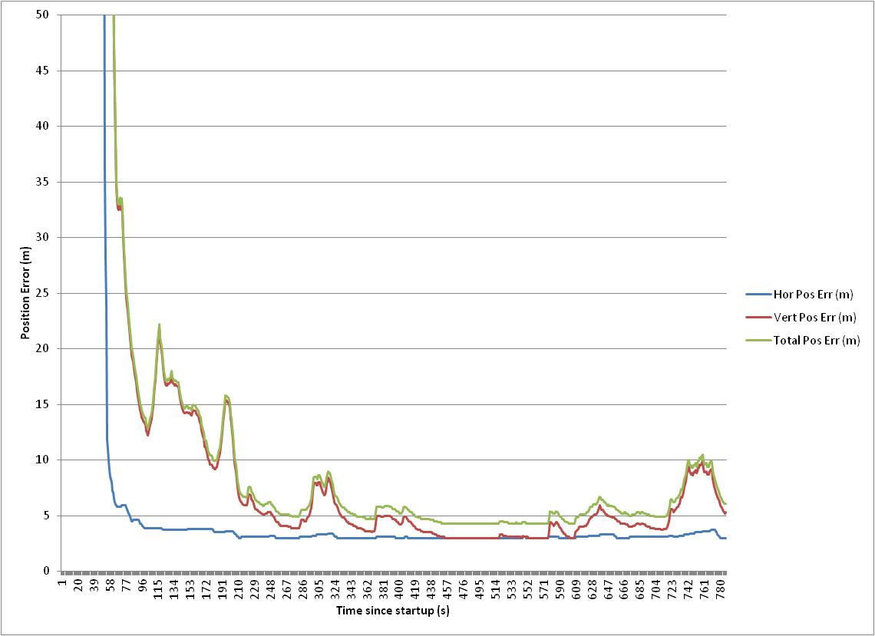

Figure 4: Typical Position Error Estimates During a Trip

The high position error estimated at the trip origin, 0 seconds, reflects the lack of satellite fixes due to the canopy and tall building near the station. Based on initial data, horizontal position errors of five meters or less and vertical position errors of ten meters or less are typical values for this receiver. High values indicate unreliable data and are filtered out of the analysis.

ArcGIS is then used to analyze the filtered and processed GPS data. The analysis will focus on six categories related to unsafe riding behavior, compared across bicycle types:

- Crossings –Signalized
  - Stopping and waiting on green signal
  - Crossing on red signal after stopping (legal in TN)
  - Crossing on red signals without stopping first
- Crossings – Stop control
  - Stopping at stop signs
  - Slowing at stop signs
  - Proceeding through stop control intersections without stopping or slowing
- Riding on sidewalks (to the extent distinguishable by GPS data resolution)
  - Riding on sidewalks (by direction)
  - Not riding on sidewalks
- Direction of travel
  - Riding against traffic (two-way traffic)
  - Riding against traffic (one-way traffic)
  - Diverting from shortest path to ride with direction of traffic (one-way or two-way)
- Speed
  - Speed at cross-streets where e-bike or regular bike has the right-of-way
  - Speed on shared use facilities, such as greenways
- Route choice
  - Greenway
  - Bike lanes or wide shoulder
  - Mixed traffic
  - Route diversion to avoid one-way streets
  - Route diversion to avoid undesirable terrain

Fixed signal timing patterns will be incorporated into the GIS network and used to compare bicycle travel through signalized intersections with green phases corresponding to the observed movements. Similarly, stop signs, sidewalks, greenways, bike lanes, one-way streets, and traffic direction will be coded into the GIS network. With this information, it can be determined where and when, the user engaged in risky behavior while operating the e-bike or regular bike. Statistical analysis will be incorporated to distinguish statistically significant differences in e-bike and bicycle risk-taking behavior based on observed occurrence per unit distance or time travelled.

1.8.1.1 Assessment of Bike-Share Influence

To further identify the impact of the bicycle sharing system on user safety and behavior, user surveys will be incorporated at periods before, during, and after the trial tests for new users of the system. These surveys will inquire about user perceptions, preferences, knowledge, and behavior in various situations where the user might face a decision involving risky behavior. These surveys will provide insight into the effect of the bicycle sharing program on user safety and the influence of provided training on user behavior and knowledge. It will also highlight areas in which additional bicycle safety education or other safety measures are needed.

1.8.2 Health

The comparison of health between e-bikes and regular bikes entails two components in this research: analysis of the physical activity health benefits of traveling by both modes and the exposure of the user to air pollution during the trip. Physical activity analysis for these modes is based on the amount of effort supplied by the user to propel each type of bicycle. Air pollution exposure analysis is based on intake fraction and concentrations of pollutants.

1.8.2.1 Bicycle Physics

The physical activity benefits to users of e-bikes and regular bikes are related to the power supplied by the user to propel the bicycle. To calculate these benefits, physics relationships, derived from Wilson et al. [37], to describe the forces acting on the bicycle are employed. The force applied by the user on the pedals to put the bicycle in motion must overcome resistive forces also acting on the bicycle to achieve motion. The force of propulsion, F_{P}, is given by Equation 4.

$F_{P}-\left(F_{A}+F_{S}+F_{R}+F_{B}\right)=F_{Acc}=ma$ (4)

Where F_{A} is the force of air resistance, F_{S} is the slope resistance, F_{R} is the rolling resistance from friction and deformation of the tire, F_{B} is bump resistance on rough surfaces, F_{Acc} is the additional force required to accelerate the bike, m is the total mass of the system, and a is acceleration.

To relate this effort to physical activity, however, power supplied by the user must be analyzed. The power applied by the rider, P_{R}, is calculated from Equation 5.

.$P_{R}η_{m}=P_{Wheel}=\left[K_{A}{\left(V+V_{W}\right)}^{2}+mg\left(s+C_{R}\right)+m_{eff}a\right]V$, (5)

Where η_{m} is the mechanical efficiency of the bike, P_{Wheel} is the power applied to the wheel, K_{A} is the aerodynamic drag factor, V is the velocity relative to the ground in m/s, V_{W} is headwind speed in m/s, s is the slope as a decimal (percent slope/100), C_{R} is the coefficient of rolling resistance, and m_{eff} is the effective mass in kg. Power is calculated in units of W.

The effective mass is the mass plus the kinetic energy of the rotation of the bicycle’s wheels, and given by the weight of the tires, rims, and one third of the spokes. Effective mass is slightly greater than total mass and in this case is considered negligible. System mass, m, refers to the mass of the bicycle, the user, and any other objects the user may have such as a backpack or purse. User masses can vary significantly and must be collected from users through surveys and associated with user ID numbers. These values can be obtained through surveys of new and current users regarding bike-share system influence on safety as described previously. Furthermore, a 10 lb or 4.5 kg additional weight will be assumed for all riders to account for backpacks or other objects the user may carry.

Since most users are not likely to use either type of bike in conditions of high wind speeds, averageAverage wind speed for the area will be used as V_{W}. Average wind speed for Knoxville, TN, varies between 5.5 and 8.4 mph depending on month of year [38]. Mechanical efficiency is typically between 0.85 and 0.97 for bicycles and will be assumed as 0.91. K_{A} for a typical, non-aerodynamic rider is 0.25. Assumed values for K_{A} and η_{m} will be refined based on P_{R} calculations from the torque sensor testing described above. C_{R} is calculated using Equation 6.

$C_{R}=0.005\left\{1+\frac{2.1}{ρ}\left[1+{\left(\frac{V}{29}\right)}^{2}\right]\right\}$, [39]

Where ρ is the bicycle tire pressure measured in bars.

Using data collected by GPS, bicycle velocity is obtained providing a basis to calculate power generated by the user each second during the trip. For regular bike trips, this calculation produces the actual power generated by the user. For e-bike trips, the power supplied to the motor must be subtracted from P_{R}.

1.8.2.2 Effects on Physical Health

Based on the power generated by the user to propel the bike, P_{R}, MET can be calculated using the relationship in Equation 7.

$\frac{P_{R}}{m×3600s}=MET$ (7)

In MET units, a comparison can now be made, through statistical analysis, between modes and for individual users in terms of life expectancy, risk of activity related disease, and calories spent during the activity to identify any statistically significant differences in these values.

Table 3: Benefits Associated with Varying Levels of Physical Activity
 | Life Expectancyª |  | Yrs w/o CVDª |  | LE w/ Diabetes (from norm)^{b}
PA Level | Men | Women | Men | Women | Men | Women
Low | - | - | - | - | - | -
Moderate | 1.3 yrs | 1.5 yrs | 1.1 yrs | 1.3 yrs | -0.5 yrs | -0.6 yrs
High | 3.7 yrs | 3.5 yrs | 3.2 yrs | 3.3 yrs | -0.1 yrs | -0.2 yrs

ªValues obtained from Franco et al. [20].

^{b}Values obtained from Jonker et al. [22].

1.8.2.3 Exposure to Air Pollutants

Travel times incurred by trips made with both types of bicycles also have influence on user exposure to harmful pollutants. Such exposure can have negative impacts on life expectancy and increase risk of disease or illness. Differences in performance between the two modes indicates differences in exposure times and breathing rates while exposed, influencing the amounts of pollutants inhaled by the user.

To analyze this exposure, the amount of pollutants emitted that are inhaled by the user, or intake fraction [40-43], is calculated using Equation 8.

$iF=\frac{\int_{People}{\int_{Time}{BR×C_{P}}}}{Q_{P}}$ (8)

Where iF is the intake fraction of a given pollutant, BR is the breathing rate of the rider, C_{P} is the exposure concentration of the pollutant at street level, and Q_{P} is the total mass of pollutant emitted. The resulting impact of exposure, EI, to a particular pollutant is calculated by Equation 9.

$EI=iF×E_{P}×X_{P}$ (9)

Where E_{P} is the emissions mass per unit time and X_{P} is the toxicity associated with the pollutant, such as effect on life expectancy or effect on disease risk due to exposure.

To determine how exposure to emissions varies between modes, volunteers who are current bike-share users will be randomly selected and asked to complete a course designed to represent a typical commute that they might take. At least 10 male and 10 female users will be selected. The users will be asked to complete the course once by regular bike and once by e-bike, on separate days to allow for full recovery between tests. BR, in terms of volume of air inhaled per unit time, for users will be measured at the halfway point and end of each course and used to determine their average breathing rate during the course. Ambient concentrations of pollutants are collected by local monitoring stations, and raw data is available online [44]. Exposure rates can then be modeled and applied to the full population of bike-share users to determine the full impacts.

Chapter 2: Characterizing Trips and Users of the On-Campus Electric Bicycle Sharing System

Abstract

The integration of electric bicycles (e-bikes) with bikesharing can potentially increase the utility of bike sharing by reducing some barriers to bicycling and increasing the amount of prospective users. North America’s first e-bike sharing system (cycleUshare) at the University of Tennessee, Knoxville, offers a new, sustainable transportation option for students, faculty, and staff. The cycleUshare system is a small pilot test with two stations to research the technology and user experiences. This paper presents an overview of the cycleUshare system and reports experiences from the first year of operation. With 93 enrolled users, cycleUshare provides a unique opportunity to study not only the system use, but also how individual users make trips with both regular and electric bicycles and the factors that influence those trips. The study finds that only 22% of users account for 81% of the trips. Factors of speed and convenience play major roles in participant’s decisions to use the system, and speed and comfort are the most influential factors in selection of an e-bike over a regular bicycle. Most of the reported trips are class related, although e-bikes are found to be used for a wide variety of trip purposes. Walking is the mode most displaced by the system indicating that e-bike sharing expands user mobility. Additionally user perceptions about bicycle types are explored. This model of electric bikeshare is found to be effective at attracting users to both regular and electric bicycles and is capable of expanding user mobility. This chapter is published in TRR as North America’s first e-bike share: A year of experience.

2.1 Introduction

In recent years, bikesharing systems have emerged around the world to offer users an innovative new mode of transportation for short trips [2, 45, 46]. Bikesharing systems have started in cities in the United States as well [1, 47, 48]. These systems offer their users shared use of a bicycle fleet and access to that fleet at multiple locations, bringing the benefits of active transportation and increased accessibility for users in urban locations. Bikesharing and non-motorized transportation also has potential benefits in terms of improvements to traffic congestion, air quality, and injuries or fatalities due to traffic crashes due to increased modal share [3, 29]. Still, some may not be drawn to bikesharing for a number of reasons including trip distances, terrain, or weather conditions [49].

Another emerging technology that may present an alternative for those individuals not inclined to participate in typical bikesharing programs is the electric bicycle, or e-bike. E-bikes have risen in popularity, primarily in China, but are slowly gaining attention in the United States and in other locations as well [50-52]. Pedal-assist e-bikes operate similarly to regular bicycles but with the addition of a small electric motor that delivers additional power to supplement that provided by the user. This assistance increases range and reduces some barriers, making them more attractive to the casual rider. In some cases e-bikes can replace bus or car trips [52-54]. Also, because pedal-assist e-bikes still require the user to supply power, they can provide similar benefits as regular bicycles [55]. Rose [54] discusses the impacts e-bikes use with regard to mobility, the environment, and health and safety and identifies the need for future research in these areas.

This paper presents early experiences from cycleUshare, an e-bike sharing system on the campus of the University of Tennessee-Knoxville (UTK) that combines bikesharing with e-bike technology. It discusses the electric bikeshare system, its operation and components, and experiences in operating and managing the system within the campus setting. This paper also gives some insights on the users and their trip characteristics during the first year of operation. Lastly, the next steps for the e-bike sharing project, and e-bike sharing in general, are described.

2.2 E-bike Sharing at UTK

In August 2011, North America’s first electric bikeshare program, cycleUshare, launched on the campus of the UTK as a pilot project [56]. Currently, there are two stations with a capacity of 20 bikes (a mix of e-bikes and regular bicycles). The project merges bikesharing and e-bikes to provide users on campus with a sustainable, alternative mode of transportation suitable for many trips around and near campus. This combination of technologies can improve the depth of penetration of bikeshare systems to a new class of users by overcoming some barriers to traditional bicycling. In the case of UTK, e-bike sharing is particularly attractive because of the hilly terrain, a long distance between campus destinations, the large number of students using cars and buses to travel between campuses, and the relative shortage of parking. The project is open to all students, faculty, and staff of UTK, and registration is free, though enrollment is capped to not overload the system [57].

The project provides a unique opportunity to study how bicycles and e-bikes are used within the campus bikeshare system. Of the many research goals associated with the project, one is to study the technical and operational feasibility of the system and evaluate its role as a transportation alternative. Data for this research is drawn primarily from three sources. The first is the transaction log recorded by the system for each transaction that occurs including bicycle check-out, bicycle check-in, and errors. The transaction log provides a detailed description of each transaction type with the time, date, user identification, bicycle type and number, battery if vended, and error type if one occurred. The second data source is GPS data collected from bikes equipped with GPS equipment that collected data from all trips on equipped bikes. These data allow researchers to investigate specific trip routes, speeds, and terrain. The GPS data are supplemented with a third data source, a survey of current cycleUshare users. All existing users of the system were contacted between May 2012 and July 2012 to participate in a survey about their travel behavior and perceptions while using cycleUshare bicycles or e-bikes. Questions related to user travel behaviors were based on GPS data collected from the individual users’ trips. Up to five trips were investigated in-detail for each user. 22 users participated in the surveys, representing 24% of the total population of current users. The survey participants were regular users, accounting for 57% of all trips made with the system’s bicycles. Survey respondents are 59% male and 82% of them are current students.

2.3 Unique Challenges

The incorporation of e-bikes into a bikeshare system introduces some unique challenges not experienced with the sharing of regular bicycles only. E-bikes are hybrid vehicles, utilizing both user supplied power and power supplied from the onboard motor. The e-bike motor operates using energy from a rechargeable battery. This means not only securing and managing the bicycles in the system, as is done with typical bikeshare systems, but also providing a means for charging and distributing the e-bike batteries. Bikeshare stations that include or accommodate e-bikes must allow for the charging of batteries either onboard the e-bike or through a battery dispensing system that charges, secures, and maintains an entire bank of batteries.

Another complicating factor at cycleUshare is that the system provides users access to both e-bikes and regular bicycles at the same station. Bicycle types are tracked by respective locations on the bicycle rack. These locations are updated automatically upon check-out and check-in. Failure to successfully track the bicycle type by location at the rack can result in the incorrect vending of bicycles to users and can create errors within the system software.

2.4 System Design

The typical components of the e-bike sharing system are the bicycles or e-bikes, a vending and charging station, and a back-office support system. FIGURE 5 (a) displays the configuration of these components at one of the e-bike sharing stations. The e-bike station, itself, serves multiple purposes. Similar to other non-electric bike sharing stations, the e-bike station provides security for the bikes not in use and access to the bikes at the station through a vending process. Unlike the non-electric bike sharing systems, the e-bike station is tasked with differentiating bicycle types, regular bicycle and e-bike, at both bike check-out and check-in. This difference is also important as the e-bike station also vends a battery for users selecting an e-bike. When users select an e-bike, they are also vended a charged battery through an automated process. The kiosk software tracks the transaction and logs the specific e-bike and battery vended to the user. This is also recorded upon check-in for the e-bike.

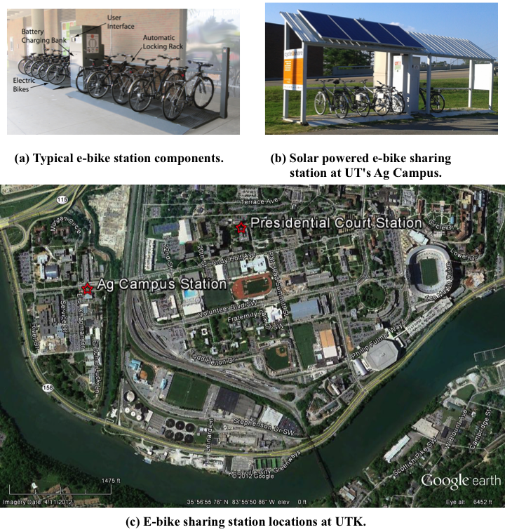

FIGURE 5 E-bike station components and locations, parts (a), (b), and (c).

The e-bike sharing system at UTK currently consists of two stations, each with a kiosk and user interface. The station is operated through a touch-screen and user-identification is achieved through scanning the University’s magnetic student/staff identification card. Each station has the capacity for ten bicycles but can be expanded. The typical bicycle fleet at each station is seven e-bikes and three regular bicycles, although this ratio varies due to bicycle and station maintenance. The locations of the current e-bike sharing stations are depicted in FIGURE 5 (c).

The first station is located at Presidential Court, central to the University’s main campus and provides access to student residence halls. This station was opened to users in August 2011 and has accounted for 91% of all trips to date. The Presidential Court station allows for the charging and dispensing of 12 batteries through grid-tied power. This station is available to users 24 hours each day.

The other e-bike sharing station is located on the University’s Agricultural (Ag) Campus, depicted in FIGURE 1(b). This station opened to users in April 2012 (near the end of the academic year). While still providing access to students, this station’s location provides improved access to e-bike sharing for faculty members and other professionals on campus in addition to access from a large surface parking lot. This station is also placed adjacent to Knoxville’s busiest greenway. The Ag Campus station has the capacity to charge and dispense 15 batteries. It operates completely on solar power, provided by photovoltaic panels (~1kW array) installed on the rooftop of the station itself. To manage power demand, this station is only available to users from 6:00AM to 10:00PM. All other aspects of the Ag Campus station are the same as those of the Presidential Court station.

The current station configuration does not allow for bicycles to be exchanged between the stations, while most bikeshare systems allow this. Only round trips returning to the station of origin are allowed, potentially limiting the number and type of trips. Future generations of the e-bike sharing stations and software are expected to allow for one-way trips. Users are instructed to adhere to a 4-hour time limit for checkouts (though there is no penalty for keeping it longer for this pilot test). To allow for safe parking of bikes away from the station, a lock is attached to each bike, and users are provided lock combinations when they enroll in the program.

The fleet technology mix allows for comparisons on user preferences and demand for each bicycle type. The e-bikes are pedal-assist e-bikes, meaning that they must be pedaled for motor assistance and function similarly to regular bicycles. The e-bikes also have controls for adjusting motor assist, allowing users to change between five different assist levels. The e-bikes use 24V, 10Ah batteries, which are charged by the station kiosk and dispensed to the user along with the e-bike. The battery connects to the rear of the e-bike to provide power to the e-bike motor (250W) when the user begins pedaling. For a 10-15 mile trip, which is approximately the range of a full battery, 0.024KWh of electricity is used. If a user loses battery power during a trip, the e-bike still functions as a regular bicycle, allowing the user to complete the trip or return to the station. Due to the additional weight of the e-bikes and the batteries, however, a loss in motor assistance increases the effort required by the user. The regular bicycles available in the e-bike sharing system are 24 speed bicycles.

2.5 Operational concept

CycleUshare is an entirely automated e-bike sharing system. From the user’s perspective, the system operates by a touch screen that presents the user with options during the bicycle check-in or check-out procedure. After the user indicates that he or she wants a bicycle, the system requests the user’s identification be swiped. This allows for tracking of the bicycle and battery involved in the transaction. Only one bicycle, either an e-bike or a regular bicycle, is released for the user, and the user is directed to that bicycle by the kiosk screen and by an indicator on the bicycle rack. Similarly, if users select an e-bike, they are directed to a specific battery for their trip based on the battery having a minimum (80%) state of charge to guarantee a ten-mile range.

Check-in transactions proceed in reverse of the check-out transaction. Once users return a bicycle to the station, the kiosk requires the user to swipe his or her identification. This allows the system to correctly identify which bicycle (and bicycle type) was returned and allocate the bicycle to a specific place on the bicycle rack. If the user returns an e-bike, the system then asks that the battery be returned to the battery rack and is automatically docked for charging. In both check-in and check-out, the procedure is designed to be simple with built-in error handling if a user does not follow procedures correctly. Still, unanticipated user errors abounded and caused substantial maintenance requests.

Users of cycleUshare must be a student, faculty, or staff member at UTK. Registration in the project is free and can be done through the project’s website [57]. The system currently has 93 users enrolled, with a several hundred potential users on a waitlist. Prior to becoming a registered user in the program, each potential user must watch mandatory videos about proper use of the e-bike sharing system and about safety while operating the bicycles. All users must be 18 years or older and agree to the terms and conditions of the program, including a waiver of liability, and consent to participate in a research project.

The rules of the program are intended to promote safe use of the bicycles in accordance with University rules. The bicycles in the program cannot be taken outside the city limits of Knoxville, TN, and must be returned to the e-bike sharing station within the specified time limit. Participants agree that they will be the sole users of the bicycles and that while operating the bicycles they will obey all traffic laws and safety rules. Participants also agree to inspect the bicycles before and after use to ensure proper working condition. Participants are encouraged, but not required to wear a helmet. In practice, almost no users wore helmets on either bicycle type.

2.6 System Performance

Data collected through the e-bike sharing systems transaction logs provide a resource to analyze how the system is utilized by the users. Tracking transactions by bicycle type reveal the demand for each bicycle type. FIGURE 2 depicts the number of e-bike and regular bicycle check-outs over the initial months (academic year) of the program along with the increase in registered users during that time. The users were gradually added to the system to allow the research team to monitor technical performance and troubleshoot problems as they arose. Notably, use was high when the project started but diminished as the weather got colder in October and November 2011. There were no check-outs during Winter break, but usage increased again rapidly in the Spring as the weather got warmer, with the exception of few check-outs during spring break in March. During this eight-month period, there were approximately 900 checkouts, nearly two thirds were e-bikes.

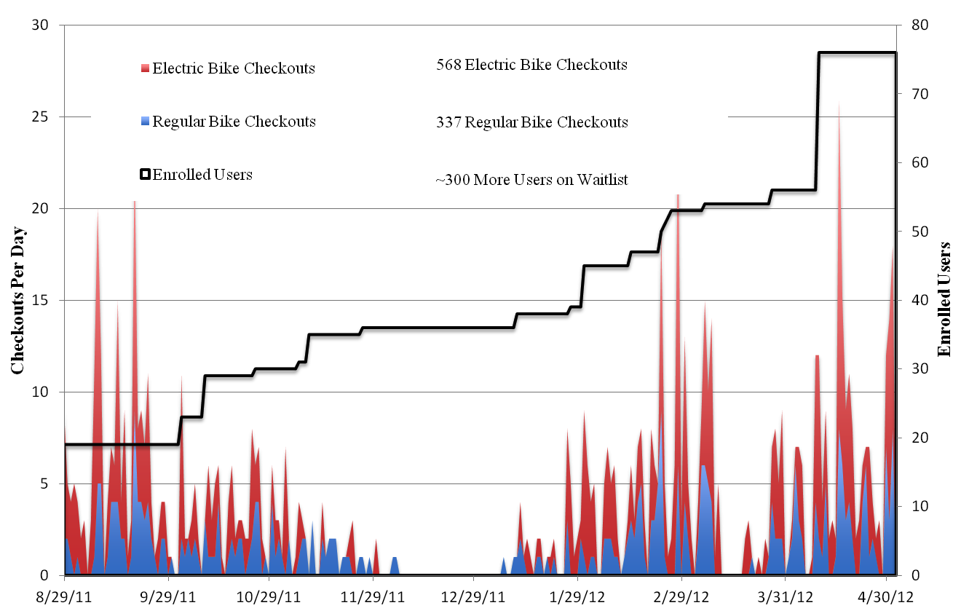

FIGURE 2 User enrollment and transaction history.

Of key interest is who actually uses the system. A small percentage of users are actually responsible for most of the system’s usage, with most users contributing only a very small number of trips. Analysis of transactions reveals that 22% of users are responsible for 81% of all trips made using the e-bike sharing system. For only those trips on e-bikes, 21% of users make 80% of trips; and for only trips by regular bicycle, only 11% of users make 80% of the trips. FIGuRE 3 shows the percentage of trips contributed by each user.

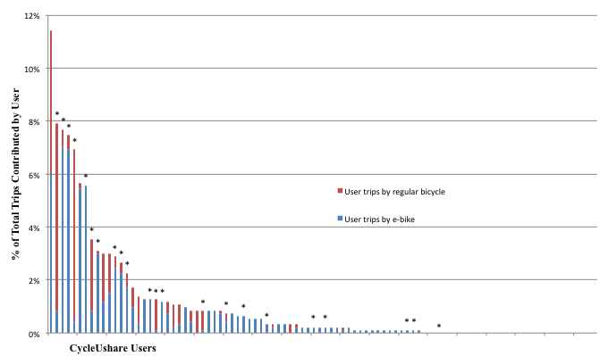
*Indicates user participated in survey.

FIGURE 3 Percentage of trips by each user.

The percentage of trips by bicycle type not only varies by individual but also by station of origin. At the Presidential Court station where most of the trips originate, 62% of check-outs are for e-bikes and 38% are for regular bicycles. At the Ag Campus station, 92% of check-outs are for e-bikes and only 8% are for regular bicycles. This large difference in preferences could be explained by the populations primarily using the stations. More students use the Presidential Court station, while more faculty and staff use the Ag Campus station. Another possible explanation is the length of time the stations have been operational. The Presidential Court station has been in operation longer allowing a larger variety of users to use the station. While there are currently 93 active users, approximately 1/3 of those users were enrolled since the opening of the Ag Campus station, and, unfortunately, less data is available about those users and their trips.

2.7 User Surveys

From user surveys conducted from May through July 2012, user behaviors and perceptions are analyzed. The 22 users (57% of trips) participating in the survey were asked about perceptions of the system and were also asked to recall recent specific trips they took using the bicycles and e-bikes from the sharing system based on GPS and kiosk data from their trips. TABLE 4 outlines the user characteristics for those participating in the survey. E-bikes constituted 64% of trips in the survey and 36% of the trips studied were regular bicycle trips. 88% of those trips originated from the Presidential Court station because of the longer installation on campus. The trips occurred between March 2012 and June 2012.

TABLE 4 Sample of CycleUshare User Characteristics
Category | Members (%)
Age | N = 22
18-20 | 55%
21-25 | 27%
Older than 25 | 18%
Status | N=22
Student | 82%
Faculty/Staff | 18%
Sex | N=22
Male | 59%
Female | 41%
Ethnicity | N = 22
White/Caucasian | 82%
Black/African American | 9%
Hispanic | 9%
Native American | 0%
Asian | 0%
Pacific Islander | 0%
BMI^{a,b} | N=20
Underweight (BMI value less than 18.5) | 5%
Normal (BMI value 18.5 - 24.9) | 55%
Overweight (BMI value 25.0 - 29.9) | 35%
Obese (BMI value 30.0 or above) | 5%
Bicycle access and ownership | N=22
Currently owns a bicycle | 41%
Currently owns an automobile | 86%
Access to a bicycle other than e-bike-share | 68%
ªValues calculated using CDC formula for Body Mass Index (BMI) [58].
^{b}BMI values of users from this study (Mean=23.49, Std. Dev=3.36) were statistically the same as a sample of 1100 entering freshman in 2006 (Mean=23.41, Std. Dev=4.48)

For each trip studied in the survey, users were asked to describe their trip purpose and their alternative mode for that trip. TABLE 5 presents the trip characteristics for the trips in the study. The most common trip purpose is class related trips, accounting for 40% of all trips. For trips by regular bicycle, class related trips account for 57% of all trips studied. Trips by e-bike are more varied in purpose, although the most common trip purpose is still class related. Although this study focuses on a campus environment, the large percentage of school or class related trips corresponds well to the large percentage of work or school trips observed in other bikeshare systems [47].

The second most common trip purpose is exercise or leisure with 15% of all trips. Of note is that 29% of female regular bicycle users reported making trips for exercise or leisure while only seven percent of male regular bicycle users reported this for a trip purpose. A number of e-bike trips, 16%, were reported as personal trips, while no regular bicycle users reported personal reasons as a trip purpose. Users making e-bike trips averaged slightly higher BMI values. Male users also average slightly higher BMI values among both e-bike and regular bike users.

TABLE 5 Sample cycleUshare Trip Characteristics
 | E-bike trips |  |  |  | Regular-bicycle trips
 | All | Male | Female |  | All | Male | Female
Trip attribute | N=37 | N=25 | N=12 |  | N=21 | N=14 | N=7
Trip Origin (% of total trips)
Presidential Court | 52% | 36% | 16% |  | 36% | 24% | 12%
Ag Campus | 12% | 7% | 5% |  | 0% | 0% | 0%
Average trip length, (m)ª | 2025  (953) | 2090  (836) | 1864  (1236) |  | 1796  (703) | 1913  (587) | 1563  (899)
Average active trip time, (minutes) ª | 13.07  (8.19) | 13.45  (7.16) | 12.12  (10.76) |  | 10.61  (5.42) | 11.49  (4.66) | 8.85  (6.74)
Average check-out duration, (minutes) ª | 73  (86) | 86  (98) | 40  (33) |  | 140  (129) | 118  (64) | 178  (200)
Average BMI value  for users ^{a,b} | 24.33  (3.17) | 24.98  (3.34) | 22.69  (2.03) |  | 22.74  (3.31) | 23.97  (3.31) | 20.27  (2.09)
Trip purpose
(% of total trips by category)
Class | 30% | 36% | 17% |  | 57% | 57% | 57%
Exercise or leisure | 16% | 16% | 17% |  | 14% | 7% | 29%
Food | 14% | 12% | 17% |  | 10% | 14% | 0%
Library/Study | 14% | 8% | 25% |  | 14% | 14% | 14%
Personal | 16% | 12% | 25% |  | 0% | 0% | 0%
Home | 8% | 12% | 0% |  | 5% | 7% | 0%
Unknown | 3% | 4% | 0% |  | 0% | 0% | 0%
Alternative mode for trip
(% of total trips by category)
Walk | 57% | 52% | 67% |  | 62% | 50% | 86%
Personal Bike | 11% | 16% | 0% |  | 19% | 29% | 0%
Bus | 11% | 4% | 25% |  | 10% | 14% | 0%
Car | 11% | 12% | 8% |  | 0% | 0% | 0%
Other | 0% | 0% | 0% |  | 0% | 0% | 0%
No Trip | 11% | 16% | 0% |  | 10% | 7% | 14%
ªStandard Deviation in Parenthesis
^{b}Values calculated using CDC formula for Body Mass Index (BMI) [58].

Of the trips analyzed in the surveys, e-bike trips averaged 13% longer than regular bicycle trips although a wide range of trip lengths were observed. On average, check-out durations are nearly twice as long for regular bicycles compared to e-bikes, 2hrs 20mins compared to 1hr 13min. E-bike trips also had longer active trip times than regular bicycle trips although, again, a wide range of trip times were observed. Longer trip lengths for e-bike trips seem to be the result of added stops during the trip. Users of regular bicycles tend to have singular destinations, where e-bike users often reported multiple destinations during the same trip. This is also evident in the GPS data for these trips. In addition, e-bike users are able to travel greater distances in shorter periods of time, although on a campus setting the check-out duration may be related to class length or other factors.

The most displaced mode, by far, is walking with 58% of all respondents saying that walking would be their alternative mode. That number increases to 64% when considering only students. Displaced walking trips were most commonly reported by female regular bicycle users (86%) with female users indicating that the remaining trips (14%) would not have been made without the e-bike sharing system in place. The factors of speed and convenience as major influences in using the e-bike sharing system make the displacement of many walking trips obvious. This corresponds to research on other bikeshare systems that found bikeshare users decrease the amount of walking trips [47].

Among trips by male users, 16% of e-bike trips and 29% of regular bicycle trips would be replaced with trips using their personal bicycle. No female users of either bicycle type reported their personal bicycle as an alternative mode. During the surveys, several users indicated that they do not have access to a bicycle other than through cycleUshare. Prior to cycleUshare, the average time since last using a bicycle was 2.5 years, with some users reporting up to 12 years since they last used a bicycle. The most common groups reporting bus as an alternative mode were female e-bike users (25%). Only 4% of male e-bike users reported bus as an alternative mode, although 14% of male regular bicycle users would use this mode.

Surprisingly, no regular bicycle trips displaced car trips where 11% of e-bike trips displaced car trips. This might be related to the number of e-bike users who reported multiple destinations for the same trip. Furthermore, users reported that 11% of e-bike trips and 10% of regular bicycle trips would not be made without the e-bike sharing system in place. All but one person replying that they would have not made the trip without the e-bike system are faculty or staff members.

Users were also asked why they chose a particular bicycle type for each trip and why they used the e-bike sharing system for that trip. The factors influencing those decisions are presented in

TABLE 6. The most common reasons for choosing an e-bike over a regular bicycle are that e-bikes are seen as more comfortable (35%), they are perceived as faster (24%), and they are considered to require less energy from the user (22%). Comfort is the most common factor for both men and women e-bike users; however, speed is second most common among men (28%) while requiring less energy is second among women users (25%). The value of comfort is obvious in one user’s statement:

“I appreciate bike-sharing because I have herniated discs in my back and the bikes allow me more mobility so I don’t have to walk everywhere.” –Anonymous cycleUshare user.

TABLE 6 Factors Influencing cycleUshare User Bicycle Choice
 | E-bike trips |  |  |  | Regular bicycle trips
 | All | Male | Female |  | All | Male | Female
Trip attribute | N=37 | N=25 | N=12 |  | N=21 | N=14 | N=7
Why user chose bicycle type?
(% of total trips by category)
It is faster | 24% | 28% | 17% |  | 43% | 50% | 29%
It provides exercise | 0% | 0% | 0% |  | 0% | 0% | 0%
I had extra time | 3% | 0% | 8% |  | 10% | 0% | 29%
I had a load to carry | 3% | 4% | 0% |  | 0% | 0% | 0%
It is comfortable | 35% | 32% | 42% |  | 5% | 7% | 0%
It requires less work/energy | 22% | 20% | 25% |  | 10% | 14% | 0%
I was making a long trip | 5% | 8% | 0% |  | 0% | 0% | 0%
I dislike the other bicycle type | 0% | 0% | 0% |  | 29% | 21% | 43%
My preferred bicycle type was not available | 5% | 8% | 0% |  | 0% | 0% | 0%
Other | 3% | 0% | 8% |  | 5% | 7% | 0%
Why user chose to use e-bike share for trip?
(% of total trips by category)
It is faster than my alternate mode | 51% | 64% | 25% |  | 48% | 36% | 71%
It provides exercise | 3% | 4% | 0% |  | 14% | 21% | 0%
It requires less energy than my alt. mode | 19% | 12% | 33% |  | 0% | 0% | 0%
It is convenient | 24% | 16% | 42% |  | 29% | 29% | 29%
It is free | 0% | 0% | 0% |  | 0% | 0% | 0%
It is better for the environment than my alternative mode | 0% | 0% | 0% |  | 0% | 0% | 0%
I do not have a bicycle | 0% | 0% | 0% |  | 0% | 0% | 0%
I do not have a car | 0% | 0% | 0% |  | 0% | 0% | 0%
I do not have to worry about parking | 3% | 4% | 0% |  | 0% | 0% | 0%
Other | 0% | 0% | 0% |  | 3% | 3% | 0%

Of users making a trip by regular bicycle, 43% responded that they selected that bicycle type because they perceive those bicycles as faster than e-bikes. This alludes to the division of opinion between users of the two bicycle types. The second most common reason for choosing a regular bicycle is that the user dislikes the other bicycle type. 29% of users selecting a regular bicycle responded that they dislike using e-bikes.

When asked why the user chose to use the e-bike sharing system for a particular trip, 51% of e-bike users and 48% of regular bicycle users responded that it was faster than their alternative mode, which for most users is walking. Convenience of the system was also an important factor. Of those trips by e-bike, 24% stated convenience as the reason for using e-bike sharing while 29% of those taking regular bicycles stated convenience as their reason. Only 3% of e-bike users and 14% of regular bicycle users said they use the system for exercise, and no one said they use it purely because it is better for the environment than their alternative. Male users are more likely to use e-bike sharing because it provides exercise. No female users of either regular bicycles or e-bikes stated that they use the system, itself, because it provides exercise.

2.8 User perspectives

In addition to reviewing actual trips, users were asked a number of questions related to their perceptions of regular bicycles and e-bikes. Questions required a 1-5 Likert scale response (Strongly Disagree to Strongly Agree). The results are widespread for most questions, although some have clearer strength of preference. TABLE 7 summarizes user perceptions about the two bicycle types utilized at cycleUshare by gender.

TABLE 7 CycleUshare User Perceptions About E-bikes and Regular Bicycles
E-bikes are more attractive because…ª |  | Strongly agree (%) | Agree (%) | Neutral (%) | Disagree (%) | Strongly Disagree (%)
They remove terrain barriers |  | 59% | 18% | 9% | 0% | 14%
 | Male | 54% | 23% | 8% | 0% | 15%
 | Female | 67% | 11% | 11% | 0% | 11%
Are easier to ride in traffic |  | 9% | 23% | 45% | 23% | 0%
 | Male | 15% | 31% | 31% | 23% | 0%
 | Female | 0% | 11% | 67% | 22% | 0%
Are easier to start at signals or stop signs |  | 32% | 32% | 18% | 9% | 9%
 | Male | 46% | 31% | 8% | 15% | 0%
 | Female | 11% | 33% | 33% | 0% | 22%
I can travel farther |  | 64% | 9% | 9% | 18% | 0%
 | Male | 69% | 8% | 8% | 15% | 0%
 | Female | 56% | 11% | 11% | 22% | 0%
Regular bicycles are more attractive because…ª |  | Strongly agree (%) | Agree (%) | Neutral (%) | Disagree (%) | Strongly Disagree (%)
They are lighter and more maneuverable |  | 41% | 23% | 9% | 18% | 9%
 | Male | 38% | 8% | 8% | 31% | 15%
 | Female | 44% | 44% | 11% | 0% | 0%
They provide more exercise opportunities |  | 27% | 5% | 27% | 32% | 9%
 | Male | 15% | 0% | 31% | 38% | 15%
 | Female | 44% | 11% | 22% | 22% | 0%
They are better for the environment |  | 18% | 5% | 41% | 27% | 9%
 | Male | 15% | 0% | 38% | 31% | 15%
 | Female | 22% | 11% | 44% | 22% | 0%
I don't have to worry about battery range |  | 18% | 9% | 9% | 50% | 14%
 | Male | 15% | 8% | 0% | 77% | 0%
 | Female | 22% | 11% | 22% | 11% | 33%
ª N=22 for all fields.

One of the motivations for creating the e-bike sharing system was to attract additional users who may not otherwise ride a bicycle due to terrain barriers. Most (77%) respondents either agree or strongly agree that e-bikes are more attractive than regular bicycles because they remove terrain barriers. Responses were similar between male and female users on this issue with 54% of males and 67% of females strongly agreeing. Only 14% of users strongly disagree that e-bikes are more attractive because the remove terrain barriers. Responses from users point out that the performance of the e-bike motor is a factor:

“If the motor on the e-bike is working, I don’t notice the difference in weight.” -Anonymous cycleUshare user.

“For exercising, I like to walk about two miles each day, but the e-bike is great because I can go farther and not worry about going up hills.” -Anonymous cycleUshare user.

Male users have stronger impressions than female users that e-bikes are more attractive because of their ease of use in traffic situations. Nearly half (31% of male users agree and another 15% strongly agree) think that e-bikes are more attractive because they are easier to ride in traffic. Women are more neutral on this issue. Also, 31% of male users agree and another 46% strongly agree that e-bikes are more attractive because they are easier to start at stop signs or traffic signals. Among women, only 11% strongly agree with this statement, 33% agree, and another 22% strongly disagree.

One of the possible advantages of regular bicycles is that they are lighter and thus more maneuverable. 64% of those surveyed either agree or strongly agree with that statement. Among users who only ride e-bikes, only 10% agree with that statement. Female users largely agree with this as 88% of female users either agree or strongly agree. Male users, however, are split on this issue as 46% agree or strongly agree while 46% disagree or strongly disagree. Other advantages of regular bicycles are they provide increased exercise opportunities and are better for the environment. Users are largely neutral on these issues, although 44% of women do agree that regular bicycles are more attractive as they provide more opportunity for exercise. As one user stated:

“When going long distances it is better to have a battery, but normally I like the other bikes for exercise.” -Anonymous cycleUshare user.

Lastly from these results, range anxiety does not appear to be an issue for most users. 73% of users agree or strongly agree that e-bikes are more attractive than regular bicycles because they can travel farther with an e-bike. Only 18% of users disagree with that statement. Those users who only ride e-bikes all strongly agree with that statement. On a related question, 64% of users disagree or strongly disagree that regular bicycles are more attractive because battery range is not an issue with those bicycles. This would indicated that one of the biggest factors in choosing either an e-bike or regular bicycle is the additional mobility gained from using an e-bike.

2.9 Challenges

A number of challenges arose during the development of the e-bike sharing system. Some of these were discussed previously in the challenges when describing operational requirements of sharing of e-bikes. Many other issues presented themselves during operation of the system. System software to accomplish the management of the bicycles and batteries in addition to operation of the kiosk and user interface proved to be the most problematic issue. Prior to system deployment, the developed software was tested under various expected conditions and for various foreseen user related problems; however, throughout the operation of the system a number of other errors have occurred. To account for these problems, software development for the system is an ongoing process and new software versions are continually installed.

Tied very closely to the software problems are user generated errors. User errors are a persistent problem, even after user education on system use and modifications to the software. The most common user related errors are related to the check-out or check-in of a bicycle or e-bike. Correct system operation relies on users to swipe their identification at both check-out and check-in for proper allocation of the bicycles and batteries in the system. Users often complete this step at bicycle check-out but fail to do so at bicycle check-in. This creates problems tracking bicycles since the they do not have identification hardware (we rely on user check-ins) and there are two types of bicycles in the system that require tracking.

The station hardware also proved problematic at times. Hardware problems have generally centered on sensors used within the station to detect the presence bicycles in the station’s bicycle rack or the presence of batteries in the kiosk battery rack. Maintenance to the bicycles and e-bikes in the system has often created challenges, particularly for e-bikes. Both bicycle types require regular maintenance to ensure proper performance. The e-bikes also rely on several additional mechanical and electrical components to function properly. Maintenance, repair, or sometimes replacement of these components is often necessary. Adding e-bikes to a bikeshare system increases complexity, maintenance requirements, and costs compared to standard bikeshare systems.

Compliance with the rules of the e-bike sharing system were minor challenges. Most trips are within the allowed time and distance; however, a few problems have occurred with users not obeying the time constraints in the conditions of use. Although these occurrences are few in number, they typically involve the same users. Vandalism, to this point, has not been a major problem, although a few rare instances have occurred. Most instances of vandalism have caused minor damage to the bicycles themselves. No vandalism or damage has occurred to either station.

2.10 Conclusions and Next steps

The model of bikesharing deployed at UTK is effective at attracting users to both regular bicycles and e-bikes as the qualities of each attract different types of users to the program. In the campus setting, most regular bicycle trips are shown to be of shorter distances and with a singular purpose. E-bike users can travel greater distances under a shorter timeframe allowing for additional stops. While the destinations for most trips in this study are class-related, a number of them included a destination off-campus. The extended mobility provided by the e-bike sharing system allows users to make trips off-campus without moving their car or waiting for the bus. Trips by e-bike are shown to have a wider variety of trip purposes than regular bicycle trips.

Considering that most e-bike trips are displacing walking trips in the campus environment, e-bike sharing greatly expands user mobility, though perhaps it does not have a strong positive influence on reduced environmental impacts of the transportation system. Based on user responses, the extended mobility and removal of terrain barriers are major advantages to the e-bikes. Male and female user responses were comparable on many issues; however, with regard to regular bicycles, a larger number of female users agree that they are more attractive than e-bikes because they are more maneuverable and because they provide more exercise opportunities. Also, users are shown not to have range anxiety over e-bike batteries, possibly because most trips are short distance.

Despite operational challenges, cycleUshare has largely been a success at the UTK. It has attracted new users to cycling and given expanded mobility to the students, faculty, and staff at the University. Interest in the program has steadily risen over the first year of operation, and, with the rise in registered users and increased demand at e-bike sharing stations, new challenges have evolved. Moreover, it has provided an educational platform to introduce alternative modes of transportation and alternative vehicle technologies to thousands of students and staff.

The next phases of development include producing an open source version of the e-bike sharing system that will be available to communities, organizations, and other groups with an interest in operating a similar system. An open source model will allow expansion of the system to other locations using the model developed at UTK. With this open platform, others can improve upon the existing design, allowing for constant evolution from the user community. System software is currently being redeveloped to produce a more user friendly and error free interface. Hardware is also being redeveloped to allow easier installation and maintenance. Last, the research associated with this project continues and additional phases of research are planned. The next phases of research include a pricing experiment and continued user behavior research related to health and safety behavior. Some say that widespread e-bike share is inevitable. In parallel, several groups are developing e-bike sharing solutions, including City Carshare (San Francisco), Sanyo (Japan), Velopass (Switzerland), Intrago, and Bike-In. This research begins to evaluate this technology as these systems are deployed.

2.11 Acknowledgements

This research was funded by Tennessee DOT, the Southeastern Transportation Center (STC) a Federal University Transportation Center, and the University of Tennessee. The authors appreciate the support of David Jordan, Ryan Overton, Larry Roberts, Ken Thomas, and John Wilkerson for development support. The authors appreciate the support of Currie Technologies and Fountain City Pedaler for equipment support.

Chapter 3: Using Observed Behaviors to Compare User Safety on Electric Assist and Regular Bicycles

Abstract

As electric bicycles (e-bikes) have emerged as a new transportation mode, their role in transportation systems and their impact on users have become important issues. The performance of e-bikes provides some benefits to users, as compared with regular bicycles, such as a reduction in user effort required for similar trips, and the behavior of the users on each bicycle type has a large influence on user safety. While similar in operation, differences in performance between these modes could ultimately affect user safety. This work uses GPS information collected during user trips on both e-bikes and regular bicycles, which are part of an on-campus e-bike sharing system (1), to study user behavior during the trips. We focus on behaviors observed under four situations: 1) stop controlled intersections, 2) signalized intersections, 3) roadway segments, and 4) shared use paths. Behavior is studied in each situation and analyzed with regard to the desired, or safest, behavior. Findings are compared between bicycle types and between individual users of the sharing system.

3.1 Introduction

3.1.1 Literature Review

3.2 Methods

3.3 Results

3.3.1 Analysis of Users and Trip Characteristics

3.3.2 User Behaviors on Greenways and Shared Use Facilities

3.3.3 User Behaviors on Roadway Segments

3.3.4 User Behaviors at Stop-Controlled Intersections

3.3.5 User Behaviors at Signalized Intersections

3.4 Discussion

3.5 Conclusions

3.6 Acknoledgements

Chapter 4: Analysis of the physical activity implications of bicycle and electric bicycle use in a bicycle sharing system.

Abstract

4.1 Introduction

4.2 Background and Literature Review

4.3 Methods

4.3.1 User Participation
age, sex, bmi, race

4.3.2 Technologies Used
EB, RB, Quarq, Garmin 500, Garmin HR monitors

4.3.3 Lab Testing
HR, VO2 (can we use KP to watts relationship?)

4.3.4 Field Testing
HR, power, cadence, speed, (temperature/weather?)

4.3.5 Post Activity Surveys

4.4 Results
- HR/VO2 correlation from lab …
- results from EB, RB, walk trips… power, speed, hr -- might make an interesting plot
- by user?
- on GW vs on roadway ?
- by grade? Uphill/downhill/flat ?
- survey results…
- mode vs perceived exertion
- HR/VO2 vs perceived exertion
- power required vs perceived exertion
- mode / power vs enjoyment value, vs need to shower
- Alternative modes vs mode used, vs exertion, vs power required
-

4.5 Discussion

4.6 Conclusions

4.7 Aknowledgements

References

1. Nice Ride Subscriber Survey -Summary Report - Nov/1/2010. 2010 November 1, 2010 December 3, 2010]; Available from: http://appv3.sgizmo.com/reportsview/?key=102593-416326-6d13ea0276ea0822c9f59f4411b6c779.

2. Tang, Y., H. Pan, and Q. Shen, Bike-Sharing Systems in Beijing, Shanghai, and Hangzhou and Their Impact on Travel Behavior, in Transportation Research Board 90th Annual Meeting2011: Washington DC.

3. Litman, T., Quantifying the Benefits of Nonmotorized Transportation For Achieving Mobility Management Objectives, 2009, Victoria Transport Policy Institute.

4. Bureau of Transportation Statistics, National Transportation Statistics, R.a.I.T.A. U.S. Department of Transportation, Editor 2009.

5. Brustman, R., An Analysis of Available Bicycle and Pedestrian Accident Data: A Report to the New York Bicycling Coalition. , 1999: Albany, NY.

6. Leden, L., P. Garder, and U. Pulkkinen, An expert judgment model applied to estimating the safety effect of a bicycle facility. Accident Analysis and Prevention, 2000. 32(2000): p. 589-599.

7. Carter, D.L., et al., Bicyclist Intersection Safety Index. Transportation Research Record, 2007. 2031: p. 18-24.

8. Klobucar, M.S. and J.D. Fricker, Network Evaluation Tool to Improve Real and Perceived Bicycle Safety. Transportation Research Record, 2007. 2031: p. 25-33.

9. Wang, Y. and N.L. Nihan, Estimating the risk of collisions between bicycles and motor vehicles at signalized intersections. Accident Analysis & Prevention, 2004. 36(3): p. 313-321.

10. Schepers, J.P., et al., Road factors and bicycle-motor vehicle crashes at unsignalized priority intersections. Accident Analysis & Prevention. In Press, Corrected Proof.

11. Aultman-Hall, L. and F.L. Hall, Ottawa-Carleton commuter cyclist on-and off-road incident rates. Accident Analysis & Prevention, 1998. 30(1): p. 29-43.

12. Bacchieri, G., et al., Cycling to work in Brazil: Users profile, risk behaviors, and traffic accident occurrence. Accident Analysis &amp; Prevention, 2010. 42(4): p. 1025-1030.

13. Boufous, S., et al., Cycling Crashes in Children, Adolescents, and Adults-A Comparative Analysis. Traffic Injury Prevention, 2011. 12(3): p. 244-250.

14. Bacchieri, G., et al., A community intervention to prevent traffic accidents among bicycle commuters. Revista de Saude Publica [online], 2010. 44(5).

15. Feenstra, H., R.A.C. Ruiter, and G. Kok, Social-cognitive correlates of risky adolescent cycling behavior. BMC Public Health, 2010. 10.

16. Feng, Z., et al., Electric-bicycle-related injury: a rising traffic injury burden in China. Injury Prevention, 2010. 16: p. 417-419.

17. Pucher, J., et al., Walking and Cycling to Health: A Comparative Analysis of City, State, and International Data. American Journal of Public Health, 2010. 100(10): p. 1986-1992.

18. Gordon-Larsen, P., et al., Active Commuting and Cardiovascular Disease Risk: The CARDIA Study. Archives of Internal Medicine, 2009. 169(13): p. 1216-1223.

19. Terzano, K. and V.C. Morckel, Walk or Bike to a Healthier Life: Commuting Behavior and Recreational Physical Activity. Environment and Behavior, 2011. 43(4): p. 488-500.

20. Franco, O.H., et al., Effects of Physical Activity on Life Expectancy With Cardiovascular Disease Archives of Internal Medicine, 2005. 165(20): p. 2355-2360.

21. Ferrucci, L., et al., Smoking, Physical Activity, and Active Life Expectancy. American Journal of Epidemiology, 1999. 149(7): p. 645-653.

22. Jonker, J.T., et al., Physical Activity and Life Expectancy With and Without Diabetes: Life table analysis of the Framingham Heart Study Diabetes Care, 2006. 29(1): p. 38-43.

23. Gojanovic, B., et al., Electric Bikes as a New Active Transportation Modality to Promote Health. Medicine & Science in Sports & Exercise, 2011. 43(11): p. 2204-2210.

24. Nevalainena, J. and J. Pekkanenb, The effect of particulate air pollution on life expectancy. The Science of the Total Environment, 1998. 217(1-2): p. 137-141.

25. Pope III, C.A., M. Ezzati, and D.W. Dockery, Fine-Particulate Air Pollution and Life Expectancy in the United States. The New England Journal of Medicine, 2009. 360(4): p. 376-386.

26. van Wijnen, J., et al., The exposure of cyclists, car drivers and pedestrians to traffic-related air pollutants. International Archives of Occupational and Environmental Health, 1995. 67(3): p. 187-193.

27. Zuurbier, M., et al., Minute ventilation of cyclists, car and bus passengers: an experimental study. Environmental Health, 2009. 8(48).

28. Boogaard, H., et al., Exposure to ultrafine and fine particles and noise during cycling and driving in 11 Dutch cities. Atmospheric Environment, 2009. 43(27): p. 4234-4242.

29. Hankey, S., J.D. Marshall, and M. Brauer, Health Impacts of the Built Environment: Within-urban Variability in Physical Inactivity, Air Pollution, and Ischemic Heart Disease Mortality. Environ Health Perspect, 2011.

30. Johan de Hartog, J., et al., Do the Health Benefits of Cycling Outweigh the Risks? Environ Health Perspect, 2010. 118(8).

31. Rojas-Rueda, D., et al., The health risks and benefits of cycling in urban environments compared with car use: health impact assessment study. BMJ, 2011. 343.

32. Pucher, J. and L. Dijkstra, Promoting Safe Walking and Cycling to Improve Public Health: Lessons from The Netherlands and Germany. American Journal of Public Health, 2003. 93(9).

33. Rasanen, M. and H. Summala, Attention and expectation problems in bicycle-car collisions: an in-depth study. Accident Analysis & Prevention, 1998. 30(5): p. 657-666.

34. Moritz, W., Adult Bicyclists in the United States: Characteristics and Riding Experience in 1996. Transportation Research Record: Journal of the Transportation Research Board, 1998. 1636: p. 1-7.

35. Wachtel, A. and D. Lewiston, Risk Factors for Bicycle-Motor Vehicle Collisions at Intersections. ITE Journal, 1994: p. 30-35.

36. Forester, J., The Bicycle Transportation Controversy. Transportation Quarterly, 2001. 55(2).

37. Wilson, D.G., J. Papadopoulos, and F.R. Whitt, Bicycling Science. 3 ed2004, Cambridge, Massachusetts: The MIT Press. 485.

38. National Climatic Data Center. Wind - Average Wind Speed - (MPH). 2008 August 20, 2008 November 15, 2011]; Available from: http://lwf.ncdc.noaa.gov/oa/climate/online/ccd/avgwind.html.

39. Akansua, S.O., et al., Internal Combustion Engines Fueled by Natural Gas – Hydrogen Mixtures. International Journal of Hydrogen Energy, 2004. 29(2004): p. 1527 – 1539.

40. Bennett, D.H., et al., Defining Intake Fraction. Environmental Science and Technology, 2002.

41. Marshall, J.D. and W.W. Nazaroff, Using INtake Fraction to Guide ARB Policy Choices: The Case of Particulate Matter, 2004, California Air Resources Board: Sacramento, CA.

42. Humbert, S., et al., Intake Fraction for Particulate Matter: Recommendations for Life Cycle Impact Assessment. Environmental Science & Technology, 2011. 45(11): p. 4808-4816.

43. Lai, A.C.K., T.L. Thatcher, and W.W. Nazaroff, Inhalation Transfer Factors for Air Pollution Health Risk Assessment. Journal of the Air and Waste Management Association, 2000. 50: p. 1688-1699.

44. US Environmental Protection Agency. AQS Data for Downloading. 2011 November 10, 2011 November 14, 2011]; Available from: http://www.epa.gov/ttn/airs/airsaqs/detaildata/downloadaqsdata.htm.

45. DeMaio, P., Bike-Sharing: History, Impacts, Models of Provision, and Future. Journal of Public Transportation, 2009. 12(4): p. 41-56.

46. Kanthor, R. Cycle city: Shanghai ramps up its bike-share schemes. 2010 [cited 2010 14 October, 2010]; Available from: http://www.cnngo.com/shanghai/play/shanghai-gets-its-ride-shanghai-rideshare-307485.

47. Shaheen, S.A., et al., Public Bikesharing in North America: Early Operator and User Understanding, 2012, Mineta Transportation Institute.

48. Toole Design Group, Bike Sharing in the United States: State of the Practice and Guide to Implementation, 2012.

49. Broach, J., J. Gliebe, and J. Dill, Bicycle Route Choice Model Developed Using Revealed Preference GPS Data., in 90th Annual Meeting of the Transportation Research Board2011: Washington, D.C.

50. Jamerson, F.E. and E. Benjamin, Electric Bikes Worldwide Reports -100,000,000 Light Electric Vehicles in 2009, 2009.

51. Shaheen, S., S. Guzman, and H. Zhang, Bikesharing in Europe, the Americas, and Asia: Past, Present, and Future. Transportation Research Record: Journal of the Transportation Research Board, 2010. In Press(related:m3gT2e26mD8J).

52. Dill, J. and G. Rose, E-bikes and Transportation Policy: Insights from Early Adopters, in Transportation Research Board 91st Annual Meeting2012: Washington, DC. p. 12.

53. Cherry, C. and R. Cervero, Use characteristics and mode choice behavior of electric bike users in China. Transport Policy, 2007. 14(2007): p. 247-257.

54. Shaheen, S., et al., China’s Hangzhou Public Bicycle: Understanding Early Adoption and Behavioral Response to Bikesharing. Transportation Research Record: Journal of the Transportation Research Board, 2011. 2247: p. 33-41.

55. Boris, G., et al., Electric Bikes as a New Active Transportation Modality to Promote Health. Medicine & Science in Sports & Exercise, 2011.

56. Cherry, C., S. Worley, and D. Jordan, Electric bike sharing: System requirements and operational concepts, in 90th Annual Meeting of Transportation Research Board2010: Washington, D.C.

57. CycleUshare - North America's First Electric Bike Sharing System. 2012 July 7, 2012]; Available from: cycleushare.com.

58. Centers for Disease Control and Prevention. Health Weight: Assessing your weight. 2011 September 13, 2011 June 30, 2012]; Available from: http://www.cdc.gov/healthyweight/assessing/bmi/adult_bmi/index.html.

