Assessing the Impact of the Tennessee Equine Industry

A Thesis Presented for the
Master of Science
Degree
The University of Tennessee, Knoxville

Olivia M. Watson
December 2023

Copyright © 2023 by Olivia M. Watson
All rights reserved.

ACKNOWLEDGEMENTS
Before all else, I would like to acknowledge and thank the Tennessee Department of Agriculture for funding this entire project and aiding in support throughout the past two years. In addition to TDA, I would like to thank Dr. David Hughes and Jamey Menard for assisting in the economic aspect of this project.
I would like to acknowledge the University of Tennessee Animal Science department, the faculty and staff, and fellow graduate students and thank them all for accepting me and allowing me to call this place home. A very big thank you to my committee members, Dr. Lew Strickland and Dr. David Hughes, for assisting and mentoring me throughout my career as a master’s student. Also, thank you to my fellow Ivey lab mates, Delaney Rostad, Sawyer Main, and Ashley Self, along with the honorary lab mates, Amy Berger and Lindsay Brown. Without the help of all of them, I do not think I could have made it this far. I appreciate every one of them and will value the friendships I have built with them forever. I would also like to thank my family and my boyfriend, Tanner Mathis, for all their love, support, and encouragement throughout this entire process.
Last, but definitely not least, I would like to thank Dr. Jennie Ivey for accepting me into her graduate program. She has taught me so many important and unforgettable lessons, both academically and in life. I cannot thank her enough for everything she has done for me over the past two years. She has not only been a mentor, but has also become a very dear friend.

Abstract
The Tennessee equine industry is alive and prevalent across the entire state. However, due to the expansiveness of the industry, lack of consistent record keeping, and large discrepancies among reporting agencies, it has proven to be difficult to accurately account for the total impact of the industry in terms of population, demographics, and overall economic impact. The objective of this study was to 1) determine population demographics and economic impact of the equine industry in Tennessee and 2) determine the public perception on the addition of live equine racing within the state. An anonymous, online assessment was developed (March-August 2022; Qualtrics, Provo, UT) to determine individual industry involvement, where respondents reported information based on ownership expenditures, business services, and overall financial activity. Data was analyzed for descriptive statistics using the means and frequency procedures in SAS 9.4 (Cary, NC). Economic modeling was performed using economic Impact Analysis for Planning (IMPLAN), an input-output model, to analyze the data to estimate the total (multiplier-based) economic contribution of the industry. Of the 2,009 respondents, 91% (n=1,830) were equine owners or leasers that identified 8,235 equids. Utilizing response results with previously estimated equid populations of 104,827 from the 2017 USDA Census, 165,800 from the American Horse Council, and population trend lines over time, an overall population of 140,000 equids was determined for Tennessee in 2021. Overall, ownership costs per equid was estimated to be $6,719, including boarding fees, healthcare, feed stuffs, pasture maintenance, and training. In terms of the addition of a racing sector, 38% (n=571) supported it, while 28% (n=427) did not, mostly due to welfare concerns for the equid. Despite the lack of economic stimulation from a racing sector, the Tennessee equine industry has an overall impact estimated to be $1.805 billion in total economic activity, 33,345 jobs, and $1.032 billion in gross state product. The equine industry has the opportunity for substantial growth and development in the coming years, including expansion of jobs, available services, and overall industry growth.

KEYWORDS: Economic, Equid, IMPLAN, Equine Industry, Tennessee

Table of Contents
Chapter One Literature Review 1
Industry Overview 2
Factors Influencing Changes in Equid Population 2
Public Assessments 3
Assessments in the Equine Industry 3
Marketing Public Assessments 4
Challenges with Public Assessments 5
Economic Importance 5
Changes in the Industry Over Time 5
Economic Impact 6
Equine Racing Industry 7
Outline of the Indsutry 7
Economic Impact 8
Second Career Opportunities 8
Literature Cited 10
Chapter Two Understanding the Tennessee Equine Industry – Demographics, Industry Scope and Economic Impact 14
Abstract 15
Introduction 17
Industry Overview 17
Materials and Methods 18
Assessment Development and Distribution 18
Default Assessment Sections 20
Consent 20
Partcipant Demographics 20
Industry Involvement 20
COVID Impact 21
Breakout Sections 21
Equid Owned and Leased Demographics 21
Equid Boarding 23
Show Industry 24
Equine Facility Owners 24
Equine Trainers/Coaches 25
Equine Healthcare Providers – Veterinarians and Farriers 25
Equine-Related Businesses 26
Equid Maintenance Fees 27
Economics 27
Analysis 28
Statistical Analysis 28
Results 29
Partcipant Demographics 29
Industry Involvement 30
COVID Impact 30
Equids Owned and Leased Demographics 31
Equine Facilities 34
Equine Facilities – Boarding (Client Perspective) 34
Equine Facilities – Boarding (Facility Owner Perspective) 35
Equine Trainers/Coaches 36
Equine Healthcare Providers – Veterinarians and Farriers 36
Equine-Related Businesses 37
Economics 38
Discussion 38
Partcipant Demographics 39
Equid Population and Demographics 39
Industry Involvement 41
COVID Impact 42
Equine Healthcare Providers – Veterinarians and Farriers 42
Equine-Related Businesses 43
Equine Industry Economic Impact 44
Conclusion 45
Literature Cited 46
Chapter Three Inclusion of Flat Racing in Tennessee: A Public Perspective 56
Abstract 57
Introduction 58
Materials and Methods 59
Assessment 59
Racing Industry 59
Statistical Analysis 60
Results 60
Racing Industry Attendance 60
Racing Industry Impact 61
Discussion 61
Racing Industry Impact 61
Conclusion 62
Literature Cited 63
Chapter Five Conclusions 65
Appendix 66
Vita 108

LIST OF TABLES

Table 1: Equid Primary Use……………………………………………………………………...89
Table 2: Equids Purchased and Sold in Tennessee………………………………………………91
Table 3: Prices of Mare Services…………………………………………...……………………92
Table 4: Prices of Stallion Services……………………………………...………………………93
Table 5: Light-Type Breeds…………………………………………...………………………....94
Table 6: Gaited Breeds………………………………………………...…………………………96
Table 7: Pony Breeds…………….………………………………………………………………98
Table 8: Sport Breeds…………………………………………………………………………...100
Table 9: Draft Breeds…………………………………………………………………………...102
Table 10: Other Equids.………………………………………………………………………...103
Table 11: Equid Sex…………….………………………………………………………………104
Table 12: Equid Age……………………………………………………………………………105
Table 13: Equid Housing Location…………….……………………………………………….106
Table 14: Lesson Prices………………………………………………………………………...107

LIST OF FIGURES

Figure 1: Assessment Flow………………………………………………………………………66

Figure 2: Tennessee Resident Location………………………………………………………….67

Figure 3: Location of Out of State Participants………………………………………………….68

Figure 4: Participant Involvement in the Tennessee Equine Industry…………………………...69

Figure 5: Types of Equine Facilities in Tennessee………………………………………………71

Figure 6: Tennessee Counties with Access to Veterinary Care………………………………….72

Figure 7: Tennessee Counties with Access to Farrier Care……………………………………...73

Figure 8: Types of Tourists Attracting Businesses………………………………………………74

Figure 9: Equid Population Density Map………………………………………………………..75

Figure 10: Tennessee Counties with Access to Healthcare……………………………………...76

Figure 11: Equid Leasee Responsibilities …………………..…………………………………...77

Figure 12: Equid Owner Responsibilities…………………………..……..……………………..78

Figure 13: Equid Leasee Permissible Activities…………………………………………………79

Figure 14: Services Provided by the Boarding Facility………………………………………….80

Figure 15: Boarding Facility Client Responsibilities…………………………………………….81

Figure 16: Boarding Facility Add-On Services……….……..…………………………………..82

Figure 17: Veterinary Services…………………..………………………………………………83

Figure 18: Mare Services…………………………………….……………………………….….84

Figure 19: Stallion Services……………………………………………………………………...85

Figure 20: Average Household Income………………………………………………………….86

Figure 21: Opposing Views on a Tennessee Racing Industry…………………………………...87

Figure 22: Impact of Adding a Racing Sector on Various Programs……..……………………..88
Chapter 1: Literature Review

Industry Overview

Factors Influencing Changes in Equid Population
The equids known and recognized today evolved significantly over time from their three toed ancestors into single toed equids (Matthew, 1926). Over the years, wild equids were domesticated and used by humans for various reasons, such as, transportation, agricultural work, hauling or carrying items, meat, and warfare (Levine, 2005). As industrialization became more widespread over the United States, the number of equids began to decrease drastically (Research, 2007). The equine population in the United States was increasing until the economic recession that plagued residents in 2008 and the closure of several equine processing plants (Taylor and Sieverkropp, 2013). Due to the closures, the overall price of equids reduced and the unwanted horse population increased, making it more difficult to quantify the true population (Heleski et al., 2008). The role of equids also shifted from working livestock into companion and recreation animals (Stowe, 2012). The most recent data from the American Horse Council (AHC), found that the majority of individuals involved within the equine industry are women over the age of 35 using equids for recreational purposes (AHC, 2017), which is a slightly different range then reported by the American Horse Publication (AHP) who reported a larger portion of the demographic being aged 45+, five years before (Stowe, 2012). In terms of primary use of equids, Indiana found that 60.4% of their respondents reported the primary use is for recreational purposes (Susan E. Conners et al., 2011). Based on the most recent numbers, there is a range from approximately 3.16 million reported by the United States Department of Agriculture (USDA) to 7.2 million reported by the AHC (AHC, 2017; USDA, 2017b).
Public Assessments
A public assessment is a great tool that can be utilized to gain a better understanding of public engagement and perception on a given product or industry. This research method is a simple way to reach individuals from different backgrounds all over the world relatively fast with third party online survey generators, such as Qualtrics or Survey Monkey, or with the use of circulating paper copies. These methods are especially helpful when working within the equine industry because it is widespread.
Assessments in the Equine Industry
Survey data has been an important resource for researchers to gain evidence-based information about their industry (Fields et al., 2015). In terms of the equine industry, the AHC created a comprehensive survey that was distributed among equine owners across the United States, consisting of questions regarding equid and human demographics to gain a better understanding of the overall industry (Stowe, 2012; AHC, 2017). Similarly, the National Animal Identification System (NAIS), a disease tracking program, randomly selected people within the equine industry to partake in a four page written survey designed to gauge perception and use of the NAIS system, emergency protocols, and preferred animal identification systems (Vanderman et al., 2009). Surveys have also been utilized in the equine industry to better under owner perceptions on various topics, such as, knowledge of nutrition (Murray et al., 2015) or better understanding feeding strategies and use of supplements (Hoffman et al., 2009). To further comprehend supplement use within the industry, a study was done using an online assessment to determine the commonality in using supplements on the competition side versus use in the recreational side (Swirsley et al., 2017).
Within the equine industry, online surveys have also been used to assess equid behavior and characteristics. A study wanting to evaluate equid temperament in the Equestrian Park, Tokyo, distributed a questionnaire to the caretakers of 86 equids housed on the property because the caretakers were the most familiar with behavior (Momozawa et al., 2003). To gain more insight into geriatric equine health and diseases, a questionnaire was sent to owners of geriatric equids to learn more about management, feeding practices, preventative health care, and quality of life (Ireland et al., 2012). Overall, online surveys and assessments have been utilized to gain insightful information throughout the equine industry.
Marketing Public Assessments
A large portion of today’s society revolves around the use of internet and many online social platforms. When it comes to marketing, the content creator must consider the behaviors of the consumer or their targeted audience (Tiago and Veríssimo, 2014). In 2010, 45% of large companies were using opt-in email chains as a form of marketing for their products (Abrahams et al., 2010). It was later found that the individuals that received the emails were more likely to visit the website or purchase something than those that did not (Goic et al., 2021). Furthermore, it was found that the younger generation finds the use of email as an effective marketing strategy (Jeshurun, 2018).
Social media platforms, such as, Facebook, Instagram, and Twitter, are utilized for not only personal use, but also used by small businesses and organizations for marketing and public interaction (Cox, 2012). It was found in a comparative study between equine and agricultural industries that the equine participants were more likely to use Facebook, and frequented social media outlets >10 per day (Martlew, 2015). A survey-based study looking into social media marketing for equine businesses found that 84.4% of their respondents used social media as a form of business promotion (Cavinder et al., 2017). That same study found that Facebook was the most utilized social media platform (Cavinder et al., 2017). When delivering important information to those involved in the equine industry, it was found that an infographic post on Facebook was 11x more effective in reaching people than the same information on an a regular webpage (Lochner et al., 2021).
Challenges with Public Assessments
Survey-based assessments face some challenges throughout the research process. A challenge that occurs is that not every person that receives a survey will respond. For example, a study was conducted to assess owner knowledge about equine nutrition that was made available to 19,000 participants; however, only 34% (6,538) completed the assessment (Murray et al., 2015). Another challenge faced by industries like the governmental public health practitioners have been seeing a decline in the number of willing respondents because of the heavy survey burden (Leider et al., 2016).
Economic Importance
Changes in the Industry Over Time
The equine industry, like others, is subject to changes over time. The role of equids in society has changed as human needs changed. In the early years, equids were utilized by farmers for work, traveling individuals, and by the cavalry in times of war (Levine, 2005). After mechanization began, the value and population began decreasing (Levine, 2005). In 2003, the AHC evaluated the United States equine industry with a survey and estimated approximately 9.2 million equids (Kilby, 2007), but the most recent data from the AHC only identified 7.2 million (AHC, 2017). The USDA reported an overall reduction in the number of horses from 2007 to 2012, but an increase in the number of mules, donkeys, and burros (USDA, 2017a). This is likely due to the economic recession, but also the closure of all of the remaining equine processing plants in the United States, which reduced the overall bottom line price of equids by 12-16% (Taylor and Sieverkropp, 2013).
Economic Impact
The AHC evaluated equine industry in the United States in 2016 and reported a total economic impact of $122 billion, along with 1.7 million jobs (AHC, 2017) . Several states have conducted similar studies to determine the economic impact within their state. West Virginia University performed a survey based evaluation and reported that the equine industry had a total industry output of more than $509 million, along with 12,924 jobs across multiple different discipline (Hughes et al., 2005). Pennsylvania reported having 216,000 equids in 2003 that generated a direct output of $642.9 million and 14,960 jobs (Swinker et al., 2003). A year later, Tennessee calculated the industry impact based on the 2002 USDA census and found the value of the equids was $565 million (Kenerson and Moore, 2004). Tennessee later analyzed that same survey data from Kenerson and Moore and inflated the numbers to 2010 dollars giving a total economic impact of more than $1 billion (Menard et al., 2010). Also in 2010, Purdue University evaluated multiple facets of their equine industry, including racehorse breeding, the racing sector, equine ownership, equine businesses, and the showing industry (Susan E. Conners et al., 2011).
Equine Racing Industry
Outline of the Industry
Horse racing is a sport that evolved from chariot racing in ancient Rome into a recognized sport across six continents and includes thoroughbred, quarter horse flat racing, and standardbred harness racing (Bell, 2021; Legg et al., 2023). A large portion of the racing industry utilizes parimutuel betting meaning that all the money wagered is pooled together and a set amount goes to taxes and the hosting track and the rest is divided between those with winning tickets (Gramm and Owens, 2005). Legislation in 1906 outlawed betting in Tennessee and all of the racetracks were deconstructed (Mielnik, 2017). However, it has recently become legal to wager on events happening outside of the state and is regulated by the Tennessee horse racing commission (Nicely, 2017). In more recent times, the interest in horse racing has declined due to changes in social values and norms (Legg et al., 2023) It has been noted that there is a decline in attendance at horse racing events and on-site parimutuel betting, which could be partly due to television broadcasting of the events along with the ability to place bets online (Roult et al., 2017). Changes in public perception and commercial broadcasting of the sport has generated more equid welfare concerns within the industry, which can also be contributing to the decrease in popularity overtime (Camp et al., 2023; Legg et al., 2023).

Economic Impact
On a global basis, horse racing accounts for approximately 30% of the total economic impact for all horse activities (Roult et al., 2017). It is reported that the economic impact of the racing industry is approximately $122 billion (Legg et al., 2023). In 2002, Pennsylvania estimated their racing industry to contribute approximately $615.1 million to the economy (Swinker et al., 2003). A study to evaluate the racing industry in Indiana estimated approximately 40,000 horses active in the horse racing and breeding industry. It was shown that the racetracks and off-track betting generated over $319 million, and breeding generated a total contribution of over $588 million in 2009. When comparing the industry in 2014 after some restructuring, the racing industry still generated more than $263 million from races and off-track betting and breeding generated just under $508 million (Furdek and Conners, 2015). As of 2021, Kentucky, one of the most well-known horse racing states, was home to five thoroughbred tracks and three harness racetracks that generate approximate 6,000 direct jobs, along with a gross domestic product (GDP) of $190 billion (Lambert, 2022a). The question posed now is: what happens to the horses that are no longer racing or that did not make the cut?
Second Career Opportunities
The average racehorse career lasts approximately 4.5 years, but the average life span or a horse is over 20 years (Camp et al., 2023). Many people are concerned about the welfare of these horses after their racing career is over. In the United States, the unwanted horse population is approximately 200,000 with anywhere from 6,000-10,00 housed in rescues, and 22% being thoroughbreds in 2015 (Weiss et al., 2017). In 2022, the Jockey Club registered more than 17,000 thoroughbred foals to add to the nearly 50,000 active racing thoroughbreds across the United States, which continued to contribute to the overflow of thoroughbreds entering the rehoming pipeline (Club, 2022; Camp et al., 2023). As horses retire from their racing careers, those that are not retained for breeding purposes have the option of a second career (Evans and Williams, 2022). Recently some studies have found that some physical factors, such as age, sex, color, registration, and future discipline were significant factors when determining online auction prices (Camp et al., 2023). Many thoroughbreds are successfully rehomed for second careers in other disciplines, specifically performance disciplines (Crawford et al., 2021).

LITERATURE CITED
Abrahams, A. S., T. Chaudhary, and J. K. Deane. 2010. A multi-industry, longitudinal analysis of the email marketing habits of the largest United States franchise chains. Journal of Direct, Data and Digital Marketing Practice 11(3):187-197. doi: 10.1057/dddmp.2009.31
Cavinder, C. A., A. Sear, R. Valdez, and L. White. 2017. Utilization of social media as a marketing tool for equine businesses
an exploratory study. NACTA Journal 61(2):137-140.
Council, A. H. 2017. Economic impact of the U.S. horse industry.
Cox, S. L. 2012. Social media marketing in a small business: a case study, Purdue University.
David W. Hughes, J. M. W., Alison C. Hanham,, and D. W. S. David J. Workman, Paul E. Lewis, Thomas E. Walker. West Virginia equine economic impact study.
Fields, R. P., K. A. Stamatakis, K. Duggan, and R. C. Brownson. 2015. Importance of scientific resources among local public health practitioners. Am J Public Health 105 Suppl 2(Suppl 2):S288-294. doi: 10.2105/ajph.2014.302323
Furdek, J. M., and S. Conners. 2015. Changes In The Horse Racing Industry And Impacts On The Indiana Economy: 2010-2014. Journal of Applied Business Research (JABR) 31(4):1323-1328.
Goic, M., A. Rojas, and I. Saavedra. 2021. The Effectiveness of Triggered Email Marketing in Addressing Browse Abandonments. Journal of Interactive Marketing 55(1):118-145. doi: 10.1016/j.intmar.2021.02.002
Gramm *, M., and D. H. Owens. 2005. Determinants of betting market efficiency. Applied Economics Letters 12(3):181-185. doi: 10.1080/1350485042000314352
Hoffman, C. J., L. R. Costa, and L. M. Freeman. 2009. Survey of Feeding Practices, Supplement Use, and Knowledge of Equine Nutrition among a Subpopulation of Horse Owners in New England. Journal of Equine Veterinary Science 29(10):719-726. doi: 10.1016/j.jevs.2009.08.005
Ireland, J. L., C. M. McGowan, P. D. Clegg, K. J. Chandler, and G. L. Pinchbeck. 2012. A survey of health care and disease in geriatric horses aged 30 years or older. The Veterinary Journal 192(1):57-64.
Jeshurun, S. B. 2018. A study on the effectiveness of email marketing. Management 6:84-86.
Kenerson, D., and J. Moore. 2004. A Tennessee Tradition Equine 2004.
Kilby, E. R. 2007. The Demographics of the U.S. Equine Population.
Lambert, T. E. 2022. The Economic Impact of Horse Racing Tracks and Historical
Horse Racing in Kentucky.
Leider, J. P., G. Shah, N. Rider, A. Beck, B. C. Castrucci, J. K. Harris, K. Sellers, D. Varda, J. Ye, P. C. Erwin, and R. C. Brownson. 2016. Challenges and Innovations in Surveying the Governmental Public Health Workforce. Am J Public Health 106(11):1967-1974. doi: 10.2105/ajph.2016.303424
Lochner, H., R. Swenson, and K. Martinson. 2021. 120 Disseminating equine science with infographics on social media. Journal of Equine Veterinary Science 100:103583.
Martlew, C. 2015. A comparative study into the impact of social media in the equine and agriculture industries, The new equine economy in the 21st century. Wageningen Academic Publishers. p. 7.
Menard, R. J., K. W. Hanks, B. C. English, and K. L. Jensen. 2010. Tennessee’s equine industry: overview and estimated economic impacts.
Momozawa, Y., T. Ono, F. Sato, T. Kikusui, Y. Takeuchi, Y. Mori, and R. Kusunose. 2003. Assessment of equine temperament by a questionnaire survey to caretakers and evaluation of its reliability by simultaneous behavior test. Applied Animal Behaviour Science 84(2):127-138. doi: 10.1016/j.applanim.2003.08.001
Murray, J.-A. M. D., C. Bloxham, J. Kulifay, A. Stevenson, and J. Roberts. 2015. Equine Nutrition: A Survey of Perceptions and Practices of Horse Owners Undertaking a Massive Open Online Course in Equine Nutrition. Journal of Equine Veterinary Science 35(6):510-517. doi: 10.1016/j.jevs.2015.02.005
Roult, R., M.-A. Lavigne, and D. Auger. 2017. The horse racing industry in Canada: current status and prospects. Managing Sport and Leisure 22(1):19-32. doi: 10.1080/23750472.2017.1338534
Stowe, c. J. 2012. Results form the 2012 AHP equine industry survey.
Susan E. Conners, P. D., D. Laurent Couetil, Ph.D., P. D. Jonathan M. Furdek, and P. D. Mark A. Russell. 2011. Indiana Equine Industry Economic Impact and Health Study.
Swinker, D. A. M., D. P. R. Tozer, D. M. L. Shields, and E. R. Landis. 2003. Pennsylvania’s equine industry inventory, basic economic and demographic characteristics.
Swirsley, N., H. S. Spooner, and R. M. Hoffman. 2017. Supplement Use and Perceptions: A Study of US Horse Owners. Journal of Equine Veterinary Science 59:34-39. doi: 10.1016/j.jevs.2017.08.021
Tiago, M. T. P. M. B., and J. M. C. Veríssimo. 2014. Digital marketing and social media: Why bother? Business Horizons 57(6):703-708. doi: https://doi.org/10.1016/j.bushor.2014.07.002
USDA. 2017. Changes in the U.S. Equine Industry, 1998−2015. In: USDA (ed.). p 96.
Vanderman, K. S., A. M. Swinker, B. E. Gill, R. B. Radhakrishna, D. M. Kniffen, W. B. Staniar, H. B. McKernan, and R. C. Miller. 2009. Survey on the Implementation of National Equine Identification in the United States. Journal of Equine Veterinary Science 29(12):819-822. doi: 10.1016/j.jevs.2009.10.014

CHAPTER 2: UNDERSTANDING THE TENNESSEE EQUINE INDUSTRY – DEMOGRAPHICS, INDUSTRY SCOPE AND ECONOMIC IMPACT

ABSTRACT
Overtime, the role of equids has changed, and has evolved into a large, multi-faceted industry. A challenge faced by the industry is being able to adequately quantify something of this magnitude. This problem is partly due to large reporting discrepancies between major reporting agencies, which may be caused by poor record keeping across the industry due to equids not producing a direct commodity. The objective is this study is to 1) understand and identify the population, demographics, and overall economic impact of the equine industry in Tennessee, 2) identify trends to better understand the scope and prevalence of the equine industry, and 3) identify areas of weakness within the industry so appropriate steps can be taken for improvement. An anonymous, online assessment was developed (March-August 2022; Qualtrics, Provo, UT) to determine individual industry involvement, where participants reported information based on personal involvement, ownership expenditures, business services, and overall financial activity over the entire 2021 year. Data was analyzed for descriptive statistics using the means and frequency procedures in SAS 9.4 (Cary, NC). Economic modeling was performed using an economic Impact Analysis for Planning (IMPLAN), an input-output model, to analyze the data to estimate the total (multiplier-based) economic contribution of the industry. This assessment had a total of 2,009 participants and identified 8,235 equids across the state. This assessment, along with previous USDA Agricultural Census’, population trendlines, and the American Horse Council’s data has produced the estimate of 140,000 equids in Tennessee in 2021. In terms of involvement, 95% (n=1,922; k=1,831) of participants were equid owners/leasers with the most common primary use being companion or recreational (k=1,340). Based on this assessment, it is estimated that the average cost of a single equid per year if $6,719. Overall, the total economic impact of the industry is estimated to be $1.805 billion in total economic activity, 33,345 jobs, and $1.032 billion in gross state product. This study shows that the equine industry in Tennessee has the opportunity to continue to grow and further develop to continue contributing positively to the equids, individuals, and the economy.
KEYWORDS: Tennessee, equine industry, economic, IMPLAN, equid

INTRODUCTION
Industry Overview
Changes in the role and use of equids overtime has given rise to a large and versatile industry all over the world. Before mechanization equids were used for primary modes of transportation, various working capacities, and eventually used for entertainment (Klecel and Martyniuk, 2021). Today, the primary use of equids is companionship and recreational activities (AHC, 2017). The evolution of equids has created many challenges in accurately quantify the industry. Economic impact and population estimation is one of the biggest challenges faced by the equine industry today, which is further complicated by poor record keeping across the industry due to equids not producing a direct commodity, large amounts of private, undocumented transactions, and the increasing unwanted equid population that are inaccurately reported (GAO, 2017; Camp et al., 2023). Thus, major reporting discrepancies exist among reputable agencies including the United States Department of Agriculture (USDA), American Horse Council (AHC), and the American Veterinary Medical Association (AVMA). For example, the USDA, who counts operations producing more than $1,000 in revenue, identified 3.16 million equids in 2017, while the AHC, who used a comprehensive industry survey, reported 7.2 million in 2016 (AHC, 2017; USDA, 2017b).
Disparities between reporting agencies on a national level makes it even more difficult to understand populations on the state level. In 2004, Kenerson and Moore conducted a survey based study about the equine industry in Tennessee that estimated 210,000 equids and just over $1 billion economic impact (Kenerson and Moore, 2004). In 2010, the industry was reevaluated using the most recent USDA Census at the time, and the 2004 survey by Kenerson and Moore, where the population was estimated to be 160,353 with an economic impact over $1.3 billion (Menard et al., 2010). It has been seventeen years since the last survey-based study of the Tennessee equine industry has occurred, and thirteen years since the Tennessee industry was evaluated. The objective is this study is to 1) understand and identify the population, demographics, and overall economic impact of the equine industry in Tennessee, 2) identify trends to better understand the scope and prevalence of the equine industry, and 3) identify areas of weakness so appropriate steps can be taken for improvement. It is hypothesized that the equine industry in Tennessee has positively impacted the state economy through various direct and indirect routes.

MATERIALS AND METHODS

Assessment Development and Distribution
An online, anonymous assessment was constructed using Qualtrics to obtain information from individuals within the equine industry. The assessment by Kenerson and Moore in 2004 that analyzed the Tennessee equine industry was used as a foundation for this assessment (Kenerson and Moore, 2004). The assessment was reviewed and approved by the Institutional Review Board at the University of Tennessee (UTK IRB 22-06761-XM). Participants were required to be over the age of 18 but were not limited to being a Tennessee resident.
Foundational questions covering equid demographics, such as breed, sex, discipline, etc. contained in the assessment were adapted from the assessment by Kenerson and Moore (Kenerson and Moore, 2004). The assessment was broken down into default sections and breakout sections (Fig. 1) (all figures are located in the appendix) depending on participant involvement within the industry with a total of 122 questions including likert, multiple choice, multiple selection, and free response questions, similar to question types seen in other equine related assessments (Hoffman et al., 2009; Roberts and Murray, 2013; Murray et al., 2015). However, participants only saw questions pertaining to their direct involvement as detailed in the sections below. All participants were asked to provide responses based on their involvement within the Tennessee equine industry during the 2021 calendar year.
Participants had access to a QR code or an internet link directing them to the assessment from mid-March – August 2022, totaling 17 weeks. The assessment was marketed on social media platforms and email chains, similar to the ways that previous equine census’ have been marketed (Stowe, 2012; AHC, 2017). To increase potential participation, the assessment was emailed to 89 breed organizations, 33 boarding facilities, and every veterinarian with a current email listed on the Tennessee Department of Agriculture (TDA) website. Thirteen separate Facebook posts reached over 15,000 people and had over 100 shares among multiple different equine related pages. The Tennessee Extension system and flyer distribution at thirteen different equine shows across the state, one equine exposition, and one livestock auction were utilized for in-person marketing.

Default Assessment Sections
Consent
An informed consent statement was displayed to all potential participants at the start of the assessment. Anyone over the age of eighteen years of age residing in the United States with any type of involvement in the Tennessee equine industry was permitted to continue the assessment. This section also contained the IRB approval number (UTK IRB 22-06761-XM) and explained that there were no known risks upon completion. Participants that did not agree were directed to the end of the assessment and did not complete any other questions. Consenting participants advanced to the next section.
Participant Demographics
After the informed consent, participants were asked to identify residency, either in Tennessee or out of state and then routed to name the county or state (Musser et al., 1999). At the end of the assessment, participants were asked age, sex, average income, and if part of their income was from the equine industry to allow for comparison of the demographic makeup of the industry in Tennessee with other locations (Stowe, 2012; AHC, 2017; Stowe, 2018).
Industry Involvement
Participants were asked to place themselves in one or more of the following categories: equid owner/leaser, boarding facility owner/manager, breeder, equine sales, parent of a youth involved within the industry, sales (feed, tack, etc.), show facility owner/manager, tourism (trail rides, guided tours etc.), agricultural worker, academic/extension, animal rights advocate, breed/discipline organization, facility worker, farrier, government/law enforcement, groom/jockey, marketing/promotion/journalism, rescue/rehabilitation, trainer/coach, veterinarian, or other (Stowe, 2012). If “other” was selected an option to type a response was made available. Participants that selected multiple areas of activity, were asked to rank their involvement of the top three activities and what percentage of their time is allocated to those activities. Participants were routed to breakout sections related to their top three areas of involvement.
COVID-19 Impact
The COVID-19-19 pandemic affected several industries across the world (Soltas, 2021). Thus, participants were asked to reflect on previous years’ equine industry involvement and compare the impact of the pandemic on their financial stability within the equine industry on a scale from no impact to a major impact (Thompson et al., 2021). Participants were then asked to identify if there were any changes in industry involvement compared to before the pandemic on a scale from no longer involved to more involved.
Breakout Sections
As previously detailed above, participants were provided with breakout section questions based on their top three self-reported industry involvement.
Equid Owned and Leased Demographics
Participants identifying as equid owner or leasers were asked if the equids were owned, leased, or a combination of both, followed by identifying the number of equids in each category (horse, pony, mule, donkey, or other equid), class of horse, breed, age, and sex (AHC, 2017). Participants were asked to identify where the equids were housed with the options of a boarding facility, property owned, property leased, or other (fill in the blank option), followed by how many miles and how often they travel round trip to the facility. To gain a better understanding of the primary use of equids, participants were given the following categories to choose from: breeding stallion, brood mare, therapeutic riding, companion/recreational, cutting, dressage, driving, endurance, foxhunting, eventing, gaited, hunter/jumper, idle/retired/not working, racing, reining, rodeo, roping, saddle seat, team penning, trail riding, western, working, or other based on categories from previously published assessment classifications (AHC, 2017; Melvin, 2021). Lastly, participants were asked if and how many equids were bought or sold in Tennessee in the following price ranges: $0-500; $501-1,000; $1,001-2,000; $2,001-5,000; $5,001-10,000; $10,001-20,000; $20,001-50,000; $50,001-100,000; and $100,001+, so the average price of equids bought or sold could be better determined.
Equid leasers were also asked all the questions above along with the base rate paid to lease all equids per month. In terms of the leasing agreement, participants were asked what they were expected to provide versus what the owner of the equid was expected to contribute from the following list: daily management and care, exercise, farrier services, feed cost, health or veterinary maintenance or emergencies, housing, and other (fill in the blank option). Participants then selected all permissible activities within the leasing agreement from the following list: use for any or all riding, showing, and breeding purposes, no use other than basic care, shared use (only being permitted to use on certain days), showing on/off the property, riding on/off the property, breeding purposes, and other (fill in the blank option).
For the economic responsibility involved in equid ownership or leasing, participants were asked to provide information about rider-related activity expenditures, specifically including land rental, tack, personal riding supplies, riding attire, insurance, maintenance/repair of structures housing equids and equipment, utilities, equipment rental, fuel use, vehicle, and trailer maintenance. Lastly, participants were asked what percent of the previous list were purchased from a manufacturer versus retailer versus a wholesaler.
Equid Boarding
Participants that selected boarding as the primary housing method received a subset of multiple selection and fill in the blank questions related to the boarding agreement. Participants were initially asked the base rate paid for all equids each month. Within the boarding agreement, participants were asked to identify what they were expected to provide versus what the facility provides with the option to select multiple amenities from the following list: administration of medication, exercise, feeding, grooming, holding for farrier, veterinary or other services, lessons with a trainer employed by the facility, space for tack, stall, stall cleaning, turn out, use of the facility for riding or training, or other (fill in the blank). Participants were then asked to identify the cost of any add-on services that are not included in their monthly board from the list above.
Boarding facility owners were asked the aforementioned questions to compare perspectives between facility owners and boarders. Boarding facility owners then indicated the availability of short term or nightly boarding. If available, boarding facility owners were prompted to provide the average cost per night, and the average number of nights the guests, and equids were staying. Lastly, facility owners were asked if a trainer was employed, either full-time working from that facility only, part-time working only from that facility only, part-time working from multiple facilities, no trainer employed, or other (fill in the blank).
Show Industry
Participants that stated involvement in the show industry or trainers taking clients to shows were asked a series of multiple-choice questions to assess showing location, frequency, type, and travel components. Specifically, participants were prompted to report the number of shows (recognized and unrecognized) attended within and outside of Tennessee, and the number of equids exhibited/shown, equids housed on grounds but not exhibited, or if participants attended shows but did not exhibit for each event. For each show/event, participants were asked the number of people traveling in their personal vehicle, number of equids hauled in a personal trailer, nights stayed away from home and location, and expenditures. Expenditures were broken into Tennessee and out of state reporting percentages to aid in capturing economic impact of the showing industry segment.
Equine Facility Owners
Facility owners, including boarding and show, were asked a series of multiple selection, fill in the blank, and multiple-choice questions to better understand the types and size of equine related facilities across Tennessee. Participants identified what type of facility was owned or operated with the choice of show/exposition center/racetrack, landowner leasing for equid purposes, boarding/lesson/training facility, or other (fill in the blank), and what percent of their clients were from Tennessee versus other states. All facility types were prompted to identify how many equids were maintained on the property, either client or facility owned, followed by the number of acres allotted specifically to equine use. Show facilities were asked to identify the number of shows offered throughout 2021, and the average amount charged to rent the facility for a weekend (Saturday and Sunday).
Equine Trainers/Coaches
Equine trainers or coaches received a subset of fill in the blank and multiple-choice questions regarding their business. To assess the types of clients served, trainers were asked what style of riding was taught to individuals and to equids including English, western, gaited/non-trotting, or other (fill in the blank), along with how many equids were trained in 2021, either for personal use or for clients. Participants were asked to provide the number of lessons taught weekly, either to individuals or equids, along with the ownership status of the equids used in lessons and the average price per lesson. Trainers/coaches were asked to identify the ownership status of the facility trained out of with the choice of the facility being owned by the participant, leased by the participant, owned by a client or third party, or other (fill in the blank); and if leased, the monthly leasing fee.
Equine Healthcare Providers – Veterinarians and Farriers
Veterinarians were asked to identify what species services were provided to with the options of: large animal, small animal, equine, exotic, or other (fill in the blank). Participants providing healthcare services to equids (veterinarians and farriers) were prompted to identify counties their services were provided to. To further understand the disparities among care between counties, participants were asked to identify services provided, with the option to select multiple services, given the options of vaccinations, floating teeth, Coggins, lameness exams, reproductive services, critical care, field surgical procedures, in-house surgical procedures, emergency services, and other (fill in the blank) for veterinarians; and barefoot trimming, basic shoeing, corrective/therapeutic shoeing, resets, and other (fill in the blank) for farriers. To further determine client needs, veterinarians were asked the number of clients that preferred ambulatory calls to in-house services. Lastly, to gain economic information, healthcare participants were asked to identify what percentage of clients were from in state versus out, along with the amount of revenue generated from physical services or medications, and the average price of farrier work.
Equine-Related Businesses
Participants involved in equine related businesses, including sales, tourism, breeders, equine sales brokers, and marketing/promotion/journalism, received a series of multiple selection, multiple-choice, and fill in the blank questions. Business owning participants were prompted to provide economic information including, the amount of revenue generated and percentage of clients from in state versus out of state, along with the prices charged for various services. Equine breeders were asked to identify the number of stallions and mares that were serviced by their business, along with the average amount charged per service with the options of artificial insemination, live cover, foaling services, oocyte transfer, embryo transfer, recipient mares, and other (fill in the blank) for mares, and a variety of semen collection and extending services for stallions. Equine sales brokers were asked to identify the number of equids sold within each of the following categories: $0-500; $501-1,000; $1,001-2,000; $2,001-5,000; $5,001-10,000; $10,001-20,000; $20,001-50,000; $50,001-100,000; and $100,001+. Lastly, businesses providing tourist activities were asked to identify which type of services were provided with the option of trail rides (facility owned or client owned equids), overnight or day ranch/camp (facility owned or client owned equids), carriage or hayrides, or other (fill in the blank).
Equid Maintenance Fees
Boarding and show facility owners, breeders, tourist businesses, parents of youths, equid owners/leasers, and those involved in rescue/rehabilitation were asked the average cost of equine related maintenance, including seed, fertilizer, and lime for pasture, feed (hay, grain, etc.), feed supplements, boarding fees paid to others, equine bedding, farrier, training, veterinary fees, medications, and breeding/stud fees, if applicable. Furthermore, participants were asked what percentage of goods were purchased in Tennessee, and the percent directly purchased from manufacturer versus retail provider versus a wholesaler.
Economics
Equine businesses were asked to indicate how much revenue was generated, the number of customers, percent of customers in Tennessee, and the percent of revenue generated from Tennessee customers. These categories included equine boarding, breeding, training/lessons, therapeutic riding, on-site riding as commercial activity, un-guided trail riding, rodeos, show event participation, commercial racing, and other. Participants also provided the number of people employed part-time, full-time, and the average payroll plus cost of benefits.
Expenditures were captured for participants identified as business owners or equid owners/leasers. Participants were asked the estimated value of their equid(s), real estate, equine related purchases, and equine related equipment. Participants with equine-related buildings were asked the total number of stalls on site. Furthermore, participants estimated value of equine-related land fencing, and buildings, and the value of all vehicles, equipment, and tack used by the operation.
Analysis
Statistical Analysis
Statistical analysis of the assessment was completed using SAS 9.4 (Cary, NC) frequency and means procedures. The frequency procedure was utilized to be able to identify trends among participants within the industry. The means procedure was used to be able to further understand averages among the industry, either for expenditures, or equid demographics. For questions that allowed multiple selections, the variable “n” will be used to identify the number of respondents, while “k” will signify the number of observations made and “e” is the number of equids identified.
Economic modeling was performed using an input-output (I-O) modeling system, specifically IMPLAN, which is commonly used to analyze the impact of industries producing commodities (Musser et al., 1999; Minnesota IMPLAN Group, 2000; Hughes et al., 2005). This modeling system allows estimates of direct, indirect, and induced effects of industry contributions. Direct economic impact refers to the immediate effect of changes in the demand of a particular industry (Menard and English, 2022), for example individuals needed to sustain the industry, such as, business owners, facility owners, and various other industry employers, along with the spending by those people. The indirect effect is the secondary effect caused by the purchasing of goods and services from those involved in the Tennessee equine industry. The induced effect is stimulated from the purchased made by Tennesseans due to household income being generated by employment within equine industry (Hughes et al., 2022).
RESULTS
Overall, there were 2,009 total participants (n); however, participants were able to omit or skip any question throughout, and only saw questions related to their direct involvement which led to various sample sizes. Due to the nature of some questions, for example, questions where participants were able to select multiple options, more observations were generated than there were participants (n), which is identified by “k”. Lastly, the number of equids reported will be represented by “e”.
Participant Demographics
Participants (n=1,647) residing within Tennessee identified their county of residence with Knox (n=109), Williamson (n=107), and Rutherford (n=92) being the most represented counties. Lake, Lauderdale, Clay, and Van Buren counties had no representation (Fig. 2). Participants (n=104) residing outside of Tennessee identified eighteen other states involved in the Tennessee equine industry with Alabama (n=19) being the highest represented (Fig. 3). Only 12% (n=116) of participants (n=946) were males, while 85% (n=808) identified as female. The majority of participant (n=951) were between the age of 35-64 years of age, with 25.55% being ages 55-64. In terms of income, 21.47% (n=201) of participants (n=936) reported a portion of their income resulted from industry involvement. More than 70% (n=706) of participants (n=889) had an annual household income of more than $50,000.
Industry Involvement
The industry involvement question separated the participants into specific breakout sections. In terms involvement, there were 28 different occupations or areas of involvement identified. Participants (n) were able to select multiple areas of involvement represented by the letter “k”. Figure 4 shows the breakdown of respondent participation within the Tennessee equine industry, except the equid owner/leaser category because 95% (n=1,922; k=1,831) of participants were equid owners or leasers. The top three areas of involvement for Tennessee residents, outside of being an owner/leaser, are equine sales brokers (k=200), equine breeders (k=225), and parents of a youth involved within the industry (k=274). Out of state respondents followed a similar trend to Tennessee resident respondents with the top three areas of involvement being equine breeders (k=24), equine sales brokers (k=17), and a tie between parents of a youth involved in the industry (k=12) and trainers/coaches (k=12). Overall, the areas of involvement across participants followed similar trends when comparing in state versus out of state participants.
COVID-19 Impact
In terms of finances, participants (n=1,524) less commonly reported having a major impact (n=225), while most either had moderate (n=495), minimal (n=418), or no impact (n=335) on finances. In terms of involvement, participants (n=1,524) were more (n=384) or similarly (n=778) involved within the industry; however, some participants were less (n=304), or no longer (n=20) involved in the industry due to COVID-19.
Equids Owned and Leased Demographics
Participants (n=1,959; k=2,225) identified 8,041 equids being owned. Of the 8,041 equids identified, 83% (e=6,691) were horses, 9% (e=743) were ponies, 5% (e=382) were donkeys, 3% (e=199) were mules, and <1% (e=26) were in the “other” category comprised of zebras, zonkeys, and other nontraditional equids. When broken down into class of horse owned, 41% (e=3,325) were light type, 34% (e=2,662) were gaited, 9% (e=756) were ponies, 8% (e=611) were in the “other” category comprised of mules, donkeys, and other nontraditional equids, 5% (e=411) were sport breeds, and 3% (e=266) were draft breeds. The light breeds were defined as being bred for endurance, agility, riding, etc. (Griffin, 2020). Light breeds were most commonly comprised of Quarter Horses (59%; e=1,890), followed by the American Paint Horse (10%; e=321), then the Thoroughbred (10%; e=315) (Table 5) (all tables are located in the appendix). Gaited breeds were defined as being bred for pleasure riding and a smooth gait (Bekker, 2009). Over half of the gaited breeds identified by this assessment were the Tennessee Walking Horse (62%; e=1,628) (Table 6). The pony breeds were defined as a horse measuring less than 14.2 hands (Griffin, 2020). A little more than half were identified under the general pony option (53%; e=756), meaning that there is variety of different breeds represented, but all measure less that 14.2 hands high (Table 7). The sport breeds were defined as being bred for athleticism and sport (Griffin, 2020). Sport breeds were mainly represented by the Warmblood (44%; e=140), which included Belgian and Dutch Warmbloods, followed by the Oldenburg (13%; e=40) and the Trakehner (20%; e=31) (Table 8). Draft breeds were defined as a horse bred for work and pulling heavy weight (Griffin, 2020). Percherons (23%; e=71) were the most common draft breed identified, followed by draft cross breeds (18%; e=53), and Friesian (16%; e=47) (Table 9). The other equid category was filled with equids that did not fit into any of the other categories, such as, donkeys, mules, zebras. A majority in this category were identified as donkeys (67%; e=377) (Table 10).
Participants primarily owned geldings (e=3,298), followed by 43% owning mares (e=3,238) (Table 11). Average age ranged from less than a year to 30+ years of age with the largest group being in the 11-15 age range at 23% (e=1,753) (Table 12). Participants identified 28 different primary uses for their equids (e=7,230) with the most common use being companion or recreational use (e=1340), followed by trail riding (e=1157), and then equids that are retired, idle, or not working (e=1028) (Table 1). Lastly, 79% (e=5,887) of the equids identified (e=7,487) were housed at a property owned by the respondent (Table 13).
Equids leased followed similar trends to equids owned, but on a smaller scale. Participants (n=117) that leased identified 174 equids. Like equids owned, horses (e=165) made up 85% of the population, followed by 13% being ponies (e=25), 2% being mules (e=3), and <1% being donkeys (e=1) or “other”. To further break down the horse category, 47% were light breeds (e=84), 22% were gaited (e=40), 15% were sport (e=27), 11% were ponies (e=19), 3% were drafts (e=5), and 2% were “other” (e=3), including zebras, zonkeys, etc. The light breeds (e=84) were comprised mainly of Quarter Horses (e=33) and Thoroughbreds (e=15) (Table 5). Of the gaited breeds (e=40), almost half were Tennessee Walking Horses (e=19) (Table 6). Pony breeds (e=19) were mainly Welsh Pony and Cob (e=7) (Table 7). The sport breeds (e=28) were comprised mainly of Warmbloods, including Dutch and Belgian (e=17) (Table 8). Only four draft breeds (e=5) were identified with the draft cross (e=2), American Cream, Friesian, and Percheron all having one (Table 9). Lastly, the other equids (e=3) were mules (e=2) and one zebra (Table 10).
The average age followed the same trend as equids owned, with the age range of 11-15 (e=53) being the highest represented group (Table 12). Sex also followed the same trend as equids owned with geldings (e=101) being the highest represented (Table 11). One of the differences between equids owned and leased is the primary use., where 34% (e=59) were used for hunter/jumper activities, as opposed to companion or recreational use being the highest for owned equids (Table 1). In terms of housing location, 68% (e=104) were housed at a boarding facility, while only 24% (e=27) were housed at a property owned by the participant (Table 13).
Equid leasers were asked about the financial commitment and permittable activities according to the lease agreement. Participants (n=62) reported that they paid on average $608.58 (std. dev. ± 647.63) monthly to lease all equids, with the average person leasing 1.8 (std. dev. ± 2.5) equids. Based on responses (n=62), those participants paid a total of $37,732 for leasing only. When discussing the responsibility of the individual leasing versus the owner of the equid, individuals leasing (n=82) reported that they were required to provide exercise (23%; k=68), followed by providing feed costs (18%; k=52), and providing daily care and management (17%; k=51) (Fig. 11). Owners (n=55) of the equids were required to provide daily management and care (k=38), followed by providing feeding cost (k=33), and health, veterinary, and maintenance costs (31) (Fig. 12). Within the leasing agreement, only 25% (k=46) of participants (n=83; k=180) were permitted to use the equid for any/all riding, breeding, or showing purposes (Fig. 13).
Participants (n=1,092) were more likely to be involved in the buying or selling of equids in Tennessee, as opposed to not (n=500). Participants (n=480) participating in the buying of equids purchased 735 equids, with the most common price range being between $2,001-$5,000 (k=159; e=233) (Table 2). Participants (n=285) involved in selling followed similar trends to those buying with a total of 514 equids sold, most commonly in the $2,001-$5,000 (k=104; e=189) (Table 2).
Equine Facilities
This assessment identified nine different types of equine related facilities (Fig. 5). In terms of acreage, participants (n=143) allocated approximately 32.87 (std. dev. ± 40.90) acres for equine use. Event holding facilities (n=11), such as showing or exposition centers, held an average of 10.34 (std. dev. ±10.58) events in 2021. Facility owners (n=14) reported that the average weekend rental cost for their facility was $735.71 (std. dev. ±833.37).
Equine Facilities – Boarding (Client Perspective)
Based on the nine types of facilities identified by this assessment, 69% (k=120) were boarding/lesson/training facilities (Fig. 5). Participants (n=385) paid on average $791.81 (std. dev. ±$1,018.78) per month for boarding services for all equids, keeping in mind that on average each participant boarded 2 (std. dev. ±2.86) equids. Participants (n=385) identified 955 equids being boarded in 2021. When traveling, participants (n=493) indicated driving an average of 59 (std. dev. ±123.61) miles round trip approximately 19 (std. dev. ± 8.96) times per month to the boarding facility.
Very little is reported on what types of services were provided in a boarding agreement. Based on this assessment, participants (n=391) identified seventeen different services that were provided by the facility, with feeding (k=327), space for tack (k=257), and a stall (k=214) being the most common (Fig. 14). In terms of client responsibilities, participants (n=324), indicated that grooming (k=281) and exercise (k=277) were the most commonly responsibilities (Fig. 15). Some clients (n=92; k=243) reported offered add-on services being available for an extra charge with the most common service offered being lessons with a trainer (k=63), but 21.7%% of clients (k=20) reported no add-on services being available (Fig. 16).
Equine Facilities – Boarding (Facility Owner Perspective)
Boarding facility owners were asked similar questions to the participants identifying as boarders. Facility owners (k=124) housed an average of 7.38 (std. dev. ±17.6) facility owned equids and 12.01 (std. dev. ±293.81) owned by clients. Owners (k=96) reported charging an average of $481.25 (std. dev. ±293.81) per equid monthly, which is more than the average reported for a single equid ($395.91) by clients in the above paragraph. For services, facility owners (n=106; k=483) also reported feeding services as the top responsibility (k=96) (Fig. 14). Some owners (n=92; k=267) also offered add-on services for an extra charge with the most common service offered being exercise or riding services (k=70), but 38% of owners (k=35) did not offer any add-on services (Fig. 16).
When reporting on short-term boarding, 64% (k=69) facility owners did not offer short term boarding, while the other 36% (k=38) did. Those that offered short-term boarding (n=35) charged an average of $40.29 (std. dev. ± 38.06) per night with the average person staying 11.33 (std. dev. ±10.82) and bringing 9.22 (std. dev. ±14.59) equids for the duration of the stay.
Equine Trainers/Coaches
Equine trainers and coaches were among the top three areas of involvement for participants (k=213) (Fig. 4). Trainers or coaches instructed more individuals than equids in 2021. Trainers (n=62) reported training an average of 9.63 (std. dev. ±11.91) equids for clients and 4.66 (std. dev. ±8.30) for personal use. In terms of lessons, participants (n=103) taught an average of 12.04 (std. dev. ±19) per week, mostly using an equid owned by someone else for 2 or more clients. Price per lesson varied depending on the number of riders. A private lesson for a single rider costed an average of $49.98 (std. dev. ±20.96), while group lessons were slightly cheaper at $43.73 (std. dev. ±21.59) per lesson (Table 14). A training session for only the equid was the most expensive with an average cost of $71.71 (std. dev. ±124.54) per lesson. Trainers (n=57) reported taking an average 9.83 (std. dev. ±13.73) equids to 7.77 (std. dev. ±8.96) events in Tennessee per year.
When asked about facility ownership, 59% of trainers owned and operated the facility they were working at (n=74), followed by 28% (n=35) working from a facility owned by a client or another party. For those that were leasing a facility (n=9), average rent was $1,544.44 (std. dev. ±1,321.33) per month.
Equine Healthcare Providers – Veterinarians and Farriers
There were thirty-two veterinarians and nine veterinary technicians that responded to this assessment (Fig. 4). Veterinarians (n=24) reported that 75% (n=18) provided services to equids, with Knox County (n=3 or 16.6%) having the highest number of clinicians providing services. When cross-referenced with a list of veterinarians provided by the Tennessee Department of Agriculture (TDA), there were 14/95 counties lacking veterinary representation (Fig. 6). In terms of services, almost all the participants (n=13) provided routine services, such as, vaccinations (k=11), Coggins tests (k=11), and teeth floating (k=9), and less commonly providing specialized services (Fig. 17). In terms of cost of care, this assessment estimated approximately $750 for routine veterinary care and $404 for farrier care annually per head (Hughes et al., 2022).
A small number of participants were farriers (k=46) working in the state of Tennessee (Fig. 4). Participants (n=31) indicated what counties they provided services to and based on the information given, 43/95 counties were not receiving services. Knox county (k=9), Jefferson County (k=7), and Dickson County (k=6) had the highest number of farriers providing services; however, most of west Tennessee was not represented (Fig. 7). Farriers (n=32) reported 95.47% of their clients being from Tennessee. In terms of revenue, farriers (n=10) reported an average of $24,900, with the highest reported being $147,000. Participants did not indicate what services were provided or the average cost of those services.
Equine-Related Businesses
Participants (n=10) that reported having some type of business that attracted tourists were asked what services were provided. Trail riding (k=38) businesses, either providing the equids (k=27) or clients bringing their own (k=11) were the most common (Fig. 8). In terms of revenue generated, tourism businesses (n=49) reported that 86.45 % (std. dev. ± 26.84) of their yearly revenue was produced within Tennessee.
There were 249 equine breeders identified (Fig 4). Participants (n=141) were more likely to offer services to mares (n=77), or mares and stallions (n=62), as opposed to offering services for only stallions (n=2). In terms of mare services offered, most of the participants offered live cover (k=82) and artificial insemination (k=80) services for equids owned by them and clients (Fig. 18). However, the price of services varied highly depending on what the service was with a range of $250-$3,140 (Table 3). Breeders providing services to stallions (n=69) were most likely to provide services for equids owned by the operation (n=59), with most of providing live cover (k=49), as opposed to collection and various extending services (Fig. 19). Like mare services, stallion services pricing varied highly depending on the service with a range from $433.33-$1,300 (Table 4).
Economics
Overall, the equine industry in Tennessee is valued at $1.805 billion (Hughes et al., 2022). It was found that for every $1 spent an impact of $1.91 was generated (Hughes et al., 2022). In terms of occupations, the equine industry generated 27,810 direct jobs, which stimulated a total of 33,069 jobs (Hughes et al., 2022). Out of state spenders accounted for $36.974 million and the generation of 171 jobs (Hughes et al., 2022).
DISCUSSION
After analyzing the results from this assessment, it was found that the Tennessee equine industry mimics national industry trends but on a smaller scale (AHC, 2017).

Participant Demographics
The United States equine industry is more concentrated in females aged 35+, which is consistent with the findings of this assessment for Tennessee (Swinker et al., 2003; Stowe, 2012; AHC, 2017; Stowe, 2018). Results from this assessment for average household income was consistent with information from previous studies with the average individual involved within the industry having a household income of more than $75,000 (Stowe, 2018). In Tennessee, the average household income for residents is $82,928 (Bureau, 2022). Based on this assessment, 41% (n=365) of participants had an average household income between $100,000-$200,000+ and had a higher average household income than the typical Tennessee resident in 2021 (Fig. 20).
Equid Population and Demographics
This assessment identified 8,325 equids across Tennessee. This assessment was not competed by every equine owner across Tennessee, so the overall population was estimated. Assessment results, along with the estimation of 165,800 head in 2016 from the AHC (AHC, 2017) and 104,827 head from the USDA Census (2017) while evaluating previous populations trends, led to the approximate total of 140,000 equids in Tennessee in 2021. It was to be expected that horses were the most represented type of equid, and consistent with studies from other states (Susan E. Conners et al., 2011; AHC, 2017). It was also expected for the Tennessee Walking Horse to be highly prevalent due to it being the state breed, along with being highly represented in previous Tennessee studies (Kenerson and Moore, 2004; Menard et al., 2010). It was found in 2015 that the northeast region of the United States had the highest portion of draft breeds, which could be why the number in this assessment was low (APHIS, 2017). The higher prevalence of mares and geldings is standard across other studies and what was represented in the Coggins information from the state (AHC, 2017; Berger et al., 2022). In terms of discipline, recreational riding has been the most common use of equids among the industry for at least the past 10 years (Stowe, 2012; AHC, 2017), and results of this assessment report recreation and trail riding as the most common use which could be due to the high level of tourism in Tennessee ((TDA), 2023). Interestingly, the population densities of equids differ from this assessment and from the findings of Berger et. al (2022) based on Tennessee Coggins information. Berger et al. (2022) found that Putnam, Bedford, and Shelby counties had the highest populations based on Coggins information. The findings of the 2017 USDA census had the highest equid populations identified in Bedford and Williamson and Wilson counties (Berger et al., 2022). This assessment found that Wilson (e=422), Williamson (e=420), and Bedford (e=369) counties were the highest, which aligns more with the findings of 2017 USDA census (Fig. 9). It is known that the USDA census only counts equids on farms generating more than $1,000 in revenue, so it was thought that the Coggins information would be able to better identify the location of equids because every equid is required to have a Coggins test performed yearly (TDA, 2021). Based on this assessment and previous studies there still needs to further research into finding the best way to accurately locate equids.
Leasing agreements are not well defined or commonly reported (Ward, 2012). There are various forms of leasing agreements, including full lease, partial lease, and care leases. Based on this assessment, a majority of respondents fall into the partial lease category, which is defined by the University of Maryland as a lease where the horse can only be used part of the time; however, the terms of usage are determined on an individual basis (Bhadurihauck and Goeringer, 2017). Interestingly, only 25% of participants were permitted to use the equid for any and all riding, breeding, or showing purposes, which could be considered a full lease (Bhadurihauck and Goeringer, 2017).
The average cost of ownership per equid resulting from this assessment is $6,719, with estimated costs categories being boarding, healthcare, breeding, training, and feed. This number is consistent within the average reported range by surrounding states (AHC, 2018b, a) (AHC, 2017). The economic value of the sale of equids was estimated to be $82.327 million, which is more than double the estimated value in 2010 (Menard et al., 2010).
Industry Involvement
Due to the nature of the industry, there are various areas of involvement for an individual. Based on this assessment, more than 90% of participants were equid owners or leasers, similar to involvement in other studies (Stowe, 2012; AHC, 2017). Outside of being equine owners, the top three areas of involvement were equine sales brokers (k=200), equine breeders (k=225), and parents of a youth involved within the industry (k=274). It is not surprising that parents of a youth involved in the industry was among the top areas of involvement because Tennessee has the highest enrollment in 4-H programs than any other states (Foundation, 2021). Equine breeders and sales brokers were more surprising; however a recent study identified 34% of their participants working an occupation under the general term of “farm management” which equine breeding and sales operations could fall into (Jaqueth et al., 2023). As for the other areas of involvement, a diverse population of participants has been noted in other states because there is so much versatility within the industry (Swinker et al., 2003).
COVID-19 Impact
The COVID-19-19 pandemic impacted the people worldwide across numerous industries (Soltas, 2021). Many participants remained financially stable throughout the pandemic, which may be related to employment status of equine owners with full time occupations outside of the industry, noting that only 21% of participants indicated a portion of their income was generated for equine activities. A recent study shows that labor-intensive industries, such as the agricultural sector, were not impacted as harshly as other sectors (Chen et al., 2021). While equids are technically considered livestock and fall into the agricultural sector, they do not produce a direct commodity such as milk or meat, so it was not expected for only a small percentage of participants to report major changes in their finances. Outdoor parks and recreational facilities have seen an increase in visitation (Ferguson et al., 2022), and it is probable that part of that increase is due to an equine presence, since the primary use of equids is for recreational or trail riding (AHC, 2017)
Equine Healthcare Providers – Veterinarians and Farriers
Equine healthcare providers, either veterinary professionals or farriers, have some presence in 86/95 counties across Tennessee (Fig. 10). Based on the results of this assessment, there were 31/95 counties there was veterinary and farrier presence, which may be credited to close working relationships between these professions (Mansmann, 2019). With this information, it will be easier to pair counties without access to healthcare to some type of care or be able to help individuals find their closest healthcare provider.
A large concern for veterinary professionals and the equine industry alike is the reducing numbers of equine veterinarians for reasons like, the mental health crisis, or that 50% of practicing veterinarians leave the large animal side for the small animal sector within 5 years, but only 1.5% of graduating veterinarians pursue equine practice, or the cost of veterinary school in relation to income (Marquit, 2020; AAEP, 2022). In terms of cost of care, the average cost per equid is $1,154 (Hughes et al., 2022), but times of injury, lameness, or sickness can significantly increase prices (Seitzinger et al., 2000). Due to hoof problems being the leading cause of lameness, veterinarians and farriers find themselves working together often (Moyer et al., 2012). The average cost of farrier care varies, but has been reported that the average full-time farrier charges $131.46 for a trim and basic shoeing, and standard care is trimming and a reset every 6-8 week, then Tennessee is below average for the price of annual farrier care at $404 annually (Journal, 2017; Hughes et al., 2022).
Equine-Related Businesses
Equine boarding facilities are rarely reported on and there is little known information for standards of care and services among the industry. This study captures a wide range of services provided, but ambiguity among industry interpretation of full, partial, and free board results in challenges to accurately capture included services and prices. However, the prices reported ranging from just over $300-$700 are consistent with information from a previous study in Virginia (Porr et al., 2008). Further research into this aspect of the industry is necessary to better understand not only the standard of care, but the business itself.
Tennessee is ranked eleventh in the nation for travel and tourism and contributed $27.5 billion in visitor spending alone ((TDA), 2023). Since tourism is a large industry and there has been an increase in outdoor activities (Ferguson et al., 2022), it was surprising that 2% of equine facilities were tourism related, but this could be due to 62% of tourism related businesses were offering trail riding services and a permanent facility is not necessarily needed. Tennessee visitors accounted for $36.974 million and the generation of 171 jobs (Hughes et al., 2022). Outside of tourism businesses, the equine commercial sporting industry, more commonly known as the showing industry, was ranked in the top 25 major economic contributors (Hughes et al., 2022).
Equine Industry Economic Impact
The Tennessee equine industry is not fully comparable to other livestock industries because a direct commodity is not produced, such as meat or milk. The equine industry is a service producing industry (Bailey et al., 2000). In terms of evaluation, the commodity producing sectors in Tennessee have been reported in cash receipt value, as opposed to overall industry impact, meaning that the total economic impact is not captured making it more difficult to compare the different livestock sectors (Menard et al., 2021). Therefore, future consideration for the Tennessee Agricultural Enhancement Program (TAEP), a cost sharing program that began in 2005 for agricultural producers in the areas of: diary solutions, livestock solutions, herd health, genetics, row crops, hay storage, livestock equipment, livestock solutions, permanent working structures, poultry growers, and producer diversification, should be viewed differently for the equine industry (TDA, 2005).
Overall, the Tennessee equine industry has an economic impact of $1.805 billion and produces more than 33,000 jobs (Hughes et al., 2022). Comparing the most recent study in 2010, the total population has decreased by approximately 70,000 head, but the economic impact increased from $1.032 billion in 2010 to $1.805 billion 2021 (Menard et al., 2010). It is estimated that there were 140,000 equids in Tennessee in 2021, which is 70,000 less equids than what was reported in 2010 (Menard et al., 2010). Despite inflation, and a huge reduction in overall population, the equine industry was still able to positively stimulate the Tennessee economy.
CONCLUSION
The Tennessee equine industry has made a substantial impact on the state of Tennessee, not only for the economy, but for the individuals involved. There is an estimated population of 140,000 equids across the Tennessee with the Tennessee Walking Horse and Quarter Horse being top two breeds represented. The industry has an overall economic impact of $1.805 billion, despite not producing a commodity or a racing sector. Overall, the equine industry has positively impacted the state of Tennessee through various direct and indirect routes.

LITERATURE CITED
(GAO, U. S. G. A. O. 2017. Animal welfare: information on the U.S. horse population. In: GAO (ed.). p 34, GAO website.
(TDA), T. D. o. A. 2023. Tennessee celebrates record $27.5 billion in travel spending in 2022.
AAEP. 2022. AAEP creates commission to alleviate equine veterinarian shortage.
Abrahams, A. S., T. Chaudhary, and J. K. Deane. 2010. A multi-industry, longitudinal analysis of the email marketing habits of the largest United States franchise chains. Journal of Direct, Data and Digital Marketing Practice 11(3):187-197. doi: 10.1057/dddmp.2009.31
AHC. 2017. Economic impact of the U.S. horse industry.
AHC. 2018a. Economic impact of the horse industry in North Carolina.
AHC. 2018b. Economic impact of the horse industry in Virginia.
Bailey, A., N. Williams, M. Palmer, and R. Geering. 2000. The farmer as service provider: the demand for agricultural commodities and equine services. Agricultural Systems 66(3):191-204.
Bekker, L. 2009. Riding the gaited horse. SA Horseman 4(4):32-35.
Bell, S. W. 2021. Horse racing in imperial Rome: athletic competition, equine performance, and urban spectacle. The Running Centaur:28-77.
Berger, A. M., L. G. Schneider, M. Horsman, S. Beaty, and J. L. Ivey. 2022. 139 Determination of Population, Demographics, and Location of Equids in Tennessee Using Coggins Test Records and United States Department of Agriculture Census Data. Journal of Animal Science 100(Supplement_1):6-7. doi: 10.1093/jas/skac028.011
Bhadurihauck, S., and P. Goeringer. 2017. Considerations for Equine Lease Agreements.
Bureau, U. S. C. 2022.
Camp, M., M. L. Kibler, J. L. Z. Ivey, and J. M. Thompson. 2023. Factors affecting thoroughbred online auction prices in non/post-racing careers. Animals (Basel) 13(8)doi: 10.3390/ani13081329
Cary, N. 2013. In: S. I. Inc. (ed.).
Cavinder, C. A., A. Sear, R. Valdez, and L. White. 2017. Utilization of social media as a marketing tool for equine businesses
an exploratory study. NACTA Journal 61(2):137-140.
Chen, J., A. Vullikanti, J. Santos, S. Venkatramanan, S. Hoops, H. Mortveit, B. Lewis, W. You, S. Eubank, and M. Marathe. 2021. Epidemiological and economic impact of COVID-19-19 in the US. Scientific reports 11(1):20451.
Club, T. J. 2022. Annual North American registered foal crop.
Conners, S. E., J. M. Furdek, L. Couetil, and G. Preston. 2011. The impact of Indiana horse racing on the Indiana economy, a preliminary study. Allied Academies International Conference. Academy for Economics and Economic Education. Proceedings14.3.
Cox, S. L. 2012. Social media marketing in a small business: a case study, Purdue University.
Dane, K. 2010. Institutionalized horse abuse: The soring of Tennessee Walking Horses. Ky. J. Equine Agric. & Nat. Resources L. 3:201.
Douglas, J., R. Owers, and M. L. H. Campbell. 2022. Social Licence to Operate: What Can Equestrian Sports Learn from Other Industries? Animals (Basel) 12(15)doi: 10.3390/ani12151987
Evans, S., and J. Williams. 2022. Exploring the key attributes of former racehorses considered to have the potential for a successful second career in horseball. Comparative Exercise Physiology 18(2):93-99.
Extension, P. 2013. Economic Impact of the Horse Racing and Breeding Industry to Indiana.
Ferguson, M. D., K. McIntosh, D. B. K. English, L. A. Ferguson, R. Barcelona, G. Giles, O. Fraser, and M. Leberman. 2022. The Outdoor Renaissance: Assessing the Impact of the COVID-19-19 Pandemic upon Outdoor Recreation Visitation, Behaviors, and Decision-Making in New England’s National Forests. Society & Natural Resources 35(10):1063-1082. doi: 10.1080/08941920.2022.2055247
Fields, R. P., K. A. Stamatakis, K. Duggan, and R. C. Brownson. 2015. Importance of scientific resources among local public health practitioners. Am J Public Health 105 Suppl 2(Suppl 2):S288-294. doi: 10.2105/ajph.2014.302323
Foundation, T.-H. 2021. About Tennessee 4-H foundation. https://tn4hfoundation.org/about-us/#:~:text=With%20over%20180%2C000%20young%20people,youth%20development%20organization%20in%20Tennessee.
Furdek, J. M., and S. Conners. 2015. Changes In The Horse Racing Industry And Impacts On The Indiana Economy: 2010-2014. Journal of Applied Business Research (JABR) 31(4):1323-1328.
Goic, M., A. Rojas, and I. Saavedra. 2021. The Effectiveness of Triggered Email Marketing in Addressing Browse Abandonments. Journal of Interactive Marketing 55(1):118-145. doi: 10.1016/j.intmar.2021.02.002
Gramm *, M., and D. H. Owens. 2005. Determinants of betting market efficiency. Applied Economics Letters 12(3):181-185. doi: 10.1080/1350485042000314352
Griffin, A. 2020. What is a horse breed? . https://horses.extension.org/what-is-a-horse-breed/.
Heleski, C., C. J. Stowe, J. Fiedler, M. L. Peterson, C. Brady, C. Wickens, and J. N. MacLeod. 2020. Thoroughbred Racehorse Welfare through the Lens of ‘Social License to Operate—With an Emphasis on a U.S. Perspective. Sustainability 12(5):1706.
Heleski, C., K. Waite, and R. Reynnells. 2008. The unwanted horse issue: what now? , USDA, USDA Website.
Hoffman, C. J., L. R. Costa, and L. M. Freeman. 2009. Survey of Feeding Practices, Supplement Use, and Knowledge of Equine Nutrition among a Subpopulation of Horse Owners in New England. Journal of Equine Veterinary Science 29(10):719-726. doi: 10.1016/j.jevs.2009.08.005
Hughes, D., R. Menard, O. Watson, and J. Ivey. 2022. Economic Impact of the Equine Industry in Tennessee.
Hughes, D. W., J. M. Woloshuk, A. C. Hanham, D. J. Workman, D. W. Snively, P. E. Lewis, and T. E. Walker. 2005. West Virginia equine economic impact study. West Virginia University
Ireland, J. L., C. M. McGowan, P. D. Clegg, K. J. Chandler, and G. L. Pinchbeck. 2012. A survey of health care and disease in geriatric horses aged 30 years or older. The Veterinary Journal 192(1):57-64.
Jaqueth, A., H. Lochner, W. Staniar, and K. Martinson. 2023. 176 Employment in the equine industry: Insights into job types, salaries, and education. Journal of Equine Veterinary Science 124:104522. doi: https://doi.org/10.1016/j.jevs.2023.104522
Jeshurun, S. B. 2018. A study on the effectiveness of email marketing. Management 6:84-86.
Journal, A. F. 2017. Pricing for trimming and shoeing American Farriers Journal, online.
Kenerson, D., and J. Moore. 2004. A Tennessee Tradition Equine 2004.
Kilby, E. R. 2007. The Demographics of the U.S. Equine Population.
Klecel, W., and E. Martyniuk. 2021. From the eurasian steppes to the roman circuses: a review of arly development of horse breeding and management. Animals 11(7):1859.
Lambert, T. E. 2022a. The Economic Impact of Horse Racing Tracks and Historical
Horse Racing in Kentucky.
Lambert, T. E. 2022b. The economic impact of horse racing tracks and historical horse racing in Kentucky.
Legg, K. A., E. K. Gee, M. Breheny, M. J. Gibson, and C. W. Rogers. 2023. A bioeconomic model for the thoroughbred racing industry-optimisation of the production cycle with a horse centric welfare perspective. Animals (Basel) 13(3)doi: 10.3390/ani13030479
Leider, J. P., G. Shah, N. Rider, A. Beck, B. C. Castrucci, J. K. Harris, K. Sellers, D. Varda, J. Ye, P. C. Erwin, and R. C. Brownson. 2016. Challenges and Innovations in Surveying the Governmental Public Health Workforce. Am J Public Health 106(11):1967-1974. doi: 10.2105/ajph.2016.303424
Levine, M. A. 2005. Domestication and early history of the horse. The domestic horse: the origins, development and management of its behaviour:5-22.
Lochner, H., R. Swenson, and K. Martinson. 2021. 120 Disseminating equine science with infographics on social media. Journal of Equine Veterinary Science 100:103583.
Mansmann, R. 2019. Additional ideas concerning the veterinary‐farrier relationship. Equine Veterinary Education 12(31):672-672.
Martlew, C. 2015. A comparative study into the impact of social media in the equine and agriculture industries, The new equine economy in the 21st century. Wageningen Academic Publishers. p. 7.
Matthew, W. D. 1926. The evolution of the horse: a record and its interpretation. The Quarterly Review of Biology 1(2):139-185.
Melvin, K. 2021. Industry perceptions of equid and livestock welfare, University of Tennessee, Knoxville.
Menard, J., and B. C. English. 2022. The economic impacts from the Tennessee
Agricultural Enhancement Program (TAEP)
an analysis update for
FY06‐FY22.
Menard, J., B. C. English, and K. Jensen. 2021. Economic contributions of agriculture and forestry in Tennesse, University of Tennessee Institute of Agriculture.
Menard, R. J., K. W. Hanks, B. C. English, and K. L. Jensen. 2010. Tennessee’s Equine Industry: Overview and Estimated Economic Impacts.
Mielnik, T. M. 2017. Early horse racing tracks Tennessee Encyclopedia. Tennessee Historical Society.
Minnesota IMPLAN Group, I. 2000. IMPLAN professional version 2.0 user’s guide, analysis guide and data guide.
Momozawa, Y., T. Ono, F. Sato, T. Kikusui, Y. Takeuchi, Y. Mori, and R. Kusunose. 2003. Assessment of equine temperament by a questionnaire survey to caretakers and evaluation of its reliability by simultaneous behavior test. Applied Animal Behaviour Science 84(2):127-138. doi: 10.1016/j.applanim.2003.08.001
Moyer, W., S. E. O'Grady, and H. W. Werner. 2012. The equine practitioner–farrier relationship: building a partnership. Veterinary Clinics: Equine Practice 28(1):117-129.
Murray, J.-A. M. D., C. Bloxham, J. Kulifay, A. Stevenson, and J. Roberts. 2015. Equine Nutrition: A Survey of Perceptions and Practices of Horse Owners Undertaking a Massive Open Online Course in Equine Nutrition. Journal of Equine Veterinary Science 35(6):510-517. doi: 10.1016/j.jevs.2015.02.005
Musser, W. N., M. Commer Jr, N. Wallace, S. Teichner, G. Sheriff, and W. Rhodes. 1999. Economic Impact of Horse Racing in Maryland. Policy Analysis Report (99-01)
Nicely. 2017. SB-0346. Tennessee General Assembly.
Porr, C., C. Childs, and C. A. Swanson. 2008. Equine boarding operations in northern Virginia 2008 survey results.
Research, K. E. 2007. Changes in the horse industry, Website.
Roberts, J. L., and J.-A. Murray. 2013. Survey of Equine Nutrition: Perceptions and Practices of Veterinarians in Georgia, USA. Journal of Equine Veterinary Science 33(6):454-459. doi: 10.1016/j.jevs.2012.08.001
Roult, R., M.-A. Lavigne, and D. Auger. 2017. The horse racing industry in Canada: current status and prospects. Managing Sport and Leisure 22(1):19-32. doi: 10.1080/23750472.2017.1338534
Seitzinger, A. H., J. Traub-Dargatz, A. Kane, C. Kopral, P. Morley, L. Garber, W. Losinger, and G. Hill. 2000. A comparison of the economic costs of equine lameness, colic, and equine protozoal myeloencephalitis (EPM). Proceedings of the 9th International Symposium on Veterinary Epidemiology and Economics1-3.
Soltas, S. H. a. E. 2021. Why the pandemic has disrupted supply chains, whitehouse.gov.
Stowe, c. J. 2012. Results form the 2012 AHP equine industry survey.
Stowe, C. J. 2018. Results from the 2018 AHP Equine Industry Survey.
Susan E. Conners, P. D., D. Laurent Couetil, Ph.D., P. D. Jonathan M. Furdek, and P. D. Mark A. Russell. 2011. Indiana Equine Industry Economic Impact and Health Study.
Swinker, D. A. M., D. P. R. Tozer, D. M. L. Shields, and E. R. Landis. 2003. Pennsylvania’s equine industry inventory, basic economic and demographic characteristics.
Swirsley, N., H. S. Spooner, and R. M. Hoffman. 2017. Supplement Use and Perceptions: A Study of US Horse Owners. Journal of Equine Veterinary Science 59:34-39. doi: 10.1016/j.jevs.2017.08.021
Taylor, M., and E. Sieverkropp. 2013. The impacts of US horse slaughter plant closures on a western regional horse market. Journal of Agricultural and Resource Economics:48-63.
TDA. 2005. TAEP. https://www.tn.gov/agriculture/farms/taep.html.
Thompson, J., M. Kibler, and J. Ivey. 2021. 124 Financial strain caused by COVID-19-19 and its impact on equine industry participant willingness-to-pay for equine care. Journal of Equine Veterinary Science 100:103587.
Tiago, M. T. P. M. B., and J. M. C. Veríssimo. 2014. Digital marketing and social media: Why bother? Business Horizons 57(6):703-708. doi: https://doi.org/10.1016/j.bushor.2014.07.002
USDA. 2017a. Changes in the U.S. Equine Industry, 1998−2015. In: USDA (ed.). p 96.
USDA. 2017b. Table 18. equine - inventory and sales: 2017 and 2012.
Vanderman, K. S., A. M. Swinker, B. E. Gill, R. B. Radhakrishna, D. M. Kniffen, W. B. Staniar, H. B. McKernan, and R. C. Miller. 2009. Survey on the Implementation of National Equine Identification in the United States. Journal of Equine Veterinary Science 29(12):819-822. doi: 10.1016/j.jevs.2009.10.014
Ward, L. 2012. The Horse Illustrated Guide to Buying a Horse. Fox Chapel Publishing.
Weiss, E., E. D. Dolan, H. Mohan-Gibbons, S. Gramann, and M. R. Slater. 2017. Estimating the availability of potential homes for unwanted horses in the United States. Animals (Basel) 7(7)doi: 10.3390/ani7070053

Chapter 3: inclusion of flat racing in tennessee: a public perspective

ABSTRACT
The Tennessee horse racing industry has not existed for more than 100 years. Recently, it has become legal for Tennessee residents to wager on events taking place outside of Tennessee, but that means the state is not benefiting economically to its fullest abilities. The objective of this study was to determine interest and gauge public perception on the inclusion of flat racing in the Tennessee equine industry. As part of a larger subset, an anonymous, online assessment was generated with using Qualtrics (Provo, UT) to determine public perception on the addition of flat racing to the equine industry in Tennessee. It was found that 60% (n=901) of participants had attended live racing in other states at some point in their lives. However, only 34% (n=505) of participants were interested in attending live races within Tennessee. The biggest cause for concern for participants (n=584) that did not want to attend was welfare concerns (k=293). Based on public opinion, participants indicated the racing industry had a positive impact on tourism, the economy, facilities, educational programs, industry related employment, and breed development. In terms of welfare and management participants were split between an overall positive (k=458) versus a negative (k=448). Overall, there needs to be further assessments regarding the addition of a racing sector to the Tennessee equine industry, but surveyed Tennessee residents showed some interest in doing so.

KEYWORDS: Tennessee, equine, racing

INTRODUCTION
Tennessee is surrounded by states that have regulated flat racing industries with public pari-mutuel wagering systems both online and in person (Lambert, 2022b). However, Tennessee does not have a racing industry, or an in-person pari-mutuel wagering system for flat racing within the state. In 1906 new legislation made wagering on horse races illegal and soon after all racetracks were deconstructed or repurposed for different use (Mielnik, 2017). In recent years the Tennessee Horse Racing Commission was founded and wagering became legal only on events taking place outside of the state since there are not any flat-racing tracks in Tennessee (Nicely, 2017).
In other locations purse money from the horse racing industry funds several government projects, including grants, education, the lottery, etc. In Indiana, it was found that the racing industry generated over $1 billion, with $69 million in state and local tax revenue, of which can be used to fund programs outside of the industry (Extension, 2013). When discussing tourism, it was found that a significant portion of the revenue generated was from off-track or pari-mutuel sources, which is what Tennessee residents participate in (Extension, 2013).
The objective of this study was to determine public perception on the addition of a flat-racing sector into the Tennessee equine industry, and gauge public perception about the industry. It is hypothesized that the inclusion of a racing industry could be beneficial to the state economy, while also benefitting the equine industry and individuals involved.

MATERIALS AND METHODS

Assessment
An anonymous, online assessment was constructed using Qualtrics to obtain information from individuals within the equine industry. This assessment was reviewed and approved by the Institutional Review Board at the University of Tennessee (UTK IRB 22-06761-XM). Participants were required to be over the age of 18 but were not limited to being a Tennessee resident.
This assessment was broken down into five default sections and eighteen breakout sections depending on participant involvement within the industry with a total of 122 questions; however, participants only saw questions pertaining to their direct involvement. All participants were asked to report on the 2021 calendar year. Previously discussed were all sections except racing. Since Tennessee does not currently have a racing industry, participants were asked a series of multiple choice, and scale type questions to help identify the public perception on the racing industry.
Racing Industry
All participants were asked if live horse racing had ever been attended in other states to detect if there is any interest in the racing sector. Next, participants were asked if given the opportunity, would they attend live horse racing within Tennessee. If “no” or “unsure” was the response, participants were prompted to provide justification. Lastly, participants were asked to state opinions regarding the equine racing industry on breed development, industry related employment, educational facilities, equine welfare and management, the Tennessee economy, tourism, and grants, responding on a scale from no impact to positively impacting. The purpose of this question was to learn more about the public’s knowledge on some of the downstream effects of the racing industry.

Statistical Analysis

Statistical analysis was performed using SAS v9.4 (Cary, 2013) frequency procedure. The frequency procedure was used to identify trends in the answer selections of the participants. Due to some questions allowing for multiple selections, the variable “n” is used to designate the number of participants, while “k” represents the total number of observations.

RESULTS

Racing Industry Attendance

Participants were asked to identify if live horse races had been previously attended in other states. Approximately 60% (n=901) of responding participants (n=1,502) had been to a race at some point in their lives, while 40% (n=599) had never attended a race. In terms of possibly attending any future equine racing events in Tennessee, it was split among participants. Approximately 38% (n=571) of responding participants (n=1,503) would attend, while 34% (n=505) would not attend, and 28% (n=427) were unsure. Participants that selected “no” or “unsure” to the previous question were prompted to justify why they were opposed to adding a racing sector to the Tennessee equine industry. The biggest concern among participants (n=584) was welfare for the horse (n=293), followed by just generally not being interested in that sector of the industry (n=163) (Fig. 21) (all figures are located in the appendix).

Racing Industry Impact

In terms of the impact on downstream effects of the industry, the overall perception was positive. Participants (n) were able to provide multiple responses to this question which is represented by “k”. Participants (n=1,475) indicated an overall positive impact on industry related employment (k=1,462), educational programs (k=1,454), equine facilities (k=1,453), the Tennessee economy (k=929), grants (k=591) and tourism (k=967). Participants were split almost evenly between a positive impact (k=458) and a negative impact (k=448) on equine welfare and management (Fig. 22).

DISCUSSION

Racing Industry Impact

It has been seen in other countries that there is a decline in the popularity of horse racing (Legg et al., 2023). It was not surprising to be split in terms of overall interest in attendance. The use of horses for entertainment purposes, such as racing, is under scrutiny from some parts of the public for horse welfare issues, so it is not unexpected for the biggest concern of participants in this assessment is welfare related (Heleski et al., 2020; Legg et al., 2023). In Tennessee, there is already a tough history with the Tennessee Walking Horse and a negative public perception of that part of industry due to welfare concerns, which could be a contributing factor to the opposition seen among participants (Dane, 2010). However, it is important to note that many off the track thoroughbreds have the opportunity for second careers outside of the racing industry (Camp et al., 2023).

The racing industry has a large impact socially and economically on the states with a prevalent equine industry (Conners et al., 2011; Lambert, 2022b). However, due to some of the negative aspects of the industry being highly publicized, many of the benefits of the industry are unknown to the general public (Douglas et al., 2022). This holds true for the participants in this assessment. The “unsure” option was the second most common choice for almost all given categories, except equine welfare and management, where it was the almost even with positive and negative impacts, and grants, where it was the top choice. It is important to continue to advocate for the benefits of the racing industry for it to survive (Douglas et al., 2022).

CONCLUSION
The addition of a racing sector to the Tennessee equine industry could be beneficial for the state in various aspects. However, there is a big concern for the welfare of the animal. It will be important moving forward to continue advocating for the positive parts of the industry and all the benefits for the animal itself and individuals involved. Overall, more studies need to be conducted to better understand the possible benefits to the Tennessee equine industry from racing events held within the state.
LITERATURE CITED
Camp, M., M. L. Kibler, J. L. Z. Ivey, and J. M. Thompson. 2023. Factors affecting thoroughbred online auction prices in non/post-racing careers. Animals (Basel) 13(8)doi: 10.3390/ani13081329
Cary, N. 2013. In: S. I. Inc. (ed.).
Conners, S. E., J. M. Furdek, L. Couetil, and G. Preston. 2011. The impact of Indiana horse racing on the Indiana economy, a preliminary study. In: Allied Academies International Conference. Academy for Economics and Economic Education. Proceedings. p 3.
Dane, K. 2010. Institutionalized horse abuse: The soring of Tennessee Walking Horses. Ky. J. Equine Agric. & Nat. Resources L. 3:201.
Douglas, J., R. Owers, and M. L. H. Campbell. 2022. Social Licence to Operate: What Can Equestrian Sports Learn from Other Industries? Animals (Basel) 12(15)doi: 10.3390/ani12151987
Extension, P. 2013. Economic Impact of the Horse Racing and Breeding Industry to Indiana.
Heleski, C., C. J. Stowe, J. Fiedler, M. L. Peterson, C. Brady, C. Wickens, and J. N. MacLeod. 2020. Thoroughbred Racehorse Welfare through the Lens of ‘Social License to Operate—With an Emphasis on a U.S. Perspective. Sustainability 12(5):1706.
Lambert, T. E. 2022. The economic impact of horse racing tracks and historical horse racing in Kentucky.
Legg, K. A., E. K. Gee, M. Breheny, M. J. Gibson, and C. W. Rogers. 2023. A bioeconomic model for the thoroughbred racing industry-optimisation of the production cycle with a horse centric welfare perspective. Animals (Basel) 13(3)doi: 10.3390/ani13030479
Mielnik, T. M. 2017. Early horse racing tracks Tennessee Encyclopedia. Tennessee Historical Society.
Nicely. 2017. SB-0346. Tennessee General Assembly.

CHAPTER 4: CONCLUSION
It has been more than a decade since the Tennessee equine industry was evaluated and its contributions to the state economy was estimated. It was found that the equine industry has made a substantial impact on the state of Tennessee, for the economy and individuals involved. It is estimated that there are 140,000 equids across Tennessee. The Tennessee Walking Horse and Quarter Horse are the top two breeds represented in this assessment. The total economic impact of the equine industry is $1.805 billion, despite not producing a commodity or currently having a racing sector. Further assessments are needed before a racing sector can be adding to the industry. However, there is general interest from the public. Overall, the equine industry has positively impacted the state of Tennessee through various direct and indirect routes.

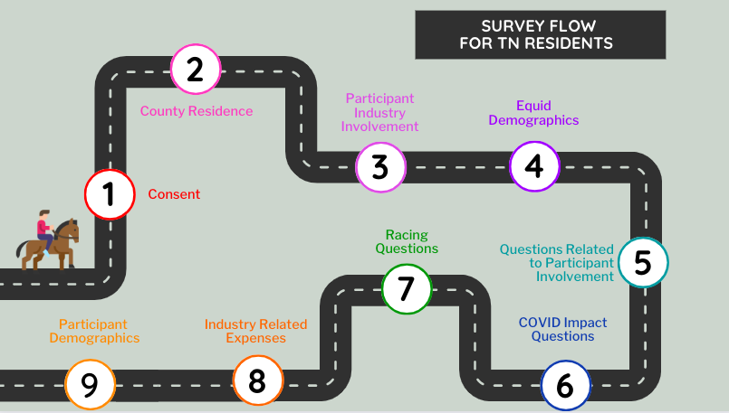
APPENDIX

Figure 1: Assessment Flow

A schematic of the assessment flow for participants residing in Tennessee. In the case the participant resided outside of Tennessee, those participants were asked to provide their home state and ties to the Tennessee industry.

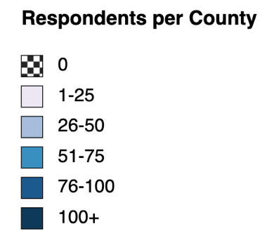
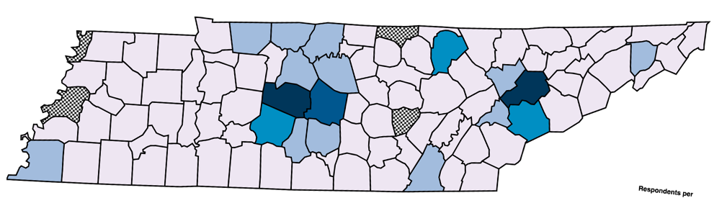
Figure 2: Tennessee Resident Location
n=1,647
Respondents (n=1,647) identified their county of residence. The counties that are checkered had no representation. The shades light (1) to dark (100+) represent the number of participants residing in those counties. The top three counties represented were Knox (n = 109), Williamson (n=107), Rutherford (n=92). The counties that went unrepresented were Lake, Lauderdale, Clay, and Van Buren.

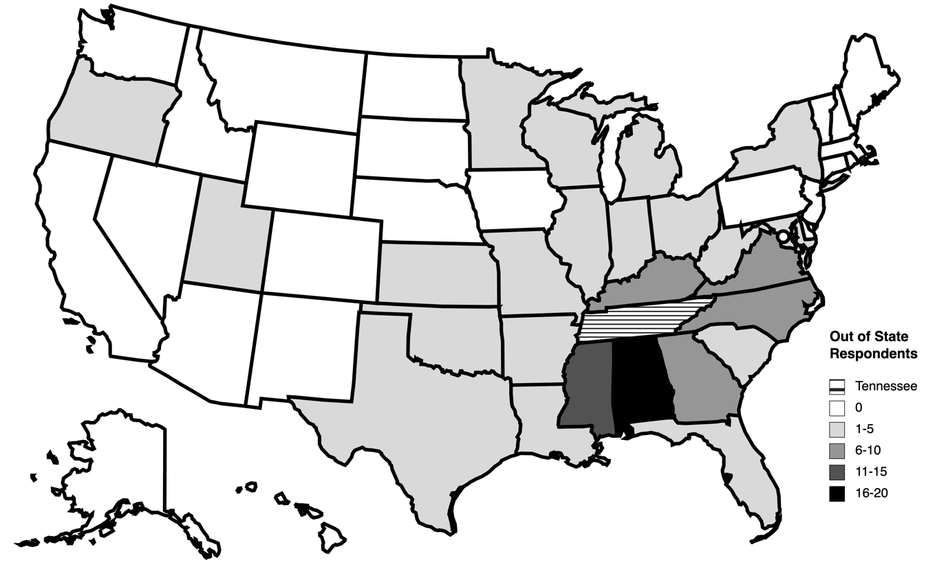
Figure 3: Location of Out of State Participants
n=104
Participants (n=104) identified their state of residence. The states that are white had no representation. The shades light (1) to dark (20) represent the number of participants from out of state. Tennessee is shown by the stripes. Of the other responding states, Alabama (n=19) had the highest number of participants.

Figure 4: Participant Involvement in the Tennessee Equine Industry
The equine industry has several different components and because of this each participant was asked to report their relationship to the Tennessee equine industry. Tennessee residents are represented by the colored bars (n=1,815; k=2,131) and out of state residents are represented by the orange bars (n=107; k=132). Participants (n=1,922) were able to select multiple areas of involvement leading to a larger number of observations (k=2,263). The activities were broken into four categories, activities directly related to facilities or facility ownership (yellow), equine businesses (green), occupations or businesses directly related to services to the equid (blue), and activities that do not fall into any other group (purple). Not pictured is the own or lease equids category because most respondents were equid owners/leasers (n= 1,922; k= 1,831).
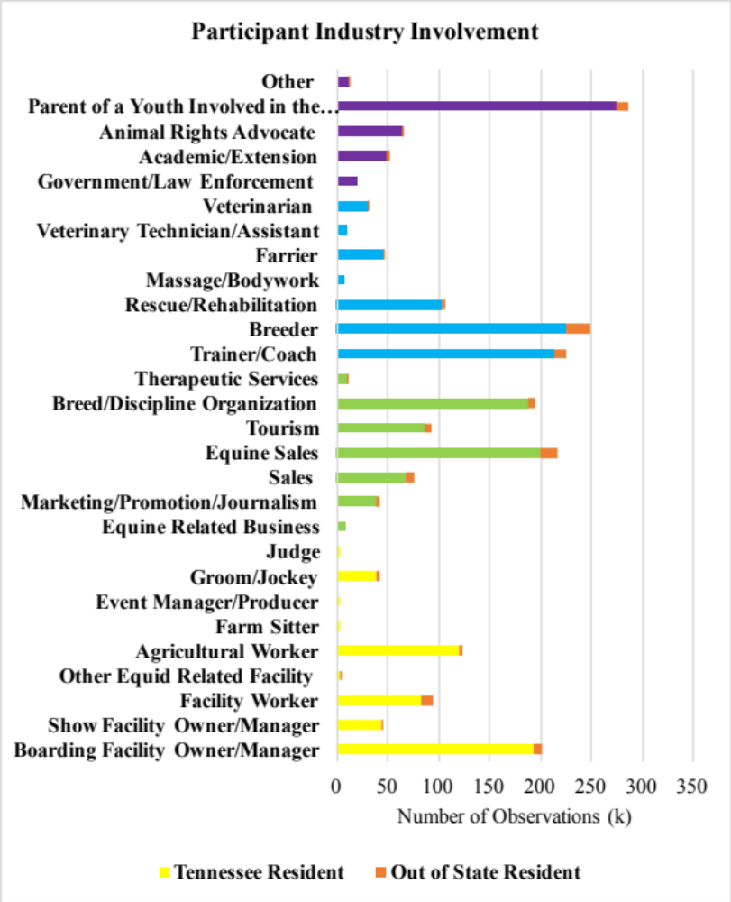
n=1,922
k=2,263
Figure 4: Participant Involvement in the Tennessee Equine Industry

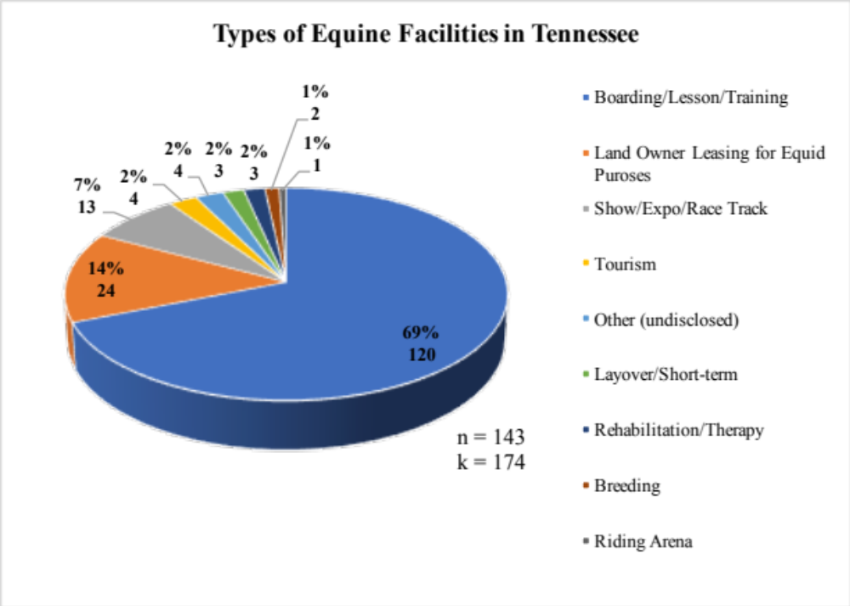
Figure 5: Types of Equine Facilities in Tennessee
Nine different types of equine related facilities were identified in Tennessee. Participants (n=143) were able to make multiple selections within this question which are identified by “k”. Boarding, lesson, and training facilities (k=120) were the most common facility type identified.

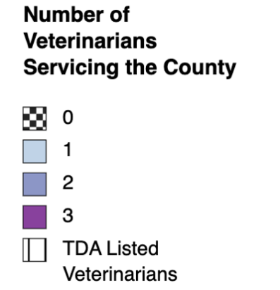
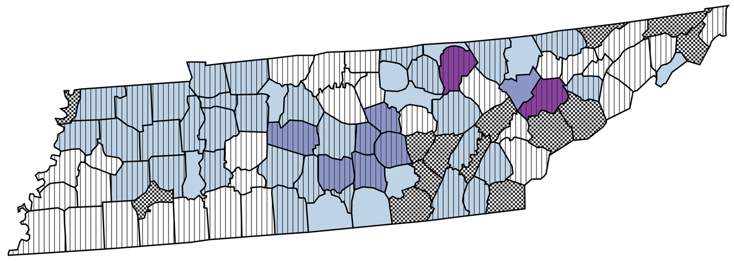
Figure 6: Tennessee Counties with Access to Veterinary Care
n=18
Equine veterinarians (n=18) were asked to identify what counties services were provided. The counties that are checkered had no representation. The shades light (1) to dark (3) represent the number of veterinarians providing services to those counties. Veterinarians identified 50 counties that had access to at least one veterinarian, with Knox County and Fentress County have 3 servicing veterinarians. Knowing that there are more than 18 equine veterinarians in Tennessee, the assessment results were cross-referenced with a list provided by the Tennessee Department of Agriculture (TDA), which are represented by the stripes. Altogether, there are 14/95 counties without access to veterinary care.

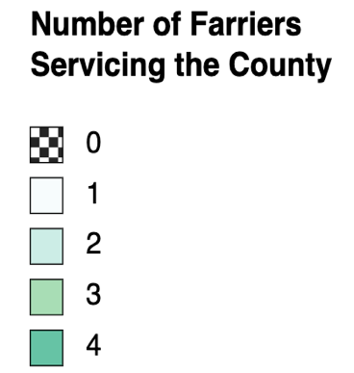
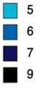
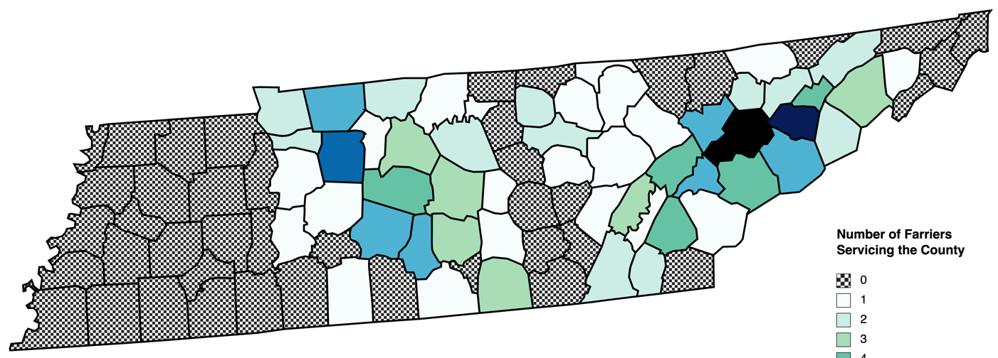
Figure 7: Tennessee Counties with Access to Farrier Care
n=46
Farriers (n=46) were asked to identify counties in which services were provided. The counties that are checkered had no representation. The shades light (1) to dark (9) represent the number of farriers providing care to those counties. Farriers (n=46) identified 53 counties that had access to at least one farrier, with Knox County (n=9) having the highest number of servicing farriers, followed by Jefferson County (n=7). There were 42 counties lacking farrier care, mainly localized to the western region of Tennessee.

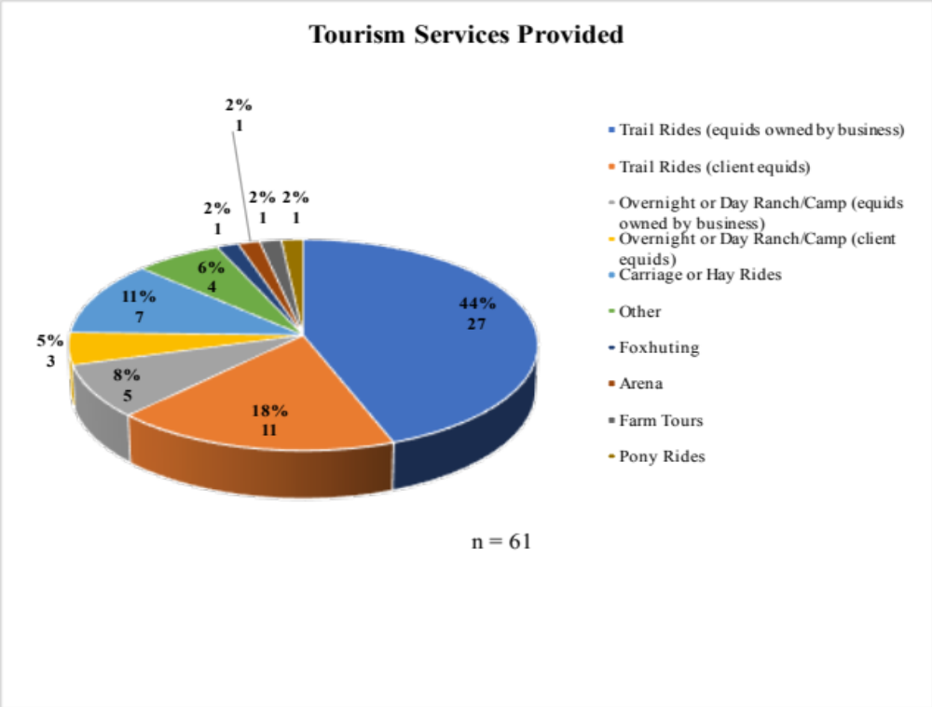
Figure 8: Types of Tourists Attracting Businesses
n=61
Participants (n) that indicated owning a business that attracts tourists were asked to identify what type of service was offered. Most businesses offered trail riding in some form, either with equids owned by the facility (n=27) or equids provided by the client (n=11). The least common services were foxhunting (n=1), a riding arena (n=1), pony rides (n=1), and farm tours (n=1).

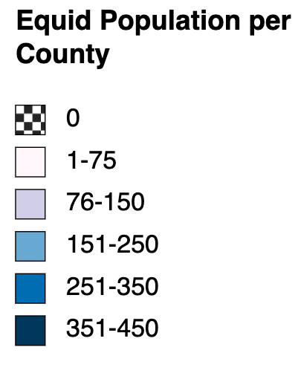
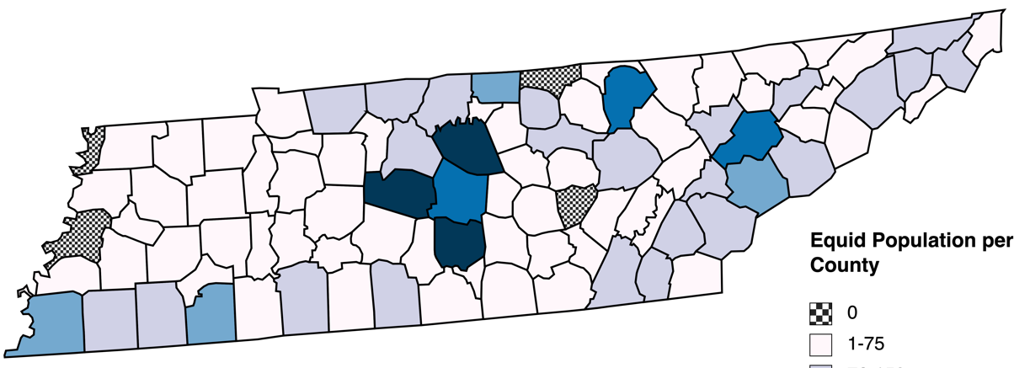
Figure 9: Equid Population Density Map
e=6,950
Equids (e=6,950) were identified based on county location. Lake, Lauderdale, Clay, and Van Buren counties had no representation and no equids identified (stripes). The highest populations identified by were in Wilson (e=422), Williamson (e=410), and Bedford (e=369) County (dark purple).

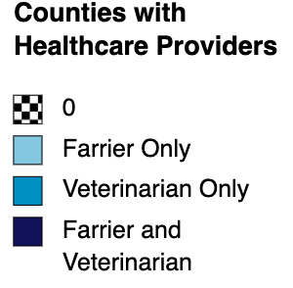
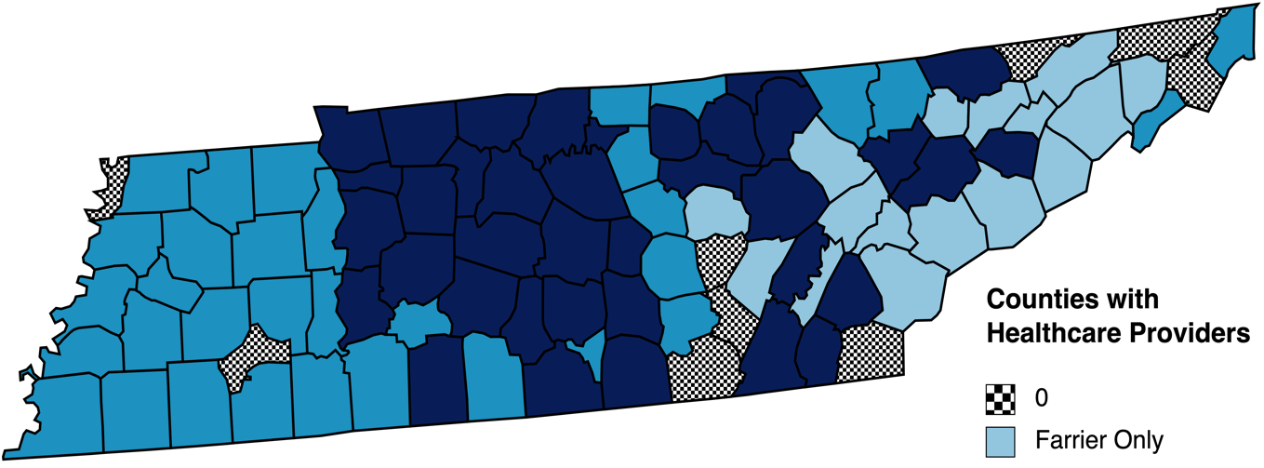
Figure 10: Tennessee Counties with Access to Healthcare
n=64
Farriers (n=46) indicated providing services to 53 counties across Tennessee. Veterinarians (n=18) indicated providing services to 50 counties. After service providers were combined, it was found that there were only 9 counties (white) without any type of healthcare representation. There were 31 counties (dark green) with access farrier and veterinary care, 18 counties with only veterinary care (light green), and 21 counties with access to only farrier care (light blue).

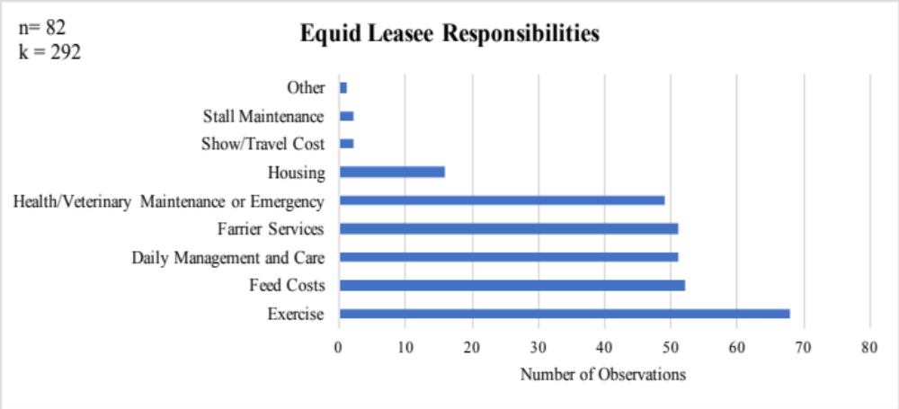
(k)
n=82
k=292

Figure 11: Equid Leasee Responsibilities
Participants that leased equids were asked to identify what types of things they were expected to provide based on the leasing agreement. Overall, most participants were required to exercise (k=68) to the equid. The number of participants is indicated by “n” and “k” is the number of observations.

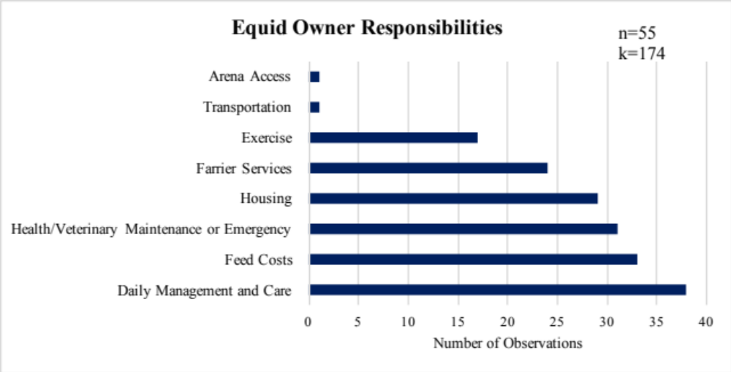
(k)

Figure 12: Equid Owner Responsibilities
Participants that leased equids were asked to identify what the owner of the equid was responsible for providing based on the leasing agreement. Overall, most equid owners were responsible for daily management and care (k=38). The number of participants is indicated by “n” and “k” is the number of observations.

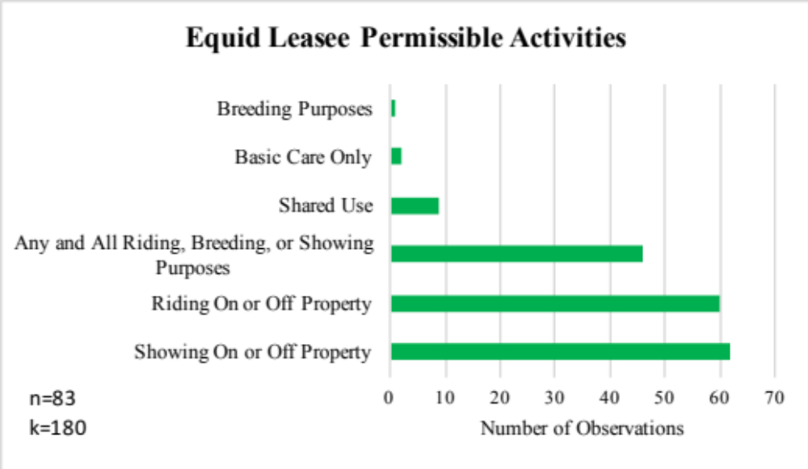
n=83
k=180
(k)

Figure 13: Equid Leasee Permissible Activities
Participants leasing equids were asked what types of activities were permitted based on the leasing agreement. Most participants were permitted to use the leased equid for showing on or off the property (k=62) or riding on or off the property (k=60). The number of participants is indicated by “n” and “k” is the number of observations.
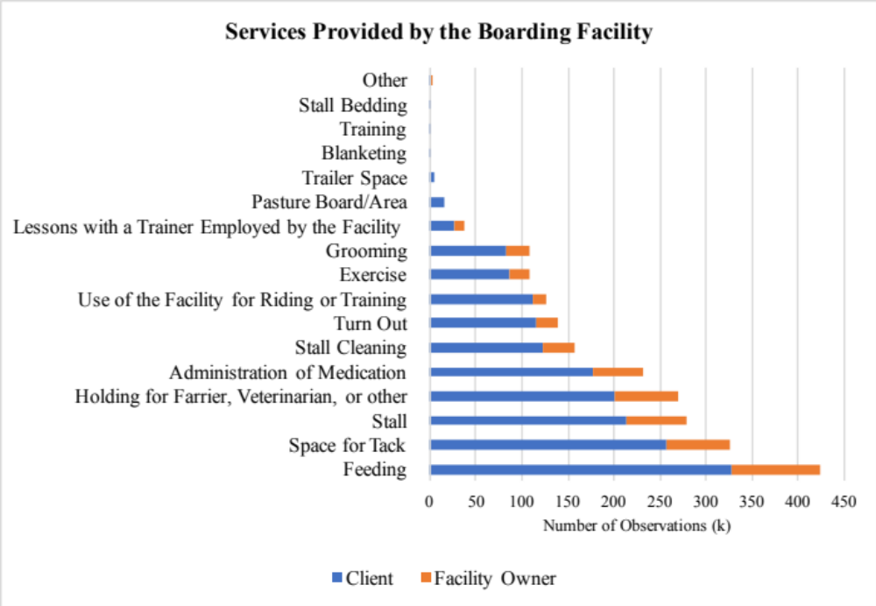
n=497
k=2,231
n=391
k=1,748
Figure 14: Services Provided by the Boarding Facility
Participants that boarded equids or that owned a boarding facility were asked to identify what services were provided by the facility. The blue bar represents facility owners and orange represents clients. The number of participants is indicated by “n” and the number of observations is “k”. The most common service provided was feeding (k=423).

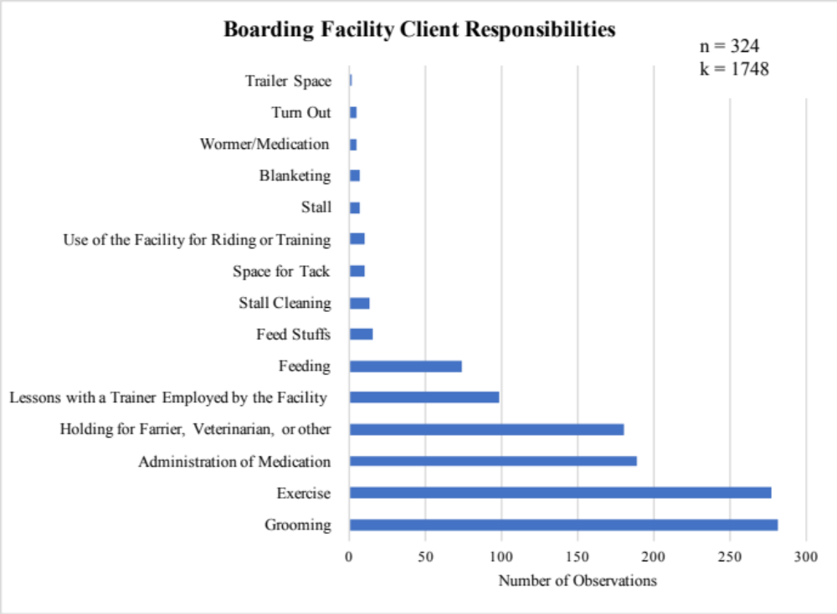
n=324
k=1,748
(k)

Figure 15: Boarding Facility Client Responsibilities
Participants that boarded equids were asked to identify what their primary responsibilities were according to the boarding agreement. The most common responsibility was grooming (k=281). The number of participants is indicated by “n” and “k” is the number of observations.

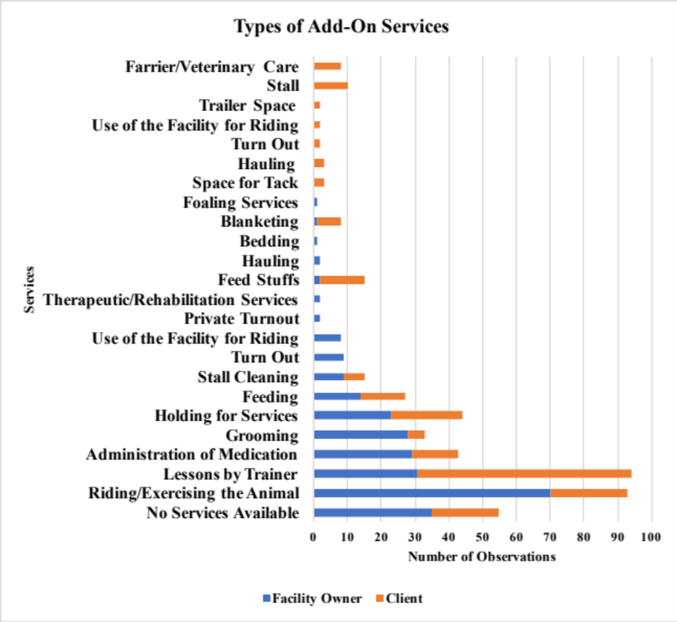
n=184
k=482
(k)
Figure 16: Boarding Facility Add-On Services
Participants that owned boarding facilities or that housed equids at a boarding facility were asked to identify any add-on services offered for an extra price. The blue bar represents facility owners and orange represents clients. The number of participants is indicated by “n” and the number of observations is “k”. The most common add-on service for clients was lessons with a trainer employed by the facility (k=63). The most common service offered by facility owners was riding or exercising the animal (k=70). Some participants did not offer add-on services (k=55).
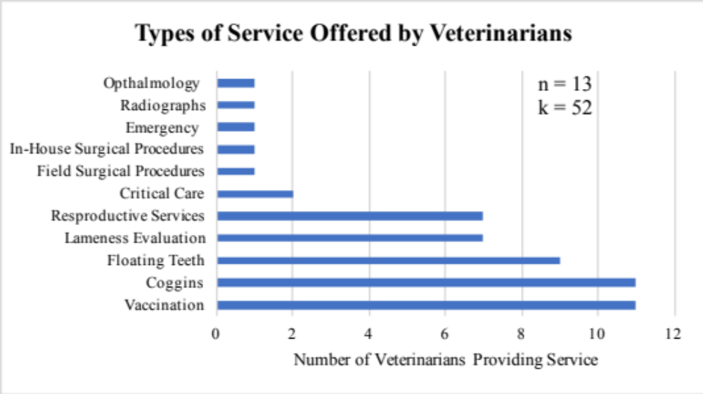
(k)
Figure 17: Veterinary Services
Equine veterinarians were asked to identify what types of services were provided. Most veterinarians provided routine health services, such as, vaccines (k=11), Coggins (k=11), and teeth floating (k=9). The number of participants is indicated by “n” and “k” is the number of observations.
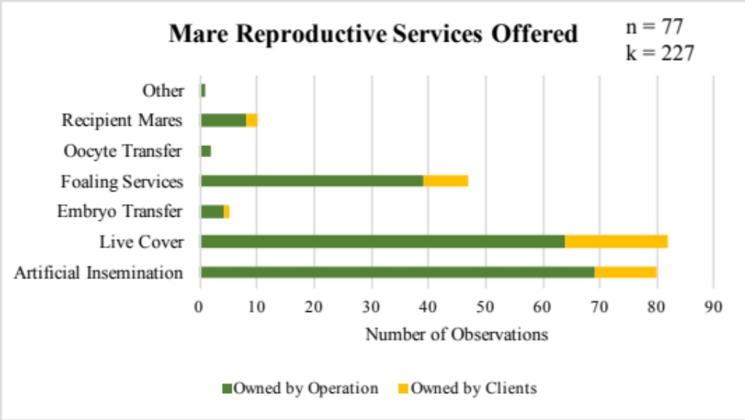
(k)

Figure 18: Mare Services
Equine breeders were among the top three areas of involvement. Breeders providing services to mare were asked to identify the types of services that were provided. The green bar refers to the number of mares that were owned by the operation and yellow is the number owned by clients. The most common service offered for mares owned by the operation was artificial insemination (k=69), while the most common service for client owned mares was live cover (k=18). The number of participants is indicated by “n” and “k” is the number of observations.

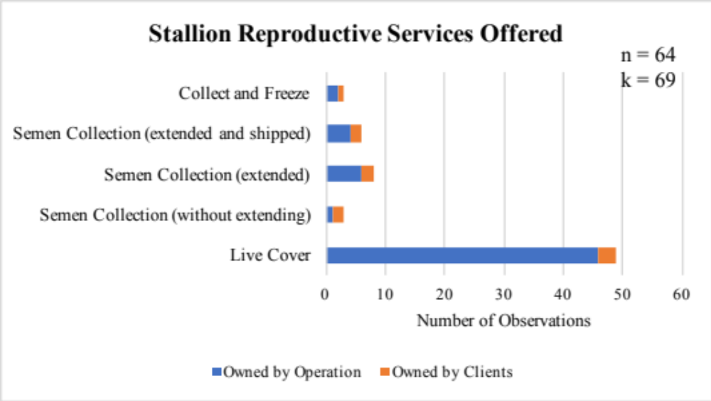
(k)

Figure 19: Stallion Services
Equine breeders were among the top three areas of involvement. Breeders providing services to stallions were asked to identify the types of services that were provided. The blue bar refers to the number of stallions that were owned by the operation and orange is the number owned by clients. The most common service offered for stallions was live cover (k=49). The number of participants is indicated by “n” and “k” is the number of observations.

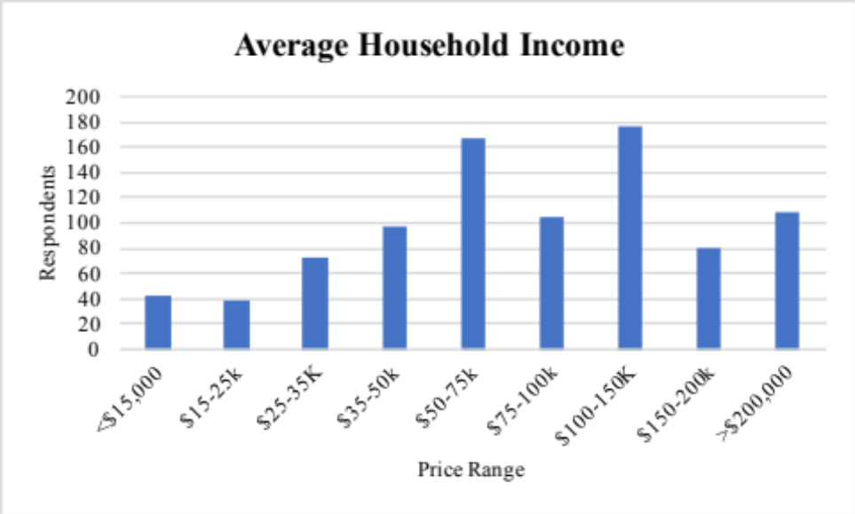
Income Range
(n)
n=889

Figure 20: Average Household Income
Participants (n=889) were asked to identify the average household income based on nine income ranges. Approximately 70% of participants (n= 636) had an average household income above $50,000.

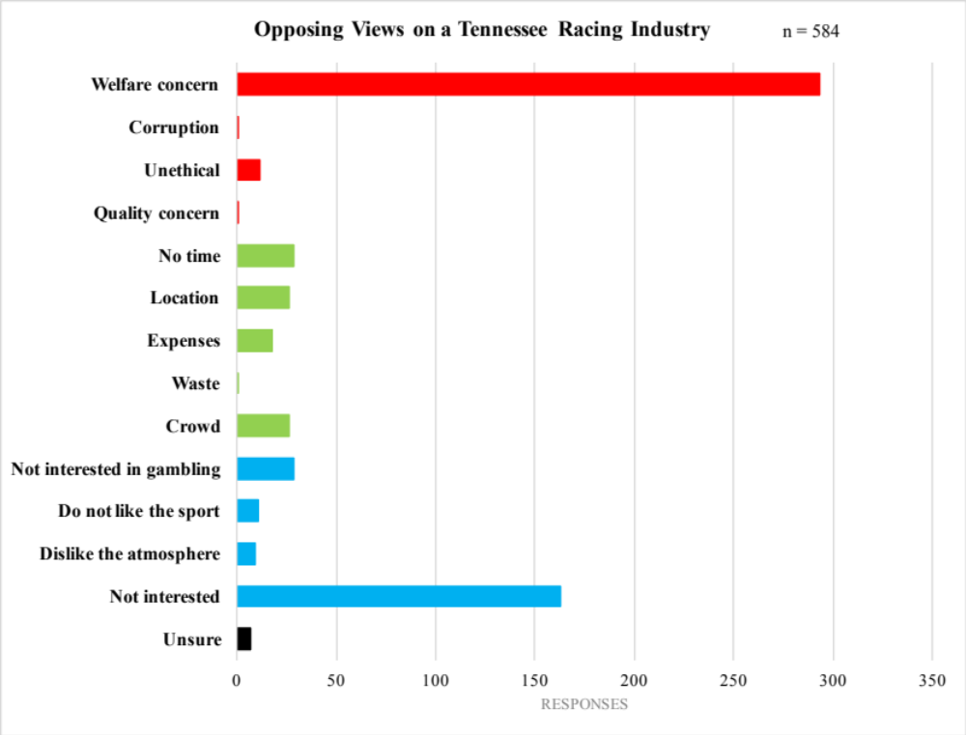Figure 21: Opposing Views on a Tennessee Racing Industry
Responses (n)

Participants (n=584) were asked to justify why they oppose a racing industry being developed in Tennessee. For the most part, participants were opposed to racing because of concerns for the animal (red). The other concerns pertained to concerns of the attendee (green), overall disinterest in the sport (blue), and unsure responses (black). The most common concern was welfare (n=293).
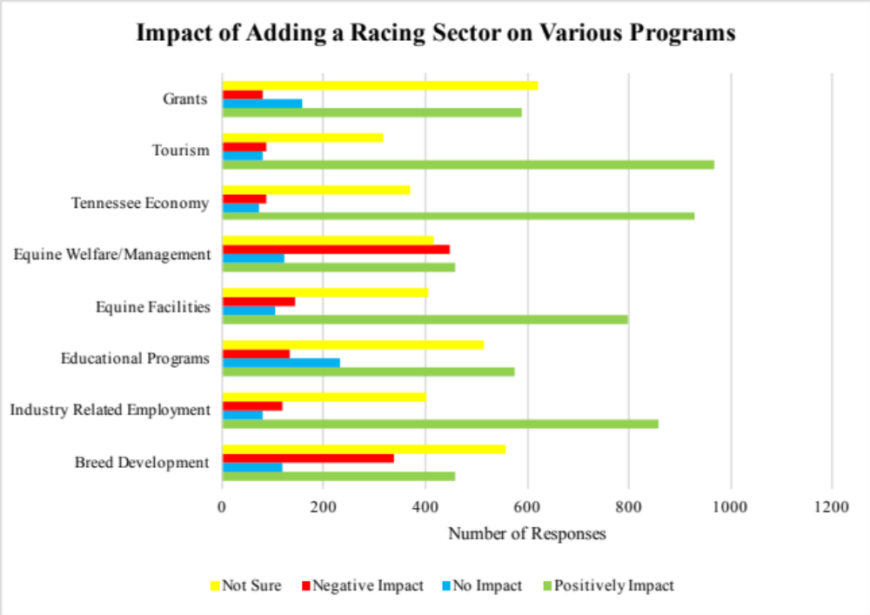
Figure 22: Impact of a Racing Sector on Various Programs
n=1,475
k=11,651
Participants (n=1,475) were able to provide multiple responses to this question which is represented by “k”. Participants (n=1,475) indicated an overall positive impact (green) on industry related employment, educational programs, equine facilities (k=1,453), Tennessee economy (k=929), grants (k=591) and tourism (k=967). About equine welfare and management, participants were almost evenly split between a positive impact (k=458) and a negative impact (red) (k=448).

TABLES
Table 1: Equid Primary Use
Primary Use | Owned (e) | Leased (e)
Companion/Recreational | 1,340 | 10
Trail Riding | 1,157 | 10
Idle/Retired/Not Working | 1,028 | 2
Brood Mare | 713 | 5
Gaited | 575 | 26
Western | 321 | 15
Hunter/Jumper | 309 | 59
Rodeo | 284 | 5
Dressage | 176 | 9
Driving | 176 | 1
Working | 175 | 2
Therapeutic Riding | 167 | 13
Breeding Stallion | 140 | 2
Show | 102 | 0
Eventing | 96 | 4
Roping | 96 | 1
Saddleseat | 82 | 6
Reining | 64 | 3
Endurance | 49 | 0
Lesson | 43 | 2
Cutting | 37 | 0
Protection | 27 | 0
Foxhunting | 22 | 0
Team Penning | 15 | 0
Racing | 14 | 0
Government | 7 | 0
Polo | 5 | 0
Other | 10 | 0
Total (e) | 6,855 | 164
Participants were asked to identify the primary use of their equids. The total number of equids is represented by “e”. Equine owners identified 28 different primary uses for their equids (e=7,230) with the most common use being companion or recreational use (e=1,340), followed by trail riding (e=1,157), and then equids that are retired, idle, or not working (e=1,028). A major difference between equids owned and leased was the primary use, where leased equids were primarily 34% (e=59) were used for hunter/jumper activities.

Table 2: Equids Purchased and Sold in Tennessee
Price Range | Purchased (e) | Sold (e)
$0-$500 | 95 | 29
$501-$1,000 | 114 | 67
$1,001-$2,000 | 38 | 32
$2,001-$5,000 | 233 | 189
$5,001-$10,000 | 107 | 104
$10,001-$20,000 | 61 | 60
$20,001-$50,000 | 58 | 19
$50,001-$100,000 | 25 | 10
$100,001+ | 4 | 4
Total (e) | 735 | 514

Participants (n=1,092) were more likely to be involved in the buying or selling of equids in Tennessee, as opposed to not (n=500). Participants (n=480) participating in the buying of equids purchased 735 equids, with the most common price range being between $2,001-$5,000 (e=233). Participants (n=285) involved in selling followed similar trends to those buying with a total of 514 equids sold, most commonly in the $2,001-$5,000 (e=189). The total number of equids is represented by “e”.

Table 3: Prices of Mare Services
Prices Charged for Mare Services | n | Min ($) | Max ($) | Mean ($) | Std. Dev. ($)
Live Cover | 34 | 10 | 1,500 | 498.09 | 288.58
Artificial Insemination | 22 | 1 | 20,000 | 1,809.77 | 4,260.02
Foaling Services | 9 | 140 | 5,000 | 1,298.89 | 1,574.13
Recipient Mare | 5 | 100 | 12,000 | 3,140 | 5,007.29
Other (undisclosed) | 1 | 250 | 250 | 250 | 0
Breeders (n) were prompted to identify the prices charged per service performed. Prices varied per service with a range from $250 for an undisclosed service to $3,140 (std. dev. +/- $5,007.29) for recipient mare services.

Table 4: Prices of Stallion Services
Prices Charged for Stallion Services | n | Min ($) | Max ($) | Mean ($) | Std. Dev. ($)
Live Cover | 36 | 200 | 1,000 | 456.94 | 180.54
Semen Collection (without extending) | 3 | 150 | 800 | 433.33 | 332.92
Semen Collection (extended) | 4 | 200 | 800 | 506.25 | 312.5
Semen Collection (extended and shipped) | 4 | 350 | 3,000 | 1,300 | 1,174.02
Collect and Freeze | 3 | 500 | 1,000 | 766.67 | 251.66
Breeders (n) were prompted to identify the prices charged per service performed. Prices varied per service with a range from $433.33 (std. dev. +/- $332.92) for semen collection without extending to $1,300 (std. dev. +/- $1,174.02) for semen collection with extending a shipping.
Table 5: Light-Type Breeds
Light-Type Breeds | Owned (e) | Leased (e)
Quarter Horse | 1,890 | 33
American Paint Horse | 321 | 13
Thoroughbred | 315 | 15
Appaloosa | 204 | 0
Arabian | 188 | 6
Crossbred | 64 | 3
Morgan | 63 | 2
Mustang | 58 | 2
Appendix | 56 | 5
Lusitano | 16 | 0
Grade | 8 | 2
Andalusian | 5 | 0
Akhal-Teke | 1 | 0
Azteca | 1 | 0
Baskir Curly | 1 | 0
Non-gaited Tennessee Walking Horse | 1 | 0
Other (undisclosed) | 26 | 2
Total (e) | 3,218 | 81
Particpants were asked to identify what breeds of light-type horses were owned or leased. The total number of equids is represented by “e”. The light breeds were defined as being bred for endurance, agility, and riding (Griffin, 2020). Light breeds were mostly comprised of Quarter Horses for owned (e=1,890) and leased (e=33).

Gaited Breeds | Owned (e) | Leased (e)
Tennessee Walking Horse | 1,628 | 19
Spotted Saddle Horse | 290 | 12
American Saddlebred | 221 | 5
Racking Horse | 117 | 0
Rocky Mountain | 80 | 0
Paso Fino | 77 | 5
Standardbred | 64 | 2
Missouri Fox Trotter | 64 | 0
Kentucky Mountain | 50 | 0
Gaited Cross Breed | 15 | 0
Gaited Light-Type | 8 | 0
Icelandic | 6 | 0
Gaited Grade | 5 | 0
National Show Horse | 5 | 0
Gaited Draft | 1 | 0
Single-Foot | 1 | 0
Total (e) | 2,632 | 43
Table 6: Gaited Breeds

Particpants were asked to identify what breeds of gaited horses were owned or leased. The total number of equids is represented by “e”. Gaited breeds were defined as being bred for pleasure riding and a smooth gait (Bekker, 2009). Over half of the gaited breed identified by this assessment were the Tennessee Walking Horse for owned (e=1,628) and leased (e=19) horses.

Pony Breeds | Owned (e) | Leased (e)
Pony | 805 | 4
Miniature Horse | 313 | 2
Shetland | 104 | 1
Welsh Pony and Cobb | 88 | 7
Pony of the Americas | 34 | 2
Hackney | 26 | 2
Norwegian Fjord | 20 | 0
Draft | 11 | 0
German Riding Pony | 2 | 0
Connemara | 2 | 0
Chincoteague | 1 | 0
Dartmoor | 1 | 0
Falabella | 1 | 0
Dale | 1 | 0
Other | 15 | 1
Total (e) | 1,424 | 19
Table 7: Pony Breeds

Particpants were asked to identify what breeds of pony were owned or leased. The total number of equids is represented by “e”. The pony breeds were defined as a horse measuring less than 14.2 hands (Griffin, 2020). For ponies owned, the most common breed was classified under the general pony option (e=756), meaning that there is variety of different breeds represented, but all measure less that 14.2 hands high. For ponies leased, the most common breed was the Welsh Pony and Cobb (e=7).

Table 8: Sport Breeds
Sport Breeds | Owned (e) | Leased (e)
Warmblood | 140 | 17
Oldenburg | 40 | 2
Trakehner | 31 | 1
Hanoverian | 26 | 1
Holsteiner | 21 | 2
Irish Sport Horse | 17 | 1
Sport Crossbred | 14 | 1
Irish Draught | 3 | 0
Knabbstrupper | 2 | 0
Selle Francais | 2 | 0
Grade | 2 | 0
Westfalen | 1 | 0
Georgian Grande | 1 | 2
Zangersheide | 1 | 0
Hessen | 1 | 0
Canadian Cheval | 1 | 0
Other (undisclosed) | 13 | 1
Total (e) | 316 | 28
Particpants were asked to identify what breeds of sport horses were owned or leased. The total number of equids is represented by “e”. The sport breeds were defined as being bred for athleticism and sport (Griffin, 2020). Sport breeds were mainly represented by the Warmblood, which included Belgian and Dutch Warmbloods for owned (e=140) and leased (e=17) horses.

Draft Breeds | Owned (e) | Leased (e)
Percheron | 71 | 1
Draft Cross | 53 | 2
Friesian | 47 | 1
Belgian | 37 | 0
Clydesdale | 24 | 0
Fell Pony | 20 | 0
Haflinger | 16 | 0
Draft | 12 | 0
Gyspy | 12 | 0
Spotted Draft | 5 | 0
Shire | 3 | 0
International Drum | 1 | 0
Brambet | 1 | 0
American Cream | 0 | 1
Total (e) | 302 | 5
Table 9: Draft Breeds
Particpants were asked to identify what breeds of draft horses were owned or leased. The total number of equids is represented by “e”. Draft breeds were defined as a horse bred for work and pulling heavy weight (Griffin, 2020). Percherons (e=71) were the most common draft breed owned, while the Draft Cross (e=2) was the most common leased draft breed.

Other Equid | Owned (e) | Leased (e)
Donkey | 377 | 0
Mule | 183 | 2
Zebra | 2 | 1
Other (undisclosed) | 2 | 0
Total (e) | 564 | 3
Table 10: Other Equids

The other equid category was filled with equids that did not fit into any of the other categories, such as, donkeys, mules, and zebras. The total number of equids is represented by “e”. The donkey was the most common other equid for owned equids (e=377). The mule was the most common other equid for leased equids (e=2).

Table 11: Equid Sex
Equid Sex | Owned (e) | Leased (e)
Colt | 250 | 8
Filly | 463 | 7
Mare | 3,238 | 60
Gelding | 3,294 | 101
Stallion | 274 | 13
Total (e) | 7,519 | 189

Participants were asked to identify the sex of the equids owned or leased. The total number of equids is represented by “e”. Mares (e=3,298) and geldings (e=3,395) were the most common sex, owned and leased.

Table 12: Equid Age
Equid Age | Owned (e) | Leased (e)
Foal | 352 | 2
2-5 | 1,310 | 22
6-10 | 1,541 | 34
11-15 | 1,753 | 53
16-20 | 1,430 | 49
21-29 | 1,143 | 16
30+ | 170 | 6
Total (e) | 7,699 | 182

Participants were asked to identify the age range that best fit the equids owned or leased. The total number of equids is represented by “e”. The greatest number of equids were in the 11-15 years of age range (e=1,806).

Table 13: Equid Housing Location
Equid Housing Location | Owned (e) | Leased (e)
Boarding Facility | 891 | 104
Property Owned | 5,887 | 37
Property Leased | 436 | 0
Training Facility | 86 | 2
Family/Friend Farm | 107 | 0
Equid Owners' Farm | 0 | 2
Other | 80 | 9
Total (e) | 7,487 | 154
Participants were asked to identify the location where the equids owned or leased were primarily held. The total number of equids is represented by “e”. Participants typically housed the equids at a property owned (e=5,887), while equids leased were typically housed at a boarding facility (e=104).

Table 14: Lesson Prices
Price Charged per Lesson | n | Min ($) | Max ($) | Mean ($) | Std. Dev. ($)
Private Lesson (one rider) | 83 | 3 | 150 | 49.98 | 20.96
Group Lesson (2+ riders) | 45 | 1 | 120 | 43.73 | 21.59
Training Session (for equid) | 55 | 1 | 750 | 71.71 | 124.54
Participants (n) that identified as trainers were asked the average price charged per lesson. Results varied depending on the number of riders per lesson or if the lesson was for the equid only. The average lesson with the equid only was the most expensive with the average price being $71.71 (std. dev. +/- $124.54). A private lesson was approximately $50 (std. dev. +/- $49.98) and a group lesson was approximately $44 (std. dev. +/- $21.59).

                - Vita
Olivia Watson grew up in a small town in Virginia with her parents and four siblings. In 2016, she started her collegiate career at the University of Tennessee, Knoxville where she majored in animal science with a minor in international agriculture and natural resources. Throughout her time at Tennessee, she was able to build lifelong friendships with her peers and had the opportunity to expand herself and spend a semester in Dublin, Ireland. She graduated in 2019 with a bachelor’s in animal science and worked for a local mixed animal practice until beginning a graduate program in 2021 with Dr. Jennie Ivey. Over her graduate school career, she continued sharpening her skills while continuing to learn something new every day.

