SOIL-WATER TRANSPORT OF A SEED COATED
NEONICOTINOID PESTICIDE IN SOYBEAN/MAIZE
CULTIVATION SYSTEMS

A Thesis Presented for the
Master of Science
Degree
The University of Tennessee, Knoxville

Geoffrey Nathaniel Duesterbeck
August 2016

Copyright © 2016 by Geoffrey Nathaniel Duesterbeck
All rights reserved.

DEDICATION

To
Suzanne Marie Duesterbeck
my wife
thank you for your belief in me. I could not have done this without you and
this achievement is as much yours as it is mine
ACKNOWLEDGEMENTS

I would like to express my gratitude to everyone who has assisted me in this research project. I would like to especially thank my major professor and mentor Dr. John A. Skinner for guiding me through this arduous process and providing endless encouragement. He was not only supportive during this research project but instilled in me a passion for honey bees and beekeeping. I also thank my committee members Dr. Scott Stewart and Dr. Andrea Ludwig for their continuous support, input, and knowledge. Without their knowledge I would not have the understanding of chemicals and soils that I now possess. Furthermore, I am grateful to Dr. Stewart whose financial support made this research project possible.
I am also thankful for the assistance of Dr. Fred Allen and Dr. Vince Pantalone, who allowed me to collect soil samples in and near their research plots.
Additionally, I would like to thank B.J. DeLozier for his assistance on clarifying chemical usage on the Plant Sciences Unit. I would like to thank Xiaocun Sun and Dr. Arnold Saxton for their statistical consultations.
ABSTRACT

The current decline of the honey bee (Apis mellifera L.) and other beneficial pollinator species is well documented. Several causes have been cited in this decline including: pathogens, pests, nutrition, and pesticide exposure. Since the advent of the neonicotinoid family of pesticides in the 1990’s an increase in honey bee colony loss has been observed. Neonicotinoid pesticides are commonly applied as a seed treatment to cotton, soybean and maize row crops. As the seed germinates, it absorbs the pesticide from the coating then spreads systemically throughout the entire plant. However, a large portion of the seed coating may stay in the soil, possibly having unintended consequences. To determine whether neonicotinoid compounds from treated seed are transported from application sites we examined soils adjacent to soybean fields for neonicotinoid pesticide at several distances from field borders as evidence of transport from seed treatments via soil-water processes Neonicotinoid content was sampled in soils of experimental plots at the University of Tennessee’s East Tennessee Research and Education Center (ETREC), Plant Sciences Unit. Soybeans treated with the neonicotinoid thiamethoxam (Cruiser) were cultivated in the test field and untreated soybeans were planted in a check field which had been previously planted with clothianidin seed treated maize in 2014. Both plots were in a maize/soybean rotation with soybeans in 2015 and maize in 2016. Soil samples were tested for neonicotinoid content using the QuEChERS (Quick, Easy, Cheap, Effective, Rugged, and Safe) method by the USDA AMS Laboratory in Gastonia, North Carolina. Soil tests indicated no thiamethoxam at the 1 ppb limit of detection (LOD), although concentrations of the thiamethoxam metabolite clothianidin were found. Initial conclusions suggest that the neonicotinoid thiamethoxam was not found in adjacent soils but its metabolite clothianidin was present in measurable concentrations. Clothianidin detected in collected soil samples was not in concentrations known to be harmful to honey bees. The clothianidin found in adjacent soils may be the result of either microbial metabolism of thiamethoxam or residual deposits from clothianidin treated maize from 2014, or both.

Table of Contents

Chapter One Introduction and General Information 1
Introduction 1
Apis mellifera 1
Economic Importance 3
Current Bee Losses and Colony Collapse Disorder 3
Pests of Honey Bees 4
Pathogens of Honey Bees 4
Honey Bee Nutrition 4
Honey Bee Exposure to Pesticides 5
Chapter Two Literature Review 6
Neonicotinoid Pesticides 6
Economic Importance and Effectiveness 7
Effects of Neonicotinoid Exposure on Honey Bees 8
Routes of Honey Bee Exposure to Neonicotinoids 9
Neonicotinoids in Agricultural Systems 10
Imidacloprid 10
Thiamethoxam 11
Clothianidin 11
Neonicotinoid Pesticide Environmental Transport 12
Research Objectives 12
Chapter Three Materials and Methods 14
Research Plots 14
Field and Plot Selection 14
Soil Collection Locations 18
Soil Sample Collection Method 19
Soil Analysis 21
Statistical Analysis 21
Chapter Four Results and Discussion 22
Neonicotinoid Compounds Reported by Soil Analysis 22
Neonicotinoid Compounds Recovered by Soil Analysis 22
Discussion 24
Metabolism and Conversion of Thiamethoxam to Clothianidin 24
Chapter Five Conclusions 32
List of References 34
Vita 48

LIST OF TABLES

Table 1. Location identification legend for soil samples collected adjacent to
research plots Q and B7 sample sites at three distances from edge of
research plots Q, without thiamethoxam seed treatment, and B7, with
thiamethoxam seed treatment, at the University of Tennessee’s Plant
Sciences East Tennessee Research and Education Center in Knoxville,
Tennessee……………………………………………………………………...20
Table 2. Clothianidin concentrations, in parts per billion (ppb), detected in soil
samples collected over 4 months from soils adjacent to research plot B7,
planted with soybean seed treated with thiamethoxam seed treatment in 2015………………………………...............................................................23
Table 3. Clothianidin concentrations, in parts per billion (ppb), detected in soil
samples collected over 4 months from soils adjacent to research plot Q,
planted without soybean seed treated with thiamethoxam seed treatment in 2015…………………………………………………………………………..25
Table 4. Imidacloprid concentrations, in parts per billion (ppb), detected in soil
samples collected over 4 months from soils adjacent to research plot Q,
planted without soybean seed treated with thiamethoxam in 2015………26

LIST OF FIGURES

Figure 1. Location of research plots Q and B7 at the University of Tennessee's
Plant Sciences East Tennessee Research and Education Center in
Knoxville, Tennessee used in this study……………………………………15
Figure 2. Research Plot B7 with 0 meter soil sample collection sites……………16
Figure 3. Concentrations of clothianidin, in parts per billion, for research plots
B7 (treated soybean seed) and Q (untreated soybean seed) at three distances from edge of research plots in meters from four dates of sample collection……………………………………………………………...28
Figure 4. Mean concentration of clothianidin in parts per billion from soil in two
fields with either soybean seed treated (Plot B7) or untreated soybean
seed (Q) at three distances from plot edge in meters…………………….30

LIST OF ABBREVIATIONS

AMS…………………………………………………….Agricultural Marketing Service
ANOVA………………………………………………………….…Analysis of Variance
CCD……………………………………………………….…Colony Collapse Disorder
EPA………………………………………………....Environmental Protection Agency
ETREC………………………..….East Tennessee Research and Education Center
FAO……………………...Food and Agriculture Organization of the United Nations
GC………………………………………………………………...Gas Chromatography
IUPAC…………………………..International Union of Pure and Applied Chemistry
LC……………………………………………………………….Liquid Chromatography
LD₅₀……………………………………………………………………….….Lethal Dose
LOD…………………………………………………………...……….Limit of Detection
MS…………………………………………………………..……….Mass Spectrometry
µg………………………………………………………….………………….Micrograms
µg/bee………………………………………………………..…….Micrograms per Bee
ng………………………………………………………………………..……Nanograms
ng/bee…………………………………………….………………..Nanograms per Bee
nAChRs........................................................…...Nicotinic Acetylcholine Receptors
pH………………………………………………..…….Measure of Acidity or Alkalinity
ppb………………………………………………………..……………..Parts per Billion
QuEChERS……………………..Quick, Easy, Cheap, Effective, Rugged, and Safe
USDA…………………………………...…..United States Department of Agriculture

Introduction and General Information

Introduction

Following the announcement of the phenomenon known as Colony Collapse Disorder in 2006 there has been a growing concern over losses of managed honey bee colonies (vanEngelsdorp et al. 2009). This concern is not confined to just the United States but globally with beekeepers reporting alarming bee colony losses across many nations (Hopwood et al. 2012). Many different causes have been attributed to this sudden bee loss including: pests, pathogens, lack of nutrient rich forages and pesticide and agrochemical exposure (Ellis 2013). Of these potential causes of bee loss, pesticides have garnered the most attention with the public and among some researchers. The family of insecticides known as the neonicotinoids are currently at the forefront of research into bee loss. These popular insecticides are found in a variety of products from seed treatments and foliar sprays used in agricultural and horticultural production to household insect control applications. With such widespread use, the possibility of honey bee exposure to these chemicals has increased and researchers continue to study the effects of neonicotinoids on honey bee decline (Hopwood et al. 2012).

Apis mellifera

Apis mellifera, the common western (European) honey bee, has been intensively managed by humans for many millennia including hybridization and introductions throughout the world by beekeepers (Caron and Connor 2013). This species has been subdivided into at least 20 recognized subspecies, none of which are native to the Americas (Mortensen et al. 2013). Due to the activities of beekeepers the honey bee is now spread across the entire world, but its native range is large and diverse, spanning Europe, Africa, and the Middle East (Han et al. 2012).
Honey bees are classified in the family Apidae, and their close relatives include the orchid bees (Euglossini), the bumble bees (Bombini), and the stingless bees (Meliponinae) (Winston and Michener 1977, Kimsey, 1984). Bees are thought to have evolved from a wasp ancestor, probably a sphecid, with mouthparts capable of ingesting nectar, which began collecting pollen to feed to their brood instead of killing prey (Winston 1987). Although the fossil record of bees is incomplete, they are thought to have evolved from sphecoid wasps during the middle of Cretaceous period, about 100 million years ago (Michener 1974). Most of the nonparasitic Apidae are characterized by the presence of a corbicula or pollen basket on the outer surface of each hind tibia, at least in workers, and this structure is used to carry pollen and nest-building materials (Michener 2000, Winston 1987). Most of the internal organs of the bee are much the same as in other insects, but the alimentary canal has a honey stomach, special adaptation in the foregut for carrying nectar or honey (Snodgrass and Erickson 1946). The mouthparts of the bee are complex modified structures located on the bottom margin of the head (Caron and Connor 2013). The proboscis of the bee is not a permanently functional organ as it is in most other sucking insects; it is temporarily improvised by bringing together the free parts of the maxillae and the labium to form a tube for ingesting liquids including nectar, honey and water (Snodgrass and Erickson 1946). The evolution and divergence of bees has been closely linked to that of angiosperm plants, with the plants evolving flowers with odors, shapes, colors, and excess nectar and pollen food rewards to attract the bees, and the bees in turn providing a mechanism to transfer pollen between plants assisting in reproduction (Winston 1987).

Economic Importance
The Western honey bee, is a species of crucial economic, agricultural, and environmental importance (Han et al. 2012). Managed honey bee colonies provide valuable products from the hive such as honey and wax. Although hive products are of economic importance, it is the pollination services bees provide that is of greatest value. It was found that the worldwide economic value of the pollination service provided by insect pollinators, bees mainly, was 153 billion Euros ($217 billion US) in 2005 for the main crops that feed the world (Helmholtz 2008). In the United States, managed honey bee colonies are frequently transported throughout the country to provide pollination services for many industries including: almond production, blueberry production, cranberry production, and fruit tree pollination. Gross revenue generated from employing managed bees for pollination services in 2012 totaled $655.6 million (Bond et al. 2014). In 2013 the annual value of direct honey bee pollination to U.S. agriculture was estimated at over $19 billion, far exceeding the value of wax and honey sales (Hansen 2015).

Current Bee Losses and Colony Collapse Disorder

Since the fall of 2006, beekeepers in the United States have reported higher-than-usual colony losses, and these losses have been termed “Colony Collapse Disorder” (Ellis 2013). Colony Collapse Disorder (CCD) is defined by the United States Environmental Protection Agency as the phenomenon that occurs when the majority of worker bees in a colony disappear and leave behind a queen, plenty of food and a few nurse bees to care for the remaining immature bees and the queen (EPA 2016). Current theories about the cause(s) of CCD include increased losses due to the invasive varroa mite; new or emerging diseases, especially mortality by a new Nosema species (related to the microsporidian giardia); poor nutrition and pesticide poisoning (through exposure to pesticides applied for crop pest control or for in-hive insect or mite control) (USDA 2007).

Pests of Honey Bees
There are several species of pests that may impact honey bee colony health. Invertebrate species which are commonly known to be harmful to honey bee health are: Varroa mite (Varroa destructor Anderson), tracheal mite (Acarapis woodii Rennie), greater wax moth (Galleria mellonella L.) and small hive beetle (Aethina tumida Murray) (Caron and Connor 2013). Of these species of invertebrate pests, the varroa mite is the most destructive to honey bee colonies (Root 2006, Sanford 2003) and has recently been found to vector several destructive viruses.

Pathogens of Honey Bees
Another cause of managed honey bee decline are the multitude of pathogens associated with honey bees. The most prevalent pathogens include: American Foulbrood, European Foulbrood and Nosema spp. (Caron and Connor 2013, Ritter and Akratanakul 2006). American Foulbrood and European Foulbrood are both caused by bacterial agents and may become quickly spread to adjacent bee colonies. In some cases, American Foulbrood can only be controlled by destroying the infected colony and beehive equipment (Ritter and Akratanakul 2006). Nosema disease, also known as Nosemosis, is caused by the fungi; Nosema apis, and N. cerana, affect the digestive tract of honey bees (Sanford 2003, Ritter and Akratanakul 2006).

Honey Bee Nutrition
Concern about the quality of nectar and pollen available to foraging honey bees has risen since colony and bee populations have declined (Huang 2010). In large scale agricultural areas, pollen and nectar may be lacking in nutrients that honey bees require for healthy development (Brodschneider and Crailsheim 2010). Lack of nutrient rich foraging sources has also been linked to increased pathogen and pest susceptibility in honey bee colonies managed near monoculture cultivation systems where plant diversity is decreased (USDA 2013).

Honey Bee Exposure to Pesticides
Honey bee exposure to pesticides has received significant attention and studies have found agricultural chemicals (including insecticides, miticides, fungicides and herbicides) in the pollen and wax of managed honey bee colonies near agricultural fields (Mullin et al. 2010, Wu et al. 2011). Recently, concern has been raised regarding the impact of a common class of pesticides known as neonicotinoids on honey bees and native bee pollinators (Lawrence and Sheppard 2013). Bees may be exposed to neonicotinoids in numerous ways, including direct contact with spray residue on plants or through ingestion of pollen or nectar (Hopwood et al. 2012, Zhu et al 2015). Water sources visited by foraging honey bees may also contain pesticide residues which bees may ingest (Johnson and Pettis 2014).

Literature Review

Neonicotinoid Pesticides

Neonicotinoids are synthetic chemical insecticides that are similar in structure and action to nicotine, a naturally occurring plant compound that was widely used as an insecticide before the Second World War (Hopwood et al. 2012). The neonicotinoid class of insecticides, including imidacloprid, acetamiprid, clothianidin, thiamethoxam, thiacloprid, dinotefuran and nitenpyram, are considered an important tool for pest management in many agricultural systems (Cutler et al. 2014). They are nicotinic acetylcholine receptor agonists; they bind strongly to nicotinic acetylcholine receptors (nAChRs) in the central nervous system of insects, causing nervous stimulation at low concentrations, but receptor blockage, paralysis and death at higher concentrations (Goulson 2013). The neonicotinoids are systemic insecticides that are taken up by a plant through either its roots or leaves and move throughout the entire plant as water and nutrients do (Lawrence and Sheppard 2013). The systemic nature of neonicotinoid pesticides provides many advantages for pest control, since they protect all parts of the plant, providing control against boring insects and root-feeding insects that are not easily controlled with foliar sprays of non-systemic compounds (Goulson 2013). These treatments are most often applied to seeds at designated seed treatment facilities in combination with other active ingredients or additives, including fungicides, nematicides, fertilizers, growth enhancers, and/or accompanying stickers, adjuvants, and lubricants (EPA 2014). Today, neonicotinoids are the most important chemical class of insecticides introduced to the global market since the advent of synthetic pyrethroids (Jeschke et al. 2011).

Economic Importance and Effectiveness
There is abundant evidence that show neonicotinoids can provide effective control for a broad range of insect pests (Jeschke et al. 2011). The protection provided by neonicotinoid seed treatments in the southeastern region of the United States on cotton, corn, rice and soybean cultivation can be significant, keeping yields high (Stewart et al. 2014). Yields may be increased in soybean production by using neonicotinoids to control the Soybean Aphid (Aphis glycines Matsumura), which can extensively diminish soybean yield when present in high densities (EPA 2014). Previous research on seed treatment efficacy indicated that soybean yields were not increased by using neonicotinoid seed treatments, as studies with imidacloprid and thiamethoxam treated soybean showed no increase in yields when compared to untreated soybean yields (Seagraves and Lundgren 2012). Yet more recent research conducted in the southeastern region of the United States has shown a significant increase in yield when neonicotinoid seed treatments are applied in comparison to fungicide only treatments in soybean cultivation systems (North et al 2016). While the question of whether neonicotinoids increase or affect yields is still the subject of much research, with results for both sides of the argument, the EPA maintains that these seed treatments provide negligible overall benefits to soybean production in most situations (EPA 2014). This data indicated that in most cases there was no difference in soybean yields when soybean seed was treated with neonicotinoids versus not receiving any insect control treatment (EPA 2014).
Soybean production is economically important to the Tennessee agriculture industry with 1,662,877 acres planted in soybean during the 2015 growing season (Bowling et al. 2016). Approximately 22% of the soybeans grown in Tennessee and the southeastern United States, including the Mid-South, received a neonicotinoid seed coat treatment with thiamethoxam or imidacloprid (EPA 2014). This large amount of acreage dedicated to soybean and maize cultivation overlaps with many areas frequented by honey bees and may be in proximate to established apiaries (group of honey bee colonies), which may increase pesticide exposure.

Effects of Neonicotinoid Exposure on Honey Bees

Current research continues into the effects that neonicotinoid pesticides have on honey bee colonies. Of concern are not only the direct lethality of the insecticides but also the sub-lethal effects. Sub-lethal effects can include a variety of behavioral changes in honey bee activities.
Neonicotinoid pesticides are highly toxic to honey bees with mortality resulting from exposure of minute amounts of these compounds (Hopwood et al. 2012). The lethal dose (LD₅₀) required to kill 50% of a population of honey bees exposed to the pesticide is measurable in units as small as micrograms (µg/bee) or nanograms (ng/bee) per bee. Imidacloprid possesses a LD₅₀ of 3.7 ng/bee, thiamethoxam has a LD₅₀ of 5 ng/bee and clothianidin, the most toxic, has a LD₅₀ of only 2.5 ng/bee (Pisa et al. 2015).
Exposure to the neonicotinoid imidacloprid can cause reduced foraging ability in honey bees as well as decreased avoidance of predatory species that bees would normally avoid (Tan et al. 2014, Schneider et al. 2012). Thiamethoxam, even at non-lethal concentrations, can also decrease honey bee foraging ability by disrupting the homing capabilities of the bees while searching for food sources (Henry et al. 2012, Schneider et al. 2012). Additional studies indicate that sub-lethal doses of neonicotinoids reduce honey bee immune suppression and contribute to viral pathogens like deformed wing virus (Rondeau et al 2014). Residues of neonicotinoids found within the brood comb and wax in hives may impact bee brood survival and result in delayed adult bee emergence, which in turn may provide a reproductive advantage to varroa mites (Wu et al. 2011, Yang et al. 2012).
Exposure to crops treated with neonicotinoid seed treatments did not appear harmful to honey bee health in studies conducted with clothianidin coated maize and canola crops exhibiting no adverse effects on honey bee colonies (Pohorecka et al. 2013, Cutler et al. 2014). Additional research with neonicotinoid treated maize and cotton found that the pollen and nectar contained neonicotinoids but the concentrations detected were below levels of concern to honey bee health (Stewart et al. 2014). A study published in 2009 found that water from leaf guttation in maize, which honey bees may ingest, contained concentrations of neonicotinoids at a level toxic to honey bees (Girolami et al. 2009).

Routes of Honey Bee Exposure to Neonicotinoids
Honey bees may be exposed to neonicotinoid pesticides by direct physical
contact and/or by ingesting materials contaminated with the compounds. Direct contact may result from the honey bee being sprayed with neonicotinoid foliar sprays, dust generated from equipment planting talc coated neonicotinoid treated seed and from landing on vegetation that has been recently been treated with a foliar spray (Hopwood et al. 2012, Krupke et al. 2012). Indirect contact with neonicotinoid pesticides may come when honey bees feed and collect nectar and pollen from flowering plants treated with neonicotinoid compounds (Rundlof et al. 2015, Stoner and Eitzer 2012). There also exists evidence that honey bees may come into contact with neonicotinoid compounds within the colony. Concentrations of neonicotinoids have been found in honey stores, pollen and wax in honey bee colonies located near areas treated with neonicotinoids (Pohorecka et al. 2013, Wu et al. 2011).

Neonicotinoids in Agricultural Systems

Due to the increased usage and reliance on neonicotinoid based insecticides in agricultural systems, it has become, crucial to examine the properties of these ubiquitous chemicals (Hopwood et al. 2013). There exists a lack of definitive research into the effects that neonicotinoids have on honey bees and other pollinating species, which warrants more in-depth study of these compounds (Simon-Delso et al. 2015).
The three neonicotinoid compounds often used in row crops are imidacloprid, thiamethoxam and clothianidin. These compounds are commonly used in seed treatments and/or foliar spray applications in row crops such as cotton, corn and soybean. The soil half-lives of these compounds vary greatly, depending on the compound and soil environmental factors such as pH, temperature, soil composition, light, and water content (Bonmatin 2014, Goulson 2013, and Fossen 2006).

Imidacloprid
Imidacloprid was one of the first neonicotinoids to be developed. It was first registered for use in the United States in 1992 and is possibly the most widely used insecticide of the neonicotinoid family (Fishel 2015). The molecular formula for imidacloprid is C₉H₁₀ClN₅O₂ and has the IUPAC name N-[1-[(6-chloropyridin-3-yl) methyl]-4, 5-dihydroimidazol-2-yl] nitramide (National Center for Biotechnology Information 2016). In 2009, global sales of imidacloprid based products were $1.09 billion US dollars and registered for 140 crop uses in 120 countries (Jeschke et al. 2011). Imidacloprid is a very effective and versatile insecticide, available in over 400 products with a wide range of applications in household and agricultural pest control (Gervais et al 2010). Agricultural pesticide products including Gaucho® (Bayer Crop Science), Admire® (Bayer Crop Science), and many others contain imidacloprid as an active ingredient (Hopwood et al 2012).
Imidacloprid has been shown to possess a long soil half-life, varying from 40 to 997 days with some sources citing a half-life of over 1,000 days in the soil matrix (Hopwood et al 2012, cited in Bonmatin et al 2014). Photolysis shortens this half-life to 39 days at the soil surface and when incorporated into soil from 26.5 to 229 days (Fossen 2006). When subjected to hydrolysis, imidacloprid may have a half-life of 33 to 44 days depending on pH levels (Fossen 2006).

Thiamethoxam
Thiamethoxam is the second largest selling neonicotinoid insecticide, with sales amounting to $627 million in 2009 and registered for use in over 65 countries and 115 crop uses (Jeschke et al. 2011). The molecular formula for this compound is C₈H₁₀ClN₅O₃S with the IUPAC name N-[3-[(2-chloro-1, 3-thiazol-5-yl) methyl]-5-methyl-1, 3, 5-oxadiazinan-4-ylidene] nitramide (National Center for Biotechnology Information 2016). Thiamethoxam is commonly used in soybean cultivation, with the majority of its use as a seed coat treatment since the arrival of the soybean aphid (Stamm et al 2013). One of the most widely used thiamethoxam based insecticides is Cruiser® (Syngenta Crop Protection), which
is commonly used in soybean, wheat, and cotton cultivation for protection against
a wide host of insect pests (Syngenta 2012).
Thiamethoxam possesses a variable soil half-life dependent several environmental variables such as soil pH, moisture content and exposure to sunlight. While the half-life may range from 46.3 to 301 days according to some sources, it may persist up to 3,000 days according to others (Bonmatin et al 2014, Goulson 2013, and Gupta et al 2008).

Clothianidin
Clothianidin is a neonicotinoid derived from parent compound thiamethoxam (Kegley et al. 2014). Clothianidin was developed by Takeda Chemical Industries in Japan in the 1990’s (FAO 2010). The molecular formula for this compound is C₆H₈ClN₅O₂S and has the IUPAC name 1-[(2-chloro-1, 3-thiazol-5-yl) methyl]-2-methyl-3-nitroguanidine (National Center for Biotechnology Information 2016). Clothianidin is the active ingredient in several popular insecticides used in maize cultivation including Poncho® (Bayer Crop Science) and Clutch® (Valent). When used as a seed treatment, clothianidin based insecticides provide protection against corn rootworm, wireworm, and cutworm (Bayer Crop Science 2014 and Valent 2010).
Of all the neonicotinoids, clothianidin may possess the longest soil half-life dependent on soil environmental conditions. Research indicates that clothianidin may persist in soil from 148 to 7,000 days (cited in Bonmatin et al 2014, Goulson 2013). Although clothianidin may possess a long soil half-life in some soils, it has been shown to not accumulate in agricultural soils as was originally predicted with soil concentrations increasing slowly over the first 4 to 5 years of use and then no longer exhibiting any continued increase (Xu et al. 2016).

Neonicotinoid Pesticide Environmental Transport
Neonicotinoid pesticides are water soluble and thus may be mobile in the soil environment allowing for contamination of untreated soils and vegetation (Johnson and Pettis 2014). The mobility of neonicotinoids in the soil environment are influenced by the physical properties of the soil they are applied to. Sorption rates increase in soils with high organic matter content, reducing leaching and soil-water transport from the application site (Chang and Selim 2010, Gupta et al. 2008). Although neonicotinoids are eventually removed from agricultural soils because of degradation or leached away by soil water, this route of loss is not well documented or established with current data (Goulson 2013).

Research Objectives

Previous research has shown that exposure to high concentrations of neonicotinoids can cause mortality in honey bees and other pollinating species of insects (Hopwood et al. 2013, Pisa et al. 2015). Many questions have been raised on the subject of neonicotinoids. Large portions of seed coating remain in the soil at the planting site these pesticides have demonstrated mobility in the soil matrix. Can these materials move out of treated areas in fields into bordering vegetation? Since these insecticides are systemic and are readily taken up by the vascular system in plants, can the pesticides also be taken up by off-target vegetation resulting in the contamination of bee visited bee-food plants like clover? Neonicotinoids can have adverse effects on honey bees even at sub-lethal concentrations. Sub-lethal effects can come from exposure to smaller concentrations of insecticides. Exposure can cause bee orientation confusion which leads to reduced foraging and failure of the bees to locate their food or return to their colony. Are concentrations of neonicotinoid compounds detected in soils from soybean seed treatments harmful to bees?
The objectives of this study were to:
1. Determine if thiamethoxam from seed treated soybeans is transported to soils adjacent to application area through the soil matrix.
2. Determine the distance, limited to 6.1 meters, that thiamethoxam may move from the planting site of treated soybean seed to adjacent soil during one growing season.
3. Determine concentrations of thiamethoxam in the soil adjacent to fields treated with a thiamethoxam seed treatment.

Materials and Methods

Research Plots

Field and Plot Selection
Two research fields were identified for analysis of thiamethoxam movement from seed coat treatments in the soil matrix. The fields chosen were research plots for soybean variety trials in 2015 and had been under maize cultivation in 2014. Fields chosen for this study were located on the University of Tennessee’s East Tennessee Research and Education Center (ETREC) Plant Sciences Unit in Knoxville, Tennessee (figures 1, 2). The fields used in this study are identified by their ETREC Plant Sciences Unit location codes (Fig. 1). Research plot Q was used as a check field and had received no neonicotinoid seed treatment to soybeans in 2015 but had been previously planted with clothianidin seed treated maize in 2014. Research plot B7 was used as the treated field for this study and had received a thiamethoxam based seed treatment (Cruiser®) to Roundup Ready® (Monsanto Company) soybeans in 2015 and had been planted previously with clothianidin seed treated maize in 2014 (Allen 2015). Dry lubricants such as talc and graphite were not used when planting soybean seed in either research plot (DeLozier 2016). Both research plots used in this study had 30 inch row spacing for all soybean varieties and were planted at a rate of approximately 6 seeds per foot of row with approximately 104,000 seeds per acre (Allen et al. 2015). Research plots B7 and
Q received a winter cover crop of wheat between 2014 and 2015 (Allen 2015).
None of the wheat seed used for cover cropping in B7 or Q had received a

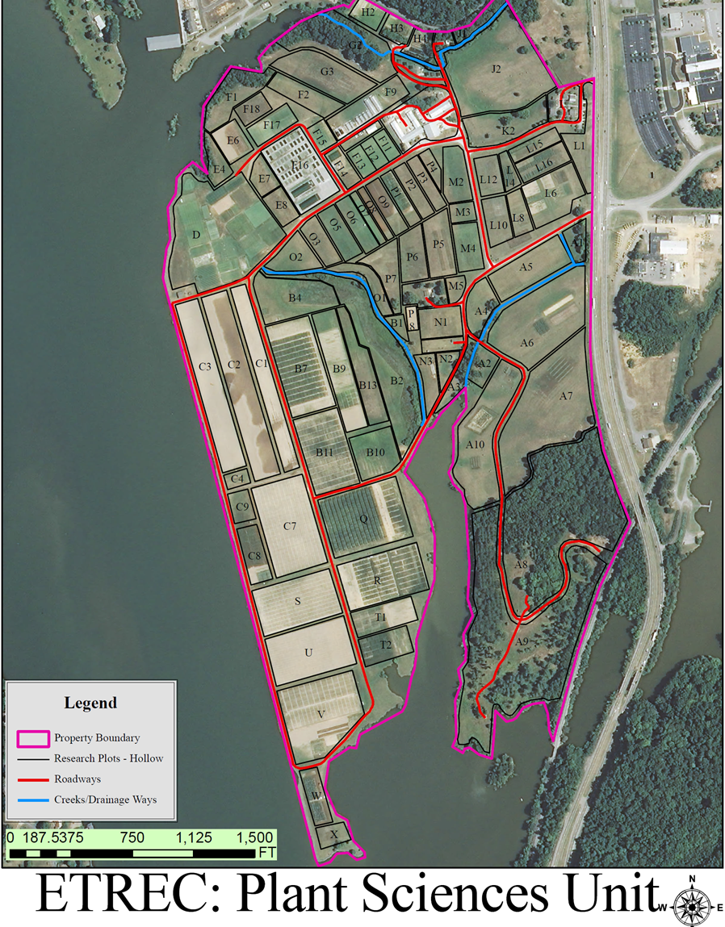
Research Plot Q
Research Plot B7
T
E
N
N
E
S
S
E
E
R
I
V
E
R
Figure 1: Location of fields Q and B7 at the University of Tennessee’s Plant Sciences East Tennessee Research and Education Center in Knoxville, Tennessee used in this study.

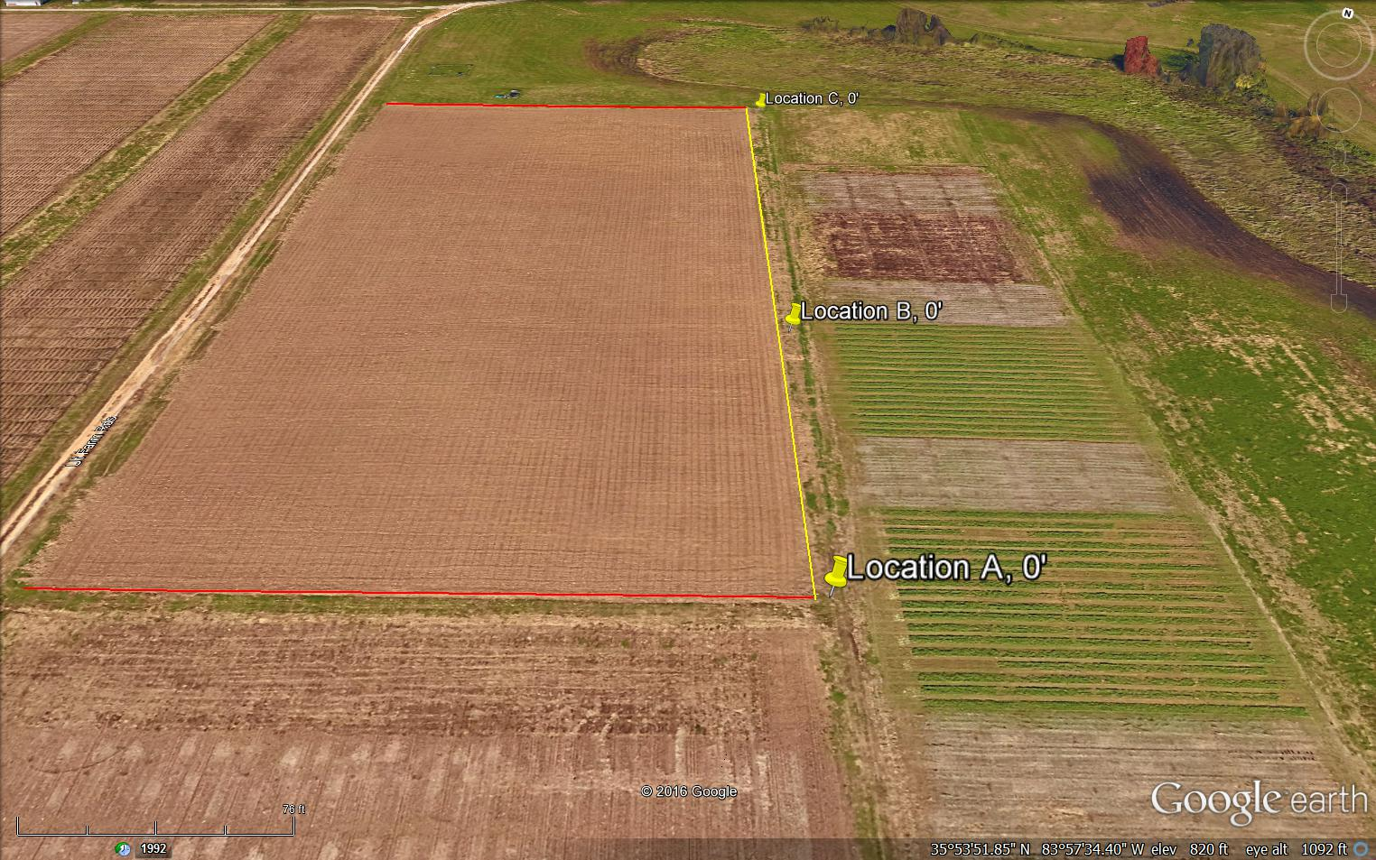
Plot Border

Plot Border-Study Area
76 ft.
Legend
Figure 2: Research Plot B7 with 0 meter soil sample collection sites

neonicotinoid seed treatment (DeLozier 2016). Research plots used in this study were lightly tilled following the harvest of the 2014 maize crop and prior to planting the winter wheat cover crop. The winter wheat cover crop was not tilled following harvest prior to soybean planting in the research plots used (Allen 2015, DeLozier 2016).
Neither research plot received additional applications of neonicotinoid pesticides following planting nor during the course of the study. Areas surrounding the research plots B7 and Q, including the soil sample collection sites, were not treated with neonicotinoid pesticides during 2014 or 2015 (DeLozier 2016). Herbicides containing the active ingredients of bentazon, imazethapyr and glyphosate were applied to both research plots during the season for routine weed control (DeLozier 2015). These chemicals were applied as needed at manufacturer recommended rates. Application during the study occurred on May 14, June 4, July 9, and July 20, 2015.
Both research plots involved in this study had a readily observed slope towards a small creek and reservoir (figure 2). Sites for soil sample collection were established on the side of the research plots which faced the water bodies, following the observed slope. Given that neonicotinoid compounds are water soluble it was assumed that these compounds would be detected along the downward slope in the soil of the adjacent plots. As it was assumed that neonicotinoids would leach downslope from the application site, the highest concentrations of thiamethoxam would most likely be detected in this region due to water drainage following rainfall events, along the slope contour.
The side of research plot B7 that was selected for soil sample collection is bordered by another field, research plot B9. The soil sample collection site B-B-6.1 adjacent to research plot B7 was located within research plot B9. Other 6.1 meter soil sample collection sites adjacent to research plot B7, B-C-6.1 and B-A-6.1, were not located within research plot B9. Research plot B9 was under soybean cultivation in 2015 and had not received neonicotinoid seed treatments in either 2014 or 2015. Soil sample collection sites established for research plot Q, were located within an area of wildflowers and grasses that had not received neonicotinoid treated seeds in 2014 or 2015.
The soil type and characteristics were the same for both research plots in this study. The soil was classified as a Sequatchie Fine Sandy Loam with a parent material of loamy alluvium derived from limestone, sandstone, and shale (Allen et al 2015). Soil in these plots contained high organic matter due to cover cropping with winter wheat and agricultural no-till practices.

Soil Collection Locations
Each research plot was measured and flagged on the corners and in the center of the plot. The initial soil sample collection sites were located at the terminal edge of the research plot, just outside of the soybean crop to avoid root damage or trampling of foliage. Initial sample collection sites were established by placing a flag marker on each corner of the plot and then using a 30 meter tape measure, the center of the plot was located from the corners and another flag marker placed in the center of the plot. Following the establishment of the initial soil collection sites, a 10 meter transect was drawn out perpendicular from each site with the 30 meter tape measure. Along each transect, a flag marker was placed at distances of 3.05 meters and 6.1 meters. This placement of flag markers was repeated for each of the established soil sample collection sites to give a total of 9 collection locations per research plot. The flag markers represented the soil sample collection locations for the determination of distance that the seed coated thiamethoxam moved, up to 6.1 meters from the application site into adjacent soils.
Each soil sample collection site was labeled to differentiate it from other sample sites. Sites for soil collection were labeled from south to north with the southern corner being labeled A, the center of the plot B and the northern corner of the plot as C. Both research plots received the same labeling of A, B, and C. All soil sample collection sites received a numerical suffix of 0, 3.05, or 6.1 to denote the distance from the plot edge. To differentiate between the soil sample collection sites adjacent to research plots Q and B7, each collection site was given an identification label. All soil sample collection sites received a prefix of Q or B corresponding to the research plot from which the soil sample was collected.
A table was generated to separate and catalog these identification labels for this
study (Table 1).

Soil Sample Collection Method
A standard soil probe from AMS Inc., model number 401.3, was used to collect soil core samples from each of the soil sample collection locations. The probe used was 33 inches in length with a diameter of 7/8 inches and having 10 inch cross-handle. Soil samples were collected with the probe from a depth of 7.6 cm to limit possible soil contamination from foliar sprays and to ensure that soil samples collected would contain only neonicotinoid compounds from seed coat treatment due to soil-water transport from the research plots.
Following the collection of a soil sample, the soil probe was thoroughly cleaned with 91% alcohol prior to the next collection to avoid contamination of samples. Soil cores were placed in paper bags after collection and labeled with the identification label corresponding to the soil sample collection site it was collected from before being placed in a laboratory grade freezer at the University of Tennessee Knoxville. Samples were stored at -20° C until ready for shipment to the USDA AMS laboratory in Gastonia, NC for analysis. Prior to shipment, soil samples were removed from the freezer and 5 g of each sample was weighed out as per the testing protocol for the Gastonia laboratory. Soil samples were then subjected to laboratory analysis for neonicotinoid content by a liquid chromatography tandem mass spectrometry method.
Soil samples were collected over a four month period corresponding with
the soybean growing season in East Tennessee. Dates of collections were: May
4 (At planting/pre-emergence), June 4, July 15 and August 24 (Post-harvest). A total of 9 soil samples were taken from each research plot on each collection date, resulting in 36 soil samples per research plot over the course of the study.

Table 1: Location identification legend for soil samples collected adjacent to research plots Q and B7 sample sites at three distances from edge of research plots Q, without thiamethoxam seed treatment, and B7, with thiamethoxam seed treatment, at the University of Tennessee’s Plant Sciences East Tennessee Research and Education Center in Knoxville, Tennessee
Distance from Field Edge | Research Plot Q, A | Research Plot Q, B | Research Plot Q, C | Research Plot B7, A | Research Plot B7, B | Research Plot B7, C
0 meters | Q-A-0 | Q-B-0 | Q-C-0 | B-A-0 | B-B-0 | B-C-0
3.05 meters | Q-A-3.05 | Q-B-3.05 | Q-C-3.05 | B-A-3.05 | B-B-3.05 | B-C-3.05
6.1 meters | Q-A-6.1 | Q-B-6.1 | Q-C-6.1 | B-A-6.10 | B-B-6.1 | B-C-6.1

Soil Analysis
Soil samples were analyzed by the United States Department of Agriculture (USDA) Agricultural Marketing Service (AMS) laboratory in Gastonia, North Carolina. Samples were analyzed using the QuEChERS (Quick, Easy, Cheap, Effective, Rugged, and Safe) method for pesticide analysis. The QuEChERS method is a highly streamlined sample preparation method with reliable results for a wide range of pesticide analyses (Anastassiades et al. 2003). The QuEChERS approach takes advantage of the wide analytical scope and high degree of selectivity and sensitivity provided by gas and liquid chromatography (GC and LC) coupled to mass spectrometry (MS) for detection of pesticide residues in a variety of food products and environmental samples (Lehotay et al. 2010). Soil samples for this study were analyzed for the presence of 13 different neonicotinoid compounds or metabolites (Barber 2016). The QuEChERS analysis method provided a LOD (limit of detection) for clothianidin, thiamethoxam imidacloprid at 1.0 ppb (parts per billion) from a soil sample of 3-5 grams (Barber 2016). Soil analysis results were received via email from the USDA AMS Gastonia laboratory.

Statistical Analysis
Statistical analysis of data collected from soil samples was conducted using SAS 9.4 software (SAS Institute, Cary NC). Due to the lack of randomization and the observational nature of this study a 2-way, repeated measures ANOVA test was used to determine significant differences among data points. Using soil sample collection dates as repeated measures allowed for comparisons to be made between collection dates, research plots and soil sample collection sites (Sun 2016).

Results and Discussion

Neonicotinoid Compounds Reported by Soil Analysis

Laboratory analysis of soil samples revealed that two neonicotinoid compounds were detected in the soil samples collected from the soil adjacent to the research plots. Neonicotinoid compounds found present in the soil samples were identified by the QuEChERS method as clothianidin and imidacloprid. No other neonicotinoid compounds were recovered in soil samples submitted for analysis (Barber et al. 2015 and 2016).

Neonicotinoid Compounds Recovered by Soil Analysis
The seed used in research plot B7 was treated with a neonicotinoid seed coat treatment of thiamethoxam (Cruiser®). Seed used in research plot Q was not treated with a thiamethoxam based seed coat treatment. Although the soil samples collected from soil adjacent to research plot B7 were expected to contain thiamethoxam, no evidence of that neonicotinoid compound was detected. Clothianidin, a primary metabolite of thiamethoxam, was detected in soil samples collected from the soil adjacent to both research plots B7 and Q.
Clothianidin was present in soil samples collected from soil adjacent to research plot B7 on June 4, July 15 and August 24 (Table 2). Concentrations of clothianidin were detected in all soil sample collection sites adjacent to research plot B7 during the June 4 collection period except from collection sites B-B-6.1, B-C-3.05 and B-C-6.1. Soil samples collected adjacent to research plot B7 during the July 15 collection period contained detectable amounts of clothianidin in all locations except B-A-0, B-A-6.1, B-C-3.05, and B-C-6.1. Only a single soil
Table 2: Clothianidin concentrations, in parts per billion (ppb), detected in soil samples collected over 4 months
from soils adjacent to research plot B7, planted with soybean seed treated with thiamethoxam in 2015.
 | Soil Sample Collection Date
Soil Sample Location Identification | May 4, 2015 | June 4, 2015 | July 15, 2015 | August 24, 2015
B-A-0 | 0 | 5.1 | 0 | 0
B-A-3.05 | 0 | 2.4 | 1.4 | 0
B-A-6.1 | 0 | 1.8 | 0 | 0
B-B-0 | 0 | 2.8 | 3.5 | 0
B-B-3.05 | 0 | 9.5 | 3.4 | 3.6
B-B-6.1 | 0 | 0 | 3.9 | 0
B-C-0 | 0 | 2.1 | 17.7 | 0
B-C-3.05 | 0 | 0 | 0 | 0
B-C-6.1 | 0 | 0 | 0 | 0

sample collected during the August 24 collection period contained a measurable concentration of clothianidin, B-B-3.05. The highest concentration of clothianidin, 17.7 ppb, detected in soil adjacent to research plot B7 was from soil sample collection site B-C-0 on July 14.
Soil samples collected adjacent to research plot Q were also analyzed for thiamethoxam content during the course of this study. No thiamethoxam was detected in any of the soil samples from soil adjacent to research plot Q, but as in soil samples collected adjacent to research plot B7, the thiamethoxam metabolite clothianidin was detected (Table 3). Clothianidin was detected in soil samples collected adjacent to research plot Q during the sample collection period on May 4 and July 15. During the soil sample collection period on May 4, clothianidin was found in soil adjacent to research plot B7 in soil sample sites Q-A-0, Q-B-0, Q-B-3.05, and Q-B-6.1. A soil sample from soil sample site Q-B-3.05, collected during July 15, from adjacent soil to research plot Q contained 3.5 ppb of clothianidin. No clothianidin was detected in soil samples collected from soil adjacent to research plot Q during June or August.
The neonicotinoid compound, imidacloprid, was also detected over the course of this study. Imidacloprid was detected in two soil samples, Q-B-6.1 and Q-C-3.05, collected from soil adjacent to research plot Q during the August soil sample collection period. Soil sample Q-B-6.1 contained 7.6 ppb of imidacloprid and soil sample Q-C-3.05 contained 1.5 ppb imidacloprid (Table 4).

Discussion

Metabolism and Conversion of Thiamethoxam to Clothianidin
There are several possible explanations for recovery of clothianidin instead of the compound thiamethoxam which was used as a seed treatment. According to the FAO, metabolic pathways of thiamethoxam in aerobic soils lead to conversion of thiamethoxam into clothianidin which may be further converted

Table 3: Clothianidin concentrations, in parts per billion (ppb), detected in soil samples collected over 4 months
from soils adjacent to research plot Q, planted with soybean seed without thiamethoxam treatment in 2015.
 | Soil Sample Collection Date
Soil Sample Location Identification | May 4, 2015 | June 4, 2015 | July 15, 2015 | August 24, 2015
Q-A-0 | 0 | 0 | 0 | 0
Q-A-3.05 | 0 | 0 | 0 | 0
Q-A-6.1 | 2.2 | 0 | 0 | 0
Q-B-0 | 2.2 | 0 | 0 | 0
Q-B-3.05 | 2.2 | 0 | 3.5 | 0
Q-B-6.1 | 2.5 | 0 | 0 | 0
Q-C-0 | 0 | 0 | 0 | 0
Q-C-3.05 | 0 | 0 | 0 | 0
Q-C-6.1 | 0 | 0 | 0 | 0

Table 4: Imidacloprid concentrations, in parts per billion (ppb), detected in soil samples collected over 4 months from soils adjacent to research plot Q, planted without soybean seed treatment with thiamethoxam in 2015.
 | Soil Sample Collection Date
Soil Sample Collection Location | May 4, 2015 | June 4, 2015 | July 15, 2015 | August 24, 2015
Q-A-0 | 0 | 0 | 0 | 0
Q-A-3.05 | 0 | 0 | 0 | 0
Q-A-6.1 | 0 | 0 | 0 | 0
Q-B-0 | 0 | 0 | 0 | 0
Q-B-3.05 | 0 | 0 | 0 | 0
Q-B-6.1 | 0 | 0 | 0 | 7.6
Q-C-0 | 0 | 0 | 0 | 0
Q-C-3.05 | 0 | 0 | 0 | 1.5
Q-C-6.1 | 0 | 0 | 0 | 0

into Clothianidin-NH and Clothianidin-Urea (cited in Simon-Delso et al 2015). Soil microbial activity involving the bacterium species from the genus Pseudomonas may be the primary cause of conversion from thiamethoxam to clothianidin in the soil environment (Pandey et al 2009). Other possible sources of conversion of thiamethoxam into clothianidin are hydrolysis and photolysis which form clothianidin as a byproduct of thiamethoxam degradation (Zabar et al 2012, FAO 2014).
The data resulting from analysis of soil samples collected adjacent to research plots Q and B7 were analyzed using SAS 9.4 software (SAS Institute, Cary NC) for statistical differences between the soil sample collection areas adjacent to research plots Q and B7. Using a 2-way, repeated measures ANOVA test it was found that soil sample data from the collection sites adjacent to research plots B7 did differ significantly from soil sample data from collection sites adjacent to research plot Q when tested at the 6% level of significance with a p-value of 0.0502. Additional statistical testing indicated that there was no statistical difference between distances that soil samples were collected or soil sample collection dates between the soil samples collected adjacent to research plots B7 and Q.
Output graphs from statistical testing show that clothianidin concentrations were not detected on the edge of research plot B7 in soil samples collected on May 4, but appeared on June 4, increased sharply on July 15 and were absence in detectable quantities by August 24, 2015 (Figure 3). The increase in concentration over time indicates that the clothianidin from seed treatment was transported from the application site in soil-water to the edge of research plot B7 over 3 months beginning on May 4 and continued through July 15 before finally dissipating by August 24. The lack of detectable concentrations of clothianidin on the edge of research plot B7 on August 24 indicates that the compound was either completely leached away or had deteriorated. Adsorption to soil particles is unlikely as the compound would have been detected continually through August.

Research Plot B7
Research Plot Q
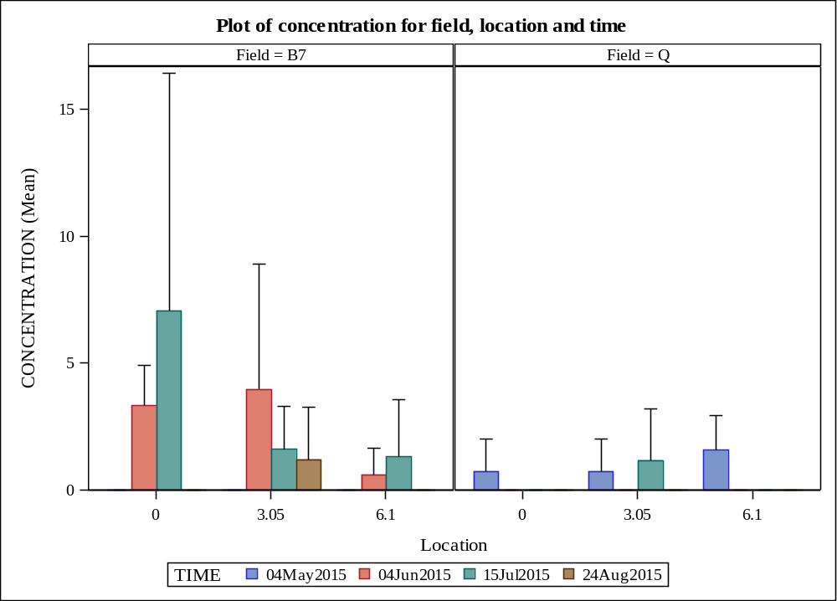
Concentration of clothianidin in parts per billion
Figure 3: Concentrations of clothianidin in parts per billion in soil for research plots B7 (treated soybean seed) and Q (untreated soybean seed) at three distances from edge of research plots in meters from four dates of sample collection.

Clothianidin detected in the soil samples collected from the edge of research plot Q did contain measurable concentrations of clothianidin on May 4, suggesting that the clothianidin detected may have been residual from the seed treated maize from the previous year and was still present due to adsorption to soil particles (Figure 3). The clothianidin was detected at distances of 3.05 meters and 6.1 meters from the edge of research plot Q on May 4, but was absent in soil samples collected on June 4 and reappeared on one occasion in a July 15 soil sample at a distance of 3.05 meters. Concentrations of clothianidin were no longer detected in soil sample collection sites adjacent to research plot Q by August 24, further indicating that the concentrations detected were the result of residues from seed coated maize in 2014.
Soil samples collected adjacent to research plot B7 detected concentrations of clothianidin at distances of 3.05 meters and 6.1 meters from the edge of the research plot (Figure 3, Figure 4). Concentrations of clothianidin detected 3.05 meters adjacent to research plot B7 were highest in soil samples collected on June 4 and decreased in concentration in soil samples collected on July 15 and August 24. Clothianidin concentrations detected at 6.1 meters from the edge of research plot B7 were higher in soil samples collected on July 15 than in soil samples from June 4 but were not detected in soil samples collected on August 24, showing a build-up in concentration over time leading to eventual loss from the soil environment. Detection of clothianidin concentrations over time at distances of 3.05 meters and 6.1 meters from the edge of the neonicotinoid seed treated research plot B7, indicated that this compound may be transported by soil-water to soils in adjacent untreated areas.
The concentrations of clothianidin detected in soil samples collected from soil adjacent to research plots were low with the exception of two occasions with concentrations reaching 17.7 and 9.5 parts per billion (Table 2). According to published LD₅₀ values, only 2.5 ng of clothianidin is toxic to honey bees (Pisa et al. 2015). To determine if the concentrations of clothianidin detected in soil samples collected are harmful to honey bees, parts per billion must be converted
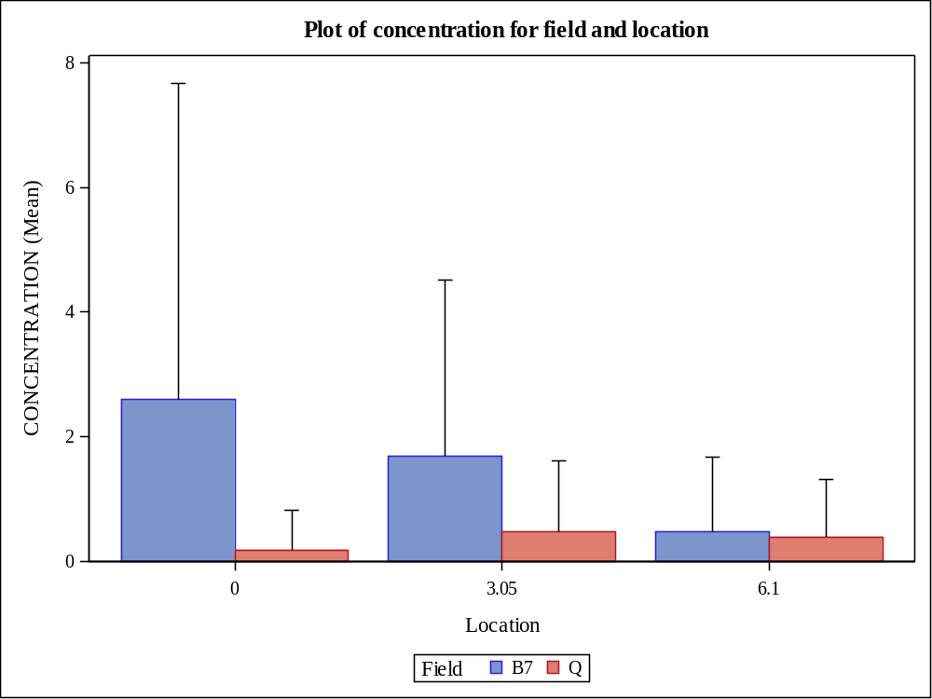
DISTANCE FROM EDGE OF RESEARCH PLOT IN METERS
MEAN OF CONCENTRATION OF CLOTHIANIDIN IN PARTS PER BILLION
Research Plot
Figure 4: Mean concentration of clothianidin in parts per billion from soil in two fields with either soybean seed treated (Plot B7) or untreated soybean seed (Q) at three distances from plot edge in meters.

to ng/bee, with a single bee weighing approximately 100 micrograms (Cited in Frazier et al. 2011). As 1 ng/bee is equivalent to 10 ppb, even the highest detected concentration of clothianidin detected in collected soil samples of 17.7 ppb is not harmful to honey bees and thus the clothianidin concentrations found in soil samples collected adjacent to research plots B7 and Q are not of concern to honey bee health.

Conclusions

The focus of this study was to collect evidence of soil-water transport of the neonicotinoid thiamethoxam in the soil matrix from a field planted with a neonicotinoid seed treatment into adjacent soils of untreated areas. Laboratory analysis of soil samples collected during this study revealed no thiamethoxam present in any of the soil samples. The neonicotinoid clothianidin was detected and is a known metabolite of thiamethoxam (Barber 2016, FAO 2010) and may break down or be metabolized in the soil and/or water. Causes of metabolism may include soil microbial activity, soil binding properties or hydrolysis. It is unlikely that the clothianidin recovered from the soil samples is residual from the previous year’s maize cultivation with neonicotinoid seed treatments as the compound was not detected in pre-planting soil samples but appeared in soil samples from later months. These data suggest that over time, the neonicotinoid clothianidin did erratically move from the application area and into the adjacent untreated soil. Concentrations of the compound varied but were highest during the months of June and July in the neonicotinoid seed treated research plot B7, while in the untreated research plot Q the month of May showed the highest concentration of clothianidin. In the control field, the presence of clothianidin may be the result of residual concentrations from the previous year treated maize, based on the detection of clothianidin in the soil at the start of the study and absent in later samples.
The neonicotinoid residues recovered from soil samples were not found in concentrations that warrant concern for honey bee and pollinator health. Furthermore, the concentrations, if taken up by non-target vegetation would likely be less concentrated resulting in less toxicity to visiting pollinators. When applied according to product label instructions, these insecticides exhibited soil-water transport out of treated areas but result in low concentrations that are well below the published LD₅₀ for honey bees.
Plantings of pollinator friendly wildflowers may provide foraging honey bees with food sources other than pollen and nectar from neonicotinoid treated crops which will reduce chemical exposure and increase honey bee nutrition diversity. Trap crop plantings along field borders may take up residual neonicotinoid concentrations in the soil, thus “trapping” them in vegetation which prevents the continued movement into non-targeted areas. Understanding that neonicotinoid insecticides may move away from application sites through the soil matrix allows for more research opportunities.

List of References

Allen, F.L. 2015. Personal correspondence. University of Tennessee, Knoxville.
Knoxville, TN, USA.

Allen, F.L., V.R. Sykes, V.G. Benelli, A.J. Ashworth, R.H. Blair, A. Thompson
McClure, and H. Kelly. 2015. Soybean Variety Performance Tests In
Tennessee. Agronomic Crop Variety Testing and Demonstrations
Department of Plant Sciences Institute of Agriculture University of
Tennessee Knoxville. Available online:
http://varietytrials.tennessee.edu/andwww.utcrops.com

Anastassiades, M., S.J. Lehotay, D. ˇStajnbaher and F.J. Schenck. 2003. J.
AOAC Int. 86.412.

Banerjee, K., S.H. Patil, S. Dasgupta, D.P. Oulkar, and P.G. Adsule. 2008.
Sorption of thiamethoxam in three Indian soils. Journal of Environmental
Science and Health, Part B: Pesticides, Food Contaminants, and
Agricultural Wastes. 43(2): 151-156. DOI: 10.1080/03601230701795130.

Barber, J. 2016. Personal correspondence and original laboratory results.
United States Department of Agriculture AMS Laboratory. Gastonia, NC,
USA.

Bonmatin, J.M., C. Giorio, V. Girolami, D. Goulson, D.P. Kreutzweiser, C.
Krupke, M. Liess, E. Long, M. Marzaro, E.A.D. Mitchell, D.A. Noome,
N. Simon-Delso, and A. Tapparo. 2014. Environmental fate and exposure;
neonicotinoids and fipronil. Environmental Science and Pollution
Research International. DOI: 10.1007/s11356-014-3332-7. Available
online: http://link.springer.com/article/10.1007/s11356-014-3332-7

Bowling, B., A. Smith, and T. Johnson. 2016. 2015 Planted Acreage for Corn,
Cotton, Grain Sorghum, Soybeans and Wheat in Tennessee by County.
University of Tennessee Institute of Agriculture. Available online:
http://economics.ag.utk.edu/crops/2015PlantedAcreagebyCo.pdf

Brodschneider, R. and K. Crailsheim. 2010. Nutrition and health in honey bees.
Apidologie 41 (2010) 278–294. Available online:
http://www.apidologie.org/articles/apido/pdf/2010/03/m09120.pdf

Caron, D.M., and L.J. Connor. 2013. Honey Bee Biology and Beekeeping.
Wicwas Press. Kalamazoo, MI, USA.

CCD Steering Committee. 2007. Colony Collapse Disorder Action Plan. United
States Department of Agriculture. Washington, D.C., USA. Available
online: http://www.ars.usda.gov/is/br/ccd/ccd_actionplan.pdf

Cutler, G.C., C.D. Scott-Dupree, M. Sultan, A.D. McFarlane, and L. Brewer.
2014. A large-scale field study examining effects of exposure to
clothianidin seed-treated canola on honey bee colony health,
development, and overwintering success. Peer J. 2:e652.

DeLozier, B.J. 2015. Personal correspondence. University of Tennessee,
Knoxville. Knoxville, TN, USA.

DeLozier, B.J. 2016. Personal correspondence. University of Tennessee,
Knoxville. Knoxville, TN, USA.

Ellis, J. 2013. Colony Collapse Disorder (CCD) in Honey Bees. University of
Florida IFAS Extension. Gainesville, FL, USA. Available online:
http://solutionsforyourlife.ufl.edu/hot_topics/agriculture/colony_collapse_disorder.shtml.

Environmental Protection Agency. 2016. Colony Collapse Disorder. Available
online: https://www.epa.gov/pollinator-protection/colony-collapse-disorder

Environmental Protection Agency. 2014. Benefits of Neonicotinoid Seed
Treatments to Soybean Production. Available online:
https://www.epa.gov/sites/production/files/2014-10/documents/benefits_of_neonicotinoid_seed_treatments_to_soybean_production_2.pdf

Fishel, F.M. 2015. Pesticide Toxicity Profile: Neonicotinoid Pesticides. University
of Florida IFAS Extension. Gainesville, FL, USA. Available online:
http://edis.ifas.ufl.edu/pi117

Food and Agriculture Organization of the United Nations. 2010. FAO
SPECIFICATIONS AND EVALUATIONS FOR AGRICULTURAL
PESTICIDES, CLOTHIANIDIN. Available online:
http://www.fao.org/fileadmin/templates/agphome/documents/Pests_Pestici des/Specs/Clothianidin2011.pdf

Food and Agriculture Organization of the United Nations. 2014. FAO
SPECIFICATIONS AND EVALUATIONS FOR AGRICULTURAL
PESTICIDES, THIAMETHOXAM. Available online:
http://www.fao.org/fileadmin/templates/agphome/documents/Pests_Pesticides/Specs/Thiamethoxam2014.pdf

Fossen, M. 2006. Environmental Fate of Imidacloprid. Environmental Monitoring
Department of Pesticide Regulation. Sacramento CA. Available online:
http://www.cdpr.ca.gov/docs/emon/pubs/fatememo/Imidclprdfate2.pdf

Frazier, J., C. Mullin, M. Frazier, and S. Ashcroft. 2011. Pesticides and their
involvement in Colony Collapse Disorder. Managed Pollinator CAP.
available online:
http://www.beeccdcap.uga.edu/documents/CAPArticle16.html

Gervais, J.A., B. Luukinen, K. Buhl, D. Stone. 2010. Imidacloprid General Fact
Sheet. National Pesticide Information Center. Oregon State University
Extension Services. Available online:
http://npic.orst.edu/factsheets/imidagen.html

Girolami, V., L. Mazzon, A. Squartini, N. Mori, M. Marzaro, A. Di Bernardo, M.
Greatti, C. Giorio and A. Tapparo. 2009. Translocation of Neonicotinoid
Insecticides From Coated Seeds to Seedling Guttation Drops: A Novel
Way of Intoxication for Bees. Journal of Economic Entomology. 102 (5):
1808-1815.

Goulson, D. 2013. An overview of the environmental risks posed by neonicotinoid
insecticides. Journal of Applied Ecology. 50 (4): 977–987.

Gupta, S., V.T. Gajbhiye and R.K. Gupta. 2008. Soil Dissipation and Leaching
Behavior of a Neonicotinoid Insecticide Thiamethoxam. Bulletin of
Environmental Contamination and Toxicology. 80:431-437.

Han, F., A. Wallberg and M.T. Webster. 2012. From where did the Western
honeybee (Apis mellifera) originate? Ecology and Evolution. 2(8): 1949–1957.

Hansen, R. 2015. Bees.
http://www.agmrc.org/commodities-products/livestock/
bees-profile/

Hatjina, F., C. Papaefthimiou, L. Charistos, T. Dogaroglu, M. Bouga,
C. Emmanouil and G. Arnold. 2013. Sublethal doses of imidacloprid
decreased size of hypopharyngeal glands and respiratory rhythm of
honeybees in vivo. Apidologie. 44 (4): 467-480.

Helmholtz Association of German Research Centres. “Economic Value Of Insect
Pollination Worldwide Estimated At U.S. $217 Billion.” ScienceDaily.
ScienceDaily, 15 September 2008.

Henry, M., M. Beguin, F. Requier, O. Rollin, J.F. Odoux, P. Aupinel, J. Aptel,
S. Tchamitchian and A. Decourtye. 2012. A Common Pesticide Decreases
Foraging Success and Survival in Honey Bees. Science. 336 (6079): 348-
350.

Hopwood, J., M. Vaughan, M. Shepherd, D. Biddinger, E. Mader, S.H. Black, and
C. Mazzacano. 2012. Are Neonicotinoids Killing Bees. Xerces Society for
Invertebrate Conservation. Portland, OR, USA.

Hopwood, J., S.H. Black, M. Vaughan, and E. Lee-Mader. 2013. Beyond the
Birds and Bees; Effects of Neonicotinoid Insecticides on Agriculturally
Important Beneficial Invertebrates. Xerces Society for Invertebrate
Conservation. Portland, OR, USA.

Huang, Z. 2010. Honey Bee Nutrition. eXtension publication. Available online:
http://articles.extension.org/pages/28844/honey-bee-nutrition

Jeong, C.Y., and H.M. Selim. 2010. Modeling Adsorption-Desorption Kinetics of
Imidacloprid in Soils. Soil Science. 175(5): 214-222.

Jeschke, P., R. Nauen, M. Schindler, and A. Elbert. 2011. Overview of the
Status and Global Strategy for Neonicotinoids. Journal of Agricultural and
Food Chemistry. 59(7):2897-908.

Johnson, J.D., and J.S. Pettis. 2014. A Survey of Imidacloprid Levels in Water
Sources Potentially Frequented by Honeybees (Apis mellifera) in the
Eastern USA. Water Air Soil Pollution Journal. 225: 2127.
doi:10.1007/s11270-014-2127-2. Available online:
http://link.springer.com/article/10.1007/s11270-014-2127-2

Kegley, S.E., B.R. Hill, S. Orme, A.H. Choi. 2014. PAN Pesticide Database,
Pesticide Action Network, North America (Oakland, CA). available online:
http://pesticideinfo.org/Detail_Chemical.jsp?Rec_Id=PC40063

Kessler, S.C., E. J. Tiedeken, K.L. Simcock, S. Derveau, J. Mitchell, S. Softley,
J.C. Stout and G.A. Wright. 2015. Bees prefer foods containing
neonicotinoid pesticides. Nature. 521: 74-76.

Kimsey, L.S. (1984). The behavioural and structural aspects of grooming and
related activities in euglossine bees (Hymenoptera: Apidae). Journal of
Zoology. 204: 541-550. doi: 10.1111/j.1469-7998.1984.tb02386.x

Krupke, C.H., G.J. Hunt, B.D. Eitzer, G. Andino and K. Given. 2012. Multiple
Routes of Pesticide Exposure for Honey Bees Living Near Agricultural
Fields. PLoS One. 7 (1): e29268. doi: 10.1372/ journal.pone.0029268.

Lawrence, T. and W.S. Sheppard. 2013. Neonicotinoid Pesticides and Honey
Bees. Washington State University Extension Fact Sheet, FS122E.
Available online:
http://cru.cahe.wsu.edu/CEPublications/FS122E/FS122E.pdf

Michener, C.D. 2000. The Bees of the World. The Johns Hopkins University
Press, Baltimore, MD, USA. 913 pp.

Mullin, C.A., M. Frazier, J.L. Frazier, S. Ashcraft, R. Simonds, et al. 2010. High
levels of miticides and agrochemicals in North American apiaries:
Implications for honey bee health. PLoS One. 5:el9754.

National Center for Biotechnology Information. PubChem Compound Database;
CID=213027.Available online: https://pubchem.ncbi.nlm.nih.gov/compound/Clothianidin#section=Information-Sources (accessed June 20, 2016).

National Center for Biotechnology Information. PubChem Compound Database;
CID= 86418. Available online:
https://pubchem.ncbi.nlm.nih.gov/compound/Imidacloprid#section=Top
(accessed June 20, 2016).

National Center for Biotechnology Information. PubChem Compound Database;
CID= 107646. Available online:
https://pubchem.ncbi.nlm.nih.gov/compound/107646
(accessed June 20, 2016).

North, J.H., J. Gore, A.L. Catchot, S.D. Stewart, G.M. Lorenz, F.R. Musser,
D.R. Cook, D.L. Kerns, and D.M. Dodds. 2016. Value of Neonicotinoid Insecticide Seed Treatments in Mid-South Soybean (Glycine max) Production Systems. Journal of Economic Entomology. Available online:
http://www.ncbi.nlm.nih.gov/pubmed/27091814

Pandey, G., S.J. Dorrian, R.J. Russell, and J.G. Oakeshott. 2009.
Biotransformation of the neonicotinoid insecticides imidacloprid and
thiamethoxam by Pseudomonas sp. 1G. Biochemical and Biophysical
Research Communications. 380 (2009) 710-714.

Pisa, L.W., V. Amaral-Rogers, L.P. Belzunces, J.M. Bonmatin, C.A. Downs, D.
Goulson, D.P. Kreutzweiser, C. Krupke, M. Liess, M. McField, C.A.
Morrissey, D.A. Noome, J. Settele, N. Simon-Delso, J.D. Stark, J.P.
Van der Sluijs, H. Van Dyck, and M. Wiemers. 2015, Effects of neonicotinoids and fipronil on non-target invertebrates. Environmental Science Pollution Research. 22:68-102. doi: 10.1007/s11356-01403471-x.

Pohorecka, K., P. Skubida, P. Semkiw, A. Miszczak, D. Teper, P. Sikorski, K.
Zagibajlo,
M. Skubida, D. Zdanska and A. Bober. 2013. Effects of Exposure of
Honey Bee Colonies to Neonicotinoid Seed-Treated Maize Crops. Journal
of Apicultural Science. 57(2): 199-208.

Bayer Crop Science. 2014. Poncho 600 FS Seed Treatment Insecticide. SDS
No. 102000012783 [Online]; Bayer Crop Science Inc. Calgary, Alberta.
February 7, 2014. Available online:
https://www.cropscience.bayer.ca/~/media/Bayer%20CropScience/Countr y-Canada-Internet/Products/Poncho/Poncho-MSDS.ashx (accessed June
16, 2016).

Ritter, W., and P. Akratanakul. 2006. Honey bee diseases and pests: a practical
guide. Food and Agriculture Organization of the United Nations. Available
online: http://www.fao.org/3/a-a0849e.pdf

Rondeau, G., F. Sanchez-Bayo, H.A. Tennekes, A. Decourtye, R. Ramirez-
Romero and N. Desneux. 2014. Delayed and time-cumulative toxicity
of imidacloprid in bees, ants and termites. Scientific Reports. 4, 5566;
DOI: 10.1038/srep05566.

Root, A. I. 2006. The ABC and XYZ of Bee Culture. A. I. Root Company, Medina,
Ohio, USA. 911 pp.

Rundlof, M., G.K.S. Andersson, R. Bommarco, I. Fries, V. Hederstrom, L.
Herbertsson, O. Jonsson, B.K. Klatt, T.R. Pedersen, J. Yourstone and
H.G. Smith. 2015. Seed coating with a neonicotinoid insecticide negatively
affects wild bees. Nature. 521(7550): 77-80. doi:10.1038/nature14420

SAS Institute, Inc. 2012. The SAS System OnlineDoc, Version 9.4. Cary, NC.
Accessed June 2016.

Sanford, M.T. 2003.Diseases and Pests of the Honey Bee. University of Florida
IFAS Extension Publication. Available online:
http://entnemdept.ufl.edu/honeybee/extension/AA09000%20Pests%20and
%20Diseases.pdf

Saxton, A.M. 2015. Design and Analysis for Biological Research. Department of
Animal Science, University of Tennessee, Knoxville. Knoxville, TN, USA.

Saxton, A.M. 2015. Personal correspondence. University of Tennessee,
Knoxville. Knoxville, TN, USA.

Seagraves, M.P. and J.G. Lundgren. 2012. Effects of neonicotinoid seed
treatments on soybean aphid and its natural enemies. Journal of Pest
Science. 85: 125-132.

Schneider, C.W., J. Tautz, B. Grunewald and S. Fuchs. 2012. RFID Tracking
of Sublethal Effects of Two Neonicotinoid Insecticides on the Foraging
Behavior of Apis mellifera. PloS One. 7(1): e30023. doi: 10.1371/
journal.pone.0030023.

Simon-Delso, N., V. Amaral-Rogers, L.P. Belzunces, J.M. Bonmatin,
M. Chagnon, C. Downs, L. Furlan, D.W. Gibbons, C. Giorgio, V.
Girolami, D. Goulson, D.P. Kreutzweiser, C.H. Krupke, M. Liess, E. Long,
M. McField, P. Mineau, E.A.D. Mitchell, C.A. Morrissey, D.A. Noome, L.
Pisa, J. Settele, J.D. Stark, A. Tapparo, H. Van Dyck, J. Van Praagh, J.P.
Van der Sluijs, P.R. Whitehorn, and M. Wiemers. 2015. Systemic
insecticides (neonicotinoids and fipronil): trends, uses, mode of action and
metabolites. Environmental Science and Pollution Research. 22: 5-34.

Stamm, M.D., T.M. Heng-Moss, F.P. Baxendale, J.C. Reese, B.D. Siegfried,
T.E. Hunt, R.E. Gaussoin, and E.E. Blankenship. 2013. Effects of
Thiamethoxam Seed Treatments on Soybean Aphid (Hemiptera:
Aphididae) Feeding Behavior. Journal of Economic Entomology.
106(6): 2384Ð2390.

Stewart, S.D., G.M. Lorenz, A.L. Catchot, J. Gore, D. Cook, J. Skinner, T.C.
Mueller, D.R. Johnson, J. Zawislak and J. Barber. 2014. Potential
Exposure of Pollinators to Neonicotinoid Insecticides from the Use of
Insecticide Seed Treatments in the Mid-Southern United States.
Environmental Science and Technology. 48(16). DOI:10.1021/es501657w.

Stoner, K.A. and B.D. Eitzer. 2012. Movement of Soil-Applied Imidacloprid and
Thiamethoxam into Nectar and Pollen of Squash (Cucurbita pepo). PloS
ONE. 7(6). e39114. doi: 10.1371/journal.pone.003914.
Sun, X. 2016. Personal correspondence and statistical counseling. University of
Tennessee, Knoxville. Knoxville, TN, USA.

Syngenta Crop Protection. 2012. Cruiser insecticide label. Syngenta Crop
Protection, Greensboro, NC, USA. Available online:
http://www.cdms.net/LDat/ld59U012.pdf

Tan, K., W. Chen, S. Dong, X. Liu, Y. Wang and J.C. Nieh. 2014. Imidacloprid
Alters Foraging and Decreases Bee Avoidance of Predators. PloS One.
9(7): e102725. doi: 10.1371/journal.pone.0102725.

Tapparo, A., D. Marton, C. Giorio, A. Zanella, L. Solda, M. Marzaro, L. Vivan and
V. Girolami. 2012. Assessment of the Environmental Exposure of
Honeybees to Particulate Matter Containing Neonicotinoid Insecticides
Coming from Corn Coated Seeds. Environmental Science and
Technology. 46(5): 2592-9. doi: 10.1021/es2035152.

United States Department of Agriculture. 2013. USDA and EPA Release New
Report on Honey Bee Health. Release No. 0086.13. USDA. Washington
DC, USA. Available online: http://www.usda.gov/wps/portal/usda/usdamediafb?contentid=2013/05/0086.xml&printable=true&contentidonly=true

Clutch 50 WDG Insecticide. MSDS NO.: 0355 [Online]; Valent USA Corporation:
Walnut Creek, CA. February 19, 2010. http://www.agrian.com/pdfs/Clutchr_50_WDG_Insecticide1T_MSDS.pdf
(accessed June 16, 2016).

van der Sluijs, J.P., N. Simon-Delso, D. Goulson, L. Maxim, J.M. Bonmatin and
L.P. Belzunces. 2013. Neonicotinoids, bee disorders and the sustainability
of pollinator services. Current Opinion in Environmental Sustainability.
5:293-305.

vanEngelsdorp, D., J.D. Evans, C. Saegerman, C. Mullin, E. Haubruge, B.K.
Nguyen, M. Frazier, J. Frazier, D. Cox-Foster, Y. Chen, R. Underwood
D.R. Tarpy, J.S. Pettis. 2009. Colony Collapse Disorder: A Descriptive
Study. PloS ONE. 4(8): e6481. doi: 10.1371/journal.pone. 0006481.

Winston, M.L. 1987. The Biology of the Honey Bee. First Harvard University
Press. Cambridge, MA, USA.

Wu, J., C. Anelli, and W. Sheppard. 2011. Sub-lethal effects of pesticide residues
in brood comb on worker honey bee (Apis mellifera) development and
longevity. PLoS ONE. 6:el14720.

Xu T., D.G. Dyer, L.L. McConnell, S. Bondarenko, R. Allen, and O. Heinemann.
2016. Clothianidin In Agricultural Soils And Uptake Into Corn Pollen And
Canola Nectar After Multiyear Seed Treatment Applications.
Environmental Toxicology and Chemistry. 35(2) 311-321.

Yang, E-C., H-C. Chang, W-Y. Wu and Y-W. Chen. 2012. Impaired Olfactory
Associative Behavior of Honeybee Workers Due to Contamination of
Imidacloprid in the Larval Stage. PLoS One. 7(11): e49472. doi:10.1371/
journal.pone.0049472.

Zabar, R., T. Komel, J. Fabjan, M.B. Kralj, and P. Trebse. 2012. Photocatalytic
degradation with immobilized TiO2 of three selected neonicotinoid
insecticides: Imidacloprid, thiamethoxam and clothianidin. Chemosphere
89 (2012) 293-301.

Zhu, Y.C., J. Adamczyk, T. Rinderrer, J. Yao, R. Danka, R. Luttrell, and J. Gore.
2015. Spray Toxicity and Risk Potential of 42 Commonly Used
Formulations of Row Crop Pesticides to Adult Honey Bees (Hymenoptera:
Apidae). Journal of Economic Entomology. 108(6):2640-7. doi:
10.1093/jee/tov269. Available online:
http://www.ncbi.nlm.nih.gov/pubmed/26352753

Vita

Geoffrey Nathaniel Duesterbeck was born January 24, 1975 in Eau Claire, WI. Geoffrey was raised in La Crosse, WI where he graduated Logan Senior High School in June 1993. He proceeded to attend the University of Wisconsin, Eau Claire until leaving to pursue a career in masonry. Geoffrey worked as a professional mason in Wisconsin and Tennessee for over 13 years before enrolling in an Associate degree program at Pellissippi State Community College in August 2010. He graduated from Pellissippi State Community College in May 2012 with an Associate of Science degree. Following his graduation from Pellissippi State, Geoffrey, transferred to the University of Tennessee, Knoxville to pursue a Bachelor of Science degree in Plant Sciences. In May 2014, he graduated with honors from the University of Tennessee, Knoxville and began studying towards a Master of Science degree in Entomology under the guidance of Dr. John A. Skinner. Geoffrey is a member of the Gamma Sigma Delta honor society as well Phi Sigma Theta National Honor Society and Phi Theta Kappa Honor Society.

