Characterization of Influenza Hemagglutinin Mutants for the Elucidation of Key Residues’ Effect on Activation

University of Tennessee, Knoxville
Chemical and Biomolecular Engineering Department

Morgan R. Baltz

Table of Contents

Abstract……………………………………………………………………3

Introduction……………………………….......………………………….3

Background……………………..………………………………………...5

Cell-Based Detection Assay to Identify Novel Activators………...6

Characterization of Single Mutants……………………………........10

Materials and Methods………………………………….……………..11

Results……………………………………………………………………13

Conclusions……………………………………………………………..15

References……………………………………………………………….18

Abstract

Hemagglutinin (HA) is a viral fusion protein that undergoes an irreversible conformational change upon acidification to catalyze the fusion of endosomal and viral membranes. Previous work utilized directed evolution to identify novel mutants with activation pH across a range of 4.8-6.0; wild-type HA activates around pH 5.2. This work further evaluates these mutants by analyzing individual amino acid substitutions and has identified point mutants responsible for phenotypic changes, thus providing additional structure-function insight. In most of the novel mutants analyzed, single mutations providing either a stabilizing or destabilizing effect were found to solely elicit the novel activation pH. Mutant HA3.2.5, however, activates at pH 5.6 through the combined effect of both stabilizing and destabilizing mutations.

Introduction

There is currently a push towards the advancement of “personalized medicine”, in which individual genetic differences guide the detection, diagnosis, and treatment of patients. It is these incredibly minute individual genetic differences that can lead to drastic variation in disease progression, and most critically, in the patient response to pharmaceuticals. One major impediment to the progression of personalized medicine, however, is the development of specific and efficient drug delivery mechanisms.
Viruses have naturally evolved as an efficient delivery mechanism, possessing the ability to recognize specific cell targets, gain entry into the host cell, and then utilize cell machinery for their own propagation. The study of these viral mechanisms advances knowledge of viruses themselves, but also provides a foundation for which new drug delivery systems can be engineered. Of particular interest is influenza hemagglutinin, a membrane protein which assists with the initial viral binding event, as well as mediating fusion between the viral and endosomal membranes, which enables the release of the viral genome into the host cell (Figure 1)

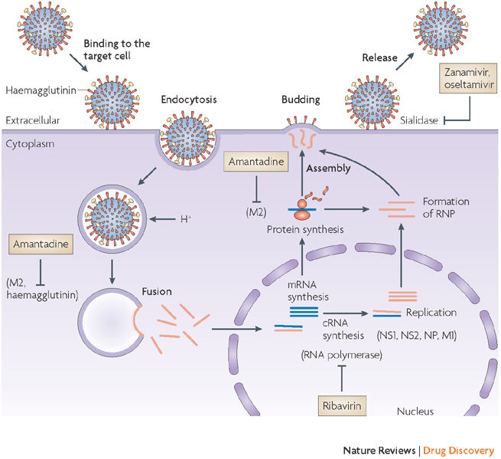
Figure 1: Influenza virus life cycle.
Mark von Itzstein, Nature Reviews: Drug Discovery , 6 (2007), 967-974.

Background

Influenza hemagglutinin (HA) is a membrane glycoprotein presented as a homotrimer of heterodimers. It is synthesized as a single polypeptide chain, HA0, which is protolytically cleaved into two subunits, HA1 and HA2, which remain associated via a disulfide bond.¹⁻³
The N-terminus of HA2 contains 20 highly conserved, hydrophobic residues called the “fusion peptide”⁴ . At neutral pH, this fusion peptide remains buried in the trimeric interface, but when the virus is endocytosed, the endosome becomes acidified, and this low pH triggers HA to undergo an irreversible conformation change termed “activation” (Figure 2). A loop to helix transition in the HA2 subunit, expels the fusion peptide from the hydrophobic trimer interior, repositioning it at the membrane distal end of the protein.⁵ It is known that the fusion peptide is necessary for fusion of the viral and endosomal membranes, but it is unknown which membrane it inserts into.⁶ The most accepted model, however, proposes that it inserts into the host membrane (Figure 3).

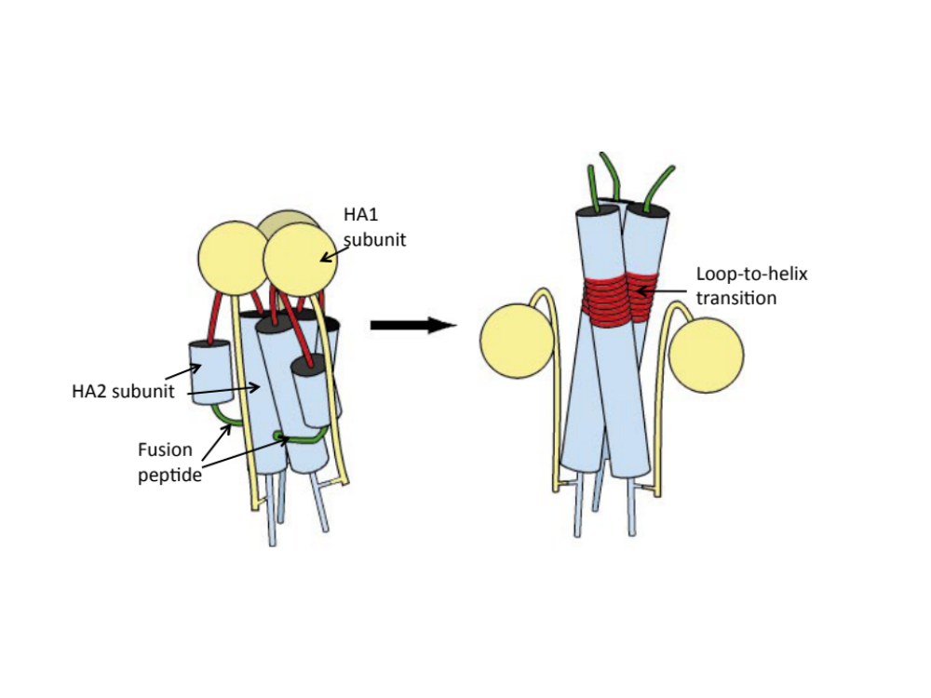

Figure 2: Hemagglutinin Trimer Cartoon.
Adapted from Eckert and Kim, Annu. Rev. Biochem., 70: 777-810, 2001.

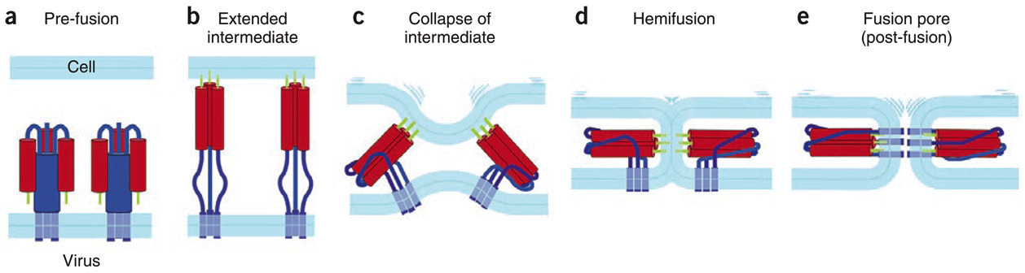
Figure 3: Hemagglutinin-Mediated Membrane Fusion.
Harrison, Stephen C., Nature Structural Biology 15 (2008), 690-698.

Cell-Based Detection Assay to Identify Novel Activators

Previous work established a cell-based HA functional assay that identified novel HA mutants that activated at both lower and higher pH than the wild-type.⁷ First, it was established the fusion peptide could be utilized as a detection tag by replacing amino acids 11-20 with a c-myc epitope sequence. With this construct, the fusion peptide, and consequently detection tag, remain buried in the trimer interface at neutral pH. In this conformation, staining with antibody specific to the c-myc epitope is unsuccessful, as the antibody has no opportunity to bind. After incubating cells at 5 minutes at a low pH, however, the fusion peptide is exposed and amenable to labeling with the c-myc epitope specific antibody.
Figure 4 verifies this assay. The x-axis quantifies the presence of HA trimers on the cell surface, while the y-axis quantifies the presence of the exposed c-myc epitope, which corresponds to activated HA trimers. At neutral pH 7, 31% of cells are expressing inactivated HA, however, 0% of the HA is activated. At pH 5.4, one can begin to see the activation of HA, as 26% of cells are expressing inactivated HA, but a small 4% of cells express activated HA. At pH 5.0, almost all of the HA has been activated, as only 3% of cells express inactivated HA, while 25% of cells are expressing activated HA. Of significant note, no cells are expressing both inactivated and activated HA, as these cells would be detected in the upper right quadrant.
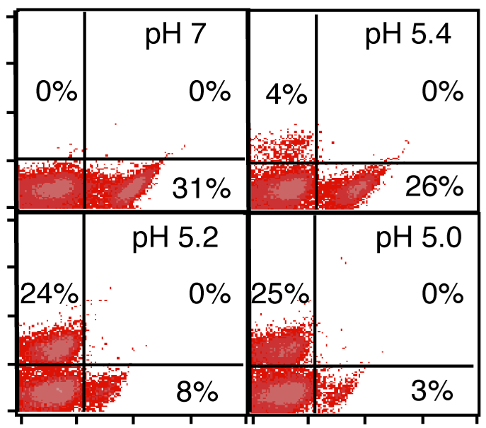
log(trimeric HA)
log(exposed c-myc)
Figure 4: Verification of c-myc Detection Tag for Activation
Lee, J.H. Engineering and Characterization of Influenza Hemagglutinin Properties in Mammalian System. PhD Thesis, 2007.

This assay was then extended to identify mutants with novel activation pH. Wild-type HA activates at pH 5.2, so it was desirable to find mutants that were comparatively stabilized (pH 4.8) and destabilized (pH 5.6 and 6.0). First a combinatorial library was created via random mutation of the protein sequence. Mutated sequences were then ligated into the retroviral vector pLNCX2. These plasmids were then used to transfect EcoPack 2-293 cells. Virus was collected and used to retrovirally transduce 3T3 cells. With this system, each cell is expressing only one mutant, and thus can be assayed using the cell-based c-myc assay described above. Secondly, virus rescue can be employed to recover DNA from desired clone.
The library was screened for higher mutants by first incubating at the desired pH. These higher pH values are sufficient for activating mutants with novel phenotypes without activating the wild-type HA. The library was then labeled with anti-cmyc antibodies. Only novel activators will have an exposed epitope, and therefore will be the only cells labeled. The library can then be screened for novel activators using Fluorescence Activated Cell Sorting (Figure 5). HC2 is an antibody specific for HA trimers in any conformation, thus quantifying overall HA expression, and as previously mentioned, anti-c-myc, recognizes the engineered c-myc tag on the fusion peptide, quantifying only activated HA. In the naïve library, only 6% of cells displayed novel activating phenotypes at pH 5.6, but after three rounds of FACS sorting, this population was enriched to 96%. Similarly, only 5% of the naïve library displayed activation at pH 6.0, but was enriched to 88% after three rounds of FACS sorting.
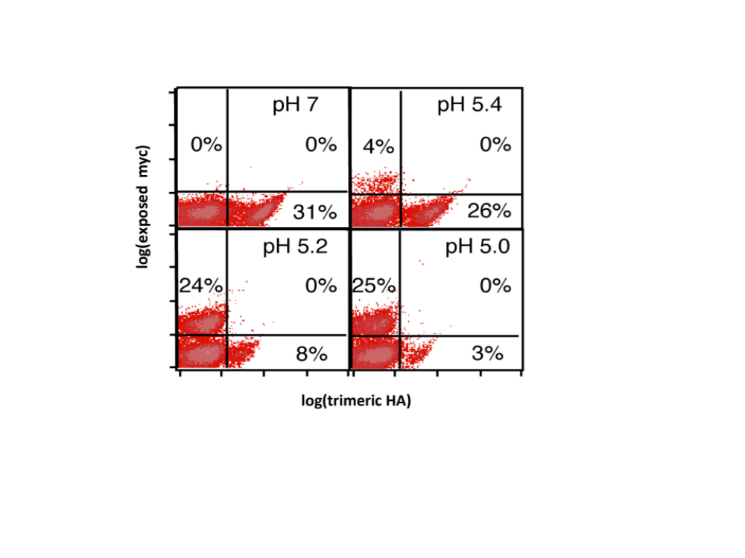
Figure 5: High pH Mutants Pre- and Post-Sort.
Lee, J.H. Engineering and Characterization of Influenza Hemagglutinin Properties in Mammalian System. PhD Thesis, 2007.

Low pH novel activators required more processing steps. Incubating the library at pH 4.8 would not only activate the desired low pH activators, but also the undesired wild-type activators and high pH activators. First, the naïve library was incubated at pH 5.2 for 5 minutes to activate wild-type activators as well as high pH activators. Thermolysin, an enzyme that preferentially cleaves hydrophobic residues, was then used to cleave the exposed fusion peptides. Now that all clones activating at pH 5.2 or above were essentially rendered inactive, the library was pulsed at the desired pH of 4.8. At this point, the process becomes similar to before, and three rounds of FACS isolated the desired low pH mutants (Figure 6).
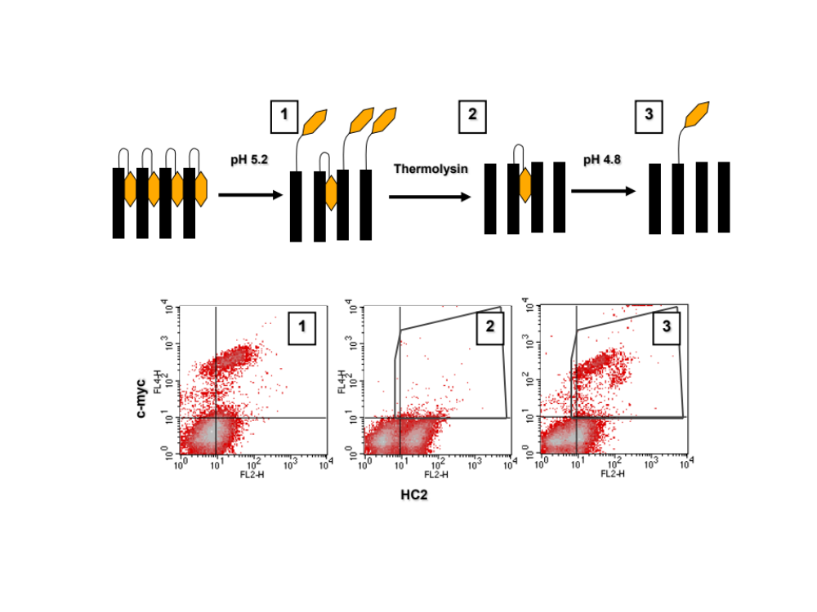
Figure 6: Low pH Mutant Schematic.
Lee, J.H. Engineering and Characterization of Influenza Hemagglutinin Properties in Mammalian System. PhD Thesis, 2007.

Mutants recovered from the sorting process were characterized to verify that they do in fact possess a novel activating phenotype, and sequencing revealed mutated residues⁷(Figure 7).

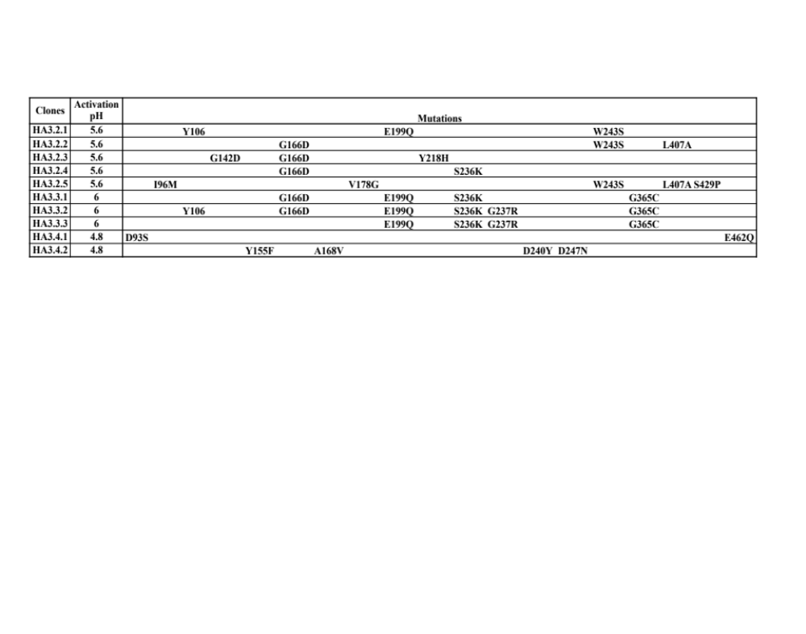
Figure 7: Summary Table of Directed Evolution Mutants

Characterization of Single Mutants

In order to delve further into the HA structure-function relationship, the directed evolution mutants were further dissected to evaluate which mutations were responsible for the novel phenotypes. A single amino acid mutant was constructed for each of the mutations in the directed evolution mutant matrix. Each of these clones was then characterized for its activation pH. The c-myc detection tag system was not used for this study. Instead, a conformation specific antibody, HC58, was used. HC58 binds only to pre-activated HA trimers. Therefore, loss of HC58 binding corresponds to HA activation.
It was found that mutations Y106F, E199Q, and S236K were not unique mutations and were in fact inherent in the wild-type sequence used to construct the naïve library. These mutants were not characterized in this study for this reason and from this point on wild-type refers to the sequence containing these three mutations.

Materials and Methods

Site-Directed Mutagenesis
A/FPV/Rostock/34 was used as the template sequence. Single amino acid mutations were created in the wild-type HA DNA using the Stratagene Site-Directed Mutagenesis Protocol. The protocol was followed except Phusion polymerase was used instead of PfuTurbo as listed, and PfuUltra was used as reaction buffer. Mutant colonies were screened for the correct mutation via sequencing.

Development of Stable Cell Lines
HEK 293 cells were utilized in the creation of a retrovirally transduced stable cell line expressing each single mutant individually. Amphopack HEK 293 cells were transfected with the desired point mutant DNA and virus was harvested two days later. Then, this harvested virus was used to transfect EcoPack HEK 293 cells. Two days post-transfection, cells are sub-cultured into media containing 200ug/ml of the antibiotic g418. Selection for cells containing the mutant DNA continues for approximately two weeks (Figure 7).

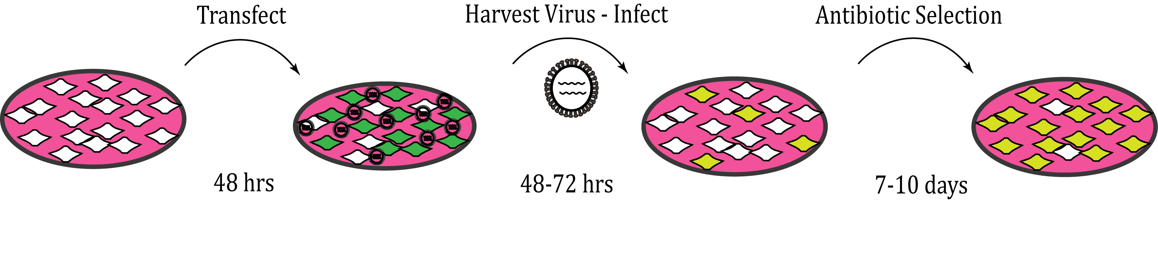
Figure 7: Schematic of the Development of Stable Cell Lines.

pH Pulse Experiment
Cells are first washed with 5ml of PBS. Then, 0.4ml of 0.05% Trypsin-EDTA is added to each T-25 flask and cells are incubated at 37°C for approximately 10 minutes, or until cells have been almost entirely released from the flask surface. Cells are then aliquoted into 1ml Eppendorf tubes (4 aliquots per T25 flask). Cells are then spun down for 5 minutes at 1,000xg and resuspended in 500ul of pH 7.4 PBS+0.1%BSA. This wash step is repeated. Cells are then spun down once more and all remaining supernatant removed via pipette.
Each aliquot is then assigned a pH within the pH range being evaluated for that particular mutant, i.e. 4.6 – 5.4 for low pH mutants, or 5.2 – 6.2 for high pH mutants. Often this range will be adjusted after preliminary data reveals the effect of the mutation on the activation pH. Each aliquot is resuspended in 750ul of the designated pH buffer (See appendix for composition). Cells are incubated for 4 minutes at room temperature and then spun down for 1 minute at 1,000xg. Supernatant is quickly dumped into waste and then the cells are neutralized with 750ul of pH 7.4 PBS + 0.1%BSA. Cells are spun down again for 4 minutes at 1,000xg. Two aliquots are also reserved as controls and were resuspended in the neutral pH 7.4 PBS+0.1%BSA buffer rather than the pH buffer.
Supernatant is removed entirely with a pipette and cells are resuspended in a small volume of pH 7.4 PBS+0.1%BSA. In many of the first experiments, a 100ul resuspension was used, but then reduced to 50ul for later experiments to conserve antibody. Cells are then labeled with a primary antibody. All cells “pulsed” with a pH buffer were labeled 1:100 with HC58, which binds to inactivated HA trimers. One control aliquot was labeled with HC58 and one with HC2, which will bind HA trimers in any conformation thus quantifying level of HA expression. Cells are incubated with the primary antibody for one hour on ice.
After primary antibody labeling, cells are spun down at 1,000xg for 5 minutes. Supernatant is removed with a pipette and cells are resuspended in 500ul of pH 7.4 PBS+0.1%BSA. Cells are spun down one more time at 1,000xg for 5 minutes and supernatant removed completely. Cells are then resuspended in 100ul of a 1:100 dilution of the fluorescent secondary antibody, AF488 goat-anti-mouse, in pH 7.4 PBS+0.1%BSA. Cells are incubated on ice, covered for 45 minutes. After incubation, cells are spun down at 1,000xg for 5 minutes, resuspended in 750ul of pH 7.4 PBS+0.1%BSA, spun down again, and resuspended in a final volume of 500ul of pH 7.4 PBS+0.1%BSA. Each aliquot is then run on the flow cytometer according to standard lab procedures.

Quantification of Activation pH
Flow cytometry data was analyzed using FloJo software to obtain median fluorescent data for each data sample. Each mutant’s activation pH was then extracted from this median fluorescent data using Prism by graphpad.

Results

The calculated activation pHs of the characterized clones are summarized in Table 1. The dose-repsonse curves of two mutants, D247N and G365C, are shown in comparison with that of wild-type for reference (Figure 8). Single mutations D247N and S429P produced stabilizing effects, activating at pH 4.83 and 5.06, respectively. Mutations I96M and G237R were found to be moderately destabilizing, activating at pH 5.79 and 5.77, respectively. Mutation G365C is significantly destabilizing, activating at pH 6.09. These five residues, I96M, D247N, S429P, G237R, and G365C, are key residues for the activation of HA (Figure 9).
Table 1: Summary Table of Single Mutant Activation pH.

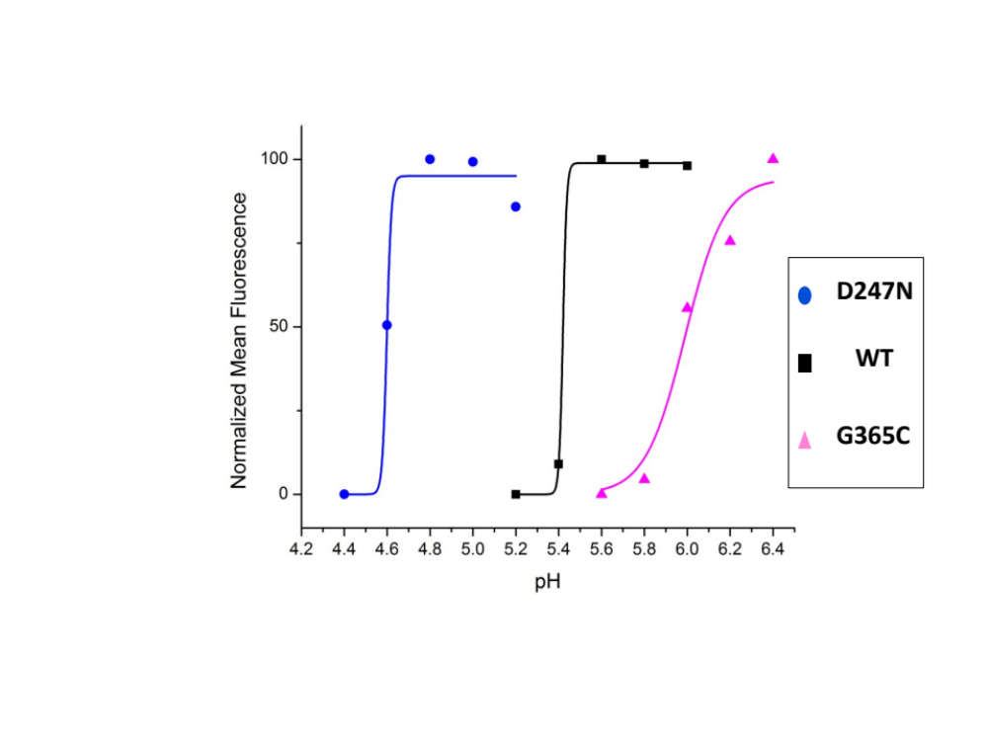
Figure 8: Dose-Response Curve for D247N, wild-type, and G365C.

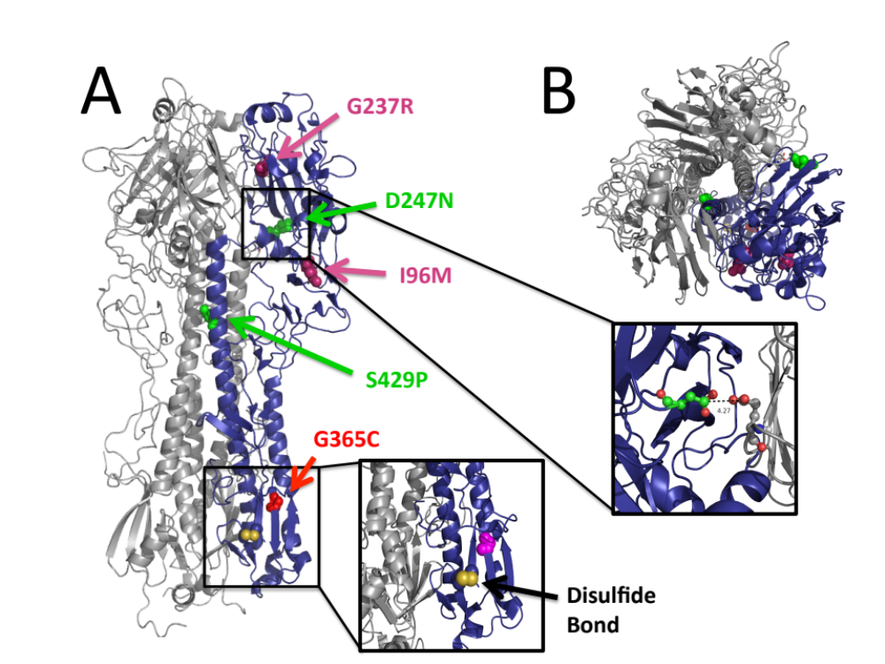
Figure 9: Structural Location of Key Residues.
A) Side view of HA trimer B) Top down view of HA trimer

Conclusions

It is clear from the characterization of these single mutations that I96M, D247N, S429P, G237R, and G365C, are key residues that can individually alter the activation pH of HA. The structure-function relationship has not been fully elucidated, however.
D247N as seen in the blown up figure, is in close proximity to a negatively charged glutamic acid. Replacing the negatively charged aspartic acid with a neutral asparagine likely eliminates this electrostatic charge, explaining the stabilizing effect of the D247N mutation. Experiments are currently planned to characterize the D247R mutation, which would replace the negatively charged aspartic acid with a positively charged asparagine, potentially stabilizing HA even further than D247N.
As shown in the blown up figure, G365C is in close proximity to the disulfide bond, which stabilizes the HA1-HA2 subunits. It is hypothesized that this cysteine mutation, which is located on the HA2 subunit, is disrupting this disulfide bond, and creating a disulfide bond of its own with the HA1 residue. This could perhaps explain the dose-response curve for G365C, which as seen in that figure, does not transition as sharply as wild-type, or D247N. A mixture of the native disulfide bond and this new G365C disulfide bond could result in this intermediate state. Experiments are not currently underway to evaluate this hypothesis, but can easily be done by mutating the G365C mutant at the HA2 cysteine residue and characterizing the activation. If this mutant is functional and activates at a high pH, our hypothesis would be confirmed
The other mutations, I96M, S429P, and G237R are less obvious in their structural reasoning for altered activation. Further analysis, likely utilizing simulation, will need to be done to formulate hypotheses regarding these mutations.
It is interesting to note that the altered phenotype of most of the mutants selected via directed evolution can be attributed to a single amino acid mutation. The exception is mutant HA3.2.5, which appears to activate at the higher pH of 5.6 through a combinatorial effect of two mutations. I96M confers a slightly destabilizing effect, but is counterbalanced by the stabilizing effect of S429P. These mutations have only been characterized individually, however, and a dual mutant should be characterized for confirmation.
At this moment no single mutation that confers altered phenotype for the remainder of the directed evolution mutants selected at pH 5.6. Some of these mutations are not entirely characterized, lacking one or two data sets for statistical significance, or contain “messy” data that may require additional experiments to confirm the calculated activation pH. It is also likely that no single mutation is leading to these altered phenotypes and that dual mutations will need to be characterized to elucidate the true cause. The repeated presence of mutation D166G, however, does lead one to hypothesize that it is producing a destabilized effect. The current calculated activation pH does in fact show a transition at pH 5.5, which is destabilized, but not statistically different from the wild type transition of pH 4.5.
To further understand the structure-function relationship between these key residues, it would be interesting to perform a search on known influenza sequences to determine if these mutations have occurred naturally. If any of these mutations were found in naturally occurring strains, it would be informative to know if that strain saw any marked difference in properties like virulence and host range.

References

- Huang, R. T., Rott, R. & Klenk, H. D. (1981). Influenza Viruses Cause Hemolysis and Fusion of Cells. Virology, 110, 243–247.

- Huang, R. T.,Wahn, K., Klenk, H. D. & Rott, R. (1980). Fusion Between Cell Membrane and Liposomes Containing the Glycoproteins of Influenza Virus. Virology, 104, 294–302.

- Klenk, H. D., Rott, R., Orlich, M. & Blodorn, J. (1975). Activation of Influenza A Viruses by Trypsin Treatment. Virology, 68, 426–439.

- Eckert, D. M. & Kim, P. S. (2001). Mechanisms of Viral Membrane Fusion and Its Inhibition. Annu. Rev. Biochem. 70, 777–810.

- Skehel, J. J. & Wiley, D. C. (2000). Receptor Binding and Membrane Fusion in Virus Entry: The Influenza Hemagglutinin. Annu. Rev. Biochem. 69, 531–569.

- Jahn, R., Lang, T. & Sudhof, T. C. (2003). Membrane Fusion. Cell, 112, 519–533.

- Lee, J.H. (2007). Engineering and Characterization of Influenza Hemagglutinin Properties in Mammalian System. PhD Thesis.

