Fatigue Study of Pipeline Steels

A Thesis Presented for the
Master of Science
Degree
The University of Tennessee, Knoxville

Bilin Chen
May 2013

ACKNOWLEDGEMENTS

First of all, I would like to devote my sincere thanks to my major advisor, Prof. Peter K. Liaw, for providing me with such a nice environment to learn, to do research and to grow. I really appreciate all the advices and encouragement over the past years.
I am also very grateful to the committee members: Prof. Carl J. McHargue and Prof. Yanfei Gao, for their kind help and guidance during my study.
My genuine thanks also go to Dr. Ke An from Oak Ridge National Laboratory (ORNL) for the help on neutron experiments and data analysis, Dr. Dr. Andy Slifka and Ms. Elizabeth Drexler the from the National Institute of Standards and Technology (NIST) for preparing the hydrogen-charged samples, and Mr. Guangfeng Zhao from The University of Kentucky for help on nanoindentation tests. Moreover, I would like to thank Dr. David Clarke from The University of Tennessee (UT), Mr. Doug Stalheim from DGS Metallurgical Solutions, Inc., Dr. Wei Zhang from Ohio State University (OSU), Dr. Govindarajan Muralidharan from ORNL, Mr. Louis Hayden from Louis E. Hayden Associates, and Mr. James Merritt from the US Department of Transportation, for great discussions and advices. Besides, would like to thank Mr. Douglas E. Fielden, Mr. Larry D. Smith, and Mr. Dan Hackworth from UT, for their great help in machining test samples. In addition, I appreciate Ms. Carol Hatmaker, and Ms. Tammy Enix from UT, for their work in the management of the project.
I appreciate Dr. Jieshan Hou from the Institute of Metal Research in the Chinese Academy of Sciences, Dr. Gong Li from Yanshan University, China, for useful discussions. I would like to thank Dr. John Dunlap, Mr. Greg Jones, Mr. Maneel Bharadwaj, Mr. Joshua Burgess and Mr. John Bohling, from UT for technical support.
I am glad to be in a group where my colleagues all work hard to create a great environment so that we can all learn from each other and grow together. Many thanks are given to Dr. Gongyao Wang, Dr. Lu Huang, Mr. Wei Wu, Mr. Andrew Chuang, Mr. Lou J. Santodonato, Mr. Qingming Feng, Mr. Zhinan An, Mr. Xie Xie, Mr. Wei Guo, Mr. Haoling Jia, Mr. Zhiqian Sun, Mr. Michael Hemphill, Mr. Zhi Tang, Mr. Gian Song, and Ms. Haoyan Diao at UT.
The project was supported by the US the Department of Transportation, Pipeline and Hazardous Materials Safety Administration (PHMSA), under contract DTPH56-10-000001, with Mr. James Merritt as the program Manager.
Lastly, I would like to dedicate my thesis to my parents, Zengyi Chen and Xuefei Yi, my brother, Bihai Chen, who always encourage and support me with their love.
.

ABSTRACT

Two types of pipeline steels, Alloy B [Fe-0.05C-1.52Mn-0.12Si-0.092Nb, weight percent (wt.%)] and Alloy C (Fe-0.04C-1.61Mn-0.14Si-0.096Nb, wt.%)], were tested. Vickers hardness and nanoindentation tests were used to obtain the hardness and elastic modulus. Compact-tension (CT) specimens were employed for fatigue experiments. Different frequencies (10 Hz, 1 Hz, and 0.1 Hz) and different stress ratios [0.1 and 0.5, stress ratio (R) = P_{min./}P_{max}., where P_{min}. is the minimum applied load, and P_{max.} is the maximum applied load) were used, and the tests were done in air, at room temperature. The effects of frequencies and different R ratios on crack-growth rates were compared. It is concluded that a higher R ratio leads to a greater fatigue-crack-growth rate (FCGR), while frequency does not have much influence. Moreover, Alloy B tends to have better fatigue resistance than Alloy C under various test conditions. The microstructures of two alloys were investigated by optical microscopy (OM), scanning electron microscopy (SEM), and transmission electron microscopy (TEM). Fracture surfaces show transgranular patterns, and fatigue striation was observed under the scanning electron microscope (SEM).
Another type of pipeline steels, X70, was also studied. Fatigue tests were performed at different load levels, and comparisons were made between different parts of weld and base metals. Fracture surfaces were observed by SEM to identify fatigue and fracture mechanisms.
Neutron-scattering-diffraction experiments were performed to study the deformation behavior around the crack tip of X52 and X70 pipeline steels. Both the hydrogen-charged sample and as-received sample were used to detect the influence of hydrogen. Preliminary results were presented in the thesis.

Table of Contents

Chapter 1 Introduction 1
Chapter 2 Literature Review 2
2.1 Development of Pipelines 2
2.2 Types of Pipelines 2
2.3 Effects of Hydrogen on Mechanical Behavior of Pipeline Steels 3
2.3.1 Effects on Tensile Properties 3
2.3.2 Effects on Fatigue-Crack-growth Behavior 5
2.4 Summary 12
Chapter 3 Fatigue-Crack Propagation Behavior of Pipeline Steels (Alloy B and Alloy C) 14
3.1 Introduction 14
3.2 Materials and Experiment Details 15
3.2.1 Materials 15
3.2.2 Microstructure Characterization 15
3.2.3 Vickers-Hardness Tests 16
3.2.4 Nanoindentation Tests 16
3.2.5 Fatigue-Crack Propagation Tests 16
3.3 Results and Discussion 17
3.3.1 Vickers-Hardness Results 17
3.3.2 Nanoindentation Results 18
3.3.3 Fatigue-Crack-Propagation Tests 18
3.3.4 SEM Image of the Fracture Surface 21
3.4 Conclusions 21
Chapter 4 Fatigue Study of X70 Pipeline Steel Welds 23
4. 1 Introduction 23
4.2 Materials and Experiment Details 24
4.2.1 Materials 24
4.2.2 Vickers-Hardness Tests 24
4.2.3 Fatigue-Crack-Propagation Tests 25
4.3 Results and Discussion 26
4.3.1 Vickers-Hardness 26
4.3.2 Fatigue-Crack-Propagation Behavior 26
4.3.3 SEM Images of Fracture Surfaces 28
4.4 Conclusions 28
Chapter 5 Neutron-Diffraction Study 29
5.1 Introduction 29
5.2 Experiment Details 29
5.2.1 Sample Preparation for In-situ Neutron-Diffraction Experiments 30
5.2.2 Tensile Tests 31
5.2.3 Strain-Mapping Tests 31
5.3 Preliminary Results and Discussion 32
5.4 Conclusions 33
Chapter 6 Conclusions and Future Work 34
6.1 Conclusions 34
6.2 Future Work 35
List of References 36
Appendixes 42
Appendix A Tables 43
Appendix B Figures 50

LIST OF TABLES

Table 1. Un-notched tensile strength in air and hydrogen [16] 44
Table 2. Tensile properties for some carbon steels under 68.9 MPa of helium and hydrogen[13] 45
Table 3. The chemical compositions of two kinds of pipeline steels studied [weight percentage (wt.%)] 46
Table 4. Summary of fatigue tests performed in air atmosphere 47
Table 5. Vickers Hardness (HV) Results for Alloys B and C 48
Table 6. The Chemical compositions of X70 base and weld metals [weight percentage (wt.%)] 49

LIST OF FIGURES

Figure 1. Elongation and reduction in area for a 0.22% carbon steel in gaseous hydrogen up to 15.2 MPa Literature results from [8] 51
Figure 2. The tensile strength of a cold-drawn 0.22% carbon steel as a function of ambient hydrogen pressure. Literature results from [15] 52
Figure 3. Hydrogen lowering the 0.2% yield stresses of carbon steels (P1: quenched and tempered and P2: controlled rolled at – 10 ℃. Literature Results from [17] 53
Figure 4. Comparison of yield strength of hydrogen gas charged (left), cathodically charged (right) samples with uncharged ones. Literature Results from [18] 54
Figure 5. Possible effects of hydrogen on fatigue behavior. Literature Results from [19, 20] 55
Figure 6. Fatigue-crack-growth rates (da/dN) as a function of stress intensity range (ΔK) for X42 and X70 pipeline steel in 6.9 MPa hydrogen and 6.9 MPa nitrogen at stress ratio (R) of 0.1. Literature results from [35] 56
Figure 7. Fatigue-crack-growth rates (da/dN) as a function of hydrogen pressure for an API 5L Grade B steel. Literature results from [38] 57
Figure 8. Fatigue-crack-growth rates (da/dN) as a function of stress ratio for X42 steel in hydrogen and nitrogen. Literature results from [37] 58
Figure 9. Effects of Cyclic frequency on ASME SA-105 Grade II steel in 103.4 MPa hydrogen at a stress ratio of 0.1 [40] 59
Figure 10. Optical microscopy (OM) image (upper two) and SEM image (lower three) of Alloy B. Literature results from [6] 60
Figure 11. TEM image of Alloy B. Literature results from [6] 61
Figure 12. OM (upper two) and SEM (lower three) images of Alloy C. Literature results from [6] 62
Figure 13. TEM image of Alloy C. Literature results from [6] 63
Figure 14. Geometry of the compact tension (CT) specimen for fatigue experiment (unit: mm) 64
Figure 15. FCGR (da/dN) versus stress-intensity-factor range (ΔK) for Alloy B at different frequencies (0.1, 1 and 10 Hz). (a) R = 0.1 and (b) R = 0.5 65
Figure 16. FCGR (da/dN) versus stress-intensity-factor range (ΔK) for Alloy C at different frequencies (0.1, 1, and 10 Hz. (a) R=0.1 and (b) R=0.5 66
Figure 17. FCGR (da/dN) versus stress-intensity-factor range (ΔK) for different stress ratios at 10 Hz. (a) Alloy B and (b) Alloy C 67
Figure 18. FCGR (da/dN) versus stress-intensity-factor range (ΔK) for different stress ratios at 1 Hz. (a) Alloy B and (b) Alloy C 68
Figure 19. FCGR (da/dN) versus stress-intensity-factor range (ΔK) for different stress ratios at 0.1 Hz. (a) Alloy B and (b) Alloy C 69
Figure 20. Comparison of FCGR curves for Alloys B and C at 10 Hz with (a) R = 0.1 and (b) R = 0.5 70
Figure 21. Comparison of FCGR curves for Alloy B and C at 1 Hz with (a) R = 0.1and (b) R = 0.5 71
Figure 22. Comparison of FCGR curves for Alloy B and C at 0.1 Hz with (a) R = 0.1 and (b) R = 0.5 72
Figure 23. The side view fracture morphology of the fatigued Alloy C at a frequency of 10 Hz in the different ΔK range: (a) small, (b) middle, and (c) large. 73
Figure 24. SEM images of fracture surfaces at ΔK = 10 MPa.m^{0.5}. (a) Alloy B and (b) Alloy C. 74
Figure 25. SEM images of Fracture surface of Alloy B (a) middle ΔK and (b) high ΔK 75
Figure 26. Sketch for the Machining of X70 pipeline steel weld sample 76
Figure 27. (a) Macro-picture of the sample; (b) Vickers hardness as a function of the distance from the left edge of heat-affected zone (HAZ) [the 0 point in (a)] 77
Figure 28. (a) Macro-picture of the sample; (b) Vickers hardness versus distance from the top of the weld [the blue point in (a)] 78
Figure 29. FCGR(da/dN) versus stress-intensity-factor range (ΔK) for the X70 base metal at different load levels 79
Figure 30. Load level versus cycles to failure for X70 base metal when R = 0.1 and f = 10 Hz 80
Figure 31. Comparison of FCGR curves (a) X70 base and upper weld (b) X70 base and lower weld when P_{max} = 5 kN, R = 0.1 and f = 10 Hz 81
Figure 32. Optical Microscopy image (a) X70 base (b) X70 weld 82
Figure 33. SEM image of fracture surface at high ΔK level. (a) X70 base (2) X70 weld 83
Figure 34. SEM image of fracture surface at high magnification. (a) X70 base (b) X70 weld 84
Figure 35. Sketch of the neutron diffraction geometry of the experiments 85
Figure 36. Stress versus strain for X52 samples with or without hydrogen charged 86
Figure 37. Lattice parameter as a function of the distance from crack tip for X52 original sample 87
Figure 38. Lattice parameter as a function of the distance from crack tip for X52 hydrogen charged sample 88

Chapter 1 Introduction
Due to increasing environmental and monetary costs of using traditional fossil energy, the development of alternative energy sources is becoming more and more significant. Among them, solar and wind energies are the most promising ones to contribute to sustainable energy requirements. However, the productivity of solar and wind energies is highly dependent on natural solar and wind cycles, which are not necessarily consistent with highs and lows of energy demands. Finding ways to store energy is a critical point to solve this problem. It has been proposed that the solar and wind energies can easily be used to separate water, thus generating hydrogen, which can be used as the energy-storage medium. Also, as the increased development of the hydrogen fuel-cell technology for the automobile industry, the demand for hydrogen is expected to increase. In addition, how to transport hydrogen to end users quickly and efficiently becomes an issue [1-5].
It is well known that the most economic and efficient way to transport a large amount of hydrogen is through steel pipelines, and the mechanical behavior of these pipeline steels will be deteriorated by the exposure to hydrogen environment [6-8].
For now, pipelines are made of steels, which will often be embrittled by hydrogen, causing the reduction of ductility, strength, and fatigue life. We call them hydrogen embrittlement (HE), and hydrogen-assisted fatigue-crack-growth (HAFCG) behavior. In the thesis, we will focus on the fatigue-crack-growth characteristics [1].

Chapter 2 Literature Review

2.1 Development of Pipelines
The origins of the development of pipelines can go as early as 3000 BC, i.e., there exist references that Egyptians used copper pipes to transport water [1]; The modern pipeline industry develops from the booming of the oil business since the 19th century. Long pipelines were built more and more since the turn of the 20th century. The pipeline industry has been growing tremendously. Now the total length of high pressure transmission pipelines was estimated to be around 3,500,000 km by 2007, over 60 percent carrying natural gas, while the rest carrying crude oil and other petroleum products [9].

2.2 Types of Pipelines
Pipelines can be used to transport gas, oil, water, etc. Also, it can be classified into three groups depending on the purpose [10].
- Gathering pipelines are used to bring crude oil or natural gas from wells to a treatment plant or facility.
- Transportation pipelines are mainly long pipes with large diameters, and they are used to move oil, gas, and other refined products between cities, countries, and even continents [11].
- Distribution pipelines are used to transport the products to the final consumer. For example, gas is distributed by them to homes and businesses branches.
In the thesis, we focus on transportation pipelines that are used to transport hydrogen. There are pipelines made of metals, plastics, or composites. Due to economic and environmental issues, the majority of transportation pipelines for hydrogen are steel pipelines.

2.3 Effects of Hydrogen on Mechanical Behavior of Pipeline Steels
The change in the mechanical behavior of pipeline steels was due to the response of material to hydrogen [8]. Also, the degradation mechanism is highly influenced by the way of exposure, or the type of attack, and sometimes opposite effects might occur [12]. Generally speaking, the elastic properties will not be affected much with the presence of hydrogen. On the other hand, the ductility, fracture toughness and fatigue-crack-growth behavior will be harmed in the atmosphere of hydrogen [8].

2.3.1 Effects on Tensile Properties
In the literature, typical tensile properties were referred to yield stress, ultimate tensile strength (UTS), the elongation of the material, and reduction in area.
Hofmann and Rauls in Ref. [14] conducted the earliest tensile test in hydrogen gas up to 15.2 MPa. A 0.22% carbon steel was used in the study. Their results were plotted in Figure 1. It can be seen from the figure that the elongation stayed around 30% with the increase of hydrogen pressure, while the reduction of area showed a trend of decrease with the increase of hydrogen pressure. The reduction of area was around 30% in 15.2 MPa hydrogen, and it was 64% when tested in air.
Similar tests were also done for Armco iron (0.028 C% ), 0.22.% C (normalized), and 0.45% C (unalloyed, normalized) carbon steels in hydrogen (0.10 MPa ~ 15.2 MPa) [16], and the reduction in area results were consistent with Hofmann and Rauls’ tests. Reduction in area decreases with the increase of hydrogen pressure. However, the elongation at failure did not stay the same, and it also decreases with the increase of hydrogen pressure.
Another test was performed by Hofmann and Rauls [15] in which the cold-drawn 0.22% carbon steel was used. As what is shown in Figure 2, the UTS decreased with the increase of hydrogen pressure. Actually, the tensile strength decreased more than 40%, as the hydrogen pressure increased from 0.10 MPa to 10.1 MPa.
Cialone and Holbrook [36] conducted a study trying to study the influence of hydrogen on ductility loss in cast carbon steels because of hydrogen. They found that in the as-cast clean (low metalloid content) steel, the effect was obvious and hydrogen promoted fracture by cleavage. However, for annealed samples, not only did the ductility increases but also the resistance to ductility losses in hydrogen environment.
In Hofmann and Rauls’ study [16], the UTS of Armco iron (0.028 C% ), 0.22.% C (normalized), and 0.45% C (unalloyed, normalized) carbon steels in hydrogen and air were compared, as what we can see in Table 1, basically the UTS did not change because of the presence of hydrogen. Some tensile properties were conducted, and the information was listed in Table 2 [13]. In this study, four different materials, ASTM A-515 Gr 70, AISI 1042 normalized, AISI 1042, and Armco iron, were investigated. It is shown in this table that the yield stress and the UTS did not change because of the environment, which is consistent with the findings by Hofmann and Rauls [16]. Besides, the elongation and reduction in area decreased when they were tested in hydrogen, as expected.
Some other studies showed the difference for yield strength. In Ellis et al.’s study [17], in order to increase the yield strength of Alloy P1 (0.092 wt.% Carbon) and Alloy P2 (0.094 wt.% Carbon), the steels blanks were prestrained up to 15%. Then the samples were cathodically charged with hydrogen. A thin layer of copper was used to cover the surface of the sample to prevent hydrogen leaking. After the hydrogen-charging process, the sample was held at room temperature for 24 h to let hydrogen distribute uniformly in the whole sample. Figure 3 showed that the yield strength decreased for the hydrogen-charged samples, at different strain levels.
On the contrary, there are some tests showing the different results. In Pussegoda and Tyson’s study [18], the results actually indicated that the yield strength increased when the samples were charged with hydrogen. In their study, two sets of experiments were performed. (1) The specimen was quenched and tempered (QT specimen). The QT specimens were charged in hydrogen gas until the concentration was around 1 ppm (wt.%). (2) The specimen was directly quenched (DQ specimen). The DQ specimens were cathodically charged to a hydrogen concentration to a range of 1 to 5 ppm. Both samples were stored in nitrogen before testing. The tests were conducted from temperature of -196°C to 135°C. To prevent the gas from going out, a thin layer of cadmium were also electroplated. As shown in Figure 4, on both conditions, the yield stress for the charged sample is higher than the uncharged one in most of the temperature ranges, but they seem to converge at higher temperatures.

2.3.2 Effects on Fatigue-Crack-growth Behavior
Though hydrogen embrittlement (HE) has been researched for many years, the mechanism is not fully understood. Also, the mechanism for fatigue-crack-growth is not completely understood. Therefore, the mechanism for fatigue-crack-growth under the influence of hydrogen is complicated [1].

2.3.2.1 Three Regions of Fatigue-Crack-growth
As presented in Figure 5, the crack-growth behavior of materials is generally divided into three regions [19, 20]. Stress intensity factor range (△K) is defined as follows,
$$△K=K_{max}-K_{min}$$
Where K_{max} is the maximum stress intensity per cycle, K_{min} is the minimum stress intensity per cycle. In region 1, △K is very low, and the crack propagates slowly. When △K continues to increase and goes over a threshold value (△K_{th}), it will be in the region 2 where the crack-growth rate will increase significantly. A typical relationship can be drawn between the fatigue-crack-growth rate (FCGR) and △K in this region, which was referred to as the Paris’ Law [21]:
$$\frac{da}{dN}=A{(△K )}^{m}$$
where $\frac{da}{dN}$ is the change in crack length per cycle, A and m are material constants. As △K continues to increase to high levels (there is a critical value K_{IC}), the Paris’ Law will no longer be applied, and the FCGR becomes rapid and unstable, which is the region 3.

2.3.2.2 Three Types of Hydrogen Assisted Fatigue-Crack-growth (HAFCG)
As presented in Figure 5, there are three types of possible effects of hydrogen on the fatigue-crack-growth of materials [1, 19, 20]. K_{IH} (the monotonic crack-growth threshold in hydrogen) was defined as the stress intensity beyond which the subcritical crack propagation will happen in the material exposed to hydrogen when a static load was applied. In their studies [1, 19, 20], it was assumed that K_{IH} values in the dynamic-loading conditions can represent those in static-loading conditions, and the static K_{IH} values can reflect the hydrogen embrittlement (HE) property.
For type A, K_{IH} = K_{IC}, which means that the material will not be affected by HE under the static-loading condition. However, when it is tested in the dynamic-loading condition, such as cyclic loading, the fatigue-crack-growth rates will be higher than those in the inert or air environment, and the △K needed for the initiation of crack-growth is also lower. For type B, K_{IH} < K_{max} < K_{IC,} the material suffers from the static HE, but dynamic loading will not make any difference when Kmax < K_{IH}. The fatigue-crack-growth is not influenced by hydrogen in that region. In the real situation, many materials will be affected by hydrogen in both regions. Thus, we will see combined influence as Type C in Figure 5.

2.3.2.3 Two Common Mechanism for the HE of Steel under Monotonic Loading
The fact that the mechanism of HE is not fully understood, and there is even no agreement on the mechanisms for HE of steels under monotonic loading [22-25]. There are two common mechanisms that have been proposed. One mechanism contends that the failure in hydrogen is due to “hydrogen-enhanced decohesion” (HEDE) [27-29]; the other thinks that that it is because of “hydrogen-enhanced local plasticity” (HELP) [30-34].
Both mechanisms are based on the assumption that the gas hydrogen will form atomic hydrogen and then diffuses to the stress region. The HEDE mechanism holds the opinion that the cohesive strength in the hydrogen-enriched region will be reduced, which will deteriorate the mechanical property of materials. On the other hand, HELP proposed that hydrogen will increase the mobility of the dislocation, resulting in a localized plastic instability, which will promote the deformation behavior. Some literature results showed that the dislocation mobility was indeed improved by hydrogen by the in-situ transmission electron microscopy (TEM) [22], but the results on this issue is mixed [22, 23, 30].

2.3.2.4 HAFCG Studies
Cialone and Holbrook conducted a comprehensive study on the tests of pipeline steels in hydrogen environment [35]. Figure 6 shows their test results on the comparison of fatigue test in 6.9 MPa hydrogen and nitrogen. A load stress ratio of 0.1 was used for this study. It can be seen from the figure that the FCGR of X42 was higher than that of X70 at the same △K. Moreover, it is clear that when the tests were run in hydrogen atmosphere, the propagation rates increase tremendously. Actually, the FCGR can be 150 times faster in hydrogen than that in nitrogen for X42. It can also be seen from the figure that the difference of fatigue-crack-growth (FCGR) rates decreased at lower △K levels.
Cotrill and King also performed tests on a C-Mn steel in hydrogen and air [35]. A stress ratio of 0.1 and a frequency of 0.1 Hz were used in the tests. They found that the difference of FCGRs between specimens tested in two environments was not much when △K was low (≈ 22 MPa m0.5). However, at a higher △K (≈ 40 MPa m0.5), the FCGRs in hydrogen were nearly 20 times of that in air.
There are a few testing variables that need to be taken into consideration when we are trying to study the FCGR of pipeline steels in hydrogen. These variables, hydrogen pressure, test stress ratio, test frequency, strength and alloy microstructure, may affect the FCGRs of materials when they are tested in hydrogen, in various ways [1]. They are to be reviewed in the subsequent sections.

2.3.2.5 Effects of Hydrogen Pressure on HAFCG
Figure 7 presents the test results reported by Zawierucha and Xu [38]. Fatigue-crack-growth tests were performed with stress ratio of 0.1 under various hydrogen pressures. The FCGR as a function of hydrogen pressure when ΔK = 22 MPa m0.5 has been plotted as Figure 7. It can be concluded that after the initial large change of FCGR when the hydrogen pressure was 1.4 MPa. The FCGR only increased 1.5 times as the hydrogen pressure changed from 1.4 MPa to 20.7 MPa.
The effects of hydrogen pressure was also investigated by Holbrook for X42 steel when ΔK = 22 MPa m0.5, at a stress ratio of 0.25 and frequency of 0.1 Hz [39]. They found that the ratio of FCGR in hydrogen to that in nitrogen increased as a power function of the hydrogen partial pressure for pressures from 0 to 6.9 MPa. Nanninga. et al. thought that the lower dependence of hydrogen pressure might because the nonequilibrium concentration of hydrogen under cyclic loading. The higher dependence of hydrogen pressure might be obtained by using lower-frequency tests since the concentration of hydrogen in material might be closer to the equilibrium condition [1].
Walter and Chandler also evaluated this with pressures ranging from 6.9 MPa to almost 100 MPa, on SA-105 Grade II steel [39]. They found that FCGR was increased tremendously with the pressure. But, there was little difference after the pressure went to more than 69 MPa, all the way up to 100 MPa.

2.3.2.6 Effect of Stress Ratio on FCG Behavior
Since the cyclic stress intensity range ΔK is related to the stress ratio by
$$ΔK = (1- R) K_{max}$$
So the maximum stress (Kmax) will be higher as R increases, at a given ΔK [1].
Cialone and Holbrook investigated the influence of hydrogen on the fatigue behavior of an X42 pipeline steel [37]. By comparing experiment results in hydrogen and nitrogen environments, they found the influence of stress ratios on crack-growth rates in hydrogen and nitrogen at a constant ΔK value. As we can see from Figure 2, in the nitrogen environment, the crack-growth rate in nitrogen increases as R increases; while in hydrogen environment, the growth rate stays the same when R is below 0.5, and increases when R is above 0.5. Generally X42 has a higher crack-growth rate in hydrogen than in nitrogen, but the difference decrease with increasing R when R < 0.5, and increases again beyond the R value of 0.5.

2.3.2.7 Effects of Frequency on HAFCG Behavior
In Cialone and Holbrook’s study on X42 pipeline steel [37], they found that there was little difference when the test was conducted in hydrogen at 1 Hz and 0.1 Hz, while the crack-growth at 10 Hz was slower.
The effect of frequency was also studied by Walter and Chandler for an ASME SA-105 Grade II steel (0.23% C and 0.62% Mn) with a stress ratio of 0.1 [40]. As can be seen in Figure 9, compared with tests done in He, the FCGRs in hydrogen were much higher than that in He. Also, FCGR increased as the test frequency decreased. Note that the highest frequency here is 1 Hz and the lowest is 0.00083 Hz. With the development of the test technique, there is no doubt that a data base with a wide range of frequencies will be established.

2.3.2.8 Effects of Yield strength and Microstructure on HAFCG Behavior
Investigations for the microstructure effects on HAFCG behavior have been conducted by Cialone and Holbrook on C-Mn steels [42-44]. The FCGR results showed that the fully-ferritic alloy seems to be more sensitive to hydrogen than the pearlite alloy, and the fractographic figures also suggested that hydrogen has a stronger influence on ferrites than pearlites. For the fully-ferritic alloy, when it was tested in hydrogen, fatigue-crack-growth happened nearly all along the grain boundaries while it was almost 100% transgranular in nitrogen. In Carroll and King’s study on C-Mn pipeline steels [45], they found no large difference in FCGRs for specimens with different microstructures and strengths. It should be noted that in Cialone and Holbrook’s study [42-44], X70 showed the lowest FCGRs in hydrogen, when is contrary to the results from statically-loading tests in hydrogen, where higher strength alloys are more susceptible to HE. More studies need to be done on various pipeline steels on this issue. Present literature resources did not provide a correlation among the microstructure, strength, and HAFCG behavior.

2.3.2.9 Other Variables
Crack closure or shielding may influence the FCG behavior of steels in hydrogen [45, 46]. Tensile overload will cause fatigue retardation in crack propagation because of the crack tip plasticity [48-50]. But Walter and Chandler [40] observed that the overload to 1.5 Kmax did not affect the FCGR in 103.4 MPa hydrogen for an ASME SA-105 Grade II steel, while retardation in FCGR occurred after overload when specimens were tested in 34.5 MPa helium. It seems that HE influenced the plasticity effect in this case [8].
Effects of gases that might inhibit the HAFCG were also studied by some researchers [8, 39, 51]. Certain gases, such as C₂H₄ and O₂, might be able to inhibit the hydrogen effect greatly by forming semi-stable bonds with iron on the surface. Other gases, such as CH₄, H₂S, natural gas, might either increase the FCGR or have no effect. Inhibitor-gas studies might be promising, but they need to deal with the safety issues since some of the gases can be inflammable, and these impurities might have a detrimental effect on the performance of the hydrogen fuel cell. Filtering processes need to be considered when high purity hydrogen is required for application.

2.4 Summary
In summary, hydrogen will serve as one of the alternative energies. The most economic and practical way to transport a large quantity of hydrogen is through steel pipelines. The exposure to hydrogen will deteriorate mechanical properties of pipeline steels. HE has been extensively studied for several decades, but the mechanism, was still not clear. Two common mechanisms, “hydrogen-enhanced decohesion” (HEDE) [27-29] and “hydrogen-enhanced local plasticity” (HELP) [30-34], were briefly reviewed. The mechanisms of hydrogen-assisted fatigue-crack-growth (HAFCG) are lacking, since both the mechanisms for HE and FCG are not clear, and dynamic loading is different from static loading in terms of hydrogen effects. Some variables, stress ratio, test frequency, gas pressure, microstructure, strength, etc. that might influence the HAFCG of steels have been briefly reviewed. The role of crack closure should also be considered for the HAFCG behavior, which might be different because of the presence of hydrogen. Overall, many literature results have proved that the FCGR increased significantly in the hydrogen environment, compared with nitrogen or air atmosphere. A better understanding of this behavior is needed for the pipeline industry and more experiment data for pipeline steels are required concerning different variables and test parameters. Ways to inhibit HAFCG should be proposed and used in future pipeline-transportation systems.

Chapter 3 Fatigue-Crack Propagation Behavior of Pipeline Steels (Alloy B and Alloy C)

3.1 Introduction
In the process of hydrogen transportation, the change of external loads, combined with the pressure variation, will create a fatigue process for the pipeline steels, which will definitely contribute to the final failure of the steels. Thus, the fatigue property of the material needs to be improved. Since once the early cracks were formed, the FCGR would be accelerated because of the hydrogen environment [52-54].
Since we do not have a general rule that can be applied to the fatigue-crack-growth behavior of pipeline steels exposed to hydrogen, data is needed, concerning the hydrogen-influenced fatigue-crack behavior of pipeline steels. In order to study the influence of hydrogen, the reference experiments should be conducted in air atmosphere.
As the pivotal aspect of present work, fatigue-property evaluation is very important. As shown in Figure 5, the fatigue behavior of materials is divided into three stages: stage I (crack initiation), stage II (crack propagation) and stage III (final fracture). These three stages are of vital significance in the determination of materials’ fatigue life. When a structural component is subjected to cyclic loading, in order to assess the structural reliability, or even predict the crack-growth life, the information of fatigue-crack-growth rates is irreplaceable [55,56].

Materials and Experiment Details

3.2.1 Materials
We have two kinds of alloys to study, named Alloy B and Alloy C. They were thermo mechanical control processed (TMCP) in a hot-rolling mill, and in a coil/plate form prior to the pipe-making process. Their chemical compositions are shown in Table 1. As we see, Alloy C has less carbon (0.04 wt.%) than Alloy C (0.05 wt.%). Also, the content of Mn and Cr in Alloy C (1.61 wt.%, and 0.42 wt.%) is higher than those in Alloy B (1.52 wt.%, and 0.25 wt.%).

3.2.2 Microstructure Characterization
The characterization of the microstructures was documented [6]. We used the same materials as the Alloy B and Alloy C in this paper.
According to the results by Stalheim and his team, Alloy B was consisted of about 90% of coarse polygonal ferrites and 10% of coarse acicular ferrites (a type of low carbon bainites), by volume fraction. The microstructures of Alloy C and Alloy B were very similar except that there are a small portion of upper bainite (~2%), 8% of coarse acicular ferrite (a type of low carbon bainite), and 90% of polygonal ferrites. The upper bainites appear dark in the light microscope. It is the lathe ferrite with limited carbon precipitation between the laths since there is only 0.04% of carbon in Alloy C. The optical microscopy (OM), scanning electron microscopy (SEM) and transmission electron microscopy (TEM) analysis is shown in Figures 10 to 13.

3.2.3 Vickers-Hardness Tests
Samples were cut, mounted, and mirror polished to make sure that the surface was flat. Vickers-hardness experiments were performed on the sample at 11 different locations, under a load of 5 kg, with a testing time of 15s. Data were then averaged to obtain the Vickers hardness value of the sample.

3.2.4 Nanoindentation Tests
Samples were prepared for nanoindentation tests to obtain the elastic modulus and mechanical behavior near the surface area. Data can also be used to compare with bulk properties. A Hysitron TriboScope (Minneapolis, MN) mounted on a Quesant atomic force microscope (AFM) (Agoura Hills, CA) was employed in this study. A cube-corner diamond indenter was used. Loading (10s), holding (10s) and unloading (10s) (altogether 30s) were chosen. Different loads were used to see the reaction of material and compare the hardness values. For each test condition, 5 to 6 indents were made to minimize the error.

3.2.5 Fatigue-Crack Propagation Tests
Compact-tension (CT) specimen was employed in our study. The specimen was prepared, according to the American Society for Testing and Materials (ASTM) Standards E 647-99. It has a notch length of 10.16 mm, a width of 50.8 mm, and a thickness of 6.35 mm. The geometry of the sample has been shown in Figure 14. A computer-controlled Material Test System (MTS) servohydraulic machine was used to perform the fatigue-crack-growth experiments. The CT specimens need to be precracked at first. Right after the precrack, the crack-growth experiments were performed, until the failure of the specimen. All specimens were tested under a constant-range-control mode with frequencies of 10, 1, and 0.1 Hz, load ratios, R of 0.1 and 0.5 [R = P_{min}./P_{max}., P_{min} and P_{max} are the applied minimum and maximum loads, respectively]. The fatigue test matrix is shown as Table 4. The crack length was measured by a crack-opening-displacement (COD) gauge through the compliance method [57]. The stress-intensity factor, K, is obtained by the following equation:
$$K=\frac{P\left(2+α\right)}{B\sqrt{W}{\left(1-α\right)}^{3/2}}\left(0.886+4.64α-13.32α^{2}+14.72α^{3}-5.6α^{4}\right)$$
where a is the crack length, W is the specimen width, α = a/W, B is the specimen thickness, and P is the applied load, the stress-intensity-factor range, ΔK is defined by
$$∆K=K_{Max.}-K_{Min.}$$
where K_{max.} and K_{min} are the maximum and minimum stress-intensity factors, respectively. The crack-growth rates (da/dN) and ΔK data were generated by the MTS machine automatically.

3.3 Results and Discussion

3.3.1 Vickers-Hardness Results
The results of Vickers Hardness tests are shown in Table 5. From the tests, the Vickers Hardness of Alloy C is around 230 HV, while that of Alloy B is about 201 HV. The difference of hardness is probably due to the larger amounts of Mn and Cr in Alloy C, which would increase the hardenability of alloy steels [58].

3.3.2 Nanoindentation Results
For the data analysis, we chose 4 sets of data from each load level, and calculate the average value of the elastic modulus and hardness. From the results, we find that the elastic modulus and hardness tend to drop with increasing load. Also, the value of hardness for Alloy C is greater than Alloy B for all the load levels, while the elastic moduli were around the same level.
To give a better comparison between these two alloys, we averaged the data from all the five load levels (2, 4, 5, 7, 8), and we found that the elastic modulus of Alloy B and Alloy C are basically the same, 183.2 (Alloy B) and 185.7 GPa (Alloy C), respectively. The average value of hardness for Alloy B is 4.7 GPa, while that of Alloy C is 5.8 GPa. The ratio of nano hardness (B to C) is 0.81, which is similar to that for Vickers hardness, 0.87. The properties in these two scales of hardness values seem consistent.

3.3.3 Fatigue-Crack-Propagation Tests
The fatigue-crack-growth-rate experiments were finished on two kinds of base pipeline steels [Alloy B (Fe-0.05C-1.52Mn-0.12Si-0.092Nb, weight percent (wt.%)] and Alloy C (Fe-0.04C-1.61Mn-0.14Si-0.096Nb, wt.%)] at different frequencies (10 Hz, 1 Hz, and 0.1 Hz) and different R ratios (0.1 and 0.5). The crack-growth rates (da/dN) as a function of ΔK are shown in Figures 15 to 22. During constant amplitude crack-growth experiment, the crack-propagation rates increase with increasing ΔK.
Figures 15 (a) and (b) plotted the fatigue-crack-growth results of Alloy B at different frequencies, and at R ratios of 0.1 and 0.5 respectively. Figures 16 (a) and (b) show the results of Alloy C. According to the figure, in the air condition, the frequencies didn’t influence the FCGRs significantly.
Figures 17 (a)-19 (a) plotted the fatigue-crack-growth results of Alloy B at different R ratios of 0.1 and 0.5 and at frequencies of 10, 1, and 0.1 Hz. Figures 17 (b)-19 (b) showed the FCGRs results of Alloy C at different R ratios of 0.1 and 0.5 and at frequencies of 10, 1, and 0.1 Hz. We found that in general, the FCGR at an R ratio of 0.5 is larger than that at an R ratio of 0.1 for various frequencies. This trend is probably due to the fact that when R is larger, the mean stress will be greater for a certain maximum stress, as in this equation,
$$σ_{m}=\frac{1+R}{2} σ_{max}$$
where σ_{m} is the mean stress, and $σ_{max}$ is the maximum stress. The amplitude of mean stress plays an important role in affecting the fatigue behavior of materials. Higher mean stress leads to greater FCGRs. It can also be explained by the bigger maximum stress intensity because of higher R. Since the cyclic stress-intensity-factor-range ΔK is related to the stress ratio by
$$ΔK = (1- R) K_{max}$$
So the maximum stress intensity (K_{max}) will be higher as R increases, at a given ΔK [1]. And since the crack-growth rates were higher when R = 0.5, the final fracture happened at a lower ΔK than when R = 0.1.
By comparing the effect of stress ratio for Alloys B and C, especially at the frequency of 1 Hz (as shown in Figure 18), we also found that the FCGR for Alloy B did not increase as much as that for Alloy C. So it seems that Alloy B is not as sensitive to R ratio as Alloy C is.
Figures 20 to 22 plotted the comparison of fatigue-crack-growth results of Alloy C and Alloy B at frequencies of 10, 1 and 0.1 Hz and R ratios of 0.1 and 0.5. The FCGRs of Alloy C is greater those of Alloy B in various conditions. It can also be seen from the figures that the difference in FCGRs between these two alloys is greater when the tests were performed at the stress ratio of 0.5, which also suggests that the FCGR of Alloy C increased more than Alloy B with increasing stress ratio.
From the literature survey we know that difference in FCGRs between Alloy B and Alloy C might due to the differences in microstructures [6]. From the microstructural characterization of Alloy B and Alloy C, in case of volume fraction, Alloy B was characterized by 90% of coarse polygonal ferrites and 10% of coarse acicular ferrites (type of low carbon bainites), while Alloy C was characterized by a small portion of upper bainites (~ 2%), 8% of coarse acicular ferrites (type of low carbon Bainite), and 90% of polygonal ferrites. So the microstructure was similar except the small portion of upper bainites, as can be seen in Figures 12 and 13. The difference of fatigue resistance might because of this upper bainite influence. Further investigations are needed to explain this behavior.

3.3.4 SEM Image of the Fracture Surface
Figure 23 presents the SEM images of the side-view fracture surface of Alloy C. Figures 23 (a), (b), and (c) represent the micrographs of the small ΔK, middle ΔK, and large ΔK, respectively. We can also clearly see the fracture surface becomes rougher with the increase of ΔK. Also, secondary cracks were observed at large ΔK.
Figure 24 presents the SEM image of the fracture surface of Alloy B and Alloy C, when ΔK = 10 MPa.m^{0.5}. Both of them show transgranular patterns.
Figure 25 presents the fracture surface of Alloy B at middle and high ΔK. Ductile striations can be clearly seen at this higher magnification. It can also be seen that striation patterns seem more obvious at high ΔK level.

3.4 Conclusions
• In general, frequencies don’t significantly influence the FCGR behavior on the current pipeline steels (Alloys B and C).
• The two alloys exhibited different fatigue behavior in air. In general, Alloy B has slower crack-growth rates than Alloy C does, that is to say, Alloy B has a better fatigue resistance than Alloy C.
• From the fatigue-crack-growth results of Alloy B at a frequency of 10 Hz and different R ratios of 0.1 and 0.5, we find that FCGR at an R ratio of 0.5 is slightly larger than that at an R ratio of 0.1.
• The scanning-electron-microscopy (SEM) images of the side-view fracture surface were taken at small, middle and large ΔK ranges, respectively. It is clear that the fracture surface becomes rougher with increasing ΔK. Moreover, the secondary cracks are observed at higher ΔK.
• The fracture surfaces of two pipeline steels show transgranular patterns, and ductile striation patterns can be clearly seen at higher magnifications.

Chapter 4 Fatigue Study of X70 Pipeline Steel Welds

4. 1 Introduction
Steel pipeline is the least expensive way to transport a large amount of hydrogen [6]. The most economic method to construct steel pipelines is though welding [59]. Due to the microstructure inhomogeneity and high residual stresses, the weld part in a steel pipeline is very susceptible to hydrogen embrittlement (HE). Compared to the base metal, the literature information on the study of the weld region is far from enough. Much input is needed to characterize the mechanical behavior of the weld region in the hydrogen atmosphere. Actually, during a Hydrogen Pipeline Workshop [60] participated by academia, national laboratories, industrial gas and energy companies, engineering firms, and federal agencies recently, several top-priority research and development (R & D) needs for steel pipelines were pointed out. More than half of the top-priority research topics were related to the investigation of mechanical behaviors in the weld region, such as the heat-affected zone (HAZ). Moreover, some recent study about pipeline steels suggested that the weld part has lower fatigue resistance and higher fatigue-crack propagation rate, when compared with its base metal [61]. Therefore, the research on the mechanical behavior of the weld region of steel pipelines has become important and much data is needed for the improvement of the welding technique and the better design of future pipelines.
X70 pipeline steel welds, as a very common alloy design, which has been used in the past years for gas and oil transmission pipeline infrastructure [6], will be studied. Results between weld and base metals will be compared.

4.2 Materials and Experiment Details

4.2.1 Materials
An X70 girth weld plate was employed in the study. The dimensions of the plate are around 520 mm (length), 270 mm (width) and 22 mm (thickness). The chemical compositions are shown in Table 6. The base metal has less carbon (0.053 wt.%) than the weld metal (0.141 wt.%). Tensile tests were run in air, and the yield strength for the base metal is 553 MPa, and the ultimate tensile strength is 640 MPa [62].
The CT specimen for the weld metal was machined according to Figure 26 so that the crack will grow in the weld and two samples were machined through the thickness direction. As shown in Figure 26, the weld is a V shape. The two samples through the thickness direction were characterized as weld (out), as the upper sample near the outside of the pipe, and weld (in), as the sample near the inside of the pipe.

4.2.2 Vickers-Hardness Tests
For the base metal, samples were cut, mounted, and polished to make sure the surface was flat. Vickers hardness tests were performed on the sample at 8 different locations, under a load of 5 kg, with a testing time of 15s. Data were then averaged to obtain the Vickers hardness value of the sample.
In order to compare the hardness of different regions of the X70 sample, we measure the Vickers Hardness along the direction normal to the fusion line, as shown in Figure 27 (a). shows. Moreover, we performed tests along the center line of the weld region to see the difference of hardness at different parts of the weld, as can be seen in Figure 28 (a).

4.2.3 Fatigue-Crack-Propagation Tests
Compact-tension (CT) specimens were employed in our study. The specimen was prepared according to the American Society for Testing and Materials (ASTM) Standards E 647-99. It has a notch length of 10.16 mm, a width of 50.8 mm, and a thickness of 6.35 mm. The geometry of the sample is shown in Figure 14. A computer-controlled Material Test System (MTS) servohydraulic machine was used to perform the fatigue-crack-growth experiments. The CT specimens were first precracked to crack length of 3,84 mm. The crack-growth experiments were performed after the precrack. Specimens were tested under different load levels, with the same frequency of 10 Hz, and R ratio of 0.1. The crack length was measured by crack-opening-displacement (COD) gauge through the compliance method [57]. The stress-intensity factor, K, is obtained by the following equation:
$$K=\frac{P\left(2+α\right)}{B\sqrt{W}{\left(1-α\right)}^{3/2}}\left(0.886+4.64α-13.32α^{2}+14.72α^{3}-5.6α^{4}\right) \left(1\right)$$
where a is the crack length, W is the specimen width, α = a/W, B is the specimen thickness and P is the applied load.
The stress-intensity-factor range, ΔK is defined by
$$∆K=K_{max.}-K_{min.} (2)$$
where K_{max.} and K_{min.} are the maximum and minimum stress-intensity factors, the crack-growth rates (da/dN) and ΔK were generated by the MTS machine automatically.

4.3 Results and Discussion

4.3.1 Vickers-Hardness
From the tests, the Vickers Hardness of X70 base metal is around 213 HV. For the comparison of the hardness of different regions of the X70 sample, the results are shown in Figure 27. The softest part was in the HAZ, which is as low as about 180 HV, while the hardest part is in the upper part of the weld region, which goes to as high as 285 HV; In the bulk part of the base metal, the hardness stays around 210 HV. However, the data in the weld region scatters, so we measure the hardness along the center line of the weld to investigate the hardness variation.
In Figure 28, we see that the hardness varies with different parts of the weld. It can go to as high as 265 HV in the upper weld, and as low as 200 HV at the location around the center of the weld. So a micro-hardness map of the whole weld region is quite necessary in order to have the full understanding of the mechanical behavior of the weld region.

4.3.2 Fatigue-Crack-Propagation Behavior
To date, the fatigue-crack-growth-rate experiments were finished on the X70 base metal under different maximum loads of 2.5, 3.5, 4.5, 5, 5.4, 6, and 7 kN, at the frequency of 10 Hz and R ratio of 0.1. The crack-growth rates (da/dN) as a function of ΔK are shown in Figure 29. From this figure, we can see that the results from different load levels were normalized by ΔK and the crack-growth rates (da/dN) as a function of ΔK curves are consistent among different load levels, which suggested that the stress intensity factor range (ΔK) is the critical factor that determined the FCGRs. Figure 30 plotted the load level versus cycles to failure. It can be seen from this figure that the fatigue life decreases with the increasing load level. While the cycles to failure was around 10⁵ when P_{max} = 7 kN, it was more than 10⁶ when the P_{max} was less than 3.5 kN.
Moreover, the fatigue behavior of base metal and weld metals were compared under same condition (P_{max} = 5 kN, R =0.1, f = 10 Hz). In particular, we also divided the weld group into upper part (related to the outside of the pipe) and lower part (related to the inside of the pipe). The comparison between base metal and upper part of the weld metal and the comparison between the base metal and the lower part of the weld metal were shown in Figures 31(a) and (b).
Figure 31(a) plotted the fatigue-crack-growth results of X70 base and upper weld of X70. From this figure we can clearly see that the FCGR of base metal is greater than that of the upper weld. Also, as long as it went to the stable growth region, the difference is larger at lower ΔK, and the difference would decrease with increasing ΔK. As the ΔK reaches around 50 MPa.m^{0.5}, the FCGR would become almost the same.
Figure 31(b) plotted the fatigue-crack-growth results of X70 base and lower weld of X70. As can be seen in this figure, the FCGR of the base metal is almost the same as that of the lower weld, for all ΔK levels. The results suggest that the upper part and lower part of the weld metal acted differently to cyclic loading.
The reason for these might be related to the difference of microstructure of base and weld metals, as can be seen in Figures 32(a) and (b). Optical Microscopy (OM) was used to characterize the microstructure. The sample from the plate, including weld metal, some part of the heat-affected zone and some of the base metal, was cut, mounted, polished and etched with 2 vol.% Nital to be ready for OM. While the base metal was mainly ferrites, the weld metal was characterized with bainite, and the grain size in the weld metal is smaller. Note that only upper part of the weld was examined.

4.3.3 SEM Images of Fracture Surfaces
Figures 33-34 show the SEM images of the fracture surface of X70 base and weld metals. Figure 33 is the fracture surface at high ΔK levels, where the material was about to fail. Secondary microcracks can be clearly seen in both the (a) base-metal and (b) weld-metal images. Figure 34 shows the higher magnification for the fracture surface. Ductile striations can be seen in both figures. Also, some defects are presented in the weld metal (b).

4.4 Conclusions
• The FCGR of the X70 base metal increase with the decreasing load levels.
• Different parts of the welds act differently to cyclic loading. The upper part of the weld showed better fatigue resistance than the lower part.
• The upper part of the weld showed greater crack-growth rates than the base metal at lower ΔK. As the ΔK goes over around 50 MPa.m0.5, the FCGR would become almost the same. While the fatigue behavior of the lower weld and base metals were very similar.
• The scanning-electron-microscopy (SEM) images show the evidence of secondary microcracks at high ΔK levels.
• The fracture surfaces present transgranular patterns, and ductile striation patterns can be clearly seen at higher magnifications.

Chapter 5 Neutron-Diffraction Study

5.1 Introduction
During the fatigue process, a plastic zone generally produces around the fatigue-crack tip, and the crack needs to pass through this plastic zone. Thus, fatigue-crack-growth behavior is controlled by the deformation zones that exist around the crack tip. Therefore, the size and nature of the crack-tip deformation zone have important effects on the fatigue-crack propagation. Neutron diffraction is a unique tool to study the mechanical behavior of materials. Its deep penetration and volume averaging capabilities enable the mapping of strain distributions in situ under applied loads. In the investigation, fatigue-crack-growth behavior of two types of X70/X52 grade pipeline steels (original and hydrogen-charged) have been investigated to find the hydrogen effect on the fatigue-crack-propagation behavior of pipeline steels at VULCAN, Spallation Neutron Source (SNS), Oak Ridge National Laboratory (ORNL).

5.2 Experiment Details
In-situ neutron-diffraction experiments were performed using the VULCAN Engineering Diffractometer at Spallation Neutron Source (SNS), Oak Ridge National Laboratory (ORNL). The experiments were divided into two parts. One was the tensile tests, which served as the reference, and the Young’s modulus was calculated from the test results will be further used as the basis of simulations. The other is the strain-mapping tests, which were to obtain the strain-evolution information at different locations around the crack tip during the loading-unloading process. Both experiments were conducted on as-received and hydrogen-charged samples.
Figure 35 shows a sketch of the neutron-diffraction geometry of the experiments. When the sample was loaded in the frame, it was carefully aligned that the loading axis was oriented 45° to the incident neutron beam. The two stationary detector banks, which were used to record the diffraction pattern, was centered on diffractions angles of 2 θ = ± 90°. Therefore, the diffraction vectors were parallel to the through-thickness (TT, perpendicular to the loading direction) and in-plane (IP, parallel to the loading direction) directions of the sample.

5.2.1 Sample Preparation for In-situ Neutron-Diffraction Experiments

5.2.1.1 Tensile Sample
Smooth bar specimens with a diameter of 5 mm were machined from the as-received X70 and X52 pipeline steel plates. The geometry was in agreement with the American Society for Testing and Materials (ASTM) Standards. Half of them were then mailed to National Institute of Standards and Technology (NIST), where they were put in a high pressure hydrogen chamber for two weeks. Then they were covered with tin in order to constrict the diffusion of hydrogen. Then they were mailed back in a low temperature environment. The other group will serve as the non-charged condition.

5.2.1.2 Compact-Tension (CT) Specimen
According to the American Society for Testing and Materials (ASTM) Standards E647-99, the CT specimens with a notch length of 8 mm, a width of 38.2 mm, and a thickness of 6.3 mm were machined from the as-received X70 and X52 pipeline steel plate. Then they were all precracked with ΔK = 15 MPa m0.5, f = 10 Hz, R [R =P_{min} /P_{max}, P_{min} and P_{max} are the applied minimum and maximum loads, respectively] = 0.1 to a crack length of 1 mm, then switch ΔK to 11 MPa m^{0.5} to generate another 1 mm of crack length, resulting in a total crack length of 2 mm. The experiments were conducted using a computer-controlled Material Test System (MTS) sevohydraulic machine. Subsequently, half of the samples were mailed to the National Institute of Standards and Technology (NIST), where they were put in a high pressure hydrogen chamber for two weeks. Then they were covered with tin in order to restrict the diffusion of hydrogen. Then they were mailed back in a low temperature environment. The other group of the as-received samples will serve as the reference condition.

5.2.2 Tensile Tests
X52 and X70 pipeline steel samples were tested, for the as-received and hydrogen-charged conditions, and there were all together four samples. The 5-mm horizontal and 5-mm vertical slits were used to define the incident neutron beam, and the diffracted beams were collimated by a 5-mm-radial collimator in the tensile test, creating a 125 mm³ gauge volume. The procedure was as follows:
- Use load control, load the sample to 8,000 N in 30 minutes.
- Switch to strain control, deform the sample until the strain reaches 10% in an hour (for the first sample, we deformed it to 15% in an hour and a half).
- Unload the sample to 0 N in 20 minutes.
- Beam was at the center of the sample, and data was collected continuously.

5.2.3 Strain-Mapping Tests
Compact tension (CT) specimens from X52 and X70 pipeline steels, as received and hydrogen₋charged, all together four samples were employed for the in-situ neutron-diffraction strain mapping experiments at VULCAN, SNS, ORNL. Figure 35 shows the geometry information of the neutron diffraction experiment. The 2-mm horizontal and 0.5-mm vertical slits were used to define the incident neutron beam, and the diffracted beams were collimated by a 2-mm-radial collimator in strain mapping test, resulting in a 2 mm³ gauge volume. The experiment procedure was described as follows (steps 1-3 are for hydrogen charged sample only):
- Ran the samples for 15 cycles with f = 0.2Hz.
- Set the system as load control, then ramp 44s until the load went to 3000N, hold for 15 min.
- Ramp 2.5 s to have the load reach 0 N, hold for 15 min.
- Detect the lattice-strain evolutions at 10 different locations from the crack tip for all the four samples [- 1 mm, - 0.5 mm, 0 mm, 0.5 mm, 1 mm, 1.5 mm, 2 mm, 2.5 mm, 3 mm, and 3.5 mm] during one fatigue (loading-unloading) cycle (0 N, 750 N, 1,500 N, 2,250 N, 3,000 N, 2,250 N, 1,500 N, 750 N, and 0 N).
- The beam was on the crack tip of the sample for steps 1-3. It took about two hours to collect data for one load level. Thus, totally 18 hours were needed for one sample.

5.3 Preliminary Results and Discussion
In-plane information was used for the analysis. Figure 35 shows the stress-strain curve of the X52 sample, with or without hydrogen charged. It can be calculated from the two curves that the Young’s moduli for these two samples are basically the same. Meanwhile, the yield modulus for the hydrogen charged sample of X52 was slightly higher than that of original sample, as shown in Figure 36. More tests are needed to confirm that if hydrogen will have an influence on the sample so that the yield strength will be increased.
The Lattice parameter versus distance from the crack tip for X52 original sample was plotted in Figure 37 and Figure 38.It can be seen from the figure that the lattice parameter increases with load and varies by locations.
By comparing the lattice parameters in these two figures, we may find that the lattice parameters were similar for both samples at locations near the crack tip, while the lattice parameters for the hydrogen-charged sample were larger at other locations. One explanation for this phenomenon is that the lattice was expanded with the adsorption of hydrogen. For locations near the crack, hydrogen leaked out because of the presence of the crack or the stress distribution around the crack tip that made the hydrogen hard to be absorbed.

5.4 Conclusions
In-situ neutron experiments were performed on pipeline-steel samples, with or without hydrogen charged. Smooth-bar specimens were used for the tensile test, while the compact tension (CT) specimen was used for the strain-mapping tests.
From the stress-strain curve of both hydrogen-charged and original sample, it was found that the yield strength was slightly increased because of the presence of hydrogen. While similar results were also found in the literature [18], other results gave opposite results that yield strength decreased due to hydrogen effect [17]. Strain mapping tests show that hydrogen does have an effect on the lattice parameter. Further investigations are needed.

Chapter 6 Conclusions and Future Work

6.1 Conclusions

The fatigue-crack-growth experiments for Alloy B [Fe-0.05C-1.52Mn-0.12Si-0.092Nb, weight percent (wt.%)] and Alloy C (Fe-0.04C-1.61Mn-0.14Si-0.096Nb, wt.%)] were performed at different frequencies (10, 1, 0.1 Hz) and different stress ratios (R = 0.1 or 0.5). It was concluded that the frequency does not influence the FCGR on these two types of steels. Also, the stress ratio seems to have an effect on the crack-growth behavior. The crack-propagation rate at an R ratio of 0.5 is greater than that at an R ratio of 0.1.
The fatigue behavior of X70 base and weld metals were studied. It was found that the inhomogeneity in the weld metal leads to different fatigue behavior, when the sample was made with the notch open at different parts of the weld. While the base metal and the lower part of weld presented very similar FCGR at a certain ΔK, the upper weld showed better fatigue resistance.
Typical ductile fatigue fracture surface was shown for all the steels in this study. Transgranular patterns and striations were clearly seen from SEM images.
The tensile tests of pipeline-steel samples presented that the yield strength of the material was increased slightly because of the presence of hydrogen. More tests need to be performed to confirm the results. The lattice parameter as a function of distance from the crack tip of the CT specimen showed the evolution of lattice parameters within a loading-unloading cycle, and the presence of hydrogen had an influence on the process. Detailed understanding will be shown upon further studies.

6.2 Future Work

In order to further understand the fatigue behavior of pipeline base steels and welds, and characterize the influence of hydrogen. More work needs to be done in future, as can be seen below;
- Since the steel pipe is made to transport hydrogen the fatigue tests in hydrogen environment will be carried out to compare with the results in air environment, and influence of hydrogen will be evaluated.
- Further analysis of the neutron-diffraction experiments results need to be done to study the influence of hydrogen on the crack tip.
- A micro-hardness mapping test will be performed to characterize the inhomogeneity of the weld region of the pipeline steel.
- A synchrotron experiment has been done to detect the plastic zone evolution upon loading-unloading, and the results are being analyzed.
- The residual stress of the weld plays a great role in the mechanical behavior of steel welds. A neutron-diffraction experiment to characterize the residual stress of the weld plate will be proposed.
- Duplicate tests need to be performed to confirm the previous results.
- Efforts will be made to simulate the fatigue behavior of pipeline steels in the hydrogen atmosphere.
- Papers will be written on previous results and future findings.

List of References

[1] N. Nanninga, A. Slifka, Y. Levy, C. White. A Review of Fatigue Crack Growth for Pipeline Steels Exposed to Hydrogen. Journal of Research of the National Institute of Standards and Technology 2010;115:437.
[2] W. C. Leighty, B. Somerday, C. San Marchi, J. Holloway, M. Rupert, G. Kieth, and D. E. White, Compressorless hydrogen transmission pipelines deliver large-scale stranded renewable energy at competitive cost. Power-Gen International Conference Las Vegas, NV, 2006.
[3] C. Retzke, P. Mulard, and M. Wenske, Wind-hydrogen feasibility study: terms of investment analysis. The TOTAL and ENERTRAG cooperation to develop and integrated wind hydrogen approach. NHA Conference and Hydrogen Expo Columbia, SC, 2009.
[4] L. C. Uson, I. A. Aguarta, L. R. Elu, E. Burkhalter, and A. Hermosilla, Green hydrogen from wind and solar: design, construction and one year operation of the ITHER project. NHA Conference and Hydrogen Expo Columbia, SC, 2009.
[5] C. Freese, GM powertrain stategy—electrification of the vehicle (keynote presentation). In: NHA Conference and Hydrogen Expo Columbia, SC, 2009.
[6] D. Stalheim, T. Boggess, C. S. Marchi, S. Jansto, B. Somerday, G. Muralidharan, and P. Sofronis, Proceedings of IPC 2010 8th International Pipeline Conference September 27-October 1, 2010, Calgary, Alberta, Canada, pp. 1-9.
[7] H. K. Birnbaum, “Hydrogen Effects on Deformation and Fracture: Science and Sociology,” MRS Bulletin, July 2003, pp. 479-485.
[8] P. S. Lam, R. L. Sindelar, and T. M. Adams, “Literature Survey of Gaseous Hydrogen Effects on the Mechanical Properties of Carbon and Low Alloy Steels,” Proceedings of 2007 ASME Pressure Vessels and Piping Division Conference, July 22-26, 2007, San Antonio, TX.
[9] P. Hopkins, “Oil and Gas Pipelines: Yesterday and Today”
[10] Available from http://en.wikipedia.org/wiki/Pipeline_transport#Types_by_transport_function
[11] Available from http://en.wikipedia.org/wiki/Pipeline_transport
[12] H. Kimura, H. Matsui, A. Kimura, T. Kimura, and K. Oguri, 1981, “Softening and Hardening in High Purity Iron and Its Alloys Charged With Hydrogen,” Hydrogen Effects in Metals, I. M. Bernstein and A. W. Thompson, eds. The Metallurgical Society of American Institute of Mining, Metallurgical, and Petroleum Engineers (AIME), New York, NY, pp. 191–208.
[13]. R. P. Jewett, R. J. Walter, W. T. Chandler, and R. P. Frohmberg, 1973, “Hydrogen Environment Embrittlement of Metals,” Rocketdyne, Division of North American Rockwell, Canoga Park, CA, NASA Contractor Report No. NASA CR-2163.
[14]. W. Hofmann, and W. Rauls, 1961, “Erzeugung von Fischaugen in Stahl durch aussere Einwirkung von Wasserstoff bei Raumtemperatur,” Archiv für das Eisenhüttenwesn, 32, p. 169–171.
[15] W. Hofmann, and W. Rauls, 1962, “Neue Beobachtungen zur Versprodung von Stahl durch Wasserstoffeinwirkung bei Raumtemperatur,” Dechema Monograph, 45, p. 33.
[16] W. Hofmann, and W. Rauls, 1965, “Ductility of Steel Under the Influence of External High Pressure Hydrogen (Hydrogen Embrittlement of Plain Steel and Armco Iron),” Weld. J. (Miami, FL, U.S.), 44, pp. 225-S–230-S.
[17] M. B. D. Ellis, R. A. Bartlett, and J. F. Knott, 1990, “Effects of Prestrain and Dissolved Hydrogen on the Tensile Properties and the Fracture Behavior of Line-Pipe Steels,” Hydrogen Effects on Material Behavior, N. R. Moody and A. W. Thompson, eds., The Minerals, Metals, and Materials Society, Warrendale, PA, pp. 991–1002.
[18] L. N. Pussegoda, and W. R. Tyson, 1981, “Relationship Between Microstructure and Hydrogen Susceptibility of Some Low Carbon Steels,” Hydrogen Effects in Metals, I. M. Bernstein and A. W. Thompson, eds., The Metallurgical Society of American Institute of Mining, Metallurgical, and Petroleum Engineers _AIME_, New York, NY, pp. 349–360.
[19] T. H. Courtney, Mechanical Behavior of Materials. Boston, MA: McGraw-Hill Higher Education, 2000.
[20] R. P. Wei and G. W. Simmons, Environment enhanced fatigue crack growth in high-strength steels. Stress Corrosion Cracking and Hydrogen Embrittlement of Iron Base Alloys Unieux Firminy, France, 1973, pp. 751-765.
[21] R. C. Paris and F. Erdogan, A critical analysis of crack propagation laws. Journal of Basic Engineering 1963; 85(4):528-534.
[22] H. K. Birnbaum, I. M. Robertson, P. Sofronis,and D. Teter, Mechanisms of hydrogen related fracture—A review. In: 2nd International Conference on Corrosion-Deformation Interactions in conjunction with EUROCORR ‘96 Nice, France, 1997, pp. 172-195.
[24] R. P. Gangloff, Hydrogen assisted cracking of high strength alloys. In: Comprehensive Structrual Integrity, Vol. 6., I. Milne, R. O. Ritchie, and B. Karihaloo, eds., New York, NY: Elsevier Science, 2003, pp. 31-101.
[25] R. A. Oriani, Hydrogen embrittlement of steels. Annual Reviews Materials Science 1978; 8:327-357.
[26] A. R. Troiano, The role of hydrogen and other interstitials in the mechanical behavior of metals. Transactions of ASM 1960; 52:54-80.
[27] A. Bamoush and H. Vehoff, In situ electrochemical nanoindentation: a technique for local examination of hydrogen embrittlement. Corrosion Science 2008; 50(1):257-267.
[28] Y. Katz, N. Tvmiak, and W. W. Gerberich, Nanomechanical probes as new approaches to hydrogen /deformation interaction studies. Engineering Fracture Mechanics 2001; 68(6):619-646.
[29] Y. Liang, D. Ahn, P. Sofronis, R. Dodds, and D. Bammann, Effect of hydrogen trapping on void growth and coalescence in metals and alloys. Mechanics of Materials 2008; 40(3):115- 132.
[30] C. D. Beachem, A new model for hydrogen-assisted cracking (hydrogen “Embrittlement”). Metallurgical Transactions 1972; 3(2):437-451.
[31] A. Beidokhti, A. Doati, and A. H. Koukabi, Effects of alloying elements and microstructure on the susceptibility of welded HSLA steel to hydrogen-induced cracking and sulfide stress cracking. Materials Science and Engineering A 2009; 507 (1-2):167-173.
[32] P. Ferreira, I. Robertson, and H. Birnbaum, Hydrogen effects on the character of dislocations in high purity aluminum. Acta Materialia 1999; 47(10):2991-2998.
[33] D. Jones, Principles and Prevention of Corrosion. Upper Saddle River, NJ: Prentice-Hall, 1996.
[34] K. Nibur, Nanoindentation slip steps and hydrogen embrittlement. PhD Pullman, WA: Washington State University, 2005.
[35] H. J. Cialone, and J. H. Holbrook, 1988, “Sensitivity of Steels to Degradation in Gaseous Hydrogen,” Hydrogen Embrittlement: Prevention and Control, ASTM STP 962, L. Raymond, ed., American Society for Testing and Materials, Philadelphia, PA, pp. 134–152.
[36] P. J. Cotrill and J. E. King, Hydrogen embrittlement contributions to fatigue crack growth in a structural steel. International Journal of Fatigue 1991; 13(6):447-452.
[37] H. J. Cialone, J. H. Holbrook. Hydrogen-induced ductility losses in cast carbon-steels. Scripta Metallurgica 1984;18:499.
[38] R. Zawierucha, and K. Xu, 2005, “Hydrogen Pipeline Steels,” Proceedings of Materials Science & Technology (MS&T’05), pp. 79–90, http://iweb.tms.org/ Purchase/ProductDetail.aspx?Product_code08-0005-CD.
[39] J. H. Holbrook, H. J. Cialone, M. E. Mayfield, and P. M. Scott, The effect of hydrogen on low-cycle-fatigue life and subcritical crack growth in pipeline steels. Columbus, OH: Battelle Columbus Laboratories, 1982.
[40] R. J. Walter and W. T. Chandler, Cyclic-load crack growth in ASME SA-105 Grade II Steel in high-pressure hydrogen at ambient temperature. In: Effect of Hydrogen on Behavior of Materials Moran, WY, 1976, pp. 273-286.
[41] R. J. Walter, and W. T. Chandler, 1976, “Cyclic-Load Crack Growth in ASME SA-105 Grade II Steel in High-Pressure Hydrogen at Ambient Temperature,” Effect of Hydrogen on Behavior of Materials, A. W. Thompson and I. M. Bernstein, eds., The Metallurgical Society of American Institute of Mining, Metallurgical, and Petroleum Engineers (AIME), New York, NY, pp. 273–286.
[42] H. J. Cialone and J. H. Holbrook, Microstructural and fractographic features of hydrogen accelerated fatigue crack growth in steels. Welding, Failure Analysis, and Metallography Denver, CO, 1985, pp. 407-422.
[43] J. H. Holbrook and H. J. Cialone, Hydrogen degradation of pipeline steels summary report. Upton, Long Island, NY: Brookhaven National Laboratory, 1984.
[44] J. H. Holbrook, E. W. Collings, H. J. Cialone, and E. J. Drauglis, Hydrogen degradation of pipeline steels final report. Upton, Long Island, NY: Brookhaven National Laboratory, 1986.
[45] M. W. Carroll and J. E. King, Hydrogen-assited fatigue crack growth in structural steel. Fracture of Engineering Materials and Structures Singapore, 1991, pp. 735-740.
[46] P. Anuschewski, W. Dietzel, M. Horstmann, M. Pfuff, and B. Wellenkotter, AC potential measurment of hydrogen-induced geometrical crack closure during fatigue crack growth. Hydrogen Effects on Material Behavior Moran, WY., 1989, pp. 929-937.
[47] R. O. Ritchie, Mechanisms of fatigue-crack propagation in ductile and brittle solids. International Journal of Fracture 1999; 100(1):55-83.
[48] W. Elber, 1971, “The Significance of Fatigue Crack Closure,” Damage Tolerance in Aircraft Structures, ASTM STP 486, American Society for Testing and Materials, Philadelphia, PA, pp. 230–242.
[49] S. Y, Lee, H. Choo, P. K. Liaw, K. An, C. R. Hubbard. A study on fatigue crack growth behavior subjected to a single tensile overload: Part II. Transfer of stress concentration and its role in overload-induced transient crack growth. Acta Materialia 2011;59:495.
[50] S.Y. Lee, P. K. Liaw, H. Choo, R. B. Rogge. A study on fatigue crack growth behavior subjected to a single tensile overload Part I. An overload-induced transient crack growth micromechanism. Acta Materialia 2011;59:485.
[51] H. G. Nelson, Hydrogen-induced slow crack growth of a plain carbon pipeline steel under conditions of cyclic loading. In: Effect of Hydrogen on Behavior of Materials Moran, WY, 1976, pp. 602-611.
[52] H. G. Kunert, and J. L. Otegui, “Factors Influencing Transit Fatigue of Seamless Pipes,” Fatigue Fract. Eng. Mater. Struct., 28, 2005, pp. 455–466.
[53] T. V. Bruno, “How to Prevent Fatigue to Tubular Goods,” Standardiztion Confernce for the Production Department,American Petroleum Institute, New Orleans, LA, 1987.
[54] C. E. Jaske, “The Effect of Cathodic Polarization on Fatigue Behavior,” Proceedings of the Annual Conference and Exhibition on Corrosion, Paper No. 03243, San Diego, CA, 2003, NACE, Houston, TX.
[55] S. Suresh: Fatigue of Materials, Cambridge Solid State Science Series, Cambridge University Press,1991.
[56] T. L. Anderson: Fracture Mechanics Fundamentals and Applications, CRC Press, 1995.
[57] P. K. Liaw, T. R. Leax, Williams RS, Peck MG, Acta Metall. 30 (1982) 2071-2078.
[58] Bain, Edgar Collins. Functions of the alloying elements in steel. American Society for Metals, 1939.
[59] J. L. Gillette and R. L. Kopla, “Overview of Interstate Hydrogen Pipeline Systems,” Argonne National Laboratory, 2007.
[60] Proceedings, Hydrogen Pipeline Working Group Workshop, Sponsored by U.S. Department of Energy, Office of EERE, Hydrogen, Fuel Cells, and Infrastructure Technologies Program, 20059.
[61] K. Xu, “Evaluation of API 5L X80 Steel in High Pressure Hydrogen Gas,” ASTM G1 Hydrogen Embrittlement Workshop, 2005.
[62] A. Slifka, unpublished results.
.

Appendixes

Appendix A Tables
Table 1. Un-notched tensile strength in air and hydrogen [16]

Material | UTS (M Pa)
 | Air Hydrogen at 15.2 MPa
0.028% C Armco iron  0.022 % C normalized  0.45 % C normalized | 354 335  490 490  663 663

Table 2. Tensile properties for some carbon steels under 68.9 MPa of helium and hydrogen[13]

Material | Yield Strength (MPa) | Tensile Strength (MPa) | Elongation  (%) | Reduction in area (%)
 | He H2 | He H2 | He H2 | He H2
ASTM A-515 Gr 70  AISI 1042 normalized  AISI 1020  Armco iron | 310 296  400 NAª  283 276  372 NAª | 448 441  621 614  434 427  386 393 | 42 29  29 22  40 32  18 15 | 67 35  59 27  68 45  83 50
ªNA: not available
Table 3. The chemical compositions of two kinds of pipeline steels studied [weight percentage (wt.%)]

Element | Alloy B | Alloy C
C | 0.05 | 0.04
Mn | 1.52 | 1.61
Cr | 0.25 | 0.42
S | 0.003 | 0.002
Si | 0.12 | 0.14
Cu | 0.23 | 0.22
Ni | 0.14 | 0.12
V | 0.001 | 0.000
Nb | 0.092 | 0.096
Al | 0.036 | 0.037
P | 0.007 | 0.010
Mo | 0 | 0.01
Ti | 0.012 | 0.015
B | 0.0001 | 0
Sn | 0.003 | 0.004
Ca | 0.0016 | 0.0032
N2 | 0.0038 | 0.0030

Table 4. Summary of fatigue tests performed in air atmosphere

Test Type | Environment | R-ratios | Frequencies | Pressure  (types) | Steels  (types) | Minimum  Tests*
Fatigue tests | Air | 0.1 | 0.1Hz | n/a | 2 | 2
Fatigue tests | Air | 0.1 | 1Hz | n/a | 2 | 2
Fatigue tests | Air | 0.1 | 10Hz | n/a | 2 | 2
Fatigue tests | Air | 0.5 | 0.1Hz | n/a | 2 | 2
Fatigue tests | Air | 0.5 | 1Hz | n/a | 2 | 2
Fatigue tests | Air | 0.5 | 10Hz | n/a | 2 | 2

Table 5. Vickers Hardness (HV) Results for Alloys B and C

Material | Alloy B | Alloy C
Vickers Hardness (HV) | 201.2 | 229.9
Error | 2.6 | 3.8

Table 6. The Chemical compositions of X70 base and weld metals [weight percentage (wt.%)]

Element | Base | Weld
C | 0.053 | 0.141
Mn | 1.52 | 0.79
Cr | 0.25 | 0.13
S | 0.005 | 0.009
Si | 0.19 | 0.08
Cu | 0.24 | 0.06
Ni | 0.15 | 0.72
V | 0.001 | 0.002
Nb | 0.089 | 0.002
Al | 0.054 | 0.001
P | 0.005 | 0.009
Mo | 0.008 | 0.108
Ti | 0.018 | 0.006
B | 0.0001 | 0.0001
Sn | 0.006 | 0.003
Ca | 0.0011 | 0.0001
N2 | 0.008 | 0.018
Co | 0.003 | 0.005
W | <0.01 | <0.01
Sb | 0.002 | 0.001
As | 0.003 | 0.007
Zr | 0.001 | 0.001
Pb | 0.001 | 0.001
O | 0.002 | 0.15

Appendix B Figures
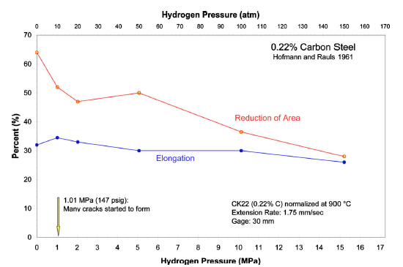

Figure 1. Elongation and reduction in area for a 0.22% carbon steel in gaseous hydrogen up to 15.2 MPa Literature results from [8]

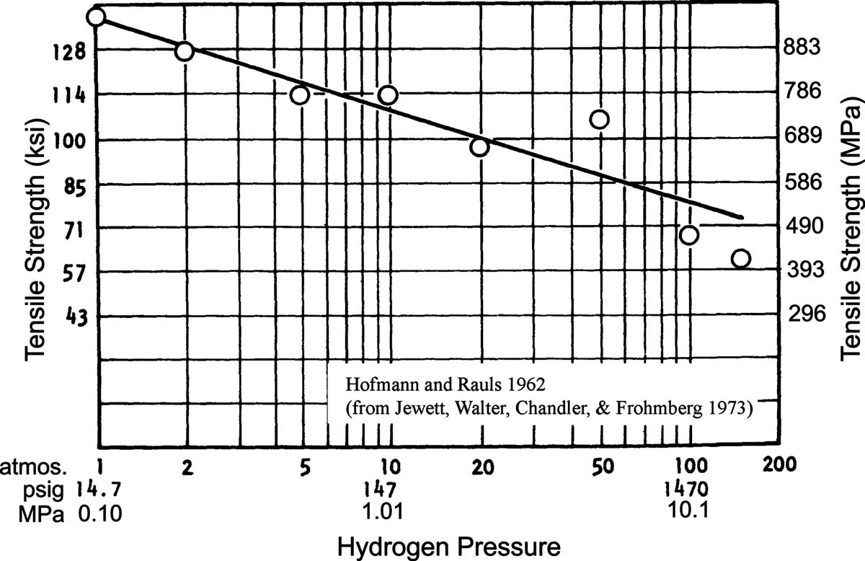
Figure 2. The tensile strength of a cold-drawn 0.22% carbon steel as a function of ambient hydrogen pressure. Literature results from [15]

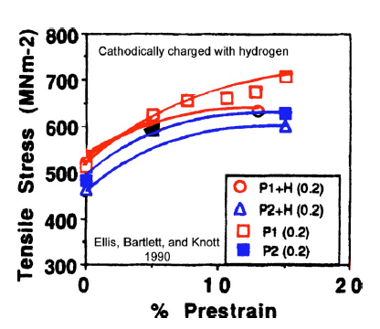
Figure 3. Hydrogen lowering the 0.2% yield stresses of carbon steels (P1: quenched and tempered and P2: controlled rolled at – 10 ℃. Literature Results from [17]

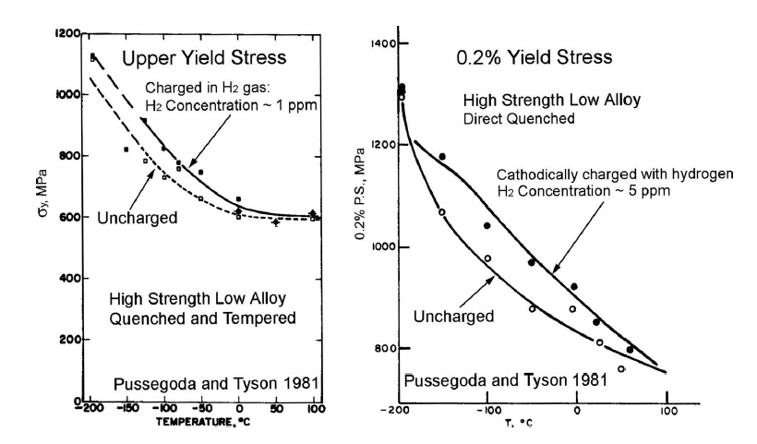
Figure 4. Comparison of yield strength of hydrogen gas charged (left), cathodically charged (right) samples with uncharged ones. Literature Results from [18]

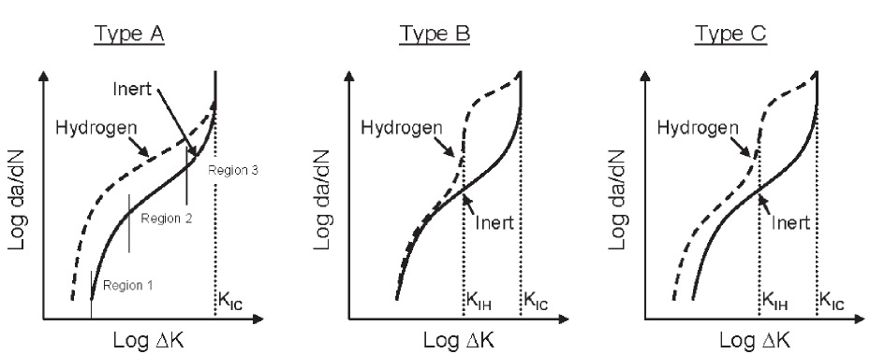
Figure 5. Possible effects of hydrogen on fatigue behavior. Literature Results from [19, 20]

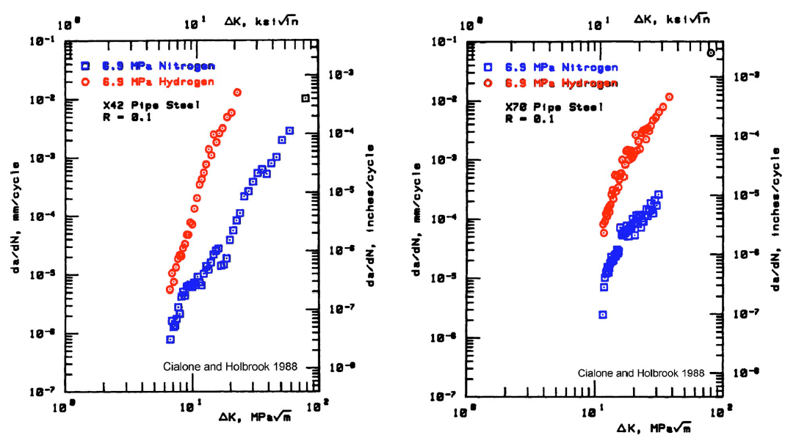
Figure 6. Fatigue-crack-growth rates (da/dN) as a function of stress intensity range (ΔK) for X42 and X70 pipeline steel in 6.9 MPa hydrogen and 6.9 MPa nitrogen at stress ratio (R) of 0.1. Literature results from [35]

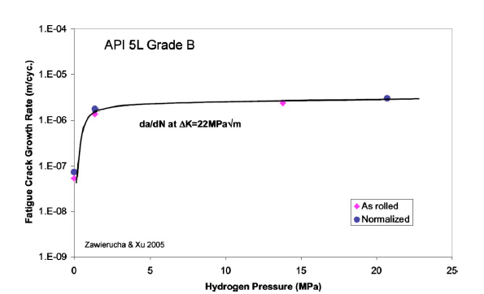
Figure 7. Fatigue-crack-growth rates (da/dN) as a function of hydrogen pressure for an API 5L Grade B steel. Literature results from [38]

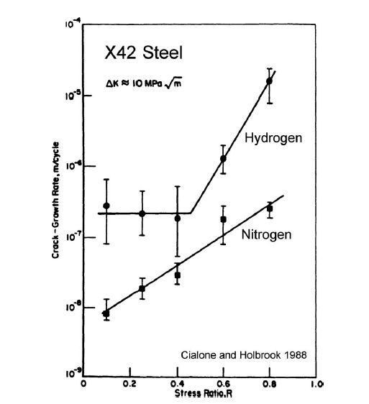
Figure 8. Fatigue-crack-growth rates (da/dN) as a function of stress ratio for X42 steel in hydrogen and nitrogen. Literature results from [37]

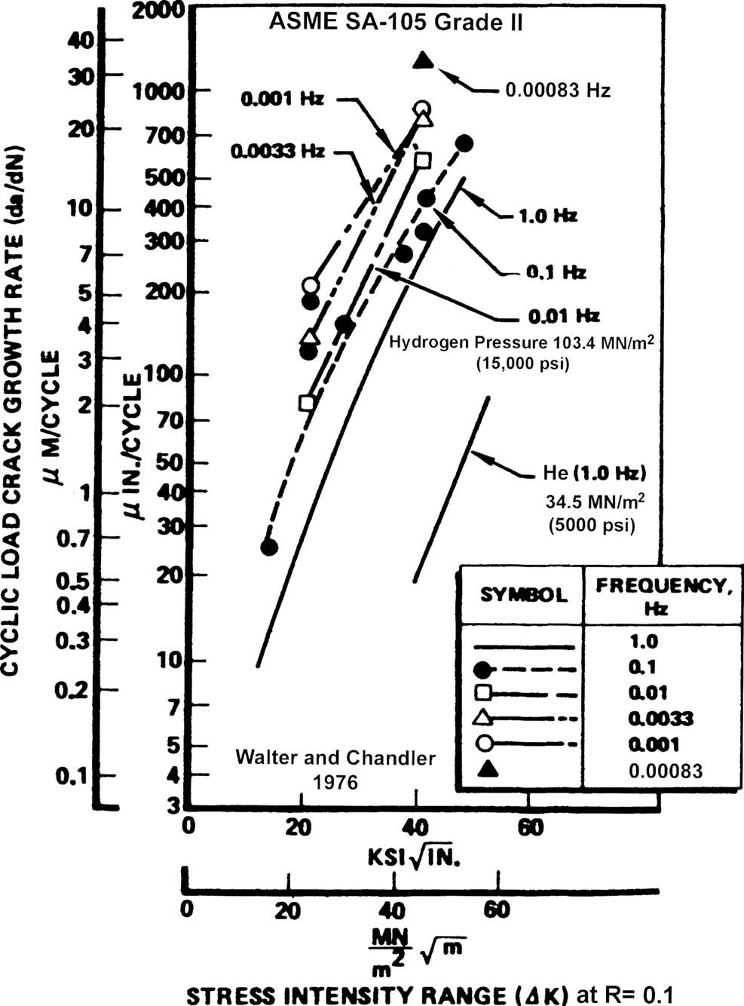
Figure 9. Effects of Cyclic frequency on ASME SA-105 Grade II steel in 103.4 MPa hydrogen at a stress ratio of 0.1 [40]

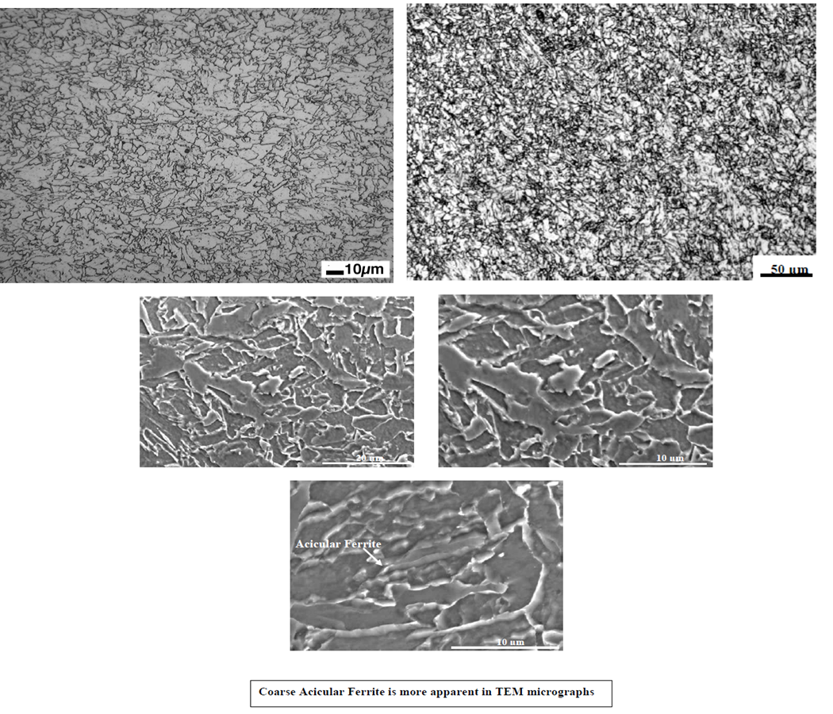
Figure 10. Optical microscopy (OM) image (upper two) and SEM image (lower three) of Alloy B. Literature results from [6]

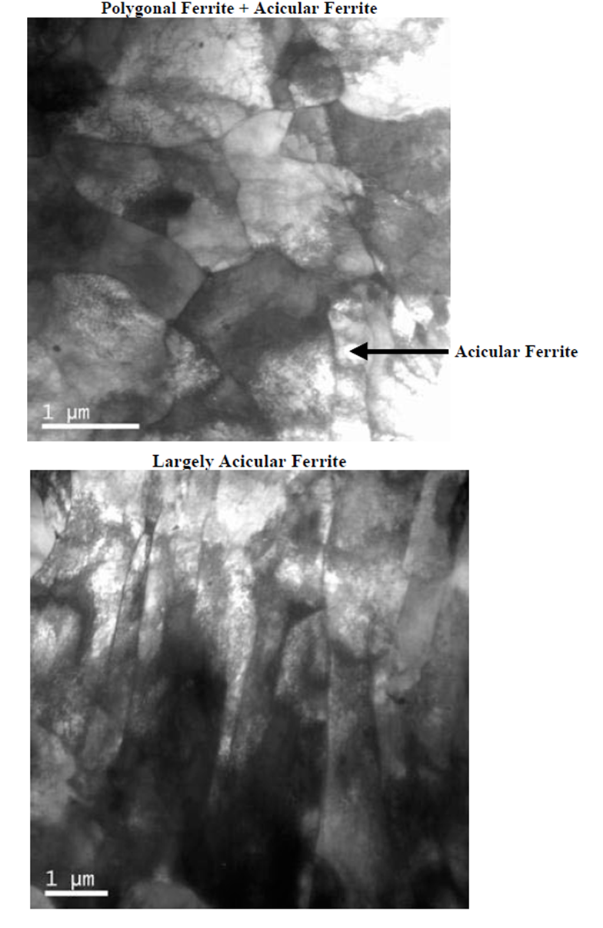
Figure 11. TEM image of Alloy B. Literature results from [6]

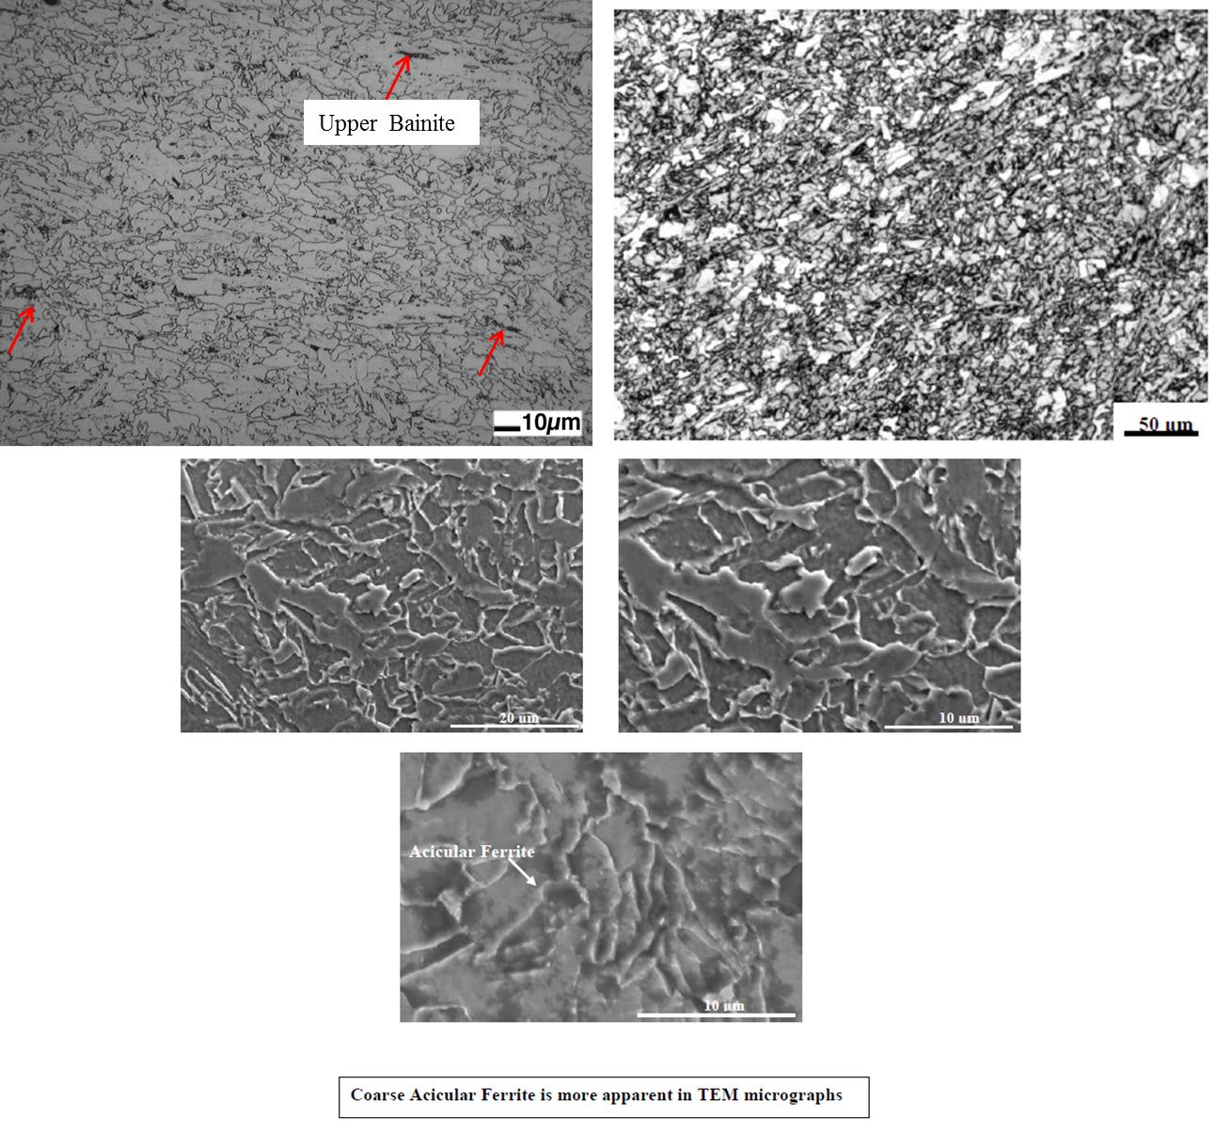
Figure 12. OM (upper two) and SEM (lower three) images of Alloy C. Literature results from [6]

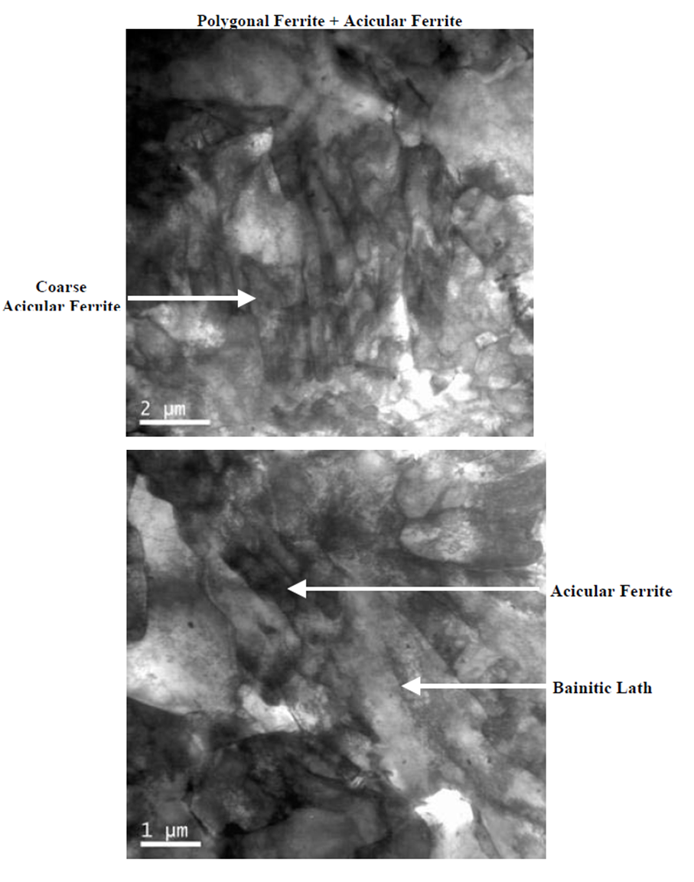
Figure 13. TEM image of Alloy C. Literature results from [6]

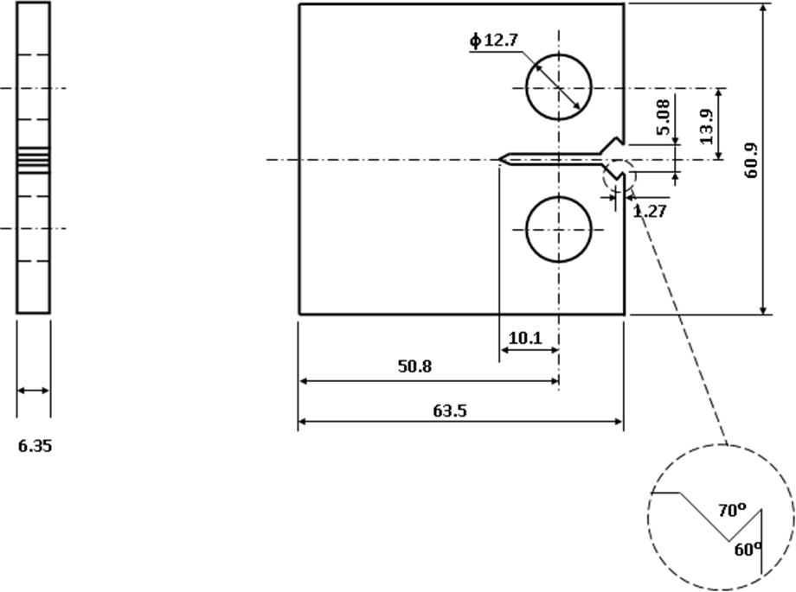
Figure 14. Geometry of the compact tension (CT) specimen for fatigue experiment (unit: mm)

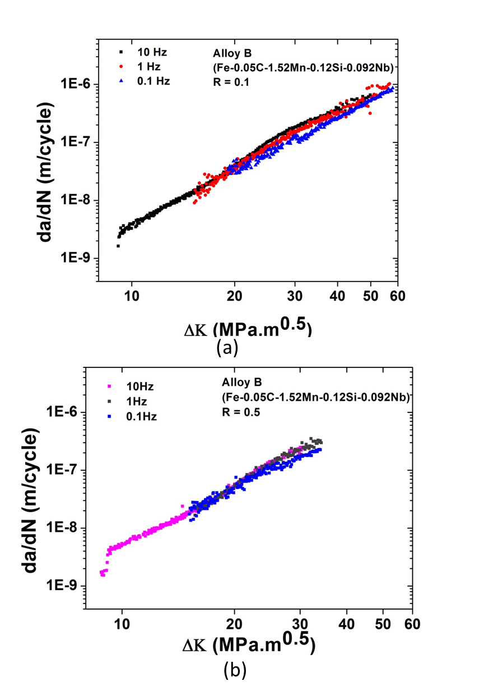
Figure 15. FCGR (da/dN) versus stress-intensity-factor range (ΔK) for Alloy B at different frequencies (0.1, 1 and 10 Hz). (a) R = 0.1 and (b) R = 0.5
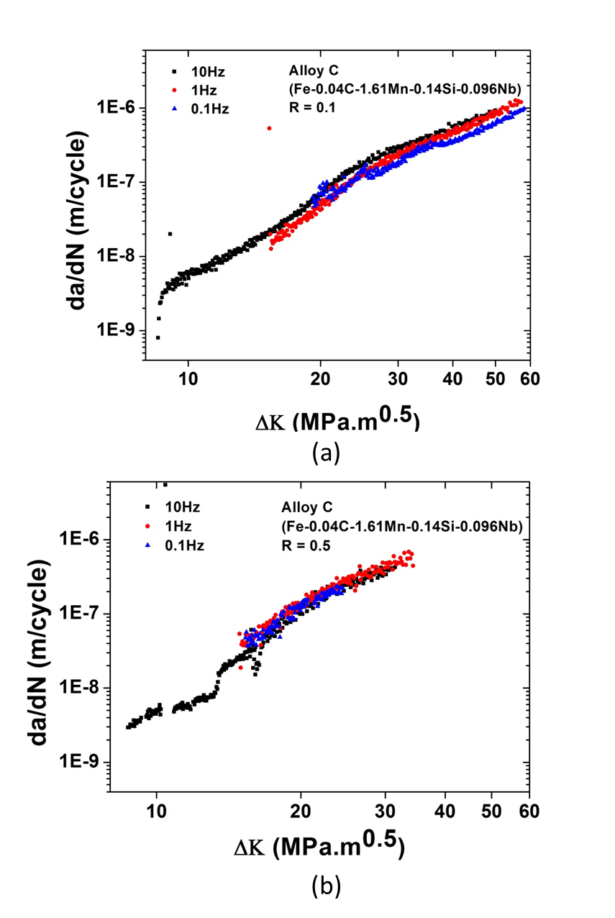
Figure 16. FCGR (da/dN) versus stress-intensity-factor range (ΔK) for Alloy C at different frequencies (0.1, 1, and 10 Hz. (a) R=0.1 and (b) R=0.5

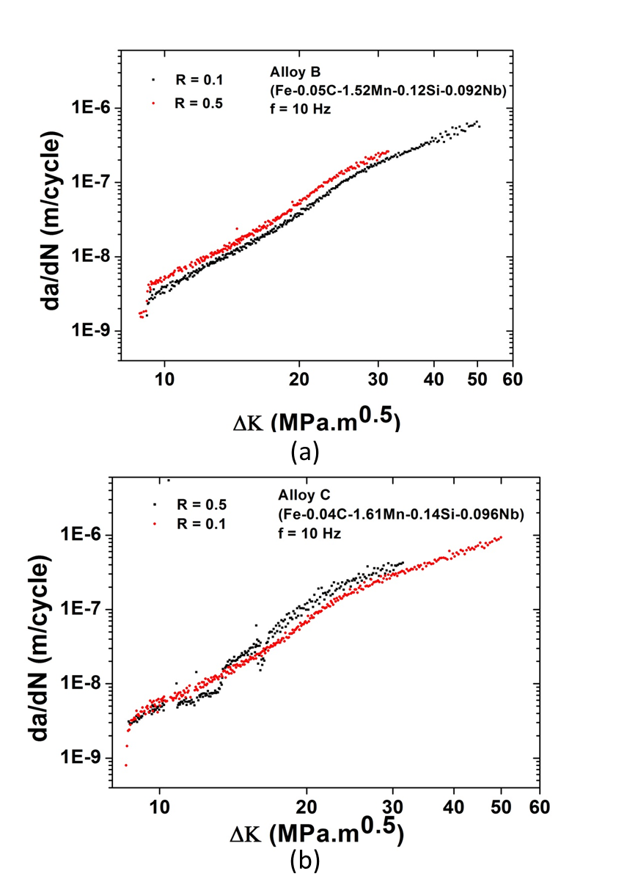
Figure 17. FCGR (da/dN) versus stress-intensity-factor range (ΔK) for different stress ratios at 10 Hz. (a) Alloy B and (b) Alloy C
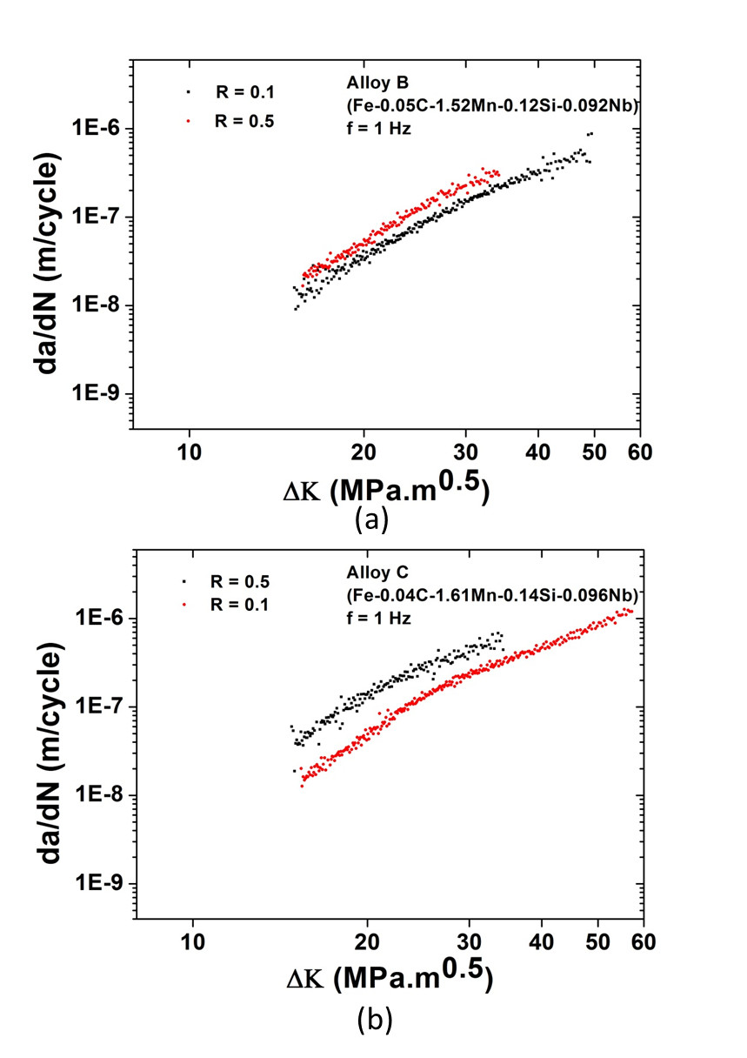
Figure 18. FCGR (da/dN) versus stress-intensity-factor range (ΔK) for different stress ratios at 1 Hz. (a) Alloy B and (b) Alloy C
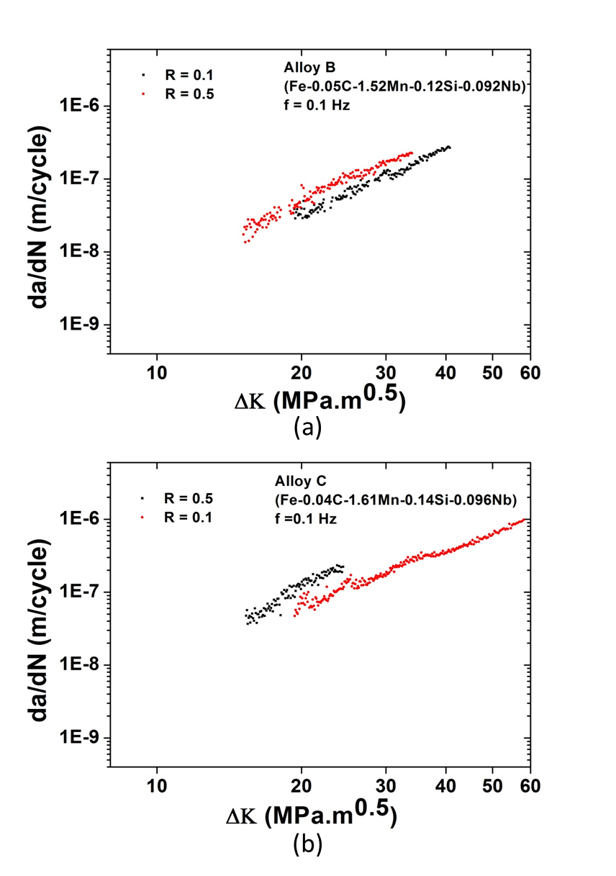
Figure 19. FCGR (da/dN) versus stress-intensity-factor range (ΔK) for different stress ratios at 0.1 Hz. (a) Alloy B and (b) Alloy C

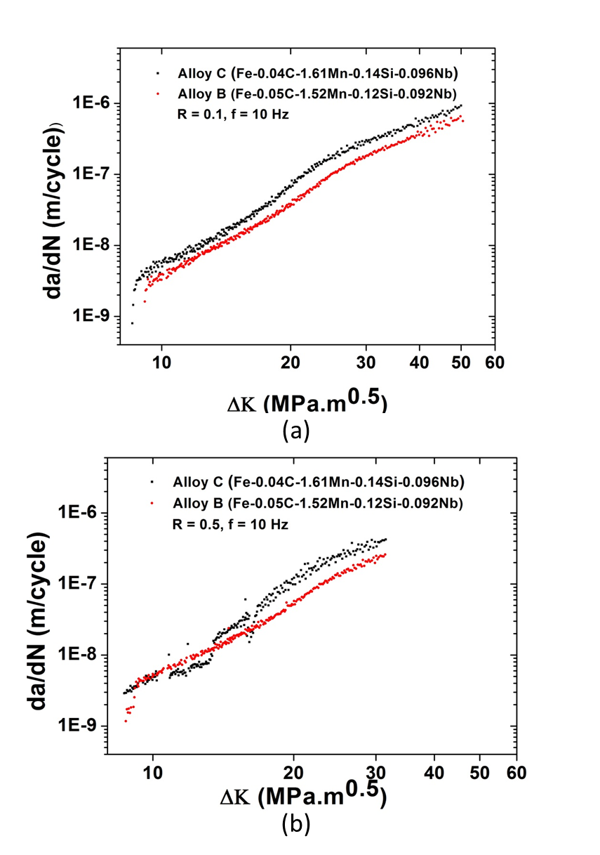
Figure 20. Comparison of FCGR curves for Alloys B and C at 10 Hz with (a) R = 0.1 and (b) R = 0.5
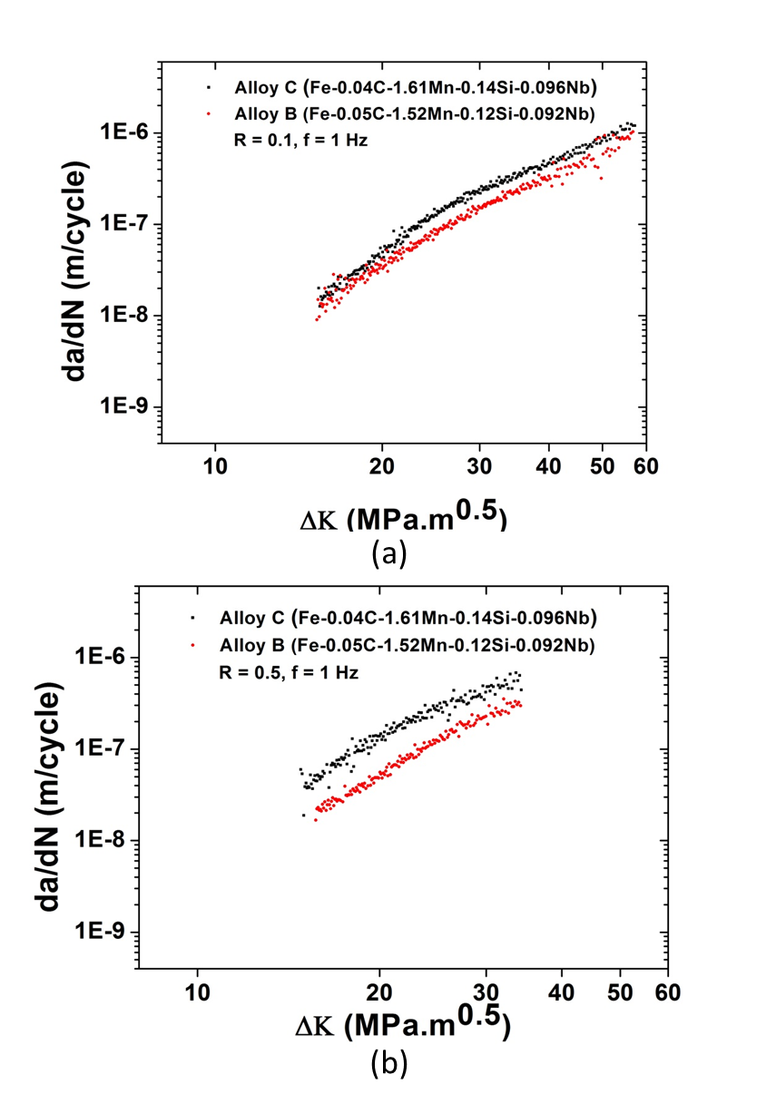
Figure 21. Comparison of FCGR curves for Alloy B and C at 1 Hz with (a) R = 0.1and (b) R = 0.5
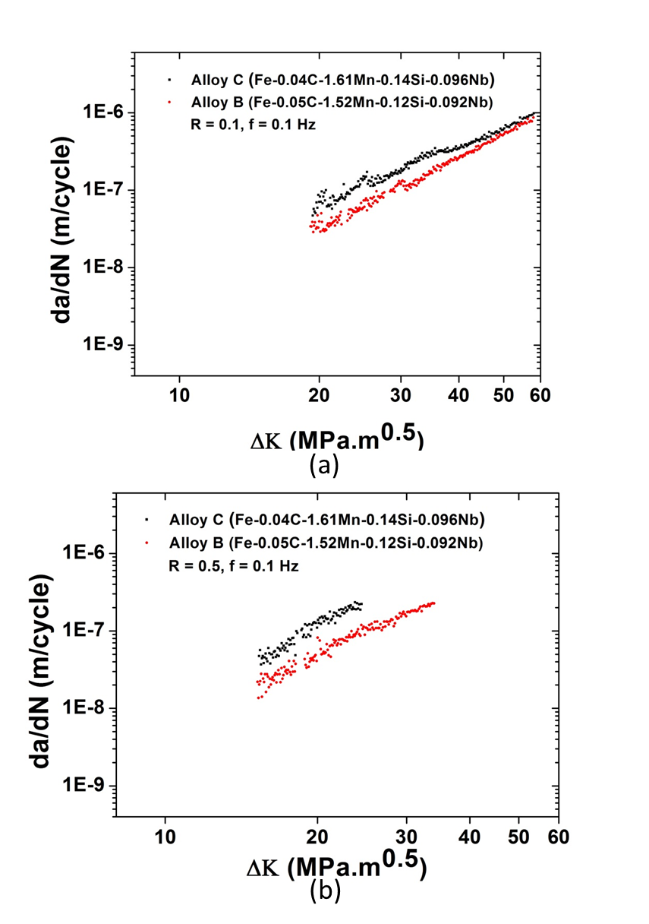
Figure 22. Comparison of FCGR curves for Alloy B and C at 0.1 Hz with (a) R = 0.1 and (b) R = 0.5

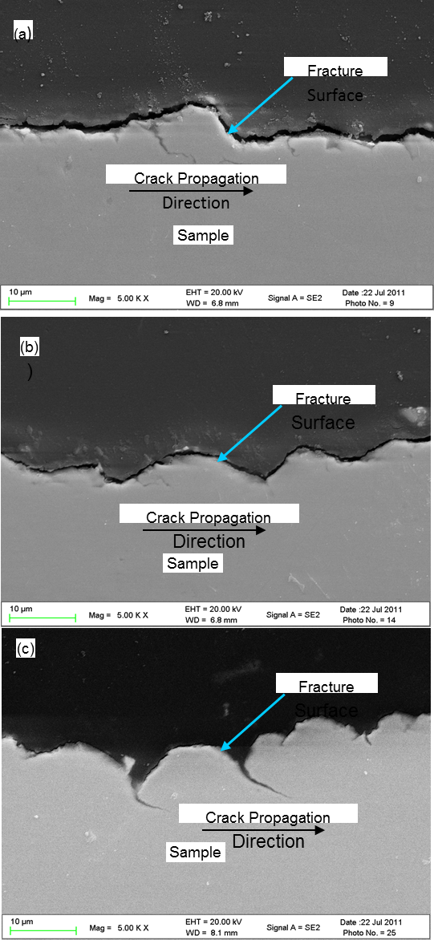
Figure 23. The side view fracture morphology of the fatigued Alloy C at a frequency of 10 Hz in the different ΔK range: (a) small, (b) middle, and (c) large.
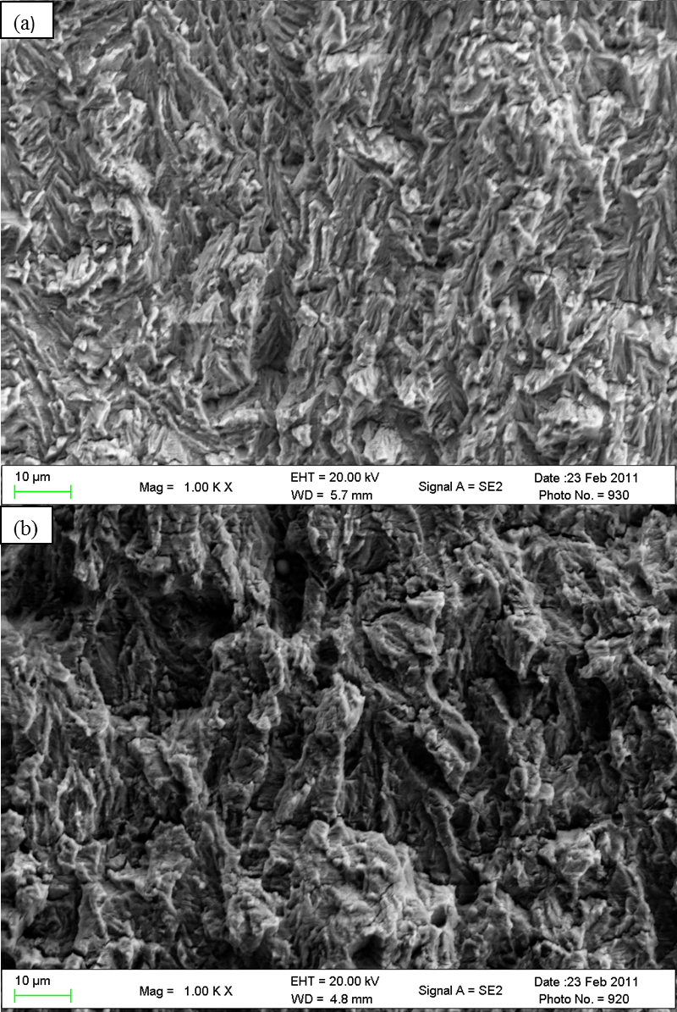
Figure 24. SEM images of fracture surfaces at ΔK = 10 MPa.m^{0.5}. (a) Alloy B and (b) Alloy C.

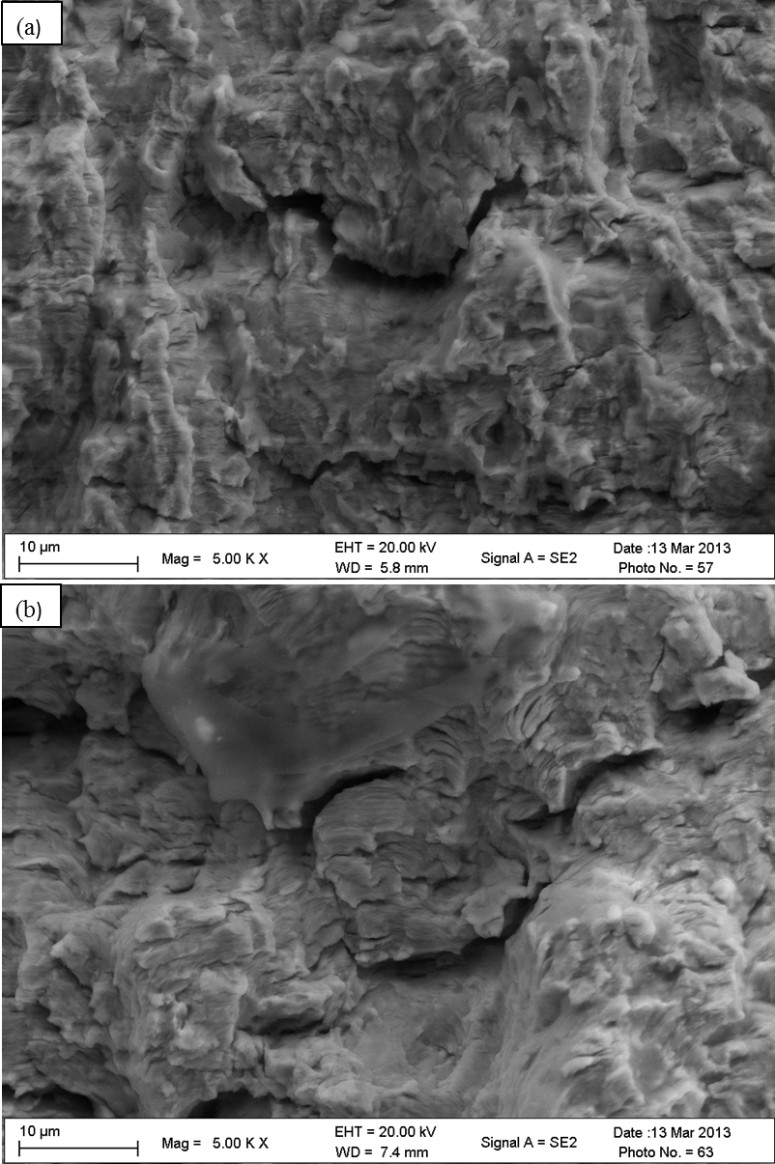
Figure 25. SEM images of Fracture surface of Alloy B (a) middle ΔK and (b) high ΔK
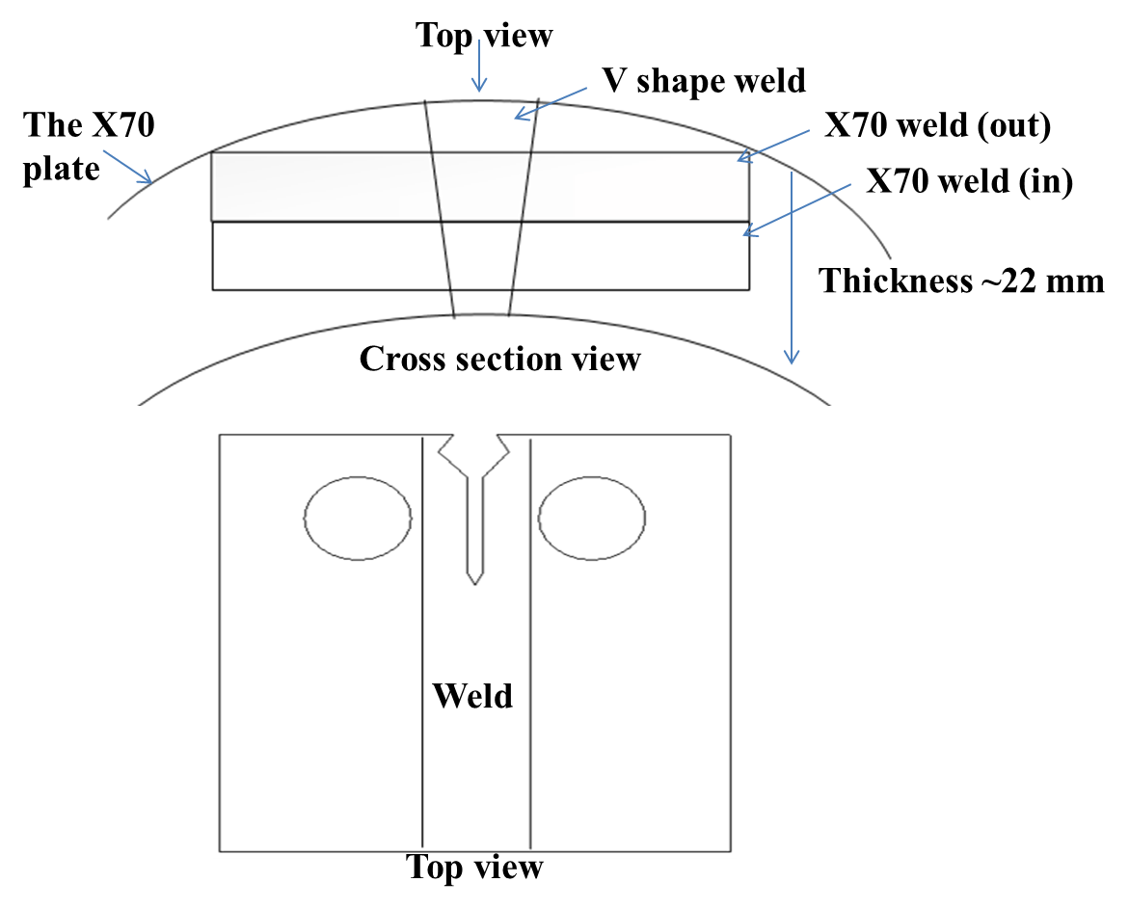
Figure 26. Sketch for the Machining of X70 pipeline steel weld sample

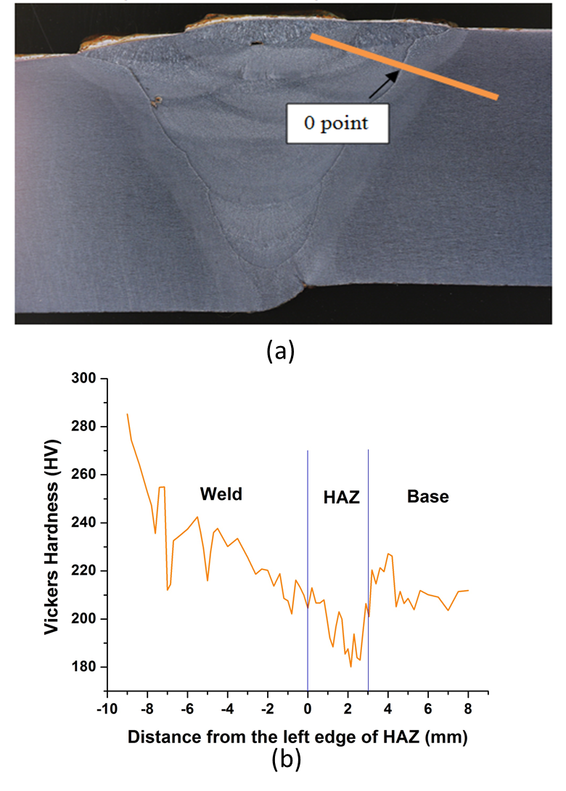
Figure 27. (a) Macro-picture of the sample; (b) Vickers hardness as a function of the distance from the left edge of heat-affected zone (HAZ) [the 0 point in (a)]

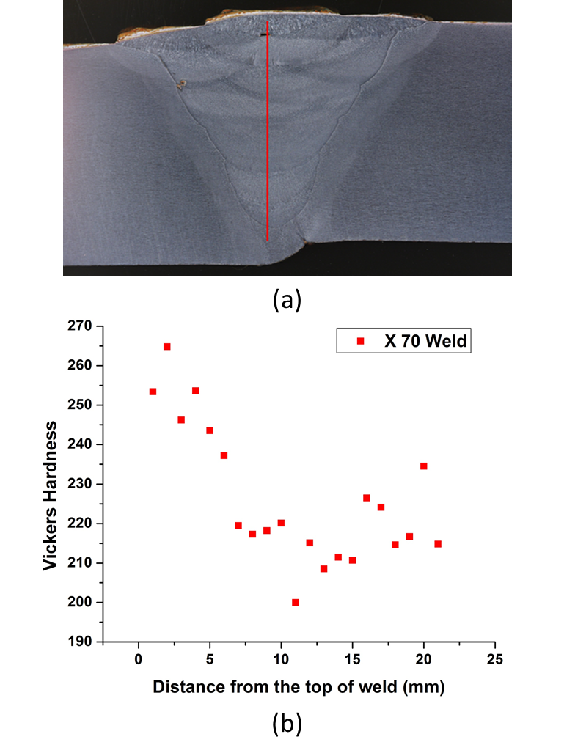
Figure 28. (a) Macro-picture of the sample; (b) Vickers hardness versus distance from the top of the weld [the blue point in (a)]

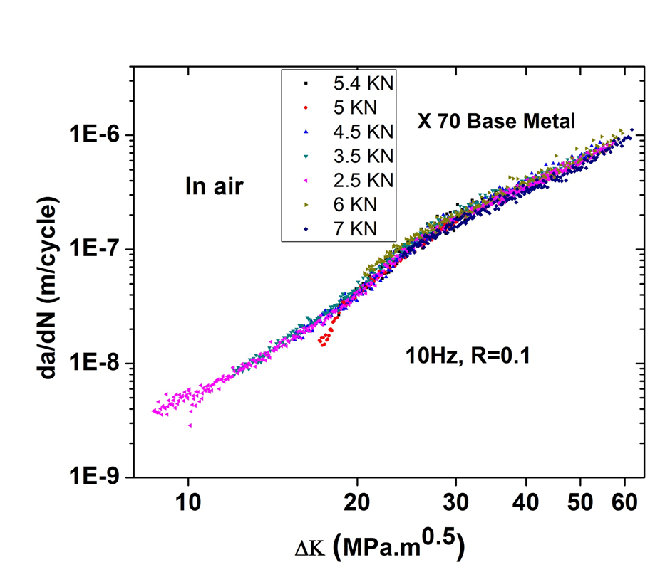
Maximum
Loads
Figure 29. FCGR(da/dN) versus stress-intensity-factor range (ΔK) for the X70 base metal at different load levels

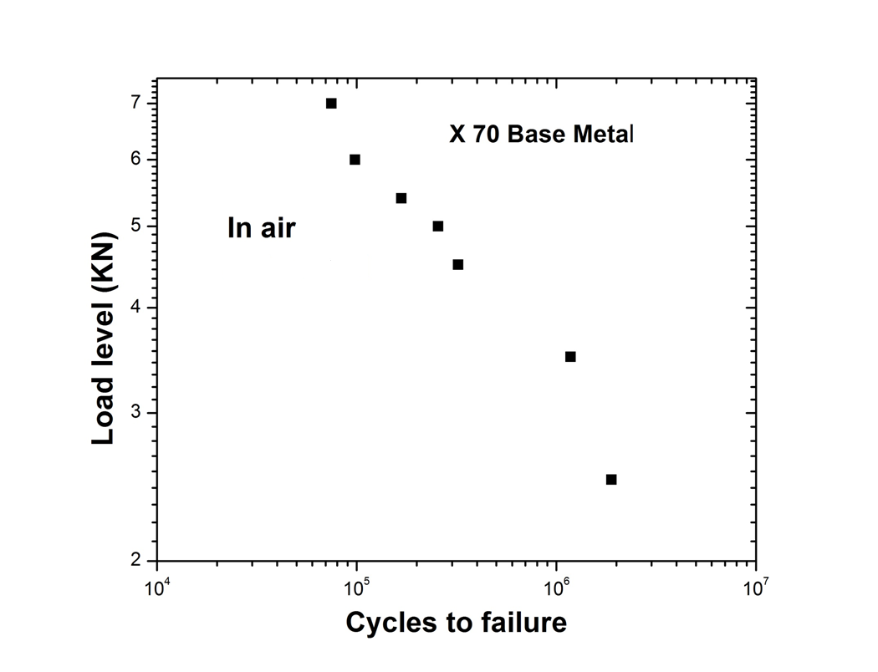
Figure 30. Load level versus cycles to failure for X70 base metal when R = 0.1 and f = 10 Hz

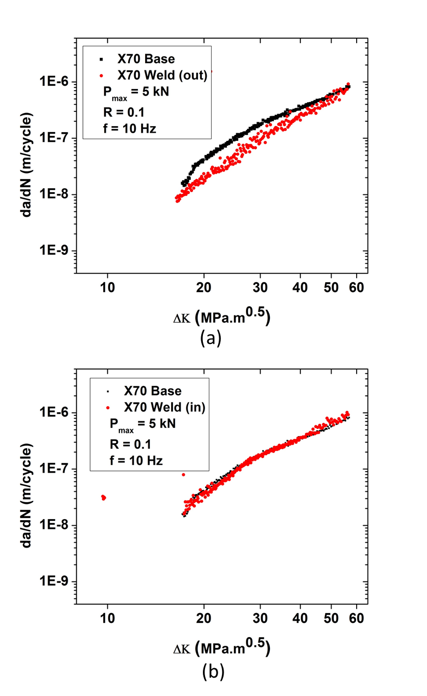
Figure 31. Comparison of FCGR curves (a) X70 base and upper weld (b) X70 base and lower weld when P_{max} = 5 kN, R = 0.1 and f = 10 Hz
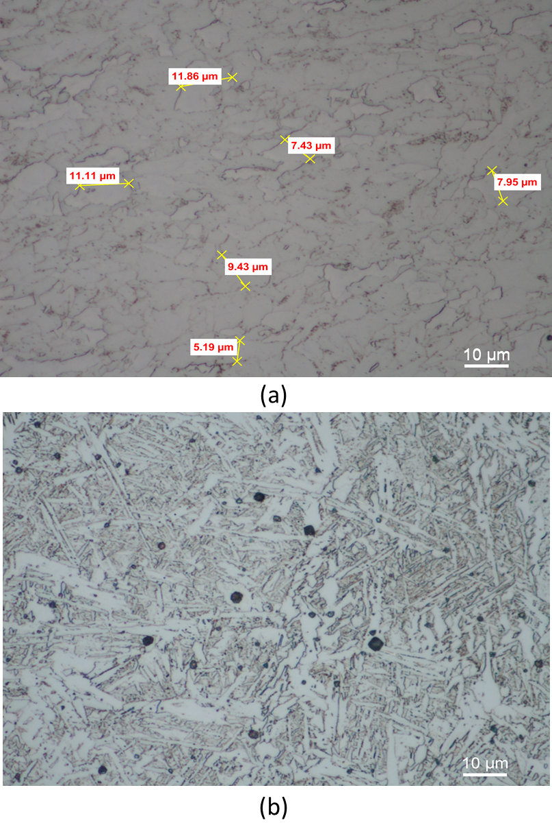
Figure 32. Optical Microscopy image (a) X70 base (b) X70 weld

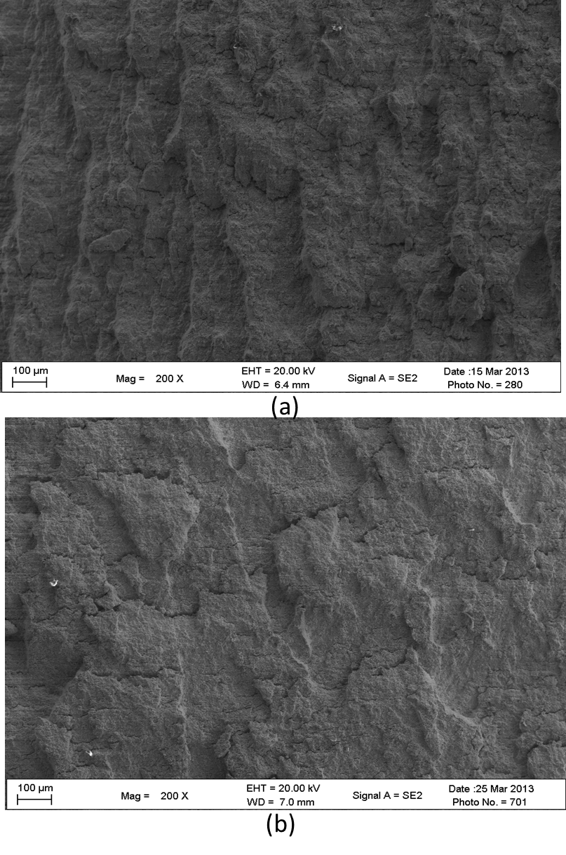
Figure 33. SEM image of fracture surface at high ΔK level. (a) X70 base (2) X70 weld

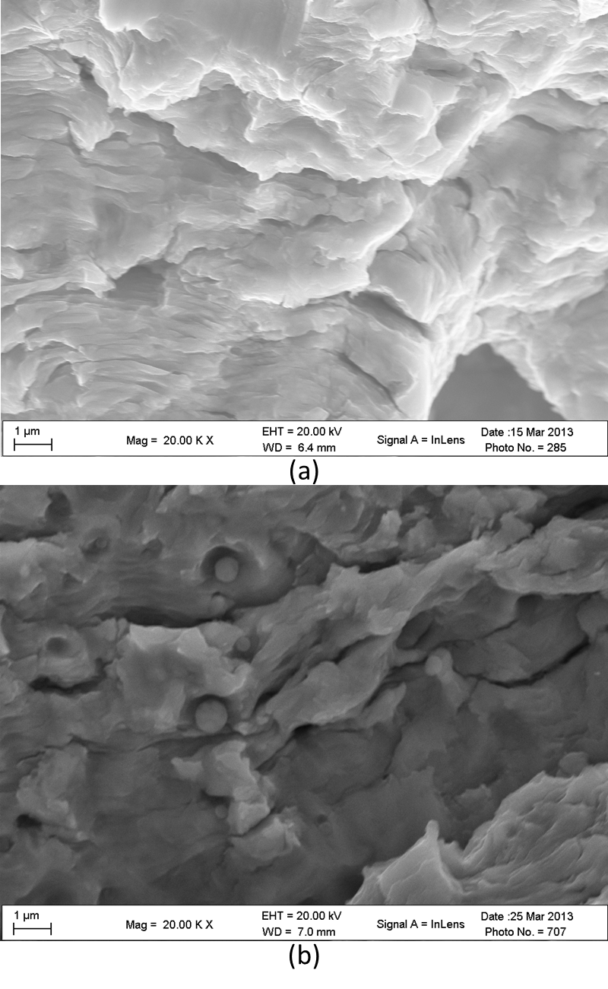
Figure 34. SEM image of fracture surface at high magnification. (a) X70 base (b) X70 weld

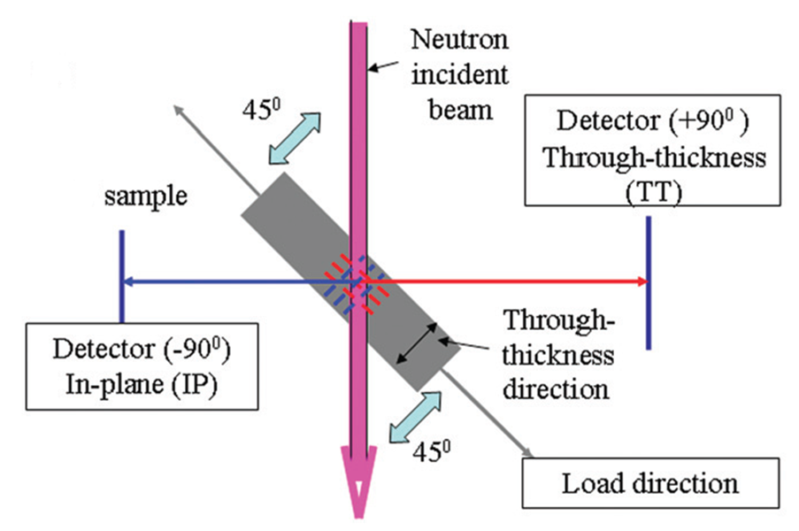
Figure 35. Sketch of the neutron diffraction geometry of the experiments

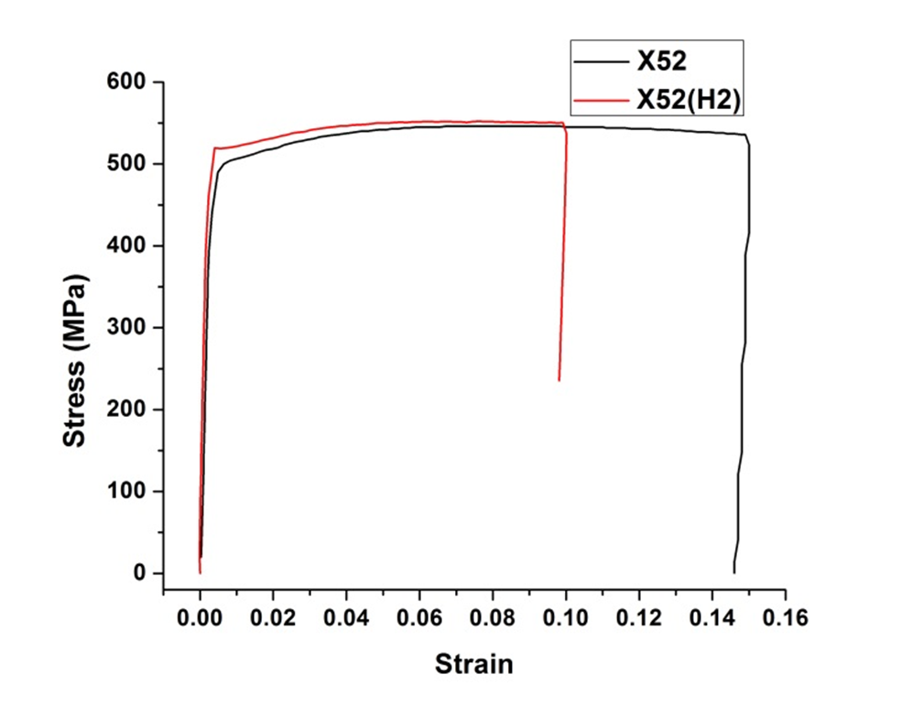
Figure 36. Stress versus strain for X52 samples with or without hydrogen charged

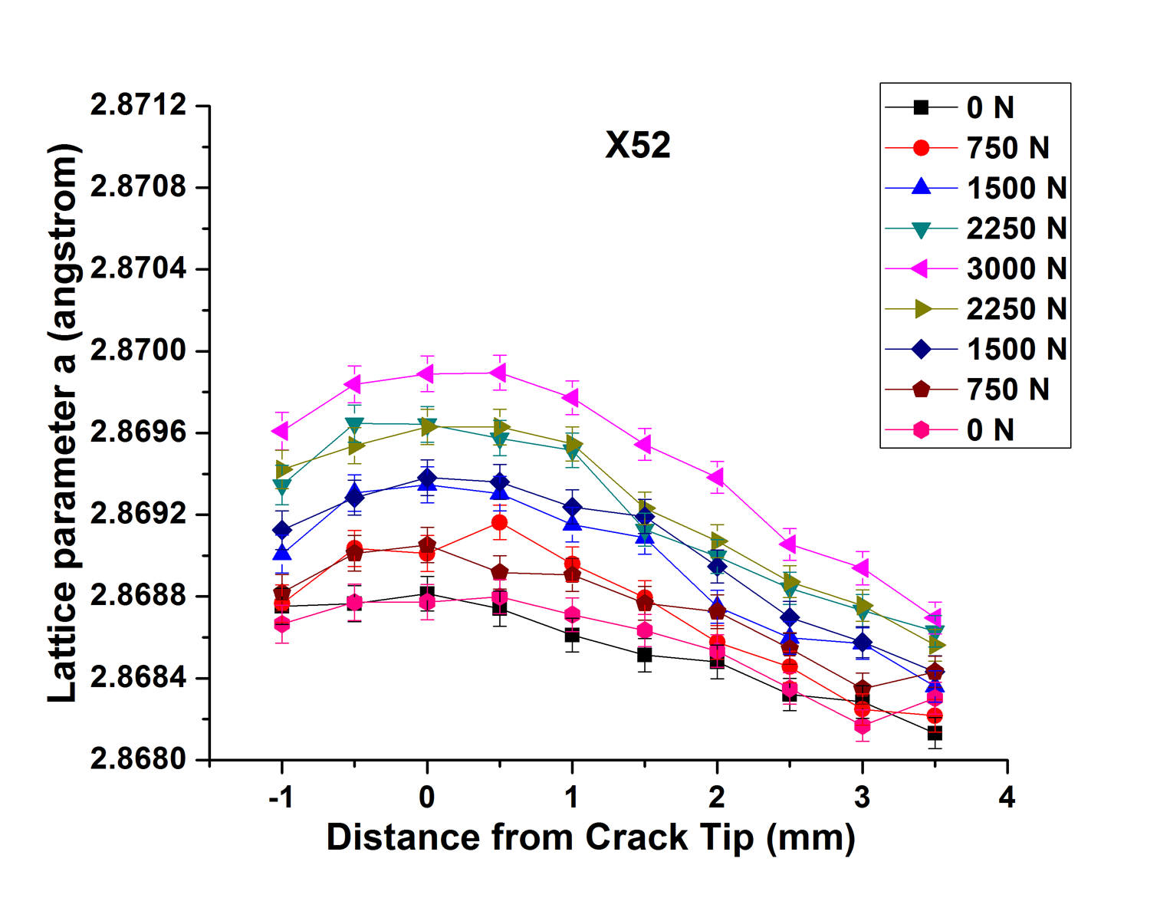
Figure 37. Lattice parameter as a function of the distance from crack tip for X52 original sample

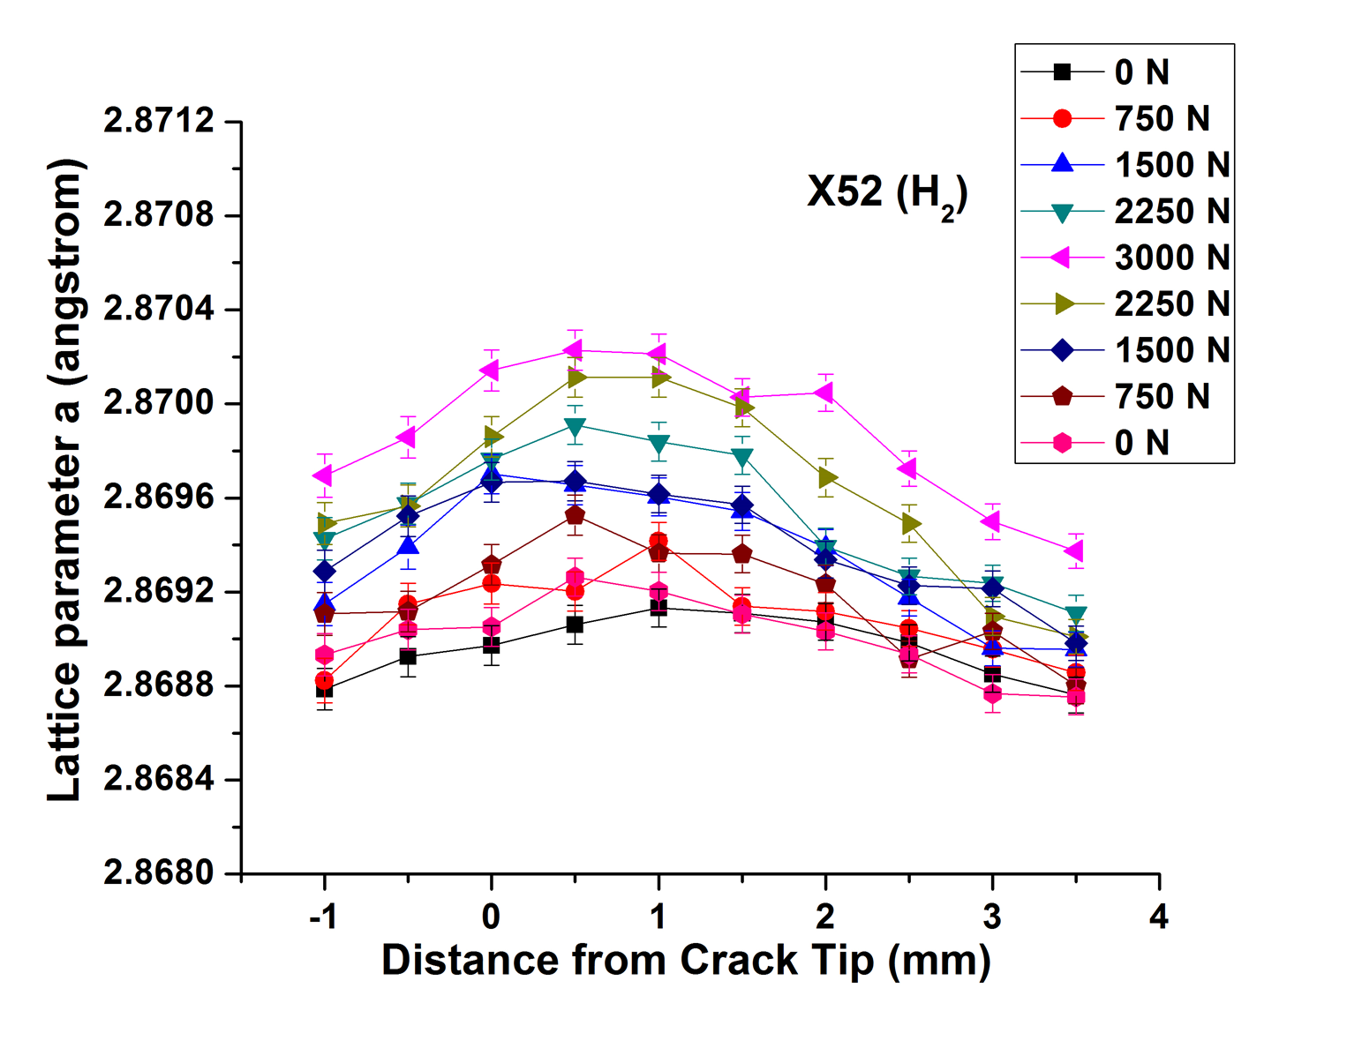
Figure 38. Lattice parameter as a function of the distance from crack tip for X52 hydrogen charged sample

