To the Graduate Council:

I am submitting herewith a dissertation written by Kelly Ann Chameroy entitled “Diagnosis and Management of Horses with Equine Metabolic Syndrome (EMS).” I have examined the final electronic copy of this dissertation for form and content and recommend that it be accepted in partial fulfillment of the requirements for the degree of Doctor of Philosophy, with a major in Comparative and Experimental Medicine.

Nicholas Frank
Major Professor

We have read this dissertation
and recommend its acceptance:

Carla Sommardahl

Joseph Bartges

Stephen Kania

Accepted for the Council:
Carolyn R. Hodges
Vice Provost and Dean of the Graduate School

(Original signatures are on file with official student records.)

Diagnosis and Management of Horses with
Equine Metabolic Syndrome (EMS)

A Dissertation Presented for
the Doctor of Philosophy
Degree
The University of Tennessee

Kelly Ann Chameroy
December 2010

Copyright © 2010 by Kelly Ann Chameroy
All rights reserved

Dedication

This dissertation is dedicated to my family for supporting me when times were trying and keeping me looking forward to the end

Acknowledgements

I would like to express thanks to my major professor, Dr. Nicholas Frank, for giving me the opportunity to expand my education and acquire the many new skills and knowledge I’ve obtained over the last several years. Thanks go out to Sarah B. Elliott for technical assistance when needed, and to Drs. Ferenc Tóth and Lisa Tadros for helping maintain the health of the animals that made these studies possible.

I would like to thank my committee members, Dr. Carla Sommardahl, Dr. Joseph Bartges, and Dr. Stephen Kania for agreeing to be on my committee and for being available for questions and technical assistance when needed.

I would also like to thank the College of Veterinary Medicine for accommodating my studies and the horses that I worked so closely with and for assisting in their medical care as well.

To Mr. Dudley Hurst, without whom these animals would not have been comfortable and happy.

And lastly, thank you to the Comparative and Experimental Medicine Program for allowing me to obtain my Ph.D.

Abstract
In horses, a painful and often debilitating disease known as laminitis can result in impaired function and, in severe cases, euthanasia. Equine Metabolic Syndrome (EMS) is a syndrome in horses that results in development of laminitis and is characterized by the presence of general and/or regional adiposity (“cresty neck”), aberrations in blood lipid concentrations, insulin resistance (IR) and/ or hyperinsulinemia.
Therapies have focused on improving the state of obesity and insulin resistance with the goal of diminishing the likelihood of laminitis development. A definitive cause for laminitis has not been established, but hyperinsulinemia and IR are likely candidates as experimental states of hyperinsulinemia have been shown to induce laminitis and improvements in insulin sensitivity and obesity have been associated with a decreased risk of laminitis development.
This dissertation discusses associations between obesity and IR, as well as potential therapies for alleviating insulin resistance with the ultimate goal of decreasing the risk of developing laminitis. Therapies evaluated included chromium and magnesium, levothyroxine sodium, and metformin hydrochloride. Horses were treated with each supplement for 10 to 36 weeks, depending on the supplement tested, and physical measurements such as body weight, neck circumference, and body condition score were obtained. Throughout each study, blood concentrations of glucose, insulin, and plasma lipids were analyzed. Chromium and magnesium currently do not appear to have any effect on insulin sensitivity, whereas results of levothyroxine administration indicate therapeutic responses, as does metformin, though results indicate further work are required.
Research contained in this dissertation focuses on the potential of identifying animals at risk of developing IR and laminitis through measurement of blood biomarkers such as adiponectin and glucagon-like peptide 1. Assays to measure markers included enzyme-linked immunosorbent assays, western blots, and radioimmunoassays. Glucagon-like peptide 1 currently does not appear to differ between healthy and IR animals, but protein band density of high-molecular weight adiponectin does appear to be lower in horses with IR when compared to healthy animals.
There is still much to learn about IR in horses, and therapy appears to be dependent on a case by case basis.

Key words: horse, obesity, insulin resistance, laminitis, equine metabolic syndrome

Table of Contents
Chapter 1 Literature review 1
1 Obesity and insulin resistance in horses and ponies 1
1.1 Body condition and fat mass assessment 1
1.2 Adipose distribution 2
2 Insulin resistance 3
2.1 Insulin secretion and function 3
2.2 Insulin receptor and signaling 3
2.3 Mechanisms of insulin resistance 4
3 Lipid metabolism 6
3.1 Lipotoxicity 6
3.2 Ectopic lipid accumulation 7
3.3 The role of beta-oxidation 8
3.4 Mechanisms of beta-oxidation 8
3.4.1 Carnitine Palmitoyl Transferase 8
3.4.2 Adenosine Monophosphate Kinase 9
4 Hepatic Insulin Resistance 10
4.1 Non-alcoholic fatty liver disease 10
4.2 Regulation of hepatic lipid content 11
4.3 Visceral adiposity and the liver 12
5 Obesity and inflammation 12
6 Adipokines and incretins 13
6.1 Leptin 13
6.1.1 Leptin secretion 14
6.1.2 Leptin function 15
6.1.3 Leptin resistance 16
6.2 Adiponectin 17
6.2.1 Structure and discovery 17
6.2.2 Adiponectin receptors 18
6.2.3 Role of adiponectin in insulin resistance 19
6.3 Resistin 20
6.3.1 Discovery and distribution 20
6.3.2 Influence of resistin on insulin sensitivity 20
6.3.3 Role of resistin in hepatic insulin resistance 21
6.4 Glucagon-Like Peptide 1 22
6.4.1 Structure and discovery 22
6.4.2 Measurement of GLP-1 22
6.4.3 Association with insulin resistance and obesity 23
6.4.4 Potential role in therapy 24
6.4.5 Conclusions 25
7 Methods of assessing insulin sensitivity and resistance in the horse 25
7.1 Frequently-sampled intravenous glucose tolerance test 25
7.1.1 Procedure in horses 25
7.1.2 Calculations 26
7.1.3 Use of the FSIGTT in horses 27
7.2 Euglycemic hyperinsulinemic clamp 28
7.2.1 Introduction 28
7.2.2 Procedure in horses 28
7.2.3 Calculations 29
7.2.4 Conclusions 30
7.3 Combined glucose-insulin test 30
7.3.1 Introduction 30
7.3.2 Procedure 31
7.3.3 Conclusions 31
7.4 Proxy measures of insulin sensitivity 32
7.4.1 Introduction 32
7.4.2 Type of proxy measurement 32
7.4.3 Equations for proxy measurements 32
7.4.4 Use of proxy measures 34
8 Treatment of insulin resistance 35
8.1 Levothyroxine 36
8.1.1 Introduction 36
8.1.2 Levothyroxine use in horses 36
8.1.3 Levothyroxine and insulin sensitivity 38
8.1.4 Conclusions 40
8.2 Metformin 40
8.2.1 Introduction 40
8.2.2 Metformin use in horses 40
8.2.3 Mechanisms of metformin action 41
8.2.4 Conclusions 42
8.3 Chromium 42
8.3.1 Introduction 42
8.3.2 Chromium and insulin sensitivity 44
8.3.3 Chromium and lipid metabolism 44
8.3.4 Chromium and mechanisms of action 45
8.3.5 Chromium toxicity 46
8.3.6 Conclusions 47
8.4 Magnesium 47
8.4.1 Introduction 47
8.4.2 Magnesium deficiency 47
8.4.3 Effects of magnesium on insulin sensitivity 48
8.4.4 Effect of magnesium on tyrosine kinase activity 49
8.4.5 Magnesium excess 50
8.4.6 Conclusions 50
8.5 Cinnamon 51
8.5.1 Introduction 51
8.5.2 Cinnamon and glycemic control 51
8.5.3 Cinnamon and insulin sensitivity 52
8.5.4 Conclusions 52
9 Pituitary pars intermedia dysfunction 53
9.1 Introduction 53
9.2 Influence of PPID on insulin sensitivity 53
9.3 Effects of season on glucose testing in horses with PPID 54
10 Equine laminitis 55
10.1 Introduction 55
10.2 Laminar damage 55
10.3 Pathophysiology of laminitis 56
10.4 Risk factors for pasture-associated laminitis 56
10.5 Insulin resistance and laminitis susceptibility 57
10.6 Conclusions 57
11 Synopsis 58

Chapter 2 Effects of a supplement containing chromium and magnesium on
morphometric measurements, resting glucose and insulin
concentrations, and insulin sensitivity in laminitic obese horses 59
2.1 Introduction 61
2.2 Materials and methods 62
2.3 Results 65
2.4 Discussion 70

Chapter 3 Effects of levothyroxine sodium on body condition, blood measures of
metabolic status, and glucose dynamics in obese, previously laminitic
horses 74
3.1 Introduction 76
3.2 Materials and methods 76
3.3 Results 80
3.4 Discussion 84

Chapter 4 Effects of metformin hydrochloride on glucose and insulin dynamics
during transition to grass paddocks in obese insulin-resistant horses 92
4.1 Introduction 94
4.2 Materials and methods 95
4.3 Results 97
4.4 Discussion 99

Chapter 5a Validation of an enzyme-linked immunosorbent assay (ELISA) for the
measurement of active GLP-1 in equine plasma 105
5a.1 Introduction 107
5a.2 Materials and methods 107
5a.3 Results 109
5a.4 Discussion 115

Chapter 5b Plasma glucagon-like peptide 1 (GLP-1) concentrations in response to an
oral sugar test in healthy and insulin-resistant horses 117
5b.1 Introduction 119
5b.2 Materials and methods 119
5b.3 Results 121
5b.4 Discussion 124

Chapter 5c Effects of weight gain on plasma active glucagon-like peptide 1 (GLP-1)
concentrations and glucose tolerance test responses in horses 127
5c.1 Introduction 129
5c.2 Materials and methods 129
5c.3 Results 132
5c.4 Discussion 141

Chapter 6 Identification and assessment of high-molecular weight adiponectin in
Horses 147
6.1 Introduction 147
6.2 Materials and methods 148
6.3 Results 149
6.4 Discussion 150

Chapter 7 Conclusions and future directions 158
References 163
Appendix 199
Vita....... 204

List of Tables
Table 2.1 - Mean ± s.d. physical measurements for 14 laminitic obese horses that received a dietary supplement in their feed once daily or remained untreated for 16 weeks 66
Table 2.2 - Mean ± s.d. resting blood measures for 14 laminitic obese horses that received a dietary supplement in their feed once daily or remained untreated for 16 weeks. Glucose and insulin data from one clinically laminitic horse that suffered from persistent lameness were excluded 67
Table 2.3 - Mean ± s.d. minimal model analysis values obtained from frequently-sampled intravenous glucose tolerance test data for 13 laminitic obese horses that received a supplement containing chromium and magnesium (n = 7) or remained untreated (control group; n = 6) for 16 weeks. Data from one clinically laminitic horse that suffered from persistent lameness were excluded 68
Table 3.1 - Mean ± s.d. physical measurements for 10 previously laminitic obese horses that received levothyroxine sodium at a dosage of 48 mg/d for 24 weeks and then 72 mg/d for 12 weeks (n = 7) or remained untreated throughout the study period (n = 3) 81
Table 3.2 - Mean ± s.d. resting blood measures for 10 previously laminitic obese horses that received levothyroxine sodium at a dosage of 48 mg/d for 6 months and then 72 mg/d for 3 months (n = 7) or remained untreated throughout the study period (n = 3) 85

Table 3.3 - Mean ± s.d. minimal model analysis values obtained from insulin-modified frequently-sampled intravenous glucose tolerance test data for 10 previously laminitic obese horses that received levothyroxine sodium at a dosage of 48 mg/d for 6 months and then 72 mg/d for 3 months (n = 7) or remained untreated throughout the study period (n = 3) 86

Table 4.1 - Mean ± s.d. physical measurements for 6 insulin-resistant, obese, previously laminitic horses that were returned to pasture for 10 weeks and received metformin for 2 weeks at dosages of 15 mg/kg bwt q 12h and 30 mg/kg bwt q 12h 98

Table 4.2 - Mean ± s.d. resting, fasting, and area under the curve measures for 6 insulin-resistant, obese, previously laminitic horses that were returned to pasture for 10 weeks and received metformin for 2 weeks at dosages of 15 mg/kg bwt q 12h and 30 mg/kg bwt q 12h 102

Table 5c.1 - Mean ± s.d. physical measurements for 6 horses with chronic insulin resistance that received a diet providing 2 × DE_{m} per day for 8 weeks 133

Table 5c.2 - Mean ± s.d. blood measures for 6 horses with chronic insulin resistance that received a diet providing 2 × DE_{m} per day for 8 weeks 140

List of Figures
Figure 1.1: Neck circumference measurements in the horse 2
Figure 1.2: Glucose concentrations of non-obese (squares) and obese (diamonds) horses during a CGIT 33
Figure 2.1: Mean ± s.d. resting serum insulin concentrations at 0 (light gray bars), 8 weeks (dark gray bars), and 16 weeks (white bars) in 13 laminitic obese horses that received a supplement containing chromium and magnesium (n = 7) or remained untreated (control group; n = 6) for 16 weeks. Data from one clinically laminitic horse that suffered from persistent lameness were excluded 69
Figure 3.1: Mean ± s.d. change in body weight (kg) at 12, 24, and 36 weeks for 10 previously laminitic obese horses that received levothyroxine sodium at a dosage of 48 mg/d for 24 weeks and then 72 mg/d for 12 weeks (n = 7) or remained untreated (n = 3). Measurements were obtained at 12 (white), 24 (gray), and 36 weeks (black). Asterisk indicates a significant difference between groups at a specific time point 82

Figure 3.2: Mean ± SEM mean neck circumference (cm) at 0, 12, 24, and 36 weeks for 10 previously laminitic obese horses that received levothyroxine sodium at a dosage of 48 mg/d for 24 weeks and then 72 mg/d for 12 weeks (n = 7; white) or remained untreated throughout the study period (n = 3; black). Asterisk indicates a significant difference between groups at a specific time point 83

Figure 3.3: Mean ± SEM mean neck circumference-to-height ratio at 0, 12, 24, and 36 weeks for 10 previously laminitic obese horses that received levothyroxine sodium at a dosage of 48 mg/d for 24 weeks and then 72 mg/d for 12 weeks (n = 7; white) or remained untreated throughout the study period (n = 3; black). Treatment × time; P = 0.031. Asterisk indicates a significant difference between groups at a specific time point 84

Figure 4.1: Mean ± s.d. plasma glucose (top panel) and serum insulin (bottom panel) concentrations during OGTs performed in 6 obese, insulin-resistant horses receiving metformin at 15 mg/kg q 12h for 14 days or 30mg/kg q 12h for 14 days while having access to pasture. Samples were collected in the fed state (light bars; fine text) and the fasted state (dark bars; bold text) 100

Figure 4.2: Mean ± s.d. area under the glucose curve (AUCg; top panel) and area under the insulin curve (AUCi; bottom panel) during OGTs in 6 obese, insulin-resistant horses horses receiving metformin at 15 mg/kg q 12h for 14 days or 30mg/kg q 12h for 14 days while having access to pasture 101

Figure 5a.1: Standard curve for active GLP-1 in equine plasma 110

Figure 5a.2: Dilution and linearity plot using assay buffer provided with the kit as the diluent and plasma from an insulin-resistant horse following an oral sugar test as the sample 111

Figure 5a.3: Dilution and linearity plot using fasted plasma from an insulin-resistant horse as the diluent and plasma from the same horse during an oral sugar test at 30, 45, and 60 minutes post-sugar bolus as the sample 112

Figure 5a.4: Lowest limit of detection plot using assay buffer provided with the kit and fasted plasma from an insulin-resistant horse 113

Figure5a.5: Spike and recovery plot using the 100 pmol/L standard provided with the assay as the spike solution and fasted plasma from a clinically normal horse as the sample that was spiked 114

Figure 5b.1: Mean ± s.d. active GLP-1 concentrations in healthy (n = 11; circles) and insulin-resistant (n = 6; squares) horses during an oral sugar test (OST) with Karo® corn syrup. Within a group, a significant difference from the baseline (time = 0) mean values is denoted by an asterisk 122

Figure 5b.2: (A) Scatterplots of mean GLP-1 AUC for normal (n = 11) and EMS (n = 6) horses (left) and peak active GLP-1 concentrations of normal (n = 11) and EMS (n = 6) horses; (B)Mean ± s.d. area under the GLP-1 curve in healthy (n = 11) and insulin-resistant (n = 6) horses during an oral sugar test (OST) with Karo® corn syrup (treatment × time effect; P = 0.281) 123

Figure 5c.1: Mean ± s.d. body weight at baseline and following administration of a diet providing 2 × DE_{m} per day for 8 weeks to horses with chronic insulin resistance (n = 6) 134

Figure 5c.2: Mean ± s.d. glucose concentrations during an IVGTT at baseline and following administration of a diet providing 2 × DE_{m} per day for 8 weeks to horses with chronic insulin resistance (n =6; pre-weight gain (•), post-weight gain (■). Inset: Mean ± s.d. area under the glucose curve 136
Figure 5c.3: Mean ± s.d. insulin concentrations during an OGTT at baseline and following administration of a diet providing 2 × DE_{m} per day for 8 weeks to horses with chronic insulin resistance (n =6; pre-weight gain (•), post-weight gain (■). Inset: Mean ± s.d. area under the insulin curve 137

Figure 5c.4: Mean ± s.d. insulin concentrations during an IVGTT at baseline and following administration of a diet providing 2 × DE_{m} per day for 8 weeks to horses with chronic insulin resistance (n =6; pre-weight gain (•), post-weight gain (■). Inset: Mean ± s.d. area under the insulin curve 138

Figure 5c.5: Mean ± s.d. GLP-1 concentrations during an OGTT at baseline and following administration of a diet providing 2 × DE_{m} per day for 8 weeks to horses with chronic insulin resistance (n =6; pre-weight gain (•), post-weight gain (■). Inset: Mean ± s.d. area under the GLP-1 curve 139

Figure 5c.6: Correlation plot of body weight against GLP-1 AUC for 6 horses pre- (•; r = -0.019; P = 0.972) and post-weight gain (■; r = 0.379; P = 0.459) 142

Figure 5c.7: Line plot showing the relationship between GLP-1 AUC and Insulin AUC for 6 horses with EMS prior to (r = 0.286; P = 0.583) and after weight gain (r = -0.231; P = 0.660) 143

Figure 5c.8: Minimal model data analysis of IVGTT data pre- and post-weight gain for 6 horses with histories of EMS; A) Insulin sensitivity, B) acute insulin response to glucose, and C) disposition index 144

Figure 6.1a: Procedure 1 – High-molecular weight adiponectin band density of 4 healthy horses (same in Figure 6.1a) and 8 EMS horses (1 to 8 out of 16) 151

Figure 6.1b: Procedure 1 – High-molecular weight adiponectin band density of 4 healthy horses (same in Figure 6.1a) and 8 EMS horses (9 to 16 out of 16) 151

Figure 6.2: Positive (human recombinant adiponectin) and negative (human apolipoprotein b, equine IgG, and equine albumin) standards used to assess specificity of antibodies 152

Figure 6.3: Procedure 2 – High-molecular weight adiponectin band density of 4 healthy horses and 6 EMS horses under reducing and denaturing conditions 153

Figure 6.4: Procedure 3 – High-molecular weight adiponectin band density of 4 healthy horses and 4 EMS horses under native conditions 154

List of Abbreviations

ACC – acetyl-coA carboxylase
ACTH – adrenocorticotropic hormone
AIR_{g} – acute insulin response to glucose
AMPK – adenosine monophosphate kinase
ANOVA – analysis of variance
ApoB – apolipoprotein B
ATP – adenosine triphosphate
AUC – area under the curve
bwt – body weight
Ca²⁺- calcium
cAMP – cyclic adenosine monophosphate
CGIT – combined glucose-insulin test
Cl – chloride
CPT – carnitine palmitoyl transferase
Cr – chromium
Cr³⁺ - trivalent chromium
Cr⁶⁺ - hexavalent chromium
d – day
DAG - diacylglycerol
DI – disposition index
dL – deciliter
DNA – deoxyribonucleic acid
DPP-4 – dipeptidyl peptidase 4
EDTA - Ethylenediaminetetraacetic acid
EHC – euglycemic hyperinsulinemic clamp
EMS – Equine Metabolic Syndrome
FAS – fatty acid synthase
FFA – free-fatty acid
FSIGTT – frequently sampled intravenous glucose tolerance test
FT₃ – free triiodothyronine
FT₄ – free thyroxine
g – gram
GLP-1 – glucagon-like peptide 1
GLUT – glucose transporter
HDL – high-density lipoprotein
HMG-CoA - 3-hydroxy-3-methylglutaryl-coenzyme A
HMW – high molecular weight
HOMA – homeostasis model assessment
HSL – hormone sensitive lipase
IL – interleukin
IR – insulin resistance
IRS-1 – insulin receptor substrate 1
IVGTT – intravenous glucose tolerance test
Jak – Janus Kinase
kcal – kilocalorie
kDa – kilodalton
kg – kilogram
L – liter
LDL – low-density lipoprotein
LMW – low molecular weight
L-T₄ – levothyroxine sodium
MetS – metabolic syndrome (human)
mg – milligram
Mg²⁺ - magnesium
MHCP – methylhydroxychalcone polymer
min – minute
MIRG – modified insulin-to-glucose ratio
mmol – millimol
MMW – mid-molecular weight
MSH – melanocyte stimulating hormone
Na – sodium
NAFLD – non-alcoholic fatty liver disease
NEFA – non-esterified fatty acid
Ob-r – leptin receptor
OGTT – oral glucose tolerance test
OST – oral sugar test
PCOS –polycystic ovary syndrome
PI₃K – phosphotidylinositol-3-kinase
PKC – protein kinase c
pmol – picomol
POMC – proopiomelanocortin
PPAR – peroxisome proliferator-activated receptor
PPID – pituitary pars intermedia dysfunction
QUICKI – quantitative insulin sensitivity check index
RISQI – reciprocal of the square root of insulin
Sg – glucose effectiveness
SI – insulin sensitivity
SOCS – suppressors of cytokine signaling
SREBP – sterol regulatory element binding protein
STAT – signal transducers and activators of transcription
T2D – type 2 diabetes
T₃ – triiodothyronine
T₄ – thyroxine
TC – total cholesterol
TG – triglyceride
TNF – tumor necrosis factor
USDA – United States Department of Agriculture
VLDL – very-low-density lipoprotein
WAT- white adipose tissue

List of Symbols
α – alpha
β – beta
° - degree
γ – gamma
≥ - greater than or equal to
≤ - less than or equal to
µ - micro
± - plus/minus

Chapter 1
Literature Review
Laminitis is a common medical condition of equids that does not have a clear pathogenesis. This disease affects domesticated horses and ponies (Equus caballus) throughout the world and has financial and welfare implications.¹⁻³ It is a potentially crippling disease of adult horses that can result in early retirement due to permanent lameness or euthanasia.¹ Laminitis is generally associated with, or diagnosed in conjunction with, other medical conditions, including insulin resistance (IR), obesity, and pituitary pars intermedia dysfunction (PPID), which is also known as equine Cushing’s disease.⁴ This literature review will focus upon obesity and IR as risk factors for laminitis, and examine potential treatments for these conditions.

1. Obesity and insulin resistance in horses and ponies
1.1 Body condition and fat mass assessment
A scoring system was devised by Henneke, et al.⁵ to assign a body condition score (BCS) to horses. This scoring system has a scale ranging from 1 to 9, with 1 representing an emaciated animal and 9 representing a morbidly obese animal. This scale allows a score to be assigned after visual appraisal and palpation of fat at 6 strategic locations: over the ribs, the area caudal to the shoulder, along the withers, in the tail head region, along the back, and along the neck.^{5,6} This scoring system has been adapted and utilized by veterinarians, nutritionists, and horse owners as a means to evaluate the horse’s condition compared to an ideal score of 5. According to this system, a score ≥ 7 represents obesity.^{2,6} This is a subjective method of assessment, however, and is prone to variability among scorers. Alternative methods of assessing obesity are cadaver dissection,^{6,7} rump-fat thicknes,^{6,8,9} and body mass index (BMI).^{6,10} Of these procedures, BCS and rump-fat thickness are the easiest to perform.⁶ Rump fat thickness is measured using B-mode ultrasonography at a site 5 cm lateral to midline at the center of the pelvic bone.^{6,8} Percentage body fat is calculated from ultrasound measurements using the formula:⁸
% fat = 2.47 + 5.47 (rump fat in cm)
1.2 Adipose distribution
In obese horses that concurrently suffer from IR, there is often enlargement of adipose tissues within the neck region, which is referred to as a “cresty neck”, or regional adiposity.^{6,11} In humans, regional adiposity refers to an increased waist circumference and this is a risk factor for metabolic syndrome (MetS).¹² One can evaluate the deposition of adipose tissue in the neck region of horses by obtaining mean neck circumference measurements using the following procedure:⁶ with the horse carrying its head in a normal, upright position, measure the distance (×) along the neck from the poll to the cranial aspect of the withers (Figure 1). Perpendicular to the line of the neck, measure circumference at 0.25×, 0.50×, and 0.75×. As obesity increases or decreases, neck measurements change accordingly. Mean neck circumference measurements were positively correlated with IR in one study of obese insulin-resistant horses.⁶ A cresty neck scoring system, along with BCS has also been found to have a strong association with blood variables such as insulin and glucose concentrations.¹³ Both crest height and neck circumference are associated with higher insulin, glucose, leptin, and triglyceride concentrations.¹³
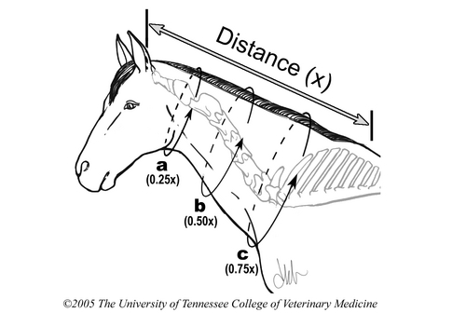
Figure 1.1: Neck circumference measurements in the horse. From Frank N et al. Physical characteristics, blood hormone concentrations, and plasma lipid concentrations in obese horses with insulin resistance J Am Vet Med Assoc 2006;228:1,383-1,390.

2. Insulin resistance
2.1 Insulin secretion and function
Insulin is a hormone synthesized and secreted by the β cells of the pancreatic Islets of Langerhans in response to hyperglycemia, and has the main function of regulating glucose utilization and production.^{1,14} This hormone also affects lipid metabolism by enhancing cellular glucose uptake and lipogenesis^{15,16}, and blood circulation because of its vasodilatory properties.¹⁷ Hypertension and vascular disease can result from hyperinsulinemia (high blood insulin concentrations).¹⁸ Insulin is extracted by the liver after its secretion, with approximately 50% lost on first pass.¹⁹⁻²¹
Insulin synthesis starts with a pro-insulin form consisting of an A-chain, B-chain, and C-peptide (connecting peptide).²² During the synthesis of insulin, C-peptide serves an integral role by linking the A and B chains and thereby ensuring correct folding and interchain disulfide bond formation.²² Before functional insulin (A and B chains joined together) is secreted, C-peptide is cleaved from the pro-insulin molecule, and remains stored in secretory granules. After C-peptide is removed, the carboxyl end of the B-chain of insulin has the appropriate conformation for binding to the insulin receptor.²² Insulin and C-peptide are secreted in equimolar amounts so any difference in their ratio implies impaired insulin clearance by the liver.²²⁻²³ The half lives of insulin and C-peptide are 4 minutes and >30 minutes, respectively.^{20,21,23,24}
Insulin secretion is highly dependent on insulin sensitivity (SI). In a study of British children, SI was dependent upon body mass index (BMI).²⁵⁻²⁷ This study revealed that insulin sensitive people released less endogenous insulin in response to glucagon stimulation when compared to individuals with type 2 diabetes mellitus and IR.²⁵

2.2 Insulin receptor and signaling
Insulin is released by the pancreas in response to feeding and acts through an insulin receptor mechanism to stimulate glucose uptake and regulation by adipose tissue, skeletal muscle, and the liver.^{1,14,28} The insulin receptor is located within the cell membrane and is composed of two α and two β sub-units which are linked by disulfide bonds.^{29,30} The α subunits are located extracellularly and are the site of insulin binding, while the β sub-units consist of transmembrane and intracellular domains.³⁰ The transmembrane domain conveys a signal to the intracellular domain that insulin has bound to the receptor, and this signal involves tyrosine kinase.^{29,30} When insulin binds to its receptor, tyrosine kinase is activated and this leads to autophosphorylation of the β sub-unit at tyrosyl residues, which begins an intracellular signaling pathway that causes phosphorylation of cytosolic protein substrates such as insulin receptor substrate-1 (IRS-1).³⁰ Upon activation of the receptor and its intracellular signaling cascade, the insulin-responsive glucose transporter GLUT 4 translocates from intracellular vesicles within the cytosol to the cell membrane and this allows passage of glucose into cells.²⁹
The ability of insulin to enhance the total net disappearance of glucose from extracellular fluid (plasma), by either inhibiting endogenous glucose production and/or enhancing the use of glucose by the body represents SI.³¹ Insulin normally maintains plasma glucose concentrations within a range and therefore protects the tissues from glucotoxicity.¹ In horses, fasting blood glucose concentrations range from 60 to 90 mg/dL¹⁶, compared with 70 to 105 mg/dL in humans, but ranges do differ according to the assays utilized by respective laboratories.³² Insulin is also responsible for stimulating lipogenesis and inhibiting hepatic gluconeogenesis.²⁸ Insulin resistance is defined and recognized by a subnormal physiologic response to normal circulating concentrations of insulin.^{13,14} Fasting hyperinsulinemia serves as an indicator of IR in horses and humans.³³⁻³⁵ Normal, healthy state levels of insulin in humans is recognized at values of <25 μIU/mL³², while normal, healthy state fasted insulin concentrations in horses are <20 μIU/mL.¹⁶ In humans, chronic hyperinsulinemia is associated with consequences such as disorders of carbohydrate metabolism, lipid metabolism, and vascular disease such as atherosclerosis.^{36,37} The occurrence of laminitis in obese horses may be a result of IR and vascular disorders such as atherogenesis, however, it has yet to be confirmed.³⁶

2.3 Mechanisms of insulin resistance
Insulin resistance can be found in both physiologic (e.g. starvation, pregnancy) and pathologic (e.g. obesity, hyperadrenocorticism) conditions.^{14,38} Proposed mechanisms of IR include breakdown of insulin-signaling mediators, down-regulation of insulin receptors, or a decrease in number of insulin receptors.^{15,36,39,40} The most common mechanisms however, involve alterations in post-receptor binding signaling pathways, associated with a decrease in autophosphorylation of β sub-units, and therefore decreased tyrosine kinase activity.^{15,41,42} This causes a domino effect in which phosphorylation of IRS-1 decreases, leading to reduced activation of phosphatidylinositol 3-kinase (PI3K).^{15,41,42} Impaired regulation of enzymes such as hexokinase and glycogen synthase can also result in disruption of intracellular glucose metabolism, which leads to reduction in insulin-mediated uptake of glucose and subsequent storage by the liver as glycogen or by adipose tissue as fat.^{15,41-43}
In horses, a syndrome that includes abnormal distribution of adipose tissue, hyperinsulinemia, glucose intolerance, elevated plasma lipid concentrations, and a predisposition to laminitis, is referred to as Equine Metabolic Syndrome (EMS).³⁶ Horses affected by this syndrome are usually between 8 and 18 years of age, are usually obese, possess a “cresty neck”, and have excess adipose accumulation in the rump area and prepuce/mammary region, as well as histories of laminitis and being an “easy keeper”.^{6,36}
Plasma lipid concentrations increase with obesity and a lack of exercise in humans, and this is explained by the fact that adipose tissues have a finite capacity to store fat, so excess fat is found in the circulation and other tissues (i.e. skeletal muscle).^{6,44} Insulin, which is often circulating at higher concentrations in obese humans than in non-obese humans, also elicits lipogenic effects and inhibits lipase activity leading to improper accumulation of fatty acids as diacylglycerols within tissues.^{6,44} This phenomenon can be referred to as lipotoxicity and this process is capable of disrupting insulin receptor signaling in muscle cells or β cell function within the pancreas.^{6,44} In one study looking at the physical characteristics and plasma lipid profiles of a group of horses, it was found that plasma non-esterified fatty acid (NEFA) concentrations were elevated in obese horses compared with non-obese counterparts.⁶ A link has also been established between free fatty acids and the development of obesity and IR (and Type 2 diabetes) in humans.^{36,45} Elevated NEFA concentrations induce IR in both skeletal muscle and the liver.^{36,46} The fact that IR is associated with weight gain, and loss, strongly suggests a cause and effect relationship.³⁶
Horses with obesity-associated laminitis usually suffer from glucose intolerance.³⁶ Glucose intolerance is diagnosed when hyperglycemia is prolonged due to delayed resolution after a glucose load either intravenously, orally, or post-prandially (reflecting following a meal).³⁶ In healthy individuals, the ingestion of a meal or glucose challenge, leads to an increase in blood glucose concentrations at which time insulin is released by the β cells of the pancreas. The increase in serum insulin concentrations signals a halt to liver glucose production via glycogenolysis and gluconeogenesis, and stimulates the uptake of glucose by skeletal muscle and adipose tissue.^{36,40} The state of glucose intolerance implies insensitivity of peripheral tissues (skeletal muscle and adipose tissue) or the liver to the actions of insulin, that amounts of insulin produced by the β cells of the pancreas are decreased, or both.^{36,39} With respect to equids, it has been shown in earlier studies that pony breeds appear to be glucose intolerant (relatively) when compared to horses.^{34,36,47}

3. Lipid metabolism
3.1 Lipotoxicity
The development of an overweight or obese state is, by definition, due to a positive energy balance.⁴⁸ It has been shown, that when there is an imbalance between energy intake and expenditure, fat is deposited due to a positive fat balance.⁴⁸⁻⁵⁰ Of the macro-nutrients utilized by the body for energy (protein, carbohydrates, fat), dietary fat is the most energy dense, providing approximately 37 kJ/g versus approximately 17 kJ/g by proteins and carbohydrates.⁴⁸ When dietary fat intake is increased, fat oxidation increases slowly leading to an overall accumulation of fat in adipose stores due to a positive energy balance.^{48,51,52}
In humans suffering from type 2 diabetes (T2D) and horses with IR, plasma NEFA and cholesterol concentrations are increased, and an overall state of dyslipidemia exists.^{6,53,54} Blood NEFA concentrations increase with obesity and lack of physical activity in humans because hormone sensitive lipase (HSL) increases, leading to enhanced mobilization of NEFAs from adipocytes.^{6,44} This state of dyslipidemia causes fatty acids to be stored in non-adipose tissues such as muscle, liver, and pancreas, in patients suffering from T2D.⁴⁸ One of the main contributing factors to the development of IR is the overabundance of NEFAs within the blood.⁵⁵ Hydrolysis of stored triglyceride (TG) into fatty acids and glycerol is regulated by insulin, as well as catecholamines and natriuretic peptides.^{55,56} Insulin normally inhibits the hydrolysis of TG and increases fat storage by stimulating re-esterification of fatty acids.^{55,57}
3.2 Ectopic lipid accumulation
High circulating NEFA concentrations can lead to ectopic accumulation of lipids in skeletal muscle and liver, and a negative correlation exists between the degree of IR and the TG content of skeletal muscle.^{53,58-61} Elevated plasma NEFA concentrations accompany obesity, IR, and T2D in humans, and have also been noted in obese insulin-resistant horses and ponies.^{6,58,62} These elevations drive the accumulation of intramyocellular lipids (IMCL) and increase the severity IR by disrupting insulin receptor signaling and creating cell damage, which is referred to as lipotoxicity.^{6,44,53,58,63,64}
Intramyocellular lipids are small lipid droplets located in the sarcoplasm of muscle cells and are predominantly found in the vicinity of the mitochondria.⁴⁸ Lipotoxicity is thought to occur by one or more of the following cellular/molecular mechanisms: 1) inflammation, 2) diacylglycerol (DAG)/protein kinase C (PKC) pathway, or 3) hyperinsulinemia.⁶⁵ It is still unclear whether IMCL accumulation is the cause or consequence of IR.^{53,65} Higher IMCL concentrations have been detected under physiological conditions, such as muscles of endurance athletes and individuals undergoing short-term (4 week) exercise training.^{58,66,67} This discrepancy implies that higher IMCL concentrations are a marker for other lipid metabolites that may be inducing IR, rather than a direct effect. ⁵⁸
The mechanism by which IMCL plays a role in IR involves the insulin signaling pathway.⁶² Diacylglycerols accumulate within muscle tissue and stimulate PKC, which inhibits tyrosine kinase activity of the insulin receptor and tyrosine phosphorylation of IRS-1, which decreases myocyte glucose uptake.^{62,68-70} In vivo studies and ex vivo biochemical analyses of muscle tissue biopsies from humans indicate that obesity and IR are associated with decreased mitochondrial fatty acid (FA) oxidative capacity.^{58,71-76} This may be the result of decreased myocyte mitochondrial numbers, abnormal mitochondrial morphology, or decreased levels of the mitochondria-associated enzymes required for FA oxidation.^{58,71-76} It is therefore possible that the increased IMCL concentrations associated with IR in humans result from a decreased capability to oxidize FA.⁵⁸ Kelley et al.⁷² demonstrated that mitochondria in patients with T2D are smaller and have morphological aberrations compared with controls. It was also shown that the mitochondrial area was positively correlated with insulin sensitivity. Mitochondrial function might also be influenced by diet, with high saturated fatty acid diets having a stronger negative effect on hepatic and peripheral insulin sensitivity than mono-unsaturated fatty acids and polyunsaturated fatty acids.^{68,77-79}

3.3 The role of β-oxidation
The mechanism behind lipid-induced IR was proposed more than 30 years ago when Randle and colleagues introduced the concept of a glucose-fatty acid cycle.⁶⁸ In this cycle, fatty acids and glucose are thought to compete for their respective substrate oxidation .⁸⁰ Perdomo et al.⁵⁸ found in work performed with L6 muscle cells that there was a distinct influence of β-oxidation rate on the severity of IR in skeletal muscle. The equilibrium, or lack thereof, between FA oxidation and re-esterification into TG is important in the determination of lipid storage in muscle.⁶² Healthy skeletal muscle is characterized by having the capacity to utilize either lipid or carbohydrate fuels for energy and to effectively interchange between these two sources, depending on the stimulus and energy demands of the tissue.⁶² For example, in a state of early starvation when glucose availability is minimal, the body shifts from utilizing glucose as its energy source to using FAs produced by TG oxidation.⁸¹
The inability of skeletal muscle to adequately oxidize TGs is an important aspect of skeletal muscle insulin insensitivity in the obese or T2D state.⁶² Beta oxidation requires that FAs leave the circulation, move into the sarcoplasm, and then enter the mitochondria by first passing through the outer mitochondrial membrane and then the inner mitochondrial membrane. In states of obesity and T2D, fatty acid synthesis is promoted, rather than oxidation, which leads to lipid accumulation within skeletal muscle.⁶²

3.4 Mechanisms of β-oxidation
3.4.1 Carnitine Palmitoyl Transferase
Entry of FAs into mitochondria is regulated by carnitine palmitoyltransferase-1 (CPT-1). Fatty acids that enter the cytosol of a muscle cell must first be converted to a fatty acyl-CoA via acyl-CoA synthetase within the outer mitochondrial membrane.⁸² In order to cross the inner-mitochondrial membrane, fatty acyl-CoA must join with carnitine and form acyl-carnitine, which is catalyzed by CPT-1 on the outer face of the inner mitochondrial membrane.⁸² The acyl group is then transferred back to a CoA-SH to re-form fatty acyl-CoA and a free carnitine.⁸² There is an even exchange between the matrix and the inter-membrane space of carnitine for acyl-carnitine via carnitine acylcarnitine translocase.^{83,84}
Carnitine palmitoyltransferase-1 is inhibited by malonyl-CoA, which is the first intermediate in the synthesis of long chain fatty acids. When carbohydrate substrates are ample, the concentration of malonyl-CoA increases, creating a negative feedback on CPT-1 activity and therefore inhibition of β-oxidation. Malonyl-CoA is formed from the conversion of pyruvate, produced by glycolysis, into acetyl-CoA.

3.4.2 Adenosine monophosphate kinase
Adenosine monophosphate kinase (AMPK) is a fuel sensing enzyme that monitors cellular energy status, increases glucose uptake, and activates catabolic pathways (β-oxidation and glycolysis) leading to ATP production.⁸⁵⁻⁸⁸ This enzyme also inhibits anabolic pathways (gluconeogenesis) that utilize ATP and has a regulatory role in two critical liver functions, gluconeogenesis and lipogenesis. A decrease in intracellular energy levels activates AMPK and this is also the route of action for anti-diabetic drugs such as metformin and the hormone adiponectin.⁶⁴
The AMPK enzyme is a multi-substrate heterotrimer that contains a catalytic α-subunit and two regulatory, β and γ, subunits.^{86,89} Increases in the intracellular AMP:ATP or creatine:phosphocreatine ratios lead to its activation.^{64,86} Phosphorylation on the threonine-172 (Thr-172) residue can also lead to its activation.⁸⁶ In its active form, AMPK phosphorylates and consequently inactivates acetyl CoA carboxylase (ACC), which is its direct substrate.⁸⁵ When ACC is inactivated, malonyl-CoA concentrations decrease and this leads to activation of CPT-1 and increased oxidation of long chain fatty acids.^{85,90}
Interactions between AMPK and glycogen stores in muscle have been reported in some studies, with this enzyme phosphorylating, and therefore inactivating, glycogen synthase.^{86,91} It has also been shown that the β-subunit of AMPK contains a motif capable of binding glycogen, which implies that it plays a role in depleting glycogen stores.^{86,92-94} One study⁸⁵ found that increased AMPK activation by the insulin sensitizing drug troglitazone caused an increase in long chain fatty acid oxidation, which reduced IMCL accumulation. However, the resulting increase in glucose uptake stimulated lactate production, rather than glycogen synthesis, as expected.⁸⁵ A similar finding occurred in a study looking at the influence of adiponectin on glucose uptake, in that glycogen synthesis decreased, whereas lactate production increased.⁸⁶ Increased β-oxidation lowers IMCL concentrations and thereby protects cells from the harmful effects of FA accumulation on insulin signaling. Work performed by Perdomo et al.⁵⁸ suggests that β-oxidation also increases insulin sensitivity independently of its impact on lipid accumulation. With its role in regulating and influencing β-oxidation, AMPK is viewed as a “metabolic switch”.

4. Hepatic insulin resistance
4.1 Non-alcoholic fatty liver disease
The hepatic manifestation of IR in humans is referred to as non-alcoholic fatty liver disease (NAFLD).⁹⁵ This condition is one of the most common causes of liver dysfunction in humans and arises from abnormal lipid droplet accumulation in hepatocytes, caused by increased calorie intake and enhanced lipogenesis, particularly in states of IR.⁹⁶ Messenger RNA expression of key lipogenic enzymes is increased with obesity, IR, and dyslipidemia in humans and this stimulates lipid synthesis.^{95,97} Fatty acids are taken out of the circulation by the liver and undergo β-oxidation, storage as TG, or export within very low-density lipoprotein (VLDL).⁹⁸ In the fasted state, FAs are mobilized and energy is produced within the liver through β-oxidation, whereas in the fed state insulin stimulates lipogenesis.^{98,99}
The liver is one of the most important organs in the body and is involved in digestion, detoxification, production, and storage.⁹⁸ The liver has a central role in glucose and lipid metabolism and it, along with skeletal muscle and adipose tissue, is a key site of insulin action.⁹⁹ It plays a major role in determining circulating insulin concentrations because 50 to 70% of insulin secreted by the pancreas is removed from the portal circulation by the liver on first pass.¹⁰⁰⁻¹⁰³ Intrahepatic fat content can range from 0 to 100%, with the amount increasing in parallel with obesity.^{101,104} In obese humans, patients with elevated intrahepatic fat are affected by IR and hyperinsulinemia.¹⁰¹ Hepatic IR is defined by the ability of insulin to suppress hepatic glucose production, while not affecting lipid synthesis and VLDL production.^{99,101,105,106} Hyperinsulinemia reflects both insulin clearance and insulin action.¹⁰¹
In one study examining the effect of liver fat on insulin clearance, Kotronen et al. ¹⁰¹ demonstrated that subjects with a high liver fat content (15%) were more obese, had higher fasting glucose, insulin, and TG concentrations, higher liver enzyme activities, and lower serum high density lipoprotein (HDL) concentrations than low liver fat (2%) patients. Those individuals with higher liver fat content had more hepatic glucose production, indicating hepatic IR.¹⁰¹ Hepatic IR and insulin clearance are independent determinants of fasting serum insulin concentrations.¹⁰¹ Decreases in hepatic fat via drug therapy and weight loss improves hepatic insulin sensitivity and increases insulin clearance.¹⁰¹ This reinforces the theory that hepatic insulin sensitivity is a function of liver fat content.

4.2 Regulation of hepatic lipid content
Sterol regulatory element binding protein 1-c (SREBP1-c) is a key regulator of hepatic FA metabolism that influences gene expression for enzymes such as fatty acid synthase (FAS) that are involved in FA synthesis within the liver.^{99,107,108} Increased expression of SREBP-1 has been shown to induce hepatic steatosis and hyperlipidemia.¹⁰⁹⁻¹¹¹
Peroxisome proliferator activated receptor alpha (PPARα), gamma (PPARγ), and delta (PPARδ) also regulate hepatic FA metabolism.⁹⁹ Insulin-sensitive liver, skeletal muscle, and adipose tissues express PPARα and this leads to an up-regulation of genes involved in FA uptake and β-oxidation.⁹⁹ There are two isoforms of PPARγ; isoform-1 is expressed in the liver and skeletal muscle and isoform-2 is only found in adipose tissue where it is involved in the regulation of adipocyte differentiation and FA storage.⁹⁹ Activation of PPARγ increases FA uptake by adipose tissue and thereby decreases amounts delivered to the liver via a mechanism referred to as “the fatty acid steal hypothesis”.^{99,112,113} In animal models, PPARδ improves lipid profiles and increases energy expenditure, while also increasing carbohydrate catabolism in the liver and suppressing hepatic glucose production.^{63,99,114,115}
The state of peripheral IR is thought to be a factor in the development of hepatic fat accumulation since IR is characterized by hyperinsulinemia and insulin elicits lipogenic effects. Hyperinsulinemia also increases FA influx into the liver and stimulates hepatic TG production.¹¹⁶ High serum insulin and glucose concentrations promote de novo lipogenesis and NAFLD may ultimately lead to the development of hepatic IR.¹¹⁶

4.3 Visceral adiposity and the liver
The location of fat might also affect the development of obesity-associated metabolic disorders. The visceral fat constituting truncal obesity is most closely associated with metabolic syndrome (MetS) and adverse outcomes in humans.¹¹⁷⁻¹²¹ Human metabolic syndrome is a syndrome comprised of a collection of risk factors for the development of type 2 diabetes and cardiovascular disease.¹²² Risk factors include dyslipidemia reflected in elevated triglycerides and low high-density lipoproteins (HDL), elevations in blood pressure and glucose, and abdominal obesity which has been associated with a pro-thrombotic and pro-inflammatory state.¹²² The association between truncal obesity and MetS has been explained by the “portal/fatty acid flux” theory. According to this theory, visceral fat has enhanced lipolytic activity that increases the amounts of FAs that enter the portal circulation and go directly to the liver, which leads to intrahepatic lipid accumulation and hepatic IR.^{57,118,123} Subcutaneous fat on the other hand appears to be metabolically protective because it is correlated with lower serum TG concentrations and higher HDL concentrations as well as strong positive correlations with adipokines such as adiponectin and leptin (discussed below).¹¹⁸ These adipokines improve insulin sensitivity in peripheral and hepatic tissues.

5. Obesity and Inflammation
It has historically been the belief that fat tissue is nothing more than an energy reserve; however, within recent years it has been established that adipose tissue is an endocrine organ that secretes numerous hormones known as adipokines.^{1,124,125} These adipokines are potential contributors to IR in humans and horses and are secreted by both adipocytes and macrophages.^{124,126,127} Key underlying pathologic processes of obesity therefore include chronic inflammation and dysregulation of adipokines.¹²⁸ Macrophages are the primary mediators of the immune response, and in adipose tissues they make up approximately 40% of the infiltrating cells of adipocytes in obese humans.^{124,129} Adipokines are soluble compounds that are secreted by white adipose tissue (WAT) from adipocytes and cells associated with WAT known as stroma vascular fraction cells.^{36,128,130,131} Multiple adipose tissue-derived signaling molecules are currently being studied as correlates of IR.¹²⁴
Endocrinologically active adipocytes are found in omental and retroperitoneal fat tissues, which are associated with intra-abdominal adiposity in humans.^{4,125} Accumulation of adipocytes in these locations is thought to be more significant that adipocytes in other locations such as subcutaneous tissues and the lower extremities.^{36,62} In obese horses with EMS, there can be accumulations of retroperitoneal fat subjacent to the body wall, sometimes as thick as 3 to 5 cm.³⁶
In horses, relationships exist among obesity, inflammatory cytokines, and insulin sensitivity; inflammation increases with obesity and this is associated with a decrease in insulin sensitivity.¹³² Adipocytes participate in the innate inflammatory response in horses.¹²⁶ In IR humans, administration of anti-inflammatories such salicylates (aspirin) have been shown to reverse IR, further supporting the role of inflammation.^{126,133} Since laminitis is associated with both obesity and IR, it is postulated that adipose-derived inflammatory cytokines are also associated with laminitis.^{126,132} Pro-inflammatory cytokines such as tumor necrosis factor alpha (TNF-α) increase with obesity whereas anti-inflammatory cytokines such as interleukin-10 (IL-10) decrease.^{132,134,135} However, the adipokines that are coming to the forefront of investigations of IR and MetS in both horses and humans are leptin, adiponectin, and resistin.

6. Adipokines and incretins
6.1 Leptin
The concept of a “thrifty gene” was first proposed for humans in 1962 by Neel,¹³⁶ and was proposed as an explanation for why some humans become obese and others do not. This theory is based upon the belief that Paleolithic humans had to be thrifty in order to survive on limited nutritional availability. The concept of the thrifty gene has also been proposed as a mechanism for why some horses appear more metabolically efficient and are termed “easy keepers”.¹³⁷ These animals gain weight on diets that would be considered nutritionally sufficient for maintenance in most other horses.
Leptin is the product of the obese (ob) gene and is a 16 kDa hormone comprised of 167 amino acids.^{64,137-139} It is secreted by adipocytes and plays an important role in appetite regulation and energy homeostasis.^{64,137-139} It was one of the first molecules to be classified as an adipokine and is considered to be an anti-obesity hormone owing to its capacity to regulate food intake.⁶⁴ In horses and ponies, leptin concentrations are positively correlated with BCS.^{137,140,141} Higher plasma leptin concentrations have also been positively correlated with area under the curve (AUC) measures of insulin and glucose dynamics.⁶ Although the measure of BCS reflects adiposity, it only measures subcutaneous depots of fat and therefore there may be varying concentrations of leptin among horses of similar BCS.^{137,142}
When considering leptin as a screening tool in horses for IR, one must also take season into account. Fitzgerald and McManus¹⁴³ found that serum leptin concentrations were elevated in mature mares during late summer into early fall, and reached their lowest concentrations during the winter. However, the same group subsequently determined that leptin concentrations were higher in the winter than in the summer in young and mature mares.^{144,145} Steelman et al.¹⁴⁴ performed a study to examine the effects of grain meal size and frequency on leptin concentrations. Horses receiving smaller, more frequent meals had leptin secretion patterns similar to those seen on pasture, perhaps due to the similarity in feed amounts. There was no diurnal variation in leptin secretion observed even though leptin concentrations are higher in the evening versus the morning in mature horses.^{144,146,147}

6.1.1Leptin secretion
Leptin and insulin share a similar pattern of secretion in that concentrations tend to increase in fed states and decrease in fasted or feed restricted states, with leptin being produced by adipose tissue in response to glucose uptake, and insulin by the pancreas in response to elevations in circulating glucose concentrations.^{81,144} In studies evaluating effects of feeding on leptin concentrations in mature mares and geldings, hyperleptinemia and hyperinsulinemia were identified in 30% of a population of horses with high BCS.^{141,148,149} Leptin concentrations have been correlated with fasted insulin concentrations in other species such as the rat and rhesus monkey.^{146,148,150,151} Leptin stimulates glucose uptake and FA oxidation within skeletal muscle and inhibits insulin secretion by acting through leptin receptors on pancreatic β cells.^{138,152,153}
Insulin and leptin have opposing actions. Insulin is lipogenic whereas leptin is lipolytic; leptin also reduces adipose depot size through its ability to suppress insulin secretion.¹⁵⁴ There was a decrease in leptin concentration in healthy horses in response to feed restriction;¹³⁷ however, when food intake was no longer restricted, there was a slower than expected increase in leptin concentrations when compared to other species. This delay may represent an evolutionary adaptation to ensure increased feed consumption after the body perceives a scarcity of forage.

6.1.2 Leptin function
It has been suggested that leptin functions as an “adipometer” that signals the brain whether calorie reserves are sufficient or not.⁸¹ Leptin regulates fuel partitioning by promoting β-oxidation and protein synthesis and inhibiting lipogenesis, which lowers TG content in WAT without any resultant increase in circulating NEFA concentrations.¹⁵⁴⁻¹⁵⁶ When looking at the influence different fat reserves have on leptin concentrations, the visceral/subcutaneous fat ratio has a moderately negative correlation with leptin.¹¹⁸ When there is sufficient energy, the central nervous system directs the expenditure of excess calories towards non-feeding activities such as reproduction and immunity.⁸¹
Leptin elicits an anorexic effect and in states of starvation this effect is lessened, which stimulates feed intake.⁸¹ The hormone exerts its action by binding to the leptin receptor (Ob-R) which is broadly expressed.⁹⁹ There have been several variants of the receptor described but the soluble leptin receptor is a major determinant of circulating leptin concentrations. This receptor contributes to the pharmacokinetics and action of leptin by stabilizing the molecule in the blood and preventing the bound form from interacting with other leptin receptors without affecting the activity of the free hormone.^{99,157,158} Within the hypothalamus, leptin exerts its effect by binding to its receptors at the arcuate nucleus and thereby communicating the overall degree of adiposity, which in circumstances of obesity leads to inhibition of food intake and a decrease in body fat mass due to increased calorie expenditure.⁸¹ In overfeeding, proopiomelanocortin (POMC) neurons are activated and contribute to the decrease in food intake in response to a positive energy balance.¹⁵⁹ The decrease in body fat mass leads to a decrease in leptin concentrations, with this cycle representing a classic negative feedback loop.⁸¹

6.1.3 Leptin resistance
Obesity is associated with leptin resistance instead of deficiency, with higher leptin concentrations detected, implying impairment of negative feedback.^{81,137,159} The state of leptin resistance is defined by high leptin concentrations with hyperphagia and obesity.¹⁵⁹ Humoral mediator elevations in a negative feedback loop are the hallmark of a resistance syndrome.^{81,160} Generally in a classic feedback loop, the cause of the resistance is either receptor or post-receptor insensitivity, however with leptin there are two additional methods in which resistance can be caused – impaired transport of leptin across the blood-brain barrier or impairment of downstream neuronal signaling.⁸¹ In both human and animal models, the majority of cases of leptin resistance occurs due to impairment at the blood-brain barrier or receptor/post-receptor level.⁸¹ A state of peripheral leptin resistance is diagnosed when exogenous doses of leptin are unable to elicit anorectic drive, indicating the inability of circulating leptin to signal the brain.⁸¹ Central leptin resistance is defined by a lack of response to leptin being administered directly to the brain and it appears from one rodent model, that peripheral resistance is more severe or precedes central resistance.^{81,161}
A transcription factor called STAT3 plays an important role in leptin resistance by affecting the leptin-induced regulation of food intake and hepatic glucose production.^{154,159} The target gene for STAT3 is suppressor of cytokine signaling 3 (Socs3) which is produced in response to cytokine signaling and provides negative feedback.^{159,162,163} It was shown in animal experiments that Socs3 plays a role in leptin resistance, because mice with genetic modifications that eliminated or inhibited its ability to bind the leptin receptor had decreased food intake and body weight.^{159,164} Another mechanism in leptin resistance is phosphatase PTP1B which is responsible for the dephosphorylation of Janus Kinase 2 (Jak2), the initial tyrosine kinase involved in leptin receptor signaling.^{159,165,166} When the gene for this enzyme is deleted, mice are lean and hypersensitive to leptin.^{159,165,166}
As leptin concentrations increase in the obese state, it appears to exert less influence on centrally-mediated appetite and weight control⁸¹ Triglycerides have been shown to decrease transport of leptin across the blood-brain barrier, and hypertriglyceridemia is detected in obese humans and animals.^{81,167}

6.2 Adiponectin
6.2.1 Structure and discovery
Adiponectin is a 30 kDa adipose-derived factor composed of 247 amino acids that directly affects glucose homeostasis and regulates insulin sensitivity.^{86,168} The gene for adiponectin was first isolated from adipose tissue in 1996 and has lower expression in obese animals and humans.^{99,169} The protein itself, however, was discovered by multiple laboratories throughout the 1990s and was given multiple names, including complement-related protein 30, adipoQ, adipose most abundant gene transcript, gelatin-binding protein, and adiponectin.¹⁶⁹⁻¹⁷²
Adiponectin has been studied in conjunction with MetS because its absence is noted in states of IR and glucose intolerance, and it has been shown to induce weight loss, inhibit hepatic glucose production, and increase FA oxidation.^{99,173,174} It is comprised of 4 regions; an N-terminal region with no homology to any known proteins, a 27 variable amino acid region, a collagen-like region, and a C-terminal globular domain that is homologous to complement factor C1q and type VIII and X collagens.^{64,170,172} It is the most abundant secretory protein of adipose tissue in humans and acts as an anti-inflammatory, insulin sensitizing anti-diabetic hormone, and anti-atherogenic agent.^{124,171,175,176} Adiponectin concentrations are inversely correlated with central adiposity, IR, and the homeostasis model of IR (HOMA-IR), which is discussed below.^{124,171,175,176} It is the predominant adipokine influencing SI and plays a role in FA oxidation, leading to lower plasma TG concentrations and improved glucose homeostasis.^{175,177}
Circulating adiponectin occurs as trimers, hexamers, and multimers with low molecular weight (LMW; single trimer), mid-molecular weight (MMW; two trimers), and high molecular weight (HMW; multiple hexamers) forms.^{64,86,177} Globular forms are also isolated, which are comprised of the globular head (C-terminal end) portion of this adipokine. Plasma concentrations are approximately 5μg/mL in humans, with lower levels detected in individuals suffering from T2D, IR, and hyperinsulinemia.^{108,168,177,178} Adiponectin concentrations are higher in women compared to men and are generally reduced in obese animals and in patients with T2D.^{168,175,177} In a study evaluating metabolic markers of IR in a population of British children, there was no significant difference noted between boys and girls;²⁶ however, as children aged and BMI increased, there was a decrease in adiponectin concentrations for both genders attributed to fat acquisition in the years before puberty. The HMW form of adiponectin is proposed to have a stronger correlation with IR compared with total circulating concentrations because this form is more biologically active.^{124,179}
In horses, plasma total adiponectin concentrations reflect obesity and therefore fitness. Gordon et al.¹⁸⁰ showed that plasma adiponectin concentrations were higher in a research population of physically fit Standardbred mares when compared to unfit counterparts. There was no diurnal variation in adiponectin secretion detected in the same study. This lack of a diurnal rhythm was also documented in humans, although one group detected a significant decline in this adipokine at night.¹⁸⁰⁻¹⁸²

6.2.2 Adiponectin receptors
There are two known receptors for adiponectin, referred to as AdipoR₁ and AdipoR_{2.} The first is predominantly expressed in skeletal muscle and WAT and shows a higher affinity for the globular form of adiponectin, which increases FA oxidation and prevents diet-induced obesity, when experimentally injected.^{86,128,183,184} In contrast, AdipoR₂ is predominantly expressed in the liver and only responds to the full length protein.^{86,184} Humans with IR and T2D have lower expression of both receptors in skeletal muscle, and the expression of both receptors is positively correlated with SI.^{177,185,186} Ceddia et al.⁸⁶ demonstrated that, by administering globular adiponectin to rat L6 myocytes, glucose uptake increased as a result of increased GLUT4 translocation to the myocyte membrane. Adiponectin receptor knock-out mice develop severe glucose intolerance and IR when both receptors are disrupted, proving that these receptors play an important role in the regulation of insulin sensitivity.^{64,187} In the same study it was shown that the two adiponectin receptors had functional differences, with AdipoR₁ being more tightly linked with AMPK activation and AdipoR₂ being associated with PPAR-α activation and the inhibition of inflammation and oxidative stress.^{64,187}
6.2.3 Role of adiponectin in insulin resistance
In humans, the prevalence of IR decreases with increasing plasma adiponectin concentrations.^{124,168} Adiponectin is positively associated with SI, and states of hypoadiponectinemia are associated with IR.^{124,176} The mechanisms by which adiponectin exerts it effect on insulin action are not completely known, but are thought to involve PPAR-α, and AMPK activation, which increase FA oxidation in muscle and liver, and therefore decrease tissue TG concentrations.⁶⁴ Lowering TG concentrations within skeletal muscle improves insulin signaling.
Several factors regulate the production of adiponectin by WAT, including inflammatory cytokines such as TNFα and interleukin 6 (IL-6), as well as PPAR-γ.^{128,188,189} Activation of PPAR-γ increases levels of adiponectin and creates a shift in fat from visceral to subcutaneous depots.^{118,190} van der Poorten et al.¹¹⁸ demonstrated that there is an inverse correlation between adiponectin levels and visceral fat depots. The inflammatory effect of TNFα is opposed by the anti-inflammatory effect of adiponectin.^{64,128,191} Adiponectin inhibits TNFα release and attenuates the inflammation associated with obesity by inducing production of other anti-inflammatory mediators such as interleukins 1 and 10 (IL-1, IL-10).^{64,128,191} However, the expression of adiponectin is down regulated with obesity and hypoadiponectinemia is observed in patients with visceral obesity and IR.^{98,108,174} This observation is especially important in circumstances of excess visceral adipose tissue because inflammation reduces adiponectin secretion.^{64,192} Increased inflammatory cytokine production and the release of FA into the portal circulation leads to hepatic TG accumulation and IR.^{64,192}
The concept of a genetic influence on adiponectin concentrations has also been proposed because offspring of hypertensive patients have lower plasma adiponectin concentrations when compared to offspring of normotensive patients.¹⁷⁵ Matsubara et al.¹⁹³ showed that plasma adiponectin concentrations are negatively correlated with serum TG concentrations and the atherogenic index, and are positively correlated with HDL-cholesterol levels.^{168,193} It has also been shown that single nucleotide polymorphisms of genes encoding adiponectin protein and receptors have associations with T2D phenotypes.¹⁷⁷ Adiponectin is not likely to be the main determinant of insulin sensitivity as many other factors have been associated with insulin sensitivity as well, but may be a marker of metabolic state which is influenced by interactions among different organs (adipose, skeletal muscle, and liver).¹⁷⁷

6.3 Resistin
6.3.1. Discovery and distribution
One of the newest adipokines to be discovered and studied for its role in IR and MetS is resistin. Resistin was discovered by three research groups and has been associated with IR.^{168,194-196} A link between resistin and IR has been found in animal models, but there have been inconsistent results in humans.^{124,195,197} Resistin is a 12.5 kDa polypeptide hormone that belongs to the family of small cysteine-rich secretory proteins.^{64,195} This adipokine is expressed predominantly by adipose tissue, but is mainly produced by the infiltrating macrophages of the adipose tissue, which are the primary mediators of the immune response and represent up to 40% of adipose tissue.^{99,124,129,168,198,199}
High plasma resistin concentrations are detected in humans with morbid obesity.^{168,200} This elevation in resistin may indicate a role in the pro-inflammatory state associated with obesity.^{64,124} However, other investigators have failed to demonstrate a relationship between obesity or IR and resistin expression.¹⁷⁵ Resistin serves as a signaling molecule between the energy storage organ of adipose tissue with the insulin-sensitive liver and skeletal muscle tissues.^{46,201}

6.3.2 Influence of resistin on insulin sensitivity
In rats, a sexual dimorphism has been found in the expression of the resistin gene, with male rats having a greater expression compared to females.^{168,202} In animals and humans, the administration of thyroid hormones increases basal and insulin-induced glucose uptake by skeletal muscle, most likely due to an increase in GLUT4 function.^{168,203} In states of drug-induced hypothyroidism, resistin mRNA expression increases in adipose tissue, which suggests that decreased resistin concentrations are involved in the improvement in insulin sensitivity seen with thyroid hormone supplementation.^{168,202} The treatment of patients with insulin-sensitizing drugs decreases resistin levels, further supporting the suggestion that this adipokine is an important mediator of IR.^{36,195}
Hivert et al.¹²⁴ found that individuals with MetS had higher resistin concentrations and lower levels of adiponectin. In this group, the prevalence of IR increased positively with increasing concentrations of resistin.¹²⁴ The expression of resistin is increased in response to pro-inflammatory cytokines such as TNF-α, IL-6, and IL-1, and resistin blood concentrations are positively correlated with blood concentrations of these inflammatory markers.^{64,204} Resistin may also stimulate the same pro-inflammatory cytokines, implying a positive feedback loop.^{128,132}

6.3.3 Role of resistin in hepatic insulin resistance
Resistin is thought to be involved in the development of hepatic IR because infusion of recombinant resistin impairs hepatic insulin sensitivity and increases hepatic glucose production.^{99,198} Hepatic resistance mediated by resistin in states of diet-induced obesity has been related to the inactivation and inhibition of AMPK and the opposing activation of ACC and Socs3.^{109,205-207} It has been shown in rats that acute administration of resistin increases blood glucose concentrations by both inhibiting insulin-stimulated glucose uptake and enhancing hepatic glucose production.^{198,208,209}
Singhal et al. ¹⁰⁹ demonstrated that deleting the resistin gene (retn) in wild type and ob/ob mice decreased hepatic TG content when compared to controls and lowered serum TG, cholesterol, glucose and insulin concentrations. In the mice deficient for the resistin gene, there was also a decrease in mRNA expression of SREBP-1, ACC, and FAS, as well as protein levels of ACC. The receptor for resistin is currently unknown, but the induction of IR via resistin has been attributed to reduced phosphorylation of AMPK and activation of Socs3.^{109,206,207} In states of resistin deficiency, insulin sensitivity is improved, which leads to decreased hepatic glucose production, improvement in hepatic IR, and increased glucose uptake by peripheral tissues.^{109,205,206} In resistin deficient mice, key lipogenic genes, including SREBP-1 and FAS, are suppressed in the liver whereas genes involved in lipolysis remain unaffected.¹⁰⁹
Treating rat hepatocytes with resistin and insulin has been shown to significantly decrease glycogen content, supporting the concept that resistin antagonizes the effects of insulin on glucose uptake and storage²⁰¹ via decreased glycogen synthesis or increased glycogenolysis. Additionally, such treatment reduces the number of insulin receptors, and as a consequence, there is a decrease in glycogen synthase activation and decrease in glycogen phosphorylase, with an increase in hepatic glucose production.²⁰¹ However, in the absence of insulin, there was no effect of resistin on glycogen phosphorylase activity, which led to the conclusion that resistin enhances glycogen phosphorylase activity by down-regulation of the insulin receptor.²⁰¹ This sequence of events may explain the association between resistin and hepatic IR.

6.4 Glucagon-Like Peptide 1
6.4.1 Structure and discovery
Glucagon-like peptide 1 (GLP-1) was first discovered in 1968 when it was established that a glucagon-like immunoreactive material secreted by L-cells of the intestine in response to an oral glucose load was different from glucagon itself.²¹⁰ It differed from glucagon both physiochemically and biologically and was found to be a component of the major proglucagon fragment that forms in parallel with glucagon during post-translational processing.^{210,211} It is a 29-amino acid protein that is secreted in an active form, designated as GLP-1 7-36 amide, and is inactivated to GLP-1 9-36 amide as a result of rapid removal of the NH₂ terminus by an enzyme known as dipeptidylpeptidase-4 (DPP-4).^{210,212} Glucagon-like peptide 1 is an incretin hormone, which is defined as a hormone capable of amplifying the glucose-induced secretion of insulin following oral glucose administration when compared to intravenous glucose administration.²¹³

6.4.2 Measurement of GLP-1
Since the active form of GLP-1 is degraded rapidly by DPP-4, it is necessary to prevent its inactivation by treating blood samples with a DPP-4 inhibitor if active GLP-1 is the hormone of interest.²¹⁴ It has been determined that the majority of active GLP-1 secreted is already inactivated by the time it reaches the portal vein, resulting in a short half-life of several minutes.²¹⁴ Assays that measure total GLP-1 use antibodies directed towards the carboxyl (COOH-) end of the protein, which is not cleaved by DPP-4.²¹⁰ However, assays designed to measure active GLP-1 utilize antibodies directed towards the intact NH₂ terminus as described above.

6.4.3 Association with insulin resistance and obesity
The main effect of GLP-1 is to enhance insulin secretion following an oral glucose dose; however, it has recently been discovered that GLP-1 also affects gastric emptying rate and satiety.²¹⁵ By slowing the rate of gastric emptying, the glycemic response to a meal is also diminished, aiding in glucose homestasis.²¹⁵ Glucagon-like peptide 1 has also been associated with inhibition of pancreatic glucagon secretion and hepatic glucose production.²¹¹
Studies have shown that there is abnormal secretion in conditions associated with insulin resistance and/or obesity such as type 2 diabetes, polycystic ovary syndrome (PCOS), and myotonic dystrophy.²¹⁶⁻²¹⁸ It has been determined that attenuated GLP-1 secretion is a result of obesity, with lean subjects showing more pronounced responses to an oral sugar challenge when compared to obese individuals.^{211,218} In a study of patients with MetS, it was determined that fasting levels of serum GLP-1 were 28% higher in people with MetS, compared to individuals with Pre-MetS.¹²² Elevations in fasting GLP-1 concentrations were significantly related to the presence of dyslipidemia.¹²² This supports earlier findings that higher fasting plasma concentrations of GLP-1 are associated with higher resting energy rates and fat oxidation.²¹⁹ Obesity is often associated with IR and diabetes as higher fat mass inhibits insulin action.^{220,221}
Polycystic ovary syndrome is one of the most common endocrine disorders in women that negatively impacts fertility and increases the incidence of T2D.²¹⁷ When compared to normal women undergoing an oral glucose tolerance test, basal concentrations were found to be similar during the early part of the test, but differed in the later part of the test, with lower concentrations in PCOS patients.²¹⁷ This is relevant to the finding that post-prandial GLP-1 concentrations and area under the curve values are significantly lower in type 2 diabetics compared to people with normal glucose tolerance.²¹⁸ However, in a study of 18 men with myotonic dystrophy, which is characterized with pronounced IR and hyperinsulinemia, a significantly greater increase in GLP-1 concentrations was detected following an oral glucose load compared to controls.²¹⁶ Baseline GLP-1 concentrations were also lower in the myotonic dystrophy patients compared to controls.

6.4.4 Potential role in therapy
Glucagon-like peptide 1 is associated with enhanced insulin secretion by the β-cells of the pancreas and has been investigated as a therapy for impaired glucose control and IR.^{212,222-225} In dogs that have undergone total pancreatectomy, administration of GLP-1 was shown to potentiate insulin action during a hyperinsulinemic clamp, and this was attributed to the effects of GLP-1 on insulin-stimulated glucose utilization.²²² This study also showed suppression of FA and glycerol concentrations because GLP-1 potentiates the anti-lipolytic effects of insulin. In humans, administration of a GLP-1 analogue significantly reduced glycosylated haemoglobin concentrations and improved fasting and post-prandial glucose control when administered in conjunction with metformin.²²⁴ Hyperglycemia is a frequent occurrence in critically ill patients on mechanical ventilation and total parenteral nutrition, and this problem can adversely affect medical outcomes. The overall glycemic response to enteral nutrient infusion was reduced in patients treated with GLP-1 over 270 minutes on 2 consecutive days compared with placebo and this was accompanied by increased insulin to glucose ratio.²²³
Administration of DPP-4 inhibitors has also been evaluated as a potential therapy for impaired glucose tolerance and IR. Inhibitors have been evaluated on their own or in conjunction with other anti-diabetic compounds.²¹² They enhance GLP-1 activity by preventing its rapid inactivation following secretion by the small intestine.²¹² In dogs, the DPP-4 inhibitor vildagliptin was found to increase hepatic glucose uptake during GLP-1 infusion.²²⁵ It was also determined that the oral administration of vildagliptin via stomach gavage 20 minutes prior to glucose and GLP-1 infusions was capable of suppressing DPP-4 activity throughout the 4-hour test period.²²⁵

6.4.5 Conclusions
Results of studies suggest that obesity, rather than IR, may play a more important role in GLP-1 secretion as obese humans tend to show higher fasting concentrations but diminished responses during oral glucose tests. This may allow GLP-1 to function as an adequate marker for identifying humans and animals that are at greater risk for the complications associated with obesity. Administration of GLP-1 or DPP-4 inhibitors appears to improve insulin sensitivity and glucose tolerance. At the time of writing, there are currently three selective DPP-4 inhibitors, sitagliptin (Januvia), vildagliptin (Galvus), and saxagliptin (Onglyza) available for use in the United States and Europe.²¹² Both GLP-1 analogues and DPP-4 inhibitors can therefore be used to treat impaired glucose tolerance and insulin resistance.

7. Methods of assessing insulin sensitivity and resistance in the horse
7.1. Frequently-sampled intravenous glucose tolerance test
The frequently-sampled intravenous glucose tolerance test (FSIGTT) is used to quantify insulin sensitivity via application of the minimal model.²²⁶⁻²²⁹ Minimal model analysis is a mathematical construct that partitions glucose disposal into insulin-dependent (insulin sensitivity – the capacity of insulin to promote glucose disposal) and insulin-independent (glucose effectiveness – the capacity of glucose to mediate is own disposal) glucose utilization, while also estimating the sensitivity of pancreatic β-cells to glucose.²²⁶⁻²²⁹ The minimal model of glucose and insulin dynamics is a nonlinear regulatory model fitted to data collected during the FSIGTT.³¹

7.1.1 Procedure in horses
An insulin-modified FSIGTT is performed in horses.²²⁸⁻²³¹ The overall procedure of this test is to administer a body weight (bwt) dependent bolus of dextrose intravenously, collect samples at specific time points, and at 20 minutes post-dextrose, administer insulin intravenously at a weight dependent dose, and then continue with collection of blood samples for a test duration of 180 minutes.^{228,231} Hoffman et al.²²⁸was the first research group to utilize the FSIGTT for assessment of insulin sensitivity and glucose metabolism in the horse. The procedure assessed by this group included baseline samples followed by administration of a 50% dextrose solution bolus at 0.3 g/kg bwt via jugular catheter. Blood samples were collected via catheter at time points 1, 2, 3, 4, 5, 6, 7, 8, 10, 12, 14, 16, and19 minutes. At 20 minutes, an insulin bolus was administered through the catheter at a dose of 30 mU/kg bwt, and sample collection resumed at 22 minutes and continued at times 23, 24, 25, 27, 30, 35, 40, 50, 60, 70, 80, 90, 100, 120, and 180 minutes. Glucose and insulin concentrations were measured in each sample.²²⁸

7.1.2 Calculations
Minimal model analysis utilizes a computerized algorithm which supplies the investigator with 3 variables: (1) the index of insulin sensitivity (SI), (2) glucose effectiveness (Sg), and (3) the acute insulin response to glucose, (AIR_{g}).^{31,227,228} The disposition index (DI) is often calculated. The measure Sg represents the capacity of glucose to mediate its own disposal, independent of changes in the circulating levels of insulin as well as its ability to inhibit hepatic glucose production. The following formula is used:
G' (t) = -(X+ S_{g}) x G(t) + (S_{g} x Gb)
where G'(t) represents the rate of glucose clearance from plasma (min ⁻¹); X represents insulin action; G(t) represents the plasma glucose concentration (mg/dL) at time t, G(0) is the theoretical concentration of glucose at time 0; and Gb represents the basal glucose concentration (mg/dL) which is maintained by hepatic glucose production.^{228,232}
The SI value represents the capacity of insulin to promote glucose disposal (L mU⁻¹ min⁻¹) and can be defined as the fractional glucose disappearance per insulin concentration unit and calculated using the following formulas:
X' (t) = -p₂ x X(t) + (p₃ x [I(t) – Ib])
SI = p₃/p₂
where X' (t) (min⁻²) represents the change in insulin action over time; p₂ represents the rate (min⁻¹) of decline of insulin action; X(t) represents insulin action (min⁻¹), p₃ is the rate (min⁻¹) of introduction of insulin into the interstitial space; I(t) is the insulin concentration (mU/L) at time t; and Ib is the basal insulin concentration (mU/L).^{228,232}
Pancreatic function is represented by AIRg (mU min L⁻¹) which quantifies the endogenous insulin secretion occurring in response to the glucose dose and is calculated using the formula;
AIRg = ∫ [I(t) – Ib] x dt
where I(t) is the insulin concentration at time t and Ib is the basal insulin concentration.²²⁸
Finally, DI is an index that describes pancreatic β-cell responsiveness and accounts for the influence of AIRg and Si and is calculated using the following formula;
DI = AIRg x SI.²²⁸

7.1.3 Use of the FSIGTT in horses
Hoffman et al.²²⁸ introduced the FSIGTT as a tool for examining glucose and insulin dynamics in horses and responses to glucose were similar to other species.^{228,233,234} However, Pratt et al.²²⁷ subsequently demonstrated that the standard FSIGTT without an insulin bolus has a higher mean coefficient of variation when compared with the euglycemic hyperinsulinemic clamp (EHC) technique, which is discussed below. It was noted that insulin sensitivity can be more precisely estimated when there is a defined demarcation between 1st and 2nd phase insulin responses, so the FSIGTT was modified to include an insulin bolus.²²⁷ The insulin-modified FSIGTT has been used to detect IR in a group of mature obese mares and provides important information regarding pancreatic insulin output.^{29,228,235} Disadvantages of the EHC are that it is time consuming, requires trained personnel, relies upon steady-state conditions, and demands constant adjustment, whereas the FSIGTT is more straightforward, less invasive, and technically simpler to perform.^{31,227,228,232}

7.2 Euglycemic hyperinsulinemic clamp
7.2.1 Introduction
The EHC technique involves inducing and maintaining a state of hyperinsulinemia via continuous infusion of insulin, while at the same time maintaining euglycemia by administering variable amounts of dextrose.²²⁷ Insulin infusion suppresses endogenous glucose production by the liver and euglycemia provides physiologic inhibition of endogenous insulin secretion.¹⁴ The clamp technique, like the FSIGTT, has been used successfully in the horse.^{227,228,236,237}
The EHC procedure was established by DeFronzo et al.²³⁷ in 1979 as a method of quantifying insulin secretion and resistance in humans, using the principle that a patient with normal insulin sensitivity would require more glucose to maintain euglycemia than an individual with IR. This same situation was first demonstrated in a horse when a 29-year-old mare suffering from persistent hyperglycemia and hypertriglyceridemia was evaluated.²³⁵ When simplified, the amount of glucose required to maintain basal concentrations is equal to the amount of glucose taken up by the tissues, and therefore represents a measure of peripheral tissue sensitivity to insulin. During the insulin infusion period, the amount of glucose required to maintain euglycemia increases, so measurements taken during the plateau period are utilized for calculations.¹⁴

7.2.2 Procedure in horses
Baseline blood samples are collected and then the horse is connected to a peristaltic infusion pump which administers human recombinant regular insulin at a constant rate of 3 mU/min/kg bwt, or 5 to 20 mU.m⁻².min⁻¹ in humans, when the dose is based upon body surface area.²³² In an early study performed in horses, a priming dose of insulin was administered at a dosage of 323 μmol/kg bwt dissolved in 50 mL saline over 10 minutes.¹⁴ Once the priming dose was administered, the constant infusion of insulin was started and continued throughout the study at a rate of 43 μmol/kg.min⁻¹.¹⁴ Dextrose was administered at the same time as insulin to prevent hypoglycemia.
The EHC procedure usually takes 180 minutes to perform and blood samples are taken at 5 minute intervals so that glucose concentrations can be measured using a portable glucometer. Depending upon the measured glucose concentration, an infusion of 50% dextrose solution is administered at variable rates by calibrated syringe pump so that blood glucose concentrations are maintained within euglycemic range. In the procedure performed by Pratt et al.,²²⁷ blood samples were also collected at 15 minute intervals for measurement of insulin concentrations. The first 90 minutes of the clamp procedure can be considered an equilibrium period, and the data collected from the samples obtained in the last 60 minutes are utilized for the calculation of whole body glucose uptake and an index of insulin sensitivity.²²⁷

7.2.3 Calculations
Whole-body glucose uptake (M) represents the amount of glucose taken up by glucose utilizing tissues in response to insulin and it is assumed that hyperinsulinemia has suppressed endogenous glucose production completely.^{227,237} Since euglycemia is not maintained perfectly throughout the procedure, a correction factor referred to as the space correction (SC) must be calculated to determine M. This correction is calculated to account for the glucose that has been added to, or removed from, the glucose space outside of normal metabolism. The following formula is used:
SC = (G₂ – G₁)(0.19 bwt)/(T x bwt)
where G₁ and G₂ represent the beginning and ending glucose concentrations of each time interval, T is the time interval (5 minutes), bwt is calculated in kg, and (0.19 bwt) is equal to the glucose space in liters. The result of this equation is required to calculate M:
M = GIR – SC
where GIR is the glucose infusion rate measured in mmol/kg/min.^{227,237}
The index of insulin sensitivity measured from this technique is calculated from the steady-state insulin concentration (I) which is the average of the serum insulin concentration measured during the final 60 minutes of the EHC and is used to calculate the M/I ratio. This ratio reflects the rate of glucose disposal per unit of insulin and serves as a reasonable index of insulin sensitivity.^{14,227,237} Another calculation for this index that can also be utilized and is:
SI_{Clamp} = M/(G x ΔI)
where G is the blood glucose concentration during the steady-state, and ΔI is the difference between the fasting and steady-state insulin concentrations.²³²
A study looking at the glucose disposal rate of both lean and obese mares found that mares with a BCS of approximately 4.5 had glucose disposal rates ranging from 3.9 to 10.5 μmol/kg/min, while obese mares with a BCS of approximately 8.5 had glucose disposal rates ranging from 0 to 14.5 μmol/kg/min.^{31,236}

7.2.4 Conclusions
When tests were compared in horses, mean coefficient of variation was 14% for the EHC compared to 24% for the FSIGT.²²⁷ Rijnen et al.¹⁴ also assessed the repeatability of EHC results by performing the procedure in the same horses on 3 different occasions over a 3-week period. This study showed close agreement among the repeated tests in terms of M values (0.013, 0.016, and 0.016 mmol/kg/min), but the M/I ratio had wider variability (0.00037, 0.00057, and 0.00067 mmol/kg/min).^{14,227} A main advantage of the EHC is that it provides a direct measure of whole body glucose disposal at a given level of insulinemia under steady-state conditions.²³² A limitation of this technique is that supraphysiological levels of insulin are maintained during the procedure.²³²

7.3 Combined glucose-insulin test
7.3.1 Introduction
Many tests can aid in the diagnosis of diabetes mellitus, including fasting blood glucose concentrations, intravenous glucose tolerance tests, and clamp techniques.²³⁸ A glucose tolerance test measures the rate of clearance of glucose from the blood after oral or IV administration, with the time for blood concentrations to return to baseline measured.^{235,239} Tests of insulin sensitivity measure the blood glucose response to an injection of exogenous insulin.²³⁵ Eiler et al.²³⁸ combined these two types of test and developed the combined glucose-insulin test (CGIT) for use in horses. This test was designed for use in the clinical setting and provides a more accurate measure of insulin sensitivity by combining information from glucose tolerance and insulin challenge tests.

7.3.2 Procedure
When performing a CGIT, a single intravenous catheter is placed in the jugular vein to serve as the route of dextrose and insulin infusion, as well as sample collection. Blood glucose concentrations are measured using a hand-held glucometer. Once baseline values are obtained, 50% dextrose solution is rapidly administered (<1 minute) at a dose of 150 mg/kg, immediately followed by a bolus of human recombinant regular insulin at a dose of 0.1 U/kg diluted in 3 mL of isotonic saline. Samples are collected by withdrawing 3 mL blood, which is discarded, and then the blood sample is collected. Blood samples are collected at 0, 1, 15, 25, 35, 45, 60, 75, 90, 105, 120, 135, and 150 minutes.²³⁸
Healthy horses show a two phase blood glucose curve with a positive phase (hyperglycemia) that goes above baseline and a negative phase (hypoglycemia) which falls below baseline. Each phase of the curve has an ascending and descending area, with ascending occurring first followed by descending in the positive phase, and the reverse is seen in the negative phase. In healthy animals, the positive phase should descend to baseline concentration around 30 minutes post glucose and insulin administration, at which time the negative phase begins and glucose concentrations fall below baseline. The nadir of glucose concentration in the negative phase has occurred by 75 minutes after the start of the procedure, at which time the ascending linear area begins around 105 minutes and is completed by approximately 140 minutes. In horses with IR, the positive phase is prolonged, causing a slower (≥ 45 minutes) return to baseline (Figure 1.2).⁶

7.3.3 Conclusions
The CGIT test is easily interpreted by examining graphed results or using the 45-minute result as a cut-off value. The procedure is relatively simple to perform and well tolerated.²³⁸ Due to the simplicity and ease of this procedure, the CGIT is a recommended test for diagnosing IR in horses.

7.4 Proxy measures of insulin sensitivity
7.4.1 Introduction
Proxies and surrogates are single sample predictors of insulin sensitivity that utilize plasma glucose and insulin concentrations.³³ They serve as inexpensive and easily applied quantitative tools.²³² Single samples often provide good representation of glucose and insulin dynamics because they describe the chronic, non-agitated state of the individual.³³ Treiber et al.³³ evaluated proxies for insulin sensitivity by comparing single plasma glucose and insulin values to minimal model analysis results in horses.

7.4.2 Types of proxy measurement
There are currently five proxies used to screen insulin sensitivity and β-cell responsiveness in humans, and two new proxies have been proposed for screening horses.³³ The proxies currently utilized in human medicine are the homeostasis model assessment (HOMA), the quantitative insulin sensitivity check index (QUICKI), the glucose-to-insulin ratio, the percent HOMA-beta cell function (HOMA-BC%), and the insulin-to-glucose ratio.
The two new proxies established for use in horses are the reciprocal of the square root of insulin (RISQI) and the modified insulin-to-glucose ratio (MIRG).

7.4.3 Equations for proxy measurements
For the following equations, all glucose and insulin values are basal measures and r is the correlation coefficient used to compare predicted insulin sensitivity with SI from the minimal model.
HOMA = (glucose-insulin)/22.5

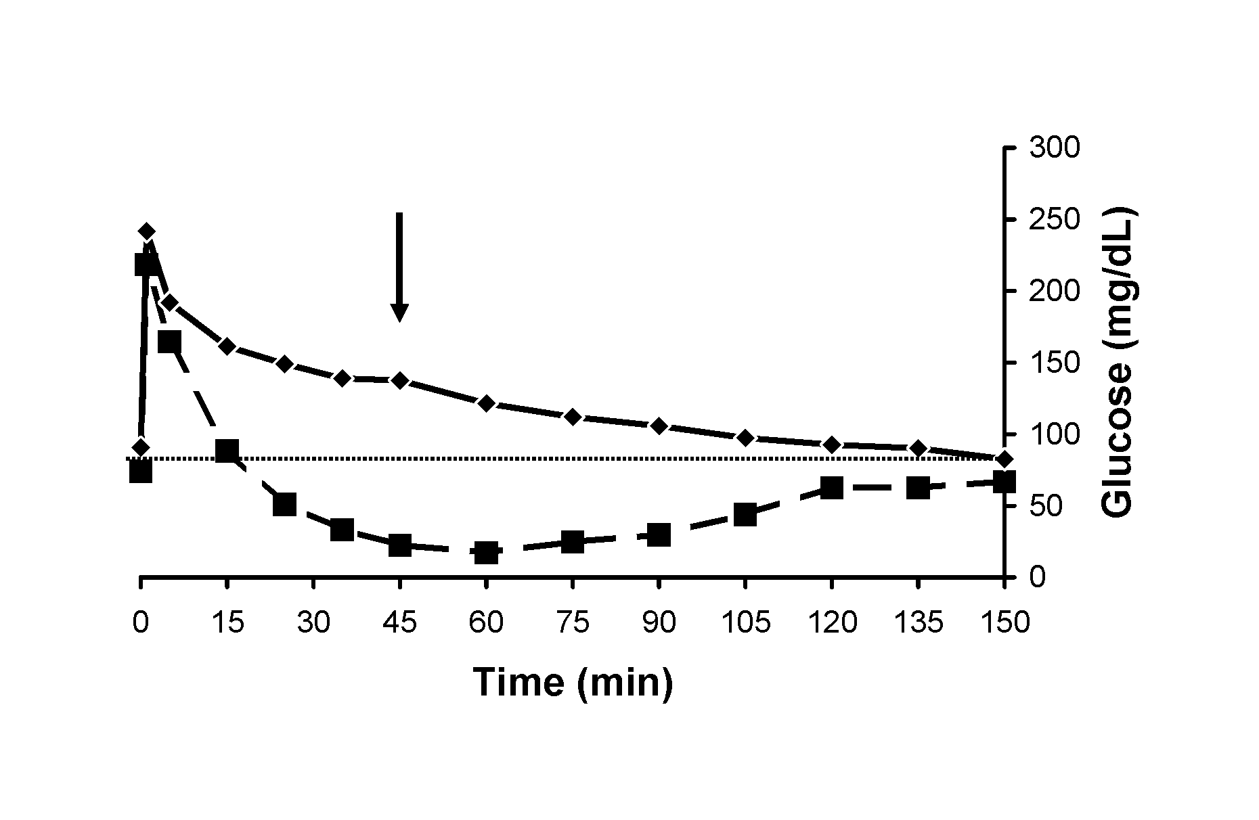 Figure 1.2: Glucose concentrations of non-obese (squares) and obese (diamonds) horses during a CGIT. Glucose concentrations in obese horses remained above baseline for the duration of the test, whereas concentrations in non-obese animals return to baseline by 15 minutes following a glucose infusion. From Frank N et al. Physical characteristics, blood hormone concentrations, and plasma lipid concentrations in obese horses with insulin resistance J Am Vet Med Assoc 2006;228:1,383-1,390.

with 22.5 being a normalizing factor which is the product of fasting glucose (4.5 mmol/L) and insulin (5 μU/mL) concentrations in healthy humans.²³² An individual with normal insulin sensitivity should, in theory, have a HOMA=1. This proxy has r values of 0.60 and 0.89 with SI.^{33,240,241}
QUICKI = (log[glucose × insulin])⁻¹
HOMA-BC% = (20 × insulin)/(glucose-63)
Correlations with SI are 0.89 for the QUICKI and 0.60 and 0.58 for the HOMA-BC.^{33,241,242} The insulin-to-glucose ratio is easily calculated and has correlation coefficients of 0.79 and 0.86; this measure correlates with insulin secretion by the pancreas.^{31,33} In contrast, the glucose-to-insulin ratio correlates with insulin sensitivity and has reported r values of 0.73, 0.91, and 0.92 with SI.^{31,33,241}
The RISQI proxy measure of insulin sensitivity was devised specifically for use in horses by Treiber et al.³³ and is calculated by the equation:
RISQI = 1/√insulin=insulin^{-0.5}
The same group developed MIRG, which is a measure of pancreatic insulin output and is calculated using the formula:
MIRG = (800-0.30 × [insulin-50]²)/(glucose-30)
Both RISQI (r = 0.77) and MIRG (r = 0.75) correlated well with SI and AIRg, respectively in the population of horses studied.³³ This group provided calculations for SI and AIRg using proxy measurements:
SI = ((7.93)(RISQI)-1.03)
AIRg = ((70.1[MIRG])-13.8)

7.4.4 Use of proxy measures
The HOMA measurement was devised to take advantage of the reciprocal relationship between basal insulin and basal glucose concentrations.³³ In humans, the HOMA has good correlation with EHC results, as well as the SI values obtained from the minimal model.^{33,240} The QUICKI, similarly, was established for use in humans as a simple method of assessing insulin sensitivity as it relies upon the same reciprocal relationship between insulin and glucose.^{33,243} When compared, the QUICKI correlates better with insulin sensitivity.^{33,243}
The glucose-to-insulin ratio is based upon the concept that the insulin-secreting response of the β-cells is exaggerated with IR, despite normal glucose concentrations; a low glucose-to-insulin ratio therefore indicates lower insulin sensitivity.³³ In the case of diabetes mellitus when hyperglycemia develops, the ratio increases, resulting in a conceptual flaw of this particular proxy.²³² This ratio has stronger correlation with insulin sensitivity than the HOMA or QUICKI.^{33,35,244} The insulin-to-glucose ratio estimates the amount of insulin secreted by β-cells in response to glucose; a high ratio indicates reduced insulin sensitivity because there is compensatory secretion of insulin by the pancreas.³³
The HOMA-BC% was first proposed in 1985 by Matthews et al.²⁴⁵ and correlates well with clamp and IV glucose tolerance test results. This measure is a proxy for AIRg and provides similar information to the insulin-to-glucose ratio.²⁴² Studies in humans have shown that estimates of β-cell function are adequate in groups of individuals with similar health, but do not correlate well across different groups.^{244,246}
In horses, RISQI correlates well with insulin sensitivity and MIRG with pancreatic function , so these measures can be used to identify animals that are compensating for decreased insulin sensitivity with increased pancreatic insulin secretion.³³ Proxies for SI and AIRg have specificity, sensitivity, and total predictive power of 85% and 88%, 45% and 50%, and 78% and 80%, respectively in horses.^{33,235} When combined, these measures can aid in distinguishing healthy horses (normal SI and AIR_{g}), from normoglycemic insulin-resistant horses with compensatory insulin secretion (normal or low SI and high AIR_{g}) and hyperglycemic horses with β-cell failure (low SI and AIR_{g}).^{33,235} Proxies also allow investigators to make multiple determinations in a population or monitor clinical cases when more accurate measures such as the FSIGTT or EHC are impractical.³³

8. Treatment of insulin resistance
Drugs and supplements are used to treat IR in humans and horses, either directly or indirectly via weight reduction, and these therapies will be reviewed in the following section.
8.1 Levothyroxine
8.1.1 Introduction
Levothyroxine sodium (LT4) is a synthetic thyroid hormone used to treat hypothyroidism, which is rare in adult horses.²⁴⁷ Studies performed by our research group have established that LT4 can be administered to horses to promote weight loss.²⁴⁷⁻²⁴⁹ The hypothalamic-pituitary-thyroid axis consists of the secretion of thyrotropin releasing hormone (TRH) by the hypothalamus, which stimulates the release of thyrotropin stimulating hormone (TSH) by the pituitary gland, which then stimulates the thyroid gland to release triiodothyronine (T3) and thyroxine (T4). Thyroid hormones are measured as free T3, free T4, total T3 or total T4. Free forms are physiologically active because they are readily available for use by the cells, whereas total measures are the sum of free and bound forms. A negative feedback loop occurs and LT4 significantly decreases TSH concentrations in healthy, euthyroid horses.^{248,250}

8.1.2 Levothyroxine use in horses
Sommardahl et al.²⁴⁸ administered LT4 to healthy adult horses over an 8-week period and detected significant decreases in body weight compared to untreated controls. Total daily doses of LT4 were 24, 48, 72, and 96 mg/d, with horses receiving LT4 at each dosage for 2 weeks at a time. There were no significant changes in health parameters (heart rate, respiratory rate, and rectal temperature) and only agitation was reported when horses received 96 mg LT4 per day.²⁴⁸ Loss of body weight may result from increased energy expenditure and enhanced lipolysis.^{249,251} Humans receiving LT4 supplementation as a treatment for hypothyroidism have lower BMI and lower serum concentrations of TG, total cholesterol (TC), and VLDL.^{252,253} Rats receiving T4 supplementation have also shown increases in SI resulting from increased rates of glucose disposal and glucose-stimulated insulin secretion.^{252,253}
Effects of LT4 supplementation on serum lipids and glucose dynamics were also examined in the same study of healthy mares.²⁴⁹ After 8 weeks of supplementation, there were significant decreases in plasma TG, TC, and VLDL concentrations in treated horses, with weak correlations found between LT4 dose and TG and TC concentrations. These weak correlations may be explained by a cumulative effect of LT4 dosing since washout periods were not inserted between treatment periods.²⁴⁹ No significant changes were noted for NEFA concentrations, regardless of LT4 dose. When effects of hypothyroidism on VLDL concentrations have been examined, the opposite response was detected.^{254,255} Humans suffering from hyperthyroidism show higher catabolic rates of VLDL-TG fractions, implying that thyroid hormones stimulate the clearance of VLDL from the circulation.^{249,256}
Associations also exist between hyperthyroidism and serum concentrations of other lipoproteins and apolipoproteins.^{249,253} Thyroid hormones stimulate FA consumption by increasing β-oxidation rate as well as uncoupled thermogenesis in hepatocytes.^{249,257,258} The increase in β-oxidation in the liver is thought to lead to a reduction in the amount of TG available for VLDL synthesis, and it has been found that the TG carried by VLDL in the circulation is catabolized at a faster rate in humans suffering from hyperthyroidism.^{249,256}
Use of LT4 in obese horses is important because obesity and IR are both risk factors for laminitis and insulin sensitivity increases in response to LT4 treatment in horses.^{6,11,228} Horses receiving LT4 have shown a >2-fold increase in SI¹¹ and significant increase in insulin disposal rate.²⁴⁹ When LT4 was administered to healthy mares, insulin sensitivity increased 1.8-, 2.4-, and 1.9-fold at 16, 32, and 48 weeks, respectively.¹¹ A negative correlation (r = -0.42) existed between SI and body weight, and glucose effectiveness increased with treatment, while AIRg decreased. A maximum of 10% weight loss occurred at 16 weeks and then body weight increased again. However, there was an overall decrease in body weight of 5% compared with pre-treatment values.¹¹ Weight loss may have been even greater if feed intake had been restricted because horses were allowed out on pasture to graze ad libitum. This is an important point because it has been shown that rats receiving thyroid supplementation undergo weight loss associated with increased calorie expenditure, decreased adipocyte size, and decreased fat pad weight, and also exhibit hyperphagia, which can offset weight loss.^{11,251}
In humans, cardiac abnormalities including tachycardia, arrhythmia, and hypertension are associated with hyperthyroidism or overzealous use of LT4.^{249,259,260} Prolonged use of LT4 in humans can result in left ventricular hypertrophy, but does not appear to affect heart rate, blood pressure, or overall cardiac function.^{259,260} Since LT4 is commonly prescribed to promote weight loss in obese horses, Frank et al.²⁵⁹ performed cardiac evaluations on the same mares described above that received 48 mg LT4/day for 48 weeks. No adverse effects were noted when echocardiograms were performed and there were no changes in cardiac troponin I concentrations or creatine kinase MB activities. Serum tT4 concentrations increased to levels 1.5- to 2-fold higher than reference range, but decreased again during the withdrawal period.²⁵⁹
It should be noted that the duration of treatment in the aforementioned study was only 48 weeks, which is short in relation to the lifespan of horses. The duration of treatment may therefore explain the lack of cardiac alterations seen in these horses.²⁵⁹⁻²⁶¹

8.1.3 Levothyroxine and insulin sensitivity
One explanation for the increase in insulin sensitivity associated with thyroid supplementation is that glucose transporter expression increases. When mouse 3T3-L1 adipocytes are exposed toT3, GLUT1 and GLUT4 increase by 87% and 90% respectively, causing a 3.6-fold increase in glucose uptake.^{249,262,263} Frank et al.¹¹ detected higher mRNA expression of GLUT4 in adipose tissue collected from LT4-treated horses, suggesting that this transporter increases in abundance with treatment. However, the opposite effect was observed in adipocytes harvested from rats that were treated with T4 for 7 days.²⁶³ There was a decrease in the density of insulin receptors, a reduction in the amount of insulin-stimulated glucose uptake, and a decrease in GLUT4 translocation to the plasma membranes upon stimulation by insulin. It is possible that increased GLUT4 mRNA expression represents a compensatory response to these alterations.
Weinstein et al.²⁰³ found that rats treated with T3 for 3 days showed increased (115% and 136%) basal glucose uptake in both soleus and extensor digitorum longus muscles respectively, as well as increased insulin-stimulated glucose uptake (55% and 42%, respectively). These results indicate that thyroid hormone supplementation increases both basal and insulin-stimulated glucose transport in mammalian skeletal muscle. This group also demonstrated that GLUT4 protein expression increased in both muscle types. Results also implied that T3 has a role in increasing the fractional partitioning of GLUT4 from its intracellular stores to its location in the plasma membrane.²⁰³
An increase in metabolic clearance rate of insulin has been detected in humans with hyperthyroidism and rats that were treated with T4 for 5 days.²⁶⁴⁻²⁶⁶ Increases in insulin binding and insulin receptor density have also been detected in adipocytes harvested from rats receiving T4 therapy.²⁶⁶ The influence of LT4 on the glucose dynamics in horses has been attributed to reductions in body weight, but direct effects must also be considered.²⁴⁹
Thyroid hormones also modulate proliferation and differentiation of adipocytes.^{267,268} In humans, hyperthyroidism enhances lipolysis while hypothyroidism has the opposite effect, which can be attributed to increases cAMP and HSL activity.²⁶⁷ Viguerie et al.²⁶⁷ showed that treatment of human adipose tissue cultures with T3 induced gene expression in adipocytes, indicating that supplementation with thyroid hormone increases lipolysis. Elevations in cAMP seen with thyroid supplementation result from down-regulation of phosphodiesterase, the enzyme responsible for the hydrolysis of cAMP.²⁶⁷ When energy supplies are low, via hypoglycemia, glucagon, or catecholamines, cAMP levels increase and activate HSL which catalyzes breakdown of stored TG in adipose tissue into FA that can be used for energy.⁸²
Rats with hypothyroidism have an overall decrease in glucose turnover and glucose utilization by skeletal muscle and adipose tissues.^{269,270} With thyroid supplementation, there is an increase in AMPK activity, resulting in a subsequent decrease in ACC activity and lower malonyl-CoA levels.²⁶⁹ This reduction in malonyl-CoA availability increases FA oxidation and lowers the fat content of peripheral tissues such as skeletal muscle and adipose. As previously noted, the decrease in fat accumulation in insulin-sensitive tissue often leads to increased insulin sensitivity.^{269,271}
Another mechanism by which LT4 might increase insulin sensitivity is through modification of lipid metabolism. Hypothyroidism reduces activity of enzymes involved in lipoprotein remodeling and lowers the number of LDL receptors, which are responsible for internalization of cholesterol into cells.²⁷² A recent study looking at the correlation between thyroid function and MetS in humans found a negative relationship between FT4 and the HOMA index, with low-normal FT4 concentrations associated with greater IR.²⁷³ This study also found a significant negative correlation between levels of free T3 and free T4 and both TC and LDL-cholesterol concentrations. Hypercholesterolemia is associated with hypothyroidism because LDL catabolism is inhibited by a lower number of LDL receptors.²⁷³ Higher serum TG concentrations in hypothyroid patients are attributed to decreased activity of hepatic TG lipase and slowed removal of circulating TG.^{273,274}

8.1.4 Conclusions
Levothyroxine administration has been associated with weight loss and increased insulin sensitivity in horses, but studies are now required to evaluate this treatment in obese insulin-resistant horses with EMS.^{11,248,249,259}

8.2 Metformin
8.2.1 Introduction
Metformin hydrochloride is an oral dimethylbiguanide anti-diabetic drug that is used in human medicine to improve insulin sensitivity.⁶⁴ This drug has been used in for the treatment of T2D in humans since 1957 and is currently the most widely prescribed insulin-sensitizing drug.²⁷⁵⁻²⁷⁸ A study in obese women with polycystic ovary syndrome (PCOS) that received one of 2 doses of metformin for 8 months, showed hepatic fat content decreased in response to treatment.²⁷⁵ Metformin is an attractive drug because it is cost-effective and has beneficial modes of action.²⁷⁶

8.2.2 Metformin use in horses
Durham et al.²⁷⁶ examined the efficacy of metformin in insulin-resistant horses at a 15 mg/kg bwt twice daily dosage and showed that treatment significantly lowered serum insulin and glucose concentrations, as well as proxy measures of insulin sensitivity and pancreatic output. In human studies, there are consistent initial reductions in fasting insulin and glucose concentrations along with improved insulin sensitivity.^{276,279,280} However, efficacy waned over time in the study performed by Durham et al.²⁷⁶ and the same finding was reported by Vick et al.²⁸¹ These results suggest insulin sensitivity deteriorates over time or the pharmacodynamics differ from other drugs. The optimum metformin dose in man is approximately 2,000 mg/d, with a range of 500 to 3,000 mg/d.²⁷⁸ In horses, dosages have ranged from 5.6 to 16.8 mg/kg bwt.^{276,281} Furthermore, the oral bioavailability of metformin is < 10% in the horse, compared with 40-60% in humans, with peak levels 1 to 3 hours post-dosing, and a half-life of 4 to 9 hours.^{276,282,283}

8.2.3Mechanisms of metformin action
Metformin has diverse modes of action that include both insulin-dependent and insulin-independent actions to promote insulin-stimulated glucose uptake as well as glycogen and TG synthesis, lipolysis, and inhibition of hepatic glucose production.^{276,279,284} Plasma lipid concentrations also decrease with metformin treatment.^{276,285}
Treatment of rats with metformin elicits dose- and time-dependent activation of AMPK.²⁷⁷ Phosphorylation of AMPK is promoted by AMP in response to a decrease in the ATP:AMP ratio, with the threonine 172 residue (Thr 172) becoming phosphorylated.²⁷⁷ It has also been proposed that metformin may elicit its influence on AMPK activation by either directly activating the AMPK-kinase, or by making AMPK a better substrate for this enzyme by binding to it directly.²⁷⁷ By enhancing the activation of AMPK, the activity of ACC decreases, which lowers malonyl-CoA levels.²⁷⁷ Beta oxidation and lipolysis are stimulated as malonyl CoA concentrations decrease.
Lipogenesis is also decreased with metformin treatment, as the activation of AMPK leads to a down-regulation of genes involved in FA synthesis, such as FAS.²⁷⁷ Insulin stimulates lipogenesis via the lipogenic transcription factor SREBP-1c, which affects genes such as FA synthase.²⁷⁷ Zhou et al.²⁷⁷ showed that incubation of rat hepatocytes with metformin strongly suppressed SREBP-1c. These effects may explain the ability of metformin to lower serum TG and VLDL concentrations in vivo.²⁷⁷ Metformin also inhibits tyrosine phosphatase hPTP-1B and it should be noted that mice that do not express this protein are very resistant to obesity.²⁸⁶⁻²⁸⁸ This may explain why individuals using metformin often maintain or lose weight. Inhibition of hPTP-1B also lowers blood lipid concentrations.²⁸⁷
Gluconeogenesis by the liver is also inhibited by treatment with metformin and this is attributed to activation of AMPK and the insulin receptor.²⁷⁷ Results of several studies indicate that active AMPK is required for metformin to exert its inhibitory effects on hepatic glucose production.^{277,287} Studies have also implicated AMPK activation in stimulating glucose uptake by skeletal muscle.^{277,289,290} Zhou et al.²⁷⁷ showed that there was an increase in the activity of the catalytic sub-units of AMPK when rat skeletal muscle was incubated with metformin, and also a significant increase in glucose uptake that was additive after the addition of insulin.
Metformin might also regulate hepatic glucose production via activation of the insulin receptor. This signals that energy supplies are sufficient, and by its activation, it inhibits glucose production by the liver. Metformin increases tyrosine kinase activity, as well as tyrosine phosphorylation of the insulin receptor, and therefore its activation.²⁸⁷ Both insulin binding and metformin increase the phosphorylation of tyrosine residues in the β-subunit of the insulin receptor in a comparable amount, however, it takes metformin longer to elicit its effect (90 minutes) compared to insulin (20-30 minutes).²⁸⁷

8.2.4 Conclusions
Metformin acts by decreasing hepatic glucose production and increasing skeletal muscle glucose uptake.⁸⁷ It is believed that metformin accomplishes this by decreasing lipogenesis, increasing lipolysis, activating AMPK, and activating the insulin receptor. This drug is considered safe in humans, although side effects seen in humans include gastrointestinal symptoms of diarrhea, abdominal comfort, nausea, and anorexia.²⁷⁹ Given the sensitivity of horses to developing colic, close attention must be paid to animals receiving metformin. However, no adverse reactions have been noted to date when metformin has been administered to horses orally.²⁷⁶ Metformin might therefore serve as a safe and affordable treatment for IR in horses.

8.3 Chromium
8.3.1 Introduction
Chromium (Cr) is an essential trace mineral required by mammals, and plays a role in carbohydrate and lipid metabolism.^{291,292} In 2001, it was established by the US Food and Nutrition Board that the daily adequate intake for men was 35 μg and 25 μg for women.²⁹² Chromium has two main oxidative forms, trivalent (Cr⁺³) and hexavalent (Cr⁺⁶); the trivalent form is the most stable whereas the hexavalent form has been shown to cause clinical cancer.^{291,293} The trivalent form is found in foods, such as egg yolks, whole grain products, nuts, meat, and dietary supplementation.²⁹⁴ Chromium supplements are available in many forms, including picolinate, chloride salt, and complex forms with nicotinic acid and amino acids.²⁹⁴ Of these forms, the picolinate form appears to be the most stable and biologically available.²⁹⁴ When compared to chromium chloride, which has a bioavailability of 0.4% at a dose of 1,000 μg/d, chromium picolinate has a bioavailability of 2.8%.^{294,295}
Studies in Eastern and Western world populations show positive metabolic effects of both chromium picolinate and chromium chloride (CrCl) by resulting in decreases in fasting plasma glucose concentrations, increased insulin sensitivity, and a reduction in the requirement of oral anti-diabetic drugs.^{294,296} Absorption of chromium is enhanced by administration of vitamin C and amino acids, but is diminished by the use of antacids, and intake of simple sugars.²⁹⁴ The highest levels in the body are found in the liver (an important site of glucose metabolism), spleen, and the kidneys, and the normal range in blood is 4.9 to 9.5 ng/mL in humans.^{294,295,297,298} In diabetics, there is a decrease in circulating levels of chromium, and an increase in urinary excretion of this mineral.^{30,294,298,299} Chromium supplementation has also been shown to reverse diabetes induced by glucocorticoid administration, as patients treated with 600 μg Cr/d showed reductions in fasting plasma glucose concentrations from 250 to 150 mg/dL, and the use of hypoglycemic drugs was reduced in 50% of patients.^{294,300} This was attributed to chromium lowering cortisol concentrations.^{301,302} It has also been shown that increased ingestion of simple sugars and elevations in cortisol lead to an increase in chromium losses, and perhaps this plays a role in the IR that occurs in horses with pituitary pars intermedia dysfunction or those that develop pasture-associated laminitis.^{303,304} However, results have been inconsistent. This may be explained by the lower doses that are tested (~200-250 μg/d), or the limited bioavailability of certain formulations, such as chromium chloride (CrCl₃).^{294,305,306}
The importance of chromium in the diet was demonstrated by Schwarz and Mertz³⁰⁷ in 1959 when it was found that rats fed a diet containing yeast as their sole protein source, had difficulty clearing glucose, but this function returned when chromium (Cr⁺³) was added to the diet.^{295,307} The idea of chromium deficiency having a role in the development of IR and diabetes in humans came about in 1977, when a patient on long term total parenteral nutrition developed clinical signs of diabetes, including glucose intolerance and peripheral neuropathy that required insulin administration of 45 units/d for control.^{291,294,298} When chromium supplementation was added at 200μg/d to the patient’s parenteral nutrition formulation, diabetic signs resolved and insulin use was no longer required.^{291,294,298} Chromium is now routinely added to parenteral nutrition preparations.³⁰³ Chromium deficiency has been observed in humans suffering from elevated blood concentrations of glucose, insulin, TG, and cholesterol, and lower HDL concentrations; however, the hallmark sign of chromium deficiency is still impaired glucose tolerance.^{294,301} Unfortunately there is no reliable method for assessing deficiency other than observing the expected beneficial changes to glucose, insulin, and lipid variables before and after supplementation.^{295,303} Deficiency can occur for the obvious reason of inadequate dietary intake, but also develops with poor intestinal absorption. Chromium absorption is improved by the addition of a chelator, and picolinic acid is most commonly used.^{308,309}

8.3.2 Chromium and insulin sensitivity
Chromium increases insulin sensitivity in rats, with Kim et al.²⁹¹ demonstrating that fasting insulin concentrations decreased by approximately 50% and area under the insulin curve decreased by almost 60% in response to treatment.²⁹¹ Other studies have also shown improvement in insulin sensitivity and fasting glucose and insulin concentrations, independent of changes in body weight or body fat percentage.^{291,303,310} In contrast, Uusitupa et al.³¹¹ detected significant reductions in the BMI of elderly patients suffering from impaired glucose tolerance. In another study, Martin et al.³¹² concluded that chromium does not induce weight loss, but may help to regulate weight gain so that there are smaller increases in body weight, percentage body fat, and total abdominal fat compared to individuals receiving placebos. Preventing an increase in body weight of 0.5 to 1.0 kg/yr becomes significant in long-term clinical trials.³⁰¹

8.3.3 Chromium and lipid metabolism
There have also been variable results related to changes in serum lipid profiles following chromium supplementation.^{294,313} Elevations in serum cholesterol and the formation of aortic plaques have been attributed to feeding rats low-chromium diets because these abnormalities were not detected in rats receiving supplemental CrCl.^{308,314} In a double-blind, crossover study, Press et al.³⁰⁸ evaluated effects of chromium picolinate on TC, LDL, HDL, TG, apolipoprotein A-I, and apolipoprotein B. Apolipoprotein B is the principal protein of VLDL and LDL whereas apolipoprotein A-I is the principal protein of HDL. Patients were administered 200 μg/d chromium picolinate and after 6 weeks of therapy there was a significant decrease in TC (7%; 276 to 256 mg/dL), LDL (10.5%; 200 to 178 mg/dL), and apolipoprotein B (16%; 155 to 130 mg/dL), whereas apolipoprotein A-I levels significantly increased with supplementation.³⁰⁸ A significant decrease in TC after 4 months of treatment with 1,000 μg chromium picolinate /d has also been detected ³⁰³. Chromium picolinate may therefore serve as a treatment for hyperlipidemia, which has been associated with obesity and IR in horses. In the aforementioned studies, improvement in blood lipid profiles was most pronounced in individuals with the highest lipid concentrations before treatment.^{294,315}

8.3.4 Chromium mechanisms of action
Chromium potentiates insulin action by inducing auto-amplification of the insulin signal.²⁹⁴ The concentration of insulin receptors varies depending on the tissue type, with an approximate concentration of 40 receptors per cell in erythrocytes to >200,000 in adipocytes and hepatocytes.²⁹⁴ In the early 1980s, Wada et al.³¹⁶ were the first to have a breakthrough in the mechanism of chromium function by the isolation and characterization of a chromium-binding oligopeptide referred to as low-molecular weight chromium-binding substance (LMWCr) or more commonly known as chromodulin.^{295,316} It has a molecular weight of only 1.5 kDa (approximately) and is comprised of only 4 amino acid residues, i.e., glycine, cysteine, glutamate, and aspartate.^{295,317} This oligopeptide binds four equivalents of chromic ions, and this binding plays a role in its potentiating effect of insulin action.²⁹⁵ The site of activation of chromodulin appears to be at or near the tyrosine kinase active site of the β-subunit of the insulin receptor, and the binding of four chromium ions is required for optimal activity.²⁹⁵
As blood glucose concentrations increase, insulin secretion by the pancreas is stimulated leading to binding and activation of the insulin receptor. As circulating levels of insulin increase, there is an influx of chromium from the circulation to within insulin-sensitive cells.²⁹⁵ The form of chromodulin that is not bound to chromium (apochromodulin) is stored within the cytosol and nuclei of insulin-sensitive cells.²⁹⁵ The transfer of chromium into the insulin-sensitive cells from the circulation is likely to be mediated by transferrin, and as chromium enters the cells, it binds to apochromodulin to form holochromodulin (Cr₄-chromodulin).^{295,318} The newly formed holochromodulin binds to the activated insulin receptor and as a result, maintains the receptor’s active conformation and amplifies its signal.²⁹⁵ The bound holochromodulin amplifies the insulin receptor signal by stimulating concentration dependent tyrosine kinase activity of the insulin receptor in the presence of insulin, but not in its absence.²⁹⁴ Not only is there increased activation of tyrosine kinase, which stimulates intracellular signaling, but there is also inhibition of tyrosine phosphatase activity, and this prolongs activation of the insulin receptor.²⁹⁴ All of these actions increase insulin sensitivity. Chromium supplementation also increases insulin binding by increasing the number of insulin receptors.²⁹¹

8.3.5 Chromium toxicity
Chromium picolinate is the most popular form of chromium supplement, and it should be noted that this form of Cr is absorbed in a different fashion from that of dietary Cr.²⁹⁵ It is a remarkably stable complex that remains intact for several hours in synthetic gastric juice and is capable of passing through the jejunum intact.^{295,319} The reference dose of safety for Cr, as established by the U.S. Environmental Protection Agency (EPA) is 350 times the upper limit of the daily intake dose of 200 μg/d.³⁰³ When humans that have taken the supplement over prolonged periods have been examined, significant DNA cleavage has been detected and this is attributed to the production of hydroxyl radicals.^{295,320} This occurs as picolinate causes the redox potential to shift to the chromic center, making it susceptible to reduction and therefore reactive oxygen species production.²⁹² There has also been increased lipid peroxidation in rats with DNA damage, but doses used in these studies have been 20 times higher than those used in humans.^{292,321} There have been no reports of chromium picolinate consistently affecting the health of humans at recommended doses, but isolated cases include weight loss, anemia, thrombocytopenia, dermatitis, hypoglycemia, and liver dysfunction and kidney failure.^{292,303}
8.3.6 Conclusions
Results of studies evaluating chromium supplementation have been mixed, so there are questions about whether individuals suffer from different degrees of chromium deficiency. Chromium shows promise as a supplement for the improvement of insulin and glucose dynamics, but the questions about safety of the picolinate form warrant further investigation. It must still be determined whether chromium supplementation improves insulin sensitivity in insulin-resistant horses.

8.4 Magnesium
8.4.1 Introduction
Magnesium (Mg²⁺) is the second most abundant intracellular cation after potassium.³²² It has been established as a cofactor for over 300 metabolic reactions, including protein synthesis, cellular energy production and storage, and glucose and insulin metabolism.^{322,323} There are at least three different pools within the body: Extracellular (1%), intracellular (34%), and skeletal (65%).^{323,324} In humans, low blood Mg²⁺ concentrations have been associated with increased risk of MetS and T2D.^{322,325,326} Several foods that are good sources of dietary Mg²⁺, include almonds, halibut, bananas, milk chocolate, and peanut butter.³²² Magnesium is an intracellular cation, so circulating levels may not provide an accurate measure of overall body Mg²⁺ status. Low plasma Mg²⁺ concentrations are a specific, but not sensitive indication of deficiency.³²² Plasma Mg²⁺ concentrations remains fairly constant in healthy humans and range from 0.75 to 0.96 mmol/L, with a recommended daily intake of 310 to 420 mg/d for adult humans.^{322,327}

8.4.2 Magnesium deficiency
The primary sites of intestinal Mg²⁺ absorption are the distal jejunum and ileum, and intestinal absorption is inversely proportional to the amount ingested from dietary or supplement sources.³²⁴ It was found that an intake of 36 mg/d resulted in 65% absorption, while intake of 973 mg/d only resulted in an absorption of 11%.³²⁴ Magnesium deficiency is likely to contribute to the development of diseases such as MetS and T2D, but it is also possible that these diseases lower magnesium stores.¹²⁸ The balance of Mg²⁺ within the body is controlled by the kidneys, and diets low in Mg²⁺ have reduced urinary excretion. In humans with T2D, there is an increase in urinary magnesium due to glucosuria.³²⁴ The normal range of urinary Mg²⁺ output is 120 to 140 mg/d.³²⁴
In both rodents and humans, Mg²⁺ deficiency has been associated with both IR and MetS.³²² Guerrero-Romero and Rodríguez-Morán³²⁸ found that serum Mg²⁺ concentrations were significantly lower in people with MetS compared with those who were healthy (1.8 ± 0.3 mg/dL vs. 2.2 ± 0.2 mg/dL). A close association with dyslipidemia was also detected. Magnesium deficiency may also play a role in T2D. Lima et al.³²⁹ found that 75% of people with poorly controlled T2D had low Mg²⁺ concentrations and approximately 31% had low intracellular Mg²⁺ concentrations. Hyperinsulinemia is a hallmark of IR, and in a study of obese children without T2D, Mg²⁺ concentrations were inversely correlated with fasting insulin concentrations and positively associated with QUICKI values (178.8 ± 19.8 vs. 63.2 ± 6.6 pmol/L and 0.31 ± 0.04 vs. 0.35 ± 0.01, respectively).^{322,330}
States of Mg²⁺ deficiency can result from decreased nutritional intake and increased renal losses. It is uncertain if supplementation elicits the same effect as increasing dietary Mg²⁺ intake.^{128,327} Major manifestations of Mg²⁺ deficiency in man can include neuromuscular abnormalities as well as biochemical (hypokalemia and hypocalcemia) and cardiovascular abnormalities.³²⁴ Guerrero-Romero et al.³³¹ worked to establish whether Mg²⁺ supplementation improves insulin sensitivity in a study of humans that did not suffer from T2D. Affected patients suffered from IR and hypomagnesemia (serum concentration ≤ 0.74 mmol/L). When supplementation was administered at 2.5g/d, serum Mg²⁺ concentrations significantly increased (0.61 ± 0.08 to 0.81 ± 0.08) and HOMA-IR decreased (4.6±2.8 to 2.6±1.1).^{322,331} This result indicates that Mg²⁺ supplementation may address risk factors for T2D and lower the probability of disease.

8.4.3 Effects of magnesium on insulin sensitivity
Magnesium exerts its positive effects by affecting insulin action. Deficiency of intracellular Mg²⁺ suppresses tyrosine kinase activity of the insulin receptor causing a decrease in insulin sensitivity.³³² Another potential mechanism is the role of Mg²⁺ as a calcium (Ca²⁺) channel blocker because in states of Mg²⁺ depletion there is a rise in intracellular Ca²⁺.^{322,333,334}
Insulin is a key hormone in the regulation of Mg²⁺ metabolism and is capable of stimulating its intracellular accumulation.^{323,327} However, activation of the insulin receptor is required for this action, which is diminished in states of hyperinsulinemia due to desensitization of the receptor.^{323,327} It has been suggested ATPase pumps are stimulated when insulin binds its receptor and this increases Mg²⁺ entry into the cell.^{323,335} Elevations in intracellular Ca²⁺ accompany Mg²⁺ deficiency because of increased uptake of extracellular Ca²⁺ as well as release from intracellular stores.³²⁴ Increased intracellular Ca²⁺ may negatively impact insulin sensitivity in adipocytes and skeletal muscle, and the antagonistic role of Mg²⁺ may be the mechanism by which it improves insulin sensitivity; Mg²⁺ can function as a weak Ca²⁺ channel blocker.^{322,323}
With a reduced function of the insulin receptor in states of hyperinsulinemia, there is a decrease in Mg²⁺ influx which reduces its capacity to regulate Ca²⁺ influx.^{323,324} A deficiency in Mg²⁺ lowers intracellular potassium concentrations and results in a partial depolarization that favors Ca²⁺ influx.^{323,324} Draznin et al.³³⁶ showed that gluteal adipocytes incubated with insulin showed a significant increase in cytosolic Ca²⁺ concentrations, and as a result, had no cellular uptake of glucose, even in the presence of insulin. Elevations in blood glucose also result in higher intracellular Ca²⁺ concentrations and this may lower Mg²⁺ concentrations and inhibit insulin receptor activity and insulin-stimulated glucose uptake.³³⁷

8.4.4 Effect of magnesium on tyrosine kinase activity
Effect of Mg²⁺ on insulin sensitivity are multi-factorial and involve reduction in tyrosine kinase activity of the insulin receptor as well as modulation of intracellular Ca²⁺ concentrations.¹²⁸ In order for the insulin receptor to elicit its effect, it must first bind insulin which causes a conformational change and begins the intracellular signaling cascade, starting with autophosphorylation of β-subunits on tyrosine residues. Suárez et al.³³³ showed a reduction in glucose clearance rate of 40% during an IVGTT in rats fed a diet designed to lead to hypomagnesemia. This same group of rats also showed a decreased insulin response, implying an impairment of the pancreatic β-cell response, as well as reduced insulin sensitivity. The concentration of Mg²⁺ is critical in the phosphorylation of tyrosine kinase of the insulin receptor, and a deficiency of this mineral impairs phosphorylation.^{322,327,338}
Hyperglycemia occurs with Mg deficiency and this is associated with a decrease in insulin-stimulated glucose uptake.³³³ Pancreatic insulin output is also decreased and diminished β-cell function is related to the Mg²⁺ to Ca²⁺ ratio.³³³ It has been established that Mg²⁺ deficiency impairs the body’s ability to handle blood glucose, at both the basal and post-prandial (or induced if during a tolerance test) levels.^{322,327,338} Whether this results from decreased insulin receptor signaling or impaired β-cell function has yet to be definitively determined.

8.4.5 Magnesium excess
Magnesium toxicity is very rare and has not been extensively studied. Since Mg²⁺ is lost in the urine and absorption is inversely proportional to intake, it would be very difficult to induce toxicity, except in cases of renal insufficiency.³²⁴ In 1998, a tolerable upper intake level for Mg²⁺ was established as 350 mg/d for humans that are 9 years and over.^{324,339}
In the rare situations in which toxicity occurs, the first symptoms are neuromuscular in nature and begin with the absence of tendon reflexes at serum concentrations of 5 to 7 mg/dL, and progress to respiratory complications at 9 to 12 mg/dL, with muscle paralysis and cardiac or respiratory failure developing at 1mg/dL and above.³²⁴ Less severe toxicity symptoms include diarrhea, dehydration, nausea, flushing, double vision, slurred speech, and weakness.^{324,339,340}

8.4.6 Conclusions
No studies have been performed to date to examine the therapeutic effect of Mg²⁺ supplementation on insulin sensitivity in horses. Given its positive outcomes in humans and rats and the wide margin of safety, Mg²⁺ supplementation should be considered as treatment for IR in horses.

8.5 Cinnamon
8.5.1 Introduction
Cinnamon (Cinnamomon cassia), which is also known as sweet wood, has long been used in Eastern medicine.^{301,341,342} This nutraceutical contains methylhydroxychalcone polymer (MHCP) that increases insulin sensitivity by mimicking the action of insulin.³⁴¹⁻³⁴³ Aqueous extracts of cinnamon potentiate insulin activity as much as 20-fold.³⁰¹ Not only has cinnamon been implicated in the improvement of insulin action, but it may also inhibit HMG-CoA reductase activity, resulting in lower blood lipid concentrations in humans and animals.^{341,344}

8.5.2 Cinnamon and glycemic control
Qin et al.³⁴² performed one of the first in vivo studies to examine the effects of cinnamon administration on insulin action in non-anesthetized rats. Rats received either saline or 2 doses (30 m/kg bwt or300 mg/kg bwt) of cinnamon daily for 3 weeks and then underwent EHC and skeletal muscle biopsy procedures. Rats receiving cinnamon extract had significantly higher glucose infusion rates compared to controls (30 mg/kg: 118%; 300 mg/kg: 146%), suggesting increased whole body glucose utilization, compared with controls. When muscle tissue was evaluated, rats receiving cinnamon had significantly higher tyrosine phosphorylation of the insulin receptor β-subunit, when compared to control animals (118% greater than control). Phosphorylation of IRS-1 (133% greater than control) was also significantly increased (41% above control).³⁴² This study showed that orally administered cinnamon enhanced in vivo glucose utilization in a dose dependent manner.³⁴²
Mang et al.³⁴¹ examined effects of an aqueous cinnamon extract on fasting blood glucose, lipid, and glycated hemoglobin (HbA_{1c}) concentrations in diabetic humans. The supplement was administered across a 4-month period three times daily with meals, and was compared with a placebo. After 4 months of supplementation, there was a significant reduction in plasma glucose from baseline, and the mean absolute percentage difference was significantly lower compared to the placebo group (10.3 ± 13.2% versus 3.37 ± 14.2%, respectively).³⁴¹ There were no significant differences in HbA_{1c} or lipid concentrations between groups. Kahn et al.³⁴⁴ also found that cinnamon supplementation significantly lowered blood glucose concentrations, with decreases ranging from 18 to 29%, which are higher than previously reported.³⁴¹ It has been suggested that the beneficial effects of cinnamon are more pronounced in patients with poorer glycemic control before therapy.³⁴¹ It has also been noted that cinnamon has greater effects in patients taking anti-diabetic drugs because these individuals have higher insulin sensitivity and cinnamon has the same action as insulin.³⁰¹

8.5.2 Cinnamon and insulin sensitivity
In states of IR, decreased phosphorylation of the insulin receptor can most likely be attributed to the action of tyrosine phosphatases, which have been detected at elevated cytosolic levels in aged IR rats.^{343,345} In vitro studies have shown that cinnamon enhances the uptake of glucose by activating the insulin receptor.^{341,343} This occurs through stimulation of the kinase activity required for autophosphorylation of the insulin receptor and enhanced glycogen synthase activity. Cinnamon is also capable of improving the anti-oxidant status of diabetic individuals, as metabolites of lipid peroxidation (malondialdehyde) decrease with cinnamon supplementation, implying protection of cells against oxidation.³⁰¹
One of the compounds that increases dephosphorylation of the insulin receptor is PTP-1B and cinnamon potentiates the effect of insulin by inhibiting PTPase activity.³⁴³ When rat adipocytes were incubated with wortmannin, an agent that inhibits PI3K, the insulin response from cinnamon or insulin was diminished, suggesting that cinnamon, like insulin, acts through a signaling pathway upstream of PI3K.³⁴³ Cinnamon acts specifically on protein tyrosine phosphatases above the level of PI3K.

8.5.4 Conclusions
Cinnamon elicits strong positive response on insulin activity, whether by directly enhancing phosphorylation of the insulin receptor and its downstream components, or inhibiting the dephosphorylation of those same sites. Humans and rodents have not experienced any adverse health effects as a result of cinnamon supplementation, so this nutraceutical should be evaluated as a treatment for IR in horses.
9. Pituitary pars intermedia dysfunction
9.1 Introduction
Pituitary pars intermedia dysfunction (PPID), which is also called equine Cushing’s Disease, is the most common endocrinopathy affecting horses. This endocrine disorder is diagnosed in horses ranging from 7 to 42 years, with approximately 85% being >15 years at the time of diagnosis.^{346,347} The incidence of PPID has increased over time as a result of greater awareness, an increase in the geriatric horse population, and availability of diagnostic tests.³⁴⁷
Clinical signs of PPID develop when the pars intermedia enlarges and eventually forms one or more functional adenomas. There is clonal expansion of POMC-secreting cells secondary to loss of hypothalamic dopaminergic innervations.^{4,346,348,349} The release of dopamine from the hypothalamus inhibits the synthesis of POMC peptides, and this lack of dopaminergic inhibition is responsible for the higher ACTH concentrations detected in horses with PPID.³⁴⁶

9.2 Influence of PPID on insulin sensitivity
Horses with PPID have histories of obesity-induced laminitis in their younger years.³⁶ Excess glucocorticoids can also induce abnormal adipose tissue distribution, hyperinsulinemia, increased plasma lipid concentrations, and glucose intolerance.^{4,36} It has also been speculated that EMS predisposes horses to PPID by playing a role in the loss of the dopaminergic inhibition.
Insulin and cortisol antagonize one another, so glucocorticoids might have a direct impact on insulin function.^{4,36} Proposed mechanisms of glucocorticoid-induced IR include reduction in the number of insulin receptors, decreased receptor affinity for insulin, and defects in the intracellular insulin signaling pathway.⁴ The pars intermedia of the pituitary gland also secretes corticotrophin-like intermediate peptide, and this is a secretagogue of insulin in genetically obese mice.^{348,350} Mouse 3T3-L1 adipocytes treated with ACTH also show a transient decrease in insulin-induced glucose uptake by 45%, implying that ACTH, rather than cortisol plays a role in the IR associated with PPID.³⁵¹
Excessive exposure to glucocorticoids in PPID could also result in IR through the over accumulation of intra-abdominal adipose tissue. Accumulation of omental adipocytes has been associated with increased expression of 11β-hydroxysteroid dehydrogenase 1 (11β-HSD1), which converts biologically inactive cortisone to active cortisol.^{36,352,353} This may play a role in the development of IR if cortisol impairs insulin-induced inhibition of hepatic glucose production and thereby induces hyperglycemia. Glucocorticoids raise blood glucose concentrations and induce transient IR to preserve glucose delivery to essential tissues such as the central nervous system and heart.^{4,352} It is important to note, however, that measured cortisol concentrations are not always elevated in horses with PPID.^{36,354}
Higher blood lipid concentrations are detected in horses with PPID and this reflects stimulation of catabolic pathways and increased lipolysis.³⁵² This enhanced catabolic effect is also related to the characteristic rounded abdomen and loss of muscle mass observed with PPID as protein breakdown causes decreases in muscle mass and tone.^{346,348,352} In states of IR, dietary carbohydrates are diverted to the liver for the production of triglyceride and ultimately stored in peripheral tissues.^{34,36} This accumulation of lipids in tissues can also perpetuate IR, as previously discussed.

9.3 Effects of season on glucose testing in horses with PPID
Work performed by McFarlane et al.³⁵⁵ revealed seasonal variability in pars intermedia activity. Seasonal alterations in plasma α-MSH concentrations indicate that pars intermedia melanotrophs become hyperplastic in the fall compared to other times of the year.^{354,355} This finding has been reinforced by other studies in which higher plasma ACTH and α-MSH concentrations have been detected in September, and it is now accepted that false positive results will be obtained when PPID testing is performed in the fall.^{10,354-356} The dexamethasone suppression test for PPID is also affected by season.³⁵⁴ Since glucocorticoids antagonize insulin, seasonal variation would also be expected to alter blood glucose and insulin concentrations, but this question has not been addressed in horses. ^{347,348}

10. Equine laminitis
10.1 Introduction
Laminitis is a painful condition of equids that can result in permanent lameness.^{1,347} In a survey performed by the USDA in 1998, it was found that 13% of farms had at least one horse develop laminitis within the previous year and 4.7% either died or were euthanized.³⁵⁷ The cause of laminitis is not always identified, but contributing factors include gastrointestinal tract disease, endocrine disorders (e.g. PPID), and IR.^{4,347} The time course of laminitis can be described as 5 stages; (1) Predisposition stage – animals suffer from a predisposing factor such as genetics, nutritional/metabolic, inflammatory (sepsis), and/or mechanical/trauma, (2) Development stage (prodromal) – this stage generally takes hours to days after a triggering event such as the rapid fermentation of soluble carbohydrates, (3) Acute stage – clinical signs are evident and there are demonstrable structural and metabolic lesions, along with the loosening of the connective tissue between the hoof wall and pedal bone, (4) Sub-acute stage – this stage can go on for weeks to months and is usually characterized by less obvious clinical signs, and (5) Chronic or persistent Stage – repair of damage can never be complete and there is generally some degree of persistent lameness.^{2,3,358}

10.2 Laminar damage
The hoof-lamellar junction is formed by the attachment of the epidermal aspect of the hoof wall to the underlying dermal connective tissue, and ultimately the pedal bone.³⁵² Laminitis is a degradative inflammatory condition of the foot in which the lamellar interface becomes damaged, resulting in separation of the sensitive and insensitive lamellae (dermoepidermal separation) at the level of the basal keratinocytes and their attachment to the underlying lamellar basement membrane (LBM).^{1,352,359} The feet of equids suffering from laminitis have typical physical characteristics that include solar prolapse, divergent growth lines (or laminitic rings) that typically are close at the toe and diverge at the heel, a widening of the white line zone, and an elongated narrow foot.^{36,360}

10.3 Pathophysiology of laminitis
Laminitis has been associated with impaired endothelial function with increased enodthelin-1 (ET-1, a vasoconstrictor) and decreased nitric oxide (NO, a vasodilator).^{2,36,361} These alterations in NO and ET-1 levels are compatible with findings in patients with diabetes.^{4,36,362} Insulin has been associated with vasodilation and capillary recruitment in skeletal muscle, and increased digital pulses observed with laminitis may be due to this effect.^{363,364} Increased digital pulses have been palpated when laminitis has been experimentally induced in ponies by infusing exogenous insulin intravenously at supraphysiological concentrations.³⁶³ In human diabetics, the common occurrence of neuropathy of the feet is attributed to an increase in venous pressure resulting in foot ulceration.^{363,365} Arteriovenous anastamoses develop as a consequence of hyperinsulinemia in these patients and may also play a role in the development of laminitis in insulin-resistant horses, with shunting of the blood depriving laminae of nutrients.³⁶³

10.4 Risk factors for pasture-associated laminitis
Laminitis is a common condition in equids, but it is important to note that not all animals under the same managerial practices develop the condition. This suggests that some horses and ponies are predisposed to pasture-associated laminitis. It is therefore important to identify animals with greater predisposition so that disease can be prevented.
Treiber et al.³⁶⁶ were able to identify ponies from an inbred herd that showed greater risk of developing pasture-associated laminitis and referred to this as pre-laminitic metabolic syndrome (PLMS). In a herd of 170 Dartmoor and Welsh ponies, 54 animals had histories of pasture-associated laminitis (pre-laminitic; PL) and the remaining 116 ponies did not (never laminitic; NL). A dominant mode of inheritance was detected for PLMS and affected ponies had higher body condition scores and elevated blood concentrations of insulin and TG concentrations.³⁶⁶ Proxies for insulin sensitivity and β-cell function were calculated (discussed earlier) and PL ponies had insulin sensitivity scores in the lowest reference quintiles and β-cell function scores in the highest reference quintile, indicating IR with pancreatic compensation. When animals were assessed using PLMS, thirteen PL ponies developed pasture-associated laminitis in May whereas NL ponies remained unaffected.³⁶⁶
10.5 Insulin resistance and laminitis susceptibility
Horses and ponies with EMS and PPID are susceptible to pasture-associated laminitis. Insulin status is a strong predictor of laminitis in horses with PPID.^{363,367} Horses were more likely to develop laminitis and survive less than 2 years after diagnosis if basal insulin concentrations were >188 μU/mL. Hyperinsulinemia is associated with IR and it has been shown that extended exposure to exogenous insulin lowers production of vasodilators such as NO and increases production of vasoconstrictors such as ET-1.^{2,361,368} This finding is inconsistent with the known vasodilatory properties of insulin, but can be explained by the presence of IR.¹⁵ Platelet activation has also been implicated in the pathophysiology of laminitis and increases thromboxane activity.^{2,369,370}
Insulin resistance may also play a role in the pathogenesis of laminitis by reducing glucose availability to laminae, which results in separation of the sensitive and insensitive laminar tissues.³⁶³ In a study by Asplin et al.³⁶³, it was hypothesized that insulin toxicity has a role in the development of laminitis. Prolonged hyperinsulinemia was induced in ponies by infusing exogenous insulin and the mean insulin concentration was 1,036 μU/mL during infusion. All treated ponies developed laminitis in all four feet. Lamellar explants were obtained and damage was consistent with laminitis. Results of this study indicate a role for insulin toxicity in the development of laminitis and this may have important repercussions in animals that experience carbohydrate overload.³⁶³ Epidermal basal cells of lamellar tissues lack insulin receptors, but they are present on endothelial cells which supports the theory that vascular impairment resulting from hyperinsulinemia and IR contributes to laminitis.^{363,371}

10.6 Conclusions
Laminitis has no definitive cause, but is associated with obesity, IR, and hyperinsulinemia, which are components of EMS. Several studies to date have shown that impairment of the vasculature plays a role in laminitis and recent evidence suggests that IR and hyperinsulinemia affect blood flow. Laminitis has distressing outcomes that are financial, physical, and emotional. Further studies are required to diagnose and manage IR and hyperinsulinemia in horses, in order to prevent laminitis.

11. Synopsis
As has been discussed throughout this literature review, there are many factors that affect the development of laminitis, and also the predisposing conditions for this disease such as IR and hyperinsulinemia. New treatments and management practices must be developed for EMS to control IR and hyperinsulinemia, and thereby lower the risk of laminitis. Additional diagnostic tests must be developed to identify at-risk horses by assessing insulin sensitivity and metabolic disturbances. This dissertation will therefore focus upon the management and diagnosis of EMS in horses with the goal of evaluating therapies for IR and the identification of animals most likely to be at risk of developing IR and therefore laminitis. It is hypothesized that chromium and magnesium, L-T₄, and metformin will be capable of improving SI and decreasing body measurements, while active GLP-1 and adiponectin may be associated with different levels of severity of IR and obesity and consequently serve as biomarkers of horses at increased risk of developing laminitis in the future.

Chapter 2

Effects of a supplement containing chromium and magnesium on morphometric measurements, resting glucose and insulin concentrations, and insulin sensitivity in laminitic obese horses

This chapter is a revision of a paper that has been accepted for publication in Equine Veterinary Journal.
My primary contribution to this paper included I) execution of the study discussed herein and II) primary author of this paper. Co-authors include Dr. Nicholas Frank who I) served as mentor, II) co-designer, and III) editor of the study, Sarah B. Elliott who served as laboratory technical support, and Dr. Raymond Boston who served as data analyst (minimal model analysis).

Abstract
Insulin resistance (IR) has been associated with an increased risk of pasture-associated laminitis in ponies and is associated with obesity and reduced insulin sensitivity in horses and ponies. Current therapies focus on alleviating insulin resistance and obesity due to their connection to laminitis. Chromium and magnesium have been touted as capable of improving insulin sensitivity in humans, and as a result, supplements containing chromium and magnesium are commercially available for use in horses. However, to date there is no scientific evidence of their efficacy in equids. The purpose of this study was to determine if a supplement containing chromium, magnesium, and various herbs was capable of affecting physical measurements, blood variables, and insulin sensitivity in previously laminitic horses. Fourteen obese horses with histories of laminitis were randomly allocated to receive 2 oz. of supplement once daily (n = 8), or serve as controls (n = 6), for a total of 16 weeks. Two horses with active laminitis were included in the treatment group. Hyperinsulinemia was detected in 12/14 horses prior to treatment. Glucose and insulin data from one mare was excluded due to persistent laminitis. Mean ± SD (n = 13) insulin sensitivity was 0.64 ± 0.62 × 10⁻⁴ L∙min⁻¹∙mU⁻¹ prior to treatment for the remaining 13 horses. Time and treatment × time effects were not significant for any of the variables examined, with the exception of resting insulin concentrations which significantly increased over time (P = 0.018). Results of this study do not support the administration of chromium and magnesium to manage obesity, regional adiposity, hyperinsulinemia, or insulin resistance in horses.

2.1 Introduction
Strategies for treating insulin resistance (IR) must be evaluated in horses because this condition has been associated with increased risk of pasture-associated laminitis in equids. ^{372,373} Chromium and magnesium supplements are readily available to horse owners and are often administered to horses with IR and laminitis. Chromium supplements have been used in human medicine since the 1970s when it was discovered that patients developed diabetes mellitus while receiving total parenteral nutrition and affected individuals benefited from chromium supplementation.^{291,293,294} Chromium is thought to elicit its effects by enhancing intracellular post-insulin receptor signaling pathways.²⁹⁴ This may occur through enhanced tyrosine kinase activity or reduced tyrosine phosphatase activity, which prolongs the effects of insulin binding to its receptor and thereby increases insulin sensitivity.^{294,295} Chromium supplements are taken by people with IR or type 2 diabetes mellitus and both chromium picolinate and chromium chloride lower fasting plasma glucose concentrations, increase insulin sensitivity, and reduce requirements for oral anti-diabetic drugs in humans.^{331,374} Dietary chromium tripicolinate also improves glucose tolerance in healthy non-obese cats when supplemented at 300 or 600 parts per billion in the diet.³⁷⁵
Magnesium deficiency has been associated with IR and metabolic syndrome in rodents and humans.³⁷⁴ In one study, serum magnesium concentrations were significantly lower in 192 human subjects with metabolic syndrome when compared with 384 healthy individuals, and an association exists between magnesium deficiency and dyslipidemia.^{328,374} In addition, magnesium supplementation has been associated with improved HOMA-IR scores in humans, indicating improved insulin sensitivity.^{331,374} This mineral is thought to elicit its positive effects on insulin sensitivity by enhancing intracellular signaling and increasing tyrosine kinase activity via calcium channel blockade.^{323,332}
Chromium supplementation has previously been evaluated in horses, but results have varied markedly among studies.³⁷⁶⁻³⁷⁸ In contrast, there is little information available regarding magnesium supplementation in horses and studies have not been performed to determine the effects of magnesium supplementation on insulin sensitivity. This study was therefore undertaken to test the hypothesis that a dietary supplement containing chromium and magnesium would lower resting glucose and insulin concentrations and increase insulin sensitivity in horses. We specifically selected laminitic obese horses for this study because obesity, IR, and laminitis are associated.^{372,373} and can be collectively referred to as Equine Metabolic Syndrome (EMS).^{36,379}

2.2 Materials and Methods
Horses – Fourteen adult horses donated to the University of Tennessee because of recurrent laminitis episodes were included in the study. Inclusion criteria for the study included histories of laminitis, obesity, and impaired insulin sensitivity (SI). Twelve horses had a history of laminitis according to the owner and referring veterinarian (n = 12) and 2 horses suffered from clinical laminitis at the time of the study. Clinical laminitis was defined by bilateral forelimb lameness and radiographic evidence of third phalanx rotation. All horses were obese, which was defined as a body condition score ≥ 7 using the 1 to 9 scoring system developed by Henneke et al.⁹ The study was performed between January and May 2008. Nine geldings and 5 mares were included in the study and horses ranged in age from 8 to 20 years (median, 14 years), with initial body weights ranging from 422 to 595 kg (median, 454 kg).
Diet – All horses were fed to provide 1.25 × digestible energy for maintenance according to National Research Council guidelines,³⁸⁰ with 670 kcal/day supplied by 0.25 kg oats/d (fed in the morning) and the remainder with Orchard/Timothy grass hay. Feed analysis was performed by a commercial forage testing laboratory. Hay fed to study horses contained 6.2 % water-soluble carbohydrate, 5.2 % ethanol-soluble carbohydrate, and 0.7 % starch on a dry matter basis. Water was available ad libitum. Horses were fed between 0700 and 0800 and again between 1500 and 1630.
Experimental design – A randomized study design with repeated measures was applied across a 16-week study period. Twelve previously laminitic obese horses were randomly allocated to treatment (n = 6) and control (n = 6) groups and two obese horses with clinical laminitis were included in the treatment group. Horses in the treatment group received 56g (2 oz) of a powdered dietary supplement containing chromium (5 mg/d as yeast), magnesium (8.8 g/d as oxide/proteinate), as well as Gymnema sylvestri, Banaba leaf extract, American ginseng, ginger root, cinnamon, biotin, L-carnitine, Bittermellon extract, and Fenugreek seed. Dosages of chromium and magnesium supplied by the supplement were determined by the manufacturer. Supplement was top-dressed on oats in the morning for 16 weeks and horses were monitored to ensure that all of the feed and supplement were consumed. Horses in the control group received the same feed without added supplement.
Custom farrier care was provided and housing assignments were determined by foot stability. Previously laminitic horses were housed in pairs (one horse allocated to each group) within three dirt paddocks measuring 15-m × 55-m (n = 6) or kept in individual stalls (2.75-m × 3.5-m) and attached outdoor dry-lots (3.7-m × 10-m; n = 6). Clinically laminitic horses (n = 2) were housed in individual stalls (3.7-m ×3.7-m) within the University of Tennessee Large Animal Hospital. Frequently-sampled intravenous glucose tolerance test (FSIGTT) procedures were performed at 0, 8, and 16 weeks, and blood was collected for complete blood count (CBC) and plasma biochemical analyses at the same time points. Horses that were housed in paddocks or barn stalls were transported to the hospital 2 days beforehand for acclimatization to their environment. Testing procedures and treatment periods were staggered across a 2-week period with animals tested in pairs (one horse from each group). The study protocol was approved by the University of Tennessee Institutional Animal Care and Use Committee.
Physical examination measurements – Physical examination variables, including rectal temperature, heart rate, and respiratory rate were recorded along with morphometric measurements at 0, 8, and 16 weeks. Morphometric measurements included body weight, body condition, girth circumference, and neck circumference. Neck circumference was measured perpendicular to the neck crest at 0.25, 0.50 (mid neck), and 0.75 of the distance from the withers to the poll with a measuring tape, as previously described.⁶
FSIGTT procedure − A 14-gauge polypropylene catheter was inserted into the jugular vein the day before each FSIGTT was performed. Horses were fed grass hay and provided with water while testing was performed. The insulin-modified FSIGTT procedure first described by Hoffman²²⁸ and modified by Tóth et al.³⁸¹ was used. Plasma and serum were harvested via low-speed (1,000 × g) centrifugation and then stored at –20 ºC until further analysis. Pre-injection (time = 0) glucose and insulin concentrations are referred to as resting concentrations.
Blood glucose and insulin concentrations – Plasma glucose concentrations were measured by use of a colorimetric assay on an automated discrete analyzer. Serum insulin concentrations were determined by use of a radioimmunoassay validated for use with equine sera in our laboratory. Each sample was assayed in duplicate and intra-assay coefficients of variation < 5% or < 10% were required for acceptance of glucose and insulin assay results, respectively.
Plasma lipid concentrations – Triglyceride and cholesterol were measured with enzymatic colorimetric reagents, on the same automated discrete analyzer. Nonesterified fatty acid (NEFA) concentrations were measured by use of an in vitro enzymatic colorimetric test kit on a microtiter plate reader. Each sample was assayed in duplicate and intra-assay coefficients of variation < 5% were required for acceptance of results.
Interpretation of FSIGTT data by use of the minimal model – Values for insulin sensitivity (SI), glucose effectiveness (Sg), acute insulin response to glucose (AIRg), and disposition index (DI) were calculated for each FSIGTT in accordance with the minimal model³⁸² by use of commercially available software, and previously described methods.^{228,383} Disposition index was calculated via multiplication of AIRg by SI.
Statistical analysis – Insulin concentrations did not fit a normal distribution, so data were log-transformed prior to analysis. Groups were compared prior to treatment (time = 0 months) using t-tests and then treatment, time, and treatment × time effects were evaluated by repeated-measures ANOVA, using statistical software. When a main effect was significant, the protected least significant difference mean separation method was used to compare different groups and time points. Significance was defined at a value of P < 0.05.

2.3 Results
Physical examination variables remained within normal limits for all horses, with the exception of one mare with clinical laminitis that suffered from persistent lameness and tachycardia. Morphometric measurements did not change significantly throughout the study period in control or treated animals (Table 2.1). Complete blood counts and plasma biochemical analysis results remained unaffected by treatment or time. Gamma-glutamyl transferase and aspartate aminotransferase activities exceeded laboratory reference ranges on at least one occasion in 9/14 (64.3%) and 6/14 (42.9%) horses, respectively (Table 2.2). However, GGT activity was found to be significantly lower in treated animals versus control animals overall.
Pre-treatment insulin concentrations ranged from 11.4 to 621.9 µU/mL (median; 57.1 µU/mL) and hyperinsulinemia (> 30 μU/mL) was detected in 12 of 14 horses at the start of the study. Pre-treatment SI values (n = 14) ranged from 0.05 to 2.11 (median: 0.48) × 10⁻⁴ L.min⁻¹.mU⁻¹, and 8 horses had values ≤ 0.50 × 10⁻⁴ L.min⁻¹.mU⁻¹. Glucose and insulin data from the mare with persistent lameness were excluded from statistical analyses because this animal remained painful and received phenylbutazone treatment. Marked hyperinsulinemia was detected in this mare at all time points, with serum insulin concentrations ranging from 417 to 1,098 µU/mL. This mare had a pre-treatment SI value of 0.20 × 10⁻⁴ L.min⁻¹.mU⁻¹.
Pre-treatment resting glucose and insulin concentrations did not differ between treatment (n = 7) and control (n = 6) groups, and hyperglycemia was not detected at any time during the study. There were no effects of time or treatment on resting plasma glucose concentrations, but insulin concentrations significantly increased (P = 0.018) over time (Figure 2.1). Plasma total cholesterol and non-esterified fatty acid concentrations were not affected by treatment or time, but mean triglyceride concentrations were higher (P = 0.024) in the control group. Treatment × time effects were not significant for any of the lipid variables examined. Minimal model variables were not affected by time or treatment in this study (Table 2.3).

Table 2.1: Mean ± s.d. physical measurements for 14 laminitic obese horses that received a dietary supplement in their feed once daily or remained untreated for 16 weeks.
Variable | Group |  | Time (wk) |  | T × time
Variable |  | 0 | 8 | 16 | P
BodyWeight (kg) | Control (n = 6)  Supplement (n = 8) | 492.5 ±57.5  460.6 ± 63.8 | 497.6 ± 56.5  468.0 ± 57.0 | 494.8 ± 51.7  469.7 ± 46.0 | 0.814
BCS | Control (n = 6)  Supplement (n = 8) | 7.5 ± 0.5  7.7 ± 0.8 | 7.6 ± 0.7  7.7 ± 0.7 | 7.7 ± 0.8  8.1 ± 0.7 | 0.626
0.25x neck (cm) | Control (n = 6)  Supplement (n = 8) | 84.8 ± 3.3  83.5 ± 4.1 | 84.1 ± 5.7  82.9 ± 3.3 | 81.3 ± 3.8  81.9 ± 2.9 | 0.667
0.50x neck (cm) | Control (n = 6)  Supplement (n = 8) | 100.3 ± 6.6  99.8 ± 5.2 | 99.8 ± 9.2  100.3 ± 6.1 | 96.6 ± 8.9  97.8 ± 5.0 | 0.921
0.75x neck (cm) | Control (n = 6)  Supplement (n = 8) | 111.5 ± 7.6  113.4 ± 5.7 | 111.5 ± 8.7  114.1 ± 5.4 | 110.3 ± 7.8  113.7 ± 4.1 | 0.530
Mean neck circumference (cm) | Control (n = 6)  Supplement (n = 8) | 98.9 ± 12.6  98.9± 13.4 | 98.4 ± 13.8  99.1 ± 13.9 | 96.1 ± 13.9  97.8 ± 13.8 | 0.686
BCS = Body condition score; x = Distance from the poll to the withers; T = Treatment

Table 2.2: Mean ± s.d. resting blood measures for 14 laminitic obese horses that received a dietary supplement in their feed once daily or remained untreated for 16 weeks. Glucose and insulin data from one clinically laminitic horse that suffered from persistent lameness were excluded.
Variable | Group |  |  |  | Time (wk) |  |  |  | T × time
Variable |  |  | 0 |  | 8 |  |  | 16 | P
Glucose  (mmol/L) |  | Control (n = 6)  Supplement (n = 7) | 5.28 ± 0.30  5.14 ± 0.30 |  | 5.47 ± 0.67  5.39 ± 0.48 |  |  | 5.26 ± 0.37  5.28 ± 0.51 | 0.911
Insulin  (µU/mL) |  | Control (n = 6)  Supplement (n = 7) | 73.7 ± 38.7  60.3 ± 55.7 |  | 123.9 ± 104.2  88.7 ± 81.2 |  | 144.9 ± 136.1  93.6 ± 106.7 |  | 0.597
GGT  (IU/L) |  | Control (n = 6)  Supplement (n = 8) | 35.0 ± 17.3ª  23.6 ± 12.4^{b} |  | 70.7 ± 84.8ª  26.1 ± 13.0^{b} |  |  | 44.7 ± 21.5ª  26.9 ± 10.0^{b} | 0.546
AST  (IU/L) |  | Control (n = 6)  Supplement (n = 8) | 317.5 ± 53.6  284.1 ± 70.8 |  |  | 364.5 ± 111.7  304.1 ± 62.1 |  | 335.7 ± 62.3  330.3 ± 65.1 | 0.565
TG  (mmol/L) |  | Control (n = 6)  Supplement (n = 8) | 0.53 ± 0.18ª  0.31 ± 0.07^{b} |  | 0.55 ± 0.25ª  0.32 ± 0.07^{b} |  |  | 0.50 ± 0.17ª  0.35 ± 0.08^{b} | 0.259
Cholesterol  (mmol/L) |  | Control (n = 6)  Supplement (n = 8) |  | 1.92 ± 0.30  1.91 ± 0.27 |  | 1.95 ± 0.26  1.91 ± 0.16 |  | 1.98 ± 0.28  1.95 ± 0.18 | 0.935
NEFA  (µmol/L) |  | Control (n = 6)  Supplement (n = 8) |  | 101.8 ± 61.3  150.1 ± 63.8 |  | 117.6 ± 129.2  109.4 ± 74.2 |  | 59.0 ± 18.3  69.8 ± 50.0 | 0.949
GGT = Gamma glutamyl transferase; AST = Aspartate aminotransferase; TG = Triglyceride; TC = Total cholesterol; NEFA = Non-esterified fatty acids; T = Treatment
Means with different superscripts within the same row differ significantly when P < 0.05
Table 2.3: Mean ± s.d. minimal model analysis values obtained from frequently-sampled intravenous glucose tolerance test data for 13 laminitic obese horses that received a supplement containing chromium and magnesium (n = 7) or remained untreated (control group; n = 6) for 16 weeks. Data from one clinically laminitic horse that suffered from persistent lameness were excluded.
Variable | Group |  | Time (wk) |  | T × time
Variable |  | 0 | 8 | 16 | P
SI × 10⁻⁴ (L.min⁻¹.mU⁻¹) | Control (n = 6)  Supplement (n = 7) | 0.66 ± 0.71  0.87 ± 0.73 | 0.77 ± 0.94  0.92 ± 0.74 | 1.30 ± 2.20  1.00 ± 1.05 | 0.678
Sg × 10⁻² (min⁻¹) | Control (n = 6)  Supplement (n = 7) | 2.19 ± 1.88  1.67 ± 0.78 | 1.67 ± 1.16  1.40 ± 1.15 | 2.50 ± 1.53  2.49 ± 1.58 | 0.822
AIRg (mU.min. L⁻¹) | Control (n = 6)  Supplement (n = 7) | 1,474 ± 593  995 ± 511 | 1,457 ± 826  896 ± 838 | 1,367 ± 777  922 ± 752 | 0.949
DI × 10⁻² | Control (n = 6)  Supplement (n = 7) | 653 ± 591  634 ± 427 | 658 ± 777  631 ± 531 | 680 ± 854  607 ± 514 | 0.985
SI = Sensitivity to insulin; Sg = Glucose effectiveness; AIRg = Acute insulin response to glucose; DI = Disposition index; T = Treatment

Figure 2.1: Mean ± s.d. resting serum insulin concentrations at 0 (light gray bars), 8 weeks (dark gray bars), and 16 weeks (white bars) in 13 laminitic obese horses that received a supplement containing chromium and magnesium (n = 7) or remained untreated (control group; n = 6) for 16 weeks. Data from one clinically laminitic horse that suffered from persistent lameness were excluded. Insulin concentrations significantly increased (P = 0.018) over time.
2.4 Discussion
Administration of a supplement containing chromium and magnesium once daily for 16 weeks did not alter morphometric measurements, blood variables, or insulin sensitivity in this study of laminitic obese horses. Serum insulin concentrations significantly increased over 16 weeks, which suggests an effect of season or diet on resting insulin concentrations.
Chromium did not alter SI, Sg, AIRg, or DI in this study, and this finding is consistent with results of previous studies in which chromium has failed to alter glucose or insulin dynamics in horses.^{376,378,384} Vervuert et al.³⁷⁶ failed to detect any effects of yeast-chromium supplementation (4.15 or 8.3 mg/day) on glucose and insulin concentrations in horses, and Cartmill et al.³¹⁵ reported that glucose dynamics and insulin sensitivity remained unaffected by chromium propionate administration (4 mg/day for 30 days) in high body condition score horses. Frequently-sampled intravenous glucose tolerance tests and minimal model analyses were performed in the latter study and these variables remained unaffected by treatment. In a recent study, Uyanik et al. administered 0, 200, or 400 µg/day chromium picolinate orally to horses for 45 days and measured glucose and lipid concentrations.³⁷⁸ Glucose concentrations remained unaffected by treatment, but plasma triglyceride concentrations decreased with chromium treatment at the 400 µg/day dosage. Administration of 200 µg or 400 µg chromium picolinate once or twice daily for 3 months did not affect resting glucose or insulin concentrations, or responses to exogenous insulin in insulin-treated diabetic dogs.³⁸⁵
Other studies have shown that chromium significantly alters glucose and insulin concentrations in horses.^{377,386,387} Ott and Kivipelto³⁷⁷ evaluated a basal diet alone and the same diet with 175, 350, or 700 µg chromium added per kilogram concentrate in Thoroughbred and Quarter Horse yearlings. Yearlings that received chromium at the highest dosage had faster glucose clearance rates than animals in the control group. Pagan et al.³⁸⁷ also reported a positive effect of chromium supplementation on glucose dynamics in adult horses. Significantly lower plasma glucose concentrations were detected during exercise and 3 hours following a meal containing 5g yeast-chromium. Lower plasma glucose concentrations were also detected 1 hour post-feeding in the same horses. In a study of aged (> 20 years) mares, Ralston et al.³⁸⁶ administered 0.01 mg/kg or 0.02 mg/kg chromium-L-methionine for 4 weeks and detected lower peak insulin responses to a concentrate meal in the 0.02 mg/kg group.
Based upon the results reported here, the combination supplement evaluated in this study did not have its intended effects. This may be explained by the subjects selected for study or the specific formulation tested. Only horses with chronic health problems were evaluated in this study, so further studies are required to evaluate chromium and magnesium supplements in less severely affected animals. Other formulations should also be evaluated in the future. Several forms of chromium are available for use, including chromium picolinate, chloride, and complexes with nicotinic acid and amino acids, in addition to the yeast form evaluated here.²⁹⁴ Of the different formulations of chromium available for use in humans, chromium picolinate has the highest stability and bioavailability.²⁹⁴ Oral bioavailability of chromium chloride is 0.4% after administration of 1,000µg/d in humans whereas chromium picolinate has 2.8% bioavailability at the same dosage. Further studies are required to determine the oral bioavailability of chromium in horses because results of this study may reflect inadequate absorption. It is important to note that the dosage of chromium included in this supplement and the duration of administration may have had some influence on the lack of effect seen here. As noted earlier, there are discrepancies in the literature in reference to dosages of chromium, duration of treatment studied, and effects of respective treatments.^{376-378,384-387}
To the authors’ knowledge, this is the first study to evaluate the effect of magnesium supplementation on insulin and glucose dynamics in horses. According to National Research Council recommendations, adult horses should receive 15 mg magnesium/kg/d, which is equivalent to 7.5 g per day for a 500kg mature horse.³⁸⁸ The amount of magnesium provided in this study (8.8 g/day) therefore exceeded maintenance requirements. Studies involving magnesium supplementation have yielded mixed results in humans. Rodríguez-Morán and Guerro-Romero³⁸⁹ reported that magnesium supplementation increased insulin sensitivity in type 2 diabetic patients with low serum magnesium concentrations (≤ 0.74 mmol/L) prior to treatment. In contrast, there was no improvement in insulin sensitivity detected when overweight nondiabetic adults received a magnesium oxide supplement for 12 weeks.³⁹⁰ These differences suggest that supplements have a greater effect on insulin sensitivity when subjects suffer from magnesium deficiency. Magnesium status was not determined in this study, so further research is required to examine this question in obese insulin-resistant horses.
Our results may also reflect inadequate magnesium absorption or improper dosing. Hintz and Schryve³⁹¹ reported mean absorption of 49.5 ± 10.9% when diets containing 25 to 90 mg magnesium per kg body weight were fed to weanlings and ponies, and results of a second study by the same authors revealed 40.2 to 54.0 % absorption, depending upon the amount of magnesium provided in the diet.³⁹² Absorption was not measured in the study reported here, so it is possible that the oral bioavailability of magnesium was lower when combined with other nutraceuticals.
Body weight was monitored in this study, but administration of the supplement was not associated with weight loss. Effects of chromium supplementation on body weight have been inconsistent in human studies, with some subjects showing a decrease in body mass index and others remaining unaffected.^{303,308,311} It has therefore been concluded that chromium supplementation prevents weight gain, but does not induce weight loss in humans.³¹² Anecdotal reports suggest that neck circumference decreases in horses with regional adiposity in response to magnesium supplementation. Mean neck circumference positively correlates with area under the insulin curve values from combined glucose-insulin tests in obese insulin-resistant horses, indicating that this physical characteristic serves as a phenotypic marker for IR in horses.⁶ Neck circumference-to-height ratio also positively correlates with blood insulin, glucose, triglyceride, and leptin concentrations in ponies.¹³ Both neck circumference and insulin sensitivity remained unaffected by chromium and magnesium supplementation in the study reported here.
Blood lipid concentrations were not affected by treatment in this study. This finding was unexpected considering results of previous studies. Total cholesterol, low-density lipoprotein, and apolipoprotein B concentrations significantly decreased in humans after supplementation with 200 μg chromium picolinate per day for 6 weeks,³⁰³ and total cholesterol concentrations decreased significantly in subjects receiving 1,000 μg chromium picolinate per day for 4 months.³⁰⁸ Triglyceride concentrations were higher in the control group in the study reported here, but this was attributed to group allocation rather than treatment.
Plasma biochemical analysis results provide new information because γ-glutamyl transferase and aspartate aminotransferase activities were elevated in laminitic obese horses. A definitive diagnosis could not be reached for this problem and only limited testing was performed, but these findings suggest the presence of hepatic lipidosis, which occurs in humans and is described as non-alcoholic fatty liver disease.⁹⁵ This condition is associated with obesity and IR in humans, and results from abnormal lipid droplet accumulation within hepatocytes.⁹⁶ Triglyceride accumulates within hepatocytes because of increased caloric intake, increased fatty acid concentrations, and increased lipid synthesis. Biopsy samples must be collected in the future to determine whether hepatic lipidosis is present in laminitic obese horses.
A significant increase in serum insulin concentrations was detected across the 16-week period between January and May. Season affects plasma adrenocorticotropin hormone concentrations in horses, with higher values detected in September, compared with January or May, ³⁵⁶ but it has not been determined whether insulin concentrations are similarly affected. This change in insulin concentrations over time may also represent an effect of diet on this variable. Horses were fed to provide digestible energy at 1.25 × the daily maintenance requirement with the goal of maintaining body weight. This strategy was successful because mean body weight did not vary significantly over time. However, horses may have received more calories during the study or certain components of the diet may have affected insulin concentrations. Resting insulin concentrations were measured in serum collected from horses with access to hay, rather than samples collected under short-term fasting conditions. It is therefore conceivable that insulinemic responses to hay increased as the study progressed. Blood samples should be collected under both fasted (feed removed 6 hours beforehand) and fed conditions in future studies to further investigate seasonal alterations in insulin concentrations.
In conclusion, the supplement containing chromium and magnesium evaluated in this study did not alter morphometric measurements, blood variables, resting insulin concentrations, or insulin sensitivity in previously laminitic obese horses, and did not support our hypothesis. Additional research is required to determine the oral bioavailability and appropriate dosages for chromium and magnesium supplements in horses.
Chapter 3
Effects of levothyroxine sodium on body condition, blood measures of metabolic status, and glucose dynamics in obese, previously laminitic horses

This chapter is a paper to be considered for submission to the American Journal of Veterinary Research.
My primary contribution to this paper included I) execution of the study discussed herein and II) primary author of this paper. Co-authors include Dr. Nicholas Frank who I) served as mentor, II) co-designer, and III) editor of the study, Sarah B. Elliott who served as laboratory technical support, and Dr. Raymond Boston who served as data analyst (minimal model analysis).

Abstract
Obesity, regional adiposity, insulin resistance (IR), and laminitis are components of Equine Metabolic Syndrome (EMS). Previous work has shown that levothyroxine sodium induces weight loss and improves insulin sensitivity in healthy horses kept on a weight reduction diet. The purpose of this study was to assess the efficacy of this treatment in horses with EMS kept on a maintenance diet. It was hypothesized that levothyroxine sodium would significantly alter physical characteristics, glucose dynamics, and markers of metabolic status in horses with EMS. Ten horses with obesity, IR, and a history of laminitis were evaluated over a 36-week period. Seven horses received levothyroxine sodium orally at a dosage of 48 mg/day (24 weeks) and then 72 mg/day (12 weeks) once daily in 0.25 kg oats, while 3 other horses received oats alone. Body weights, morphometric measurements, and frequently-sampled intravenous glucose tolerance tests were performed at 0, 12, 24, and 36 weeks.
Analysis of variance analysis revealed significant time × treatment effects for within-horse change in body weight (P = 0.049) and mean neck circumference (P = 0.027), but no significant change in BCS (P = 0.350). Mean body weight decreased by 30.8 ± 14.0 kg over 36 weeks in treated horses and by 6.5 ± 24.6 kg in the three control animals. Treatment did not affect area under the glucose curve values (time × treatment; P = 0.511), but area under the insulin curve tended to decrease over time in treated animals (time × treatment; P = 0.061; Fig. 4). No significant treatment × time effects were detected for insulin sensitivity (P = 0.210) or other minimal model values. Levothyroxine induces weight loss and reduces neck circumference in horses with EMS when animals are kept on a weight maintenance diet, but does not influence glucose dynamics or insulin sensitivity.
3.1 Introduction
Obesity, regional adiposity, and insulin resistance (IR) are risk factors for laminitis in horses and this collection of conditions is referred to as Equine Metabolic Syndrome (EMS).^{372,373} Previous studies performed by our research group have shown that the administration of levothyroxine sodium (L-T₄) at varying doses (24 to 96 mg L-T₄/d) induces weight loss, and this is accompanied by increased insulin sensitivity in healthy adult horses.^{11,248,249,259} In one study, eight healthy adult mares received L-T₄ at dosages of 24, 48, 72, and 96 mg/d, with each dose administered for 2 weeks.²⁴⁹ Significant improvement in insulin sensitivity (SI) was detected as horses lost weight. Improvements in circulating triglycerides (TG) and total cholesterol (TC) were also noted.²⁴⁹ In a more recent study, L-T₄ was administered at a dosage of 48 mg/d to 6 healthy adult mares for 48 weeks.¹¹ A significant decrease in body weight occurred in response to treatment and SI significantly increased. The effects of L-T₄ administration on body weight have also been evaluated in obese Morgan horse mares. Four horses received 48 mg L-T₄/d for 24 weeks and four other horses remained untreated (unpublished data). Body weight, BCS, and mean neck circumference significantly decreased and SI increased in both groups indicating that L-T₄ treatment and controlled calorie intake are both capable of eliciting significant improvements in body condition and insulin sensitivity.
Results of our previous studies indicate that L-T₄ treatment induces weight loss in healthy and obese horses and this is accompanied by an increase in SI. However, diet was a confounding factor in our study of obese Morgan horse mares, so it must be determined whether L-T₄ exerts independent effects on body weight in obese horses. We hypothesized that the administration of L-T₄ would significantly alter physical characteristics, glucose dynamics, and markers of metabolic status in horses with histories of laminitis and chronic obesity, when provided a maintenance diet.

3.2 Materials and Methods
Horses – Ten adult horses that were previously donated to the University of Tennessee were included in the study. All horses had EMS and were obese with histories of laminitis. Laminitis status was determined from statements given by the owner or referring veterinarian, as well as radiographic evidence of laminitis or divergent growth rings. Obesity was defined by a body condition score (BCS) of ≥ 7/9 according to the 1 to 9 scoring system developed by Henneke et al.⁹ The study was performed between July 2008 and May 2009. Custom farrier care was provided as needed and animal housing assignments were determined by foot stability. Horses were housed in pairs within three dirt paddocks measuring 15-m × 55-m (n = 6), or were housed alone in individual stalls (2.75-m × 3.5-m) with attached outdoor dry-lots in a barn (3.7-m × 10-m; n = 4). Horses did not have access to pasture throughout the duration of the study. Six geldings and four mares were included in the study and ranged in age from 6 to 20 years at the initiation of the study (median, 15 years), with initial body weights ranging from 430 to 589 kg (median, 490 kg).
Diet – All horses were fed to provide 1.25 × digestible energy for maintenance according to 2007 National Research Council guidelines³⁸⁰ with 670 kcal/day supplied by 0.5 lb oats/d (fed in the morning) and the remainder with an Orchard/Timothy grass hay, as determined by the DE content of feeds, which was measured by a commercial forage testing laboratory. Hay fed to study horses came from 3 different batches and provided 5.2 to 11.9 % water-soluble carbohydrate, 3.9 to 6.0% ethanol-soluble carbohydrate, and 0.2 to 3.9% starch on a dry matter basis. Water was available ad libitum and animals were fed between 0700 and 0800 and again between 1430 and 1530.
Experimental design – A completely randomized study design with repeated measures was used across a 36-week period. Horses were allocated to treatment (n = 7) and control (n = 3) groups after pre-treatment (time = 0) testing. Horses housed in pairs within paddocks were randomly assigned to the two groups and horses housed in the barn were allocated to treatment (n = 4) or control (n = 2) groups. Physical measurements and insulin-modified frequently-sampled intravenous glucose tolerance test (FSIGTT) procedures were performed at 0, 12, 24, and 36 weeks. Blood was collected for a complete blood cell counts (CBC) at time 0 and for plasma biochemical analyses at times 0, 12, 24, and 36 weeks. Horses were transported to the teaching hospital 2 days prior to testing procedures to allow acclimation to their environment. Testing procedures and treatment periods were staggered across a 2-week period with animals tested in pairs. Horses in the treatment group received levothyroxine sodium at a total daily dosage of 48 mg/d (0 - 24 weeks) and at a dosage of 72 mg/d for the remainder of the study (24 – 36 weeks). Levothyroxine powder was top-dressed on oats in the morning for 36 weeks and horses were monitored to ensure that all feed and supplement was consumed. Control animals received the same feed without addition of supplement. At the completion of the study period treated animals received weaning dosages of L-T₄ of 24 mg L-T₄/d for 1 week followed by 12 mg L-T₄/d for 1 week. The study protocol was approved by the University of Tennessee Institutional Animal Care and Use Committee.
CBC and plasma biochemical analysis – Complete blood cell counts were performed on whole blood using an automated analyzer. Plasma biochemical analyses were used to measure blood urea nitrogen, calcium, creatinine, glucose, phosphorus, total bilirubin, total protein, albumin and globulin, and activities of creatine kinase, aspartate transaminase, and γ-glutamyl transferase in samples of heparinized plasma by use of an automated discrete analyzer with reagents provided by the manufacturer.
Morphometric measurements – Physical examination variables including rectal temperature, heart rate, and respiratory rate were recorded along with morphometric measurements at 0, 12, 24, and 36 weeks. Morphometric measurements included body weight, body condition, girth circumference, and neck circumference. Neck circumference was measured perpendicular to the neck crest at 0.25, 0.50 (mid neck), and 0.75 of the distance from the withers to the poll with a measuring tape, as previously described.⁶ Mean neck circumference values were calculated.
FSGITT procedure – A 14-gauge polypropylene catheter was inserted into the jugular vein the day before each FSIGTT was performed. Horses were allowed access to grass hay and water while testing was performed. Patency of the IV catheter was maintained before the test by injection of 5 mL of saline solution containing heparin (4 U/mL) into the catheter every 6h. For the FSIGTT procedure, an injection cap and infusion set (length, 30 cm; internal diameter, 0.014 cm) were attached to the catheter. The FSIGTT procedure first described by Hoffman et al.²²⁸ and modified by Toth et al.³⁸¹ was used; 100 mg glucose/kg bwt was infused as a bolus within 1 min as 50% (wt/vol) dextrose solution followed by 20 mL heparinised saline. Blood samples were collected via the catheter 10, 5 and 1 min before and 1, 2, 3, 4, 5, 6, 7, 8, 10, 12, 14, 16, and 19 min after infusion of dextrose. At 20 min, regular insulin was administered (20 mU/kg body weight) followed by 20 mL heparinised saline. Blood samples were subsequently collected at 22, 23, 24, 25, 27, 30, 35, 40, 50, 60, 70, 80, 90, 100, 120, 150, and 180 min relative to dextrose infusion. At each time point, 3 mL blood was withdrawn from the infusion line and discarded. Blood was collected into tubes containing sodium heparin and tubes without anticoagulant and then 5 mL heparinised saline was infused. Plasma and serum were harvested via low-speed (1,000 × g) centrifugation and then stored at –20º C until further analysis. Pre-injection (time = 0) glucose and insulin concentrations are referred to as resting concentrations.
Blood and glucose concentrations – Plasma glucose concentrations were measured by use of a colorimetric assay on an automated discrete analyzer. Serum insulin concentrations were determined by use of a radioimmunoassay validated for use in horses.³⁹³ Each sample was assayed in duplicate and intra-assay coefficients of variation < 5% or < 10% were required for acceptance of glucose and insulin assay results, respectively. Samples with insulin concentrations greater than the highest value of the standard curve were diluted with serum from a healthy horse.
Plasma lipid concentrations – Triglyceride and total cholesterol concentrations were measured with enzymatic colorimetric reagents on an automated discrete analyzer^{h} Each sample was assayed in duplicate and intra-assay coefficients of variation < 5% were required for acceptance of results.
Interpretation of FSIGTT data – Values for insulin sensitivity (SI), glucose effectiveness (Sg), acute insulin response to glucose (AIRg), and disposition index (DI) were calculated for each FSIGTT in accordance with the minimal model³⁸² by use of commercially available software, and previously described methods.^{228,383} Disposition index was calculated via multiplication of AIR_{g} by SI. Area under the curve values for glucose (AUCg) and insulin (AUCi) concentrations were also calculated using statistical software.
Statistical analysis – Insulin and γ-glutamyl transferase concentrations did not fit a normal distribution, so data were log-transformed prior to analysis. Repeated-measures analysis of variance (ANOVA) was performed using statistical software.m Treatment, time, and treatment × time effects were evaluated. When a main effect was significant, the protected least significant difference mean separation method was used to compare different groups and time points. Significance was defined at a value of P < 0.05.

3.3 Results
One horse from each group failed to complete the study. A horse from the LT₄ group was found dead with fibrinohemorrhagic colitis and a control group horse was euthanized due to persistent laminitis. Horses in the treatment group received LT₄ in amounts equivalent to dosages of 0.09 – 0.11 mg/kg bwt when receiving 48 mg LT₄/d and 0.14 – 0.18 mg/kg bwt when receiving 72 mg LT₄/d. Physical examination variables remained within normal limits throughout the study in all horses. Mean pre-treatment body weight did not differ between control and treatment groups (Table 3.1). A significant time × treatment effect was detected for within-horse change in body weight with decreases of 31 ± 14 kg and 7 ± 25 kg occurring in treatment and control groups, respectively (P = 0.049; Figure 3.1). No difference in pre-treatment BCS was detected between groups. Treatment and time × treatment effects (P = 0.125 and P = 0.350, respectively) were not statistically different. Statistical analysis to assess the influence of housing did not reveal a significant effect (P = 0.195). Mean ± s.d. neck circumference also showed a significant treatment × time effect (P = 0.027; Figure 3.2) with changes of -3.0 ± 2.0 cm and 1.6 ± 1.0 cm in treatment and control groups, respectively. A weak positive correlation was found between mean neck circumference and AUCi (r = 0.24), whereas a weak negative correlation was found between treatment period and mean neck circumference (r = - 0.18). Mean ± SEM neck circumference-to-height ratio also showed a significant treatment × time effect (P = 0.031; Figure 3.3).

Table 3.1: Mean ± s.d. physical measurements for 10 previously laminitic obese horses that received levothyroxine sodium at a dosage of 48 mg/d for 24 weeks and then 72 mg/d for 12 weeks (n = 7) or remained untreated throughout the study period (n = 3).
Variable | Group | Time (months) |  |  |  | T × time  P
Variable | Group | 0 3 6 9 |  |  |  | T × time  P
Body Weight  (kg) | Control (n=3)  Treated (n=7) | 524.8 ± 76.84  489.1 ± 46.61 | 521.1 ± 80.58  473.2 ± 50.81 | 511.1 ± 74.32  471.9 ± 48.29 | 518.3 ± 80.09  458.3 ± 49.40 | 0.049
BCS | Control (n=3)  Treated (n=7) | 8.7 ± 0.29  7.9 ± 0.53 | 8.3 ± 0.58  7.9 ± 0.67 | 8.2 ± 1.04  7.8 ± 0.49 | 8.3 ± 0.76  7.4 ± 0.53 | 0.350
0.25x neck  (cm) | Control (n=3)  Treated (n=7) | 81.7 ± 3.21  80.5 ± 3.62 | 83.7 ± 2.08  80.6 ± 3.78 | 83.7 ± 2.25  78.5 ± 3.89 | 83.0 ± 2.00  77.7 ± 2.80 | 0.334
0.50x neck  (cm) | Control (n=3)  Treated (n=7) | 99.0 ± 3.61  95.1 ± 4.60 | 98.7 ± 2.89  96.1 ± 5.61 | 98.5 ± 3.28  93.1 ± 7.30 | 101.8 ± 2.75  92.7 ± 4.72 | 0.114
0.75x neck  (cm) | Control (n=3)  Treated (n=7) | 115.3 ± 3.51  109.5 ± 5.19 | 113.3 ± 0.58  108.3 ± 5.25 | 112.7 ± 4.51  107.4 ± 6.22 | 115.8 ± 3.33  105.6 ± 6.49 | 0.046
Mean neck  circumference  (cm) | Control (n=3)  Treated (n=7) | 98.7 ± 16.8  95.0 ± 14.5 | 98.6 ± 14.8  95.0 ± 13.9 | 98.3 ± 14.5  93.0 ± 14.5 | 100.2 ± 16.5  92.0 ± 14.0 | 0.027
Neck-to-height  (ratio) | Control (n=3)  Treated (n=7) | 0.65 ± 0.04  0.60 ± 0.02 | 0.65 ± 0.05  0.63 ± 0.02 | 0.65 ± 0.03  0.62 ± 0.02 | 0.66 ± 0.03  0.61 ± 0.02 | 0.031

Figure 3.1: Mean ± s.d. change in body weight (kg) at 12, 24, and 36 weeks for 10 previously laminitic obese horses that received levothyroxine sodium at a dosage of 48 mg/d for 24 weeks and then 72 mg/d for 12 weeks (n = 7) or remained untreated (n = 3). Treatment × time; P = 0.049. Measurements were obtained at 12 (white), 24 (gray), and 36 weeks (black). Asterisk indicates a significant difference between groups at a specific time point.

Figure 3.2: Mean ± SEM mean neck circumference (cm) at 0, 12, 24, and 36 weeks for 10 previously laminitic obese horses that received levothyroxine sodium at a dosage of 48 mg/d for 24 weeks and then 72 mg/d for 12 weeks (n = 7; white) or remained untreated throughout the study period (n = 3; black). Treatment × time; P = 0.027. Asterisk indicates a significant difference between groups at a specific time point.

Complete blood cell counts were normal for all horses prior to treatment, and plasma biochemical values did not change significantly over time. However, γ-glutamyl transferase and aspartate aminotransferase activities exceeded laboratory reference ranges on at least one occasion in 5/10 (50 %) and 4/10 (40 %) horses, respectively (Table 3.2). Plasma total cholesterol concentrations significantly increased over time in the control group, but not the L-T₄ group (P < 0.001). Plasma triglycerides did not differ between groups, but hypertriglyceridemia (> 85 mg/dL) was detected in 2/10 (20 %) animals on at least one occasion.
Resting hyperinsulinemia (> 30 µU/mL) was detected in 6/10 (60%) of horses prior to treatment and concentrations ranged from 15.0 to 183.1 µU/mL (median; 51.53 µU/mL). Pre-treatment SI values (n = 10) ranged from 0.02 to 3.01 (control; 0.09 to 3.01, treated; 0.02 to 2.35, median; 0.34) × 10⁻⁴ L·min⁻¹·mU⁻¹ (Table 3.3) and 5 horses had values ≤ 0.50 × 10⁻⁴ L·min⁻¹·mU⁻¹. There were no significant treatment × time effects detected for insulin sensitivity (P = 0.210), glucose effectiveness (P = 0.447), acute insulin response to glucose (P = 0.773), or disposition index (P = 0.639).

3.4 Discussion
Results of this study indicate that the administration of L-T₄ induces weight loss and reduces neck circumference in previously laminitic obese horses even when animals are consuming a weight maintenance diet. Weight loss was significantly greater when treated horses received 72 mg L-T₄/d, which suggests that this higher dose may be more appropriate for horses with chronic obesity and IR. Our hypothesis that horses kept on a maintenance diet would lose weight with L-T₄ treatment was supported, so a more pronounced decrease in body weight would be expected if L-T₄ treatment were combined with a weight reduction diet. Horses were fed to provide 1.25× DE because results of an earlier study demonstrated that horses maintained body weight on this diet (Chapter 2). By providing a diet to maintain body weight, weight loss can be attributed to L-T₄ treatment.
Horses included in this study showed wide individual variation in weight loss and this may be explained by the chronicity of obesity. Obese horses in this study showed only 4% loss in body weight compared to 4 – 10% loss in healthy horses from our previous

Figure 3.3: Mean ± SEM mean neck circumference-to-height ratio at 0, 12, 24, and 36 weeks for 10 previously laminitic obese horses that received levothyroxine sodium at a dosage of 48 mg/d for 24 weeks and then 72 mg/d for 12 weeks (n = 7; white) or remained untreated throughout the study period (n = 3; black). Treatment × time; P = 0.031. Asterisk indicates a significant difference between groups at a specific time point.

Table 3.2: Mean ± s.d. resting blood measures for 10 previously laminitic obese horses that received levothyroxine sodium at a dosage of 48 mg/d for 6 months and then 72 mg/d for 3 months (n = 7) or remained untreated throughout the study period (n = 3).

Variable | Group | Time (weeks) |  |  |  | T × time
Variable | Group | 0 12 24 36 |  |  |  | P
Glucose  (mg/dL) | Control (n=3)  Treated (n=7) | 92.85 ± 2.72  90.07 ± 5.18 | 91.44 ± 9.17  89.13 ± 6.71 | 91.43 ± 5.52  96.12 ± 8.20 | 101.68 ± 12.69  96.50 ± 5.45 | 0.321
Insulin  (µIU/mL) | Control (n=3)  Treated (n=7) | 72.92 ± 95.48^{b}  83.72 ± 60.55^{ab} | 47.92 ± 69.05^{b}  82.31 ± 57.00^{ab} | 68.11 ± 69.80^{b}  82.36 ± 78.13^{ab} | 141.26 ± 147.23ª  55.14 ± 42.16^{ab} | 0.009
GGT  (IU/L) | Control (n=3)  Treated (n=7) | 38 ± 33  26 ± 8 | 79 ± 110  31 ± 17 | 22 ± 10  37 ± 27 | 21 ± 10  37 ± 22 | 0.295
AST  (IU/L) | Control (n=3)  Treated (n=7) | 313 ± 103  296 ± 45 | 262 ± 119  295 ± 76 | 242 ± 7  291 ± 91 | 286 ± 61  316 ± 76 | 0.846
TG  (mg/dL) | Control (n=3)  Treated (n=7) | 44.76 ± 9.06  48.77 ± 28.73 | 59.26 ± 7.36  43.71 ± 17.49 | 32.12 ± 4.71  48.01 ± 23.62 | 31.51 ± 6.96  40.88 ± 31.50 | 0.128
TC  (mg/dL) | Control (n=3)  Treated (n=7) | 63.23 ± 7.77^{cde}  68.94 ± 9.47^{bcde} | 63.35 ± 3.06^{cde}  69.15 ± 10.32^{abc} | 73.38 ± 9.13ª  67.76 ± 6.88^{abc} | 75.16 ± 4.80ª  66.98 ± 6.03^{abc} | < 0.001
GGT = Gamma glutamyl transferase; AST = Aspartate aminotransferase; TG = Triglyceride; TC = Total cholesterol; T = Treatment

Table 3.3: Mean ± s.d. minimal model analysis values obtained from insulin-modified frequently-sampled intravenous glucose tolerance test data for 10 previously laminitic obese horses that received levothyroxine sodium at a dosage of 48 mg/d for 6 months and then 72 mg/d for 3 months (n = 7) or remained untreated throughout the study period (n = 3).

Variable | Group | Time (weeks) |  |  |  | Time × T
Variable | Group | 0 | 12 | 24 | 36 | P
SI × 10⁻⁴ (L.min⁻¹.mU⁻¹) | Control (n=3)  Treated (n=7) | 1.38 ± 1.49  0.55 ± 0.85 | 0.52 ± 0.42  0.74 ± 0.70 | 0.94 ± 0.65  0.85 ± 0.70 | 0.83 ± 0.70  0.88 ± 0.74 | 0.210
Sg × 10⁻² (min⁻¹) | Control (n=3)  Treated (n=7) | 0.02 ± 0.01  0.54 ± 1.38 | 0.01 ± 0.00  0.03 ± 0.01 | 0.01 ± 0.01  0.02 ± 0.01 | 0.01 ± 0.01  0.02 ± 0.01 | 0.447
AIRg (mU.min. L⁻¹) | Control (n=3)  Treated (n=7) | 679 ± 264  1341 ± 500 | 797± 344  1403± 735 | 953 ± 389  1292 ± 603 | 1003 ± 944  1111± 457 | 0.773
DI × 10⁻² | Control (n=3)  Treated (n=7) | 1164 ± 348  594 ± 766 | 503 ± 475  885 ± 1009 | 666 ± 440  958 ± 891 | 608± 425  786 ± 561 | 0.639
SI = Sensitivity to insulin; Sg = Glucose effectiveness; AIRg = Acute insulin response to glucose; DI = Disposition index; T = Treatment

studies.^{11,248} Variation might also have arisen from differences in dose because the dosage of L-T₄ ranged from 0.09 to 0.11 mg/kg for the first 24 weeks and then increased to 0.14 to 0.18 mg/kg bwt. Housing assignments could also have affected results because weight loss was greater in some of the treated animals housed outdoors in dirt paddocks.
Levothyroxine sodium is a synthetic form of thyroxine that reduces body weight through an increase in metabolic rate via increased mitochondrial respiration rate and increased fatty acid cycling.³⁹⁴ Both lipolysis and lipogenesis increase creating a “futile cycle” that results in the dissipation of energy, with the ultimate favoring of lipolysis.³⁹⁴ Thyroid hormone agonists have a favorable effect on cholesterol concentrations due to up-regulation of hepatic enzymes responsible for degradation of cholesterol as well as reductions in circulating triglyceride concentrations.²⁷³ Administration of 500 µg/kg/d of L-T₄ to rats to induce hyperthyroidism resulted in a 44% increase in insulin-stimulated glucose transport as well as an increase in the number of GLUT4 glucose transporters, indicating an improvement in insulin sensitivity.³⁹⁵
In humans with hyperthyroidism, enhanced lipolysis can be attributed to increased production of cyclic adenosine monophosphate (cAMP) and enhanced hormone sensitive lipase (HSL) activity.²⁶⁷ This enhances hydrolysis of stored triglycerides and increases production of free fatty acids (FFA), which are used for energy by the body.⁸² Thyroid supplementation has also been associated with an increase in adenosine monophosphate kinase (AMPK) activity resulting in increased fatty acid oxidation and decreased fatty acid accumulation within peripheral insulin-sensitive tissues such as skeletal muscle and adipose tissue.²⁶⁹ This decrease in fat accumulation in insulin-sensitive tissues has been associated with increased insulin sensitivity. Increased AMPK activity may impact insulin sensitivity by enhancing insulin receptor substrate-1 (IRS-1), which is an important rate-limiting component of the intracellular insulin signaling pathway.^{269,271}
In dogs, the administration of levothyroxine at a dosage of 22 µg/kg bwt to hypothyroid dogs resulted in an increase in energy expenditure which was significant when compared to pre-treatment values.³⁹⁶ Mean energy expenditure increased from 32.2 ± 9.4 kcal/kg/d to 42.9 ± 10.6 kcal/kg/d. Pre-treatment values were lower than normal dogs, but post-treatment values did not differ significantly. A synergistic relationship between triiodothyronine and insulin has been proposed and this relationship may explain the improvement in insulin sensitivity associated with L-T₄ administration.³⁹⁷ Both insulin and T3 are involved in the regulation of glucose transport proteins, including GLUT4, and are also known to stimulate expression of hexokinase and glycogen synthase which have important roles in glucose uptake and disposal.³⁹⁷ Triiodothyronine and insulin reciprocally regulate glycolysis and glucose storage by influencing cyclic AMP activity.³⁹⁷ Conversion of L-T₄ into T₃ would therefore be expected to elicit this response.
A significant reduction in mean neck circumference was identified in the horses studied here and this is important because mean neck circumference has been positively correlated with AUCi in a previous study of obese insulin-resistant horses.⁶ Positive correlations have also been detected for mean neck circumference-to-height ratio and insulin, glucose, triglyceride, and leptin concentrations in ponies.¹³ Hyperinsulinemia was also detected in 40% of horses in a population of moderate, overweight, or obese horses when a cresty neck score of ≥ 3/5 was detected.¹³ A significant decrease in mean neck circumference was associated with a trend towards lower AUCi in the study reported here, but SI values did change significantly.
Blood concentrations of triglycerides and total cholesterol remained unaffected by treatment in this study. This was an unexpected finding because studies in humans and horses have shown that plasma total cholesterol, triglyceride, and LDL concentrations decrease following administration of L-T₄.^{249,394} Horses studied here did not suffer from hypercholesterolemia, but hypertriglyceridemia was detected in 2 of the 10 horses during the study period. Triglyceride concentrations have been used to differentiate between never-laminitic and pre-laminitic ponies in a previous study and may be an indicator of laminitis risk in equids.³⁷³ Since hypertriglyceridemia was only detected on one occasion in each of the affected horses in this study, this finding may reflect alterations in diet or L-T₄ administration.
Area under the insulin curve tended to decrease with treatment, suggesting an increase in insulin sensitivity or decrease in pancreatic insulin secretion. However, SI did not increase significantly over time and AIRg, which is a measure of pancreatic insulin output, remained unaffected. Individual horse variability within the control group may be attributed to differences in responses to diet or season. Season affects SI in humans. In a study of healthy elderly humans, SI decreased in the summer and increased during the winter months.³⁹⁸ A larger number of horses should be included in future studies to strengthen the study design. Obese insulin-resistant horses may also show greater variability in SI and AIRg than healthy animals. Individual horses also varied markedly over time with respect with minimal model values, particularly within the control group. Resting hyperinsulinemia was detected in 6 of 10 horses in this study and improvements in AUCi and AIRg suggest that insulin secretion by the pancreas was decreasing over time in treated animals. This may be important because it has been shown that experimentally-induced hyperinsulinemia can induce laminitis in healthy ponies.³⁶³ Unfortunately, only three animals in the control group completed the study and this represents a weakness of the study design.
Plasma biochemical analysis results showed elevations in γ-glutamyl transferase and aspartate aminotransferase activities in 50% and 40% of horses, respectively. This provides new information regarding the effects of obesity and IR on general health. Although only limited testing was performed, these findings suggest the presence of hepatic lipidosis. Hepatic lipidosis can occur in humans and is described as non-alcoholic fatty liver disease. This condition results from abnormal lipid droplet accumulation within hepatocytes, as a consequence of obesity and IR.^{95,96} Lipid droplets are triglycerides that accumulate within hepatocytes due to increased caloric intake, elevated FFA concentrations, and increased intrahepatic lipid synthesis.⁹⁶ Additional research is required to determine whether hepatic lipidosis occurs in obese insulin-resistant horses.
In comparison with results of previous studies, L-T₄ treatment did not significantly increase SI, but only a significant decrease in body weight and mean neck circumference was detected in the study reported here. Explanations for this finding include the small number of horses evaluated, differences among individual horses, and additional variability introduced when minimal model analyses were performed. Our results suggest that administration of L-T₄ at the 72 mg/d dosage would be expected to elicit greater changes in insulin and glucose dynamics, so this should be considered for future studies. No obvious adverse health effects were associated with L-T₄ treatment. However, it should be noted that one mare died unexpectedly following 2 weeks of L-T₄ treatment at the 48 mg/d dosage. It was concluded by necropsy and histopathology that this mare died from acute fibrinohemorrhagic colitis, which was unlikely to be a result of L-T₄ administration.
It is also necessary to evaluate the pharmacokinetics and pharmacodynamics of L-T₄ in horses. When the pharmacokinetics of levothyroxine were examined in dogs, an oral solution showed bioavailability of only 22% at a dosage of 40 µg/kg bwt and administration for 14 days did not result in drug accumulation.³⁹⁹ Food intake delayed both the rate and extent of absorption by 45% in dogs. In humans, oral bioavailability of levothyroxine ranges from 70 to 80% when administered in a fasted state.⁴⁰⁰ Pharmacokinetic studies are therefore needed to determine whether oral bioavailability differs between normal and chronically obese insulin-resistant horses or if feeding affects absorption.
We conclude that levothyroxine sodium induces weight loss and reduces mean neck circumference in previously laminitic obese horses and these changes occurred when horses were provided with a weight maintenance diet, supporting our hypothesis. Although no significant improvement in insulin sensitivity was detected in this study, AUCi results suggest that L-T₄ alters insulin dynamics.

Chapter 4
Effects of metformin hydrochloride on glucose and insulin dynamics during transition to grass paddocks in obese insulin-resistant horses

This chapter is a paper to be considered for submission to the American Journal of Veterinary Research.
My primary contribution to this paper included I) execution of the study discussed herein and II) primary author of this paper. Co-authors include Dr. Nicholas Frank who I) served as mentor, II) co-designer, and III) editor of the study, Sarah B. Elliott who served as laboratory technical support, and Dr. Raymond Boston who served as data analyst (minimal model analysis).

Abstract
Metformin hydrochloride is used as a treatment for insulin resistance (IR) in equids. This drug may also be useful for controlling IR when insulin-resistant horses are reintroduced to pasture. We tested the hypothesis that metformin alters glucose dynamics in insulin-resistant horses undergoing reintroduction to grazing. Six adult horses with chronic IR were transferred to grass paddocks after spending > 15 months confined in stalls with attached gravel turnout areas. Glucose and insulin dynamics were assessed using the combined glucose-insulin test (CGIT) before and 1, 2, 4, 6, 8, and 10 wk after horses were transferred to grass paddocks. After horses were housed in grass paddocks for 2 wk, they were treated with metformin (15 mg/kg q12h) for 2 wk, taken off treatment for 2 wk, and then treated with metformin at a high dosage (30 mg/kg q12h) for 2 wk. Horses were also reevaluated 2 wk later.
Time effects were significant (P < 0.001) for resting plasma glucose concentrations and area under the glucose curve (AUCg) values. Mean glucose concentrations increased from 81.2 ± 3.4 to 99.4 ± 6.7 mg/dL over 1 wk and then decreased to 81.9 ± 4.0 mg/dL by 10 wk. No differences were detected between pre- and post-metformin mean values for resting glucose concentrations or AUCg at either dosage level. However, mean AUCg significantly decreased (18.6%) across the 10-week study period. Metformin did not affect glucose dynamics in this study, but AUCg decreased over time when insulin-resistant horses were transferred to grass paddocks. Time effects were significant (P < 0.001) for fed and fasted serum insulin concentrations. Area under the insulin curve (AUCi) values significantly (P = 0.003) decreased by 42% throughout the study period. All horses had insulin concentrations > 100 mU/L at 45 min of the CGIT at the beginning of the study and 3 of 6 horses at week = 10.
Horses did not develop laminitis when turned-out on pasture, and insulin sensitivity appeared to improve over time according the AUC values. This suggests that metformin may be able to prevent exacerbation of insulin resistance when at risk animals are turned-out on pasture.

4.1 Introduction
Insulin resistance (IR) is a major health concern in horses because of its association with pasture-associated laminitis.^{372,373} Metformin hydrochloride is an N,N-dimethylbiguanide agent that has been available since the 1950s and is used for the treatment of type 2 diabetes in humans.⁴⁰¹⁻⁴⁰³ Metformin lowers blood glucose concentrations without inducing hyperinsulinemia, hypoglycemia, or weight gain.²⁸⁷ Several mechanisms of action have been proposed for metformin including inhibition of hepatic gluconeogenesis glycogenolysis,^{401,403} increased glucose uptake by skeletal muscle and therefore increased glycogenesis,²⁷⁹ enhanced fatty acid oxidation in muscle and liver, and inhibition of lipogenesis and cholesterol and triglyceride synthesis.⁴⁰² Metformin also enhances intracellular activity of the insulin receptor by inhibiting tyrosine phosphatase and stimulating tyrosine kinase,²⁸⁷ which increases insulin sensitivity.
Metformin is a potential treatment for IR in horses because generic forms are relatively inexpensive. However, studies to date in horses have shown varying results. Johnson et al. ⁴⁰⁴ were the first to report metformin use in a horse with type 2 diabetes. This animal showed positive response to metformin when the drug was administered a single time at a dosage of 500 mg, in combination with 5 mg glyburide. Interstitial glucose concentrations returned to reference range 4.5 hours after metformin administration. Vick et al. subsequently assessed the effects of metformin on insulin sensitivity and reproductive cyclicity in obese mares.²⁸¹ This study showed inconsistent results, with an improvement in insulin sensitivity detected with twice daily administration of 1.5 grams metformin, but not with 3 or 4.5 grams. Finally, a clinical study performed by Durham et al. showed that proxy measures of insulin sensitivity improved when horses with IR and recurrent laminitis received metformin at a dosage of 15 mg/kg bwt q12h.²⁷⁶
It has been assumed since Treiber et al.³⁷² published their findings that insulin sensitivity decreases when horses and ponies are grazing on pasture. In the aforementioned study, insulin-resistant ponies exhibited further decreases in insulin sensitivity between March and May when the starch content of pasture grass increased. Ponies also developed laminitis during this period, which provided evidence of an association between IR and this condition in equids. On the basis of these results, insulin sensitivity would be expected to decrease when insulin-resistant horses are transferred from stalls to grass paddocks. Metformin treatment can therefore be considered in this situation to address diet-induced IR. We therefore hypothesized that insulin sensitivity would decrease when obese insulin-resistant horses were permitted to graze on grass and then increase again in response to metformin treatment. Treatment with metformin was delayed for 2 weeks to assess glucose and insulin concentrations during the transition, and two dosages were evaluated.

4.2 Materials and Methods
Horses – Six adult horses with EMS that had previously been donated to the University of Tennessee were included in the study. All horses were obese, as defined by a body condition score (BCS) ≥7/9 according to the 1 to 9 scoring system developed by Henneke et al.⁹ Mean BCS was 8 ± 1. Each horse had a history of IR and at least one episode of laminitis according to the owner and/or referring veterinarian. The study was performed over 10 weeks beginning in August 2009 and ending in November 2009. Custom farrier care was provided as needed. All horses had been housed individually in stalls (2.75-m × 3.5-m) with attached outdoor drylots (3.7-m × 10-m) for ≥ 15 months. Following baseline measurements, horses were transferred to individual orchard grass paddocks (15-m × 55-m) for the remainder of the study. Three mares and 3 geldings were included in the study and horses ranged in age from 7 to 21 years (median, 15 years), with initial body weights ranging from 432 to 558 kg (median, 465 kg).
Diet – All horses were fed a standard ration consisting of 0.25 kg of oats twice daily which provided 1,340 kcal/day, and orchard/timothy grass mixture hay which provided 820 kcal/lb fed. Horses received 8.5 to 10 lb hay twice daily to meet their digestible energy requirement for maintenance in the each day, and also consumed pasture grass after they were transferred to paddocks. Water was available ad libitum via automatic waterers. Horses were fed between 0700 and 0800 and again between 1900 and 2000.
Experimental design – A randomized block design, blocked on horse, was used across the 10-week study period, with all horses receiving the same treatments. Physical measurements and combined glucose-insulin test (CGIT) procedures were performed at 0 (stall), 1, 2, 4, 6, 8, and 10 weeks. Initial testing was performed when horses were housed in stalls (Week 0), and then repeated after the transition to grass paddocks. Horses were treated twice daily for 14 days during two treatment periods (Weeks 2-4 and 6-8) separated by a 2-week washout period. Resting glucose and insulin concentrations were measured under fed conditions 24h before each CGIT and then again under fasting conditions at the beginning of each test. The study protocol was approved by the University of Tennessee Institutional Animal Care and Use Committee.
Treatments – Metformin tablets (1,000 mg) were ground to a powder and then top-dressed on oats. Horses received metformin at the 15 mg/kg q12h dosage for the first treatment period and 30 mg/kg q12h for the second period.
Morphometric measurements – Physical examination variables, including rectal temperature, heart rate, and respiratory rate were recorded along with morphometric measurements at 0, 2, 4, 6, 8, and 10 weeks. Morphometric measurements included body weight, body condition, girth circumference, and neck circumference. Neck circumference was measured perpendicular to the neck crest at 0.25, 0.50 (mid neck), and 0.75 of the distance from the withers to the poll with a measuring tape, as previously described.⁶ Mean neck circumference values were calculated.
CGIT procedure – A 14-gauge polypropylene catheter was inserted into the jugular vein the night before each CGIT was performed. Horses received a single flake of hay at 8 PM the night before, but no other feed until the test was completed the next morning. Water was available ad libitum. Patency of the IV catheter was maintained overnight by injecting 100 mg of heparin into a heparin lock injection cap. For the CGIT procedure, an injection cap and infusion set (length, 30 cm; internal diameter, 0.014 cm) were attached to the catheter. The CGIT procedure first described by Eiler²³⁸ was used. Briefly, 150 mg glucose/kg bwt was infused as a bolus within 1 minute using 50% (wt/vol) dextrose solution immediately followed by 0.1 IU regular insulin/kg bwt as a bolus followed by 20 mL heparinized saline. Blood samples were collected via the catheter 10, 5 and 1 min before, and 1, 5, 10, 15, 25, 35, 45, 60, 75, 90, 105, and 120 min after infusion of dextrose and insulin. At each time point, 3 mL blood was withdrawn from the infusion line and discarded. Blood was collected into tubes containing potassium oxalate/sodium fluoride and tubes without anticoagulant and then 5 mL heparinized saline was infused. Plasma and serum were harvested after centrifugation (3,500 × g) and then stored at -20º C until further analysis. Pre-injection glucose and insulin concentrations were averaged and are referred to as fasted concentrations.
Blood glucose and insulin concentrations – Plasma glucose concentrations were measured by use of a colorimetric assay on an automated discrete analyzer. Serum insulin concentrations were determined by use of a radioimmunoassay previously validated for use in horses.³⁹³ Each sample was assayed in duplicate and intra-assay coefficients of variation < 5% or < 10% were required for acceptance of glucose and insulin assay results, respectively.
Statistical analysis – Insulin concentrations did not fit a normal distribution, so data were log transformed prior to analysis. Time and treatment effects were evaluated for all variables by repeated measures analysis of variance (ANOVA) using statistical software. When time or treatment effects were significant, the protected least square difference mean separation method was used to compare different treatment periods. Significance was defined as a value P < 0.05.

4.3 Results
Physical examination parameters remained within normal limits for all horses throughout the study period. Mean body condition score, mean girth circumference, and overall mean neck circumference did not change over time (Table 4.1), but mean body

Table 4.1: Mean ± s.d. physical measurements for 6 insulin-resistant, obese, previously laminitic horses that were returned to pasture for 10 weeks and received metformin for 2 weeks at dosages of 15 mg/kg bwt q 12h and 30 mg/kg bwt q 12h
Time (wk)
Measure | 0 | 2 | 4 | 6 | 8 | 10 | Time
Measure | Stall | G only | 15 mg/kg | G only | 30 mg/kg | G only | P
Body weight (kg) | 483 ± 56ª | 477 ± 65^{ab} | 482 ± 60ª | 477 ± 59^{ab} | 482 ± 62ª | 471 ± 60^{b} | 0.015
BCS | 7.8 ± 1.0 | 7.8 ± 1.0 | 7.5 ± 1.0 | 7.6 ± 0.9 | 7.3 ± 0.8 | 7.6 ± 0.7 | 0.080
Mean neck circumference (cm) | 92.7 ± 12.4 | 91.9 ± 12.4 | 93.2 ± 12.4 | 93.0 ± 12.5 | 93.1 ± 11.9 | 93.0 ± 13.0 | 0.320
Girth (cm) | 183.4 ± 7.5 | 184.0 ± 7.6 | 183.6 ± 7.7 | 184.5 ± 7.8 | 185.0 ± 7.0 | 183.8 ± 7.7 | 0.521

BCS = body condition score; G only = horses were on pasture with no metformin
^{a,b}For each variable, means with different superscripts differ significantly; P , 0.05

weight significantly decreased over time (2.5 %) when compared to the baseline value (P = 0.015).
Fed glucose concentrations significantly increased when horses were transferred to grass paddocks, but then decreased (P < 0.001) over time (Table 4.2). Fasted glucose concentrations significantly decreased over time (P = 0.021) with the lowest concentration detected after metformin administration at the 30 mg/kg metformin dosage (Figure 4.1). Mean AUCg decreased (P < 0.001) by 19% across 10 weeks, with the lowest AUCg value detected at 8 weeks after 30 mg/kg metformin treatment (Figure 4.2). Time for glucose concentrations to return to baseline during the CGIT ranged from 35 to 120 minutes at Week 0 and 25 to 120 minutes at Week 10. Five of 6 horses failed to return to baseline glucose concentrations by 45 minutes at week 0 and 3 of 6 horses at week 10.
Fed and fasted insulin concentrations significantly decreased over time (P < 0.001; Figure 4.1). Mean fasted insulin concentration was significantly lower at the end of the 30 mg/kg treatment period (Week 8) when compared with the pre-treatment (Week 6) value. Mean AUCi significantly decreased by 42% (P = 0.003) across the 10-week study period. The lowest AUCi value was detected following metformin treatment at the 30 mg/kg dosage (Figure 4.2). Insulin concentrations at 45 minutes collected during the CGIT ranged from 146.2 to 393.9 mU/mL at the beginning of the study and from 44.1 to 233.1 mU/mL at time = 10 weeks. Six of 6 horses had insulin concentrations > 100 mU/L at the beginning of the study and 3 of 6 horses at week = 10.

4.4 Discussion
Results of this study indicate that hyperinsulinemia and insulin resistance improved when obese, insulin-resistant horses were turned out into grass paddocks. Horses lost weight in response to turn-out and this was attributed to increased exercise as exercise had been restricted in these horses for ≥ 15 months. Metformin lowered resting insulin concentrations when administered at the 30 mg/kg dosage, but results remain inconclusive. Horses in this study lost weight over time, with mean body weight decreasing by 2.5%. Metformin induces weight loss and this has been attributed to reduced gastrointestinal absorption of carbohydrates, anorectic effects, and lower leptin concentrations, as well as the promotion of
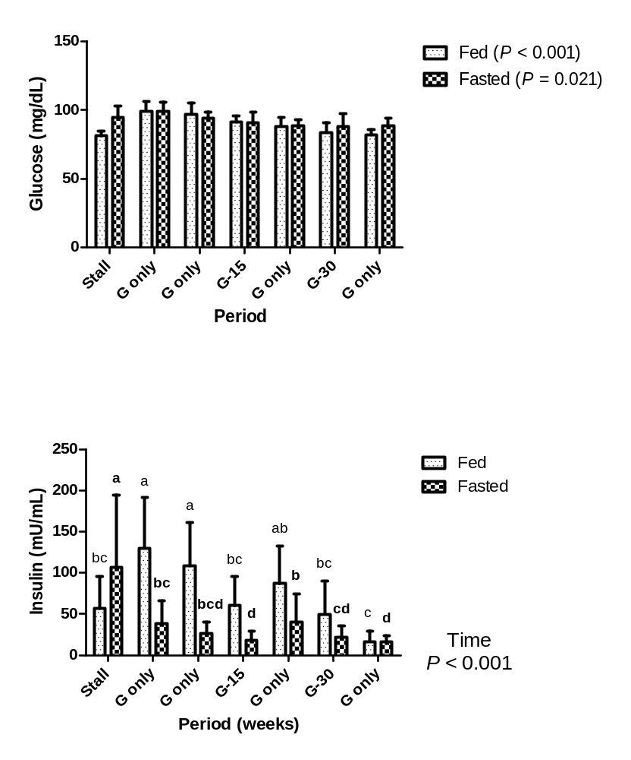
B
A
Figure 4.1: Mean ± s.d. plasma glucose (A) and serum insulin (B) concentrations during OGTs performed in 6 obese, insulin-resistant horses receiving metformin at 15 mg/kg q 12h for 14 days or 30mg/kg q 12h for 14 days while having access to pasture. Samples were collected in the fed state (light bars; fine text) and the fasted state (dark bars; bold text).
G-only = pasture only, no metformin; G-15 = pasture and 15 mg/kg bwt metformin q 12h; G-30 = pasture and 30 mg/kg bwt metformin q 12h.
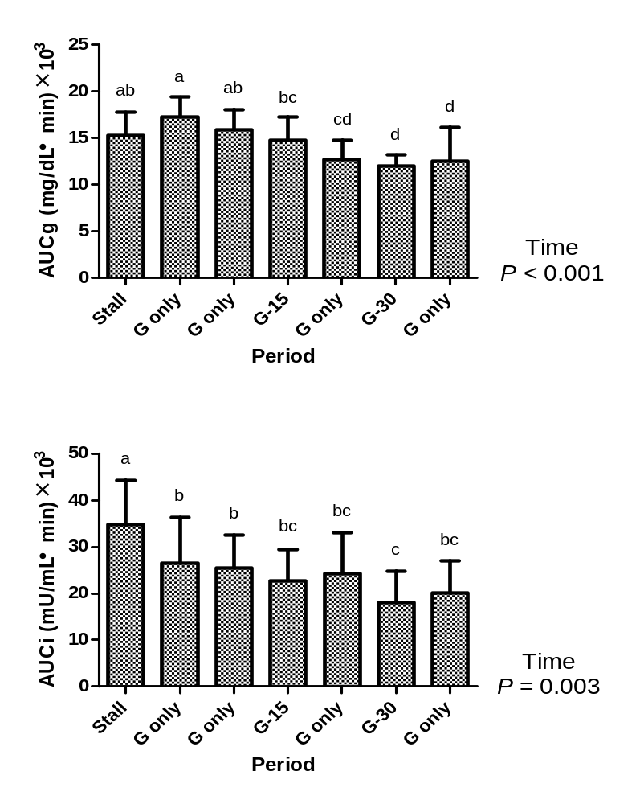
Figure 4.2: Mean ± s.d. area under the glucose curve (AUCg; top panel) and area under the insulin curve (AUCi; bottom panel) during OGTs in 6 obese, insulin-resistant horses horses receiving metformin at 15 mg/kg q 12h for 14 days or 30mg/kg q 12h for 14 days while having access to pasture.

Table 4.2: Mean ± s.d. resting, fasting, and area under the curve measures for 6 insulin-resistant, obese, previously laminitic horses that were returned to pasture for 10 weeks and received metformin for 2 weeks at dosages of 15 mg/kg bwt q 12h and 30 mg/kg bwt q 12h
Time (wk) | 0ª | 1 | 2 | 4^{b} | 6 | 8^{c} | 10 | Time
 |  |  |  |  |  |  |  | P
Resting Glucose (mg/dL)
Fed | 81.18 ± 3.4e | 99.35 ± 6.7a | 97.12 ± 8.1^{ab} | 91.27 ± 4.3^{bc} | 88.21 ± 6.3^{cd} | 83.68 ± 7.3de | 81.88 ± 4.0e | < 0.001
Fasted | 94.74 ± 8.0^{ab} | 98.84 ± 7.1ª | 93.98 ± 4.7^{abc} | 90.83 ± 7.7^{bc} | 88.74 ± 4.1^{bc} | 88.09 ± 9.1^{c} | 88.55 ± 5.3^{c} | 0.021
Resting Insulin (mU/mL)
Fed | 56.7 ± 38.8^{bc} | 130.2 ± 60.9ª | 108.4 ± 52.5ª | 60.1 ± 35.3^{bc} | 86.9 ± 45.4^{ab} | 50.0 ± 39.7^{bc} | 16.7 ± 12.8^{c} | < 0.001
Fasted | 106.4 ± 88.3ª | 38.8 ± 27.4^{bc} | 26.6 ± 13.8^{bcd} | 18.6 ± 10.8^{d} | 40.1 ± 34.0^{b} | 22.1 ± 13.6^{cd} | 16.7 ± 7.1^{d} | < 0.001
AUCg ([mg/dl] · min) × 10³ | 15.3 ± 2.5^{ab} | 17.3 ± 2.1ª | 15.9 ± 2.2^{ab} | 14.8 ± 2.5^{bc} | 12.7 ± 2.1^{cd} | 12.0 ± 1.2^{d} | 12.5 ± 3.7^{d} | < 0.001
AUCi (mU/ml] · min) × 10³ | 34.7 ± 9.6ª | 26.5 ± 9.9^{b} | 25.5 ± 7.1^{b} | 22.8 ± 6.7^{bc} | 24.3 ± 8.7^{bc} | 18.0 ± 6.8^{c} | 20.1 ± 7.0^{bc} | 0.003
^{a, b, c} For time, a = Horses housed in stalls; b = Day 14 of metformin treatment (15 mg/kg); c = Day 14 of metformin treatment (30 mg/kg)
AUCg = area under the curve for glucose; AUCi = area under the curve for insulin
^{a,b,c,d,e} For each variable, means with different superscripts differ significantly; P < 0.05.

lipolysis and fatty acid oxidation.⁴⁰⁵ However, it is also likely that horses lost weight as a result of increased exercise.
Bioavailability of metformin depends upon the species. In humans, metformin pharmacokinetics result in a moderate oral bioavailability of 50 to 60% with maximal concentrations reached 1 to 3 hours post-dosing with 500 to 1000 mg.²⁷⁹ Metformin has a calculated half-life of 6 hours and terminal elimination of 9 to 17 hours in humans.^{279,283} In
rats, metformin at a dose of 50 mg/kg bwt results in a maximal concentration of 3.9 µg/mL at 1.3 hours post oral dosing and half-life of 3.2 hours.⁴⁰⁶
Recently, pharmacokinetics of metformin have been assessed in horses.²⁸³ Metformin was administered at a dose of 6g three times orally (in fed or unfed states) or intravenously. Plasma concentrations were no longer detectable 4 hours post-IV administration, suggesting a clearance rate 10 times greater than humans. Oral bioavailability was poor and varied with feeding. Fed animals showed oral bioavailability of 3.9 ± 1.0 % compared with fasted animals (7.1 ± 1.5 %),²⁸³ suggesting administration after a short fast may be beneficial. These results suggest that the dosages selected, which were equivalent to 7.5 and 15 g for 500-kg horse, were still too low to elicit full effects. The half-life of orally administered metformin has not been determined in the horse, but more frequent dosing may also be necessary.
Insulin resistance and resting hyperinsulinemia are predictors of pasture-associated laminitis in ponies.^{372,407} Metformin has been used to treat insulin resistance in horses and ponies in order to lower laminitis risk. In this clinical study, metformin was orally administered at a dosage of 15 mg/kg bwt q 12h and insulin sensitivity was evaluated by proxy measures following short (6-14 days) and long-term therapy (23-220 days).²⁷⁶ Short-term administration resulted in significant improvement in insulin sensitivity, but this was not detected with long-term treatment. Results may have been confounded because animals included in the study were fed low-glycemic feeds, allowed zero to minimal grazing, and exercise. In the study reported here, horses had unlimited access to grass within their paddocks and unstructured exercise. Horses were observed running in paddocks and their activity level appeared to increase after turnout.
Exercise has been associated with improvements in insulin sensitivity and glucose uptake into peripheral tissues as well as weight loss in humans.⁴⁰⁵ However, results of a study assessing the effect of exercise training on glucose and insulin dynamics in Arabian geldings did not support the assumption that exercise increases insulin sensitivity, although body weight and fat mass decreased over time.⁴⁰⁸ Hypoglycemia is a potential complication of metformin use in horses. This problem was suspected in a horse with type 2 diabetes mellitus when metformin was administered at a dosage of 15 mg/kg bwt q12h.⁴⁰⁹ Hypoglycemia was not detected in the study reported here.
Weaknesses of our study design included the use of the CGIT to assess insulin sensitivity and unmeasured exercise. Assessment of insulin sensitivity using the CGIT is complicated by the administration of exogenous insulin immediately following glucose. Interpretation of the CGIT for the diagnosis of insulin resistance is based upon the glucose and insulin concentrations at 45 minutes. Insulin resistance is diagnosed when glucose concentration fails to return to baseline by 45 minutes and/or the insulin concentration exceeds 100 mU/mL at 45 minutes.³⁷⁹ The glucose measurement at 45 minutes represents the insulin sensitivity and the insulin measurement represents the pancreatic output. Horses in this study met the criteria for IR based on these results.
We conclude that insulin-resistant horses benefit from turnout into grass paddocks. Lower AUCi values indicated improved insulin sensitivity in these animals, suggesting that our hypothesis was supported. Improvement in insulin sensitivity over time might also be attributed to metformin treatment, but effects of time and treatment cannot be separated in this study.

Chapter 5a
Validation of an enzyme-linked immunosorbent assay (ELISA) for the measurement of active GLP-1 in equine plasma

This paper is formatted from a version to be submitted for consideration for publication to the American Journal of Veterinary Research
My primary contribution to this paper included I) execution of the study discussed herein and II) primary author of this paper. Co-authors include Dr. Nicholas Frank who I) served as mentor, II) co-designer, and III) editor of the study, and Amy Schuver who I) was involved in sample collection and II) animal management.

Abstract
Glucagon-Like Peptide 1 (GLP-1) is an incretin hormone secreted the small intestine that plays a role in satiety and stimulates insulin release from pancreatic β-cells. The objective of this study was to validate a commercially available (Millipore Corporation) human active GLP-1 enzyme-linked immunosorbent assay (ELISA) for use with equine plasma. Resting blood samples were collected from one insulin-resistant horse and one healthy horse. Plasma was collected with EDTA and treated with dipeptidyl-peptidase IV inhibitor. Dilution, linearity, and lowest limit of detection were assessed using sample buffer included in the kit and plasma from the insulin-resistant horse. For spike and recovery, the high standard was diluted in equine plasma from one healthy horse. Intra-assay variability was calculated from quadruplicate measures of GLP-1 in blood collected at 3 time points during oral sugar tests in 3 healthy horses. Inter-assay variability was assessed from concentrations of quality control solutions provided in the kit on 3 plates. Dilution of equine plasma resulted in a linear plot of GLP-1 concentrations (r² = 0.995). The lowest limit of detection for the assay was 1.7 pmol/L because this was the value obtained for the sample buffer. Overall recovery was 98.3%, for active GLP-1 in equine plasma. Inter-assay coefficient of variation (CV%) value of 2.3% and 2.6% were obtained for the two quality control solutions. Mean ± SD intra-assay CV% was 9.5 ± 5.1%. Results indicate that GLP-1 can be measured in equine plasma using the ELISA evaluated in this study.

5a.1 Introduction
Glucagon-like peptide 1 (GLP-1) is an incretin hormone secreted by the L cells of the distal small intestine in a dose-dependent manner in response to dietary glucose.^{212,219} Incretins act upon β-cells of the pancreas to enhance insulin secretion before blood glucose levels rise after a meal.²¹⁵ Following ingestion, glucose and GLP-1 enter the portal circulation and circulate through the liver. Glycogen synthesis is stimulated by increased activity of glycogen synthase and decreased activity of glycogen phosphorylase.^{225,410} Some studies in humans have shown alterations in the secretion and sensitivity of GLP-1 in states of obesity and insulin resistance, due to impaired potentiation of the beta cell response to glucose.^{217,411,412} In women with polycystic ovary syndrome, which is an established risk factor for type 2 diabetes, GLP-1 secretion follows a different time pattern after an oral glucose challenge, with lower concentrations detected in the latter part of the challenge in PCOS sufferers when compared with controls.²¹⁷ A significant increase in GLP-1 has also been detected in men with insulin-resistant myotonic dystrophy.²¹⁶
Insulin resistance (IR) increases the risk of laminitis in horses and is a component of Equine Metabolic Syndrome (EMS).³⁷⁹ It is therefore important for IR to be detected in horses before laminitis develops. Since IR affects GLP-1 responses to an oral glucose challenge in humans, it is our overall hypothesis that plasma incretin concentrations differ significantly between healthy and insulin-resistant horses. The objective of the study reported here was to validate an ELISA to measure active GLP-1 in equine plasma, so that insulin-resistant and healthy horses can be compared in the future.

5a.2 Materials and methods
Horses – Five horses (one with IR and 4 with normal insulin sensitivity) from the University of Tennessee College of Veterinary Medicine teaching and research herd provided plasma samples for the validation. Insulin resistance was defined by a resting insulin concentration > 20 mU/L and previous history of sensitivity to insulin (SI) values < 1.0 from frequently-sampled intravenous glucose tolerance testing and minimal model analysis. Plasma was collected from the insulin-resistant horse following an overnight fast and at 30, 45, and 60 minutes during an oral sugar test (OST). These three plasma samples from the OST were pooled together to provide a high GLP-1 concentration sample. A resting blood sample was collected from one normal horse after an overnight fast, and samples were collected at 0, 15, and 30 minutes during an OST from 3 other normal horses (fasting conditions).
Sample preparation – Blood was collected into EDTA-treated collection tubes and centrifuged (3,500 × g) immediately. Ten µL dipeptidyl peptidase-4 inhibitor (DPP-IV) was added to 1.5 mL microcentrifuge tubes and 1 mL of EDTA plasma was added immediately to the inhibitor and inverted to mix thoroughly. Tubes were then flash frozen on dry ice and stored at - 20° C until analyzed.
Validation – All samples were thawed on ice and assay components were prepared according to kit directions. Dilution, linearity, and spike and recovery were performed on a single 96-well plate with samples analyzed in duplicate. The standard curve for the assay was performed in accordance with the assay protocol and consisted of the following concentrations: blank (assay buffer alone), 2, 5, 10, 20, 50, and 100 pmol/L, followed by 2 quality controls representing low and high GLP-1 concentrations (QC1 = 5.1 – 10.5 pmol/L, QC2 = 27.8 – 57.7 pmol/l).
Dilution and linearity: Dilution and linearity were assessed by diluting the high GLP-1 sample (pooled OST samples) from the insulin-resistant horse with assay buffer provided in the kit or fasted resting plasma sample from the insulin resistant horse. Plasma and the respective diluent were plated in duplicate as 1:5, 2:5, 3:5, and 4:5 diluted plasma and plasma and diluent alone.
Lowest limit of detection: Lowest limit of detection was performed by analyzing serially diluted sample in duplicate. Each of the 4 serial dilutions was performed by mixing 2 parts sample with 3 parts assay buffer and was plated to included assay buffer alone, 4 serial dilutions, and pooled GLP-1 sample from the insulin-resistant horse.
Spike and recovery: Spike and recovery was performed using the resting plasma from a fasted normal horse and the high standard solution (100 pmol/L) from the kit. Samples were plated in duplicate as follows: high standard alone, 1:1 plasma and high standard, 1:3 plasma and previously diluted sample across 3 serial dilutions, and plasma alone.
Inter- and intra-assay variability: Inter-assay variability was calculated by plating the same QC1 and QC2 from the assay on 3 different plates. Intra-assay variability was calculated from quadruplicate measures of active GLP-1 in 3 samples collected from 3 normal horses at 0, 15, and 30 min during an OST.

5a.3 Results
A quadratic curve with r² = 0.9997 was obtained with standards provided in the kit (Figure 5a.1). Dilution and linearity tests of pooled equine plasma from an insulin-resistant horse diluted with assay buffer resulted in a linear plot of GLP-1 concentrations with an observed slope of 5.0 and r² = 0.99, compared with an expected slope of 4.9 and r² = 1.00 (Figure 5a.2). Dilution and linearity tests of pooled equine plasma from an insulin-resistant horse diluted with plasma from the same horse under fasted conditions resulted in a linear plot of GLP-1 concentrations, with an observed slope and r² of 3.8 and 0.99, respectively versus expected values of 3.6 and 1.00, respectively (Figure 5a.3). Lowest limit of detection for the assay was 1.7 pmol/L because this was the value calculated when assay buffer was plated alone (Figure 5a.4). The manufacturer states a concentration of 2 pmol/L as the lowest detectable by the assay, with no background subtraction performed when calculating concentrations (personal communication). Spike and recovery produced calculated slope and r² values of 85.1 and 0.98, respectively, compared with the expected values of 97.6 and 0.99, respectively (Figure 5a.5). Overall validation procedures for the ELISA revealed a mean ± s.d. observed-to-expected ratio for dilution and linearity of 97.0 ± 4.4% when using assay buffer as diluent and 100.0 ± 3.8% when samples were diluted with plasma from a fasted insulin-resistant horse. Mean ± s.d. observed-to-expected ratio for spike and recovery was 97.6 ± 10.5% and the overall recovery for this assay was 98.3% for active GLP-1 in equine plasma. Mean ± s.d. intra-assay CV% was 9.5 ± 5.1% and inter-assay CV% for the 2 quality controls was 2.3% and 2.6%, respectively.

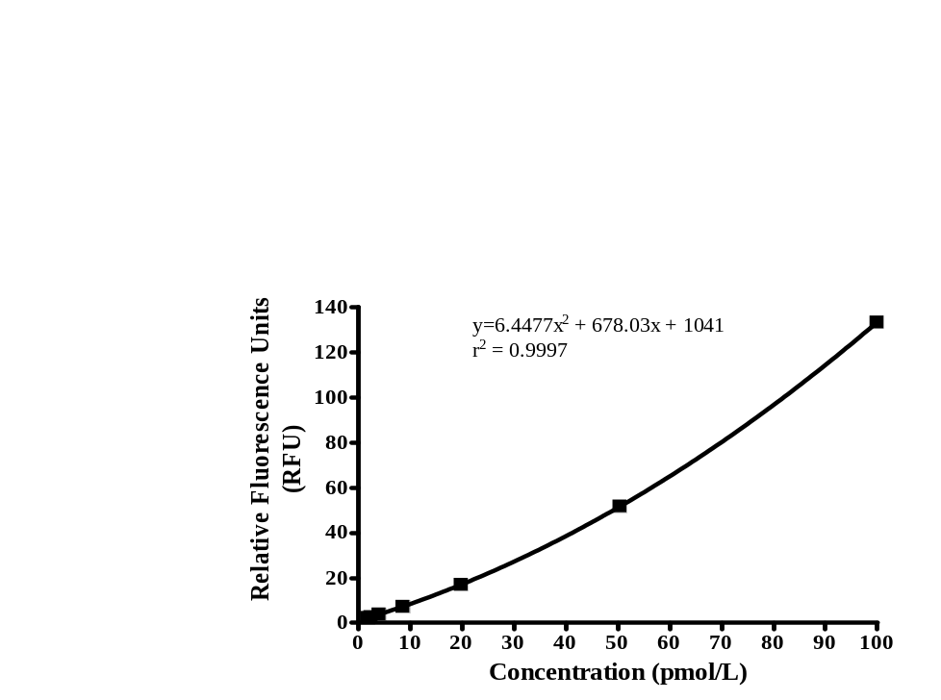

Figure 5a.1: Standard curve for active GLP-1 in equine plasma.

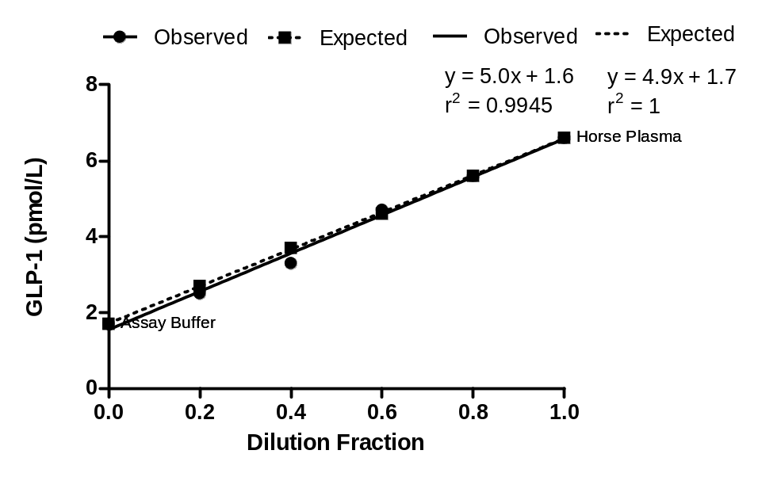

Figure 5a.2: Dilution and linearity plot using assay buffer provided with the kit as the diluent and plasma from an insulin-resistant horse following an oral sugar test (pooled 30, 45, and 60 minutes post-sugar) as the sample.

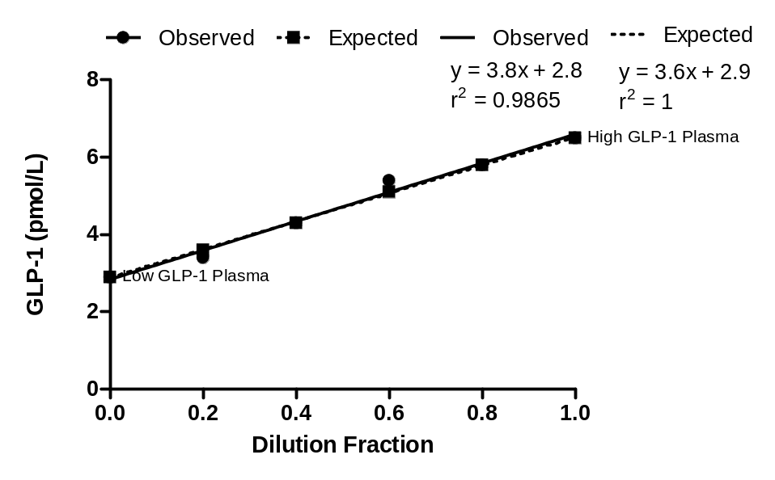

Figure 5a.3: Dilution and linearity plot using fasted plasma from an insulin-resistant horse as the diluent and plasma from the same horse during an oral sugar test pooled from 30, 45, and 60 minutes post-sugar bolus.

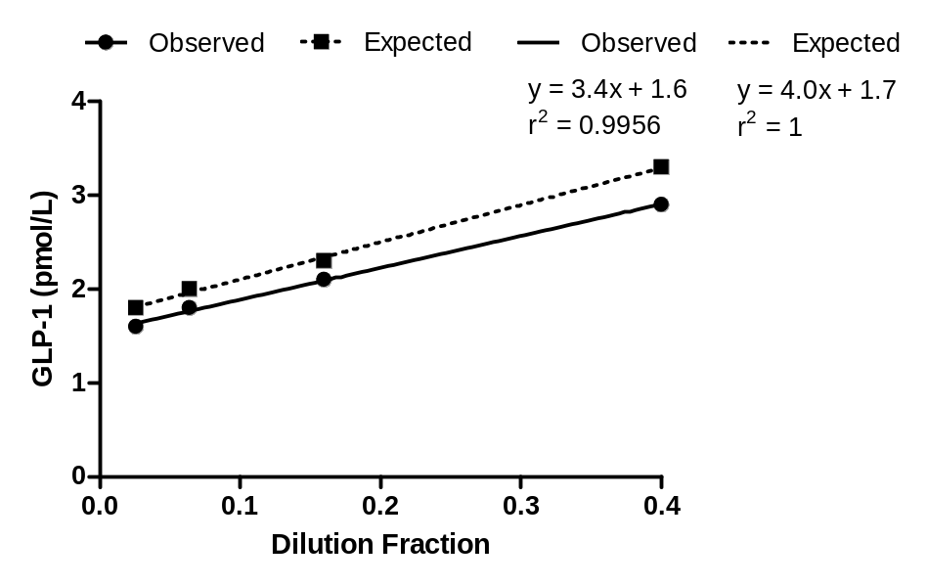

Figure 5a.4: Lowest limit of detection plot using assay buffer provided with the kit and fasted plasma from an insulin-resistant horse.

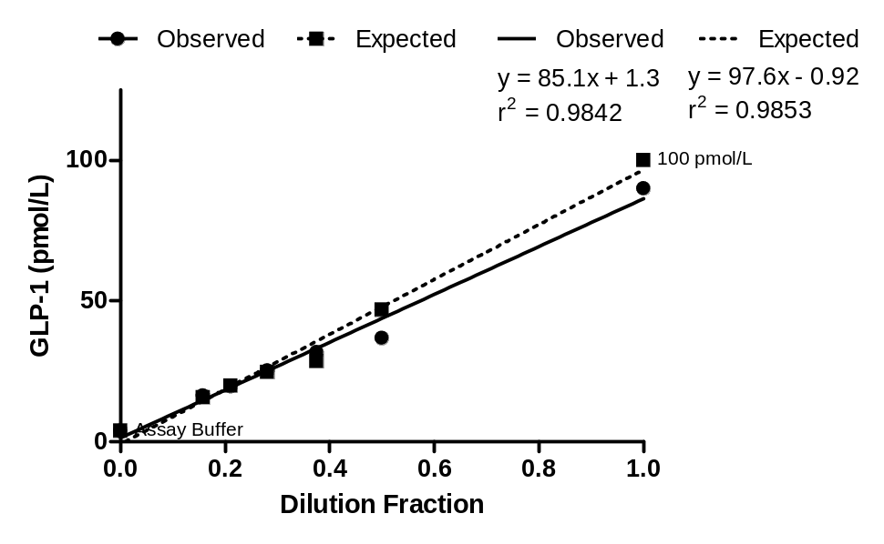

Figure5a.5: Spike and recovery plot using the 100 pmol/L standard provided with the assay as the spike solution and fasted plasma from a clinically normal horse as the sample that was spiked.

5a.4 Discussion
Results of this study indicate that active GLP-1 can be measured in equine plasma using an ELISA kit designed for humans. This commercially available kit can be used to measure GLP-1 concentrations in horses and assess influences of different metabolic states and diets.
Glucagon-like peptide 1 may serve as a potential marker for identification of horses at risk for developing laminitis. In humans, alterations in GLP-1 concentrations have been identified in conditions associated with insulin resistance and obesity.^{212,217} Relationships among obesity, fat oxidation, and its influence on GLP-1 are reflected in the “glucose-fatty-acid-cycle proposed by Randle.^{219-221,413} According to the Randle Theory, competition exists between fat oxidation and glucose uptake, such that the body preferentially utilizes fatty acids for energy and this impairs insulin action.⁴¹³ Increased concentrations of fasting GLP-1 have been detected in association with obesity and increased resting metabolic rates and fat oxidation in humans.²¹⁹ Pima Indians have the highest reported prevalence of non-insulin dependent diabetes.²²¹ In this population, there is an increased affinity for intestinal binding of long-chain fatty acids resulting in increased fat oxidation and a decreased insulin activity.²²¹ Kunz et al.²²⁰ confirmed that a higher fat mass results in an increased resting metabolic rate and fat oxidation with a decrease in carbohydrate oxidation, most likely as a result of impaired insulin activity. Obesity therefore impairs insulin action by enhancing fat oxidation, and this is associated with higher fasting GLP-1 concentrations. Higher fasting concentrations of GLP-1 are detected in obese humans, but concentrations are lower during oral glucose tolerance tests.^{211,218} However, the opposite is noted in situations where IR is the predominant process. In men with myotonic dystrophy, a condition characterized by IR and hyperinsulinemia, resting GLP-1 concentrations are lower compared to healthy individuals, but higher during oral glucose tolerance tests.²¹⁶
Diet influences GLP-1 concentrations in rats, dogs, and humans.⁴¹⁴⁻⁴¹⁷ In rats, high-fat feeding attenuated GLP-1 secretion following oral glucose loads, whereas no change was detected when rats were fed a standard chow diet.⁴¹⁵ In contrast, high fat and high-calorie feeding increased GLP-1 concentrations in dogs and humans, respectively.^{415,416} Diets of different fiber types have also been associated with alterations in GLP-1 concentrations.⁴¹⁷⁻⁴¹⁹ Results have varied however, with significant increases in GLP-1 concentrations observed when dogs ingested high-fermentable fiber over long periods.⁴¹⁸ Humans also required 12 months on a high-wheat fiber before GLP-1 concentrations increased after oral glucose challenge.⁴¹⁷ However, there was no significant effect of feeding a highly fermentable fiber diet on GLP-1 concentrations in another study performed in dogs.⁴¹⁹
Horses that are at higher risk of IR and laminitis are generally obese and have elevated blood lipid concentrations.⁶ Since higher GLP-1 concentrations have been associated with obesity and impaired insulin action in humans, it is likely that GLP-1 will reflect the metabolic status of the horse. However, GLP-1 responses appear to vary according to the predominant mechanism (obesity versus IR), which explains the variation in reported results from other species.^{216,217}
Human metabolic syndrome (MetS) is similar to Equine Metabolic Syndrome in that both syndromes include hyperinsulinemia, IR, dyslipidemia, and obesity^{122,420}. These conditions are risk factors for cardiovascular disease and type 2 diabetes in humans and laminitis in horses. In humans, GLP-1 concentrations were higher in subjects with a cluster of MetS risk factors that did not include adiposity.¹²² Basal active GLP-1 concentrations range from 28.4 to 42.9 pg/mL, with overweight individuals having lower concentrations compared to lean controls.⁴²¹ Concentrations also vary according to sampling location, with portal vein concentrations ranging from 50 to 60 pmol/L in humans and 30 to 60 pmol/L in dogs due to clearance from the circulation.^{422,423} In dogs, basal concentrations range from 4.4 to approximately 15 pmol/Lin different studies.⁴¹⁴
Normal ranges have not been established in horses as this is, to the authors’ knowledge, the first study to measure active GLP-1 in equine plasma. The strong correlation with MetS risk factors and GLP-1 concentrations in humans suggests that this incretin hormone may be a useful marker for EMS and laminitis risk in horses. However, it is apparent from studies performed in other species that concentrations must be measured under different metabolic and dietary conditions in order to fully understand the normal physiology of GLP-1 in horses. We conclude that a commercial assay is available to measure GLP-1 in equine plasma.

Chapter 5b
Plasma glucagon-like peptide 1 (GLP-1) concentrations in response to an oral sugar test in healthy and insulin-resistant horses

This paper is a version to be submitted for consideration for publications in the American Journal of Veterinary Research.
My primary contribution to this paper included I) execution of the study discussed herein and II) primary author of this paper. Co-authors include Dr. Nicholas Frank who I) served as mentor, II) co-designer, and III) editor of the study, and Amy Schuver who I) was involved in sample collection and II) animal management.

Abstract
Glucagon-like peptide 1 (GLP-1) is an incretin hormone secreted by the small intestine in response to feeding. Studies in other species indicate that obesity and insulin resistance are associated with alterations in GLP-1 concentrations after feeding. An enzyme-linked immunosorbent assay for human active GLP-1 has recently been validated for use with equine plasma in our laboratory. We tested the hypothesis that healthy and insulin-resistant horses differ in their GLP-1 response to an oral sugar test (OST). Eleven healthy horses and six insulin-resistant horses underwent an OST after overnight fasting. After baseline blood samples were collected, 50 mg sugar per kg body weight was administered as Karo® Original Light Corn Syrup (10g sugar/30 mL syrup) via dose syringe. Blood samples were then collected at 15, 30, 45, 60, 75, 90, 105, and 120 min. Active GLP-1 was measured in EDTA plasma treated with dipeptidyl-peptidase IV inhibitor.
Mean GLP-1 concentrations significantly increased (P < 0.001) during the OST, but individual responses varied widely. Median (range) maximum percent increase in GLP-1 concentration after sugar administration was 67% (–15% to 188%) in healthy horses and 148% (35% to 286%) in insulin-resistant horses. Metabolic status did not affect GLP-1 concentrations (P = 0.623), percent change (P = 0.167), fold change (P = 0.161), or area under the curve in response to sugar administration (P = 0.281). Healthy and insulin-resistant horses did not differ with respect to GLP-1 responses to Karo® syrup in this study, but specific nutrients should be tested in the future.

5b.1 Introduction
Incretin hormones are peptide hormones that are secreted by the intestine in response to glucose intake and enhance secretion of insulin following glucose intake.²¹⁷ Glucagon-like peptide 1 (GLP-1) is an incretin hormone secreted from L-cells of the small intestine that exerts its effect on the β-cells of the pancreas resulting in elevations in insulin in a glucose dependent manner.^{214,215,222} Other effects of GLP-1 secretion include slowing gut motility and gastric emptying, which delays blood sugar increases following a meal,²¹⁵ inhibition of glucagon release and promotion of satiety,⁴¹⁰ reduction in insulin clearance, which raises blood concentrations,²⁰ and effects on cardiac function.²¹⁰ Receptors for GLP-1 have been identified in the pancreatic islets, gastrointestinal tract, kidney, heart, lung, central nervous system, and adipose tissue.²¹⁴
Aberrations in GLP-1 secretion and function have been detected in diabetes and other medical conditions associated with impaired glucose regulation, insulin resistance, and obesity.^{210,217,219} In humans, type 2 diabetes, polycystic ovary syndrome (PCOS), and myotonic dystrophy are associated with insulin resistance (IR) and abnormal GLP-1 responses following oral glucose challenges.^{216,217,416} Results have differed among studies with some showing greater increases in GLP-1 concentrations following oral glucose in males with myotonic dystrophy²¹⁶, and others revealing that concentrations are lower in the later stages of oral glucose tolerance tests in women with PCOS.²¹⁷ In states of obesity, basal fat oxidation is increased, and this is associated with higher fasting GLP-1 concentrations.²¹⁹⁻²²¹
We hypothesized that there would be a difference in GLP-1 concentrations in response to an oral sugar test (OST) between insulin-resistant and normal horses.

5b.2 Materials and Methods
Horses – A total of 17 horses were included in the study. Six horses with EMS which included histories of IR and obesity were compared with 11 healthy mares. Geldings and mares were included in the IR group. All horses were owned by the University of Tennessee. Insulin-resistant horses were housed alone in individual stalls (2.75-m × 3.5-m) with attached outdoor dry-lots (3.7-m × 10-m) in a barn. Healthy horses were part of the teaching and research herd and were housed outdoors on pasture with access to run-in sheds. Insulin-resistant horses did not have access to pasture for ≥ 15 months prior to and throughout the study. Body condition scores (BCS) of insulin-resistant horses were obese (≥ 7/9), whereas healthy horses ranged from 4 to 6/9. Body weights ranged from 429 to 559 kg (mean, 475 ± 59 kg) for insulin-resistant horses, and from 445 to 507 kg (mean, 469 ± 25 kg).
Diet – Insulin-resistant horses were fed orchard/timothy grass hay ad libitum and healthy horses were allowed to graze unrestricted. Water was available ad libitum via automatic waterers or water troughs.
Experimental design – A randomized block design, blocked on metabolic status with repeated measures was used. Each horse underwent an OST on a single occasion with blood samples collected q15 min for 120 minutes following baseline samples and sugar administration.
Oral sugar test procedure – A 14-gauge polypropylene jugular catheter was placed the evening prior to OST testing. All horses were enclosed in stalls overnight and received a single flake of hay at 2000 and then no feed until after testing the following morning. Water was available ad libitum throughout the procedure. Patency of the IV catheter was maintained overnight by injecting 100 mg heparin into a heparin lock infusion cap. For the OST procedure, an injection cap and infusion set (length, 30 cm; internal diameter, 0.014 cm) were attached to the catheter. An OST procedure designed by our research group was used. Baseline blood samples were collected at 0800 via the catheter and then corn syrup was administered via dose syringe at a dosage of 0.15 mL/kg bwt to provide 150 mg dextrose derived digestible sugars per kg bwt. Samples were then collected via the catheter at 15, 30, 45, 60, 75, 90, 105, and 120 minutes relative to sugar administration. At each time point, 3 mL of blood was withdrawn from the infusion line and discarded. Blood was collected into tubes containing EDTA and then 5 mL of heparinised saline was infused. Plasma for active GLP-1 measurements was centrifuged immediately (3500 × g) for 3 minutes. After plasma was harvested, a 1 mL aliquot was added to 10 µL dipeptidyl peptidase-IV inhibitor in a 1.5 mL microcentrifuge tube on ice. Samples were immediately inverted to mix thoroughly and were then flash frozen on dry ice. Samples were stored at -20° C until further analysis.
Plasma GLP-1 concentrations – Plasma active GLP-1 concentrations were measured by use of a commercially available human active GLP-1 ELISA previously validated by our laboratory for use in the horse. Each sample was assayed in duplicate and intra-assay coefficients of variation (CV%) < 10% were required for acceptance of assay results.
Statistical analysis - Active GLP-1 concentrations did not fit a normal distribution, so data were log transformed prior to analysis. Metabolic status and time effects for all variables were evaluated by repeated measures analysis of variance (ANOVA) using statistical software. When main effects were significant, the protected least square difference mean separation method was used to compare different effects. Significance was defined as a value P < 0.05.

5b.3 Results
Overall active GLP-1 concentrations significantly increased (P < 0.001; Figure 5b.1) over time during the OST compared to baseline, with peak concentrations measured at 60 to 75 minutes. However, individual animals varied markedly. No group × time (P = 0.623) or group (P = 0.320) effects were detected for active GLP-1 concentrations. Baseline concentrations of GLP-1 in the study reported here ranged from 1.5 to 6.5 pmol/L (median, 3.3 pmol/L) for healthy horses and 2.2 to 6.3 pmol/L (median, 3.4 pmol/L) for insulin-resistant horses, and did not differ between groups. Peak concentrations ranged from 2.8 to 12.7 pmol/L (median, 4.6 pmol/L) in healthy horses and 3.7 to 18.3 pmol/L in insulin-resistant horses (median, 9.2 pmol/L). Area under the curve values for active GLP-1 did not differ (P = 0.281; Figure 5b.2) between groups. Median (range) maximum percent increase in active GLP-1 concentrations after sugar administration was 67% (˗15% to 188%) in healthy horses and 148% (35% to 286%) in insulin-resistant horses, but groups did not differ significantly (P = 0.170). Metabolic status did not affect percent change in GLP-1 (P = 0.167) or fold change in GLP-1 (P = 0.161) during the OST.

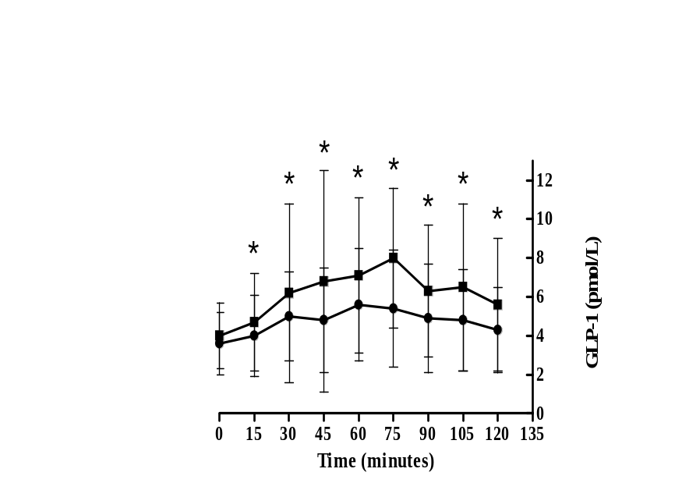

Figure 5b.1: Mean ± s.d. active GLP-1 concentrations in healthy (n = 11; circles) and insulin-resistant (n = 6; squares) horses during an oral sugar test (OST) with Karo® corn syrup. Within a group, a significant difference from the baseline (time = 0) mean values is denoted by an asterisk (time effect; P < 0.001).

A

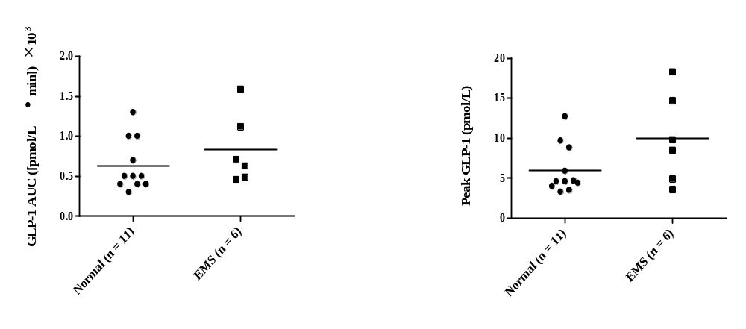
B

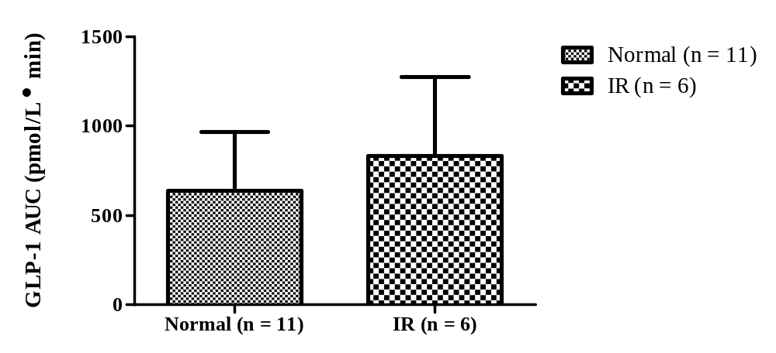

Figure 5b.2: (A) Scatterplots of mean GLP-1 AUC for normal (n = 11) and EMS (n = 6) horses (left) and peak active GLP-1 concentrations of normal (n = 11) and EMS (n = 6) horses; (B)Mean ± s.d. area under the GLP-1 curve in healthy (n = 11) and insulin-resistant (n = 6) horses during an oral sugar test (OST) with Karo® corn syrup (treatment × time effect; P = 0.281).
5b.4 Discussion
Results of this study indicate that the OST can be used to assess active GLP-1 secretion in horses. However, no significant differences were detected between healthy and insulin-resistant horses when corn syrup was used for this test, so further studies are required to examine the GLP-1 response to different oral sugars in horses.
Results of this study contrast with findings from studies performed in humans.^{216,217} Conditions associated with IR and/ or type 2 diabetes, such as PCOS in women and myotonic dystrophy in men, have been studied in regards to active GLP-1 concentrations.^{216,217} Women suffering from PCOS have the same GLP-1 responses during the majority of the OGTT when compared to controls, except at 180 min when concentrations are significantly lower.²¹⁷ However, results of another study were consistent with our findings in that GLP-1 responses were the same in healthy women and those with PCOS during an OGTT.⁴²⁴ It is important to note that horses were only sampled until 120 minutes in this study, so the OST should be extended to 180 minutes in the future.
When GLP-1 was measured in men with myotonic dystrophy, significantly higher concentrations were detected during OGTTs in insulin-resistant subjects compared to those with normal insulin sensitivity.²¹⁶ Although plotted GLP-1 concentrations here appeared higher in insulin-resistant horses, values were not significantly different. The question of whether IR impairs GLP-1 secretion has not been answered yet in human medicine. Short-term glucosteroid administration, which induces glucose intolerance and IR, impairs the incretin effect in humans.⁴¹⁶ It has also been shown that impairment of the incretin response can be reversed after normalization of glucose tolerance, as reported with gestational diabetes, suggesting that this impairment results from IR.²¹³
Metabolic syndrome in humans is a collection of risk factors for cardiovascular disease and diabetes.¹²² In contrast, Equine Metabolic Syndrome (EMS) is a set of risk factors for the development of laminitis.³⁷⁹ There are similarities between the two disorders, including obesity, insulin resistance, hyperinsulinemia, and dyslipidemia.^{122,420} A condition in humans referred to as non-alcoholic fatty liver disease (NAFLD), or hepatic steatosis, results from ectopic accumulation of triglycerides within the cytoplasm of hepatocytes, and is closely related to obesity and sometimes associated with IR.⁴²⁵ It has been established in humans that NAFLD increases dipeptidyl peptidase-IV (DPP-4) activity, which is the enzyme responsible for rapid degradation of active GLP-1 in the circulation.^{212,426,427} This may explain the common finding that GLP-1 concentrations following a meal are often diminished in people with type 2 diabetes. In horses suffering from EMS, a state of hepatic insulin resistance is believed to play a role in hyperinsulinemia that is commonly detected. It is possible that this may result in elevated activity of DPP-4 and explain the lack of significant findings in the study reported here.³⁷⁹ Hepatic insulin resistance is a result of ectopic lipid accumulation and has been documented on post-mortem examination of some obese, insulin-resistant horses studied by our research group (unpublished data). Hepatic lipid accumulation may lead to elevated DPP-4 concentrations and lowered GLP-1 responses during the OST.
In has been shown in humans that a higher body mass index (BMI), which reflects a state of obesity, results in significantly greater basal energy expenditure as a result of increased fat oxidation.²²⁰ Higher rates of fat oxidation have been associated with increased fasting plasma GLP-1 concentrations in humans.²¹⁹ The Randle Theory suggests that lipids and carbohydrates compete as the oxidative fuel source for skeletal muscle and by doing so, skeletal muscle glucose uptake is impeded and results in IR.^{221,413} This may explain why some studies have shown elevated fasting GLP-1 concentrations in obese individuals.²¹¹
In healthy humans, peripheral blood GLP-1 concentrations can rise to 30 pmol/L, but generally remain below 10 pmol/L following a meal.⁴²² Rats show a postprandial concentration of approximately 20 pmol/L.⁴²² Studies in dogs have detected basal concentrations of approximately 4.9 pmol/L after feeding once or twice daily.⁴¹⁴ These baseline concentrations are similar to the concentrations detected in the study reported here (range, 1.5 to 6.5 pmol/L). In a study of women with PCOS, peak GLP-1 concentrations were approximately 7 pmol/L following an oral glucose load,²¹⁷ and 60 pmol/L and 27 pmol/L following a carbohydrate or fat meal, respectively in healthy women.²¹¹ In contrast, obese women with PCOS showed peak responses of approximately 25 pmol/L and 27 pmol/L following a carbohydrate or fat meal, respectively.²¹¹ Peak responses did not differ statistically between normal and insulin-resistant horses in this study.
As previously discussed, GLP-1 is secreted in response to dietary glucose in a dose dependent manner so a commercially available sugar source was utilized in this study. However, studies in rats and dogs have shown variability in GLP-1 responses, depending upon food type. A study performed by Massimino et al.⁴¹⁸ determined that the chronic ingestion of high fermentable dietary fiber in dogs resulted in significantly greater GLP-1 concentrations when compared to dogs fed low fermentable fiber. In conjunction with elevated GLP-1 secretion, an increase in intestinal glucose transport capacity and glucose homeostasis following an oral glucose challenge was also detected. A more recent study found opposite results.⁴¹⁹ Post-prandial concentrations of GLP-1 did not differ significantly between groups of dogs fed high and low fermentable fiber diets, and interestingly dogs consuming the high fermentable fiber showed lower voluntary feed intake.⁴¹⁹ A study by Lubbs et al.⁴¹⁴ assessed the effects of different dietary macronutrients on GLP-1 secretion in dogs. An overall higher GLP-1 concentration was measured in dogs fed twice daily compared to dogs fed once daily. When dogs were challenged acutely with water, carbohydrates, fat, or protein, those dosed with carbohydrates peaked at 60 minutes and then decreased, before spiking once more at 360 minutes, which was the final time point in the study. A study in rats detected a decrease in GLP-1 concentrations when rats were fed a high-fat diet compared to a basic chow diet.⁴¹⁵
This is, to the authors’ knowledge, the first study to evaluate active GLP-1 concentrations in horses in response to an oral sugar test. Insulin-resistant horses in the study reported here were restricted to a hay-only diet whereas normal horses had access to pasture. It is possible that variability in the amount and type of fiber consumed by these horses may have influenced results. Although statistical significance was not attained in this study, and as a result did not support our hypothesis, horses within groups varied markedly with insulin-resistant horses often having higher GLP-1 concentrations when compared to healthy controls. Further studies are therefore required to determine whether certain horses with IR exhibit abnormal GLP-1 responses compared to controls and if this abnormality impacts the health of the animal. Further study is required to assess GLP-1 responses in individual animals during transition from one metabolic state to another in an attempt to eliminate variability. More animals must be evaluated to determine whether obesity and IR affect GLP-1 responses to feeding in horses.

Chapter 5c

Effects of weight gain on plasma active glucagon-like peptide 1 (GLP-1) concentrations and glucose tolerance test responses in horses

This paper is formatted from a version to be submitted for consideration for publication to the American Journal of Veterinary Research
My primary contribution to this paper included I) execution of the study discussed herein and II) primary author of this paper. Co-authors include Dr. Nicholas Frank who I) served as mentor, II) co-designer, and III) editor of the study, Sarah B. Elliott who I) assisted with sample collection, II) animal preparation, and III) technical assistance, and Amy Schuver who I) was involved in sample collection and II) animal management.

Abstract
Insulin resistance (IR) is associated with obesity, type 2 diabetes, metabolic syndrome, polycystic ovary syndrome, and myotonic dystrophy. Aberrations in glucagon-like peptide 1 (GLP-1) have been identified in these conditions. Insulin resistance and obesity also occur, in association with laminitis, and this syndrome is referred to as Equine Metabolic Syndrome (EMS). We have previously observed that some horses with EMS have higher GLP-1 concentrations (Chapter 5). However, it is unclear whether obesity and IR raise or lower GLP-1 concentrations in horses. We therefore tested the hypothesis that induction of weight gain in horses with histories of IR and chronic obesity would result in alterations in GLP-1 concentrations. Six horses with histories of IR and obesity underwent weight gain over 8 weeks by providing 2.0 × DE_{m} per day. Oral glucose tolerance tests (OGTT) were performed prior to initiation of weight gain and 8 weeks later. Glucose, insulin, and GLP-1 from the OGTT were analyzed by area under the curve and repeated measures ANOVA.
Mean body weight significantly increased (P = 0.003) over 8 weeks. Glucagon-like peptide 1 concentrations increased over time during the OGTT (P = 0.023) but did not differ with weight gain. Area under the GLP-1 curve did not change significantly with weight gain. Mean glucose concentrations did not differ with weight gain, whereas insulin concentrations increased over time (P = 0.027) as well as area under the insulin curve (AUCi; P = 0.003). An increase in body weight over 8 weeks did not result in changes in GLP-1 concentrations. Future studies should include more animals in order to determine whether GLP-1 concentrations can be used to identify insulin-resistant horses and assess reductions in insulin sensitivity due to diet.

5c.1 Introduction
Insulin resistance is a condition in which physiologic concentrations of insulin are unable to elicit the appropriate response by insulin sensitive tissues such as skeletal muscle, adipose tissue, or the liver.⁴²⁸ It is a condition that has been associated with states of obesity, type 2 diabetes, polycystic ovary syndrome (PCOS), metabolic syndrome, and myotonic dystrophy.^{122,216,217,221,429} In horses, it is a component of the Equine Metabolic Syndrome (EMS) and is believed to be a factor predisposing horses to laminitis.³⁷⁹
In diseases such as myotonic dystrophy, type 2 diabetes, and PCOS where obesity and insulin resistance occur, aberrations in glucagon-like peptide 1 (GLP-1) have been observed.^{216,217} Glucagon-like peptide 1 is an incretin hormone released by the L-cells of the distal small intestine in a dose dependent response to dietary glucose resulting in enhanced insulin secretion by the pancreas.²¹⁰ Results of studies in humans and other species have varied with respect to fasting GLP-1 concentrations and GLP-1 responses to oral glucose challenges.^{217,219,430}
States of higher resting energy expenditure and fat oxidation have been associated with higher fasting concentrations of GLP-1.²¹⁹ States of obesity have been associated with elevated states of basal fat oxidation and a resulting decrease in insulin action, both of which could be associated with elevated GLP-1 concentrations.²¹⁹⁻²²¹ We hypothesized that inducing weight gain and obesity in horses with histories of chronic insulin resistance would increase basal concentrations and GLP-1 responses during oral glucose tolerance tests.

5c.2 Materials and methods
Horses – Six adult horses that had been donated to the University of Tennessee and maintained for > 24 months were included in the study. Each horse had been donated due to histories of laminitis and chronic insulin resistance. At the beginning of the study horses had a mean body condition score of 6/9 and ranged from 4 to 8.5/9; scores ≥ 7 are considered overweight according to the 1 to 9 scoring system devised by Henneke et al.⁹ The study was performed from May 2010 to July 2010. Custom farrier care was provided as needed. All horses were housed individually in orchard grass paddocks (15-m × 55-m) with run-in sheds. Three mares and 3 geldings were included in the study and ranged in age from 8 to 22 years (median, 16 years), with initial body weights ranging from 381 to 533 kg (median, 423 kg).
Diet – All horses were allowed free access to pasture, and were supplemented with a diet to provide 2 × DE_{m}. Forty percent of digestible energy was provided by timothy/orchard grass hay which provided 1100 kcal/lb, on a dry matter basis, and 60% with a sweet feed that provided 1330 kcal/lb on a dry matter basis. Hay provided 13.7% water-soluble carbohydrates (WSC), 0.9% starch, and 10.8% simple sugars (ESC) on a dry matter basis and sweet feed provided 8.8% WSC, 17.4% starch, and 6.2% ESC on a dry matter basis, as determined by a commercial forage testing laboratory. Horses were transitioned to the diet over a span of 1-week by incrementally feeding 0.25 × target amount twice daily on day 1, 0.5 × target amount on days 2, 3, and 4, 0.75 × target amount on days 5, 6, and 7, and the full amount by day 8. Water was available ad libitum via automatic waterers and grain and hay were offered between 0700 and 0800 and again between 1500 and 1530.
Experimental design – A longitudinal prospective study with 6 horses serving as their own controls was performed. All horses underwent intravenous glucose tolerance test (IVGTT) and oral glucose tolerance test (OGTT) procedures prior to the initiation of weight gain (time = - 1 week) and again after 8 weeks on the weight gain diet (time = 9 weeks). Tests were performed on consecutive days with the IVGTT being performed on the first day and the OGTT being performed the next day. Horses were transported to the teaching hospital in pairs 2 days prior to the first test to allow acclimation to the surroundings. At both time points, morphometric measurements were collected along with blood samples. The study protocol was approved by the University of Tennessee Institutional Animal Care and Use Committee.
Morphometric measurements – Morphometric measurements included neck circumference, body weight, body condition score (BCS), girth circumference, and rump fat thickness. Neck circumference was measured perpendicular to the crest of the neck at 0.25, 0.50 (mid neck), and 0.75 of the distance from the withers to the poll with a measuring tape as previously described.⁶ Mean neck circumference values were calculated. Rump fat thickness was measured via ultrasonography placed 5 cm lateral from the dorsal midline at the center of the pelvic bone as previously described by Carter et al.⁴³¹
Testing procedure – Two 14-gauge polypropylene catheters were inserted into the left and right jugular veins using aseptic technique the day before the first test was performed. Horses underwent an overnight fast before testing was performed and tests were performed under fasting procedures with the exception of water which was available throughout the procedures. Patency of IV catheters was maintained by infusion of 5 mL saline solution containing heparin (4 U/mL) into the catheter q 6h. An injection cap and infusion set (length, 30 cm; internal diameter, 0.014 cm) were attached to each catheter.
IVGTT procedure – Dextrose as a 50% solution (wt/vol) dextrose solution was infused in one jugular catheter at a concentration of 150 mg/kg bwt followed by 20 mL heparinised saline. Blood samples were collected from the other jugular catheter 15 minutes before dextrose infusion and 1, 2, 3, 4, 5, 6, 7, 8, 10, 12, 15, 16, 19, 22, 23, 24, 25, 27, 30, 35, 45, 50, 60, 75, 90, 105, 120, 150, and 180 minutes relative to dextrose infusion. At each time point, 3 mL of blood was discarded and then blood was collected into tubes containing a glycolytic inhibitor (potassium oxalate/ sodium fluoride) and tubes without anti-coagulant. Following sample collection, 5 mL heparinised saline was infused. Plasma and serum were harvested via centrifugation (3,500 × g) and then stores at -20° C until further analysis. Pre-injection insulin and glucose concentrations are referred to as baseline concentrations. Following completion of this test, the dextrose infusion catheter was removed.
OGTT procedure - During the OGTT procedure, dextrose powder was weighed to provide 150 mg/kg bwt dextrose. Powder was mixed with water and gently heated to bring into solution. The dextrose solution was administered to horses via dose syringe. Blood samples were collected 15 minutes prior to dextrose administration and 15, 30, 45, 60, 75, 90, 105, 120, 135, 150, 165, and 180 minutes relative to oral dextrose administration. At each time point, 3 mL of blood was withdrawn and discarded and blood samples for glucose and insulin were collected into tubes containing a glycolytic inhibitor (potassium oxalate/ sodium fluoride) and tubes without anti-coagulant. Samples for GLP-1 were collected into EDTA treated tubes and centrifuged immediately (3,500 × g for 3 minutes). Following centrifugation, 1 mL of plasma was added to 10 µL of dipeptidyl peptidase-IV inhibitor (DPP4) in 1.5 mL microcentrifuge tubes on ice. Samples were inverted to mix thoroughly and then flash frozen on dry ice and stored at -20° C until further analysis. Samples for glucose and insulin were centrifuged following sample collection.
Blood glucose, insulin, and GLP-1 concentrations – Plasma glucose concentrations were measured by use of a colorimetric assay on an automated discrete analyzer. Serum insulin concentrations were determined by use of a radioimmunoassay previously validated for use in horses.³⁹³ Each sample was assayed in duplicate and intra-assay coefficients of variation (CV%) < 5% or < 10% were required for acceptance of glucose and insulin assay results, respectively. Glucagon-like peptide 1 was measured by use of an enzyme-linked immunosorbent assay (ELISA) previously validated for use with horse plasma in our laboratory. Each sample was assayed in duplicate and CV% of < 10% was required for acceptance of GLP-1 results.
Statistical analysis – Area under the glucose curve (AUCg) data did not fit a normal distribution, so data were rank transformed prior to analysis. Time, treatment, and test effects were evaluated for all variables by repeated measures analysis of variance (ANOVA) using statistical software. When time, test, or treatment effects were significant, the protected least square mean separation method was used to compare different treatment periods. Significance was defined as a value P < 0.05.

5c.3 Results
Testing was performed at baseline and 4 weeks later in one mare due to the development of laminitis. Mean body weight significantly increased over the treatment period (P = 0.003; Table 5c.1; Figure 5c.1). Mean body weight prior to diet intervention was 438 ± 61 kg (range, 381 to 533 kg) and increased to 464 ± 61 kg (range, 394 to 550 kg). Percent body

Table 5c.1: Mean ± s.d. physical measurements for 6 horses with chronic insulin resistance that received a diet providing 2 × DE_{m} per day for 8 weeks.
Variable | Treatment |  | Treatment
Variable | Pre (0 wks) Post (8 wks) |  | P
Body Weight  (kg) | 438 ± 61 | 464 ± 61 | 0.003
BCS  (1 to 9 scale) | 6.1 ± 1.6 | 8.0 ± 0.8 | 0.006
0.25 × neck  (cm) | 74 ± 3 | 80 ± 5 | 0.003
0.5 × neck  (cm) | 88 ± 7 | 97 ±5 | < 0.001
0.75 × neck  (cm) | 105 ± 7 | 112 ± 6 | 0.002
Mean neck circumference  (cm) | 89 ± 6 | 96 ± 5 | < 0.001
Girth circumference  (cm) | 180 ± 7 | 184 ± 8 | 0.012
Rump fat thickness  (cm) | 1.85 ± 0.69 | 2.50 ± 0.86 | 0.002
Neck-to-height  (ratio) | 0.60 ± 0.04 | 0.64 ± 0.4 | < 0.001
BCS = Body condition score; x = Distance from the poll to the withers; P < 0.05

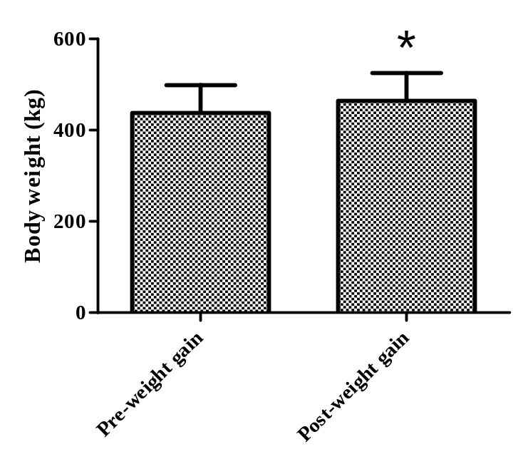

Figure 5c.1: Mean ± s.d. body weight at baseline and following administration of a diet providing 2 × DE_{m} per day for 8 weeks to horses with chronic insulin resistance (n = 6).

weight gain ranged from 2 to 10%, with the lowest gain occurring in a horse that was on the diet for 8 weeks. Body condition score significantly increased over the treatment period (P = 0.006). Mean BCS was 6 ± 2 (range, 4 to 8.5) prior to diet intervention and increased to 8 ±1 (range, 7 to 9). Mean neck circumference significantly increased during the study (P < 0.001). Girth circumference increased by the end of the diet intervention and was significantly (P = 0.011) different when compared to baseline measurements. Rump fat thickness also increased significantly (P = 0.002) when horses were fed a weight gain diet, with mean values increasing from 1.85 ± 0.69 cm to 2.50 ± 0.86 cm. Mean neck-to-height ratios significantly increased with weight gain (P < 0.001). Weak correlations were detected between body weight and mean neck circumference (r = 0.22; P = 0.678) and rump fat thickness (r = 0.24; P = 0.643) following weight gain. Mean neck circumference measurements showed a strong correlation with rump fat thickness (r = 0.85; P = 0.031), BCS (r = 0.91; P = 0.013), and a weak correlation with girth circumference (r = 0.16; P = 0.770) following weight gain. Rump fat thickness was correlated with BCS (r = 0.62; P = 0.186) and girth circumference (r = -0.29; P = 0.573) after weight gain.
Blood glucose concentrations were higher during the IVGTT (P < 0.001) compared to the OGTT, and were higher prior to weight gain (P = 0.001). When AUCg data for the IVGTT were rank transformed (Figure 5c.2), significant treatment (P = 0.012), test (P < 0.001), and treatment × test effects (P = 0.049) were detected when comparing the IVGTT with the OGTT. This was a result of AUCg values being greater prior to weight gain, greater during the IVGTT, and the highest during the pre-weight gain IVGTT.
Baseline OGTT serum insulin concentrations did not differ after weight gain (P = 0.142; Figure 5c.3), but differed dependent on tests (P < 0.001; Table 5c.2), and a treatment × test effect was detected for the IVGTT (P = 0.038). Insulin concentrations were higher after weight gain and highest in the post-weight gain IVGTT. For the OGTT, baseline insulin concentrations did not differ significantly after weight gain, but AUCi differed between pre- and post-weight gain values (P = 0.003) and between the two tests (P = 0.024). Area under the insulin curve during the IVGTT significantly increased following weight gain (P = 0.001; Figure 5c.4). Insulin concentrations during the OGTT were significantly higher after weight-gain. Plasma GLP-1 concentrations did not show a treatment effect (P = 0.141), but did show a time effect within the OGTT (P = 0.023; Figure 5c.5 with the highest concentrations measured at 45 minutes compared to baseline.

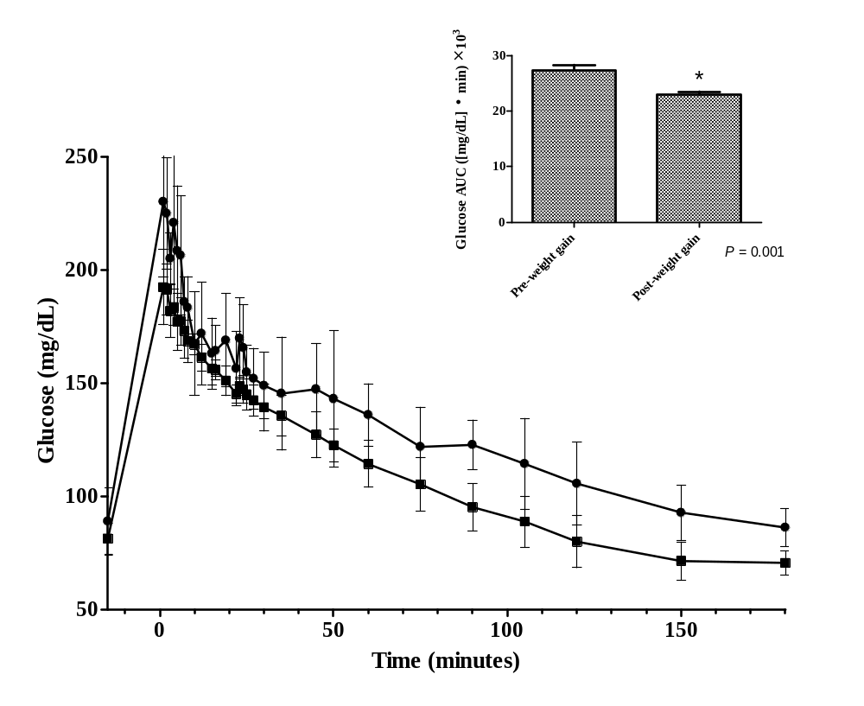
Figure 5c.2: Mean ± s.d. glucose concentrations during an IVGTT at baseline and following administration of a diet providing 2 × DE_{m} per day for 8 weeks to horses with chronic insulin resistance (n =6; pre-weight gain (•), post-weight gain (■). Inset: Mean ± s.d. area under the glucose curve.

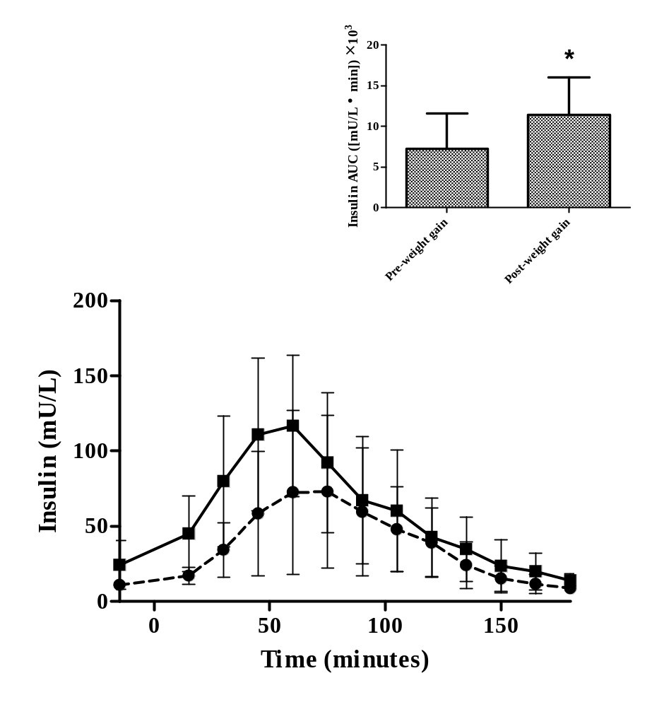
Figure 5c.3: Mean ± s.d. insulin concentrations during an OGTT at baseline and following administration of a diet providing 2 × DE_{m} per day for 8 weeks to horses with chronic insulin resistance (n =6; pre-weight gain (•), post-weight gain (■). Inset: Mean ± s.d. area under the insulin curve.

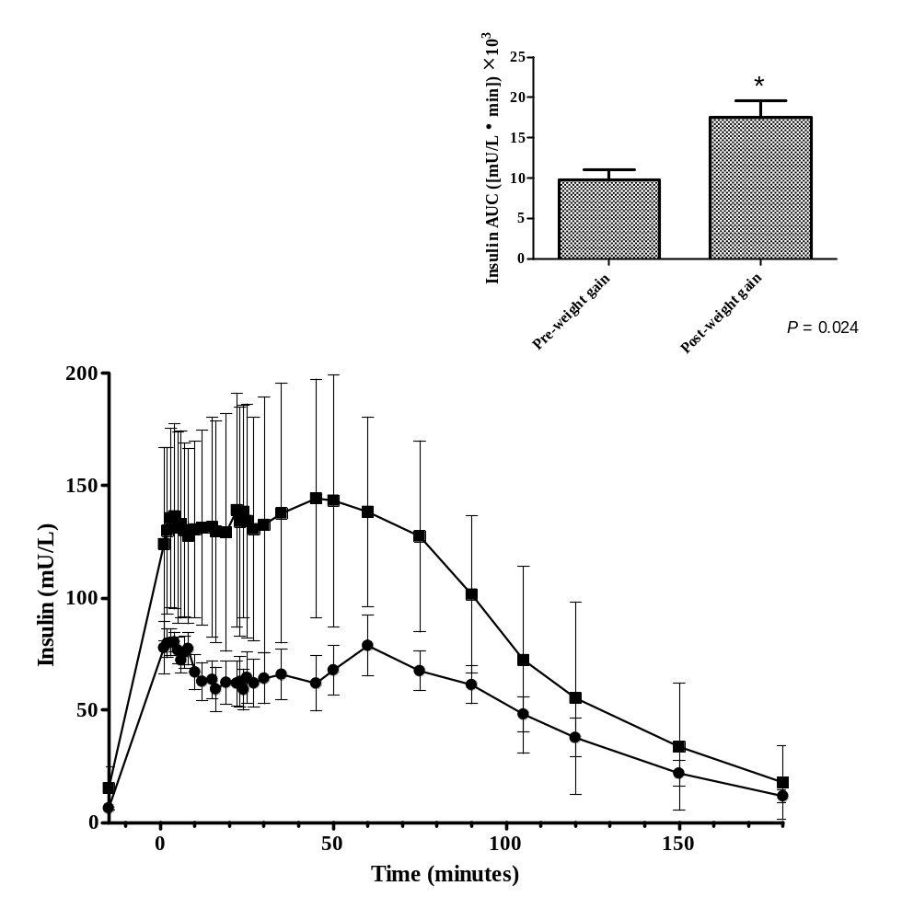
Figure 5c.4: Mean ± s.d. insulin concentrations during an IVGTT at baseline and following administration of a diet providing 2 × DE_{m} per day for 8 weeks to horses with chronic insulin resistance (n =6; pre-weight gain (•), post-weight gain (■). Inset: Mean ± s.d. area under the insulin curve.

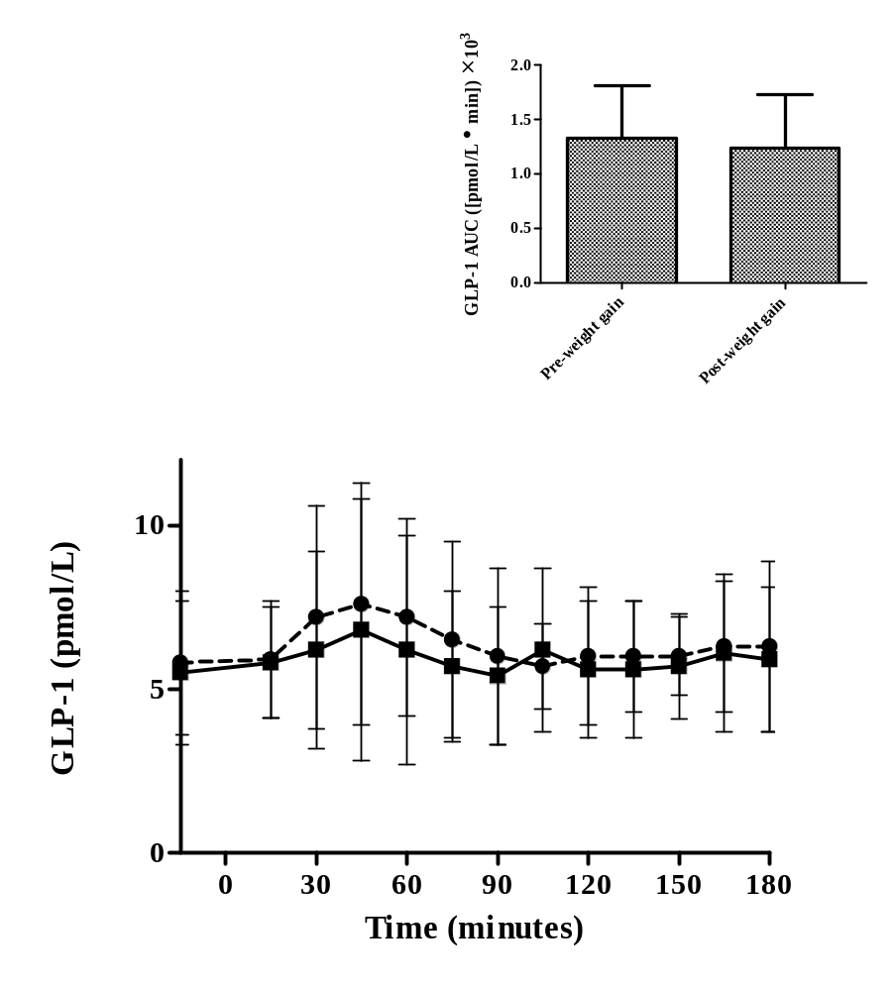
Figure 5c.5: Mean ± s.d. GLP-1 concentrations during an OGTT at baseline and following administration of a diet providing 2 × DE_{m} per day for 8 weeks to horses with chronic insulin resistance (n =6; pre-weight gain (•), post-weight gain (■). Inset: Mean ± s.d. area under the GLP-1 curve.

Table 5c.2: Mean ± s.d. blood measures for 6 horses with chronic insulin resistance that received a diet providing 2 × DE_{m} per day for 8 weeks.
Variable | Treatment |  | Treatment  P
Variable | Pre (0 wks) Post (8 wks) |  | Treatment  P
Mean baseline  OGTT glucose (mg/dL) | 86.77 ± 6.80 | 81.30 ± 8.09 | 0.261
AUCg  ([mg/dL] · min) × 10³ | 16.93 ± 7.35 | 18.71 ± 1.63 | 0.012
Mean baseline  OGTT insulin (mU/L) | 10.88 ± 3.78 | 24.18 ± 16.16 | 0.142
AUCi  ([mU/L] · min) × 10³ | 7.26 ± 4.30 | 11.37 ± 4.63 | 0.003
GLP-1  (pmol/L) | 0 min – 5.8 ± 2.2 | 0 min – 5.5 ± 2.2 | 0.836
GLP-1  (pmol/L) | 45 min – 7.6 ± 3.7 | 45 min – 6.8 ± 4.0 | 0.836
AUC GLP-1  ([pmol/L] · min) × 10³ | 1.33 ± 0.48 | 1.24 ± 0.49 | 0.285
AUCg = area under the glucose curve; AUCi = area under the insulin curve;
GLP-1 = Glucagon-Like Peptide 1; OGTT = oral glucose tolerance test; P < 0.05

A weak correlation was detected between insulin and GLP-1 (r = 0.29; P = 0.583) and mean neck circumference (r = 0.34; P = 0.511) prior to weight gain, but there was a stronger correlation between insulin and girth circumference (r = 0.61; P = 0.200). Area under the GLP-1 curve showed a negative correlation with body weight before weight gain (r = -0.019; P = 0.972; Figure 5c.6) and a positive correlation following weight gain (r = 0.379; P = 0.459). However, the relationship between insulin and GLP-1 became negative following weight gain (r = -0.23; P = 0.660; Figure 5c.7).
Minimal model data analysis for IVGTT data detected a non-significant decrease in insulin sensitivity (P = 0.721; Figure 5c.8) in response to weight gain, as well as a non-significant increase in the disposition index (P = 0.665). However, a significant increase in the AIR_{g} was detected (P = 0.042) as a result of weight gain.

5c.4 Discussion
Provision of a diet containing 2 × DE_{m} for 8 weeks resulted in significant weight gain in 6 horses with chronic insulin resistance. Increase in weight gain was associated with increased OGTT and IVGTT AUCi values but not GLP-1 concentrations. However, weight gain was positively correlated with area under the GLP-1 curve and negatively correlated with AUCi during both the IVGTT and OGTT. Data from the mare that was removed from the weight gain diet after 4 weeks was included in the analysis with all other animals. This mare had gained an acceptable amount of weight in that time period (6% gain) for her data to be included with the other animals. This mare was removed from the study because laminitis developed and this problem subsided once she was removed from the diet. An earlier study performed to compare active GLP-1 concentrations between normal and insulin resistant horses did not detect a significant effect of metabolic status; however, the numbers were low (8 normal horses and 10 insulin-resistant horses) and horses underwent an OST versus the OGTT performed here.
Studies in other species have revealed varying findings with respect to GLP-1 concentrations and obesity.^{210,219} Some studies have shown an association between higher rates of basal fat oxidation, which is related to the state of obesity, and fasting GLP-1 concentrations²¹⁹⁻²²¹ and

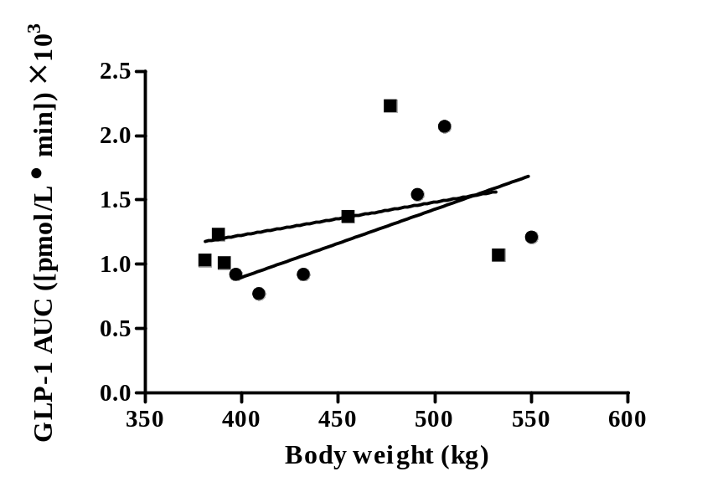
Figure 5c.6: Correlation plot of body weight against GLP-1 AUC for 6 horses pre- (•;
r = -0.019; P = 0.972) and post-weight gain (■; r = 0.379; P = 0.459).

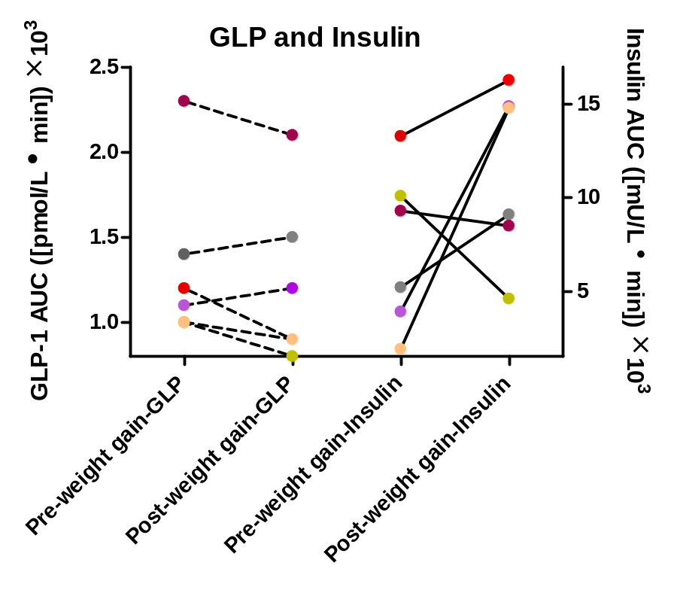

Figure 5c.7: Line plot showing the relationship between GLP-1 AUC and Insulin AUC for 6 horses with EMS prior to (r = 0.286; P = 0.583) and after weight gain (r = -0.231; P = 0.660).

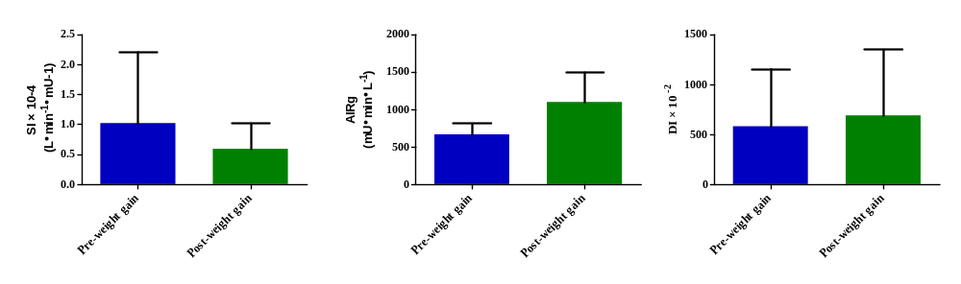
A
C
B

Figure 5c.8: Minimal model data analysis of IVGTT data pre- and post-weight gain for 6 horses with histories of EMS; A) Insulin sensitivity, B) acute insulin response to glucose, and C) disposition index.
others have reported reduced secretion in states of obesity, with improved secretion measured following weight loss.²¹⁰ This reported decrease in secretion associated with obesity has been suggested to be a result of L-cell responsiveness, presumably due to elevations in circulating free fatty acid concentrations.²¹⁰ However, in a study of type 2 diabetic and non-diabetic humans, free fatty acids did not appear to have an effect, but body mass index was negatively associated with GLP-1 secretion.²¹⁸
In the study reported here, body weight increased after feeding of a diet designed to provide 2 × DE_{m} for 8 weeks. This amount of digestible energy induced weight gain over a period of 16 weeks in horses, which resulted in an overall gain of 20%,⁴³¹ supporting its use. In horses, an association has been found between the presence and severity of a cresty neck and alterations in insulin sensitivity⁶ and that the mean neck circumference-to-wither height ratio can be used as an indicator of the severity of neck adiposity.¹³ It was determined that a neck-to-height ratio of ≥ 0.63 ± 0.1 is an indicator of a cresty neck score of ≥ 3, which indicates increased risk for pasture-associated laminitis.¹³ Horses in this study had mean neck-to-height ratio representative of a cresty neck score < 3 at the beginning of the study and a value representing a cresty neck score of ≥ 3 after weight gain.
Glucose and insulin concentrations were higher during the IVGTT when compared with the OGTT. This was expected because glucose is administered directly into the circulation resulting in a more rapid response by the pancreas; however, GLP-1 concentrations were not significantly different between pre- and post-weight gain in the study reported here during the OGTT. A negative relationship was also detected between AUCi for both tests and area under the GLP-1 curve and this was not expected, but is supported by findings in humans with normal glucose tolerance or type 2 diabetes.²¹⁸ Toft-Nielsen et al.²¹⁸ concluded that this occurs as a result of a negative feedback effect of insulin on GLP-1 secretion.
The study diet was not analyzed for fat content or fermentability of fiber. This may have influenced results of GLP-1 concentrations because it has been shown that an acute dose of fat resulted in a GLP-1 peak by 60 minutes and concentrations remained elevated throughout a 360 minute period.⁴¹⁴ It was also shown that GLP-1 increases following a carbohydrate bolus, resulting in a peak at 60 minutes, which is similar to the findings in this study, and decreased until peaking again at 360 minutes.⁴¹⁴ Unfortunately, the study here was only extended to 180 minutes, so it is possible that we may have detected a greater difference between pre- and post-weight gain if samples been collected for longer. In rats, administration of a high fat diet resulted in a significant decrease in GLP-1 concentrations when measured during an OGTT every ten days for 60 days.⁴¹⁵
Dietary fibers with different fermentability have also been shown to influence GLP-1 secretion. In a study of dogs consuming a high- or low-fermentable fiber diet for 14 days, it was determined that the consumption of high fermentable fiber induced a pronounced GLP-1 response to the OGTT.⁴¹⁸ An increase in maximal glucose uptake by the small intestine was also observed.⁴¹⁸ It was determined that the enhanced glucose uptake was most likely responsible for the increase in GLP-1 secretion.⁴¹⁸ A more recent study failed to show an effect of fiber type on post-prandial GLP-1 concentrations, but samples were collected after regular meals rather than a specific challenge.⁴¹⁹
Insulin resistance and obesity are components of EMS as well as metabolic syndrome (MetS) in humans, and higher concentrations of GLP-1 have been observed in humans with naturally occurring and experimentally induced insulin resistance.^{122,216,416,420} We hypothesized the gain in body weight would lower insulin sensitivity, and GLP-1 concentrations would increase as a result. We did not detect a change in GLP-1 concentrations following weight gain in horses with chronic IR. However, we did detect an increase in AUCi values, suggesting a decrease in insulin sensitivity. The negative relationship we detected between AUCi and area under the GLP-1 curve are consistent with results of another study.²¹⁸ It is also possible that our results reflect the diet being fed to induce weight gain or variability among assays used to measure GLP-1. The assay used in the study reported here measures active GLP-1 which is measured after treatment of plasma samples with DPP-IV inhibitor. However, there are assays available that measure total GLP-1 and this may explain differences among studies.
This study assessed the effects of weight gain on active GLP-1 secretion in horses with chronic insulin resistance. A significant effect was not detected here, which did not support our hypothesis, but future work should focus upon the effects of diet type on GLP-1 concentrations. It would also be appropriate to evaluate horses after a longer duration of obesity. More animals should be included in future studies and insulin resistant horses should be compared with healthy animals as obesity is induced.
Chapter 6
Identification and assessment of high-molecular weight adiponectin in horses

6.1 Introduction
Adiponectin is a 247 amino acid adipocytokine that was discovered by multiple laboratories in the 1990s.¹⁶⁸⁻¹⁷² This protein forms multimers within adipocytes and four species are identified in human plasma.⁴³² These include a trimer composed of three 30 kDa monomers that is approximately 90 kDa in size and referred to as low-molecular weight adiponectin (LMW), an albumin-binding trimer that is approximately 158 kDa, a hexamer that is 180 kDa referred to as mid-molecular weight (MMW) adiponectin, and a high-molecular weight (HMW) form that is generally comprised of 12 to 18 monomers (360 to 540 kDa).^{432,433} Adiponectin has been identified and measured in several other species, including horses.^{86,433,434}
Of normal circulating plasma proteins, adiponectin accounts for approximately 0.01% in mammalian species and normal concentrations of total adiponectin appear to vary among species.^{433,434} Ranges include 5 to 30 µg/mL for humans, 9 to 17.4 µg/mL for mice, 3 to 12 µg/mL in the arctic blue fox, 4 to 10 µg/mL in chickens, and 4.34 ± 0.12 µg/mL have been measured for weanlings and 2.69 ± 0.17 µg/mL for mature mares.⁴³³⁻⁴³⁵ In dogs, a lower range of 0.85 to 1.5 µg/mL has been detected, with a mean concentrations of 1.22 µg/mL.⁴³³ It has been determined that the HMW adiponectin is the biologically active form and is capable of suppressing serum glucose concentrations in a dose-dependent manner, as well as improving insulin sensitivity.⁴³⁶ The ratio of HMW to LMW is used as a determinant of insulin sensitivity.⁴³⁶
Despite the fact that adiponectin is primarily secreted by adipose tissues, concentrations of this adipokine are inversely proportional to the level of adiposity in both humans and horses, with a location association in humans indicating that larger visceral fat depots result in lower circulating concentrations.^{118,434} Obesity represents a chronic state of inflammation and hypoadiponectinemia is observed in patients with visceral obesity and IR.^{98,108,174} This observation is especially important in circumstances of excess visceral adipose tissue, as inflammation reduces adiponectin secretion.^{192,437} Adiponectin possesses anti-inflammatory properties, so lower production leads to increased secretion of other inflammatory cytokines such as tumor necrosis factor-α (TNF- α).^{192,437}
Aberrations in adiponectin have been associated with states of obesity, type 2 diabetes, and metabolic syndrome in humans.⁴³⁸ A genetic heritability of 55.1% has also been detected in a population of humans in which the prevalence of metabolic syndrome was 29.3% in women and 37.1% in men.⁴³⁹ Since obesity, insulin resistance, and circulating adiponectin concentrations are associated in humans, we hypothesized that horses with Equine Metabolic Syndrome (EMS) would have lower circulating HMW adiponectin concentrations when compared to healthy horses.

6.2 Materials and Methods
Horses – Nine healthy horses with normal body condition scores and resting insulin concentrations and 16 horses diagnosed with EMS were included in the study. Equine Metabolic Syndrome was defined by general and/or regional adiposity, hyperinsulinemia, and abnormal intravenous glucose tolerance test results (SI values < 1.0 L·min⁻¹·mU⁻¹). Breeds of EMS horses included Tennessee Walking Horse (TWH) or TWH cross (n = 2), Morgan (n = 2), Arabian or Arabian cross (n = 5), Paso Fino (n = 3), Missouri Fox Trotter (n = 1), Azteca (n = 1), and Saddlehorse Breeds (n = 2). Healthy horses were Quarter Horse or TWH crosses (n = 9).
Samples – Serum samples were collected from animals under fed conditions. All horses were being maintained on a hay only (EMS), or hay and grass diet (healthy). Samples were collected via jugular catheter into blood tubes containing no preservative or anti-coagulant. Samples were allowed to clot at room temperature for a minimum of 20 minutes and serum was collected via high-speed centrifugation (3,500 to 4,000 × g). Serum was stored at -80° C until further analysis.
Morphometric measurements – Morphometric measurements included body weight, body condition score, girth circumference, and neck circumference which was obtained by dividing the total neck length (x) from the poll to the cranial aspect of the withers into quarters and obtaining circumference measurements at 0.25x, 0.5x, and 0.75x. Body condition scores were assessed for healthy horses.
Dialysis procedure – Dialysis buffer was made by adding 0.01 mol sodium phosphate dibasic (Na₂HPO₄), 0.16 mol sodium chloride (NaCl), and 0.01 mmol ethylenediaminetetraacetic acid (EDTA) into a total volume of 2L distilled water. Samples were added to dialysis cassettes in a volume of 50 µL and floated in dialysis solution at 4° C overnight (approximately 12 h) with a stir bar to maintain uniform temperature. Samples were removed from dialysis cassettes by attaching a gel loading tip to a 1 mL syringe and withdrawing the dialysate. Recovered volume was recorded and total sample volume was brought to 500 µL to produce a 1:10 dilution of the original sample. Dialyzed samples were then further diluted to a total dilution of 1:500 prior to mixing with sample buffer and loading onto gels.
Western blot procedure – Three procedures were used in which samples were mixed with three different sample buffers according to overall running conditions. These included sodium dodecyl sulfate (SDS; Procedure 1), Laemmli (Procedure 2), and Tris-HCl (Procedure 3) for reducing, reducing and denaturing, and native gel conditions, respectively. Transfer buffer was the same for all procedures (Tris/glycine buffer plus 800 mL methanol into a total volume of 4L). All samples were thawed on ice before use in the system. Positive and negative standards to assess specificity of antibodies included recombinant human adiponectin, equine IgG, equine albumin, and human apolipoprotein B. Gel electrophoresis and blotting were performed as described in Appendix I with a primary anti-adiponectin antibody produced in rabbits^{p} and a peroxidase labeled secondary antibody against rabbit IgG produced in goats^{q}.

6.3 Results
Healthy horses had body condition scores ranging from 4 to 6/9 and all EMS horses had BCS of ≥ 7/9. Mean resting insulin concentrations collected under fed conditions were 2.5 ± 1.3 mU/L for healthy horses and 82.5 ± 66.0 mU/L for insulin resistant horses.
Procedure 1 – Under reducing conditions, HMW adiponectin band density showed wide variability among horses classified in both groups. However, horses with EMS subjectively appeared to have lower density HMW adiponectin bands when compared to healthy horses. Multiple bands were visible with this method and were located at 50 to 75 kDa, 100 kDa, 150 kDa, and > 250 kDa (Figure 6.1 a and b). Recombinant adiponectin was used as a positive control and showed similarity in banding pattern compared to samples. Negative standards did not show any visible bands in response to the antibodies (Figure 6.2).
Procedure 2 – When samples were reduced and denatured, band pattern changed to show recombinant adiponectin as a single band of ~37 kDa and horse samples produced three main bands at ~37 kDa, 37 to 50 kDa, and 50 to 75 kDa. Differences in band density were not evident when healthy and EMS horses were compared (Figure 6.3).
Procedure 3 – Bands differed in appearance with the native system when compared to the first two procedures in which SDS was included. Band density differed between groups with EMS horses having lower density HMW adiponectin bands. Three main bands were visible for recombinant adiponectin with this procedure and were between 140 and 232 kDa, 440 to 669 kDa, and > 669 kDa. Horse samples showed two bands located at 440 to 669 kDa and > 669 kDa (Figure 6.4). These bands were presumed to be MMW and HMW adiponectin, respectively.

6.4 Discussion
Of the three different procedures assessed, only the third procedure represented a true native protein protocol as no reducing agents or denaturing steps were included. Sodium dodecyl sulfate is a detergent that functions by binding proteins in a sample, resulting in linearization of the folded protein by disrupting the secondary structure and altering charge.^{440,441} In the case of adiponectin, it results in disruption of the disulfide bonds that are involved in the tertiary structure of the protein and HMW form.^{440,441} The sulfate groups within SDS are negatively charged and by binding to lipophilic portions of a protein, it results in an overall negative charge.⁴⁴¹ By altering the structure of proteins to a more linearized form and producing an ultimate negative charge, proteins that are loaded on a polyacrylamide gel will migrate in

EMS Horses (1-8)
IgG
Normal
Adiponectin

HMW
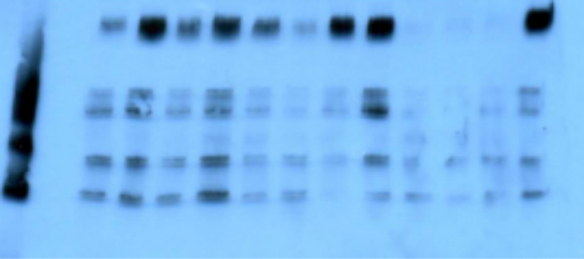
100 kDa
150 kDa
75 kDa
50 kDa
250 kDa
Figure 6.1a: Procedure 1 – High-molecular weight adiponectin band density of 4 healthy horses and 8 EMS horses (1 to 8 out of 16).

IgG
Adiponectin
EMS Horses (9-16)
HMW
Normal
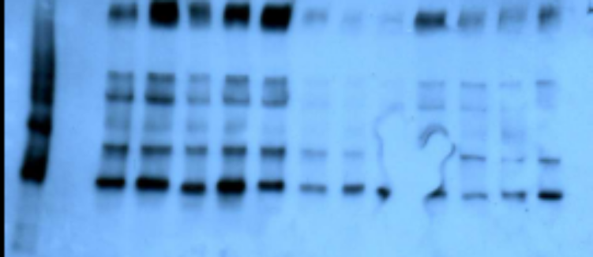
50 kDa
75 kDa
100 kDa
150 kDa
250 kDa

Figure 6.1b: Procedure 1 – High-molecular weight adiponectin band density of 4 healthy horses (same in Figure 6.1a) and 8 EMS horses (9 to 16 out of 16).

Apolipoprotein B
Adiponectin
Albumin
IgG
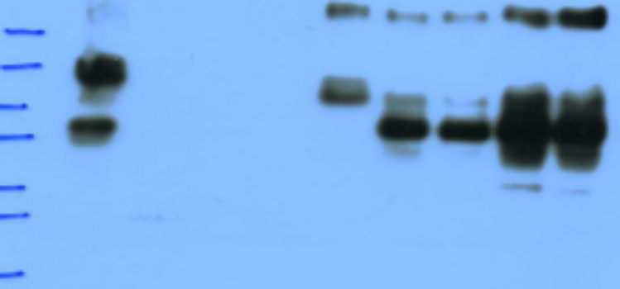
20 kDa
50 kDa
37 kDa
75 kDa
100 kDa
150 kDa
250 kDa

Figure 6.2: Positive (human recombinant adiponectin) and negative (human apolipoprotein b, equine IgG, and equine albumin) standards used to assess specificity of antibodies.

Adiponectin
EMS Horses (1-6)
250 kDa
Normal
IgG
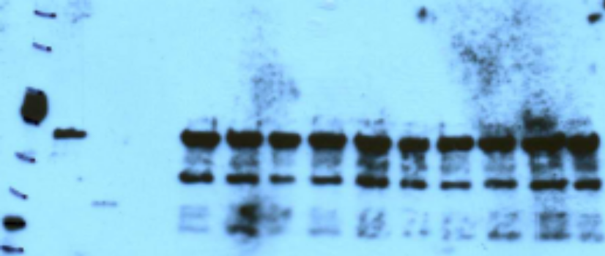
20 kDa
25 kDa
37 kDa
50 kDa
75 kDa
100 kDa
150 kDa

Figure 6.3: Procedure 2 – High-molecular weight adiponectin band density of 4 healthy horses and 6 EMS horses under reducing and denaturing conditions.

Apolipoprotein B
Albumin
EMS Horses (2, 5, 7& 11)
Normal
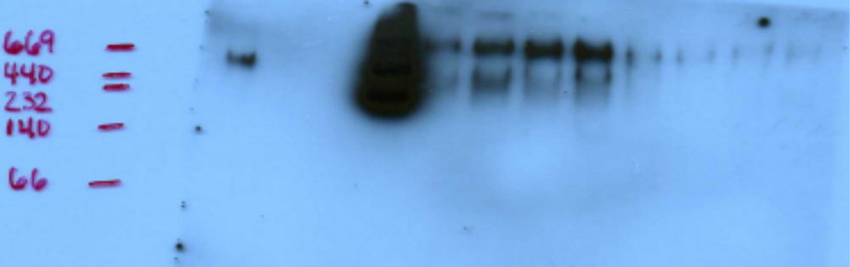
MMW
HMW
66 kDa
140 kDa
440kDa
232 kDa
669 kDa

Figure 6.4: Procedure 3 – High-molecular weight adiponectin band density of 4 healthy horses and 4 EMS horses under native conditions.
relation to their molecular size, rather than charge, therefore resulting in band patterns reflecting the different sizes of individual proteins or the different parts of a multimeric protein.
Use of a sample buffer that included 2-mercaptoethanol in Procedure 2 and boiling for 10 minutes reduced and denatured proteins. Heat denatures proteins by disrupting the weak interactions that hold proteins together, including hydrogen bonds and hydrophobic interactions, and this affects three dimensional structure.⁸² The secondary structure of the protein is no longer in place after denaturation, so only the primary structure is left, which is comprised of the amino acid sequence.⁸² When proteins in serum samples were exposed to SDS, 2-mercaptoethanol, and heat, the band pattern of the protein changed to bands with smaller molecular weights than native samples. This was also a different band pattern when compared to the samples that were exposed to SDS alone (Procedure 1). The recombinant adiponectin showed a single band at 37 kDa and the equine samples showed the same band and 2 slightly higher bands at approximately 50 and 50 to 75 kDa, which most likely represent dimer forms. It is possible that the temperature of the water was not high enough to fully dissociate the oligomers of adiponectin. Chicken adiponectin completely dissociates at 100° C, whereas boiling at 70° C does not have the same effect, and this may explain the findings in the study here.⁴³⁵ It was concluded that adiponectin will undergo incomplete dissociation resulting in multiple bands under certain circumstances. The fact that the HMW isoform appears to dissociate in the presence of reducing agents suggests that disulfide bonds are involved. Dimer forms may be held together by non-covalent bonds since heat is capable of dissociating them.
In the native procedure, proteins migrated within the gel based on molecular weight and electrical charge. The native conformation was important for the purposes of this work because the HMW form is the most biologically active.⁴³⁵ Circulating levels of HMW, rather than total adiponectin, are inversely related to the incidence of type 2 diabetes and insulin resistance, and selective down-regulation of the HMW isoform is associated with hyperinsulinemia in humans.⁴³⁵ Two bands were seen under native conditions. These may represent two HMW forms because multimers can form from 12 monomers to >18.⁴³⁵ Chicken HMW adiponectin is >669 kDa, but can also occur as oligomer forms with 242 kDa and 330 kDa bands.⁴³⁵ Alternatively, the second band reported here represented MMW adiponectin.
There were similarities in band pattern identified in the work reported here when compared to other mammalian species, however some discrepancies were noted and these could be a species differences. Currently no work had been performed to evaluate the native distribution of HMW adiponectin in the horse. It has been established in humans that different environmental factors, such as glucose concentration affect post-translational modification of adiponectin.⁴³⁵ Differences among animal species are thought to be a result of variation in the amino-terminal variable region which contains the cysteine residues involved in the formation of the different multimer forms via the formation of disulfide bonds.⁴⁴⁰ It has been established that mice have one HMW species whereas multiple HMW species have been detected in humans.⁴⁴⁰ In Procedures 1 or 3, no bands representing the monomer form of adiponectin were evident. This is similar to findings in human and mouse samples, because under non-reducing and heat-denaturing conditions, adiponectin monomers were not detected.⁴⁴² It was concluded that trimer and monomer forms are less abundant in serum samples under non-reducing and heat-denaturing conditions and may not be abundant enough concentrations to be detected with some procedures.⁴⁴²
Band densities for HMW adiponectin bands appeared to differ between healthy horses and those with EMS, but there was considerable individual variability. This may reflect differences in the ability of multimerization of adiponectin into the HMW isoform or differences in adipose distribution of individual animals. In chickens, it has been determined that abdominal fat pad mass is inversely proportional to adiponectin concentrations in plasma.⁴³⁵ In horses, a clinical sign of EMS is the deposition of adipose tissue along the nuchal ligament of the crest as well as above the tail-head and along the ventral aspect of the abdomen. The amount of adiposity within the crest of the neck has also been associated with the level of insulin resistance and risk of developing laminitis.^{13,373} Recent findings have determined that the nuchal adipose tissue is a more biologically active depot for the production of pro-inflammatory cytokines.⁴⁴³ Increased gene expression of interleukin-6 (IL-6) and interleukin-1β (IL-1 β) have been detected in nuchal adipose tissue when compared to omental adipose, which differs from the situation in humans.⁴⁴³ Adiponectin has an anti-inflammatory role so inflammation may become more pronounced when concentrations decrease, and this may be associated with insulin resistance.⁴⁴⁴
By showing that many horses with EMS have lower HMW adiponectin band densities, we may be able to identify animals with insulin resistance. In humans, differences in multimerization potential of adiponectin have been associated with the diabetic phenotype and hypoadiponectinemia.⁴⁴⁰ Eight mutations of human adiponectin have been reported, but four main mutations have been associated with the diabetic and hypoadiponectinemic phenotype.⁴⁴⁰ When these mutants are present, adiponectin is secreted only as a trimer, or as MMW multimers and trimers that are unable to form stable HMW multimers.⁴⁴⁰ Mutants are not only defective in the synthesis of adiponectin multimers, but also its secretion.⁴⁴⁵ Multimers are formed exclusively within the adipocyte and are stable, preventing interconversion to other forms once in the circulation.⁴⁴⁵ More recently, a disulfide-bond A oxidoreductase-like protein was found to have a regulatory role in the formation of different adiponectin multimers and is diminished in fat tissues with obesity.⁴⁴⁵ To date, the genetic component of adiponectin formation has not been investigated in horses, so it is possible that similar mutations exist in this species. These mutations might predispose animals to the development of insulin resistance and, as a consequence, decreased concentrations of HMW adiponectin.
This study provides preliminary evidence to support the hypothesis that HMW adiponectin band density is lower in horses with EMS, when compared to healthy counterparts. Our findings add to the work of determining different metabolic aspects that play a role in the development of EMS and laminitis. Differences in HMW adiponectin concentrations might explain why some horses are overweight but not insulin resistant.

Chapter 7
Conclusions and Future Directions

Equine Metabolic Syndrome (EMS) resembles human metabolic syndrome, except that horses develop laminitis instead of atherosclerosis or cardiovascular disease.⁴⁴⁶ The human metabolic syndrome is still being investigated and scientific advances are needed to truly understand its connection with type 2 diabetes and cardiovascular disease. However, some of the advances made in human medicine can be applied to horses as both syndromes include obesity, insulin resistance, and dyslipidemia.⁴⁴⁶ Results of studies presented in this dissertation have advanced our knowledge of EMS in some areas, while also revealing new areas for study.
When horses were treated with a combined chromium and magnesium supplement to assess the effects of body weight, adiposity, insulin sensitivity, and glucose dynamics, no improvements were noted following its administration for 16 weeks. It is possible that bioavailability of the compounds was poor, as pharmacokinetics and pharmacodynamics of chromium and magnesium have not been assessed in horses. The 2 oz. dose administered to horses was considered to be the loading dose by the manufacturer and is recommended as a therapeutic dose, whereas 1 oz. of the supplement is considered to be a maintenance dose. Horses in our studies were severe chronic cases of EMS and it is possible that a longer duration of treatment was needed or components included in the supplement were ineffective in severe cases. Horses were not exercised or placed on a weight loss diet, so this too may have had an effect on the results observed. Additional studies are required to determine the bioavailability of this supplement and assess management interventions because most owners would be inducing weight loss by feed restriction and exercise as the same time.
The administration of levothyroxine sodium to horses suffering from insulin resistance and obesity resulted in similar findings to earlier studies performed by our research group.^{11,249} Administration of 48 mg levothyroxine per day for 24 weeks resulted in mild decreases in body weight, but increasing the dosage to 72 mg/d an additional 12 weeks induced a significant decrease in body weight when compared to baseline values. Over the duration of the study there was also a significant decrease in mean neck circumference, which might reflect an improvement in insulin sensitivity because neck adiposity and circumference are inversely related to insulin sensitivity in horses. These measures can serve as indicators of the risk of developing insulin resistance, and neck circumference-to-height ratio is a predictor for pasture-associated laminitis.^{6,13} The nuchal fat has also been shown to actively secrete inflammatory cytokines which have been associated with aberrations in insulin sensitivity.⁴⁴³ However, in the study reported here, we did not see a significant improvement in insulin sensitivity following administration of levothyroxine for 36 weeks. It is possible that a longer duration of treatment or using the higher dosage throughout the study period would have resulted in greater improvements. The initial dosage of 48 mg/d was chosen on the basis of our previous results, but these studies were performed in healthy horses. Our results indicate that a higher dosage of levothyroxine is appropriate for horses with severe chronic EMS.
Metformin hydrochloride has been used as a therapy for diabetes since the 1950s.⁴⁰¹⁻⁴⁰³ Its primary function is to inhibit hepatic gluconeogenesis but the drug also plays a role in enhancing fatty acid oxidation in the muscle and liver and enhances the intracellular activity of the insulin receptor pathway.^{287,402} Studies of metformin in horses with insulin resistance have shown that the drug has positive effects, but they appear variable and short-lived.²⁷⁶ We administered metformin at two dosages (15 mg/kg q 12h and 30 mg/kg q 12h) to our obese, insulin-resistant horses and observed improvements in insulin and glucose concentrations across the study period. Interestingly, we did not see expected rebounds in values when metformin was discontinued. Overall glucose and insulin values decreased as an effect of time and it is difficult to determine if this resulted from change in season or unrestricted access to the outdoors and exercise after having been confined for over a year. Further work is therefore required to determine whether effects were due to treatment or the other confounders mentioned. Since our study was performed, it has been shown that metformin has poor oral bioavailability in horses.²⁸³ This drug warrants further examination because generic metformin is relatively inexpensive and administration with a small amount of oats was accepted by the horses in the study performed here.
Glucagon-like peptide 1 is an incretin hormone secreted by the small intestine in response to oral glucose in a dose dependent manner.²²² Aberrations in secretion and sensitivity of GLP-1 following oral glucose challenge tests have been identified in medical conditions involving insulin resistance.^{217,411,412} We hypothesized that insulin-resistant horses would differ in their GLP-1 response to an oral glucose tolerance test when compared to horses with normal insulin sensitivity. We were unable to detect a significant difference between groups although insulin-resistant horses generally showed higher concentrations, as visualized with a scatterplot, but there was obvious variability between and within groups. The number of horses included in this study was small, so more horses should be included in the future to increase power. We also evaluated the effects of weight gain another study to determine if it had an effect on GLP-1 concentrations; we expected that obesity would increase the severity of insulin resistance. For the 6 horses used in this study, we were unable to detect a significant difference after weight gain, and this may be explained by the modest amount of weight gained, which was lower than that observed in a another weight-gain study with Arabian geldings.⁴³¹ Further studies are required to examine more animals and the effects of greater weight gain. A model for experimentally induced insulin resistance could also be used to determine differences between insulin-sensitive and insulin-resistant animals.
Adiponectin is an important circulating marker for insulin resistance. This measure can identify individuals at risk for developing type 2 diabetes because low percentages of HMW adiponectin are detected in type 2 diabetics, when compared to total adiponectin.⁴⁴⁷ The concentration of HMW adiponectin relative to total adiponectin is referred to as the S_{A} index and is used as a marker for diabetes because it is tightly correlated with glucose intolerance and the phenotypes of metabolic syndrome.⁴⁴⁷ We attempted to show that horses with insulin resistance have low concentrations of circulating HMW adiponectin compared to normal controls, as represented by band density during western blotting procedures. More work is needed in this area to obtain consistency in band appearance, but our preliminary results indicate that horses with insulin resistance have lower concentrations of HMW adiponectin. Interestingly, there is obvious intra-group variability as some normal animals show band density similar to insulin-resistant horses and vice versa. In the future, we must try to determine the cause of these differences within groups.
The work performed here with a genetically diverse population of horses suffering from EMS has introduced more questions than answers. The physical characteristics of EMS were perhaps the only component that was consistent within the 16 horses included in our studies. We observed that responses to pharmacologic interventions varied among horses and group responses differed from earlier studies, although this was attributed to the chronic disease state of horses included our studies.
The primary goal of this work was to examine strategies for diagnosing and managing EMS in horses. After completing this work, it can still be concluded that diagnosis is most consistent when methods currently used in veterinary practice are applied, including the frequently-sampled intravenous glucose tolerance test (FSIGTT) and combined glucose-insulin tolerance test (CGIT). However, our research group was able to establish a simple diagnostic test that we refer to as the oral sugar test (OST). Horses with insulin resistance showed a more pronounced response to an oral sugar challenge when compared to normal animals. This test shows great promise because it is less invasive than the CGIT or FSIGT, and is easier to perform by the veterinarian or researcher; the corn syrup used in the test is readily available. From a clinical standpoint, an owner can administer the syrup to their horse while it remains in its normal environment, which should reduce stress and minimize confounding of results. The veterinarian can arrive at a pre-established time to collect a blood sample.
The goal of identifying easily measured blood markers proved to be more challenging than anticipated. Adiponectin is a difficult protein to work with because it forms multimers in circulation (HMW adiponectin) and this is the form of interest. Results obtained by western blotting techniques were very difficult to obtain consistently. It is possible that the protein would be better measured prior to freezing or it may degrade over time. Currently, there is no easy method to measure equine adiponectin, although a human HMW adiponectin ELISA has recently been validated for use with equine serum.⁴⁴⁸ It must also be recognized that ELISAs are expensive and the cost of performing a western blot is considerably cheaper.
Glucagon-like peptide 1 can now be measured in equine plasma using an ELISA validated by our research group, but significant differences have not been detected between normal and insulin-resistant animals. This may be a result of the low number of animals studied to date, so more work is required in the future to truly conclude if differences are detectable between these groups of animals.
Current management practices for horses with EMS include weight loss by dietary restriction in conjunction with exercise, along with restricted grazing or complete prohibition of grazing. Induction of weight loss has been shown to result in improvements in insulin sensitivity.¹¹ In more severe cases, pharmacologic intervention is undertaken and this has included levothyroxine sodium, metformin, and herbal supplements in the past. To date, levothyroxine and metformin are the only compounds with supportive scientific evidence of efficacy. However, as we saw with our population of EMS horses, results were variable. This further supports the notion that EMS is not a “black and white” disorder, so one method does not work for all. The best results we obtained were with the administration of levothyroxine, but it was still the case that some horses responded better than others. This suggests that there are different levels of severity of this disorder and it must be managed on an individual basis.
Interestingly, we discovered that an acute re-introduction to pasture did not adversely affect the health of insulin-resistant horses. Insulin concentrations decreased over time, and animals lost weight, presumably due to increased exercise. No lameness related to grazing was identified, and some horses used in these studies had histories of laminitis related to grazing. In contrast, we observed that 2 of 6 horses developed laminitis (with a third showing equivocal signs) while undergoing weight gain via overfeeding. It was not clear whether this was a result of the amount of grain fed, presence of grain in the diet, or the combination of grain and pasture grass. This point again reinforces how responses are very variable among horses, so these points must be taken into account when attempting therapy and management.
As the results of the studies discussed here indicate, EMS is not an easy disorder to understand. The work performed here has introduced more questions than answers, so more studies are required to elucidate the causes and treatments for this syndrome in horses. Ongoing genetic studies may reveal mechanisms and targets for therapies so that we may one day identify animals at risk for developing laminitis prior to its occurrence.
List of References

1. Johnson PJ, Messer NT, Slight SH, et al. Endocrinopathic laminitis in the horse. Clin Tech Equine Pract 2004;3:45-56.
2. Harris P, Bailey SR, Elliott J, et al. Countermeasures for pasture-associated laminitis in ponies and horses. Innovations in companion animal nutrition and Countermeasures to laminitis Proceedings of the WALTHAM International Nutritional Sciences Symposia, Washington DC, USA, 14-18 September 2005 2006;2114S-2121S.
3. Bailey SR, Marr CM, Elliott J. Current research and theories on the pathogenesis of acute laminitis in the horse. Vet J 2004;167:129-142.
4. Johnson PJ, Messer NT, Ganjam VK. Cushing's syndromes, insulin resistance and endocrinopathic laminitis. Equine Vet J 2004;36:194-198.
5. Henneke DR, Potter GD, Kreider JL, et al. Relationship between condition score, physical measurements and body fat percentage in mares. Equine Vet J 1983;15:371-372.
6. Frank N, Elliott SB, Brandt LE, et al. Physical characteristics, blood hormone concentrations, and plasma lipid concentrations in obese horses with insulin resistance. J Am Vet Assoc 2006;228:1383-1390.
7. Kearns CF, McKeever KH, Abe T. Overview of horse body composition and muscle architecture: implications for performance. Vet J 2002;164:224-234.
8. Kearns CF, McKeever KH, Kumagai K, et al. Fat-free mass is related to one-mile race performance in elite standardbred horses. Vet J 2002;163:260-266.
9. Henneke DR, Potter GD, Kreider JL, et al. Relationship between condition score, physical measurements and body-fat percentage in mares. Equine Vet J 1983;15:371-372.
10. Donaldson MT, McFarlane D, Jorgensen AJR, et al. Correlation between plasma alpha-melanocyte-stimulating hormone concentration and body mass index in healthy horses. Am J Vet Res 2004;65:1469-1473.
11. Frank N, Elliott SB, Boston RC. Effects of long-term oral administration of levothyroxine sodium on glucose dynamics in healthy adult horses. Am J Vet Res 2008;69:76-81.
12. Carr MC, Brunzell JD. Abdominal obesity and dyslipidemia in the metabolic syndrome: importance of type 2 diabetes and familial combined hyperlipidemia in coronary artery disease risk. J Clin Endocr Metab 2004;89:2601-2607.
13. Carter RA, Geor RJ, Staniar WB, et al. Apparent adiposity assessed by standardised scoring systems and morphometric measurements in horses and ponies. Vet J 2009;179:204-210.
14. Rijnen K, van der Kolk JH. Determination of reference range values indicative of glucose metabolism and insulin resistance by use of glucose clamp techniques in horses and ponies. Am J Vet Res 2003;64:1260-1264.
15. Treiber KH, Kronfeld DS, Geor RJ. Insulin resistance in equids: possible role in laminitis. J Nutr 2006;136:2094S-2098S.
16. Ralston SL. Insulin and glucose regulation. Vet Clin N Am - Equine 2002;18:295-304.
17. Chen Y-L, and Messina, E. Dilation of isolated skeletal muscle arterioles by insulin is endothelium dependent and nitric oxide mediated. Am J Physiol 1996;270:H2120-H2124.
18. He Y, MacLeod KM. Modulation of noradrenaline-induced vasoconstriction in isolated perfused mesenteric arterial beds from obese Zucker rats in the presence and absence of insulin. Ca J Physiol Pharmacol 2002;80:171-179.
19. Erdmann J, Kallabis B, Oppel U, et al. Development of hyperinsulinemia and insulin resistance during the early stage of weight gain. Am J Physiol-Endo Met 2008.
20. Ahren B, Thomaseth K, Pacini G. Reduced insulin clearance contributes to the increased insulin levels after administration of glucagon-like peptide 1 in mice. Diabetologia 2005;48:2140-2146.
21. Polonsky KS, Rubenstein AH. C-peptide as a measure of the secretion and hepatic extraction of insulin. Pitfalls and limitations. Diabetes 1984;33:486-494.
22. Wahren J, Ekberg K, Johansson J, et al. Role of c-peptide in human physiology. Am J Physiol - Endoc Metab 2000;278:F759-F768.
23. Meier JJ, Gallwitz B, Siepmann N, et al. The reduction in hepatic insulin clearance after oral glucose is not mediated by gastric inhibitory peptide (GIP). Regul Peptides 2003;113:95-100.
24. Sonksen PH, Tompkins CV, Srivastava MC, et al. A comparative study on the metabolism of human insulin and porcine proinsulin in man. Clin Sci Mol Med 1973;45:633-654.
25. Dorkhan M, Tripathy D, Malm G, et al. Independent measures of insulin secretion and insulin sensitivity during the same test: the glucagon-insulin tolerance test. J Intern Med 2008:1-10.
26. Murphy MJ, Hosking J, Metcalf BS, et al. Distribution of adiponectin, leptin, and metabolic correlates of insulin resistance: a longitudinal study in British children; 1: prepuberty (EarlyBird 15). Clin Chem 2008;54:1298-1306.
27. Tripathy D, Carlsson AL, Lehto M, et al. Insulin secretion and insulin sensitivity in diabetic subgroups: studies in the prediabetic and diabetic state. Diabetologia 2000;43:1476-1483.
28. Sowers JR, Frohlich ED. Insulin and insulin resistance: impact on blood pressure and cardiovascular disease. Med Clin North Am 2004;88:63-82.
29. Kronfeld DS, Treiber KH, Hess TM, et al. Insulin resistance in the horse: definition, detection, and dietetics. J Anim Sci 2005;83:E22-E31.
30. Stipanuk MH. Biochemical, Physiological, and Molecular Aspects of Human Nutrition. 2 ed. St., Louis, MO: Saunders El Sevier, 2006.
31. Kronfeld DS, Treiber KH, Geor RJ. Comparison of nonspecific indications and quantitative methods for the assessment of insulin resistance in horses and ponies. J Am Vet Med Assoc 2005;226:712-719.
32. Kaplan LA, Pesce, A.J., and Kazmierczak, S.C. Clinical Chemistry: Theory, Analysis, Correlation. S. Louis, MO: Mosby, 2003.
33. Treiber KH, Kronfeld DS, Hess TM, et al. Use of proxies and reference quintiles obtained from minimal model analysis for determination of insulin sensitivity and pancreatic beta-cell responsiveness in horses. Am J Vet Res 2005;66:2114-2121.
34. Jeffcott LB, Field JR, McLean JG, et al. Glucose tolerance and insulin sensitivity in ponies and Standardbred horses. Equine Vet J 1986;18:97-101.
35. Craig LB, Ke, R.W., and Kutteh, W.H. Increased prevalence of insulin resistance in women with a history of recurrent pregnancy loss. Fertil Steril 2002;78:487-490.
36. Johnson PJ. The equine metabolic syndrome: peripheral cushing's syndrome. Vet Clin N Am - Equine 2002;18:271-293.
37. Simonson DC. Hyperinsulinemia and its sequelae. Horm Metab Res Suppl 1990;22:17-25.
38. Kahn CR. Role of insulin receptors in insulin-resistant states. Metabolism 1980;29:455-466.
39. Laakso M. Insulin resistance and its impact on the approach to therapy of type 2 diabetes. Int J Clin Pract Suppl 2001:8-12.
40. Ganong WF. Review of Medical Physiology. 20 ed. Stamford, CT: McGraw-Hill, 2001.
41. Lamothe B, Baudry A, Desbois P, et al. Genetic engineering in mice: impact on insulin signalling and action. Biochem J 1998;335 ( Pt 2):193-204.
42. Zierath JR, Houseknecht KL, Gnudi L, et al. High-fat feeding impairs insulin-stimulated GLUT4 recruitment via an early insulin-signaling defect. Diabetes 1997;46:215-223.
43. Saltiel AR, Kahn CR. Insulin signalling and the regulation of glucose and lipid metabolism. Nature 2001;414:799-806.
44. Boden G, and Laakso, M. Lipids and glucose in type 2 diabetes: what is the cause and effect? Diabetes Care 2004;27:2253-2259.
45. Boden G. Pathogenesis of type 2 diabetes. Endocrin Metab Clin 2001;30:801-815.
46. Boden G. Role of fatty acids in the pathogenesis of insulin resistance and NIDDM (non-insulin dependent diabetes mellitus). Diabetes 1997;46:3-8.
47. Field JR, Jeffcott, L.B. Equine laminitis - another hypothesis for pathogenesis. Med Hypotheses 1989;30:203-210.
48. Schrauwen P. High-fat diet, muscular lipotoxicity and insulin resistance. Proc Nutr Soc 2007;66:33-41.
49. Bennett C, Reed, W.G., Peters, J.C., Abumrad, N.N., Sun, M., and Hill, J.O. Short-term effects of dietary-fat ingestion on energy expenditure and nutrient balance. Am J Clin Nutr 1992;55:1071-1077.
50. Schutz Y, Flatt JP, Jequier E. Failure of dietary fat intake to promote fat oxidation: a factor favoring the development of obesity. Am J Clin Nutr 1989;50:307-314.
51. Thomas CD, Peters JC, Reed GW, et al. Nutrient balance and energy expenditure during ad libitum feeding of high-fat and high-carbohydrate diets in humans. Am J Clin Nutr 1992;55:934-942.
52. Schrauwen P, van Marken Lichtenbelt WD, Saris WH, et al. Changes in fat oxidation in response to a high-fat diet. Am J Clin Nutr 1997;66:276-282.
53. Krebs M, and Roden, M. Nutrient-induced insulin resistance in human skeletal muscle. Curr Med Chem 2004;11:901-908.
54. Mingrone G, Greco AV, Capristo E, et al. L-carnitine improves glucose disposal in type 2 diabetic patients. J Am Coll Nutr 1999;18:77-82.
55. Rodriguez A, Catalan V, Gomez-Ambrosi J, et al. Visceral and subcutaneous adiposity: are both potential therapeutic targets for tackling and metabolic syndrome. Curr Pharm Design 2007;13:2169-2175.
56. Langin D. Adipose tissue lipolysis as a metabolic pathway to define pharmacological strategies against obesity and the metabolic syndrome. Pharmacol Res 2006;53:482-491.
57. Lafontan M, Berlan M. Do regional differences in adipocyte biology provide new pathophysiological insights? Trends Pharmacol Sci 2003;24:276-283.
58. Perdomo G, Renee Commerford S, Richard AT, et al. Increased b-oxidation in muscle cells enhances insulin-stimulated glucose metabolism and protects against fatty acid-induced insulin resistance despite intramyocellular lipid accumulation. J Biol Chem 2004;279:27177-27186.
59. Power RA, Hulver, M.W., Zhang, Y.J., Dubois, J., Marchand, R.M., Ilkayeva, O., Muoio, D.M., and Mynatt, R.L. Carnitine revisited: potential use as adjunctive treatment in diabetes. Diabetologia 2007;50:824-832.
60. Shulman GI. Cellular mechanisms of insulin resistance. J Clin Invest 2000;106:171-176.
61. Unger RH. Lipotoxic diseases. Annu Rev Med 2002;53:319-336.
62. Goodpaster BH, Wolf D. Skeletal muscle lipid accumulation in obesity, insulin resistance, and type 2 diabetes. Pediatric Diabetes 2004;5:219-226.
63. Lee JS, Pinnamaneni SK, Eo SJ, et al. Saturated, but not n-6 polyunsaturated, fatty acids induce insulin resistance: role of intramuscular accumulation of lipid metabolites. J Appl Physiol 2006;100:1467-1474.
64. Bertolani C, and Marra, F. The role of adipokines in liver fibrosis. Pathophysiology 2008;15:91-101.
65. Ye J. Role of insulin in the pathogenesis of free fatty acid - induced insulin resistance in skeletal muscle. Endocr Metab Immune Disord: Drug Targets 2007;7:65-74.
66. Helge JW, and Dela, F. Effect of training on muscle triacyglycerol and structural lipids: a relation to insulin sensitivity? Diabetes 2003;52:1881-1887.
67. Goodpaster BH, He, J., Watkins, S., and Kelley, D.E. Skeletal muscle lipid content and insulin resistance: evidence for a paradox in endurance-trained athletes. J Clin Endocr Metab 2001;86:5755-5761.
68. Han P, Yan Zhang, Y., Lu, Y., He, B., Zhang, W., and Xia, F. Effects of different free fatty acids on insulin resistance in rats. Hepatobiliary Pancreat Dis Int 2008;7:91-96.
69. Itani SI, Ruderman NB, Schmieder F, et al. Lipid-induced insulin resistance in human muscle is associated with changes in diacylglycerol, protein kinase C, and IkappaB-alpha. Diabetes 2002;51:2005-2011.
70. Itani SI, Zhou Q, Pories WJ, et al. Involvement of protein kinase C in human skeletal muscle insulin resistance and obesity. Diabetes 2000;49:1353-1358.
71. Simoneau JA, Veerkamp JH, Turcotte LP, et al. Markers of capacity to utilize fatty acids in human skeletal muscle: relation to insulin resistance and obesity and effects of weight loss. FASEB J 1999;13:2051-2060.
72. Kelley DE, He J, Menshikova EV, et al. Dysfunction of mitochondria in human skeletal muscle in type 2 diabetes. Diabetes 2002;51:2944-2950.
73. Kelley DE, Mandarino LJ. Hyperglycemia normalizes insulin-stimulated skeletal muscle glucose oxidation and storage in noninsulin-dependent diabetes mellitus. J Clin Invest 1990;86:1999-2007.
74. Kelley DE, Simoneau JA. Impaired free fatty acid utilization by skeletal muscle in non-insulin-dependent diabetes mellitus. J Clin Invest 1994;94:2349-2356.
75. Kim JY, Hickner RC, Cortright RL, et al. Lipid oxidation is reduced in obese human skeletal muscle. Am J Physiol Endocrinol Metab 2000;279:E1039-1044.
76. Simoneau JA, Kelley DE. Altered glycolytic and oxidative capacities of skeletal muscle contribute to insulin resistance in NIDDM. J Appl Physiol 1997;83:166-171.
77. Stefan N, Wahl HG, Fritsche A, et al. Effect of the pattern of elevated free fatty acids on insulin sensitivity and insulin secretion in healthy humans. Horm Metab Res 2001;33:432-438.
78. Vessby B, Uusitupa M, Hermansen K, et al. Substituting dietary saturated for monounsaturated fat impairs insulin sensitivity in healthy men and women: The KANWU Study. Diabetologia 2001;44:312-319.
79. Storlien LH, Jenkins AB, Chisholm DJ, et al. Influence of dietary fat composition on development of insulin resistance in rats. Relationship to muscle triglyceride and omega-3 fatty acids in muscle phospholipid. Diabetes 1991;40:280-289.
80. Randle PJ. Regulatory interactions between lipids and carbohydrates: the glucose fatty acid cycle after 35 years. Diabetes Metab Rev 1998;14:263-283.
81. Banks WA. The blood-brain barrier as a cause of obesity. Curr Pharm Design 2008;14:1606-1614.
82. Lehninger AL, Nelson DL, Cox MM. Lehninger principles of biochemistry. 3rd ed. New York: Worth Publishers, 2000.
83. Stephens FB, Constantin-Teodosiu D, Greenhaff PL. New insights concerning the role of carnitine in the regulation of fuel metabolism in skeletal muscle. J Physiol 2007;581:431-444.
84. Pande SV. A mitochondrial carnitine acylcarnitine translocase system. Proc Natl Acad Sci USA 1975;72:883-887.
85. Fediuc S, Pimenta AS, Gaidhu MP, et al. Activation of AMP-activated protein kinase, inhibition of pyruvate dehydrogenase activity, and redistribution of substrate partitioning mediate the acute insulin sensitizing effects of troglitazone in skeletal muscle cells. J Cell Physiol 2008;215:392-400.
86. Ceddia RB, Somwar R, Maida A, et al. Globular adiponectin increases GLUT4 translocation and glucose uptake but reduces glycogen synthesis in rat skeletal muscle cells. Diabetologia 2005;48:132-139.
87. Shaw RJ, Lamia, K.A., Vasquez, D., Koo, S-H., Bardeesy, N., DePinho, R.A., Montminy, M., and Cantley, L.C. The kinase LKB1 mediates glucose homeostasis in liver and therapeutic effects of metformin. Science 2005;310:1642-1646.
88. Carling D. AMP-activated protein kinase: balancing the scales. Biochimie 2005;87:87-91.
89. Hardie DG. AMP-activated protein kinase: a key system mediating metabolic responses to exercise. Med Sci Sports Exerc 2004;36:28-34.
90. McGarry JD. Banting lecture 2001: dysregulation of fatty acid metabolism in the etiology of type 2 diabetes. Diabetes 2002;51:7-18.
91. Carling D, and Hardie, D.G. The substrate and sequence specificity of the AMP-activated protein kinase. Phosphorylation of glycogen synthase and phosphorylase kinase. Biochimica et Biophysica Acta 1989;1012:81-86.
92. Wojtaszewski JF, Jorgensen SB, Hellsten Y, et al. Glycogen-dependent effects of 5-aminoimidazole-4-carboxamide (AICA)-riboside on AMP-activated protein kinase and glycogen synthase activities in rat skeletal muscle. Diabetes 2002;51:284-292.
93. Hudson ER, Pan DA, James J, et al. A novel domain in AMP-activated protein kinase causes glycogen storage bodies similar to those seen in hereditary cardiac arrhythmias. Curr Biol 2003;13:861-866.
94. Polekhina G, Gupta A, Michell BJ, et al. AMPK beta subunit targets metabolic stress sensing to glycogen. Curr Biol 2003;13:867-871.
95. Qin XM, Xie XF, Fan YB, et al. Peroxisome proliferator-activated receptor-delta induces insulin-induced gene-1 and suppresses hepatic lipogenesis in obese diabetic mice. Hepatology 2008;48:432-441.
96. Kato M, Higuchi N, Enjoji M. Reduced hepatic expression of adipose tissue triglyceride lipase and CGI-58 may contribute to the development of non-alcoholic fatty liver disease in patients with insulin resistance. Scand J Gastroentero 2008;43:1018-1019.
97. Nagle CA, An J, Shiota M, et al. Hepatic overexpression of glycerol-sn-3-phosphate acyltransferase 1 in rats causes insulin resistance. J Biol Chem 2007;282:14807-14815.
98. Watanabe S, Yaginuma R, Ikejima K, et al. Liver diseases and metabolic syndrome. J Gastroenterol 2008;43:509-518.
99. Petruzzelli M, Lo Sasso G, Portincasa P, et al. Targeting the liver in the metabolic syndrome: evidence from animal model. Curr Pharm Design 2007;13:2199-2207.
100. Bratusch-Marrain PR, Waldhausl, W.K., Gasic, S., and Hofer, A. Hepatic disposal of biosynthetic human insulin and porcine c-peptide in humans. Metabolism 1984;33:151-157.
101. Kotronen A, Vehkavaara, S., Seppala-Lindroos, A., Berghoim, R., and Yki-Jarvinen, H. Effect of liver fat on insulin clearance. Am J Physiol Endocrinol Metab 2007;293:E1709-E1715.
102. Toffolo G, Campioni M, Basu R, et al. A minimal model of insulin secretion and kinetics to assess hepatic insulin extraction. Am J Physiol Endocrinol Metab 2006;290:E169-E176.
103. Duckworth WC, and Kitabchi, A.E. Insulin metabolism and degredation. Endo Rev 1981;2:210-233.
104. Jakobsen MU, Berentzen T, Sorensen TI, et al. Abdominal obesity and fatty liver. Epidemiol Rev 2007;29:77-87.
105. Ryysy L, Hakkinen AM, Goto T, et al. Hepatic fat content and insulin action on free fatty acids and glucose metabolism rather than insulin absorption are associated with insulin requirements during insulin therapy in type 2 diabetic patients. Diabetes 2000;49:749-758.
106. Seppala-Lindroos A, Vehkavaara S, Hakkinen AM, et al. Fat accumulation in the liver is associated with defects in insulin suppression of glucose production and serum free fatty acids independent of obesity in normal men. J Clin Endocrinol Metab 2002;87:3023-3028.
107. Horton JD, Goldstein, J.L., and Brown, M.S. SREBPs: activators of the complete program of the cholesterol and fatty acid synthesis in the liver. J Clin Invest 2002;109:1125-1131.
108. Arita Y, Kihara S, Ouchi N, et al. Paradoxical decrease of an adipose-specific protein, adiponectin, in obesity. Biochem Biophys Res Commun 1999;257:79-83.
109. Singhal NS, Patel RT, Qi Y, et al. Loss of resistin ameliorates hyperlipidemia and hepatic steatosis in leptin-deficient mice. Am J Physiol - Endoc Metab 2008;295:E331-E338.
110. Browning JD, and Horton, J.D. Molecular mediators of hepatic steatosis and liver injury. J Clin Invest 2004;114:147-152.
111. Shimano H, Horton JD, Hammer RE, et al. Overproduction of cholesterol and fatty acids causes massive liver enlargement in transgenic mice expressing truncated SREBP-1a. J Clin Invest 1996;98:1575-1584.
112. Tsuchida A, Yamauchi T, Kadowaki T. Nuclear receptors as targets for drug development: molecular mechanisms for regulation of obesity and insulin resistance by peroxisome proliferator-activated receptor gamma, CREB-binding protein, and adiponectin. J Pharmacol Sci 2005;97:164-170.
113. Tobin JF, Freedman LP. Nuclear receptors as drug targets in metabolic diseases: new approaches to therapy. Trends Endocrinol Metab 2006;17:284-290.
114. Tanaka T, Yamamoto J, Iwasaki S, et al. Activation of peroxisome proliferator-activated receptor delta induces fatty acid beta-oxidation in skeletal muscle and attenuates metabolic syndrome. Proc Natl Acad Sci U S A 2003;100:15924-15929.
115. Oliver WR, Jr., Shenk JL, Snaith MR, et al. A selective peroxisome proliferator-activated receptor delta agonist promotes reverse cholesterol transport. Proc Natl Acad Sci U S A 2001;98:5306-5311.
116. Rahman El-Zayadi A. Hepatic steatosis: a benign disease or a silent killer. World J Gastroentero 2008;14:4120-4126.
117. Despres J. Inflammation and cardiovascular disease: is abdominal obesity the missing link? Inter J Obesity 2003;27 (Suppl 3):S22-S24.
118. van der Poorten D, Milner KL, Hui J, et al. Visceral fat: a key mediator of steatohepatitis in metabolic liver disease. Hepatology 2008;48:449-457.
119. Despres J-P, and Lemieux, I. Abdominal obesity and metabolic syndrome. Nature 2006;444:881-887.
120. Kuk JL, Katzmarzyk PT, Nichaman MZ, et al. Visceral fat is an independent predictor of all-cause mortality in men. Obesity (Silver Spring) 2006;14:336-341.
121. Lemieux I, Pascot A, Prud'homme D, et al. Elevated c-reactive protein: another component of the atherothrombotic profile of abdominal obesity. Arterioscler Thromb Vasc Biol 2001;21:961-967.
122. Yamaoka-Tojo M, Tojo T, Takahira N, et al. Elevated circulating levels of an incretin hormone, glucagon-like peptide-1, are associated with metabolic components in high-risk patients with cardiovascular disease. Cardiovasc Diabetol 2010;9:17.
123. Bergman RN, Kim, S.P., Catalano, K.J., Hsu, I.R., Chiu, J.D., Kabir, M., et al. Why visceral fat is bad: mechanisms of the metabolic syndrome. Obesity (Silver Spring) 2006;14 (Suppl 1):16S-19S.
124. Hivert M, Sullivan LM, Fox CS, et al. Associations of adiponectin, resistin, and TNF alpha with insulin resistance. J Clin Endocr Metab 2008.
125. Chaldakov GN, Stankulov, I.S., Hristova, M. et al. Adipobiology of disease: adipokines and adipokine-targeted pharmacology. Curr Pharm Des 2003;9:1023-1031.
126. Vick MM, Murphy BA, Sessions DR, et al. Effects of systemic inflammation on insulin sensitivity in horses and inflammatory cytokine expression in adipose tissue. Am J Vet Res 2008;69:130-139.
127. Kershaw EE, Flier JS. Adipose tissue as an endocrine organ. J Clin Endocrinol Metab 2004;89:2548-2556.
128. Cave MC, Hurt RT, Frazier TH, et al. Obesity, inflammation, and the potential application of pharmaconutrition. Nutr Clin Pract 2008;23:16-34.
129. Weisberg SP, McCann D, Desai M, et al. Obesity is associated with macrophage accumulation in adipose tissue. J Clin Invest 2003;112:1796-1808.
130. Cancello R, and Clement, K. Is obesity an inflammatory illness? role of low-grade inflammation and macrophage infilitration in human white adipose tissue. BJOG 2006;113:1141-1147.
131. Fantuzzi G. Adipose tissue, adipokines, and inflammation. J Allergy Clin Immunol 2005;115:911-919.
132. Vick MM, Adams AA, Murphy BA, et al. Relationships among inflammatory cytokines, obesity, and insulin sensitivity in the horse. J Anim Sci 2007;85:1144-1155.
133. Yuan M, Konstantopoulos N, Lee J, et al. Reversal of obesity- and diet-induced insulin resistance with salicylates or targeted disruption of Ikkbeta. Science 2001;293:1673-1677.
134. Vick MM, Murphy BA, Sessions DR, et al. Effects of systemic inflammation on insulin sensitivity in horses and inflammatory cyokine expression in adipose tissue. Am J Vet Res 2008;69:130-139.
135. Xu H, Barnes GT, Yang Q, et al. Chronic inflammation in fat plays a crucial role in the development of obesity-related insulin resistance. J Clin Invest 2003;112:1821-1830.
136. Neel JV. Diabetes mellitus: a "thrifty" genotype rendered detrimental by "progress"? 1962. B World Health Organ 1999;77:694-703; discussion 692-693.
137. Buff PR, Spader BR, Morrison CD, et al. Endocrine responses in mares undergoing abrupt changes in nutritional management. J Anim Sci 2006;84:2700-2707.
138. Han HR, Ryu H-J, Cha HS, et al. Genetic variations in the leptin and leptin receptor genes are associated with type 2 diabetes mellitus and metabolic traits in the Korean female population. Clin Genet 2008;74:105-115.
139. Schwartz MW, Woods SC, Porte D, Jr., et al. Central nervous system control of food intake. Nature 2000;404:661-671.
140. Buff PR, Dodds, A.C., Morrison, C.D., Whitley, N.C., McFadin, E.L., Daniel, J.A., Djiane, J., and Keisler, D.H. Leptin in horses: tissue localization and relationship between peripheral concentrations of leptin and body condition. J Anim Sci 2002;80:2942-2948.
141. Gentry LR, Thompson J, D.L. , Gentry J, G.T. , et al. The relationship between body condition, leptin, and reproductive and hormonal characteristics of mares during the seasonal anovulatory period. J Anim Sci 2002;80:2695-2703.
142. Cartmill JA, Thompson, D.L., Storer, W.A., Gentry, L.R., and Huff, N.K. Endocrine responses in mares and geldings with high body condition scores grouped by high vs. low resting leptin concentrations. J Anim Sci 2003;81:2311-2321.
143. Fitzgerald BP, and McManus, C.J. Photoperiodic versus metabolic signals as determinants of seasonal anestrus in the mare. Biol Reprod 2000;63:335-340.
144. Steelman SM, Micheal-Eller EM, Gibbs PG, et al. Meal size and feeding frequency influence serum leptin concentration in yearling horses. J Anim Sci 2006;84:2391-2398.
145. McManus CJ, Fitzgerald BP. Effect of daily clenbuterol and exogenous melatonin treatment on body fat, serum leptin and the expression of seasonal anestrus in the mare. Anim Reprod Sci 2003;76:217-230.
146. Cartmill JA, Thompson, D.L., Storer, W.A., Crowley, J.C., Huff, N.K.m and Waller, C.A. Effect of dexamethasone, feeding time, and insulin infusion on leptin concentrations in stallions. J Anim Sci 2005;83:1875-1881.
147. Buff PR, Morrison CD, Ganjam VK, et al. Effects of short-term feed deprivation and melatonin implants on circadian patterns of leptin in the horse. J Anim Sci 2005;83:1023-1032.
148. Storer WA, Thompson Jr., D.L., Waller, C.A., and Cartmill, J.A. Hormonal patterns in normal and hyperleptinemic mares in response to three common feeding-housing regimens. J Anim Sci 2007;85:2873-2881.
149. Cartmill JA. Leptin in horses: influences of body condition, gender, insulin insensitivity, feeding, and dexamethasone. Baton Rouge, LA: University of Louisiana, 2004.
150. Velasque MT, Bhathena SJ, Hansen CT. Leptin and its relation to obesity and insulin in the SHR/N-corpulent rat, a model of type II diabetes mellitus. Int J Exp Diabetes Res 2001;2:217-223.
151. Bodkin NL, Nicholson, M., Ortmeyer, H.K., and Hansen, B.C. Hyperleptinemia: relationship to adiposity and insulin resistance in the spontaneously obese rhesus monkey. Horm Metab Res 1996;28:674-678.
152. Seufert J, Kieffer TJ, Leech CA, et al. Leptin suppression of insulin secretion and gene expression in human pancreatic islets: implications for the development of adipogenic diabetes mellitus. J Clin Endocrinol Metab 1999;84:670-676.
153. Wauters M, Considine RV, Van Gaal LF. Human leptin: from an adipocyte hormone to an endocrine mediator. Eur J Endocrinol 2000;143:293-311.
154. Buettner C, Muse ED, Cheng A, et al. Leptin controls adipose tissue lipogenesis via central, stat3-independent mechanisms. Nat Med 2008;14:667-675.
155. Wang MY, Lee Y, Unger RH. Novel form of lipolysis induced by leptin. J Biol Chem 1999;274:17541-17544.
156. Shimabukuro M, Koyama K, Chen G, et al. Direct antidiabetic effect of leptin through triglyceride depletion of tissues. Proc Natl Acad Sci U S A 1997;94:4637-4641.
157. Yang G, Ge H, Boucher A, et al. Modulation of direct leptin signaling by soluble leptin receptor. Mol Endocrinol 2004;18:1354-1362.
158. Landt M. Leptin binding and binding capacity in serum. Clin Chem 2000;46:379-384.
159. Morrison CD. Leptin resistance and the response to positive energy balance. Physiol Behav 2008;94:660-663.
160. Verhoeven GF, Wilson JD. The syndromes of primary hormone resistance. Metabolism 1979;28:253-289.
161. El-Haschimi K, Pierroz, D.D., Hileman, S.M., Bjorbaek, C., and Flier, J.S. Two defects contribute to hypothalamic leptin resistance in mice with diet-induced obesity. J Clin Invest 2000;105:1827-1832.
162. Howard JK, and Flier, J.S. Attenuation of leptin and insulin signaling by socs proteins. Trends Endocrinol Metab 2006;17:365-371.
163. Bjorbaek C, El-Haschimi K, Frantz JD, et al. The role of socs-3 in leptin signaling and leptin resistance. J Biol Chem 1999;274:30059-30065.
164. Bjornnholm M, Munzberg H, Leshan RL, et al. Mice lacking inhibitory leptin receptor signals are lean with normal endocrine function. J Clin Invest 2007;117:1354-1360.
165. Zabolotny JM, Bence-Hanulec KK, Stricker-Krongrad A, et al. PTP1B regulates leptin signal transduction in vivo. Dev Cell 2002;2:489-495.
166. Cheng A, Uetani, N., Simoncic, P.D., Chaubey, V.P., Lee-Voy, A., McGlade, C.J., et al. Attenuation of leptin action and regulation of obesity by protein tyrosine phosphatase 1b. Dev Cell 2002;2:497-503.
167. Banks WA, Coon, A.B., Robinson, S.M., Moinuddin, A., Shultz, J.M., Nakaoke, R., and Morley, J.E. Triglycerides induce leptin resistance at the blood-brain barrier. Diabetes 2004;53:1253-1260.
168. Iglesias P, Alvarez Fidalgo P, Codoceo R, et al. Serum concentrations of adipocytokines in patients with hyperthyroidism and hypothyroidism before and after control of thyroid function. Clin Endocrinol (Oxf) 2003;59:621-629.
169. Hu E, Liang P, Spiegelman BM. AdipoQ is a novel adipose-specific gene dysregulated in obesity. J Biol Chem 1996;271:10697-10703.
170. Scherer PE, Williams S, Fogliano M, et al. A novel serum protein similar to C1q, produced exclusively in adipocytes. J Biol Chem 1995;270:26746-26749.
171. Maeda K, Okubo K, Shimomura I, et al. cDNA cloning and expression of a novel adipose specific collagen-like factor, apM1 (AdiPose Most abundant Gene transcript 1). Biochem Biophys Res Commun 1996;221:286-289.
172. Nakano Y, Tobe T, Choi-Miura NH, et al. Isolation and characterization of GBP28, a novel gelatin-binding protein purified from human plasma. J Biochem 1996;120:803-812.
173. Kadowaki T, Yamauchi T. Adiponectin and adiponectin receptors. Endocr Rev 2005;26:439-451.
174. Kubota N, Terauchi Y, Yamauchi T, et al. Disruption of adiponectin causes insulin resistance and neointimal formation. J Biol Chem 2002;277:25863-25866.
175. Papadopoulos DP, Makris, TH. K., Perrea, D., Papazachou, O., Daskalaki, M., Sanidas, E., and Votteas, V. Adiponectin-insulin and resistin plasma levels in young healthy offspring of patients with essential hypertension. Blood Pressure 2008;17:50-54.
176. Tschritter O, Fritsche A, Thamer C, et al. Plasma adiponectin concentrations predict insulin sensitivity of both glucose and lipid metabolism. Diabetes 2003;52:239-243.
177. Ruchat SM, Loos RJF, Rankinen T, et al. Associations between glucose tolerance, insulin sensitivity and insulin secretion phenotypes and polymorphisms in adiponectin and adiponectin receptor genes in the Quebec Family Study. Diabetic Med 2008:1-7.
178. Spranger J, Kroke A, Mohlig M, et al. Adiponectin and protection against type 2 diabetes mellitus. Lancet 2003;361:226-228.
179. Hara K, Horikoshi, M., Yamauchi, T., Yago, H., Miyazaki, O., Ebinuma, H., Imai, Y., Nagai, R., and Kadowaki, T. Measurement of the high-molecular weight form of adiponectin in plasma is useful for the prediction of insulin resistance and metabolic syndrome. Diabetes Care 2006;29:1357-1362.
180. Gordon ME. Ghrelin, Leptin and Adiponectin Characterization in Horses: The Effects of Various Nutritional and Physiological Challenges. Animal Science: Rutgers, 2005.
181. Gavrila A, Peng, C.K., Chan, J.L., Mietus, J.E., Goldberger, A.L., and Mantzoros, C.S. Diurnal and ultradian dynamics of serum adiponectin in healthy men: comparison with leptin, circulating soluble leptin receptor, and cortisol patterns. J Clin Endocr Metab 2003;88:2838-2843.
182. Yildiz BO, Suchard MA, Wong ML, et al. Alterations in the dynamics of circulating ghrelin, adiponectin, and leptin in human obesity. Proc Natl Acad Sci U S A 2004;101:10434-10439.
183. Freubis J, Tsao, T.S., Javorschi, S., et al. Proteolytic cleavage product of 30-kDa adipocyte complement-related protein increases fatty acid oxidation in muscle and causes weight loss in mice. Proc Natl Acad Sci USA 2001;98:2005-2010.
184. Yamauchi T, Kamon J, Ito Y, et al. Cloning of adiponectin receptors that mediate antidiabetic metabolic effects. Nature 2003;423:762-769.
185. Civitarese AE, Jenkinson, C.P., Richardson, D., Bajaj, M., Cusi, K., Kashyap, S., Berria, R., Belfort, R., DeFronzo, R.A., Mandarino, L.J., and Ravussin, E. Adiponectin receptors gene expression and insulin sensitivity in non-diabetic Mexican Americans with or without a family history of type 2 diabetes. Diabetologia 2004;47:816-820.
186. Wang H, Zhang H, Jia Y, et al. Adiponectin receptor 1 gene (ADIPOR1) as a candidate for type 2 diabetes and insulin resistance. Diabetes 2004;53:2132-2136.
187. Yamauchi T, Nio Y, Maki T, et al. Targeted disruption of AdipoR1 and AdipoR2 causes abrogation of adiponectin binding and metabolic actions. Nat Med 2007;13:332-339.
188. Bruun JM, Lihn AS, Verdich C, et al. Regulation of adiponectin by adipose tissue-derived cytokines: in vivo and in vitro Investigations in humans. Am J Physiol - Endocr Metab 2003;285:E527-E533.
189. Fasshauer M, Kralisch, S., Klier, M., et al. Adiponectin gene expression and secretion is inhibited by interleukin-6 in 3T3-L1 adipocytes. Biochem Biophys Res Commun 2003;301:1045-1050.
190. Miyazaki Y, Mahankali A, Matsuda M, et al. Effect of pioglitazone on abdominal fat distribution and insulin sensitivity in type 2 diabetic patients. J Clin Endocrinol Metab 2002;87:2784-2791.
191. Ouchi N, Kihara S, Arita Y, et al. Adiponectin, an adipocyte-derived plasma protein, inhibits endothelial NF-kappaB signaling through a cAMP-dependent pathway. Circulation 2000;102:1296-1301.
192. Gastaldelli A, Cusi K, Pettiti M, et al. Relationship between hepatic/visceral fat and hepatic insulin resistance in nondiabetic and type 2 diabetic subjects. Gastroenterology 2007;133:496-506.
193. Matsubara M, Maruoka S, Katayose S. Decreased plasma adiponectin concentrations in women with dyslipidemia. J Clin Endocrinol Metab 2002;87:2764-2769.
194. Banerjee RR, and Lazar, M.A. Dimerization of resistin and resistin-like molecules is determined by a single cysteine. J Biol Chem 2001;276:25970-25973.
195. Steppan CM, Brown EJ, Wright CM, et al. A family of tissue-specific resistin-like molecules. Proc Natl Acad Sci U S A 2001;98:502-506.
196. Holcomb IM, Kabakoff, R.C., Chan, B., Baker, T.W., Gurney, A., et al. FIZZ1, a novel cysteine-rich secreted protein associated with pulmonary inflammation, defines a new gene family. EMBO J 2000;19:4046-4055.
197. de Court V, Degawa-Yamauchi, M., Considine, R.V., and Tataranni, P.A. High serum resistin is associated with an increase in adiposity but not a worsening of insulin resistance in Pima Indians. Diabetes 2004;53:1279-1284.
198. Rajala MW, Obici S, Scherer PE, et al. Adipose-derived resistin and gut-derived resistin-like molecule-beta selectively impair insulin action on glucose production. J Clin Invest 2003;111:225-230.
199. Curat CA, Wegner, V., Sengenes, C., Miranville, A., Tonus, C., Busse, R., Bouloumie, A. Macrophages in human visceral adipose tissue: increased accumulation in obesity and a source of resistin and visfatin. Diabetologia 2006;49:744-747.
200. Savage DB, Sewter CP, Klenk ES, et al. Resistin / Fizz3 expression in relation to obesity and peroxisome proliferator-activated receptor-gamma action in humans. Diabetes 2001;50:2199-2202.
201. Yang Y, Xiao M, Mao Y, et al. Resistin and insulin resistance in hepatocytes: resistin disturbs glycogen metabolism at the protein level. Biomed Pharmacol 2008:1-9.
202. Nogueiras R, Gualillo O, Caminos JE, et al. Regulation of resistin by gonadal, thyroid hormone, and nutritional status. Obes Res 2003;11:408-414.
203. Weinstein SP, O'Boyle E., and Haber, R.S. Thyroid hormone increases basal and insulin-stimulated glucose transport in skeletal muscle: the role of GLUT4 glucose transporter expression. Diabetes 1994;43:1185-1192.
204. Reilly MP, Lehrke M, Wolfe ML, et al. Resistin is an inflammatory marker of atherosclerosis in humans. Circulation 2005;111:932-939.
205. Qi Y, Nie Z, Lee YS, et al. Loss of resistin improves glucose homeostasis in leptin deficiency. Diabetes 2006;55:3083-3090.
206. Banerjee RR, Rangwala, S.M., Shapiro, J.S., Rich, A.S., Rhoades, B., Qi, Y., Wang, J., Rajala, M.W., Pocai, A., Scherer, P.E., Steppan, C.M., Ahima, R.S., Obici, S., Rossetti, L., and Lazar, M.A. Regulation of fasted blood glucose by resistin. Science 2004;303:1195-1198.
207. Muse ED, Obici S, Bhanot S, et al. Role of resistin in diet-induced hepatic insulin resistance. J Clin Invest 2004;114:232-239.
208. Yang Y, Xiao M, Mao Y, et al. Resistin and insulin resistance in hepatocytes: resistin disturbs glycogen metabolism at the protein level. Biomed Pharmacother 2008:1-9.
209. Palanivel R, Maida A, Liu Y, et al. Regulation of insulin signalling, glucose uptake and metabolism in rat skeletal muscle cells upon prolonged exposure to resistin. Diabetologia 2006;49:183-190.
210. Holst JJ. The physiology of glucagon-like peptide 1. Physiol Rev 2007;87:1409-1439.
211. Ranganath LR, Beety JM, Morgan LM, et al. Attenuated GLP-1 secretion in obesity: cause or consequence? Gut 1996;38:916-919.
212. Scheen AJ. Pharmacokinetics of dipeptidylpeptidase-4 inhibitors. Diabetes Obes Metab 2010;12:648-658.
213. Aaboe K, Krarup T, Madsbad S, et al. GLP-1: physiological effects and potential therapeutic applications. Diabetes Obes Metab 2008;10:994-1003.
214. Drucker DJ. Minireview: The glucagon-like peptides. Endocrinology 2001;142:521-527.
215. Hellstrom PM. GLP-1: broadening the incretin concept to involve gut motility. Regu Pept 2009;156:9-12.
216. Johansson A, Olsson T, Cederquist K, et al. Abnormal release of incretins and cortisol after oral glucose in subjects with insulin-resistant myotonic dystrophy. Eur J Endocrinol 2002;146:397-405.
217. Vrbikova J, Hill M, Bendlova B, et al. Incretin levels in polycystic ovary syndrome. Eur J Endocrinol 2008;159:121-127.
218. Toft-Nielsen MB, Damholt MB, Madsbad S, et al. Determinants of the impaired secretion of glucagon-like peptide-1 in type 2 diabetic patients. J Clin Endocrinol Metab 2001;86:3717-3723.
219. Pannacciulli N, Bunt JC, Koska J, et al. Higher fasting plasma concentrations of glucagon-like peptide 1 are associated with higher resting energy expenditure and fat oxidation rates in humans. Am J Clin Nutr 2006;84:556-560.
220. Kunz I, Schorr U, Rommling K, et al. Habitual fat intake and basal fat oxidation in obese and non-obese Caucasians. Int J Obes Relat Metab Disord 2002;26:150-156.
221. Baier LJ, Sacchettini JC, Knowler WC, et al. An amino acid substitution in the human intestinal fatty acid binding protein is associated with increased fatty acid binding, increased fat oxidation, and insulin resistance. J Clin Invest 1995;95:1281-1287.
222. Sandhu H, Wiesenthal SR, MacDonald PE, et al. Glucagon-like peptide 1 increases insulin sensitivity in depancreatized dogs. Diabetes 1999;48:1045-1053.
223. Deane AM, Chapman MJ, Fraser RJ, et al. The effect of exogenous glucagon-like peptide-1 on the glycaemic response to small intestinal nutrient in the critically ill: a randomised double-blind placebo-controlled cross over study. Crit Care 2009;13:R67.
224. Nauck MA, Ratner RE, Kapitza C, et al. Treatment with the human once-weekly glucagon-like peptide-1 analog taspoglutide in combination with metformin improves glycemic control and lowers body weight in patients with type 2 diabetes inadequately controlled with metformin alone: a double-blind placebo-controlled study. Diabetes Care 2009;32:1237-1243.
225. Edgerton DS, Johnson KM, Neal DW, et al. Inhibition of dipeptidyl peptidase-4 by vildagliptin during glucagon-like Peptide 1 infusion increases liver glucose uptake in the conscious dog. Diabetes 2009;58:243-249.
226. Ward GM, Weber KM, Walters IM, et al. A modified minimal model analysis of insulin sensitivity and glucose-mediated glucose disposal in insulin-dependent diabetes. Metabolism 1991;40:4-9.
227. Pratt SE, Geor RJ, McCutcheon LJ. Repeatability of 2 Methods for assessment of insulin sensitivity and glucose dynamics in horses. J Vet Intern Med 2005;19:883-888.
228. Hoffman RM, Boston RC, Stefanovski D, et al. Obesity and diet affect glucose dynamics and insulin sensitivity in Thoroughbred geldings. J Anim Sci 2003;81:2333-2342.
229. Bergman RN, Ider, Y.Z., Bowden, C.R., and Cobelli, C. Quantitative estimation of insulin sensitivity. Am J Phys 1979;236:E667-E677.
230. Saad MF, Anderson RL, Laws A, et al. A comparison between the minimal model and the glucose clamp in the assessment of insulin sensitivity across the spectrum of glucose tolerance. Insulin Resistance Atherosclerosis Study. Diabetes 1994;43:1114-1121.
231. Caumo A, Bergman, R.N., and Cobelli, C. Insulin sensitivity from meal tolerance tests in normal subjects: a minimal model index. J Clin Endocr Metab 2000;85:4396-4402.
232. Muniyappa R, Lee S, Chen H, et al. Current approaches for assessing insulin sensitivity and resistance in vivo: advantages, limitations, and appropriate usage. Am J Physiol Endocrinol Metab 2008;294:E15-26.
233. Feldhahn JR, Rand, J.S., and Martin, G. Insulin sensitivity in normal and diabetic cats. J Fel Med Surg 1999;1:107-115.
234. Finegood DT, Pacini, G., andMergman, R.N. The insulin sensitivity index: correlation in dogs between values determined from the intravenous glucose tolerance test and the euglycemic glucose clamp. Diabetes 1984;33:362-368.
235. Firshman AM, Valberg SJ. Factors affecting clinical assessment of insulin sensitivity in horses. Equine Vet J 2007;39:567-575.
236. Powell DM, Reedy SE, Sessions DR, et al. Effect of short-term exercise training on insulin sensitivity in obese and lean mares. Equine Vet J Suppl 2002:81-84.
237. DeFronzo RA, Jacot, E., Tobin, J.D., and Andres, R. Glucose clamp technique: a method for quantifying insulin secretion and resistance. Am J Phys 1979;237:E214-E223.
238. Eiler H, Frank N, Andrews FM, et al. Physiologic assessment of blood glucose homeostasis via combined intravenous glucose and insulin testing in horses. Am J Vet Res 2005;66:1598-1604.
239. Mehring JS, Tyznik WJ. Equine glucose tolerance. J Anim Sci 1970;30:764-766.
240. Fukushima M, Taniguchi, A., Sakai, M., Doi, K., Nagasaka, S., Tanaka, H., Tokuyama, K., and Nakai, Y. Homeostasis model assessment as a clinical index of insulin resistance. Diabetes Care 1999;22:1911.
241. Conwell LS, Brown, W.J., Trost, S.G., and Batch, J.A. Indexes of insulin resistance and secretion in obese children and adolescents. Diabetes Care 2004;27:314-319.
242. Uwaifo GI, Fallon EM, Chin J, et al. Indices of insulin action, disposal, and secretion derived from fasting samples and clamps in normal glucose-tolerant black and white children. Diabetes Care 2002;25:2081-2087.
243. Katz A, Nambi SS, Mather K, et al. Quantitative insulin sensitivity check index: a simple, accurate method for assessing insulin sensitivity in humans. J Clin Endocrinol Metab 2000;85:2402-2410.
244. Gungor N, Saad, R., Janosky, J., et al. Validation of surrogate estimates of insulin sensitivity and insulin secretion in children and adolescents. J Pediatrics 2004;144:47-55.
245. Matthews DR, Hosker JP, Rudenski AS, et al. Homeostasis model assessment: insulin resistance and beta-cell function from fasting plasma glucose and insulin concentrations in man. Diabetologia 1985;28:412-419.
246. Tripathy D, Almgren P, Tuomi T, et al. Contribution of insulin-stimulated glucose uptake and basal hepatic insulin sensitivity to surrogate measures of insulin sensitivity. Diabetes Care 2004;27:2204-2210.
247. Frank N, Sojka J, Messer NTI. Equine thyroid dysfunction. Vet Clin N Am-Equine 2002;18:305-319.
248. Sommardahl CS, Frank N, Elliott SB, et al. Effects of oral administration of levothyroxine sodium on serum concentrations of thyroid gland hormones and responses to injections of thyrotropin-releasing hormone in healthy adult mares. Am J Vet Res 2005;66:1025-1031.
249. Frank N, Sommardahl CS, Eiler H, et al. Effects of oral administration of levothyroxine sodium on concentrations of plasma lipids, concentration and composition of very-low-density lipoproteins, and glucose dynamics in healthy adult mares. Am J Vet Res 2005;66:1032-1038.
250. Samuels MH, Veldhuis JD, Henry P, et al. Pathophysiology of pulsatile and copulsatile release of thyroid-stimulating hormone, luteinizing hormone, follicle-stimulating hormone, and alpha-subunit. J Clin Endocrinol Metab 1990;71:425-432.
251. Oppenheimer JH, Schwartz HL, Lane JT, et al. Functional relationship of thyroid hormone-induced lipogenesis, lipolysis, and thermogenesis in the rat. J Clin Invest 1991;87:125-132.
252. Casla A, Arrieta, F., Grant, C. et al. Effect of short- and long-term experimental hyperthyroidism on plasma glucose level and insulin secretion during an intravenous glucose load and on insulin binding, insulin receptor kinase activity and insulin action in adipose tissue. Metabolism 1993;42:814-821.
253. Kung AW, Pang RW, Lauder I, et al. Changes in serum lipoprotein(a) and lipids during treatment of hyperthyroidism. Clin Chem 1995;41:226-231.
254. Frank N, Sojka, J.E., Patterson, B.W., Wood, K.V., Bonham, C.C., and Latour, M.A. Effect of hypothyroidism on kinetics of metabolism of very-low-density lipoprotein in mares. Am J Vet Res 2003;64:1052-1058.
255. Frank N, Sojka JE, Latour MA, et al. Effect of hypothyroidism on blood lipid concentrations in horses. Am J Vet Res 1999;60:730-733.
256. Abrams JJ, Grundy SM, Ginsberg H. Metabolism of plasma triglycerides in hypothyroidism and hyperthyroidism in man. J Lipid Res 1981;22:307-322.
257. Gregory RB, and Berry, M.N. Stimulation by thyroid hormone of coupled respiration and of respiration apparently not coupled to the synthesis of ATP in rat hepatocytes. J Biol Chem 1992;267:8903-8908.
258. Brindley DN, and Salter, A.M. Hormonal regulation of the hepatic low density lipoprotein receptor and the catabolism of low density lipoproteins: relationship with the secretion of very low density lipoproteins. Prog Lipid Res 1991;30:349-360.
259. Frank N, Buchanan BR, Elliott SB. Effects of long-term oral administration of levothyroxine sodium on serum thyroid hormone concentrations, clinicopathologic variables, and echocardiographic measurements in healthy adult horses. Am J Vet Res 2008;69:68-75.
260. Ching GW, Franklyn, J.A., Stallard, T.J., et al. Cardiac hypertrophy as a result of long-term thyroxine therapy and thyrotoxicosis. Heart 1996;75:363-368.
261. Biondi B, Fazio S, Carella C, et al. Cardiac effects of long term thyrotropin-suppressive therapy with levothyroxine. J Clin Endocr Metab 1993;77:334-338.
262. Romero R, Casanova B, Pulido N, et al. Stimulation of glucose transport by thyroid hormone in 3T3-L1 adipocytes: increased abundance of GLUT1 and GLUT4 glucose transporter proteins. J Endocrinol 2000;164:187-195.
263. Fickova M, Zorad, S., and Macho, L. The effect of in vivo thyroxine treatment on insulin receptors, glucose transport and GLUT4 in rat adipocytes. Horm Metab Res 1997;29:16-19.
264. Varnum B, Davidson MB, Venkatesan N. Insulin secretion and action in the hyperthyroid rat. Horm Metab Res 1985;17:383-386.
265. Ohguni S, Notsu K, Kato Y. Correlation of plasma free thyroxine levels with insulin sensitivity and metabolic clearance rate of insulin in patients with hyperthyroid Graves' disease. Intern Med 1995;34:339-341.
266. Heise E, Joost, H.G., and Hasselblatt, A. Insulin binding and response to insulin of adipocytes from thyroxine-treated rats. Endocrinology 1982;110:955-960.
267. Viguerie N, Millet L, Avizou S, et al. Regulation of human adipocyte gene expression by thyroid hormone. J Clin Endocrinol Metab 2002;87:630-634.
268. Hauner H, Entenmann, G., Wabitsch, M., Gaillard, D., Ailhaud, G., Negrel, R., and Pfeiffer, E.F. Promoting effect of glucocorticoids on the differentiation of human adipocyte precursor cells cultured in a chemically defined medium. J Clin Invest 1989;84:1663-1670.
269. Vettor R. The metabolic actions of thyroid hormone and leptin: a mandatory interplay or not? Diabetologia 2005;48:621-623.
270. Cettour-Rose P, Theander-Carrillo, C., Asensio, C., Klein, M., Visser, T.J., Burger, A.G., Meier, C.A., and Rohner-Jeanrenaud, F. Hypothyroidism in rats decreases peripheral glucose utilization, a defect partially corrected by central leptin infusion. Diabetologia 2005;48:624-633.
271. Jakobsen SN, Hardie DG, Morrice N, et al. 5'-AMP-activated protein kinase phosphorylates IRS-1 on Ser-789 in mouse C2C12 myotubes in response to 5-aminoimidazole-4-carboxamide riboside. J Biol Chem 2001;276:46912-46916.
272. Brenta G, Berg, G., Arias, P., Zago, V., Schnitman, M., Luz Muzzio, M., Sinay, I, and Schreier, L. Lipoprotein alterations, hepatic lipase activity, and insulin sensitivity in subclinical hypothyroidism: response to L-T4 treatment. Thyroid 2008;17:453-460.
273. Roos A, Bakker SJ, Links TP, et al. Thyroid function is associated with components of the metabolic syndrome in euthyroid subjects. J Clin Endocrinol Metab 2007;92:491-496.
274. Nikkila EA, Kekki M. Plasma triglyceride metabolism in thyroid disease. J Clin Invest 1972;51:2103-2114.
275. Preiss D, Sattar N, Harborne L, et al. The effects of 8 months of metformin on circulating GGT and ALT levels in obese women with polycystic ovarian syndrome. Int J Clin Pract 2008:1-7.
276. Durham AE, Rendle DI, Newton JE. The effect of metformin on measurements of insulin sensitivity and beta cell response in 18 horses and ponies with insulin resistance. Equine Vet J 2008;40:493-500.
277. Zhou G, Myers R, Li Y, et al. Role of AMP- activated protein kinase in mechanism of metformin action. J Clin Invest 2001;108:1167-1174.
278. Nathan DM, Buse JB, Davidson MB, et al. Management of hyperglycemia in type 2 diabetes: A consensus algorithm for the initiation and adjustment of therapy: a consensus statement from the American Diabetes Association and the European Association for the Study of Diabetes. Diabetes Care 2006;29:1963-1972.
279. Bailey CJ. Treating insulin resistance in type 2 diabetes with metformin and thiazolidinediones. Diabetes Obes Metab 2005;7:675-691.
280. Kay JP, Alemzadeh R, Langley G, et al. Beneficial effects of metformin in normoglycemic morbidly obese adolescents. Metabolism 2001;50:1457-1461.
281. Vick MM, Sessions DR, Murphy BA, et al. Obesity is associated with altered metabolic and reproductive activity in the mare: effects of metformin on insulin sensitivity and reproductive cyclicity. Reprod Fertil Dev 2006;18:609-617.
282. Scheen AJ. Clinical pharmacokinetics of metformin. Clin Pharmacokinet 1996;30:359-371.
283. Hustace JL, Firshman AM, Mata JE. Pharmacokinetics and bioavailability of metformin in horses. Am J Vet Res 2009;70:665-668.
284. Giannarelli R, Aragona, M., Coppelli, A., and Del Prato S. Reducing insulin resistance with metformin: the evidence today. Diabetes Metab 2003;29:6S28-26S35.
285. DeFronzo RA, Goodman AM. Efficacy of metformin in patients with non-insulin-dependent diabetes mellitus. The Multicenter Metformin Study Group. N Engl J Med 1995;333:541-549.
286. Elchebly M, Payette, P., Michaliszyn, E., Cromlish, W., Collins, S., Loy, A. L., Normandin, D., Cheng, A., Himms-Hagen, J., Chan, C-C., Ramachandran, C., Gresser, M.J., Tremblay, M.L., and Kennedy, B.P. Increased insulin sensitivity and obesity resistance in mice lacking the protein tyrosine phosphatase-1B gene. Science 1999;283:1544-1548.
287. Holland W, Morrison T, Chang Y, et al. Metformin (Glucophage) inhibits tyrosine phosphatase activity to stimulate the insulin receptor tyrosine kinase. Biochem Pharmacol 2004;67:2081-2091.
288. Charles MA, Morange, P., Eschwege, E., Andre, P., Vague, P., and Juhan-Vague, I. Effect of weight change and metformin on fibrinolysis and the von willebrand factor in obese nondiabetic subjects. Diabetes Care 1998;21:1967-1972.
289. Hayashi T, Hirshman, M.F., Kurth, E.J., Winder, W.W., and Goodyear, L.J. Evidence of 5' AMP-activated protein kinase mediation of the effect of muscle contraction on glucose transport. Diabetes 1998;47:1369-1373.
290. Goodyear LJ. AMP - activated protein kinase: a critical signaling intermediary for exercise-stimulated glucose transport? Exercise Sport Sci Rev 2000;28:113-116.
291. Kim D, Kim T, Park I, et al. Effects of chromium picolinate supplementation on insulin sensitivity, serum lipids, and body weight in dexamethasone-treated rats. Metabolism 2002;51:589-594.
292. Vincent JB. The potential value and toxicity of chromium picolinate as a nutritional supplement, weight loss agent and muscle development agent. Sports Med 2003;33:213-230.
293. Jeejeebhoy KN. The role of chromium in nutrition and therapeutics and as a potential toxin. Nutrition Reviews 1999;57:329-335.
294. Hummel M, Standl E, Schnell O. Chromium in metabolic and cardiovascular disease. Horm Metab Res 2007;39:743-751.
295. Vincent JB. The biochemistry of chromium. J Nutr 2000;130:715-718.
296. Jovanovic-Peterson L, Gutierry M, aP, C.M. Chromium supplementation for gestational diabetic women (GDM) improves glucose tolerance and decreases hyperinsulinemia. Diabetes 1996;43:337.
297. Anderson RA, Bryden NA, Polansky MM, et al. Dietary chromium effects on tissue chromium concentrations and chromium absorption in rats. J Trace Elem Exp Med 1996;9:12-25.
298. Jeejeebhoy KN, Chu, R.C., Marliss, E.B., et al. Chromium supplementation, glucose intolerance, and neuropathy reversed by chromium supplementation in a patient receiving long-term total parenteral nutrition. Am J Clin Nutr 1977;30:531-538.
299. Rajpathak S, Rimm EB, Li T, et al. Lower toenail chromium in men with diabetes and cardiovascular disease compared with healthy men. Diabetes Care 2004;27:2211-2216.
300. Ravina A, Slezak L, Mirsky N, et al. Reversal of corticosteroid-induced diabetes mellitus with supplemental chromium. Diabet Med 1999;16:164-167.
301. Anderson RA. Chromium and polyphenols from cinnamon improve insulin sensitivity. Proc Nutr Soc 2008;67:48-53.
302. Freedman MR, Horwitz, B.A., and Stern, J.S. Effect fo adrenalectomy and glucocorticoid replacement on devlopment of obesity. Am J Physiol Regul Integr Comp Physiol 1986;250:R595-R607.
303. Anderson RA, Cheng NZ, Bryden NA, et al. Elevated intakes of supplemental chromium improve glucose and insulin variables in individuals with type 2 diabetes. Diabetes 1997;46:1786-1791.
304. Kozlovsky AS, Moser PB, Reiser S, et al. Effects of diets high in simple sugars on urinary chromium losses. Metabolism 1986;35:515-518.
305. Abraham AS, Brooks, B.A., and Eylath, U. The effects of chromium supplementation on serum glucose and lipids in patients with and without non-insulin dependent diabetes. Metabolism 1992;41:768-771.
306. Uusitupa MIJ, Kumpulainen, J.T., Voutilainen, E., et al. Effect of inorganic chromium supplementation on glucose tolerance, insulin response, and serum lipids in noninsulin-dependent diabetics. Am J Clin Nutr 1983;38:404-410.
307. Schwarz K, Mertz W. Chromium(III) and the glucose tolerance factor. Arch Biochem Biophys 1959;85:292-295.
308. Press RI, Geller, J., and Evans, G.W. The effect of chromium picolinate on serum cholesterol and apolipoprotein fractions in human subjects. West J Med 1990;152:41-45.
309. Evans GW. The role of picolinic acid in metal metabolism. Life Chem Rep 1982;1:57-67.
310. Cefalu W, Bell-Farrow, A.D., and Wang, Z.Q. Effect of chromium picolinate on insulin sensitivity in vivo. J Trace Elem Med Biol 1999;12:71-83.
311. Uusitupa MIJ, Mykkanen L, Siitonen O, et al. Chromium supplementation in impaired glucose-tolerance of elderly - effects on blood-glucose, plasma-insulin, c-peptide and lipid-levels. Br J Nutr 1992;68:209-216.
312. Martin J, Wang ZQ, Zhang XH, et al. Chromium picolinate supplementation attenuates body weight gain and increases insulin sensitivity in subjects with type 2 diabetes. Diabetes Care 2006;29:1826-1832.
313. Cefalu WT, and Hu, F.B. Role of chromium in human health and in diabetes. Diabetes Care 2004;27:2741-2751.
314. Schroeder HA. Serum cholesterol and glucose levels in rats fed refined and less refined sugars and chromium. J Nutr 1969;97:237-242.
315. Anderson RA. Chromium, glucose tolerance, diabetes and lipid metabolism. J Adv Med 1995;8:37-49.
316. Wada O, Wu GY, Yamamoto A, et al. Purification and chromium-excretory function of low-molecular-weight, chromium-binding substances from dog liver. Environ Res 1983;32:228-239.
317. Yamamoto A, Wada O, Ono T. Isolation of a biologically active low-molecular-mass chromium compound from rabbit liver. Eur J Biochem 1987;165:627-631.
318. Sun Y, Ramirez J, Woski SA, et al. The binding of trivalent chromium to low-molecular-weight chromium-binding substance (LMWCr) and the transfer of chromium from transferrin and chromium picolinate to LMWCr. J Biol Inorg Chem 2000;5:129-136.
319. Gammelgaard B, Jensen, K., and Steffansen, B. In vitro metabolism and permeation studies in rat jejunum: organic chromium compared to inorganic chromium. J Trace Elem Med Biol 1999;13:82-88.
320. Speetjens JK, Collins RA, Vincent JB, et al. The nutritional supplement chromium(III) tris(picolinate) cleaves DNA. Chem Res Toxicol 1999;12:483-487.
321. Hepburn DDD, Burney JM, Woski SA, et al. The nutritional supplement chromium picolinate generates oxidative DNA damage and peroxidized lipids in vivo. Polyhedron 2003.
322. Volpe SL. Magnesium, the metabolic syndrome, insulin resistance, and type 2 diabetes mellitus. Crit Rev Food Sci Nutr 2008;48:293-300.
323. Paolisso G, Barbagallo M. Hypertension, diabetes mellitus, and insulin resistance - the role of intracellular magnesium. Am J Hypertens 1997;10:346-355.
324. Bohl CH, and Volpe, S.L. Magnesium and exercise. Crit Rev Food Sci Nutr 2002;42:533-563.
325. Murakami K, Okubo H, Sasaki S. Effect of dietary factors on incidence of type 2 diabetes: a systematic review of cohort studies. J Nutr Sci Vitaminol (Tokyo) 2005;51:292-310.
326. He K, Liu K, Daviglus ML, et al. Magnesium intake and incidence of metabolic syndrome among young adults. Circulation 2006;113:1675-1682.
327. Barbagallo M, Dominguez LJ. Magnesium metabolism in type 2 diabetes mellitus, metabolic syndrome and insulin resistance. Arch Biochem Biophys 2007;458:40-47.
328. Guerrero-Romero F, Rodriguez-Moran M. Low serum magnesium levels and metabolic syndrome. Acta Diabetologica 2002;39:209-213.
329. Lima Mde L, Pousada J, Barbosa C, et al. Magnesium deficiency and insulin resistance in patients with type 2 diabetes mellitus. Arq Bras Endocrinol Metabol 2005;49:959-963.
330. Huerta MG, Roemmich JN, Kington ML, et al. Magnesium deficiency is associated with insulin resistance in obese children. Diabetes Care 2005;28:1175-1181.
331. Guerrero-Romero F, Tamez-Perez HE, Gonzalez-Gonzalez G, et al. Oral magnesium supplementation improves insulin sensitivity in non-diabetic subjects with insulin resistance. A double-blind placebo-controlled randomized trial. Diabetes Metab 2004;30:253-258.
332. Takaya J, Higashino H, Kobayashi Y. Intracellular magnesium and insulin resistance. Magnesium Res 2004;17:126-136.
333. Suarez A, Pulido, N., Casla, A., Cassanova, B., Arrieta, F.J., and Rovira, A. Impaired tyrosine-kinase activity of muscle insulin receptors from hypomagnesaemic rats. Diabetologia 1995;38:1262-1270.
334. Iseri LT, French JH. Magnesium: nature's physiologic calcium blocker. Am Heart J 1984;108:188-193.
335. Lostroh AJ, Krahl ME. Insulin action. Accumulation in vitro of Mg 2 + and K + in rat uterus: ion pump activity. Biochim Biophys Acta 1973;291:260-268.
336. Draznin B, Sussman, K.., Exkel, R.H., Kao, M., Yost, T., and Sherman, N.A. Possible role of cytosolic free calcium concentrations in mediating insulin resistance of obesity and hyperinsulinemia. J Clin Invest 1988;82:1848-1852.
337. Barbagallo M, Shan, J., Pang, P.K.T., and Resnick, L.M. Glucose-induced alterations of cytosolic free calcium in cultured rat tail artery vascular smooth muscle cells. J Clin Invest 1995;95:763-767.
338. Altura BM, Altura, B.T., and Carella, A. Magnesium deficiency-induced spasms of umbilical vessels: relation to preeclampsia, hypertension, growth retardation. Science 1983;221:376-378.
339. Yates AA, Schlicker SA, Suitor CW. Dietary reference intakes: the new basis for recommendations for calcium and related nutrients, B vitamins, and choline. J Am Diet Assoc 1998;98:699-706.
340. Mordes JP, Wacker WE. Excess magnesium. Pharmacol Rev 1977;29:273-300.
341. Mang B, Wolters M, Schmitt B, et al. Effects of a cinnamon extract on plasma glucose, HbA1c, and serum lipids in diabetes mellitus type 2. Eur J Clin Invest 2006;36:340-344.
342. Qin B, Nagasaki M, Ren M, et al. Cinnamon extract (traditional herb) potentiates in vivo insulin-regulated glucose utilization via enhancing insulin signaling in rats. Diabetes Res Clin Pract 2003;62:139-148.
343. Imparl-Radosevich J, Deas S, Polansky MM, et al. Regulation of PTP-1 and insulin receptor kinase by fractions from cinnamon: implications for cinnamon regulation of insulin signalling. Horm Res 1998;50:177-182.
344. Khan A, Safdar, M., Ali Khan, M.M., Khattak, K.N., and Anderson, R.A. Cinnamon improves glucose and lipids of people with type 2 diabetes. Diabetes Care 2003;26:3215-3218.
345. Nadiv O, Shinitzky M, Manu H, et al. Elevated protein tyrosine phosphatase activity and increased membrane viscosity are associated with impaired activation of the insulin receptor kinase in old rats. Biochem J 1994;298 ( Pt 2):443-450.
346. Dybdal N. Pituitary Pars Intermedia Dysfunction (Equine Cushing's Like Disease). Philadelphia, PA: W B Saunders Co., 1997.
347. Donaldson MT, Jorgensen AJR, Beech J. Evaluation of suspected pituitary pars intermedia dysfunction in horses with laminitis. J Am Vet Assoc 2004;224:1123-1127.
348. Schott HC. Pituitary pars Intermedia dysfunction: equine cushing's disease. Vet Clin N Am - Equine 2002;18:237-270.
349. Millington WR, Dybdal NO, Dawson R, Jr., et al. Equine cushing's disease: differential regulation of beta-endorphin processing in tumors of the intermediate pituitary. Endocrinology 1988;123:1598-1604.
350. Beloff-Chain A, Morton, J., Dunmore, S., Taylor, G.W., and Morris, H.R. Evidence that the insulin secretagogue, beta-cell-tropin, is ACTH 22-39. Nature 1983;301:255-258.
351. Iwen KAH, Senyaman O, Schwartz A, et al. Melanocortin crosstalk with adipose functions: ACTH directly induces insulin resistance, promotes a pro-inflammatory adipokine profile and stimulates UCP-1 in adipocytes. J Endocrinol 2008;196:465-472.
352. Johnson PJ, Slight SH, Ganjam VK, et al. Glucocorticoids and laminitis in the horse. Vet Clin N Am - Equine 2002;18:219-236.
353. Sandeep TC, Walker BR. Pathophysiology of modulation of local glucocorticoid levels by 11beta-hydroxysteroid dehydrogenases. Trends Endocrinol Metab 2001;12:446-453.
354. Frank N, Andrews FM, Sommardahl CS, et al. Evaluation of the combined dexamethasone suppression/thyrotropin-releasing hormone stimulation test for detection of pars intermedia pituitary adenomas in horses. J Vet Intern Med 2006;20:987-993.
355. McFarlane D, Donaldson MT, McDonnell SM, et al. Effects of season and sample handling on measurement of plasma alpha-melanocyte-stimulating hormone concentrations in horses and ponies. Am J Vet Res 2004;65:1463-1468.
356. Donaldson MT, McDonnell SM, Schanbacher BJ, et al. Variation in plasma adrenocorticotropic hormone concentration and dexamethasone suppression test results with season, age, and sex in healthy ponies and horses. J Vet Intern Med 2005;19:217-222.
357. USDA. Lameness and laminitis in U.S.horses In: System NAHM, ed, 2000.
358. Kronfeld DS, Treiber KH, Hess TM, et al. Metabolic syndrome in healthy ponies facilities nutritional countermeasures against pasture laminitis. Am Soc Nutr 2006;136:2090S-2093S.
359. Pollitt CC. Basement membrane pathology: a feature of acute equine laminitis. Equine Vet J 1996;28:38-46.
360. Jeffcott LB. The Merck Veterinary Manual. 8 ed. Whitehouse Station, NJ: Merck & Co., Inc., 1998.
361. Potenza MA, Marasciulo FL, Chieppa DM, et al. Insulin resistance in spontaneously hypertensive rats is associated with endothelial dysfunction characterized by imbalance between NO and ET-1 production. Am J Physiol Heart Circ Physiol 2005;289:H813-822.
362. Schiekofer S, Balletshofer B, Andrassy M, et al. Endothelial dysfunction in diabetes mellitus. Semin Thromb Hemost 2000;26:503-511.
363. Asplin KE, Sillence MN, Pollitt CC, et al. Induction of laminitis by prolonged hyperinsulinaemia in clinically normal ponies. Vet J 2007;174:530-535.
364. Baron AD, Steinberg HO, Chaker H, et al. Insulin-mediated skeletal muscle vasodilation contributes to both insulin sensitivity and responsiveness in lean humans. J Clin Invest 1995;96:786-792.
365. Boulton AJM, Scarpello, J.H.B., and Ward, J.D. Venous oxygenation in the diabetic neuropathic foot: evidence of arteriovenous shunting? Diabetologia 1982;22:6-8.
366. Treiber KH, Kronfeld DS, Hess TM, et al. Pre-laminitic metabolic syndrome in genetically predisposed ponies involves compensated insulin resistance. J Anim Physiol Anim Nutr 2005;89:427-433.
367. McGowan CM, Frost R, Pfeiffer DU, et al. Serum insulin concentrations in horses with equine Cushing's syndrome: response to a cortisol inhibitor and prognostic value. Equine Vet J 2004;36:295-298.
368. Allen J, D. Evaluation of equine digital starling forces and hemodynamics during early laminitis. Am J Vet Res 1990;51:1930-1934.
369. McKellar QA, Nolan AM, Galbraith EA. Serum thromboxane generation by platelets in several domestic animal species. Br Vet J 1990;146:398-404.
370. Weiss DJ, Evanson OA, McClenahan D, et al. Effect of a competitive inhibitor of platelet aggregation on experimentally induced laminitis in ponies. Am J Vet Res 1998;59:814-817.
371. Asplin KE, McGowan CM, Pollitt CC, et al. Role of insulin in glucose uptake in the equine hoof. Am Coll Vet Intern Med 2007.
372. Treiber KH, Kronfeld DS, Hess TM, et al. Evaluation of genetic and metabolic predispositions and nutritional risk factors for pasture-associated laminitis in ponies. J Am Vet Med Assoc 2006;228:1538-1545.
373. Carter RA, Treiber KH, Geor RJ, et al. Prediction of incipient pasture-associated laminitis from hyperinsulinaemia, hyperleptinaemia and generalised and localised obesity in a cohort of ponies. Equine Vet J 2009;41:171-178.
374. Volpe SL, Huang HW, Larpadisorn K, et al. Effect of chromium supplementation and exercise on body composition, resting metabolic rate and selected biochemical parameters in moderately obese women following an exercise program. J Am Coll Nutr 2001;20:293-306.
375. Appleton DJ, Rand JS, Sunvold GD, et al. Dietary chromium tripicolinate supplementation reduces glucose concentrations and improves glucose tolerance in normal-weight cats. J Fel Med Surg 2002;4:13-25.
376. Vervuert I, Cuddeford D, Coenen M. Effects of chromium supplementation on selected metabolic responses in resting and exercising horses. Equine Comp Exerc Physiol 2006;3:19-27.
377. Ott EA, Kivipelto J. Influence of chromium tripicolinate on growth and glucose metabolism in yearling horses. J Anim Sci 1999;77:3022-3030.
378. Uyanik F, Guclu BK, Bekyurek T, et al. The effect of chromium supplementation on body weight, serum glucose, proteins, lipids, minerals and ovarian follicular activity in working horses. J Anim Vet Adv 2008;7:771-776.
379. Frank N. Equine metabolic syndrome. J Equine Vet Sci 2009;29:259-267.
380. National Research Council (U.S.). Committee on Nutrient Requirements of Horses. Nutrient requirements of horses. 6th rev. ed. Washington, D.C.: National Academies Press, 2007.
381. Toth F, Frank N, Elliott SB, et al. Optimisation of the frequently sampled intravenous glucose tolerance test to reduce urinary glucose spilling in horses. Equine Vet J 2009;41:844-851.
382. Bergman RN, Phillips LS, Cobelli C. Physiologic evaluation of factors controlling glucose-tolerance in man - measurement of insulin sensitivity and beta-cell glucose sensitivity from the response to intravenous glucose. J Clin Invest 1981;68:1456-1467.
383. Boston RC, Stefanovski D, Moate PJ, et al. MINMOD Millennium: a computer program to calculate glucose effectiveness and insulin sensitivity from the frequently sampled intravenous glucose tolerance test. Diabetes Technol Ther 2003;5:1003-1015.
384. Cartmill JA, Thompson, D.L., Jr, Storer, W.A., Huff, N.K. and Waller, C.A. Effects of chromium supplementation on plasma and leptin in horses with elevated concentrations of leptin. Proc 19th Equine Sci Soc Symp 1995;353.
385. Schachter S, Nelson RW, Kirk CA. Oral chromium picolinate and control of glycemia in insulin treated diabetic dogs. J Vet Intern Med 2001;15:379-384.
386. Ralston SL, Dimock, A. N., and Socha, M. Glucose/insulin responses to IV dextrose versus oral concentrate challenges following chromium supplementation in geriatric mares. Proc 16th Equine Nutr Physiol Soc Symp 1997;90-91.
387. Pagan JD, Rotmensen, T., and Jackson, S. G. The effect of chromium supplementation on metabolic response to exercise in Thoroughbred horses. Proc 14th Equine Nutr Physiol Symp 1995;96-101.
388. Anon. Minerals In: Council NR, ed. In: Nutrient Requirements of Horses. 6th ed: National Academies Press, 2007;69-108.
389. Rodriguez-Moran M, Guerrero-Romero F. Oral magnesium supplementation improves insulin sensitivity and metabolic control in type 2 diabetic subjects - A randomized double-blind controlled trial. Diabetes Care 2003;26:1147-1152.
390. Lee S, Park HK, Son SP, et al. Effects of oral magnesium supplementation on insulin sensitivity and blood pressure in normo-magnesemic nondiabetic overweight Korean adults. Nutr Metab Cardiovasc Dis 2009;19:781-788.
391. Hintz HF, Schryver HF. Magnesium metabolism in the horse. J Anim Science 1972;35:755-759.
392. Hintz HF, Schryver HF. Magnesium, calcium and phosphorus metabolism in ponies fed varying levels of magnesium. J Anim Sci 1973;37:927-930.
393. Freestone JF, Wolfsheimer KJ, Kamerling SG, et al. Exercise induced hormonal and metabolic changes in Thoroughbred horses-effects of conditioning and acepromazine. Equine Vet J 1991;23:219-223.
394. Grover GJ, Mellstrom K, Malm J. Therapeutic potential for thyroid hormone receptor-beta selective agonists for treating obesity, hyperlipidemia and diabetes. Curr Vasc Pharmacol 2007;5:141-154.
395. Matthaei S, Trost B, Hamann A, et al. Effect of in vivo thyroid hormone status on insulin signalling and GLUT1 and GLUT4 glucose transport systems in rat adipocytes. J Endocrinol 1995;144:347-357.
396. Greco DS, Rosychuk RAW, Ogilvie GK, et al. The effect of levothyroxine treatment on resting energy expenditure of hypothyroid dogs. J Vet Intern Med 1998;12:7-10.
397. Kim SR, Tull ES, Talbott EO, et al. A hypothesis of synergism: the interrelationship of T3 and insulin to disturbances in metabolic homeostasis. Med Hypotheses 2002;59:660-666.
398. Bunout D, Barrera G, de la Maza P, et al. Seasonal variation in insulin sensitivity in healthy elderly people. Nutrition 2003;19:310-316.
399. Le Traon G, Burgaud S, Horspool LJ. Pharmacokinetics of total thyroxine in dogs after administration of an oral solution of levothyroxine sodium. J Vet Pharmacol Ther 2008;31:95-101.
400. Lilja JJ, Laitinen K, Neuvonen PJ. Effects of grapefruit juice on the absorption of levothyroxine. Br J Clin Pharmacol 2005;60:337-341.
401. Chu CA, Wiernsperger N, Muscato N, et al. The acute effect of metformin on glucose production in the conscious dog is primarily attributable to inhibition of glycogenolysis. Metabolism 2000;49:1619-1626.
402. Musi N, Hirshman MF, Nygren J, et al. Metformin increases AMP-activated protein kinase activity in skeletal muscle of subjects with type 2 diabetes. Diabetes 2002;51:2074-2081.
403. Kim YD, Park KG, Lee YS, et al. Metformin inhibits hepatic gluconeogenesis through AMP-activated protein kinase-dependent regulation of the orphan nuclear receptor SHP. Diabetes 2008;57:306-314.
404. Johnson PJ, Scotty NC, Wiedmeyer C, et al. Diabetes mellitus in a domesticated Spanish mustang. J Am Vet Med Assoc 2005;226:584-588, 542.
405. Desilets AR, Dhakal-Karki S, Dunican KC. Role of metformin for weight management in patients without type 2 diabetes. Ann Pharmacother 2008;42:817-826.
406. Swales JG, Gallagher R, Peter RM. Determination of metformin in mouse, rat, dog and human plasma samples by laser diode thermal desorption/atmospheric pressure chemical ionization tandem mass spectrometry. J Pharm Biomed Anal 2010.
407. Bailey SR, Habershon-Butcher JL, Ransom KJ, et al. Hypertension and insulin resistance in a mixed-breed population of ponies predisposed to laminitis. Am J Vet Res 2008;69:122-129.
408. Carter RA, McCutcheon LJ, Valle E, et al. Effects of exercise training on adiposity, insulin sensitivity, and plasma hormone and lipid concentrations in overweight or obese, insulin-resistant horses. Am J Vet Res 2010;71:314-321.
409. Durham AE, Hughes KJ, Cottle HJ, et al. Type 2 diabetes mellitus with pancreatic beta cell dysfunction in 3 horses confirmed with minimal model analysis. Equine Vet J 2009;41:924-929.
410. D'Alessio D, Vahl T, Prigeon R. Effects of glucagon-like peptide 1 on the hepatic glucose metabolism. Horm Metab Res 2004;36:837-841.
411. Mingrone G, Nolfe G, Gissey GC, et al. Circadian rhythms of GIP and GLP1 in glucose-tolerant and in type 2 diabetic patients after biliopancreatic diversion. Diabetologia 2009;52:873-881.
412. Hojberg PV, Zander M, Vilsboll T, et al. Near normalisation of blood glucose improves the potentiating effect of GLP-1 on glucose-induced insulin secretion in patients with type 2 diabetes. Diabetologia 2008;51:632-640.
413. Randle PJ, Garland PB, Hales CN, et al. The glucose fatty-acid cycle. Its role in insulin sensitivity and the metabolic disturbances of diabetes mellitus. Lancet 1963;1:785-789.
414. Lubbs DC, Vester Boler BM, Ridge TK, et al. Dietary macronutrients and feeding frequency affect fasting and postprandial concentrations of hormones involved in appetite regulation in adult dogs. J Anim Sci 2010.
415. Gniuli D, Calcagno A, Dalla Libera L, et al. High-fat feeding stimulates endocrine, glucose-dependent insulinotropic polypeptide (GIP)-expressing cell hyperplasia in the duodenum of Wistar rats. Diabetologia 2010;53:2233-2240.
416. Hansen KB, Vilsboll T, Bagger JI, et al. Reduced glucose tolerance and insulin resistance induced by steroid treatment, relative physical inactivity, and high-calorie diet impairs the incretin effect in healthy subjects. J Clin Endocrinol Metab 2010.
417. Freeland KR, Wilson C, Wolever TM. Adaptation of colonic fermentation and glucagon-like peptide-1 secretion with increased wheat fibre intake for 1 year in hyperinsulinaemic human subjects. Br J Nutr 2010;103:82-90.
418. Massimino SP, McBurney MI, Field CJ, et al. Fermentable dietary fiber increases GLP-1 secretion and improves glucose homeostasis despite increased intestinal glucose transport capacity in healthy dogs. J Nutr 1998;128:1786-1793.
419. Bosch G, Verbrugghe A, Hesta M, et al. The effects of dietary fibre type on satiety-related hormones and voluntary food intake in dogs. Br J Nutr 2009;102:318-325.
420. Frank N, Geor RJ, Bailey SR, et al. Equine metabolic syndrome. J Vet Intern Med 2010;24:467-475.
421. Chanoine JP, Mackelvie KJ, Barr SI, et al. GLP-1 and appetite responses to a meal in lean and overweight adolescents following exercise. Obesity (Silver Spring) 2008;16:202-204.
422. Shigeto M, Katsura M, Matsuda M, et al. Low, but physiological, concentration of GLP-1 stimulates insulin secretion independent of the cAMP-dependent protein kinase pathway. J Pharmacol Sci 2008;108:274-279.
423. Bloomgarden ZT. Gut-derived incretin hormones and new therapeutic approaches. Diabetes Care 2004;27:2554-2559.
424. Svendsen PF, Nilas L, Madsbad S, et al. Incretin hormone secretion in women with polycystic ovary syndrome: roles of obesity, insulin sensitivity, and treatment with metformin. Metabolism 2009;58:586-593.
425. van Herpen NA, Schrauwen-Hinderling VB. Lipid accumulation in non-adipose tissue and lipotoxicity. Physiol Behav 2008;94:231-241.
426. Firneisz G, Varga T, Lengyel G, et al. Serum dipeptidyl peptidase-4 activity in insulin resistant patients with non-alcoholic fatty liver disease: a novel liver disease biomarker. PLoS One 2010;5:e12226.
427. Williams DL. Minireview: finding the sweet spot: peripheral versus central glucagon-like peptide 1 action in feeding and glucose homeostasis. Endocrinology 2009;150:2997-3001.
428. Kahn CR. Insulin resistance, insulin insensitivity, and insulin unresponsiveness: a necessary distinction. Metabolism 1978;27:1893-1902.
429. Diamanti-Kandarakis E, Economou F, Palimeri S, et al. Metformin in polycystic ovary syndrome. Ann N Y Acad Sci 2010;1205:192-198.
430. Freyse EJ, Becher T, El-Hag O, et al. Blood glucose lowering and glucagonostatic effects of glucagon-like peptide I in insulin-deprived diabetic dogs. Diabetes 1997;46:824-828.
431. Carter RA, McCutcheon LJ, George LA, et al. Effects of diet-induced weight gain on insulin sensitivity and plasma hormone and lipid concentrations in horses. Am J Vet Res 2009;70:1250-1258.
432. Hada Y, Yamauchi T, Waki H, et al. Selective purification and characterization of adiponectin multimer species from human plasma. Biochem Biophys Res Commun 2007;356:487-493.
433. Brunson BL, Zhong Q, Clarke KJ, et al. Serum concentrations of adiponectin and characterization of adiponectin protein complexes in dogs. Am J Vet Res 2007;68:57-62.
434. Kearns CF, McKeever KH, Roegner V, et al. Adiponectin and leptin are related to fat mass in horses. Vet J 2006;172:460-465.
435. Hendricks GL, 3rd, Hadley JA, Krzysik-Walker SM, et al. Unique profile of chicken adiponectin, a predominantly heavy molecular weight multimer, and relationship to visceral adiposity. Endocrinology 2009;150:3092-3100.
436. Pajvani UB, Hawkins M, Combs TP, et al. Complex distribution, not absolute amount of adiponectin, correlates with thiazolidinedione-mediated improvement in insulin sensitivity. J Biol Chem 2004;279:12152-12162.
437. Wolf AM, Wolf D, Rumpold H, et al. Adiponectin induces the anti-inflammatory cytokines IL-10 and IL-1RA in human leukocytes. Biochem Biophys Res Commun 2004;323:630-635.
438. Kadowaki T, Yamauchi T, Kubota N, et al. Adiponectin and adiponectin receptors in insulin resistance, diabetes, and the metabolic syndrome. J Clin Invest 2006;116:1784-1792.
439. Henneman P, Aulchenko YS, Frants RR, et al. Genetic architecture of plasma adiponectin overlaps with the genetics of metabolic syndrome-related traits. Diabetes Care 2010;33:908-913.
440. Waki H, Yamauchi T, Kamon J, et al. Impaired multimerization of human adiponectin mutants associated with diabetes. Molecular structure and multimer formation of adiponectin. J Biol Chem 2003;278:40352-40363.
441. Carey FA. Organic chemistry. 4th ed. Boston: McGraw-Hill, 2000.
442. Pajvani UB, Du X, Combs TP, et al. Structure-function studies of the adipocyte-secreted hormone Acrp30/adiponectin. Implications fpr metabolic regulation and bioactivity. J Biol Chem 2003;278:9073-9085.
443. Burns TA, Geor RJ, Mudge MC, et al. Proinflammatory cytokine and chemokine gene expression profiles in subcutaneous and visceral adipose tissue depots of insulin-resistant and insulin-sensitive light breed horses. J Vet Intern Med 2010;24:932-939.
444. Wang Z, Nakayama T. Inflammation, a link between obesity and cardiovascular disease. Mediators Inflamm 2010;2010:535918.
445. Liu M, Zhou L, Xu A, et al. A disulfide-bond A oxidoreductase-like protein (DsbA-L) regulates adiponectin multimerization. Proc Natl Acad Sci U S A 2008;105:18302-18307.
446. Geor R, Frank N. Metabolic syndrome-from human organ disease to laminar failure in equids. Vet Immunol Immunopathol 2009;129:151-154.
447. Suzuki S, Wilson-Kubalek EM, Wert D, et al. The oligomeric structure of high molecular weight adiponectin. FEBS Lett 2007;581:809-814.
448. Wooldridge AA, Applegate R, Zhong Q, et al. Characterization of adiponectin protein complexes in the horse. J Vet Intern Med 2010;24:362.

Appendix

Buffer components

- Sodium dodecyl sulfate (SDS) 5x sample buffer - 0.3 M Tris-HCl, 5% SDS, 50% Glycerol and proprietary pink dye
- SDS running buffer 0.025 M Tris, 0.192 M Glycine, and 0.1% SDS per 4L
- 2x Laemmli sample buffer 4% SDS, 20% Glycerol, 10% 2-mercaptoethanol, 0.004% Bromophenol Blue, and 0.125 M Tris-HCl pH 6.8
- Tris/Glycine running buffer - 0.025 M Tris and 0.192 M Glycine per 4L
- Native sample buffer - 62.5 M Tris-HCl pH 6.8, 40% Glycerol, and 0.01% Bromophenol Blue
Procedure 1
- Gently remove the comb from a pre-cast Tris/HCl 4 to 15% gradient gel and carefully cut along the solid black line along the bottom with a scalpel and carefully remove the tape strip, rinse both sides of the gel cassette with de-ionized water. Place gels within gel electrophoresis unit according to instruction manual.
- Fill the gel assembly (upper chamber) with SDS running buffer to the top of the wells. Place the gel assembly into the tank (lower chamber) and fill with running buffer to approximately 2/3 height.
- Dilute samples 1:200 with distilled water and mix with non-reducing sample buffer.
- Load samples into wells in a final volume of 15 µL. A kaleidoscope standard ladder which consisted of 10 pre-stained recombinant proteins of 10, 15, 20, 25, 37, 50, 75, 100, 150, and 250 kDa was loaded into lane 1.
- Run samples at 80 V for 20 minutes and then increase voltage to 120 V until the dye front reaches the bottom of the gel.
- Chill transfer buffer at 4° C. Soak paper membranes, fiber pads, and nitrocellulose membrane in chilled transfer buffer.
- Remove gel from its frame by cutting along the solid black lines on either side of the gel and place gel plastic side down in chilled transfer buffer and store at 4° C for 15 minutes to allow for shrinkage.
- Assemble gel holder cassettes for transfer as follows:
  - Fiber pad
  - Paper membrane
  - Gel- placed glass side up
  - Nitrocellulose membrane
  - Paper membrane
  - Fiber pad
- Place assembled gel holder cassette into the electrode module with the black side of the cassette facing the black side of the electrode module.
- Place an ice pack in the buffer tank and place the electrode module into the buffer tank with the black side of the electrode module facing the ice pack. Place a small stir bar below the cassette. Add chilled transfer buffer to the base of the lip of the buffer tank.
- Place the unit on a stir plate to allow adequate circulation of the transfer buffer.
- Run the transfer at 80 V for 1 ½ h.
- Following transfer, remove the membrane and cover with ponceau stain for approximately 5-minutes to visualize quality of the transfer.
- Rinse membrane 3 times in a 0.5% Phosphate Buffered Saline (PBS)-Tween (500 µL Tween-20 per 100 mL of PBS) solution for 5-minutes per rinse until all visible ponceau stain is removed.
- Place membrane in 5% milk solution (5g powdered non-fat milk per 100mL of PBS-Tween) and block for 1h at room temperature on a rocker.
- Rinse membrane 3x in PBS-Tween for 5-minutes per rinse.
- Incubate membrane with 1° antibody (Anti-adiponectin antibody produced in rabbit) for 1h at room temperature at a concentration of 1:250 with 5% milk solution.
- Rinse membrane 1x in PBS-Tween for 5 minutes.
- Incubate membrane with 2° antibody (Peroxidase-labeled affinity purified antibody to rabbit IgG) for 1h at room temperature at a concentration of 1:8,000 with 5% milk solution.
- Rinse membrane 3x in PBS-Tween for 5 minutes per rinse.
- Rinse membrane 3x in PBS for 5 minutes per rinse.
- Blot membrane of excess PBS using lint-free paper and cover with prepared chemiluminescent substrate and incubate for 5 minutes at room temperature.
- Blot membrane of excess substrate with lint-free paper and place in a clear sheet protector or plastic wrap and expose to x-ray film. Develop film in x-ray processor.

Procedure 2 – steps differing from Procedure 1
Protocol procedure is the same as Procedure 1 with the exception of the following steps:
3. Mix diluted samples with 2x Laemmli buffer (in 1:1 ratio). Boil samples for 10
minutes. Perform a quick spin with a microcentrifuge to release steam from the
samples.

Procedure 3 – steps differing from Procedure 1
2. Fill the buffer tank with Tris/Glycine running buffer.
3. Dilute samples 1:500 following the dialysis procedure and then mix
with 2x native sample buffer (in 1:1 ratio).
4. Load samples to provide a total volume of 20 µL per well. Load native high-
molecular weight standard consisting of lyophilized proteins of
thyroglobulin (669 kDa), ferritin (440 kDa), catalase (232 kDa), lactate
dehydrogenase (140 kDa), and bovine serum albumin (67 kDa) in lane 1.
5. Run gel at 80 V until dye front runs down 2/3rd distance (approximately 3.3 cm)
from the base of the wells.
7. Do not chill gel in transfer buffer prior to assembling gel holder cassette.
17. Incubate membrane with 1° antibody for 1h at room temperature at a
1:2,000 dilution.
19. Incubate membrane with 2° for 1h at room temperature at a 1:12,000 dilution.

Vita
Kelly Ann Chameroy was born in Manchester, Connecticut. She graduated with an Associate of Science degree in May 1998 from Manchester Community College in General Studies prior to enrolling at the University of Connecticut. In 2002, she obtained her Bachelor of Science degree in Animal Science with a focus in Equine Studies and continued to work towards a Master of Science in Animal Science in 2004 with a focus on gastric ulcerations in horses. Following completion of her MS, she moved to Virginia for 1 year to manage a Paso Fino farm and soon after returned to Connecticut where she worked as a veterinary technician for 15 months and than as a research assistant at Yale University School of Medicine. From Yale, studies for her Ph.D. in the Comparative and Experimental Medicine program were begun under the tutelage of Dr. Nicholas Frank in the Department of Large Animal Clinical Sciences in the University of Tennessee College of Veterinary Medicine.

Dairy One Forage Testing Laboratory, Ithaca, NY
Glucose, Roche Diagnostic Systems Inc, Somerville, NJ
Cobas Mira, Roche Diagnostic Systems Inc, Somerville, NJ
Coat-A-Count Insulin, Siemens Medical Solutions Diagnostics, Los Angeles, CA
Triglyceride, Wako Chemicals USA, Richmond, Va
Cholesterol, Wako Chemicals USA, Richmond, Va
NEFA C, Wako Chemicals USA, Richmond, Va
UV-160, Shimadzu, Kyoto, Japan
MinMod Millennium, version 6.10, Raymond Boston, University of Pennsylvania, Kennet Square, PA
Stata 9.2, Stata Corporation, College Station, TX
PROC MIXED, SAS, version 9.2, SAS Institute Inc., Cary, NC
a Dairy One Forage Testing Laboratory, Ithaca, NY
ADVIA 120 Haematology System, Bayer Healthcare LLC, Tarrytown, NY
Hitachi 911, Boehringer Manheim Corp., Indianapolis, IN
Butterfly, Abbott Laboratories, North Chicago, IL
Dextrose 50% injection, Abbott Laboratories, North Chicago, IL
Humulin R, Eli Lilly and Co., Indianapolis, IN
Glucose, Roche Diagnostic Systems Inc., Somerville, NJ
Cobas Mira, Roche Diagnostic Systems Inc., Somerville, NJ
Coat-A-Count insulin , Diagnostic Products Corp., Los Angeles, CA
Wako Chemicals USA, Richmond, VA
MinMod Millennium, version 6.10, Raymond Boston, University of Pennsylvania, Kennet Square, PA
Stata 9.2, Stata Corporation, College Station, TX
PROC MIXED, SAS, version 9.2, SAS Institute Inc., Cary, NC
Metformin hydrochloride, Apotex Corp., Toronto, Ontario, Canada
Heparin Lock Injection Site, Medical Specialties Dist., LLC, Sloughton, MA
Butterfly, Abbott Laboratories, North Chicago, IL
Dextrose 50% injection, Abbott Laboratories, North Chicago, IL
Humulin R, Eli Lilly and Co., Indianapolis, IN
Glucose, Roche Diagnostic Systems Inc., Somerville, NJ
Cobas Mira, Roche Diagnostic Systems Inc., Somerville, NJ
Coat-A-Count insulin , Diagnostic Products Corp., Los Angeles, CA
PROC MIXED, SAS, version 9.2, SAS Institute Inc., Cary, NC
DPP-4 Inhibitor, Millipore Corp., Billerica, MA
Human Active GLP-1 ELISA, Millipore Corp., Billerica, MA
Heparin Lock Injection Site, Medical Specialties Dist., LLC, Sloughton, MA
Butterfly, Abbott Laboratories, North Chicago, IL
DPP-4 inhibitor, Millipore Corp., Billerica, MA
Human active GLP-1 ELISA, Millipore Corp., Billerica, MA
PROC MIXED, SAS, version 9.2, SAS Institute Inc., Cary, NC
Dairy One Forage Testing Laboratory, Ithaca, NY
Butterfly, Abbott Laboratories, North Chicago, IL
Dextrose 50% Injection, Abbott Laboratories, North Chicago, IL
D - (+) – Dextrose Powder, Sigma Life Sciences, St. Louis, MO
Dipeptidyl Peptidase – IV Inhibitor, Millipore Corporation, Billerica, MA
Glucose, Roche Diagnostic Systems Inc., Somerville, NJ
Cobas Mira, Roche Diagnostic Systems Inc., Somerville, NJ
Coat-A-Count insulin, Diagnostic Products Corp., Los Angeles, CA
GLP-1 (Active) ELISA, Millipore Corporation, Billerica, MA
PROC MIXED, SAS, version 9.2, SAS Institute Inc., Cary, NC
Slide-A-Lyzer Dialysis Cassettes, 20,000 dalton, Rockford, IL
Recombinant Human Adiponectin, San Diego, CA
Equine IgG, Montgomery, TX
Equine Albumin, Rancho Dominguez, CA
Human Apolipoprotein B, Billerica, MA
Lane Marker Non-Reducing Sample Buffer, Rockford, IL
Tris/Glycine/SDS Buffer, Solon, OH
Laemmli 2x concentrate, St. Louis, MO
Tris/Glycine Buffer, Solon, OH
Native Sample Buffer, Hercules, CA
4-15% Tris-HCl Gradient Gels, Hercules, CA
Mini-PROTEAN Tetra Cell, Hercules, CA
Precision Plus Protein Kaleidoscope Standards, Hercules, CA
Ponceau-S, St. Louis, MO
Tween-20, Fairlawn, NJ
Anti-adiponectin antibody produced in rabbit, St. Louis, MO
Peroxidase-labeled Affinity Purified Antibody to Rabbit IgG (H+L), Gatlinburg, MD
SuperSignal West Pico Chemiluminescent Substrate, Rockford, IL
Blue X-ray Film, Candler, NC

