Characterization of a Proof-of-Concept Imager to Safeguard Spent Nuclear Fuel Using Passive Fast Neutron Emission Tomography

A Dissertation Presented for the
Doctor of Philosophy
Degree
The University of Tennessee, Knoxville

Mairead E. Montague
May 2024

Copyright © 2023 by Mairead E. Montague
All rights reserved.

Acknowledgements
This material is based upon work supported by the Department of Energy National Nuclear Security Administration under Award Number DE-NA0003996 and DE-NA0003180. This report was prepared as an account of work sponsored by an agency of the United States Government. Neither the United States Government nor any agency thereof, nor any of their employees, makes any warranty, express or limited, or assumes any legal liability or responsibility for the accuracy, completeness, or usefulness of any information, apparatus, product, or process disclosed, or represents that its use would not infringe privately owned rights. Reference herein to any specific commercial product, process, or service by trade name, trademark, manufacturer, or otherwise does not necessarily constitute or imply its endorsement, recommendation, or favoring by the United States Government or any agency thereof. The views and opinions of authors expressed herein do not necessarily state or reflect those of the United States Government or any agency thereof. This work is supported by the US Department of Energy, Office of Defense Nuclear Nonproliferation Research and Development in the National Nuclear Security Administration (NA-22). This material is based in part upon work supported by the Department of Energy National Nuclear Security Administration through the Nuclear Science and Security Consortium under Award Number DE-NA0003180.

Abstract
A primary part of nuclear nonproliferation and nuclear security principles involves verification of spent fuel to ensure no material diversion has occurred. As a result, various verification technologies have been developed to detect when irradiated fuel pins have gone outside of regulatory control. One proposed method of spent nuclear fuel verification includes using a fast neutron emission tomography system for spent nuclear fuel. This system may allow for imaging of individual fuel pins and quantifications of neutron source strength. A proof-of concept fast neutron emission tomography system for verification of spent nuclear fuel was constructed at ORNL. An analytic neutron response model used in MLEM reconstructions was created based on the system’s geometry and results from MCNP simulations. In order to ensure accurate reconstructions of spent fuel, a series of measurements were performed to characterize the as-built imager. Results from this data were incorporated into the analytic neutron response model to match the analytic responses to the real response of the system. Characterization measurements were made to improve neutron detector efficiency values and estimate collimator penetration of neutrons and collimator slit scattering values. Using the data collected, these values were incorporated into the analytic response model and new reconstructions of mock fuel pins were created. The end goal is to have a neutron response model which accurately depicts the as-built system’s response and produces accurate reconstructions of whole spent fuel assemblies.

Table of Contents
Chapter 1. Introduction 1
1.1 Safeguards Context Background 1
1.2 Computed Tomography 3
1.3 Iterative Image Reconstruction Algorithm 5
1.4 Improvements to Iterative Image Reconstruction Algorithm 7
1.5 Passive Gamma Emission Tomography 8
1.6 Muon Tomography for Spent Nuclear Fuel 10
1.7 Neutron Source Examination 11
1.8 Neutron Tomography of Spent Nuclear Fuel 11
1.9 Neutron Emission Tomography 11
1.10 Statement of Original Contributions 13
Chapter 2. NET System Design Prior to This Work 15
2.1 Initial System Design Requirements 15
2.2 Neutron Detector Design 16
2.3 Parallel Slit Ring Collimator Concept 22
2.4 Parallel Slit Ring Collimator Parameters 22
2.5 Gamma Dose 27
2.6 Imager Specific Signal-to-Noise Ratio 28
2.7 Analytic Neutron Response 30
2.7.1 Detection Efficiency 31
2.7.2 Inter-detector Scattering 33
2.7.3 Collimator Penetration 34
2.7.4 Slit Scattering 37
2.7.5 Direct and Edge Transmission 40
2.7.6 Total Neutron Response 42
2.8 Final Parallel Slit Ring Collimator Characteristics 43
2.9 Total NET System Design 45
2.10 Analytic Response Code 49
2.11 Simulated Reconstructions 50
Chapter 3. Detector Construction 51
3.1 Proof-of-Concept Imager Design Changes 51
3.2 Proof-of-Concept Imager Construction 51
3.2.1 Collimator Construction 53
3.2.2 Detector Module Construction 53
3.2.1 Full Imager Assembly 56
3.3 Data Acquisition System 58
Chapter 4. Detector Module Testing 63
4.1 Experimental Set-up 63
4.2 Experimental Procedure 63
4.3 Discussion of Results 66
4.3.1 Absolute Efficiency 69
4.3.2 Geometric Efficiency 69
4.3.3 Intrinsic Efficiency 71
4.3.4 Changing Threshold Trigger Voltage 71
4.3.5 Changing Bias Voltage 71
4.4 Final Threshold Choices 74
Chapter 5. Initial Measurements 75
Chapter 6. Analytical Image Reconstruction Method 78
6.1 72 Slit Model Initial Changes 78
6.2 Experimental Data Reconstructions 78
6.2.1 Single Source Reconstruction at the Origin 78
6.2.1 Five Source Reconstruction 80
6.2.1 Horizontal Sinogram Lines 82
Chapter 7. Image Reconstruction Improvements 83
7.1 Simulation Verification 83
7.1.1 Edge and Direct Scattering Rotation Effects 83
7.1.2 Effective Collimator Thickness Change 84
7.2 Measurement Verification 85
7.2.1 Neutron Source 85
7.2.2 Efficiency Verification 85
7.2.1 Representative Source Points 91
7.2.2 Measurement-Guided Effective Thickness Changes 94
7.2.1 Angular Code Changes 97
7.3 Representative Reconstructions 97
7.3.1 Representative Points Reconstruction 97
7.3.2 Five Points Reconstruction 99
Chapter 8. Full Fuel Assembly Measurements and Reconstructions 105
8.1 Experimental Procedure 105
8.2 Reconstruction and Discussions 106
8.2.1 4 Points Unattenuated 106
8.2.2 Attenuated Reconstructions 111
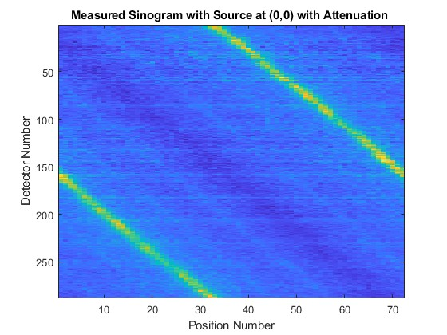 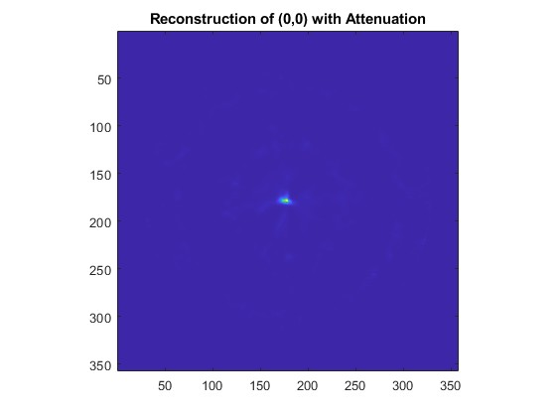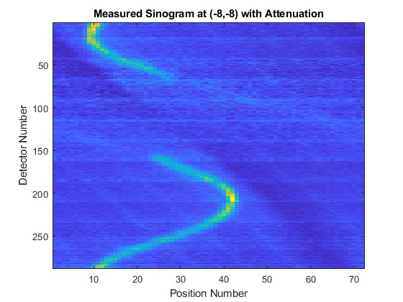x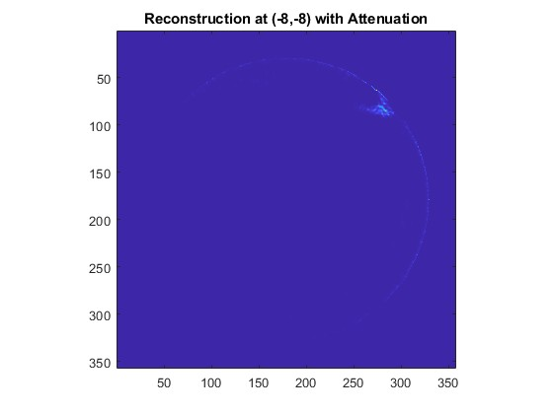 113
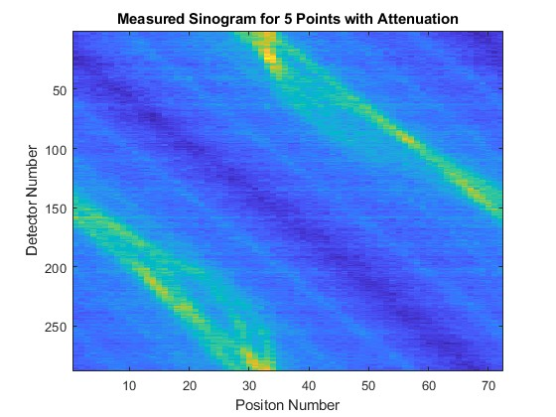 115
Chapter 9. Conclusion 116
9.1 Conclusions 116
9.2 Future Work 116
List of References 117
Vita 120

List of Tables
Table 1: Most Important Gamma-Ray Emissions from Fission Products [11] 9
Table 2. Neutron and gamma-ray interaction probability for common neutron detectors [10]. 18
Table 3. Main components of a boron carbide straw and respective dimensions and material parameters [10] 20
Table 4. Reactor types, the number in existence, and their typical assembly sizes 26
Table 5. Collimator component variations for comparisons [10] 29
Table 6. Estimated fit function for the point spread function [9] 35
Table 7. Imager components and dimensions for the final imager design [10] 47
Table 9. Source information and final yield values from the Californium Shuffler. 64
Table 10. Standard measurements made on each detector module. 65
Table 11. Negative threshold voltages to see noise triggering. 67
Table 12. Bias Voltage changes made on detector module 2. 67
Table 13. Summary of initial measurements performed. 77

List of Figures
Figure 1. Emission computed tomography flowchart. [8] 4
Figure 2. Creation of a sinogram from a set of projections. [8] 4
Figure 3. Creation of a back projection image from 1-D projections. [8] 6
Figure 4. Logic flow chart for iterative reconstructions. [8] 6
Figure 5. Isotope contributions to the total gamma ray activity over 10 years. [12] 9
Figure 6. Relative neutron emission rates per isotope from a PWR spent fuel assembly at a burnup of 31.5 GWd/tU over the course of 10 years. [5] 12
Figure 7. Drawing of a Boron-Coated Straw detector. [9] 19
Figure 8. Interaction probability as a function of energy for neutrons (blue) and gammas (orange) in ¹⁰B. [8] 21
Figure 9. MCNP model of a single detector module in the final geometry. [10] 24
Figure 10. The evolution of the design of (a) a traditional parallel slit collimator through (b-d) the slit rotations into (e) the modified parallel slit ring collimator. [10] 25
Figure 11. Gamma dose rates in R/hr for all detectors using a gamma source with an emission rate of 4.03 × 10¹⁶ photons/second. [10] 31
Figure 12. Image showing position of single pin (left) and the associated halo (right). [8] 32
Figure 13. Detector efficiencies by detector row number. [9] 32
Figure 14. MCNP Simulated point spread function (black) and analytically fit PSF (red) for slit 49 in linear scale (left) and logarithmic scale (right). [9] 34
Figure 15. Effective collimator thickness for each row with a line source at the center of the FOV. [9] 37
Figure 16. Drawing representing the distances used when calculating collimator penetration. [9] 38
Figure 17. Slit scattering schematic. [9] 39
Figure 18. Single slit collimator drawing for simulating edge and direct scattering. [9] 41
Figure 19. The relative neutron intensity as a function of distance from a slit edge (left) and relative intensity using a scaled distance from the slit edge (right). [9] 42
Figure 20. Neutron source positions at every 1 cm from the collimator edge with a single slit collimator (left) and a full 96 slit collimator (right). 44
Figure 21. Calculated neutron response for all 36 source positions using the analytic model (left) and the simulated neutron response from MCNP (right). [9] 44
Figure 22. The signal to noise ratio as a function of gamma dose rate for all collimator material configurations and slit widths (left) and for a collimator configuration with 10 cm of stainless steel and 30 cm of borated polyethylene and all slit widths (right). [9] 46
Figure 23. The collimator consists of 10 cm of stainless steel (a), 30 cm of borated polyethylene (b), with 96 slits in the collimator (c). The detector ring is 12 detector modules (d) with a 5 cm thick ring of HDPE surrounding the detectors (e). [10] 48
Figure 24. The two detector ring positions used to represent a full ring of 12 detector modules. 52
Figure 25. Composite wedges of the collimator. 54
Figure 26. Assembly of the collimator. 54
Figure 27. Detector module processing board (top left), photo (bottom left), and drawing of straw detectors embedded in HDPE (right). 55
Figure 28. Drawing of the full imager assembly. 57
Figure 29. The grid fixture installed in the inspections volume. 57
Figure 30. Neutron source rod by itself (left) and in the grid fixture (right). 59
Figure 31. A drawing of the grid fixture within the full imager (a), a cutaway of the fixture’s placement within the full imager (b), and an image of the fixture itself (c). 59
Figure 32. The data acquisition system. 61
Figure 33. Wiring diagram for the translator. 61
Figure 34. Experimental set-up for module efficiency testing. 64
Figure 35. Net detector count rates for each detector module measured. 68
Figure 36. Average absolute efficiency for each detector module with a threshold value of 25 mV and a bias voltage of 700 V. 70
Figure 37. Schematic of the calculation of the solid angle for the space which the detector does not occupy. 70
Figure 38. Intrinsic efficiency for each detector module with a threshold value of 25 mV and a bias voltage of 700 V. 72
Figure 39. Intrinsic efficiency for detector module 4 with varying lower threshold voltages and a bias voltage of 700V. 72
Figure 40. Intrinsic efficiencies for one detector with a threshold value of 25 mV and a varying bias voltage. 73
Figure 41. The DAQ and fully assembled imager system. 76
Figure 42. The grid with red labels on each fuel pin where a source measurement was taken. 77
Figure 43. The sinogram generated from the experimental data with a source at (0,0) (a) and the corresponding forward projection (b). 80
Figure 44. The reconstructed image of a single source at (0,0) (a) and a magnified version of the same image (b). 81
Figure 45. Efficiency measurement diagram. 88
Figure 46. Uncorrected efficiency sinogram 89
Figure 47. Module Efficiency Corrected Sinogram 91
Figure 48. Relative Efficiency Values from Simulation and Measurement. 92
Figure 49. Room return diagram. 93
Figure 50. Average Counts in Efficiency Measurement. 93
Figure 51. Relative efficiency values from simulation and measurement. 94
Figure 52: Smoothed relative efficiency values coming from measurements. 94
Figure 53. PWR assembly grid with (0,0) and (-8,-8) labelled with blue dots. 95
Figure 54. Lines of response centerlines in across the field of view 97
Figure 55. Sinogram created from the measured data with a point at position (0,0). 98
Figure 56. Sinogram created from the measured data with a point at position (-8,-8). 99
Figure 57. Number of counts per source position. 99
Figure 58. Sinogram of measured data with sources at (0,0) and (-8,-8). 101
Figure 59. Sinogram of measured data with sources at (0,0), (-2,0), (-2,-1), (-3,-1), and (0,-4). 101
Figure 60. Diagram of measured locations for full fuel assembly equivalent. 104

Introduction

Safeguards Context Background
From its inception, the International Atomic Energy Agency (IAEA) was created with the purpose of promoting peaceful applications of atomic energy and with the power to verify the peaceful utilization [1]. As early as 1946, discussions took place amongst the UN security council powers and Canada to establish a committee which would control the information and technology surrounding nuclear applications. By 1953 when President Eisenhower spoke in front of the UN General Assembly, he proposed an organization which would promote the peaceful applications of nuclear power by sharing nuclear material and nuclear energy technology with other countries. However, he also stipulated that this international organization would need to have enough power to control how prevent any country from transitioning to non-peaceful applications [1]. By 1968, the Treaty on the Non-Proliferation of Nuclear Weapons (NPT) specified that participating countries would work with the IAEA to prevent the diversion of nuclear technology from peaceful purposes to nuclear weapons or nuclear explosive devices [2]. The signing states agreed to enact safeguards measures which allow the IAEA to establish proof that nuclear technologies are not being used for weapons purposes. This includes preventing material created during the nuclear fuel cycle from being diverted for weapons purposes. The nuclear fuel cycle is the process which extends from when uranium is mined from the earth, through the processing and enrichment of nuclear fuel, until the uranium is removed from a nuclear reactor as spent nuclear fuel and put into long term storage. At every stage along this process, the IAEA needs to be sure that no material or technologies were diverted for weapons purposes.
Since the ratification of the NPT, many discussions have been had around how the IAEA can prove nuclear materials and technology is only being used for peaceful purposes [2]. One of the most basic methods of implementing nuclear safeguards comes from material control and accountability. By taking into account the material present initially in a nuclear facility and monitoring the quantity of nuclear material, material diversions can be detected as missing material [2,3]. This method of the verification of nuclear material quantities can be applied to a number of types of nuclear facilities at different stages during the nuclear fuel cycle, including reactor facilities and spent nuclear fuel storage sites where spent nuclear fuel (SNF) is handled and stored [3]. Because SNF holds the potential to be diverted for non-peaceful purposes, it is particularly important to establish verification methods at these locations to track the amount of nuclear material present. As a result, the IAEA has prioritized developing methods for the verification of nuclear material within spent nuclear fuel assemblies [3].
When determining the standards for verification of SNF, i.e. how confident the IAEA is that a material is or is not present, there are two main situations in which the IAEA assumes material diversion of spent nuclear fuel may occur: gross defects and partial defects [3]. Gross defects are the diversion of full spent fuel assemblies, while partial defects involve the diversion of single or multiple fuel pins within an assembly. The IAEA’s verification standard is that they must be able to detect partial defects where more than 50% of the spent fuel pins have been diverted [3]. However, during operation of nuclear power plants, operators are permitted to replace single fuel pins during reactor refueling outages if the fuel pins experience leakage. Fuel pin leakage happens when the casing around spent nuclear fuel ruptures and small quantities of nuclear fuel escape the casing and move into the reactor coolant [4]. This does not require replacement of a whole new spent fuel assembly for the ruptured fuel pin, rather just the effected pin can be replaced. IAEA’s verification standard of only detecting the diversion of 50% or more fuel pins in a fuel assembly makes it difficult to determine if a fuel rod or several fuel rods have been removed and diverted for proliferation purposes, or if a fuel rod has been replaced in a refueling outage due to leakage issues [3,5].
Due to the radioactive nature of SNF, radiation detection methods have been used to non-destructively determine the presence of nuclear material in spent nuclear fuel. However, initial detection methods tended to look at the fuel assembly as a whole and check for gross defects as opposed to checking for partial defects [5]. For this reason, creating a verification tool with single fuel pin resolution as well as source age determination has value in detecting individual fuel pin diversion. When focusing on detection of individual spent fuel pins, tomographic methods of verification have been proposed and developed since 1991 [5]. These methods potentially allow for image reconstruction of spent nuclear fuel with information about the strength of the radioactive sources within the fuel rod.
In addition to meeting the IAEA’s safeguards verification standards, tomographic verification systems also support the IAEA general mission to develop surveillance techniques for nuclear materials and support the pursuit of the continuity of knowledge over nuclear materials and facilities [3,5]. Continuity of knowledge (CoK) is an important goal of safeguards nuclear material accountability, implying that it should always be known where nuclear material is and what sort of activities it is going through [6]. In order to ensure that CoK is accurate, tools must be developed to examine nuclear materials. Tomographic verification methods for spent nuclear fuel verification support the continuity of knowledge through allowing inspectors to verify the quantity and strength of nuclear material [6].

Computed Tomography
Computed tomography (CT) has been researched for medical applications since the 1960’s with the most common type of CT being x-rays [7]. In all CT, cross sectional images are created using projected data taken from many angles around the object of interest. In x-ray tomography an external source is used to produce the radiation signatures detected. Using an external source of radiation signatures and measuring how much attenuation occurs through the object of interest is referred to as transmission computed tomography [8]. The other type of tomography is emission computed tomography where the signatures detected originate from the object of interest. Emission computed tomography has been a research topic for decades now as well with Positron Emission Tomography (PET) first taking place in 1977 [7,8].
In gamma emission CT an object is divided into separate lines of response, as demonstrated by the parallel lines in front of each rotating gamma camera in Figure 1, and multiple views, illustrated by the different rotating gamma camera placements [8]. The data from all lines of response at one view is a 1-D projection at different gamma camera angles. Using the measurements from each of the projection angles, an emission computed tomography algorithm, or ECT algorithm, can combine the projections to form a reconstruction image of the object of interest [8].
The same principles of emission tomography apply whether gammas, neutrons or another radiation signature is used. For passive neutron emission tomography, the lines of response are isolated using collimation and the detectors used in the system are neutron detectors as opposed to gamma cameras [7,8].
The projection data gathered in this system can be represented by a sinogram. A sinogram compiles this data by mapping the projections into a graph. Figure 2 shows a mapping
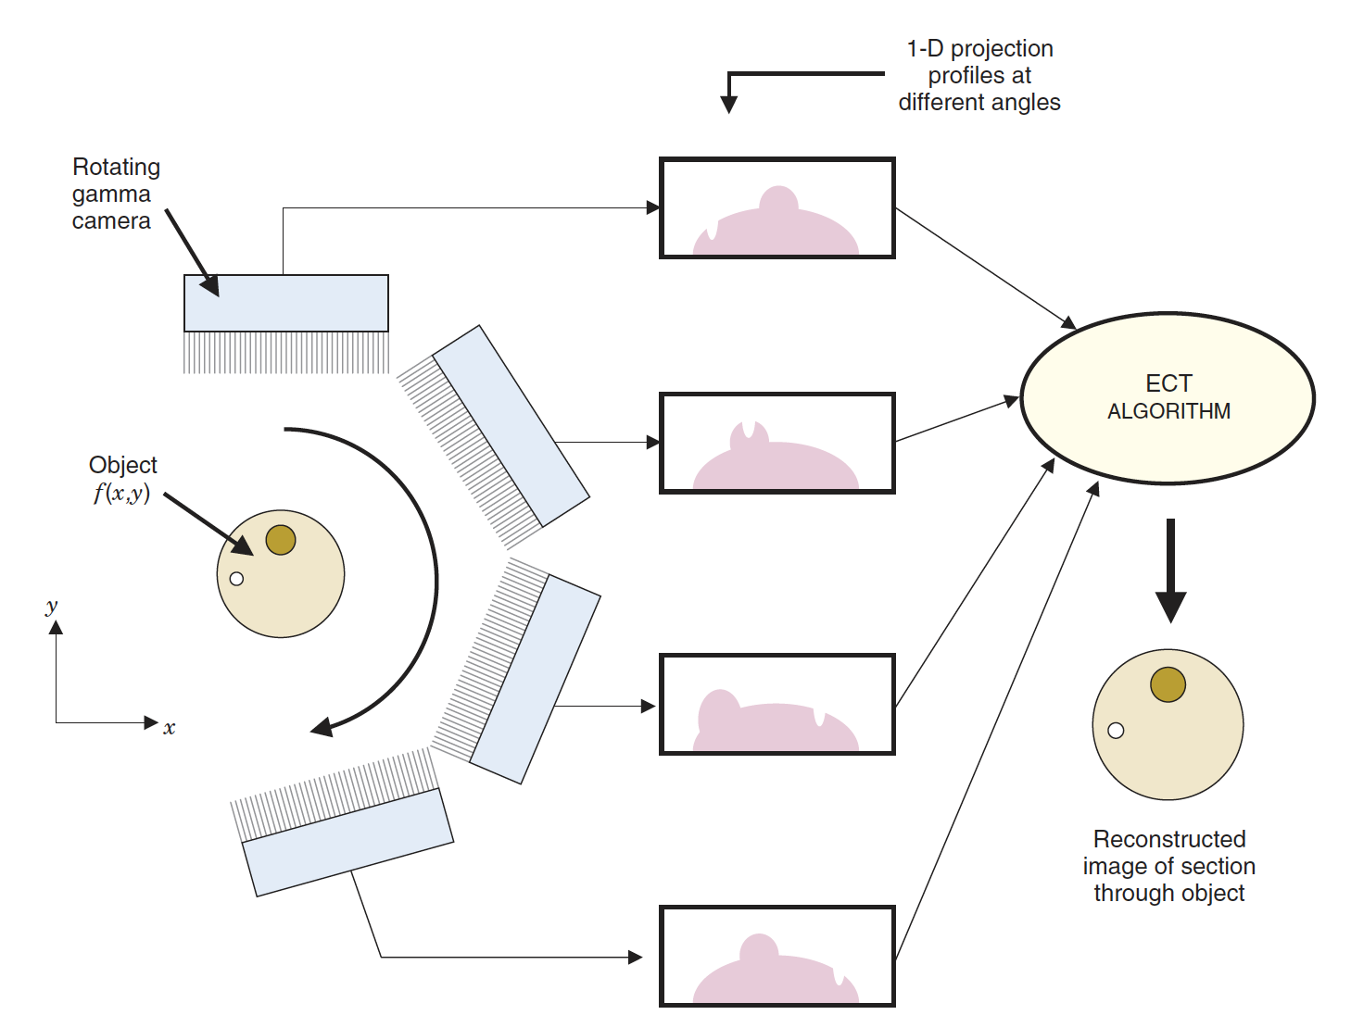
Figure 1. Emission computed tomography flowchart. [8]

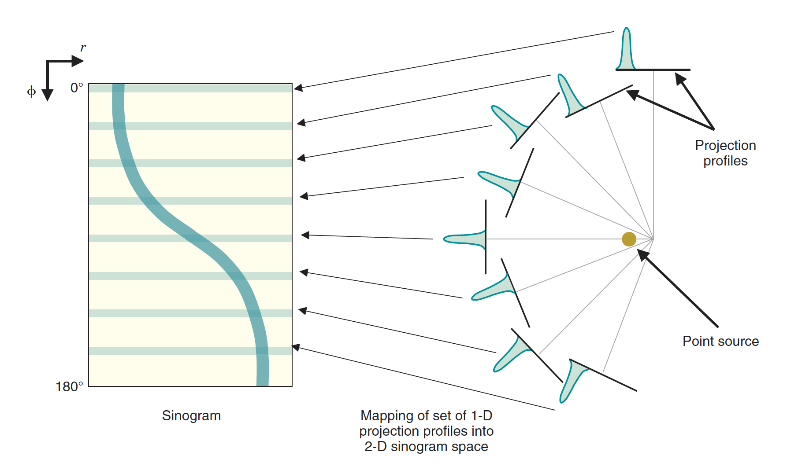
Figure 2. Creation of a sinogram from a set of projections. [8]
of the projections into a sinogram [8]. Each measurement in the system is taken by collecting data for each line of response with the detector at a particular position. By creating a graph where the line of response and the detector position are the x and y axes, respectively, a color spectrum can be used to represent the relative intensity detected at each line of response. All projections can be added to the sinogram.

Iterative Image Reconstruction Algorithm
Computed tomography image reconstruction algorithms use the projection data coming from a detection system and combine it to create image reconstructions. The most basic image reconstruction algorithm divides all signal data in one perspective equally amongst the pixels examined by that perspective [8]. This same method is repeated for all perspectives. Figure 3 shows the accumulations of these perspectives into an image [8]. By combining enough perspectives, the location with higher source intensity becomes more obvious as these partial divisions pile up [8]. This represents the source distribution, but basic back projection attributes some source strength to pixels where no source is present. In cases where there are multiple sources, where the source is spread out, or where the contrast between the source and the background is low this initial back projection does not create sufficiently accurate images to pinpoint the source location [8].
In cases where simple back projections are insufficient to create an accurate image, iterative methods can be used to improve the image quality. Figure 4 diagrams the logic behind an iterative conversion method [8]. An initial image estimate is made and then forward projected. In cases where simple back projections are insufficient to create an accurate image, iterative methods can be used to improve the image quality. Figure 4 diagrams the logic behind an iterative conversion method [8]. An initial image estimate is made and then forward projected. Forward projection is the inverse of back projection. Instead of starting with a series of projections and then layering to form an image, forward projection starts with an image and then works to calculate projections that would layer to form the image. After forward projecting the image estimate, the sinogram created from measured data can be compared to the calculated sinogram created by the forward projection process. The difference between these can then be used to modify the forward projection values. The updated forward projection can be back projected to create an updated image estimate. This process then repeats, iteratively changing the
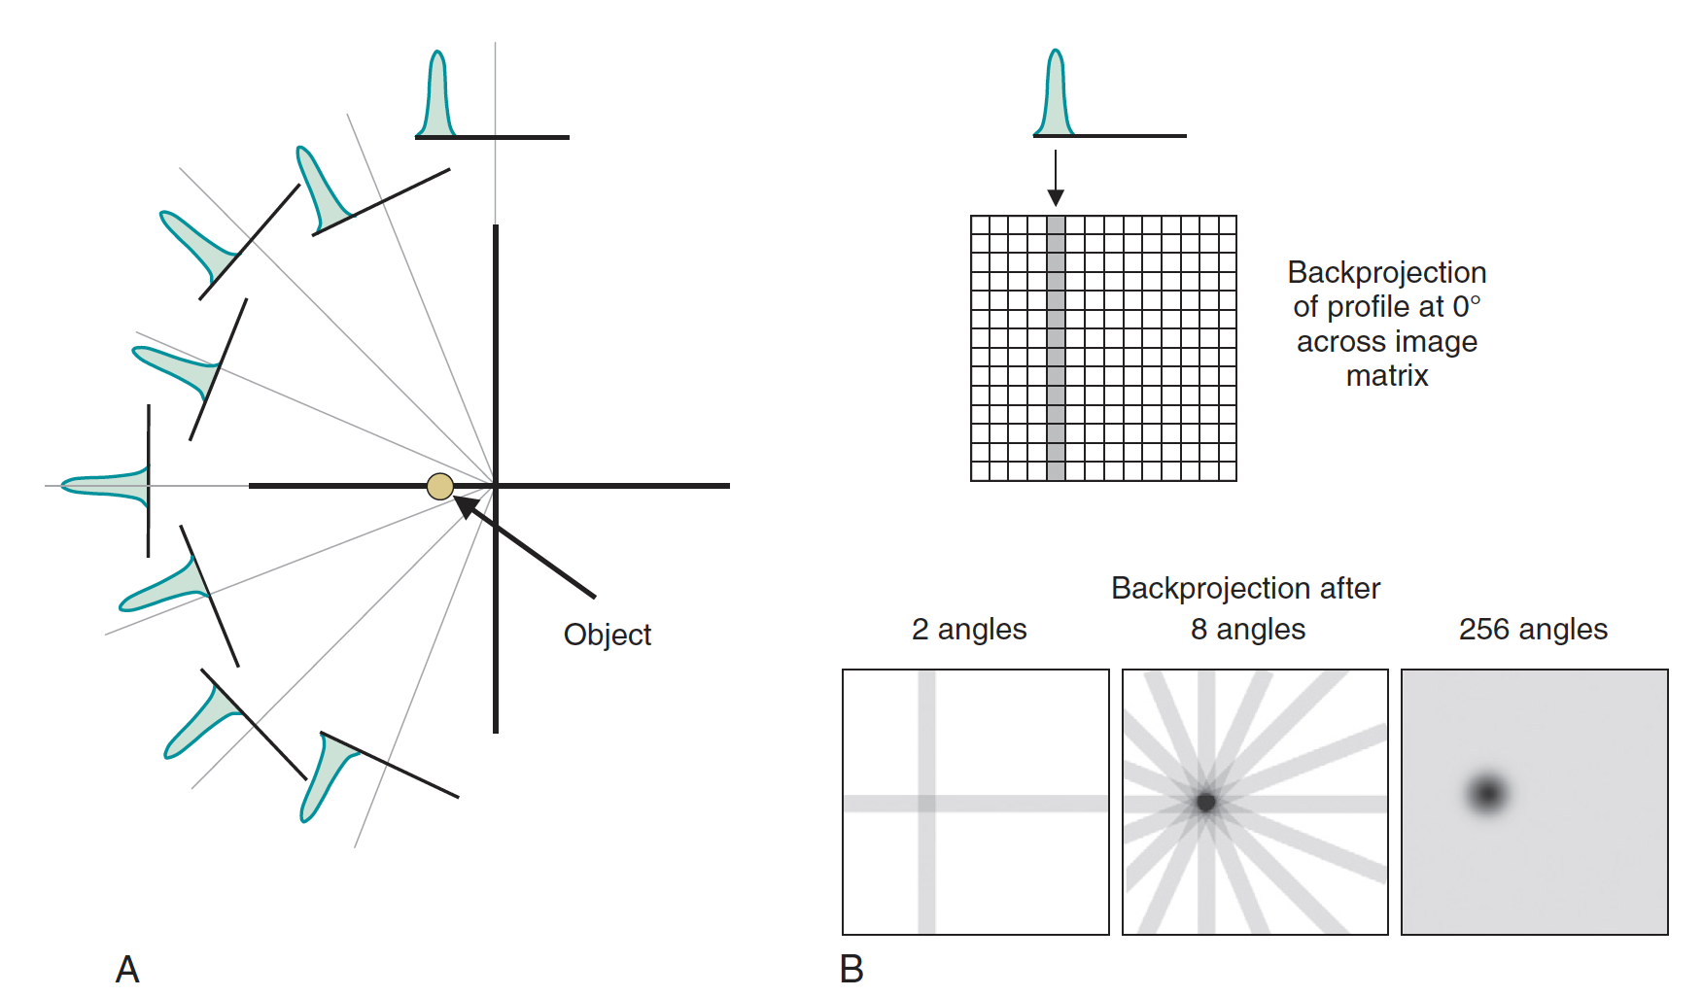
Figure 3. Creation of a back projection image from 1-D projections. [8]

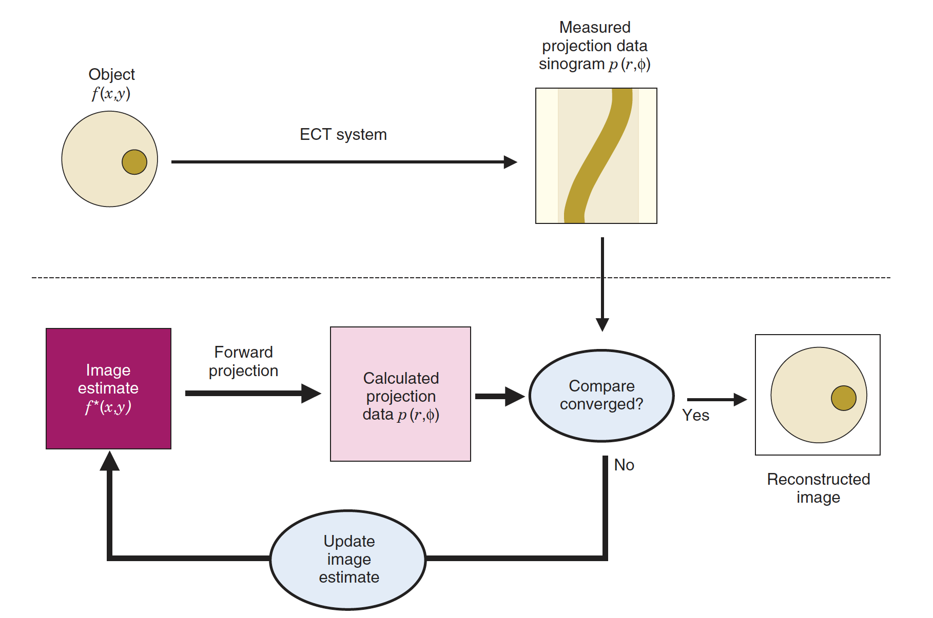
Figure 4. Logic flow chart for iterative reconstructions. [8]
image estimate forward projection until the image converges. Convergence is when there is no difference between the estimated forward projection and the measured sinogram or until the difference is small enough that the reconstructed image adequately represents the original object. Determining whether the reconstructed image adequately represents the original object is dependent on the purpose for creating the image and can be different for every iterative reconstruction process.

Improvements to Iterative Image Reconstruction Algorithm
Basic iterative reconstruction methods may take many iterations to converge. Iterative reconstruction methods can be modified in ways to force the reconstructions to converge faster while still maintaining accuracy. One common way of speeding up the iterative convergence includes incorporating prior information about the system [8,9]. This may be something like knowing the object shape. An algorithm may also “force” the reconstructed image to be nonnegative by setting any pixels which go negative to zero. Both methods can be used in an algorithm to increase the convergence rate [8].
Statistical considerations can also be applied to iterative methods to determine the most likely source distribution in the object and converge images faster. Maximum likelihood expectation maximization (MLEM) is an iterative algorithm which assigns a higher statistical weighting factor to portions of projections with greater detected signal [8,9]. This is opposed to equally distributing the signal across all pixels viewed in the projection like a simple back projection would. MLEM algorithms have been widely used in medical tomography applications for decades and are a well-established method of creating measurement-informed reconstruction images [9].
Mathematically, the initial iteration can be represented as:
$Ax = y$ (Equation 1)
$y_{i}=\sum_{j}{a_{ij}x_{j}}$ (Equation 2)
where x is an image whose pixel values, represented by x_{ij} correspond to source intensity at a particular location. The matrix A of a_{ij} represents the statistical probability that radiation emitted from the i-th pixel will be detected in the j-th projection. The variable y is the measured projection data at a particular location, i.e., the measured sinogram. Each successive iteration can be represented as:
${x_{j}}^{(k+1)}={x_{j}}^{(k)}\frac{1}{Σ_{i}a_{ij}}\sum_{i}{a_{ij}\left(\frac{y_{i}}{\sum_{h}{a_{ih}x_{h}^{(k)}}}\right)}$ (Equation 3)
where k is the current iteration [9]. The term in parentheses in the denominator represents a summation over all image pixels which must be computed prior to the summation over the j-th projection. To avoid confusion, it is given an index of h instead of i.

Passive Gamma Emission Tomography
Passive gamma emission tomography (PGET) has been under research and development for imaging spent fuel assemblies with single fuel pin resolution since the 1980s [5]. The PGET method relies primarily on the detection of high energy gamma rays from spent fuel fission products. The most important gamma-ray emissions for spent fuel after a cooling time of 5 years are listed in Table 1. The Cs and Eu content in spent fuel is considered the most useful for PGET [11]. Figure 5 shows the contribution to the total gamma ray activity for various gamma emitters in spent fuel at a burnup of 12.18 GWd/tU [12]. After 1 year of cooling, the total gamma ray activity is roughly proportional to burnup, and theoretically, PGET can be performed beyond one year of cooling. However, in practice it has been recommended to use PGET after at least 2 years of cooling time. Beyond 2 years, the ¹³⁷Cs gamma ray begins to dominate the gamma activity, meaning that the ¹³⁷Cs gamma ray becomes roughly proportional to burnup and other short lived isotopes decay away [11]. This allows for easier detection and isolation of the 662 keV gamma ray coming from ¹³⁷Cs which allows for better burnup estimation [12]. Additionally, high gamma doses, like that coming off spend nuclear fuel which has been cooled for less than 2 years, have the potential to damage gamma ray detectors and introduce artifacts into the image reconstruction. In addition, ¹³⁷Cs fission yields are almost equal to its neutron absorption cross section. This means the gamma ray emissions can be used to determine the total number of fissions. These two traits combined make ¹³⁷Cs the primary isotope used for PGET of spent fuel [12].
Despite having the largest contribution to the activity of spent fuel, ¹³⁷Cs does not have the highest gamma energy, which is a drawback for tomography due to self-shielding in spent fuel. From the center of a fuel assembly to the outer edge, 662 keV ¹³⁷Cs gamma rays can
Table 1: Most Important Gamma-Ray Emissions from Fission Products [11]
Isotope | Half-life (yrs) | Gamma Ray energy (keV) | Branching Ratio (%)
¹³⁴Cs | 2.07 | 604.7  795.8 | 97.6  85.4
¹³⁷Cs | 30.08 | 661.1 | 85.1
¹⁴⁴Ce-¹⁴⁴Pr | 0.78 | 1489.2  2185.6 | 0.3  0.7
¹⁵⁴Eu | 8.60 | 996.3  1004.8  1274.4 | 10.3  17.4  35.5

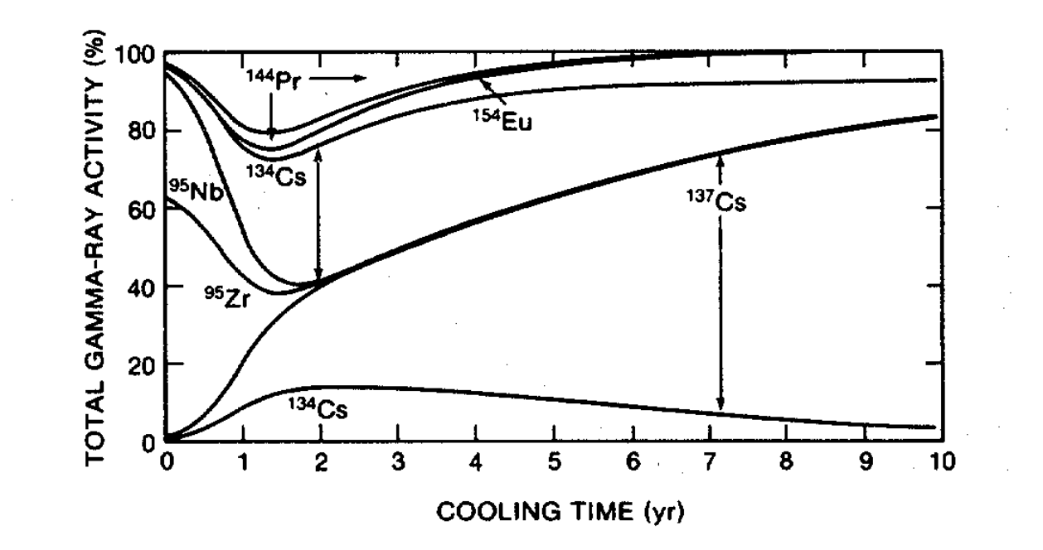
Figure 5. Isotope contributions to the total gamma ray activity over 10 years. [12]
experience large attenuation by a factor on the order of 100 [12]. The attenuation coefficient of a 662 keV gamma through nuclear fuel is 1.324 cm⁻¹ meaning that the average distance that a 662 keV gamma can travel through the fuel assembly without an interaction is 0.755 cm [12]. Collimators are used in a PGET system to attenuate low energy gamma rays and define the lines of response for the gamma detector used. Both the self-shielding in fuel assemblies and the addition of a collimator compound, resulting in a large reduction in gamma rays with 662 keV intensity. PGET has been used to image spent nuclear fuel assemblies with cooling times as long as 18.5 years.
In order to compensate for the larger attenuation factor for 662 keV ¹³⁷Cs, PGET reconstructions began incorporating counts from gamma rays with energies over 700 keV [10]. Higher energy gamma rays have smaller attenuation factors across the width of the fuel assembly and can be used along with the 662 keV ¹³⁷Cs counts to accurately image the center of fuel assemblies. The 1274.4 keV gamma from ¹⁵⁴Eu has an attenuation coefficient of 0.689 cm⁻¹ meaning it can travel 1.452 cm on average without an interaction in the fuel. This is nearly twice as far as the 662 keV ¹³⁷Cs gamma. In comparison, a standard 17 x 17 PWR fuel assembly is 24 cm by 24 cm in dimension. The drawback to using higher energy gamma rays like ¹⁵⁴Eu is the small contribution of these gammas to the total gamma activity. This makes getting sufficient statistics to create a reconstruction a longer process than using a more active gamma emitter. After reconstruction methods for PGET began to include more advanced attenuation responses, like including additional high energy gamma rays, it was determined that attenuation would no longer be a limiting factor in the use of PGET [2][13]. However, PGET’s success does not decrease the value in also researching a NET method for spent fuel verification. In the past, there was some concern that due to high gamma fluxes and self-shielding of gamma rays by fuel pins within fuel assemblies, using PGET on fuel assemblies would be challenging [10][11].

Muon Tomography for Spent Nuclear Fuel
Placeholder

Neutron Source Examination
Spent nuclear fuel has a high neutron emission rate on the order of 10⁷ or 10⁸ n/s. Many of these neutrons come from transuranic isotopes that are formed during reactor operation. As uranium isotopes capture neutrons, built-up quantities of transuranic materials emit neutrons during their own decay processes. Specifically, the main sources of neutrons in fuel assemblies are ²⁴⁴Cm, ²⁴²Cm, ²⁴⁰Pu, ²³⁸Pu, and ²⁴²Pu. The emission rates of these neutron emitters during a 10-year cooling period of a fuel assembly with a 31.5GWd/tU burnup are shown in Figure 6 [3].
Traditionally measuring neutrons from spent fuel means measuring the ²³⁹Pu content in the fuel. However, as demonstrated in Figure 6, the Pu content saturates with increased burnup or exposure. This means that detector systems that use this technique for spent fuel verification would be minimally sensitive to rod replacements made after the first cycle in a reactor.
After approximately 20 months, ²⁴⁴Cm neutron emission dominates all neutron emission through the end of the 10-year observation time. The isotope ²⁴⁴Cm has a half-life of 18.2 years and a neutron production rate of 1.64 × 10⁷ neutrons/s/gram with much of this neutron emission coming from spontaneous fission [5]. This is lower than the 3.35 × 10⁹ gammas/s/gram from ¹³⁷Cs alone [5]. Unlike the Pu content, ²⁴⁴Cm does not saturate as a function of burnup, so using this as the signature of choice would enable an imager to be sensitive to rod replacements made after the first cycle. For this reason, the neutrons from the spontaneous fission of the ²⁴⁴Cm isotopes built up in the SNF will be the primary neutron signature detected by the NET system.

Neutron Tomography of Spent Nuclear Fuel
Placeholder
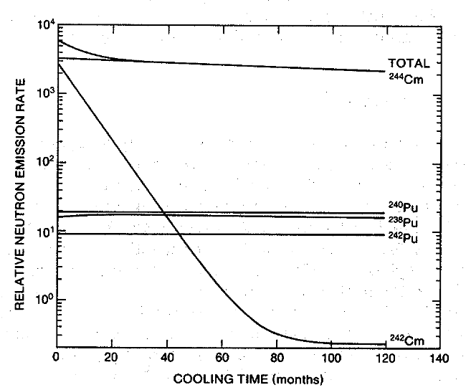
Figure 6. Relative neutron emission rates per isotope from a PWR spent fuel assembly at a burnup of 31.5 GWd/tU over the course of 10 years. [5]

Statement of Original Contributions
This dissertation follows dissertation work performed by Dr. Anagha Iyengar in her thesis titled, “The Design of an Imager to Safeguard Spent Fuel Using Passive Fast Neutron Emission Tomography” [13]. Using the radiation transport and the analytic code models developed in that thesis as a basis, this document discusses further work on the development of a fast neutron emission tomography imager for spent nuclear fuel.
Original contributions for this project begin in Section 2.7.6 where simulated MNCP6 radiation transport data was used to fit various constants which define the individual components of the neutron response model for the imager design using a 96-slit collimator. This was the final part of determining an analytic response code for the imager geometry described in Sections 2.8 and 2.9, the design characteristic conclusions from Dr. Iyengar’s dissertation work.
Due to outside considerations, the imager model was not able to be constructed according to Dr. Iyengar’s design. This work details the changes that were made to the imager during fabrication. In addition to running radiation transport simulations to determine coefficients for the analytic neutron response model as described in the previous work, novel contributions to the project include adapting the radiation transport and analytic models to match the geometric design of the as-built detector system.
Following the fabrication of the 6 detector modules, imager efficiency testing for each individual detector module was performed. In this experiment, the intrinsic, geometric, and absolute efficiencies for each detector module were calculated. In addition, the high voltage and trigger threshold voltages for each detector were determined and a value for detector operation compared.
Other novel contributions include characterization of the as-built imager system using measured data and incorporation of that data into an updated analytic neutron response code. Following individual detector module analysis, the total imager system was constructed onsite at ORNL with the help of moving and rigging experts. Initial measurements were taken in a preliminary measurement campaign which demonstrated the system’s ability to detect neutrons and reconstruct measured data with the adapted analytic neutron response code. Further measurements characterizing the imager were later performed to inform the analytic neutron response code and account for changes between the ideal imager and the as-built imager. These characterizing measurements include determining the relative efficiency of the individual detectors, and additional changes to collimator penetration. The document details the measurement campaign plans, execution and data collection. Novel contributions include the incorporation of measured data into the analytic response code for improved response simulations. Additionally, novel contributions include the measurements of neutron sources at each position in the field of view with and without attenuation rods present and the reconstruction and analysis of these sources.

NET System Design Prior to This Work

Initial System Design Requirements
Fast neutrons are highly penetrating. With a mean free path of 1.905 cm in fuel, 1 MeV neutrons readily escape from standard PWR fuel rods which only have a 0.9652 cm diameter [8]. Unfortunately, the long mean free path of fast neutrons in borated high-density polyethylene, 4.630 cm at 1 MeV, also makes fast neutrons difficult to collimate and measure with fine spatial resolution [ENDF]. In addition, it is difficult to measure the neutron source strength compared to the overwhelming gamma ray emissions from spent fuel.
Creating a fast neutron detector which can image spent nuclear fuel means balancing several characteristics: high detection efficiency, high spatial resolution, and the ability to minimize gamma exposure while maintaining a size roughly equivalent to a spent fuel cask. The compact size of the imager is important so as not to disrupt operations at any facility in which verification measurements are taking place.
The neutron source strength, compared to the gamma strength, in spent fuel means that the number of neutrons which are present should be detected with as much efficiency as possible. Ideally, the detectors would record all incident neutrons. More realistically, the detectors should be able to record at least 1/3 of the incident neutrons. Designs which place large detectors close to the fuel and using wide collimator slits would increase the neutron efficiency.
Due to the small sizes of both the fuel pins (0.9652 cm) and the gaps between them (0.328 cm), the system spatial resolution needs to be less than 3 millimeters in order to define and image individual pins [9]. Spatial resolution is how finely the imager can pinpoint the location of a source. A spatial resolution less than 3 mm would need lines of response to be approximately the same width as the fuel pin gap and consequently, collimator slits comparable in size to the fuel pin gap. Increased amounts of neutron moderator define these lines of response but decrease the efficient use of the neutrons.
The gamma-ray dose to the detectors must also be properly managed to avoid gamma pile up in the detectors. Gamma dose can be reduced with dense collimator materials, but these are not very good for neutron moderation and collimation because neutron attenuation in dense materials is low. Additionally, the neutron detectors chosen must be somewhat gamma blind, which means using a neutron detector where the neutron energy loss happens in a moderator rather than in the active detector volume. The drawback to moderated detectors is that they are larger than non-moderated detectors.
Despite the challenges associated with an NET imager system, previous work determined that the use of a novel collimator concept appears to make it possible to construct an imager having sufficient resolution to identify individual fuel pins while also keeping the imager sufficiently compact, efficient, and radiation resistant to be practical [9]. This novel collimator is referred to as a “parallel-slit ring collimator” [9].

Neutron Detector Design
The neutron detectors for the imaging system were chosen with gamma-sensitivity in mind. All neutron detectors are gamma sensitive to some degree. Gammas from spent fuel impart energy to electrons in the detector fill gas via Compton scattering interactions. The resulting high energy electron proceeds to ionize more electrons along its path. The electronic pulses caused by these gamma-produced electrons are comparable to the pulses created by neutron interactions with electrons in the fill gas. Due to the higher gamma emissions from SNF than neutron emissions, there is a potential for many more gamma pulses to be recorded than true neutron pulses. If many pulses from both neutron and gamma interactions are registered close together within the resolving time of the detector electronics, they can pileup and result in false counts. The neutron detectors must be chosen to favor neutron absorption and limit gamma absorption. This can be done by changing neutron energies to favor absorption and by choosing materials which are highly neutron absorbing. Table 2 shows the gamma and neutron interaction probabilities for thermal and fast neutrons in common neutron detector materials. Thermal neutrons can be absorbed with a higher probability than gamma-rays. However, for fast neutrons, like those coming from spent nuclear fuel, the magnitude of the gamma-ray interaction probabilities is on the same order as the neutron interaction probabilities.
Due to their commercial availability, the detectors used in this NET system are boron-coated straw detectors embedded in a high-density polyethylene moderator (HDPE). These detectors are commercially available from Proportional Technologies Inc. (PTI). One straw detector consists of a 4 mm diameter tube of aluminum lined with a boron-carbide-coated, copper straw along the outside diameter, as shown in Figure 7 [10]. Table 3 shows the main components of the boron carbide straw as well as their dimensions [10]. An anode wire runs through the center of the tube, separated from the straw by a fill gas. Fast neutrons are thermalized in the HDPE moderator and then captured by the ¹⁰B in the B₄C layer. The high energy neutrons (0.84 MeV or 1.47 MeV) interact with the boron producing secondary particles via the ¹⁰B + n → ⁷Li + 𝛼 reaction. The resulting alpha particle and ⁷Li isotopes are detected when they escape the B₄C layer, enter the detector fill-gas, and proceed to ionize the gas atoms as they travel. The straw detector then acts as a proportional counter. The electrons created in the gas drift toward the thin anode wire down the center of the straw and away from the tube wall which acts as a cathode [10]. When the detector threshold is exceeded, a signal is generated.
These detectors exhibit particularly good gamma blindness for a number of reasons. The first reason is the small detector fill gas volume means that there is a limited space in which any particle may interact and create a signal. Figure 8 shows the interaction probability for gamma rays and neutrons in ¹⁰B [8]. The probability of gamma interactions in boron is much lower than the ¹⁰B interactions with thermal neutrons. Additionally, the detector consists mostly of an inert moderator which decreases the number of gamma ray interactions. As instrumented, the boron straw detectors can tolerate gamma fields up to approximately 500 R/h [9].
A single detector module for this system consists of several of the boron carbide straws arranged in rows then embedded in a HDPE matrix. For this particular system, one way to minimize the detector module’s gamma sensitivity is to limit the active volume of the detector. This means choosing a straw arrangement geometry with the least number of straws and largest amount of moderator. The boron straw detectors were arranged such that a full imager would use 2304 of these straws. The final imager design has 12 detector modules, each containing 24 rows of 8 boron straw detectors that are read out together. Figure 9 shows a drawing of the straw detector arrangement of one of these detector modules [10]. All together the detectors consist of 288 rows of straw detectors embedded in HDPE, with each giving a readout in the full detector imager. A single detector module consists of 24 rows of straws in HDPE, an air gap which surrounds the HDPE matrix containing the straws, aluminum walls separating rows of detectors, and Cd layers on the inner and outer radii of the module to remove thermal neutrons. Each module is 113 cm tall, 100 cm of which consists of boron coated straw detectors, and the remaining 13 cm are composed of electronics and casing around the detectors.

Table 2. Neutron and gamma-ray interaction probability for common neutron detectors [10].
 | Interaction Probability
Thermal Detectors | Thermal Neutron | 1-MeV Gamma-ray
³He (2.5 cm diam., 4 atm) | 0.77 | 0.0001
Ar (2.5 cm diam., 2 atm) | 0.0 | 0.0005
BF₃ (5 cm diam., 0.66 atm) | 0.29 | 0.0006
Al tube wall (0.8 mm) | 0.0 | 0.014
 | Interaction Probability
Fast Detectors | 1-MeV Neutron | 1-MeV Gamma-ray
⁴He (5 cm diam., 18 atm) | 0.01 | 0.001
Al tube wall (0.8 mm) | 0.0 | 0.014
Scintillator (5.0 cm) | 0.78 | 0.26

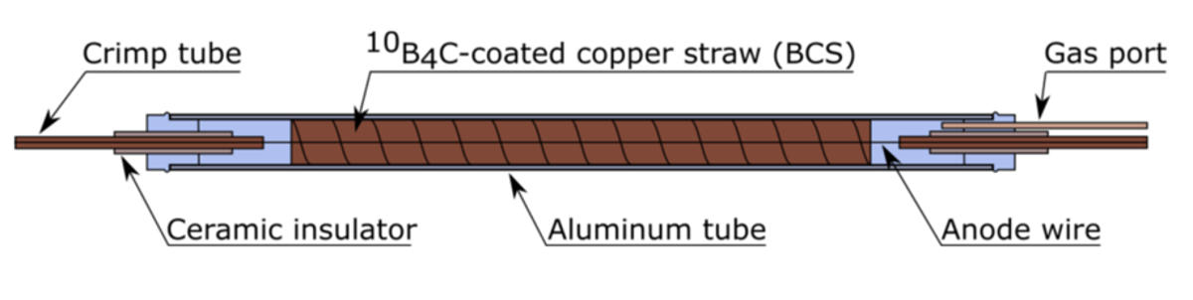
Figure 7. Drawing of a Boron-Coated Straw detector. [9]

Table 3. Main components of a boron carbide straw and respective dimensions and material parameters [10]
Component | Material | Radius (cm) | Thickness (cm) | Density (g/cm³)
Fill gas | 90% Ar, 10% CO₂ | 0.22150 | - | 1.20×10⁻³
Boron Carbide | B₄C with ¹⁰B enriched to 96% | 022164 | 1.4×10⁻⁴ | 2.38
Coating tube | Copper | 0.22434 | 2.7×10⁻³ | 8.96
Detector Wall | Aluminum | 0.27666 | 5.2×10⁻² | 2.70

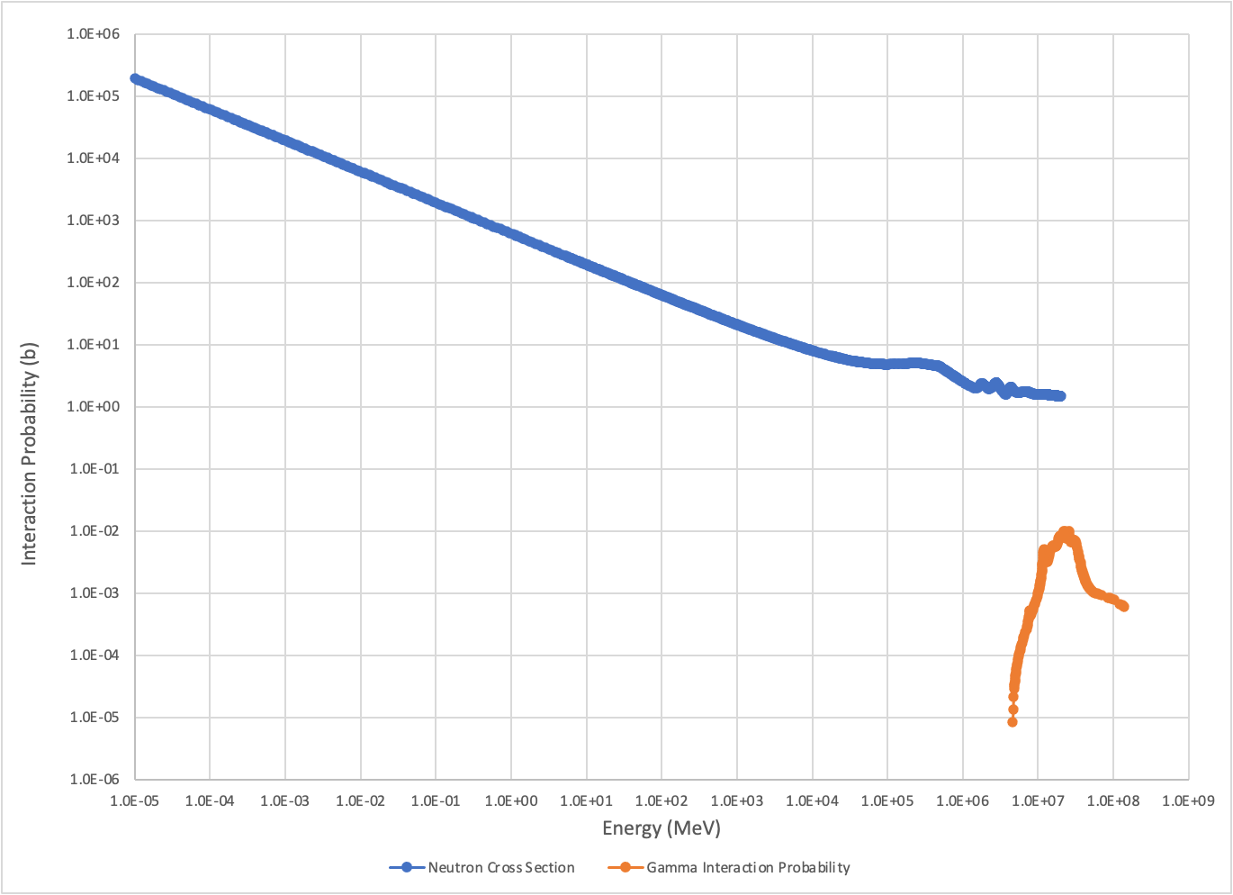
Figure 8. Interaction probability as a function of energy for neutrons (blue) and gammas (orange) in ¹⁰B. [8]

Parallel Slit Ring Collimator Concept
A novel collimator was designed based on a parallel slit collimator but rotated into an annulus. Figure 10 shows the difference between a conventional parallel slit detector and the modified parallel slit collimator [10]. Rotating the slits in the collimator allows a greater distance between each detector element and slit than would otherwise be required using a conventional parallel slit collimator. Rotating the position of each slit through a known angle achieved equal detector spacing around the outside of the collimator annulus. This maintains the function of the collimator and the lines of response along particular chords across the central volume of the annulus, also known as the inspection volume or the field of view (FOV), are maintained, as in the parallel slit collimator. The increased distance between detector elements reduces the neutron scattering which may occur between detectors, increasing spatial resolution. Because all projection angles around the fuel assembly will need to be imaged by rotating the collimator, the rotated slits still create the same line of response as it originally. This makes Figure 10(e) equivalent to Figure 10(a) upon a full rotation of the collimator.
The number of slits in the collimator was decided to be 96. Due to the angular rotation that transformed a parallel slit collimator to a modified parallel slit ring collimator, the slit openings around the outer edge of the collimator were evenly spaced. Using 96 collimator slits meant that each slit would point to every third detector. The detectors were each placed at an angle of 1.5 degrees around the collimator meaning the outer slit edges were arranged every 4.5 degrees. This would create 96 lines of response across the field of view for each projection.

Parallel Slit Ring Collimator Parameters
After deciding to use the modified parallel slit ring collimator, a number of sensitivities studies were performed to determine the final design of the collimator. First, non-variable parameters for the imager design were identified. The imager design was constrained by a non-variable size. The inner radius of the imager is 17.667 cm, which was calculated to accommodate an assembly 1 cm greater than the half diagonal of a standard PWR 17 × 17 fuel assembly (24 cm) [10].
PWR reactors are the most common types of nuclear power reactors in the world with 304 PWR reactors in operation which use this fuel assembly size [11]. Given that the number of
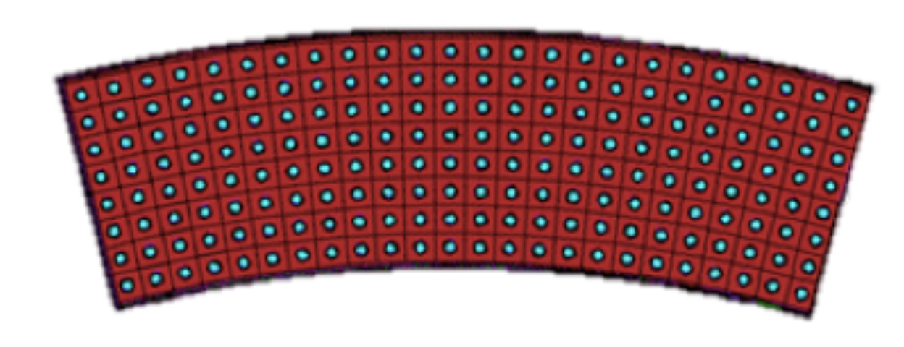
Figure 9. MCNP model of a single detector module in the final geometry. [10]

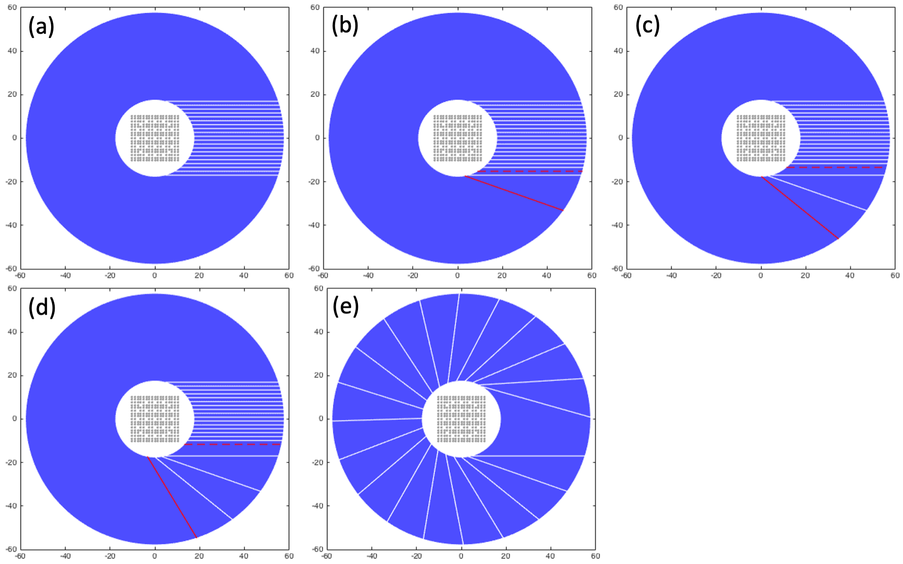
Figure 10. The evolution of the design of (a) a traditional parallel slit collimator through (b-d) the slit rotations into (e) the modified parallel slit ring collimator. [10]

PWR reactors greatly surpasses the number of any other type of reactor, the NET system was designed around a typical PWR 17 × 17 fuel assembly. Additional typical reactor fuel assembly dimensions are included in Table 4. For square fuel bundles, demarcated by an asterisk, the half diagonal length of the fuel assembly is used. For cylindrical fuel assemblies the half diagonal length is equivalent to their radius. Out of the 438 reactors in existence, 435 of them (99.3%) have fuel assemblies or bundles small enough to fit in this imager inner radius.
The total outer radius limit of the imager was selected in order to be reasonably handled by a spent fuel facility. This means that the imager must be able to fit in a spent fuel cask that operators at spent fuel storage facilities would typically handle. The baseline imager was designed so the device would fit within 48 cm internal radius of the GNS Castor series of transport casks because this cask type is commonly used for international fuel shipments. The collimator height was approximately 1 m. This height increased the measurement efficiency but also limited image reconstruction uncertainty due to spent fuel warping. Spent fuel assemblies can warp along their 4 m length by as much as 1 cm. Constraining the imager to 1 m in length minimizes the amount of uncertainty in the fuel length location to 0.25 cm or less. This uncertainty length is comparable to the space between each fuel pin. Shielding made up of borated polyethylene and stainless steel also cover the top and bottom of the imager to protect the detectors from radiation coming from the fuel assembly extending out on either side of the imager.
Following the size constraints, parameters of the imager were identified as variable: stainless steel thickness, borated polyethylene thickness, and slit width. The collimator is made up of two materials – an inner ring of stainless steel and an outer ring of borated polyethylene - with a number of slits to define the lines of response. The borated polyethylene in the collimator attenuates high energy neutrons to create the distinct lines of response. The stainless-steel portions provide structural support as well as attenuate out a portion of the gamma emissions from the spent fuel [10]. MCNP simulations were conducted to determine the thicknesses of the borated polyethylene and stainless steel as well as the slit widths.
Gamma dose rate and neutron detection efficiency simulations were run in MCNP. The initial MCNP simulations determined that the minimum quantity of borated polyethylene for neutron collimation was 30 cm. From this, eleven different combinations of stainless steel and
Table 4. Reactor types, the number in existence, and their typical assembly sizes
Reactor Type | Number [11] | Typical Fuel Assembly Half Diagonal Lengths (cm)
Pressurized Water Reactor* | 304 | 16.667
Boiling Water Reactor* | 61 | 15.26 [12]
Pressurized Heavy Water Reactor | 48 | 5.1 [13]
Advanced Gas-Cooled Reactor | 11 | 13.175 [14]
Light Water Graphite Reactor | 11 | ~4 [15]

borated polyethylene thicknesses were analyzed. Table 5 shows the thicknesses viewed. Slit width was also a variable parameter for the image [10]. In addition to the 11 different combinations of collimator component thicknesses, 32 different slit widths were simulated. These included 9 different parallel slit widths with dimensions (1 mm to 5 mm in 0.5mm intervals), and 23 tapered slit combinations with inner dimensions of 1 mm, 2 mm, 2.5 mm, and 3 mm going to an outer dimension of 5 mm in 0.5 mm intervals.

Gamma Dose
The gamma dose rate of a worst-case scenario gamma source was calculated using MCNP. The gamma source was assumed to be a fuel with a high burnup of 40 Gwd/MTU and a short cooling time of one year. This gamma source was chosen as a “worst case” scenario to yield a conservative estimation for the gamma dose expected. This gamma source yields an emission rate of 4.03E16 photons/second. Figure 11 shows the gamma dose rate deposited in the detectors with the gamma emission rate divided equally across all fuel pins in the fuel assembly. The collimator used in this simulation had parallel slit widths 3 mm wide consisting of 10 cm of stainless steel followed by 30 cm of borated polyethylene. The gamma dose rate to any of the detectors does not exceed 500 R/h with this collimator which was determined to be the tolerable dose rate in the detectors. This is due to the low-probability, large amplitude interactions of single gamma rays in the boron-straw neutron detectors [9].

Imager Specific Signal-to-Noise Ratio
After determining how these parameters could be modified, the conditions on which parameter performance is judged were identified. The collimator needed sufficient spatial resolution to isolate the fuel pins and fuel pin gap. Figure 12 shows the position of a single pin and the fuel pin gap halo which isolated the pin from others around it. To quantify this spatial resolution, a signal-to-noise ratio (SNR) was previously defined in reference 9. The signal is the magnitude of the difference between the calculated response of the imager to a single pin and the calculated response from the imager to the halo surrounding that pin. This can also be described

Table 5. Collimator component variations for comparisons [10]
Collimator Component Thickness (cm) |  |  | Outer Borated Polyethylene Shielding (cm)
Stainless Steel | Borated Polyethylene | Total | Outer Borated Polyethylene Shielding (cm)
5 | 35 | 40 | 5.822
10 | 30 | 40 | 5.822
6 | 36 | 42 | 3.822
5 | 38 | 43 | 2.822
6 | 37 | 43 | 2.822
7 | 36 | 43 | 2.822
5 | 40 | 45 | 0.822
6 | 39 | 45 | 0.822
7 | 38 | 45 | 0.822
8 | 37 | 45 | 0.822
10 | 35 | 45 | 0.822

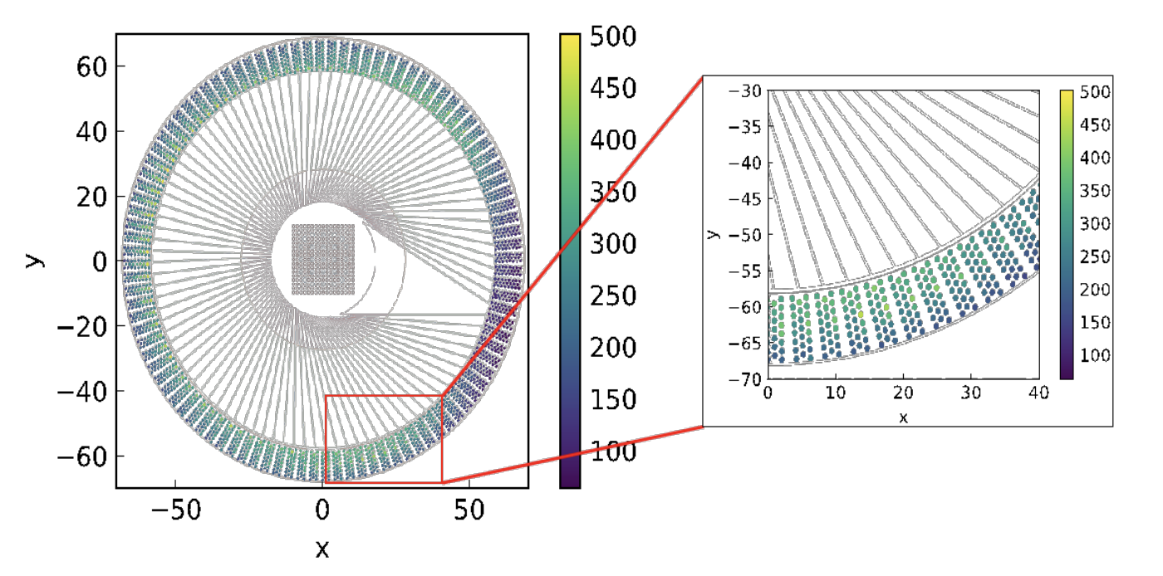
Figure 11. Gamma dose rates in R/hr for all detectors using a gamma source with an emission rate of 4.03 × 10¹⁶ photons/second. [10]

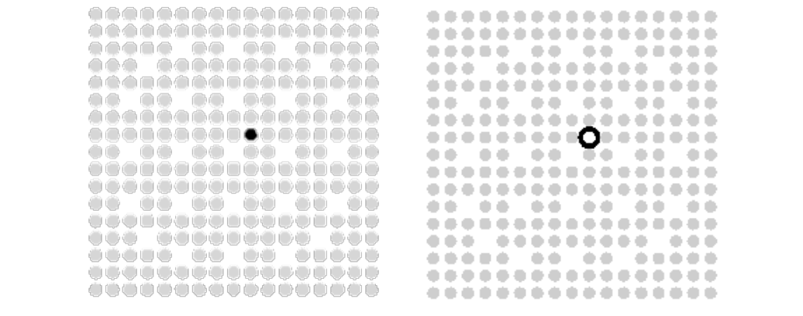
Figure 12. Image showing position of single pin (left) and the associated halo (right). [8]

as the difference in neutron counts attributed to the fuel pin and the neutron counts attributed to the space surrounding the pin. The noise is approximated by the square root of the neutron counts for the full assembly in the region of interest for the particular fuel pin. The signal-to-noise ratio can be written as:
$SNR = \sum{\frac{\left|R_{p} - R_{h}\right|}{\sqrt{R_{a}}}}$ (Equation 3)
where R_{p} represents the response to the fuel pin, R_{h} is the response to the halo, and R_{a} is the response to the whole assembly.
In general, to best reconstruct an image of the fuel pins, the activity associated with each fuel pin needs to be attributed to the pin itself rather than the inter-pin space. This maximizes the numerator value in Equation 3. The denominator in Equation 3 is also the uncertainty or standard deviation of the neutron measurement in that particular region. The best imager would maximize the SNR to ensure that the detected activity from the fuel pins is larger than the uncertainty in the detector measurements, while maintaining a tolerable gamma ray dose of 500 R/h or less to the detectors.

Analytic Neutron Response
Maximizing the SNR requires knowing the neutron response on the millimeter length scale for the entire FOV for each projection angle. Generating responses for all points in the field of view for all the different potential collimator configurations becomes computationally expensive very quickly. To reduce the number of simulations, an approximate imager response was developed based on analytical models of the neutron response components. The analytic model for neutron response was based on the expected physical processes, then empirically fit to agree with data from a limited number of MCNP simulations. It is important to note that the response needed to capture spatial variations that could otherwise be attributed to differences in neutron intensity. Small inaccuracies in the response could impact the attribution of neutron intensity to a specific fuel pin because a single fuel pin corresponds to less than 0.4% of the total intensity.

Detection Efficiency
The detection efficiency variation across individual rows of detectors is also taken into account. Each row of 8 detectors has a slight difference in detection efficiency due to small variations in the boron carbide layers in individual straws from manufacturing. Small differences in the gain of each detector row also contribute to efficiency variations. Figure 13 shows simulated absolute neutron detection efficiency across all 288 rows of straw detectors when a line source of ²⁴⁴Cm is placed at the center of the imager inspection volume and no collimator present [9]. PTI, the manufacturer for the boron coated straw detectors, has reported that the detector straws have an intrinsic efficiency of 54% [9] [16]. The simulated efficiency also shows 12 larger dips in the number of neutron counts detected. Due to the design of the detector modules, there is a gap in the HDPE moderator at the edges of each detector module. The Al casing that surrounds the outside of each detector module creates a moderator gap when each of the 12 individual detectors are placed next to one another. The gap creates a decrease in detector efficiency because the Al does not moderate neutrons as well as HDPE. The efficiency loss at the edges of the detector modules is about 8% compared to the average efficiency for detector straw rows in the center of each module.

Inter-detector Scattering
Inter-detector scattering was also considered wherein neutrons traverse the collimator slit and then scatter into a neighboring detector to generate signal. Inter-detector scattering limits the spatial resolution of the detector. Neutrons that traverse the collimator slits scatter in the moderator around the boron coated straws but due to this scattering they may be detected in a row of straw detectors that is farther from the slit in which they traveled. This can lead to misattribution of neutron paths when the neutron is detected in a row of straw detectors corresponding to a different slit than the one it actually traveled down. Inter-detector scattering is the physical process that results in a characteristic spreading of the detector response which is conventionally known as the point spread function (PSF).
The PSF was characterized by simulating a beam of neutrons with the energy spectrum of ²⁴⁴Cm scattering down individual detector slits. The neutron capture rate in each detector was recorded. From this data, a double Gaussian fit for the PSF was created and can be written as:

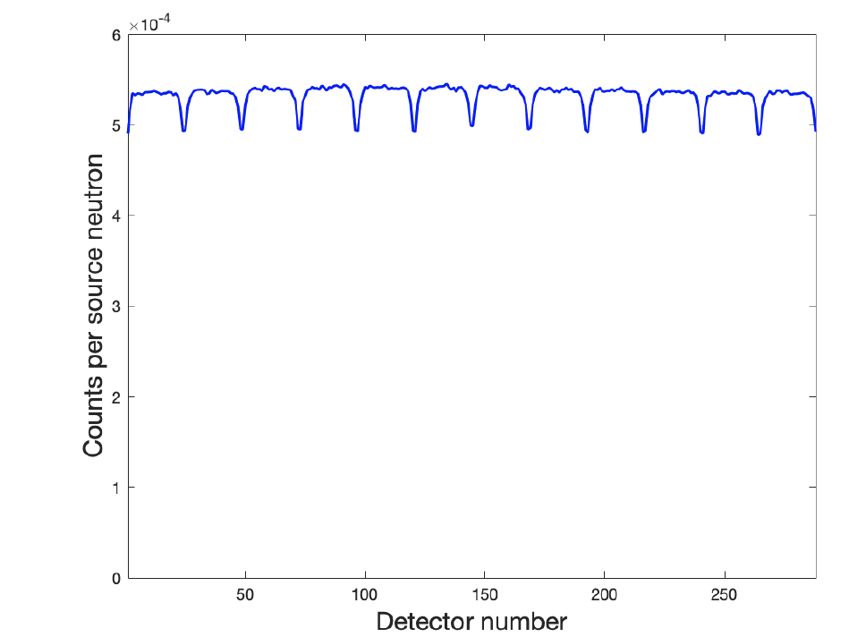
Figure 13. Detector efficiencies by detector row number. [9]

$PSF = A(θ)\left(exp\left(-\frac{(x-x_{0}(θ))^{2}}{2σ(θ)^{2}}\right)+\frac{1}{1.75}exp\left(-\frac{(x-x_{0}(θ))^{2}}{2(1.75σ(θ)^{2})}\right)\right)$ (Equation 4)
where, A, x₀ and σ represent the amplitude, offset and width of the distribution, respectively. The value x represents the distance (in number of detectors) between the detector at the outer diameter of the slit and the detector where the response peaks. The quantities A, x₀ and σ are written as a function of the angle θ between the slit and the unit vector normal to the detector surface. Note that the distance between neighboring detectors at the edge of detector modules must be reduced to 0.8716 to make the parameters a relatively smooth function of the angle 𝜃. This shorter distance reflects the reduced amount of HDPE moderator at the edges of each detector module and the decreased distance reflects an effective distance in HDPE moderator. The fit values for the PSF are tabulated in Table 6. Figure 14 shows an example PSF for a particular slit of the collimator where the angle θ is zero. In this instance the slit is normal to the detector surface. Figure 14(a) shows a linear scale of the simulated neutron captures (black) across all 288 detectors as well as the double Gaussian PSF fit (red). Figure 14(b) shows the logarithmic scale of the same counts and fit equation.

Collimator Penetration
Due to the quantity of slits made into the collimator there are paths through which the effective density of the collimator is much lower than if the same collimator thickness were completely made of borated polyethylene. Neutrons coming from a spent fuel assembly could potentially travel through the collimator in these effectively thinner areas without being attenuated. If they are moderated and absorbed in the boron straws, this can lead to misattribution of neutron source signal to a path along a collimator slit when the neutron actually travelled directly through the collimator. The portion of the neutron counts which would penetrate the collimator in this way was simulated using a line source with the neutron spectrum of ²⁴⁴Cm which was centered in the inspection volume. Then the number of neutrons detected was compared by taking the negative natural logarithm of the number of neutron counts detected for each detector with and without the collimator present, which can be written as:
$t_{eff}=-ln\left(\frac{C_{coll}}{C_{nocoll}}\right)$ (Equation 5)
where t_{eff} is the effective collimator thickness, C_{coll} is the number of counts with a collimator present and C_{nocoll} is the number of counts with no collimator present.
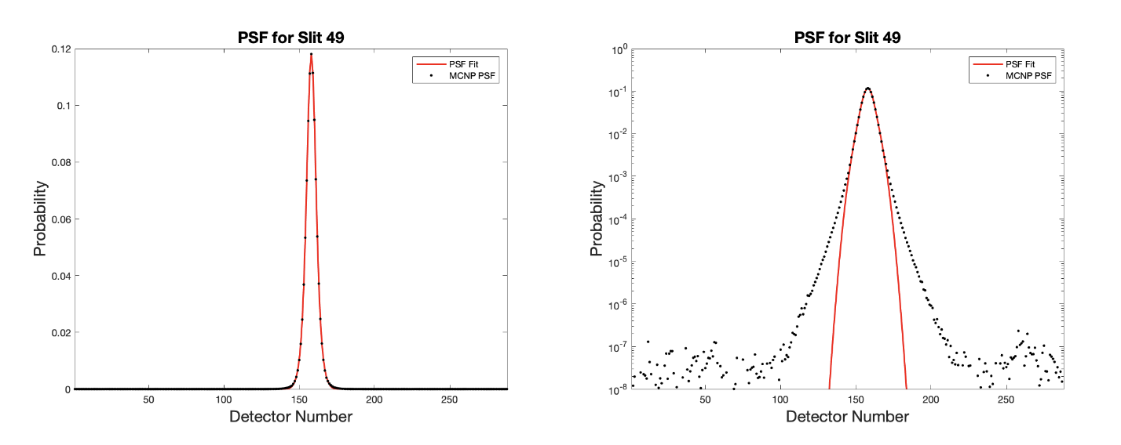
Figure 14. MCNP Simulated point spread function (black) and analytically fit PSF (red) for slit 49 in linear scale (left) and logarithmic scale (right). [9]

Table 6. Estimated fit function for the point spread function [9]
Parameter | Estimated Function
$$A(θ)$$ | $$7.3569 * 10^{-2} + 2.7192*10^{-4} *θ$$
$$σ(θ)$$ | $$2.6312 + 1.221 *10^{-2} *θ$$
$$x_{0}(θ)$$ | $$1.5664 *10^{-4} + 5.9349 *10^{-2} *θ$$

Figure 15 shows the calculated neutron effective thicknesses for each detector row number (black) [9]. The difference in the effective thickness changes for each detector row because the density of the slits in the collimator changes for each path as the slits are unevenly distributed around the collimator. The collimator penetration would vary depending on the source location through the inspection volume. In order to generalize the collimator penetration values, an analytic fit to the data was created. The results of the fit for a line source centered in the inspection volume can be seen in Figure 15 in red [9].
Figure 16 shows the relative distances and angles from any detector to an arbitrary source point in the inspection volume. The path through the borated polyethylene portion of the collimator has a length of t + Δt, where t is the straight-line path from the detector to the collimator inner edge and t + Δt represents the increase of the path length from the detector to the collimator edge in the direction of the source position. The effective collimator thickness values for all detectors given any source position can be written as:
$Δt_{eff} = t_{eff}\frac{Δt}{t}$ (Equation 6)
where Δt_{eff} is the effective collimator thicknesses given any source location, and t_{eff} is the initial effective collimator thickness values with a source at the center of the FOV. This is multiplied by the ratio of the difference in collimator path length from director to the source point, Δt, to the direct path length through the collimator, t. This ratio can be written as:
$\frac{Δt}{t} =\frac{R_{out}cos(θ)-\sqrt{{r_{in}}^{2}-{R_{out}}^{2}sin(θ)}}{R_{out}-r_{in}}-1$ (Equation 7)
where t is the shortest collimator path length, θ is the angle between t and t + Δt, R_{out} defines the radius from the center of the inspection volume to the detector edge and r_{in} defines the radius of the inspection volume. Then, the collimator penetration for any point in the FOV can be estimated as:
$P = A_{cp}\left(\frac{R_{out}}{R}\right)exp\left(-{Δt}_{eff}\right)exp\left(-t_{eff}\right)$ (Equation 8)
where P is the collimator penetration, and the factor A_{cp} is to fit radiation transport simulated data. Given that 𝐴_{cp}exp(-t_{eff}) yields the value of collimator penetration with the source in the middle of the inspection volume, the factor (R_{out}/R)exp(-Δt_{eff}) corrects for different source–detector distances and paths through the collimator.

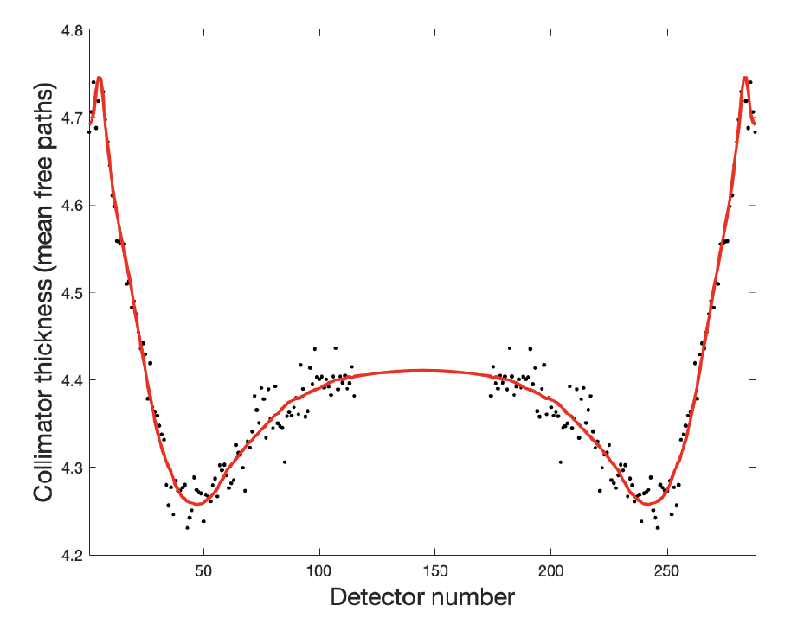
Figure 15. Effective collimator thickness for each row with a line source at the center of the FOV. [9]

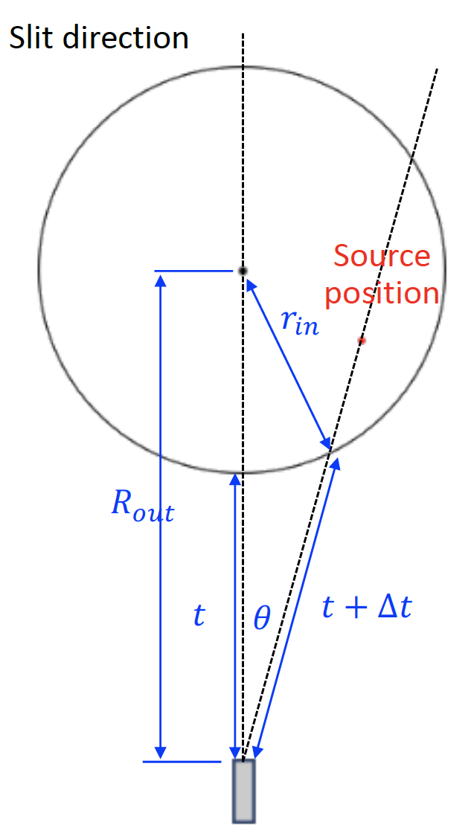
Figure 16. Drawing representing the distances used when calculating collimator penetration. [9]

Slit Scattering
One portion of the neutron response is slit scattering. This refers to a neutron that may be incident on a region of the collimator close to a slit opening, but not directly in the path of the slit, which scatters one or more times and is then directed unimpeded down the collimator slit. Figure 17 shows a drawing of a slit scattering example. The probability of slit scattering can be written as:
$S = A_{s}\frac{t}{s}\frac{r_{0}}{r+2}\left\{\frac{cosθ , if cosθ> cos(θ_{1})cos(θ_{2})}{cos(θ_{1})cos(θ_{2}), otherwise}\right\}$ (Equation 9)
where A_{s} is a factor determined by radiation transport simulations, r is the distance from the source to the slit opening, r₀ is the distance from the center of the FOV to the slit opening, and the angle between r and r₀ is θ₁. The length and direction of the collimator slit is s and the shortest distance from the detector and the collimator edge is defined as t. The angle between the slit direction and the source location is θ, and θ₂ is the angle between the FOV center and the slit direction.

Direct and Edge Transmission
The direct and edge responses of the collimator quantify the transmission of neutrons unimpeded down the collimator slits. The direct transmission simulated the amount of signal from neutrons that traveled to the detectors unimpeded by a collimator slit. The edge transmission represents the number of neutrons which travel down collimator slits but where the collimator wall partially or fully occludes the slit. An example of this would be neutrons traveling through the partially occluded slit wall and into one of the collimator slits, and then continuing down the slit to the detectors.
In order to simulate the direct and edge components of the response, a ²⁴⁴Cm line source was placed in a simulated collimator with a single slit in it. The line source was moved perpendicularly to the slit direction at 3 different distances from the slit opening. These distances were 5.04, 10.08, and 20.16 cm. Figure 18 shows a drawing depicting the collimator with a single slit of length t with an outer opening of w, and a perpendicular line at distance d from the slit opening along which line sources were moved. The distance that the source was moved from the centerline of the slit is w_{s}. For the simulations associated with each distance from the slit opening, 89 different source positions were simulated spanning the distance from the slit
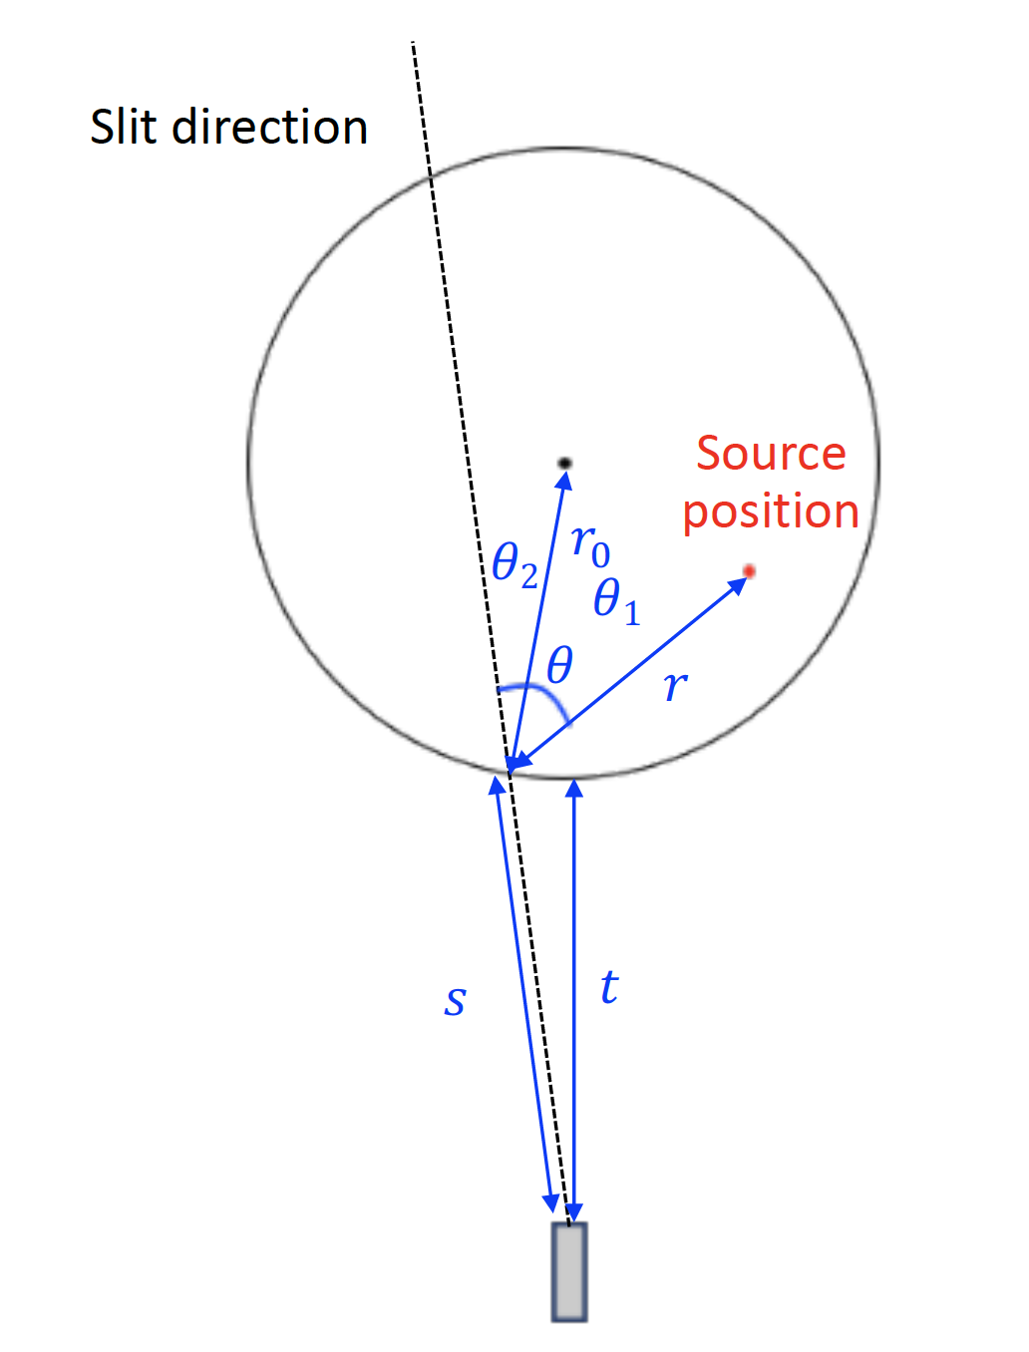
Figure 17. Slit scattering schematic. [9]

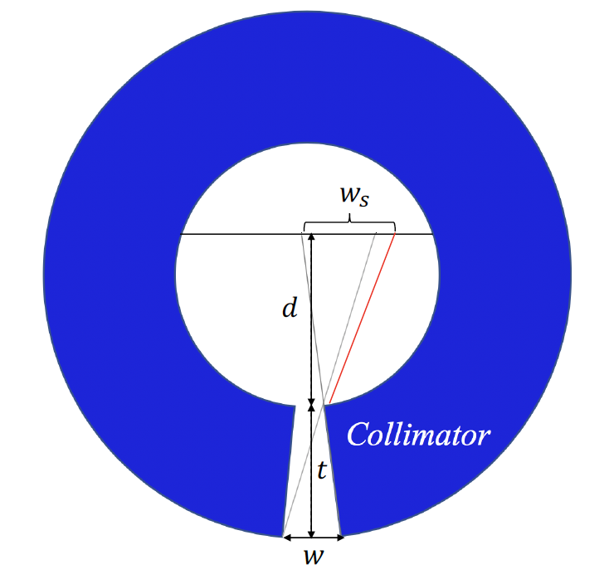
Figure 18. Single slit collimator drawing for simulating edge and direct scattering. [9]
centerline of w_{s} = -3.5 cm to +3.5 cm in 0.1 cm increments and then extending to w_{s} = -8 cm to +8 cm from the slit centerline in 0.5 cm increments. Figure 19(a) shows the results from these simulations.
The distance past the slit edge can be linearly scaled as:
$x = a_{0}\frac{w}{t}d+a_{1}\frac{w}{t}$ (Equation 10)
where d is the distance, 𝑎₀ = 1.1896, and 𝑎₁ = 3.7057. The drop off in relative intensities are well aligned at each distance, as shown in Figure 19(b). This means the slit edge region responses can be modeled as a factor f, written as:
$f = 1-\frac{x}{a_{0}\frac{w}{t}d+a_{1}\frac{w}{t}}$ (Equation 11)
The direct transmission response, where the source has unimpeded view of the entire back opening 𝑤, should scale as one over the distance from the source to the detector. However, because the slit opening at the inner diameter of the collimator is smaller than that at the outer edge of the collimator, this response becomes more complicated. The different solid angles created by the inner and outer collimator slit widths are taken into account by allowing an exponent for the inverse distance from the detector that can be greater than one. The total direct and edge components can be combined and written as:
$D=A_{d}{\left(\frac{R_{out}}{d+t}\right)}^{α}f_{1}f_{2}$ (Equation 12)
where R_{out} is the outer collimator radius, t is the collimator thickness, and d is the distance from the inner slit opening to the source. The α factor was determined by evaluating radiation transport simulations and finding that an alpha factor of 1.43 used as an exponent makes the equation best match the simulated data. The factor A_{d} is chosen to match radiation transport simulation data. The f₁ and f₂ factors are calculated for each slit edge according to Equation 11.

Total Neutron Response
The total neutron response can be determined by combining all components of the response. The total response can be written as:
$T = ϵ_{rel}∘(PSF*D +PSF*S+P)$ (Equation 13)
where total neutron response is represented by T and was calculated by taking the sum of the direct and edge transmission, the collimator penetration and the slit scattering components.

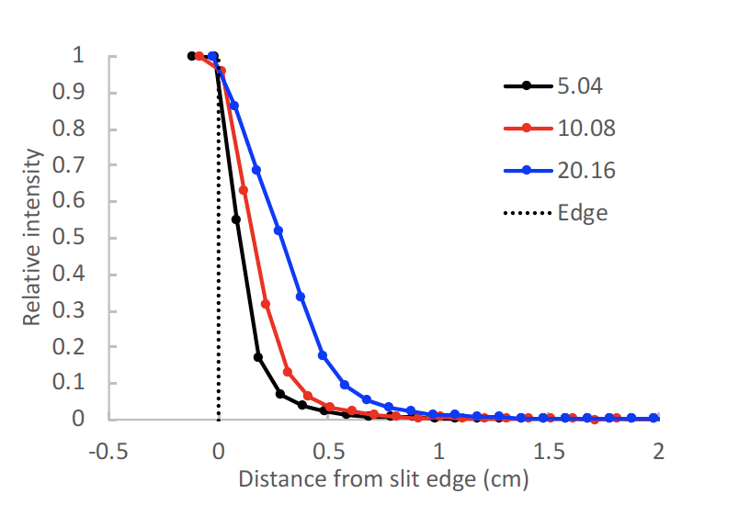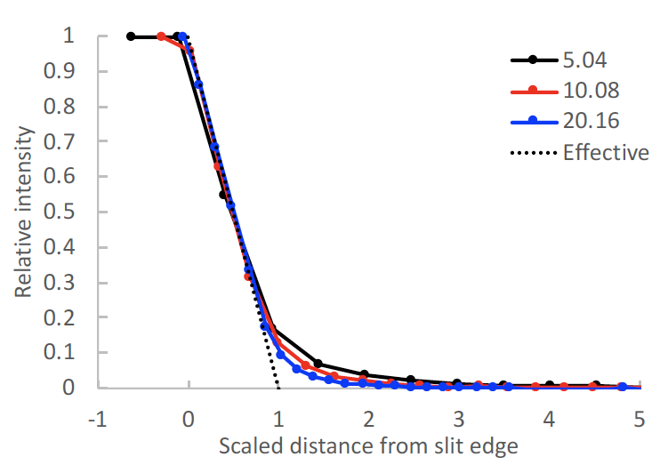
Figure 19. The relative neutron intensity as a function of distance from a slit edge (left) and relative intensity using a scaled distance from the slit edge (right). [9]

The direct and edge transmission as well as the slit scattering components were operated on by the PSF, then all components are operated on by the relative detector efficiency, ϵ_{rel}. In the equation the “$∘$” operator refers to element-wise multiplication whereas “*” refers to matrix multiplication. The expression 𝐷 is interpreted as a 96 × 1 matrix (one value for each slit), and the 𝑃𝑆𝐹 as a 288 × 96 matrix (all detector values for each slit) that, when matrix-multiplied by 𝐷, yields a 288 × 1 matrix (one value for each detector). Likewise, 𝜖_{ref} is a 288 × 1 matrix of relative efficiency values (one for each detector). This matrix is used to multiply each contribution elementwise to arrive at the total response. Similarly, S is defined as a 96 × 1 matrix, and P was defined as a 288 × 1 matrix. The total analytical neutron response for one projection is a 288 × 1 matrix.
The values of the constants 𝐴_{d}, 𝐴_{ss}, and 𝐴_{cp}, were each earlier stated to be fitted from radiation transport simulation data. Radiation transport simulations were performed for a ²⁴⁴Cm line source placed at positions along the central axis of slit 49 at distances between 1 and 35 cm from the slit opening in 1 cm increments. Similar simulations were performed for a collimator having only slit 49. The positions of the 49th slit and the 35 points where the source is positioned are shown in Figure 20 for (left) a collimator with a single slit and (right) a collimator with 96 slits.
The single slit collimator simulations were used to generate data with very minimal contributions from the collimator penetration response while the full collimator simulations were used to examine all contributions to the neutron response. Using the data from the 35 simulations values for 𝐴_{d}, 𝐴_{ss}, and 𝐴_{cp} were chosen to match the simulated data. The best fit values were 𝐴_{d} = 3.390725 × 10⁻⁴, 𝐴_{ss} = 4.553 × 10⁻⁶, and 𝐴_{cp} = 4.363601 × 10⁻⁴. Figure 21 shows the comparison between the neutron response generated by MCNP radiation transport code and the analytic response code for all detectors when the source is placed at the 35 different locations shown in Figure 20. The calculation visually matches.

Final Parallel Slit Ring Collimator Characteristics
Ultimately, using various simulations, an optimized version of the parallel slit ring collimator was created. The estimated neutron response for each of the configurations described in Section 1.7.4 was calculated, including the results with various slit widths and slit tapers. Then the responses were used to calculate the SNR for each configuration. It was determined that the
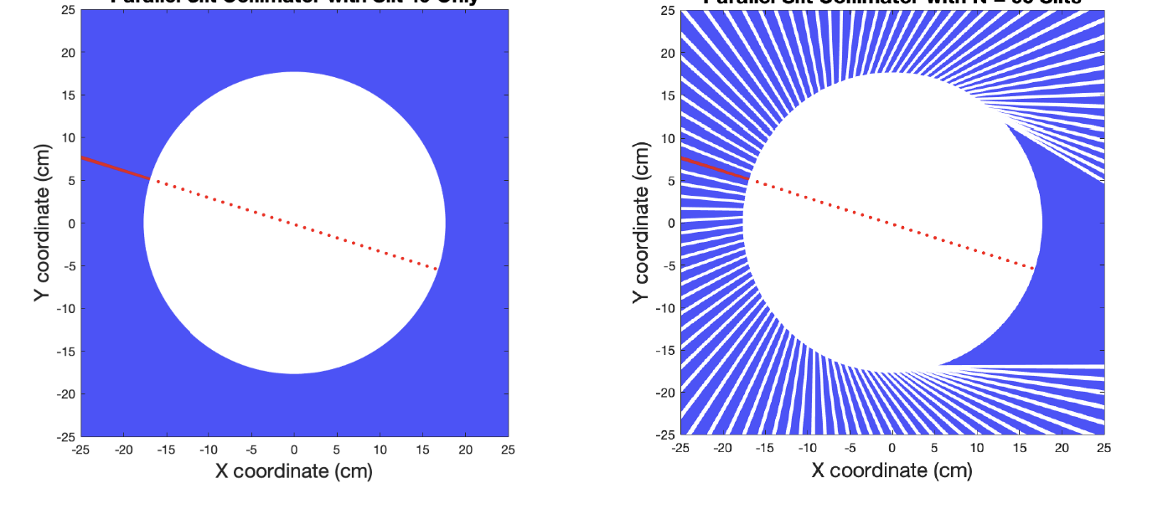
Figure 20. Neutron source positions at every 1 cm from the collimator edge with a single slit collimator (left) and a full 96 slit collimator (right).

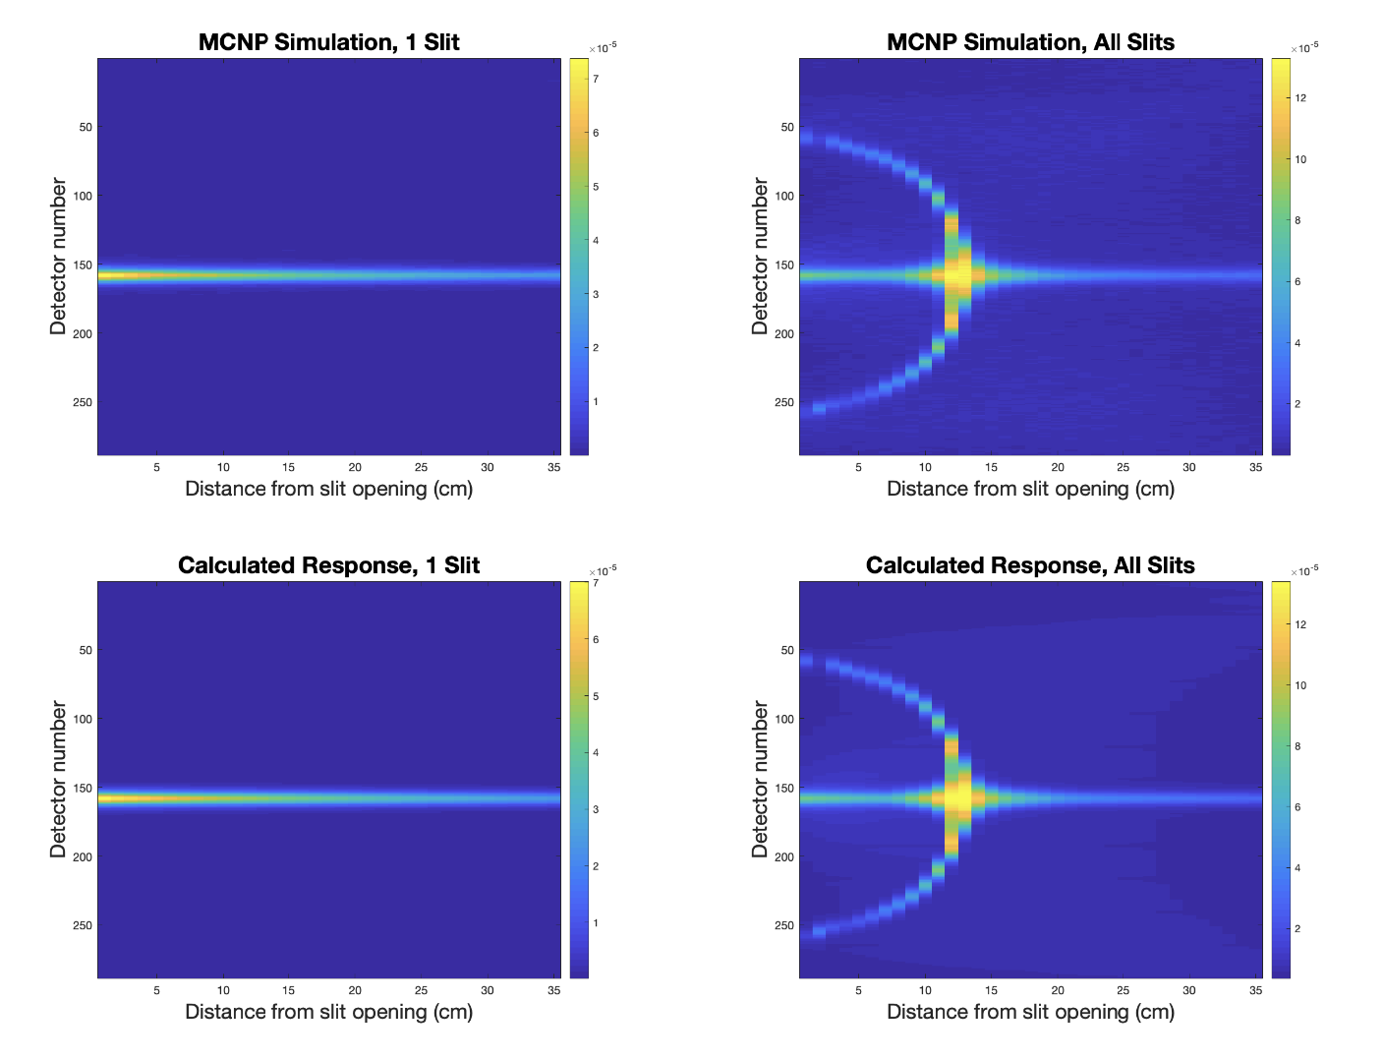
Figure 21. Calculated neutron response for all 36 source positions using the analytic model (left) and the simulated neutron response from MCNP (right). [9]

values for all configurations that have the same slit dimensions were approximately the same, but the SNR does increase with increasing quantities of borated polyethylene in the collimator.
Neutron response simulations indicate that the collimator spatial resolution is effectively limited by inter-detector scattering (PSF), not slit width. This means wider slits can be used to increase neutron efficiency and more stainless steel can be added to the collimator design to attenuate gamma rays that would otherwise deliver too much gamma dose for wider slits to be
used. While steel poorly modulates neutrons, it effectively controls gamma dose. Simulations also found that the performance of collimator configurations varies only weakly with the collimator thickness. As a result, the more compact designs are preferred.
The SNR is plotted as a function of gamma dose in the detectors in Figure 22 (left) for all configurations which have a more compact design with a thickness less than or equal to 45 cm. Using 500 R/hr as a cut off gamma dose, many design configurations are eliminated. The blue dots in Figure 22 (left) represent one of the most compact collimator configurations with a total thickness of 40 cm: 30 cm of borated polyethylene and 10 cm of stainless steel. Each blue dot represents a different slit width tested using this configuration and the majority of the slit widths used with this collimator configuration are below the gamma dose threshold. The best configuration would maximize the SNR while staying below the gamma dose rate threshold of 500 R/hr.
Using tapered slits can maximize performance from a compact design because they provide a combination of dose control and efficiency. The narrowness of the slit in the steel region attenuates more gammas and preserves the areal density of the collimator while the wider portions of the slit in the borated polyethylene region preserve the collimator efficiency. Figure 22 (right) shows the SNR and gamma dose rates for different slit tapers using a collimator with 10 cm of stainless steel and 30 cm of borated polyethylene. After examining the SNR and gamma dose rates from a variety of different slit tapers, a collimator composed of a 10 cm stainless steel section and a 30 cm borated polyethylene section with tapered slits with a width of 3 mm at the inner collimator radius and a width of 8 mm at the outer collimator radius produces a near-optimal value of SNR with a compact overall size. The SNR value for this configuration is marked by a red point on Figure 22 (right).

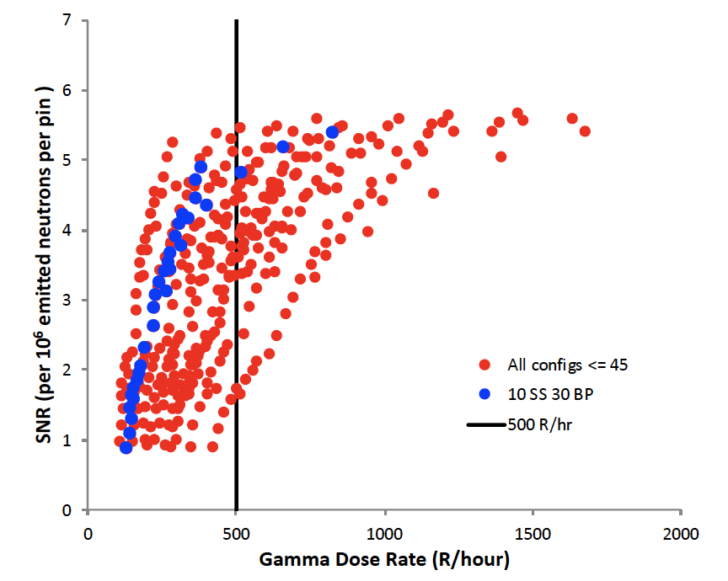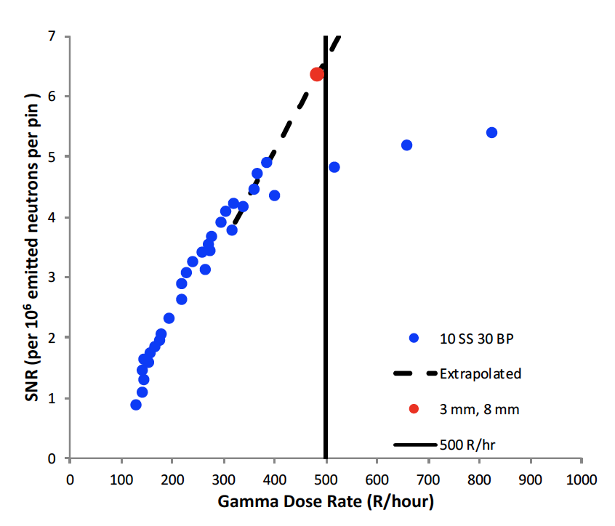
Figure 22. The signal to noise ratio as a function of gamma dose rate for all collimator material configurations and slit widths (left) and for a collimator configuration with 10 cm of stainless steel and 30 cm of borated polyethylene and all slit widths (right). [9]

Table 7. Imager components and dimensions for the final imager design [10]
Imager Component | Dimension (cm)
Overall imager height | 100.00
Fuel assembly cavity radius | 17.677
Stainless steel thickness | 10.000
Borated polyethylene thickness | 29.523
Air gap between collimator and detector | 0.3000
Inner slit width | 0.3000
Outer slit width | 0.8000
Al wall | 0.0635
Cd layer | 0.0406
Detector HDPE Thickness | 9.9187

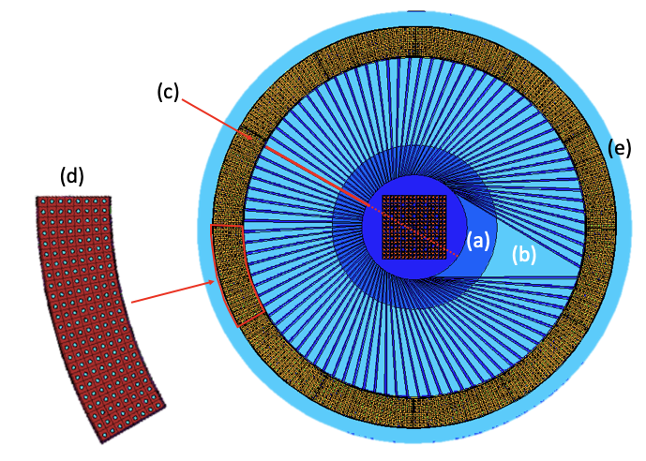
Figure 23. The collimator consists of 10 cm of stainless steel (a), 30 cm of borated polyethylene (b), with 96 slits in the collimator (c). The detector ring is 12 detector modules (d) with a 5 cm thick ring of HDPE surrounding the detectors (e). [10]

Total NET System Design
The final collimator and detector system design is made up of several different pieces. Figure 23 identifies each of these components. The imager FOV has a radius of 17.85 cm to allow for measurements of spent fuel assemblies. The collimator surrounding this field of view consists of an initial 10 cm of stainless steel followed by 29.22 cm of borated polyethylene that is 5% by weight boron. The slits were tapered with a width of 3 mm at the inner collimator radius and a width of 8 mm at the outer collimator radius. Ninety-six slits were incorporated into this collimator design.
Surrounding the collimator are 12 neutron detector modules. The detector modules sit 0.5 cm behind the collimator to allow the collimator to rotate without friction between the detector modules and collimator. More borated polyethylene, 5 cm in thickness, was added behind each of the detector modules to prevent background neutrons from scattering into the system. This gives a total imager diameter of approximately 146 cm. Table 8 contains information about the dimensions of the final collimator design. [10]
The detector system is intended to be used for fast neutrons, however; both fast and thermal neutrons are coming from spent nuclear fuel. Ensuring that the majority of the neutron flux is primarily fast neutrons is done with material selection. The mean free paths (mfp) in air of
fast neutrons and thermal neutrons are 2.51 × 10⁴ cm and 1.83 × 10⁴ cm, respectively. Meaning that both neutrons have the potential to travel in air to the detectors. The borated HDPE used in the collimator attenuates many of the thermal neutrons since the mean free path of thermal neutrons in borated high-density polyethylene is 0.421 cm. Given that the collimator consists of approximately 30 cm of HDPE, which is much larger than the mfp, the collimator acts as very effective shielding against thermal neutrons. The fast neutron mean free path in HPDE is 6.75 cm. The collimator is 4.44 times thicker than the mfp of the fast neutrons in borated HDPE. Many of the fast neutrons which enter the collimator will have interactions, but some will still travel through the collimator, and some may have multiple collisions and exit the collimator. The number of neutrons which make it through the collimator will need to be accounted for. There is also a 0.0406 thick layer of Cd lining the front of the detector between the collimator and the detectors and a second layer behind the detectors. The mfp of thermal neutrons in Cd is 0.00879 cm so any thermal neutrons which happen to make it to the cadmium layer will likely be attenuated before reaching the detectors. The mfp of fast neutrons in Cd is 3.91 cm, meaning most fast neutrons will pass through without an interaction in the Cd. The material selection ensures that a majority the neutron flux that reaches the detectors are fast neutrons.

Analytic Response Code
The as-built imager geometry was recreated in MATLAB. This also included a way to rotate the imager a set amount to generate different perspectives. The geometry of the system was then combined with the neutron response model outlined in Section 2.7 and the equations coded in MATLAB to create a full analytic response model. Using the geometry of the system and a knowledge of a source strength, the neutron response for every millimeter in the FOV was created and stored in saved variables. This method was chosen because it is less computationally expensive than running 10⁷ radiation transport simulations to produce results for every square millimeter in the inspection volume. It would also be more accurate than creating a grid of neutron responses spaced at every centimeter across the inspection volume and interpolating the results to get responses at every millimeter.

Simulated Reconstructions
A maximum likelihood expectation maximization (MLEM) reconstruction code was implemented in MATLAB to create forward and back projected images. The neutron response code was used to create forward projections, then neutron counts data from experiment or simulation was used as the measured data sinogram to compare to the simulated forward projections. A correction factor was multiplied to the analytic forward response and back projected from there. The iterations repeated using the analytic neutron response model to generate and weight forward projections until the image began to converge.
The MLEM reconstruction starts by comparing each position and detector from the measured sinogram to an initial forward projection which is created by finding the analytic code response at that same position and detector and multiplying it by an initial guess. The initial guess for the reconstruction code is always a value for 1 for every detector in every position. A ratio of the differences between the two is created by dividing the measured data points by the forward projection. This ratio is then multiplied by the forward projection to give a corrected forward projection which accounts for the differences from the measured data. The corrected forward projection is saved to a variable labeled “correction” which tracks the changes with each iteration. The correction variable is multiplied by the initial guess to give a new guess for the next iteration. The next iteration continues using the new guess. Over time ratio between the corrected forward projection and the measured data becomes smaller as the guesses become better and closer to the measured data. Eventually, enough iterations take place to make the difference between the guess and the measured data negligibly different and at this point the data has converged, and an image is generated.

Detector Construction

Proof-of-Concept Imager Design Changes
When constructing the imaging system, cost became a limiting factor. As a result, changes were made to the proof-of-concept imager system. Initially the collimator was designed such that it would be equivalent to having 96 parallel slits examining 96 different chords across the inspection volume [13]. These 96 slits would point towards an outer annulus of 288 detectors such that each slit pointed to every third detector. Arranging the slits in this way added a level of symmetry in the lines of response. The same line of response could be evaluated from different angles by two different slits. This gave 48 individual lines of response across the field of view.
Due to cost considerations changes had to be made in the prototype detector. Instead of the 96 slits in the collimator as originally planned, the number of slits was reduced to 72. This represents one slit for every 4 detectors rather than 1 slit for every 3 detectors. One of the concerns with decreasing the number of slits is the impact this reduction would have on the resolution. If the same symmetry from the 96 slit model were kept in the 72-slit model, the 72 slit version would only have 36 distinct lines of response. This would not be enough lines of response for sufficient spatial resolution across the field of view. Instead, fifty percent of the slits were offset by half-a-slit spacing, creating 72 separate lines of response.
In addition to changing the collimator, the number of detector modules themselves also had to be reduced. Rather than the planned 12 detector modules, the number of modules was dropped to 6 modules. Rather than a full ring of detector modules, every other detector position was replaced with a detector spacer made of aluminum and polyethylene. This held 6 of the detectors in alternating locations around the ring. To make a full measurement as though 288 detectors were used, the detector ring could be rotated by 1 detector module spacing, or, equivalently, by 30 degrees. Figure 24 shows how the detectors would be placed such that a full detector ring could be mocked up. The downside of this change was that each measurement would need to be taken twice, once in each position, to get the full view.

Proof-of-Concept Imager Construction

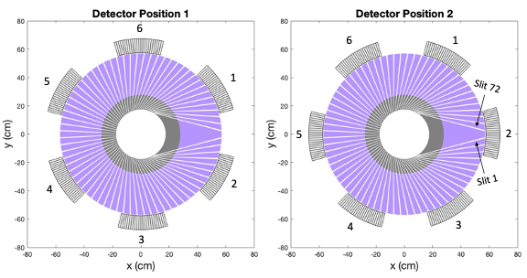
Figure 24. The two detector ring positions used to represent a full ring of 12 detector modules.

Collimator Construction
After design, the collimator was constructed by Agile Technologies. The collimator consisted of 72 slits which were designed with an inner diameter of 0.3 cm and an outer diameter of 0.8 cm. The 72 slits were arranged to cover the full 34 cm diameter of the FOV and view different chords across this region. Because of this each slit has different lengths and opening angles around the collimator. To accurately recreate this design, the collimator was built by assembling wedge-shaped pieces into the cylindrical collimator. When creating the collimator, instead of taking solid pieces of HDPE and stainless steel and then carving out gaps for the collimator slits, individual wedges composed of stainless steel and HDPE were constructed and combined. Figure 25 shows the stainless-steel wedge pieces (left) and the composite collimator wedges (right). These wedge-shaped pieces were cut to the size of the collimator material between the collimator slits. Each wedge was a composite consisting of a 10 cm thick stainless-steel portion which was screwed into a 29.22 cm thick HDPE collimator piece. In order to hold and arrange these composite wedges in the correct place, two guides were created, one for each the top and bottom of the collimator. Figure 26(a) shows the collimator guides with no wedges in place. These guides were created by taking rings of composite stainless steel and HDPE and machining slits into each one, shown in Figure 26(b). Then the collimator wedge pieces were slid into position using the guide slits. The final collimator with wedges installed is shown in Figure 26(c).

Detector Module Construction
The 6 detector modules were constructed as designed with 24 rows of 8 boron coated straw detectors with each embedded in HDPE. Each row of eight straws is read out by a single, low power electronic front-end readout board. Images of a detector module are shown in Figure 27.
The readout electronics are implemented by a fast current preamplifier as a front-end element, followed by another amplification stage, a passive, 6-pole, low-pass filter with a 56 MHz bandwidth, and a driver [17]. The resulting signal triggers a comparator which compares the signal to a common threshold value across the entire module. Any signal greater than this threshold is counted as an event. The event signal is then sent to a processing board which spans the entire detector module top surface. This board then buffers the signal and directs it into the
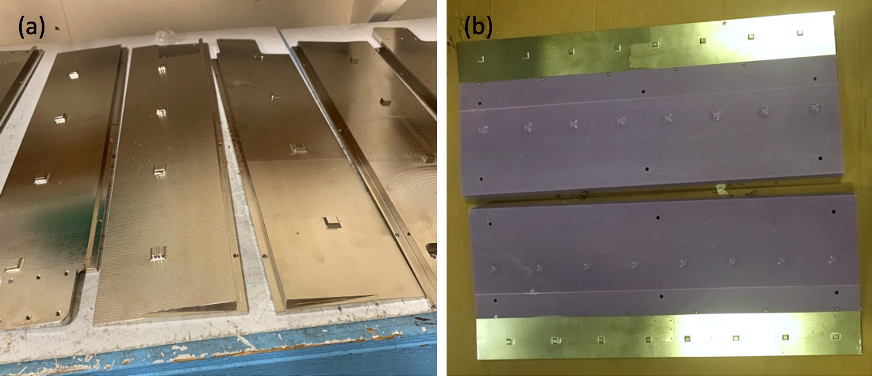
Figure 25. Composite wedges of the collimator.

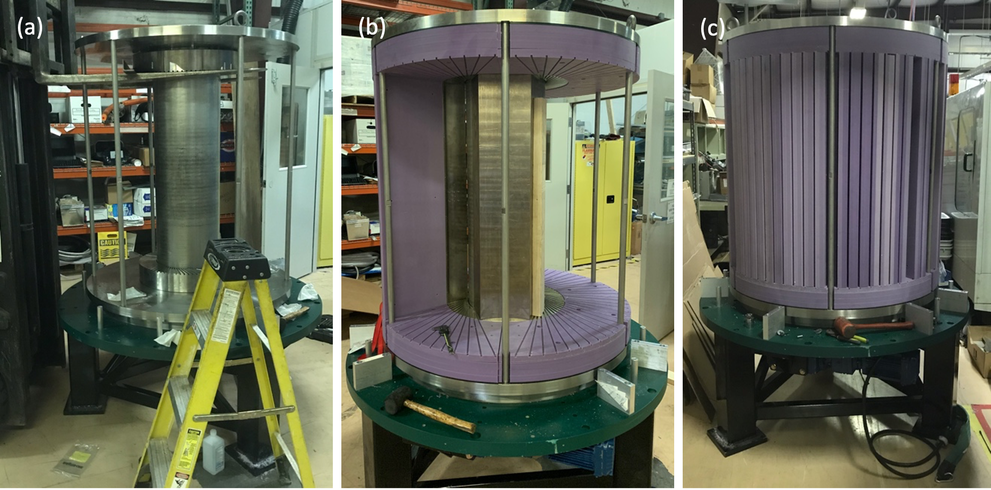
Figure 26. Assembly of the collimator.

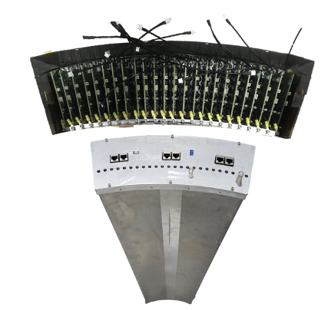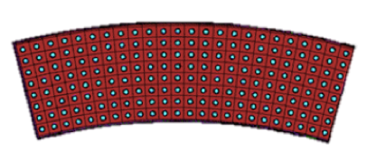
Figure 27. Detector module processing board (top left), photo (bottom left), and drawing of straw detectors embedded in HDPE (right).

output signal. This processing board also controls the detector voltage biasing value of +-6.5 V [17]. The output signals are provided for further processing to the back end and data acquisition (DAQ) electronics via Cat6e shielded cables.
The detector channels are numbered from 1 to 24. Six RJ-45 connectors cover an entire board and each carry four signals from the detector to the DAQ system [17]. The resulting current required by a single detector module is 1.38 A from the positive bias and about 0.46 A from the negative bias voltage.

Full Imager Assembly
Figure 28 shows a labelled drawing of the full assembly. The imager was constructed onsite at ORNL. First, an assembly and support stand were set up with a variable speed drive motor and pinion mounted to the stand. This would provide the detector base. A stainless-steel base plate was mounted on top of the support stand as a stationary plate with mounted large
diameter high-capacity slewing gear bearings, Kaydon Model #HS6-37N1Z. A secondary base plate was added on top of the bearings allowing the plate to rotate on the gear driven support bearings [17]. The collimator was mounted onto the upper plate. The collimator is rotated by a helical-bevel gearmotor and motion control inverter drive, SEW Eurodrive Model KA67R37** and MC07B0015-2B1** [17]. The motor and inverter drive together allow the collimator to rotate at various speeds between 0 and approximately 2 rpm. The power supply for the motor was installed on the leg of the imager support stand in a National Electrical Manufacturers Association rated electrical enclosure [17].
An additional stainless-steel annulus was added to the system around the second base plate to mount the detectors to the imager. This annulus was also placed on support bearings; however, these were not gear driven. This allowed the collimator and the annulus to be rotated independently of one another. A layer of 1” thick borated polyethylene was added above the annulus plate to prevent neutrons from scattering into the detectors from below. The six detector modules were mounted into this stainless steel and HDPE layer with detector spacers between each module. A 5 cm layer of HDPE was added behind each detector module to prevent background neutrons from scattering into the system. Figure 29 shows a top-down view of the as-built fixture placed within the imager. A mock fuel assembly fixture was added to the system to allow sources and mock fuel rods to be accurately placed within the imager FOV. This fixture
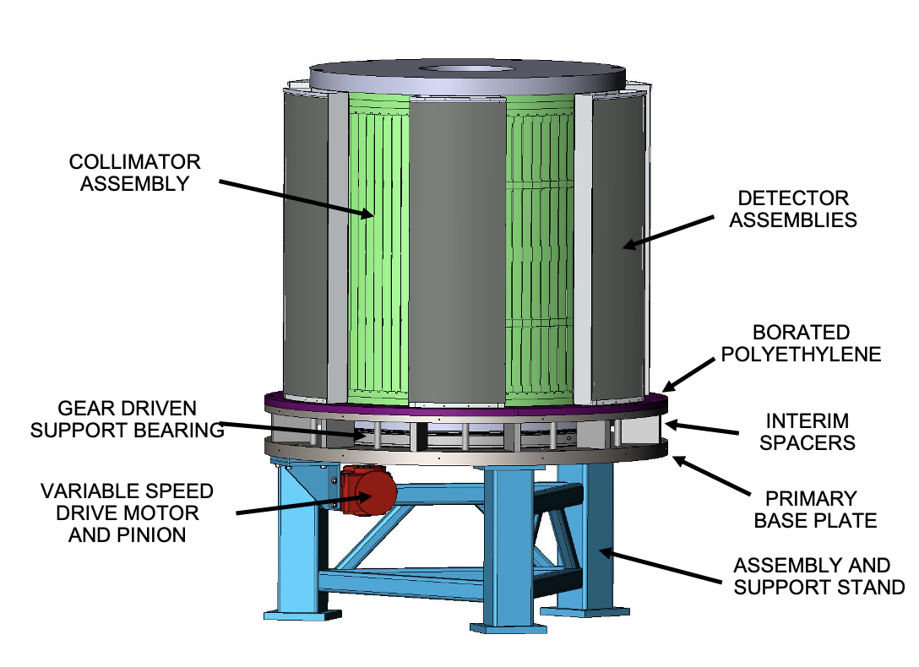
Figure 28. Drawing of the full imager assembly.

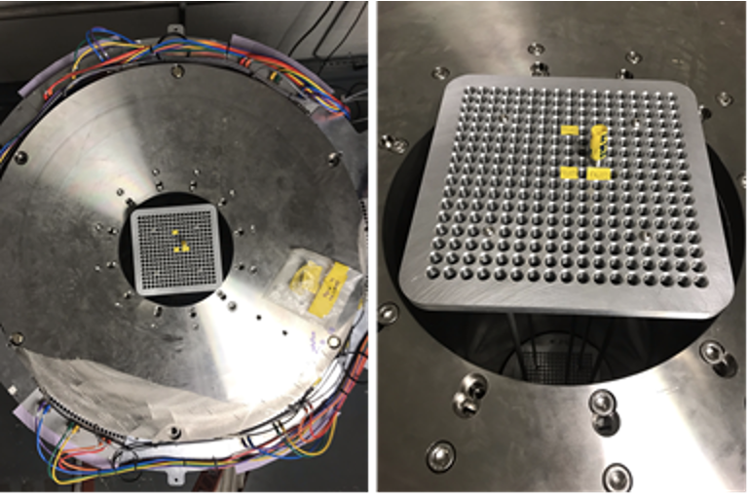
Figure 29. The grid fixture installed in the inspections volume.

was created to hold mock fuel pins in an arrangement modeled on a PWR fuel assembly. The fixture consists of two aluminum grids with 17x17 holes of diameter 0.9652 cm spaced with their centers 1.27 cm apart. Four stainless steel rods span 94 cm and connect the upper grid and lower grid to ensure the fuel pins remain vertically aligned.
Two different types of rods were procured in order to populate this grid fixture, the first being a neutron source rod. A thin-walled aluminum tube with an outer diameter of 0.9525 cm acted as the source rod. An elastomer stop was placed 25 cm within the tube from the bottom of the rod. This allowed a thin, cylindrical source to be added into the tube from the top of the rod where it would sit atop the stopper. This placed the source at a position 3 cm below the centerline of the neutron detectors. This source rod could be moved from one assembly grid location to another by removing the rod and placing it into the next position of interest. Figure 30 shows the rod and how the rod is placed in the assembly grid.
The second set of rods, this time made of stainless steel, was procured to mimic the attenuation that would come from other fuel rods in the assembly. These 121.9 cm long, 0.9525 cm diameter, stainless-steel rods would be added to all positions in the grid fixture other than the position occupied by the neutron source to mock the neutron absorption from the rest of the fuel assembly. Figure 31 shows a drawing of the fixture populated with rods and positioned within the imager (a), as well as a cutaway of the fixture within the imager (b), and a rendering of just the fixture itself (c). By taking separate neutron measurements with the neutron source rod in different locations, a full fuel assembly’s worth of data can be considered when all the data is summed.

Data Acquisition System
The DAQ system uses a CAEN V2495 Programmable Logic Unit with three added A395A digital input boards and FW2495SC FPGA firmware in order to be used as a multi-event scalar counter. Using the three additional boards, 160 independent counting channels are available to record data from the detectors. Given that only 6 of the detector modules were made, with 24 data readouts each, only 144 of these 160 channels are used for signal. The remaining 16 channels allow the addition of a clock pulser and IR optical switches which encode the positions of the collimator as it rotates. The V2495 is then read by a custom software program created by Cadre5 which accesses the detector information through a SIS3153 VME bus and allows for

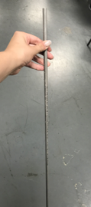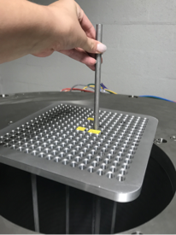
Figure 30. Neutron source rod by itself (left) and in the grid fixture (right).

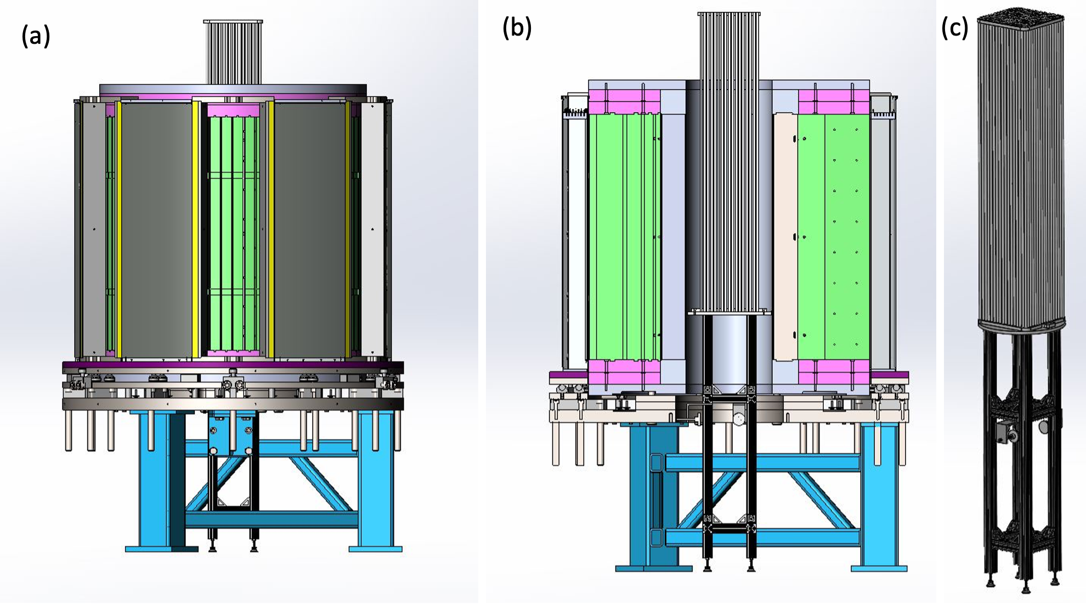
Figure 31. A drawing of the grid fixture within the full imager (a), a cutaway of the fixture’s placement within the full imager (b), and an image of the fixture itself (c).
system control through a custom interface. The interface allows for control of the two CAEN V6533P six-channel, positive polarity, 4 kV, 3 mA detector module power supplies as well. A photograph showing the V2495 logic unit, two V6533P HV modules, and VME bridge is shown in Figure 32.
The V2495 modules accept input on proprietary CAEN A967 flat ribbon cables. A custom interface module is located within a rack enclosure to convert the detector signals from Cat6e signaling to the CAEN flat ribbon cabling. The back of the module has 48 RJ-45 cable inputs across 4 PC boards upon which the incoming signal is buffered. At this point the signal is driven into the CAEN flat ribbon cables which are arranged on the front of this module. The CAEN ribbon cables consist of two 34 pin channels which merge into a 68-pin connector that is directly connected to the V2495 module and the accompanying A395A input boards. Each of the CAEN cables can carry up to 34 signals; however, only 32 of these signals are used on each. Due to the mechanical characteristics of the CAEN flat-ribbon cable, a straight-through mapping of the channel numbers is not possible.
In order to accommodate these cables, the 34 pin connectors are attached to the interface
module starting from the right side of the module. This can be seen as the black module in Figure 33 with 12 connections. The first connector will plug to the lower rightmost mating connector on the panel. The second will plug under this connector. The next cable will plug in the center row according to the same modality and so on. These connectors are assigned letters A-F to differentiate to which connector a reference is being made. The lower rightmost mating connector is labeled A, while the lower center connector is B and the leftmost lower connector is labeled C. The upper rightmost connector is labeled D, the center is labeled E, and the upper leftmost is labeled F. Consequently, the Cat6e cable on the opposite side of the module must be mapped accordingly.
Due to the design of the CAEN DAQ, the connector labeled C is designated as a set of 32 output channels. For this reason, no RJ-45 cables are connected to that connector. The back of the CAEN module has 48 RJ-45 inputs arranged in a grid of 4 rows by 12 columns. Within the grid, each of the 6 connectors has 8 inputs arranged in a grid of 2 rows by 4 columns, as shown in Figure 33. To read signals out from the detector modules, the RJ-45 inputs for the first detector are connected to Connector A. Beginning with the 2x4 grid starting in the lower rightmost corner of the module, the first RJ-45 cable is plugged into the lower left input of the 8
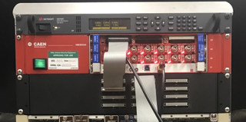
Figure 32. The data acquisition system.

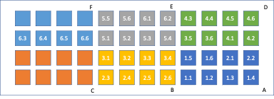
Figure 33. Wiring diagram for the translator.

inputs in this group. The connections continue in this row of 4 from right to left before jumping to the upper row of 4 inputs and continuing left to right. The connections then go to the lower center 2x4 grid of inputs, corresponding to Connector B, and continue in the same pattern of connecting to the lower row, going from left to right, then the upper row left to right. Each RJ-45 input from each detector module is mapped in this pattern to the alphabetically advancing connector, skipping connector C.
The interface module requires approximately 8 A from a 3.3 V supply. To power the entire system, a Keysight N6700C modular rack power system was chosen. A single rack (N6700C) with two N6742B channels (8V, 12.5A for the detector module) and one N6731B channel (5V, 10A for the interface box) powers all 6 detector modules as well as the interface module.

Detector Module Testing
Prior to assembling the full imager the detector modules were tested to determine the optimal threshold values for the detector modules. An initial experiment was conducted to determine the efficiency of these detector segments and compare the intrinsic efficiency of the detector modules to the manufacturer purported value. Various trigger thresholds and bias voltages were analyzed to see the impact on efficiency and compared to the manufacturer values.

Experimental Set-up
In this experiment, a ²⁵²Cf neutron source was used to calculate the detector module efficiencies. Calculating the efficiency requires a reliance on a well-known source. In order to later determine the intrinsic efficiency of the detectors, the ²⁵²Cf source used was first counted in the Californium shuffler at Oak Ridge National Laboratory (ORNL). The detection efficiency of the Californium shuffler is well known to be 16.76% with a 2% relative uncertainty, this was verified on June 6, 2019. Table 9 shows the measured values for the ²⁵²Cf source used. The source had an original activity of 9.96 × 10⁻⁴ Ci at the date of creation on 3/13/07. At its last assay on 9/17/19, the source was measured at an activity of 3.71 × 10⁻⁵ Ci. The neutron yield of 99236 $±$ 1985 n/s was used in this experiment.

Experimental Procedure
For the purpose of the experiment, the detectors were arranged in a semicircle such that half of the ring of detector modules was created, as seen in Figure 34. The ²⁵²Cf source can also be seen located at the center of where the fuel assembly would be, 57.2 cm from the inside of the Cd layer on the detectors and at a height of 56 cm from the base of the detectors. The source was placed on a ring stand and held in this location for the duration of the measurements. No collimator was used in this experiment. The detector modules were numbered from 1 to 6 from right to left around the semicircle. Detector module 1 had previously been damaged and was not used in the experiment except to moderate neutrons for better efficiency detection in module 2. Each of detectors 2-6 were counted individually to determine efficiency. A series of measurements were made with each detector module to better characterize the detector, Table 10 describes the measurements made on each detector.
Table 9. Source information and final yield values from the Californium Shuffler.
10/29/19 | Single |  | Doubles
Gross | 16636.458 | 6.480 | 2258.183 | 16.148
Background | 4.423 | 0.095 | 0.337 | 0.030
Net | 16632.035 | 6.481 | 2257.806 | 16.148
6/6/19
Gross | 18291.538 | 4.58 | 3737.404 | 10.59
Bkg | 4.618 | 0.11 | 0.524 | 0.10
Net | 18286.92 | 5458 | 3736.88 | 10.60

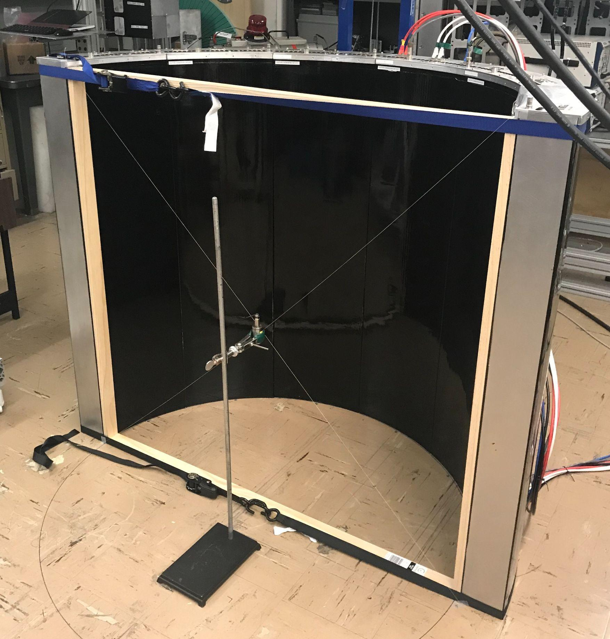
Figure 34. Experimental set-up for module efficiency testing.
Table 10. Standard measurements made on each detector module.
Run Number | Lower Threshold (mV) | Bias Voltage (V) | Time (s)
Background | 25 | 700 | 1800
1 | 25 | 700 | 1200
2 | 0 | 700 | 600
3 | 25 | 700 | 600
4 | 50 | 700 | 600
5 | 75 | 700 | 600
6 | 100 | 700 | 600
7 | 125 | 700 | 600
8 | 150 | 700 | 600
9 | 175 | 700 | 600

Each detector module had a variable threshold that could be set to a specific voltage. Incoming signals that generate voltages above that trigger threshold would register in the detector as a neutron count. For each detector the lower threshold for detector triggering was changed over a series of values from 0 to 175 mV. When examining the detector modules, it was found that they had a slight offset built into the threshold, which allowed for voltages less than 0 mV to be applied as the threshold for triggering. This can be attributed to a calibration error in determining thresholds for the detectors and is not a negative polarity voltage applied to the detector threshold. The negative thresholds referred to in this paper represent the offset due to calibration error and do not represent negative polarity voltages. In addition to the measurements described in Table 10, these negative threshold values were recorded to observe the extent of the detector threshold offset. The threshold was lowered until it reached a voltage at which the detector was consistently triggering on noise rather than counts. A representative measurement was made on detector 4 to get this value and the measurements made are described in Table 11. A final comparison was made by changing the bias high voltage on the detector and observing the corresponding change in efficiency. Table 12 depicts the measurements that were taken to determine a representative efficiency curve for the change in bias voltage.

Discussion of Results
Count rates seen using the source described above were typically between 28 and 33 counts per second in each of the 24 detector channels for detectors 2-5, as seen in Figure 35. Detector 6 had a much lower count rate due to its placement around the semicircle of detectors. The steep decrease in the count rate of the detector channels in module 6 is a result of its placement in the arrangement of the detector modules. The lack of moderation from a module to the left of the detector reduce the count rate significantly as no neutrons are being moderated and scattered into the left side of the detector. In a full imager assembly, this would not be an issue as a full ring of detectors would leave no detector module with an unmoderated side. With the system that was used in this experiment, this is important to note while examining efficiencies. This was not the case for module 2 which saw no drop in the count rate because detector module 1 was in place in the semicircle, moderating and scattering neutrons into detector 2. As previously mentioned, detector module 1 was not operational at the time; however, had it been operational, a drop in the count rate along the right side of the detector in channels 19-24 would
Table 11. Negative threshold voltages to see noise triggering.
Lower Threshold Voltage (mV) | Bias Voltage (V) | Time (s)
0 | 700 | 30
-5 | 700 | 30
-7.5 | 700 | 30
-8 | 700 | 30
-9 | 700 | 30
-10 | 700 | 30

Table 12. Bias Voltage changes made on detector module 2.
Lower Threshold Voltage (mV) | Bias Voltage (V) | Time (s)
25 | 600 | 600
25 | 700 | 600
25 | 800 | 600
25 | 900 | 600

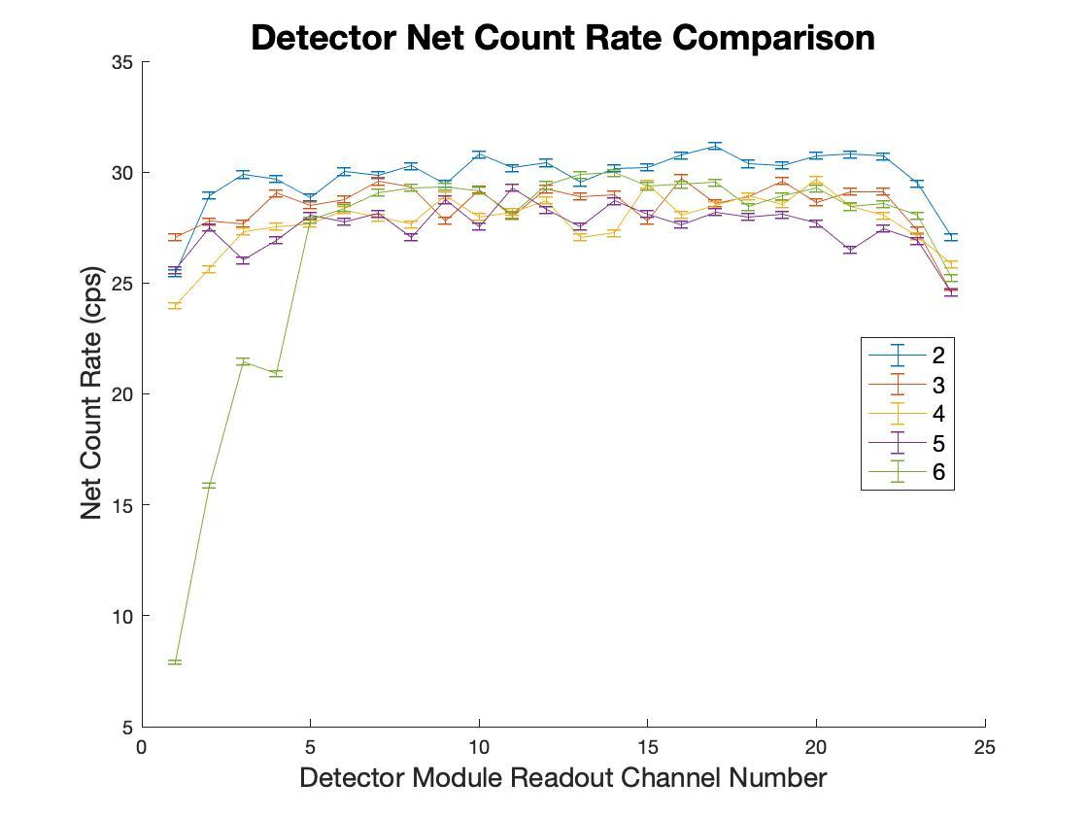
Figure 35. Net detector count rates for each detector module measured.

likely have been seen. It is expected that the drop would look symmetrical to the drop in channels 1-5 for detector module 6. The error bars in Figure 35 come from the statistical uncertainty i.e. the standard deviation of the counts.

Absolute Efficiency
The absolute efficiency of the detectors was determined from the count rate and knowledge of the source used. The neutron yield of the source described in Section 4.1 was used in this calculation. The calculation of the absolute efficiency for each detector module readout [18] can be described by the equation:
$ϵ_{absolute}= \frac{\# of neutrons detected}{\# of neutrons emitted by source}=\frac{net count rate}{neutron source yield}$ (Equation 14)
By averaging the absolute efficiency for each channel, an average absolute efficiency for each detector module can be found, as shown in Figure 36.

Geometric Efficiency
The geometric efficiency of the detector depends on the detector shape and design. The geometric efficiency represents the fraction of the emitted source neutrons incident upon the detector module [18] and can be written as:
$ϵ_{geometric}= \frac{Ω}{4π}$ (Equation 14)
The solid angle of the detectors in this configuration can be defined as:
$Ω=4π(1-\cos\left(\tan^{-1}{\frac{h}{d}}\right))$ (Equation 15)
This is equivalent to taking the solid angle occupied by the top of the ring of detectors and the solid angle formed by the bottom of the ring of detectors and subtracting that value from 4π. Figure 37 is a diagram depicting the solid angles unoccupied by the detector ring and helps to illustrate Equation 15. The blue cylinder represents the ring detectors. The cones outlined in black indicate the unoccupied solid angles into which neutrons can be emitted by the source located at the connection of the two cones. The solid angle of the ring detector can then be defined as the total directions in which neutrons can be emitted minus the directions in which there is no detector. In this Equation 15, h represents the half height of the detector and d is the perpendicular distance from the source to the detector face.
Using these equations, the value for the geometric efficiency of one detector module can
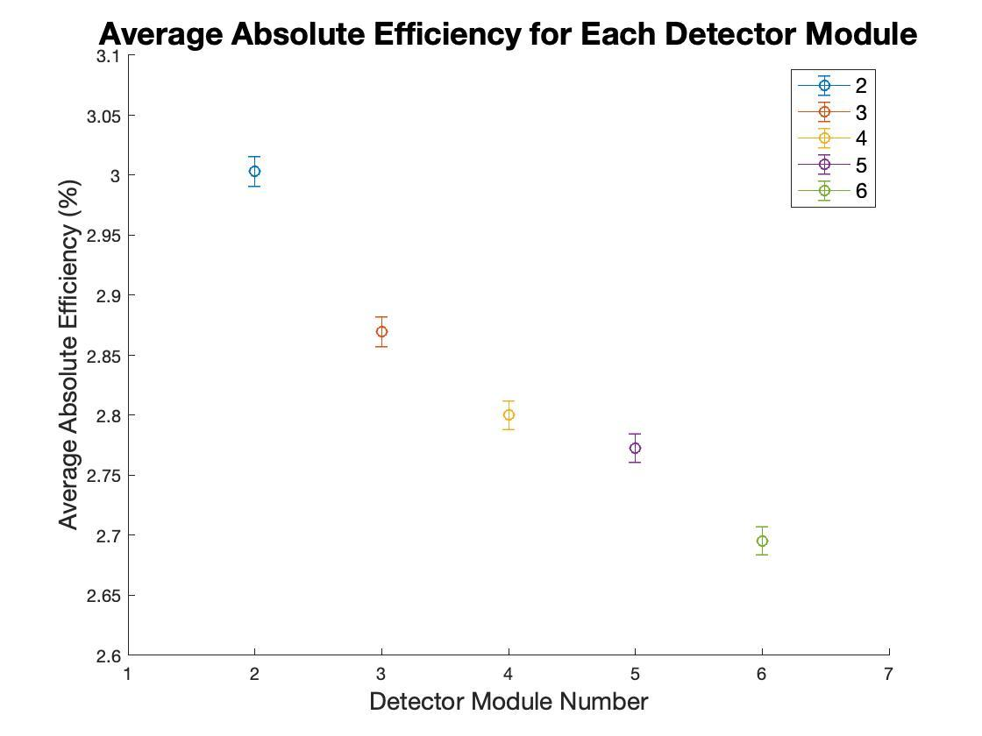
Figure 36. Average absolute efficiency for each detector module with a threshold value of 25 mV and a bias voltage of 700 V.

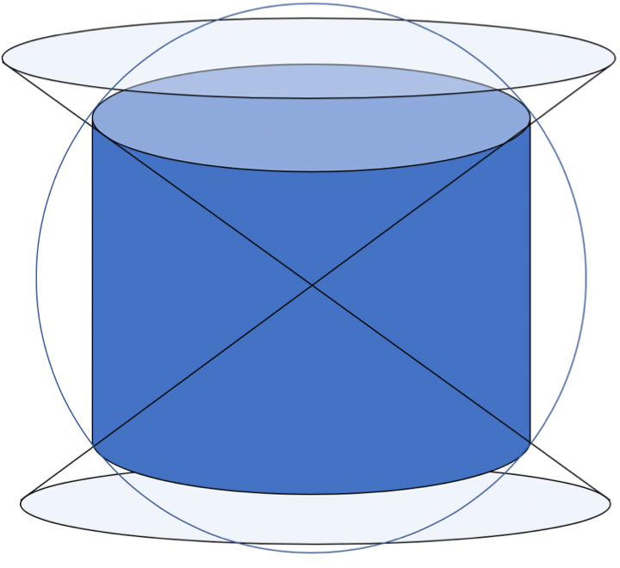
Figure 37. Schematic of the calculation of the solid angle for the space which the detector does not occupy.

be determined to be 65.95%. Dividing the geometric efficiency for the full ring of detector modules by the number of detector modules (12), yields a geometric efficiency of 5.50% for a single detector module.

Intrinsic Efficiency
The intrinsic efficiency is a measure of how many of the neutrons incident on the detector are actually detected and can be written as:
$ϵ_{intrinsic}=\frac{\# of neutrons detected}{\# of neutrons incident on detector}=\frac{ϵ_{absolute}}{ϵ_{geometric}}$ (Equation 16)
Figure 38 shows the intrinsic efficiencies calculated for each detector module. The published value from Proportional Technologies Inc. is 54% intrinsic efficiency [16]. For detector modules 2-5 which have proper neutron moderation, the difference in their intrinsic efficiency values from the PTI reported value is less than 3%. Detector module 6, with insufficient moderation, has a value which differs from the PTI value by less than 5%.
The agreement between the intrinsic efficiencies found experimentally and the PTI value demonstrates that the efficiency is still comparable in the detector modules. Such detection efficiency meets the requirements to allow the proposed neutron emission tomography system to detect and image neutrons with sufficient accuracy to verify spent fuel.

Changing Threshold Trigger Voltage
Changing the threshold voltage for triggering the detector modules results in different efficiencies. Lowering the threshold needed to trigger the detector means that more events are being counted. To see the extent to which adjusting the threshold changed the efficiencies, intrinsic efficiencies for eight different positive threshold voltages and five negative threshold voltages were calculated. Detector module 4 was used to determine a representative detector module response to these changing thresholds, as shown in Figure 39. The 25 mV threshold used in the calculation of the intrinsic efficiencies shown in Figure 36, was an appropriate value to use given that it yields an efficiency which is most comparable to the PTI reported value.

Changing Bias Voltage
Changing the bias voltage applied to the detector also changes the efficiencies. Figure 40 shows calculated intrinsic efficiencies for four different bias voltages. PTI has suggested that very high
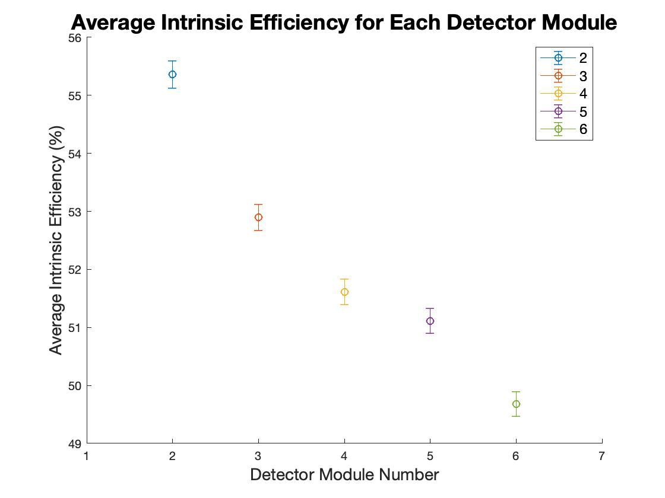
Figure 38. Intrinsic efficiency for each detector module with a threshold value of 25 mV and a bias voltage of 700 V.

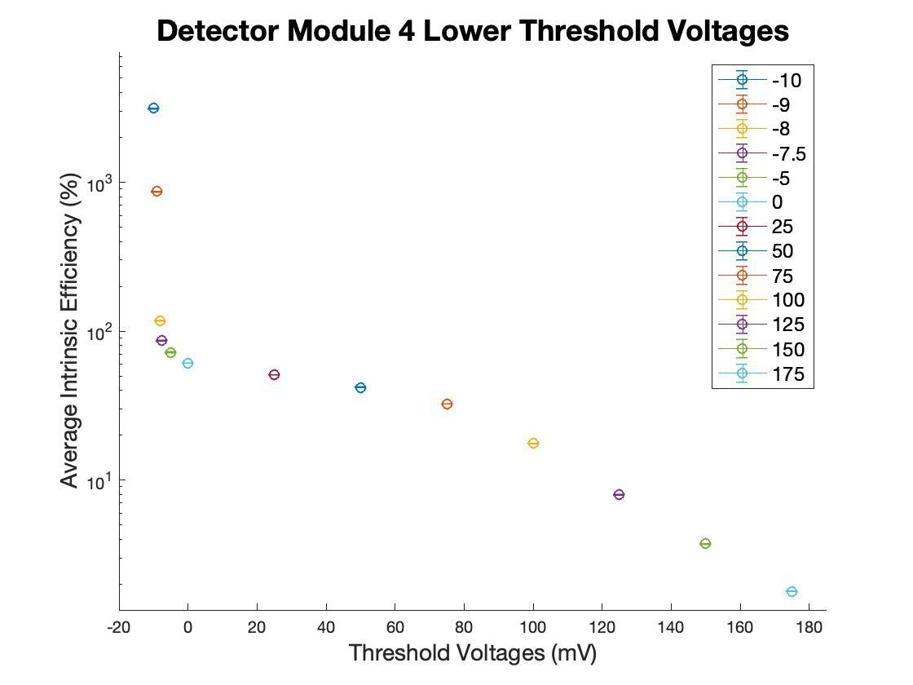

Figure 39. Intrinsic efficiency for detector module 4 with varying lower threshold voltages and a bias voltage of 700V.
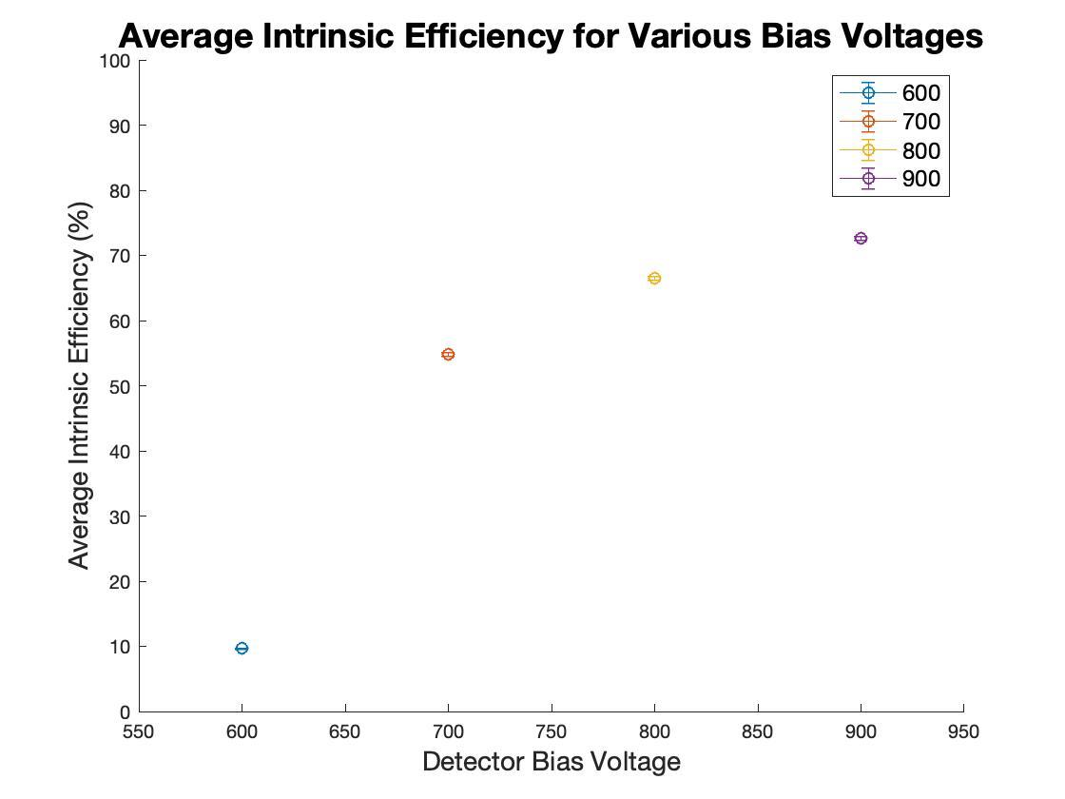
Figure 40. Intrinsic efficiencies for one detector with a threshold value of 25 mV and a varying bias voltage.

bias voltages show worse discrimination between neutron and photon interactions in the detector. This would imply that a lower bias voltage should be used. However, there is a significant difference in efficiencies between 600 V and 700 V. PTI recommended using a 700 V bias voltage for the detector modules because the efficiency was still relatively high at that value, but the photon and neutron discrimination would be much better than at higher voltages. Using a 700 V bias voltage yields results most comparable to the PTI intrinsic efficiency value for the boron coated straw detectors and all efficiencies in Figure 38 were made using this 700 V value.

Final Threshold Choices
After examining intrinsic efficiencies calculated from various trigger voltages and varying bias voltages, the intrinsic efficiency calculated under the conditions of 700 V bias voltage and a threshold trigger of 25 mV aligns with manufacturer reported value for intrinsic efficiency. Placing the boron coated straw detectors into this detector module configuration does not have a significant impact on intrinsic efficiency. The theoretical estimations for the accuracy of Neutron Emission Tomography were based on maintaining this intrinsic efficiency. The NET system, built to the designed geometry, maintains sufficient absolute detection efficiency to accurately image the fuel for verification purposes. This will lead to improved detection over present GET and support the IAEA's key mission to prevent the proliferation of nuclear weapons.

Initial Measurements
A series of initial measurements was taken using the imager system. The imager system was set up as described in Section 3. The fully assembled imager and DAQ are shown in Figure 41. First, a background measurement was taken with no source present. The detectors were turned on and the measurement was taken for 58.9 minutes. These values were then used to subtract off room background from further measurements.
In order to represent the ²⁴⁴Cm spontaneous fission source, two ²⁵²Cf sources were used instead. Two ²⁵²Cf sources, Cf-252-5442 and Cf-252-5443, had emission rates estimated to be 61090 ± 1222 and 6690 ± 134 neutrons per second at the time the measurements were taken, for a total of 67780 neutrons per second. The ²⁵²Cf source was placed into the neutron source rod with the stopper in place at 25 cm from the bottom of the source rod. After accounting for the 1.5 cm height of the stopper, this allowed the sources to be positioned along the centerline of the imager’s inspection volume. The rod was then placed into the fuel assembly mock grid. The rod was used to take measurements at grid positions corresponding to (0,0), (0,4), (2,0), (1,3), and (2,1), as can be seen in Figure 42. ​These positions were chosen because they allowed for examination of different source spacing. Using these, the detector could be tested to see if the reconstruction has sufficient spatial resolution to differentiate between sources located 1, √2, 2, and 4 fuel pin distances apart.
The collimator was rotated at a constant angular speed while recording data for one full rotation of the collimator. The neutron counts were then binned by collimator position and collimator positions were determined by the time it took to make one full rotation at a constant speed. For this experiment the number of data bins used, i.e., the number of projections, was equivalent to the number of slits in the collimator. The neutron counts per slit were then organized by detector number, 1 through 288, and projection number. This created a sinogram as it is typically referred to in conventional computed tomography. Details of the measurements are summarized in Table 13.

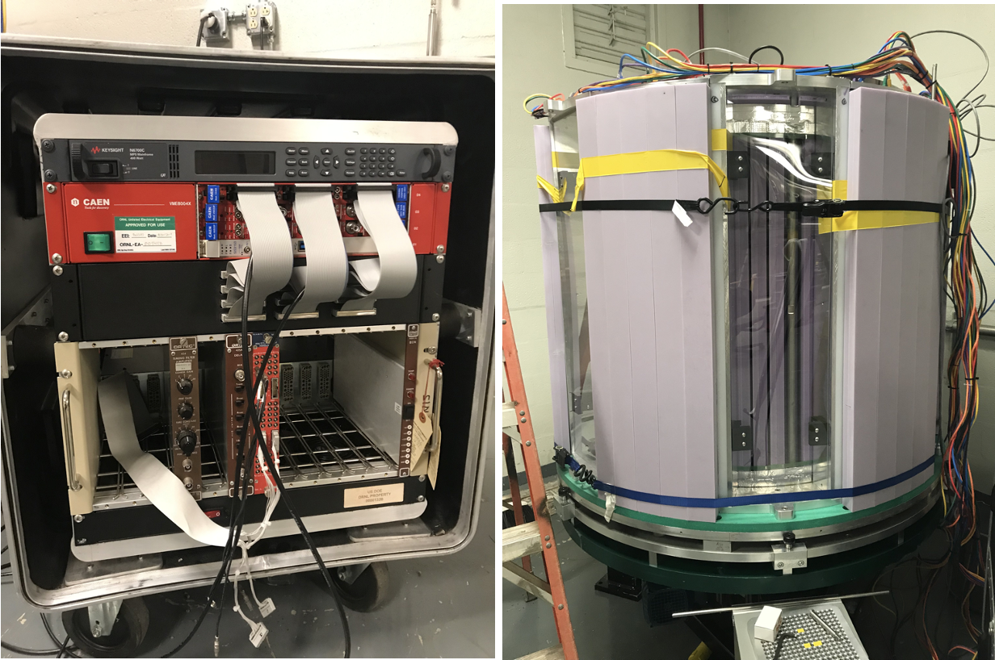
Figure 41. The DAQ and fully assembled imager system.

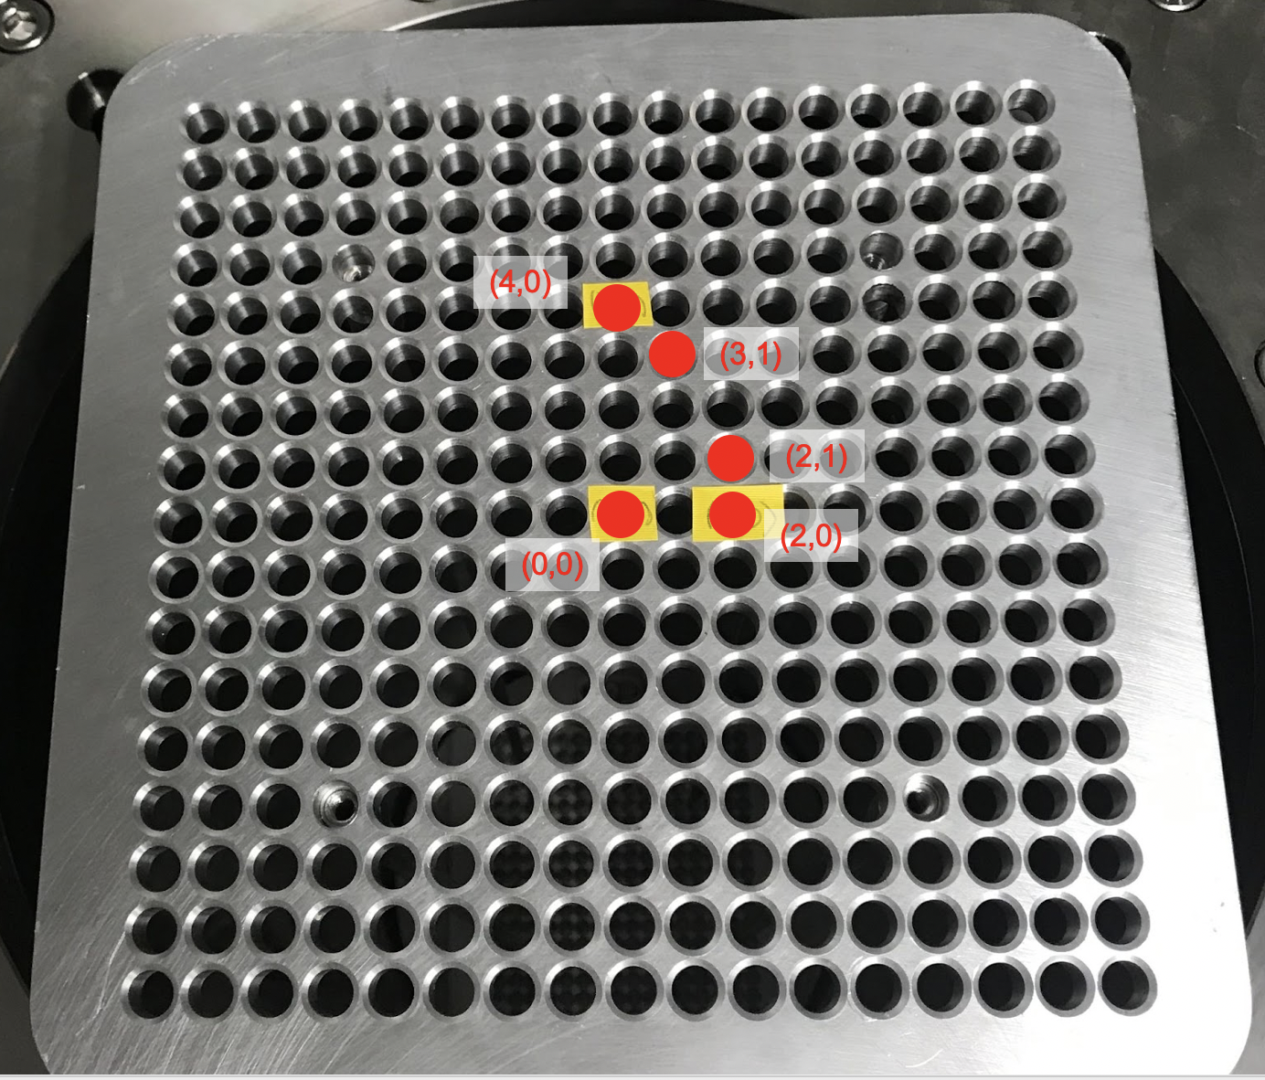
Figure 42. The grid with red labels on each fuel pin where a source measurement was taken.

Table 13. Summary of initial measurements performed.
Source slot | Date of Measurement | Measurement time (s) | Emitted neutrons per projection | Detected neutrons per projection
(0,0) | 6/28/21 | 4520 | 4.26×10⁶ | 7571
(0,4) | 7/1/21 | 4641 | 4.37×10⁶ | 7460
(2,0) | 7/1/21 | 4518 | 4.25×10⁶ | 7454
(1,3) | 7/12/21 | 4593 | 4.32×10⁶ | 7450
(2,1) | 7/2/21 | 4606 | 4.34×10⁶ | 7485

Analytical Image Reconstruction Method

72 Slit Model Initial Changes
To make any potential reconstructions, the analytic response model must be adapted to match the as-built detector. Meaning that the response model needed to be updated to account for 72 collimator slits instead of 96. The analytic model was first updated to include the as-built dimensions for the field of view and collimator thicknesses. Following that update, the code was changed to account for the spacing of the new slit numbers, spreading them around the collimator annulus. Next the number of positions at which the detectors were read out was changed from 96 to 72 as well, extending the rotational distance between each position. Instead of one slit every 3 detectors where the arc length between slit openings at the detectors was previously 3.74 cm, now the arc length between slit openings is 5 cm because there is one slit for every 4 detectors. These were the minimum changes needed to update the model to a 72 slit collimator version.

Experimental Data Reconstructions

Single Source Reconstruction at the Origin
The first set of data to examine was that of a single source placed at the center of the fuel assembly grid, position (0,0). After binning the data by detector number and projection, a sinogram was created for the experimental data, as seen in Figure 43(a). The data was then loaded into the reconstruction code and a forward projection of the data was created and can be viewed in Figure 43(b). The main detector signal can be seen as two lines of color moving diagonally through the images. Smaller horizontal lines, which occur at the edges of each detector module, can also be seen in these images for a total of 12 such lines in the images. These lines represent the change in detector efficiency along the edge of the detectors. Up until this point, this value has only been estimated, but moving forward the relative efficiency of each detector will be experimentally determined to properly account for the changes in efficiency for each detector. The data was back projected to generate an image. This process of forward and back projection was repeated 1000 times to generate images of the source. Figure 44(a) shows
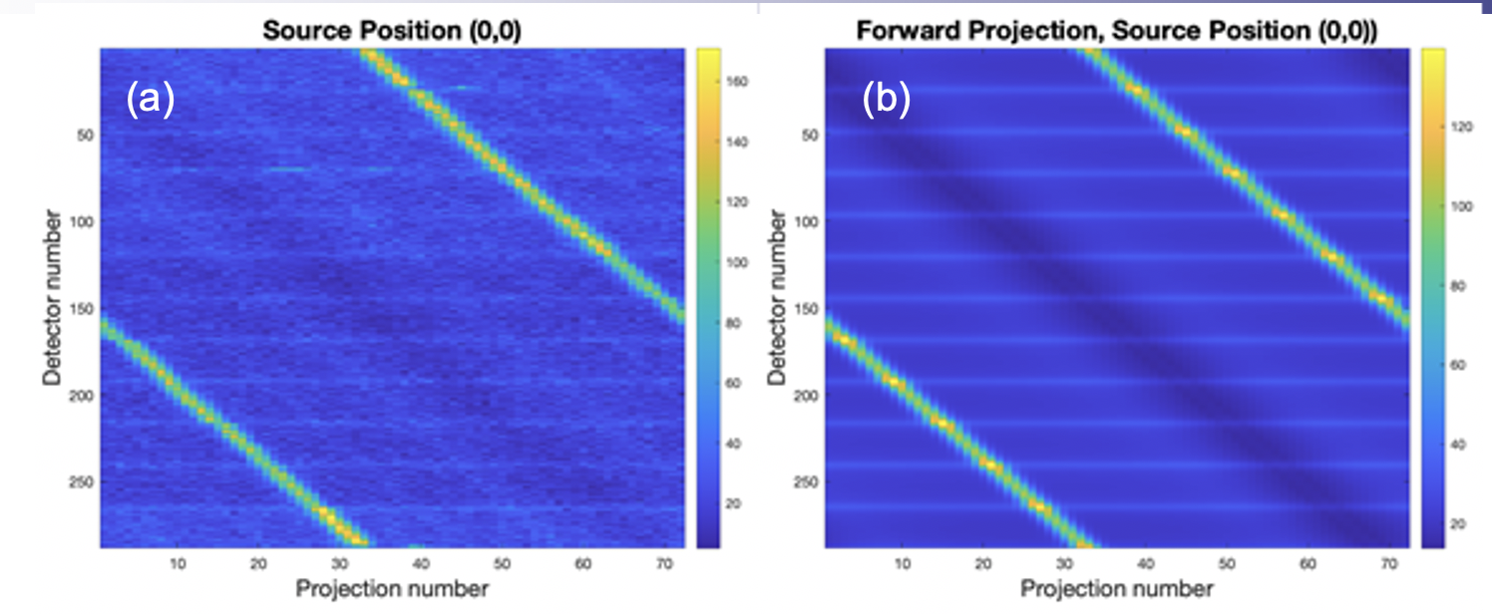
Figure 43. The sinogram generated from the experimental data with a source at (0,0) (a) and the corresponding forward projection (b).

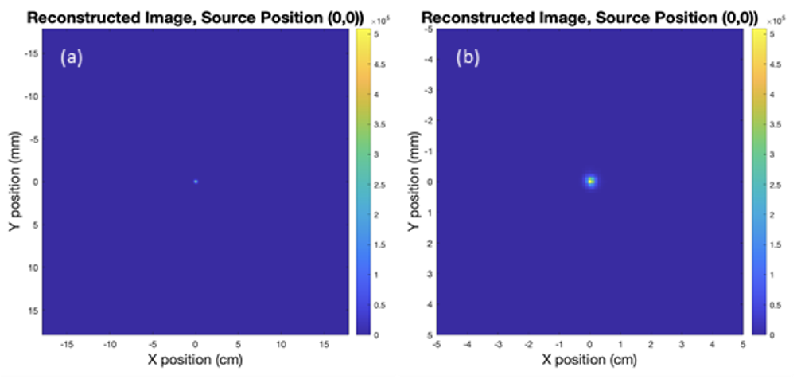
Figure 44. The reconstructed image of a single source at (0,0) (a) and a magnified version of the same image (b).
the reconstructed image of the source at (0,0) and Figure 44(b) shows a close-up image of the source. The source point is shown to be in the approximate center of the inspection volume, as it was placed in the experimental setup. No major distortions of the source shape were immediately seen upon examining the image.

Five Source Reconstruction
Following the reconstruction of a source point at (0,0), the individual measurements for (0,0), (0,4), (2,0), (1,3), and (2,1) were summed to represent a measurement containing five sources. Again, the data was binned by the number of detectors as well as the number of perspectives, and a sinogram was created showing data from all 5 sources. The difference between this sinogram and that of 1 source positioned at (0,0) is immediately obvious. Instead of 2 lines diagonally crossing the sinogram, more lines representing sources are present. These source lines cross over one another repeatedly and make for a more complicated sinogram than with only one source present. The sinogram data is then forward projected and the sinogram created from experimental data as well as the forward projection of the data are shown in Figure 45. After 1000 iterations of forward and back projecting an image was generated which showed all 5 sources in the volume of inspection.
Of particular interest is the image convergence, the point where the spatial resolution is sufficient such that it is obvious that each source is distinct from the others. Figure 46 shows the difference between an image generated with only 100 iterations and an image generated with 1000 iterations. In the 1000 iteration image the sources at (2,1) and (2,0) are clearly defined as separate sources. With only 100 iterations the edges between these two sources are so blurred that the separation between these two is not distinct.
This algorithm demonstrates sufficient spatial resolution to resolve individual fuel pins. However, the image does show some issues with the spatial reconstruction. Every source except the one at the origin is oblong-shaped, rather than circular, indicating issues with the simulated response. The intensities of each source should be similar, but the image shows a much greater intensity for the source at the center. The integrated intensity of the source at (0,0) is 3.85×10⁶ emitted neutrons while the integrated intensity of the source at position (0,4) is only 2.28×10⁶ emitted neutrons This is a 59% difference in the emitted neutron intensity when the difference should be negligible. If all intensities of the sources are summed then the total source intensity in
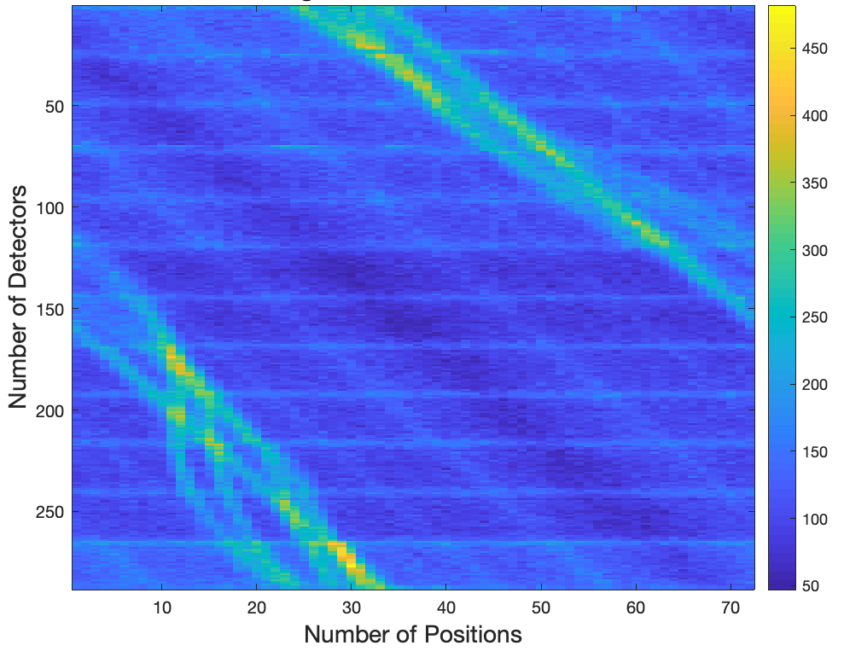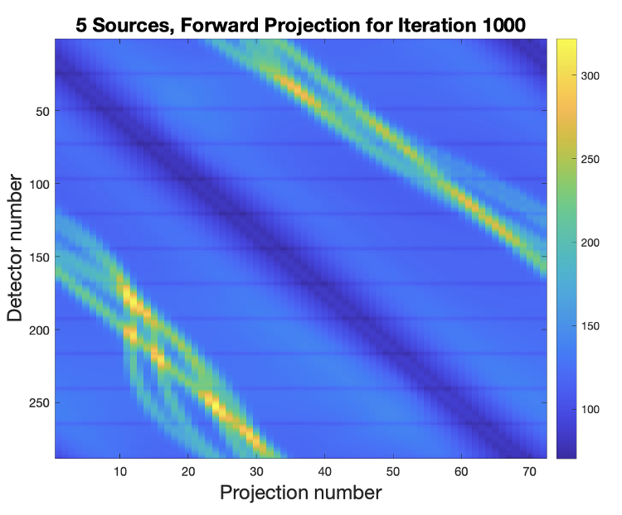
Figure 45. The experimentally generated sinogram for 5 sources (a) and the forward projection for 5 sources (b).

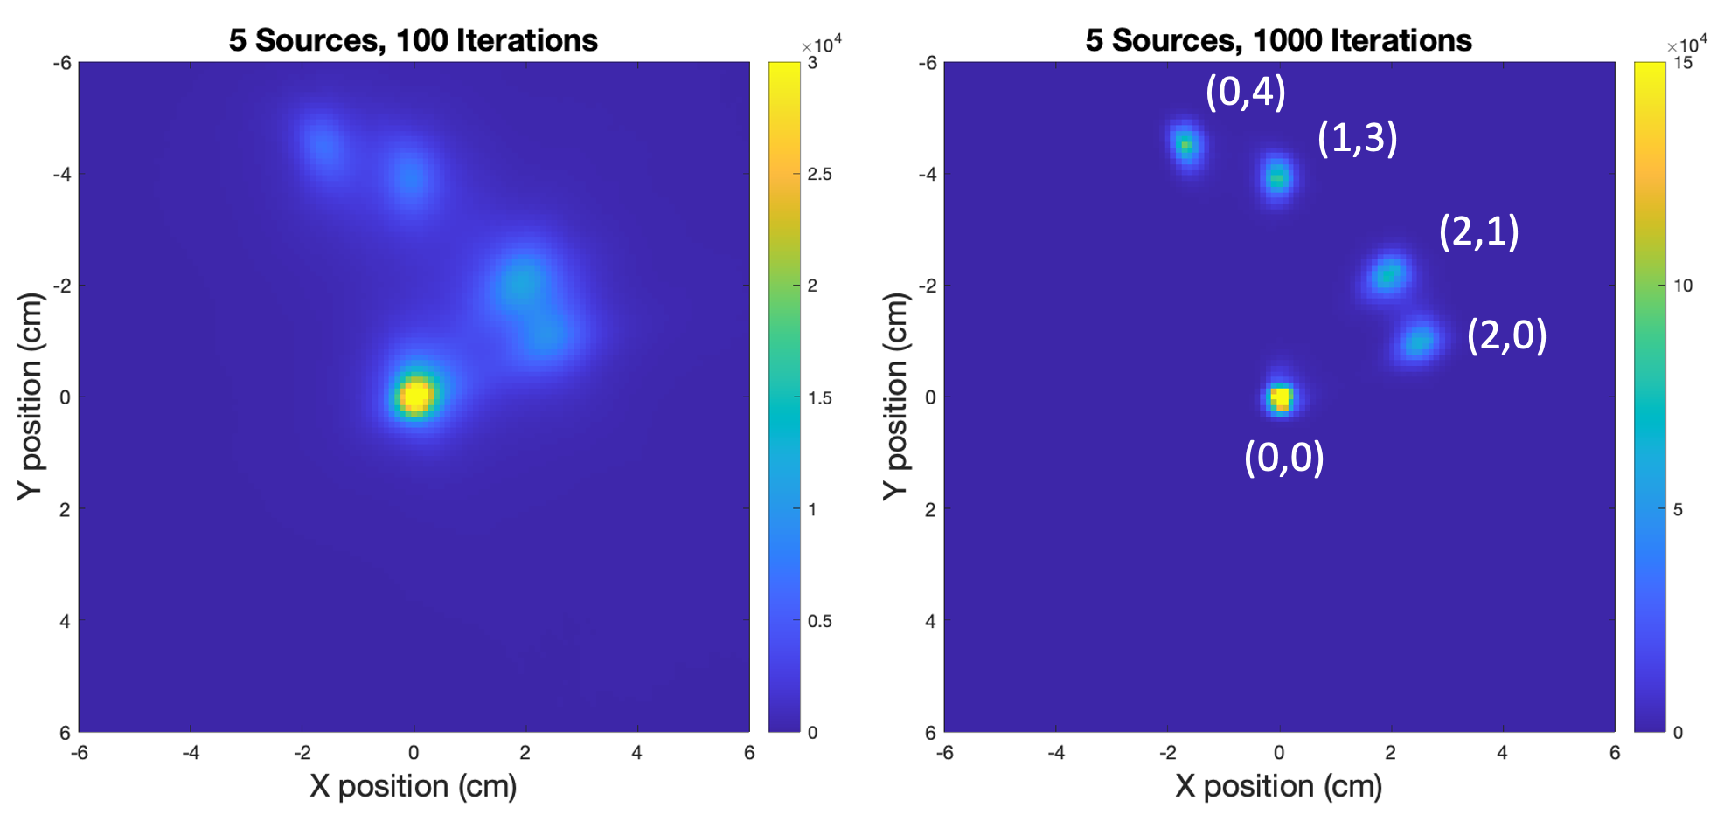
Figure 46. The difference in images created when (a) 100 iterations are used versus (b) when 1000 iterations are used.

the image is accurate, but the reconstruction code is assigning too much of the neutron source to the source at position (0,0).

Horizontal Sinogram Lines
Following the examination of the sinograms generated by the experimental data, one difference seen between the forward projection and the experimental data occurs at the detector module boundaries. Looking at Figure 45(a) there are horizontal lines present in the sinogram which are lighter than the expected scattering contribution. In Figure 45(b) these same lines are shown but as lower than the background scatter contribution. The difference in these images is a result of neutron scattering out of the top and bottom of the imager. These neutrons bounce off the concrete floor and walls of the laboratory in which the imager is housed and are reflected back towards the detector modules. This type of scattering back into detectors from the environment is referred to as room return.
Since the decision was made to have only 6 of 12 detector modules built, these scattered neutrons interact with the sides of the detector modules. If 12 modules had been built, they would be abutting one another in the detector module ring. The sides of each of these modules would be directly next to the side of another module. Without all 12 modules, the sides of these detector modules are exposed. The neutrons coming from room return are now incident on the exposed detector module sides. These extra neutrons are recorded by the modules the same as source neutrons. These neutrons appear as “extra source” at the edges of the modules.
If all 12 detector modules had been present, there would be fewer counts at those locations. The aluminum casing between detector module edges takes up space that would otherwise have been occupied by more HDPE if the detector ring was one continuous annulus. Without the HDPE in those places, fewer fast neutrons are moderated to thermal temperatures, meaning fewer neutrons are captured in the boron coated straws at the edges of the detector modules because fewer neutrons have the correct energies to be absorbed by the straws. The forward projection in Figure 45(b) shows this impact. When looking at the sinogram, measures will have to be taken to properly account for the sinogram horizontal lines.

Image Reconstruction Improvements
After determining that the imager would have sufficient spatial resolution to differentiate between individual pins, interest turns to reconstructing a mock full fuel assembly to complete the proof-of-concept demonstration. When adding more than 5 sources to the reconstruction, the distortion in the fuel pin reconstruction and the misattribution of the source intensity toward the center of the FOV becomes problematic. Prior to trying to make a full fuel assembly measurement and reconstruction, the issues seen in the reconstruction of 5 sources must first be addressed.
The analytic neutron response model does not match the as-built detector system. In order to make the previous reconstructions certain aspects of the analytic neutron model were updated to match the as-built system while others retained aspects from the original 96 slit model. The analytic response code was updated with the new 72 slit geometry as well as an updated 72 slit collimator thickness and relative efficiency. However, the neutron response model does not account for all the differences that may be seen in neutron response due to changes in the as-built detector. These changes include the impact of the missing detector modules and impact of any structural supports added during construction. The relative efficiency of each detector readout is going to be different from an idealized detector seen in the simulated model. The collimator thicknesses are going to change as well due to construction difficulties. Instead of performing many simulations to match the as-built detector module, measurements using the as-built detector system were taken in order to have data to fit the neutron response model to the real imager.

Simulation Verification
In hoping to improve the response for the analytic model of the 72-slit collimator, a few changes had to be made within the code to better reflect the as-built imager.

Edge and Direct Scattering Rotation Effects
One of the things that had to be considered when examining the differences between the ideal detector and the as-built is how the as-built detector continuously rotates. Initially, the analytic code set the number of positions at which the imager evaluated the source to the same as the number of collimator slits, 72. When the analytic code calculates the position at which it evaluates the system it goes directly to that exact position and effectively gets a “point-and-shoot” measurement. In this way the positions where the analytic code calculates the lines of response are in very distinct positions with 5-degree rotations in between these positions. This is different from how the as-built imager operates. The imager is constantly rotating and taking data and that data is binned into sections approximating the imager positions. Due to the constant rotation of the imager, there is a difference between the measurement data that the imager records across the 5 degrees of rotation and attributes to one position and the lines of response data that the analytic code creates for the one position that is 5 degrees different from the previous position. In order to try to remedy this issue, the position sampling for the analytic code was increased. Instead of sampling 72 times for 72 positions, the analytic code sampled the data 288 times or 4 times as often as previously. This means that the analytic code now samples at every 1.25 degree. Due to memory constraints with the code used to create the analytic response and reconstruct measured data, the 288 positions needed to be paired down to get an averaged 72 positions. Of these 288 positions, 4 of them were averaged together at a time to get one position.

Effective Collimator Thickness Change
After incorporating the new changes into the detector module, certain other characteristics had to be adapted to ensure the model was representative of the constructed system. Using an MCNP6 simulation model, a new effective collimator thickness could be created in the same manner as described in Section 2.7.3, but for a system with 72 collimator slits, instead of the original 96. First, a simulation placing a source at the center of the field of view was run followed by a simulation of the same source at the center, but with no collimator present. Examining the ratio between these two simulations yielded the mean free paths through the collimator that neutrons would travel to be detected in each detector. This data was then fit to two curves using a polynomial fit to get a smoothed version of the data which was then incorporated into the analytic response code. The effective collimator thickness is used to simulate the collimator penetration values of neutrons as well as the scattering of neutrons into the detectors through collimator slits.

Measurement Verification
To improve the neutron response to match the as-built imager, a series of verification measurements were performed. These measurements will help further characterize the as-built system and improve image reconstruction by defining parts of the neutron response used in the reconstruction code in terms of measured values instead of simulated values.

Neutron Source
The neutron source used in this experiment was measured originally on Sept. 9 2021. The source was 17.256 wt% Cf-249, 18.815 wt% Cf-250, 8.133 wt% Cf-251, and 54.76 wt% Cf-252. The original activity of this source was 9.29 × 10⁻⁴ Ci or 34373000 Bq. The measurements were taken from August 4, 2022 through August 25, 2022 so the date of August 1, 2022 was used to represent the approximate neutron emission during this first measurement campaign. The value for neutron emission rate used in this experiment was 3.173 × 10⁶ n/s. It was decided to set the collimator’s rotation speed to 1 revolution/minute.

Efficiency Verification
The first measurement will act as an efficiency calibration for the detectors. Currently, the analytical model uses a calculated estimate for all 288 detector response efficiencies. In order to get a more accurate calibration the neutron source will be attached to the inner edge of the collimator, aligned with the slit which is directly perpendicular to the inspection volume. This will give the neutrons a direct path to the detector opposite that slit. The collimator will then be rotated at a constant rate dosing each detector evenly. The efficiency of each detector will be calculated, and this value used in the source reconstruction. The source location along the collimator wall and its rotation are displayed in Figure 47.
The efficiency of the system was measured as described and the results were compiled into an initial sinogram. This sinogram is shown in Figure 48. Immediately portions of the sinogram stand out. There are six separate horizontal regions in the sinogram which are
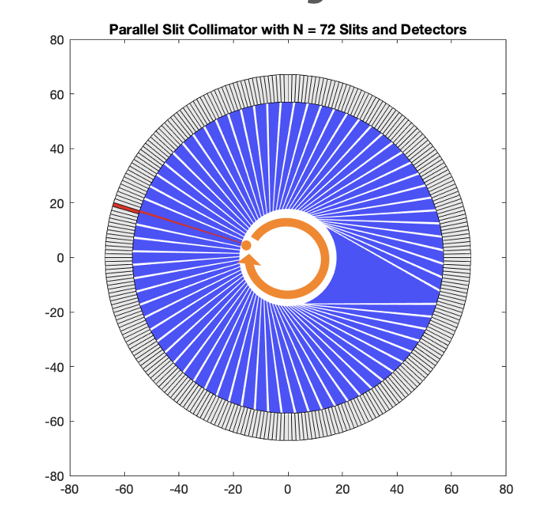
Figure 47. Efficiency measurement diagram.

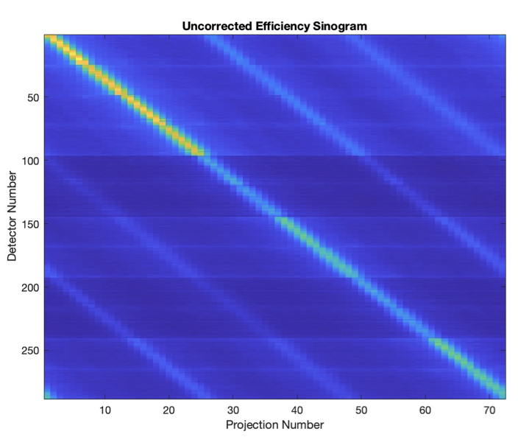
Figure 48. Uncorrected efficiency sinogram
emphasized by how drastically the source strength intensity and background change across these regions. As demonstrated in section 4.3.1, the neutron detector modules do not have the same efficiency across then when set to the same high voltage and threshold. In order to compare gains
of each detector individually, a correction factor needed to be applied across each module. The correction factor was determined by dividing the average counts across all modules and diving the average counts across each module. This resulted in a correction factor for each detector module. Figure 49 shows the sinogram after correcting the modules.
To get the relative efficiency values the source intensity at each position was first calculated and averaged over all positions. The background counts at each position were also determined and subtracted from the total sinogram. This resulted in relative efficiency values which looked like those in blue in Figure 50. The red values are the calculated relative efficiency from simulation. These measured values are almost the inverse of the simulated values which pointed at an issue with the measurement. When only 6 detector modules were created instead of 12, aluminum detector spacers were used to hold the place of the missing detector modules. Without these detector modules in place there, the edges of the detector modules which should be abutting each other are exposed. This allows neutrons to bounce off the walls in the room and scatter into the sides of the detector modules. This phenomenon of neutrons scattering off the surrounding environment and bouncing into the system is referred to as room return. Figure 51 shows how the neutrons escape out of the exposed top and bottom of the imager and bounce around in the room, ultimately some of them scattering into the detector modules. These neutrons coming from room-return are creating the peaks in the relative efficiency.
In order to get the true relative efficiency, the neutrons from room return must be subtracted from the system. First the average signal values are calculated for each detector. This includes the average values where each detector was examining the source as well as when it was not. Following this, the average background values were calculated by determining the average counts per detector for the detectors which are not examining the source. This included the average values for the room return. By subtracting the average background from the average signal values, the average source counts could be determined. These average source counts were then used to determine the relative efficiency values. Figure 52 shows the difference between the average signal values, average background values and the average source counts. Figure 53 shows the corrected relative efficiency values coming from measured data versus the simulated
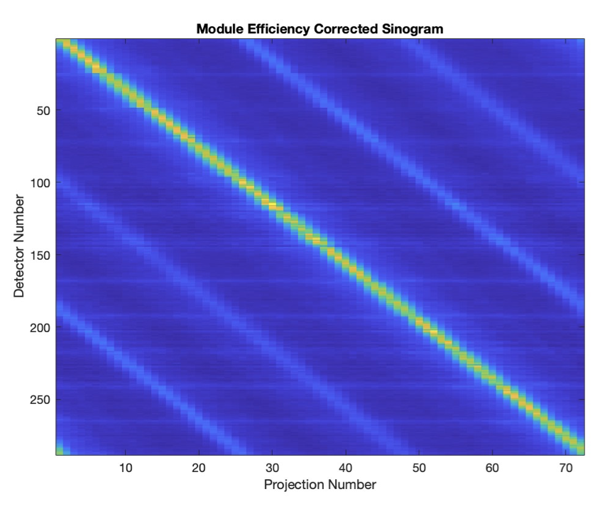
Figure 49. Module Efficiency Corrected Sinogram

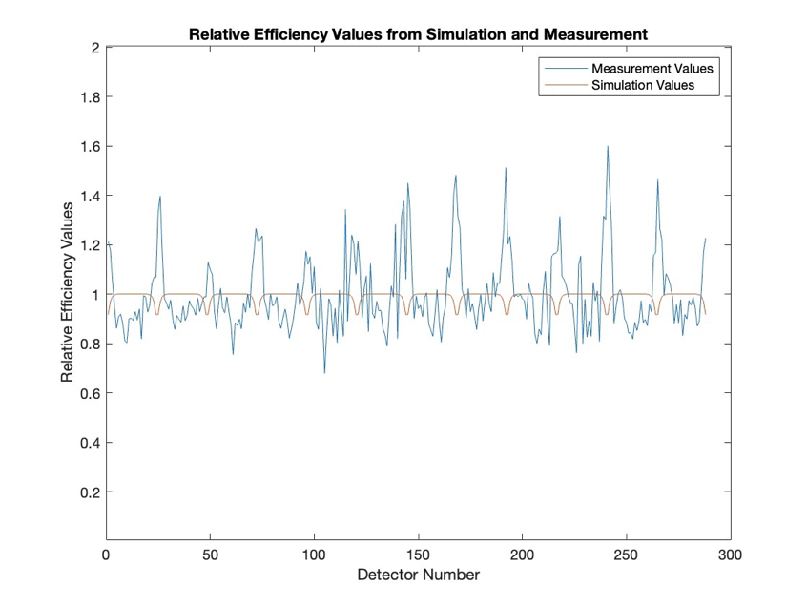
Figure 50. Relative Efficiency Values from Simulation and Measurement.

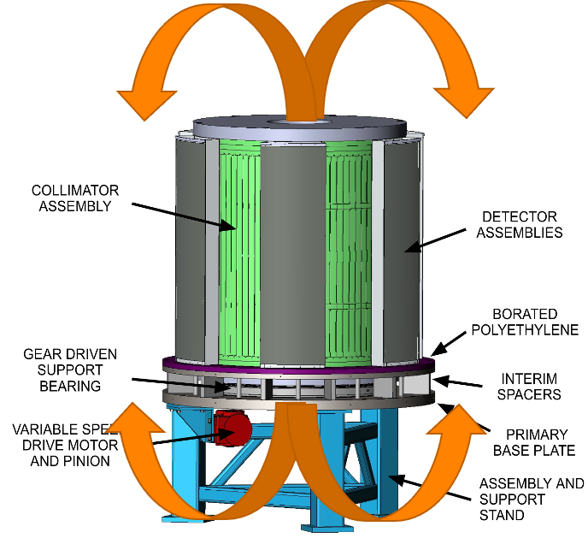
Figure 51. Room return diagram.

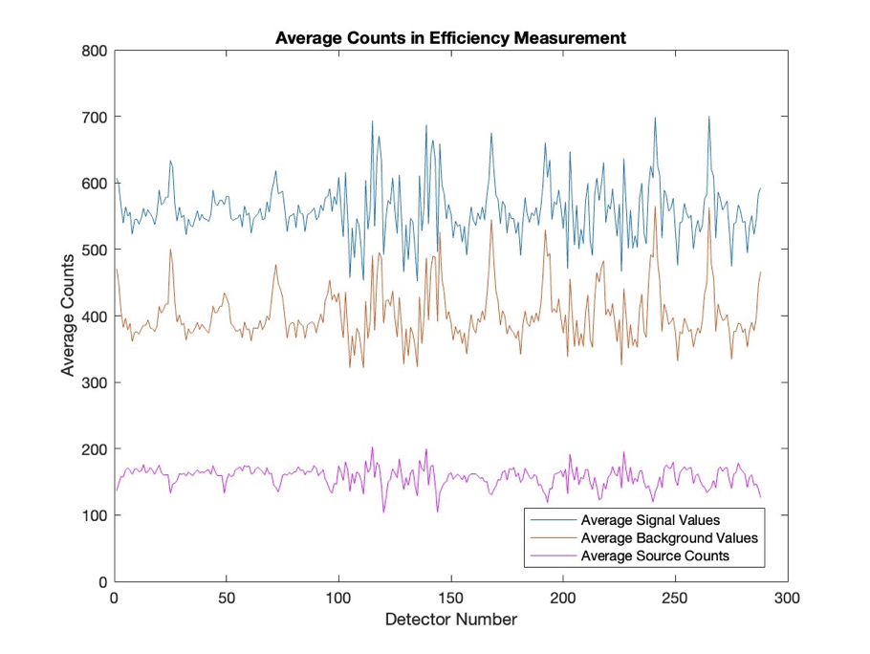
Figure 52. Average Counts in Efficiency Measurement.
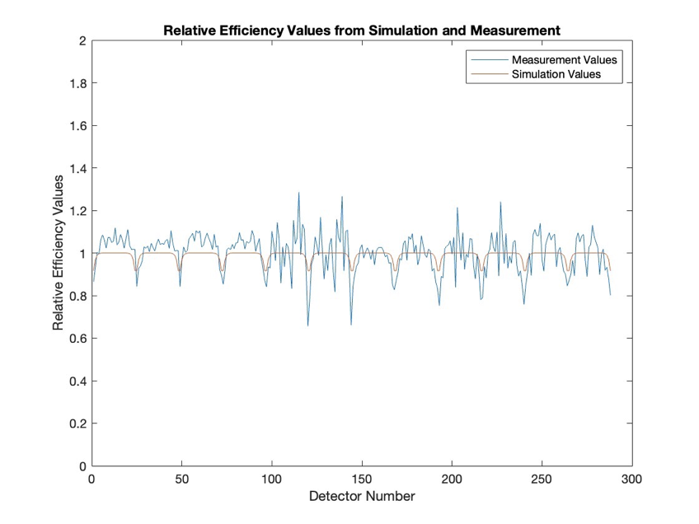
Figure 53. Relative efficiency values from simulation and measurement.

relative efficiency values. In this case there is much better agreement between these values than in Figure 50. The new relative efficiency values still have more variation across the 24 rows of detectors than in the simulated version, but this makes sense as each of the detectors has its own gain which needs to be accounted for. In order to apply this new efficiency in such a way that no new high frequency issues are introduced, a cubic polynomial was fit to the relative efficiency of each detector module. This resulted in smoother relative efficiency values as can be seen in Figure 54. These smoothed relative efficiency values are applied to the analysis of all further measurements.

Representative Source Points
To determine how well the analytic model was matching the measured data, two representative points were chosen for analysis. The origin point, located at the center of the inspection volume, and a corner point, located at the furthest extent from the origin in the corner of the PWR 17x17 assembly. Figure 55 shows the locations of these points within a fuel assembly grid. These points represent the “best case” and “worst case” scenarios for the reconstruction algorithm when there is no attenuation of neutrons occurring from interactions in fuel. The number of lines of response which intersect in a particular point as the collimator rotates define how well each position is sampled by the system. Figure 56 shows where the centerlines of each line of response crosses the inspection volume. The origin measurement is considered a best-case source location because the lines of response frequently cross and sample the origin point so that without attenuation or self-shielding, it can be imaged with high spatial resolution. The corner measurement is considered the worst location for imaging because there is much less sampling along the edges of the inspection volume.
Additionally, the positions at which the collimator makes a measurement are determined by moving 5 degrees to the next position as described in Section 7.1.1. At the edge of the detector module, the arc length that the collimator position shifts is much longer than at the center of the detector. The source rods have a diameter of 0.9652 cm whereas the arc length where at the same radius where (-8,-8) is located (r = 15.33 cm) gives an arc length of 1.33 cm. This means that the moving of the detector could completely miss the source in some places. With less sampling comes higher uncertainties and lower spatial resolution. With both a best location and a worst location, the neutron response model can be evaluated at both extremes.
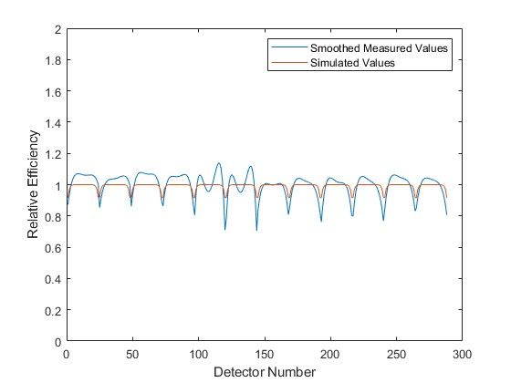
Figure 54: Smoothed relative efficiency values coming from measurements.

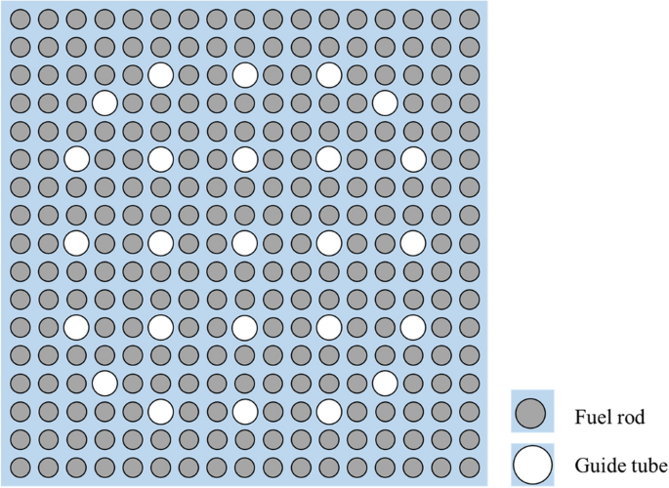
Figure 55. PWR assembly grid with (0,0) and (-8,-8) labelled with blue dots.
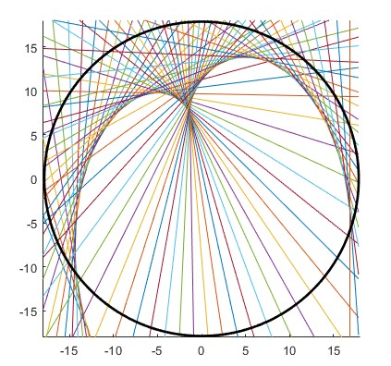
Figure 56. Lines of response centerlines in across the field of view

The first representative measurement was taken with a source placed at the center of the inspection volume, also referred to as the origin point or (0,0). For this measurement the source is placed in the center of the reconstruction volume and data taken with the collimator rotating. Data was recorded for an hour at detector position 1 and an hour at detector position 2. Figure 57 shows the sinogram created from the origin point data.
The corner measurement was taken by placing the neutron source at a position (-8,-8) and rotating the collimator to take data. Again, the measurement was taken for an hour in detector position 1 and an hour in detector position 2. Placing the neutron source at the corner of the grid yields a neutron response at edge locations of the field of view. This information is different from attaching the source to the collimator itself like what was done for the efficiency measurement. In this case the source is stationary while the collimator spins. This yields values for sections of the FOV which are otherwise difficult to model using the neutron response code. Figure 58 shows the measured data sinogram of a source at (-8,-8).

Measurement-Guided Effective Thickness Changes
The sinogram created from the data origin measurement, pictured in Figure 57, immediately showed some interesting things occurring in the sinogram. One of which being the echoes of the source along various diagonal lines. These additional diagonal lines are located at 13 slits and 25 slits away from slit 37 where the source is being detected. Originally it was considered that there was a possibility that these slits were wider than the surrounding collimator slits. In reality, after examining how the imager was constructed, these places are actually where there were stainless steel tie rods placed to support the imager. In constructing the imager 6 of these 1” tie rods were placed evenly spaced around the imager to support the top and bottom of the collimator. At these places the collimator is physically shorter than in the other locations. Because there is physically less collimator in these places, there is less neutron attenuation happening around these slits. As a result, more neutrons are detected in the detectors surrounding these tie rods, leading to the diagonal lines.
In order to remove these lines, the total measured neutrons were projected into the slit axis like in Figure 59. At this point a fit was created to the peaks at 13, 25, 37, 49, and 61. The fitted values were used as a multiplier of the effective thickness. In these locations there was a

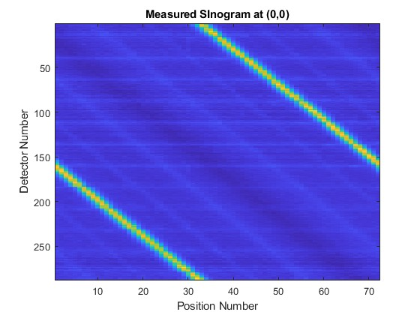
Figure 57. Sinogram created from the measured data with a point at position (0,0).
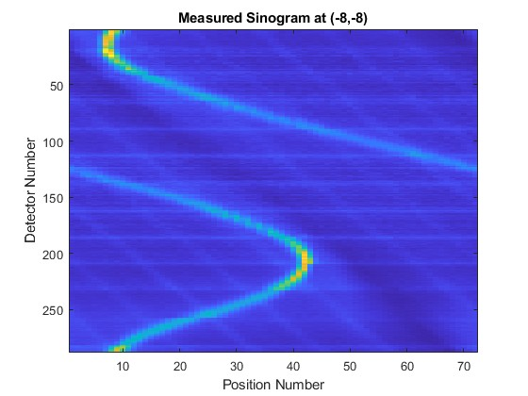
Figure 58. Sinogram created from the measured data with a point at position (-8,-8).

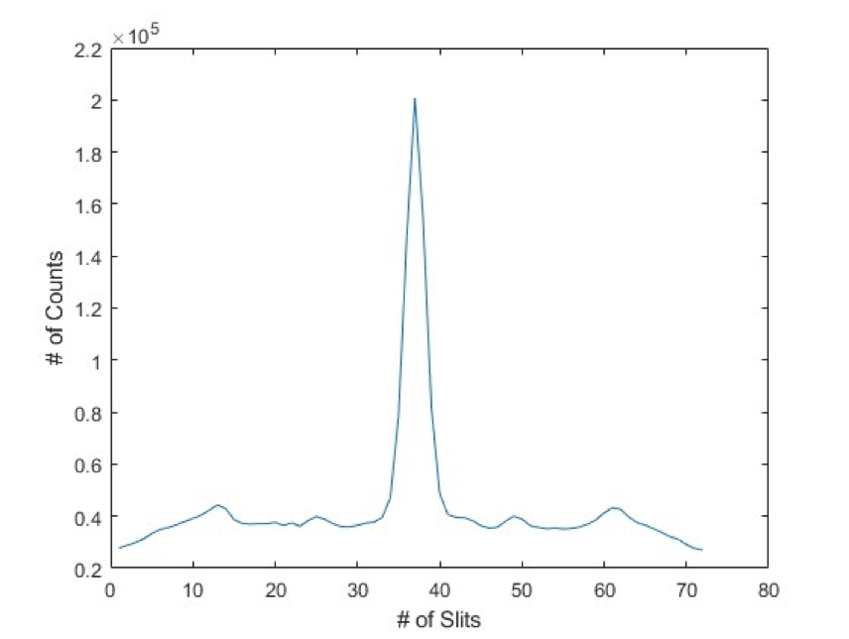
Figure 59. Number of counts per source position.

different effective collimator thickness than originally expected, and this was a constant in the collimator, meaning the correction had to be applied before the lines of response were created. This could not be fixed afterwards, rather it was better to carry this change through the analytic code. The new effective thickness was applied to each part of the collimator to get the analytic response to match the as-built model.

Angular Code Changes
One change that had to be made to the code included the addition of angular dependences. The slit scattering portion of the code needed to include a directional component indicating the angle between the collimator slit and the line defined by the detector and the center of the volume. The directional factor was added in the form of a cosine of the angle defined by the dot product of the unit vector from the detector to the center of the FOV and unit vector from the detector to the slit opening. Geometrically, adding this factor accounts for the angle and direction of the slit, which is different from geometry dealing with the slit opening to the center alone. This factor of slit length and direction accounts for how neutrons are detected in the system, rather than just how neutrons enter the slit of interest.

Representative Reconstructions
Following changes to the code, a series of characteristic reconstructions were made using the two representative points and the five points previously reconstructed in Section 6.2.2. Reconstruction images were made using 357 pixels by 357 pixels to create the image. Each pixel represents 1 square millimeter in the inspection volume. Given that the gaps between fuel pins are 3.28 mm, a pixel resolution of 1 mm was chosen to ensure that the pixel resolution is small enough to image the fuel pin gap.

Representative Points Reconstruction
The first reconstruction performed was of the source located at the origin. This is the easiest case to reconstruct and Figure 60 shows the reconstruction for (0,0). Visually the reconstruction does show source intensity emanating from a point in the center of the inspection volume. The reconstruction pixel with the highest source intensity value is (179,179), which corresponds to (0,0) in the mock grid.
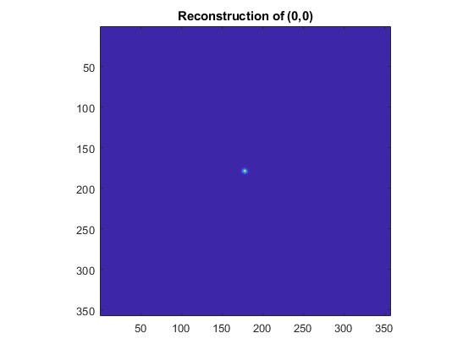
Figure 60. Reconstruction of the neutron source at the point (0,0), the center of the inspection volume.

After examining the best reconstruction, looking at the worst was the next step. Figure 61 shows the reconstruction at (-8,-8). The center of the fuel pin located at (-8,-8) corresponds to pixel (280, 76). The source located at (-8,-8) has a larger “smear” of green surrounding the point and lining the edge of the field of view. The green smear of the source intensity results from trying to reconstruct a point which is sampled less often. This is because of how the reconstruction code samples the edges of the detector less frequently since the lines of response overlap less often around the detector edges. The pixel within the smear with the highest source intensity is (280, 76) which means the source is placing the intensity in the correct spot, even if it does not resolve into a circular pin-like shape.
The next step was to see if both the corner and the origin could be accurately reconstructed. Figure 62 shows the reconstruction of the two points. The corner point still did not resolve into a circular shape. Through the pixel with the greatest source intensity is still located correctly at (280,76) for the corner smear and at (179,179) for the origin point. When the source intensity at the origin point and the source intensity for the corner point smear are summed, the origin point is determined to have greater source intensity. The ratio of the corner measurement total counts to the origin measurement total counts is 0.983, whereas the same ratio for the reconstruction is 0.931. Some corner measurement source is being lost in the smear and attributed elsewhere in the reconstruction. The image shows that the source may be attributed in very small quantities to the edge of the field of view.

Five Points Reconstruction
In order to get a point of comparison for improvements to the analytic code, points (0,0), (2,0), (2,1), (1,3), and (0,4) were re-measured and reconstructed. Due to the symmetry of the system, the source positions which were measured to get this data corresponded to mock fuel rod grid positions (0,0), (-2,0), (-2,-1), (-1,-3), and (0, -4). The sinogram for the new 5 points measurement is shown in Figure 63 and the reconstruction is shown in Figure 64. The reconstruction shows 5 distinct points in the field of view. In order to better examine the spatial resolution of the imager, the location of the pixel with the highest source intensity was compared to the calculated location of the center of the fuel pin. For fuel pin (0,0), the center of the fuel pin would be located at pixels (179,179). In the reconstructed image, the pixel with the highest source intensity for that fuel pin located at (0,0) was, in fact, (179, 179). For fuel pin (2,0) the
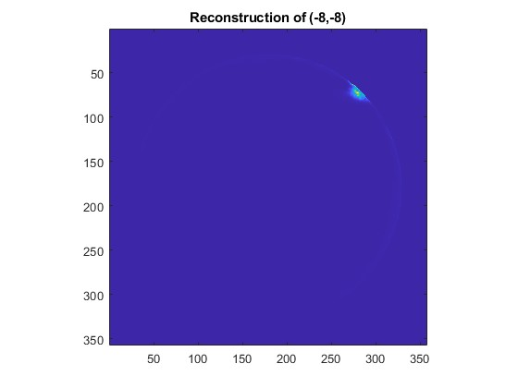
Figure 61. Reconstruction of the neutron source at point (-8,.-8), the corner of the measurement grid.

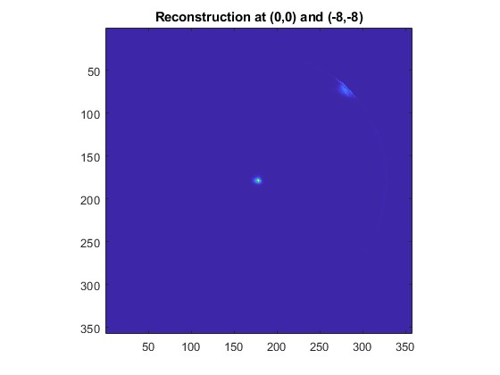
Figure 62. Reconstruction of source points at both (0,0) and (-8,-8).
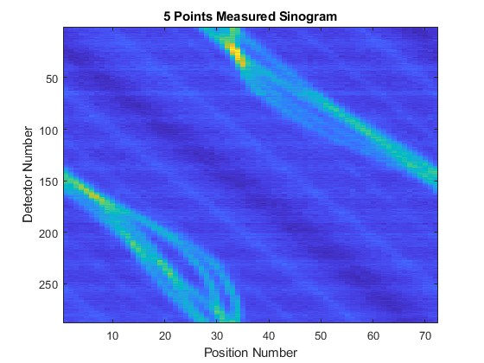
Figure 63. Sinogram of measured data with sources at (0,0), (-2,0), (-2,-1), (-3,-1), and (0,-4).

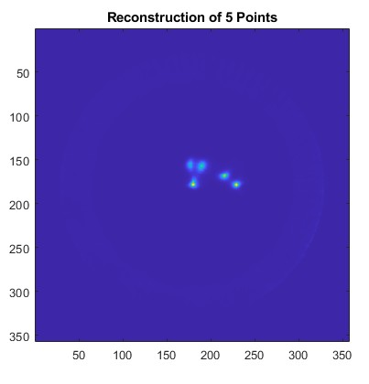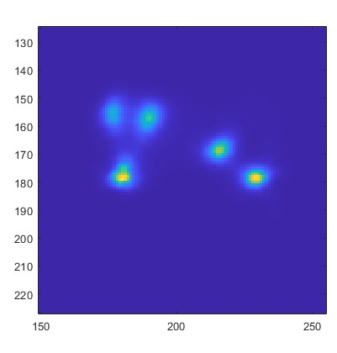
Figure 64. Reconstruction of 5 points at (0,0), (2,0,), (2,1), (1,3), and (0,4) with full image displayed (right) and a zoomed in version of the reconstruction focusing on the points of interest (left).
corresponding pixels to the center of the pin are (153, 179), which is where the peak neutron source intensity should be located. The reconstruction instead places the peak source intensity at (155, 176), which is 3.16 mm away. Fuel pin (2,1) corresponds to pixel (153,191); however, the reconstruction attributes the most source intensity to (157, 190) which is also 3.16 mm away. The fuel pin located at (1,3) corresponds to pixel (166, 217). For this fuel pin, the reconstruction places the peak source intensity spot at (169, 215), which is 2.83 mm away. Lastly, the center of the fuel pin pixel corresponding to the pin located at (0,4) is (179, 229). The reconstruction places the peak source intensity at (178, 229) which is 1 mm away.
The differences between the reconstruction peak intensity locations and the center of the fuel pin locations need to be less than 3 mm to differentiate between fuel pins since the air gap between the pins in 3.28 mm. In some places, this is happening correctly, but in other locations, namely at fuel pins (2,0) and (2,1), the source is not attributed to the correct location. One potential reason why the source rod may not be attributing the location to exactly the correct spot is due to the room return inherent in the measurement which has an impact on the signal to noise ratio since room return is effectively adding noise to the system. The rotation of the collimator also likely plays into the difficulties with matching a source to a location. As discussed in Section 7.1.1, the collimator rotation means that the measurement bins are wider than the analytic model bins for the projections. Despite attempts to correct for this in the analytic model but expanding the projections, without more accurate data binning, the data is being spread over multiple projections.

Full Fuel Assembly Measurements and Reconstructions

Experimental Procedure
Following these characterizations, multiple measurements were made to represent an entire fuel assembly. The neutron source used in these measurements is the same as the ²⁵²Cf neutron source described in Section 7.2.1.
For the unattenuated source measurements, the source rod was positioned in one location and the collimator rotated at a constant rate at 1 rev/min for 10 minutes while taking data at a rate of 5 readouts per second. This measurement was performed once with the detector modules held in position 1 and then a second time with the detector modules in position 2. This is the same process as described in Section 5 for taking measurements with the exception that the collimator speed, measurement time and neutron source were updated for this campaign. The measurement process was repeated, moving the source rod to a different location until enough data was taken to represent an entire spent fuel assembly.
The attenuated measurements used stainless-steel rods with the same outer diameter as the source rod to represent attenuation which would happen in the fuel assembly due to additional fuel rods being in place. The stainless-steel rods are placed into the fuel assembly grid in all positions where a fuel rod would be located except for the location at which the measurement is occurring. In that position, the aluminum source rod continues to be used. Some of the fast neutrons from the ²⁵²Cf source are attenuated by the stainless steel in the assembly, similarly to how other fuel rods would attenuate some of the fast neutrons emitted from a single fuel rod. Figure 60 shows where fuel rods would be located in an assembly and therefore where the stainless-steel rods were placed in the mock assembly grid. The source was moved from position to position by removing the stainless-steel rod from the position of interest, placing the aluminum source rod in that position and then using the stainless-steel rod to fill in the previous measurement position. Once again, each measurement was performed twice, once with detectors in position 1 and then again in position 2. Data was recorded for 10 min in each of these positions and the collimator was rotated at a constant speed of 1 rev/min with a data readout rate of 5 readouts per second.
Only one quarter of the positions in the fuel assembly grid need to be measured within the imager since both the imager and PWR assemblies are symmetric. This means that measuring a fuel rod in position (8,8) would give a translated version of the same neutron response as a fuel rod in position (-8,8), (8,-8) or (-8,-8). By translating the sinogram position rows by ¼ of the positions the results can be effectively rotated about the origin. Figure 65 shows a full fuel assembly indicating where rod positions would be. The orange box shows the fuel positions measured during this experiment. All the data will be summed to yield the representation of the full assembly and the image of all the source points reconstructed.

Reconstruction and Discussions

4 Points Unattenuated
Given the increased sampling of the lines of response closer to the center of the inspection volume, it was chosen to begin reconstructions with a few sources close to the center of the inspection volume and work out to the edges, where the sampling is worse. The first few reconstructed sources include positions (0,0), (0,-1), (-1,0), and (-1,-1). Figure 67 shows the summed measured sinogram.
The reconstruction of these 4 points did not result in an image with 4 distinct source locations. The reconstruction image shown in Figure 68 shows a center source point and then 3 blurred sources around that origin where the other points did not fully resolve. The unresolved source points occur because the rotation of the collimator blurs the source detection enough that the measured sinogram is not sufficiently precise. For example, Figure 68 includes the analytic and measured sinograms of point (-1,-1). The source sinograms have roughly the same shape and the source intensities are in the same places in each sinogram, but the measured data is blurred over 2-3 positions because of the way that the data is binned. The line which defines the positions where the detectors see the highest source intensity is much sharper on the analytic sinogram. When the source intensity is spread over 2 positions, like it is in the measured data, some of the more defining features of the sinogram are blurred. Expanding the analytic code to match the blurring from the measured data loses some location data. When all these smeared source points are combined into one sinogram to try to reconstruct all points, there is not enough distinct differences in the sinogram to localize the points. Figure 69 shows the analytic code generated sinogram for the 4 points. Compared to Figure 66, the sinogram generated by the code
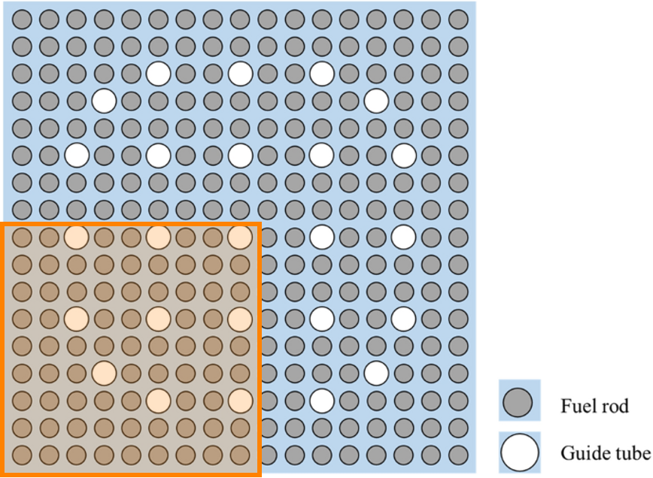
Figure 65. Diagram of measured locations for full fuel assembly equivalent.

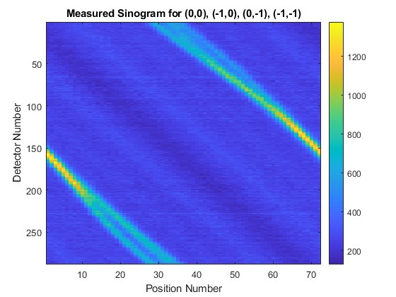
Figure 66. Summed sinogram of the measured data at 4 points: (0,0), (-1,0), (0,-1), (-1,-1)

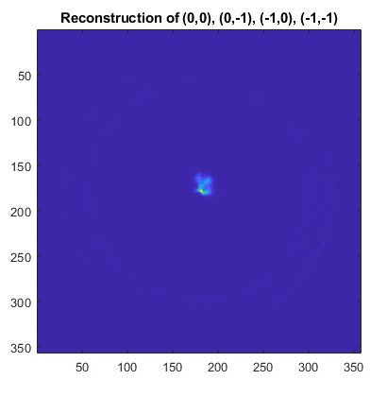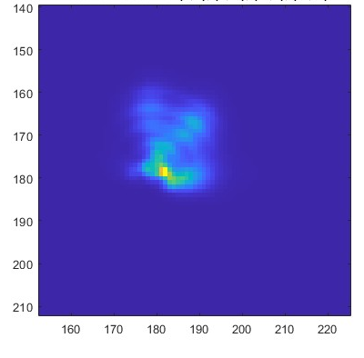
Figure 67. Reconstruction of the 4 points for all 357x357 pixels(left) and a zoomed in version (right).

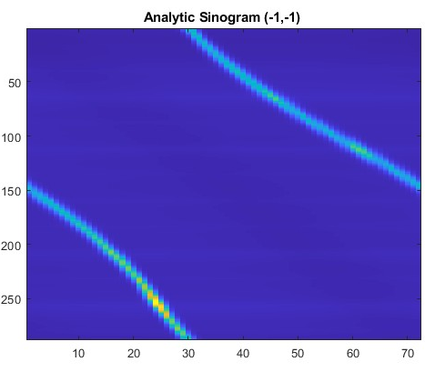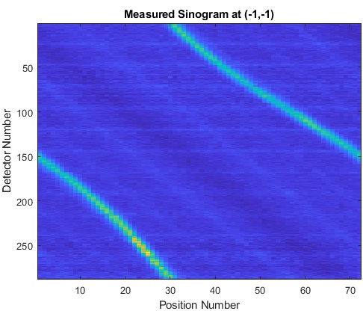
Figure 68.Comparison between the analytic sinogram for point (-1,-1) (left) and the measured sinogram (right).
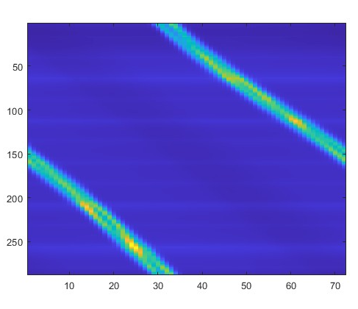
Figure 69. Analytic code generated results for the same 4 points.

has distinct lines representing each point. The lines add together in some places to increase the source intensity at that specific detector and position, but much of the individual source data is preserved in the summing of the source positions. The same cannot be said of the measured sinogram for the 4 points. The data for each point adds together to increase the source intensity in many places. The measured data for each source position does not preserve the shape of the location well enough to distinguish individual pins. The spatial resolution is defined by how well the measured data sinograms can preserve the individual shape of each of
the source positions. In order to preserve the shape perfectly the spatial resolution would have to be sufficiently good to differentiate whether a source is present for each millimeter across the field of view. The current spatial resolution does not do so and cannot even tell the difference between fuel pins with a gap of 3.28 mm.
The issues with the spatial resolution come from how the measured data is binned into various positions. The constant rotation of the collimator results in a constant stream of data coming from slightly different collimator positions that are binned into one single position. Previously, this issue was mentioned in Section 7.1.1 and the analytic code was expanded to try to account for the collimator rotation. However, without location data corresponding to the collimator location for each read out, it is difficult bin the data such that each position is even as distinct as the 4 positions averaged together in the analytic model. The rotation of the collimator means that the locations for each source peak are smeared across two collimator positions where they should be in only one. If more exact location data were available correlating the readout data with the location of the collimator, the data would be able to be binned in a more precise way. Instead of the bins accounting for a 5-degree spread around the collimator position location, more precise collimator location data could reduce that 5-degree spread to potentially 2 or 3 degrees. While this would result in the elimination of some collected data to crease more precise bins, increasing the collection time and number of rotations would allow the system to compensate for the decreased counts used in the detector bins.

Attenuated Reconstructions
Despite the system being unable to reconstruct a full fuel assembly with or without attenuation, some of the previously examined source measurements can be re-examined with attenuation rods present. The addition of the attenuating rods serves to decrease the signal to noise ratio by decreasing the amount of signal detected.
The origin measurement is surrounded by the attenuating rods, meaning that in all directions fast neutrons from the center pin have a high likelihood of interaction. Figure 70 shows the sinogram and reconstruction of (0,0). The addition of the attenuation rods leads to a total neutron count reduction of 7.62%; however, the neutron counts coming from the source are reduced by 42.83%. This means that the addition of the attenuation rods increases scattering and background significantly and allows for less direct scattering of neutrons down collimator slits.
The corner measurement has the same challenges as mentioned in Section 7 due to the lower sampling rate along the edges of the inspection volume, but the reconstruction becomes more challenging when the attenuating rods are added. Figure 71 shows the sinogram and reconstruction generated for (-8,-8). The rods decrease the signal going to part of the detector, while some of the signal remains the same because of the location of the source rod. The attenuating rods do not surround the corner measurement and so they only decrease the neutron intensity in certain directions. This can be seen in the sinogram where the parts with the greatest source intensity are those where there are no rods between the detector and the source. In the places where there are many rods between the source and the detector, the source is so attenuated that the source nearly blends in with the increased scattering background from neutron scattering off of the stainless-steel rods. Much more of the source is attributed to the edges of the inspection volume in the attenuated measurement than in the unattenuated. This includes the highest source intensity pixel which is (274, 63), which is 14.3 mm from the source location and along the edge of the inspection volume. In fact, very little source is attributed to the location (280, 76) at all. The pixel with the second highest source intensity which is not located along the edge of the inspection volume is (284, 85). This is the highest pixel within the source blur, and it is located 9.85 mm from the corner source rod. The amount of source attributed to the corner location of (280, 76) where the center of the source rod is located is only 8.9% of the source at pixel (284, 85).
Finally, the 5 points were again examined with attenuation rods in place. Figure 72 shows the sinogram and reconstruction of these 5 points. While is it still possible to visually tell that 5 separate sources are in the image, many more artifacts are introduced. There appear to be 3 ring

Figure 70. Sinogram and reconstruction of (0,0) with attenuation rods in place.

Figure 71. Sinogram and Reconstruction of (-8,-8) with attenuating rods in place.

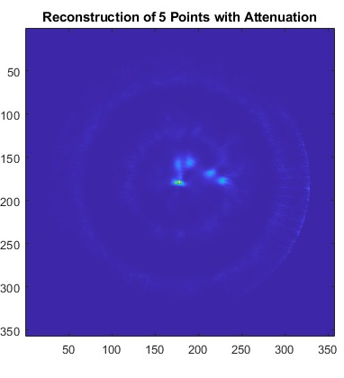

Figure 72. Sinogram and reconstruction of 5 source points with attenuation rods present.

artifacts surrounding the origin point at different radii. In order to use the imager to create full fuel assembly measurements, these ring artifacts would have to be removed from the image.

Conclusion

Conclusions
In this dissertation a fast neutron emission tomography system was described, constructed, characterized, and tested. Picking up from Dr. Iyengar’s NET Imager design, modifications had to be made when constructing the imager. These modifications included the reducing of the collimator slits from 96 to 72 and a change in the spacing between the collimator slits. An analytic neutron response model as well as a radiation transport model were also updated to reflect this change. Measurements were taken to verify the absolute efficiency of the detector modules as well as determine the bias voltage and trigger threshold which yield the best efficiency for the modules. The modified imager was constructed on site at ORNL. An initial measurement campaign was performed using the imager which demonstrated the imager’s ability to collect and reconstruct measured data using the analytic neutron response model. Following the initial observations, further characterization of the imager took place. First, the relative efficiency of each detector in the imager was determined through measurement and incorporated into the analytic response code. Following that, representative source locations at (0, 0) and (-8, -8) were used to determine changes needed for the analytic model. This included the addition of an angular factor to the slit scattering calculation as well as changes to the collimator’s effective thickness values. Finally, a measurement campaign took place to find the imager response to fuel rod positions with and without attenuation rods in place and to determine in the spatial resolution of the system would be less than 3 mm.
While the NET system still has the potential to be used to image spent nuclear fuel, the system as currently built is not able to do so. The spatial resolution is not sufficient to be able to distinguish multiple fuel pins at gaps of 3.28 mm. Increased background counts coming from room return, as well as limited data about the collimator location for each data read out, render the measurements too imprecise to image 3 mm of less. Without the addition of more borated polyethylene to the system or the addition of the missing 6 detector modules, the room return of the system cannot be decreased. Additionally, without using a system to determine the collimator rotation angle at more data readout times, the data cannot be more precisely evaluated. With these changes made to the imager, the system may be able to image spent fuel rods.

Future Work
Going forward, there is some additional work which could be done with the imager. The first thing that would be necessary would be to switch the motor which is rotating the collimator with a different motor which also tracks rotation location over time. This would allow the measured data to be chosen so that it more closely matches the “point-and-shoot” calculations that the analytic neutron response code uses to calculate projections. Additionally, the addition of the remaining 6 detector modules to the system would improve the data as it would remove the issues with room return increasing the neutron background.
Following these changes to the detector another set of measurements should be performed as described in Section 8. The source rod data should be compiled until a whole spent nuclear fuel assembly equivalent is being reconstructed both with and without attenuation rods in place. This would demonstrate the ability of the imager to reconstruct whole spent fuel assemblies. Source points of interest should be removed from the whole assembly equivalent to determine if the imager sufficiently reconstructs missing fuel pins when there are so many sources present in the inspection volume. Measuring and reconstructing sources with different source strength would also be helpful to mockup spent fuel verification of fuel rods with different burn ups to determine if the system can be used to detect rod replacements which have lower burnup than the surrounding rods.
Most PGET system’s have been used to image other types of fuel aside from PWR 17 x 17 fuel assemblies, including VVER-1000 fuel. In order to be able to compare the image quality with the images from PGET, the NET system should try to reconstruct these smaller fuel assemblies and see how sensitive it is to missing rods. Both simulations and measurements of other fuel assemblies should be done with the NET system to compare to the PGET systems currently in place.
In summary, a proof-of-concept fast neutron emission tomography imager has been constructed, operated, and characterized with spent nuclear fuel verification for international safeguards applications in mind. While the as built imager does not have sufficient spatial resolution to image spent fuel pins, with some changes, the imager has the potential to do so.

List of References
[1] The Technical Objective of Safeguards THE NON-DIVERSION UNDERTAKING AND THE SAFEGUARDS OBJECTIVE. (n.d.). https://www.iaea.org/sites/default/files/17203401317.pdf
[2] Goldschmidt, B. (1956). The Origins of the International Atomic Energy Agency. https://www.iaea.org/sites/default/files/publications/magazines/bulletin/bull19-4/19401281219.pdf
[3] International safeguards in the design of facilities for long term spent fuel management (NF-T-3.1). (2018). INTERNATIONAL ATOMIC ENERGY AGENCY. https://www.iaea.org/publications/10806/international-safeguards-in-the-design-of-facilities-for-long-term-spent-fuel-management
[4] Evdokimov, I. A., Khromov, A. G., Kalinichev, P. M., Likhanskii, V. V., Kovalishin, A. A., Laletin, M. N., Gurevich, M. I., & Zborovskii, V. G. (2020). Detection of fuel washout from leaking fuel rods during operation of WWER power units. Journal of Nuclear Materials, 538, 152205. https://doi.org/10.1016/j.jnucmat.2020.152205
[5] Levai, F., Desi, S., Tarvainen, M., & Arlt, R. (1993). Use of high energy gamma emission tomography for partial defect verification of spent (No. STUKYTOTR56; p. 51). http://inis.iaea.org/search/search.aspx?orig_q=RN:25037535
[6] Bean, R., Blair, D. S., & Pickett, C. (2014). Attaining and Maintaining a Continuity of Knowledge to Draw Safeguards Conclusions with Confidence. ESARDA Bulletin, 51(SAND-2014-19685J).
[7] Bull, J. (1980). The History of Computed Tomography. In J. Caillé & G. Salamon (Eds.), Computerized Tomography. Springer Berlin Heidelberg.
[8] Cherry, Simon R., James A. Sorenson, and Michael E. Phelps. Physics in Nuclear Medicine. 4th ed. Philadelphia: Elsevier/Saunders, 2012. Print.
[9] Shiba, S., & Sagara, H. (2020). MLEM reconstruction method applied to partial defect verification using simulated data. Annals of Nuclear Energy, 139, 107242. https://doi.org/10.1016/j.anucene.2019.107242
[10] Fang, M., Altmann, Y., Della Latta, D. et al. Quantitative imaging and automated fuel pin identification for passive gamma emission tomography. Sci Rep 11, 2442 (2021). https://doi.org/10.1038/s41598-021-82031-8
[11] C. Bélanger Champagne, Peura, P., P. Eerola, T. Honkamaa, White, T., M. Mayorov, & P. Dendooven. (). Effect of GammaRay Energy on Image Quality in Passive Gamma Emission Tomography of Spent Nuclear Fuel. IEEE Transactions on Nuclear Science, 66(1), 487–496. https://doi.org/10.1109/TNS.2018.2881138
[12] Reilly, D., Ensslin, N., Hastings Smith, Kreiner, S., Los Alamos National Laboratory (U.S, & Etats-Unis. Nuclear Regulatory Commission. (1991). Passive nondestructive assay of nuclear materials. Us Department Of Commerce, National Technical Information Service.
[13] Backholm, Rasmus et al. “Simultaneous reconstruction of emission and attenuation in passive gamma emission tomography of spent nuclear fuel.” arXiv: Instrumentation and Detectors (2019): n. pag.
[14] ] Iyengar, Anagha Srikanth, "The Design of an Imager to Safeguard Spent Fuel Using Passive Fast Neutron Emission Tomography. " PhD diss., University of Tennessee, 2019. https://trace.tennessee.edu/utk_graddiss/5343
[15] Poulson, D., Bacon, J., Durham, M., Guardincerri, E., Morris, C. L., & Trellue, H. R. (2018). Application of muon tomography to fuel cask monitoring. Philosophical transactions. Series A, Mathematical, physical, and engineering sciences, 377(2137), 20180052. https://doi.org/10.1098/rsta.2018.0052
[16] “Nuclear Power Reactors.” Nuclear Power Reactors - World Nuclear Association, https://world-nuclear.org/information-library/nuclear-fuel-cycle/nuclear-power-reactors/nuclear-power-reactors.aspx.
[17] Moore, R.S., & Notz, K.J. (1989). Physical characteristics of GE [General Electric] BWR [boiling-water reactor] fuel assemblies (ORNL/TM--10902). United States
[18] Wasywich, K.M. (1993). Characteristics of used CANDU fuel relevant to the Canadian nuclear fuel waste management program (AECL--10463). Canada
[19] “General Design and Principles of the Advanced Gas-Cooled Reactor (AGR).” IAEA Open Knowledge Wiki , https://nucleus.iaea.org/sites/graphiteknowledgebase/wiki/Guide_to_Graphite/General%20Design%20and%20Principles%20of%20the%20Advanced%20Gas-Cooled%20Reactor%20(AGR).aspx#:~:text=Each%20reactor%20has%20308%20fuel,channels%2C%20each%20127mm%20in%20diameter.
[20] “Nuclear Fuel and its Fabrication”, World Nuclear Association, https://world-nuclear.org/information-library/nuclear-fuel-cycle/conversion-enrichment-and-fabrication/fuel-fabrication.aspx#:~:text=The%20fuel%20is%20cooled%20by,bundle%20about%208%20cm%20diameter
[21] Proportionaltech, “Products: 1” star straw neutron detector direct, drop-in replacement for up to 3.4 atm 1” 3he tubes,” tech. rep
[22] Knoll, G F. Radiation detection and measurement. United States: N. p., 1979. Web.

Vita
Originally from the northeast, Mairead E. Montague grew up in Bridgewater, NJ. After high school, she attended the University of California, Berkeley and received a Bachelor of Science degree in Nuclear Engineering in 2018. Before graduating with her undergraduate degree, she knew she wanted to attend graduate school. She chose to attend the University of Tennessee, Knoxville beginning in Fall 2018 to pursue a Doctor of Philosophy degree in Nuclear Engineering while pursuing a concurrent Master of Science degree in Nuclear Engineering. During this time Mairead was recognized with the Tennessee Fellowship for Graduate Excellence. Mairead completed her MS in 2019 and continued with PhD research at Oak Ridge National Laboratory. Her research interests include the development of novel detector systems for nuclear safeguards and security. Mairead has worked with neutron detection as well as scintillator testing.
After graduation, she will begin a post-doctoral appointment with Dr. Sara Pozzi at the University of Michigan as a Distinguished Postdoctoral Research Fellow with the Consortium
for Monitoring, Verification, and Technology. She is incredibly grateful for all the support from her husband, family, and friends as she begins her new career.

