The Effect of Tillage Practice and Cover Cropping Systems
on Yield, Quality, and Angular Leaf Spot Occurrence
in Dark Tobacco in Tennessee

A Thesis Presented for the
Master of Science
Degree
The University of Tennessee, Knoxville

Alyssa Corinne Thelin
May 2025

ACKNOWLEDGEMENTS
Thank you to Dr. Mitchell Richmond and Dr. Virginia Sykes for your fantastic advising and mentorship throughout my time in graduate school. The completion of this degree would not have been possible without the support and guidance I received from both of you.
Thank you to my committee members, Dr. Zachariah Hansen and Dr. Debasish Saha, for your help, support, and guidance.
Thank you to the Official Variety Testing Team and the Specialty Crops Lab: Andrew Lawson, Francisco Palacios, Lexie Worley, Yannick Roberts, Alyssa Counce, Sarah Grahm, Rachel Hefton, Linus Parish, Jonah Hillard, and Samuel Jones for all your help and fun memories!
Thank you to the crew at Highland Rim Research and Education Center, especially Weston Bracey and Rob Ellis for all your hard work and encouragement!
Thank you to all the friends I made along the way, Brooke Keadle Emery, Catie Caterham, Lexie Worley, Sarah Grahm, Rachel Hefton, and Bailey Burns. You guys made my time in Tennessee an unforgettable memory.
And finally, thank you to all my friends and family from Oklahoma. Braden Coats and Mykah Snyder Stone, your support meant the world to me and helped me through all the ups and downs of obtaining a master’s degree. Thank you to Ayson Thelin, the best youngest brother, for sending me funnies every day that brought a smile to my face and warmth to my heart. Thank you to my mom and dad for supporting my decision to move out-of-state and so far away from home.

ABSTRACT
Angular Leaf Spot (ALS) (Psuedomonas syringae pv. tabaci) has become an increasingly important disease in Mid-South US dark tobacco production since 2015. Current recommendations for control of ALS have limited efficacy and include selection of dark tobacco varieties with low susceptibility and the use of crop protection agents, such as agricultural streptomycin. Tobacco producers have limited options in weed management and rely heavily on tillage and a few pre-emergent herbicides. Cover crops are beneficial at decreasing weed biomass, improving soil health, and reducing soil borne pathogens in many crops. With the limited options for managing ALS, alternative control approaches that integrate tillage methods and cover crop selection are of interest. The objectives of this project were to evaluate the impact of cover crops and tillage in tobacco production systems on ALS occurrence, tobacco yield, and leaf quality. Field plots were arranged in a split-block design with four replications. Tillage type (conventional and no-tillage) was applied to the main plot and cover crop treatment (cereal rye, crimson clover, hairy vetch, and fallow) to the sub-plot. Field inoculations of ALS were applied to dark tobacco Phase 1 of 2022 and 2023. Inoculated tobacco was terminated and left in the experimental area to serve as ALS inoculum for the subsequent Phase 2 tobacco crop. Tobacco yield was reduced with no-tillage production but not cover crop selection in both years of the study. Disease progression was not statistically different by cover crops or tillage type during the first year of this study. During 2024, conventional tillage had reduced disease progression compared to no-tillage. Cover crop selection did not influence disease progression in either year of this study. Additional research studying the impacts of other methods, such as cultural controls, should be conducted.

TABLE OF Contents
LIST OF TABLES v
LIST OF FIGURES vi
CHAPTER ONE: LITERATURE REVIEW AND INTRODUCTION 1
1.1 Dark Tobacco Production 1
1.2 Cover Crops 1
1.3 Tillage Impact 4
1.4 Angular Leaf Spot 5
CHAPTER TWO: IMPACT OF TILLAGE AND COVER CROP TYPE ON DARK TOBACCO YIELD, LEAF QUALITY, AND ANGULAR LEAF SPOT OCCURENCE IN TENNESSEE 7
2.1 Introduction 7
2.2 Materials and Methods 8
2.2.1 Site description and field management 8
2.2.2 Tobacco cultivar and establishment 9
2.2.3 Inoculation procedures and preparation 10
2.2.4 Serial dilution procedures 10
2.2.5 Disease ratings 11
2.2.6 Cover crop and tillage treatments 11
2.2.7 Statistical analysis 13
2.3 Results and Discussion 14
CHAPTER THREE: CONCLUSIONS 19
List of References 20
Appendix 25
Vita 40

LIST OF TABLES
Table 1. Biomass, nitrogen percent, 8-week cumulative and total nitrogen release by cover crop species separated by year.. 35
Table 2. Average total yield and yield of each stalk position and grade index of dark fire cured tobacco by year and tillage type. 36
Table 3. Biomass, nitrogen percent, 8-week cumulative and total nitrogen release by cover crop species separated by year.. 37
Table 4. Average total yield and yield of each stalk position and grade index of dark fire cured tobacco by year and tillage type. 38
Table 5. Biomass, nitrogen percent, 8-week cumulative and total nitrogen release by cover crop species separated by year.. 39

LIST OF FIGURES
Figure 1. Research timeline. 25
Figure 2. 2023 Average Canopy Coverage by Cover Crop Type Over Time . 26
Figure 3. 2024 Average Canopy Coverage by Cover Crop Type Over Time 27
Figure 4. Interaction Effect of Year by Tillage Type on AUDPS 28
Figure 5. Cover Crop Type did not Affect Final Diseae 29
Figure 6. Combined Disease Incidence and Index Over Time in 2024 30
Figure 7. Sum of Monthly Precipitation of 2023, 2024, and 30-Year Average in Springfield, TN 31
Figure 8. Cover Crop Species did not Affect Dark Tobacco Yield 32
Figure 9. Images of Canopy Coverage of the 2022 – 2023 Cover Crop Season 33
Figure 10. Images of Canopy Coverage of the 2023 – 2024 Cover Crop Season 34

CHAPTER ONE: LITERATURE REVIEW AND INTRODUCTION

1.1 Dark Tobacco Production
Tennessee’s average dark tobacco production from 2022 to 2024 was 20.4 million kgs, making up nearly 80% of the total tobacco acreage in the state (United States Department of Agriculture – National Agriculture Statistics Survey [USDA – NASS], 2025). Dark tobacco (Nicotiana tabacum L.) is native to tropical regions making it a suitable crop for production in the humid climate of Tennessee (Collins & Hawks, 2013). Tennessee’s humid climate creates the optimum climate for proliferation of diseases impacting all stages of tobacco production, which can lead to a loss of revenue due to decreased yield and leaf quality (Bailey et al. 2025a). Dark tobacco production in the eastern US follows standard practices in preventing disease and disease spread, such as equipment sanitation and utilization of varieties with low susceptibility for certain diseases. These prevention methods are used frequently as a high-quality tobacco crop is imperative for producers (Bailey et al. 2025e). Some dark tobacco markets have a low tolerance for poor leaf quality, which often results from leaf spots or disease damage, making the utilization of prevention measures necessary (Bailey et al. 2025e). Other measures to reduce the likelihood of disease occurrence include but are not limited to crop rotation and proper site selection and preparation (Bailey et al. 2025b). With current and future incentivized programs, such as Environmental Quality Incentives Program (EQIP) and Conservation Stewardship Program (CSP), growers may have options available for adopting cultural methods to aid in controlling, reducing, or preventing diseases in their cropping systems.

1.2 Cover Crops
The use of cover crops has increased in recent years due to the increasing evidence of ecological and economic advantages attached to cover crop incorporation in production systems. As of 2022, the USDA Conservation Practice Adoption Motivations survey reported 61% of farmers and ranchers utilize cover cropping in their production systems (USDA, 2022). Cover crops can reduce the need for chemical herbicides by inhibiting the growth of weeds when grown as a winter cover for warm season crops (Werle & Blanco-Canqui, 2017; Ellis et al. 2000). Cover crop utilization aids in increasing soil quality by protecting aggregates from raindrop impact, thereby decreasing soil detachment and erosion (Dabney et. al. 2001; Clark, 2012). Other soil quality impacts include the enhancement of water infiltration and reduction of soil compaction in the presence of cover crops (Blanco-Canqui et al. 2015; Dabney et al. 2001). Reduction or alleviation of soil compaction is achieved through belowground biomass and increase in the critical water content at which compaction occurs. This means soils with cover crops can withstand higher traffic at higher water contents compared to soils without cover crops (Blanco-Canqui et al. . 2015). Cover crop use has branched to include pest and pathogen management in the last few decades in addition to their known soil quality benefits. Implementing cover crops can negatively impact pests and pathogens by altering soil environmental properties, encouraging populations of pest predators, and even creating barriers to pest/pathogen movement (Sarrantonio & Gallandt, 2003). Leaving plant litter at the soil surface after cover cropping allows for stimulation of diverse microbial communities and may reduce soil-borne pathogens either through increased competition or by increasing the abundance of beneficial, pathogen antagonizing microbes (Vukicevich et al. 2016). Another way cover crops accomplish alterations to soil environments is moderation in soil temperature. They provide interception of solar radiation thus reducing daily maximums and increasing daily minimums of soil temperatures. This regulation of extreme soil temperatures can favor soil processes such as increasing microbial biomass and diversity (Blanco-Canqui et al. 2015). The effects of soil properties and characteristics under cover crops have a compounding influence on soil processes, such as increasing aggregate stability. Ignoring the negative effects of agriculture production on soil health and characteristics could lead to bigger environmental issues (soil erosion, eutrophication, etc.).
Three commonly used cover crops in the southern United States are cereal rye, crimson clover, and hairy vetch. Cereal rye (Secale cereale L.) is suitable for many crop rotations including soybean, corn, and vegetables (Clark, 2012). In regions where water supply is not limited, cereal rye has the capability of producing high amounts of biomass and canopy cover which can provide a physical suppression of weeds (Davis, 2010; Ryan et al. 2011). These characteristics make cereal rye a favorable choice of cover crop for producers, especially in Tennessee. Cereal rye plant matter decomposition releases phytotoxic chemicals which have an allelopathic effect on some weed species, aiding in the reduction of herbicide-resistant weeds (Barnes and Putnam, 1986; Clark, 2012). The use of cereal rye as a cover crop can also reduce excess nitrogen in the soil by absorbing and storing it in plant tissue during winter and early spring growth, reducing the likelihood of nitrate leaching (Weiner et al. 2002).
Crimson clover contributes high nitrogen concentrations to the soil and reduces soil erosion when planted as a cover crop and left as a residue after termination. This cover crop grows well in the winter making it suitable for early-fall harvested or late-spring planted crops (Clark, 2012). The incorporation of crimson clover can improve microbial biomass and soil enzyme activities as was observed by Kirchner et al. (1993) in a conventional tillage, continuous corn system.
Similar to crimson clover, hairy vetch can be used as a nitrogen source and weed suppressor when planted as a cover crop. It acts as a weed suppressor mainly by outcompeting weeds and shading the soil to prevent germination of weed seeds. Hairy vetch helps to improve water retention in the root zone by reducing surface runoff and increasing infiltration by creating macropores in the soil (Clark, 2012).
Excluding cover crops from the production system can negatively impact the height of tobacco plants by increasing competition and overgrowth of weeds (Ellis et al. 2000). A study in burley tobacco revealed establishment of cover crops (wheat plus crimson clover and cereal rye plus crimson clover) was not negatively impacted following herbicide treatment (pre-sulfetrazone, carfentrazone, post-clomazone, and pre-pendemethalin) of tobacco fields. However, in this study early termination of cover crops decreased weed suppression capabilities (Haramoto et al. 2020). Tobacco yield was not impacted when a mixture of legume and rye cover crops were compared to legume only cover crops. However, a study in no-till, flue-cured tobacco increased yields following a legume cover crop, likely due to nitrogen carryover (Wiepke et al. 1988). Nitrogen recommendations are currently based on previous crop and soil drainage class and ranges by state from 199 to 309 kg ha⁻¹ (Bailey et al. 2025d). Nitrogen is the most important nutrient for the growth, development, and quality of tobacco (Tso 1972). Over fertilization results in lowered quality due to green grades in cured leaves and increased amounts of tobacco specific nitrosamines (TSNA) produced by the tobacco plants. Increases in TSNA production leads to increased carcinogen load in the cured leaves. Incorporation of cover crops can benefit production systems by reducing fertilizer applications, improving soil health, and eligibility for producers to participate in conservation programs.

1.3 Tillage Impact
Tillage and no tillage systems have been thoroughly researched for decades for their advantages and disadvantages to agriculture production and environmental quality. The decision to implement tillage or opt for no-till requires knowledge of the end goal for the system. No-till tobacco systems rely predominantly on herbicide chemistry for weed control. With only five available herbicides and no roundup-ready cultivars, a combination of tillage and herbicides are the top choices among tobacco producers for weed control.
Tillage can decrease the amount of organic matter in the surface layers of the soil (Hussain et al. 1996). Conventionally tilled areas often decrease some soil physical properties such as aggregate stability and structure. Aggregate stability is important for water infiltration and percolation throughout the soil profile. As aggregate stability decreases, surface water run-off and soil erosion tend to increase (Hussain et al. 1996). Aggregate stability is influenced by the amount and species of microbes found in the soil. Frequent tillage can disrupt the communities of soil fungi and bacteria shifting the populations of each and changing the functions and benefits provided by the diverse communities. These disturbances can promote microbial populations that provide fewer resources and benefits back into the soil environment (Vukicevich et al. 2016). Most tobacco systems are tilled to prepare the soil for transplanting of young tobacco plants (Bailey et al. 2025b). In a study conducted in Brazil, long-term tilled tobacco systems were assessed for healthy soil quality parameters (Thomas & Antoneli, 2022). Long-term, conventionally tilled soils had a decrease of up to 57% soil organic matter and a reorganization of soil particles which led to an increase in soil erodibility (Thomas & Antoneli, 2022). Subsoiling, a non-inversion form of tillage below a 14-inch depth, is a typical practice in most tobacco systems (SARE, 2023). According to a study in Kentucky, subsoiling did not significantly impact yield compared to surface tillage (Ritchey et al. 2012). The results of the surface tillage were variable. Transplant success was higher in areas that had been tilled, but areas under no-tillage had better soil physical properties (Ritchey et al. 2012). The presence of subsurface compaction can have negative effects on tobacco systems as presented in Murdock et. al. 1986. Compacted soils treated with subsoiling in the row resulted in increased tobacco yields when compared to tobacco plots not subsoiled or conventionally tilled prior to transplanting (Murdock et al. 1986). The subsoiled plots reduced compaction allowing tobacco plants to have better root growth and development.

1.4 Angular Leaf Spot
Reporting of angular leaf spot (ALS) by tobacco producers over the last decade has increased showing need for research of this plant disease. Angular leaf spot is caused by the bacteria Pseudomonas syringae pv. tabaci (Pst). This pathovar is a member of the widely studied bacterial species P. syringae. As defined by the American Phytopathological Society, a pathovar is a subdivision of a plant-pathogenic bacterial species defined by host range (APS, 2023). This bacterium has more than 60 identified pathovars associated with the species (Xin et al. 2018). Each of the identified pathovars infects a characteristically unique set of host plants such as oats, soybeans, tomatoes, and tobacco (Xin et al. 2018; Lyndon & Patterson, 2001). Pseudomonas syringae infects nearly all economically valuable crops, making it one of the most common pathogens. The growth of P. syringae occurs in two phases: epiphytic and endophytic. The epiphytic stage occurs as the bacteria live on the above ground portions of the plants (stems, leaves, flowers, and fruits). The endophytic stage begins when the bacteria enter the host plant tissue and start colonizing within the apoplast. Entry into the plant is achieved by passing through stomatal openings and/or tissue wounds on the plant. To aid in the entry of P. syringae, the bacteria produce compounds that strongly counteract the plant’s defense mechanisms against pathogen invasion. For example, one specific compound produced is called coronatine. It can inhibit stomatal closure and re-open stomata by interacting with jasmonate signaling receptors (Xin et al. 2018).
Pseudomonas syringae pv. tabici causes two foliar plant diseases in tobacco: wildfire and ALS (Collins & Hawks, 2013; Daub et al. 1991; Davis & Nielsen, 1999; Young et al. 1978). Wildfire bacteria produce a compound called tabtoxin, which serves as a chemically distinguishing feature from ALS bacteria (Lyndon & Patterson, 2001). Visual differences between wildfire and ALS are observed through differences in the size of lesions. Wildfire lesions range in size from one to two cm in diameter while ALS lesions are much smaller ranging in size from approximately 12 to 76 mm in diameter. Additionally, in severe cases, the centers of ALS lesions can fall out. Angular leaf spot lesions are bound by leaf veins and can cause leaves to become puckered and torn (Collin & Hawks et al. 2013; Davis & Neilsen, 1999).
The recent increase in widespread occurrence of ALS in US tobacco production has sparked research to expand knowledge of the disease. The spread of ALS occurs through water, either precipitation or irrigation, splashing contaminated soil from plant-to-plant or leaf-to-leaf (Daub et al. 1991). Additionally, ALS can be spread through pulling/handling of wet plants when necrotic lesions are oozing bacteria. Sources of initial ALS inoculum include infected plant residue, infected seed, or naturally infected weeds such as smartweed, shepherd’s purse, or dandelions. Basic management practices used to reduce disease spread include sanitary practices, low susceptibility varieties, and chemical protection. Preventative treatments of agriculture streptomycin are an effective control (Bailey et al. 2025e; Daub et al. 1991; Davis & Neilsen, 1999). Additionally, recent research has evaluated the susceptibility of dark tobacco cultivars to ALS and has discovered streptomycin resistant strains of Pst (Keeney et al. et al. 2021; Keeney-Webb et al. et al. 2022). A study looking into the susceptibility of dark tobacco varieties to ALS resulted in categorizing varieties ranging from less susceptible to highly susceptible to ALS. However, this study stated it is more important to select variety susceptibility to black shank over ALS (Hansen et al. 2022).

CHAPTER TWO: IMPACT OF TILLAGE AND COVER CROP TYPE ON DARK TOBACCO YIELD, LEAF QUALITY, AND ANGULAR LEAF SPOT OCCURENCE IN TENNESSEE

2.1 Introduction
Tennessee’s average dark tobacco production from 2022 to 2024 was 20.4 million kg, making up nearly 80% of the total tobacco acreage in the state (USDA – NASS, 2025). The humid climate of Tennessee makes dark tobacco (Nicotiana tabacum L.), a native to tropical regions, a suitable crop for the state (Collins & Hawks, 2013). Tennessee’s climate creates an optimal environment for the proliferation of impactful tobacco diseases (Bailey et al. et al. 2025a). Standard practices of disease prevention are followed by US dark tobacco production systems. These practices include but are not limited to equipment sanitation, utilization of low susceptibility/resistant tobacco cultivars, and crop rotation (Bailey et al. 2025e). It is imperative for tobacco producers to understand the options available when making decisions related to their production systems and disease management.
Cover crop usage has increased in recent years due to their widely studied ecological and economic benefits provided to agriculture systems. Examples of ecological benefits include improving soil quality, enhancing water infiltration, and reducing soil compaction (Blanco-Canqui. et al. 2015; Dabney et al. 2001). With only five chemical herbicides available and no roundup ready tobacco cultivars, tobacco producers have limited options for weed management. Tobacco producers could benefit economically by utilizing a cover crop’s ability to inhibit the growth of weeds as a weed management supplement thus reducing their need for chemical herbicides (Werle & Blanco-Canqui, 2017; Ellis et al. 2000).
Due to a lack of registered post-emergent herbicides, tobacco producers often rely on a combination of tillage, pre-emergent herbicides, and cover crops to manage weed populations (Bailey. et al. 2025c). The implementation of tillage has been researched thoroughly for decades (Hussain et al. 1999; Vukicevich et al. 2016) and making the decision to incorporate tillage or no-tillage into the production system depends on the goals, benefits, and challenges of the production system. Conventionally tilled areas can experience a decrease in soil organic matter and soil aggregate stability which could lead to an increase in surface runoff and a decrease in beneficial microbial populations (Hussain et al. 1999; Vukicevich et al. 2016).
Reports of angular leaf spot (ALS) from dark tobacco producers in the Mid-South US since 2015 increased drastically driving the need for solutions for control and prevention of this foliar disease. Angular leaf spot is caused by the bacteria Pseudomonas syringae pv. tabaci (pst). This bacterium also causes the tobacco disease wildfire, but there are chemical and visual differences between the two foliar diseases. Wildfire causing bacteria secretes a compound (tabtoxin) and lesions are between one and two centimeters in diameter (Lyndon & Patterson, 2001). Lesions caused by pst are less than one centimeter in diameter (Collin & Hawks et al. 2013; Davis & Neilsen, 1999). Recent research has studied the susceptibility of dark tobacco cultivars to ALS and categorized the cultivars from high to low susceptibility. This study emphasized the importance of considering a cultivar’s resistance to black shank prior to ALS susceptibility (Hansen et al. 2022). Research screening active ingredients for control and prevention of ALS has yielded limited success. These recent studies have observed cuprous oxide and copper sulfate to be effective at providing control of ALS to the same degree as streptomycin sulfate, the grower standard for ALS control (Keeney-Webb et al. 2022; Webb & Bailey, 2024; Webb & Bailey, 2025). In the presence of streptomycin-resistant bacteria, cuprous oxide and copper sulfate can be used as alternative disease management options. Although some chemicals can provide some control, there is not a chemical that can eliminate ALS (Webb & Bailey, 2025). It is important to note that copper resistance has been reported in pseudomonas species and research evaluating the resistance to common copper products used against ALS bacteria in tobacco production systems is needed (Cooksey & Azad, 1992).
The objectives of this study were to determine the effect of tillage and cover crop type on tobacco yield, cured leaf quality, and ALS disease progression.

2.2 Materials and Methods

2.2.1 Site description and field management
Field plots were established in 2022, 2023, and 2024 at the University of Tennessee Highland Rim AgResearch and Education Center located near Springfield, Tennessee (36.482425, -86.837935). The soil type at the field site was a moderately well drained Sango Silt loam (coarse-silty, siliceous, semiactive, thermic Glossic Fragiudult) with soil pH of 6.4, 5.39, and 5.82 in 2022, 2023, and 2024, respectively. Applications of lime, potassium and phosphorus were based on soil testing and recommendations for the production of dark tobacco. Nitrogen was applied broadcast, preplant at a rate of 247.5 kg N ha⁻¹ using coated urea.
A randomized split-block design was utilized with four replications. Tillage type was the main plot, with conventional tillage (chisel plow and rotary tiller) and no-tillage. The field site selected was no-tillage crab grass pasture from 2017 – 2020. In 2021, the field was chisel plowed and disced to prepare the soil for corn and was cover-cropped with a no-tillage cereal rye crop in the winter. After harvesting cereal rye in 2022, the field received a chisel plow and disc tillage to prepare the soil for the first transplanting of tobacco. Each tillage treatment plot was divided into four sub-plots for application of cover crop treatment. Three cover crops were chosen for this study along with a fallow treatment as a control. Elbon cereal rye (Secale cereale), Dixie Reseeding crimson clover (Trifolium incarnatum), and Purple Bounty hairy vetch (Vica villosa) were seeded at a rate of 168, 28, and 33 kg ha⁻¹, respectively (Pedreira et al, 2024). Fallow plots were not maintained weed free during the cover crop season. However, a post emergent herbicide (Gramoxone) was sprayed to burn down reemerging cover crops in the NT plots in 2023 at a rate of 2.96 L ha⁻¹ and a rate of 2.22 L ha⁻¹ in 2024. Pre-emergent herbicides (carfentrazone-ethyl and sulfentrazone) were sprayed before tobacco was transplanted at a rate of 0.74 L ha⁻¹ on 8 June 2023 and 31 May 2024. Tobacco was transplanted at a row spacing of 107 cm and plant spacing of 81 cm, achieving a plant population of 11,500 plants ha⁻¹. Plots were four rows wide, but data were only collected from the center two rows.

2.2.2 Tobacco cultivar and establishment
Dark tobacco variety KTD17LC was selected for these trials due to its higher susceptibility to ALS (Bailey et al. et al. 2025a). Tobacco was seeded in a float-bed greenhouse on 17 April 2022, 15 March 2023, and 19 March 2024. This research relied on two tobacco crops to collect a complete year of data (Figure 1). Tobacco transplanted for inoculation (Phase 1, Figure 1) was transplanted on 14 June 2022 and 16 June 2023. The Phase 1 tobacco crop in 2022 was subjected to extreme adverse weather conditions, including excessive heat up to 37.2 °C and limited precipitation (3.2 cm) for the following 30 days. This resulted in poor crop stand and re-establishment on 13 July 2022. Tobacco for subsequent data collection was transplanted on 16 June 2023 and 31 May 2024 (Phase 2, Figure 1). Field management followed the University of Tennessee recommendations for dark tobacco production (Bailey et al. 2025b).

2.2.3 Inoculation procedures and preparation
During Phase 1 of the research (Figure 1), field plots were inoculated with pst on 24 August 2022 at approximately midday (1:30 PM CDT) and 11 July 2023 at approximately 9:00 pm (CDT). Due to high temperatures and low moisture in 2022 at the time of inoculation, disease infection was very poor resulting in extremely low disease pressure. Time of inoculation was adjusted in 2023 based on environmental conditions and the impact on inoculation success from the previous year. Inoculation protocol was similar to methods described in Pfeufer et al (2017). Bacterial isolates were collected from the University of Kentucky. The isolate cultured for Phase 1 inoculation in 2022 was 16P455 and in 2023 was Pst 1073. Inoculum was prepared using sterile King’s B (KB) media under a laminar flow hood. Five days before inoculation, pst was grown on Luria-Bertani (LB) agar plates. The day before inoculation isolated colonies of pst were collected from agar plates and suspended into 2 L of the KB broth in 4 L sterile glass flasks. One individual colony was added to each flask. Flasks were covered and placed on a shaker table for 20 hours at 200 rpm at room temperature. After shaking was completed, bacterial suspension was added to sterile 1 L glass bottles, capped, and placed into a cooler with ice packs to halt further growth of bacteria. At the field, 456 mL of bacterial suspension was added to a 11.4 L battery powered sprayer combined with municipal water. The sprayer was calibrated to deliver a volume of 234 L ha⁻¹. The timing for inoculation application was made corresponding to tobacco growth stages 1108 to 1110 (Papenfus & Billenkamp, 2019). These growth stage values correspond to the number of developed leaves, eight and ten, respectively, on the tobacco plants. The inoculum was applied to the upper 4-5 leaves on the dark tobacco plants.

2.2.4 Serial dilution procedures
Serial dilution and colony counting on agar plates were conducted on the same day as field inoculation, prior to transportation, to determine the concentration of inoculum, expressed as colony forming units (CFU) per milliliter of bacterial suspension. The method for the serial dilution conducted was based on protocols from Reynolds (2005). In 2022, nine 1 mL sterile, plastic vials were labeled one to eight for the dilutions and one labeled “S” to indicate stock bacterial solution. In 2023, 12 vials were used and labeled in the same way (one to twelve, and “S” for stock). In each of the numbered vials, 900 µL of sterile water was added. From the “S” vial, 100 µL of the stock was added to vial number one and mixed by pipette. The process was repeated by taking 100 µL of solution from the preceding vial and adding the solution to the next numbered vial. This created a 10-fold dilution starting with vial number 1 having the highest stock concentration to vial number 8 or 12 having the lowest. After creating the dilutions, 100 µL from each numbered vial were placed on an LB agar plate with three sterile metal beads, covered, and shaken repeatedly until the solution was evenly dispersed on the plates. Metal beads were removed from the agar plates before being sealed with parafilm and left at room temperature for 48 hours. After the 48 hours elapsed, colonies were counted. There were 1.3 x 10¹⁰ CFU per mL sprayed in August 2022 and 2.8 x 10⁶ CFU per mL in July 2023. All preparations for serial dilution components were made underneath a laminar flow hood.

2.2.5 Disease ratings
Disease ratings after inoculation in Phase 1 were made to gain a baseline of disease pressure for the future. Disease ratings were scheduled to begin approximately two weeks after inoculation. In 2022, only one rating was taken ( 5 October) before tobacco was terminated due to low levels of ALS incidence and severity. In 2023, disease ratings were taken weekly beginning 26 July and ending 19 September. Ratings were conducted visually by assessing plants in the center two rows for incidence (percent of plants showing any disease symptoms) and severity (average area of leaves covered by lesions of the infected plants, measured in percent). At the end of the tobacco growing season of Phase 1, the crop was terminated using a silage chopper and inoculated plant matter was spread evenly across the field to act as soil inoculum for the tobacco crop transplanted in Phase 2.

2.2.6 Cover crop and tillage treatments
Cover crop treatments were applied in Phase 1 to plots after the termination of the first transplanting of each tobacco field (Figure 1). Light tillage was used to prepare the seed bed for cover crop planting. Cover crops were planted on 11 October 2022 and 10 October 2023. Due to low establishment of crimson clover and hairy vetch in 2023, a second seeding occurred on 10 November. One month after planting, monthly data collection began and included canopy coverage, soil moisture, and soil temperature of each plot. One cover crop establishment rating was made during the first monthly data collection to estimate the percentage of plants that germinated in each plot. Canopy coverage was obtained both visually and using digital image analysis. Percentage of cover crops and of weeds present were evaluated visually and then photographs were taken top-down of two randomly selected 0.5 m² squares from chest height. Photographs were analyzed for green cover in digital imaging software, APS Assess. Soil moisture was collected using a Campbell Scientific Hydrosense II by measuring the volumetric water content at a depth of 15 cm. Soil temperature was measured using a soil thermometer inserted 15 cm into the soil. Cover crop biomass harvest occurred on 14 April 2023 and 12 April 2024. Cover crop biomass samples were harvested using a 0.5 m² square and clipped to about five cm above the soil surface. Weeds were hand separated from each harvest sample. Dry weight was collected for cover crop and weed samples after drying for 48 hours at a consistent temperature. All samples were analyzed at The University of Tennessee Beef & Forage Center’s NIRS Forage and Feed Nutritional Analysis Laboratory in Knoxville, TN, USA. This lab was certified by the National Forage Testing Association for all years of this project. Forage samples were dried in a 55 ⁰C forced air oven for at least 72 hours, or until weights did not change, then ground using a Wiley Mill (Thomas-Wiley Laboratory Mill Model 4, Arthur H. Thomas Co., Philadelphia, PA) passing through a 2-mm screen; followed by a cyclone sample mill (Foss Cyclotec, Foss North America, Eden Prairie, MN) grind to pass through a 1-mm screen (McIntosh et al., 2022). Additional drying of the prepared sample in a forced air oven at 55 ⁰C was completed before scanning to ensure consistent moisture levels across the entire project (McIntosh et al., 2022). The samples were scanned on a FOSS DS2500 near infrared spectrometer (NIRS) using ISIScan Nova v. 8.0.6.2 (Foss North America, Eden Prairie, MN). Spectra were then applied by species to the Grass Hay (GH), Mixed Hay (MH), and Legume Hay (LH) prediction calibrations (2023 & 2024) provided and licensed by the NIRS Forage and Feed Consortium (NIRSC, Berea, KY). The global and neighborhood statistical tests were monitored and analyzed for accuracy across all predictions with the entire data set fitting the calibrations within the (H <3.0) limit of fit and reported accordingly (Murray and Cowe, 2004). Units of measurement for nutritive analyses are presented at 100% dry matter (DM) across the entire data set. Validation statistics and an external sub-set of wet chemistry validation will be completed for publication purposes to compare NIRS predictions to the primary methods used to create NIRSC calibrations (McIntosh et al. 2022). For further analysis, to assess the nitrogen percent and nitrogen input back into the system of each of the cover crop species and fallow treatments, the crude protein values were converted to nitrogen by using [N=CP*6.25]. The remaining cover crops in the field were terminated prior to tillage treatment application. Glyphosate (Bayer AG, St. Louis, Missouri) was used at a rate of 2.37 L ha⁻¹ to burn down the cover crops on 20 April 2023 and 25 April 2024. Tillage treatments were applied about four weeks before tobacco was transplanted in Phase 2 into each research field.
The Phase 2 tobacco transplant for evaluation of overwintering capabilities of pst and tillage occurred on 13 June 2023 and 31 May 2024. Tobacco transplanted at this time was not inoculated but assessed for disease incidence and severity after cover crop and tillage implementation. Conventionally tilled plots were transplanted with a carrousel type transplanter (RJ Equipment, Blenheim, ON, CAN). No-tillage plots were transplanted with the same transplanter with the tillage blade removed. Disease ratings were taken weekly from 26 July to 19 September in 2023 and 30 July to 11 September in 2024. Disease rating followed the same protocol as disease ratings after inoculation. A calculation for final disease index was made by multiplying incidence and severity and dividing the product by 100. Although plots were assessed for disease symptoms, disease pressure in 2023 was very low and symptoms were not seen until 13 September. The phase two tobacco crops were harvested on 22 September 2023 and 11 September 2024 and fire-cured following recommended practices to obtain appropriate leaf characteristics for market. After curing, the tobacco leaves were removed from the stalk and separated into three stalk positions consisting of lug (lower stalk), second (mid-stalk), and leaf (upper stalk) and weighed to calculate yield per hectare. Cured dark tobacco was graded according to the official USDA dark fire cured tobacco standards and grades were assigned to an index value between 0 and 100. Federal leaf quality grade index data are a weighted average of grade across stalk positions based on the grade received for each stalk position and the yield proportion of each stalk position contributing to total yield.

2.2.7 Statistical analysis
Statistical analysis was completed with SAS 9.4 (SAS Institute Inc., Cary, NC). Tobacco yield and quality, area under the disease progress steps (AUDPS) (Simko, 2024), cover crop NIRS, and cover crop canopy coverage were analyzed using PROC GLIMMIX at an alpha of 0.05. Analysis of cover crop canopy coverage used cover crop type (CCT), collection time, and year as fixed effects and replication and replication by CCT as random effects. Cover crop NIRS statistical analysis used CCT and year as fixed effects and replication and replication by CCT as random effects. Tobacco yield, leaf quality, and AUDPS statistical analysis used CCT, TT, and year as fixed effects and replication and replication by TT as random effects. Soil moisture and temperature were analyzed using PROC ANOVA at an alpha of 0.05 using year and CCT as fixed effects and replication and replication by CCT as the random effects. PROC ANOVA was chosen to compare data within the same collection date for soil moisture and temperature. Where appropriate, means were separated with the use of Tukey HSD multiple comparison procedure.

2.3 Results and Discussion
Significant differences between treatments were determined by P < 0.05. Data for cover crop canopy coverage are shown by year as there was a significant interaction of year by collection time by CCT. In 2023, cereal rye had significantly higher canopy cover for one, two, and four months after planting compared to crimson clover, hairy vetch, and fallow (Figure 2). Crimson clover and hairy vetch in 2023 had poor establishment during the early cover crop growing season and did not have significantly higher canopy cover compared to fallow until harvest time (Figure 2). In 2024, cereal rye canopy cover was significantly higher than crimson clover, hairy vetch, and fallow in canopy cover for one, two, and four months after planting (Figure 3). Unlike 2023, crimson clover and hairy vetch in 2024 had significantly higher canopy cover than the fallow plots for two and four months after planting but were still significantly lower than cereal rye until harvest time (Figure 3).
In 2023, biomass data was collected for cereal rye, crimson clover, and hairy vetch. Prior to grinding for NIRS, crimson clover samples were mistakenly recombined with the weed biomass from each plot making the samples no longer representative of crimson clover and unusable for statistical analysis. In 2023, hairy vetch had a significantly higher nitrogen percent at 4.3% compared to cereal rye at 2.0% (Table 1). The significant difference between 2023 hairy vetch and cereal rye total nitrogen release is likely due to higher biomass production in cereal rye. In 2024, biomass data was collected for all cover crop and fallow treatments. Fallow plots during 2024 had high weed populations which likely contributed to the higher nitrogen percentage than cereal rye. Hairy vetch had the highest nitrogen content at 5.1% followed by crimson clover at 3.3%. Fallow and cereal rye had the lowest nitrogen contentat 2.7% and 1.7%, respectively (Table 1). Total cover crop nitrogen and eight-week cumulative release values after termination for each cover crop treatment in both years can be found in Table 1. Higher nitrogen content and canopy coverage in 2024 legumes could be attributed to better stand establishment in the early season compared to 2023. Although not the highest biomass producing cover crop treatment , hairy vetch produced sufficient biomass in 2024 to release the highest amount of total nitrogen back into the soil (Table 1). Crude protein and nitrogen content in cereal rye crops were exceptionally high during the trials; however, these values are in accordance with previous studies reporting biomass quality of cereal rye crops harvested early in maturity (Kantar et al. 2011; McCormick et al. 2006). Standard values for cereal rye nitrogen content for an early April biomass harvest in Tennessee is about 1.75% (Southern CCVT, 2024).
Angular leaf spot occurrence had a significant interaction of year by tillage type. The 2023 season had significantly lower disease pressure overall compared to 2024 (Figure 4). For both years, cover crop type did not have a significant effect on disease pressure (Figure 5). There were no significant differences between tillage types in 2023 suggesting that low disease pressure resulted in similar disease occurrence in the following crop. Different isolates of pst were used for each inoculation. This could have impacted survival and infection between each year. However, the inoculum load was higher in Phase 1 of 2022 (1.3x10⁸) than in Phase 1 of 2023 (2.8x10⁶).
Differences in inoculation timing could have impacted the success of infection from year to year. In 2022, field inoculation was performed midday and inoculum was subjected to direct sunlight and higher air temperature. In 2023, a different approach was taken where inoculum was applied at dusk with cooler temperatures and no direct sunlight. Additionally, precipitation within seven days after inoculation was 44 and 1.5 mm in 2022 and 2023, respectively. High humidity and warm temperatures can negatively affect the epiphytic populations of P. syringae species (Xin et al. et al. 2018). Warm temperatures above 28 °C slow motility and production of phytotoxins, both of which are crucial for plant infection by P. syringae species (Xin, et al. 2018). The higher temperatures and lower moisture experienced during 2022 inoculation (Phase 1) could explain some of the lack of success in disease prevalence in 2023 (Phase 2) (Figure 1). High temperatures can influence plant immune responses, making plants more susceptible to disease infection at higher temperatures. However, tobacco plant growth occurs more rapidly under warm temperatures with an optimal temperature of 27 °C (Xin et al. et al. 2018; Tso, 1972). The final disease index during the Phase 1 tobacco crop (Figure 1) was 0.02 in 2022 and 62 in 2023. Due to extremely low disease pressure, 2023 disease data were excluded from further analysis.
During 2024, significant differences between tillage types were observed where no-tillage had significantly higher AUDPS compared to conventional tillage (Figure 4). Under higher disease pressure observed in Phase 1 of the 2023-2024 research season, conventional tillage appeared to result in less disease compared to no-till. However, this result is based on one year of field experimentation due to the lack of sufficient inoculum in the first year of this study.
Although pre-emergent herbicide was sprayed on the plots before tobacco transplanting, weeds were still present in and around the tobacco plots. Additionally, fallow plots during the cover crop seasons were not maintained weed free and had various winter weeds present. It is possible that weeds and crop residues can harbor pst, therefore, it could be possible that conventional tillage had less residue for the pst to survive and reinfect the tobacco crop in 2024 (Wisler & Norris, 2005; Mougou & Boughalleb-M’Hamdi, 2016). Other studies have observed various Pseudomonas species being effectively harbored in common weed species found in the Mid-South region of the US (Dutta et al. 2014; McCarter et al. 1983).
Disease spread in 2024 was significantly slower under conventional tillage by approximately two weeks compared to no-tillage during the same time (Figure 6A). Analyzing disease incidence lends better understanding of the rate of spread of ALS. No-tillage plots experienced slightly earlier onset and quicker spread of disease symptoms compared to conventional tillage. While there was a difference in the rate of spread, both tillage systems ended the season with 100% disease incidence (Figure 6A). However, the severity of the disease at the end of the season was significantly different between tillage types, with no-tillage being more severe than conventional (Figure 6B). Tillage type and cover crop type had a minimal impact on soil moisture and temperature dynamics and it is unlikely that it contributed to disease proliferation (Tables 3, 4, and 5). The research site experienced low moisture and high temperatures during the tobacco growing seasons, making consistent monitoring of soil moisture and temperature difficult. However, according to Xin et al. (2018), P. syringae bacteria are positively influenced in pathogenicity during times of high humidity and moisture.
Under the conditions of this study, tobacco yield components were significantly impacted by tillage type. No-tillage resulted in significantly lower yields for all stalk positions except lug (Table 3). However, second and leaf stalk positions account for about 90% of the total yield in these trials (Table 3). The yield difference associated with tillage type has been previously recorded at this experimental site (Bailey et al. 2025b). The field site had been under no-tillage for three years before being transitioned to corn production then to the research field site. Early-stage no-tillage systems often experience lowered yields, likely due to weed competition. As the soil builds resilience under more long-term no-tillage, soil health can improve and the no-tillage system will be able to overcome limitations, such as weed problems. It is likely that better root to soil contact was achieved in conventional tillage treatments whereas no-tillage transplanting may have been limited with the no-tillage transplanter used in this experiment. Furthermore, the soil type at this location may be less than ideal for no-tillage tobacco production as other research has shown no yield penalty associated with no-tillage (Bailey et al. 2025b).
Disease ratings in 2024 showed higher pressure in no-tillage treatments than conventional tillage. The AUDPS was not significantly impacted by tillage in 2023 (Figure 5), however, yield was still reduced with no-tillage tobacco production. Therefore, the significant difference of AUDPS in 2024 likely isn’t as much of a significant factor in yield as tillage. Overall, individual stalk positions and total yield were higher in 2024 than 2023 (Table 3).
This research site was not irrigated in either year of the study. In the two weeks around transplanting in 2023, the research site received 18.5 mm in the week before and 31.75 mm in the week after transplanting. For the two weeks surrounding 2024 transplanting, the research site received 136 mm in the week before and 48.5 mm in the week after transplanting. The experimental site for 2023 was below and 2024 was above the 30-year average for precipitation around transplanting. Ideal tobacco transplanting conditions include soil that is near field water capacity to reduce transplant shock (Davis & Nielson, 1999). About three to five weeks after transplanting, tobacco plants are more sensitive to overwatering and benefit from slight water stress to encourage deeper root growth (Davis & Nielson, 1999). Differences between years are likely caused by differences in water availability at critical growing times during the season. Although 2024 had lower precipitation from June to August compared to 2023, having more ideal conditions at the beginning of the season likely resulted in better plant growth and preparation for later dry season conditions (Figure 6). Yield differences between years were likely not caused by the length of the growing season as season length was 101 days in 2023 and 103 days in 2024.
Dark tobacco federal leaf quality grade index had a significant effect between years but not between tillage types (Table 3). Federal grade indices averaged 38 for conventional tillage and 36 for no-tillage, while 2023 grade index averaged 16 and 2024 averaged 58 (Table 2).
There was no effect of cover crop type on dark fire-cured tobacco total yield (Figure 7) or individual stalk positions (Table 2). Total yield ranged from 2,680 to 2,855 kg ha⁻¹ across all cover crop treatments averaged over year. The lack of yield response to cover crop type was not unexpected due to sufficient levels of nitrogen applied prior to transplanting, negating nitrogen credits associated with legume type cover crops (Table 1). Additionally, legume cover crops release the most nitrogen within two weeks after termination. Tobacco is transplanted approximately eight weeks after an April cover crop termination. It is likely most of the legume nitrogen had already been released and was no longer available to the tobacco crop at the time of transplanting. Leaf quality grade index for dark tobacco was not significantly influenced by cover crop type. Across cover crop types, leaf quality grade index ranged from 34 to 39 (Table 2).

CHAPTER THREE: CONCLUSIONS
Under the conditions of this study, no-tillage plots experienced lower yields and cover crops did not influence tobacco yield, leaf quality, or disease occurrence. Although cover crops did not increase tobacco yield or decrease disease occurrence, cover crops could still be implemented for other benefits, such as lower soil erosion and increased water infiltration, without risking negative impact on the dark tobacco crops. Common cover crops used in tobacco production systems are cereal rye and winter wheat. Long-term research utilizing common cover crops would be beneficial to evaluate the impact on tobacco yield and production systems. With the limited disease data, this study suggests there may be differences in soil preparation methods associated with tillage and no-tillage on disease progression and pst recovery. If disease pressure is high one year, it could be expected that conventional tillage application could lower disease incidence as observed in one year of this trial. Typically, tobacco crops are harvested and removed from the field but in cases of severe disease, the crop can be considered not harvestable resulting in crop destruction in the field. Furthermore, KTD17LC is a highly susceptible variety to ALS and other varieties with less susceptibility may have shown less disease. More research should be conducted on additional cultural methods of control and prevention of ALS. Current tobacco production systems under true no-tillage are less than 5%. Research incorporating conservation tillage implements, such as strip tillage, and the impact on ALS occurrence would be beneficial to better represent how tobacco producers are managing their production systems. Research should be conducted on weed species populations to identify more clearly the role weeds may play in the spread and inoculation of tobacco crops with pst. Knowledge about what weed species may be host plants for pst may provide critical information for tobacco producers to potentially reduce a direct path of infection to their tobacco crops. Further research should also be conducted on whether pst can be recovered and isolated from the soil and potentially explore additional methods of soil treatment if pst is found. With limited evidence on the impact of soil abiotic factors and prevalence of pst, monitoring soil moisture and temperature more consistently could be beneficial. This information could be key to reducing ALS in tobacco fields and helping producers protect dark tobacco crops. Although the results of this study did not observe benefits of cover cropping or no-tillage on yield, quality, or disease control, long-term benefits of cover crops and no-tillage are still well documented in tobacco and other crops (Hussain et al. et al. 1999; Ellis et al. et al. 2000; Dabney et al. et al. 2001; Blanco-Canqui et al. et al. 2015; Vukicevich et al. et al. 2016; Werle & Blanco-Canqui, 2017).

                - List of References
American Phytopathological Society (APS). (2023, March 02). Illustrated Glossary of
Pathology. APS.
Bailey, A., Pearce, B., Legleiter, T., Ritchey, E., Snell, W., Bessin, R., Fisher, A., Richmond, M., Reed, D., Zeng, Y., Vann, M., James, M., Ahumada, D., Lopez, L. (2025a). Selecting dark tobacco varieties. Burley and dark tobacco production guide (pp. 7-11).
Bailey, A., Pearce, B., Legleiter, T., Ritchey, E., Snell, W., Bessin, R., Fisher, A., Richmond, M., Reed, D., Zeng, Y., Vann, M., James, M., Ahumada, D., Lopez, L. (2025b). Field selection and soil preparation. Burley and dark tobacco production guide (pp. 22-28).
Bailey, A., Pearce, B., Legleiter, T., Ritchey, E., Snell, W., Bessin, R., Fisher, A., Richmond, M., Reed, D., Zeng, Y., Vann, M., James, M., Ahumada, D., Lopez, L. (2025c). Weed management. Burley and dark tobacco production guide (pp. 28-32).
Bailey, A., Pearce, B., Legleiter, T., Ritchey, E., Snell, W., Bessin, R., Fisher, A., Richmond, M., Reed, D., Zeng, Y., Vann, M., James, M., Ahumada, D., Lopez, L. (2025d). Fertilization. Burley and dark tobacco production guide (pp. 32-35).
Bailey, A., Pearce, B., Legleiter, T., Ritchey, E., Snell, W., Bessin, R., Fisher, A., Richmond, M., Reed, D., Zeng, Y., Vann, M., James, M., Ahumada, D., Lopez, L. (2025e). Disease management. Burley and dark tobacco production guide (pp. 35-43).
Barnes, J. P., & Putnam, A. R. (1987). Role of benzoxazinones in allelopathy by rye
(Secale cereale L.). Journal of Chemical Ecology, 13(4).
Blanco‐Canqui, H., Shaver, T. M., Lindquist, J. L., Shapiro, C. A., Elmore, R. W.,
Francis, C. A., & Hergert, G. W. (2015). Cover crops and ecosystem services: Insights from studies in temperate soils. Agronomy journal, 107(6), 2449-2474.
Clark, A. (Ed.). (2012). Managing cover crop profitability. Sustainable Agriculture
Research and Education.
Collins, W. K., & Hawks, S. N. (2013). Principles of Flue-Cured Tobacco Production.
Cooksey, D. A., & Azad, H. R. (1992). Accumulation of Copper and Other Metals by Copper-Resistant Plant-Pathogenic and Saprophytic Pseudomonads. Applied and Environmental Microbiology, 58(1), 274-278.
Dabney, S. M., Delgado, J. A., & Reeves, D. W. (2001). Using winter cover crops to
improve soil and water quality. Communications in Soil Science and Plant Analysis. 32.
Daub, M. E., Echandi, E., Gooding, Jr., G. v., Jones, K. J., Lucas, G. B., Main, C. E.,
Powell, N. T., Schneider, S. M., Shew, H. D., Shoemaker, P. B., & Spurr, Jr., H. W. (1991). Infectious diseases. Compendium of Tobacco Diseases. (pp. 30-32).
Davis, A. S. (2010). Cover-crop roller–crimper contributes to weed management in no-till
soybean. Weed Science, 58(3), (pp. 300-309).
Davis, D. L., & Nielsen, M. T. (Eds.). (1999). Tobacco Production, Chemistry, and
Technology.
Dutta, B., Gitaitis, R. D., Webster, T. M., Sanders, H., Smith, S., & Langston, D. B.
(2014). Distribution and survival of Pseudomonas sp. on Italian ryegrass and curly dock in Georgia. Plant Disease, 98(5), 660–666.
Ellis, R. L., Morgan, G. D., Rhodes, G. N., & Mueller, T. C. (2000). Cover crop
Management in no-till tobacco. Tobacco Science. 44, (pp. 44-48).
Hansen, Z., Keeney, A., & Bailey, A. (2022). Dark tobacco variety evaluations for susceptibility to angular leaf spot. Proceedings of the Tobacco Workers’ Conference, Richmond, VA.
Haramoto, E. R., & Pearce, R. (2019). Cover crop termination treatment impacts weed
suppression potential. Weed Science, 67(1), 91–102.
Haramoto, E. R., Lowry, C. J., & Pearce, R. (2020). Cover crops are not affected by
tobacco soil residual herbicides but also do not provide consistent weed management benefits. Weed Technology, 34, 383–393.
Hussain, I., Olson, K. R., & Ebelhar, S. A. (1996). Long-term tillage effects on
soil chemical properties and organic matter fractions. Soil Science Society of America Journal. 63.
Kantar, M., Sheaffer, C., Porter, P., Krueger, E., & Ochsner, T. E. (2011). Growth Stage Influences Forage Yield and Quality of Winter Rye. Forage & Grazinglands, 9(1), 1–7.
Keeney, A. B., Bailey, W. A., & Hansen, Z. R. (2021). Differential susceptibility to
angular leaf spot (Pseudomonas syringae pv. tabaci) in dark tobacco varieties. Proceeding of the Cooperation Center for Scientific Research Relative to Tobacco (CORESTA) Meeting, USA.
Keeney-Webb, A., Bailey, A., & Rodgers, C. (2022). Field monitoring and management
practices associated with angular leaf spot of dark tobacco. Proceedings of the Tobacco Workers’ Conference, Richmond, VA.
Lydon, J., & Patterson, C. D. (2001). Detection of tabtoxin-producing strains of
Pseudomonas syringae by PCR. Letters in Applied Microbiology, 32, 166–170.
McCarter, S.M., J.B. Jones, R.D. Gitaitis, & D.R. Smitley. (1983). Survival of
Pseudomonas syringae pv. tomato in association with tomato seed, soil, host tissue, and epiphytic weed hosts in Georgia. Phytopathology 73(10), 1393-1398
McCormick, J. S., Sulc, R. M., Barker, D. J., & Beuerlein, J. E. (2006). Yield and nutritive value of autumn-seeded winter-hardy and winter-sensitive annual forages. Crop Science, 46(5), 1981–1989.
McIntosh, D., B. J. Anderson-Husmoen, R. Kern-Lunbery, P. Goldblatt, R. Lemus, T. Griggs, L. Bauman, S. Boone, G. Shewmaker, and C. Teutsch. 2022. Guidelines for Optimal Use of NIRSC Forage and Feed Calibrations in Membership Laboratories (Second Edition). The University of Tennessee Press, Knoxville, TN.
Mougou, I. & Boughalleb-M’Hamdi, N. (2016). Detection, survival, and source of inoculum of Pseudomonas syringae pv. syringe from weeds and plant debris in relation to epidemiology of bacterial citrus blast and black pit in Tunisia. British Microbiology Research Journal, 16(5), ), 1-10.
Murdock, L.W., Everette, G., Howard, T., Green, B., & Barnhisel, R. (1986). In-the-row subsoiling of tobacco. Agronomy Notes. 19(5).
Murray, I., and I. Cowe. 2004. Sample preparation. In: C. A. Roberts, J. J. Workman, and J. B. Reeves, editors, Near-infrared spectroscopy in agriculture. ASA, CSSA, and SSSA, Madison, WI. p. 75–112.
Pedreira, B., Harper, C., Raper, T., Sykes, V., & Mcneal, J. (2024). Forage and field crop seeding guide for Tennessee. University of Tennessee Institute of Agriculture. PB 378 REV.
Ryan, M. R., Curran, W. S., Grantham, A. M., Hunsberger, L. K., Mirsky, S. B.,
Mortensen, D. A., ... & Wilson, D. O. (2011). Effects of seeding rate and poultry litter on weed suppression from a rolled cereal rye cover crop. Weed Science, 59(3), 438-444.
Ritchey, E. L., Pearce, R. C., & Grove, J. H. (2012). Tillage and subsoiling effects
on soil compactions and yield of burley tobacco. UKnowledge. 1(2).
Sarrantonio, M., & Gallandt, E. (2003). The role of cover crops in North American
cropping systems. Journal of Crop Production, (8)1–2, 53–74.
Simko, I. 2024. IdeTo: Spreadsheets for Calculation and Analysis of Area Under the Disease Progress Over Time Data.
Sustainable Agriculture Research and Education (SARE). (2023, March 02).
Conservation Tillage Systems in the Southeast – Subsoiling. Sustainable Agriculture Research and Education.
Thomaz, E., & Antoneli, V. (2022). Long-term soil quality decline due to the
conventional tobacco tillage in Southern Brazil. Archives of Agronomy and Soil Science. 68(6), 719–731.
Tso, T. C. (1972). Physical Environment. Physiology and Biochemistry of Tobacco Plants (pp. 19-26). Dowden, Hutchinson, & Ross, Inc.
USDA. (2022). Conservation Practice Adoption Motivations, 2021: Cropland and Confined Livestock Practices. NASS Highlights. 2022-8.
[USDA-NASS] United States Department of Agriculture National Agriculture Statistics
Service. (2024) Accessed May 20, 2024.
Vukicevich, E., Lowery, T., Bowen, P., Ramon Úrbez-Torres, J., & Hart, M. (2016).
Cover crops to increase soil microbial diversity and mitigate decline in perennial agriculture. A review. Agronomy for Sustainable Development. 36(48).
Webb, A. B., & Bailey, W. A. (2024). Copper Efficacy Field Trials for Control of Pseudomonas syringae pv. tabaci in Nicotiana tabacum Production. Plant Health Progress, 25(4), 492–497.
Webb, A. B., & Bailey, W. A. (2025). Chemical Efficacy Field Trials for Pseudomonas syringae pv. tabaci (Angular Leaf Spot) in Nicotiana tabacum. Plant Health Progress.
Werle, R., Burr, C., & Blanco-Canqui, H. (2017). Cereal rye cover crop suppresses winter annual weeds. Canadian Journal of Plant Science, 98(2), 498–500.
Wiepke, T., Worsham, A.D., & Lemons, R.W. (1988). Effect of hairy vetch, crimson
clover, and rye cover crops on yield and quality of no-till flue-cured tobacco in North Carolina. Proceeding from the Southern Conservation Tillage Conference, USA. 88(1), 86-88.
Wisler, G.C., and Norris, R.F. (2005) Interactions between weeds and cultivated plants as
related to management of plant pathogens. Weed Science 53, 914-917.
Xin, X. F., Kvitko, B., & He, S. Y. (2018). Pseudomonas syringae: What it takes to be a
pathogen. Nature Reviews Microbiology. 16(5), 316–328.
Young, J. M., Dye, D. W., Bradbury, J. F., Panagopoulos, & C. G., Robbs, C. F. (1978) A
proposed nomenclature and classification for plant pathogenic bacteria. New Zealand Journal of Agricultural Research, 21(1), 153-177.

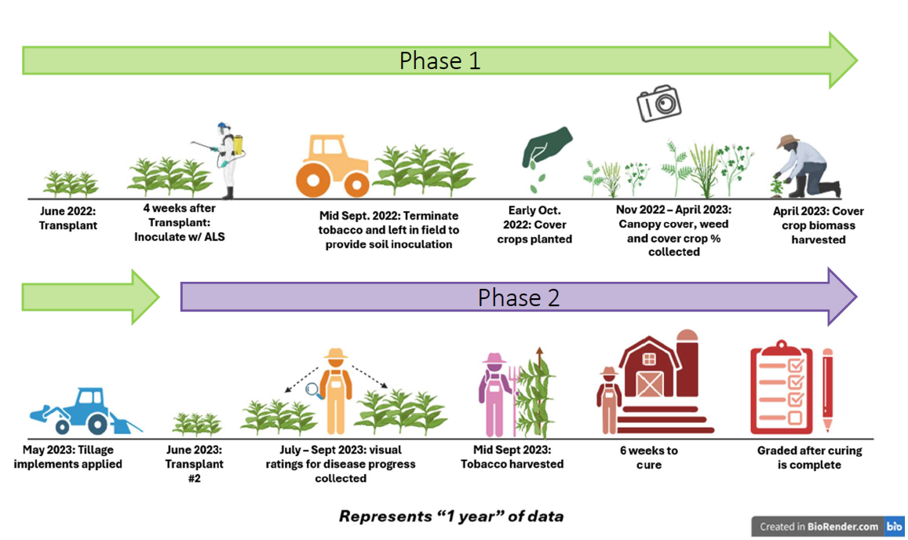
                - Appendix
Figure 1. Research timeline. Repeated for the 2023-2024 research and growing seasons.
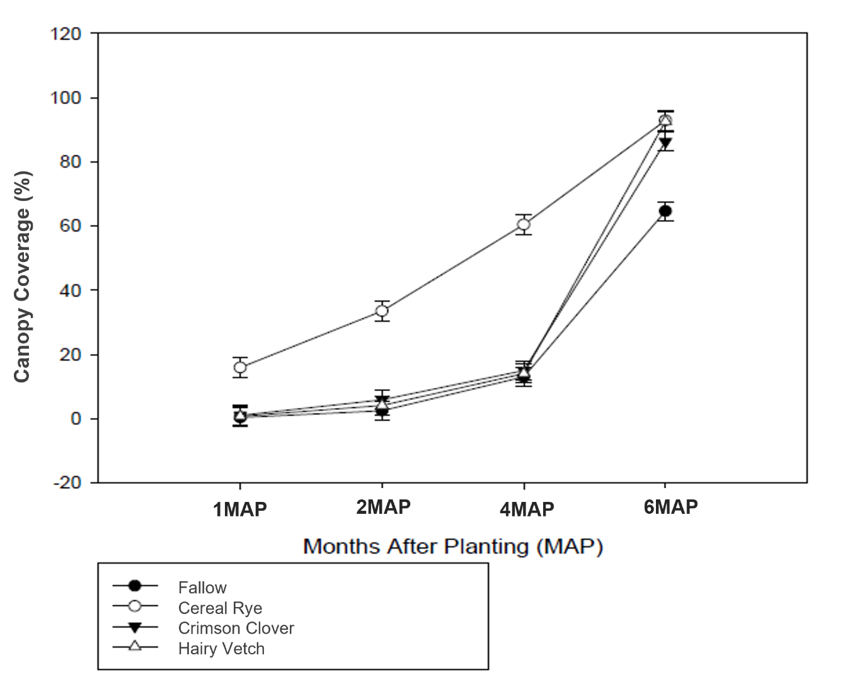
Figure 2. The percentage of canopy cover present in a 0.5 m² square (crop+weed) in 2023 as determined by APS Assess digital imaging software (p<0.0001). Standard error bars are based on Tukey HSD at alpha = 0.05.
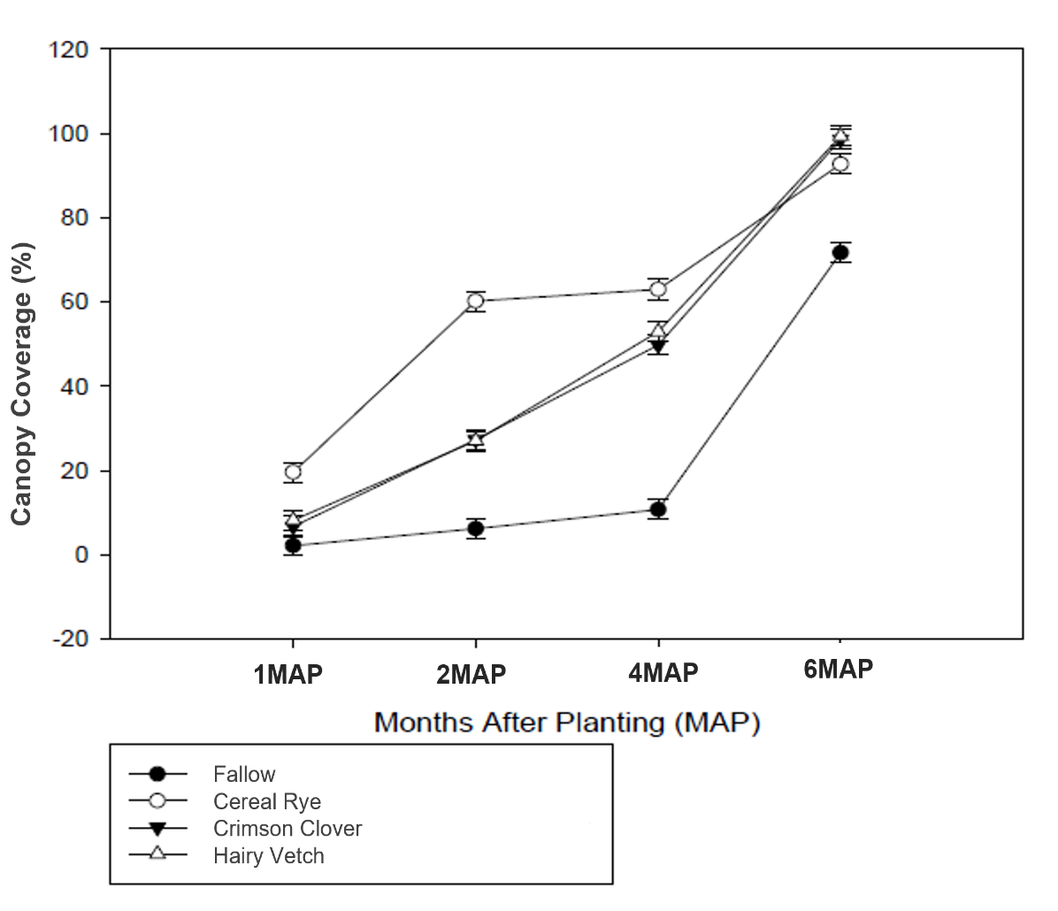
Figure 3. The percentage of ground cover present in a 0.5 m² square (crop+weed) in 2024 as determined by APS Assess digital imaging software (p<0.0001). Standard error bars are determined by Tukey HSD at alpha = 0.05.
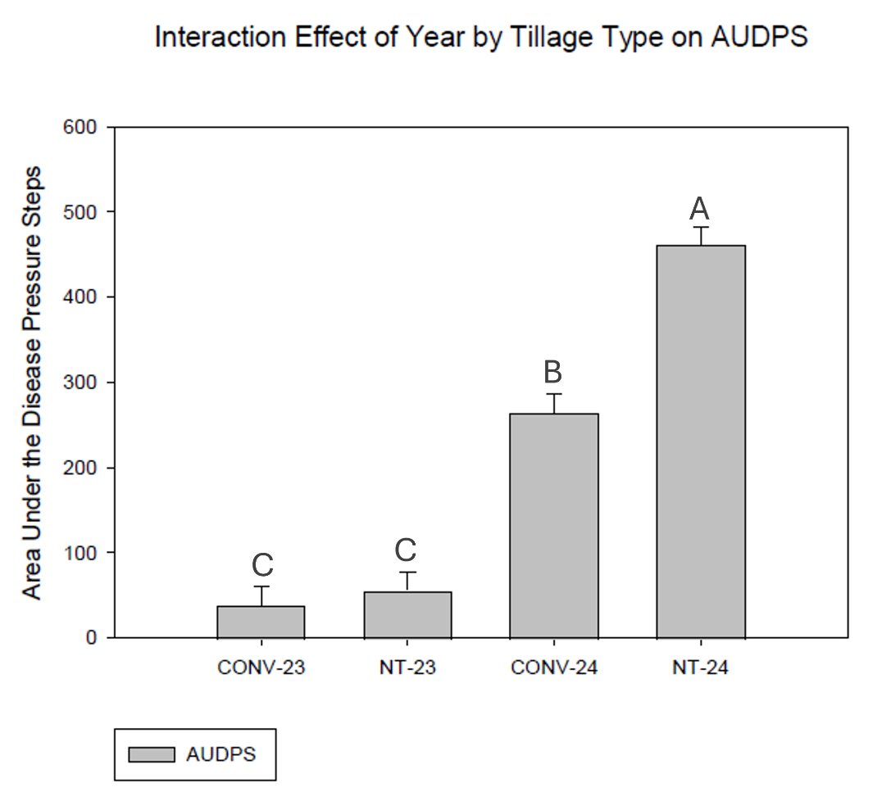
Figure 4. Main effect of tillage type (CONV = conventional, NT = no-tillage) by year (23 = 2023, 24 = 2024) (p<0.0001) on Area Under the Disease Pressure Steps (AUDPS) (Simko 2024). Values denoted with different letters indicate significance at p<0.05 as determined by Tukey HSD.

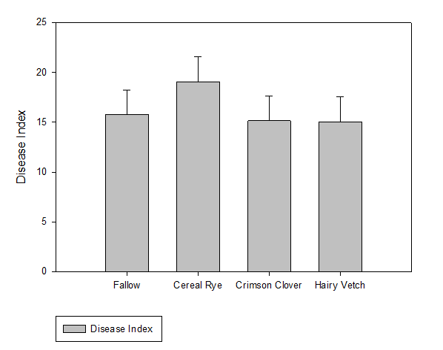
Figure 5. Cover crop species did not have an effect on final disease index (p=06319).

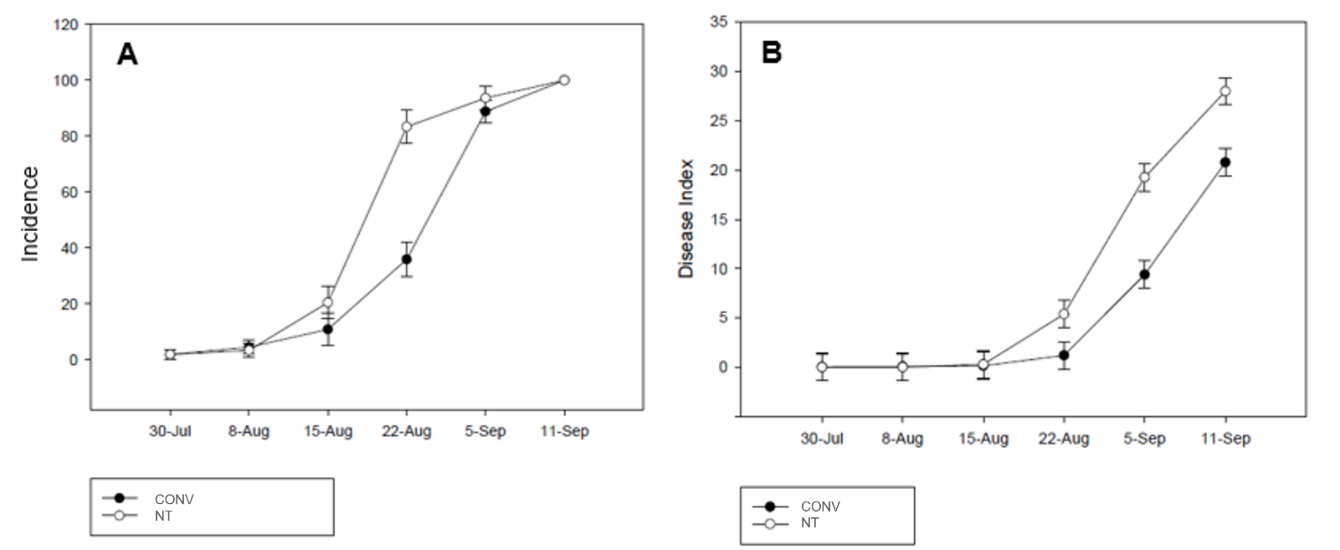
Figure 6. 2024 disease incidence (A; the percent of plants in the ceter two rows showing disease symptons) and disease index (B; (incidence*severity)/100) overtime for tobacco disease ratings separated by tillage type (p<0.0001). Standard error bars are determined by Tukey HSD at alpha = 0.05.

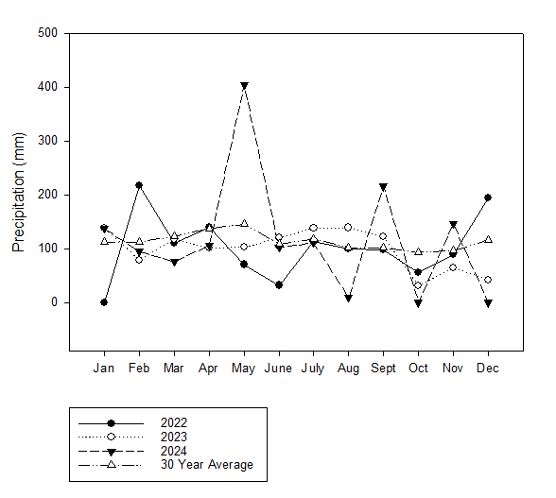
Figure 7. Monthly sum of precipitation overtime from January to October for 2023, 2024, and a 30 year average for Springfield, Tennessee.
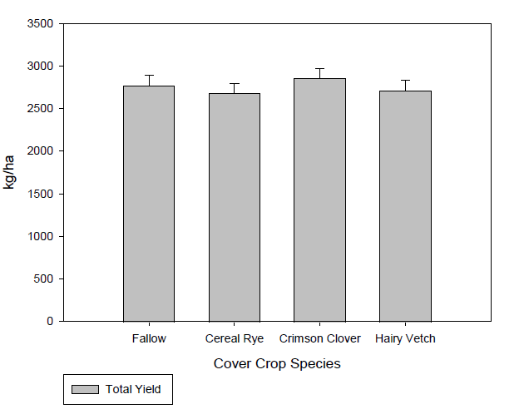
Figure 8. Yield of dark fire cured tobacco averaged over 2023 and 2024 by cover crop type. No significance was observed (p = 0.4616).

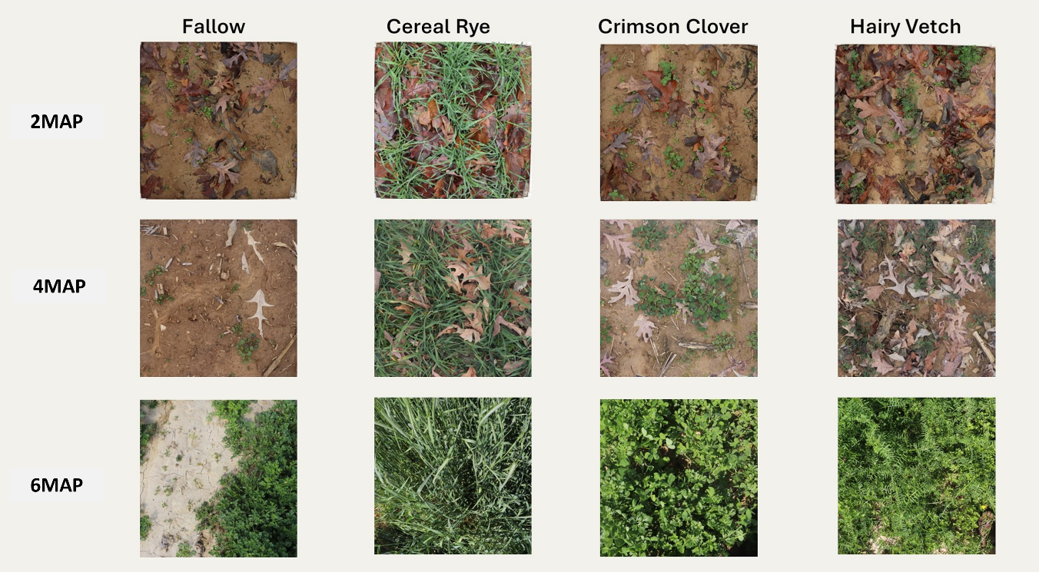
Figure 9. Images of canopy coverage from the 2022 – 2023 cover crop season visualizing the trend of canopy coverage between cover crop treatments over time.

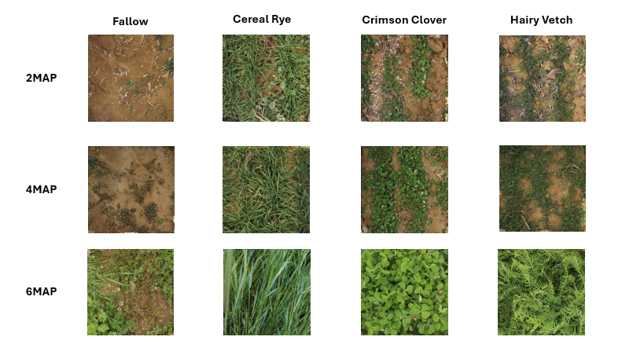
Figure 10. Images of canopy coverage from the 2023 – 2024 cover crop season visualizing the trend of canopy coverage between cover crop treatments over time.

Tables
Table 1. Biomass, nitrogen percent, 8-week cumulative and total nitrogen release by cover crop species separated by year.
Year | Cover Crop Species | Biomass | Nitrogen | 8-week cumulative release | Total N release
Year | Cover Crop Species | kg ha⁻¹ | % dry matter | kg ha⁻¹
2023 | Cereal Rye | 6338a | 2.02b | 25.75a | 45.50a
2023 | Hairy Vetch | 888b | 4.27a | 10.13a | 14.88b
2023 | P-value | 0.0010 | 0.0031 | 0.0598 | 0.0257
2024 | Fallow | 2150C | 2.72C | 17.75C | 21.25C
2024 | Cereal Rye | 8450A | 1.66D | 21.50C | 39.13B
2024 | Crimson Clover | 4100B | 3.27B | 42.63B | 49.88B
2024 | Hairy Vetch | 3950BC | 5.07A | 62.38A | 73.63A
2024 | P-value | <0.0001 | <0.0001 | <0.0001 | <0.0001

Footnote: Values for biomass, nitrogen percent, 8-week cumulative and total nitrogen release within each year followed by the same letter indicate significance at p<0.05 as determined by Tukey HSD.
Table 2. Average yield of each stalk position and total yield (kg ha⁻¹) and leaf quality grade index of dark fire-cure tobacco by year, tillage type, and cover crop type.
 | Stalk Position (kg ha⁻¹) |  |  |  | Grade Index
 | Lug | Second | Leaf | Total | 0-100
2023 | 252b | 527b | 1536b | 2315b | 16b
2024 | 344a | 812a | 2039a | 3195a | 58a
SEM | 15 | 21 | 52 | 81 | 2
P-value | <0.0001 | <0.0001 | <0.0001 | <0.0001 | <0.0001
CONV | 318A | 740A | 2033A | 3091A | 38A
NT | 279A | 599B | 1542B | 2420B | 36A
SEM | 15 | 21 | 52 | 81 | 2
P-value | 0.1082 | 0.0134 | 0.0034 | 0.0037 | 0.5716
Fallow | 278a | 675a | 1818a | 2771a | 34a
Cereal Rye | 303a | 658a | 1719a | 2680a | 39a
Crimson Clover | 311a | 692a | 1852a | 2855a | 37a
Hairy Vetch | 301a | 652a | 1762a | 2715a | 39a
SEM | 19 | 28 | 66 | 99 | 3
P-value | 0.5687 | 0.7146 | 0.3816 | 0.4617 | 0.5586
Footnote: Values for stalk position, total, and grade index followed by the same letter within year, tillage type, or cover crop type indicate significance at p<0.05 as determined by Tukey HSD.
Table 3. Average soil moisture percent by cover crop treatment for each collection date.
Cover Crop | Feb. 10, 2023 | Apr. 14, 2023 | Nov. 8, 2023 | Feb. 6, 2024 | Apr. 12, 2024
Fallow | 35.0 | 17.0 | 16.2 | 29.0 | 17.0
Cereal Rye | 35.2 | 19.4 | 18.4 | 31.3 | 19.4
Crimson Clover | 34.4 | 18.8 | 17.4 | 31.4 | 18.8
Hairy Vetch | 35.0 | 18.0 | 16.5 | 30.3 | 18.0
P-value | 0.8024 | 0.6514 | 0.4832 | 0.0911 | 0.1440
Footnote: Soil moisture percent was analyzed by collection date using PROC ANOVA.

Table 3. Average soil temperature (°C) by cover crop treatment for each collection date.
Cover Crop | Feb. 10, 2023 | Apr. 14, 2023 | Nov. 8, 2023 | Dec. 12, 2023 | Feb. 6, 2024 | Apr. 12, 2024
Fallow | 8.4 | 15.4 | 18.8 | 8.0 | 11.6 | 15.4
Cereal Rye | 8.1 | 14.6 | 18.1 | 7.8 | 10.6 | 14.6
Crimson Clover | 8.0 | 14.8 | 18.0 | 7.5 | 10.5 | 14.8
Hairy Vetch | 8.4 | 14.6 | 17.5 | 7.9 | 10.9 | 14.6
P-value | 0.3320 | 0.1926 | 0.0685 | 0.4912 | 0.1810 | 0.1926
Footnote: Soil temperature was analyzed by collection date using PROC ANOVA.

Table 5. Average soil moisture and temperature for June 26, 2023 by cover crop and tillage treatments.
Treatment | Soil Moisture | Soil Temperature
Treatment | % | °C
Fallow | 13.5 | 31.9
Cereal Rye | 24.2 | 31.9
Crimson clover | 13.8 | 31.5
Hairy Vetch | 13.3 | 31.5
P-value | 0.4670 | 0.4556
CONV | 13.6 | 31.5
NT | 18.9 | 31.9
P-value | 0.3782 | 0.1134
Footnote: Soil moisture and temperature were analyzed separately by cover crop and tillage treatment using PROC ANOVA.

Vita
Alyssa Corinne Thelin was born in Midwest City, Oklahoma. She spent her childhood and formative teen years in Choctaw, Oklahoma where she attended elementary, middle, and high school. She was active in her church youth group and working in the family restaurant. During her senior year of high school, she discovered her interest in plants and the environment through her introductory botany class. After high school, she moved to Stillwater, Oklahoma to attend Oklahoma State University. There she majored in plant and soil sciences with a concentration in soil and water resources. She was active as an undergraduate research assistant where she found her love for soil. The support she received from her undergraduate advisors and supervisors led her to apply, and eventually be accepted, to graduate school. She graduated from Oklahoma State University with honors in May 2022. In August 2022, she began her master’s program at the University of Tennessee, Knoxville as a Graduate Research Assistant under the advisement and supervision of Drs. Mitchell Richmond and Virginia Sykes. During graduate school, she attended two professional development conferences, presented at four scientific conferences, and many extension field days. Alyssa left her graduate program with an exciting appreciation for crop science and a new hatred for the rain.

