Does Industry-Specific Expertise Improve Board Functioning?
Evidence from Forced Bank CEO Turnovers

A Dissertation Presented for the
Doctor of Philosophy
Degree
The University of Tennessee, Knoxville

Zhongdong Chen
August 2013

Acknowledgement

I am very grateful to my committee consisting of Alvaro Taboada (chair), Andy Puckett, Georg Schaur, and Tracie Woidtke for valuable discussion and suggestions.
In addition, I wish to thank Harold Black, David Cicero, Phillip Daves, Ramon DeGennaro, Mike Ehrhardt, Larry Fauver, Deborah Harrell, Jason Howell, Ulrike Malmendier, Usha Mittoo, John Wachowicz, James Wansley, and seminar participants at the University of Tennessee and at the 2011 FMA PhD Consortium.
The views expressed here are solely the responsibility of the author and any errors are my own.

Abstract

This study investigates whether independent directors’ expertise in the industry in which the firm operates improves board functioning. To assess the quality of board functioning, I examine firm performance following a CEO turnover. Using a sample of 173 bank CEO turnovers from 1995 to 2010, I find that the market responds more favorably to forced CEO turnover decisions when they are made by a board with more independent financial industry experts. I document that following a forced bank CEO turnover, improvements in bank performance are positively related to independent financial industry expertise on the board, while bank-risk taking is negatively correlated with such expertise. This is likely because a properly functioning board is particularly important when a forced CEO turnover becomes necessary, and industry-specific expertise greatly improves boards’ ability to locate a superior successor CEO and to monitor and advise new management in such a crisis situation. I do not find that board independence has a similar impact on bank performance or risk-taking.

Table of Contents

Chapter 1: Introduction …………………………………………………………..... 1
Chapter 2: Related Literature and Background Information ………...……….... 8
2.1. Directors’ expertise ......................................................................................... 8
2.2. Determinants of post-turnover performance ................................................. 10
2.3. Regulatory requirements on bank board structure ........................................ 13
Chapter 3: Data and Summary Statistics ……………………………………...... 16
3.1. Bank CEO turnover ....................................................................................... 16
3.2. Bank board structure ..................................................................................... 18
3.3. Director compensation and ownership structure ........................................... 20
3.4. Forced and voluntary CEO turnovers ........................................................... 21
3.5. Insider and outsider successions ................................................................... 22
Chapter 4: Market Reaction to Bank CEO Turnover Announcements .............. 24
Chapter 5: Performance Changes around Bank CEO Turnovers ....................... 30
5.1. Changes in return on assets around CEO turnovers ...................................... 32
5.2. Changes in return on equity around CEO turnovers ..................................... 34
5.3. Abnormal stock performance around CEO turnovers ................................... 35
5.4. Changes in risk-taking around CEO turnovers .............................................. 37
Chapter 6: Determinants of Post-Turnover Bank Performance ......................... 39
Chapter 7: Robustness Tests ................................................................................... 44
7.1. Alternative definition of “board independence” ........................................... 44
7.2. Annual accounting data ................................................................................. 47
7.3. Alternative measure of risk-taking ................................................................ 48
7.4. Better board functioning or mean reversion? ................................................ 50
7.5. Do independent financial industry experts influence other independent
directors? ........................................................................................................ 51
Chapter 8: Conclusion and Summary .................................................................... 52
References ................................................................................................................. 54
Appendices ................................................................................................................ 60
Appendix A － Tables ......................................................................................... 61
Appendix B － Figures ........................................................................................ 78
Vita ............................................................................................................................. 81

List of Tables

Table 1 : Summary Statistics ................................................................................... 61
Panel A: Summary Statistics ................................................................................ 62
Panel B: CEO Turnover Frequency ...................................................................... 62
Table 2: CARs Around CEO Turnover Announcements ..................................... 63
Panel A: CARs Around CEO Turnover Announcements by Turnover Type ...... 63
Panel B: CARs Around CEO Turnover Announcements by Board Structure ..... 64
Table 3: Pairwise Correlations between Independent Variables ......................... 65
Table 4: Regression Results for CARs Around CEO Turnover Announcements
...................................................................................................................... 66
Table 5: Changes in Return on Assets (ROA) Around CEO Turnovers ............ 67
Panel A: Change in ROA by Turnover Type or Successor Origin ...................... 67
Panel B: Change in ROA by Turnover Type and Successor Origin .................... 67
Table 6: Changes in Return on Equity (ROE) Around CEO Turnovers ........... 68
Panel A: Change in ROE by Turnover Type or Successor Origin ....................... 68
Panel B: Change in ROE by Turnover Type and Successor Origin ..................... 68
Table 7: Abnormal Stock Performance Around CEO Turnovers ...................... 69
Panel A: Abnormal Stock Performance by Turnover Type or Successor Origin
................................................................................................................ 69
Panel B: Abnormal Stock Performance by Turnover Type and Successor Origin
................................................................................................................ 69
Table 8: Changes in Bank Risk-Taking Around CEO Turnovers ...................... 70
Panel A: Z-Score by Turnover Type or Successor Origin .................................... 70
Panel B: Z-Score by Turnover Type and Successor Origin ................................. 70
Table 9: Regression Analysis of the Determinants of Post-Turnover Performance
...................................................................................................................... 71
Table 10: Regression Results for an Alternative Definition of Board
Independence ........................................................................................... 73
Panel A: Event Study ........................................................................................... 74
Panel B: Determinants of Post-Turnover Performance ....................................... 75
Table 11: Regression Results for Annual Return on Assets, Annual Return on
Equity, and Annualized Stock Return Volatility ................................... 76

List of Figures

Figure 1: Median Industry-Adjusted Return on Assets Around CEO Turnovers
By Turnover Type or Successor Origin …………………………......... 78

Figure 2: Median Industry-Adjusted Return on Assets Around CEO Turnovers
By Turnover Type and Successor Origin ………………………........... 79

Figure 3: Median Industry-Adjusted Return on Equity Around CEO Turnovers
By Turnover Type or Successor Origin …………………………......... 79

Figure 4: Median Industry-Adjusted Return on Equity Around CEO Turnovers
By Turnover Type and Successor Origin ………………………........... 80

Chapter 1
Introduction

The recent policy debate over corporate governance reform has sparked new interest in board structure (Adams, Hermalin, and Weisbach, 2010). When examining the impact of board structure on board monitoring and advising, previous studies largely focus on board independence (e.g., Weisbach, 1988; Denis and Denis, 1995), board size (e.g., Yermack, 1996; Coles, Daniel, and Naveen, 2008), CEO-chairman duality (e.g., Masulis, Wang, and Xie, 2007; Larcker, Ormazabal, and Taylor, 2011), staggered boards (e.g., Bange and Mazzeo, 2004; Bebchuk and Cohen, 2005), and independent directors’ expertise that is not related to the industry in which the firm operates (e.g., Agrawal and Chadha, 2005; Güner, Malmendier, and Tate, 2008). Less attention has been paid to independent industry-specific expertise on boards, which arguably combines inside directors’ industry knowledge (e.g., Fama, 1980; Fama and Jensen, 1983; Klein, 1998) and independent directors’ vigilance (e.g., Mace, 1986; Brickley, Coles, and Terry, 1994; Rosenstein and Wyatt, 1997). Industry-specific expertise may lower directors’ cost to obtain and process information, and may therefore reduce information asymmetry and improve board functioning (e.g., Kroll, Walters, and Wright, 2008; Brickley and Zimmerman, 2010). In this study I investigate this view by examining the correlation between independent financial industry expertise on a bank board and bank performance following a forced CEO turnover, relative to voluntary CEO turnovers.
I focus on the banking industry for three reasons. First, information asymmetry is arguably more of an issue in the banking industry due to the complexity of banks and the opacity of bank operations (e.g., Furfine, 2001; Levine, 2004). Industry-specific expertise may therefore be particularly important for independent bank directors to be able to monitor and advise management. Some extreme examples of the primary occupations of independent bank directors in this study are dentists, professional volunteers, dairy farmers, and chiropractors. It is reasonable to assume that without a solid financial industry background, independent bank directors are less able to fulfill their fiduciary duties. Second, financial industry expertise is more readily observable than other types of industry expertise. The definition of a financial industry expert in this study follows Güner et al. (2008) and Minton, Taillard, and Williamson (2013). A director is classified as a financial industry expert if the director is (was) employed by a financial organization (e.g., venture capital firm; consumer lending company; mutual fund; hedge fund) or a banking regulator. Last but not least, blamed for the recent financial crisis (e.g., Kirkpatrick, 2009; Adams, 2011), governance mechanisms in the banking industry have received growing attention since then (e.g., Adams, 2012). Adams (2011) suggests that “measures of governance that have been the focus of recent governance policies are insufficient to describe governance failures attributed to financial firms.” In line with such concerns, government regulators and institutional investors are requiring banks to restructure their boards with more independent directors that have financial industry expertise. However, our knowledge regarding the impact of independent financial industry expertise on the quality of bank board functioning is quite limited.
Forced CEO turnovers make a unique set to test the quality of board functioning. In such crisis situations, the board of directors is not only responsible for replacing the poorly performing CEO (Weisbach, 1988), but also responsible for identifying and attracting “superior replacement managers” (Denis and Denis, 1995) and providing advice and counsel (Mace, 1986; also see Adams et al., 2010). Given that independent directors typically spend only “a limited amount of time with the organization” (Judge and Dobbins, 1995) but are likely to “act in crisis situations” (Mace, 1986), a properly functioning board may be particularly important when a bank needs to oust its incumbent CEO and adjust its strategies (Parrino, 1997). While previous bank CEO turnover studies tend to focus on the probability of forced CEO turnover (e.g., Webb, 2008; Palvia, 2011), this study investigates the relation between bank performance following a forced CEO turnover and board structure with a focus on independent directors’ industry-specific expertise. With such expertise, independent directors may be better able to filter out exogenous performance shocks when assessing the true quality of candidate CEOs (e.g., Jenter and Kanaan, 2010), and to advise and monitor the successor CEO. If this were the case, independent financial industry expertise should positively affect board functioning and, ultimately, bank performance following a forced CEO turnover. In this study, I examine post-turnover bank performance to assess the quality of board functioning.
I investigate the relationship between independent financial industry expertise and the functioning of a bank board with a sample of 173 bank CEO turnovers, including 70 forced turnovers and 103 voluntary turnovers. I find a higher rate of forced bank CEO turnovers during periods of financial turmoil, consistent with Jenter and Kanaan (2010). In an event study examining cumulative abnormal stock returns (CARs) around the announcements of a bank CEO turnover, I find that the market response to forced CEO turnovers is significantly positive while such response to voluntary CEO turnovers is statistically and economically insignificant. I further find that the positive market response is driven by forced turnover decisions made by a bank board with more independent financial industry experts. The evidence indicates that the market recognizes the significant role of financial industry experts in a CEO firing decision and believes that they are likely to help improve the status quo.
In an examination of post-turnover bank performance, I find that forced CEO turnover and outsider succession significantly improve bank performance. After controlling for the interactive effects between forced CEO turnover and board structure, forced CEO turnover does not improve post-turnover bank performance anymore. The improvements in bank performance following a forced CEO turnover are driven by banks with more independent financial industry experts on their boards. In contrast, board independence does not benefit forced CEO turnovers in terms of ex-post performance. Consistent with Minton et al. (2013), independent financial industry experts tend to encourage risk-taking following a CEO turnover, but they are negatively correlated with risk-taking at banks with a forced CEO turnover. This is likely because in the crisis situation where the performance has been poor and the bank needs to replace its CEO, it is more important for the bank to decrease risk-taking and restore its stability. Independent directors with financial industry expertise may be better able to monitor and advise the successor CEO in such efforts. The evidence suggests that independent financial industry expertise improves the functioning of a bank board in the period following a forced CEO turnover.
These findings are robust when grey directors are included, suggesting that “grey” financial industry experts may also contribute to proper board functioning in crisis situations. These findings are also robust to the use of annual accounting data and to alternative measures of risk-taking. Moreover, the improvements in ex-post performance are not driven by mean reversion.
These findings add to the growing literature suggesting the importance of directors’ industry-specific expertise on board functioning. The new evidence of a positive correlation between independent financial industry expertise and bank performance following a forced turnover provides empirical support to the recent studies that emphasize independent directors’ industry-specific expertise (e.g., Fields, Fraser, and Subrahmanyam, 2012; Faleye, Hoitash, and Hoitash, 2012; Wang, Xie, and Zhu, 2013). This study also adds to the literature on the relationship between forced CEO turnover and ex-post firm performance. The evidence suggests that forced CEO turnovers do not necessarily improve firm performance. The improvements in firm performance following a forced CEO turnover are to an extent driven by independent directors’ expertise in the industry in which the firm operates. This may explain the documented insignificant relationship between forced CEO turnover and ex-post performance at community banks (Schaeck, Cihak, Maechler, and Stolz, 2012). Finally, this study has implications for banking policies and regulations that emphasize independent directors’ financial industry background.
The remainder of the paper is organized as follows. In Chapter 2, I discuss related literature and provide some background information on regulatory requirements on bank board structure. In Chapter 3, I describe the data. Chapters 4, 5, and 6 are dedicated to reporting the empirical results. I present robustness tests in Chapter 7, and concluding remarks in Chapter 8.

Chapter 2
Related literature and background information

2.1. Directors’ expertise

Rosenstein and Wyatt (1990) examine stock market reaction to the announcement of the appointment of an independent director. They find that a director’s occupation does not impact abnormal stock returns around announcements. They argue that independent directors are equally valuable, independent of their occupation. The evidence in Shivdasani and Yermack (1999) is supportive of this argument.
Recent studies suggest that independent directors with expertise in the industry in which the firm operates is important for internal control mechanisms. Eng and Mak (2003) argue that such expertise on a board and corporate disclosure are substitutes, suggesting the important role of independent expertise in corporate control. Gul and Leung (2004) find consistent evidence. They also find that CEO/chairman duality limits corporate disclosure and independent industry-specific expertise on a board weakens such negative association. A more recent study by Wang et al. (2012) finds that independent industry-specific expertise on an audit committee lowers the likelihood of earnings management and financial fraud. Besides, such expertise on a compensation committee reduces excess CEO compensation but increases the sensitivity of CEO turnover to poor performance.
Previous studies have also shown that independent directors’ industry-specific expertise is important to firm performance, strategies, and value. Kor and Misangyi (2008) argue that independent industry-specific expertise can, to some extent, offset the lack of industry experience by top management. In line with this view, Anderson and Reeb (2003a, 2003b) find better performance at US firms with founding-family ownership. This is likely because, as suggested in Anderson and Reeb (2004), families may place independent directors with industry-specific expertise on the board for performance related reasons. This indicates that founding families recognize the value of independent industry-specific expertise on a board. Moreover, Dass, Kini, Nanda, and Onal (2011) find that outside directors’ industry-specific expertise is negatively correlated with cash-conversion cycle, inventory, and accounts receivable while positively correlated with accounts payable. They also find that such expertise contributes to better investment strategies. They argue that with a better understanding of industry “conditions and trends”, outside directors with industry-specific expertise can better help firms shape policies and strategies. Consistent with these findings, Fields et al. (2012) document that independent industry-specific expertise on a board not only helps firms lower the cost of debt, but also helps firms obtain better credit terms. Using a sample of industrial firms in the S&P 1500 indexes, Faleye et al. (2012) find that such expertise significantly increases firm value. This is likely because independent industry-specific expertise contributes to firm innovation and corporate control (e.g., CEO turnover decisions and CEO compensation).
However, Minton et al. (2013) find different results. Their evidence from the banking industry shows that independent financial industry expertise on a bank board is positively correlated with poor stock performance and risk-taking during the recent financial crisis, and the correlation is stronger among large commercial banks. They suggest that it is because financial industry experts may encourage bank management to exploit the “too big to fail” effect. Their findings might have captured the fact that in general financial industry experts encourage risk-taking, and when a major financial crisis strikes, such strategy would lead to greater losses. In contrast, this study examine the impact of independent financial industry expertise on a bank performance following a forced CEO turnover, where financial industry expertise may be particularly important in successor CEO selecting, strategy reshaping, and management monitoring.

2.2. Determinants of post-turnover performance

The turnover literature suggests that, in general, forced CEO turnover leads to improved ex-post performance because of improved management (e.g., Denis and Denis, 1995; Weisbach, 1988; Fredrickson et al., 1988). Huson et al. (2004) specifically point out that the magnitude of improvement in performance is positively correlated with board independence. However, a recent study by Schaeck et al. (2011) does not find improved bank performance following the forced turnover of a community bank CEO. Successor origin also impacts post-turnover performance. For instance, Khurana and Nohria (2000) find that following a forced CEO turnover, an insider succession leads to statistically and economically insignificant performance changes while an outsider succession leads to better performance. In line with this notion, Adams and Mansi (2009) find evidence that successor origin is correlated with the change in firm value. Huson et al. (2004) document a positive correlation between outsider succession and expected change in subsequent performance. As a result, Borokhovich et al. (1996) find that abnormal stock returns around forced CEO turnover announcements are significantly positive for outsider successions but significantly negative for insider successions.
Post-turnover performance may be related to board size. Hermalin and Weisbach (2003) argue that board size is negatively related to firm performance. This is likely because of inefficiency and the free-rider problem associated with large boards (e.g., Jensen, 1993). However, Coles, Daniel, and Naveen (2008) suggest that very small and very large boards can both be optimal, depending on firm complexity. In line with this argument, Adams and Mehran (2008) find that Tobin’s Q is increasing in bank board size, given that banks are comparatively large and complex. Moreover, Pathan (2009) argues that small boards and more powerful boards tend to restrain bank risk-taking.
A staggered board deters takeover and thus hinders market discipline (e.g., Bebchuk, Coates, and Subramanian, 2002), resulting in less managerial effort. Consistent with this, Bebchuk and Cohen (2005) find lower Tobin’s Q at firms with a staggered board. Faleye (2007) further suggests that a staggered board decreases the probability of forced CEO turnover at underperforming firms. Mahoney and Mahoney (1993) and Faleye (2007) both find a negative market reaction to the announcement of the adoption of a classified board. Therefore, a staggered board may be negatively associated with post-turnover improvements in firm performance.
An independent board is believed to be associated with better governance quality. Beasley (1996) suggests that firms committing financial statement fraud tend to have a significantly lower percentage of independent directors. Core, Holthausen, and Larcker (1999) find that firms with a weak board are more likely to overcompensate their CEOs. Although in general board independence does not significantly impact long term firm performance (e.g., Hermalin and Weisbach, 1988; Klein, 1998; Bhagat and Black, 2002), it is positively correlated with firm performance following a CEO turnover (e.g., Huson et al., 2004).
According to Yermack (2004), with all incentives accounted for, a $1,000 increase in firm value increases the wealth of a Fortune 500 firm director by 11 cents. A one standard deviation change in firm performance implies a change of about $285,000 in the director’s wealth. Thus a well-motivated independent director has a good reason to monitor management. In line with this reasoning, studies have shown that the percentage of equity-based compensation and ownership by independent directors are positively correlated with a higher probability of forced CEO turnover at underperforming firms (e.g., Perry, 1999; Brickley, Lease, and Smith, 1988). However, a higher percentage of equity-based compensation as well as a greater ownership by independent bank directors may encourage excessive risk-taking, maximizing the value of under-priced deposit insurance. The impact of these incentives on bank performance following a forced CEO turnover is not clear.
Woidtke (2002) argues that institutional investors are likely to monitor management, although the value effect of institutional monitoring depends on the objectives of the institutions. Therefore, institutional ownership may be positively correlated with improvements in performance following a forced bank CEO turnover.

2.3. Regulatory requirements on bank board structure

Recent efforts by government regulators to increase bank board independence can be traced back to the Financial Institutions Reform Recovery and Enforcement Act of 1989 (FIRREA) and the Federal Deposit Insurance Corporation Improvement Act of 1991 (FDICIA). The Sarbanes-Oxley Act of 2002 (SOX) also emphasizes board independence but it applies only to public financial institutions. The Federal Deposit Insurance Corporation (FDIC) issued the “Pocket Guide for Directors” (the guide) to non-public banks following the passage of SOX. The guide, which emphasizes “the need for a strong and independent board of directors”, encourages practices quite similar to, or even identical to those in SOX. The Federal Reserve Board (FRB), the Office of Thrift Supervision (OTS), and the Office of the Comptroller of the Currency (OCC) also issued similar guidance to non-public banks which they supervised. Banks listed on the NYSE, AMEX, and NASDAQ are required by the exchanges to have a board that is comprised of a majority of independent directors.
At the same time, the definition of “independence” has become stricter in the last decade. The Amendments to the Housing Act on July 30, 2008 specifies that “an individual is not eligible to be an independent bank director if the individual serves as an officer, employee, or director of any member of the bank, or of any recipient of loans from the bank”. The three stock exchanges also adopted stricter definition of “independent director” since 2002.
Previously, regulations largely focused on board independence. Although FDIC implemented new requirements on independent directors’ financial industry expertise following the banking crisis in the 1990s, they are applied only to bank audit committees. Until recently, little attention was paid to the occupational background of independent directors at banks. Following the recent crisis, government regulators and institutional investors are requiring banks to restructure their boards with more independent directors that have financial industry expertise.

Chapter 3
Data and summary statistics

3.1. Bank CEO turnovers

In this study, I explore the relation between independent financial industry expertise and post-turnover bank performance using a sample of CEO turnovers at US banks in the 1995-2010 period. To identify changes in CEO position, I start with all firms in Standard & Poor’s Execucomp database with an SIC code between 6000 and 6300 from January 1st, 1995 to December 31st, 2010. Of these 295 firms, I exclude non-lending firms with SIC codes 6172 (Finance Lessors), 6099 (Functions Rel to Dep Bkg, Nec), 6282 (Investment Advice), 6163 (Loan Brokers), 6200 (Security & Commodity Brokers), and 6211 (Security Brokers & Dealers). I also exclude the three federal credit agencies (Freddie Mac, Fannie Mae, and Sallie Mae) because they are different from other financial institutions due to their unique role as quasi-government entities. I manually check the remaining firms and exclude those firms (e.g., American Express, Mellon Financial Corp, State Street Corporation, Finova Group, and Financial Federal Corporation) whose primary service is not making loans (e.g., wire transferring and investment advice). This yields a final raw sample of 202 firms, including 150 commercial banks and bank-holding companies, one finance services company, five mortgage bankers, 33 federal-chartered savings institutions and 13 non-federal-chartered savings institutions. Following Fahlenbrach and Stulz (2011), I define the lending firms from this sample as banks. With a mean age of 23 years (median age of 24 years), this final raw sample is potentially biased towards large banks because Execucomp tends to cover larger firms. The silver lining from this potential bias is that those banks represent the bulk of the market value of all banks in the US and their turnover decisions and performance have a significant impact on the industry and its “aggregate wealth” (Huson et al., 2004).
After I identify CEO changes at the 202 sample banks through the Execucomp database, I search for sample banks’ announcements and related news on their top management changes through LexisNexis and Factiva. For the purpose of this study, I exclude CEO turnovers that are directly related to M&A activities. I also exclude turnovers of interim/acting CEOs that serve less than one year. This selection process yields 173 bank CEO turnovers at 112 unique banks. Together with the information provided by Execucomp, I am able to obtain turnover announcement date and effective date, CEO age and tenure at turnover for these turnovers. For the entire CEO turnover sample, as shown in panel A of Table 1, the total assets of a median (mean) bank is 12,380.50 (77,235.37) million (all tables are included in Appendix A). The median (mean) outgoing bank CEO is 62 (61.34) years old and has served as a CEO for 9 (10.43) years.
[Insert Table 1]

3.2. Bank board structure

Information on board structure in the turnover year is obtained from the bank’s proxy statement (Form 14A) immediately before the turnover announcement through SEC’s Edgar filing database. Board information for 13 turnovers is set to missing either because the proxy statements are not found in the Edgar database (e.g., Hanmi Financial Corp, 1999), or because the proxy statements do not provide enough information (e.g., the primary occupation of the directors is not reported by Bancwest Corp in 2004). Following the literature (e.g., Huson et al., 2004), I classify a director as an insider if the director is, or was employed by the bank, its subsidiary, or an affiliated organization. Other directors are classified as outside directors. I examine each outside director’s detailed information reported in the proxy statement and classify an outside director as “grey” if the director (1) is employed by one of the following firms: consulting/advisory firm, investment bank, law firm, insurance company; or (2) has significant business relationship with the bank; or (3) is related to an officer of the bank (e.g., Huson et al., 2001). Other outside directors are classified as independent directors. As reported in panel A of Table 1, a median bank board has 13 directors, of which 67.93% (78.86%) are independent (outside) directors. These percentages are similar to those reported in Adams and Mehran (2003) and Booth, Cornett, and Tehranian (2002). In this study, board independence is defined as the ratio between the number of independent directors and board size. The alternative definition of board independence (the ratio between the number of outside directors and board size) is employed in the robustness tests. Furthermore, for a median bank, the average tenure of independent (outside) directors is 10.13 (10.18) years.
As previously mentioned, a director is classified as a financial industry expert if the director is, or was employed by a financial institution (e.g., venture capital firm; consumer lending company; mutual fund; hedge fund) or a banking regulator (e.g., the FRB; the FDIC; the OCC). I find that other director occupations include, but are not limited to, attorneys, dentists, realtors, professional volunteer, professors, surgeons, farmers, dairy farmers, chiropractors, judges, and executive officers of industrial firms. While the percentage of independent directors is high, the median percentage of independent (outside) financial industry experts (the number of independent (outside) financial industry experts on a board/board size) is only 10.82% (12.50%). The correlation coefficient between the percentages of independent (outside) directors and independent (outside) financial industry experts is 0.2295 with a p-value of 0.0064 (0.1219 with a p-value of 0.1512).
CEO/chairman duality is found in the proxy statement immediately before a turnover announcement. Of the 173 outgoing CEOs in the entire turnover sample, 116 (67.05%) are also board chairmen.

3.3. Director compensation and ownership structure

Director compensation information in the turnover year is obtained either from the Execucomp database or from bank filings. I calculate the percentage of director equity-based compensation (EBC) using the year-end stock price in the prior year for stock grants and I use the modified Black-Scholes option valuation model for option grants (e.g., Guay, 1999; Core and Guay, 2002). As reported in panel A of Table 1, the median EBC is 48.69%.
When calculating institutional ownership, I exclude ownership by institutions affiliated with the bank, such as a subsidiary bank or employee stock ownership plan trust, because these institutions are not likely to monitor bank management (e.g., Adams and Mehran, 2003). The median ownership by CEO and his or her immediate family, independent (outside) directors as a group, and institutional investors are 0.72%, 1.11% (1.37%) , 5.06%, respectively.

3.4. Forced and voluntary CEO turnovers

Following the turnover literature (e.g., Huson et al., 2001), I classify a turnover as forced if: (1) the announcement mentions strategy or opinion differences between the CEO and the board; or (2) related news uses words such as “ousted, fired, or forced out”; or (3) the CEO is under the age of 60 and he (or she) is leaving for reasons other than death, health issues, or reposition; or (4) the retiring CEO is under the age of 60 and does not announce his (or her) intention to retire at least 6 months prior to the effective turnover date. All other turnovers are classified as voluntary. Panel B of Table 1 reports the frequency of bank CEO turnovers over the 1995-2010 period. Of all the 173 bank CEO turnovers identified in this study, 70 are classified as forced turnovers and 103 are classified as voluntary turnovers. The average annual turnover rate (the ratio between the annual number of turnovers and the annual number of banks) is 7.37%, similar to that reported in Hubbard and Palia (1995) (6%, a sample of 116 banks) over the three years before the introduction of interstate bank regulation. The average annual forced turnover rate (40.46%) is higher than that reported in Taylor (2010) (21.3%, financial firms, 1970-2007) and that reported in Huson et al. (2004) (16%, firms across industries, 1971-1994). It is because the sample period in this study covers two financial crises (the 1998 LTCM/Asian financial crisis and the recent 2007-2009 crisis) and one recession (2000-2002), in which the frequency of forced CEO turnover spiked. This is consistent with Jenter and Kanaan (2010) where they find that CEOs are more likely to be fired during periods of industry turmoil.

3.5. Insider and outsider successions

A succession is labeled an insider succession if the successor holds, or held a position in the bank, its subsidiaries or affiliates for more than a year (e.g., Huson et al., 2001). All other successions are labeled an outsider succession. Out of the 173 successions, 37 are classified as outsider successions and 136 are classified as insider successions. Panel B of Table 1 reports that 32.86% (13.59%) of the outgoing CEOs are replaced by an outside successor following a forced (voluntary) turnover, lower (higher) than the 49.6% (9.9%) reported in Parrino (1997) (a sample of firms across industries over 1970-1989). This indicates that outsider succession is more likely following a forced turnover than following a voluntary turnover.

Chapter 4
Market reaction to bank CEO turnover announcements

There have been many empirical studies examining the impact of CEO turnover announcement on stock price. In general, these studies find an insignificant reaction across their overall samples but significantly positive market reaction for forced turnovers (e.g., Furtado and Karan,1990; Khanna and Poulsen, 1995; Shivdasani and Yermack, 1999). In this section, I examine the impact of turnover type and board structure on stock price around bank CEO turnover announcements, using a sample of 173 bank CEO turnovers as described in the prior section. If the market recognizes the value of independent financial industry expertise in improving board functioning, there should be a positive correlation between independent financial industry expertise and abnormal stock returns around CEO turnover announcement.
Panel A of Table 2 presents the results of an event study centered on the turnover announcement day (day 0). Following the literature (e.g., Weisbach, 1988; Shivdasani and Yermack, 1999; Masulis et al., 2007), I report cumulative abnormal returns (CARs) for various windows including [0], [-1, 0], [0, +1], [-1, +1] and [-2, +2]. The reported CARs are returns adjusted by a four factor model that includes the market risk premium (the spread between CRSP value-weighted market return and risk-free rate), SMB (the return spread between portfolios of small and big capitalization stocks), HML (the return spread between portfolios of high and low book-to-market stocks), and a momentum factor. The market model parameters are estimated with daily returns over the 150-trading-day period 30 days before a turnover announcement (e.g., Ellis, 2010). To be included in this event study, a bank’s stock must trade around the announcement day and over the parameter estimation period. I report the results for the remaining 155 CEO turnover announcements in panel A of Table 2.
[Insert Table 2]
Panel A of Table 2 shows that, for the overall turnover sample, the average market reaction (both mean and median) is significant and positive over five event windows. Market reaction to forced turnovers is statistically (at least at the 1% level) and economically (with a mean of 4.10% and a median of 2.15% on the announcement day) significant over all event windows. In contrast, CARs for voluntary turnovers are statistically and economically insignificant. The spreads between market reactions (mean and median) to forced turnovers and voluntary turnovers is statistically (both at the 1% level) and economically (4.46 % and 2.46% on the announcement day, respectively) significant over all event windows. These results are consistent with the findings in the previous CEO turnover literature. To explore the impact of board structure on CARs, I divide the turnover sample into high and low groups based on independent financial industry expertise and board independence, respectively. The results reported in panel B of Table 2 show that the high independent financial industry expertise group receives more favorable market reaction than the low independent financial industry expertise group. The spread between the two groups (mean and median) are statistically (both at the 1% level on the announcement day) and economically significant (2.90% and 1.42% on the announcement day, respectively) over all but one of the event windows. In contrast, the high board independence group tends to receive more favorable market reaction than the low board independence group, but the spread is only significant over [-1, 0] and [-1, +1] windows for median comparison. These preliminary results suggest that the market recognizes the value of both independent financial industry experts and independent directors in CEO turnover decisions.
To systematically examine the impacts of turnover type and board structure on CARs around CEO turnover announcements, I estimate OLS model (1). Pairwise correlations between independent variables are reported in Table 3 and regression results for model (1) are reported in Table 4..
[Insert Table 3]
${CARs}_{i}=β_{0}+β_{1}{Forced}_{i}+β_{2}{Board Size}_{i}+β_{3}{Staggered Bpard}_{i}+ β_{4}{IDTenure}_{i}+β_{5}{EBC}_{i}+β_{6}{IDOwnership}_{i}+β_{7}{IOwnership}_{i}+ { aggered β}_{8}{CEOOwnership}_{i}+β_{9}{CEOTenure}_{i}+β_{10}{Duality}_{i}+β_{11}{\%ID}_{i}+ β_{12}{\%IFIE}_{i}+β_{13}{Size}_{i}+ITS+ε_{i}$ (1)
where CARs are abnormal stock returns around bank CEO turnover announcements. Forced is a forced turnover indicator that is equal to 1 if a turnover is classified as forced and 0 otherwise. Board Size is the number of directors on a bank board. Staggered Board is an indicator that is equal to 1 if a board are classified and 0 otherwise. IDTenure is the average tenure of independent directors. EBC is the ratio between independent directors’ equity-based compensation and total compensation. IDOwnership, IOwnership, and CEOOwnership are the percentages of shares outstanding owned by independent directors as a group, institutional investors, and outgoing CEO and his (or her) immediate family, respectively. CEOTenure is the tenure of an outgoing CEO. Duality is an indicator that is equal to 1 if there is CEO-chairman duality and 0 otherwise. %ID is the percentage of independent directors on a bank board, while %IFIE is the percentage of independent financial industry experts on a bank board. Size is the natural logarithm of a bank’s total assets. To test whether board independence and independent financial industry expertise are particularly important for the decisions of a forced CEO turnover, I include two interaction terms (ITS): one is between the forced turnover indicator and board independence (% ID*Forced), the other is between the forced turnover indicator and the percentage of independent financial industry experts on a board (% IFIE*Forced). Because 47 (41.96%) of the 112 unique banks in the sample have at least two CEO turnovers over the sample period, I cluster the standard errors by bank.
[Insert Table 4]
The results reported in Table 4 suggest that without controlling for the interactive effects between board structure and the forced turnover indicator, CARs for forced turnovers are significantly higher (at the 5% level over [0], [-0, +1], and [-1,+1]) than those for voluntary turnovers. In contrast with previous studies, board independence (%ID) is not correlated with market reaction. The percentage of independent financial industry experts (%IFIE) is positively correlated with CARs over all event windows, significant at the 1% (5%, 10%) level in three (one, one) estimates. A one standard error increase in %IFIE is associated with a 15.29% increase in CARs on the announcement day. The results suggest that the market recognizes the value of independent financial industry expertise for bank CEO turnovers in general. Furthermore, board size, independent directors’ equity-based compensation, and bank size tend to be positively correlated with CARs while CEO ownership and CEO-chairman duality tend to be negatively correlated with CARs around CEO turnover announcements.
When the two interaction terms are included in the regressions, the coefficients on the forced turnover indicator and %IFIE both become insignificant in all estimates. However, the coefficient on the interaction term %IFIE*Forced is significant at the 1% (5%, 10%) level in two (one, one) estimates. A one standard error increase in %IFIE is associated with a 25.30% (34.18%) increase in CARS on the announcement day ([-1,+1] window). The F-test rejects the null hypothesis that the coefficients on %IFIE and %IFIE*Forced are jointly zero in four estimates. In contrast, the other interaction term, % ID*Forced, is not correlated with CARs in any estimate. F-test (unreported) is not able to reject the null hypothesis that the coefficients on %ID and %ID*Forced are joint zero. The evidence indicates that forced CEO turnovers tend to receive positive market reaction and it is driven by turnover decisions made by a board with more independent financial industry experts. One explanation is that these experts are better able to filter out exogenous negative performance shocks from CEO quality and are therefore less likely to scapegoat. Another explanation is that they may be better able to locate a superior successor, leading to truly improved management. It is also possible that the market believes that following a forced turnover, these experts are better able to advise the new management during the crisis period. Unfortunately, it is nearly impossible to disentangle these effects.

Chapter 5
Performance changes around bank CEO turnovers

The CEO turnover literature has shown that turnover type (forced vs. voluntary) and successor origin (outsider vs. insider) impact post-turnover performance at industrial firms (e.g., Denis and Denis, 1995; Parrino, 1997; Huson et al., 2004). However, this may not hold for banks due to the unique nature of their business and the heavy regulations they face, along with their different governance mechanisms (e.g., Brickley and James, 1987; Adams and Mehran, 2002; Adams and Mehran, 2003; Becher, Campbell, and Frye, 2005). Direct evidence from the banking industry is limited to date. Therefore in this section I examine bank performance around CEO turnovers within the framework of this study. Because bank regulators use return on assets (ROA) and return on equity (ROE) to measure bank profitability (e.g., Gilbert and Wheelock, 2007), and the previous studies suggest that CEO turnovers will impact firms’ ROA, abnormal stock performance, and risk-taking (e.g., Huson et al., 2001; Clayton, Hartzell, and Rosenberg, 2003; Adams and Mansi, 2009;), I employ six measures of performance: unadjusted and industry-adjusted return on assets (ROA) and return on equity (ROE), abnormal stock performance, and the z-score, a proxy for bank risk-taking.
Specifically, I examine bank performance over the 15-quarter period centered on the turnover announcement quarter. I do not choose a period of three years (e.g., Huson et al., 2004) because 60 (34.68%) successor CEOs in the sample survive less than three calendar years. In contrast, only 28 (16.18%) successor CEOs survive less than seven quarters. Arguably, a period of seven fiscal quarters is long enough to test the impact of bank CEO turnover on subsequent bank performance. Besides, according to Huson et al. (2001), “quarterly data … would provide a more precise measure of the information available to internal monitors when the succession is announced”. As a matter of fact, only 9 out of 70 forced turnover decisions (12.86%) are made in the last month of a fiscal year. It should be noted that quarterly data are unaudited. However, quarterly data (e.g., call report) are also used by banking regulators to perform off-site examination of banks (e.g., Cole and Gunther, 1998; Hirtle and Lopez, 1999), suggesting their inherent value. Examinations by bank regulators also add credibility to quarterly data. Moreover, quarterly data may be seasonal and changes over the seven-quarter pre- and post-turnover periods may partially capture this seasonality. I utilize industry-adjusted data in the empirical tests to alleviate this issue.
To obtain a clean sample, I extensively check bank announcements and news reports and exclude banks that announce M&A activity in the seven-quarter period either before (four turnovers) or following (17 turnovers) a CEO turnover. I also exclude observations where the successor CEO survives less than seven quarters (28 turnovers, eight of these are due to bankruptcy). This selection process results in a sample of 124 bank CEO turnovers, including 46 forced turnovers (15 of these CEOs are succeeded by an outsider) and 78 voluntary turnovers (12 of these CEOs are succeeded by an outsider). Quarterly data on bank total assets, shareholder’s equity, net income, and tier 1 risk-adjusted capital assets ratio from 1993 to 2012 are manually collected from Form 10-Q and Form 10-K. Stock price information is obtained through the Center for Research in Security Prices (CRSP).

5.1. Changes in return on assets around CEO turnovers

In this section, I compare the changes in return on assets (ROA = net income/the book value of total assets, see, e.g., Anderson and Reeb, 2003a; Adams and Mehran, 2008) across turnover types and successor origins in the seven-fiscal-quarter pre- and post-turnover periods.
[Insert Figs. 1 and 2]
Figs. 1 and 2 (all figures are included in Appendix B) plot sample banks’ median industry-adjusted ROA over the 15-quarter period centered on the turnover announcement quarter (Q0). Industry median ROA is calculated from a pool of banks covered by COMPUSTAT from 1993 to 2012. The upper graph in Fig. 1 compares forced turnovers with voluntary turnovers. Banks constantly experiencing worse performance tend to fire their CEOs and their performance improves thereafter. The lower graph in Fig. 1 compares outsider successions with insider successions. It shows that banks experiencing a significant decrease in performance tend to select an outside successor and their performance improves afterward. Voluntary or insider succession does not display a similar pattern. The upper graph in Fig. 2 suggests that among banks that fire their CEOs, those experiencing a more significant decrease in performance tend to choose a successor from the outside talent pool, and their performance improves. The lower graph in Fig. 2 indicates that within the voluntary turnover group, banks experiencing worse and more volatile performance tend to select an outside successor.
[Insert Table 5]
In Table 5, I report mean changes in unadjusted and industry-adjusted ROA in the pre-turnover (Quarter -1 minus Quarter -7) and post-turnover (Quarter 7 minus Quarter 1) periods. Panel A indicates that banks experiencing worse performance (column 1 minus column 2) tend to oust their CEOs, leading to a more significant improvement (0.46%, significant at the 1% level). Panel A of Table 5 also indicates outside successors tend to outperform inside successors in the post-turnover period, significant at the 10% level (column 3 minus column 4). Panel B of Table 5 shows that among banks with a forced CEO turnover, those that have a worse pre-turnover performance tend to select an outsider successor and their improvements in performance are more significant in the post-turnover period (column 5 minus column 7). Following a voluntary CEO turnover, insider succession leads to a significant decrease in performance (at the 5% level, column 6). Furthermore, outsider succession significantly improves performance only when following a forced turnover (columns 7 and 8).

5.2. Changes in return on equity around CEO turnovers

I find similar results with the changes in return on equity (ROE = net income/the book value of equity, see, e.g., Billett and Xue, 2007; Lin and Zhang, 2009) over the 15-quarter period around CEO turnovers. The trends in sample banks’ median industry-adjusted ROE in Figs. 3 and 4 are consistent with those shown in Figs. 1 and 2, respectively.
[Insert Figs. 3 and 4]
Mean changes in unadjusted and industry-adjusted ROE reported in Table 6 are consistent with the results reported in Table 5. Panel A shows that banks experiencing worse performance tend to replace their CEOs, leading to a more significant improvement. In contrast, there is no significant difference between insider successions and outsider succession in both pre- and post-turnover periods. Panel B shows that outside successors tend to do better following a forced CEO turnover (column 5 minus column 7, significant at the 5% level). Insider successions following a voluntary turnover lead to a significant decrease in ROE (column 6, at the 10% level). Outsider successions following a voluntary turnover do not improve subsequent ROE. In contrast, outsider successions following a forced turnover can better improve ROE (column 7 minus column 8, significant at the 1% level). I find similar results with industry-adjusted ROE.
[Insert Table 6]

5.3. Abnormal stock performance around CEO turnovers

In this section I examine banks’ long-run abnormal stock performance around CEO turnovers. Table 7 reports mean abnormal stock returns over the following six window periods around the announcement quarter (Q0): [-Q7, -Q1], [-Q4, -Q1], [-Q1], [+Q1], [+Q1, +Q4], [+Q1, +Q7]. Stock returns are adjusted by a four factor model that includes the market risk premium (the spread between CRSP value-weighted market return and risk-free rate), SMB (the return spread between portfolios of small and big capitalization stocks), HML (the return spread between portfolios of high and low book-to-market stocks), and a momentum factor. The market model parameters are estimated with data over the 24-month period seven quarters before the turnover announcement quarter.
[Insert Table 7]
Panel A of Table 7 suggests that voluntary successions and insider successions lead to negative abnormal stock performance (columns 2 and 3), both significant at the 1% level. Banks showing a sharp decrease in pre-turnover abnormal stock performance, especially during the [-Q7, -Q1] and [-Q4, -Q1] windows (both significant at the 1% level) tend to choose an outside successor. Their abnormal stock performance improves in the post-turnover period relative to insider successions (column 3 minus column 4, significant at the 10% level over the [+Q1] window).
As shown in panel B of Table 7, insider successions are associated with negative abnormal stock performance, either following a forced turnover (column 5) or a voluntary turnover (column 6). Among banks that fire their CEOs, those with a worse abnormal stock performance (at the 5% level) in the pre-turnover period tend to select an outside successor. They significantly outperform banks that have chosen an insider successor following a forced turnover (at least at the 10% level, column 5 minus column 7). Moreover, outsider successions following a forced turnover significantly outperform those following a voluntary turnover over the [+Q1, +Q4] and [+Q1, +Q7] windows (column 7 minus column 8).

5.4. Changes in risk-taking around CEO turnovers

In this section, I examine changes in bank risk-taking in the seven-quarter pre- and post-turnover periods. Following Laeven and Levine (2009) and others, I use the z-score to proxy bank risk-taking, which is defined as “the inverse of the probability of insolvency”. A positive (negative) change in z-score implies a decrease (increase) in bank risk-taking. Following the literature, the z-score is calculated as a bank’s average return on assets (ROA) plus capital assets ratio (CAR) divided by the standard deviation of return on assets (σ(ROA)) over the seven-quarter period, or mathematically, z = (ROA+CAR)/σ(ROA). To deal with the skewness in the z-score, I use the natural logarithm of the z-score in the empirical tests (Laeven and Levine, 2009), hereafter referred to as the z-score.
[Insert Table 8]
Results reported in panel A of Table 8 suggest that voluntary turnovers and insider successions are associated with an increase in the z-score, significant at the 10% level (columns 2 and 3, respectively). In contrast, forced turnovers or outsider successions do not decrease bank risk-taking. However, there is no significant difference in the change in the z-score between forced and voluntary turnovers, or between insider and outsider successions. I find consistent results in panel B of Table 8. Only when following a voluntary turnover, insider successions lead to an increased z-score.

Chapter 6
Determinants of post-turnover bank performance

Consistent with the previous turnover literature, results in the previous section show that turnover type and successor origin do impact post-turnover bank performance. In this section, I systematically examine the factors that drive the changes in post-turnover bank performance. I am particularly interested in the relationship between board structure and post-turnover bank performance. If independent bank directors with financial industry expertise are better able to locate a superior replacement CEO and to monitor and advise the new management in crisis situations, their expertise should contribute to the improvements in performance following a forced CEO turnover. I test this view by running OLS model (2) and report the results in Table 9. Because some banks have multiple CEO turnovers over the sample period, I cluster standard errors by bank.
${PC}_{i}=β_{0}+β_{1}{Forced}_{i}+β_{2}{Out}_{i}+β_{3}{Board Size}_{i}+β_{4}{Staggered Board}_{i}+ β_{5}{IDTenure}_{i}+β_{6}{EBC}_{i}+β_{7}{IDOwnership}_{i}+β_{8}{IOwnership}_{i}+ { aggered β}_{9}{CEOOwnership}_{i}+β_{10}{CEOTenure}_{i}+β_{11}{Duality}_{i}+β_{12}{\%ID}_{i}+ β_{13}{\%IFIE}_{i}+β_{14}{Size}_{i}+β_{15}{Crisis}_{i}+ITS+Control++ε_{i}$ (2)
where PC is performance change over the seven-quarter post-turnover period, including changes in unadjusted and industry-adjusted ROA and ROE, abnormal stock performance, and change in the z-score. Out is an outsider succession indicator that is equal to 1 if a successor CEO is an outsider and 0 otherwise. Crisis is a financial crisis indicator variable that is equal to 1 for year 1998 (the LTCM crisis) and years 2007-2010 (the recent financial crisis). I control for the percentage change in total assets (equity) for ROA (ROE) specifications because the change in ROA (ROE) may partially derive from the change in total assets (equity). Other variables are defined as in model (1). I include outgoing CEOs’ ownership, tenure, and CEO-chairman duality status in model (2) because the previous turnover literature (e.g., Parrino, 1997; Khurana and Nohria, 2000) suggests that the improvements in performance following a forced CEO turnover may come from strategic and structural changes, which might be more significant if the outgoing CEO is more powerful.
[Insert Table 9]
Results in Table 9 (columns 1, 3, 5, 7, and 9) indicate that without controlling for the interactive effects between forced CEO turnover and board structure, forced CEO turnover significantly increases unadjusted and industry-adjusted ROA and ROE (at the 1% level) and abnormal stock performance (at the 10% level). The magnitude is economically significant. On average, forced turnover increases unadjusted and industry-adjusted ROA (ROE) by around 0.50% (9.00%) and abnormal stock performance by 27.94%. Outsider succession leads to a 0.15% improvement in ex-post performance when measured with unadjusted and industry-adjusted ROA, significant at the 10% level. These results are consistent with the previous CEO turnover literature. Moreover, the ownership of an outgoing CEO is negatively correlated with the improvements in unadjusted and industry-adjusted ROA and ROE while is positively correlated with abnormal stock performance. The change in equity is positively related to the improvements in unadjusted and industry-adjusted ROE, both significant at the 1% level. During financial crises, it is more difficult for banks to improve their performance following a CEO turnover, significant at the 5% level. Furthermore, independent directors’ equity-based compensation and outgoing CEOs’ ownership are positively correlated with bank risk-taking, significant at the 10% and 5% level, respectively (column 11). Ultimately, neither board independence nor independent financial industry expertise is correlated with any measure of the improvement in performance.
When the interaction terms are included in the estimates (columns 2, 4, 6, 8, and 10), the coefficient on the forced CEO turnover indicator becomes insignificant in all estimates, suggesting that a forced CEO turnover does not necessarily improve a bank’s performance if there is no independent financial industry experts on the board. Outsider successions tend to improve bank performance when measured with unadjusted and industry-adjusted ROA (both significant at the 10% level. In addition, outgoing CEOs’ ownership is negatively related to the improvements in post-turnover bank performance when measured with unadjusted and industry-adjusted ROA and ROE, significant at the 5% level. However, it is positively correlated with abnormal stock performance, significant at the 10% level. Moreover, the change in equity is positively correlated with the improvements in unadjusted and industry-adjusted ROE, both significant at the 1% level. It is more difficult to improve ex-post performance when a turnover occurs during a crisis years, significant at the 5% level (except for the z-score).
As discussed previously, a properly functioning board can be particularly important when a forced CEO turnover becomes necessary. And with a solid financial industry background, independent directors might be better to able to fulfill their duties. The results reported in Table 9 are consistent with this view. Columns 2, 4, 6, and 8 show that independent financial industry expertise is significantly positively correlated with the improvements in bank performance following a forced CEO turnover when measured with unadjusted and industry-adjusted ROA and ROE (at the 5% level). On average, a one standard error increase in %IFIE is associated with a 1.54% (27.69%) increase in unadjusted ROA (ROE), and a 1.49% (26.90%) increase in industry-adjusted ROA (ROE). This might be because independent directors with financial industry expertise are better able to locate a superior successors CEO. They might also be better able to monitor and advise the management during the crisis period. F-test rejects the null hypothesis that the coefficients on %IFIE and %IFIE*Forced are jointly zero. In contrast, the interaction term, %ID*Forced, is not related to improvements in post-turnover performance. F-test (unreported) is not able to reject the null hypothesis that the coefficients on %ID and %ID*Forced are jointly zero.
Ultimately, when examining bank-risk taking in the post-turnover period (column 12), I find that independent financial industry expertise is positively (negatively) correlated with risk-taking (the z-score) for the overall turnover sample, significant at the 5% level. This might be because financial industry experts encourage risk taking to take advantage of the “too big to fail” effect and the under-priced deposit insurance. However, following a forced CEO turnover, independent financial industry expertise significantly decreases (increases) risk-taking (the z-score), significant at the 5% level. This is likely because under the crisis situation, financial industry experts are better able to control CEO risk-taking and maintain the stability of the bank.

Chapter 7
Robustness Tests

7.1. Alternative definition of “board independence”

Previous turnover studies suggest that grey directors do not impact the documented correlation between board structure and post-turnover performance (e.g., Huson et al., 2004). Because factors such as bank lending relationship and M&A activity (Adams and Mehran, 2008) result in more grey directors on bank boards (e.g. Adams and Mehran, 2003), grey directors may impact the main findings in this study.
In this section board independence is defined as the ratio between the number of outside directors and board size. I run OLS models (3) and (4) and report the results in panels A and B of Table 10, respectively. ODTenure is the average tenure of outside directors. ODEBC is equity-based compensation of outside directors. ODOwnership is the ownership of outside directors as a group. %OD is the ratio between outside directors and board size. %OFIE is the ratio between outside financial industry experts and board size. Other variables are defined as in models (1) and (2). Standard errors are clustered by bank.
${CARs}_{i}=β_{0}+β_{1}{Forced}_{i}+β_{2}{Board Size}_{i}+β_{3}{Staggered Bpard}_{i}+ β_{4}{ODTenure}_{i}+β_{5}{ODEBC}_{i}+β_{6}{ODOwnership}_{i}+β_{7}{IOwnership}_{i}+ { aggered β}_{8}{CEOOwnership}_{i}+β_{9}{CEOTenure}_{i}+β_{10}{Duality}_{i}+β_{11}{\%OD}_{i}+ β_{12}{\%OFIE}_{i}+β_{13}{Size}_{i}+ITS+ε_{i}$ (3)
${PC}_{i}=β_{0}+β_{1}{Forced}_{i}+β_{2}{Out}_{i}+β_{3}{Board Size}_{i}+β_{4}{Staggered Board}_{i}+ β_{5}{ODTenure}_{i}+β_{6}{ODEBC}_{i}+β_{7}{ODOwnership}_{i}+β_{8}{IOwnership}_{i}+ { aggered β}_{9}{CEOOwnership}_{i}+β_{10}{CEOTenure}_{i}+β_{11}{Duality}_{i}+β_{12}{\%OD}_{i}+ β_{13}{\%OFIE}_{i}+β_{14}{Size}_{i}+β_{15}{Crisis}_{i}+ITS+Control++ε_{i}$ (4)
[Insert Table 10]
I find similar results when grey directors are included. Panel A of Table 10 indicates forced turnovers receive significantly positive market reaction over all but one of the event windows. Outside financial industry expertise is positively correlated with CARs, significant at the 1% (5%, 10%) level in three (one, one) estimates. On average, one standard error increase in the percentage of outside financial industry expertise is associated with an at least 16.62% increase in CARs over the five event windows for the entire turnover sample. After I control for the interactive effects between board structure and forced CEO turnover, the forced turnover indicator becomes insignificant in all estimates, consistent with the results reported in Table 4. Meanwhile, the coefficient on the interaction term, %OFIE*Forced is significant in at the 1% (5%, 10%) level in three (one, one) estimates. On average, a one standard error increase in outside financial industry expertise increases CARs on the announcement day of a forced CEO turnover by 29.41%. The evidence suggests the markets understand the value of outside financial industry expertise in CEO turnover decisions. Surprisingly, the coefficient on board independence (%OD) is negative in eight estimates, significant at least at the 10% level.
Results reported in panel B of Table 10 are consistent with those reported in Table 9. A forced CEO turnover improves ex-post bank performance only if the board is supplemented by outside financial industry expertise. The coefficient on %OFIE*Forced is significant at least at the 5% level when measured with unadjusted and industry-adjusted ROA and ROE. On average, following a forced CEO turnover, a one standard error increase in outside financial industry expertise increase unadjusted and industry-adjusted ROA (ROE) by 0.74% and 0.80% (13.73% and 14.80%), respectively. In contrast, board independence does not have a similar impact on bank performance in the post-turnover period. The evidence suggests that in crisis situations, grey directors with financial industry expertise also contribute to the proper functioning of a bank board. However, I find that outside financial industry expertise is negatively correlated with improvements in the post-turnover period for the overall sample, significant at least at the 10% level in five estimates. This is consistent with Minton et al. (2013) where they find that independent financial industry expertise is negatively related to stock performance and Tobin’s Q during the recent financial crisis. Finally, outside financial industry expertise encourages bank risk-taking for the entire turnover sample (at the 1% level), but reduces risk-taking following a forced CEO turnover (at the 5% level).

7.2. Annual accounting data

As mentioned before, the seasonality in quarterly data might lead to biased conclusions on the relationship between the improvements following a forced CEO turnover and independent financial industry expertise on a bank board. In this section I test whether the previous results are robust when annual accounting data are used. The data are manually collected from sample banks 10-K reports. Industry median ROA and ROE are calculated from the banks covered by COMPUSTAT. Observations where the successor CEO does not survive until the end of year two (with the turnover year being year 0) are excluded. Banks that announce M&As in these two years are also excluded. I run OLS model (5) with the dependent variables being unadjusted and industry-adjusted ROA and ROE and report the results in columns one through eight of Table 11. Instead of controlling for the two financial crises during the sample period, I include year fixed effects. Standard errors are clustered by bank.
${PC}_{i}=β_{0}+β_{1}{Forced}_{i}+β_{2}{Out}_{i}+β_{3}{Board Size}_{i}+β_{4}{Staggered Board}_{i}+ β_{5}{ODTenure}_{i}+β_{6}{ODEBC}_{i}+β_{7}{ODOwnership}_{i}+β_{8}{IOwnership}_{i}+ { aggered β}_{9}{CEOOwnership}_{i}+β_{10}{CEOTenure}_{i}+β_{11}{Duality}_{i}+β_{12}{\%OD}_{i}+ β_{13}{\%OFIE}_{i}+β_{14}{Size}_{i}+ITS+Control++ε_{i}$ (5)
[Insert Table 11]
The results reported in Table 11 suggest that forced CEO turnovers lead to improved unadjusted and industry-adjusted ROA, significant at the 5% level (columns one and three). When the interaction terms are included in the model, the relationship does not hold anymore. At the same time, the interaction term, %IFIE*Forced is significant at the 5% level, suggesting that the improvement in ROA following a forced CEO turnover comes from banks with more independent financial industry expertise on their boards (columns two and four). On average, a one standard error increase in %IFIE is associated with an 8.72% (8.71%) increase in unadjusted (industry-adjusted) ROA following a forced CEO turnover. Financial industry experts also tend to improve ROE following a forced CEO turnover, marginally significant at the 10% level (columns six and eight). The evidence indicates that independent financial industry expertise does improve board functioning when a bank is in a crisis situation. Compared with Table 9, the weaker results in Table 11 may suggest that quarterly data can better describe the dynamics in a CEO turnover decision.

7.3. Alternative measure of risk

In this section, I test whether my results in Table 9 vary when a different measure of risk is employed. Following the literature, I use the annualized volatility of stock returns to measure bank risk-taking (e.g., Laeven and Levine, 2009; Esty, 1998). A larger volatility implies more risk-taking. The annualized post-turnover volatility is calculated from daily stock returns over the seven-quarter period following a CEO turnover. One advantage of the volatility of stock returns (e.g., Laeven and Levine, 2009) is that it relies on the market rather than accounting data. One disadvantage is that it may be impacted by issues beyond the scope of this study. For instance, Fahlenbrach and Stulz (2011) argue that in 2009, bank stocks may be influenced by the threat of nationalization. Since stock returns are sensitive to these year-specific issues I control for year fixed effects instead of relying on the financial crisis indicator. I run OLS model (5) with the dependent variable being the change in annualized volatility of stock returns, and report the results in columns nine and ten of Table 11. Standard errors are clustered by bank.
The results show that forced CEO turnover significantly reduces annualized stock return volatility, significant at the 5% level (column 9). Such reduction in risk-taking is driven by forced turnover decisions made by a board with more independent financial industry experts. As shown in column 10 of Table 11, when the interaction terms are included, forced CEO turnover does not significantly reduce risk-taking. The interaction term, %IFIE*Forced is negatively correlated with the change in annualized stock return volatility, significant at the 5% level. Moreover, independent financial industry expertise is positively correlated with risk-taking for the entire turnover sample, significant at the 10% level. These results are consistent with the results reported in Table 9.

7.4. Better board functioning or mean reversion?

One view is that the observed relationship between improvements in bank performance following a forced CEO turnover and independent financial industry expertise is driven by mean reversion, rather than better board functioning. If bank performance is worse during the pre-forced-turnover period at banks with more independent financial industry experts, the observed relationship may capture the more significant improvements in the mean-reverting process. If this were the case, the improved bank performance cannot be attributed to better board functioning.
Therefore I test whether more independent financial industry experts on a board is associated with worse bank performance in the seven-quarter period before a forced CEO turnover. The results (unreported) reject the possibility that improvements in bank performance following a forced CEO turnover are due to mean reversion. I do not find a significant correlation between independent financial industry expertise and pre-turnover bank performance among banks that oust their CEOs, with or without controlling for bank risk-taking.

7.5. Do independent financial industry experts influence other independent directors?

In this section I test whether independent directors without a financial industry background will rely on independent financial industry experts for their expertise. To test this possibility, I replace %IFIE with a dummy variable IFIEdummy that is 1 if there is at least one independent financial industry expert on a board and 0 otherwise. I also replace the interaction term %IFIE*Forced with IFIEdummy*Forced in the regressions. The results (unreported) suggest that the above dummy variable and interaction term are not correlated with improvements in bank performance following a forced turnover of a bank CEO. One explanation is that independent directors without a financial industry background do not rely on financial industry experts on the same board, otherwise they would be sending out signals of incompetence. Another explanation is that two heads are indeed better than one.

Chapter 8
Conclusion and Summary

With a sample of 173 US bank CEO turnovers, I find that relative to voluntary turnovers of a bank CEO, forced turnovers are typically preceded by a significant decline in bank performance and followed by significant improvements in ex-post performance. However, the impact of forced CEO turnover on ex-post performance is dependent on bank board structure. Market reaction to turnover announcements tends to agree with the view that forced turnover decisions made by a board with more independent financial industry experts are likely to improve the status quo.
In line with this market belief, evidence from post-turnover bank performance indicates that improvements in performance following a forced turnover of a bank CEO are related to independent financial industry experts on a bank board. The empirical results show that the forced turnover indicator is significantly positively correlated with improvements in unadjusted and industry-adjusted ROA and ROE as well as abnormal stock performance when the interactive effects between independent financial industry expertise and forced CEO turnover are not controlled. Once I control for the interactive effects, the forced turnover indicator becomes insignificant in all estimates. Moreover, independent financial industry experts are better able to control bank risk-taking and maintain the stability of banks following a forced CEO turnover. The evidence is consistent with the view that industry-specific expertise improves board functioning, which is particularly important during the period following a forced CEO turnover. It is likely because such expertise lowers the cost of independent industry experts on a corporate board to obtain and process information, and may therefore improve their ability to locate a superior successor CEO and to advise and monitor management in a crisis situation. However, board independence does not show a similar impact on either improvements in performance or bank risk-taking. These results are robust when annual accounting data, alternative definition of board independence, and alternative measure of risk are employed.

References

Adams, R., 2011. Governance and the financial crisis. International Review of Finance 12:1, 7-38.
Adams, R., 2012. Foreword to special issue: governance, policy and the crisis. International Review of Finance 12:1, 1-5.
Adams, R., Almeida, H., Ferreira, D., 2005. Powerful CEOs and their impact on corporate performance. Review of Financial Studies 18, 1403-1432.
Adams, R., Hermalin, B., Weisbach, M., 2010. The role of boards of directors in corporate governance: a conceptual framework and survey. Journal of Economic Literature 48, 58-107.
Adams, J., Mansi, S., 2009. CEO turnover and bondholder wealth. Journal of Banking & Finance 33, 522-533.
Adams, R., Mehran, H., 2002. Board structure and banking firm performance. Working paper, Federal Reserve Bank of New York.
Adams, R., Mehran, H., 2003. Is corporate governance different for bank holding companies? Economic Policy Review, April 2003, 123-142.
Adams, R., Mehran, H., 2008. Corporate performance, board structure, and their determinants in the banking industry. Working Paper, Federal Reserve Bank of New York, Staff report No. 330.
Agrawal, A., Chadha, S., 2005. Corporate governance and accounting scandals. Journal of Law and Economics 48, 371-406.
Anderson, R., Reeb, D., 2003a. Founding-family ownership and firm performance: evidence from the S&P 500. The Journal of Finance 58, 1301-1328.
Anderson, R., Reeb, D., 2003b. Family ownership, corporate diversification, and firm leverage. Journal of Law and Economics 46, 653-684.
Anderson, R., Reeb, D., 2004. Board composition: balancing family influence in S&P 500 firms. Administrative Science Quarterly, 49, 209-237.
Bange, M. M., Mazzeo, M. A., 2004. Board composition, board effectiveness, and the observed form of takeover bids. Review of Financial Studies 17, 1185-1215.
Barro, J., Barro, R., 1990. Pay, performance, and turnover of bank CEOs. Journal of Labor Economics 8, 448-481.
Beasley, M., 1996. An empirical analysis of the relation between the board of director composition and financial statement fraud. The Accounting Review 71, 443-465.
Bebchuk, L., Coates, J., Subramanian, G., 2002. The powerful anti-takeover force of staggered boards, theory, evidence, and policy. Stanford Law Review 54, 887-952.
Bebchuk, L, Cohen, A., 2005. The costs of staggered boards. Journal of Financial Economics 78. 409-433.
Bebchuk, L, Cohen, A., Ferrell, A., 2009. What matters in corporate governance? Review of Financial Studies 22, 783-827.
Becher, D., Campbell, T., Frye, M., 2006. Incentive compensation for bank directors: the impact of deregulation. Journal of Business 78 Issue 5, 1753-1777.
Bhagat, S., Black, B., 2002. The non-correlation between board independence and long-term firm performance. Journal of Corporate Law 27, 231-273.
Billett, M. T., Xue, H., 2007. The takeover deterrent effect of open market share repurchases. Journal of Finance 62, 1827-1850.
Booth, J., Cornett, M., Tehranian, H., 2002. Boards of directors, ownership, and regulation. Journal of Banking and Finance 26, 1973-1996.
Borokhovich, K., Brunarski, K., Donahue, M., Harman, Y., 2006. The importance of board quality in the event of a CEO death. The Financial Review 41, 307-337.
Borokhovich, K., Parrino, R., Trapani, T., 1996. Outside directors and CEO selection. Journal of Financial and Quantitative Analysis 31, 337-355.
Brickley, J., Coles, J., Terry, R., 1994. Outside directors and the adoption of poison pills. Journal of Financial Economics 35, 371-390.
Brickley, J., James, C., 1987. The takeover market, corporate board structure, and ownership structure: the case of banking. Journal of Law & Economics 30, 161-180.
Brickley, J., Jeffrey, C., Gregg, J., 1997. The leadership structure: separation the CEO and chairman of the board. Journal of Corporate Finance, 3, 189-220.
Brickley, J., Lease, D., Smith, R., 1988. Ownership structure and voting on anti-takeover amendments. Journal of Financial Economics 20, 267-291.
Brickley, J., Zimmerman, J., 2010. Corporate governance myths: comments on Armstrong, Guay, and Weber. Working Paper, University of Rochester.
Clayton, M., Hartzell, J., Rosenberg, J., 2003. The impact of CEO turnover on equity volatility. Federal Reserve Bank of New York Staff Reports, No. 166, May 2003.
Cole, R., Gunther, J., 1998. Predicting bank failures: a comparison of on- and off-site monitoring systems. Journal of Financial Services Research 13, 103-117.
Coles, J., Daniel, N., Naveen, L., 2008. Boards: does one size fit all? Journal of Financial Economics 87, 329-356.
Core, J., Guay, W., 2002. Estimating the value of employee stock option portfolios and their sensitivities to price and volatility. Journal of Accounting Research 40, 613-630.
Core, J., Holthausen, R., Larcker, D., 1999. Corporate governance, chief executive officer composition, and firm performance. Journal of Financial Economics 51, 371-406.
Crawford, A., Ezzell, J., Miles, J., 1995. Bank CEO pay-performance relations and the effects of deregulation. The Journal of Business 68, 231-256.
Dass, N., Kini, O., Nanda, V., Onal, B., 2011. The influence of directors from related industries in shaping firm policies. Working Paper, Georgia Institute of Technology, Georgia State University, and Aalto University.
Denis, D., Denis, D., Sarin, A., 1997. Ownership structure and top management turnover. Journal of Financial Economics 45, 193-221.
Ellis, J., 2010. Are turnaround specialists special? An examination of CEO reputation and CEO succession. Working paper. University of Pittsburgh.
Eng, L., Mak, Y., 2003. Corporate governance and voluntary disclosure. Journal of Accounting and Public Policy 22, 325-345.
Esty, B., 1998. The impact of contingent liability on commercial bank risk taking. Journal of Financial Economics 47, 189-218.
Fahlenbrach, R., Stulz, R., 2011. Bank CEO incentives and the credit crisis. Journal of Financial Economics 99, 11-26.
Faleye, O., 2003. Are large boards poor monitors? Evidence from CEO turnover. Working paper, Northeastern University.
Faleye, O., 2007. Classified boards, firms value, and managerial entrenchment. Journal of Financial Economics 73, 501-559.
Faleye, O., Hoitash, R., Hoitash, U., 2012. Industry expertise on corporate boards. Working Paper, Northeastern University & Bentley University.
Fama, E., 1980. Agency problem and the theory of the firm. Journal of Political Economy 88, 288-308.
Fama, E., Jensen, M., 1983. Separation of ownership and control. Journal of Law and Economics 26, 301-325.
Fredrickson, J., Hambrick, D., Baumrin, S., 1988. A model of CEO dismissal. Academy of Management Review 13, 255-270.
Fields, P., Fraser, D., Subrahmanyam, A., 2012. Board quality and the cost of debt capital: The case of bank loans. Journal of Banking & Finance 36, 1536-1547.
Furfine, C., 2001. Banks monitoring banks: Evidence from the overnight federal funds market. Journal of Business 74, 33-58.
Furtado, E., Karan, V., 1990. Causes, consequences, and shareholder wealth effects of management turnover: a review of the empirical evidence. Financial Management 19 (2), 60-75.
Gandel, S., 2009. Help wanted: bank boards seeking competent directors. TIME, May 20, 2009.
Gilbert, A., Wheelock, D., 2007. Measuring commercial bank profitability: proceed with caution. Federal Reserve Bank of St. Louis Review, November/December 2007.
Guay, W., 1999. The sensitivity of CEO wealth to equity risk: an analysis of the magnitude and determinants. Journal of Financial Economics 53, 43-71.
Gul, F., Leung, S., 2004. Board leadership, outside directors’ expertise and voluntary corporate disclosures. Journal of Accounting and Public Policy 23, 351-379.
Güner, B., Malmendier, U., Tate, G., 2008. Financial expertise of directors. Journal of Financial Economics 88, 323-354.
Heckman, J., 1979. Sample selection bias as a specification error. Econometrica 47, 153-161.
Hermalin, B., Weisbach, M., 1988. The effects of board composition and direct incentives on firm performance. Journal of the Financial Management Association 20, 101-112.
Hetzel, R., 1991. Too big to fail: origins, consequences, and outlook. Economic Review 77, 3-13.
Hirtle, B., Lopez, J., 1999. Supervisory information and the frequency of bank examinations. FRBNY Economic Policy Review, April, 1-19.
Hubbard, G., Palia, D., 1995. Executive pay and performance: evidence from the U.S. banking industry. Journal of Financial Economics 39, 105-130.
Huson, M., Malatesta, P., Parrino, R., 2004. Managerial succession and firm performance. Journal of Financial Economics 74, 237-275.
Huson, M., Parrino, R., Starks, L., 2001. Internal monitoring mechanisms and CEO turnover: a long-term perspective. Journal of Finance 56, 2265-2297.
Jensen, M., 1993. The modern industrial revolution, exit, and the failure of internal control systems. Journal of Finance 48, 831-880.
Jenter, D., Kanaan, F., 2010. CEO turnover and relative performance evaluation. Journal of Finance forthcoming. Stanford University and MIT.
Judge, W., Dobbins, G., 1995. Antecedents and effects of outside director’s awareness of CEO decision style. Journal of Management 21, 43-64.
Khanna, N., Poulsen, A., 1995. Managers of financially distressed firms: Villains or scapegoats? Journal of Finance 50, 919-940.
Kirkpatrick, G., 2009. The corporate governance lessons from the financial crisis. Financial Markets Trends 96, 52-81.
Klein, A., 1998. Firm performance and board committee structure. Journal of Law and Economics 41, 275-303.
Khurana, R., Nohria, N., 2000. The performance consequences of CEO turnover. Working paper. MIT and Harvard University.
Kor, Y., Misangyi, V., 2008. Outside directors’ industry-specific experience and firms’ liability of newness. Strategic Management Journal 29, 1345-1355.
Kroll, M., Walters, B., Wright, P., 2008. Board vigilance, director experience, and corporate outcomes. Strategic Management Journal 29, No. 4, 363-382.
Laeven., L., Levine, R., 2009. Bank governance, regulation and risk taking. Journal of Financial Economics 93, 259-275.
Larcker, D. F., Ormazabal, G., Taylor, D. J., 2011. The market reaction to corporate governance regulation. Journal of Financial Economics 101, 431-448.
Levine, R., 2004. The corporate governance of banks: a concise discussion of concepts and evidence. Working Paper, The World Bank.
Lin, X., Zhang, Y., 2009. Bank ownership reform and bank performance in China. Journal of Banking & Finance 33, 20-29.
Mace, M., 1986. Directors: myth and reality. Harvard Business School Press, Boston, MA.
Macey, J., O’Hara, M., 2003. The corporate governance of banks. FRBNY Economic Policy Review 9, 91-107.
Mahoney, J., Mahoney, J., 1993. An empirical investigation of the effect of corporate charter amendments on stockholder wealth. Strategic Management Journal 14, 17-32.
Masulis, R. W., Wang, C., Xie, F., 2007. Corporate governance and acquirer returns. Journal of Finance 62, 1851-1889.
Minton, B., Taillard, J., Williamson, R., 2013. Do independence and financial expertise of the board matter for risk taking and performance. Journal of Financial and Quantitative Analysis, forthcoming.
Morck, R., Shleifer, A., Vishny, R., 1989. Alternative mechanisms for corporate control. The American Economic Review 79 (4), 842-852.
O’Hara, M., Shaw, W., 1990. Deposit insurance and wealth effects: The value of being “too big to fail”. Journal of Finance 45, 1587-1600.
Palvia, A., 2011. Banks and managerial discipline: does regulatory monitoring play a role? The Quarterly Review of Economics and Finance 51, 56-68.
Pathan, S., 2009. Strong boards, CEO power and bank risk-taking. Journal of Banking & Finance 33, 1340-1350.
Parrino, R., 1997. CEO turnover and outside succession: a cross-sectional analysis. Journal of Financial Economics 46, 165-197.
Perry, T., 1999. Incentive compensation for outside directors and CEO turnovers. Working paper, Arizona State University.
Rosenstein, S., Wyatt, J., 1990. Outside directors, board independence, and shareholder wealth. Journal of Financial Economics 44, 229-250.
Rosenstein, S., Wyatt, J., 1997. Insider directors, board effectiveness, and shareholder wealth. Journal of Financial Economics 26, 175-191.
Schaeck, K., Cihak, M., Maechler,A., Stolz, S., 2011. Who disciplines bank managers? Review of Finance 16, 197-243.
Shivdasani, A., Yermack, D., 1999. CEO involvement in the selection of new board members: an empirical analysis. Journal of Finance 5, 1829-1853.
Taylor, L., 2010. Why are CEOs rarely fired? Evidence from structural estimation. Journal of Finance 65, 2051-2087.
Wang, C., Xie, F., Zhu, M., 2013. Industry expertise of independent directors and board monitoring. Working Paper, Chinese University of Hong Kong, Clemson University, and City University of Hong Kong.
Warner, J., Watts, R., Wruck, K., 1988. Stock prices and top management changes. Journal of Financial Economics 20, 461-492.
Weisbach, M., 1988. Outside directors and CEO turnover. Journal of Financial Economics 20, 431-460.
Woidtke, T., 2002. Agents watching agents?: evidence from pension fund ownership and firm value. Journal of Financial Economics 63, 99-131.
Yermack, D., 1996. Higher market valuation of companies with a small board of directors. Journal of Financial Economics 40, 185-211.
Yermack, D., 2004. Remuneration, retention, and reputation incentives for outside directors. Journal of Finance 59, 2281-2308.
Yeyati, E., Micco, A., 2007. Concentration and foreign penetration in Latin American banking sectors: impact on competition and risk. Journal of Banking and Finance 31, 1633-1647.

Appendices

Appendix A: Tables

Table 1. Summary statistics
Statistics are for a sample of 173 turnovers during the 1995-2010 period. Panel A reports summary statistics while panel B reports turnover frequency during the 16-year period. A director is classified as an insider if the director is, or was employed by the bank, its subsidiary or affiliated organization. Other directors are classified as outside directors. An outside director is classified as “grey” if the director (1) is employed by one of the following firms: consulting/advisory firm, investment bank, law firm, insurance company; or (2) has significant business relationship with the bank; or (3) is related to an officer of the bank. Other outside directors are classified as independent directors. A director is classified as a financial industry expert if the director is or was employed by another financial organization or a banking regulator. A turnover is classified as forced if: (1) the turnover announcement mentions different strategy or opinion between the CEO and the board; or (2) related news uses words such as “ousted, fired, forced out”; or (3) the CEO is under the age of 60 and he (or she) is leaving for reasons other than death, health issues or reposition; or (4) the retiring CEO is under the age of 60 and does not announce his (or her) intention to retire at least 6 months prior to the effective turnover date. Other turnovers are classified as voluntary turnovers. A succession is labeled an insider succession if the successor holds, or held position(s) in the bank, its subsidiaries, or affiliates for more than a year. Other successions are classified as outsider successions. Board Size is the number of directors on a bank board. Equity Based Compensation is the percentage of independent directors' equity based compensation.

Table 1. Cont’d
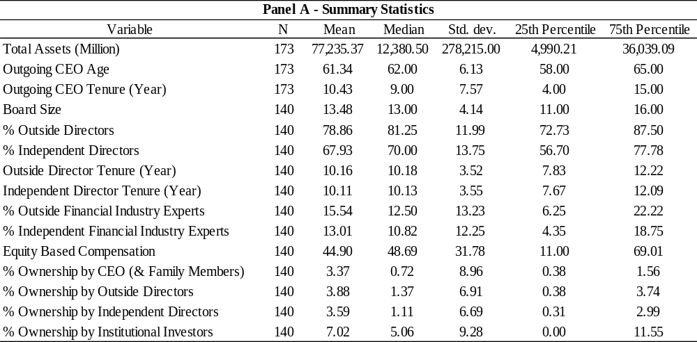
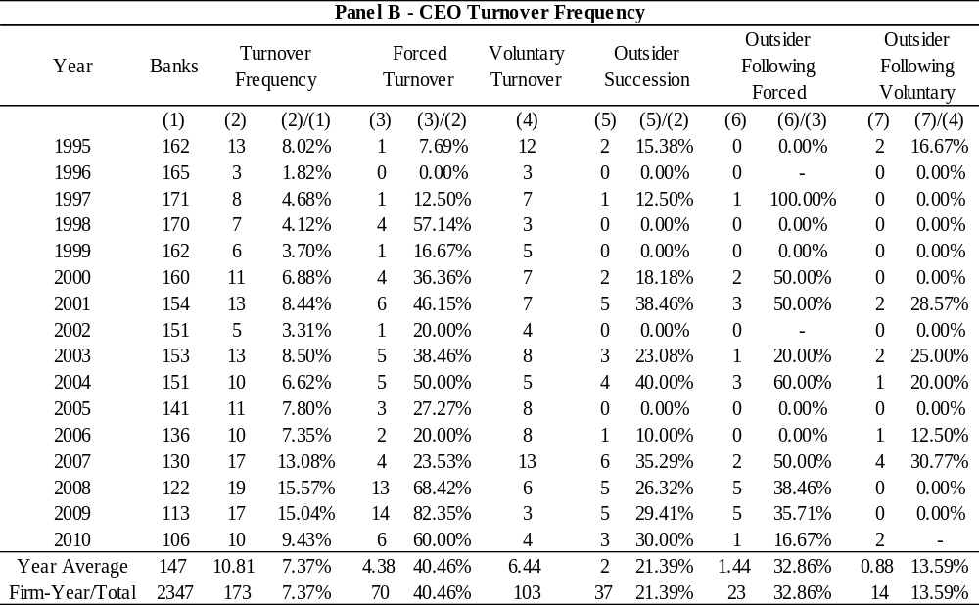

Table 2. CARs around CEO turnover announcements
This table presents the average cumulative abnormal returns (CARs) for 155 CEO turnover announcements over various event windows including [0], [-1, 0], [0, +1], [-1, +1], and [-2, +2]. CARs are stock returns adjusted by a four factor model that includes the market risk premium, SMB (the return spread between portfolios of small and big capitalization stocks), HML (the return spread between portfolios of high and low book-to-market stocks), and a momentum factor. The market model parameters are estimated with data over the 150-trading-day period 30 days before the turnover announcement. To be included in this event study, a bank’s stock must trade around announcement day and over the parameter estimation period. In panel A, the turnover sample is divided into two groups based on the type of turnover: forced and voluntary turnovers. In panel B, the turnover sample is divided into high and low groups based on the level of independent financial industry expertise and board independence, respectively. Brown-Warner t-statistics for means, z-statistics from Wilcoxon signed-rank tests for medians, z-statistics from generalized sign tests for the percentages of positive CARs, and t-statistics from two-tailed t-tests for the spreads are reported in Italics.

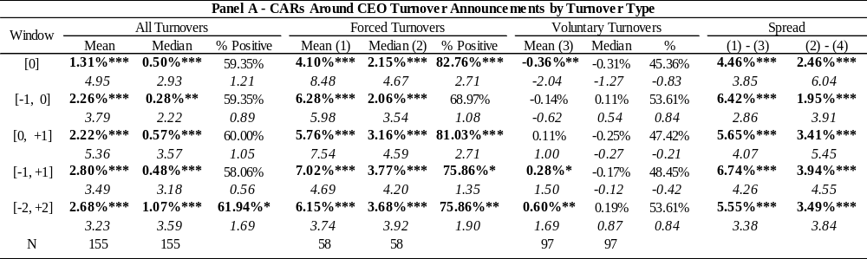
Table 2. Cont’d
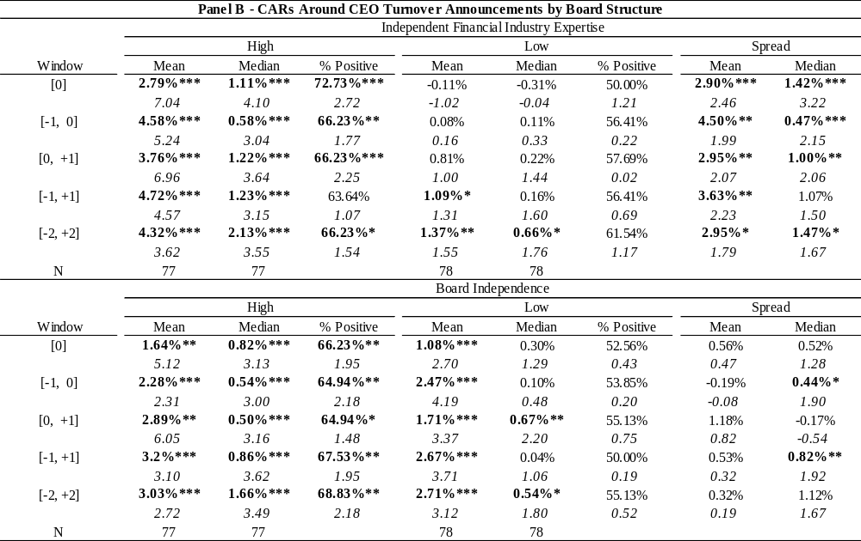

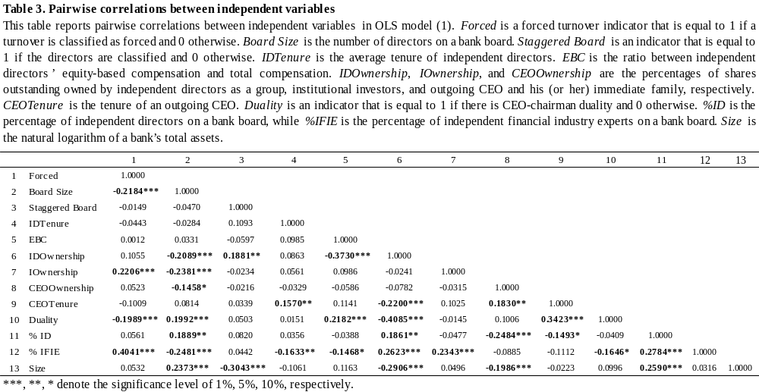

Table 4. Regression results for CARs around CEO turnover announcements
This table reports regression results for OLS model (1). CARs are abnormal stock returns around bank CEO turnover announcements. ITS is the interaction terms: %ID*Forced and % IFIE*Forced. Other variables are defined as in Table 3. Standard errors are clustered by bank. T-statistics are reported in Italics. F-test is against the null hypothesis that the coefficients of %IFIE and %IFIE*Forced are jointly zero.

${CARs}_{i}=β_{0}+β_{1}{Forced}_{i}+β_{2}{Board Size}_{i}+β_{3}{Staggered Bpard}_{i}+β_{4}{IDTenure}_{i}+ β_{5}{EBC}_{i}+β_{6}{IDOwnership}_{i}+β_{7}{IOwnership}_{i}+{ aggered β}_{8}{CEOOwnership}_{i}+ β_{9}{CEOTenure}_{i}+β_{10}{Duality}_{i}+β_{11}{\%ID}_{i}+ β_{12}{\%IFIE}_{i}+β_{13}{Size}_{i}+ITS+ε_{i}$
(1)
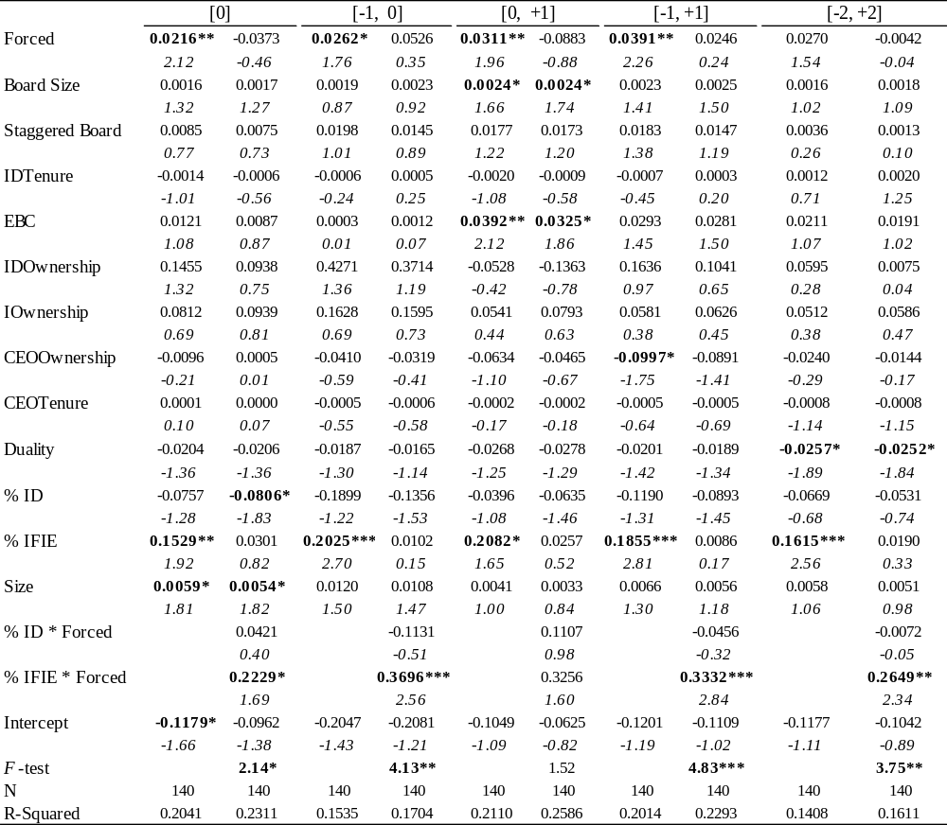
***, **, * denote the significance level of 1%, 5%, 10%, respectively.
Table 5. Changes in return on assets (ROA) around CEO turnovers
This table presents mean changes in unadjusted and industry-adjusted ROA (net income/the book value of total assets) in seven quarters before (-Q1 minus –Q7) and following (Q7 minus Q1) bank CEO turnovers for a sample of 124 successions from January 1st, 1995 to December 31st, 2010. Banks that announce M&As in the seven quarters either before or after the announced CEO turnover are excluded. Outgoing CEOs or successors who have held the CEO position for less than seven quarters are also excluded. T-statistics are reported in Italics.

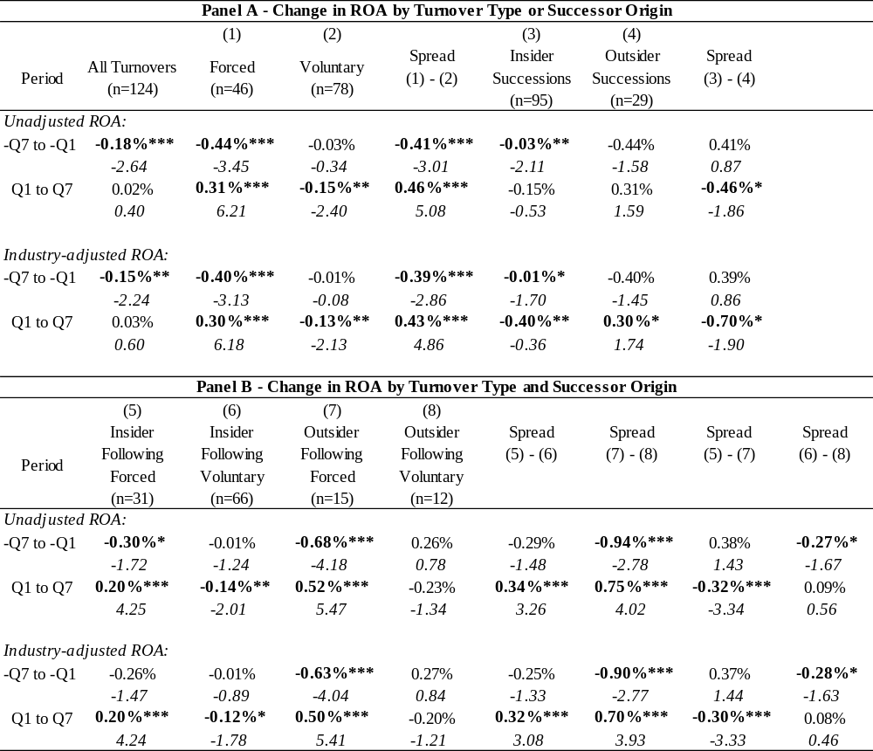
***, **, * denote the significance level of 1%, 5%, 10%, respectively.

Table 6. Changes in return on equity (ROE) around CEO turnovers
This table presents mean changes in unadjusted and industry-adjusted ROE (net income/the book value of equity) in seven quarters before (-Q1 minus –Q7) and following (Q7 minus Q1) bank CEO turnovers for a sample of 124 successions from January 1st, 1995 to December 31st, 2010. Banks that announce M&As in the seven quarters either before or after the announced CEO turnover are excluded. Outgoing CEOs or successors who have held the CEO position for less than seven quarters are also excluded. T-statistics are reported in Italics.

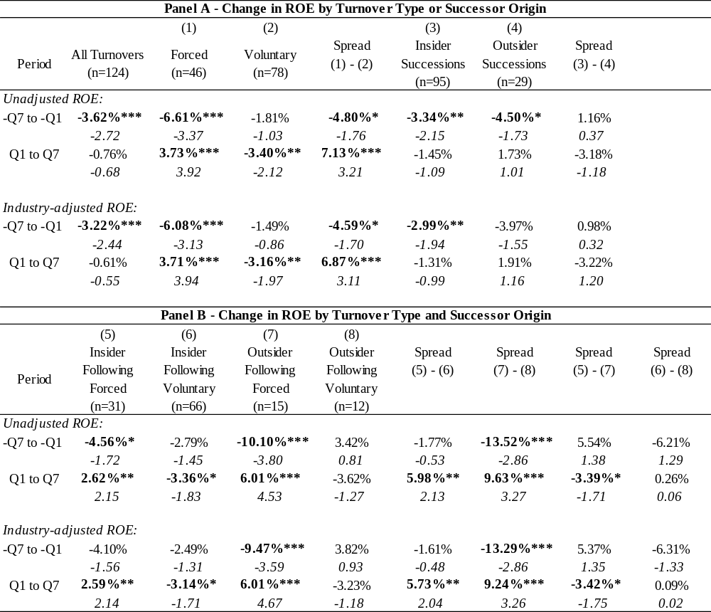
***, **, * denote the significance level of 1%, 5%, 10%, respectively.

Table 7. Abnormal stock performance around CEO turnovers
This table reports abnormal stock performance over various window in the pre- and post-turnover periods around the announcement quarter (Q0): [-Q7, -Q1], [-Q4, -Q1], [-Q1], [+Q1], [+Q1, +Q4], [+Q1, +Q7]. Banks that announce M&As in seven quarters either before or after the announced CEO turnover are excluded. Outgoing CEOs or successors who have held the CEO position for less than seven quarters are also excluded. Stock returns are adjusted by a four factor model that includes the market risk premium (the spread between CRSP value-weighted market return and risk-free rate), SMB (the return spread between portfolios of small and big capitalization stocks), HML (the return spread between portfolios of high and low book-to-market stocks), and a momentum factor. The market model parameters are estimated with data over the 24-month period seven quarters before the turnover announcement quarter. T-statistics are reported in Italics.

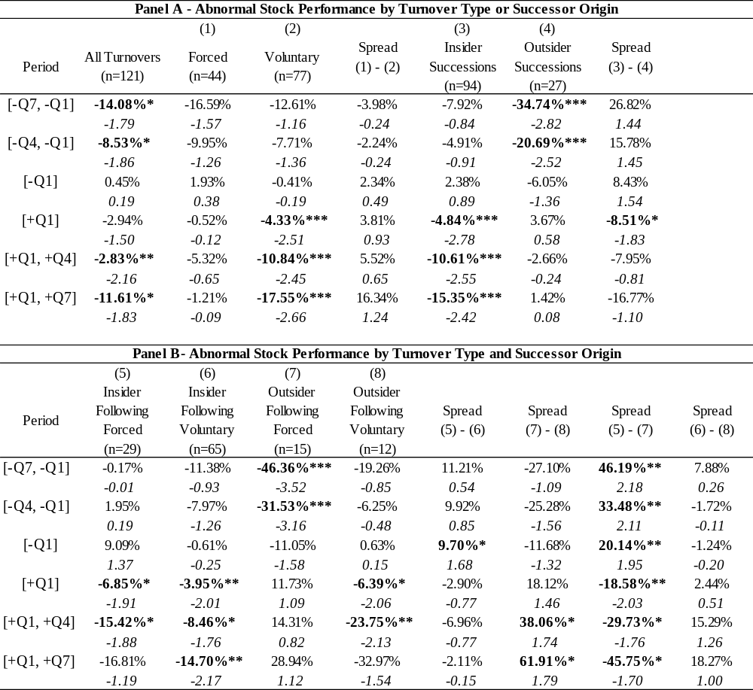
***, **, * denote the significance level of 1%, 5%, 10%, respectively.

Table 8. Changes in bank risk-taking around CEO turnovers
This table reports the z-score in the seven-quarter pre- and post-turnover periods as well as the change between the two. The z-score is used to proxy bank risk-taking. An increase (decrease) in the z-score implies a decrease (increase) in bank risk-taking. T-statistics are reported in Italics.

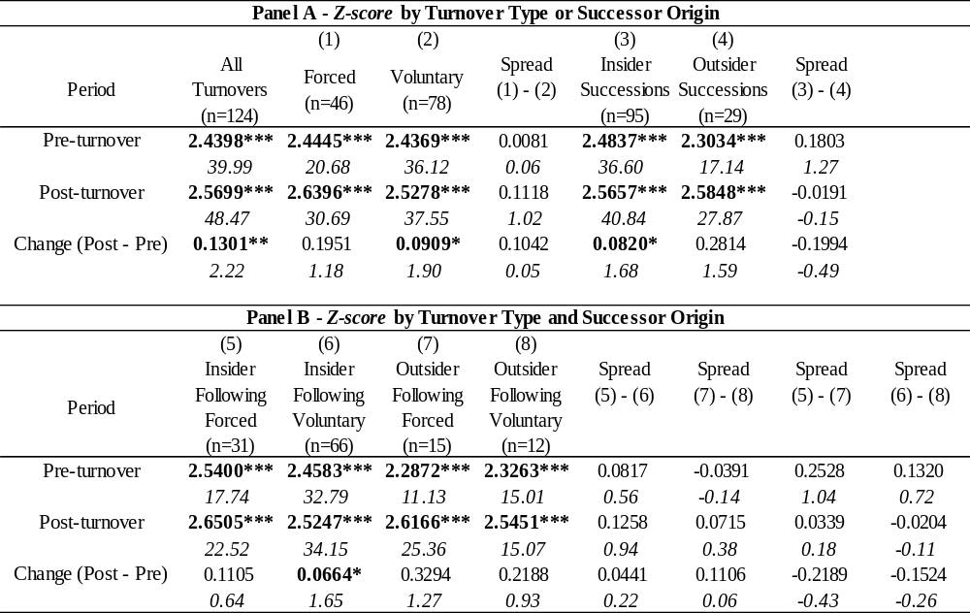
***, **, * denote the significance level of 1%, 5%, 10%, respectively.

Table 9. Regression analysis of the determinants of post-turnover performance
This table reports regression results for OLS model (2). PC is performance change over the seven-quarter post-turnover period, including changes in unadjusted and industry-adjusted ROA and ROE, abnormal stock performance, and change in the z-score. Out is an outsider succession indicator that is equal to 1 if a successor CEO is an outsider and 0 otherwise. Crisis is a financial crisis indicator variable that is equal to 1 for year 1998 (the LTCM crisis) and years 2007-2010 (the recent financial crisis). I control for the percentage change (Control) in total assets (equity) for ROA (ROE) specifications because the change in ROA (ROE) may partially derive from the change in total assets (equity). Other variables are defined as in model (1). F-test is against the null hypothesis that the coefficients of %IFIE and %IFE*Forced are jointly zero. T-statistics are reported in Italics.

${PC}_{i}=β_{0}+β_{1}{Forced}_{i}+β_{2}{Out}_{i}+β_{3}{Board Size}_{i}+β_{4}{Staggered Board}_{i}+β_{5}{IDTenure}_{i}+ β_{6}{EBC}_{i}+β_{7}{IDOwnership}_{i}+β_{8}{IOwnership}_{i}+{ aggered β}_{9}{CEOOwnership}_{i}+ β_{10}{CEOTenure}_{i}+β_{11}{Duality}_{i}+β_{12}{\%ID}_{i}+β_{13}{\%IFIE}_{i}+β_{14}{Size}_{i}+β_{15}{Crisis}_{i}+ ITS+Control++ε_{i}$ (2)
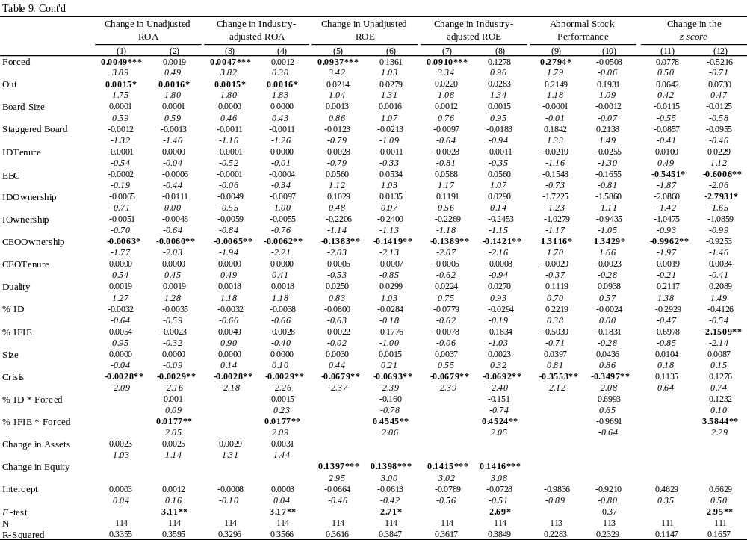

Table 10. Regression results for an alternative definition of board independence
This table presents empirical results where board independence is defined as the ratio between the number of outside directors and board size. Panel A reports regression results for OLS model (3). Panel B reports regression results for OLS model (4). ODTenure is the average tenure of outside directors). ODEBC is equity-based compensation of outside directors. ODOwnership is the ownership of outside directors as a group. %OD is the ratio between outside directors and board size. %OFIE is the ratio between outside financial industry experts and board size. Other variables are defined as in models (1) and (2). F-test is against the null hypothesis that the coefficients of %OFIE*Forced and %%OFIE are jointly zero. T-statistics are reported in Italics.

${CARs}_{i}=β_{0}+β_{1}{Forced}_{i}+β_{2}{Board Size}_{i}+β_{3}{Staggered Bpard}_{i}+β_{4}{ODTenure}_{i}+ β_{5}{ODEBC}_{i}+β_{6}{ODOwnership}_{i}+β_{7}{IOwnership}_{i}+{ aggered β}_{8}{CEOOwnership}_{i}+ β_{9}{CEOTenure}_{i}+β_{10}{Duality}_{i}+β_{11}{\%OD}_{i}+ β_{12}{\%OFIE}_{i}+β_{13}{Size}_{i}+ITS+ε_{i}$
(3)
${PC}_{i}=β_{0}+β_{1}{Forced}_{i}+β_{2}{Out}_{i}+β_{3}{Board Size}_{i}+β_{4}{Staggered Board}_{i}+β_{5}{ODTenure}_{i}+ β_{6}{ODEBC}_{i}+β_{7}{ODOwnership}_{i}+β_{8}{IOwnership}_{i}+{ aggered β}_{9}{CEOOwnership}_{i}+ β_{10}{CEOTenure}_{i}+β_{11}{Duality}_{i}+β_{12}{\%OD}_{i}+β_{13}{\%OFIE}_{i}+β_{14}{Size}_{i}+β_{15}{Crisis}_{i}+ ITS+Control++ε_{i}$ (4)

Table 10. Cont’d
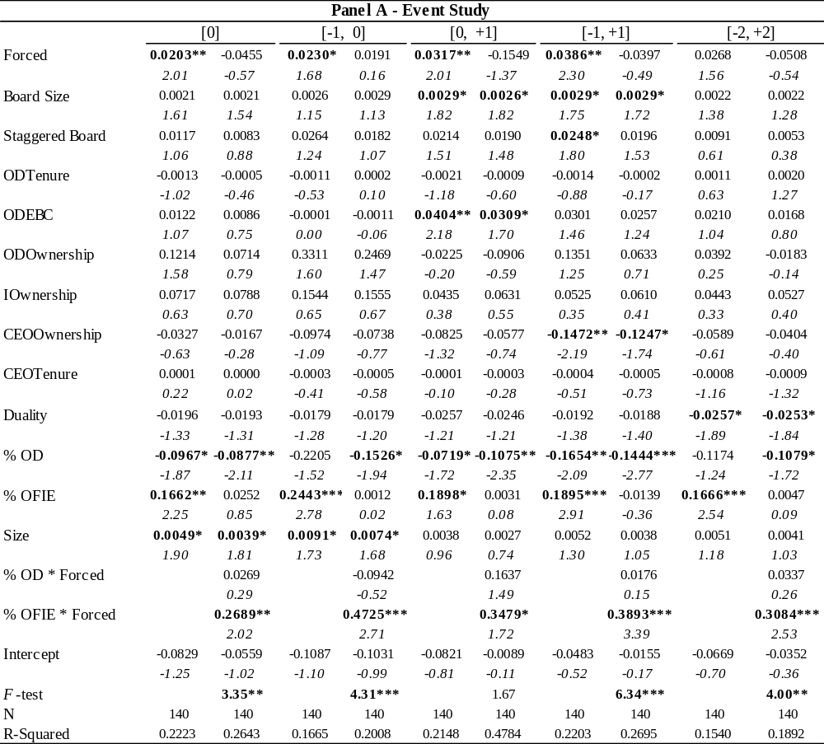

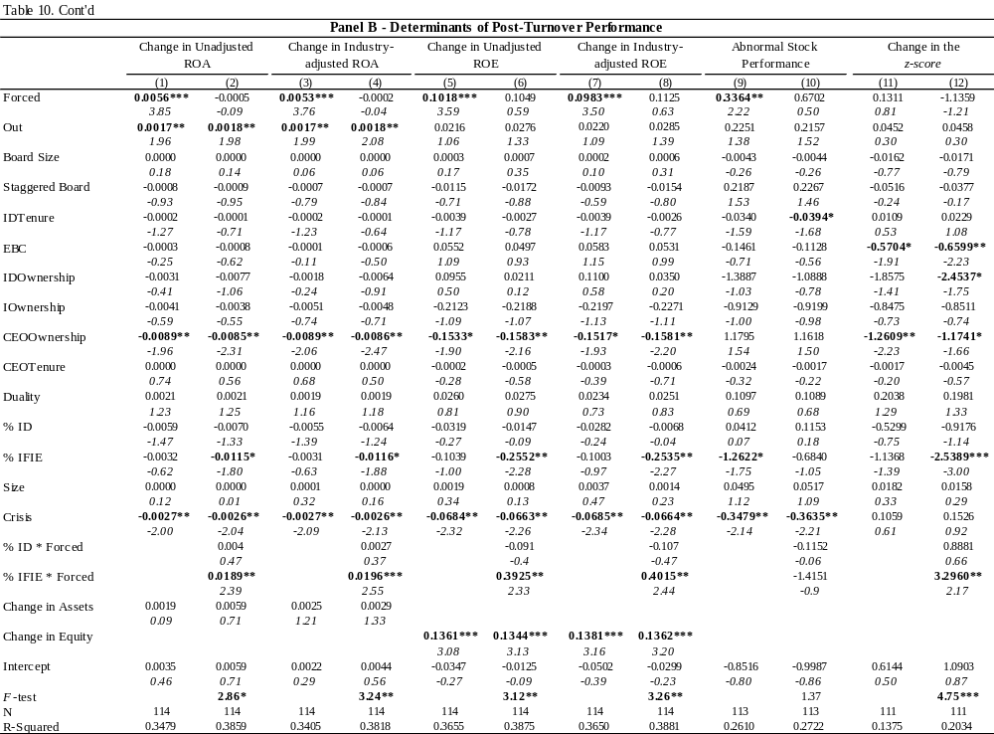

Table 11. Regression results for annual return on assets, annual return on equity, and annualized stock return volatility
This table reports regression results for model (5) where PC is the changes in annual unadjusted and industry-adjusted ROA and ROE, and annualized stock return volatility. Other variables are defined as in the previous models. Industry median ROA and ROE are calculated from the banks covered by COMPUSTAT. Observations where the successor CEO does not survive till the end of year two (with the turnover year being year 0) are excluded. Banks announce M&As in these two years are also excluded. Year fixed effect is controlled and standard errors are clustered by bank. F-test is against the null hypothesis that the coefficients on %IFIE and %IFIE*Forced are jointly zero. T-statistics are reported in Italics.

${PC}_{i}=β_{0}+β_{1}{Forced}_{i}+β_{2}{Out}_{i}+β_{3}{Board Size}_{i}+β_{4}{Staggered Board}_{i}+β_{5}{IDTenure}_{i}+ β_{6}{EBC}_{i}+β_{7}{IDOwnership}_{i}+β_{8}{IOwnership}_{i}+{ aggered β}_{9}{CEOOwnership}_{i}+ β_{10}{CEOTenure}_{i}+β_{11}{Duality}_{i}+β_{12}{\%ID}_{i}+β_{13}{\%IFIE}_{i}+β_{14}{Size}_{i}+ ITS+Control+ ε_{i}$ (5)

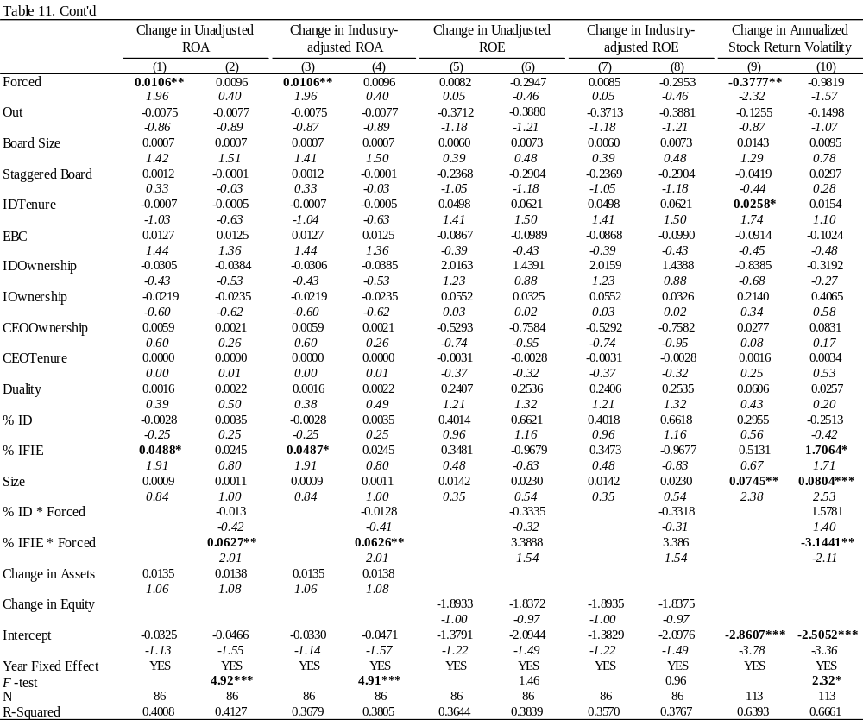
Appendix B: Figures

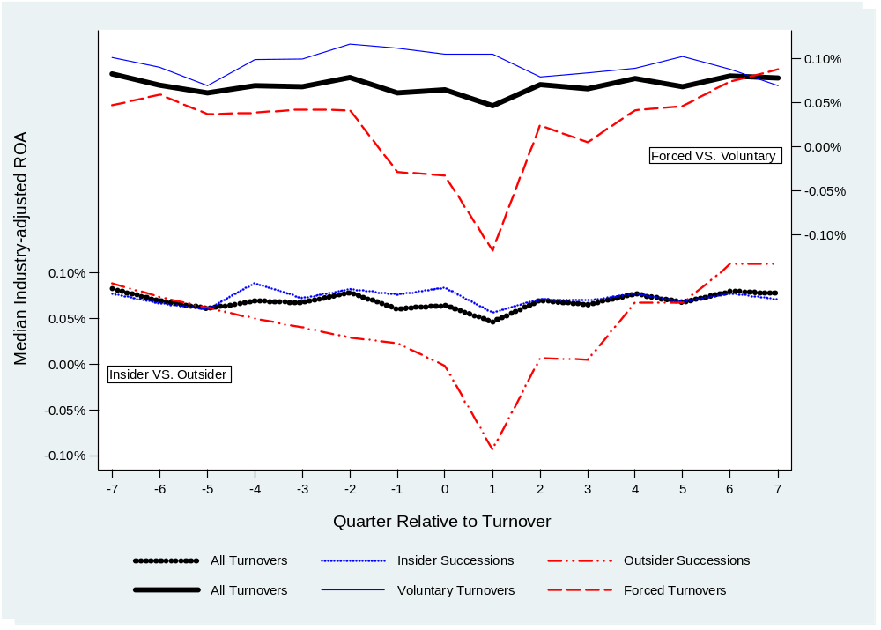
Figure 1. Median industry-adjusted return on assets around CEO turnovers by turnover type or successor origin

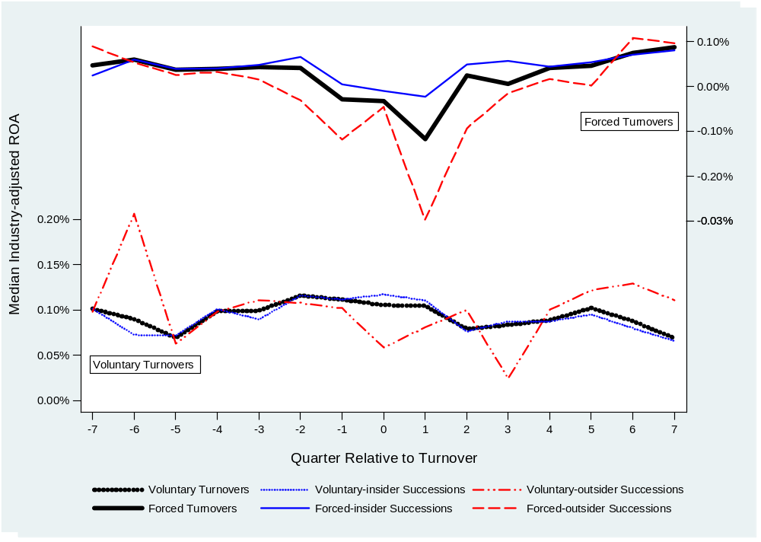
Figure 2. Median Industry-adjusted return on assets around CEO turnovers by turnover type and successor origin

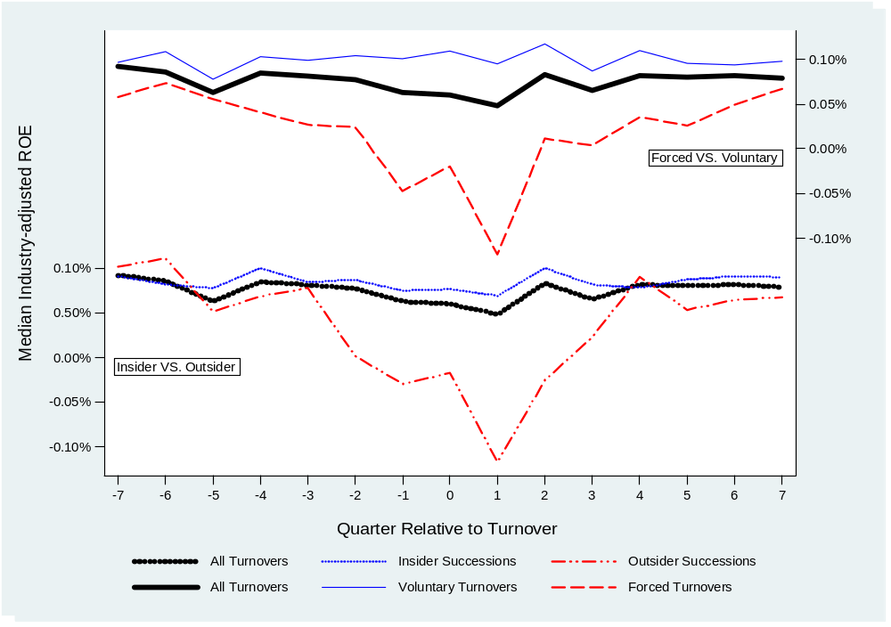
Figure 3. Median industry-adjusted return on equity around CEO turnovers by turnover type or successor origin

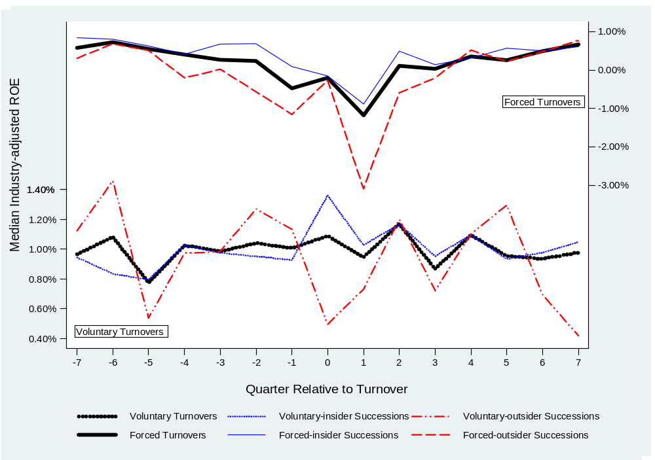
Figure 4. Median Industry-adjusted return on equity around CEO turnovers by turnover type and successor origin

VITA

Zhongdong Chen was born in Chongqing, China. He earned his undergraduate B.A degree and graduate M.A degree at Sichuan University in Chengdu, China. He will finish his doctoral work at the University of Tennessee in August 2013 and will then join the faculty of the Business School at Carson-Newman University in Jefferson City, TN as an Assistant Professor of Finance.
Zhongdong has been working as a Research Assistant for the Department of Finance at the University of Tennessee since 2007. He has taught undergraduate introductory finance and business courses during this time. He has also been an adjunct professor for Carson-Newman University teaching Corporate Finance in spring 2013. His research interests include empirical assets pricing, corporate finance, and banking. He has presented his research papers at multiple finance conferences including Financial Management Association annual conferences, Midwest Financial Association annual conferences, Southwestern Finance Association annual conferences, and Academy of Economics and Finance annual conference.

This classification is somewhat different from that used in Güner et al. (2008) and Minton et al. (2013) due to the purpose of this study. In contrast with the previous studies, I do not classify finance-related officers at non-financial firms or business professors as financial industry experts because they may not necessarily have a strong understanding of bank operations. Furthermore, the two cited studies do not classify directors with work experience with a banking regulator as financial industry experts.
“Help Wanted: Bank Boards Seeking Competent Directors”, Stephen Gandel, TIME, May 20, 2009.
On July 21, 2011, the OTS became part of the OCC.
I start with the year 1995 because board information prior to 1994 is not available in the Edgar filing database.
For example, Sallie Mae functioned as a government-sponsored enterprise until its privatization process was finished in 2004 and even after that point it was still widely regarded as quasi-government backed. However, the main results do not change after I include the 10 CEO turnovers at these three institutions during the sample period.
The sample size is small compared with cross-industry studies. However, sample size tends to be limited in studies on bank CEO turnovers (see, e.g., Hubbard and Palia, 1995, 61 CEO turnovers; Webb, 2008, 36 CEO turnovers; Palvia, 2011, 169 CEO turnovers). Of the 112 unique banks during the 1995-2010 period, one bank (0.89%) has five CEO turnovers, three banks (2.68%) have four CEO turnovers, five banks (4.46%) have three CEO turnovers, 38 banks (33.93%) have two CEO turnovers, and 65 banks (58.04%) have one CEO turnover.
Thereafter I report summary statistics only for CEO turnovers that have enough data for OLS model (1).
Hubbard and Palia (1995) find a cumulative turnover rate of 18.1% in the three years before interstate banking legislation. I divide this percentage by three to find the approximate annual turnover rate.
CRSP value-weighted NYSE/AMEX/NASDAQ Index dropped 37.55% during 2000-2002.
I do not differentiate between outside successors from other banks and those from other industries (see Parrino, 1997). Of the 34 outside successors, only three come immediately from another industry. However, they all have a banking background.
I do not test the difference between insider succession and outsider succession because many banks, especially those that oust their CEOs, have not selected a successor at the time of announcement, which significantly reduces the sample size.
If a CEO turnover is announced on a non-trading day, the next trading day is regarded as day 0.
When using raw stock returns instead of CARs over the five event windows, I find similar results.
Unlike forced CEO turnovers, the announcement quarter of a voluntary CEO turnover may be different from the effective turnover quarter. To capture the performance change only attributable to a successor CEO, I omit the quarter(s) between the turnover announcement quarter and effective turnover quarter.
I find similar patterns in unadjusted ROA.
Median tests show similar results.
I find similar patterns in unadjusted ROE.
Because previous studies suggest that a bank’s risk preference may also be related to unobservable factors such as business model and competition (e.g., Yeyati and Micco, 2007), I use the change in the z-score instead of the level of the z-score to capture the effect of a CEO turnover on bank risk-taking. However, I find similar but weaker results when the level of the z-score is employed in unreported tests.
I do not control chairman/CEO duality for successor CEOs because an outgoing CEO will typically remain on the board as the chairman for several months (or even several quarters) before the successor CEO takes over the chair position. For instance, AmSouth Bancorporation announced on December 21, 1995 that current CEO John W. Woods would be succeeded in January 1996 by C. Dowd Ritter, president and COO of the bank. Mr. Woods would continue as the chairman of the board, an additional role to be assumed by Mr. Ritter in August 1996.

