Providing Insight to Enable the Design of Tailored, Nano-Structured Polymeric Surfaces and Interfaces

A Dissertation Presented for the
Doctor of Philosophy
Degree
The University of Tennessee, Knoxville

Onome Jeminoyo Agori-Iwe
August 2020

Copyright © 2020 by Onome Agori-Iwe
All rights reserved.

Dedication

I dedicate this body of work to my parents, Esther Agori-Iwe and the late Dr. Kesiena Agori-Iwe, to my brothers, Matthew and David, and to my son, Marsalis, for all of their love, support and encouragement throughout the years. I also dedicate this body of work to my Lord and Savior Jesus Christ, to whom I am raising my ‘Ebenezer,’ because He has done so much for me:
“Who is like the Lord our God who is seated on high, who looks far down on the heavens and the earth? He raises the poor from the dust, and lifts the needy from the ash heap, to make them sit with princes, with the princes of his people.”

Psalm 113:5-8
I Samuel 7:12

Acknowledgements

I greatly appreciate and acknowledge my major professor, Dr. Mark Dadmun, and all of my committee members, Dr. Jimmy Mays, Dr. Charles Feigerle, and Dr. Thomas Zawodzinski, for all of their guidance, support and encouragement.
I also want to thank all of the collaborators involved in the research efforts described in this body of work including: Dr. Lian Hutchings, Dr. Richard Thompson, and Dr. Jonathan Dodds at Durham University (Durham, England); Dr. Ken Carter and Dr. Damla Koylu at the University of Massachusetts; Dr. Joseph Pickel, Dr. Li Hong He, and Dr. Xiang Yu at the Center for Nanophase Materials Science (CNMS) at Oak Ridge National Lab (ORNL).
Research support for this work was provided by the Department of Energy, Office of Basic Sciences, through the EPSCoR grant, DE-FG02-08ER46528, and the Department of Energy, Office of Basic Energy Sciences, Division of Materials Sciences and Engineering. The support of the Scientific User Facilities Division, Office of Basic Energy Sciences, U.S. Department of Energy, who sponsors ORNL’s Spallation Neutron Source (SNS), is also gratefully appreciated.
I also want to express my gratitude to Dr. John Ankner, Dr. Jim Browning, and Candice Halbert for their help and training in the use of the Beamline 4B Liquids Reflectometer at the SNS at ORNL. I also want to thank Tom Malmgren for his help and training in the use of the Polymer Characterization Lab at the University of Tennessee.

Abstract
Methods are presented for modifying polymeric material surfaces using: 1) selective surface segregation in binary branched/linear polymer blends, and 2) surface functionalization with polymer brushes. Using neutron reflectivity, elastic recoil detection, and other complementary techniques, the aim was to identify structure-property relationships and provide fundamental insight into the time evolution and formation of surfaces and interfaces in these materials.
In blends of poly(styrene) (PS) HyperMacs and DendriMacs in a linear deuterated PS (d-PS) matrix, smaller hyperbranched additives (<1E6 g/mol) move slower than their linear analogues. Larger (>1E6 g/mol) and less flexible hyperbranched additives with smaller fractal dimensions move faster than their linear analogues, suggesting that they are less entangled with the linear matrix. In blends of poly(methyl methacrylate)-random-poly(ethylene glycol) methacrylate (P(MMA-r-PEGMA)) comb copolymers in a linear d-PMMA matrix, it was observed that while increasing the branch density of the comb increases the amount of surface excess, these combs are an order of magnitude slower than a linear analog. This was attributed to an increased number of branch points which can dominate the friction in a Reptating backbone. Using the Kramer-Jones theory and the Slow Mode theory, mutual and tracer diffusion coefficients for each blend were extracted.
A 3-dimensional inimer-embedded cross-linked system from which d-PS was grown was investigated. d-PS growth is initiated both at the surface and within the bulk of these materials. Increasing the amount of inimer increased d-PS growth throughout the entire layer. The surface growth of d-PS is more efficient at low concentrations of inimer, while higher concentrations resulted in the growth of d-PS throughout the bulk of the layer (due to differences in the amount of swelling in the network). A second polymer brush system was investigated in which functionalized poly(cyclohexadiene) (PCHD) brushes were attached to a solid substrate using a grafting-to approach and were subsequently aromatized to poly(paraphenylene) (PPP) in-situ. PPP, a conducting polymer with high chemical and thermal stability, is insoluble at high molecular weight. The approach utilized in this study was designed to overcome this challenge by focusing on the synthesis, assembly, and aromatization of functionalized PCHD brushes attached to a solid substrate.
Table of Contents

Chapter 1 Introduction 1
1.1 Overview 1
1.2 Thermodynamics and Kinetics as the Driving Forces for Interfacial Phenomena 3
1.3 Model Systems for Structure-Property Studies 5
1.4 Characterization of Polymeric Surfaces and Interfaces 7
1.5 Approaches to Functionalizing Polymeric Material Surfaces 13
A. Traditional Techniques 13
B. Polymer Brushes 15
C. Surface Segregation in a Binary Blend 19
1.6 Model Systems Investigated in this Study 22
A. The Time Evolution of the Surface Segregation of Branched Polymers in a Linear Matrix 22
B. Tuning Surface Properties of Polymeric Materials Using Grafting-To and Grafting-From Approaches 25
Chapter 2 Understanding the Thermodynamics and Dynamics of the Time Evolution of the Surface Segregation of Branched Polymeric Additives from a Linear Polymer Matrix 27
2.1 Overview 27
2.2 Theories Describing the Dynamics of Linear and Branched Polymers in the Melt 28
2.3 Surface Segregation in Binary Polymer Blends 34
A. The Kramer-Jones Depletion Layer Model: A Method to Extract the Mutual Diffusion Coefficient of a Surface Segregating Binary Blend 34
B. The Fast and Slow Mode Theories: A Method to Extract the Tracer Diffusion Coefficient of a Surface Segregating Component in a Binary Blend 38
2.4 Previous Studies on Surfactant Transport in Blends Composed of Linear Polymers 42
Chapter 3 The Time Evolution of the Surface Segregation of HyperMacs and DendriMacs from a Linear Matrix 47
3.1 Introduction 47
A. Overview 47
B. The Synthesis and Structure of HyperMacs and DendriMacs 49
C. Distinguishing Physical Characteristics of Hyperbranched Polymers 53
3.2 Materials and Methods 53
A. Materials 53
B. Method for Preparation of Thin Film Samples 54
C. Methods for Characterization of PS HyperMacs and DendriMacs 56
1) Solution Viscometry 56
2) Triple Detection Size Exclusion Chromatography 57
D. Methods for Characterization of the Blend Film 57
1) Ellipsometry 57
2) Neutron Reflectivity 57
3) Elastic Recoil Detection Spectroscopy 58
3.3 Results and Discussion 59
A. Analysis of the Structure of HyperMacs and DendriMacs 59
1) The Molecular Weight Characteristics of HyperMacs and DendriMacs 59
2) Analysis of the Nature and Amount of Branching in HyperMacs and DendriMacs: The Intrinsic Viscosity Branching Factor, g’, and the Zimm-Stockmayer Branching Factor, g 60
3) Insight into the 3-Dimensional Structure of HyperMacs and DendriMacs 71
B. Determining Blend Film Structure and its Evolution with Time 74
1) Neutron Reflectivity Profiles: Examination of the Raw Data 74
2) The Model Used to Describe Surface Segregation in Binary Branched/Linear Blends 77
C. Snapshots of HyperMac and DendriMac Movement in a Linear Matrix 85
1) The Time Evolution of the Volume Fraction, Φ, of Branched Additives in a Linear Matrix 85
2) The Time Evolution of the Interfacial Excess, Z*, of Branched Additives in a Linear Matrix 88
D. How Branched Additive Molecular Weight and Amount of Branching Affects Z* at an Interface 89
E. How the Architecture of HyperMacs and DendriMacs in a Linear Matrix Affects their Dynamic Behavior 93
1) Overview 93
2) The Mutual Diffusion Coefficient, D_{m}, of a Hyperbranched/Linear Blend from Depth Profile Experiments 94
3) The Tracer Diffusion Coefficient, D_{A}*, of a Hyperbranched Polymer from Depth Profile Experiments 100
3.4 Conclusions 104
Chapter 4 The Time Evolution of the Surface Segregation of P(MMA-r-PEGMA) Comb Copolymers from a Linear Matrix 106
4.1 Introduction 106
A. Overview 106
B. Theoretical Investigations of the Equilibrium Structures of Surface Segregated Comb/Linear Blends 107
C. The Thermodynamic Behavior of PEO and PMMA in Thin Films 109
4.2 Materials and Methods 112
A. Materials 112
B. Preparation of Thin Films 113
C. Characterization of the Comb Copolymers 114
1) ¹H-Nuclear Magnetic Resonance (NMR) Spectroscopy 114
2) Size Exclusion Chromatography 114
D. Characterization of the Blend Films 115
1) Ellipsometry 115
2) Neutron Reflectivity 116
3) Water Contact Angle Goniometry and Annealing Experiment 116
4.3 Results and Discussion 117
A. Verifying the Structure of the Combs 117
1) ¹H-NMR 117
2) Size Exclusion Chromatography 119
B. Determining Blend Film Structure and its Evolution with Time 120
1) Neutron Reflectivity Profiles: Examination of the Raw Data 120
2) The Model Used to Describe Surface Segregation in Comb/Linear Blends 122
3) Snapshots of P(MMA-r-PEGMA) Comb Copolymer Movement in a Linear Matrix 131
C. How the Architecture of Comb Copolymers in a Linear Matrix Affects Their Dynamic Behavior 140
1) Overview 140
2) The Mutual Diffusion Coefficient, D_{m}, of a Comb/Linear Blend from Depth Profile Experiments 141
3) The Tracer Diffusion Coefficient, D_{A}*, of a Comb Copolymer from Depth Profile Experiments 146
4.4 Conclusions 149
Chapter 5 Determining the Structure of a Surface-Functionalized Cross-Linked Network 151
5.1 Introduction 152
A. Overview 152
B. Fabrication of 3-Dimensional Inimer-Embedded Functionalized Materials 153
5.2 Materials and Methods 156
A. Characterization of Films 156
1) Neutron Reflectivity 156
2) Dynamic Secondary Ion Mass Spectroscopy (DSIMS) 157
3) In-Situ Ellipsometry 158
4) Water Contact Angle Goniometry 159
5.3 Results and Discussion 159
A. Insight into the Structure of Functionalized Cross-Linked Networks 159
1) Determining Structure in the Bulk of the Film 159
2) Determining Structure at the Film Surface 161
3) Developing the Best Model to Describe the Density Profile of Functionalized Cross-Linked Networks 164
B. Correlating the Structure of Functionalized Surfaces and Interfaces with Synthetic Conditions 169
1) The Impact of Inimer Concentration on d-PS Growth 169
2) The Impact of Swelling and Monomer Concentration on d-PS Growth 172
5.4 Conclusions 182
Chapter 6 A Structure-Property Investigation of Self-Assembled Well-Defined PCHD and PPP Brushes 184
6.1 Introduction 184
6.2 Materials and Methods 185
A. Materials 185
B. Method for Synthesis of Precursor Polymers 185
C. Method for Tethering End-Functionalized PCHD to a Substrate 186
D. Method for Creating PPP from PCHD Tethered to a Substrate 188
E. Methods for Characterization of Grafted PCHD and PPP Layers 189
1) Ellipsometry 189
2) Water Contact Angle Goniometry 190
3) Atomic Force Microscopy 190
4) Internal and External Infrared Reflectance Spectroscopy 192
1) Raman Spectroscopy 195
2) UV-Vis Spectroscopy 196
3) Optical Microscopy 196
6.3 Results and Discussion 196
A. Characterization of End-Tethered PCHD Polymer Brush Films Formed from Solution Grafting 196
1) Overview 196
2) Evaluation of the Structure and Quality of End-Tethered PCHD Brushes 197
B. Characterization of Aromatized PPP Polymer Brush Films 208
Chapter 7 Lessons Learned and Future Work 214
7.1 Overview 215
7.2 Lessons Learned from Studies of Self-Healing Materials Formed from Surface Segregating Binary Branched/Linear Blends 215
7.3 Future Work and Some Potential Practical Industrial Applications: Self-Healing Binary Branched/Linear Blends 219
7.4 Lessons Learned from Studies of the Formation of Functionalized Polymeric Interfaces Using Grafting-From and Grafting-To Approaches 222
7.5 Future Work and Some Potential Practical Industrial Applications: Functionalized Polymeric Interfaces Using Grafting-From and Grafting-To Approaches 224
List of References 226
Appendices 238
Appendix A: Supporting Information for Chapters 3 and 4 239
A.1 Methods for Characterization of Hyperbranched and Comb Copolymer Polymeric Additives 240
A. Solution Viscometry 240
B. Size Exclusion Chromatography 244
A.2 Methods for Characterization of the Blend Film 245
B. Neutron Reflectivity 251
C. Elastic Recoil Detection Spectroscopy 259
1) Overview of the Experiment 259
2) Analysis of ERD Data in Thermally Annealed Blends of HyperMacs and DendriMacs in a Linear Polymer Matrix 263
D. Water Contact Angle Goniometry 264
A.3 Additional Experimental Data for Chapter 3 267
A. Huggins-Kraemer Plots of HyperMacs and DendriMacs 267
B. Neutron Reflectivity Profiles for Binary Blends of HyperMacs and DendriMacs in a Linear Matrix 270
C. ERD Spectra for Binary Blends of HyperMacs and DendriMacs in a Linear Matrix 280
D. Neutron Reflectivity Fit Parameters for Binary Blends of HyperMacs and DendriMacs in a Linear Matrix 286
E. Neutron Reflectivity Volume Fraction Copolymer Plots for Binary Blends of HyperMacs and DendriMacs in a Linear Matrix 291
A.4 Additional Experimental Data for Chapter 4 300
A. Proton NMR Spectra of P(MMA-r-PEGMA) Comb Copolymers 300
B. Size Exclusion Chromatograms of P(MMA-r-PEGMA) Comb Copolymers 303
C. Neutron Reflectivity Profiles for Binary Blends of P(MMA-r-PEGMA) Comb Copolymers in a Linear Matrix 305
D. Neutron Reflectivity Fit Parameters for Binary Blends of P(MMA-r-PEGMA) Comb Copolymers in a Linear Matrix 311
E. Neutron Reflectivity Volume Fraction Copolymer Plots for Binary Blends of P(MMA-r-PEGMA) Comb Copolymers in a Linear Matrix 314
Appendix B: Supporting Information for Chapters 5 and 6 320
A. Dynamic Secondary Ion Mass Spectroscopy (DSIMS) 321
B. In-Situ Ellipsometry 323
Vita 325

List of Tables

Table 1.1 Surface sensitive techniques for structure-property investigations of polymeric systems, including the information that can be obtained, the limitations and depth resolution of each technique. 14
Table 2.1 The diffusion coefficients for entangled linear polymers, star polymers, H-polymers, and comb copolymers. 31
Table 2.2 Experimental and computational results of studies on the dynamics of linear entangled polymers. 33
Table 3.1 The M_{n}, M_{w}, and PDI of polymers used in the dewetting test. 55
Table 3.2 The molecular weight characteristics of macromonomers as obtained from Triple Detection SEC. 59
Table 3.3 The molecular weight characteristics for HyperMacs, DendriMacs, and linear dPS, as well as degree of coupling, Dp_{n}, for the hyperbranched polymers. Triple Detection SEC was used to characterize the hyperbranched polymers. Linear dPS was characterized with SEC using RI and LS detectors. 60
Table 3.4 Intrinsic viscosity ([η]) of HyperMacs and DendriMacs obtained by two different methods - viscometry and Triple Detection SEC. 64
Table 3.5 The intrinsic viscosity, η, of HyperMacs, DendriMacs, and their linear analogs as well as the intrinsic viscosity branching factor, g’. 65
Table 3.6 A summary of the radii of gyration for branched HyperMacs and DendriMacs (Rgbr) and their linear analogs (Rglin) as well as the Zimm-Stockmayer Branching Factor, g. 67
Table 3.7 The average number of long chain branches (LCB) per macromolecule, n, and the number of branches per 1000 backbone carbons (branching frequency), λ, for HyperMacs and DendriMacs. 69
Table 3.8 The value of α derived from the size-mass scaling relationship, R_{g} M^{α}, as well as fractal dimension, 1/ α, and their corresponding polymer conformations in dilute solution. 72
Table 3.9 Sample names for binary polymer blends containing 10 w/w% HyperMac or DendriMac and 90 w/w% linear deuterated PS. 75
Table 3.10 The scattering length density (SLD) values obtained from fits to neutron reflectivity profiles of a monolayer of each binary blend component. 79
Table 3.11 The surface excess, Z*, at both air and Si substrate interfaces obtained from ERD measurements of annealed blends containing HyperMacs and DendriMacs . The amount of surface excess obtained from model fits to neutron reflectivity data of the same film is included in parentheses. The error for both ERD measurements and NR fits to the data is no more than 1 nm. 81
Table 3.12 Neutron reflectivity fit parameters for the blend film DM1105LPS as-cast and annealed up to 33 days at 150°C under vacuum. 86
Table 3.13 The mutual diffusion coefficients, D_{m}, for blends containing HyperMacs and DendriMacs in a linear homopolymer matrix as well as the equilibrium time, t_{eq}, and net equilibrium interfacial excess near the Si interface, ΔZ*_{Si eq}. 100
Table 3.14 Tracer diffusion coefficients, D_{A}*, for HyperMacs and DendriMacs in a linear homopolymer matrix as well as for their linear analogs. 102
Table 4.1 Mole % and w/w % PEGMA macromonomer in P(MMA-r-PEGMA) comb copolymers determined by 1HNMR analysis. 119
Table 4.2 M_{w} and PDI from SEC measurements for the three P(MMA-r-PEGMA) comb copolymers as well as the linear matrix, d-PMMA, used in this study. 120
Table 4.3 Sample codes for binary polymer blends containing 10 w/w % P(MMA-r-PEGMA) comb copolymer and 90 w/w % linear d-PMMA. 121
Table 4.4 Scattering length density (SLD) values obtained from fits to the NR profiles of binary blend components. 126
Table 4.5 Neutron reflectivity fit parameters for the blend 5050MMAEO_LPMMA. 129
Table 4.6 The mutual diffusion coefficients, D_{m}, for blends containing P(MMA-r-PEGMA) comb copolymers (10 w/w %) in a linear homopolymer matrix as well as the equilibrium anneal time, t_{eq}, and equilibrium Si interfacial excess Z*_{Si eq}. 145
Table 4.7 Tracer diffusion coefficients, DA*, for comb copolymers in a linear PMMA homopolymer matrix as well as for their linear analogs. 148
Table 5.1 Samples with varying inimer and monomer concentration investigated in this study of functionalized cross-linked polymer networks. 157
Table 5.2 Film thicknesses for samples investigated in this study before and after secondary polymerization with deutrated styrene. 162
Table 5.3 Water contact angle measurements for cross-linked functionalized samples as well as monolayers of PP/inimer. 163
Table 5.4 Neutron scattering length densities (SLD) for monolayers of d-PS and monolayers of PP/inimer layers containing 10 w/w %, 30 w/w % and 50 w/w % inimer. 164
Table 5.5 Results of the tests for redundancy of fit parameters designated ‘A’ and ‘B’. 168
Table 5.6 Best-fit neutron reflectivity parameters of the 2-layer model for each cross-linked functionalized film investigated in this study. The fit parameters for each layer include thickness, d, scattering length density, ρ, and roughness between the air and near air surface, σ_{air/near air}, as well as roughness between the near air surface and underlayer, σ_{near air/underlayer}. 170
Table 5.7 Calculated cross-link density for monolayers of PP/inimer as well as d-PS grafted layers polymerized with 1:600 inimer:dS and containing 10 w/w %, 30 w/w % and 50 w/w % inimer. 181
Table 6.1 The molecular weight and microstructure of PCHD precursor polymers investigated in this study. 186
Table 6.2 Solution graft reaction conditions as well as the resulting structure of end tethered PCHD brushes including thicknesses, h_{dry}, distance between grafted chains, MD, and graft density, σ. 199
Table 6.3 A comparison of brush structure (MD and σ) achieved by grafting to silicon oxide surfaces via spin coating, solution grafting, and surface-initiated ATRP. 200
Table A.1 Neutron reflectivity fit parameters for the binary blend HM373LPS. 286
Table A.2 Neutron reflectivity fit parameters for the binary blend HM871LPS. 287
Table A.3 Neutron reflectivity fit parameters for the binary blend HM1530LPS. 288
Table A.4 Neutron reflectivity fit parameters for the binary blend DM505LPS. 288
Table A.5 Neutron reflectivity fit parameters for the binary blend DM1105LPS. 289
Table A.6 Neutron reflectivity fit parameters for the binary blend 9010MMAEO_LPMMA. 312
Table A.7 Neutron reflectivity fit parameters for the binary blend 7525MMAEO_LPMMA. 312
Table A.8 Neutron reflectivity fit parameters for the binary blend 5050MMAEO_LPMMA. 313

List of Figures

Figure 1.1 The rational design of new polymeric materials with tailored physical properties involves synthesis, structural characterization, and theory. 6
Figure 1.2 The grafting-to (a) and grafting-from (b) methods to create a polymer brush. 16
Figure 1.3 Surface segregation of a component from a polymer blend after annealing. 23
Figure 2.1 An illustration of hierarchical stress relaxation in a hyperbranched polymer which was proposed by Mc Leish. 31
Figure 2.2 An illustration of the depletion layer model proposed by Kramer and Jones to describe the formation of a wetting layer in a binary miscible polymer blend. 36
Figure 2.3 Example of a volume fraction profile of a surface segregating binary blend film after it has reached equilibrium. 38
Figure 3.1 Huggins-Kraemer plot obtained from viscometry measurements of HyperMac PSHM1530. The plot extrapolates to an intrinsic viscosity, η, of 0.1094 mL/mg (1.094 dL/g). 62
Figure 3.2 Intrinsic viscosity as a function of M_{w} for PS HyperMacs, DendriMacs, and their linear analogs. 64
Figure 3.3 Intrinsic viscosity branching factor, g’, as a function of M_{w} for HyperMacs and DendriMacs. 66
Figure 3.4 The average number of LCBs per macromolecule, n, as a function of the log of M_{w}. 69
Figure 3.5 Branching frequency (number of branches per 1000 backbone carbon atoms), λ, as a function of the log of M_{w}. 70
Figure 3.6 The growth of R_{g} with increasing molecular weight of HyperMacs PSHM373, PSHM871, and PSHM1530. The inset table displays the size-mass scaling exponent, α, obtained from the slope of the graph. R is a goodness-of-fit parameter. The fractal dimension, 1/α, is also included in the table. 73
Figure 3.7 The growth of R_{g} with increasing molecular weight of DendriMacs PSDM505 and PSDM1105. The inset table displays the size-mass scaling exponent, α, obtained from the slope of the graph. R is a goodness-of-fit parameter. The fractal dimension, 1/ α, is also included in the table. 74
Figure 3.8 Neutron reflectivity data for the binary blend HM1530LPS measured as-cast up to an anneal time of 48 hours at 150°C under vacuum. Data is offset by a decade for clarity. 76
Figure 3.9 a) Neutron reflectivity profiles for the binary blend HM1530LPS measured as-cast up to a maximum anneal time of 33 days at 150°C. b) Data highlighted in box in a) shows the low Q region and emphasizes dampening of fringes with increasing anneal time. Data is offset by a decade for clarity. 76
Figure 3.10 ERD spectra for the binary blend HM1530LPS annealed for 12 hours at 150°C under vacuum. Depth into the film increases with decreasing particle energy. 82
Figure 3.11 ERD spectra for the binary blend HM1530LPS annealed for 48 hours at 150°C under vacuum. Depth into the film increases with decreasing particle energy. 82
Figure 3.12 NR profile and fit of blend DM1105LPS annealed for 48 hours at 150°C under vacuum. The inset contains a plot of the SLD profile used to generate the model NR fit to the data. 84
Figure 3.13 Volume fraction profiles generated by model fits to NR data for blend DM505LPS.The surface segregation process was monitored for films as-cast out to 48 hours of anneal time at 150°C under vacuum. Data is truncated to emphasize interfaces. 87
Figure 3.14 Volume fraction profiles generated by model fits to NR data for blend DM505LPS.The surface segregation process was monitored for films as-cast out to 33 days of anneal time at 150°C. Data is truncated to emphasize interfaces. 87
Figure 3.15 The time evolution of the bulk (reservoir) volume fraction of HyperMacs and DendriMacs in blend films as-cast and annealed up to 33 days at 150°C under vacuum. 88
Figure 3.16 The time evolution of the surface excess, Z*Si, near the Si interface for HyperMacs in a linear d-PS matrix from the as-cast film to 33 days of annealing time under vacuum at 150°C. 90
Figure 3.17 The time evolution of the surface excess, Z*Si, near the Si interface for DendriMacs in a linear d-PS matrix from the as-cast film to 33 days of annealing time under vacuum at 150°C. 90
Figure 3.18 The interfacial excess near the Si interface after spin-casting, Z*_{Si Initial}, as a function of the size of the branched additive, M_{w}. 91
Figure 3.19 The final interfacial excess of branched additives in a linear matrix near the Si interface, Z*_{Si Final}, as a function of the branched additive M_{w}. M_{w} of the linear matrix is 320,000 g/mol. All blends were annealed for 33 days at 150°C under vacuum. 92
Figure 3.20 The growth of the net interfacial excess layer near the Si interface, ΔZ*_{Si},for the blend containing HyperMac HM373LPS annealed up to 33 days at 150°C under vacuum. 95
Figure 3.21 The growth of the net interfacial excess layer near the Si interface, ΔZ*_{Si}, for the blend containing HyperMac HM871LPS annealed up to 33 days at 150°C under vacuum. 96
Figure 3.22 The growth of the net interfacial excess layer near the Si interface, ΔZ*_{Si}, for the blend containing HyperMac HM1530LPS annealed up to 33 days at 150°C under vacuum. 97
Figure 3.23 The growth of the net interfacial excess layer near the Si interface, ΔZ*_{Si}, for the blend containing DendriMac DM505LPS annealed up to 33 days at 150°C under vacuum. 98
Figure 3.24 The growth of the net interfacial excess layer near the Si interface, ΔZ*_{Si}, for the blend containing DendriMac DM1105LPS annealed up to 33 days at 150°C under vacuum. 99
Figure 3.25 The tracer diffusion coefficient of HyperMacs and DendriMacs in a linear d-PS matrix with M_{w} of 335,800 g/mol. Also shown are the calculated values of the diffusion coefficient of linear analogs of HyperMacs and DendriMacs as well as of the linear matrix. The fractal dimension of each HBP additive is included in parentheses. 102
Figure 4.1 An illustration of the differences in the architectures of the three P(MMA-r-PEGMA) comb copolymers used as additives in a linear d-PMMA matrix to examine the effect of branch density on the approach to equilibrium in these self-healing surface segregating materials. 113
Figure 4.2 500 MHz 1H-NMR spectrum of the 9010MMAEO P(MMA-r-PEGMA) comb copolymer. 119
Figure 4.3 SEC chromatogram for the 5050MMAEO P(MMA-r-PEGMA) comb copolymer. 121
Figure 4.4 Neutron reflectivity profiles of the blend 9010MMAEO_LPMMA measured as-cast up to an anneal time of 36 hours at 150°C. Data is scaled for clarity. 123
Figure 4.5 a) Neutron reflectivity profiles for the blend 9010MMAEO_LPMMA measured as-cast up to a maximum anneal time of 33 days at 150°C under vacuum. b) Data highlighted in box in a) shows the low Q region and emphasizes dampening of fringes with increased anneal time. Data is scaled for clarity. 124
Figure 4.6 Neutron reflectivity profile and fit to blend 5050MMAEO_LPMMA annealed for 8 days at 150°C under vacuum. The inset contains a plot of the SLD profile used to generate the model fit to the data. 127
Figure 4.7 Water contact angles for as-cast and thermally annealed binary blend films at 150°C under vacuum. Binary blends are composed of 5 w/w %, 10 w/w %, 20 w/w %, 30 w/w %, 40 w/w % and 50 w/w % P(MMA-r-PEGMA) comb copolymers that are 25% and 35% PEGMA by mass (designated ‘7525MMAEO’ and ‘6535MMAEO,’ respectively. Error bars are smaller than the symbol for most measurements. 130
Figure 4.8 Volume fraction profiles generated by model fits to NR data for blend 9010MMAEO_LPMMA.The surface segregation process was monitored for films as-cast out to 36 hours of anneal time at 150°C under vacuum. Data is truncated to emphasize interfaces. 132
Figure 4.9 Volume fraction profiles generated by model fits to NR data for blend 9010MMAEO_LPMMA.The surface segregation process was monitored for films as-cast out to 33 days of anneal time at 150°C under vacuum. Data is truncated to emphasize interfaces. 133
Figure 4.10 Volume fraction profiles generated by model fits to NR data for blend 7525MMAEO_LPMMA.The surface segregation process was monitored for films as-cast out to 33 days of anneal time at 150°C under vacuum. Data is truncated to emphasize interfaces. 135
Figure 4.11 Volume fraction profiles generated by model fits to NR data for blend 5050MMAEO_LPMMA.The surface segregation process was monitored for films as-cast out to 33 days of anneal time at 150°C under vacuum. Data is truncated to emphasize interfaces. 136
Figure 4.12 The time evolution of the bulk (reservoir) volume fraction of P(MMA-r-PEGMA) comb copolymers in a linear d-PMMA matrix as-cast and annealed up to 25 and 33 days at 150°C under vacuum. Error bars are smaller than symbols. 137
Figure 4.13 The time evolution of the near-air interfacial excess of blend 7525MMAEO_LPMMA annealed at 150°C under vacuum that was obtained from fits to neutron reflectivity profiles. The inset contains the time evolution of the water contact angle of as-cast and annealed blend films of 9010MMA_7525MMAEO at 150C under vacuum. All blends are 10 w/w% 7525MMAEO comb copolymer. 138
Figure 4.14 The time evolution of the surface excess near the Si interface, Z*_{Si}, for binary blends of P(MMA-r-PEGMA) comb copolymers in a linear matrix for as-cast films and films annealed up to 25 and 33 days under vacuum at 150°C. 140
Figure 4.15 The growth of the interfacial excess layer near the Si interface, Z*_{Si}, for blend 9010MMAEO_LPMMA annealed up to 33 days at 150°C under vacuum. 142
Figure 4.16 The growth of the interfacial excess layer near the Si interface, Z*_{Si}, for blend 7525MMAEO_LPMMA annealed up to 33 days at 150°C under vacuum. 143
Figure 4.17 The growth of the interfacial excess layer near the Si interface, Z*_{Si}, for blend 5050MMAEO_LPMMA annealed up to 25 days at 150°C under vacuum. 144
Figure 4.18 The tracer diffusion coefficient, D*A, of comb copolymers P(MMA-r-PEGMA) as a function of M_{w} in a linear d-PMMA matrix with M_{w} of 136,000 g/mol. Also shown are the calculated values of the diffusion coefficient of linear analogs of the comb copolymers (i.e., having the same molecular weight as the comb copolymers) as well as of the linear d-PMMA matrix. 148
Figure 4.19 Total air and Si interfacial excess for surface segregating binary blends containing 10 w/w % P(MMA-r-PEGMA) comb copolymers in a linear d-PMMA matrix. 150
Figure 5.1 The components of the photopolymer network include di- and tri-acrylates as well as an inimer from which polymer growth is initiated. 155
Figure 5.2 Fabrication of functionalized cross-linked inimer-embedded photopolymer networks investigated in this study. 155
Figure 5.3 DSIMS spectra for a sample containing 30 w/w % inimer polymerized with 1:400 inimer:dS. 160
Figure 5.4 Neutron reflectivity profile for the cross-linked functionalized sample containing 10 w/w % inimer and polymerized with 1:400 inimer:styrene. A 2-layer model (red) with a thick brush layer on top (~390 Å) and a PP/inimer underlayer (~1480 Å) is shown along with a 1-layer model (blue) representing a monolayer of pure PP/inimer containing 10 w/w% inimer. The scattering length density profiles for each model are shown in the inset. 166
Figure 5.5 Results of tests for redundancy of fit parameters for the sample containing 50 w/w % inimer polymerized with 1:600 inimer:dS. Fit ‘A’ was generated by holding the parameters of the layer near the substrate constant while allowing the layer near the air interface to refine. Likewise, Fit ‘B’ was generated by the subsequent refinement of both layers simultaneously. 168
Figure 5.6 Results of a model fit to neutron reflectivity data for a sample containing 10 w/w % inimer polymerized with 1:400 inimer:dS using 2 layers composed of a slight excess of d-PS in the surface layer as compared to the underlayer. The scattering length density profile is shown in the inset. 169
Figure 5.7 Volume fraction of d-PS as a function of depth in cross-linked functionalized films polymerized with 1:600 inimer:dS and containing 10 w/w %, 30 w/w % and 50 w/w % inimer. 171
Figure 5.8 Total amount of d-PS in the entire film as a function of wt.% inimer for samples polymerized with 1:200, 1:400 and 1:600 inimer:dS. 173
Figure 5.9 Results of in-situ ellipsometry measurements for the PP/inimer monolayer containing 50 w/w % inimer. 174
Figure 5.10 The effect of wt.% inimer on swelling behavior of monolayers composed of PP/inimer. 175
Figure 5.11 The effect of wt. % inimer on swelling behavior of samples polymerized with 1:200 inimer:dS 176
Figure 5.12 The effect of wt. % inimer on swelling behavior of samples polymerized with 1:400 inimer:dS 177
Figure 5.13 The effect of wt. % inimer on swelling behavior of samples polymerized with 1:600 inimer:dS 178
Figure 5.14 Interfacial excess of d-PS in the near surface region as a function of wt.% inimer for samples polymerized with 1:200, 1:400, and 1:600 inimer:dS. 182
Figure 6.1 Illustration of the atomic force microscopy (AFM) experimental setup. 191
Figure 6.2 The geometry of the internal reflection spectroscopy measurement. 193
Figure 6.3 Grazing angle attenuated total reflectance infrared (GATR-IR) spectroscopy. 194
Figure 6.4 The geometry and experimental setup of external specular reflection infrared spectroscopy. 195
Figure 6.5 Evolution of water contact angle and estimated surface coverage with time for the 12,000 g/mol end tethered PCHD brush formed from solution grafting (1.3 wt.% PCHD in benzene). 201
Figure 6.6 AFM height images highlighting the time evolution of the surface topography of a monolayer of 12,000 g/mol end-tethered PCHD brushes formed from solution grafting in benzene (1.3 wt.% SiCl3-PCHD). The imaged regions have an area of 5 µm x 5 µm. 203
Figure 6.7 An AFM height image obtained for end-tethered 4,700 g/mol PCHD brushes formed from solution grafting in benzene (2.0 wt.% SiCl3-PCHD). The imaged region has an area of 5 µm x 5 µm. 204
Figure 6.8 A representative optical microscope image of end-tethered 4,700 g/mol PCHD brushes formed from solution grafting (2.0 wt.% SiCl3-PCHD) in benzene for 116 hours. 205
Figure 6.9 A UV-Vis absorption spectrum for the 4,700 g/mol PCHD brush prepared from solution grafting in benzene (2.0 wt.% SiCl3-PCHD) onto a quartz substrate for 116 hours. 207
Figure 6.10 An ATR-IR spectrum for the 4,700 g/mol end-tethered PCHD brush formed from solution grafting onto a silicon substrate in benzene (2.0 wt.% SiCl3-PCHD) for 116 hours . The table in the inset contains literature values for transmission IR shifts of thin film PCHD (ref. 166). Data was collected at an incidence angle of 63.5°. 207
Figure 6.11 A spectrum of grazing angle specular reflectance for the 4,700 g/mol end- tethered PCHD brush formed from solution grafting onto a quartz substrate in benzene (2.0 wt.% SiCl3-PCHD) for 116 hours. The table in the inset contains literature values for transmission IR shifts of thin film PCHD (ref. 166). Data was collected at an incidence angle of 80.0°. 209
Figure 6.12 AFM height images obtained for end-tethered 4,700 g/mol PCHD brushes formed from solution grafting before (left) and after (right) aromatization in 1,2-DCB and DDQ for 48 hours. The imaged region has an area of 5 µm x 5 µm. 209
Figure 6.13 UV-Vis spectrum for the 4,700 g/mol end-tethered PCHD brush formed from solution grafting on a quartz substrate following aromatization for 48 hours in 1,2-DCB and DDQ. 211
Figure 6.14 GATR-IR spectrum for the 4,700 g/mol end-tethered PCHD brush formed from solution grafting on a silicon substrate following aromatization for 48 hours in 1,2-DCB and DDQ. The table in the inset contains literature values for transmission IR shifts of PPP formed in the bulk (ref. 166). Data was collected at an incidence angle of 62.5°. 212
Figure 6.15 Raman spectrum of the 4,700 g/mol end tethered PCHD brush on quartz formed from solution grafting after aromatization for 48 hours in 1,2-DCB and DDQ. 214
Figure A.1 A Huggins-Kraemer plot illustrating how the intrinsic viscosity was obtained from the viscometry measurement. 242
Figure A.2 Reflection and refraction of light from a single interface. 247
Figure A.3 Reflection and refraction of light from a sample containing an exposed surface and a buried interface. 249
Figure A.4 Configuration for nulling ellipsometry experiment. 250
Figure A.5 How n, the neutron refractive index, is related to the scattering experiment. 253
Figure A.6 How Q_{z}, the momentum transfer vector, is related to the geometry of the scattering experiment. 254
Figure A.7 A neutron reflectivity profile of a single deuterated poly(styrene) layer on a silicon substrate. Note the distance between the minima of the Kiessig fringes which indicates the thickness of the polymer layer. The inset shows the scattering length density profile for this polymer layer. 256
Figure A.8 Experimental setup for an ERD measurement. Both projectile and target ions are scattered in the forward direction. A Mylar foil helps to select for the target H and D ions. 260
Figure A.9 Counts of H and D recoil ions detected as a function of energy for a blend of deuterated and protonated PS collected in an ERD experiment. Detectors are assigned channel numbers which represent the energy loss with depth into the film, ΔE. Calibration standards and simulation programs, such as SIMNRA, can be used to convert an ERD spectrum into a depth composition profile. 261
Figure A.10 A schematic of the solid-liquid-gas phase boundaries formed when a drop of liquid makes contact with a solid surface. 265
Figure A.11 The three most common methods for measuring contact angles are advancing, receding, and static (sessile) drop methods. 266
Figure A.12 Huggins-Kraemer plot obtained from viscometry measurements of HyperMac PSHM373. The plot extrapolates to an intrinsic viscosity, η, of 0.0629 mL/mg. 267
Figure A.13 Huggins-Kraemer plot obtained from viscometry measurements of HyperMac PSHM871. The plot extrapolates to an intrinsic viscosity, η, of 0.0984 mL/mg. 268
Figure A.14 Huggins-Kraemer plot obtained from viscometry measurements of HyperMac PSHM1530. The plot extrapolates to an intrinsic viscosity, η, of 0.1094 mL/mg. 269
Figure A.15 Huggins-Kraemer plot obtained from viscometry measurements of DendriMac PSDM505. The plot extrapolates to an intrinsic viscosity, η, of 0.0756 mL/mg. 269
Figure A.16 Huggins-Kraemer plot obtained from viscometry measurements of DendriMac PSDM1105. The plot extrapolates to an intrinsic viscosity, η, of 0.1124 mL/mg. 270
Figure A.17 Neutron reflectivity data for the binary blend HM373LPS measured as-cast up to an anneal time of 48 hours at 150°C under vacuum. Data is offset by a decade for clarity. 271
Figure A.18 Neutron reflectivity profiles for the binary blend HM373LPS measured as-cast up to a maximum anneal time of 33 days at 150°C. Data is offset by a decade for clarity. 271
Figure A.19 Neutron reflectivity profiles for the binary blend HM871LPS measured as-cast up to an anneal time of 48 hours at 150°C under vacuum. Data is offset by a decade for clarity. 272
Figure A.20 Neutron reflectivity profiles for the binary blend HM871LPS measured as-cast up to a maximum anneal time of 33 days at 150°C. Data is offset by a decade for clarity. 273
Figure A.21 Neutron reflectivity profiles for the binary blend HM1530LPS measured as-cast up to an anneal time of 48 hours at 150°C under vacuum. Data is offset by a decade for clarity. 274
Figure A.22 Neutron reflectivity profiles for the binary blend HM1530LPS measured as-cast up to a maximum anneal time of 33 days at 150°C. Data is offset by a decade for clarity. 275
Figure A.23 Neutron reflectivity profiles for the binary blend DM505LPS measured as-cast up to an anneal time of 48 hours at 150°C under vacuum. Data is offset by a decade for clarity. 276
Figure A.24 Neutron reflectivity profiles for the binary blend DM505LPS measured as-cast up to a maximum anneal time of 33 days at 150°C. Data is offset by a decade for clarity. 277
Figure A.25 Neutron reflectivity profiles for the binary blend DM1105LPS measured as-cast up to an anneal time of 48 hours at 150°C under vacuum. Data is offset by a decade for clarity. 278
Figure A.26 Neutron reflectivity profiles for the binary blend DM1105LPS measured as-cast up to a maximum anneal time of 33 days at 150°C. Data is offset by a decade for clarity. 279
Figure A.27 ERD spectrum for the binary blend HM1530LPS annealed for 12 hours at 150°C under vacuum. 280
Figure A.28 ERD spectrum for the binary blend HM1530LPS annealed for 48 hours at 150°C under vacuum. 281
Figure A.29 ERD spectrum for the binary blend HM871LPS annealed for 12 hours at 150°C under vacuum. 281
Figure A.30 ERD spectrum for the binary blend HM871LPS annealed for 48 hours at 150°C under vacuum. 282
Figure A.31 ERD spectrum for the binary blend HM373LPS annealed for 12 hours at 150°C under vacuum. 282
Figure A.32 ERD spectrum for the binary blend HM373LPS annealed for 48 hours at 150°C under vacuum. 283
Figure A.33 ERD spectrum for the binary blend DM1105LPS annealed for 12 hours at 150°C under vacuum. 283
Figure A.34 ERD spectrum for the binary blend DM1105LPS annealed for 48 hours at 150°C under vacuum. 284
Figure A.35 ERD spectrum for the binary blend DM505LPS annealed for 13 hours at 150°C under vacuum. 284
Figure A.36 ERD spectrum for the binary blend DM505LPS annealed for 48 hours at 150°C under vacuum. 285
Figure A.37 Neutron reflectivity volume fraction copolymer plots for the binary blend HM373LPS annealed as-cast to 48 hours at 150°C under vacuum. Data is truncated to emphasize the interfaces. 291
Figure A.38 Neutron reflectivity volume fraction copolymer plots for the binary blend HM373LPS annealed as-cast to 33 days at 150°C under vacuum. Data is truncated to emphasize the interfaces. 292
Figure A.39 Neutron reflectivity volume fraction copolymer plots for the binary blend HM871LPS annealed as-cast to 48 hours at 150°C under vacuum. Data is truncated to emphasize the interfaces. 293
Figure A.40 Neutron reflectivity volume fraction copolymer plots for the binary blend HM871LPS annealed as-cast to 33 days at 150°C under vacuum. Data is truncated to emphasize the interfaces. 294
Figure A.41 Neutron reflectivity volume fraction copolymer plots for the binary blend HM1530LPS annealed as-cast to 48 hours at 150°C under vacuum. Data is truncated to emphasize the interfaces. 295
Figure A.42 Neutron reflectivity volume fraction copolymer plots for the binary blend HM1530LPS annealed as-cast to 33 days at 150°C under vacuum. Data is truncated to emphasize the interfaces. 296
Figure A.43 Neutron reflectivity volume fraction copolymer plots for the binary blend DM505LPS annealed as-cast to 48 hours at 150°C under vacuum. Data is truncated to emphasize the interfaces. 297
Figure A.44 Neutron reflectivity volume fraction copolymer plots for the binary blend DM505LPS annealed as-cast to 33 days at 150°C under vacuum. Data is truncated to emphasize the interfaces. 298
Figure A.45 Neutron reflectivity volume fraction copolymer plots for the binary blend DM1105LPS annealed as-cast to 48 hours at 150°C under vacuum. Data is truncated to emphasize the interfaces. 299
Figure A.46 Neutron reflectivity volume fraction copolymer plots for the binary blend DM1105LPS annealed as-cast to 33 days at 150°C under vacuum. Data is truncated to emphasize the interfaces. 300
Figure A.47 500 MHz ¹H-NMR spectrum of the 9010MMAEO P(MMA-r-PEGMA) comb copolymer. 301
Figure A.48 500 MHz ¹H-NMR spectrum of the 7525MMAEO P(MMA-r- PEGMA) comb copolymer. 302
Figure A.0.49 500 MHz ¹H-NMR spectrum of the 5050MMAEO P(MMA-r- PEGMA) comb copolymer. 303
Figure A.50 SEC chromatogram of the 9010MMAEO P(MMA-r-PEGMA) comb copolymer. Note that the number shown at the top of the peak is the M_{p}. 304
Figure A.51 SEC chromatogram of the 5050MMAEO P(MMA-r-PEGMA) comb copolymer. 305
Figure A.52 Neutron reflectivity profiles of the blend 9010MMAEO_LPMMA measured as-cast up to an anneal time of 36 hours at 150°C. Data is scaled for clarity. 306
Figure A.53 Neutron reflectivity profiles of the blend 9010MMAEO_LPMMA measured as-cast up to a maximum anneal time of 33 days at 150°C under vacuum. Data is scaled for clarity. 307
Figure A.54 Neutron reflectivity profiles of the blend 7525MMAEO_LPMMA measured as-cast up to an anneal time of 36 hours at 150°C. Data is scaled for clarity. 308
Figure A.55 Neutron reflectivity profiles of the blend 7525MMAEO_LPMMA measured as-cast up to a maximum anneal time of 33 days at 150°C under vacuum. Data is scaled for clarity. 309
Figure A.56 Neutron reflectivity profiles of the blend 5050MMAEO_LPMMA measured as-cast up to an anneal time of 36 hours at 150°C. Data is scaled for clarity. 310
Figure A.57 Neutron reflectivity profiles of the blend 5050MMAEO_LPMMA measured as-cast up to a maximum anneal time of 33 days at 150°C under vacuum. Data is scaled for clarity. 311
Figure A.58 Neutron reflectivity volume fraction copolymer plots for the binary blend 9010MMAEO_LPMMA annealed as-cast to 36hours at 150°C under vacuum. Data is truncated to emphasize the interfaces. 315
Figure A.59 Neutron reflectivity volume fraction copolymer plots for the binary blend 9010MMAEO_LPMMA annealed as-cast to 33 days at 150°C under vacuum. Data is truncated to emphasize the interfaces. 316
Figure A.60 Neutron reflectivity volume fraction copolymer plots for the binary blend 7525MMAEO_LPMMA annealed as-cast to 36hours at 150°C under vacuum. Data is truncated to emphasize the interfaces. 317
Figure A.61 Neutron reflectivity volume fraction copolymer plots for the binary blend 7525MMAEO_LPMMA annealed as-cast to 33 days at 150°C under vacuum. Data is truncated to emphasize the interfaces. 318
Figure A.62 Neutron reflectivity volume fraction copolymer plots for the binary blend 5050MMAEO_LPMMA annealed as-cast to 36hours at 150°C under vacuum. Data is truncated to emphasize the interfaces. 319
Figure A.63 Neutron reflectivity volume fraction copolymer plots for the binary blend 5050MMAEO_LPMMA annealed as-cast to 25 days at 150°C under vacuum. Data is truncated to emphasize the interfaces. 320
Figure B.1 An illustration of the experimental setup for DSIMS measurements to obtain depth profile information on thin polymer films investigated in this study. 322
Figure B.2 An illustration of the optical setup for phase modulated ellipsometry. 324

Chapter 1
Introduction
  - Overview

An interface forms a common boundary with the surrounding environment and influences interactions with that environment. In living organisms, for example, surfaces are present everywhere from cell membranes to skin to lungs. It is at the interface of the lungs, for instance, that the exchange of O₂, CO₂, and H₂O vapor occurs. Surfaces are involved in other natural processes such as cell surface recognition. In many biological processes, a specific protein, once presented at the surface of a cell, can trigger a series of events within the cell. Moreover, surfaces and interfaces of synthetic materials have an important role in the design and development of specific applications because the majority of interaction with any material is at its free surface. Thus, precise engineering of surfaces and interfaces has become very significant in materials applications relevant to all aspects of everyday living from energy production to biomedical implants.^{1, 2, 3}
Plastics play an increasingly important role in the development of new materials for a wide range of engineering applications. Surface engineering of such polymeric materials has led to the research and development of methods to functionalize and nanoscopically tune surfaces and interfaces for use in numerous end-use commercial applications such as coatings on furniture, appliances, and automobiles, in which the goal is often to modify the material texture, optical properties, and scratch resistance, as these features can influence the product’s marketability.⁴ Likewise, surface modification of polymeric biomedical materials is necessary to tailor these surfaces for specific biological applications. For instance, the interface between a synthetic polymer and a biological environment is fundamentally important in the development and application of biomedical materials. A primary goal of surface modification of polymeric biomaterials is to make them resistant to protein adsorption.⁵ Biomaterials such as surgical dressings, drug delivery implants, and catheters must be hemocompatible. The interaction of a biomaterial with blood can result in the adsorption of blood proteins on the surface. This event triggers formation of platelets, which can later develop into aggregates also known as thrombus or blood clot formation. Thus, biomedical materials that are resistant to protein adsorption are essential to prevent blood clots traveling through the bloodstream, an event that can eventually prevent blood flow.
Multi-component polymer materials have become progressively more important in many material applications since blending of polymers is a practical way to enhance the properties of a material.⁶ In many multi-component commercial polymer materials, the interface between components often defines the utility of the material. For example, adhesion between phase domains is essential in the application of ultra-high-strength composite materials in airplanes. The interface is also particularly important in the development of polymer photovoltaic solar cells. Solar cells composed of inorganic material are expensive to manufacture and thus a great amount of dedicated research has been directed toward the development of suitable alternative solar cells based on polymer materials.⁷ In these applications, knowledge of how each component impacts charge transport in polymer solar cells will allow for the development of organic solar cells that are economically competitive with inorganic solar cells.
Despite their significance, however, the interrelationships between interfacial structure, composition, and material properties in multi-component polymeric materials are still poorly understood.⁸ In a multi-component system such as a polymeric film or coating, for example, the composition at an interface may have a different composition than that of the bulk. The evolution of the structure of such a system from a homogenous or deposited film to its steady state or equilibrium structure is a process that takes time. Understanding the timescale of the formation process as well as the physical nature of the interface is important for predicting and designing multi-component polymeric systems for a wide range of applications in which the surface of the material is tailored for a specific function. Furthermore, with respect to multi-component polymeric materials, there is a lack of consolidated or general theories to understand and predict the time evolution and formation of interfaces. Thus, the primary aim of this body of work is to provide additional insight into the time evolution and formation of interfaces in multi-component polymeric materials.
Toward this objective, the focus of the following studies will be to understand the underlying physics governing the formation of tailored surfaces and interfaces that result from two approaches to designing materials with tunable surface properties. The first of these approaches includes the selective surface segregation of one component from a binary polymer blend. The other approach involves functionalization of polymeric materials with a polymer brush layer, which is a self-assembled densely packed monolayer of polymers end-tethered to a surface. Ultimately, a fundamental understanding of these surface functionalized multi-component materials will enable the design and production of novel, nanostructured, multi-component polymeric materials with unique, controllable, and predictable surface and interface properties.
  - Thermodynamics and Kinetics as the Driving Forces for Interfacial Phenomena

Achievement of thermodynamic equilibrium is the driving force for the formation of surfaces and interfaces with compositions that may differ from the bulk. For the study of surfaces, the relevant thermodynamic parameter is the Helmholtz free energy, A. Moreover, the Helmholtz free energy per unit area of a surface, Ω, is related to the surface tension, γ, at constant volume, V, temperature, T, and number of moles of a species, n, through the following relation in equation 1.1:⁹
(1.1)
In studies of surfaces and interfaces, the amount of interfacial modifier that accumulates at a surface or interface is an important parameter as it defines the physical characteristics of that interface. Interfacial modifiers or surfactants are agents that can accumulate at an interface and modify the surface composition, pressure, and thus, the surface tension. Thus, the amount of the interfacial modifier at a surface, also known as the surface excess, is related to the surface tension. The surface excess designates the amount of a given species that is accumulated or diminished at the interface. The relationship between changes in the surface tension, dγ, and the surface excess, , was derived by Gibbs and is given by equation 1.2:⁹

(1.2)

where dµ_{J} is the change in chemical potential of a surfactant present at an interface. In equation 1.2, the negative sign indicates that if the surface excess,, is positive, then the surfactant not only accumulates at the interface, but it also lowers the surface tension.
Moreover, in order to successfully predict the structure and properties of new materials that are based on the surface and interfacial modification of polymeric materials, information about the relationship between molecular structure and the dynamics of the formation of tailored surfaces is also necessary. Such relationships can be complicated as the interactions between, for example, different polymer segments in a polymer blend can depend on many variables including temperature, molecular architecture, and chemical composition. Nevertheless, this information is crucial to enable the design of multi-component polymeric materials with predictable and tailored surface properties. One approach to developing a better understanding of the dynamics (as well as thermodynamics) of the processes that control the interfacial behavior of polymeric materials involves the investigation of well-defined model systems.
  - Model Systems for Structure-Property Studies

In the plastics industry, the development of new and improved polymeric materials is not usually focused on the design of new polymers, which often involves more capital investment, but rather, material solutions are highly sought after.¹⁰ This is accomplished, for example, by blending two polymers that individually have the characteristic physical properties desired in a material. Likewise, one can also use polymers as coatings on a variety of substrates, such as wood and metal, which alter the material surface’s functionality, providing a material surface with properties such as wettability and adhesion. In each of these examples, it is critical to know the relationship between the polymeric material’s molecular level structure and its physical properties in order to successfully achieve the desired material properties. Consequently, one goal of innovation in the plastics industry is the rational design of new polymer materials. Such an endeavor requires structure-property studies of model materials in order to gain fundamental insight that will enable the development of new materials. A fundamental understanding of how a material’s molecular structure impacts its physical properties will provide the information required to enable the prediction of properties of new materials.
A well-defined model for fundamental structure-property studies of polymeric materials requires synthetic methodologies that can produce a targeted architecture, microstructure, and molecular weight distribution. Some of the synthetic strategies used to produce well-defined molecular architectures in this body of work include anionic synthesis and atom transfer radical polymerization (ATRP).
Equally important to structure-property studies are robust techniques for fabrication of a new material to achieve a specific nanoscale structure. Likewise, it is necessary to utilize experimental techniques that have sufficient resolution to distinguish the structure within a material over a wide range of length scales.¹¹ Rational design also requires the proper interpretation of experiments performed on model systems that are based on theory. Moreover, a well-designed experiment on a model system can be a test of theory. Thus, the critical evaluation of theories will result in further insight into structure-property correlations. The process can be iterative such that, for example, theory and simulation can be correlated to the results of an experiment, which can provide further insight into the physics of a new material. Thus, synthesis, structural characterization, and theory are all important elements in the development of rationally designed materials (Fig. 1.1).

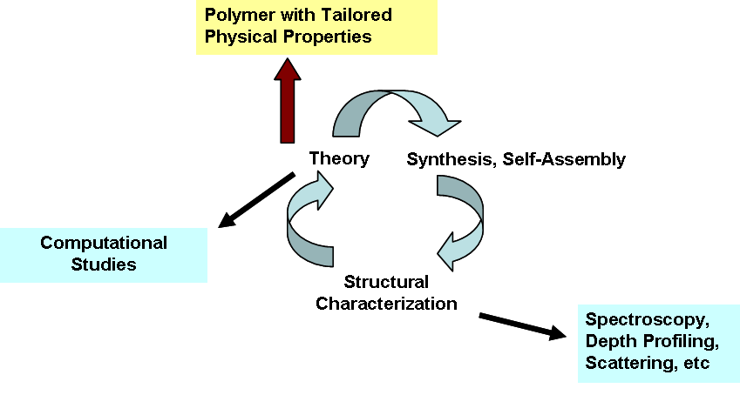

Figure 1.1 The rational design of new polymeric materials with tailored physical properties involves synthesis, structural characterization, and theory.
  - Characterization of Polymeric Surfaces and Interfaces

As structure that defines function and performance approaches the nanoscale, interfaces become increasingly important. As such, one needs techniques capable of measuring both the length and time scales involved in the formation of surfaces and interfaces. The purpose of this section is to highlight some of the techniques available for such studies in polymeric systems utilizing experimental tools that probe a variety of length and time scales as these are related to the structure and dynamics within a material.
The goal of the measurement of polymeric surfaces and interfaces in this body of work will be not only to reveal the equilibrium structure of a material, but also to obtain a fundamental understanding of how the final structure evolves. This involves measurement of the dynamics of the approach to an equilibrium structure. For example, in studies involving measurement of the equilibrium structure as well as examination of the adsorption-desorption process in the selective segregation of a surfactant to a biphasic interface, Balsara et al ^{11, 12, 13} emphasized the fact that in order to properly study surfactant transport to and across an interface, one needs to use experimental methods with resolution smaller than the width of the interface being investigated. Consequently, resolution on the order of the polymer tube diameter is required to effectively monitor surfactant transport to and across an interface in a polymeric material. Thus, in this section, a broad overview of the toolbox of techniques available for the study of structure-property relationships at the surface and interfaces of polymeric materials will be presented, along with a discussion of the advantages and disadvantages of each technique (with a more detailed discussion of the theory and physics underlying each technique included in the Appendix). The techniques for surface and interface characterization of polymeric materials employed in this body of work include contact angle goniometry, ellipsometry, attenuated total reflection infrared (ATR-IR) spectroscopy, atomic force microscopy (AFM), secondary ion mass spectroscopy (SIMS), elastic recoil detection spectroscopy (ERD), and neutron reflectivity (NR).
Contact angle goniometry provides information on the surface tension of a surface. The contact angle of a liquid drop positioned on a surface is measured, and thus, this technique probes the outermost layer of atoms. The contact angle depends on the surface roughness and thus can give information about the degree of coverage of a surface as well as the composition of a surface. This technique is also sensitive to surface contamination. The surface tension is strongly dependent on the strength of bonding in the bulk of a material. For example, hard solids such as metallic, ionic and covalently bonded solids typically have high energy surfaces with surface tension values ~500-5000 mJ/m², which is in contrast to weakly bonded molecular solids (such as polymers) and liquids which have low energy surfaces with surface tension values < 100 mJ/m². ^{5,6,14} In polymeric materials, interactions between chains are dominated by van der Waals forces and hydrogen bonds. Nevertheless, although contact angle goniometry offers information about the energy of a surface, it is not a direct method of obtaining molecular information.
Ellipsometry measures the change in the polarization of light reflected from a surface. This information can be used to provide the thickness and index of refraction of a thin film on a reflecting substrate. The depth resolution is typically about 1 nm, depending on the optical contrast present in the components of the film as well as the substrate.^{5, 15} Information on the roughness in the plane of the surface can also be obtained. In addition, some ellipsometers are equipped to scan large areas to give information on thickness and refractive index variations over the plane of the surface. Furthermore, in-situ elliposometry allows the environmental conditions to be varied during a measurement so that, for example, information on the adsorption kinetics of molecules from solution onto a substrate can be obtained using a liquid cell. Limitations of the technique include a lack of sufficient optical contrast in multilayer samples. This can lead to ambiguities in data interpretation.
For surface and thin film investigations, infrared reflectance spectroscopy provides a quantitative determination of the chemical composition of a surface, which is accomplished by monitoring the vibrational modes of molecules at an interface.⁵ Thus, the presence of different materials can be distinguished by their IR spectra. Two modes for IR reflectance measurements are internal and external (specular) reflectance. ATR-IR (attenuated total reflection infrared) spectroscopy is an internal reflectance technique that is useful for materials that are opaque or non-reflective. In ATR-IR, multiple reflections from a smooth crystal are applied at the interface between a crystal and the sample surface, and the interface between the crystal and the sample surface is investigated. At the interface, a small portion of the IR beam penetrates into the sample. The part of the wave that penetrates the sample is called an evanescent wave, whose penetration depth is of the order of the wavelength of radiation used. Thus, a depth of several micrometers can typically be probed using this technique. In specular reflectance mode, an IR spectrum can be collected for a sample on a reflective surface. A challenge associated with reflectance measurements (both internal and external) is anomalous dispersion of the refractive index. That is, variation of the refractive index with wavelength introduces a band shift to lower frequencies as the angle of incidence approaches the critical angle (the angle of incidence above which total internal reflection occurs). These dispersion effects also influence intensity differences between transmission and reflectance measurements, and thus reflectance spectra may follow the dispersion of the refractive index.¹⁶
Atomic force microscopy (AFM) provides information on surface topology. Using AFM, single polymer molecules adsorbed on a smooth solid substrate have been resolved.⁵ The probe is a sharp tip called a cantilever with a diameter of typically less than 50 nm. As the cantilever is scanned across a sample surface, it is placed close enough to the surface such that it can interact with the force fields associated with the surface. Using AFM, a surface can also be imaged with respect to its hardness, roughness, adhesion, friction, conductivity, charge, or magnetism. In addition, the tip can serve as a nano-manipulation tool as it has been used to position atoms and molecules on a surface.⁵ A limitation of AFM is known as the profile-broadening effect due to the tip-sample convolution. That is, the topology of the surface outlined by a cantilever probe is really a convolution of the shape of the tip and the shape of the sample. This results in a broadened profile of the surface if the tip radius is on the order of the radius of a feature in the sample being imaged. Ideally, the tip needs to have a radius much smaller than the feature of a sample being imaged to avoid profile broadening.
Secondary Ion Mass Spectrometry (SIMS) is a tool that is used to characterize the chemical composition of surfaces and interfaces at high resolution. SIMS elemental detection limits are in the ppm to sub-ppb range.¹⁵ In a SIMS experiment, an ion beam bombards a surface and produces ionized characteristic fragments of the surface called secondary ions that are subsequently analyzed in a mass spectrometer. Identification of these fragments by mass spectrometry detection allows for characterization of the depth profile of the material. In the static SIMS mode, surface composition is investigated by removing only a monolayer from the sample surface. Depth profiles of a material can also be obtained using the dynamic mode (Dynamic Secondary Ion Mass Spectrometry or DSIMS). In the dynamic mode, the material is continuously sputtered away with primary ions having energies between 1 and 20 keV. The result is transfer of energy and momentum from the ions to the atoms in the surface via direct or indirect collisions. As a consequence, neutral and charged particles are ejected. Interfaces between layers of a material may be investigated, and depth resolution can be as small as 12 nm, depending on the sputter rate.¹⁵ An important consideration in such experiments is the limitation in depth resolution. The depth resolution of a DSIMS analysis is affected by the flatness of the area sputtered with ions. The sputtered region is referred to as a crater. The bottom of a sputtered crater becomes progressively rougher as the crater deepens, resulting in a continual degradation of depth resolution.
Another technique that utilizes ions as a probe for interface analysis is elastic recoil detection (ERD). ERD is used for the specific detection of hydrogen isotopes (both protons and deuterium) in surface layers of thickness up to ~1 µm. With this technique, the concentration profile for each species as a function of depth can be determined. In an ERD experiment, ions such as ⁴He⁺ with energies of 1-2 MeV undergo elastic nucleus-nucleus collisions with the hydrogen and deuterium nuclei of a sample, producing ¹H⁺ and ²H⁺ ions. The mass of the scattering nucleus and the depth of penetration of the ion into the sample before the scattering collision occurred can be determined when the energy and scattering angle of the incident ion is known. These ¹H⁺ and ²H⁺ ions are scattered in the forward direction along with the ⁴He⁺ ions. A stopping foil is placed in front of the detectors to reduce the kinetic energy of the forward scattered ions. The energy loss for the heavier ⁴He nuclei is greater than that for the lighter H and D target nuclei when passing through the Mylar foil, thus making it possible to distinguish between the incident projectile and recoiling ions. The depth probed is typically on the order of 1µm and the depth resolution varies with depth. For example, at a depth of 1000 Å in Si, the resolution is between 300 and 600 Å.¹⁵ An advantage of this technique is that the energy spectrum of the recoiling ¹H⁺ and ²H⁺ ions provides information on the mass of the ion and its depth into the film prior to the collision, which ultimately makes it straightforward to obtain a concentration vs. depth profile. Also, deuterating one of the components can generate contrast in the sample. A disadvantage of the technique is that in some cases, radiation damage to samples can occur.
Neutron reflectivity (NR) is a powerful technique that offers depth resolution on the order of ~1 nm, and as such is a very useful tool for determining the variation in concentration of a material’s components with depth.¹⁵ The scattering cross section, σ, along with the scattering length, b, is a measure of the scattering strength of an atom and is expressed in equation 1.3:
σ = 4πb² (1.3).
Neutron cross-sections for the elements are determined experimentally and only depend on the nucleus of the atom. Moreover, the scattering power of an element varies for different isotopes of each element. The difference in the neutron scattering lengths for the isotopes hydrogen and deuterium is very large. Thus, deuterium labeling offers a convenient manner of creating contrast for neutron reflectivity studies of soft materials. Moreover, one can deuterate a polymer material without substantially affecting the thermodynamics of the system.¹⁷ However, because NR is a scattering technique, the intensity of reflected neutrons is measured while the phase information is lost. The reflectivity measured is the Fourier transform of the concentration profile of the sample. Thus, it is necessary to use other complementary depth profiling techniques that can place constraints on the concentration profiles. A real-space model depth profile has to be transformed into a reflectivity profile in reciprocal space and compared to the actual data collected in the experiment. Nevertheless, using the complementary structural information of samples that are examined with neutron reflectivity, this technique has been used to successfully characterize the depth profile of a broad range of polymeric materials including polymer blends and polymer brushes.^{18, 19, 20, 21, 22, 23}
Table 1.1 contains a summary of the information that can be obtained with each surface sensitive technique discussed thus far, as well as the limitations and depth resolution of each technique.
  - Approaches to Functionalizing Polymeric Material Surfaces

- Traditional Techniques

Traditional methods to modify the surface of a plastic material have included chemical, flame, and plasma treatments. For instance, direct fluorination is a common chemical treatment used to functionalize polymeric surfaces.²⁴ The treatment, which involves a heterogeneous reaction of gaseous fluorine with a polymeric surface, renders the top ~0.01 – 1 µm of the material modified. Similarly, flame and plasma treatments are used to functionalize polymeric surfaces with hydroxyl and carbonyl groups.^{5, 25} These treatments oxidize polymeric surfaces, thus creating a surface with a higher surface energy. Using high temperature and a lean gas-to-air ratio, flame treatments produce reactive oxygen via an ionized air stream, which alters the surface as it impinges upon it. Plasma processing, in addition to functionalization of surfaces, can also clean a surface by removing its outer molecular layer. Moreover, it can also result in the etching of a new topology on a surface. The plasma used in such processes is often composed of ionized gas (eg., oxygen). Plasma treatments of polymer materials are the most widely used industrial techniques for surface modification.
Nevertheless, chemical, flame and plasma treatments all lack control of the surface modification process at the nanoscale. Control of surface modification at the nanoscale offers a more competitive surface modification technique for industrial applications as it has the potential
to overcome obstacles including lack of uniformity, reproducibility, and robustness associated with traditional surface processing techniques. In the following sections, two alternatives to
Table 1.1 Surface sensitive techniques for structure-property investigations of polymeric systems, including the information that can be obtained, the limitations and depth resolution of each technique.
Technique | Information Obtained | Limitations | Depth Limit and/or Resolution
Contact Angle Goniometry | Roughness and surface energy | No direct molecular information | None; Surface information only
Ellipsometry | Refractive index and thickness | Need sufficient optical contrast | Resolution ~ 1 nm depending on optical contrast
ATR-IR | Identification of molecules at an interface | Anomalous dispersion of refractive index | Depth on order of wavelength (several µm)
AFM | Surface topography | Tip-sample convolution/ broadened profiles | Surface information; Resolution depends on tip and sample
SIMS/DSIMS | Chemical composition/ Depth profiles | Resolution degrades with depth | Depth limit ~ 100 µm/depends on sputter rate and data collection time; Resolution ~ 10 nm
ERD | Depth profile | Detects ¹H or ²H | Depth ~ 1µm; Resolution ~ 30-60 nm
NR | Depth profile | Phase information lost; requires a model | Depth on the order of mm; resolution ~ 1 nm

traditional surface modification techniques are presented. Both fabrication of polymer brushes on a surface and surface segregation of a surface-active additive in a homopolymer matrix offer the possibility of nanoscale control of the surface modification process of polymeric materials.
- Polymer Brushes

A polymer brush is a self-assembled densely packed monolayer of polymers end-tethered to a surface. The two methods for tethering a polymer chain to a surface are grafting-to and grafting-from.^{26, 27, 5, 28, 29, 30, 31,} In the grafting-to approach, one end of an end-functionalized polymer adsorbs to or covalently attaches to a surface. Steric hindrance can play a significant role in this surface modification process. When a chain approaches a surface that already has chains grafted to it, the probability of a chain adsorbing or attaching to the surface is greatly reduced, and the final grafting density, as a result, can be quite low. One way to circumvent this problem is to spin coat a solution of the polymer onto the surface and then thermally anneal above the glass transition temperature of the polymer.³² In the grafting-from approach, an immobilized initiator is attached to a surface, which allows the polymerization of monomers from these active sites. In Figure 1.2, the grafting-to and grafting-from methods for creating a polymer brush surface are illustrated. As the grafting density of a polymer increases, the chains stretch away from the surface in order to avoid unfavorable overlap of polymer chains. Thus, at high grafting densities, the monolayer is referred to as a brush. The free energy of formation of a polymer brush involves both the interaction energy resulting from monomer-monomer interactions, called F_{int}, as well as the elastic free energy, F_{el}, that depends on the difference in energy between stretched and unstretched chains. The height of an equilibrium brush, h, (i.e., when F_{int} and F_{el} are minimized for a system) can be estimated for a brush in good or poor solvents according to equations 1.4 and 1.5, respectively:³³
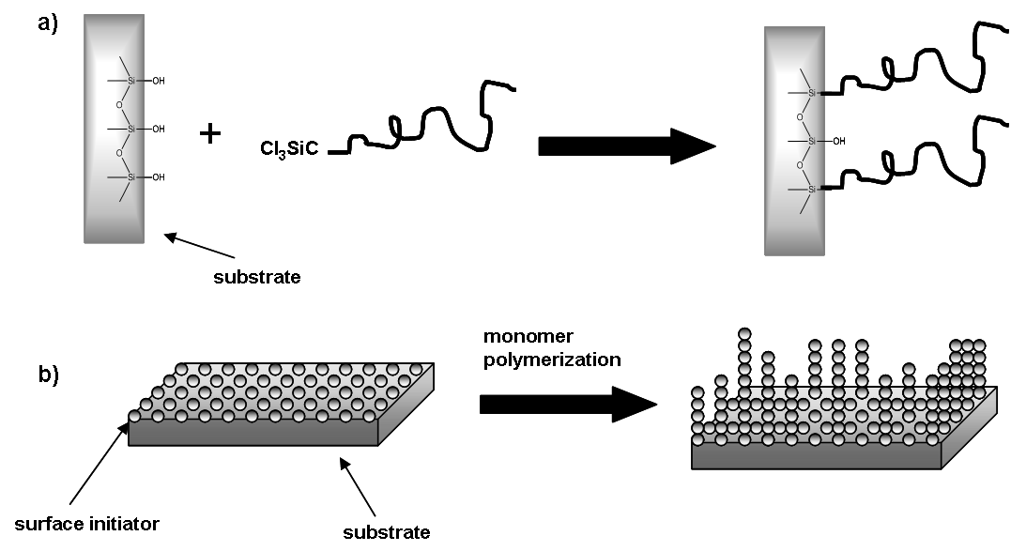

Figure 1.2 The grafting-to (a) and grafting-from (b) methods to create a polymer brush.

h ~ N x σ^{1/3} (good solvent) (1.4)
h ~ N x σ^{1/2} (poor solvent) (1.5)
where N is the degree of polymerization and σ is the grafting density. The brush height scales linearly with N, the degree of polymerization, while the grafting density, σ, scales with an exponent that depends on whether the brush is in a good solvent (where swelling of the brush layer is promoted) or a poor solvent (where the brush collapses). The controlled growth of polymer chains is best accomplished through living (or controlled) polymerization. Scheme 1-1 illustrates conventional free radical polymerization with initiation, propagation, and termination steps. When using conventional free radical polymerization to functionalize surfaces, the molecular weight and polydispersity is difficult to control due to the high concentration of active radicals and growing chains in the confined interfacial region.^{27, 5} Such conditions cause cross-linking reactions as well as chain termination. Another problem that can result is heterogeneous grafting, which occurs when chains that are already grafted, as well as free chains, undergo chain transfer. Chain transfer causes free chains to react with grafted chains instead of the surface. When this occurs, the length of chains grafted to a surface can vary in an unpredictable manner.
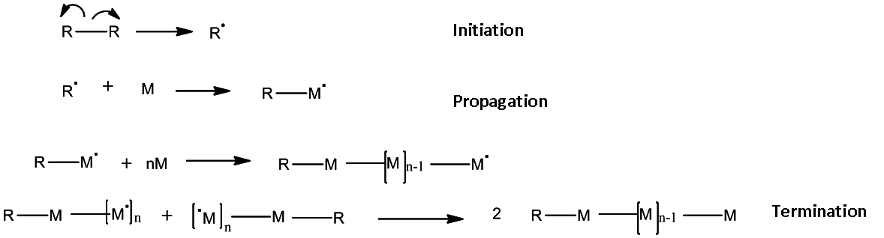

Scheme 1-1 Initiation, propagation and termination steps in conventional free radical polymerization.

Living or controlled polymerization,²⁹ on the other hand, proceeds with limited or no chain termination or chain transfer. The result is predictable molecular weights and narrow polydispersities. Furthermore, brush chain length is proportional to the polymer molecular weight. Thus, living polymerization provides more control of the brush thickness and grafting density than conventional radical polymerization.
Surface-initiated Atom Transfer Radical Polymerization (ATRP) is a controlled radical polymerization that has been successfully used to create high density polymer brushes in a grafting-from approach,^{27, 34, 35, 36, 37} including in the synthesis of surface functionalized materials investigated in Chapter 5. Surface-initiated ATRP involves the transfer of a halogen atom from a surface-bound initiator to a free monomer (Scheme 1-2). As illustrated in Scheme 1-2, a carbon-halogen bond in an organic halide, R-Cl, which serves as an initiator, is cleaved heterolytically by abstraction from a transition metal complex, Cu^{I}L_{x}, which serves as a catalyst and controls chain propagation. Cu^{I} is bound to a ligand, L_{x}, which helps solubilize the metal in the organic solvent. The reaction between the organic halide and the transition metal complex generates a
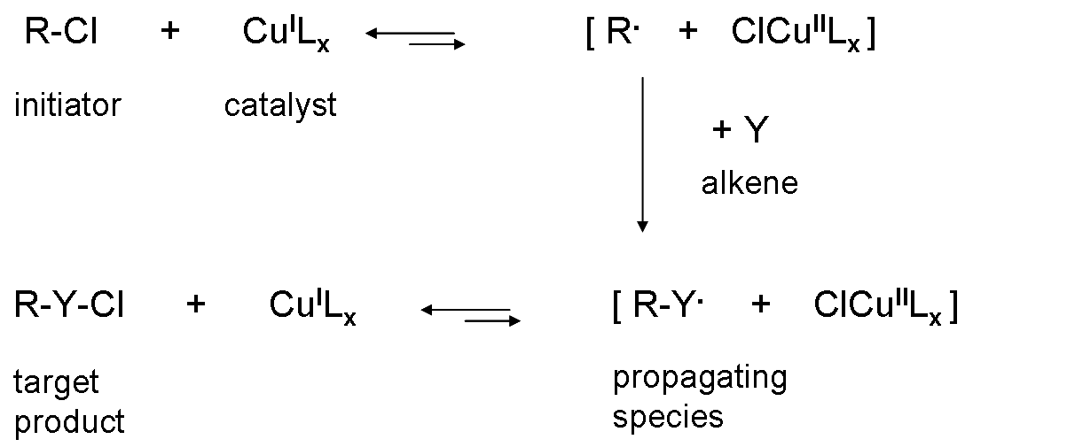

Scheme 1-2 An illustration of Atom Transfer Radical Polymerization (ATRP) using Cu^{I}L_{x} as the transition metal complex.

carbon centered radical, R., as well as the oxidized species, ClCu^{II}L_{x}. The next step involves radical addition of R. to an alkene, Y, to form the intermediate radical species R-Y.. The reaction between the transition metal complex, ClCu^{II}L_{x}, and R-Y., generates the target product, R-Y-Cl. Furthermore, the reduced transition metal species, Cu^{I}L_{x}, is regenerated, and this can be used to promote another redox reaction. Bimolecular termination between the alkyl radicals is suppressed by a fast reaction between the intermediate radical species, RY., and the transition metal complex, ClCu^{II}L_{x}. Thus, the concentration of radicals in solution is low. Furthermore, it is possible using ATRP to obtain a narrow molecular weight distribution if the rate of reversible conversion of the living polymer chain, R-Y., to the species with the halogen group, R-Y-Cl, occurs at about the same rate as the rate of propagation.
Another type of commonly employed living/controlled polymerization method is anionic polymerization^{38, 33} (Scheme 1-3), which can be used to create the end-functionalized polymers needed in a grafting-to approach. Anionic polymerization was used to create poly(paraphenylene) surfaces in Chapter 6 of this body of work. Anionic polymerization is sensitive to impurities, and as such requires high vacuum techniques or inert atmospheres. This polymerization also affords control of chain length and molecular weight distribution, as well as chain end functionality. The polymerization involves the three main steps of initiation,
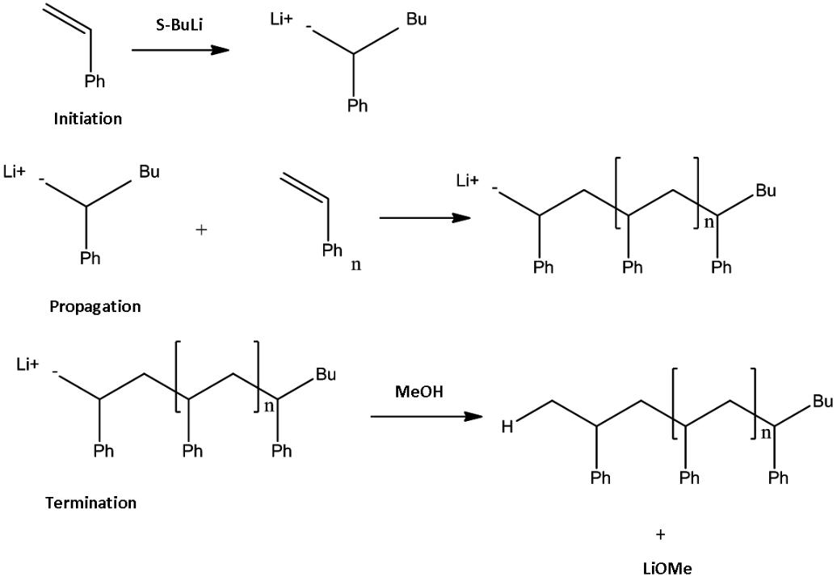

Scheme 1-3 An illustration of the anionic polymerization of poly(styrene).

propagation and termination as illustrated in Scheme 1-3. The initiator commonly used for anionic synthesis is an alkyl lithium compound such as sec-butyl lithium. Propagation proceeds with reaction of the carbanionic species with a vinyl monomer, such as styrene, to produce a polymer chain with a living end. Termination can be achieved with an alcohol such as methanol.
- Surface Segregation in a Binary Blend

Many useful materials made from polymers are blends of more than one polymer. The study of blend surfaces monitors the impact of the presence of a surface on the blend phase structure. The thermodynamic treatment of the bulk phase of polymer blends is described by the Flory-Huggins theory, which analytically accounts for the enthalpic and entropic contributions to the free energy of mixing in terms of the molecular characteristics of the components of the polymer blend system. The free energy of mixing can either be negative, which promotes mixing, or positive, which opposes mixing. According to the Flory-Huggins theory, the free energy of mixing, ΔF_{mix}, is given by equation 1.6:³⁹
(1.6)
where φ is the volume fraction of one of the components, k is Boltzmann’s constant, T is the temperature, N_{A} and N_{B} are the degree of polymerization of polymers A and B in a blend, respectively, and χ is the Flory-Huggins interaction parameter that, ideally, describes the enthalpic interaction between polymer segments. The first two terms in the free energy of mixing are related to the entropic contribution to mixing. Increasing the value of these entropic terms promotes mixing. However, as the molecular weight of the chains increases, the entropy of mixing becomes rather small. Conversely, the enthalpy of mixing, represented by the third term in equation 1.6, is controlled by the Flory-Huggins interaction parameter, χ, and not by polymer molecular weight. The enthalpic contribution depends on the compatibility of the polymers in the blend and can have either a positive or negative value. Most polymers have unfavorable interactions, which results in a large value of χ. A large positive value of χ will result in a positive value for the free energy of mixing. A positive free energy of mixing value will lead to macrophase separation in the polymer blend.
Surface enrichment, however, will result in further de-mixing of blend components and as a result there is a loss of combinatorial entropy. Moreover, there can be a loss of mixing enthalpy in the case of blends where interactions are favorable. Overall, it is the balance of the surface free energy and the free energy of mixing in the bulk that ultimately governs surface segregation behavior for polymer blends.
Surface segregation is a phenomenon that is generally observed in mixtures of all material classes. Typically, enthalpic factors dominate, and the lower surface energy component of a multicomponent material enriches the surface. However, for polymer melts, entropic factors can dominate the surface segregation process in the absence of strong energetic interactions. A configurational entropic penalty exists for a polymer chain when it comes to a surface due to the reduced number of configurations available to it. One way to reduce this entropic penalty is to enrich the surface with the component that contains more chain ends, as these chain ends experience a lower entropic penalty. It has been demonstrated theoretically and experimentally that chain ends preferentially segregate to the surface in a polymer blend (in the absence of strong energetic interactions) to minimize this entropic penalty.^{39,40,45} Moreover, this entropic driving force can be used to preferentially segregate branched polymers from a blend with a linear polymer.⁴⁰ Previous studies on binary blends of branched and linear polymer melts have demonstrated that the chain ends of branched polymers lower the surface energy by preferentially segregating to the surface.^{40,41} Moreover, when the ends of branched polymers are functionalized with a hydrophilic group, for example, the surface can be preferentially enriched with the higher energy component of the blend (i.e., the branched component, in this example).⁴⁵ Commercial applications for high energy hydrophilic surfaces formed from entropy-driven selective surface segregation in a polymer blend, for example, include improving resistance to protein adsorption in biomedical and marine applications, as well as reducing static charge buildup in textile and microelectronic applications of plastics.⁴² Furthermore, unlike polymeric surfaces modified with small molecules that can easily be removed by evaporation and wear, these surface segregated blend surfaces are more thermodynamically stable and physically robust because the branched polymer additive is anchored via entanglements into the linear polymer matrix. An additional benefit is that the resulting surfaces are self-healing as more branched functionalized additive can be driven to the surface by annealing with heat or solvent. Figure 1.3 illustrates the surface segregation of a component from a polymer blend.
Nevertheless, in order to realize the application of these self-healing polymeric material surfaces, it is necessary to understand how the molecular architecture of a branched additive in a linear matrix affects the thermodynamics and kinetics of the surface segregation process. The kinetics of the surface segregation process defines the timescale over which equilibrium is achieved, which is crucial in potential applications, and is certainly affected by the size and shape of polymeric branched additives. Insight into the structure-property relationships involved in such materials is expected to serve as valuable input in the rational design of such self-healing polymer materials.
  - Model Systems Investigated in this Study

- The Time Evolution of the Surface Segregation of Branched Polymers in a Linear Matrix

The primary aim of this study is to understand the thermodynamics as well as the dynamics involved in the surface segregation of branched polymers blended in a linear homopolymer matrix. Neutron reflectivity was employed to reveal the evolving density profiles of these self-healing materials composed of protonated branched polymers in a deuterated linear matrix. The films were thermally annealed in a sequence of steps to follow the slow approach of the branched additive’s segregation to the air and substrate interfaces. By monitoring the time evolution of the surface and substrate excess of the branched polymer, several snapshots of the dynamic process of this entropically driven surface segregation were obtained. In order to systematically determine how branch length and branch density affected the dynamic properties of the surface segregation process, both hyperbranched and comb polymer architectures were investigated. In each case, the branched additive loading was low (10 w/w %) to ensure that
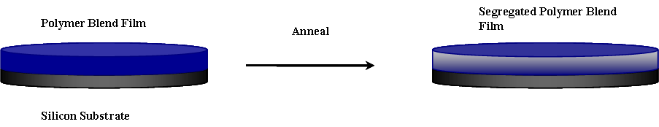

Figure 1.3 Surface segregation of a component from a polymer blend after annealing.

interactions between the polymeric additive’s segments were minimized. The matrix was always a linear deuterated high molecular weight homopolymer with a chemical composition similar to that of the additive.
The first systems examined were hyperbranched polystyrene (PS) HyperMacs and DendriMacs ^{43, 44} synthesized at Durham University in Durham, England, in Dr. Lian Hutching’s research lab, and were blended at 10 w/w % loading with deuterated linear high molecular weight PS. The HyperMacs investigated were synthesized using PS AB₂ macromonomer building blocks in a one-pot reaction via a Williamson Ether synthesis that resulted in a well-defined, narrow molar mass distribution of the chains between branch points, but an overall wide molecular weight distribution for the branched polymer (PDI = 2-5). DendriMacs, as the name suggests, have a structure more like dendrimers. Nevertheless, they are also made in a similar one-pot synthesis, and although coupling is not perfect, as in a dendrimer, they have a more well-defined structure than HyperMacs. Films were spin coated from a 2 w/w % polymer solution in toluene onto silicon wafers. The depth profiles of the films were characterized with neutron reflectivity, and the amount of branched polymer that segregated to both buried and exposed interfaces was monitored as a function of annealing time at 150°C under vacuum. Neutron reflectivity profiles were measured for as-cast films as well as at intervals up to a maximum of 33 days. Thus, information regarding the steady-state structure as well as the dynamic evolution of the depth profile in these model systems was obtained.
Another model system examined was poly(methyl methacrylate)-random-poly(ethylene glycol) methacrylate (P(MMA-r-PEGMA) blended with deuterated linear poly(methyl methacrylate) (d-PMMA). The backbone of the copolymer was composed of PMMA while the branches were made up of PEO chains. A macromonomer synthetic approach, completed at the Center for Nanophase Materials Science (CNMS) at Oak Ridge National Laboratory (ORNL), resulted in well-defined comb copolymers. As with the HyperMacs, the branched component in the blends was 10 w/w %. Each PEO branch contained about 20 ethylene oxide units. The density of PEO branches was varied by varying the mole percent of PEGMA macromonomer in the copolymer from 1.3% to 2.4% to 8.5 %. This corresponds to a w/w % PEGMA of 10%, 25%, and 50%, respectively. Neutron reflectivity was used to elucidate the depth profile of the blend film and its evolution with time. Previous research has demonstrated that similar comb copolymer additives preferentially segregate to the surface in a deuterated linear PMMA matrix due to an entropic driving force.⁴⁵ However, in that study, only the equilibrium structures of these binary polymer blend films were investigated with neutron reflectivity. Thus, the current study seeks to discover the time evolution of the surface segregation of these potentially self-healing model systems.
Preceding the results and discussion of the surface segregation studies covered in Chapters 3 and 4 of this body of work is a discussion in Chapter 2 of the theoretical basis for understanding and analyzing the observed dynamic and thermodynamic surface segregation behavior in these model blend systems. This discussion is based on a model proposed by Kramer and Jones for the formation of a wetting layer in a polymer blend that invokes a depletion layer in the film during segregation. Moreover, Chapter 2 includes a brief review of the results of previously reported relevant studies of the transport of polymeric interfacial modifiers to and across interfaces in polymer melts.

B. Tuning Surface Properties of Polymeric Materials Using Grafting-To and Grafting-From Approaches

The other methods employed to achieve control of macromolecular surfaces and interfaces focus on grafting-to and grafting-from polymeric brushes at a surface. In a grafting-from approach, d-PS is grown from a functionalized soft, 3-dimensional matrix. There are many reported examples of polymers grown from a solid 2-dimensional substrate, such as Si.^{27, 6} However, in this particular study, covered in Chapter 5, the functionalized surface is a photopolymer cross-linked network that has inimers embedded throughout the matrix. Inimers are compounds that contain both initiator and monomer functionality. A mixture of diacrylates and triacrylates, along with the inimer, are photopolymerized with UV light to create the cross-linked photopolymer network. The growth of deuterated styrene polymer chains from the embedded inimers is accomplished via ATRP. The objective of the study was to determine not only the composition depth profile of the material, but also to discover at what depth the initiation of polymerization took place, as it could be primarily at the surface or within the film, depending on the reaction conditions. Consequently, the percent initiator, as well as the amount of deuterated styrene monomer, was varied systematically so that reaction conditions could be correlated with the depth profiles of these novel films. These materials were first developed and fabricated in Dr. Ken Carter’s research group at the University of Massachusetts. Previous work on patterned films of similar inimer-embedded 3-dimensional interfaces in Dr. Carter’s research group at the University of Massachusetts resulted in a method for tuning feature sizes in a polymeric material down to 60 nm using combined traditional microfabrication techniques (top-down approach) with directed self-assembly of single polymer molecules (bottom-up approach).⁴⁶ The study of unpatterned films in the present body of work using NR and DSIMS provides fundamental information for the application of these materials in next generation devices such as molecular-scale electronics and magnetic storage.
In the final study of this dissertation, well-defined poly(cyclohexadiene) (PCHD) end-functionalized polymers with narrow molecular weight distribution are examined as reactants to form thin films by solution grafting onto Si and quartz substrates. The resulting end-tethered PCHD brushes were aromatized in-situ. The goal was to create conjugated poly(paraphenylene) (PPP) brushes on a substrate, as PPP is inherently difficult to process because of its increasing insolubility as the molecular weight increases. By using this in-situ aromatization method, the difficulties encountered with PPP processability in solution can be avoided. Conjugated PPP has many potentially useful physical properties including high thermal stability as well as conductivity when it is doped.^{47, 48} Thus, one possible application of high molecular weight PPP films is in fuel cells for energy conversion. Characterization of PCHD films before and after aromatization as well as the discovery of experimental conditions needed to tether PCHD to a substrate from solution was aided by a variety of surface sensitive techniques. The techniques included AFM, ATR-IR, Raman spectroscopy, and ellipsometry. The end-functionalized PCHD was synthesized at CNMS at ORNL in Oak Ridge, TN, while the solution grafting of these polymers to Si and quartz substrates was accomplished in collaboration with Dr. Jimmy Mays’ research group at the University of Tennessee using anionic polymerization. Results of the structure-property studies on PCHD and PPP end-tethered surfaces are reported in Chapter 6.

Understanding the Thermodynamics and Dynamics of the Time Evolution of the Surface Segregation of Branched Polymeric Additives from a Linear Polymer Matrix

  - Overview

The purpose of studying the time evolution of the surface segregation of branched polymeric additives from a linear polymer matrix is to design self-healing materials with tailored surface properties that include biocompatibility, microbial resistance, flame resistance, and adhesion. The matrix, which makes up the bulk of the material, is chosen to have the required material strength for a specific application. The other component of these self-healing materials is chosen to have a desired surface-sensitive property and is also able to selectively segregate to the material surface. Ordinarily, the surface composition of a blend will be enriched with the lower surface energy component. However, it is possible for entropic factors to dominate the surface segregation process (in the absence of strong energetic interactions) such that the higher energy component enriches the surface of the blend. Both experimental^{45,49,50,51} and theoretical investigations,^{49,52,53} have revealed that chain ends will preferentially segregate to the surface of a blend to minimize the number of times a polymer coil has to cross the interface. Thus, entropically driven segregation is possible for blends of branched and linear polymers. Unlike in traditional methods of surface modification where the surface can be worn away, the surface of these self-healing materials is renewable, as there is more of the surface segregating component available in the bulk of the material. Thermal or solvent annealing can be used to drive the surface segregating component from the bulk to the surface.
Nevertheless, for these self-healing materials to be commercially viable, it is necessary to understand how the structure of polymeric additives in a linear matrix affects the thermodynamics and dynamics of the surface segregation process. In order to achieve predictable control over the physical properties of a material surface that has been tailored for a specific application, a theoretical understanding of the process is crucial. Such a theory is also required for proper interpretation of experimental results aimed at illuminating structure-property relationships. Ideally, a theory that encapsulates the fundamental knowledge concerning the physics of these systems will serve as essential input to enable the rational design of these materials. As discussed in Chapter 1, one approach toward achievement of these objectives is to investigate model systems. Chapters 3 and 4 present the results of experimental studies that monitor the time evolution of the surface segregation of hyperbranched polymers and comb copolymers, respectively, from a linear matrix. These binary branched/linear polymer blends are model systems designed to facilitate an understanding of the impact that molecular architecture has on the thermodynamics and dynamics of the self-healing process. It is also a goal of these studies to determine information that will provide an improved fundamental understanding of the dynamics of surfactant adsorption and desorption, as the specific details of this ubiquitous process remain elusive. Thus, the primary aim of this chapter is to present a framework that will be utilized to interpret and understand the physics of the dynamical interfacial phenomena and local segmental relaxation processes present in these model binary polymer blend systems during the surface segregation process.

2.2 Theories Describing the Dynamics of Linear and Branched Polymers in the Melt

Molecular level theories that describe the dynamics of linear polymers in the melt include the Reptation theory^{54,55} for entangled systems and the Rouse theory^{54,55} for unentangled systems. Moreover, there are modifications to these theories, such as dynamic dilution,⁵⁶ which describes the dynamics of systems containing branched polymers. These theories will be covered in more detail in this section, as they will become important for interpreting and understanding the results of our studies on the dynamics of the surface segregation process in binary branched/linear blends.
Translational motion for a polymer chain in an entangled melt occurs by the relaxation of surrounding topological constraints. Depending on its length, a polymer chain can be constrained in its movement due to entanglements with other surrounding chains. The entanglement length, M_{e}, is the minimum chain length for a polymer in the melt to be entangled. These topological constraints confine polymer chains to a tube-like region according to Doi and Edwards’ tube model for entangled polymers.⁵⁷ de Gennes⁵⁸ proposed that for linear entangled polymer chains, the movement of a polymer chain is by Reptation, which involves motion along the contour of the tube, while movement tangential to the tube direction is restricted by the topological constraints of the tube. The time for a chain to escape its tube of topological constraints, also known as the Reptation time, τ_{rep}, scales as the third power of the molecular weight, M_{w} (τ_{rep} ~ M_{w}³).⁵⁵ Moreover, the Reptation theory predicts that the diffusion coefficient of an entangled linear polymer, D, is inversely proportional to the square of the molecular weight (D ~ M_{w}⁻²).⁵⁹
In contrast, polymers below the entanglement molecular weight move through a melt without topological constraints and can be described by the Rouse model. In the Rouse model, a polymer is described as a chain of beads (i.e., monomers) linked by springs. Movement of the chain occurs via N modes of the chain, where N is the number of monomers. An experimentally identifiable signature of Rouse dynamics is that there is an inverse relationship between the diffusion coefficient of a polymer and the molecular weight (D ~ M_{w}⁻¹).
More complex dynamics are required for polymers that do not have a linear architecture. Branched molecules, depending on their specific structure, can relax by arm retraction, branch point hopping, and hierarchical relaxation.⁵⁵ For example, the branch point of a star polymer prevents Reptation so that the only other option for the center of mass to move is via arm retraction followed by branch point hopping. The time it takes for an arm to relax (retract to its branch point), τ_{arm}, is determined by its molecular weight. Following arm retraction, stars can diffuse by the random motion of the star’s branch point (branch point hopping). The distance that the branch point can move is only of the order of one tube diameter, a. Thus, the diffusion coefficient for an entangled star polymer is inversely proportional to the time it takes for an arm to relax. It has been found experimentally that star shaped polymers diffuse more slowly than linear chains with the same number of monomers.⁵⁵In contrast, entangled linear polymers move a distance on the order of their size, R_{g}, when they relax. H-shaped polymers and comb copolymers undergo translational motion by arm retraction and branch point hopping at short times, followed by Reptation of the backbone at long times.⁵⁵ The diffusion coefficient for H-shaped polymers and comb copolymers is inversely proportional to the time it takes for the backbone to relax, τ_{rep bb}. H-shaped polymers and comb copolymers move a distance on the order of the mean-square size of the backbone, N_{bb}b² (where N_{bb} is the number of monomers in the backbone and b is the size of a monomer in the backbone). Table 2.1 contains a summary of how the diffusion coefficient is related to the time for relaxation and the distance the polymer moves (which depends on the polymer architecture).
Translational motion for hyperbranched polymers in the melt was proposed by McLeish^{60,54} and is called hierarchical stress relaxation. According to this model, outer segments relax first (and are therefore assigned higher priority) followed by inner segments. Once a particular branch of a hyperbranched polymer has relaxed, it loses its elastic character and becomes a frictional object. This relaxed frictional object is also described as ‘solvent.’ Figure 2.1 illustrates hierarchical stress relaxation in a hyperbranched polymer. The transition from
Table 2.1 The diffusion coefficients for entangled linear polymers, star polymers, H-polymers, and comb copolymers.

ªEntangled Linear Polymers | ªEntangled Star Polymers | ªEntangled H-Polymers and Combs
D~R_{g}²/τ_{rep} | D ~ a²/τ_{arm} | D ~ N_{bb}b²/τ_{rep bb}

ªRubenstein, M.; Colby, R. H., Polymer Physics. Oxford University Press: 2003.

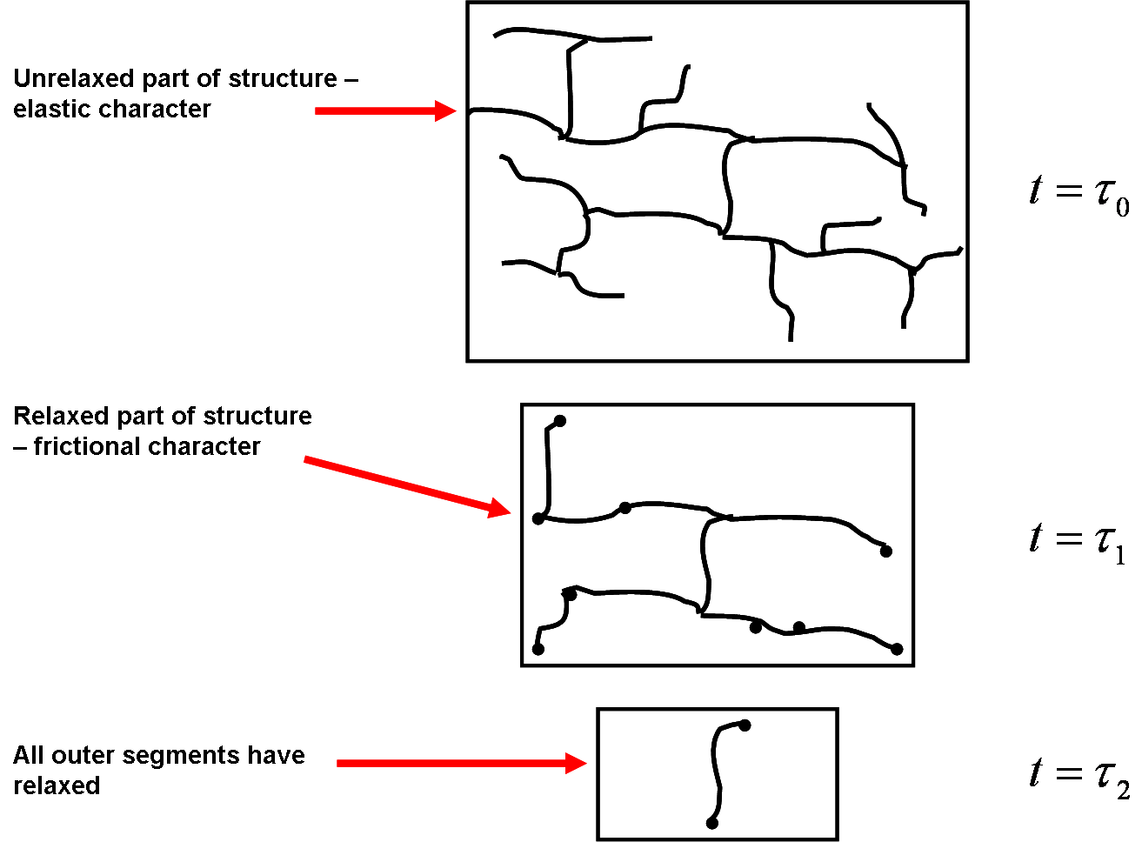

Figure 2.1 An illustration of hierarchical stress relaxation in a hyperbranched polymer which was proposed by Mc Leish.
.

elastic to solvent-like character, as illustrated in Fig. 2.1, is explained by dynamic dilution,⁵⁶ in which a branch, after it relaxes, ceases to impose constraints on surrounding molecules. The time it takes for a branch to relax is proportional to its frictional contribution. Dynamic dilution effectively dilutes the topological network in a polymer melt. The tube diameter enlarges, due to relaxed dangling end material (a process also referred to as tube dilation).
Likewise, constraint release is another phenomenon that supports the notion that topological constraints in a polymer melt are dynamic and not static. Constraint release involves relaxation of the surrounding matrix, and therefore a change in the surrounding tube. Constraint release occurs because the lifetime of the surrounding topological constraints is finite. The width of the tube, on average, remains constant during the constraint release process. Regarding the process of constraint release, deGennes proposed that the rate of constraint release is proportional to the number of chain ends in a melt.⁶¹
Experimental and computational studies on the dynamics of linear entangled polymers reveal stronger molar mass dependences of the diffusion coefficient, relaxation time, and viscosity than predicted by the simple Reptation model. Table 2.2 displays a summary of these experimental and theoretical results. The fact that the simple Reptation model does not accurately represent experimental and computational results for the molar mass dependence of the dynamics of linear entangled polymers has been attributed to tube length fluctuations.⁵⁹ Topological constraints in a polymer melt are dynamic and not static, which is why it is believed that there is a stronger molar mass dependence of the diffusion coefficient on molecular weight found in laboratory experiments (D ~ M^{-2.3}) for example, than predicted by the Reptation model (D ~ M⁻²).⁵⁹ The Evans-Edwards Model for linear entangled polymer melts, which uses Monte
Table 2.2 Experimental and computational results of studies on the dynamics of linear entangled polymers.

ªReptation Model Predictions for Linear Entangled Polymer Melts | ªExperimental Results for Linear Entangled Polymer Melts | ªEvans-Edwards Model Predictions for Linear Entangled Polymer Melts
D ~ M⁻² | D ~ M^{-2.3} | D ~ M^{-2.5±0.1}
τ ~ M³ | τ ~ M^{3.4} | τ ~ M^{3.5±0.1}
η ~ M³ | η ~ M^{3.4} | ____

ªRubenstein, M.; Colby, R. H., Polymer Physics. Oxford University Press: 2003.

Carlo simulations to reproduce the dynamics of an entangled polymer chain in an array of fixed obstacles,⁵⁹ also predicts a stronger molar mass dependence of the diffusion coefficient (D ~ M-2.5±0.1) than predicted by the simple Reptation model.
Theories based on tube dilation and reorganization have also been used to understand and interpret the dynamic behavior of binary blends of branched polymers in a linear matrix. Van Ruymbeke et al ^{62,63} proposed a model to explain the linear viscoelastic behavior of binary blends of symmetric and asymmetric star and linear polymers in the melt. According to their model, the dynamics of complex blends, with a distribution of relaxation times that depends on the polymer architecture as well as on its surroundings, can be understood and predicted by taking into consideration Reptation times, fluctuation times (i.e., relaxation of ‘arms’ or ‘branches’), constraint release time (relaxation of the surrounding matrix), as well as tube dilation. They assert that the solvent fraction (relaxed fraction of polymer) of the branched polymer increases with time, and as a result, the Reptation, fluctuation, and constraint release times also continuously change. The mechanism by which acceleration of a particular relaxation process takes place is via tube dilation. Their model, when tested on a wide range of literature that examined the linear viscoelastic behavior of blends of asymmetric and symmetric stars in a linear matrix, accurately models the data. Work by Vega and Milner⁶⁴on the dynamic behavior of binary comb/linear blends and binary low density poly(ethylene) (LDPE)/linear blends showed that after an applied strain, the topological network relaxes by dynamic dilution, which effectively ‘prunes’ these branched additives down to only a very weakly entangled ‘solution’ of linear chains. Similarly, in a recent study by Ruocco et al⁶⁵, in which they conducted a combined rheology and small angle neutron scattering (SANS) experiment to investigate the dynamics of dendritically branched polymers in a linear homopolymer matrix, they observed that both Reptation as well as dynamic dilution took place following an applied strain. Moreover, they observed Reptation at early times and dynamic dilution after long times.
Thus, in the chapters that follow, analysis of the surface segregation behavior of branched additives in a linear matrix will include discussions on whether the model branched/linear systems exhibit Reptation dynamics, Rouse dynamics, or more complex dynamics, such as have been discussed here. These results will provide necessary fundamental information on the dynamics of branched polymer chains in linear matrices, which will benefit the design of self-healing materials with tailored surface properties for specific commercial applications.
  - Surface Segregation in Binary Polymer Blends

A. The Kramer-Jones Depletion Layer Model: A Method to Extract the Mutual Diffusion Coefficient of a Surface Segregating Binary Blend

The depletion layer model, proposed by Kramer and Jones,¹⁷ has been used successfully in previous studies, to understand selective surface segregation in binary blends of linear polymers.^{66,18,67} According to this model, formation of the equilibrium surface profile is governed by a competition between the free energy gain associated with segregation of the lower energy component, and the free energy penalty that accompanies having and sustaining a region that is a different composition than the bulk. Furthermore, in this model, it is assumed that there is a local equilibrium between the wetting layer at the surface and the layer just beneath it, which is depleted in the surface segregating component. The diffusion rate is characterized by a mutual diffusion coefficient, D_{m}, and involves the coordinated movement of one component toward the surface and the other component away from the surface. The growth of the wetting layer is diffusion limited, and its size is on the order of the radius of gyration, R_{g}, of the segregating component. The Kramer-Jones model is well suited to study surface segregation in binary polymer blends with depth profiling techniques such as ion beam analysis and neutron reflectivity, as selectively deuterating a component of the binary blend makes it possible to follow the transport of one of the components through the matrix. Figure 2.2 illustrates the specific details of the depletion layer model for a binary blend in which one of the components preferentially segregates to the surface of the blend.
Ideally, at a time τ₀, prior to annealing, the blend is reasonably homogeneous and there is no depletion or surface excess layer. Once the blend film is annealed, at time τ₁, the film segregates into three distinct regions. Closest to the surface of the blend is a surface excess layer containing the lower surface energy component of the blend. Immediately beneath this surface excess is a depletion layer which has been depleted of the lower surface energy component as a result of the immediate surface segregation. The depletion layer is followed by the underlying bulk polymer matrix. There is a concentration gradient between the surface excess layer and the depletion layer, as well as between the depletion layer and the bulk polymer matrix, which serves
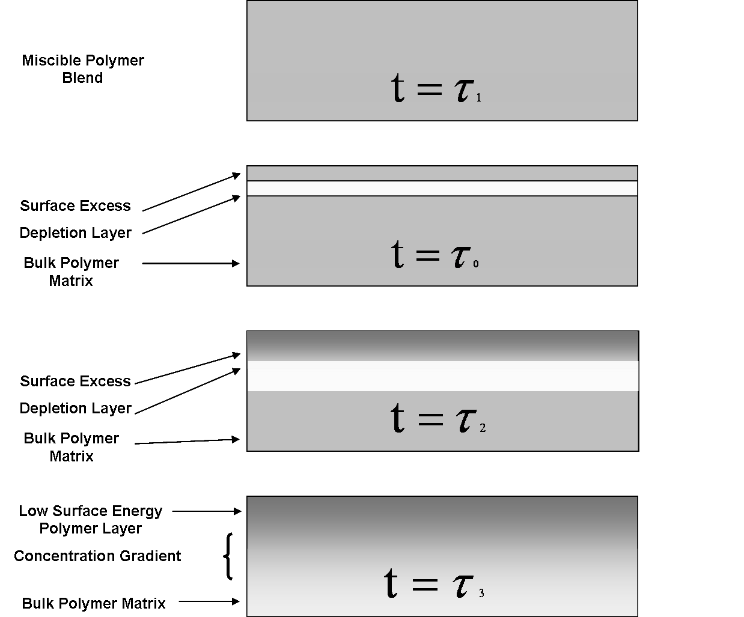

Figure 2.2 An illustration of the depletion layer model proposed by Kramer and Jones to describe the formation of a wetting layer in a binary miscible polymer blend.

as a driving force for further diffusion of the surface segregating component from the bulk to the depletion layer. At a later time τ₂, there is less of the surface segregating additive in the bulk polymer matrix, and the surface excess layer contains a higher concentration of the additive relative to the initial concentration. Also, as the depletion layer increases in size, the size of the surface segregated layer also increases, since it must maintain equilibrium with the depletion layer. At time τ₃, the sharp concentration gradient has relaxed by the inter-diffusion of the lower surface energy component to the surface. Moreover, the surface segregating layer and depletion layer cease to increase in size because the system is at equilibrium.
The rate of growth of the wetting layer is controlled by the mutual diffusion coefficient of the system and is limited by the diffusion of the surface segregating additive to the surface. Thus, the depletion layer model predicts t^{1/2} diffusion kinetics, in which the growth of the wetting layer saturates after sufficient annealing time. Equation 2.1 displays the relationship between the mutual diffusion coefficient, D_{m}, the amount that has diffused to the surface (wetting layer) after equilibrium, Z_{eq}* (also referred to as the surface excess), the time it takes to reach equilibrium, t_{eq}, and the amount of surface segregating material remaining in the bulk at equilibrium, Φ_{b}.
(2.1)
Using depth profile techniques like ion beam analysis and neutron reflectivity, the amount of surface segregating material present at the surface, in the bulk, and near the substrate can be monitored. Figure 2.3 illustrates a representative volume fraction profile of a surface segregating binary blend film after it has reached equilibrium.
In the systems investigated in this study (i.e., binary blends of linear and branched polymers), the blend surface is not predicted to be enriched with the lower surface energy component of the blend, but rather, the branched additive, since chain ends are predicted to preferentially enrich the surface of a binary branched/linear blend in the absence of strong energetic interactions. This is what has been referred to as entropically-driven surface segregation.⁴⁵ In the chapters that follow, the Kramer-Jones model will be used to investigate the entropically-driven surface segregation of branched polymeric additives in a linear polymer matrix.

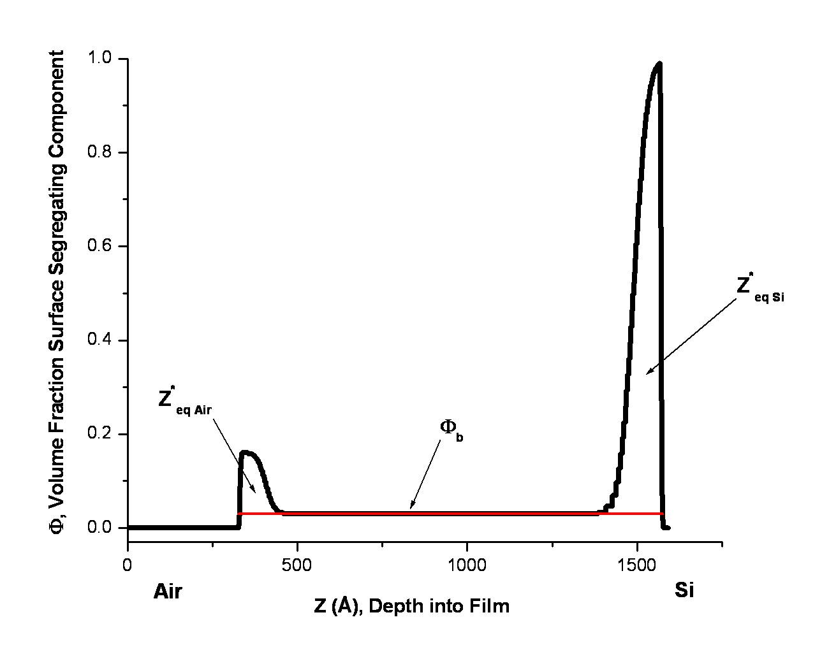

Figure 2.3 Example of a volume fraction profile of a surface segregating binary blend film after it has reached equilibrium.

B. The Fast and Slow Mode Theories: A Method to Extract the Tracer Diffusion Coefficient of a Surface Segregating Component in a Binary Blend

As described in the last section, the Kramer-Jones theory is used to extract the mutual diffusion coefficient of a surface segregating binary blend which is obtained from depth profiling experiments such as neutron reflectivity. Likewise, the Fast and Slow Mode theories^{68, 69,70,71} have been developed in previous studies to extract the tracer diffusion coefficient of a surface segregating component in a binary blend.^{18,72} The tracer diffusion coefficient is the diffusion coefficient of the surface segregating species. Consistent with the Fast Mode theory, the mutual diffusion coefficient is dominated by the faster moving component in a surface segregating binary polymer blend. In contrast, the Slow Mode theory predicts that interdiffusion in a binary blend is dominated by the slower diffusing polymer. A fair amount of controversy exists over the validity of the Fast and Slow Mode theories.^{73,74} A number of experiments have been conducted to prove as well as disprove the validity of both the Fast and Slow Mode theories.^{18, 75,76,73,74,77,69,78,79}Moreover, an attempt has been made to consolidate both theories.⁷³ Thus, both the Fast and Slow mode theories will be presented, as well as the proposed consolidated theory, in this discussion.
The tracer diffusion coefficient of a surface segregating species in a binary blend is calculated using the Fast Mode theory as shown in equation 2.2:⁶⁹
(2.2)
where D_{A}* is the tracer diffusion coefficient of the fast-moving component, D_{m} is the mutual diffusion coefficient, Φ_{A} and Φ_{B} are the volume fractions of components A and B, respectively, D_{B}* is the diffusion coefficient of component B, and N_{A} and N_{B} are the degree of polymerization for components A and B, respectively. Experiments conducted by Kramer, Green, and Palmstrom,⁷⁹ in which they inserted a layer of gold ‘markers’ between a layer of short and long linear polymer chains, revealed the following relationship shown in equation 2.3:
(2.3)
where X is the distance that the marker moves in time, t, and D_{s} is the diffusion coefficient of the short linear polymer chains. Thus, it was demonstrated in this experiment that the overall diffusion was dominated by the shorter (lower molecular weight), faster moving, linear polymer chains. Kramer et al⁷⁹ also observed that for binary polymer blends composed of polymer pairs with different molecular weights, the interface moves toward the polymer with lower molecular weight as interdiffusion proceeds, and the interface is asymmetrical.
Brochard and de Gennes⁷⁰ suggested that the Fast Mode observed in experiments by Kramer et al⁷⁹ could be accounted for by considering the length scale of the diffusion experiment. At times shorter than the Reptation time of the longer chains, the longer chains are merely swollen by the shorter chains. This shorter period of time also corresponds to shorter diffusion distances. However, once the Reptation time of the longer chains was reached, Brochard and de Gennes hypothesized that the Slow Mode of interdiffusion should dominate the diffusion process as the relationship in equation 2.4 shows:
(2.4)
where D_{L} is the diffusion coefficient of the long (higher molecular weight, slower) linear polymer chains, and X is the distance that the marker moves in time, t. Whereas in the fast mode theory cross-velocity correlations between the slow and fast components of a binary blend are considered to be negligible, in the Slow Mode theory, the velocities of the individual components do affect one another, perhaps through interactions between the components, such that the slower component controls the diffusion. Thus, the slow mode can be qualitatively considered as the hindered motion of interacting chains.
The Slow Mode theory also assumes that the fluxes of the two types of polymers are equal and opposite such that the interface remains symmetric as interdiffusion proceeds for symmetric boundary conditions.⁷⁰ Nevertheless, Jabbari and Peppas⁶⁹ conducted a study in which they examined the differences in the concentration profiles of polymer pairs with similar and dissimilar physical properties. They reported that polymer pairs with dissimilar physical properties have asymmetric concentration profiles whereas polymer pairs with similar physical properties have symmetric concentration profiles.
The tracer diffusion coefficient of a surface segregating species in a binary blend is calculated using the Slow Mode theory as shown in equation 2.5:
(2.5)
where D_{A}* is the tracer diffusion coefficient of the slow-moving component, and the other terms are identical to the ones described in equation 2.2.
An attempt has been made to consolidate both the Fast and Slow Mode theories by Akcasu et al.^{74,73} This consolidated theory, also known as the ANK theory, can be applied to a binary polymer melt by interpreting the matrix component as ‘vacancies.’ A large vacancy concentration corresponds to a highly compressible binary polymer mixture while a small vacancy concentration corresponds to an incompressible binary polymer mixture. According to the ANK theory, the vacancy concentration increases with increasing experimental temperature and likewise decreases with decreasing experimental temperature. Thus, when the experimental temperature is far above the glass transition temperature, the ANK theory predicts the fast mode will dominate diffusion in a polymer blend. Similarly, the ANK theory predicts a gradual transition to the slow mode as the experimental temperature approaches the glass transition temperature.
In the present study, the analytical functions for both the Fast and Slow Modes will be evaluated to determine which one gives a physically reasonable result. This will enable extraction of a tracer diffusion coefficient for each branched additive in a linear matrix. By comparing the differences in tracer diffusion coefficients for each branched polymeric additive (in the same linear matrix), information about how the specific architecture of each surface segregating species affects the overall surface segregation process will be obtained.
  - Previous Studies on Surfactant Transport in Blends Composed of Linear Polymers

A number of studies have been conducted on surfactant transport in blends composed of linear polymers.17,66,18, 67, 80,81,82,83,84,85,86,87,88,13,89 A selection of these studies will be presented in this section in order to highlight the work that has already been accomplished on these types of systems. Kramer and Jones⁶⁶ investigated the kinetics of the evolution of a wetting layer in a linear/linear blend of 10% w/w deuterated poly(styrene) (d-PS) and 90% w/w poly(styrene) (PS). The PS had a weight average molecular weight, M_{w}, of 1.8 M g/mol and the d-PS had an M_{w} of 1.03 M g/mol. The polymer film was annealed at 184°C, a temperature above the bulk glass transition temperature, T_{g},. It is important to note that in thin polymer films, the T_{g} can actually be different from the bulk due to the effect of confinement of polymers in a thin film, as well as effects related to interactions between the polymer segments and the substrate.⁹⁰ Using an ion beam method of analysis, Forward Recoil Elastic Spectroscopy (FRES), to monitor the growth of the wetting layer as a function of thermal annealing time, Kramer and Jones observed that the blend component with the lowest cohesive energy density, d-PS, formed a wetting layer at the air surface. The cohesive energy density is the amount of energy that is required to pull molecules apart from one another, as in an ideal gas. Deuterated PS enriched the surface of the blend instead of protonated PS because the C-D bond is less polarizable than the C-H bond, and therefore it has the lower surface energy. Analysis of the growth of the layer with time revealed t^{1/2} kinetics. They also observed that just beneath the growing wetting layer there was a layer that was depleted in d-PS. They used a mean field model to understand and interpret their results for the equilibrium surface enrichment. A layer of d-PS, which was on the order of the R_{g}, enriched the surface of the blend after the longest anneal time.
An investigation of a different system, using the depletion layer model developed by Kramer and Jones, was conducted in the Dadmun Lab by Arlen et al,^{18,67} on a blend of linear alternating copolymers in a linear matrix. The model system consisted of two layers. The bottom layer was composed of a binary blend of 10% w/w styrene/methyl methacrylate alternating copolymer (poly(styrene-alt-methyl methacrylate)) with an M_{w} of approximately 100,000 g/mol and 90% w/w deuterated poly(methyl methacrylate) (d-PMMA) with an M_{w} of 360,000 g/mol. The top layer was composed of a layer of d-PS with M_{w} of 670,000 g/mol. The alternating copolymer segregates to the interface between the d-PMMA and d-PS layers in order to lower the surface tension between the 2 homopolymer layers. Neutron reflectivity was used to monitor the migration of the alternating copolymer as a function of annealing time at 150 °C, which is above the T_{g} of the polymers. Examination of this model system provided information on the effect that monomeric distribution, as well as monomer type, has on the dynamics of the selective segregation of the alternating copolymers to a biphasic interface. Growth of the segregating layer obeyed t^{1/2} kinetics, which is consistent with the model of Kramer and Jones. In addition to obtaining a mutual diffusion coefficient for the segregation process, tracer diffusion coefficients for the individual alternating copolymers were also extracted using the Fast theory of mutual diffusion.¹⁷ The mutual diffusion coefficient is associated with the individual tracer diffusion coefficients of the components through weighted sums. Moreover, using this methodology, they were also able to calculate the segmental friction factor and the longest relaxation time of the alternating copolymer. These values were compared for alternating copolymers in a linear matrix with varying molecular weight and composition, which allowed them to correlate the structure of the alternating copolymers with their overall physical properties.
Reynolds et al¹³ investigated another model system that also employed selective segregation of a component in a blend to a biphasic interface. In this study, the segregating component was a symmetric linear diblock copolymer composed of saturated polybutadiene with 90% 1,2-addition (sPB90) in one half of the copolymer and 63% 1,2-addition saturated polybutadiene (sPB63) in the other half. These two blocks are highly immiscible. Thus, the driving force for segregation was incorporated into this model system by using interfaces composed of the two incompatible polymers, PB90 and PB63. Two thin films of PB90 and PB63 were deposited sequentially on a substrate, followed by a third film on top, which was composed of a blend of PB90 and the diblock. The M_{w} values for PB90 and PB63 were 220,000 and 187,000 g/mol, respectively, and 40,000 g/mol for the diblock. Dynamic Secondary Ion Mass Spectrometry (DSIMS) was used to measure the time dependence of the evolution of the diblock surfactant concentration profiles. Annealing was performed at room temperature (which was above the T_{g} of the polymers) and quenched using a cooling stage with liquid nitrogen. The surface energy between the 2 immiscible polymers was lowered by the segregation of the diblock copolymer to the interface. Self-Consistent Field Theory (SCFT), a mean-field model, was used to calculate the free-energy field, U(z), for the polymer blend system. The Smoluchowski diffusion equation was used to model the adsorption and diffusion of the diblock copolymer in an external mean field consisting of the bulk phases and interfaces of the blend. Analysis of the dynamic behavior of the diblock surfactant going to and across a biphasic interface revealed that there were three stages involved in this process. First, the surfactant diffused from the upper layer to the first (and closest) biphasic interface. It then saturated to a maximum that was actually above the predicted equilibrium value. The following stage involved desorption from the first interface and adsorption at the second biphasic interface. At equilibrium, both biphasic interfaces contained the same amount of diblock surfactant.
A study at NIST by Wang et al⁸⁹ investigated a critical blend film near the T_{g} of the polymers in a blend. This was done so that the chain dynamics would be sufficiently halted and the transient early-stage growth during the formation of a wetting layer could be investigated. The system was a 48%/52% w/w blend of d-PMMA and poly(styrene)-ran-acrylonitrile) (SAN) where the acrylonitrile is 33% by mass. This blend is a thermodynamically strongly segregating blend, hence the need to anneal the blend at a temperature that would slow down the dynamics. The spinodal temperature for a polymer blend describes a region of the phase diagram where at a particular temperature and composition, the blend is unstable and will spontaneously phase separate. It was estimated that the spinodal temperature for the 48/52% w/w blend of dPMMA and SAN copolymer blend film is ~ 115°C. By choosing a blend film with a spinodal temperature between the T_{g} of dPMMA (~ 120°C) and room temperature, they were able to create homogeneous films through spin casting and slow down the kinetics of the segregation process by annealing at 130°C, which is just above the T_{g} of the dPMMA. In summary, they found that there are essentially 2 stages of surface enrichment at early times. The first stage involves a fast enrichment of the surface that grows with a length the size of polymer chain segments. During the second stage, there is slow growth of a diffuse layer that is on the order of the R_{g} of the segregating polymer. Wang et al modeled the evolution of the surface enrichment with a stretched exponential that at early times showed that the enrichment can be fit to a power law t ^{0.41}, but at later times levels off, indicating saturation.
All of the studies reviewed thus far have involved linear polymer blends. In this body of work, however, the focus will be on the dynamics and thermodynamics of a system containing a branched polymer in a linear homopolymer matrix. Previous studies by Walton et al^{49,45} as well as Wu and Frederickson⁵² have described the final equilibrium structure of blends of combs in a linear matrix. However, the aim of this study is to examine the specific details of the surface segregation process by evaluating the time evolution of the surface segregation of both comb and hyperbranched polymer architectures in a linear matrix. Thus, these results are expected to fill in a gap in the general knowledge of the details of the surface segregation process that will ultimately contribute to the application of these types of tailored surfaces for a variety of commercial applications.

The Time Evolution of the Surface Segregation of HyperMacs and DendriMacs from a Linear Matrix

3.1 Introduction

A. Overview

A comprehensive understanding of all the processes and parameters that impact the approach and attachment of a surface-active additive to an interface in a multi-component mixture is necessary in order to realize the commercial application of self-healing materials. As discussed in Chapters 1 and 2, there exists a thermodynamic pathway by which a broad range of functionalities can be incorporated at the surface of a polymeric material via the entropically driven selective surface segregation of a branched polymeric additive in a linear matrix (i.e., in the absence of strong energetic interactions). Potential applications for such self-healing materials include smart surfaces that respond to specific environments. How promptly these multicomponent polymeric surfaces respond to an environmental trigger is determined by the rate of migration of the additive in the blend to the surface. A gradual migration of the functional polymer might be desired, for example, in the long-term exposure of a surface to an environment that is corrosive or perhaps in a biologically suspect atmosphere. Likewise, a more rapidly triggered response may be required for a surface in an environment where there is exposure to an ignition source, or one in which there has been a chemical spill.
The incorporation of hyperbranched polymers (HBPs) in a linear matrix, due to the abundance of chain ends, provides a facile method to functionalize surfaces via selective surface segregation in multicomponent polymer blends. In a study by Orlicki et al⁵⁰, hyperbranched polyethyleneimines, modified with methacrylated fluorosurfactants and aliphatic epoxides, were complexed with polyoxymetalates (POMs)⁹¹ and then were blended in a thermoplastic polyurethane matrix. Solution casting of films of these multicomponent blends, where the amount of HBP-POM content relative to the thermoplastic polyurethane matrix was varied, resulted in the successful transport of the oxoanions to the polymer film surface. POMs such as H₅PV₂Mo₁₀O₄₀ and Na₅PV₂Mo₁₀O₄₀ have been shown to degrade chemical warfare agents^{92,93} and thus this application is of particular importance to the U.S. Army. Moreover, the bulk material, thermoplastic polyurethane, serves as a convenient matrix for polymer coating and fabric applications of this system. Using various depth profiling techniques, they determined that the hybrid HBP-POM complex enriched the material surface ~10-fold over the bulk concentration with the oxoanions.
The surface migration of hyperbranched surface-active additives in an electrospinning process was demonstrated in a study by Hunley et al.⁵¹ Perfluorinated hyperbranched polyethyleneimine additive was added to a PMMA matrix, and this material was used to create nanofibers via an electrospinning process. Using surface sensitive techniques, they observed that the hyperbranched additive selectively segregated to the surface of the nanofibers. In a subsequent step, silver nanoparticles were adsorbed onto the functionalized fiber surface. Surface functionalization of nanofibers enables a wide range of applications due to their high surface area.^{94,95,96,97,98,99} Functionalized nanofibers have been reported to successfully separate complex protein mixtures due to their high porosity and surface area.⁹⁴ Moreover, functionalized nanofibers, composed of a variety of polymers, have been shown to exhibit superhydrophobicity with water contact angles greater than 150°.⁹⁹
Despite their importance in many relevant commercial applications, the majority of studies involving surface segregation of polymeric additives with varying architecture and end-group chemistry in a binary polymer blend have been directed at the overall equilibrium (or steady state) structure of such systems.^{100,101,53,49,52,102} However, studies on the time evolution of the surface segregation process as a function of polymeric additive architecture are lacking. A systematic study of how the polymeric architecture of the additive affects the dynamics of the selective surface segregation process is needed to rationally tune the response of self-healing polymeric materials for use in a wide range of engineering applications. In this study, the model systems are binary blends of a hyperbranched polymeric additive in a linear polymer matrix. The polymeric additives are HyperMacs and DendriMacs,^{43,44,103,104} which are made from high molecular weight functionalized polymer building blocks, offering a different structure than dendrimers which are made from low molecular weight functionalized monomers.

B. The Synthesis and Structure of HyperMacs and DendriMacs
HyperMacs and DendriMacs are synthesized from α,ω,ω’-trifunctional AB₂ PS macromonomers in a one-pot Williamson ether synthesis that uses a convergent approach to achieve a dendritically branched structure.⁴⁴ In this convergent synthesis, the polymer is built from the outer periphery to the core, as opposed to the divergent approach in which the molecule is built from the core out towards the periphery of the molecule. The reaction scheme detailing the anionic synthesis of the macromonomer building block used to create a PS HyperMac is displayed in Scheme 3-1. The macromonomer, synthesized by the anionic polymerization of styrene, is endcapped by an alkyl chloride group on one end, and on the other end, by a diphenylethylene derivative containing two phenol groups.¹⁰³ In Scheme 3-2, how these AB₂ macromonomer building blocks are used to build up highly branched HyperMacs through Williamson ether coupling is illustrated. Nevertheless, Scheme 3-2 only displays one of the many structures that results from the AB2 coupling reaction of macromonomers. HyperMacs have a wide range of structures that originates from both intermolecular and intramolecular
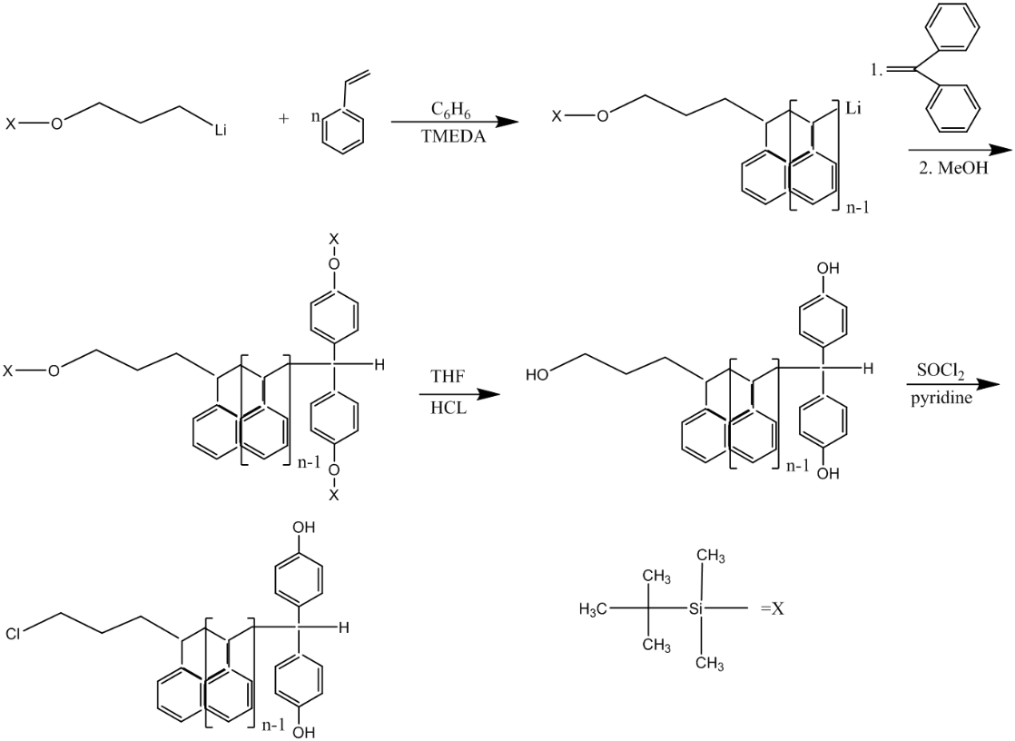

Scheme 3-1 Anionic synthesis of the PS AB2 macromonomer building block.

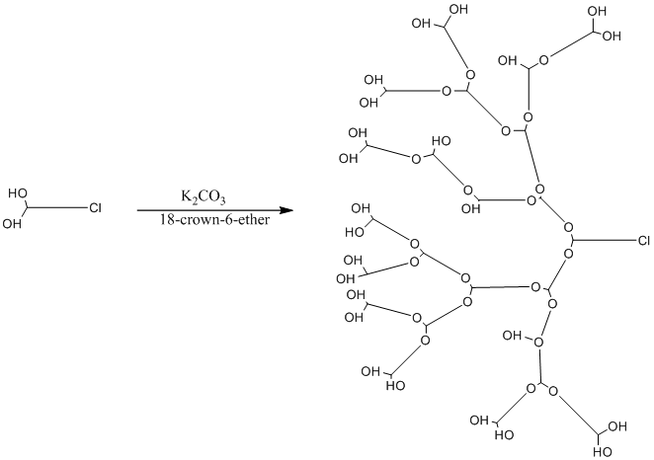

Scheme 3-2 Williamson ether coupling of AB₂ PS macromonomers is used to build up hyperbranched PS HyperMacs.
coupling of AB2 macromonomer building blocks, as illustrated in Scheme 3-3.¹⁰³ More than one structure will be formed from this synthesis, given a specific number of macromonomers in the coupled product, which is also known as the DP_{n}, where Dp_{n} = M_{n HyperMac}/M_{n macromonomer}.¹⁰³ For example, in Scheme 3-3, a DP_{n} of 5 gives two different coupled products, but each has the same number of macromonomers. Previous studies involving the molecular weight distribution analysis of PS HyperMacs report that as a result of the coupling reaction, molecular weights of HyperMacs can be in excess of 10,000,000 g/mol.¹⁰⁵ Moreover, it was found that through intramolecular coupling, cyclic unimers and dimers were also included in the structural complexity.^{44,43}
A similar but slightly different strategy is employed in the synthesis of DendriMacs.¹⁰⁴ These structures are comparable to classical dendrimers and as such the first few steps
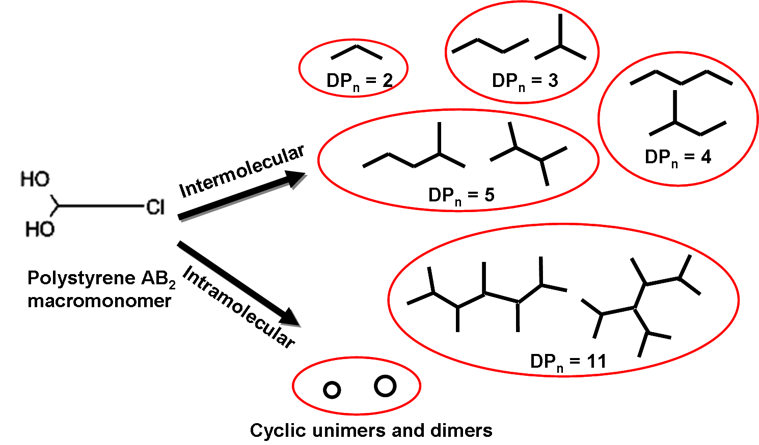

Scheme 3-3 An illustration of the wide range of structures in a PS HyperMac as a result of intermolecular and intramolecular coupling.
involve the synthesis of dendrons that are eventually coupled to create a first generation DendriMac, for example, as illustrated in Scheme 3-4. In Scheme 3-4, the Williamson ether coupling of two alkyl chloride end-functionalized PS chains and a different PS AB2 macromonomer, AB₂–(OH)₃, results in the formation of a first generation dendron, G1-OH. G1-OH is reacted with a trifunctional core, 1,1,1-tris(4-hydroxyphenyl) ethane, forming a first generation DendriMac, G1-DendriMac, which has a greater degree of structural homogeneity than randomly branched PS HyperMacs.⁴³ Hutchings et al ¹⁰⁶ reported that the structural characterization of a first generation DendriMac revealed the presence of only about 14% of a lower molecular weight byproduct that was identified as having one missing arm.
Both HyperMacs and DendriMacs have well defined molecular weights between branch points due to the anionic synthesis of the macromonomer building blocks. However, the coupled products overall have a wide molecular weight distribution. Nevertheless, DendriMacs and
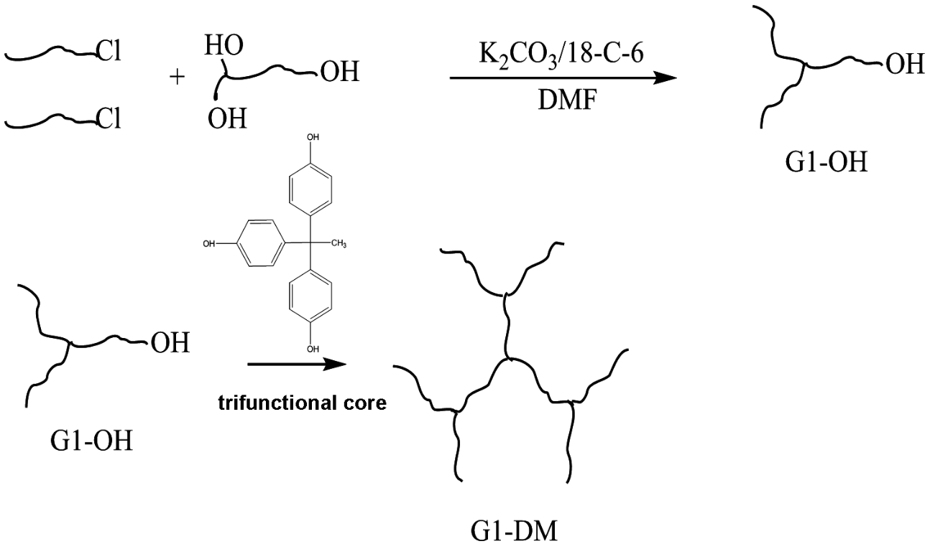

Scheme 3-4 The synthesis of a first generation DendriMac, G1-DM, created from a first generation dendron, G1-OH, as well as a trifunctional core, 1,1,1-tris(4-hydroxyphenyl)ethane.
HyperMacs possess less structural and molecular weight heterogeneity than industrially produced metallocene catalyzed branched polymers. For instance, low density poly(ethylene) (LDPE) is composed of multiple species of linear, star, and comb molecules containing backbones and branches that are polydisperse in length. HyperMacs and DendriMacs belong to the same topological family of hyperbranched polymers with long chain branching and have the potential to be useful as model systems for many other structure-property investigations of branched polymers including melt rheology.^{43, 103}

C. Distinguishing Physical Characteristics of Hyperbranched Polymers
Hyperbranched polymers have a number of distinguishing and notable physical characteristics.¹⁰⁷ The physical properties of particular relevance to the present study include the molecular shape and viscosity of the hyperbranched polymers. The terms Cayley tree¹⁰⁸ and arborescent¹⁰³ have been used to describe the molecular shapes of dendritic polymers like HyperMacs and DendriMacs. Hyperbranched polymers assume an overall globular architecture and as a result it has been reported that they are largely unentangled even at molecular weights above 1.0 x 10⁶ g/mol.¹⁰⁸ The fact that these polymers may be unentangled will be important for understanding the dynamics of these additives in a linear matrix. Moreover, the experimentally observed low solution and melt viscosity of hyperbranched polymers is also attributed to their globular shape. In comparison to linear analogues of the same molar mass, hyperbranched polymers have a significantly lower intrinsic viscosity as well as smaller hydrodynamic size.^{43,44,107}

3.2 Materials and Methods
- Materials

HPLC grade toluene (Fisher Scientific, Fair Lawn, NJ) was used to prepare polymer solutions that were later spin coated onto silicon wafers and analyzed with various surface sensitive techniques. The silicon substrates were 2” and 5” in diameter, 3 mm–5 mm in thickness, single-sided polished <100> crystal orientation, N-doped silicon wafers (Wafer World, West Palm Beach, FL). Chloroform, sulfuric acid, and 30 w/w % hydrogen peroxide were used to clean silicon substrates and were all certified ACS grade (Fisher Scientific). All water used to clean silicon substrates was purified using a Milli-pore water treatment apparatus. Branched poly(styrene) (PS) HyperMacs and DendriMacs, used in the surface segregation studies, was obtained from Durham University and synthesized by Dr. Lian Hutchings’ lab. Linear deuterated poly(styrene) (dPS) (Polymer Source, Dorval(Montreal), QC), used as the linear matrix in the surface segregation studies, was purchased and used as received. A separate set of linear PS and dPS samples was used to evaluate dewetting behavior in thin films. Linear PS samples were purchased from Polymer Source (Dorval(Montreal), QC). Linear dPS was purchased from Scientific Polymer Products (Ontario, NY). The substrates used to evaluate dewetting behavior in thin films included three 2” diameter and 3 mm thick silicon wafers. HPLC grade tetrahydrofuran (Fisher Scientific) was used for SEC analysis of the polymers.
- Method for Preparation of Thin Film Samples

It has been observed that thin films of poly(styrene) (PS) may dewet a silicon surface upon annealing.¹⁰⁹ The dewetting behavior depends on surface preparation of the silicon wafer, time between wafer cleaning and film deposition, molar mass of the polymer, as well as film thickness.^{17,110}Thus, prior to preparing the samples for analysis with various surface and depth profiling techniques, a dewetting test was performed on films composed of protonated and deuterated PS with varying molecular weights to determine if dewetting occurs with annealing at 150°C when the film thickness is kept constant at 1000 Å, and the same cleaning method is used for each Si substrate surface. The M_{w}, M_{n}, and PDI of the three linear and deuterated PS samples investigated, PS-1, PS-2, and d-PS, (data obtained from Polymer Source) is summarized in Table 3.1. Silicon substrates were first cleaned with chloroform. Next, the wafers were soaked in a hot piranha solution (70% H₂SO₄, 30% H₂O₂) for 1 hour. Afterwards the wafers were rinsed with high-purity water, dried with dry N₂(g) and then placed in a model 144AX UVO-Cleaner (Irvine, California) oven for 10 minutes. Using this cleaning procedure, the SiO₂ layer, as measured by ellipsometry, had a thickness of 15-20 Å. Immediately after coming out of the UV oven, the wafers were spin coated with a 2.6 w/w % solution of the polymer in toluene, which had been filtered with 0.45µm pore PTFE filters (Fisher Scientific). A Headway Research Inc. Model PWM32 spin coater was used at a speed of 2500 rpm for 30 seconds. Film thickness was determined to be 1000 Å for these samples using a DRE-Dr. Riss Ellipsometerbau GmbH (Ratzeburg, Germany) ELX-02C rotating analyzer nulling ellipsometer at a 70° angle of incidence with a He-Ne laser (λ=632.8 nm). The indices of refraction for all layers were considered to be no different from the bulk values. For PS, dPS, SiO₂, and Si these values were 1.59, 1.50, 1.4571, and 3.8816-i0.0190, respectively. All reported thickness values were averaged over 5 measurements from several areas of the sample surface. The samples were
Polymer | M_{n} (g/mol) | M_{w} (g/mol) | PDI
PS-1 | 156,000 | 169,000 | 1.08
PS-2 | 465,000 | 490,000 | 1.05
d-PS | 616,000 | 672,000 | 1.09
examined after 12.5 hours of annealing in a vacuum oven at 150°C and no signs of dewetting

Table 3.1 The M_{n}, M_{w}, and PDI of polymers used in the dewetting test.

were observed.
Thin films for the study of the selective segregation of HyperMacs and DendriMacs in a linear matrix were prepared similarly to the films used in the dewetting test. Polymer solutions were made from a 2.6 w/w % solution in toluene of a blend of 90 w/w % linear dPS (M_{n} = 320,000 g/mol) and 10 w/w % PS HyperMac or PS DendriMac. Solutions were filtered with 0.45µm pore PTFE filters (Fisher Scientific). The solutions were spin coated onto freshly cleaned 2” and 5” diameter, 3 mm – 5 mm thick silicon wafers (using the same cleaning procedure as used in the dewetting test). The films were approximately 1100 Å thick as determined by ellipsometry. The surface segregation process was monitored in these systems as a function of annealing time in a vacuum oven at 150°C. Thermally annealed films were immediately quenched on a room temperature aluminum block prior to being measured with neutron reflectivity.
- Methods for Characterization of PS HyperMacs and DendriMacs
  - Solution Viscometry
The intrinsic viscosity of hyperbranched HyperMacs and DendriMacs was measured in THF at 25°C with a 0.47 mm capillary Ubbelohde viscometer (type 531-03, k=0.003) and a Schott Instruments Visco Systems AVS 370 Dilute Solution Viscometer. The capillary viscometer chosen has a flow time of 177 seconds, a measuring range of 0.5-2 mm²/sec and total volume of 75 mL. The viscometer was thoroughly cleaned with THF prior to each use and dried with dry N_{2(g)}. The solvent, THF, was degassed by sonication prior to being used in the viscometry measurement. From these measurements, the Intrinsic Viscosity Branching Factor, g’, which is a measure of the degree of branching, was determined. A more detailed discussion concerning the theory underlying the solution viscometry measurement is presented in Appendix A.1, section A.
  - Triple Detection Size Exclusion Chromatography

The molecular weight distribution of HyperMacs and DendriMacs was characterized with a Polymer Labs GPC-120 size exclusion chromatograph equipped with a Precision Detector PD2040 light scattering detector that measures scattered light at 15° and 90°, a Viscotek 220 differential viscometer, and a Polymer Labs refractometer. The mobile phase was THF and the stationary phase was composed of four PL gel 7.5 x 300 mm columns with pore sizes of 500Å, 1,000 Å, 10,000 Å, and 1,000,000 Å and a molar mass range of 600 to 7,500,000 g/mol. Measurements were conducted at 40°C using a concentration of 1 mg/mL. Results were analyzed using Polymer Labs Cirrus software calibrated with narrow molecular weight PS standards. A discussion of the theory underlying triple detection size exclusion chromatography (SEC) is covered in Appendix A.1, Section B.
- Methods for Characterization of the Blend Film
  - Ellipsometry
Ellipsometry measurements to determine film thickness were conducted as described in Materials and Methods 3.2 Section B. A discussion of the theory underlying ellipsometry measurements can be found in Appendix A.2, Section A.

  - Neutron Reflectivity

In order to obtain depth profile measurements of the as-cast and thermally annealed blend films, neutron reflectivity experiments were completed on the Beamline 4B Liquids Reflectometer (horizontal reflectometer) at the Spallation Neutron Source (SNS) at Oak Ridge National Lab (ORNL). A q-range of 0.005 to 0.14 Å⁻¹ with Δq/q = 0.05 was used. Data collected at the SNS was reduced and scaled using software developed on-site. Motofit¹¹¹ and Mlayer (SNS, ORNL), were used to fit the data and construct neutron scattering length density depth profiles that describe the structure of the blend films. Both fitting programs produced consistent results. A standard test for statistical significance, chi squared (χ²), was calculated for each fit. Volume fraction plots of the polymeric additive in each layer from the scattering length density profile were generated using the Tiles Program (SNS, ORNL). A discussion on the theory of neutron reflectivity can be found in Appendix A.2, Section B.
  - Elastic Recoil Detection Spectroscopy

Complementary depth profile measurements using elastic recoil detection (ERD) spectroscopy on thermally annealed binary blend films were conducted to corroborate the results of model fits to neutron reflectivity data. ERD measurements were carried out by Dr. Richard L. Thompson at Durham University. In these experiments, a National Electrostatics Corporation (Middleton, WI) 5SDH Pelletron accelerator was used to produce a helium ion beam. A 1.7 MeV ⁴He⁺ beam was delivered to the sample surface at 9° grazing incidence (81° from the sample normal) and recoiling ions were detected at 150° to the incident beam. The detector resolution was 40 keV and the energy spread of the incident beam was 5 keV. A 5 µm thick Mylar foil placed before the detector was used to slow down the energy of recoiling helium ions thus distinguishing them from the target H and D ions in the blend film. Calibration standards for films of known composition and thickness were used to calculate stopping powers. In addition, the program SIMNRA¹¹² was used to simulate ERD spectra and convert the spectra into depth composition profiles. A discussion regarding the theory underlying ERD is presented in Appendix A.2, section C.

3.3 Results and Discussion

A. Analysis of the Structure of HyperMacs and DendriMacs

- The Molecular Weight Characteristics of HyperMacs and DendriMacs

Table 3.2 contains a summary of the molecular weight characteristics measured by Triple Detection SEC of the macromonomers used to synthesize HyperMacs (PSMACHM373, PSMACHM871, and PSMACHM1530) and DendriMacs (PSMACDM505 and PSMACDM1105). The macromonomers are linear, have low dispersity, and are well defined. Moreover, these macromonomers provide long chain branching in HyperMacs and DendriMacs since they have a molecular weight above the entanglement molecular weight, M_{e}, of Polystyrene (13,600 - 17,500 g/mol).⁵⁵ In Table 3.3, the molecular weight characteristics of HyperMacs (PSHM373, PSHM871, and PSHM1530) and DendriMacs (PSDM505 and PSDM1105), as well as that of linear dPS, which functions as the matrix in these surface segregation studies, is summarized, along with the degree of coupling, Dp_{n}, for each hyperbranched polymer.

Sample Name | Mn (g/mol) | Mw (g/mol) | PDI
PSMACHM373 | 28,100 | 28,500 | 1.01
PSMACHM871 | 27,000 | 28,500 | 1.05
PSMACHM1530 | 28,100 | 28,500 | 1.01
PSMACDM505 | 28,100 | 28,500 | 1.01
PSMACDM1105 | 28,100 | 28,500 | 1.01
Table 3.2 The molecular weight characteristics of macromonomers as obtained from Triple Detection SEC.

Table 3.3 The molecular weight characteristics for HyperMacs, DendriMacs, and linear dPS, as well as degree of coupling, Dp_{n}, for the hyperbranched polymers. Triple Detection SEC was used to characterize the hyperbranched polymers. Linear dPS was characterized with SEC using RI and LS detectors.
Sample Name | Mn (g/mol) | Mw (g/mol) | PDI | DP_{n}
PSHM373 | 167,00 | 373,100 | 2.23 | 5.9
PSHM871 | 198,800 | 870,800 | 4.38 | 7.4
PSHM1530 | 510,400 | 1,530,000 | 3.00 | 18.2
PSDM505 | 137,400 | 505,000 | 3.68 | 4.9
PSDM1105 | 308,500 | 1,105,000 | 3.58 | 11.0
Linear dPS | 320,000 | 335,800 | 1.05 | ---

HyperMacs and DendriMacs investigated in this study have number average molecular weights ranging from ~100,000 g/mol to ~500,000 g/mol and are very polydisperse. The degree of coupling increases with the molecular weight of each HyperMac; the same trend is observed for the DendriMacs. This may be expected due to the coupling scheme employed in the synthesis of these hyperbranched polymers. The molar mass of the linear dPS matrix was chosen to be above the entanglement molecular weight to mimic Reptation in the melt^{58,113,114} as well as to mitigate dewetting from the Si substrate.¹⁷

- Analysis of the Nature and Amount of Branching in HyperMacs and DendriMacs: The Intrinsic Viscosity Branching Factor, g’, and the Zimm-Stockmayer Branching Factor, g

Long chain branching in polymers affects both their molecular density as well as their size. For a given molecular weight, an increase in long chain branching in a polymer reduces its size and increases its molecular density. Moreover, the solution viscosity of such a polymer is lower than the solution viscosity of a linear analog (i.e., a polymer of the same molecular weight). To gain more information on the nature of branching as well as the amount of branching in a polymer with long chain branching, one can conduct Triple Detection SEC as well as solution viscometry measurements of branched polymers and compare properties such as size (i.e., radius of gyration, R_{g}) and intrinsic viscosity to that of a linear analog.
Both the Intrinsic Viscosity Branching factor, g’, as well as the Zimm-Stockmayer Branching Factor, g, for HyperMacs and DendriMacs was determined. The Intrinsic Viscosity Branching Factor, g’, is a ratio of the intrinsic viscosity of a branched polymer to that of a linear analog of the same molecular weight. As the value of g’ decreases, the molecular density increases (i.e., the molecular structure becomes more compact). Likewise, the Zimm-Stockmayer Branching Factor, g, defined as the ratio of the mean squared radius of gyration of a branched polymer to that of a linear polymer with the same molecular weight, also measures a contraction in the size of the polymer. Furthermore, information about the average number of branches in a polymer can be determined once the values of the Zimm-Stockmayer Branching Factor, g, are known by applying different statistical models (which are based on assumptions about the distribution of branches on the polymer backbone). These combined analyses (i.e., determination of g’ and g) make it possible to obtain detailed information about the architecture of HyperMacs and DendriMacs.
Analysis of the intrinsic viscosity, η, of each HyperMac and DendriMac was conducted. Appendix A.3, section A, contains Huggins-Kraemer plots for all the HyperMacs and DendriMacs investigated in this study. Figure 3.1 is a representative Huggins-Kraemer plot from which the intrinsic viscosity of the HyperMacs and DendriMacs was extrapolated. The red data points in Figure 3.1 are the relative viscosity, η_{rel}, which is the viscosity of a solution relative to the pure solvent. The relative viscosity can be obtained by measuring and calculating the ratio of the time for a given volume of polymer solution, t_{sol’n} and solvent, t_{solvent}, to flow through a glass capillary as shown in equation 3.1:¹¹⁵
(3.1).
The white and blue data points in Figure 3.1 are the specific viscosity, η_{sp}, which is the fractional change in viscosity upon addition of polymer and is calculated using equation 3.2:¹¹⁵
(3.2).
When η_{sp}/c and ln(η_{rel})/c are plotted as a function of solution concentration, c, they extrapolate to the same intrinsic viscosity at zero concentration according to equation 3.3:¹¹⁵
(3.3).

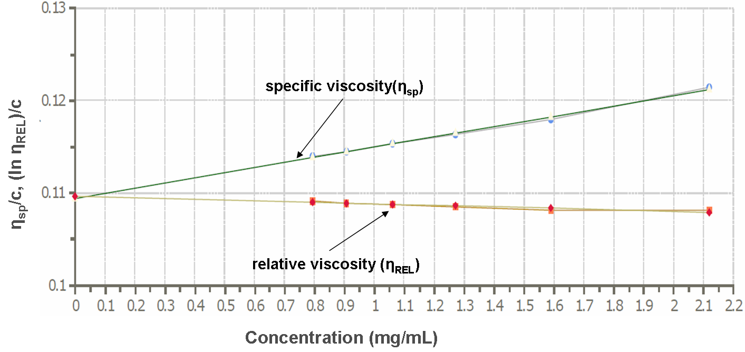

Figure 3.1 Huggins-Kraemer plot obtained from viscometry measurements of HyperMac PSHM1530. The plot extrapolates to an intrinsic viscosity, η, of 0.1094 mL/mg (1.094 dL/g).

Table 3.4 contains a summary of the results of the measured intrinsic viscosity by both solution viscometry and Triple Detection SEC for HyperMacs and DendriMacs; both sets of measurements yield consistent values. The units have been converted from mg/mL to dL/g for convenience.
By comparing the intrinsic viscosity of a branched polymer to its linear analog, one can gain a better understanding of the correlation between molecular architecture and physical properties. The intrinsic viscosity for a linear polystyrene chain is readily calculated using equation 3.4, the Mark-Houwink equation:⁴⁴
(3.4)
where K is 12.8E-5 dL/g, a is 0.712 for linear PS ¹⁰³ (in THF at 30°C), and M is M_{v}. Figure 3.2 displays the measured intrinsic viscosity for PS HyperMacs and DendriMacs and the calculated intrinsic viscosity of their linear analogs as a function of molecular weight. As the molecular weight of HyperMacs and DendriMacs increases, the intrinsic viscosity also increases, but at a slower rate than is observed for a linear polymer of identical molecular weight. This is what is expected for branched polymers since they have smaller hydrodynamic volumes than linear polymers of the same molecular weight and therefore have smaller intrinsic viscosities.
Using the results of solution viscometry and Triple Detection SEC measurements, as well as the calculated values of intrinsic viscosity for linear analogs (using the Mark-Houwink equation), the Intrinsic Viscosity Branching factor, g’, was calculated as shown in equation 3.5:¹¹⁶
(3.5)
where η_{branched}, and η_{linear} are the intrinsic viscosities of a branched polymer and its linear analog,
Table 3.4 Intrinsic viscosity ([η]) of HyperMacs and DendriMacs obtained by two different methods - viscometry and Triple Detection SEC.

Sample Name | [η] (dL/g) Viscometry | [η] (dL/g) Triple Detection SEC
PSHM373 | 0.629 | 0.640
PSHM871 | 0.982 | 0.905
PSHM1530 | 1.094 | 1.095
PSDM505 | 0.756 | 0.816
PSDM1105 | 1.122 | 1.122

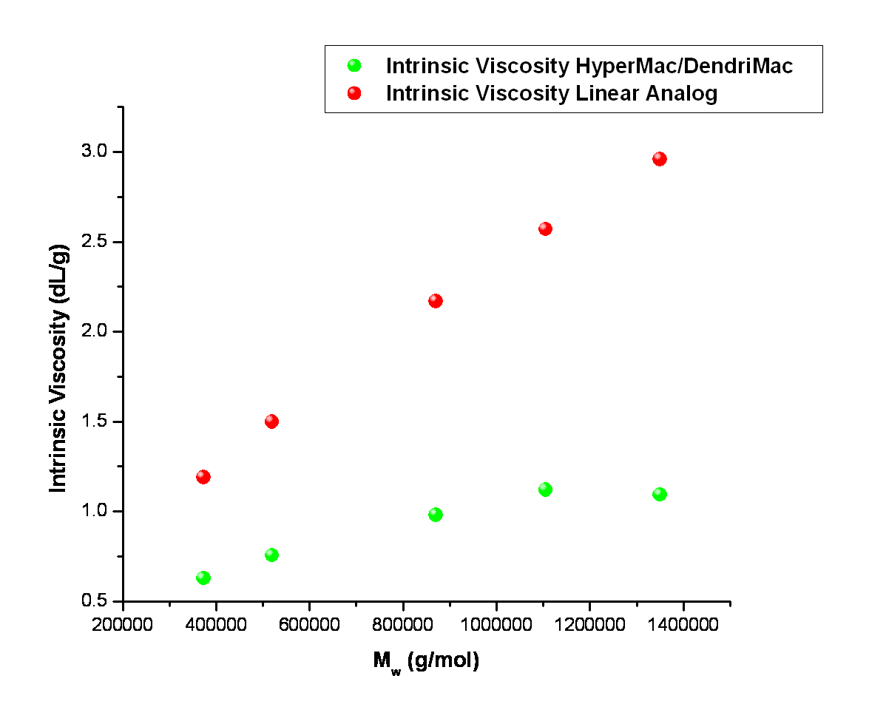

Figure 3.2 Intrinsic viscosity as a function of M_{w} for PS HyperMacs, DendriMacs, and their linear analogs.
respectively. Table 3.5 contains a summary of g’ values for HyperMacs and DendriMacs
investigated in this study. HyperMac PSHM1530 has the smallest g’ value while HyperMac PSHM373 has the largest g’ value. Moreover, as illustrated in Figure 3.3, as the molecular weight of these hyperbranched polymers increases, the value of ‘g decreases. Thus, since branching increases with increasing molecular weight, due to the coupling strategy employed in the synthesis of HyperMacs and DendriMacs, it can be inferred that HyperMac PSHM1530 has the greatest amount of branching while HyperMac PSHM373 has the least
amount of branching. Furthermore, a review of the literature on the reported values of g’ for other hyperbranched polymers is consistent with the g’ values for HyperMacs and DendriMacs obtained in this study. Hyperbranched polymers such as Hirao’s 2nd and 3rd generation dendrimer-like PMMA molecules have g’ values of 0.59 and 0.46, respectively.⁴⁴

Table 3.5 The intrinsic viscosity, η, of HyperMacs, DendriMacs, and their linear analogs as well as the intrinsic viscosity branching factor, g’.

Sample Name | ª [η] (dl/g) of HyperMacs and DendriMacs | ^{b} [η] (dl/g) of a Linear PS Analog | ^{c} g'
PSHM373 | 0.629 | 1.19 | 0.53
PSHM871 | 0.982 | 2.17 | 0.45
PSHM1530 | 1.094 | 2.96 | 0.37
PSDM505 | 0.756 | 1.50 | 0.50
PSDM1105 | 1.122 | 2.57 | 0.44

ª η from viscometry measurements
^{b} from Mark-Houwink equation: [η] = KMa where used Mw from light scattering for M, K = 12.8E-5 dL/g, and a = 0.712 (Source: Eur. Poly. J. 44 (2008) 665-676)
^{c} g’ = [η]branched/[η]linear
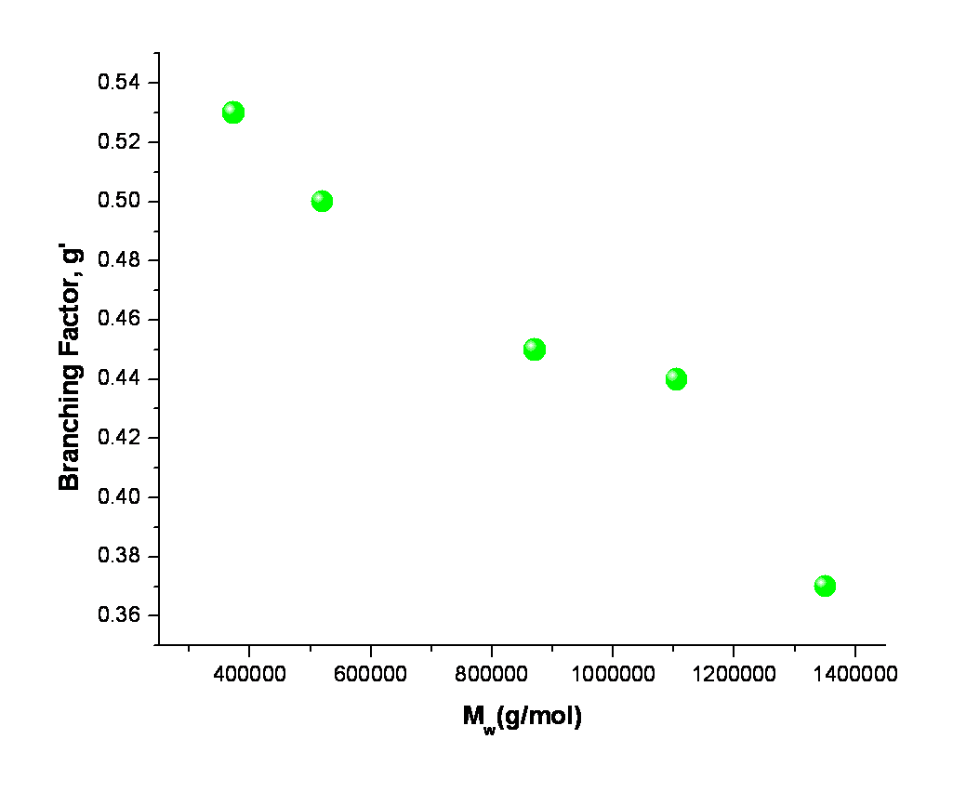

Figure 3.3 Intrinsic viscosity branching factor, g’, as a function of M_{w} for HyperMacs and DendriMacs.

The amount of branching as well as the branching frequency (or branching density) in a branched polymer can be measured quantitatively by first determining the value of the Zimm-Stockmayer Branching Factor, g, shown in equation 3.6:¹¹⁶
$g=\frac{R_{gbranched}}{R_{glinear}}$ (3.6)
where R_{gbranched} is the radius of gyration of the branched polymer (measured using Light Scattering with Triple Detection SEC) and R_{glinear} is the radius of gyration of a linear analog (obtained by either Light Scattering or calculation). R_{gbranched} for HyperMacs and DendriMacs was measured with Triple Detection SEC, while R_{glinear} for linear analogs was calculated using equation 3.7:¹¹⁷
$R_{g PS/THF }={0.245M}^{0.546}$ (3.7)
where R_{g PS/THF} is the radius of gyration of PS in THF solvent and M is the molar mass of the polymer. Table 3.6 contains a summary of the values of R_{gbranched}, R_{glinear}, and the Zimm-Stockmayer Branching Factor, g, for HyperMacs and DendriMacs.
Triple Detection SEC software (Polymer Labs Cirrus) was used to calculate the average number of branches per macromolecule, n, as well as the frequency of branching, λ, by evaluating the Zimm-Stockmayer Branching Factor, g, from each SEC slice of data (i.e., R_{gbr} from light scattering and the corresponding calculated R_{glin} from a linear analog).

Table 3.6 A summary of the radii of gyration for branched HyperMacs and DendriMacs (Rgbr) and their linear analogs (Rglin) as well as the Zimm-Stockmayer Branching Factor, g.
Sample Name | ªR_{gbr} (nm) of HyperMacs  and DendriMacs | ^{b}R_{glin} (nm) of a Linear  PS Analog | ^{c} g
PSHM373 | 18.1 | 27.0 | 0.67
PSHM871 | 24.2 | 42.9 | 0.56
PSHM1530 | 29.9 | 58.3 | 0.51
PSDM505 | 19.1 | 31.8 | 0.60
PSDM1105 | 29.2 | 48.8 | 0.60

ª R_{gbr} from light scattering (Triple Detection SEC)
^{b} R_{glin} from calculation: Rg _{PS/THF} = 0.0245M^{0.546} (Source: J. Phys. Chem. Ref. Data, 23 (1994) 619-640)
^{c} g = R_{gbranched}/R_{glinear}

This was followed by iterative fitting to equation 3.8, the Zimm-Stockmayer relation for g as a function of n:¹¹⁶
${g_{3}=\left[{\left(1+\frac{n}{7}\right)}^{1/2}+\frac{4n}{9π}\right]}^{-1/2}$ (3.8)
which assumes the polymer is trifunctional, randomly branched, and monodisperse. Equation 3.8 is the appropriate Zimm-Stockmayer relation to use for HyperMacs and DendriMacs since the branches are trifunctional, and although the overall polymer is polydisperse, the branch lengths are monodisperse. Furthermore, the branching frequency, λ, which is the number of branches per 1000 backbone carbon atoms, was calculated using equation 3.9:¹¹⁶
$λ=m×n×1000/MW$ (3.9)
where m is the molar mass of a monomer (which is approximately equal to the molar mass of a unit of styrene monomer, 104 g/mol), n is the average number of branches per macromolecule, and MW is the M_{w} of the polymer. The results of the branching analysis are summarized in Table 3.7. Note that the average number of branches for each macromolecule is comparable to the degree of coupling, DPn, determined for HyperMacs and DendriMacs (Dpn is 5.9, 7.4, 18.2, 4.9, and 11.0 for samples PSHM373, PSHM871, PSHM1530, PSDM505, and PSDM1105, respectively; see Table 3.3).
A plot of the average number of LCBs, n, as a function of the log of M_{w} as displayed in Figure 3.4, yields the expected result. As the molar mass of HyperMacs and DendriMacs increases, the amount of branching increases. Thus, PSHM1530 has the greatest amount of branching while PSHM373 has the least amount of branching. However, the branching frequency, λ, does not increase with increasing molecular weight, as illustrated in Figure 3.5. The frequency of branching decreases as the molecular weight of HyperMacs and DendriMacs
Table 3.7 The average number of long chain branches (LCB) per macromolecule, n, and the number of branches per 1000 backbone carbons (branching frequency), λ, for HyperMacs and DendriMacs.

Sample Name | n (Average # of LCB/Macromolecule) | λ (Branching Frequency/# of Branches Per 1000 Backbone Carbons)
PSHM373 | 6.4 | 1.78
PSHM871 | 9.3 | 1.11
PSHM1530 | 14.4 | 0.98
PSDM505 | 7.1 | 1.46
PSDM1105 | 9.7 | 0.91

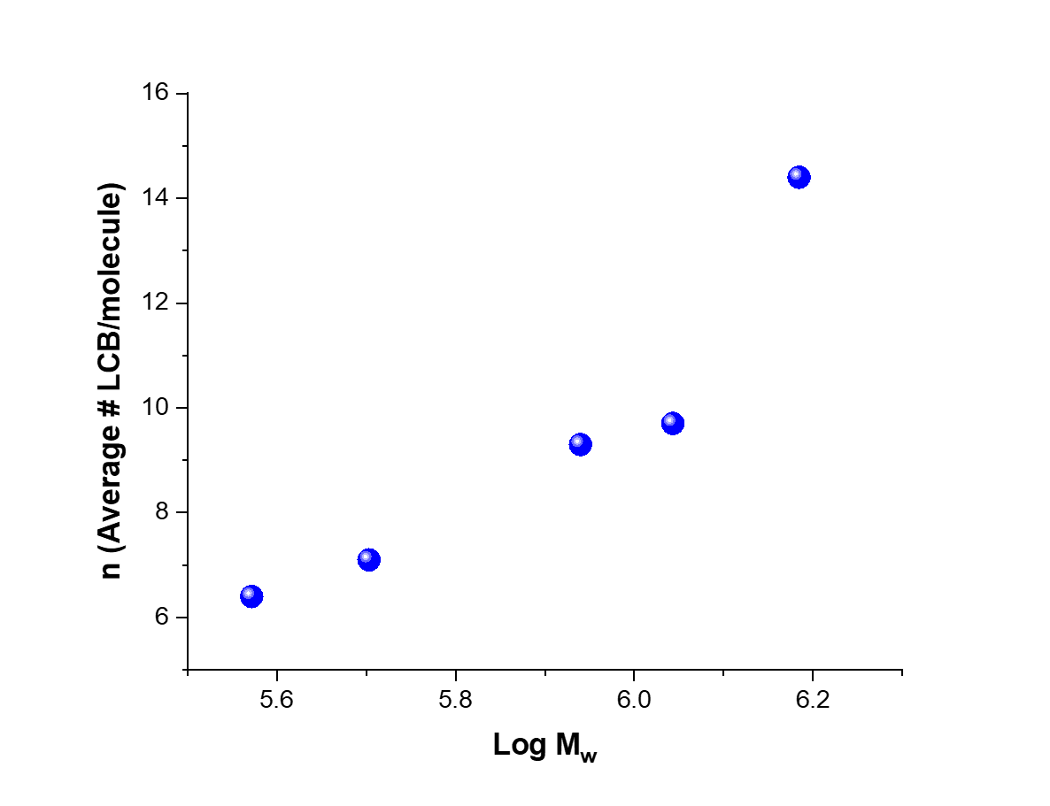

Figure 3.4 The average number of LCBs per macromolecule, n, as a function of the log of M_{w}.

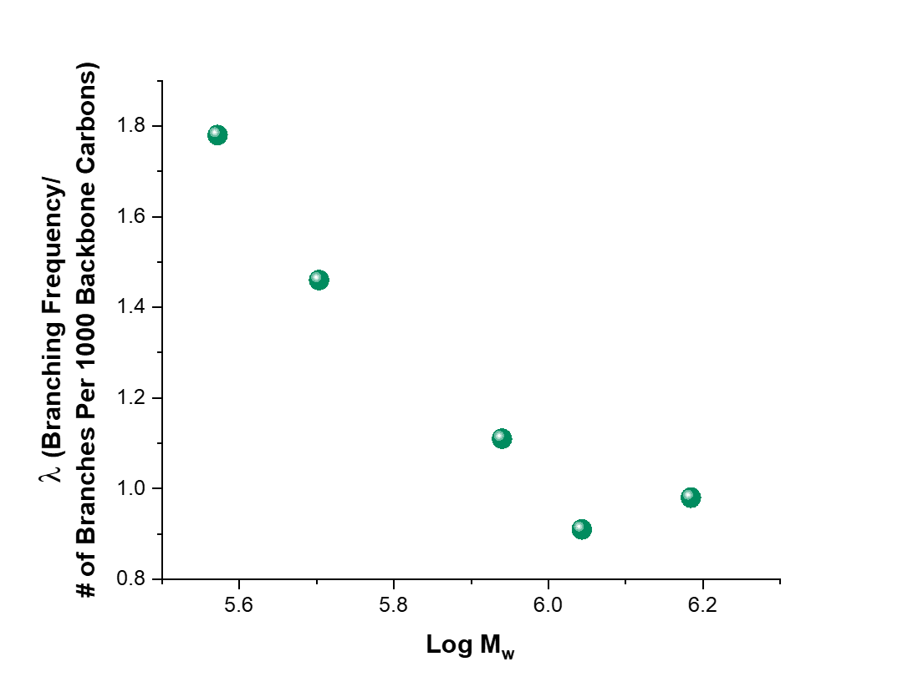

Figure 3.5 Branching frequency (number of branches per 1000 backbone carbon atoms), λ, as a function of the log of M_{w}.

increases. This trend can be explained by considering that as one adds additional macromonomers to a growing HyperMac or DendriMac chain, there is an inherent increase in the viscosity of the reaction solution which limits the amount of branching. Indeed, as noted by Dodds,¹¹⁸ HyperMacs and DendriMacs for this reason are unlikely to contain as much branching as conventional hyperbranched polymers. Nevertheless, density of branching is not the only factor to consider when attempting to characterize the architecture of a branched polymer. The shape of a branched polymer (eg., spherical, rod-shaped, etc.) is also an important part of its architecture and can also affect its diffusive properties both in solution as well as in the melt.

3) Insight into the 3-Dimensional Structure of HyperMacs and DendriMacs

Previous studies by Baille et al¹¹⁹ in which they investigated the effect of the shape (or molecular density distribution) of a polymer on its self-diffusion coefficient indicate that for the same molecular weight and under the same experimental conditions, dendrimers diffuse faster than HBPs, which themselves diffuse faster than linear polymers. The differences in their diffusion coefficients can be attributed to their varied 3-dimensional structures. For example, dendrimers can be described as solid, space-filling structures with fractal dimensions similar to a sphere.⁵⁵ On the other hand, HBPs are non-compact fractal structures with fractal dimensions much less than a sphere.⁵⁵ Moreover, hyperbranched polymers, which are the focus of the present study, can have varied topologies, even when the molecular weights are the same, due to the different ways that the branches can be connected and distributed throughout the macromolecule. These differences in topology could have an effect not only on their shape, but possibly also on their diffusive behavior.
A qualitative evaluation of the 3-dimensional structure or shape of a polymer can be deduced from the size-mass scaling relationship shown in equation 3.10: ⁵⁵
(3.10)

where R_{g} and M are the radius of gyration and molar mass of a polymer measured with SEC, respectively, and α is a constant which is obtained by measurement of the slope of a log-log plot of R_{g} vs. M. The constant, α, is dependent on the polymer conformation, the temperature, as well as the solvent. Values for α that can qualitatively be attributed to a particular polymer conformation are displayed in Table 3.8 along with the corresponding fractal dimension, 1/α.⁵⁵ A random coil polymer in a θ-solvent will assume a tightly coiled conformation (α ~ 0.5) while a random coil polymer in a good solvent will have a more expanded, swollen conformation (α ~
Table 3.8 The value of α derived from the size-mass scaling relationship, R_{g} M^{α}, as well as fractal dimension, 1/ α, and their corresponding polymer conformations in dilute solution.

Polymer Conformation | Size-Mass Scaling Exponent, α | Fractal Dimension, 1/α
Random Coil | 0.5 – 0.6 | 1.7 – 2.0
Rigid Rod | 1.0 | 1.0
Sphere | 0.33 | 3.0

0.6). Furthermore, 0.6 < α < 1.0 indicates a semi-flexible conformation with intermediate properties between a rigid rod and a highly flexible coil. Baille et al¹¹⁹ reported α ~ 0.62 for hyperbranched poly(glycidols), which indicates that the molecular density distribution of their HBPs is similar to that of a swollen polymer chain in a good solvent.
Figures 3.6 and 3.7 display the size-mass relationship of the HyperMacs and DendriMacs, respectively, examined in this study as measured by Triple Detection SEC. These results reveal that most of these hyperbranched polymers have a molecular density distribution similar to that of a swollen polymer chain in a good solvent, which is consistent with other reported results on the conformation of hyperbranched polymers.¹¹⁹ Thus, HyperMacs and DendriMacs, like other hyperbranched polymers, are not compact solid spheres, but rather assume a conformation that lies somewhere between a linear polymer and a perfect dendrimer.^{43,103} Nevertheless, it is also noteworthy to mention that a decrease in the fractal dimension, 1/α, indicates an increase in chain rigidity. The conformational and size differences

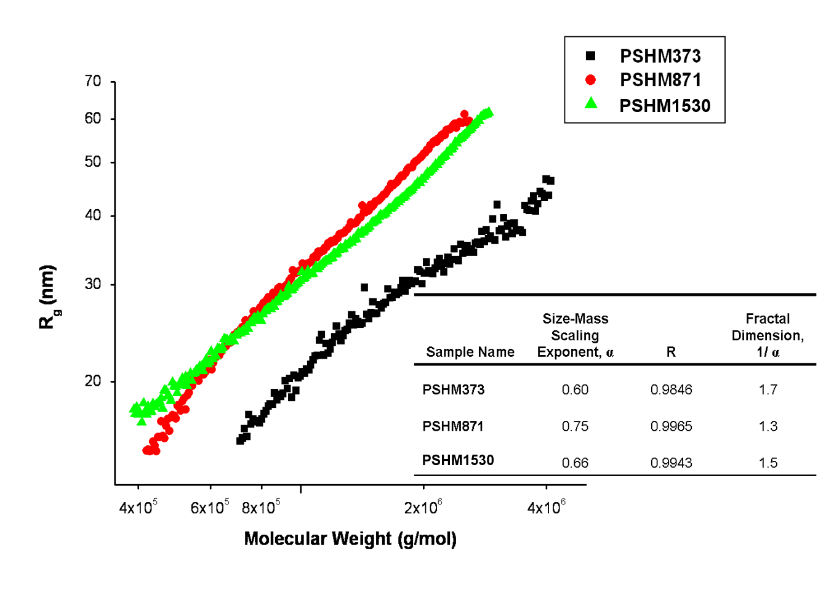

Figure 3.6 The growth of R_{g} with increasing molecular weight of HyperMacs PSHM373, PSHM871, and PSHM1530. The inset table displays the size-mass scaling exponent, α, obtained from the slope of the graph. R is a goodness-of-fit parameter. The fractal dimension, 1/α, is also included in the table.

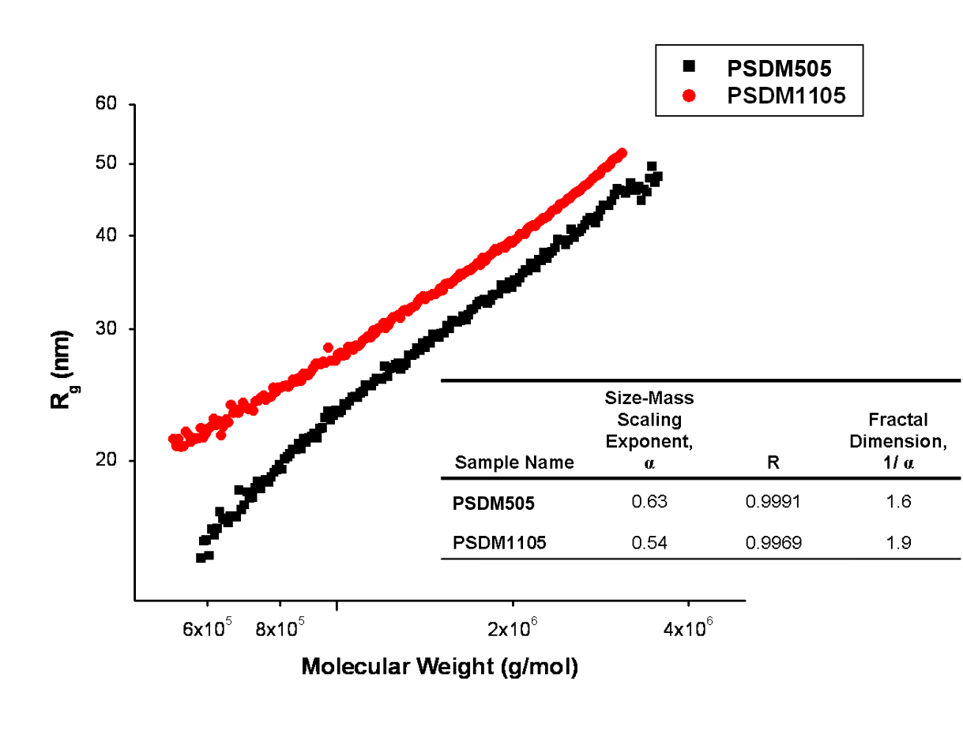

Figure 3.7 The growth of R_{g} with increasing molecular weight of DendriMacs PSDM505 and PSDM1105. The inset table displays the size-mass scaling exponent, α, obtained from the slope of the graph. R is a goodness-of-fit parameter. The fractal dimension, 1/ α, is also included in the table.

between HyperMacs and DendriMacs evaluated in this study will be useful in understanding the structure-property relationships concerning their diffusive behaviors in a linear polymer matrix.

B. Determining Blend Film Structure and its Evolution with Time

1) Neutron Reflectivity Profiles: Examination of the Raw Data

Neutron reflectivity data for short anneal times (as-cast to 48 hours) and long anneal times (as-cast to 33 days) was collected for binary blends of PS HyperMacs and DendriMacs in a linear dPS matrix. Table 3.9 contains a summary of the sample names designated for each binary blend containing 10 w/w % HyperMac or DendriMac and 90 w/w % linear deuterated PS.
Table 3.9 Sample names for binary polymer blends containing 10 w/w% HyperMac or DendriMac and 90 w/w% linear deuterated PS.
Sample Names for Blends
HM373LPS
HM871LPS
HM1530LPS
DM505LPS
DM1105LPS

Appendix A.3, section B, contains neutron reflectivity profiles for all blends investigated in this study. Figure 3.8 illustrates the time evolution of the neutron reflectivity profiles for the binary blend HM1530LPS. The binary blend is thermally annealed at 150°C under vacuum for up to 48 hours. A few important observations can be made without a quantitative analysis of the data. The frequency of the fringes indicates the overall thickness of the polymer layer, while the dampening of the fringes is determined by the width and nature of the polymer/polymer interfaces within the polymer film. In Figure 3.8, the amplitude of the fringes in the neutron reflectivity profile does not appear to change much with increasing annealing time, which indicates that the depth profile of the thin film is not changing significantly and therefore the amount of segregation is probably small on this time scale.
Neutron reflectivity profiles for the binary blend HM1530LPS that is annealed for much longer times do exhibit a more significant decay in the amplitude of the fringes as shown in Figure 3.9, which indicates that the surface segregation that occurs on this timescale is more
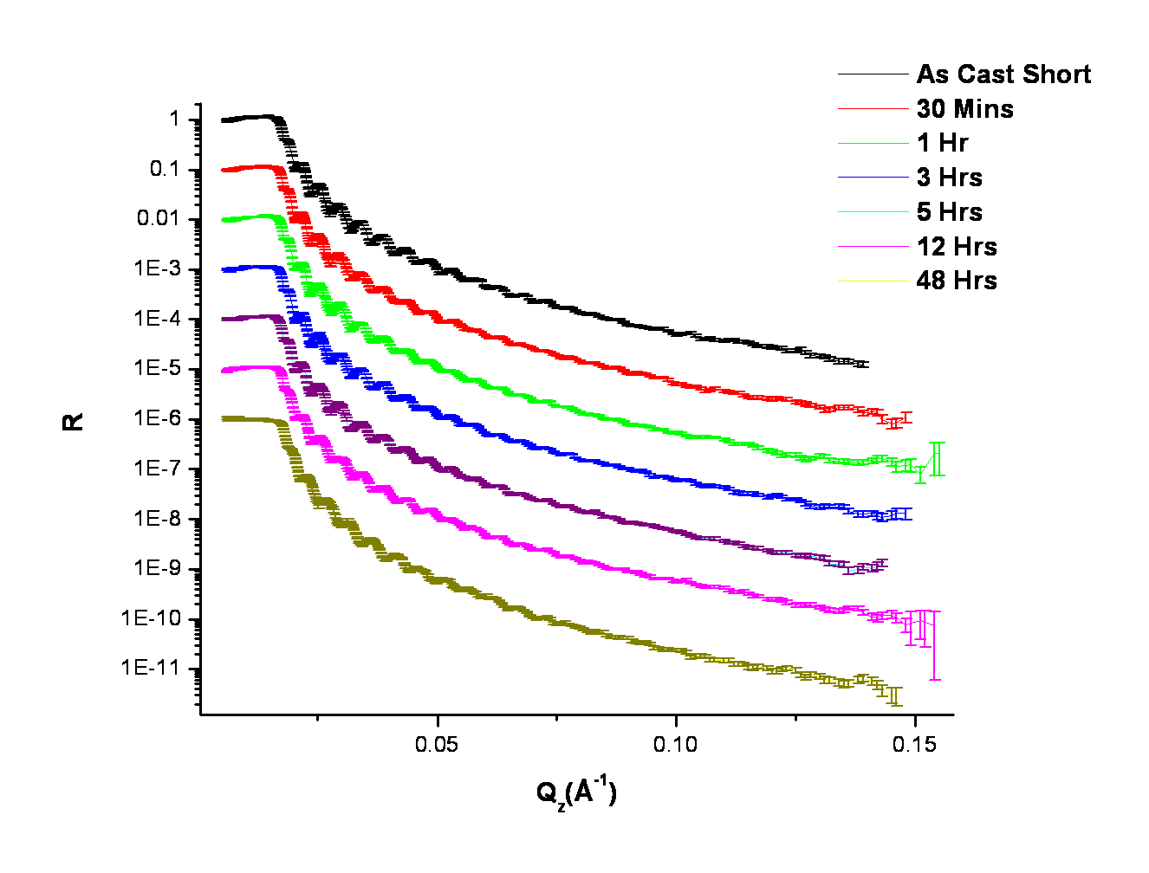

Figure 3.8 Neutron reflectivity data for the binary blend HM1530LPS measured as-cast up to an anneal time of 48 hours at 150°C under vacuum. Data is offset by a decade for clarity.

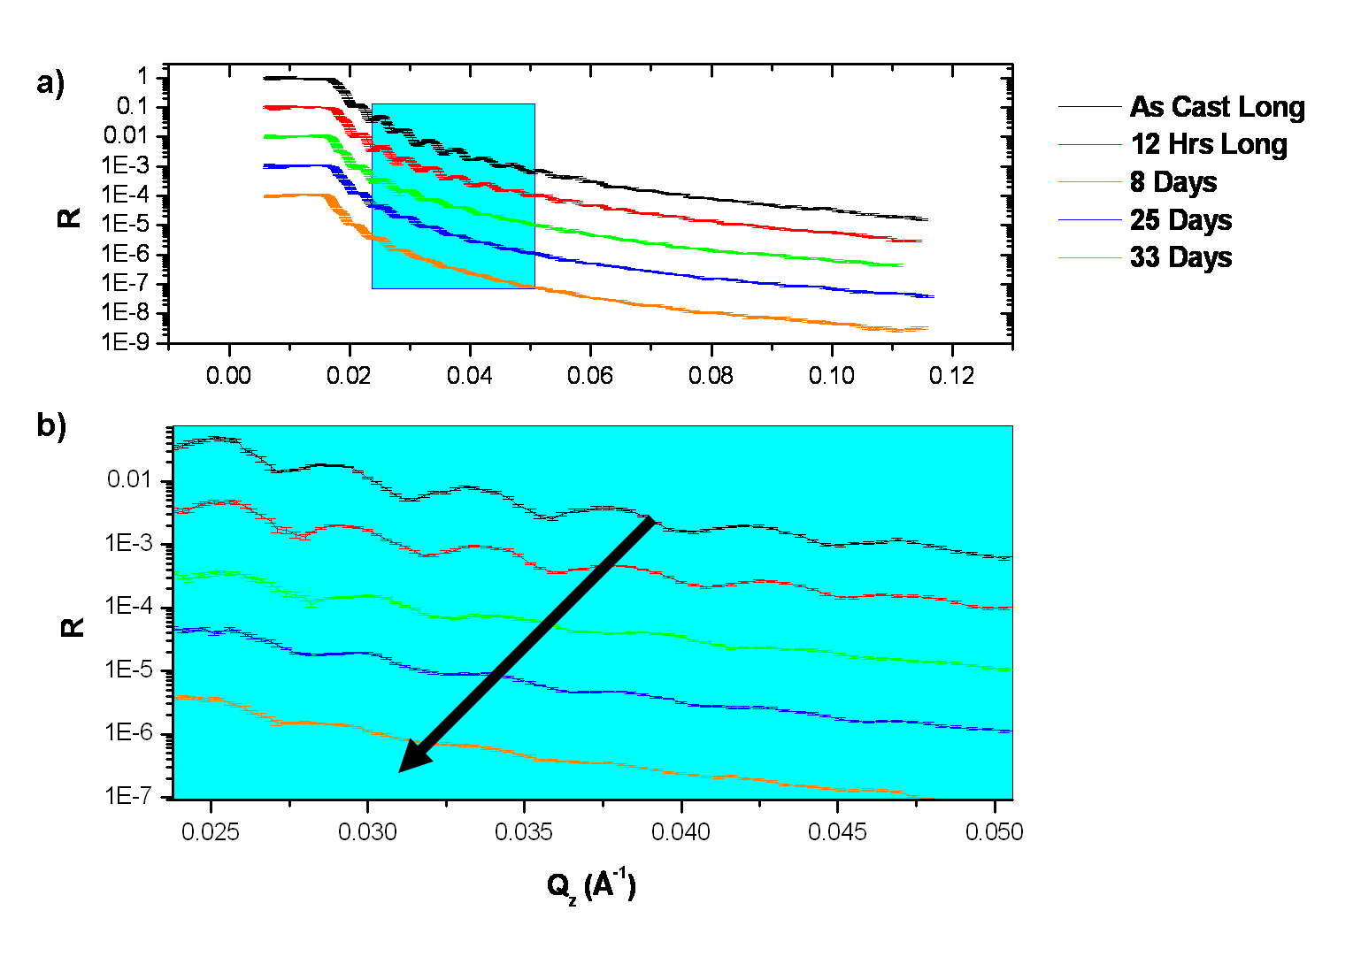

Figure 3.9 a) Neutron reflectivity profiles for the binary blend HM1530LPS measured as-cast up to a maximum anneal time of 33 days at 150°C. b) Data highlighted in box in a) shows the low Q region and emphasizes dampening of fringes with increasing anneal time. Data is offset by a decade for clarity.
significant than the surface segregation after shorter anneal times. Models of the real-space depth profiles of these evolving films were fit to the neutron reflectivity data to extract more detailed information about the location of branched polymers within the linear matrix at different times during the surface segregation process.
- The Model Used to Describe Surface Segregation in Binary Branched/Linear Blends

The neutron reflectivity (NR) curve is fit by a model multilayer scattering length density profile that consists of the scattering length density of each layer, the thickness of each layer, as well as the shape of the interface between each layer of the film. Due to the non-uniqueness of any fit, which is caused by the phase problem associated with all scattering experiments, it is prudent to use complementary experiments to constrain the models used to fit neutron reflectivity data. Complementary techniques that are used to verify the model fit include ellipsometry to obtain the overall thickness of the layer, as well as elastic recoil detection (ERD) spectroscopy, which provides direct measurements of the depth profile.
In the current study of the time evolution of the surface segregation of branched polymeric additives in a linear polymer matrix, a careful and systematic approach to fitting the data was employed to distinguish the different components of the measured average depth profile of the film. A hybrid fitting approach consisting of a combination of genetic optimization parameter searches (within the bounds of a physically reasonable model using the fitting program Motofit), as well as manual fitting, to preserve mass balance (using the Mlayer program; Spallation Neutron Source, Oak Ridge National Lab), was employed to determine the evolving density profiles of thermally annealed binary polymer blends. Genetic algorithms are effective minimization tools as they can explore parameter space while avoiding getting trapped in local minima.¹²⁰ This type of minimization involves evaluation of a set of fit parameters, called chromosomes, which are evaluated against a fit function (such as chi squared) for their fitness. The fitness determines whether the parameters will be used to contribute to a new generation of fit parameters. Pairs of chromosomes are mutated and create the next generation of fit parameters. This type of fitting procedure can be constrained to search parameter space within the bounds of a user-defined physical model.
Using this systematic method enables an efficient protocol to test theoretical models that describe the diffusion behavior of polymeric additives in a polymer matrix such as the Kramer-Jones depletion layer model.^{66,17} As explained in Chapter 2, this model describes the diffusion-controlled growth of a wetting layer in a binary polymer blend. Furthermore, in this model, it is assumed that there is a local equilibrium between the wetting layer at the surface and the layer just beneath it that is depleted in the surface segregating component. This diffusion process is described by a mutual diffusion coefficient, D_{m}, which involves the coordinated movement of one component toward the surface and the other component away from the surface. Moreover, using the Fast and Slow mode theories, one can extract the tracer diffusion coefficients of polymeric additives in a linear matrix.
The first step in fitting an appropriate model to each unannealed and annealed binary blend film involved determining the scattering length density of each component in the blend. Thus, NR profiles of monolayers of each binary blend component were measured. Table 3.8 contains a summary of the measured scattering length density obtained from fits to NR profiles of a monolayer of each blend component. As indicated in the footnote of Table 3.10, the SLD of the dPS varied within a small range. This behavior has been reported previously by Zhang et al¹²¹ and can be attributed to annealing which causes a loss of residual solvent in spin-coated

Table 3.10 The scattering length density (SLD) values obtained from fits to neutron reflectivity profiles of a monolayer of each binary blend component.

Polymer | SLD/10-6Å-2
dPS | ª 6.0E-6 ± 0.2E-6
PSHM373 | 1.51E-6
PSHM871 | 1.52 E-6
PSHM1530 | 1.48E-6
PSDM505 | 8.40E-7
PSDM1105 | 1.36E-6

ª SLD for dPS varied within a small range.

films as well as an increase in film density. The increase in polymer density may arise from relaxation of a non-equilibrium low-density state of a spin-cast film and/or the intrinsic effect of
the solvent on the polymer packing. The subphases, Si and SiO₂, were fit with an SLD of 2.07E-6 Å⁻² and 3.20E-6 Å⁻², respectively. The SiO₂ layer thickness was determined from ellipsometry experiments to be approximately 15 Å. Interfaces in the thin film were modeled with an error function.
The next step in discovering an appropriate model to fit the evolving buried and exposed interfaces of annealed binary polymer blends involved fitting 1-, 2-, and 3-layer slab models to NR profiles of as-cast films and those annealed for 30 minutes, 1 hour, 3 hours, 5 hours, 12 hours, 48 hours, 8 days, 25 days, and 33 days at 150°C under vacuum. A constrained genetic optimization parameter search within Motofit was performed by placing upper and lower bounds on each fit parameter. The best fit parameters for the unannealed blend film were used as starting fit parameters for the blend film annealed for 30 minutes. Likewise, the best fit parameters of each preceding annealed blend were used to fit successively annealed ones. In each case, the mass balance of each scattering length density profile was preserved by verifying that the overall volume fraction of branched additive within the layer was approximately 0.10. A 3-layer slab model was found to fit the data best. The model is composed of a near-air layer, a near-Si substrate layer, and a bulk (or middle) layer, which will also be referred to as a ‘reservoir’ in the discussions that follow. The 3-layer slab model was corroborated by the results of ERD measurements for some of the annealed blend films, as shown in Table 3.11, where the surface excesses at both the near-air and near-Si substrate interfaces obtained by both NR fits and ERD for the same film are displayed. In the ERD experiment, depth resolution degrades as the ion beam penetrates the film, primarily due to straggling, as discussed in Appendix A.2, Section C. Based on the conditions of the ERD experiment, the error in the ERD measurements is no more than 1 nm. Likewise, the estimated error in the parameter fits to the NR data is less than 1 nm. In Table 3.11, the interfacial excesses obtained by NR fits to the data and by ERD measurements are reasonably close as they are within 1-2 nm of each other and show consistent trends among samples. Both the ERD and NR results indicate that the surface excess of the branched polymers at the Si substrate interface increases with increased annealing time. Near the air interface, both ERD and NR results indicate that there is a small excess of branched polymer. Consistent with the depletion layer model, both the ERD measurements and NR fits to the data indicate that the branched polymeric additive is depleted from the bulk of the film with increased annealing time.
Appendix A.3, Section C, contains the ERD spectra. Additional detail on how the ERD spectra are used to determine the volume fraction of branched additive at the air and Si surfaces

Table 3.11 The surface excess, Z*, at both air and Si substrate interfaces obtained from ERD measurements of annealed blends containing HyperMacs and DendriMacs . The amount of surface excess obtained from model fits to neutron reflectivity data of the same film is included in parentheses. The error for both ERD measurements and NR fits to the data is no more than 1 nm.
Blend | HM  373  LPS | HM  373  LPS | HM  871  LPS | HM  871  LPS | HM  1530  LPS | HM  1530  LPS | DM  505  LPS | DM  505  LPS | DM  1105  LPS | DM  1105  LPS
Anneal Time | 12 h | 48 h | 12 h | 48 h | 12 h | 48 h | 13 h | 48 h | 12 h | 48 h
Air Z*(nm) | 3.5 (2.1) | 1.8 (1.6) | 3.3 (3.1) | 2.2 (1.4) | 3.9 (1.8) | 1.8 (2.2) | 2.8 (2.3) | 2.3 (2.8) | 4.7 (1.8) | 2.9 (2.2)
Si Z*(nm) | 7.4 (8.8) | 9.6 (9.9) | 5.6 (5.7) | 8.5 (6.2) | 4.8 (6.2) | 9.0 (7.5) | 5.4 (5.8) | 8.2 (6.9) | 6.3 (7.5) | 9.2 (8.4)

is included in Appendix A.2, Section C. Representative ERD spectra for the blend HM1530LPS annealed for 12 hours and 48 hours is displayed in Figures 3.10 and 3.11, respectively, where the
surface excess of the branched additive near the Si substrate increases as annealing time increases.
The 3-layer fit is a physically reasonable model for these blends since the entropic penalty for bringing a polymer chain to a surface is decreased when the branched polymeric additive diffuses to either the Si or air interface (i.e., assuming no strong energetic interactions). At either interface, the total number of configurations available to the polymer chains, and hence the entropy of the system, is reduced. To minimize the number of reflections required by a polymer coil at the material boundary, chain ends preferentially segregate to the surface of a polymer melt, in the absence of strong interactions. It is interesting to note that the three-layer slab model also fit the as-cast films, indicating that the branched polymers segregated to both the air and Si substrate interfaces during the spin coating process. After spin coating, the majority of
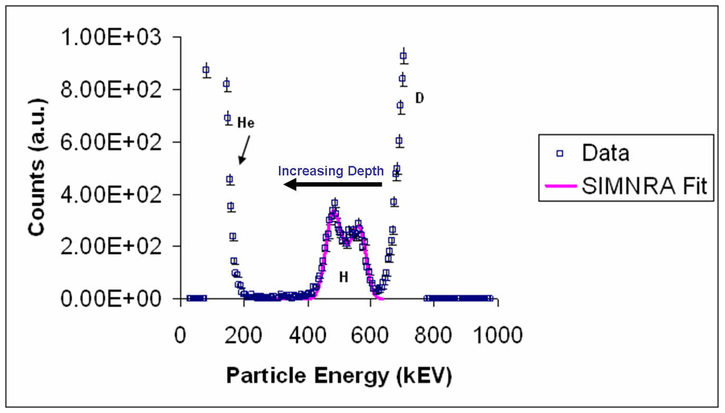

Figure 3.10 ERD spectra for the binary blend HM1530LPS annealed for 12 hours at 150°C under vacuum. Depth into the film increases with decreasing particle energy.

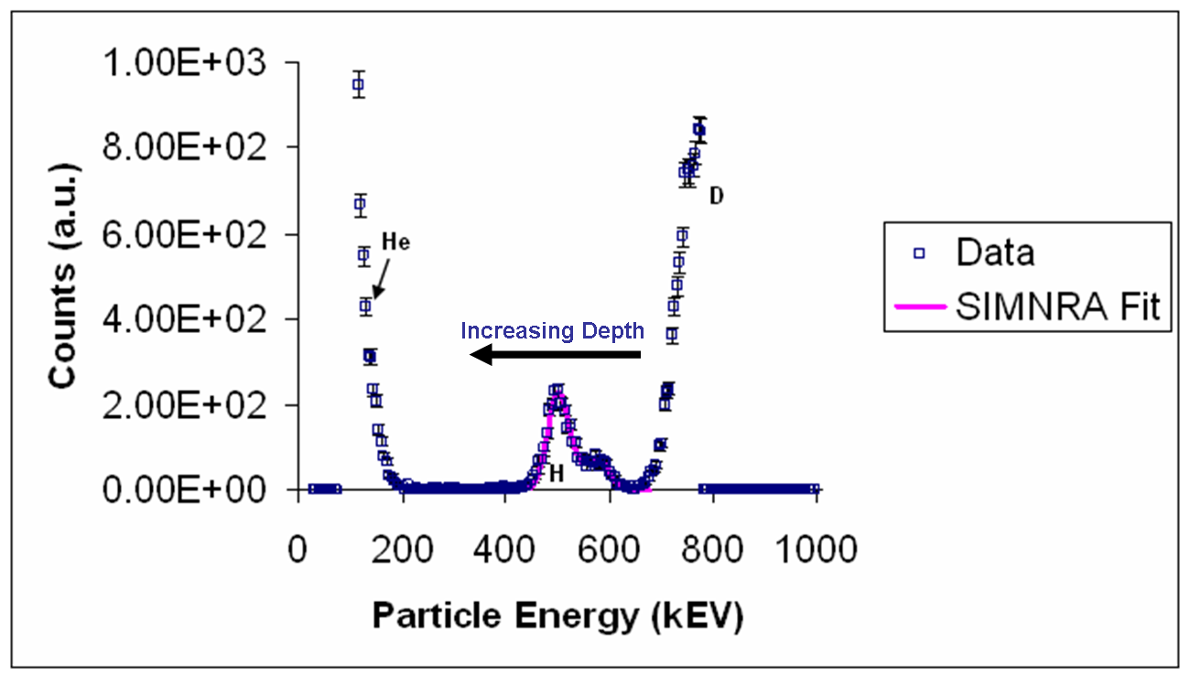

Figure 3.11 ERD spectra for the binary blend HM1530LPS annealed for 48 hours at 150°C under vacuum. Depth into the film increases with decreasing particle energy.
the surface excess was at the Si interface. Moreover, after a steady state was achieved (following thermal annealing), only the Si interface was fully covered with branched additive (i.e., the relative volume fraction of branched additive at the Si interface was 1.0 while the relative volume fraction of branched additive at the air interface was less than 1.0). Studies by Walton et al⁵³ on the surface segregation of a polymeric surfactant in a linear matrix have shown that when there is not enough mass to cover both the air and Si interfaces (i.e., the film is not thick enough), the additive will only fully cover the closest interface. Walton et al⁵³ showed experimentally in their study of the equilibrium profiles of annealed binary blends of comb copolymers in a linear matrix that when the film thickness was ~1000 Å, only the Si interface was fully covered with the comb copolymer. However, when the film thickness was increased to 2000 Å, both the air and Si interfaces were fully covered with comb copolymer (i.e., the relative volume fraction of branched additive at both the Si and air interfaces was 1.0). In all experiments, they found that the additive rich regions adjacent to the substrate and air interfaces had a thickness on the order of the R_{g} of the polymeric surfactant at equilibrium when enough material was present to cover both interfaces.
Models that contain asymmetric interfaces at the reservoir/near-substrate polymer interfaces were also fit to the reflectivity data. Theoretical predictions by Brochard et al¹²² show that the interdiffusion of two polymer chains with different mobilities results in the diffusion of the faster moving species into the slower moving species. Green et al¹²³ proved this experimentally by placing inert gold 'markers' at the original polymer/polymer interface and measuring their displacement with time. For diffusion times smaller than the Reptation time of the diffusing species, the interface assumes a classical error function shape on the side of the slow-moving species with a discontinuity on the side of the fast-moving component. The more mobile component swells the slow component and thus the interface moves towards the side of the fast-moving component but retains its sharpness. Beyond the Reptation time, the step in concentration disappears and the interface broadens. Nevertheless, it was found that the neutron reflectivity data in the present study does not agree with a model that includes an asymmetric interface.
Figure 3.12 shows a model fit to the blend DM1105LPS annealed for 48 hours at 150°C under vacuum using the 3-layer model. As indicated in the SLD plot of Fig. 3.12, DendriMacs are depleted from the bulk (reservoir) of the film while the near-air and near-Si interfaces are enriched with the branched additive. The highest concentration of the branched additive after 48 hours of thermal annealing is near the Si interface.

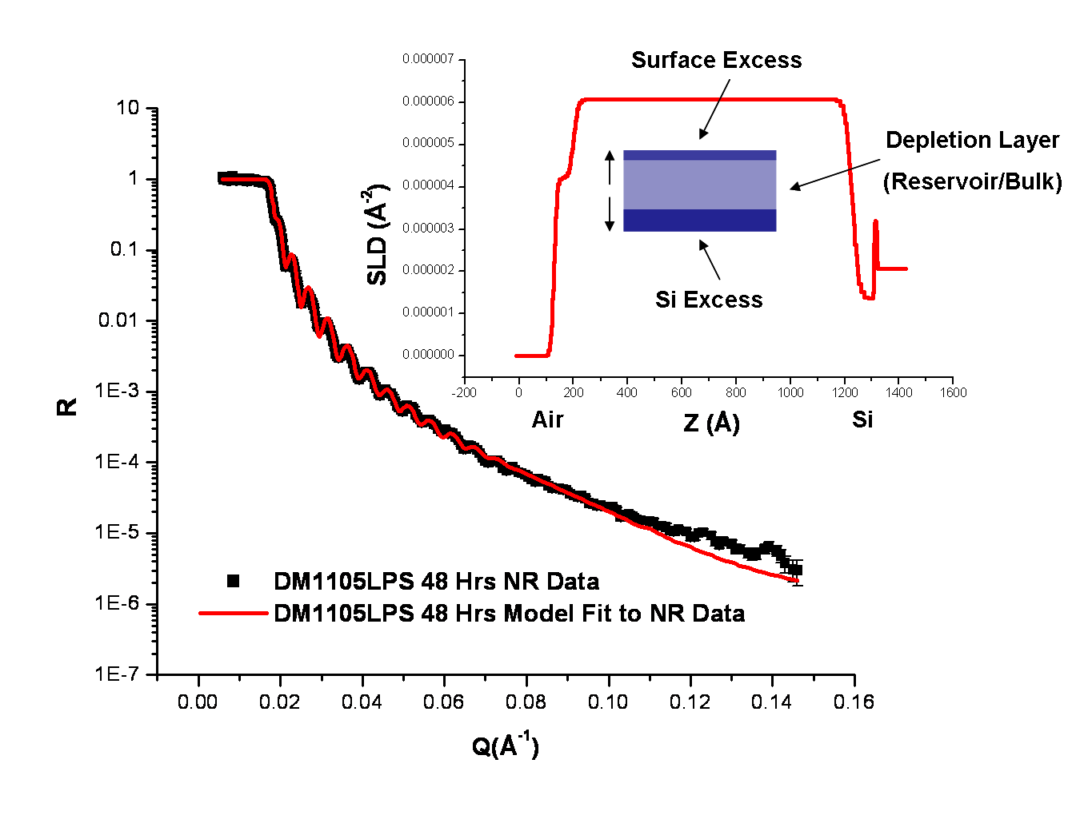

Figure 3.12 NR profile and fit of blend DM1105LPS annealed for 48 hours at 150°C under vacuum. The inset contains a plot of the SLD profile used to generate the model NR fit to the data.
Appendix A.3, Section D, contains neutron reflectivity fit parameters for all of the blends investigated in this study. Table 3.12 displays the neutron reflectivity fit parameters used to generate the evolving profiles for the blend DM1105LPS, as well as ellipsometry measurements for some of the films.
- Snapshots of HyperMac and DendriMac Movement in a Linear Matrix

  - The Time Evolution of the Volume Fraction, Φ, of Branched Additives in a Linear Matrix

Model fits to NR data were used to extract volume fraction profiles for each blend using the Tiles program (Spallation Neutron Source, Oak Ridge National Lab). Volume fraction profiles of the branched additive in the film, such as those shown for the short-time and long-time anneal studies on blend DM505LPS, in Figures 3.13 and 3.14, respectively, provide snapshots of the overall movement of branched additive in the linear matrix as annealing time increases. The depth into the film, Z, is normalized by the sample film thickness, L. After the longest annealing time (33 days), the relative volume fraction of branched additive near the Si substrate is 1.0, while the relative volume fraction of branched additive near the air interface is only ~ 0.2 (Fig. 3.14). As discussed earlier, this can be attributed to the fact that the film thickness in these experiments (~1100 Å) does not provide enough material to fully cover both the air and Si interfaces. Overall, there is a net movement of the branched additive toward the near-Si interface. The branched additive also travels toward the air interface at early times (Fig. 3.13) before finally moving away from the air interface after longer annealing times (Fig. 3.14). As time evolves, the thickness of the excess layer near the Si interface increases and the interface between this excess layer and reservoir (bulk) polymer interface broadens. The concentration of additive in the reservoir is depleted for both the short and long-time anneal studies (Figs. 3.13

Table 3.12 Neutron reflectivity fit parameters for the blend film DM1105LPS as-cast and annealed up to 33 days at 150°C under vacuum.
Anneal Times  (Secs) | ªd_{T}  (Å) | ^{b}d_{T}  (Å) | ^{b}d_{air}  (Å) | ^{b}d_{Si}  (Å) | ^{e}(b/V)_{air}  x10⁻⁶  (Å⁻²) | ^{e}(b/V)_{Si}  x10⁻⁶  (Å⁻²) | ^{e}(b/V)_{res}  x10⁻⁶  (Å⁻²) | ^{f}σ_{air}  (Å) | ^{f}σ_{sub}  (Å) | ^{f}σ_{res}  (Å)
^{c}Short  0  1800  3600  10800  18000  43200  172800  ^{d}Long  0  43200  691200  2.16E6  2.85E6 | 1250 ± 3  1156 ± 1 | 1269  1266  1266  1265  1265  1265  1180  1320  1320  1280  1300  1320 | 58  62  62  64  66  67  72  56  68  85  85  8 | 69  71  72  74  75  78  81  68  68  85  85  85 | 4.52  4.52  4.53  4.99  4.77  4.61  4.20  4.55  5.11  5.71  5.93  5.35 | 1.36  1.36  1.36  1.36  1.36  1.36  1.36  1.36  1.36  1.36  1.36  1.36 | 5.84  5.83  5.85  5.85  5.81  5.95  6.06  6.02  6.16  6.10  6.34  5.81 | 12  12  14  10  12  14  22  20  10  10  10  14 | 14  14  14  14  18  16  46  40  40  85  85  85 | 10  10  10  10  7  7  32  5  5  85  85  85
ªThickness of entire film determined from ellipsometry (measured after 12 hrs and 48 hrs anneal time); Note also that the measurements are from 2 different films – as cast to 12 hours and 48 hours
^{b}Thickness of film determined from fit to NR profile of entire film (d_{T}), at the air (d_{air}), and at the Si substrate (d_{Si})
^{c}Short time study as cast to 48 hours
^{d}Long time study as cast to 33 days
^{e}Scattering length density (b/V x 10⁻⁶ Å⁻²) at the air interface (air), Si substrate (Si), and reservoir (res.)
^{f}Roughness at the interfaces between the air interface and 1st layer (σ_{air}), 1st and 2nd layer(σ_{res}), and 2nd and 3rd layer(σ_{sub}) of segregated polymer blend film

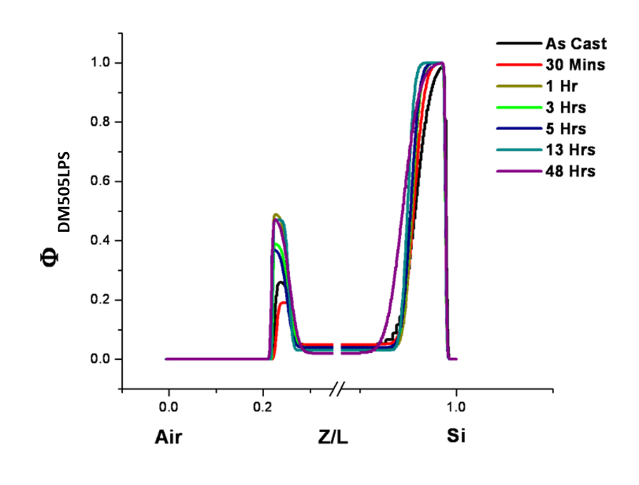

Figure 3.13 Volume fraction profiles generated by model fits to NR data for blend DM505LPS.The surface segregation process was monitored for films as-cast out to 48 hours of anneal time at 150°C under vacuum. Data is truncated to emphasize interfaces.

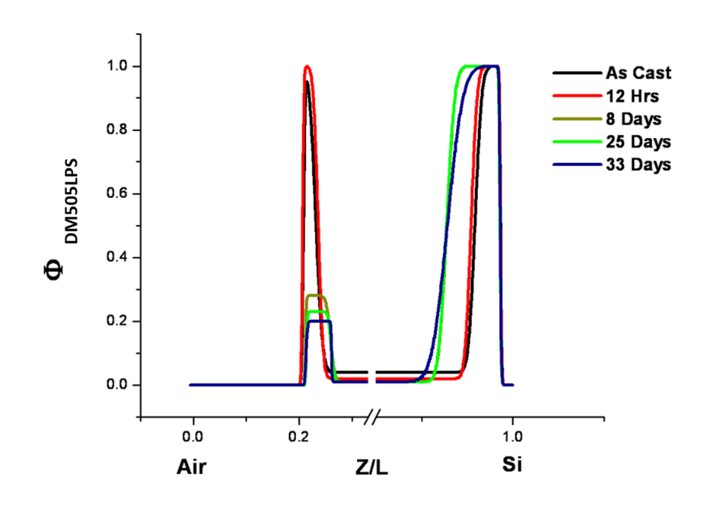

Figure 3.14 Volume fraction profiles generated by model fits to NR data for blend DM505LPS.The surface segregation process was monitored for films as-cast out to 33 days of anneal time at 150°C. Data is truncated to emphasize interfaces.

and 3.14). Appendix A.3, Section E contains the volume fraction profiles for all the blends investigated in this study.
Figure 3.15 illustrates how the concentration of branched additive in the reservoir (bulk) of the film decreases at early times before approaching a steady state after longer annealing times.
  - The Time Evolution of the Interfacial Excess, Z*, of Branched Additives in a Linear Matrix

From the fitted neutron reflectivity profiles of the unannealed and annealed films, the interfacial excess, Z*, which is the amount of additive near an interface and above the bulk concentration of branched additive, is determined. This parameter is calculated by integrating the

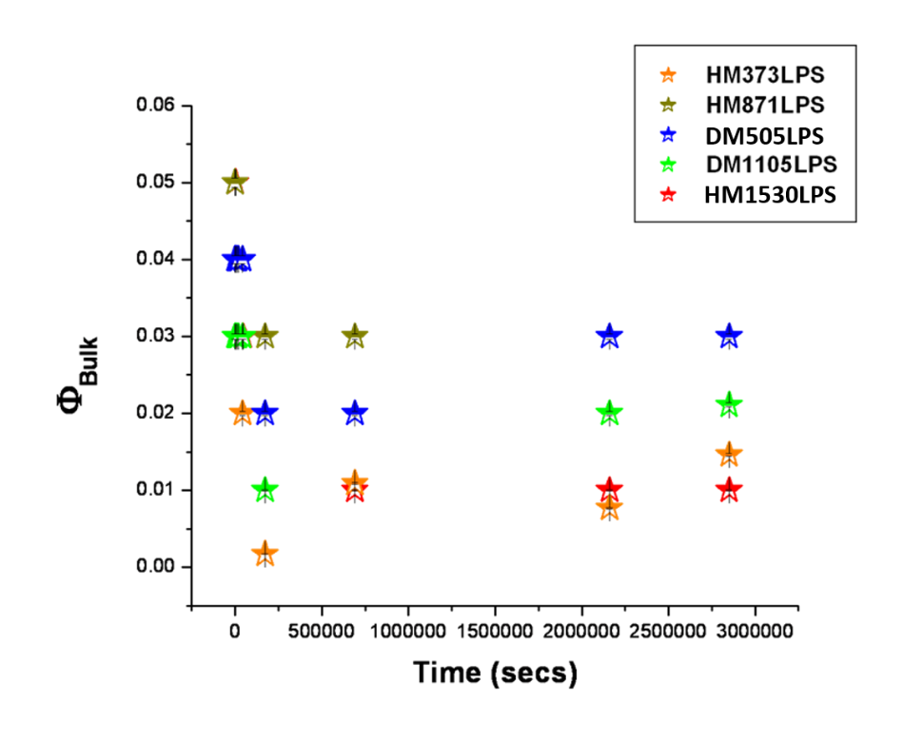

Figure 3.15 The time evolution of the bulk (reservoir) volume fraction of HyperMacs and DendriMacs in blend films as-cast and annealed up to 33 days at 150°C under vacuum.
excess branched additive volume fraction profile derived from neutron reflectivity according to equation 3.11:¹⁷
(3.11).

In Equation 3.11, (z) is the branched additive volume fraction at depth z in the film while is the branched additive volume fraction in the bulk of the film. Figures 3.16 and 3.17 show the time evolution of the surface excess near the Si interface, Z*_{Si}, for HyperMacs in a linear matrix and DendriMacs in a linear matrix, respectively. After spin casting (before annealing), there is a significant amount of interfacial excess near the Si interface for blends containing HyperMacs and DendriMacs (Figs. 3.16 and 3.17). The length scale of this initial surface excess is on the order of several polymer chain segments given that a PS segment is ~ 7 Å.⁵⁵ This initial surface excess after spin casting was reproducible for both the long and short-time studies. At early annealing times, the interfacial excess near the Si interface increases slowly and then saturates after long times, indicating that all the thermally annealed binary blends investigated in this study have reached a steady state.
- How Branched Additive Molecular Weight and Amount of Branching Affects Z* at an Interface

An examination of the initial interfacial excess near the Si interface as a function of M_{w} offers some insight as to how size affects how branched polymeric additives pack at an interface. Figure 3.18 displays the relationship between the initial interfacial excess after spin casting at the Si interface, Z*_{Si Initial}, and the size of the branched polymeric additive, M_{w}. Perhaps because smaller branched additives can pack more efficiently and tightly at an interface, the blend containing the smallest branched polymer, HM373LPS, has the greatest initial interfacial excess near the Si interface, while the blend containing the largest branched polymer, HM1530LPS, has
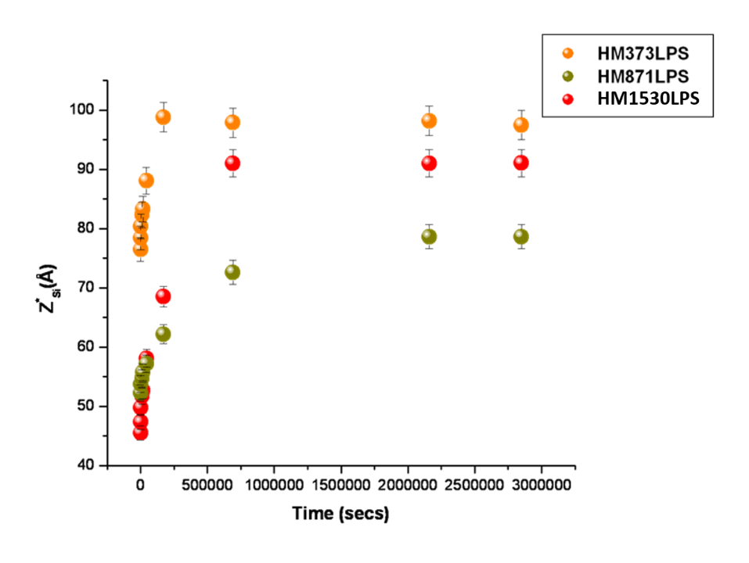

Figure 3.16 The time evolution of the surface excess, Z*Si, near the Si interface for HyperMacs in a linear d-PS matrix from the as-cast film to 33 days of annealing time under vacuum at 150°C.

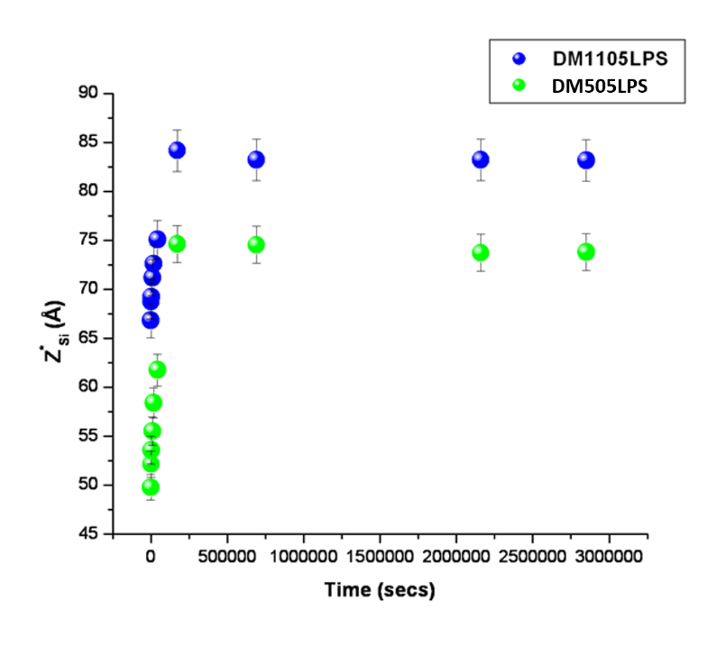

Figure 3.17 The time evolution of the surface excess, Z*Si, near the Si interface for DendriMacs in a linear d-PS matrix from the as-cast film to 33 days of annealing time under vacuum at 150°C.
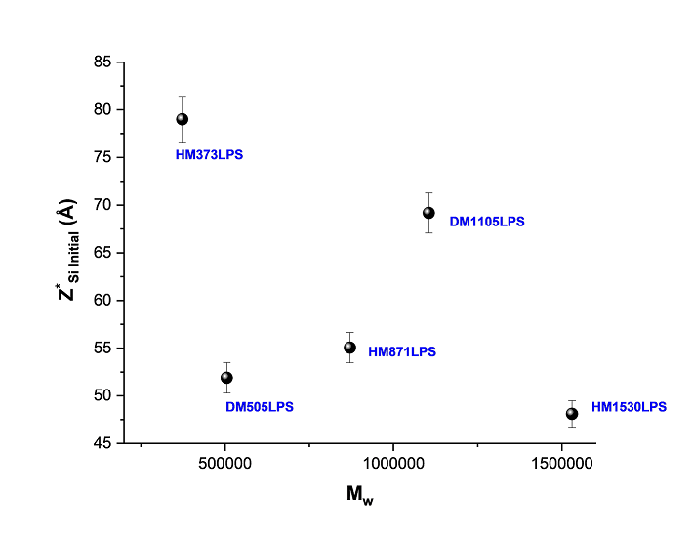

Figure 3.18 The interfacial excess near the Si interface after spin-casting, Z*_{Si Initial}, as a function of the size of the branched additive, M_{w}.

the least initial interfacial excess near the Si interface. Nevertheless, size alone does not explain how well these additives segregate to an interface during film formation. The shape of the additive likely plays a role as the blend containing the branched additive with an M_{w} of 1,105,000 g/mol, DM1105LPS, also has a substantial initial interfacial excess near the Si interface.
Likewise, the final amount of interfacial excess near the Si interface, Z*_{Si Final}, as a function of the M_{w} of the branched additive was also evaluated to get more qualitative information about the surface segregation process in these systems. Figure 3.19 illustrates how
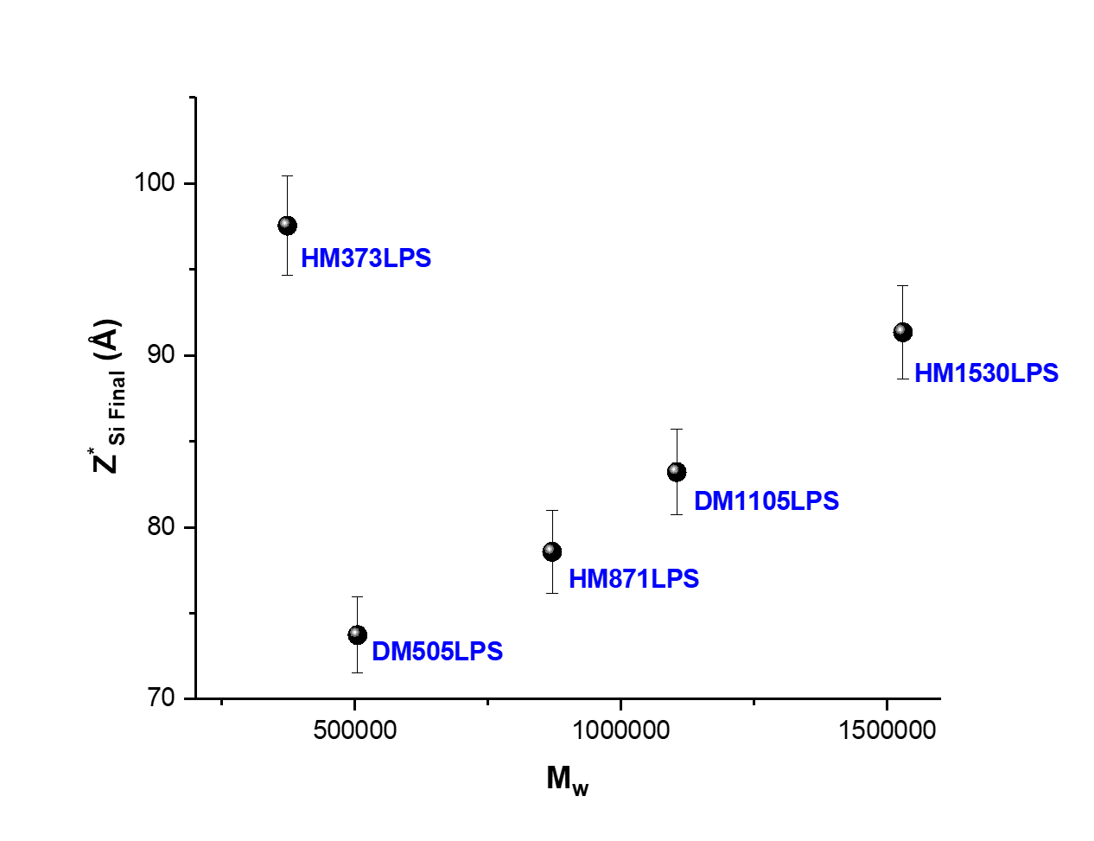

Figure 3.19 The final interfacial excess of branched additives in a linear matrix near the Si interface, Z*_{Si Final}, as a function of the branched additive M_{w}. M_{w} of the linear matrix is 320,000 g/mol. All blends were annealed for 33 days at 150°C under vacuum.

size and branching of the branched additive affects the steady state amount that segregates to the near-Si interface. Figure 3.19 indicates that both branching and molecular weight are competing effects in these branched/linear blends. At the low molecular weight end of the ‘spectrum,’ both the linear matrix and branched additive (HM373LPS) are approximately the same molecular weight, such that branching in the branched additive provides the driving force for surface segregation (i.e., no molecular weight barrier effect). However, when the branched additive and linear matrix are not the same molecular weight, the driving force for surface segregation changes. When the linear matrix is the smaller molecule (~320 K g/mol), it has an entropic driving force to segregate to the surface, and thus a larger branched additive such as the DendriMac in the blend DM505LPS, has a comparatively smaller amount of surface excess after the longest annealing time. Nevertheless, as the molecular weight of the branched additive in the binary blend increases, the branching-based driving force for surface segregation dominates because as the molecular weight of the branched additive increases, branching also increases. It is also interesting to note that these results differ from what has been previously reported for blends containing only linear polymer chains. Previous studies on the surface segregation of
binary blends of linear short and long chains report that the amount of surface segregation decreases with increasing molecular weight,^{49, 124, 125, 126, 127} due to a decrease in the number of chain ends and thus an increase in the entropic penalty for bringing a chain to a surface. However, for blends of HyperMacs and DendriMacs in a linear matrix, increasing the molecular weight of the branched additive results in an increase in the amount of surface segregation since an increase in the branched additive molecular weight also results in an increase in the amount of branching.
- How the Architecture of HyperMacs and DendriMacs in a Linear Matrix Affects their Dynamic Behavior

- Overview

The approach to designing materials composed of HBPs in a linear matrix that possess tunable surface properties requires an understanding of the dynamics of these branched macromolecules in a matrix of long homopolymer chains. The Kramer-Jones Depletion Layer Model, which describes the diffusion-controlled growth of a wetting layer in a binary polymer blend, enables determination of the diffusion coefficient of HBPs. According to this model, the surface segregating layer grows as t^{1/2}. However, the Depletion Layer Model assumes that the initial surface excess of the surface-segregating component is zero, which is clearly not valid in the samples examined here. To account for the initial surface excess that results from the spin casting process, the growth of the wetting layer near the Si interface for HyperMacs and DendriMacs in a linear matrix was fit to the function y = t^{1/2} + b, where b represents the initial interfacial excess at the near-Si interface, Z*_{Si Initial}. The net interfacial excess near the Si interface, ΔZ*_{Si} = Z*_{Si Final} - Z*_{Si Initial}, displays t^{1/2} kinetics for all the branched/linear blends investigated. Therefore, by plotting ΔZ*_{Si} as a function of time, it is possible to extract quantitative information about the dynamics of the surface segregation process using the Kramer-Jones model. The mutual diffusion coefficient, D_{m}, consistent with the Depletion Layer Model of Kramer and Jones, is calculated using equation 3.12: ¹⁷
(3.12)
where is the equilibrium interfacial excess (which is the net interfacial excess near the Si interface in the present study, ΔZ*_{Si}), is the volume fraction of branched additive in the bulk (or reservoir) of the film at equilibrium, and is the time it takes for the blend to reach equilibrium. Following this analysis, as described in Chapter 2, the Fast and Slow Mode theories were applied to these data to extract the tracer diffusion coefficient for each surface segregating branched additive from the mutual diffusion coefficient of each binary blend. The mutual and tracer diffusion coefficients help to provide insight into how the architecture of each branched additive affects the dynamics of the branched polymer in the surface segregation process.
- The Mutual Diffusion Coefficient, D_{m}, of a Hyperbranched/Linear Blend from Depth Profile Experiments

Figures 3.20-3.24 demonstrate how the net equilibrium interfacial excess near the Si interface, ΔZ*_{Si eq}, as well as the equilibrium time, t_{eq}, was extracted from plots of the growth of the net equilibrium interfacial excess as a function of time. From these data, the mutual diffusion
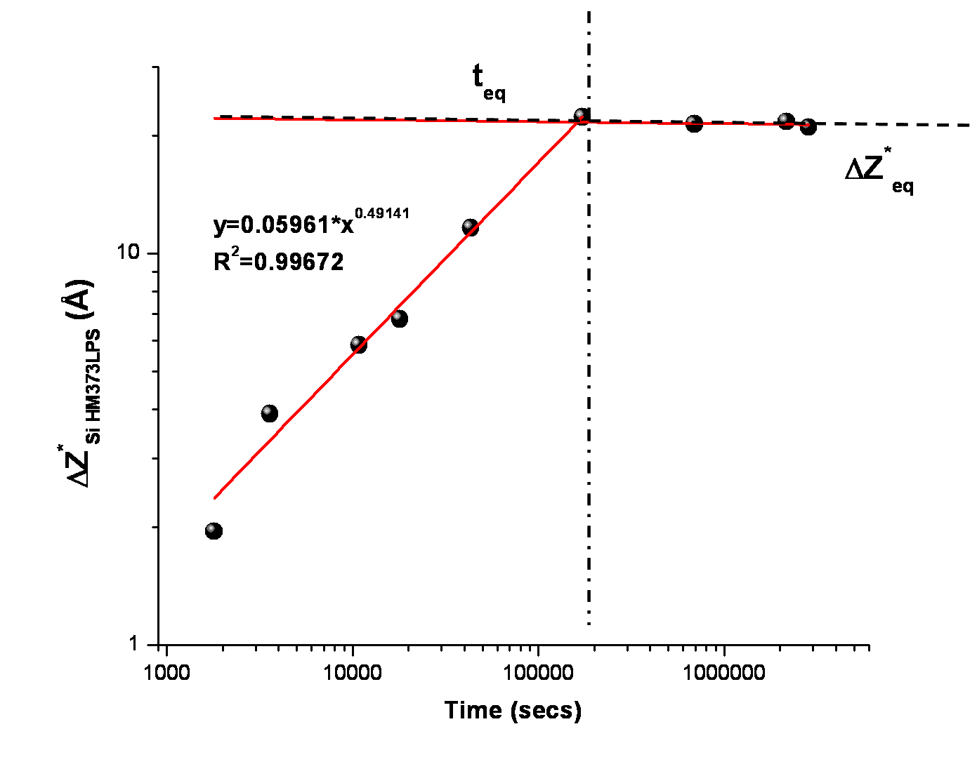

Figure 3.20 The growth of the net interfacial excess layer near the Si interface, ΔZ*_{Si},for the blend containing HyperMac HM373LPS annealed up to 33 days at 150°C under vacuum.

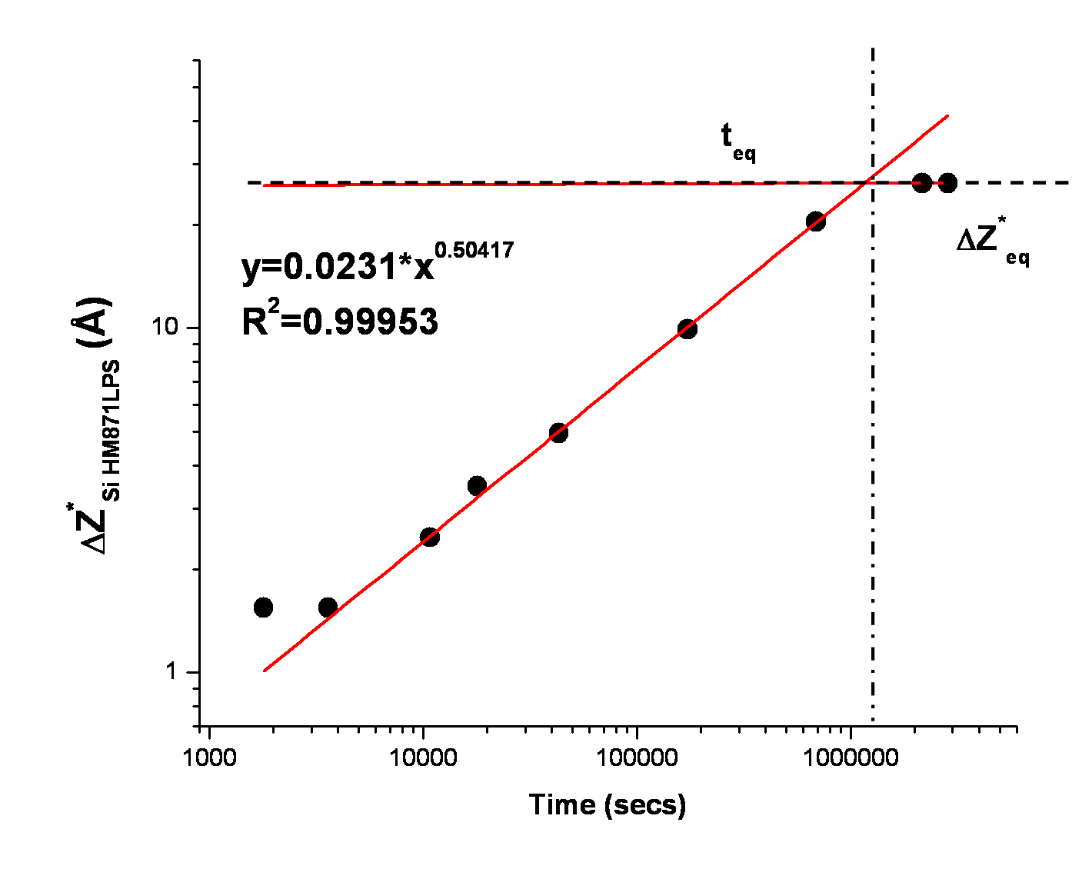

Figure 3.21 The growth of the net interfacial excess layer near the Si interface, ΔZ*_{Si}, for the blend containing HyperMac HM871LPS annealed up to 33 days at 150°C under vacuum.

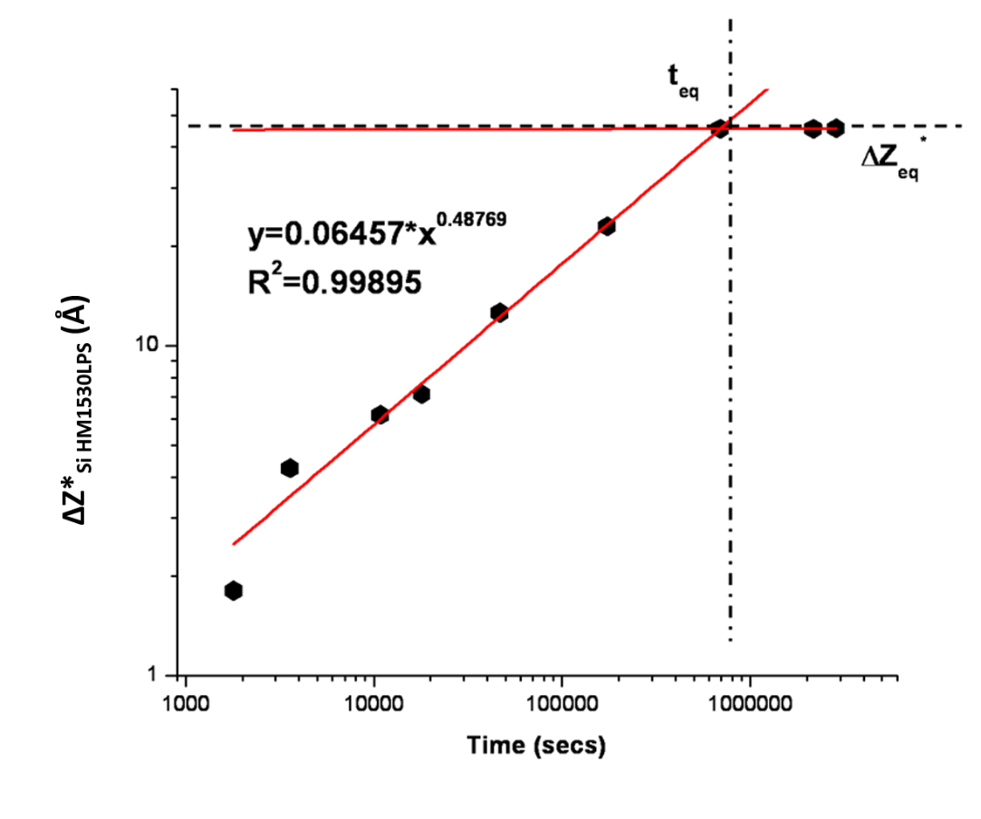

Figure 3.22 The growth of the net interfacial excess layer near the Si interface, ΔZ*_{Si}, for the blend containing HyperMac HM1530LPS annealed up to 33 days at 150°C under vacuum.

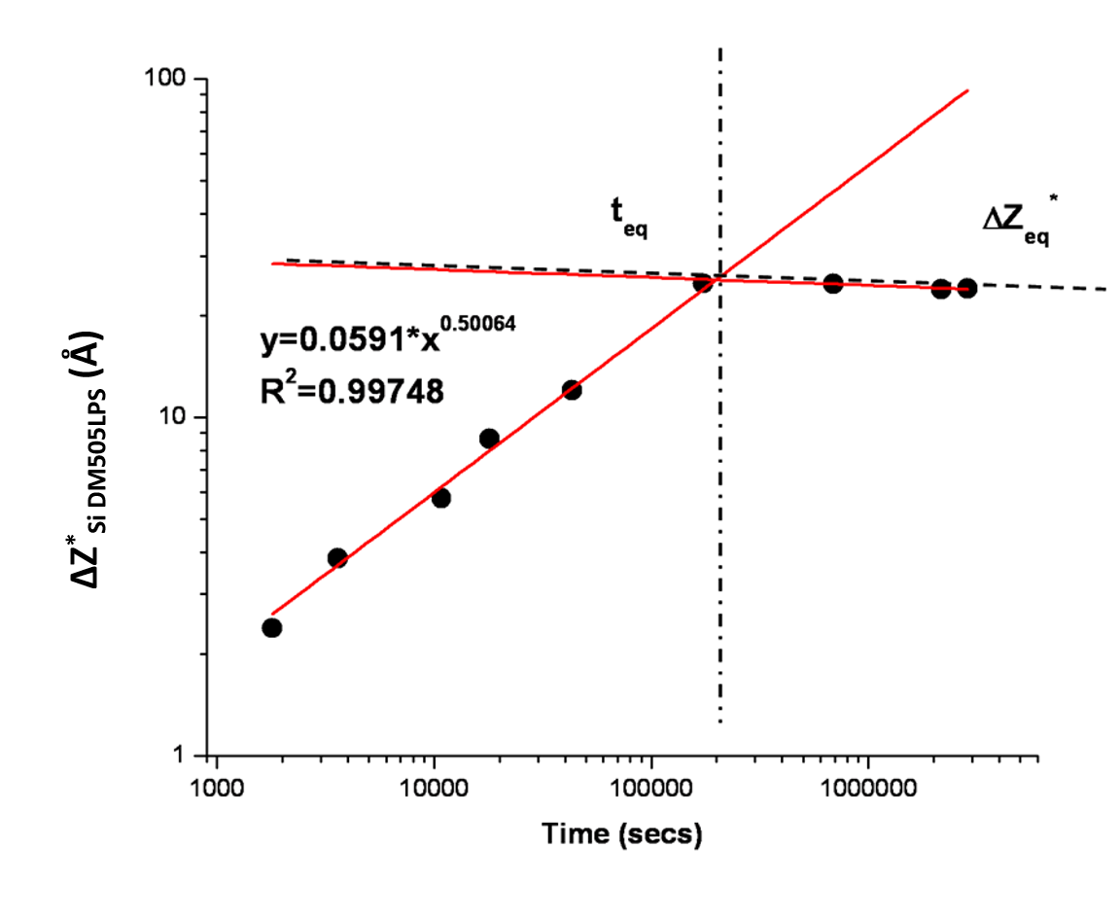

Figure 3.23 The growth of the net interfacial excess layer near the Si interface, ΔZ*_{Si}, for the blend containing DendriMac DM505LPS annealed up to 33 days at 150°C under vacuum.

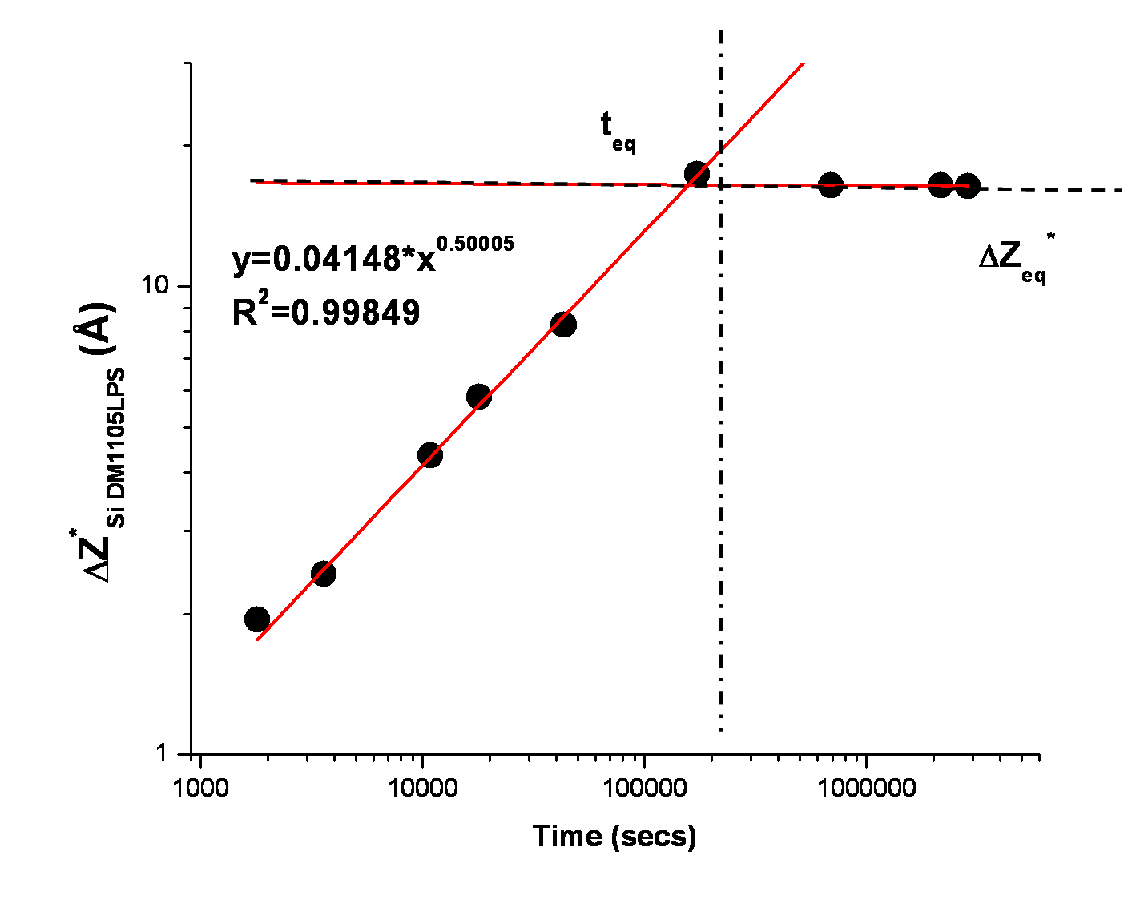

Figure 3.24 The growth of the net interfacial excess layer near the Si interface, ΔZ*_{Si}, for the blend containing DendriMac DM1105LPS annealed up to 33 days at 150°C under vacuum.

coefficient, D_{m}, was calculated using Equation 3.9 for each blend, the results of which are summarized in Table 3.13.
The D_{m} of linear polystyrene in a number of PS/d-PS blends has been reported in the literature for polymers of various sizes and at various annealing temperatures: D_{m}=5.16E-16cm²/s, M_{w}=110,000 and 93,000 g/mol, T=125°C; ¹²⁸ D_{m}=2.44E-17cm²/s, M_{w}=660,000 and 752,000 g/mol, T=140°C; ⁸⁶ D_{m}=5.45E-18cm²/s, M_{w}=233,000 g/mol, T=120°C. ⁸⁷ The magnitudes of the mutual diffusion coefficients in binary blends of HBPs in a linear matrix, (Tbl.
Table 3.13 The mutual diffusion coefficients, D_{m}, for blends containing HyperMacs and DendriMacs in a linear homopolymer matrix as well as the equilibrium time, t_{eq}, and net equilibrium interfacial excess near the Si interface, ΔZ*_{Si eq}.

Sample Name | D_{m}(cm²/sec) | t_{eq}(secs) | ΔZ*_{eq}(Å)
HM373LPS | 1.24E-15 | 166,200 | 21.0
HM871LPS | 6.71E-17 | 1,154,300 | 26.4
HM1530LPS | 3.00E-15 | 691,200 | 45.5
DM505LPS | 3.25E-16 | 197,500 | 24.0
DM1105LPS | 3.86E-16 | 155,500 | 16.3

3.13) are in reasonable agreement with these measurements of blends composed of linear PS chains.
- The Tracer Diffusion Coefficient, D_{A}*, of a Hyperbranched Polymer from Depth Profile Experiments

More information about the dynamics of the surface segregation process can be extracted by determining the tracer diffusion coefficient of the branched additive in these binary branched/linear blends. Inspection of the Fast and Slow Mode theories, as described in Chapter 2, indicates that only the Slow Mode theory gives a physically reasonable result for HyperMacs and DendriMacs. Equation 3.13 shows how the tracer diffusion coefficient is calculated using the Slow Mode theory:^{69,18}
(3.13)
where D_{A}* is the tracer diffusion coefficient of the slow-moving component, D_{m} is the mutual diffusion coefficient, Φ_{A} and Φ_{B} are the volume fractions of components A and B, respectively, D_{B}* is the diffusion coefficient of component B, and N_{A} and N_{B} are the degree of polymerization for components A and B, respectively. The diffusion coefficient of the linear matrix, D_{B}*, must also be known to compute the tracer diffusion coefficient of the HBP using equation 3.13. Thus, from previous measurements of the diffusion coefficient of linear PS under the same conditions (150° C under vacuum in films ~1000 Å thick), it is estimated that D_{B}* for linear PS with M_{w} of 335,800 g/mol is 3.38E-16 cm²/sec. Moreover, using the model of Doi and Edwards for polymer dynamics,¹²⁹ as shown in equation 3.14, the tracer diffusion coefficients of linear analogs of PS HyperMacs and DendriMacs as well as of the linear PS matrix in the blend was calculated:
(3.14)
where k_{B} is Boltzmann’s constant, 1.3087E-16 cm².g.s⁻².K⁻¹, T is the temperature, 423 K, d_{t} is the tube diameter for PS, 5.7E-7 cm, ξ is the friction coefficient for PS, 0.045 dyn.s/cm, N is the degree of polymerization, and b is the segment length of PS, 6.7E-8 cm.^{67,130} Table 3.14 contains a summary of diffusion coefficients for HyperMacs and DendriMacs in a linear matrix along with the diffusion coefficients of their linear analogs.
Figure 3.25 illustrates the differences in the dynamic behavior of surface segregating HyperMacs and DendriMacs in a linear matrix compared with the dynamics of their linear analogs. In Figure 3.25, the calculated diffusion coefficients of linear PS analogs exhibit the molecular weight dependence of D~M_{w}⁻² as predicted by the Reptation theory for entangled linear polymers. However, the measured tracer diffusion coefficients of HyperMacs and DendriMacs display a higher molecular weight dependence than predicted by Reptation theory.
The experimentally determined diffusion coefficient of entangled linear polymers also does not agree with the predictions of the Reptation theory⁵⁹ as the relationship between the tracer
Table 3.14 Tracer diffusion coefficients, D_{A}*, for HyperMacs and DendriMacs in a linear homopolymer matrix as well as for their linear analogs.
Sample Name | D_{A}* HBP  (cm²/sec) | D_{A}* Linear PS Analog  (cm²/sec)
HM1530LPS | 2.84E-16 | 1. 81E-17
HM373LPS | 1.90E-16 | 2.36E-16
HM871LPS | 1.36E-17 | 4.34E-17
DM505LPS | 3.95E-17 | 1.22E-16
DM1105LPS | 3.16E-17 | 2.69E-17

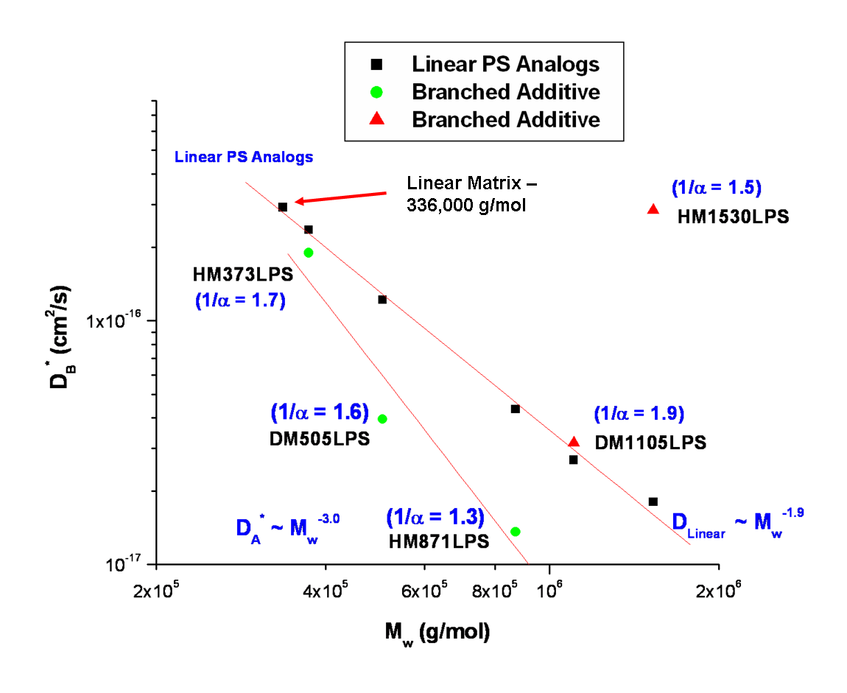

Figure 3.25 The tracer diffusion coefficient of HyperMacs and DendriMacs in a linear d-PS matrix with M_{w} of 335,800 g/mol. Also shown are the calculated values of the diffusion coefficient of linear analogs of HyperMacs and DendriMacs as well as of the linear matrix. The fractal dimension of each HBP additive is included in parentheses.
diffusion coefficient and molecular weight is D~M_{w}^{-2.3}. Similarly, the Edwards-Evans model,⁵⁹ which is based on polymer dynamic simulations of linear entangled polymers, also predicts a stronger molar mass dependence of the diffusion coefficient, D~M_{w}^{-2.5+/-0.1}. These higher molecular weight dependences of the diffusion coefficient, as discussed in Chapter 2, have been attributed to tube length fluctuations. One way to understand this dynamic behavior is to assume that the tube is dynamic and not static, and that this results in more complex dynamics than predicted by the simple Reptation theory. Furthermore, as discussed in Chapter 2, hyperbranched polymers do not relax by simple Reptation, but via hierarchical relaxation, as proposed by Mc Leish.^{131,132}
In Figure 3.25, the tracer diffusion coefficient of the branched additive in the blend HM373LPS is of the same order of magnitude as the calculated diffusion coefficient of a linear analog. However, as the molecular weight of HyperMacs and DendriMacs increases (below a molecular weight of 1E6 g/mol), the tracer diffusion coefficient of the branched additive is lower than that of a linear analog. Above a branched additive molecular weight of 1E6 g/mol, however, a crossover occurs, and the tracer diffusion coefficient of the branched additive is faster than that of a linear analog. One way to interpret these results is to consider the impact that HBP structure and molecular weight has on the diffusive properties. When the HBP additive has a molecular weight below ~ 1E6 g/mol, molecular weight has a larger impact on the diffusive properties and thus smaller HBPs move faster than larger HBPs. However, when the HBP additive exceeds a molecular weight of ~ 1E6 g/mol, the HBP structure has a larger impact on the diffusive properties. HBPs above a molecular weight of ~ 1E6 g/mol that are less flexible and have smaller fractal dimensions will entangle less easily with the linear matrix and will therefore move faster (see differences in fractal dimensions labeled for each additive in Fig. 3.25).

3.4 Conclusions

The evolving density profiles that monitor the surface segregation process in binary blends composed of hyperbranched polymeric additives in a linear homopolymer matrix have been elucidated using both neutron reflectivity and complementary ERD experiments. HyperMacs and DendriMacs in a linear matrix segregated to both the near-air and near-substrate interfaces, with the majority segregating to the near-Si interface. The latter can be attributed to a lack of sufficient material (film thickness) to cover both interfaces with a monolayer of branched additive. It was discovered that with respect to the thermodynamics of these blends (i.e., how much of the additive segregates to a surface), both branching and molecular weight are competing effects in these systems. Examination of the interfacial excess near the Si interface as a function of M_{w} clearly demonstrated that both the smallest as well as the largest branched additive in a linear matrix produces the most interfacial surface excess at equilibrium. Moreover, both the near-air and near-Si interfaces were enriched with PS HyperMacs and DendriMacs instead of the d-PS matrix, which has been shown experimentally to be the lower energy component in a binary linear PS/d-PS blend.⁶⁶ Thus, this result is consistent with an entropically driven segregation process in these self-healing systems.
There was a substantial and reproducible amount of initial interfacial excess prior to annealing (as-cast) near the Si interface for all the blends studied. The growth of the near-Si interfacial excess fit the function y = t^{1/2} + b, where b represents an offset equal to the initial interfacial excess at the near-Si interface, Z*_{Si Initial}. The net interfacial excess near the Si interface, ΔZ*_{Si}, exhibits t^{1/2} kinetics for all the branched/linear blends investigated. Using the net interfacial excess, the Kramer-Jones model was applied to the blend systems. Quantitative information about the dynamics of the surface segregation process was extracted, including the net equilibrium interfacial excess, the equilibration time of the surface segregation process, and the mutual diffusion coefficient of the binary blend. Moreover, after attempting to utilize both the Fast and Slow Mode theories for these branched/linear systems, it was found that only the Slow Mode theory provided a physically reasonable result. Using the Slow Mode theory, the tracer diffusion coefficient of each branched polymeric additive in a linear polymer matrix was determined. Thus, these results also demonstrate a method to successfully measure diffusion coefficients of hyperbranched polymeric additives in a linear polymer matrix.
Furthermore, it was found that with respect to the dynamic behavior of these branched/linear blends (i.e., how fast an additive segregates to a surface), both the molecular weight as well as the structure of the additive have an impact on its diffusive properties. Below a molecular weight of ~1E6 g/mol, the smaller branched additives move slower than their linear analogues. However, above a molecular weight of ~ 1E6 g/mol, less flexible branched additives with smaller fractal dimensions move faster than their linear analogues, suggesting that they are less likely entangled with the linear matrix. Moreover, the dynamics of these HBPs in a linear matrix were not observed to obey simple Reptation dynamics (i.e., D ~ M_{w}^{-2.0}), but rather the diffusion coefficient for these HBPs exhibited a higher molecular weight dependence (i.e., D ~ M_{w}^{-3.0}).

The Time Evolution of the Surface Segregation of P(MMA-r-PEGMA) Comb Copolymers from a Linear Matrix

  - Introduction

A. Overview
The surface segregation behavior of graft copolymers of poly(ethylene oxide) (PEO) and poly(methyl methacrylate) (PMMA) in a linear PMMA matrix are investigated in this study. PMMA and PEO have commercial relevance, as they are both components of many FDA approved biomedical implantable devices. Biomedical implants require materials that resist protein adsorption and cell adhesion while also providing a hydrophilic surface. Intraocular lens (IOL) implants are one such example. PMMA, a common IOL material, has been known to damage corneal endothelium during intraocular implant surgery due to the adhesive contacts formed between the polymer and tissue surface.⁴⁹ One solution to this problem is hydrophilic modification of PMMA. PEO is both hydrophilic and resistant to protein adsorption and cell adhesion. By making a copolymer composed of both PEO and PMMA, the benefits of both polymers can be harnessed.
Water contact angle studies conducted by Walton et al⁴⁵ revealed that surfaces of thin films composed of the comb copolymer poly(methyl methacrylate)-random-poly(ethylene glycol) methyl ether methacrylate (P(MMA-r-MnG)), as well as the surface of thermally annealed films composed of PMMA/P(MMA-r-MnG) blends are hydrophilic. The comb copolymers are composed of a PMMA backbone and PEO branches. Walton et al demonstrated that even though the surface tension of a film composed of P(MMA-r-MnG) is higher than the surface tension of a film composed of PMMA, 2000 Å thick films composed of PMMA/P(MMA-r-MnG) blends that were 2 to 20 w/w% copolymer were completely covered at both the air and substrate interfaces of the thin film with a monolayer of the comb copolymer following thermal annealing. However, thermally annealed thin films composed of linear PEO blended with linear PMMA, in which linear PEO was approximately the same molecular weight as the comb copolymer, did not form a segregated layer at either the air or substrate interfaces after thermal annealing under the same conditions. Thus, entropy-driven surface segregation resulted in surfaces that were both stable to dissolution in water-based environments, due to the presence of the PMMA, and that were also hydrophilic due to the pendant PEO branches in the surface segregated comb copolymer.⁴⁵
In the present investigation, the aim is to study similar blends containing PEO grafted PMMA comb copolymers (specifically, P(MMA-r-PEGMA)) with varying degrees of branching in a deuterated linear PMMA matrix in order to develop a fundamental understanding of how the molecular architecture of the branched graft copolymer affects the surface segregation behavior in these blends. By following the time evolution of the surface segregation process, insight into the approach to the equilibrium structure can be used to tailor branched additives where parameters such as branch density are optimized for specific applications.

B. Theoretical Investigations of the Equilibrium Structures of Surface Segregated Comb/Linear Blends
The theoretical work of Wu and Frederickson,⁵² followed by further work by Walton et al,⁴⁹ provides information on the equilibrium density profiles of surface segregated blends of comb copolymers with varying degrees of branching and branch lengths in a linear polymer matrix. The results of their simulations, which were obtained using a self-consistent mean-field model, confirmed that it is possible to dramatically increase the degree of segregation of an additive in a linear polymer matrix by modifying its architecture from a linear to a branched comb structure. In linear/linear blends, the amount of surface segregation increases as the molecular weight of the additive decreases. Simulations showed that the converse is true for blends of branched comb copolymers in a linear matrix in which surface enhancement increases as the molecular weight of the comb copolymer increases. In contrast to the surfaces of surface segregated linear/linear blends where low molecular weight additives can be removed by wear, evaporation or dissolution, blends containing higher molecular weight branched surface segregating additives offer a potentially more robust surface.
Wu and Frederickson determined that the characteristic length scale for the equilibrium surface enrichment profile, ζ, of a comb/linear blend (i.e., the size of the region enriched with the surface segregated additive) scales with the R_{g} of the comb copolymer’s backbone for dilute concentrations of comb.⁵² At high concentrations of comb, ζ scales as the R_{g} of a linear polymer of the same molecular weight as the entire comb copolymer. Wu and Frederickson⁵² as well as Walton et al⁴⁹ found that in a comb/linear blend, at equilibrium, the profile of branched additives near the air interface exhibits a crest near the air interface which exponentially decays into the bulk of the film. This observation is in contrast to linear/linear surface segregated blends at equilibrium in which the near-surface concentration profile falls away abruptly and thus these interfaces can be modeled with a hyperbolic tangent. The near-surface crest observed in comb/linear blends can be accounted for by considering that as the chain ends localize at the surface, the backbone of the comb is pulled toward the surface. Nevertheless, since it is not entropically favorable for the branch points to reside at the surface, the backbone is slightly localized toward the bulk. Hence, Walton et al⁴⁹ used an error function, instead of a hyperbolic tangent, to model the more extended concentration profiles of these additives near an interface in their studies on the equilibrium structure of comb/linear blends. Their simulations also showed that a larger crest correlated with larger surface excesses. Moreover, they discovered that additives with sparsely-spaced long branches in comb/linear blends had equilibrium profiles that resembled the profiles of surface segregated linear/linear blends at equilibrium. Thus, after endeavoring to establish all the factors which controlled the equilibrium amount of surface excess in comb/linear blends, they determined that the comb architecture that achieved the largest degree of segregation is one in which the branches are short without being too short (i.e., so short as to behave as a linear polymer) and in which the branch points are closely spaced.
Furthermore, calculations by Walton et al⁵³ of the surface energy of segregated comb/linear blends revealed that when the number of branches is large, the surface energy, γ, scales as β⁻¹ where β is the number of branches, supporting the hypothesis that chain ends drive the segregation process as the surface energy reduction is related to the number of chain ends.
Nevertheless, what is missing in these studies is information on the details of the surfactant adsorption process. In order to realize the commercial application of binary branched/linear self-healing materials, it is necessary to understand the dynamics of the process. In the present study, fundamental information toward the rational design of these self-healing materials is obtained by following the time evolution of the approach to equilibrium for combs with varying branch density in surface segregating comb/linear blends.

C. The Thermodynamic Behavior of PEO and PMMA in Thin Films
It is important to consider how the interaction between PEO and PMMA segments in a binary blend can affect the overall thermodynamics of the blend, as this fundamental information is required to develop a better understanding of how to rationally design self-healing materials composed of P(MMA-r-PEGMA) comb copolymers in a linear PMMA matrix. Previous studies on homopolymer PMMA/PEO blends have revealed that PEO in these blends crystallizes in the bulk as well as in thin films.¹³³ However, the rate of crystallization decreases as PMMA content increases. Moreover, PEO chain length affects crystallization behavior. Guo¹³³ reported that thin films of P(MMA-r-MnG)with short PEO side chains (M_{n} of PEO 1650 g/mol) did not crystallize, as they observed no microphase separation structure with Transmission Electron Microscopy (TEM). In the present study, PEO side chains of PEO grafted PMMA comb copolymers have anM_{n} of 1,100 g/mol. Moreover, in the present study, the PEO concentration varies from ~1 to 5 w/w % in comb/linear blends. Thus, microphase separation is not expected for these materials.
D. Synthesis of P(MMA-r-PEGMA) Comb Copolymers
Random comb copolymers, P(MMA-r-PEGMA), were synthesized at the Center for Nanophase Materials Science (CNMS) at Oak Ridge National Lab (ORNL) by Dr. Joseph Pickel and Dr. Li Hong He using ATRP by copolymerization of MMA monomer with an MMA functionalized PEO macromonomer, poly(ethylene glycol) methacrylate (PEGMA), having an M_{n} of 1100 g/mol, containing 23 ethylene oxide (EO) units, and terminated by a hydroxyl group. The reaction was conducted in acetone at 85°C and included ethyl-2-bromo propionate (EBP) as initiator, N, N, N’, N’’, N’’-pentamethyldiethylenetriamine (PMDETA) as ligand, and CuBr as catalyst (Scheme 4-1). The progress of the reaction was monitored with size exclusion chromatography (SEC), and post-polymerization purification techniques were used to remove unreacted macromonomer. This synthetic approach differs from the one used to create P(MMA-r-MnG) copolymer combs in the study by Walton et al⁴⁵ in which they used anionic synthesis to create combs that were 50% poly(ethylene glycol) methyl ether methacrylate (i.e., poly(ethylene glycol) macromonomer terminated in a methoxy group) by mass and 50% MMA monomer by

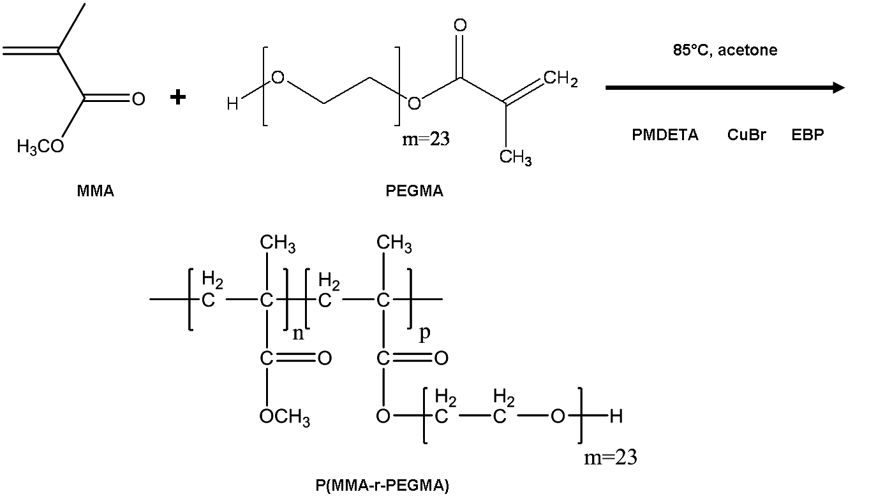

Scheme 4-1 ATRP synthesis of P(MMA-r-PEGMA) copolymer combs by copolymerization of MMA monomer with an MMA functionalized PEO macromonomer, poly(ethylene glycol) methacrylate (PEGMA), having an M_{n} of 1100 g/mol and containing 23 ethylene oxide (EO) units.

mass. P(MMA-r-MnG) comb copolymers in Walton et al’s study had a number average molecular weight (M_{n}) of 40,700 g/mol and polydispersity of 1.26 determined by SEC. Also, the length of the PEO chains in the comb copolymers investigated in the present study is approximately twice as long (23 EO units) as that used in the Walton et al study (9 EO units). However, both synthetic procedures generate random comb copolymers. Moreover, since the primary goal of the present study is to discover the effect that the additive comb architecture has on the approach to equilibrium in a linear matrix, comb copolymers with a target ca. 1 mole %, 3 mole %, and 8 mole % PEGMA branches were synthesized. This corresponds to comb copolymers that are approximately 10%, 25% and 50% PEGMA macromonomer by mass, respectively. Thus, the branch density (i.e., architecture) of the PEO grafted PMMA copolymers was varied by varying the mole percent of PEGMA macromonomer (M_{n}=1100 g/mol) in the synthesis of P(MMA-r-PEGMA).
In the present study, two of the comb copolymers have a weight average molecular weight of ~50,000 g/mol (1 mole% and 8 mole% PEGMA comb copolymers) while one of the comb copolymers has a weight average molecular weight of ~100,000 g/mol (3 mole % PEGMA). Both ¹H-NMR and SEC were used to characterize the composition and molecular weight characteristics of these combs. Comb copolymers in this study were designated sample codes according to their approximate w/w % PEGMA content. Figure 4.1 displays an illustration of the differences in architecture (i.e., branch density) of these combs, which are designated ‘9010MMAEO’, ‘7525MMAEO’, and ‘5050MMAEO,’ in which the numbers refer to the percent MMA and PEGMA by mass, respectively.

4.2 Materials and Methods
- Materials

HPLC grade toluene (Fisher Scientific, Fair Lawn, NJ) was used to prepare polymer solutions that were later spin coated onto silicon wafers and analyzed with various surface sensitive techniques. The silicon substrates were 2” and 5” in diameter, 3 mm–5 mm in thickness, single-sided polished <100> crystal orientation, N-doped silicon wafers (Wafer World, West Palm Beach, FL). Chloroform, sulfuric acid, and 30 w/w % hydrogen peroxide were used to clean silicon substrates and were all certified ACS grade (Fisher Scientific). All water used to clean silicon substrates was purified using a Milli-pore water treatment apparatus. Comb copolymers, P(MMA-r-PEGMA), were synthesized at the Center for Nanophase Materials Science (CNMS) at Oak Ridge National Lab (ORNL). Linear deuterated poly(methyl
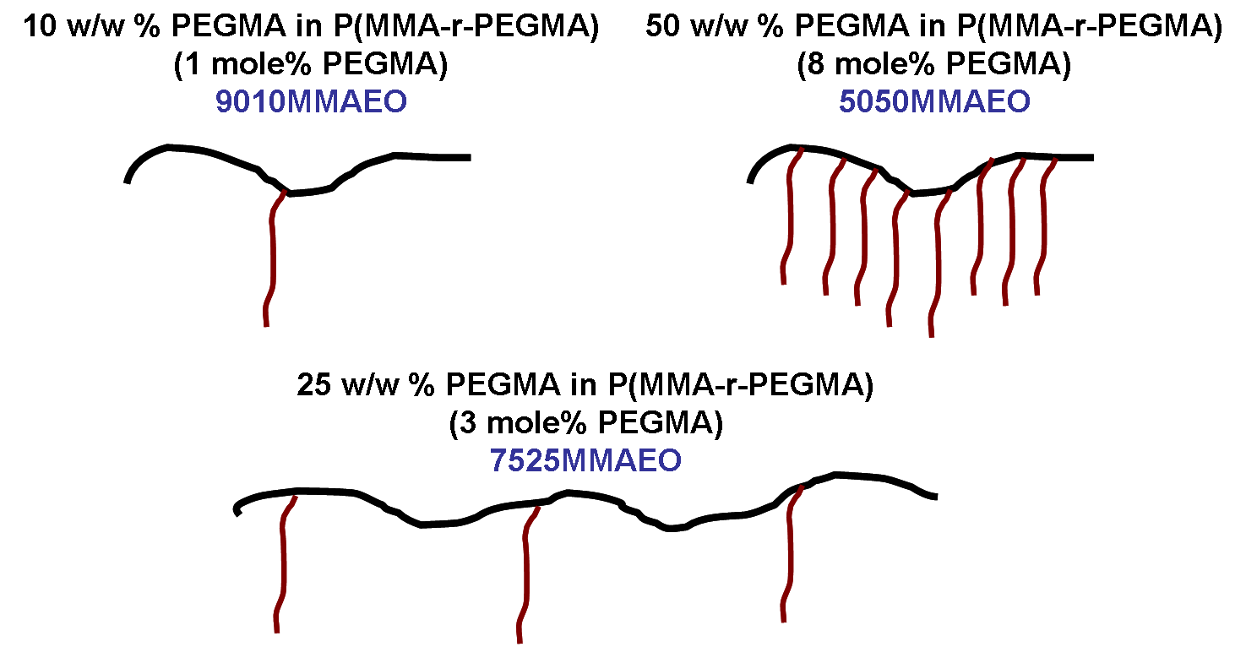

Figure 4.1 An illustration of the differences in the architectures of the three P(MMA-r-PEGMA) comb copolymers used as additives in a linear d-PMMA matrix to examine the effect of branch density on the approach to equilibrium in these self-healing surface segregating materials.

methacrylate) (dPMMA) (Polymer Source, Dorval(Montreal), QC) was purchased and used as received. HPLC grade tetrahydrofuran (Fisher Scientific) was used for SEC analysis of the polymers.
- Preparation of Thin Films

Thin films for the study of the selective surface segregation of comb/linear blends were prepared from a 2.6 w/w % solution in toluene of a blend of 90 w/w % linear d-PMMA (M_{n} = 123,000 g/mol) and 10 w/w % P(MMA-r-PEGMA) copolymer. Solutions were filtered with 0.45µm pore PTFE filters (Fisher Scientific). Prior to spin coating the solutions onto substrates, silicon wafers were first cleaned with chloroform. Next, the wafers were soaked in a hot piranha solution (70% H₂SO₄, 30% H₂O₂) for 1 hour. Afterwards the wafers were rinsed with high-purity water, dried with dry N₂(g) and then placed in a model 144AX UVO-Cleaner (Irvine, California) oven for 10 minutes. Using this cleaning procedure, the SiO₂ layer, as measured by ellipsometry, had a thickness of 15-20 Å. Immediately after coming out of the UV oven, the wafers were spin coated with the filtered polymer blend solution in toluene using a Headway Research Inc. Model PWM32 spin coater at a speed of 2500 rpm for 30 seconds. Samples were annealed on thermally equilibrated aluminum blocks in a vacuum oven at 150°C and then quenched on room temperature aluminum blocks prior to measurement of their neutron reflectivity profiles. The surface segregation process was monitored in these systems as a function of annealing time from as-cast out to 33 days.
- Characterization of the Comb Copolymers

  - ¹H-Nuclear Magnetic Resonance (NMR) Spectroscopy

The copolymer composition of P(MMA-r-PEGMA) combs with varying graft densities was determined by measuring the ¹H-NMR spectrum of samples dissolved in CDCl₃ with a 500 MHz NMR spectrometer (Agilent Technologies, Inc. VNMRS-500) at the Center for Nanophase Materials Science (CNMS). TMS was used to reference the spectrum. The mole percent PEGMA and MMA was determined from integration of peak areas at ~4.1 - 4.3 ppm and ~0.4 - 2.4 ppm, respectively. ¹H-NMR spectra were also collected at the University of Tennessee using a 300MHz NMR spectrometer (Varian, Inc. VNMRS-300). Samples for these experiments were also dissolved in CDCl₃ and the spectrum was referenced with TMS.

  - Size Exclusion Chromatography

The characterization of copolymers with size exclusion chromatography (SEC) is not trivial as there is both a chemical composition distribution (CCD) as well as a molecular weight distribution (MWD). Nevertheless, for the most part, SEC is still widely used for the characterization of copolymers. It is especially important to obtain an accurate dn/dc for the polymer/solvent system as well as to calibrate the chromatography system with an appropriate set of linear polymer standards.
SEC characterization was conducted at CNMS at ORNL using an Agilent 1100 series GPC system equipped with a refractive index detector and a two-angle light scattering detector (Precision Detectors). The dn/dc was measured (Wyatt Optilab Rex, λ=650 nm) for several P(MMA-r-PEGMA) samples with varying graft densities and was determined to be 0.087 mL/g. The mobile phase was THF and samples were also prepared in this solvent. Three Polymer Labs Mixed C columns were used as the stationary phase and calibration was performed using PMMA standards (molar mass range of 2,600 to 900,000 g/mol).
- Characterization of the Blend Films

    - Ellipsometry

Thin polymer films were prepared as described in section 4.2 B. Film thickness was determined using a DRE-Dr. Riss Ellipsometerbau GmbH (Ratzeburg, Germany) ELX-02C rotating analyzer nulling ellipsometer at a 70° angle of incidence with a He-Ne laser (λ=632.8 nm). The indices of refraction for all layers were considered to be no different from the bulk values. For PMMA, dPMMA, SiO₂, and Si these values were 1.4914, 1.4914, 1.4571, and 3.8816-i0.0190, respectively. All reported thickness values were averaged over 5 measurements from several areas of the sample surface.
    - Neutron Reflectivity

Neutron reflectivity curves for as-cast and annealed P(MMA-r-PEGMA)/d-PMMA binary blend films (90 w/w % linear d-PMMA and 10 w/w % P(MMA-r-PEGMA) copolymer) were collected at the Spallation Neutron Source (SNS) at Oak Ridge National Lab (ORNL) on the horizontal reflectometer at Beamline 4B. The horizontal reflectometer at the SNS is a time of flight spectrometer with Δq/q = 0.05. A q-range of 0.005 to 0.14 Å⁻¹ was investigated. Data collected at the SNS was reduced and scaled using software developed on-site. Motofit¹¹¹ and another fitting program, Mlayer (SNS, ORNL), were used to fit the data and construct neutron scattering length density profiles that model the thin films. Both fitting programs produced consistent results. A standard test for statistical significance, chi squared (χ²), was calculated for each fit and was less than 10.0. The volume fraction of the polymeric additive in each layer was calculated using the Tiles Program (SNS, ORNL). Further detail on the theory of neutron reflectivity is covered in Appendix A.2, section B.
    - Water Contact Angle Goniometry and Annealing Experiment

Water contact angle goniometry was conducted on as-cast and thermally annealed thin films composed of blends of P(MMA-r-PEGMA) copolymers in a linear PMMA matrix to monitor the surface segregation of the comb copolymers to the air interface. For the annealing experiment, thin polymer films were prepared similar to the procedure described in section 4.2 B. PMMA, which was the linear matrix in the binary blend, was purchased from Polysciences (Warrington, Pennsylvania) and had an M_{n} of 100,000 g/mol. The comb copolymer designated 7525MMAEO (2.4 mole% PEGMA, ~25 w/w % PEGMA synthesized at CNMS at ORNL) was one of two comb copolymers investigated in the water contact angle goniometry and neutron reflectivity experiments. The other comb copolymer, also synthesized at CNMS at ORNL, was 4.8 mole% PEGMA, ~35 w/w % PEGMA, and is designated 6535MMAEO. The composition and molecular weight of this copolymer using ¹H-NMR and SEC were determined using the same methods as described in 4.2 section C at CNMS at ORNL. The 7525MMAEO and 6535MMAEO comb copolymers had an M_{n} of 82,500 g/mol and 107,700 g/mol, respectively.
Binary blends investigated in the water contact angle goniometry annealing experiment were composed of 5 w/w %, 20 w/w %, 30 w/w %, 40 w/w % and 50 w/w % 7525MMAEO and 6535MMAEO comb copolymer in a linear PMMA matrix. Polymer were spin coated from a 2.5 w/w % solution of linear PMMA and P(MMA-r-PEGMA) in toluene. Silicon substrates that had dimensions of approximately 2 cm x 2 cm were cut from 0.5 mm thick, 2” diameter, single-sided polished <100> crystal orientation, N-doped silicon wafers (Wafer World,West Palm Beach, FL). After spin coating, the prepared films were annealed in a vacuum oven at 150 °C. Contact angle measurements were performed under ambient conditions with a Rame-Hart (Mountain Lakes, NJ) Model 100 contact angle goniometer using the sessile drop method. The liquid used was high purity water. Droplets were approximately 3µL and all reported values were averaged over 3 measurements taken at different locations on the sample surface. A more detailed discussion on contact angle goniometry is covered in Appendix A.2, section D.

4.3 Results and Discussion

A. Verifying the Structure of the Combs

1) ¹H-NMR
¹H-NMR spectra of the three P(MMA-r-PEGMA) copolymers used as polymeric additives in the neutron reflectivity study were collected to determine their chemical composition distribution (CCD). ¹H-NMR spectra of all the comb copolymers investigated in this study are included in Appendix A.4, section A. Figure 4.2 displays the ¹H-NMR spectrum of the 9010MMAEO P(MMA-r-PEGMA) comb copolymer. Resonances due to the first two protons of the PEO chain per PEGMA macromonomer occur downfield at a chemical shift of ~4.1 ppm in the ¹H-NMR spectrum. Resonances due to the five protons of the MMA backbone per repeat unit occur upfield in a chemical shift range of ~0.4 to 2.4 ppm. In Figure 4.2, the sum of the integrations in the region from 0.4 – 2.4 ppm due to the 5 MMA backbone protons per repeat unit is 55.33. Likewise, the integration of the region at ~4.1 ppm due to the first two protons per macromonomer is 0.29. Thus, one can calculate the mole percent of PEGMA in the 9010MMAEO comb copolymer using equation 4.1:
$\left(mole\%PEGMA=\frac{\frac{0.29}{2protons}}{\frac{0.29}{2protons}+\frac{55.33}{5protons}}\right)×100\%=1.3mole\%PEGMA$ (4.1)
Moreover, one can calculate the w/w % of PEGMA in the 9010MMAEO comb copolymer using equation 4.2 and the mole percent determined in equation 4.1:
$$\left(w/w\%PEGMA=\frac{\frac{1.3molesPEGMA}{1}×\frac{1100gPEGMA}{1molePEGMA}}{\frac{1.3molesPEGMA}{1}×\frac{1100gPEGMA}{1molePEGMA}+\frac{98.7molesMMA}{1}+\frac{100gMMA}{1moleMMA}}\right)×100\%=12.7w/w\%PEGMA$$ (4.2)
Table 4.1 contains a summary of the mole % and w/w % PEGMA macromonomer determined from the ¹HNMR analysis for all three comb copolymers studied.
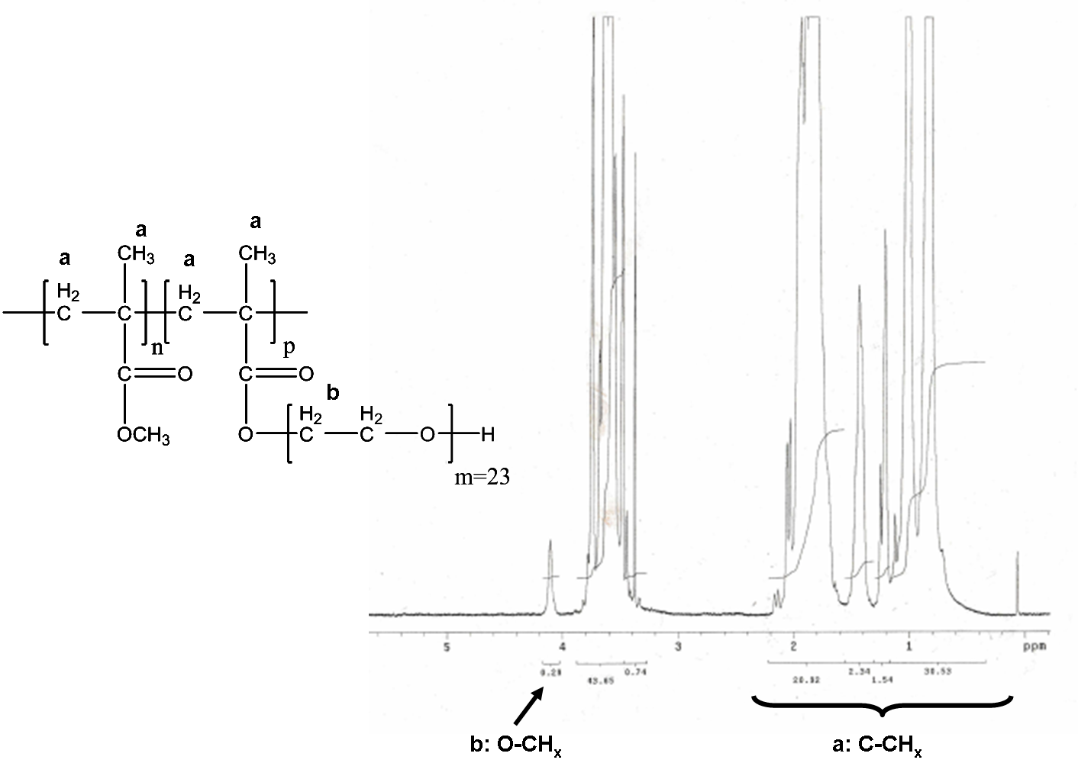

Figure 4.2 500 MHz 1H-NMR spectrum of the 9010MMAEO P(MMA-r-PEGMA) comb copolymer.

Table 4.1 Mole % and w/w % PEGMA macromonomer in P(MMA-r-PEGMA) comb copolymers determined by 1HNMR analysis.
Sample Code for Comb Copolymer | Mole % PEGMA by 1H-NMR | w/w% PEGMA by ¹H-NMR
9010MMAEO | 1.3 | 12.6
7525MMAEO | 2.4 | 21.6
5050MMAEO | 8.5 | 50.6

2) Size Exclusion Chromatography
The molecular weight and molecular weight distribution (MWD) for the graft copolymers was determined by size exclusion chromatography (SEC). Table 4.2 contains a summary of the M_{w} and PDI for the three graft comb copolymers, as well as of the d-PMMA used as the linear matrix, in the blends investigated in this study.
SEC chromatograms for all of the comb copolymers can be found in Appendix A.4, Section B. Figure 4.3 displays an SEC chromatogram for the 5050MMAEO P(MMA-r-PEGMA) comb copolymer, which elutes at t_{R}~20 minutes.

B. Determining Blend Film Structure and its Evolution with Time

1) Neutron Reflectivity Profiles: Examination of the Raw Data
Neutron reflectivity data for short (as-cast to 48 hours) and long anneal times (as-cast to 33 days) was collected for binary blends of P(MMA-r-PEGMA) comb copolymers in a linear d-PMMA matrix. Table 4.3 contains a summary of the sample codes designated for each binary

Table 4.2 M_{w} and PDI from SEC measurements for the three P(MMA-r-PEGMA) comb copolymers as well as the linear matrix, d-PMMA, used in this study.
Polymer | M_{w} (g/mol) | PDI
9010MMAEO | 47,200 | 1.23
7525MMAEO | 108,100 | 1.31
5050MMAEO | 53,400 | 1.28
dPMMA | 136,000 | 1.10
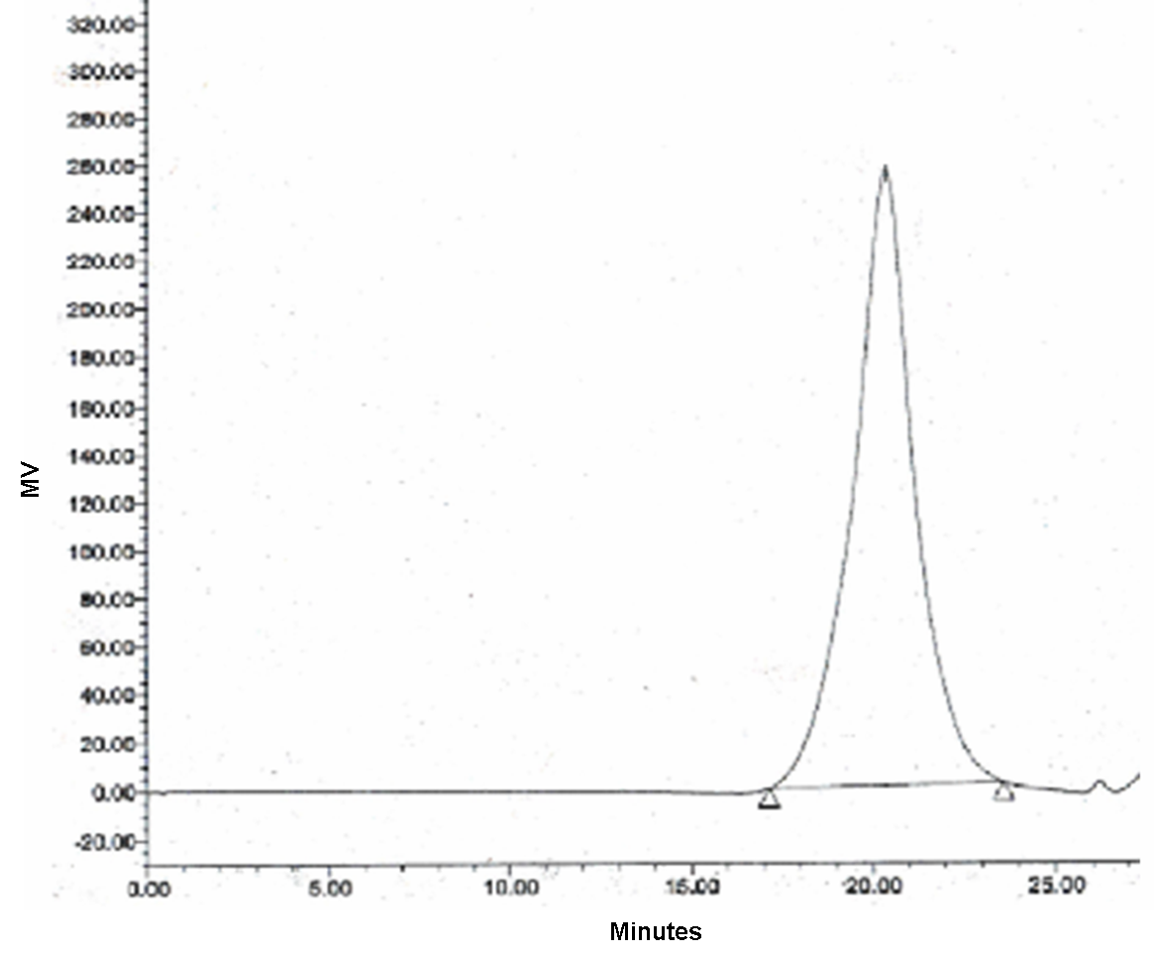

Figure 4.3 SEC chromatogram for the 5050MMAEO P(MMA-r-PEGMA) comb copolymer.

Table 4.3 Sample codes for binary polymer blends containing 10 w/w % P(MMA-r-PEGMA) comb copolymer and 90 w/w % linear d-PMMA.
Sample Codes for Binary Comb/Linear Blends
9010MMAEO_LPMMA
7525MMAEO_LPMMA
5050MMAEO_LPMMA

blend containing 10 w/w % P(MMA-r-PEGMA) comb copolymer and 90 w/w % linear d-PMMA.
Neutron reflectivity profiles for all of the blends investigated in this study are included in Appendix A.4, section C. Figure 4.4 illustrates the time evolution of the neutron reflectivity profiles of the binary blend, 9010MMAEO_LPMMA, as the system is annealed at 150°C under vacuum for up to 36 hours. In Figure 4.4, the amplitudes of the fringes in the neutron reflectivity profile do not change much with annealing up to 36 hours, which suggests that the amount of segregation is small on this time scale. Neutron reflectivity profiles of the binary blend 9010MMAEO_LPMMA, which is annealed for a longer time, do exhibit a more significant decay in the amplitude of the fringes over this time period, as shown in Figure 4.5. Models of the real-space depth profiles of these evolving films were fit to the neutron reflectivity data to extract more quantitative information about the movement of comb copolymers within the linear matrix.

2) The Model Used to Describe Surface Segregation in Comb/Linear Blends
The strategy employed in fitting models of the real-space scattering length density profiles of surface segregating blends to the neutron reflectivity (NR) data in this study was similar to that which was used in the elucidation of the depth profiles of blends of hyperbranched polymers in a linear matrix in Chapter 3. Genetic optimization parameter searches within Motofit, coupled with manual fitting to preserve mass balance (using the Mlayer program), enabled the testing of various models to fit neutron reflectivity profiles of unannealed and annealed binary blend films. The Kramer-Jones depletion layer model,¹⁷ used to describe the evolving surface segregating profiles investigated in Chapter 3, was also used to describe the
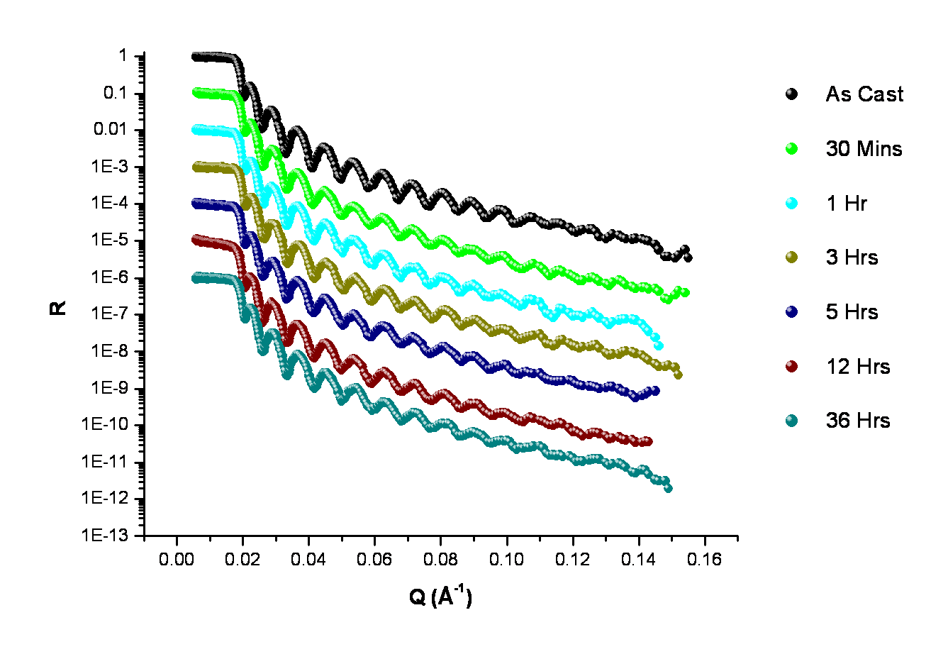

Figure 4.4 Neutron reflectivity profiles of the blend 9010MMAEO_LPMMA measured as-cast up to an anneal time of 36 hours at 150°C. Data is scaled for clarity.

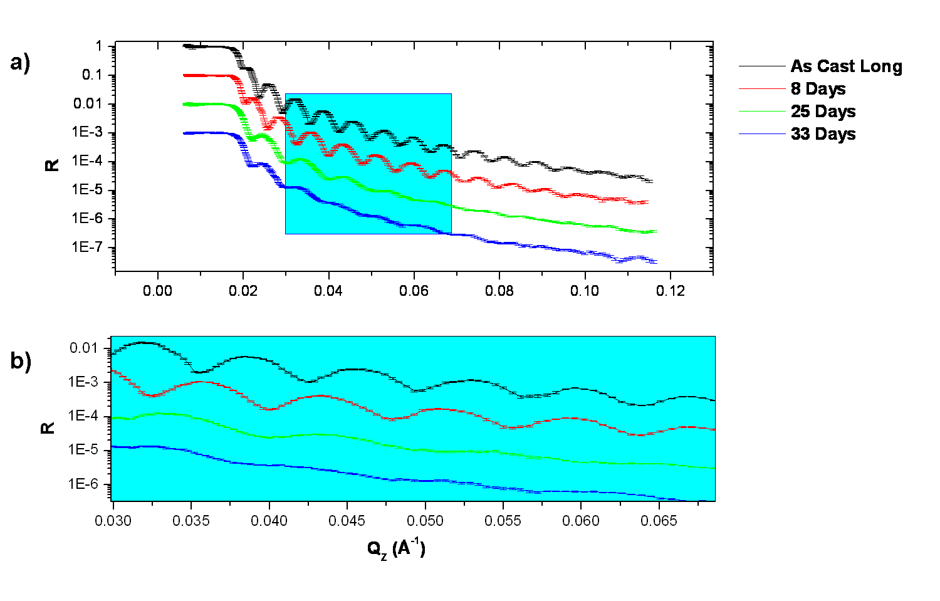

Figure 4.5 a) Neutron reflectivity profiles for the blend 9010MMAEO_LPMMA measured as-cast up to a maximum anneal time of 33 days at 150°C under vacuum. b) Data highlighted in box in a) shows the low Q region and emphasizes dampening of fringes with increased anneal time. Data is scaled for clarity.

evolving depth profiles of copolymer combs in a linear matrix in this study. Moreover, water contact angle goniometry measurements on unannealed and annealed binary blend films helped to corroborate NR model fits of surface segregated layers at the near-air interface.
The SLD for each component of the blend was determined by fitting monolayers of each component with a 1-layer (slab) model. Table 4.4 contains a summary of the measured scattering length densities (SLD) from fits to the NR profiles of monolayers composed of the individual blend components. As observed by Zhang et al,¹²¹ thin films of PMMA are often in a non-equilibrium low-density state after spin-casting, and thus the scattering length density can vary within a small range upon thermal annealing (as indicated in the footnote of Tbl. 4.4).
The Si and SiO₂ subphases were assigned an SLD of 2.07E-6 Å⁻²and 3.20E-6 Å⁻², respectively. The SiO₂ layer thickness had been determined from ellipsometry experiments to be ~15 Å. Interfaces in the thin film were modeled with an error function.
To model the evolving buried and exposed interfaces of annealed blends, 1, 2 and 3-layer models were fit to NR data of unannealed films and those annealed 30 minutes, 1 hour, 3 hours, 5 hours, 12 hours, 36 hours, 8 days, 25 days, and 33 days at 150°C under vacuum (with the exception of the blend 5050MMAEO_LPMMA which was only annealed for 25 days). In each case, the mass balance of each scattering length density profile was verified by checking that the overall volume fraction of branched additive within the layer was approximately 0.10. The best model fits to the data were consistent with the 3-layer slab model reported by Walton et al⁴⁵ for blend films composed of a P(MMA-r-MnG) comb copolymer (50 w/w % MMA monomer and 50 w/w % macromonomer MnG) that was blended with 80 w/w % to 98 w/w % linear d-PMMA. Although they did not investigate the time evolution of the surface segregation process in their
Table 4.4 Scattering length density (SLD) values obtained from fits to the NR profiles of binary blend components.
Polymer | SLD/10-6Å⁻²
d-PMMA | ª 7.0 E-6 ± 0.2 E-6
9010MMAEO | 1.03 E-6
7525MMAEO | 9.19 E-7
5050MMAEO | 8.55 E-7

ª The SLD for dPMMA varied within a small range. This has been observed before as reported in ref 8.

study, they did evaluate films that had been annealed for 5 days at 190°C (and were assumed to be at equilibrium). In their model, the bulk (or reservoir) layer, which composed the majority of the film, had an SLD that varied between the blend SLD and the SLD of the linear d-PMMA matrix. Moreover they observed surface segregation of the comb copolymer to both the air and Si interfaces when the film thickness was 2000 Å, but only segregation of the comb to the Si interface when the film thickness was 1000 Å. As explained in Chapter 3, this observation can be attributed to the amount of mass available to cover each interface (i.e., film thickness). The 3-layer model fit both unannealed as well as annealed binary films composed of comb copolymer and linear d-PMMA in the present study.
Furthermore, fits that included asymmetric interfaces at the evolving interfaces were also attempted based on previous studies of such interfaces in blends of polymeric species with differentmobilities.^{134, 122}Nevertheless, as in the case of blend films containing hyperbranched polymers in a linear matrix investigated in Chapter 3, a more complicated interface did not improve the fits to as-cast and annealed binary blends of comb copolymers in a linear matrix. Moreover, elastic recoil detection (ERD) spectroscopy measurements on annealed films were attempted, but due to beam damage, the resolution was smeared. Nevertheless, it was possible to distinguish a greater excess of the comb additive at the near-Si interface than at the surface of annealed blends from the ERD measurements, which is consistent with the fits to the neutron reflectivity data.
Figure 4.6 displays a model fit to blend 5050MMAEO_LPMMA annealed under vacuum for 8 days at 150°C using the 3-layer model. As indicated in the SLD plot of Fig. 4.6, the comb copolymers are depleted from the bulk (reservoir) of the film, while the near-surface and near-Si
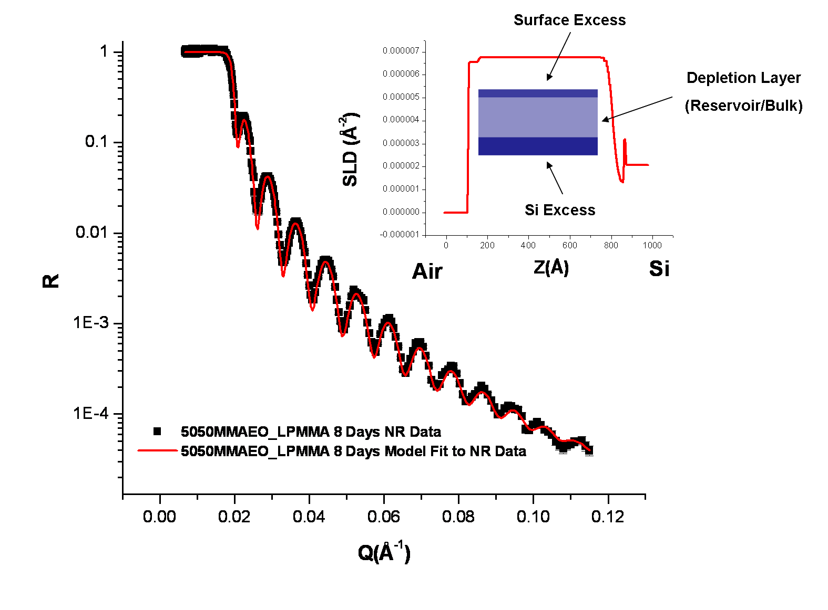

Figure 4.6 Neutron reflectivity profile and fit to blend 5050MMAEO_LPMMA annealed for 8 days at 150°C under vacuum. The inset contains a plot of the SLD profile used to generate the model fit to the data.
interfaces are enriched with the comb copolymer. The highest concentration of the branched additive after 8 days of thermal annealing is near the Si interface.
Neutron reflectivity fit parameters for all of the blends can be found in Appendix A.4, section D. Table 4.5 contains a summary of the neutron reflectivity fit parameters used to generate the evolving profiles for blend 5050MMAEO_LPMMA, as well as ellipsometry measurements for some of the films.
In Figure 4.7, water contact angles of the films as-cast and thermally annealed up to 48 hours at 150°C under vacuum are shown, where for example, a blend composed of 95 w/w % linear PMMA and 5 w/w % of the ‘6535MMAEO’ copolymer is designated with the sample code ‘9505MMA_6535MMAEO.’ The decrease in water contact angle up to 5 hours of thermal annealing is indicative of the formation of a surface segregated layer of the comb copolymer which contains hydrophilic PEO chain ends. The water contact angle for binary blend films is ~55° after 5 hours of thermal annealing (Fig. 4.7), which is similar to results reported by Walton et al⁴⁵ in which they immersed binary blend films composed of 20% w/w P(MMA-r-MnG) (50% w/w PEO) and 80% w/w linear PMMA in water, to drive PEO chains to the surface, and then measured their water contact angle at various time intervals up to 4 days. Walton et al⁴⁵ reported that the water contact angle for thin films (not immersed in water) of PMMA, d-PMMA, P(MMA-r-MnG), as well as a 20% w/w blend of P(MMA-r-MnG) copolymer in a linear PMMA matrix is ~70°. Following immersion in water for 1 hour and 20 minutes, they observed that the water contact angle for these binary blend film, as well as the thin film composed of only the copolymer, dropped down to ~60°. Poly(hydroxyl ethyl methacrylate) (PHEMA), a material used in soft contact lenses, also exhibits a water contact angle of ~ 60°.⁴⁵ Although hydrophilic
Anneal Times  (Secs) | ªd_{T}  (Å) | ^{b}d_{T}  (Å) | ^{b}d_{air}  (Å) | ^{b}d_{Si}  (Å) | ^{e}(b/V)_{air}  x10⁻⁶  (Å⁻²) | ^{e}(b/V)_{Si}  x10⁻⁶  (Å⁻²) | ^{e}(b/V)_{res.}  x10⁻⁶  (Å⁻²) | ^{f}σ_{air}  (Å) | ^{f}σ_{Si}  (Å) | ^{f}σ_{res}  (Å)
^{c}Short  0  1800  3600  10800  18000  43200  129600  ^{d}Long  0  691200  2.16E6 | 680±3  800±2 | 680  650  650  645  644  643  635  795  754  718 | 20  28  28  28  28  28  28  18  51  52 | 52  52  52  52  52  52  52  52  52  52 | 5.18  5.21  6.17  5.21  5.45  5.40  5.65  5.51  6.56  6.72 | 5.88  5.99  5.99  5.81  5.63  5.40  5.03  6.27  1.28  1.29 | 6.17  6.38  6.33  6.39  6.40  6.53  6.55  6.56  6.77  6.96 | 8  10  8  10  10  4  12  5  5  10 | 4  5  8  34  52  42  52  5  45  52 | 20  5  12  5  5  4  5  5  10  10
Table 4.5 Neutron reflectivity fit parameters for the blend 5050MMAEO_LPMMA.

ªThickness of entire film determined from ellipsometry (as cast)
^{b}Thickness of film determined from fit to NR profile of entire film (d_{T}), at the air (d_{air}), and at the Si substrate (d_{Si})
^{c}Short time study as cast to 36 hours
^{d}Long time study as cast to 25 days
^{e}Scattering length density (b/V x 10⁻⁶ Å⁻²) at the air interface (air), Si substrate (Si), and reservoir (res.)
^{f}Interfacial width (Å) between air/polymer interface, σ_{air}, polymer/Si subtrate interface, σ_{Si}, and between the polymer/polymer interface, σ_{res..}

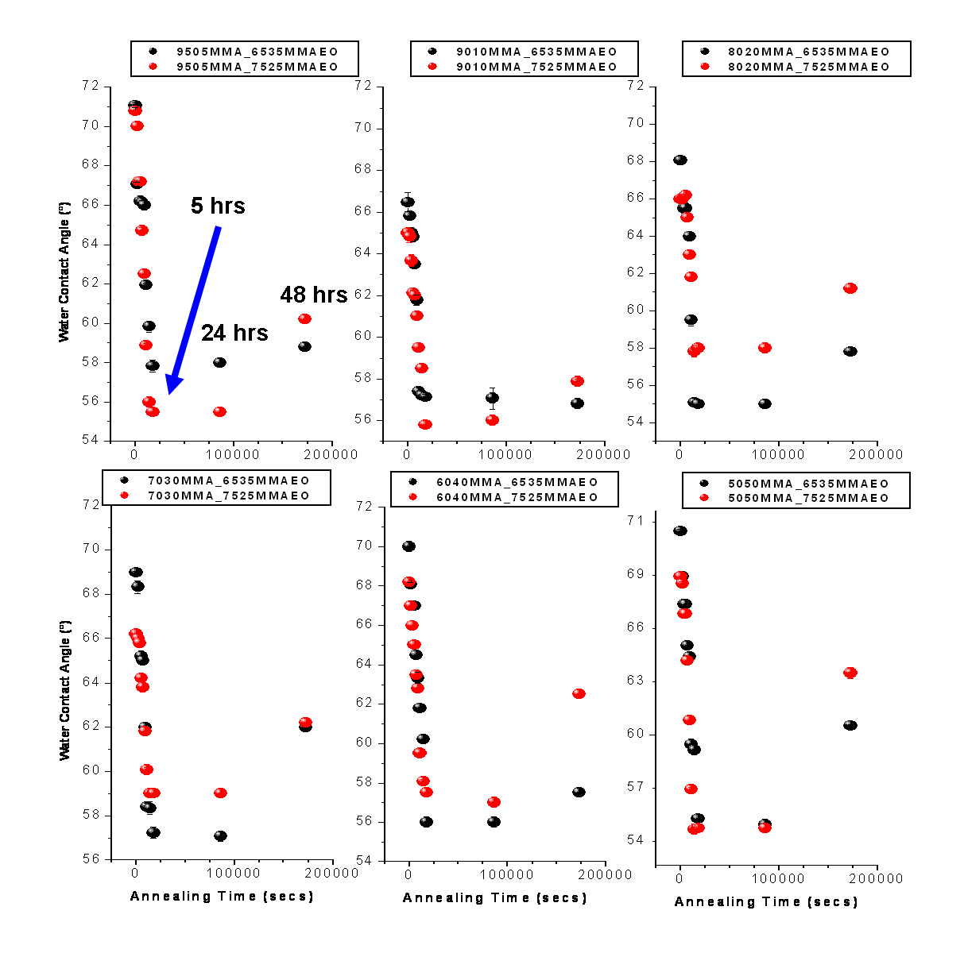

Figure 4.7 Water contact angles for as-cast and thermally annealed binary blend films at 150°C under vacuum. Binary blends are composed of 5 w/w %, 10 w/w %, 20 w/w %, 30 w/w %, 40 w/w % and 50 w/w % P(MMA-r-PEGMA) comb copolymers that are 25% and 35% PEGMA by mass (designated ‘7525MMAEO’ and ‘6535MMAEO,’ respectively. Error bars are smaller than the symbol for most measurements.

surfaces are ordinarily associated with a surface that has a 0° water contact angle, indicating complete wetting of the surface, these surfaces with higher water contact angles can also be considered hydrophilic as they are also characterized by their capacity to absorb water.⁴⁵
It is interesting to note that the water contact angle for annealed blend films in the present study is dynamic, as the initial decrease at early times (as-cast to 5 hours) is followed by an increase in water contact angle at later times (Fig. 4.7). As will be shown in the following section, fits to neutron reflectivity profiles reveal that the amount of near-air interfacial excess of the comb copolymer first increases at early annealing times then decreases after longer annealing times before reaching a steady state, which is also consistent with the observed behavior from water contact angle studies.
- Snapshots of P(MMA-r-PEGMA) Comb Copolymer Movement in a Linear Matrix

Model fits to NR data were used to extract volume fraction profiles for each blend using the Tiles program (Spallation Neutron Source, Oak Ridge National Lab). Volume fraction profiles for all of the blends investigated in this study are included in Appendix A.4, section E. Snapshots of the overall movement of copolymer combs in the linear matrix, as thermal annealing time increases, are shown for the short-time (as-cast to 36 hours) and long-time (as-cast to 33 days) studies on blend 9010MMAEO_LPMMA shown in Figures 4.8 and 4.9, respectively. Overall, the net movement of the branched additive is toward the near-Si interface. Near the air interface, at early times (~3-5 hours), the comb copolymer concentration increases before finally decreasing and approaching a steady state at later times (Figs. 4.8 and 4.9). Near the Si substrate, for both the short and long-time annealing studies, the comb copolymer concentration increases with annealing time before approaching a steady state (Figs. 4.8 and 4.9).
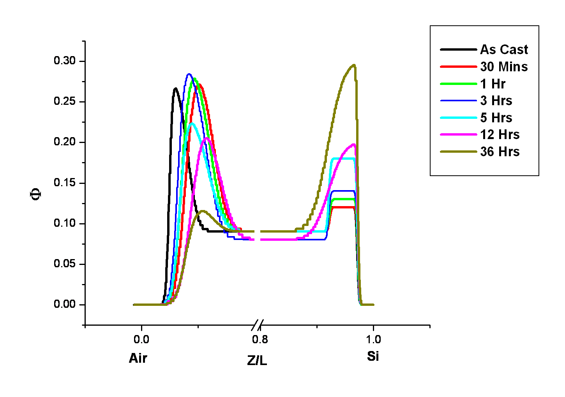

Figure 4.8 Volume fraction profiles generated by model fits to NR data for blend 9010MMAEO_LPMMA.The surface segregation process was monitored for films as-cast out to 36 hours of anneal time at 150°C under vacuum. Data is truncated to emphasize interfaces.

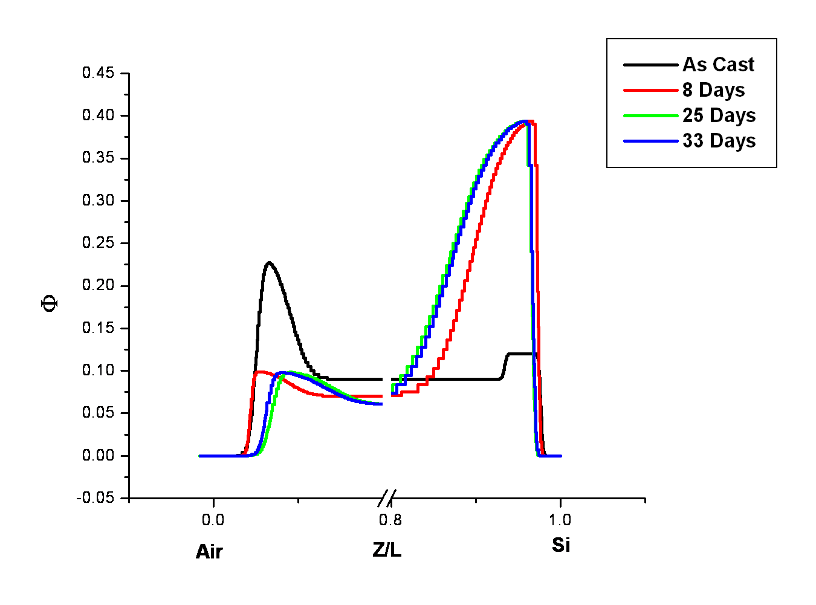

Figure 4.9 Volume fraction profiles generated by model fits to NR data for blend 9010MMAEO_LPMMA.The surface segregation process was monitored for films as-cast out to 33 days of anneal time at 150°C under vacuum. Data is truncated to emphasize interfaces.

It is interesting to note that even after the longest anneal time, 33 days, the Si interface is only partially covered (~40%) with the 9010MMAEO comb copolymer in the blend (Fig. 4.9). As discussed in Chapter 3, this result is partially due to the fact that these are thin films (~600-700 Å), and therefore there is not enough material to fully cover each interface. This result is in contrast with volume fraction profiles of surface segregated blends of HyperMacs and DendriMacs in a linear matrix (Chapter 3), in which the near-Si interface is fully covered with the branched additive, and the concentration of additive near the Si substrate is invariant (in as-cast films as well as films annealed up to 33 days).
Nevertheless, as the branch density of the comb copolymer increases, the surface coverage near the Si interface increases after the longest anneal time (for thin films ~600-700 Å), as shown in Figures 4.10 and 4.11, for binary blends containing the 7525MMAEO and 5050MMAEO comb copolymers, respectively.
As in the 9010MMAEO_LPMMA blend, the overall net movement of comb copolymer is toward the near-Si interface for blends 7525MMAEO_LPMMA and 5050MMAEO_LPMMA. Similar to blends containing hyperbranched additives in a linear matrix, the concentration of branched additive in the reservoir (bulk) of the film decreases at early times before approaching a steady state after longer annealing times as shown in Figure 4.12.
Using the same methodology as in Chapter 3, the interfacial excess, which is the concentration of additive above the bulk concentration of the blend near the air interface, Z_{Air}*, as well as near theSi interface, Z_{Si}*, was determined from the fitted neutron reflectivity profiles of unannealed and annealed films. In Figure 4.13, the time evolution of the surface excess of branched additive near the air interface in the blend designated 7525MMAEO_LPMMA (10
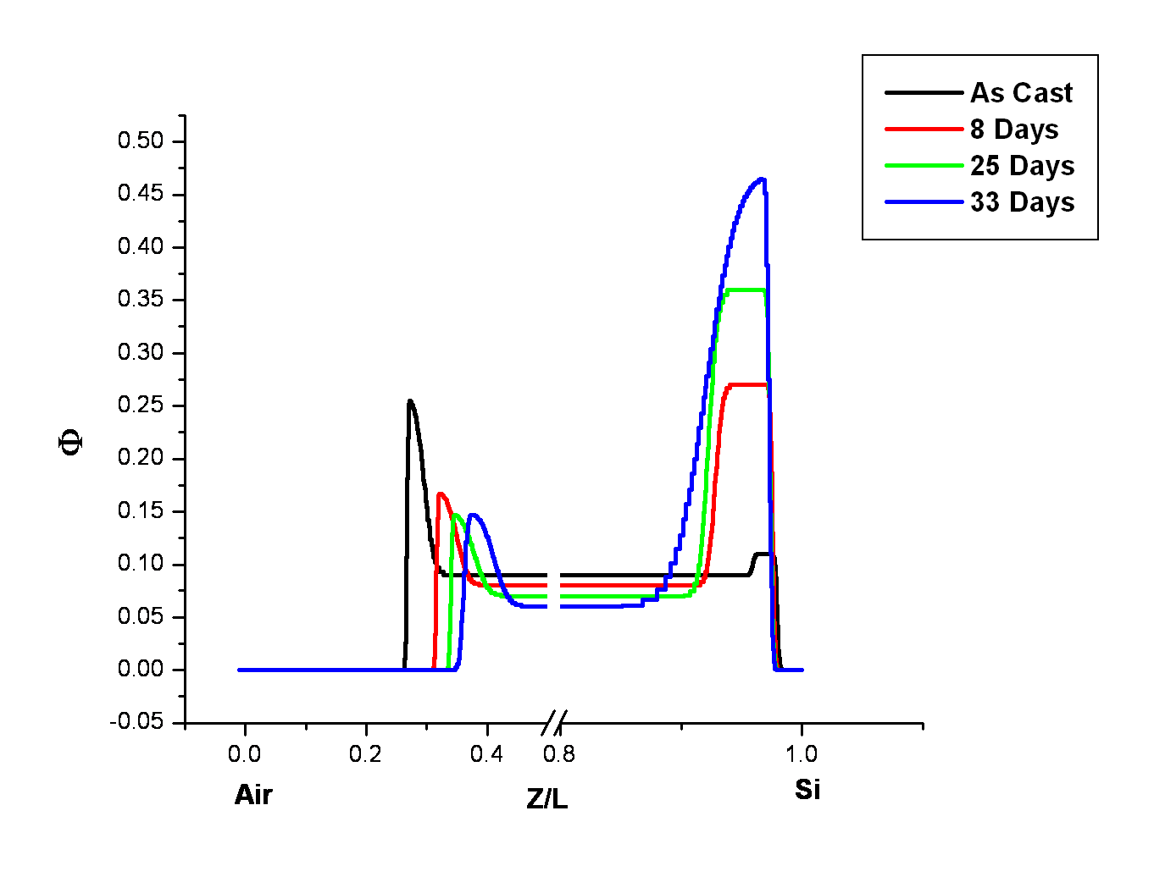

Figure 4.10 Volume fraction profiles generated by model fits to NR data for blend 7525MMAEO_LPMMA.The surface segregation process was monitored for films as-cast out to 33 days of anneal time at 150°C under vacuum. Data is truncated to emphasize interfaces.

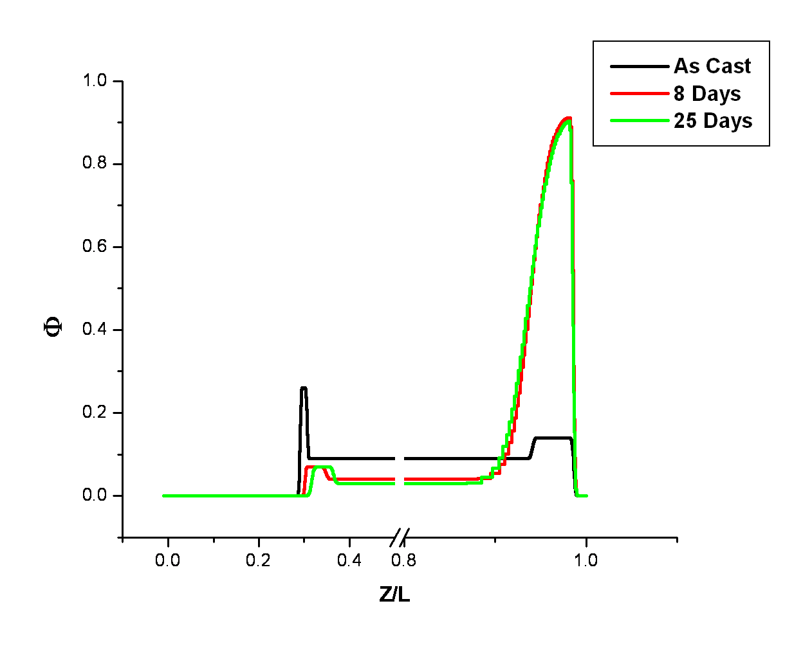

Figure 4.11 Volume fraction profiles generated by model fits to NR data for blend 5050MMAEO_LPMMA.The surface segregation process was monitored for films as-cast out to 33 days of anneal time at 150°C under vacuum. Data is truncated to emphasize interfaces.

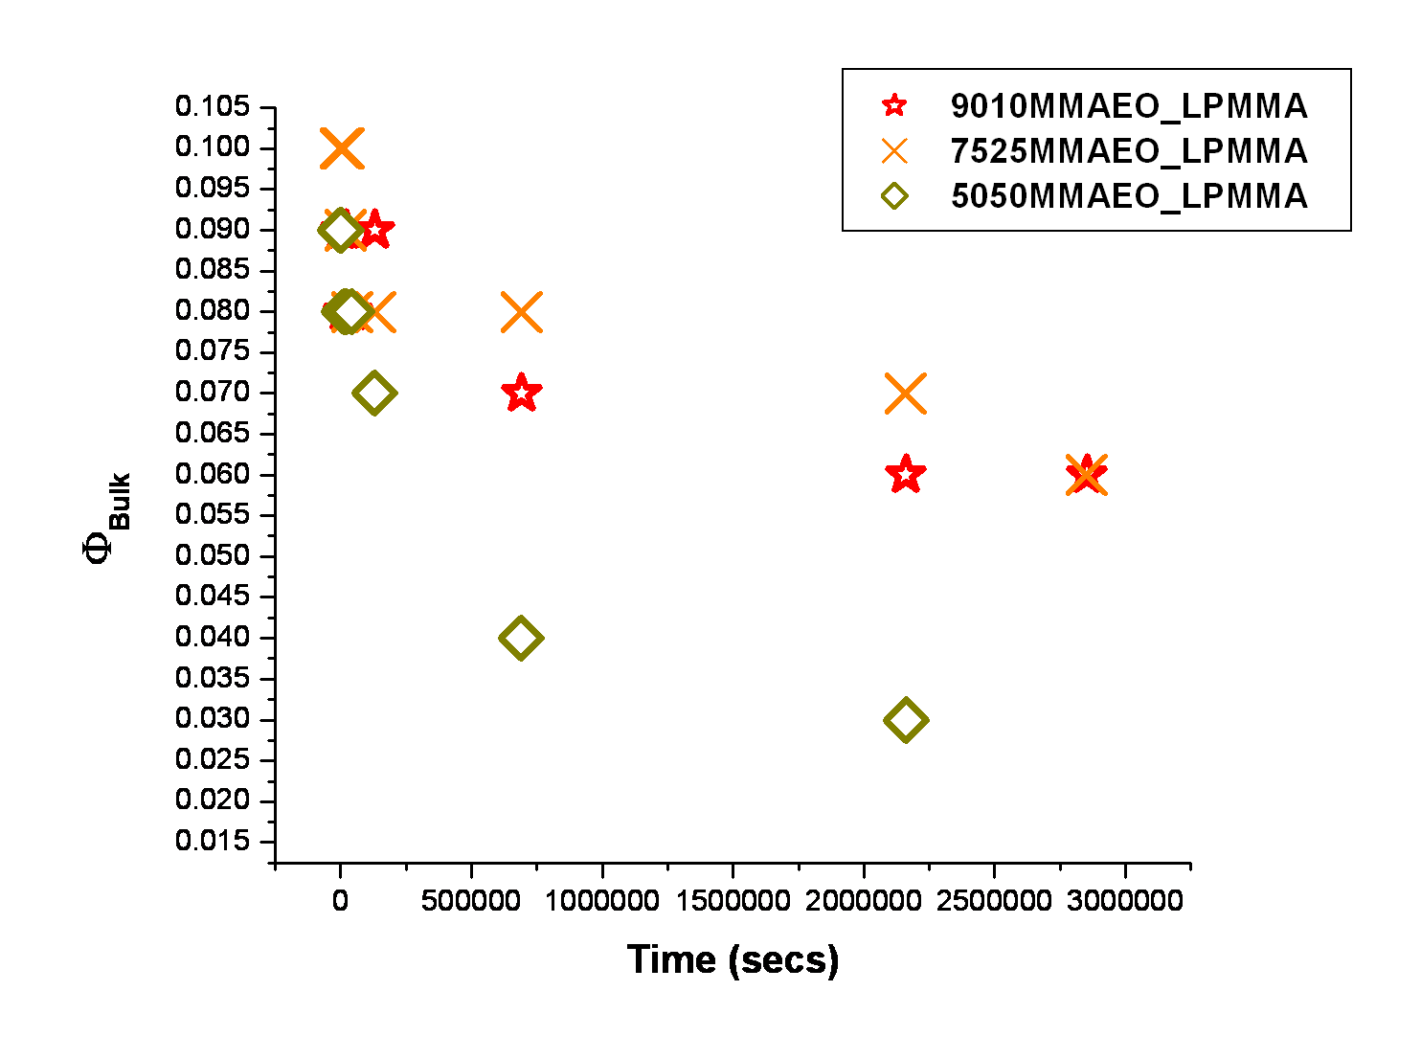

Figure 4.12 The time evolution of the bulk (reservoir) volume fraction of P(MMA-r-PEGMA) comb copolymers in a linear d-PMMA matrix as-cast and annealed up to 25 and 33 days at 150°C under vacuum. Error bars are smaller than symbols.

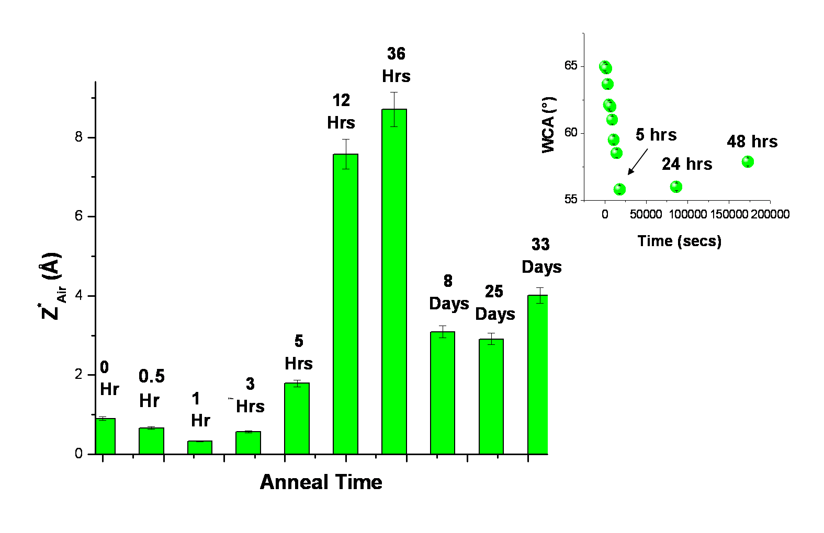

Figure 4.13 The time evolution of the near-air interfacial excess of blend 7525MMAEO_LPMMA annealed at 150°C under vacuum that was obtained from fits to neutron reflectivity profiles. The inset contains the time evolution of the water contact angle of as-cast and annealed blend films of 9010MMA_7525MMAEO at 150C under vacuum. All blends are 10 w/w% 7525MMAEO comb copolymer.

w/w% 7525MMAEO comb copolymer) is displayed, along with the evolution of the measured water contact angle of as-cast and annealed films (150°C under vacuum) of blend 9010MMA_7525MMAEO (10 w/w% 7525MMAEO comb copolymer) which is displayed in the inset. The results of the water contact angle experiments and the fits to the neutron reflectivity profiles are consistent. At early times (as-cast to 5 hours), the water contact angle decreases, which indicates PEO chains are present at the surface of the blend. Likewise, at early times, the near-air interfacial excess gradually increases. The amount of near-air interfacial excess reaches a maximum after 36 hours (Fig. 4.13) before declining and approaching a steady state. Further water contact angle studies should confirm that the water contact angle increases after longer annealing times, consistent with the movement of the branched additive away from the near-air interface.
Figure 4.14 displays the time evolution of the surface excess near the Si interface for P(MMA-r-PEGMA) comb copolymers, with varying branch density, in a linear matrix. The more densely grafted comb copolymer, 5050MMAEO, composed of 8.5 mole % PEGMA, has more chain ends than the less densely grafted comb copolymers present in the other blends (1.3 mole% PEGMA in 9010MMAEO and 2.4 mole % in 7525MMAEO). An increase in the number of chain ends (in the absence of strong energetic interactions) correlates with an increase in the entropic driving force for surface segregation in these systems. In contrast with blends containing HyperMacs and DendriMacs in a linear matrix, these comb/linear blends do not contain a significant amount of branched additive near the Si interface after spin-casting (only ~0.2 to 3 Å). Moreover, the time evolution of the near-Si interfacial excess indicates that blends
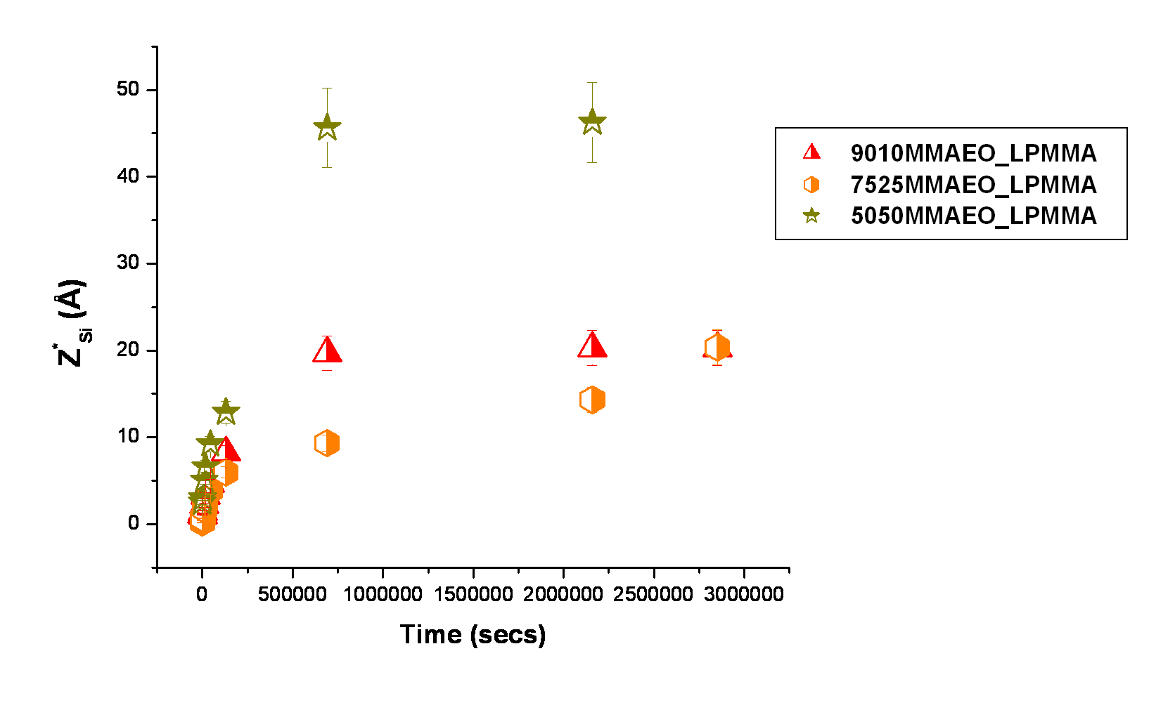

Figure 4.14 The time evolution of the surface excess near the Si interface, Z*_{Si}, for binary blends of P(MMA-r-PEGMA) comb copolymers in a linear matrix for as-cast films and films annealed up to 25 and 33 days under vacuum at 150°C.

containing the 9010MMAEO and 5050MMAEO comb copolymers reached a steady state, while the blend containing the 7532MMAEO comb copolymer may or may not have.

C. How the Architecture of Comb Copolymers in a Linear Matrix Affects Their Dynamic Behavior

- Overview

The dynamic behavior of combs in a linear matrix was examined using a method similar to the one used to analyze hyperbranched polymers in a linear matrix in Chapter 3. Since the binary comb/linear blends investigated in the present study did not have a significant amount of initial interfacial excess following the spin coating process, we evaluated the time evolution of the interfacial excess near the Si interface, Z*_{Si}, directly (i.e., instead of a net interfacial excess, as in Chapter 3). With t^{1/2} growth of the interfacial excess in a surface segregating binary blend, the depletion layer model of Kramer and Jones can be used to determine the mutual diffusion coefficient, D_{m}. As in the previous chapter, we evaluated both the fast and slow mode theories for these systems to extract the tracer diffusion coefficients, D_{A}*, for each comb copolymer in a linear matrix. An examination of how D_{A}* changes with the weight average molecular weight, M_{w}, provides a test of theory for entangled and unentangled dynamics in these blend systems. Furthermore, since the ultimate aim of the entire investigation is to predict the dynamic behavior of these self-healing materials, we will determine how the differences in comb architecture (branch density and size) affects the dynamic behavior of each comb in a linear matrix.
- The Mutual Diffusion Coefficient, D_{m}, of a Comb/Linear Blend from Depth Profile Experiments

Using the results of fits to NR data, the equilibrium interfacial excess near the Si interface, Z*_{Si eq}, as well as the equilibrium time, t_{eq}, were determined from the plots displayed in Figures 4.15-4.17. Note that the results do not clearly indicate whether the blend 7525MMAEO_LPMMA reached a steady state after the longest anneal time (33 days). Nevertheless, for the calculations described below, the blend is assumed to have reached a steady state. Thus, the calculations for the blend 7525MMAEO_LPMMA merely provide an upper bound for the mutual and tracer diffusion coefficients for this system.
The mutual diffusion coefficient for each blend was calculated using Equation 4.3 using the depletion layer model of Kramer and Jones:⁶⁶
(4.3)
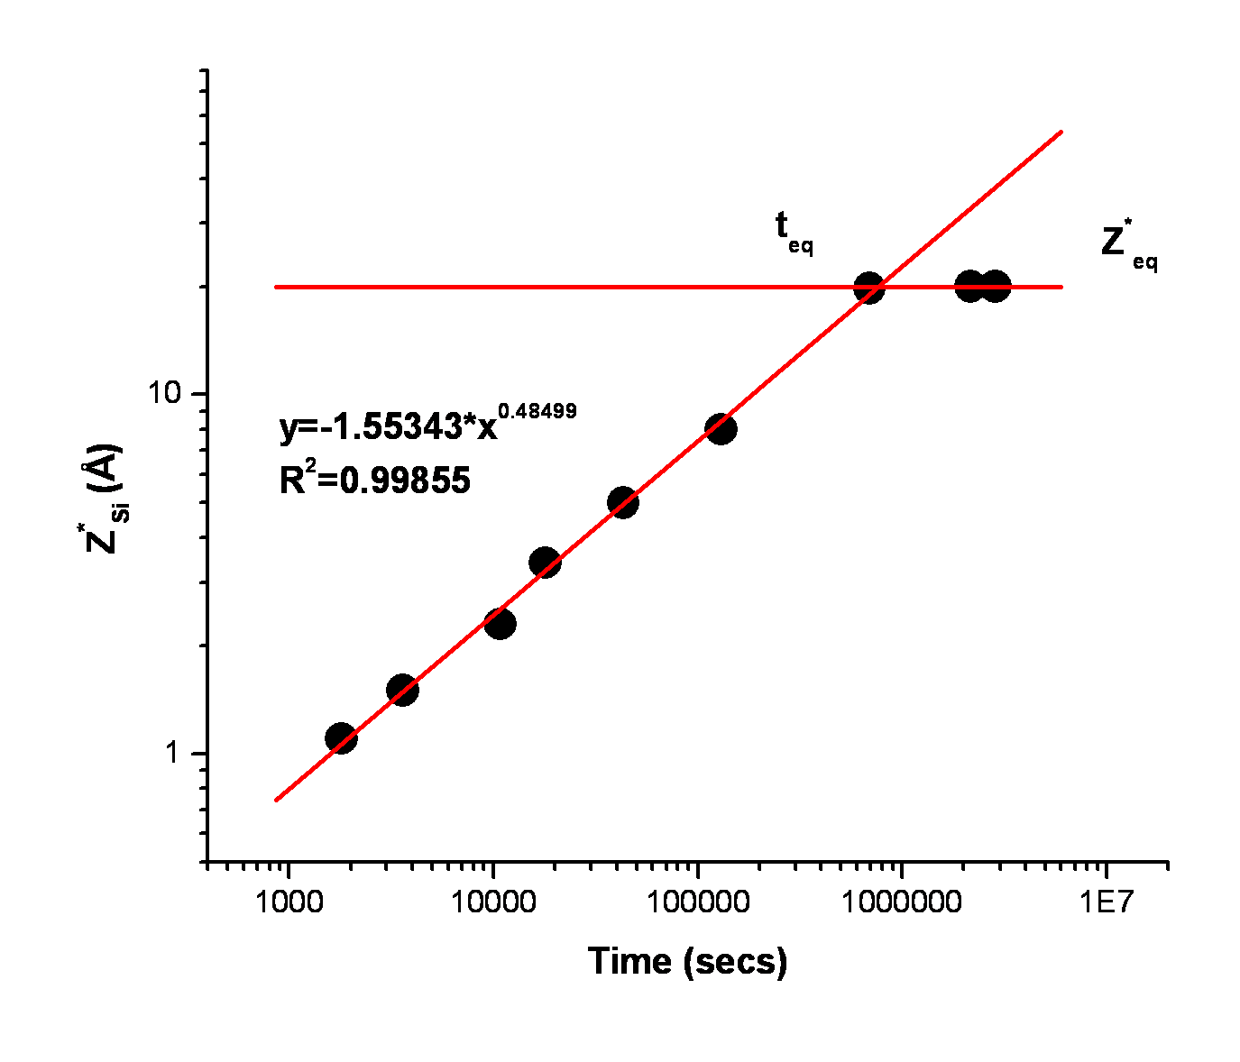

Figure 4.15 The growth of the interfacial excess layer near the Si interface, Z*_{Si}, for blend 9010MMAEO_LPMMA annealed up to 33 days at 150°C under vacuum.

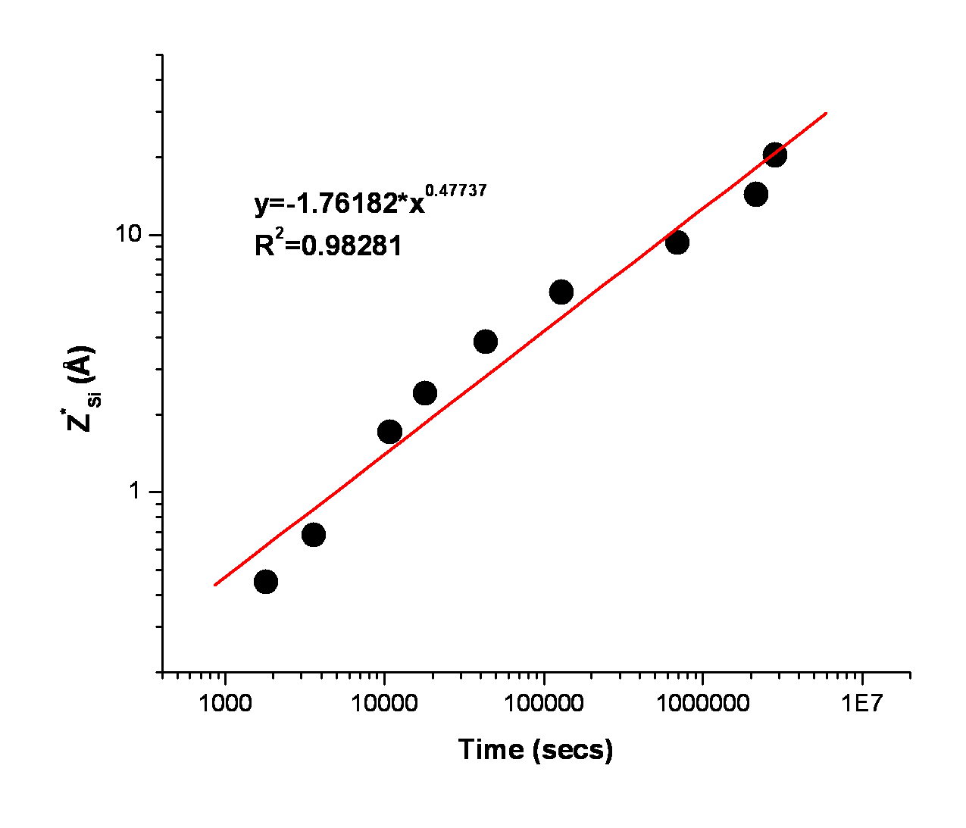

Figure 4.16 The growth of the interfacial excess layer near the Si interface, Z*_{Si}, for blend 7525MMAEO_LPMMA annealed up to 33 days at 150°C under vacuum.

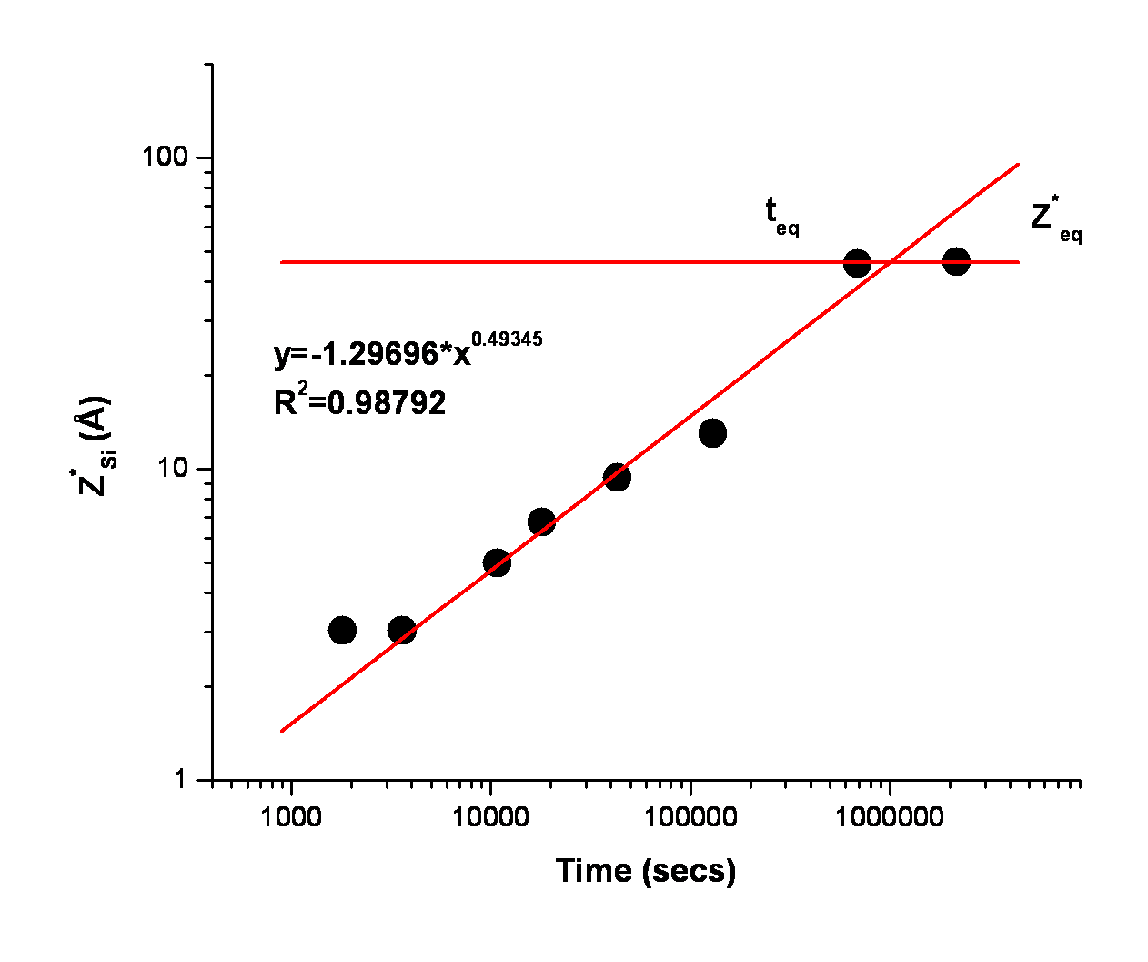

Figure 4.17 The growth of the interfacial excess layer near the Si interface, Z*_{Si}, for blend 5050MMAEO_LPMMA annealed up to 25 days at 150°C under vacuum.

where is the equilibrium interfacial excess, is the volume fraction of branched additive in the bulk (or reservoir)of the film at equilibrium, and is the time it takes for the surface segregation process to reach equilibrium. The equilibrium interfacial excess Z*_{Si eq}, equilibrium time, t_{eq}, and the mutual diffusion coefficients, D_{m}, are summarized for each comb/linear blend in Table 4.6. Each surface segregating blend displays t^{1/2} growth of the interfacial excess layer. The blend 7525MMAEO_LPMMA is estimated to have the slowest mutual diffusion coefficient, as indicated in Tbl. 4.6. This result is consistent with the fact that this comb copolymer has an
Table 4.6 The mutual diffusion coefficients, D_{m}, for blends containing P(MMA-r-PEGMA) comb copolymers (10 w/w %) in a linear homopolymer matrix as well as the equilibrium anneal time, t_{eq}, and equilibrium Si interfacial excess Z*_{Si eq}.
Sample Name | D_{m}(cm²/sec) | t_{eq}(secs) | Z*_{Si eq}(Å)
9010MMAEO_LPMMA | 1.47E-17 | 7.80E5 | 20
6535MMAEO_LPMMA | ≤4.05E-18 | ≥2.85E6 | 20
5050MMAEO_LPMMA | 1.10E-16 | 2.16E6 | 46

M_{w} that is approximately twice as large as the other two comb copolymers (108,100 g/mol, Tbl. 4.2), which indicates that the size of the comb plays a role in the surface segregation process, verifying that smaller polymers will equilibrate more quickly. Nevertheless, the blend containing the comb copolymer with the highest graft density (i.e., 5050MMAEO, 8.5 mole% PEGMA), and which also has an M_{w} that is approximately the same magnitude as the 9010MMAEO comb (~50,000 g/mol; Tbl 4.2), has the largest mutual diffusion coefficient. This result indicates that the number of chain ends also plays a significant role in the surface segregation process of these systems.
The order of magnitude of the measured mutual diffusion coefficients for these blends is also consistent with previously reported self-diffusion coefficients for blends of d-PMMA and PMMA. The values of tracer diffusion coefficients (D*) measured from the interdiffusion of d-PMMA (M_{w} = 127,000 g/mol) and PMMA (M_{w} =100,250 g/mol) at various annealing temperatures have been reported by Shearmur et al:¹³⁵ D*=3.0E-18cm²/s, T=149°C; D*=9.1E-17cm²/s, T=162°C; D*=4.6E-16cm²/s, T=171°C; D*=2.4E-15cm²/s, T=181°C.
- The Tracer Diffusion Coefficient, D_{A}*, of a Comb Copolymer from Depth Profile Experiments

The ability of the Fast and Slow Mode theories to determine the tracer diffusion coefficient of the comb copolymers based on the mutual diffusion coefficients presented above was evaluated. This analysis found that only the Slow Mode theory gave a physically reasonable result. Equation 4.4 shows the equation used to calculate the tracer diffusion coefficient of the combs in a linear matrix using the Slow Mode theory^{18, 69}:
(4.4)
where D_{A}* is the tracer diffusion coefficient of the slow-moving component, D_{m} is the mutual diffusion coefficient, Φ_{A} and Φ_{B} are the volume fractions of components A and B, respectively, D_{B}* is the diffusion coefficient of component B, and N_{A} and N_{B} are the degree of polymerization for components A and B, respectively. The diffusion coefficient of the linear matrix, D_{B}*, also must be known to compute the tracer diffusion coefficient of the branched additive using Equation 4.4. Thus, from previous measurements of the diffusion coefficient of linear PMMA in the Dadmun Lab¹⁸ under the same conditions (150° C under vacuum in films ~1000 Å thick), it was estimated that D_{B}* for linear PMMA with M_{w} of 136,000 g/mol is 1.52E-18 cm²/sec. Moreover, using the model of Doi and Edwards for polymer dynamics,¹²⁹ as shown in Equation 4.5, one can calculate the tracer diffusion coefficients of linear analogs of P(MMA-r-PEGMA) comb copolymers as well as of the linear PMMA matrix in the blend:
(4.5)
where k_{B} is Boltzmann’s constant, 1.3087E-16 cm².g.s⁻².K⁻¹, T is the temperature, 423 K, d_{t} is the tube diameter for PMMA, 7.3E-7 cm, ξ is the friction coefficient for PMMA, 0.39 dyn.s/cm, N is the degree of polymerization, and b is the segment length of PMMA, 8.7E-8 cm.^{67,130} Table 4.7 contains a summary of the tracer diffusion coefficients of the comb copolymers in a linear matrix along with the calculated diffusion coefficients of their linear analogs (i.e., polymer chains with the same molecular weight as the complete comb copolymer). Again, the value of the tracer diffusion coefficient for the comb copolymer in the blend 7525MMAEO_LPMMA is only an upper bound, as the data does not indicate that this blend reached equilibrium (Tbl. 4.7).
Figure 4.18 displays the tracer diffusion coefficient of the comb copolymers and their linear analogs. Linear analogs of comb copolymers as well as the linear matrix display Reptation dynamics, as shown in Figure 4.18 (i.e., D_{B}* ~ M_{w}⁻²). Comb copolymers, however, have tracer diffusion coefficients that are nearly 1-3 orders of magnitude smaller than their linear analogs (Fig. 4.18). It is likely that the differences in tracer diffusion coefficients of comb copolymers and their linear analogs are related to their different architectures. Recall, as discussed in Chapter 2, that comb copolymers undergo translational motion by arm retraction and branch point hopping at short times followed by Reptation of the backbone at long times.⁵⁹ Thus, even though increasing the branch density (while holding the molecular weight constant) increases the tracer diffusion coefficient of a comb copolymer by an order of magnitude, the increased number of high friction points along the backbone results in the comb copolymer having a diffusion coefficient an order of magnitude smaller than its linear analog. Also, in Figure 4.18, note that by doubling the length of the comb copolymer (i.e., branched additive in the blend 7525MMAEO_LPMMA), the diffusion coefficient is approximately 3 orders of magnitude
Table 4.7 Tracer diffusion coefficients, DA*, for comb copolymers in a linear PMMA homopolymer matrix as well as for their linear analogs.
Sample Name | D_{A}* Comb Copolymer  (cm²/sec) | D_{A}* Linear PMMA Analog  (cm²/sec)
9010MMAEO_LPMMA | 2.96E-20 | 1.08E-17
7525MMAEO_LPMMA | ≤4.29E-21 | 2.06E-18
5050MMAEO_LPMMA | 7.74E-19 | 8.44E-18

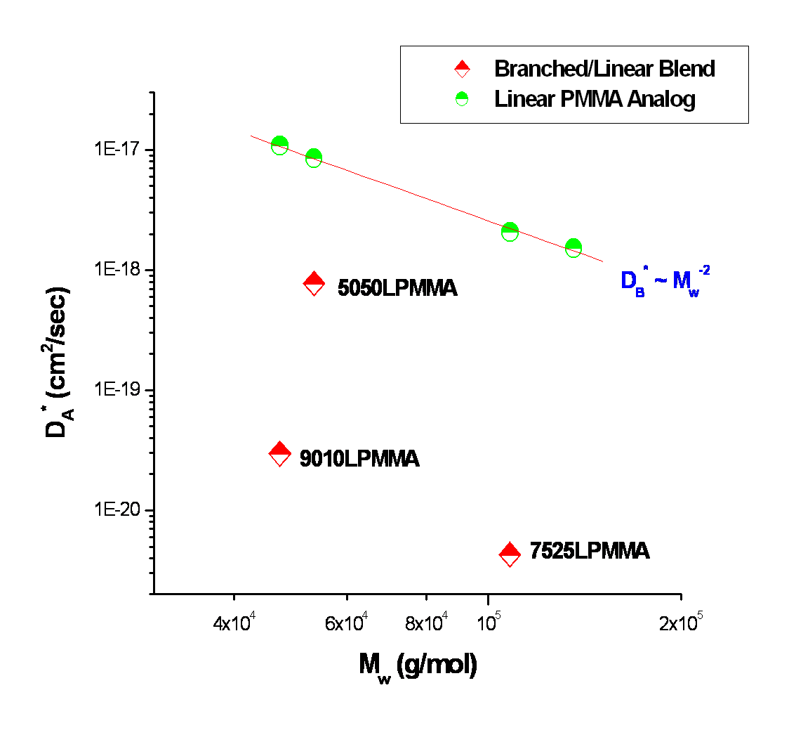

Figure 4.18 The tracer diffusion coefficient, D*A, of comb copolymers P(MMA-r-PEGMA) as a function of M_{w} in a linear d-PMMA matrix with M_{w} of 136,000 g/mol. Also shown are the calculated values of the diffusion coefficient of linear analogs of the comb copolymers (i.e., having the same molecular weight as the comb copolymers) as well as of the linear d-PMMA matrix.
smaller than its linear analog. The branch density of the additive in 7525MMAEO_LPMMA is intermediate compared to the other 2 combs, but the increased chain length (size) has a greater impact on its dynamics than its branch density in this particular case.
Figure 4.19 further illustrates how both the number of chain ends as well as the size of the comb impacts the amount of surface segregation in these self-healing materials as it displays the total interfacial excess of the branched copolymer at both the air and Si interfaces as a function of the branch density (w/w % PEGMA). An increase in the molecular weight of the comb, even with an accompanying increase in branch density (7525MMAEO), does not increase the total interfacial excess of the branched additive. Rather, an increase in branch density, while keeping the molecular weight the same, resulted in greater total interfacial excess of the branched additive (5050MMAEO).

4.4 Conclusions
In Chapter 3, increasing the number of chain ends, and thus the molecular weight of the hyperbranched polymeric additive, increased the amount of surface segregation. However, in these studies of comb copolymers with varying branch densities in a linear matrix, it was found that although increasing the branch density increases the amount of surface segregated material, increasing the branch density also increases the number of branch points, which dominates the friction in the Reptating backbone of the comb.⁵⁹ This is likely why a linear analog (having the same molecular weight as the comb copolymer) is still an order of magnitude faster than a comb copolymer under the same conditions. Moreover, simple Reptation dynamics for these comb copolymers (i.e., D ~ M_{w}⁻²) was not observed. Nevertheless, potential applications for these self-healing materials may include a need for slow, gradual migration of a functionalized polymer to a surface as in, for example, the long-term exposure of a surface to an environment that is
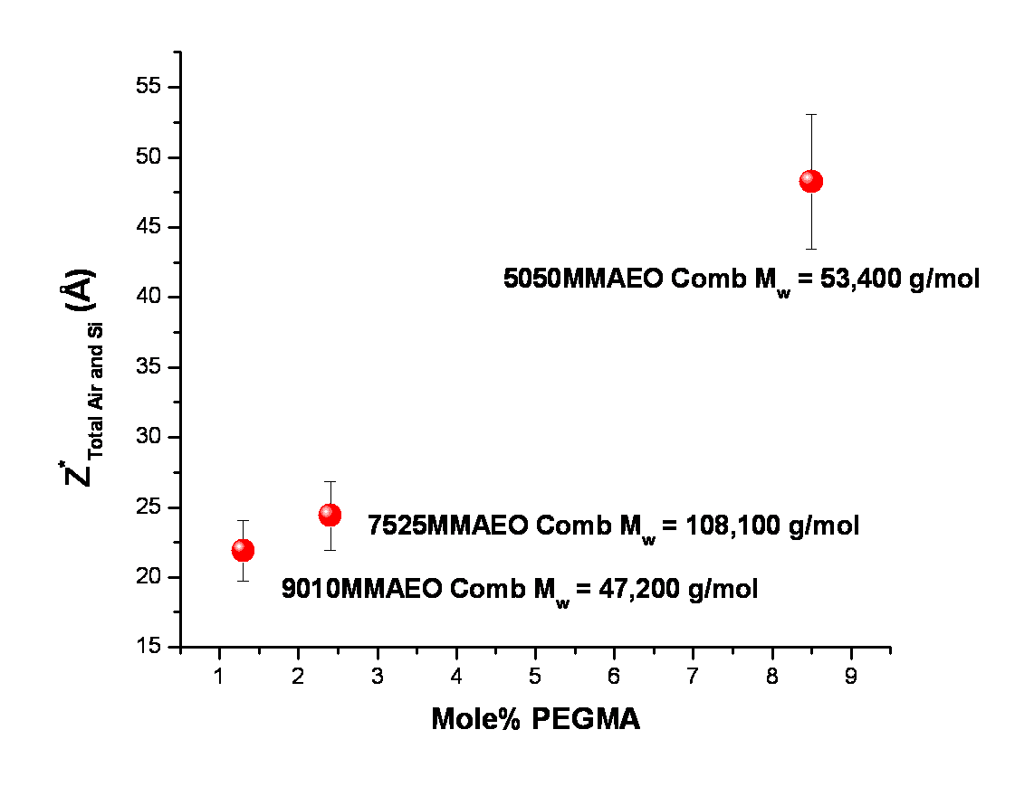

Figure 4.19 Total air and Si interfacial excess for surface segregating binary blends containing 10 w/w % P(MMA-r-PEGMA) comb copolymers in a linear d-PMMA matrix.

corrosive. Likewise, faster migration may be needed, for example, for a surface in an environment in which there has been a chemical spill. Thus, comb copolymers in a linear matrix may be suitable for surfaces requiring gradual, long-term responses, while hyperbranched polymers in a linear matrix may be suitable for surfaces needing a more rapidly triggered response. The results of Chapters 3 and 4 have provided fundamental information about such self-healing systems that can be used to incorporate these materials into useful industrial applications for smart responsive surfaces.
Furthermore, neutron reflectivity depth profile experiments corroborated by water contact angle measurements of the evolving surfaces of these binary comb/linear blends was successfully used to elucidate the surface segregation process in these self-healing systems. Using these measurements, the mutual diffusion coefficient (using the Kramer-Jones depletion layer model) and the tracer diffusion coefficient for each branched additive (using the Slow Mode theory) was extracted. Thus, these results also demonstrate a method to effectively measure diffusion coefficients of comb copolymers in a linear polymer matrix.

Determining the Structure of a Surface-Functionalized Cross-Linked Network

5.1 Introduction

A. Overview
The second method of functionalizing polymeric surfaces and interfaces investigated in this body of work involves tethering of individual polymer chains to an interface via covalent bonds. Both grafting-to and grafting-from techniques are employed in the creation of surfaces with end-tethered polymers.²⁸ The present study utilizes a grafting-from approach that involves a 3-dimensional functionalized surface.
Von Werne et al^{46, 136} reported the development of a method to tune the feature sizes in a polymeric material down to 60 nm using a combined top-down and bottom-up approach consisting of contact molding and living free radical polymerization. The top-down approach generally involves microfabrication methods and micropatterning techniques such as photolithography. Photolithography is widely used to make modern microelectronic devices and involves the selective removal of parts of a thin film or substrate.¹³⁷ Light is used to transfer a pattern from a photomask, which blocks light in some areas and transmits it in other areas, to a light sensitive chemical called a photoresist which covers a substrate. A series of these chemical treatments typically results in reproducible and scaleable features down to a size of approximately 100 nm.^{138,139} Nevertheless, the top-down approach cannot by itself meet the demands of the next generation of microelectronic devices in which the desire is for sub-100 nm feature sizes. In contrast, the bottom-up approach, which involves the self-assembly of molecules at an interface, offers promise to fulfill the demands for smaller feature sizes.^{140,141} However, the challenge in using the bottom-up approach lies in the inherent difficulty of directing the position of these self-assembled molecules over large areas. Moreover, the expectation remains high to deliver the same robustness and reliability of traditional top-down approaches.
The bottom-up portion of the combined approach to tune polymeric surfaces down to sub-100 nm feature sizes involves polymerization from a soft 3-dimensional interface, reported by Von Werne et al,^{46,136} and utilizes inimers (compounds that contain both initiator and monomer functionality) embedded in a photopolymer network to pattern a surface. This technique provides a unique method to nanoscopically tune the size and shape of polymeric surfaces and interfaces for next-generation devices. Nevertheless, in order to realize the application of such a technique for commercial use in molecular-scale electronics, optoelectronics, and biotechnology, for example, it is necessary to understand the exact nature of the homopolymer-photopolymer interface. Thus, the scope of the present study involves characterization of the structure of deuterated poly(styrene) (PS) grown from inimers embedded in a protonated photopolymer matrix by examining unpatterned films. Using a combination of techniques that included neutron reflectivity, dynamic secondary ion mass spectrometry (DSIMS), and in-situ ellipsometry, the location of initiation of polymer growth in the functionalized film was determined. Moreover, information about the depth profile of the grafted unpatterned films was determined and correlated with synthetic conditions.

B. Fabrication of 3-Dimensional Inimer-Embedded Functionalized Materials
The process to fabricate inimer-embedded functionalized materials was developed in the research group of Dr. Carter at the University of Massachusetts. Thus this work was a collaborative effort in which the materials were fabricated at the University of Massachusetts,¹⁴² while characterization of the materials was completed in this study and as such is the scope of the body of work described here.
In Figure 5.1, the components of the inimer-embedded photopolymer network are shown. The photopolymer synthetic technique, also known as the 2P Process,¹⁴³ was originally developed by Philips for magnetic storage. The 2P process is a copolymerization of acrylate monomers. Fast polymerization is necessary for this process to be efficient and thus di- and tri-acrylates are used in an addition reaction along with N-vinyl pyrrolidinone (NVP) which increases chain propagation.^{46, 144} The di-acrylate, ethoxylated bisphenol-A-dimethacrylate, was chosen because it imparts hardness and rigidity to the material.⁴⁶ Likewise 2-ethyl-(hydroxymethyl)-1,3-propanediol triacrylate provides high cross-linking density.⁴⁶ In the present study, cross-linked photopolymers are embedded with an inimer, 2-methacryloxyethyl-2’-bromoisobutyrate in a thin film. The photopolymerization of this film is initiated when UV light (λ=365nm) is absorbed by the photoinitiator, 2,2-dimethoxy-2-phenylaecetophenone.
Flat, unpatterned films were fabricated as shown in Figure 5.2. Silicon substrates were cleaned, and a monolayer of an adhesion promoter was formed on the substrates by spin-coating 3-(trimethoxysilyl)propylmethacrylate at 3000 rpm for 10 seconds. This was followed by baking the wafers at 130°C for 2 minutes. The monolayer presents methacrylate groups on the surface which facilitates the adhesion of the methacrylate based network photopolymer/inimer layer formed in the following step. The acrylates, inimer, and NVP were then spin coated from a propylene glycol methyl ether acetate solution. Subsequently, the layer was photopolymerized with 365 nm UV light for 10 minutes. Next, growth of polystyrene via a secondary polymerization was accomplished using Atom Transfer Radical Polymerization (ATRP). To
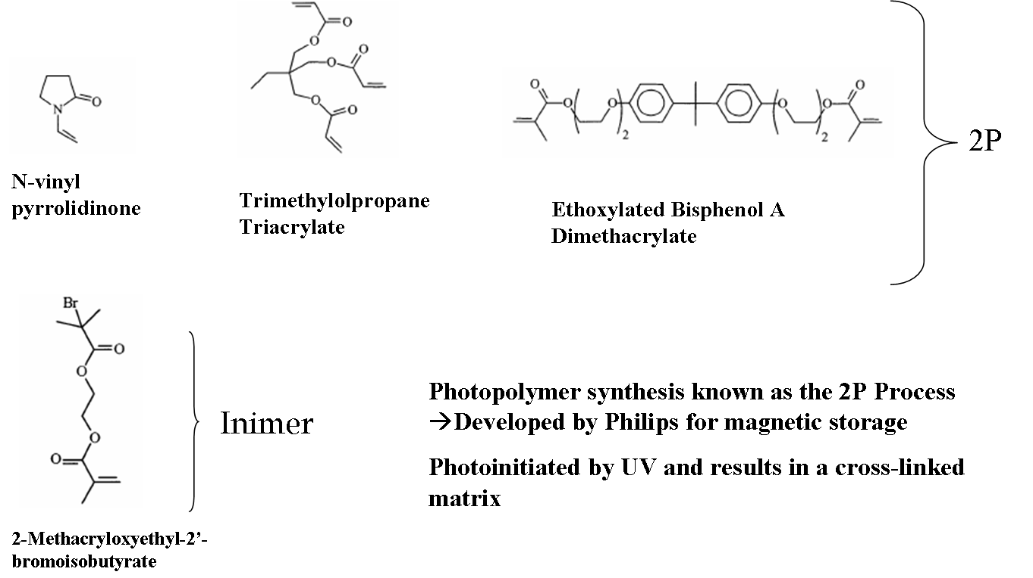

Figure 5.1 The components of the photopolymer network include di- and tri-acrylates as well as an inimer from which polymer growth is initiated.

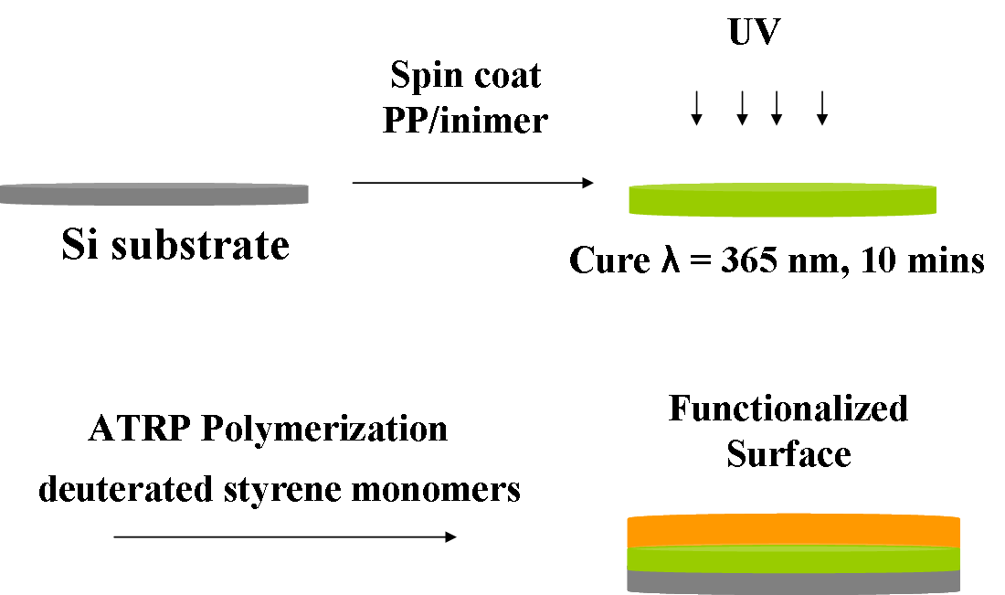

Figure 5.2 Fabrication of functionalized cross-linked inimer-embedded photopolymer networks investigated in this study.
commence this reaction, a 50 mL reaction vessel containing the inimer embedded photopolymer coated wafer and 50 v/v % anisole was charged with deuterated styrene monomer, ethyl-2-bromoisobutyrate initiator, CuBr catalyst, and PMDETA ligand.¹⁴² The reaction was conducted under a nitrogen atmosphere at 90°C for 4 hours.¹⁴² Any polymer not grafted was removed by extraction with THF.
In Table 5.1, a summary of the samples fabricated for this study, in which the inimer concentration and grafted molecular weight of d-PS chains was systematically varied, is presented.

5.2 Materials and Methods

- Characterization of Films

- Neutron Reflectivity

Neutron reflectivity was used to characterize the segment density profile of samples fabricated with varying monomer and inimer concentration. Samples were on 0.5 mm thick Si substrates cut down to an area of ~ 2 in². Data was collected at the NIST Center for Neutron Research (NCNR) on the NG-7 horizontal reflectometer. The neutron wavelength was fixed at 4.75 Å. A q-range of 0.007 to 0.08 Å⁻¹ was investigated for nine deuterated poly(styrene) (d-PS) brush samples. However, due to time limitations, only a q-range of 0.007 to 0.03 Å⁻¹ was investigated for the three monolayers of inimer embedded photopolymer (PP). As a result, more data for these inimer embedded photopolymer monolayers was collected at the Spallation Neutron Source (SNS) at Oak Ridge National Lab (ORNL) on the horizontal reflectometer at Beamline 4B. The horizontal reflectometer at the SNS is a time of flight spectrometer with Δq/q = 0.05. A q-range of 0.005 to 0.14 Å⁻¹ was investigated. Reflred, a data reduction program from
Table 5.1 Samples with varying inimer and monomer concentration investigated in this study of functionalized cross-linked polymer networks.
 | 10% Inimer | 30% Inimer | 50% Inimer
Inimer:dS | 1:200  1:400 | 1:200 | 1:200
Inimer:dS | 1:200  1:400 | 1:400 | 1:400
Inimer:dS | 1:600 | 1:600 | 1:600

NIST, was used to reduce the data collected at NIST. On-site data reduction software was used to reduce the data collected at the SNS. Both Reflfit and Motofit,¹¹¹ two fitting packages, were used to fit the data from NIST and from the SNS. An error function was used to model the interfaces in these systems. Volume fraction plots of deuterated PS in cross-linked functionalized films were generated using the Tiles Program (SNS, ORNL). A standard test for statistical significance, chi squared (χ²), was calculated for each fit and was less than 10.0. The theory of neutron reflectivity is covered in Appendix A.2, section B.
- Dynamic Secondary Ion Mass Spectroscopy (DSIMS)

DSIMS data was collected by Dr. Tom Mates at the University of California Santa Barbara on a model 6650 Dynamic Quadropole instrument (Physical Electronics, Chanhassen, MN, USA). A 2kV O²⁺ primary ion beam was used to probe a sample area of 300µm x 345 µm enclosed in a vacuum chamber (8E-10 torr). After rastering the O²⁺ beam over the sample, secondary ions of ¹H, ²D, ¹²C, ²⁸Si, and ⁷⁹Br were produced and detected by a mass spectrometer from a region that was 15% of the sputtered crater area. Charge neutralization was achieved using a 300 eV electron beam. Subsequent analysis of the DSIMS depth profiles was completed by Professor Ryan Hayward at the University of Massachusetts. An overview of the theory underlying the DSIMS experiment is covered in Appendix B.1, Section A.
- In-Situ Ellipsometry

In-situ swelling experiments were conducted using a Laser Picometer phase modulated ellipsometer (Beaglehole Instruments, Wellington, New Zealand), with a He-Ne laser source at a wavelength of 633 nm. An overview of the theory underlying the phase modulated ellipsometry experiment is covered in Appendix B.1. Prior to measurements, the flow cell was cleaned by soaking in a 70:30 H₂SO₄/ 30% H₂O₂piranha solution for 20 minutes followed by rinsing with nanopure water and finally drying with N₂(g).
The sensitivity of the ellipsometry parameters to the thickness of a layer ismaximized at the Brewster angle. The Brewster angle is the angle at which the p-polarization goes to zero and only s-polarization remains. The Brewster angle for a Si substrate is 75°.¹⁴⁵ As the objective of the experiment was to measure the positive change in the thickness of the film while immersed in solvent, the angle of incidence was varied from 50° to 75° for both the alignment and real-time thickness measurements. Alignment of the flow cell containing toluene and sample (which was cut down to a smaller size to fit in the sample cell, ~ 0.5 in²) was performed by adjusting the height of the sample at 50°, 62.5°, and 75° to maximize the signal at each angle.
Experiments were conducted at ambient temperature, ~ 25°C. ACS grade Toluene (Fisher) was used as the swelling solvent. After aligning the beam to maximize intensity at 3 angles, the thickness was determined approximately every 2 minutes (the actual time of the measurement was recorded). The dry film thicknesses before and after the swelling experiments were also measured for each sample. The thickness and refractive index was determined for each measurement using the Igor Pro data analysis software (Wavemetrics) to generate a model fit to the experimental data. Fitting of the data was accomplished with a Cauchy model within the analysis software. An overview of the theory underlying the in-situ ellipsometry experiment is covered in Appendix B.1, section B.
- Water Contact Angle Goniometry

Water contact angle goniometry was conducted for each sample to complement the results of other surface measurements. Contact angle measurements were performed under ambient conditions with a Rame-Hart (Mountain Lakes, NJ) Model 100 contact angle goniometer using the sessile drop method. The liquid used was high purity water. Droplets were approximately 3µL and all reported values were averaged over 8 measurements taken at different locations on the sample surface. An overview of the theoretical basis for contact angle goniometry is covered in Appendix A.2, section D.

5.3 Results and Discussion
- Insight into the Structure of Functionalized Cross-Linked Networks

- Determining Structure in the Bulk of the Film
A primary objective of the present study was to discover where polymer growth is initiated in these functionalized cross-linked networks. Samples containing 30 w/w % inimer and polymerized with 1:400, 1:500 and 1:700 inimer:dS were characterized with Dynamic Secondary Ion Mass Spectroscopy (DSIMS). DSIMS provides a complementary real-space depth profile of films useful in corroborating model fits to NR data. Figure 5.3 displays the results of the DSIMS profile for the sample containing 30 w/w % inimer and polymerized with 1:400 inimer:dS. The behavior of the signal at the free surface shown in Figure 5.3 is most likely due to
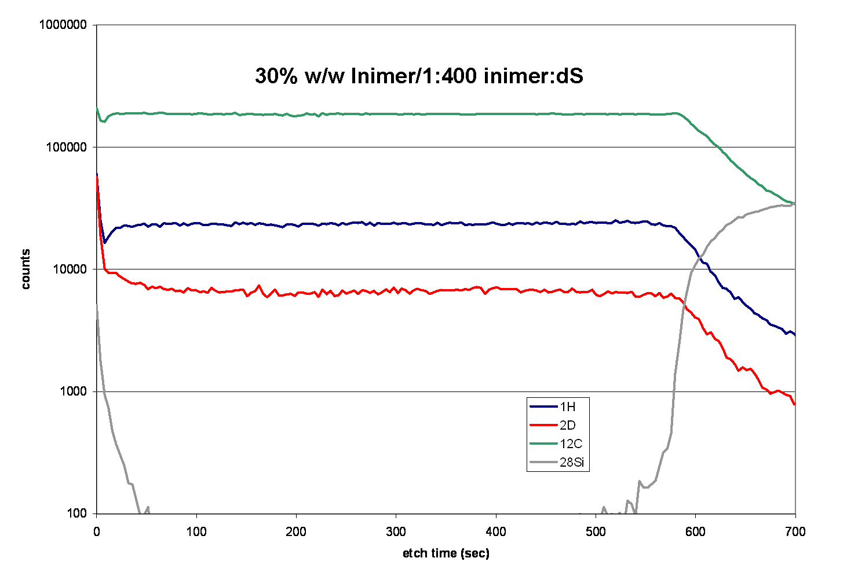

Figure 5.3 DSIMS spectra for a sample containing 30 w/w % inimer polymerized with 1:400 inimer:dS.

an artifact that occurred during establishment of a steady state etching profile (i.e., since no sacrificial layer was used). From the DSIMS experiment, the volume fraction of d-PS within the entire layer can be computed more than one way. For instance, one can compare the number of counts for ¹H and ²D normalized by the ¹²C counts. One can also obtain etch rates for a reference material as described in Appendix B.1. In Figure 5.3, the ratio of the number of counts for ²D and ¹H (normalized by the ¹²C count) indicates that ~33% of the entire film contains d-PS. The amount of d-PS in the entire film for the other samples polymerized with 1:500 and 1:700 inimer:dS was also ~30% (See Appendix B.2 for results). Results from the DSIMS experiment indicate that the bulk of the film consists of a mixture of both d-PS and PP/inimer. Moreover, these results indicate that polymer growth is initiated throughout the bulk of the film in these functionalized cross-linked networks.

2) Determining Structure at the Film Surface
Previous work by von Werne et al⁴⁶ on patterned films containing 20 w/w % inimer in the photopolymer network, prepared in the same way that the flat films in this study were made, revealed that the thickness of the film increased after the secondary polymerization of monomer. Table 5.2 shows the film thicknesses measured with ellipsometry before and after the secondary polymerization with deuterated styrene in the present study. The change in film thickness varied from 30 to 51 nm in the present study. Similarly the change in film thickness for patterned films containing 20 w/w % inimer in the photopolymer network in von Werne et al’s⁴⁶ study was ~ 20 nm. They also demonstrated that the water contact angle of these films changes from 69.2° to 87.6° following secondary polymerization with deuterated styrene. Previously reported contact angles for pure PS films are in the range of 90° - 96°.¹⁴⁶ These results suggest that a PS brush was formed at the surface of the films investigated in von Werne et al’s study.
To examine the samples in this study, the water contact angle of the surface of all the films investigated in the present study were measured and are summarized in Table 5.3; these results clearly indicate that the top layer is not a monolayer of pure d-PS. A mixed layer, composed of both d-PS and PP/inimer, is likely formed at the surface of these cross-linked functionalized networks. Moreover, the standard deviation of the measurements was high for many of the samples, indicating that the surfaces are heterogeneous. It is possible that patches of

Table 5.2 Film thicknesses for samples investigated in this study before and after secondary polymerization with deutrated styrene.

 | Thicknesses by ªEllipsometry Before and After Secondary Polymerization with dS
Samples/  Inimer:dS | 10% Inimer | 30% Inimer | 50% Inimer
1:200 | Before: 145 nm  After: 196 nm | Before: 149 nm  After: 199 nm | Before: 156 nm  After: 191 nm
1:400 | Before: 148 nm  After: 187 nm | Before: 150 nm  After: 182 nm | Before: 151 nm  After: 197 nm
1:600 | Before: 147 nm  After: 177 nm | Before: 150 nm  After: 192 nm | Before: 157 nm  After: 201 nm

ªEllipsometry was measured in the Carter research lab where the samples were fabricated.

Table 5.3 Water contact angle measurements for cross-linked functionalized samples as well as monolayers of PP/inimer.
Sample | Average Water Contact Angle (°)
10wt% inimer/1:200 inimer:dS | 74 ± 3
10wt% inimer/1:400 inimer:dS | 69 ± 4
10wt% inimer/1:600 inimer:dS | 75 ± 4
30wt% inimer/1:200 inimer:dS | 67 ± 7
30wt% inimer/1:400 inimer:dS | 70 ± 5
30wt% inimer/1:600 inimer:dS | 69 ± 13
50wt% inimer/1:200 inimer:dS | 75 ± 6
50wt% inimer/1:400 inimer:dS | 79 ± 6
50wt% inimer/1:600 inimer:dS | 68 ± 9
10wt% inimer/PP | 74 ± 2
30wt% inimer/PP | 71 ± 3
50wt% inimer/PP | 75 ± 2

dense d-PS could have been formed on the surface of the films and thus would also contribute to the observed surface heterogeneity. Thus, the next step in the endeavor to learn more about the nature of the homopolymer/PP/inimer interface involved searching for a suitable model of the real-space density profiles of these films systematically, in order to determine the depth at which polymer growth is initiated as well as the density profile of polymer growth.

3) Developing the Best Model to Describe the Density Profile of Functionalized Cross-Linked Networks
Neutron reflectivity (NR) profiles for each of the PP/inimer monolayers, as well as a monolayer of d-PS, were collected and fit with a 1-layer slab model. The scattering length densities (SLD) of the PP/inimer monolayers and the d-PS monolayer were also calculated and compared to the fit. Table 5.4 contains a summary of the neutron SLD’s of a pure d-PS layer, as well as those of pure PP/inimer layers, containing 10 w/w %, 30 w/w % and 50 w/w % inimer. The calculated SLD’s were obtained using the chemical composition and mass densities of the inimer and PP, as well as an SLD calculator available at the NCNR NIST website.¹⁴⁷ The calculated SLD for the PP was 1.31E-6 Å⁻². A mass density for the inimer used in this study, 2-methacryloxyethyl-2’-bromoisobutyrate, was not available. However, a close analogue of this inimer is methyl-2-bromoisobutyrate which has a mass density of 1.39 g/cm³. Using this mass density, the calculated SLD for the inimer was 1.22E-6Å⁻². Both the measured and calculated SLD’s for the three PP/inimer monolayers yielded a value of ~1.3E-6 Å⁻² (Tbl. 5.4).
A significant challenge existed in modeling these cross-linked functionalized films as the amount of d-PS incorporated into the layer after the secondary polymerization is unknown. Nevertheless, a dense layer of d-PS on the surface of a protonated cross-linked PP/inimer layer

Table 5.4 Neutron scattering length densities (SLD) for monolayers of d-PS and monolayers of PP/inimer layers containing 10 w/w %, 30 w/w % and 50 w/w % inimer.

Polymer | Measured SLD (Å⁻²) | Calculated SLD (Å⁻²)
dPS | 5.72E-6 | 6.00E-6
10 wt. % Inimer/PP | 1.30E-6 | 1.30E-6
30 wt. % Inimer/PP | 1.34E-6 | 1.28E-6
50 wt. % Inimer/PP | 1.32E-6 | 1.26E-6

will have a distinct NR profile compared to one without a dense top layer of d-PS, due to the distinct differences in the scattering length densities of the d-PS and the inimer/PP layer.
Figure 5.4 illustrates both a 2-layer model fit to the NR data of the sample containing 10 w/w % inimer and 1:400 inimer:dS, as well as the fit to a model representing a monolayer (of the same total thickness) of pure PP/inimer containing 10 w/w % inimer for comparison. In Figure 5.4, the 2-layer model is composed of a top layer of pure deuterated PS with a thickness matching the change in thickness after secondary polymerization measured by ellipsometry (390 Å, Table 5.2), while the underlayer is composed of a pure PP/inimer layer (1480 Å, Table 5.2). Clearly, the 2-layer d-PS brush layer model does not fit the data. Likewise, a pure PP/inimer layer is not the best fit to the data either as χ², a measure of the goodness of the model fit to the data, is ~19 for the 1-layer model. A model that includes a 100 Å thick top layer of pure d-PS was also fit to the data but did not serve as an appropriate description of the real-space profile of this sample either. Thus, these results corroborate the water contact angle results presented
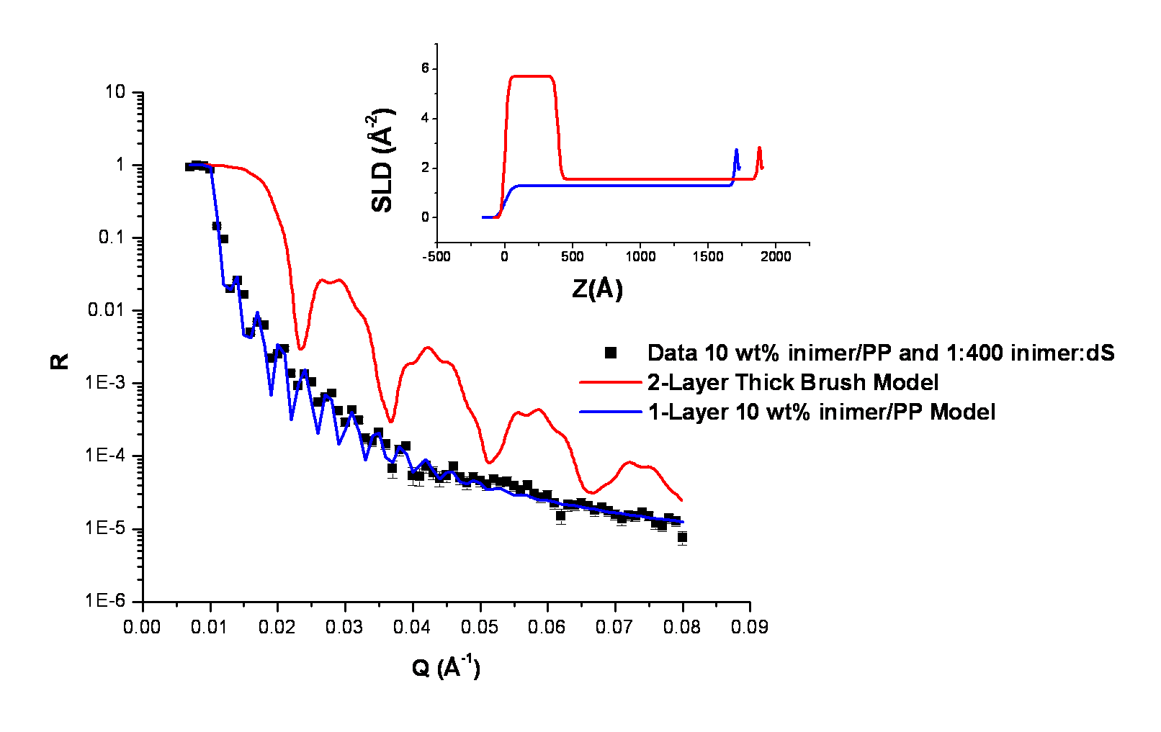

Figure 5.4 Neutron reflectivity profile for the cross-linked functionalized sample containing 10 w/w % inimer and polymerized with 1:400 inimer:styrene. A 2-layer model (red) with a thick brush layer on top (~390 Å) and a PP/inimer underlayer (~1480 Å) is shown along with a 1-layer model (blue) representing a monolayer of pure PP/inimer containing 10 w/w% inimer. The scattering length density profiles for each model are shown in the inset.

earlier, indicating that polymer growth initiation is not constrained to the near surface region to form a pure dPS brush. To determine the depth at which polymer growth is initiated as well as the density of polymer growth, 1-layer, 2-layer and 3-layer models were fit to the neutron reflectivity data. A 1-layer model assumes an even distribution of d-PS throughout the PP/inimer cross-linked network. A 2-layer model could also be fit to the data in which one layer is enriched in d-PS relative to the other. Likewise, a 3-layer model could be envisioned in which the concentration of d-PS progressively increased from the near substrate layer to the air interface.
To fit the single and multi-layer models to the data, genetic optimization parameter searches were conducted using Motofit¹¹¹ to determine the best-fit parameters. The 3-layer model did not significantly improve the goodness-of-fit (χ²) when compared to the simpler 2-layer model. However, comparison of the 1-layer and 2-layer models required testing for redundancy of fit parameters to determine the best model. Such a test involved taking the best 2-layer model and holding the parameters of the layer near the substrate constant while allowing the layer near the air interface to refine using Levenberg-Marquardt linear regression. In a subsequent fit, both layers were allowed to refine simultaneously. A set of redundant parameters, whereby the χ² statistic does not improve, indicates that the model is not improved by the addition of a second layer. A set of intertwined parameters, in which the goodness-of-fit does improve, however, indicates that a 2-layer model is required.
Figure 5.5 shows the sample scattering length density profiles for fits designated ‘A,’ in which the parameters of the layer near the substrate were held constant, while allowing the layer near the air interface to refine, as well as fits designated ‘B,’ whereby the subsequent refinement of both layers was performed. Table 5.5 contains a summary of the results of these ‘A’ and ‘B’ fits for all of the cross-linked functionalized samples. These results clearly show that the difference in d-PS concentration near the air interface and in the underlayer is very subtle. Moreover, this result is also consistent with a model that contains regions or patches of d-PS near the air interface such that there is only a small increase in the average d-PS concentration in the near surface region. Thus, 2-layer model fits with a surface layer containing only a modest increase in the average d-PS concentration in the near surface region were chosen to fit neutron reflectivity profiles of cross-linked functionalized materials investigated in this study.
Figure 5.6 displays a neutron reflectivity profile and model fit for the sample containing 10 w/w % inimer polymerized in 1:400 inimer:dS, which shows that the model with a slight
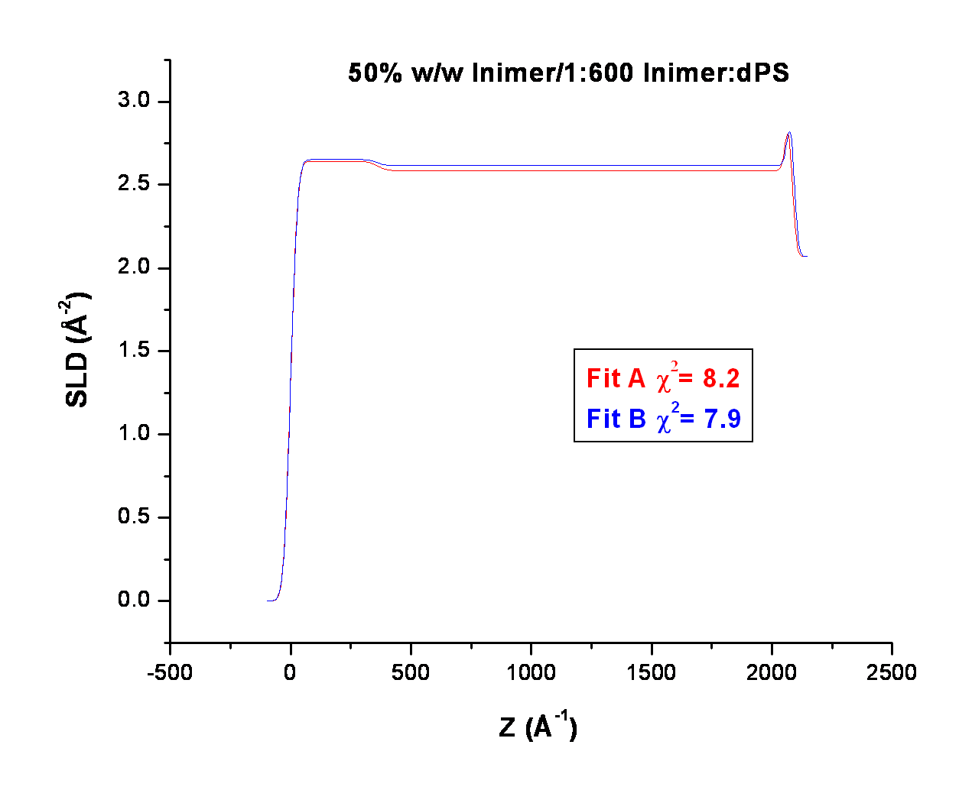

Figure 5.5 Results of tests for redundancy of fit parameters for the sample containing 50 w/w % inimer polymerized with 1:600 inimer:dS. Fit ‘A’ was generated by holding the parameters of the layer near the substrate constant while allowing the layer near the air interface to refine. Likewise, Fit ‘B’ was generated by the subsequent refinement of both layers simultaneously.

Sample | Fit ‘A’  χ2 | Fit ‘B’  χ2
10wt% inimer/1:200 inimer:dS | 8.6 | 8.4
10wt% inimer/1:400 inimer:dS | 8.7 | 8.6
10wt% inimer/1:600 inimer:dS | 2.7 | 2.7
30wt% inimer/1:200 inimer:dS | 8.1 | 8.1
30wt% inimer/1:400 inimer:dS | 4.2 | 4.2
30wt% inimer/1:600 inimer:dS | 2.9 | 2.9
50wt% inimer/1:200 inimer:dS | 5.1 | 4.7
50wt% inimer/1:400 inimer:dS | 12.8 | 12.8
50wt% inimer/1:600 inimer:dS | 8.2 | 7.9
Table 5.5 Results of the tests for redundancy of fit parameters designated ‘A’ and ‘B’.

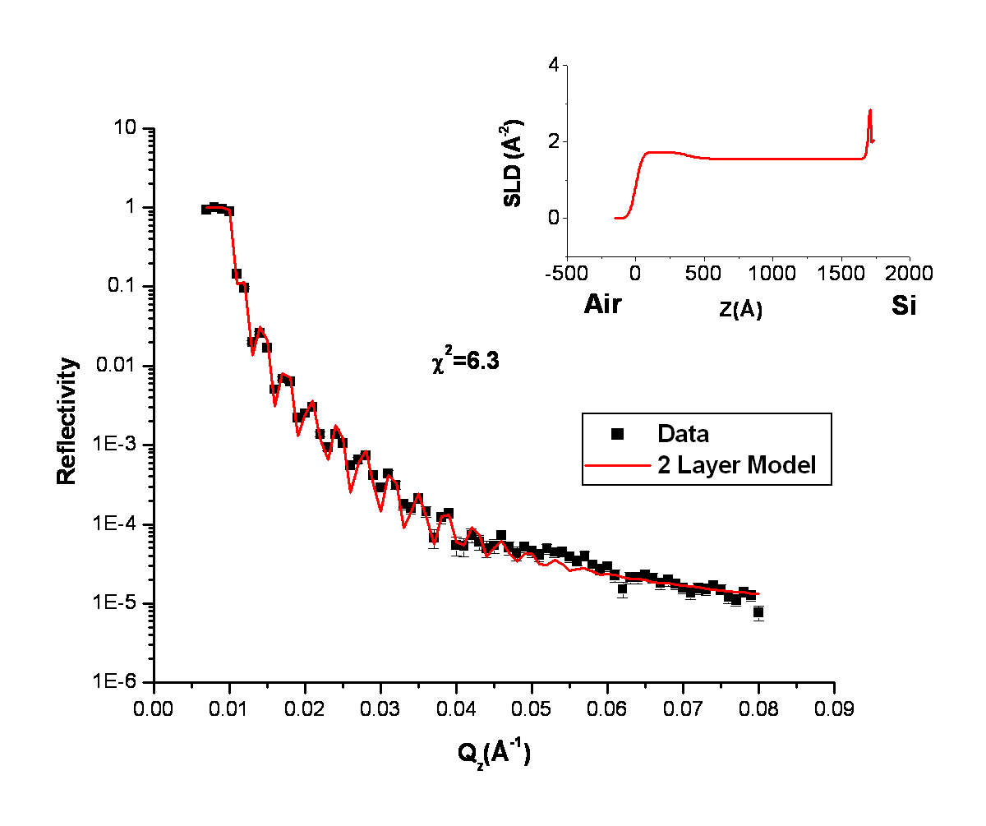

Figure 5.6 Results of a model fit to neutron reflectivity data for a sample containing 10 w/w % inimer polymerized with 1:400 inimer:dS using 2 layers composed of a slight excess of d-PS in the surface layer as compared to the underlayer. The scattering length density profile is shown in the inset.

excess of d-PS at the surface relative to the d-PS concentration in the entire layer fit the experimental NR profile very well.
Table 5.6 contains a summary of the best-fit neutron reflectivity parameters for each cross-linked functionalized film investigated in this study based on the 2-layer model.
- Correlating the Structure of Functionalized Surfaces and Interfaces with Synthetic Conditions

1) The Impact of Inimer Concentration on d-PS Growth
Another important objective of this study is to understand how synthetic conditions are correlated with the depth profile of these cross-linked functionalized materials. Ultimately, this
Table 5.6 Best-fit neutron reflectivity parameters of the 2-layer model for each cross-linked functionalized film investigated in this study. The fit parameters for each layer include thickness, d, scattering length density, ρ, and roughness between the air and near air surface, σ_{air/near air}, as well as roughness between the near air surface and underlayer, σ_{near air/underlayer}.
 | Near Air Layer |  |  | Underlayer
Sample | d  (Å) | ρ  (x10-6Å⁻²) | σ  (Å) | d  (Å) | ρ  (x10⁻⁶Å⁻²) | σ  (Å)
10wt% inimer/1:200 inimer:dS | 397 | 1.76 | 32 | 1259 | 1.57 | 70
10wt% inimer/1:400 inimer:dS | 379 | 1.73 | 37 | 1320 | 1.57 | 71
10wt% inimer/1:600 inimer:dS | 141 | 1.56 | 33 | 1544 | 1.44 | 95
30wt% inimer/1:200 inimer:dS | 487 | 2.22 | 34 | 1600 | 2.10 | 92
30wt% inimer/1:400 inimer:dS | 806 | 1.83 | 24 | 870 | 1.82 | 88
30wt% inimer/1:600 inimer:dS | 392 | 2.26 | 27 | 1507 | 2.17 | 196
50wt% inimer/1:200 inimer:dS | 248 | 2.30 | 25 | 1674 | 2.27 | 31
50wt% inimer/1:400 inimer:dS | 495 | 2.01 | 40 | 1352 | 1.97 | 32
50wt% inimer/1:600 inimer:dS | 419 | 2.69 | 23 | 1654 | 2.59 | 74

fundamental information will be useful in designing these types of materials with tunable surface properties. Using the model scattering length densities obtained from fits to neutron reflectivity (Tbl. 5.6), the volume fraction of d-PS as a function of depth into the film, Φ_{d-PS}, can be calculated using Equation 5.1: ¹⁴⁸
(5.1)
where ρ_{model}, ρ_{PP/inimer}, and ρ_{d-PS} are the neutron scattering length densities of the functionalized cross-linked film obtained from the model, the PP/inimer monolayer, and deuterated PS, respectively. Figure 5.7 shows that the volume fraction of d-PS increases as the wt. % inimer increases for samples polymerized with 1:600 inimer:dS. By integrating the total area under these curves, the total amount of d-PS in the entire film is obtained for each sample.

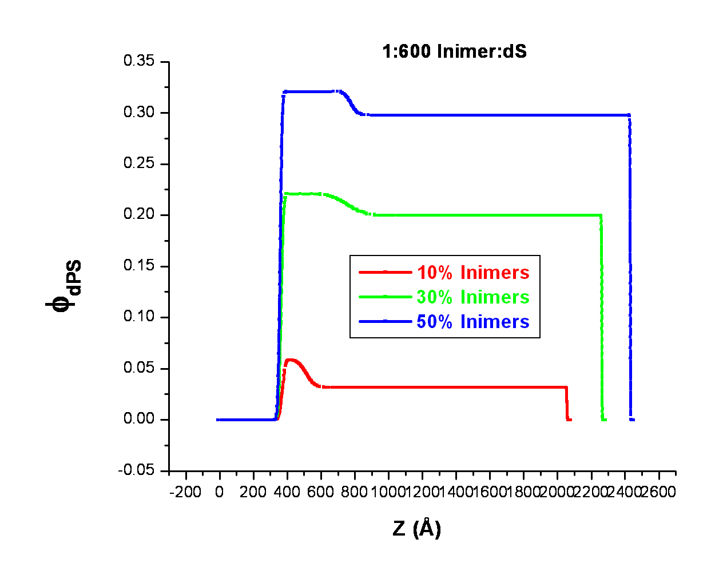

Figure 5.7 Volume fraction of d-PS as a function of depth in cross-linked functionalized films polymerized with 1:600 inimer:dS and containing 10 w/w %, 30 w/w % and 50 w/w % inimer.
As shown in Figure 5.8, the total amount of d-PS in the entire film increases with increasing wt.% inimer for most of the samples, which makes sense as there are more initiation sites, thus more polymer chains grafted off of the 3-dimensional inimer-embedded surface.

2) The Impact of Swelling and Monomer Concentration on d-PS Growth
Since results from various surface sensitive techniques indicated that the observed increase in film thickness upon polymerization was not due to the growth of a dense surface brush layer, we decided to examine how swelling of these inimer-embedded networks impacted the growth of d-PS both in the near surface region as well as throughout the entire layer. In-situ ellipsometry swelling experiments were conducted in toluene for the monolayers of PP/inimer as well as for each d-PS grafted layer.
In Figure 5.9, the increase in swelling as a function of time for the PP/inimer monolayer containing 50% w/w inimer in toluene is displayed. From the in-situ ellipsometry swelling experiments, the percent increase in film thickness was calculated, the results of which are shown in Figure 5.10 for the monolayers of PP/inimer with varying concentration of inimer. An increase in swelling with an increase in the wt. % inimer might be an expected result for monolayers of PP/inimer as the inimer is a monomethacrylate, while the PP is composed of a mixture of di- and tri-acrylates. Monomethacrylates should disrupt the denser network of di- and tri-acrylates, which would decrease the cross-link density, thus allowing the film to swell more.
Likewise, the swelling behavior of samples grafted with d-PS was also measured. Figures 5.11, 5.12 and 5.13 show the swelling behavior in toluene with variation in the wt. % inimer in cross-linked functionalized materials that were polymerized with 1:200, 1:400 and 1:600 inimer:dS, respectively. The general trend observed in Figures 5.11 - 5.13 is that swelling
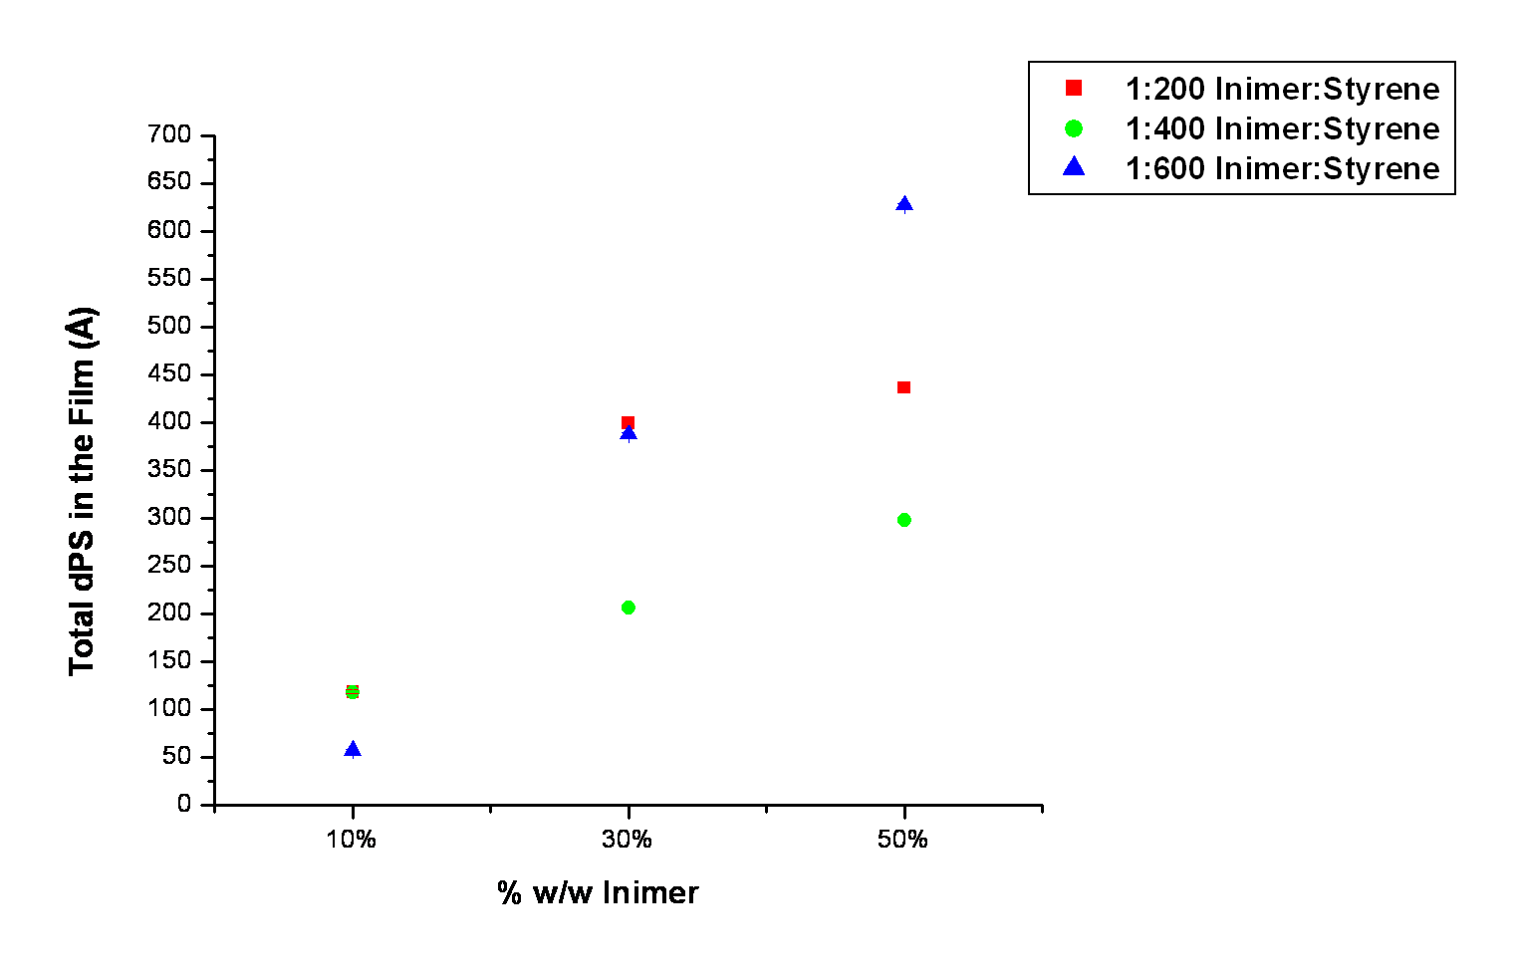

Figure 5.8 Total amount of d-PS in the entire film as a function of wt.% inimer for samples polymerized with 1:200, 1:400 and 1:600 inimer:dS.

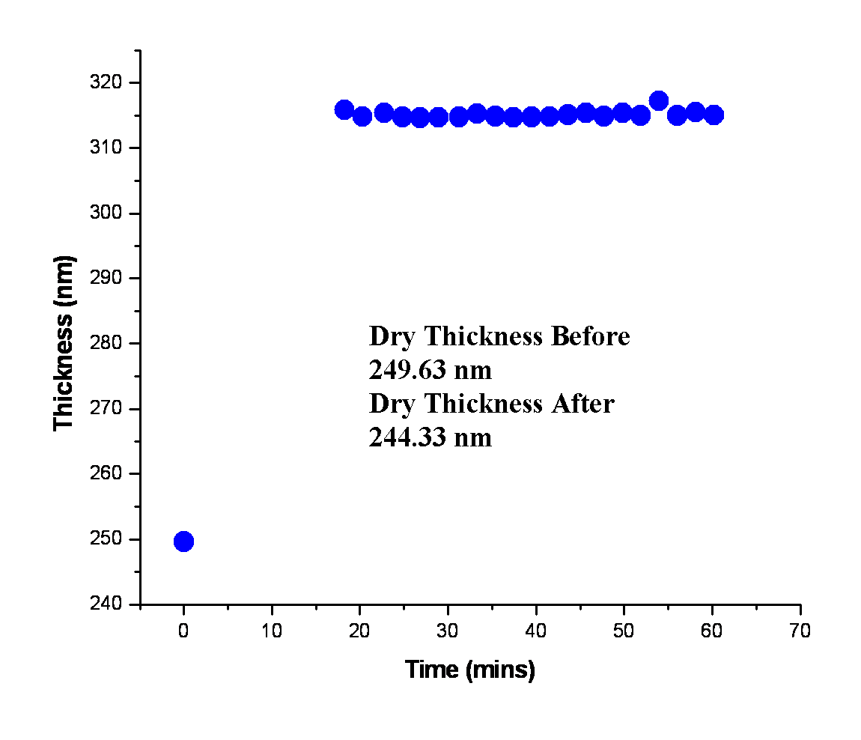

Figure 5.9 Results of in-situ ellipsometry measurements for the PP/inimer monolayer containing 50 w/w % inimer.

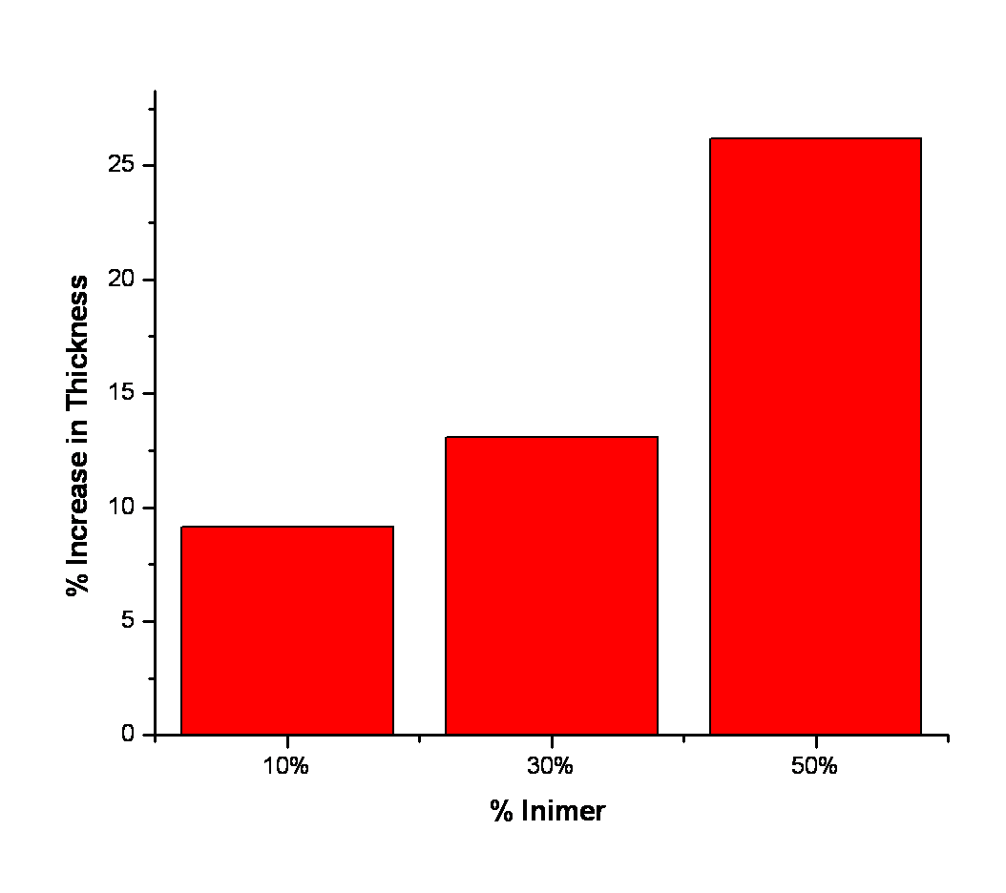

Figure 5.10 The effect of wt.% inimer on swelling behavior of monolayers composed of PP/inimer.

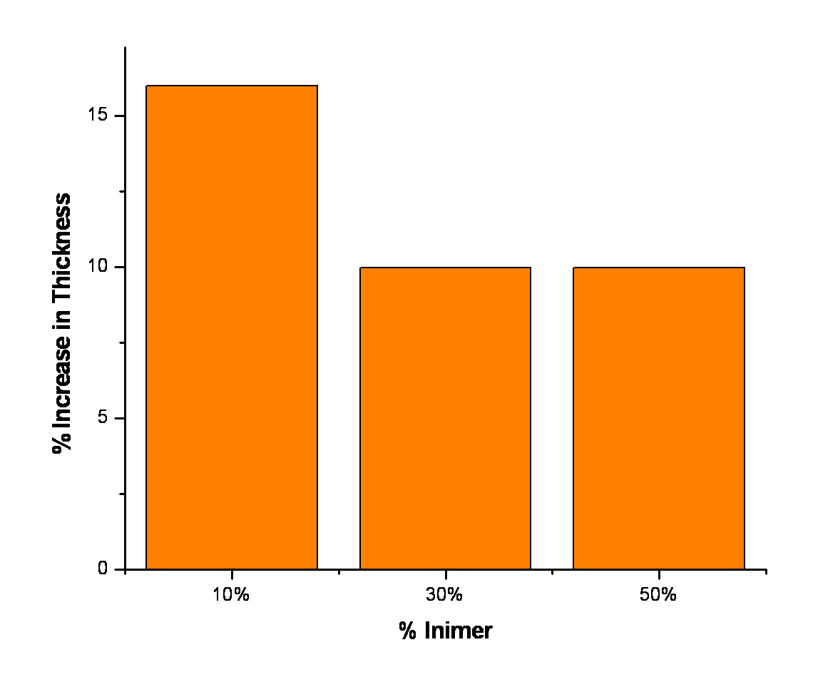

Figure 5.11 The effect of wt. % inimer on swelling behavior of samples polymerized with 1:200 inimer:dS

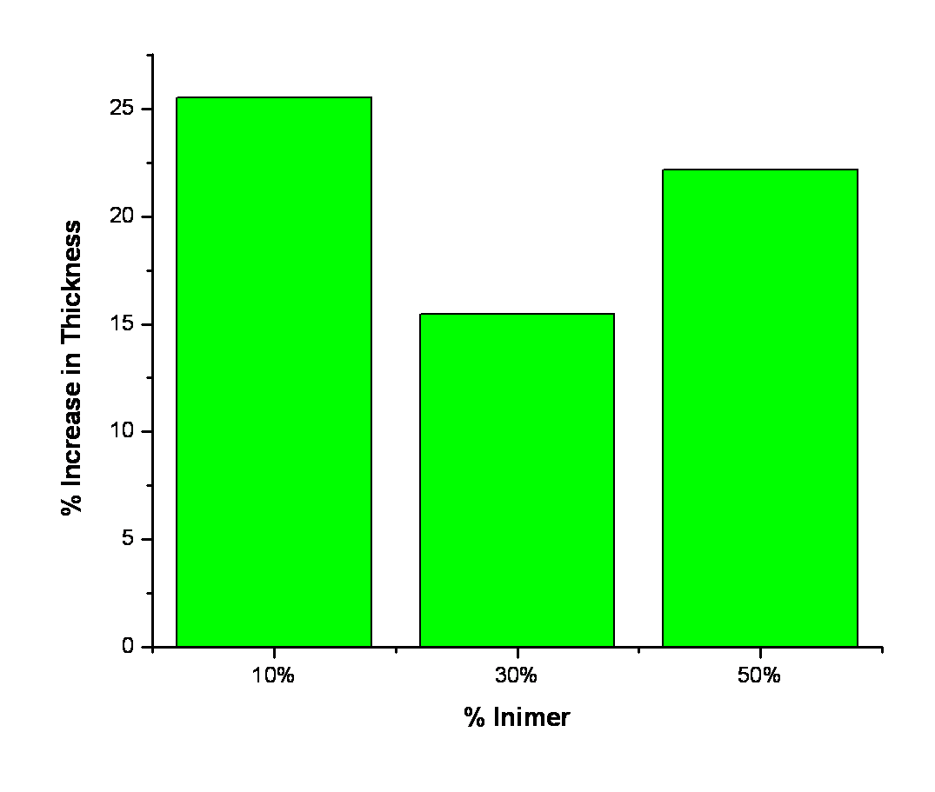

Figure 5.12 The effect of wt. % inimer on swelling behavior of samples polymerized with 1:400 inimer:dS

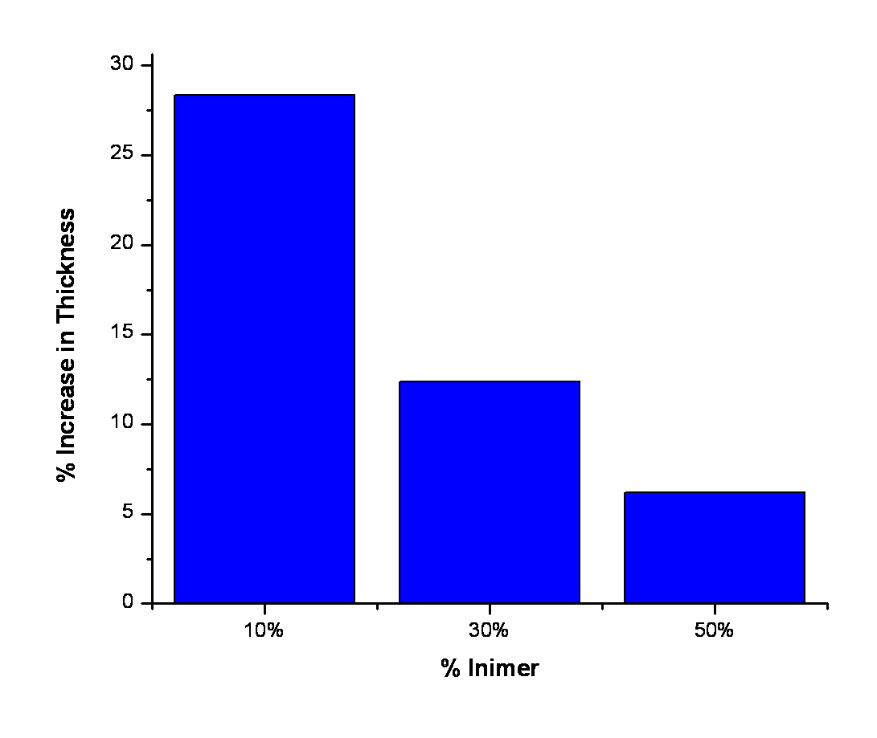

Figure 5.13 The effect of wt. % inimer on swelling behavior of samples polymerized with 1:600 inimer:dS

decreases with increasing wt. % inimer for the samples with grafted d-PS. A possible explanation for the decrease in swelling with increasing wt. % inimer in the d-PS grafted PP/inimer layers is that as the number of d-PS chain ends increase, they participate in further cross-linking reactions with any loose ends of the existing PP/inimer network, which results in a less swollen film.
To test the hypotheses regarding the swelling behavior of monolayers of PP/inimer as well as of d-PS grafted layers, the cross-link density of each sample was calculated. The amount of swelling, measured from an in-situ ellipsometry experiment, can be used to determine the cross-link density of a polymer film through the following relation in Equation 5.2:¹⁴⁹
(5.2)
where is the crosslink density, is the inverse of the swell ratio, is the molar volume of the swelling solvent (105.7 cm³/mol for toluene),¹⁵⁰ andis the Flory-Huggins interaction parameter for the polymer-solvent system. The parameteris calculated from solubility parameters using Equation 5.3:^{149, 151}
(5.3)
where R is the gas constant, T is the temperature in Kelvins, and and are the solubility parameters of the solvent and polymer samples, respectively. Solubility parameters for components of the inimer-embedded network were calculated from group contribution tables of the cohesive energy density. Calculation of the solubility parameter for d-PS grafted to the PP/inimer network required knowledge of the molecular weight of the grafted chains. Consequently, more samples were obtained from the Carter group and the molecular weight of free, unattached polymer in solution was obtained and analyzed with SEC for samples polymerized with 1:600 inimer:dS that contained 10%, 30% and 50% w/w inimer. Table 5.7 displays a summary of the calculated cross-link density for monolayers of PP/inimer as well as the d-PS grafted layers polymerized with 1:600 inimer:dS and containing 10%, 30% and 50% w/w inimer. A decrease in cross-link density with increasing inimer concentration for monolayers of PP/inimer (Tbl. 5.7) is consistent with the hypothesis that an increase in the monomethacrylate-based inimer decreases the cross-link density of the film. Likewise, the results of calculations of the cross-link density of the samples with grafted d-PS, as shown in Table 5.7, are also consistent with the proposed physical explanation for their observed swelling behavior. As the wt.% inimer increases in d-PS grafted PP/inimer layers, the crosslink density increases as a result of additional cross-linking reactions of growing d-PS with any loose ends of the existing PP/inimer network, which results in the observed decrease in swelling for these films.
The observed swelling behavior in monolayers of PP/inimer can be used to understand the impact of swelling on d-PS growth within the entire film as well as in the near surface region. Increased swelling of the PP/inimer monolayer with increasing inimer concentration should also facilitate increased growth of d-PS throughout the entire layer since the monomer can more easily penetrate the entire layer. This explanation is consistent with the NR results which indicate that d-PS growth throughout the entire film increases with increasing concentration of inimer and therefore with increased swelling of the layer (Fig. 5.8).

Table 5.7 Calculated cross-link density for monolayers of PP/inimer as well as d-PS grafted layers polymerized with 1:600 inimer:dS and containing 10 w/w %, 30 w/w % and 50 w/w % inimer.
Sample | Crosslink Density (mols/cm³)
10 wt. % inimer/PP | 0.027
30 wt. % inimer/PP | 0.022
50 wt. % inimer/PP | 0.013
10 wt. % inimer/1:600 inmer:dS | 0.012
30 wt. % inimer/1:600 inmer:dS | 0.023
50 wt. % inimer/1:600 inmer:dS | 0.035

Conversely, it could be argued that decreased swelling of the PP/inimer layer with decreasing inimer concentration should promote d-PS growth in the near surface region of these films. In Figure 5.14, the interfacial excess of d-PS in the near surface region is greatest at the lowest inimer concentration (10 w/w %) for the samples polymerized with 1:200 and 1:400 inimer:styrene. Although decreased swelling, which corresponds to smaller inimer concentration, promotes d-PS growth in the near surface region for samples polymerized with 1:200 and 1:400 inimer:dS, the sample polymerized with 1:600 inimer:dS displays a slow increasing growth of d-PS in the near surface region as the layer swells or as inimer concentration increases in Fig. 5.14. Nevertheless, even at the maximum inimer concentration (50 w/w % inimer), surface polymerization for the sample containing 1:600 inimer:dS is less than it is for the sample containing 10 w/w % inimer and 1:200 inimer:dS (Fig. 5.14). This behavior is an indication that
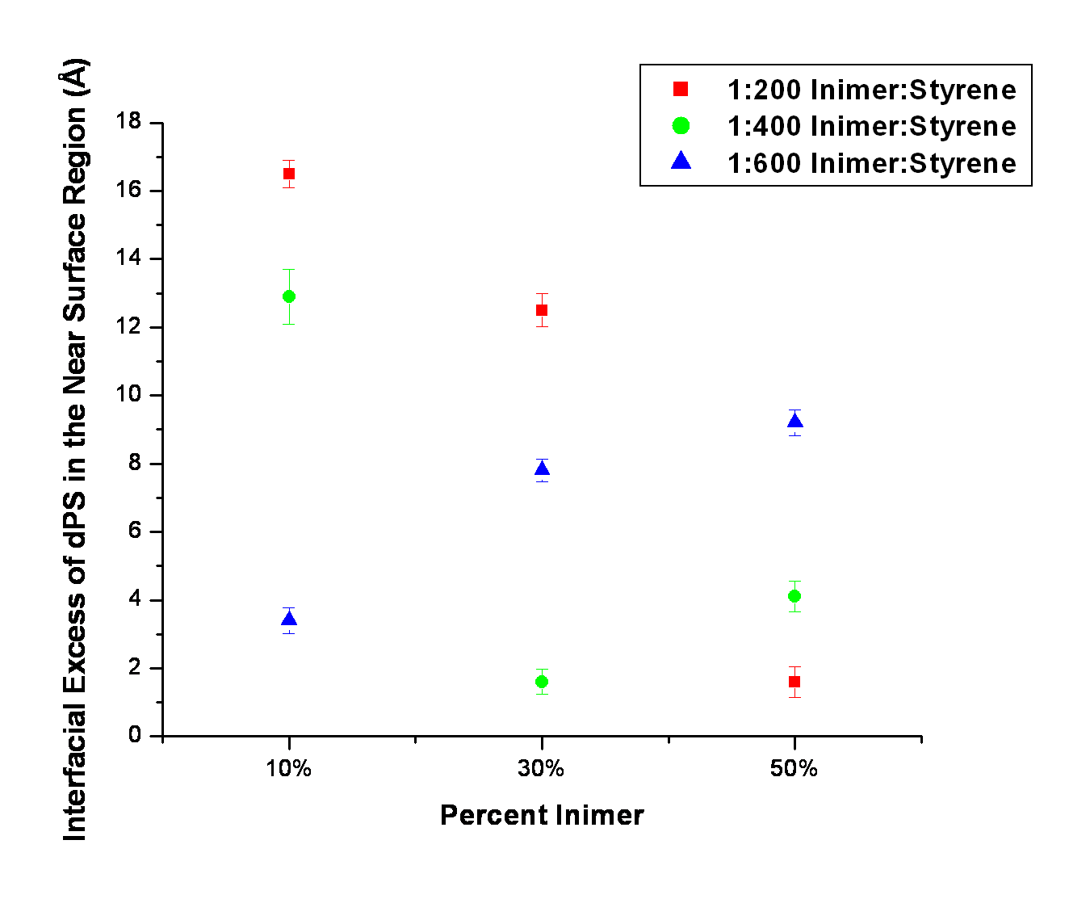

Figure 5.14 Interfacial excess of d-PS in the near surface region as a function of wt.% inimer for samples polymerized with 1:200, 1:400, and 1:600 inimer:dS.

the length of polymer chains (dS monomer concentration) also impacts d-PS growth in the near surface region. A possible explanation for this observed behavior is chain termination caused by the close proximity of ‘living’ chains as the molecular weight increases. Rahane et al¹⁵² reported in their study of the kinetics of the growth of a surface-tethered PMMA film created with surface-initiated ATRP (employing photoiniferter-mediated photopolymerization) that bimolecular termination was the dominant mechanism for a range of reaction conditions.

5.4 Conclusions
In the present study, the depth profiles of grafted polymer chains from a 3-dimensional inimer-embedded functionalized film, which has potential application in the next generation of molecular-scale electronics¹⁵³ and magnetic storage^{154, 31, 155, 156}, were investigated. The results of a combination of surface sensitive techniques, including neutron reflectivity and DSIMS, lead to the conclusion that d-PS growth is initiated both at the surface and within the bulk of these materials. Increasing the amount of inimer in the film increases the amount of d-PS polymerized throughout the entire layer. Moreover, by correlating the cross-link density of these films with the reaction conditions, it was determined that surface growth of d-PS is more efficient at low concentrations of inimer. This phenomenon was attributed to a decrease in the amount of swelling in the network under these conditions. An increase in the swelling of the network during polymerization at higher inimer loadings allowed the initiation of the growth of d-PS to occur throughout the bulk of the entire film, resulting in less d-PS grown at the surface. An observed decrease in d-PS at the surface with increasing molecular weight of the grafted d-PS is attributed to complex kinetics, possibly involving bi-molecular termination reactions during the grafting polymerization.

A Structure-Property Investigation of Self-Assembled Well-Defined PCHD and PPP Brushes

6.1 Introduction
Fuel cells, photovoltaics, organic optoelectronic devices, and organic integrated circuits are some of the many applications involving the use of conjugated polymers.^{157,158} The optical, electrical, and magnetic properties of conjugated polymers makes them well suited to use in a variety of energy conversion technologies. Nevertheless, in order to develop new and improved devices, a fundamental understanding of how the structure of these nanomaterials correlates to their performance and properties is needed. Likewise, it is important to be able to control the architecture of these materials at the nanoscale in order to properly assign these structure-property relationships.⁷
Poly(paraphenylene) (PPP) is a conducting polymer with high chemical and thermal stability.¹⁵⁹ When doped with an oxidizing or reducing agent, PPP can also be highly conducting.¹⁶⁰ Nevertheless, there are challenges associated with the application of these polymers in next generation technological devices due to difficulties with solubilizing high molecular weight PPP. Due to this limitation, past research has focused on the relationship between the molecular structure and its electronic property in oligomers of PPP.¹⁶⁰ As there are no studies that correlate the morphology and structure of well-defined long chains of PPP to their opto-electronic performance, due to its insolubility, the properties of higher molecular weight PP are often extrapolated from studies on oligomeric PPP. The approach employed in the present study is designed to overcome these challenges by focusing on the synthesis, assembly, and aromatization of functionalized poly(cyclohexadiene) (PCHD) brushes attached to a solid substrate, as illustrated in Scheme 6-1.
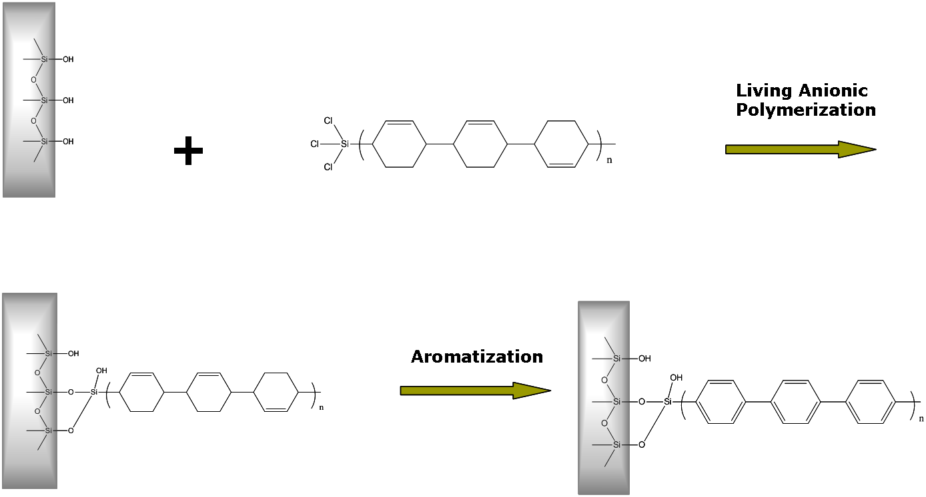

Scheme 6-1 The approach used in the present study to obtain well-defined PPP brushes based on aromatization of surface tethered PCHD precursor chains.

6.2 Materials and Methods
- Materials

Chlorosilane end-functionalized poly(cyclohexadiene) (PCHD) was synthesized by Dr. Xiang Yu at the Center for Nanophase Materials Sciences (CNMS) at Oak Ridge National Laboratory (ORNL). Silicon substrates for the grafting studies were obtained from Wafer World (West Palm Beach, FL). ACS grade solvents including 75% ethanol-preserved chloroform, hexane and benzene, used in the characterization of grafted layers, were obtained from Fisher Scientific (Fairlawn, NJ). Solution grafting was performed under the direction of Dr. Suxiang Deng at the University of Tennessee in Knoxville, TN.
- Method for Synthesis of Precursor Polymers

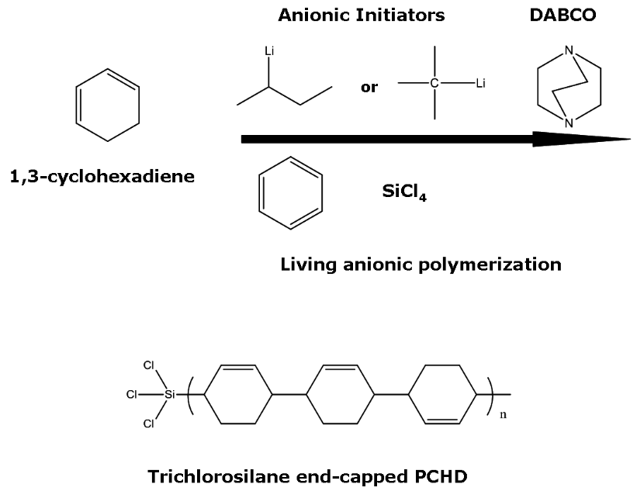
Two well-defined poly(cyclohexadiene) (PCHD) polymers, with a trichlorosilane end-group, were synthesized by high vacuum anionic polymerization techniques.^{38, 161} Scheme 6-2 displays the synthesis of PCHD from 1,3-cyclohexadiene (1,3-CHD). Specific details of the synthesis have been reported previously.¹⁶¹

Scheme 6-2 Synthesis of PCHD from 1,3-CHD in benzene using anionic initiators, sec- or butyl-lithium, and an additive, 1,4-diazabicyclo[2.2.2]octane (DABCO). The polymer was terminated with silicon tetrachloride (SiCl₄).

A summary of the molecular weight, polydispersity and microstructure of PCHD precursor polymers is displayed in Table 6.1.

C. Method for Tethering End-Functionalized PCHD to a Substrate
PCHD polymer brushes were formed using self-assembly from dilute solutions in benzene (1.3 wt.% for PCHD-1 and 2.0 wt.% for PCHD-2) onto silicon and quartz substrates.
Table 6.1 The molecular weight and microstructure of PCHD precursor polymers investigated in this study.
Polymer | M_{n} (kg/mol) | PDI | 1,4/1,2-CHD units (mol%)
PCHD-1 | 4.3 | 1.09 | 98/2
PCHD-2 | 11.7 | 1.07 | 98/2

Silicon substrates were cut into various sizes from 2” diameter 300-350 µm thick single side polished <100> crystal orientation, N-doped silicon wafers (Wafer World, West Palm Beach, FL). Quartz substrates were also cut into various sizes. The substrates were cleaned using a 70:30 sulfuric acid/30% hydrogen peroxide solution for 1 hour, followed by rinsing in nanopure water, and then drying in dry nitrogen gas. Measurements of the silicon oxide layer for this cleaning method consistently provided a thickness of approximately 1.5 nm. Cleaning was also accomplished using the RCA method.¹⁶² This method also produced a silicon oxide thickness of approximately 1.5 nm. The cleaned substrates were used immediately after cleaning.
Due to the very reactive nature of the trichlorosilane end-group, the grafting synthesis was performed in a moisture and air-free environment. Self-assembly from dilute solutions in benzene was performed in a reactor connected to a high vacuum line. Standard high vacuum anionic procedures ³⁸ were followed to graft the end-functionalized PCHD molecules from solution to either quartz or silicon substrates. Once the substrates were removed from the grafting solution, they were immediately transferred to a vacuum oven and annealed for 1 hour at 110 °C to further drive the hydrolysis that is the grafting reaction. In subsequent syntheses, annealing time under vacuum was increased to 12 hours at 110 °C. The substrates were sonicated in ACS grade 75% ethanol-preserved chloroform (Fisher Scientific, Fairlawn, NJ) from 20 minutes up to 2 hours to remove any physisorbed polymer. ACS grade hexane and benzene (Fisher Scientific) were also used for sonication. Scheme 6-3 illustrates how the end-functionalized precursor, trichlorosilane end-capped PCHD, is grafted to a silicon substrate.
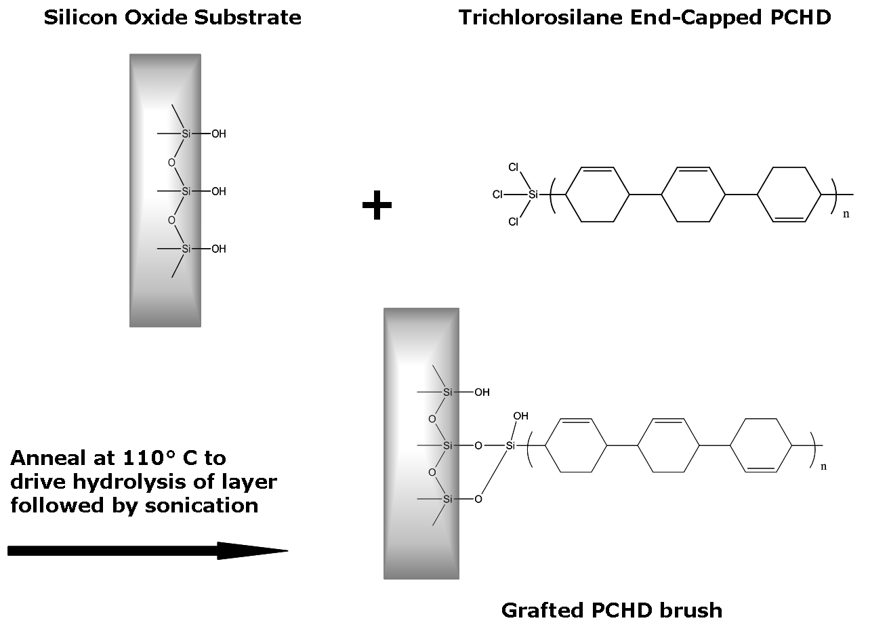

Scheme 6-3 Grafting of the precursor, trichlorosilane end-capped PCHD, to a silicon substrate.

D. Method for Creating PPP from PCHD Tethered to a Substrate

After their formation and characterization, PCHD brushes were aromatized using 2,3-dichloro-5,6-dicyanobenzoquinone (DDQ). In order to determine the best reaction conditions for aromatization, the solvent, temperature, moles of DDQ, and time for reaction was varied. For instance, for a reaction that consists of 200 mL of xylene, 8.8E-4 moles of DDQ (4.4E-3 M DDQ), 110-120 °C, and 30 hours of reaction time, the layer thickness of the brush following aromatization was reduced by 60% (from 5 nm to 2 nm, as measured by ellipsometry). Further studies showed that a better solvent for the aromatization was 1,2-dichlorobenzene (1,2-DCB). Thus, reaction conditions that consisted of 200 mL of 1,2-DCB and 1.3E-3 moles of DDQ (6.5E-3 M DDQ) reacting at 120 °C for 48 hours resulted in the brush swelling to 225% of its original thickness for the brushes formed from solution grafting (i.e., from 4 nm to 9 nm, as measured by ellipsometry). The aromatization reaction is displayed in Scheme 6-4.
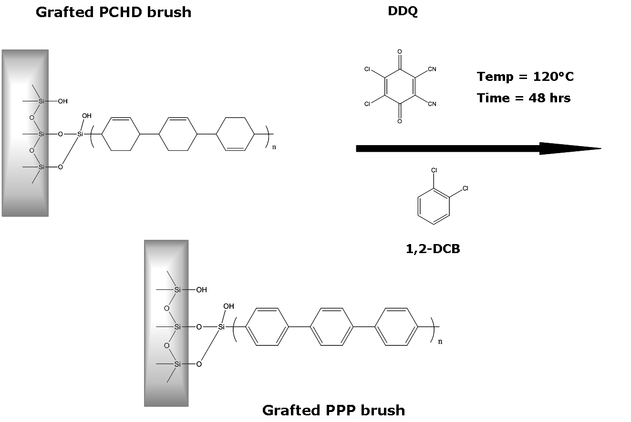

Scheme 6-4 Aromatization of grafted PCHD brush using DDQ in 1,2-DCB (or xylene) to transform it to a PPP brush.

E. Methods for Characterization of Grafted PCHD and PPP Layers
      - Ellipsometry

The thickness of polymer layers was determined by ellipsometry using an EL X-02C null ellipsometer with a fixed angle of incidence (70°) and a He-Ne laser (λ=632.8 nm). Measurements of thickness were also conducted on a JA Woollam M-2000V Spectroscopic Ellipsometer at a 70° angle of incidence. The indices of refraction for all layers were considered to be no different from the bulk values. For PCHD, PPP, SiO₂, and Si these values were 1.55, 1.55, 1.4571, and 3.8816-i0.0190, respectively. Further detail on the theory underlying ellipsometry measurements is covered in Appendix A.2, section A.
      - Water Contact Angle Goniometry

Measurement of the static water contact angle on the surfaces of samples was carried out by the sessile drop (3 µL) method using a Rame-Hart (Model 100) contact angle goniometer. The water contact angle was read within 60 seconds. The contact angle was measured on various parts of the wafer and is the average of at least 5 different measurements. Water contact angle of the cleaned silicon oxide surface before grafting of the PCHD monolayer was measured and determined to be zero. An overview of the theoretical basis for contact angle goniometry is covered in Appendix A.2, section D.
      - Atomic Force Microscopy

Atomic force microscopy (AFM) is a type of scanning probe microscopy (SPM) that is designed to measure the topography of a sample surface.⁵ AFM employs a probe, composed of a sharp tip, and a cantilever that acts as a spring, as shown in Figure 6.1. The spring constants and resonant frequencies of the probe can be varied by using different cantilever materials, lengths, and shapes. As the AFM probe is raster-scanned across the surface of the sample, Van der Waals attractive or repulsive forces are measured between the tip and the sample. This interaction occurs at very short distances and depends on the mode of measurement. In contact AFM mode,
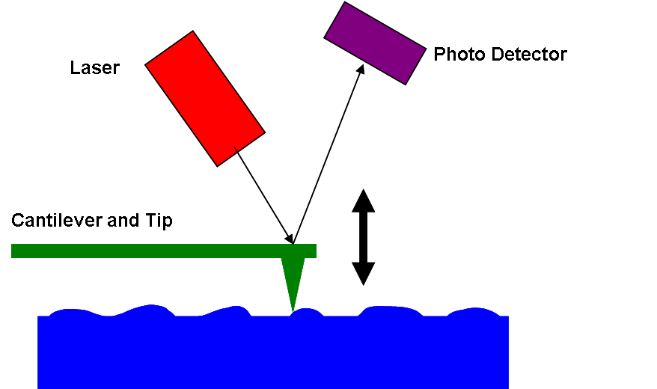

Figure 6.1 Illustration of the atomic force microscopy (AFM) experimental setup.

in which the tip makes contact with the surface, the deflection of the cantilever is due to repulsive Van der Waal forces. These forces of interaction occur at a probe-surface separation of <0.5 nm. In non-contact AFM mode, in which the probe does not touch the sample surface, attractive Van der Waals forces are dominant and the forces of interaction occur at a probe-surface separation of 0.1-10 nm. In the present study, the intermittent contact AFM mode, also referred to as tapping mode, was used to study the topography of surface tethered PCHD and PPP brushes. Tapping mode, like the contact mode, involves contact with the sample surface. However, in tapping mode, the cantilever is oscillated at its resonant frequency during scanning and the forces of interaction occur at a probe-surface separation of 0.5-2 nm. Precise measurement of the movement of the vertical and lateral deflections of the cantilever is accomplished using an optical lever which operates by the reflection of a laser beam off of the cantilever onto a position-sensitive photodioide detector. The position of the laser spot on the detector indicates the angular deflection of the cantilever. Piezoelectric materials are used to position the tip with high precision. A feedback loop is used to control the amount of force on the sample. The feedback loop includes the cantilever, optical lever, and a feedback circuit which adjusts the voltage applied to the scanner in an attempt to maintain constant oscillation amplitude of the cantilever.
An MFP-3D atomic force microscope was used in AC-mode (tapping mode) to examine the surface profile of tethered PCHD and PPP brushes. A Si₃N₄ rectangular cantilever with tetrahedral tip (OMCL-AC16OTS series, type 2) was used for these experiments. The tapping mode of a Digital Instruments Multimode Scanning Probe Microscope was also used to measure surface topography in these studies. Veeco model TESP tips were used for measurements with the Digital Instruments AFM.
      - Internal and External Infrared Reflectance Spectroscopy

Infrared (IR) spectroscopy measures changes in the vibration modes of molecules upon absorption of infrared radiation and is useful for the identification of chemical functionalities within a molecule. Modes of measurement in IR include absorption, emission, and reflection. The reflection mode was used in the present study, as it is particularly well suited for investigating sample interfaces. The reflection mode includes two techniques known as internal and external specular IR reflection spectroscopy. When electromagnetic radiation is incident on a surface, depending on the angle and the refractive index, the wave can be internally or externally reflected according to Snell’s Law.⁵ The wave can also be partially absorbed or even transmitted depending on the material. Total internal reflection occurs when electromagnetic radiation traveling in an optically dense medium, with refractive index n₁, impinges on an interface at an incident angle, θ_{incident}, greater than the critical angle, θ_{critical}, onto a less dense medium, with refractive index n₂, as shown in Figure 6.2.
The internal reflection measurement known as grazing angle attenuated total reflectance infrared (GATR-IR) spectroscopy requires that a sample be in contact with a crystal, called an internal reflective element (IRE), which has a higher refractive index than the sample being measured. At the interface between the sample surface and the crystal, a small portion of the IR beam, an evanescent wave, penetrates multiple times into the sample, as illustrated in Figure 6.3,

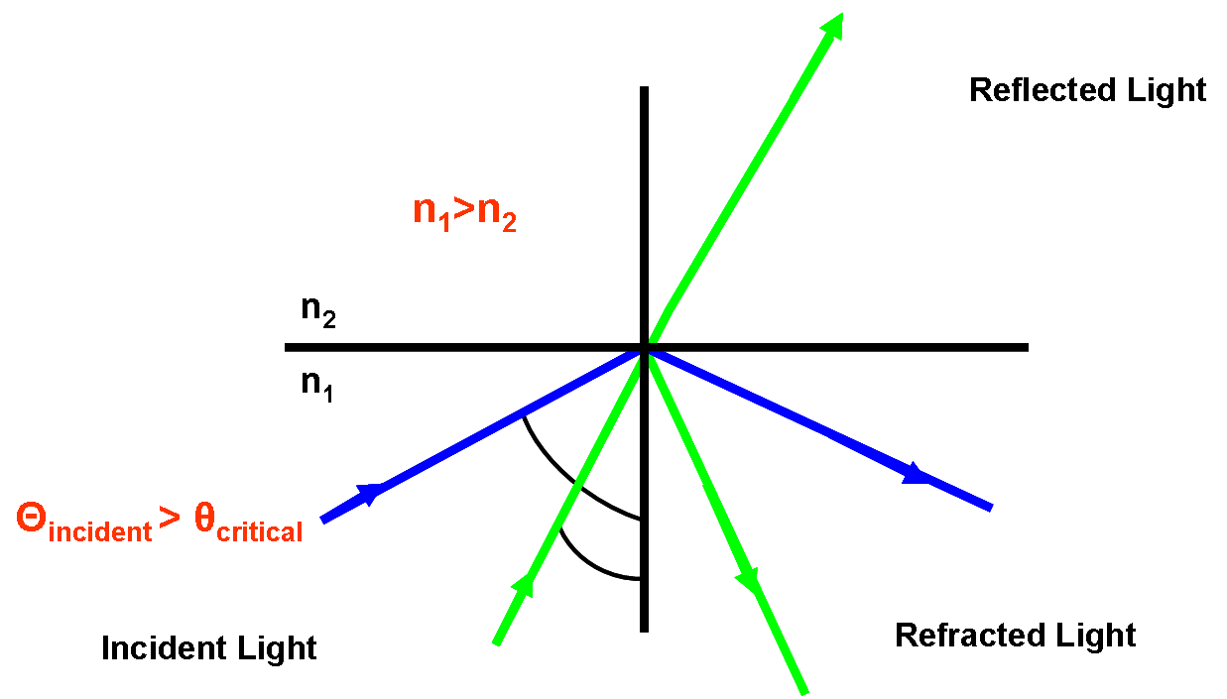

Figure 6.2 The geometry of the internal reflection spectroscopy measurement.
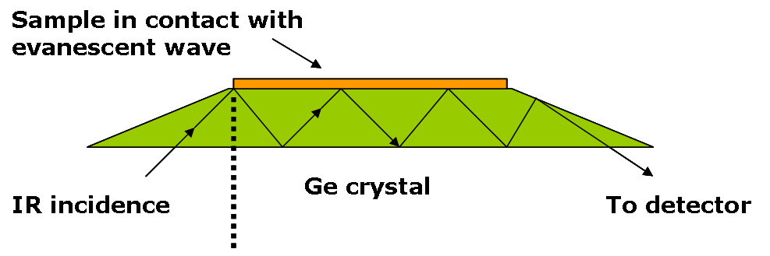

Figure 6.3 Grazing angle attenuated total reflectance infrared (GATR-IR) spectroscopy.

where the IRE is a germanium crystal. The GATR-IR technique is useful for materials that are opaque or non-reflective.
The external reflection technique is well suited for samples that are on reflective surfaces. The geometry and experimental setup of external specular reflection infrared spectroscopy (also referred to as grazing angle specular reflectance infrared spectroscopy) is shown in Figure 6.4, where the angle of incidence equals the angle of reflectance.
For GATR-IR and grazing angle specular reflectance infrared spectroscopy measurements, a Bruker Vertex 70 FTIR spectrometer was used with a deuterated triglycine sulfate (DTGS) or a liquid nitrogen cooled mercury-cadmium-telluride (MCT) detector. The spectral range measured was 4000 to 600 cm⁻¹ for the internal reflectance measurements on silicon, and 3500 to 2500 cm⁻¹ for the external specular reflectance measurements on quartz, with a spectral resolution of 4 cm⁻¹. For GATR-IR measurements on silicon, the internal reflective element was a germanium crystal. Pressure applied to ensure good contact between the crystal and sample on silicon was 500 pounds per square inch (psi). Incident angles were varied to
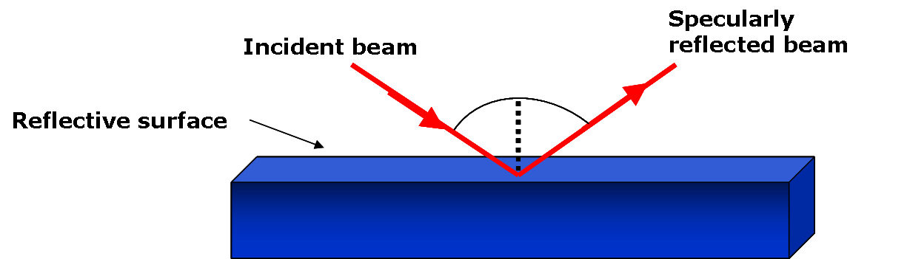

Figure 6.4 The geometry and experimental setup of external specular reflection infrared spectroscopy.

maximize intensity and obtain the best spectrum possible. To probe brush orientation, a polarizer at angular settings of 0° and 90° was used. The 0° angular setting produces s- and p-polarized light while the 90° angular setting produces s-polarized light.
      - Raman Spectroscopy

Raman spectroscopy, used along with IR, provides complementary identification of chemical functionality.⁵ However, a Raman experiment measures changes in polarizability due to scattering of light by vibrating molecules. Light that is absorbed by a molecule can be scattered elastically resulting in Rayleigh scattering in which no energy is lost or gained and the wavelength remains unchanged. Light can also be scattered inelastically such that the scattered light has a longer or shorter wavelength than the incident light. Depending on the symmetry of a molecule as well as the polarity of bonds in a molecule, the modes of vibration can be Raman active, IR active, or both.
A Renishaw InVia Raman Microscope was used to obtain Raman spectra on quartz substrates in the spectral range of 3200 to 100 cm⁻¹ at a fixed wavelength of 633 nm.
      - UV-Vis Spectroscopy

UV-Vis spectroscopy involves the measurement of the absorption of ultraviolet-visible electromagnetic radiation by molecules as they undergo electronic energy transitions from the ground state to the excited state. UV-Vis spectroscopy was used to examine tethered brushes on quartz substrates before and after aromatization using a Varian Cary 5000 UV-Vis-NIR absorption spectrometer. The spectral range examined was 200 to 600 nm, with a spectral resolution of 1 nm.
      - Optical Microscopy

A Leica DM4500P polarized optical microscope was used to examine the quality of films on silicon substrates.

6.3 Results and Discussion
- Characterization of End-Tethered PCHD Polymer Brush Films Formed from Solution Grafting

- Overview
In an attempt to discover suitable solution grafting conditions, solution concentration and the amount of time of reaction between end-functionalized PCHD and silicon oxide surfaces was varied, where solution concentrations of 1.3, 1.4 and 2.0 wt. % were studied. Reaction times of 2 hours, 3.5 hours, 4.5 days, 6.5 days, 1 week, and 3 weeks were tested. The quality of high vacuum achieved during the reaction has a profound effect on the quality of the monolayer formed, as any moisture or O₂(g) content will cause multilayers to form. Thus, the quality of the monolayer formed was evaluated with 2-D and 3-D AFM height images, water contact angle, and ellipsometry. Grafting from solution was also attempted in an argon gas environment. However, this technique failed to produce a well-formed monolayer, as evidenced by water contact angles that were half the value of water contact angles for monolayers formed under high vacuum. In an effort to increase the thickness, and thus the grafting density, of higher molecular weight PCHD precursors (12,000 g/mol), grafting from a 1.4 wt. % solution in a relatively poor solvent for PCHD, tetrahydrofuran (THF), was attempted. Previous work by Auroy et al.^{163, 164} suggests that in a poor solvent, the size of a polymer chain is reduced and thus higher grafting densities can be achieved. Thus, reaction with THF, at room temperature, was attempted and allowed to react for ~6 days. Interestingly, AFM revealed the presence of ‘island’ formation (i.e., regions or patches of densely grafted polymer) on silicon substrates for these reaction conditions. Portions of the silicon substrate that was grafted with polymer had thicknesses comparable to the thicknesses obtained by grafting from solution using a good solvent (i.e., benzene). A longer reaction time may have resulted in a full monolayer for this polymer-solvent system.¹⁶⁵ However, the successful fabrication of surface-tethered brushes from a benzene solution proved to be more straightforward, and further studies using THF solvent were abandoned.
- Evaluation of the Structure and Quality of End-Tethered PCHD Brushes
Ellipsometry measurements of grafted PCHD layers provide information on the structure and quality of polymer brushes formed from the various reaction conditions. The distance between grafted chains, MD, which is related to the density of grafted chains, σ, can be obtained from:¹⁶⁶
(6.1)
where MD is the distance between graft points, ρ is the bulk density of PCHD (1.07 g/cm³), h_{dry} is the thickness by ellipsometry, and N_{A} is Avogadro’s number. Table 6.2 displays a summary of the detailed structure of end-tethered PCHD brushes formed from several different solution grafting experiments conducted in this study. A more highly grafted layer was formed from the smaller 4,700 g/mol end-functionalized PCHD precursors, as might be expected since, due to their size, they can pack more efficiently at the surface (σ = 1.1 chains/nm²). It is also interesting to note that increasing the molecular weight of the precursor results in increased brush height (10.9 nm for the 12,000 g/mol precursor) but decreased brush density, as compared to the smaller molecular weight precursor which exhibited nearly twice the brush density with a smaller brush height (7.8 nm). As might be expected, the approach of an incoming polymer to the surface is hindered as the graft density of the surface increases. This barrier increases with increasing chain length.
Table 6.3 contains a summary of the average distance between graft points (MD) and grafting density (σ) of end-tethered PCHD brushes created by solution grafting in the current study, those that are formed by the grafting of end-tethered PCHD brushes onto silicon by spin coating (an experiment conducted in parallel with this study at CNMS at ORNL by collaborators),¹⁶⁷ trichlorosilane end-terminated PS brushes also created by spin coating,³² as well as results for PMMA brushes grafted onto silicon using surface-initiated ATRP polymerization of MMA in a grafting-from approach.¹⁶⁸ Table 6.3 shows that the distance between grafted chains and the graft density of PCHD brushes formed by solution grafting in the current study is comparable to reported values of MD and σ in previous studies of other end-functionalized brushes tethered to silicon substrates.^{32, 168} Further characterization with water
Table 6.2 Solution graft reaction conditions as well as the resulting structure of end tethered PCHD brushes including thicknesses, h_{dry}, distance between grafted chains, MD, and graft density, σ.
M_{w}  (g/mol) | Wt%  SiCl₃-PCHD | Reaction Time (hrs) | h_{dry}(nm) | MD (nm) | σ (chains/nm²)
12000 | 1.3 | 618 | 1.0 | 4.3 | 0.054
ª12000 | 1.3 | 160 | 2.6 | 2.7 | 0.14
12000 | 1.3 | 168 | 5.8 | 1.8 | 0.31
12000 | 1.3 | 111 | 10.9 | 1.3 | 0.59
4700 | 2.0 | 188 | 4.1 | 1.3 | 0.57
4700 | 1.4 | 336 | 4.2 | 1.3 | 0.58
4700 | 2.0 | 116 | 7.8 | 0.96 | 1.1

ª This experiment was conducted under an Argon atmosphere while the rest of the experiments were conducted under high vacuum.

Table 6.3 A comparison of brush structure (MD and σ) achieved by grafting to silicon oxide surfaces via spin coating, solution grafting, and surface-initiated ATRP.
Polymer  Brush | Grafting  Method | M_{n} or M_{w}  (g/mol) | MD  (nm) | σ  (chains/nm²)
ªPS-SiCl₃ | Spin  Coating | Mw = 12550  Mw = 6550 | 1.4  1.2 | 0.53  0.65
^{d}PCHD-SiCl₃ | Spin  Coating | Mw = 12000  Mw = 4700 | 1.3  1.3 | 0.54  0.55
^{c}PCHD-SiCl₃ | Solution  Grafting | Mw = 12000  Mw = 4700 | 1.3  0.96 | 0.59  1.1
^{b}PMMA | Surface-  Initiated ATRP | Mn = 10000 | 1.2 | 0.70

ª Tran, Y.; Auroy, P. J. Am. Chem. Soc. 2001, 123, 3644.
^{b}Tsujii, Y.; Ohno, K.; Yamamoto, S.; Goto, A.; Fukuda, T. Adv. Polym. Sci. 2006, 197, 1.
^{c}Current study involving solution grafting of PCHD-SiCl₃ to Si
^{d}Parallel study conducted by collaborators at CNMS at ORNL involving spin coating of PCHD-SiCl₃ onto Si

contact angle measurements was conducted to monitor the formation of a monolayer of PCHD via solution grafting and thereafter assess the quality of the formed layers.
The surface energy of a multi-component surface can be predicted using the Cassie equation¹⁶⁹ shown in equation 6.2:
(6.2)
where χ is expressed by equation 6.3:
(6.3).
Indices 1 and 2 in Equations 6.2 and 6.3 designate the individual components of a multicomponent system. In addition, the parameter is the surface coverage and is the water contact angle. Water contact angles were measured for the 12,000 g/mol end-tethered PCHD brushes formed by solution grafting from a 1.3 wt. % PCHD solution in benzene. The highest water contact angle achieved was 94°. A freshly cleaned silicon wafer had a water contact angle of 0°. Figure 6.5 displays the evolution of water contact angle and estimated surface coverage (as calculated by the Cassie equation) with reaction time. The water contact angle and surface coverage reaches a maximum as the reaction time increases; however, after the longest reaction

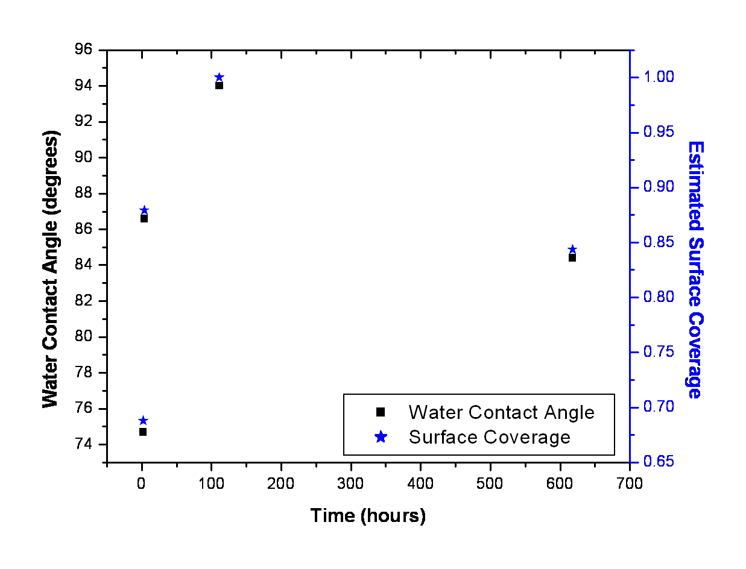

Figure 6.5 Evolution of water contact angle and estimated surface coverage with time for the 12,000 g/mol end tethered PCHD brush formed from solution grafting (1.3 wt.% PCHD in benzene).

time (~600 minutes), the water contact angle as well as surface coverage decreases, indicating that the quality of the layer may have changed. It is likely that multilayers are formed after long reaction times.
Water contact angles measured for several 4,700 g/mol end-tethered PCHD brushes formed from solution grafting onto silicon wafers averaged ~90°.Water contact angles for PCHD end-tethered brushes in this study are consistent with water contact angles for other aliphatic systems including octadecyl trichlorosilane (OTS), which has a reported water contact angle of 110°, and poly(styrene), with a reported water contact angle of 94°.
AFM was also used to assess the topographical characteristics of the end-tethered PCHD brushes. Analysis with AFM revealed smooth, high quality films with surface roughnesses in the range of 0.11-1.1 nm for monolayers formed from solution grafting. Figure 6.6 shows the time evolution of the surface topography of a monolayer of the 12,000 g/mol end-tethered PCHD brush formed from solution grafting.
At early times, ’island’ shaped patterns are visible, as the layer is only partially formed. Likewise, a larger roughness is associated with these partially formed layers. After longer reaction times, the roughness decreases and a full monolayer is formed. The 4,700 g/mol end tethered PCHD precursor formed a monolayer with a significantly lower RMS roughness as shown in its AFM height image in Figure 6.7. This observation confirms the earlier hypothesis that smaller sized precursors can pack more efficiently at the surface.
Film quality was also assessed with optical microscopy and the results were consistent with the AFM height images, as shown in Figure 6.8, for end-tethered 4,700 g/mol PCHD brushes formed from solution grafting in benzene (2.0 wt. % SiCl₃-PCHD) for 116 hours.
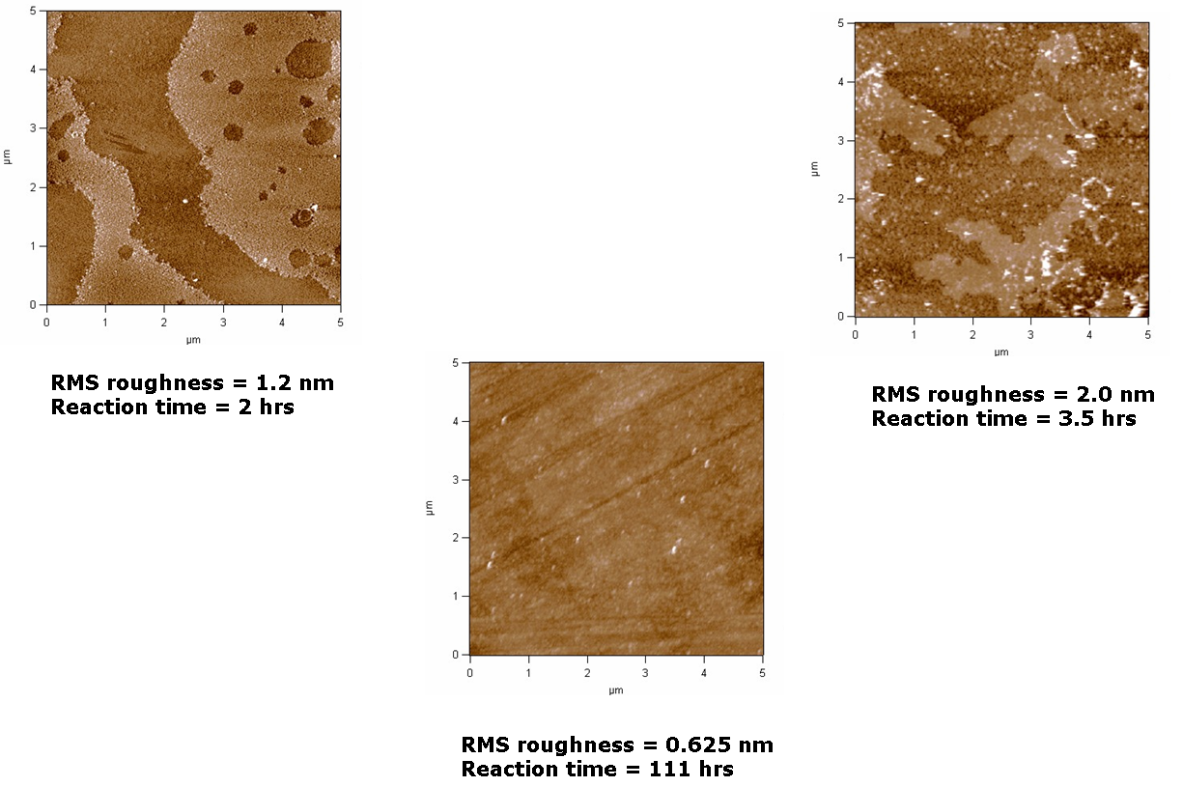

Figure 6.6 AFM height images highlighting the time evolution of the surface topography of a monolayer of 12,000 g/mol end-tethered PCHD brushes formed from solution grafting in benzene (1.3 wt.% SiCl3-PCHD). The imaged regions have an area of 5 µm x 5 µm.

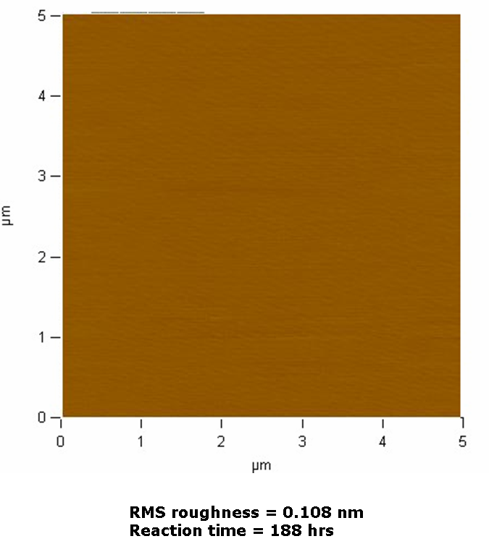

Figure 6.7 An AFM height image obtained for end-tethered 4,700 g/mol PCHD brushes formed from solution grafting in benzene (2.0 wt.% SiCl3-PCHD). The imaged region has an area of 5 µm x 5 µm.

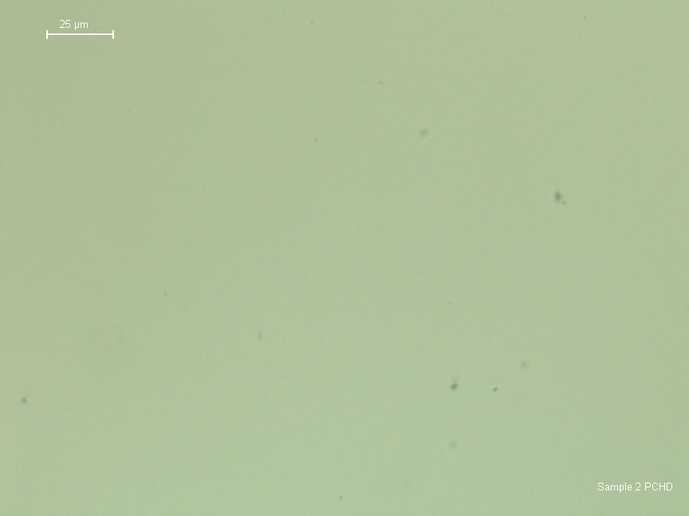

Figure 6.8 A representative optical microscope image of end-tethered 4,700 g/mol PCHD brushes formed from solution grafting (2.0 wt.% SiCl3-PCHD) in benzene for 116 hours.

Spectroscopic techniques were used to characterize the end tethered brushes formed from solution grafting to confirm their chemical composition. In Figure 6.9, the UV-Vis absorption spectrum for a monolayer of the 4,700 g/mol PCHD brush grafted to a quartz substrate in benzene (2.0 wt.% SiCl₃-PCHD) for 116 hours is shown. The maximum UV-Vis absorption is ~200 nm for PCHD brushes created by solution grafting methods. In the parallel study, conducted by collaborators at CNMS, end- tethered PCHD brushes formed by spin coating also had a maximum absorbance of ~200 nm.¹⁶⁷
Reflectance spectroscopy of grafted PCHD brushes formed by both spin coating and solution grafting on silicon and quartz substrates also exhibited similar results.¹⁶⁷ Absorption due to the double bond CH stretches and CH₂ ring stretches are observed between ~3018cm⁻¹ and 2860 cm⁻¹ in spectra obtained for brushes on silicon and quartz substrates. A C=C double bond ring stretch at ~1650 cm⁻¹ and a CH₂ bending (deformation) mode at ~1450 cm⁻¹ is also observed in the IR spectra of brushes on silicon substrates only, as quartz substrates absorb IR radiation below 2300 cm⁻¹. An ATR-FTIR spectrum of bulk PCHD has similar absorption modes. All of the observed IR absorption values are consistent with literature values for PCHD in a thin film.¹⁷⁰ Figure 6.10 shows an ATR-IR spectrum for the 4,700 g/mol end-tethered PCHD brush formed from solution grafting onto a silicon substrate in benzene (2.0 wt.% SiCl₃-PCHD) for 116 hours. In the inset of Figure 6.10, literature values for the transmission IR shifts of thin films of end-tethered PCHD are consistent with the ATR-IR results obtained in this experiment. In these experiments, the polarization of radiation was varied in order to elucidate brush orientation. The electric component of a light wave is composed of two orthogonal components identified as p and s. The p-component of a light wave lies in the plane of the incident and reflected wave, while
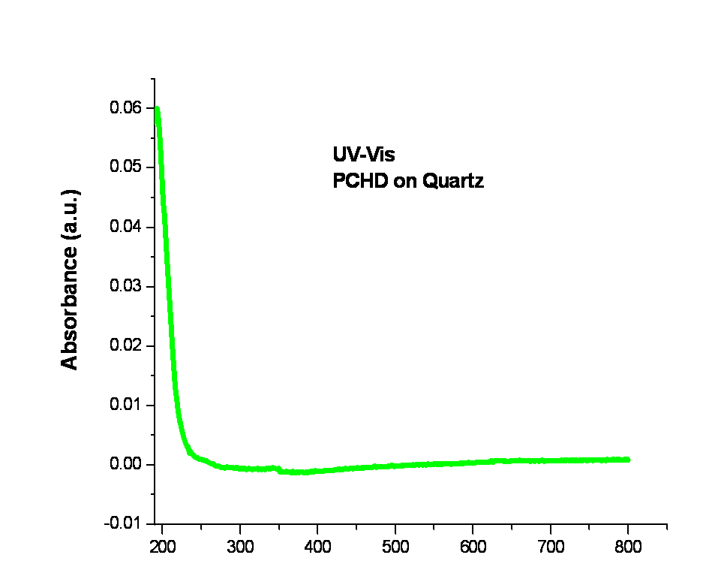

Figure 6.9 A UV-Vis absorption spectrum for the 4,700 g/mol PCHD brush prepared from solution grafting in benzene (2.0 wt.% SiCl3-PCHD) onto a quartz substrate for 116 hours.

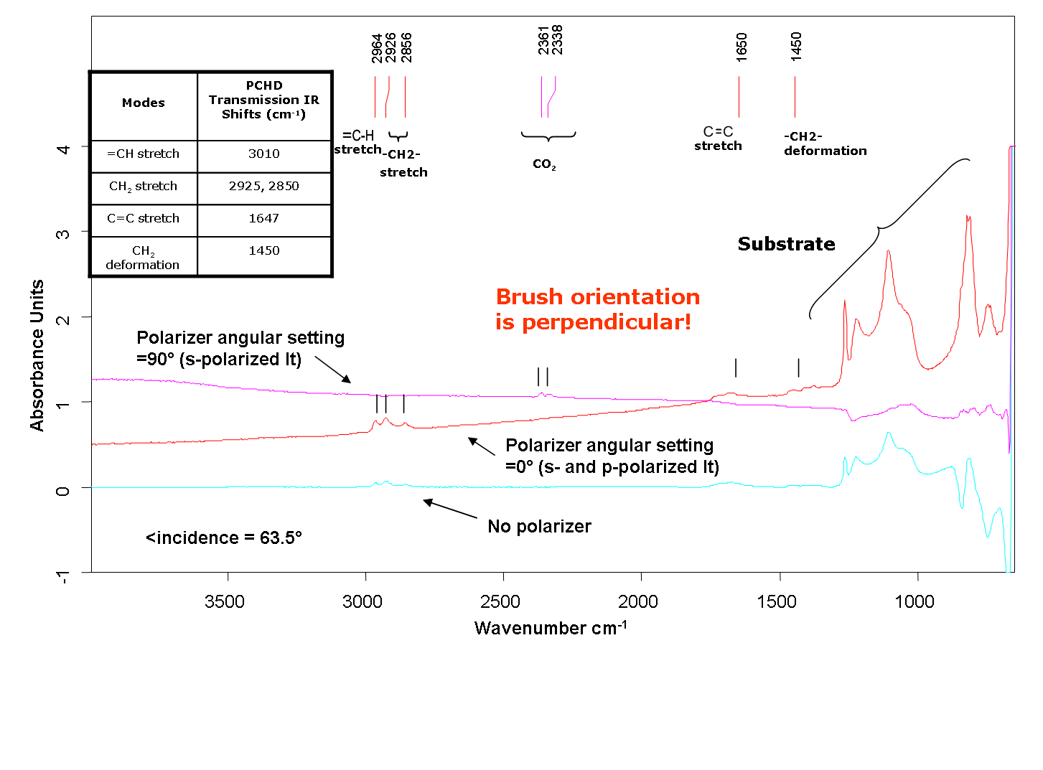

Figure 6.10 An ATR-IR spectrum for the 4,700 g/mol end-tethered PCHD brush formed from solution grafting onto a silicon substrate in benzene (2.0 wt.% SiCl3-PCHD) for 116 hours . The table in the inset contains literature values for transmission IR shifts of thin film PCHD (ref. 166). Data was collected at an incidence angle of 63.5°.
the s-component lies perpendicular to the plane of beam propagation. In Figure 6.10, the observed absorptions are due to molecules oriented perpendicular to the substrate since there are no absorptions in the regions of interest when only s-polarized light is used, but absorptions due to the PCHD brush do appear when both s- and p-polarized light is used in the measurement.
Similarly, Figure 6.11 displays the grazing angle specular reflectance spectrum for 4,700 g/mol end-tethered PCHD brushes formed from solution grafting onto a quartz substrate in benzene (2.0 wt.% SiCl₃-PCHD) for 116 hours.
Results from both IR spectroscopy experiments indicate that PCHD end tethered brush layers were successfully formed on both quartz and silicon substrates when the reaction was conducted in benzene (2.0 wt.% SiCl₃-PCHD) for 116 hours.
- Characterization of Aromatized PPP Polymer Brush Films

Following their characterization, end tethered PCHD brushes were aromatized. Water contact angles of the aromatized layers averaged ~80°. This value is consistent with water contact angles of some other pure aromatic systems including graphite, which has a water contact angle of 86° and C₆₀, which has a water contact angle of 76°.
Figure 6.12 shows the AFM height images for the 4,700 g/mol end tethered PCHD brush before and after aromatization. These and other AFM height images revealed that the roughness of the layer increases with aromatization. Moreover, there is a slight decrease in layer thickness following aromatization.

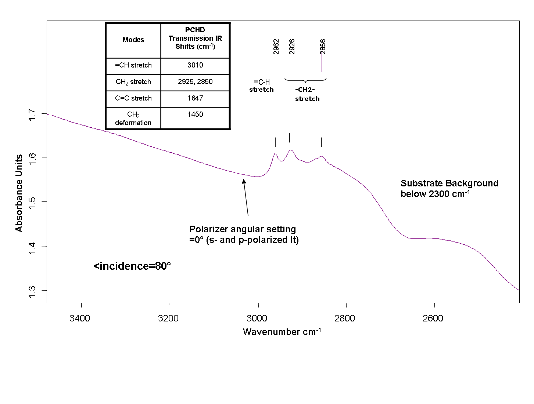

Figure 6.11 A spectrum of grazing angle specular reflectance for the 4,700 g/mol end- tethered PCHD brush formed from solution grafting onto a quartz substrate in benzene (2.0 wt.% SiCl3-PCHD) for 116 hours. The table in the inset contains literature values for transmission IR shifts of thin film PCHD (ref. 166). Data was collected at an incidence angle of 80.0°.

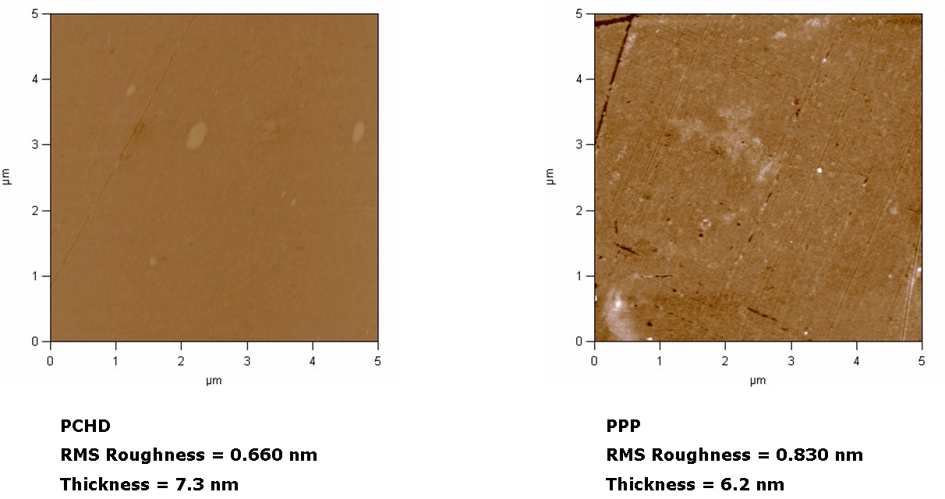

Figure 6.12 AFM height images obtained for end-tethered 4,700 g/mol PCHD brushes formed from solution grafting before (left) and after (right) aromatization in 1,2-DCB and DDQ for 48 hours. The imaged region has an area of 5 µm x 5 µm.
The UV-Vis spectrum of grafted PCHD brush layers after aromatization for 48 hours in 1,2-DCB and DDQ exhibits two new absorption bands that appear at ~230 nm and between ~320-340 nm, as shown in Figure 6.13.
A study by Natori et al. ¹⁷¹ suggests that the UV-Vis absorption from 310-380 nm is caused by the presence of 1,4-PPP units. It is also reported that the theoretical UV-vis absorption maximum for an infinitely long PPP chain is 339 nm,¹⁷² which is estimated by extrapolation of spectra of oligomeric PPP.¹⁷² However, the oligomeric PPP studies were conducted in solution and it may be misleading to infer thin film properties from these results.¹⁷³
Further characterization of the aromatized end-tethered brushes with IR spectroscopy monitors the extent of the reaction. However, typical bands used to estimate the conjugation length for PPP (~800 cm⁻¹, 760cm⁻¹, and 1480 cm⁻¹) are not accessible due to the absorption of the substrate (quartz). Nevertheless, one might expect a disappearance of absorption peaks in the region between ~3018cm⁻¹ and ~2860 cm⁻¹ upon complete aromatization. In a parallel study performed by collaborators at CNMS of end-tethered PCHD brushes formed by spin coating, absorption peaks in the region between ~3018cm⁻¹ and ~2860 cm⁻¹ were no longer visible following aromatization.¹⁷³ Figure 6.14 displays the GATR-IR spectrum of the 4,700 g/mol end-tethered PCHD brush following the aromatization reaction in 1,2-DCB and DDQ for 48 hours. In Figure 6.14, the absorption peaks due to the presence of the PCHD brush were still present, indicating that the aromatization reaction was not complete.
To obtain a more quantitative measure of the extent of the aromatization reaction of end-grafted PCHD layers, Raman spectra on quartz substrates were collected. Raman spectroscopy can be interpreted to offer an estimate of the conjugation length of conjugated polymers.
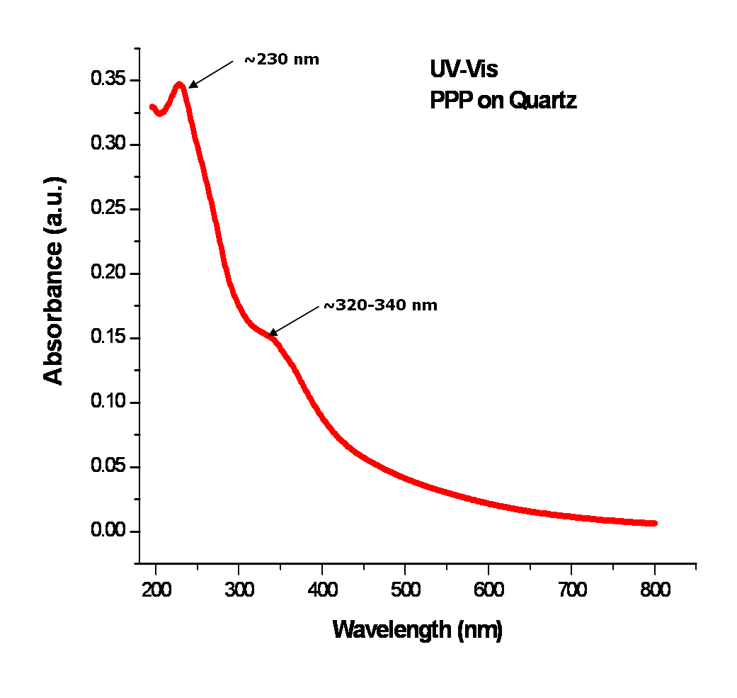

Figure 6.13 UV-Vis spectrum for the 4,700 g/mol end-tethered PCHD brush formed from solution grafting on a quartz substrate following aromatization for 48 hours in 1,2-DCB and DDQ.

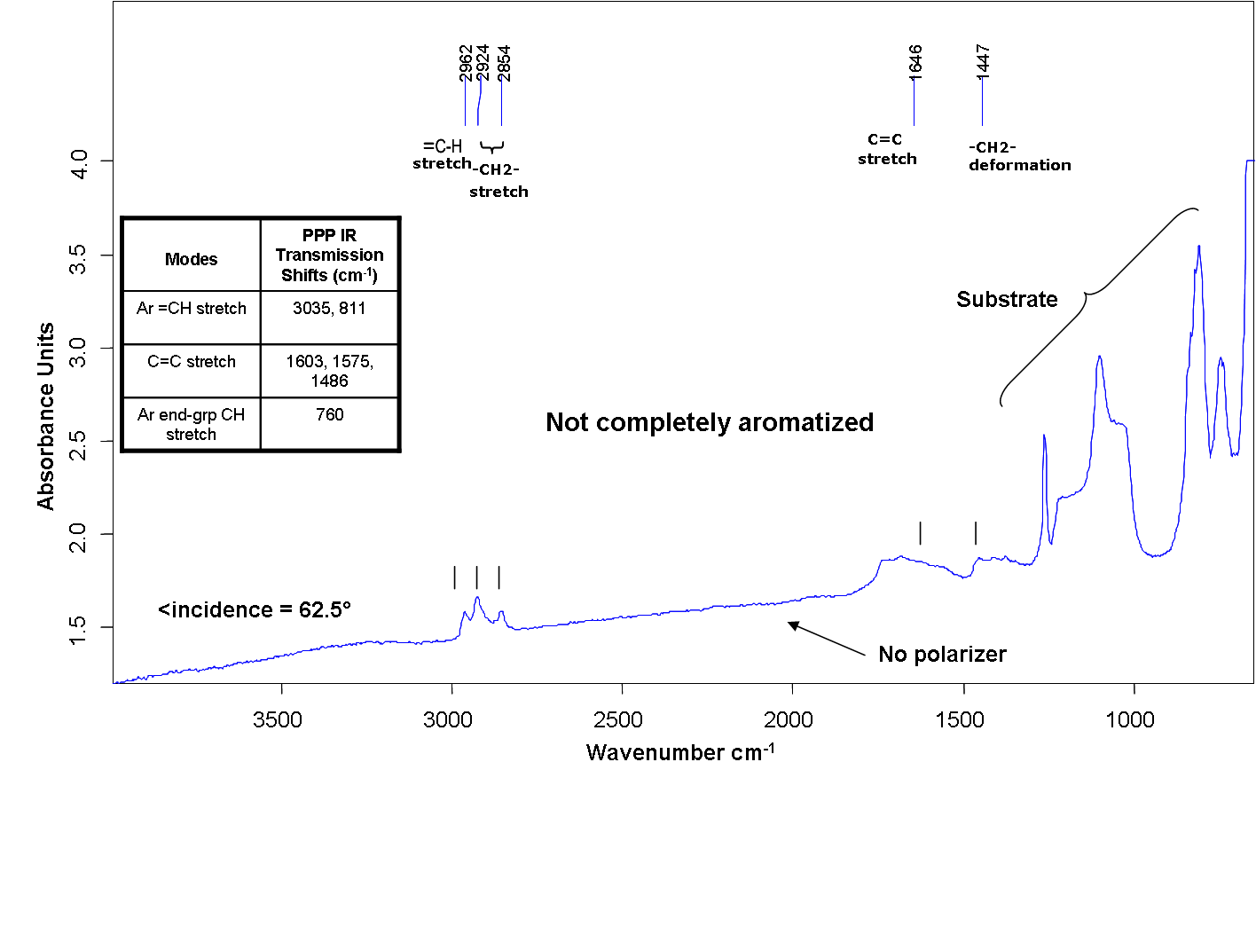

Figure 6.14 GATR-IR spectrum for the 4,700 g/mol end-tethered PCHD brush formed from solution grafting on a silicon substrate following aromatization for 48 hours in 1,2-DCB and DDQ. The table in the inset contains literature values for transmission IR shifts of PPP formed in the bulk (ref. 166). Data was collected at an incidence angle of 62.5°.

Previous studies of the Raman active modes present in p-oligophenyls reveal that there is an increase in the ratio of intensities of the 1220cm⁻¹ and 1280cm⁻¹ Raman bands with increasing conjugation.^{174, 175} Figure 6.15 shows the Raman spectrum for the 4,700 g/mol end tethered PCHD brush formed from solution grafting on a quartz substrate following aromatization for 48 hours in 1,2-DCB and DDQ. Both the 1220 cm⁻¹ and 1280cm⁻¹ Raman active modes are present in the spectrum of aromatized PCHD brush, which is consistent with IR spectroscopy results that indicate that the end-tethered PCHD brush layer is not fully aromatized. The intensity of the 1220cm⁻¹ band is ~5 times larger than the 1280 cm⁻¹ band. Literature studies report that this ratio is similar to the ratio observed for quaterphenyl.¹⁷⁶ Likewise, the effective conjugation length of PPP fabricated from the parallel spin-coating study consists of 5 phenyl units.¹⁷³ Mulazzi et al¹⁷⁷ determined via theoretical calculations of UV-Vis spectra of PPP that defects in the microstructure of the polymer reduces the effective conjugation length. It was concluded in the study of surface tethered PPP that these defects can be attributed to 1,2-linkages distributed along the chain length, which broadens the UV-Vis absorption spectra of thin film PPP compared to the UV-Vis spectra of thin film oligo-paraphenyls.¹⁷³
6.4 Conclusions
High density PCHD brushes were successfully formed in a grafting-to approach. Both solution grafting and spin coating techniques were employed in parallel studies to tether end-functionalized PCHD to both Si and quartz substrates. Raman spectroscopy studies show that the aromatization of end-tethered PCHD produces a PPP brush with a conjugation length of 4 units when formed from solution grafting, but produce polymers with a conjugation length of 5 phenyl units using spin coating procedures.¹⁷³ The observed reduction in the effective conjugation length can be explained by considering the theoretical work of Mulazzi et al,¹⁷⁷ based on the
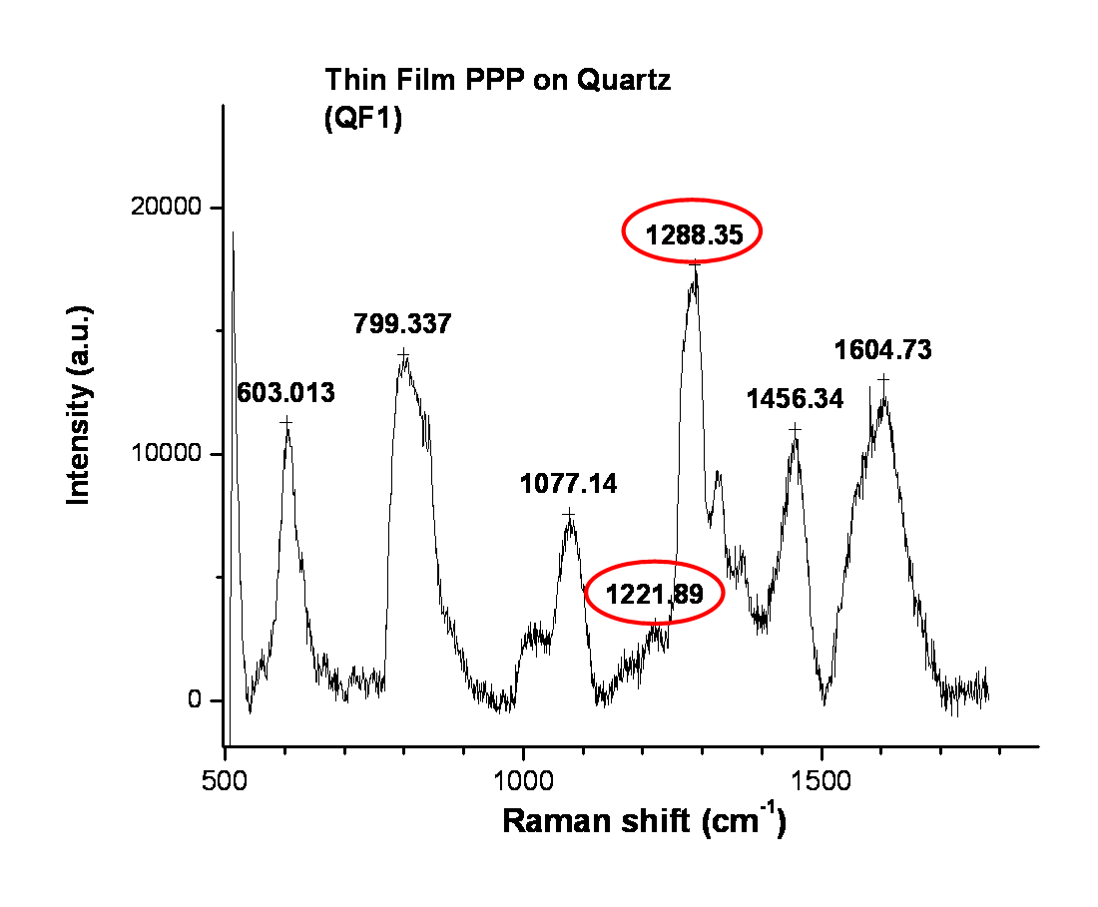

Figure 6.15 Raman spectrum of the 4,700 g/mol end tethered PCHD brush on quartz formed from solution grafting after aromatization for 48 hours in 1,2-DCB and DDQ.

UV-Vis spectra of PPP, in which they found that 1,2-defects are responsible for reducing the effective conjugation length of these PPP layers. Nevertheless, the solution grafting technique presented some challenges as it took several attempts to determine optimal reaction conditions to graft a monolayer. Greater control over the reaction is needed for further studies of brushes formed using the solution grafting technique.

Lessons Learned and Future Work

7.1 Overview
Professor Richard Feynman’s assertion that “There’s Plenty of Room at the Bottom”¹⁷⁸ is still a very relevant theme in present day scientific research spanning a wide range of disciplines and sub disciplines from biology to chemistry to physics. Indeed, the objective of many current scientific research endeavors is to have control over structure and organization at the nanoscale. Likewise, the present body of work involved developing methods for modifying polymeric material surfaces using surface segregation in binary branched/linear polymer blends as well as surface functionalization with polymer brushes. Consequently, model polymeric systems with well-defined structures were studied to facilitate identification of the specific (nanoscale) structure-property relationships.
In order to predictably and reliably direct the self-assembly of polymers at an interface, a fundamental understanding of the underlying physics of the approach to a final equilibrium or steady state structure must be attained. Thus, this body of work also provides a framework to understand the observed physical phenomena in these model systems, with the end goal of contributing fundamental insight toward the development of new technologies utilizing surface modification methods of polymeric materials. A summary of the lessons learned from the studies presented in this body of work will be covered in this chapter, followed by a discussion of future work along with some potential practical industrial applications.

7.2 Lessons Learned from Studies of Self-Healing Materials Formed from Surface Segregating Binary Branched/Linear Blends
In this study, two model systems, poly(styrene) (PS) HyperMacs and DendriMacs in a linear d-PS matrix and poly(methyl methacrylate)-random-poly(ethylene glycol) methacrylate (P(MMA-r-PEGMA)) comb copolymers in a linear d-PMMA matrix, were chosen to investigate the effects of architecture on the surface segregation of a branched polymer in a linear matrix. HyperMacs and DendriMacs are dendritic, hyperbranched polymers that have well-defined structure between branch points. P(MMA-r-PEGMA) comb copolymers examined in this study have well-defined graft densities. Thus, the aim of these studies was to correlate the amount and rate of formation of the interfacial excess of branched polymeric additives in a linear polymer matrix to the branched additive architecture. Thermal annealing was used to drive the surface segregation process. By measuring the time evolution of the amount of interfacial excess formed at an interface with depth profile and surface sensitive techniques, the specific details of the approach of each system to a final equilibrium or steady-state was followed.
Several surface sensitive techniques were utilized to help elucidate the evolving structures of surface segregating binary branched/linear blends. Neutron reflectivity was used in these studies and is a depth profiling technique that not only gives information about the chemical composition of a thin film normal to the surface, but is also sensitive to the details of buried interfaces at a molecular level with resolution on the order of one nanometer. Fits to neutron reflectivity data were used to construct neutron scattering length density depth profiles that describe the depth profile of the blend film. Fitting was accomplished using a hybrid fitting approach consisting of a combination of genetic optimization parameter searches (within the bounds of a physically reasonable model using the fitting program Motofit¹¹¹), as well as manual fitting, to preserve mass balance (using the Mlayer program/SNS,ORNL). Elastic Recoil Detection (ERD) spectroscopy, ellipsometry, and water contact angle goniometry were all used as complementary techniques to help construct an appropriate, physically reasonable model of the evolving film and thus corroborate neutron reflectivity fits.
The systematic method of elucidating the evolving structures of thin films of surface segregating binary branched/linear blends also provides an efficient protocol to test theoretical models that describe the diffusion behavior of polymeric additives in a polymer matrix such as the Kramer-Jones depletion layer model.^{66,17} The Kramer-Jones depletion layer model describes the diffusion-controlled growth of a wetting layer in a binary polymer blend. Growth of the wetting layer follows a t^{1/2} dependence. Furthermore, in this model, it is assumed that there is a local equilibrium between the wetting layer at the surface and the layer just beneath it that is depleted in the surface segregating component. This diffusion process is described by a mutual diffusion coefficient, D_{m}, which involves the coordinated movement of one component toward the surface and the other component away from the surface. Using the Fast and Slow mode theories,^{68, 69,70,71} (i.e., in which the mutual diffusion coefficient in a surface segregating binary polymer blend is dominated by the faster moving component – Fast mode – or by the slower diffusing component –Slow mode), one can also extract the tracer diffusion coefficients of polymeric additives, D_{A}*, in a linear polymer matrix. The specific details of the surface segregation process in model binary branched/linear polymeric systems was elucidated using a combination of surface sensitive techniques and the Kramer-Jones model. Both the D_{m} for each blend as well as D_{A}* for each branched additive was extracted. Thus, the results also demonstrate a method to effectively measure diffusion coefficients of hyperbranched polymers and comb copolymers in a linear polymer matrix.
With respect to the thermodynamics of blends of thermally annealed PS HyperMacs and DendriMacs in a linear PS matrix (i.e., how much of the branched additive segregates to a surface), it was discovered that both branching and molecular weight are competing effects as these systems approach equilibrium. Examination of the interfacial excess near the Si interface as a function of M_{w} clearly demonstrates that both the smallest as well as the largest branched additive in a linear matrix produces the most interfacial surface excess after a steady state has been reached. Moreover, both the near-air and near-Si interfaces were enriched with PS HyperMacs and DendriMacs instead of the d-PS matrix; d-PS has been shown experimentally to be the lower energy component in a binary linear PS/d-PS blend.⁶⁶ Thus, this result is consistent with an entropically driven surface segregation process in these self-healing binary branched/linear systems.
It was also discovered that with respect to the dynamic behavior of these blends of HyperMacs and DendriMacs in a linear polymer matrix (i.e., how fast an additive segregates to a surface), both the molecular weight as well as the structure of the hyperbranched additive impact its diffusive properties. Below a molecular weight of ~1E6 g/mol, smaller hyperbranched additives move slower than their linear analogues. However, above a molecular weight of ~ 1E6 g/mol, less flexible hyperbranched additives with smaller fractal dimensions move faster than their linear analogues, suggesting that they are less entangled with the linear matrix (which is consistent with previous rheological studies on hyperbranched polymers and has been attributed to their overall architecture).¹⁰⁸ While a number of studies indicate that the Fast Mode dominates in surface segregating polymer blends, in the present study it was observed that only the Slow mode theory gave a physically reasonable result, meaning that the slowest moving component of the binary blend was dominating mutual diffusion in these systems. Moreover, the dynamics of these hyperbranched polymers in a linear matrix were not observed to obey simple Reptation dynamics (i.e., D ~ M_{w}^{-2.0}), but rather the diffusion coefficient for these hyperbranched polymers exhibited a higher molecular weight dependence (i.e., D ~ M_{w}^{-3.0}). These higher molecular weight dependences of the diffusion coefficient have been attributed to tube length fluctuations.⁵⁹ One way to understand this dynamic behavior is to assume that the tube is dynamic and not static, and that this results in more complex dynamics than predicted by the simple Reptation theory. In fact, hyperbranched polymers do not relax by simple Reptation, but via hierarchical relaxation, as theoretically described by McLeish.^{131,132}
In blends composed of P(MMA-r-PEGMA) comb copolymers in a linear d-PMMA matrix, it was found that increasing the branch density of the comb copolymer increases the amount of surface segregated material. Nevertheless, increasing the branch density also increases the number of branch points, which dominates the friction in the Reptating backbone of the comb.⁵⁹ This is likely why a linear analog (having the same molecular weight as the comb copolymer) is still an order of magnitude faster than a comb copolymer under the same conditions. As in studies with blends of HyperMacs and DendriMacs in a linear matrix, comb copolymers with varying graft densities in a linear matrix also exhibited Slow mode behavior, such that the slowest moving component in the blend dominated the mutual diffusion in these systems. Furthermore, simple Reptation dynamics (i.e., D ~ M_{w}⁻²) for these comb copolymers in a linear matrix were not observed, but rather, the dynamics were more complex, and could not be described with a simple relationship.

  - Future Work and Some Potential Practical Industrial Applications: Self-Healing Binary Branched/Linear Blends

Polymeric coatings are ubiquitous as they are present in a wide variety of consumer applications including architectural and decorative paints, lacquers, and varnishes, industrial coatings for wood, coatings for consumer electronics and appliances, automotive exterior and interior coatings, and special purpose coatings including protective coatings, marine anti-fouling coatings, anti-corrosion coatings, and aerospace coatings. Performance requirements of coatings include abrasion resistance, UV-radiation resistance, heat resistance, paint adhesion, flexibility, impact resistance, and appearance. The selective segregation of a branched polymeric additive in a linear polymer matrix is a technique with the potential to meet a broad range of stringent coating performance requirements for industrial applications. In such branched/linear self-healing systems, by selecting a branched polymer with specific chemical functionality, one can provide tailored performance for a specific coating application.
One such example where a surface segregating branched/linear binary blend might be useful is in polymer coatings for anti-corrosion applications. The state-of-the art in self-healing coatings for anti-corrosion on metal substrates¹⁷⁹ utilizes different mechanisms to achieve self-repair in corrosive media including chemical reactions triggered by damage to the protective coating, chemical reactions between the components of a polymer layer and the metal substrate, pH buffering by polyelectrolyte multilayers, as well as encapsulation of corrosion inhibitors (via microcapsules or nanocapsules) which are incorporated in the coating. Nevertheless, surface segregation of a binary branched/linear blend is a self-healing mechanism that has not been utilized. Such a system where the surface segregating additive (in a linear polymer matrix) is a hyperbranched polymer complexed with polyoxometalates (such as phosphomolybdate ions, PMo₁₂O₄₀³⁻), for example, might offer an advantage over encapsulation of corrosion inhibitors (via microcapsules or nanocapsules). A disadvantage of self-healing in coatings that contain micro- or nanocapsules filled with inhibitor (in which the contents of the capsule are released following a change in pH, light of a specific wavelength, a change in temperature, etc.) is that self-repair in such systems is possible only after the coating has been damaged, which would then result in subsequent release of the corrosion inhibitors to the metal substrate. Self-healing in coatings based on binary branched/linear blends is triggered by changes in environmental stimuli (such as change in temperature and exposure to solvent), and the functionalities that would prevent corrosion (eg., a hyperbranched polymer complexed with polyoxometalates) would be in direct contact with the substrate following surface segregation from the linear polymer matrix.
Additional studies toward a better understanding of the fundamental structure-property relationships in the selective surface segregation of branched polymeric additives in a linear polymer matrix could be conducted in future investigations. In the surface segregation studies covered in this body of work, the volume fraction of additive in a linear matrix was chosen to be 10 w/w% in order to avoid miscibility issues. However, how the amount of sorption varies with the branched additive concentration could also be probed for each of the systems investigated in this study. From such studies, an adsorption isotherm consisting of the amount of additive sorbed to an interface after the system has reached a steady state would provide additional insight to predict sorption behavior. For miscible blends containing higher branched additive loadings, the effect of higher additive concentration on the dynamics of the system could also be investigated.
The variation of other experimental variables such as the temperature of thermal annealing and the use of solvent annealing to drive the surface segregation process could also be probed in subsequent studies. A higher thermal annealing temperature under vacuum could be useful, for example, in the study of the P(MMA-r-PEGMA) comb copolymers in a linear matrix as their approach to a steady state was very slow. Solvent annealing could be conducted alongside thermal annealing studies to compare the degree of control over the surface segregation process under each condition. Moreover, by changing the polarity of the solvent from aqueous to organic, for example, the surfaces of blends containing P(MMA-r-PEGMA) comb copolymers could be changed from hydrophilic to hydrophobic. Furthermore, the effect that an attractive surface has on the surface segregation dynamics could be probed by changing the chemical composition of the substrate (from SiO to SiH in silicon substrates, for example).
Moreover, in investigations on the thermodynamic and dynamic behavior of HBP polymers in a linear polymer matrix in Chapter 3, measurements to determine the branched additive polymer conformation (fractal dimensions) were conducted in solution (see section 3.3, SEC measurements). However, the studies on diffusion behavior were conducted in the melt. Thus, it might be interesting to conduct molecular dynamic simulations on these branched/linear systems in the melt to confirm that varying conformations of these HBP additives in the melt affects their diffusive behavior, as the NR and ERD data suggest that there is a relationship between HBP fractal dimension and diffusive behavior in these branched/linear blends.

7.4 Lessons Learned from Studies of the Formation of Functionalized Polymeric Interfaces Using Grafting-From and Grafting-To Approaches
The two model systems to study grafting-from and grafting-to approaches examined in this body of work included a cross-linked photopolymer (PP)/inimer embedded functionalized material and a silane end-functionalized poly(cyclohexadiene) (PCHD). In the grafting-from approach, deuterated PS growth was initiated from a 3-dimensional inimer embedded PP network. The grafting-to approach initially involved tethering of silane end-functionalized PCHD to a substrate followed by conversion of the grafted layer to poly(paraphenylene) (PPP) upon aromatization with 2,3-dichloro-5,6-dicyanobenzoquinone (DDQ). By following the formation of these model functionalized polymeric surfaces, the structure of these systems was not only correlated to their physical properties, but also to the synthetic and fabrication conditions.
The ultimate objective of studies involving grafting of end-functionalized PCHD brushes to a substrate was to create conducting PPP surfaces. PPP in the melt is difficult to process at high molecular weights. Thus, previous studies of this polymer in the melt have only involved oligomer species. In this grafting-to approach, a solution grafting procedure was employed. High density grafted PCHD brushes were successfully formed. The quality of the monolayer formed was assessed with water contact angle goniometry and atomic force microscopy (AFM), both of which indicated a full monolayer had been formed. The chemical composition of the grafted layer was confirmed using UV and grazing angle attenuated total reflectance infrared (GATR-IR) spectroscopy. Nevertheless, aromatization of the PCHD layer proved to be more of a challenge as Raman spectroscopy results, following aromatization, indicated that there was a difference in the conjugation length of PPP brushes depending on whether the layer was formed from solution grafting or using spin coating procedures (spin coating of end-tethered PCHD brushes was performed by collaborators at the Center for Nanophase Materials Science at Oak Ridge National Lab in a parallel study). Using spin coating procedures, the PPP brush had a conjugation length of 5 units while the PPP brush formed from solution grafting had a conjugation length of only 4 units. The reduced effective conjugation length, based on the theoretical work of Mulazzi et al,¹⁷⁷ can be attributed to 1,2-defects in the PPP chain.
The goal of the study involving polymer growth from an inimer embedded interface was to determine at what depth in the film polymer growth was initiated as well as to correlate reaction conditions such as weight percent inimer and d-PS molecular weight (inimer to dS ratio) to fabricated film structure. The results of a combination of surface sensitive techniques including neutron reflectivity and dynamic secondary ion mass spectroscopy (DSIMS) led to the conclusion that d-PS growth was initiated both at the surface and within the bulk of these materials. Moreover, increasing the amount of inimer in the film resulted in an increase in the amount of d-PS throughout the entire layer. By correlating the cross-link density of these films with the reaction conditions, it was determined that surface growth of d-PS is promoted by use of low concentrations of inimer. This phenomenon can be attributed to a decrease in the amount of swelling in the network, as determined by in-situ ellipsometry swelling experiments. An increase in the swelling of the network allowed d-PS growth throughout the bulk of the entire film and thus less surface d-PS growth.

7.5 Future Work and Some Potential Practical Industrial Applications: Functionalized Polymeric Interfaces Using Grafting-From and Grafting-To Approaches
Doping of conjugated polymers such as poly(aniline) and poly(pyrrole) provides still another option for creating anti-corrosion coatings on metal substrates. For example, poly(aniline) doped with molybdate ions functions as a sacrificial anode on metal substrates and thus is used in anti-corrosion coating applications.¹⁷⁹ Likewise, conductive PPP brushes doped with metal ions could also be used for anti-corrosion coating applications.
Nevertheless, future work on PPP brush formation is needed to enable the application of this technology for anti-corrosion coatings. The solution grafting technique involving the end-tethering of PCHD brushes to a substrate followed by their subsequent conversion to PPP presented some challenges as it took several attempts at varying reaction conditions to graft a monolayer. Greater control over the reaction is needed to form brushes using the solution grafting technique. In a report by Taylor et al.,¹⁶⁶ high density 20K molecular weight thiol terminated poly(ethylene oxide) (PEO-SH) brushes were grafted to gold substrates at room temperature using a solution grafting technique. In their approach, control of the grafting density of the PEO-SH brush is accomplished by including a PEO homopolymer in their graft solution. The excluded volume interaction, an effect that limits the access of chains to a surface that already has grafted chains tethered to it, is suppressed in the presence of the homopolymer. The volume fraction as well as degree of polymerization of the homopolymer is varied and this ultimately results in control over the size of the grafting chains. Control of the size of the grafting chains results in control over the graft density of brushes.¹⁶⁶ A similar method could be employed in the solution grafting of end-functionalized PCHD precursor chains in order to have greater control over the reaction (i.e., using non-functionalized PCHD chains in the graft solution). This would allow further studies on the kinetics of the solution grafting technique. Moreover, it may be that the solution grafting technique, once optimized, will be a competitive method for creating a conducting surface. It would be interesting to conduct a structure-property study whereby the conductivity is probed both within the plane of the film and perpendicular to the film for both solution grafted as well as spin coated PPP brushes. Perhaps the structure and thus conductivity of polymer brushes created by spin coating versus solution grafting will differ.
Following the combined top-down bottom-up method of fabrication as described in von Werne et al’s⁴⁶ study, cross-linked functionalized PP/inimer networks formed on patterned surfaces could serve as a method to fabricate haptic coatings. Haptic coatings are coatings designed with a specific texture and are primarily used as coatings for consumer electronics (eg., cell phone covers, laptops, etc) but can also be found in automotive interiors. Haptic coatings can have a ‘soft’ feel, a ‘rubbery’ feel, or a ‘silky’ feel, for example, and are rated on a haptic scale (which indicates the human tactile sense attributed to a particular coating). However, the haptic scale used in the industrial application of these specialized coatings is not well-defined. In practice, these textured coatings are rated on a haptic scale by a panel of individuals that may or may not rate the coatings exactly the same as the end-user of such coatings (i.e., the customer). Nevertheless, a recent study suggests that the human finger can distinguish textures on a surface in which the feature sizes are on the order of nanometers (~ 10 nm).¹⁸⁰ Thus, the top-down bottom-up method of creating nanoscale features in a coating using cross-linked functionalized PP/inimer networks may facilitate better structure-property relationships in such coatings, thus making the human tactile perception of haptic coatings more quantifiable and less subjective.
Future investigations involving cross-linked functionalized PP/inimer networks should include further neutron reflectivity studies in which films (prepared from a low percent of inimer and varying ratios of dS to inimer concentration) are swollen in a good solvent such as toluene. Density profiles of swollen films would provide more information about the structure of end-tethered d-PS grown from the 3-dimensional surface. Moreover, these density profiles could be compared with those of the dry films. It would also be interesting to follow the formation of d-PS from the cross-linked inimer embedded network. This could be accomplished by measuring the neutron reflectivity profiles at specified intervals thus providing ‘snap shots’ of the kinetics of the reaction process.

List of References

1. Allara, D. L., A Perspective on Surfaces and Interfaces. Nature 2005, 437.
2. Xia, F.; Jiang, L., Bio-Inspired, Smart, Multiscale Interfacial Materials. Advanced Materials 2008, 20, 2842-2858.
3. Russell, T. P., Surface-Responsive Materials. Science 2002, 297 (5583), 964-967.
4. Granick, S.; Kumar, S. K.; Amis, E. J.; Antonietti, M.; Balazs, A. C.; Chakraborty, A. K.; Grest, G. S.; Hawker, C.; Janmey, P.; Kramer, E. J.; Nuzzo, R.; Russell, T. P.; Safinya, C. R., Macromolecules at Surfaces: Research Challenges and Opportunities from Tribology to Biology. J. Poly. Sci. Part B: Poly Phys 2003, 41, 2755-2793.
5. Stamm, M., Polymer Surfaces and Interfaces: Characterization, Modification and Applications. First ed.; 2008.
6. Garbassi, F.; Morra, M.; Occhiello, E., Polymer Surfaces: From Physics to Technology. John Wiley & Sons: New York, 2000.
7. Yang, X.; Loos, J., Toward High-Performance Polymer Solar Cells: The Importance of Morphology Control. Macromolecules 2007, 40 (5), 1353-1362.
8. Granick, S., Perspective: Kinetic and Mechanical Properties of Adsorbed Polymer Layers. The european Physical Journal E 2002, 9, 421-424.
9. Atkins, P. W., Physical Chemistry. W.H. Freeman and Company New York 1998.
10. Reisch, M., European Firms Chart New Paths. Chemical and Engineering News 2010 88 (40).
11. Reynolds, B. J.; Ruegg, M. L.; Balsara, N. P.; Radke, C. J., Relationship between Macroscopic and Microscopic Models of Surfactant Adsorption Dynamics at Fluid Interfaces. Langmuir 2006, 22 (22), 9201-9207.
12. Reynolds, B. J.; Ruegg, M. L.; Mates, T. E.; Radke, C. J.; Balsara, N. P., Experimental and Theoretical Study of the Adsorption of a Diblock Copolymer to Interfaces between Two Homopolymers. Macromolecules 2005, 38 (9), 3872-3882.
13. Reynolds, B. J.; Ruegg, M. L.; Mates, T. E.; Radke, C. J.; Balsara, N. P., Diblock Copolymer Surfactant Transport across the Interface between Two Homopolymers. Langmuir 2006, 22 (22), 9192-9200.
14. Goodwin, J., Colloids and Interfaces with Surfactants and Polymers. Second ed.; John Wiley & Sons Ltd: West Sussex, England, 2009.
15. Brundle, C. R.; Evans, C. A. J.; Wilson, S.; Fitzpatrick, L. E., Encyclopedia of Materials Characterization: Surfaces, Interfaces, Thin Films Butterworth-Heinemann: Boston, 1992.
16. Bohn, P. W., LOCALIZED OPTICAL PHENOMENA AND THE CHARACTERIZATION OF MATERIALS INTERFACES. Annual Review of Materials Science 1997, 27 (1), 469-498.
17. Jones, R. A. L.; Richards, R. W., Polymers at Surfaces and Interfaces Cambridge University Press: New York, 1999.
18. Arlen, M. J.; Dadmun, M. D.; Hamilton, W. A., Using neutron reflectivity to determine the dynamic properties of a copolymer in a homopolymer matrix. Journal of Polymer Science Part B: Polymer Physics 2004, 42 (17), 3235-3247.
19. Bucknall, D. G.; Butler, S. A.; Higgins, J. S., Real-Time Measurement of Polymer Diffusion Coefficients Using Neutron Reflection. Macromolecules 1999, 32 (16), 5453-5456.
20. Bucknall, D. G.; Fernandez, M. L.; Higgins, J. S., Neutron reflection studies of interfaces between partially miscible and compatibilised immiscible polymers. Faraday Discussions 1994, 98, 19-30.
21. Bucknall, D. G.; Higgins, J. S.; Penfold, J.; Rostami, S., Segregation behaviour of deuterated poly(styrene-block-methyl methacrylate) diblock copolymer in the presence of poly(methyl methacrylate) homopolymer. Polymer 1993, 34 (3), 451-458.
22. Coote, M. L.; Gordon, D. H.; Hutchings, L. R.; Richards, R. W.; Dalgliesh, R. M., Neutron reflectometry investigation of polymer-polymer reactions at the interface between immiscible polymers. Polymer 2003, 44 (25), 7689-7700.
23. Feng, Y.; Weiss, R. A.; Karim, A.; Han, C. C.; Ankner, J. F.; Kaiser, H.; Peiffer, D. G., Compatibilization of Polymer Blends by Complexation. 2. Kinetics of Interfacial Mixing. Macromolecules 1996, 29 (11), 3918-3924.
24. Kharitonov, A. P.; Kharitonova, L. N.; Taege, R.; Ferrier, G.; Durand, E.; Tressaud, A., Direct Fluorination of Poymers and Membranes. Actualite Chimique 2006, 301-302, 130-134.
25. Collins, G., A.; Rej, D. J., Plasma Processing of Advanced Materials. 1996.
26. Minko, S., Grafting on Solid Surfaces: “Grafting to” and “Grafting from” Methods. In Polymer Surfaces and Interfaces, Stamm, M., Ed. Springer Berlin Heidelberg: 2008; pp 215-234.
27. Sinha, S. K.; Briscoe, B. J., Polymer Tribology. Imperial College Press: London, 2009.
28. Zhao, B.; Brittain, W. J., Polymer brushes: surface-immobilized macromolecules. Progress in Polymer Science 2000, 25 (5), 677-710.
29. Husseman, M.; Malmström, E. E.; McNamara, M.; Mate, M.; Mecerreyes, D.; Benoit, D. G.; Hedrick, J. L.; Mansky, P.; Huang, E.; Russell, T. P.; Hawker, C. J., Controlled Synthesis of Polymer Brushes by “Living” Free Radical Polymerization Techniques. Macromolecules 1999, 32 (5), 1424-1431.
30. Dyer, D., Photoinitiated Synthesis of Grafted Polymers. In Surface-Initiated Polymerization I, Jordan, R., Ed. Springer Berlin / Heidelberg: 2006; Vol. 197, pp 47-65.
31. Tsujii, Y.; Ohno, K.; Yamamoto, S.; Goto, A.; Fukuda, T., Structure and Properties of High-Density Polymer Brushes Prepared by Surface-Initiated Living Radical Polymerization. In Surface-Initiated Polymerization I, Jordan, R., Ed. Springer Berlin / Heidelberg: 2006; Vol. 197, pp 1-45.
32. Tran, Y.; Auroy, P., Synthesis of Poly(styrene sulfonate) Brushes. Journal of the American Chemical Society 2001, 123 (16), 3644-3654.
33. Advincula, R., Polymer Brushes by Anionic and Cationic Surface-Initiated Polymerization (SIP). In Surface-Initiated Polymerization I, Jordan, R., Ed. Springer Berlin / Heidelberg: 2006; Vol. 197, pp 107-136.
34. Wang, J.-S.; Matyjaszewski, K., Controlled/"living" radical polymerization. atom transfer radical polymerization in the presence of transition-metal complexes. Journal of the American Chemical Society 1995, 117 (20), 5614-5615.
35. Liu, D.; Chen, Y.; Zhang, N.; He, X., Controlled grafting of polymer brushes on poly(vinylidene fluoride) films by surface-initiated atom transfer radical polymerization. Journal of Applied Polymer Science 2006, 101 (6), 3704-3712.
36. He, X.; Yang, W.; Pei, X., Preparation, Characterization, and Tunable Wettability of Poly(ionic liquid) Brushes via Surface-Initiated Atom Transfer Radical Polymerization. Macromolecules 2008, 41 (13), 4615-4621.
37. Wang, Y.-P.; Pei, X.-W.; He, X.-Y.; Lei, Z.-Q., Synthesis and characterization of surface-initiated polymer brush prepared by reverse atom transfer radical polymerization. European Polymer Journal 2005, 41 (4), 737-741.
38. Uhrig, D.; Mays, J. W., Experimental techniques in high-vacuum anionic polymerization. Journal of Polymer Science Part A: Polymer Chemistry 2005, 43 (24), 6179-6222.
39. Sperling, L. H., Introduction to Physical Polymer Science. John Wiley &Sons, Inc.: Bethlehem, PA, 2006.
40. Walton, D. G.; Mayes, A. M., Entropically driven segregation in blends of branched and linear polymers. Physical Review E 1996, 54 (3), 2811.
41. Grundke, K.; Azizi, M.; Ziemer, A.; Michel, S.; Pleul, D.; Simon, F.; Voit, B.; Kreitschmann, M.; Kierkus, P., Hyperbranched polyesters as potential additives to control the surface tension of polymers. Surface Coatings International Part B: Coatings Transactions 2005, 88 (2), 101-106.
42. Matsuda, T., Photoiniferter-Driven Precision Surface Graft Microarchitectures for Biomedical Applications. In Surface-Initiated Polymerization I, Jordan, R., Ed. Springer Berlin / Heidelberg: 2006; Vol. 197, pp 67-106.
43. Hutchings, L. R., DendriMacs and HyperMacs - emerging as more than just model branched polymers. Soft Matter 2008, 4 (11), 2150-2159.
44. Hutchings, L. R.; Dodds, J. M.; Roberts-Bleming, S. J., HyperMacs: Highly Branched Polymers Prepared by the Polycondensation of AB2 Macromonomers, Synthesis and Characterization. Macromolecules 2005, 38 (14), 5970-5980.
45. Walton, D. G.; Soo, P. P.; Mayes, A. M.; Sofia Allgor, S. J.; Fujii, J. T.; Griffith, L. G.; Ankner, J. F.; Kaiser, H.; Johansson, J.; Smith, G. D.; Barker, J. G.; Satija, S. K., Creation of Stable Poly(ethylene oxide) Surfaces on Poly(methyl methacrylate) Using Blends of Branched and Linear Polymers. Macromolecules 1997, 30 (22), 6947-6956.
46. von Werne, T. A.; Germack, D. S.; Hagberg, E. C.; Sheares, V. V.; Hawker, C. J.; Carter, K. R., A Versatile Method for Tuning the Chemistry and Size of Nanoscopic Features by Living Free Radical Polymerization. Journal of the American Chemical Society 2003, 125 (13), 3831-3838.
47. Ambrosch-Draxl, C.; Puschnig, P.; Resel, R.; Leising, G., Electronic properties of ppp-oligomers investigated from first-principles. Synthetic Metals 1999, 101 (1-3), 673-674.
48. Crecelius, G.; Stamm, M.; Fink, J.; Ritsko, J. J., AsF5-Doped Polyparaphenylene: Evidence for Polaron and Bipolaron Formation. Physical Review Letters 1983, 50 (19), 1498.
49. Walton, D. G. Creating Stable Hydrophilic Surfaces with Blends of Branched and Linear Polymers PhD, Massachusetts Institute of Technology Cambridge, 1997.
50. Orlicki, J. A.; Kosik, W. E.; Demaree, J. D.; Bratcher, M. S.; Jensen, R. E.; McKnight, S. H., Surface segregation of branched polyethyleneimines in a thermoplastic polyurethane. Polymer 2007, 48 (10), 2818-2826.
51. Hunley, M. T.; Harber, A.; Orlicki, J. A.; Rawlett, A. M.; Long, T. E., Effect of Hyperbranched Surface-Migrating Additives on the Electrospinning Behavior of Poly(methyl methacrylate). Langmuir 2007, 24 (3), 654-657.
52. Wu, D. T.; Fredrickson, G. H., Effect of Architecture in the Surface Segregation of Polymer Blends. Macromolecules 1996, 29 (24), 7919-7930.
53. Walton, D. G.; Mayes, A. M., Entropically Driven Segregation in Blends of Branched and Linear Polymers Physical Review E 1996, 54 (3), 2811-2815.
54. McLeish, T. C. B., Tube theory of entangled polymer dynamics. Advances in Physics 2002, 51 (6), 1379-1527.
55. Rubenstein, M.; Colby, R. H., Polymer Physics. Oxford University Press: 2003; p 456.
56. Ball, R. C.; McLeish, T. C. B., Dynamic dilution and the viscosity of star-polymer melts. Macromolecules 1989, 22 (4), 1911-1913.
57. Doi, M.; Edwards, S. F., Dynamics of concentrated polymer systems. Part 1.-Brownian motion in the equilibrium state. Journal of the Chemical Society, Faraday Transactions 2: Molecular and Chemical Physics 1978, 74, 1789-1801.
58. de Gennes, P. G., Reptation of a Polymer Chain in the Presence of Fixed Obstacles. The Journal of Chemical Physics 1971, 55 (2), 572-579.
59. Rubinstein, M.; Colby, R. H., Polymer Physics. Oxford University Press: New York, 2003; p 440.
60. McLeish, T. C. B., Hierarchical Relaxation in Tube Models of Branched Polymers. Europhysics Letters (EPL) 1988, 6.
61. De Gennes, P. G., Macromolecules 1975, 36.
62. Van Ruymbeke, E.; Keunings, R.; Bailly, C., Prediction of Linear Viscoelastic Properties for Polydisperse Mixtures of Entangled Star and Linear Polymers: Modified Tube-based Model and Comparison with Experimental Results. Journal of Non-Newtonian Fluid Mechanics 2005, 128, 7-22.
63. Van Ruymbeke, E. Relationship Between Linear Viscoelastic Properties and Molecular Structure for Linear and Branched Polymers Dissertation, Universite Catholique de Louvain, Louvain-la-Neuve, Belgium, 2005.
64. Vega, D. A.; Milner, S. T., Shear Damping Function Measurements for Branched Polymers. Journal of Polymer Science Part B: Polymer Physics 2007, 45, 3117-3136.
65. Ruocco, N.; Dahbi, L.; Driva, P.; Hadjichristidis, N.; Algier, J.; Radulescu, A.; Sharp, M.; Lindner, P.; Straube, E.; Pyckhout-Hintzen, W.; Richter, D., Microscopic Relaxation Processes in Branched-Linear Polymer Blends by Rheo-SANS. Macromolecules 2013, 46, 9122-9133.
66. Jones, R. A. L.; Kramer, E. J., Kinetics of formation of a Surface Enriched Layer in an Isotopic Polymer Blend. Philosophical Magazine B 1990, 62 (2), 129-137.
67. Arlen, M. J. The Interfacial Modification of PS/PMMA Interfaces Using Alternating and Random Copolymers University of Tennessee, Knoville, 2003.
68. Brochard-Wyart, F.; Jouffroy, J.; Levinson, P., Macromolecules 1983, 16, 1638.
69. Jabbari, E.; Peppas, N. A., A Model for Interdiffusion at Interfaces of Polymers with Dissimilar Properties. Polymer 1995, 36 (3), 575-586.
70. De Gennes, P. G., C R Acad Sci 1981, 2, 1505.
71. Kramer, E. J.; Green, P.; Palmstrom, C. J., Polymer 1984, 25 (4), 473.
72. Composto, R. J.; Mayer, J. W.; Kramer, E. J.; White, D. M., Fast Mutual Diffusion in Polymer Blends. Physical Review Letters 1986, 57 (11), 1312.
73. Akcasu, A. Z., Macromol. Theory Simul. 1997, 6, 679-702.
74. Akcasu, A. Z.; Nagele, G.; Klein, R., Macromolecules 1995, 28, 6680-6683.
75. Composto, R. J.; Kramer, E. J.; White, D. M., Macromolecules 1988, 21, 2580.
76. Jablonski, E. L.; Gorga, R. E.; Narasimhan, B., Polymer 2003, 44, 729.
77. Jabbari, E.; Peppas, N. A., Macromolecules 1993, 26, 2175.
78. Meier, H.; Strobl, G. R., Macromolecules 1987, 20, 649.
79. Kramer, E. J.; Green, P.; Palmstrøm, C. J., Interdiffusion and marker movements in concentrated polymer-polymer diffusion couples. Polymer 1984, 25 (4), 473-480.
80. Jones, R. A. L.; Klein, J.; Donald, A. M., Mutual diffusion in a miscible polymer blend. Nature 1986, 321 (6066), 161-162.
81. Oslanec, R.; Genzer, J.; Faldi, A.; Composto, R. J.; Garrett, P. D., Macromolecules 1999, 32.
82. Jones, R. A. L.; Kramer, E. J.; Ravailovich, M. H.; Sokolov, J.; Sharz, S. A., Physical Review Letters 1989, 62.
83. Budkowski, A., Advances in Polymer Science: Interfaces, Crystallization, and Viscoelasticity 1999, 148, 1.
84. Whitlow, S. J.; Wool, R. P., Macromolecules 1989, 22 (6), 2648.
85. Hong, P. P.; Boerio, F. J.; Smith, S. D., Macromolecules 1994, 27.
86. Reiter, G.; Steiner, U., J. Phys. II 1991, 1 (6), 659.
87. Karim, A.; Felcher, G. P.; Russell, T. P., Interdiffusion of Polymers at Short Times. Macromolecules 1994, 27 (23), 6973-6979.
88. Sivaniah, E.; Sferrazza, M.; Jones, R. A. L.; Bucknall, D. G., Phys. Rev. E 1999, 59 (1), 885.
89. Wang, H.; Douglas, J. F.; Satija, S. K.; Composto, R. J.; Han, C. C., Early-Stage Compositional Segregation in Polymer-Blend Films. Physical Review E 2003, 67.
90. Kawashima, K.; et al., Distribution of glass transition temperature T g in a polymer thin film by neutron reflectivity. Journal of Physics: Conference Series 2009, 184 (1), 012004.
91. Ammam, M., Polyoxometalates: Formation, Structrues, Principal Properties, Main Deposition Methods, and Application in Sensing
Journal of Materials Chemistry A 2013, 1, 6291-6312.
92. Johnson, R. P.; Hill, C. L., Journal of Applied Toxicology 1999, 19, S71-5.
93. Boring, E.; Geletii, Y. V.; Hill, C. L., Journal of Molecular Catalysis A: Chemical 2001, 176, 49-63.
94. Kim, T. G.; Park, T. G., Biotechnology Progress 2006, 22, 1108-1113.
95. Mc Kee, M. G.; Elkins, C. L.; Long, T. E., Polymer 2004, 45, 8705-8715.
96. Yang, Q.; Wu, J.; Li, J. J.; Hu, M. X.; Xu, Z. K., Macromolecular Rapid Communications 2006, 27, 1942-1948.
97. Sun, X. Y.; Shankar, R.; Borner, H. G.; Ghosh, T. K.; Spontak, R. J., Advanced Materials 2007, 19, 87-91.
98. Deitzel, J. M.; Kosik, W.; McKnight, S. H.; Beck Tan, N. C.; De Simoner, J. M.; Crette, S., Polymer 2002, 43, 1025-1029.
99. Singh, A.; Steely, L.; Allcock, H. R., Langmuir 2005, 21, 11604-11607.
100. Qian, Z.; Minnikanti, V. S.; Archer, L. A., Journal of Polymer Science Part B: Polymer Physics 2008, 46, 1788-1801.
101. Venkatachala, S.; Minnikanti, V. S.; Archer, L. A., Surface Migration of Branched Molecules: Analysis of Energetic and Entrpoic Factors Journal of Chemical Physics 2005, 123.
102. Luzinov, I.; Minko, S.; Tsukruk, V. V., Adaptive and Responsive Surfaces Through Controlled Reorganization of Interfacial Polymer Layers Progress in Polymer Science 2004, 29 (7), 635-698.
103. Clarke, N.; Luca, E. D.; Dodds, J. M.; Kimani, S. M.; Hutchings, L. R., HyperMacs - long chain hyperbranched polymers: A dramatically improved synthesis and qualitative rheological analysis. European Polymer Journal 2008, 44 (3), 665-676.
104. Hutchings, L. R.; Roberts-Bleming, S. J., DendriMacs. Well-Defined Dendritically Branched Polymers Synthesized by an Iterative Convergent Strategy Involving the Coupling Reaction of AB2 Macromonomers. Macromolecules 2006, 39 (6), 2144-2152.
105. Dodds, J. M.; Hutchings, L. R., rHyperMacs-Highly Branched Network Precursors or Semi-Interpenetrating Networks? Macromol. Symp. 2010, 291-292, 26-35.
106. Hutchings, L. R.; Kimani, S. M.; Hoyle, D. M.; Read, D. J.; Das, C.; McLeish, T. C. B.; Chang, T.; Lee, H.; Auhl, D., In Silico Molecular Design, Synthesis, Characterization, and Rheology of Dendritically Branched Polymers: Closing the Design Loop. ACS Macro Letters 2012, 1 (3), 404-408.
107. Seiler, M., Hyperbranched polymers: Phase behavior and new applications in the field of chemical engineering. Fluid Phase Equilibria 2006, 241 (1-2), 155-174.
108. Dodds, J. M.; De Luca, E.; Hutchings, L. R.; Clarke, N., Rheological properties of HyperMacs—long-chain branched analogues of hyperbranched polymers. Journal of Polymer Science Part B: Polymer Physics 2007, 45 (19), 2762-2769.
109. Müller-Buschbaum, P., Influence of surface cleaning on dewetting of thin polystyrene films. European Physical Journal E -- Soft Matter 2003, 12 (3), 443-448.
110. Bauer, E.; Maurer, E.; Mehaddene, T.; Roth, S. V.; Muller-Buschbaum, P., Flow in Confined Geometry Introduced by Dewetting of Ultrathin PS Films. Macromolecules 2006, 39, 5087-5094.
111. Nelson, A., Co-refinement of Multiple Contrast Neutron/X-Ray Reflectivity Data Using Motofit. Journal of Applied Crystallography 2006, 39, 273-276.
112. Mayer, M., SIMNRA User's Guide Plasmaphysik, M.-P.-I. f., Ed. Garching, 1997; p 113.
113. de Gennes, P. G., Scaling Concepts in Polymer Physics. Cornell University: Ithaca, NY, 1979.
114. Graessley, W. W., Advanced Polymer Science 1982, 47.
115. Vega, M. P.; Lima, E. L.; Pinto, J. C., In-line monitoring of weight average molecular weight in solution polymerizations using intrinsic viscosity measurements. Polymer 2001, 42 (8), 3909-3914.
116. Lederer, A.; Burchard, W., Hyperbranched Polymers: Macromolecules in Between Deterministic Linear Chains and Dendrimer Structures. The Royal Society of Chemistry: Cambridge, UK, 2015.
117. Fetters, L. J.; Hadjichristidis, N.; Lindner, J. S.; Mays, J. W., Molecular Weight Dependence of Hydrodynamic and Thermodynamic Properties for Well-Defined Linear Polymers in Solution. Journal of Physical and Chemical Reference Data 1994, 23 (4), 619-640.
118. Dodds, J. M. Synthesis and Characterization of Branched Polymers. Durham University, Durham, UK, 2009.
119. Baille, W. E.; Zhu, X. X.; Fomine, S., Study of Self-Diffusion of Hyperbranched Polyglycidols in Poly(vinyl alcohol) Solutions and Gels by Pulsed-Field Gradient NMR Spectroscopy. Macromolecules 2004, 37 (23), 8569-8576.
120. Wormington, M.; Panaccione, C.; Matney, K. M.; Bowen, K., Characterization of Structures from X-Ray Scattering Data Using Genetic Algorithms. Phil. Trans. R. Soc. Lond. A 1999, 357, 2827-2848.
121. Zhang, X.; Yager, K. G.; Kang, S.; Fredin, N. J.; Akgun, B.; Satija, S.; Douglas, J. F.; Karim, A.; Jones, R. L., Solvent Retention in Thin Spin-Coated Polystyrene and Poly(methyl methacrylate) Homopolymer Films Studied By Neutron Reflectometry. Macromolecules 2009, 43 (2), 1117-1123.
122. Brochard-Wyart, F.; de Gennes, P. G., Hindered Interdiffusion in Asymmetric Polymer-Polymer Junctions. Makromol. Chem., Macromol. Symp. 1990, 40 (null), 167-177.
123. Green, P. F.; Palmstrom, C. J.; Mayer, J. W.; Kramer, E. J., Marker displacement measurements of polymer-polymer interdiffusion. Macromolecules 1985, 18 (3), 501-507.
124. Hariharan, A.; Kumar, S. K.; Russell, T. P., A lattice model for the surface segregation of polymer chains due to molecular weight effects. Macromolecules 1990, 23 (15), 3584-3592.
125. Hariharan, A.; Kumar, S. K.; Russell, T. P., Reversal of the isotopic effect in the surface behavior of binary polymer blends. The Journal of Chemical Physics 1993, 98 (5), 4163-4173.
126. Hopkinson, I.; Kiff, F. T.; Richards, R. W.; Affrossman, S.; Hartshorne, M.; Pethrick, R. A.; Munro, H.; Webster, J. R. P., Investigation of Surface Enrichment in Isotopic Mixtures of Poly(methyl methacrylate). Macromolecules 1995, 28 (2), 627-635.
127. Schaub, T. F.; Kellogg, G. J.; Mayes, A. M.; Kulasekere, R.; Ankner, J. F.; Kaiser, H., Surface Modification via Chain End Segregation in Polymer Blends. Macromolecules 1996, 29 (11), 3982-3990.
128. Whitlow, S. J.; Wool, R. P., Investigation of diffusion in polystyrene using secondary ion mass spectroscopy. Macromolecules 1989, 22 (6), 2648-2652.
129. Doi, M.; Edwards, S. F., The Theory of Polymer Dynamics. 2nd ed.; Clarendon: Oxford, 1988.
130. Achibat, T.; Boukenter, A.; Duval, E.; Lorentz, G.; Etienne, S., Journal of Chemical Physics 1991, 95.
131. McLeish, T. C. B., Advances in Physics 2002, 51 (6), 1379-1572.
132. McLeish, T. C. B., Europhysics Letters (EPL) 1988, 6.
133. Guo, S.-r., Chinese Journal of POlymer Science 2003, 21 (4), 405-412.
134. Fernandez, M. L.; Higgins, J. S.; Penfold, J.; Shackleton, C., Interfacial structure for a compatible polymer blend for short and intermediate annealing times. Journal of the Chemical Society, Faraday Transactions 1991, 87 (13), 2055-2061.
135. Shearmur, T. E.; Clough, A. S.; Drew, D. W.; van der Grinten, M. G. D.; Jones, R. A. L., Interdiffusion of deuterated and protonated poly(methyl methacrylate). Polymer 1998, 39 (11), 2155-2159.
136. Beinhoff, M.; Von Werne, T. A.; Germack, D. S.; Hagberg, E. C.; Hawker, C. J.; Carter, K. R., Recent Advances in Contact Molding for Nanoscopic Pattern Transfer. Polym. Prep. 2003, 44 (1), 496-497.
137. Roy, D.; Basu, P. K.; Eswaran, S. V., Photoresists for Microlithography:Role of Organic Chemistry in Microelectronics. Resonance 2002.
138. Klopp, J. M.; Pasini, D.; Byers, J. D.; Willson, C. G.; Fréchet, J. M. J., Microlithographic Assessment of a Novel Family of Transparent and Etch-Resistant Chemically Amplified 193-nm Resists Based on Cyclopolymers. Chemistry of Materials 2001, 13 (11), 4147-4153.
139. Tran, H. V.; Hung, R. J.; Chiba, T.; Yamada, S.; Mrozek, T.; Hsieh, Y.-T.; Chambers, C. R.; Osborn, B. P.; Trinque, B. C.; Pinnow, M. J.; MacDonald, S. A.; Willson, C. G.; Sanders, D. P.; Connor, E. F.; Grubbs, R. H.; Conley, W., Metal-Catalyzed Vinyl Addition Polymers for 157 nm Resist Applications. 2. Fluorinated Norbornenes: Synthesis, Polymerization, and Initial Imaging Results. Macromolecules 2002, 35 (17), 6539-6549.
140. Ma, Q. G.; Remsen, E. E.; Kowalewski, T.; Wooley, K. L., Journal of the American Chemical Society 2001, 123.
141. Thurn-Albrecht, T.; Schotter, J.; Kastle, C. A.; Emley, N.; Shibauchi, T.; Krusin-Elbaum, L.; Guarini, K.; Black, C. T.; Tuominen, M. T.; Russell, T. P., Science 2000, 290.
142. Koylu, D. Polymer Brush-Modified Photopolymer Network Surfaces and their Applications. PhD, University of Massachusetts, Amherst, 2010.
143. van Rijsewijk, H. C. H.; Legierse, P. E. J.; Thomas, G. E., Manufacture of LaserVision Video Discs by a Photopolymerization Process. Philips Technical Review 1982, 40 (10), 287-309.
144. Leonard-Stibbe, E.; Lecayon, G.; Deniau, G.; Viel, P.; Defranceschi, M.; Legeay, G.; Delhalle, J., The Cationic Polymerizaton of N-Vinyl-2-Pyrrolidone Initiated Electrochemically by Anodic Polarization on a Pt Surface Journal of POlymer Science Pt A: Polymer Chemistry 1994, 32, 1551-1555.
145. Bourgeois, A.; Turcant, Y.; Walsh, C.; Defranoux, C., Ellipsometry porosimetry (EP): thin film porosimetry by coupling an adsorption setting with an optical measurement, highlights on additional adsorption results. Adsorption 2008, 14 (4), 457-465.
146. Jarvis, N. L.; Fox, R. B.; Zisman, W. A., COntact Angle, Wettability, and Adhesion. American Chemical Society: Washington, D.C., 1964.
147. Kienzle, P. Scattering Length Density Calculator 2014. http://www.ncnr.nist.gov/resources/sldcalc.html.
148. Pellegrini, N. N.; Sikka, M.; Satija, S. K.; Winey, K. I., Segregation of a Random Copolymer from Miscible Blends. Macromolecules 1997, 30 (21), 6640-6644.
149. Flory, P. J.; Rehner, J. J., Statistical Mechanics of Cross-Linked Polymer Networks II. Swelling. The Journal of Chemical Physics 1943, 11 (11), 521-526.
150. Brandrup, J.; Immergut, E. H., Polymer Handbook. Wiley: New York, 1989.
151. Vlad, C. D.; Costea, E.; Poinescu, I., On the cross-linking density of poly(dimethacrylate esters) networks. European Polymer Journal 1998, 34 (9), 1315-1318.
152. Rahane, S. B.; Kilbey, S. M.; Metters, A. T., Kinetics of Surface-Initiated Photoiniferter-Mediated Photopolymerization. Macromolecules 2005, 38 (20), 8202-8210.
153. Hagberg, E. C.; Carter, K. R., Nanocontact Molding of Functional Photopolymer Resins for Direct Fabrication of Organic Electronics Polymer Preprints 2004, 45 (2), 13-14.
154. McClelland, G. M.; Hart, M. W.; Rettner, C. T.; Best, M. E.; Carter, K. R.; Terris, B. D., Nanoscale patterning of magnetic islands by imprint lithography using a flexible mold. Applied Physics Letters 2002, 81 (8), 1483-1485.
155. Zhou, F.; Huck, W. T. S., Surface grafted polymer brushes as ideal building blocks for "smart" surfaces. Physical Chemistry Chemical Physics 2006, 8 (33), 3815-3823.
156. Bowman, C. N.; Carver, A. L.; Kennett, S. L.; Williams, M. M.; Peppas, N. A., Polymers for Information Storage Systems I: Preparation and Properties of Highly Crosslinked Polydimethacrylates. Polymer Bulletin 1988, 20, 329-333.
157. Wallace, G. G.; Dastoor, P. C.; Officer, D. L.; Too, C. O., Conjugated Polymers: New Materials for photovoltaics. Chemical Innovation 2000, 30 (4), 15-22.
158. Zotti, G.; Vercelli, B.; Berlin, A., Monolayers and Multilayers of Conjugated Polymers as Nanosized Electronic Components. Accounts of Chemical Research 2008, 41 (9), 1098-1109.
159. Berresheim, A. J.; Muller, M.; Mullen, K., Polyphenylene Nanostructures. Chemical Reviews 1999, 99 (7), 1747-1786.
160. Shacklette, L. W.; Chance, R. R.; Ivory, D. M.; Miller, G. G.; Baughman, R. H., Electrical and optical properties of highly conducting charge-transfer complexes of poly(p-phenylene). Synthetic Metals 1980, 1 (3), 307-320.
161. Hong, K.; Mays, J. W., 1,3-Cyclohexadiene Polymers. 1. Anionic Polymerization. Macromolecules 2001, 34 (4), 782-786.
162. Aswal, D. K.; Lenfant, S.; Guerin, D.; Yakhmi, J. V.; Vuillaume, D., Self assembled monolayers on silicon for molecular electronics. Analytica Chimica Acta 2006, 568 (1-2), 84-108.
163. Auroy, P.; Auvray, L.; Léger, L., Characterization of the brush regime for grafted polymer layers at the solid-liquid interface. Physical Review Letters 1991, 66 (6), 719.
164. Auroy, P.; Auvray, L.; Leger, L., Building of a grafted layer. 1. Role of the concentration of free polymers in the reaction bath. Macromolecules 1991, 24 (18), 5158-5166.
165. Wang, Y.; Lieberman, M., Growth of Ultrasmooth Octadecyltrichlorosilane Self-Assembled Monolayers on SiO2. Langmuir 2003, 19 (4), 1159-1167.
166. Taylor, W.; Jones, R. A. L., Producing High-Density High-Molecular-Weight Polymer Brushes by a “Grafting to” Method from a Concentrated Homopolymer Solution. Langmuir 2010, null-null.
167. Alonzo, J.; Chen, J.; Messman, J.; Yu, X.; Hong, K.; Deng, S.; Swader, O.; Dadmun, M. D.; Ankner, J. F.; Britt, P.; Mays, J. W.; Malagoli, M.; Sumpter, B. G.; Bredas, J. L.; Kilbey, S. M., Chemistry of Materials 2011, 23, 4367-4374.
168. Tsujii, Y.; Ohno, K.; Yamamoto, S.; Goto, A.; Fukuda, T., Structure and Properties of High-Density Polymer Brushes Prepared by Surface-Initiated Living Radical Polymerization. Advances in Polymer Science 2006, 197, 1-45.
169. Dong, J.; Wang, A.; Ng, K. Y. S.; Mao, G., Self-assembly of octadecyltrichlorosilane monolayers on silicon-based substrates by chemical vapor deposition. Thin Solid Films 2006, 515 (4), 2116-2122.
170. Marvel, C. S.; Hartzell, G. E., Preparation and Aromatization of Poly-1,3-cyclohexadiene1. Journal of the American Chemical Society 1959, 81 (2), 448-452.
171. Natori, I.; Natori, S.; Sato, H., Synthesis of Soluble Polyphenylene Homopolymers as Polar Macromolecules: Complete Dehydrogenation of Poly(1,3-cyclohexadiene) with Controlled Polymer Chain Structure. Macromolecules 2006, 39 (9), 3168-3174.
172. Gin, D. L.; Avlyanov, J. K.; MacDiarmid, A. G., Synthesis and processing of poly(p-phenylene) via the phosphoric acid-catalyzed pyrolysis of a stereoregular precursor polymer: a characterization study. Synthetic Metals 1994, 66 (2), 169-175.
173. Alonzo, J.; Chen, J.; Messman, J.; Yu, X.; Hong, K.; Deng, S.; Swader, O.; Dadmun, M.; Ankner, J. F.; Britt, P.; Mays, J. W.; Malagoli, M.; Sumpter, B. G.; Bredas, J.-L.; Kilbey II, S. M., Assembly and Characterization of Well-defined High-Molecular-Weight Poly(p-phenylene) Polymer Brushes Chemistry of Materials 2011, 23, 4367-4374.
174. Krichene, S.; Buisson, J. P.; Lefrant, S., Interpretation of vibrational studies in phenyl compounds: From oligophenyls to polyparaphenylene. Synthetic Metals 1987, 17 (1-3), 589-594.
175. Zannoni, G.; Zerbi, G., Lattice dynamics and vibrational spectra of undoped and doped polyparaphenylene. The Journal of Chemical Physics 1985, 82 (1), 31-38.
176. Krichene, S.; Lefrant, S.; Froyer, G.; Maurice, F.; Pelous, Y., Raman Scattering Induced by Undoped and Doped Poly(paraphenylene). Journal de Physique 1983, C3, 733-736.
177. Mulazzi, E.; Ripamonti, A.; Athouel, L.; Wery, J.; Lefrant, S., Physical Review B 2002, 65, 08524.
178. Feynman, R. P., There's Plenty of Room at the Bottom. Engineering and Science 1960, 23 (5), 22-36.
179. Stankiewicz, A.; Szczygiel, I.; Szczygiel, B., Self-Healing Coatings in Anti-Corrosion Applications. Journal of Materials Science 2013, 48, 8041-8051.
180. Skedung, L.; Arvidsson, M.; Chung, J. Y.; Stafford, C. M.; Berglund, B.; Rutland, M. W., Feeling Small: Exploring the Tactile Perception Limits. Scientific Reports 2013, 3, 2617.
181. Matsuo, A.; Watanabe, T.; Hirao, A., Synthesis of Well-Defined Dendrimer-like Branched Polymers and Block Copolymer by the Iterative Approach Involving Coupling Reaction of Living Anionic Polymer and Functionalization. Macromolecules 2004, 37 (17), 6283-6290.
182. Hayduk, W.; Laudie, H.; Smith, O. H., Viscosity, freezing point, vapor-liquid equilibriums, and other properties of aqueous-tetrahydrofuran solutions. Journal of Chemical & Engineering Data 1973, 18 (4), 373-376.
183. Chang, T.; Lee, H. C.; Lee, W.; Park, S.; Ko, C., Polymer Characterization by Temperature Gradient Interaction Chromatography. Macromolecular Chemistry and Physics 1999, 200, 2188-2204.
184. Jones, R. A. L.; Richards, R. W., Polymers at Surfaces and Interfaces. Cambridge University Press: 1999.
185. Berk, N. F.; Majkrzak, C. F., Using parametric B splines to fit specular reflectivities. Physical Review B 1995, 51 (17), 11296.
186. Kunz, K.; Reiter, J.; Goetzelmann, A.; Stamm, M., Model-free analysis of neutron reflectivity data from polymer thin films with the simulated annealing technique. Macromolecules 1993, 26 (16), 4316-4323.
187. Geoghan, M., Polymer Surfaces and Interfaces III. John Wiley & Sons Ltd.: Chichester, 1999.
188. Composto, R. J.; Walters, R. M.; Genzer, J., Materials Science and Engineering: R: Reports 2002, R38, 107.

Appendices

Appendix A:
Supporting Information for Chapters 3 and 4

A.1 Methods for Characterization of Hyperbranched and Comb Copolymer Polymeric Additives
- Solution Viscometry
To provide a more direct correlation between branched structure and surface segregation behavior in the model blend systems, the intrinsic viscosity of branched HyperMacs and DendriMacs was measured. From this data, the branching factor, g’, was determined, which is a measure of the degree of branching and decreases with the amount of branching^{44, 181}:
g'=[η]_{branched}/[η]_{linear} (A.1)

where [η] is the intrinsic viscosity and g’ is therefore a ratio of the amount of branching in a branched polymer as compared to a linear analog of the same molecular weight.
To obtain the intrinsic viscosity of a polymer, both the relative and specific viscosity must first be measured, calculated and then extrapolated to zero concentration to extract the intrinsic properties of the polymer chain itself. The time it takes for a volume of polymer solution to flow through a thin capillary is compared to the time for solvent flow. For a Newtonian fluid (in which the viscosity is independent of the shear rate), the flow time for either is proportional to the viscosity and inversely proportional to the density through the following relation¹¹⁵:
(A.2)
where k represents physical constants of the viscometer that include the radius of the capillary and its length. The relative viscosity is the viscosity of a solution relative to the pure solvent. Thus if it is assumed that at the concentrations of interest the density of the polymer solution and solvent is approximately 1, the relative viscosity (η_{rel}) can be obtained by measuring and calculating the ratio of the time for a given volume of polymer solution (t_{sol’n}) and solvent (t_{solvent}) to flow through a glass capillary¹¹⁵:
(A. 3)
The specific viscosity is the fractional change in viscosity upon addition of polymer. Similar to the calculation of the relative viscosity, one can compare the flow time of the solution to that of the pure solvent to obtain the specific viscosity, η_{sp}:¹¹⁵
(A.4)
When η_{sp}/c and ln(η_{rel})/care plotted against concentration (c), they extrapolate to the same intrinsic viscosity at zero concentration according to equation A.5:¹¹⁵
(A.5)
Such a plot is called a Huggins-Kraemer plot and is illustrated in Figure A.1.

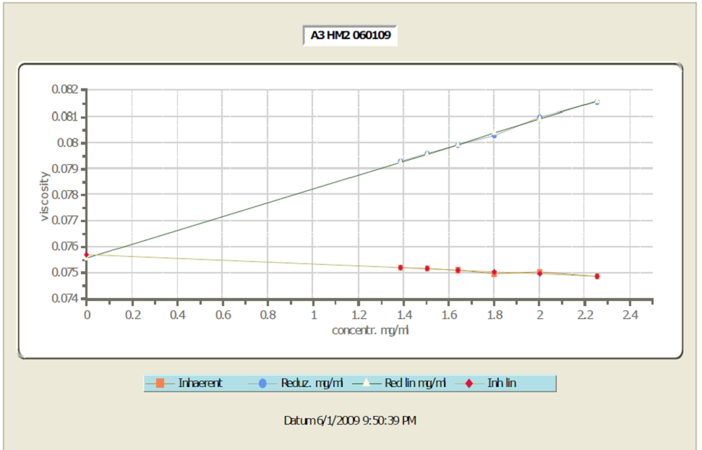

Figure A.1 A Huggins-Kraemer plot illustrating how the intrinsic viscosity was obtained from the viscometry measurement.

A Schott Instruments ViscoSystems AVS 370 Dilute Solution Viscometer was used for automated dilutions of five concentrated polymer solutions composed of HyperMacs and DendriMacs in tetrahydrofuran (THF) at 30°C. For four of the five solutions a starting concentration of 2.0-2.2 mg/mL was diluted five times down to a concentration of 0.8-1.4 mg/mL. One of the solutions had a starting concentration of 1.1 mg/mL and was diluted five times down to 0.5 mg/mL. A few recommended guidelines for choosing an appropriate capillary viscometer were followed to ensure that measurements would give the best possible results.¹¹⁵ It is best to choose a viscometer such that the flow time is greater than 100 seconds to avoid having to take into account the kinetic energy of a fast flowing fluid which can impact the value of the measured viscosity. To adjust flow times, viscometers are available with different radius capillaries. The smaller the capillary, the longer the flow time and thus one needs to select a viscometer to give good flow times in the expected viscosity range of the measured solutions. Moreover, it is important to clean the capillary viscometer thoroughly prior to use to remove any contamination from previous solutions as well as any dust particles, as these could add to the solution and change its viscosity.
Calculation of flow times for various viscometers was used to determine the best capillary viscometer for the experiment. The ratio of the absolute viscosity (also known as dynamic viscosity), η, to mass density, ρ, is the kinematic viscosity, ν, as shown in equation A.6:¹¹⁵
(A.6)
Both the absolute and kinematic viscosity is related to the capillary viscometer constant, k, and the flow time, t, through the following relation:¹¹⁵
(A.7)
Values for the temperature dependent absolute viscosity and mass density of THF were obtained from the literature and used to calculate flow times. At 25°C, the absolute viscosity of THF is 0.4695 centipoise (cps) and the mass density is 0.88194 g/mL.¹⁸² For these experiments, a 0.47 mm capillary Ubbelohde viscometer (type 531-03, k=0.003) was chosen to measure the flow of polymer solutions as well as pure solvent. The viscometer chosen has a flow time of 177 seconds, a measuring range of 0.5-2 mm²/sec and total volume of 75 mL. The viscometer was thoroughly cleaned with THF prior to each use and dried with dry N₂(g). The solvent, THF, was degassed by sonication prior to being used in the viscometry measurement.
- Size Exclusion Chromatography

Size Exclusion Chromatography (SEC) is the most widely used method for characterization of synthetic polymers as it requires relatively small amounts of sample, time and effort. The stationary phase is a solid support that is composed of porous beads that vary in size. The space between the porous beads is referred to as the interstitial space. For the routine separation of synthetic polymers, SEC typically utilizes a crosslinked polystyrene divinylbenzene gel as the stationary phase. The mobile phase is an organic solvent. Thus, in a mixture of small and large macromolecules, smaller macromolecules can explore the space within the porous beads as well as the interstitial space while larger macromolecules can only survey the interstitial space between the beads. Moreover, in SEC, any enthalpic contribution to the free energy of the system is minimized by choosing a mobile phase that is a good or strong solvent. Specifically, the designation of good and strong solvent refers to the ability of the solvent to readily elute the polymer from the column. By selecting a mobile phase that swells the polymer and promotes polymer-solvent interactions, conditions can overwhelmingly favor the elution of the polymer with the mobile phase and disfavor polymer-column as well as polymer-polymer interactions. Thus, conformational entropy differences dominate the partition equilibrium between the two environments and polymers are separated by their hydrodynamic size. Fortunately, for many homopolymers with a linear architecture, a simple linear relationship exists between the molecular weight and retention volume of the polymer. Using a concentration sensitive detector such as a refractive index detector to obtain information on how much of an analyte is present as well as calibration with linear polymer standards to determine the molecular weight, one can extract the molecular weight distribution from such experiments.
Triple detection SEC not only utilizes concentration detectors, but also detectors that are sensitive to molar mass. Both light scattering and differential viscometers are two such detectors. Light scattering detection makes it possible to determine the molar mass distribution directly. By using light scattering detection at more than one angle, the radius of gyration for a polymer can also be acquired. The measured intrinsic viscosity, using a differential viscometer detector, can also be used to indirectly provide the molar mass distribution.
Nevertheless, since this particular study involves hyperbranched polymers, it is important to recognize the limitations of SEC for the analysis of branched polymers. SEC cannot identify what is referred to as the local polydispersity in an elution fraction. Fractions of analytes containing a distribution of structures and molar masses may elute at the same retention volume because they have the same (or very similar) hydrodynamic size. Thus while SEC is sufficient to characterize the molecular weight distribution of linear polymers, analysis of branched polymers may require not only the use of triple detection, but also, as reported in the literature for a wide variety of branched architectures, techniques employing two-dimensional separation where, for example, one dimension is SEC and the other is a technique called temperature gradient interaction chromatography (TGIC) which separates according to molar mass.¹⁸³

A.2 Methods for Characterization of the Blend Film
A. Ellipsometry
Ellipsometry measures the changes in the polarization of light caused by reflection or transmission from a material. How a light wave changes upon passing through a medium can be characterized by the complex refractive index, N, which is described in the following equations:¹⁸⁴
(A.8)
(A.9)
(A.10)
where n is the index of refraction and is a ratio of the speed of light in a vacuum, c, to the speed of light in a particular medium, v; k, the extinction coefficient, is a value that determines how rapidly the amplitude of a wave traveling through a medium diminishes; a is the absorption coefficient; and λ is the wavelength of the light. The electric component of a light wave is composed of two orthogonal components identified as p and s. The p component of a light wave lies in the plane of the incident and reflected wave while the s component lies perpendicular to the plane of beam propagation. The amplitudes and phase of the p and s polarized components of light change upon reflection or transmission through an interface. A phase angle of 0° will result in linear polarization with the orientation determined by the relative amplitudes of the vector components. A phase angle of 90° as well as equal amplitudes for s and p components will result in circular polarization. Unequal amplitudes and a phase angle not equal to 0° or 90° results in elliptical polarization. In ellipsometry, linearly polarized light impinges on a sample and the amplitude and phase shifts of the s and p components of the light wave are measured and used to extract information on the complex refractive index and thickness of the sample film after fitting the data to a theoretical model of the given experimental system. The theory of how the measurement of the change in light relates to the sample film properties is based on the Fresnel equations for reflection and transmission of polarized light. For reflection from a single interface, the Fresnel equations are the following:¹⁸⁴
(A.11)
(A.12)
where the Fresnel reflection coefficients, r_{p} and r_{s}, are the ratios of the amplitude of the reflected and incident waves for the p and s components of the wave, respectively. The angles θ₁ and θ₂ are the angles of incidence and refraction relative to the normal, and n₁ and n₂ are the refractive indices of the 2 media as illustrated below in Figure A.2.

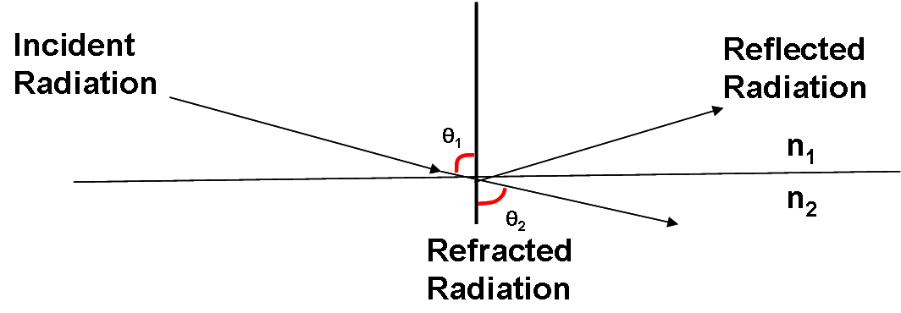

Figure A.2 Reflection and refraction of light from a single interface.
The same process of reflection and refraction occurs within each buried interface of a sample with multiple layers and interfaces so that the total reflection coefficients, R, for the s and p wave components for a sample that for example, has a buried interface as well as an exposed surface are:¹⁸⁴
(A.13)

(A.14)
where β, the phase of the wave, relates to the film thickness, t₁, through the following relationship:¹⁸⁴
(A.15)
The superposition of multiple light waves introduces interference that depends on the relative phase of each light wave. In a multilayered system, multiple reflections at the interfaces of the layers superimpose to finally form the reflected light wave with an altered state of polarization. Figure A.3 illustrates the reflection and refraction of light in a sample containing an exposed surface and a buried interface.

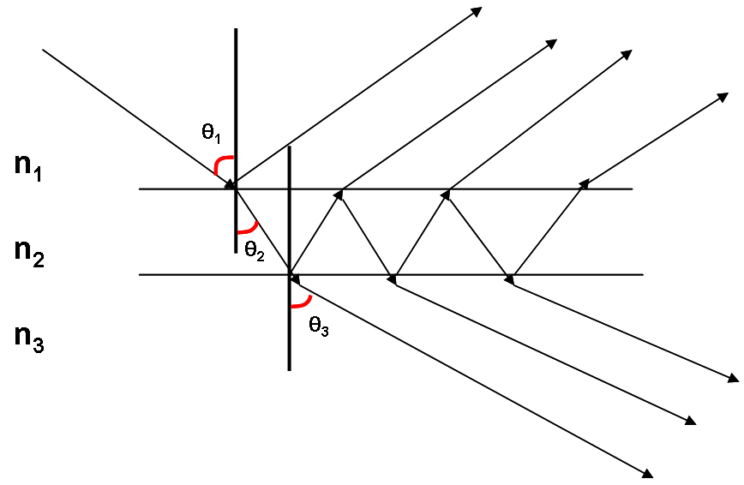

Figure A.3 Reflection and refraction of light from a sample containing an exposed surface and a buried interface.

The parameters that are actually measured in an ellipsometry experiment are tan Ψ and cos Δ, which are also the polar representation of r in thecomplex plane. The parameter tan Ψ is the ratio of the amplitudes of the p and s components of the reflected light while cos Δ is the ratio of the phase of the p and s components of reflected light. The Drude equation (A.16) is the fundamental equation of ellipsometry and it relates the measured quantities Ψand Δto the amplitudes of the s and p components of the reflected wave (i.e., total reflection coefficients, R_{p} and R_{s}):¹⁸⁴

(A.16)
where
(A.17)

(A.18)

Thus, using the Drude equation, both thicknesses and refractive indices can be determined for layers in a sample by fitting data to a model based on the known experimental parameters.
Ellipsometers based on rotating polarizing elements are used to measure the parameters tan Ψ and cos Δ. One way to measure these parameters is in a nulling ellipsometry configuration where the path of light and its polarization are as shown in Figure A.4.

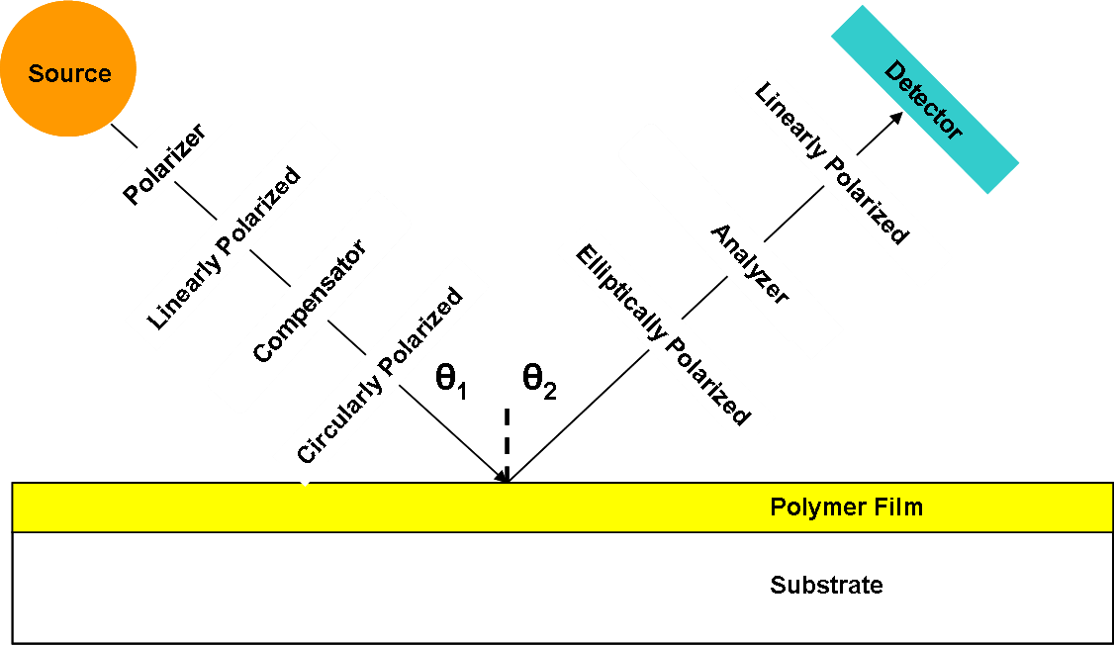

Figure A.4 Configuration for nulling ellipsometry experiment.
Monochromatic light passes thru a polarizer and becomes linearly polarized. The linearly polarized light passes thru a compensator also known as an optical retarder that shifts the phase between the s and p components of light such that the resulting wave is circularly polarized. The circularly polarized light becomes elliptically polarized upon reflection under an angle equal to the incident angle from a sample. The angles of the analyzer and the incident light polarizer are adjusted such that the elliptically polarized light emerging from the sample is converted to linearly polarized light that is oriented at an angle 90° to the incident linearly polarized light. Since two linear polarizers at an angle of 90° do not transmit light, a null signal is detected by a photodetector. Moreover the ellipsometric angles Ψ and Δ are a function of the angles obtained for the polarizer, analyzer, and compensator. The thickness of the sample film and the complex refractive index are obtained by comparing the ellipsometric angles to a theoretical model of the given experimental system. A nulling ellipsometer was used to measure the thicknesses of dry films in these studies.
- Neutron Reflectivity

Neutron reflectivity is a depth profiling technique that gives information about the composition of a thin film normal to the surface. The technique is sensitive to the details of an interface at a molecular level with resolution on the order of one nanometer. Since neutrons interact weakly with most materials, they can penetrate deep into a material without destroying it. In contrast, complementary ion beam methods such as dynamic secondary ion mass spectrometry (DSIMS), with depth resolution on the order of tens of nanometers, often result in the destruction of a material after analysis. A distinct advantage of neutron reflectivity is that isotopic substitution can be used to create contrast in hydrogenous systems because the neutron scattering length (measure of scattering power) for hydrogen and deuterium are very different (-3.74E-5Å and 6.67E-5Å, respectively). By deuterating one component of a hydrogeneous system, one can potentially explore depth profiles for a number of model systems.
Reflection of a wave at an interface between two materials occurs when the refractive indices of the materials are different. Neutrons reflect and refract from an interface according to Snell’s Law:¹⁸⁴
(A.19)
where n₀ and n₁ are refractive indices and θ₀ and θ₁ are the angles of incidence and refraction, respectively. The refractive index of materials for neutrons is given by:¹⁸⁴
(A.20)
where the imaginary component accounts for adsorption which is small for most materials and is therefore considered negligible. The real part of the refractive index, δ_{N}, is defined as:¹⁸⁴
(A.21)
where N_{i} is the number density of scattering centers (or formula units per unit volume) that each have a coherent scattering neutron scattering length b_{i}, and ρ is the scattering length density. For most materials the value of the neutron scattering length is small and therefore n is less than unity. Thus in such materials there exists a critical angle below which there will be total reflection and above which there will be refraction into the material. The value of the critical angle, θ_{C} , depends on the wavelength of radiation, λ, and on the scattering length density of the sample, ρ, through the following relation:¹⁸⁴
(A.22)
The value of δ_{N} is on the order of 10⁻⁶ and thus the critical angle is very small. Consequently, measurements in neutron reflectivity must be made at grazing angles of incidence and highly collimated beams of neutrons must be used. Figure A.5 illustrates how the refractive index is related to the scattering experiment, where the angle of incidence equals the angle of reflection and is called specular reflection.

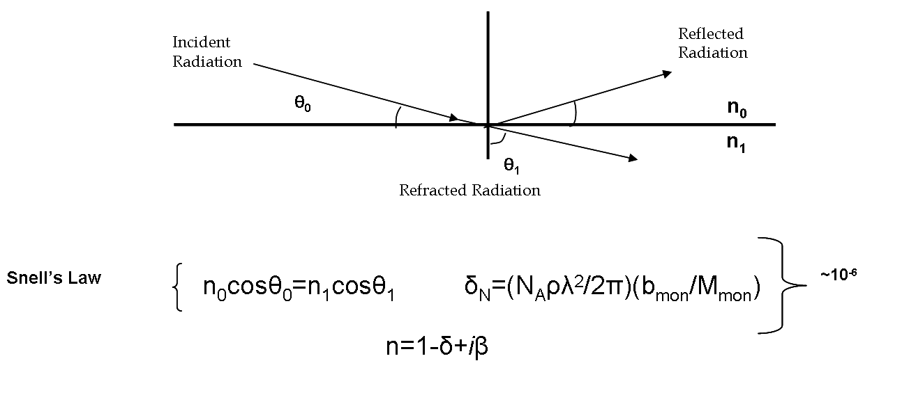

Figure A.5 How n, the neutron refractive index, is related to the scattering experiment.

In a neutron reflectivity experiment, a collimated neutron beam with wavelength, λ, impinges on a surface at an incident angle, θ, and the reflectivity, R, which is a ratio of the reflected and incident beams, is measured as a function of momentum transfer perpendicular to the sample surface, Q_{z}. Equation A.23 shows the relationship between Q_{z} the incident angle, θ, and wavelength, λ:¹⁸⁴

(A.23)
Figure A.6 illustrates how the momentum transfer vector, Qz, is related to the scattering experiment. The momentum transfer vector, Qz, is composed of the incident wavevector, k_{i}, and the reflected wavevector, k_{f}.

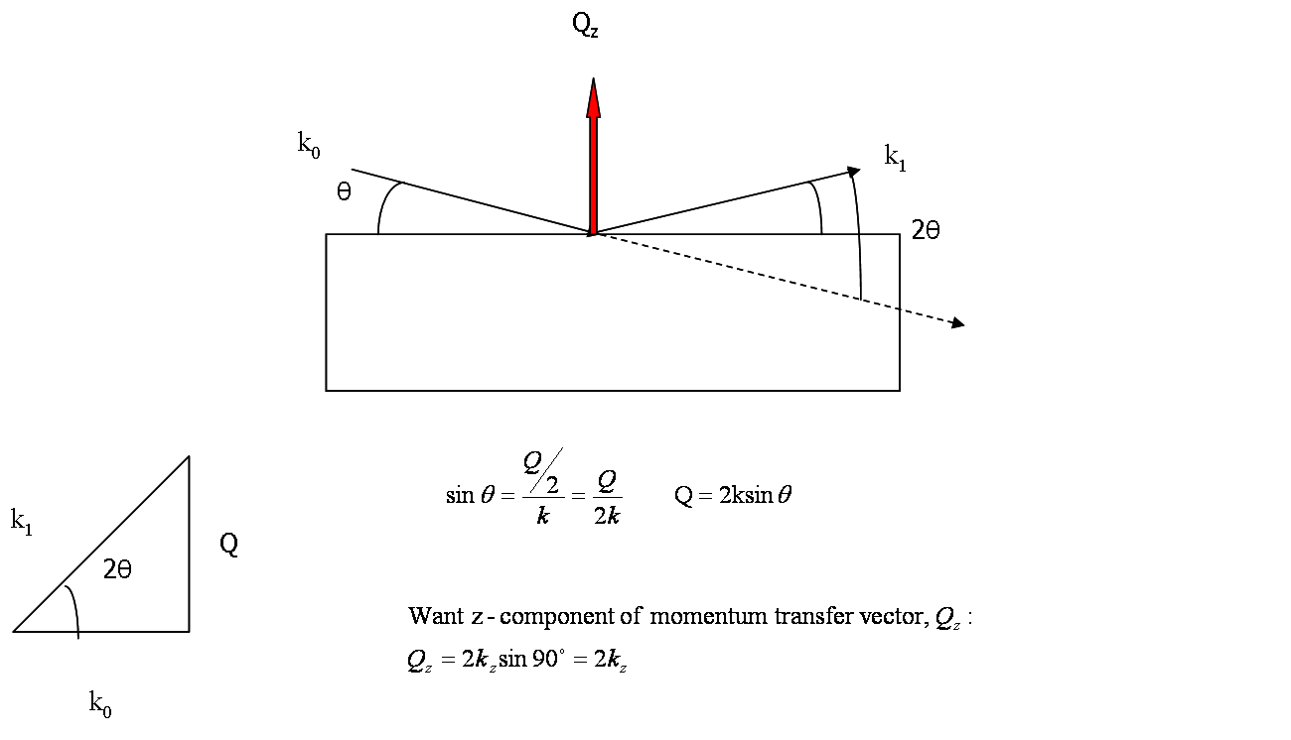

Figure A.6 How Q_{z}, the momentum transfer vector, is related to the geometry of the scattering experiment.
How much radiation is reflected at a surface or interface depends on the differences in the momentum transfer in the media on either side of an interface, k₀ and k₁, which is also related to the neutron refractive index, n, and scattering length density, ρ, through the following relationships:¹⁸⁴
(A.24)
During an experiment, the intensity of the reflected radiation is measured for a range of Q_{z} values which are chosen by changing the angle of incidence of the beam to the sample surface and/or by changing the wavelength of the neutron beam. At small momentum transfer values, there will be total external reflection and the reflected intensity will be unity. Q_{c} is called the critical edge and it is the value below which the reflected intensity is unity. At values greater than Q_{c}, the reflectivity is governed by the Fourier transform of the scattering length density gradient normal to the surface by the following relationships:¹⁸⁴
(A.25)

(A.26)
The reflectivity decreases above Q_{c} as Q_{z}⁻⁴ for an infinitely sharp interface.For an interface that is not sharp, the reflectivity falls off more quickly. Moreover, interference between reflected beams leads to maxima and minima in the reflectivity called Kiessig fringes. The thickness of the polymer layer can be determined from the distance between the minima in the Kiessig fringes:¹⁸⁴
(A.27)
Any roughness at the interfaces within the layer (caused by interdiffusion between different polymers in a blend, for example) will dampen the depth and height of the Kiessig fringes. The height of the fringes also indicates the difference in scattering length density between the substrate and the polymer. Figure A.7 illustrates a typical reflectivity profile.

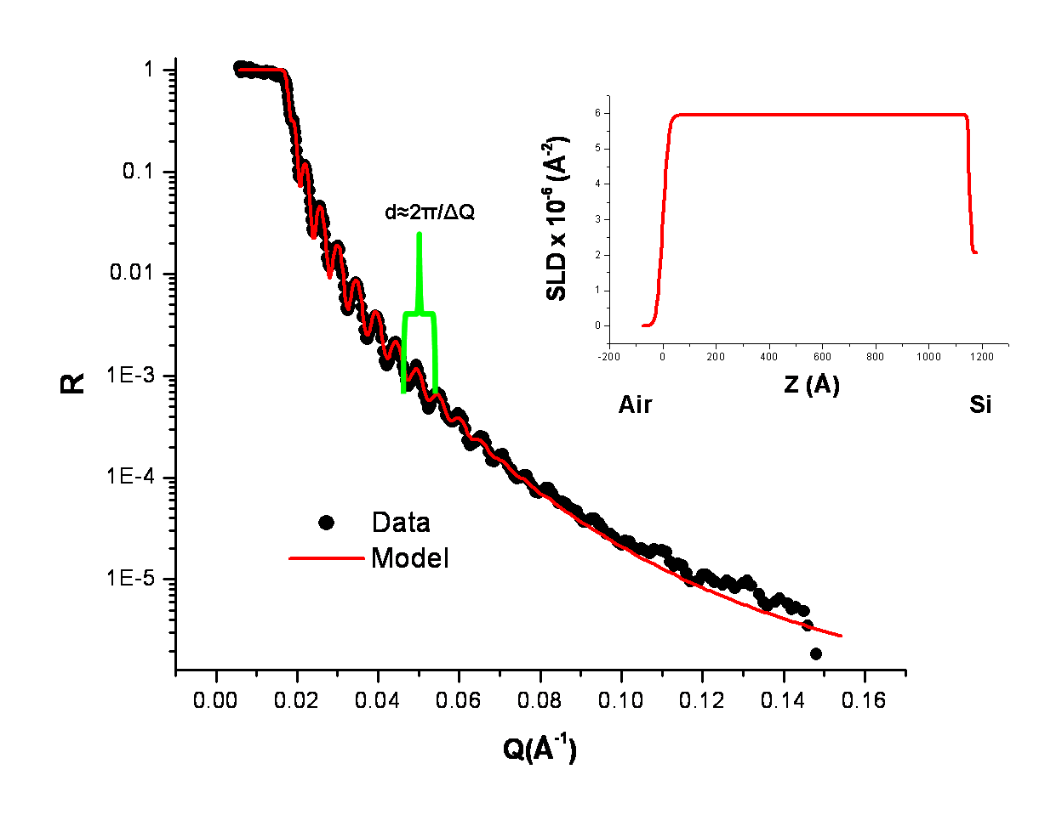

Figure A.7 A neutron reflectivity profile of a single deuterated poly(styrene) layer on a silicon substrate. Note the distance between the minima of the Kiessig fringes which indicates the thickness of the polymer layer. The inset shows the scattering length density profile for this polymer layer.
Since the reflectivity that is measured is an optical transform of the real-space composition profile normal to the surface, one cannot directly determine the depth profile from this experiment (however, there are some alternative treatments that have been discussed in the literature).^{185,186} This is of course known as the age-old inverse problem. That is, since phase information is lost in a scattering experiment, there are a number of models that may fit the data well. Information about the thickness of the film and the composition of the film are needed in order to fit the data properly. In addition, results from other depth profile experiments are useful in verifying a model obtained with neutron reflectivity. Thus the procedure for obtaining an accurate description of the depth profile of a material involves an iterative process that includes creating a model of the film in real-space, transforming that model to a reflectivity profile in scattering space and then refining the fit to the data followed by further re-evaluation of the fit. There are many software packages available to perform this iterative fitting. In general, these software packages approximate the continuously varying scattering length density profile with a slab model which divides the profile into layers of thickness d_{n}, heights of scattering length density ρ_{n} and roughness between layers σ_{n}, all of which are sandwiched between the super- and sub-phases air and silicon, for example, as shown in the inset of Figure A.7. The parameters that are used to describe these layers are varied in a refinement procedure that minimizes the differences between the theoretical and measured reflectivity curves. As was discussed in the section on ellipsometry (part A), the Fresnel equations describe the ratio of amplitudes of reflected and incident beams. In neutron reflectivity, these amplitudes are expressed in terms of the wave vector of momentum transfer.¹⁸⁴ The Fresnel reflection coefficient between adjacent layers, modified by an error function which describes the roughness or diffuseness between layers as well as a phase factor, β, which accounts for the thickness of each layer, is calculated. A matrix is then calculated for each layer and the product of these matrices is used to calculate the reflectivity, R. This procedure for calculating the reflectivity from a model real-space profile is known as the Abeles matrix method for a stratified interface. Further details on the method can be obtained from the literature.¹⁸⁴
Neutron reflectivity experiments are conducted at reactor sources such as the National Institute of Standards Center for Neutron Research (NCNR) in Gaithersburg, Maryland, or at a spallation source such as the Spallation Neutron Source (SNS) at Oak Ridge National Lab (ORNL) in Oak Ridge, Tennessee. At a reactor source, the neutron wavelength is fixed, and the angle of incidence is varied. In contrast, at a spallation source, the angle of incidence is held constant while the wavelength is varied. Measurement of reflectivity by a reflectometer gives rise to smearing of the profile. The momentum transfer resolution of the spectrometer, ΔQ/Q, is given by:¹⁸⁴
(A.28)
where the first term represents the wavelength divergence and the second term represents the angular divergence of the neutron beam. The angular divergence is largely determined by the dimensions of the slits that collimate the incoming neutron beam. For a fixed wavelength spectrometer, the wavelength divergence is set by the wavelength resolution of the monochromator. For a fixed angle of incidence spectrometer, wavelength resolution is determined by how well the time-of-flight of a neutron traveling from a source to detector is measured. At a spallation source, neutrons are produced by accelerating protons onto a heavy metal target. The energy of a neutron, E, of mass m_{n}, is proportional to the square of the velocity, ν, which is also related to the wavelength of the neutron, λ, through the following relationship:¹⁸⁴
(A.29)
The wavelength of the neutron can be determined by:¹⁸⁴
(A.30)
where the time, t, is the time which originates with the impact of a proton beam on a heavy metal target and ends with the arrival at a detector; likewise, the distance from the source of neutrons to the detector is l. Instrument resolution for both fixed wavelength and fixed angle of incidence spectrometers, ΔQ/Q, is kept constant by increasing the dimensions of the slits (Δθ) as θ increases.However, for a time-of-flight spectrometer, in order to cover a wide range of Q_{z}, measurements have to be taken at different angles. Thus data analysis involves extra processing of the data as the reflectivity profiles from measurements at different angles for a single sample have to be combined. For both types of spectrometers, a background scan has to be measured and used to normalize the reflectivity profile. Incoherent scattering from hydrogen is a major contributor to this measured background.

C. Elastic Recoil Detection Spectroscopy

1) Overview of the Experiment
Elastic Recoil Detection (ERD) Spectroscopy is used for the detection of hydrogen (¹H and ²H) in polymer films.¹⁸⁷ Just as in neutron reflectivity, isotopic substitution can be used for contrast to resolve depth distribution in polymer blends. It requires an accelerator source of MeV ions. Typically ⁴He ions are used at an energy of 1-2 MeV because the heavier the projectile ion, the more potential for sample radiation damage. Mass and energy resolving bending magnets and collimators help to define the ⁴He ion beam position and spot size. In an ERD experiment, the mass of the incident ion, ⁴He, is greater than the mass of the target, H and D, and thus both the incident ⁴He ions and the recoiling H⁺ and D⁺ ions are scattered in the forward direction. A Mylar foil is placed in front of the detectors to reduce the kinetic energy of the forward scattered ions. The energy loss for the heavier ⁴He nuclei is greater than that for the lighter H and D target nuclei when passing through the Mylar foil, thus making it possible to distinguish between the incident projectile and recoiling ions. To increase the number of recoiling ions detected, a glancing angle arrangement is chosen, since most specimens will be too thick to allow either ⁴He or H ions to escape in transmission geometry. In addition, the sample is placed in a vacuum chamber during the measurement to prevent energy loss due to collisions with air. Local ion beam heating is minimized by both the use of liquid nitrogen for cooling as well as rastering of the beam over various regions of the sample. Figure A.8 illustrates the experimental setup for an ERD measurement.
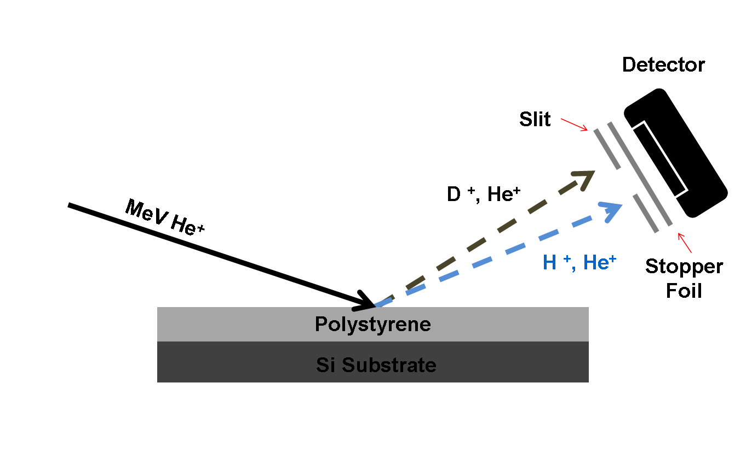

Figure A.8 Experimental setup for an ERD measurement. Both projectile and target ions are scattered in the forward direction. A Mylar foil helps to select for the target H and D ions.

In an ERD experiment, the energy of ions scattered at a known angle is measured and used to indicate both the mass of the scattering nucleus and the depth of penetration of the ion into the sample before the scattering collision occurred.¹⁸⁷ A compositional depth profile can be created because different nuclei will scatter incident ions with different energy. Detectors are assigned channel numbers which represent energy loss, ΔE, with depth into the film. The elements present in a target sample are determined by the position of the peak (i.e. the energy). The width of the peak gives information about the thickness of the layer. The height of a peak in an ERD spectrum, or counts per channel, gives concentration information at energies corresponding to particular depths within the sample. Figure A.9 displays a sample ERD spectrum of a thin polymer blend film composed of deuterated and protonated PS.

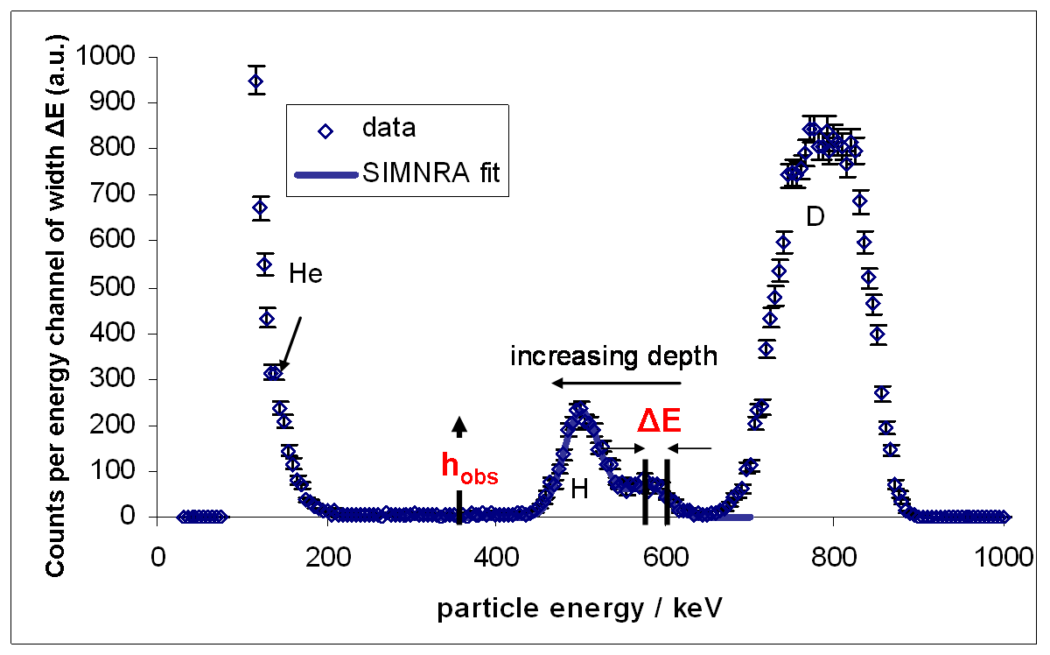
Figure A.9 Counts of H and D recoil ions detected as a function of energy for a blend of deuterated and protonated PS collected in an ERD experiment. Detectors are assigned channel numbers which represent the energy loss with depth into the film, ΔE. Calibration standards and simulation programs, such as SIMNRA, can be used to convert an ERD spectrum into a depth composition profile.

Detailed information regarding the depth profile of a material and its chemical composition is obtained as a result of the interactions between incident projectile ions and the electrons and nuclei of a material. As incident ions penetrate a target, interactions with electrons and nuclei within a material result in energy loss due to momentum transfer between the particles. How much a sample reduces the incident ion beam energy is referred to as the stopping power. The stopping power is related to the depth of the recoiling ions. The energy loss with depth can be calculated experimentally by measuring the energy loss for a film of known composition and thickness. Such films are used as calibration standards to help interpret the collected data. Moreover, software programs such as SIMNRA¹¹²can be used to simulate ERD spectra, as shown in Figure A.9.The differential cross section for the nuclear scattering process between the projectile and target ions is used to convert the number of detected recoil particles into a volume fraction of H or D ions in a sample at a particular depth.¹⁸⁷
Depth resolution in an ERD experiment is determined by the energy resolution capabilities of the detector and the energy loss of the ion beam due to straggling in the Mylar stopper foil.^{187, 188} The largest contribution to depth resolution is due to this phenomenon of straggling in which the ion beam spreads as a result of multiple small-angle collisions with nuclei in the sample. Straggling increases with the square root of the Mylar film thickness. Thus depth resolution varies with depth. Based on the conditions of the ERD experiment in our studies, the error in the ERD measurements is estimated to be no more than 1 nm.

2) Analysis of ERD Data in Thermally Annealed Blends of HyperMacs and DendriMacs in a Linear Polymer Matrix
In an ERD measurement, the depth scale is defined in terms of how much matter is traversed by the ion beam and is reported in units of atoms/cm². To convert this depth scale into units of length (eg., nm), the number of atoms per unit area (as measured by ERD) first has to be converted to a mass per unit area, and this is followed by conversion into a thickness using the density of the material. Equation A.31 illustrates how 10¹⁵atoms/cm² of a monomer unit of PS (which contains 50% atomic hydrogen, C_{0.5}H_{0.5}) is converted to a mass per unit area:

(A.31)
Using the density of PS (1.05 g/cm³), equation A.32 shows how the mass per unit area equates to a thickness (in nm):

(A.32)
The interfacial excess, Z*, of protonated HyperMacs and DendriMacs in a deuterated linear matrix at the near-air and near-substrate interfaces is the thickness of a layer (as measured by ERD), d, multiplied by a correction factor, Γ, that is equal to the actual volume fraction, Φ, divided by the mean assumed mass fraction, µ :
. (A.33)
The actual volume fraction of the branched additive in each binary blend investigated in this study, Φ, is 0.10. However, the mean assumed mass fraction, µ, represents the average fraction of H (i.e., branched additive) in each layer, which can vary from 0 to 1.0 depending on how much of the additive has migrated to each interface. The mean assumed mass fraction, µ, is calculated according to Equation 3.AA:
(A.34)
where d is the thickness of a layer in the near-air, near-Si substrate regions and in the bulk of the film, Φ_{bulk} is the volume fraction of the branched additive in the bulk of the film (which is depleted with increased annealing time as there is not enough material to cover both the near-air and near-substrate interfaces), and ρ_{film} and ρ_{PS} are the mass densities of the binary blend film and PS, respectively.

D. Water Contact Angle Goniometry
In a contact angle goniometry experiment, the angle between a solid surface and the line that is tangent to a liquid drop on a surface is measured. In the case where water is used as a liquid, small values of the contact angle would indicate a hydrophilic surface while larger values would signify that the surface is more hydrophobic. Thus water contact angle measurements can be used to monitor the surface segregation of a polymer blend component with a polar group, for example. The tangent line between the drop and solid surface will move until equilibrium is established between interfacial tensions at the solid, liquid and gas phases as illustrated in Figure A.10.

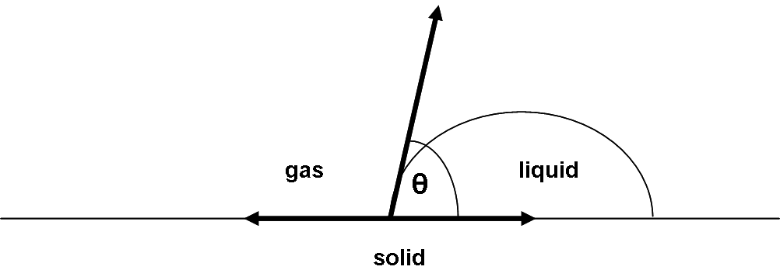

Figure A.10 A schematic of the solid-liquid-gas phase boundaries formed when a drop of liquid makes contact with a solid surface.
The balance of interfacial tension at the interface between the three phases is expressed through the Young equation:

(A.35)

where γ_{vs} γl_{s} γ_{vl} are vectors describing the interfacial tension between the vapor and solid, liquid and solid and vapor and liquid phases, respectively, and θ is the measured contact angle.
Contact angle measurements can be made in static or dynamic mode. In static mode (also known as the sessile drop method), the droplet is stationary. In dynamic mode, liquid is either flowing to the droplet during the measurement in which case the measured contact angle is called an advancing contact angle, or liquid is flowing away from the droplet and the measured angle is called a receding contact angle. The difference in receding and advancing contact angles is referred to as hysteresis and can be attributed to surface roughness, heterogeneity in the chemical composition of the surface, adsorption of the liquid on the surface, liquid dissolution on the surface, as well as the rate of change of the size of the droplet. The advancing and receding angles can be equated to sessile contact angle measurements when the hysteresis is due to the presence of high and low energy regions on a sample surface. A receding angle can be equated to a static drop measurement on an ideal high energy surface while an advancing angle can represent the equilibrium contact angle on an ideal low energy surface. Figure A.11 illustrates the three types of contact angle measurements.

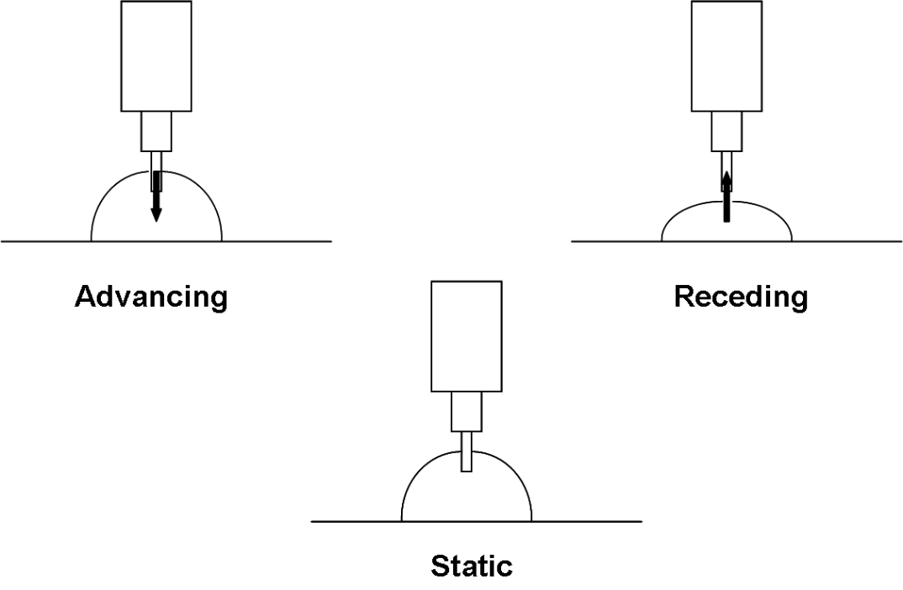

Figure A.11 The three most common methods for measuring contact angles are advancing, receding, and static (sessile) drop methods.

The largest contribution to error in a goniometry experiment is in the assignment of the tangent line that defines the measured contact angle. Reproducibility of the measured angle can vary with the particular operator and even when the measurements are made by the same individual. Computer programs that can assign the tangent angle minimize this error greatly.

A.3 Additional Experimental Data for Chapter 3
- Huggins-Kraemer Plots of HyperMacs and DendriMacs

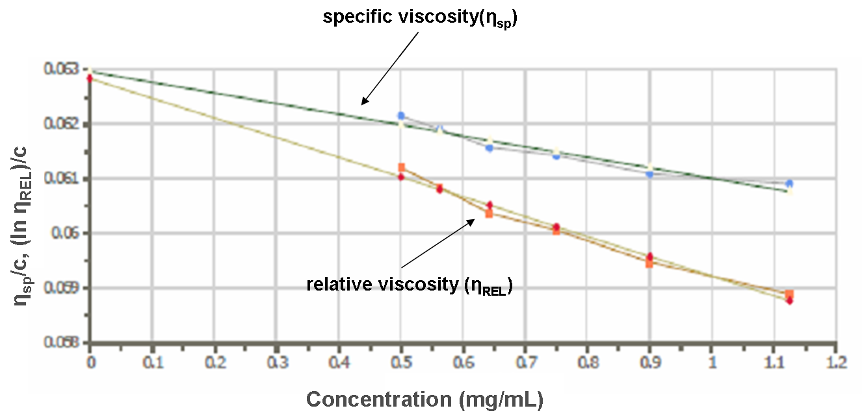

Figure A.12 Huggins-Kraemer plot obtained from viscometry measurements of HyperMac PSHM373. The plot extrapolates to an intrinsic viscosity, η, of 0.0629 mL/mg.

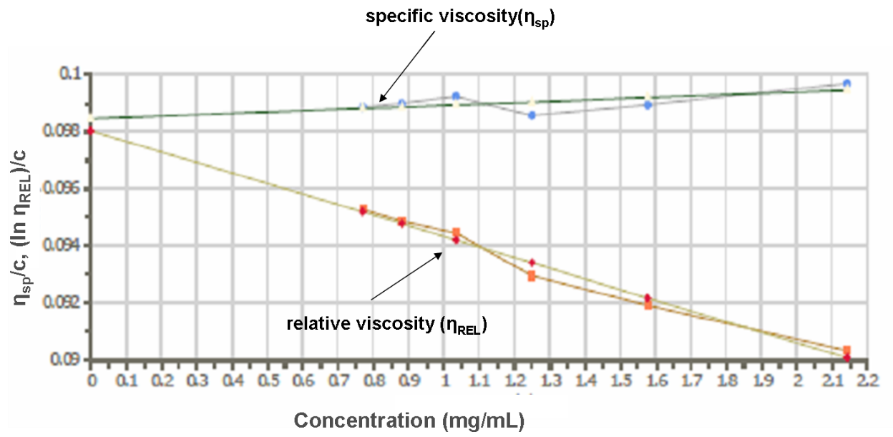

Figure A.13 Huggins-Kraemer plot obtained from viscometry measurements of HyperMac PSHM871. The plot extrapolates to an intrinsic viscosity, η, of 0.0984 mL/mg.

Figure A.14 Huggins-Kraemer plot obtained from viscometry measurements of HyperMac PSHM1530. The plot extrapolates to an intrinsic viscosity, η, of 0.1094 mL/mg.

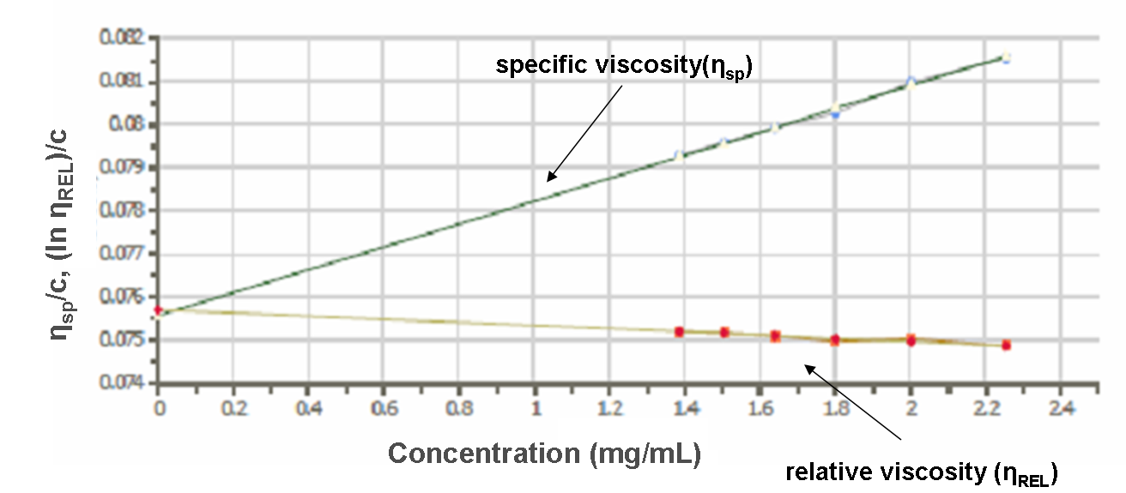

Figure A.15 Huggins-Kraemer plot obtained from viscometry measurements of DendriMac PSDM505. The plot extrapolates to an intrinsic viscosity, η, of 0.0756 mL/mg.

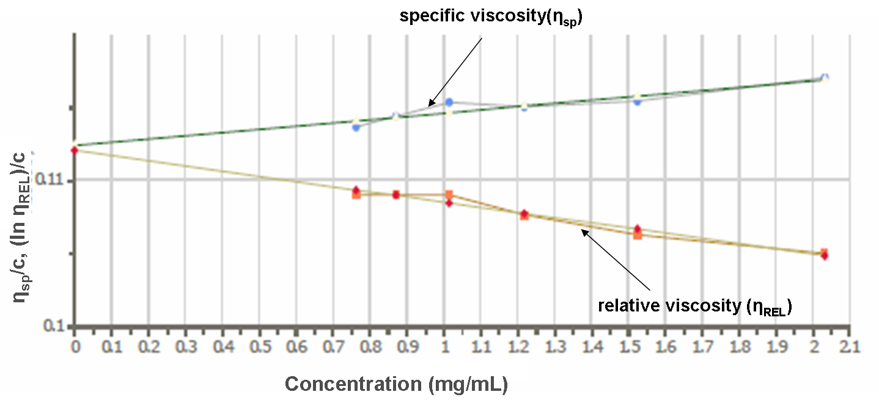

Figure A.16 Huggins-Kraemer plot obtained from viscometry measurements of DendriMac PSDM1105. The plot extrapolates to an intrinsic viscosity, η, of 0.1124 mL/mg.
- Neutron Reflectivity Profiles for Binary Blends of HyperMacs and DendriMacs in a Linear Matrix

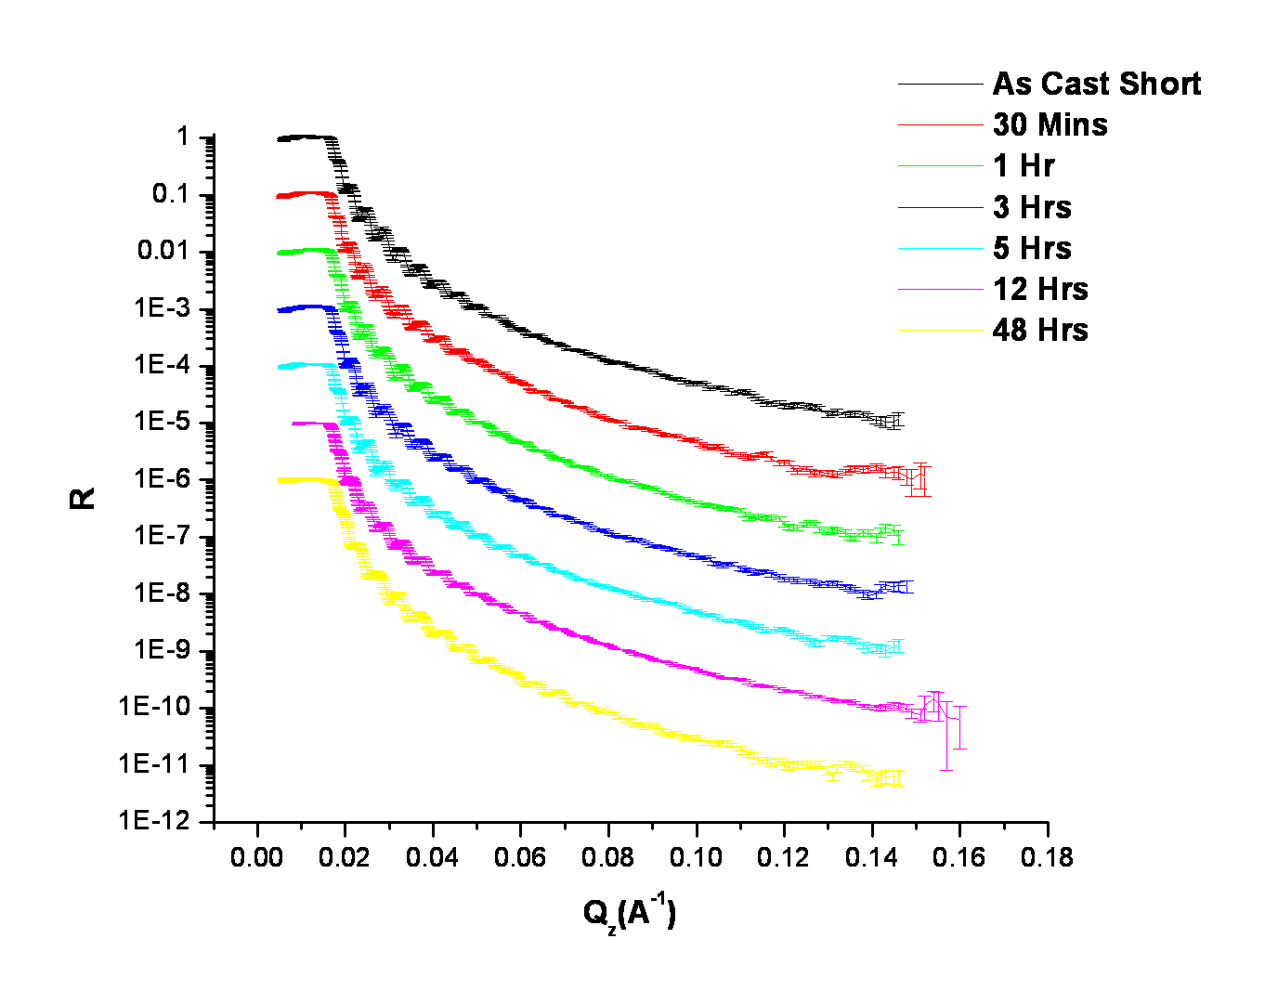

Figure A.17 Neutron reflectivity data for the binary blend HM373LPS measured as-cast up to an anneal time of 48 hours at 150°C under vacuum. Data is offset by a decade for clarity.

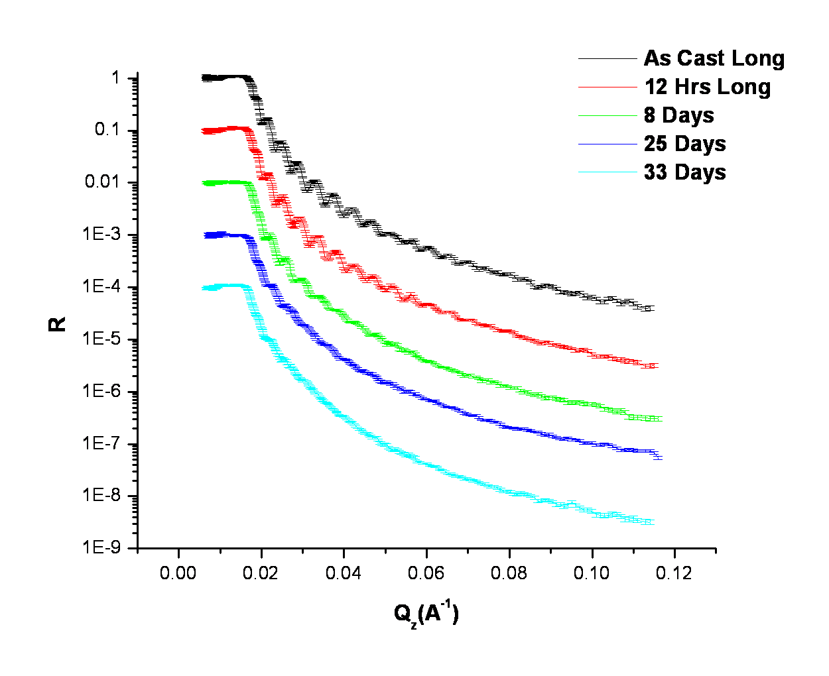

Figure A.18 Neutron reflectivity profiles for the binary blend HM373LPS measured as-cast up to a maximum anneal time of 33 days at 150°C. Data is offset by a decade for clarity.

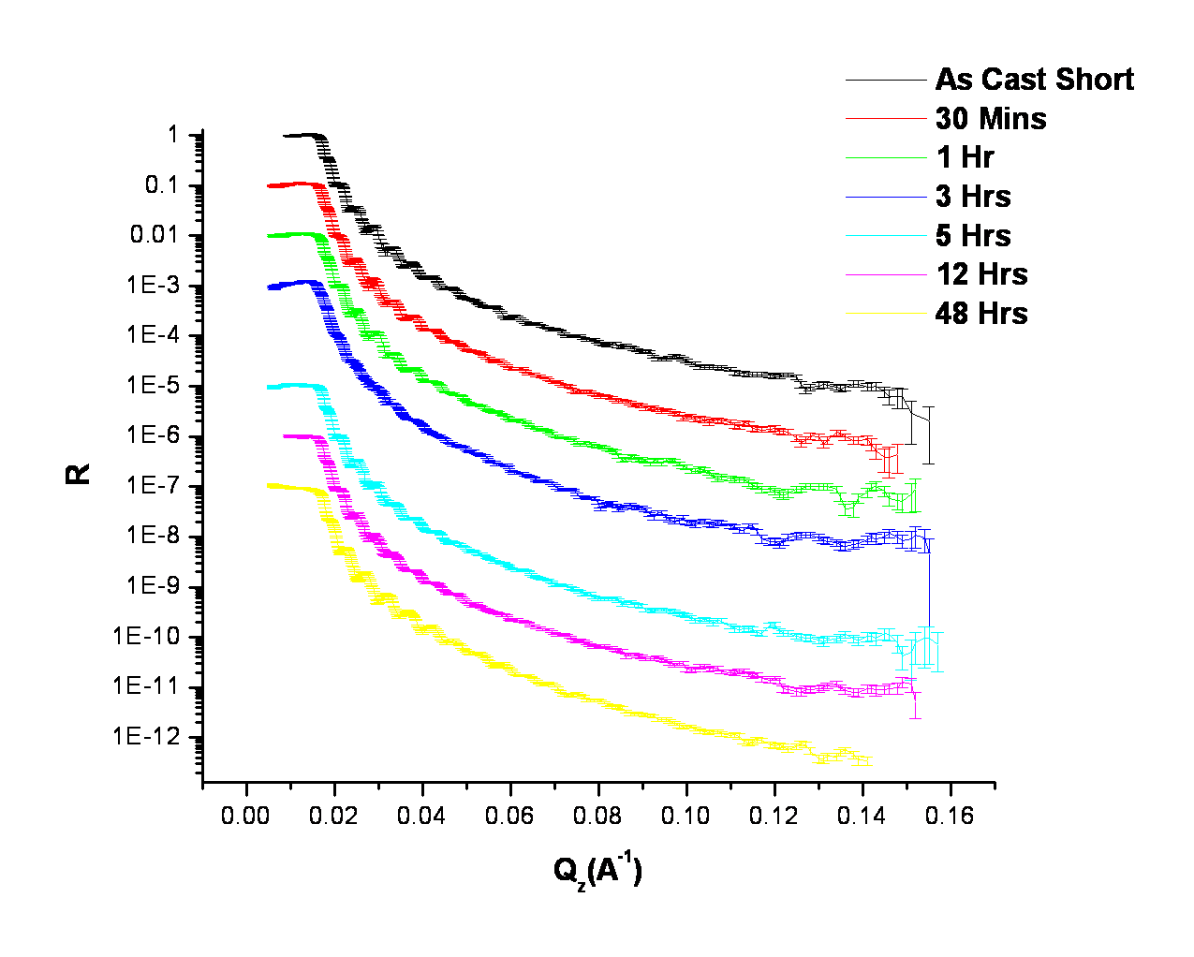

Figure A.19 Neutron reflectivity profiles for the binary blend HM871LPS measured as-cast up to an anneal time of 48 hours at 150°C under vacuum. Data is offset by a decade for clarity.

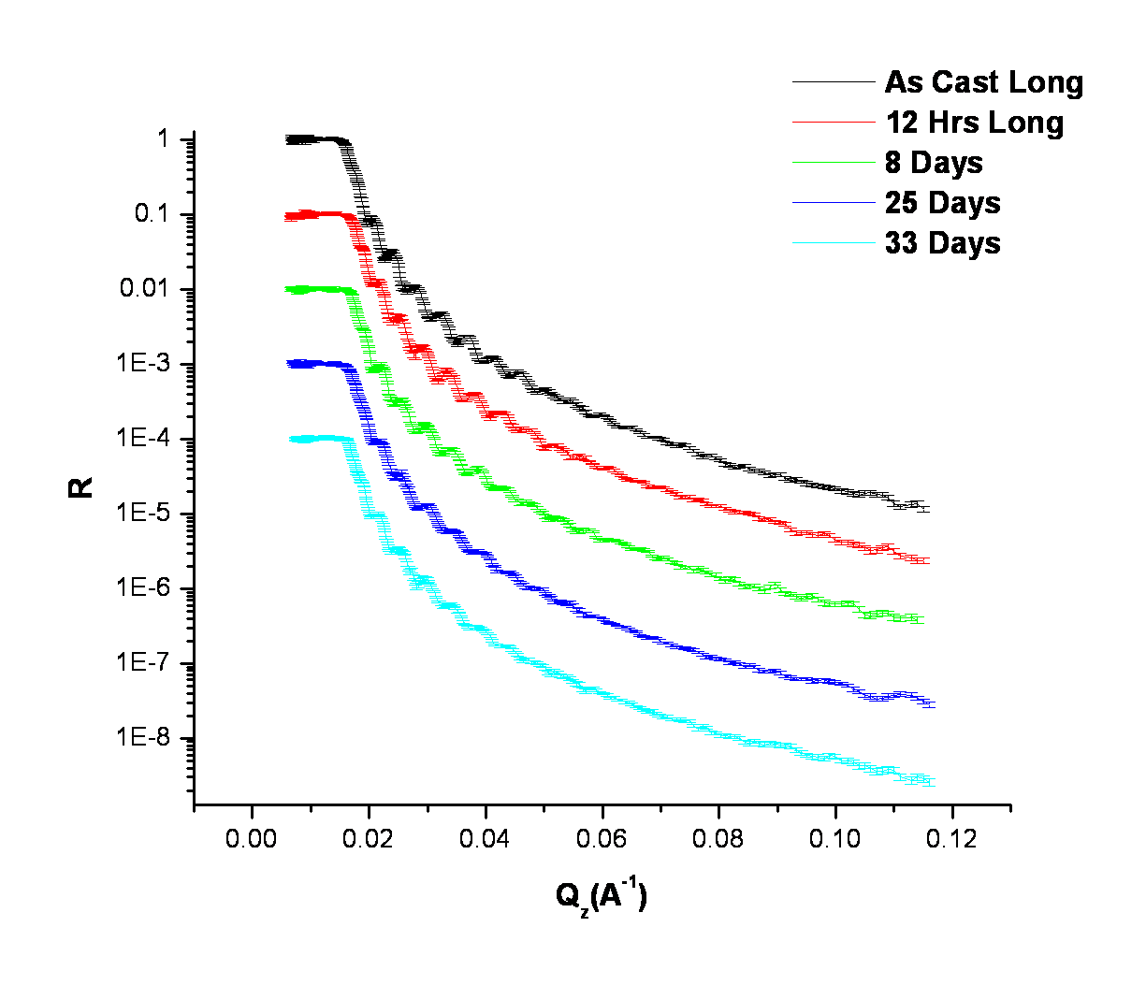

Figure A.20 Neutron reflectivity profiles for the binary blend HM871LPS measured as-cast up to a maximum anneal time of 33 days at 150°C. Data is offset by a decade for clarity.

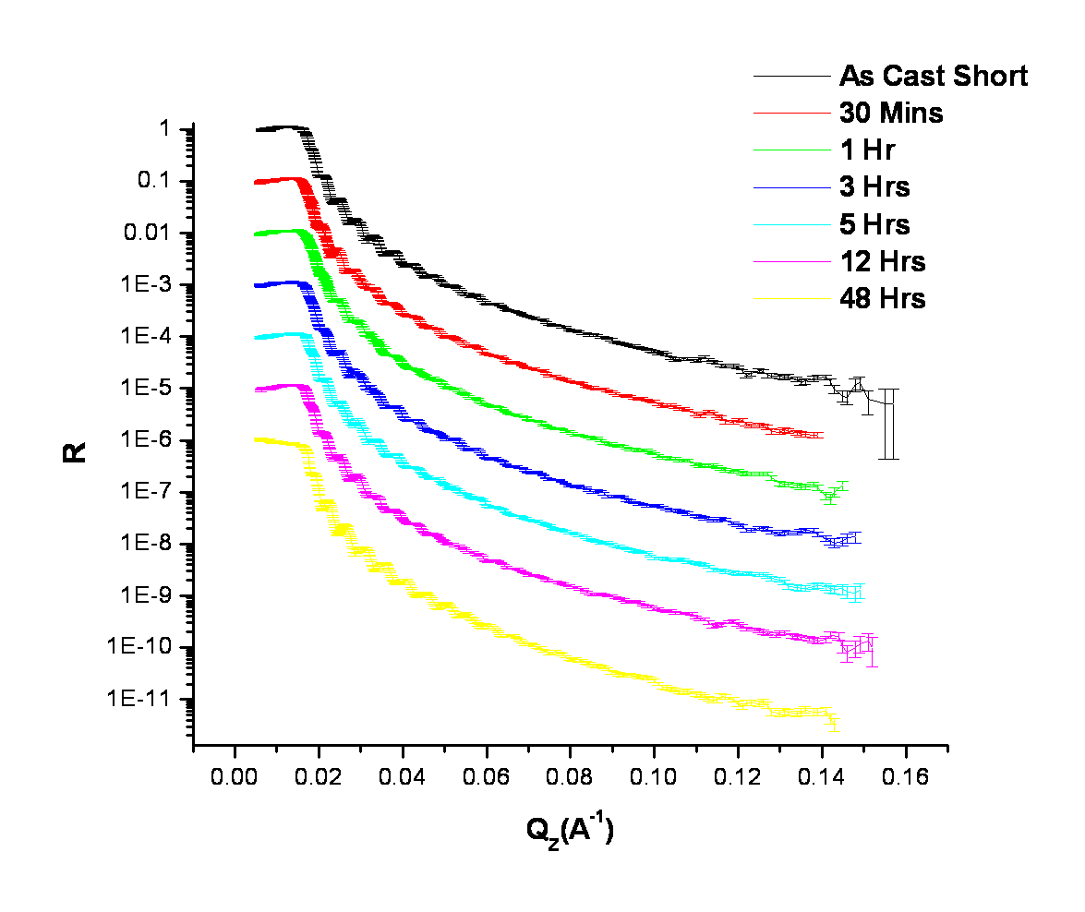

Figure A.21 Neutron reflectivity profiles for the binary blend HM1530LPS measured as-cast up to an anneal time of 48 hours at 150°C under vacuum. Data is offset by a decade for clarity.

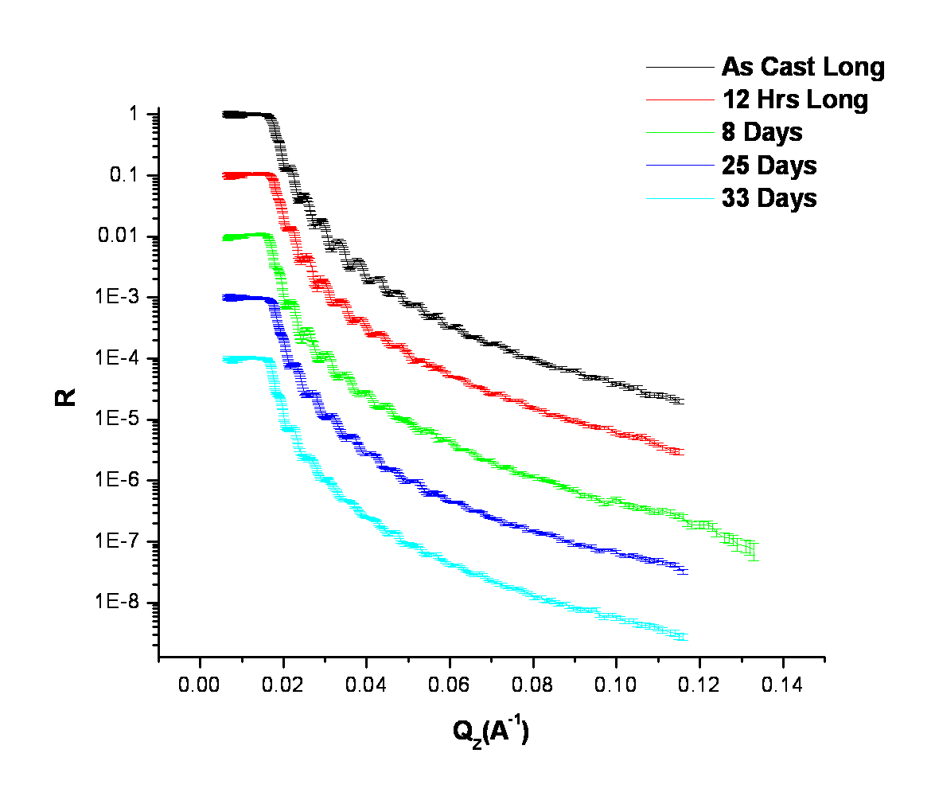

Figure A.22 Neutron reflectivity profiles for the binary blend HM1530LPS measured as-cast up to a maximum anneal time of 33 days at 150°C. Data is offset by a decade for clarity.

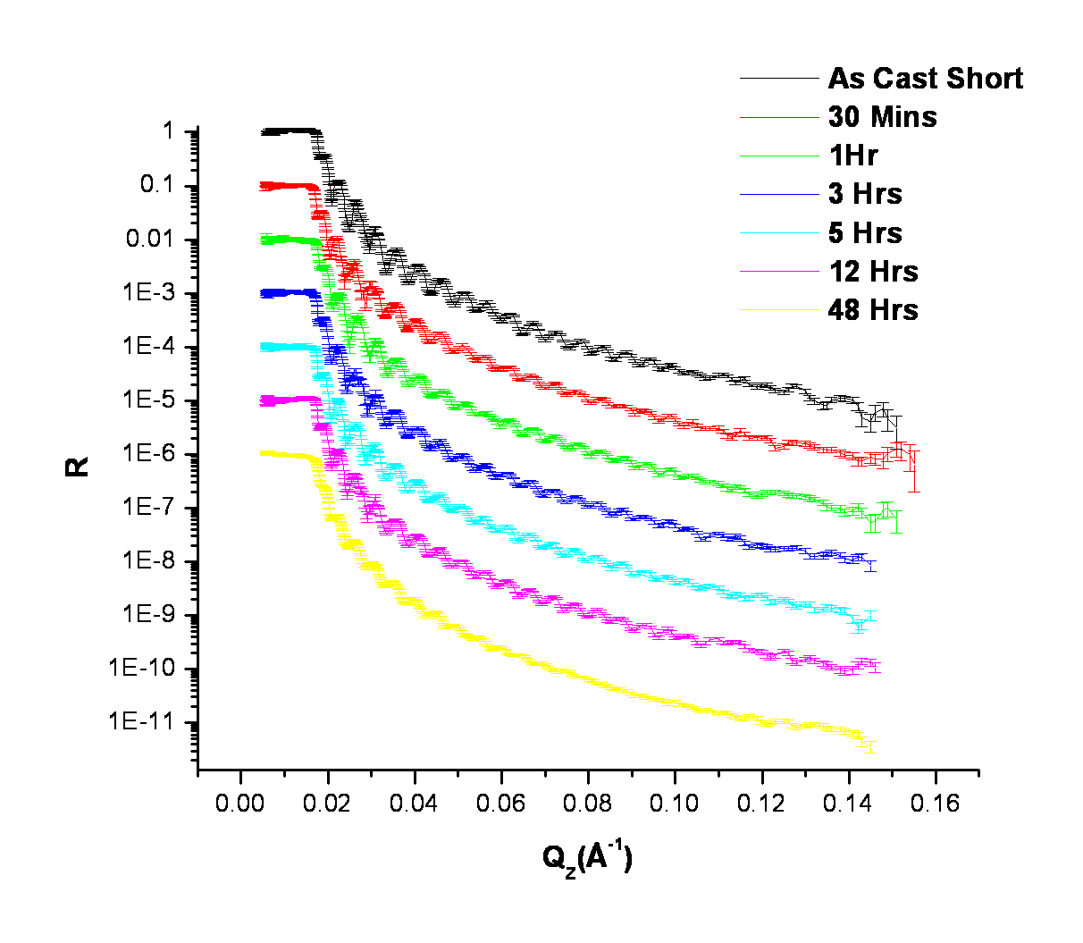

Figure A.23 Neutron reflectivity profiles for the binary blend DM505LPS measured as-cast up to an anneal time of 48 hours at 150°C under vacuum. Data is offset by a decade for clarity.

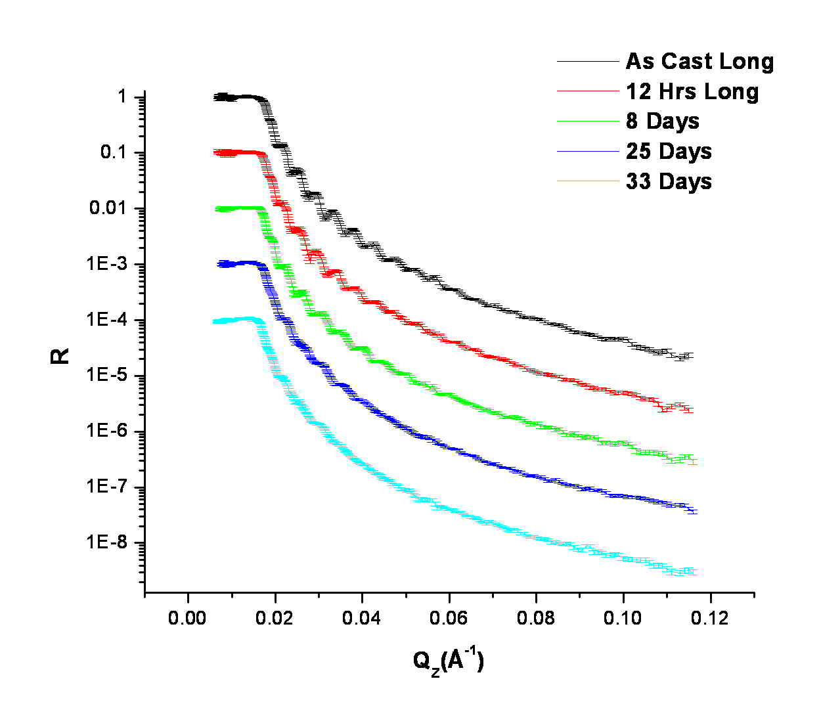

Figure A.24 Neutron reflectivity profiles for the binary blend DM505LPS measured as-cast up to a maximum anneal time of 33 days at 150°C. Data is offset by a decade for clarity.

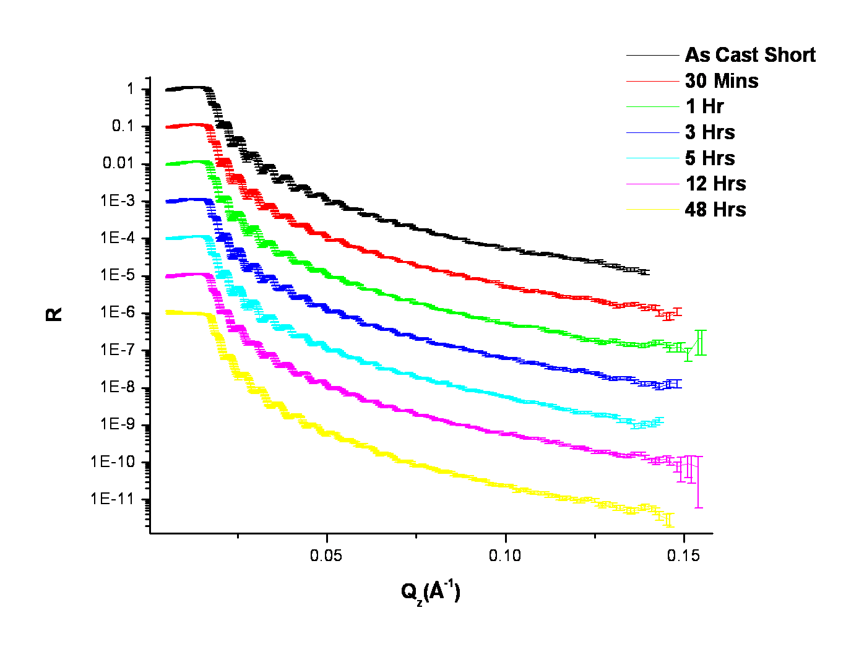

Figure A.25 Neutron reflectivity profiles for the binary blend DM1105LPS measured as-cast up to an anneal time of 48 hours at 150°C under vacuum. Data is offset by a decade for clarity.

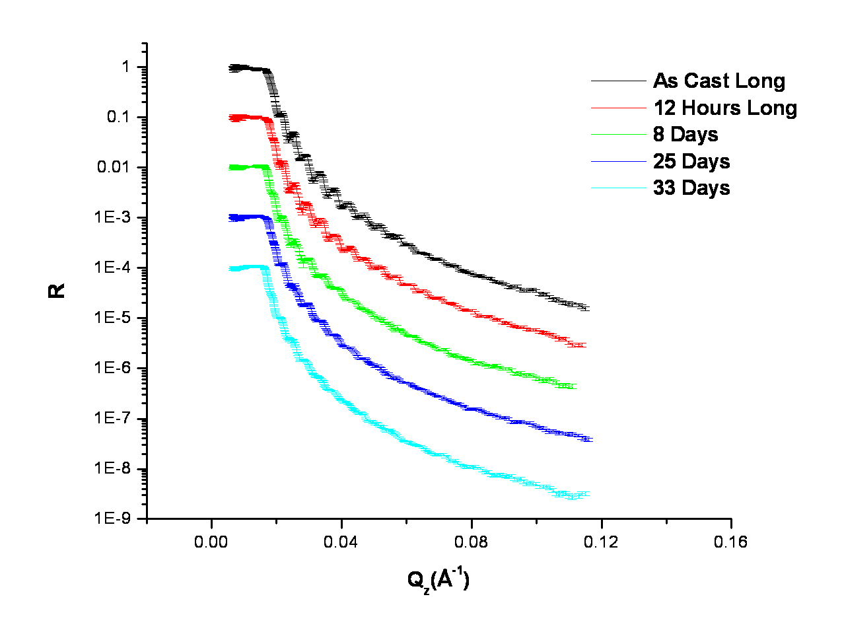

Figure A.26 Neutron reflectivity profiles for the binary blend DM1105LPS measured as-cast up to a maximum anneal time of 33 days at 150°C. Data is offset by a decade for clarity.

C. ERD Spectra for Binary Blends of HyperMacs and DendriMacs in a Linear Matrix
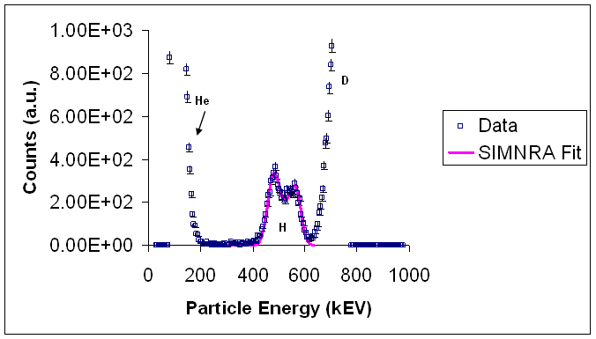

Figure A.27 ERD spectrum for the binary blend HM1530LPS annealed for 12 hours at 150°C under vacuum.

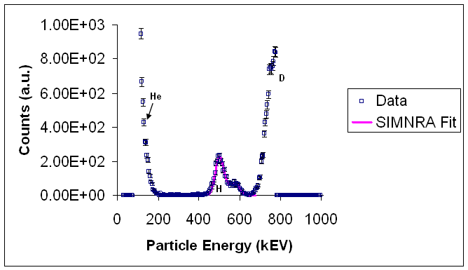

Figure A.28 ERD spectrum for the binary blend HM1530LPS annealed for 48 hours at 150°C under vacuum.

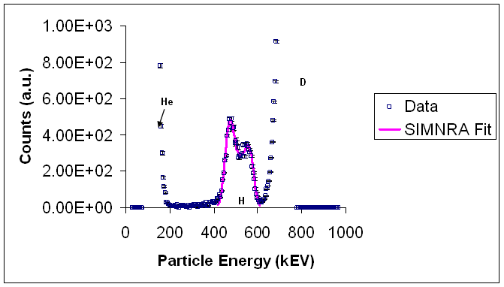

Figure A.29 ERD spectrum for the binary blend HM871LPS annealed for 12 hours at 150°C under vacuum.
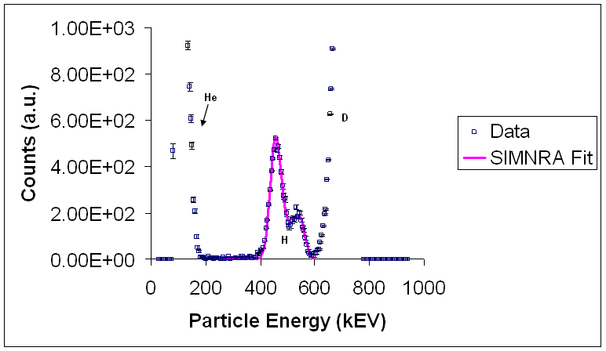

Figure A.30 ERD spectrum for the binary blend HM871LPS annealed for 48 hours at 150°C under vacuum.

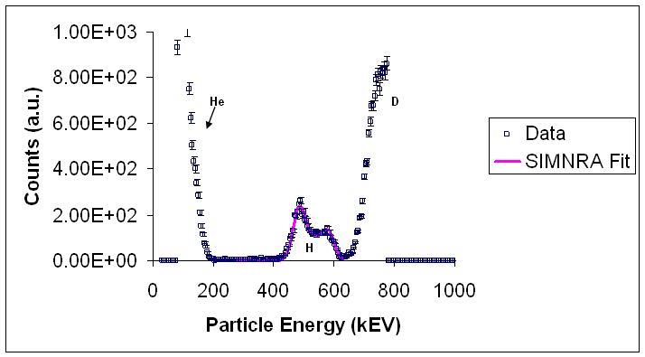

Figure A.31 ERD spectrum for the binary blend HM373LPS annealed for 12 hours at 150°C under vacuum.
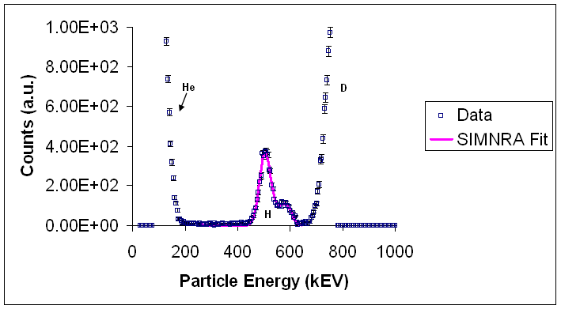

Figure A.32 ERD spectrum for the binary blend HM373LPS annealed for 48 hours at 150°C under vacuum.

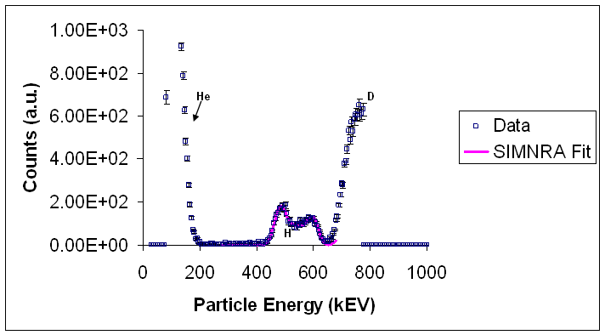

Figure A.33 ERD spectrum for the binary blend DM1105LPS annealed for 12 hours at 150°C under vacuum.

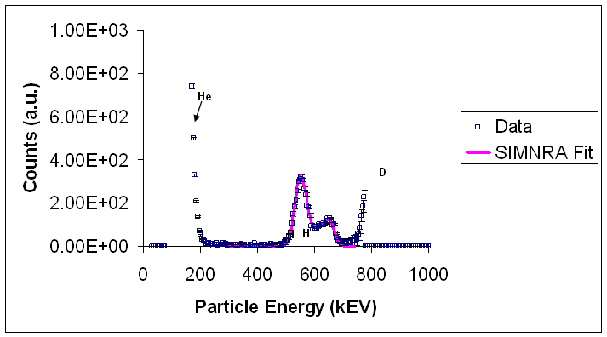

Figure A.34 ERD spectrum for the binary blend DM1105LPS annealed for 48 hours at 150°C under vacuum.

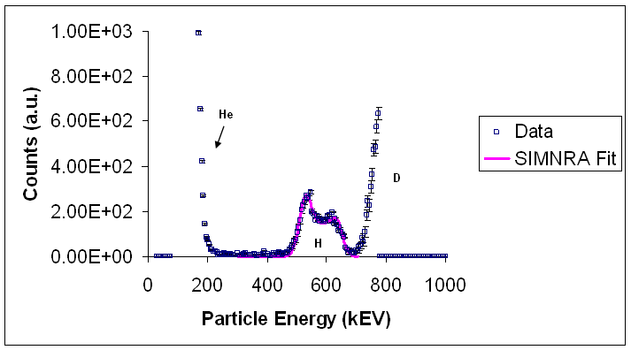

Figure A.35 ERD spectrum for the binary blend DM505LPS annealed for 13 hours at 150°C under vacuum.
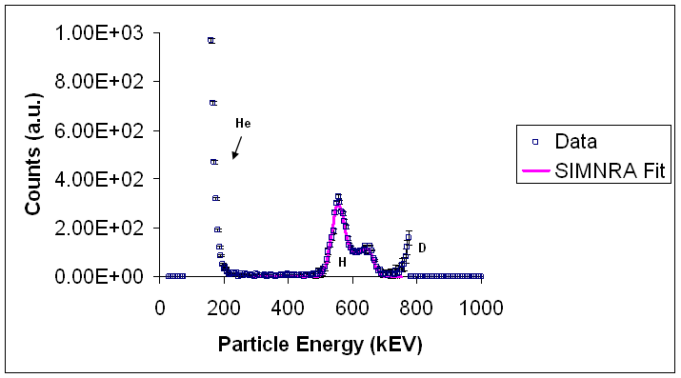

Figure A.36 ERD spectrum for the binary blend DM505LPS annealed for 48 hours at 150°C under vacuum.

D. Neutron Reflectivity Fit Parameters for Binary Blends of HyperMacs and DendriMacs in a Linear Matrix
Table A.1 Neutron reflectivity fit parameters for the binary blend HM373LPS.
Anneal Times  (Secs) | ªd_{T}  (Å) | ^{b}d_{T}  (Å) | ^{b}d_{air}  (Å) | ^{b}d_{Si}  (Å) | ^{e}(b/V)_{air}  x10⁻⁶  (Å⁻²) | ^{e}(b/V)_{Si}  x10⁻⁶  (Å⁻²) | ^{e}(b/V)_{res.}  x10⁻⁶  (Å⁻²) | ^{f}σ_{air}  (Å) | ^{f}σ_{sub}  (Å) | ^{f}σ_{res.}  (Å)
^{c}Short  0  1800  3600  10800  18000  43200  172800  ^{d}Long  0  43200  691200  2.16E6  2.85E6 | 1302 ± 2  1134 ± 2 | 1335  1320  1313  1311  1310  1310  1167  1300  1310  1273  1189  1197 | 63  63  71  72  73  80  80  63  80  84  88  88 | 79  81  83  85  86  90  99  79  90  99  99  99 | 5.00  4.99  5.00  5.00  5.01  4.68  5.26  4.99  4.68  5.26  5.57  5.67 | 1.51  1.51  1.51  1.51  1.51  1.51  1.51  1.51  1.51  1.51  1.51  1.51 | 5.89  5.77  5.85  5.89  5.89  5.84  6.19  5.89  5.84  6.12  6.19  5.91 | 14  14  15  14  9  5  17  6  10  14  4  12 | 20  18  24  24  26  34  64  16  22  44  5  56 | 10  26  16  18  24  28  54  5  10  30  14  14

ªThickness of entire film determined from ellipsometry (measured after 12 hrs and 48 hrs anneal time); Note also that the measurements are from 2 different films – as cast to 12 hours and 48 hours
^{b}Thickness of film determined from fit to NR profile of entire film (d_{T}), at the air (d_{air}), and at the Si substrate (d_{Si})
^{c}Short time study as cast to 48 hours
^{d}Long time study as cast to 33 days
^{e}Scattering length density (b/V x 10⁻⁶ Å⁻²) at the air interface (air), Si substrate (Si), and reservoir (res.)
^{f}Roughness at the interfaces between the air interface and 1st layer (σ_{air}), 1st and 2nd layer(σ_{res}), and 2nd and 3rd layer(σ_{sub}) of segregated polymer blend film

Table A.2 Neutron reflectivity fit parameters for the binary blend HM871LPS.
Anneal Times  (Secs) | ªd_{T}  (Å) | ^{b}d_{T}  (Å) | ^{b}d_{air}  (Å) | ^{b}d_{Si}  (Å) | ^{e}(b/V)_{air}  x10⁻⁶  (Å⁻²) | ^{e}(b/V)_{Si}  x10⁻⁶  (Å⁻²) | ^{e}(b/V)_{res.}  x10⁻⁶  (Å⁻²) | ^{f}σ_{air}  (Å) | ^{f}σ_{sub}  (Å) | ^{f}σ_{res.}  (Å)
^{c}Short  0  1800  3600  10800  18000  43200  172800  ^{d}Long  0  43200  691200  2.16E6  2.85E6 | 1241 ± 4  1118 ± 2 | 1284  1270  1263  1263  1263  1263  1132  1320  1285  1259  1240  1240 | 53  53  56  57  57  59  64  55  54  64  75  75 | 55  56  56  57  57.5  59  64  55  59  75  81  81 | 4.34  4.11  4.03  4.14  3.49  3.49  4.75  3.09  3.90  4.55  5.28  5.28 | 1.52  1.52  1.52  1.52  1.52  1.52  1.52  1.52  1.52  1.52  1.52  1.52 | 5.82  5.83  5.82  5.71  5.85  5.77  5.75  5.31  6.11  5.99  5.87  5.87 | 10  10  14  18  5  5  24  18  5  5  5  5 | 55  56  56  57  42  46  64  40  26  22  70  76 | 52  53  56  57  56  59  64  22  38  24  48  48

ªThickness of entire film determined from ellipsometry (measured after 12 hrs and 48 hrs anneal time); Note also that the measurements are from 2 different films – as cast to 12 hours and 48 hours
^{b}Thickness of film determined from fit to NR profile of entire film (d_{T}), at the air (d_{air}), and at the Si substrate (d_{Si})
^{c}Short time study as cast to 48 hours
^{d}Long time study as cast to 33 days
^{e}Scattering length density (b/V x 10⁻⁶ Å⁻²) at the air interface (air), Si substrate (Si), and reservoir (res.)
^{f}Roughness at the interfaces between the air interface and 1st layer (σ_{air}), 1st and 2nd layer(σ_{res}), and 2nd and 3rd layer(σ_{sub}) of segregated polymer blend film

Table A.3 Neutron reflectivity fit parameters for the binary blend HM1530LPS.
Anneal Times  (Secs) | ªd_{T}  (Å) | ^{b}d_{T}  (Å) | ^{b}d_{air}  (Å) | ^{b}d_{Si}  (Å) | ^{e}(b/V)_{air}  x10⁻⁶  (Å⁻²) | ^{e}(b/V)_{Si}  x10⁻⁶  (Å⁻²) | ^{e}(b/V)_{res.}  x10⁻⁶  (Å⁻²) | ^{f}σ_{air}  (Å) | ^{f}σ_{sub}  (Å) | ^{f}σ_{res.}  (Å)
^{c}Short  0  1800  3600  10800  18000  46800  172800  ^{d}Long  0  43200  691200  2.16E6  2.85E6 | 1202 ± 3  1233 ± 1 | 1160  1160  1160  1160  1176  1170  1210  1280  1270  1218  1214  1230 | 51  51  51  51  51  40  61  35  45  74  74  76 | 48  50  52  54  55  40  70  35  55  92  92  92 | 4.99  5.00  3.88  4.26  4.32  3.93  3.83  1.48  3.51  4.73  5.14  5.02 | 1.48  1.48  1.48  1.48  1.48  1.48  1.48  1.48  1.48  1.48  1.48  1.48 | 5.99  5.59  6.03  5.86  5.83  5.95  5.91  5.97  6.01  5.96  6.19  5.83 | 12  14  5  5  4  6  10  18  5  5  6  8 | 44  32  24  26  26  22  50  18  18  26  26  50 | 28  14  36  38  38  32  54  32  32  24  18  4

ªThickness of entire film determined from ellipsometry (measured after 12 hrs and 48 hrs anneal time); Note also that the measurements are from 2 different films – as cast to 12 hours and 48 hours
^{b}Thickness of film determined from fit to NR profile of entire film (d_{T}), at the air (d_{air}), and at the Si substrate (d_{Si})
^{c}Short time study as cast to 48 hours
^{d}Long time study as cast to 33 days
^{e}Scattering length density (b/V x 10⁻⁶ Å⁻²) at the air interface (air), Si substrate (Si), and reservoir (res.)
^{f}Roughness at the interfaces between the air interface and 1st layer (σ_{air}), 1st and 2nd layer(σ_{res}), and 2nd and 3rd layer(σ_{sub}) of segregated polymer blend film

Table A.4 Neutron reflectivity fit parameters for the binary blend DM505LPS.
Anneal Times  (Secs) | ªd_{T}  (Å) | ^{b}d_{T}  (Å) | ^{b}d_{air}  (Å) | ^{b}d_{Si}  (Å) | ^{e}(b/V)_{air}  x10⁻⁶  (Å⁻²) | ^{e}(b/V)_{Si}  x10⁻⁶  (Å⁻²) | ^{e}(b/V)_{res.}  x10⁻⁶  (Å⁻²) | ^{f}σ_{air}  (Å) | ^{f}σ_{sub}  (Å) | ^{f}σ_{res.}  (Å)
^{c}Short  0  1800  3600  10800  18000  43200  172800  ^{d}Long  0  43200  691200  2.16E6  2.85E6 | 1252 ± 2  1174 ± 1 | 1287  1287  1287  1287  1270  1270  1183  1280  1280  1215  1170  1170 | 48  50  52  53  54  62  76  50  53  76  76  76 | 52  54.5  56  58  61  64.5  76  56  57  76  76  76 | 3.33  3.76  3.48  3.68  4.80  4.35  4.14  3.26  3.46  4.71  5.24  5.07 | 0.84  0.84  0.84  0.84  0.84  0.84  0.84  0.84  0.84  0.84  0.84  0.84 | 5.79  5.74  6.13  5.99  6.03  5.97  5.62  5.90  6.09  5.86  6.06  5.86 | 9  7  6  10  6  4  18  12  12  8  5  5 | 19  20  22  22  24  28  70  38  18  60  65  72 | 8  8  18  8  8  6  70  10  5  56  50  50

ªThickness of entire film determined from ellipsometry (measured after 12 hrs and 48 hrs anneal time); Note also that the measurements are from 2 different films – as cast to 12 hours and 48 hours
^{b}Thickness of film determined from fit to NR profile of entire film (d_{T}), at the air (d_{air}), and at the Si substrate (d_{Si})
^{c}Short time study as cast to 48 hours
^{d}Long time study as cast to 33 days
^{e}Scattering length density (b/V x 10⁻⁶ Å⁻²) at the air interface (air), Si substrate (Si), and reservoir (res.)
^{f}Roughness at the interfaces between the air interface and 1st layer (σ_{air}), 1st and 2nd layer(σ_{res}), and 2nd and 3rd layer(σ_{sub}) of segregated polymer blend film

Table A.5 Neutron reflectivity fit parameters for the binary blend DM1105LPS.
Anneal Times  (Secs) | ªd_{T}  (Å) | ^{b}d_{T}  (Å) | ^{b}d_{air}  (Å) | ^{b}d_{Si}  (Å) | ^{e}(b/V)_{air}  x10⁻⁶  (Å⁻²) | ^{e}(b/V)_{Si}  x10⁻⁶  (Å⁻²) | ^{e}(b/V)_{res.}  x10⁻⁶  (Å⁻²) | ^{f}σ_{air}  (Å) | ^{f}σ_{sub}  (Å) | ^{f}σ_{res.}  (Å)
^{c}Short  0  1800  3600  10800  18000  43200  172800  ^{d}Long  0  43200  691200  2.16E6  2.85E6 | 1250 ± 3  1156 ± 1 | 1269  1266  1266  1265  1265  1265  1180  1320  1320  1280  1300  1320 | 58  62  62  64  66  67  72  56  68  85  85  85 | 69  71  71.5  73.5  75  77.5  81  68  68  85  85  85 | 4.52  4.52  4.53  4.99  4.77  4.61  4.20  4.55  5.11  5.71  5.93  5.35 | 1.36  1.36  1.36  1.36  1.36  1.36  1.36  1.36  1.36  1.36  1.36  1.36 | 5.84  5.83  5.85  5.85  5.81  5.95  6.06  6.02  6.16  6.10  6.34  5.81 | 12  12  14  10  12  14  22  20  10  10  10  14 | 14  14  14  14  18  16  46  40  40  85  85  85 | 10  10  10  10  7  7  32  5  5  85  85  85

ªThickness of entire film determined from ellipsometry (measured after 12 hrs and 48 hrs anneal time); Note also that the measurements are from 2 different films – as cast to 12 hours and 48 hours
^{b}Thickness of film determined from fit to NR profile of entire film (d_{T}), at the air (d_{air}), and at the Si substrate (d_{Si})
^{c}Short time study as cast to 48 hours
^{d}Long time study as cast to 33 days
^{e}Scattering length density (b/V x 10⁻⁶ Å⁻²) at the air interface (air), Si substrate (Si), and reservoir (res.)
^{f}Roughness at the interfaces between the air interface and 1st layer (σ_{air}), 1st and 2nd layer(σ_{res}), and 2nd and 3rd layer(σ_{sub}) of segregated polymer blend film

E. Neutron Reflectivity Volume Fraction Copolymer Plots for Binary Blends of HyperMacs and DendriMacs in a Linear Matrix

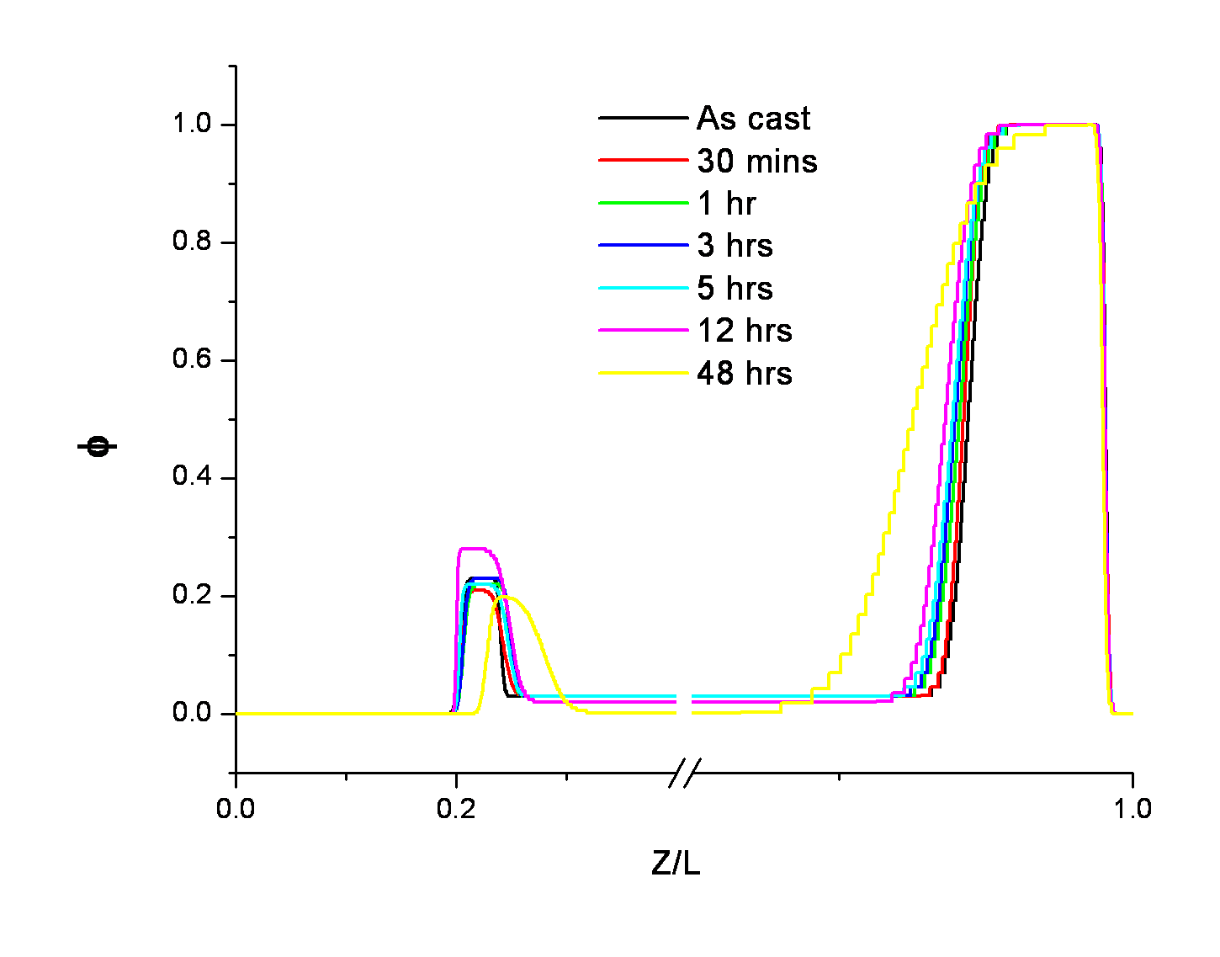

Figure A.37 Neutron reflectivity volume fraction copolymer plots for the binary blend HM373LPS annealed as-cast to 48 hours at 150°C under vacuum. Data is truncated to emphasize the interfaces.

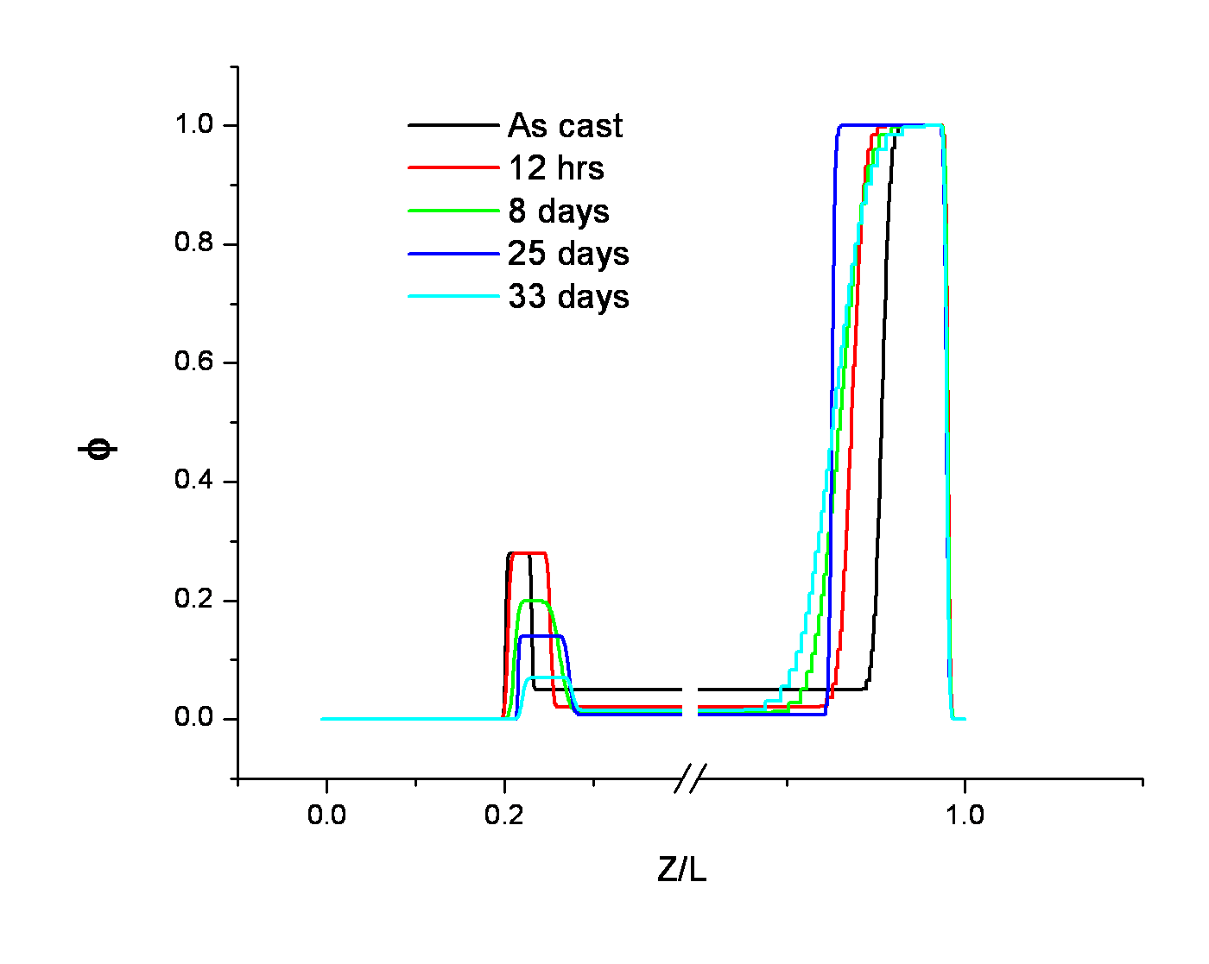

Figure A.38 Neutron reflectivity volume fraction copolymer plots for the binary blend HM373LPS annealed as-cast to 33 days at 150°C under vacuum. Data is truncated to emphasize the interfaces.

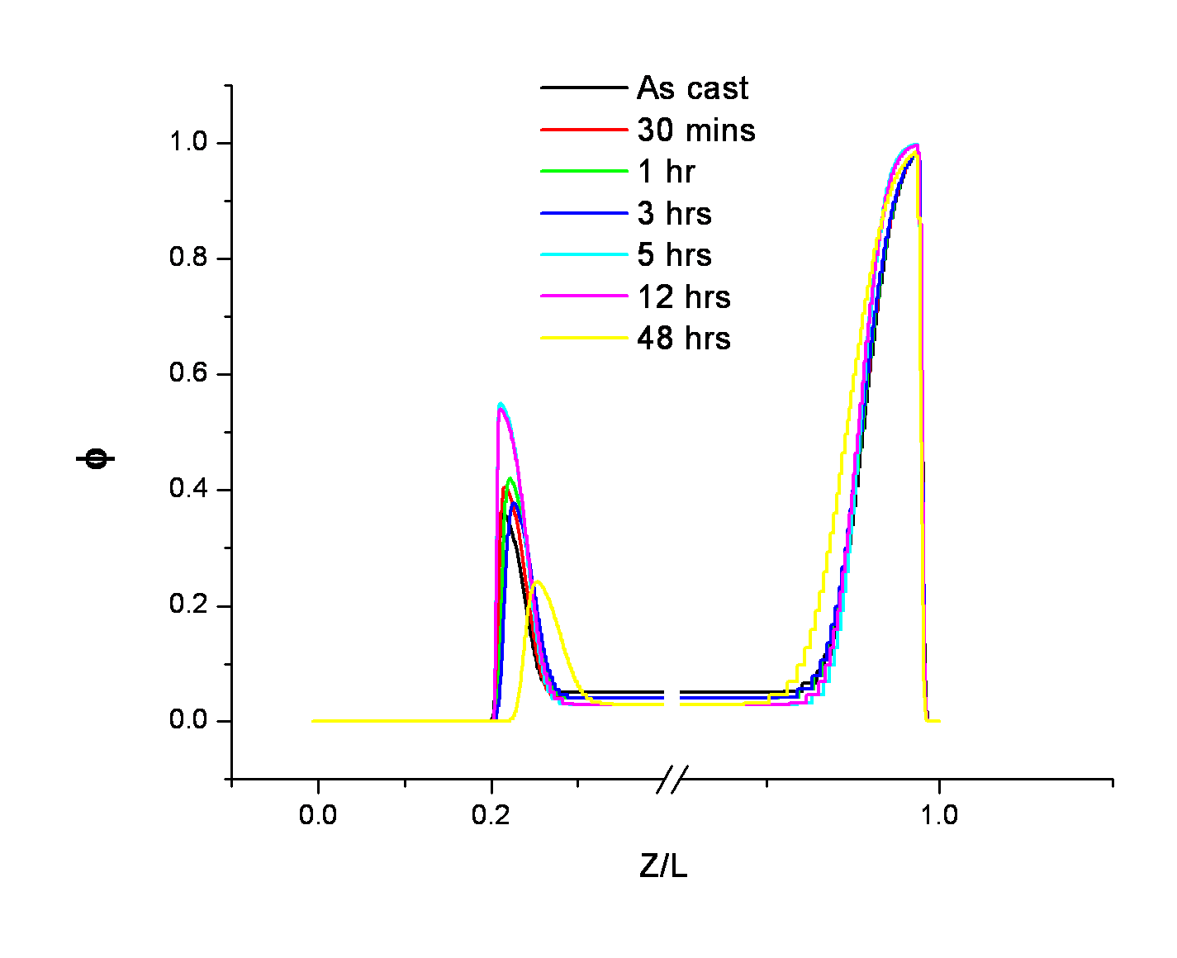

Figure A.39 Neutron reflectivity volume fraction copolymer plots for the binary blend HM871LPS annealed as-cast to 48 hours at 150°C under vacuum. Data is truncated to emphasize the interfaces.

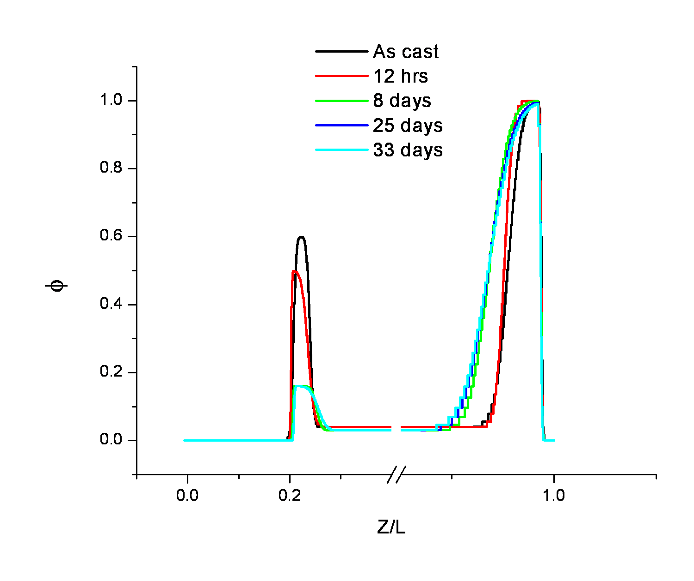

Figure A.40 Neutron reflectivity volume fraction copolymer plots for the binary blend HM871LPS annealed as-cast to 33 days at 150°C under vacuum. Data is truncated to emphasize the interfaces.

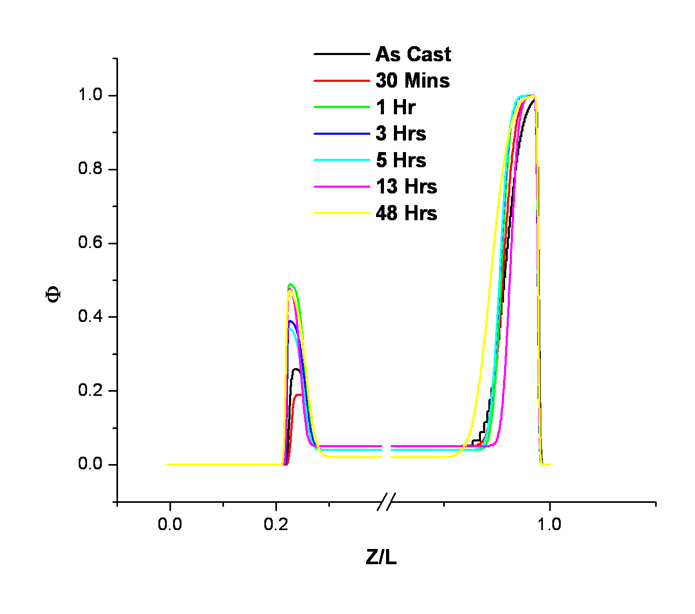

Figure A.41 Neutron reflectivity volume fraction copolymer plots for the binary blend HM1530LPS annealed as-cast to 48 hours at 150°C under vacuum. Data is truncated to emphasize the interfaces.

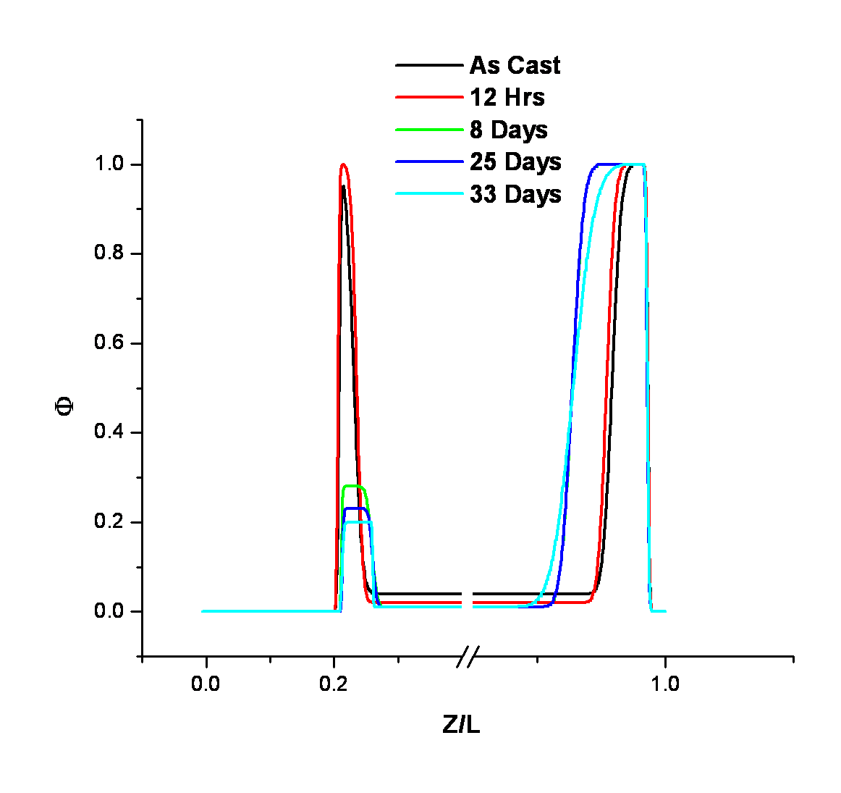

Figure A.42 Neutron reflectivity volume fraction copolymer plots for the binary blend HM1530LPS annealed as-cast to 33 days at 150°C under vacuum. Data is truncated to emphasize the interfaces.

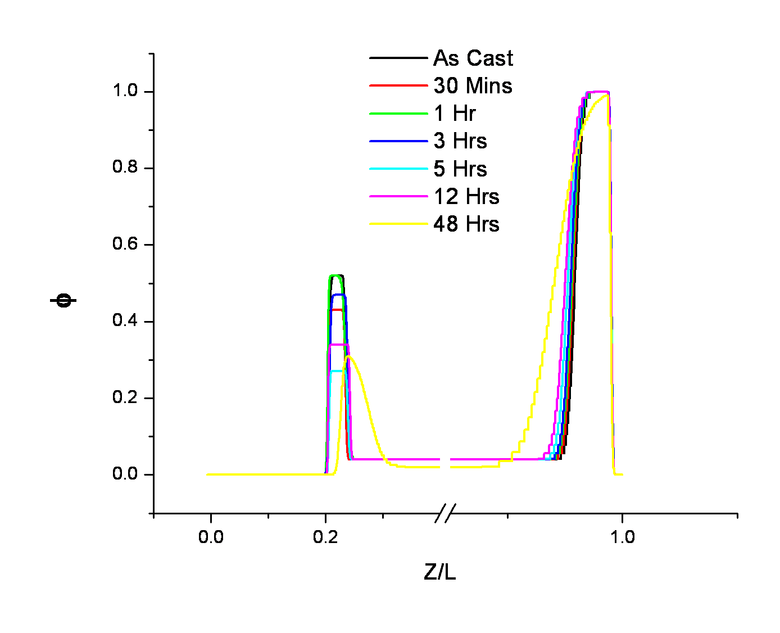

Figure A.43 Neutron reflectivity volume fraction copolymer plots for the binary blend DM505LPS annealed as-cast to 48 hours at 150°C under vacuum. Data is truncated to emphasize the interfaces.

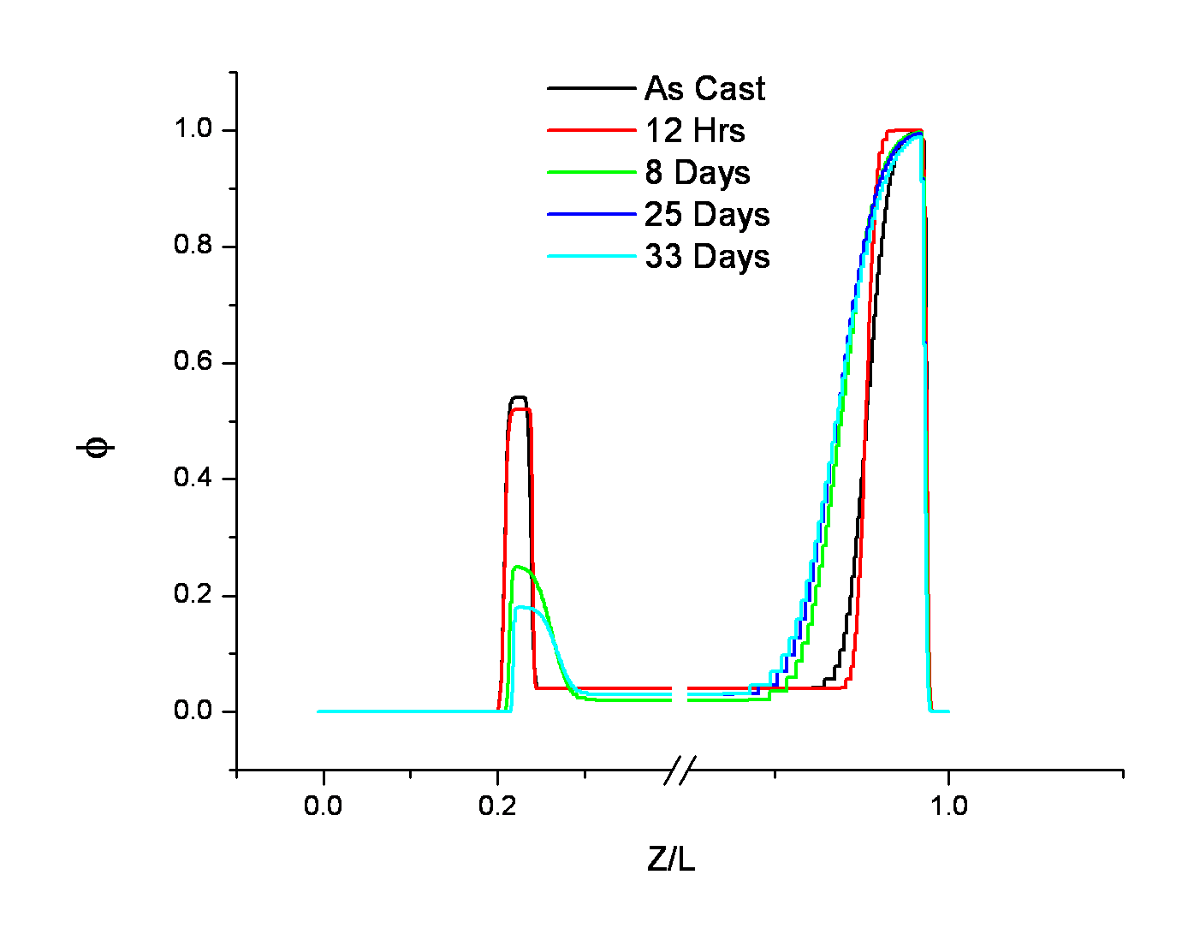

Figure A.44 Neutron reflectivity volume fraction copolymer plots for the binary blend DM505LPS annealed as-cast to 33 days at 150°C under vacuum. Data is truncated to emphasize the interfaces.

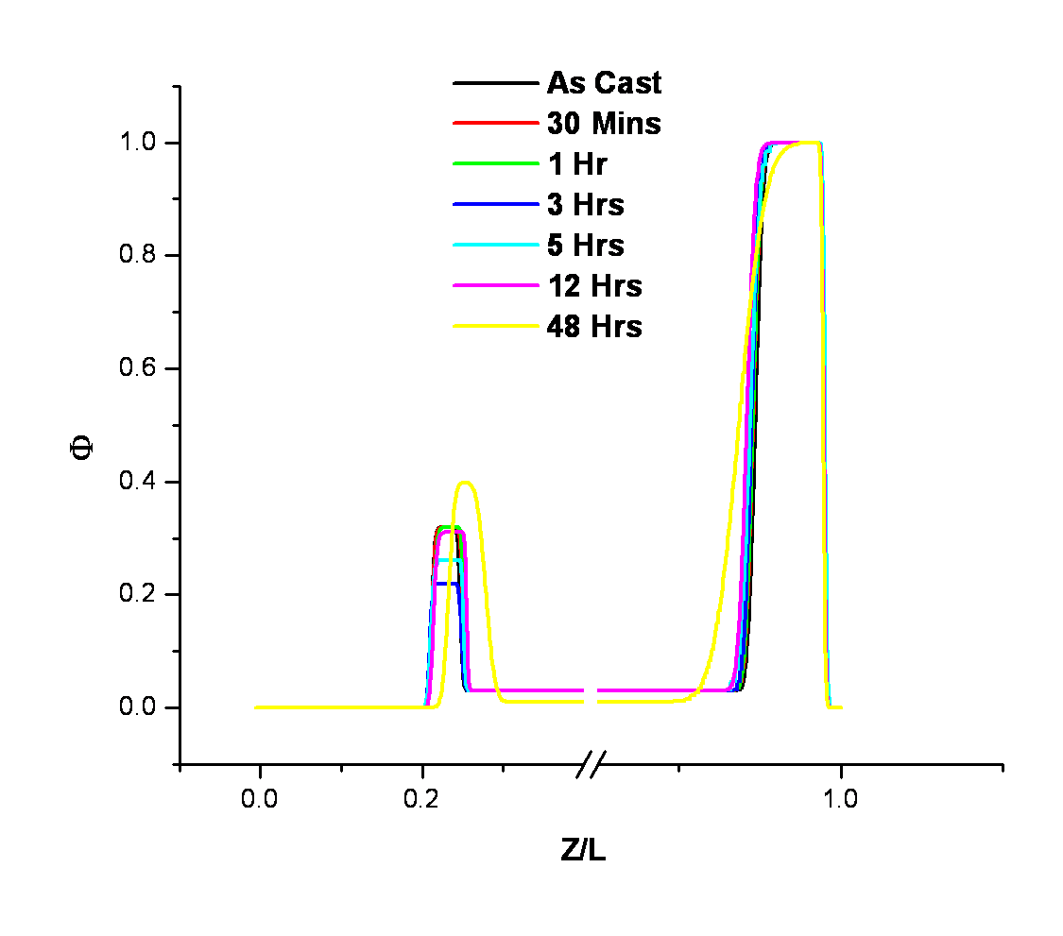

Figure A.45 Neutron reflectivity volume fraction copolymer plots for the binary blend DM1105LPS annealed as-cast to 48 hours at 150°C under vacuum. Data is truncated to emphasize the interfaces.

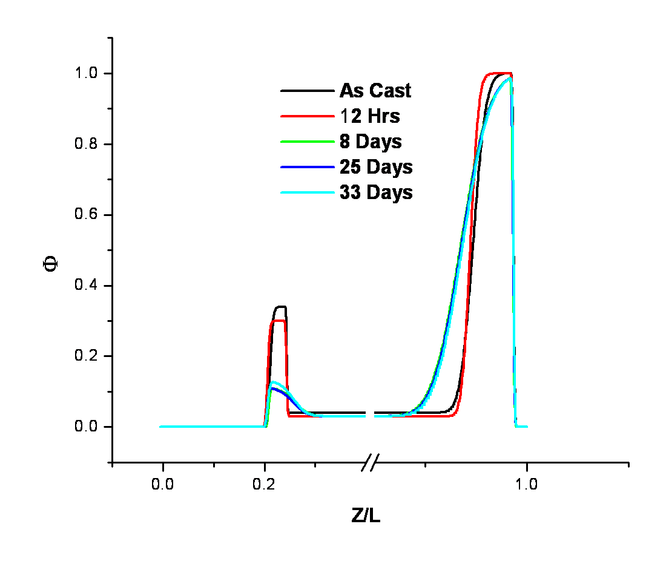

Figure A.46 Neutron reflectivity volume fraction copolymer plots for the binary blend DM1105LPS annealed as-cast to 33 days at 150°C under vacuum. Data is truncated to emphasize the interfaces.

A.4 Additional Experimental Data for Chapter 4
- Proton NMR Spectra of P(MMA-r-PEGMA) Comb Copolymers

Figure A.47 500 MHz ¹H-NMR spectrum of the 9010MMAEO P(MMA-r-PEGMA) comb copolymer.

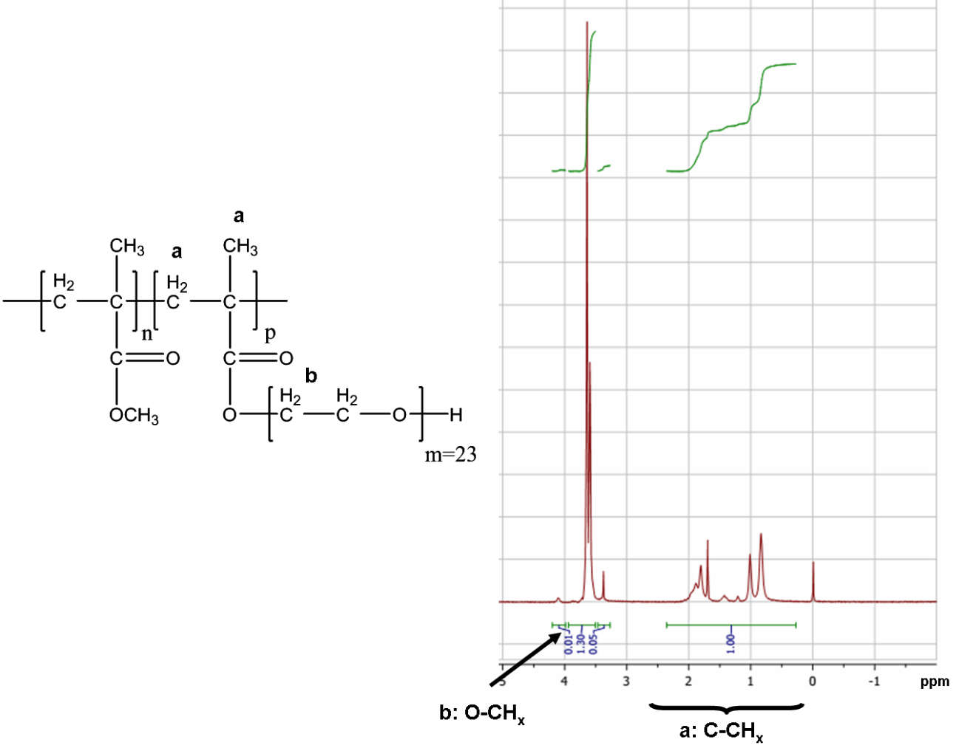

Figure A.48 500 MHz ¹H-NMR spectrum of the 7525MMAEO P(MMA-r- PEGMA) comb copolymer.

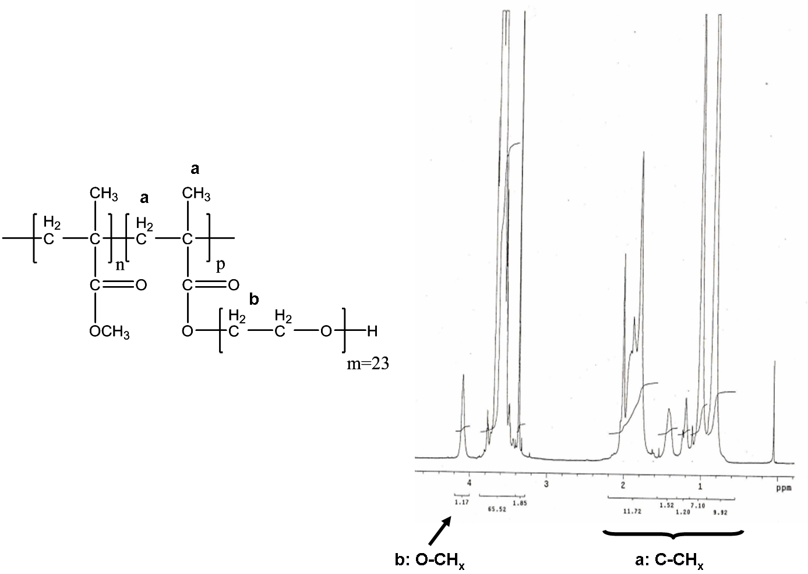

Figure A.0.49 500 MHz ¹H-NMR spectrum of the 5050MMAEO P(MMA-r- PEGMA) comb copolymer.

- Size Exclusion Chromatograms of P(MMA-r-PEGMA) Comb Copolymers

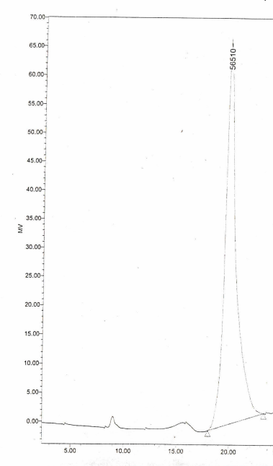

Figure A.50 SEC chromatogram of the 9010MMAEO P(MMA-r-PEGMA) comb copolymer. Note that the number shown at the top of the peak is the M_{p}.

Figure A.51 SEC chromatogram of the 5050MMAEO P(MMA-r-PEGMA) comb copolymer.

- Neutron Reflectivity Profiles for Binary Blends of P(MMA-r-PEGMA) Comb Copolymers in a Linear Matrix

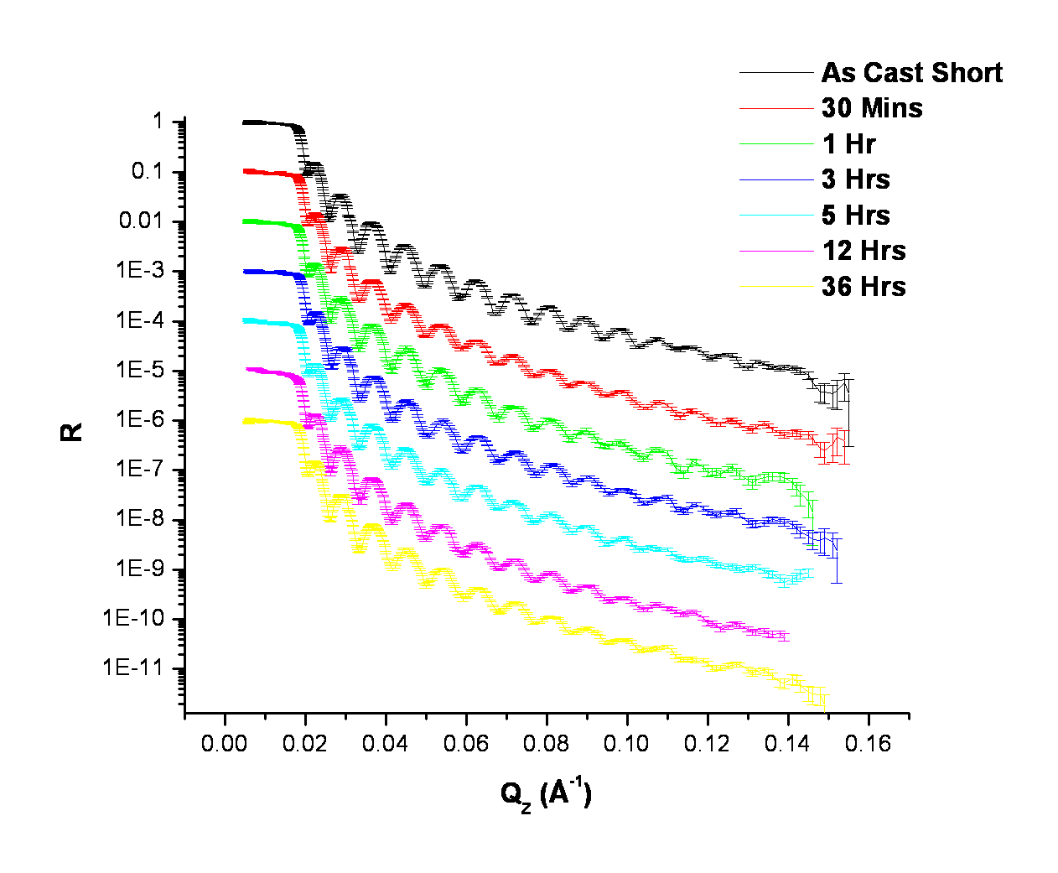

Figure A.52 Neutron reflectivity profiles of the blend 9010MMAEO_LPMMA measured as-cast up to an anneal time of 36 hours at 150°C. Data is scaled for clarity.

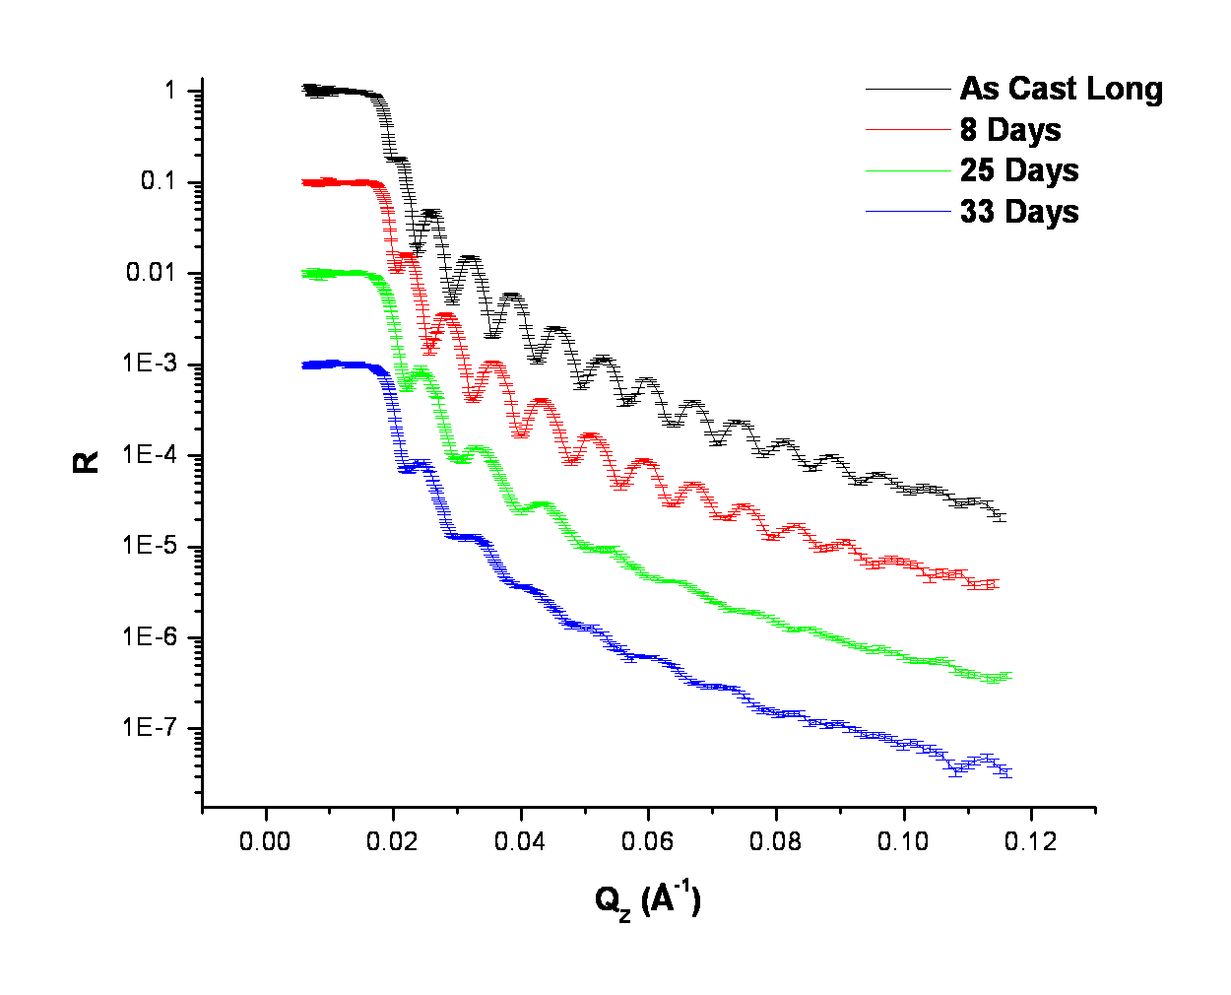

Figure A.53 Neutron reflectivity profiles of the blend 9010MMAEO_LPMMA measured as-cast up to a maximum anneal time of 33 days at 150°C under vacuum. Data is scaled for clarity.

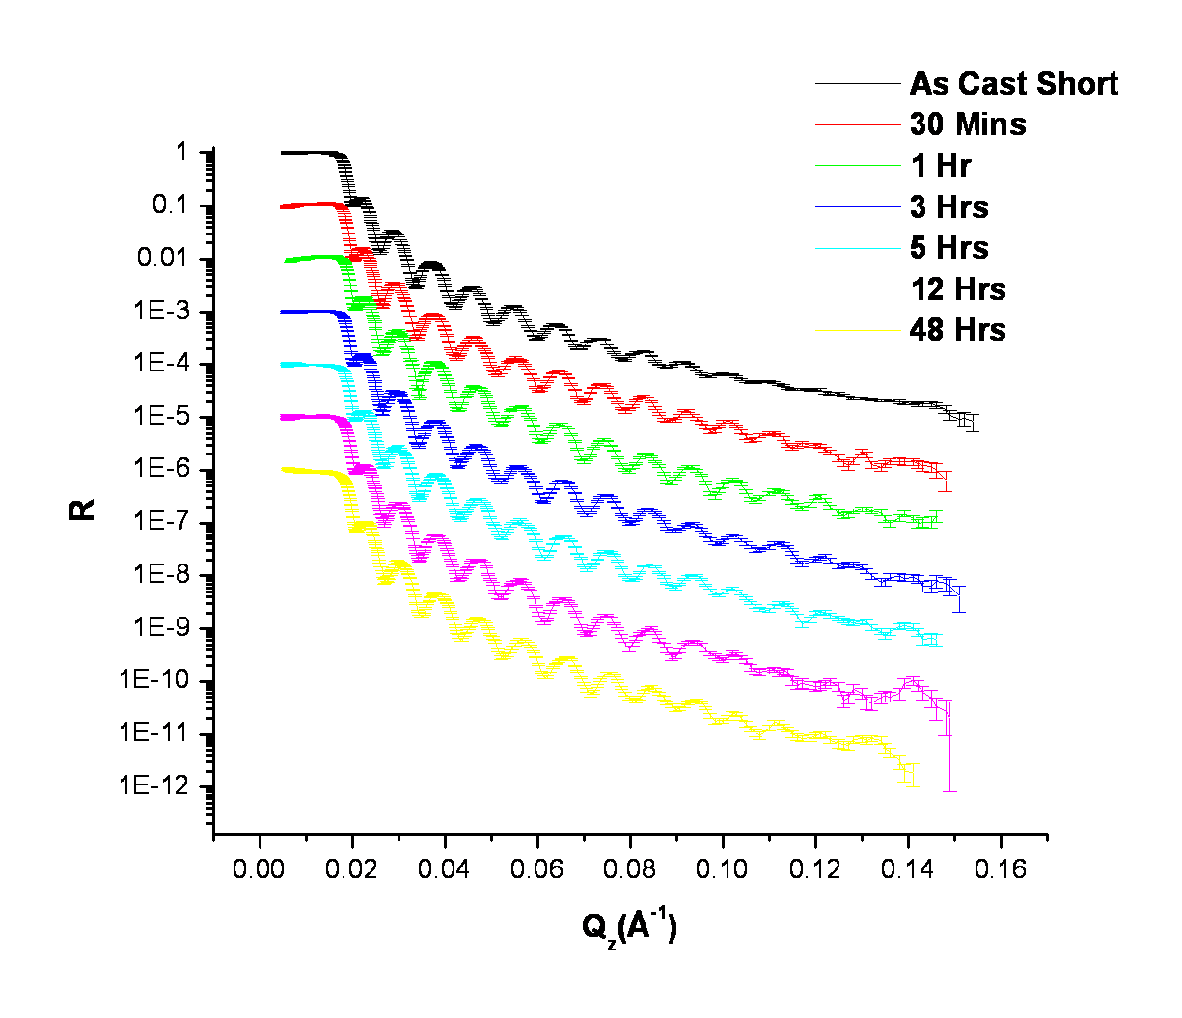

Figure A.54 Neutron reflectivity profiles of the blend 7525MMAEO_LPMMA measured as-cast up to an anneal time of 36 hours at 150°C. Data is scaled for clarity.

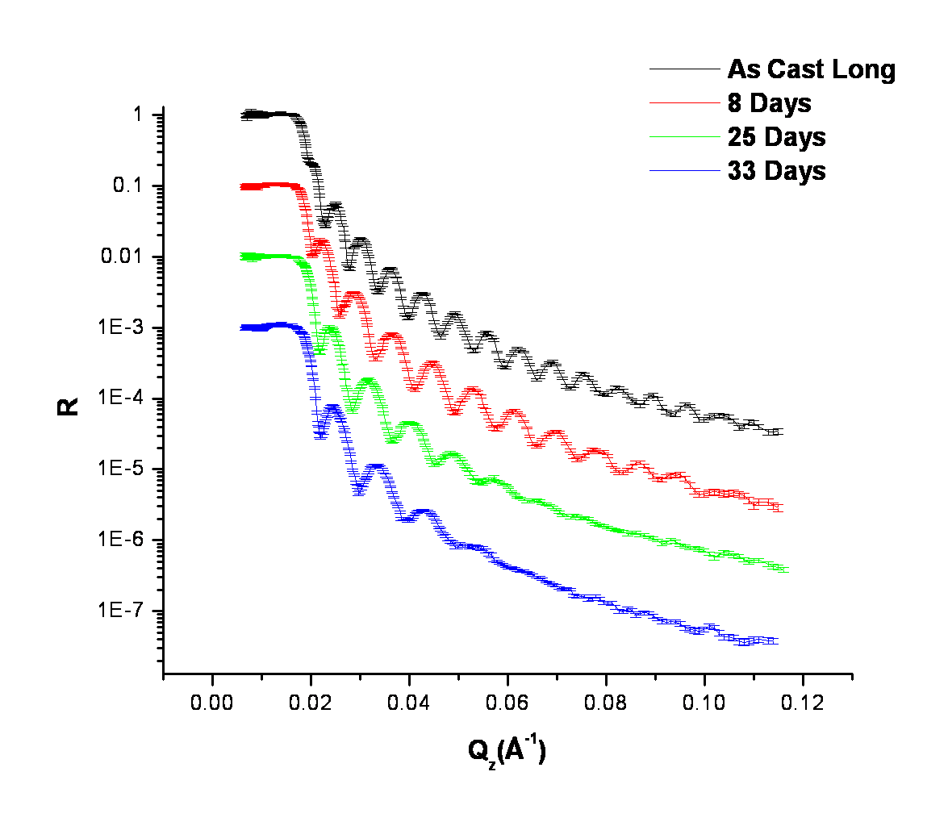

Figure A.55 Neutron reflectivity profiles of the blend 7525MMAEO_LPMMA measured as-cast up to a maximum anneal time of 33 days at 150°C under vacuum. Data is scaled for clarity.

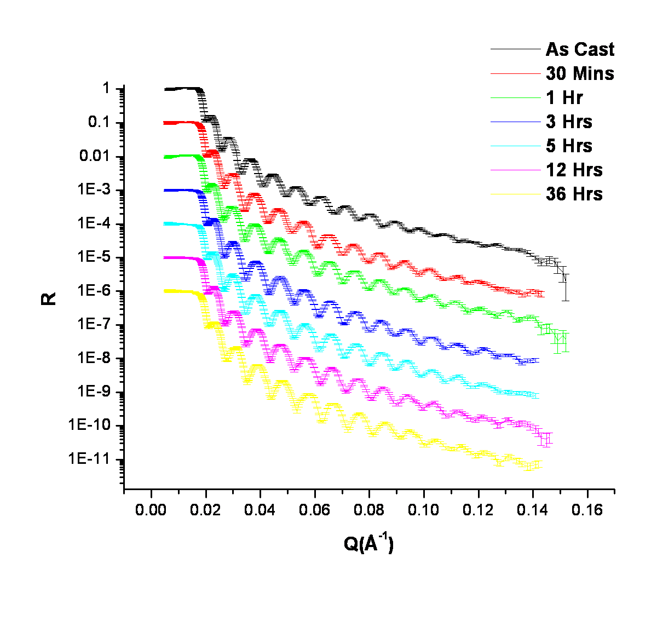

Figure A.56 Neutron reflectivity profiles of the blend 5050MMAEO_LPMMA measured as-cast up to an anneal time of 36 hours at 150°C. Data is scaled for clarity.

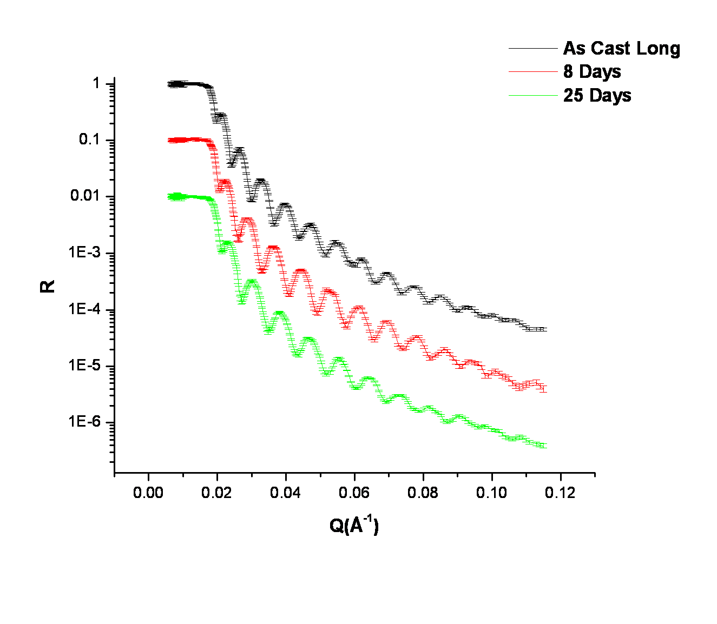

Figure A.57 Neutron reflectivity profiles of the blend 5050MMAEO_LPMMA measured as-cast up to a maximum anneal time of 33 days at 150°C under vacuum. Data is scaled for clarity.

- Neutron Reflectivity Fit Parameters for Binary Blends of P(MMA-r-PEGMA) Comb Copolymers in a Linear Matrix

Table A.6 Neutron reflectivity fit parameters for the binary blend 9010MMAEO_LPMMA.
Anneal Times  (Secs) | ªd_{T}  (Å) | ^{b}d_{T}  (Å) | ^{b}d_{air}  (Å) | ^{b}d_{Si}  (Å) | ^{e}(b/V)_{air}  x10⁻⁶  (Å⁻²) | ^{e}(b/V)_{Si}  x10⁻⁶  (Å⁻²) | ^{e}(b/V)_{res.}  x10⁻⁶(Å⁻²) | ^{f}σ_{air}  (Å) | ^{f}σ_{Si}  (Å) | ^{f}σ_{res.}  (Å)
^{c}Short  0  1800  3600  10800  18000  43200  129600  ^{d}Long  0  691200  2.16E6  2.85E6 | 685±3  830±3 | 679  679  679  675  675  675  675  822  718  550  570 | 24  38  38  38  38  38  38  36  36  44  44 | 38  38  38  38  38  40  40  38  60  60  60 | 5.11  5.11  5.11  5.14  5.49  5.49  6.20  5.42  6.40  6.40  6.49 | 6.02  6.16  6.10  6.08  5.84  5.73  5.14  6.12  4.61  4.61  4.67 | 6.18  6.36  6.36  6.40  6.39  6.40  6.40  6.28  6.58  6.64  6.73 | 8  22  20  16  18  30  24  14  6  12  10 | 5  5  5  5  5  40  40  5  60  60  60 | 24  34  34  34  38  38  30  36  36  40  44

ªThickness of entire film determined from ellipsometry (as cast)
^{b}Thickness of film determined from fit to NR profile of entire film (d_{T}), at the air (d_{air}), and at the Si substrate (d_{Si})
^{c}Short time study as cast to 36 hours
^{d}Long time study as cast to 33 days
^{e}Scattering length density (b/V x 10⁻⁶ Å⁻²) at the air interface (air), Si substrate (Si), and reservoir (res.)
^{f}Interfacial width (Å) between air/polymer interface, σ_{air}, polymer/Si subtrate interface, σ_{Si}, and between the polymer/polymer interface, σ_{res..}

Table A.7 Neutron reflectivity fit parameters for the binary blend 7525MMAEO_LPMMA.
Anneal Times  (Secs) | ªd_{T}  (Å) | ^{b}d_{T}  (Å) | ^{b}d_{air}  (Å) | ^{b}d_{Si}  (Å) | ^{e}(b/V)_{air}  x10⁻⁶  (Å⁻²) | ^{e}(b/V)_{Si}  x10⁻⁶  (Å⁻²) | ^{e}(b/V)_{res.}  x10⁻⁶  (Å⁻²) | ^{f}σ_{air}  (Å) | ^{f}σ_{Si}  (Å) | ^{f}σ_{res.}  (Å)
^{c}Short  0  1800  3600  10800  18000  43200  129600  ^{d}Long  0  691200  2.16E6  2.85E6 | 675±2  895± | 660  653  650  645  643  643  641  885  694  620  580 | 25  25  25  36  36  36  36  36  36  38  48 | 25  25  25  36  36  36  36  36  50  50  50 | 5.80  6.05  6.40  6.27  6.09  5.12  4.77  5.05  5.88  6.17  6.17 | 5.98  6.11  6.34  6.09  6.03  5.48  5.29  5.89  5.29  4.88  4.20 | 6.04  6.24  6.54  6.42  6.43  6.51  6.31  5.98  6.41  6.66  6.75 | 5  5  14  14  15  17  15  5  5  5  12 | 5  5  7  7  18  36  36  5  12  14  46 | 17  17  17  17  36  36  36  36  36  40  40

ªThickness of entire film determined from ellipsometry (as cast)
^{b}Thickness of film determined from fit to NR profile of entire film (d_{T}), at the air (d_{air}), and at the Si substrate (d_{Si})
^{c}Short time study as cast to 36 hours
^{d}Long time study as cast to 33 days
^{e}Scattering length density (b/V x 10⁻⁶ Å⁻²) at the air interface (air), Si substrate (Si), and reservoir (res.)
^{f}Interfacial width (Å) between air/polymer interface, σ_{air}, polymer/Si subtrate interface, σ_{Si}, and between the polymer/polymer interface, σ_{res..}

Table A.8 Neutron reflectivity fit parameters for the binary blend 5050MMAEO_LPMMA.
Anneal Times  (Secs) | ªd_{T}  (Å) | ^{b}d_{T}  (Å) | ^{b}d_{air}  (Å) | ^{b}d_{Si}  (Å) | ^{e}(b/V)_{air}  x10⁻⁶  (Å⁻²) | ^{e}(b/V)_{Si}  x10⁻⁶  (Å⁻²) | ^{e}(b/V)_{res.}  x10⁻⁶  (Å⁻²) | ^{f}σ_{air}  (Å) | ^{f}σ_{Si}  (Å) | ^{f}σ_{res.}  (Å)
^{c}Short  0  1800  3600  10800  18000  43200  129600  ^{d}Long  0  691200  2.16E6 | 680±3  800±2 | 680  650  650  645  644  643  635  795  754  718 | 20  28  28  28  28  28  28  18  51  52 | 52  52  52  52  52  52  52  52  52  52 | 5.18  5.21  6.17  5.21  5.45  5.40  5.65  5.51  6.56  6.72 | 5.88  5.99  5.99  5.81  5.63  5.40  5.03  6.27  1.28  1.29 | 6.17  6.38  6.33  6.39  6.40  6.53  6.55  6.56  6.77  6.96 | 8  10  8  10  10  4  12  5  5  10 | 4  5  8  34  52  42  52  5  45  52 | 20  5  12  5  5  4  5  5  10  10

ªThickness of entire film determined from ellipsometry (as cast)
^{b}Thickness of film determined from fit to NR profile of entire film (d_{T}), at the air (d_{air}), and at the Si substrate (d_{Si})
^{c}Short time study as cast to 36 hours
^{d}Long time study as cast to 25 days
^{e}Scattering length density (b/V x 10⁻⁶ Å⁻²) at the air interface (air), Si substrate (Si), and reservoir (res.)
^{f}Interfacial width (Å) between air/polymer interface, σ_{air}, polymer/Si subtrate interface, σ_{Si}, and between the polymer/polymer interface, σ_{res..}

- Neutron Reflectivity Volume Fraction Copolymer Plots for Binary Blends of P(MMA-r-PEGMA) Comb Copolymers in a Linear Matrix

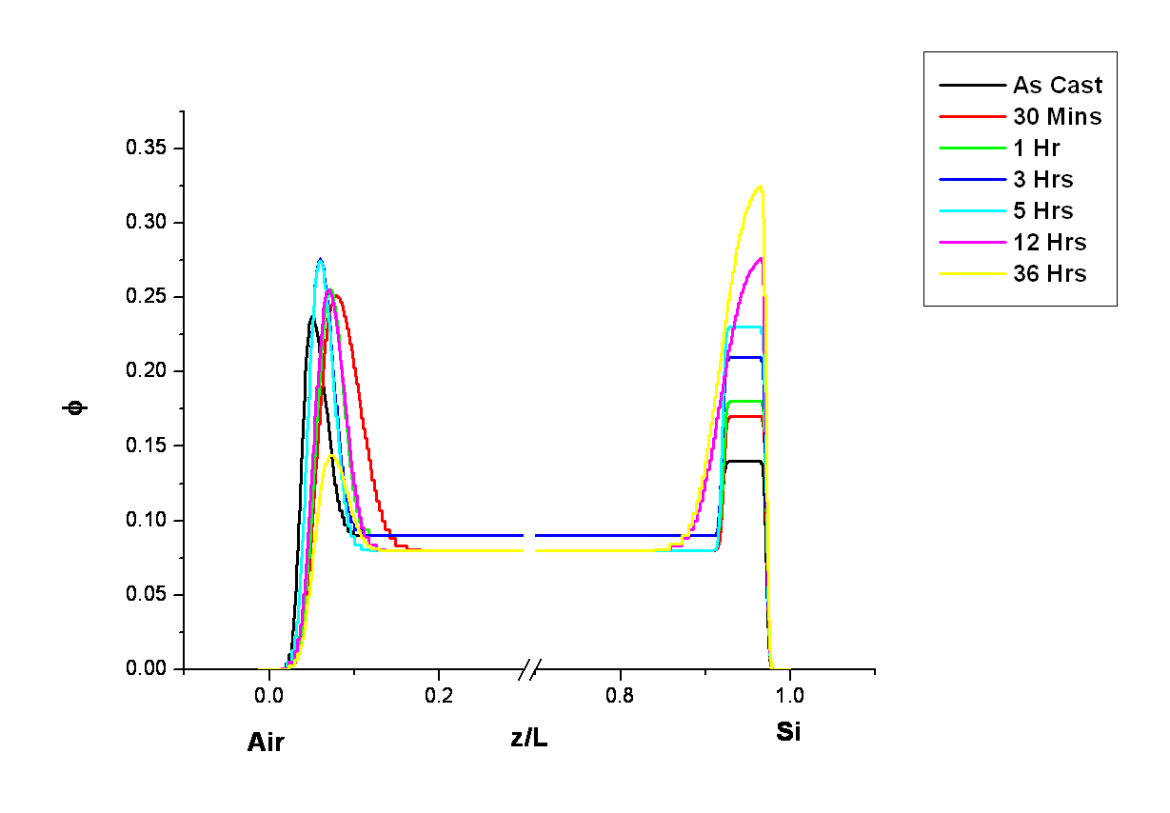

Figure A.58 Neutron reflectivity volume fraction copolymer plots for the binary blend 9010MMAEO_LPMMA annealed as-cast to 36hours at 150°C under vacuum. Data is truncated to emphasize the interfaces.

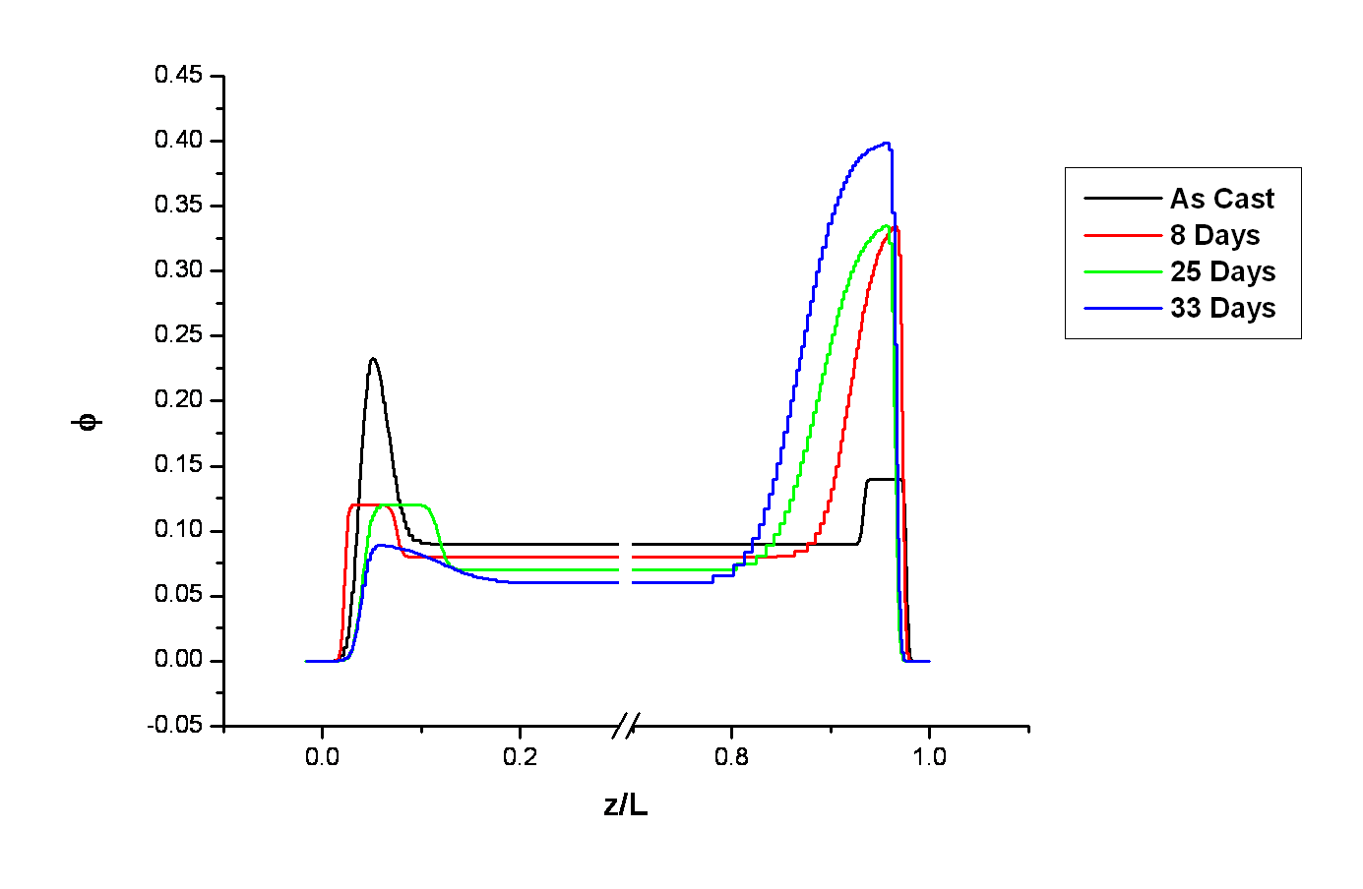

Figure A.59 Neutron reflectivity volume fraction copolymer plots for the binary blend 9010MMAEO_LPMMA annealed as-cast to 33 days at 150°C under vacuum. Data is truncated to emphasize the interfaces.

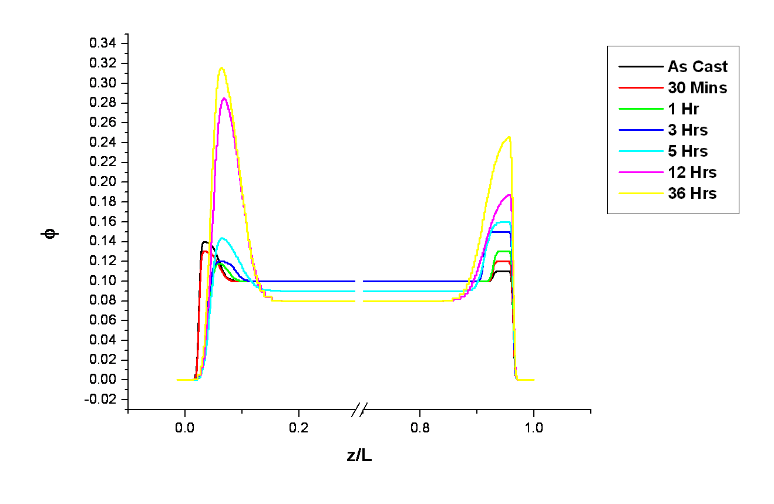

Figure A.60 Neutron reflectivity volume fraction copolymer plots for the binary blend 7525MMAEO_LPMMA annealed as-cast to 36hours at 150°C under vacuum. Data is truncated to emphasize the interfaces.

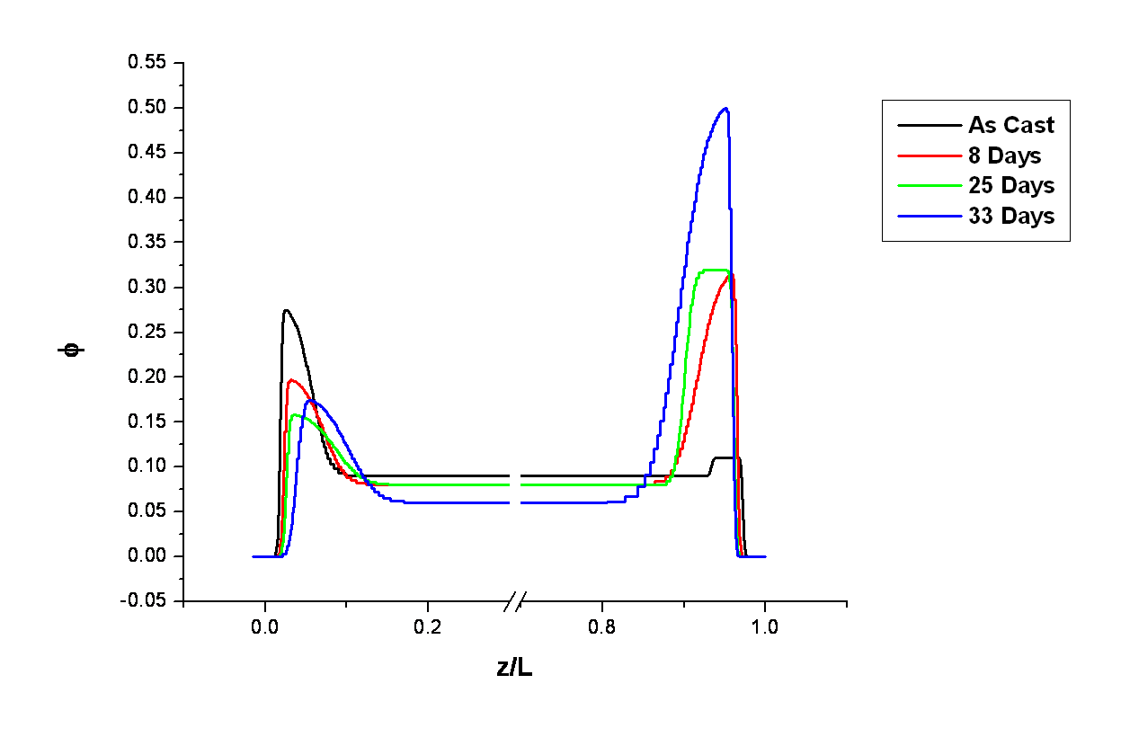

Figure A.61 Neutron reflectivity volume fraction copolymer plots for the binary blend 7525MMAEO_LPMMA annealed as-cast to 33 days at 150°C under vacuum. Data is truncated to emphasize the interfaces.

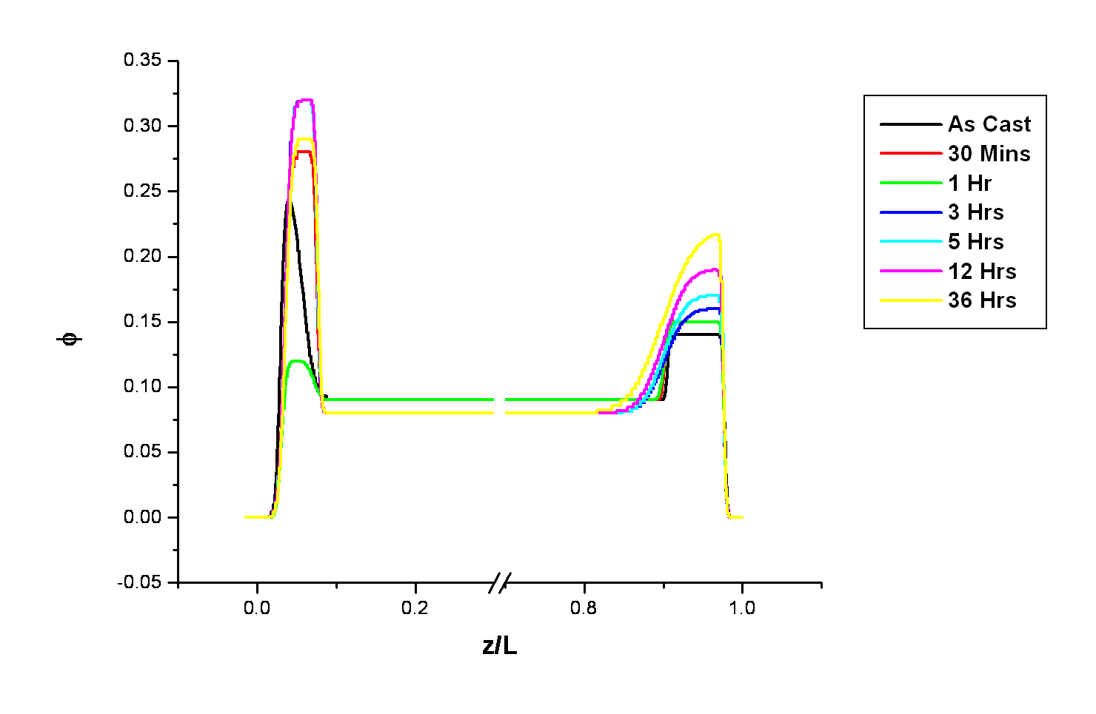

Figure A.62 Neutron reflectivity volume fraction copolymer plots for the binary blend 5050MMAEO_LPMMA annealed as-cast to 36hours at 150°C under vacuum. Data is truncated to emphasize the interfaces.

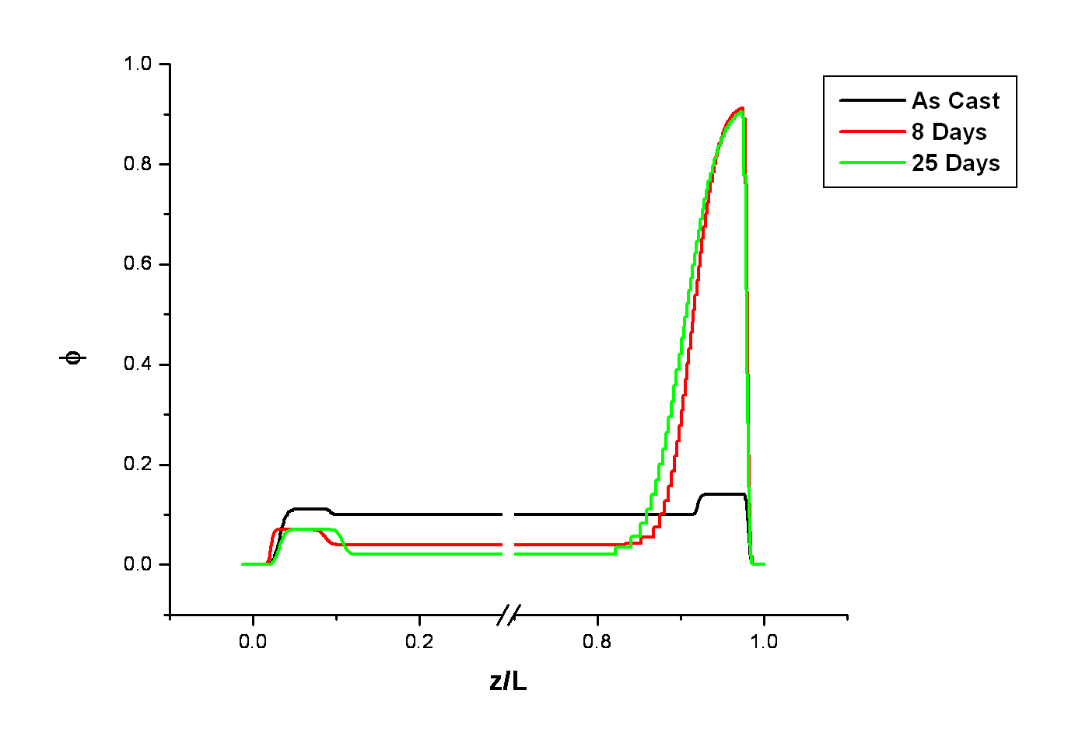

Figure A.63 Neutron reflectivity volume fraction copolymer plots for the binary blend 5050MMAEO_LPMMA annealed as-cast to 25 days at 150°C under vacuum. Data is truncated to emphasize the interfaces.

Appendix B:
Supporting Information for Chapters 5 and 6

B.1 Methods for Characterization of Thin Films Composed of Functionalized Cross-Linked Networks and Self-Assembled Well-Defined PCHD and PPP Brushes
- Dynamic Secondary Ion Mass Spectroscopy (DSIMS)

To help complement the neutron reflectivity results of this study, Dynamic Secondary Ion Mass Spectrometry (DSIMS) data for these materials was also collected. Figure B.1 illustrates the DSIMS experimental setup.

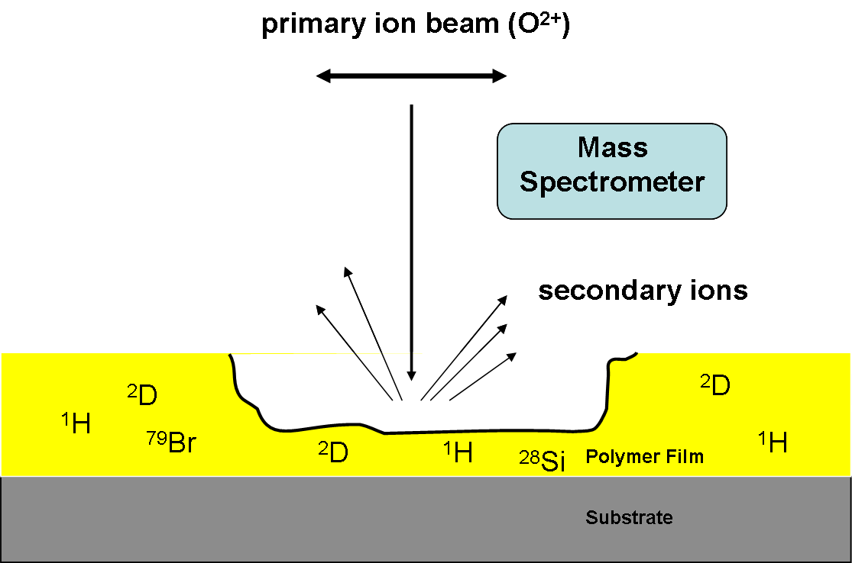

Figure B.1 An illustration of the experimental setup for DSIMS measurements to obtain depth profile information on thin polymer films investigated in this study.

In a DSIMS experiment, high fluxes of ions bombard a surface. Some of the material removed from the surface will be positively or negatively charged. These molecular fragments are called secondary ions. These secondary ions are detected and then analyzed in a mass spectrometer. The result is that the material sputtered from this event gives information about the composition depth profile of the material. However, depth resolution is limited because of a process called ion beam mixing. In ion beam mixing, ions of sufficient energy knock atoms out of their atomic lattice positions. The result is interfacial mixing at boundary layers. This leads to broadening of what would otherwise be a sharp interface. Nevertheless, useful information can be gathered from such an experiment and used to help improve or support a model of the depth profile for a material.
Extraction of a depth profile from a DSIMS experiment requires the use of a reference thin film sample with well-defined layers in order to measure the etch rates of individual layers. The time it takes to remove a layer through the sputtering process is correlated with the thickness of that particular layer through the following relationship:
Thickness = etch rate * etch time (B.1)

Given the same ion beam conditions, this means that an etch rate for a particular material with a specific composition can be calculated. However, to account for differences in the ion beam conditions for a particular experiment, normalization using the ¹²C count rate for the same sample being investigated is also performed. The normalization procedure using ¹²C assumes that the density of ¹²C in the reference material containing separate layers of dPS and PP/inimer is the same as in the composite PP/inimer/dPS material being investigated. It is also assumed that the ionization efficiency is the same for both this reference material and the composite material. Ellipsometry measurements of the sample before and after the secondary polymerization along with etch rates obtained from the reference material were used to calculate a volume fraction of dPS with depth into the film.
- In-Situ Ellipsometry

To measure the changing thicknesses of films immersed in solvent, in-situ ellipsometry measurements were employed. In-situ measurements require continuous real-time signal readout and thus phase modulated ellipsometry is used since it is faster and more sensitive than ellipsometry measurements based on rotating polarizing elements (see Appendix A2 for further detail). The optical setup for phase modulated ellipsometry employed in this study is shown in Figure B.2.

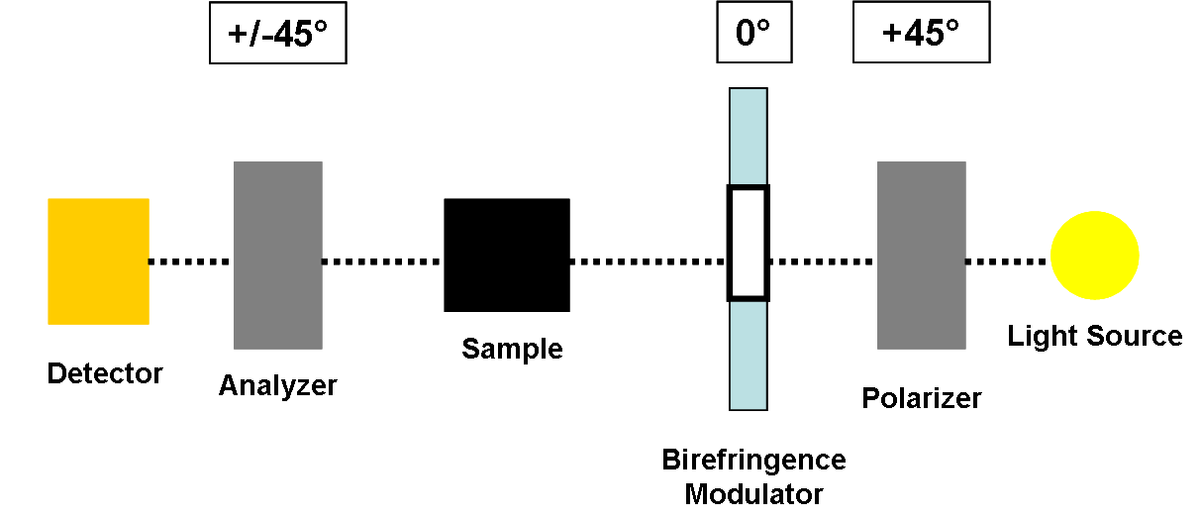

Figure B.2 An illustration of the optical setup for phase modulated ellipsometry.

Phase modulated ellipsometry involves the use of a birefringence modulator which is composed of an isotropic slab of glass attached to a quartz crystal. The glass slab is set into oscillation at its resonance frequency via the piezoelectric effect whereby electricity is used to drive the oscillation of a material. The oscillation produces a periodic uniaxial strain which results in a periodic change in the refractive index for light parallel to the oscillation direction. This strain-induced birefringence, also known as the photoelastic effect, also introduces a phase shift in light parallel and perpendicular to the oscillation direction. Thus, during a modulation cycle, the light beam alternates between linear, elliptical, and circular polarization. Following reflection from the surface of a sample, the change in the polarization of the incident light beam is collected by a detector. The reflected light is further analyzed as an AC signal that is proportional to the real and imaginary parts of the complex reflectivity ratio.

Vita

Onome Jeminoyo Agori-Iwe was born in West Lafayette, Indiana, to Esther and Dr. Kesiena Agori-Iwe. She grew up in Urbana, Illinois, and later her family moved to Georgia, where she earned a B.S. in Chemistry from Georgia State University. Onome worked as an Environmental Compliance Manager for Tyson Foods after earning her undergraduate degree. After working for a short while, Onome decided to return to school to pursue a graduate degree at the University of Tennessee.
Prior to joining Dr. Dadmun’s group, she served as student operator of the Single Crystal X-Ray Diffractometer for the Chemistry Department at UT while working for Dr. John Turner, where she maintained the instrument, solved small molecule crystal structures, and trained members of the Department in the use of the diffractometer.
After joining Dr. Dadmun’s research group, she completed much of her graduate work in polymer chemistry at Oak Ridge National Lab at the Center for Nanophase Materials Science as well as at the Spallation Neutron Source. She also collected neutron reflectivity data at the National Institute of Standards and Technology (NIST) Center for Neutron Research (NCNR). While working in Dr. Dadmun’s research group, Onome presented contributed talks and a poster presentation at American Physical Society meetings as well at the International Conference on Neutron Scattering.
Onome was also awarded a Marie Curie Fellowship where she spent two years at Durham University in Durham, England, and worked in Dr. Lian Hutchings research lab. She was a part of a research team called Dynacop - Dynamics of Architecturally Complex Polymers – a collaboration between 9 European Universities and 2 industrial partners (DOW and BASF), in which the objective was to obtain a fundamental understanding of the flow behavior and dynamics of blends of architecturally complex polymer blends. One of the practical industrial applications of the research collaboration was to address the issue of instability in extrusion which results in imperfect plastic parts and is costly. Onome’s role as a part of the Dynacop team was to develop methods to separate architecturally complex polymer mixtures to support structure-property polymer melt rheology studies using a technique called Temperature Gradient Interaction Chromatography (TGIC). The use of TGIC to analyze complex polymer mixtures had been developed in Dr. Taihyun Chang’s research lab at POSTECH in Pohang, South Korea, for several decades, but was not being utilized widely in other research labs. Onome built one of the first TGIC instruments outside of Dr. Taihyun Chang’s lab at Durham University and used the technique to successfully separate HyperMacs and DendriMacs. HyperMacs and DendriMacs belong to the same topological family of hyperbranched polymers with long chain branching as industrially produced metallocene catalyzed branched polymers like low density poly(ethylene) (LDPE) and thus have the potential to be useful as model systems for many structure-property investigations of branched polymers, including melt rheology. The resolution of TGIC is superior to size exclusion chromatography (SEC), which is the standard technique for separation of polymer mixtures. Onome was hosted by Dr. Taihyun Chang in his lab at POSTECH in Pohang, South Korea, for 30 days, to learn more about the technique. While in Europe as a Marie Curie Fellow, Onome presented contributed talks on the TGIC analysis of HyperMacs at various conferences.
Most recently, Onome has been working for a polymer resin supplier to the coatings industry, Allnex, in Alpharetta, Georgia, as a Technical Service and Development Chemist. She has learned to formulate and characterize UV curable coatings for graphics applications (i.e., inks) as well as how to formulate and characterize powder coatings (usually applied to metal substrates). She has a wonderful son, Marsalis, who is 11 years old. She enjoys spending time with her son, mom, and brothers, as well as hitting golf balls at the golf driving range as often as possible as she would really like to improve her golf game.

