An Analysis of Consumer Response to Businesses’ Expression of Beliefs

Justin Boyter

Faculty Advisor: Deborah Swanquist

Fall 2012
Chancellor’s Honors Program
The University of Tennessee, Knoxville

Table of Contents

Abstract 3

Introduction 6

Recent Examples 8

Survey 15

Conclusion 25

References 27

Appendix

Appendix A: Copy of Survey 29

Appendix B: Survey Results 34

Abstract

Over the last several decades, American society has experienced dramatic changes. A great deal of that change has been in relation to the development of new technology. In just the last 30 years, a large number of technological advancements have shaped society and are now used by the vast majority of Americans on a daily basis. These important technological developments have increased rapidly since the 1980’s with the rise of personal computers, cell phones, and the internet.
The development of these technologies marked the beginning of a new era in the spread of information and the connectedness of society. The smart phone’s coupling of the mobility of the cell phone with the reach of the internet has enabled anybody anywhere to share information worldwide. During this time of advancement in computers and increased usage of the smart phone, another development came about in the form of social media and networking that allows users to truly leverage the communicative powers of the devices.
Social media and networking exploded in the late 2000’s and continues to grow. The top social networking site, Facebook, now has over 1 billion users alone and it’s estimated that approximately 1.5 billion people around the world now use social networking and media (International Business Machines, 2012). Social media and networking have expanded the significance of communication technology from the business world to society as a whole as people not only use their communication devices for work, but staying connected with friends and family, entertainment, staying up to date on current news, and a variety of other purposes. The expansion of these new forms of communication has opened a variety of opportunities to businesses, but also added a great deal of complexity to the environment in which businesses operate.
Social media is a fantastic tool for businesses that has changed the way they communicate with customers and employees. Approximately 94% of businesses with a marketing department now use social media as part of their marketing platform (Bosari, 2012). Through social media marketing, businesses can reach an incredible number of people in a more targeted and personal manner. In addition to advertising their products and services, social media can be used by businesses to offer special deals/promotions, release positive news and information, and build their brand. Interestingly, unlike forms of communication used by businesses in the past that allowed for a one-way transmission of information, social media and networking facilitates a two-way interaction. Customers not only receive information about businesses, but can provide information to businesses and spread information about businesses to others. While the ability of customers to communicate to and about businesses can be highly beneficial, it also poses incredible danger when it comes to potentially negative and damaging information. Businesses must now be even more careful with their actions and decision making and consider the impact knowing that any and all information will become public knowledge.
Adding to the danger posed to businesses by the communication of negative information over social media and other outlets is the changing nature of society’s interest level and views on divisive issues. Over the last 20 years, American society has become much more evenly divided on a number of issues that were once agreed upon by large percentages of the population. In addition to becoming more evenly divided, the constant exposure to information on issues and the ability to express opinions on those issues over social media and networking has fueled an enormous rise in the in the interest and passion Americans hold about different issues. Discussions once reserved for close friends and family that were primarily highlighted in the news during election debates are now continuously displayed and furiously argued over in the public forum of social media. When businesses are linked to these issues through their own actions, communications, or other means, they have the potential to greatly impact their brand, reputation, and performance.

Introduction

The social environment in which businesses operate in the U.S. is highly complex. American society’s hunger for conflict and drama in the media coupled with the ability to rapidly disseminate information through social media and other outlets poses a great deal of danger to businesses. Businesses must be extremely careful in their decision making and vigilant in the monitoring of their corporate communications. Businesses must also be aware of their management’s expression of beliefs, as association with a particular belief can produce a significant response among consumers and the media. An increasingly common response is for consumers to organize a boycott when they disagree with a business’s stance on an issue. Using the incredible capabilities of social networking and media, consumers can quickly organize and promote boycotts of businesses with national and even global participation. Despite this potential for negative impact on the business, many businesses and their owners or management feel strongly enough that they still communicate their beliefs and values on politically or religiously significant topics. When businesses make the decision to dive into these culturally dividing issues, or are inadvertently associated with them, they should consider the potential negative impact. This project will attempt to analyze consumer response to businesses’ expression of beliefs, particularly in relation to controversial subjects such as religion, politics, and culture, as these are more likely to have a significant impact on consumers’ decision making. The project seeks to discover differences in consumers’ responses to businesses’ beliefs on various controversial issues and the impact those responses may have on the business. The project seeks to gather this information through surveying and a review of recent, well-publicized occurrences of consumer reactions. The information generated from this project should be useful to all businesses, particularly their public relations department, in understanding how their company’s expression of or association with beliefs on controversial topics will affect their public image and profitability.

Recent Examples

This section of the report highlights recent, well-publicized incidents in which businesses have faced significant consumer response and media attention due to expression of or association with a belief. The specifics of each incident are outlined and the movement of the company’s stock price is analyzed (pre and post incident) if the company is publicly traded.

J.C. Penney Company

On Jan. 25th, 2012, JC Penney’s CEO Ron Johnson announced a complete revision of its marketing strategy with changes in its pricing, branding, promotions, and a refreshing of its stores (Palmer, 2012). One component of these changes was the hiring of openly gay comedian and talk show host Ellen DeGeneres as a spokeswoman. The hiring sparked protest from One Million Moms, a conservative offshoot of the pro-family American Family Association. The organization initially called for a boycott of the retailer on Feb. 1 which it eventually retracted, but stated that “We have heard back from men and women — not just moms — saying they will no longer shop there at JC Penney, as long as Ellen DeGeneres is their spokesperson” (Hallowell, 2012). A few months later, JC Penney faced another boycott call from One Million Moms when they featured a picture of a lesbian couple and their daughters in their May catalog (Freeburn, 2012). In addition to the boycott, One Million Moms encouraged concerned customers to call or visit their local store managers and “ask them to tell corporate that they should remain neutral in the cultural war. The company’s stock price did see a large jump in response to the announcement of the marketing overhaul, but it’s doubtful that the hiring of Ellen DeGeneres was a driving force. The company’s stock price did not seem to exhibit any noticeable movement that can be directly attributed to the One Million Moms call for boycotts. (The graph below depicts J.C. Penney’s 2012 stock price with the related dates highlighted)
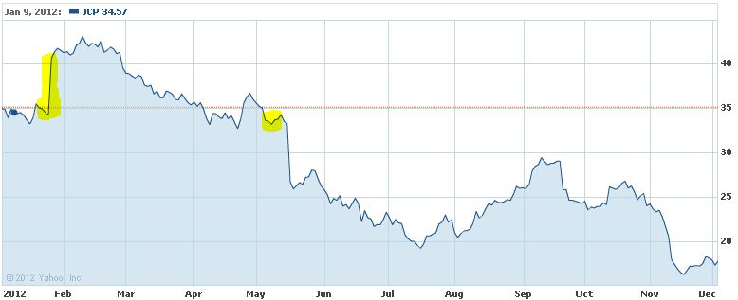

Kraft
On June 25th, 2012, Kraft Foods entered the realm of controversy when it posted the following gay pride Oreo on the company’s Facebook page.
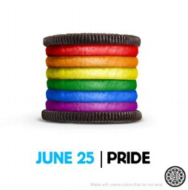
A spokeswoman for Kraft stated that the picture was part of a “series of daily ads reflecting current events in a fun way using images of Oreo cookies and milk” (Bingham, Oreo Pride: Rainbow-Stuffed Cookie Sparks Threats of Boycott, 2012). The ad received mixed reactions and comments on Facebook with some users pledging support and others threatening to boycott. Mondelez International Inc.’s (a spinoff of Kraft that holds the Oreo brand) stock did experience a noticeable decline at the date of the controversy, but quickly recovered and it’s uncertain whether the temporary decline related to the incident. (The graph below depicts Mondelez International’s 2012 stock price with the related dates highlighted)
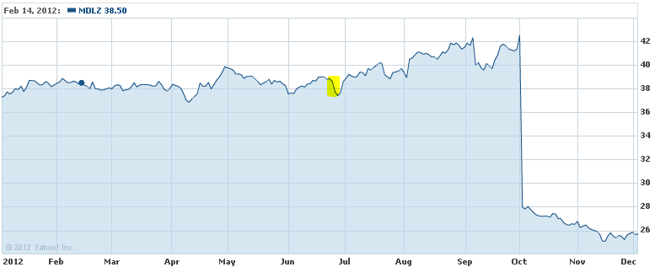

Google

On July 7th, 2012, Google launched a new campaign called “Legalize Love” supporting lesbian, gay, bisexual, and transgender (LGBT) rights around the world. Google executive Mark Palmer-Edgecumbe said that the company launched the campaign because “We want our employees who are gay or lesbian or transgender to have the same experience outside the office as they do in the office” (Google Announces Worldwide 'Legalize Love' Campaign Plan In Support Of Gay Rights , 2012). The American Family Association called for a nationwide boycott of all of Google’s products, but admitted that “A lot of us are so integrated into Google and Google products. This is going to be a tough one. It’s more than just a search engine. Many of us have Android phones — the Android system is a Google product. Many of us use Google calendar, Google Tasks and Gmail. And all those kinds of things. YouTube. And all the other things … this one’s going to be tough. This one’s going to be one of those situations where I guess we’ll test the meat of our convictions” (American Family Association Calls For Google Boycott Over Pro Gay Stance , 2012). At the date of Google’s announcement of the program, share prices were in the midst of a multi-day decline and did not appear to respond directly to the controversy. (The graph below depicts Google’s 2012 stock price with the related dates highlighted)
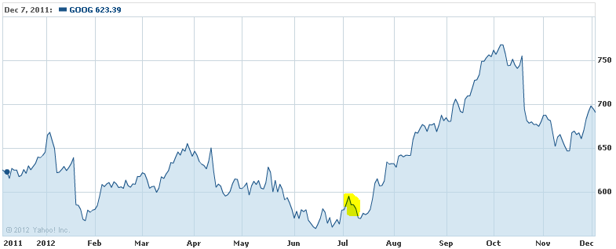
Starbucks

On January 24th, 2012, Starbucks took a corporate-wide stance in support of same sex marriage by issuing a memorandum saying “Starbucks is proud to join other leading Northwest employers in support of Washington State legislation recognizing marriage equality for same-sex couples.” By March, the National Organization for Marriage announced that it was launching a boycott of the company and dubbed it the “Dump Starbucks” campaign. Jonathan Baker, the director of NOM’s Corporate Fairness Project, said that the company’s statement was especially significant because “The support is not just the personal endorsement of a senior executive, but is the official corporate position of the company” (Gryboski, 2012). The Dump Starbucks website states that “Starbucks has declared a culture war on all people of faith (and millions of others)” and has had nearly 49,000 individuals pledge to boycott the company. At the time of both Starbucks issuance of the memo and the National Organization for Marriage’s organization of the boycott, Starbucks stock was in the middle of a multi-month upward trend and did not appear to be affected. (The graph below depicts Starbuck’s 2012 stock price with the related dates highlighted)
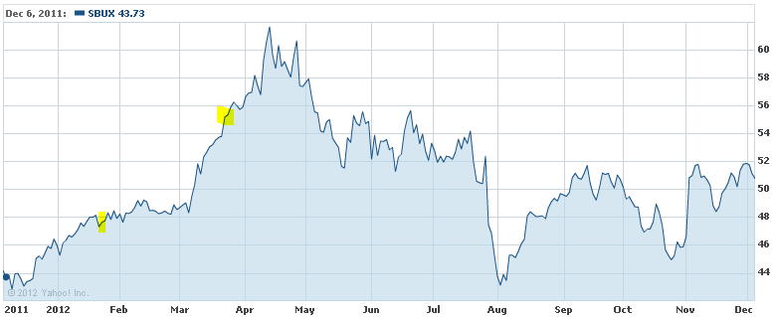
Hobby Lobby

Hobby Lobby recently filed a lawsuit over new requirements to provide insured employees with contraceptive and abortion coverage. The private company’s owner, David Green, is a devout Baptist and claims that compliance with the offending portion of the health care law “would force religiously-motivated business owners like plaintiffs to violate their faith under the threats of millions of dollars in fines.” If the company does not comply with the mandate they could be subject to as much as $1.3 million in fines per day (Chiaramonte, 2012). Customers and others who were offended by Hobby Lobby’s move have taken to social media to protest and organize a boycott, but did not attract a large number of people. Hobby Lobby is privately owned and so not stock information was available to evaluate.
Chick-fil-A
The mostly widely publicized incident of business involvement in 2012 related to Chick-fil-A’s donations to anti-gay groups and the statements of its owner, Dan Cathy. In July, Dan Cathy was interviewed by the Baptist Press, a Christian news outlet, and stated “We are very much supportive of the family -- the biblical definition of the family unit. We are a family-owned business, a family-led business, and we are married to our first wives. We give God thanks for that...we know that it might not be popular with everyone, but thank the Lord, we live in a country where we can share our values and operate on biblical principles” (Blume, 2012). The comments quickly were picked up by other media outlets and spread over social networks igniting a firestorm of debate. Both critics and supporters quickly organized protests and events including National Same Sex Kiss Day and Chick-fil-A Appreciation Day. Chick-fil-A is a private company and did not release its sales figures from Chick-fil-A Appreciation Day, but Steve Robinson, Chick-fil-A’s executive vice president of marketing said that “we can confirm reports that it was a record-setting day” (Bingham, Chick-fil-A Has 'Record-Setting' Sales on Appreciation Day, 2012). As a private company, Chick-fil-A does not have stock information to be evaluated.
Summary
Businesses seem to be coming under fire with increasing frequency and severity for expressing or being associated with beliefs on controversial topics. However, an evaluation of company’s share prices that have experienced such an incident shows they do not seem to experience any significant short term impact. Even when dramatic movements in stock prices correlate to the timing of these controversies, it is difficult to siphon out the amount of change inflicted solely by the negative publicity and boycotts. Akshay Rao, a marketing professor at the Carlson School of Management at the University of Minnesota, was skeptical about a link between sales figures and protests related to General Mills opposition of an amendment to Minnesota’s constitution banning gay marriage and stated that “To make a connection between an earnings report and a particular social phenomenon is very difficult. ... What you can infer, based on how quiet everything has been since the initial flurry of protests and counter protests, is that the issue pretty much lost steam. And I think there's been a good reason for that” (Webb, 2012). While the initial outcry of company critics in these cases seems to be intense and potentially damaging, most protests and negative perceptions seem to fade quickly in the minds of most consumers and have minimal impact on businesses bottom lines and share prices.
Survey

Methodology

The researcher constructed a set of questions aimed at determining how consumers respond to businesses’ expression of beliefs. The survey also includes an in-depth demographic portion to allow for the identification of correlations within the response data by different demographics. Once the survey draft was designed, the researcher consulted with the thesis advisor and others to revise the survey and ensure the wording of the questions was clear and appropriately targeted at obtaining the desired information with the least amount of bias. Once the questions and format of the survey were finalized, the researcher used an online survey service, Qualtrics.com, to distribute the survey via the Internet to approximately 300 individuals (for a full list of questions included in the survey, see Appendix A). Out of the approximately 300 disseminated, 121 individuals responded with 111 respondents completing the entire survey complete (~37% response rate). The survey response data was then analyzed using Qualtrics integrated analysis tools, primarily the cross tabulation function which allowed the researcher to cross reference questions and their responses to identify any correlations in consumers’ responses. Cross tabulations were performed on all pairings of questions that could yield potentially useful information and evaluated to determine if any correlations existed. After the cross tabulation data had been reviewed and any correlations observed, the researcher consulted with the thesis advisor to ensure the correlations were meaningful and supported by the data.
Limitations

The observations from the research presented here are limited in their ability to be extrapolated to the general population as a convenient sample group was utilized for this study. To acquire the largest amount of responses possible, the researcher used a sample population that was readily available to him. The use of a convenient sample group resulted in a fairly homogenous survey population consisting predominantly of white/Caucasian (87%), single (88%), and Protestant Christian (69%) individuals between the ages of 18-29 (94%) with some college education (80%) and individual income below $25,000 (86%). Due to the lack of diversity in the sample population, the research could be limited in representing other demographics and the general population of the United States.
Observations

- Consumers’ decisions to patronize or avoid businesses are more influenced by religious affiliation than political affiliation.
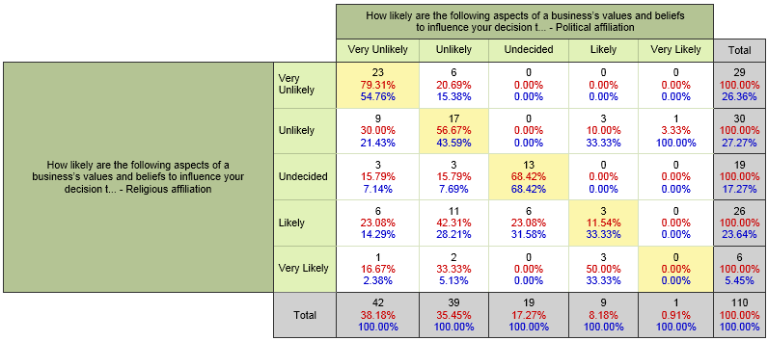

The results from the questions “How likely are the following aspects of a business’s values and beliefs to influence your decision to patronize or avoid a business? – Religious affiliation” and “How likely are the following aspects of a business’s values and beliefs to influence your decision to patronize or avoid a business? – Political affiliation” were cross tabulated to determine how individuals responded to each and on which topic they placed more importance.
The highlighted diagonal line from the top left to the bottom right represents 56 individuals who placed an equal weight of importance on the influence of businesses’ political and religious affiliations on their decision making. The area on the upper right side of the highlighted line represents 10 individuals whose consumption decisions were more likely to be influenced by a business’s political affiliation than religious affiliation. The area on the lower left side of the highlighted line represents 44 individuals whose consumption decisions were more likely to be influenced by a business’s religious affiliation than political affiliation. In addition, 13 individuals answered Undecided (or indifferent) to both the influence of political and religious affiliation of businesses on their consumption decisions. An additional 6 individuals answered Undecided to the influence of political affiliation, but all 6 said that religious affiliation was likely to influence them. Also, six other individuals answered undecided to the influence of religious affiliation, but three of them said that political affiliation was unlikely to influence them and the other three said it was very unlikely to influence them. The data shows that consumers’ decision making is more likely to be influenced by a business’s religious affiliation and association with issues of religious importance than political affiliation. Businesses can expect greater publicity and potential financial impact when they become involved or associated with issues of religious significance than purely political issues. The observation is further supported by the dominance of businesses in the media throughout 2012 for stances on religious issues such as gay marriage.
2. Most individuals believe business’s beliefs and values are unimportant and unlikely to influence their consumption decisions. When a business’s beliefs and values do influence consumers, it positively influences those with similar beliefs and values more strongly than it negatively influences those with opposing beliefs and values.
a.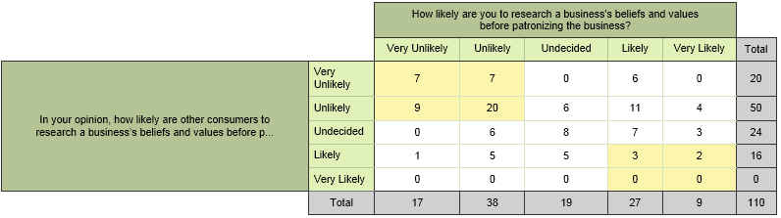
The results from the questions “In your opinion, how likely are other consumers to research a business’s beliefs and values before patronizing the business?” and “How likely are you to research a business's beliefs and values before patronizing the business?” were cross tabulated to determine whether consumers researched businesses’ beliefs and values and thought others did as well. The four boxes in the top left corner of the cross tabulation represent 43 individuals who believed that neither they nor others were unlikely or very unlikely to research a business’s beliefs and values before patronizing it. The four boxes in the bottom right corner of the cross tabulation represent five individuals who believe that both they and others were likely or very likely to research a business’s beliefs and values before patronizing it. The much higher number of individuals in the top left shows that most people do not perform research on a business's beliefs before patronizing the business.
b.
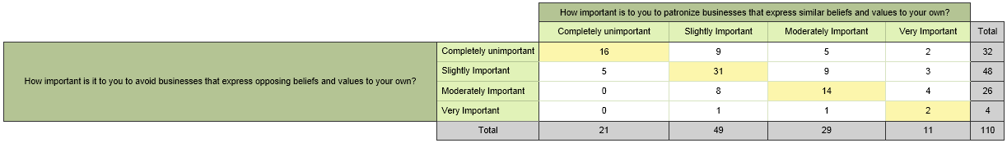
The results from the questions “How important is to you to avoid businesses that express opposing beliefs and values to your own?” and “How important is to you to patronize businesses that express similar beliefs and values to your own?” were cross tabulated to determine whether consumers felt more strongly about businesses with similar beliefs and values or those with opposing beliefs and values. The highlighted line from the top left to the bottom right represents 63 individuals who placed equal importance on patronizing businesses with similar beliefs and avoiding businesses with opposing beliefs. The area above and to the right of the line represents 32 individuals who place more importance on patronizing businesses with similar beliefs. The area below and to the left of the line represents 15 individuals who place more importance on avoiding businesses with opposing beliefs. The larger number of individuals who place more importance on patronizing businesses with similar beliefs than avoiding those with opposing beliefs shows most consumers are drawn to businesses with similar beliefs more than they are repelled by businesses with opposing beliefs.
c.
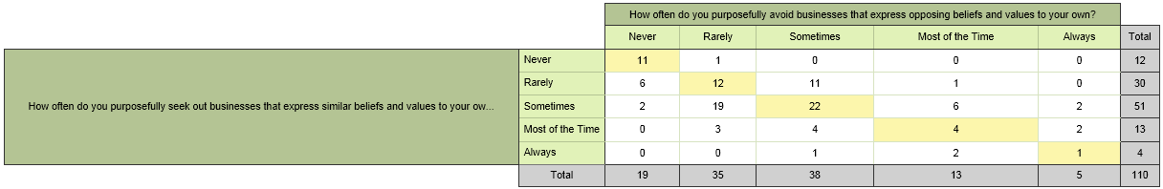
The results from the questions “How often do you purposefully seek out businesses that express similar beliefs and values to your own?” and “How often do you purposefully avoid businesses that express opposing beliefs and values to your own?” were cross tabulated to determine whether consumers are more likely to patronize businesses with similar beliefs and values or avoid those with opposing beliefs and values. The highlighted line from the top left to the bottom right represents 49 individuals who equally patronize businesses with similar beliefs as they as they do avoid businesses with opposing beliefs. The area above and to the right of the line represents 23 individuals who avoid businesses with opposing beliefs and values more often than they patronize businesses with similar beliefs and values. The area below and to the left of the line represents 37 individuals who patronize businesses with similar beliefs and values more often than they avoid businesses with opposing beliefs and values. Similar to the cross tabulation in part b above, the larger number of individuals who patronize businesses with similar beliefs more often than avoid those with opposing beliefs reflects that most consumers are drawn to businesses with similar beliefs more than they are detracted by businesses with opposing beliefs.
d.
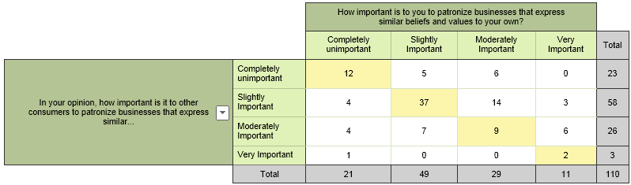
The results from the questions “In your opinion, how important is it to other consumers to patronize businesses that express similar beliefs and values to their own?” and “How important is to you to patronize businesses that express similar beliefs and values to your own?” were cross tabulated to determine the correlation between how strongly consumers feel about patronizing businesses with similar beliefs and how strongly they think others feel. The highlighted line from the top left to the bottom right represents 60 individuals who think they feel equally as strong about patronizing businesses as others. The area above and to the right of the line represents 34 individuals who believe they feel more strongly about patronizing businesses with similar beliefs than others. The area below and to the left of the line represents 16 individuals who believe others feel more strongly about patronizing businesses with similar beliefs than they do. The larger proportion of individuals who believe they feel more strongly about patronizing businesses with similar beliefs than others could be a result of media attention to controversies where consumers are exhibiting opposition to a business. More media attention is placed on instances of consumer opposition than consumer agreement. This media bias may create the assumption that most consumers are quick to openly oppose a business with which they disagree, but not as likely to openly support a business that exhibits values and beliefs in line with their own.
e.
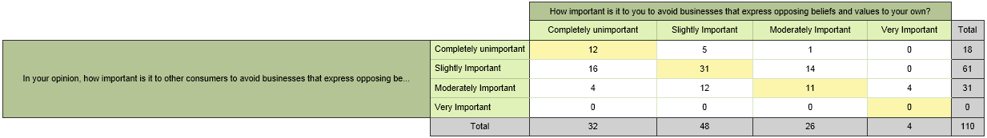
The results from the questions “In your opinion, how important is it to other consumers to avoid businesses that express opposing beliefs and values to their own?” and “How important is to you to avoid businesses that express opposing beliefs and values to your own?” were cross tabulated to determine the correlation between how strongly consumers feel about avoiding businesses with opposing beliefs and how strongly they think others feel. The highlighted line from the top left to the bottom right represents 54 individuals who think they feel equally as strong about avoiding businesses as others. The area above and to the right of the line represents 24 individuals who think they feel more strongly about avoiding businesses with opposing beliefs than others. The area below and to the left of the line represents 32 individuals who think others feel more strongly about patronizing businesses with similar beliefs than they do. Similarly to cross tabulation d above that shows consumers believe they support businesses with similar beliefs more than others, cross tabulation e supports the same conclusion, but with the opposite side of the coin by showing a larger proportion of individuals who believe that others feel more strongly about avoiding businesses with opposing beliefs than they do. As stated above, I believe that media coverage of these incidents subconsciously influenced respondents’ answers as a lesser amount of media coverage on positive consumer responses and an exaggerated emphasis on negative responses leads to the perception of a public that is more concerned with protesting businesses they disagree with than supporting businesses that have similar beliefs. The dramatic bias in the media may give the perception that the negative response of consumers opposed to businesses in these instances is stronger than it really is in reality.
f.
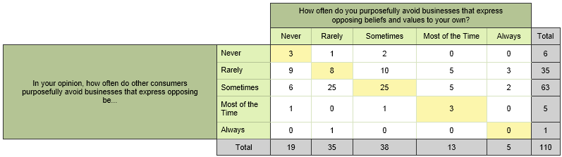
The results from the questions “In your opinion, how often do other consumers purposefully avoid businesses that express opposing beliefs and values to their own?” and “How often do you purposefully avoid businesses that express opposing beliefs and values to your own?” were cross tabulated to determine how consumers decisions to avoid businesses with opposing beliefs correlated with their perception of how often others’ did the same. The highlighted line from the top left to the bottom right represents 39 individuals who believe they avoid businesses that express opposing beliefs with approximately the same frequency as others. The area above and to the right of the line represents 28 individuals who think they avoid businesses with opposing beliefs more often than others. The area below and to the left represents 43 individuals who think others avoid businesses with opposing beliefs more often than they do. Much like the observation in cross tabulation e above that more people believe that others feel more strongly about avoiding businesses with opposing beliefs than they do, cross tabulation e simply takes it one step further and shows consumers think others are more likely to actually avoid the businesses they disagree with than themselves.
g.
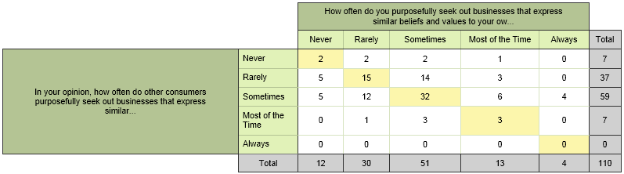
The results from the questions “In your opinion, how often do other consumers purposefully seek out businesses that express similar beliefs and values to their own?” and “How often do you purposefully seek out businesses that express similar beliefs and values to your own?” were cross tabulated to determine how consumers decisions to patronize businesses with similar beliefs correlated with their perception of how often others’ did the same. The highlighted line from the top left to the bottom right represents 52 individuals who believe they patronize businesses that express similar beliefs with approximately the same frequency as others. The area above and to the right of the line represents 32 individuals who think they patronize businesses with similar beliefs more often than others. The area below and to the left represents 26 individuals who think others patronize businesses with similar beliefs more often than they do. The larger proportion of individuals that think they are more likely to patronize businesses with similar beliefs than others is representative of the fact that individuals respond strongly to businesses with similar beliefs, but those types of reactions are given less attention in the media leading to the misperception that others are not as likely to patronize businesses with similar beliefs.
Conclusion

In the new age of the instantaneous spreading of information over social networks, businesses must be aware that their statements and actions, and those of their senior management and other associates, will quickly become public knowledge and scrutinized like never before. They must pay particularly close attention to association with positions on controversial issues such as those related to religion and politics. After evaluating the results of this project’s survey, it appears that businesses’ affiliation with religious issues elicits stronger responses by consumers than those of a purely political nature. The instances where businesses do become associated with one side of a controversial issue and evoke consumer response tend to be given a great deal of attention and hype in the media. Most of the time these stories tend to focus on the reactions of those consumers who have taken offense to the business’s stance such as the organization of protests and boycotts. Despite the great deal of negativity presented by the media in these instances, it seems that businesses are unlikely to face any material financial impact. The evaluation of companies’ stock prices that had recently experienced such events showed no significant change in share value that could be directly attributed to consumers’ response to the business’s expression of belief. In fact, it appears more likely that businesses will experience a positive impact from consumer reactions than a negative impact. Survey data shows consumers tend to respond more strongly to businesses who express similar beliefs than they do to businesses that express opposing beliefs. Consumer response in recent events supports this claim. When General Mills expressed support for gay marriage by opposing a Minnesota amendment that would ban it, nearly 25,000 consumers pledged to boycott General Mills products at the website DumpGeneralMills.com. At the same time gay rights groups organized an online thank-you-General-Mills campaign which received 80,000 signers (Webb, 2012). In addition, when Chick-fil-A CEO Dan Cathy made comments opposing gay marriage, gay activists quickly ignited a media frenzy with their protests and organized a National Same Sex Kiss day at Chick-fil-A that received about 11,000 attendees on Facebook. The Chick-fil-A Appreciation Day event organized by supporters had roughly 55 times that many Facebook attendees (Bingham, Chick-fil-A Has 'Record-Setting' Sales on Appreciation Day, 2012). Despite being on opposite sides of the same issues, both companies received considerably more support than opposition. While it may seem like a public relations nightmare when portrayed in the media, it appears that the greater enthusiasm of individuals in agreement with a business’s stance on a particular issue outweighs negative reactions and may actually be beneficial in the short term. With this knowledge in mind, businesses should be less worried when caught in this type of controversy, but will still probably save themselves a headache staying neutral in the religious and political battles of American society.

References
American Family Association Calls For Google Boycott Over Pro Gay Stance . (2012, July 11). Retrieved December 5, 2012, from The Inquisitr: http://www.inquisitr.com/274856/american-family-association-calls-for-google-boycott-over-pro-gay-stance-video/
Google Announces Worldwide 'Legalize Love' Campaign Plan In Support Of Gay Rights . (2012, July 7). Retrieved December 5, 2012, from Huffington Post: http://www.huffingtonpost.com/2012/07/07/google-announces-support-same-sex-marriage_n_1656680.html
Bingham, A. (2012, August 2). Chick-fil-A Has 'Record-Setting' Sales on Appreciation Day. Retrieved December 5, 2012, from ABC News: http://abcnews.go.com/Politics/OTUS/chick-fil-record-setting-sales-appreciation-day/story?id=16912978
Bingham, A. (2012, June 26). Oreo Pride: Rainbow-Stuffed Cookie Sparks Threats of Boycott. Retrieved December 5, 2012, from ABC News: http://abcnews.go.com/blogs/politics/2012/06/oreo-pride-rainbow-stuffed-cookie-sparks-boycott/
Blume, K. A. (2012, July 16). 'Guilty as charged,' Cathy says of Chick-fil-A's stand on biblical & family values. Retrieved December 5, 2012, from Baptist Press: http://www.bpnews.net/BPnews.asp?ID=38271
Bosari, J. (2012, August 8). The Developing Role of Social Media in the Modern Business World. Retrieved December 5, 2012, from Forbes: http://www.forbes.com/sites/moneywisewomen/2012/08/08/the-developing-role-of-social-media-in-the-modern-business-world/
Chiaramonte, P. (2012, September 20). Hobby shop chain faces backlash for stance against ObamaCare. Retrieved December 5, 2012, from Fox News: http://www.foxnews.com/us/2012/09/20/growing-boycott-against-retail-chain-hobby-lobby-after-lawsuit-against-health/
Freeburn, C. (2012, May 7). Second Lesbian Protest for J.C. Penney. Retrieved December 5, 2012, from InvestorPlace: http://investorplace.com/2012/05/second-lesbian-protest-for-j-c-penney/
Gryboski, M. (2012, 23 March). NOM Launches Starbucks Boycott Over Same-Sex Marriage Stance. Retrieved December 5, 2012, from Christian Post: http://www.christianpost.com/news/nom-launches-boycott-of-starbucks-over-same-sex-marriage-stance-72006/
Hallowell, B. (2012, August 3). Here Are 7 Other Faith-Related Boycotts Against American Companies (In Addition to Chick-Fil-A). Retrieved December 5, 2012, from The Blaze: http://www.theblaze.com/stories/here-are-7-other-faith-based-boycotts-against-american-companies-in-addition-to-chick-fil-a/
International Business Machines. (2012, December 5). The Rise of Social Business. The Wall Street Journal, p. B10.
Palmer, A. (2012, January 25). JCPenney overhauls marketing, promo strategy. Retrieved December 5, 2012, from Direct Marketing News: http://www.dmnews.com/jcpenney-overhauls-marketing-promo-strategy/article/224733/
Webb, T. (2012, September 20). General Mills' earnings unhurt by boycott over marriage issue. Retrieved December 5, 2012, from TwinCities Pioneer Press: http://www.twincities.com/business/ci_21585402/boycott-over-marriage-issue-doesnt-hurt-general-mills

APPENDIX A

Dear survey participant,
Thank you for your time today in completing this short survey. We are researching the impact of business's expression of beliefs on controversial topics on consumers' decision making.
Your participation in this important research is completely confidential. No personal information will be published or used for any purposes other than the research being conducted.
If you have any questions regarding this research project, please contact the primary researcher at the University of Tennessee:
Mr. Justin Boyter
jboyter1@utk.edu
The estimated time to complete the survey is about 5 minutes.
Please answer the following questions:

What is your gender?

( ) Male
( ) Female

What is your age?

( ) Under 18
( ) 18-29
( ) 30-49
( ) 50-64
( ) 65 years and over

What is your ethnicity?

( ) American Indian/Native American
( ) Asian
( ) Black/African American
( ) Hispanic/Latino
( ) Middle Eastern
( ) White/Caucasian
( ) Pacific Islander
( ) Other

What is your current marital status?

( ) Single, Never Married
( ) Married
( ) Separated
( ) Divorced
( ) Widowed

What is the highest level of education you have completed?

( ) Some high school
( ) High school graduate
( ) Some college
( ) Trade/Technical/Vocational training
( ) College graduate
( ) Some postgraduate work
( ) Postgraduate degree

What do you expect your 2012 individual income from all sources before taxes to be?

( ) Under $25,000
( ) $25,000 - $39,999
( ) $40,000 - $74,999
( ) $75,000 - $99,999
( ) $100,000 - $250,000
( ) Above $250,000

What do you expect your 2012 household income from all sources before taxes to be?

( ) Under $25,000
( ) $25,000 - $39,999
( ) $40,000 - $74,999
( ) $75,000 - $99,999
( ) $100,000 - $250,000
( ) Above $250,000

Generally speaking, which political affiliation do you most identify with?

( ) Democrat
( ) Moderate/Independent
( ) Republican
( ) Libertarian
( ) Other

How strongly do you identify with the political affiliation selected above?

( ) Not at all
( ) Some
( ) Quite a bit
( ) A great deal
( ) Completely

What is your religious affiliation?

( ) Protestant Christian
( ) Roman Catholic
( ) Jewish
( ) Muslim
( ) Hindu
( ) Buddhist
( ) Atheist
( ) Agnostic
( ) Other

How strongly do you identify with the religious affiliation selected above?

( ) Not at all
( ) Some
( ) Quite a bit
( ) A great deal
( ) Completely

How likely are you to research a business's beliefs and values before patronizing the business?

( ) Very Unlikely
( ) Unlikely
( ) Undecided
( ) Likely
( ) Very Likely

How often do you purposefully seek out businesses that express similar beliefs and values to your own?

( ) Never
( ) Rarely
( ) Sometimes
( ) Most of the Time
( ) Always

How important is to you to patronize businesses that express similar beliefs and values to your own?

( ) Completely unimportant
( ) Slightly Important
( ) Moderately Important
( ) Very Important

How often do you purposefully avoid businesses that express opposing beliefs and values to your own?

( ) Never
( ) Rarely
( ) Sometimes
( ) Most of the Time
( ) Always

How important is it to you to avoid businesses that express opposing beliefs and values to your own?

( ) Completely unimportant
( ) Slightly Important
( ) Moderately Important
( ) Very Important

How likely are the following aspects of a business’s values and beliefs to influence your decision to patronize or avoid a business?

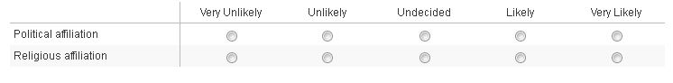

In your opinion, how likely are other consumers to research a business’s beliefs and values before patronizing the business?

( ) Very Unlikely
( ) Unlikely
( ) Undecided
( ) Likely
( ) Very Likely

In your opinion, how often do other consumers purposefully seek out businesses that express similar beliefs and values to their own?

( ) Never
( ) Rarely
( ) Sometimes
( ) Most of the Time
( ) Always

In your opinion, how important is it to other consumers to patronize businesses that express similar beliefs and values to their own?

( ) Completely unimportant
( ) Slightly Important
( ) Moderately Important
( ) Very Important

In your opinion, how often do other consumers purposefully avoid businesses that express opposing beliefs and values to their own?

( ) Never
( ) Rarely
( ) Sometimes
( ) Most of the Time
( ) Always

In your opinion, how important is it to other consumers to avoid businesses that express opposing beliefs and values to their own?

( ) Completely unimportant
( ) Slightly Important
( ) Moderately Important
( ) Very Important

APPENDIX B

Survey Results
1. What is your gender?
# | Answer |  | Response | %
1 | Male |  | 45 | 41%
2 | Female |  | 65 | 59%
 | Total |  | 110 | 100%

Statistic | Value
Min Value | 1
Max Value | 2
Mean | 1.59
Variance | 0.24
Standard Deviation | 0.49
Total Responses | 110

2. What is your age?
# | Answer |  | Response | %
1 | Under 18 |  | 0 | 0%
2 | 18-29 |  | 103 | 94%
3 | 30-49 |  | 3 | 3%
4 | 50-64 |  | 3 | 3%
5 | 65 years and over |  | 1 | 1%
 | Total |  | 110 | 100%

Statistic | Value
Min Value | 2
Max Value | 5
Mean | 2.11
Variance | 0.21
Standard Deviation | 0.46
Total Responses | 110

3. What is your ethnicity?
# | Answer |  | Response | %
1 | American Indian/Native American |  | 1 | 1%
2 | Asian |  | 2 | 2%
3 | Black/African American |  | 6 | 5%
4 | Hispanic/Latino |  | 2 | 2%
5 | Middle Eastern |  | 0 | 0%
6 | White/Caucasian |  | 97 | 87%
7 | Pacific Islander |  | 1 | 1%
8 | Other |  | 2 | 2%
 | Total |  | 111 | 100%

Statistic | Value
Min Value | 1
Max Value | 8
Mean | 5.73
Variance | 1.09
Standard Deviation | 1.04
Total Responses | 111

4. What is your current marital status?
# | Answer |  | Response | %
1 | Single, Never Married |  | 97 | 88%
2 | Married |  | 12 | 11%
3 | Separated |  | 0 | 0%
4 | Divorced |  | 1 | 1%
5 | Widowed |  | 0 | 0%
 | Total |  | 110 | 100%

Statistic | Value
Min Value | 1
Max Value | 4
Mean | 1.14
Variance | 0.17
Standard Deviation | 0.42
Total Responses | 110

5. What is the highest level of education you have completed?
# | Answer |  | Response | %
1 | Some high school |  | 0 | 0%
2 | High school graduate |  | 5 | 5%
3 | Some college |  | 88 | 80%
4 | Trade/Technical/Vocational training |  | 2 | 2%
5 | College graduate |  | 10 | 9%
6 | Some postgraduate work |  | 3 | 3%
7 | Postgraduate degree |  | 2 | 2%
 | Total |  | 110 | 100%

Statistic | Value
Min Value | 2
Max Value | 7
Mean | 3.31
Variance | 0.88
Standard Deviation | 0.94
Total Responses | 110

6. What do you expect your 2012 individual income from all sources before taxes to be?
# | Answer |  | Response | %
1 | Under $25,000 |  | 95 | 86%
2 | $25,000 - $39,999 |  | 3 | 3%
3 | $40,000 - $74,999 |  | 8 | 7%
4 | $75,000 - $99,999 |  | 3 | 3%
5 | $100,000 - $250,000 |  | 1 | 1%
6 | Above $250,000 |  | 0 | 0%
 | Total |  | 110 | 100%

Statistic | Value
Min Value | 1
Max Value | 5
Mean | 1.29
Variance | 0.63
Standard Deviation | 0.79
Total Responses | 110

7. What do you expect your 2012 household income from all sources before taxes to be?
# | Answer |  | Response | %
1 | Under $25,000 |  | 49 | 45%
2 | $25,000 - $39,999 |  | 8 | 7%
3 | $40,000 - $74,999 |  | 17 | 16%
4 | $75,000 - $99,999 |  | 7 | 6%
5 | $100,000 - $250,000 |  | 23 | 21%
6 | Above $250,000 |  | 5 | 5%
 | Total |  | 109 | 100%

Statistic | Value
Min Value | 1
Max Value | 6
Mean | 2.65
Variance | 3.10
Standard Deviation | 1.76
Total Responses | 109

8. Generally speaking, which political affiliation do you most identify with?
# | Answer |  | Response | %
1 | Democrat |  | 26 | 24%
2 | Moderate/Independent |  | 29 | 26%
3 | Republican |  | 43 | 39%
4 | Libertarian |  | 6 | 5%
5 | Other |  | 6 | 5%
 | Total |  | 110 | 100%

Statistic | Value
Min Value | 1
Max Value | 5
Mean | 2.43
Variance | 1.16
Standard Deviation | 1.08
Total Responses | 110

9. How strongly do you identify with the political affiliation selected above?
# | Answer |  | Response | %
1 | Not at all |  | 8 | 7%
2 | Some |  | 40 | 36%
3 | Quite a bit |  | 35 | 32%
4 | A great deal |  | 19 | 17%
5 | Completely |  | 8 | 7%
 | Total |  | 110 | 100%

Statistic | Value
Min Value | 1
Max Value | 5
Mean | 2.81
Variance | 1.09
Standard Deviation | 1.04
Total Responses | 110

10. What is your religious affiliation?
# | Answer |  | Response | %
1 | Protestant Christian |  | 76 | 69%
2 | Roman Catholic |  | 9 | 8%
3 | Jewish |  | 0 | 0%
4 | Muslim |  | 0 | 0%
5 | Hindu |  | 0 | 0%
6 | Buddhist |  | 1 | 1%
7 | Atheist |  | 8 | 7%
8 | Agnostic |  | 4 | 4%
9 | Other |  | 12 | 11%
 | Total |  | 110 | 100%

Statistic | Value
Min Value | 1
Max Value | 9
Mean | 2.69
Variance | 8.91
Standard Deviation | 2.99
Total Responses | 110

11. How strongly do you identify with the religious affiliation selected above?
# | Answer |  | Response | %
1 | Not at all |  | 2 | 2%
2 | Some |  | 23 | 21%
3 | Quite a bit |  | 18 | 16%
4 | A great deal |  | 25 | 23%
5 | Completely |  | 42 | 38%
 | Total |  | 110 | 100%

Statistic | Value
Min Value | 1
Max Value | 5
Mean | 3.75
Variance | 1.49
Standard Deviation | 1.22
Total Responses | 110

12. How likely are you to research a business's beliefs and values before patronizing the business?
# | Answer |  | Response | %
1 | Very Unlikely |  | 17 | 15%
2 | Unlikely |  | 38 | 35%
3 | Undecided |  | 19 | 17%
4 | Likely |  | 27 | 25%
5 | Very Likely |  | 9 | 8%
 | Total |  | 110 | 100%

Statistic | Value
Min Value | 1
Max Value | 5
Mean | 2.75
Variance | 1.49
Standard Deviation | 1.22
Total Responses | 110

13. How often do you purposefully seek out businesses that express similar beliefs and values to your own?
# | Answer |  | Response | %
1 | Never |  | 12 | 11%
2 | Rarely |  | 30 | 27%
3 | Sometimes |  | 51 | 46%
4 | Most of the Time |  | 13 | 12%
5 | Always |  | 4 | 4%
 | Total |  | 110 | 100%

Statistic | Value
Min Value | 1
Max Value | 5
Mean | 2.70
Variance | 0.89
Standard Deviation | 0.94
Total Responses | 110

14. How important is to you to patronize businesses that express similar beliefs and values to your own?
# | Answer |  | Response | %
1 | Completely unimportant |  | 21 | 19%
2 | Slightly Important |  | 49 | 45%
3 | Moderately Important |  | 29 | 26%
4 | Very Important |  | 11 | 10%
 | Total |  | 110 | 100%

Statistic | Value
Min Value | 1
Max Value | 4
Mean | 2.27
Variance | 0.79
Standard Deviation | 0.89
Total Responses | 110

15. How often do you purposefully avoid businesses that express opposing beliefs and values to your own?
# | Answer |  | Response | %
1 | Never |  | 19 | 17%
2 | Rarely |  | 35 | 32%
3 | Sometimes |  | 38 | 35%
4 | Most of the Time |  | 13 | 12%
5 | Always |  | 5 | 5%
 | Total |  | 110 | 100%

Statistic | Value
Min Value | 1
Max Value | 5
Mean | 2.55
Variance | 1.11
Standard Deviation | 1.05
Total Responses | 110

16. How important is it to you to avoid businesses that express opposing beliefs and values to your own?
# | Answer |  | Response | %
1 | Completely unimportant |  | 32 | 29%
2 | Slightly Important |  | 48 | 44%
3 | Moderately Important |  | 26 | 24%
4 | Very Important |  | 4 | 4%
 | Total |  | 110 | 100%

Statistic | Value
Min Value | 1
Max Value | 4
Mean | 2.02
Variance | 0.68
Standard Deviation | 0.82
Total Responses | 110

17. How likely are the following aspects of a business’s values and beliefs to influence your decision to patronize or avoid a business?
# | Question | Very Unlikely | Unlikely | Undecided | Likely | Very Likely |  | Mean
1 | Political affiliation | 42 | 39 | 19 | 9 | 1 | 110 | 1.98
2 | Religious affiliation | 29 | 30 | 19 | 26 | 6 | 110 | 2.55

Statistic | Political affiliation | Religious affiliation
Min Value | 1 | 1
Max Value | 5 | 5
Mean | 1.98 | 2.55
Variance | 0.97 | 1.59
Standard Deviation | 0.99 | 1.26
Total Responses | 110 | 110

18. In your opinion, how likely are other consumers to research a business’s beliefs and values before patronizing the business?
# | Answer |  | Response | %
1 | Very Unlikely |  | 20 | 18%
2 | Unlikely |  | 50 | 45%
3 | Undecided |  | 24 | 22%
4 | Likely |  | 16 | 15%
5 | Very Likely |  | 0 | 0%
 | Total |  | 110 | 100%

Statistic | Value
Min Value | 1
Max Value | 4
Mean | 2.33
Variance | 0.88
Standard Deviation | 0.94
Total Responses | 110

19. In your opinion, how often do other consumers purposefully seek out businesses that express similar beliefs and values to their own?
# | Answer |  | Response | %
1 | Never |  | 7 | 6%
2 | Rarely |  | 37 | 34%
3 | Sometimes |  | 59 | 54%
4 | Most of the Time |  | 7 | 6%
5 | Always |  | 0 | 0%
 | Total |  | 110 | 100%

Statistic | Value
Min Value | 1
Max Value | 4
Mean | 2.60
Variance | 0.50
Standard Deviation | 0.71
Total Responses | 110

20. In your opinion, how important is it to other consumers to patronize businesses that express similar beliefs and values to their own?
# | Answer |  | Response | %
1 | Completely unimportant |  | 23 | 21%
2 | Slightly Important |  | 58 | 53%
3 | Moderately Important |  | 26 | 24%
4 | Very Important |  | 3 | 3%
 | Total |  | 110 | 100%

Statistic | Value
Min Value | 1
Max Value | 4
Mean | 2.08
Variance | 0.55
Standard Deviation | 0.74
Total Responses | 110

21. In your opinion, how often do other consumers purposefully avoid businesses that express opposing beliefs and values to their own?
# | Answer |  | Response | %
1 | Never |  | 6 | 5%
2 | Rarely |  | 35 | 32%
3 | Sometimes |  | 63 | 57%
4 | Most of the Time |  | 5 | 5%
5 | Always |  | 1 | 1%
 | Total |  | 110 | 100%

Statistic | Value
Min Value | 1
Max Value | 5
Mean | 2.64
Variance | 0.49
Standard Deviation | 0.70
Total Responses | 110

22. In your opinion, how important is it to other consumers to avoid businesses that express opposing beliefs and values to their own?
# | Answer |  | Response | %
1 | Completely unimportant |  | 18 | 16%
2 | Slightly Important |  | 61 | 55%
3 | Moderately Important |  | 31 | 28%
4 | Very Important |  | 0 | 0%
 | Total |  | 110 | 100%

Statistic | Value
Min Value | 1
Max Value | 3
Mean | 2.12
Variance | 0.44
Standard Deviation | 0.66
Total Responses | 110

