Predictive Models for Mechanistic Cutting Force Coefficients and Surface Roughness in Carbon Fiber Reinforced Polymers Milling with Tool Wear

A Thesis Presented for the
Master of Science
Degree
The University of Tennessee, Knoxville

Junbeom Son
May 2024

Acknowledgements

I would like to express my sincere gratitude to everyone for their guidance and support throughout the development of this thesis. I extend special thanks to Dr. Tony Schmitz for his mentorship and patience. It has been an invaluable opportunity to learn about engineering and to develop a professional attitude from him. I am also grateful to my thesis committee, Dr. Uday Vaidya and Dr. Bradley Jared, for their insightful feedback and expertise. In addition, I would like to thank all my colleagues at the Machine Tool Research Center for their help and patience. Finally, I would like to thank my friends and family for their unconditional support and love.
Abstract

Machining carbon fiber composite materials poses significant challenges including rapid tool wear and decreased productivity. This research aims to address these challenges by developing a predictive model for surface roughness in carbon fiber composite milling operations using a cutting force-based approach.

This research applies a mechanistic cutting force model to force prediction in carbon fiber composite milling. Because tool wear can be significant in this application, the force model coefficients are defined as a function of the volume of material removed. This enables the cutting force growth with tool wear to be embedded within the model. Examples are provided for different tool coatings to demonstrate their importance, including carbide tools coated with AlTiCrN and polycrystalline diamond (PCD). Tool wear tests are completed where cutting forces are measured periodically during the milling process. Tool wear is investigated in terms of flank wear width (FWW). Additionally, the investigation includes the measurement of surface roughness on the workpiece with a 3D optical measurement system.

The data demonstrates a clear correlation between tool wear, cutting forces, and surface roughness. A model is proposed, leveraging the observed dependency of cutting forces on the volume of material removed to predict surface roughness during milling operations. The model provides a practical tool for machinists and engineers to anticipate surface quality variations based on real-time cutting force measurements, thereby enhancing productivity. This research contributes to the advancement of machining strategies for carbon fiber reinforced polymers by offering a predictive framework that facilitates improved surface quality control and efficiency in milling operations.
Table of Contents

Chapter One Introduction 1
Chapter Two Literature Review 3
Chapter Three Methodology 12
Milling dynamics 12
Vibration in milling 12
Stability map 13
Mechanistic force model 18
Cutting mechanism 18
Cutting force coefficients 19
Time domain simulation 24
Force measurement with data filtering 27
Experimental description 28
Chapter Four Results and Discussion 32
AlTiCrN coating 32
Tool and workpiece dynamics 32
Cutting force coefficients 32
Mechanistic force model validation 42
Cutting force coefficients model 51
Tool wear measurement 51
Surface roughness prediction model 58
PCD coating 61
Tool and workpiece dynamics 61
Cutting force coefficients 61
Mechanistic force model validation 66
Cutting force coefficients model 79
Tool wear and measurement 79
Surface roughness prediction model 82
Coating comparison 82
Chapter Five Conclusions 94
List of References 95
Vita 98

List of Tables

Table 3-1. Helical endmills selection. 30
Table 4-1. Selected parsing time to find mean cutting forces. 36
Table 4-2. Cutting force coefficients results. 37
Table 4-3. FWW values of a tooth of the three repeat tool wear tests from microscope images. 55
Table 4-4. Surface roughness measurement values of the three repeat tool wear tests. 60
Table 4-5. Cutting force coefficients results. 65
Table 4-6. FWW values of a tooth of the three repeat tool wear tests from microscope images. 84
Table 4-7. Surface roughness measurement values of the three repeat tool wear tests. 88

List of Figures

Figure 2-1. Scanning electron microscope (SEM) images of the surface machined in a) the parallel direction and b) the perpendicular direction [4]. 5
Figure 2-2. Cutting unidirectional CFRP, 0° fiber orientation and + 20° rake angle [6]. 7
Figure 2-3. Cutting unidirectional CFRP, 45° fiber orientation and + 10° rake angle [6]. 7
Figure 3-1. Instantaneous chip thickness dependent on the vibration contribution from current and previous teeth [24]. 14
Figure 3-2. A stability map separates stable and unstable combinations of spindle speed, Ω, and axial depth of cut, b_{lim} [24]. 14
Figure 3-3. Down milling configuration to calculate the directional orientation factors [24]. 15
Figure 3-4. A tap test to measure the tool tip FRF. The input is the impact force caused by the hammer and the output is the acceleration, which is integrated in the frequency domain to obtain the displacement-to-force FRF. 17
Figure 3-5. Cutting force components in the tangential and normal directions. The positive direction of axial cutting force components is based on the feeding and rotating directions. In this case, the positive direction of axial cutting force is into the plane of the diagram [24]. 20
Figure 3-6. Experimental setup for wear tests and cutting force measurement. 30
Figure 3-7. The experimental cutting test sequence flow map. 31
Figure 4-1. Tool FRF in the x direction. 33
Figure 4-2. Tool FRF in the y direction. 33
Figure 4-3. Workpiece FRF in the x direction. 34
Figure 4-4. Workpiece FRF in the y direction. 34
Figure 4-5. Stability map for a cutting force coefficient of 800 N/mm². The green mark represents the machining parameters. 35
Figure 4-6. Cutting force measurement with 0.100 mm/tooth. The red, blue, and black lines represent the cutting forces in the x, y, and z directions respectively. 36
Figure 4-7. Linear regression to calculate the cutting force coefficients for a new tool. 36
Figure 4-8. Cutting force coefficients in the tangential direction. The red dots show the first cutting test values, the green dots show the second cutting test values, and the blue dots show the third cutting test values. 38
Figure 4-9. Cutting force coefficients in the normal direction. 39
Figure 4-10. Cutting force coefficients in the axial direction. 39
Figure 4-11. Edge coefficients in the tangential direction. 40
Figure 4-12. Edge coefficients in the normal direction. 40
Figure 4-13. Edge coefficients in the axial direction. 41
Figure 4-14. The FRF $H(f)$ in the x direction with the input force applied by the hammer and output force measured from the dynamometer. The tooth passing frequency and its harmonics are included at 466.7 (the tooth passing frequency), 933.4, 1400.1, 1866.8, and 2333.5 Hz using red lines. 43
Figure 4-15. The FRF $H(f)$ in the y direction with the input force applied by the hammer and output force measured from the dynamometer. 44
Figure 4-16. The red line is the measured x direction FRF, $Hx(f)$ and the blue line is the modeled FRF, $Hx *(f)$. 44
Figure 4-17. The red line is the measured y direction FRF, $Hy(f)$ and the blue line is the modeled FRF, $Hy *(f)$. 45
Figure 4-18. Time domain forces in the x direction. The red line is the measured cutting force with 0.100 mm/tooth and the blue line is the filtered cutting force. 45
Figure 4-19. Frequency domain forces in the x direction. The red line is the measured cutting force with 0.100 mm/tooth and the blue line is the filtered cutting force. 46
Figure 4-20. Time domain forces in the y direction. The red line is the measured cutting force with 0.100 mm/tooth and the blue line is the filtered cutting force. 46
Figure 4-21. Frequency domain forces in the y direction. The red line is the measured cutting force with 0.100 mm/tooth and the blue line is the filtered cutting force. 47
Figure 4-22. Cutting force components for new tool forces in the x (feed) and y directions for 3 mm radial depth, 3 mm axial depth, and 0.100 mm feed per tooth. The blue, yellow, red lines represent the simulated force, measured force, and filtered force. 48
Figure 4-23. Cutting force components for worn tool after a volume of 70459.2 mm³ material was removed. Forces are shown in the x (feed) and y directions for 3 mm radial depth, 3 mm axial depth, and 0.100 mm feed per tooth. 49
Figure 4-24. Cutting force components for worn tool after a volume of 155833.2 mm³ material was removed. Forces are shown in the x (feed) and y directions for 3 mm radial depth, 3 mm axial depth, and 0.100 mm feed per tooth. 50
Figure 4-25. Data and best fit line for the tangential direction cutting force coefficient. The red dots are the averaged values from the three repeated cutting tests and the red error bars indicate the standard deviation. 52
Figure 4-26. Data and best fit line for the normal direction cutting force coefficient. 52
Figure 4-27. Data and best fit for the tangential direction edge coefficient. 53
Figure 4-28. Data and best fit for the normal direction edge coefficients. 53
Figure 4-29. Tool microscope images used to measure the increasing FWW. 54
Figure 4-30. FWW measurement. The blue dots are the measured values and the red line is the least squares best fit. 54
Figure 4-31. FWW and k_{tc}. The red dots are the calculated values of k_{tc}, the red error bars show the standard deviation, and the black line is the least squares best fit line of the tangential direction cutting force coefficients. The blue dots are measured FWW values, and the purple dashed line is the least squares best fit of FWW. 56
Figure 4-32. FWW and k_{nc}. The red dots are the calculated values of k_{nc}, the red error bars show the standard deviation, and the black line is the least squares best fit line of the normal direction cutting force coefficients. The blue dots are measured FWW values, and the purple dashed line is the least squares best fit of FWW. 57
Figure 4-33. Scanned images by Alicona optical 3D measurement system. 59
Figure 4-34. Areal surface roughness measurement. The red dots are the average values from three repeated tool wear tests, the red error bars represent the standard deviation, and the blue line is the least squares best fit. 59
Figure 4-35. Prediction model of Sa. The red dots are the average values of three repeated tool wear tests, the red error bars represent the standard deviation, and the black line is the least squares best fit. 60
Figure 4-36. Tool FRF in the x direction. 62
Figure 4-37. Tool FRF in the y direction. 62
Figure 4-38. Workpiece FRF in the x direction. 63
Figure 4-39. Workpiece FRF in the y direction. 63
Figure 4-40. Stability map for a cutting force coefficient of 800 N/mm². The green mark represents the machining parameters. 64
Figure 4-41. Cutting force coefficients in the tangential direction. The red dots show the first cutting test values, the green dots show the second cutting test values, and the blue dots show the third cutting test values. 67
Figure 4-42. Cutting force coefficients in the normal direction. 68
Figure 4-43. Cutting force coefficients in the axial direction. 68
Figure 4-44. Edge coefficients in the tangential direction. 69
Figure 4-45. Edge coefficients in the normal direction. 69
Figure 4-46. Edge coefficients in the axial direction. 70
Figure 4-47. The FRF $H(f)$ in the x direction with the input force applied by the hammer and output force measured from the dynamometer. The tooth passing frequency and its harmonics are included at 466.7 (the tooth passing frequency), 933.4, 1400.1, 1866.8, and 2333.5 Hz using red lines. 71
Figure 4-48. The FRF $H(f)$ in the y direction with the input force applied by the hammer and output force measured from the dynamometer. 72
Figure 4-49. The red line is the measured x direction FRF, $Hx(f)$ and the blue line is the modeled FRF, $Hx *(f)$. 72
Figure 4-50. The red line is the measured y direction FRF, $Hy(f)$ and the blue line is the modeled FRF, $Hy *(f)$. 73
Figure 4-51. Time domain forces in the x direction. The red line is the measured cutting force with 0.100 mm/tooth and the blue line is the filtered cutting force. 73
Figure 4-52. Frequency domain forces in the x direction. The red line is the measured cutting force with 0.100 mm/tooth and the blue line is the filtered cutting force. 74
Figure 4-53. Time domain forces in the y direction. The red line is the measured cutting force with 0.100 mm/tooth and the blue line is the filtered cutting force. 74
Figure 4-54. Frequency domain forces in the y direction. The red line is the measured cutting force with 0.100 mm/tooth and the blue line is the filtered cutting force. 75
Figure 4-55. Cutting force components for new tool forces in the x (feed) and y directions for 3 mm radial depth, 3 mm axial depth, and 0.100 mm feed per tooth. The blue, yellow, red lines represent the simulated force, measured force, and filtered force. 76
Figure 4-56. Cutting force components for worn tool after a volume of 70459.2 mm³ material was removed. Forces are shown in the x (feed) and y directions for 3 mm radial depth, 3 mm axial depth, and 0.100 mm feed per tooth. 77
Figure 4-57. Cutting force components for worn tool after a volume of 155833.2 mm³ material was removed. Forces are shown in the x (feed) and y directions for 3 mm radial depth, 3 mm axial depth, and 0.100 mm feed per tooth. 78
Figure 4-58. Data and linear fitting of the tangential direction cutting force coefficient. The red dots are the averaged values from the three repeated cutting tests and the red error bars indicate the standard deviation. 80
Figure 4-59. Data and linear fitting of the normal direction cutting force coefficient. 80
Figure 4-60. Data and linear fitting of the tangential direction edge coefficient. 81
Figure 4-61. Data and linear fitting of the normal direction edge coefficient. 81
Figure 4-62. Tool microscope images used to measure the increasing FWW. 83
Figure 4-63. FWW measurement. The blue dots are the measured values and the red line is the least squares best fit. 83
Figure 4-64. FWW and k_{tc}. The red dots are the calculated values of k_{tc}, the red error bars show the standard deviation, and the black line is the least squares best fit line of the tangential direction cutting force coefficients. The blue dots are measured FWW values, and the purple dashed line is the least squares best fit of FWW. 85
Figure 4-65. FWW and k_{nc}. The red dots are the calculated values of k_{nc}, the red error bars show the standard deviation, and the black line is the least squares best fit line of the normal direction cutting force coefficients. The blue dots are measured FWW values, and the purple dashed line is the least squares best fit of FWW. 86
Figure 4-66. Scanned images by Alicona optical 3D measurement system. 87
Figure 4-67. Areal surface roughness measurement. The red dots are the average values of the three repeat tool wear tests, red error bars represent the standard deviation, and the blue line is the least squares best fit. 87
Figure 4-68. Cutting force coefficients in the tangential direction. The red dots are the averaged values of the tangential direction cutting force coefficient for the AlTiCrN coating tool and the red error bars show the standard deviation. The blue dots are the averaged values of the tangential direction cutting force coefficient for the PCD coating tool and the blue error bars show the standard deviation. 90
Figure 4-69. Cutting force coefficients in the normal direction. 90
Figure 4-70. Cutting force coefficients in the axial direction. 91
Figure 4-71. Edge coefficients in the tangential direction. 91
Figure 4-72. Edge coefficients in the normal direction. 92
Figure 4-73. Edge coefficients in the axial direction. 92
Figure 4-74. The red dots are the averaged FWW values for the AlTiCrN coating tool and the red error bars show the standard deviation. The blue dots are the averaged FWW values for the PCD coating tool and the blue error bars show the standard deviation. 93
Figure 4-75. The red dots are the averaged Sa values for the AlTiCrN coating tool and the red error bars show the standard deviation. The blue dots are the averaged Sa values for the PCD coating tool and the blue error bars show the standard deviation. 93

Introduction

The increasing demand for carbon fiber reinforced polymers (CFRP) in various industries can be attributed to their exceptional mechanical properties, such as high strength to weight ratios and durability. These materials are usually manufactured to near net-shape. However, achieving final dimensions and features requires additional machining processes such as milling (or trimming) and drilling. As the demand for CFRP rises, the need for efficient machining processes also increases.

The heterogeneous and anisotropic structure of CFRP presents unique machining characteristics, posing distinct challenges compared to conventional materials. Another significant challenge in milling CFRP is its abrasive nature, leading to rapid tool wear. This wear not only increases the cost due to frequent tool replacements but also adversely affects the surface finish. This poses a significant obstacle to achieving high productivity and quality in industries where CFRP is used.

This research examines tool wear and its impact on the cutting force and surface roughness in CFRP milling. The primary objectives are to: 1) develop a cutting force model composed of mechanistic coefficients that vary with tool wear as a function of the volume of material removed; and 2) use the cutting force model coefficients increases to predict the increase in surface roughness as the tool wears. Cutting force is a key indicator of tool wear, and as tool wear progresses, surface roughness gets worse. Thus, the research focus is improved understanding of the correlation between cutting force, tool wear, and resulting surface roughness and its implications for improving milling efficiency and product quality in CFRP applications.

The significance of this study is its potential to be applied to CFRP milling processes in production settings. The industrial application of accurate cutting force measurement faces challenges due to the expense associated with sophisticated measurement systems. In the literature review, tool wear monitoring methods and the development and application of cutting force models given the cost related limitations are presented. By developing a predictive model based on tool wear dependent cutting forces, engineers can manage tool wear more effectively. The practical applications of this model in industry aligns with the goals of enhancing productivity and meeting quality standards in the production of CFRP components.

Literature Review

CFRP is a composite material comprised of carbon fibers embedded in a polymer matrix. This heterogeneous structure provides the high strength and stiffness per weight from the carbon fibers and the flexibility and resilience from the matrix, resulting in a material that exhibits superior mechanical properties compared to traditional materials [1]. One of the biggest advantages of CFRP is its high strength-to-weight ratio. This property makes it an ideal material for applications where weight reduction is crucial such as the aerospace and automotive industries. The flourishing market for CFRP, projected to reach 285 kt in 2025, reflects its growing adoption in industries prioritizing strength-to-weight ratio and material efficiency [2]. For example, the aerospace industry increasingly relies on CFRP for structural components to enhance fuel efficiency and reduce emissions. The expansion of CFRP usage is also evident in the automotive industry, where its high strength contributes to safety-critical parts.

The mechanical properties of CFRP are highly dependent on the orientation of the carbon fibers[1], [3]. When fibers are aligned in the direction of the applied load, the material exhibits maximum strength and stiffness. This is known as anisotropy. This directional property is a key characteristic of CFRP. However, the anisotropic nature of CFRP poses unique challenges in machining. The material removal mechanism is significantly influenced by fiber orientation. Cutting against the fiber direction leads to a worse surface finish whereas cutting along the fiber direction leads to better surface finish. Koplev [4] conducted experiments on unidirectional CFRP and observed poor surface quality and significant tearing when cutting perpendicular to the fiber direction as displayed in Figure 2-1. Conversely, cutting parallel to the fiber direction resulted in a smoother surface, illustrating the impact of fiber orientation on milling outcomes. Wang [5] observed a severe surface damage due to fiber bending beyond 90 ̊ of the fiber orientation.

In addition to the challenges posed by fiber orientation, Wang [5] discovered a difference between the real and nominal depths of cut during the cutting process. This is due to the unique character of fiber reinforced polymers (FRP) material under cutting forces. As the cutting tool engages with the material, a portion of the FRP in the cutting path is not immediately removed but instead is pushed downwards. After the cutting tool passes, the pushed down material tends to recover partially due to its elastic properties. This bouncing back phenomenon illustrates the elastic character of CFRP. It was found that when the fiber orientation is below 90 ̊, three distinct deformation zones including the bouncing back effect appear. These zones, categorized as chipping, pressing, and bouncing, appear differently based on the fiber orientation relative to the cutting direction. In the chipping zone, material removal occurs primarily through brittle fracturing of the fibers, which can lead to a rough surface finish. The pressing zone involves more of a crushing action, potentially causing fiber smearing and subsurface damage. The bouncing zone, typically encountered at shallower angles, is characterized by minimal material engagement, often leading to incomplete cutting or fuzzing. Those three cutting mechanisms exhibit the elastic-brittle material characteristics of CFRP.

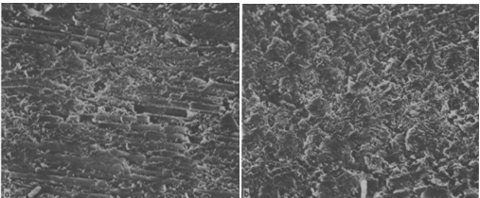
Figure 2-1. Scanning electron microscope (SEM) images of the surface machined in a) the parallel direction and b) the perpendicular direction [4].

Chip formation during CFRP milling has been studied. Keneeda [6] utilized SEM to reveal how chip formation changes with fiber orientation. For instance, at a 0° fiber orientation and a positive 20° rake angle, tool penetrates layers, initiating a delamination process as illustrated in Figure 2-2. When the cutting tool engages with the material initially, it causes the layer to bend. Following this, the layer undergoes fracturing within the epoxy resin matrix, where the fracturing occurs slightly away from the tool's edge with significant fluctuations in cutting forces. In addition to the phenomenon at 0° fiber orientation, another chip formation type known as fiber cutting is revealed for fiber orientations from 0° to 90° regardless of rake angle as illustrated in Figure 2-3. Initially, as the cutting tool engages in CFRP to remove the material, there’s bending deformation of the layer being machined. The layer deflects around the tool edge. At this point, the tool attempts to cut the carbon fiber prepreg. However, the presence of the resin makes immediate cutting difficult. Instead of a clean cut, the tool pushes the layer. As the tool applies more compressive load, the material no longer withstands the load. This leads to the fiber being crushed and eventually splitting.
Li [7] introduced a method to predict the fracture toughness of unidirectional CFRP by analyzing chip formation. Energy consumption to form the chip was categorized into new surface energy, friction energy, and chip fracture energy. Friction energy was identified as the most influential factor, surpassing both new surface energy and chip fracture energy.

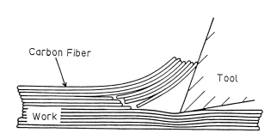
Figure 2-2. Cutting unidirectional CFRP, 0° fiber orientation and + 20° rake angle [6].
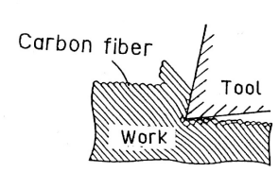
Figure 2-3. Cutting unidirectional CFRP, 45° fiber orientation and + 10° rake angle [6].

This suggests that when cutting CFRP, particularly the frictional aspect is critical in the chip formation process.

Delamination is a phenomenon that must be considered when machining CFRP, since it is directly related to surface quality. During milling, the axial milling force produced by the milling tool causes delamination when the force level exceeds the adhesion force between the fiber and matrix [8]. Delamination can be categorized into interlayer and surface delamination. The surface layer is more susceptible due to insufficient supporting force from the matrix. The characteristics of delamination include tear defects, burr defects, and loose fibers [9]. Tear defects occur when fibers break along the axial direction and are pulled out, forming grooves and voids. Burr defects involve fibers not being cut and hanging outward, while loose fibers are present along the milling edge. Hintze [10] conducted cutting tests on a unidirectional CFRP. It was discovered that a sharp tool provides clean fiber cutting without causing delamination. In contrast, with a highly worn tool, significant delamination occurs in the form of fiber overhangs and breakouts on the upper layers of the cut edges.

Tool wear is a primary cause of delamination, strongly affecting surface quality of CFRP [9], [10], [11]. The occurrence of tool wear poses a significant constraint on machining productivity [12]. In an industrial production environment, the presence of tool wear can lead to unforeseen machine downtime, diminished quality, or the necessity to discard the component, leading to significant financial losses.
FWW has been a popular indicator for tool life when machining metal workpieces [13]. However, due to the abrasive character of CFRP and the influence of delamination on tool wear, FWW may be not sufficient to quantify tool life when machining composites materials. It was proposed that the conventional tool flank wear criterion of a VB (FWW) value of 0.3 mm for metal cutting is not directly applicable in glass fiber reinforced polymers (GFRP) machining due to poor workpiece surface quality observed at a VB value of 0.2 mm and beyond [12]. In addition, Caggiano[14], [15] examined drilling of CFRP laminates. A critical VB value of 0.04 mm was identified, beyond which hole quality was unacceptable. Additionally, the cutting-edge radius (CER) of tools used in milling CFRP is crucial due to its impact on the machining process and the resulting surface quality of the workpiece [10], [11], [16]. Due to highly abrasive nature of carbon fibers, CER can be used to indicate tool life. The complex tool wear mechanisms when machining composites materials must be considered to improve machining productivity.

Tool wear monitoring plays a crucial role in advanced manufacturing, contributing significantly to the enhancement of manufacturing processes through the prediction of tool life [17]. Since CFRP machining leads to rapid tool wear with complex tool wear mechanisms, managing tool wear is essential in production settings. Methods for monitoring tool wear are categorized into two main types: direct and indirect. The direct method, as an offline approach, involves directly measuring tool wear using various sensors such as an optical microscope. For example, FWW can be measured using a digital microscope and CER can be measured using an optical 3D measurement system. This direct approach provides accurate data but has real-time limitations, because the cutting process must be interrupted to enable the tool wear measurement. In contrast, the indirect method analyzes surrogate signals, such as cutting force, vibration, and acoustic emission (AE) acquired during the machining process, to estimate tool wear state [17]. This online approach is more suitable for industrial applications. Typically, tool condition monitoring includes: 1) measuring process variables sensitive to cutting tool condition and machining parameters, such as cutting forces, acoustic emission, vibration, temperature, surface finish, and noise, and 2) analyzing these signals to estimate the level of tool wear.

Zhu [18] employed a machine learning approach to predict tool wear during CFRP drilling. He utilized cutting force and vibration signals as input features to train a backpropagation artificial neural network (ANN) model. The ANN model learned complex patterns and relationships between input signals and tool wear progression through iterative training on a dataset of drilling experiments. This data driven approach may offer high generalization capabilities but lack interpretability, making it challenging to understand the underlying reasons for their predictions.
In contrast, a physics-based approach can be effectively utilized to estimate tool wear, providing valuable insights into the underlying mechanisms governing the machining process. Cutting force has been widely used as an indicator of tool wear due to its sensitivity to the cutting process. A cutting force model plays a significant role in machining due to its predictive capability, allowing engineers to predict cutting forces and optimize machining process efficiently. Mechanistic models represent an intuitive approach for optimizing cutting parameters [19]. Zhang [20] developed a mechanical model for predicting cutting forces in orthogonal cutting of unidirectional composites by categorizing the cutting zone into chipping, pressing, and bouncing regions. Su [21] developed a mechanistic force model in milling plain woven CFRP where the cutting force coefficients were derived from an analytical model utilizing Zhang’s mechanical model. Alternatively, instead of using analytical methods, a mechanistic force model with the cutting force coefficients calculated experimentally is used for this study and is presented in Chapter Three.

However, obtaining cutting force data requires the use of sensors such as dynamometers and employing these sensors in a production setting may not be practical. Given these limitations, prior research efforts have addressed alternative force measurement systems. In response to these challenges, Gomez [22] developed a cost-effective solution by designing and testing a low-cost dynamometer using an optical interrupter. The dynamometer utilized a knife-edge sensor to measure displacement, offering an affordable yet accurate method for force measurement in milling operations. In addition to this low-cost dynamometer, an energy based cutting force model was developed for using motor spindle power [23]. These alternative approaches offer affordable and accurate solutions for measuring cutting forces in milling operations, addressing the limitations of traditional dynamometers.

Methodology

Milling dynamics

Vibration in milling
A fundamental aspect of milling is the periodicity of the cutting force [24]. As the cutting teeth enter and exit the cut, they generate a periodic forcing function because the cutting force varies with these entries and exits. In addition, both the tool and the workpiece exhibit flexibility. The variable cutting force acts on the flexible tool and workpiece and causes displacement, which leads to vibration. Considering this mechanism, the instantaneous chip thickness, $h$, and the surface normal, $n$, are expressed using Eqs. 3.1 and 3.2, as demonstrated in Figure 3-1:
 | $$h(t) = f_{t}sin(ɸ) + n(t-τ) – n(t)$$ | (3.1)
 | $$n =(xt-xw)sin\left(ɸ\right)-(yt-yw)cos(ɸ)$$ | (3.2)
where $f_{t}$is the feed per tooth, $ɸ$ is the time dependent tool rotating angle, $n(t-τ)$ and $n(t)$ represent the vibration contributions along the surface normal by the previous tooth and current tooth, respectively, $τ$ is the tooth period, $xt$ and $yt$ represent the tool displacements in the x and y directions, and $xw$ and $yw$ represent the workpiece displacements in the x and y directions.

The cutting force is proportional to the chip thickness that depends on current vibration and previous pass. The current vibration also depends on cutting force and the chip thickness. This feedback can significantly influence the machining process, causing self-excited vibration or chatter. Since chatter leads to accelerated tool wear and poor surface finish, a stability map is constructed to select combinations of spindle speed and depth of cut that do not exhibit chatter.

Stability map
A stability map provides pre-process milling parameter selection using a boundary which separates stable and unstable spindle speed-depth of cut combination for a given radial depth of cut as shown in Figure 3-2. To construct a stability map, a frequency domain solution known as the average tooth angle approach developed by Tlusty is used in this study [25]. This approach assumes an average angle of the tooth in the cut. The average cutting angle, $ɸ_{avg}$ is calculated using Eq. 3.3, where $ɸ_{s}$ is the start cutting angle and $ɸ_{e}$ is the exit cutting angle. This assumption enables a fixed force direction to be defined and an analytical solution to be obtained.
 | $$ɸ_{avg}=\frac{ɸ_{s}+ ɸ_{e}}{2}$$ | (3.3)

To construct the stability map, the initial step is to calculate the oriented frequency response function (FRF). The fixed force is first projected on the system’s x and y axes and then along the surface normal located at the average tooth angle. The directional orientation factors for down milling are calculated using Eqs. 3.4 and 3.5, where $β$ is the cutting angle, as displayed in Figure 3-3:

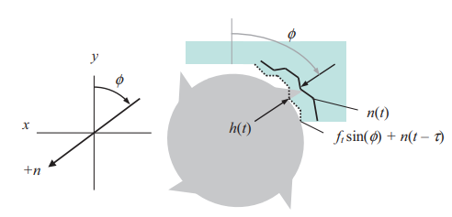
Figure 3-1. Instantaneous chip thickness dependent on the vibration contribution from current and previous teeth [24].

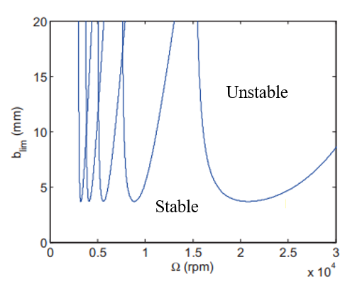
Figure 3-2. A stability map separates stable and unstable combinations of spindle speed, Ω, and axial depth of cut, b_{lim} [24].

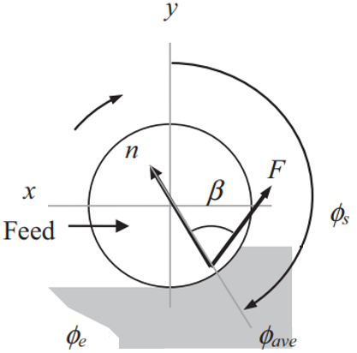

Figure 3-3. Down milling configuration to calculate the directional orientation factors [24].

 | $$μ_{x}=\cos\left(β-\left(90- ɸ_{avg}\right)\right)cos⁡(90-ɸ_{avg})$$ | (3.4)
 | $$μ_{y}=\cos\left(180- ɸ_{avg}- β\right)cos⁡(180-ɸ_{avg})$$ | (3.5)

A tap test is conducted in both tool and workpiece x and y axes to measure the FRFs as shown in Figure 3-4. The oriented FRF is then computed using Eqs. 3.6 through 3.8, where $FRF_{tool orient}$ is the oriented FRF of tool, $FRF_{workpiece orient}$ is the oriented FRF of workpiece, and $FRF_{orient}$ is the oriented FRF of the tool and workpiece system.
 | $$FRF_{tool orient}= μ_{x}FRF_{tool x}+μ_{y}FRF_{tool y}$$ | (3.6)
 | $$FRF_{workpiece orient}= μ_{x}FRF_{workpiece x}+μ_{y}FRF_{workpiece y}$$ | (3.7)
 | $$FRF_{orient}= FRF_{tool orient}+FRF_{workpiece orient}$$ | (3.8)

Once the oriented FRF is computed, the next step is to determine the limited axial depth of cut to avoid chatter. To achieve this, the oriented FRF and its corresponding frequency range are modified to cover only those frequencies that are relevant to chatter. This is defined as the frequency range where the real part of the oriented FRF is negative. The governing equations to determine the limiting axial depth of cut, $b_{lim}$, are expressed using Eqs. 3.9 through 3.12, where $K_{s}$ is the cutting force coefficient, $N_{t}^{*}$ is the average number of teeth in the cut, $N_{t}$ is number of teeth, $f_{c}$ is the chatter frequency, Ω is spindle speed, N is the integer number of waves between teeth, and Ɛ is the phase between current and previous tool vibrations:

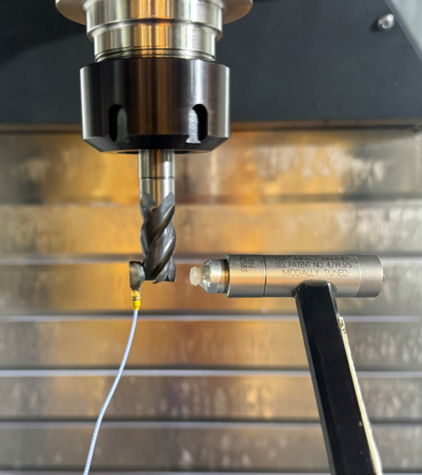
Impact hammer
Accelerometer
Figure 3-4. A tap test to measure the tool tip FRF. The input is the impact force caused by the hammer and the output is the acceleration, which is integrated in the frequency domain to obtain the displacement-to-force FRF.
 | $$b_{lim}= \frac{-1}{2K_{s}Real\left[FRF_{orient}\right]N_{t}^{*}}$$ |  | (3.9)
 |  | $$N_{t}^{*}= \frac{ɸ_{e}-ɸ_{s}}{\frac{360}{N_{t}}}$$ | (3.10)
 |  | $$\frac{f_{c}}{ΩN_{t}}= N+\frac{Ɛ}{2π}$$ | (3.11)
 | $$Ɛ= 2π-2\tan^{-1}{(\frac{Re\left[FRF_{orient}\right]}{Im[FRF_{orient}]})}$$ |  | (3.12)

As shown, determining the cutting force model coefficients is required to construct a stability map. Cutting force coefficients are not material properties only, but also depend on the tool geometry and the chip formation mechanism. The cutting force coefficients can be determined empirically. A linear regression approach is used in this study as explained in the next section, Mechanistic force model.

Mechanistic force model

Cutting mechanism
Mechanistic force models represent a “lumped parameter” approach to describing cutting forces [24]. The force model used for this research includes two terms: cutting (shearing) and rubbing (plowing). The cutting term is directly proportional to the chip thickness, h, and axial depth, b. Because endmills have a nonzero cutting-edge radius, the rubbing effect can also be considered.
This rubbing term is directly proportional to axial depth, b. These cutting and rubbing phenomena are incorporated in the model using Eqs. 3.13 through 3.15:
 | $$F_{n}=k_{nc}bh+k_{ne}b$$ | (3.13)
 | $$F_{t}=k_{tc}bh+k_{te}b$$ | (3.14)
 | $$F_{a}=k_{ac}bh+k_{ae}b$$ | (3.15)
where $F$ is the time dependent force component in the tangential, $t$, and normal, $n$, and axial, a, directions. For the coefficients, $c$ indicates a cutting coefficient and $e$ represents an edge, or rubbing, coefficient; $b$ is the axial depth of cut; and $h$ is the time and angle dependent chip thickness, and the projection geometry for the tangential and normal cutting force components into x and y directions in milling is shown in Figure 3-5.

Cutting force coefficients
The six cutting force coefficients {$k_{nc}$ $k_{ne}$ $k_{tc}$ $k_{te}$, $k_{ac}$, and $k_{ae}$} are determined using the average force linear regression approach [24]. The forces during the milling process are measured using a dynamometer over a range of feed per tooth values. The forces projected of the normal and tangential components are transformed back into x, y, and z directions expressed using Eqs. 3.16 through 3.18 as demonstrated in Figure 3-5:
 | $$F_{x}=k_{tc}bf_{t}\sin\left(ɸ\right)+k_{te}bcos\left(ɸ\right)+k_{nc}bf_{t}\sin^{2}{(ɸ)}+k_{ne}bsin(ɸ)$$ | (3.16)
 | $$F_{y}=k_{tc}bf_{t}\sin^{2}\left(ɸ\right)+k_{te}bsin\left(ɸ\right)-k_{nc}bf_{t}\sin\left(ɸ\right)\cos\left(ɸ\right)-k_{ne}bsin(ɸ)$$ | (3.17)
 | $$F_{z}= -k_{ac}bf_{t}\sin\left(ɸ\right)-k_{ae}b$$ | (3.18)
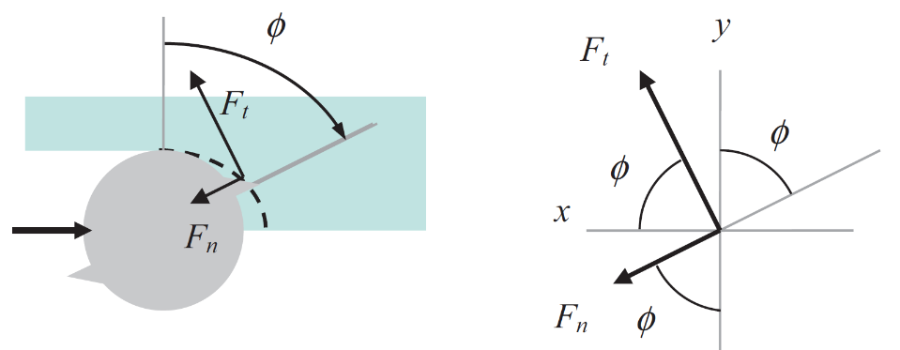
Figure 3-5. Cutting force components in the tangential and normal directions. The positive direction of axial cutting force components is based on the feeding and rotating directions. In this case, the positive direction of axial cutting force is into the plane of the diagram [24].
To calculate the average (or mean) cutting forces, the equations are modified with the summation that accounts for all potential teeth in the cut as expressed using Eqs. 3.19 through 3.21:
 | $$F_{x}= \sum_{j=1}^{N_{t}}{\left(k_{tc}bf_{t}\frac{sin⁡(2ɸ_{j})}{2}+k_{te}bcos\left(ɸ_{j}\right)+k_{nc}bf_{t}\frac{(1-\cos\left(2ɸ_{j}\right))}{2}+k_{ne}bsin(ɸ_{j}) \right)g(ɸ_{j})}$$ | (3.19)
 | $$F_{y}= \sum_{j=1}^{N_{t}}{\left(k_{tc}bf_{t}\frac{(1-\cos\left(2ɸ_{j}\right))}{2}+k_{te}bsin\left(ɸ_{j}\right)-k_{nc}bf_{t}\frac{\sin\left(2ɸ_{j}\right)}{2}-k_{ne}bcos(ɸ_{j}) \right)g(ɸ_{j})}$$ | (3.20)
 | $$F_{z}= \sum_{j=1}^{N_{t}}{\left(-k_{ac}bf_{T}\sin\left(ɸ_{j}\right)-k_{ae}b \right)g(ɸ_{j})}$$ | (3.21)
In these equations, the switching function, $g(ɸ_{j})$ has value of one only when the tooth is in the cut and is zero otherwise.
The mean force per revolution is then calculated with the integration limits set between the start and exit cutting angles using Eqs. 3.22 through 3.25:
 | $${\overline{F}}_{x}={\left[ \frac{N_{t}bf_{t}}{8π}\left(-k_{tc}\cos\left(2ɸ\right)+k_{nc}\left(2ɸ-\sin\left(2ɸ\right)\right)\right)+\frac{N_{t}b}{2π}\left(k_{te}\sin\left(ɸ\right)-k_{ne}\cos\left(ɸ\right)\right)\right]}_{ɸ_{s}}^{ɸ_{e}}$$ | (3.22)

 | $${\overline{F}}_{y}={\left[ \frac{N_{t}bf_{t}}{8π}\left(k_{tc}\left(2ɸ-\sin\left(2ɸ\right)\right)+k_{nc}\cos\left(2ɸ\right)\right)-\frac{N_{t}b}{2π}\left(k_{te}\cos\left(ɸ\right)+k_{ne}\sin\left(ɸ\right)\right)\right]}_{ɸ_{s}}^{ɸ_{e}}$$ | (3.23)

 | $${\overline{F}}_{z }={\left[\frac{N_{t}b}{2π}\left(k_{ac}f_{t}\cos\left(ɸ\right)-k_{ae}ɸ\right)\right]}_{ɸ_{s}}^{ɸ_{e}}$$ | (3.24)

The start and exit cutting angle, $ɸ_{s}$ and $ɸ_{e}$ are determined by the tool diameter, $d$ and radial depth cut, $a$. The diameter of the tools used in this research is 12.7 mm and the radial depth cut is 3 mm. In down milling, $ɸ_{s}$ and $ɸ_{e}$are determined using Eqs. 3.25 and 3.26:
 | $$ɸ_{s}=180-\cos^{-1}\left(\frac{r-a}{r}\right)=121.84 ̊$$ | (3.25)
 | $$ɸ_{e}=180 ̊$$ | (3.26)

The mean forces per revolution are then calculated using Eqs. 3.27 through 3.29:
 | $${\overline{F}}_{x}=\frac{N_{t}b}{8π}\left(-1.44k_{tc}+1.13k_{nc}\right)f_{t}+\frac{N_{t}b}{2π}(-0.85k_{te}+0.47k_{ne})$$ | (3.27)
 | $${\overline{F}}_{y}=\frac{N_{t}b}{8π}\left(1.13k_{tc}+1.44k_{nc}\right)f_{t}+\frac{N_{t}b}{2π}(0.47k_{te}+0.85k_{ne})$$ | (3.28)
 | $${\overline{F}}_{z}=\frac{N_{t}b}{2π}(-0.47k_{ac})f_{t}-\frac{N_{t}b}{2π}1.01k_{ae}$$ | (3.29)
These mean force equations are a function of the feed per tooth and have the linear slope-intercept form with $f_{t}$ as the independent variable. For instance, the equation of the mean forces in the x direction can be expressed using Eq. 3.30, where ${\overline{F}}_{x, i}$ is the mean value of the measured force in the x direction for each feed per tooth value, $f_{t,i}$, $a_{0x}$ is the intercept of the linear fit, and $a_{1x}$ is the slope, and $E_{i}$ is the error between the measured mean force and the value calculated from the linear regression:
 | $${\overline{F}}_{x,i}=a_{0x}+a_{1x}f_{t,i}+E_{i}$$ | (3.30)
To determine the slope and intercept, the sum of the errors squared is minimized. The quality of the linear fit to the data is determined calculating the coefficient of determination, $r^{2}$. The slope, intercept, and the coefficient of determination are expressed using Eqs. 3.31 through 3.33:
 | $$a_{1x}= \frac{n\sum_{i=1}^{n}{f_{t,i}{\overline{F}}_{x,i}- }\sum_{i=1}^{n}{f_{t,i}}\sum_{i=1}^{n}{{\overline{F}}_{x,i}}}{n{\sum_{i=1}^{n}{f_{t,i}}}^{2}-{\left(\sum_{i=1}^{n}{f_{t,i}}\right)}^{2}}$$ | (3.31)

 | $$a_{0x}=\frac{1}{n}\sum_{i=1}^{n}{{\overline{F}}_{x,i}}-a_{1x}\frac{1}{n} \sum_{i=1}^{n}{f_{t,i}}$$ | (3.32)

 | $$r_{x}^{2}=\frac{\sum_{i=1}^{n}{{{(\overline{F}}_{x,i}-\frac{1}{n}\sum_{i=1}^{n}{{\overline{F}}_{x,i}})}^{2}- \sum_{i=1}^{n}{E_{i}^{2}} }}{\sum_{i=1}^{n}{{{(\overline{F}}_{x,i}-\frac{1}{n}\sum_{i=1}^{n}{{\overline{F}}_{x,i}})}^{2} }}$$ | (3.33)

Using the tool diameter and radial depth applied in this research, the six cutting force coefficients are calculated using Eqs. 3.34 through 3.39:
 | $$k_{nc}=\frac{8π}{2.91N_{t}b}\left(a_{1x}+1.27a_{1y}\right)$$ | (3.34)

 | $$k_{tc}=\frac{8π}{-2.33N_{t}b}\left(a_{1x}-0.78a_{1y}\right)$$ | (3.35)

 | $$k_{ac}=\frac{2π}{-0.47N_{t}b}a_{1z}$$ | (3.36)

 | $$k_{ne}=\frac{2π}{2.01N_{t}b}\left(a_{0x}+1.81a_{0y}\right)$$ | (3.37)

 | $$k_{te}=\frac{2π}{-1.11N_{t}b}\left(a_{0x}-0.55a_{0y}\right)$$ | (3.38)

 | $$k_{ae}=\frac{2π}{-1.01N_{t}b}a_{0z}$$ | (3.39)

Time domain simulation
A stability map shows the “global” perspective for the spindle speed-axial depth domain, whereas time domain simulation (TDS) provides “local” cutting force and vibration information for a selected spindle speed-axial depth combination. The TDS that is described by Schmitz [24] is used to validate the mechanistic force model for this project. The TDS proceeds as:
- The instantaneous chip thickness calculated.
- The cutting force is calculated.
- The calculated force is used to find the new displacement using numerical Euler integration.
- The process is repeated after the tooth angle is incremented.
To identify the position of a tooth, the angle of the cut is divided into a discrete number of steps. This is a crucial strategy in the simulation because it enables us to predefine the possible teeth orientation and to store the surface created from the previous tooth. Steps per revolution, $SR$ is determined by selecting time step, $dt$ and spindle speed, Ω. The corresponding increment small angle step, $dɸ$ is calculated. The cutting angle, $ɸ$ is defined as a vector of angle, $ɸ=\left[0,dɸ,2dɸ,3dɸ,…,\left(SR-1\right)dɸ\right];$ The total number of steps, $steps$ is determined by the simulation time and $dt$. The relationships between each variable are displayed in Eqs. 3.40 through 3.42:
 | $$SR=\frac{60}{Ωdt}$$ | (3.40)
 | $$dɸ=\frac{360}{SR}( ̊)$$ | (3.41)
 | $$steps=round(time/dt)$$ | (3.42)
The TDS includes a single loop with index, i, which is incremented up to the total number of steps, $steps$. In the simulation, Eqs. 3.1 and 3.2 are modified as Eqs. 3.43 and 3.44, where $surf$ represent $n\left(i-τ\right)$, which is the surface normal vibration by previous tooth and $n\left(i\right)$ is the surface normal vibration by current tooth:
 | $$h\left(i\right)=f_{t}sin(ɸ(i))+surf-n(i)$$ | (3.43)
 | $$n\left(i\right)=(xt-xw)\left(i-1\right)sin\left(ɸ\left(i\right)\right)-(yt-yw)\left(i-1\right)cos⁡(ɸ\left(i\right))$$ | (3.44)
Additionally, the helix angle of the endmill is included in the TDS by discretizing the axial depth along its axis with width, $db$. Each slice has $db$ of axial depth and is considered as a straight endmill. Another for loop is created to account for the individual axial slices and the surface normal from the previous tooth vector, $surf$ is then an array to include the axial slice components. Each axial slice component has an angular difference from the original cutting angle, $ɸ$. Therefore, the delay angle, $χ$ is used to compensate the actual cutting angle, $phi$ are determined using Eqs. 3.45 and 3.46, where r is the radius of tool and γ is the helix angle of the tool:
 | $$χ=\frac{dbtanγ}{r}$$ | (3.45)
 | $$phi=ɸ-χ$$ | (3.46)
When the actual cutting angle is contained within the cut, the surface normal of the current tooth and the instantaneous chip thickness are computed. When the current tooth vibrates out of cut, which is when $h$ is less than or equal to zero, $F_{t}$ and $F_{n}$ are computed to zero and $surf$ is updated adding $f_{t}sin⁡(ɸ)$. On the other hand, when the current tooth is engaged in cut, which is when h is greater than zero, $F_{t}$ and $F_{n}$ are computed using the Eqs. 3.13 and 3.14 and $surf$ is then updated as $n$. The computed $F_{t}$ and $F_{n}$ is projected into the x and y directions to calculate $F_{x}$ and $F_{y}$ using the Eqs. 3.47 and 3.48:
 | $$F_{x}=F_{t}\cos\left(ɸ\right)+F_{n}sin(ɸ)$$ | (3.47)
 | $$F_{y}=F_{t}\sin\left(ɸ\right)-F_{n}cos(ɸ)$$ | (3.48)
Finally, the computed cutting forces are then used to calculate the displacement. The accelerations are first calculated using Eqs. 3.49 and 3.50. The accelerations are used to calculate the velocities using Eqs. 3.51 and 3.52. Finally, the displacement is calculated using the velocities as shown in Eqs. 3.53 and 3.54.
 | $${\ddot{x}}_{t\backslash w}=\frac{F_{x}-c_{x }{\dot{x}}_{t\backslash w}-k_{x}x_{t\backslash w}}{m_{x}}$$ |  | (3.49)
 |  | $${\ddot{y}}_{t\backslash w}=\frac{F_{y}-c_{x}{\dot{y}}_{t\backslash w}-k_{y}y_{t\backslash w}}{m_{y}}$$ |  | (3.50)
 |  | $${\dot{x}}_{t\backslash w}={\dot{x}}_{t\backslash w}+{\ddot{x}}_{t\backslash w}(dt)$$ |  | (3.51)
 |  | $${\dot{y}}_{t\backslash w}={\dot{y}}_{t\backslash w}+{\ddot{y}}_{t\backslash w}(dt)$$ | (3.52)
 |  | $$x_{t\backslash w}=x_{t\backslash w}+{\dot{x}}_{t\backslash w}(dt)$$ | (3.53)
 |  | $$y_{t\backslash w}=y_{t\backslash w}+{\dot{y}}_{t\backslash w}(dt)$$ | (3.54)
In these equations, ${\ddot{x}}_{t\backslash w}$, ${\ddot{y}}_{t\backslash w}$, ${\dot{x}}_{t\backslash w}$, ${\dot{y}}_{t\backslash w}$, $x_{t\backslash w}$, and $y_{t\backslash w}$ represent acceleration, velocity, and displacement of tool and workpiece in the x and y directions, and $m_{t\backslash w}$, $c_{t\backslash w}$, $k_{t\backslash w}$ are the modal mass, viscous damping, and stiffness values of tool and workpiece that are acquired from tap testing.

Force measurement with data filtering
Due to the finite stiffness of the dynamometer, it can be considered as a dynamic system.
When the tooth passing frequency and its harmonics get close to the natural frequencies of the dynamometer, undesired frequency content is superimposed on the cutting force signal. An inverse force filter [26] is applied to the measured forces to compensate the unwanted frequency content and validate the mechanistic force model used in this research. The inverse force filtering for the measured force data is completed using the following steps:
- The FRF $H\left(f\right)$ is obtained by conducting a tap test and expressed using Eq. 3.55, where $F_{R}(f)$ is the input force applied by the hammer and $F_{D}(f)$ is the output force measured from the dynamometer.
 | $$H\left(f\right)=\frac{F_{D}\left(f\right)}{F_{R}(f)}$$ | (3.55)
- Modal parameters are determined by fitting $H(f)$ to obtain the modeled FRF using the modal parameters, $H^{*}(f)$.
- $H^{*}(f)$ is inverted and ${H^{*}}^{-1}(f)$ represents the ratio $\frac{F_{R}\left(f\right)}{F_{D}(f)}$.
- A low pass filter is created and multiplied by ${H^{*}}^{-1}(f)$ to reduce noise at higher frequencies.
- The Fourier transform of the measured forces is multiplied by the inverse force filter and low pass filter to attenuate the unwanted frequency contents.
- The force is converted back to the time domain using the inverse Fourier transform.

Experimental description
Toray 3900 PREPREG SYSTEM, T830H-6K, plain weave carbon fiber workpieces were used for this project. The prepreg system was cured using an autoclave by Elevated Materials. A 150 mm long workpiece was machined to determine the wear-dependent cutting force model. The setup is displayed in Figure 3-6. A volume of 155833.2 mm³ material was removed by down milling using two four-flute, 12.7 mm diameter, 0.762 mm corner radius, solid carbide helical endmills as shown in Table 3.1. AlTiCrN coating is suitable for a wide range of metalworking applications whereas PCD is suitable for abrasive materials like CFRP. The tools were inserted in a CAT40-ER32 collet holder with 46 mm of extension from the holder face. A PCB PIEZOTRONICS 086C04 impact hammer and 352A21 accelerometer were used to measure the tool FRFs as shown in Figure 3-3. The tool and workpiece FRFs were used to calculate a stability map and select stable cutting parameters; the radial depth was 3 mm, the axial depth was 3 mm, the spindle speed was 7000 rpm, and the feed per tooth was 0.150 mm.

The goal of the experimental cutting test was to measure the cutting force coefficients, FWW, and the areal surface finish of the machined area as tool wears out. A flow map to describe the cutting test sequence is displayed in Figure 3.7. First, the cutting force coefficients for a new tool were measured using four feed per tooth values of {0.075, 0.100, 0.125, 0.150} mm. A 76.2 mm long carbon fiber composite workpiece was mounted on a Kistler 9257B cutting force dynamometer to measure the cutting force. A clean up path cut was conducted for every cutting force measurement. The dynamometer was connected to a Kistler 5167A amplifier using a Kistler 1685B5 cable. A MetalMAX data acquisition system was connected to a laptop to record the time dependent cutting forces. For every 10,800 mm³ of material removed on the wear plate, wear on the flank face was recorded using a digital microscope. For every 21,600 mm³ material removed on the wear plate, the cutting force coefficients were measured using the dynamometer and four feed per tooth values of {0.075, 0.100, 0.125, 0.150} mm. In addition, for every 10,800 mm³ of material removed on the wear plate, a 0.100 mm feed per tooth cut was conducted on a 76.2 mm length of the CFRP block to produce a wall surface to be scanned using an Alicona 3D optical measurement system. This surface was used to assess the surface quality after milling. After cutting the wall surface, the tool moved back to the wear plate to remove materials and these processes were conducted repeatedly until the volume of material removed (VMR) reached to 155833.2 mm³.

Table 3-1. Helical endmills selection.
Brand | Part number | Helix angle | Coating
Accupro | 34894RF | 38 | AlTiCrN
Niagara cutter | 17000010 | 30 | PCD

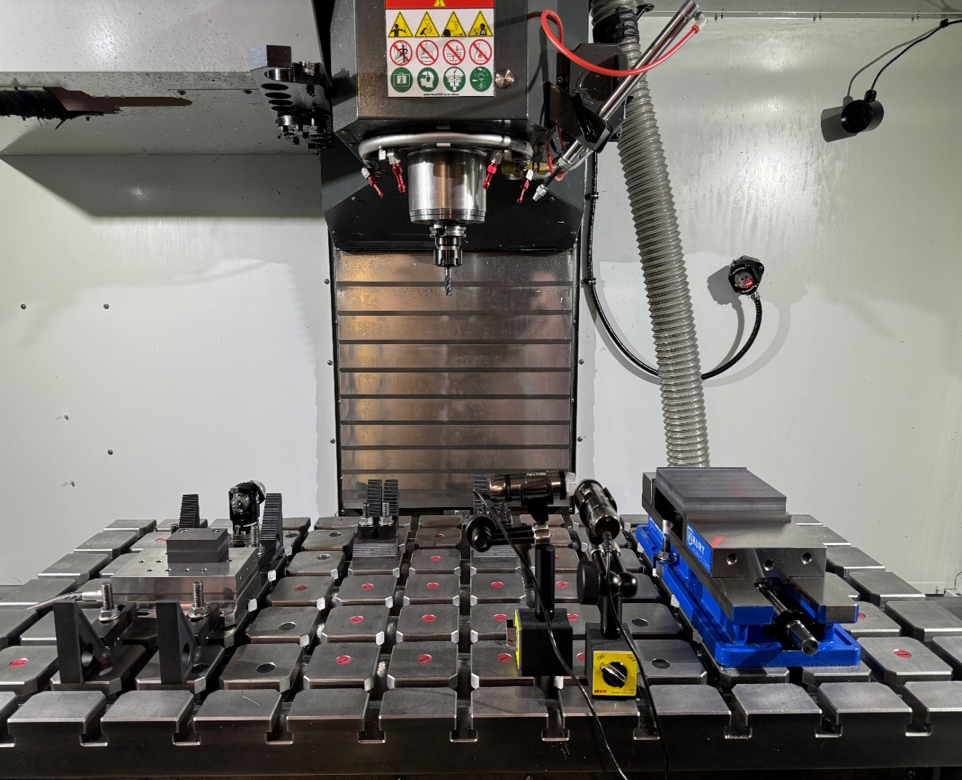
Wear plate
Digital microscopes
Wall surface blocks
Dynamometer
Figure 3-6. Experimental setup for wear tests and cutting force measurement.
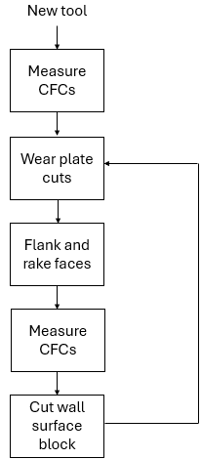
Figure 3-7. The experimental cutting test sequence flow map.

Results and Discussion

AlTiCrN coating

Tool and workpiece dynamics
Tap testing on the AlTiCrN coating tool and workpiece in x and y directions was completed to measure the FRFs (10,000 Hz measurement bandwidth); see Figures 4-1 through 4-4. It is seen that the tool is more flexible than the workpiece system. The FRFs were used to produce a stability map using the average tooth angle approach and TXF software developed by Manufacturing Laboratories Inc (MLI) [27]. The cutting parameters used to construct the stability map were 0.150 mm feed per tooth and a 3 mm radial depth of cut. The cutting force coefficient, $K_{s}$, was selected as 800 N/mm² to ensure stable operation, even during worn tool conditions. See Figure 4-5, where the selected spindle speed and axial depth were 7000 rpm and 3 mm.

Cutting force coefficients
Cutting forces were measured during CFRP milling using a 50,000 Hz sampling frequency and the Spinscope software and data acquisition developed by MLI [28]; see Figure 4-6. The mean forces from the measured data were used to calculate the cutting force coefficients. The parsing time was selected depending on the feed per tooth as shown in Table 4-1 and the cutting data was cropped to select only the steady state portion of the cutting force for each parsing time. The linear regression approach was conducted with the parsed mean forces of the four feeds to calculate the cutting force coefficients. Results for a new tool are displayed in Figure 4-7. The coefficients of determination, r², indicate that the quality of linear fitting was acceptable.
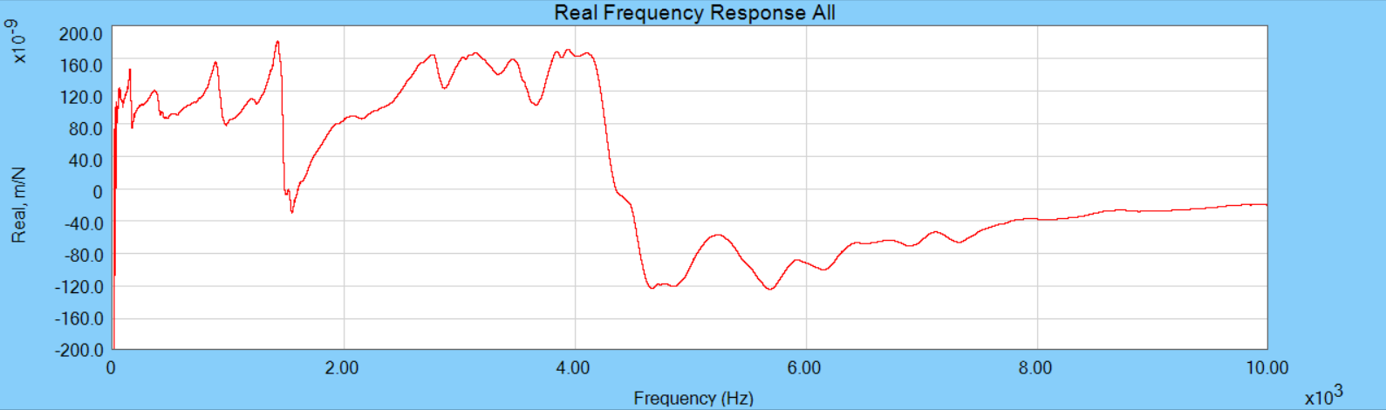
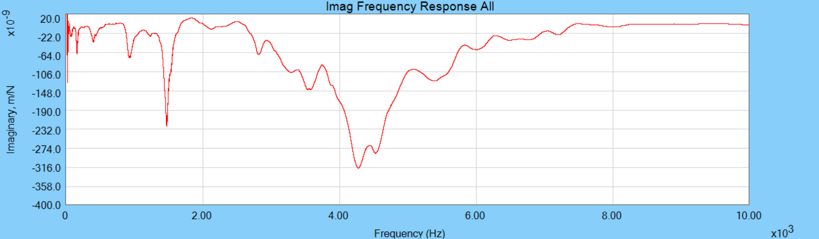
Figure 4-1. Tool FRF in the x direction.
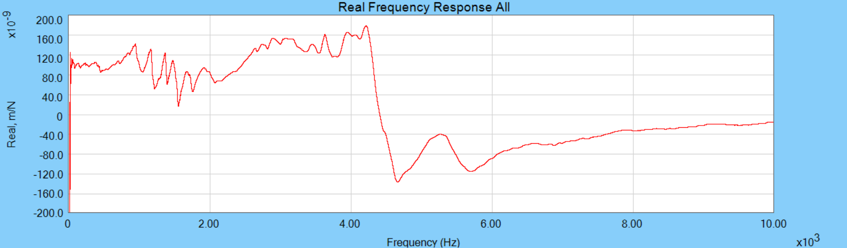
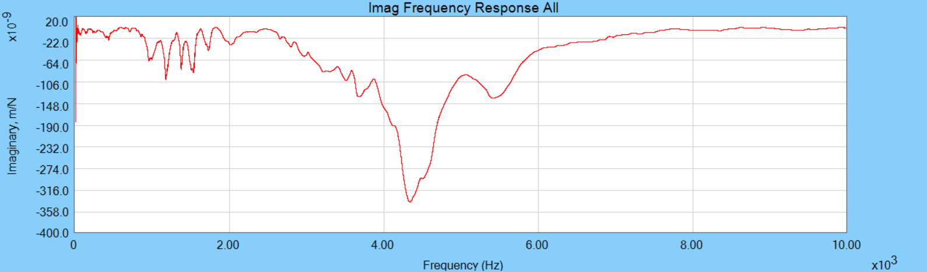
Figure 4-2. Tool FRF in the y direction.

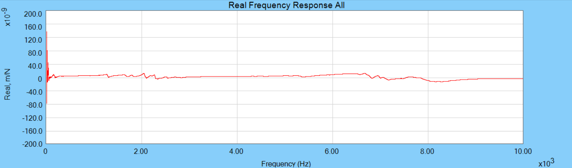
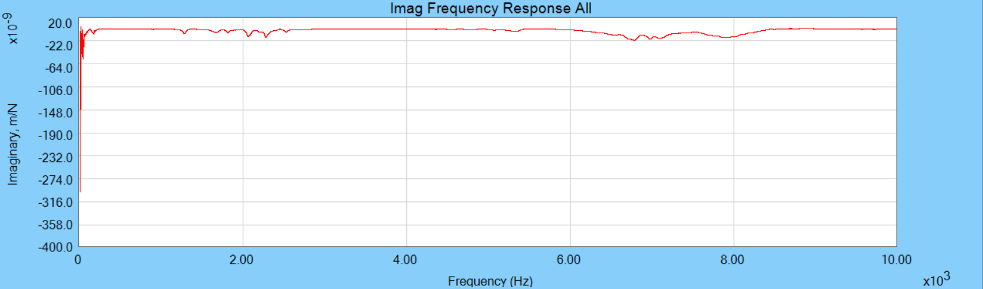
Figure 4-3. Workpiece FRF in the x direction.
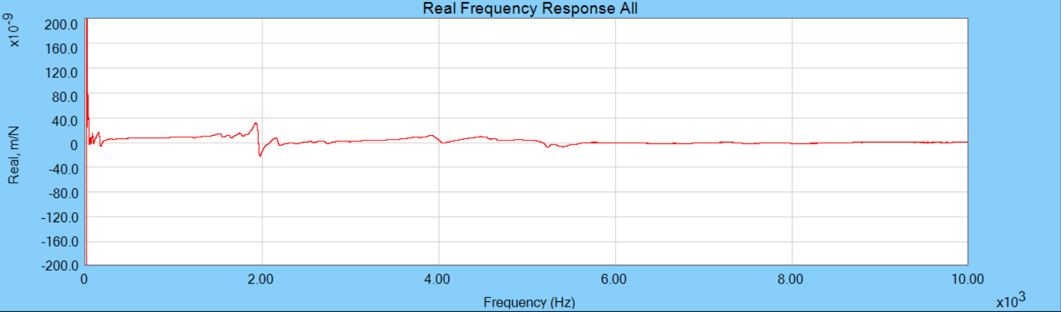
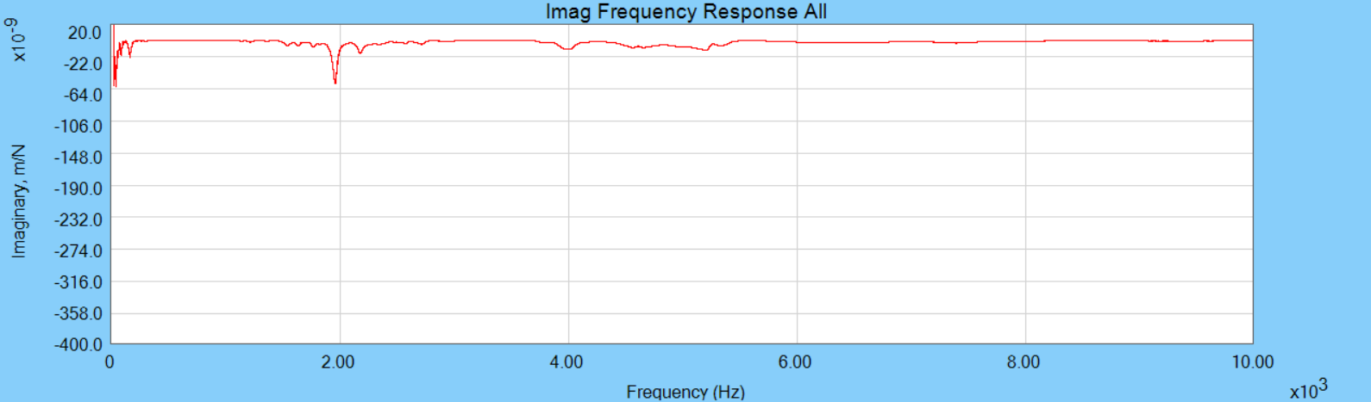
Figure 4-4. Workpiece FRF in the y direction.

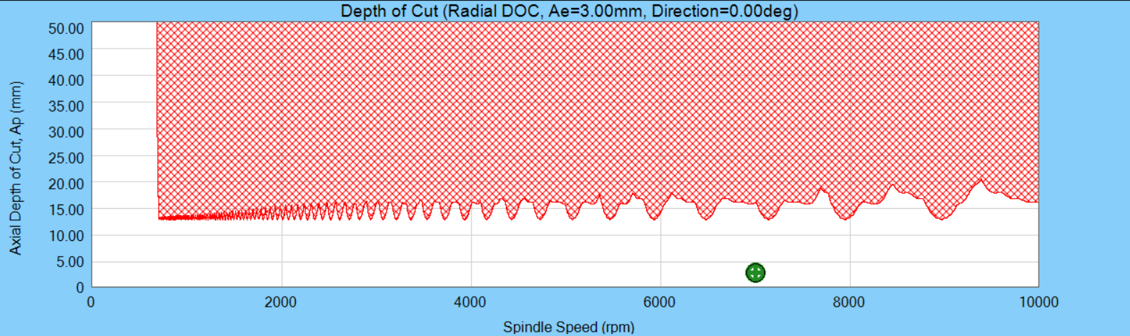
Figure 4-5. Stability map for a cutting force coefficient of 800 N/mm². The green mark represents the machining parameters.

Table 4-1. Selected parsing time to find mean cutting forces.
$f_{t}$ (mm/tooth) | 0.075 | 0.100 | 0.125 | 0.150
Time (s) | 1.25 | 1 | 0.75 | 0.5

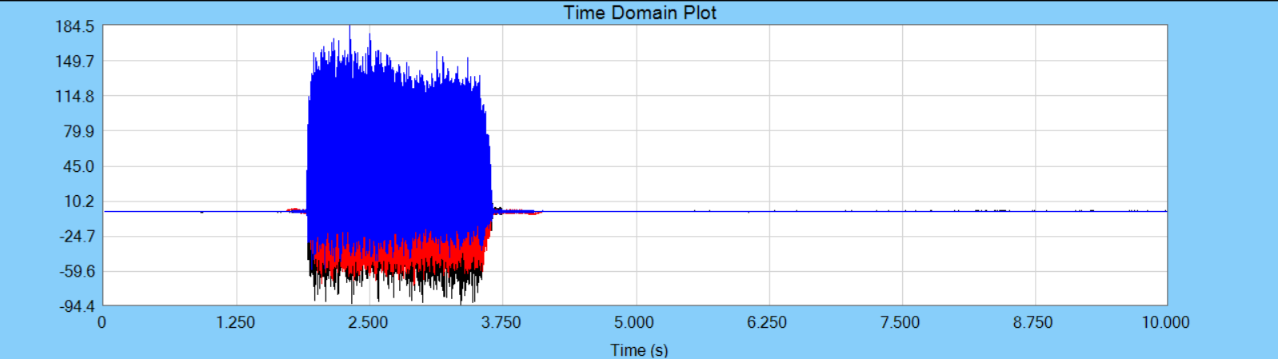
Figure 4-6. Cutting force measurement with 0.100 mm/tooth. The red, blue, and black lines represent the cutting forces in the x, y, and z directions respectively.
Figure 4-7. Linear regression to calculate the cutting force coefficients for a new tool.
Table 4-2. Cutting force coefficients results.

VMR | 0 | 13543.2 | 42001.2 | 70459.2 | 98917.2 | 127375.2 | 155833.2 | mm³
k_{tc} | 386.9 | 405.7 | 446.0 | 485.8 | 534.5 | 571.7 | 605.5 | N/mm²
k_{tc} | 402.0 | 419.0 | 450.2 | 486.7 | 530.1 | 515.5 | 620.5 | N/mm²
k_{tc} | 372.8 | 381.6 | 457.2 | 488.2 | 533.9 | 593.0 | 576.2 | N/mm²
k_{nc} | 186.0 | 241.5 | 313.0 | 382.7 | 406.9 | 458.5 | 496.2 | N/mm²
k_{nc} | 225.1 | 223.2 | 278.2 | 334.8 | 353.6 | 344.5 | 497.7 | N/mm²
k_{nc} | 152.2 | 220.7 | 284.5 | 379.4 | 395.5 | 481.0 | 467.7 | N/mm²
k_{ac} | 102.6 | 97.7 | 61.4 | 61.5 | -9.2 | 8.5 | -44.8 | N/mm²
k_{ac} | 100.0 | 104.1 | 52.9 | 17.2 | 2.5 | -26.4 | 24.0 | N/mm²
k_{ac} | 73.8 | 76.3 | 100.1 | 43.1 | -9.4 | -41.6 | -42.2 | N/mm²
k_{te} | 3.1 | 5.3 | 8.4 | 9.3 | 9.9 | 10.3 | 10.1 | N/mm
k_{te} | 2.1 | 4.3 | 7.4 | 8.9 | 8.3 | 10.0 | 7.7 | N/mm
k_{te} | 2.5 | 4.8 | 5.3 | 6.6 | 6.3 | 6.0 | 7.8 | N/mm
k_{ne} | 12.0 | 24.8 | 41.9 | 52.5 | 61.2 | 67.5 | 73.0 | N/mm
k_{ne} | 7.7 | 23.3 | 38.8 | 48.3 | 56.3 | 65.1 | 66.6 | N/mm
k_{ne} | 9.9 | 19.5 | 30.8 | 37.5 | 44.3 | 48.3 | 56.1 | N/mm
k_{ae} | 1.8 | -3.5 | -7.6 | -10.6 | -10.1 | -15.4 | -13.6 | N/mm
k_{ae} | 1.7 | -3.5 | -6.3 | -7.7 | -8.6 | -11.7 | -15.8 | N/mm
k_{ae} | 1.9 | -3.1 | -9.1 | -8.3 | -8.1 | -8.2 | -11.8 | N/mm

Figure 4-8. Cutting force coefficients in the tangential direction. The red dots show the first cutting test values, the green dots show the second cutting test values, and the blue dots show the third cutting test values.

Figure 4-9. Cutting force coefficients in the normal direction.
Figure 4-10. Cutting force coefficients in the axial direction.
Figure 4-11. Edge coefficients in the tangential direction.
Figure 4-12. Edge coefficients in the normal direction.
Figure 4-13. Edge coefficients in the axial direction.

Mechanistic force model validation
The mechanistic model with the cutting force coefficients was validated by comparing the predicted forces to the measured forces. An inverse force filter was applied to the measured forces to ensure accurate results. Tap tests were conducted on the workpiece in both the x and y directions to measure the system dynamics and the FRFs are shown in Figures 4-14 and 4-15. The figures show that the workpiece/dynamometer system is not rigid. The tooth passing frequency was calculated from the product of spindle speed and the number of teeth, $\frac{7000}{60}\left(4\right)$ = 466.7 Hz. The red lines indicate the tooth passing frequency and its harmonics. The fifth and fourth harmonics especially provide unwanted frequency content in the measured cutting forces in x and y directions. Modal parameters of the FRF were fit and used to calculate the $H^{*}\left(f\right)$, as displayed in Figures 4-16 and 4-17. Examples of the inverse force filtering are shown in Figures 4-18 through 4-21 (0.1 mm/tooth data with no tool wear). The selected cut-off frequency was 1800 Hz for the lowpass filter for both the x and y directions. The time domain simulation and measurement results for the first cutting test with a new tool and worn tool after volumes of 70459.2 mm³ and 155833.2 mm³ were removed are presented in Figures 4-22 through 4-24. The simulated, filtered, and measured x and y direction forces are displayed. The figures demonstrate that the mechanistic force model accurately represents the cutting force.

The fifth harmonic
Figure 4-14. The FRF $H(f)$ in the x direction with the input force applied by the hammer and output force measured from the dynamometer. The tooth passing frequency and its harmonics are included at 466.7 (the tooth passing frequency), 933.4, 1400.1, 1866.8, and 2333.5 Hz using red lines.
The fourth harmonic
Figure 4-15. The FRF $H(f)$ in the y direction with the input force applied by the hammer and output force measured from the dynamometer.
Figure 4-16. The red line is the measured x direction FRF, $H_{x}(f)$ and the blue line is the modeled FRF, $H_{x}^{ *}(f)$.
Figure 4-17. The red line is the measured y direction FRF, $H_{y}(f)$ and the blue line is the modeled FRF, $H_{y}^{ *}(f)$.
Figure 4-18. Time domain forces in the x direction. The red line is the measured cutting force with 0.100 mm/tooth and the blue line is the filtered cutting force.
Figure 4-19. Frequency domain forces in the x direction. The red line is the measured cutting force with 0.100 mm/tooth and the blue line is the filtered cutting force.
Figure 4-20. Time domain forces in the y direction. The red line is the measured cutting force with 0.100 mm/tooth and the blue line is the filtered cutting force.
Figure 4-21. Frequency domain forces in the y direction. The red line is the measured cutting force with 0.100 mm/tooth and the blue line is the filtered cutting force.
Figure 4-22. Cutting force components for new tool forces in the x (feed) and y directions for 3 mm radial depth, 3 mm axial depth, and 0.100 mm feed per tooth. The blue, yellow, red lines represent the simulated force, measured force, and filtered force.

Figure 4-23. Cutting force components for worn tool after a volume of 70459.2 mm³ material was removed. Forces are shown in the x (feed) and y directions for 3 mm radial depth, 3 mm axial depth, and 0.100 mm feed per tooth.

Figure 4-24. Cutting force components for worn tool after a volume of 155833.2 mm³ material was removed. Forces are shown in the x (feed) and y directions for 3 mm radial depth, 3 mm axial depth, and 0.100 mm feed per tooth.

Cutting force coefficients model
Since the carbon fibers in the plain-woven structure composite are not ideally distributed [21], the four cutting force coefficients (k_{tc}, k_{nc}, k_{te}, and k_{ne}) values from the three repeating cutting tests are not identical. Linear data fitting on the averaged value of three repeating cutting tests was conducted to predict the cutting force coefficients increase with tool wear. The fitting results are presented in Figures 4-25 through 4-28, where the four cutting force coefficients are expressed as a function of VMR to be able to be applied to the mechanistic force model from Eqs. 3-13 and 3-14. The linear fitting equations of the four cutting force coefficients are expressed using Eqs. 4-1 through 4-4.
 | $$k_{tc} =0.001377 \left(VMR\right)+388.08 N/mm^{2}$$ | (4.1)
 | $$k_{nc} =0.001835 \left(VMR\right)+204.98 N/mm^{2}$$ | (4.2)
 | $$k_{te} =0.0000346 \left(VMR\right)+4.34 N/mm$$ | (4.3)
 | $$k_{ne} =0.0003379 \left(VMR\right)+17.46 N/mm$$ | (4.4)

Tool wear measurement
After a volume of 13,543.2 mm³ was removed (eight 150 mm long cuts and four 76.2 mm long cuts) or a volume of 14229.0 mm³ (eight 150 mm long cuts, four 76.2 mm long cuts, and one 76.2 mm long cut for the wall surface) was removed, the FWW was recorded using a digital microscope. Images of one of the four teeth from the first tool wear test are displayed in Figure 4-29. The corresponding FWW values are presented in Figure 4-30 and Table 4-3. After a total volume of 155833.22 mm³ was removed, the FWW reached a final value of 0.238 mm. The increasing trend of FWW matches with the growth of the tangential and normal direction cutting force coefficients as shown in Figures 4-31 and 4-32.
.

Figure 4-25. Data and best fit line for the tangential direction cutting force coefficient. The red dots are the averaged values from the three repeated cutting tests and the red error bars indicate the standard deviation.
Figure 4-26. Data and best fit line for the normal direction cutting force coefficient.

Figure 4-27. Data and best fit for the tangential direction edge coefficient.
Figure 4-28. Data and best fit for the normal direction edge coefficients.

.
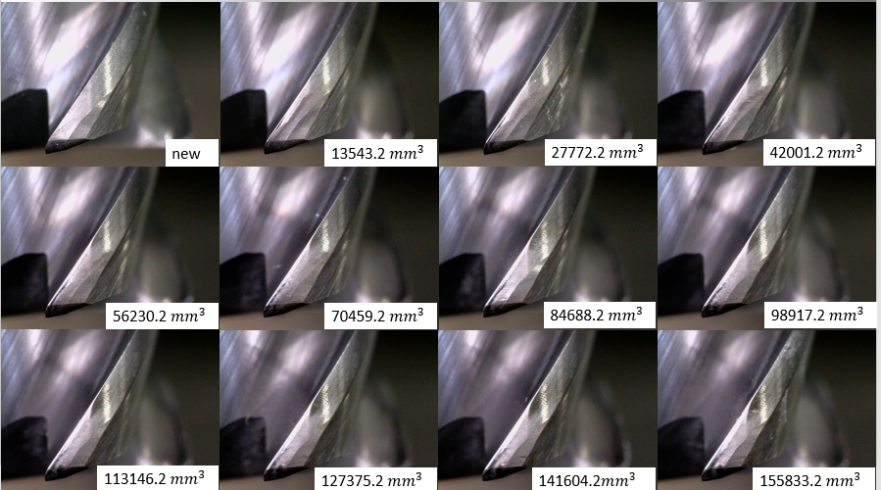
Figure 4-29. Tool microscope images used to measure the increasing FWW.
Figure 4-30. FWW measurement. The blue dots are the measured values and the red line is the least squares best fit.

Table 4-3. FWW values of a tooth of the three repeat tool wear tests from microscope images.
VMR (mm³) | FWW (mm) | FWW (mm) | FWW (mm)
13543.2 | 0.069 | 0.054 | 0.053
27772.2 | 0.099 | 0.088 | 0.083
42001.2 | 0.116 | 0.106 | 0.092
56230.2 | 0.129 | 0.114 | 0.115
70459.2 | 0.143 | 0.121 | 0.115
84688.2 | 0.172 | 0.142 | 0.145
98917.2 | 0.185 | 0.155 | 0.145
113146.2 | 0.206 | 0.168 | 0.169
127375.2 | 0.206 | 0.189 | 0.175
141604.2 | 0.235 | 0.201 | 0.169
155833.2 | 0.238 | 0.214 | 0.192

Figure 4-31. FWW and k_{tc}. The red dots are the calculated values of k_{tc}, the red error bars show the standard deviation, and the black line is the least squares best fit line of the tangential direction cutting force coefficients. The blue dots are measured FWW values, and the purple dashed line is the least squares best fit of FWW.
Figure 4-32. FWW and k_{nc}. The red dots are the calculated values of k_{nc}, the red error bars show the standard deviation, and the black line is the least squares best fit line of the normal direction cutting force coefficients. The blue dots are measured FWW values, and the purple dashed line is the least squares best fit of FWW.

Surface roughness prediction model
Measurements of the surface roughness on the machined wall surfaces were conducted. Accurate and reliable surface roughness measurement of carbon fiber composite is difficult due to its non-homogeneous character. The non-contact optical method has been demonstrated to provide accurate surface roughness of machined composites [29]. Specifically, the non-contact optical method allows the characterization of roughness or damage on individual ply layers of machined laminates. In this study, a 10 mm by 1 mm area of the cut wall was scanned using an Alicona optical 3D measurement system and seen in Figure 4-33. More matrix smearing is observed as more material removed, which leads to carbon fibers being torn and pulled out. The areal surface roughness, Sa, of the machined wall was measured and the results are presented in Figure 4-34 and Table 4-4. The Sa values grow with increasing volume of material removed, as expected. Monitoring cutting force is an efficient way to predict tool wear in production settings. The cutting force coefficient, K_{s} was calculated from the k_{tc} and k_{nc} values and was used to construct a surface roughness model. Linear data fitting on the averaged value of K_{s} was completed to predict the surface roughness. The fitting result is presented in Figure 4-35. The surface roughness is expressed as a function of K_{s} in Eq. 4-5. This equation enables engineers in industry to predict surface roughness by monitoring the cutting force growth.
 | $$S_{a} =0.014365 \left(K_{s}\right)-4.31 μm$$ | (4.5)

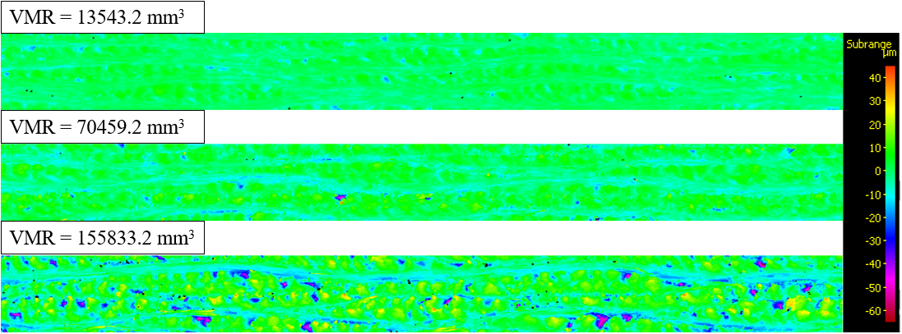
Figure 4-33. Scanned images by Alicona optical 3D measurement system.
Figure 4-34. Areal surface roughness measurement. The red dots are the average values from three repeated tool wear tests, the red error bars represent the standard deviation, and the blue line is the least squares best fit.

Table 4-4. Surface roughness measurement values of the three repeat tool wear tests.
VMR (mm³) | Sa (μm) | Sa (μm) | Sa (μm)
13543.2 | 2.16 | 2.43 | 2.34
27772.2 | 2.57 | 2.80 | 2.94
42001.2 | 3.67 | 3.38 | 3.64
56230.2 | 3.83 | 3.39 | 4.47
70459.2 | 4.45 | 4.02 | 3.75
84688.2 | 5.38 | 4.65 | 3.99
98917.2 | 5.19 | 4.78 | 6.11
113146.2 | 6.96 | 5.21 | 5.68
127375.2 | 6.08 | 5.54 | 5.88
141604.2 | 6.89 | 5.81 | 5.72
155833.2 | 7.05 | 5.99 | 7.26

Figure 4-35. Prediction model of Sa. The red dots are the average values of three repeated tool wear tests, the red error bars represent the standard deviation, and the black line is the least squares best fit.

PCD coating

Tool and workpiece dynamics
Tap testing on the PCD coating tool and workpiece in x and y directions was completed to measure the FRFs (10,000 Hz measurement bandwidth); see Figures 4-36 through 4-39. It is seen that the tool is more flexible than the workpiece system. The FRFs were used to produce a stability map using the average tooth angle approach and TXF software developed by Manufacturing Laboratories Inc (MLI) [27]. The cutting parameters used to construct the stability map were 0.150 mm feed per tooth and a 3 mm radial depth of cut. The cutting force coefficient, $K_{s}$, was selected as 800 N/mm² to ensure stable operation, even during worn tool conditions. See Figure 4-40, where the selected spindle speed and axial depth were 7000 rpm and 3 mm.

Cutting force coefficients
Cutting forces were measured during CFRP milling using a 50,000 Hz sampling frequency and the Spinscope software and data acquisition. The mean forces from the measured data were used to calculate the cutting force coefficients. The parsing time was selected depending on the feed per tooth as shown in Table 4-1 and the cutting data was cropped to select only the steady state portion of the cutting force for each parsing time. After a volume of 13,543.2 mm³ material removed, cutting force coefficients were again calculated. Then, after each volume of 28,458.0 mm³ material was removed, cutting force coefficients were calculated as well. Each wear test was completed three times to evaluate repeatability. The cutting force coefficients are listed in Table 4-5 and plotted in Figures 4-41 through 4-46 as a function of VMR. Due to the high wear resistance and high thermal conductivity of PCD [30], little tool wear is observed for the same VMR of 155833.2 mm³ VMR compared

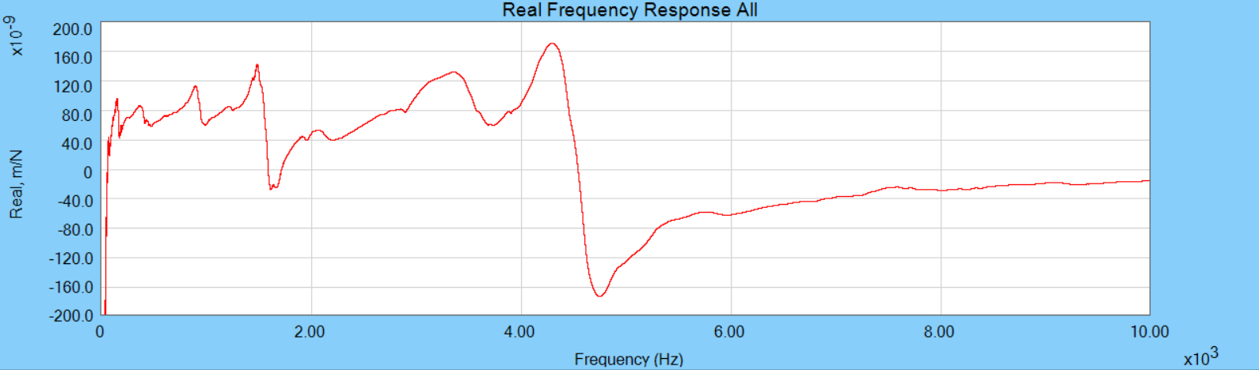
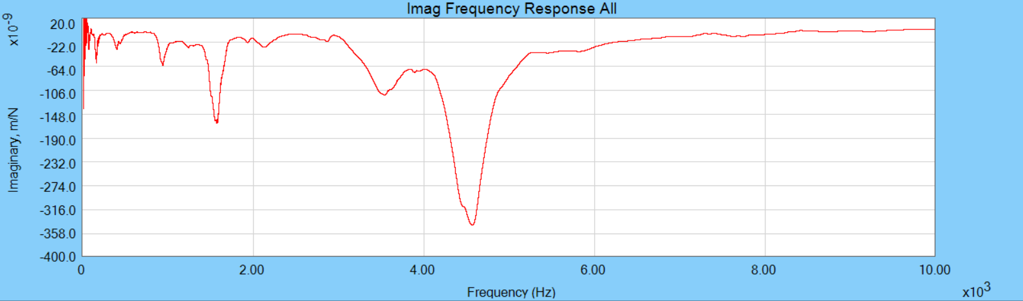
Figure 4-36. Tool FRF in the x direction.
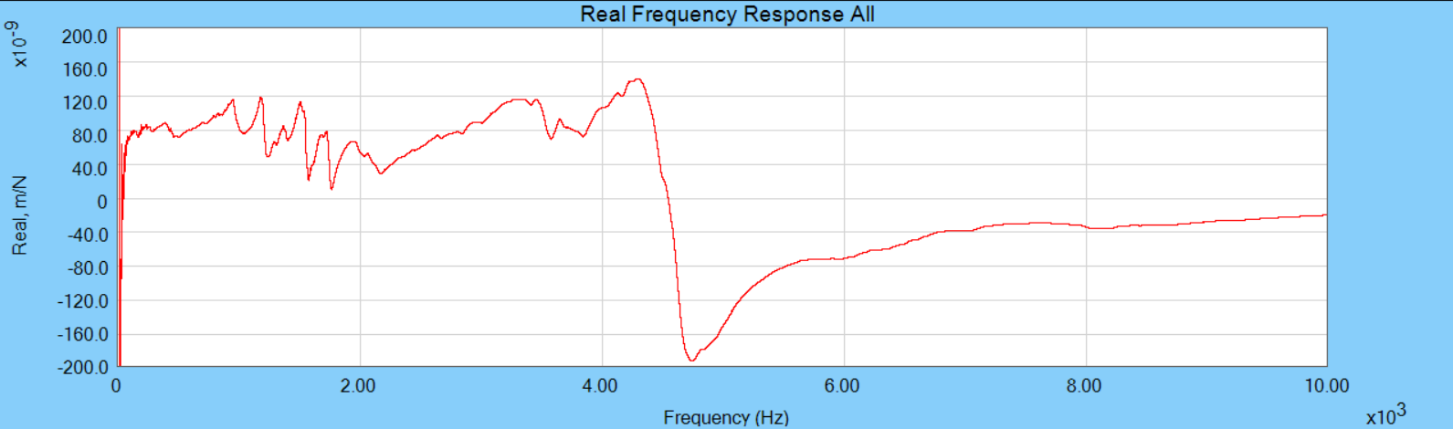
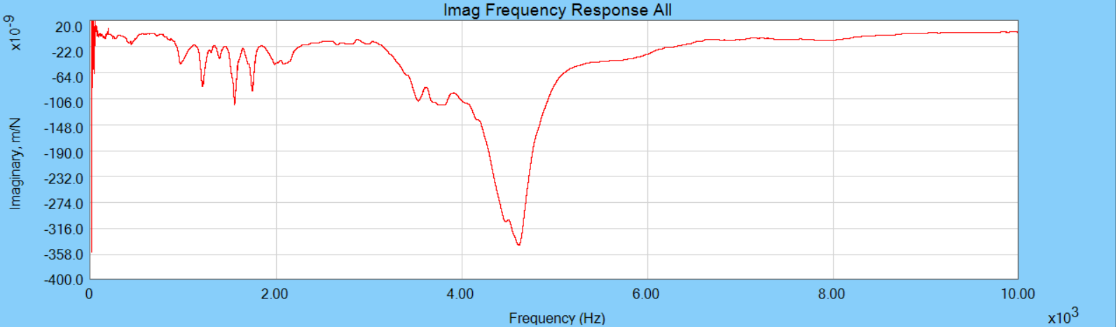
Figure 4-37. Tool FRF in the y direction.

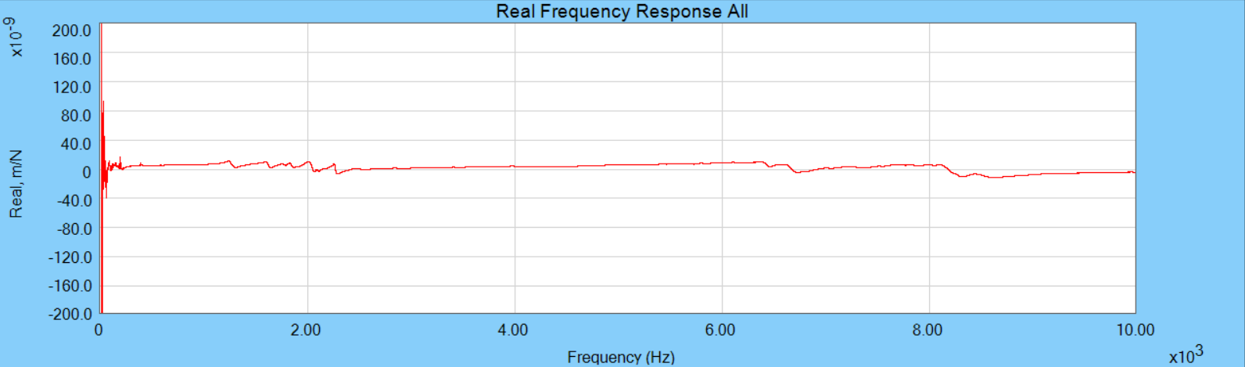
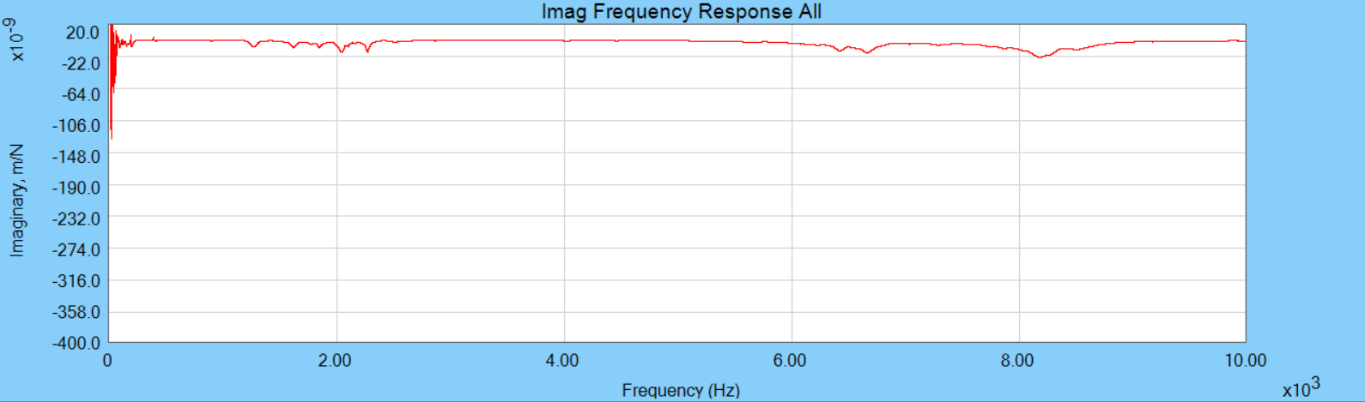
Figure 4-38. Workpiece FRF in the x direction.
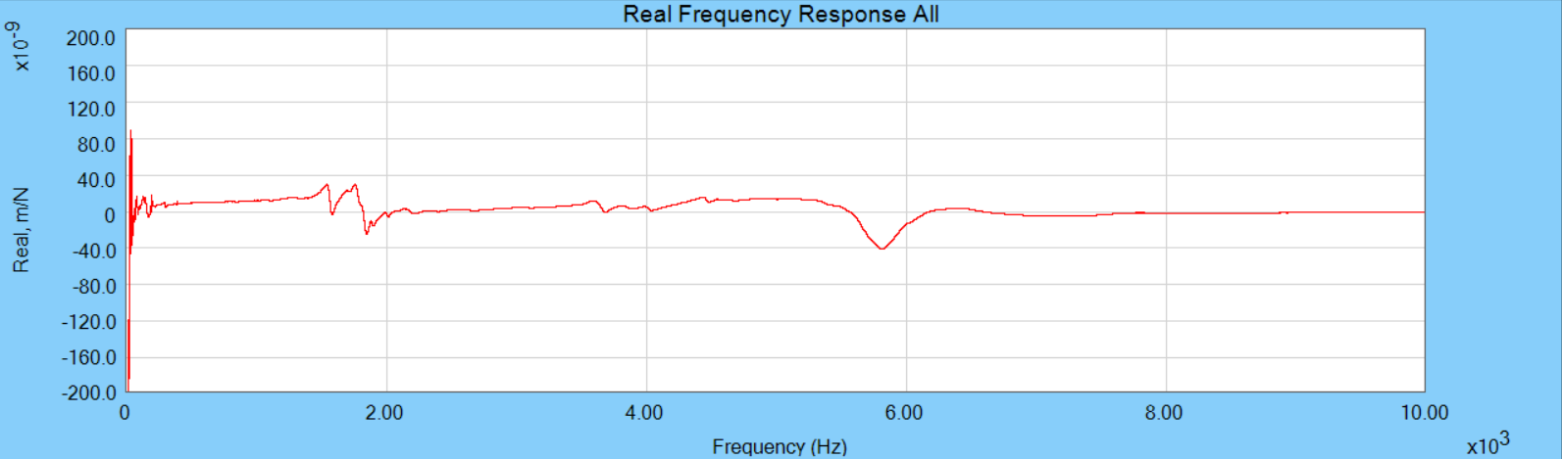
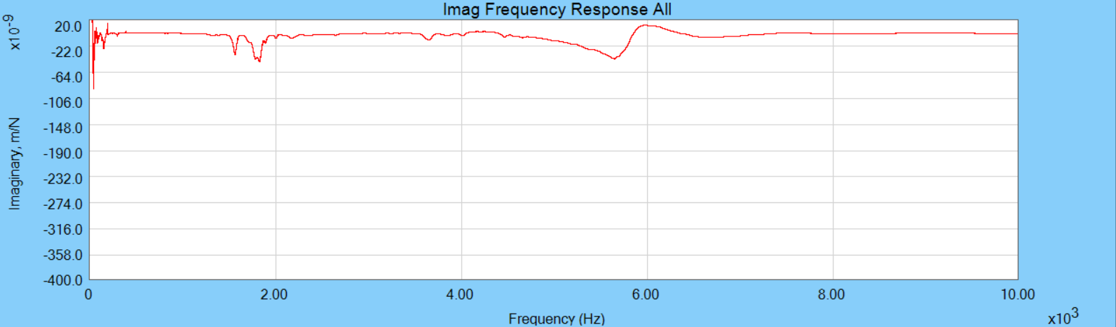
Figure 4-39. Workpiece FRF in the y direction.

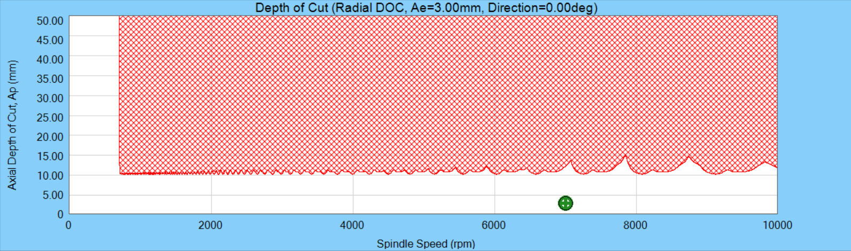
Figure 4-40. Stability map for a cutting force coefficient of 800 N/mm². The green mark represents the machining parameters.

Table 4-5. Cutting force coefficients results.
VMR | 0 | 13543.2 | 42001.2 | 70459.2 | 98917.2 | 127375.2 | 155833.2 | mm³
k_{tc} | 351.8 | 364.5 | 332.3 | 346.3 | 337.4 | 347.9 | 352.7 | N/mm²
k_{tc} | 363.5 | 374.6 | 364.4 | 363.5 | 362.3 | 359.1 | 365.0 | N/mm²
k_{tc} | 397.1 | 347.6 | 375.3 | 404.4 | 376.3 | 379.1 | 380.8 | N/mm²
k_{nc} | 30.1 | 58.0 | 35.2 | 54.7 | 52.0 | 54.1 | 60.7 | N/mm²
k_{nc} | 32.7 | 54.5 | 49.4 | 62.7 | 55.0 | 71.2 | 73.9 | N/mm²
k_{nc} | 87.9 | 72.3 | 100.7 | 120.4 | 97.6 | 127.5 | 120.4 | N/mm²
k_{ac} | 107.4 | 121.1 | 100.9 | 102.7 | 112.3 | 110.5 | 113.4 | N/mm²
k_{ac} | 157.7 | 131.7 | 125.9 | 122.9 | 121.2 | 117.2 | 116.5 | N/mm²
k_{ac} | 136.2 | 106.4 | 108.9 | 111.4 | 105.4 | 97.8 | 96.1 | N/mm²
k_{te} | 3.4 | 3.7 | 4.2 | 3.4 | 3.8 | 3.5 | 3.3 | N/mm
k_{te} | 3.9 | 3.3 | 3.0 | 3.1 | 3.1 | 3.5 | 3.1 | N/mm
k_{te} | 4.5 | 5.1 | 3.7 | 2.7 | 3.9 | 3.6 | 3.5 | N/mm
k_{ne} | 17.4 | 14.8 | 16.3 | 16.1 | 16.9 | 17.5 | 17.8 | N/mm
k_{ne} | 16.0 | 16.0 | 16.7 | 17.3 | 18.6 | 18.6 | 18.9 | N/mm
k_{ne} | 14.6 | 17.0 | 18.8 | 19.2 | 21.6 | 20.2 | 21.6 | N/mm
k_{ae} | 0.0 | -1.2 | -1.2 | -2.3 | -3.2 | -3.0 | -3.9 | N/mm
k_{ae} | -3.0 | -2.0 | -2.9 | -3.3 | -3.6 | -3.5 | -4.2 | N/mm
k_{ae} | -0.6 | -0.6 | -2.8 | -3.0 | -3.2 | -3.0 | -3.4 | N/mm

to the AlTiCrN coating. Therefore, the normal direction cutting force coefficients do not dramatically increase and the tangential direction cutting force coefficients are relatively consistent even though significant material has been removed.

Mechanistic force model validation
The mechanistic model with the cutting force coefficients was validated by comparing the predicted forces to the measured forces. An inverse force filter was applied to the measured forces to ensure accurate results. Tap tests were conducted on the workpiece in both the x and y directions to measure the system dynamics and the FRFs are shown in Figures 4-47 and 4-48. The figures show that the workpiece/dynamometer system is not rigid. The tooth passing frequency was calculated from the product of spindle speed and the number of teeth, $\frac{7000}{60}\left(4\right)$ = 466.7 Hz. The red lines indicate the tooth passing frequency and its harmonics. The fifth and fourth harmonics especially provide unwanted frequency content in the measured cutting forces in x and y directions. Modal parameters of the FRF were fit and used to calculate the $H^{*}\left(f\right)$, as displayed in Figures 4-49 and 4-50. Examples of the inverse force filtering are shown in Figures 4-51 through 4-54 (0.1 mm/tooth data with no tool wear). The selected cut-off frequency was 1250 Hz and 1800 Hz for the lowpass filter in the x and y directions, respectively. The time domain simulation and measurement results are presented in Figures 4-55 through 4-57. The simulated, filtered, and measured x and y direction forces are displayed. The figures demonstrate that the mechanistic force model accurately represents the cutting force.

Figure 4-41. Cutting force coefficients in the tangential direction. The red dots show the first cutting test values, the green dots show the second cutting test values, and the blue dots show the third cutting test values.

Figure 4-42. Cutting force coefficients in the normal direction.
Figure 4-43. Cutting force coefficients in the axial direction.
Figure 4-44. Edge coefficients in the tangential direction.
Figure 4-45. Edge coefficients in the normal direction.
Figure 4-46. Edge coefficients in the axial direction.

The fifth harmonic

Figure 4-47. The FRF $H(f)$ in the x direction with the input force applied by the hammer and output force measured from the dynamometer. The tooth passing frequency and its harmonics are included at 466.7 (the tooth passing frequency), 933.4, 1400.1, 1866.8, and 2333.5 Hz using red lines.
The fourth harmonic
Figure 4-48. The FRF $H(f)$ in the y direction with the input force applied by the hammer and output force measured from the dynamometer.
Figure 4-49. The red line is the measured x direction FRF, $H_{x}(f)$ and the blue line is the modeled FRF, $H_{x}^{ *}(f)$.
Figure 4-50. The red line is the measured y direction FRF, $H_{y}(f)$ and the blue line is the modeled FRF, $H_{y}^{ *}(f)$.
Figure 4-51. Time domain forces in the x direction. The red line is the measured cutting force with 0.100 mm/tooth and the blue line is the filtered cutting force.
Figure 4-52. Frequency domain forces in the x direction. The red line is the measured cutting force with 0.100 mm/tooth and the blue line is the filtered cutting force.
Figure 4-53. Time domain forces in the y direction. The red line is the measured cutting force with 0.100 mm/tooth and the blue line is the filtered cutting force.
Figure 4-54. Frequency domain forces in the y direction. The red line is the measured cutting force with 0.100 mm/tooth and the blue line is the filtered cutting force.
Figure 4-55. Cutting force components for new tool forces in the x (feed) and y directions for 3 mm radial depth, 3 mm axial depth, and 0.100 mm feed per tooth. The blue, yellow, red lines represent the simulated force, measured force, and filtered force.

Figure 4-56. Cutting force components for worn tool after a volume of 70459.2 mm³ material was removed. Forces are shown in the x (feed) and y directions for 3 mm radial depth, 3 mm axial depth, and 0.100 mm feed per tooth.

Figure 4-57. Cutting force components for worn tool after a volume of 155833.2 mm³ material was removed. Forces are shown in the x (feed) and y directions for 3 mm radial depth, 3 mm axial depth, and 0.100 mm feed per tooth.

Cutting force coefficients model
Since the carbon fibers in the plain-woven structure composite are not ideally distributed [21], the four cutting force coefficients (k_{tc}, k_{nc}, k_{te}, and k_{ne}) values from the three repeating cutting tests are not identical. Like the AlTiCrN coating tool, linear data fitting on the averaged value of three repeating cutting tests was conducted to predict the cutting force coefficients increase with tool wear. The fitting results are presented in Figures 4-58 through 4-61, where the four cutting force coefficients are expressed as a function of VMR to be able to be applied to the mechanistic force model from Eqs. 3-13 and 3-14. The linear fitting equations of the four cutting force coefficients are expressed using Eqs. 4-6 through 4-9. However, the high wear resistant character of PCD coating tool, the cutting force coefficients do not exhibit the increasing trend as tool wears thereby the cutting force coefficients model with the linear fitting do not have a reasonable result.
 | $$k_{tc} =-0.000013 \left(VMR\right)+365.07 N/mm^{2}$$ | (4.6)
 | $$k_{nc} =0.000204 \left(VMR\right)+55.14 N/mm^{2}$$ | (4.7)
 | $$k_{te} =-0.0000038 \left(VMR\right)+3.87 N/mm$$ | (4.8)
 | $$k_{ne} =0.0000235 \left(VMR\right)+15.99 N/mm$$ | (4.9)

Tool wear and measurement
After a volume of 13,543.2 mm³ was removed (eight 150 mm long cuts and four 76.2 mm long cuts) or a volume of 14229.0 mm³ (eight 150 mm long cuts, four 76.2 mm long cuts, and one 76.2 mm long cut for the wall surface) was removed, the FWW was recorded using a digital microscope.
Figure 4-58. Data and linear fitting of the tangential direction cutting force coefficient. The red dots are the averaged values from the three repeated cutting tests and the red error bars indicate the standard deviation.
Figure 4-59. Data and linear fitting of the normal direction cutting force coefficient.
Figure 4-60. Data and linear fitting of the tangential direction edge coefficient.
Figure 4-61. Data and linear fitting of the normal direction edge coefficient.

Images of one of the four teeth from the first tool wear test are displayed in Figure 4-62. The corresponding FWW values are presented in Figure 4-63 and Table 4-6. After a total volume of 155833.22 mm³ was removed, the FWW reached a final value of 0.061 mm, which is barely worn out compared to the AlTiCrN coating tool. The very small increasing trend of FWW matches with the consistent and barely growth of the tangential and normal direction cutting force coefficients as shown in Figures 4-64 and 4-65.

Surface roughness prediction model
Measurements of the surface roughness on the machined wall surfaces were conducted. A 10 mm by 1 mm area of the cut wall was scanned using an Alicona optical 3D measurement system and seen in Figure 4-66. Compared to the surface machined by AlTiCrN coating tool, the machined walls exhibit few defects. The areal surface roughness, Sa, of the machined wall was measured and the results are presented in Figure 4-67 and Table 4-7. The Sa values exhibit a consistent trend with increasing volume of material removed, as expected. Since the cutting force coefficients values and Sa values do not increase considerably due to low tool wear, no prediction model is required. The conclusion is that PCD coating tool wear for the same VMR as the AlTiCrN coating tool is not an issue.

Coating comparison
AlTiCrN coating is used for metal machining due to its enhanced hardness, heat resistance, and lower friction compared to the carbide substrate material. PCD coating is an advanced material known for its exceptional hardness and wear resistance. In this study, CFRP milling performance using the two coatings was compared based on: the change in the

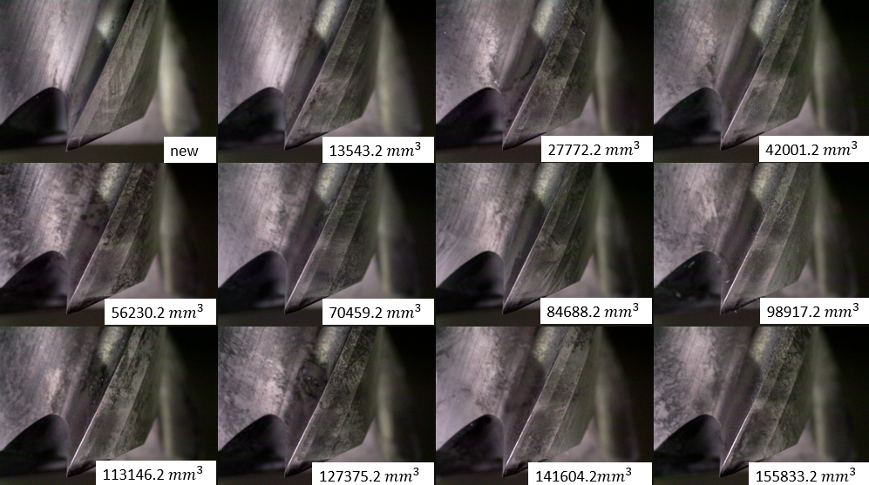Figure 4-62. Tool microscope images used to measure the increasing FWW.
Figure 4-63. FWW measurement. The blue dots are the measured values and the red line is the least squares best fit.

Table 4-6. FWW values of a tooth of the three repeat tool wear tests from microscope images.
VMR (mm³) | FWW (mm) | FWW (mm) | FWW (mm)
13543.2 | 0.038 | 0.037 | 0.023
27772.2 | 0.038 | 0.037 | 0.023
42001.2 | 0.047 | 0.037 | 0.036
56230.2 | 0.047 | 0.037 | 0.036
70459.2 | 0.047 | 0.037 | 0.036
84688.2 | 0.047 | 0.037 | 0.045
98917.2 | 0.047 | 0.046 | 0.045
113146.2 | 0.061 | 0.046 | 0.045
127375.2 | 0.061 | 0.046 | 0.050
141604.2 | 0.061 | 0.046 | 0.059
155833.2 | 0.061 | 0.059 | 0.059

Figure 4-64. FWW and k_{tc}. The red dots are the calculated values of k_{tc}, the red error bars show the standard deviation, and the black line is the least squares best fit line of the tangential direction cutting force coefficients. The blue dots are measured FWW values, and the purple dashed line is the least squares best fit of FWW.
Figure 4-65. FWW and k_{nc}. The red dots are the calculated values of k_{nc}, the red error bars show the standard deviation, and the black line is the least squares best fit line of the normal direction cutting force coefficients. The blue dots are measured FWW values, and the purple dashed line is the least squares best fit of FWW.

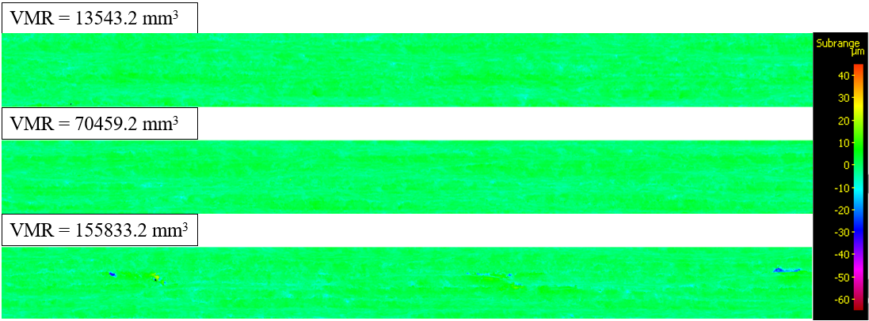
Figure 4-66. Scanned images by Alicona optical 3D measurement system.
Figure 4-67. Areal surface roughness measurement. The red dots are the average values of the three repeat tool wear tests, red error bars represent the standard deviation, and the blue line is the least squares best fit.

Table 4-7. Surface roughness measurement values of the three repeat tool wear tests.
VMR (mm³) | Sa (μm) | Sa (μm) | Sa (μm)
13543.2 | 1.527 | 1.802 | 2.095
27772.2 | 1.486 | 1.883 | 1.476
42001.2 | 1.461 | 1.784 | 1.549
56230.2 | 1.385 | 1.862 | 1.502
70459.2 | 1.419 | 1.746 | 1.679
84688.2 | 1.41 | 1.586 | 1.743
98917.2 | 1.409 | 1.743 | 1.813
113146.2 | 1.495 | 1.829 | 1.645
127375.2 | 1.366 | 1.53 | 1.796
141604.2 | 1.49 | 1.479 | 1.732
155833.2 | 1.501 | 1.555 | 1.661

mechanistic cutting force model coefficients, FWW, and Sa as displayed in Figures 4-68 through 4-75. It is seen that as the AlTiCrN coating tool cuts more material removed, the cutting force and edge coefficients in the tangential and normal directions increase dramatically. This corresponds to the increase of FWW. Similarly, Sa increases as the tool wears. On the other hand, the cutting force coefficients remain essentially constant for the PCD coating with the same VMR. This is due to little tool wear as measured by the FWW. As expected, Sa is also approximately constant. The PCD coating surpasses the performance of AlTiCrN coating. Additionally, an interesting finding is in the direction of axial cutting force. Figure 4-70 exhibits the direction of axial cutting force is positive when both tools are new. It is because the axial force has an upward pushing effect on the surface fiber, thereby the tool tends to be pulled out of the tool holder and spindle. However, it is identified that after the AlTiCrN coating tool cuts a volume of 98917.2 mm³ material removed, the direction of the axial force is changed. The matrix smearing and the pulled fibers as shown in Figure 4-33 induce more friction. When a worn AlTiCrN coating tool cuts the material, and the sheared chip is on the rake face of the tool, the chip creates higher friction on the tool and the friction leads to the tool being pushed into the tool holder and spindle.
Figure 4-68. Cutting force coefficients in the tangential direction. The red dots are the averaged values of the tangential direction cutting force coefficient for the AlTiCrN coating tool and the red error bars show the standard deviation. The blue dots are the averaged values of the tangential direction cutting force coefficient for the PCD coating tool and the blue error bars show the standard deviation.
Figure 4-69. Cutting force coefficients in the normal direction.
Figure 4-70. Cutting force coefficients in the axial direction.
Figure 4-71. Edge coefficients in the tangential direction.
Figure 4-72. Edge coefficients in the normal direction.
Figure 4-73. Edge coefficients in the axial direction.
Figure 4-74. The red dots are the averaged FWW values for the AlTiCrN coating tool and the red error bars show the standard deviation. The blue dots are the averaged FWW values for the PCD coating tool and the blue error bars show the standard deviation.
Figure 4-75. The red dots are the averaged Sa values for the AlTiCrN coating tool and the red error bars show the standard deviation. The blue dots are the averaged Sa values for the PCD coating tool and the blue error bars show the standard deviation.

Conclusions
In this CFRP milling study, a mechanistic cutting force model and a surface roughness prediction model were developed and presented for two tool coatings: AlTiCrN and PCD. The mechanistic cutting force was modeled empirically and validated using TDS. The mechanistic cutting force coefficients were expressed as a function of VMR. Additionally, with AlTiCrN coating tool, the surface roughness was expressed as a function of the cutting force coefficients and can therefore be predicted by monitoring cutting force. For the PCD coating tool, little tool wear was observed for the same VMR of 155833.2 mm³. Therefore, the cutting force coefficients and surface roughness did not change appreciably and the same models were not applicable over the AlTiCrN VMR testing range. The conclusion is that the PCD coating significantly outperforms the AlTiCrN coating. Future work will examine the VMR limits of the PCD coating and continued modeling efforts to predict surface roughness as a function of the CFRP and machining specifications.

List of References
[1] P. K. Mallick, Fiber-Reinforced Composites: Materials, Manufacturing, and Design, 3rd ed. CRC Press, 2007. doi: 10.1201/9781420005981.
[2] J. Zhang, G. Lin, U. Vaidya, and H. Wang, “Past, present and future prospective of global carbon fibre composite developments and applications,” Compos B Eng, vol. 250, Feb. 2023, doi: 10.1016/j.compositesb.2022.110463.
[3] M. Altin Karataş and H. Gökkaya, “A review on machinability of carbon fiber reinforced polymer (CFRP) and glass fiber reinforced polymer (GFRP) composite materials,” Defence Technology, vol. 14, no. 4. China Ordnance Society, pp. 318–326, Aug. 01, 2018. doi: 10.1016/j.dt.2018.02.001.
[4] A. Koplev, Aa. Lystrup, and T. Vorm, "The cutting process, chips, and cutting forces in machining CFRP," Composites, vol. 14, no. 4, pp. 371-376, 1983, doi: 10.1016/0010-4361(83)90157-X.
[5] X. M. Wang and L. C. Zhang, “An experimental investigation into the orthogonal cutting of unidirectional fibre reinforced plastics,” Int J Mach Tools Manuf, vol. 43, no. 10, pp. 1015–1022, Aug. 2003, doi: 10.1016/S0890-6955(03)00090-7.
[6] T. Kaneeda, "CFRP cutting mechanism," in Proc. 16th North American Manufacturing Research Conference, 1991, pp. 216-221.
[7] H. Li, X. Qin, G. He, Y. Jin, D. Sun, and M. Price, “Investigation of chip formation and fracture toughness in orthogonal cutting of UD-CFRP,” International Journal of Advanced Manufacturing Technology, vol. 82, no. 5–8, pp. 1079–1088, Feb. 2016, doi: 10.1007/s00170-015-7471-x.
[8] T. Gao et al., “Fiber-reinforced composites in milling and grinding: machining bottlenecks and advanced strategies,” Frontiers of Mechanical Engineering, vol. 17, no. 2. Higher Education Press Limited Company, Jun. 01, 2022. doi: 10.1007/s11465-022-0680-8.
[9] K. Colligan and M. Ramulu, "Delamination in surface plies of graphite/epoxy caused by the edge trimming process," in Proc. Manuf. Compos. Mater., vol. 112, 1991, pp. 113-125.
[10] W. Hintze Wolfgang, D. Hartmann, and C. Schütte, “Occurrence and propagation of delamination during the machining of carbon fibre reinforced plastics (CFRPs) - An experimental study,” Compos Sci Technol, vol. 71, no. 15, pp. 1719–1726, Oct. 2011, doi: 10.1016/j.compscitech.2011.08.002.
[11] A. Faraz, D. Biermann, and K. Weinert, “Cutting edge rounding: An innovative tool wear criterion in drilling CFRP composite laminates,” Int J Mach Tools Manuf, vol. 49, no. 15, pp. 1185–1196, Dec. 2009, doi: 10.1016/j.ijmachtools.2009.08.002.
[12] J. Karandikar, T. McLeay, S. Turner, and T. Schmitz, “Tool wear monitoring using naïve Bayes classifiers,” International Journal of Advanced Manufacturing Technology, vol. 77, no. 9–12, pp. 1613–1626, Apr. 2015, doi: 10.1007/s00170-014-6560-6.
[13] M. Kuntoğlu, A. Aslan, H. Sağlam, D. Y. Pimenov, K. Giasin, and T. Mikolajczyk, “Optimization and analysis of surface roughness, flank wear and 5 different sensorial data via tool condition monitoring system in turning of aisi 5140,” Sensors (Switzerland), vol. 20, no. 16, pp. 1–22, Aug. 2020, doi: 10.3390/s20164377.
[14] A. Caggiano, P. Centobelli, L. Nele, and R. Teti, “Multiple Sensor Monitoring in Drilling of CFRP/CFRP Stacks for Cognitive Tool Wear Prediction and Product Quality Assessment,” in Procedia CIRP, Elsevier B.V., 2017, pp. 3–8. doi: 10.1016/j.procir.2017.03.047.
[15] A. Caggiano, “Machining of fibre reinforced plastic composite materials,” Materials, vol. 11, no. 3. MDPI AG, Mar. 18, 2018. doi: 10.3390/ma11030442.
[16] J. Qiu, S. Zhang, B. Li, Y. Li, and L. Wang, “Research on Tool Wear and Surface Integrity of CFRPs with Mild Milling Parameters,” Coatings, vol. 13, no. 1, Jan. 2023, doi: 10.3390/coatings13010207.
[17] M. Jamshidi, "Tool Wear Monitoring Based on Fractal Analysis of Cutting Force Signals While Machining Titanium Alloy Within CFRP/Titanium Stack. " M.S. thesis, University of Montreal, 2018.
[18] G. Zhu, S. Hu, and H. Tang, “Prediction of tool wear in CFRP drilling based on neural network with multicharacteristics and multisignal sources,” Composites and Advanced Materials, vol. 30, p. 2633366X2098723, Jan. 2021, doi: 10.1177/2633366x20987234.
[19] Y. Song, H. Cao, W. Zheng, D. Qu, L. Liu, and C. Yan, “Cutting force modeling of machining carbon fiber reinforced polymer (CFRP) composites: A review,” Composite Structures, vol. 299. Elsevier Ltd, Nov. 01, 2022. doi: 10.1016/j.compstruct.2022.116096.
[20] L. C. Zhang, H. J. Zhang, and X. M. Wang, “A force prediction model for cutting unidirectional fibre-reinforced plastics,” Machining Science and Technology, vol. 5, no. 3, pp. 293–305, 2001, doi: 10.1081/MST-100108616.
[21] F. Su, J. Yuan, F. Sun, Z. Wang, and Z. Deng, “Modeling and simulation of milling forces in milling plain woven carbon fiber-reinforced plastics,” International Journal of Advanced Manufacturing Technology, vol. 95, no. 9–12, pp. 4141–4152, Apr. 2018, doi: 10.1007/s00170-017-1556-7.
[22] M. Gomez, "Displacement-based dynamometer for milling force measurement. " PhD diss., University of Tennessee, 2021.
[23] M. Xu, R. B. Jerard, and B. K. Fussell, "Energy Based Cutting Force Model Calibration for Milling," Comput.-Aided Des. Appl., vol. 4, nos. 1-4, pp. 341-351, 2007, doi: 10.1080/16864360.2007.10738554
[24] T. L. Schmitz and K. S. Smith, Machining Dynamics. Springer International Publishing, 2019. doi: 10.1007/978-3-319-93707-6.
[25] J. Tlusty, W. Zaton, and F. Ismail, “Stability Lobes in Milling,” CIRP Ann., vol. 32, no. 1, pp. 309–313, Jan. 1983, doi: 10.1016/S0007-8506(07)63411-8.
[26] M. Magnevall, M. Lundblad, K. Ahlin, and G. Broman, “High frequency measurements of cutting forces in milling by inverse filtering,” Machining Science and Technology, vol. 16, no. 4, pp. 487–500, Dec. 2012, doi: 10.1080/10910344.2012.698970.
[27] Manufacturing Laboratory Inc, “TXF.” Accessed: Mar. 29, 2024. [Online]. Available: https://mfg-labs.weebly.com/
[28] Manufacturing Laboratory Inc, “Spinscope.” Accessed: Mar. 29, 2024. [Online]. Available: https://mfg-labs.weebly.com/
[29] N. Duboust et al., “An optical method for measuring surface roughness of machined carbon fibre-reinforced plastic composites,” J Compos Mater, vol. 51, no. 3, pp. 289–302, Feb. 2017, doi: 10.1177/0021998316644849.
[30] W. Pan, S. Ding, and J. Mo, “Thermal characteristics in milling Ti6Al4V with polycrystalline diamond tools,” International Journal of Advanced Manufacturing Technology, vol. 75, no. 5–8, pp. 1077–1087, Oct. 2014, doi: 10.1007/s00170-014-6094-y.

Vita
Junbeom Son received his bachelor's degree in Mechanical Engineering with a minor in Mathematics from Youngstown State University in 2020. As an undergraduate research assistant, he conducted research in heat transfer. Unsure whether to pursue a career in academia or industry, Junbeom initially chose the latter, starting as a process engineer in the automotive industry. After two years in the industry, he returned to academia, beginning his master’s program in Mechanical Engineering at the University of Tennessee, Knoxville, under the guidance of Dr. Tony Schmitz. His major work involves applying machining dynamics theory to CFRP milling to enhance productivity.

