Quantum Mechanical/Molecular Mechanical

Simulations of Enzymes

A Dissertation Presented for the

Doctor of Philosophy

Degree

The University of Tennessee, Knoxville

Yufei Yue

May 2016

Copyright © 2016 by Yufei Yue
All rights reserved.

DEDICATION

To my parents
Xiangyu Zhang and Rulin Yue

To my grandparents
Tianju Lei, Fenghe Yue and Qifeng Long

ACKNOWLEDGEMENTS

I would like to express the deepest appreciation to my advisor, Professor Hong Guo, who has the attitude and the substance of a genius, for his professional advice, continuous encouragement and support for my academic study and career planning in the past 5 years. Beyond that, I am feeling very fortunate to have worked with someone who could be your lifelong mentor.

I would like to sincerely thank my committee members, Dr. Albrecht von Arnim, Dr. Jerome Baudry and Dr. Chunlei Su for their valuable suggestions during my course of study and completion of my dissertation. I also want to thank Dr. Cynthia Peterson and Dr. Feng Cheng who once served in my committee.

I want to thank all the members of Dr. Hong Guo’s lab, including Dr. Qin Xu, Dr. Jianzhuang Yao, Dr. Yuzhuo Chu, Dr. Haobo Guo, Dr. Peng Lian and Dr. Ping Qian for their technical help and meaningful discussions, and our collaborator Dr. Xiaohan Yang from Oak Ridge National Lab. Completion of this dissertation is impossible without their support.

Finally, I would like to send my gratitude to my parents Xiangyu Zhang and Rulin Yue. They are always encouraging and supporting me with their best wishes.

ABSTRACT
S-adenosyl methionine (SAM) dependent methylation process is universally found in all branches of life. It has important implications in mammalian pathogenesis and plant metabolism. The methyl transfer is catalyzed by SAM-dependent methyltransferases(MTases). Two MTases are studied in this dissertation: the 1,7-dimethyl-xanthine methyltransferase (DXMT) which involves in the plant caffeine biosynthesis, and the protein arginine methyltransferase(PRMT5) that participates in mammalian posttranslational modification. Late phase of caffeine biosynthesis starts from the substrate xanthosine and ends with the product caffeine, with theobromine as an intermediate product. DXMT is a key enzyme in this process that catalyzes two methylation steps: 1)methylation of 7-methylxanthine to form theobromine; 2)methylation of theobromine to form caffeine. The catalytic mechanism and product promiscuity of DXMT is of great interest. In Chapter 1, the quantum mechanical/molecular mechanical (QM/MM) molecular dynamics (MD) and free energy simulations were performed to elucidate the dual catalytic roles of DXMT. Simulations results show that a histidine residue(His160) may act as a general base catalyst during the methyl transfer process. PRMTs work as histone code modifiers that methylate the substrate arginine. They are related with cell disorders and disease. The product specificity of PRMTs refers to their ability to produce either symmetric di-methylarginine(SDMA), asymmetric di-methylarginine
(ADMA) or mono-methylarginine(MMA). Understanding the product specificity of PRMTs is important since different methylations may cause distinctive and even reverse biological consequences. PRMT5 produces SDMA, as compared to PRMT 1 and PRMT3 that produce ADMA. In Chapter 2, simulation study of PRMT5 has drawn a theoretical insight to explain the catalytic difference between SDMA and ADMA. Neddylation is a type of eukaryotic Ubiquitin-like (UBL) protein modification that is essential in cell division and development. Unlike ubiquitin and other small ubiquitin-like modifiers which target variety of protein substrates, the UBL NEDD8 is highly selective on modifying cullin proteins (CULs) and contributes to 10% - 20% of all cellular ubiquitination. In Chapter 3, the crystal structure of a trapped E3-E2 ̴ NEDD8-target intermediate was used for modeling, and simulations were applied to investigate the catalytic mechanism of NEDD8 transfer from E2 to the substrate. Some key insights were observed that are not accessible by experiments.

TABLE OF CONTENTS
INTRODUCTION 1
Caffeine Biosynthesis and Dimethylxanthine Methyltransferase 1
Histone Code and Protein Arginine Methyltransferase 3
CULLIN-RING E3 Catalyzed Transfer of Ubiquitin-Like Protein NEDD8 5
Computational study of enzymology through QM/MM Methods 8
QM/MM Molecular Dynamic Simulations 9
QM/MM Free Energy Simulations 12
References 14
CHAPTER 1 Catalytic Mechanism and the Role of Key Residues in Caffeine Biosynthesis Catalyzed by Dimethylxanthine Methyltransferase from QM/MM Simulations 29
Abstract 30
Introduction 31
Methods 34
Results and Discussion 37
Conclusion 44
Acknowledgement 45
References 46
Appendix 52
CHAPTER 2 Computational Study of Symmetric Methylation on Histone Arginine Catalyzed by Protein Arginine Methyltransferase PRMT5 through QM/MM MD and Free Energy Simulations 63
Abstract 64
Introduction 65
Methods 68
Results and Discussion 70
Conclusion 77
Acknowledgement 78
References 79
Appendix 86
CHAPTER 3 Computational study of Ubiquitin-like NEDD8 transfer in RING E3-E2~UBL-target Complex 96
Abstract 97
Introduction 98
Methods 100
Results and Discussion 103
Conclusions 110
Acknowledgement 110
References 111
Appendix 117
CONCLUSIONS 126
Summary 126
Future directions 129
VITA 131

LIST OF FIGURES
Figure 1.1 Caffeine biosynthesis pathway in Coffea canephora ‘robusta’ 52
Figure 1.2 Key structures of DXMT complex 54
Figure 1.3 The active-site structure during the free energy simulation of N3 methylation 55
Figure 1.4 The active-site structure during the free energy simulation of N1 methylation 56
Figure 1.5 The distance between H on the substrate and NE2 on His160 as a function of the reaction coordinate 57
Figure 1.6 Free energy profiles of methyl transfer to N3 and to N1 of the purine ring 58
Figure 1.7 2D free energy contour map of N3 methylation on 7mX 59
Supplement Figure 1.1 Comparison between SCC-DFTB and high level MP2/6–31G** method 60
Supplement Figure 1.2 The dynamics of active site during the free energy simulation of N3 methylation with the fixed covalent hydrogen bond 61
Supplement Figure 1.3 The dynamics of active site during the free energy simulation of N1 methylation with the fixed covalent hydrogen bond 62
Figure 2.1 Methylation of arginine by different types of PRMTs 86
Figure 2.2 Comparison of the active sites of the crystal structures for Type-II PRMT5 and Type-I PRMT3 87
Figure 2.3 Two possible pathways for the 1st methylation 88
Figure 2.4 The average active-site structures obtained for the 1st methylation on N_{η1} 89
Figure 2.5 The average active-site structure obtained for the 1st methylation on N_{η2} 90
Figure 2.6 2D free-energy contour map for the 1st methylation on N_{η1} 91
Figure 2.7 Free energy barriers for the 2nd methylation 92
Figure 2.8 Results from the simulations for the 2nd methylation on N_{η2} 93
Figure 2.9 Results from the MD simulations for the 2nd methylation on N_{η1} 94
Figure 2.10 2D free-energy contour map for the 2nd methylation on N_{η2} 95
Figure 3.1 Crystal Structure of RBX1(E3)-UBC12(E2)~NEDD8(UBL)-CUL1(Substrate)-DCN1(CoE3) Complex 117
Figure 3.2 MD results of active-site structure of E3-E2~NEDD8-Substrate-CoE3 Complex 118
Figure 3.4 Two possible deprotonation pathways of substrate K720 120
Figure 3.5 One possible deprotonation pathway through E117 121
Figure 3.6 One possible deprotonation pathway through D143 122
Figure 3.7 Active-site structure during the 2D free-energy simulation of nucleophilic attack 123
Figure 3.8 2D free-energy contour map for nucleophilic attack 124
Figure 3.9 Proposed mechanism of NEDD8 transfer catalyzed in the E3-E2~NEDD8-Substrate-CoE3 complex 125

INTRODUCTION

Caffeine Biosynthesis and Dimethylxanthine Methyltransferase

As a well-known plant alkaloid, caffeine is synthesized in the seeds, leaves and fruits of variety of flowering plants, including three eudicots of great economical value: coffea (Coffea arabica and Coffea canephora), cacao (Theobroma cacao) and tea plant (Camellia sinensis).¹ It is a plant secondary metabolite originally working as insect repellent^{2,3} in leaves, and as inhibitor to seed germination of competing species in fruits and seeds⁴. But it is more recognized as a human central nervous system stimulant, widely used in in the beverage and pharmaceutical industries. The late stage of caffeine biosynthesis involves three S-adenosyl-L-methionine(SAM) dependent N-methyl transfer processes and one ribose removal step, converting the initial substrate of xanthosine(XR) to the final product of caffeine, with 7-methylxanthine(7mX) and theobromine(Tb) as two intermediate successive products.¹ Eleven enzymes participating in this pathway have been isolated and biochemically identified as N-methyltransferase(NMT).^{5,6,7,8,9} Comparative genomic analyses suggests NMTs are highly conserved in eudicots.¹⁰

Only two of NMTs, xanthosine methyltransferases (XMT) and 1,7-dimethylxanthine methyltransferase(DXMT) from Coffea canephora ‘robusta’, were structurally characterized¹¹. NMTs shares a conserved domain, from the wider B’ motif methyltransferase family, which functions in the SAM-dependent methylation.⁹ There is a structurally characterized salicylic acid O-methyltransferase, SAMT that belongs to the same family¹². The overall structure of DXMT is similar to SAMT¹¹. Yao et al. performed hybrid quantum mechanical/molecular mechanical (QM/MM) simulations to study the methyl transfer process catalyzed by SAMT and gained some key insights into the catalysis mechanism not experimentally observable¹³. Moreover, computational approaches appear to be well suited for the investigations of enzyme-catalyzed methyl transfer processes, based on a good correlation between enzymes’ activities(k_{cat}) observed experimentally and the results(free energy barriers) of the computer simulations in previous researches^{14,15,16}.

The substrate recognition and catalytic efficiency of DXMT appears to have subtle and promiscuous characteristics. DXMT shows dual activity toward 7mX and Tb, but not toward XR¹¹. One histidine residue, His160, is conserved in the theobromine synthase and caffeine synthase, thought of having catalytic role^{11,17}. It is thus of great interest to apply computer simulations to study the trivial catalytic mechanism of DXMT. In Chapter 1, quantum mechanical /molecular mechanical (QM/MM) MD and free energy simulations were performed to illustrate the catalytic mechanism of DXMT and to explain experimental observations concerning the activity of this enzyme. It proposed that His160 may act as a general base/acid catalyst during the enzyme-catalyzed methyl transfer to both 7mX and Tb.

Histone Code and Protein Arginine Methyltransferase

Methylation of histone on its arginine side chain during post-translation is an epigenetic mark that plays a vital role in variety of cell function.¹⁸ Arginine is unique with its guanidino group which contains five potential hydrogen bond donors that if well positioned may interact with biological hydrogen bond acceptors. In protein-DNA and protein-RNA complexes, arginine residues frequently work as hydrogen bond donors to backbone phosphate groups and to A, T, G bases^{19,20}. And the salt bridge interactions between arginine and aspartate/glutamate two H-bond is especially stable in proteins.^{21,22} Methyl addition to an arginine residue not only changes its shape, but also removes a potential hydrogen bond donor.¹⁸ Formation of some protein quaternary structures could thus be inhibited because of the disturbance of arginine methylation.^{23,24} Methylation of arginine residues might also change their affinity to aromatic rings in cation-pi interactions^{25,26} Therefore methylation on protein arginine(s) residues could modulate protein binding interactions, resulting in regulation of physiological functions.

Protein arginine methyltransferases (PRMTs) catalyze the transfer of methyl group from S-adenosyl-L-methionine (AdoMet) to the guanidino nitrogen on arginine side chain. Histone and many other substrate proteins with target arginine could thus be modified.¹⁸ Depending on types of PRMTs (I, II or III), there are three known methylation products, asymmetric dimethylarginine (ADMA), symmetric dimethylarginine (SDMA) and monomethylarginine (MMA). The Type II PRMT5 catalyzes the transfers of methyl groups to the two ω-guanidino nitrogen atoms of arginine from the target protein, resulting in the ω-N^{G}, N’^{G} symmetric dimethylation of arginine (SDMA).²⁷ Symmetric dimethylation of those proteins profoundly impact many biological processes including epigenetic control of gene expression, splicing regulation, DNA damage response and germ cell development and pluripotency.²⁸ Interestingly, the Type II PRMT5s often share the common recognition sequences with the Type I PRMTs such as PRMT1 and PRMT3 which add two methyl groups to the same ω-guanidino nitrogen atom (ADMA).²⁸ And the same target arginine can be either symmetrically or asymmetrically dimethylated. However, SDMA and ADMA are isomeric protein posttranslational modifications with distinct and sometimes reversible biological effects. One common case is the methylation of Arginine 3 on histone H4 (H4R3): symmetric dimethylation of H4R3 could repress gene expression^{29,30,31}, while asymmetric dimethylation of H4R3 is associated with gene activation^{32,33}.

The crystal structures of several PRMTs are identified, which includes PRMT1, PRMT3, PRMT6 of Type I PRMTs, PRMT5 of Type II PRMTs and PRMT7 of Type III PRMTs. And computational simulations have investigated the catalytic mechanism of PRMT1 and PRMT3.^{34,35} Important questions concerning the product specificity of Type I ADMA were addressed. In Chapter 2, the methylation reaction catalyzed by Type II PRMT5 was investigated by use of quantum mechanical/molecular mechanical (QM/MM) molecular dynamics (MD) and free energy simulations. The simulations have identified some important interactions and proton transfers involving the active site residues. Similar to Type I PRMT1 and PRMT3, the homologous Glu435 residue in PRMT5 is suggested to function as general base catalyst during the catalysis. And the methyl transfer and proton transfer seem to be somehow concerted. However, unlike Type I PRMTs which energetically favor N_{η2} atom of arginine as target for both the 1st and 2nd methylations^{34,35}, PRMT5 shows an energetic preference of N_{η1} over N_{η2} as target for the first methylation and subsequently target N_{η2} for the second methylation. This research supplies a better mechanistic understanding of symmetric dimethylation and suggests a different mechanism from asymmetric dimethylation.

CULLIN-RING E3 Catalyzed Transfer of Ubiquitin-Like Protein NEDD8

Neddylation is a type of ubiquitination-like post-translation modification through which a ubiquitin-like(UBL) protein called NEDD8 is transferred to its highly selective substrate cullin proteins(CULs) on a conserved lysine.³⁶ Neddylation takes approximately 10% - 20% of ubiquitination in eukaryotic proteome.^{37,38,39} It participates in regulation of import biological processes such as signal transduction⁴⁰, cell division^{41,42} and development⁴³.

Like ubiquitin(UB) ligation, neddylation involves three collaborative enzymes, E1, E2 (UBC12) and RING E3(RBX1) enzymes. E1 activates NEDD8 and loads it onto a conserved cysteine from E2, making a thioester bond to covalently link E2 and NEDD8.⁴⁴ RING E3 then recruits substrate CULs and the E2~NEDD8 intermediate, completes the transfer of NEDD8 to the substrate CULs.³⁶ Recently the active configuration mimicking NEDD8 ligation to the substrate CUL1 was achieved through crystallization of the RBX1(E3)-UBC12(E2)~NEDD8-CUL1(Substrate)-DCN1(Co-E3) complex.³⁶ Similar to processes of UB and UBL ligation to substrate proteins^{45,46}, the RING-box protein 1(RBX1) utilizes N-terminal domain(NTD) to heterodimerize with the substrate CUL1, and then binds and activates the UBC12~NEDD8 intermediate³⁶. Different from other UB and UBL ligation, RBX1 also needs assistance of a Co-E3, DCN1, which binds CUL1 and UBC12’s NTD, to form a catalytic ternary complex.^{47,48} However, RBX1 and DCN1 are away from the acceptor lysine (K720) on substrate CUL1 where ligation takes place .³⁶

To obtain a crystal complex of E3-E2~NEDD8-CUL1-DCN1, three residue mutations are introduced: K720R from CUL1, C111S from E2 and N103S from E2.³⁶ The substitution of K720 by an arginine makes the receptor residue less active. The substitution of C111 by serine makes a more stable oxyester bond between the hydroxyl side chain of serine and the backbone carbonyl group of G76 from C-terminal of NEDD8 (as compared to a highly activated thioester bond formed between the thiol side chain of cysteine and backbone carbonyl group of G76). N103 is a highly conserved residue that is believed to play a catalytic role of stabilizing the oxyanion intermediate formed during formation of isopeptide bond between K720 and G76.^{49,50} Altogether, those three mutations help avoid NEDD8 transfer and making crystallization of NEDD8 ligation intermediate possible. Although structural analysis combined with mutagenesis have determined roles of key residues in the active site during NEDD8 ligation^{36,48, 51}, the dynamic motions of the active site residues and their roles in determining the ligation kinetics are not clear and can be further understood by QM/MM MD and free energy simulations.

Computational study of ubiquitination process involving E3-E2~UB-SUMO2 has proposed two key events during the ubiquitin transfer from E2 to substrate SUMO2, including deprotonation of substrate lysine and the following nucleophilic attack from receptor lysine to the thioester bond.⁵² According to the study, deprotonation of substrate lysine catalyzed by a general base, D117 on E2, has almost no energy barrier to overcome. The deprotonated lysine then approaches the thioester bond via a conformational change, and then initiates a nucleophilic attack on the thioester bond between UB and E2 to form an oxyanion intermediate. Finally nucleophilic elimination results in cleavage of the thioester bond and subsequently formation of an isopeptide bond between UB and substrate SUMO2. In Chapter 4 we examined the neddylation catalysis based on the crystal structure of E3-E2~NEDD8-CUL1-CoE3 complex³⁶ by use of QM/MM MD and free energy simulations. The results show that either D117 or E143 from E2 could be the general base catalyst for the deprotonation of substrate K720. Furthermore, the making of isopeptide between K720 side chain and G76, and the breaking of thioester bond seem to be concerted without forming an oxyanion intermediate. And K720 could potentially work as a general acid catalyst to promote the leave of C111 from E2.

Computational study of enzymology through QM/MM Methods

Enzymes are essential for life due to their extraordinary efficiency and specificity on the catalysis of biochemical reactions under typically mild physiological conditions typically and occasionally extreme environments. Understanding the working mechanisms of enzymes could not only solve fundamental problems in biology such as evolution and biosynthesis, but also contribute to bioengineering and rational drug design.⁵³ Experimental study including enzyme kinetics, mutagenesis and structural biology have provided insights into enzymes. However, enzymatic reactions usually process in a transient manner and might involve players of complexity, beyond the limitations of experimental observations^{54,55}. Computer simulations have demonstrated the capability of offering atomic resolution into the enzymatic dynamics and reactions, thus help interpreting, complementing and expanding experimental results.⁵⁶ One important case is that simulations can be applied to study the energy barrier and geometry of transition state structures, which is key to reactivity but very difficult to be accessible through experiments.

Enzyme behaviors could be described in models through fundamental laws of quantum mechanics (QM), molecular mechanics (MM) integrated with statistical mechanics.^{55,57} QM developed based on density function theory(DFT)^{58,59} now has the ability to describe reactive chemistry for systems with up to hundreds of atoms with a decent accuracy. However, treating the whole biological macromolecules with thousands of atoms by QM would be extremely computationally expensive and not accessible. MM based on classical mechanics have been well established that provide insights into the conformational energetics and non-bonded interactions in systems with up to hundreds of thousands of atoms.^{57,60,61,62,63} The QM/MM^{64,65,66,67,68} methods combine the accuracy of QM and speediness of MM, and are widely used to model enzymatic reactions involving breaking and making of covalent bond. The active sites of enzyme complexes are often treated with QM to encompass any important electronic structure effects, and the remainder of the system are modeled with MM which employs the appropriate structural constrains, electrostatic and van der Waals interactions with the core active sites.⁶⁹

QM/MM Molecular Dynamic Simulations
Enzymes work like a dynamic machine. They are in motions at multiple timescales, which play important roles for their biological functions.^{70,71} QM/MM Molecular dynamics(MD) simulations are used to provide theoretical understanding of enzyme motions. It depends on two sets of potential functions. One is the force fields for MM which is based on empirical potential functions to describe small-amplitude vibrations, van der Waals interactions and electrostatic interactions. The other sets of potential functions is for QM for the description of electronic structure effects.

A few force fields have been well developed in the past thirty years, including AMBER (Assisted Model Building and Energy Refinement)⁷², CHARMM (Chemistry at HARvard Macromolecular Mechanics)⁶¹, GROMOS (GROningen MOlecular Simulation)⁶², and OPLS (Optimized Potential for Liquid Simulations)⁷³. These empirical approaches have been applied to simulate biological macromolecules such as proteins and nucleotide acids. Here in this dissertation, the all-atom force field CHARMM22⁶¹ was adopted for MM and the modified TIP3P model⁷⁴ was used to to add solvent water molecules to the model. All atoms were treated explicitly. For the efficiency of calculation on the solvents, three point charges were employed to describe water molecules while ignoring the internal interactions.⁷⁴

QM utilizes potential functions to model the physical system and then the potential is inserted into the Schrodinger equation to solve for the wave function, bound states energy spectrum and scattering phase shift.⁷⁵ QM potentials are critical for simulations of electron redistribution caused by the bond-breaking and bond-making among other processes. High level ab initio approaches such as Hartree-Fork (HF), MP2 and DFT methods were developed for QM simulations.⁷⁶ B3LYP, a commonly used hybrid-function of DFT, works well for small systems and gained comparable accuracy as MP2.⁷⁷ Nonetheless, the ab initio methods generally are very computationally expensive. Some semi-empirical methods, i.e. MNDO (Modified Neglect of Diatomic Overlap), AM1 (Austin Model 1), PM3 (Parameterized Model 3), and SCC-DFTB (Self-Consistent Charge Density Functional Tight Binding) were used as better cost-efficient solutions for QM simulations.^{78,79} Among those, SCC-DFTB method is derived as a second-order expansion from the DFT total energy function with respect to charge density variation relative to a chosen reference.⁷⁹ The energies calculated by SCC-DFTB are comparable to the high-level B3LYP for systems with or without MM potentials. Running as fast as AM1 and PM3, SCC-DFTB yields more reliable results for biological models.⁸⁰ The integration of SCC-DFTB with CHARMM were successfully applied to study quite a few enzymes. ^{13,14,15,16,81} As such, the hybrid SCC-DFTB/CHARMM approaches are employed for our simulations.

Simulations carried out in this dissertation have to deal with the issue where the QM/MM boundary falls onto a covalent bond. For instance, a side chain of a catalytic residue might locate in the QM region while its backbone is in the MM region. The problem is how to partition a MM atom and a QM atom linked by a covalent bond. Methods such as link atom⁶⁵, delocalize Gaussian MM charges(DGMM) and generalized hybrid orbital (GHO) were mainly used to deal with this issue. The link atom method, which utilizes a hydrogen to saturate both ends of QM and MM regions, is implemented to the SCC-DFTB/CHARMM simulations in this dissertation.

For enzymes, the catalytic activity is often linked to the dynamics occurring in a relatively localized region including the active site, the substrate and the surrounding solvent⁸². Thus the standard MD simulations of the entire molecule might be rather inefficient in studying the essential motions. Stochastic boundary conditions (SBC) were applied to take advantage of the spatial localization by replacing atoms beyond a given distance by thermal bath model⁸³. A system with SBC is divided into two parts: the reaction zone and the reservoir zone (thermal bath model). The reaction zone is further partitioned by the reaction region and the buffer region, where the former is treated by molecular dynamics and the latter is treated by Langevin dynamics. The atoms that belong to the reservoir region are eliminated and those in buffer region work to equilibrate the forces from the inexistent reservoir region. In this dissertation, modeling with SBC chose an atom in the active site as reference center and set radii for reaction region, buffer region and reservoir zone, respectively.

QM/MM Free Energy Simulations
With the methodology adopted for MD simulations as discussed above, the free energy simulations further take the advantage of umbrella sampling⁸⁴ method along with the Weighted Histogram Analysis Method (WHAM)⁸⁵ to determine the potential of mean force (PMF) as a function of predefined reaction coordinate(s). The reaction coordinate(s) were chosen based on how the catalytic process is described. For instance, they can be a structural parameter that changes during the chemical transformation, such as distance, bond length and dihedral angle. They also can be a linear combination of those structural parameters.

The transition state configurations are difficult to obtain during regular simulations. The umbrella sampling utilizes a harmonic potential function to expand the exploration for those rare configurations on the coordinate space. The function is described as,
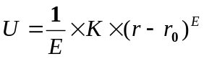 ,
Where K is the force constant, r is the reaction coordinate, r₀ is the origin of harmonic function on reaction coordinate, and E is set as 2 for default. The WHAM program calculates the probability density function of the configurations along the reaction coordinate(s) in a histogram and then estimates the free energy change on the coordinate(s).^{85,86} Except for regular WHAM that was applied to estimate the free energy change on one reaction coordinate, two-dimensional(2D) WHAM was employed in this dissertation to estimate the free energy change when two dimensional reaction coordinates were considered. The 2D free energy profiles computed by 2D-WHAM is good at implicating the synchronicity of multiple chemical steps.

References

1. Ashihara, H.; Sano, H.; Crozier, A., Caffeine and related purine alkaloids: Biosynthesis, catabolism, function and genetic engineering. Phytochemistry 2008, 69 (4), 841-856.
2. Uefuji, H.; Tatsumi, Y.; Morimoto, M.; Kaothien-Nakayama, P.; Ogita, S.; Sano, H., Caffeine production in tobacco plants by simultaneous expression of three coffee N-methyltrasferases and its potential as a pest repellant. Plant Mol Biol 2005, 59 (2), 221-227.
3. Nathanson, J. A., Caffeine and Related Methylxanthines - Possible Naturally-Occurring Pesticides. Science 1984, 226 (4671), 184-187.
4. Pacheco, A.; Pohlan, J.; Schulz, M., Allelopathic effects of aromatic species intercropped with coffee: Investigation of their growth stimulation capacity and potential of caffeine uptake in Puebla, Mexico. Allelopathy J 2008, 21 (1), 39-56.
5. Kato, M.; Mizuno, K.; Crozier, A.; Fujimura, T.; Ashihara, H., Plant biotechnology - Caffeine synthase gene from tea leaves. Nature 2000, 406 (6799), 956-957.
6. Ogawa, M.; Herai, Y.; Koizumi, N.; Kusano, T.; Sano, H., 7-Methylxanthine methyltransferase of coffee plants - Gene isolation and enzymatic properties. J Biol Chem 2001, 276 (11), 8213-8218.
7. Mizuno, K.; Kato, M.; Irino, F.; Yoneyama, N.; Fujimura, T.; Ashihara, H., The first committed step reaction of caffeine biosynthesis: 7-methylxanthosine synthase is closely homologous to caffeine synthases in coffee (Coffea arabica L.). Febs Lett 2003, 547 (1-3), 56-60.
8. Mizuno, K.; Okuda, A.; Kato, M.; Yoneyama, N.; Tanaka, H.; Ashihara, H.; Fujimura, T., Isolation of a new dual-functional caffeine synthase gene encoding an enzyme for the conversion of 7-methylxanthine to caffeine from coffee (Coffea arabica L.). Febs Lett 2003, 534 (1-3), 75-81.
9. Kato, M.; Mizuno, K., Caffeine synthase and related methyltransferases in plants. Front Biosci 2004, 9, 1833-1842.
10. Denoeud, F.; Carretero-Paulet, L.; Dereeper, A.; Droc, G.; Guyot, R.; Pietrella, M.; Zheng, C. F.; Alberti, A.; Anthony, F.; Aprea, G.; Aury, J. M.; Bento, P.; Bernard, M.; Bocs, S.; Campa, C.; Cenci, A.; Combes, M. C.; Crouzillat, D.; Da Silva, C.; Daddiego, L.; De Bellis, F.; Dussert, S.; Garsmeur, O.; Gayraud, T.; Guignon, V.; Jahn, K.; Jamilloux, V.; Joet, T.; Labadie, K.; Lan, T. Y.; Leclercq, J.; Lepelley, M.; Leroy, T.; Li, L. T.; Librado, P.; Lopez, L.; Munoz, A.; Noel, B.; Pallavicini, A.; Perrotta, G.; Poncet, V.; Pot, D.; Priyono; Rigoreau, M.; Rouard, M.; Rozas, J.; Tranchant-Dubreuil, C.; VanBuren, R.; Zhang, Q.; Andrade, A. C.; Argout, X.; Bertrand, B.; de Kochko, A.; Graziosi, G.; Henry, R. J.; Jayarama; Ming, R.; Nagai, C.; Rounsley, S.; Sankoff, D.; Giuliano, G.; Albert, V. A.; Wincker, P.; Lashermes, P., The coffee genome provides insight into the convergent evolution of caffeine biosynthesis. Science 2014, 345 (6201), 1181-1184.
11. McCarthy, A. A.; McCarthy, J. G., The structure of two N-methyltransferases from the caffeine biosynthetic pathway. Plant Physiol 2007, 144 (2), 879-889.
12. Zubieta, C.; Ross, J. R.; Koscheski, P.; Yang, Y.; Pichersky, E.; Noel, J. P., Structural basis for substrate recognition in the salicylic acid carboxyl methyltransferase family. Plant Cell 2003, 15 (8), 1704-1716.
13. Yao, J. Z.; Xu, Q.; Chen, F.; Guo, H., QM/MM Free Energy Simulations of Salicylic Acid Methyltransferase: Effects of Stabilization of TS-like Structures on Substrate Specificity. J Phys Chem B 2011, 115 (2), 389-396.
14. Guo, H. B.; Guo, H., Mechanism of histone methylation catalyzed by protein lysine methyltransferase SET7/9 and origin of product specificity. P Natl Acad Sci USA 2007, 104 (21), 8797-8802.
15. Xu, Q.; Chu, Y. Z.; Guo, H. B.; Smith, J. C.; Guo, H., Energy Triplets for Writing Epigenetic Marks: Insights from QM/MM Free-Energy Simulations of Protein Lysine Methyltransferases. Chem-Eur J 2009, 15 (46), 12596-12599.
16. Chu, Y. Z.; Xu, Q.; Guo, H., Understanding Energetic Origins of Product Specificity of SET8 from QM/MM Free Energy Simulations: What Causes the Stop of Methyl Addition during Histone Lysine Methylation? J Chem Theory Comput 2010, 6 (4), 1380-1389.
17. Mizuno, K.; Kurosawa, S.; Yoshizawa, Y.; Kato, M., Essential Region for 3-N Methylation in N-Methyltransferases Involved in Caffeine Biosynthesis. Z Naturforsch C 2010, 65 (3-4), 257-265.
18. Bedford, M. T.; Clarke, S. G., Protein Arginine Methylation in Mammals: Who, What, and Why. Mol Cell 2009, 33 (1), 1-13.
19. Calnan, B. J.; Tidor, B.; Biancalana, S.; Hudson, D.; Frankel, A. D., Arginine-Mediated Rna Recognition - the Arginine Fork. Science 1991, 252 (5009), 1167-1171.
20. Luscombe, N. M.; Laskowski, R. A.; Thornton, J. M., Amino acid-base interactions: a three-dimensional analysis of protein-DNA interactions at an atomic level. Nucleic Acids Res 2001, 29 (13), 2860-2874.
21. Mitchell, J. B. O.; Thornton, J. M.; Singh, J.; Price, S. L., Towards an Understanding of the Arginine Aspartate Interaction. J Mol Biol 1992, 226 (1), 251-262.
22. Melo, A.; Ramos, M. J.; Floriano, W. B.; Gomes, J. A. N. F.; Leao, J. F. R.; Magalhaes, A. L.; Maigret, B.; Nascimento, M. C.; Reuter, N., Theoretical study of arginine-carboxylate interactions. J Mol Struc-Theochem 1999, 463 (1-2), 81-90.
23. Bedford, M. T.; Richard, S., Arginine methylation: An emerging regulator of protein function. Mol Cell 2005, 18 (3), 263-272.
24. Bedford, M. T., Arginine methylation at a glance. J Cell Sci 2007, 120 (24), 4243-4246.
25. Sprangers, R.; Groves, M. R.; Sinning, L.; Sattler, M., High-resolution X-ray and NMR structures of the SMN tudor domain: Conformational variation in the binding site for symmetrically dimethylated arginine residues. J Mol Biol 2003, 327 (2), 507-520.
26. Hughes, R. M.; Waters, M. L., Arginine methylation in a beta-hairpin peptide: Implications for Arg-pi interactions, Delta Cp degrees, and the cold denatured state. J Am Chem Soc 2006, 128 (39), 12735-12742.
27. Wang, M.; Xu, R. M.; Thompson, P. R., Substrate Specificity, Processivity, and Kinetic Mechanism of Protein Arginine Methyltransferase 5. Biochemistry-Us 2013, 52 (32), 5430-5440.
28. Sun, L. T.; Wang, M. Z.; Lv, Z. Y.; Yang, N.; Liu, Y. F.; Bao, S. L.; Gong, W. M.; Xu, R. M., Structural insights into protein arginine symmetric dimethylation by PRMT5. P Natl Acad Sci USA 2011, 108 (51), 20538-20543.
29. Pal, S.; Vishwanath, S. N.; Erdjument-Bromage, H.; Tempst, P.; Sif, S., Human SWI/SNF-associated PRMT5 methylates histone H3 arginine 8 and negatively regulates expression of ST7 and NM23 tumor suppressor genes. Mol Cell Biol 2004, 24 (21), 9630-9645.
30. Wang, X.; Zhang, Y.; Ma, Q. B.; Zhang, Z. L.; Xue, Y. B.; Bao, S. L.; Chong, K., SKB1-mediated symmetric dimethylation of histone H4R3 controls flowering time in Arabidopsis. Embo J 2007, 26 (7), 1934-1941.
31. Zhao, Q.; Rank, G.; Tan, Y. T.; Li, H. T.; Moritz, R. L.; Simpson, R. J.; Cerruti, L.; Curtis, D. J.; Patel, D. J.; Allis, C. D.; Cunningham, J. M.; Jane, S. M., PRMT5-mediated methylation of histone H4R3 recruits DNMT3A, coupling histone and DNA methylation in gene silencing. Nat Struct Mol Biol 2009, 16 (3), 304-311.
32. Wang, H. B.; Huang, Z. Q.; Xia, L.; Feng, Q.; Erdjument-Bromage, H.; Strahl, B. D.; Briggs, S. D.; Allis, C. D.; Wong, J. M.; Tempst, P.; Zhang, Y., Methylation of histone H4 at arginine 3 facilitating transcriptional activation by nuclear hormone receptor. Science 2001, 293 (5531), 853-857.
33. Fuchs, S. M.; Krajewski, K.; Baker, R. W.; Miller, V. L.; Strahl, B. D., Influence of Combinatorial Histone Modifications on Antibody and Effector Protein Recognition. Curr Biol 2011, 21 (1), 53-58.
34. Chu, Y. Z.; Li, G. H.; Guo, H., QM/MM MD and free energy simulations of the methylation reactions catalyzed by protein arginine methyltransferase PRMT3. Can J Chem 2013, 91 (7), 605-612.
35. Zhang, R. H.; Li, X.; Liang, Z. J.; Zhu, K. K.; Lu, J. Y.; Kong, X. Q.; Ouyang, S. S.; Li, L.; Zheng, Y. G.; Luo, C., Theoretical Insights into Catalytic Mechanism of Protein Arginine Methyltransferase 1. Plos One 2013, 8 (8).
36. Scott, D. C.; Sviderskiy, V. O.; Monda, J. K.; Lydeard, J. R.; Cho, S. E.; Harper, J. W.; Schulman, B. A., Structure of a RING E3 trapped in action reveals ligation mechanism for the ubiquitin-like protein NEDD8. Cell 2014, 157 (7), 1671-84.
37. Soucy, T. A.; Smith, P. G.; Milhollen, M. A.; Berger, A. J.; Gavin, J. M.; Adhikari, S.; Brownell, J. E.; Burke, K. E.; Cardin, D. P.; Critchley, S.; Cullis, C. A.; Doucette, A.; Garnsey, J. J.; Gaulin, J. L.; Gershman, R. E.; Lublinsky, A. R.; McDonald, A.; Mizutani, H.; Narayanan, U.; Olhava, E. J.; Peluso, S.; Rezaei, M.; Sintchak, M. D.; Talreja, T.; Thomas, M. P.; Traore, T.; Vyskocil, S.; Weatherhead, G. S.; Yu, J.; Zhang, J.; Dick, L. R.; Claiborne, C. F.; Rolfe, M.; Bolen, J. B.; Langston, S. P., An inhibitor of NEDD8-activating enzyme as a new approach to treat cancer. Nature 2009, 458 (7239), 732-6.
38. Osaka, F.; Saeki, M.; Katayama, S.; Aida, N.; Toh-e, A.; Kominami, K.; Toda, T.; Suzuki, T.; Chiba, T.; Tanaka, K.; Kato, S., Covalent modifier NEDD8 is essential for SCF ubiquitin-ligase in fission yeast. Embo J 2000, 19 (13), 3475-3484.
39. Tateishi, K.; Omata, M.; Tanaka, K.; Chiba, T., The NEDD8 system is essential for cell cycle progression and morphogenetic pathway in mice. The Journal of cell biology 2001, 155 (4), 571-9.
40. Read, M. A.; Brownell, J. E.; Gladysheva, T. B.; Hottelet, M.; Parent, L. A.; Coggins, M. B.; Pierce, J. W.; Podust, V. N.; Luo, R. S.; Chau, V.; Palombella, V. J., Nedd8 modification of cul-1 activates SCF(beta(TrCP))-dependent ubiquitination of IkappaBalpha. Molecular and cellular biology 2000, 20 (7), 2326-33.
41. Liakopoulos, D.; Doenges, G.; Matuschewski, K.; Jentsch, S., A novel protein modification pathway related to the ubiquitin system. Embo J 1998, 17 (8), 2208-2214.
42. Kurz, T.; Pintard, L.; Willis, J. H.; Hamill, D. R.; Gonczy, P.; Peter, M.; Bowerman, B., Cytoskeletal regulation by the Nedd8 ubiquitin-like protein modification pathway. Science 2002, 295 (5558), 1294-8.
43. Pozo, J. C.; Timpte, C.; Tan, S.; Callis, J.; Estelle, M., The ubiquitin-related protein RUB1 and auxin response in Arabidopsis. Science 1998, 280 (5370), 1760-3.
44. Huang, D. T.; Hunt, H. W.; Zhuang, M.; Ohi, M. D.; Holton, J. M.; Schulman, B. A., Basis for a ubiquitin-like protein thioester switch toggling E1-E2 affinity. Nature 2007, 445 (7126), 394-8.
45. Gareau, J. R.; Reverter, D.; Lima, C. D., Determinants of small ubiquitin-like modifier 1 (SUMO1) protein specificity, E3 ligase, and SUMO-RanGAP1 binding activities of nucleoporin RanBP2. The Journal of biological chemistry 2012, 287 (7), 4740-51.
46. Plechanovova, A.; Jaffray, E. G.; Tatham, M. H.; Naismith, J. H.; Hay, R. T., Structure of a RING E3 ligase and ubiquitin-loaded E2 primed for catalysis. Nature 2012, 489 (7414), 115-20.
47. Kim, A. Y.; Bommelje, C. C.; Lee, B. E.; Yonekawa, Y.; Choi, L.; Morris, L. G.; Huang, G.; Kaufman, A.; Ryan, R. J.; Hao, B.; Ramanathan, Y.; Singh, B., SCCRO (DCUN1D1) is an essential component of the E3 complex for neddylation. The Journal of biological chemistry 2008, 283 (48), 33211-20.
48. Huang, G.; Kaufman, A. J.; Ramanathan, Y.; Singh, B., SCCRO (DCUN1D1) promotes nuclear translocation and assembly of the neddylation E3 complex. The Journal of biological chemistry 2011, 286 (12), 10297-304.
49. Wu, P. Y.; Hanlon, M.; Eddins, M.; Tsui, C.; Rogers, R. S.; Jensen, J. P.; Matunis, M. J.; Weissman, A. M.; Wolberger, C. P.; Pickart, C. M., A conserved catalytic residue in the ubiquitin-conjugating enzyme family. Embo J 2003, 22 (19), 5241-5250.
50. Berndsen, C. E.; Wiener, R.; Yu, I. W.; Ringel, A. E.; Wolberger, C., A conserved asparagine has a structural role in ubiquitin-conjugating enzymes. Nat Chem Biol 2013, 9 (3), 154-156.
51. Calabrese, M. F.; Scott, D. C.; Duda, D. M.; Grace, C. R. R.; Kurinov, I.; Kriwacki, R. W.; Schulman, B. A., A RING E3-substrate complex poised for ubiquitin-like protein transfer: structural insights into cullin-RING ligases. Nature structural & molecular biology 2011, 18 (8), 947-949.
52. Zhen, Y.; Qin, G.; Luo, C.; Jiang, H.; Yu, K.; Chen, G., Exploring the RING-catalyzed ubiquitin transfer mechanism by MD and QM/MM calculations. PloS one 2014, 9 (7), e101663.
53. van der Kamp, M. W.; Mulholland, A. J., Combined Quantum Mechanics/Molecular Mechanics (QM/MM) Methods in Computational Enzymology. Biochemistry-Us 2013, 52 (16), 2708-2728.
54. Yang, W.; Gao, Y. Q.; Cui, Q.; Ma, J.; Karplus, M., The missing link between thermodynamics and structure in F1-ATPase. P Natl Acad Sci USA 2003, 100 (3), 874-879.
55. Brooks, B. R.; Brooks, C. L.; Mackerell, A. D.; Nilsson, L.; Petrella, R. J.; Roux, B.; Won, Y.; Archontis, G.; Bartels, C.; Boresch, S.; Caflisch, A.; Caves, L.; Cui, Q.; Dinner, A. R.; Feig, M.; Fischer, S.; Gao, J.; Hodoscek, M.; Im, W.; Kuczera, K.; Lazaridis, T.; Ma, J.; Ovchinnikov, V.; Paci, E.; Pastor, R. W.; Post, C. B.; Pu, J. Z.; Schaefer, M.; Tidor, B.; Venable, R. M.; Woodcock, H. L.; Wu, X.; Yang, W.; York, D. M.; Karplus, M., CHARMM: The Biomolecular Simulation Program. J Comput Chem 2009, 30 (10), 1545-1614.
56. van der Kamp, M. W.; Shaw, K. E.; Woods, C. J.; Mulholland, A. J., Biomolecular simulation and modelling: status, progress and prospects. J R Soc Interface 2008, 5, S173-S190.
57. Brooks, B. R.; Bruccoleri, R. E.; Olafson, B. D.; States, D. J.; Swaminathan, S.; Karplus, M., Charmm - a Program for Macromolecular Energy, Minimization, and Dynamics Calculations. J Comput Chem 1983, 4 (2), 187-217.
58. Becke, A. D., Density-Functional Exchange-Energy Approximation with Correct Asymptotic-Behavior. Phys Rev A 1988, 38 (6), 3098-3100.
59. Parr, R. G.; Yang, W., Density-functional theory of atoms and molecules. Oxford University Press ;
Clarendon Press: New York
Oxford England, 1989; p x, 333 p.
60. Pearlman, D. A.; Case, D. A.; Caldwell, J. W.; Ross, W. S.; Cheatham, T. E.; Debolt, S.; Ferguson, D.; Seibel, G.; Kollman, P., Amber, a Package of Computer-Programs for Applying Molecular Mechanics, Normal-Mode Analysis, Molecular-Dynamics and Free-Energy Calculations to Simulate the Structural and Energetic Properties of Molecules. Comput Phys Commun 1995, 91 (1-3), 1-41.
61. MacKerell, A. D.; Bashford, D.; Bellott, M.; Dunbrack, R. L.; Evanseck, J. D.; Field, M. J.; Fischer, S.; Gao, J.; Guo, H.; Ha, S.; Joseph-McCarthy, D.; Kuchnir, L.; Kuczera, K.; Lau, F. T. K.; Mattos, C.; Michnick, S.; Ngo, T.; Nguyen, D. T.; Prodhom, B.; Reiher, W. E.; Roux, B.; Schlenkrich, M.; Smith, J. C.; Stote, R.; Straub, J.; Watanabe, M.; Wiorkiewicz-Kuczera, J.; Yin, D.; Karplus, M., All-atom empirical potential for molecular modeling and dynamics studies of proteins. J Phys Chem B 1998, 102 (18), 3586-3616.
62. Scott, W. R. P.; Hunenberger, P. H.; Tironi, I. G.; Mark, A. E.; Billeter, S. R.; Fennen, J.; Torda, A. E.; Huber, T.; Kruger, P.; van Gunsteren, W. F., The GROMOS biomolecular simulation program package. J Phys Chem A 1999, 103 (19), 3596-3607.
63. Kaminski, G. A.; Friesner, R. A.; Tirado-Rives, J.; Jorgensen, W. L., Evaluation and reparametrization of the OPLS-AA force field for proteins via comparison with accurate quantum chemical calculations on peptides. J Phys Chem B 2001, 105 (28), 6474-6487.
64. Warshel, A.; Levitt, M., Theoretical Studies of Enzymic Reactions - Dielectric, Electrostatic and Steric Stabilization of Carbonium-Ion in Reaction of Lysozyme. J Mol Biol 1976, 103 (2), 227-249.
65. Field, M. J.; Bash, P. A.; Karplus, M., A Combined Quantum-Mechanical and Molecular Mechanical Potential for Molecular-Dynamics Simulations. J Comput Chem 1990, 11 (6), 700-733.
66. Gao, J., Combined Qm/Mm Simulation Study of the Claisen Rearrangement of Allyl Vinyl Ether in Aqueous-Solution. J Am Chem Soc 1994, 116 (4), 1563-1564.
67. Svensson, M.; Humbel, S.; Froese, R. D. J.; Matsubara, T.; Sieber, S.; Morokuma, K., ONIOM: A multilayered integrated MO+MM method for geometry optimizations and single point energy predictions. A test for Diels-Alder reactions and Pt(P(t-Bu)(3))(2)+H-2 oxidative addition. J Phys Chem-Us 1996, 100 (50), 19357-19363.
68. Zhang, Y. K.; Lee, T. S.; Yang, W. T., A pseudobond approach to combining quantum mechanical and molecular mechanical methods. J Chem Phys 1999, 110 (1), 46-54.
69. Friesner, R. A.; Guallar, V., Ab initio quantum chemical and mixed quantum mechanics/molecular mechanics (QM/MM) methods for studying enzymatic catalysis. Annu Rev Phys Chem 2005, 56, 389-427.
70. Henzler-Wildman, K.; Kern, D., Dynamic personalities of proteins. Nature 2007, 450 (7172), 964-72.
71. Zwier, M. C.; Chong, L. T., Reaching biological timescales with all-atom molecular dynamics simulations. Current opinion in pharmacology 2010, 10 (6), 745-52.
72. Cornell, W. D.; Cieplak, P.; Bayly, C. I.; Gould, I. R.; Merz, K. M.; Ferguson, D. M.; Spellmeyer, D. C.; Fox, T.; Caldwell, J. W.; Kollman, P. A., A second generation force field for the simulation of proteins, nucleic acids, and organic molecules (vol 117, pg 5179, 1995). J Am Chem Soc 1996, 118 (9), 2309-2309.
73. Jorgensen, W. L.; Maxwell, D. S.; TiradoRives, J., Development and testing of the OPLS all-atom force field on conformational energetics and properties of organic liquids. J Am Chem Soc 1996, 118 (45), 11225-11236.
74. Jorgensen, W. L.; Chandrasekhar, J.; Madura, J. D.; Impey, R. W.; Klein, M. L., Comparison of Simple Potential Functions for Simulating Liquid Water. J Chem Phys 1983, 79 (2), 926-935.
75. Alhaidari, A. D.; Ismail, M. E. H., Quantum mechanics without potential function. J Math Phys 2015, 56 (7).
76. Gao, J. L.; Truhlar, D. G., Quantum mechanical methods for enzyme kinetics. Annu Rev Phys Chem 2002, 53, 467-505.
77. Kim, K.; Jordan, K. D., Comparison of Density-Functional and Mp2 Calculations on the Water Monomer and Dimer. J Phys Chem-Us 1994, 98 (40), 10089-10094.
78. Stewart, J. J. P., Special Issue - Mopac - a Semiempirical Molecular-Orbital Program. J Comput Aid Mol Des 1990, 4 (1), 1-45.
79. Elstner, M.; Porezag, D.; Jungnickel, G.; Elsner, J.; Haugk, M.; Frauenheim, T.; Suhai, S.; Seifert, G., Self-consistent-charge density-functional tight-binding method for simulations of complex materials properties. Phys Rev B 1998, 58 (11), 7260-7268.
80. Cui, Q.; Elstner, M.; Kaxiras, E.; Frauenheim, T.; Karplus, M., A QM/MM implementation of the self-consistent charge density functional tight binding (SCC-DFTB) method. J Phys Chem B 2001, 105 (2), 569-585.
81. Guo, H.; Cui, Q.; Lipscomb, W. N.; Karplus, M., Understanding the role of active-site residues in chorismate mutase catalysis from molecular-dynamics simulations. Angew Chem Int Edit 2003, 42 (13), 1508-1511.
82. Brooks, C. L.; Brunger, A.; Karplus, M., Active-Site Dynamics in Protein Molecules - a Stochastic Boundary Molecular-Dynamics Approach. Biopolymers 1985, 24 (5), 843-865.
83. Brunger, A.; Brooks, C. L.; Karplus, M., Stochastic Boundary-Conditions for Molecular-Dynamics Simulations of St2 Water. Chem Phys Lett 1984, 105 (5), 495-500.
84. Torrie, G. M.; Valleau, J. P., Monte-Carlo Free-Energy Estimates Using Non-Boltzmann Sampling - Application to Subcritical Lennard-Jones Fluid. Chem Phys Lett 1974, 28 (4), 578-581.
85. Kumar, S.; Bouzida, D.; Swendsen, R. H.; Kollman, P. A.; Rosenberg, J. M., The Weighted Histogram Analysis Method for Free-Energy Calculations on Biomolecules .1. The Method. J Comput Chem 1992, 13 (8), 1011-1021.
86. Kobrak, M. N., Systematic and statistical error in histogram-based free energy calculations. J Comput Chem 2003, 24 (12), 1437-46.

CHAPTER 1 Catalytic Mechanism and the Role of Key Residues in Caffeine Biosynthesis Catalyzed by Dimethylxanthine Methyltransferase from QM/MM Simulations

A version of this chapter was originally published by Yufei Yue and Hong Guo: Yufei Yue, Hong Guo. “Quantum Mechanical/Molecular Mechanical (QM/MM) Study of Catalytic Mechanism and the Role of Key Residues in Caffeine Biosynthesis Catalyzed by Dimethylxanthine Methyltransferase” J. Chem. Inf. Model., 54 (2014): 593-600. My contributions to this study include: 1) design of experiments; 2) building models and running simulations; 3) analyzing results and preparing the manuscript. Dr. Hong Guo supervised in the experimental design and reviewed the manuscript.

Abstract

The caffeine biosynthetic pathway is of considerable importance for beverage and pharmaceutical industries which produces two blockbuster products, theobromine and caffeine. The major biochemistry in caffeine biosynthesis starts from the initial substrate of xanthosine and ends with the final product caffeine, with theobromine serving as an intermediate. The key enzyme, S-adenosyl-L-methionine (SAM) dependent 1,7-dimethyl-xanthine methyltransferase (DXMT), catalyzes two important methyl transfer steps in caffeine biosynthesis: 1) methylation of N3 of 7-methylxanthine (7mX) to form theobromine (Tb); 2) methylation of N1 of theobromine to form caffeine (Cf). Although DXMT has been structurally characterized recently, our understanding of the detailed catalytic mechanism and role of key catalytic residues are still lacking. In this work, the quantum mechanical/ molecular mechanical (QM/MM) molecular dynamics (MD) and free energy simulations are performed to elucidate the catalytic mechanism of the enzyme-catalyzed reactions and to explain experimental observations concerning the activity of this enzyme. The roles of certain active-site residues are studied, and it is proposed that based on the results of computer simulations that a histidine residue (His160) at the active site of DXMT may act as a general base/acid catalyst during the methyl transfer process.

Introduction

As one of the best known plant alkaloids, caffeine (1,3,7-trimethylxanthine) is produced in seeds, leaves and fruits of many higher plants, including three very important crops: coffee (Coffea arabica and Coffea canephora), cacao (Theobroma cacao) and tea (Camellia sinensis).¹ It is a secondary metabolite in plants and can work as a native insect repellent² and inhibitor to the germination of other seeds³. However, it is probably better known as a human central nervous system stimulant, widely used in beverage and pharmaceutical industries. The main pathway of caffeine biosynthesis starts from the initial substrate xanthosine(XR) and ends with the final product of caffeine, involving three S-adenosyl-L-methionine(SAM) dependent N-methyl transfer processes and one ribose removal step(Figure 1.1).¹ In this biosynthetic pathway, the ribose is removed and 7-N, 3-N and 1-N on the purine alkaloid are methylated(Figure 1.1), producing 7-methylxanthosine(7mXR),7-methylxanthine(7mX) and theobromine (3,7-dimethy-lxanthine, Tb) as intermediates.

Eleven enzymes that participate in this pathway have been isolated so far and identified as N-methyltransferase.^{4,5,6,7,8,9} These enzymes catalyze the N-methylation of nitrogen-containing compounds and belong to the wider motif B’ methyltransferase family, which is plants specific and catalyzes SAM-dependent substrate methylation.¹⁰ Only two of these enzymes in the pathway, xanthosine methyltransferases (XMT) and 3,7-dimethylxanthine methyltransferase (DXMT), both from Coffea canephor ‘robusta’, have been structurally characterized.¹¹ XMT is capable of catalyzing the methyl transfer to and, probably, nucleotide cleavage of XR.¹¹ DXMT has dual activities toward both 7mX(3-N) and Tb(1-N).¹¹

Previous experimental studies have indicated that the substrate recognition and catalytic efficiency of DXMT and other members of the family appear to have subtle biochemical characteristics, and their dependences on the active site and other residuals may be complicated.^{9,11,12} It is of great interest to quantitatively assess the subtle structure features in the active site of DXMT that may lead to a better understanding of substrate recognition. Moreover, a detailed study of the substrate specificity for DXMT could help to identify the key residues in the active site that could be genetically modified by site-directed mutagenesis to generate decaffeinated coffee species. The overall structure of DXMT was also found to resemble that of salicylic acid O-methyltransferase, SAMT,¹¹ which is another SAM-dependent motif B’ methyltransferase that has been structurally identified.¹³ Yao et al. performed computer simulations on the SAMT catalyzed methyl transfer from SAM to salicylic acid(SA), by use of quantum mechanics and molecular mechanics hybrid(QM/MM) molecular dynamic(MD) simulations.¹⁴ They suggested based on a good correlation between the activities of the enzymes observed experimentally and the results of the computer simulations that the computational approaches seem to be well suited for the investigations of enzyme-catalyzed methyl transfer processes.^{15,16,17}

Although the X-ray structures of DXMT have been determined, the catalytic mechanism of the enzyme is still not clear. For instance, Figure 1.1 shows that a general base seems to be required to remove the proton of the hydroxyl group (e.g., at the 2 position) in order to have the methyl group transferred to the nitrogen (e.g., either the 3 or 1 position) in each case. However, the general base or general bases have not identified so far. In this work, the quantum mechanical /molecular mechanical (QM/MM) MD and free energy simulations are performed to determine the catalytic mechanism of the enzyme-catalyzed reactions involving DXMT and to explain some experimental observations. It is proposed that a conserved residue, His160, may act as a general base/acid catalyst for the conversion of 7-methylxanthine to caffeine with theobromine as an intermediate product.

Methods

The initial coordinates for the reactant complexes of the methyl transfers to N3 or N1 of the purine ring are based on the crystallographic complexes (PDB ID: 2EFJ) of DXMT containing AdoHcy and theobromine with two different orientations. The QM/MM MD and free energy (potential of mean force) simulations were performed in the determination of the free energy profiles for the methylation processes with the CHARMM program.¹⁸ Water spheres based on a modified TIP3P water model¹⁹ with radius of 30 Å, centered at either N3 or N1 of the purine ring, were used to solvate the system. Stochastic boundary with a Poisson-Boltzmann charge-scaling scheme²⁰ was applied. The reservoir region has r > 22 Å, and the buffer region has radius(r) equal to 20 Å ≤ r ≤ 22 Å. The reaction region has r ≤ 20 Å. The methyl group of AdoMet, the substrate (7mX or Tb) and the side chain of His160 were treated by QM and the rest of the system by MM. All-hydrogen potential function (PARAM27)²¹ was used for the MM region, and the self-consistence charge density functional tight binding (SCC-DFTB)^{22,23} method was used for the QM region. The link-atom approach²⁴ was used to separate the QM and MM regions. A small system containing the side chain of His160, a part of AdoMet, and the complete 7mX molecule was studied by using the SCC-DFTB and high level MP2/6–31G** methods with energy minimization to determine the accuracy of the SCC-DFTB method (Supplement Figure 1.1), suggesting that the SCC-DFTB method performs well for this system.

To build the initial reactant complex for the N3 methylation on 7mX from the X-ray structure, the substrate analog was modified to 7mX by deleting the methyl group at its N3 position, and a methyl group was added to S_{δ} of AdoHcy to generate the methyl-donor AdoMet. Similarly, to build the initial reactant complex for the N1 methylation on Tb, AdoHcy was modified to AdoMet by adding a methyl group. The initial reactant complex for the N1 methylation on 7mX is built by deleting the methyl group on N3 of the original Tb substrate in the crystal structure. The initial reactant complex containing paraxanthine (Px) is established by adding a methyl group to and deleting a methyl group on N1 of the 7Mx-like Tb in the crystal structure. The reference center for partitioning the system was chosen to be either N3 or N1 of the substrate, depending on which atom is the methyl acceptor. The resulting systems contain about 5800 atoms, including about 600 water molecules. The initial structures for the entire stochastic boundary systems were optimized using the steepest descent (SD) and adopted-basis Newton-Raphson (ABNR) methods. The systems were gradually heated from 50.0 to 298.15 K in 50 ps. A 1-fs time step was applied for the integration of equation of motion, and the coordinates were saved every 50 fs. 1.5 ns QM/MM MD simulations were executed for each of the reactant complexes initially. Similar to the methyl transfer from AdoMet to salicylic acid catalyzed by SAMT¹⁴, the S_{N}2 methyl transfer reaction from AdoMet to N_{1/3} on the DXMT’s substrate is presumably more efficient if the S_{δ}-CH₃ group of AdoMet is well aligned with the lone pair of electrons of N_{1/3} in the reactant complexes. The reaction coordinate was defined as a linear combination of r(C_{M}…N_{1/3}) and r(S_{δ}…C_{M}), which is R= r(S_{δ}…C_{M}) - r(C_{M}…N_{1/3}). The umbrella sampling method²⁵ implemented in the CHARMM program along with the Weighted Histogram Analysis Method (WHAM) ²⁶ was applied to determine the free energy (potential of mean force, PMF) as a function of the reaction coordinate(s) for the methyl transfer process. For each methyl transfer process, twenty simulation windows were saved, and for each window 50 ps production runs were performed after 50 ps equilibration. The force constants of the harmonic biasing potentials used in the PMF simulations were 50 to 500 kcal mol^{–1} Å^{–2}.

The simulations were also performed with the O…H bond on the substrate fixed by SHAKE²⁷ algorithm of CHARMM to avoid proton transfer from the substrate to NE2 position of His160 in order to estimate the effect of the proton transfer on the methyl transfer. The distance between the proton donated from the substrate and its acceptor, NE2 on His160, was monitored in the whole simulation as a function of the reaction coordinate R= r(S_{δ}…C_{M}) - r(C_{M}…N_{1/3}).

The 2D free energy map (PMF) for the conversion of 7mX to Tb was determined with the umbrella sampling method ²⁵ and two-dimensional WHAM²⁶. The time step for QM/MM MD simulation is 1 fs. One reaction coordinate is Rx = r(S_{δ}…C_{M})- r(C_{M}…N₃), describing the methyl transfer process. The other reaction coordinate is the distance between H on the hydroxyl group of 7mX and NE2 on His160, Ry = r(H…NE2), describing the proton transfer process. 209 windows were used in the calculation of 2D PMF, and 50 ps production runs were preformed after 50 ps equilibration for each window. The force constants for each window were in the range of 100-400 kcal∙Mol⁻¹∙Å⁻² for both Rx and Ry.

Results and Discussion

Reactant complexes for N3 and N1 methylation
The X-ray structures of the DXMT complexes have been available.¹¹ As shown in Figure 1.2A, Tb has its N3 methyl group pointing to S_{δ} of AdoHcy in the X-ray structure. This is in contrast with the case of another orientation of Tb in the structure in which N1 of Tb instead of N3 is close to S_{δ} (Figure 1.2B). Both these orientations are presumably stabilized in the active site by hydrogen binding interactions, including the interactions of O2 of Tb with the side chains of His160 and Trp161 and the hydrogen bond involving the hydroxyl group of Ser237 and O6 in Fig.2A (N9 in Figure 1.2B). Moreover, water mediated hydrogen bonds are also formed involving the backbone N-H group of Ser237 and O6 in Figure 1. 2A (or N9 in Figure 1.2B) and the hydroxyl group of Tyr18 and N9 in Figure 1.2A (Try18 and O6 in Figure 1.2B). In addition to the hydrogen bonding interactions, the existence of hydrophobic environment can also be seen in Figure 1.2A and B. For instance, the purine ring forms hydrophobic contacts with Ile332 and Tyr157, while Phe27, Leu26, Tyr368 and Val328 produce a hydrophobic core that may also contribute the binding.

The average structures of the reactant complexes for the conversion of 7mX to Tb and for the conversion of Tb to Cf obtained after 1ns QM/MM MD simulations are shown in Figure 1.2C and D, respectively. The hydrogen bonding and hydrophobic interactions discussed earlier for the original crystal structures (Figure 1.2A and B) generally remain (see Figure 1.2C and D). However, there are some significant deviations, as can be seen by comparison of Figure 1. 2A with C, and Figure 1. 2B with D, respectively. Those differences might be explained in part by the fact that, unlike the crystal structure, the reactant complex contains AdoMet rather than AdoHcy. The existence of a positively charged methyl group on AdoMet is expected to produce some changes in the interactions, leading to modifications of the active-site structure. For instance, the distance from S_{δ} to N1 increased from 3.6Å in Figure 1.2B to 4.7Å in Figure 1.2D. For the reactant complexes of other methyltransferases including PKMT^{15,31,32}, PRMT³³ and SAMT,¹⁴ the methyl transfer processes appear to be favorable if the distance between the methyl group from methyl donor and acceptor nitrogen (or oxygen) is around 3 Å. This seems to be the case as shown in Figure 1.2C and D. Figure 1.2C and D also show that the methyl group of AdoMet is well aligned with the lone-pair electrons of N3 from 7mX and that of N1 from Tb in the both reactant complexes. It has been indicated from previous studies on PKMTs¹⁴ and SAMT^{15,16,17} that a good alignment between the transferable methyl group and the lone pair of electrons of the its acceptor, such as nitrogen and oxygen, is of importance for an efficient methyl transfer. The simulation results here imply that the DMXT reactant complex containing either 7mX or Tb could meet the requirement for a good alignment of the reactive groups participating in the methyl transfer, which is consistent with the substrate specificity^{9,11} of this enzyme. As discussed below, free energy simulations from the reactant complex to the transition-like state indicates that a proper balance of hydrogen bonding and hydrophobic interactions appears to be responsible for the good alignment of the reactive groups in the process of methyl transfer.

His160 as general acid/base catalyst for N3 and N1 methylation
7mX may exist in one of the three tautomers in solution (see Figure 1.1).²⁸ Methyl transfer from AdoMet to N3 on 7mX is presumably a S_{N}2 reaction in which the lone pair of electrons from the nucleophile N3 attacks C_{M} of the methyl group. Although the normal pKa of histidine imidazole is around 6, different prediction methods seem to indicate that His160 in the active site of DXMT may have a lower pKa (3.21 by ProPka 29; <0 by H++ 30). Therefore His160 may be neutral, making it more likely to act as a general base. The neighboring O2 of 7mX and the side chain of Tyr157 might contribute to lowering the pKa of imidazole of His160.²⁹ In the crystal structure, the atom NE2 of His160 is within 2.5 Å of the atom O2 on the substrate (Figure 1.2A). After 1 ns MD simulation, the distance between NE2 and O2 is slightly increased to be 2.8 Å (Figure 1.2C). Thus, it is likely that NE2 on His160 might help to stabilize the hydroxyl O2 on 7mX through strong hydrogen bonding in the reactant complex and act as the general base during the methyl transfer. Tb also has different tautomers, with either deprotonated N1 or deprotonated O2 (Figure 1.1). After 1 ns MD simulation, NE2 of His160 is well kept at 2.9 Å to O2 of the substrate (Figure 1.2B), the same as in the crystal structure (Figure 1.2D). It’s thus likely that, similar to the case involving 7mX, NE2 on His160 might help to stabilize the hydroxyl O2 on Tb through strong hydrogen bonding and act as a general base as well. Consistent with the suggestion above, the distance between Trp161 and O2 are reasonably maintained during the simulations (see Figure 1.3 and 1.4), possibly contributing as another stabilizing force of O2 on the substrate.

The hydrophobic interactions in all those simulations (see Figure 1.3 and 1.4) remain basically the same as that observed in the X-ray structure; for clarity they are not shown in Figure 1.3 and 1.4. It is of interest to note that the active-site water molecule, TIP85, moves away from the active site. Nevertheless, the distance between the nitrogen on the side chain of Trp161 and O2 of substrates is well kept at round 3.2Å as shown in Figure 1.3 and 1.4. The hydrogen bond between Trp161 and the hydroxyl O2 on the substrate appears to help to maintain the substrate in the reactive configuration for the methyl transfer. The hydrogen bonding interactions of the backbone nitrogen from Ser237 with either O6 of 7mX or N9 of Tb as well as those mediated by the water molecule are generally stable in all simulations; they may play a role in generating the reactive configuration for the reactant complex as well.

The role of His160 as a general base is further demonstrated in the free energy simulations of methyl transfer processes. As shown in Figure 1.3 and 1.4, a spontaneous proton transfer from O2 to neutral His160 occurred during methylation of N3 (7mX->Tb) and N1 (Tb->Cf), respectively. In Figure 1.3 where the average structures near TS are given, window10 shows that the average distance between the proton and NE2 of His160 is 1.4 Å, window11 shows that the proton transfer has basically completed (H…NE2 average distance is 1.1 Å). In Figure 1.4, window10 show that the average distance between proton and NE2 of His160 is 1.9 Å, and window11 show that the proton transfer has basically completed (H…NE2 average distance is 1.1 Å).

To monitor the breakage of O-H bond of the substrate and the formation of N-H bond between H and NE2 of His160, the distance between H and NE2 as a function of the reaction coordinate, R= r(S_{δ}…C_{M})- r(C_{M}…N_{1/3}), was plotted in Figure 1.5. The N-H covalent bond is considered being formed when the distance between H and NE2 is less than 1.1 Å. The reaction coordinate for the transition state (R_{TS}) is estimated to correspond to the highest free energy point in the free energy profile shown in Figure 1.5. It shows in Figure 1.5A and B that the N-H bond is formed near the transition state (R_{TS}=0.17 Å for N3, R_{TS}=0.43 Å for N1) of methylation. Furthermore, Figure 1.3 and 1.4 show that the proton transfer and the breakage of S_{δ}-C_{M} bond are not concerted, which is consistent with the two dimensional free energy map (see below in Figure 1.7).

The free energy profiles of stepwise methyl transfer processes
The free energy profiles (potential of mean force) for the methyl transfer from AdoMet to 7mX and Tb are plotted in Figure 1.6A and B, respectively, as a function of the reaction coordinate (R = r(S_{δ}…C_{M}) - r(C_{M}…N₃) in Figure 1.6A and R=r(S_{δ}…C_{M})- r(C_{M}…N₁) in Fig. 6B). As can be seen in Figure 1.6A, the free energy barrier from the initial reactant complex to the transition state is calculated to be about 16-17 kcal/mol for the first methyl transfer to 7mX. And this free energy barrier is estimated to be approximately 18 kcal/mol for the second methyl transfer to Tb as shown in Figure 1.6B. Moreover, preventing the proton transfer could greatly increase the free energy barrier of methylation. Indeed, as shown in Figure 1.6A and B, preventing the proton transfer (by SHAKE algorithm in CHARMM²⁷) increases the energy barrier for the 7mX methylation by 3.7 kcal/mol and for the Tb methylation by 12.7 kcal/mol, respectively.

By comparing the two free energy profiles of methylation of 7mX in Figure 1.6A, it is interesting to note that the profile with the proton fixed overlaps with the profile without fixing the proton until the two profiles approaches near transition state(i.e., around R=0.17Å). Without the proton transfer, the transition state of methylation is much lagged behind and is reached at around R=0.64 Å. This is consistent with the fact that the average structure of each window in Figure 1.3 before transition state is quite similar to the corresponding one in Supplement Figure 1.2. By contrast, the free energy profile of methyl transfer to N1 (Figure 1.6B) shows that preventing the proton transfer increases the free energy change at the beginning of methylation of Tb already. The free energy difference is also reflected in Supplement Figure 1.3. It seems in Supplement Figure 1.3 that the inability of the formation of a stable hydrogen bonding between NE2 of His160 and the fixed proton of Tb may be responsible for the increasement of the free energy barrier. In summary, we suggest that His160 is likely to act as the general acid/base catalyst and mediate the proton transfer for the methylation of N3 and N1.

It should be pointed out that the stepwise bond-breaking and -making events might not well be reflected in the one-dimension (1D) free energy simulation and therefore two dimension(2D) simulation involving both methylation and proton transfer might offer a clearer picture on those events. The 2D free-energy contour map with reaction coordinates for both methylation (Rx= r(S_{δ}…C_{M}) - r(C_{M}…N₃)) and proton transfer (Ry=r(H…NE2)) is shown in Figure 1.7. As demonstrated in Figure 1.7, the progress of the proton transfer seems to be ahead of the methylation process. Indeed, the proton transfer is basically completed at around the transition state of N3 methylation (point B in Figure 1.7). The completion of proton transfer could thereafter promote the final attachment of the positive charged methyl group to the substrate.

The major pathway for DXMT catalyzed caffeine synthesis is thought by a step-by-step methylation of N3(7mX->Tb) and then N1(Tb->Cf).¹¹ Uefuji et al. detected the activity of DXMT toward paraxanthine(Px).³⁴ Px is an isomer of Tb which has two methyl groups on N1 and N7 of its purine ring(Figure 1.1), while Tb has two methyl groups on N3 and N7. The enzymatic activity of DXMT on Px is about 10 times higher than that for Tb.³⁴ The MD simulations of the step-by-step methylation was carried out for N1(7mX->Px) and then N3(Px->Cf). The free energy profiles for the methyl transfer from AdoMet to 7mX and Px are as a function of the reaction coordinate, respectively. The free energy barrier for the N1 methylation on 7mX is 17.4 kcal/mol, which is 1.1 kcal/mol higher than that of N3 methylation on 7mX. This difference might suggest that DMXT prefer to methylate N3 other than N1 of 7mX. Furthermore, the free energy barrier for the conversion of Px to Cf is estimated to be 15.8 kcal/mol, which is 2.2 kcal/mol lower than that for the conversion of Tb to Cf. DXMT is thus estimated to be much more efficient for converting paraxanthine to caffeine than for converting theobromine to caffeine. This is consistent with the experimental result that the conversion efficiency of Tb to Cf is only 3.8% of that of Px to Cf by DXMT from Coffee arabica.³⁴ As an intermediate product in the caffeine biosynthesis, paraxanthine is more quickly to be converted to caffeine than theobromine. This might explain why theobromine is detectable in the coffee and tea plants while paraxanthine is rarely detected in the same species.

Conclusion
In this study, a histidine residue, His160, in the active site of DXMT was identified by the QM/MM MD and free energy simulations as a general base/acid catalyst that accepts the proton from the hydroxyl group of both 7-methylxanthine and theobromine. The computational simulations provided a clearer picture for the catalytic mechanism of DXMT catalyzed methyl-transfer process.

Acknowledgement
We thank Professor Martin Karplus for a gift of the CHARMM program. This work was supported by the National Science Foundation (Grant 0817940 to H.G.). We are also grateful for the computer resources (Newton) from University of Tennessee, Knoxville.

References

1. Ashihara, H.; Sano, H.; Crozier, A. Caffeine and related purine alkaloids: Biosynthesis, catabolism, function and genetic engineering. Phytochemistry 2008, 69, 841−856.
2. UefujI, H.; Tatsumi, Y.; Morimoto, M.; Kaothien-Nakayama, P.; Ogita, S.; Sano, H. Caffeine production in tobacco plants by simultaneous expression of three coffee N-methyltransferases and its potential as a pest repellant. Plant Mol. Biol. 2005, 59, 221−227.
3. Waller, G. Biochemical frontiers of allelopathy. Biol. Plant. 1989, 31, 418−447.
4. Kato, M.; Mizuno, K.; Crozier, A.; Fujimura, T.; Ashihara, H. Caffeine synthase gene from tea leaves. Nature 2000, 406, 956−957.
5. Ogawa, M.; Herai, Y.; Koizumi, N.; Kusano, T.; Sano, H. 7- Methylxanthine Methyltransferase of Coffee Plants. J. Biol. Chem. 2001, 276, 8213−8218.
6. Mizuno, K.; Kato, M.; Irino, F.; Yoneyama, N.; Fujimura, T.; Ashihara, H. The first committed step reaction of caffeine biosynthesis: 7-methylxanthosine synthase is closely homologous to caffeine synthases in coffee (Coffea arabica L.). FEBS Lett. 2003, 547, 56−60.
7. Mizuno, K.; Okuda, A.; Kato, M.; Yoneyama, N.; Tanaka, H.; Ashihara, H.; Fujimura, T. Isolation of a new dual-functional caffeine synthase gene encoding an enzyme for the conversion of 7- methylxanthine to caffeine from coffee(Coffea arabica L.). FEBS Lett. 2003, 534, 75−81.
8. Uefuji, H.; Ogita, S.; Yamaguchi, Y.; Koizumi, N.; Sano, H. Molecular Cloning and Functional Characterization of Three Distinct N-Methyltransferases Involved in the Caffeine Biosynthetic Pathway in Coffee Plants. Plant Physiol. 2003, 132, 372−380.
9. Yoneyama, N.; Morimoto, H.; Ye, C. X.; Ashihara, H.; Mizuno, K.; Kato, M. Substrate specificity of N-methyltransferase involved in purine alkaloids synthesis is dependent upon one amino acid residue of the enzyme. Mol. Genet. Genomics 2006, 275, 125−135.
10. Kato, M.; Mizuno, K. Caffeine synthase and related methyltransferases in plants. Front. Biosci. 2004, 9, 1833−1842.
11. McCarthy, A.; McCarthy, J. The Structure of Two NMethyltransferases from the Caffeine Biosynthetic Pathway. Plant Physiol. 2007, 144, 879−889.
12. Mizuno, K.; Kurosawa, S.; Yoshizawa, Y.; Kato, M. Essential region for 3-N methylation in N-methyltransferases involved in caffeine biosynthesis. Z. Naturforsch. C 2010, 65, 257−265.
13. Zubieta, C.; Ross, J. R.; Koscheski, P.; Yang, Y.; Pichersky, E.; Noel, J. Structural Basis for Substrate Recognition in the Salicylic Acid Carboxyl Methyltransferase Family. Plant Cell 2003, 15, 1704−1716.
14. Yao, J.; Xu, Q.; Chen, F.; Guo, H. QM/MM Free Energy Simulations of Salicylic Acid Methyltransferase: Effects of Stabilization of TS-like Structures on Substrate Specificity. J. Phys. Chem. B 2011, 115, 389−396.
15. Guo, H.; Guo, H. Mechanism of histone methylation catalyzed by protein lysine methyltransferase SET7/9 and origin of product specificity. Proc. Natl. Acad. Sci. U.S.A. 2007, 104, 8797−8802.
16. Xu, Q.; Chu, Y. Z.; Guo, H. B.; Smith, J. C.; Guo, H. Energy Triplets for Writing Epigenetic Marks: Insights from QM/MM FreeEnergy Simulations of Protein Lysine Methyltransferases. Chem. Eur. J. 2009, 15, 12596−12599.
17. Chu, Y.; Xu, Q.; Guo, H. Understanding Energetic Origins of Product Specificity of SET8 from QM/MM Free Energy Simulations: What Causes the Stop of Methyl Addition during Histone Lysine Methylation? J. Chem. Theory Comput. 2010, 6, 1380−1389.
18. Brooks, B. R.; Bruccoleri, R. E.; Olafson, B. D.; States, D. J.; Swaminathan, S.; Karplus, M. CHARMM: A program for macromolecular energy, minimization, and dynamics calculations. J. Comput. Chem. 1983, 4, 187−217.
19. Jorgensen, W.; Chandrasekhar, J.; Madura, J.; Impey, R.; Klein, M. Comparison of simple potential functions for simulating liquid water. J. Chem. Phys. 1983, 79, 926−935.
20. Brooks, C. L.; Brunger, A.; Karplus, M. Active site dynamics in protein molecules: a stochastic boundary molecular-dynamics approach. Biopolymers 1985, 24, 843−865.
21. MacKerell, A. D.; Bashford, D.; Bellott, M.; Dunbrack, R. L.; Evanseck, J. D.; Field, M. J.; Fischer, S.; Gao, J.; Guo, H.; Ha, S.; Joseph-McCarthy, D.; Kuchnir, L.; Kuczera, K.; Lau, F. T. K.; Mattos, C.; Michnick, S.; Ngo, T.; Nguyen, D. T.; Prodhom, B.; Reiher, W. E.; Roux, B.; Schlenkrich, M.; Smith, J. C.; Stote, R.; Straub, J.; Watanabe, M.; Wiorkiewicz-Kuczera, J.; Yin, D.; Karplus, M. All-atom empirical potential for molecular modeling and dynamics studies of proteins. J. Phys. Chem. B 1998, 102, 3586−3616.
22. Elstner, M.; Porezag, D.; Jungnickel, G.; Elsner, J.; Haugk, M.; Frauenheim, T.; Suhai, S.; Seifert, G. Self-consistent-charge densityfunctional tight-binding method for simulations of complex materials properties. Phys. Rev. B 1998, 58, 7260−7268.
23. Cui, Q.; Elstner, M.; Kaxiras, E.; Frauenheim, T.; Karplus, M. A QM/MM Implementation of the Self-Consistent Charge Density Functional Tight Binding (SCC-DFTB) Method. J. Phys. Chem. B 2001, 105, 569−585.
24. Field, M. J.; Bash, P. A.; Karplus, M. A combined quantum mechanical and molecular mechanical potential for molecular dynamics simulations. J. Comput. Chem. 1990, 11, 700−733.
25. Torrie, G. M.; Valleau, J. P. Monte-Carlo free energy estimates using non-Boltzmann sampling. Application to the subcritical LennardJones fluid. Chem. Phys. Lett. 1974, 28, 578−581.
26. Kumar, S.; Bouzida, D.; Swendsen, R. H.; Kollman, P. A.; Rosenberg, J. M. The weighted histogram analysis method for freeenergy calculations on biomolecules. I. The method. J. Comput. Chem. 1992, 13, 1011−1021.
27. Ryckaert, J.; Ciccotti, G.; Berendsen, H. Numerical integration of the Cartesian equation of motion of a system with constraints: molecular dynamics of n-alkanes. J. Comput. Phys. 1977, 23, 327−341.
28. Callahan, M. P.; Gengeliczki, Z.; Svadlenak, N.; Valdes, H.; Hobza, P.; de Vries, M. S. Non-standard base pairing and stacked structures in methyl xanthine clusters. Phys. Chem. Chem. Phys. 2008, 10, 2819−2816.
29. Rostkowski, M.; Olsson, M.; Søndergaard, C. R.; Jensen, J. H. Graphical analysis of pH-dependent properties of proteins predicted using PROPKA. BMC Struct. Biol. 2011, 11, 6.
30. Anandakrishnan, R.; Aguilar, B.; Onufriev, A. H++ 3.0: automating pK prediction and the preparation of biomolecular structures for atomistic molecular modeling and simulations. Nucleic Acids Res. 2012, 40, W537−W541.
31. Zhang, X.; Bruice, T. C. Catalytic Mechanism and Product Specificity of Rubisco Large Subunit Methyltransferase: QM/MM and MD Investigations. Biochemistry 2007, 45, 5505−5514.
32. Hu, P.; Wang, S.; Zhang, Y. How Do SET-Domain Protein Lysine Methyltransferases Achieve the Methylation State Specificity? Revisited by Ab Initio QM/MM Molecular Dynamics Simulations. J. Am. Chem. Soc. 2008, 130, 3806−3813.
33. Yao, J.; Chu, Y.; An, R.; Guo, H. Understanding Product Specificity of Protein Lysine Methyltransferases from QM/MM Molecular Dynamics and Free Energy Simulations: The Effects of Mutation on SET7/9 beyond the Tyr/Phe Switch. J. Chem. Inf. Model. 2012, 52, 449−456.
34. Chu, Y.; Li, G.; Guo, H. QM/MM MD and free energy simulations of the methylation reactions catalyzed by protein arginine methyltransferase PRMT3. Can. J. Chem. 2013, 91, 605−612.
35. Roberts, M. F.; Waller, G. R. N-methyltransferases and 7- methyl-N-nucleoside hydrolase activity in Coffea arabica and the biosynthesis of caffeine. Phytochemistry 1979, 18, 451−455.

Appendix

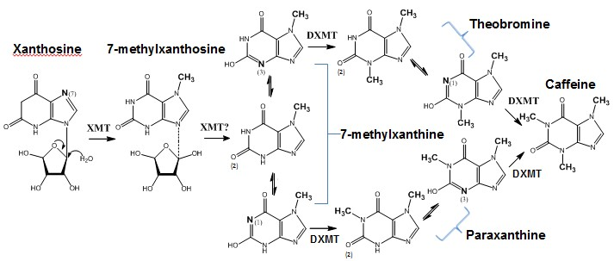

Figure 1.1 Caffeine biosynthesis pathway in Coffea canephora ‘robusta’
The conversion of xanthosine to caffeine involves three N-methylation steps and the removal of ribose moiety. The major pathway is through an intermediate product, theobromine. However, the pathway through the intermediate paraxanthine is also possible. The nitrogen undergoing methylation and transferred methyl groups are highlighted in bold. Note 7-methylxanthine, theobromine and paraxanthine may exist as different tautomers. For instance, 7-methylxanthine may exist as one of the three tautomers (1, 2 or 3).

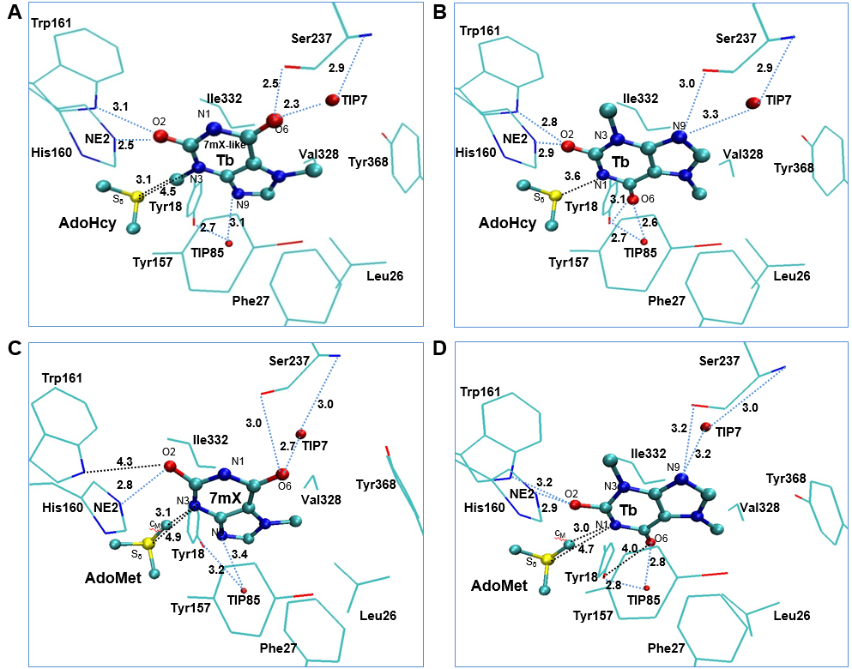

Figure 1.2 Key structures of DXMT complex
(A) The active site in the X-ray structure of DXMT(PDB ID: 2EFJ) complexed with AdoHcy and 7mX-like Tb. (B) The active site in the X-ray structure of DXMT complexed with AdoHcy and Tb. (C) Structure of the active site of the reactant complex containing AdoMet and 7mX along with some average distances. (D) Structure of the active site of the reactant complex containing AdoMet and Tb along with some average distances. DXMT is shown in sticks, and AdoHcy and Tb are in balls and sticks. Only the three atoms C5’, CG and S_{δ} from AdoHcy and the residues that are close to Tb are shown for clarity. The possible hydrogen bonding between Tb and nearby residuals are shown in blue dotted line. Some distances are given with unit of angstrom.

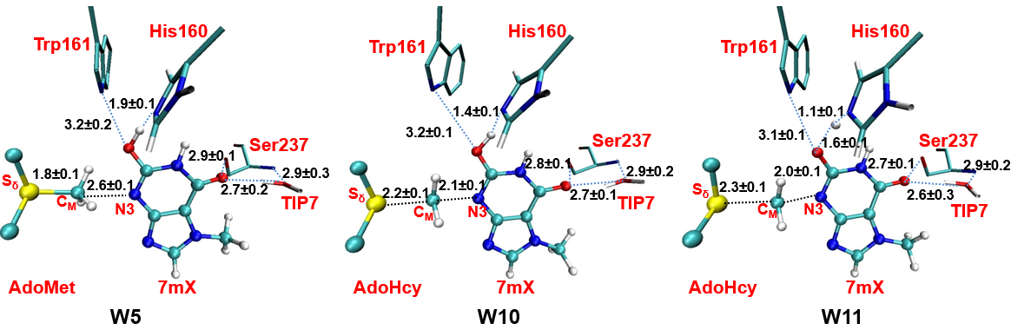

Figure 1.3 The active-site structure during the free energy simulation of N3 methylation
The average structures in window 5(W5, before the transition state, TS), window 10(W10, approaching near TS), window 11(W11, passed near TS) of N3 methylation are shown. The possible hydrogen bonding between 7mX and nearby residues are shown in blue dotted line. Some average distances are given with the unit of angstrom.

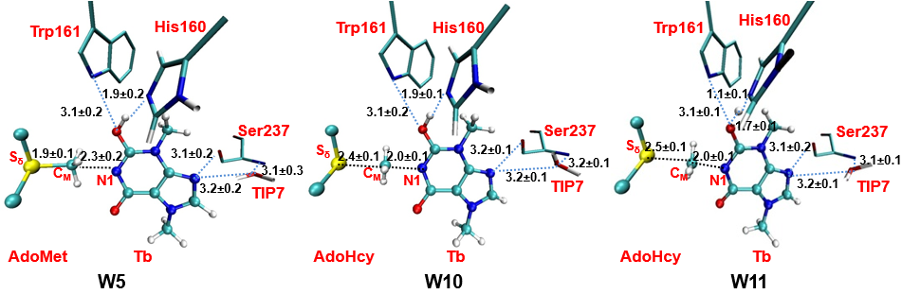

Figure 1.4 The active-site structure during the free energy simulation of N1 methylation
The average structures in window 5(W5, before the transition state (TS)), window 10(W10, approaching near TS), window 11(W11, passed near TS) of N1 methylation are shown. The possible hydrogen bonding between Tb and nearby residues are shown in blue dotted line. Some average distances are given with the unit of angstrom.

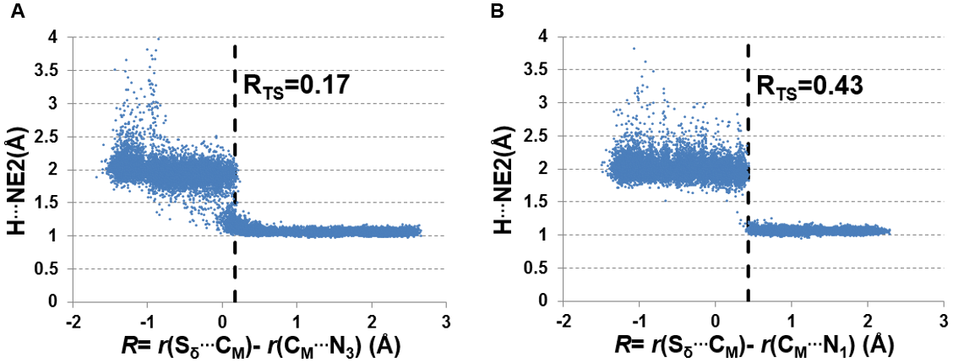

Figure 1.5 The distance between H on the substrate and NE2 on His160 as a function of the reaction coordinate
(A) The methylation of N₃(7mX->Tb); (B) The methylation of N₁(Tb->Cf). Note that O…H is broken and NE2…H is formed when the distance between H and NE2 is about 1.1 Å. The reaction coordinate for transition state is shown as R_{TS} in a dotted line.

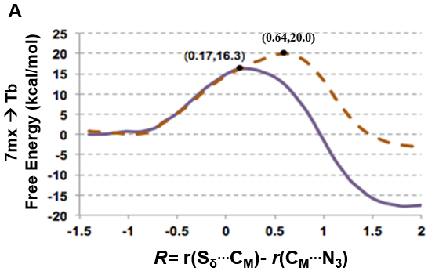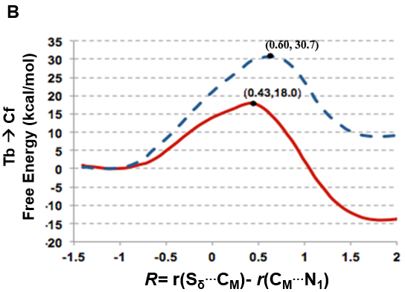
Figure 1.6 Free energy profiles of methyl transfer to N3 and to N1 of the purine ring
The free energy is calculated as the result of potential mean force and respectively plotted against the reaction coordinate R= r(C_{M}···S_{δ}) - r(C_{M}··· N₃) for methylation of N₃, and R = r(C_{M}···S_{δ}) - r(C_{M}··· N₁) for methylation of N₁. The solid line shows the energy profile of simulation without O-H bond fixed; the dotted line shows the energy profile of simulation with O-H fixed. The relative free energy at the transition state for each reaction is shown in bracket.
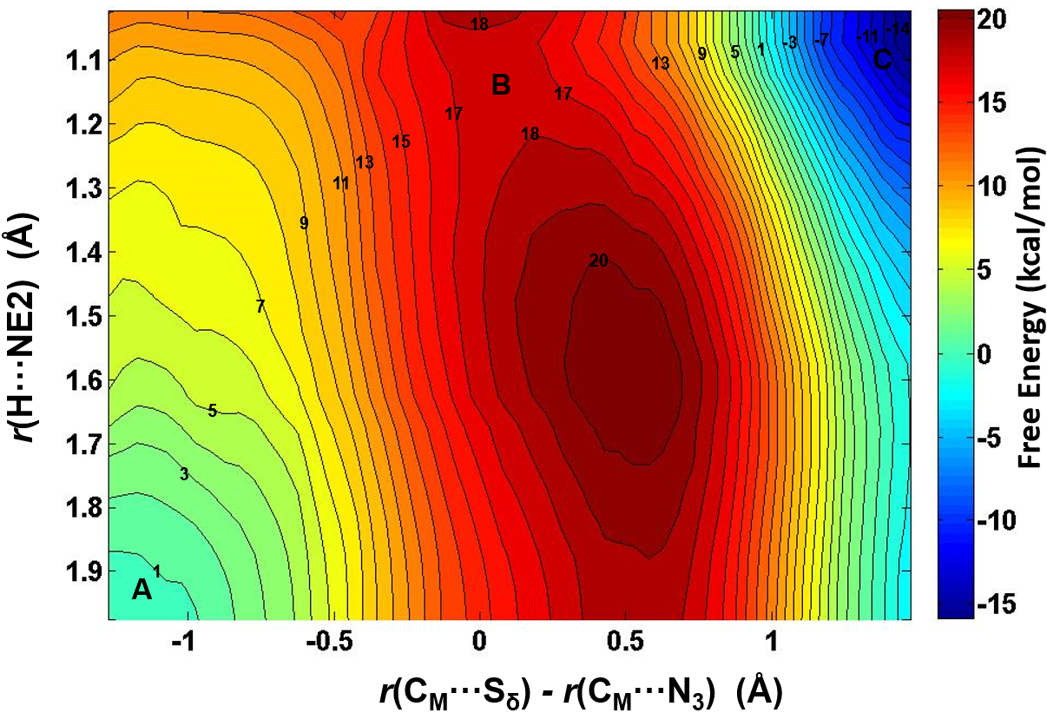

Figure 1.7 2D free energy contour map of N3 methylation on 7mX
The horizontal axis represents the reaction coordinate of methyl transfer and the vertical axis represents the proton transfer. Points A, B, C designate the reactant, transition state, and product complexes, respectively. Some contour lines are shown with respective energy value. The energy bar in shown on the right.

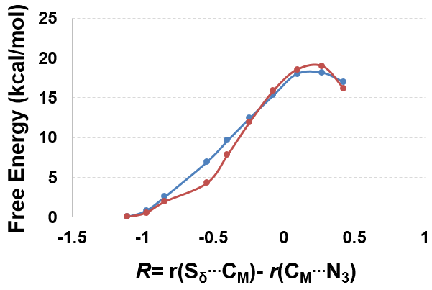

Supplement Figure 1.1 Comparison between SCC-DFTB and high level MP2/6–31G** method
The potential energy curve calculated by the self-consistent charge density functional tight-binding method(SCC-DFTB, in blue) and the single-point energy curve calculated by ab initio MP2/6–31G** method(in red) were applied in a small model.

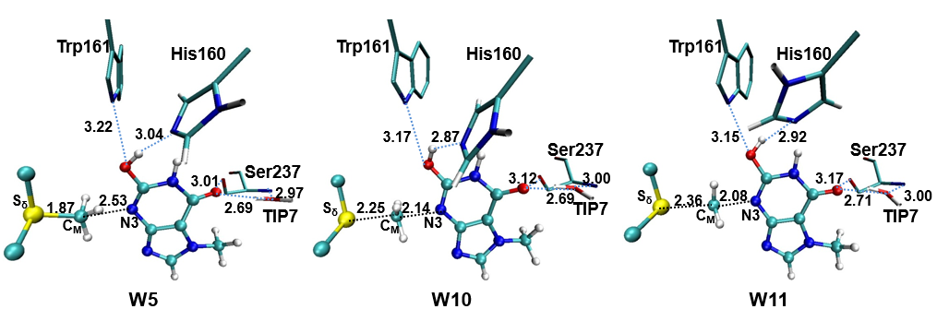
Supplement Figure 1.2 The dynamics of active site during the free energy simulation of N3 methylation with the fixed covalent hydrogen bond
The average structures in window 5(W5, before the transition state, TS), window 10(W10, approaching near TS), window 11(W11, passed near TS) of N3 methylation are shown.

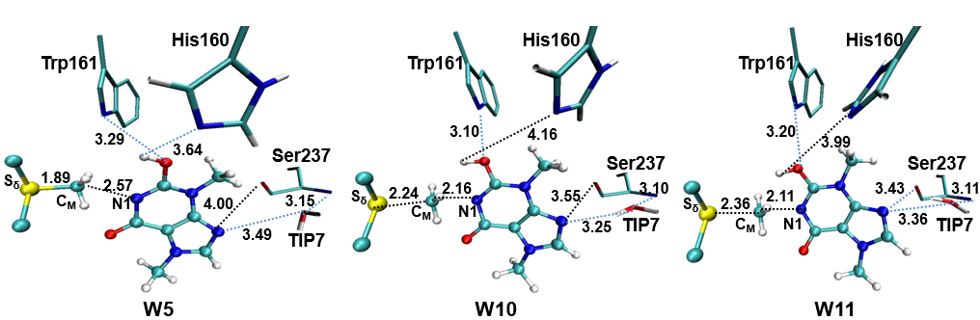

Supplement Figure 1.3 The dynamics of active site during the free energy simulation of N1 methylation with the fixed covalent hydrogen bond
The average structures in window 5(W5, before the transition state(TS)), window 10(W10, approaching near TS), window 11(W11, passed near TS) of N1 methylation are shown.

CHAPTER 2 Computational Study of Symmetric Methylation on Histone Arginine Catalyzed by Protein Arginine Methyltransferase PRMT5 through QM/MM MD and Free Energy Simulations

A version of this chapter was originally published by Yufei Yue, Yuzhu Chu and Hong Guo: Yufei Yue, Yuzhuo Chu, Hong Guo. “Computational Study of Symmetric Methylation on Histone Arginine Catalyzed by Protein Arginine Methyltransferase PRMT5 through QM/MM MD and Free Energy Simulations.” Molecules, 20 (2015): 10032-10046. My contributions to this study include: 1) design of experiments; 2) building models and running simulations; 3) analyzing results and preparing the manuscript. Dr. Yuzhuo Chu contributed with some preliminary results regarding PRMT3. Dr. Hong Guo supervised in the experimental design, participated in discussion and reviewed the manuscript.

Abstract
Protein arginine methyltransferases (PRMTs) catalyze the transfer of the methyl group from S-adenosyl-L-methionine (AdoMet) to arginine residues. There are three types of PRMTs (I, II and III) that produce different methylation products, including asymmetric dimethylarginine (ADMA), symmetric dimethylarginine (SDMA) and monomethylarginine (MMA). Since these different methylations can lead to different biological consequences, understanding the origin of product specificity of PRMTs is of considerable interest. In this article, the quantum mechanical/molecular mechanical (QM/MM) molecular dynamics (MD) and free energy simulations are performed to study SDMA catalyzed by the Type II PRMT5 on the basis of experimental observation that the dimethylated product is generated through a distributive fashion. The simulations have identified some important interactions and proton transfers during the catalysis. Similar to the cases involving Type I PRMTs, a conserved Glu residue (Glu435) in PRMT5 is suggested to function as general base catalyst based on the result of the simulations. Moreover, our results show that PRMT5 has an energetic preference for the first methylation on N_{η1} followed by the second methylation on a different ω-guanidino nitrogen of arginine (N_{η2}).The first and second methyl transfers are estimated to have free energy barriers of 19–20 and 18–19 kcal/mol respectively. The computer simulations suggest a distinctive catalytic mechanism of symmetric dimethylation that seems to be different from asymmetric dimethylation.

Introduction
Posttranslational methylation of histone proteins on their arginine residues is an epigenetic mark that plays a vital role in cell function and is related with cell disorders and diseases.¹ Protein arginine methyltransferases (PRMTs) catalyze the transfer of methyl group(s) from S-adenosyl-l-methionine (AdoMet) to the guanidine nitrogen of arginine residue, resulting in the reaction products containing methylarginine along with S-adenosyl homocysteine (SAH).² In addition to the methylation of histone proteins, PRMTs could also modify a variety of other proteins.³ Depending on types of PRMTs (I, II or III), the methylation products may contain asymmetric dimethylarginine (ADMA), symmetric dimethylarginine (SDMA) or monomethylarginine (MMA) (shown in Figure 2.1)¹.

The Type II PRMT5 to be investigated in this work catalyzes the transfer of methyl groups to the two different ω-guanidino nitrogen atoms on the arginine residue of the target protein, producing the ω-N^{G}, N′^{G} symmetrically dimethylated arginine (SDMA)⁴. PRMT5 has a variety of substrates that include histones, transcription factors, splicesomal proteins and piRNA biogenesis related proteins, and this enzyme functions in both nucleus and cytoplasm³. SDMA may profoundly impact many biological processes including epigenetic control of gene expression⁵, circadian rhythms^{6,7}, splicing regulation ^{8,9}, germ cell development and pluripotency^{10,11}, and DNA damage response^{12,13}. The Type II PRMT5, however, often share the common recognition sequence with the Type I PRMTs which add two methyl groups to the same ω-guanidino nitrogen atom (ADMA).¹⁴ Thus, the same target arginine may be either symmetrically or asymmetrically dimethylated. As such, SDMA and ADMA are isomeric protein posttranslational modifications with distinct and sometimes reversible biological effects.¹⁴ One example is the methylation of arginine 3 on histone H4 (H4R3): symmetric dimethylation of H4R3 could repress gene expression^{15,16}, while asymmetric dimethylation of H4R3 is correlated with gene activation^{17,18}. Recent studies have focused on understanding the enzymatic mechanisms that differentiate the two chemically isomeric but functionally antagonistic posttranslational modifications¹⁴.

The crystal structures have been determined for several PRMTs, including PRMT1¹⁹, PRMT3²⁰, PRMT6 ²¹, PRMT10 ²² of Type I, PRMT5²³ of Type II and PRMT7²⁴ of Type III. Computer simulations have been applied to investigate the catalytic mechanism of PRMT1²⁵ and PRMT3²⁶, and some important questions concerning the product specificity of Type I ADMA have been addressed. The computational approaches used in these earlier studies include molecular dynamics and free energy simulations (potential of mean force) with the hybrid quantum mechanical and molecular mechanical (QM/MM) potential that seem to be suitable to investigate the enzyme-catalyzed methyl transfer process and have also been widely used for some other methyltransferases ^{26–32}.

In this study, the methylation reaction catalyzed by Type II PRMT5 is investigated by use of QM/MM MD and free energy simulations on the basis of experimental observation that the dimethylated product is generated through a distributive fashion. The simulations have identified some important interactions and proton transfers involving the active site residues. Similar to the cases of Type I PRMT1²⁵ and PRMT3 ²⁶, a homologous Glu residue (Glu435) in PRMT5 seems to function as a general base catalyst during the catalysis, and the corresponding proton transfer is found to be somehow concerted with the methyl transfer process. However, unlike Type I PRMTs which energetically favors a single ω-guanidino nitrogen (N_{η2}) of arginine as the target for the both 1st and 2nd methylations ^{25,26}, PRMT5 is found to have an energetic preference of targeting N_{η1} for the first methylation and then targeting a different ω-guanidino nitrogen (N_{η2}) for the second methylation. The first and second methyl transfers are estimated to have free energy barriers of 19–20 and 18–19 kcal/mol, respectively, from the simulations. These results are consistent with the existing experimental data ²³. Our computational study provides a better understanding of the symmetric di-methylation mechanism that is different from the asymmetric di-methylation.

Methods
The simulation coordinates for the reactant complexes of methyl transfers were based on the crystallographic complex (PDB ID: 4GQB, 2.06 Å) of PRMT5²³ that contains AdoMet analog and the H4 peptide with the methylation targeting substrate, Arg3. The coordinates of PRMT3 for comparison is from the crystal structure (PDB ID:1F3L, 2.06 Å) and modified based on the previous work²⁶. The QM/MM MD and free energy (potential of mean force, PMF)) simulations were applied for monitoring the methylation processes and determining the free energy profiles with the CHARMM program ³⁵. A water sphere based on a modified TIP3P water model ³⁶ with radius(r) of 30 Å, centered at CZ of Arg3, was pre-equilibrated to the system. A stochastic boundary with a Poisson-Boltzmann charge-scaling scheme³⁷ was applied for the model. The reservoir region had r > 22 Å, and the buffer region had r equal to 20 Å ≤ r ≤ 22 Å. The reaction region had r ≤ 20 Å. The -CH₂-CH₂-S⁺(Me)-CH₂- part of AdoMet, the side chain of substrate Arg3/monomethylated Arg3, the side chains of E435 and E444 were treated by QM and the rest of the system by MM. The resulting systems contained around 5500 atoms with about 800 water molecules. The all-hydrogen potential function (PARAM27)³⁸ was used for the MM region, the self-consistence charge density functional tight binding (SCC-DFTB) ^{39,40} method was used for the QM region. The link-atom approach ⁴¹ was applied to separate the QM and MM regions.

The initial structures for the entire resulting system were optimized by use of the steepest descent (SD) and adopted-basis Newton-Raphson (ABNR) methods. The systems were gradually heated from 50 to 310.15 K in 50 ps. A 1 fs time step was applied to integrate equation of motion. 1.5 ns QM/MM MD simulations were initially executed for each of the reactant complex. The reaction coordinate was defined as a linear combination of r(C_{M} ... S_{δ}) and r(C_{M} … N_{η1/2}), which is R = r(C_{M} ... S_{δ}) – r(C_{M} … N_{η1/2}). The umbrella sampling method⁴² in the CHARMM program along with the weighted histogram analysis method (WHAM) ⁴³ was used to determine the free energy(PMF) change as a function of the reaction coordinate(s). The Monte Carlo Simulation bootstrapping integrated with WHAM ⁴³ was applied 100 times to estimate the errors (shown in Figure 2 and indicated in the legend of Table 1) of the PMF profile. 20–22 simulation windows were saved for each methyl transfer process. And for each window 50 ps production runs were performed after 50 ps equilibration. The force constants of the harmonic biasing potentials used in the PMF simulations were 50–500 kcal mol⁻¹ Å⁻². During the 50-ps production run of each window, structural coordinates were saved every 50 steps (1 fs/step), and consequently there are 1000 frames saved for each window. The distances shown in Figures 2.4, 2.5, 2.8 and 2.9 are the means of corresponding distances with stand deviation (S.D.) collected from those 1000 frames. The 2D free energy (PMF) map were also determined with umbrella sampling method and two-dimensional-WHAM. The time step for simulations is 1 fs. The horizontal reaction coordinate for the 1st methylation on N_{η1,} R_{x} = r(C_{M} ... S_{δ}) − r(C_{M} … N_{η1}), was used to describe the methyl transfer process. And the vertical reaction coordinate, R_{y} = r(HH₁₂ ... N_{η1}) − r(HH₁₂ … OE₁), was used to describe the proton transfer process. Similarly, for the 2nd methylations, the methyl transfer was explained by R_{x} = r(C_{M} ... S_{δ}) − r(C_{M} … N_{η2}) and the proton transfer by R_{y} = r(HH₂₂ ... N_{η2}) − r(HH₂₂ … OE₁). Approximated 300–400 windows were used in the construction of 2D free energy map, with 50 ps production run following 50 ps equilibration for each window. The force constants for each window were in the range of 100–800 kcal mol⁻¹ Å⁻².

Results and Discussion

Comparison of the Active site Structures of Type II PRMT5 and Type I PRMT3
The two invariant glutamate residues from the “double-E” loop found in all PRMTs ³³ are structurally conserved in both Type I PRMT3 and Type II PRMT5 active sites (E435 and E444 in Figure 2.2A; E144 and E153 in Figure 2.2B). As shown in Figure 2.2, the carboxylate side chain of E444 in PRMT5 (E153 in PRMT3) forms a stable salt bridge with the N_{ε} and N_{η1} atoms of the substrate arginine. The side chain of E435 in PRMT5 (E144 PRMT3) interacts with N_{η1} and N_{η2} of the substrate. These two Glu residues are required for the enzymatic activities; the mutation of either of them could greatly decrease the enzymatic activity ¹⁴.

Previous computational studies have identified E144 as the general base to accept proton from the arginine during the methyl transfer catalyzed by Type I PRMTs ^{25,26}. One interesting questions is whether the corresponding E435 from PRMT5 would play a similar role during the catalysis. Four other residues that are conserved in the active site of PRMT5 are F327, K333, S578 and S439; the corresponding residues in PRMT3 are M48, R54, Y148 and H293, respectively. Although the mutation of S439 and S578 of PRMT5 diminishes the enzymatic activity significantly ¹⁴, the exact role of these residues is not clear; both S439 and S578 seem to be far away from the methyl donating AdoMet (Figure 2.2A). Interestingly, the F327M mutant of PRMT5 could produce both ADMA and SDMA ¹⁴, indicating that F327 may occupy a key position in PRMT5 and its properties may be important in determining the product specificity. Moreover, K333 is in the vicinity of F327 and could form hydrogen bonds with both the carboxylate group of AdoMet and E435.

The previous computational studies have shown that for PRMT1 and PRMT3 the 1st and 2nd methyl transfers would be energetically more favorable with relatively lower barriers if N_{η2} (see Figure 2.2B) is the methyl acceptor in each of the cases ^{25,26}. This is consistent with the fact that they are both Type I PRMTs and the methylation products contain asymmetric dimethylarginine (ADMA). In the active site of the PRMT5 structure (Figure 2.2A), N_{η1} appears to be in a much better position for acting as the methyl acceptor compared to N_{η2}; this is in contrast with the case of PRMT3 where N_{η2} seems to be in a better position for accepting the methyl group ²⁶. Indeed, the distance between N_{η1} and C_{M} is 3.2 Å in the active site of PRMT5 as compared to 4.9 Å between N_{η2} and C_{M}.

The First Methylation Catalyzed by PRMT5
The acceptor site for the first methylation process catalyzed by PRMT5 is studied by comparing the energetics of the methyl addition to N_{η1} and N_{η2}, respectively, on the arginine via QM/MM MD and free energy simulations. As shown in Figure 2.3 (b), the free energy barrier for the methyl transfer to N_{η1} is 20.4 kcal/mol, which is 9 kcal/mol lower than that for the methyl transfer to N_{η2}. This suggests that the 1st methyl group is likely to be transferred to the N_{η1} atom, as the corresponding process is energetically more favorable. This is in contrast with the 1st methylation catalyzed by PRMT3 which favors N_{η2} as the methyl acceptor ²⁶.

The average active-site structures of the reactant complex and near transition state for the 1st methyl transfer are shown in Figures 2.4 and 2.5 for the methyl transfer to N_{η1} and N_{η2}, respectively. The interactions obtained from the simulations for the reactant complex generally resemble the interactions observed in the crystal structure. This seems to indicate that the conformation of the active site in the crystal structure is well maintained after initial 1.5 ns MD simulations. In the reactant complex for the methyl transfer to N_{η1} (Figure 2.4A), N_{η1} is well aligned with the methyl group of AdoMet, and this good alignment presumably leads to a relatively low barrier for the methyl transfer. The arginine on the substrate appears to be well stabilized through the salt bridge with E444 as well as hydrogen bonding interaction with E435. K333 may also help to adjust the orientation of E435 through a hydrogen bonding interaction. F327 seems to be involved in the π-cation interaction with the arginine in the reactant state. Moreover, as mentioned earlier the bulk size of this residue may prevent the formation of a good alignment between the transferable methyl group and N_{η2} and interfere with the methyl transfer to N_{η2}. Indeed, the structures in Figures 2.2A shows that the distance between the transferable methyl group (C_{M}) and N_{η2} can be as much as 4.9 Å in the reactant complex. By contrast, the corresponding distance in PRMT3, which has M48 at the location rather than a Phe residue, is much smaller (e.g., 3.9 Å in Figure 2.2B). It is of interest to note from Figure 4B that the distance between F327 and the arginine increases significantly near the transition state during the methyl transfer to N_{η2}.

The 1D free energy simulations only used the reaction coordinate for the methyl transfer. Nevertheless, the proton transfer occurred near the transition state of methylation (Figures 2.4B and 2.5B). To better understand the relationship between the methyl transfer and the proton transfer process, the 2D free energy simulations were performed (Figure 2.6). As is shown in Figure 2.6, the reaction path goes from point A (designated as the reactant complex) to point B (the transition state), and finally reaches point D as the product complex. Before reaching the transition state at point B, the proton has been basically transferred from N_{η1} of the substrate arginine to the carboxyl oxygen of E435. And the free energy barrier is estimated to be 19–20 kcal/mol from the 2D free energy simulations, which is almost the same as that obtained from the 1D free energy simulations (20.4 kcal/mol). Moreover, point D in Figure 2.6 is about 6 kcal/mol lower than point C, suggesting that the deprotonated product is more stable in the active site than the protonated product and that the proton transfer is coupled with the methyl transfer during methylation.

The Second Methylation Catalyzed by PRMT5
With the first methyl group being transferred already, the 2nd methylation reaction can now be examined to determine the mechanism for the formation of the symmetrically dimethylated product. Previous experimental study on Caenorhabditis elegans PRMT5 (cPRMT5) has shown that the dimethylated product is generated through a distributive fashion ⁴ in which the peptide is released prior to rebinding to facilitate a second round of methylation. The distributive mechanism was further confirmed from the study of the human hPRMT5•MEP50 complex ³⁴. This is in contrast with the cases of some protein lysine methyltransferases for which the multiple rounds of methylation are believed to proceed processively without the release of the intermediates from the active sites. The kinetic data (K_{m} and k_{cat}) for cPRMT5, hPRMT5 and hPRMT5•MEP50 complex have also been obtained for a variety of un-methylated and mono-methylated substrates. For the hPRMT5•MEP50 complex for which the current investigation is based on, the differences in K_{m} and k_{cat} for the first and second methyl transfers are rather small and are beyond the accuracy of most of quantum mechanical approaches used in QM/MM studies. Although several experimental structures for PRMTs are available, the structure for the reactant complex of the second methyl transfer has not been determined. In our earlier investigations of protein lysine methyltransferases^{27–30}, we developed an approach based on the free energy simulations of the methyl transfer processes that allows us to determine whether or not the enzymes would be able to add methyl groups. This approach has been successfully applied to study the product specificity for a number of protein lysine methyltransferases, and its usefulness has also been confirmed on some other methyltransferases2^{6,31,32}, including PRMT1 ²⁶. This approach is especially suitable for the current investigation because the K_{m} values for the first and second methyl transfers are rather similar (see above), and the hypothetical non-existent methyl transfers can be presumably eliminated using this approach in the similar manner as the product specificity is determined ^{26–30}. In Figure 2.7, the three different configurations for the mono-methyl arginine without destroying the salt bridge with E444 are given. The nitrogen atom already connecting to the methyl group is designated as N_{η1} and that without the methyl group (i.e., NH₂) designated as N_{η2}. As is demonstrated in Figure 2.7, for each configuration there are two possible di-methylation products (SDMA and ADMA). The QM/MM free energy simulations have been performed for each of the six methylation processes. Figure 2.7(I) shows that the free energy barriers were calculated to be 32.3 and 36 kcal/mol for the 2nd methyl transfer to the N_{η1} and N_{η2} atoms, respectively. Since either of these energy barriers seems to be too high, the 2nd methylation may not start from the configuration in Figure 2.7(I). The similar argument can be made for the configuration in Table Figure 2.7(III).

Figure 2.7(II) shows that the second methyl transfer has the lowest free energy barrier (20.1 kcal/mol) if it is transferred to N_{η2} (i.e., the SDMA product), while the free energy barrier for the second methyl transfer to N_{η1} (i.e., the ADMA product) based on the configuration in Figure 2.7(II) is 11.2 kcal/mol higher.

The average structures of the reactant complex and near transition state for the 2nd methyl transfer to N_{η2} and N_{η1} are exhibited in Figures 2.8 and 2.9, respectively. The active-site structures of the reactant complex (Figure 2.8A) show that the N_{η2} atom is well aligned with the methyl group of AdoMet. The relatively high barrier for the 2nd methyl transfer to N_{η1} appears due in part to the steric hindrance of F327 (as in the case of the 1st methyl transfer), although other factors may be involved as well. One interesting observation for the second methyl transfer is that the proton has not been transferred to the general base E435 at the transition state (see Figures 2.8B and 2.9B). This is in contrast with the case of the first methyl transfer (shown in Figures 2.4B and 2.5B) where the proton transfer occurs before the methylation reaches the transition state. This observation is also reflected in the 2D free energy map involving both the 2nd methyl transfer and the proton transfer (Figure 2.10). As is shown in the reaction path illustrated in Figure 2.10, the reaction reaches the transition state at point B without the deprotonation of the monomethylarginine.

Another interesting observation from Figures 2.8B and 2.9B is that E435 forms a salt bridge to both N_{η1} and N_{η2} near the transition state. This salt bridge may be relatively strong compared to that in the reactant complex and help to stabilize the transition state; it may also play a role for the delayed proton transfer mentioned earlier. The free energy barrier is estimated to be 18–19 kcal/mol by the 2D free energy simulation (Figure 2.10), consistent with 20.1 kcal/mol from the 1D free energy simulations (Figure 2.7).

Conclusion
In this study, the Type II PRMT5 was investigated by the QM/MM MD and free energy simulations. E435 was found to function as a general base catalyst for accepting a proton from the substrate arginine during the 1st and the 2nd methylation. This residue seems to play a similar role as E144 in Type I PRMT3. The simulations provide the detailed mechanism for the symmetric di-methylation by the enzyme and suggest the possible role for some other key residues as well during the catalysis. The k_{cat} for the arginine methylation catalyzed by PRMT5 is measured to be between 10 to 50 h⁻¹, indicating that the activation energy barrier is about 18 kcal/mol based on transition state theory ²³. Thus, our estimates of the free energy barriers for the methyl transfers (19–20 and 18–19 kcal/mol for the first and the second methylation, respectively) are reasonable compared with the experimental observations. Furthermore, the simulations suggest that the symmetric di-methylation by PRMT5 seems to be energetically favorable, in agreement with the fact that PRMT5 is Type II PRMT. The proposed mechanism here based on the simulation results is different from the asymmetric dimethylation ^{25,26}.

Acknowledgement
We thank Martin Karplus for a gift of the CHARMM program. This work was supported by the National Science Foundation (Grant 0817940 to H.G.). We are also grateful for the computer resources (Newton) from University of Tennessee, Knoxville and from the Extreme Science and Engineering Discovery Environment (XSEDE), which is supported by National Science Foundation grant number ACI-1053575.

References
- Bedford, M.T.; Clarke, S.G. Protein arginine methylation in mammals: Who, what, and why. Mol. Cell 2009, 33, 1–13.
- Di Lorenzo, A.; Bedford, M.T. Histone arginine methylation. FEBS Lett. 2011, 585, 2024–2031.
- Biggar, K.K.; Li, S.S. Non-histone protein methylation as a regulator of cellular signalling and function. Nat. Rev. Mol. Cell Biol. 2015, 16, 5–17.
- Wang, M.; Xu, R.M.; Thompson, P.R. Substrate specificity, processivity, and kinetic mechanism of protein arginine methyltransferase 5. Biochemistry 2013, 52, 5430–5440.
- Wysocka, J.; Allis, C.D.; Coonrod, S. Histone arginine methylation and its dynamic regulation. Front. Biosci. 2006, 11, 344–355.
- Sanchez, S.E.; Petrillo, E.; Beckwith, E.J.; Zhang, X.; Rugnone, M.L.; Hernando, C.E.; Cuevas, J.C.; Godoy Herz, M.A.; Depetris-Chauvin, A.; Simpson, C.G.; et al. A methyl transferase links the circadian clock to the regulation of alternative splicing. Nature 2010, 468, 112–116.
- Hong, S.; Song, H.R.; Lutz, K.; Kerstetter, R.A.; Michael, T.P.; McClung, C.R. Type II protein arginine methyltransferase 5 (prmt5) is required for circadian period determination in arabidopsis thaliana. Proc. Natl. Acad. Sci. USA 2010, 107, 21211–21216.
- Meister, G.; Eggert, C.; Buhler, D.; Brahms, H.; Kambach, C.; Fischer, U. Methylation of sm proteins by a complex containing prmt5 and the putative u snrnp assembly factor picln. Curr. Biol. 2001, 11, 1990–1994.
- Deng, X.; Gu, L.; Liu, C.; Lu, T.; Lu, F.; Lu, Z.; Cui, P.; Pei, Y.; Wang, B.; Hu, S.; et al. Arginine methylation mediated by the arabidopsis homolog of prmt5 is essential for proper pre-mrna splicing. Proc. Natl. Acad. Sci. USA 2010, 107, 19114–19119.
- Nishida, K.M.; Okada, T.N.; Kawamura, T.; Mituyama, T.; Kawamura, Y.; Inagaki, S.; Huang, H.; Chen, D.; Kodama, T.; Siomi, H.; et al. Functional involvement of tudor and dprmt5 in the pirna processing pathway in drosophila germlines. EMBO J. 2009, 28, 3820–3831.
- Gonsalvez, G.B.; Rajendra, T.K.; Tian, L.; Matera, A.G. The sm-protein methyltransferase, dart5, is essential for germ-cell specification and maintenance. Curr. Biol. 2006, 16, 1077–1089.
- Jansson, M.; Durant, S.T.; Cho, E.C.; Sheahan, S.; Edelmann, M.; Kessler, B.; la Thangue, N.B. Arginine methylation regulates the p53 response. Nat. Cell Biol. 2008, 10, 1431–1439.
- Yang, M.; Sun, J.; Sun, X.; Shen, Q.; Gao, Z.; Yang, C. Caenorhabditis elegans protein arginine methyltransferase prmt-5 negatively regulates DNA damage-induced apoptosis. PLoS Genet 2009, 5, e1000514.
- Sun, L.; Wang, M.; Lv, Z.; Yang, N.; Liu, Y.; Bao, S.; Gong, W.; Xu, R.M. Structural insights into protein arginine symmetric dimethylation by prmt5. Proc. Natl. Acad. Sci. USA 2011, 108, 20538–20543.
- Wang, X.; Zhang, Y.; Ma, Q.; Zhang, Z.; Xue, Y.; Bao, S.; Chong, K. Skb1-mediated symmetric dimethylation of histone h4r3 controls flowering time in arabidopsis. EMBO J. 2007, 26, 1934–1941.
- Zhao, Q.; Rank, G.; Tan, Y.T.; Li, H.; Moritz, R.L.; Simpson, R.J.; Cerruti, L.; Curtis, D.J.; Patel, D.J.; Allis, C.D.; et al. Prmt5-mediated methylation of histone h4r3 recruits dnmt3a, coupling histone and DNA methylation in gene silencing. Nat. Struct. Mol. Biol. 2009, 16, 304–311.
- Wang, H.; Huang, Z.Q.; Xia, L.; Feng, Q.; Erdjument-Bromage, H.; Strahl, B.D.; Briggs, S.D.; Allis, C.D.; Wong, J.; Tempst, P.; et al. Methylation of histone h4 at arginine 3 facilitating transcriptional activation by nuclear hormone receptor. Science 2001, 293, 853–857.
- Strahl, B.D.; Briggs, S.D.; Brame, C.J.; Caldwell, J.A.; Koh, S.S.; Ma, H.; Cook, R.G.; Shabanowitz, J.; Hunt, D.F.; Stallcup, M.R.; et al. Methylation of histone h4 at arginine 3 occurs in vivo and is mediated by the nuclear receptor coactivator prmt1. Curr. Biol. 2001, 11, 996–1000.
- Zhang, X.; Cheng, X. Structure of the predominant protein arginine methyltransferase prmt1 and analysis of its binding to substrate peptides. Structure 2003, 11, 509–520.
- Siarheyeva, A.; Senisterra, G.; Allali-Hassani, A.; Dong, A.; Dobrovetsky, E.; Wasney, G.A.; Chau, I.; Marcellus, R.; Hajian, T.; Liu, F.; et al. An allosteric inhibitor of protein arginine methyltransferase 3. Structure 2012, 20, 1425–1435.
- Wang, C.; Zhu, Y.; Chen, J.; Li, X.; Peng, J.; Chen, J.; Zou, Y.; Zhang, Z.; Jin, H.; Yang, P.; et al. Crystal structure of arginine methyltransferase 6 from trypanosoma brucei. PLoS ONE 2014, 9, e87267.
- Cheng, Y.; Frazier, M.; Lu, F.; Cao, X.; Redinbo, M.R. Crystal structure of the plant epigenetic protein arginine methyltransferase 10. J. Mol. Biol. 2011, 414, 106–122.
- Antonysamy, S.; Bonday, Z.; Campbell, R.M.; Doyle, B.; Druzina, Z.; Gheyi, T.; Han, B.; Jungheim, L.N.; Qian, Y.; Rauch, C.; et al. Crystal structure of the human prmt5:Mep50 complex. Proc. Natl. Acad. Sci. USA 2012, 109, 17960–17965.
- Wang, C.; Zhu, Y.; Caceres, T.B.; Liu, L.; Peng, J.; Wang, J.; Chen, J.; Chen, X.; Zhang, Z.; Zuo, X.; et al. Structural determinants for the strict monomethylation activity by trypanosoma brucei protein arginine methyltransferase 7. Structure 2014, 22, 756–768.
- Zhang, R.; Li, X.; Liang, Z.; Zhu, K.; Lu, J.; Kong, X.; Ouyang, S.; Li, L.; Zheng, Y.G.; Luo, C. Theoretical insights into catalytic mechanism of protein arginine methyltransferase 1. PLoS ONE 2013, 8, e72424.
- Chu, Y.; Li, G.; Guo, H. QM/MM md and free energy simulations of the methylation reactions catalyzed by protein arginine methyltransferase prmt3. Can. J. Chem. 2013, 91, 605–612.
- Guo, H.B.; Guo, H. Mechanism of histone methylation catalyzed by protein lysine methyltransferase set7/9 and origin of product specificity. Proc. Natl. Acad. Sci. U.S.A. 2007, 104, 8797–8802.
- Xu, Q.; Chu, Y.Z.; Guo, H.B.; Smith, J.C.; Guo, H. Energy triplets for writing epigenetic marks: Insights from qm/mm free-energy simulations of protein lysine methyltransferases. Chemistry 2009, 15, 12596–12599.
- Chu, Y.; Yao, J.; Guo, H. QM/MM md and free energy simulations of g9a-like protein (glp) and its mutants: Understanding the factors that determine the product specificity. PLoS ONE 2012, 7, e37674.
- Chu, Y.; Xu, Q.; Guo, H. Understanding energetic origins of product specificity of set8 from qm/mm free energy simulations: What causes the stop of methyl addition during histone lysine methylation? J. Chem. Theory Comput. 2010, 6, 1380–1389.
- Yao, J.; Xu, Q.; Chen, F.; Guo, H. Qm/mm free energy simulations of salicylic acid methyltransferase: Effects of stabilization of ts-like structures on substrate specificity. J. Phys. Chem. B 2010, 115, 389–396.
- Yue, Y.; Guo, H. Quantum mechanical/molecular mechanical study of catalytic mechanism and role of key residues in methylation reactions catalyzed by dimethylxanthine methyltransferase in caffeine biosynthesis. J. Chem. Inf. Model. 2014, 54, 593–600.
- Cheng, X.D.; Collins, R.E.; Zhang, X. Structural and sequence motifs of protein (histone) methylation enzymes. Annu. Rev. Biophys. Biomol. Struct. 2005, 34, 267–294.
- Wang, M.; Fuhrmann, J.; Thompson, P.R. Protein arginine methyltransferase 5 catalyzes substrate dimethylation in a distributive fashion. Biochemistry 2014, 53, 7884–7892.
- Brooks, B.R.; Bruccoleri, R.E.; Olafson, B.D.; States, D.J.; Swaminathan, S.; Karplus, M. CHARMM: A program for macro-molecular energy, minimization, and dynamics calculations. J. Comput. Chem. 1983, 4, 187–217.
- Jorgensen, W.; Chandrasekhar, J.; Madura, J.; Impey, R.; Klein, M. Comparison of simple potential functions for simulating liquid water. J. Chem. Phys. 1983, 79, 926–935.
- Brooks, C.L.; Brunger, A.; Karplus, M. Active site dynamics in protein molecules: A stochastic boundary molecular-dynamics approach. Biopolymers 1985, 24, 843–865.
- MacKerell, A.D.; Bashford, D.; Bellott, M.; Dunbrack, R.L.; Evanseck, J.D.; Field,M.J.; Fischer, S.; Gao, J.; Guo, H.; Ha, S.; et al. All-atom empirical potential for molecular modeling and dynamics studies of proteins. J. Phys. Chem. B 1998, 102, 3586–3616.
- Elstner, M.; Porezag, D.; Jungnickel, G.; Elsner, J.; Haugk, M.; Frauenheim, T.; Suhai, S.; Seifert, G. Self-consistent-charge density functional tight-binding method for simulations of complex materials properties. Phys. Rev. B 1998, 58, 7260–7268.
- Cui, Q.; Elstner, M.; Kaxiras, E.; Frauenheim, T.; Karplus, M. A QM/MM Implementation of the Self-Consistent Charge Density Functional Tight Binding (SCC-DFTB) Method. J. Phys. Chem. B 2001, 105, 569–585.
- Field, M.J.; Bash, P.A.; Karplus, M. A combined quantum mechanical and molecular mechanical potential for molecular dynamics simulations. J. Comput. Chem. 1990, 11, 700–733.
- Torrie, G.M.; Valleau, J.P. Monte-Carlo free energy estimates using non-Boltzmann sampling. Application to the subcritical Lennard Jones fluid. Chem. Phys. Lett. 1974, 28, 578–581.
- Kumar, S.; Bouzida, D.; Swendsen, R.H.; Kollman, P.A.; Rosenberg, J.M. The weighted histogram analysis method for free energy calculations on biomolecules. I. The method. J. Comput. Chem. 1992, 13, 1011–1021.

Appendix

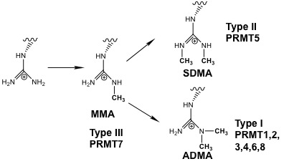

Figure 2.1 Methylation of arginine by different types of PRMTs
Type I PRMT can produce both monomethylarginine (MMA) and asymmetric dimethylarginine (ADMA). Type II PRMT can produce both MMA and symmetric dimethylarginine (SDMA). Type III PRMT can only produce MMA.

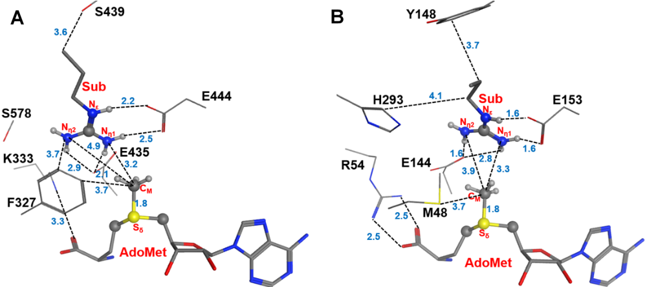
Figure 2.2 Comparison of the active sites of the crystal structures for Type-II PRMT5 and Type-I PRMT3
(A) The active site of PRMT5 (PDB ID: 4QGB); (B).The active site of PRMT3(PDB ID:1F3L). The two glutamate residues, E435 (E144) and E444 (E153) in PRMT5 (PRMT3), are conserved in the both types of PRMTs. F327, K333, S578 and S439 in PRMT5 are the conserved residues among Type-II PRMTs. The corresponding residues in Type-I PRMT3 are M48, R54, H293 and Y148, respectively. The substrate arginine is labeled as Sub. Some distances are shown in blue with the unit of angstrom.

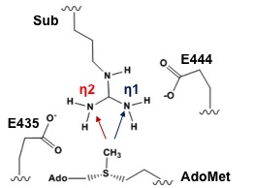
(a)

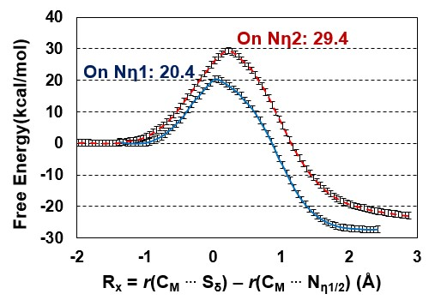
Figure 2.3 Two possible pathways for the 1st methylation
(a) Two possible sites for the 1st methylation. The substrate arginine is labeled as Sub. (b) Free energy profiles of the 1st methylation on N_{η1} and N_{η2}. To N_{η1}: blue line with a free energy barrier of 20.4 kcal/mol; to N_{η2}: red dotted line with a free energy barrier of 29.4 kcal/mol. Error bars are shown on the free energy profile (within ± 0.12 kcal/mol).

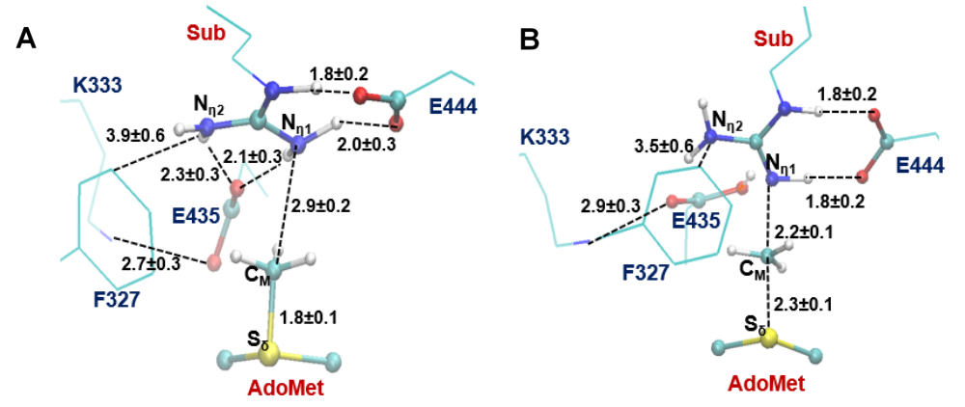
Figure 2.4 The average active-site structures obtained for the 1st methylation on N_{η1}
(A) Reactant complex. (B) Near the transition state. Some average distances in active sites are shown in angstrom. Note that E435 works as the proton acceptor based on the simulations.

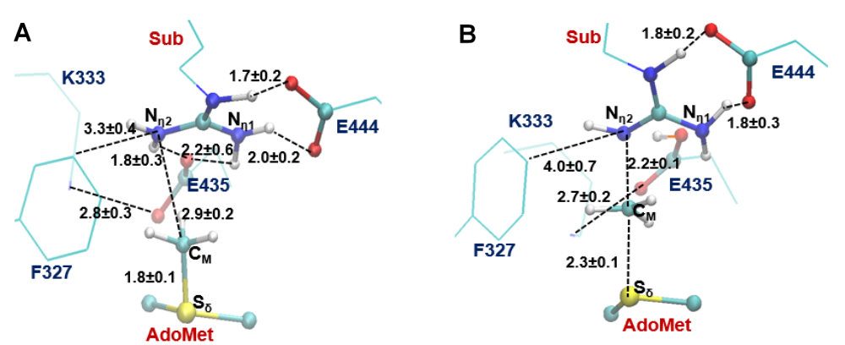
Figure 2.5 The average active-site structure obtained for the 1st methylation on N_{η2}
- Reactant complex. (B) Near the transition state.

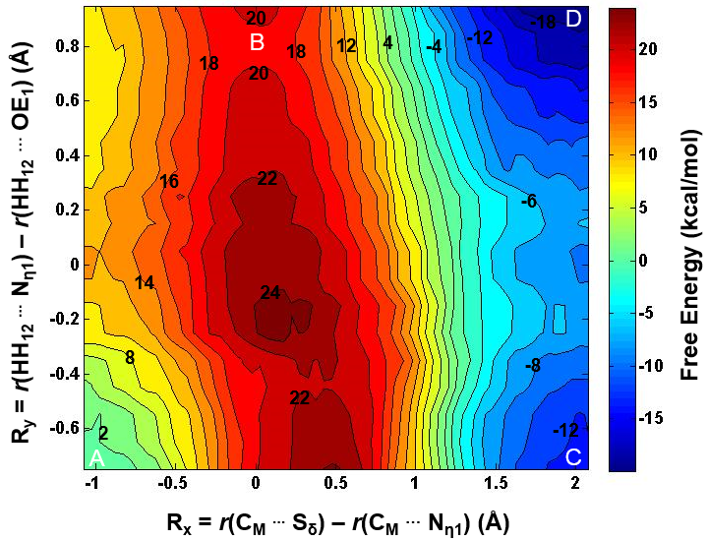
Figure 2.6 2D free-energy contour map for the 1st methylation on N_{η1}
R_{x}: the reaction coordinate of the methyl transfer; R_{y}: the reaction coordinate for the proton transfer. Points A, B, and D designate the reactant, near transition state, and product complexes, respectively. Some contour lines are shown with respective energy values. The energy barrier is estimated to be around 19–20 kcal/mol.

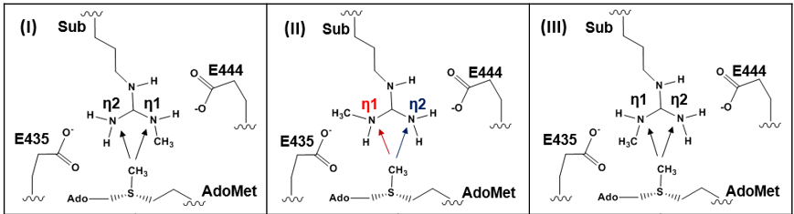
To N_{η1} | To N_{η2} | To N_{η1} | To N_{η2} | To N_{η1} | To N_{η2}
32.3 kcal/mol | 36 kcal/mol | 31.3 kcal/mol | 20.1 kcal/mol | 43.9 kcal/mol | 32.5 kcal/mol

Figure 2.7 Free energy barriers for the 2nd methylation
The 2nd methylation can be on either the mono-methylated nitrogen atom (designated as N_{η1}) or un-methylated nitrogen atom (designated as N_{η2}) of the mono-methylated arginine (MMA) with three possible configurations for the reactant complex without destroying the salt bridge involving E444. The only difference between Configurations II and III is whether the methyl group is pointing to the AdoMet side (III) or away from the AdoMet side (II). The conformation in (II) has the lowest energy barrier of 20.1 kcal/mol when the 2nd methylation occurs to N_{η2} which will eventually produce the symmetrically dimethylated arginine (SDMA). Error bars are also determined, similar to those given in Figure 2 (within ± 0.2 kcal/mol).

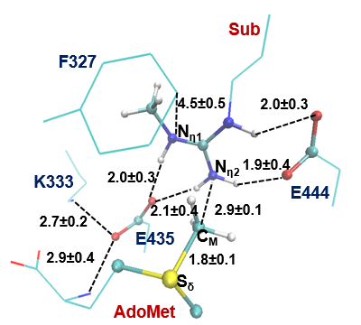
(A)

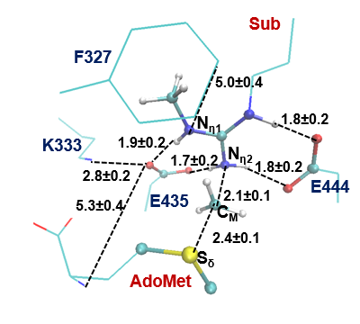
(B)

Figure 2.8 Results from the simulations for the 2nd methylation on N_{η2}
(A) Active-site structure of the reactant complex; (B) Active-site structure near the transition state.

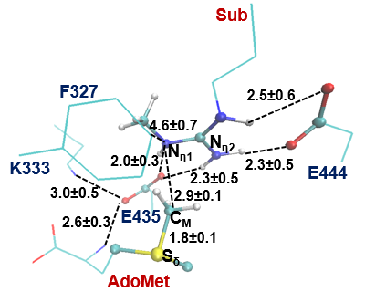
(A)

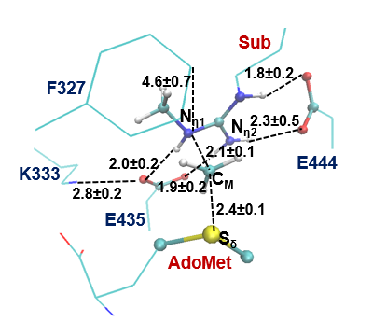
(B)

Figure 2.9 Results from the MD simulations for the 2nd methylation on N_{η1}
(A) Active-site structure of the reactant complex; (B) Active-site structure near the transition state.

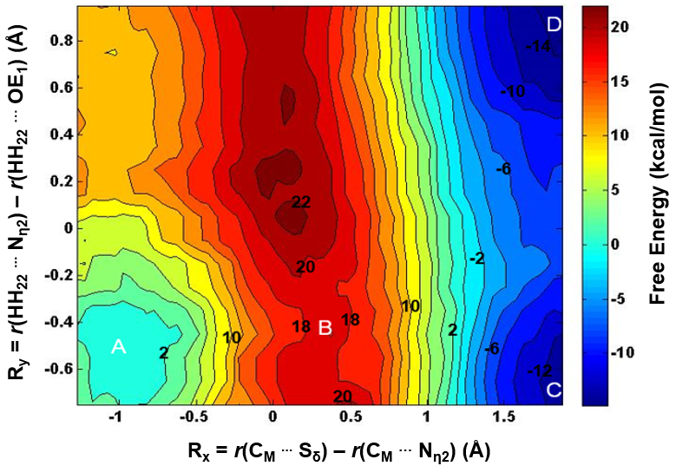
Figure 2.10 2D free-energy contour map for the 2nd methylation on N_{η2}
Points A, B, and D designate the reactant, near transition state, and product complex, respectively. Point C corresponds to the hypothetical product complex with proton not being transferred, which is only 2 kcal/mol higher than Point D in the free-energy contour map. Some contour lines are shown with respective energy value in kcal/mol. The energy bar is shown on the right. The energy barrier is estimated to be around 18–19 kcal/mol.

CHAPTER 3 Computational study of Ubiquitin-like NEDD8 transfer in RING E3-E2~UBL-target Complex

Abstract
Ubiquitin-like (UBL) protein modification of substrate proteins plays a key role in regulating protein function. Unlike ubiquitin (UB) and small ubiquitin-like modifier (SUMO) which are ligated to a massive segment of the proteome, the UBL NEDD8 is highly selective on modifying closely related cullin proteins (CULs) on a single lysine residue and contributes to 10% - 20% of all cellular ubiquitination. In this study, the X-ray structure of a trapped E3-E2 ̴ NEDD8-target intermediate (RBX1-UBC1 ̴NEDD8-CUL1-DCN1) is used to build computer models, and combined quantum mechanics/molecular mechanics (QM/MM) and molecular dynamics (MD) simulations are performed to investigate the catalytic mechanism of the NEDD8 transfer from E2 to the substrate. The role of the active site residues is examined. It is demonstrated that either E117 or D143 from E2 might work as a general base catalyst to deprotonate substrate K720. During the nucleophilic attack from substrate K720 to the thioester bond linking E2 and NEDD8, the formation of new isopeptide bond between K720 and NEDD8 and the breaking of thioester bond are concerted. Furthermore, K720 also acts as a general acid catalyst to protonate the leaving group of C111 from E2. The free energy barrier for nucleophilic attack is estimated to be 14 -15 kcal/mol.

Introduction
Neddylation is the process by which the ubiquitin-like(UBL) protein NEDD8 is ligated to its highly selective substrate cullin proteins(CULs) on a single conserved lysine.¹ NEDD8 ligation to CULs are responsible for about 10% - 20% of all cellular ubiquitination.² It is essential in Eukaryotes^{3,4} and regulates import biological processes such as signal transduction⁵, cell division^{6,7} and development⁸.

Neddylation involves a catalytic cascades with E1, E2 (UBC12) and RING E3(RBX1) enzymes. E1 activates NEDD8 and loads it onto the catalytic cysteine from E2, forming a transient thioester-bound E2~NEDD8 intermediate.⁹ RING E3 then recruits and loosely connects the substrate CULs with the E2~NEDD8 intermediate, promoting the transfer of NEDD8 at its C-terminal to the acceptor lysine on CULs.¹ Recently the active configuration regarding NEDD8 ligation to the substrate CUL1 was achieved through crystallization of the RBX1(E3)-UBC12(E2)~NEDD8-CUL1(Substrate)-DCN1(Co-E3) complex(PDB ID:4P5O,see Figure 3.1).¹ Similar to processes of ubiquitin(UB) and UBL ligation to substrate^{10,11} , RBX1 utilizes N-terminal domain(NTD) as substrate-binding domain to anchor in CUL1’s C-terminal domain(CTD), and then binds and activates the UBC12~NEDD8 intermediate¹. Different from other UB and UBL ligation, RBX1 also needs a co-E3, DCN1, which binds CUL1 and UBC12’s NTD, to enhance the ligation.^{12,13} However, RBX1 and its assistant DCN1 are both distal from the active site with a acceptor lysine (K720) on CUL1 where ligation occurs (see Figure 3.1).¹

The obtaining of E3-E2~NEDD8-CUL1-DCN1 crystal structure was achieved by incorporating three mutations, K720R(CUL1), C111S(E2) and N103S(E2).¹ Those mutations were introduced to make the receptor K720 less active and a more stable oxyester bond (as compared to the highly activated thioester bond) between E2 and NEDD8, thus preventing NEDD8 transfer and making crystallization of NEDD8 ligation intermediate possible. K720 is the acceptor lysine from CUL1. C111 is the catalytic cysteine from E2 which forms the thioester bond with the backbone carbonyl carbon of C-terminal G76 from NEDD8. N103 is a highly conserved residue that is believed to play a catalytic role of stabilizing the oxyanion intermediate formed during formation of isopeptide bond between K720 and G76.^{14,15} Although structural and activity analysis through mutagenesis have determined functions of some important residues in the active site during NEDD8 ligation^{1,13, 16}, the dynamic behaviors of the active site residues and their roles in determining the energy barriers on the ligation reaction pathway could be further understood by molecular dynamics(MD) and free energy simulations.

Computational study of ubiquitination process involving E3-E2~UB-SUMO2 has put insights into two key events during the catalysis of ubiquitin transfer from E2 to substrate SUMO2, including deprotonation of substrate lysine and the following nucleophilic attack.¹⁷ According to the study, deprotonation of substrate lysine by basic D117 on E2 occurs first with almost no energy barrier. The activated lysine then approaches the thioester bond via a conformational, and undergoes a nucleophilic attack on the thioester bond between UB and E2 to form an oxyanion intermediate. Finally nucleophilic elimination results in cleavage of the thioester bond and later formation of isopeptide bond between UB and substrate SUMO2. Here we examine the ubiquitin-like neddylation catalysis based on the structure of E3-E2~NEDD8-CUL1-DCN1 complex from the previous investigations¹ by use of quantum mechanical/molecular mechanical (QM/MM) MD and free energy (potential of mean force) simulations. The results show that either D117 or E143 from E2 could be a general base catalyst for the deprotonation of substrate K720. Furthermore, the bond making between Nε of K720 and Cα of G76 on NEDD8, and the breaking of thioester bond seem to be concerted without forming a stable oxyanion intermediate. And K720 could potentially work as a general acid catalyst for the leaving C111 OF E2.

Methods
The initial coordinates for the reactant complex is based on the crystallographic complex (PDB ID: 4P5O)¹ of RBX1-UBC12~NEDD8-CUL1-DCN1 containing five chains: RING E3 ligase RBX1, E2 conjugase UBC12, E2 bound ubiquitin-like NEDD8, ubiquitination substrate protein Cullin-1(CUL1) and the assistant co-E3 DCN-like protein 1(DCN1) as shown in Figure 3.1. The mutation sites R720 from CUL1, S103 and S111 from UBC12 of the crystal structure were reversely mutated to the wild type K720, N103 and C111 in the software MOE by choosing the rational rotamer conformation. Structure preparing including optimizing protonation states of titratable residues and flips of ASN, GLN and HIS were done by MOE as well. Two initial models were built, one has K720 with protonated side chain entering the active site and the other has K720 with deprotonated side chain mimicking the reactant state of nucleophilic attack. The QM/MM MD and free energy (potential of mean force, PMF) simulations were performed to determine the free energy profiles as well as protein geometry with the CHARMM program¹⁸. Water spheres based on a modified TIP3P water model¹⁹ with radius(r) of 30 Å and centered at Cβ were used for solvation. A stochastic boundary with a Poisson−Boltzmann charge-scaling scheme was applied²⁰. The reservoir region has r > 22 Å, and the buffer region has 20 ≤ r ≤ 22 Å. The reaction region has r ≤ 20 Å. The side chain of C111(E2), N103(E2), K720(CUL1), E117(E2), D143(E2), the backbone carbonyl part of G75(NEDD8) and the full G76(NEDD8) were treated by QM and the rest of the system by MM. An all hydrogen potential function (PARAM27)²¹ was used for the MM region, and the self-consistence charge density functional tight binding (SCC-DFTB) method^{22,23,24} was used for the QM region. The link-atom approach was used to separate the QM and MM regions.²⁵

To build the initial structural model to simulate the deprotonation of substrate K720, K720 was chosen with its side chain in protonated state. To simulate the following nucleophilic attach, the model was modified by only neutralizing the lysyl side chain of K720. The resulting systems contain about 5500 atoms with approximately 700 water molecules. The initial structures for the entire stochastic boundary systems were optimized using the steepest descent (SD) and adopted-basis Newton−Raphson (ABNR) methods. The systems were gradually heated from 50.0 to 310.15 K in 50 ps. A 1-fs time step was applied for the integration of equation of motion, and the coordinates were saved every 50 fs. Initially, 5 ns QM/MM MD simulations were executed for each of the reactant complexes.

The reaction coordinate for the deportation process was defined as a linear combination of d_{(Nε…H)} and d_{(O…H)} as RC = d_{(Nε…H)} – d_{(O…H)} where O is the side chain carboxyl oxygen of E117 or G143, H and Nε are from the lysyl side chain of K720. The umbrella sampling method²⁶, implemented in the CHARMM program along with the Weighted Histogram Analysis Method (WHAM)^{27,28} was applied to determine the free energy (PMF) as a function of the reaction coordinate(s) for the proton transfer process. For each proton transfer process, twelve simulation windows were saved, and for each window 50 ps production runs were performed after 50 ps equilibration. The force constants of the harmonic biasing potentials used in the PMF simulations were 400 kcal mol⁻¹ Å⁻². The 2D free energy map (PMF) for the nucleophilic attack was also determined with the umbrella sampling method and two-dimensional WHAM. The time step for QM/MM MD simulation is 1 fs. One reaction coordinate is RC1 = d_{(Cα…S)}, describing the bond breaking between Cα of G76(NEDD8) and Sγ of C111(E2). The other reaction coordinate is RC2 = d_{(Nε … Cα)} which describes the bond making between Cα of G76(NEDD8) and Nε of K720(substrate CUL1). 416 windows were used in the calculation of 2D PMF, and 100 ps production runs were preformed after 50 ps equilibration for each window. The structures from the second 50 ps out of the 100 ps production runs were saved for each window. The force constants for each window were in the range of 100−500 kcal mol⁻¹ Å⁻² for both RC1 and RC2.

Results and Discussion

The E3-E2~NEDD8-CUL1-DCN1 complex after QM/MM MD simulations
The crystal structure of E3-E2~NEDD8-CUL1-DCN1 complex (PDB ID:4P5O) introduced three mutations, K720R (CUL1), N103S (E2) and C111S (E2), for the purpose of suppressing neddylation and obtaining a stable intermediate state that resembles RING E3 tapped in action of mediating NEDD8 ligation.¹ To investigate the molecular mechanism of NEDD8 transfer, reverse mutations of those three residues were employed to the initial configuration of the enzyme-substrate complex to build simulation models.

Models with K720 in deprotonated state and protonated state were built respectively. The pK_{a} of lysine side chain in solution is 10.5 which makes it easy to be positively charged in physiological environment. The protonated state of K720 was further confirmed by MOE when preparing the structure for modeling. During the UB ligation process, it has been demonstrated both experimentally^{11,29} and computationally¹⁷ that an acidic residue, either glutamate or aspartate in the active site, could catalyze the deprotonation of receptor lysine.

After 1 ns QM/MM MD simulations, the model with protonated K720 has two acidic residues that could potentially take the proton from K720. As shown in Figure 3.2, the ε-amino group of K720 is 3.9 angstrom away from the carboxyl group of D143 from E2, and 3.5 angstrom away from the carboxyl group of E117 from E2. The distance between Nε of K720 and the carbonyl C of thioester bond is 4.2 angstrom. However, the ε-amino group of K720 is not pointing to the electrophilic C with a relatively flat angle, indicating it is not in a good near-attack conformation for nucleophilic attack on the thioester bond. Moreover, a key interaction observed in UB ligation were recapped through our simulations on NEDD8 ligation: i.e., the side chain of N103 from E2 has an N-H bond pointing with a distance of 2.2 angstrom to the carbonyl O by the reactive thioester bond, which could establish a hydrogen bonding interaction. The catalytic role of asparagine neighboring the thioester bond that helps to stabilize the oxyanion intermediate during UB ligation was discussed previously.^{14,17,30,31} Y774 is shown in the crystal structure that aligns and directs CUL1’s acceptor K720R.¹ Our simulations show there is a strong pi-cation interaction between the positively charged ε-amino group of K720 and substrate Y774. As shown in Figure 3.2, the distance between Nε of K720 and aromatic side chain of Y774 is only 3.7 angstrom, and the lysyl side chain is parallel to the plane of aromatic side chain. Furthermore, the positively charged side chains of R74 from NEDD8 and R717 from CUL1 are all within 4 angstrom of the negatively charged carboxyl side chain of D143, indicating the position of D143 side chain could be potentially adjusted by those two arginines through salt bridge interaction(s).

After 1 ns QM/MM MD simulations, the model with deprotonated K720 shows the ε-amino group of K720 is approaching near-attack conformation where the distance between Nε of K720 and C of thioester bond is 3.5 angstrom and the lone-pair electrons of Nε points directly to the thioester bond. In the meantime, N103 is still in good position that helps to stabilize the carbonyl O bound to the thioester C through hydrogen bonding. The distance between N103 side chain H and the carbonyl O is 2.2 angstrom. As compared to the simulation results of the model with protonated K720, Y774 is further away from the neutral K720 side chain (5.2 angstrom vs 3.7 angstrom), possibly because the pi-cation interaction no longer exists with a neutral ε-amino group. Furthermore, it also seems that the carboxyl side chain of D143 is moving away from K720 lysyl side chain and forms a stable salt bridge with R717 on the far side of active site. However, E117 might still maintain a weak hydrogen bonding with the neutral ε-amino group with a distance of 3.4 angstrom.

Deprotonation of K720 could be catalyzed by either D143 or E1117
As discussed before, there are two acidic residues, D143 and E117 in the active site that might potentially deprotonate K720 and suppress its pK_{a}. Interestingly the D143A mutation could not substantially affect neddylation involving UBC12 as E2¹, although the corresponding ASP is essential for SUMO ligation through UBC9 (E2)³⁰ and UB ligation through UBCH5(E2)¹¹. It’s also worth noting that when ASP does not exist on Ube2S (E2), a GLU from UB might instead play the catalytic role of ASP for deprotonation, and also help posit receptor lysine in good position and orientation for UB ligation.³² So the question is whether D143 or E117 might deprotonate K720.

QM/MM MD simulations show that the D143 and K720 might form a stable salt bridge interaction during the initial substrate binding as shown in Figure 3.4A and 3.4C. The distance between carboxyl side chain of D143 and Nε of K720 is maintained at around 3-4 angstrom, and that between E117 and K720 is around 6-8 angstrom. After 0.8 ns simulations (shown in Figure 3.4B, C), those two distances seem to converge at around 3-4 angstrom. As such we would propose that D143 might induce the initial binding of receptor K720 to the active site while E117 might not.

Then free energy simulations were applied to compare the two potential deprotonation pathways. The proton transfer from K720 to E117 has to overcome almost no free energy barrier(1 -2 kcal/mol)(Figure 3.5D). So does the proton transfer from K720 to D143 (Figure 3.6D). The simulation windows for reactant complex, near transition state and product state are shown for deprotonation process through E117 and D143 pathway in Figure 3.5A,B,C and Figure 3.6A,B,C, respectively. Altogether, simulation results show that either E117 or D143 could be potential acidic catalyst for the deprotonation of K720. It’s proposed that D117 might substitute the catalytic role of D143 when D143 is absent. This helps to explain why D143A mutation can’t cause failure of neddylation in experiment observation.

Nucleophilic attack on the thioester bond by neutral K720 during neddylation
The nucleophilic attack in neddylation might involve three chemical steps, 1) breaking of the thioester bond between Cα and Sγ; 2) formation of isopeptide bond between Cα and Nε; 3) proton transfer from Nε to Sγ. However, the order of those chemical steps and change of active site geometry in the reaction path are not well understood.

The two-dimensional (2D) QM/MM MD and free energy simulations in this study proposed that the breaking of thioester bond is in concert with the making of isopeptide bond during nucleophilic attack. And there is a transition state when nucleophilic attack has already completed but proton has not been transferred from Nε to Sγ(see figure 3.7). And free energy path are designated on the 2D free energy map following A -> B -> C -> D with an estimated energy barrier of 14 -15 kcal/mol(see Figure 3.8).

The average active site structures of four key steps on the reaction path are exhibited in Figure 3.7. The reaction path starts from an energy favored pre-reactant complex (Figure 3.7A) which is similar to the structures obtained from MD simulations (Figure 3.3). In the pre-reactant complex, the distance between Nε of K720 and Cα of C111, d_{(Nε}…_{Cα)}, is 3.41 angstrom. The lone-pair electrons of Nε appears to point to the thioester bond, but not in good alignment with the electrophilic Cα. The amino group from N103 side chain helps to stabilize the carbonyl O bound to Cα with a distance of 2.2 angstrom between H of the amino group and the carbonyl O. A weak hydrogen bond between Nε of K720 and oxygen of E117 side chain might help posit the Nε on a better near attack orientation. After climbing up about 2 kcal/mol from point A to point B on the free energy map as shown in Figure 3.8, the reaction has reached a state of reactant complex when the nucleophilic Nε is in a near attack position that points to Cα with a distance of 2.11 angstrom (Figure 3.7B). As shown in Figure 3.7B, the lone-pair electrons of Nε also appears to be in good alignment with Cα. In the meantime, the carboxyl side chain E117 seems not to be necessary any more for the nucleophilic attack and moves to a distance of 5.3 angstrom away from K720 side chain.

The nucleophilic attack reaches its transition state with the distance between Cα and Sγ, d_{(Cα}…_{Sγ)} ≈ 2.7 angstrom, and d_{(Nε}…_{Cα)} ≈ 1.6 angstrom, as indicated in point C(Figure 3.8). The average structures of active site near transition state is shown in Figure 3.7C. It shows that the thioester bond (d_{(Nε}…_{Cα)} = 1.55 angstrom) is broken and the isopeptide bond (d_{(Cα}…_{Sγ)} = 2.67 angstrom) is formed in the near-transition configuration. Sγ from C111 in not bound to Cα and has become negatively charged in the current state. After the transition state, the reaction proceeds to the final product state where the positively charged isopeptide bond has transferred a proton to the negative charged Sγ of C111(see Figure 3.7D and point D in Figure 3.8). In the process, K720 is proposed to act as a general acid catalyst to protonate the leaving group of C111.

The process of nucleophilic attack was proposed for UB ligation in a recent computational study.¹⁷ Based on its QM/MM simulations on potential energy surface (PES) of UB ligation, there seems to exist an oxyanion intermediate on the reaction path in which Cα and Nε has formed a covalent bond while the thioester bond is still unbroken. This would suggest that breaking of the thioester bond between Cα and Sγ is subsequent to formation of isopeptide between Nε and Sγ. But our study shows that the breaking of thioester bond and the making of isopeptide during the NEDD8 ligation process would adopt a concerted way in which those two chemical events are highly synchronous. As shown in the 2D free energy map (Figure 3.8), point E that corresponds to the oxyanion intermediate, where d_{(Nε}…_{Cα)} = 1.7 angstrom and d_{(Cα}…_{Sγ)} = 2.0 angstrom, apparently deviates from the proposed reaction path of A->B->C->D. The difference between our study and the recent published computational study is possibly due to the fact that nucleophilic attack during NEDD8 ligation is slightly different from that during UB ligation. Another explanation might be that the reaction path for UB ligation was estimated based on mapping the potential energy surface which only considers potential energy change while the reaction path for NEDD8 ligation was discovered on a free energy map.

Conclusions
In this study, QM/MM MD and free energy simulations were employed to refine the mechanistic insights of RING E3 catalyzed NEDD8 transfer from E2 to substrate CUL1(see Figure 9). Two acidic residues, E117 and D143, might work as general base catalyst to deprotonate K720 with almost no free energy barrier. During the nucleophilic attack from substrate K720 to thioester bond between NEDD8 and E2, the formation of new isopeptide bond between K720 and G76, and the breaking of thioester bond are highly concerted. And K720 transfers a proton to the leaving C111 after reaching the transition state of nucleophilic attack and eventually the NEDD8-bound substrate CUL1 is released.

Acknowledgement
We thank Professor Martin Karplus for a gift of the CHARMM program. We are also grateful for the computer resources (Newton) from University of Tennessee, Knoxville.

References

1. Scott, D. C.; Sviderskiy, V. O.; Monda, J. K.; Lydeard, J. R.; Cho, S. E.; Harper, J. W.; Schulman, B. A., Structure of a RING E3 trapped in action reveals ligation mechanism for the ubiquitin-like protein NEDD8. Cell 2014, 157 (7), 1671-84.
2. Soucy, T. A.; Smith, P. G.; Milhollen, M. A.; Berger, A. J.; Gavin, J. M.; Adhikari, S.; Brownell, J. E.; Burke, K. E.; Cardin, D. P.; Critchley, S.; Cullis, C. A.; Doucette, A.; Garnsey, J. J.; Gaulin, J. L.; Gershman, R. E.; Lublinsky, A. R.; McDonald, A.; Mizutani, H.; Narayanan, U.; Olhava, E. J.; Peluso, S.; Rezaei, M.; Sintchak, M. D.; Talreja, T.; Thomas, M. P.; Traore, T.; Vyskocil, S.; Weatherhead, G. S.; Yu, J.; Zhang, J.; Dick, L. R.; Claiborne, C. F.; Rolfe, M.; Bolen, J. B.; Langston, S. P., An inhibitor of NEDD8-activating enzyme as a new approach to treat cancer. Nature 2009, 458 (7239), 732-6.
3. Osaka, F.; Saeki, M.; Katayama, S.; Aida, N.; Toh-e, A.; Kominami, K.; Toda, T.; Suzuki, T.; Chiba, T.; Tanaka, K.; Kato, S., Covalent modifier NEDD8 is essential for SCF ubiquitin-ligase in fission yeast. Embo J 2000, 19 (13), 3475-3484.
4. Tateishi, K.; Omata, M.; Tanaka, K.; Chiba, T., The NEDD8 system is essential for cell cycle progression and morphogenetic pathway in mice. The Journal of cell biology 2001, 155 (4), 571-9.
5. Read, M. A.; Brownell, J. E.; Gladysheva, T. B.; Hottelet, M.; Parent, L. A.; Coggins, M. B.; Pierce, J. W.; Podust, V. N.; Luo, R. S.; Chau, V.; Palombella, V. J., Nedd8 modification of cul-1 activates SCF(beta(TrCP))-dependent ubiquitination of IkappaBalpha. Molecular and cellular biology 2000, 20 (7), 2326-33.
6. Liakopoulos, D.; Doenges, G.; Matuschewski, K.; Jentsch, S., A novel protein modification pathway related to the ubiquitin system. Embo J 1998, 17 (8), 2208-2214.
7. Kurz, T.; Pintard, L.; Willis, J. H.; Hamill, D. R.; Gonczy, P.; Peter, M.; Bowerman, B., Cytoskeletal regulation by the Nedd8 ubiquitin-like protein modification pathway. Science 2002, 295 (5558), 1294-8.
8. Pozo, J. C.; Timpte, C.; Tan, S.; Callis, J.; Estelle, M., The ubiquitin-related protein RUB1 and auxin response in Arabidopsis. Science 1998, 280 (5370), 1760-3.
9. Huang, D. T.; Hunt, H. W.; Zhuang, M.; Ohi, M. D.; Holton, J. M.; Schulman, B. A., Basis for a ubiquitin-like protein thioester switch toggling E1-E2 affinity. Nature 2007, 445 (7126), 394-8.
10. Gareau, J. R.; Reverter, D.; Lima, C. D., Determinants of small ubiquitin-like modifier 1 (SUMO1) protein specificity, E3 ligase, and SUMO-RanGAP1 binding activities of nucleoporin RanBP2. The Journal of biological chemistry 2012, 287 (7), 4740-51.
11. Plechanovova, A.; Jaffray, E. G.; Tatham, M. H.; Naismith, J. H.; Hay, R. T., Structure of a RING E3 ligase and ubiquitin-loaded E2 primed for catalysis. Nature 2012, 489 (7414), 115-20.
12. Kim, A. Y.; Bommelje, C. C.; Lee, B. E.; Yonekawa, Y.; Choi, L.; Morris, L. G.; Huang, G.; Kaufman, A.; Ryan, R. J.; Hao, B.; Ramanathan, Y.; Singh, B., SCCRO (DCUN1D1) is an essential component of the E3 complex for neddylation. The Journal of biological chemistry 2008, 283 (48), 33211-20.
13. Huang, G.; Kaufman, A. J.; Ramanathan, Y.; Singh, B., SCCRO (DCUN1D1) promotes nuclear translocation and assembly of the neddylation E3 complex. The Journal of biological chemistry 2011, 286 (12), 10297-304.
14. Wu, P. Y.; Hanlon, M.; Eddins, M.; Tsui, C.; Rogers, R. S.; Jensen, J. P.; Matunis, M. J.; Weissman, A. M.; Wolberger, C. P.; Pickart, C. M., A conserved catalytic residue in the ubiquitin-conjugating enzyme family. Embo J 2003, 22 (19), 5241-5250.
15. Berndsen, C. E.; Wiener, R.; Yu, I. W.; Ringel, A. E.; Wolberger, C., A conserved asparagine has a structural role in ubiquitin-conjugating enzymes. Nat Chem Biol 2013, 9 (3), 154-156.
16. Calabrese, M. F.; Scott, D. C.; Duda, D. M.; Grace, C. R. R.; Kurinov, I.; Kriwacki, R. W.; Schulman, B. A., A RING E3-substrate complex poised for ubiquitin-like protein transfer: structural insights into cullin-RING ligases. Nature structural & molecular biology 2011, 18 (8), 947-949.
17. Zhen, Y.; Qin, G.; Luo, C.; Jiang, H.; Yu, K.; Chen, G., Exploring the RING-catalyzed ubiquitin transfer mechanism by MD and QM/MM calculations. PloS one 2014, 9 (7), e101663.
18. Brooks, B. R.; Bruccoleri, R. E.; Olafson, B. D.; States, D. J.; Swaminathan, S.; Karplus, M., Charmm - a Program for Macromolecular Energy, Minimization, and Dynamics Calculations. J Comput Chem 1983, 4 (2), 187-217.
19. Jorgensen, W. L.; Chandrasekhar, J.; Madura, J. D.; Impey, R. W.; Klein, M. L., Comparison of Simple Potential Functions for Simulating Liquid Water. J Chem Phys 1983, 79 (2), 926-935.
20. Brooks, C. L.; Brunger, A.; Karplus, M., Active-Site Dynamics in Protein Molecules - a Stochastic Boundary Molecular-Dynamics Approach. Biopolymers 1985, 24 (5), 843-865.
21. MacKerell, A. D.; Bashford, D.; Bellott, M.; Dunbrack, R. L.; Evanseck, J. D.; Field, M. J.; Fischer, S.; Gao, J.; Guo, H.; Ha, S.; Joseph-McCarthy, D.; Kuchnir, L.; Kuczera, K.; Lau, F. T. K.; Mattos, C.; Michnick, S.; Ngo, T.; Nguyen, D. T.; Prodhom, B.; Reiher, W. E.; Roux, B.; Schlenkrich, M.; Smith, J. C.; Stote, R.; Straub, J.; Watanabe, M.; Wiorkiewicz-Kuczera, J.; Yin, D.; Karplus, M., All-atom empirical potential for molecular modeling and dynamics studies of proteins. J Phys Chem B 1998, 102 (18), 3586-3616.
22. Elstner, M.; Porezag, D.; Jungnickel, G.; Elsner, J.; Haugk, M.; Frauenheim, T.; Suhai, S.; Seifert, G., Self-consistent-charge density-functional tight-binding method for simulations of complex materials properties. Phys Rev B 1998, 58 (11), 7260-7268.
23. Cui, Q.; Elstner, M.; Kaxiras, E.; Frauenheim, T.; Karplus, M., A QM/MM implementation of the self-consistent charge density functional tight binding (SCC-DFTB) method. J Phys Chem B 2001, 105 (2), 569-585.
24. Gaus, M.; Cui, Q. A.; Elstner, M., DFTB3: Extension of the Self-Consistent-Charge Density-Functional Tight-Binding Method (SCC-DFTB). J Chem Theory Comput 2011, 7 (4), 931-948.
25. Field, M. J.; Bash, P. A.; Karplus, M., A Combined Quantum-Mechanical and Molecular Mechanical Potential for Molecular-Dynamics Simulations. J Comput Chem 1990, 11 (6), 700-733.
26. Torrie, G. M.; Valleau, J. P., Monte-Carlo Free-Energy Estimates Using Non-Boltzmann Sampling - Application to Subcritical Lennard-Jones Fluid. Chem Phys Lett 1974, 28 (4), 578-581.
27. Kumar, S.; Bouzida, D.; Swendsen, R. H.; Kollman, P. A.; Rosenberg, J. M., The Weighted Histogram Analysis Method for Free-Energy Calculations on Biomolecules .1. The Method. J Comput Chem 1992, 13 (8), 1011-1021.
28. Kumar, S.; Rosenberg, J. M.; Bouzida, D.; Swendsen, R. H.; Kollman, P. A., Multidimensional Free-Energy Calculations Using the Weighted Histogram Analysis Method. J Comput Chem 1995, 16 (11), 1339-1350.
29. Bernier-Villamor, V.; Sampson, D. A.; Matunis, M. J.; Lima, C. D., Structural basis for E2-mediated SUMO conjugation revealed by a complex between ubiquitin-conjugating enzyme Ubc9 and RanGAP1. Cell 2002, 108 (3), 345-356.
30. Yunus, A. A.; Lima, C. D., Lysine activation and functional analysis of E2-mediated conjugation in the SUMO pathway. Nature structural & molecular biology 2006, 13 (6), 491-499.
31. Reverter, D.; Lima, C. D., Insights into E3 ligase activity revealed by a SUMO-RanGAP1-Ubc9-Nup358 complex. Nature 2005, 435 (7042), 687-692.
32. Wickliffe, K. E.; Lorenz, S.; Wemmer, D. E.; Kuriyan, J.; Rape, M., The mechanism of linkage-specific ubiquitin chain elongation by a single-subunit E2. Cell 2011, 144 (5), 769-81.

Appendix

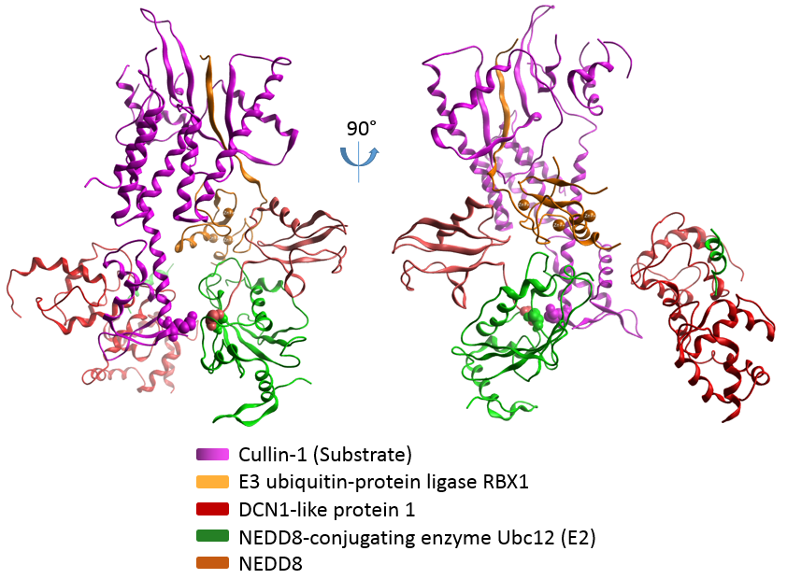

Figure 3.1 Crystal Structure of RBX1(E3)-UBC12(E2)~NEDD8(UBL)-CUL1(Substrate)-DCN1(CoE3) Complex
Modeled K720 from substrate and C111 from E2 as well as G76 from UBL are shown in space fillings. The five chains are represented by ribbons with different colors.

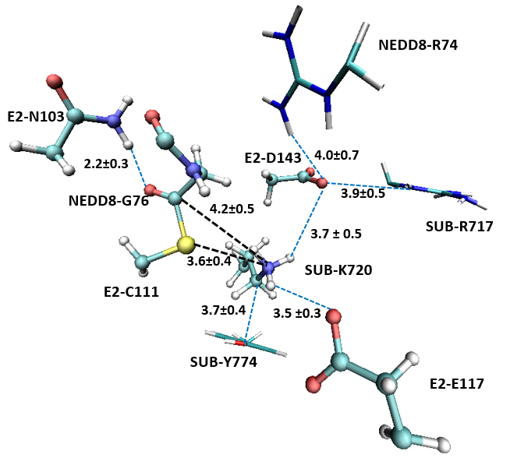
Figure 3.2 MD results of active-site structure of E3-E2~NEDD8-Substrate-CoE3 Complex
The results are generated after 1 ns simulations. The substrate of K720 is in protonated state. Side chains of N103, C111, E117 and D143 from E2, the whole G76 and part of G75 from NEDD8, and substrate K720 are shown in ball and stick. Major possible van der Waal’s interactions and salt bridges are shown in blue dotted lines. And related distances are given with standard deviations in angstrom. The average distances between Nε of K720 and Sγ OF C111, and between Nε of K720 and Cα OF G76 are shown.

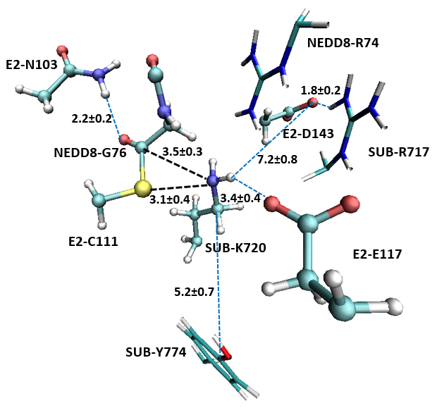
Figure 3.3 Average active-site structure of E3-E2~NEDD8-Substrate-DCN1 Complex (PDB ID: 4P5O) with deprotonated K720 after 1 ns simulations.
Side chains of N103, C111, E117 and D143 from E2, the whole G76 and part of G75 from NEDD8, and substrate K720 are shown in ball and stick. Major possible van der Waal’s interactions and salt bridges are shown in blue dotted lines. And related distances are given with standard deviations in angstrom. The average distances between Nε of K720 and Sγ OF C111, and between Nε of K720 and Cα OF G76 are shown.

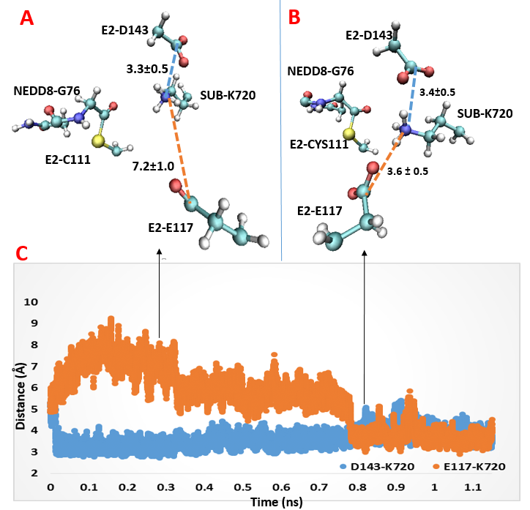
Figure 3.4 Two possible deprotonation pathways of substrate K720
(A) Average structure of active site at around 0.3 ns simulation. (B) Average structure of active site at around 0.8 ns simulation. The distance between carboxyl carbon of D143 and side chain amino nitrogen of K720 is shown with blue dotted lines in (A) and (B). The distance between carboxyl group of E117 and Nε of K720 is shown with orange dotted lines in (A) and (B). (C) Monitoring the distance between the carboxyl group of D143(in blue)/E117(in orange) and the amino group of K720 during MD simulations. The two arrows indicate when the screenshot of average structure in (A) and average structure in (B) are taken respectively. (D) RMSD tracking of main chain from the simulating complex.

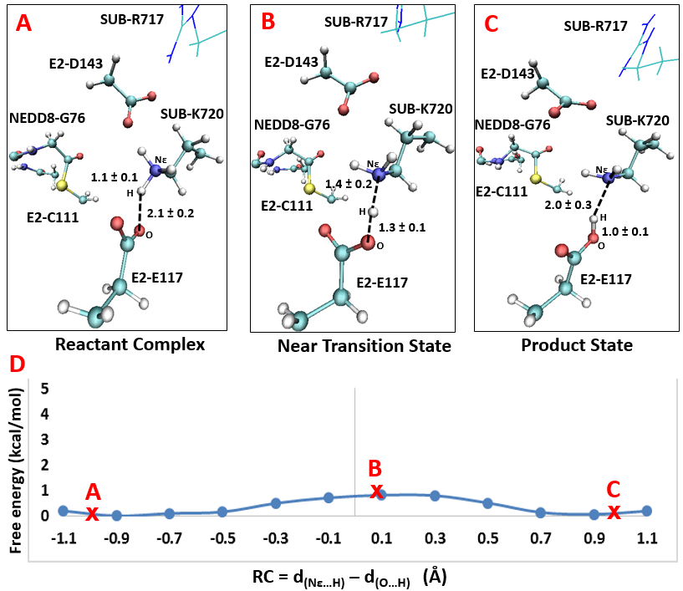

Figure 3.5 One possible deprotonation pathway through E117
Average structures of reactant complex, near transition state and product state are shown in (A), (B) and (C) respectively. Some average distances are given with standard deviations in angstrom. (D) Free energy simulations of the deprotonation reaction path through E117. Point A, B and C designates where average structures in (A), (B) and (C) are taken from the reaction path. The distance difference between Nε…H and O…H is the reaction coordinate used to describe the processing of deprotonation.

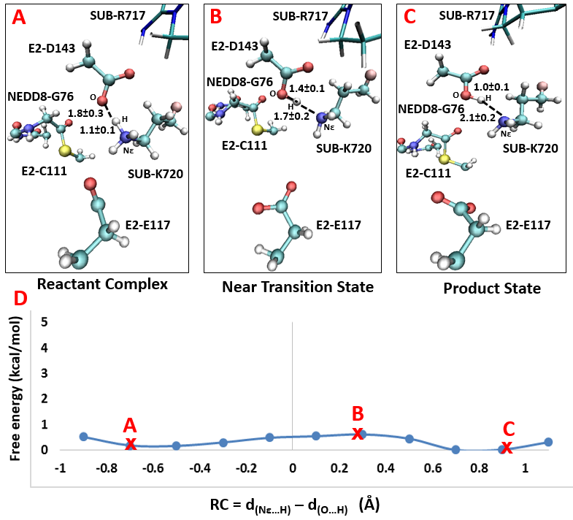
Figure 3.6 One possible deprotonation pathway through D143
Average structures of reactant complex, near transition state and product state are shown in (A), (B) and (C) respectively. Some average distances are given with standard deviations in angstrom. (D) Free energy simulations of the deprotonation reaction path through E143. Point A, B and C designates where average structures in (A), (B) and (C) are taken from the reaction path. The distance difference between Nε…H and O…H is the reaction coordinate used to describe the processing of deprotonation.

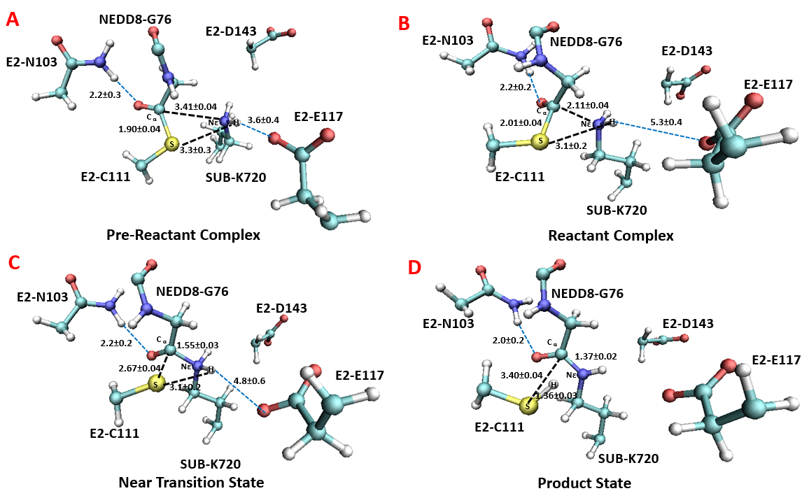

Figure 3.7 Active-site structure during the 2D free-energy simulation of nucleophilic attack
The average structures around Point A(pre-reactant complex), Point B (reactant complex), Point C(near transition state) and Point D(Product Complex) as designated in Figure 3.8 are shown. Some average distances are given with units of angstrom.

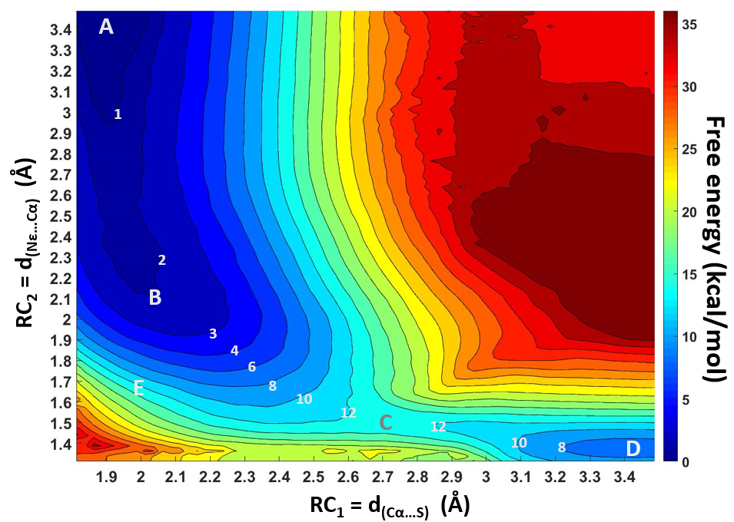
Figure 3.8 2D free-energy contour map for nucleophilic attack
The horizontal axis represents the distance between Cα and Sγ, and the vertical axis represents the distance between Nε and Cα. Points A, B, C and D designate the pre-reactant complex, reactant complex, near transition sate and product complex, respectively. Point E is the hypothetical oxyanion intermediate. Some contour line are show with respective energy value. The energy bar is shown on the right.

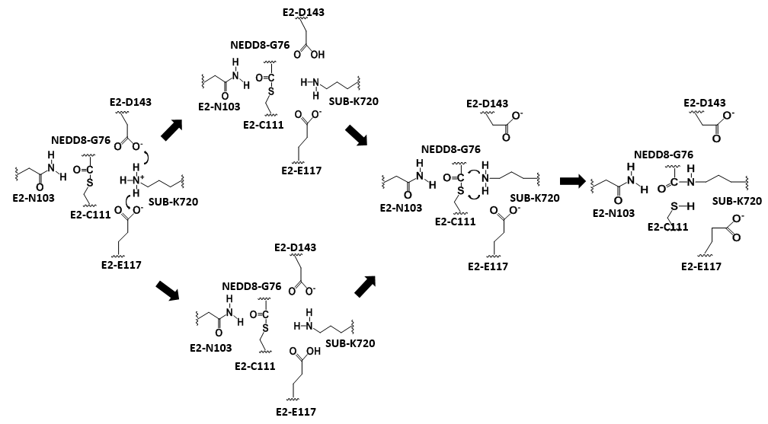
Figure 3.9 Proposed mechanism of NEDD8 transfer catalyzed in the E3-E2~NEDD8-Substrate-CoE3 complex

CONCLUSIONS

Summary
Understanding the catalytic mechanism of enzymes has fundamental and practical importance. The dynamic motions during catalysis such as proton transfer and side chain movement, as well as synchronicity of concerted reactions, cannot be directly observed through structural analysis by X-ray crystallography or NMR combined with mutagenesis. QM/MM simulations is capable of monitoring those dynamic motions on a timescale ranging from femtoseconds to nanoseconds while enzymes working on making or breaking covalent bond. Moreover, transition state geometry as well as energy barriers in the enzymatic reaction can be obtained this way.

In this dissertation, the QM/MM MD simulations, as well as free energy simulations through calculation of potential of mean force using umbrella sampling and the weighted histogram analysis method, were employed to study the catalytic mechanism of two SAM dependent N-methyltransferase, DXMT and PRMT5, and the ubiquitination-like neddylation process in the RBX1(E3)-UBC12(E2) ~NEDD8(UBL)-CUL1(Substrate)-DCN1(CoE3) complex.

Simulations of DXMT has monitored the proton transfer process from the hydroxyl group of either 7-methylxanthine (7mX) or theobromine(Tb) to the general base catalyst His160. It shows the proton transfer completes before end of methylation process. The timely proton transfer can lower the energy barrier for 7mX methylation and for Tb methylation by 3.7 and 12.7 kcal/mol, respectively. The two-dimensional (2D) free energy map describing both proton transfer and methylation process further indicates the proton transfer is done before reaching the transition state of methylation and the completion of proton transfer could thus promote the final attachment of the positive charged methyl group to the substrate.
Furthermore, the product promiscuity seems to be depend on the relative position and orientation between the catalytic His160 imidazole side chain and the substrate 7mX/Tb as observed by MD simulations.

The general base catalysis was also observed during the two-step symmetric methylation on substrate arginine by PRMT5. A glutamate in the active site, GLU435, utilize its deprotonated carboxylic side chain to accept a proton from the substrate arginine during the 1st and the 2nd methylation. Furthermore, simulations have identified some key residues that contribute to the transition state stabilization. The two-step methylations are both stabilized through strong double salt bridge interactions between substrate arginine and the two neighboring Glu435 and Glu444, while those interactions are less dominant in the reactant state. The simulations also illustrate the origin of product specificity for the symmetric di-methylation (SDMA) as compared to asymmetric di-methylation (ADMA). Unlike ADMA PRMTs which energetically favors a single ω-guanidino nitrogen (N_{η2}) of arginine as the target for the both 1st and 2nd methylations, SDMA PRMT5 is found to have an energetic preference of targeting N_{η1} for the first methylation and subsequently targeting a different ω-guanidino nitrogen (N_{η2}) for the second methylation. The first and second methyl transfers are estimated to have free energy barriers of 19–20 and 18–19 kcal/mol, respectively, which are consistent with the existing experimentally examined k_{cat}.

In the simulations of neddylation in the E3-E2~NEDD8-Substrate-CoE3 complex, the synchronicity of two chemical processes, breaking of thioester bond and formation of isopeptide bond, were directly observed from the 2D free energy map.
The proceedings of thioester bond breaking and isopeptide bond making are highly concerted, making the formation of an oxyanion intermediate unnecessary. Two residues in the active site, Glu117 and Asp143 from E2, were found to work as general base catalyst to deprotonate substrate lysine with almost no free energy barrier. Before reaching the product state, the substrate lysine works as a general acid catalyst to transfer a proton to the leaving Cys111 from E2, releasing the newly formed Substrate~NEDD8 from E2. The relative free energy barrier is estimated to be 14-15 kcal/mol, which is consistent with the high reactive activity observed in experiments.

To sum up, the QM/MM MD and free energy simulations applied in this dissertation well support the importance of dynamics during enzymatic catalysis. In all the three cases studied, general acid/based catalyzed proton transfer appears to be capable of lowering the free energy barrier. The synchronicity of proton transfer and main nucleophilic attack reactions were also investigated. The proton transfer completes before reaching the transition state of N₃ and N₁ methylation by DXMT, and N_{η1} methylation by PRMT5. And its completion might also fall behind the transition state, such as during N_{η2} methylation by PRMT5 and during neddylation in the E3-E2~NEDD8-Substrate-CoE3 complex. Structure based analysis proposed that hydrogen bond interactions are the key reason for transition state stabilization. But the simulations performed here would suggest the previous proposal might not work for some cases.

Future directions
DXMT has a close homolog xanthosine methyltransferase (XMT) which converts xanthosine (XR) to 7mx by removing the ribose from XR and adding a methyl group to N₇ of XR. On the pathway of caffeine biosynthesis, XMT is upstream of DXMT, producing 7mx as substrate for DXMT. XMT has an active-site similar to DXMT except the catalytic His160 in DXMT is substituted by a glutamine, Gln161 in XMT. The Q161H mutant could change the substrate specificity of XMT and make it able to catalyze both N₇ and N₃ methylation, while N₃ methylation is also catalyzed by DXMT. It would be interesting to simulate enzymatic catalysis by XMT and Q161H mutant of XMT to gain further understanding of product specificity of enzymes involved in caffeine biosynthesis. It could help to answer question like whether theobromine biosynthesis occurs evolutionarily as precursor to biosynthesis of caffeine.

The QM/MM simulations has been proved working well for enzymatic catalysis in local regions, especially for describing active-site conformational change and chemical reactions. However, remote regions might also have its influence on enzymatic activity through allosteric regulation. In the E3-E2~NEDD8-Substrate-Co_E3 complex, the E3 ligase and E3 assistant Co_E3 are not close to the active site of NEDD8 transfer. However, they play essential roles of recruiting and connecting the substrate cullin with the E2~NEDD8 intermediate, building a ternary complex favored by the enzymatic reaction. With or without the existence of E3 and CoE3, a microsecond (ms) level MM MD simulations followed by QM/MM free energy simulations might help to obtain insights into how E3 and CoE3 allosterically maintain an ideal active site configuration for neddylation.

VITA

Yufei Yue was born in Chengdu, China in 1985. He attended Sichuan University in 2003 and graduated with a Bachelor of Science degree in Biotechnology in 2007. He continued his graduate study in Plant Genetics Lab at Sichuan University. In 2010, he joined the Department of Biochemistry, Cellular and Molecular Biology at the University of Tennessee Knoxville for his Ph.D. study. He then started there pursing a Master of Science degree in Statistics in 2012. He is graduating in May 2016.

