To the Graduate Council:

I am submitting herewith a dissertation written by Kristin Denise Morgan entitled “Dynamic Simulations and Data Mining of Single-Leg Jump Landing: Implications for ACL Injuries.” I have examined the final electronic copy of this dissertation for form and content and recommend that it be accepted in partial fulfillment of the requirements for the degree of Doctor of Philosophy, with a major in Biomedical Engineering.

Jeffrey A. Reinbolt, Major Professor

We have read this dissertation
and recommend its acceptance:

William R. Hamel

J. A.M. Boulet

Songning Zhang

Accepted for the Council:

Carolyn R. Hodges

Vice Provost and Dean of the Graduate School

(Original Signatures are on file with official student records.)

Dynamic Simulations and Data Mining of Single-Leg Jump Landing: Implications for ACL Injuries

A Dissertation Presented for the
Doctor of Philosophy
Degree
The University of Tennessee, Knoxville

Kristin Denise Morgan
May 2014

Copyright © 2014 by Kristin Denise Morgan. “This Page is Optional”
All rights reserved.

DEDICATION

I dedicate my work to…

ACKNOWLEDGEMENTS

Thank you for your help. Adviser, Jon Donnelly, Lab mates, PEER etc.

ABSTRACT

This is a sample Word document that can be used as a template in formatting your multipart or manuscript thesis/dissertation. This abstract should cover all parts of your multi-part thesis or dissertation. This abstract must be 350 words or fewer If you are using special characters, you’ll want to spell them out between square brackets after each time you use them (this is in the abstract only. It’s not necessary elsewhere in the document, although use of special characters in the title is prohibited.)
For our purposes a special character is any character which cannot be found on your typical English language keyboard. Because of how your abstract is used in the cataloging process, you will want to tell people how to interpret your special character in case the character itself gets garbled. So, if I wanted to use the µ [micro] character in my abstract, I would have to tell people how to interpret it. Since you’re the expert, you decide how to best interpret that character. It could be µ [micro] or µ [mu], whichever would make the most sense if the symbol itself cannot be replicated

PREFACE

This page is optional.

TABLE OF CONTENTS

INTRODUCTION 4
Heading 2 4
Heading 2 4
Heading 3 4
Heading 3 4
Heading 2 4
CHAPTER I THE FIRST ARTICLE 4
Abstract 4
Heading 2 4
Heading 3 4
Heading 3 4
Heading 3 4
References 4
Appendix 4
CHAPTER II THE SECOND ARTICLE 4
Abstract 4
Introduction 4
Heading 3 4
Heading 3 4
Heading 2 4
Heading 3 4
Heading 3 4
Heading 2 4
References 4
CONCLUSION 4
Heading 2 4
VITA 4

LIST OF TABLES

Table 1. Table title. 4
Table 2: This Is The Second Table 4

LIST OF FIGURES

Figure 1. Shapes. 4

TABLE OF CONTENTS

CHAPTER I Introduction
1.1 Literature Review
1.1.1 Defining the Function of the Anterior Cruciate Ligament
1.1.2 Cadaveric and in-vivo Analysis of ACL Strain
1.1.3 Kinematics and Kinetics: Biomechanical Assessment of ACL Injury Risk
1.1.4 Electromyography (EMG): Bridging the Gap between Kinematics and Kinetics and
Muscle Function
  - 5 Computational Modeling: Utilizing Simulations to Assess Cause-Effect
Relationship in Human Movement
1.2 OpenSim
1.3 Computer Modeling and Simulation Development
1.3.1 Scaling
1.3.2 Inverse Kinematics (IK)
1.3.3 Residual Reduction Analysis (RRA)
1.3.4 Computed Muscle Control (CMC)
1.4 Overview and Specific Studies
1.4.1 Study 1: Determination the Individual Muscle Force Contributions during Single-
Leg Jump Landing
1.4.2 Study2: Assess How Individual Muscles Resist Elevated Knee Abduction Moment
during Single-Leg Jump Landing
1.4.3 Study 3: Utilize Data Mining to Detect Movement Abnormalities and Identify
Individuals At-Risk for ACL Injury
1.4.4 Study 4: Utilize Data Mining to Detect Movement Abnormalities and Identify
Individuals At-Risk for ACL Injury
CHAPTER II Elevated Gastrocnemius Forces Compensate for Decreased Hamstrings Forces
during the Weight-Acceptance Phase of Single-Leg Jump Landing: Implications for ACL
Injury Risk
2.1 Abstract
2.2 Introduction
2.3 Methodology
2.3.1 Experimental Protocol and Data Collection
2.3.2 Subject-specific Models and Simulations
2.3.3 Muscle Force Estimates during Single-Leg Jump Landing
2.4 Results
2.5 Discussion
2.6 Conclusion?
2.7 Appendix?
2.8 References?
CHAPTER III Assess How Individual Muscles Resist Elevated Knee Abduction Moment during
Single-Leg Jump Landing
3.1 Abstract
3.2 Introduction
3.2.1 Induced Acceleration Analysis Description
3.2.2 Expand on Introduction
3.3 Methodology
3.4 Results
3.5 Discussion
3.6 Conclusion?
CHAPTER IV Utilize Data Mining to Detect Movement Abnormalities and Identify Individuals
At-Risk for ACL Injury
4.1 Abstract
4.2 Introduction
4.3 Methodology
4.3.1 Experimental Protocol and Data Collection
4.3.2 Subject-specific Models and Simulations
4.3.3 Stability Analysis and ACL Injury Risk Classification
4.3.4 Principal Component Analysis and Muscle Excitation Assessment
4.4 Results
4.5 Discussion
4.6 Conclusion?
4.6.1 Single-Leg Jump Landing Motor Strategy, PCA and Injury Mechanism
CHAPTER V Implementing Stability Criteria and Wavelet Analysis to Assess Knee Stability
and Muscle Excitation Patterns in Athletic Populations: Implications for ACL Injuries
5.1 Abstract
5.2 Introduction
5.3 Methodology
5.4 Results
5.5 Discussion
5.6 Conclusion?
CHAPTER VI Conclusion
6.1 Significance of Research
6.2 Research Innovation
6.3 Fundamental Contributions
6.4 Summary???
LIST OF REFENCES
APPENDIX
VITA

LIST OF TABLES

Table 2.1. Mean maximum and minimum muscle force estimates for the individual muscles during the weight-acceptance phase of single-leg jump landing for fourteen trials.

Table 2.2. Mean maximum and minimum muscle force estimates for the three muscle groups during the weight-acceptance phase of single-leg jump landing for fourteen trials.

Table 2.3. Comparison of time differences between peak vertical ground reaction force (GRF) and maximum muscle force estimate for each muscle group during the weight-acceptance phase of single-leg jump landing for fourteen participants.

Table 2.4. Comparison of the mean maximum joint kinematics, kinetics and vertical ground reaction force (GRF) for the fourteen trials during the weight-acceptance phase of single-leg jump landing.

LIST OF FIGURES

Figure 1.1 Front view of the knee including the anterior cruciate ligament (ACL), posterior cruciate ligament (PCL), lateral collateral ligament (LCL) and medial collateral ligament (MCL).

Figure 1.2 Schematic of the Three Stages of Stance Phase, Determined Using Resultant Ground Reaction Forces.

Figure 1.3 Series of images chronicling the subject performing the experimental single-leg jump landing protocol.

Figure 1.4 Schematic of the Computed Muscle Control Algorithm

Figure 2.1 Series of images showing one of the seven participants and his subject-specific model performing the single-leg jump landing protocol: 1) jump from preferred leg; 2) attempt contact with a football at approximately 90% of vertical jump height and randomly moved relative to jump path; 3) contact force platform with the same leg used for jump.

Figure 2.2. Lower extremity muscle force estimates (normalized by peak isometric force, Fmax) for muscles crossing the knee joint during the weight acceptance phase of single-leg jump landing.

Figure 2.3. Comparison of lower extremity joint angles at different steps in the process of creating a muscle-actuated dynamic simulation during the weight-acceptance phase of single-leg jump landing for an example participant.

Figure 2.4. Comparison of experimental surface electromyography (sEMG) and simulated muscle excitations during the weight-acceptance phase of single-leg jump landing for an example participant.

Figure 3.1. Five ground contact points (per foot) are defined by markers in OpenSim

Figure 3.2 Muscle contributions to experimentally measured knee frontal, sagittal, and transverse plane accelerations for six muscles crossing the knee and the summation of the contributions of the six muscles during the WA phase of single-leg jump landing.

CHAPTER I

INTRODUCTION

1.1 Literature Review

1.1.1 Defining the Function of the Anterior Cruciate Ligament
The ACL is one of four ligaments in the knee. The three additional ligaments are the posterior cruciate ligament (PCL), medial collateral ligament (MCL) and the lateral collateral ligament (LCL). Together these ligaments function to stabilize the knee. The MCL and LCL are aligned along the outsides of the knee with the ACL and PCL crisscrossing each other in the knee joint. The ACL connects the medial portion of the lateral femoral condyle to the distal portion of the midtibial plateau [13] (Fig. 1.1). This orientation allows the ACL to resist anterior translation of the tibia with respect to the femur and maintain rotational joint stability [13]. Thus, when the ACL tears, joint (specifically rotational) stability is lost. ACL tears occur when the force/loads applied to the ACL exceeds the ligament strength (tolerance) [14]. It was the work of previous researchers that determined the orientation and movements that placed the greatest forces/loads on the ACL and increased its risk for injury.

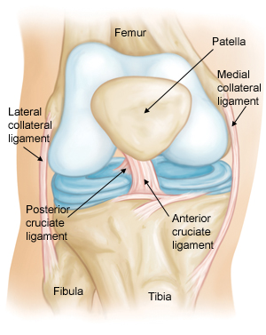
Figure 1.1. Front view of the knee including the anterior cruciate ligament (ACL), posterior cruciate ligament (PCL), lateral collateral ligament (LCL) and medial collateral ligament (MCL). [American Academy of Orthopaedic Surgeons]

1.1.2 Cadaveric and In-vivo Analysis of ACL Strain
Cadaveric and in-vivo research provide researchers with the ability to directly measure ACL strain (forces) under a variety of loading conditions. Such conditions specify the combinations of forces, torques, moments applied in the sagittal, frontal and transverse planes that the ACL [15]. Based on the ability of the ACL to resist anterior tibial translation (occurring in the sagittal plane) and tibial rotation (occurring in the transverse plane) researchers were able to evaluate loading in each plane. In the sagittal plane researchers concentrated on flexion-extension angles, in the frontal plane, knee varus and valgus moments were investigated and in the transverse plane, internal and external rotation torques/moments. When applied in isolation, ACL strain increased when the knee is near full extension or hyperextended and experiencing valgus moments and internal rotation torques [15, 16]. Examining various loading conditions in isolation is important for determining which state has the greatest influence on ACL strain; yet, the knee motion that leads to ACL injuries does not occur solely in one plane, thus researchers analyzed the effect of combined loading on the ACL.
Studies analyzed the combined effect knee flexion-extension angles with knee valgus moments under compression; the combination of externally applied anterior-posterior shear force, internal-external torques and varus-valgus moments during (20° of) flexion; and the combination of anterior tibial force, varus-valgus moments and internal-external torques [15, 17, 18]. The results of these studies found that ACL strain increased nonlinearly with increasing anterior tibial force as the knee neared full extension and the force in the ACL increased 30% when under the combined effect of knee flexion and valgus loading than in flexion alone [17, 18]. Fleming et al. (2001) [15] observed an increased in ACL strain during small flexion angles and valgus loading. The ACL force increased to 300N for the combined loading of internal rotation and anterior tibial force when the knee was hyperextended, which was twice the force under the same conditions for external tibial rotation. All of these studies showed that are under increased strain and force when the knee is near or more than fully extended and valgus (abduction) and internal rotation loading.
Cadaveric and in-vivo studies set the ground work for assessing load conditions that lead to elevated ACL strain. However, cadaveric studies are limited by their inability to measure strain in its natural environment surrounded by the live, supporting musculature while in-vivo studies are limited by the number of willing participants, thus researchers were unable to directly measure ACL strain during dynamic movements. They did nevertheless used the knowledge that ACL strain increased during increasing valgus (abduction) and internal rotation moments when the knee was hyperflexed or near full extension to investigate which dynamic movements (tasks) occurred and the kinematics and kinetics sequences of such events.

1.1.3 Kinematics and Kinetics: Biomechanical Assessment of ACL Injury Risk
Sports; such as, basketball, soccer, volleyball, Australian Rules Football, reported high incidences of ACL injury [1, 2, 6]. During these sports, running, cutting, sidestepping and landing are typical movements and all involve rapid transition and/or decelerations of the body [2, 6]. Thus biomechanical researchers investigated kinematics and kinetics during these movements to determine which were more likely to place elevated strain on the ACL. A comparison of running, cutting and sidestepping tasks discovered that knee valgus and internal rotation moments were larger during cutting and sidestepping tasks than running [19]. Studies of single-leg jump landing also reported increased valgus and internal rotation moments during the movement [20-23]. These results indicate that the sidestepping, cutting and single-leg jump landings may place the ACL under greater loading (strain, forces) than other sports tasks. To validate if the biomechanical measurements assessed during these studies were indicative of increased ACL injury risk, researchers compared joint biomechanics between individuals who had and had not suffered an ACL injury and between female and male athletes, as females are more likely to tear their ACLs than men [1, 24, 25]. Researchers found that ACL sufferers exhibited significantly larger knee abduction angles 8° than non ACL injury sufferers and significantly higher knee abduction moments with sufferers reporting moments of 45.3±28.5Nm to 18.5±15.6Nm for non-sufferers [25]. An investigation of female and male kinematics and kinetics during sidestepping and jump landing tasks again observed higher knee abduction angles and moments in females than males [21, 26, 27]. One study found knee abduction moments in females nearly twice as large as males, 21.9±13.5Nm and 13.0±12.0Nm, respectively. These and other studies indicated that sidestepping and jump landing tasks could place elevated strain on the ACL and it was also found that knee valgus/abduction moments were a strong predictor of ACL injury in individuals [25, 26].
With knee valgus/abduction moments identified as strong predictors of ACL injury and the added contribution of internal rotation moments and small knee flexion angles to further increase strain on the ACL, Besier et al. (2001) [19] decided to analyze when during the movements these biomechanical variables were the largest. Besier et al. divided the ground reaction force profile measured during the sidestepping task into three phases: weight acceptance (WA), peak push off (PPO) and finale push off (FPO). The WA phase is defined as the time from the heel strike to the first trough, PPO is the time from 10% before and after peak GRF and the FPO is the last 15% of stance (Fig. 1.2) [19]. Peak knee valgus moments were significantly larger during the WA and FPO phases of cutting and sidestepping than running and peak internal rotation moments were significantly larger during the WA phase for sidestepping and cutting than running. Since peak knee valgus and internal rotation moments are associated with increased ACL strain, it is possible to infer that ACL injury is more likely to occur during the WA phase of movement.
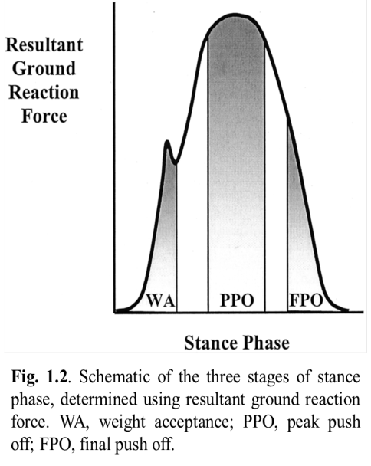
(Fix Caption and Reference)
The assessment of biomechanical variables determined that sidestepping or cutting and jump landing tasks placed individuals at higher risk for injury, elevated knee valgus/abduction were strongly correlated with ACL injury risk and that injuries were potentially more likely to occur during the WA phase of movement. Since we have determined the tasks, predictors and timing associated with ACL injury the remaining step centers on determining the role muscles play in protecting the ACL against elevated knee valgus and internal rotation moments during these tasks.

1.1.4 Electromyography (EMG): Bridging the Gap between Kinematics and Kinetics and Muscle Function
Electromyography (EMG) is utilized to gain insight into muscle function during movement. Studies have used EMG that measures muscle activity during movements associated with ACL to better understand how muscles support/protect the knee under dangerous loading [28-31]. Muscle activity/function is assessed via muscle activation magnitude/amplitude, timing and co-contraction indices (CCI). Muscle activation amplitude and timing relate muscle excitation coordination (temporal) patterns to movement while CCI assesses the contribution of muscle groups to see how muscle groups activate and co-contract to balance each other and stabilize the knee. How muscles function during movement, such as landing, is important because muscles and ligaments are responsible for the distribution of forces across the articular surface, in this case the knee [28]. Thus increased muscle force contribution could reduce the forces (taken up by) exerted on the ligament and mitigate injury risk. Given that anterior tibial translation, small knee flexion angles, elevated knee valgus/abduction and internal rotation moments are all associated with ACL injury, researchers investigated muscle activation under these conditions to ascertain how muscles function support and stabilize the knee during these movements (dangerous loading). Together the aforementioned metrics can be used to determine muscle contribution to movement via muscle activation measurement(s).
Besier et al. (2003) [32] and Wikstrom et al. (2008) [29] investigated selective muscle activation during running, cutting, sidestepping and single-leg jump landing tasks. Besier et al. (2003) [32] observed that when grouping the muscles by function (i.e. knee flexor and extensor, medial and lateral and internal-external rotators), an increase in their muscle activation was correlated with an increase in valgus and internal rotation moments during the pre-planned as opposed to unanticipated cutting and sidestepping tasks. This finding was believed to indicate that muscles selectively activate to properly execute the task and protect the knee against dangerous loadings. Wikstrom et al. (2008) [29] examined how muscle activation patterns differ during successful and failed jump landings. EMG data was collected for the vastus medialis, semimbranosus, lateral gastrocnemius and tibialis anterior muscles 200ms pre through 200ms post landing. The results showed that muscles activated earlier and exhibited stronger preparatory and reactive amplitudes for successful landings as opposed to failed landings. Additionally, muscles were found to activate in a different order for successful and failed landings with muscles activating in the following order for successful landings: vastus medialis, semimbranosus, lateral gastrocnemius and then the tibialis anterior muscle. The vastus medialis and semimbranosus represent the quadriceps and hamstring muscles in this study. An analysis of those two muscles showed that the vastus medialis activated 3ms before the semimbranosus and that post landing the vastus medialis was slightly more activated than the semimbranosus at 0.40 and 0.34, respectively. However, for the failed landing the semimbranosus muscle activated 16ms before the vastus medialis and there was a slightly larger discrepancy in reactive muscle activation amplitude with the vastus medialis producing 0.35 while the semimbranosus produced 0.27. This study like prior investigations highlighted that the quadriceps and hamstring muscles are critical to supporting the knee during landing. And that to successfully support the knee increased activation of the hamstring muscles could help counterbalance the increased activation of the quadriceps muscles.
Previous cadaveric studies had also indicated that strong quadriceps loading was found to cause increased anterior tibial translation with respect to the femur and in turn contributed to increased ACL injury [2]. This result focused attention on the relationship between the quadriceps and hamstring muscles during different tasks (to assess relationships between joint biomechanics and muscle activation [33]. Analysis of muscle activation during such events revealed that in populations at greater risk for ACL injury, individuals displayed greater quadriceps muscle activation [33, 34]. The greater the level of muscle activation of the quadriceps relative to the hamstrings leads to enhanced knee joint instability [33]. A more balanced co-contraction of these muscles reduced anterior tibial translation and helped support the knee during valgus loading [28, 34]. The balanced co-contraction during tasks typically indicates an increase in hamstring muscle activity to counter the strongly activated quadriceps muscles during tasks associated with ACL injury. Fujii et al. (2012) [35] found that this increased hamstring muscle activation was correlated with smaller peak internal tibial rotation angle during single-leg jump landing. While studies have shown quadriceps-hamstring co-contraction are the main contributors to stabilizing the knee during dynamic sports tasks associated with ACL injury; Podraza et al. (2010) [31] found that other muscles surrounding the knee may also function to stabilize the knee and improve joint stiffness. Podraza et al. (2010) [31] evaluated muscle activation during single-leg landing task and concluded that in response to the dominant activation of the quadriceps that it is possible that the soleus and gastrocnemius muscles may play a more prominent role in countering the quadriceps activation than the hamstrings during landing. This result suggests that greater concentration should be paid to the function of all of the muscles surrounding the knee not just the quadriceps and hamstrings.
EMG is effective in evaluating muscle activity during dynamic movements but does not yield information about a muscle’s relative contribution to movement, but computer simulations may provide additional insights [36]. For example, algorithms (e.g., computed muscle control) can estimate muscle forces required for the desired movement given kinematic and kinetic data [9]. To determine individual muscles contribution to movement, computational modeling that incorporates mathematical algorithms has and continues to be used to analyze muscle function during dynamic movement [9, 37].

1.1.5 Computational Modeling: Utilizing Simulations to Assess Cause-Effect Relationship in Human Movement
Computational modeling of human movement is used to relate various aspects of the human biological system to movement. In previous decades, biomechanical models were simplistic 1- and 2- dimensional models containing fewer body segments, degrees of freedom and muscles for their analysis [37-40]. The advancements in computer technology have led to the development of more complex biomechanical models and more computationally efficient analyses [41].
Through computational modeling, researchers are able to develop subject-specific simulations that relate joint kinematics and kinetics to muscle force production and function. Unlike EMG analysis where muscle activation is linearly related to muscle force, simulations are able to account for the musculotendon properties; such as, muscle activation and contraction dynamics, force-length and force-velocity relationships and moment arms analysis to appropriately model non-linear relationships between muscle activation and force production. Such simulations are utilized to investigate the cause-and-effect relationship between joint motion and muscle function [9, 11, 12, 42, 43].
Musculoskeletal modeling software programs allow users to select from a bank of expressions and create subject-specific simulations to explore a variety of research questions. OpenSim is such a software program that provides users with a mathematical and computational modeling framework to analyze everything from designing prosthetic devices, to studying how they will function in the body and assessing the outcomes of surgical procedures like tendon lengthening in cerebral palsy patients. Here this research will use high quality experimental motion capture data of individuals performing a single-leg jump landing protocol to conduct and evaluate simulation based research of muscle contribution during these jump landings. This research is divided into three studies.
1.2 OpenSim
Briefly Discuss what OpenSim is.

1.3 Computer Modeling and Simulation Development
Computer simulations are a valuable tool to use to investigate human movement [41]. Developing subject-specific simulations on which CMC can be implemented is a multi-step process. First, a generic musculoskeletal model is scaled to the size of the subject by specifying its mass properties and segment dimensions obtained from experimental exams and marker data. Next, inverse kinematics (IK) is conducted to derive the joint angles from the experimental marker data obtained during the jump landing. Then OpenSim’s residual reduction algorithm was used to create dynamically consistent simulations with the experimentally recorded ground reaction forces (peak residual forces less than 4N, peak residual moments less than 8Nm). Now that the model is dynamically consistent model we can run the CMC algorithm. CMC was used to estimate muscle excitations and subsequently muscle forces during the weight-acceptance phase of single-leg jump landing. The end result is a subject-specific 14 segment, 37 degree-of-freedom (DoF), 92 muscle-tendon actuated subject specific models were created in OpenSim 1.9.1 to simulate single-leg jump landing (Fig. 1.3). The 14 segment, 37 DoF is the same model previously described [48]. The 92 muscle-tendon actuators actuated the lower extremity and back joints while the arms were actuated by torque actuators also previously described [12]. The model included a 3 DoF knee actuators by muscles and ideal torque actuators. The following paragraphs will provide additional details of the simulation development described above.
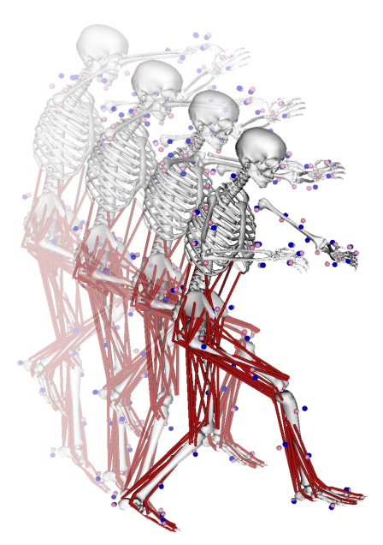
Figure 1.3. Series of images chronicling the subject performing the experimental single-leg jump landing protocol. Three-dimensional 14-segment, 37 degree-of-freedom and 92 muscle-tendon actuated subject-specific simulations were created in OpenSim 1.9.1 from the experimentally measured kinematic and ground reaction force data.
(Format Caption and Figure number)

1.3.1 Scaling
The objective of scaling is to develop a subject specific model that has the same mass and anthropometric measurements as the subject performing the experiment. First the subjects mass is redistributed amongst the model body segments to replicate the subjects body mass. Then the generic virtual model markers are repositioned on the model using the location of the subjects’ experimental markers to identify the appropriate joint centers and define the correct segment lengths. To ensure the best match (i.e. minimal error) between the model and experimental markers, the experimentally collected static pose is used to calculate the average distance between the experimental and model markers. Since greater confidence is placed on the location of the bony landmarks (i.e. joint) markers, the model virtual markers are adjusted to strongly match the location of those experimental markers while keeping the error between the other markers low/small. The result is a model that closely matches the subjects’ mass properties and segment dimensions.

1.3.2 Inverse Kinematics (IK)
Inverse kinematics is a process that derives the joint angles from the experimental marker data recorded during the single-leg jump landing protocol. At each time instant throughout the single-leg jump landing movement, the error between the experimental markers and the model markers and the experimental coordinate and IK defined coordinate is measured. A weighted least square algorithm (Equation 2.1) is utilized to reduce these errors between the experimental and model markers ($X_{i}^{exp}, X_{i}\left(q\right)$) and generalized coordinates ($q_{j}^{exp},q_{j}$), where $w_{i}$ and $ω_{j}$ are the user defined weightings.

$$\begin{matrix}min \\ q\end{matrix}\left[\sum_{iϵmarkers}{w_{i}{\left\|X_{i}^{exp}-X_{i}\left(q\right)\right\|}^{2}+\sum_{jϵunprescribed coords}{ω_{j}{\left(q_{j}^{exp}-q_{j}\right)}^{2}}}\right] (2.1)$$

$$q_{j}=q_{j}^{exp} for all prescribed coordinates j$$

The weighting coefficients are adjusted to better track markers and coordinates the researchers have the greatest confidence in. The result is model joint angles and positions that accurately track the experimental movement.

1.3.3 Residual Reduction Analysis (RRA)
Residual reduction analysis employs a forward dynamics to create a simulation that recreates the IK motion using torques actuators acting at/on the joints to create dynamically consistent models. A dynamically consistent model is one where the summation of the (derived) model forces matches the experimentally measured GRFs that provide an accurate measurement of forces. However, throughout model development, assumptions for model marker placement/location and joint angle and positions used to derive model accelerations can cause errors to accumulate causing the model forces to differ from the GRFs. To make the model forces equal the GRFs, residual forces and torques are added to the model to match GRFs as seen in Equation (2.2). Six generalized coordinates represented by 6 DoF (3 transitional, 3 rotational) between the model pelvis and the ground are the reserve actuators. The reserves are applied throughout the simulation to ensure model forces equal GRFs. To minimize the contribution of the reserve actuators, which are nonphysical compensatory forces (and allow the model to rely on the actual model forces), an optimization algorithm is employed. The optimization function uses the relationship between the weighted ($w_{{\ddot{q}}_{i}})$ sum of the model and experimental acceleration difference squared (${\ddot{q}}_{i}^{exp}, {\ddot{q}}_{i}^{sim})$, and the normalized residual forces and torques ($\frac{R_{j}\left(x_{j}^{R}\right)}{R_{j}^{max}})$ along with the normalized joint torques ($\frac{T_{k}\left(x_{k}^{T}\right)}{T_{k}^{max}})$ to calculate the smallest X shown in Equation (2.3) (Donnelly et al 2012 opt). The end result of this process is a dynamically consistent simulation actuated by joint torques and residuals.

$\sum{F_{model}+ \sum{F_{residuals}}}=GRFs$ (2.2)

$$J\left(x\right)=\begin{matrix}min \\ x^{R},x^{T}\end{matrix}\left[\sum_{i=1}^{n_{q}}{w_{{\ddot{q}}_{i}}{\left({\ddot{q}}_{i}^{exp}-{\ddot{q}}_{i}^{sim}\right)}^{2}+\sum_{j=1}^{6}{{\left(\frac{R_{j}\left(x_{j}^{R}\right)}{R_{j}^{max}}\right)}^{2}+}}\sum_{k=1}^{n_{T}}{{\left(\frac{T_{k}\left(x_{k}^{T}\right)}{T_{k}^{max}}\right)}^{2}}\right] (2.3)$$

1.3.4Computed Muscle Control (CMC)
Muscle forces were then estimated for these dynamically consistent simulations during the weight-acceptance (WA) phase of single-leg jump landing using CMC. The CMC algorithm will be applied to identify individual muscle force contribution during single-leg landing. The CMC algorithm is an optimization tool that estimates individual muscle force estimates during dynamic movements (Fig. 1.4).
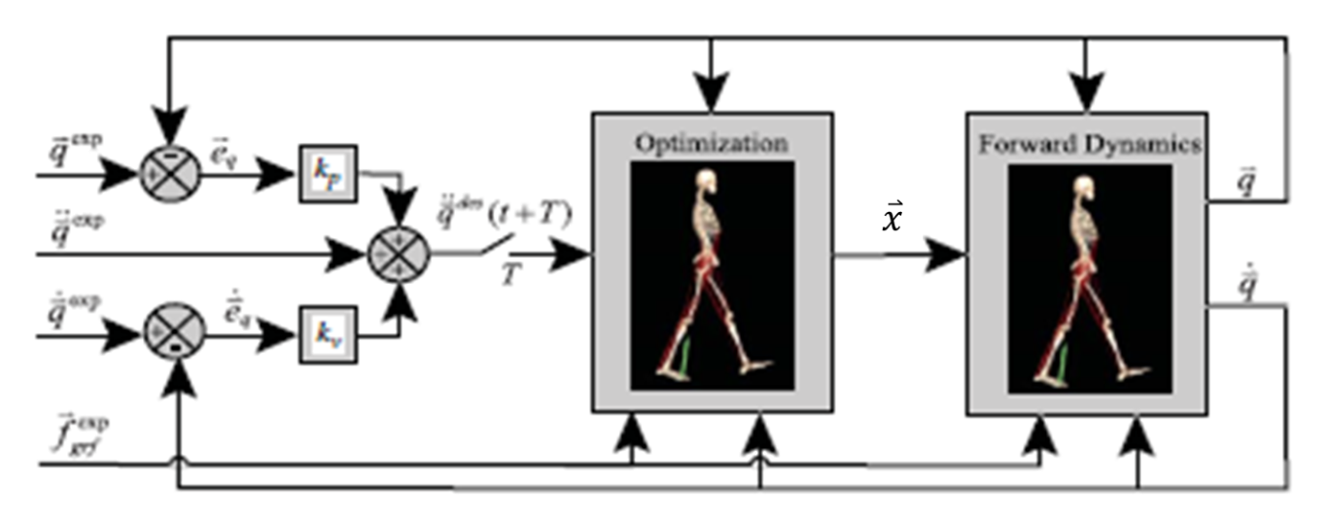
Fig. 1.4. Schematic of the Computed Muscle Control Algorithm [42]

The way CMC estimates muscle force is by first deriving the desired (joint, generalized coordinate) acceleration, ${\ddot{\overset{⃑}{q}}}^{*}$, that will drive the model coordinates,$\overset{⃑}{q}$, to the experimentally recorded motion data,${\overset{⃑}{q}}_{exp}$. This is done by minimizing the least-squared error between the experimental and the modeled motion of the simulation using a proportional-derivative (PD) control law, where ${\overset{⃑}{k}}_{v}$ and ${\overset{⃑}{k}}_{p}$ are the velocity and position error feedback gains, respectively in Equation 2.4, then applying static optimization to determine the distribution of the excitations across all of the muscles over small time interval over the simulation (i.e. single-leg landing) (Eqs. 2.5-2.6). Static optimization is dependent upon a performance criterion ($J)$, which is used to calculate the muscle excitations during landing. For OpenSim’s CMC, there are two performance criteria expressions. Both expressions use the sum of the actuators (i.e. muscles) squared ($x_{i}^{2})$; however, each model adjusts for how well the desired accelerations match the model accelerations. The slow target (Eq. 2.5) incorporates the weighted square of the difference of the desired and model accelerations with the goal that this difference is as small as possible. For fast target (Eq. 2.6) the desired and model accelerations are required to be equal due to the constraint, $C_{j}$. Fast target is the preferred option to apply but if the constraint cannot be met, slow target is used. From the resulting excitations CMC integrates the muscle force-velocity, force-length relationships and muscle moment arm geometry to translate muscle excitation into muscle forces.

${\ddot{\overset{⃑}{q}}}^{*}\left(t+T\right)={\ddot{\overset{⃑}{q}}}_{exp}\left(t+T\right)+{\overset{⃑}{k}}_{v}∙ \left[{\dot{\overset{⃑}{q}}}_{exp}\left(t\right)-\dot{\overset{⃑}{q}}\left(t\right)\right]+{\overset{⃑}{k}}_{p}∙\left[{\overset{⃑}{q}}_{exp}\left(t\right)-\overset{⃑}{q}(t)\right]$ (2.4)

$$J=\sum_{i=1}^{nx}{x_{i}^{2}}+ \sum_{j=1}^{nq}{w_{j}} {\left({\ddot{q}}_{j}^{*}-{\ddot{q}}_{j}\right)}^{2} (2.5)$$
$$J=\sum_{i=1}^{nx}{x_{i}^{2}}; C_{j }= {\ddot{q}}_{j}^{*}-{\ddot{q}}_{j}, for all j (2.6)$$

1.4 Overview and Specific Studies
Over 200,000 anterior cruciate ligament (ACL) injuries occur every year [1, 2] in the United States costing $1.5 billion annually in ACL reconstruction and treatment [3, 4]. Approximately 80% of ACL injuries are non-contact injuries [5], the majority of which occur during single-leg landings when the knee is near full extension and externally valgus loaded [6-8]. While clinical and experimental studies have well defined these kinematic and kinetic characteristics of ACL injury, the mechanism behind ACL injury is not well understood. As is indicated by the 50% increase in ACL injuries reported over the last decade despite the implementation of ACL injury prevention programs. Such programs are aimed at altering muscle force and activation patterns to circumvent the ACL injury mechanism; however, they are limited by their inability to assess individual muscle function (e.g. force, activation) to resist excessive knee loading during movement. Our long-term goal is to determine individual muscle function during jump landing in order to dramatically reduce the rate of ACL injury through the implementation of muscle-targeted prevention programs.
Musculoskeletal models and dynamic simulations have been used to determine individual muscle contributions to pedaling, walking and running [9-12]; yet, none have assessed individual muscle contributions to jump landing. Here muscle-actuated dynamic simulations will be used to determine the joint accelerations induced by individual muscles, to identify the muscles that resist excessive knee abduction moments in individuals at high risk of ACL injury. We hypothesize that increased force generation of the quadriceps and medial and lateral gastrocnemius muscles will serve to resist excessive knee abduction moments during single-leg jump landing and help mitigate ACL injury risk after proposed muscle-targeted training intervention programs. We will combine results from dynamic simulations with data mining techniques to identify individuals at risk for ACL injury and utilize all of this information to design muscle-targeted training intervention programs to reduce excessive knee abduction moments. To accomplish this we will address the following specific studies.
1.4.1 Study 1: Determine the Individual Muscle Force Contributions during Single-Leg Jump Landing.
Goal: The purpose of Study 1 is to answer the following questions: 1) What are the individual muscle forces generated to successfully perform a single-leg jump landing?; 2) Which muscles serve as the main contributors for supporting the knee during landing?
Methods: To accomplish this study, subject-specific muscle-actuated simulations will reproduce experimentally measured landing kinematics and kinetics of ten subjects. For each simulation, individual muscles forces will be estimated using a computed muscle control (CMC) during jump landing.
Significance: This investigation will clarify how individual muscles generate force to dynamically support the knee during single-leg jump landing.

1.4.2 Study 2: Assess How Individual Muscles Resist Elevated Knee Abduction Moment during Single-Leg Jump Landing.
Goal: The purpose of Study 2 is to answer the following questions: 1) What is the ideal foot-contact model to accurately calculate frontal plane knee accelerations?; 2) Which muscles produce the greatest acceleration to resist elevated knee abduction moment?
Methods: The subject-specific muscle-actuated simulations and resulting muscle force data from generated from CMC will serve as inputs for induced acceleration analysis to quantify which muscles function to resist knee abduction moment during jump landing.
Significance: This work will enable researchers to determine which individual muscles are specifically responsible for resisting knee abduction moment during single-leg jump landing and how they can potentially reduce ACL injury risk.

1.4.3 Study 3: Utilize Data Mining to Detect Movement Abnormalities and Identify Individuals At-Risk for ACL Injury.
Goal: The purpose of Study 3 is to answer the following questions: 1) What are the key biomechanical factors needed to successfully perform a single-leg jump landing?; 2) What underlying patterns in muscle function are common amongst individuals at elevated risk for ACL injury?
Methods: We will utilize principal component analysis and wavelet analysis to explore the experimentally measured kinematic, kinetic and surface EMG data for critical features and underlying patterns that may be correlated with individuals at-risk for injury.
Significance: This work will provide us with ability to develop new metrics to identify individuals at high risk for ACL injury.

1.4.4 Study 4: Utilize Data Mining to Detect Movement Abnormalities and Identify Individuals At-Risk for ACL Injury.
Goal: The purpose of Study 3 is to answer the following questions: 1) What are the key biomechanical factors needed to successfully perform a single-leg jump landing?; 2) What underlying patterns in muscle function are common amongst individuals at elevated risk for ACL injury?
Methods: We will utilize principal component analysis and wavelet analysis to explore the experimentally measured kinematic, kinetic and surface EMG data for critical features and underlying patterns that may be correlated with individuals at-risk for injury.
Significance: This work will provide us with ability to develop new metrics to identify individuals at high risk for ACL injury.

Together, these studies will determine the roles muscles play in supporting the knee and direct future research for designing more effective training protocols. The mechanisms behind ACL injury are exceptionally complex; yet, by isolating critical features and patterns common amongst individuals at elevated risk of ACL injury via principal component and wavelet analysis it may indicate how muscles function differently to support the knee in individuals at-risk for ACL injury. This knowledge is an important and necessary step toward both understanding and designing muscle-targeted training protocols that reduce ACL injury risk.

CHAPTER ii
ELEVATED GASTROCNEMIUS FORCES COMPENSATE FOR DECREASED HAMSTRINGS FORCES DURING THE WEIGHT-ACCEPTANCE PHASE OF SINGLE-LEG JUMP LANDING: IMPLICATIONS FOR ACL INJURY RISK

A version of this chapter was originally published by John X. Doe and Juanita Q. Vera:
John X. Doe, Juanita Q. Vera. “Towards A Theory of Page Rage.” Journal of Infomatic Bloat 221 (2009): 102-105.

The student must add a brief explanatory statement at the beginning of each article, stating how the article was revised and/or detailing the student’s involvement in the article. Any co-researchers should be identified and their role clarified as part of this statement.

2.1 Abstract

Approximately 160,000 anterior cruciate ligament (ACL) injuries in the U.S. each year are non-contact injuries, with most occurring during a single-leg jump landing or sidestepping sports tasks when the knee is near full extension. To reduce ACL injury risk, one option deserving further investigation is to improve muscle strength and/or activation patterns to support the knee under elevated external loading. This study’s purpose was to characterize relative force production of muscles supporting the knee during the weight-acceptance (WA) phase of single-leg jump landing and investigate gastrocnemii forces compared to hamstrings. Male Western Australian Amateur Football players completed a single-leg jump landing protocol and seven participants were randomly chosen for further modeling and simulation. A three-dimensional, 14-segment, 37 degree-of-freedom, 92 muscle-tendon actuated model was created for each participant in OpenSim 1.9.1. Computed muscle control was used to generate 14 muscle-driven simulations, 2 trials per participant, of the WA phase of single-leg jump landing. A one-way ANOVA and Tukey post-hoc analysis showed both the quadriceps and gastrocnemii muscle force estimates were significantly greater than the hamstrings (p < 0.001). Elevated quadriceps and gastrocnemii forces during landing may represent a generalized muscle support strategy to: 1) produce a support moment in the stance limb and 2) increase knee joint stiffness, protecting the knee and ACL from external knee loading and injury risk. These results not only contribute to our understanding of muscle function during single-leg jump landing, but also serve as the foundation for novel muscle-targeted training intervention programs to reduce ACL injuries.

2.2 Introduction
The objective of this first study is to determine the individual muscle force contribution during single-leg jump landing a movement associated with ACL injury. During a single-leg jump landing scenario, with the knee near full extension (low knee flexion angles), the application of externally applied translation forces (anterior drawer) coupled with valgus and internal rotation knee moments significantly elevated ACL strain when compared to any of these loading condition in isolation [31, 44-46]. There are effectively two available avenues to reduce ACL injury risk. These are: 1) change and athlete’s technique to reduce external joint loading that could strain the ACL and/or 2) improve the activation and strength of the musculature supporting the knee and ACL when loading is elevated. The goal of most prophylactic training protocols are therefore focused on either reducing the magnitude of externally applied joint loads to the knee and/or increase the neuromuscular support of the muscle crossing the knee when loading is elevated in efforts to mitigate ACL strain and injury risk. With ACL injury rates appearing to increase over the past decade, it is apparent that ACL injury prevention research and prophylactic training protocols are not being effectively translated into injury prevention practice among heterogeneous community level athletic populations [14]. The likely factor associated with these observed increases is that the mechanical aetiology of ACL injuries is not fully understood. The downstream effect is the development of ineffective prophylactic training interventions that do not target the biomechanical factors that elevate ligament strain and injury risk.
The lower limb musculature crossing the knee plays an important role in mitigating ACL injury risk during sporting tasks. In general terms, surface electromyography (sEMG) is used to estimate a muscle’s activation, where muscle function/force production during dynamic sport tasks is then inferred [28, 29, 32]. As an athlete’s joint kinematics change during dynamic sporting tasks, so does the force and moment capacity of the muscles that support the knee and ACL from external joint loading. Measures of sEMG also do not account for muscle architecture, force-velocity/force-length relationships or changes in muscle moment arm geometry during dynamic sport tasks, limiting their use in estimating muscle functioning during dynamic sporting task. Computed muscle control (CMC) is an in-silico computational tool capable of bridging this gap, providing valuable insight into the roles individual muscles play during dynamic movements like single-landing sporting tasks [9, 42]. These methods have been used to successfully analyze muscle force contributions during dynamic movement tasks such as walking, cycling and running [9, 12, 47]. The purpose of this study was to use CMC to characterize the force production of the muscles supporting the knee during the weight-acceptance (WA) phase of single-leg jump landing. It is with this information that clinicians/researchers can more effectively develop prophylactic training protocols designed to reduce ACL injury risk and see ACL focused research translated into injury prevention practice among community level athletic populations.
2.2 Introduction
Over 200,000 anterior cruciate ligament (ACL) injuries occur annually in the U.S. (Arendt and Dick, 1995; DeMorat, 2004; Ren et al., 2010) despite decades of research and development of injury prevention protocols (Donnelly et al., 2012a). ACL healthcare costs the U.S. approximately $1 billion annually (Boden et al., 2000; Kao et al., 1995). Approximately 80% of ACL injuries are non-contact, with most occurring during single-leg jump landing or sidestepping sports tasks (Cochrane et al., 2007; Koga et al., 2010; Krosshaug et al., 2007). During a single-leg jump landing with the knee near full extension, the application of externally applied translational forces coupled with valgus and internal rotation knee moments elevates the strains on the ACL to injurious thresholds (>2000 N) greater than when these loads are applied in isolation (Hagood et al., 1990; Markolf et al., 1995; Markolf et al., 1998; McLean et al., 2004; McLean et al., 2005, 2008; Podraza and White, 2010; Walla et al., 1985). There are effectively two avenues to reduce ACL injury risk: 1) change an athlete’s technique to reduce joint loading and/or 2) improve muscle strength and/or activation patterns to support the knee (Donnelly et al., 2012a). Most preventative training protocols focus on reducing externally applied knee loads and/or increasing support of muscles crossing the knee when loading is elevated to mitigate ACL strain and injury risk. With ACL injury rates increasing 50% over the past decade (Donnelly et al., 2012a), it appears prevention research is not effectively translating into injury prevention practice among heterogeneous community-level athletic populations (Donnelly et al., 2012a).
The roles muscles play in stabilizing the knee during landing are not well understood. A byproduct of the primary motor control task goal, which is to generate a support moment keeping the center of mass (CoM) upright, is the co-contraction of the quadriceps and hamstrings muscles, which is believed to be essential to stabilizing the knee during dynamic movements, specifically with regard to ACL injury. However, recent literature has shown that the gastrocnemii muscles may play an increased role in stabilizing the knee during landing (Mokhtarzadeh et al., 2013; Podraza and White, 2010). Moderate hamstrings activation compared to quadriceps activation has been linked to elevated knee valgus and internal rotation moments which are often predictors of ACL injury risk (Donnelly et al., 2012a; Hewett et al., 2006; Hewett et al., 2005; Wojtys et al., 2002). Thus, it is possible that elevated gastrocnemii force could function to replace and/or work in conjunction with the hamstrings to reduce harmful knee flexor-extensor imbalance and potential ACL injury risk.
There are limitations to using electromyography alone to determine biomechanical factors elevating ACL injury risk. Surface electromyography (sEMG) has been used to estimate muscle activation, where muscle force and function during sports tasks is then inferred (Besier et al., 2003; Lloyd and Buchanan, 2001; Wikstrom et al., 2008). As joint kinematics change during these tasks, so does muscle force and moment generating capacity to support the knee and ACL from external joint loading. Yet, sEMG measurements do not account for muscle architecture, force-length-velocity relationships or muscle moment arm geometry during dynamic movements. A gap exists in estimating muscle forces, and more importantly functions, during these tasks. Muscle-actuated, forward dynamic simulation is an in-silico computational tool bridging this gap, providing valuable insights into the roles individual muscles play during dynamic movements (Seth et al., 2011; Thelen and Anderson, 2006; Thelen et al., 2003). This tool has been used to analyze muscle contributions during dynamic movements such as walking, cycling, running, sidestep cutting and landing tasks and, in combination with sEMG, may be used to investigate single-leg jump landing (Arnold et al., 2007; Hamner et al., 2010; Laughlin et al., 2011; Thelen et al., 2003; Weinhandl et al., 2013).
This study used dynamic simulation, in combination with motion capture data, to investigate the important role lower limb muscles crossing the knee play in mitigating ACL injury risk during single-leg jump landing. The objective of this work was to characterize the force production of the muscles supporting the knee during the weight-acceptance (WA) phase of single-leg jump landing. It is hypothesized that the gastrocnemii will produce forces comparable to that of the hamstrings to counteract the quadriceps muscle forces to help support and stabilize the knee. With this information, our understanding of muscle function in single-leg jump landing will increase so researchers/clinicians may effectively target these muscles in developing preventative training protocols to reduce ACL injury risk and see ACL focused research translated into injury prevention practice.
2.3 Methodology
2.3.1 Experimental Protocol and Data Collection
Male Western Australian Amateur Football players were recruited to perform a single-leg jump landing experimental protocol (Donnelly et al., 2012c). Participants were instructed to jump from their preferred leg (the right leg for participants presented here) and, while in flight, grab an Australian rules football randomly swung medially, laterally or held central relative to the participants approach direction (Dempsey et al., 2012). The ball height was approximately 90% of each participant’s maximal vertical jump height. Participants were instructed to land with the same leg from which they jumped upon a force platform (Fig. 2.1). Seven participants (age 20.7 ± 1.8 years; height 1.9 ± 0.1m; mass 87.8 ± 5.1 kg) were randomly selected and two trials per participant for a total of 14 experimental trials were chosen for further subject-specific modeling and dynamic simulation analysis. Of the 14 jump landing trials analyzed in this study, 9 trials were assessed when the ball was swung laterally, 3 medially and 2 where the ball remained in the center. All experimental procedures were approved by the University of Western Australia Human Research Ethics Committee and all participants provided their informed written consent prior to data collection.
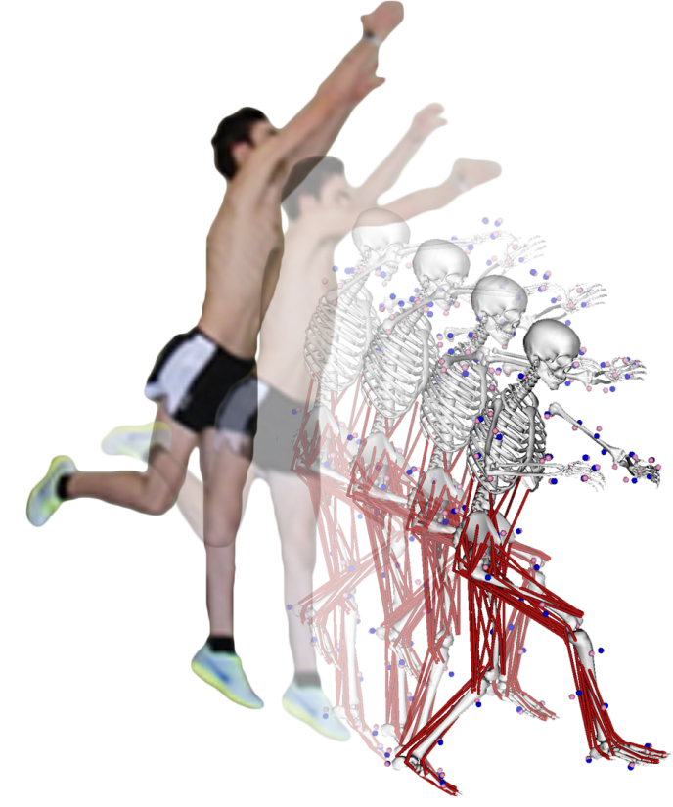
Figure 2.1. Series of images showing one of the seven participants and his subject-specific model performing the single-leg jump landing protocol: 1) jump from preferred leg; 2) attempt contact with a football at approximately 90% of vertical jump height and randomly moved relative to jump path; 3) contact force platform with the same leg used for jump. Three-dimensional, 14-segment, 37 degree-of-freedom and 92 muscle-tendon actuated subject-specific simulations were created in OpenSim 1.9.1 from the experimentally measured kinematic and ground reaction force data to estimate the lower extremity muscle forces during the weight-acceptance phase of the landing.

Three-dimensional kinematic marker trajectories, ground reaction forces (GRF) and sEMG data from six muscles crossing the knee were recorded for each participant during the experimental data collection. Fifty-six upper- and lower-body retro-reflective markers were utilized to capture kinematic trajectories (Donnelly et al., 2012b). Marker trajectories were recorded at 250 Hz using a 12-camera Vicon MX motion capture system (VICON Peak, Oxford Metrics Ltd., UK) (Dempsey et al., 2007; Donnelly et al., 2012c). GRF data were synchronously recorded at 2,000 Hz using an AMTI (Advanced Mechanical Technology Inc., Watertown, MA) 1.2 x 1.2m force platform. Both the kinematic and GRF data were low-pass filtered using a zero phase-shift, 4th-order Butterworth filter with a cutoff frequency of 20 Hz in Workstation (ViconPeak, Oxford Metrics Ltd., UK). The sEMG data were synchronously collected at 2,000 Hz for six muscles: vastus medialis, vastus lateralis, medial and lateral gastrocnemii and medial and lateral hamstrings. Eight surface muscles were measured with sEMG in total; however, this study focused on the six muscles that crossed the knee for analysis. The raw experimental sEMG data were band-pass filtered using a zero phase-shift, 4th-order Butterworth filter with a frequency band between 30 and 500 Hz, full wave rectified and then low-pass filtered using a zero phase-shift, 4th-order Butterworth filter with a cutoff frequency of 6 Hz to create linear envelopes. Following linear enveloping, peak muscle activation from each muscle recorded during the three landing conditions were used to normalize each muscle’s sEMG signal to 100% activation. The result is a sEMG waveform from zero to full activation.
2.3.2 Subject-specific Models and Simulations
Seven three-dimensional, 14-segment, 37 degree-of-freedom (DoF), 92 muscle-tendon actuated subject-specific models were created in OpenSim 1.9.1 to generate simulations of each participant performing the single-leg jump landing task (Fig. 2.1). The details of this model have been described previously (Donnelly et al., 2012c). The 92 muscle-tendon units actuated the lower extremity and lower back joint, while the arms were actuated by torque actuators also described previously (Hamner et al., 2010). The maximum isometric force of each muscle was increased by 60% compared to the model provided in OpenSim (Delp et al., 1990) based on research by Arnold et al. (Arnold et al., 2010). The model included a 3 DoF knee actuated by muscles and ideal torque actuators (±50Nm). These values are consistent with previous literature (Seedhom et al., 1972; Zhao et al., 2007). Subject-specific joint centers were derived using functional knee and hip joint methods (Besier et al., 2003), custom biomechanical models in MATLAB (MATLAB 7.8, The MathWorks, Inc., Natick Massachusetts, USA) and Vicon Bodybuilder (Dempsey et al., 2007). The resulting joint centers, marker trajectories and GRF data were then exported to OpenSim 1.9.1. Segment lengths were scaled to each participant’s specific joint centers and segment masses to each participant’s total body mass. Inverse kinematics (IK) was used to derive simulated joint angles from the experimental marker data recorded during the jump landing. Residual reduction analysis (RRA) was used to create simulations that were dynamically consistent with the experimentally recorded ground reaction forces (Delp et al., 2007; Donnelly et al., 2012c). Muscle forces were estimated for the weight-acceptance (WA) phase of single-leg jump landing using computed muscle control (CMC). CMC is an algorithm that utilizes optimization, forward dynamics and feedback control to estimate individual muscle forces during dynamic movements (Thelen and Anderson, 2006; Thelen et al., 2003).
The WA phase was defined as the time from the initial contact to the first trough in the vertical ground reaction force profile (Dempsey et al., 2007). The WA phase was analyzed as this phase is thought to be when the ACL is at the greatest risk for injury (Dempsey et al., 2007; Donnelly et al., 2012a).
2.3.3 Muscle Force Estimates during Single-leg Jump Landing
Muscle force estimates for nine muscles crossing the knee and the soleus were analyzed to determine their contribution during the WA phase of single-leg jump landing. Individual muscle forces were normalized by their individual maximum isometric force values used during the simulation to determine their relative force contribution. The mean maximum muscle forces for the nine muscles crossing the knee were analyzed individually and in groups of functional relevance (i.e., quadriceps, hamstrings and gastrocnemii). The force production time to reach maximum muscle force for the quadriceps, hamstrings and gastrocnemii muscle groups relative to the time to peak vertical GRF were also calculated. A one-way ANOVA and Tukey post-hoc analysis were conducted to compare mean maximum muscle force estimates for the individual muscles and each muscle group as well as their relative mean maximum force production timing with respect to the time to peak vertical GRF (α = 0.05).
2.4 Results
Gastrocnemii and quadriceps forces were, on average, higher than hamstrings forces during the WA phase of single-leg jump landing. No differences were observed in individual muscle force production between the subjects and trials; thus, all fourteen trials were analyzed together (Table 2.1). The largest muscle force estimates during the WA phase of single-leg jump landing in decreasing order were the quadriceps (1,730±271N), gastrocnemii (1,256±512N) and hamstrings (442±234N) (Fig. 2.2 and Table 2.2). The maximum force production between these muscle groups were significantly different (p<0.001) with the post-hoc analysis showing the quadriceps muscles produced significantly greater force than both the gastrocnemii (p=0.002) and hamstrings (p<0.001) muscles and mean maximum gastrocnemii muscle force estimates were significantly greater than the hamstrings (p<0.001).
Differences in the time for each muscle group to reach its maximum force production relative to the time to peak vertical GRF were observed. The quadriceps reached maximum muscle force first (3.4±14.8ms) followed by the gastrocnemii muscles (15.2±16.6ms) and then finally the hamstring muscles (19.6±23.5ms); however, these temporal differences were not significant (p=0.073) (Table 2.3). All three muscle groups reached maximum force, on average, after peak vertical GRF was observed.

Table 2.1. Mean maximum and minimum muscle force estimates for the individual muscles during the weight-acceptance phase of single-leg jump landing for fourteen trials.
 |  | Participant Muscle Force (N)
Muscle | Value |  | 1a | 1b | 2a | 2b | 3a | 3b | 4a | 4b | 5a | 5b | 6a | 6b | 7a | 7b | Mean ± StDev
Vastus  Medialis | Max  Min |  | 2,895  452 | 3,144  72 | 3,273  101 | 3,136  64 | 2,495  71 | 2,511  73 | 3,125  682 | 1,893  503 | 2,670  184 | 1,961  137 | 1,270  73 | 1,388  72 | 1,629  229 | 3,424  88 | 2,488±734^{b}  200±199
Vastus Lateralis | Max  Min |  | 1,065  101 | 683  117 | 696  34 | 706  59 | 1,136  111 | 2,251  133 | 226  97 | 1,995  98 | 220  121 | 1,188  281 | 676  128 | 2,645  131 | 1,599  317 | 254  137 | 1,096±770^{c,d,e,f}  133±76
Vastus Intermedius | Max  Min |  | 1,978  78 | 242  83 | 1,155  101 | 1,375  75 | 1,202  81 | 1,276  91 | 2,347  80 | 271  83 | 1,359  65 | 1,177  39 | 1,612  888 | 2,494  99 | 2,251  69 | 2,476  103 | 1,515±731^{c,d,e}  138±216
Rectus  Femoris | Max  Min |  | 1,651  411 | 2,016  964 | 2,231  1098 | 1,972  899 | 2,098  197 | 2,499  1279 | 2,084  92 | 2,890  98 | 844  90 | 1,055  18 | 2,470  1489 | 408  155 | 689  203 | 2,605  867 | 1,822±778^{b,c}  561±514
Medial Gastrocnemius | Max  Min |  | 1,746  151 | 2,344  125 | 928  80 | 3,174  84 | 732  283 | 1,332  247 | 2,561  650 | 2,115  482 | 3,076  171 | 1,098  351 | 378  176 | 154  41 | 692  117 | 1,745  314 | 1,577±975^{c,d}  234±171
Lateral Gastrocnemius | Max  Min |  | 1,360  509 | 1,016  296 | 1,098  568 | 1,558  671 | 481  107 | 1,223  455 | 353  39 | 919  482 | 312  66 | 606  182 | 1,356  625 | 1,335  884 | 374  103 | 1,094  155 | 935±430^{d,e,f}  367±267
Biceps Femoris Longus | Max  Min |  | 467  21 | 963  71 | 29  1 | 176  1 | 234  60 | 137  77 | 245  9 | 754  1 | 18  1 | 579  62 | 351  19 | 189  5 | 181  34 | 73  2 | 314±282^{f}  26±29
Semimbranosus | Max  Min |  | 983  153 | 1,522  316 | 1,031  85 | 1,273  107 | 729  6 | 107  2 | 1,019  81 | 592  92 | 446  164 | 476  109 | 510  211 | 91  2 | 124  9 | 912  2 | 701±444^{e,f}  96±93
Semitendinosus | Max  Min |  | 333  33 | 571  49 | 399  105 | 377  29 | 232  42 | 284  25 | 235  85 | 173  96 | 291  78 | 462  203 | 225  62 | 96  13 | 114  36 | 569  18 | 312±150^{f}  62±50
Soleus | Max  Min |  | 4,445  245 | 3,012  186 | 5,189  233 | 5,055  163 | 3,562  181 | 2,112  239 | 2,152  30 | 3,323  70 | 2,073  576 | 2,729  41 | 2,861  293 | 3,582  250 | 4,031  4 | 2,390  9 | 3,323±1049ª  180±152
ANOVA identified a significant difference for the maximum values of the individual muscles (p < 0.001; n = 14).
Symbols a,b,c,d,e,f indicate Tukey’s adjusted post-hoc difference (α = 0.05) in mean maximum muscle force between the individual muscles. Muscles with the same letters are not significantly different from each other. Conversely, if muscles do not share a letter, the means are significantly different.

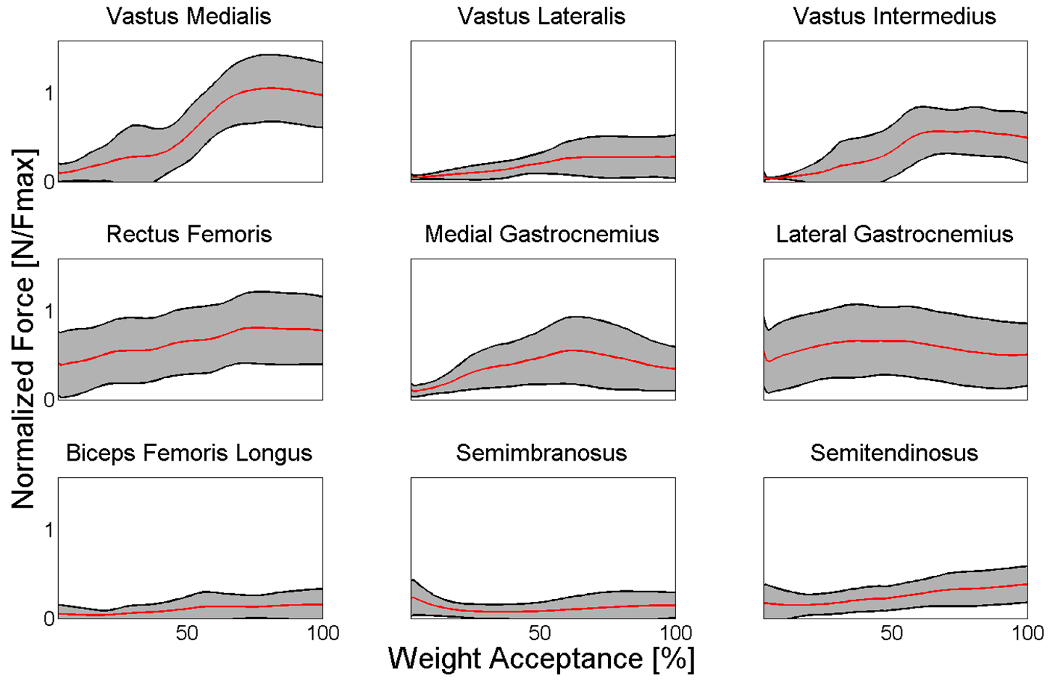
Figure 2.2. Lower extremity muscle force estimates (normalized by peak isometric force, Fmax) for muscles crossing the knee joint during the weight acceptance phase of single-leg jump landing. Mean forces (solid line) and one standard deviation (gray area) for the fourteen trials by the seven participants. Note, due to the force-velocity relationship of the muscle model, some normalized force estimates are higher than 1 as a result of eccentric contractions taking place.

Table 2.2. Mean maximum and minimum muscle force estimates for the three muscle groups during the weight-acceptance phase of single-leg jump landing for fourteen trials.
 | Participant Muscle Force (N)
Muscle Group | Value | 1a | 1b | 2a | 2b | 3a | 3b | 4a | 4b | 5a | 5b | 6a | 6b | 7a | 7b | Mean ± StDev
Quadriceps | Max  Min | 1,897  261 | 1,521  309 | 1,839  334 | 1,797  274 | 1,733  115 | 2,134  394 | 1,946  238 | 1,762  196 | 1,273  115 | 1,345  119 | 1,507  645 | 1,734  114 | 1,542  205 | 2,190  299 | 1,730±271ª  258±143
Gastrocnemii | Max  Min | 1,553  330 | 1,680  211 | 1,013  324 | 2,366  378 | 607  195 | 1,278  351 | 1,457  345 | 1,517  482 | 1,694  119 | 852  267 | 867  401 | 745  463 | 533  110 | 1,420  235 | 1,256±512^{b}  301±116
Hamstrings | Max  Min | 594  69 | 1,019  145 | 486  64 | 609  46 | 398  36 | 176  35 | 500  58 | 506  63 | 252  81 | 506  125 | 362  97 | 125  7 | 140  26 | 518  7 | 442±234^{c}  61±41
ANOVA identified a significant difference for the maximum values of the muscle groups (p < 0.001; n = 3).
Symbols a,b,c indicate Tukey’s adjusted post-hoc difference (α = 0.05) in mean maximum muscle force between the muscle groups. Muscle groups with the same letters are not significantly different from each other. Conversely, if muscle groups do not share a letter, the means are significantly different.

Table 2.3. Comparison of time differences between peak vertical ground reaction force (GRF) and maximum muscle force estimate for each muscle group during the weight-acceptance phase of single-leg jump landing for fourteen participants. Positive time values indicate that the muscle group reached maximum force after peak GRF was reached.
 | Participant Time to Maximum Force (ms)
Muscle Group | 1a | 1b | 2a | 2b | 3a | 3b | 4a | 4b | 5a | 5b | 6a | 6b | 7a | 7b | Mean ± StDev
Quadriceps | 31.5 | -5.9 | -1.6 | -0.9 | -10.9 | 17.7 | -5.4 | 3.5 | 19.5 | -9.8 | 23.4 | -0.6 | -20.5 | 8.1 | 3.4± 14.8
Gastrocnemii | 36.0 | 25.5 | -22.3 | 13.5 | 17.8 | 26.4 | -5.6 | 24.7 | 2.2 | 14.0 | 40.0 | 2.4 | 15.4 | 22.3 | 15.2± 16.6
Hamstrings | 43.1 | 6.8 | 59.2 | 8.2 | -17.9 | 6.8 | 32.3 | 24.7 | 34.6 | 48.4 | 36.0 | 9.4 | -13.1 | -3.6 | 19.6± 23.5
ANOVA identified a significant difference for the time to maximum muscle group force for the muscle groups (p = 0.073 and n = 3).
Negative values indicate the muscle group reached maximum force before vertical ground reaction force maximum.

2.5 Discussion
The purpose of this study was to characterize force production of muscles supporting the knee during the WA phase of single-leg jump landing. Results showed that the quadriceps generated the greatest force followed by the gastrocnemii and then the hamstrings. Additionally, the quadriceps reached maximum force earlier than the gastrocnemii and hamstrings. Future research for effectively designing preventative training protocols should consider targeting the strength and coordination of these muscle groups, particularly the quadriceps and gastrocnemii, for injury prevention practice among community-level athletic populations.
There are several possible biomechanical explanations for why each muscle group crossing the knee produces force differently to stabilize and support the knee during singe-leg jump landing. The co-contraction of the quadriceps, gastrocnemii and hamstrings is likely utilized to improved joint stability and reduce the strain exerted on the ACL during single-leg landing (Podraza and White, 2010; Riemann and Lephart, 2002). Results also support the notion that the primary motor control task during landing is to produce a support moment capable of maintaining the whole body center of mass (CoM) upright as the quadriceps and gastrocnemii provide knee extension and ankle plantarflexion moments, respectively (Winter, 1980). These results suggest co-contraction between the quadriceps and gastrocnemii, not the quadriceps and hamstrings, are the primary muscle groups used to stabilize and support the knee from external joint loading during landing.
The hamstrings produced less maximum force and peaked later than the gastrocnemii muscles. This finding adds to the clinical understanding of how muscles function to support the knee during single-leg landing. Previous clinical research proposed hamstrings are activated to a similar extent as gastrocnemii during landing (Cowling and Steele, 2001). Clinical research has also proposed that elevated hamstrings activation in response to quadriceps activation is used to increase co-contraction, stabilize the knee and protect the knee ligaments, including the ACL, from external valgus and/or torsional loading (Alentorn-Geli et al., 2009; Hewett et al., 2006; Li et al., 1999; Wojtys et al., 2002). However, these clinical findings are based on muscle activation estimates (sEMG), rather than muscle force estimates. The current study’s results suggest the gastrocnemii, rather than the hamstrings, generate forces to counterbalance elevated quadriceps forces and stabilize the knee joint during the WA phase of single-leg jump landing.
The soleus produced large forces during the single-leg jump landing (3,323±1049 N), which is consistent with peak isometric in-vivo force measurements (3,469 ± 720 N) reported by Rubenson et al. (2012). Previous research suggested this additional force would add to the gastrocnemii-soleus complex force generating capacity, suggesting the role of the gastrocnemii in supporting the knee during single-leg landing may be underestimated (Mokhtarzadeh et al., 2013; Podraza and White, 2010; Rubenson et al., 2012).
The gastrocnemii are biarticular muscles that have multiple functions about the knee and ankle. Gastrocnemii’s primary function is to plantarflex the foot during landing, which contributes to the production of a support moment (Winter, 1980). Results presented here suggest its secondary function may be to co-contract with the quadriceps to stabilize the knee and protect the ACL from external joint loading. These results are supported by previous research that has shown elevated gastrocnemii activity compared to the hamstrings during jump landings (Chappell et al., 2007; Colby et al., 2000; Fagenbaum and Darling, 2003; Myer et al., 2009; Nyland et al., 2010; Padua et al., 2005; Viitasalo et al., 1998). The mean gastrocnemii force was greater than the hamstrings, and was consistent across all fourteen simulations in this study irrespective of swing direction. These findings suggest a generalized muscle force strategy may be used to generate a support moment to resist the fall of the whole body mass center, while also supporting the knee and ACL from external knee loading and injury risk (Boden et al., 2009).
Although not a focus of this research, specific temporal patterns in maximum muscle force generation were observed. Mean maximum force of the gastrocnemii occurred 15.2 ms after peak vertical GRF, which is when peak ACL strain is observed during a similar jump-landing task (Cerulli et al., 2003). Gastrocnemii maximum force was preceded by the quadriceps but shortly followed by the hamstrings. The timing of maximum muscle force production provides useful information about how muscles help distribute loads at the articular surface among the muscles and ligaments, like the ACL (Iida et al., 2011; Lloyd and Buchanan, 2001). The timing of muscle activation is a critical factor between successful and failed jump landings as late activation of quadriceps with respect to hamstrings led to failed jump landings (Wikstrom et al., 2008). The pattern including early gastrocnemii activation could show how individuals use a bottom up strategy to stabilize the knee and, in turn, reduce ACL injury risk.
Musculoskeletal modeling for biomechanical analysis is challenging. Often assumptions regarding model parameters have to be made to perform these analyses. The model included a 3 DoF knee, with prescribed kinematics to allow for the knee’s rolling motion in the sagittal plane (Delp et al., 1990); however, the model did not include knee ligaments or an articular surface, which can function to support the knee against external frontal plane knee moments. Using OpenSim joints and actuators without implementation of complex contact model components, there are three possible approaches to address this limitation: 1) lock frontal plane knee motion (which is unrealistic as it assumes the knee only moves in two planes); 2) allow the knee to move freely in the frontal plane similar to the hip (which is unrealistic as it fails to account for the ligaments and articular surface that help support/resist motion in the frontal plane); and 3) allow the knee to move in the frontal plane but use an ideal torque actuator to represent the ligaments and articular surface supporting the knee against external frontal plane knee moments. This third option was employed. Since the simulated muscle excitations were similar to experimentally recorded excitations the inclusion of the ideal torque actuator did not significantly affect muscle force results in this study. The torque actuator worked with and not against the muscles to help stabilize the knee during landing as the model accurately tracked the frontal plane knee kinematics.
The model’s maximum isometric muscle forces had to be uniformly increased 60% to better represent the muscle architecture of a young healthy athletic adult male population (Arnold et al., 2010; Lexell et al., 1988), since the baseline force values were derived from elderly cadavers (Delp et al., 1990). While these increases in maximum isometric muscle force were sufficient to facilitate the generation of accurate single-leg jump landing simulations, a more universal method for adjusting muscle forces for varying populations may be necessary and should be addressed in future research.
Despite these assumptions, the simulated kinematics, kinetics and muscle excitations were comparable against experimental kinematic, kinetic and muscle activation estimates and provided confidence that the results are representative of muscle forces during single-leg jump landing. The mean deviation between experimental (IK) and muscle-actuated simulation kinematics was 3.5 ± 1.4° for all lower extremity joint angles during the WA phase of single-leg jump landing for all participants with a maximum of 9.9° abduction at the hip (Fig. 2.3, Table 2.4). These deviations in simulated joint kinematics and moments are needed to improve the dynamic consistency with experimentally recorded GRF. All simulations were shown to be dynamically consistent with low peak residual forces (5N) and moments (8Nm) at the pelvis. The CMC excitations used to drive the simulation were closely aligned with the experimentally measured sEMG activation data (Fig. 2.4). The consistency between the simulated joint kinematics, kinetics, and muscle excitations compared with the experimentally recorded data suggests simulations of single-leg jump landing represented the experimental sport task.

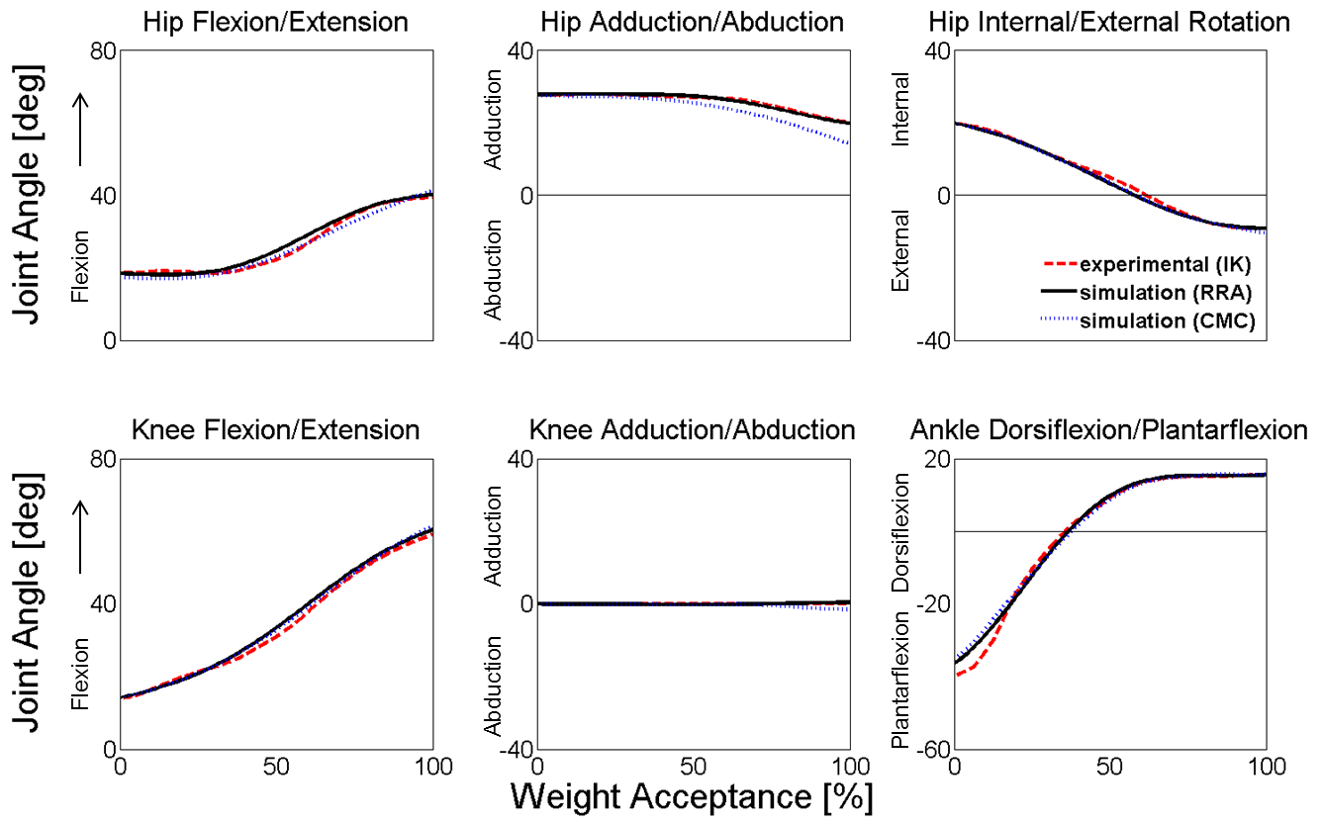
Figure 2.3. Comparison of lower extremity joint angles at different steps in the process of creating a muscle-actuated dynamic simulation during the weight-acceptance phase of single-leg jump landing for an example participant. The dashed-line represents the joint angles calculated by inverse kinematics (IK), the solid line represents joint angles following residual reduction analysis (RRA) to make the motion dynamically consistent with ground reaction forces, and the dotted line represents joint angles from the muscle-actuated simulation generated with computed muscle control (CMC).

Table 2.4. Comparison of the mean maximum joint kinematics, kinetics and vertical ground reaction force (GRF) for the fourteen trials during the weight-acceptance phase of single-leg jump landing.
Kinematics (degrees)
Hip flexion | 22.3±15.6
Hip adduction | 22.0±8.5
Hip internal rotation | 12.9±15.1
Knee flexion | 53.4±7.2
Knee adduction | 0.5±1.3
Knee internal rotation | 8.3±17.3
Ankle dorsiflexion | 17.8±7.1
Joint moments (Nm/kg-m)
Hip extension | 2.3±1.3
Hip abduction | 0.8±0.8
Hip external rotation | 0.6±0.2
Knee extension | 3.1±0.6
Knee abduction | 1.1±0.4
Knee internal rotation | 0.1±0.1
Ankle plantarflexion | 2.2±0.6
Ground Reaction Force (BW)
Vertical ground reaction force | 4.3±0.6

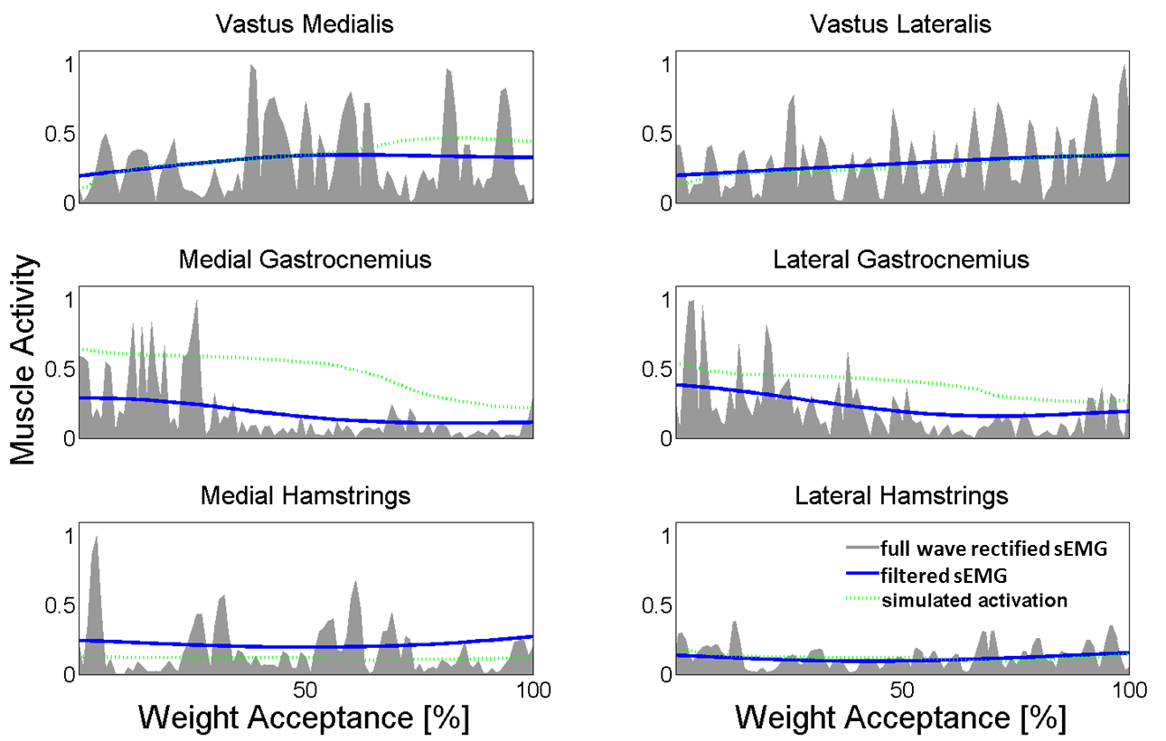
Figure 2.4. Comparison of experimental surface electromyography (sEMG) and simulated muscle excitations during the weight-acceptance phase of single-leg jump landing for an example participant. Experimental unfiltered full wave rectified (gray area) and filtered (solid line) sEMG and simulated muscle excitations (dashed line) estimated during the weight acceptance phase of single-leg jump landing. The experimental unfiltered full wave rectified (gray area) and filtered (solid line) sEMG data are individually normalized to the maximum recorded signal of each muscle over one of the landing trials. Simulated excitations (dashed line) are defined to be between 0 (no excitation) and 1 (full excitation).

This study investigated male muscle force estimates during single-leg jump landing with implications for ACL injury risk despite the fact that females suffer ACL injuries at a disproportionately higher rate than men (Hewett et al., 2006). Female’s tend to produce a smaller knee flexor moment than men and this inability to counterbalance the quadriceps and reduce anterior tibial translation may be the potential cause for this higher rate (Hewett et al., 2006; Hewett et al., 1996). The males in this study demonstrated that elevated force production by the gastrocnemius-soleus complex may be the way to address this muscle imbalance and resist anterior tibial translation, a finding observed in the literature (Mokhtarzadeh et al., 2013; Podraza and White, 2010). While female models would have different skeletal geometry and muscle strength, the females (muscles) should have the same goal for muscle force production to generate a moment to support the CoM, stiffen the knee and mitigate the loads on the ACL. Since both males and females should have the same injury mechanism where the ACL ruptures when the load is greater than the tissue tolerance, females may simply have a larger quadriceps to gastrocnemii and hamstrings deficit which could be why they get injured more.
The combination of experimental and computational tools used in this study were capable of producing fourteen independent dynamically consistent simulations of single-leg jump landing, with a muscle force estimates supported by previous clinical (Chappell et al., 2007; Colby et al., 2000; Nyland et al., 2010; Padua et al., 2005; Podraza and White, 2010) and in-silico (Shin et al., 2007) research. These results indicate a strategy where quadriceps, gastrocnemii, and hamstrings play different roles in supporting the knee and this information can serve as the foundation for novel muscle-targeted training intervention programs to reduce ACL injuries.
2.6 Conclusion?

References

Place references for this chapter here, or you can collect all of your references into a reference section at the end of the document (before the appendix if you have one for the entire ETD, and before the vita). If you have one reference section, the heading for this section should be treated as a major heading, and the title should get its own page.

Still deciding if I want to put references at the end of each chapter or at the end.

Appendix

You can place references for this chapter here, or you can collect all of your references into a reference section at the end of the document (before the appendix if you have one for the entire ETD, and before the vita). If you have one reference section, the heading for this section should be treated as a major heading, and the title should get its own page.

I’m still deciding if I want to put figures and tables in text or in appendix. I also have to decide if I’m going to generate additional figures for this section.

CHAPTER III
ASSESS HOW INDIVIDUAL MUSCLES RESIST ELEVATED KNEE ABDUCTION MOMENT DURING SINGLE-LEG JUMP LANDING

3.1 Abstract
Chapter 2 determined the individual muscle force production of muscles crossing the knee during the WA phase of single-leg jump landing. The results of that study determined that the quadriceps produced the greatest force with the gastrocnemius and hamstring muscles producing force to counter the quadriceps muscles. The elevated gastrocnemius muscle force production is thought to indicate that the gastrocnemii muscles play a more prominent role in opposing the quadriceps muscles while stabilizing and supporting the knee during landing than the hamstring muscles (as previously believed). Increased force production by the quadriceps and gastrocnemii muscles does not validate their potential role as the primary contributors to stabilizing and supporting the knee during landing. A muscles’ contribution to movement is dependent on 1) calculating individual muscle force production and then 2) computing the muscle forces’ ability to accelerate (knee) joint motion during landing. After assessing the individual muscle force production during landing via CMC, the next step is to compute the muscle forces’ ability to accelerate the knee during landing.
Muscles accelerate joints and determining how they accelerate the knee during landing may be the key to understanding ACL injury prevention. Induced acceleration analysis (IAA) identifies the accelerations caused or “induced” by individual muscle forces acting on a model (e.g., contribution of muscle forces to knee accelerations). Such an analysis can reveal the contribution of each individual muscle to frontal, sagittal and transverse plane knee accelerations and determine those muscles responsible for resisting certain elevated knee accelerations; thus providing a connection between knee abduction and internal rotation accelerations and ACL injury risk. The present study will use this analysis to better understand the cause-effect relationship (i.e., muscle contributions to movement) between muscle forces and joint biomechanics. This lack of understanding has limited the progress of the current ACL injury research.
The seminal objective of this current study was to understand how muscles contribute to knee accelerations associated with knee injury risk, specifically anterior cruciate ligament (ACL) injury risk during single-leg jump landing. Induced acceleration analysis will be performed using OpenSim to determine which muscles accelerate the knee in the frontal, sagittal and transverse planes.

3.2 Introduction

3.2.1 Induced Acceleration Analysis Description
The objective of this study was to understand how muscles contribute to knee accelerations associated with knee injury risk, specifically anterior cruciate ligament (ACL) injury risk, during single-leg jump landing. Induced acceleration analysis was performed in OpenSim to determine which muscles accelerate the knee in the frontal, sagittal and transverse planes. IAA quantifies an individual muscles ability to accelerate a joint or body segment. Reliable ground reaction force data measured from force plates are decomposed to calculate the individual muscle forces using the concept/principle of dynamic coupling. Dynamic coupling describes the interconnectedness of the body segments throughout the body. Thus by applying this principle the force produced when the foot comes into connect with the ground (i.e. force platform) is transmitted throughout the body to determine individual muscle force contribution at each joint and body segment.
A critical aspect of this analysis was the ability to accurately model the foot-ground (contact) interaction [63]. There are a variety of methods in addition to IAA that calculates individual muscle force contribution to movement; such as, perturbation analysis [10]. These methods vary by how they model the foot-floor (foot-ground) interaction. For the perturbation analysis, the hard-constraint approach has been used to model the foot-ground contact in activities like walking while a combination of non-penetrating unilateral constraints and pure rolling constraints have been used to analyzing running [10, 12]. However, limitations of current foot-ground contact models are that they are typically designed for heel first landing and have difficulty modeling the rapid transition from flight to landing phase. Because we are interested in modeling the WA phase of single-leg jump landing, which is a toe first landing movement that captures the flight to landing transition, we need to apply the appropriate foot-ground contact model to evaluate the individual muscle force contribution during jump landing. Currently, a MULTIPOINT model consisting of 5 points, each with a weighting coefficient that changes with time is the best option for describing the foot as it transitions from heel strike to toe-off [41, 43, 64, 65]. This model will be modified for jump landing to address our hypothesis and determine if the quadriceps, medial hamstrings and medial and lateral gastrocnemii will provide the greatest contribution to resisting elevated knee abduction moment and ACL injury risk.
OpenSim’s IAA v2.4.0 modeled the foot-ground interaction using five foot-ground contact points- two at the medial and lateral sides of the mid calcaneus (heel), two at the first and fifth metatarsals junctions and one at the toe [43]. Each contact point was modeled as a rigid contact (i.e. weld joint) leaving the foot unable to accelerate in any direction. In this model, when the foot comes out of contact with the ground, discontinuities would arise. To eliminate these discontinuities Dorn et al. utilized a diagonal weight matrix that applied a linear (foot) acceleration constraint to each contact point. These weightings varied from 0 (unconstrained) to 1 (fully constrained, rigidly constrained) based on the contact points location to the center of pressure (CoP).

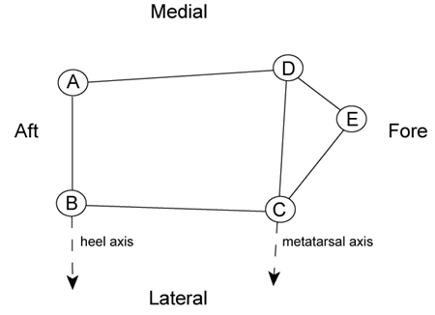
Fig. 3.1. Five ground contact points (per foot) are defined by markers in OpenSim [43]

When the CoP is behind (posterior) the medial and lateral calcaneus contact points, the weighting function in Equation 3.1 is applied. And as the CoP moves anteriorly towards the calcaneus contact points, the weighting function described by Equation 3.2 is used. The switching between these two equations was based on the shortest distances from the CoP to the heel axis AB and the metatarsal axis CD, respectively.
$$φ\left(d_{h},d_{m}\right)=\frac{d_{h}}{d_{h}+d_{m}} (3.1)$$

$$γ\left(d_{m},d_{E}\right)=\frac{d_{m}}{d_{E}} (3.2)$$

With the foot contact weighting functions developed, they are applied to the equations of motion (Eq. 3.3) for a musculoskeletal model. In Equation 3.3, M is an n x n mass matrix where q, $\dot{q}$, and $\ddot{q}$ are nx1 vectors of generalized displacements, velocities and accelerations, respectively. C is an n x 1 generalized force vector obtained from the velocity terms obtained from the centrifugal and Coriolis force equations and G is an n x1 generalized force vector due to gravity. S is an n x k matrix of muscle moment arms that maps a k x 1 vector of muscle forces $F_{m}$ into generalized forces and $R_{6x1}$ is the vector of generalized residual forces/torques. Continuing on, $r_{nτx1}$ is the vector of generalized reserve forces/torques; $F_{ext}$ is an 3f x 1 vector of external reaction forces exerted on the foot by the ground by the f foot contact points that are in contact with the ground, and E is an n x3f linear generalized Jacobian matrix that defines the relation between the generalized velocity $\dot{q}$ and the linear velocity of the foot-ground contact point. This equation is used to decompose the ground reaction force into individual muscle force contribution.
$$M \left(q\right)\ddot{q}=C\left(q,\dot{q}\right)+G\left(q\right)+ \left[\begin{matrix}0_{6x1} \\ S(q)F_{m}\end{matrix}\right]+\left[\begin{matrix}R_{6x1} \\ r_{nτx1}\end{matrix}\right]+E\left(q\right)F_{ext} (3.3)$$

3.2.2 EXPAND ON INTRODUCTION to tell why you are doing this study!!!!

3.3 Methodology
The thirty-seven (37) DoF and ninety-two (92) muscle actuated subject specific dynamically consistent simulations developed in the previous study with an incorporated foot contact expression served as the model for the induced acceleration analysis (IAA). Additional critical inputs included ground reaction force and CoP location and kinematics and CMC derived muscle force estimates. The generated output provided the individual muscle force contributions for the anterior-posterior, vertical and mediolateral CoM and GRF accelerations and the acceleration of each joint and body segment in the model in sagittal, frontal and transverse planes during the WA phase of single-leg jump landing. The principle of superposition was used to calculate the error between the experimental and model computed GRFs to assess the validity of the results [10, 12, 43]. These results were used to determine the muscles crossing the knee contribution to accelerating the knee in the frontal, sagittal, and transverse planes during the WA phase of single-leg jump landing.
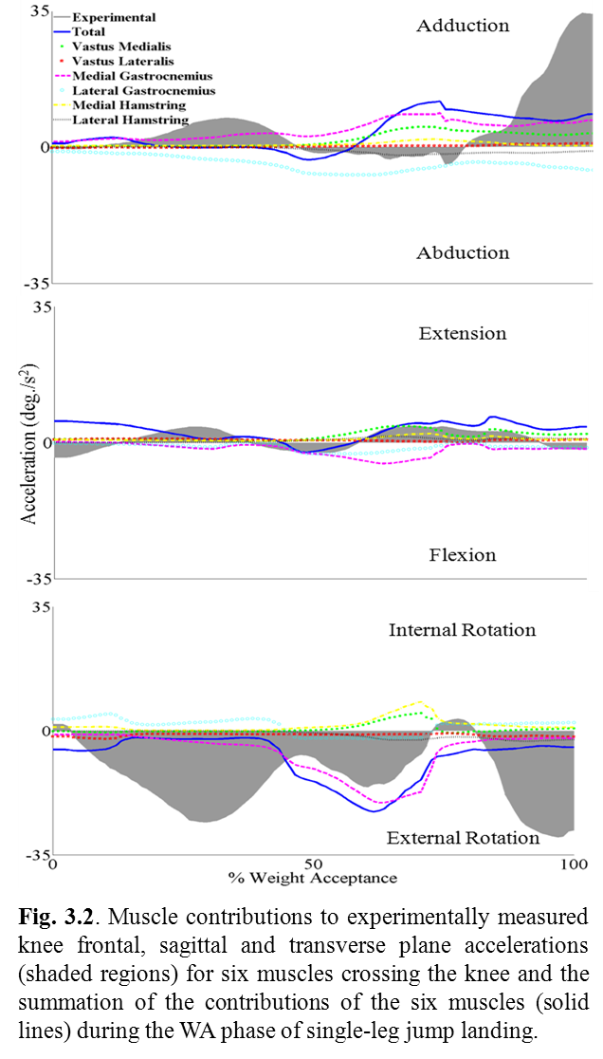

3.4 Results
The muscular contributions to knee accelerations varied widely during the WA phase of SLJL (Fig. 3.2). In the frontal plane, the muscles that contributed to knee adduction based on peak and mean acceleration in descending order were the medial gastrocnemius, vastus medialis and medial hamstring muscles. The lateral gastrocnemius and hamstring muscles opposed adduction. In the sagittal plane, the muscles that accelerated the knee into extension in decreasing order were the vastus medialis, medial hamstring, lateral hamstring and vastus lateralis muscles. The gastrocnemii muscles resisted extension. In the transverse plane, the vastus medialis and medial hamstring muscles mainly contributed to internal knee rotation and the medial gastrocnemius muscle was the strongest contributor to external knee rotation.
3.5 Discussion
The objective of this study was to understand how muscles contributed to knee accelerations and mitigating injury risk. It has been surmised that muscles opposing knee extension, abduction and also internal rotation could potentially reduce injury risk [7]. The present results indicate that strong force production by the medial muscles served to counteract the early force production of the lateral gastrocnemius to adduct the knee and potentially mitigate ACL injury risk. Additionally, the gastrocnemii muscles flexed the knee in an attempt to oppose the quadriceps muscles motion and increase knee flexion during landing. However, the lateral gastrocnemii role of internally rotating and abducting the knee may mitigate its positive effect via knee flexion.

3.6 Conclusion?
Based on these results, the medial gastrocnemius may be the best target for prevention programs to reduce ACL injury risk since it can generate a large enough acceleration to oppose knee abduction and internal rotation. The lateral gastrocnemius is useful as a knee flexor and in this capacity could potentially resist the anterior translation of the tibia; however, its role in abducting the knee may diminish the significant of the former contribution to lowering ACL injury risk.
This preliminary study involved only one individual our future work will include additional subjects and address the generality of observed trends across a large population. Additionally, future analyses will investigate the contributions of muscles that do not cross the knee to knee accelerations in the frontal, sagittal and transverse planes.
IAA does a poor job of tracking high velocity movements and future work will focus on developing an appropriate foot contact model to mitigate this problem. Currently, researchers are investigating modeling the foot-ground contact using rolling constraints to more accurately represent the foot-ground interaction. More recent versions of OpenSim provide the flexibility to apply these constraints to the model. The law of superposition will be employed to validate each model by comparing the results of the model generated GRF to the experimental GRF. The model that best matches the experimental GRF will be used for IAA to determine which muscles best resist against knee abduction acceleration.

CHAPTER IV

UTILIZE DATA MINING TO DETECT MOVEMENT ABNORMALITIES AND IDENTIFY INDIVIDUALS AT-RISK FOR ACL INJURY

Or

TITLE OF PCA PAPER

4.1 Abstract
The purpose of Chapter 4 is to utilize data mining to identify hidden patterns in the joint biomechanics and EMG data to identify individuals at risk for ACL injury. While it is important to know which biomechanical factors contribute to movement, it is also critical to determine how they function differently in individuals at high and low risk for ACL injury. In this study a large dataset of experimental kinematic, kinetic, sEMG and simulated muscle force data were obtained to determine relationships between these biomechanical variables and ACL injury risk. We can assess this relationship using functional data analysis that utilizes/applies statistical methods; such as principal component analysis (PCA) to determine the relationship between these biomechanical variables and ACL injury risk. The end goal is to use the model to identify individuals at high risk for ACL injury.
Wavelet analysis can be used to detect anomalies in time series. This approach involves reducing the original waveform into wavelets, shortened versions of the original waveform to identify and analyze patterns and/or abnormalities in the data [66]. With respect to the human body, wavelets have been used to analyze brain activity and heart rhythms to detect the onset of seizures and myocardial infarctions and to detect hidden features/elements within the genetic code; however its application in human movement is lesser known [67-69]. This study will use this technique to analyze muscle activity derived from EMG data with the aim of detecting abnormalities associated with at-risk individuals.
Both PCA and wavelet analysis will be used in conjunction to detect unique features that earmark at risk individuals prone to ACL injuries. First PCA will be used to correlate changes in knee kinematics and kinetics to muscle function via EMG data. Next wavelet analysis will be used to extract hidden patterns in EMG data and map them to the PCA result. It is our view that such an approach can be quite fruitful.
4.1 Abstract
Anterior cruciate ligament (ACL) injuries are common sports injuries, costing the US economy roughly $1 billion per year. To reduce this burden, researchers generally analyze an athlete’s joint motion and muscle activation during movements where non-contact ACL injuries have been shown to occur to better understand the underlying mechanisms of ACL injury. In general terms, most studies analyze discrete variables at specified instances in time to identify differences in an athlete’s movement patterns to identify possible biomechanical factors associated with non-contact ACL injuries; however, additional information could be obtained from analyzing these variables over the entire waveforms. Principal component analysis (PCA) is a statistical tool that analyzes multiple waveforms to determine the source of variability between them. These tools have been used previously, and shown to be an effective clinical tool in the assessment of human movement in multiple clinical populations. In this study, PCA was used to analyze an athlete’s joint motions and muscle activation waveforms during a single-leg jump-landing sport task to determine if individuals at varying risks of ACL injury as determined from their peak valgus knee loading adopted different motor recruitment strategies. Results showed that individuals classified as high- and moderate-risk adopted a generalized muscle activation pattern while the low-risk groups selectively activated muscles with moment arms that support the knee in the frontal plane. And all three risk groups reported elevated gastrocnemius muscles activation relative to the hamstring muscles. These findings provided added insight into how muscles are used to support the knee during single-leg landing and may aid in designing ACL injury prevention training designed to mitigate ACL injury risk.

4.2 Introduction
Anterior cruciate ligament (ACL) injuries are a common sports injury occurring in 1 in every 3,000 individuals [1]. Approximately 60% of ACL injuries are classified as non-contact, with approximately half of these occurring during single-leg jump landing sport tasks [2-3]. The ACL serves to resist excessive translational and rotational motion between the femur and tibia with an ACL injury leading to a loss in joint stability which is critical to the successful execution of dynamic movements like single-leg jump landing. To understand the relationship between joint stability and ACL injuries researchers have implemented injury prevention protocols to reduce ACL injury rates; yet, despite their implementation ACL injuries have increased over the last decade. The problem may not be the protocols but for whom the protocols target/are designed.
The current literature has seen an influx of research focusing on the support (role) muscles provide in stabilizing the knee and causal relationships between joint biomechanics and muscle function. In an attempt to develop such relationships, a feedback description is hypothesized where the musculoskeletal system (body) is represented by a feedback system that receives joint inputs; the body sensors are sensory neurons that detect deviations/disturbances from the norm and stimulate muscles actions that stabilize the system. In this approach muscles response is linked to joint stability and dynamics and provides a framework for establishing cause-effect relationships for ACL injuries.
Here traditional control theory concepts will be used to assess knee stability. [Presently there are no formal definition for stability (and/or joint stability) in the biomechanics arena(check?)]. Control theory recognizes/defines stability as “a performance measure of a system” (p. MCS 1016) that can be quantified. Both Nyquist and Bode Stability criteria are frequency techniques that evaluate the transfer function of the system to provide graphical and quantitative measures for differentiating stable, marginally stable, and unstable system states. In this study, individuals will be classified as low-, moderate- or high- risk for ACL injury using the aforementioned control stability criteria.
Joint stability is important because it dictates muscles response and being able to ascertain what musles are activated during a jump landing is critical to assessing ACL injury risk. If differences in muscle activation patterns exist between athlete’s defined as high and low risk, such information can potentially be used to devise effective ACL injury prevention training programs. The key is to extract or mine the relevant features within these large, multivariate datasets [8]. Principal component analysis (PCA) is a valuable statistical analysis tool for reducing such large high-dimensional datasets into a smaller ones and isolating the dominant sources of variability within them. This method has been successful applied in clinical settings to 1) identifying differences in lifting kinematics and kinetics between healthy individuals and lower back pain populations, 2) distinguishing between frontal plane kinetics of male and female subjects during unanticipated cutting maneuvers, and 3) assessing the success of two total hip arthroplasty surgical approaches in restoring the normal gait patterns post-surgery [13-15]. The success of PCA in these aforementioned clinical applications provides a rationale for its use in identifying specific muscle recruitment strategies distinct to populations classified as high, moderate and low risk to ACL injury.
Here traditional control stability analysis was used to classfied individuals into ACL injury high, moderate and low risk athletes that are at risk during single-leg jump landing. The research goal is to establish which biomechanical variables (marks) account for most of the variability between individuals in each of these risk groups and if different muscle activation strategies are presented. Subject-specific simulations of single-leg jump landings provided kinematic and kinetic data, while surface electromyography provided information about muscle activation. PCA was then used to identify muscle activation strategies distinct to each risk group. [HYPOTHESIS???]

4.3 Methodology
4.3.1 Experimental Protocol and Data Collection
Western Australian Amateur Football players were recruited to complete a single-leg jump landing protocol. Joint kinematics and ground reaction force (GRF) measurements were obtained from the experimental motion capture data collected during the protocol (see experimental details below). For the single-leg jump landing protocol, subjects were instructed to jump from their preferred leg, and while in flight, an Australian football was randomly swung medially, laterally or held central to the subjects approach direction [16]. The height of the ball was approximately 90% of each subject’s maximal vertical jump height. After the subject had successfully made contact with the football in flight, they were instructed to contact the force platform with the same right leg from which they jumped. Five athletes (age 20.5 ± 1.8 years; mass 87.5 ± 4.4kg; weight 1.86 ± 0.1m) were randomly selected from the aforementioned cohort. Six trials were analyzed per each participant; two when the ball was swung medially, two when it was swung and two when it was held central to the landing direction for 30 trials total [17]. All of the experimental procedures were approved by the University of Western Australia Human Research Ethics Committee and all subjects provided their informed written consent prior to data collection.
Experimental kinematic marker trajectories, GRF, and surface electromyography (sEMG) data were collected from each subject during the single-leg jump landing task. Three-dimensional, full-body kinematics were recorded using a12-camera, 250 Hz VICON MX motion capture system (VICON Peak, Oxford Metrics Ltd., UK) [18,19]. The GRF data were synchronously recorded at 2,000 Hz using an AMTI (Advanced Mechanical Technology Inc., Watertown, MA) 1.2 x 1.2m force platform. Both the kinematic and GRF data were low-pass filtered at 20 Hz using a zero phase-shift 4th-order Butterworth digital filter in Workstation (ViconPeak, Oxford Metrics Ltd., UK). Additionally, sEMG data were collected at 2,000 Hz for six muscles: vastus medialis, vastus lateralis, medial and lateral gastrocnemii and medial and lateral hamstrings. The medial and lateral vasti muscles were measured to represent the quadriceps muscle group. The raw experimental sEMG data were filtered with a zero phase-shift 4th-order Butterworth filter between 30 and 500 Hz, full wave rectified and then low-pass filtered using a zero phase-shift 4th-order Butterworth digital filter at 6 Hz to create linear envelopes. Following linear enveloping, peak muscle activation from each muscle (n=6) recorded during any of the nine landing conditions was used to normalize each muscle’s sEMG signal to 100% activation. The result is a sEMG waveform from zero to full activation.
4.3.2 Subject-specific Models and Simulations
Multiple three-dimensional 14-segment, 37 degree-of-freedom (DoF), 92 muscle-tendon actuated subject-specific models were created in OpenSim 1.9.1 to generate simulations of the subjects performing single-leg jump landings (Fig. 1) [20]. Each simulation was generated using a three-step process. First, the model’s segment lengths and mass were scaled to each subject. Second, joint kinematics were calculated from experimental kinematic marker data using inverse kinematics (IK). Third, residual reduction analysis (RRA) was used to create dynamically consistent simulations with the experimentally recorded ground reaction forces [18]. These dynamically consistent simulations were analyzed during the weight-acceptance (WA) phase of single-leg jump landing. The WA phase of landing was analyzed since this is the period when knee valgus and internal rotation moments acting on the knee are the highest and thought to be when the ligament is at the greatest risk of injury [18, 19].
4.3.3 Stability Analysis and ACL Injury Risk Classification
Subjects were classified as having low, moderate and high risk of ACL injury using Nyquist and Bode Stability Criteria. Step one in this process involved performing a regression analysis of the kinematic and the kinetic sagittal, frontal and transverse knee waveform data to generate a time dependent mathematical model. This time dependent output model was then convert via Laplace Transform into an open loop transfer function that represented the knee kinematic and kinetic dynamics. The finally analytical step involved evaluating the stability of the open loop output model using the aforementioned stability methods.
The Nyquist Stability Criterion employs Cauchy’s theorem that maps the output transfer function into the upper---- complex plane. This theorem determines a system stability based on the number of encirclement of the point (-1, 0) and the number of poles lying in the right half of the complex plane. For those cases where no poles are present in the right half plane a stable if it does not encircle (-1, 0); otherwise it is unstable and will encircled (-1, 0). A stable system is characterized as “a dynamic system with a bounded response to a bounded input where all of the poles (i.e. roots of the transfer function denominator) of the transfer function have negative real part( p.356).” For an unstable system, the response is unbounded to a bounded input and requires that only one pole of the transfer function needs to be positive for this to occur.
The Bode stability criterion was used to further delineate a marginally stable group. With a marginally stable some of the poles are zero and the remaining ones are negative reals or complex roots that have negative real components. This approach used the Bode gain and phase margins of the transfer function to further assess stability. These two stability metrics are a measure of displacement from unstable behavior and provide estimates of critical frequencies. Marginally stable groups are associated with systems where one of the gain and phase margin is positive while the others is negative. Participants were classified high, moderate and low risk if their kinematic and kinetic waveforms were stable, marginally stable or unstable, respectively. [Provide breakdown of those i.e. Knee Flexion Stable 10, Knee Flexion Marginally stable 9 and Knee Flexion unstable 11 etc.] Both the Nyquist and Bode stability are related frequency analyses.
Side note: Concerned about if subject is unstable in one plane, stable in another how do I classify them? Am I running PCA on knee kinematic, kinetic data as well?
4.3.4 Principal Component Analysis and Muscle Excitation Assessment
PCA was used to identify waveform variability from the joint kinematic, kinetic and sEMG data. sEMG data during the weight acceptance (WA) phase of single-leg jump landing was grouped based on stability. To perform the analysis matrices were created that represented the time during the WA phase of landing normalized to 101 points and are the columns of the joint kinematic, kinetic and sEMG variables for the each of the participants based on their stability classification. For example, the PCA of sagittal plane knee kinematics had 10 stable participants thus the matrix was 101 x 10.
PCA is a multistep process. For each variable of interest in the study, the first step involved subtracting the mean from each observation. Next, the covariance matrix was used to calculate the eigenvalue-eigenvector pairs. These eigenvalue-eigenvector pairs represent the PC loadings and principal components (PCs); respectively. The PCs were placed in order from highest to lowest based on their associated loadings. PC 1 was the PC with the largest associated loading that accounted for the greatest percentage of variance in the data. The set of PCs that explained at least 90% of the variance were used for further analysis. The 90% criteria was used instead of the Cattell and Kaiser criteria, as they have been found to include too many or few components to appropriately explain the variance of a waveform [21]. From the PC loadings and PCs, PC scores are generated that represent the data in the new rotated space [21]. The PC scores are calculated by multiplying the PC loading times the original data minus the data mean. These PC scores are then used to observe the variations in the data [22]. Principal component scores were plotted against all of the means of the variables of interest to assess differences in amplitude, changing slope steepness, and peak-to-peak time differences between the biomechanical waveforms [23]. During the instances when differences between the PC score and knee abduction moment were observed, the muscle activations patterns for the subjects were evaluated. Relationships between the biomechanical waveform variability and muscle activation levels were evaluated to identify differences in muscle activation strategies used by subjects at varying risk of ACL injury during the single-leg jump landing [I actually may not do this part in blue but I kept it in here just in case].
An additional analysis of the sEMG data was performed to further assess the muscle activity during the WA phase of landing. For this analysis thirty matrices were developed for each participant where again represented the time normalized to 101 points and represented the six muscles for which sEMG data was collected. Hence these matrices were created and analyzed for each participant to determine if stable, marginally stable and unstable participants displayed different muscle activation patterns. Each PC loading corresponded to one of the six muscles, thus the magnitude of each PC loading was evaluated to identify the most influential muscles during the WA phase of single-leg jump landing. The muscles with the greatest magnitude in muscle activation were identified as the most influential muscles that account for the waveform variability. All of the aforementioned analyses were performed using Matlab for Windows (Matlab R2012a, The Math Works, Natick, Massachusetts, USA).
4.4 Results

4.5 Discussion

4.6 Conclusions??
PCA was an effective tool for identifying those points within the data that were correlated with differences in muscle activation patterns between ACL injury risk groups. This analysis suggests that the gastrocnemius muscles may have a greater role in single-leg jump landing than initially believed. The clinical significance of this finding is that the role of providing a counter rotation at the knee to resist the one generated by the quadriceps muscles does not reside solely with the hamstrings. This finding provides valuable insight about muscle function during landing and suggests new approaches and designs for ACL training interventions programs.

Chapter 4.6.1 Single-Leg Jump Landing Motor Strategy, PCA and ACL Injury Mechanism
To execute a movement requires the coordinated effort of muscles [41]. Studies have analyzed jump landing motor strategies and recognized that to execute a successful jump landing is dependent upon the muscle coordination during all phases: take-off, flight and landing. This information highlights the need to evaluate muscle coordination/function throughout all three phases. We will therefore conduct PCA on all three phases. A limitation of such a study is that we are unable to capture simulated muscle force data for the take-off and flight phase of landing and must rely on sEMG data to gather information about muscle function during these phases. We believe that the added benefit of muscle force data during the weight acceptance phase will allow us to develop a correlation between muscle force and activation. Such information is also crucial for assessing muscle function during the latter two phases of jump landing.

CHAPTER V

IMPLEMENTING STABILITY CRITERIA AND WAVELET ANALYSIS TO ASSESS KNEE STABIILITY AND MUSCLE EXCITATION PATTERNS IN ATHLETIC POPULATIONS: IMPLICATIONS FOR ACL INJURIES

5.1 Abstract

Introduction: An anterior cruciate ligament (ACL) tear is a common knee injury in sports and, despite current prevention research, injury rates are sharply increasing. Lower-extremity muscles stabilize and support the knee during dynamic movements, such as single-leg jump landing (SLJL), to reduce ACL strain. Frequency techniques, commonly used in control theory to assess system stability, may be used to evaluate knee stability and classify biomechanical data into low- and high-risk ACL injury groups. Additionally, wavelet analysis, commonly used to detect abnormalities in biosignals, may be used to isolate underlying relationships between risk groups. The objective is to identify unstable landing biomechanics and to determine potentially harmful differences in muscle function elevating ACL injury risk.

Methods: Experimental kinematic, surface electromyography (sEMG), and ground reaction data were recorded for thirty male Australian football players performing a SLJL and subject-specific simulations were created in OpenSim for each participant [1]. Musculoskeletal models with 37 degrees-of-freedom and 92 muscle-tendon actuators were scaled to each participant’s size. Inverse kinematics and a residual reduction algorithm were used to generate dynamically consistent simulations of the weight-acceptance phase of SLJL (peak residuals within 4N and 8Nm).

To evaluate knee stability in the sagittal, frontal and transverse planes, an open-loop transfer model of the joint kinematic and kinetic data was analyzed with Nyquist and Bode diagrams for their encirclement properties and gain and phase dynamics; respectively. Subsequently, a Daubechies wavelet filter divided the sEMG signals into trend and fluctuation sub-signals to uncover features unique to the stable (low-risk) and unstable (high-risk) groups. The aforementioned analyses were performed in MATLAB.

Results and Discussion: Nyquist diagrams assessed sagittal plane knee stability for two participants based on if the (-1, 0) point was encircled (Fig. 1a-b). Visual differences in medial gastrocnemius sub-signals between participants indicate variability in muscle excitation patterns in individuals with unstable landing biomechanics.

This methodology provides a novel approach to assessing knee instability in athletic populations. The wavelet analysis enables researchers to detect hidden muscle function in at-risk populations. Together, this work contributes to our understanding of ACL injury risk and provides insights to complement current ACL injury prevention research.

5.1 Abstract
The purpose of Chapter 4 is to utilize data mining to identify hidden patterns in the joint biomechanics and EMG data to identify individuals at risk for ACL injury. While it is important to know which biomechanical factors contribute to movement, it is also critical to determine how they function differently in individuals at high and low risk for ACL injury. In this study a large dataset of experimental kinematic, kinetic, sEMG and simulated muscle force data were obtained to determine relationships between these biomechanical variables and ACL injury risk. We can assess this relationship using functional data analysis that utilizes/applies statistical methods; such as principal component analysis (PCA) to determine the relationship between these biomechanical variables and ACL injury risk. The end goal is to use the model to identify individuals at high risk for ACL injury.
Wavelet analysis can be used to detect anomalies in time series. This approach involves reducing the original waveform into wavelets, shortened versions of the original waveform to identify and analyze patterns and/or abnormalities in the data [66]. With respect to the human body, wavelets have been used to analyze brain activity and heart rhythms to detect the onset of seizures and myocardial infarctions and to detect hidden features/elements within the genetic code; however its application in human movement is lesser known [67-69]. This study will use this technique to analyze muscle activity derived from EMG data with the aim of detecting abnormalities associated with at-risk individuals.
Both PCA and wavelet analysis will be used in conjunction to detect unique features that earmark at risk individuals prone to ACL injuries. First PCA will be used to correlate changes in knee kinematics and kinetics to muscle function via EMG data. Next wavelet analysis will be used to extract hidden patterns in EMG data and map them to the PCA result. It is our view that such an approach can be quite fruitful.

5.2 Introduction
Wavelet analysis is a preferred method of time series analysis over alternative techniques; such as, Fourier analysis and autoregressive integrated moving average (ARIMA) models, because wavelets preserve both the spatial and temporal components of the original signal, whereas in the case of the Fourier analysis only the frequency component is retained [66]. There are a multitude of wavelet analysis techniques that can be applied; however, this study will use one of the simplest [82]. Haar wavelet is a discrete waveform transform that divides the signal into a trend and fluctuation. Each of these signals is half the length of the original signal thus resulting in multiple cycles of calculating trends and fluctuations that can be analyzed to detect abnormalities hidden in these various sub-signals. While the temporal plots of the trend and fluctuation data will be examined to identify abnormalities an additional technique; Order Recurrence Plots (ORPs), will be used as a method for visually observing the anomalies in the data captured by the Haar wavelet analysis. ORPs are used to analyze dynamic systems where the focus is to distinguish between ordered patterns or chaos in the data or determine the point of transition between ordered and chaotic behavior [83].Utilizing ORPs in combination with Haar wavelets will allow us to further determine if there are any patterns in the Haar trend and difference data that can be associated with injury risk. In this study, Haar wavelet analysis and ORPs will be used to explore EMG data for muscle activity abnormalities in the six muscles surrounding the knee.

5.3 Methodology
Sixty-five EMG data trials collected for the nine athletes previously identified and placed into high, low and moderate-risk groups will be used for the analysis. EMG waveforms for six of the muscles that cross the knee; which are the vastus medialis, vastus lateralis, medial and lateral hamstrings and medial and lateral gastrocnemii, was analyzed during the WA phase of landing. Haar wavelet analysis was performed on each waveform individually calculating the trends and fluctuations. To generate the trend (a) original waveform signal (f) calculates the average of successive data points and multiplies it by $\sqrt{2}$ resulting in the following equation for the calculation of the first trend ($a_{1}$) (Eq. 4.1).

$a_{1}= \frac{\left(f_{1}+f_{2}\right)}{\sqrt{2}}$ (4.1)

The fluctuation (d) is the difference between successive data points again multiplied by $\sqrt{2} \left(Eq. 4.2\right).$
${ d}_{1}= \frac{\left(f_{1}-f_{2}\right)}{\sqrt{2}}$ (4.2)

The data underwent four reductions generating four trends (a1-a4) and four fluctuation (d1-d4) wavelets for each muscle waveform. This analysis was conducted in Matlab (Matlab 7.8, The Math Works, Inc., Natick Massachusetts, USA).
ORPs will be created for the raw/unfiltered EMG data the Haar trends (a1-a4) and fluctuations (d1-d4) data all plotted against themselves. The ORPs are calculated using the following equation (4.3).

${ R}_{i,j}\left(ε\right)=Θ\left(ε-\left\|{\vec{x}}_{i}-{\vec{x}}_{j}\right\|\right), i,j=1,…,N,$ (4.3)
N = number of measured points of ${\vec{x}}_{i}$
$Θ$ = Heaviside function
$ε$= threshold or cut off distance
$\left\|∙\right\|=$ norm

${ R}_{i,j}\left(ε\right)=\left\{\begin{matrix}1∶ \left\|{\vec{x}}_{i}-{\vec{x}}_{j}\right\|≤ε \\ 0 : otherwise \end{matrix}\right. {\vec{x}}_{i} ∈R^{d}, i,j=1, …,N,$ (4.4)

Here when ${\vec{x}}_{i}-{\vec{x}}_{j}$ falls within the boundary defined by, $ε,$ a 1 is produced; however, when the difference lies outside of the boundary a 0 is generated in Equation 4.4. In the ORPs, the ones are represented by the color black and zeroes are red. This analysis was also conducted in Matlab (Matlab 7.8, The Math Works, Inc., Natick Massachusetts, USA).
Plots of the Haar wavelet transformed EMG data trends and fluctuations will be plotted for each muscle. ORPs plots will be generated for the raw EMG data and the Haar wavelet transformed data.
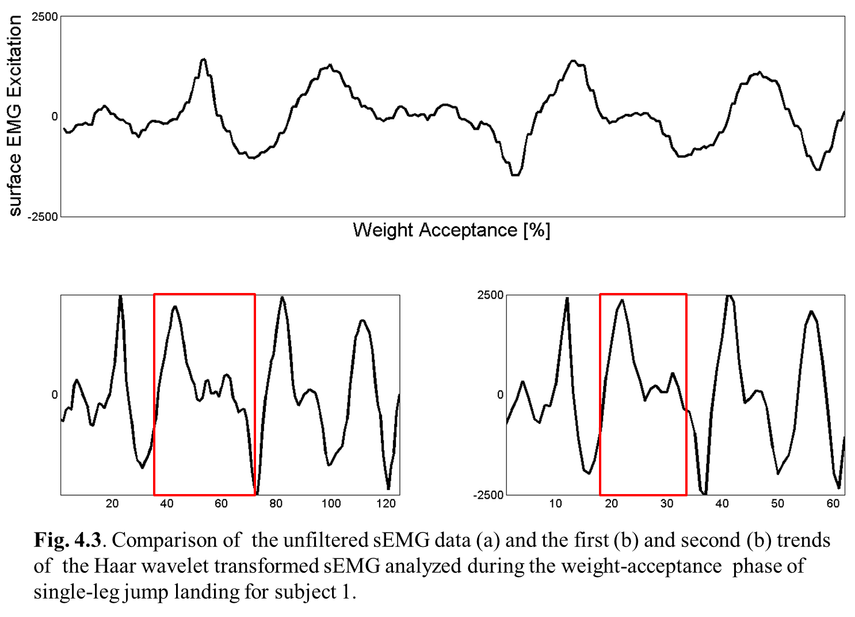
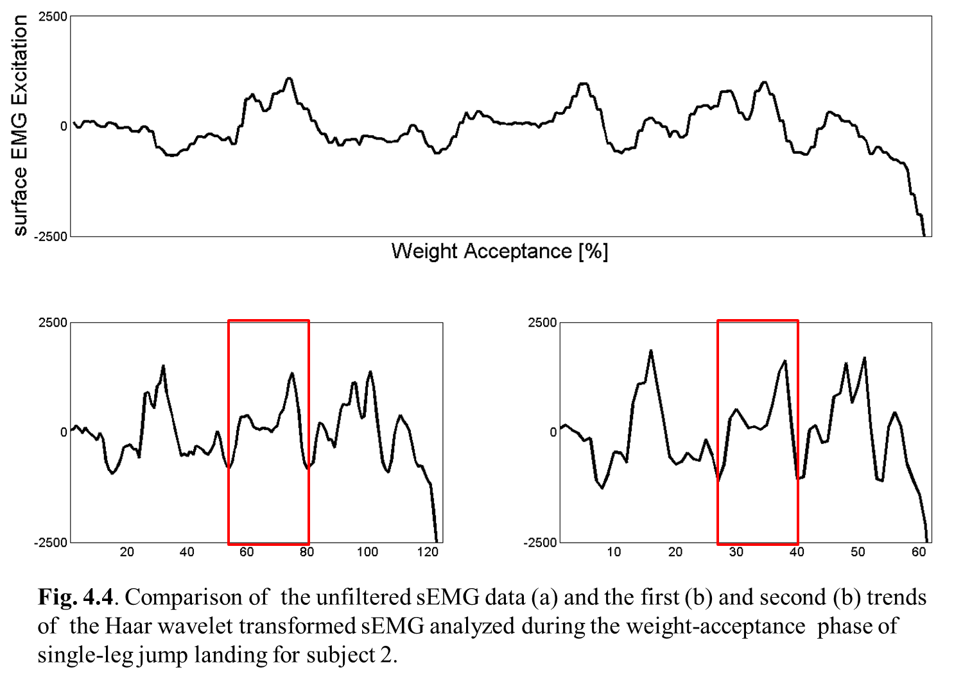
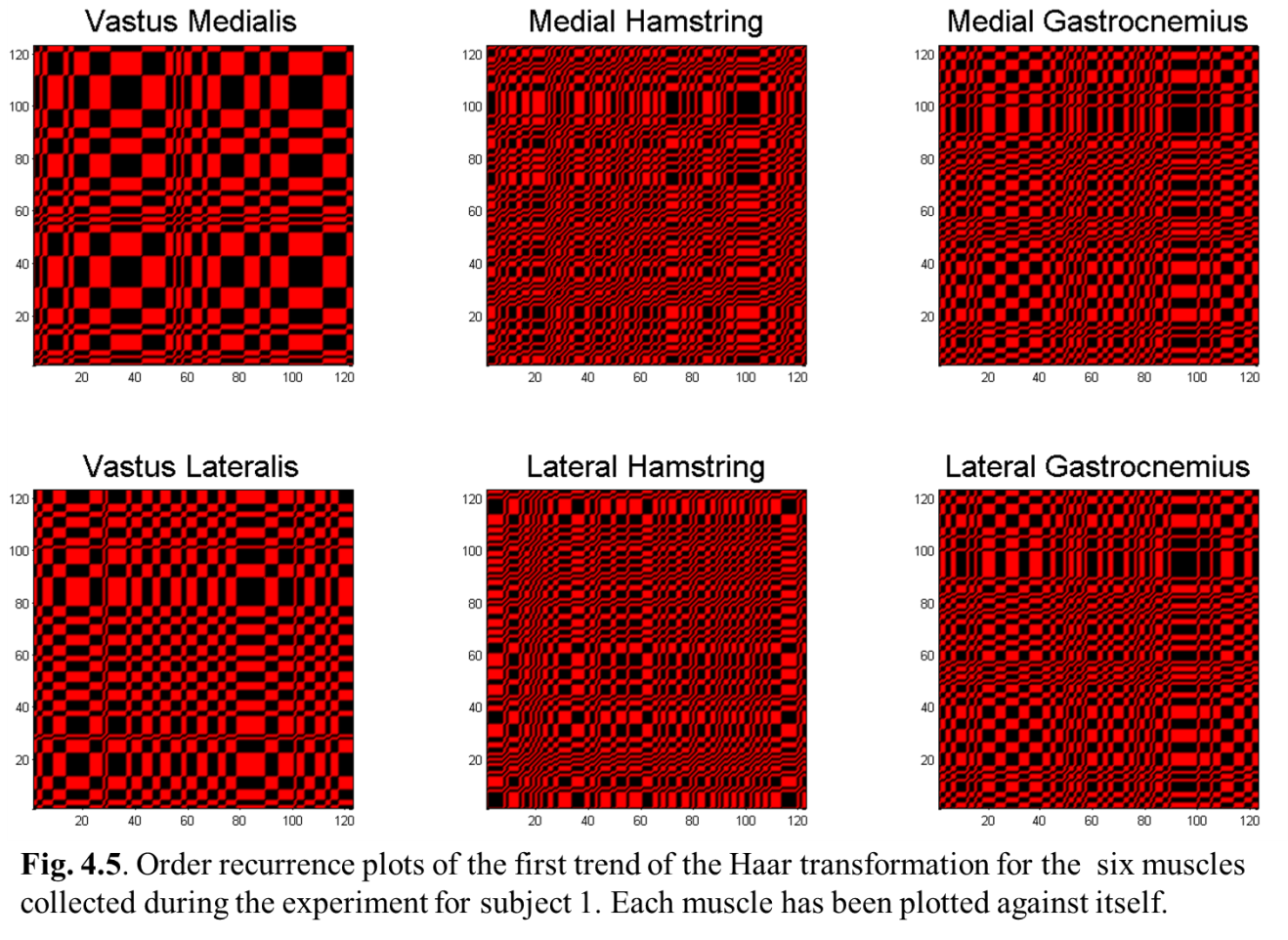
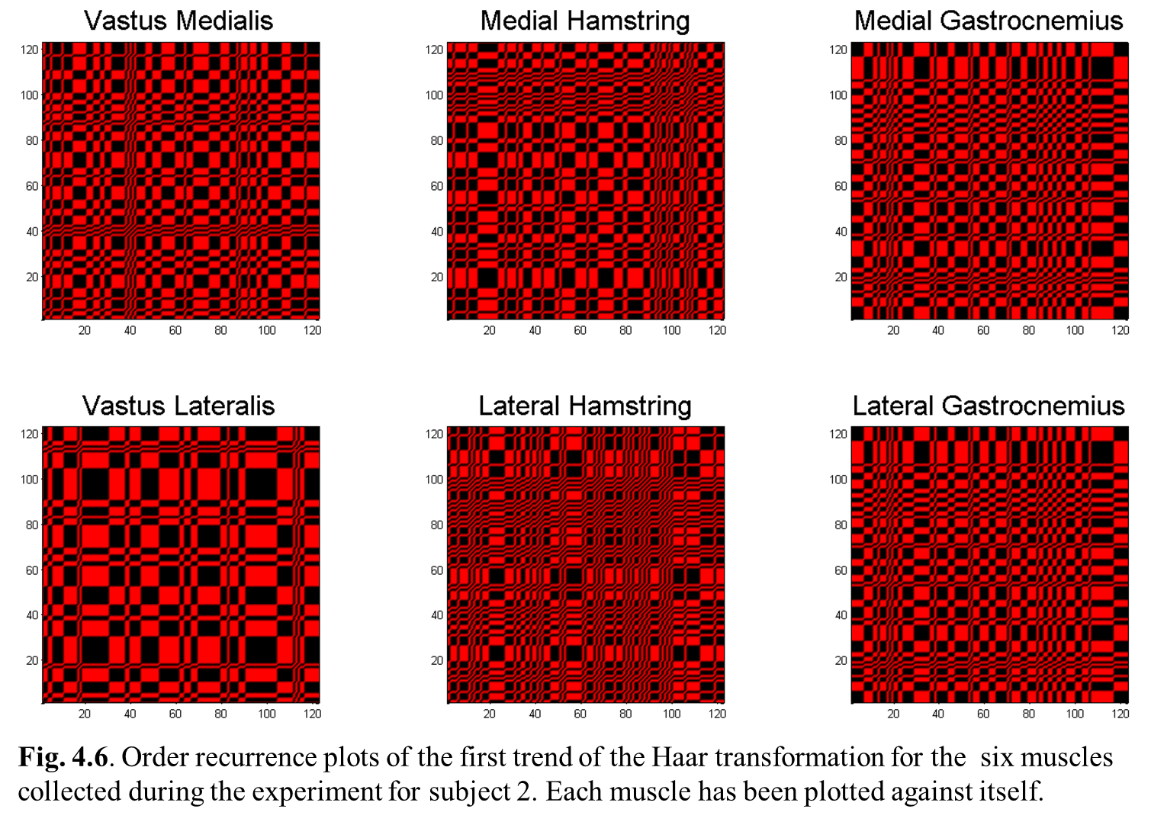

5.4 Results
The preliminary Haar wavelet analysis extracted a pattern from the vastus medialis EMG data. For the subjects that represented the high and moderate risk groups, the shape of the repeating pattern, observed within the trend, was similar. This shape is best described as a large spike followed by a smaller spike (Fig. 4.3). For the low risk group, the pattern was reversed with the large spike trailing the smaller spike (Fig 4.4). Cyclical patterns were also observed in the other muscles; however, none that occurred amongst all three subjects.
An analysis of the ORPs confirmed the presence of cyclical pattern in the data as indicated by repeating checkerboard pattern (Fig. 4.5-4.6). The larger the structure and/or pattern the more ordered the data. However, the appearance of smaller more grain like patterns and structures indicate that the data is more chaotic. The medial and lateral vasti displayed a more ordered pattern than the gastrocnemii and hamstring muscles. Additionally, in both subjects ORPs, the medial and lateral gastrocnemii muscles displayed extremely similar patterns with each other (Fig. 4.5-4.6). For subject 2, the similar gastrocnemii pattern included the onset of bowing or a curve in the plot, which was also observed in subject 1’s vastus lateralis and hamstring muscle plots.

5.5 Discussion
The application of the Haar wavelet analysis in combination with the ORPs is a unique approach for analyzing EMG data to detect movement abnormalities. While this analysis is still in its preliminary stages it has been observed that the differences in the patterns detected in the vastus medialis muscle could be used to indicate individuals at elevated risk for injury. The ORPs identified the medial and lateral vasti as having the strongest underlying pattern of the muscles; however, the gastrocnemii display similar underlying patterns possibly indicating how they may work to function similarly during the single-leg jump landing movement. The bowing displayed by a number of the muscles indicates that the system dynamics are changing. These changing system dynamics could be connected with changing muscle function during the movement and potentially related to elevated knee abduction moment and in turn increased injury risk.

5.6 Conclusions???
The next step in this research will involve performing this analysis for all 65 EMG trials to determine if the trends here are consistent amongst all individuals. Additional, wavelet analysis techniques; like, Daubechies and Continuous Wavelet Transform (CWT) will be explored to determine if they can provide added insight into varying muscle function via EMG waveform analysis.

CHAPTER VI

CONCLUSION

This is the conclusion for the entire document. It can be a numbered chapter or it can stand alone. If you did not make your introduction a chapter and give it a number, you should not make the conclusion a numbered chapter. If you did call your Introduction “Chapter 1”, you should give your conclusion a chapter number.

6.1 Significance of Research (change to past tense)
Effective non-contact ACL injury intervention programs have the enormous potential to drastically reduce the incidence of non-contact ACL injuries in active populations. However, improving the effectiveness of training programs is challenging because the cause-effect relationship between muscle function and joint biomechanics with respect to ACL injury is not well understood. Dynamic simulations provide the capability to determine (identify) the functional roles of individual muscles, which is essential to elucidating this relationship. Utilizing dynamic simulations we can examine the biomechanical factors that influence knee motion to discern the cause of ACL injury. We anticipate that the insights gained from this work will provide new guidelines for designing ACL injury prevention programs resulting in a significant drop in ACL injuries.
Models and computational tools developed will find broad applications. Numerous studies have been performed to record neuromuscular excitation patterns, understand muscle contraction dynamics, characterize musculoskeletal geometry, and quantify multijoint movement kinematics. However, linking the detailed knowledge of these elements of the neuromusculoskeletal system to create an integrated understanding of normal and disordered movement remains a major challenge in the application of biomechanics to a wide range of biomechanics problems and basic science research.
The proposed work will improve methodologies for interpreting the dynamical functions of muscles during movement, generate novel statistical models of the ACL injury mechanisms, and provide a general computational framework for pursuing further research. The simulations developed will be implemented in freely available musculoskeletal modeling and simulation software, which enables these results to be shared with other research groups. Over the past two years, there have been over 60,000 downloads of models, simulations, and software from the project’s website (see simtk.org/home/opensim) with over 9,000 active users of these freely available biomechanics tools. This project will continue this development. Thus, the work proposed here will have broad impact for basic studies of neuromuscular biomechanics and for persons at high risk for ACL injury.

6.2 Research Innovation (change to past tense and Stability Analysis)
The principles that govern the relationships between muscles contributions and purposeful movement in individuals during single-leg jump landings have not been uncovered. For decades, experimental approaches have advanced our understanding of biomechanics. However, the inability to experimentally measure muscle forces and identify the cause-effect relationships (i.e. muscle contributions to movement) between muscle forces and joint biomechanics has limited the research progress. The difficulty in determining an individual muscle contribution to movement stems from the fact that muscles accelerate joints they do not span and body segments to which they are not attached. Thus to determine muscle contribution will require a novel approach driven by the use of a unique set of tools to accomplish this task.
Muscle-actuated dynamic simulations provide a scientific framework, in combination with and complementing experimental approaches for estimating important variables and identifying cause-and-effect relationships. In this study, muscle-actuated dynamic simulations, statistical learning methods and motion capture analysis will be used to bridge the gap between disciplines and enhance basic research studies and improve human movement.
This work will advance basic knowledge and understanding in related fields of science and engineering. It meshes the experimental capabilities of physicians, physical therapist, and rehabilitation scientists with the computer simulation capabilities of engineers, mathematicians, and computer scientist and addresses important (biomechanical) research questions. An added benefit of this approach (research) is that we can develop subject-specific models from freely available open -source software. Thus implying that the discoveries can be readily shared, investigated and discussed with other researchers to promote dialogue amongst researchers and help advance the field toward the end goal of understanding the underlying mechanisms behind injuries and movement disorders.

6.3 Fundamental Contributions
The objective of this research was to determine individual muscle force contribution to single-leg jump landing, which muscles function to support the knee against elevated abduction moment, identify individuals at risk for ACL injury based on muscle function and develop a muscle-targeted training ACL injury prevention program to mitigate ACL injury risk. The preliminary findings of this research indicated that the quadriceps and gastrocnemii muscles are the primary muscles used to support the knee during single-leg jump landing and that the gastrocnemii may work to counterbalance the force production of the quadriceps and not the hamstrings. More specifically, IAA the medial gastrocnemii was the greatest contributor to resisting knee abduction and internal rotation during single-leg jump landing while both the medial and lateral gastrocnemii have the potential to increase knee flexion during landing all of which can reduce ACL injury risk. The statistical analysis found that when analyzing the critical features associated with potential ACL injury risk, the gastrocnemii muscles were the most strongly activated followed by the quadriceps. The activation of the gastrocnemii may again denote the gastrocnemii’s ability to resist elevated knee abduction (valgus) moment during landing. Based on these studies ACL injury prevention programs will focus on altering gastrocnemii muscle function to reduce injury risk.
Musculoskeletal models and computational tools are critical in biomechanics research as they allow researchers to evaluate the cause-effect relationship between joint movement and muscle function. In the proposed work it allowed researchers to identify the gastrocnemii as important contributors to stabilizing and support the knee during single-leg jump landing, although previous research had overlooked their contribution [22, 35, 54, 80]. This finding that may not have been concluded without the development and analysis of the muscle-actuated simulations created in OpenSim. Additionally, the data mining analysis will be used to detect hidden anomalies in the data associated with increased ACL injury risk. Thus future work should use this methodology to assess individual muscle contribution during other dynamic movements to potentially reduce injury risk.

6.4 Summary???

REFERENCES

VITA

John X. Doe was born. He wrote a thesis. He graduated. This page really is required.

