Title: From Campus to Community: Making the Case for Open Access by Bringing Nonprofits to Academic Libraries

Authors: Rachel Caldwell, Melanie Allen, Ann Viera, and Alan Wallace

Issue to be Addressed:
Who is the audience for scholarly research in the form of peer-reviewed articles? Academic researchers mainly write for other researchers in their discipline, but their findings could help many people outside of academia make more informed decisions using data and evidence.¹ Unfortunately, access to academic journals is a privilege for a limited audience, since much of the research literature is reserved for those affiliated with institutions that pay subscriptions to scholarly journals.

In response to this inequity, the Open Access (OA) movement has encouraged scholarly authors to publish openly rather than in journals available only behind a subscription paywall. In particular, during Open Access Week—an annual celebration organized by the Association of Research Libraries’ Scholarly Publishing and Academic Resource Coalition (SPARC)—academic librarians are especially encouraged to plan events related to the benefits of open publishing.² However, these librarian-led programs targeting faculty and graduate students typically reach only a small number of authors on any given campus.

Recent OA Week promotions at the national level have incorporated videos with personal stories of what non-academics can do when they have access to research. For example, one of SPARC’s promotional videos featured high school student Jack Andraka, who developed a new diagnostic tool after comparing many peer-reviewed articles on pancreatic cancer.³ With this approach in mind, a group of librarians at the University of Tennessee (UT), led by their scholarly communication librarian, decided to focus their OA Week outreach efforts on local nonprofit organizations (NPOs), inviting NPO staff to participate in a workshop called Accessing Academic Research (AAR). NPOs learned how to search for and access academic research and, at the end of the workshop, participants were invited to share their own stories of how access to research matters to their organization and clients. Librarians plan to use these stories in training events, newsletters, and campus outreach materials, presenting research authors with compelling local narratives about the value of open access.

Background:
Academic libraries in the United States have a long record of outreach to off-campus community groups broadly defined.^{4, 5, 6} Stangl notes “elements of outreach exist in early discussions,” citing a symposium held in 1967.⁷ Schneider finds evidence of outreach as far back as 1958 and states that “the principles of librarianship have endured over the years; issues of access to information, responsibility of the academy to the public, and creating useful partnerships continue to play a large role in our profession.”⁸

These principles were present in the AAR workshops offered by librarians and assisted by School of Information Sciences (SIS) students at the University of Tennessee (UT). Since 2016, UT librarians have offered three stand-alone workshops for NPOs in Knox County and surrounding communities in East Tennessee. Librarians covered the following topics:

- An introduction to peer-reviewed literature and subscription databases
- An overview of open access, paywalls and subscription access
- Strategies for searching library databases, such as building a good search string with keywords, finding synonyms, and identifying academic jargon and subject headings
- Domain-searches in web browsers for finding data and government reports
- Google Scholar
- Access options for participants after the workshop

During the workshop, time was reserved for one-on-one research consultations with librarians. Participants were also notified that they may request up to 20 articles to which the library has a subscription in the six months following the workshop, provided at no cost to the NPOs. At the end of the workshop, participants were invited to take part in brief, video-recorded interviews about their thoughts on public access to research.

The AAR workshop was similar to two NPO-centered academic library outreach efforts reported in the library literature, though at least one researcher over a decade ago anticipated that many more academic libraries might offer such programs.^{9, 10, 11} Given the size of the nonprofit sector, similarities between libraries and nonprofits, the commitment of universities to measure community engagement, the longstanding breadth and depth of partnerships between different types of libraries, and the education needs of nonprofit professionals and of library school students, evidence of only two outreach efforts seems low. This may indicate that academic library outreach to nonprofits in an orchestrated manner is under-reported.

This supposition is substantiated to a degree by two recent cases of nonprofit outreach by academic librarians. In 2016, the library at Simon Fraser University and a Canadian foundation sought to “provide leaders in charitable and non-profit organizations in British Columbia with access to the latest research and knowledge in their fields” via a pilot called the Community Scholars Program.¹² And in 2017, Crumpton and Bird reported preliminary results from two studies for the project Real Learning Connections.¹³ The project trains library and information science (LIS) students to serve as bridges between libraries and NPOs while also refreshing librarian practitioner skills.

In one of the Real Learning Connections studies, titled “What Do Community Organizations Need from Libraries?,” students interviewed NPO staff to answer this research question: “How can libraries engage with other community organizations, especially nonprofits, to support their needs with the unique skills offered by librarians?” Five skills NPOs identified as a need with which libraries could help included “teaching research skills.”¹⁴ Crumpton and Bird conclude that “deeper research could further explore the opportunities and benefits of library/non-profit collaboration.”¹⁵

Similar to Crumpton and Bird, an important partner in UT’s AAR workshops was the group of SIS students that assisted library workshop leaders. Though students have had only an informal role in the workshops to date, a group of SIS students will have the opportunity to commit to involvement over the course of a year starting in fall 2017. For their culminating project, these students will lead drop-in sessions for NPOs that have previously participated in a workshop and seek further research consultations.

Additional AAR partners included the university library and NPOs. UT is a land-grant university with a library system made up of three campus libraries serving approximately 28,000 students and over 1,500 faculty.¹⁶ Distinct from Memphis in the western part of the state and Nashville in the center, Knoxville is an Appalachian community in East Tennessee. NPOs in East Tennessee serve a community of 33 counties, 21% of which are considered economically “distressed” counties and 40% of which are economically “at-risk” counties, though Knox County and most of its immediate neighboring counties are considered economically “transitional” counties.^{17, 18} The land-grant mission of the university and the economic conditions of East Tennessee make both outreach to NPOs and advocacy for open access to research a natural fit for the university library.

Objective:
The AAR workshop had two objectives: to demonstrate how academic libraries can contribute to building productive relationships between campus and the larger community, and to provide university researchers with compelling reasons to share their work openly.

The first objective is in support of UT’s quality enhancement plan (QEP), which focuses on experience learning. The QEP involves students in projects and “useful partnerships” that solve a real-world problem or directly affect a community, typically mediated through a credit-bearing course.¹⁹ With renewed campus attention on community engagement, the main goal falling under this objective was to introduce regional NPOs to resources at a large academic library that can help them achieve their goals. From delivering client programs to interacting with a board of trustees to reviewing volunteer applicants, evidence based-practices can affect an NPO’s success and the lives of those it serves. So, the AAR workshop introduced ways to access evidence found in peer-reviewed articles, case studies, data sets, and so on.

In addition to facilitating university engagement with the community, the AAR workshop also supported the service learning aspect of the QEP. Though not tied to course credit, SIS students involved in the workshop helped organize the events and observed reference interview skills in the field, helping prepare them for LIS careers by observing and assisting in librarian-community interactions.

The workshop’s second objective supported the library’s scholarly communication efforts on campus: to create a program for OA Week that librarians considered worth the investment of their time and energy. Since 2009, many (mostly academic) libraries around the world celebrate OA Week in October to advocate for open access publishing as well as open archiving in repositories—including both disciplinary repositories, such as arXiv for physicists, and institutional repositories, such as the University of California’s eScholarship.²⁰ While the number of libraries participating in OA Week has grown exponentially, the workshops, presentations, tabling, and other outreach efforts in which librarians invest significant time often result in a low return on investment.^{21, 22}

Despite low turn-out at OA events in past years, UT librarians’ interest in offering an OA Week program remained high. After experimenting for several years with different styles of faculty engagement on OA issues, librarians decided to turn their attention from authors to readers. In doing so, campus authors might learn how a lack of access to research impacts people outside of academia in the words of those who directly experience it, rather than from second- or third-hand accounts, which research shows are less persuasive.²³

The goals falling under this objective were to:
- interview participating NPOs about the lack of access to academic research journals,
- record and incorporate their stories into a promotional campaign intended to influence and encourage campus researchers to publish or archive their research results openly, and
- share the stories with liaison librarians, providing them anecdotes to include in outreach and reference interviews.

The objectives were designed to benefit all partners reciprocally. NPO staff gained continuing education in research skills and were introduced to librarians to add to their support network, regardless of whether they agreed to a recorded interview or not. The University and its library were seen as partners sharing resources to help community organizations and leaders improve the lives of vulnerable and disenfranchised East Tennesseeans. SIS students gained experience relevant to future careers and librarians collected evidence of community research needs to support the case for open access.

Stakeholders:
The scholarly communication librarian designed the workshop with the input and support of liaison librarians serving disciplines with a strong public service element: education, public health and nursing, and veterinary medicine. These liaisons often field questions related to open publishing and also advocate for open access, due in part to access-related questions they receive from former students who lose subscription privileges after graduation. Librarians considered the workshop an outreach approach worth exploring, and recognized its potential to lead to greater engagement with the community.

Buy-in was needed from library administration and nonprofit agencies in the community. Librarians asked for the administration’s support by tying the event to the library’s then-developing 5-year strategic plan. Amidst library-wide discussions about goals and priorities, the workshop supported several important initiatives, including advocating for open scholarship and improving community awareness of the library’s (and university’s) contributions to the region. Perhaps with these goals in mind, and following a long-standing tradition of community outreach from the library, library administration supported the program by providing space, staff resources, and lunch for workshop participants.^{24, 25, 26}

Central to the workshop organizers’ goals was shifting the notion of audience away from campus and towards the community. This required additional librarian preparation because workshop participants were community members working at and leading NPOs, with needs distinct from the library’s typical audience of faculty and students. Preparation included anticipating the kinds of research findings NPOs would find most valuable (Table 1). The region struggles with interrelated issues commonly found throughout Appalachia: high rates of opioid abuse, greater incidences of lifestyle diseases (e.g., tobacco-related diseases), a lack of access to healthcare, levels of educational attainment below the national average, and so on. Thus, the involvement of the public health liaison and education liaison was key to a successful workshop.

Table 1. Pre-Workshop Survey Responses: Organizational Focus

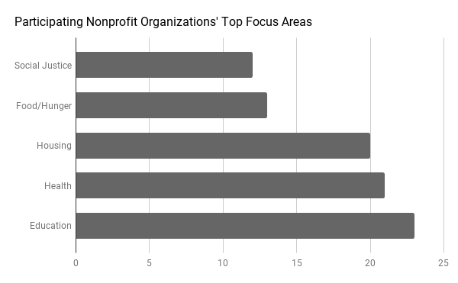

NPOs received invitations and promotional materials that emphasized the relevance of the workshop to finding research that could be applied to grant proposals, client services, and organizational management. This approach seemed to be effective, as evidenced by the number of participants at the workshop (see “Outcome”).

Campus researchers were another group with potential interest in one of the workshop outcomes. Buy-in from this group remains uncertain. One hope is that shared exit interviews between librarians and NPOs will persuade authors to consider the relevance of their work to readers beyond institutions of higher education and, in turn, participate more often in open publishing or open archiving in repositories. Videos are currently in the editing phase and have not been distributed to campus.

Intervention:
NPOs registered one or two staff members for the workshop, with spaces limited to the first 24 applicants. A total of three stand-alone workshops were offered over the course of a year. The first was a two-hour pilot program held in the afternoon. The second and third workshops lasted five hours each, starting in the morning with lunch provided.

Because most of the library’s license agreements permit unaffiliated researchers to access subscription databases only while on campus from a library IP address, participants were encouraged to visit the library after the workshop. But the library also offered participants up to 20 articles delivered to individuals for their own research purposes in the six months following the workshop. This makes the program relevant as both an annual OA Week program and an annual Fair Use Week program. (Since 2015, the Association of Research Libraries has encouraged week-long celebrations of Fair Use every February.²⁷)

Methods for inviting NPOs expanded over the course of the three workshops. Participants in the summer 2016 pilot were identified and invited through two umbrella organizations associated with the university’s annual giving campaign, the United Way of Greater Knoxville and Community Shares. In the subsequent fall and spring, invitations were also sent via direct emails, announcements sent to the Alliance for Better Nonprofits (a local organization focused on training and supporting NPOs), and messages sent to local community networks through social networking sites, such as Facebook.

As part of the second and third workshops, attendees were invited to participate in an optional interview held directly after the workshop. (It should be noted that, as part of the registration process, participants were informed that photography may occur at the event and were thus more likely to participate in recorded interviews.) Interviewing was strictly voluntary and not a condition for attending the workshop. Staff in The Studio, a media production lab in the library, helped record the interviews. Each interview lasted less than 10 minutes.

Interviewees were asked the following questions:
- In a nutshell, what does your organization do?
- Does your organization have a need to access research? If so, for what purposes?
- Before today, how and where have you searched for research findings?
- Have you ever had trouble accessing research findings?
- Knowing that researchers have the option to publish openly, imagine that there is a professor listening to you right now. What would you want to say to that professor about open access publishing?

The resulting videos will be distributed as part of an open access awareness campaign in Fall 2017 and beyond.

Outcome:
Attendance numbers suggest the workshop fulfills a continuing education need for training to find and access research. A total of 25 organizations and 36 individuals have participated over three workshops. Two participants that attended the second workshop sent another colleague from their organization to the third workshop.

Though open access was one aspect of the program, the demonstrated tools and research skills were not only UT-subscription databases. This is notable because, by a show of hands, over half of participants in each session were unfamiliar with the statewide library resource Tennessee Electronic Library, which provides access to some subscription databases free of charge to anyone with an IP address in the state. Furthermore, domain searches limited to state- and federal-government sources were also not known by a majority of participants.

Prior to the workshop, participants provided information about their organizations and their expected outcomes in the online registration process. After the workshop, librarians sent participants a post-workshop survey, which elicited feedback and quotes that 1) have helped improve the workshop and 2) may be used for OA advocacy in addition to the videos. Based on feedback, librarians have increased time allotted for taking sample research questions from participants to demonstrate search skills and strategies to the group. Participants were also given several copies of a handout with a link to the library guide designed for them, and librarians have taught exclusively from the guide.²⁸ In ten months, the guide has been viewed nearly 600 times.

NPOs reported that they were immediately able to put into practice what they learned to improve the organization’s professional efficiency, services to clients, and grant proposals; however, only two participants have asked for copies of articles from librarians after the workshop, and four participants have reached out to librarians with additional questions. It is difficult to say if this means that NPOs are having success in their searches and in contacting authors directly for a copy of a research article, or if they are making do with what they find.

Survey responses (n=26) indicate that 69% of participants found the workshop’s greatest value to be working with and learning from librarians directly, with 35% specifically mentioning the hands-on nature of the workshop or time for one-on-consultations as the most valuable aspects. Also valuable was learning how to use tools other than a simple Google search to find resources and/or how to access these tools as non-UT-affiliated members of the community (38%). Former UT students, once with full access to university library resources, have been among the participants. Their responses indicate a new awareness that access to peer-reviewed research is not equitable. One participant (not a former student), wrote in an email to organizers that he is more aware of the issues involved in academic publishing as a result of the workshop and, “anything to help return control to the authors is worth time and effort toward accomplishing.”

Six individuals participated in the optional recorded interviews (17%). Each one gave the library excellent material for videos promoting open access. Once the videos are distributed, authors’ interest in openly archiving their research in the institutional repository, Tennessee Research and Creative Exchange (TRACE), may or may not increase as a result of the campaign. But, draft videos have been shared with liaison librarians, many of whom were not part of the workshop. The drafts have been well-received and equipped liaisons with both anecdotes and evidence about the importance of public access to research.

Participants also provided written quotes in their post-survey responses that could be useful in OA advocacy, such as:

- Access to research is “critically important for implementing effective prevention programming.”
- “Researchers and authors need to [consider] where they place their potentially valuable and life-improving research and information….We cannot use it if we don't have access to it!”
- “As a nonprofit, we want to utilize research to drive us to best practices. However, it is difficult if the research that applies to our work is hidden behind paywalls!”
- Open access “is so helpful for non-profits with few employees and low budgets, doing research for grants and presentations [to Boards] for new programs.”
- “Grant applications using the most recent data and peer-reviewed best practices may have a better chance of approval. Access to this research also enables applicants to ensure they're on the right track with program planning.”
- “Open access publishing is an opportunity for everyone to learn about the research you do.”
- “Open access is helpful to allow communities to make real-world application of University research. Please help further open the doors to access.”

The library may take some of these quotes and incorporate them into presentations and the homepage of the university’s open repository, similar to Harvard’s use of community feedback to promote Digital Access to Scholarship at Harvard (DASH), their institutional repository. Harvard Library’s Office for Scholarly Communication asked readers who accessed an article or other research document in the repository to leave a comment about what access to scholarly research means to them (Figure 1).

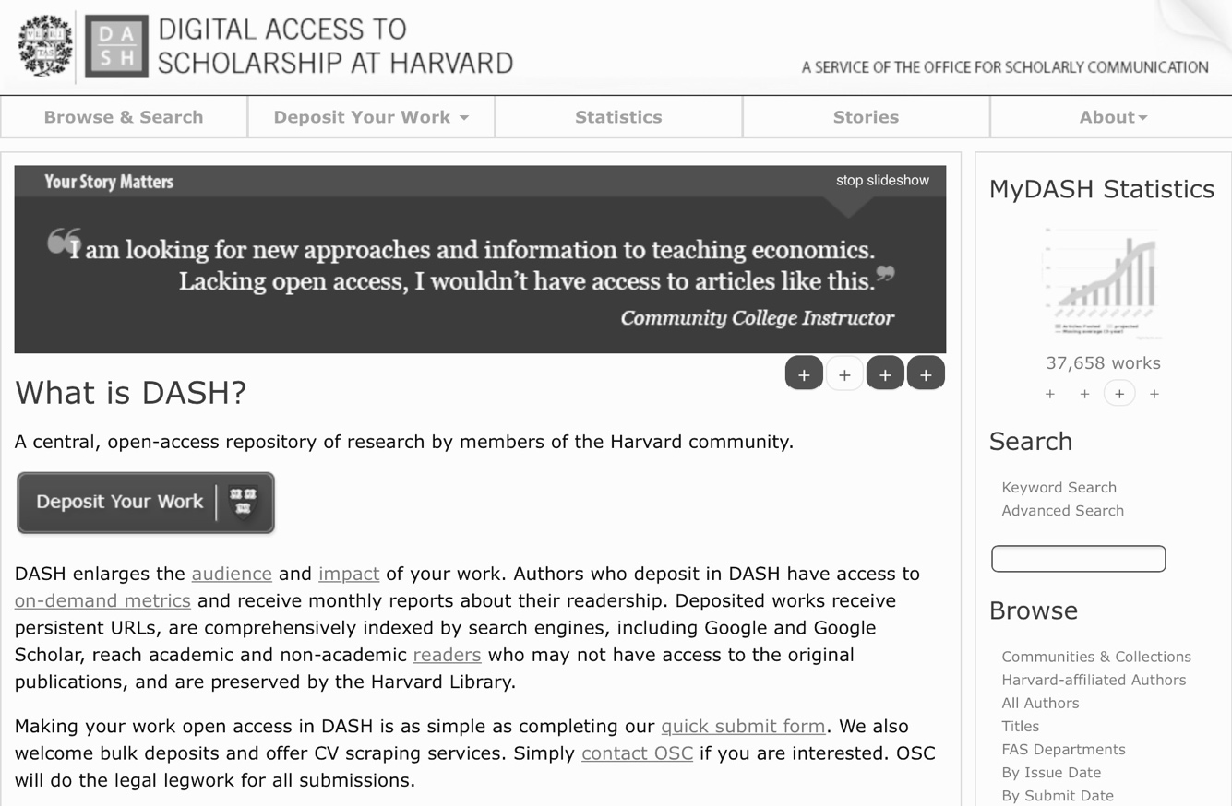
Figure 1. Homepage of Harvard University’s institutional repository (https://dash.harvard.edu), featuring quotes from repository users.

Videos are compelling, easy to share, and the expected medium for advocacy in today’s media-rich environment. By enlisting the expertise of staff at The Studio in the library, the librarians ensured high-quality recording of comments was easy and quick for workshop participants willing to be recorded. However, capturing comments to promote open access as Harvard does might be more sustainable due to the effort involved in video postproduction tasks.

In whatever way feedback is shared with campus in the future, the participants’ enthusiasm for the workshops, and evidence that the workshop benefits the community and addresses a research need, have made the return on investment worthwhile to librarians who plan to continue the program for both OA Week and Fair Use Week for the foreseeable future. Though it is too early to know if there will be any change in campus authors’ behaviors after hearing the NPOs’ stories, the workshops have brought more of an audience to the library than any other single previous OA Week outreach effort. Furthermore, all survey respondents (100%) indicated that they would “definitely recommend” the AAR workshop to other NPOs, indicating both success and a potential future audience.

There are also early signs of campus support for the workshop’s goals. The library was awarded a small internal grant in 2017 to support LIS student involvement. Librarians expect that a cohort of 5-10 LIS students will commit to approximately 25-hours of involvement over the academic year, first observing, then shadowing, and finally leading drop-in sessions for NPO participants seeking individual research assistance after the workshop. Librarians will lead several training sessions for these students as part of the program.

Long-term assessment goals include measuring any impact of the training on services offered by NPOs, grants awarded, interactions with an NPO’s boards of trustees, and so on. After the NPOs’ recorded interviews are shared on campus, the scholarly communication librarian will investigate possible correlations in the number of faculty research deposits to the institution’s open repository, and the number of applications to the open access publishing fund (where faculty request the university to cover the article processing charges that some open access journals charge), before and after the campaign. Feedback from SIS students will also be collected to improve their experience. Finally, in preparation for upcoming workshops, librarians aim to implement best practices in adult learning to improve outcomes for workshop participants.

Bibliography
1. West, Jillian and Stephanie Chernitskiy. “Turning Research into Action: A Dialogue with Decision-Makers (Part One).” Policies for Action (May 16, 2017). Accessed June 26, 2017. http://www.policiesforaction.org/blog/turning-research-into-action-a-dialogue-decision-makers-part-one.

2. Scholarly Publishing and Academic Resources Coalition. “International Open Access Week.” Accessed April 24, 2017. http://www.openaccessweek.org.

3. Scholarly Publishing and Academic Resources Coalition. “How Open Access Empowered a 16-Year-Old to Make a Cancer Breakthrough.” Accessed June 23, 2017. http://www.openaccessweek.org/video/how-open-access-empowered-a-16-year-old-to-make-cancer-breakthrou.

4. Schneider, Tina. “Outreach: Why, How and Who? Academic Libraries and their Involvement in the Community.” Reference Librarian, 39 (2004): 199-213.

Note: In anticipation of more research in this area, we created a Zotero public group with all the citations from our literature reviews for this chapter: https://www.zotero.org/groups/librariesandnonprofits.

5. Courtney, Nancy, ed. Academic Library Outreach: Beyond the Campus Walls. Westport, Conn: Libraries Unlimited, 2009.

6. Miller, William and Rita M. Pellen, eds. Libraries Beyond Their Institutions: Partnerships that Work. Binghamton, N.Y.: Haworth Press, 2006.

7. Stangl, Angela M. “Academic Library Outreach: A Framework.” Paper presented at the annual meeting for the BOBCATSS Symposium, Barcelona, Spain, January 29-31, 2014. https://proceedings.bobcatsss2014.hb.se/article/view/302

8. Schnieder, Tina.

9. Durbin, Roger and Jo Ann Calzonetti. “Academic Meets Corporate: Science and Technology Library Services in the Corporate World.” Science & Technology Libraries 24 (2003): 73-86. doi: 10.1300/J122v24n01_06.

10. Salinas, Romelia and Richard Chabrán. “Preparing Ethnic Non-profits for the 21st Century.” In Libraries Beyond their Institutions: Partnerships that Work, edited by William Miller and Rita M. Pellen, 121-136. Binghamton, N.Y.: Haworth Press, 2005/2006.

11. Cargo, Russell A. “Made for Each Other: Nonprofit Management Education, Online Technology, and Libraries.” The Journal of Academic Librarianship, 26 (2000): 15-20.

12. Simon Fraser University Library. “The Community Scholars Program.” Last modified June 15, 2017. http://www.lib.sfu.ca/about/overview/services-you/community-scholars.

13. Crumpton, Michael and Nora Bird. “Connecting Libraries and Learning with Community Organizational Needs.” Presentation at the annual meeting for the Association for Library and Information Science Education Conference, Atlanta, Georgia, January 18, 2017. https://libres.uncg.edu/ir/uncg/f/M_Crumpton_Connecting_2017.pdf.

14. Ibid.

15. Ibid.

16. The University of Tennessee, Knoxville, Office of Institutional Research and Assessment. “UTK 2016-17 Fact Book.” Accessed June 23, 2017. https://oira.utk.edu/factbook/admissions.

17. Tennessee. Department of State. “The Three Grand Divisions.” In Tennessee Blue Book 2013-2014, 625. Nashville: Secretary of State, 2013. Accessed June 25, 2017. http://www.tennessee.gov/sos/bluebook/.

18. Appalachia Regional Commission. “County Economic Status and Distressed Areas per County in the Appalachian Region, FY 2017.” Accessed June 23, 2017. https://www.arc.gov/appalachian_region/CountyEconomicStatusandDistressedAreasinAppalachia.asp.

19. The University of Tennessee, Knoxville. “Experience Learning.” Accessed June 23, 2017. http://experiencelearning.utk.edu/.

20. Joseph, Heather. “The Open Access Movement Grows Up: Taking Stock of a Revolution,” PLoS Biology 11, no. 10 (2013). doi: 10.1371/journal.pbio.1001686.

21. Ibid.

22. Johnson, Paula C. “International Open Access Week at Small to Medium U.S. Academic Libraries: The First Five Years.” The Journal of Academic Librarianship 40 (2014): 626-631. doi: 10.1016/j.acalib.2014.07.011.

23. Cantor, Joanne R., Herminia Alfonso, and Dolf Zillman. “The Persuasive Effectiveness of the Peer Appeal and a Communicator’s First-Hand Experience.” Communication Research 3 (1976): 293-310. doi: 10.1177/009365027600300304.

24. Mack, Thura, Ingrid Ruffin, and Nicole Barajas. “Beyond BOSS: A Blueprint for STEM Engagement, Student Recruitment and Outreach.” Tennessee Libraries 64, no. 4 (2014). http://www.tnla.org/?page=TL64_4_STEM

25. Baggett, Mark Patrick, Anne Bridges, Ken Wise, Sarah Tanner, and Jennifer Mezick. “Populating the Wilderness: Crowdsourcing Database of the Smokies.” Library Hi Tech 32 (2014): 249-259. doi: 10.1108/LHT-11-2013-0150.

26. Dewey, Barbara I. “Through Any Means Available: Connecting People with Scholarship.” Journal of Library Administration 49 (2009): 533-544. doi: 10.1080/01930820903090912.

27. Association of Research Libraries. “Fair Use/Fair Dealing Week.” Accessed June 23, 2017. http://fairuseweek.org.

28. University of Tennessee Libraries. “Accessing Academic Research: For East Tennessee Nonprofits.” Last modified May 23, 2017. http://libguides.utk.edu/nonprofits

