Omega-3 Polyunsaturated Fatty Acids: Methods to Reduce Atherosclerosis in the Obese Minipig
Mary Hall
Department of Animal Science
CJ Kojima, Mentor

Introduction
Obesity and the associated health concerns have become popular topics in the medical community due to the epidemic status they have reached in many developed countries. Obesity creates significant economic stress due to medical costs, and also often leads to decreased life expectancy and quality of life⁹. Obesity in humans is known to be linked to health issues including insulin resistance, hypertension, and atherosclerosis which lead to serious complications, including death⁹.
Atherosclerosis is an especially dangerous complication of obesity because it can lead to obstruction of the arteries supplying blood to the heart. Diseases of the heart are the leading cause of death in the United States, accounting for 25% of all deaths in the year 2007⁴. Of these heart disease related deaths, 66% resulted from ischemic (coronary artery) disease and 22% resulted from acute myocardial infarction⁴. Both ischemic heart disease and myocardial infarction are possible complications of atherosclerosis⁵. Because of the significant mortality associated with this disease, research relating to atherosclerosis mechanisms as well as possible treatments is of utmost importance.
The development of atherosclerosis occurs in several steps. The first step involves the formation of a fatty streak, which occurs when lipoproteins are transported into the arterial walls. This process is initially dependent on the difference in concentration of LDL cholesterol inside and outside the cell and its interaction with the LDL receptor. Once the lipid is inside, the development of plaques depends more on the retention of the lipid in the arterial wall, not the rate of transport, regardless of concentration².
The next step is oxidation of the lipids within the artery wall. This process occurs in two phases; first, LDL is mildly oxidized by monocytes, then LDL is further oxidized by macrophages. One product of this oxidation, lysophosphatidylcholine, attracts monocytes and T-lymphocytes while simultaneously inducing vascular cell adhesion molecule-1 (VCAM-1) which binds to these immune cells on the vascular wall⁵. Once strong oxidation occurs, LDL receptors are impaired and lipids are transported into the cell without regard to concentration in the cell, resulting in an abundance of lipids in the cytoplasm. These cells are referred to as foam cells because of the foamy consistency the cytoplasm takes on².
Once this fatty streak has formed, the lipid core may continue to expand and eventually intrude into the lumen of the vessel. As the lipid core grows, proteinases begin to be secreted by activated leukocytes, breaking down the extracellular matrix. Additionally, pro-inflammatory cytokines including INF-tau can limit synthesis of new collagen. This causes the fibrous cap of the vessel wall to weaken, making it susceptible to rupture. If the plaque ruptures, a thrombus will form and occlude the artery. This can result in two outcomes: it may completely block the vessel, resulting in a clinical event such as myocardial infarction, or if it only partially occludes the lumen the thrombus may be repaired by thrombolysis and resorbed. This triggers a wound healing response with release of platelet derived growth factor (PDGF) and transforming growth factor-β (TGF-β), causing smooth muscle cells to proliferate and collagen to be produced as scar tissue. This strengthens the fibrous cap on the vascular wall, but it also causes the blockage to intrude further into the lumen. This leads to a more chronic condition such as ischemia⁵.
Atherosclerosis is an inflammatory disease that, in the past, was mainly considered a degenerative disease which was not preventable². Treatment mostly focused on prevention through reduction of LDL cholesterol, and was not as effective as would be expected – reduction of LDL levels typically results in only, at best, a one-third improvement over five years⁵. This may be due in part to the fact that in developed nations, cholesterol levels that are considered average among the population still greatly exceed the normal level expected for humans according to levels seen in animals as well as humans in agrarian societies⁵. Because of these limitations of LDL cholesterol reduction, alternative methods to reduce atherosclerosis are increasingly being considered.
Omega-3 Polyunsaturated Fatty Acids (PUFA) are one type of supplement that has emerged as a possible prevention method for atherosclerosis. There are several mechanisms by which Omega-3 PUFA have been shown to mediate atherosclerosis. One of these is the reduction of plasma concentration of triglycerides and VLDL cholesterol. This reduces one of the main initial triggers of atherosclerosis. Another mechanism is inhibition of thrombus formation by substituting in the place of arachidonic acid on the endothelium. Arachidonic acid derived metabolites have a tendency to be more prothrombotic and more vasoconstrictive than the metabolites of Omega-3 PUFA. This process mediates the clot formation that can occlude the vessel in atherosclerosis and prevents the lumen space from becoming smaller due to vasoconstriction. However, this does not cause a drastic reduction in atherosclerosis³. Mechanisms that may have more significant anti-atherosclerotic effects are the suppression of inflammatory cytokines such as IL-1 and TNF in monocytes, reduction of PGDF production, and reduction of adhesion factors responsible for the binding of immune cells such as VCAM-1. These cytokine based mechanisms are the main focus of present studies of atherosclerosis prevention because they are still not fully understood and they have strong potential as a preventative measure for the process of atherosclerosis³.
Swine are increasingly being seen as a viable model for atherosclerosis in humans due to their anatomical similarities, particularly in the cardiovascular system. The coronary vascular system is similar to 90% of the human population, which makes development of coronary artery disease in pigs an excellent model for human coronary artery disease⁸. The metabolism of the pig and its development of obesity have also been shown to be similar to humans. Swine are devoid of brown fat postnatally and the size of the adipose tissue in swine is adequate for analysis of samples through assays; this makes the swine model superior to rodent models used in the past⁸.
The purpose of this study is to develop a model of obesity-induced atherosclerosis similar to that seen in humans. If successful, this swine model can be used to pursue possible treatments for atherosclerosis as well as develop a more detailed understanding of the mechanisms behind the gene expression control of progression of the disease. The pilot study will test the efficacy of a 16 week trial of high fat diet in inducing atherosclerosis. This diet is expected to cause significant increases in body weight, blood triglyceride and cholesterol levels, and development of identifiable fatty plaques on the artery walls as shown in past studies of obesity correlated conditions⁶. It would also be expected that inflammation would cause an increase in the stress hormone, cortisol, and decreases in cortisol-inactivating Corticosteroid Binding Globulin (CBG) resulting in a higher level of free, active cortisol in the bloodstream (Free Cortisol Index)¹. The first treatment that is being tested is supplementation of this high fat, atherosclerosis-inducing diet with Omega-3 PUFA. Supplementation of the high fat diet with Omega-3 PUFA is expected to mediate inflammation and the adverse health effects of the diet, including obesity, blood triglyceride and cholesterol levels, cortisol and CBG levels and overall development of atherosclerosis³.

Materials and Methods:
Pilot study:
Two miniature swine from Sinclair Bio Resources⁷ were obtained at the age of 7 months, both castrated males. Both were fed a high fat diet consisting of Purina Mills Laboratory Mini-Pig Breeder Chow (75% of diet) supplemented with Coconut Oil (17.2%), Corn Oil (2.3%), Sodium Cholate bile salt (1.5%), and Cholesterol (4.0%). This diet was fed for 16 weeks.
Measures of body weight and fasting blood samples were taken at baseline and at 4 week intervals afterward, and blood samples were analyzed for glucose levels, cholesterol and triglyceride content, and cortisol and Corticosteroid Binding Globulin (CBG). Glucose was measured at the time each sample was taken using a Glucometer. Cholesterol and triglycerides were measured from the blood samples in the University of Tennessee Pathology Laboratory. Cortisol was measured by Radioimmunoassay and Corticosteroid Binding Globulin was measured by ELISA. Free Cortisol Index was obtained from the Cortisol to CBG ratio.
At baseline and at 4 week intervals, the pigs were sedated with ketamine (10 mg/kg) and midazolam (0.4 mg/kg) intramuscularly and transported to the University of Tennessee Graduate School of Medicine where Positron Emission Tomography (PET) and X-ray Computed Tomography (CT) scans were taken. IV catheters were placed for anesthetic support as well as administration of radiopharmaceutical and vascular contrast agent (1 ml/kg Omnipaque). Tracheal intubation was also performed with administration of inhaled isofluorane/oxygen in sternal recumbency for 60 minutes during the radiopharmaceutical uptake period and acquisition of whole-body PET/CT images. The CT scans were used to find measurements of back fat depth and abdominal and pericardial fat volume.
At the conclusion of the 16 week study, the pigs were euthanized and a necropsy was performed. Samples of liver, pancreas, thymus, spleen, visceral and subcutaneous fat, and artery wall were obtained and flash frozen using liquid nitrogen. Sections of arteries were also taken and preserved in formalin for future photography and examination.
Omega-3 PUFA study:
Eight miniature swine from Sinclair Bio Resources were obtained at the age of 7 months, all castrated males. Four of these swine were fed the same high fat diet as in the pilot study as a control group, while four were fed this high fat diet plus a supplement of Grow Mega fish oil. One of the control pigs and one of the Omega-3 PUFA supplement pigs were each removed from the study due to health concerns. One developed a gastric ulcer while the other developed an upper respiratory infection; both were treated for these conditions and switched to a non-high fat diet for the remainder of the study period. They were not included in the final data for either group.
Measures of body weight and fasting blood samples were taken in 4 week intervals as described in the pilot study. The PET and CT scans were not repeated for this study. At the conclusion of the study, euthanasia and necropsy were performed as in the pilot study. Samples of liver, pancreas, lymph node, thymus, spleen, subcutaneous and abdominal fat, and artery were obtained and flash frozen using liquid nitrogen. Sections of arteries were also taken and preserved in formalin for future photography and examination.

Results and Discussion
Pilot Study
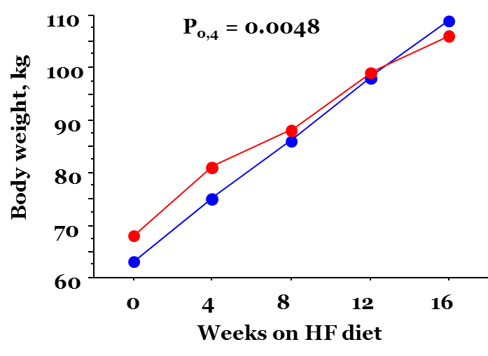
Figure 1: Body weights of the two minipigs over the course of the 16 week trial. The stated P-value indicates a significant difference between start and end of trial. Body weight showed a consistent linear increase in both pigs. A pre-planned comparison between start- and end-points revealed significant weight gains in these mature pigs. These results are compatible with what was hypothesized for this high fat diet trial.
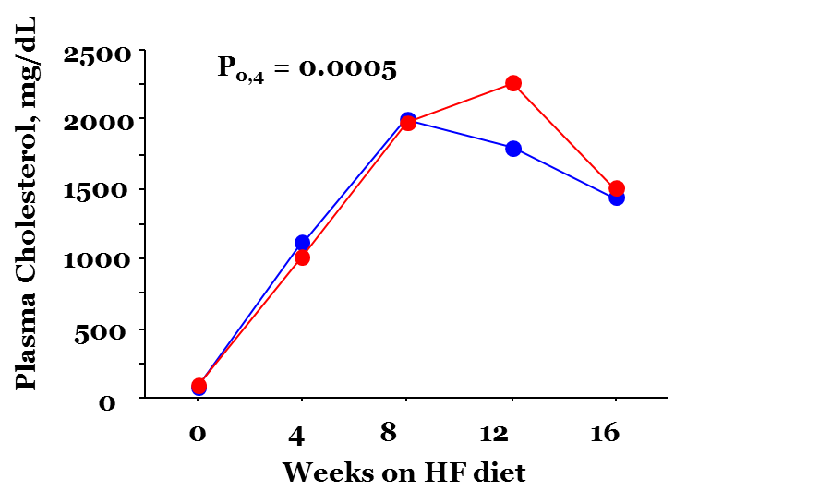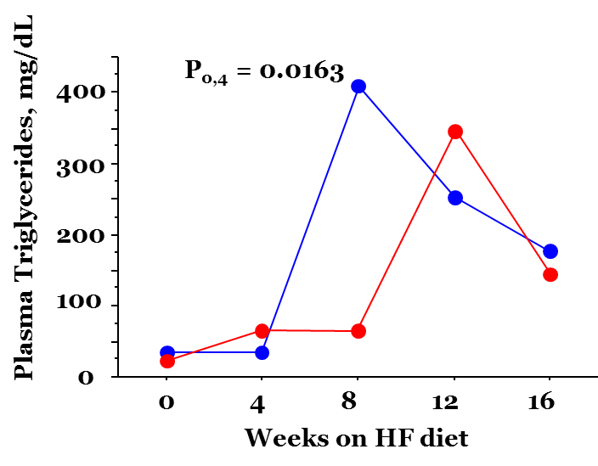
Figure 2: Circulating concentrations of plasma cholesterol (left) and triglycerides (right) The stated P-value indicates a significant difference between start and end of trial. Of particular interest is the pig-to-pig variation, which will need to be accounted for in future studies. The reason for the peak concentration at 8-12 weeks followed by a decrease is also unknown and will require further investigation. The increases from baseline are compatible with what was hypothesized for this high fat diet trial.
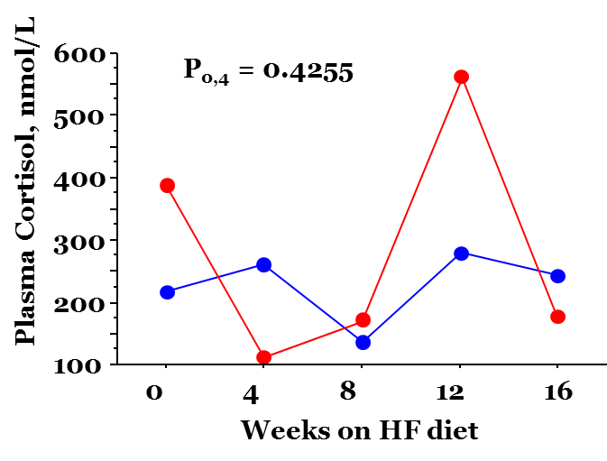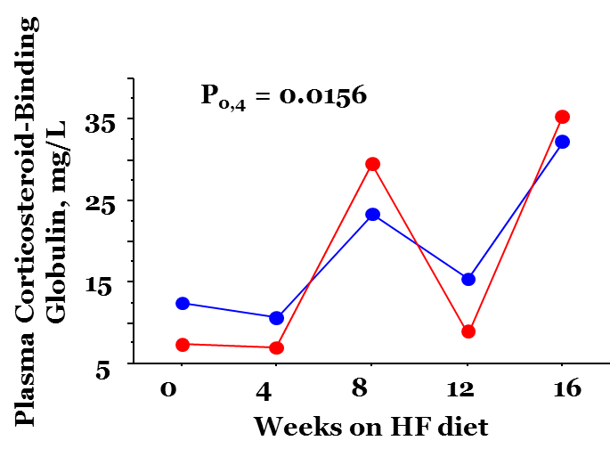
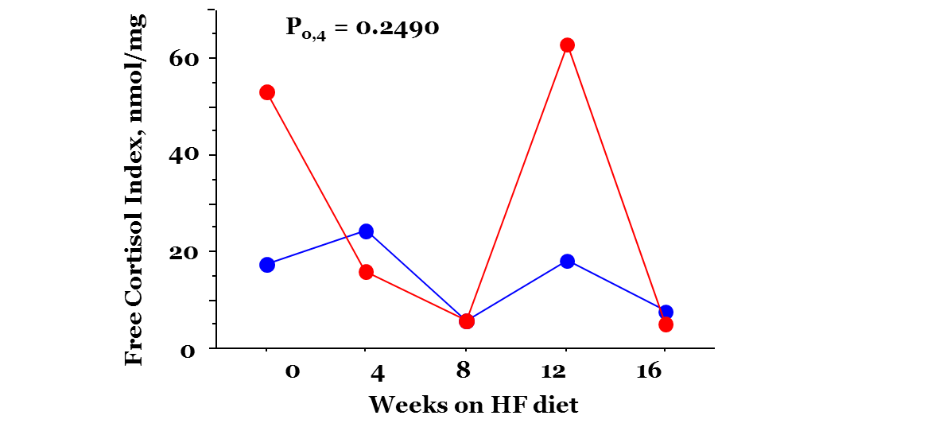
Figure 3: Plasma concentrations of cortisol (top left), CBG (top right) and values for the Free Cortisol Index (bottom). No significant change was observed in either plasma cortisol or the Free Cortisol Index. There was an observed increase in CBG from baseline to final measurement, but because there is no correlation of the overall sequence of measurements no conclusions can be drawn from this difference. It was hypothesized that increased inflammation would cause cortisol to increase while CBG would decrease. This correlation was not proven in this trial.
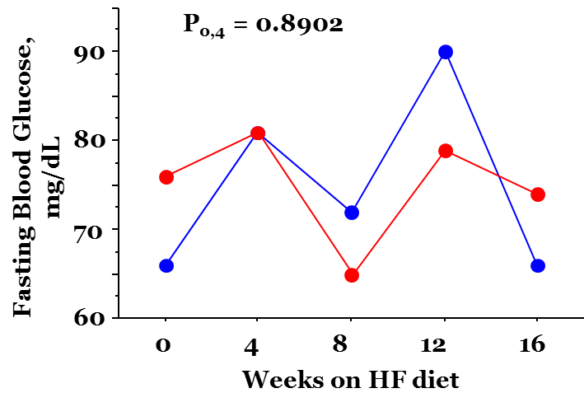
Figure 4: Circulating concentration of blood glucose after overnight fasting. No significant trend or difference was observed in fasting blood glucose values from the baseline values to the conclusion of the experiment. This result was not as hypothesized, but did not affect the main focus of the study, development of atherosclerosis. It was hypothesized that the high fat diet would likely induce a diabetic or pre-diabetic insulin resistant condition, causing increases in fasting blood glucose. This condition was not observed in this 16 week trial. It is possible that more obesity related health conditions such as this could occur over a longer time period, but further investigation is needed in this area.

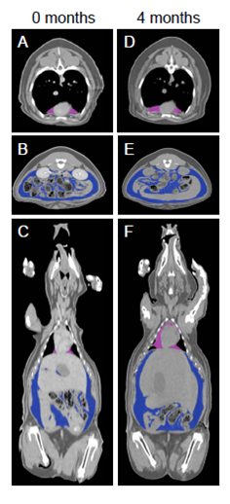
Figure 5: Representative CT images showing increased backfat depth (white arrow, A and D), pericardial fat volume (pink, A,C,D and F) and visceral fat volume (B,C,E and F) from the beginning (A-C) to the end (D-F) of the trial. These increases are compatible with what was hypothesized for this high fat diet trial.
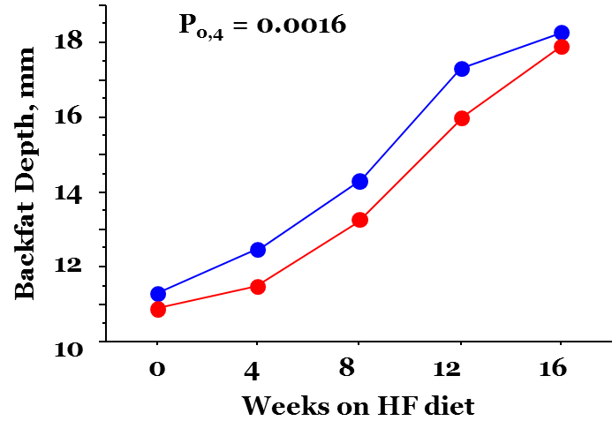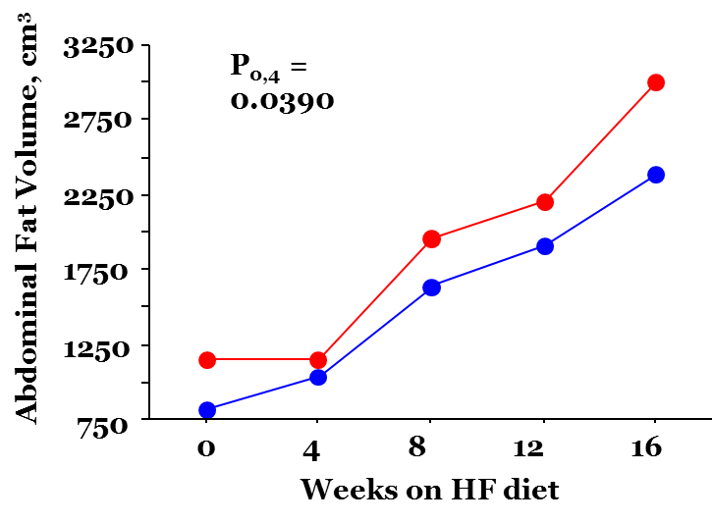
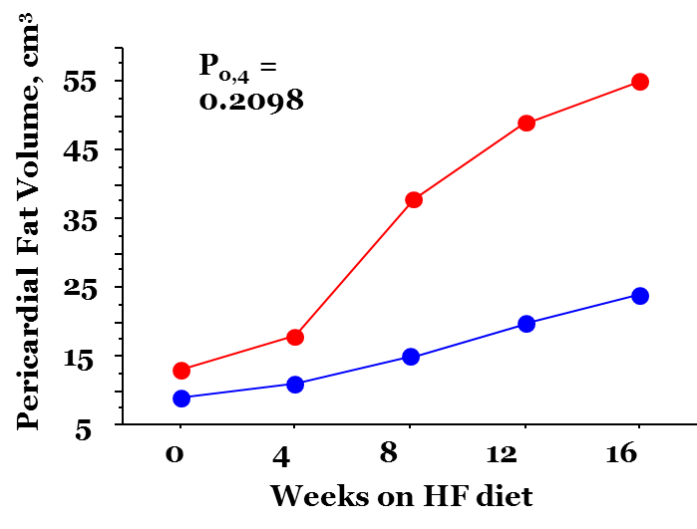
Figure 6: Measures of back fat depth, abdominal fat volume, and pericardial fat volume as obtained by CT scans. A significant increase was seen in all of these values, though there was wide pig-to-pig variation in pericardial fat volume for unknown reasons. The increases are compatible with what was hypothesized for this high fat diet trial. Further investigation is needed to determine the reason for the variation in the location of fat depots between pigs.
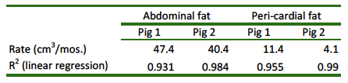
Table 1: Rates of accumulation of visceral (abdominal) and pericardial fat depots over the course of the trial. Accumulation occurred in a linear fashion. These results are compatible with what was hypothesized for this high fat diet trial.

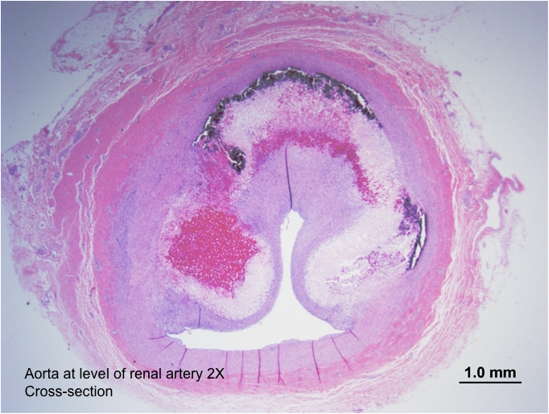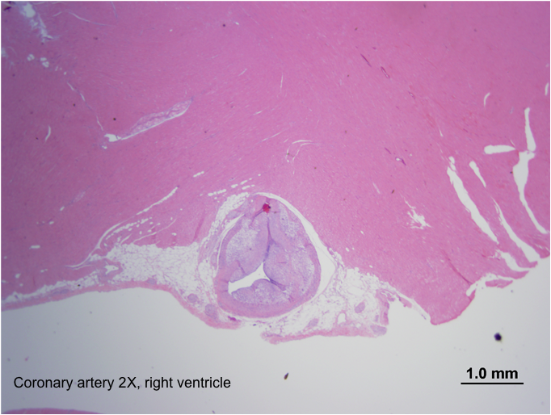
Figure 7: Representative cross sections of caudal aorta at the level of renal artery (left) and coronary artery (right). Near-total occlusion of the arteries occurred over the span of the 16 week trial. This is a direct observation of the induction of atherosclerosis in this model. As hypothesized, atherosclerotic plaques were created in this model.

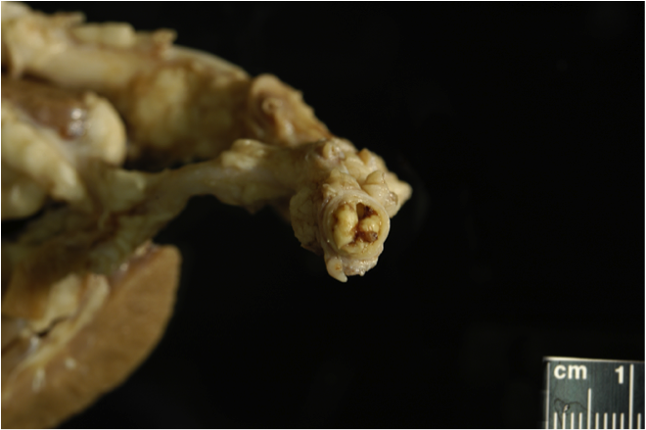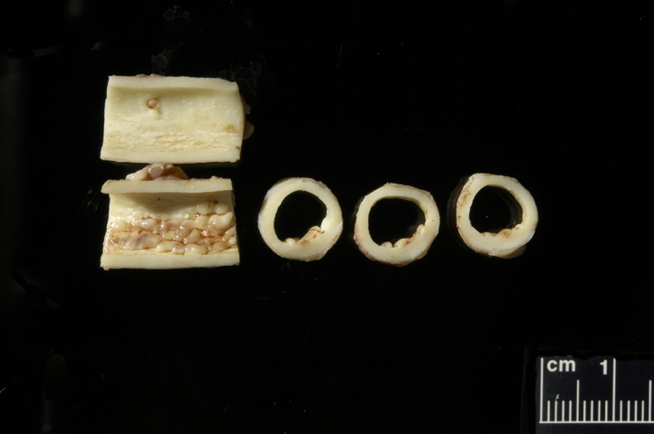
Figure 8: Representative cross section of caudal aorta immediately distal to kidney (left) and representative longitudinal and cross sections of thoracic aorta (right). Near-total occlusion of the caudal artery occurred over the span of the 16 week trial. This is a direct observation of the induction of atherosclerosis in this model. As hypothesized, atherosclerotic plaques were created in this model. Additionally, symptoms of peripheral artery disease were observed in these pigs, showing evidence that these plaques caused ischemia of the caudal artery and possibly other portions of the peripheral vascular system.

Omega-3 PUFA Study

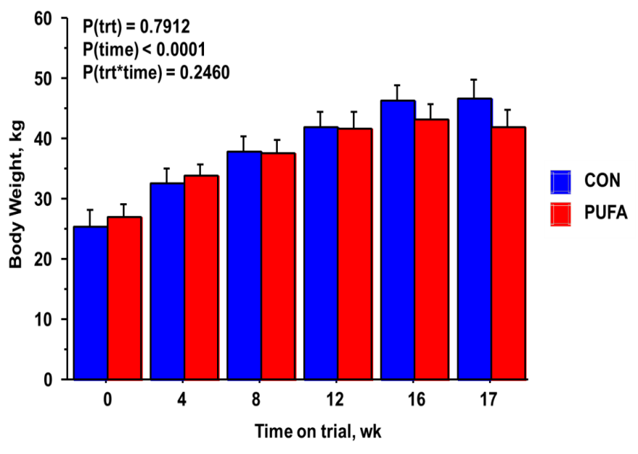
Figure 9: Average values of body weight for high fat diet Control and PUFA-supplemented groups. Over the course of the trial, the PUFA supplemented group had a lower body weight for the most part. The PUFA group started out at a slightly higher average weight than the control group, so this trend is not seen until week 8 of the trial. In terms of total gain, control pigs tended to gain more weight over the trial period than PUFA pigs did (21.2 ± 2.6 vs. 15.2 ± 0.9; p = 0.09). These results are all compatible with the hypothesis that the PUFA diet would show less weight gain than the high fat diet without supplementation.

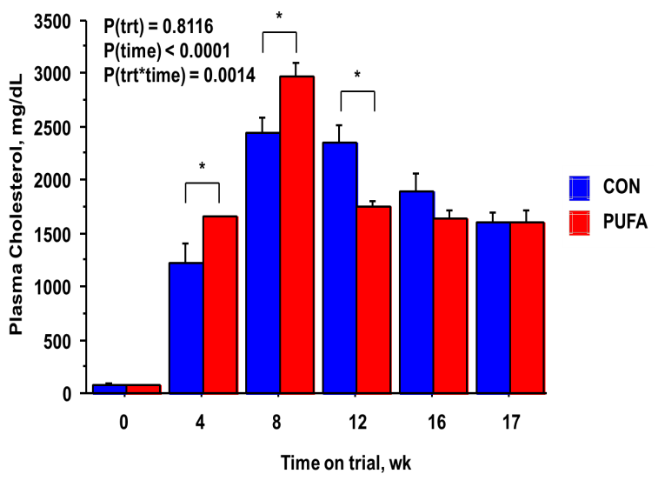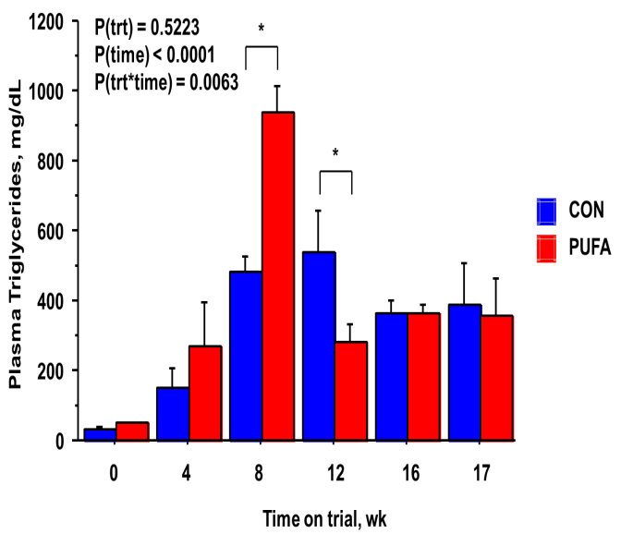
Figure 10: Plasma concentrations of cholesterol (top) and triglycerides (bottom). The pattern of these values is similar to that seen in the pilot study, with a peak around 8-12 weeks and subsequent decrease. Interestingly, the PUFA group had a higher concentration of both cholesterol and triglycerides at the peak point, followed by a significant drop, putting the later values lower than or equal to the control group. The reason for this is unknown and further investigation is needed in this area. The overall increase in cholesterol and triglycerides is lower in the PUFA group compared to the control, as hypothesized.
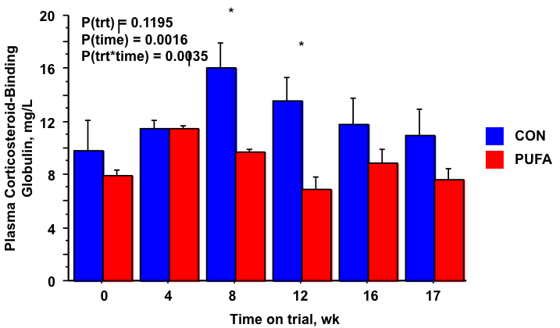
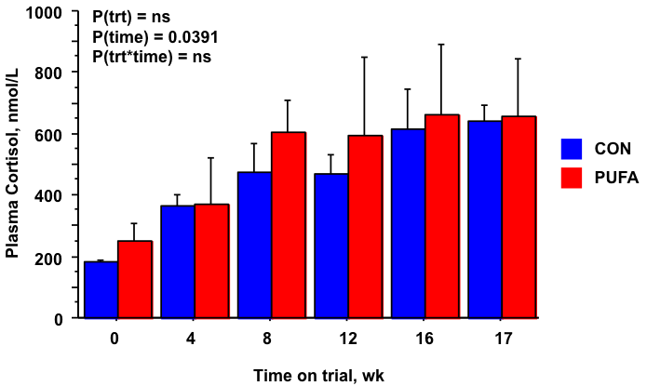
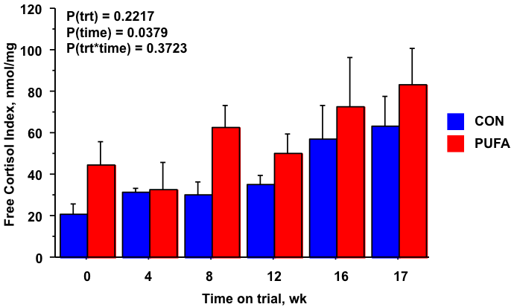

Figure 11: Plasma concentrations of cortisol (top left), CBG (top right) and values for the Free Cortisol Index (bottom). The results of these measurements do not follow the hypothesized pattern. Due to an expected decrease in inflammation with PUFA supplementation, the concentration of cortisol would theoretically decrease while CBG would increase compared to the control. In this trial, the opposite seems to have occurred, and the overall free cortisol increased in the PUFA group. The reason for this is unknown. Testing for pro-inflammatory and anti-inflammatory cytokines present in the blood, currently in progress, may explain this discrepancy.

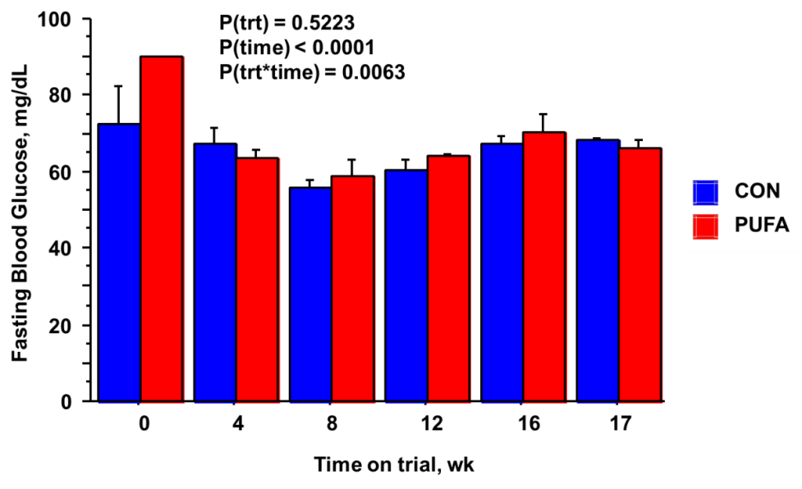
Figure 12: Circulating concentration of blood glucose after overnight fasting. Similar to the pilot study, no statistically significant change in blood glucose was seen between the baseline and final readings. The 16 week trial does not induce insulin resistance as was hypothesized, and there is no significant difference between the PUFA and control groups.

Statistical analysis
Variables were analyzed in SAS (SAS Institute, Cary, NC, USA) with use of the mixed model ANOVA. All data were analyzed with repeated measures. Least squares means were compared with Fisher’s protected LSD. Significance was set at P ≤ 0.05, but trends when 0.10 ≥ P ≥ 0.05 were also noted in a priori comparisons of treatment effects at each time point. All figures depict raw means and SEs.

Discussion
This trial was successful in creating a model of obesity and atherosclerosis in swine that is similar to that seen in humans, including clinical signs of ischemia. Both the pilot study and the control group of the Omega-3 PUFA trial showed significant increases in body weight and development of atherosclerosis. The Omega-3 supplementation trial had mixed results, with body weight and cholesterol and triglyceride concentrations being decreased as expected, while free cortisol showed the opposite result compared to what was hypothesized. Testing of gene expression based pro-inflammatory and anti-inflammatory cytokines is currently in progress, and may show more clearly what is occurring in terms of inflammation with Omega-3 PUFA supplementation. Additionally, arterial samples from the Omega-PUFA study are currently being analyzed as in the pilot study for plaque development. This may show more of the positive effects of PUFA supplementation. The model for atherosclerosis that has been developed in this experiment can be used for future treatment models as well as further investigation of the molecular mechanisms of the development of atherosclerosis.

Acknowledgements
I would like to thank the College of Agricultural Sciences and Natural Resources (CASNR) Honors Program at the University of Tennessee, Animal Science professors Dr. Cheryl Kojima and Dr. Henry Kattesh, Laboratory Associates Mary Roberts and Lezsek Wojakiewicz, Dr. Robert Donnell, Dr. Amy LeBlanc and Dr. Reza Seddeghi from the UT College of Veterinary Medicine, and Dr. Johnathan Wall from the UT Graduate School of Medicine. Funding was provided by the UT CASNR Honors Program as well as a UTIA AgResearch Innovation Grant.

Works Cited
- Bartalena, L; Hammond, GL; Farsetti, A. et al. Interleukin-6 Inhibits Corticosteroid-Binding Globulin Synthesis by Human Hepatoblastoma-Derived (Hep G2) Cells. Endocrinology 1993. 133:291–6.
- Berliner, Judith A; Navah, Mohammad; Fogelman, Alan et al. Atherosclerosis: Basic Mechanisms. Circulation 1995. 91:2488-2496.
- De Caterina, Raffaele and Zampolli, Antonella. N-3 Fatty Acids: Antiatherosclerotic Effects. Lipids 2001. 36: S69-S78.
- Kochanek, KD; Xu, JQ; Murphy, SL; et al. Deaths: Preliminary Data for 2009. Centers for Disease Control. National Vital Statistics Reports 2011. Vol 59 No 4.
- Libby, Peter. Inflammation in Atherosclerosis. Nature 2002. 420: 868-874.
- Ohnishi, H. Saitoh, N. Ura, N. et al. Relationship Between Insulin Resistance and Accumulation of Coronary Risk Factors. Diabetes, Obesity and Metabolism. 2002. 4: 388-393.
- Sinclair Miniature Swine. Sinclair Bio Resources. Accessed 5/08/11: http://www.sinclairbioresources.com/Products/Sinclair.aspx
- Smith, Alison and Swindle, Michael. Comparative Anatomy and Physiology of the Pig. Scandinavian Journal of Laboratory Animal Science 1998. Accessed 05/08/11: http://www.nal.usda.gov/awic/pubs/swine/swine.htm
- Spurlock, M and Gabler, N. The development of porcine models of obesity and the metabolic syndrome. J Nut 2008. 138: 397–402. Accessed 05/08/11 from: http://jn.nutrition.org/cgi/reprint/138/2/397

