Deciphering the Role of Microbial Functional Traits in Agricultural Subsoil Organic Carbon Dynamics

A Dissertation Presented for the

Doctor of Philosophy

Degree

The University of Tennessee, Knoxville

Rounak Patra

August 2024

Acknowledgement
First and foremost, I would like to express my sincere gratitude to my major advisor, Dr. Sindhu Jagadamma, and co-advisor, Dr. Debasish Saha, for their time, constant support, and guidance throughout my doctoral program. I am deeply appreciative of all their valuable feedback and suggestions, which have been vital for my professional development. I am extremely grateful to my committee members, Drs. Melissa Cregger and Jennifer DeBruyn, for their continuous guidance and valuable suggestions. Special thanks to Dr. Melissa Cregger for her guidance and support during the GATE fellowship application and for facilitating the microbial analysis at ORNL. I am very thankful to the University of Tennessee-Oak Ridge Innovation Institute (UT-ORII) for the Graduate Advancement & Training Education (GATE) fellowship. I also acknowledge the financial support from the Tennessee Plant Research Center, the Ecological Society of America, and the Soil Sciences Society of America for providing research support funding and for attending national and international conferences. Sincere thanks to all my past and present lab mates at UT and ORNL for their constant help with lab analysis throughout my degree program. I would like to acknowledge the personnel at the West Tennessee Research and Education Center (WTREC) in Jackson, TN, for managing the field trials and assisting with sample collection. I am also grateful to all my friends in Knoxville and abroad, as well as the faculty and staff of the BESS department for their help and support in various capacities. Finally, I am greatly indebted for the unconditional support of my partner, Piuli, and my parents and Vulu back in India. Thank you for your everlasting support through the ups and downs of graduate school.

Abstract
Soil is vital for agriculture, playing a crucial role in biogeochemical cycles by acting as the largest terrestrial carbon (C) pool, significantly impacting the global C cycle. Intensive agricultural practices have caused an extensive soil organic C (SOC) deficit. Conservation practices like no-tillage (NT) and winter cover cropping help mitigate these deficits by improving soil conditions and supporting active microbial traits associated with C cycling. This aids the crop residue conversion into microbial biomass and by-products, stabilizing them as a more persistent mineral-associated organic matter-C (MAOM-C) pool. Agricultural subsoils beneath the plow horizon, are emerging as potential C sinks due to their unique soil environment, lower management impacts, and a higher abundance of C-unsaturated mineral fraction, presenting an opportunity for secure SOC storage. This research aims to understand microbial functional trait-mediated SOC dynamics under conventional and conservation agricultural practices in both topsoil and subsoil. Utilizing a long-term continuous cotton field experiment in West Tennessee, the study examines the effects of soil depth and agricultural practices on microbial functional traits associated with C cycling and SOC accrual. We hypothesized that conservation practices, particularly NT combined with deep-rooted winter wheat (WW), would enhance microbial functional traits such as carbon use efficiency (CUE) and enzymatic efficiency (EE), leading to increased SOC storage. We found that NT increased topsoil SOC stock than conventional tillage. However, WW increased subsoil SOC stock. A short-term incubation experiment with ¹³C-glucose addition revealed significant increases in CUE and EE under NT topsoil. WW improved microbial CUE in both topsoil and subsoil layers. A long-term incubation study with ¹³C-labeled plant residue revealed increased residue-derived C allocation to SOC fraction under long-term cover crops. This increase in SOC was mediated by improved microbial functional traits, increased residue-derived C storage in the MAOM-C pool, and decreased C loss from native SOC. This research demonstrates how management practices and soil depth influence microbial functional traits, affecting SOC dynamics. Strategic implementation of long-term conservation agriculture promotes SOC storage and mitigates C loss, especially in the subsoil. Our results demonstrate the need for further research and policy support to implement agricultural subsoil-targeted SOC sequestration strategies.

Table of Contents

Chapter 1: Introduction and dissertation overview 1
1.1. Soil Carbon Cycle 1
1.2. Agricultural SOC sequestration strategies 2
1.3. Factors affecting agricultural SOC dynamics 4
1.3.1. Changes in the soil physical architecture 4
1.3.2. SOC stabilization capacity in the soil-mineral matrix 5
1.3.3. Microbial control over SOC fractions 6
1.4. Subsoil SOC Dynamics 8
1.5. Objectives 10
1.6. Description of the Study Site 12
1.7. Chapter formatting and publication details 13
Appendix 14
Chapter 2: Winter wheat cover crop increased subsoil organic carbon in a long-term cotton cropping system in Tennessee 17
2.1. Abstract 19
2.2. Introduction 21
2.3. Materials and methods 24
2.3.1. Soil sampling 24
2.3.2 Bulk soil analysis 24
2.3.3 Soil physical fractionation 25
2.3.4. Soil organic C stratification ratios 27
2.3.5. Root biomass determination 27
2.3.6. Statistical analysis 27
2.4. Results 28
2.4.1. Total SOC stock and concentration 28
2.4.2. SOC fractions 29
2.4.3 Carbon stratification ratios 30
2.4.4. Drivers of total SOC concentration change in topsoil and subsoil 31
3.5. Carbon accumulation capacity In POM and MAOM Fractions 32
2.5. Discussion 32
2.5.1. Profile SOC storage under conservation management practices 32
2.5.2. SOC functional fractions driving profile-scale SOC distribution 35
2.5.3. Implications of C functional pools for SOC storage 36
2.6. Conclusion 37
Appendix 39
Chapter 3: Deep-rooted winter wheat cover crop promotes subsoil organic carbon storage through improved microbial functional traits 51
3.1. Abstract 53
3.2. Introduction 54
3.3. Materials and methods 58
3.3.1. Soil sampling, processing, and analyses 58
3.3.2. Analysis of C in bulk soil and physical fractions 59
3.3.3. Incubation experiment and C isotope addition 60
3.3.4. Measurement of ¹³C in C pools 60
3.3.5. Enzymatic assay 62
3.3.6. Measurement of microbial functional traits associated with C cycling 62
3.3.7. Data analyses 63
3.4. Results 65
3.4.1. Bulk soil characteristics and SOC fractions 65
3.4.2. ¹³C in microbial C pools and activity of C cycling enzymes 65
3.4.3. Community-level microbial functional traits associated with C cycling 66
3.4.4. Relationship between microbial functional traits and SOC 67
3.5. Discussion 67
3.5.1. Microbial functional traits in topsoil and subsoil 67
3.5.2. Distinct soil properties, management practices, and microbial functional traits-drive SOC accumulation in topsoil and subsoil 69
3.5.3. Implications and challenges for studying microbial functional traits for SOC storage 71
3.6. Conclusion 72
Appendix 74
Chapter 4: Long-term cover cropping increased carbon storage in bulk soil fractions and decreased priming effect from added residue 84
4.1. Abstract 86
4.2. Introduction 88
4.3. Materials and methods 91
4.3.1. Soil sampling 91
4.3.2. Incubation experiment set-up 91
4.3.3. CO₂ measurement 92
4.3.4. Destructive soil sampling and SOC fractionation 93
4.3.5. Isotopic calculations 94
4.3.6. Statistical analysis 95
4.4. Results 96
4.4.1. Total CO₂-C mineralization 96
4.4.2. Residue and soil derived CO₂ production 97
4.4.3. Priming Effect 98
4.4.3. Carbon in POM-C fraction 98
4.4.4. Carbon in MAOM-C fraction and MAOM-C_{capcity} 100
4.5. Discussion 101
4.5.1. Effect of long-term management practices and soil depth on CO₂ mineralization and priming effect 101
4.5.2. Effect of long-term management practices and soil depth on residue-derived C in SOC fractions 104
4.5.3. Management implications from this study 105
4.6. Conclusion 106
Appendix 108
Chapter 5: Long-term cover cropping increased residue derived carbon storage in mineral associated C fraction by regulating microbially functional traits 124
5.1. Abstract 126
5.2. Introduction 128
5.3. Materials and Methods 131
5.3.1. Experimental Site, soil sampling and incubation experiment set up 131
5.3.2. Measurement of residue derived C in CO₂ and bulk SOC fractions 131
5.3.3. Measurement of microbial biomass C and C-cycling enzyme activities 131
5.3.4. Isotopic calculations 133
5.3.5. Statistical analysis 134
5.4. Results 135
5.4.1. ¹³C recovered in C_{growth}, CO₂ and in soil physical fractions 135
5.4.2. Microbial functional traits associated with C cycling 137
5.4.2.1. C-cycling enzymatic activities and enzymatic efficiency 137
5.4.2.2. Microbial CUE and qCO₂ 138
5.4.3. Relationship between microbial functional traits and residue C recovered in soil C fractions 139
5.5. Discussion 140
5.5.1. Effect of agricultural management practices and soil depth on microbial functional traits 140
5.5.2. Conservation agricultural practices drive residue derived C dynamics 142
5.6. Conclusion 143
Appendix 145
Chapter 6: General conclusion and future research directions 160
6.1. Understanding the role of soil microbial diversity and functionality 161
6.2. Understanding MAOM-C dynamics through molecular characterization 162
6.3. Understanding the impact of extreme climatic conditions 163
6.4. Navigating the policy and socioeconomic factors 164
References 165
Vita 181

List of Tables

Table 1. Details of the individual chapters and their publication status 14
Table 2. Tillage and cover crop effects on total soil organic carbon, particulate organic carbon, and mineral-associated organic carbon for each soil depth 39
Table 3. Principal component analysis for the determination of total SOC concentration drivers 40
Table 4. Regression equations determine total SOC concentration drivers for topsoil and subsoil 41
Table 5. Basic soil parameters for each soil depth (mean ± standard error values across all treatments) 42
Table 6. P-values for all the measured parameters 43
Table 7. Treatment effects on additional C fractional parameters and root mass at each soil depth 45
Table 8. Basic soil parameters for topsoil and subsoil 74
Table 9. Tillage and cover crop effects on microbial functional traits associated with C cycling 75
Table 10. P-values for all the soil parameters 76
Table 11. Potential relationships between variables derived from the literature and the ANOVA results derived from this study 77
Table 12. Model selection results for predicting SOC concentrations in topsoil and subsoil, starting with the full model including all explanatory variables. All results are based on linear mixed effect (lme) models with field replications as a random factor 78
Table 13. Cumulative CO₂ mineralized (CO_{2total}, g C kg soil⁻¹) and bulk SOC fractions recovered (POM-C_{total} and MAOM-C_{total}, g C kg soil⁻¹) over the incubation period under management treatments in (a) topsoil and (b) subsoil. 108
Table 14. Significance of repeated-measures ANOVA for residue (CO_{2res}), soil derived (CO_{2soil}), cumulative CO₂ (CO_{2total}), and cumulative Priming effect (PE). 110
Table 15. Significance of repeated-measures ANOVA for residue (MAOM-C_{res}), soil derived (MAOM-C_{soil}), and total mineral associated organic carbon (MAOM-C_{total}), MAOM-C_{CN} (CN ratio of MAOM-C) and estimated MAOM-C saturation deficit over the incubation period. 111
Table 16. Significance of repeated-measures ANOVA for residue (POM-C_{res}), soil derived (POM-C_{soil}), total particulate organic C (POM-C_{total}), POM-C_{CN} (CN ratio of POM-C) over the incubation period. 112
Table 17. Microbial C_{growth} (nmols g⁻¹ soil) over the incubation period under agricultural management treatments in topsoil and subsoil. 145
Table 18. Total C-cycling enzymatic activity (nmols g⁻¹ soil) over the incubation period under agricultural management treatments in topsoil and subsoil. 146
Table 19. The percentage of added ¹³C from residue recovered in mineralized CO₂ (fCO_{2res}, %) and different bulk SOC fractions (fPOM-C_{res} and fMAOM-C_{res}, %) across (a) topsoil, and (b) subsoil agricultural treatments. 147
Table 20. Significance of repeated-measures ANOVA for Total, AG, BG, CB, and XYL enzymatic activity. Units are nmol g soil⁻¹ 149
Table 21. Significance of repeated-measures ANOVA for CUE (Carbon use efficiency), EE (C-cycling enzymatic efficiency; mg C_{growth} mmol⁻¹ enzymes), and qCO₂ (microbial metabolic efficiency). 150
List of Figures

Figure 1. Conceptual diagram of the topsoil and subsoil microbial trait mediated SOC dynamics under conventional and conservation management practices. 15
Figure 2. Layout of the long-term agricultural field experiment (1981-present) located in Jackson, West Tennessee. 16
Figure 3. Depth-wise soil organic carbon (SOC) stock under long-term cover cropping (a) and tillage practices (b) 46
Figure 4. Depth-wise distribution of microbial biomass carbon (MBC) under long-term tillage and cover cropping practices. 47
Figure 5. Carbon stratification ratio (SR) for total SOC (SR_{SOC}) (a), MAOM-C (SR_{MAOM-C}) (b), and POM-C (SR_{POM-C}) (c) as affected by long-term tillage practices. 48
Figure 6. Relationship of total SOC concentration (SOC_{con}) with POM-C (a,b) and MAOM-C (c,d) for all the treatments. (a,c) represent soil samples from tillage zone (topsoil representative: 0-10 cm); and (b,d) represent soil samples beyond the tillage depth (subsoil representive: 10-60 cm) 49
Figure 7. Bulk density in response to long-term tillage practices. CT, Conventional-tillage; NT, No-till. 50
Figure 8. Depth-wise total soil organic carbon, particulate and mineral associated soil organic carbon, and dissolved organic carbon under long-term tillage (a-d) and cover cropping (e-h) practices. 79
Figure 9. Depth-wise soil microbial functional traits under long-term tillage (a-c) and cover cropping (d-f) practices. 80
Figure 10. Drivers of topsoil and subsoil SOC accretion. Structural equation modelling diagram representing relationship of agricultural management practices, soil physicochemical parameters, microbial functional traits, and soil carbon fractions with SOC concention 81
Figure 11. Conceptual priori-model of proposed relationships for structural equation modelling (SEM) exploring the effect between SOC concentration and agricultural management practices (Tillage and Cover cropping; exogenous variables), soil properties (pH, Bulk density, and Clay content; endogenous variables), microbial functional traits (C_{growth}, C_{respiration}, Net enzymatic activity; endogenous variables), soil C fractions (POM-C, MAOM-C, and DOC; endogenous variables). Black solid arrows are the hypothesized direct relationship derived from the literature and the linear mixed effects ANOVA results. 82
Figure 12. Pearson correlations analysis between SOC and its predictor variables which exhibit significant difference at P ≤ 0.1 for the (a) topsoil and (b) subsoil. 83
Figure 13. Cumulative residue and soil-derived C mineralized as CO₂ under different treatment combinations at (a) topsoil and (b) subsoil. In the stacked bars, solid color pattern denotes soil-derived MAOM-C, and dotted color pattern denotes residue-derived MAOM-C. 113
Figure 14. Cumulative (CO_{2total}; a,b) and Specific CO₂ mineralization (Specific CO_{2total}; c,d) over the course of incubation experiment as a function of soil depth (a,c) and across agricultural treatment combinations at topsoil and subsoil (b,d). 114
Figure 15. Cumulative PE over the course of incubation as a function of (a) soil depth, and (b) across agricultural treatment combinations at topsoil and subsoil. 115
Figure 16. Cumulative priming effect in soils added with C-labelled residues under different treatment combinations at (a) topsoil and (b) subsoil. Data represents mean ± standard errors. 116
Figure 17. Total (POM-C_{total}; g C kg soil⁻¹) over the course of incubation experiment as a function of soil depth (a) and depth wise agricultural treatment combinations (b). 117
Figure 18. Cumulative residue and soil derived POM-C under different treatment combinations at (a) topsoil and (b) subsoil. In the stacked bars, solid color pattern denotes soil-derived POM-C, and dotted color pattern denotes residue-derived POM-C 118
Figure 19. Total MAOM-C (MAOM-C_{total}; g C kg soil⁻¹) over the course of incubation experiment as a function of (a) soil depth and (b) depth wise agricultural treatment combinations. 119
Figure 20. Cumulative residue and soil derived MAOM-C under different treatment combinations at (a) topsoil and (b) subsoil. Within stacked bars, solid color pattern denotes soil derived MAOM-C, and dotted color pattern denotes residue derived MAOM-C. Data represents mean ± standard errors. 120
Figure 21. Estimated MAOM-C saturation deficit under different treatment combinations at topsoil and subsoil. 121
Figure 22. CN ratio of MAOM-C_{total} and POM-C_{total} under different treatment combinations at topsoil and subsoil. 122
Supplementary Figure 23. POM-C_{total} (a,b) and MAOM-C_{total} (c,d) CN ratio over the course of incubation experiment as a function of soil depth (a,c) and across agricultural treatment combinations at topsoil and subsoil (b,d). 123
Figure 24. Residue derived CO₂ (CO_{2res}; g C kg soil⁻¹) over the course of incubation as a function of (a) soil depth, and (b) across agricultural treatment combinations at topsoil and subsoil. 151
Figure 25. Residue derived POM-C (POM-C_{res}; g C kg soil⁻¹) over the course of incubation as a function of (a) soil depth, and (b) across agricultural treatment combinations at topsoil and subsoil. 152
Figure 26. Residue derived MAOM-C (MAOM-C_{res}; g C kg soil⁻¹) over the course of incubation as a function of (a) soil depth, and (b) across agricultural treatment combinations at topsoil and subsoil. 153
Figure 27. Activities of individual C-cycling enzymes under different agricultural treatment combinations at (a) topsoil and (b) subsoil. 154
Figure 28. Total C-cycling enzymatic activity (nmol g soil⁻¹) over the course of incubation as a function of (a) soil depth, and (b) across agricultural treatment combinations at topsoil and subsoil. 155
Figure 29. Depth-wise soil microbial functional traits associated with C-cycling under long-term agricultural treatment combination at topsoil (a,c,e) and subsoil (b,d,f). 156
Figure 30. Carbon use efficiency (CUE) over the course of incubation as a function of (a) soil depth, and (b) across agricultural treatment combinations at topsoil and subsoil. 157
Figure 31. Microbial metabolic efficiency (qCO₂, mg Cgrowth kg soil⁻¹) over the course of incubation as a function of (a) soil depth, and (b) across agricultural treatment combinations at topsoil and subsoil. 158
Figure 32. Structural equation modelling diagram representing relationship of agricultural management practices, soil microbial functional traits associated with C cycling, and residue derived C stabilization as MAOM-C_{res} and destabilization as CO_{2res} in (a) topsoil and (b) subsoil. 159

Chapter 1: Introduction and dissertation overview

1.1. Soil Carbon Cycle
Carbon (C), the fourth most abundant element in the world, circulates among the planet's primary reservoirs—oceans, atmosphere, and land (Lal, 2004a). This global C cycle operates as a closed-loop system, with the total amount of C remaining constant, though their distribution across different reservoirs shifts due to climatic factors (Friedlingstein et al., 2022; Lal, 2004a). The C emitted to the atmosphere is balanced by what is absorbed in those natural sinks. However, this balance has been disrupted since the Industrial Revolution when fossil fuel consumption for energy production began to rise exponentially. More C now persists in the atmosphere than the other reservoirs can absorb, increasing atmospheric accumulation of greenhouse gases (GHG) such as CO₂ (Friedlingstein et al., 2022). The rise in atmospheric C has, in turn, amplified the capacity of natural C sinks (e.g. oceans and vegetation), though these sinks could become saturated and future expansion of these sinks remains uncertain (McKinley et al., 2017; Keenan and Williams, 2018). Current atmospheric CO₂ levels are likely to cause significant climate alterations globally, affecting vulnerable communities, ecosystems, and food security.
Soil C serves as the largest C reservoir in the terrestrial ecosystems and supports 94% of food production. Also, it provides essential ecosystem services, including biodiversity, nutrient cycling, and water cycling (Lal, 2009). Soil C exists as soil organic carbon (SOC) and soil inorganic carbon (SIC), with an estimated total of 1500-2300 Petagrams (Pg) of soil C present down to a depth of 1 meter (Batjes, 1996; Jobbágy and Jackson, 2000; Scharlemann et al., 2014; Jackson et al., 2017). The quantities of SOC and SIC vary significantly in different ecosystems. In croplands, the soil C can be almost entirely soil organic C (SOC) if the soil pH is <7.1 (Al-Kaisi et al., 2005), whereas in desert soils, SIC contributes to >80% of the total soil C pool (Wang et al., 2010). SOC plays a critical role in ecosystem services, and is more vulnerable to mineralization and loss due to anthropogenic activity (Sanderman et al., 2017). As soils have been intensively cultivated to meet the global food, fiber, and biofuel demands of a growing population, we lost around 130 Pg of C from the soil in the last two-centuries (Sanderman et al., 2017), with agricultural sector accounts for ~10% of the total C emissions to the atmosphere (EPA, 2022). Adoption of best management practices provide a potential to maintain, or even improve the long-term storage of SOC in agricultural soils, which can help in counterbalancing the CO₂ emissions from agriculture and fossil fuels (Lal, 1998; Lal et al., 2015).

1.2. Agricultural SOC sequestration strategies
Conservation agriculture, based on the implementation of best management practices has often been proposed as a strategy for sequestering atmospheric C into soil (Lal et al., 2015). The primary contributions to the agricultural-SOC pool come from post-harvest crop residue either as (a) structural residue (e.g., roots, stem etc.) or (b) photosynthate-C from living roots through rhizodeposition (Sokol et al., 2019a). A part of this residue C is stabilized in soil as SOC, but most of the crop residue-derived C is ultimately released back to the atmosphere as CO₂. Therefore, the SOC pool in response to agricultural management practices significantly influences the exchange of C between the terrestrial ecosystems and the atmosphere (Lal, 1998). The dynamic nature of agricultural SOC pool has garnered considerable interest among practitioners, scientists, and policymakers because agricultural systems have the distinctive ability to either become source or sink of SOC, with the outcome heavily dependent on management practices (Harden et al., 2018). Thus, gaining a clear understanding of the mechanisms on how annual croplands can either favor SOC accumulation or depletion is critical.
Several nature-based agricultural practices are popular for achieving SOC accumulation including reduced or no-tillage, growing cover crops, practicing agroforestry, and applying biochar (Bossio et al., 2020). These practices are foundational to conservation agriculture, with focusing mostly on minimizing soil disturbance and erosion, maintaining soil cover, and crop rotation to restore soil productivity, and enhance ecosystem services (Bossio et al., 2020; CEAP 2022). The role of these systems is increasingly recognized as crucial for meeting future food demands and increasing soil C storage. However, quantifying agricultural SOC sequestration rates accurately is highly debated, particularly following the COP21 ‘4 per mille’ initiative, which aims to sequester an additional 0.4% SOC annually to offset anthropogenic CO₂ emissions based on 2015 levels (Minasny et al., 2017).
SOC sequestration is not a permanent solution because the stored C can return to the atmosphere, negating any climate or soil health benefits if SOC-building management practices are not consistently maintained. This reversal is more likely in topsoils, due to conditions that promote decomposition including soil disturbance and higher levels of microbial activity. Consequently, there is increasing interest in exploring the potential for SOC sequestration in deeper soil layers, a more effective strategy for long-term SOC storage (Rumpel and Kögel-Knabner, 2011; Button et al., 2022). Management practices including less frequent deep inversion tillage (Alcántara et al., 2016; Ye et al., 2019), planting deep-rooted crops (Kell, 2011; Lynch and Wojciechowski, 2015) and newer approaches such as crop-residue and biochar burial (Bruun et al., 2014), Fe and Al hydroxide additions (Kirsten et al., 2021) aim to enhance C storage in soil depths. However, these newer, more ambitious approaches need to be tested in the field before widescale implementation (Button et al., 2022), as the transfer of C does not equate to soil C sequestration in terms of removing atmospheric-C and ensuring its stability in the soil. Adopting subsoil specific management strategies could ultimately redefine agricultural SOC sequestration, but only through comprehensive field trials and adaptive management can we ensure their effectiveness and sustainability in storing SOC in subsoil.

1.3. Factors affecting agricultural SOC dynamics
In the last decade, SOC formation and persistence concepts have been changed drastically, from complex polymers resisting microbial decomposition to form SOC (“humic substances”) to recalcitrant C compounds from direct plant contributions and microbial by-products stabilizing on the soil mineral fraction to form SOC (“microbial turnover pathway”) (Schmidt et al., 2011; Lehmann and Kleber, 2015). Despite these changes in concepts, unanswered questions remain, particularly regarding the response of SOC to different agricultural management practices and soil depth, affecting SOC formation and distribution as a slow-cycling mineral associated organic C (MAOM-C) or the more transient particulate organic C (POM-C).

1.3.1. Changes in the soil physical architecture
The structure of the soil and the total pore space distribution plays a crucial role in cropland-SOC dynamics by facilitating crop residue transformation into POM-C. As soil micro and macrofauna together break down complex crop-residues (large molecular weight and insoluble polymers such as lignin, cutin), the residue is broken into fragments that gradually become part of POM-C (Lavallee et al., 2020; Cotrufo et al., 2022). This POM-C can exist as free-POM-C that is not protected in aggregates, or it can be trapped within soil aggregates as occluded-POM-C (von Lützow et al., 2007). POM can also be categorized by its density; light-POM-C constituting less dense fresh crop-residue, and heavy-POM, which is denser, often found attached to sand particles, and has been partially decomposed by microbes (Lavallee et al., 2020). While POM-C accumulates in the soil with no upper limit (Cotrufo et al., 2019), with its importance in aiding microbial activity and soil fertility, management practices and soil depth can dictate POM-C formation and stability.

1.3.2. SOC stabilization capacity in the soil-mineral matrix
Direct sorption of soluble organic C compounds are attached to soil mineral surfaces via different types of chemical bonds, forming MAOM-C (von Lützow et al., 2007; Cotrufo et al., 2015). MAOM-C constitutes a significant proportion of total SOC ( >50%) with significantly longer turnover times (Cotrufo et al., 2019; Lavallee et al., 2020). The soil mineral matrix possesses a distinct yet limited ability to stabilize MAOM-C on the fine silt+clay particles (<53 µm), since smaller particles offer a larger surface area for sorption (Hassink, 1997; Stewart et al., 2007; Gulde et al., 2008). Mineral reactivity and their sorption capacity are increased by the presence of Al and Fe oxides and hydroxides, and by the surface charge that arises from structural differences in the phyllosilicate minerals (Sollins et al., 2009). Swelling 2:1 clay like smectite and vermiculite offer a high C sorption potential due to their large surface area (600-900 m² g⁻¹). In contrast, non-expanding phyllosilicates like illite and chlorite (70-170 m² g⁻¹) have more sorption potential than 1:1 low-surface-area clay minerals like kaolinite (5-30 m² g⁻¹) (Brady et al., 2008; Sollins et al., 2009). This highlights the complexity of interactions between organic C and soil minerals in determining the MAOM-C stabilization. The difference between this maximum MAOM-C storage capacity and the current MAOM-C content within the fine particle fraction is referred to as the MAOM-C saturation deficit (Hassink, 1997; Stewart et al., 2007). Soils with a high MAOM-C saturation deficit (highly-managed agroecosystems) will retain more of the newly added crop residue C compared to soils with a low MAOM-C saturation deficit (undisturbed grassland) (Hassink, 1997; Cotrufo et al., 2022; Georgiou et al., 2022). A global meta-analysis has shown that forest and grassland subsoil are further away from SOC saturation compared to surface soils (Georgiou et al., 2022). They also showed no significant difference in topsoil C-saturation levels between these two ecosystems, but grasslands did show a higher C-saturation in subsoil compared to the forests. This observation underscores the role of rooting depth, and subsequent subsoil-C input rates on MAOM-C formation and persistence, suggesting that implementation of subsoil-specific management practices can increase subsoil SOC sequestration.

1.3.3. Microbial control over SOC fractions
The soil microbial community plays a crucial role in controlling the SOC dynamics by decomposing and stabilizing SOC to satisfy their growth and maintenance needs (Liang et al., 2017). Even though microbial biomass C constitutes a small portion of the total SOC, the combined contributions of microbial biomass and by-products account for up to 80% of the stable SOC pool (Blagodatskaya and Kuzyakov, 2013). Traditional first-order SOC cycling models have historically included the role of microbes indirectly, by using proxy-based functions of SOC pool instead of any biological characteristics (Todd-Brown et al., 2013). In newer models that specifically represent non-linear microbial processes (e.g., soil priming effect), including a microbial biomass pool is key (Wieder et al., 2013). These models view SOM breakdown as dependent either on the size of this biomass pool or on the enzymes produced by microbes (Wieder et al., 2013). A critical aspect of these models is how they simulate the way microbes use C, whether for respiration or growth. This is performed by introducing a microbial functional trait or parameter known as microbial carbon use efficiency (CUE), which is the ratio between consumed C that is utilized for producing new microbial biomass and by-products and what is utilized for catabolic activities such as respiration (Manzoni et al., 2012). The efficiency with which microbes convert crop residue C into biomass has a direct impact on the size of the microbial biomass C pool and, consequently, on the amount and quality of the crop residue being processed for SOC formation (Cotrufo et al., 2013, 2015). The Microbial Efficiency-Matrix Stabilization (MEMS) framework by Cotrufo et al., (2013) integrates the efficiency of microbial substrate use with the formation of MAOM-C fractions as the stabilization of residue C within soils are primarily governed by the microbial conversion efficiency, forming more-persistent MAOM-C.
Attempts to pinpoint a universally accepted value for microbial functional trait-based models have yet to yield a clear consensus, resulting in a wide range of estimated CUE values that span from 0 to 1 (Sinsabaugh et al., 2013; Geyer et al., 2016). CUE is a collective measure reflecting various microbial activities, such as how efficiently microbes assimilate nutrients, their respiration during maintenance and enzyme production, and the generation of metabolic by-products (e.g., protective exopolysaccharides and metabolites) (Joergensen and Wichern, 2018; Schimel et al., 2022). The variability in these activities leads to the observed fluctuations in CUE. These activities operate over different time scales and are influenced by several factors such as the availability of resources, nutrient uptake rates, and the size of the microbial biomass pool, adding more complexity to accurately determining CUE through altered production of non-growth microbial by-products and C-cycling enzymes (Schimel et al., 2022). Enzymes such as hydrolases and glucosidases primarily break down crop residues, while oxidase enzymes catalyze the decomposition of polymeric products from the carbon cycle (Sinsabaugh et al., 2002). Although these enzymes are crucial for nutrient cycling ─ delivering essential nutrients to plants and microorganisms and central to biogeochemical cycles, their activity can be affected by changes in soil and environmental changes. Previous meta-analyses have shown that β-glucosidase and xylosidase activities demonstrate a significant correlation with SOC improvement under conservation and no-tillage practices, indicating greater ecosystem-level functional diversity with these conservation agricultural practices compared to conventional tillage. However, annual croplands typically experience faster crop residue decomposition and a greater microbial metabolic quotient (CO₂-C per unit microbial biomass C, 3.1 for croplands vs. 1.4 for natural ecosystems, unit: mol C mmol MBC⁻¹ h⁻¹) (Xu et al., 2017). This is generally due to (a) the harvesting of the majority of crop residues reduces microbial biomass C compared to unmanaged forests and grasslands, and (b) increased soil disturbance from management interventions such as tillage, which reduces microbial enzymatic production, efficiency in converting and stabilizing crop-residue carbon into SOC and therefore increases CO₂-C loss, reducing agricultural SOC over time (van Groenigen et al., 2013; Xu et al., 2017; Sauvadet et al., 2018; Kallenbach et al., 2019). However, our understanding of how soil microbial functional traits respond to contrasting agricultural practices, particularly across different soil depths where C availability and microbial activity decreases drastically, is still limited.

1.4. Subsoil SOC Dynamics
The subsoils, which lie beneath the plow zone (A_{p}), receive no or minimal inputs of above ground crop residue yet play a crucial role in SOC storage. The deep soil layers can contain up to 70% of the total soil C in 1 m depth (Jobbágy and Jackson, 2000; Button et al., 2022). Subsoils of annual cropping systems may hold a high capacity for SOC storage since they are typically less saturated with SOC compared to topsoil (Rumpel and Kögel-Knabner, 2011; Georgiou et al., 2022). However, little is known about the mechanisms behind agricultural SOC dynamics at various depths.
Soil mixing by tillage and bioturbation processes play a crucial role in the vertical distribution of crop residues from soil surface to down the soil profile . However, no-tillage practices increase aggregation and SOC accumulation at the soil surface (West and Post, 2002; Lorenz and Lal, 2005; Luo et al., 2010). Subsoils with their lower porosity limited O₂ availability, and limited and patchy presence of C inputs create an environment with little microbial activity (Salomé et al., 2010; Rumpel et al., 2012). These factors, coupled with stronger bonding of C with subsoil minerals and physical encapsulation of C within prism-like soil structures prevalent in the subsoil, render crop residue C less available and accessible to microbes. These subsoil-specific unique processes decrease SOC turnover and increase SOC age, making agricultural subsoil layers potential targets for long-term C storage strategies. However, the challenge lies in comprehensively understanding the impact of agricultural management practices on these stabilization mechanisms to predict how SOC dynamics is impacted under these practices. The stability of the subsoil C is also depends on fresh C inputs and consequent microbial activity, which can be altered by changes in management practices, potentially reducing the effectiveness of deep soil as a SOC sink (Fontaine et al., 2007; Dimassi et al., 2014b). The introduction of fresh C input into the soil can stimulate the decomposition of native SOC, a phenomenon known as the priming effect (Kuzyakov et al., 2000). PE is variable and depends on a variety of factors, including the quality and quantity of SOM input in the soil (Shahbaz et al., 2017; Fang et al., 2018). While agricultural topsoil may be more susceptible to PE and thus SOC loss due to environmental fluctuations, availability of crop residue, and management-mediated disturbances, the occurrence of PE in subsoil could have a huge implication as 2/3rd of total SOC is stored in subsoil. The impact of PE on subsoil SOC pools in annual croplands and the balance between SOC stabilization and loss due to priming remains an area for further investigation.

1.5. Objectives
The overarching goal of this dissertation is to investigate the mechanistic pathways of SOC formation and persistence in response to contrasting agricultural management practices and soil depth (Figure 1). By integrating data collected from long-term field experiments and lab-based incubations, I aimed to understand the interplay of microbial functional traits, SOC functional fractions, and soil depth in controlling the SOC dynamics under contrasting management practices. The specific objectives were as follows:
- To determine how contrasting long-term tillage and cover cropping practices affect the profile-scale total SOC stock as well as SOC distribution in different functional C fractions (Chapter 2). We hypothesized that,
  - the positive effect of no-tillage on SOC accumulation will be limited to the topsoil,
  - cover crops with extensive root systems will increase profile-scale SOC stock,
  - different C functional fractions control SOC accumulation in topsoil and subsoil due to differences in the pedo-climatic factors and management interventions across the soil depth.
- To measure the response of microbial functional traits associated with C-cycling to the long-term conservation agricultural practices such as no-tillage and cover cropping in topsoil as well as subsoil (Chapter 3). We hypothesized that,
  - no-tillage improves microbial functional traits facilitating SOC accumulation in topsoil than subsoil because the beneficial effect of no-tillage is restricted in the topsoil,
  - deep-rooted crops improve subsoil microbial functional traits by increasing C availability in the subsoil,
  - SOC accumulation in topsoil and subsoil will be influenced by distinct microbial functional traits, driven by differences in agricultural treatments, microbial functional traits, and SOC fractions.
- To understand the effect of contrasting agricultural management practices and soil depth on processes dictating the fate of added residue C in SOC storage and mineralization (Chapter 4). We hypothesized that:
  - adding residue in the subsoil will increase MAOM-C accrual compared to surface soil. This will reduce native SOC loss by priming and enhance residue C cycling through microbial biomass and byproducts, thereby increasing MAOM-C accrual in the C undersaturated mineral fraction of subsoil over time,
  - long-term conservation agricultural treatments (no-tillage and the use of cover cropping practices) will increase the storage of residue-derived C in SOC fractions and reduce the priming effect.
- To examine the temporal changes in microbial functional traits and their influence on residue derived SOC stabilization and destabilization under conservation agriculture versus conventional agriculture in both topsoil and subsoil (Chapter 5). We hypothesized that:
  - in the absence of substrate limitation at subsoil, subsoil microbial functional traits associated with C-cycling will improve (increased CUE and EE, and decreased qCO₂) and equate to the topsoil microbial functional traits,
  - Soils under long-term no-tillage and deep rooted cover crops will improve microbial functional traits over time compared to soils under tillage and no winter cover crops.

1.6. Description of the Study Site
This dissertation research was carried out at the West Tennessee Research and Education Center of the University of Tennessee, located in Jackson, Tennessee, USA (35° 37' N, 88°50' W). We utilized a long-standing agricultural field experiment that has been operational since 1981. The site experiences an average annual temperature of 15.6 °C and average annual precipitation of 1300 mm. The soil was classified as Lexington silt loam (fine-silty, mixed, thermic Ultic Hapludalfs), originated from marine deposits. The experimental design was a randomized complete block (RCBD) with a split-split plot configuration, where N rates are allocated to main plots, cover crops to subplots, and tillage operations to sub-sub plots (Figure 1). The field experiment included four N fertilization rates: 0, 34, 67, and 101 kg N hectare⁻¹ year⁻¹; four cover crop treatments: crimson clover (Trifolium incarnatum L.), hairy vetch (Vicia villosa), winter wheat (Triticum aestivum L.), and a no-cover control; and two tillage regimes: no-tillage and conventional disk-tillage, with cotton (Gossypium hirsutum L.) being the continuous cash crop. Each treatment is replicated four times, with each plot measuring 12 m $×$ 8 m and containing eight rows of cotton. This dissertation research is focused on select treatments: two tillage regimes (no-tillage, NT; and conventional-tillage, CT) and three cover crops (no-cover, NC; hairy vetch, HV; and winter wheat, WW) receiving 67 kg N hectare⁻¹ year⁻¹. Tillage plots are disk-tilled annually to a depth of 10 cm and then leveled. Cover crops are planted in October or November each year and chemically terminated in April or May using Gramoxone SL 2.0 at 3.51 L hectare⁻¹ prior to cotton sowing at 86,500 seeds hectare⁻¹. Additional fertilizers are applied based on soil test recommendations, including phosphorus as triple superphosphate (101 kg P₂O₅ hectare⁻¹) and potassium as muriate of potash (134 kg K₂O hectare⁻¹). Different cotton cultivars have been planted over the years, with mechanical harvesting typically occurring between October and November.

1.7. Chapter formatting and publication details
Chapters 2 to 5 follow the format of manuscripts for peer-reviewed publication, with each chapter beginning with a title page that lists the authors, their contributions to the work, and the status of journal publication. Table 1 provides the details of the individual chapters along with their respective publication statuses.

Appendix

Table 1. Details of the individual chapters and their publication status
Chapter | Title | Status
1 | Introduction and dissertation overview
2 | Winter wheat cover crop increased subsoil organic carbon in a long-term cotton cropping system in Tennessee | Published in Soil and Tillage Research (https://doi.org/10.1016/j.still.2022.105521)
3 | Deep-rooted winter wheat cover crop promotes subsoil organic carbon storage through improved microbial functional traits | Published in Applied Soil Ecology (https://doi.org/10.1016/j.apsoil.2024.105413)
4 | Long-term cover cropping increased carbon storage in bulk soil fractions and decreased priming effect from added residue | To be prepared for peer-reviewed journal submission
5 | Long-term cover cropping increased residue derived carbon storage in mineral associated C fraction by regulating microbially functional traits | To be prepared for peer-reviewed journal submission
6 | General conclusion and future research direction

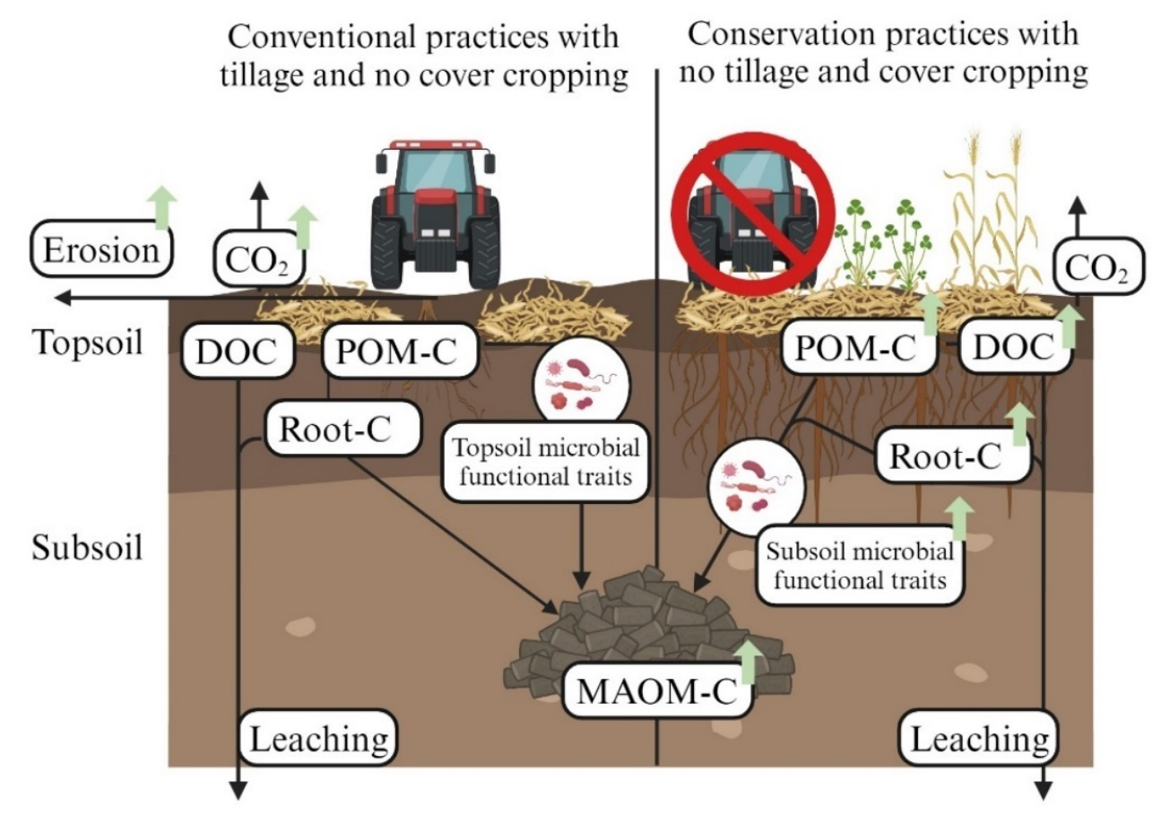
DOC: Dissolved organic C; POM-C: Particulate organic matter C; MAOM-C: Mineral associated organic matter C; Root-C: Root biomass and exudate C. DOC: Dissolved organic C; POM-C: Particulate organic matter C; MAOM-C: Mineral associated organic matter C; Root-C: Root biomass and exudate C. Green arrows represent hypothesized C flux into different C fractions within an arable soil profile under contrasting agricultural practices. An increased amount of crop residue retained under the conservation practices increases POM-C in the topsoil and Root-C in the subsoil. Increased POM-C will increase C supply in the deeper subsoil through increased C transport as DOC and POM-C, improving microbial functional traits over time. Improved microbial functional traits will increase C invested for microbial biomass and by-product, which will be physico-chemically stabilized in the silt-clay fraction to form MAOM-C in the deeper subsoil under conservation agricultural practices. Tillage and no cover cropping treatments will lose more crop residue C and SOC as CO₂ since the crop residue C is less protected from physical occlusion and microbial decomposition.
Figure 1. Conceptual diagram of the topsoil and subsoil microbial trait mediated SOC dynamics under conventional and conservation management practices.
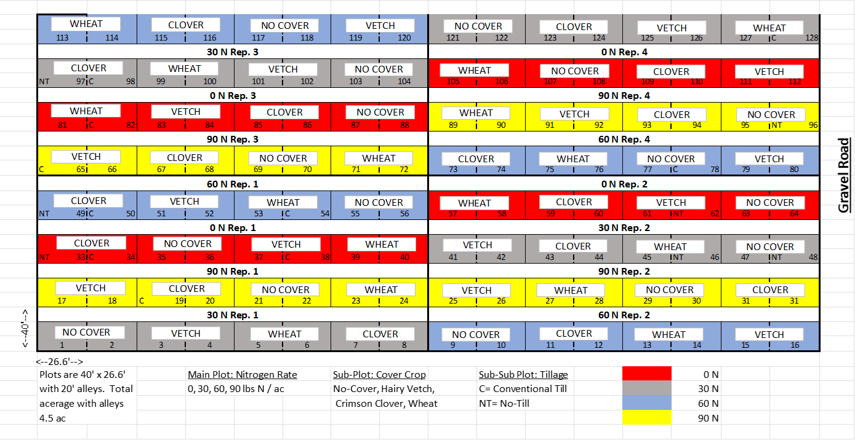
Figure 2. Layout of the long-term agricultural field experiment (1981-present) located in Jackson, West Tennessee.
For this dissertation research, samples were collected from plots receiving the economic optimum rate of N fertilization for the research station set at 67 kg N ha⁻¹ yr⁻¹ (indicated by blue plots). From the blue colored plots, we collected samples from the two tillage treatments (no-tillage, NT; and conventional-tillage, CT) and three cover crops (no-cover, NC; hairy vetch, HV; and winter wheat, WW) receiving 67 kg N hectare⁻¹ year⁻¹. It was observed that cotton lint yield did not increase beyond this level of N fertilization (Nouri et al., 2021).

Chapter 2: Winter wheat cover crop increased subsoil organic carbon in a long-term cotton cropping system in Tennessee

Authors
Rounak Patra, Debasish Saha, and Sindhu Jagadamma.

Publication status
This manuscript has been published in Soil Tillage and Research.

Citation
Patra, R., Saha, D., Jagadamma, S., 2022. Winter wheat cover crop increased subsoil organic carbon in a long-term cotton cropping system in Tennessee. Soil and Tillage Research 224, 105521. https://doi.org/10.1016/j.still.2022.105521

Author contributions
RP, DS, and SJ conceived the experiment. RP conducted the experiments, analyzed the data, and wrote the first draft of the manuscript. DS and SJ reviewed and edited the manuscript.

(Patra et al., 2022)

2.1. Abstract
Long-term cover-cropping and no-tillage practices can facilitate soil organic carbon (SOC) accumulation in agroecosystems for soil health and climate mitigation benefits. However, the contribution of these conservation management practices to SOC gain has mainly been reported from the topsoil relative to the subsoil layers. To understand this knowledge gap, it is essential to determine the distribution of total SOC and SOC fractions in response to agricultural management practices across the soil profile. Therefore, this study was conducted by leveraging a 40-year-old replicated field experiment in a continuous cotton (Gossypium hirsutum) system. The management treatments examined included three cover crop treatments: 1) hairy vetch, HV (Vicia villosa); 2) winter wheat, WW (Triticum aestivum L.), and 3) no cover crop, NC; and two tillage treatments: 1) conventional-tillage, CT (10 cm deep) and 2) no-tillage, NT. Soil samples were collected from four depths (0-5, 5-10, 10-30, and 30-60 cm) and analyzed for total SOC and C associated with soil functional fractions such as microbial biomass (MBC), particulate organic matter (POM-C), and mineral-associated organic matter (MAOM-C). Results showed that the profile-scale (0-60 cm) SOC stock was greater for WW (33.7 Mg ha⁻¹) compared to HV (29.1 Mg ha⁻¹) and NC (24.4 Mg ha⁻¹), while the tillage effect was non-significant (28 Mg ha⁻¹ for NT and 29.3 Mg ha⁻¹ for CT). The NT concentrated SOC in the top 5-cm layer, which was reflected in the concentrations of POM-C and MBC. Below the tillage depth (10-30 cm), SOC accrual was greater under CT (10.4 Mg ha⁻¹) than NT (8.9 Mg ha⁻¹), despite similar profile-scale SOC stocks. Principal component analysis (PCA) and subsequent multiple regression analysis revealed that total SOC in topsoil and subsoil were driven by POM and MAOM-related parameters, respectively. We also observed a limited accumulation of C in POM fraction (0.2-6.1 g C kg⁻¹ soil in tilled topsoil and 0.01-0.71 g C kg⁻¹ soil in subsoil) with a weak relationship with total SOC concentration (topsoil slope = 0.29, subsoil slope = 0.13), most likely driven by the warm and humid climatic conditions of the study region that increases POM decomposition rate. Contrastingly, accumulation of C in MAOM fraction was greater (2.7-12.7 g C kg⁻¹ soil in topsoil and 0.6-5.4 g C kg⁻¹ soil in subsoil), and it was strongly related to total SOC concentration than POM-C, especially in the subsoil (topsoil slope = 0.43, subsoil slope = 0.71). Growing deep-rooted winter wheat cover crop increased SOC in the subsoil, indicating the need for climate, soil, and ecosystem-specific management practices for profile-scale net SOC accumulation and redistribution in agroecosystems.

2.2. Introduction
The loss of soil organic carbon (SOC) in agroecosystems is primarily attributed to intensive productivity-oriented management activities. Land-use conversion from natural to agricultural systems resulted in a 40-90 Pg decline in global SOC (Lal, 2004b; Smith, 2008; Don et al., 2011). This decline in SOC has increased awareness of the importance of global C budgets and has accelerated SOC storage evaluations under long-term agricultural management practices (Kirschbaum, 2000; Olson, 2013). Implementing long-term cover cropping and no-tillage practices, two most popular conservation management practices across the United States (US), has been shown to improve SOC accumulation across different agro-ecoregions of the US (West and Post, 2002; Blanco-Canqui and Lal, 2008; Jagadamma and Lal, 2010; Chalise et al., 2019; Singh et al., 2020). No-tillage reduces residue decomposition compared to conventional tillage due to no or minimal soil disturbance, which helps in soil aggregation and protects SOC from microbial decomposition (Six et al., 2000; West and Post, 2002; Franzluebbers, 2010). However, several studies showed that profile-scale SOC stock was similar in no-tilled and tilled soils, indicating that increased SOC in topsoil under no-till is compensated by increased SOC in subsoil under tilled soil (Luo et al., 2010; Olson and Al-Kaisi, 2015; Jagadamma et al., 2019). Integration of cover crops during the non-cash crop growing season has also increased SOC in agroecosystems by providing additional aboveground and belowground C inputs to soil (Poeplau and Don, 2015; Jian et al., 2020). In general, grass cover crops (e.g., winter wheat, triticale, oats) produce more biomass compared to legumes (e.g., hairy vetch, clovers, Austrian winter pea) and brassicas (e.g., radish, turnip, canola) (Cherney et al., 1991; Sassenrath and Farney, 2019). A significant C contribution from cover crops comes from root-biomass, which contributes more C to the subsoil (Rasse et al., 2005). For example, Amsili and Kaye, 2021 reported a significant increase in root C input by a triticale (grass type cover) compared to crimson clover (legume) and canola (brassica) cover crops. Previous research has demonstrated that the effect of conservation practices on SOC storage depends not only on the type and duration of the practices but also on the chemical composition and turnover rates of SOC.
The SOC comprises heterogeneous C compounds with a broad molecular-size range, oxidation and reduction potential, and stability (Lehmann and Kleber, 2015). Agroecosystem management practices impart a strong control on the chemical composition and stability of SOC (Jagadamma and Lal, 2010). However, determining the changes in total SOC with management practices is challenging because SOC accumulation in detectable quantity is a slow process. Instead of total SOC, active SOC fractions with shorter turnover time and distinct chemistry, such as particulate organic matter C (POM-C) and microbial biomass C (MBC), can serve as early indicators for management-induced changes (Cambardella and Elliott, 1994; Poeplau et al., 2018; Six et al., 1998). On the contrary, the mineral-associated organic matter C (MAOM-C) fraction represents the SOC fraction with a longer-turnover time and is composed of dissolved organic carbon (DOC) and microbial by-products adsorbed and/or co-precipitated to the surface of soil minerals (von Lützow et al., 2007; Poeplau et al., 2018). Given the continued interest in SOC stabilization and destabilization in agricultural soils, it is critical to understand the profile distribution of functionally diverse C fractions under contrasting management practices.
Most previous studies on changes in SOC distribution in response to agroecosystem management practices have ignored the effect of soil depth (Yost and Hartemink, 2020) despite the estimate that more than 50 % of the global SOC stock resides below 30 cm soil depth (Jobbágy and Jackson, 2000). In addition, the subsoil micro-environment possesses several characteristics that indicate its potential for longer-term SOC storage compared to that in the topsoil (Fontaine et al., 2007; Rumpel and Kögel-Knabner, 2011). These characteristics include, 1) greater soil volume that comprises C-depleted mineral fraction, 2) an increased proportion of slow-cycling root C, and 3) a less favorable micro-climate for SOC mineralization due to the reduced substrate availability and microbial activity (Fierer et al., 2003; Lorenz and Lal, 2005; Stewart et al., 2007; Rumpel and Kögel-Knabner, 2011). These potential SOC sink characteristics of subsoil raised concerns about our current understanding of the impact of agricultural management practices on subsoil SOC dynamics and their consequent implication on the global carbon cycle. Previous studies have quantified SOC in subsoils of varying depths in response to agricultural practices (Babujia et al., 2010; Christopher et al., 2009; Luo et al., 2010; Poirier et al., 2009; Sainju et al., 2005). However, results so far have been inconsistent, meaning that profile-scale SOC concentration and distribution were either increased (Babujia et al., 2010), decreased (Christopher et al., 2009), or unchanged (Poirier et al., 2009; Luo et al., 2010; Jagadamma et al., 2019) under long-term management practices. Due to the paucity of studies focused on subsoil SOC and the lack of consistency among the existing results, the magnitude, and direction of SOC change in the subsoil in response to management changes are still unclear.
Although our understanding of the SOC response to agroecosystem management practices has improved in recent years, global C cycle model performances can be improved by adequate representation of depth-wise data on total SOC and functional pools (Jenkinson and Coleman, 2008; Rumpel and Kögel-Knabner, 2011). Given the differences in SOC sources, quality, and stabilization mechanisms between topsoil and subsoil, a more site-specific understanding of the role of agroecosystem management practices on profile-scale SOC accumulation and distribution is warranted (Freibauer et al., 2004; Lorenz and Lal, 2005; Angst et al., 2018). Therefore, in this study, our objective was to determine how contrasting long-term tillage and cover cropping practices affect the profile-scale total SOC stock as well as SOC distribution in different functional C fractions. We hypothesized that, (i) the positive effect of no-tillage on SOC accumulation will be limited to the topsoil, (ii) cover crops with extensive root systems will increase profile-scale SOC stock, and (iii) different C functional fractions control SOC accumulation in topsoil and subsoil.

2.3. Materials and methods

2.3.1. Soil sampling
Details of the experimental site: please refer to section 1.5.
Soil cores (8 cm diameter and 60 cm long) were collected using a hydraulic probe in June 2020. Four cores were taken from the inter-row spaces of each plot and transported to the laboratory in a cooler with ice packs. In the laboratory, each core was split into four depth increments: 0–5, 5–10, 10–30, and 30–60 cm. Two core segments per plot were used for root biomass determination, and the other two cores were used to analyze soil properties.

2.3.2 Bulk soil analysis
Two depth-separated core segments per plot were weighed to record the fresh weight of soil before they were processed for other analyses. A subsample (10 g) from field-moist soil samples was collected and oven-dried at 105 ℃ for 48 hours to measure gravimetric moisture content. Wet soil weight, gravimetric moisture content, and soil volume were used to determine the soil bulk density (BD). The composited field-moist soil was sieved through a 4 mm sieve and a subsample was stored under 4 ℃ until MBC analysis. The remaining soil was air-dried and sieved through a 2 mm sieve to analyze basic properties (Supplementary Table 1), SOC, and functional C fractions. The air-dried and 2 mm sieved samples were further pulverized using a vial rotator (SampleTek model 200) and used for the determination of total SOC concentration (SOC_{con}) using an Elementar vario MAX cube CN analyzer (Elementar, Hanau, Germany). Depth-wise SOC stock was calculated using the layer SOC_{con}, layer thickness, and respective BD data (Lal et al., 1999). Since the topsoil bulk density (BD) was statistically similar across tillage practices (Supplementary Table 1), we opted for depth-wise SOC stock calculation rather than the equivalent soil mass (ESM) approach, which must be considered when different land-use treatments significantly alter the soil mass over a predetermined soil depth (Ellert and Bettany, 1995; Meurer et al., 2018).Soil MBC was determined by following the modified chloroform fumigation and extraction procedure (Vance et al., 1987). Fresh 4 mm sieved 15 g soils were fumigated for 48 hours in the dark. After fumigation, soils were extracted with 45 ml 0.5 M K₂SO₄ solution, followed by shaking at 200 rpm for 1 hour, centrifuging for 2 min at 2500 rpm, and filtering the supernatant using Whatman no. 42 filter paper. On the day of incubation, 15 g of the unfumigated soil samples were extracted using the same protocol. The fumigated and unfumigated filtrates were analyzed for C concentration using Elementar vario TOC cube CN analyzer in liquid mode (Elementar, Hanau, Germany). Microbial biomass C was determined as the difference in measured C concentration between fumigated and unfumigated samples and divided by the extraction efficiency coefficient of 0.45 (Beck et al., 1997).

2.3.3 Soil physical fractionation
We used a combination of size and density-based fractionation methods to separate bulk soil into POM and MAOM fractions following the modified Par+Den1 fractionation method (Poeplau et al., 2018). We conducted a preliminary fractionation test to determine the general proportion of SOC associated with occluded POM (POM within the aggregates), free POM (POM outside the aggregates), and sand fraction (density greater than 1.8 g cm⁻³ and size greater than 53 µm). We found that the SOC associated with occluded POM and sand fraction was negligible in contrasting treatments and soil depths (< 2 % of the total SOC). Therefore, we omitted the steps to isolate the occluded POM and C associated with sand fraction from the subsequent data analysis procedures. Air-dried and 2-mm sieved 15 g soil was added to 60 ml of 0.5 % sodium hexametaphosphate solution to disperse the soil particles. The soil solution was shaken for 18 hours in a reciprocal shaker at 200 rpm and then passed through a 53 µm sieve. The sand and POM fractions were retained on the 53 µm sieve, while the silt and clay sized MAOM fraction was passed through the sieve and collected in a beaker. To separate the POM from the sand fraction, the combined sand and POM fraction were treated to density fractionation using a 1.8 g cm⁻³ sodium polytungstate (SPT) solution. The resulting mixture was centrifuged for 1 hour at 1069 g, and the floated POM was aspirated. The recovered MAOM and POM fractions were washed three times with Milli-Q water to remove any residual SPT solution and dried at 60 ℃. Before measuring organic C concentration, the recovered POM and MAOM fractions were weighed, and the proportions of their weight (%) were described as fPOM and fMAOM. The dried fractions were further pulverized using a vial rotator (SampleTek model 200), and organic C concentrations in the recovered POM (POM-Cp) and MAOM (MAOM-Cp) fractions (g C kg⁻¹ POM or MAOM) were measured using the Elementar vario MAX cube CN analyzer (Elementar, Hanau, Germany). The C associated with POM and MAOM fractions on a unit soil weight basis (POM-C and MAOM-C in g C kg⁻¹ soil) was calculated by using equations (1) and (2).
POM-C = fPOM × POM-Cp (1)
MAOM-C = fMAOM × MAOM-Cp (2)

2.3.4. Soil organic C stratification ratios
The stratification ratios (SR) were calculated for total SOC, POM-C, and MAOM-C as the ratio of C concentrations at 0-5 cm soil depth (topmost soil layer) vs. at 10-30 cm soil depth (layer immediately below the tillage depth) (equation 3).
SR_{X} = C_{X}(0-5 cm) / C_{X}(10-30 cm) (3)
where _{X} is the SOC fraction (total SOC, POM-C and MAOM-C) and C is their respective concentrations.

2.3.5. Root biomass determination
Root biomass was determined according to Amsili and Kaye (2021). The core segments were gently broken by hand, and the material from two cores per plot for each depth increment was composited. These soil samples were soaked overnight in 1 % Liquinox solution to assist soil dispersion and root separation. The next day, the soil solution was passed through a 0.5 mm sieve. Washing roots through a 0.5 mm sieve can capture up to 95 % of the root biomass (Böhm, 1979; Amato and Pardo, 1994). The remnants collected on the sieve were suspended in water to clean roots from associated soil and other debris. The collected roots were oven-dried at 50 ℃ for 48 hours and then weighed to calculate the root biomass.

2.3.6. Statistical analysis
Analysis of variance was performed using the linear mixed-effect model in SAS v9.4 statistical package (SAS Institute, Inc., Cary, NC). The least-square means were separated using Fisher's least significant difference (LSD) test at P ≤ 0.05. Tillage, cover crops, and their interactions were considered as fixed effects and replication as random effects. Statistical analyses were conducted separately for each soil depth. We performed principal component analysis (PCA) by following the method described in Andrews et al. (2002) to identify a minimum set of SOC fractional properties that drives changes in total SOC concentration (SOC_{con}) in the tillage zone (combining data from 0-5 and 5-10 cm soil depth layers; representing topsoil) and soil layers beyond the tillage depth (combining 10-30 and 30-60 cm soil depth layers; representing subsoil). We retained the variables that showed significant differences at P ≤ 0.05 in at least one of the PCA treatments. Principal components (PCs) are the linear combinations of the variables that account for the maximum variance within the dataset. The PCs with eigenvalues (amount of variance explained by each factor) higher than 1 were selected to determine profile-scale SOC_{con} distribution drivers (Brejda et al., 2000). Individual variables received a weight (factor loading) within each PC according to its contribution to the PC. We selected the variables with the highest weight from each PC to build the minimum dataset of soil parameters. Finally, to check how well the minimum dataset determines the profile-scale SOC_{con} distribution, we performed a multiple regression analysis using R statistical software (R Core Team, 2021), using the minimum dataset parameters as independent variables and SOC_{con} as a dependent variable at P ≤ 0.05 (Andrews et al., 2002; Jagadamma et al., 2008).

2.4. Results

2.4.1. Total SOC stock and concentration
After 40 years of cover cropping, the whole profile (0-60 cm) SOC stock was greater in WW (33.7 Mg ha⁻¹) compared to HV (29.1 Mg ha⁻¹) and winter fallow (24.4 Mg ha⁻¹) (Figure 3a). Integration of winter cover crops, particularly WW, resulted in more SOC accumulation in the subsoil layers. Combining 10-30 cm and 30-60 cm depths, WW resulted in 23 and 34.5 % more SOC stock than HV and NC, respectively. Between the two tillage treatments, statistically similar whole profile SOC stock was found across the cover crop treatments (28.8 Mg ha⁻¹ for NT and 29.4 Mg ha⁻¹ for CT) (Figure 3b). Although NT resulted in greater SOC stock in the 0-5 cm depth (7.42 Mg ha⁻¹) compared to CT (5.6 Mg ha⁻¹), the trend was reversed below the tillage depth of 10 cm and resulted in greater SOC stock under CT in the 10-30 cm depth compared to NT (10.4 vs. 8.88 Mg ha⁻¹, P < 0.05). The total SOC concentration (SOC_{con}) also varied almost similarly to SOC stock in response to treatments and soil depths (Table 3 and 7). The interaction of tillage and cover crops was not significant for SOC stock and concentrations in most depths except for SOC stock at subsoil depth intervals of 10-30 cm and 30-60 cm (Table 6).

2.4.2. SOC fractions
Microbial biomass C sharply decreased from topsoil to subsoil layers (Figure 4). At the 0-5 cm soil layer, CT under winter fallow showed the least (245 mg kg⁻¹), and NT under HV cover showed the highest (430 mg kg⁻¹) MBC concentration (Figure 6 and Table 7). At this depth, NT resulted in 28 % more MBC than CT across the cover crop treatments. At 5-10 cm, NT and CT showed similar MBC when winter cover crops (HV and WW) were grown. However, CT had 25 % lower MBC in winter fallow plots than NT. Immediately below the tillage depth (10-30 cm), CT showed 17 % higher MBC than NT across the cover crop treatments, with WW showing the highest increase (Figure 6). All tillage and cover crop combination treatments had similar MBC concentrations at 30-60 cm depth intervals (Figure 6 and Table 7).
In the top 0-5 cm layer, NT had two times higher POM-C concentration than CT (3.86 and 1.11 g kg⁻¹ for NT and CT, respectively) (Table 3 and 7). The trend remained the same at the 5-10 cm layer with a decrease in magnitude (0.80 vs. 0.44 g kg⁻¹ for NT and CT, respectively). No significant change in POM-C concentration between tillage practices was observed in subsoil depth intervals (Table 3). A significant increase in POM-C was observed with the integration of cover crops at 0-5 cm and 10-30 cm soil layers. The highest increase in POM-C was observed in topsoil 0-5 cm layer with HV cover (3.49 g kg⁻¹), followed by WW (2.58 g kg⁻¹) and NC (1.40 g kg⁻¹) across the tillage practices (P < 0.05, Table 1). At 10-30 cm layer, the highest POM-C was observed under WW (0.43 g kg⁻¹) followed by HV (0.34 g kg⁻¹) and NC (0.17 g kg⁻¹) (P < 0.05, Table 1). Between the two tillage treatments, no significant difference in MAOM-C concentration was found in 0-5 cm and 5-10 cm soil layers (Table 2). However, the MAOM-C was higher under CT than NT in the subsoil layers: 37 % increase in 10-30 cm and 71 % increase in 30-60 cm (Table 2). Across the cover crop treatments, MAOM-C was similar for all the treatments in all soil layers except at 5-10 cm depth. At this depth, the highest increase in MAOM-C was observed under WW (7.23 g kg⁻¹), followed by HV (4.98 g kg⁻¹) and NC (5.04 g kg⁻¹). For both POM-C and MAOM-C fractions, the interaction effect of tillage and cover crops was mostly non-significant except for the MAOM-C fraction at 5-10 cm (Table 6).

2.4.3 Carbon stratification ratios
Stratification ratios were calculated between the topmost surface soil layer (0-5 cm) and the soil layer immediately beneath the plow layer (10-30 cm) for total SOC (SR_{SOC}), POM-C (SR_{POM-C}), and MAOM-C (SR_{MAOM-C}). Results showed that tillage treatments significantly influenced SR_{SOC}, and SR_{POM-C} (Table 7). The mean values under NT and CT were 3.52 and 2.42, respectively, for SR_{SOC} and 17.09 and 4.02, respectively, for SR_{POM-C} (Figures 5a and c). Mean values of SR_{MAOM-C} were not different between NT and CT practices (Figure 5b). Effects of cover crops and tillage x cover crop interaction on SR were not significantly different for total SOC and the fractions (Figure 5b, Table 6).

2.4.4. Drivers of total SOC concentration change in topsoil and subsoil
We used PCA to determine a minimum set of SOC fractional properties responsible for variations in profile-scale total SOC concentration (SOCcon). We found that 10 out of 16 C-related parameters measured differed by at least one treatment (tillage or cover crop) or soil depth. These properties are MBC, POM and MAOM fractional abundance (fPOM, fMAOM), CN ratio of POM and MAOM fractions (POM-CN and MAOM-CN), C concentration in POM and MAOM fractions (POM-Cp, MAOM-Cp), total C associated with POM and MAOM fractions per unit soil weight basis (POM-C, MAOM-C), and total root biomass (Troot) (Table 3 and Table 7). On these 10 SOC related parameters, PCA was performed separately for the tillage zone (topsoil representative: 0-10 cm) and the depth below the tillage zone (subsoil representative: 10-60 cm) to determine if the parameters associated with SOC functional fractions drive SOC_{con}. We selected three PCs for 0-10 cm and four PCs for 10-60 cm soil layers accounting for 69 and 79 % of the cumulative sample variance, respectively (Table 2). Indicators associated with the greatest absolute eigenvector values were selected from each PC to determine SOC_{con} drivers at the respective soil depth layers. These indicators were POM-C in PC1, fPOM in PC2, and fMAOM in PC3 for the topsoil and MAOM-Cp in PC1, Troot in PC2, MBC in PC3, and MAOM-CN in PC4 for the subsoil (Table 2). The multiple regression analysis was conducted to identify the drivers of SOC_{con} from the PCA selected data set variables for both topsoil and subsoil (Table 2). The analysis revealed that fPOM and POM-C fractions drive topsoil SOC_{con} (R² = 0.43, P < 0.001), and MBC and MAOM-Cp fractions drive subsoil SOC_{con} (R² = 0.35, P < 0.001), while the other selected parameters were not included in the model as they were not statistically significant in explaining SOC_{con} (Table 3).

3.5. Carbon accumulation capacity In POM and MAOM Fractions
Total SOC_{con} across the treatments and soil depths ranged from 3.2-14.5 g kg⁻¹ in the tillage depth (topsoil representative: 0-10 cm) and 1.28-5.75 g kg⁻¹ in the soil layers below the tillage depth (subsoil representative: 10-60 cm). The POM-C and MAOM-C concentrations ranged from 0.23-6.1 g C kg⁻¹ soil and 2.1-12.7 g C kg⁻¹ soil, respectively for topsoil and 0.01-0.71 g C kg⁻¹ soil and 0.58-5.43 g C kg⁻¹soil, respectively for subsoil (Figure 6). Regression analysis revealed that MAOM-C had a relatively stronger linear relationship with SOC_{con} (Figure 6c and d) than POM-C (Figure 6a and b) in the subsoil (Slope_{MAOM-C} = 0.71 vs. Slope_{POM-C} = 0.13), compared to topsoil (Slope_{MAOM-C} = 0.43 vs. Slope_{POM-C} = 0.29).

2.5. Discussion

2.5.1. Profile SOC storage under conservation management practices
This study evaluated the impacts of long-term conservation management practices to identify cropping systems that can increase SOC across the soil profile compared to the conventional practices. We found that 40 years of no-tillage adoption improved topsoil SOC stock but had similar SOC stock to that of shallow-tilled systems when 60 cm soil profile SOC stock was compared (Figure 2b), consistent with the results from previous global meta-analyses and review studies (West and Post, 2002; Luo et al., 2010; Meurer et al., 2018). This seems to be particularly important in hot and humid climatic conditions that favor SOC decomposition over accumulation (Franzluebbers, 2010; Dimassi et al., 2014b; Jagadamma et al., 2019) as opposed to cold and drier climates where significant SOC accumulation occurs under no-till relative to different frequencies and intensities of tillage (Jagadamma and Lal, 2010; VandenBygaart et al., 2010; VandenBygaart, 2016). Thus, changes in soil micro-climate appear to have strong control on the magnitude and direction of no-till impacts on SOC changes.
In this study, average soil bulk density values were similar for NT (1.22 Mg m⁻³) and CT (1.27 Mg m⁻³) in the 0-5 cm soil layer after 40 years of management (Figure 7). Thus, tillage induced changes in topsoil SOC stock were largely due to the changes in total SOC and fractional SOC pools. However, the NT systems showed a noticeably higher BD (1.32 Mg m⁻³) than the CT system (1.14 Mg m⁻³) in the soil layer immediately below the tillage depth (10-30 cm) (Figure 7). Higher BD in NT subsoil layers may restrict organic C migration from the topsoil to subsoil compared to CT system (Bronick and Lal, 2005; Garcia-Franco et al., 2015), which was also evident from the higher stratification of SOC fractions under NT compared to CT (Figure 3). Furthermore, the subsoil compaction under NT may limit the oxygen availability, thereby limiting the microbial activity (Balesdent et al., 2000), which is supported by the sharp reduction in MBC beyond the 0-10 cm tillage depth (Figure 3). The increased SOC stock in the surface soil layers of NT treatment was compensated by a 13 % increase in SOC stock by the shallow-tilled CT treatment in 10-30 cm depth (Figure 2b), which can be primarily attributed to the incorporation of crop residues by tillage and residue C distribution beyond the top 10 cm tillage layer.
Despite the positive effect of long-term NT on SOC accumulation being restricted to the topsoil, profile SOC accumulation was increased when a grass-type winter cover crop (WW) was integrated into the system (Figures 3a and b). Integrating winter cover crops introduces greater soil cover and increases the quantity of the above and below-ground residue input (Poeplau and Don, 2015; Jian et al., 2020). We found a 9-35 % increase in profile-scale SOC stock from the combined effect of a winter cover crop and the main crop (cotton) relative to the main crop without the cover crop (NC) (Figure 4a).
The effect of cover crops on SOC changes depends on cover crop species type. Some studies demonstrated that growing cover crops with higher quality residues (e.g., lower CN ratio) such as legumes increases SOC due to their more efficient utilization by the soil microbes, resulting in greater production of microbial biomass and by-products and subsequent stabilization as soil organic matter (e.g., Boddey et al., 2010; Kallenbach et al., 2015). Consistent with these studies, we found a 12.7 % increase in SOC_{con}, 28 % increase in MBC, and ~200 % increase in POM-C concentrations under HV compared to winter fallow in 0-5 cm soil layer (Figure 2 and Table 1). However, this favorable effect of HV cover crop on SOC accumulation observed in the surface soil layer was not reflected in the profile SOC stock as WW integrated systems showed greater SOC_{con} and SOC stock in the subsoil relative to HV and winter fallow (Figure 3a).
Profile SOC stock is typically influenced by many factors including above- and below-ground biomass input, intrinsic soil properties, physical disturbance, movement of organic matter through the soil profile, and microbial activity. The emerging literature on soil organic matter stabilization emphasizes that a part of DOC from residue decomposition is rapidly incorporated into microbial biomass and its by-products, thereby directly contributing to the MAOM-C formation through stabilization onto the mineral surfaces (Cotrufo et al., 2013). This finding points to a potentially significant role the movement of DOC through soil profile play in subsoil SOC accumulation. Also, the observed increase in subsoil SOC stock under WW treatment compared to HV and NC treatments (Figure 3a) can be attributed to deeper root distribution of the wheat crop. Although root biomass was statistically similar among cover crops in the surface soil layers, WW had 39 and 76 % more root biomass than HV and NC treatments, respectively, in the 30-60 cm depth (Table 6 and 7). Previous studies have reported that grass cover crops contribute to more SOC accumulation by increasing total C input from extensive root biomass and higher root CN ratio (Lorenz and Lal, 2005; Sainju et al., 2005; McDaniel et al., 2014; Amsili and Kaye, 2021). The tight coupling of roots-microbes-minerals in the subsoil favors greater stabilization of C accumulated in the subsoil than in the surface soil (Hicks Pries et al., 2017; Sokol and Bradford, 2019).

2.5.2. SOC functional fractions driving profile-scale SOC distribution
We identified the specific C fractions driving the topsoil and subsoil SOC_{con} under the long-term management practices using the univariate, multivariate, and regression analyses. The results showed that different C functional fractions dictate change in SOC_{con} in surface soil and subsoil (Table 4). Generally, POM is more sensitive to management-mediated changes in the soil than total SOC (Cambardella and Elliott, 1992; Plaza-Bonilla et al., 2014). In accordance with this, our results showed significant improvement of POM and related parameters in topsoil layers by conservation management practices (Figure 5c, Table 2). We also found POM related parameters (POM-C and fPOM) as the most robust predictors of topsoil SOC_{con} across the management treatments (Table 4). In the subsoil, the change in SOC_{con} was best explained by MBC and MAOM-C concentrations (MAOM-Cp) (Table 4). Plant residues or POM are progressively decomposed and converted to microbial by-products, and such microbial by-products are subsequently stabilized on the mineral surface to form MAOM fraction (Cotrufo et al., 2013). Previous studies have reported that 10-20 % of the added aboveground litter is retained in the MAOM-C fraction (Haddix et al., 2020). With environmental changes (e.g., weathering activity via high rainfall) and management interventions (e.g., tillage activity), decomposition of crop residues and aggregate protected POM in the soil surface enhances, leading to increased leaching of DOC to the subsoil. This increased presence of DOC in the subsoil could increase microbial uptake of C to increase MBC and subsequent sorption on the soil mineral fraction (Sanderman and Amundson, 2008; Osanai et al., 2020).

2.5.3. Implications of C functional pools for SOC storage
We found that POM-C and MAOM-C exhibited different strengths of relationship with SOC_{con} in topsoil and subsoil depth intervals. A maximum POM-C concentration of ~6 g C kg⁻¹ soil was noted when SOC_{con} was 12 to 14 g C kg⁻¹ soil, indicating limited C storage in POM, and beyond this SOC_{con}, additional C storage was realized through MAOM accrual (Figure 6). Although soil C saturation follows a hierarchical pattern from POM to MAOM pools (Gulde et al., 2008), we observed limited POM accumulation in our study, supported by the weak relationship between POM-C and SOC_{con} (topsoil slope = 0.29, subsoil slope = 0.13) (Figure 6). This low POM retention is likely due to our hot and humid climate, conducive to SOC mineralization over accumulation in agroecosystems (Franzluebbers, 2010; Jagadamma et al., 2019). This trend is also found in other ecological regions. For example, a review study including data from 67 agricultural sites concluded that, on average, POM-C contributed 22 % of the total SOC (Gregorich et al., 2006). Another study based on European grasslands and forests concluded that although the C accrual potential of POM fraction is unlimited, the majority of the C is stored in the MAOM fraction with a saturation limit of 50 g SOC kg⁻¹ soil, indicating inherent high SOC accrual capacity as MAOM-C (Cotrufo et al., 2019). Unlike our study, these past studies have mostly ignored the effect of soil depth on the dynamics of SOC physical fractions in response to agricultural management practices.
Contrary to our POM-C results, accumulation of MAOM-C was unconstrained in our study, with MAOM-C dominating both in the surface soil (tillage zone) and subsoil (soil layers beyond tillage zone) SOC_{con} (Table 2). Consequently, we found a relatively stronger relationship between MAOM-C with SOC_{con} (Topsoil slope = 0.43, Subsoil slope = 0.71) (Figures 6). Increased accumulation of MAOM-C, especially in the subsoil, was likely a legacy effect of long-term conservation management practices, which increases C inputs in the subsoil through increased root biomass (Table 6 and 7), and potential vertical movement of DOC through soil profile (Presley et al., 2004; Osanai et al., 2020). Across all treatments and depths, POM-C and MAOM-C contributed 11 and 85 %, respectively, of total SOC in our study (Table 2). Our results reiterate that effective SOC accumulation strategies in agroecosystems require consideration of climate, soil, and ecosystem-specific management practices. For example, implementing no-tillage alone may not be sufficient to increase whole-profile SOC stock compared to tilled systems; instead, it may redistribute the SOC near the soil surface. However, if more than one conservation practices are adopted in tandem, such as growing winter cover crops along with NT adoption, particularly in regions with hot and humid climatic conditions and/or low native SOC content, it can not only improve surface soil SOC accumulation but can also distribute more C to the subsoil.

2.6. Conclusion
Our results demonstrated that adopting long-term conservation management practices such as NT and cover cropping differently influenced the topsoil and subsoil SOC stocks. NT increased SOC accumulation in the surface soil. While NT increased SOC accumulation in the surface soil, profile SOC accumulation was more impacted by cover crops irrespective of tillage. In particular, the addition of a grass cover crop increased SOC stock in the subsoil. While the MAOM fraction generally revealed more C storage capacity than the POM fraction, we found that POM and MAOM-related parameters drove total SOC differently in topsoil and subsoil. Although POM and MAOM fractions responded positively to conservation management practices, POM-C had greater control over topsoil SOC storage, whereas the MAOM fraction had more control over subsoil SOC storage. Our results indicate the need to develop soil and environment-specific cropping systems by integrating complementary conservation management practices to increase profile-scale SOC storage. The results also stress the need for more data on subsoil SOC dynamics in response to depth sensitive SOC management strategies to help develop policies to mitigate greenhouse gas emissions and foster healthy soils.
Acknowledgments
The authors would like to thank the University of Tennessee’s West Tennessee Research and Education Center for managing the long-term cotton field experiment. We extend our gratitude to Wesley Wright for helping with sample collection and Joseph Amsili for providing critical input with the root biomass determination protocol.
Conflicts of Interest: The authors declare no conflict of interest.

Appendix
Table 2. Tillage and cover crop effects on total soil organic carbon, particulate organic carbon, and mineral-associated organic carbon for each soil depth
 |  | Tillage |  |  |  |  |  |  |  | Cover crops
 | Soil depth (cm) |  | CT | NT |  |  |  |  | NC |  | HV |  | WW
SOC_{con} (g C kg⁻¹ soil) | 0-5 |  | 9.78Ab |  | 12.98Aa |  |  | 9.68Ab |  |  | 12.17Aa | 12.29Aa
 | 5-10 |  | 6.44Ba |  | 6.20Ba |  |  | 5.16Ba |  |  | 6.32Ba | 7.49Ba
 | 10-30 |  | 4.13Ca |  | 3.59Ca |  |  | 3.61Ca |  |  | 3.63Ca | 4.34Ca
 | 30-60 |  | 2.37Da |  | 2.36Da |  |  | 2.29Dab |  |  | 1.96Db | 2.85Da
POM-C (g C kg⁻¹ soil) | 0-5 |  | 1.12Ab |  | 3.86Aa |  |  | 1.40Ab |  |  | 3.49Aa | 2.58Aab
POM-C (g C kg⁻¹ soil) | 5-10 |  | 0.44Bb |  | 0.80Ba |  |  | 0.46Ba |  |  | 0.70Ba | 0.70Ba
 | 10-30 |  | 0.34Ba |  | 0.29Ba |  |  | 0.17Bb |  |  | 0.34Bab | 0.43Ba
 | 30-60 |  | 0.12Ca |  | 0.06Ca |  |  | 0.05Ca |  |  | 0.04Ca | 0.18Ca
MAOM-C (g C kg⁻¹ soil) | 0-5 |  | 6.54Aa |  | 6.70Aa |  |  | 4.88Aa |  |  | 7.27Aa | 7.71Aa
MAOM-C (g C kg⁻¹ soil) | 5-10 |  | 5.37Aa |  | 6.12Aa |  |  | 5.04Aab |  |  | 4.98Ab | 7.23Aa
 | 10-30 |  | 4.09Ba |  | 2.98Bb |  |  | 3.11Ba |  |  | 3.78a | 3.71Ba
 | 30-60 |  | 2.79Ba |  | 1.63Bb |  |  | 1.75Ba |  |  | 2.39Ba | 2.48Ba
Means followed by the upper-case letters indicate significant differences among soil depths at P≤ 0.05. Means followed by lowercase letters indicate significant differences among treatments for each soil depth (P ≤ 0.05). CT, Conventional-tillage; NT, No-tillage; NC, no cover; HV, hairy vetch cover crop; WW, winter wheat cover crop. SOC_{con}, total SOC concentration; POM-C: C associated with POM fraction; MAOM-C, C associated with MAOM fraction.

Table 3. Principal component analysis for the determination of total SOC concentration drivers
 | Topsoil (0-10 cm) |  |  |  | Subsoil (10-60 cm)
PCA output | PC1 | PC2 | PC3 |  | PC1 | PC2 | PC3 | PC4
Eigenvalues | 3.85 | 1.93 | 1.34 |  | 3.97 | 1.72 | 1.21 | 1.00
Proportion of Variance | 0.39 | 0.18 | 0.12 |  | 0.40 | 0.17 | 0.12 | 0.10
Cumulative Variance | 0.39 | 0.57 | 0.69 |  | 0.40 | 0.57 | 0.69 | 0.79
Eigenvectors
MBCª | 0.75 | 0.21 | -0.03 |  | 0.58 | 0.15 | 0.49 | 0.28
fPOM | 0.78 | 0.34^{b} | -0.36 |  | 0.74 | -0.32 | 0.46 | -0.29
POM-Cp | 0.82 | -0.05 | 0.13 |  | 0.39 | 0.41 | -0.40 | -0.39
POM-CN | 0.71 | -0.06 | 0.30 |  | 0.48 | 0.71 | 0.09 | -0.14
POM-C | 0.88 | 0.23 | -0.28 |  | 0.79 | -0.18 | 0.39 | -0.34
fMAOM | -0.16 | 0.21 | 0.83 |  | -0.51 | -0.27 | -0.03 | -0.64
MAOM-Cp | 0.51 | -0.82 | 0.12 |  | 0.80 | -0.30 | -0.45 | 0.01
MAOM-CN | -0.15 | -0.48 | -0.19 |  | 0.70 | -0.09 | -0.14 | 0.35
MAOM-C | 0.50 | -0.82 | 0.15 |  | 0.78 | -0.32 | -0.46 | -0.02
Troot | 0.32 | 0.32 | 0.52 |  | 0.28 | 0.78 | -0.07 | -0.10
ª MBC, microbial biomass carbon; fPOM, fractional proportion of particulate organic matter (POM); POM-Cp, C concentration in the recovered POM-fraction; POM-CN, CN ratio of POM; POM-C, C associated with POM fraction in unit soil weight basis; fMAOM, fractional proportion of mineral associated organic matter (MAOM); MAOM-Cp, C concentration in the recovered MAOM-fraction; MAOM-CN, CN ratio of MAOM; MAOM-C, C associated with MAOM fraction in unit soil weight basis; Troot, total root biomass.
^{b} Factor loadings in bold indicate that the indicators are highly weighted and included in the multiple regression analysis

Table 4. Regression equations determine total SOC concentration drivers for topsoil and subsoil
Soil depth | Equation | Adjusted R² | P value
Topsoil (0-10 cm) | SOC_{con} = 5.83+0.8*POM-C+2*fPOM | 0.43 | < 0.001
Subsoil (10-60 cm) | SOC_{con} = 1.2+3.16*MAOM-Cp+0.01*MBC | 0.35 | < 0.001
SOC_{con}, total SOC concentration; POM-C, C concentration in particulate organic matter (POM) in unit soil weight basis; fPOM, fractional proportion of POM; MAOM-Cp, C concentration in the recovered mineral-associated organic matter (MAOM) fraction; MBC, microbial biomass carbon.

Table 5. Basic soil parameters for each soil depth (mean ± standard error values across all treatments)
 | Soil Depth (cm) | mean ± standard error
pH | 0-5 | 6.3 ± 0.1
pH | 5-10 | 6.3 ± 0.1
pH | 10-30 | 6.4 ± 0.1
pH | 30-60 | 6.3 ± 0.1
Soil moisture content (%) | 0-5 | 23 ± 1.4
Soil moisture content (%) | 5-10 | 21 ± 1.7
Soil moisture content (%) | 10-30 | 21.6 ± 1.3
Soil moisture content (%) | 30-60 | 24.5 ± 1.6
Sand (g kg⁻¹) | 0-15 | 160 ± 9
 | 15-30 | 130 ± 8
Silt (g kg⁻¹) | 0-15 | 681 ± 8
Silt (g kg⁻¹) | 15-30 | 629 ± 11
Clay (g kg⁻¹) | 0-15 | 159 ± 41
Clay (g kg⁻¹) | 15-30 | 242 ± 14
Sand, Silt and Clay content data is adopted from Nouri et al., 2019 (doi:10.1016/j.geoderma.2018.10.016).

Table 6. P-values for all the measured parameters
 | Soil depth (cm) | Cover | Tillage | Cover*Tillage
SOCstockª | 0-5 | 0.04 | < 0.001 | 0.10
 | 5-10 | 0.07 | 0.63 | 0.27
 | 10-30 | 0.06 | 0.02 | 0.02
 | 30-60 | 0.01 | 0.95 | 0.01
 | 0-60 | 0.002 | 0.10 | 0.3
SOC_{con} | 0-5 | 0.05 | 0.001 | 0.84
 | 5-10 | 0.11 | 0.78 | 0.58
 | 10-30 | 0.28 | 0.06 | 0.13
 | 30-60 | 0.05 | 0.96 | 0.11
MBC | 0-5 | 0.001 | < 0.001 | 0.02
MBC | 5-10 | 0.001 | 0.03 | 0.17
MBC | 10-30 | 0.001 | 0.04 | 0.01
MBC | 30-60 | 0.63 | 0.06 | 0.47
POM-C | 0-5 | 0.001 | 0.001 | 0.06
 | 5-10 | 0.15 | 0.001 | 0.18
 | 10-30 | 0.003 | 0.57 | 0.68
 | 30-60 | 0.18 | 0.15 | 0.62
POM-Cp | 0-5 | 0.17 | < 0.001 | 0.47
 | 5-10 | 0.13 | 0.77 | 0.27
 | 10-30 | 0.003 | 0.22 | 0.13
 | 30-60 | 0.18 | 0.26 | 0.45
fPOM | 0-5 | 0.002 | < 0.001 | 0.001
 | 5-10 | 0.73 | < 0.001 | 0.08
 | 10-30 | 0.27 | 0.62 | 0.67
 | 30-60 | 0.002 | 0.44 | 0.23
POM-CN | 0-5 | 0.001 | < 0.001 | < 0.001
 | 5-10 | 0.04 | 0.01 | 0.35
 | 10-30 | 0.07 | 0.66 | 0.6
 | 30-60 | < 0.001 | 0.63 | 0.01
fMAOM | 0-5 | 0.70 | 0.57 | 0.04
 | 5-10 | 0.21 | 0.66 | 0.11
 | 10-30 | 0.52 | 0.60 | 0.74
 | 30-60 | 0.11 | 0.34 | 0.03
Table 6. Continued
MAOM-Cp | 0-5 | 0.70 | 0.57 | 0.04
 | 5-10 | 0.21 | 0.66 | 0.11
 | 10-30 | 0.52 | 0.60 | 0.74
 | 30-60 | 0.11 | 0.34 | 0.03
MAOM-C | 0-5 | 0.12 | 0.85 | 0.34
 | 5-10 | 0.03 | 0.18 | 0.005
 | 10-30 | 0.40 | 0.01 | 0.60
 | 30-60 | 0.08 | 0.001 | 0.12
MAOM-CN | 0-5 | 0.7 | 0.7 | 0.55
 | 5-10 | 0.78 | 0.9 | 0.09
 | 10-30 | 0.31 | 0.75 | 0.64
 | 30-60 | 0.04 | 0.92 | 0.27
Bulk density | 0-5 | 0.26 | 0.65 | 0.06
 | 5-10 | 0.24 | 0.61 | 0.12
 | 10-30 | 0.84 | 0.001 | 0.41
 | 30-60 | 0.28 | 0.20 | 0.01
Troot | 0-5 | 0.08 | 0.09 | 0.13
Troot | 5-10 | 0.18 | 0.06 | 0.22
 | 10-30 | 0.08 | 0.92 | 0.41
 | 30-60 | 0.05 | 0.07 | 0.19
SR_{SOC} | 0-5/10-30 | 0.95 | 0.01 | 0.59
SR_{MAOM-C} | 0-5/10-30 | 0.80 | 0.21 | 0.77
SR_{POM-C} | 0-5/10-30 | 0.32 | < 0.001 | 0.30
ª SOCstock, soil organic carbon stock; SOC_{con}, total SOC concentration; Bulk Density; MBC, Microbial Biomass Carbon; POM-C, C associated with POM fraction in unit soil weight basis; POM-Cp, C concentration in the recovered POM-fraction; fPOM, fractional proportion of POM; POM-CN, CN ratio of POM; fMAOM, fractional proportion of MAOM; MAOM-Cp, C concentration in the recovered MAOM-fraction; MAOM-C, C associated with MAOM fraction in unit soil weight basis; MAOM-CN, CN ratio of MAOM; Bulk density; Troot, total root biomass; SR_{SOC}, Stratification ratio for SOC_{con} between 0-5/10-30 cm; SR_{MAOM-C}, Stratification ratio for MAOM-C between 0-5/10-30 cm; SR_{POM-C}, Stratification ratio for POM-C between 0-5/10-30 cm. Bold numbers indicate statistical significance at P≤ 0.05
Table 7. Treatment effects on additional C fractional parameters and root mass at each soil depth
 |  | Tillage treatments |  |  |  |  | Cover cropping treatments
 | Soil Depth (cm) | CT |  | NT |  | NC |  | HV |  | WW
fPOM (%) | 0-5 | 0.68b | 1.52a |  | 0.82b |  |  | 1.29a | 1.20a
fPOM (%) | 5-10 | 0.35a | 0.26b |  | 0.28a |  |  | 0.39a | 0.41a
fPOM (%) | 10-30 | 0.20a | 0.16a |  | 0.08a |  |  | 0.2a | 0.27a
fPOM (%) | 30-60 | 0.06a | 0.04a |  | 0.04b |  |  | 0.04b | 0.08a
POM-C_{p} (g kg⁻¹ POM) | 0-5 | 16.02b | 25.01a |  | 15.50 |  |  | 24.44 | 21.62
POM-C_{p} (g kg⁻¹ POM) | 5-10 | 12.96b | 22.02a |  | 17.35 |  |  | 18.30 | 16.81
POM-C_{p} (g kg⁻¹ POM) | 10-30 | 17.91a | 19.17a |  | 21.5a |  |  | 17.30b | 16.83b
POM-C_{p} (g kg⁻¹ POM) | 30-60 | 17.35a | 15.34a |  | 15.92ab |  |  | 9.93b | 23.19a
POM-CN | 0-5 | 16.47b | 26.73a |  | 15.05b |  |  | 24.26a | 25.49a
 | 5-10 | 18.09b | 23.26a |  | 23.55a |  |  | 17.36b | 21.13ab
 | 10-30 | 26.21a | 23.89a |  | 26.30ab |  |  | 15.07b | 33.77a
 | 30-60 | 19.79a | 18.78a |  | 15.97ab |  |  | 8.55b | 33.33a
fMAOM (%) | 0-5 | 94.66a | 94.41a |  | 94.68a |  |  | 94.08a | 94.85a
fMAOM (%) | 5-10 | 94.61a | 94.74a |  | 95.59a |  |  | 94.11a | 94.34a
fMAOM (%) | 10-30 | 95.16a | 95.59a |  | 95.38a |  |  | 95.94a | 94.82a
fMAOM (%) | 30-60 | 96.11a | 96.66a |  | 96.82a |  |  | 96.85a | 95.50a
MAOM-C_{P} (g kg⁻¹ MAOM) | 0-5 | 0.69a | 0.71a |  | 0.52a |  |  | 0.78a | 0.82a
MAOM-C_{P} (g kg⁻¹ MAOM) | 5-10 | 0.57a | 0.64a |  | 0.53a |  |  | 0.53a | 0.77a
MAOM-C_{P} (g kg⁻¹ MAOM) | 10-30 | 0.43a | 0.31a |  | 0.33a |  |  | 0.40a | 0.39a
MAOM-C_{P} (g kg⁻¹ MAOM) | 30-60 | 0.23a | 0.20a |  | 0.14a |  |  | 0.21a | 0.31a
MAOM-CN | 0-5 | 9.63a | 8.96a |  | 10.32a |  |  | 8.79a | 8.77a
 | 5-10 | 9.95a | 9.68a |  | 8.88a |  |  | 10.01a | 10.56a
 | 10-30 | 6.34a | 6.53a |  | 6.07a |  |  | 6.12a | 7.11a
 | 30-60 | 4.87a | 4.81a |  | 3.70b |  |  | 3.85b | 5.96a
Troot (kg ha⁻¹ soil) | 0-5 | 212a | 288a |  | 295a |  |  | 276a | 179a
Troot (kg ha⁻¹ soil) | 5-10 | 177a | 272a |  | 276a |  |  | 189a | 208a
Troot (kg ha⁻¹ soil) | 10-30 | 179a | 182a |  | 237a |  |  | 141a | 164a
Troot (kg ha⁻¹ soil) | 30-60 | 237a | 285a |  | 193b |  |  | 247ab | 343a
Means followed by lowercase letters indicate significant differences among treatments for each soil depth (P≤ 0.05). fPOM, fractional proportion of POM; POM-Cp, C concentration in the recovered POM-fraction; POM-CN, CN ratio of POM-fraction; fMAOM, fractional proportion of MAOM; MAOM-Cp, C concentration in the recovered MAOM-fraction; MAOM-CN, CN ratio of MAOM-fraction; Troot, total root biomass.

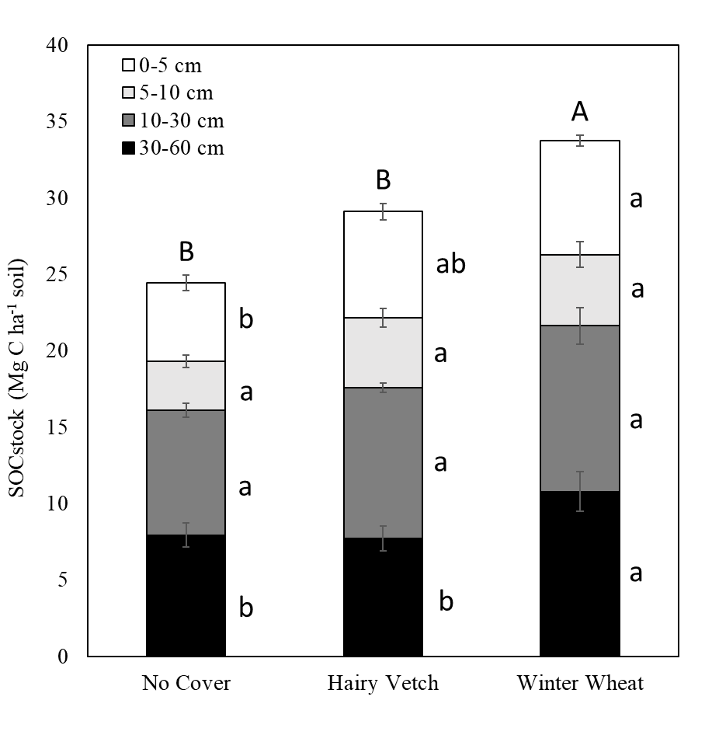
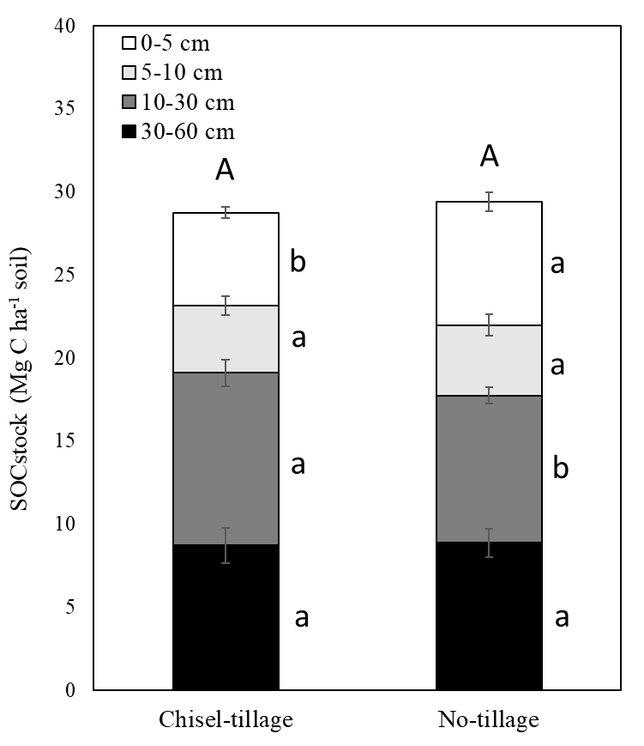
Figure 3. Depth-wise soil organic carbon (SOC) stock under long-term cover cropping (a) and tillage practices (b)
b
a
The upper-case letters indicate significant differences in whole profile (0-60 cm) SOC stock among treatments and the lowercase letters indicate significant differences in SOC stock among treatments for each soil depth (P ≤ 0.05).

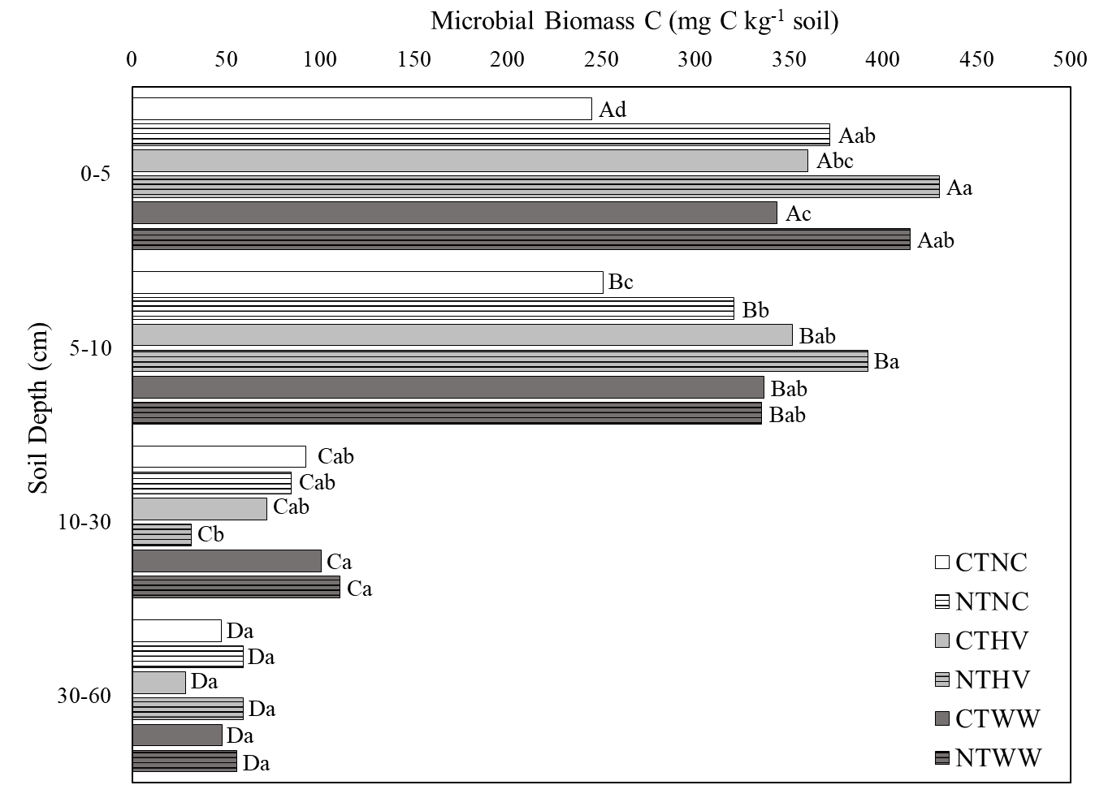

Figure 4. Depth-wise distribution of microbial biomass carbon (MBC) under long-term tillage and cover cropping practices.
The upper-case letters indicate significant differences in MBC among soil depth and the lowercase letters indicate significant differences in MBC among treatments for each soil depth (P ≤ 0.05). CT, Conventional-tillage; NT, No-tillage; NC, No Cover; HV, Hairy Vetch; WW, Winter Wheat.

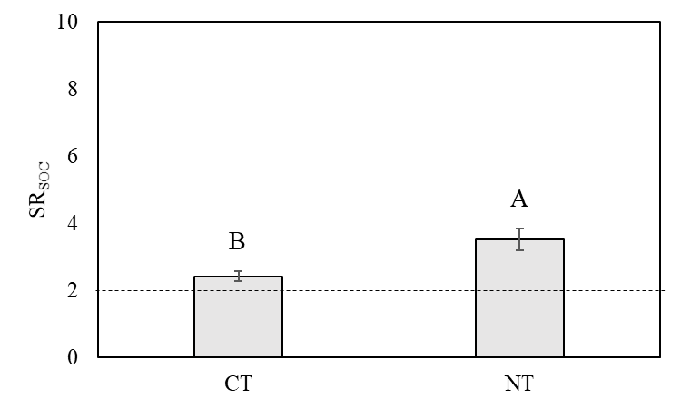
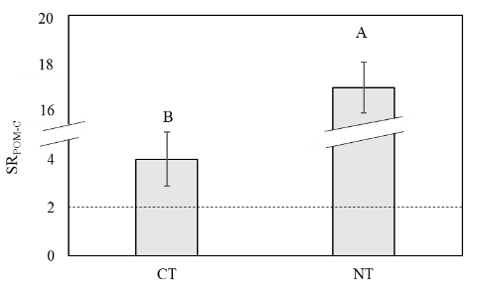
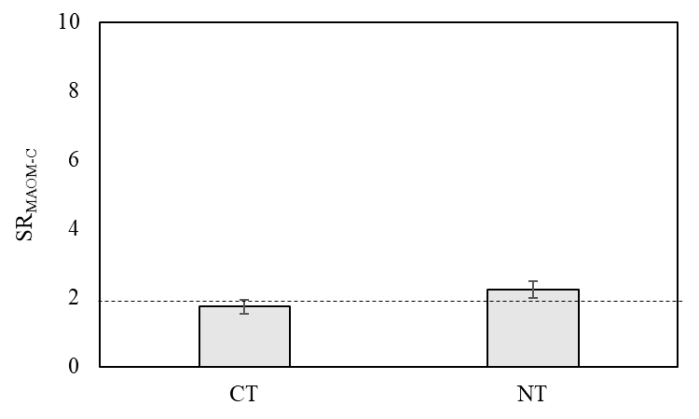
a
b
c

Figure 5. Carbon stratification ratio (SR) for total SOC (SR_{SOC}) (a), MAOM-C (SR_{MAOM-C}) (b), and POM-C (SR_{POM-C}) (c) as affected by long-term tillage practices.

CT, Conventional-tillage; NT, No-tillage. The lower-case letters indicate significant differences between the two tillage treatments (P ≤ 0.05). No letters denote non-significance (P > 0.05).
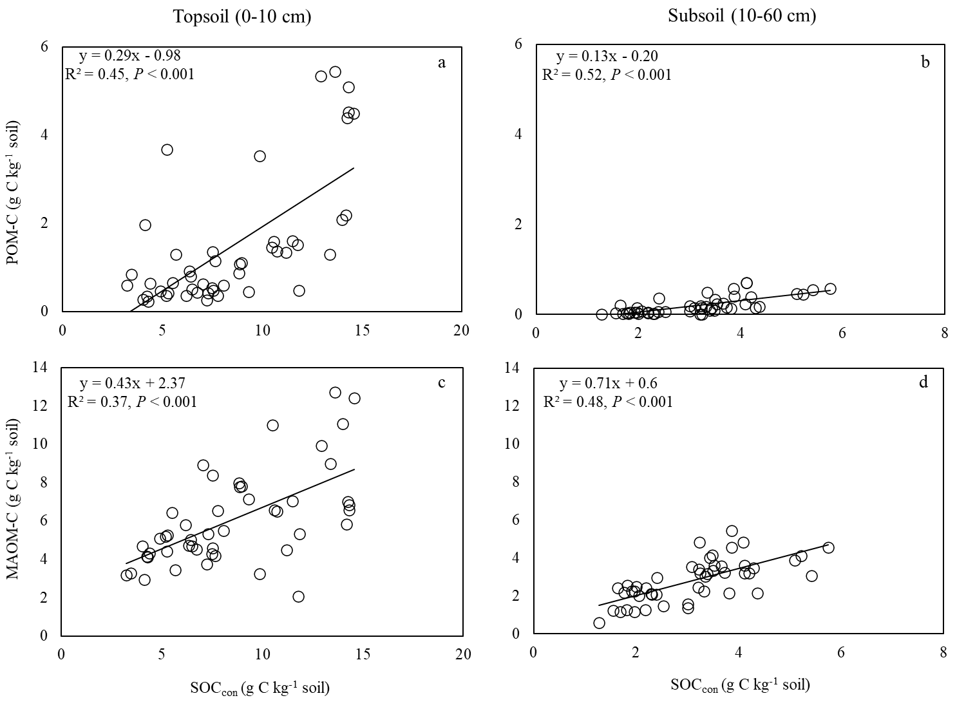

Figure 6. Relationship of total SOC concentration (SOC_{con}) with POM-C (a,b) and MAOM-C (c,d) for all the treatments. (a,c) represent soil samples from tillage zone (topsoil representative: 0-10 cm); and (b,d) represent soil samples beyond the tillage depth (subsoil representive: 10-60 cm)

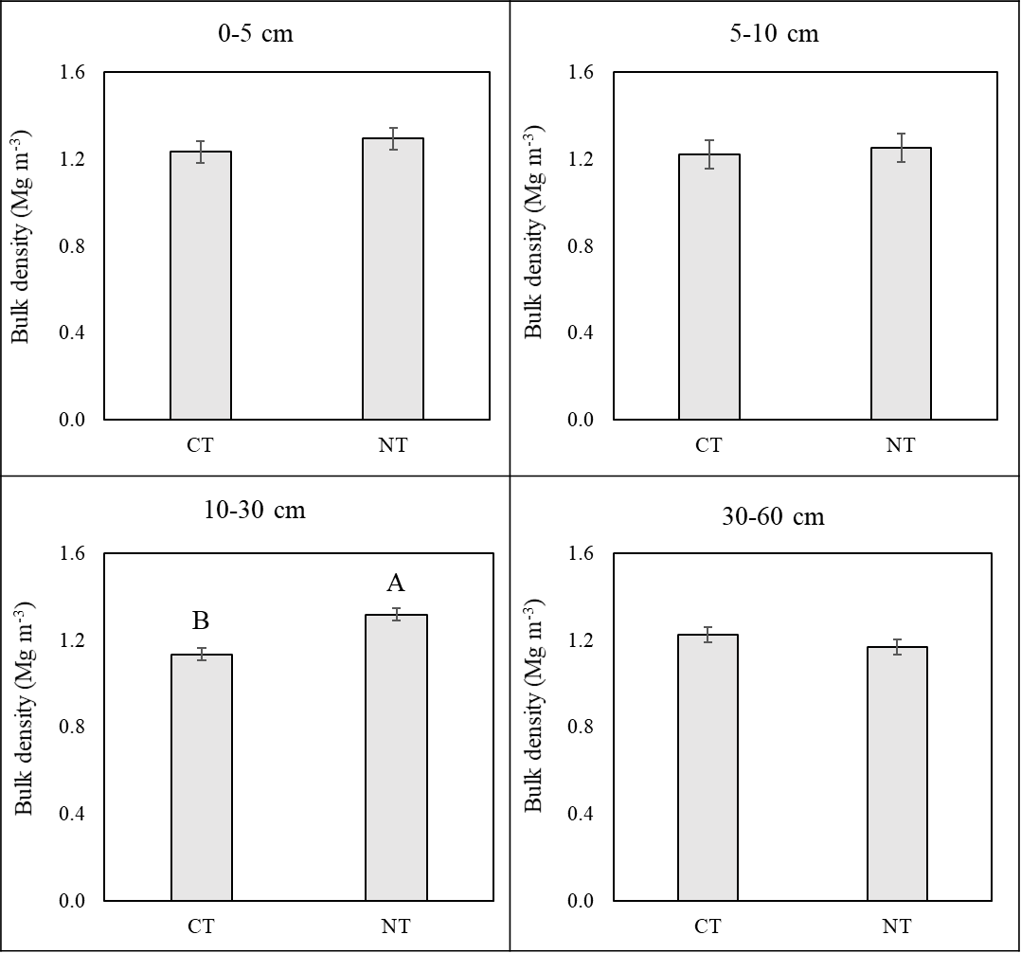

Figure 7. Bulk density in response to long-term tillage practices. CT, Conventional-tillage; NT, No-till.
The upper-case letters indicate significant differences between the two tillage treatments (P≤ 0.05). No letters denote non-significance (P> 0.05).

Chapter 3: Deep-rooted winter wheat cover crop promotes subsoil organic carbon storage through improved microbial functional traits

Authors
Rounak Patra, Debasish Saha, Avishesh Neupane, and Sindhu Jagadamma.

Publication status
This manuscript has been published in Applied Soil Ecology.

Citation
Patra, R., Saha, D., Neupane, A., Jagadamma, S., 2024. Deep-rooted winter wheat cover crop promotes subsoil organic carbon storage through improved microbial functional traits. Applied Soil Ecology 199, 105413. doi:10.1016/j.apsoil.2024.105413

Author contributions
RP, DS, and SJ conceived the experiment. RP conducted the experiments with technical support from AN for the stable isotopic calculations. RP wrote the manuscript. AN, DS and SJ reviewed the manuscript.

(Patra et al., 2024)

3.1. Abstract
Emerging microbial trait-based approaches for soil organic carbon (SOC) storage advocate enhancing specific soil microbial functional traits, such as increased carbon use efficiency (CUE) and enzymatic efficiency (EE) and decreased metabolic quotient (qCO₂). These traits facilitate the efficient conversion of crop residues into microbial biomass C (MBC), that is subsequently stabilized as SOC in the soil mineral fraction. However, our current understanding of SOC dynamics in croplands is mainly confined to topsoil or tillage zone, and the field-based evidence for subsoil microbial functional trait dynamics is sparse. To address this knowledge gap, we studied the effect of contrasting long-term agricultural management practices on microbial functional traits favoring SOC accumulation in topsoil and subsoil by conducting a laboratory experiment using ¹³C labeled glucose addition. Our results show a 19% increase in C_{growth} (C allocated for microbial biomass growth), 11% increase in CUE and 14% increase in EE under no-till (NT) compared to conventional till (CT) in topsoil (0-10 cm) and no difference in these microbial parameters in subsoil (30-40 cm) between NT and CT. Growing a deep-rooted winter wheat (WW) cover crop increased CUE by 28% in the topsoil and 11% in the subsoil compared to no-cover treatment. We found separate drivers controlling SOC accumulation in topsoil and subsoil. These drivers are increased particulate organic matter C (POM-C) and C_{growth}, under NT in topsoil and increased C_{growth} over respiration and mineral associated organic matter C (MAOM-C), under WW in subsoil. Overall, our results provide experimental evidence that different microbial functional traits, molded by different long-term conservation practices, dictate SOC storage in agricultural topsoil and subsoil.

3.2. Introduction
Agricultural activities have contributed to the loss of 133 Petagrams (Pg) of soil organic carbon (SOC) from the top two meters of soil globally and this loss has accelerated in recent centuries (Köchy et al., 2015; Sanderman et al., 2017). This is concerning because SOC storage and stability in agricultural soils are critical to i) improving soil fertility and overall soil health, ii) enhancing food security through increased agricultural productivity, and iii) offsetting anthropogenic C emissions and mitigating climate change (Lal, 2004b). Both the scientific and policymaking communities are interested in promoting natural solutions for SOC sequestration in agricultural lands (Minasny et al., 2017).
Current nature-based and conservation agricultural management practices, such as reduced/no-tillage, cover cropping, and organic manure addition, have predominantly concentrated on improving topsoil conditions. As a result, previous studies primarily addressed the impact of long-term conservation agricultural practices on topsoil SOC dynamics (Yost and Hartemink, 2020; Button et al., 2022). Since organic C concentration is substantially greater in topsoil than the subsoil (Jobbágy and Jackson, 2000), topsoil has relatively less potential for further accumulation of SOC (Rumpel and Kögel-Knabner, 2011; Georgiou et al., 2022). Also, the SOC in topsoil has significantly shorter residence time than in subsoil due to i) relatively high disturbance from tillage and other land disturbances and ii) favorable climatic conditions that enhance microbial activities for SOC mineralization (Fontaine et al., 2007; Salomé et al., 2010; Shi et al., 2020). Earlier SOC models either did not include subsoil (Stockmann et al., 2013; Begum et al., 2017) or categorized it as diluted topsoil (Jenkinson and Coleman, 2008).
Subsoil exhibits different C cycling dynamics relative to the topsoil due to several factors, including its relatively stable microclimatic conditions (Jobbágy and Jackson, 2000; Fontaine et al., 2007), greater abundance of C-unsaturated soil mineral fraction (Georgiou et al., 2022), distinct microbial community composition with different energy requirements compared to topsoil (Kramer and Gleixner, 2008; Salomé et al., 2010; Jones et al., 2018). Specifically, the subsoil experiences reduced temperature and moisture variability, as well as decreased nutrient availability compared to topsoil (Fierer et al., 2003; Fontaine et al., 2007). In addition, the limited supply of organic C in the subsoil limits enzyme production essential for substrate degradation, leading to reduced microbial utilization of available substrate C (Fontaine et al., 2007; Salomé et al., 2010; Rumpel and Kögel-Knabner, 2011). These oligotrophic conditions, combined with the presence of larger aggregates like structures (e.g., prisms) due to lack of soil disturbance and decreased bioturbation from roots, further restrict microbial access of substrate C in subsoil (Rumpel and Kögel-Knabner, 2011; Rumpel et al., 2012). In addition, a higher relative abundance of reactive mineral surfaces for bonding with C compounds leads to increased MAOM-C with depth (Rumpel and Kögel-Knabner, 2011). Due to these characteristics, subsoil C tends to be significantly older than topsoil C (Torn et al., 1997; Shi et al., 2020). The unique physical, chemical, and biological attributes of the subsoil and sporadic subsoil studies have resulted in conflicting SOC storage and distribution results in subsoils under long-term agricultural management practices (Button et al., 2022). Efforts to increase subsoil SOC stocks through conservation agricultural management often focus on increasing root carbon inputs in the subsoil, given their significant influence on subsoil SOC stocks through longer residence time compared to shoot-derived carbon, and the potential protection of root-C through occlusion within soil aggregates (Jobbágy and Jackson, 2000; Six et al., 2002; Rasse et al., 2005). The incorporation of deep-rooted perennial crops into crop rotations show increased subsoil root C delivery (Osanai et al., 2020; Poffenbarger et al., 2020; Patra et al., 2022), while some studies show no such effect (Bell et al., 2012; Tautges et al., 2019). These divergent results highlight the need for evaluation of subsoil SOC formation and stabilization processes across different agricultural management practices with contrasting root C inputs since subsoil possesses unique characteristics favoring SOC permanence.
The knowledge on the significance of soil depth in agricultural SOC storage is constrained not only by the spatial variability of management practices with depth, but also by the distinct ways different soil layers influence the availability of C sources and their distribution in different SOC fractions (Rasse et al., 2005; Sokol et al., 2019b; Patra et al., 2022). For example, a higher fraction of the topsoil microbial community is active year-round due to the supply of C and nutrients from plant residues and other external nutrient and C sources (Blagodatskaya and Kuzyakov, 2013; Min et al., 2021). These active microbes in the topsoil processes the C sources through either ex-vivo modification by extracellular enzymatic activity or an in-vivo microbial turnover pathway (Liang et al., 2017). On the other hand, subsoil is often energy-constrained and receives less frequent, more irregular, and widely variable amount of C input, mainly as root-derived C and dissolved organic C translocated from the topsoil (Fontaine et al., 2007; Osanai et al., 2020). In addition, relatively C- unsaturated subsoil mineral fraction binds C more strongly and reduces microbial availability of the already limited resources (Rumpel and Kögel-Knabner, 2011). Given the decreased availability of resources, microbial efficiency in processing C may increase with soil depth, as previous studies have shown that subsoil SOC becomes increasingly microbially-processed relative to topsoil (Rumpel and Kögel-Knabner, 2011; Poffenbarger et al., 2020). Nonetheless, field-based evidence of the magnitude and direction of the microbial efficiency in processing C inputs in subsoil in relation to topsoil in managed ecosystems is limited.
Microbial residue transformation leading to SOC formation largely depends on microbial functional traits associated with C cycling, such as community-level microbial carbon use efficiency (CUE), enzymatic efficiency (EE), and metabolic quotient (qCO₂) (Kallenbach et al., 2015). Microbial CUE, the ratio of C utilized for microbial growth over total C utilized for microbial growth and respiration, controls the role of microbial biomass-derived C in SOC formation (Sinsabaugh et al., 2013). Recent studies and meta-analyses have suggested that higher microbial CUE may increase the contribution of microbial-derived C for SOC formation and stabilization (Kallenbach et al., 2016; Tao et al., 2023). Enzymatic efficiency (EE) is the ratio of total C uptake over the total production of C cycling enzymes by soil microbes to degrade plant residues (Sauvadet et al., 2018). According to recent studies, C cycling enzyme production requires MBC investment, which incurs extra resource costs and reduces microbial CUE (Malik et al., 2019). The qCO₂ is the ratio of basal respiration rate to MBC, which depends on several factors such as substrate availability, soil physicochemical properties, and microbial community structure, with an expected negative correlation with CUE (Xu et al., 2017). Nonetheless, the interplay of these microbial functional traits and their interaction with abiotic and biotic factors in topsoil and subsoil determines the rate of microbial processing of C inputs to stabilize SOC. However, information on how subsoil microbial functional traits change in response to cropland management practices remains thin.
To address the knowledge gaps in the microbial processing of subsoil C in agroecosystems, we investigated if the long-term conservation agricultural practices such as no-tillage and cover cropping alter microbial functional traits related to SOC storage in topsoil as well as subsoil. We performed a laboratory incubation experiment using topsoil and subsoil samples collected from a long-term agricultural field experiment. We measured microbial functional traits associated with C cycling (CUE, EE, and qCO₂) by tracking a ¹³C labeled C substrate in microbial biomass and respired C pools. Our hypotheses were: 1) no-tillage improves microbial functional traits facilitating SOC accumulation in topsoil than subsoil because the beneficial effect of no-tillage is restricted in the topsoil, 2) deep-rooted crops improve subsoil microbial functional traits by increasing C availability in the subsoil, and 3) SOC accumulation in topsoil and subsoil will be influenced by distinct microbial functional traits, driven by differences in agricultural treatments, microbial functional traits, and SOC fractions.

3.3. Materials and methods

3.3.1. Soil sampling, processing, and analyses
Details of the experimental site: please refer to section 1.5.
In June 2021, we randomly collected 10 soil cores using a 2.5 cm diameter manual auger from the inter-row spaces of each experimental unit, separately from 0-10 cm (Ap horizon) and 30-40 cm (Bt horizon) depths. In this study, 0-10 cm represents topsoil (plow layer for the CT treatment), and 30-40 cm represents subsoil. The cores were composited by experimental unit and depth and transported to the laboratory in a cooler with ice packs on the same day. A representative subset of the composited soil samples was air-dried and passed through a 2-mm sieve and the sieved soil was used for the analysis of basic soil properties and SOC fractionation. Another representative fresh subsample was stored at 4 °C for a few days for the incubation experiment. Before starting the pre-incubation of the soil samples, the gravimetric soil moisture content was determined by oven-drying 10 g of fresh soil at 105 ℃ for 48 hours. We measured soil pH on 3 g air-dried and sieved soil in a 2:1 water-to-soil ratio using a benchtop pH meter (Mettler Toledo).

3.3.2. Analysis of C in bulk soil and physical fractions
We used the air-dried and 2-mm sieved soil for analyzing total SOC and dissolved organic C (DOC). A sub-sample of air-dried soil was pulverized using a vial rotator (SampleTek model 200) and the total C concentration was measured by dry combustion method using an Elementar Vario MAX cube CN analyzer (Elementar, Hanau, Germany). Since soil pH was < 7, we assumed that total C was equal to SOC (Al-Kaisi et al., 2005).We measured DOC following the protocol from Jones and Willett (2006) after slight modification. Briefly, 4 g soil was mixed with 40 mL of deionized water and shaken at 200 rpm for 1 hour, followed by centrifugation at 3,500 rpm for 30 minutes. The resulting supernatant was filtered using Whatman #42 filter paper and analyzed for total C using an Elementar Vario TOC cube CN analyzer (Elementar, Hanau, Germany).
We used a modified size and density-based fractionation method to separate bulk soil into particulate organic matter (POM) and mineral-associated organic matter (MAOM) fractions (Poeplau et al., 2018). Based on the results from Patra et al. (2022) and a pre-test, we omitted measurement of C from sand fraction as it constituted only < 2 % of the total SOC. We added 15 g of air-dried and 2-mm sieved soil to 60 mL of 0.5 % sodium hexametaphosphate solution to disperse the soil particles. The resultant soil slurry was shaken for 18 hours at 200 rpm in a reciprocal shaker and passed through a 53-µm sieve. The silt and clay-sized fractions (MAOM) that passed through the sieve were collected in a beaker, while the sand and POM fractions were retained on the sieve. The combined sand and POM fractions were treated to density fractionation with 1.8 g cm⁻³ sodium polytungstate (SPT) solution to separate the light POM from the heavy sand fraction. The resulting mixture was centrifuged for 1 hour at 1069 g followed by aspirating the floating POM fraction. We washed the recovered POM fraction three times with deionized water to remove any residual SPT solution. Both MAOM and POM fractions were dried at 60 ℃. After weighing the dried fractions, the C concentrations in the POM (POM-C) and MAOM (MAOM-C) fractions were analyzed using the Elementar Vario MAX cube CN analyzer (Elementar, Hanau, Germany).

3.3.3. Incubation experiment and C isotope addition
We passed the fresh soil samples through a 2-mm sieve and pre-incubated them at 20 °C for five days in an aerobic environment. After pre-incubation, we transferred 100 g of soil samples from each experiment unit into specimen cups and added ¹³C-labeled glucose. For the labeling, we mixed >99 atom % universally-labeled ¹³C glucose (D-Glucose-¹³C₆ from Sigma Aldrich) with unlabeled glucose to achieve total ¹³C enrichment of 10 atom %. The amount of added C from glucose was ~50 % of the initial MBC to reduce the SOC loss through priming effect (Blagodatskaya and Kuzyakov, 2008). The ¹³C-labeled glucose was added to the soil in dissolved form, and the volume of deionized water used was carefully chosen to achieve the final moisture content of 50 % water holding capacity. We included one additional specimen cup per treatment as control, which was added with deionized water without glucose. We placed each specimen cup inside 1L mason jars, sealed, and incubated at 20 °C for 24 h.

3.3.4. Measurement of ¹³C in C pools
Just before ¹³C glucose addition (beginning of incubation; T₀) and at the end of incubation in 24 h (T₂₄), we collected 15 mL of headspace gas from the sealed jars via syringe-needle assembly and injected them into pre-evacuated 12 mL exetainer vials. Soils from T₀ and T₂₄ were also analyzed for MBC using a modified chloroform fumigation extraction method (Vance et al., 1987). Briefly, 15 g of soil samples were fumigated with chloroform for 48 h, after which we extracted them in 40 mL 0.25 M K₂SO₄ solution and filtered the extract using Whatman #42 filter paper (fumigated sample). Similarly, we extracted 15 g of non-fumigated soil on the day chloroform fumigation was started (non-fumigated sample). 15 mL of fumigated and non-fumigated extracts were freeze-dried in a Lyophilizer (Labconco, MO, USA) and shipped alongside the headspace gas samples to the Stable Isotope Core Laboratory at Washington State University for total C and ¹³C analyses. Total C and ¹³C from freeze-dried MBC were converted to CO₂ with an elemental analyzer and measured using a continuous flow Isotope Ratio Mass Spectrometer (IRMS). The head space gas samples were analyzed by a ThermoFinnigan GasBench II interface for total CO₂ measurement followed by ¹³C measurement in a continuous flow IRMS. The abundance of ¹³C in relation to the V-PDB standard C was expressed as δ¹³C (‰ values). Incorporation of ¹³C in microbial biomass (¹³C-MBC) was calculated by following equations (1) and (2):
‰MBC_{treatment} =$\frac{\left(‰F_{DOC}× F_{DOC}\right)-(‰{NF}_{DOC}× NF_{DOC})}{(F_{DOC}- {NF}_{DOC})}$ (1)
¹³C-MBC =$\left(F_{DOC}- NF_{DOC}\right)$ $× \frac{(‰{MBC}_{treatment}-‰{MBC}_{control})}{(‰solution-‰{MBC}_{control})}$ (2)
where ‰F_{DOC} and F_{DOC} represent the ¹³C (‰) and total C (mg C g⁻¹ soil) concentrations, respectively, from the fumigated (F) samples, and ‰NF_{DOC} and NF_{DOC} represent the ¹³C (‰) and total C (mg C g⁻¹ soil) concentrations, respectively, from the nonfumigated (NF) samples. ‰MBC_{treatment} and ‰MBC_{control} are the MB¹³C‰ from samples treated with ¹³C-glucose solution and deionized water only (control), respectively, and ‰solution is the ¹³C‰ present in the added glucose solution. The total amount of added C taken up by the soil microbial community (C_{uptake}) was calculated as follows:
C_{uptake} = C_{growth} + C_{respiration} (3)
where C_{growth} is the C allocated for microbial biomass growth (¹³C incorporated in MBC, mg MB¹³C g⁻¹ soil), and C_{respiration} is the C respired by the microbes (added ¹³C in respired CO₂, mg ¹³CO₂ g⁻¹ soil).

3.3.5. Enzymatic assay
We measured key C cycling enzymes such as α- and β-glucosidase (AG and BG), cellobiohydrolase (CB), and β-xylosidase (XYL) using a modified microplate assay (Bell et al., 2013). We prepared the soil slurries by blending 2.75 g of soil samples in 91 mL of 50 mM sodium acetate buffer at average soil pH (6.3, Table 1) in a Waring blender for 1 min. Then 800 μL of the soil slurry was transferred into two 96-deep well (1.2 mL) microplates in each of the 8 wells of one column, from which we used one plate to create 4-methylumbelliferone (MUB) standard curves (0, 1.25, 2.5, 5, 10, 25, 50, and 100 μM concentrations). For each 800 µL of soil slurry, we added 200 µL of the fluorometric substrate and incubated the mixture in the dark at 25 °C for 3 hours. After incubation, we centrifuged the soil slurries for 3 minutes at 1500 g and transferred 250 µL of the supernatant from each well to black, flat-bottomed 96-well plates. Using a microplate reader (Synergy-BioTek Instruments, Inc., Vermont, USA), we scanned the 96-well plates at excitation and emission wavelengths of 365 and 450 nm, respectively. We used the MUB standard curve to create a linear standard curve to determine the activity of C acquiring enzymes for each sample. Finally, we calculated total C cycling enzymatic activity as the sum of the activities of AG, BG, CB, and XYL in nmol g⁻¹ soil (Bell et al., 2013).

3.3.6. Measurement of microbial functional traits associated with C cycling
We calculated community-level microbial CUE by following Sinsabaugh et al. (2013):
CUE = $\frac{C_{growth}}{C_{uptake}} = \frac{{MBC}^{13}C}{({MBC}^{13}C+^{13}{CO}_{2})}$ (4)
We calculated community-level microbial biomass specific respiration rate or metabolic quotient (qCO₂) by following Anderson and Domsch (1990):
qCO₂ = $\frac{C_{respiration}}{\text{MBC}}$ (5)
We calculated C cycling enzymatic efficiency (EE) by following Sinsabaugh et al. (2002) and Sauvadet et al. (2018):
EE = $\frac{C_{uptake}}{Total C cycling enzymatic activity}$ (6)

3.3.7. Data analyses
We used SAS v9.4 statistical package (SAS Institute, Inc., Cary, NC) to conduct analysis of variance (ANOVA) employing the linear mixed-effect model. Tillage and cover crops were treated as fixed effects and replication was treated as random effect. We analyzed data separately as within and between soil depths, considering all fixed and random effect factors. The treatment differences were considered significant at P ≤ 0.1 and mean separations for significance were done using the Tukey test. We did not find significant interaction effect of tillage and cover cropping treatments on SOC concentration and majority of the microbial functional traits. As a result, we separately assessed the main effects of tillage and cover crops to identify the factors influencing SOC concentration at different soil depths (Supplementary Table 1).
For comprehensive understanding of the extent to which management practices (tillage and cover cropping treatments), soil properties (pH, bulk density, soil clay content), microbial functional traits (C_{growth}, C_{respiration}, Net enzymatic activity), and soil C fractions (POM-C, MAOM-C, and DOC), explain the variability of SOC concentration, we employed structural equation modeling (SEM) based on a priori model derived from literature knowledge and ANOVA results (Table 11 and Figure 11). Agricultural management practices were treated as exogenous predictor variables (Peng et al., 2023). Measured values of soil properties, microbial functional traits, and SOC fractions were used to create endogenous predictor variables. These variables are predicted to have direct and indirect effects on SOC accumulation (Arrows 1-8 in Supplementary Figure 1). We transformed exogenous categorical predictors (tillage and cover cropping practices) into numerical variables using presence-absence matrices. Z-score standardization was applied to ensure parameters were comparable. We used the corrplot version 0.92 R package for correlation analysis to evaluate the relationships across predictor variables (Wei et al., 2017). Then, we created a minimum dataset of soil parameters that explain SOC variation by eliminating autocorrelated and numerically derived predictor variables (Figure 12) (Prommer et al., 2020). Using the MuMIn version 1.47.5 R package, we constructed a series of models encompassing all possible combinations of the initial predictors in predicting SOC concentration, with separate models for topsoil and subsoil (Barton and Barton, 2015). We tested our priori model for the SEM analysis using the piecewiseSEM version 2.3 R package (Lefcheck, 2016). We selected the simplest model for topsoil and subsoil that explained the most variation in SOC based on Akaike’s Information Criterion (AIC). Models within 2 AIC units (∆AIC < 2) of the top model were chosen, enabling us to assess the individual significance of predictor combinations in the top performing models (Risch et al., 2019; Huang et al., 2022). We simplified the original model by sequentially removing non-significant paths until reaching the final optimal model (Table 12). Overall model fit was assessed using Fisher’s C statistics (Shipley, 2009).

3.4. Results

3.4.1. Bulk soil characteristics and SOC fractions
The basic soil properties for both topsoil (0-10 cm) and subsoil (30-40 cm) are presented in Table 8. No-tillage and cover cropping significantly influenced total SOC, POM-C, MAOM-C, and DOC fractions at topsoil and subsoil depths. From the topsoil to subsoil, SOC concentrations decreased sharply (Figure 8). In the topsoil, NT increased total SOC and C in functional fractions compared to CT with the tillage treatments did not affect subsoil SOC concentrations. When cover crop treatments were compared, both cover crops increased SOC concentration in the topsoil (8.8 ± 0.6 and 8.6 ± 0.3 g C kg⁻¹ soil in HV and WW, respectively) compared to NC (7.7 ± 0.4 g C kg⁻¹ soil) across the tillage treatments (Fig. 8e). The MAOM-C in topsoil increased by 32% under HV and 18% under WW compared to NC (Figure 1f) and the POM-C increased by 13% by HV and 27% by WW compared to NC (Figure 1g). Cover crops influenced topsoil DOC differently with HV showing 37% increase, but WW showed 18% decrease compared to NC (Figure 8h). Cover crop treatments also affected the subsoil SOC and its functional fractions. Winter wheat, a deep-rooted cover crop, showed the highest values of SOC, MAOM-C, POM-C, and DOC in subsoil (Figure 8e to h).

3.4.2. ¹³C in microbial C pools and activity of C cycling enzymes
Microbial C used for anabolic (C_{growth}) and catabolic (C_{respiration}) processes, and total C uptake (C_{uptake}) for both anabolic and catabolic processes were significantly influenced by management practices and decreased sharply from topsoil to subsoil (Table 9). In the topsoil, C_{growth} was higher in NT than in CT (0.038 ± 0.005 vs. 0.032 ± 0.003 mg C g soil⁻¹), whereas tillage treatments did not influence C_{growth} in the subsoil. Integrating WW cover crop increased C_{growth} by 45% in the topsoil and 53% in the subsoil compared to NC treatment. While topsoil C_{respiration} was significantly greater for NT than for CT (0.045 ± 0.003 vs 0.038 ± 0.005 mg C g soil⁻¹), it was not significantly different in the subsoil. Compared to NC treatments, incorporating cover crops increased topsoil C_{respiration}, with only WW cover crop decreased subsoil C_{respiration}. Topsoil total C_{uptake} was higher under NT relative to CT, but there was no difference in total C_{uptake} between tillage practices. Total C_{uptake} was higher under HV and WW compared to NC in the topsoil but no differences across cover crop treatments were found in the subsoil. Although total C cycling enzymatic activity decreased sharply with soil depth, either tillage or cover crop treatments did not influence enzymatic activity in the topsoil. But in the subsoil, NT showed greater enzymatic activity than CT (Table 9).

3.4.3. Community-level microbial functional traits associated with C cycling
Microbial CUE ranged from 0.33 to 0.67 and it varied by management practices and soil depth (Figure 9a, d). Microbial CUE increased from the topsoil to subsoil (Supplementary Table 7). Within topsoil, we observed greater CUE under NT relative to CT (0.48 ± 0.01 vs. 0.43 ± 0.02); however, tillage did not influence CUE in the subsoil (Figure 9a). Compared to NC control, WW and HV cover crop increased CUE by 33% and 17%, respectively (Figure 9d). Microbial EE increased from topsoil to subsoil with NT improved EE relative to CT in topsoil. Cover crop integration affected EE only in the subsoil with WW increased EE by 40% compared to NC treatment (Figure 9b, e). Microbial qCO₂ was also affected by management practices and soil depth, with qCO₂ rapidly decreasing from topsoil to subsoil (Table 10). Across the management practices, qCO₂ was greater in topsoil than in subsoil. Between the two tillage treatments, qCO₂ was greater under NT in topsoil and similar in subsoil. In the topsoil, HV increased qCO₂ by 19%, while WW reduced qCO₂ by 26% compared to NC. In the subsoil, WW cover decreased qCO₂ by 17% relative to NC control (Figure 9c, f).

3.4.4. Relationship between microbial functional traits and SOC
The SEM explained 60% and 47% of the variations in topsoil and subsoil SOC concentrations, respectively (Figure 10). The models identified the factors influencing SOC accrual in topsoil and subsoil, demonstrating direct and indirect connections of SOC concentration to agricultural management practices, SOC fractions, soil physicochemical factors, and microbial functional traits.
In terms of main crop management practices (exogenous treatment predictors), only NT and WW cover crop treatments significantly improved SOC concentrations in the topsoil and subsoil, respectively. In the topsoil under NT treatment, higher POM-C (0.96 ± 0.24, P ≤ 0.001) and increased investment in C_{growth} (0.41 ± 0.16, P ≤ 0.01), lead to an indirect positive effect on SOC concentration (Figure 10a). Despite the negative impact of clay content on POM-C content (-0.48 ± 0.24, P ≤ 0.1), it had a net positive effect on topsoil SOC storage (0.31 ± 0.15, P ≤ 0.1). In the subsoil under WW treatment, increased MAOM-C (0.7 ± 0.15, P ≤ 0.001) and improved microbial anabolism (C_{growth}) (0.41 ± 0.19, P ≤ 0.1) over catabolism (C_{respiration}) (-0.47 ± 0.18, P ≤ 0.1) indirectly increased subsoil SOC concentration (Figure 10b).

3.5. Discussion

3.5.1. Microbial functional traits in topsoil and subsoil
Based on the recent trait-based frameworks, microbial functional traits play a crucial role in efficiently transforming crop residues into microbial biomass C, a major portion of which subsequently stabilizes as SOC in the mineral fraction (Cotrufo et al., 2013). However, existing knowledge on SOC dynamics under highly managed agroecosystems is mostly limited to topsoil tillage zones, limiting the field-based evidence for subsoil microbial functional trait dynamics. In this study, we investigated the impact of contrasting long-term agricultural practices on microbial functional traits, as drivers of SOC accumulation in both topsoil and subsoil through a ¹³C labeled glucose addition experiment. We found greater microbial CUE and EE, and lower qCO₂ under long-term NT in topsoil, but in the subsoil, tillage practices showed no differences in microbial functional traits (Figure 9a-c). This supports our first hypothesis that NT improves microbial functional traits associated with C cycling in the topsoil than subsoil. Relative to CT, lower disturbance and greater crop residue retention under NT result in higher stratification of topsoil SOC, which increases C availability for microbial uptake (Sauvadet et al., 2018). Though topsoil under NT increased both C_{growth} and C_{respiration}, it appears that microbial C_{growth} outpaced C_{respiration}, leading to greater CUE relative to CT. Management practices that promote SOC accumulation may benefit from a positive microbial feedback loop facilitated by improvements in microbial functional traits. The higher CUE and lower qCO₂ loss signify a more efficient NT system, indicating increased C stabilization via the in-vivo microbial turnover pathway (Liang et al., 2017). Notably, the microbial C requirements for growth and respiration were comparable between the CT and NT practices in the subsoil, reiterating that the beneficial effect of NT is limited to topsoil (Table 9 and Figure 9a-c).
In line with our second hypothesis, our results clearly demonstrate greater topsoil and subsoil microbial C_{growth} and CUE under WW cover crop compared to other cover crop treatments, regardless of tillage practices (Table 9 and Figure 9d). The ratio of root mass to root length distribution in monocotyledon crops (e.g. WW) showed a linear decrease with soil depth, whereas in dicotyledons (e.g. HV), this ratio exhibited an exponential decline (Fan et al., 2016). Incorporating deep-rooted cover crops, such as WW, can increase below-ground C inputs by increasing rhizodeposition and improving the abundance and activity of rhizosphere microbes (Sher et al., 2020). Consequently, this can increase the proximity of microbes to C sources, leading to a reduction in C loss through catabolic pathways and an increase in the metabolic efficiency of microbes. Previous studies have shown increased microbial richness, increased production of extracellular polymeric substances, higher soil aggregate formation, and SOC storage in subsoils under deep-rooted perennial switchgrass compared to annual crops (He et al., 2017; Sher et al., 2020). Our previous research, leveraging the same field experiment, found 39% higher root biomass from WW compared to NC in the subsoil depth of 30-60 cm (Patra et al., 2022). In the subsoil, in addition to CUE, WW also increased EE and reduced qCO₂ (Figure 9e-f), supporting that microbial functional traits associated with C-cycling can be improved in the subsoil by increasing root C input (Poirier et al., 2018).

3.5.2. Distinct soil properties, management practices, and microbial functional traits-drive SOC accumulation in topsoil and subsoil
We identified different soil microbial functional traits driving SOC accrual in topsoil and subsoil under long-term contrasting agronomic practices using SEM (Figure 10). In the topsoil, NT practice, POM-C, C_{growth}, and soil clay content are the significant factors explaining SOC accrual (Figure 3a). Previous research suggests that in humid and high precipitation regions, such as our study area, extracellular enzymes can partially oxidize POM-C, facilitating their direct binding to soil mineral surfaces (Kramer et al., 2012; Sanderman et al., 2014). Our results showed NT practices enhanced EE (Figure 9b), likely due to less disturbance and more residue retention, promoting crop residue stabilization in the topsoil via the ex-vivo pathway (Billings and Ziegler, 2005; Fischer et al., 2010). Increased access to C substrates in the NT topsoil improved microbial CUE (Figure 9a, d), which may have led topsoil microbes to contribute to the SOC storage by favoring the production of microbial biomass, exudates (e.g., extracellular polymeric substances), and other microbial byproducts. Even though MBC generally accounts for only < 5% of SOC, recent studies show that microbial biomass contributed more than 50% of the SOC in cropland, as evidenced by C_{growth} emerging as a strong driver for topsoil SOC (Liang et al., 2017; B. Wang et al., 2021). Considering the reduced soil disturbance and increased availability of crop residues from NT practices, our findings suggest that topsoil SOC in the hot and humid region agroecosystems increase due to an interactive effect from conservation agricultural management, improved microbial functional traits and SOC fractions.
In the subsoil, investment in microbial anabolism over catabolism and higher MAOM-C are the significant factors explaining SOC concentration (Figure 10b). Subsoil is generally energetically restricted due to limited availability of C substrates (Fontaine et al., 2007; Kramer and Gleixner, 2008), which limits subsoil C_{growth}. Our data reveal increased CUE and EE, and decreased qCO₂ in the subsoil compared to topsoil (Figure 9). This aligns with Jones et al. (2018), who showed that subsoil microbes enter a stationary growth phase under resource limitations but readily respond to available carbon by breaking dormancy and initiating biomass growth. The hot and humid climatic conditions of the study region favors increased crop residue decomposition, potentially resulting in increased leaching of DOC into the subsoil (Jagadamma et al., 2019; Patra et al., 2022). The DOC input from topsoil, coupled with absence of tillage influenced SOC mineralization, and more root C inputs from deep rooted WW cover crops in the C-unsaturated subsoil could facilitate MAOM-C formation (Rumpel and Kögel-Knabner, 2011; Lehmann and Kleber, 2015; Sokol et al., 2019a). We speculate that increased C inputs from WW cover crops alleviated microbial energy restrictions in the subsoil, thereby assisting the subsoil microbial community in WW cover crop treatment to allocate more C towards C_{growth} and lose a proportionally smaller amount of C through C_{respiration} (Table 9 and Figure 9). This increased CUE and reduced qCO₂, and subsequently led to the formation of more microbial biomass before its direct sorption onto mineral surfaces to form MAOM-C (Sokol et al., 2019b). Our findings, highlighting the role of NT and deep-rooted cover crops in increasing subsoil MAOM-C formation, align with previous studies, where perennial grasses with extensive root systems increased MAOM-C formation efficiency through greater production of rhizodeposits and their direct incorporation onto soil minerals (Poirier et al., 2018). Empirical evidence from our results further supports the concept of the in-vivo microbial turnover pathway for facilitating MAOM-C formation in C-unsaturated agricultural subsoil (Kallenbach et al., 2016; Liang et al., 2017; Angst et al., 2021). Supporting our third hypothesis, we observed distinct topsoil and subsoil SOC formation and stabilization dynamics, attributed to different microbial functional traits: C_{growth} in topsoil through higher POM-C under NT treatment and preferential investment in C_{growth} over C_{respiration} through more C input via deep-rooted cover crop in subsoil.

3.5.3. Implications and challenges for studying microbial functional traits for SOC storage
Subsoil could potentially retain additional C to offset anthropogenic greenhouse gas emissions (Lorenz and Lal, 2005; Rumpel and Kögel-Knabner, 2011). Though conservation agricultural practices are considered as natural options for SOC accretion, our results demonstrate that NT adoption was not effective in increasing subsoil SOC, but deep-rooted cover crops such as WW increase it by reducing maintenance energy costs and increasing C_{growth} investment (Müller et al., 2016; Osanai et al., 2020; Patra et al., 2022). Our findings provide evidence that even though subsoil microbial activity is generally energetically deprived, they can be metabolically efficient to newly available C sources. Our results align with growing literature that increasing the length of crop rooting zone, either through genetic selection of crops or agronomic management, is a viable option to store more subsoil C without reducing aboveground harvestable biomass (Kell, 2011; Lynch and Wojciechowski, 2015).
This study demonstrated how long-term conservation agricultural management options influence the microbial functional traits associated with C cycling in contrasting soil depths. However, three primary assumptions underlie our findings. First, the measurement of microbial functional traits utilized ¹³C labeled glucose, a highly soluble C substrate that microorganisms immediately assimilate, which differs from C supplied through plant residue decomposition (Geyer et al., 2019). Therefore, adding glucose as a C substrate may overestimate microbial CUE (Joergensen and Wichern, 2018). Second, the rapid turnover of microbial biomass induced by glucose intake may result in the transfer of a proportion of C to non-biomass products, including secondary metabolites, extracellular polymeric substances, and exo-enzymes (Joergensen and Wichern, 2018), which we did not take into account when calculating microbial functional traits. In future studies, it will be beneficial to derive microbial functional traits associated with C-cycling from varied and complex C sources beyond glucose and to include exogenous microbial products during CUE calculation; even though glucose remains a prevalent choice in current studies (Geyer et al., 2019; Islam et al., 2023).

3.6. Conclusion
Our study supports the understanding that long-term conservation agricultural management significantly influences soil microbial physiology, which dictates SOC dynamics throughout the soil profile. We observed that the improved microbial functional traits associated with C cycling under long-term conservation management practices help to explain the increased topsoil and subsoil SOC accrual compared with their counterpart systems that are conventionally managed. In the topsoil, NT systems increased SOC storage over CT, primarily through higher POM-C storage and increased C_{growth}. This is achieved as a result of reduced soil disturbance and increased crop residue retention under NT topsoil. These factors together foster a more metabolically efficient microbial community, capable of reducing Crespiration and stabilizing fresh C inputs as Cgrowth. In alignment with our first hypothesis, the beneficial effect of NT on SOC accrual was confined to the topsoil. In the subsoil, the presence of deep-rooted WW cover crops increased SOC by alleviating microbial energy limitations and promoting microbial C allocation towards Cgrowth over Crespiration, leading to a significant increase in MAOM-C formation. This finding supports our second hypothesis. Overall, our findings indicate that soil microenvironmental changes and differences in the availability of C sources from long-term agroecosystem management interventions can influence active microbial functional traits, which are crucial for SOC formation and stabilization. These traits can be targeted through specific land management practices to enable increased storage of SOC not only in the topsoil layers but also in subsoil layers of agroecosystems.
Acknowledgements
The first author is thankful to a Graduate Advancement & Training Education (GATE) fellowship from the University of Tennessee - Knoxville Science Alliance. The Tennessee Department of Agriculture (A20-0337) and USDA Hatch Grant (TEN00569) also partially fund this research. Authors are thankful to the University of Tennessee’s West Tennessee Research and Education Center for managing the long-term cotton field experiment. Authors are also grateful to Brian Kozlowski for helping with soil sampling and Sujata Agarwal and Patricia Lazicki for the lab support.
Conflicts of Interest: The authors declare no conflict of interest.

Appendix

Table 8. Basic soil parameters for topsoil and subsoil
Soil Properties | Topsoil | Subsoil
Soil pH | 6.31 ± 0.05 | 6.26 ± 0.08
Bulk density‡ (BD; Mg m⁻³) | 1.25 ± 0.05 | 1.20 ± 0.09
Moisture content (g kg⁻¹) | 182.05 ± 3.78 | 196.20 ± 4.06
Sand§ (g kg⁻¹) | 160.33 | 129.83
Silt (g kg⁻¹) | 680.83 | 628.83
Clay (g kg⁻¹) | 158.33 | 241.50
C/N ratio | 9.24 ± 0.37 | 5.91 ± 0.34
Soil organic N (SON, g kg⁻¹) | 0.91 ± 0.06 | 0.48 ± 0.02

† Values denote mean + standard error.
‡ Bulk density data are from Patra et al. (2022).
§ Sand, silt and clay content data are from Nouri et al. (2019).

Table 9. Tillage and cover crop effects on microbial functional traits associated with C cycling
Treatment | Soil depth | C allocated for growth | C allocated for respiration |  | Total C uptake | Total C-cycling enzymatic activity
 | (cm) | (C_{growth}; mg C g⁻¹ soil) | (C_{respiration}; mg C g⁻¹ soil) | (C_{uptake}; mg C g⁻¹ soil) |  |  | (nmol g⁻¹ soil)
CT | Topsoil | 0.032 ± 0.003 Ab | 0.038 ± 0.005 Ab | 0.071 ± 0.008 Ab |  |  | 594 ± 85 Aa
 | Subsoil | 0.014 ± 0.002 Ba | 0.009 ± 0.001 Ba | 0.024 ± 0.003 Ba |  |  | 130 ± 7 Bb
NT | Topsoil | 0.038 ± 0.005 Aa | 0.045 ± 0.003 Aa | 0.082 ± 0.007 Aa |  |  | 639 ± 57 Aa
 | Subsoil | 0.014 ± 0.002 Ba | 0.008 ± 0.001 Ba | 0.023 ± 0.003 Ba |  |  | 146 ± 13 Ba
NC | Topsoil | 0.029 ± 0.003 Ab | 0.037 ± 0.004 Ab | 0.066 ± 0.006 Ab |  |  | 554 ± 64 Aa
 | Subsoil | 0.013 ± 0.002 Bb | 0.010 ± 0.001 Ba | 0.023 ± 0.003 Ba |  |  | 132 ± 11 Ba
HV | Topsoil | 0.034 ± 0.005 Aab | 0.049 ± 0.005 Aa | 0.082 ± 0.009 Aa |  |  | 610 ± 81 Aa
 | Subsoil | 0.014 ± 0.002 Bb | 0.009 ± 0.002 Bab | 0.024 ± 0.003 Ba |  |  | 142 ± 8 Ba
WW | Topsoil | 0.042 ± 0.005 Aa | 0.039 ± 0.003 Aab | 0.081 ± 0.075 Aa |  |  | 684 ± 70 Aa
 | Subsoil | 0.020 ± 0.002 Ba | 0.008 ± 0.001 Bb | 0.024 ± 0.003 Ba |  |  | 140 ± 11 Ba

† CT, Conventional-tillage; NT, No-tillage; NC, No cover; HV, Hairy vetch cover crop; WW, Winter wheat cover crop.
‡ Values followed by different upper-case letters indicate significant differences between soil depths for each treatment and soil parameters (P ≤ 0.1). Means followed by different lower-case letters indicate significant differences between tillage or cover crop treatments for each soil depth and soil parameters (P ≤ 0.1)
Table 10. P-values for all the soil parameters
 | Soil depth  layers | Cover | Tillage | Cover*Tillage | Across  soil depth
Soil organic C (SOC) | Topsoil | ns† | * | ns | ***
Soil organic C (SOC) | Subsoil | * | ns | ns
Particulate organic matter C (POM-C) | Topsoil | *** | *** | *** | ***
Particulate organic matter C (POM-C) | Subsoil | *** | *** | ***
Mineral associated organic matter C (MAOM-C) | Topsoil | * | * | * | ***
Mineral associated organic matter C (MAOM-C) | Subsoil | * | ns | ns
Dissolved organic C (DOC) | Topsoil | ** | *** | * | ***
Dissolved organic C (DOC) | Subsoil | *** | ns | ns
C allocated for growth (C_{growth}) | Topsoil | * | * | ns | ***
C allocated for growth (C_{growth}) | Subsoil | * | ns | ns
C allocated for respiration (C_{respiration}) | Topsoil | * | * | ns | ***
C allocated for respiration (C_{respiration}) | Subsoil | * | ns | ns
Total C uptake (C_{uptake}) | Topsoil | * | *** | * | ***
Total C uptake (C_{uptake}) | Subsoil | ns | ns | ns
Total C-cycling enzymatic activity | Topsoil | ns | ns | ns | ***
Total C-cycling enzymatic activity | Subsoil | ns | * | ns
Carbon use efficiency (CUE) | Topsoil | * | * | ns | ***
Carbon use efficiency (CUE) | Subsoil | * | ns | ns
Enzymatic efficiency (EE) | Topsoil | ns | ns | ns | **
Enzymatic efficiency (EE) | Subsoil | ns | * | **
Metabolic quotient (qCO₂) | Topsoil | * | * | * | ***
Metabolic quotient (qCO₂) | Subsoil | * | * | ns
fPOM (fractional proportion of POM) | Topsoil | * | *** | *** | ***
fPOM (fractional proportion of POM) | Subsoil | *** | ns | *
fMAOM (fractional proportion of MAOM) | Topsoil | ns | ns | ns | ***
fMAOM (fractional proportion of MAOM) | Subsoil | ns | ns | ns
†*** P < 0.001, ** P < 0.01, * P < 0.1, and ns denotes P > 0.1 for the effects of the cover cropping and tillage practices on measured soil properties at different soil depths.
Table 11. Potential relationships between variables derived from the literature and the ANOVA results derived from this study
Path | Pathway | Proposed relation
1 | Cropping treatments → SOC fractions | Long-term conservation agricultural practices (no tillage and cover cropping) positively affect SOC fractions (Patra et al., 2022; Wooliver and Jagadamma, 2023).
2 | Cropping treatments → Microbial functional traits | Long-term conservation agricultural practices (no tillage and cover cropping) positively affect active microbial functional traits (Kallenbach et al., 2019). The goal of this study was to determine whether long-term conservation agricultural practices (no tillage and cover cropping) positively affect microbial functional traits across soil depth.
3 | Cropping treatments → Soil properties | Long-term conservation agricultural practices (no tillage and cover cropping) can increase bulk density and alter soil pH over time (Li et al., 2020).
4 | SOC fractions → Microbial functional traits | Plant residues are primary source of microbial C in SOM (C. Wang et al., 2021; Huang et al., 2023).
5 | Soil properties → Microbial functional traits | Acidic soils experience more significant limitations on SOC storage due to constraints in microbial growth (Malik et al., 2018). Clay content positively affect microbial functional traits (Huang et al., 2023).
6 | SOC fractions → SOC concentration | SOC physical fractions positively affect SOC concentration (Patra et al., 2022).
7 | Microbial functional traits → SOC concentration | Microbial functional traits are significant predictors of SOC concentration at a global scale (Tao et al., 2023). The goal of this study was to understand whether the knowledge about the microbial functional traits can predict SOC concentration across soil depth.
8 | Soil properties → SOC concentration | SOC stocks are directly influenced by both SOC concentration and bulk density (Lal et al., 1994). Acidic soils experience more significant limitations on SOC storage due to constraints in microbial growth (Malik et al., 2018). Clay content positively affects SOC concentration (Rumpel and Kögel-Knabner, 2011).
Table 12. Model selection results for predicting SOC concentrations in topsoil and subsoil, starting with the full model including all explanatory variables. All results are based on linear mixed effect (lme) models with field replications as a random factor
Response | Predictor | Estimate | SE | P | df
SOC | C_{growth} | 0.41 | 0.16 | 0.02 | 20
SOC | Clay | 0.31 | 0.15 | 0.05 | 20
 | POM-C | 0.34 | 0.16 | 0.05 | 20
POM-C | NT | 0.96 | 0.24 | <0.001 | 21
 | Clay | -0.48 | 0.24 | 0.06 | 21
C_{growth} | POM-C | 0.48 | 0.19 | 0.02 | 22

Response | Predictor | Estimate | SE | P | df
SOC | C_{growth} | 0.56 | 0.14 | <0.001 | 20
SOC | C_{respiration} | -0.53 | 0.13 | <0.001 | 20
 | MAOM-C | 0.48 | 0.12 | <0.001 | 20
C_{respiration} | WW | -0.47 | 0.18 | <0.001 | 21
 | C_{growth} | 0.72 | 0.18 | <0.001 | 21
C_{growth} | WW | 0.41 | 0.19 | 0.05 | 22
MAOM-C | WW | 0.70 | 0.15 | <0.001 | 22

†Abbreviations: Estimate, Parameter estimate; SE, Parameter estimate standard error; P, P-value; df, Degrees of freedom of the models; C_{growth}, C allocated for growth; C_{respiration}, C allocated for respiration; Clay, soil clay content; MAOM-C, concentration of C associated with MAOM fraction; POM-C, concentration of C associated with POM fraction; NT, No-tillage treatment; WW, winter wheat cover crop.

Figure 8. Depth-wise total soil organic carbon, particulate and mineral associated soil organic carbon, and dissolved organic carbon under long-term tillage (a-d) and cover cropping (e-h) practices.
Different upper-case letters indicate significant differences between soil depths for each treatment and soil variable (P ≤ 0.1). Different lower-case letters indicate significant difference between tillage or cover crop treatments for each soil depth and soil variable (P ≤ 0.1). SOC, total SOC concentration; MAOM-C, concentration of C associated with MAOM fraction; POM-C: concentration of C associated with POM fraction; DOC: dissolved organic C concentration; CT, Conventional tillage; NT, No tillage; NC, No cover; HV, Hairy vetch cover crop; WW, Winter wheat cover crop. Topsoil: soil sample from 0-10 cm soil depth; Subsoil: soil samples from 30-40 cm soil depth. Center lines within the box show the medians; box limits indicate the 25th and 75th percentiles; crosses represent sample means; bars indicate 95% confidence intervals of the means.

Different upper-case letters indicate significant differences between soil depths for each treatment and microbial functional trait (P ≤ 0.1). Different lower-case letters indicate significant difference between tillage or cover crop treatments for each soil depth and microbial functional trait (P ≤ 0.1). CT, Conventional tillage; NT, No tillage; NC, No cover; HV, Hairy vetch cover crop; WW, Winter wheat cover crop. Topsoil: soil sample from 0-10 cm soil depth; Subsoil: soil samples from 30-40 cm soil depth. Center lines within the box show the medians; box limits indicate the 25th and 75th percentiles; crosses represent sample means; bars indicate 95% confidence intervals of the means.
Figure 9. Depth-wise soil microbial functional traits under long-term tillage (a-c) and cover cropping (d-f) practices.
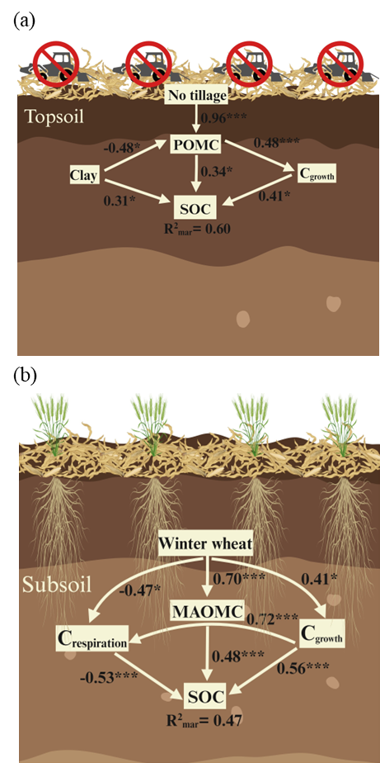

Figure 10. Drivers of topsoil and subsoil SOC accretion. Structural equation modelling diagram representing relationship of agricultural management practices, soil physicochemical parameters, microbial functional traits, and soil carbon fractions with SOC concention
The numbers adjacent to the arrows are the standardized path coefficients. The models were constructed by piecewise SEM version 2.3 R package, and the model information are as follows: Topsoil: Fisher’s C = 6.917, P-value = 0.546 and df = 8; Subsoil: Fisher’s C = 3.702, P-value = 0.72, and df = 6. Abbreviations: Cgrowth, C allocated for growth; Crespiration, C allocated for respiration; Clay, Soil clay content; POM-C, concentration of C associated with POM fraction; MAOM-C, concentration of C associated with MAOM fraction; NT, No tillage; WW, Winter wheat cover crop.

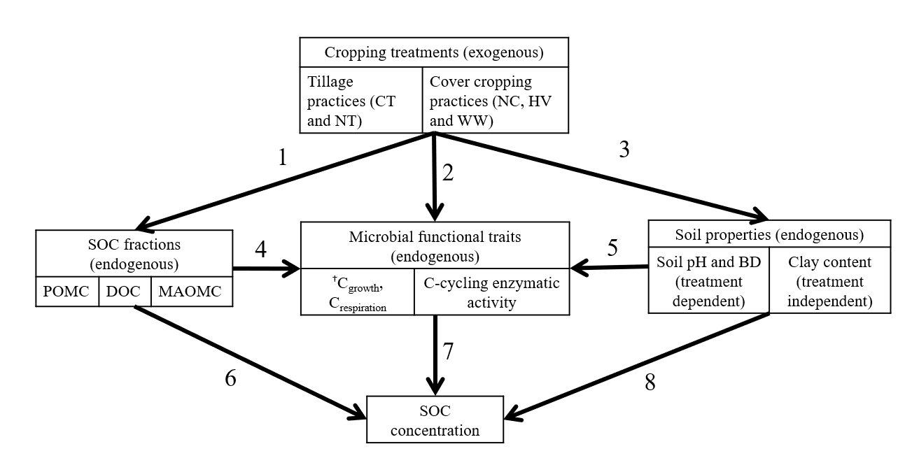
Figure 11. Conceptual priori-model of proposed relationships for structural equation modelling (SEM) exploring the effect between SOC concentration and agricultural management practices (Tillage and Cover cropping; exogenous variables), soil properties (pH, Bulk density, and Clay content; endogenous variables), microbial functional traits (C_{growth}, C_{respiration}, Net enzymatic activity; endogenous variables), soil C fractions (POM-C, MAOM-C, and DOC; endogenous variables). Black solid arrows are the hypothesized direct relationship derived from the literature and the linear mixed effects ANOVA results.
†Abbreviations: Cgrowth, C allocated for growth; Crespiration, C allocated for respiration; POM, concentration of C associated with POM fraction; MAOM-C, concentration of C associated with MAOM fraction; DOC, Dissolved organic C; BD, Bulk density; CT, Conventional tillage; NT, No tillage; NC, No cover; HV, Hairy vetch cover crop; WW, Winter wheat cover crop.

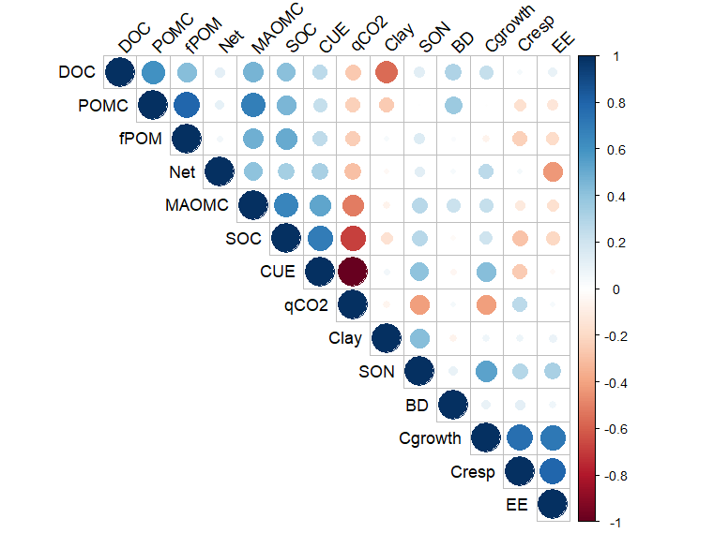
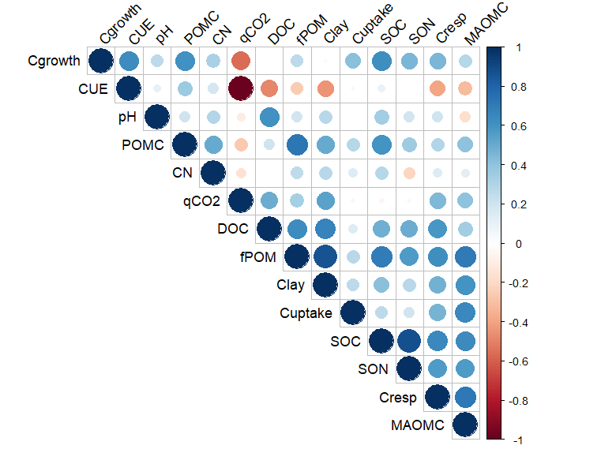
†Abbreviations: Cgrowth, C allocated for growth; Cresp, C allocated for respiration; CUE, Carbon use efficiency; pH, soil pH; CN, C/N ratio; qCO₂, metabolic quotient; fPOM, fractional proportion of POM; Clay, soil Clay content; Cuptake, Total C uptake; SOC, Soil organic C; SON, Soil organic N; particulate organic matter C; MAOM-C, mineral-associated organic matter C; POM-C, Particulate organic matter C; DOC, Dissolved organic C; BD, Bulk density; EE, Enzymatic efficiency; Net, Total C-cycling enzymatic activity.
Figure 12. Pearson correlations analysis between SOC and its predictor variables which exhibit significant difference at P ≤ 0.1 for the (a) topsoil and (b) subsoil.
(a)
(b)
†

Chapter 4: Long-term cover cropping increased carbon storage in bulk soil fractions and decreased priming effect from added residue

Authors
Rounak Patra, Debasish Saha, and Sindhu Jagadamma.

Publication status
This manuscript will be prepared for peer-reviewed journal submission.

Author contributions
RP, DS, and SJ conceived the experiment. RP conducted the experiments and wrote the manuscript. DS and SJ reviewed the manuscript.

4.1. Abstract
Understanding the fate of crop residue in soil and its impact on native soil organic carbon (SOC) is vital for devising effective SOC sequestration strategies in highly managed agricultural ecosystems. Yet, the effect of contrasting agricultural management practices on residue-derived C allocation in different SOC fractions across soil depths remains poorly understood, complicating projections of agricultural SOC storage at the profile scale. This study examines the impact of long-term contrasting agricultural management practices on added residue C distribution in bulk soil fractions and CO₂ mineralization across the soil profile. We conducted a six-month long laboratory incubation experiment using ¹³C-labeled mannagrass residue (Glyceria striata (Lam.)) added to topsoil (0-10 cm) and subsoil (30-40 cm) samples collected from a long-term field experiment that included conventional (CT) and no-tillage (NT) treatments, each with three cover crops (no cover, NC; hairy vetch, HV; and winter wheat, WW). We measured CO₂ from residue and native soil derived C as well as C retained in bulk SOC fractions such as particulate organic C (POM-C) and mineral associated organic C (MAOM-C). Results indicate that after residue addition, the loss of total CO₂C and CO₂ from native SOC due to priming effect was significantly higher in the topsoil, and the corresponding C accrual in SOC fractions was lower in topsoil compared to the deeper subsoils. The magnitude of CO₂-C loss and respective C accrual in SOC fractions from the added residue was dictated by the agricultural management practices. At the end of the experiment, residue addition under conservation agricultural practices significantly decreased SOC loss due to the priming effect, with topsoil NT and cover cropping treatments reducing the priming effect by 10%, and subsoil treatments reducing it by 40% compared to CTNC treatment. Conservation practices also showed the highest amount of C recovered in SOC fractions with residue addition. Under NT systems, the highest POM-C was recovered in high biomass HV topsoil (2.93 ± 0.37 g C kg soil⁻¹) and deep-rooted WW subsoil (0.62 ± 0.1 g C kg soil⁻¹). NTHV treatments showed the highest topsoil MAOM-C accrual (8.5 ± 0.67 g C kg soil⁻¹), and NTWW showed the highest MAOM-C accrual (3.48 ± 0.32 g C kg soil⁻¹) in the subsoil at the end of the experiment. Our findings bridge empirical gaps in understanding the effects of long-term conservation management on profile-scale SOC dynamics in agricultural soils.

4.2. Introduction
Agriculture is the largest land-use in the terrestrial ecosystem, covering an estimated 38% of the global land area. Conventional management of agricultural systems contributed to a significant depletion of soil organic carbon (SOC)—approximately 133 petagrams (1 Pg = 10¹⁵ g) lost from the upper two meters of soil (Sanderman et al., 2017). Due to the geographical expanse of croplands with depleted SOC, there is an increasing interest among scientists, practitioners and policymakers in adopting nature-based conservation agricultural practices aimed at increasing SOC sequestration (Lal, 2004a; Lal et al., 2015; Lehmann and Kleber, 2015; Minasny et al., 2017).
Adopting long-term conservation agricultural strategies, such as reduced or no tillage, cover cropping and crop rotation has been demonstrated to increase SOC accrual (West and Post, 2002; Lal et al., 2015; Bossio et al., 2020). Conservation tillage practices increase SOC accumulation by decreasing C loss from soil disturbance and cover cropping increase SOC through increasing C input to soil (Bossio et al., 2020). Increased return of crop residues by cover cropping leads to the enrichment of particulate organic matter (POM), undecomposed or partially decomposed crop residues, present in soil as unprotected or as occluded within soil aggregates. Carbon in POM (POM-C) exhibits shorter residence time of days to months (von Lützow et al., 2007). A portion of this POM-C is gradually decomposed by the soil microbial community, and the resulting dissolved and microbial C is physiochemically stabilized within the soil mineral matrix to form mineral associated organic matter C (MAOM-C) (Cotrufo et al., 2013). Carbon in MAOM (MOAM-C) is more stable with residence time of decades to millennia (Lavallee et al., 2020), thus the accrual of MAOM-C is critical for long-term sequestration of SOC (Georgiou et al., 2022).
Soil organic carbon concentration is generally higher in topsoil than subsoil, primarily due to increased presence of plant residues and organic amendments. However, topsoil also experiences high rates of C mineralization due to more favorable conditions for microbial activity and increased disturbances from agricultural management (Lal et al., 2015). In contrast, residue decomposition in deeper soil horizons is restricted by factors such as (i) less abundance of residues, (ii) less favorable conditions for microbial activity (high CO₂:O₂ ratio), (iv) less fluctuation in temperature and moisture, and (iv) patchy distribution of fresh residues from reduced agricultural management disturbances (Lorenz and Lal, 2005; Fontaine et al., 2007; Salomé et al., 2010; Kuzyakov and Blagodatskaya, 2015).
Despite these theories, limited field-based research has directly investigated the dynamics of subsoil SOC under highly-managed agroecosystems (Button et al., 2022). While presence of more C input favor SOC accumulation in topsoil, soil physical properties including clay content and bulk density are significantly higher in subsoil, contributing to more than 50% of SOC stock below the tillage zone (Jobbágy and Jackson, 2000; Rumpel and Kögel-Knabner, 2011; Button et al., 2022). Also, the mean residence time of SOC is substantially longer in subsoil compared to that of regularly managed agricultural topsoil (Shi et al., 2020). Yet, research has predominantly focused on evaluating the effects of long-term conservation agriculture practices on topsoil SOC dynamics.
Management practices that provide more C input in subsoil offer a more effective strategy for limiting SOC losses and increasing permanence of stored SOC (Lynch and Wojciechowski, 2015; Button et al., 2022). However, increasing C input may also stimulate subsoil microbial activity and increase the mineralization of native SOC, a phenomenon known as the priming effect (Kuzyakov et al., 2000). Previous studies have shown that fresh crop residue input can trigger a larger priming effect in energy-limited subsoils (Fontaine et al., 2007). Nonetheless, larger variations in reported priming effects due to changes in substrate quality, environmental factors, and land-management practices suggest a need for a deeper understanding of the conditions that influence priming effect with residue C addition in agricultural subsoils (Blagodatskaya and Kuzyakov, 2008; Jagadamma et al., 2014; Luo et al., 2016; Chen et al., 2019).
This study aims to assess the influence of contrasting agricultural management practices on topsoil and subsoil SOC dynamics. By adding ¹³C labelled residue, we aimed to understand the effect of contrasting agricultural management practices on processes dictating SOC storage and mineralization. Specifically, we study the changes in bulk SOC fractions (POM-C and MAOM-C) and mineralized CO₂ derived from the added residue and native SOC. We hypothesize that lifting subsoil substrate limitation by adding residue will increase MAOM-C accrual and will not result in additional subsoil native SOC loss through priming effect, in contrast to surface soil. With increased fractions of physico-chemically protected MAOM-C and reduced availability of POM-C in the subsoil, subsoil microbes will preferentially utilize the added residue-C for maintenance and growth. This will reduce PE loss and enhance residue C cycling through microbial biomass and byproducts, increasing MAOM-C accrual potential in the subsoil undersaturated fine silt-clay fraction over time.
We also hypothesize that long-term no-tillage and the use of deep-rooted cover crops will increase the storage of residue-derived C in SOC fractions and reduce the priming effect. Previous studies have shown that addition of residue will increase native SOC priming by increasing nutrient demand by introducing a C-rich and nutrient poor residue would force microbial nutrient mining from SOM, increasing the native SOM priming (Blagodatskaya and Kuzyakov, 2008; Sinsabaugh et al., 2016). However, we anticipate that the magnitude of the SOC fractional changes from the added residue C at different soil depths will be dictated by the differences in the long-term cropping practices, allowing us to infer the effectiveness of depth-specific conservation agricultural management practices on long-term SOC storage.

4.3. Materials and methods

4.3.1. Soil sampling
Details of the experimental site: please refer to section 1.5.
In August 2022, we randomly collected 20 soil cores per plot using a 2.5 cm diameter manual auger. These were taken from the inter-row spaces of each experimental unit, separately from two depth ranges: 0-10 cm (to represent the topsoil, which also corresponds to the plow layer in the CT treatment), and 30-40 cm (to represent the subsoil). The collected soil was transported to the laboratory in a cooler with ice packs on the same day for analysis. A sub-sample of the fresh soil was used to determine the water holding capacity (WHC) using the standard gravimetric method. Another sub-sample was air-dried and sieved using a 2 mm sieve for the determination of baseline SOC concentration and for soil fractionation. The remaining soil was stored at 4°C for a few days prior to the initiation of the incubation experiment.

4.3.2. Incubation experiment set-up
Initially, soil from all six treatment combinations were adjusted to 50% WHC and pre-incubated at 21 °C for 3 days. This was to stabilize any disturbances caused by the soil sampling and preparation processes. Following pre-incubation, 45 g (dry weight equivalent) of the homogenized soil was transferred into 125 ml plastic cups. The ¹³C labeled fowl mannagrass (Glyceria striata [Lam.]) residue was added and homogeneously mixed into the soil (δ¹³C = -43.5 ‰ VPDB). Prior to addition, the residue was oven-dried at 60 °C for 48 hours and finely chopped to 2 mm to ensure uniform mixing with the soil. This residue was grown in a greenhouse under an atmosphere of ¹³C-depleted CO₂ (Kao-Kniffin and Balser, 2007). The quantity of labeled residue C added to the topsoil and subsoil equaled ~5% of the initial SOC present in the baseline soil recorded from previous experiments (Figure 8). Following the addition of the labeled residue, each plastic cup containing soil was placed inside a 946 ml glass jar.
The experiment was composed of two factors: soil sampling depths (0–10 cm and 30-40 cm; two levels), and agricultural management practices (three cover crops and two tillage practices; six levels), each with four field replicates and two laboratory replicates. A total of 96 microcosms (2 soil depths × 6 agricultural treatments × 4 field replicates × 2 laboratory replicates) were prepared for each of six time intervals for destructive samplings (Before residue addition, 1, 10, 30, 90, and 180 days after residue addition). We also included control samples (soil without residue addition) and blank glass jar for each sampling point. The blank jar was included to account for the baseline CO₂ concentration and its δ¹³C for isotopic mass correction. The jars were incubated in the dark at 21 °C for a period of 180 days. To maintain the soil water content at 50% WHC, the jars were periodically weighed, and distilled water was added as necessary.

4.3.3. CO₂ measurement
Throughout the incubation, respired CO₂ was measured by collecting gas samples from the incubation jars designated for destructive sampling at the end of the incubation experiment (180th day). Gas samples were collected at 1, 3, 5, 8, 10, 15, 23, 30, 45, 60, 75, 90, 120, 150, and 180 days (15 time points) after the incubation started. Prior to each gas sampling, the incubation jars were opened to facilitate a complete exchange of the headspace with the room atmosphere. Afterward, the jars were sealed with septum-fitted lids for approximately 24 hours (from the 1st to the 30th day) to 72 hours (from the 45th to the 180th day) to attain a headspace gas concentration significantly distinct from the soil without residue addition. ~ 60 ml of gas from the headspace was drawn from the closed jars using a syringe-needle assembly. Before sampling, the headspace air was mixed by pumping air using an empty syringe 2-3 times. Following each gas sampling, the incubation jars were re-aerated.
The gas sample was analyzed for total CO₂ concentration and δ¹³C using a Picarro G2131-i isotopic CO₂ analyzer based on cavity ring-down spectroscopy (CRDS) technology (Picarro Inc., Santa Clara, CA, USA). Total CO₂ concentration and the δ¹³C values were calibrated/corrected using reference air blanks of known CO₂ (1500 ppm and atmospheric air of the sampling day) and δ¹³C value (-25‰ and atmospheric air of the sampling day). The δ¹³C value, expressed in per mil (‰), was calculated relative to the Pee Dee Belemnite (PDB) standard. The universal gas law was applied to convert the CO₂ concentration to a C mass basis, considering the total internal jar volume after subtracting the volume occupied by soil and the cup. Cumulative CO₂ emissions were calculated by linear interpolation of gas emission values between the measurement intervals.

4.3.4. Destructive soil sampling and SOC fractionation
Incubated soils were destructively harvested on days 1, 10, 30, 90, and 180, allowing us to track the fate of added residue C in different SOC fractions. Samples were air-dried for bulk SOC and total N analysis and SOC fractionation into POM-C and MAOM-C (adjusted from Poeplau et al. 2018). To each 250 ml Nalgene bottle, containing 15 g of the destructively harvested soil, 60 ml of 0.5% sodium hexametaphosphate solution was added. These bottles were then shaken for 18 hours at 180 rpm. Subsequently, the soil slurry was poured onto a 53 μm sieve placed on top of a funnel, leading into a pre-weighed container. Silt and clay-sized fractions (MAOM-C) passing through the sieve were collected, dried at 60 ℃, and then weighed. POM-C remaining on the sieve were retained by backwashing into a pre-weighed plastic boat and subsequently dried at 60 ℃ and weighed. Based on a previous study from the same field experiment, the measured SOC in the sand fraction was <2% SOC (Patra et al., 2022), so it was considered negligible. So, the >53 μm fraction was analyzed without separating the sand. The dried POM-C and MAOM-C fractions were pulverized, and the C concentration and δ¹³C composition were analyzed through dry combustion using the Elementar Vario MAX cube CN analyzer (Elementar, Hanau, Germany), and a combustion module attached to a Cavity Ring-Down Spectroscopy (CM-CRDS) of a Picarro G2131-i analyzer (Picarro Inc., Santa Clara, CA, USA), respectively.

4.3.5. Isotopic calculations
Six different SOC pools were derived, using constant mass proportions from SOC fractions and mineralized CO₂: residue derived and soil derived pools of POM-C, MAOM-C and CO₂, whereby “residue derived” and “soil derived” refers to added mannagrass-residue derived C and native SOM derived C of the incubated soils, respectively. Cumulative POM-C, MAOM-C and CO₂ were calculated as sums of residue and soil derived C in each fraction. The proportion of residue derived CO₂ and soil derived CO₂ were calculated using the following equations (1) and (2) (Hayes, 2004):
$f_{residue}=\frac{{δ^{13}C‰}_{soil+residue}- {δ^{13}C‰}_{soil-residue}}{{δ^{13}C‰}_{residue}{{- δ}^{13}C‰}_{soil-residue}}$ (1)
$f_{soil}=1- f_{residue}$ (2)
Where $f_{residue}$ and $f_{soil}$ are the fractions of residue derived and soil derived CO₂-C in the total measured CO₂-C , respectively, from POM-C, MAOM-C, and total SOC. ${δ^{13}C‰}_{soil+residue}$ is the isotopic composition of CO₂-C produced from the native soil with added residue, and ${δ^{13}C‰}_{soil-residue}$ is the isotopic composition of CO₂-C produced from the native soil without added residue. ${δ^{13}C‰}_{residue}$is the value of the ¹³C labeled residue. The calculation of residue derived, and soil derived SOC concentration was as follows:
$$Residue derived C=f_{residue} ×\left(C_{soil+residue}-C_{blank}\right) (3)$$
$Soil derived C=f_{soil} ×\left(C_{soil+residue}-C_{blank}\right)$ (4)
The residue-induced SOC priming (PE) was measured as follows (Blagodatskaya and Kuzyakov, 2008):
$PE= {CO}_{2 \left(soil+residue\right)}-{CO}_{2 (soil-residue)}- {CO}_{2 \left(blank\right)}$ (5)
The MAOM-C saturation deficit was estimated based on the following equation from Six et al. (2002)
$MAOM-C saturation deficit=16.33+0.32 [silt+clay content \left(\%\right)]$ (6)
Where $[(silt+clay content (\%)]$ was obtained from Nouri et al. (2019) from the same experimental site. We then estimated the MAOM-C saturation deficit according to Stewart et al. (2007):
$MAOM-C Saturation deficit=1- \frac{{MAOC}_{measured}}{{MAOC}_{capacity}}$ (7)
where MAOM-C measured is the C measured from the >53 µm (silt+clay) fractions and MAOM-C saturation deficit is derived from Eq. 6.

4.3.6. Statistical analysis
We used SAS v9.4 statistical package (SAS Institute, Inc., Cary, NC) to conduct analysis of variance (ANOVA) employing the mixed-effect model. Agricultural treatment combinations were treated as fixed effects and replications were treated as random effects. We analyzed data separately between soil depths, considering all fixed and random effect factors. The treatment differences were considered significant at P ≤ 0.1 and mean separations for significance were done using the Tukey test. We performed linear regression models using R (R Core Team, 2021) to assess the temporal dynamics of measured CO₂, C loss through PE, SOC fractions and their CN ratio across each combination of cropping treatments, separately analyzing topsoil and subsoil.

4.4. Results

4.4.1. Total CO₂-C mineralization
The addition of ¹³C-labeled residue led to an increase in the cumulative CO₂ mineralization (CO_{2total}) compared to residue-unamended soils. This effect was significantly affected by agricultural management treatments and soil depth over the incubation period. After residue addition, the topsoil CO_{2total} steadily increased from 0.19 ± 0.01 g C kg⁻¹ soil (at day 1) to 2.95 ± 0.21 g C kg⁻¹ soil (at day 180), whereas in the subsoil, it increased from 0.06 ± 0.01 g C kg⁻¹ soil to 0.65 ± 0.04 g C kg⁻¹ soil over the same period (Table 13).
Within both tillage (CT) and no-till (NT) systems, the inclusion of any cover cropping (HV or WW) treatments led to a reduction in the CO_{2total} compared to no cover (NC) cropping treatments (Figure 13). In the topsoil, the highest CO_{2total} after 180 days of incubation was found under NTNC (3.36 ± 0.23 g C kg⁻¹ soil), followed by in the order of NTWW = CTWW = CTNC = NTHV > CTHV, by 5% and 12%, respectively (Table 13a).
Across the incubation period, subsoil CO_{2total} and specific CO_{2total} (g CO₂-C kg⁻¹ SOC) were significantly lower than the topsoil (Figure 14). In the subsoil, the highest CO_{2total} after 180 days of incubation was found under NTHV (0.75 ± 0.04 g C kg⁻¹ soil), followed by in the order of NTWW = CTNC = CTHV > NTNC = CTWW. Under subsoil CT treatments, the inclusion of any cover crop resulted in an 8% decrease in CO_{2total}, whereas, under NT treatments, the inclusion of cover crops led to a 11% increase in CO_{2total}, when compared to NC (Table 13b). Across the soil depth, all the agricultural treatments showed similar temporal patterns of CO_{2total} and specific CO_{2total}, with NC treatments showing higher estimate, potentially indicating a stronger influence of cover crop in reducing specific CO_{2total} production (Figure 13 and 14).

4.4.2. Residue and soil derived CO₂ production
The cumulative residue-derived CO₂ (CO_{2res}) was significantly influenced by agricultural management practices and soil depth throughout the incubation period. After 180 days of incubation, the topsoil CO_{2res} increased from 0.06 ± 0.002 g C kg⁻¹ soil on day 1 to 1.78 ± 0.07 g C kg⁻¹ soil on day 180, while in the subsoil, CO_{2res} increased from 0.01 ± 0.001 g C kg⁻¹ to 0.41 ± 0.01 g C kg⁻¹ soil over the same period (Fig. 14 and Table 15). In the topsoil, NTNC treatment had the highest CO_{2res} over the 180-day incubation period. The presence of HV cover crop reduced CO_{2res} by 13% under tillage treatments and by 19% under no-tillage treatments, compared to NC. In the subsoil, the CO_{2res} were not significantly affected by management treatments over the incubation period.
The cumulative soil-derived CO₂ efflux (CO_{2soil}) was significantly affected by agricultural management and soil depth. After 180 days of incubation following the addition of residue, the soil-derived CO_{2soil} increased from 0.04 ± 0.001 g C kg⁻¹ soil to 1.2 ± 0.11 g C kg⁻¹ soil in topsoil and from 0.006 ± 0.0002 g C kg⁻¹ soil to 0.24 ± 0.002 g C kg⁻¹ soil in the subsoil (Fig. 1 and Supplementary Table 7). In the topsoil, the CO_{2soil} were not significantly different across management treatments over the incubation period. In the subsoil, NTHV had the highest CO_{2soil} over the 180-day incubation period. The presence of any cover crop decreased CO_{2soil} by 28% under CT treatment and increased by 31% under NT treatments, compared to NC.

4.4.3. Priming Effect
The addition of ¹³C-labeled residue in all treatments significantly increased CO_{2soil}, leading to a positive priming effect over the 180-day incubation period. Cumulative primed C was significantly affected by soil depth, with topsoil (1.02 ± 0.07 g C kg soil⁻¹) significantly increasing cumulative priming effect compared to subsoil (0.18±0.02 g C kg soil⁻¹) (Figure 15). In the topsoil, the priming effect was in the order of NTNC > NTWW = CTNC = CTWW = NTHV > CTHV. Within both CT and NT systems, the inclusion of a cover crop led to a reduction in the priming effect, by 5% and 26%, respectively. In the subsoil, the priming effect was in the order of NTNC > CTNC = CTHV = CTWW = NTWW > NTHV on day 1 of incubation period, after which the order changed to NTNC > CTHV > NTWW > CTNC = NTHV > CTWW over the 180-day incubation period. During the 180-day incubation period, presence of a cover crop under NT led to a 10% decrease in topsoil and a 40% decrease in subsoil priming effect, when compared to NC (Figure 16).

4.4.3. Carbon in POM-C fraction
The addition of residue increased the total POM-C fraction (POM-C_{total}) compared to soils without added residues, which was significantly influenced by agricultural treatments and soil depth throughout the incubation period. During the incubation, POM-C_{total} decreased, with a sharper decrease in topsoil compared to subsoil (Figure 17). Before residue addition, highest POM-C_{total} was observed under NTWW (3.36 ± 0.17 g C kg⁻¹ soil) followed by the order of NTHV > CTHV = NTNC > CTWW > CTNC in the topsoil (Table 13). Residue addition increased topsoil POM-C_{total} from 2.31 ± 0.29 g C kg⁻¹ soil to 6.47 ± 0.26 g C kg⁻¹ soil after day 1, averaged over the cropping treatments. With time, POM-C_{total} decreased rapidly (Figure 17), with after 180 days, the highest amount of POM-C_{total} was recovered from NTHV, followed by CTHV > NTWW = CTWW = NTNC = CTNC. Within CT and NT systems, the inclusion of HV cover crop resulted in a 39% and 84% increase in POM-C_{total}, respectively, compared to NC. The trend was similar for the residue-derived (POM-C_{res)} and soil-derived POM-C (POM-C_{soil}) fractions, with inclusion of HV cover crop under NT significantly increased added POM-C retention when compared to NC control (Figure 18a).
Similar to the topsoil, highest POM-C_{total} was observed under NTWW (0.95±0.06 g C kg⁻¹ soil) followed by NTHV > CTHV = NTNC > CTWW > CTNC before the addition of residue (Table 13). Following residue addition, subsoil POM-C_{total} increased from 0.53±0.12 g C kg⁻¹ soil to 0.86 ± 0.07 g C kg⁻¹ soil after day 1, when averages taken across the cropping treatments. With time, POM-C_{total} decreased slowly compared to the topsoil (Figure 17). However, after 180 days, no significant differences across the cropping treatments were observed in the POM-C_{total}, with the significance being minimally detectable due to the large variability in the data (Table 13b). The trend was similar in the soil derived POM-C fraction (POM-C_{soil}). However, significant difference is observed in residue derived POM-C fraction (POM-C_{res}), with inclusion of WW cover crop under NT significantly increased POM-C_{res} when compared to NC control (Figure 18b).

4.4.4. Carbon in MAOM-C fraction and MAOM-C_{capcity}
The addition of residue increased the total MAOM-C (MAOM-C_{total}) compared to soils with no residue added. This increase was significantly affected by cropping practices and soil depth over the incubation period. Before residue addition, the highest topsoil MAOM-C_{total} was observed under NTHV (7.22 ± 0.35 g C kg⁻¹ soil) (Table 13a). After the addition of residue, topsoil MAOM-C_{total} decreased during the incubation experiment (Figure 19). At the end of the experiment, the highest amount of MAOM-C_{total} was recovered from NTHV, followed by in the order of NTWW = NTNC = CTWW > CTHV = CTNC (Table 13a). In CT and NT systems, the inclusion of WW as a cover crop resulted in a 10% and 6% increase in MAOM-C_{total}, respectively, compared to NC. This trend was also similar for the residue derived MAOM-C fraction (MAOM-C_{res}). However, soil derived MAOM-C fraction (MAOM-C_{soil}) recovered at the end of the 180-day incubation experiment did not show any significant difference across management practices (Fig. 20a).
In the subsoil, the highest MAOM-C_{total} was observed under NTWW (3.3 ± 0.06 g C kg⁻¹ soil) followed by in the order of CTWW = NTHV > CTHV = NTNC = CTNC before residue addition (Table 13b). Following residue addition to the subsoil, no significant differences were observed in the MAOM-C_{total} after 180 days of incubation across agricultural treatments, with significance being minimally detectable due to large variability in the data. However, there was a steady increase in MAOM-C_{CN} ratio throughout the experiment (Figure 23), indicating remaining residue C cannot continue to stabilize as MAOM-C, given that MAOM-C formation is relatively nitrogen-expensive. However, significant difference is observed in MAOM-C_{res}, with NTWW and CTHV showing the highest accumulation of MAOM-C_{res} (Fig. 20b).
MAOM-C saturation deficit was significantly influenced by cropping treatments and soil depth. The topsoil MAOM-C saturation deficit decreased from 0.86 to 0.83, while the subsoil deficit estimation remains unchanged 180 days after residue addition (Figure 21). Before residue addition in the topsoil, the lowest MAOM-C saturation deficit was observed under NTHV treatment (0.83 ± 0.01). The trend remains unchanged even after 180 days after the residue addition, with the lowest MAOM-C saturation deficit observed under NTHV, followed by the order of NTWW = NTNC = CTHV = CTNC < CTWW. Throughout the incubation experiment (before and after residue addition), the subsoil MAOM-C saturation deficit remained higher than that of topsoil. Similar to topsoil, the lowest saturation deficit was observed under NTHV subsoil before the residue addition (0.94 ± 0.01), which continued till day 10 (0.94 ± 0.01). However, by the end of the incubation, no difference in MAOM-C saturation deficit was observed across the cropping treatment combinations (Figure 21).

4.5. Discussion
In this study, we investigated the effects of long-term, contrasting agricultural management practices on residue C decomposition dynamics. Specifically, we examined how integrating cover crops, both with and without tillage, influences the balance between native SOM mineralization and residue-C accrual within different SOC fractions in both topsoil and subsoil.

4.5.1. Effect of long-term management practices and soil depth on CO₂ mineralization and priming effect
Throughout the incubation period, residue addition led to an increase in CO₂ mineralization and stronger priming effect across all the agricultural treatments and soil depth (Figure 13 and 15). This is likely due to the C-rich and nutrient poor nature of the added residue (mannagrass) (C:N_{residue} = ~65), leading to an increased N demand. Without external N application, active microbes will likely utilize the N from native SOM, resulting in a higher priming effect (Blagodatskaya and Kuzyakov, 2008). This aligns with earlier reports indicating a stronger priming effect when residues with high CN ratios were added (Shahbaz et al., 2017).
We observed higher CO_{2total}, specific CO₂ (cumulative CO₂ normalized to bulk soil SOC at the start of the experiment), and stronger PE in topsoil compared to subsoil (Figure 13 and 14). From the same experimental site, we previously reported a higher POM-C:SOC ratio and a lower MAOM-C:SOC ratio in the topsoil compared to the subsoil (Patra et al., 2022, Table 2). The POM-C is a more decomposable C pool than MAOM-C, thus exhibit strong positive correlation with specific CO₂ production (Dimassi et al., 2014a; Shi et al., 2020). Due to higher silt-clay content in the subsoil, the C undersaturated fine fraction offers a larger specific surface area and increased sorption capacity of exchangeable cations. This limits the physicochemical accessibility of native SOM to soil microorganisms for decomposition (Rumpel and Kögel-Knabner, 2011). This increased physicochemical protection of SOM in subsoil minerals could reduce its mineralization and PE.
In the topsoil, long-term cover cropping led to a reduction in the CO_{2total} and PE (Figure 14a and 16a), regardless of tillage regimes. This may be attributed to the presence of cropping residue-C from the legacy cover-crop residue in the soils, which reduced the magnitude of the positive PE induced by the additional residue input. Significant reduction of CO_{2res} production from HV grown soils, by 13% under CT and by 19% under NT compared to NC, underline this legacy nutrient contribution (Figure 14a). Previous studies have shown that higher residue availability decrease positive PE by alleviating “microbial nutrient mining” of native SOM (Blagodatskaya and Kuzyakov, 2008; Shahbaz et al., 2017). Conversely, native SOC in the NC treatment was not insulated against the PE triggered by the residue input from long-term cover cropping. This was confirmed by the substantial increase in CO₂ mineralization and SOM priming under NC treatments in topsoil (Figure 16a).
In the subsoil, a different trend was observed. A combination of NT and cover cropping increased CO_{2total}, which did not lead to an increase in positive PE (Figure 14b and 16b). Conversely, CT in combination with cover cropping increased PE in the subsoil, particularly with HV cover crop. Previous studies at the same site reported greater BD and SOC stratification in the subsoils of NT systems compared to CT systems (Patra et al., 2022, Figure 7). This higher BD and SOC in NT subsoil layers may (a) inhibit SOC vertical migration from topsoil to subsoil and (b) reduce oxygen availability, thereby constraining microbial activity (Balesdent et al., 2000; Bronick and Lal, 2005). As shown in Figure 3 from Chapter 2, a 13% increase in SOC stock in the 10–30 cm depth by CT treatment, likely from tilled-in crop residues and topsoil-derived C, leading to negligible difference in baseline POM-C_{total} between CT and NT treatments with cover crops (Table 16). Thus, in CT subsoil systems with cover crops, particularly from HV, enhanced microbial activity may occur due to the tillage-induced presence of crop residues, where microbes, typically in a stationary growth phase due to resource limitations, become activated in response to available C (Fontaine et al., 2003; Jones et al., 2018). Consequently, C input via dissolved C from topsoil or deeper root growth may provide sufficient labile C from residue to induce priming native SOM (Alcántara et al., 2016), though the specific C addition rates that trigger subsoil SOM priming will be highly systems specific (e.g. tillage difference mentioned in this study) and require further investigation.

4.5.2. Effect of long-term management practices and soil depth on residue-derived C in SOC fractions
The addition of residues increased SOC accumulation, after taking both the residue mineralization and the PE into account. However, these effects were dependent on agricultural treatments and soil depth. Our results show a higher recovery of POM-C_{total} from added mannagrass residue in cover crop grown soils, regardless of the tillage treatments (Figure 18, Table 13). The presence of cover cropping within CT and NT systems prevents residue and native SOC mineralization as CO₂ by supplementing crop residues from the legacy cover-cropping residue within the treatment soils. This result is consistent with previous studies, where low-quality plant structural components contributes to POM-C formation through fragmentation and partial decomposition of the residue (Cotrufo et al. 2015; Castellano et al. 2015). Our results support the idea that more POM-C can be formed than mineralized from low-quality residue addition in soils grown under long-term cover crops. Therefore, increased accumulation of more labile POM-C fractions under cover cropping practices will provide an early benefit of SOC gain in agroecosystems, but this gain will eventually offset in the longer term by microbial decomposition, which is especially important in hot and humid Southeastern US.
MAOM-C is relatively more persistent SOM fraction and targeted for long-term SOC sequestration (von Lützow et al., 2007; Lavallee et al., 2020). We found a higher recovery of MAOM-C_{total} from added residue when a cover crop is introduced within both CT and NT systems, compared to NC. When compared to the topsoil, the MAOM-C loss over the incubation period in the subsoil was less and at the end of the experiment, more MAOM-C was recovered under cover cropping treatments, indicating cover crops fostering a more efficient subsoil environment for MAOM-C stabilization (Figure 19 and 20). This result was consistent with the expectation that residue C input to subsoils will result in increased MAOM-C sequestration due to (a) higher silt-clay mineral fraction available for C sorption in the subsoil with a greater specific surface area for exchangeable cations limiting microbial decomposition rates (Rumpel and Kögel-Knabner, 2011), and (b) lower C saturation and therefore higher capacity for MAOM-C formation (Figure 21, Georgiou et al. 2022). MAOM-C_{res} stabilization continues to increase over time, with MAOM-C_{soil} decreasing during the incubation (Figure 20). However, we hypothesize that remaining residue cannot continue to stabilize as MAOM-C since (a) previous literature showed MAOM-C formation efficiency decreases with time (Lavallee et al., 2018), (b) newly formed MAOM-C may be the result of mineral surface exchanges rather than net accrual of MAOM-C (Jilling et al., 2018), and (c) MAOM-C sequestration is N expensive as MAOM-C_{C:N} ratio is much lower compared to POM-C_{C:N}, and even lower in subsoil compared to topsoil (Rumpel et al., 2012). These reasons underscore the importance of further investigating the actual saturation limit of soil mineral matrix, rather than relying on empirical equations to estimate the MAOM-C saturation limit. Additionally, understanding how the type and quantity of residue-C inputs affect MAOM-C stabilization is crucial when managing agroecosystems for SOC sequestration.

4.5.3. Management implications from this study
Our study demonstrates that the accrual of bulk SOC fractions and the mineralization of native SOM through PE are interconnected and fundamental processes critical for C cycling from crop residue return in agricultural soils. We present direct evidence that conservation agricultural management systems with cover cropping practices can increase SOC protection against PE and can lead to increased residue C retention in POM-C and MAOM-C fractions, likely from the microbial and soil physicochemical positive feedback benefit from the management legacy (Mbuthia et al., 2015; Nouri et al., 2021). Cover crop treatments showed higher C recovery in bulk SOC fractions and lower PE compared to no-cover practices, suggesting long-term cover cropping increases residue-C incorporation into bulk SOC and reduces SOC losses from PE. This is in accordance with our findings of greater SOC storage in the cover cropping than in the no-cover control from the same experimental site (Patra et al., 2022).
There are several mechanisms to explain the observed potential for cover crops to efficiently transform added residue into POM-C and MAOM-C, suggesting similar outcomes might be achievable in field conditions. First, in the southeastern US, winter legume cover crops such as HV are cultivated to produce substantial biomass. These legume cover crops are adapted to the humid areas of the southeast US with moderate winter temperatures for optimal biomass yield (Holderbaum et al., 1990). More high quality residue-C inputs not only could increase POM-C storage to compensate for the higher decomposition rate, but also promote MAOM-C formation (Franzluebbers 2010; Singh et al. 2020). Second, WW as a cover crop, when planted early, develop a comprehensive root system, where primary roots reach depths of 90-120 cm (Modak et al., 2019). These residual roots over time will contribute to subsoil C input, potentially enhancing subsoil SOC storage (Poirier et al., 2018; Osanai et al., 2020). Thus, transitioning to cropping systems that can more efficiently store SOC throughout the soil profile could help meet the critical need to accumulate SOC in agroecosystems.

4.6. Conclusion
Our results showed that long-term agricultural management practices significantly influence the magnitude of the fate of added residue-C withing bulk SOC fractions, CO₂ production and native SOC loss across the soil depth profile. The observed higher retention of residue C as POM-C and the higher residue C stabilization as MAOM-C in the fine silt+clay fraction explains the increased SOC accumulation and decreased native SOC loss as priming effect, especially in the deeper subsoil. Conservation agricultural practices such as NT and Cover cropping improved residue-derived C storage in bulk soil fractions and reduced the priming effect, irrespective of tillage differences. The legacy of conservation management practices protected native SOC from the priming effect by increasing the availability of HV biomass in the topsoil and WW root-derived C input in the subsoil, increasing C availability, subsequently increasing MAOM-C storage. These results suggest that strategic implementation of conservation management practices can promote efficient conversion of residue-derived C into SOC at the profile scale, contributing to long-term SOC storage under highly-managed agroecosystems.

Appendix
Table 13. Cumulative CO₂ mineralized (CO_{2total}, g C kg soil⁻¹) and bulk SOC fractions recovered (POM-C_{total} and MAOM-C_{total}, g C kg soil⁻¹) over the incubation period under management treatments in (a) topsoil and (b) subsoil.
Table 13 (a)
Day | Treatments | CO_{2total} |  | POM-C_{total} | MAOM-C_{total}
Before residue addition | CTNC | 0.024 ± 0.002A |  | 1.37 ± 0.00D | 5.70 ± 0.54B
Before residue addition | CTHV | 0.018 ± 0.002A |  | 2.48 ± 0.09BC | 5.49 ± 0.38B
Before residue addition | CTWW | 0.016 ± 0.002A |  | 1.85 ± 0.01CD | 5.92 ± 0.41B
Before residue addition | NTNC | 0.021 ± 0.002A |  | 2.11 ± 0.13BC | 4.77 ± 0.18B
Before residue addition | NTHV | 0.023 ± 0.002A |  | 2.73 ± 0.30AB | 7.22 ± 0.35A
Before residue addition | NTWW | 0.021 ± 0.002A |  | 3.36 ± 0.17A | 5.99 ± 0.12B
Day 1 | CTNC | 0.09 ± 0.01A |  | 6.41 ± 0.63A | 7.62 ± 0.60A
 | CTHV | 0.10 ± 0.01A |  | 6.84 ± 0.74A | 8.31 ± 0.63A
 | CTWW | 0.09 ± 0.01A |  | 6.66 ± 0.50A | 7.42 ± 0.34A
 | NTNC | 0.09 ± 0.01A |  | 5.26 ± 0.63A | 7.49 ± 0.61A
 | NTHV | 0.08 ± 0.01A |  | 7.07 ± 0.50A | 8.16 ± 1.07A
 | NTWW | 0.09 ± 0.01A |  | 6.56 ± 0.59A | 9.28 ± 0.73A
Day 10 | CTNC | 0.60 ± 0.05A |  | 6.09 ± 0.59AB | 7.20 ± 0.58B
 | CTHV | 0.52 ± 0.07A |  | 7.56 ± 0.83A | 8.32 ± 0.65AB
 | CTWW | 0.61 ± 0.07A |  | 6.47 ± 0.61AB | 7.43 ± 0.31B
 | NTNC | 0.58 ± 0.05A |  | 5.20 ± 0.54AB | 7.63 ± 0.65B
 | NTHV | 0.54 ± 0.04A |  | 6.30 ± 0.71AB | 9.29 ± 0.57A
 | NTWW | 0.55 ± 0.05A |  | 6.99 ± 0.86B | 9.30 ± 0.68A
Day 30 | CTNC | 0.98 ± 0.07A |  | 6.81 ± 0.90A | 7.18 ± 0.48B
 | CTHV | 0.81 ± 0.10A |  | 5.78 ± 0.75A | 7.82 ± 0.67B
 | CTWW | 1.02 ± 0.11A |  | 7.27 ± 0.80A | 7.11 ± 0.43AB
 | NTNC | 1.04 ± 0.09A |  | 4.94 ± 0.67A | 7.84 ± 0.96AB
 | NTHV | 0.94 ± 0.08A |  | 6.87 ± 0.99A | 8.67 ± 0.50A
 | NTWW | 0.96 ± 0.10A |  | 6.23 ± 0.45A | 8.41 ± 0.40A
Day 90 | CTNC | 1.99 ± 0.16A |  | 5.67 ± 0.45A | 7.34 ± 0.80A
 | CTHV | 1.69 ± 0.17A |  | 6.34 ± 0.50A | 6.98 ± 0.87A
 | CTWW | 2.09 ± 0.19A |  | 6.20 ± 0.97A | 7.50 ± 0.62A
 | NTNC | 2.34 ± 0.21A |  | 5.14 ± 0.38A | 8.66 ± 1.29A
 | NTHV | 1.88 ± 0.13A |  | 6.91 ± 0.63A | 9.54 ± 0.67A
 | NTWW | 2.11 ± 0.17A |  | 6.03 ± 0.57A | 9.54 ± 0.85A
Day 180 | CTNC | 2.90 ± 0.20AB |  | 3.14 ± 0.23B | 7.24 ± 0.68B
 | CTHV | 2.55 ± 0.21B |  | 4.39 ± 0.47AB | 7.48 ± 0.71B
 | CTWW | 2.98 ± 0.22AB |  | 3.89 ± 0.54B | 8.02 ± 0.35AB
 | NTNC | 3.36 ± 0.23A |  | 3.17 ± 0.36B | 8.04 ± 0.59AB
 | NTHV | 2.71 ± 0.21AB |  | 5.85 ± 0.74A | 8.50 ± 0.69A
 | NTWW | 3.20 ± 0.21AB |  | 3.90 ± 0.32B | 8.49 ± 0.45AB
Table 13 (b). Continued
Day | Treatments |  | CO_{2total} | POM-C_{total} | MAOM-C_{total}
Before residue addition | CTNC |  | 0.003 ± 0.0002A | 0.28 ± 0.02C | 2.37 ± 0.22B
Before residue addition | CTHV |  | 0.002 ± 0.0001B | 0.42 ± 0.06BC | 2.48 ± 0.08B
Before residue addition | CTWW |  | 0.002 ± 0.0001B | 0.79 ± 0.11AB | 2.69 ± 0.23AB
Before residue addition | NTNC |  | 0.003 ± 0.0002A | 0.41 ± 0.07BC | 2.23 ± 0.25B
Before residue addition | NTHV |  | 0.002 ± 0.0001B | 0.44 ± 0.12BC | 2.72 ± 0.10AB
Before residue addition | NTWW |  | 0.002 ± 0.0001B | 0.95 ± 0.07A | 3.30 ± 0.06A
Day 1 | CTNC |  | 0.01 ± 0.00A | 0.71 ± 0.09A | 2.88 ± 0.20C
 | CTHV |  | 0.02 ± 0.00A | 0.96 ± 0.16A | 3.80 ± 0.27AB
 | CTWW |  | 0.02 ± 0.00A | 0.81 ± 0.14A | 3.48 ± 0.21BC
 | NTNC |  | 0.02 ± 0.00A | 0.63 ± 0.09A | 3.08 ± 0.18BC
 | NTHV |  | 0.02 ± 0.00A | 1.07 ± 0.21A | 4.53 ± 0.37A
 | NTWW |  | 0.02 ± 0.00A | 1.00 ± 0.31A | 3.69 ± 0.32ABC
Day 10 | CTNC |  | 0.11 ± 0.01A | 0.70 ± 0.08A | 3.30 ± 0.30B
 | CTHV |  | 0.12 ± 0.01A | 0.83 ± 0.11A | 3.67 ± 0.41AB
 | CTWW |  | 0.09 ± 0.00A | 0.69 ± 0.16A | 3.48 ± 0.34AB
 | NTNC |  | 0.11 ± 0.00A | 0.69 ± 0.11A | 3.18 ± 0.22AB
 | NTHV |  | 0.13 ± 0.01A | 1.11 ± 0.29A | 4.25 ± 0.39A
 | NTWW |  | 0.11 ± 0.01A | 0.85 ± 0.20A | 3.70 ± 0.32AB
Day 30 | CTNC |  | 0.19 ± 0.01A | 0.69 ± 0.10A | 2.77 ± 0.20B
 | CTHV |  | 0.20 ± 0.01A | 0.85 ± 0.16A | 3.15 ± 0.24AB
 | CTWW |  | 0.17 ± 0.01A | 0.71 ± 0.06A | 2.97 ± 0.16B
 | NTNC |  | 0.21 ± 0.01A | 0.52 ± 0.07A | 3.17 ± 0.25AB
 | NTHV |  | 0.19 ± 0.01A | 0.89 ± 0.18A | 3.47 ± 0.26AB
 | NTWW |  | 0.20 ± 0.01A | 0.87 ± 0.16A | 3.90 ± 0.36A
Day 90 | CTNC |  | 0.42 ± 0.02A | 0.74 ± 0.06A | 3.06 ± 0.19B
 | CTHV |  | 0.42 ± 0.02A | 0.92 ± 0.12A | 3.63 ± 0.20A
 | CTWW |  | 0.38 ± 0.01A | 0.75 ± 0.07A | 3.44 ± 0.20AB
 | NTNC |  | 0.39 ± 0.01A | 0.70 ± 0.09A | 3.06 ± 0.19B
 | NTHV |  | 0.45 ± 0.01A | 0.88 ± 0.16A | 3.46 ± 0.27AB
 | NTWW |  | 0.40 ± 0.02A | 0.98 ± 0.23A | 3.29 ± 0.20AB
Day 180 | CTNC |  | 0.66 ± 0.04AB | 0.39 ± 0.07A | 2.77 ± 0.15A
 | CTHV |  | 0.61 ± 0.04AB | 0.46 ± 0.06A | 3.18 ± 0.30A
 | CTWW |  | 0.56 ± 0.03B | 0.59 ± 0.09A | 2.95 ± 0.29A
 | NTNC |  | 0.61 ± 0.04B | 0.38 ± 0.06A | 2.84 ± 0.27A
 | NTHV |  | 0.75 ± 0.04A | 0.47 ± 0.10A | 3.13 ± 0.30A
 | NTWW |  | 0.69 ± 0.04AB | 0.62 ± 0.10A | 3.48 ± 0.32A
CT, Conventional-tillage; NT, No-tillage; NC, No cover; HV, Hairy vetch cover crop; WW, Winter wheat cover crop. Values mean ± SE. Means followed by different upper-case letters indicate significant differences between cropping treatments for each soil depth and soil parameters.
Table 14. Significance of repeated-measures ANOVA for residue (CO_{2res}), soil derived (CO_{2soil}), cumulative CO₂ (CO_{2total}), and cumulative Priming effect (PE).
Timepoint | Depth | CO_{2res} | CO_{2soil} | CO_{2total} | PE
Day 1 | Depth | *** | *** | *** | ***
Day 1 | Topsoil x Treatments | * | n.s. | * | *
Day 1 | Subsoil x Treatments | n.s. | * | n.s. | n.s.
Day 10 | Depth | *** | *** | *** | ***
Day 10 | Topsoil x Treatments | n.s. | n.s. | n.s. | n.s.
Day 10 | Subsoil x Treatments | n.s. | * | n.s. | ***
Day 30 | Depth | *** | *** | *** | ***
Day 30 | Topsoil x Treatments | * | n.s. | * | n.s.
Day 30 | Subsoil x Treatments | n.s. | n.s. | n.s. | **
Day 90 | Depth | *** | *** | *** | ***
Day 90 | Topsoil x Treatments | * | n.s. | n.s. | n.s.
Day 90 | Subsoil x Treatments | n.s. | n.s. | n.s. | n.s.
Day 180 | Depth | *** | *** | *** | ***
Day 180 | Topsoil x Treatments | * | n.s. | * | n.s.
Day 180 | Subsoil x Treatments | n.s. | * | * | *

*** denotes P<0.001, ** denotes P<0.01, * denotes P<0.1, n.s. denotes P>0.1, and n.a. denotes not available for the effects of soil depth, agricultural treatment, and their interactions.

Table 15. Significance of repeated-measures ANOVA for residue (MAOM-C_{res}), soil derived (MAOM-C_{soil}), and total mineral associated organic carbon (MAOM-C_{total}), MAOM-C_{CN} (CN ratio of MAOM-C) and estimated MAOM-C saturation deficit over the incubation period.
Timepoint | Depth | MAOM-C_{res} |  | MAOM-C_{soil} |  | MAOM-C_{total} |  | MAOM-C_{CN} |  | Saturation deficit
Day 1 | Depth |  | *** |  | *** |  | *** |  | *** |  | ***
Day 1 | Topsoil x Treatments |  | n.s. |  | n.s. |  | n.s. |  | n.s. |  | n.s.
Day 1 | Subsoil x Treatments |  | n.s. |  | * |  | * |  | n.s. |  | *
Day 10 | Depth |  | *** |  | *** |  | *** |  | *** |  | ***
 | Topsoil x Treatments |  | * |  | * |  | * |  | * |  | *
 | Subsoil x Treatments |  | n.s. |  | * |  | * |  | n.s. |  | *
Day 30 | Depth |  | *** |  | *** |  | *** |  | *** |  | ***
 | Topsoil x Treatments |  | n.s. |  | * |  | * |  | * |  | *
 | Subsoil x Treatments |  | * |  | * |  | * |  | * |  | *
Day 90 | Depth |  | *** |  | *** |  | *** |  | *** |  | ***
 | Topsoil x Treatments |  | * |  | n.s. |  | n.s. |  | * |  | *
 | Subsoil x Treatments |  | n.s. |  | * |  | * |  | * |  | *
Day 180 | Depth |  | *** |  | *** |  | *** |  | *** |  | ***
 | Topsoil x Treatments |  | ** |  | n.s. |  | * |  | * |  | *
 | Subsoil x Treatments |  | * |  | n.s. |  | n.s. |  | n.s. |  | n.s.
*** denotes P<0.001, ** denotes P<0.01, * denotes P<0.1, n.s. denotes P>0.1, and n.a. denotes not available for the effects of soil depth, agricultural treatments, and their interactions.

Table 16. Significance of repeated-measures ANOVA for residue (POM-C_{res}), soil derived (POM-C_{soil}), total particulate organic C (POM-C_{total}), POM-C_{CN} (CN ratio of POM-C) over the incubation period.
Timepoint | Depth | POM-C_{res} | POM-C_{soil} | POM-C_{total} | POM-C_{CN}
Day 1 | Depth | *** | *** | *** | ***
 | Topsoil x Treatments | n.s. | * | n.s. | n.s.
 | Subsoil x Treatments | * | n.s. | n.s. | n.s.
Day 10 | Depth | *** | *** | *** | ***
 | Topsoil x Treatments | n.s. | * | * | *
 | Subsoil x Treatments | * | n.s. | n.s. | n.s.
Day 30 | Depth | *** | *** | *** | ***
 | Topsoil x Treatments | n.s. | n.s. | n.s. | n.s.
 | Subsoil x Treatments | * | n.s. | n.s. | n.s.
Day 90 | Depth | *** | *** | *** | ***
 | Topsoil x Treatments | n.s. | n.s. | n.s. | *
 | Subsoil x Treatments | n.s. | n.s. | n.s. | n.s.
Day 180 | Depth | *** | *** | *** | ***
 | Topsoil x Treatments | * | * | * | n.s.
 | Subsoil x Treatments | * | n.s. | n.s. | n.s.
*** denotes P<0.001, ** denotes P<0.01, * denotes P<0.1, n.s. denotes P>0.1, and n.a. denotes not available for the effects of soil depth, agricultural treatments, and their interactions.

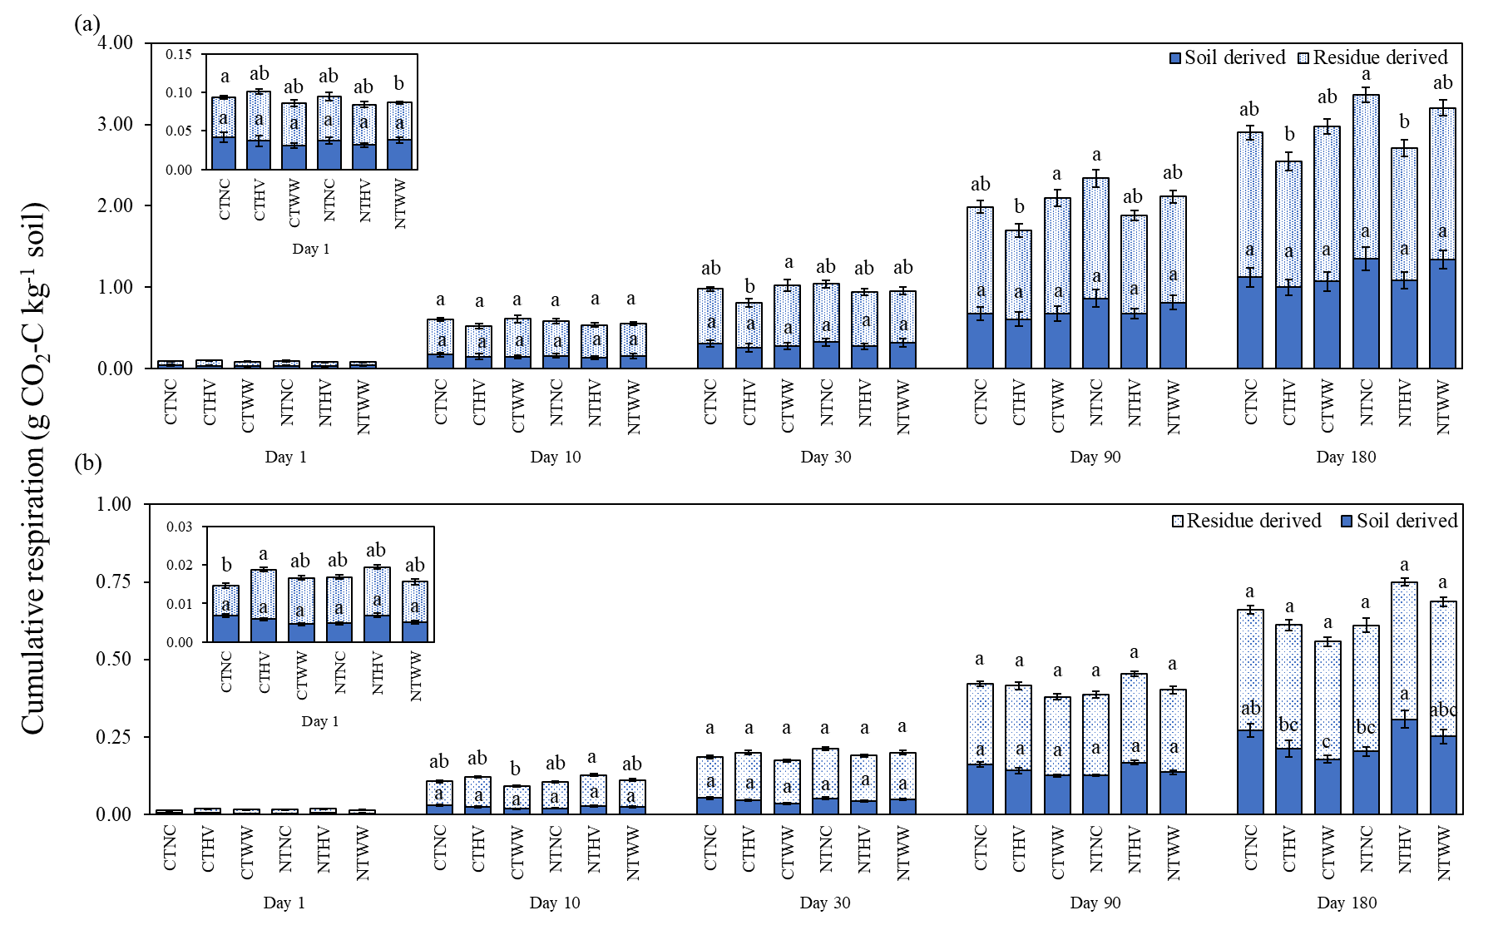
CT and NT denote the conventional and no-till treatments, respectively. NC, HV and WW denote no cover, hairy vetch, and winter wheat cover cropping treatments, respectively. Data represents mean ± standard errors. Means followed by different lower-case letters indicate significant differences between cropping treatments for each soil depth and soil parameters.
Figure 13. Cumulative residue and soil-derived C mineralized as CO₂ under different treatment combinations at (a) topsoil and (b) subsoil. In the stacked bars, solid color pattern denotes soil-derived MAOM-C, and dotted color pattern denotes residue-derived MAOM-C.

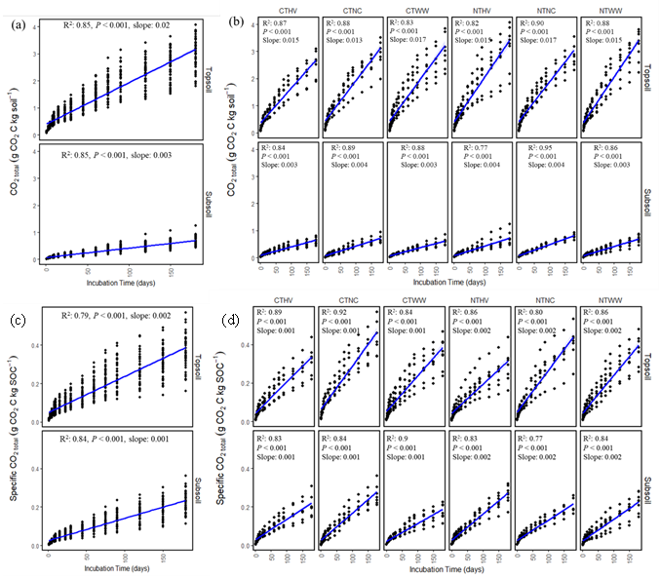
Figure 14. Cumulative (CO_{2total}; a,b) and Specific CO₂ mineralization (Specific CO_{2total}; c,d) over the course of incubation experiment as a function of soil depth (a,c) and across agricultural treatment combinations at topsoil and subsoil (b,d).

CT and NT denote the conventional and no-till treatments, respectively. NC, HV and WW denote no cover, hairy vetch, and winter wheat cover cropping treatments, respectively.

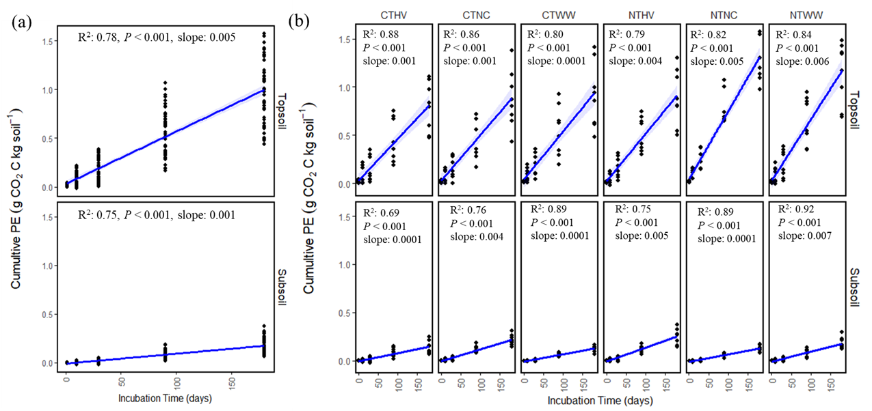
Figure 15. Cumulative PE over the course of incubation as a function of (a) soil depth, and (b) across agricultural treatment combinations at topsoil and subsoil.
CT and NT denote the conventional and no-till treatments, respectively. NC, HV and WW denote no cover, hairy vetch, and winter wheat cover cropping treatments, respectively.

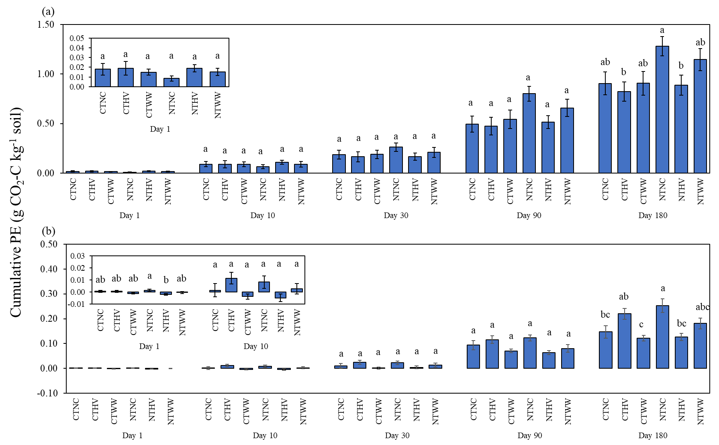
CT and NT denote the conventional and no-till treatments, respectively. NC, HV and WW denote no cover, hairy vetch, and winter wheat cover cropping treatments, respectively. Data represents mean ± standard errors. Means followed by different lower-case letters indicate significant differences between cropping treatments for each soil depth.
Figure 16. Cumulative priming effect in soils added with C-labelled residues under different treatment combinations at (a) topsoil and (b) subsoil. Data represents mean ± standard errors.
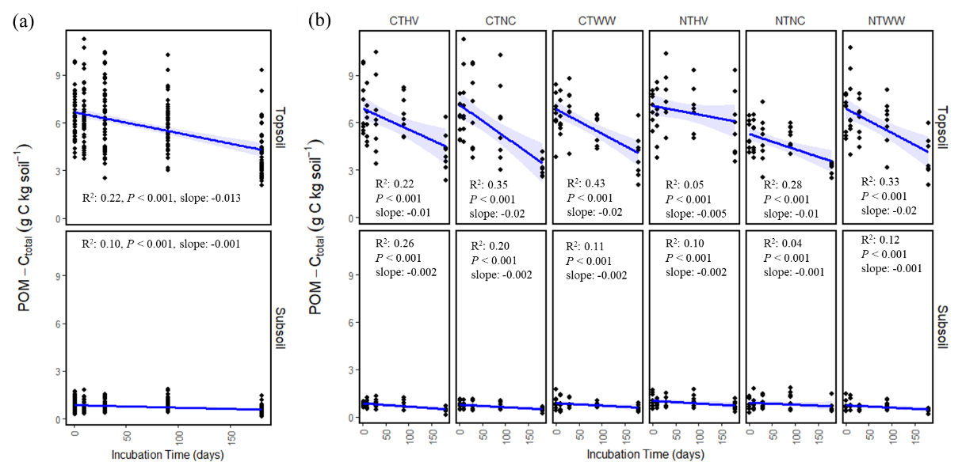

Figure 17. Total (POM-C_{total}; g C kg soil⁻¹) over the course of incubation experiment as a function of soil depth (a) and depth wise agricultural treatment combinations (b).

CT and NT denote the conventional and no-till treatments, respectively. NC, HV and WW denote no cover, hairy vetch, and winter wheat cover cropping treatments, respectively.
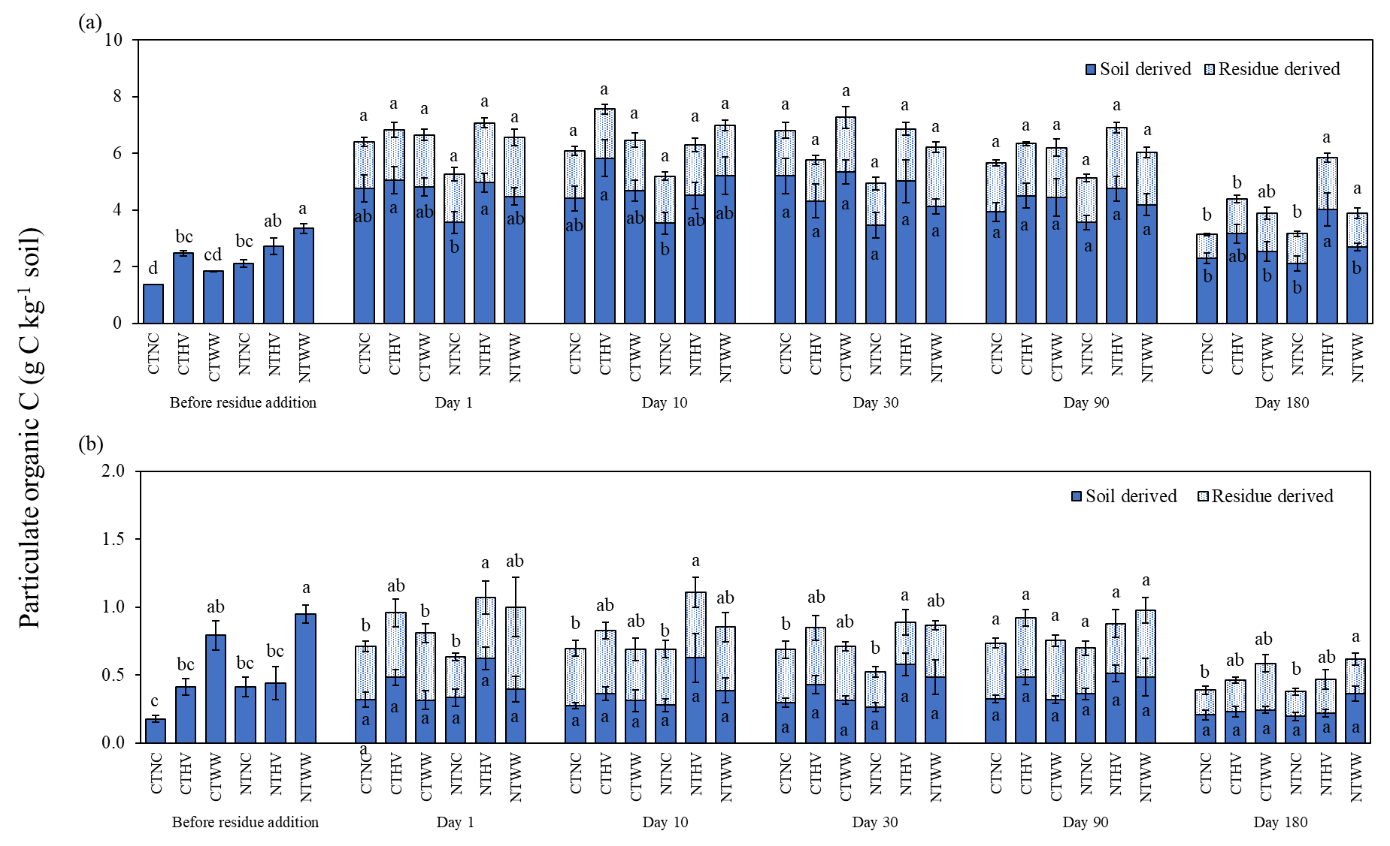
Figure 18. Cumulative residue and soil derived POM-C under different treatment combinations at (a) topsoil and (b) subsoil. In the stacked bars, solid color pattern denotes soil-derived POM-C, and dotted color pattern denotes residue-derived POM-C

CT and NT denote the conventional and no-till treatments, respectively. NC, HV and WW denote no cover, hairy vetch, and winter wheat cover cropping treatments, respectively. Data represents mean ± standard errors. Data represents mean ± standard errors. Means followed by different lower-case letters indicate significant differences between cropping treatments for each soil depth and measured parameters.
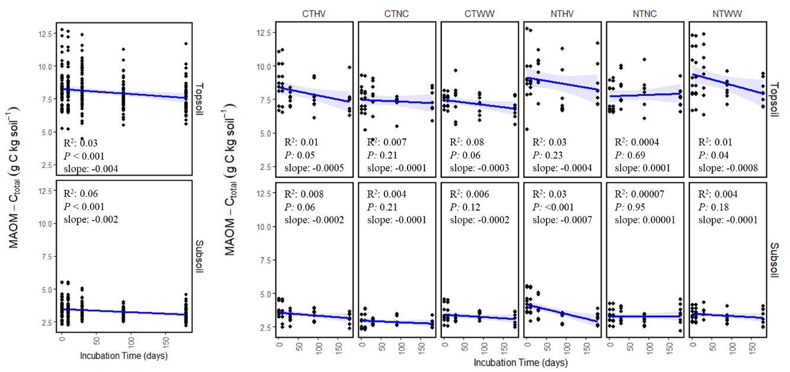
Figure 19. Total MAOM-C (MAOM-C_{total}; g C kg soil⁻¹) over the course of incubation experiment as a function of (a) soil depth and (b) depth wise agricultural treatment combinations.

CT and NT denote the conventional and no-till treatments, respectively. NC, HV and WW denote no cover, hairy vetch, and winter wheat cover cropping treatments, respectively.
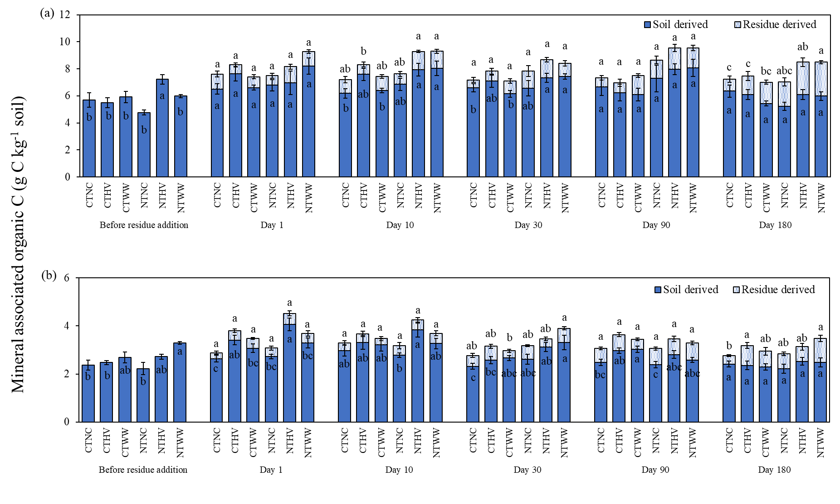
CT and NT denote the conventional and no-till treatments, respectively. NC, HV and WW denote no cover, hairy vetch, and winter wheat cover cropping treatments, respectively. Data represents mean ± standard errors. Means followed by different lower-case letters indicate significant differences between cropping treatments for each soil depth.
Figure 20. Cumulative residue and soil derived MAOM-C under different treatment combinations at (a) topsoil and (b) subsoil. Within stacked bars, solid color pattern denotes soil derived MAOM-C, and dotted color pattern denotes residue derived MAOM-C. Data represents mean ± standard errors.
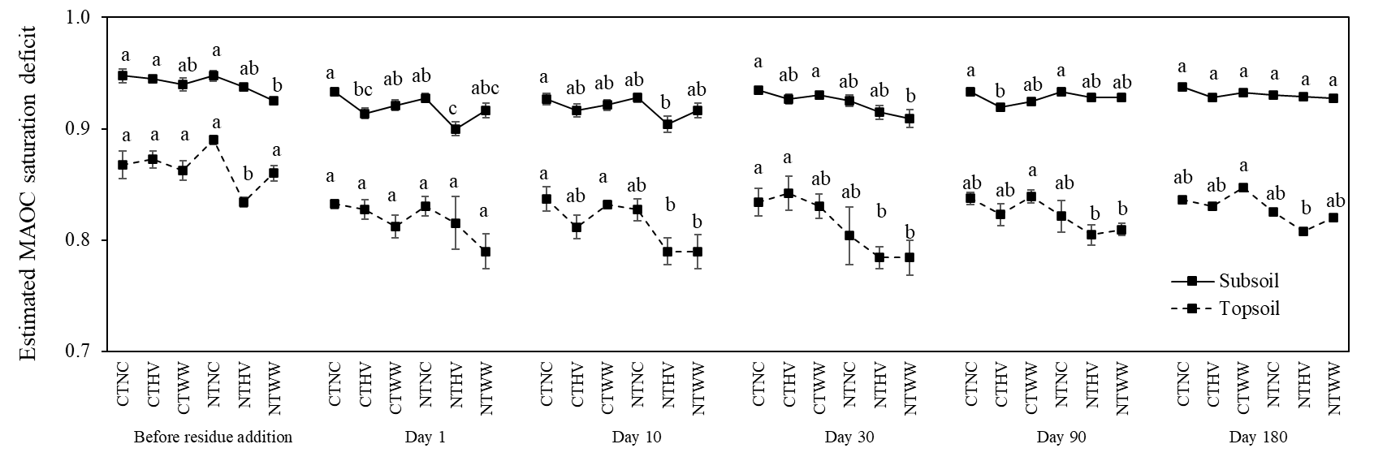
Figure 21. Estimated MAOM-C saturation deficit under different treatment combinations at topsoil and subsoil.
CT and NT denote the conventional and no-till treatments, respectively. NC, HV and WW denote no cover, hairy vetch, and winter wheat cover cropping treatments, respectively. Data represents mean ± standard errors. Means followed by different lower-case letters indicate significant differences between cropping treatments for each soil depth.

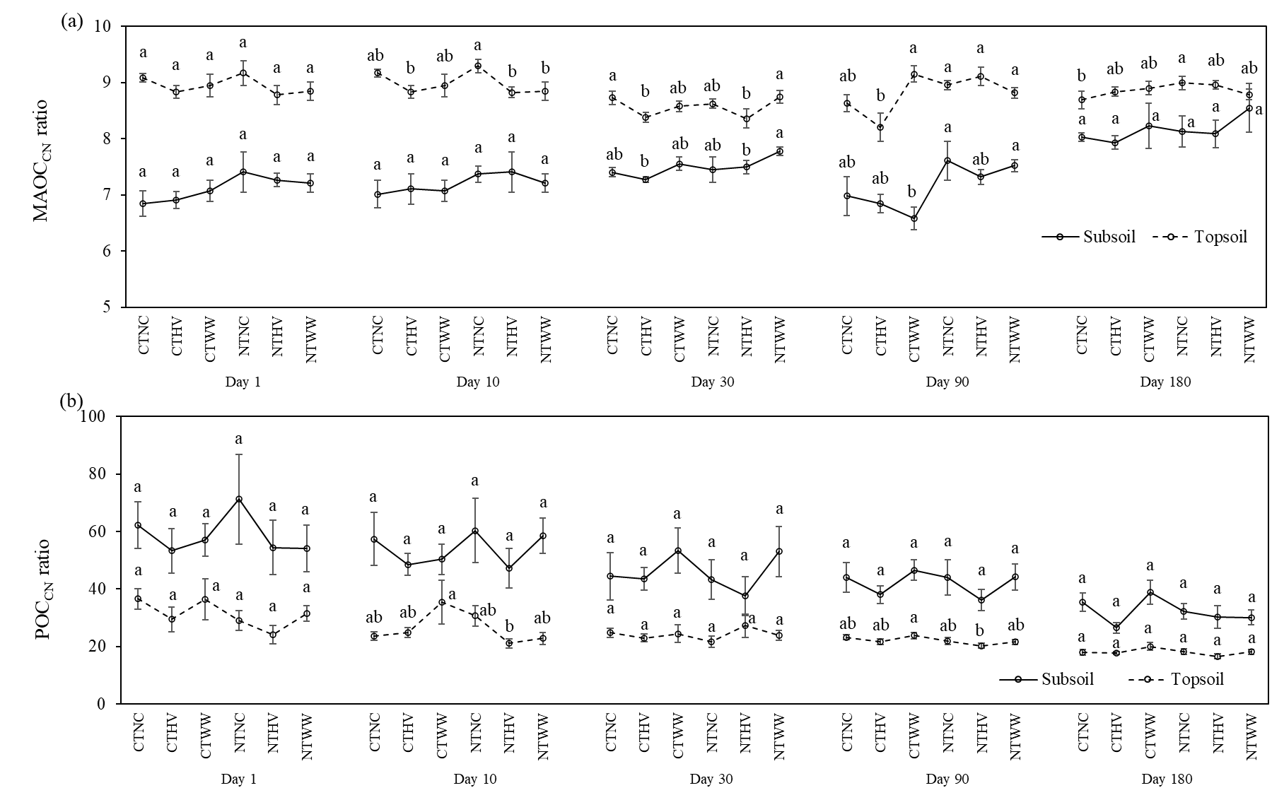
CT and NT denote the conventional and no-till treatments, respectively. NC, HV and WW denote no cover, hairy vetch, and winter wheat cover cropping treatments, respectively. Data represents mean ± standard errors. Means followed by different lower-case letters indicate significant differences between cropping treatments for each soil depth.
Figure 22. CN ratio of MAOM-C_{total} and POM-C_{total} under different treatment combinations at topsoil and subsoil.

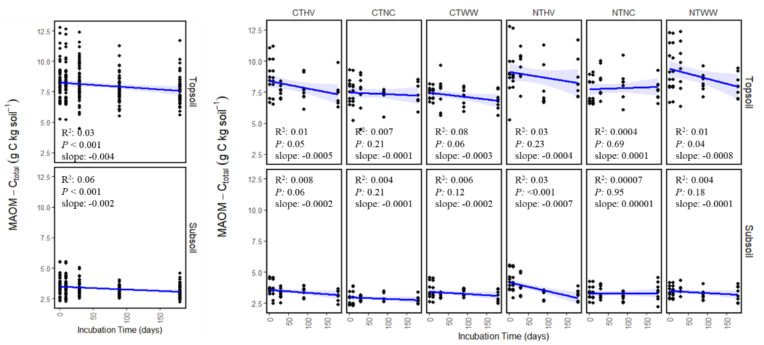
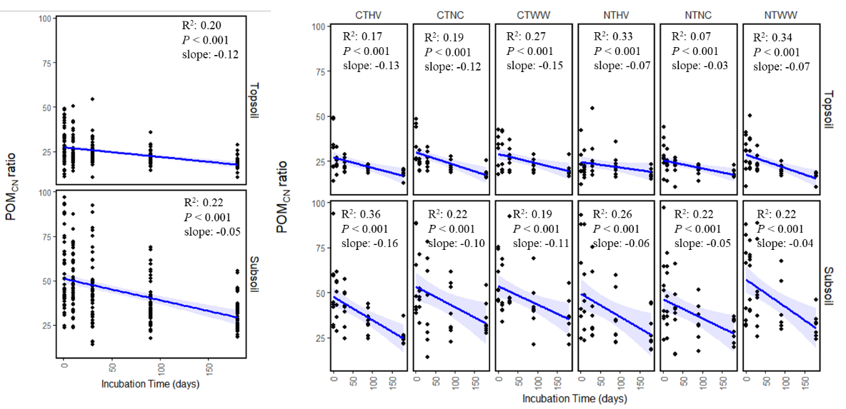
CT and NT denote the conventional and no-till treatments, respectively. NC, HV and WW denote no cover, hairy vetch, and winter wheat cover cropping treatments, respectively. Data represents mean ± standard errors. Means followed by different lower-case letters indicate significant differences between cropping treatments for each soil depth.
Supplementary Figure 23. POM-C_{total} (a,b) and MAOM-C_{total} (c,d) CN ratio over the course of incubation experiment as a function of soil depth (a,c) and across agricultural treatment combinations at topsoil and subsoil (b,d).
(a)
(b)
(c)
(d)

Chapter 5: Long-term cover cropping increased residue derived carbon storage in mineral associated C fraction by regulating microbially functional traits

Authors
Rounak Patra, Melissa Cregger, Debasish Saha, and Sindhu Jagadamma.

Publication status
This manuscript will be prepared for peer-reviewed journal submission.

5.1. Abstract
Agriculture practices with no tillage and cover cropping can store more soil organic C (SOC) compared to conventional tillage and no cover cropping practices by modulating the microbial processing of crop residue C. However, our understanding of the relationship between microbial functional traits processing the retained crop residue C and SOC storage in response to contrasting agricultural management practices is limited, particularly when considering for the deeper subsoil. This study investigates the impact of contrasting agricultural management strategies—conservation practices including no-tillage (NT) and cover cropping versus conventional tillage without cover cropping—on the temporal dynamics of microbial functional traits and the residue-derived C dynamics in the soil depth profile. We conducted a laboratory incubation experiment for six-months using ¹³C-labeled mannagrass residue (Glyceria striata (Lam.)) added to topsoil (0-10 cm) and subsoil (30-40 cm) samples collected from a long-term field experiment that included a combination of tillage (conventional-tillage and no-tillage) winter cover crop (no cover, hairy vetch, and winter wheat) treatments. Microbial carbon use efficiency (CUE), enzymatic efficiency (EE), and metabolic quotient (qCO₂) were measured to assess microbial functional traits associated with C-cycling. Structural Equation Modeling (SEM) was employed to analyze the interactions between microbial traits and the fate of residue-derived carbon in forming stable SOC fractions. Conservation practices significantly improved microbial functional traits across the soil depth profile, particularly evident in the cover cropping practices, which showed improved CUE and EE, and reduced qCO₂, facilitating greater stabilization of MAOM-C. The topsoil, while showing an initial high CUE, experienced a decrease in CUE over time. In contrast, the subsoil showed significant improvements in microbial traits over time under conservation practices, suggesting an improved capacity for deep soil layers to contribute to SOC sequestration. SEM results indicated that these improvements were pivotal for increasing MAOM-C stabilization and reducing carbon loss as CO2.

5.2. Introduction
Conventional agricultural practices played a key role in the historical loss of soil organic carbon (SOC) from croplands, with an estimated 130 Petagrams (Pg) of carbon lost from the upper 2 meters of soil (Sanderman et al., 2017). Conservation agriculture, commonly characterized by increased crop residue return via cover cropping and no or minimal soil disturbance via the adoption of no-tillage or reduced tillage methods, has been suggested as a strategy for restoring SOC levels and offering additional ecosystem co-benefits in degraded croplands (Paustian et al., 2016). It is estimated that 67% of the of the cultivated croplands in the US adopt some form of conservation tillage, while only 6% of the US croplands utilize cover crops (CEAP, 2022). Increased SOC accrual was observed after a shift from intensive tillage with no winter cover cropping to no-tillage and cover cropping (Lal et al., 2015; Paustian et al., 2016; Bossio et al., 2020). However, the response of cropland SOC to changes in agricultural management practices can vary significantly across the soil depth (Luo et al., 2010; Patra et al., 2022). Soils managed under cover cropping and reduced or no- tillage should accumulate more SOC in the topsoil (Luo et al., 2010; Alcántara et al., 2016). This SOC is predominantly be stored as relatively easily decomposable organic matter pools such as macroaggregate-protected organic matter or POM-C (Six et al., 2000). No-till soils with high-biomass producing cover crops will also stratify SOC near the surface soil (Baker et al., 2007; Franzluebbers, 2010; Patra et al., 2022), which are more vulnerable to further SOC loss under any changes in management practices (Baker et al., 2007). While studies predominantly indicate an increase in topsoil SOC following the adoption of conservation agricultural practices, information on the fate of crop residue-derived C dictating subsoil SOC dynamics under these management practices remains limited.
In croplands, formation of bulk SOC fractions from the crop-residue C and mineralization to atmospheric CO₂ are highly dependent on (i) amount of organic C input to the soil through plant primary production, (ii) agricultural management practices determining the quantity and quality of crop residue C available for storage in soil, and (iii) soil microbial composition and functions controlling both the stabilization and destabilization of crop residue C (Schmidt et al., 2011; Schimel and Schaeffer, 2012). Microbial functional traits associated with C-cycling captures the balance between residue C stabilization and destabilization processes (Liang et al., 2017). One such functional trait, microbial carbon use efficiency (CUE), is the ratio between C allocated to anabolic activities (C_{growth}, C invested for microbial biomass growth and production of non-biomass byproducts) to catabolic processes (respiration, maintenance energy expenditure), and it establishes a microbial control point between C accrual and loss from an ecosystem (Sinsabaugh et al., 2013; Joergensen and Wichern, 2018). Microbial CUE has strong implications for long-term SOC storage (Tao et al., 2023), as residue C converted into microbial necromass, which is subsequently stabilized as more-persistent mineral associated organic C (MAOM-C) (Grandy and Robertson, 2007; Cotrufo et al., 2013). Other important microbial functional traits are enzymatic efficiency (EE), which is the ratio of C_{growth} to the C acquiring enzymatic activity, and qCO₂, which is the ratio of basal respiration rate to C_{growth}. Both these traits require C_{growth} investment, which incurs extra nutrient costs and can negatively affect microbial CUE (Malik et al., 2019). However, estimating field-based soil microbial functional traits is complex due to the processes occurring at different temporal scales and being influenced by various confounding factors.
The temporal dynamics of agricultural SOC and microbial functional traits are primarily shaped by pedoclimatic variations and management interventions. Additionally, these trait estimations can be affected by the experimental setup, such as the measurement duration (Geyer et al., 2019), and the quality and quantity of the added C substrate (Geyer et al., 2016; Sinsabaugh et al., 2016). A previous comparative study by Geyer et al. (2019) suggested that the community level microbial CUE decrease over time. This decline reflects the overall nutrient availability for soil microbes, leading to reduced stabilization of C as SOC and increased carbon loss via CO₂ respiration, as well as native SOC priming effect driven by microbial nutrient mining (Blagodatskaya and Kuzyakov, 2008; Shahbaz et al., 2017). However, recent meta-analysis from Islam et al. (2023) showed functional trait estimation from croplands have mainly focused on a single C compound (such as glucose or amino-acids) over fixed time periods, rarely considering the potential general patterns of temporal dynamics of microbial functional traits under complex residue-derived C sources. Therefore, studying the temporal dynamics of microbial functional traits from a complex C source is crucial, as microbial processes are not static but evolve in response to the changing conditions imposed by agricultural practices and natural environmental cycles. Moreover, the interplay between temporal dynamics and soil depth introduces additional complexity.
In this study, we conduct a long-term incubation experiment using surface and sub-surface soils collected from a long-term agricultural experiment that includes both conventional and conservation agricultural practices. Our primary objectives were to understand the interactive effects of agricultural management practices and soil depth on the temporal dynamics of microbial functional traits, which dictate the fate of the added crop-residue C. Specifically, our study aimed to: (i) examine the interactive effects of contrasting agricultural management practices and soil depth on the temporal dynamics of microbial functional traits associated with C-cycling, (ii) assess how these microbial functional traits dictate the fate of SOC fractions across the soil depth profile under these contrasting agriculture practices (treatments with and without conventional tillage and cover cropping). We hypothesized that (a) in the subsoil microbial functional traits associated with C-cycling will improve over time (increased CUE and EE, and decreased qCO₂), and equate to the topsoil microbial functional traits during the incubation experiment, (b) Soils under long-term no-tillage and deep rooted cover crops will improve microbial functional traits over time compared to soils under conventional tillage and no winter cover crops. Improvement in microbial functional traits will help no-tillage and cover cropping practices efficiently accumulate more SOC in C fractions rather depleting SOC as CO₂ compared to agricultural treatments with tillage and no cover cropping.

5.3. Materials and Methods

5.3.1. Experimental Site, soil sampling and incubation experiment set up
Please refer to section 1.6 for details of the experimental site and sections 4.3.1 and 4.3.2 for information on the soil sampling and incubation experiment setup.

5.3.2. Measurement of residue derived C in CO₂ and bulk SOC fractions
Please refer to sections 4.4.1 to 4.4.4 for methods related to the measurement of residue carbon fractionation in soil fractions and CO₂ production.

5.3.3. Measurement of microbial biomass C and C-cycling enzyme activities
We measured the soil microbial biomass carbon (MBC) by modified chloroform fumigation-extraction method, using an extraction efficiency of 0.45 (Vance et al., 1987). Destructively harvested 10 g soil from the incubation experiment were fumigated with chloroform for 48 h, after which we extracted them in 25 mL 0.25 M K₂SO₄ solution and filtered the extract using Whatman #42 filter paper (fumigated sample). Similarly, we extracted 10 g of destructively harvested soil on the day chloroform fumigation was started (non-fumigated sample). 6 mL of fumigated and non-fumigated extracts were analyzed through dry combustion using the Elementar Vario TOC cube CN analyzer (Elementar, Hanau, Germany). 3 mL of fumigated and non-fumigated extracts were freeze-dried in a Lyophilizer (Labconco, MO, USA) and measured for ¹³C analyses in a combustion module attached to a Cavity Ring-Down Spectroscopy of a Picarro G2131-i analyzer (Picarro Inc., Santa Clara, CA, USA).
We measured key C cycling enzymes such as α- and β-glucosidase (AG and BG), cellobiohydrolase (CB), and β-xylosidase (XYL) using a modified microplate-based fluorometric assay (Bell et al., 2013). We prepared the soil slurries by blending 2 g of soil samples in 91 mL of 50 mM sodium acetate buffer at average soil pH of 6.3 (Patra et al., 2022) in a Waring blender for 1 min. Then 800 μL of the soil slurry was transferred into two 96-deep well (1.2 mL) microplates in each of the 8 wells of one column, from which we used one plate to create 4-methylumbelliferone (MUB) standard curves (0, 1.25, 2.5, 5, 10, 25, 50, and 100 μM concentrations). For each 800 µL of soil slurry, we added 200 µL of the fluorometric substrate and incubated the mixture in the dark at 25 °C for 3 hours. After incubation, we centrifuged the soil slurries for 3 minutes at 1500 g and transferred 250 µL of the supernatant from each well to black, flat-bottomed 96-well plates. Using a microplate reader (Synergy-BioTek Instruments, Inc., Vermont, USA), we scanned the 96-well plates at excitation and emission wavelengths of 365 and 450 nm, respectively. We used the MUB standard curve to create a linear standard curve to determine the activity of C acquiring enzymes for each sample. Finally, we calculated total C cycling enzymatic activity as the sum of the activities of AG, BG, CB, and XYL in nmol g⁻¹ soil (Bell et al., 2013).

5.3.4. Isotopic calculations
Please refer to 4.3.5 for the isotopic calculation of residue derived ¹³C fractionation calculation (equations 1-4). The proportion of C recovered from residues in each SOC fraction was calculated using the following equation:
${\%C}_{recovered}=\frac{f_{residue}×{SOC}_{fraction}}{C_{input}} × 100$ (5)
Where $f_{residue}$ is the fraction of residue derived C in the total measured C in each SOC fraction, ${SOC}_{fraction}$ is the concentration of residue derived C in the total measured C in each SOC fraction. We followed 3.3.6 to measure microbial functional traits associated with C-cycling. To prevent the overestimation of CUE values by mistakenly assigning unrecovered, non-decomposed residue C, we adjusted for ${residue}^{13}C$ recovered in our C_{uptake} calculation.
C_{growth} = MB¹³C +MR¹³C (5)
${MRC}^{13}C= {Residue}^{13}C-{MBC}^{13}C{- POM}^{13}C-^{13}{CO}_{2}$ (6)
C_{uptake} = ${Residue}^{13}C recovered-{POM}^{13}C$ (7)
CUE = $\frac{C_{growth}}{C_{uptake}}$ (8)
We calculated specific respiration rate or metabolic quotient (qCO₂, g CO₂-C kg⁻¹ C_{growth}) by following Anderson and Domsch (1990).
qCO₂ = $\frac{C_{respiration}}{C_{growth}}$ (10)
Where C_{respiration} is the ¹³CO₂-C mineralized due to microbial respiration. We calculated enzymatic efficiency (EE; mg C_{growth} mmol⁻¹ enzymes) by following Sauvadet et al. (2018):
EE = $\frac{C_{growth}}{Total C cycling enzymatic activity}$ (11)

5.3.5. Statistical analysis
We used SAS v9.4 statistical package (SAS Institute, Inc., Cary, NC) to conduct analysis of variance (ANOVA) based on linear mixed effect model for repeated measures to examine the agricultural treatment combinations on the temporal dynamics of microbial functional traits. Agricultural treatment combinations were treated as fixed effects and replication was treated as random effect. We separately analyzed topsoil and subsoil data, considering all fixed and random effect factors. The treatment differences were considered significant at P ≤ 0.1 and mean separations for significance were done using the Tukey test. Also, linear regression models were performed using R (R Core Team, 2021) to assess the temporal dynamics of residue-derived SOC fractions and microbial functional traits across each combination of cropping treatments, separately analyzing topsoil and subsoil.
Structural Equation Model is performed to understand the direct and indirect effect of agricultural management practices and microbial functional traits (C_{growth}, C_{respiration}, net enzymatic activity) on residue derived C accrual as MAOM-C_{res} and mineralization as CO_{2res} based on a priori model derived from literature knowledge (Table 11 and Figure 11). Agricultural treatment combinations were treated as exogenous predictor variables (Peng et al., 2023). Measured values of microbial functional traits and recovered residue derived C in bulk soil fractions (POM-C_{res} and MAOM-C_{res}) and residue derived CO₂-C mineralization (CO_{2res}) were used to create endogenous predictor variables. We transformed exogenous categorical predictors into numerical variables using presence-absence matrices. Z-score standardization was applied to ensure parameters were comparable. Using the MuMIn version 1.47.5 R package, we constructed a series of models encompassing all possible combinations of the initial predictors in predicting residue derived C fractions, with separate models for topsoil and subsoil (Barton and Barton, 2015). We tested our priori model for the SEM analysis using the piecewiseSEM version 2.3 R package (Lefcheck, 2016). We selected the topsoil and subsoil model that explained the most variation in MAOM-C_{res} and CO_{2res} based on Akaike’s Information Criterion (AIC), and sequentially removed non-significant paths to simplify the original model.

5.4. Results

5.4.1. ¹³C recovered in C_{growth}, CO₂ and in soil physical fractions
Residue C used for C_{growth} were significantly influenced by incubation time, management practices and soil depth (Table 7). In the topsoil, C_{growth} increased from day 1 (0.04 ± 0.004 g C kg⁻¹ soil) to day 180 (0.08 ± 0.01 g C kg⁻¹ soil), across agricultural treatment combinations. After day 90, topsoil C_{growth} was higher under conservation practices with NT and cover crops (NTHV and NTWW 0.07 ± 0.01 g C kg soil⁻¹) than in CTNC (0.03 ± 0.01 g C kg soil⁻¹). A similar trend was observed after day 180, when topsoil NTHV and NTWW had higher C_{growth} (0.11±0.01 g C kg soil⁻¹ for both treatments) compared to CTNC (0.04 ± 0.01 g C kg soil⁻¹) and CTHV (0.06 ± 0.01 g C kg soil⁻¹) treatments. In the subsoil, C_{growth} increased from day 1 (0.02 ± 0.002 g C kg⁻¹ soil) to day 180 (0.03 ± 0.01 g C kg⁻¹ soil) across agricultural treatment combinations. Integrating WW cover crop with NT consistently showed highest C_{growth} from day 30 to day 180 (0.03 ± 0.002, 0.51 ± 0.003, 0.04 ± 0.01 g C kg soil⁻¹ at day 30, 90 and 180, respectively).
We traced the fate of C added from residue in different soil pools, which includes CO₂, MAOM-C and POM-C (Table 18). The percentage of added residue C mineralized as CO₂ (fCO_{2res}) showed significant variation with incubation time, agricultural management, and soil depth. After the addition of residue, CO_{2res} increased during the incubation experiment, irrespective of soil depth and agricultural treatments, however, the increase was much steeper in the topsoil (Figure 24). In the topsoil, 21±1.2 % of added residue was mineralized by the end of the incubation. The highest fCO_{2res} was observed under NTNC and WW cover cropping treatments, followed by the order of CTNC > NTHV > CTHV. Within both CT and NT systems, the inclusion of HV cover crop resulted in a 14% and 20% decrease in fCO_{2res}, respectively, compared to the NC control (Table 18a). On average, 18.6 ± 1.2% of the added residue was mineralized as CO₂ in the subsoil by the end of the incubation period. However, no significant difference was observed among treatments throughout the experiment (Table 18b).
The percentage of added residue-C recovered as POM-C fraction (fPOM-C_{res}) showed significant variation with time, agricultural management, and soil depth. Following the addition of residue, fPOM-C_{res} significantly decreases with time, with topsoil losing more POM-C_{res} compared to the subsoil across the agricultural treatment combinations (Figure 25). In the topsoil, 45.6 ± 4.6 % of residue-C was present as fPOM-C_{res} at the end of the incubation, with the highest fPOM-C_{res} observed under NTHV treatment, followed by in the order of CTHV > CTWW = NTWW = NTNC = CTNC. In both CT and NT systems, the inclusion of HV cover crop treatment resulted in a 39% and 48% increase in fPOM-C_{res}, respectively, compared to NC. On average, 22.5 ± 2.9 % of the added residue-C was recovered as fPOM-C_{res} in the subsoil by the end of the incubation period. Across the subsoil agricultural treatments, no significant difference was observed in the fraction of residue-C recovered as POM-C by the end of the incubation period (Table 18).
The percentage of added residue-C recovered as MAOM-C fraction (fMAOM-C_{res}) showed significant variation with incubation time, agricultural management, and soil depth. MAOM-Cres increased significantly over time, with more so in the topsoil than in the subsoil, with treatment specific effect significantly affecting MAOM-C_{res} (Figure 26). In the topsoil, 19.8 ± 3 % of fMAOM-C_{res} was recovered at the end of the incubation with the highest fMAOM-C_{res} under NTWW treatment, followed by in the order of NTHV > NTNC > CTWW > CTHV > CTNC. In both CT and NT systems, the inclusion of WW cover crop treatment resulted in a 76% and 42% increase in fMAOM-C_{res}, respectively, compared to the NC control. On average, 31.3 ± 5 % of the fMAOM-C_{res} was recovered from the subsoil by the end of the incubation. Across the subsoil agricultural treatments, the highest fMAOM-C_{res} was observed under NTWW and CTHV treatments, followed by the order of CTWW = NTNC = NTHV > CTNC (Table 18).

5.4.2. Microbial functional traits associated with C cycling

5.4.2.1. C-cycling enzymatic activities and enzymatic efficiency
Individual and total C cycling enzymatic activities were significantly influenced by incubation time, soil depth and management practices. Enzymatic activity increased during the incubation period, with a stronger increase in the surface soil compared to the subsoil (Figure 28). In the topsoil, total enzymatic activities increased from 761 ± 42 nmols g⁻¹ soil after day 1 to 1673 ± 86 nmols g⁻¹ soil after day 180 (Table 2). At the end of the experiment, the lowest total enzymatic activity was observed under topsoil NTWW treatment (1393 ± 119 nmols g⁻¹ soil), primarily driven by the BG activity (860 ± 64 nmols g⁻¹ soil) (Figure 27 and Table 20). In the subsoil, total enzymatic activities increased from 311±15 nmols g⁻¹ soil on day 1 to 482 ± 14 nmols g⁻¹ soil on day 180 (Figure 28, Table 20). However, after 180 days of incubation, subsoil enzymatic activities showed no change across the agronomic treatment combinations (Figure 27 and Table 20).
Although total C cycling enzymatic activity increased over time, microbial EE remained stable during the incubation period at the topsoil and subsoil (Figure 31). Within topsoil, implementation of NT and WW cover cropping increased EE, with only CTNC treatments reduced EE over time (Figure 31a). During the incubation experiment, the lowest topsoil EE was observed under CTNC at day 30, 90 and 180 (0.7 ± 0.2, 0.6 ± 0.1, 0.5 ± 0.1 mg C_{growth} mmol⁻¹ enzymatic activity, respectively) and the highest EE was recorded under NTHV at day 30 (0.5 ± 0.1 mg C_{growth} mmol⁻¹ enzymatic activity) and under NTWW at days 90 and 180 (0.45 ± 0.1, 0.5 ± 0.1 mg C_{growth} mmol⁻¹ enzymatic activity, respectively). Across the cropping treatments, subsoil EE remain unchanged over the incubation period (Figure 31), with only NTWW exhibited the highest EE from day 30 to day 180 (1.9 ± 0.3, 1.7 ± 0.3, and 2.2 ± 0.5 mg C_{growth} mmol⁻¹ enzymatic activity, respectively) and CTNC exhibited the lowest EE at day 180 (0.8 ± 0.1 mg C_{growth} mmol⁻¹ enzymatic activity).

5.4.2.2. Microbial CUE and qCO₂
Microbial CUE ranged from 0.20 to 0.63 and varied over time, by management practices, and soil depth (Figures 29 and 30). Within the topsoil, CUE decreased from day 1 (0.47 ± 0.2) to day 180 (0.37 ± 0.05), across the agricultural treatment combinations. Throughout the incubation, topsoil microbial CUE generally decreased under tillage practices. However, NTNC and NTHV showed no significant changes, while NTWW showed a significant improvement in microbial CUE (Figure 30). At the end of the experiment, NT and cover cropping treatments (NTHV 0.55 ± 0.05 and NTWW 0.45 ± 0.03) showed the highest CUE compared to tilled no-cover treatments (0.2 ± 0.04) (Figure 29a). Subsoil CUE displayed a different trend; while topsoil CUE was initially higher and then decreased, subsoil CUE increased from day 1 (0.33 ± 0.1) to day 180 (0.41 ± 0.1), with NTWW treatments showing a positive increase in CUE throughout the experiment (Figure 30). At the end of the experiment, NTWW (0.56 ± 0.1) showed the highest CUE compared to CTNC treatments (0.21 ± 0.03) (Figure 29b).
Microbial qCO₂ was influenced by time, management practices, and soil depth. Throughout the incubation, qCO₂ increased over time, with higher qCO₂ being observed from topsoil to subsoil (Figure 32). Within the topsoil, qCO₂ increased from day 1 (0.09 ± 0.03 g C kg⁻¹ C_{growth}) to day 180 (1.35 ± 0.23 g C kg⁻¹ C_{growth}) across agricultural treatments. Within topsoil, the rate of qCO₂ increase was influenced by cropping treatments, with from day 30 onwards, CTNC treatment significantly increased qCO₂ production (1.75 ± 0.6, 2.43 ± 0.42, 2.37 ± 0.49 g C kg⁻¹ C_{growth} at day 30, 90 and 180, respectively) and NT in combination with cover crops showed the lowest qCO₂ (Figure 29e). Similarly, subsoil showed an increase in qCO₂ from day 1 (0.04 ± 0.003 g C kg⁻¹ C_{growth}) to day 180 (0.68 ± 0.09 g C kg⁻¹ C_{growth}) across agricultural treatments, with the rate of increase is much slower compared to the topsoil (Figure 32). At the end of the experiment, the highest qCO₂ production in subsoil was observed under CTNC (1.08 ± 0.13 g C kg⁻¹ C_{growth}) treatment compared to all other cropping treatments (Figure 29f).

5.4.3. Relationship between microbial functional traits and residue C recovered in soil C fractions
We established separate topsoil and subsoil structural equation models to explain the influence of long-term conservation agricultural practices on microbial functional traits driving residue derived C stabilization in MAOM-C fraction (MAOM-C_{res}) and destabilization as CO₂ (CO_{2res}) from the added residue (Figure 33). The topsoil SEM explained 85% and 15% of the variations in MAOM-C_{res} and CO_{2res}, respectively. In the topsoil, presence of both NT and cover cropping (exogenous treatment predictors) indirectly increased MAOM-C_{res} production through increased POM-C_{res} (0.35, P ≤ 0.001), CUE (0.35, P ≤ 0.001), EE (0.35, P ≤ 0.001). This increased efficiency in MAOM-Cres storage decreased CO₂res production through decreasing qCO_{2res} (0.56, P ≤ 0.001) (Figure 33a). The subsoil SEM explained 87% and 25% of the variations in MAOM-C_{res} and CO_{2res}, respectively. In the subsoil, only WW cover crop not as the exogenous treatment predictors significantly decreased POM-C_{res} (-0.11, P ≤ 0.1), improved EE (0.18, P ≤ 0.1) and CUE (0.35, P ≤ 0.001), increasing MAOM-C_{res} formation, and WW cover crop reduced qCO₂ (0.29, P ≤ 0.05), indirectly decreasing CO_{2res} production.

5.5. Discussion

5.5.1. Effect of agricultural management practices and soil depth on microbial functional traits
Our findings highlight the dynamic interplay between agricultural management practices and microbial functional traits and its subsequent influence on SOC fractions. Throughout the incubation experiment, we observed a decrease in topsoil CUE under tillage practices, which suggests that legacy of higher soil disturbance can adversely affect microbial efficiency, consistent with previous findings (van Groenigen et al., 2013; Sauvadet et al., 2018; Kallenbach et al., 2019). Conventional agricultural management with tillage and no cover practices significantly impact the soil C cycle by altering soil physical, chemical, and biological properties, thereby increasing soil C destabilization processes (Bailey et al., 2019). The destabilization of agricultural SOC by conventional management practices can occur through three processes: (i) release from physical occlusion (Six et al., 1998, 2002), (ii) desorption from soil minerals due to changes in soil chemistry (Malik et al., 2018; Kirsten et al., 2021), and (iii) increased heterotrophic respiration and microbial metabolism, driven by increased C-bioavailability following shift in C from slow-pool into active pool (Six et al., 2000; Grandy and Robertson, 2007). This greater SOC availability under conventional systems increases C-cycling enzymatic activities and aligns with an elevated microbial demand for nutrients as decomposition progresses (Figures 29e and 31). However, these conditions are resulting in decreased microbial functional traits (low CUE, and high qCO₂), leading to decreased efficiency of residue C allocation in SOC, i.e. increasing CO_{2res} production and decreasing long-term residue C storage through MAOMC_{res} production. The adoption of conservation agriculture such as no-tillage and cover cropping reduces soil disturbance and increase residue addition to soil, promotes soil aggregate formation and stability, and provide an environment for the preferential accumulation of SOC through decreased POM-C decomposition into CO₂ production and increased physiochemically protected MAOM-C (Paustian et al., 2016). Conservation practices such as NT combined with cover cropping increased microbial functional traits, particularly evident in the NTWW treatment, supporting the hypothesis that conservation practices stabilize crop residue-derived C more effectively by fostering a conducive microbial environment, thereby alleviating metabolic constraints on C_{growth}, and facilitating the transformation of residue C into MAOM-C rather than being lost as CO₂ (Figure 32a).
The differential trends noted between the topsoil and subsoil microbial functional trait responses also underscore the critical role of soil depth in mediating processes and residue C dynamics in agricultural ecosystems. Nutrient bioavailability tends to decrease sharply with soil depth due to increased mineral soil fraction that is depleted of C and nutrients and more heterogenous spatial distribution of organic matter inputs in the subsoil (Fontaine et al., 2007; Rumpel et al., 2012). While topsoil CUE decreased over time, subsoil CUE showed a gradual increase, particularly under NTWW treatment, suggesting that subsoil environments might be more responsive to conservation practices. Despite a reduction in residue availability and microbial C_{growth} from the topsoil to the subsoil, we did not observe significant difference in CUE after 180 days between the topsoil and subsoil (Figure 29). This suggests that subsoil microbial community may increase residence time in response to decreased nutrient availability, maintaining similar CUE across the soil depth profile (Spohn et al., 2016; Min et al., 2021). Increased subsoil microbial residence time can be influenced by subsoil specific environmental cues such as reduced and heterogeneous substrate availability, which can dictate and synchronize microbial dormancy As previous studies have shown that environmental cues can control the composition of the active microbial community across landscapes (Jones and Lennon, 2010), thereby affecting their functional traits. Our results shows long-term agricultural management practices can influence residue C bioavailability across the soil profile, affecting subsoil microbial functional traits. In the subsoil, we observed higher CUE and EE, and lower qCO₂ under cover cropping practices compared to CTNC treatments. This supports the notion that microbial functional traits associated with C-cycling can be improved in the subsoil specific agricultural practices for subsoil SOC storage (Lynch and Wojciechowski, 2015; Osanai et al., 2020).

5.5.2. Conservation agricultural practices drive residue derived C dynamics
We explored how different management practices impact soil microbial functional traits, driving the stabilization and loss of residue-derived C in both topsoil and subsoil using SEM (Figure 32). In the topsoil, NT combined with high biomass cover cropping practice significantly increased POM-C_{res}, CUE, and EE, and decreased qCO₂. Increased POM-C_{res} under NT and cover cropping topsoil suggest that these practices harbor metabolically efficient microbial community, indicating greater allocation of residue-C for C_{growth} through microbial in-vivo and ex-vivo transformation of residue to MAOM-C (Liang et al., 2017; Sokol et al., 2019a). Long-term cover cropping provides a continuous supply of fresh crop residue C to soil microbial communities. Increased C bioavailability under these practices increased C_{growth}, which outpaces qCO₂ production, and increasing MAOM-C_{res} stabilization. Thus, topsoil under conservation agricultural practices with NT and cover cropping improved SOC accumulation by (i) increasing C availability, favoring microbial-mediated residue C stabilization as MAOM-C_{res}, and (ii) decreasing the loss of bioavailable residue C, demonstrated by decreased qCO₂.
A different pattern was observed in the subsoil, which is generally considered energetically restricted due to the limited bioavailability and increased spatial heterogeneity of C, greater availability of mineral surface area for C stabilization, and limited microbial growth (Fontaine et al., 2007; Kramer and Gleixner, 2008; Rumpel and Kögel-Knabner, 2011). The increased CUE and reduced qCO₂ under subsoil is indicative of a more efficient soil microbial community that can synthesize new biomass from available C without excessive loss through CO₂ production, as reflected in the lower qCO₂. The adoption of WW cover crops supplements the subsoil with labile C substrates, potentially improving microbial functional traits. As an example, microbial EE, which measures how much microbial C invested towards microbial biomass and by-products growth (C_{growth}) through the total C cycling enzymatic activity (equation 12; Sauvadet et al., 2018), was also increased under NTWW subsoil. This improvement in EE, combined with a strategic increase in CUE, and decreased qCO₂ production, facilitates the residue C conversion into MAOM-C pools rather than being lost as CO₂ (Figure 32b).

5.6. Conclusion
This study has investigated the impacts of contrasting agricultural practices, such as with and without conventional tillage and cover cropping, on the temporal dynamics of microbial functional traits and their influence on the fate of residue-derived C across the cropland soil depth profile. Our findings demonstrate that agricultural practices such as no-tillage and cover cropping significantly improve microbial functional traits associated with C-cycling, particularly in the subsoil, creating a conducive environment for stabilizing residue C as more-persistent MAOM-C rather than mineralizing it as CO₂. The study highlights that different agricultural treatment combinations variably influence SOC dynamics, with high-biomass producing cover crops integrated with no-tillage proving most effective in the topsoil and deep-rooted cover crops proving most effective to improve microbial functional traits in the subsoil. Adoption of conservation practices do improve microbial functional traits associated with C-cycling compared to conventional practices, however, the overall residue C processing efficiency of topsoil decreased throughout the experiment. The subsoil displayed improved microbial functional traits under no-tillage with deep rooted WW treatments, suggesting that deeper soil layers can substantially contribute to SOC sequestration when managed appropriately.

Appendix
Table 17. Microbial C_{growth} (nmols g⁻¹ soil) over the incubation period under agricultural management treatments in topsoil and subsoil.
Day | Treatments | Topsoil | Subsoil
Day 1 | CTNC | 0.041 ± 0.010A | 0.010 ± 0.003A
 | CTHV | 0.032 ± 0.005A | 0.018 ± 0.003A
 | CTWW | 0.036 ± 0.007A | 0.018 ± 0.001A
 | NTNC | 0.029 ± 0.008A | 0.021 ± 0.004A
 | NTHV | 0.054 ± 0.008A | 0.016 ± 0.004A
 | NTWW | 0.048 ± 0.006A | 0.018 ± 0.005A
Day 10 | CTNC | 0.042 ± 0.009AB | 0.014 ± 0.003A
 | CTHV | 0.038 ± 0.005AB | 0.018 ± 0.005A
 | CTWW | 0.047 ± 0.006AB | 0.012 ± 0.003A
 | NTNC | 0.033 ± 0.007B | 0.019 ± 0.005A
 | NTHV | 0.061 ± 0.004A | 0.018 ± 0.005A
 | NTWW | 0.056 ± 0.007AB | 0.019 ± 0.005A
Day 30 | CTNC | 0.024 ± 0.008A | 0.020 ± 0.003AB
 | CTHV | 0.036 ± 0.009A | 0.026 ± 0.003A
 | CTWW | 0.047 ± 0.005A | 0.014 ± 0.002B
 | NTNC | 0.053 ± 0.016A | 0.025 ± 0.001A
 | NTHV | 0.060 ± 0.008A | 0.016 ± 0.003AB
 | NTWW | 0.044 ± 0.009A | 0.026 ± 0.003A
Day 90 | CTNC | 0.028 ± 0.007B | 0.026 ± 0.002AB
 | CTHV | 0.036 ± 0.011AB | 0.030 ± 0.003AB
 | CTWW | 0.064 ± 0.007AB | 0.018 ± 0.002B
 | NTNC | 0.059 ± 0.012AB | 0.030 ± 0.002AB
 | NTHV | 0.071 ± 0.012A | 0.029 ± 0.005AB
 | NTWW | 0.066 ± 0.009A | 0.032 ± 0.004A
Day 180 | CTNC | 0.040 ± 0.009C | 0.016 ± 0.001B
 | CTHV | 0.061 ± 0.013C | 0.037 ± 0.005A
 | CTWW | 0.071 ± 0.007BC | 0.029 ± 0.006AB
 | NTNC | 0.078 ± 0.012ABC | 0.028 ± 0.003AB
 | NTHV | 0.108 ± 0.014AB | 0.027 ± 0.006AB
 | NTWW | 0.113 ± 0.006A | 0.045 ± 0.006A
CT and NT denote the conventional and no-till treatments, respectively. NC, HV and WW denote no cover, hairy vetch, and winter wheat cover cropping treatments, respectively. Values mean ± SE. Means followed by different upper-case letters indicate significant differences between cropping treatments for each soil depth and soil parameters.

Table 18. Total C-cycling enzymatic activity (nmols g⁻¹ soil) over the incubation period under agricultural management treatments in topsoil and subsoil.
Day | Treatments | Topsoil | Subsoil
Day 1 | CTNC | 804 ± 70A | 309 ± 24AB
 | CTHV | 784 ± 96A | 341 ± 29AB
 | CTWW | 804 ± 80A | 302 ± 14AB
 | NTNC | 581 ± 77A | 269 ± 25B
 | NTHV | 710 ± 85A | 366 ± 19A
 | NTWW | 881 ± 107A | 277 ± 28AB
Day 10 | CTNC | 1112 ± 123A | 204 ± 31B
 | CTHV | 945 ± 144A | 333 ± 44A
 | CTWW | 1015 ± 95A | 195 ± 20B
 | NTNC | 833 ± 127A | 223 ± 27B
 | NTHV | 988 ± 98A | 288 ± 28AB
 | NTWW | 1078 ± 132A | 234 ± 28AB
Day 30 | CTNC | 725 ± 47AB | 416 ± 31AB
 | CTHV | 757 ± 63AB | 367 ± 47AB
 | CTWW | 936 ± 97A | 350 ± 37AB
 | NTNC | 643 ± 74B | 319 ± 22B
 | NTHV | 742 ± 89AB | 469 ± 44A
 | NTWW | 836 ± 43AB | 341 ± 32AB
Day 90 | CTNC | 1104 ± 76A | 503 ± 49AB
 | CTHV | 1150 ± 77A | 528 ± 41AB
 | CTWW | 938 ± 50AB | 609 ± 41A
 | NTNC | 748 ± 60B | 481 ± 39AB
 | NTHV | 1133 ± 73A | 524 ± 29AB
 | NTWW | 958 ± 50AB | 455 ± 36B
Day 180 | CTNC | 1763 ± 80AB | 469 ± 57A
 | CTHV | 1525 ± 72AB | 516 ± 60A
 | CTWW | 1821 ± 208AB | 420 ± 43A
 | NTNC | 1578 ± 159AB | 489 ± 92A
 | NTHV | 1959 ± 195A | 508 ± 57A
 | NTWW | 1393 ± 119B | 491 ± 50A

CT and NT denote the conventional and no-till treatments, respectively. NC, HV and WW denote no cover, hairy vetch, and winter wheat cover cropping treatments, respectively. Values mean ± SE. Means followed by different upper-case letters indicate significant differences between cropping treatments for each soil depth and soil parameters.

Table 19. The percentage of added ¹³C from residue recovered in mineralized CO₂ (fCO_{2res}, %) and different bulk SOC fractions (fPOM-C_{res} and fMAOM-C_{res}, %) across (a) topsoil, and (b) subsoil agricultural treatments.
(a)
Day | Treatments | fCO_{2res} | fPOM-C _{res} | fMAOM-C _{res}
Day 1 | CTNC | 0.01 ± 0.00A | 0.81 ± 0.09A | 0.12 ± 0.02A
 | CTHV | 0.01 ± 0.00A | 0.74 ± 0.10A | 0.08 ± 0.02A
 | CTWW | 0.01 ± 0.00A | 0.74 ± 0.05A | 0.09 ± 0.02A
 | NTNC | 0.01 ± 0.00A | 0.74 ± 0.06A | 0.08 ± 0.02A
 | NTHV | 0.01 ± 0.00A | 0.80 ± 0.04A | 0.14 ± 0.02A
 | NTWW | 0.01 ± 0.00A | 0.61 ± 0.04A | 0.12 ± 0.02A
Day 10 | CTNC | 0.05 ± 0.00A | 0.86 ± 0.10A | 0.11 ± 0.02AB
 | CTHV | 0.04 ± 0.00A | 0.70 ± 0.07A | 0.08 ± 0.02B
 | CTWW | 0.05 ± 0.00A | 0.72 ± 0.04A | 0.12 ± 0.02AB
 | NTNC | 0.05 ± 0.00A | 0.80 ± 0.10A | 0.08 ± 0.02B
 | NTHV | 0.04 ± 0.00A | 0.72 ± 0.07A | 0.16 ± 0.01A
 | NTWW | 0.04 ± 0.00A | 0.58 ± 0.04A | 0.14 ± 0.02AB
Day 30 | CTNC | 0.08 ± 0.00AB | 0.80 ± 0.10A | 0.06 ± 0.02A
 | CTHV | 0.06 ± 0.01B | 0.65 ± 0.09A | 0.09 ± 0.03A
 | CTWW | 0.08 ± 0.01A | 0.79 ± 0.07A | 0.11 ± 0.02A
 | NTNC | 0.08 ± 0.00AB | 0.71 ± 0.05A | 0.14 ± 0.04A
 | NTHV | 0.08 ± 0.00AB | 0.77 ± 0.10A | 0.15 ±0.02A
 | NTWW | 0.07± 0.00AB | 0.55 ± 0.06A | 0.11 ± 0.02A
Day 90 | CTNC | 0.15 ± 0.01AB | 0.70 ± 0.12A | 0.07 ± 0.02B
 | CTHV | 0.12 ± 0.01B | 0.71 ± 0.05A | 0.08 ± 0.03AB
 | CTWW | 0.16 ± 0.01A | 0.64 ± 0.04A | 0.16 ± 0.02AB
 | NTNC | 0.17 ± 0.01A | 0.68 ± 0.06A | 0.15 ± 0.03AB
 | NTHV | 0.14 ± 0.01AB | 0.78 ± 0.06A | 0.18 ± 0.03A
 | NTWW | 0.15 ± 0.01AB | 0.58 ± 0.04A | 0.16 ± 0.02AB
Day 180 | CTNC | 0.20 ± 0.01ABC | 0.35 ± 0.02B | 0.10 ± 0.03C
 | CTHV | 0.17 ± 0.01C | 0.49 ± 0.04AB | 0.15 ± 0.04C
 | CTWW | 0.21 ± 0.01AB | 0.45 ± 0.06B | 0.18 ± 0.02BC
 | NTNC | 0.23 ± 0.01A | 0.44 ± 0.05B | 0.20 ± 0.03ABC
 | NTHV | 0.18 ± 0.01BC | 0.56 ± 0.06A | 0.27 ± 0.04AB
 | NTWW | 0.21 ± 0.01AB | 0.35 ± 0.02B | 0.28 ± 0.02A

Table 19. Continued
(b)
Day | Treatments | fCO_{2res} | fPOM-C _{res} | fMAOM-C _{res}
Day 1 | CTNC | 0.00 ± 0.00A | 0.38 ± 0.04AB | 0.11 ± 0.03A
 | CTHV | 0.01 ± 0.00A | 0.44 ± 0.06AB | 0.18 ± 0.03A
 | CTWW | 0.01 ± 0.00A | 0.33 ± 0.05AB | 0.19 ± 0.02A
 | NTNC | 0.01 ± 0.00A | 0.29 ± 0.04B | 0.22 ± 0.05A
 | NTHV | 0.01 ± 0.00A | 0.49 ± 0.07A | 0.17 ± 0.04A
 | NTWW | 0.01 ± 0.00A | 0.37 ± 0.07AB | 0.18 ± 0.05A
Day 10 | CTNC | 0.04 ± 0.00A | 0.32 ± 0.03A | 0.15 ± 0.04A
 | CTHV | 0.04 ± 0.00A | 0.38 ± 0.04A | 0.17 ± 0.06A
 | CTWW | 0.04 ± 0.00A | 0.32 ± 0.07A | 0.12 ± 0.04A
 | NTNC | 0.04 ± 0.00A | 0.32 ± 0.04A | 0.19 ± 0.06A
 | NTHV | 0.05 ± 0.00A | 0.41 ± 0.05A | 0.18 ± 0.05A
 | NTWW | 0.04 ± 0.00A | 0.38 ± 0.04A | 0.20 ± 0.05A
Day 30 | CTNC | 0.06 ± 0.00A | 0.32 ± 0.04AB | 0.21 ± 0.03AB
 | CTHV | 0.07 ± 0.01A | 0.39 ± 0.05AB | 0.26 ± 0.03AB
 | CTWW | 0.06 ± 0.01A | 0.33 ± 0.01AB | 0.14 ± 0.03B
 | NTNC | 0.07 ± 0.00A | 0.24 ± 0.02B | 0.16 ± 0.03AB
 | NTHV | 0.07 ± 0.00A | 0.41 ± 0.06A | 0.26 ± 0.02A
 | NTWW | 0.07 ± 0.01A | 0.36 ± 0.05AB | 0.27 ± 0.02A
Day 90 | CTNC | 0.13 ± 0.01A | 0.35 ± 0.03A | 0.27 ± 0.03A
 | CTHV | 0.13 ± 0.01A | 0.41 ± 0.03A | 0.31 ± 0.04A
 | CTWW | 0.11 ± 0.01A | 0.35 ± 0.02A | 0.19 ± 0.03A
 | NTNC | 0.11 ± 0.01A | 0.32 ± 0.04A | 0.31 ± 0.03A
 | NTHV | 0.13 ± 0.01A | 0.41 ± 0.05A | 0.30 ± 0.05A
 | NTWW | 0.12 ± 0.01A | 0.38 ± 0.09A | 0.33 ± 0.04A
Day 180 | CTNC | 0.19 ± 0.01A | 0.20 ± 0.02A | 0.16 ± 0.02B
 | CTHV | 0.19 ± 0.01A | 0.19 ± 0.03A | 0.38 ± 0.05A
 | CTWW | 0.17 ± 0.01A | 0.27 ± 0.03A | 0.31 ± 0.08AB
 | NTNC | 0.17 ± 0.01A | 0.19 ± 0.02A | 0.29 ± 0.04AB
 | NTHV | 0.20 ± 0.01A | 0.28 ± 0.04A | 0.28 ± 0.07AB
 | NTWW | 0.20 ± 0.01A | 0.21 ± 0.03A | 0.46 ± 0.06A
CT, Conventional-tillage; NT, No-tillage; NC, No cover; HV, Hairy vetch cover crop; WW, Winter wheat cover crop. Values mean ± SE. Means followed by different upper-case letters indicate significant differences between tillage or cover crop treatments for each soil depth and soil parameters.

Table 20. Significance of repeated-measures ANOVA for Total, AG, BG, CB, and XYL enzymatic activity. Units are nmol g soil⁻¹

Timepoint | Parameters | Total | AG | BG | CB | XYL
Day 1 | Depth | <0.001 | <0.001 | <0.001 | <0.001 | <0.001
 | Topsoil x Treatments | 0.23 | 0.12 | 0.21 | 0.54 | 0.48
 | Subsoil x Treatments | 0.05 | 0.64 | 0.01 | 0.06 | 0.48
Day 10 | Depth | <0.001 | <0.001 | <0.001 | <0.001 | <0.001
 | Topsoil x Treatments | 0.6 | 0.02 | 0.667 | 0.9 | 0.13
 | Subsoil x Treatments | 0.01 | 0.02 | 0.001 | 0.02 | 0.09
Day 30 | Depth | <0.001 | <0.001 | <0.001 | <0.001 | <0.001
 | Topsoil x Treatments | 0.1 | 0.58 | 0.07 | 0.36 | 0.35
 | Subsoil x Treatments | 0.06 | 0.28 | 0.01 | 0.03 | 0.08
Day 90 | Depth | <0.001 | <0.001 | <0.001 | <0.001 | <0.001
 | Topsoil x Treatments | 0.005 | 0.06 | <0.001 | 0.03 | 0.189
 | Subsoil x Treatments | 0.08 | 0.44 | 0.11 | 0.09 | 0.13
Day 180 | Depth | <0.001 | <0.001 | <0.001 | <0.001 | <0.001
 | Topsoil x Treatments | 0.07 | 0.21 | 0.06 | 0.2 | 0.78
 | Subsoil x Treatments | 0.9 | 0.84 | 0.63 | 0.69 | 0.99
Bold denotes P<0.1 for the effects of soil depth, agricultural treatment, and their interactions.

Table 21. Significance of repeated-measures ANOVA for CUE (Carbon use efficiency), EE (C-cycling enzymatic efficiency; mg C_{growth} mmol⁻¹ enzymes), and qCO₂ (microbial metabolic efficiency).

Timepoint | Depth | C_{growth} | CUE | EE | qCO₂
Day 1 | Depth | <0.001 | 0.01 | 0.92 | <0.001
 | Topsoil x Treatments | 0.180 | 0.21 | 0.15 | 0.44
 | Subsoil x Treatments | 0.350 | 0.65 | 0.22 | 0.53
Day 10 | Depth | <0.001 | 0.02 | 0.02 | <0.001
 | Topsoil x Treatments | 0.038 | 0.28 | 0.80 | 0.23
 | Subsoil x Treatments | 0.720 | 0.45 | 0.71 | 0.64
Day 30 | Depth | <0.001 | 0.01 | 0.62 | <0.001
 | Topsoil x Treatments | 0.170 | 0.30 | 0.04 | 0.10
 | Subsoil x Treatments | 0.007 | 0.01 | 0.01 | 0.001
Day 90 | Depth | <0.001 | 0.03 | 0.90 | <0.001
 | Topsoil x Treatments | 0.010 | 0.001 | 0.05 | 0.01
 | Subsoil x Treatments | 0.070 | 0.02 | 0.04 | 0.01
Day 180 | Depth | <0.001 | 0.3 | 0.02 | <0.001
 | Topsoil x Treatments | 0.001 | <0.001 | 0.01 | 0.01
 | Subsoil x Treatments | 0.003 | 0.01 | 0.06 | 0.01
Supplementary Table 2: Bold denotes P<0.1 for the effects of soil depth, agricultural treatment, and their interactions.

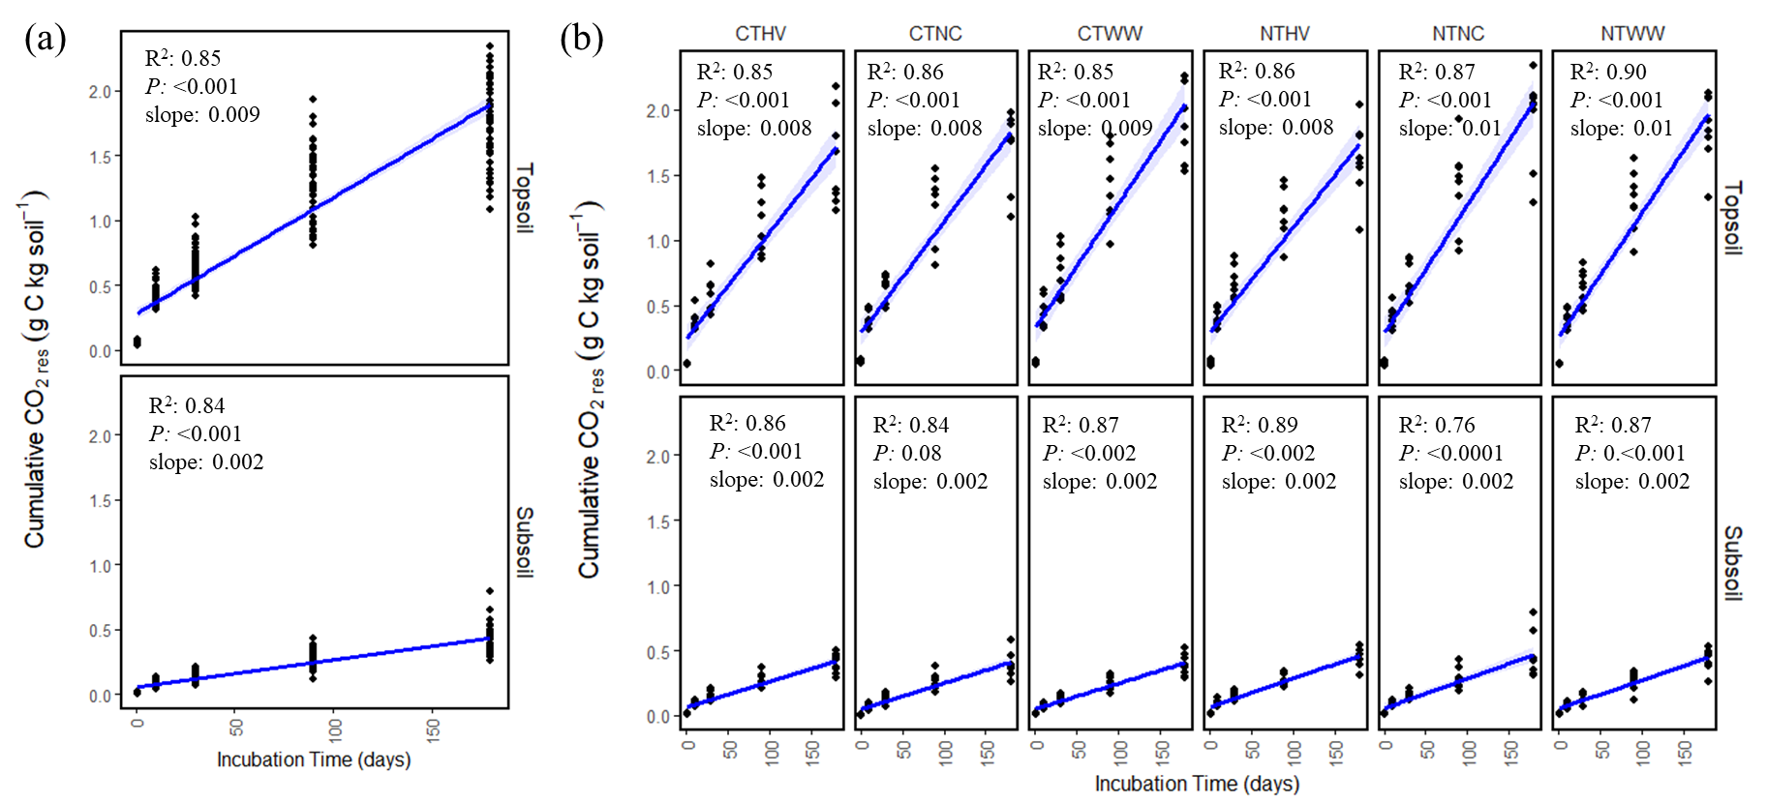
Figure 24. Residue derived CO₂ (CO_{2res}; g C kg soil⁻¹) over the course of incubation as a function of (a) soil depth, and (b) across agricultural treatment combinations at topsoil and subsoil.
CT and NT denote the conventional and no-till treatments, respectively. NC, HV and WW denote no cover, hairy vetch, and winter wheat cover cropping treatments, respectively.
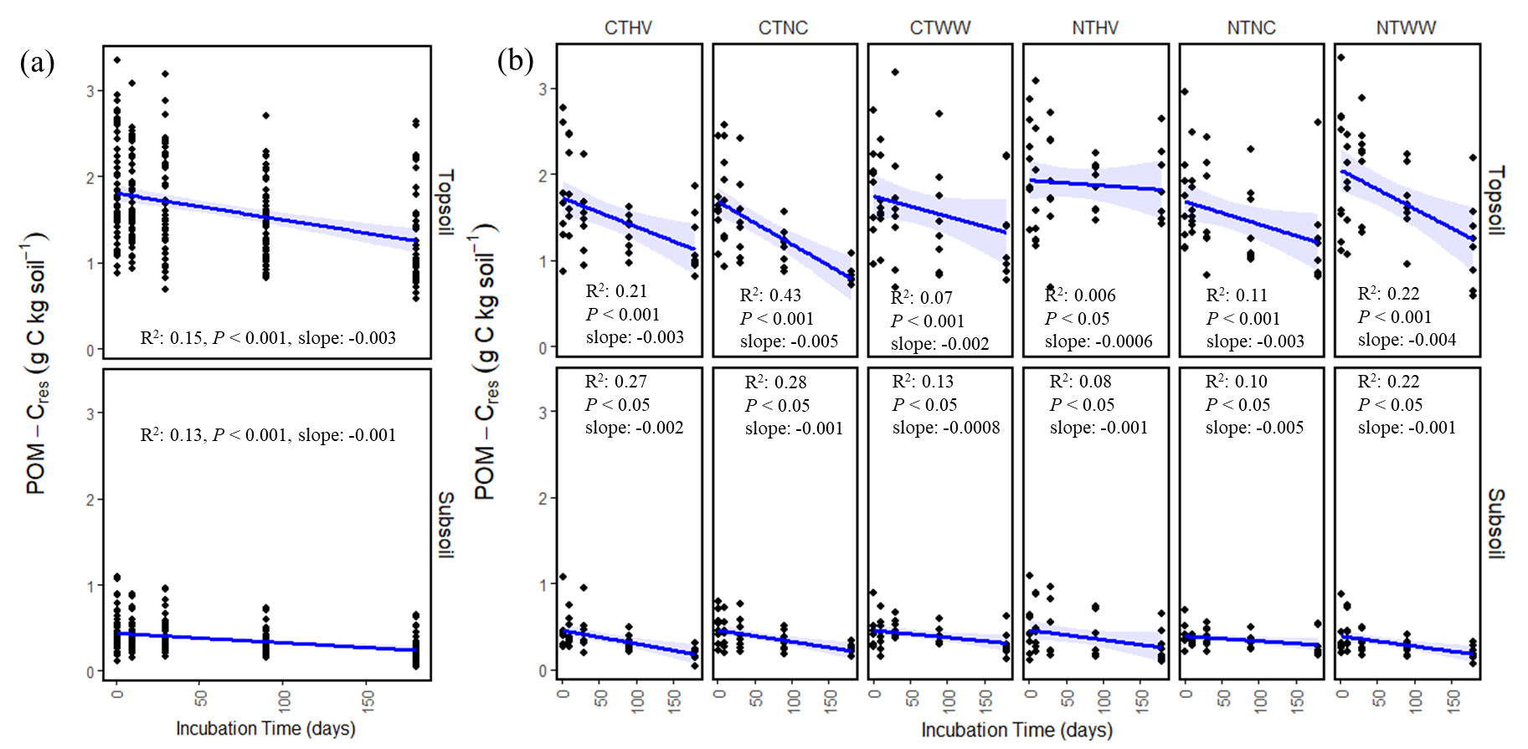
CT and NT denote the conventional and no-till treatments, respectively. NC, HV and WW denote no cover, hairy vetch, and winter wheat cover cropping treatments, respectively.
Figure 25. Residue derived POM-C (POM-C_{res}; g C kg soil⁻¹) over the course of incubation as a function of (a) soil depth, and (b) across agricultural treatment combinations at topsoil and subsoil.
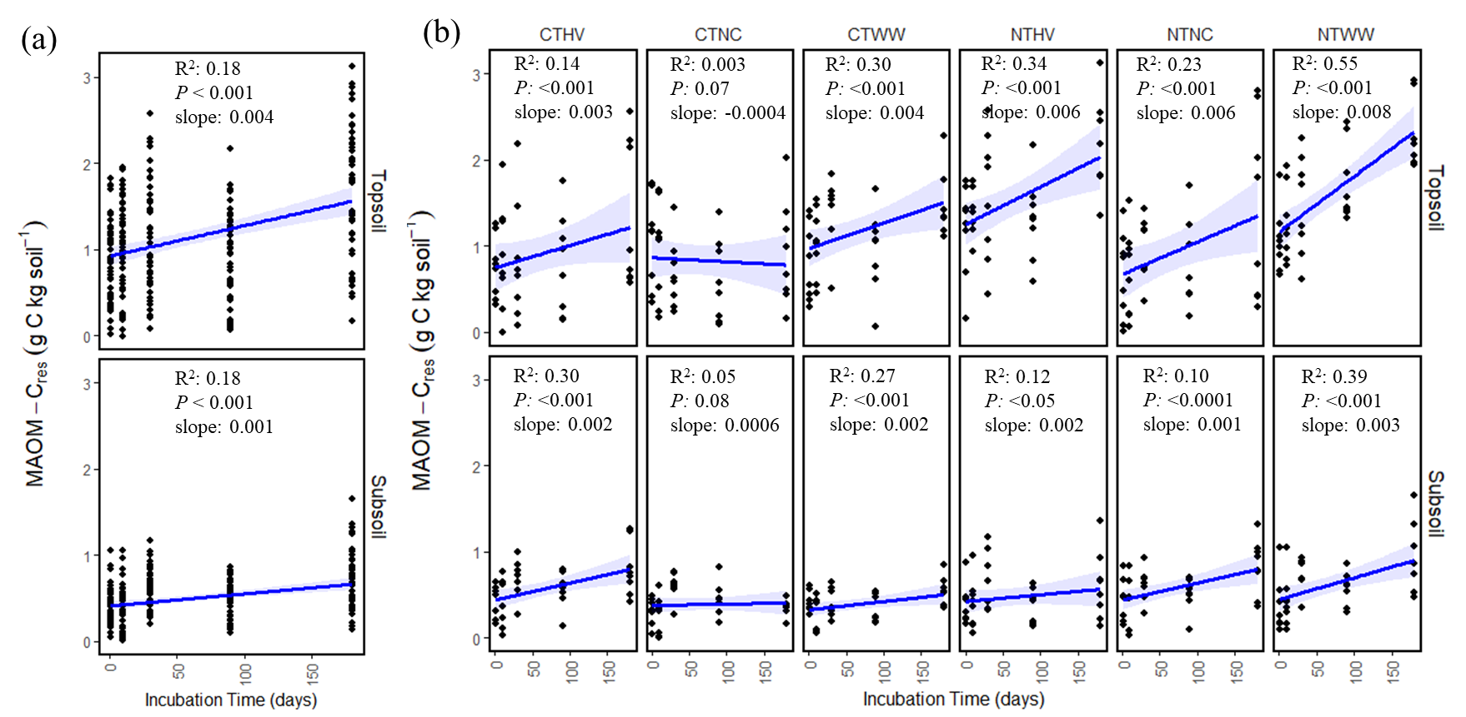
CT and NT denote the conventional and no-till treatments, respectively. NC, HV and WW denote no cover, hairy vetch, and winter wheat cover cropping treatments, respectively
Figure 26. Residue derived MAOM-C (MAOM-C_{res}; g C kg soil⁻¹) over the course of incubation as a function of (a) soil depth, and (b) across agricultural treatment combinations at topsoil and subsoil.
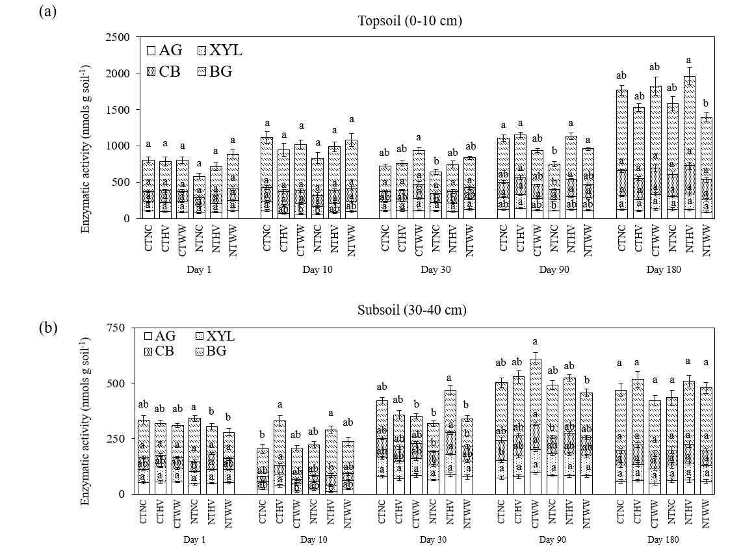
Figure 27. Activities of individual C-cycling enzymes under different agricultural treatment combinations at (a) topsoil and (b) subsoil.
Data represents mean ± standard errors. Different lower-case letters indicate significant difference between agronomic treatment combination for each soil depth and c-cycling enzymes (P ≤ 0.1). AG (α-glucosidase), BG (β-glucosidase), CB (cellobiohydrolase), XYL (β-xylosidase).
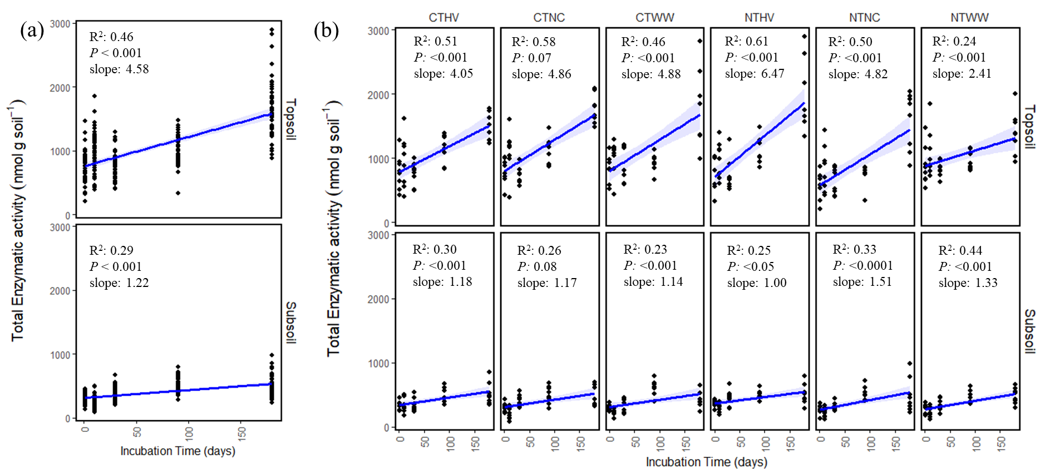
Figure 28. Total C-cycling enzymatic activity (nmol g soil⁻¹) over the course of incubation as a function of (a) soil depth, and (b) across agricultural treatment combinations at topsoil and subsoil.
CT and NT denote the conventional and no-till treatments, respectively. NC, HV and WW denote no cover, hairy vetch, and winter wheat cover cropping treatments, respectively
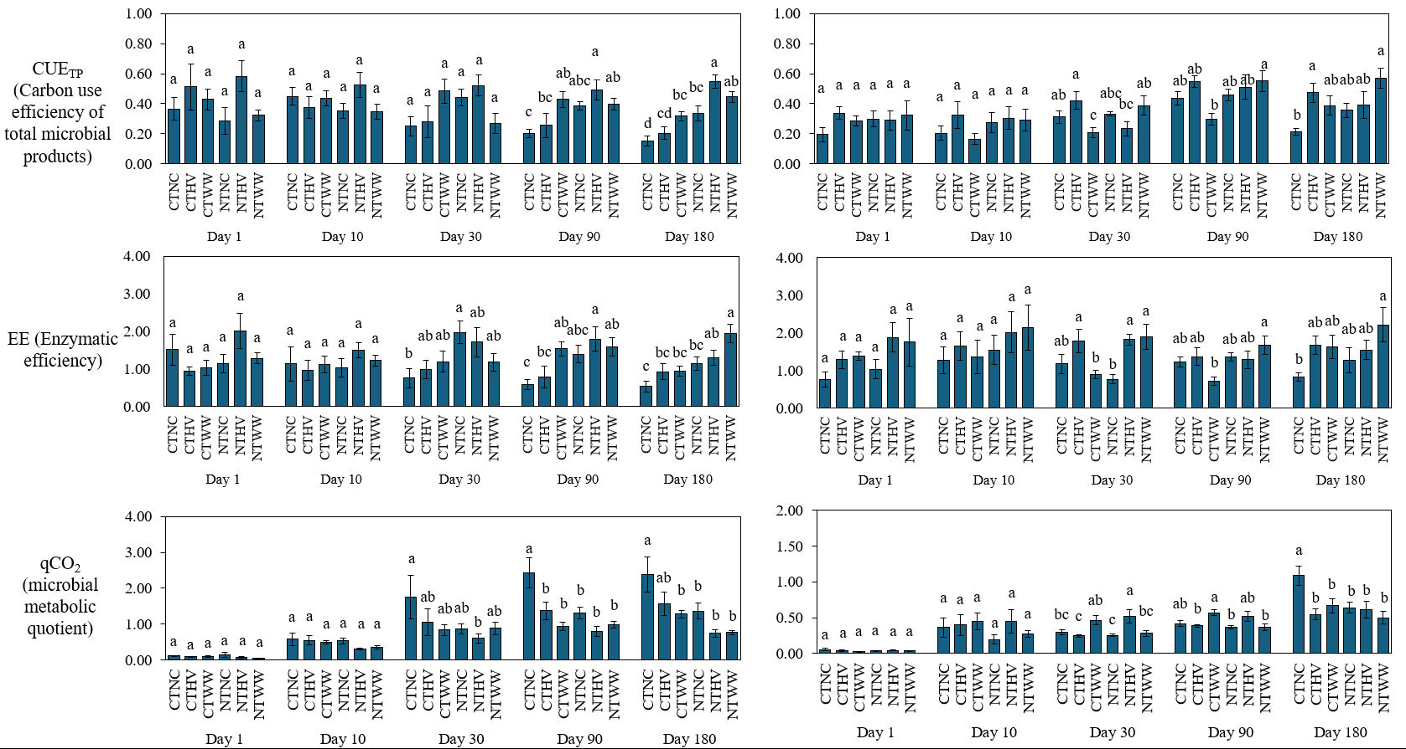
Different lower-case letters indicate significant difference between agronomic treatment combination for each soil depth and microbial functional trait (P ≤ 0.1).
Figure 29. Depth-wise soil microbial functional traits associated with C-cycling under long-term agricultural treatment combination at topsoil (a,c,e) and subsoil (b,d,f).
Topsoil (0-10 cm)
Subsoil (30-40 cm)
(f)
(d)
(b)
(a)
(c)
(e)
Different lower-case letters indicate significant difference between agronomic treatment combination for each soil depth and microbial functional trait (P ≤ 0.1).
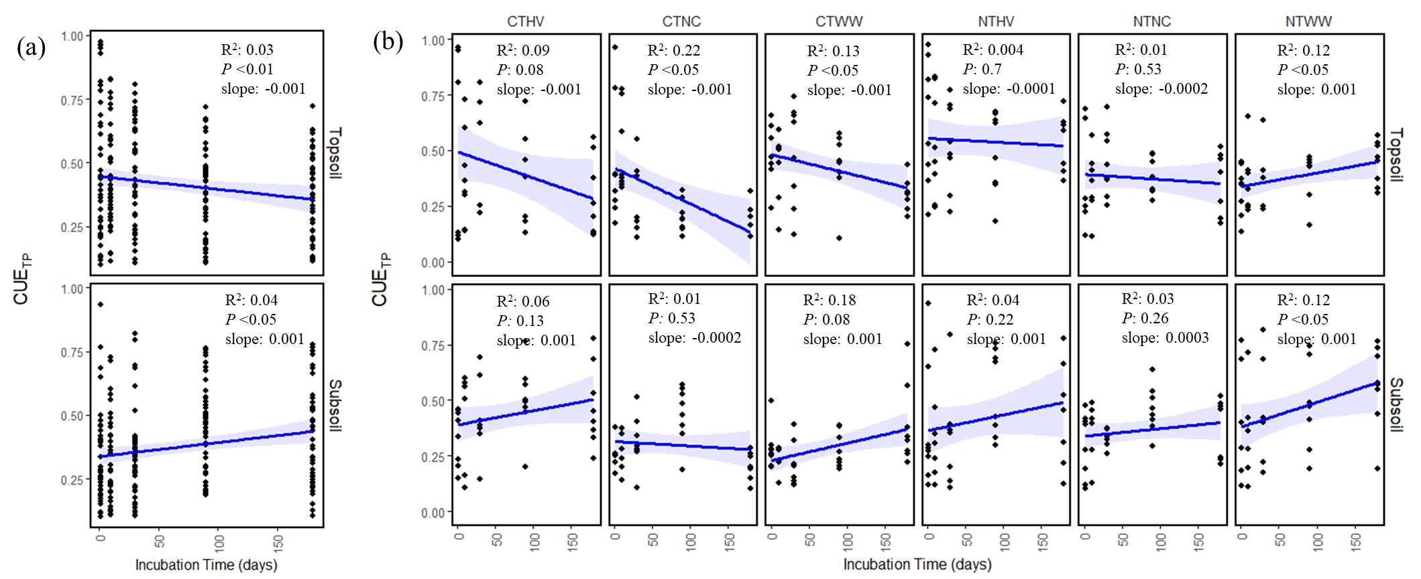
Figure 30. Carbon use efficiency (CUE) over the course of incubation as a function of (a) soil depth, and (b) across agricultural treatment combinations at topsoil and subsoil.
CT and NT denote the conventional and no-till treatments, respectively. NC, HV and WW denote no cover, hairy vetch, and winter wheat cover cropping treatments, respectively.
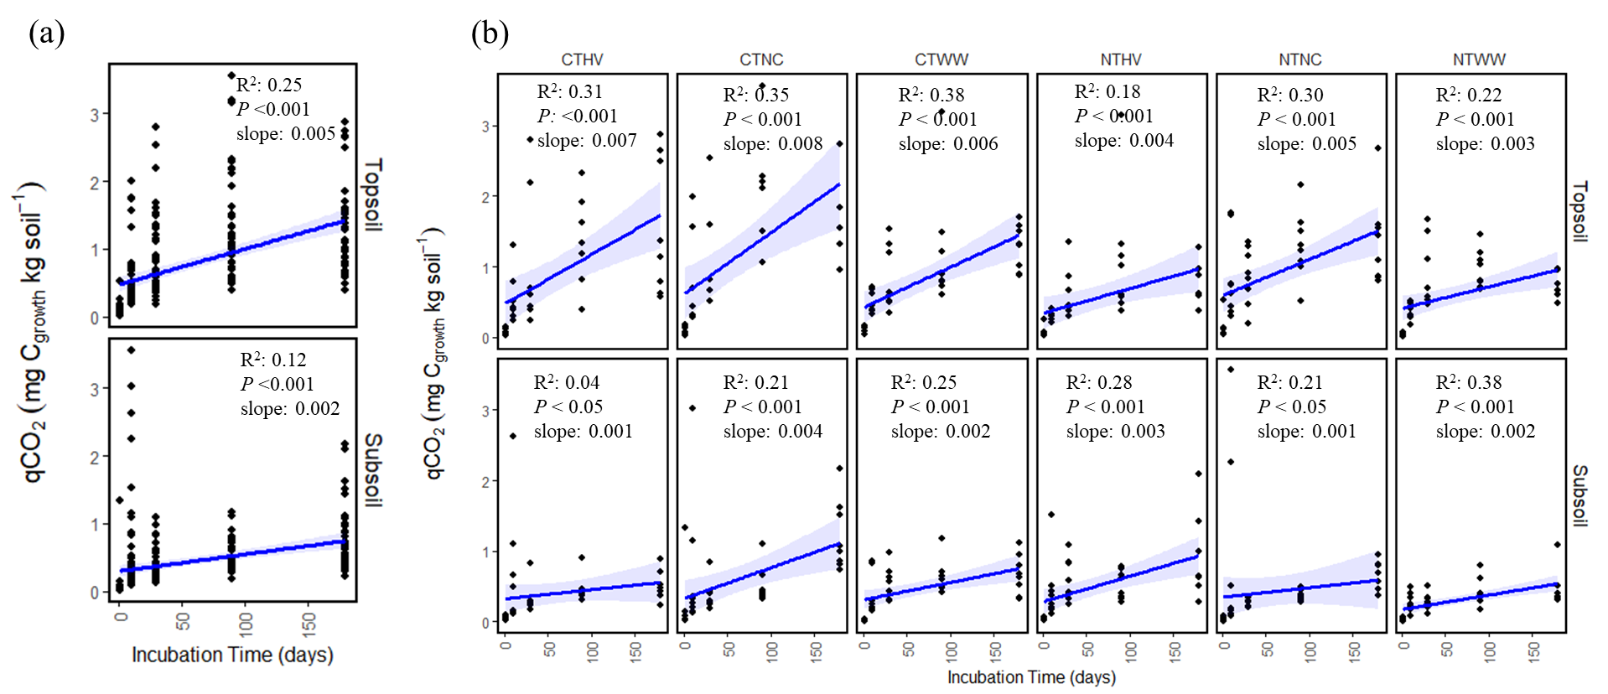
Figure 31. Microbial metabolic efficiency (qCO₂, mg Cgrowth kg soil⁻¹) over the course of incubation as a function of (a) soil depth, and (b) across agricultural treatment combinations at topsoil and subsoil.
CT and NT denote the conventional and no-till treatments, respectively. NC, HV and WW denote no cover, hairy vetch, and winter wheat cover cropping treatments, respectively.

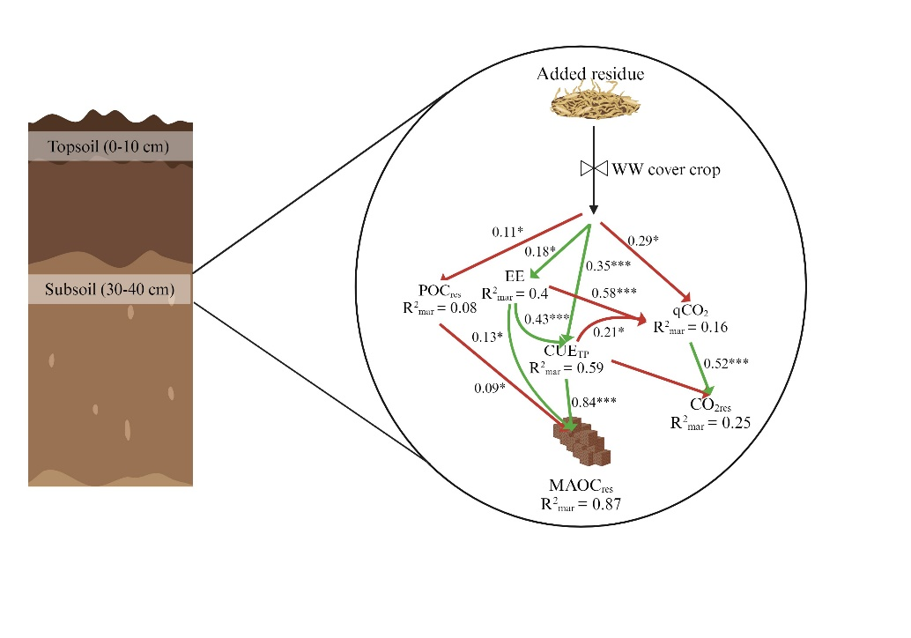
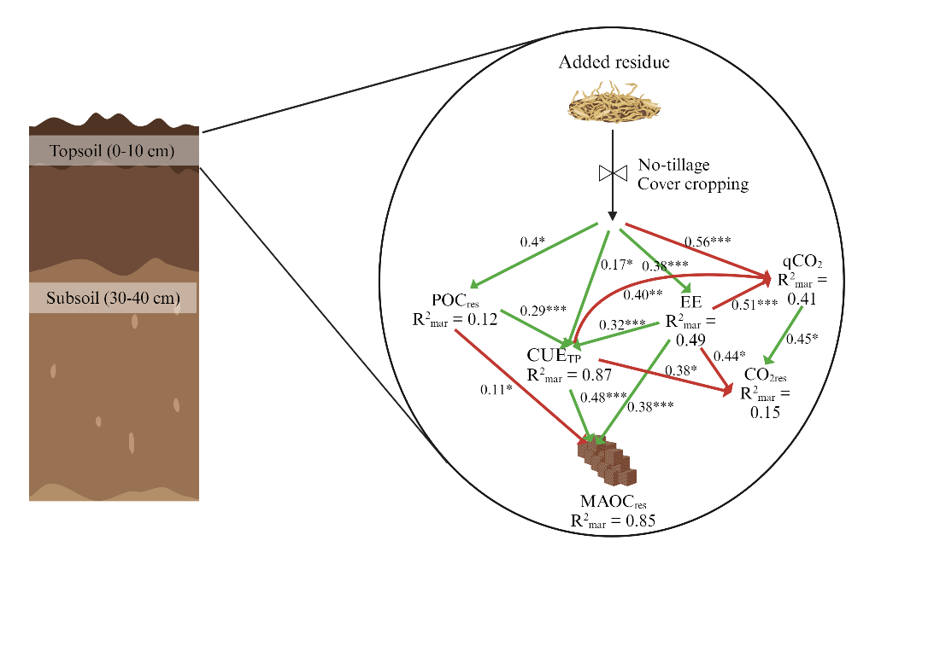
Figure 32. Structural equation modelling diagram representing relationship of agricultural management practices, soil microbial functional traits associated with C cycling, and residue derived C stabilization as MAOM-C_{res} and destabilization as CO_{2res} in (a) topsoil and (b) subsoil.
(a)
(b)

Only significant relationships were shown (P ≤ 0.1). The numbers adjacent to the arrows are the standardized path coefficients. Abbreviations: Cgrowth, C allocated for growth; Crespiration, C allocated for respiration; Clay, Soil clay content; POM-C_{res}, ¹³C recovered in POM fraction; MAOM-C_{res}, ¹³C recovered in MAOM-C fraction; CO_{2res}, ¹³C recovered in mineralized CO₂; CUE (Carbon use efficiency); EE (C-cycling enzymatic efficiency; mg C_{growth} mmol⁻¹ enzymes); qCO₂ (microbial metabolic quotient; g C kg⁻¹ C_{growth}).

Chapter 6: General conclusion and future research directions
Cropland SOC dynamics are frequently manipulated through active management interventions, compared to natural ecosystems, where changes are predominantly driven by slow environmental trends (e.g. warming) or black-swan events (e.g. wildfires). While conventional agricultural practices tend to reduce SOC over time, strategically managed conservation practices improve SOC over time. This potential is often overlooked by ignoring the effect of cropland management in deeper subsoil, or the overlooked role soil microbial communities play in dictating cropland SOC dynamics. The efficiency with which microbes transform crop-residue C into SOM and its long-term stability under different agricultural practices remain uncertain and have formed the basis of my dissertation research. In this dissertation research, I used a laboratory and field based approach to understand how conservation agricultural practices, specifically no-tillage and cover cropping, influence SOC across different soil profiles, with a focus on microbial functional traits and their role in profile-scale SOC sequestration mechanisms in a long-term low-biomass cotton cropping system in hot and humid Tennessee.
Results from Chapter 2 showed the significance of winter wheat as a deep-rooted cover crop in improving cropland SOC storage, especially in the subsoil. This finding challenges the conventional focus on studying agricultural topsoil SOC dynamics, highlighting how specific management practices can store SOC in the subsoil.
Results from Chapter 3 showed how conservation practices, particularly the use of deep-rooted winter wheat improves microbial functional traits associated with C-cycling, which improved subsoil SOC accrual. This chapter bridges the gap between microbial functional traits and SOC storage, especially in the annual cropping subsoils.
In Chapter 4, we examined the fate of added residue-derived carbon under different agricultural practices and soil depths. The insights from this long-term incubation experiment emphasize how conservation practices can improve the stabilization of residue-derived C in SOC pools, particularly in the more-persistent MAOM-C fractions.
Chapter 5 builds on the incubation experiment from the preceding chapter by exploring the temporal dynamics of microbial functional traits associated with C-cycling and their influence on the fate of added residue-derived C. Results from this chapter shows how conservation practices improve microbial functional traits to dictate fate of the added C in storage of MAOM-C rather than getting lost as CO₂.
These results suggest that under hot and humid climate of southeastern US with relatively high SOC decomposition rate, low-biomass cash crops should be managed by conservation management practices such as no-tillage and cover cropping to improve the soil microbial functional traits, facilitating SOC storage across the soil depth profile. Several future research directions emerged from this study to advance our understanding of profile-scale SOC dynamics in annual cropping systems:

6.1. Understanding the role of soil microbial diversity and functionality
The complex role of soil microbial diversity and functionality in SOC dynamics underscores the necessity of advancing our understanding beyond identifying soil microbial community composition. It involves demonstrating how the functional traits of these microbial communities contribute to the transformation and stabilization of SOC, particularly within the context of varying effect of soil depth and agricultural management practices. The diverse metabolic efficiencies, enzymatic activities, and community structures of soil microbes play a pivotal role in the decomposition of crop residues, synthesis of microbial by-products, and formation and persistence of SOC in croplands (Kallenbach et al., 2016; Domeignoz-Horta et al., 2020). However, mechanistic understanding of the dynamics between active vs. dormant microbial populations across different soil depths of annual cropping systems, and how they influence microbial functional traits associated with C-cycling remains elusive.
Research has shown that soil depth significantly influences microbial community composition and activity, with shallower layers containing more active microbial populations due to greater availability of plant residues and favorable environmental conditions (Fierer et al., 2003; Fierer, 2009). In contrast, subsoil harbors a higher proportion of dormant microbes, with activity patterns primarily be influenced by the sporadic and spatially-isolated availability of fresh organic input (Salomé et al., 2010; Eilers et al., 2012; Blagodatskaya and Kuzyakov, 2013). Future research should aim to understand how management changes in annual cropping systems dictate the dynamics of active and dormant microbes across soil profiles by using cutting-edge molecular techniques, such as quantitative stable-isotope probing (qSIP) (Dunford and Neufeld, 2010). Different management practices in agroecosystems will trigger microbial dormancy and reactivation differently through altered root exudates, fresh SOM input, and soil moisture fluctuations. Finally, integrating microbial activity and dormancy patterns in ecosystem level models will improve the prediction accuracy of cropland SOC stocks with changing climate (Wang et al., 2015).

6.2. Understanding MAOM-C dynamics through molecular characterization
While this dissertation is primarily focused on the influence of microbial factors, particularly microbial functional traits, on profile-scale SOC dynamics in agroecosystem, it is essential to expand future research to include role of molecular composition of MAOM-C to assess SOC stability and its response to contrasting agricultural management practices and soil depth.
Investigating the interaction of different C compounds (low vs. high molecular weight, aromatic vs. aliphatic, etc.) with the soil mineral fraction has provided insights into the mechanisms of SOC stabilization at the molecular level (Angst et al., 2018; Sokol and Bradford, 2019; Poeplau et al., 2023). Studies examining how MAOM-C molecular characteristics correlate with MAOM-C saturation deficit, especially in C-unsaturated croplands and deeper subsoils, are relatively underexplored. Future studies could use spectroscopic tools, such as Fourier-transform infrared spectroscopy (FTIR) and nuclear magnetic resonance (NMR), to decipher the complex classes of compounds constituting cropland SOC and their interactions with agroecosystem management and soil depth. Integrating both biotic and abiotic factors through modeling approaches could enhance predictions of profile-scale SOC dynamics in agricultural systems. Additionally, this approach can help target amendments that improve the interaction between SOM and soil minerals, promoting SOC stabilization in cropland soils.

6.3. Understanding the impact of extreme climatic conditions
Assessing the impact of climate change on the effectiveness of conservation agricultural practices in increasing SOC storage is imperative, given the increasing variability in weather patterns and the consequent shifts in agricultural productivity and soil health. Extreme weather events such as heatwaves, floods, and droughts not only threaten crop productivity but also disrupt soil physical and biological health, potentially leading to decreased C addition to the systems and increased SOC losses (Frank et al., 2015; Nouri et al., 2021). Therefore, understanding how these changing climatic conditions impact the dynamics of SOC, especially in subsoil layers which serve as crucial reservoirs for long-term SOC storage, is essential. Future research should focus on investigating the potential of subsoil-specific conservation management such as integrating deep-rooted perennial crops and cover crops to increase subsoil SOC storage capacity as a buffer against climate-induced variability. Also, examining the role of soil amendments such as compost, manure, and biochar to maintain SOC levels in the face of extreme climatic events will be crucial for developing climate-resilient cropping systems.

6.4. Navigating the policy and socioeconomic factors
Exploring the interplay between policy instruments and socioeconomic factors is critical in advancing the adoption of conservation agricultural practices (Knowler and Bradshaw, 2007), particularly aimed at increasing subsoil SOC storage. Stakeholders often overlook subsoil in making soil management decisions. However, with the increase in topsoil degradation and the vulnerability of topsoil SOC to extreme climatic conditions, recognition of the critical importance of subsoil management for secure storage of SOC becomes imperative. This approach can help develop a dual-purpose ecosystem where the topsoil is utilized for crop production, while the subsoil serves as a reservoir for SOC storage. Future research should understand the socioeconomic barriers to adoption of practices that enhance subsoil SOC, including initial costs and knowledge gaps. Understanding the impact of these practices on farmer livelihoods and labor requirements is also crucial for designing targeted policies.

References
Alcántara, V., Don, A., Well, R., Nieder, R., 2016. Deep ploughing increases agricultural soil organic matter stocks. Global Change Biology 22, 2939–2956. doi:10.1111/gcb.13289
Al-Kaisi, M.M., Yin, X., Licht, M.A., 2005. Soil carbon and nitrogen changes as influenced by tillage and cropping systems in some Iowa soils. Agriculture, Ecosystems & Environment 105, 635–647. doi:10.1016/j.agee.2004.08.002
Amato, M., Pardo, A., 1994. Root length and biomass losses during sample preparation with different screen mesh sizes. Plant and Soil 161, 299–303. doi:10.1007/BF00046401
Amsili, J.P., Kaye, J.P., 2021. Root traits of cover crops and carbon inputs in an organic grain rotation. Renewable Agriculture and Food Systems 36, 182–191. doi:10.1017/S1742170520000216
Anderson, T.-H., Domsch, K.H., 1990. Application of eco-physiological quotients (qCO2 and qD) on microbial biomasses from soils of different cropping histories. Soil Biology and Biochemistry 22, 251–255. doi:10.1016/0038-0717(90)90094-G
Andrews, S.S., Mitchell, J.P., Mancinelli, R., Karlen, D.L., Hartz, T.K., Horwath, W.R., Pettygrove, G.S., Scow, K.M., Munk, D.S., 2002. On‐Farm Assessment of Soil Quality in California’s Central Valley. Agronomy Journal 94, 12–23. doi:10.2134/agronj2002.1200
Angst, G., Messinger, J., Greiner, M., Häusler, W., Hertel, D., Kirfel, K., Kögel-Knabner, I., Leuschner, C., Rethemeyer, J., Mueller, C.W., 2018. Soil organic carbon stocks in topsoil and subsoil controlled by parent material, carbon input in the rhizosphere, and microbial-derived compounds. Soil Biology and Biochemistry 122, 19–30. doi:10.1016/j.soilbio.2018.03.026
Angst, G., Mueller, K.E., Nierop, K.G.J., Simpson, M.J., 2021. Plant- or microbial-derived? A review on the molecular composition of stabilized soil organic matter. Soil Biology and Biochemistry 156, 108189. doi:10.1016/j.soilbio.2021.108189
Babujia, L.C., Hungria, M., Franchini, J.C., Brookes, P.C., 2010. Microbial biomass and activity at various soil depths in a Brazilian oxisol after two decades of no-tillage and conventional tillage. Soil Biology and Biochemistry 42, 2174–2181. doi:10.1016/j.soilbio.2010.08.013
Bailey, V., Pries, C., Lajtha, K., 2019. What do we know about soil carbon destabilization? ENVIRONMENTAL RESEARCH LETTERS 14. doi:10.1088/1748-9326/ab2c11
Baker, J.M., Ochsner, T.E., Venterea, R.T., Griffis, T.J., 2007. Tillage and soil carbon sequestration—What do we really know? Agriculture, Ecosystems & Environment 118, 1–5. doi:10.1016/j.agee.2006.05.014
Balesdent, J., Chenu, C., Balabane, M., 2000. Relationship of soil organic matter dynamics to physical protection and tillage. Soil and Tillage Research 53, 215–230. doi:10.1016/S0167-1987(99)00107-5
Barton, K., Barton, M.K., 2015. Package ‘mumin.’ Version 1, 439.
Batjes, N.H., 1996. Total carbon and nitrogen in the soils of the world. European Journal of Soil Science 47, 151–163. doi:10.1111/j.1365-2389.1996.tb01386.x
Beck, T., Joergensen, R.G., Kandeler, E., Makeschin, F., Nuss, E., Oberholzer, H.R., Scheu, S., 1997. An inter-laboratory comparison of ten different ways of measuring soil microbial biomass C. Soil Biology and Biochemistry 29, 1023–1032. doi:10.1016/S0038-0717(97)00030-8
Begum, K., Kuhnert, M., Yeluripati, J., Glendining, M., Smith, P., 2017. Simulating soil carbon sequestration from long term fertilizer and manure additions under continuous wheat using the DailyDayCent model. Nutrient Cycling in Agroecosystems 109, 291–302. doi:10.1007/s10705-017-9888-0
Bell, C.W., Fricks, B.E., Rocca, J.D., Steinweg, J.M., McMahon, S.K., Wallenstein, M.D., 2013. High-throughput Fluorometric Measurement of Potential Soil Extracellular Enzyme Activities. Journal of Visualized Experiments 50961. doi:10.3791/50961
Bell, L.W., Sparling, B., Tenuta, M., Entz, M.H., 2012. Soil profile carbon and nutrient stocks under long-term conventional and organic crop and alfalfa-crop rotations and re-established grassland. Agriculture, Ecosystems & Environment 158, 156–163. doi:10.1016/j.agee.2012.06.006
Billings, S.A., Ziegler, S.E., 2005. Linking microbial activity and soil organic matter transformations in forest soils under elevated CO2. Global Change Biology 11, 203–212. doi:10.1111/j.1365-2486.2005.00909.x
Blagodatskaya, E., Kuzyakov, Y., 2013. Active microorganisms in soil: Critical review of estimation criteria and approaches. Soil Biology and Biochemistry 67, 192–211. doi:10.1016/j.soilbio.2013.08.024
Blagodatskaya, Е., Kuzyakov, Y., 2008. Mechanisms of real and apparent priming effects and their dependence on soil microbial biomass and community structure: critical review. Biology and Fertility of Soils 45, 115–131. doi:10.1007/s00374-008-0334-y
Blanco-Canqui, H., Lal, R., 2008. No-Tillage and Soil-Profile Carbon Sequestration: An On-Farm Assessment. Soil Science Society of America Journal 72, 693–701. doi:10.2136/sssaj2007.0233
Boddey, R.M., Jantalia, C.P., ConceiãÃO, P.C., Zanatta, J.A., Bayer, C., Mielniczuk, J., Dieckow, J., Dos Santos, H.P., Denardin, J.E., Aita, C., Giacomini, S.J., Alves, B.J.R., Urquiaga, S., 2010. Carbon accumulation at depth in Ferralsols under zero-till subtropical agriculture. Global Change Biology 16, 784–795. doi:10.1111/j.1365-2486.2009.02020.x
Böhm, W., 1979. Methods of Studying Root Systems, Ecological Studies. Springer Berlin Heidelberg, Berlin, Heidelberg. doi:10.1007/978-3-642-67282-8
Bossio, D.A., Cook-Patton, S.C., Ellis, P.W., Fargione, J., Sanderman, J., Smith, P., Wood, S., Zomer, R.J., Von Unger, M., Emmer, I.M., Griscom, B.W., 2020. The role of soil carbon in natural climate solutions. Nature Sustainability 3, 391–398. doi:10.1038/s41893-020-0491-z
Brady, N.C., Weil, R.R., Weil, R.R., 2008. The nature and properties of soils. Prentice Hall Upper Saddle River, NJ.
Brejda, J.J., Moorman, T.B., Karlen, D.L., Dao, T.H., 2000. Identification of Regional Soil Quality Factors and Indicators I. Central and Southern High Plains. Soil Science Society of America Journal 64, 2115–2124. doi:10.2136/sssaj2000.6462115x
Bronick, C.J., Lal, R., 2005. Soil structure and management: a review. Geoderma 124, 3–22. doi:10.1016/j.geoderma.2004.03.005
Bruun, E.W., Petersen, C.T., Hansen, E., Holm, J.K., Hauggaard‐Nielsen, H., 2014. Biochar amendment to coarse sandy subsoil improves root growth and increases water retention. Soil Use and Management 30, 109–118. doi:10.1111/sum.12102
Button, E.S., Pett-Ridge, J., Murphy, D.V., Kuzyakov, Y., Chadwick, D.R., Jones, D.L., 2022. Deep-C storage: Biological, chemical and physical strategies to enhance carbon stocks in agricultural subsoils. Soil Biology and Biochemistry 170, 108697. doi:10.1016/j.soilbio.2022.108697
Cambardella, C.A., Elliott, E.T., 1994. Carbon and Nitrogen Dynamics of Soil Organic Matter Fractions from Cultivated Grassland Soils. Soil Science Society of America Journal 58, 123–130. doi:10.2136/sssaj1994.03615995005800010017x
Cambardella, C.A., Elliott, E.T., 1992. Particulate Soil Organic-Matter Changes across a Grassland Cultivation Sequence. Soil Science Society of America Journal 56, 777–783. doi:10.2136/sssaj1992.03615995005600030017x
Castellano, M.J., n.d. Integrating plant litter quality, soil organic matter stabilization, and the carbon saturation concept - Castellano - 2015 - Global Change Biology - Wiley Online Library [WWW Document]. URL https://onlinelibrary-wiley-com.proxy.lib.utk.edu/doi/full/10.1111/gcb.12982 (accessed 9.1.20).
Castellano, M.J., Mueller, K.E., Olk, D.C., Sawyer, J.E., Six, J., 2015. Integrating plant litter quality, soil organic matter stabilization, and the carbon saturation concept. Global Change Biology 21, 3200–3209. doi:10.1111/gcb.12982
Chalise, K.S., Singh, S., Wegner, B.R., Kumar, S., Pérez-Gutiérrez, J.D., Osborne, S.L., Nleya, T., Guzman, J., Rohila, J.S., 2019. Cover Crops and Returning Residue Impact on Soil Organic Carbon, Bulk Density, Penetration Resistance, Water Retention, Infiltration, and Soybean Yield. Agronomy Journal 111, 99–108. doi:10.2134/agronj2018.03.0213
Chen, L., Liu, L., Qin, S., Yang, G., Fang, K., Zhu, B., Kuzyakov, Y., Chen, P., Xu, Y., Yang, Y., 2019. Regulation of priming effect by soil organic matter stability over a broad geographic scale. Nature Communications 10, 5112. doi:10.1038/s41467-019-13119-z
Cherney, J.H., Johnson, K.D., Volenec, J.J., Greene, D.K., 1991. Biomass Potential of Selected Grass and Legume Crops. Energy Sources 13, 283–292. doi:10.1080/00908319108908989
Christopher, S.F., Lal, R., Mishra, U., 2009. Regional Study of No-Till Effects on Carbon Sequestration in the Midwestern United States. Soil Science Society of America Journal 73, 207–216. doi:10.2136/sssaj2007.0336
Conservation Effects Assessment Project, United States Natural Resources Conservation Service, 2022. Conservation practices on cultivated cropland: a comparison of CEAP I and CEAP II survey data and modeling. Natural Resources Conservation Service, U.S. Department of Agriculture, [Washington, D.C.]. doi:10.32747/2022.8078218.nrcs
Cotrufo, M.F., Haddix, M.L., Kroeger, M.E., Stewart, C.E., 2022. The role of plant input physical-chemical properties, and microbial and soil chemical diversity on the formation of particulate and mineral-associated organic matter. Soil Biology and Biochemistry 168, 108648. doi:10.1016/j.soilbio.2022.108648
Cotrufo, M.F., Ranalli, M.G., Haddix, M.L., Six, J., Lugato, E., 2019. Soil carbon storage informed by particulate and mineral-associated organic matter. Nature Geoscience 12, 989–994. doi:10.1038/s41561-019-0484-6
Cotrufo, M.F., Soong, J.L., Horton, A.J., Campbell, E.E., Haddix, M.L., Wall, D.H., Parton, W.J., 2015. Formation of soil organic matter via biochemical and physical pathways of litter mass loss. Nature Geoscience 8, 776–779. doi:10.1038/ngeo2520
Cotrufo, M.F., Wallenstein, M.D., Boot, C.M., Denef, K., Paul, E., 2013. The Microbial Efficiency-Matrix Stabilization (MEMS) framework integrates plant litter decomposition with soil organic matter stabilization: do labile plant inputs form stable soil organic matter? Global Change Biology 19, 988–995. doi:10.1111/gcb.12113
Demyan, M.S., Rasche, F., Schulz, E., Breulmann, M., Müller, T., Cadisch, G., 2012. Use of specific peaks obtained by diffuse reflectance Fourier transform mid-infrared spectroscopy to study the composition of organic matter in a Haplic Chernozem. European Journal of Soil Science 63, 189–199. doi:10.1111/j.1365-2389.2011.01420.x
Dimassi, B., Mary, B., Fontaine, S., Perveen, N., Revaillot, S., Cohan, J.-P., 2014a. Effect of nutrients availability and long-term tillage on priming effect and soil C mineralization. Soil Biology and Biochemistry 78, 332–339. doi:10.1016/j.soilbio.2014.07.016
Dimassi, B., Mary, B., Wylleman, R., Labreuche, J., Couture, D., Piraux, F., Cohan, J.-P., 2014b. Long-term effect of contrasted tillage and crop management on soil carbon dynamics during 41 years. Agriculture, Ecosystems & Environment 188, 134–146. doi:10.1016/j.agee.2014.02.014
Domeignoz-Horta, L.A., Pold, G., Liu, X.-J.A., Frey, S.D., Melillo, J.M., DeAngelis, K.M., 2020. Microbial diversity drives carbon use efficiency in a model soil. Nature Communications 11, 3684. doi:10.1038/s41467-020-17502-z
Don, A., Schumacher, J., Freibauer, A., 2011. Impact of tropical land-use change on soil organic carbon stocks - a meta-analysis. Global Change Biology 17, 1658–1670. doi:10.1111/j.1365-2486.2010.02336.x
Dunford, E.A., Neufeld, J.D., 2010. DNA Stable-Isotope Probing (DNA-SIP). Journal of Visualized Experiments 2027. doi:10.3791/2027
Eilers, K.G., Debenport, S., Anderson, S., Fierer, N., 2012. Digging deeper to find unique microbial communities: The strong effect of depth on the structure of bacterial and archaeal communities in soil. Soil Biology and Biochemistry 50, 58–65. doi:10.1016/j.soilbio.2012.03.011
Ellert, B.H., Bettany, J.R., 1995. Calculation of organic matter and nutrients stored in soils under contrasting management regimes. Canadian Journal of Soil Science 75, 529–538. doi:10.4141/cjss95-075
EPA, 2022. Agriculture contributed 10.5 percent of U.S. greenhouse gas emissions in 2018 [WWW Document]. URL http://www.ers.usda.gov/data-products/chart-gallery/gallery/chart-detail/?chartId=98305 (accessed 10.16.21).
Fan, J., McConkey, B., Wang, H., Janzen, H., 2016. Root distribution by depth for temperate agricultural crops. Field Crops Research 189, 68–74. doi:10.1016/j.fcr.2016.02.013
Fang, Y., Singh, B.P., Collins, D., Li, B., Zhu, J., Tavakkoli, E., 2018. Nutrient supply enhanced wheat residue-carbon mineralization, microbial growth, and microbial carbon-use efficiency when residues were supplied at high rate in contrasting soils. Soil Biology and Biochemistry 126, 168–178. doi:10.1016/j.soilbio.2018.09.003
Fierer, N., 2009. Global patterns in belowground communities.
Fierer, N., Schimel, J.P., Holden, P.A., 2003. Variations in microbial community composition through two soil depth profiles. Soil Biology and Biochemistry 35, 167–176. doi:10.1016/S0038-0717(02)00251-1
Fischer, H., Ingwersen, J., Kuzyakov, Y., 2010. Microbial uptake of low-molecular-weight organic substances out-competes sorption in soil. European Journal of Soil Science 61, 504–513. doi:10.1111/j.1365-2389.2010.01244.x
Fontaine, S., Barot, S., Barré, P., Bdioui, N., Mary, B., Rumpel, C., 2007. Stability of organic carbon in deep soil layers controlled by fresh carbon supply. Nature 450, 277–280. doi:10.1038/nature06275
Fontaine, S., Mariotti, A., Abbadie, L., 2003. The priming effect of organic matter: a question of microbial competition? Soil Biology and Biochemistry 35, 837–843. doi:10.1016/S0038-0717(03)00123-8
Frank, Dorothea, Reichstein, M., Bahn, M., Thonicke, K., Frank, David, Mahecha, M.D., Smith, P., Van Der Velde, M., Vicca, S., Babst, F., Beer, C., Buchmann, N., Canadell, J.G., Ciais, P., Cramer, W., Ibrom, A., Miglietta, F., Poulter, B., Rammig, A., Seneviratne, S.I., Walz, A., Wattenbach, M., Zavala, M.A., Zscheischler, J., 2015. Effects of climate extremes on the terrestrial carbon cycle: concepts, processes and potential future impacts. Global Change Biology 21, 2861–2880. doi:10.1111/gcb.12916
Franzluebbers, A.J., 2010. Achieving Soil Organic Carbon Sequestration with Conservation Agricultural Systems in the Southeastern United States. Soil Science Society of America Journal 74, 347–357. doi:10.2136/sssaj2009.0079
Freibauer, A., Rounsevell, M.D.A., Smith, P., Verhagen, J., 2004. Carbon sequestration in the agricultural soils of Europe. Geoderma 122, 1–23. doi:10.1016/j.geoderma.2004.01.021
Friedlingstein, P., O’Sullivan, M., Jones, M.W., Andrew, R.M., Gregor, L., Hauck, J., Le Quéré, C., Luijkx, I.T., Olsen, A., Peters, G.P., Peters, W., Pongratz, J., Schwingshackl, C., Sitch, S., Canadell, J.G., Ciais, P., Jackson, R.B., Alin, S.R., Alkama, R., Arneth, A., Arora, V.K., Bates, N.R., Becker, M., Bellouin, N., Bittig, H.C., Bopp, L., Chevallier, F., Chini, L.P., Cronin, M., Evans, W., Falk, S., Feely, R.A., Gasser, T., Gehlen, M., Gkritzalis, T., Gloege, L., Grassi, G., Gruber, N., Gürses, Ö., Harris, I., Hefner, M., Houghton, R.A., Hurtt, G.C., Iida, Y., Ilyina, T., Jain, A.K., Jersild, A., Kadono, K., Kato, E., Kennedy, D., Klein Goldewijk, K., Knauer, J., Korsbakken, J.I., Landschützer, P., Lefèvre, N., Lindsay, K., Liu, J., Liu, Z., Marland, G., Mayot, N., McGrath, M.J., Metzl, N., Monacci, N.M., Munro, D.R., Nakaoka, S.-I., Niwa, Y., O’Brien, K., Ono, T., Palmer, P.I., Pan, N., Pierrot, D., Pocock, K., Poulter, B., Resplandy, L., Robertson, E., Rödenbeck, C., Rodriguez, C., Rosan, T.M., Schwinger, J., Séférian, R., Shutler, J.D., Skjelvan, I., Steinhoff, T., Sun, Q., Sutton, A.J., Sweeney, C., Takao, S., Tanhua, T., Tans, P.P., Tian, X., Tian, H., Tilbrook, B., Tsujino, H., Tubiello, F., Van Der Werf, G.R., Walker, A.P., Wanninkhof, R., Whitehead, C., Willstrand Wranne, A., Wright, R., Yuan, W., Yue, C., Yue, X., Zaehle, S., Zeng, J., Zheng, B., 2022. Global Carbon Budget 2022. Earth System Science Data 14, 4811–4900. doi:10.5194/essd-14-4811-2022
Garcia-Franco, N., Albaladejo, J., Almagro, M., Martínez-Mena, M., 2015. Beneficial effects of reduced tillage and green manure on soil aggregation and stabilization of organic carbon in a Mediterranean agroecosystem. Soil and Tillage Research 153, 66–75. doi:10.1016/j.still.2015.05.010
Georgiou, K., Jackson, R.B., Vindušková, O., Abramoff, R.Z., Ahlström, A., Feng, W., Harden, J.W., Pellegrini, A.F.A., Polley, H.W., Soong, J.L., Riley, W.J., Torn, M.S., 2022. Global stocks and capacity of mineral-associated soil organic carbon. Nature Communications 13, 3797. doi:10.1038/s41467-022-31540-9
Geyer, K., Schnecker, J., Grandy, A.S., Richter, A., Frey, S., 2020. Assessing microbial residues in soil as a potential carbon sink and moderator of carbon use efficiency. Biogeochemistry 151, 237–249. doi:10.1007/s10533-020-00720-4
Geyer, K.M., Dijkstra, P., Sinsabaugh, R., Frey, S.D., 2019. Clarifying the interpretation of carbon use efficiency in soil through methods comparison. Soil Biology and Biochemistry 128, 79–88. doi:10.1016/j.soilbio.2018.09.036
Geyer, K.M., Kyker-Snowman, E., Grandy, A.S., Frey, S.D., 2016. Microbial carbon use efficiency: accounting for population, community, and ecosystem-scale controls over the fate of metabolized organic matter. Biogeochemistry 127, 173–188. doi:10.1007/s10533-016-0191-y
Grandy, A.S., Robertson, G.P., 2007. Land-Use Intensity Effects on Soil Organic Carbon Accumulation Rates and Mechanisms. Ecosystems 10, 59–74. doi:10.1007/s10021-006-9010-y
Gregorich, E.G., Beare, M.H., McKim, U.F., Skjemstad, J.O., 2006. Chemical and Biological Characteristics of Physically Uncomplexed Organic Matter. Soil Science Society of America Journal 70, 975–985. doi:10.2136/sssaj2005.0116
Gulde, S., Chung, H., Amelung, W., Chang, C., Six, J., 2008. Soil Carbon Saturation Controls Labile and Stable Carbon Pool Dynamics. Soil Science Society of America Journal 72, 605–612. doi:10.2136/sssaj2007.0251
Haddix, M.L., Gregorich, E.G., Helgason, B.L., Janzen, H., Ellert, B.H., Francesca Cotrufo, M., 2020. Climate, carbon content, and soil texture control the independent formation and persistence of particulate and mineral-associated organic matter in soil. Geoderma 363, 114160. doi:10.1016/j.geoderma.2019.114160
Harden, J.W., Hugelius, G., Ahlström, A., Blankinship, J.C., Bond‐Lamberty, B., Lawrence, C.R., Loisel, J., Malhotra, A., Jackson, R.B., Ogle, S., Phillips, C., Ryals, R., Todd‐Brown, K., Vargas, R., Vergara, S.E., Cotrufo, M.F., Keiluweit, M., Heckman, K.A., Crow, S.E., Silver, W.L., DeLonge, M., Nave, L.E., 2018. Networking our science to characterize the state, vulnerabilities, and management opportunities of soil organic matter. Global Change Biology 24. doi:10.1111/gcb.13896
Hassink, J., 1997. The capacity of soils to preserve organic C and N by their association with clay and silt particles. Plant and Soil 191, 77–87. doi:10.1023/A:1004213929699
Hayes, J.M., 2004. An introduction to isotopic calculations. Woods Hole Oceanographic Institution, Woods Hole, MA 2543.
He, S., Guo, L., Niu, M., Miao, F., Jiao, S., Hu, T., Long, M., 2017. Ecological diversity and co-occurrence patterns of bacterial community through soil profile in response to long-term switchgrass cultivation. Scientific Reports 7, 3608. doi:10.1038/s41598-017-03778-7
Hicks Pries, C.E., Bird, J.A., Castanha, C., Hatton, P.-J., Torn, M.S., 2017. Long term decomposition: the influence of litter type and soil horizon on retention of plant carbon and nitrogen in soils. Biogeochemistry 134, 5–16. doi:10.1007/s10533-017-0345-6
Holderbaum, J.F., Decker, A.M., Messinger, J.J., Mulford, F.R., Vough, L.R., 1990. Fall‐Seeded Legume Cover Crops for No‐Tillage Corn in the Humid East. Agronomy Journal 82, 117–124. doi:10.2134/agronj1990.00021962008200010026x
Huang, W., Kuzyakov, Y., Niu, S., Luo, Y., Sun, B., Zhang, J., Liang, Y., 2023. Drivers of microbially and plant‐derived carbon in topsoil and subsoil. Global Change Biology 29, 6188–6200. doi:10.1111/gcb.16951
Huang, X., Wang, L., Mei, Y., Jia, Z., Li, T., Yu, G., Ran, W., 2022. Towards a mechanistic understanding of microbial and nonmicrobial mediated topsoil organic carbon sequestration efficiency in a rice-wheat cropping system. Applied Soil Ecology 170, 104259. doi:10.1016/j.apsoil.2021.104259
Islam, Md.R., Singh, B., Dijkstra, F.A., 2023. Microbial carbon use efficiency of glucose varies with soil clay content: A meta-analysis. Applied Soil Ecology 181, 104636. doi:10.1016/j.apsoil.2022.104636
Jackson, R.B., Lajtha, K., Crow, S.E., Hugelius, G., Kramer, M.G., Piñeiro, G., 2017. The Ecology of Soil Carbon: Pools, Vulnerabilities, and Biotic and Abiotic Controls. Annual Review of Ecology, Evolution, and Systematics 48, 419–445. doi:10.1146/annurev-ecolsys-112414-054234
Jagadamma, S., Essington, M.E., Xu, S., Yin, X., 2019. Total and active soil organic carbon from long-term agricultural management practices in West Tennessee. Agricultural & Environmental Letters 4.
Jagadamma, S., Lal, R., 2010a. Distribution of organic carbon in physical fractions of soils as affected by agricultural management. Biology and Fertility of Soils 46, 543–554.
Jagadamma, S., Lal, R., 2010b. Distribution of organic carbon in physical fractions of soils as affected by agricultural management. Biology and Fertility of Soils 46, 543–554. doi:10.1007/s00374-010-0459-7
Jagadamma, S., Lal, R., Hoeft, R.G., Nafziger, E.D., Adee, E.A., 2008. Nitrogen fertilization and cropping system impacts on soil properties and their relationship to crop yield in the central Corn Belt, USA. Soil and Tillage Research 98, 120–129. doi:10.1016/j.still.2007.10.008
Jagadamma, S., Mayes, M.A., Steinweg, J.M., Schaeffer, S.M., 2014. Substrate quality alters the microbial mineralization of added substrate and soil organic carbon. Biogeosciences 11, 4665–4678. doi:10.5194/bg-11-4665-2014
Jenkinson, D.S., Coleman, K., 2008. The turnover of organic carbon in subsoils. Part 2. Modelling carbon turnover. European Journal of Soil Science 59, 400–413. doi:10.1111/j.1365-2389.2008.01026.x
Jian, J., Du, X., Reiter, M.S., Stewart, R.D., 2020. A meta-analysis of global cropland soil carbon changes due to cover cropping. Soil Biology and Biochemistry 143, 107735. doi:10.1016/j.soilbio.2020.107735
Jilling, A., Keiluweit, M., Contosta, A.R., Frey, S., Schimel, J., Schnecker, J., Smith, R.G., Tiemann, L., Grandy, A.S., 2018. Minerals in the rhizosphere: overlooked mediators of soil nitrogen availability to plants and microbes. Biogeochemistry 139, 103–122. doi:10.1007/s10533-018-0459-5
Jobbágy, E.G., Jackson, R.B., 2000. The Vertical Distribution of Soil Organic Carbon and Its Relation to Climate and Vegetation. Ecological Applications 10, 423–436. doi:10.1890/1051-0761(2000)010[0423:TVDOSO]2.0.CO;2
Joergensen, R.G., Wichern, F., 2018. Alive and kicking: Why dormant soil microorganisms matter. Soil Biology and Biochemistry 116, 419–430. doi:10.1016/j.soilbio.2017.10.022
Jones, D., Willett, V., 2006. Experimental evaluation of methods to quantify dissolved organic nitrogen (DON) and dissolved organic carbon (DOC) in soil. Soil Biology and Biochemistry 38, 991–999. doi:10.1016/j.soilbio.2005.08.012
Jones, D.L., Magthab, E.A., Gleeson, D.B., Hill, P.W., Sánchez-Rodríguez, A.R., Roberts, P., Ge, T., Murphy, D.V., 2018. Microbial competition for nitrogen and carbon is as intense in the subsoil as in the topsoil. Soil Biology and Biochemistry 117, 72–82. doi:10.1016/j.soilbio.2017.10.024
Jones, S.E., Lennon, J.T., 2010. Dormancy contributes to the maintenance of microbial diversity. Proceedings of the National Academy of Sciences 107, 5881–5886. doi:10.1073/pnas.0912765107
Kallenbach, C.M., Frey, S.D., Grandy, A.S., 2016. Direct evidence for microbial-derived soil organic matter formation and its ecophysiological controls. Nature Communications 7, 1–10. doi:10.1038/ncomms13630
Kallenbach, C.M., Grandy, A.S., Frey, S.D., Diefendorf, A.F., 2015. Microbial physiology and necromass regulate agricultural soil carbon accumulation. Soil Biology and Biochemistry 91, 279–290. doi:10.1016/j.soilbio.2015.09.005
Kallenbach, C.M., Wallenstein, M.D., Schipanksi, M.E., Grandy, A.S., 2019. Managing Agroecosystems for Soil Microbial Carbon Use Efficiency: Ecological Unknowns, Potential Outcomes, and a Path Forward. Frontiers in Microbiology 10. doi:10.3389/fmicb.2019.01146
Kao-Kniffin, J., Balser, T.C., 2007. Elevated CO2 differentially alters belowground plant and soil microbial community structure in reed canary grass-invaded experimental wetlands. Soil Biology and Biochemistry 39, 517–525. doi:10.1016/j.soilbio.2006.08.024
Keenan, T.F., Williams, C.A., 2018. The Terrestrial Carbon Sink. Annual Review of Environment and Resources 43, 219–243. doi:10.1146/annurev-environ-102017-030204
Kell, D.B., 2011. Breeding crop plants with deep roots: their role in sustainable carbon, nutrient and water sequestration. Annals of Botany 108, 407–418. doi:10.1093/aob/mcr175
Kirschbaum, M.U.F., 2000. Will changes in soil organic carbon act as a positive or negative feedback on global warming? Biogeochemistry 48, 21–51. doi:10.1023/A:1006238902976
Kirsten, M., Mikutta, R., Vogel, C., Thompson, A., Mueller, C.W., Kimaro, D.N., Bergsma, H.L.T., Feger, K.-H., Kalbitz, K., 2021. Iron oxides and aluminous clays selectively control soil carbon storage and stability in the humid tropics. Scientific Reports 11, 5076. doi:10.1038/s41598-021-84777-7
Knowler, D., Bradshaw, B., 2007. Farmers’ adoption of conservation agriculture: A review and synthesis of recent research. Food Policy 32, 25–48. doi:10.1016/j.foodpol.2006.01.003
Köchy, M., Hiederer, R., Freibauer, A., 2015. Global distribution of soil organic carbon – Part 1: Masses and frequency distributions of SOC stocks for the tropics, permafrost regions, wetlands, and the world. SOIL 1, 351–365. doi:10.5194/soil-1-351-2015
Kramer, C., Gleixner, G., 2008. Soil organic matter in soil depth profiles: Distinct carbon preferences of microbial groups during carbon transformation. Soil Biology and Biochemistry 40, 425–433. doi:10.1016/j.soilbio.2007.09.016
Kramer, M.G., Sanderman, J., Chadwick, O.A., Chorover, J., Vitousek, P.M., 2012. Long‐term carbon storage through retention of dissolved aromatic acids by reactive particles in soil. Global Change Biology 18, 2594–2605. doi:10.1111/j.1365-2486.2012.02681.x
Kuzyakov, Y., Blagodatskaya, E., 2015. Microbial hotspots and hot moments in soil: Concept & review. Soil Biology and Biochemistry 83, 184–199. doi:10.1016/j.soilbio.2015.01.025
Kuzyakov, Y., Friedel, J.K., Stahr, K., 2000. Review of mechanisms and quantification of priming effects. Soil Biology and Biochemistry 32, 1485–1498. doi:10.1016/S0038-0717(00)00084-5
Lal, R., 2009. Challenges and opportunities in soil organic matter research. European Journal of Soil Science 60, 158–169. doi:10.1111/j.1365-2389.2008.01114.x
Lal, R., 2004a. Soil carbon sequestration to mitigate climate change. Geoderma 123, 1–22. doi:10.1016/j.geoderma.2004.01.032
Lal, R., 2004b. Soil Carbon Sequestration Impacts on Global Climate Change and Food Security. Science 304, 1623–1627. doi:10.1126/science.1097396
Lal, R. (Ed.), 1998. The potential of U.S. cropland to sequester carbon and mitigate the greenhouse effect. Ann Arbor Press, Chelsea, MI.
Lal, R., Mahboubi, A.A., Fausey, N.R., 1994. Long-Term Tillage and Rotation Effects on Properties of a Central Ohio Soil. Soil Science Society of America Journal 58, 517–522. doi:10.2136/sssaj1994.03615995005800020038x
Lal, R., Negassa, W., Lorenz, K., 2015. Carbon sequestration in soil. Current Opinion in Environmental Sustainability 15, 79–86. doi:10.1016/j.cosust.2015.09.002
Lavallee, J.M., Conant, R.T., Paul, E.A., Cotrufo, M.F., 2018. Incorporation of shoot versus root-derived 13C and 15N into mineral-associated organic matter fractions: results of a soil slurry incubation with dual-labelled plant material. Biogeochemistry 137, 379–393. doi:10.1007/s10533-018-0428-z
Lavallee, J.M., Soong, J.L., Cotrufo, M.F., 2020. Conceptualizing soil organic matter into particulate and mineral‐associated forms to address global change in the 21st century. Global Change Biology 26, 261–273. doi:10.1111/gcb.14859
Lefcheck, J.S., 2016. piecewiseSEM : Piecewise structural equation modelling in r for ecology, evolution, and systematics. Methods in Ecology and Evolution 7, 573–579. doi:10.1111/2041-210X.12512
Lehmann, J., Kleber, M., 2015. The contentious nature of soil organic matter. Nature 528, 60–68. doi:10.1038/nature16069
Li, Y., Li, Z., Cui, S., Zhang, Q., 2020. Trade-off between soil pH, bulk density and other soil physical properties under global no-tillage agriculture. Geoderma 361, 114099. doi:10.1016/j.geoderma.2019.114099
Liang, C., Schimel, J.P., Jastrow, J.D., 2017. The importance of anabolism in microbial control over soil carbon storage. Nature Microbiology 2, 1–6. doi:10.1038/nmicrobiol.2017.105
Lorenz, K., Lal, R., 2005. The Depth Distribution of Soil Organic Carbon in Relation to Land Use and Management and the Potential of Carbon Sequestration in Subsoil Horizons, in: Advances in Agronomy. Elsevier, pp. 35–66. doi:10.1016/S0065-2113(05)88002-2
Luo, Z., Wang, E., Sun, O.J., 2016. A meta-analysis of the temporal dynamics of priming soil carbon decomposition by fresh carbon inputs across ecosystems. Soil Biology and Biochemistry 101, 96–103. doi:10.1016/j.soilbio.2016.07.011
Luo, Z., Wang, E., Sun, O.J., 2010. Can no-tillage stimulate carbon sequestration in agricultural soils? A meta-analysis of paired experiments. Agriculture, Ecosystems & Environment 139, 224–231. doi:10.1016/j.agee.2010.08.006
Lynch, J.P., Wojciechowski, T., 2015. Opportunities and challenges in the subsoil: pathways to deeper rooted crops. Journal of Experimental Botany 66, 2199–2210. doi:10.1093/jxb/eru508
Malik, A.A., Puissant, J., Buckeridge, K.M., Goodall, T., Jehmlich, N., Chowdhury, S., Gweon, H.S., Peyton, J.M., Mason, K.E., van Agtmaal, M., Blaud, A., Clark, I.M., Whitaker, J., Pywell, R.F., Ostle, N., Gleixner, G., Griffiths, R.I., 2018. Land use driven change in soil pH affects microbial carbon cycling processes. Nature Communications 9, 3591. doi:10.1038/s41467-018-05980-1
Malik, A.A., Puissant, J., Goodall, T., Allison, S.D., Griffiths, R.I., 2019. Soil microbial communities with greater investment in resource acquisition have lower growth yield. Soil Biology and Biochemistry 132, 36–39. doi:10.1016/j.soilbio.2019.01.025
Manzoni, S., Taylor, P., Richter, A., Porporato, A., Ågren, G.I., 2012. Environmental and stoichiometric controls on microbial carbon-use efficiency in soils. New Phytologist 196, 79–91. doi:10.1111/j.1469-8137.2012.04225.x
Mbuthia, L.W., Acosta-Martínez, V., DeBruyn, J., Schaeffer, S., Tyler, D., Odoi, E., Mpheshea, M., Walker, F., Eash, N., 2015. Long term tillage, cover crop, and fertilization effects on microbial community structure, activity: Implications for soil quality. Soil Biology and Biochemistry 89, 24–34. doi:10.1016/j.soilbio.2015.06.016
McDaniel, M.D., Tiemann, L.K., Grandy, A.S., 2014. Does agricultural crop diversity enhance soil microbial biomass and organic matter dynamics? A meta-analysis. Ecological Applications 24, 560–570. doi:10.1890/13-0616.1
McKinley, G.A., Fay, A.R., Lovenduski, N.S., Pilcher, D.J., 2017. Natural Variability and Anthropogenic Trends in the Ocean Carbon Sink. Annual Review of Marine Science 9, 125–150. doi:10.1146/annurev-marine-010816-060529
Meurer, K.H.E., Haddaway, N.R., Bolinder, M.A., Kätterer, T., 2018. Tillage intensity affects total SOC stocks in boreo-temperate regions only in the topsoil—A systematic review using an ESM approach. Earth-Science Reviews 177, 613–622. doi:10.1016/j.earscirev.2017.12.015
Min, K., Slessarev, E., Kan, M., McFarlane, K., Oerter, E., Pett-Ridge, J., Nuccio, E., Berhe, A.A., 2021. Active microbial biomass decreases, but microbial growth potential remains similar across soil depth profiles under deeply-vs. shallow-rooted plants. Soil Biology and Biochemistry 162, 108401. doi:10.1016/j.soilbio.2021.108401
Minasny, B., Malone, B.P., McBratney, A.B., Angers, D.A., Arrouays, D., Chambers, A., Chaplot, V., Chen, Z.-S., Cheng, K., Das, B.S., Field, D.J., Gimona, A., Hedley, C.B., Hong, S.Y., Mandal, B., Marchant, B.P., Martin, M., McConkey, B.G., Mulder, V.L., O’Rourke, S., Richer-de-Forges, A.C., Odeh, I., Padarian, J., Paustian, K., Pan, G., Poggio, L., Savin, I., Stolbovoy, V., Stockmann, U., Sulaeman, Y., Tsui, C.-C., Vågen, T.-G., van Wesemael, B., Winowiecki, L., 2017. Soil carbon 4 per mille. Geoderma 292, 59–86. doi:10.1016/j.geoderma.2017.01.002
Modak, K., Ghosh, A., Bhattacharyya, R., Biswas, D.R., Das, T.K., Das, S., Singh, G., 2019. Response of oxidative stability of aggregate-associated soil organic carbon and deep soil carbon sequestration to zero-tillage in subtropical India. Soil and Tillage Research 195, 104370. doi:10.1016/j.still.2019.104370
Müller, K., Kramer, S., Haslwimmer, H., Marhan, S., Scheunemann, N., Butenschön, O., Scheu, S., Kandeler, E., 2016. Carbon transfer from maize roots and litter into bacteria and fungi depends on soil depth and time. Soil Biology & Biochemistry 93, 79–89. doi:10.1016/j.soilbio.2015.10.015
Nouri, A., Lee, J., Yin, X., Tyler, D.D., Saxton, A.M., 2019. Thirty-four years of no-tillage and cover crops improve soil quality and increase cotton yield in Alfisols, Southeastern USA. Geoderma 337, 998–1008. doi:10.1016/j.geoderma.2018.10.016
Nouri, A., Yoder, D.C., Raji, M., Ceylan, S., Jagadamma, S., Lee, J., Walker, F.R., Yin, X., Fitzpatrick, J., Trexler, B., Arelli, P., Saxton, A.M., 2021. Conservation agriculture increases the soil resilience and cotton yield stability in climate extremes of the southeast US. Communications Earth & Environment 2, 155. doi:10.1038/s43247-021-00223-6
Olson, K.R., 2013. Soil organic carbon sequestration, storage, retention and loss in U.S. croplands: Issues paper for protocol development. Geoderma 195–196, 201–206. doi:10.1016/j.geoderma.2012.12.004
Olson, K.R., Al-Kaisi, M.M., 2015. The importance of soil sampling depth for accurate account of soil organic carbon sequestration, storage, retention and loss. CATENA 125, 33–37. doi:10.1016/j.catena.2014.10.004
Osanai, Y., Knox, O., Nachimuthu, G., Wilson, B., 2020. Increasing soil organic carbon with maize in cotton-based cropping systems: Mechanisms and potential. Agriculture, Ecosystems & Environment 299, 106985. doi:10.1016/j.agee.2020.106985
Patra, R., Saha, D., Jagadamma, S., 2022. Winter wheat cover crop increased subsoil organic carbon in a long-term cotton cropping system in Tennessee. Soil and Tillage Research 224, 105521. doi:10.1016/j.still.2022.105521
Patra, R., Saha, D., Neupane, A., Jagadamma, S., 2024. Deep-rooted winter wheat cover crop promotes subsoil organic carbon storage through improved microbial functional traits. Applied Soil Ecology 199, 105413. doi:10.1016/j.apsoil.2024.105413
Paustian, K., Lehmann, J., Ogle, S., Reay, D., Robertson, G.P., Smith, P., 2016. Climate-smart soils. Nature 532, 49–57. doi:10.1038/nature17174
Peng, Y., Rieke, E.L., Chahal, I., Norris, C.E., Janovicek, K., Mitchell, J.P., Roozeboom, K.L., Hayden, Z.D., Strock, J.S., Machado, S., Sykes, V.R., Deen, B., Tavarez, O.B., Gamble, A.V., Scow, K.M., Brainard, D.C., Millar, N., Johnson, G.A., Schindelbeck, R.R., Kurtz, K.S.M., Van Es, H., Kumar, S., Van Eerd, L.L., 2023. Maximizing soil organic carbon stocks under cover cropping: insights from long-term agricultural experiments in North America. Agriculture, Ecosystems & Environment 356, 108599. doi:10.1016/j.agee.2023.108599
Plaza-Bonilla, D., Álvaro-Fuentes, J., Cantero-Martínez, C., 2014. Identifying soil organic carbon fractions sensitive to agricultural management practices. Soil and Tillage Research 139, 19–22. doi:10.1016/j.still.2014.01.006
Poeplau, C., Begill, N., Liang, Z., Schiedung, M., 2023. Root litter quality drives the dynamic of native mineral-associated organic carbon in a temperate agricultural soil. Plant and Soil 491, 439–456. doi:10.1007/s11104-023-06127-y
Poeplau, C., Don, A., 2015. Carbon sequestration in agricultural soils via cultivation of cover crops – A meta-analysis. Agriculture, Ecosystems & Environment 200, 33–41. doi:10.1016/j.agee.2014.10.024
Poeplau, C., Don, A., Six, J., Kaiser, M., Benbi, D., Chenu, C., Cotrufo, M.F., Derrien, D., Gioacchini, P., Grand, S., Gregorich, E., Griepentrog, M., Gunina, A., Haddix, M., Kuzyakov, Y., Kühnel, A., Macdonald, L.M., Soong, J., Trigalet, S., Vermeire, M.-L., Rovira, P., van Wesemael, B., Wiesmeier, M., Yeasmin, S., Yevdokimov, I., Nieder, R., 2018. Isolating organic carbon fractions with varying turnover rates in temperate agricultural soils – A comprehensive method comparison. Soil Biology and Biochemistry 125, 10–26. doi:10.1016/j.soilbio.2018.06.025
Poffenbarger, H.J., Olk, D.C., Cambardella, C., Kersey, J., Liebman, M., Mallarino, A., Six, J., Castellano, M.J., 2020. Whole-profile soil organic matter content, composition, and stability under cropping systems that differ in belowground inputs. Agriculture, Ecosystems & Environment 291, 106810. doi:10.1016/j.agee.2019.106810
Poirier, V., Angers, D.A., Rochette, P., Chantigny, M.H., Ziadi, N., Tremblay, G., Fortin, J., 2009. Interactive Effects of Tillage and Mineral Fertilization on Soil Carbon Profiles. Soil Science Society of America Journal 73, 255–261. doi:10.2136/sssaj2008.0006
Poirier, V., Roumet, C., Munson, A.D., 2018. The root of the matter: Linking root traits and soil organic matter stabilization processes. Soil Biology and Biochemistry 120, 246–259. doi:10.1016/j.soilbio.2018.02.016
Presley, D.R., Ransom, M.D., Kluitenberg, G.J., Finnell, P.R., 2004. Effects of Thirty Years of Irrigation on the Genesis and Morphology of Two Semiarid Soils in Kansas. Soil Science Society of America Journal 68, 1916–1926. doi:10.2136/sssaj2004.1916
Prommer, J., Walker, T.W.N., Wanek, W., Braun, J., Zezula, D., Hu, Y., Hofhansl, F., Richter, A., 2020. Increased microbial growth, biomass, and turnover drive soil organic carbon accumulation at higher plant diversity. Global Change Biology 26, 669–681. doi:10.1111/gcb.14777
R Core Team, 2021. R Core Team (2021). R: a language and environment for statistical computing. R Foundation for Statistical Computing, Vienna.
Rasse, D.P., Rumpel, C., Dignac, M.-F., 2005. Is soil carbon mostly root carbon? Mechanisms for a specific stabilisation. Plant and Soil 269, 341–356. doi:doi.org/10.1007/s11104-004-0907-y
Risch, A.C., Zimmermann, S., Ochoa-Hueso, R., Schütz, M., Frey, B., Firn, J.L., Fay, P.A., Hagedorn, F., Borer, E.T., Seabloom, E.W., Harpole, W.S., Knops, J.M.H., McCulley, R.L., Broadbent, A.A.D., Stevens, C.J., Silveira, M.L., Adler, P.B., Báez, S., Biederman, L.A., Blair, J.M., Brown, C.S., Caldeira, M.C., Collins, S.L., Daleo, P., Di Virgilio, A., Ebeling, A., Eisenhauer, N., Esch, E., Eskelinen, A., Hagenah, N., Hautier, Y., Kirkman, K.P., MacDougall, A.S., Moore, J.L., Power, S.A., Prober, S.M., Roscher, C., Sankaran, M., Siebert, J., Speziale, K.L., Tognetti, P.M., Virtanen, R., Yahdjian, L., Moser, B., 2019. Soil net nitrogen mineralisation across global grasslands. Nature Communications 10, 4981. doi:10.1038/s41467-019-12948-2
Rumpel, C., Chabbi, A., Marschner, B., 2012. Carbon Storage and Sequestration in Subsoil Horizons: Knowledge, Gaps and Potentials, in: Lal, R., Lorenz, K., Hüttl, R.F., Schneider, B.U., von Braun, J. (Eds.), Recarbonization of the Biosphere. Springer Netherlands, Dordrecht, pp. 445–464. doi:10.1007/978-94-007-4159-1_20
Rumpel, C., Kögel-Knabner, I., 2011. Deep soil organic matter—a key but poorly understood component of terrestrial C cycle. Plant and Soil 338, 143–158. doi:10.1007/s11104-010-0391-5
Sainju, U.M., Singh, B.P., Whitehead, W.F., 2005. Tillage, Cover Crops, and Nitrogen Fertilization Effects on Cotton and Sorghum Root Biomass, Carbon, and Nitrogen. Agronomy Journal 97, 1279–1290. doi:10.2134/agronj2004.0213
Salomé, C., Nunan, N., Pouteau, V., Lerch, T.Z., Chenu, C., 2010. Carbon dynamics in topsoil and in subsoil may be controlled by different regulatory mechanisms. Global Change Biology 16, 416–426. doi:10.1111/j.1365-2486.2009.01884.x
Sanderman, J., Amundson, R., 2008. A comparative study of dissolved organic carbon transport and stabilization in California forest and grassland soils. Biogeochemistry 89, 309–327. doi:10.1007/s10533-008-9221-8
Sanderman, J., Hengl, T., Fiske, G.J., 2017. Soil carbon debt of 12,000 years of human land use. Proceedings of the National Academy of Sciences of the United States of America 114, 9575–9580. doi:10.1073/pnas.1706103114
Sanderman, J., Maddern, T., Baldock, J., 2014. Similar composition but differential stability of mineral retained organic matter across four classes of clay minerals. Biogeochemistry 121, 409–424. doi:10.1007/s10533-014-0009-8
Sassenrath, G.F., Farney, J.K., 2019. Biomass Production of Single Species Cover Crop. Kansas Agricultural Experiment Station Research Reports 5. doi:10.4148/2378-5977.7744
Sauvadet, M., Lashermes, G., Alavoine, G., Recous, S., Chauvat, M., Maron, P.-A., Bertrand, I., 2018. High carbon use efficiency and low priming effect promote soil C stabilization under reduced tillage. Soil Biology and Biochemistry 123, 64–73. doi:10.1016/j.soilbio.2018.04.026
Scharlemann, J.P., Tanner, E.V., Hiederer, R., Kapos, V., 2014. Global soil carbon: understanding and managing the largest terrestrial carbon pool. Carbon Management 5, 81–91. doi:10.4155/cmt.13.77
Schimel, J., Schaeffer, S., 2012. Microbial control over carbon cycling in soil. Frontiers in Microbiology 3, 348. doi:10.3389/fmicb.2012.00348
Schimel, J., Weintraub, M.N., Moorhead, D., 2022. Estimating microbial carbon use efficiency in soil: Isotope-based and enzyme-based methods measure fundamentally different aspects of microbial resource use. Soil Biology and Biochemistry 169, 108677. doi:10.1016/j.soilbio.2022.108677
Schmidt, M.W.I., Torn, M.S., Abiven, S., Dittmar, T., Guggenberger, G., Janssens, I.A., Kleber, M., Kögel-Knabner, I., Lehmann, J., Manning, D.A.C., Nannipieri, P., Rasse, D.P., Weiner, S., Trumbore, S.E., 2011. Persistence of soil organic matter as an ecosystem property. Nature 478, 49–56. doi:10.1038/nature10386
Shahbaz, M., Kuzyakov, Y., Sanaullah, M., Heitkamp, F., Zelenev, V., Kumar, A., Blagodatskaya, E., 2017. Microbial decomposition of soil organic matter is mediated by quality and quantity of crop residues: mechanisms and thresholds. Biology and Fertility of Soils 53, 287–301. doi:10.1007/s00374-016-1174-9
Sher, Y., Baker, N.R., Herman, D., Fossum, C., Hale, L., Zhang, X., Nuccio, E., Saha, M., Zhou, J., Pett-Ridge, J., Firestone, M., 2020. Microbial extracellular polysaccharide production and aggregate stability controlled by switchgrass (Panicum virgatum) root biomass and soil water potential. Soil Biology and Biochemistry 143, 107742. doi:10.1016/j.soilbio.2020.107742
Shi, Z., Allison, S.D., He, Y., Levine, P.A., Hoyt, A.M., Beem-Miller, J., Zhu, Q., Wieder, W.R., Trumbore, S., Randerson, J.T., 2020. The age distribution of global soil carbon inferred from radiocarbon measurements. Nature Geoscience 1–5. doi:10.1038/s41561-020-0596-z
Shipley, B., 2009. Confirmatory path analysis in a generalized multilevel context. Ecology 90, 363–368. doi:10.1890/08-1034.1
Singh, Surendra, Nouri, A., Singh, Shikha, Anapalli, S., Lee, J., Arelli, P., Jagadamma, S., 2020. Soil organic carbon and aggregation in response to thirty-nine years of tillage management in the southeastern US. Soil and Tillage Research 197, 104523. doi:10.1016/j.still.2019.104523
Sinsabaugh, R.L., Carreiro, M.M., Repert, D.A., 2002. Allocation of extracellular enzymatic activity in relation to litter composition, N deposition, and mass loss. Biogeochemistry 60, 1–24. doi:10.1023/A:1016541114786
Sinsabaugh, R.L., Manzoni, S., Moorhead, D.L., Richter, A., 2013. Carbon use efficiency of microbial communities: stoichiometry, methodology and modelling. Ecology Letters 16, 930–939. doi:10.1111/ele.12113
Sinsabaugh, R.L., Turner, B.L., Talbot, J.M., Waring, B.G., Powers, J.S., Kuske, C.R., Moorhead, D.L., Shah, J.J.F., 2016. Stoichiometry of microbial carbon use efficiency in soils. Ecological Monographs 86, 172–189. doi:10.1890/15-2110.1
Six, J., Conant, R.T., Paul, E.A., Paustian, K., 2002. Stabilization mechanisms of soil organic matter: Implications for C-saturation of soils. Plant and Soil 241, 155–176. doi:10.1023/A:1016125726789
Six, J., Elliott, E.T., Paustian, K., Doran, J.W., 1998. Aggregation and Soil Organic Matter Accumulation in Cultivated and Native Grassland Soils. Soil Science Society of America Journal 62, 1367. doi:10.2136/sssaj1998.03615995006200050032x
Six, J., Paustian, K., Elliott, E.T., Combrink, C., 2000. Soil Structure and Organic Matter I. Distribution of Aggregate-Size Classes and Aggregate-Associated Carbon. Soil Science Society of America Journal 64, 681–689. doi:10.2136/sssaj2000.642681x
Smith, P., 2008. Land use change and soil organic carbon dynamics. Nutrient Cycling in Agroecosystems 81, 169–178. doi:10.1007/s10705-007-9138-y
Sokol, N.W., Bradford, M.A., 2019. Microbial formation of stable soil carbon is more efficient from belowground than aboveground input. Nature Geoscience 12, 46–53. doi:10.1038/s41561-018-0258-6
Sokol, N.W., Sanderman, J., Bradford, M.A., 2019a. Pathways of mineral‐associated soil organic matter formation: Integrating the role of plant carbon source, chemistry, and point of entry. Global Change Biology 25, 12–24. doi:10.1111/gcb.14482
Sokol, N.W., Sanderman, J., Bradford, M.A., 2019b. Pathways of mineral‐associated soil organic matter formation: Integrating the role of plant carbon source, chemistry, and point of entry. Global Change Biology 25, 12–24. doi:10.1111/gcb.14482
Sollins, P., Kramer, M.G., Swanston, C., Lajtha, K., Filley, T., Aufdenkampe, A.K., Wagai, R., Bowden, R.D., 2009. Sequential density fractionation across soils of contrasting mineralogy: evidence for both microbial- and mineral-controlled soil organic matter stabilization. Biogeochemistry 96, 209–231. doi:10.1007/s10533-009-9359-z
Spohn, M., Klaus, K., Wanek, W., Richter, A., 2016. Microbial carbon use efficiency and biomass turnover times depending on soil depth – Implications for carbon cycling. Soil Biology and Biochemistry 96, 74–81. doi:10.1016/j.soilbio.2016.01.016
Stewart, C.E., Paustian, K., Conant, R.T., Plante, A.F., Six, J., 2007. Soil Carbon Saturation: Concept, Evidence and Evaluation. Biogeochemistry 86, 19–31. doi:doi.org/10.1007/s10533-007-9140-0
Stockmann, U., Adams, M.A., Crawford, J.W., Field, D.J., Henakaarchchi, N., Jenkins, M., Minasny, B., McBratney, A.B., Courcelles, V. de R. de, Singh, K., Wheeler, I., Abbott, L., Angers, D.A., Baldock, J., Bird, M., Brookes, P.C., Chenu, C., Jastrow, J.D., Lal, R., Lehmann, J., O’Donnell, A.G., Parton, W.J., Whitehead, D., Zimmermann, M., 2013. The knowns, known unknowns and unknowns of sequestration of soil organic carbon. Agriculture, Ecosystems & Environment 164, 80–99. doi:10.1016/j.agee.2012.10.001
Tao, F., Huang, Y., Hungate, B.A., Manzoni, S., Frey, S.D., Schmidt, M.W.I., Reichstein, M., Carvalhais, N., Ciais, P., Jiang, L., Lehmann, J., Wang, Y.-P., Houlton, B.Z., Ahrens, B., Mishra, U., Hugelius, G., Hocking, T.D., Lu, X., Shi, Z., Viatkin, K., Vargas, R., Yigini, Y., Omuto, C., Malik, A.A., Peralta, G., Cuevas-Corona, R., Di Paolo, L.E., Luotto, I., Liao, C., Liang, Y.-S., Saynes, V.S., Huang, X., Luo, Y., 2023. Microbial carbon use efficiency promotes global soil carbon storage. Nature 618, 981–985. doi:10.1038/s41586-023-06042-3
Tautges, N.E., Chiartas, J.L., Gaudin, A.C.M., O’Geen, A.T., Herrera, I., Scow, K.M., 2019. Deep soil inventories reveal that impacts of cover crops and compost on soil carbon sequestration differ in surface and subsurface soils. Global Change Biology 25, 3753–3766. doi:https://doi.org/10.1111/gcb.14762
Todd-Brown, K.E.O., Randerson, J.T., Post, W.M., Hoffman, F.M., Tarnocai, C., Schuur, E.A.G., Allison, S.D., 2013. Causes of variation in soil carbon simulations from CMIP5 Earth system models and comparison with observations. Biogeosciences 10, 1717–1736. doi:10.5194/bg-10-1717-2013
Torn, M.S., Trumbore, S.E., Chadwick, O.A., Vitousek, P.M., Hendricks, D.M., 1997. Mineral control of soil organic carbon storage and turnover. Nature 389, 170–173. doi:10.1038/38260
van Groenigen, K.J., Forristal, D., Jones, M., Smyth, N., Schwartz, E., Hungate, B., Dijkstra, P., 2013. Using metabolic tracer techniques to assess the impact of tillage and straw management on microbial carbon use efficiency in soil. Soil Biology and Biochemistry 66, 139–145. doi:10.1016/j.soilbio.2013.07.002
Vance, E.D., Brookes, P.C., Jenkinson, D.S., 1987. An extraction method for measuring soil microbial biomass C. Soil Biology and Biochemistry 19, 703–707. doi:10.1016/0038-0717(87)90052-6
VandenBygaart, A.J., 2016. The myth that no-till can mitigate global climate change. Agriculture, Ecosystems & Environment 216, 98–99. doi:10.1016/j.agee.2015.09.013
VandenBygaart, A.J., Bremer, E., McConkey, B.G., Janzen, H.H., Angers, D.A., Carter, M.R., Drury, C.F., Lafond, G.P., McKenzie, R.H., 2010. Soil organic carbon stocks on long-term agroecosystem experiments in Canada. Canadian Journal of Soil Science 90, 543–550. doi:10.4141/cjss10028
von Lützow, M., Kögel-Knabner, I., Ekschmitt, K., Flessa, H., Guggenberger, G., Matzner, E., Marschner, B., 2007. SOM fractionation methods: Relevance to functional pools and to stabilization mechanisms. Soil Biology and Biochemistry 39, 2183–2207. doi:10.1016/j.soilbio.2007.03.007
Wang, B., An, S., Liang, C., Liu, Y., Kuzyakov, Y., 2021. Microbial necromass as the source of soil organic carbon in global ecosystems. Soil Biology and Biochemistry 162, 108422. doi:10.1016/j.soilbio.2021.108422
Wang, C., Qu, L., Yang, L., Liu, D., Morrissey, E., Miao, R., Liu, Z., Wang, Q., Fang, Y., Bai, E., 2021. Large‐scale importance of microbial carbon use efficiency and necromass to soil organic carbon. Global Change Biology 27, 2039–2048. doi:10.1111/gcb.15550
Wang, G., Jagadamma, S., Mayes, M.A., Schadt, C.W., Megan Steinweg, J., Gu, L., Post, W.M., 2015. Microbial dormancy improves development and experimental validation of ecosystem model. The ISME Journal 9, 226–237. doi:10.1038/ismej.2014.120
Wang, Y., Li, Y., Ye, X., Chu, Y., Wang, X., 2010. Profile storage of organic/inorganic carbon in soil: From forest to desert. Science of The Total Environment 408, 1925–1931. doi:10.1016/j.scitotenv.2010.01.015
Wei, T., Simko, V., Levy, M., Xie, Y., Jin, Y., Zemla, J., 2017. Package ‘corrplot.’ Statistician 56, e24.
West, T.O., Post, W.M., 2002. Soil organic carbon sequestration rates by tillage and crop rotation. Soil Science Society of America Journal 66, 1930–1946. doi:doi.org/10.2136/sssaj2002.1930
Wieder, W.R., Bonan, G.B., Allison, S.D., 2013. Global soil carbon projections are improved by modelling microbial processes. Nature Climate Change 3, 909–912. doi:10.1038/nclimate1951
Wooliver, R., Jagadamma, S., 2023. Response of soil organic carbon fractions to cover cropping: A meta-analysis of agroecosystems. Agriculture, Ecosystems & Environment 351, 108497. doi:10.1016/j.agee.2023.108497
Xu, X., Schimel, J.P., Janssens, I.A., Song, X., Song, C., Yu, G., Sinsabaugh, R.L., Tang, D., Zhang, X., Thornton, P.E., 2017. Global pattern and controls of soil microbial metabolic quotient. Ecological Monographs 87, 429–441. doi:10.1002/ecm.1258
Ye, R., Parajuli, B., Sigua, G., 2019. Subsurface Clay Soil Application Improved Aggregate Stability, Nitrogen Availability, and Organic Carbon Preservation in Degraded Ultisols with Cover Crop Mixtures. Soil Science Society of America Journal 83, 597–604. doi:10.2136/sssaj2018.12.0496
Yost, J.L., Hartemink, A.E., 2020. How deep is the soil studied – an analysis of four soil science journals. Plant and Soil 452, 5–18. doi:10.1007/s11104-020-04550-z

Vita

Rounak, originally from West Bengal, India, was born on February 29, 1996. He pursued his Integrated Bachelor of Science and Master of Science degrees in Biological Science at the Indian Institute of Science Education and Research (IISER) Kolkata, India, from 2013 to 2018. After graduating, Rounak was appointed as a Junior Research Fellow at the National Mission on Himalayan Studies and IISER Kolkata from 2018 to 2019. In 2019, Rounak began his journey as a Ph.D. student and Graduate Research Assistant at the University of Tennessee, Knoxville (UTK), where he focused on understanding the microbial functional trait-mediated SOC dynamics across the soil depth profile under conventional and conservation agricultural practices. After completing his PhD, Rounak will begin as a Postdoctoral Research Associate at the Institute for Sustainability, Energy, and Environment (iSEE) at the University of Illinois Urbana-Champaign, within the Center for Advanced Bioenergy and Bioproducts Innovation (CABBI). He is immensely grateful for the support and encouragement from his mentors, family, and friends throughout his academic and research endeavors.

