The Remediation of Paralinguistic Features for the Construction of Epistemic Stance in Online Vegan Communities

A Thesis Presented for the

Master of Arts

Degree

The University of Tennessee, Knoxville

James Robert Shepard

August 2020

Copyright © 2020 by James Robert Shepard
All rights reserved.

ABSTRACT

In this thesis, I examine how members of online vegan communities construct and perform epistemic stance through exploiting the affordances of alphabetic computer-mediated communication (CMC) to remediate paralinguistic features. The data are taken from two exchanges across two different online platforms: Facebook and Reddit. Working within the constraints of alphabetic CMC and the affordances of their respective platforms, interactants discuss vegan activism in ways that mimic traditional oral communication. Utilizing unique linguistic constructions and features of CMC such as emoji and emoticons, interactants are able to clearly perform their affective and epistemic stances as well as demonstrate what McCulloch calls online fluency. As the exchanges take place within online vegan communities, interactants are able to discuss, evaluate, and critique vegan activists without having to justify or defend veganism as an ideology or practice. This allows for interactants to position themselves around a clear and identifiable stance-object, while simultaneously co-constructing a joint stance. Comparing the linguistic choices of users on both Facebook and Reddit allows for a clear picture of how users leverage the affordances and work within the constraints of both mediums to accomplish shared goals.

Table of Contents
Chapter 1: Introduction 1
1.1 INTRODUCTION 1
1.2. BACKGROUND 3
1.3. VEGAN ACTIVISTS ONLINE 6
1.3. METHOD & RATIONALE 7
1.4. CONCLUSION 9
Chapter 2: Literature Review 12
2.1. INTRODUCTION 12
2.2 STANCE & STANCETAKING 13
2.3. PARALINGUISTICS 16
2.4. CMC NECESSITATES REMEDIATING PARALINGUISTIC FEATURES 17
2.5. HOW PARALINGUISTIC FEATURES ARE REMEDIATED WITHIN CMC 20
2.6. THE ROLE OF COMPUTER MEDIATED PARALINGUISTICS WITHIN ACTIVISM 27
2.7. CONCLUSION 30
Chapter 3: Soft advocacy 33
3.1. INTRODUCTION 33
3.2 METHODS: 33
3.4. RESULTS 34
3.5. DISCUSSION 37
3.6 CONCLUSION 43
Chapter 4: Over to the Vegan Side 47
4.1 INTRODUCTION 47
4.2 METHODS 48
4.3 RESULTS 50
4.4. DISCUSSION 56
4.5 CONCLUSION 75
Chapter 5: Communicating Shared Values 77
5.1 INTRODUCTION 77
5.2 LOCALITY 78
5.3 REMEDIATION OF PARALINGUISTIC FEATURES 80
5.4 SEQUENTIAL ENVIRONMENT 85
5.5 STANCE MARKERS 89
5.6 PERFORMING ONLINE VEGAN ACTIVISM 92
5.7 CONCLUSION 94
BIBLIOGRAPHY 98
VITA 104

Chapter 1: Introduction

INTRODUCTION

With the continued integration of digital technologies into the everyday lives of people living in the industrialized world, people are utilizing computer-mediated communication (CMC) now more than ever before. While the advent of digital technologies has greatly expanded the reach of communicative capabilities (i.e. the number of people who can communicate and the distances they can communicate over), many of the communicative properties of these technologies are still wed to and rely on alphabetic means of communication, effectively removing the presence of paralinguistic features from discourse and altering the ways in which interactants position themselves. By maintaining a strong reliance on alphabetic text, CMC limits communicative potential; paradoxically, the constraints of alphabetic text in CMC have enabled the development of significant linguistic innovations, allowing for increased communicative potential that is inextricably linked to the affordances of CMC. Interactants are able to leverage the affordances and constraints of CMC to fill in the linguistic gaps created by alphabetic texts, establishing stance in novel ways, echoing characteristics of oral communication and bridging both oral, literate, and digitally literate means of communication.
Additionally, online activism and digital direct action has risen in tandem with the prevalence of CMC (Vlavo 2017). Activists are no longer limited by their ability to assemble in physical spaces; indeed, many protests and acts of advocacy occur entirely online (Vlavo 2017; Glenn 2015). This change in the nature of activism results in new considerations of what is considered activism. With many pejorating the online work that some do in the name of activism as slacktivism (Glenn 2015: Knibbs 2013), the legitimacy of digital activism is somewhat constrained by its liminality (Vlavo 2017). While activism has fundamentally changed with the advent of CMC, the goal of this thesis is not to interrogate individual acts of activism or advocacy, but rather to examine how online activist communities talk about the stance-object of activism.
Of the many activist groups that have grown in recent years, vegans have seen considerable growth, particularly online. Between 2014 and 2017 the number of individuals identifying as vegan in the United States rose by 500 percent, from around 1 percent of the U.S. population to around 6 percent (GlobalData 2017). While these numbers have undoubtedly changed since 2017, and exact numbers of vegans are difficult to come by, there is no denying the significance of this increase. Moreover, vegans have utilized digital technologies for activism in novel ways (Sneijder & te Molder 2005). Many activists will film themselves having discussions or debates with strangers on the streets and upload those videos to YouTube where the discussion continues in the comments. Another key way that vegans have adapted to CMC is through the Challenge 22 program. Challenge 22 is a free global online support group and mentoring program for new vegans or people who are interested in trying veganism. The initial goal of Challenge 22 is to get participants to adopt a vegan lifestyle for 22 days, the program places participants in contact with mentors, dieticians, and a support team on Facebook. While surely not the only group of activists to create a robust online support system, Challenge 22 illustrates how activism and advocacy — especially among vegans — has changed to suit an increasingly electrate (Ulmer 2003) society, one where digital communications bridge the space between the immediacy of oral communication and the thoughtfulness of written communication. With a combination of social media and online communities and support groups, vegan activists have been able to leverage the affordances of CMC to effectively engage in activism within a digital space. (Vlavo 2017).
While vegans are indeed engaging in digital activism, the goal of this thesis, as stated above is not to analyze activist efforts. Instead my aim is to look at how vegan activists engage in conversation when the stance object (Kiesling et al. 2018; Du Bois 2007) is activism. As such, this thesis explores the remediation of paralinguistic features in alphabetic CMC to construct epistemic stance, in particular within online communities of vegan activists. In particular, I am looking at two distinct exchanges — one on Reddit and one on Facebook — to explore how vegan activists remediate paralinguistic features to construct epistemic stance. The rest of this chapter provides a background in stance, veganism, and the chosen methodology.

1.2. BACKGROUND

1.2.1. Stancetaking
Kärkkäinen (2006) describes stance as a public act that is informed and shaped by the communication and stances of other interactants that unfolds within the sequential environment of a conversation. In other words, an individual’s stance emerges when they participate in a dialog with another speaker. Hunston and Thompson (2000) argue that “the expression of attitude is not, as is often claimed, simply a personal matter… but a truly interpersonal matter in that the basic reason for advancing an opinion is to elicit a response” (143) For one to construct and present their stance they must interact with someone else. The interaction itself may even be considered an act of stancetaking. By even engaging in conversation about a given topic, the interactant identifies themselves as someone who would make an evaluation, as such they also mark themselves as knowledgeable (or at the very least they perceive themselves as knowledgeable), unless, of course, they explicitly identify their lack of knowledge (Du Bois & Kärkkäinen 2012).
Stancetaking is one of the ways in which speakers can express their attitudes and evaluations or knowledge about a given subject. Epistemic stance relates to a speaker’s knowledge or confidence in a position, while affective stance shows a speaker’s emotional position (Pavalanathan et al 2017). This paper primarily focuses on epistemic stance, as speakers will generally mark epistemic stance more frequently than affective stance, using highly regular and routinized linguistic forms (Kärkkäinen 2006; Precht 2003). Indeed, English speakers tend to use only around 150 out of over 1,400 stanced words in the language (Precht 2003).
By emphasizing the interaction between speakers, stancetaking goes beyond the single subjective individual and reflects the influences of the culture and community in which a speaker participates. These social factors influence linguistic choices including when and how to participate in a dialog. With the influence of social factors and the highly regularized ways in which stance markers are used, stance then is not only constructed by linguistic features themselves (i.e. lexicon, syntax, grammar) but also by the sequence in which those features, including stance markers, occur (Wu 2004; Kärkkäinen 2006; Du Bois & Kärkkäinen 2012).

1.2.2. The Sequential Environment in Digital Spaces
In any interaction, speakers rely on the sequential environment wherein an utterance is produced to accomplish a variety of interactional tasks like complaining, displaying neutrality, and establishing accountability (Sneijder & te Molder 2005; Kärkkäinen 2006). Beyond simply referring to the order in which words or phrases are uttered, the sequential environment intersects with the constructed environment in which social interaction takes place (Scollon and Scollon 2003: 167) to affect interaction order. The sequential environment and the built environment interact with other social factors to determine what gets said and how something is said. If the sequential environment is important to the success of a speaker accomplishing their interactional goals, then different modes of communication will affect the environment, and subsequently those tasks.
Digital spaces upset the sequential environment in such a way that it is structured differently than spoken discourse. While many online spaces -- such as Reddit, Facebook, Twitter -- allow users to interact in conversation-like threads that lend themselves to the study of interpersonal social and linguistic phenomena (Pavalanthan et al. 2017: 3), the interactions between users are still somewhat asynchronous (at least more asynchronous than face-to-face conversation). The sequence of utterances in digital discourse, particularly on Facebook, allows interactants to present many stance markers in a single utterance (or post/comment). As such, tools that are typically used in conjunction with linguistic choices to establish stance in spoken language (backchannels, gestures, and other paralinguistic features) are necessarily remediated in digital spaces. The influence of digital space on the linguistic environment, in turn, affects the discourse strategies (Modan 2007) that an interactant can use.
In looking at interactions between vegans in a digital, online space, this thesis draws from the work of Sneijder and Te Molder (2005; 2009) which employs discursive psychology to examine identity work, stance, and attributions of accountability in online vegan communities. The ways in which CMC changes the sequential environment of discourse affect how interactants are able to construct individual stance or co-construct a joint stance. As stated above, the tools that interactants use in face-to-face communications to establish and convey stance are remediated in digital spaces. As such, the analysis of the data presented in this thesis does not attend to the literal non-verbal and tonal cues that interactants use to work toward a convergent stance (Kärkkäinen 2006), but rather focuses on what the interactants have deliberately chosen to type and present, and how those choices remediate (Alexander et al. 2016) paralinguistic features within a digital sequential environment.

1.3. VEGAN ACTIVISTS ONLINE

As stated above, the number of individuals who self-identify as vegan has increased dramatically in the U.S. (GlobalData), yet within this relatively small population there is some debate over the definition of veganism — likely due in part to the low number of vegans — and how best to advocate for veganism (Braunsberger & Flamm 2019). In 1979 the vegan society defined the term vegan as “a philosophy and way of living that seeks to exclude — as far as possible and practicable — all forms of exploitation of, and cruelty to, animals for food, clothing, or any other purpose” (The Vegan Society 2016). While the idea of abstaining from cruelty towards non-human animals undoubtedly precedes 1979, the official comprehensive definition, and subsequent naming of the movement establishes veganism as a thoroughly modern ideology. This definition establishes veganism as a way of life that extends beyond diet
Within the vegan community there are a few divisions of identity. Those described as health vegans and environmental vegans who don’t avoid animal products entirely (as far as practicable and possible) are considered plant-based; those who base their veganism on animal rights are known as ethical vegans (Braunsberger & Flamm 2019). While some may abstain from eating any animal products (a plant-based diet), they might not avoid wearing leather or using cosmetics that were tested on animals. Yet, in spite of (or perhaps because of) these divisions, the commonality of wanting to reduce harm to non-human animals, and diverse reasons for doing so, inform online discussions of vegan activism (Sneijder and te Molder 2005; 2007). Being a modern ideology, veganism and vegan activists are uniquely positioned to engage in modern communicative mediums. With a large digital presence, diverse justifications for veganism, and shared goals that reach across those justifications, discussions within online vegan communities are especially salient in determining how interactants use CMC to construct stance (Kiesling et al. 2018; Pavalanathan et al. 2017). Even when there is a disagreement about how to be a successful activist, the ultimate goal is still the same; as such, vegan activists often work to co-construct a joint stance (Kärkkäinen 2006), that allows them to work through disagreements and nuances in ideology while maintaining a shared identity. Given that all interactions are inherently evaluative (Du Bois & Kärkkäinen 2012), examining stancetaking allows for a closer look at those evaluations and what they mean within the realm of activism.

1.3. METHOD & RATIONALE

The data for this thesis are extracted from two different comment threads across two different online platforms: the Salt Lake City-based Facebook group SLC Vegan and the subreddit r/VeganActivism. Both Facebook and Reddit employ conversation-like threads that allow for effective study of interpersonal social and linguistic phenomena (Pavalanathan et al. 2017). The sequential environment of these comment threads provides commenters with the opportunity to directly engage with one another and participate in multiple asynchronous conversations. In addition to the sequential environment both SLC Vegan and r/VeganActivism are public groups, meaning that the information contained within the threads is available to anyone with access to the internet (although to post on SLC Vegan one must be a member of the group). Although the conversations are interpersonal and are likely to utilize less careful speech (Labov 1972), the public availability of the conversations means that interlocutors have to negotiate interpersonal connections and the construction of epistemic stance within a public space. Additionally, while both extracted interactions have a small intended audience, because the conversations are publicly available, the actual audience may be much larger. This allows for connections to be made outside of the echo-chamber of vegan activist groups and provides another affordance that must be negotiated when engaging in discussions of activism. However, because the conversations take place within vegan communities, interactants are able to discuss, criticize, and evaluate the actions of other vegans without having to justify veganism as an ideology.
Even though Reddit and Facebook both utilize conversation-like threads on posted content, the affordances and constraints of each platform are distinct enough to warrant a comparison. In particular, Reddit affords more typographical options, employing a simple word processor that allows users to italicize or bold their comments; there is also the option to strikethrough and superscript text and insert inline code. In addition to the typographical variety, Reddit also provides users with the ability to quote the content of another user’s comment. This feature is particularly key in determining how users construct stance as the quoted text signals an increased level of investment (Kiesling et al. 2018) and/or a new interaction or stance object (Pavalanathan et al. 2017). All of these features provide Reddit users with a wider range of tools with which to represent paralinguistic features typographically as well as construct and perform stance.
Facebook, on the other hand, is more limited in what users are able to do with text. There are currently no options on Facebook to bold or italicize text within the text entry box on Facebook, instead users have to copy and paste preformatted Unicode characters (Flournoy 2018). So, while there is an option for formatted text on Facebook, it requires extra steps, yet because of these extra steps, formatted text on Facebook stands out more and is more highly marked. Users on Facebook then must either find novel ways of typographically representing prosodic, tonal, and gestural language features or take extra steps to follow typical typographic conventions. The constraints of Facebook are, in a sense, enabling, providing users with the opportunity to clearly present something that is outside of the realm of most Facebook text or develop new ways of working within alphabetic CMC.
The ways in which users work within the constraints and exploit the affordances of a given digital medium demonstrates their fluency in the internet (McCulloch 2019) as a platform for communication. The choice for an internet user to pose a question within a given medium is an evaluation of that medium (Tannen 2013). That evaluation is informed by the medium itself. Facebook is more personal. Users have profiles with real names and personal information that can be viewed by others; SLC Vegan, in particular, is a community that is tied to place and, as such, is limited in the number of members. Reddit, on the other hand, is more anonymous. Usernames often obscure identity and identifying profile pictures are rare; however, anyone can subscribe to the subreddit r/VeganActivism. So, while both groups are comprised primarily of vegans, the locality of SLC Vegan and the vast reach of r/VeganActivism arguably affect the kinds of content that users post. In turn, the content posted affects the stance-object, which then affects how users evaluate, invest in, and align with both the poster and the stance-object (Kiesling et al. 2018; Sneijder & te Molder 2005; Du Bois & Kärkkäinen 2012).

1.4. CONCLUSION

In chapter two I offer a brief overview of some key terms and concepts. In particular, I define stance and stancetaking as the way a speaker indicates how they know about, are commenting on, or are taking a position towards a given stance-object (Wu 2003; Kärkkäinen 2006; Kiesling et al. 2018). I also explain some of the ways in which paralinguistic features are remediated within CMC — particularly through the use of kineticons, emoticons, emoji, and backchannels — and why those features are remediated within CMC. Additionally, I discuss the changes to activism through the role of CMC.
Chapters three and four look at two distinct data sets from Facebook and Reddit, respectively. In chapter three, I analyze a conversation between Tia and Angie, two members of the Facebook Group SLC Vegan, regarding the actions of a group of Direct Action Everywhere (DxE) protesters in Southern Utah. This dataset is compelling for several reasons: first, the SLC Vegan group enables vegans to discuss and critique activists without critiquing veganism as a philosophy, thereby allowing for unique and nuanced stancetaking within the vegan community; second, both of the interactants are able to use their respective locations to inform their discussion of the stance object (in this case, the DxE protesters); third, Facebook comments provide an opportunity for users to engage in informal online communication, allowing for significant parallels to be drawn between CMC and spoken communication. In chapter four I look at the comments on a post from the subreddit r/VeganActivism, and an exchange between the original poster, pixiepunch16 and another user, sheilastretch, in particular. This dataset is interesting for many of the same reasons as the Facebook dataset, yet some of the conventions of Reddit allow for different points of analysis. Comments on Reddit tend to be longer than comments on Facebook and, as such, provide a robust amount of data. Additionally, the relative anonymity of Reddit users (especially when compared to Facebook users), affects how interactants construct and perform stance. Additionally, the stance-object of the original Reddit post is not the actions of a third-party activist group, but instead the activist approaches of the original poster. So, while vegans on r/VeganActivism don’t need to defend veganism as an ideology, the ways in which they refer to the stance object are complicated by a more personal connection to the original poster.
In chapter five I compare and contrast the strategies used by Tia and Angie on Facebook and pixiepunch16 and sheilastretch on Reddit. In particular, I examine the effects of digital and physical locality on stancetaking, how the interactants remediate paralinguistic features in (dis)similar ways, which stance markers are used and how, and what it means to perform vegan activism online. In placing the two exchanges across two distinct mediums in conversation with one another, I am able to illustrate how the sequential environment and affordances of a particular medium inform the linguistic choices that one makes within that medium.
The data analyzed in this thesis by no means provides a full picture of digital paralinguistic remediation, online activism, stancetaking, or the affordances of computer-mediated communication, and that is not the point. Rather, the goal is to add one more piece of understanding to the ever-expanding puzzle of online communication. As a vegan myself, I am not only personally invested in the stance-object of each interaction, but I am able to, much like the interactants in each conversation, discuss and analyze the linguistic choices of vegans without having to justify, defend, or critique veganism itself. As an active user of CMC and young linguist, I aim to gather greater insight into the extensions and limitations of language in a digital space. As digital communications evolve, speakers will continue to leverage the affordances of computer-mediated communication to allow their voices to be heard.

Chapter 2: Literature Review

2.1. INTRODUCTION

While the ubiquity of digital communications technologies has undoubtedly impacted the field of rhetoric and writing studies, the practices and activities which are the subject of inquiry for rhetoric have also felt this impact. As communication continues to be (re)mediated through digital technologies, language features have changed and expanded to fill new discursive roles. Indeed, the internet and digital communications technologies provide novel and innovative ways of extending the practices of spoken language into the digital space. Understanding how communicators use digital technologies to replicate the spoken features and paralinguistic features of language will help us to better see how these new modes of communicating can be leveraged to perform authority.
To discuss the impact of technology and digital communications in 2020 seems almost banal, as digital communication has become fully integrated into the lives of people in industrialized countries. Yet it is still significant to note the impact that the preponderance of digital communication technologies and computer mediated communication (CMC) has had on the communicative capabilities of humans. Although these technologies have indeed expanded communicative reach — an increasingly greater number of people can now communicate over great distances — there are still ways in which CMC have limited communicative capabilities. Many of the communicative properties of these technologies are still tied to alphabetic, orthographic communication, effectively hindering the use of paralinguistic features and altering how interactants position themselves and construct stance (Kärkkäinen 2006; Kiesling et al. 2018; Lyons 2018; Tannen 2013; Werry 1996). Essentially, because of the primarily alphabetic nature of CMC, many paralinguistic features must be changed or remediated (Bolter and Grusin 1999) in order for interactants to maintain the wide range of communicative capabilities present in face-to-face interaction.
To better explain how paralinguistic features are remediated within digital communication in order to construct and perform epistemic stance, particularly in regards to online activist discourses, I will first discuss stance and stancetaking. Next, I will examine paralinguistic features and how they are affected by computer mediated communication before discussing how CMC changes or affects activism. I will then explore how the remediation of paralinguistic features within CMC allows individuals to construct and interpret stance in regards to online activist discourses. Finally, I will discuss how two forms of contemporary digital activism — slacktivism and cancel culture — demonstrate how the unique affordances of CMC can be leveraged to mobilize individuals behind a cause.

2.2 STANCE & STANCETAKING

Stance can be typically understood as the ways in which interactants establish their position and convey meaning in a given interaction or how they express the ways they know about or are commenting on a given stance object (Wu 2004). While some scholars focus on instances of stancetaking in regards to an individual speaker, others emphasize the importance of inter-speaker relationships and the stance focus (Kärkkäinen 2006; Kiesling et al. 2018). Traditional spoken communication relies on a multitude of factors working in conjunction with one another to convey meaning and establish stance: syntax, semantics, pragmatics, prosody, intonation, emotion, affect, etc.
While text-based communication allows users to effectively implement tools of semantics, syntax, and pragmatics, other valuable linguistic resources such as prosody, emotion, intonation, and affect are less present in CMC. Essential for contextualizing, interpreting, and accomplishing the goals of a given interaction, emotion and affect are significant factors of language (Du Bois & Kärkkäinen 2012). Historically, scholars have maintained that individuals are unable to know what the other is feeling, yet pragmatically, this position does not reflect how people live their lives or react to their own experiences (Du Bois & Kärkkäinen 2012: 434). The position that one cannot know how another feels ignores the fact that emotion is relayed in nearly every interaction (Ochs 1993) — even the absence of emotion is still an affective stance. By extension, the absence of an explicit portrayal of expertise constitutes an epistemic stance.
Du Bois (1993, 2007) triangulates the various factors one may use to construct stance into three basic criteria. Referred to as the stance triangle, DuBois’ distillation of stance emphasizes the importance of a speaker’s assessment of the various components of discourse, namely (1) the topic of discussion, (2) the audience/interlocutor, and (3) the discourse (speech, writing, etc.) itself. Put differently, stance is one’s relationship to their utterance, the subject of their utterance, and their audience or interlocutors. A speaker can construct a stance that evaluates a stance object (or the main topic of discussion), the individual with whom they are interacting, and the language or utterance itself. DuBois’ stance triangle indicates that stance is always about relationships and, as such, is highly recursive, interactive, and fluid.
Building on the work of DuBois, Kärkkäinen (2006) also highlights the significance of relationships in stance. Rather than viewing stance as an indication of an individual speaker’s attitude toward discursive components, Kärkkäinen argues that stance emerges from a dialogic interaction between interlocutors. For Kärkkäinen, stance is a public action that is shaped by the stance of the involved participants. This emphasis of broad relationships within discourse allows for scholars to add to DuBois’ stance triangle in ways that allow for more information to be extracted from an interaction.
Following from Du Bois’ stance triangle, Kiesling et al. define stance as “the discursive creation of a relationship between a language user and some discursive figure, and to other language users in relation to that figure” (2018: 687). This definition synthesizes Kärkkäinen’s approach with the stance triangle, providing researchers the opportunity to examine even more aspects of stance, particularly within the realm of digital communication. Within this definition, they identify three dimensions of stancetaking: affect, investment, and alignment (Kiesling et al. 2018: 688).
Affect refers to the way a stancetaker evaluates a stance object. The same focus of stance might be evaluated positively or negatively. For example, the same request can be conveyed with a negative affect (“Shut up!”) or a positive affect (“Could you please be quieter?”). Investment is the strength of a speaker’s utterance, or how much they care about the subject and the lengths they will go to defend their claims and opinions. Alignment is the extent to which a speaker orients or positions themselves to their audience, whether real or imagined. These three dimensions of stance can be operationalized with different intensity or purpose to construct and perform stance.
The three dimensions of stancetaking provided by Kiesling et al. add further nuance to Du Bois’ stance triangle and, as such, provide a solid framework by which to analyze the construction and performance of stance. By using the three dimensions of stance in conjunction with the stance triangle, one can more thoroughly explore the ways in which interactants establish stance. The combination of the stance triangle with the three dimensions of stance is especially significant for the assessment of stance within computer mediated communication (CMC) as the deeper understanding of one’s stance gained from such an approach makes up for the loss of language features — such as prosody, intonation, backchannels, and gesture — within digital communication.

2.3. PARALINGUISTICS

While there has been debate over the role of “non-verbal” components of communication and to what extent those non-verbal communicative cues ought to be considered as part of a language system, scholars have concluded that “verbal” language between adults in face-to-face interaction often doesn’t go beyond 35% (Birdwhistell 1970; Vargas 1986). The implication of this number is that upwards of 65% of human, face-to-face communication is non-verbal. Laver (2003) confirms this, pointing out that “managing social interaction through speech is never limited to spoken language alone” (414); as such, we can conceptualize these non-verbal communicative cues by dividing the aspects of human communication into three semiotic layers: the linguistic, extralinguistic, and the paralinguistic. Although all three layers work to some extent in conjunction with one another, the focus of this work is on the paralinguistic layer of communication.
Analyzing paralinguistic features within digital communication presents unique challenges, especially in regards to stance and stancetaking. Paralinguistic features can be generally understood as those features of language that surround the linguistic layer of communication (Laver 2003; Ephratt 2011), including kinesics or body gestures and acoustic/vocal activity. Paralinguistic features, like any language feature, are a key part of constructing and performing stance in spoken communication; however, the nature of digital and computer mediated communication complicates one’s ability to use the non-verbal and prosodic features of the paralinguistic to construct and contribute to a convergent stance (Kärkkäinen 2006). It is difficult to express gesture, tone, and facial expression through traditional alphabetic CMC; orthography itself does not reflect body language or prosody in ways that are truly reflective of face-to-face communication. As such, if someone communicating through alphabetic CMC wants to more fully demonstrate their affect, investment, or alignment regarding a stance focus, then they must develop ways to express paralinguistic features. It is due to both the affordances and constraints of CMC that interactants generate methods of remediating paralinguistic features.

2.4. CMC NECESSITATES REMEDIATING PARALINGUISTIC FEATURES

Although computer mediated communication is (increasingly) multimodal, it is still primarily text based; as such, many language features, especially paralinguistic features, must be remediated in order for “speakers” to convey the full extent of their meaning and establish their stance — whether affective or epistemic — on a particular subject. Through the remediation of linguistic features, interlocutors communicating digitally are able to use alphabetic texts in ways that are more similar to spoken communication than written language. In order to understand what language features need to be remediated (as well as why and how they are remediated) it is important to explore what is meant by “remediation.”

2.4.1 Remediation
Remediation typically refers to the process of taking something that exists in one medium and adapting it into another medium. In rhetoric and writing studies, remediation is often used to refer to how a writer or speaker can adapt and reshape knowledge across different media (Alexander et al. 2016). Where Alexander et al. discuss remediation within the context of multiliteracy centers, focusing primarily on applying existing knowledge in new modes of composing, others (Ringer et al. 2018, Bolter & Grusin 1999) have applied the concept of remediation to the process of re-genreing. Essentially, to re-genre something is to take the content and information present in one medium and change it into another. For example, taking an alphabetic argumentative essay, distilling the main points of the argument, and presenting them in a video, infographic, Instagram story, etc. would be a re-genreing of that essay.
For the sake of concision, I use the term “remediation” exclusively, following the framework and definition of Bolter and Grusin (1999) and Hodgson (2019). Bolter and Grusin define remediation as “the representation of one medium in another,” as well as the set of practices by which media “appropriate[s] the techniques, forms, and social significance of other media” (1999: 45). Bolter and Grusin’s definition on how one medium is represented in another is an important element in understanding remediation.
Building from these definitions of remediation, we can understand remediation within the context of this paper. By understanding what remediation is, we can begin to examine what features of traditional spoken communication are changed in the digital space and why. Indeed, as stated above, language is not simply the words individuals use to communicate and, as such, alphabetic orthography does not always convey the full extent of a speaker’s meaning. Because of the limits of CMC on the semiotic layers of linguistic communication, the remediation of language features is necessary for one to fully construct their stance, or to be fully understood. For example, interactants may type haha or lol to indicate not just laughter, but also their mood and connote the way their comment should be interpreted; in this way they are adding a new layer of communication to compensate for missing paralinguistic features within CMC.

2.4.2 Why Language Features Need to be Remediated in CMC
If gestures are part of language (McNeill 2005), then text-based CMC taken at face value (i.e. writing alphabetic texts) does not include gestures and, as such, is missing a key feature of language itself. It’s no wonder, then, that users of CMC have developed innovative ways to compensate for the lack of paralinguistic features in text-based CMC and demonstrate their fluency in online communication (McCulloch 2019).
In traditional spoken communication, emotion and affect are displayed through a variety of indexical cues such as “intonation, prosody, voice quality, facial expression, body posture, and other signs” (Du Bois & Kärkkäinen 2012: 435). While these indexical cues are absent from traditional alphabetic communications, the affordances in CMC allow individuals to express emotion and affect and develop stance in diverse ways, including more faithful replication of spoken language in text, innovative language symbols, kineticons, emoticons, and the conditioned usage of non-language symbols.
A significant way that users of CMC can situate themselves in an online conversation is by attempting to replicate spoken language more faithfully. Whereas traditional alphabetic texts composed for the purposes of publication are subject to drafts, edits, and revisions, oral discussion does not receive the same treatment. Acknowledging the deliberate and careful word choice of traditional oratory or illocutionary speech acts, generally speaking, conversational speech is less subject to revision and deliberation. While a speaker may draft and revise their comments mentally, once an utterance is spoken it cannot be edited. This inability for spoken, conversational language to be revised to the same extent as written texts informs the language choices of interlocutors in online CMC discussions; indeed, “digital media interaction is characterized by written linguistic phenomena analogous to those… constituting conversational style in spoken interaction” (Tannen 2013: 100). Interestingly, alphabetic text in online discussions is just as able to be drafted, edited, and revised before “publication” (that is to say the sending of a message) as written texts, yet online discussions often reflect conventions and features of spoken language more than written language.
Another important aspect of how language features are remediated within CMC is found in how users of CMC subvert traditional distinctions between information that is given and given off, as Goffman (1959) identifies. When information is given, a speaker intentionally chooses to provide it. When it is given off, it is provided unintentionally. For example, when a speaker says “thanks for the advice,” the given information is an expression of gratitude, but if they say “thanks for the advice” while rolling their eyes, the message that is given off is one of sarcasm, indeed, not of gratitude. Both information that is given and given off are essential in creating and performing stance. The unintentional (given off) information allows interactants to better understand one’s affect and alignment to a stance object. While typically the distinction between information that is given and given off can be found in the intentionality of the information, CMC blurs that distinction, allowing interactants to intentionally provide information that would otherwise be given off. By remediating paralinguistic features and accounting for information that is given off, CMC is able to become more “characterized by written linguistic phenomena analogous to those… constituting conversational style in spoken interaction” (Tannen 2013: 100). As such, in order to better leverage the affordances of CMC, one must necessarily remediate paralinguistic features.

2.5. HOW PARALINGUISTIC FEATURES ARE REMEDIATED WITHIN CMC

If paralinguistic features are an essential part of language and stance, then text-based CMC taken at face value (i.e. writing alphabetic texts) does not include these features and, as such, is missing a key component of language itself. It’s no wonder then that users of CMC — at this point in the post-digital world, nearly everybody — have developed innovative ways to compensate for the lack of paralinguistic features in text-based CMC. Due to the inherent lack of nonverbal and prosodic features that are used to establish stance in CMC, the phonetic properties that are normally used by speakers to create tone and establish stance are less easily conveyed and interpreted within computer-mediated communication. Because of this lack of phonological, gestural, and prosodic properties of text-based communication, users of both synchronous and non-synchronous CMC modes have established “a complex set of orthographic strategies designed to compensate for the lack of intonation and paralinguistic cues that interactive written discourse imposes” (Werry 1996: 57). Although the remediation of linguistic and paralinguistic features within CMC may take many forms that extend beyond alphabetic text-based communication, for the purposes of this paper I would like to focus on three basic ones: emoticons, kineticons, emoji.
When considering the role of emoticons, kineticons, and emoji as forms of expression (Goffman 1959) within CMC, it is important to note that although the information indicated through the use of emoticons, kineticons, and emoji would be considered information that is given off in the corporeal meatspace, the person who is typing the message still intentionally lets the other interactant know what facial expression or gesture accompanies their message, consciously building and taking a stance in an interaction. As such, expression via CMC still relays a sense of intentionality that is not always present in spoken communication, while also expressing a lack of intentionality that is often absent in written texts. By making the choice to include information about ostensibly unintentional expressions, digital communicators use alphabetic texts to echo conventions of spoken language.
It’s important to note, however, that the spoken aspects of language are also present in CMC through the use of dialog act markers and backchannels. Backchannels and dialog act markers are the sounds or gestures that a listener gives to a speaker that signal their desire for them to keep talking. For example, saying “yep” and “uh-huh” while somebody else talks indicates that you are listening and want them to continue. Backchannels and dialog act markers indicate a more casual conversational style, allowing interactants position themselves as friendly, informal, or non-threatening, informing their stance and relationship to an interlocutor. However, for the purposes of this project, I will look exclusively at the remediation of paralinguistic features. This is not to say that the use of dialog act markers and backchannels in CMC is not significant in constructing stance, but rather, while they are used in CMC, they are not remediated to the extent of paralinguistic features.
Another important aspect of emoticons, kineticons, and emoji to consider is the way that they intentionally portray information that would otherwise be given off. While typically the features expressed by emoticons, kineticons, and emoji would be, to some extent, involuntary or unintentional, a communicator still has to select which emoticon to use or which emoji best conveys their attitude. It is because of this intentional selection of otherwise unintentional information that they are especially salient in stancetaking. In what follows, I will discuss the use of emoticons, kineticons, and emoji in greater detail.

2.5.1 Emoticons
Emoticons are text-based representations of common facial expressions. Dresner and Herring (2010) determine that emoticons are situated “between the extremes of language and non-language” (253). Emoticons are situated within non-language in that they function similarly to punctuation marks and other typographic indicators of illocutionary force. Emoticons, however, are situated within language in that they convey the paralinguistic features of body language that are inextricably linked to language as a whole.
Emoticons are text-based representations of common facial expressions (e.g. :) or :( and the like). Similar to kineticons, emoticons are used to help establish a stance by expressing in alphabetic CMC the paralinguistic information that would otherwise be delivered through body language and facial expression (Dresner & Herring 2010: 250). Some argue that emoticons and other ASCII-based means of communication ought to be understood exclusively through linguistic terms (rather than extra- or paralinguistic terms), as they serve a more pragmatic meaning than a paralinguistic meaning (Dresner & Herring 2010). Citing Walther and D’addario 2001, Dresner and Herring (2010) summarize just one way that emoticons operate on a linguistic level, stating:
It was found that when the two components are pointed in opposite affective directions (one positive and one negative), the linguistic part had a stronger impact on the overall affective assessment of the message. The researchers also found that the appearance of any negative component in a message (be it verbal or an emoticon) had a negative effect on the overall assessment of the message, whereas the same did not hold for positive components (251).

Even though emoticons represent pragmatic information, they are still intentionally used to represent the paralinguistic features that are present in oral communication; an interactant must choose to type an emoticon, thus signaling an intentional conveyance of facial expressions or other bodily indicators. In a sense, emoticons fill the absence of paralinguistic features like body language and tone in CMC and allow for paralinguistic features to influence the way a message is received in a space where they would otherwise be absent. In spoken language, it's easier to tell how a positive message conveyed with tone that indexes negativity does not make the utterance entirely negative but does still negatively affect perceptions of that message. Conversely, a negative message presented with a positive tone still comes across negatively. Emoticons allow users communicating in digital spaces to add the extra layer of nuance and interpretation that is often lost in traditional written text and mark the informality of online communication (McCulloch 2019). The use of emoticons in alphabetic CMC demonstrates the innovative ways that speakers and utterances evoke a confluence of diverse characteristics, much like the “polyphonous identities” of stancetaking and identity performance (Fought 2013); speakers — or, in this case, typists — are able to negotiate between several different expectations of what it means to communicate a certain way and convey, simultaneously, many linguistic identities. An interactant on a Reddit thread can be an expert in a subject while at the same time communicating in informal language that doesn’t necessarily index expertise.
Dresner and Herring expand on and contend with Walther and D’addario’s work to conclude that emoticons are situated “between the extremes of language and non-language” (Dresner and Herring 2010: 253). Emoticons are situated within non-language in that they function in a similar way to punctuation marks and other typographic indicators of illocutionary force. Essentially, spoken language does not represent punctuation as it is traditionally represented in written texts. An argument could be made that spoken language lacks punctuation altogether. A speaker does not say I want soup [comma] salad [comma] and breadsticks [exclamation point]; rather they will string words and phrases together or use hard stops and pauses or conjunctions. It is on these grounds that emoticons reside in the realm of non-language; however, emoticons are situated within language in that the paralinguistic features (i.e. body language) they convey are inextricably tied to language as a whole. McNeill (2005) claims that “it is profoundly an error to think of gesture as a code or ‘body language’ separate from spoken language… gestures are a part of language” (4). The communication of facial expressions and body language is just as much a part of language as the oral utterances of spoken language.
Wherever they fall within the spectrum of language and non-language, emoticons nevertheless fill a void created by the constraints of text-based CMC, a void that initially inhibits the representation of paralinguistic features. As such, emoticons represent the innovative ways in which communicators exploit the affordances and constraints of text-based CMC.

2.5.2 Kineticons
Similar to emoticons, Kineticons, are defined as “typographically marked graphical representations of actions and observable phenomena” (Lyons 2018: 18) In describing facial expressions, kineticons assist in displaying the evaluative stance or emotion of a speaker. Additionally, they are meant to refer to the immediate present. In English they often appear as descriptions of typically visible gestures or facial expressions surrounded by asterisks (e.g. *shrugs*, *blushes*). While they do describe, to some extent, something that would otherwise be seen, kineticons are not purely descriptive, as their primary purpose is to present the emotional state or evaluative stance of a speaker as opposed to literally describing an action or state (Lyons 2018: 20). So while they do contain descriptive language, kineticons don’t necessarily describe what is actually happening. An interactant may type *blushes* while not actually blushing. By displaying a communicator’s stance in a way meant to be perceived as immediate, kineticons bridge the gap between orthographic representations of language and oral, spoken language. Although presented as an immediate expression given off as a response to a message, the immediacy of kineticons is complicated by their intentionality.

2.5.3 Emoji
Emoji synthesize the information of emoticons and kineticons into iconographic representations of communicative expression, effectively expanding the affordances of CMC. Because not all emoji have one-to-one correlates with prosodic features, they therefore differ from kineticons and emoticons in that they don’t exclusively indicate an affective stance or emotional state.
Similar to how emoticons and kineticons “serve to express the sender’s stance to the proposition in the preceding part of the message” (Lyons 2018: 23), emoji, functioning as a sort of synthesis of emoticons and kineticons, remediate the alphabetic text of the kineticon into iconographic representations of communicative expression that exploit the affordances of alphabetic CMC to remediate paralinguistic features. While not text-based per se, emoji also function like emoticons in that they often accompany other pieces of text and are used in “ways that parallel use of co-speech gesture” (McCulloch & Gawne 2018: 3). Because not all emoji have one-to-one correlates with prosodic features, such as those representing food or animals, they therefore differ from kineticons and emoticons in that they don’t exclusively indicate an affective stance or an interactant’s emotional state. McCulloch and Gawne (2018) argue that emoji function more like gestures, in particular the “beat” gesture, which is a type of gesture defined as “one that contains a repetitive up-down or side-to-side rhythm” (2) such as shaking one’s head repeatedly as they say “no, no, no” or clapping with every word to add emphasis to an utterance.
While the similarity of emoji and gestures may lead some to conclude that they are not alphabetic digital remediations of spoken language, the case for why emoticons ought to be considered within the purview of language applies in this instance as well. Much like facial expressions and other information that is given off (Goffman 1959), emoji are just one of the many ways that communicators “convey contextualization cues in the digital realm to achieve different interactional goals” (Bennett 2012: 197). Due to their similarity to kineticons and emoticons as a means of constructing affective stance through digital text, and the way that gestures, and subsequently emoji, function as paralinguistic (and consequently linguistic) features, emoji exploit the affordances and constraints of CMC to remediate oral language in a digital space.

2.6. THE ROLE OF COMPUTER MEDIATED PARALINGUISTICS WITHIN ACTIVISM

In order to understand the role of remediated paralinguistic features in stancetaking within activist discourses, we must understand how CMC has changed and affected activism.
While many scholars argue about the extent to which stance is performative (Kärkkäinen 2006; Du Bois 2007; Kiesling 2009), activism is often embedded in performativity. Carlson (1996) identifies three different aspects or clusters of performance: performance as a display of specific skills, performance of specific cultural behaviors and social rituals, and performance as a measurement of the efficiency or progress of social actors. In her book Performing Digital Activism, Fidele Vlavo (2015) adapts Carlson’s clusters of performance and argues that digital activism utilizes to some extent all three of these. In a sense, digital activism (and activism more generally) always involves some performative aspect. For example, to add a filter to one’s Facebook profile picture in support of a cause is to demonstrate a skill (being able to work Facebook), to engage in a social and cultural behavior (showing solidarity with victims or other activists), and to demonstrate progress in technology. Focusing on protests that occur in digital spaces and through digital means, Vlavo deals with how to perform digital activism — that is, activism digitally — to illustrate how activists have used CMC and the path that digital activism has taken since the advent of CMC, yet doesn’t necessarily discuss the way CMC has affected activism.
Where traditional activism is often understood as groups gathering together within physical spaces, using tangible resources, to coordinate rallies, boycotts, and protests that have a tangible, physical impact (Glenn 2015: 82), digital activism is often lacking in tangible resources. Indeed, some scholars have identified and often criticized the passivity of digital activism. Many forms of digital activism are criticized and viewed as lacking in social force or real ability to effect change, yet, as the literature demonstrates, at least two forms of activism — slacktivism and cancelling — have tangible outcomes in the real world.
There are many ways of performing activism in a digital space, yet they are often critiqued when compared to traditional notions of activism. One form of digital activism — pejorated as “slacktivism” — is often maligned as requiring minimal time and effort, described as “feel-good back patting” (Knibbs 2013) and characterized as the endorsement of a cause on social media or the signing of online petitions without any corollary action in the meatspace. Slacktivism typically consists of liking or sharing posts that support or bring awareness to a cause, and although simply sharing an article on Twitter or changing your profile picture on Facebook doesn’t have any immediate impacts on policy, such acts of passive activism can be viewed positively as a means of activism that can extend beyond the limitations of the meatspace. Indeed, there is a positive causal relationship between slacktivism and “real-world” action (Knibbs 2013). While the purpose of this project is not to determine which methods of activism are superior, the impact of increasing awareness for a cause cannot be understated; awareness is the first step to taking action.
Another controversial form of digital activism allows individuals to mobilize within a digital space against organizations or individuals who have committed a wrong. Often referred to as “cancelling,” “call-out culture” or “cancel culture,” this method of activism manifests in the form of a digital boycott wherein an individual accused or proven to commit a wrongdoing is thrust out of social circles. The process of “cancelling” someone typically involves a quick rallying of individuals drawing attention to the accused’s problematic actions. The attention spreads exponentially, and there are often real-world repercussions, such as individuals losing jobs or their audience (see: comedian Louis C.K., actor Kevin Spacey, musical group Brand New). While cancelling itself has some problematic implications, it demonstrates a salient component of activism in the digital age: the rapid mobilization of individuals, whether against or in support of a cause, is only possible through the affordance of digital technologies and the previously discussed impact on communicative capabilities. Online, people are able to mobilize much quicker, across vast geographic boundaries, and in much greater numbers than they could in the meatspace. Social movements utilize the affordance of CMC, including the remediation of paralinguistic features, to accomplish their respective goals (Earl et al. 2011; Glenn 2015; Nikunen 2018; Knibbs 2013).
While both of these forms of activism are often heavily criticized, they illustrate the extent to which digital technologies have allowed people to engage in activist work unencumbered by the limitations of the physical world. The point of discussing slacktivism and cancel culture is not to assess the efficacy of either method of activism, but rather to demonstrate how individuals may use the tools afforded to them through CMC to engage in activism. Both slacktivism and cancelling show the ways in which “the technical affordances of social and other digital media platforms can enable movements that are qualitatively different from previous forms of collective action in that they do not require participants to share a common identity or vision” (Gustaffson and Weinryb 2019:3). Indeed, the web offers two key affordances relevant to activism: sharply reduced costs for creating, organizing, and participating in protest; and the decreased need for activists to be physically together in order to act together (Earl et al... 2018). Earl et al. demonstrate that the more these affordances are leveraged, the greater the impact in organizing and participating in protests. In a sense, the level of participation in a protest is positively correlated to the ability of an activist (group, individual, organization) to exploit the affordances of computer mediated communication.
Gustafsson and Weinryb assert that, digital activism, when combined with one’s authority (or epistemic stance), is “fundamentally focused on personalized engagement, and simultaneously interconnected through the technological affordances of social media platforms” (2019: 1). Essentially, in order to optimize one’s epistemic stance in a digital space as it relates to activism, they must demonstrate an understanding — whether learned or innate — of all of the pieces that are in play: the remediation of paralinguistic features, the affordances of CMC, an understanding activism. What an individual knows about activism affects how they talk about it generally, which, in turn, affects how they talk about it digitally (both through CMC and as direct digital action). When people participate in online activist discourses, they leverage their knowledge of these factors to construct and perform stance (Kiesling et al. 2018). Knowledge of stance constructed through remediation of paralinguistic features and an understanding of activism tie together to inform analysis of discussions about how to be an activist or what kinds of activism work better than others. When you understand all three of these things, you are better able to construct your stance/authority; as such, those aspiring activists seeking to make a case for their cause have a variety of tools in place to construct their epistemic stance. By looking at how individuals use those tools when participating in activist discourses online, we can arrive at an understanding of how the remediation of paralinguistic features are used in practice.

2.7. CONCLUSION

What I have provided above is simply an overview of all of the pieces that are in play for understanding and contextualizing the role of paralinguistic features in constructing stance within digital activist discourses. By assessing the impact of digital technology and CMC on activism, looking at three key examples of how paralinguistic features are remediated in digital communications — emoticons, kineticons, emoji — and placing them within the greater conversation of stance and stancetaking, we can begin to see how communicators can leverage the affordances of CMC to convey meaning and construct stance. The examples I have given are by no means exhaustive, but they do illustrate the key ways that CMC influences one’s ability to perform stance online. Through the remediation of paralinguistic features, interactants can more fully display the three dimensions of stancetaking (Kiesling et al. 2018) in ways that standard written communication doesn’t allow for. By taking knowledge of digital activism — informed by knowledge of corporeal activism and activism generally — and examining how the remediation of paralinguistic features offers insight into one’s affect, investment, and alignment, we can paint a multidimensional picture of how individuals construct and perform stance in digital activist discourses. The goal of future work, then, is to examine interactions between activists and assess the ways in which they utilize their knowledge of digital activism and the affordances of CMC to construct their stance.
It’s important to remember that although the features discussed above function as digital remediations of speech and/or text, language use is multimodal, created across diverse mediums and carried through varying means of communication (Scollon and Levine 2004). The ways in which communicators employ alphabetic texts in CMC are not separate from the spoken or written language but are just as much a part of the communicative process. Innovations in alphabetic CMC share in the same goal as speech or writing: to express information, ideas, values, knowledge, and feeling to those who are able and willing to hear.
The goal of my research is to take the frameworks I have discussed above and analyze how people construct epistemic stance in online discussions of activism. In looking at discursive interactions between activists in digital spaces, future work might be able to better understand how activism is affected by digital technologies and how people leverage the affordances of CMC in the remediation linguistic features. Such an approach allows for analysis of activist groups with potentially conflicting values, beliefs, or goals. The intent is not to assess the activism itself, but rather, to analyze the language used by activists.

Chapter 3: Soft Advocacy

3.1. INTRODUCTION

This chapter examines the ways in which vegans in online spaces construct stance, drawing upon the work of Sneijder and te Molder (2005; 2009) and their interaction with theories of discursive psychology (Edwards 1997) to examine online discussions of veganism. I primarily focus on how Angie, a vegan woman in her 30s, establishes an epistemic stance (Kärkkäinen 2006) when discussing the approach of Direct Action Everywhere (DxE) protesters in Southern Utah in response to another woman’s original post regarding vegan protesters. The data are extracted from three comments on a post in the Utah-based SLC Vegan Facebook group. In addition to simply discussing the actions of the protestors, the interactants are able to exploit the affordances of computer-mediated communication (CMC) to help construct stance. I argue that because the discussion occurs in a public group comprised exclusively of vegans, the interactants are able to engage in a criticism of vegan activism while simultaneously upholding the same values and goals of those they are criticizing. Because the interactants don’t need to justify veganism to one another, they are able to more effectively co-construct a joint stance.

3.2 METHODS

For this chapter, I extracted three comments from a post in the Utah-based Facebook Group, SLC Vegan. Rather than eliciting a conversation through a post of my own, I gathered data from a post that I did not interact with at all. I chose this approach because, even though I don’t personally know every member of the group, many of them know of my position as a student in rhetoric, writing, and linguistics. In not prompting a conversation of my own, I diminished the potential for more careful speech (Labov 1972). Additionally, I ensured that the interactions I extracted related to an issue that is potentially divisive amongst members of the group (or at least one that people feel a variety of ways about). The comments that I extracted were in response to a member’s post criticizing the methods of a group of Direct Action Everywhere (DxE) protesters. Although observing reactions to posts in which I am not involved does limit the type and amount of interactions available for extraction, it also enables me to establish a more etic perspective as an observer, while still maintaining emic status as a member of the Facebook group.
The data consist of three total comments from two members of the group. Angie -- a white woman in her 30s who has been a member of SLC Vegan since August 2017 -- supplied two of the comments. Tia -- a white woman in her 20s and member of the group since August 2016 -- supplied one comment but created the original post to which all of the comments respond. To maintain the privacy of the interactants, their names have been changed and their ages are unspecified. While I present all three comments in this paper, the analysis primarily centers around Angie’s first comment, as it informs the other two comments and is the one that Tia, the original poster, directly responds to. I provide all three comments to contribute to a fuller picture of the interaction.
The methods of analyzing the data are affected by the medium in which the discourse takes place. Due to the lack of “nonverbal and prosodic cues” that “contribute toward a convergent stance” (Kärkkäinen 2006: 722) the analysis of these data focuses primarily on what can be observed in alphabetic texts, namely the lexical and syntactic variables used in stancetaking (Barbieri 2008; Tagliamonte 2005).

3.4. RESULTS

The extracts below were all comments on an original post made by Tia on the SLC Vegan Facebook group page. Tia’s original post expressed concern over the actions of vegan protestors who were demonstrating outside of her place of employment (a restaurant in Southern Utah that serves non-vegan food). In the original post, Tia commented on how she felt that the protesters’ method of chanting into a microphone and holding signs outside of a restaurant patio for three hours was not appropriate and reinforced harmful vegan stereotypes. She also indicated that she felt happy to see other vegans in the town, but she also worried that her coworkers would associate her with the protesters.
In addition to screenshots of the comments on Facebook, all of the extracts are presented as they appeared in the comment thread (including spelling and grammatical errors). The only changes made to the extracts were the breaking up and organizing of the comments into numbered lines as if to appear in intonation units: discursive units of cognitive significance, consisting of functional and coherent segments of syntactic, informational and semantic units (Chafe 1993). Even though utterances in CMC aren’t spoken, due to the informal nature of online communication, especially on Facebook, alphabetic CMC tends to follow conventions of spoken language (McCulloch 2019). The criteria for determining what constitutes an intonation unit for these posts was based on punctuation, backchannels, clauses and topics. Commas and ellipses mark a new intonation, as well as conjunctions and shifts in the topic of the clause.
Extract 1 was the third comment on the post and the first comment posted by Angie.
Extract 3.1
Date: April 27
From: Angie

- I live in California but I think I know who they are,
- nice kids, well meaning...
- but taking a
- ‘DxE’ like approach to their advocacy in southern Utah.
- I grew up there so I commented on something they posted
- and I did not decline their friend requests
- because I wondered
- if talking to them about their approach being adapted would help at all,
- I don't think St. George would be a place
- where protests would bring new vegans to the cause.
- Next time you see them, maybe go talk to them
- and ask to have lunch somewhere,
- maybe you can get them to see how they can inspire change in an authentic way
- that the community can embrace.
- I pointed them in Renee from Rowdy Girl Sanctuary's direction
- I think, she has a rancher advocacy program to help
- and she's very specific about not judging but educating instead
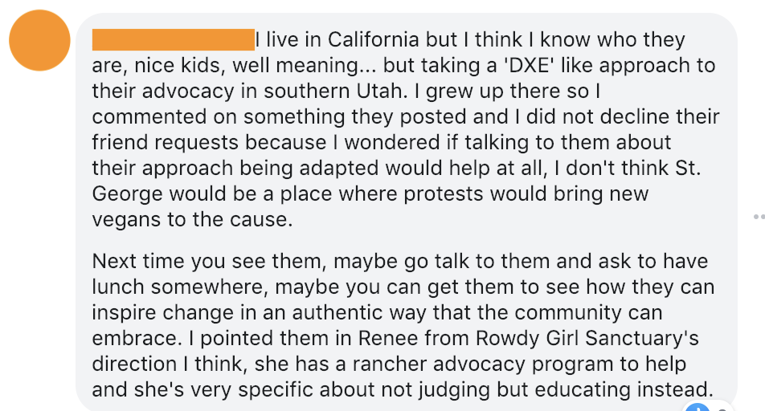
Extract 2 is a response to Angie’s comment from Tia (the original poster). Although a direct response to Angie’s comment, extract 2 was posted as the start of a new comment thread, rather than under Angie’s initial comment.
Extract 3.2: Reply to Angie in a new thread
Date: April 27
From: Tia (Original Poster)

- I agree.... different set up would be ideal.
- I feel like it did more harm than good towards a vegan message.
- Opposite in fact
- all I heard inside were comments on how much people love meat
- and dont care about animals. 😟

Extract 2a is Angie’s response to Tia’s comment. This extract was posted within the thread created by Tia. As such, it is meant to be read as a direct response to the content of Tia’s comment.
Extract 3.2a: Reply within Tia’s new thread
Date: April 27
From: Angie

- So sad,
- I wonder if they even know their actions cause backlash?
- Maybe no one has told them
- or maybe they don't care
- but in all cases I hope they stay safe.
- St. George is full of carnists and ranchers as you know,
- and every vegan there is setting a precedent for those that follow them
- whether they realize it or not.
- I was in Kanab and it was a bit different
- but even there with so many vegans and vegetarians
- I'd think soft advocacy would be most effective.
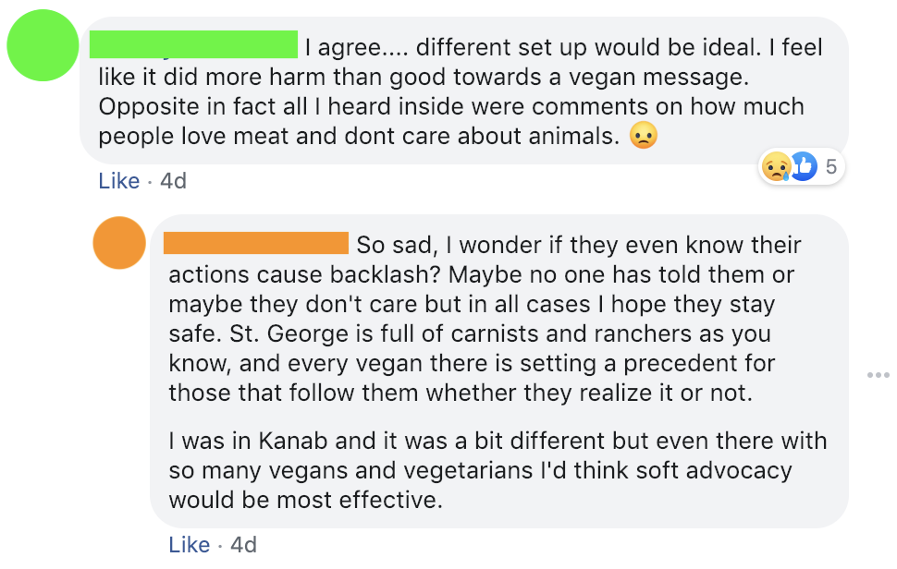

3.5. DISCUSSION

Extract 3.1: Angie establishes authority based on locality an experience
In extract 3.1, Angie uses a variety of approaches to demonstrate her knowledge and establish her authority on the subject. Establishing authority is important because, as she lives outside of Utah, she might not fully understand the attitudes towards veganism in St. George, Utah. However, the fact that Angie lives in California contributes to her knowledge; she thinks she knows who the protesters are because she lives in California, where DxE is headquartered. This prior knowledge informs the remainder of her comment and establishes an authority that is present in extracts 3.1 and 3.2a. Because she knows the protestors and is familiar with their methods, she is able to better comment on the effectiveness of their methods:
5. I grew up there so I commented on something they posted
6. and I did not decline their friend requests
7. because I wondered
8. if talking to them about their approach being adapted would help at all,
9. I don't think St. George would be a place
10. where protests would bring new vegans to the cause.

She further establishes her knowledge of how the protesters’ methods don’t work in Southern Utah by stating that she grew up there (line 5). This helps give credibility to her specific claim that St. George is not a good place for vegan protests (line 8). Angie uses the fact that she grew up in the area to aid in constructing her epistemic stance.
Given that epistemic stance markers occur before the issue at hand (Kärkkäinen 2006), we know Angie’s knowledge of the protestors and the effectiveness of their methods in a particular place is a significant issue because of the preceding epistemic stance marker I think. Angie uses the non-authoritative I think to manage the potential risk of being wrong, a tool that is also used by Tia in line 18. This non-committal approach of I think is also reflected in Angie’s use of but. Angie aims for a balanced perspective in her comment. Through her repeated use of but (lines 1, 3, 17, 27, 32), she compares two different perspectives in an attempt to objectify her report (Sneijder & te Molder 2005). Using but indicates that the content of what follows contradicts the preceding statement. This contradiction makes the subject of the everything preceding but appear more extreme, thus legitimizing her claims to the alternative (Edwards 2000; Pomerantz 1986).
Angie also allows readers to fill in the blanks of her messages, using implication as a way to demonstrate knowledge. The dangling modifier in line 4 allows Tia to fill in the gaps herself. The implication of line four is that the approach used by the protestors doesn’t work in Southern Utah. By leaving that argument implied (and with Tia responding in agreement in extract 3.2), Angie and Tia are able to co-construct a joint stance (Kärkkäinen 2006) in which they establish themselves as opposed to the methods of the protestors but still supportive of vegan activism more generally. In constructing this joint stance, Angie and Tia present themselves as having knowledge that the subjects of their discussion -- the protesters -- don’t possess.
Beyond being the subject of the original post, the idea that the protestors need to change their approach is given particular attention in line eight. By wondering if talking to the protesters would help, Angie implies that their approach is something that needs helping. The conditional formulation aids in this position. Though a common discursive resource, the conditional formulation is especially salient in online discussions of veganism (Sneijder & te Molder 2005). By using the conditional if (line 8), Angie upholds norms and conventions of her community. Line eight is interesting, though, in that it’s not quite a standard if/then formulation wherein a logical then follows a conditional if, but, rather, it is speculative. The then of this incomplete conditional formulation is the implication that talking to protesters will lead to them changing their approach. Much like the implication of the dangling modifier in line 3, the incomplete conditional formulation allows Tia to fill in the gaps and make her more receptive of Angie’s authority and co-construct a joint stance as she agrees with Angie’s position (line 18).
11. Next time you see them, maybe go talk to them
12. and ask to have lunch somewhere,
13. maybe you can get them to see how they can inspire change in an authentic way
14. that the community can embrace.

All of the factors that contribute to Angie’s epistemic stance give weight to the suggestion offered to Tia in lines 11-14 to maybe go talk to [the protesters]. Here Angie takes the knowledge she has and identifies the dietary commonality between Tia and the protesters as a resource that Tia can use to create an opportunity to change the minds of the protesters. The repeated use of maybe in these lines allows Angie to make this suggestion without making a truth claim about the effectiveness of her suggestion. This section is also structured like conditional formulation, but with implied ifs and thens. If Tia sees the protesters again then she should talk to them; if she talks to them then she can get them to change their minds.

Extract 3.2: Adopting Angie’s epistemic stance and adding affect

- I agree.... different set up would be ideal.
- I feel like it did more harm than good towards a vegan message.
- Opposite in fact
- all I heard inside were comments on how much people love meat
- and dont care about animals. 😟

Tia’s response to Angie (lines 18-22) positions Tia as taking the same epistemic stance as Angie. The ellipses that follow Tia’s positive statement of agreement function as a tonal cue in the text of their comment, suggesting that there is more to Tia’s statement than general agreement. Much in the same way that intonation in spoken communication can add ambiguity to a spoken utterance, the use of ellipsis in Tia’s comment remediate this tonal strategy and add ambiguity to her comment. Yet, even within this ambiguity, Tia’s use of ellipsis matches Angie’s linguistic strategies; thus, demonstrating a matching alignment and level of investment. Both Tia and Angie, have valuable information to contribute to the discussion, yet the ellipsis belie their confidence in their statements; both Tia and Angie are negotiating their epistemic stance through the uses of ellipsis as remediations of intonation.
While she does initially agree with Angie, the ellipses following I agree could imply that Tia’s agreement with Angie’s comment is not a confident agreement. Indeed, by specifying that a different set up would be ideal (line 18), Tia takes the general open-ended agreement and roots it in a potential solution to the concern in her original post. This specification indicates what Tia believes to be the most significant point in Angie’s comment. By using the affordances of alphabetic text to remediate tonal cues, Tia’s suggestion for a different approach is given more weight; following an ambiguous, unconfident agreement with a confident suggestion allows Tia to mark the significance points of Angie’s comment while still leaving room for discussion.
Tia supports her belief that a different approach would be better in line 19. The I feel in line 19 functions not only as an epistemic stance marker but as a way to mark affective stance as well. She uses I feel to describe both an evaluation of the protest and establish knowledge. It also helps to hedge the statements that follow. In rooting her critique in feelings rather than empirical knowledge, Tia protects herself from offering a potentially false assessment. However, she warrants her feelings by describing her experience of non-vegans’ reactions to the protest (lines 20-21). By critiquing the protesters for doing more harm than good towards a vegan message and supporting that with her experience at work (lines 20-21), Tia upholds the shared values of all participants (including the absent protesters) while simultaneously critiquing members of the vegan community and advocating for change.
Not only does Tia establish epistemic stance by agreeing with Angie’s comment and adopting Angie’s perspective, she also constructs an affective stance through her use of 😟. Tia ends her comment with by adding a frowny face emoji (😟). While a commonly used emoji that corresponds with the emoticon :( Tia’s use of the 😟 demonstrates one of the ways in which users of alphabetic CMC can communicate paralinguistic features. Tia places the emoji at the end of her comment, thus signaling a shift in tone and affect. Tia uses 😟as its own sentence, it follows the final period of her comment. As with any (para)linguistic feature, the goal is to convey meaning. By placing the emoji outside of her comment, Tia expresses the sadness indexed by 😟as outside of her use of language. Tia doesn’t use the emoji to comment on one particular sentence or utterance, but rather to add meaning to her comment as a whole. Compared to her use of ellipsis — which echo verbal intonation — the emoji represents the gestural features of paralinguistics (McCulloch & Gawne 2018). Much in the same way that gestures don’t share in the grammatical structure of spoken language, but rather work in conjunction with spoken language, emoji work with written language to emphasize meaning. Just as a speaker might smack a podium or raise their fist to add emphasis to the content of their message, Tia uses the 😟 as if to show that she herself is frowning and sad about the content of her message, adding another contextual layer to her comment.

Extract 3.2a: Directly responding to and matching affective stance
If Angie is the one with the more established epistemic stance, then her corroboration of Tia’s sadness (as represented by 😟 in line 22) with so sad (line 23) legitimizes Tia’s affective stance regarding the protesters and her feelings about the non-vegans’ reactions. Angie intensifies Tia’s emotional state by using so to intensify sad. By establishing herself as an authority on the subject at hand, any instances where Angie agrees with Tia further strengthens Tia’s own epistemic stance. Angie’s final comment (lines 22-27) continues the theme of advocating for the protesters to use different approach, but rather than talking about a different approach or set up generally, Angie names soft advocacy (line 32) as a specific approach to take. Naming this approach demonstrates Angie’s authority and knowledge of the subject -- to name an approach you have to know the approach -- but also adds to the repertoire of knowledge she is sharing with Tia.
It’s important to note that because this interaction takes place in an online community dedicated to vegans, Angie and Tia are able to critique the approach of the protesters without having to justify or defend veganism as a concept. This allows Angie to comment on the protesters while still valuing their safety (line 26). Tia, Angie, and the protesters share similar goals; they all want to effectively advocate for veganism. While, Angie does establish herself as having knowledge on the subject, she does not make any claims to fully know the best approach for vegan advocacy, but rather critiques the protesters based on her prior experience. In line 23 Angie questions the knowledge of the protesters. By framing addressing the protesters’ knowledge as a question, Angie is able to critique their methods without diminishing their efforts. By setting up two potential answers to the question -- either maybe no one has told them [their actions cause backlash] or they don’t care -- Angie places the onus on the Tia and other readers to decide for themselves. This non-authoritative answer to the problem keeps the conversation open and provides the community opportunities to continue examining, critiquing, methods of vegan activism.

3.6 CONCLUSION
The discursive resources used by Angie to construct epistemic stance allow her to establish authority in an online vegan space (SLC Vegan) that is tied to locality, all while living outside the area in which the group is based. Her location and past experience, coupled with how she structures and words her comments, contribute to her epistemic stance. Primarily through the use of conditional formulations, Angie is able to outline the fact that there are particular consequences of circumstances or activities (Sneijder & te Molder 2005: 682), but leaves the exact consequences up for debate. Many of the conditional structures that Angie employs are constructed with implied ifs (conditions) and thens (consequences). The use of implied conditional structures allows for Tia’s responses of agreement to strengthen Angie’s epistemic stance. Tia’s agreement with Angie enables them to co-construct a joint stance (Kärkkäinen 2006).
Because the sequential environment of digital discourse on Facebook allows users to present multiple stance markers that are viewed all at once in a single post, interactants are able to respond directly to the stance presented in a preceding comment. Tia and Angie match one another’s stance through similar linguistic features. They both employ ellipsis as a way to mark uncertainty and remediate prosodic cues of spoken language. They both comment without necessarily following conventions of prescriptive grammar, thus recognizing how Facebook — and online CMC in general — allows for serious conversations to occur with informal language. In this way, Tia and Angie further echo spoken communication and align with one another. Further, Tia uses a frowning emoji, indexing a negative affect, and Angie responds in turn with “so sad” (line 23), directly addressing a marked shift in Tia’s affective stance. The strategies employed by Tia and Angie to construct and perform epistemic stance are, indeed, tied to the medium of Facebook. They are relatively limited in the length of their comments, yet manage to debate the actions of and co-construct a joint epistemic stance regarding DxE protestors and the best methods of vegan advocacy.
In SLC Vegan, the members share a clearly identified set of values and goals. Because of the nature of digital discourse and the shared values of the community, users are able to use stance markers with great impact. In the interaction between Angie and Tia, the critiques against the protesters are not seen as critiques against veganism, effectively allowing the conversation to remain focused on the content of the original post. Further analysis of all of the comments on Tia’s original post could potentially show the ways in which members of SLC vegan use stanced language to uphold their shared values. Examining stancetaking in other online activist communities may provide insight into the new ways digital discourse affects a group’s ability to communicate their values and goals.

Appendix I: Tia’s Original Post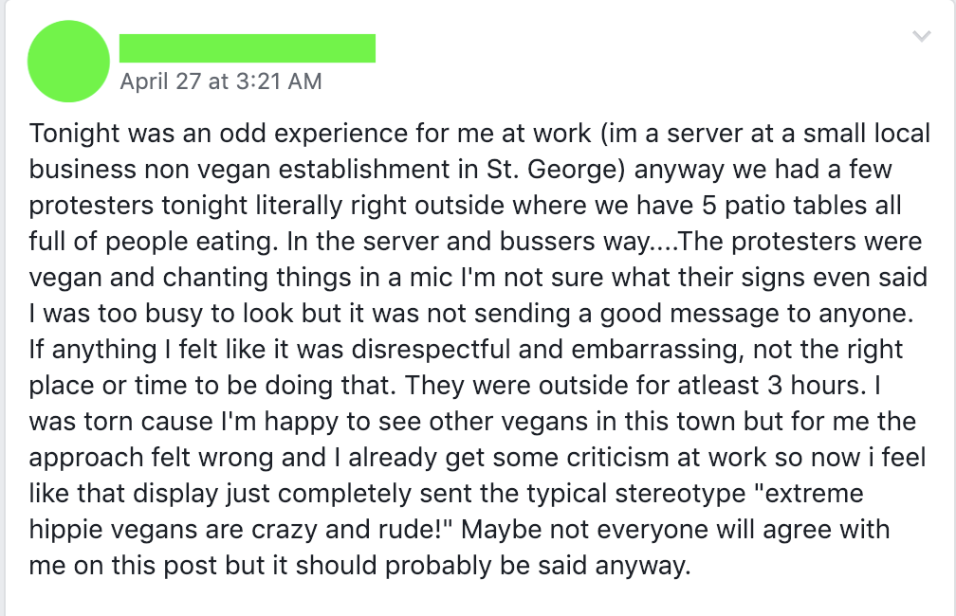

Chapter 4: Over to the Vegan Side

4.1 INTRODUCTION
As with the previous chapter, this chapter looks at how vegans use the affordances of alphabetic computer-mediated communication (CMC) to construct and perform stance (Kärkkäinen 2006) in discussions of activism. While the data from the previous chapter was extracted from Facebook comments, the data for this chapter come from a Reddit thread. Reddit comments are generally more anonymous and lengthier than Facebook comments, providing robust data that is not as closely tied to personal identity. The anonymity of Reddit comments obscures the audience/interlocutor axis of the stance triangle, giving more weight to the axes of the discourse itself and the topic of discussion and causing the inclusion of personal details to be highly marked. In particular, this chapter examines a Reddit thread connected to user pixiepunch16’s “Questions about talking to non-vegans [sic].” While there are several comments responding to the original post by pixiepunch16, this chapter focuses primarily on the interaction between the original poster (OP) and Reddit user sheilastretch. Building off of the work Sneijder and te Molder (2005; 2009) this chapter uses the comments from other users on the thread as a comparative anchor, and explores how sheilastretch utilizes the affordances and constraints of CMC to foster a discourse with pixiepunch16 wherein they construct and perform stance (Kiesling 2009; Du Bois & Kärkkäinen 2012) while simultaneously promoting effective vegan advocacy.
Interactants in spoken conversation are able to perform a wide array of communicative tasks through their understanding and use of the sequential environment of discourse. Digital spaces, however, upset the sequential environment in such a way that it is structured differently and more asynchronously than spoken discourse (Sneijder and Te Molder 2005). Indeed, part of what makes Reddit a worthwhile venue to assess stancetaking and other discursive strategies are the conversation-like threads that allow for both the use of more traditional interpersonal and linguistic phenomena (Pavalanathan et al. 2017) and the ability to exploit the affordances of CMC to compensate for the loss of paralinguistic features in CMC. In the discussion below, we see how English speakers use the same small set of stance markers repeatedly (Kärkkäinen 2006) and adapt to the sequential environment to construct and co-construct epistemic stance regarding the stance object of pixiepunch16’s vegan activism (McCulloch 2019; Oskoz & Pérez-Broncano 2016).
Engaging in discourse on Reddit’s conversation-like threads allows interactants to directly address one another in a way that mimics synchronous conversation (Pavalanathan et al. 2017), effectively allowing for the remediations of paralinguistic features to carry more weight and more successfully construct stance in the digital space, while still accounting for the constraints and affordances of CMC (Oskoz & Pérez-Broncano 2016). Through their use of enthusiasm markers, personal life-details, and matching alignment, pixiepunch16 engages with the interactants on this Reddit thread in such a way that whatever new knowledge the commenters bring to the conversation is added to pixiepunch16’s epistemic stance. Pixiepunch16 is able to adopt the epistemic stance of others as they construct their own. This allows for the authority present in the OP regarding their knowledge of veganism to remain consistent and for their perspective on personal activism strategies to change.

4.2 METHODS
For this chapter, I extracted a total of nine (9) comments by various Reddit users in response to an original post from January 2020 entitled “Questions for talking to non-vegans [sic]” posted by Reddit user pixiepunch16. As in chapter three, I elected to extract data from a comment thread in which I was not a participant in order to avoid coloring my interpretations of the data through the observer’s paradox. Although the users on the r/VeganActivism Subreddit are unaware of my position as rhetoric and linguistics student, and, as such, are less inclined to employ careful speech in the same ways as the Facebook group members, in order to maintain consistency across datasets, I did not engage with the interlocutors.
I collected the data from this particular Reddit thread because the question posed in the original post by pixiepunch16 elicits a variety of perspectives, stances, and opinions without being divisive or controversial. In responding directly and independently to a question, the commenters quickly and efficiently establish their epistemic stance (Kiesling 2009; Hunston & Thompson 2000). While all of the nine comments engage in the work of interlocutors moving towards a convergent stance (Kärkkäinen 2006), this chapter focuses predominantly on an exchange between sheilastretch and the original poster, pixiepunch16. I chose to focus on the back-and-forth between these two users for two reasons: first, sheilastretch’s comment (and OP’s response) are some of the longest on the thread and, therefore, provide ample data with which to work; and second, the exchange between these two users is the only one with multiple responses, echoing the structure of the comment thread from the previous chapter.
he focus of this thesis is the remediation of paralinguistic features in CMC, which have been argued to be typically remediated through the unique use of standard lexical and syntactic features (Lyons 2018; Baroni 2013; Pavalanathan et al. 2017); this chapter focuses on what can be observed through alphabetic texts (Barbieri 2008; Tagliamonte 2005). While these digital texts are still wed to alphabetic structures, communicators are able to utilize and exploit the orthographic affordances of CMC (Dresner & Herring 2010) to further their discursive goals. As such, the analysis of these data focuses not only on the role of alphabetic CMC as written conversation (Tannen 2013) but also on how interactants leverage the affordances of CMC and the medium of Reddit (i.e. hyperlinks, upvotes, quote-posting) to construct and perform stance. I will present the data in section three as screenshots of the Reddit comments and then analyze it according to the significant discursive turns in section four.

4.3 RESULTS
The extracts below include the original Reddit post by user pixiepunch16 in the subreddit r/VeganActivism, as well as nine comments made in response to the original post (OP). While the bulk of the analysis focuses on an exchange of four comments made between pixiepunch16 and sheilastretch, I have elected to include the OP and some other comments in order to provide a fuller picture of the exchange and establish the patterns of communication that pixiepunch16 shows, further demonstrating the ways in which users of alphabetic CMC on Reddit are able to exploit the affordances of digital communication to construct stance.
Because the original post is where we see the first instances of stancetaking from pixiepunch16, I have provided the content of the OP as a screenshot. Given that the medium of a message is inextricably linked to the message itself (McLuhan 1967) and informs, through prior text associations, one’s perception of the kind of message being delivered (Tannen 2013), the comments are provided as screenshots. Providing the comments as screenshots allows for the entirety of the alphabetic CMC modes to be relayed (and saves space as well). Whereas in the previous chapter I presented the comments in quasi intonation units, for this chapter I have chosen to present the comments as screenshots, both because of the length of the comments and to better demonstrate the format in which they appeared.
Additionally, I have decided not to include every comment made on the OP. Rather, because my focus is on an exchange between two users (as in chapter three), I have decided to include only those comments which I feel demonstrate how pixiepunch16 communicates. This is to provide more context for the analysis between pixiepunch16 and sheilastretch (extracts….) While not every comment is presented in this section, screenshots of all of the comments are available in the appendix. The original post by pixiepunch16 asks for advice on how to talk to non-vegans without coming across as elitist, establishing pixiepunch16’s approaches to advocacy as the primary stance object. In section four, I will explain how the respondents align with pixiepunch16 and use their own experiences to inform their construction of epistemic stance, all while engaging with alphabetic CMC in unique ways.

Extract 4.1
January 2020
From: pixiepunch16
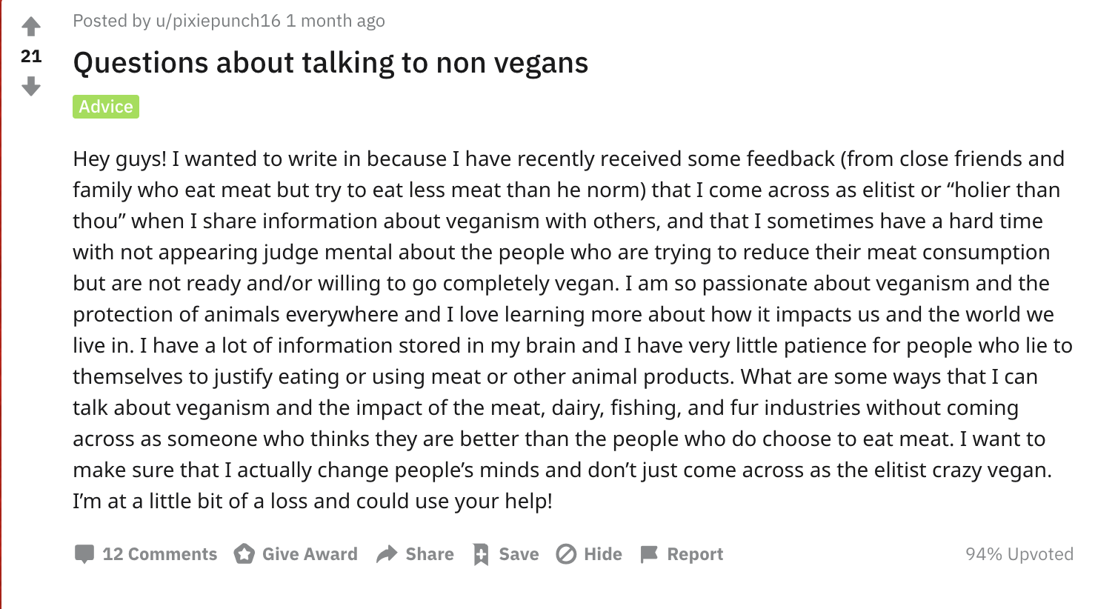

Extract 4.2 is a comment from Reddit user c5tr0 and pixiepunch16’s reply, beginning a new comment thread with exactly one response from the original poster. c5tr0’s comment consists of three short paragraphs with a parenthetical statement at the very end; pixiepunch16’s reply is provided as one whole paragraph.
Extract 4.2
Date: January 2020
From: c5tr0 and pixiepunch16 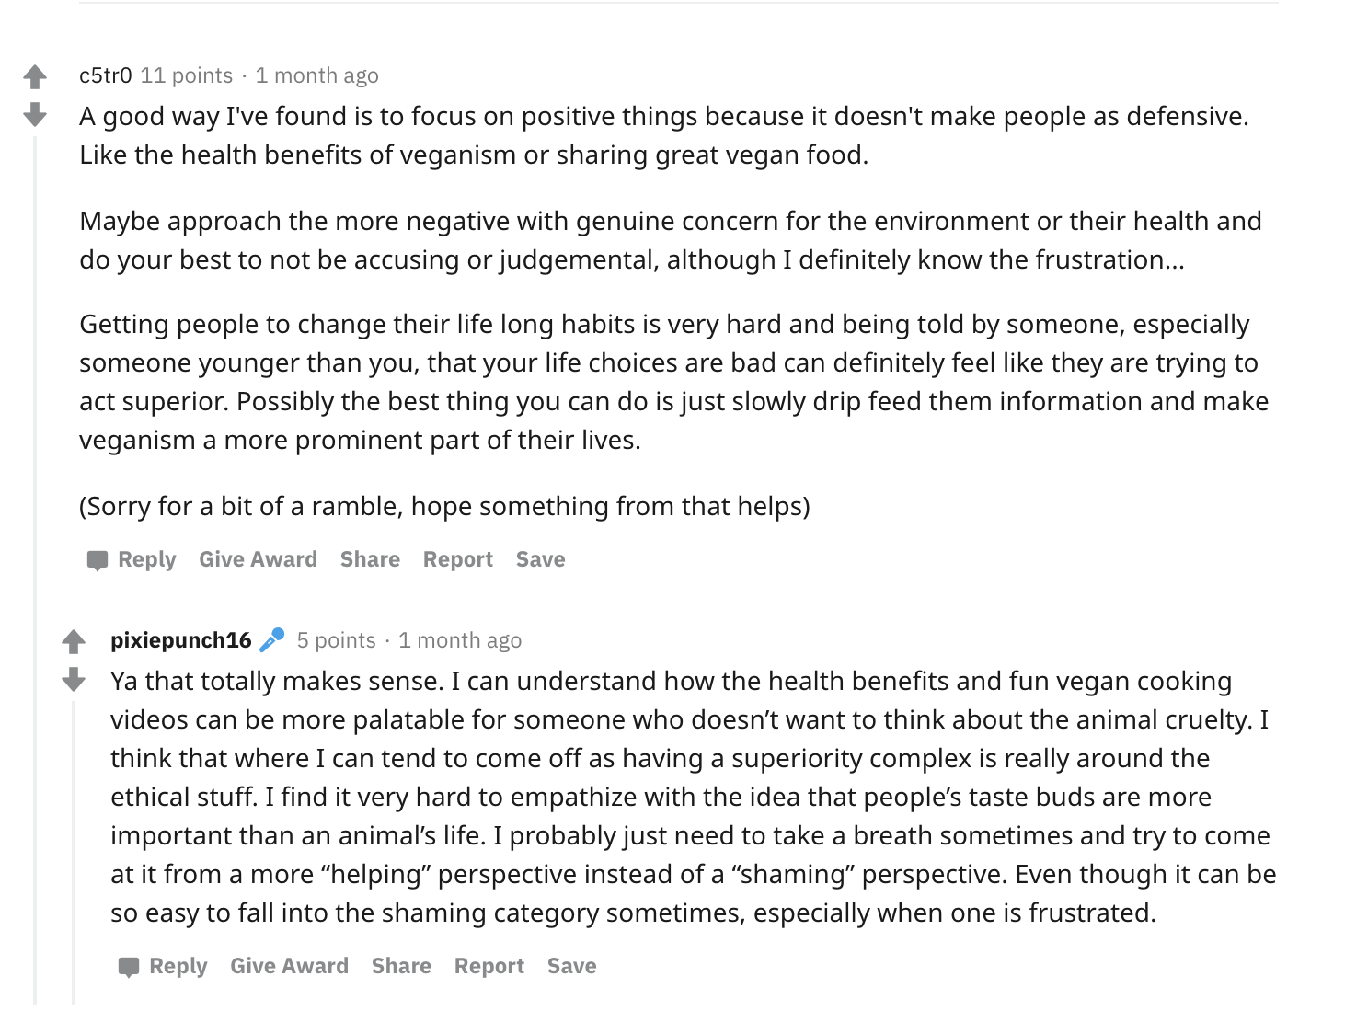
Like Extract 4.2, Extract 4.3 marks the beginning of a new comment thread consisting of a comment from nochedetoro and a single response from pixiepunch16. Pixiepunch16’s response comment marks the first use of emoji on this particular reddit post.

Extract 4.3
Date: January 2020
From: nochedetoro and pixiepunch16

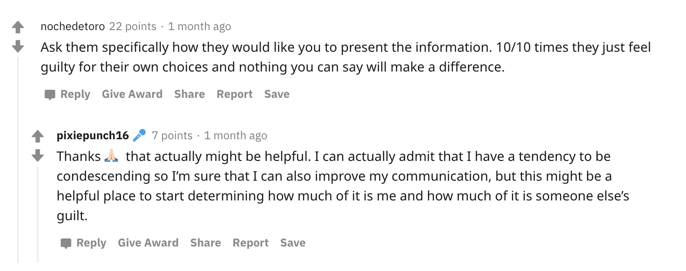

Extract 4 is by far the longest comment on the thread. It comes from user sheilastretch and consists of several paragraphs, nearly all of which are as long as the entirety of each previous comment. Extract 6 also marks the first use of hyperlinks to an external site on this reddit thread.
Extract 4.4
Date: January 2020
From: sheilastretch
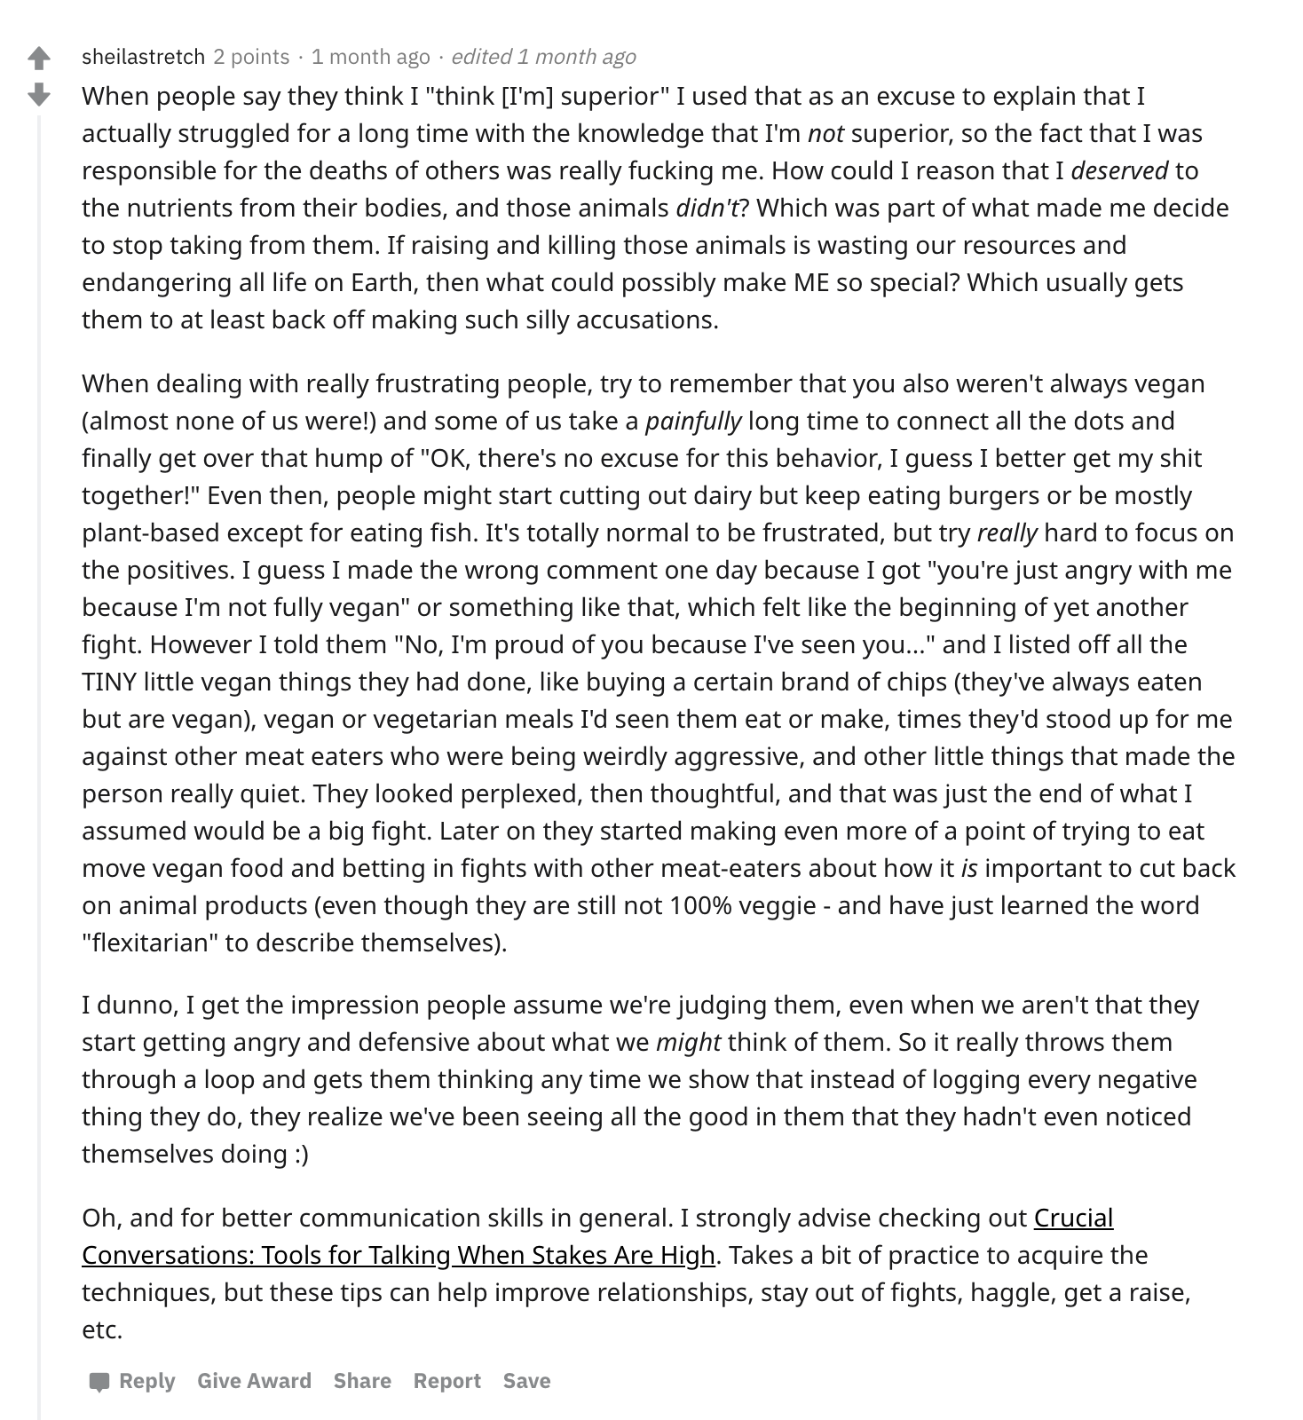

Extract 4.4a is pixiepunch16’s response to sheilastretch’s comment. As with the other comments from pixiepunch16, it is meant to be read as a direct response to the comment to which it is linked.
Extract 4.4a
Date: January 2020
From: pixiepunch16

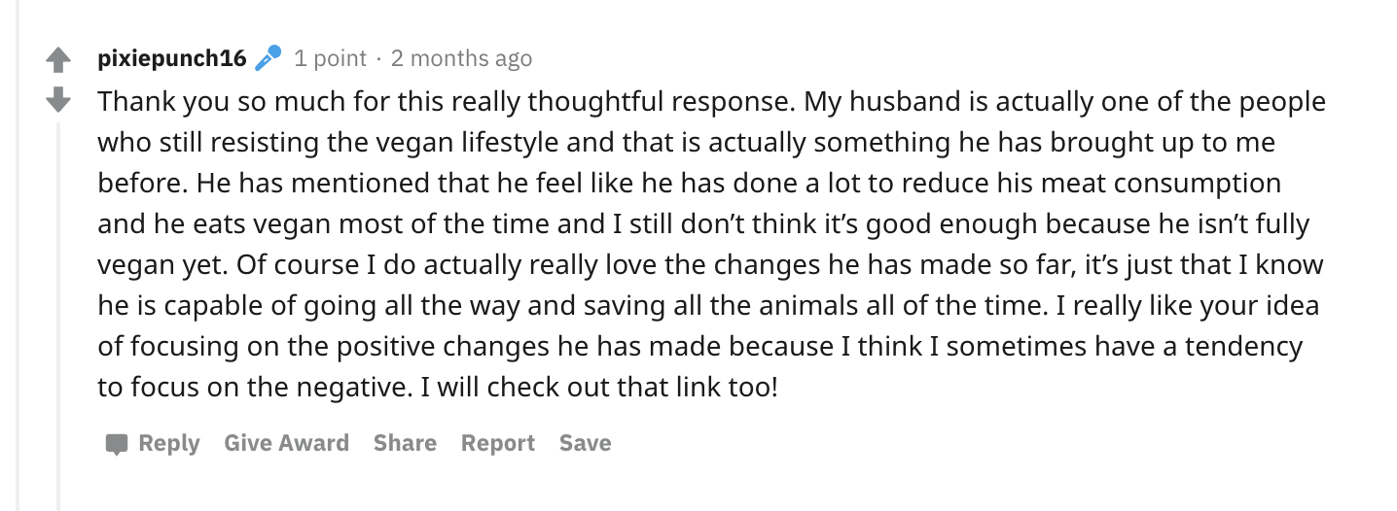

In extract 4b, sheilastretch responds directly to pixiepunch16’s reply within the same thread started by sheilastretch. In this comment, sheilastretch uses one of the features of Reddit to directly quote pixiepunch16. Again, sheilastretch’s comment consists of multiple longer paragraphs.

Extract 4.4b
Date: January 2020
From: sheilastretch
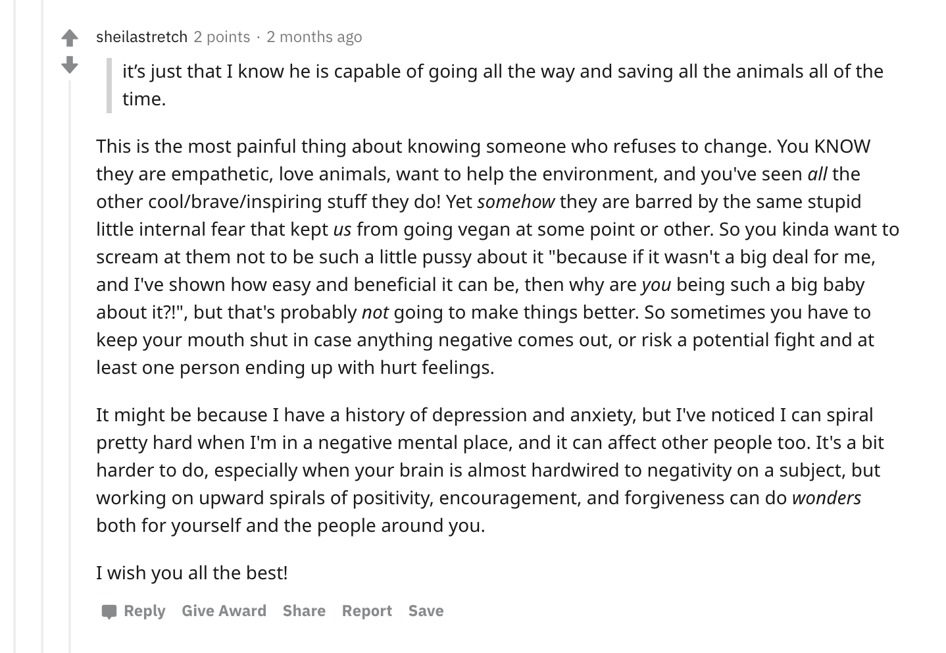

The final extract, 4c, is pixiepunch16’s final reply to sheilastretch. In this comment, pixiepunch16 responds in a single paragraph. This extract also contains the second use of emoji in the thread.

Extract 4.4c
Date: January 2020
From: pixiepunch16
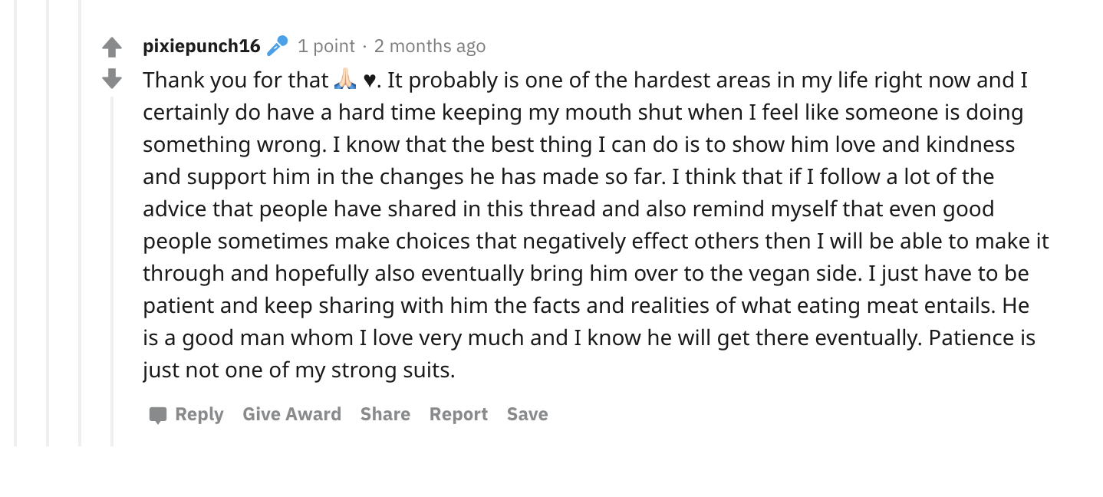

4.4. DISCUSSION
The discussion below goes through each extract presented above. I present them in the order they appeared in the previous section and analyze them according to the key discursive and linguistic features used by each interactant. In particular I examine pixiepunch16’s high level of enthusiasm and investment, matching pixiepunch16’s alignment towards the stance-object amongst all commenters, sheilastretch’s unique use of capitalization and italics to remediate intonation, and the addition of a new stance-object through the inclusion of personal details.

Extract 4.1: Enthusiastically asking for advice

In their initial post, pixiepunch16 establishes a positive affect, a clear stance-object — their personal advocacy strategies — and goal, and an uncertain epistemic stance. Through the use of enthusiasm markers (i.e. linguistic features that index excitement or enthusiasm, such as exclamation points, repetition, capitalization, message length), pixiepunch16 illustrates that, although they are seeking advice for a serious topic — vegan activism — they are friendly and, therefore, open to advice. Their comment doesn’t carry an air of superiority; indeed, pixiepunch16’s stated goal is to not “come across as elitist.” By bookending the OP with enthusiasm markers in the form of exclamation marks — “Hey guys!” and “could use your help!” — pixiepunch16 ensures that the first and final things a reader sees before commenting are indicators of positive affect. In this way, pixiepunch16 is able to use the symbols available in English orthography to convey a friendly tone. Through the use of these enthusiasm markers, pixiepunch16 indicates that, while the content and subject matter of the original post is serious, they themselves are amicable and willing to listen. Additionally, the use of the informal regional variety of the second person plural “guys” further shows that pixiepunch16 is willing to listen, as they understand that there are likely to be multiple responses to the question at hand.
The level of detail and amount of information that precedes the actual question in the OP allows for pixiepunch16 to display a high level of investment regarding the stance object. Pixiepunch16 focuses exclusively on their role as a vegan activist and defends their affective position not as extreme, but as being “so passionate about veganism and the protection of animals everywhere.” In this post, pixiepunch16 recognizes their roles as an activist and a passionate vegan as potentially conflicting. They want to be an effective activist, but find it difficult due to the “information stored in [their] brain” and lack of patience to advocate effectively. Here, pixiepunch16 establishes an epistemic stance as one who knows a lot about veganism, but is less certain in their skills as an activist. This stance indicates that pixiepunch16 doesn’t necessarily need more information about veganism, rather, they desire skills and strategies to communicate with non-vegans successfully.
By indicating that people who are trying to reduce their meat consumption are “not ready and/or willing” to commit to veganism, pixiepunch16 conflates one’s readiness and willingness to go vegan as linked to their ability to be an effective vegan advocate. In this move, pixiepunch16 demonstrates how within a space where participants share the same values, less work needs to be done to establish ethos. In other words, the sequential environment of digital spaces — consisting of CMC generally and of the r/VeganActivism subreddit — does much of that work for pixiepunch16 (Sneijder and Te Molder 2005). The members of r/VeganActivism and pixiepunch16’s post are able to read the OP and take pixiepunch16 at face value. Pixiepunch16 doesn’t need to account for the reasons that might preclude people from veganism, as convincing others to go vegan is simply a matter of whether or not they are an effective activist. In this way, the question of “the ways that [pixiepunch16] can talk about veganism” to those reluctant to change, though open ended, is centered around how to improve the activist techniques of a single individual and their interactions with a select few people.
If epistemic stance markers occur before the issue at hand, then it can be argued that everything preceding the actual question in the OP is part of pixiepunch16’s efforts to construct and perform stance. By claiming that they “want to make sure that I actually change people’s minds,” pixiepunch16 is able to address their shortcomings without undermining the shared ideology of the group (Sneijder and te Molder 2005). The actual question asked by pixiepunch16 focuses on the individual and personal responsibility, placing the onus on the vegan activist to determine how they are perceived by others. In a sense, pixiepunch16’s question is about how they can construct and perform a stance in which the stance object — veganism — is portrayed with a positive affect and a high level of investment to which those they are speaking to can positively align (Kiesling et al. 2018).

Extract 4.2: Reducing Defensiveness
“[...] focus on positive things because it doesn’t make people as defensive. Like the health benefits of veganism or sharing great food.
“Maybe approach the more negative with genuine concern for the environment or their health and do your best not to be accusing or judgemental, although I definitely know the frustration…” (c5tr0)

In their reply to pixiepunch16’s question, c5tr0 adds a new layer to the goal of improving pixiepunch16’s activism: a reduction in defensiveness. c5tr0 highlights the importance of focusing on “positive things” like “health benefits… or sharing great vegan food” in an effort to reduce the defensiveness of those resistant to veganism whom pixiepunch16 is trying to engage with. Interestingly, c5tr0, while aligning with pixiepunch16 in a shared goal of improving vegan advocacy, avoids using enthusiasm markers, effectively establishing a tone contrasting the tone pixiepunch16 cultivates in the OP. Indeed, c5tr0’s only use of punctuation to convey paralinguistic features occurs in instances of negative self-evaluation (Du Bois and Kärkkäinen 2013). Through the use of ellipsis (...) when discussing frustration with activism and the parenthetical apology at the end of their comment, c5tr0 conveys a sense of doubt or uncertainty in their comment.
Beyond functioning as an absence of information or a trailing off in thought, the use of ellipsis may also indicate that c5tr0’s linguistic norms are oriented toward the offline world similar to the findings of McCulloch (McCulloch 2019: 111). This would then give credence to c5tr0’s assumption that pixiepunch16 is advocating veganism to people who are older than they are. It is safe to assume that, if c5tr0’s language use is oriented offline rather than online, they themselves are older. Moreover, pixiepunch16’s original post doesn’t indicate an offline orientation, and their use of enthusiasm markers, intensifiers, high level of investment, might index youth (Tannen 2013).
“Ya that totally makes sense. I can understand how the health benefits and fun vegan cooking videos can be more palatable for someone who doesn’t want to think about the animal cruelty. I think that where I can tend to come off as having a superiority complex is really around the ethical stuff. I find it very hard to empathize with the idea that people’s taste buds are more important than an animal’s life. I probably just need to take a breath sometimes and try to come at it from a more “helping” perspective instead of a “shaming” perspective. Even though it can be so easy to fall into the shaming category sometimes, especially when one is frustrated.” (pixiepunch16)

Pixiepunch16’s response to c5tr0 demonstrates a positive alignment with an attempt at joint-stancetaking (Du Bois and Kärkkäinen 2013). By beginning their response in agreement — “Ya that totally makes sense” — pixiepunch16 is positively acknowledging c5tr0’s advice, exemplifying the willingness to listen present in the OP. Pixiepunch16 further aligns with c5tr0 by adding additional reasons to support c5tr0’s advice before including more detail about why they are experiencing the problem in the first place. This interpersonal joint-stancetaking is further evident in pixiepunch16’s frequent use of hedges (can, probably), validating c5tr0’s response while also recognizing personal responsibility
By indicating that they “find it very hard to empathize” and that they “probably just need to take a breath,” pixiepunch16 continues to place responsibility for successful activism on themselves, recognizing what they perceive as faults in their approach. Through this process of self-reflection, pixiepunch16 demonstrates a high level of investment both in the causes of the problem and in wanting to find a solution. It is worth noting, however, that pixiepunch16’s self-reflection, use of hedges, and alignment with c5tr0’s advice, while demonstrating a positive affective stance, negatively portrays their epistemic stance (Ochs 1993). Indeed, through agreeing with the response, pixiepunch16 acknowledges the epistemic stance of the respondent; by adding further detail to the responses, they effectively borrow the epistemic stance of the other interactants.

Extract 4.3: Removing the onus of responsibility
“Ask them specifically how they would like you to present the information. 10/10 times they just feel guilty for their own choices and nothing you can say will make a difference.” (nochedetoro)

In Extract 4.3, we see a shift in who the commenters view as responsible. Reddit user nochedetoro removes the onus of responsibility from pixiepunch16 and places it on those with whom pixiepunch16 is interacting. In their comment, nochedetoro also removes the blame of any ineffective activism from pixiepunch16 and places it on non-vegans, confidently asserting that because of the guilt felt by non-vegans, “nothing [pixiepunch16] can say will make a difference.” While nochedetoro’s comment explicitly acknowledges and separates the roles of the non-vegan and vegan in animal rights activism, pixiepunch16’s response positively aligns with nochedetoro while continuing to focus on their own role as an activist.
“Thanks 🙏🏻 that actually might be helpful. I can actually admit that I have a tendency to be condescending so I’m sure that I can also improve my communication, but this might be a helpful place to start determining how much of it is me and how much of it is someone else’s guilt.” (pixiepunch16)

Pixiepunch16’s reply to nochedetoro, like most of their replies, starts by positively aligning with the comment to which they are responding. Yet, where pixiepunch16 typically employs enthusiasm markers to convey tone or affect, here they use a simple thanks followed by the emoji of praying hands. Through the use of 🙏 — an emoji often associated with gratitude and humility — pixiepunch16 intensifies their simple thanks and makes what could otherwise be interpreted as a cold and distant response into one that is genuine. In this way the emoji does the paralinguistic work of clarifying intent. What would, in face-to-face conversation be presented as a gesture is instead remediated into an iconographic representation that serves to intensify, clarify, contextualize and intonate thanks.
The use of the certainty adverb actually as a discourse marker (Tagliamonte 2005: Pavalanathan et al. 2017) functions as an evaluation both of pixiepunch16’s position as an activist and nochedetoro’s response. Using actually twice — first in reference to the helpfulness of the response; second in reference to their approach — allows pixiepunch16 to acknowledge aspects of their activism that they might not have necessarily considered while still placing the responsibility on themselves. The first actually implies that pixiepunch16 has not considered the approach of nochedetoro, but believes it will be helpful. Where often the use of actually can be seen as a marker of condescension or correction, the syntactic position of pixiepunch16’s actually serves to emphasize and mark agreement with nochedotoro’s point. This softens the impact of the second actually as a corrective response, because in this sentence, pixiepunch16 is disagreeing with nochedotoro’s point that the non-vegans are the obstacle to pixiepunch16’s activism. Instead, pixiepunch16 is, again, placing the burden of responsibility on themselves: it is not that non-vegans feel guilty, but that pixiepunch16 has “a tendency to be condescending.” But because the first actually signals agreement with nochedetoro, the second actually comes across as less confrontational. It is through this parallel use of the word actually that pixiepunch16 helps construct and maintain a positive affective stance while simultaneously borrowing the knowledge of the other interactants to establish epistemic stance.

Extract 4.4-4.4c: Conversation between pixiepunch16 and sheilastretch
Extracts 4 through 4c are not only the longest comments on the post, but they also show the most significant stancetaking between two interlocutors. The back-and-forth discussion parallels the conversation between Tia and Angie in the previous chapter, allowing for greater comparative analysis. Pixiepunch16 and sheilastretch both negotiate knowledge and authority on the subject of veganism while still maintaining a focus on improving pixiepunch16’s activism. In their exchange the stance object — or the thing which is being evaluated — is the center of their discourse (Du Bois and Kärkkäinen 2012). Both pixiepunch16 and sheilastretch exploit the affordances of alphabetic CMC in general, and of Reddit in particular, to help further cooperatively construct and perform stance.

Extract 4.4: Creating Intonation with Alphabetic Communication
Throughout sheilastretch’s comments, the affordances of alphabetic computer mediated communication are utilized to convey the non-verbal and prosodic cues present in spoken language. With their use of italics, capitalization, punctuation, and emoticons, sheilastretch is able to allude to intonation in their typed response. In extract 4.4, sheilastretch uses both italics and capitalization to emphasize the point they are making. While both italics and capitalization add some level of emphasis or intensification, the fact that sheilastretch uses both indicates a difference in what both features of alphabetic communication index.
“... I actually struggled for a long time with the knowledge that I’m not superior, so the fact that I was responsible for the dates of others was really fucking me. How could I reason that I deserved to the nutrients from their bodies, and those animals didn’t? … It’s totally normal to be frustrated, but try really hard to focus on the positives.” (sheilastretch)

When sheilastretch says “I’m not superior,” “those animals didn’t,” and “try really hard to focus on the positives” they are adding a tone to their message that is otherwise absent in alphabetic texts. It is difficult, however, to parse exactly what that tone should be. The words that sheilastretch chooses to italicize fall within a wide range of parts of speech — (pro)nouns (wonders, you, us); auxiliary verbs (is); verbs (deserved) — most of them are adverbs (painfully, really, not, didn’t, somehow). By emphasizing adverbs — a part of speech that inherently adds clarity/emphasis to whatever it’s modifying — sheilastretch deepens the emphasis. If pixiepunch16 is already going to read the adverbs as modifiers, modifying them further strengthens their modifying capabilities, effectively allowing sheilastretch to expand the intensity of the italicized words. Because they function in different syntactic ways, the italicized words, while primarily intensifiers, can be read in different tones, indeed, it is through the lexical and morphosyntactic cues in sheilastretch’s comments that the italicized words are read as enthusiastic intensifiers that match pixiepunch16’s positive affect in the OP.
Where the italicized words may each carry a subtle difference in tone from one another, the capitalized words in sheilastretch’s comments are purely emphatic. While capitalized phrases or clauses indicate shouting, a single capitalized word within a sentence reads as emphatic (McCulloch 2019: 115). As one of the oldest ways of marking tone in alphabetic CMC, emphatic capitalization is not unique exclusively to internet communication, but, because of that, it is a feature that is common recognized among users of alphabetic CMC and, therefore, easily understood as marking stance (Biber and Finnegan 1989; Pavalanathan et al. 2017).
Through changing typography, sheilastretch’s comment reads like a spoken comment. The variation in capitalization, italics, quotations, and parentheticals gives the comment a rhythm and a voice that can be lacking in CMC. While not prosodic per se, exploiting the affordances of alphabetic CMC allows sheilastretch to compensate for the lack of prosodic cues in alphabetic text (Kärkkäinen 2006). By generating their own computer-mediated prosody and intonation, sheilastretch’s messages establish a human presence in the digital space; by matching the enthusiasm of pixiepunch16’s OP, sheilastretch constructs a stance which positively evaluates the stance object — pixiepunch16’s activism. The length, detail, and authority with which sheilastretch speaks indicates a high level of investment (like pixiepunch16) and an authoritative epistemic stance regarding the stance object.
Although by far the longest comment in the thread, sheilastretch’s reply to the OP shows positive alignment and a high level of investment with pixiepunch16 and their activism, marking a high level of politeness. Due to their high level of fluency in typing and CMC, sheilastretch communicates just as politely as they would while talking face to face (McCulloch 2019: 122). Sheilastretch responds to the OP without contradicting or invalidating the experience of pixiepunch16, all while offering a response from their own perspective, legitimizing the concerns presented in the OP. They maintain politeness throughout their initial response, even ending the primary content of their comment with :) as they are delivering their words with a cheery smile (McCulloch 2019: 125), blurring the line between language and non-language in CMC and furthering the positive affective state of their comment (Dresner & Herring 2010).
Yet while sheilastretch is able to communicate as politely as they would in a face-to-face conversation, they further demonstrate their fluency in CMC by exploiting the affordances of digital communication on Reddit, particularly in their use of hyperlinking and comment quoting (Extract 4.4b). The hyperlink is interesting because, not only does it occur after the primary content of sheilastretch’s message, the link itself is not related to veganism or vegan activism. If epistemic stance markers occur before the issue at hand, everything before the link — sheilastretch’s experience, techniques, perspective as a vegan activist, etc. — serves to add authority to the posted link. Given that the techniques in the link are not unique to vegan activism, but are relevant to conversation and persuasion more generally, sheilastretch is counting on her experience as a vegan activist to construct an epistemic stance which adds credence to the universality of the strategies in the link. Additionally, by including a link on the comment thread, sheilastretch further demonstrates their fluency in typing and CMC, thus increasing their perceived politeness (McCulloch 2019). All of sheilastretch’s techniques — positive alignment, high investment, fluency in CMC, politeness — aid in the construction of their epistemic stance and elicit a response from pixiepunch16 that further solidifies their authority. By interacting with all of the dimensions of stance taking (i.e. the interlocutor, the topic, and the text itself), sheilastretch effectively constructs and performs epistemic stance throughout their interactions with pixiepunch16.

Extract 4.4a: Creating a New Stance-Object through Personal Details
“Thank you so much for this really thoughtful response. My husband is actually one of the people who still resisting the vegan lifestyle and that is actually something he has brought up to me before. He has mentioned that he feel like he has done a lot to reduce his meat consumption and he eats vegan most of the time and I still don’t think it’s good enough because he isn’t fully vegan yet. Of course I do actually really love the changes he has made so far, it’s just that I know he is capable of going all the way and saving all the animals all of the time. I really like your idea of focusing on the positive changes he has made because I think I sometimes have a tendency to focus on the negative. I will check out that link too!” (pixiepunch16)

Pixiepunch16’s first response to sheilastretch contains many of the same features that they have used in their other replies, particularly the use of adverbial discourse markers used to add emphasis (actually, really) and a positive alignment with the commenter to whom they are responding (Du Bois 2007; Kiesling et al. 2018; Pavalanathan et al. 2017). Yet, where pixiepunch16’s replies to other comments focus on their own problems with vegan activism, the response to sheilastretch extends their consistent strategies to include more details about the “close friends and family” (Extract 4.1) that they are trying to engage with, specifically their husband. By deepening the communicative strategies used in previous replies, pixiepunch16 is able to maintain the focus of their OP while providing the commenter with the most established epistemic stance with more information to help answer the initial question.
The adverbial discourse markers used in this comment add both emphasis and clarity. When pixiepunch16 states that their “husband is actually one of the people” they are referring to in the OP, pixiepunch16 emphasizes the closeness of the “close friends and family” from the OP, while adding information that is not present in the OP. Including their husband further explains the desire that pixiepunch16 has to improve their activism, because their husband is “still resisting the vegan lifestyle” and it “is actually something he has brought up” they are letting sheilastretch know that there is a tension and personal stakes to their activism. This added detail of pixiepunch16’s husband creates an additional stance focus (Kiesling et al. 2018: Du Bois & Kärkkäinen 2012). Now pixiepunch16 and sheilastretch are talking about pixiepunch16’s vegan activism and also the tension between them and their husband.
The tension between pixiepunch16 and their husband is further illustrated in the subjectivity of their husband’s position and the perceived inevitability of his transition to veganism. Pixiepunch16 notes that their husband “feel[s] like he has done a lot to reduce his meat consumption” and that they “still don’t think it’s good enough.” Here, pixiepunch16 shows that their perspective and their husband’s perspective are different. For pixiepunch16 reduced meat consumption is not enough and reflects poorly on their activism; if they can’t get the person closest to them to become vegan, then they must not be an effective advocate. Yet, by stating that “he isn’t fully vegan yet,” pixiepunch16 implies that him becoming vegan is an inevitability. So not only is there a tension between pixiepunch16 and their husband, there is also a tension between their activism more generally and the assured result of their relationship. This tension, however, is softened when pixiepunch16 states that they “do actually really love the changes he has made.” The use of two adverbial discourse markers intensifies the fact that pixiepunch16 recognizes the positive changes made by their husband, referencing sheilastretch’s call to recognize “all of the TINY little vegan things they had done” (Extract 4.4), while also doing the work of indicating sincerity. Much like in their response to nochedetoro (Extract 4.3), pixiepunch16 uses actually and really to soften tension, this time between them and their husband. Additionally, pixiepunch16 also really to emphasize their call to sheilastretch’s response, stating “I really like your idea of focusing on the positive changes.” Not only is pixiepunch16 explicitly calling to sheilastretch’s suggestions and recognizing sheilastretch’s epistemic stance, they are highlighting a specific suggestion that can be used to mitigate the tension between them and their husband and, hopefully, improve their activism.
This extra detail can be viewed as an extension of pixiepunch16’s consistent positive alignment with the commenters (Kiesling et al. 2018). In previous comments, pixiepunch16 has positively aligned themselves with commenters by matching enthusiasm and length of comment, but here they are aligning with sheilastretch’s long, detailed, and personal comment by including even more personal details about their life and activism. So, what may be seen as a divergence from their other replies is, rather, an extension of the same strategies. Pixiepunch16 indicates positive alignment from their first sentence, thanking sheilastretch for the “really thoughtful response.” By front loading their comment with a recognition and intensified judgement (really thoughtful) of the response, pixiepunch16 is able to communicate the details about their life with the confidence that sheilastretch will understand and respond appropriately. Beyond matching the level of detail in sheilastretch’s comment, pixiepunch16 also matches the order in which sheilastretch presents information, acknowledging the link at the end of sheilastretch’s comment at the end of their own comment. This acknowledgement of the link coupled by a match in the structure of the comment reinforces sheilastretch’s epistemic stance; the recognition of the unique affordance to CMC reinforces sheilastretch’s fluency in digital communication. In traditional spoken communication, sheilastretch would be limited to mentioning the source and what about it is helpful, but with computer-mediated communication, they are able to provide pixiepunch16 (and others who may be reading the Reddit thread) with direct access to the source. Indeed, they could have simply mentioned the source itself, further mimicking spoken communication, but instead, sheilastretch elects to leverage a typical affordance of CMC.

Extract 4.4b: Working with Two Stance-objects: Activism and Husband
“[...]You KNOW they are empathetic, love animals, want to help the environment, and you've seen all the other cool/brave/inspiring stuff they do! Yet somehow they are barred by the same stupid little internal fear that kept us from going vegan at some point or other… ‘I’ve shown how easy and beneficial it can be, then why are you being such a big baby about it?!’, but that’s probably not going to make things better. So sometimes you have to keep your mouth shut[...]” (sheilastretch)

Sheilastretch’s second response to pixiepunch16 continues many of the same strategies present in their first comment, but, like pixiepunch16’s reply, they extend the work of those strategies and positively align with the previous comment (Oskoz 2016; Kiesling et al. 2018). In this comment, sheilastretch continues to demonstrate their CMC fluency, create their own alphabetic, computer-mediated prosody, and further construct their epistemic stance. Yet these strategies are all employed with the understanding that there are two stance-objects now: pixiepunch16’s activism and their husband. Sheilastretch is able to adapt to the change in stance-objects while employing the same stancetaking techniques and maintaining an authoritative epistemic stance.
While many modes of CMC allow for linking to external websites, Reddit’s quoting feature is relatively unique. In their first comment, sheilastretch shows CMC fluency through the use of a hyperlink, but in this comment they demonstrate their fluency in both CMC more generally and Reddit specifically. Recognizing this affordance of Reddit, sheilastretch is able to continue constructing their epistemic stance regarding vegan activism, while simultaneously centering their comment on the additional stance object: pixiepunch16’s husband. By quoting directly from pixiepunch16 about their husband, sheilastretch signals that the content of this response is going to directly address the fact that pixiepunch16 “know[s] he [husband] is capable of going all the way and saving all the animals all of the time.” In this way, sheilastretch is relying on the epistemic stance established in their first comment to add authority to their perspective on pixiepunch16’s resistance to veganism. This expanded authority colors all of sheilastretch’s discursive strategies.
Like in their first comment, sheilastretch’s use of italics and capitalization helps establish a computer-mediated prosody in their comment, yet they also utilize unique punctuation (?!) that is not traditionally used in alphabetic communication. In this particular comment the points that sheilastretch are emphasizing all highlight the tension pixiepunch16 feels between their activism and their husband. In this way, sheilastretch draws attention to the two stance objects simultaneously. The use of (?!) in the comment adds a new way to not only emphasize a point, but to relay information about sheilastretch’s stance as well. The (?!) indicates exasperation. By asking “why are you being such a big baby about it?!” after recognizing the good things that pixiepunch16’s husband might have done, sheilastretch shows that not only have they been in a similar situation, but that they also understand how frustrating it can be to recognize the positive steps towards veganism a close family member might be making while still wishing for them to do more. Sheilastretch employs these tools for emphasis to give a voice to their comment. This voice that they give to the comment makes the content of their writing seem more personal and “real,” effectively improving their ethos and helping to construct their epistemic stance.
Using this improved epistemic stance, sheilastretch offers advice to pixiepunch16 that directly relates to the two stance objects in question. By saying “sometimes you have to keep your mouth shut in case anything negative comes out, or risk a potential fight and at least one person ending up with hurt feelings” sheilastretch encourages pixiepunch16 to approach activism differently: to not advocate at all. The reason for this suggestion is for pixiepunch16 to save face with their husband and not call them out, so long as they are recognizing “all the TINY little vegan things” (Extract 4.4). While the suggestion for someone to “shut your mouth” is rather forceful, admonishing even, sheilastretch is able to offer this advice without damaging their alignment to pixiepunch16 because (1) they had marked their epistemic stance before the suggestion, and (2) they immediately increase their positive alignment with pixiepunch16 afterwards. Sheilastretch marks their epistemic stance through their use of the affordances of Reddit, the presentation of a hypothetical scenario to which pixiepunch16 can relate, their voice in writing, and fluency in CMC; they increase their level of alignment by adding personal details following the advice.
“[...] It might be because I have a history of depression and anxiety, but I’ve noticed I can spiral pretty hard when I’m in a negative mental place, and it can affect other people too[...]” (sheilastretch)

Sheilastretch is able to save face with pixiepunch16 by immediately sharing a personal experience. Much like how pixiepunch16’s reply to sheilastretch (Extract 4.4a) adds more personal details to align with sheilastretch’s lengthy comment (Extract 4.4), sheilastretch strengthens this alignment by including personal details about their own life, in particular how their struggles with mental health color their interactions with others. While these personal details don’t necessarily add to sheilastretch’s epistemic stance, but they do contribute to their construction of affective stance which, in turn, adds to the “realness” present in their voice and CMC fluency, and ultimately and recursively, increases their epistemic stance. The more knowledge that they demonstrate, the better their personal details are perceived; the more valid the personal details of their comment, the more likely their knowledge will be trusted. As such, sheilastretch uses their personal experience to increase their epistemic stance, demonstrating another tool with which one can construct and perform stance.

Extract 4.4c: Continuing Positive Alignment and Expressing Gratitude
“Thank you for that 🙏🏻 🖤. It probably is one of the hardest areas in my life right now and I certainly do have a hard time keeping my mouth shut when I feel like someone is doing something wrong. I know that the best thing I can do is to show him love and kindness and support him in the changes he has made so far.” (pixiepunch16)

In their final response to sheilastretch, pixiepunch16 continues their strategies of positive alignment and adding personal detail. Pixiepunch16 positively aligns with sheilastretch’s comment by expressing gratitude. Yet they further establish their alignment through the use of the emoji pair 🙏🏻 🖤. These emoji function as a co-speech gesture (McCulloch 2019: 168), indicating pixiepunch16’s affective stance and signaling a less-formal tone. Much like in their reply to nochedetoro (Extract 4.3), the use of emoji here add context to pixiepunch16’s expression of gratitude. They are inextricably linked to “[t]hank you for that” as markers of affect and alignment, filling the role of tone and gesture that would otherwise be present in face to face conversation. Not only is pixiepunch16 expressing gratitude to sheilastretch, they are also matching their fluency in CMC. The common prayer hands emoji 🙏🏻 expresses a general statement of thanks, but the black heart emoji 🖤 is unique in that the heart is a common symbol, but the coloring is uncommon. Pairing the common emoji with an uncommon representation of another common symbol allows pixiepunch16 to use emoji idiolectically and establish a unique emoji voice (McCulloch and Gawne 2018). Through the expression of gratitude that directly responds to sheilastretch’s comment — and all the stancetaking strategies therein — pixiepunch16 is able to positively align with and take advantage of the sheilastretch’s epistemic stance to inform her own stance.
“[...]I think that if I follow a lot of the advice that people have shared in this thread and also remind myself that even good people sometimes make choices that negatively affect others then I will be able to make it through and hopefully also eventually bring him over to the vegan side. I just have to be patient and keep sharing with him the facts and realities of what eating meat entails. He is a good man whom I love very much and I know he will get there eventually[...]” (pixiepunch16)

As they perform their final representation of epistemic stance, pixiepunch16 explicitly recognizes their own epistemic stance in regard to the two stance objects in question: their activism and their husband’s reluctance for veganism. Although this response seems to resolve the questions posed in the OP, pixiepunch16’s use of epistemic stance markers belies an uncertainty in their position. They differentiate between things that they “know” and things that they “think.” This distinction creates a dichotomy in pixiepunch16’s epistemic stance (though one could argue that there is always a dichotomy in stance). Yet, in spite of dichotomy, they are able to adopt the epistemic stance of sheilastretch to strengthen the things that they claim they “know” while maintaining enough uncertainty in the things that they “think” to allow for further discussion of activism. Pixiepunch16 knows that showing, much like sheilastretch suggests, showing “love and kindness and support… in the changes he has made so far” is the “best thing” to do to persuade their husband to fully commit to veganism; they also know “he will get there eventually” — implying an inevitability to their husbands transition. Yet, pixiepunch16 doesn’t know the advice provided will be enough, they “think that if [they] follow a lot of the advice” then they will “eventually bring him over to the vegan side.” Interestingly, pixiepunch16 is referencing the advice from everyone in the thread and not just sheilastretch. By referring to the advice of others with less confidence than they have in sheilastretch’s advice, pixiepunch16 is helping to co-construct sheilastretch’s epistemic stance, thus constructing the epistemic stance of pixiepunch16 as well.
While this response seems to indicate that sheilastretch’s comments successfully answered their questions, pixiepunch16’s response doesn’t fully address the concerns of their question. The inevitably of their husband’s transition to veganism coupled with the uncertainty in the advice given by others creates a tension between the content of this comment (Extract 4.4c) and the OP (Extract 4.1). Pixiepunch16 claims that facts alone are enough to change their husband, even though their original post indicates that they are worried about their use of facts coming across as elitist. It is worth noting, however, that this tension results from pixiepunch16 placing all of the responsibility for the stance objects on themselves. The ultimate goal is still to improve activism, while the secondary goal is to bring their husband over “to the vegan side.”
If, as said above, epistemic stance markers occur before the issue at hand (Kärkkäinen 2012), then all of the comments within the thread, and particularly in response to sheilastretch, serve to aid in establishing pixiepunch16’s epistemic stance regarding the inevitability of their husband becoming vegan. Indeed, pixiepunch16 uses various discursive strategies — positive alignment, investment, emoji, careful use of intensifiers and enthusiasm markers, and the adoption of others’ stance — to construct and perform an epistemic stance that is at once informed by their own experience and the experiences of the others on the comment thread. In particular, pixiepunch16 emphatically agrees with sheilastretch’s comments, matching the level of detail and validating the proffered advice to co-construct an epistemic stance that answers the question posed in the OP, while leaving room open for continued discussion. Effective activism is, of course, continually changing and leaving the discussion open allows pixiepunch16 to continue to hear and adopt the advice of others to develop their skills as an activist.

4.5 CONCLUSION
Throughout this thread pixiepunch16 employs a variety of discursive resources to present a continuously positive affect and alignment with the interlocutors and uniquely construct and perform an epistemic stance which simultaneously conveys authority and willingness to adapt and change. These strategies are particularly present in pixiepunch16’s interactions with sheilastretch. Sheilastretch provides an increased level of detail — which pixiepunch16 matches — with a high level of fluency in digital communication (McCulloch 2019) that establishes their comments as some of the most authoritative on the thread. By aligning themselves with one another throughout their interaction, pixiepunch16 and sheilastretch co-construct a joint stance (Kärkkäinen 2006) that conveys knowledge and authority while still leaving the conversation open. Indeed, pixiepunch16’s final comment speaks to the inevitability of their success as an activist and also to the uncertainty of some of the strategies provided throughout the thread.
While asynchronous in nature, the conversation-like threads on reddit enable users to address each other in ways that echo synchronous conversation, which, in turn, allows for the remediation of paralinguistic features to hold more weight in the construction of stance. Beyond the ability to directly quote a previous comment — an affordance which sheilastretch exclusively employs — the conversation threads allow interactants to directly respond to one another, while still providing comments for all to see, thus creating an open-ended discourse. It is this affordance of open-endedness that pixiepunch16 actively leverages to establish her position as a vegan who is both knowledgeable and in need of help.
Although pixiepunch16’s authority is well established in the OP, they are able to continue constructing and performing epistemic stance throughout the thread by emphatically agreeing with the respondents. Because there is no need to debate whether one should be a vegan activist (the subreddit is, in fact, r/VeganActivism), all interactants can offer advice without fear of judgement for their lifestyle. Pixiepunch16’s strategy of agreeing with, matching the alignment, and then adding further detail to the commenters’ responses allows them to borrow the epistemic stance of others as they continue to construct their own.

Chapter 5: Communicating Shared Values

5.1 INTRODUCTION
This final chapter compares the exchange between Angie and Tia from chapter 3 with the exchange between Reddit users pixiepunch16 and sheilastretch. The similarities and differences between the two interactions both arise from the medium in which the interactions take place. The affordances and constraints of CMC in general, and the sequential environments of both Reddit and Facebook in particular, allow for all of the interactants to co-construct and perform epistemic stance in innovative ways. Key differences in both conversations can be found in the use of locality as a tool for epistemic stance, the remediation of paralinguistic features, the sequential environment, and the use of stance markers.
Both exchanges center on the best approaches of vegan activism. Tia and Angie’s conversation in Chapter 3 critiques the approaches of the vegan activist group Direct Action Everywhere (DxE) and their outreach attempts in Saint George, Utah. The conversation between pixiepunch16 and sheilastretch in Chapter 5 focuses on pixiepunch16’s efforts to be a more effective vegan advocate to their close friends and family, more generally and their husband specifically. While there are some key similarities in the content, goal, and strategies used by all four interactants, the ways in which they leverage the affordances of CMC to construct and perform stance are affected by many factors. What follows is an analysis of both interactions and their similarities and differences within the categories of locality, paralinguistics, sequential environment, and stance markers.

5.2 LOCALITY

5.2.1 Physical Locality
In the conversation on Facebook between Tia and Angie, the physical location of both interactants plays a key role in their construction of epistemic stance. Indeed, as a vegan page for the Salt Lake City, Utah area, the Facebook group itself is tied to location. Both Tia and Angie make explicit connections to locality and place: Tia lives and works in Saint George and finds the activist strategies of Direct Action Everywhere (DxE) problematic; Angie, who lives in California, is familiar with the strategies of the group and ties that familiarity to her location in the meat-space. By connecting her physical location to her familiarity with DxE protestors, Angie establishes an epistemic stance which gives them authority on the stance object of the DxE protesters. Because DxE often uses more radical approaches to activism, Angie’s familiarity with their approach enables her to discuss vegan activism more generally; being familiar with more “extreme” activism gives her a unique perspective. Tia’s location in the decidedly not-vegan-friendly city of Saint George, Utah, also informs her epistemic stance. She is able to talk with Angie about the activist techniques that would actually work in the location in question. Because Tia’s original post explicitly refers to the locality of the poster and the protestors, Angie’s mentioning her place in California aligns with the content of the original post. Both interactants are able to leverage locality to construct epistemic stance and judge the efficacy of a particular activist strategy.
The subreddit r/VeganActivism differs from the SLC Vegans Facebook Page in that it is not tied to a specific location, instead it functions as a place for vegans from all over the world to gather and discuss vegan activism. Where Angie and Tia’s interaction relies on place and locality, pixiepunch16 and sheilastretch’s conversation does not. As such, pixiepunch16 and sheilastretch do not use their location to add to their epistemic stance. In fact, throughout the thread, place is never mentioned. Because of this lack of calls to place, locality is not a tool that can be leveraged by pixiepunch16 or sheilastretch to construct their respective epistemic stances. The relative anonymity of both interactants does, however, affect the ways in which they construct stance, allowing the inclusion of personal details to be more highly marked as a tool for stancetaking (Kiesling et al. 2018).

5.2.2 Digital Locality
While locality in the physical world only plays a significant factor in one of the conversations, it is important to note that both conversations do occur in a digital place, as such, how the interactants establish themselves within that digital space also affects their ability to construct and successfully perform epistemic stance. In lieu of relying on their physical locations to bolster epistemic stance, pixiepunch16 and sheilastretch — and Tia and Angie, to an extent — take advantage of their locations within a digital space. Both r/VeganActivism and SLC Vegans exist exclusively within a digital space. While SLC Vegans is tied to the Salt Lake City area, the group members, like in r/VeganActivism come from various locations, as such, all members of both communities, when interacting within that community, are doing so in a designated digital locality. This digital location, like all digital spaces, comes with its own set of rules, mores, and conventions (McCulloch 2019) which can be used to construct stance.
Acronyms are one of the key markers of locality on the internet; they effectively level the playing field amongst faster and slower typists, and function as an in-group vocabulary that indicates one’s familiarity with the internet and trust that the interactants will understand (McCulloch 2019). Yet, even though acronyms are a key way of signaling one’s familiarity with and location within the internet, neither the conversation on Facebook nor Reddit contain internet-specific acronyms. So while these conversations are happening on the internet, they are not done in such a way as to draw attention to the fact that they are internet-based. Aside from sheilastretch’s hyperlinking and quoting, the linguistic tools used by all of the examined speakers are not necessarily unique to the internet, but rather to computer-mediated communication generally. This may be due in part to the fact that, as public internet spaces, both Reddit and Facebook cater to a wide variety of people who may not be as savvy at using communicating via the internet; or it may be due to the content and goal of the conversations.
As both conversations center around how best to approach activism, it stands to reason that the activist interlocutors are attempting to make their messages as clear to bystanders as possible, as a sort of secondary digital activism. Even though pixiepunch16, sheilastretch, Tia, and Angie are all talking about how to engage with activism in the meatspace, their conversations stand as a record of their stance on particular kinds of activism and also allow non-interactant viewers the opportunity to consider approaches to activism (Vlavo 2017). So, although both conversations are not marked with internet locality, Tia, Angie, pixiepunch16, and sheilastretch all communicate in a way that demonstrates their awareness of the internet as both a unique place for conversation and a public place. By recognizing the internet — and Facebook and Reddit, in particular — as public places, all of the interactants can engage in a discourse that ultimately furthers their goals as vegan activists (Vlavo 2017; Sneijder and Te Molder 2005).

5.3 REMEDIATION OF PARALINGUISTIC FEATURES
As with any conversation in CMC, work needs to be done to account for the missing paralinguistic features that are used in traditional spoken communication to aid in communication tone, affect, and stance (Lyons 2017; Tannen 2013; Scollon & Levine 2004). While there are many ways to remediate paralinguistic features within CMC, whether through emoji, kineticons, emoticons, backchannels, eye dialect, or even simply using capitalization and italics (McCulloch & Gawne 2018: Lyons 2018; Dresner & Herring 2010), the specific ways that a user of CMC can remediate these features is tied to the affordances of whatever computer-mediated medium they are using. The key differences in the remediation of paralinguistic features between Tia and Angie’s conversation and pixiepunch16 and sheilastretch’s conversation are due to the differences in what Facebook and Reddit allow their users to do orthographically.
On Facebook, users are not able to make their words appear bold or in italics; as such, the work that an individual can do to communicate tone in ways that are often used in typical written communication are limited. Although the subject is serious and both Tia and Angie want to be effective advocates for veganism, they still communicate informally. In order to better establish an overall tone for their conversation, Tia and Angie’s orthographic choices emphasize the fact that their conversation is informal. In particular Tia’s lack of possessive apostrophes and non-capitalization of the first-person pronoun I reflect this informal communication. These choices in particular demonstrate how interpersonal conversations on Facebook, much like face-to-face conversations, are not restricted by prescriptive grammatical conventions. Although capitalization and punctuation are not present in traditional spoken communication (unless explicitly marked, i.e. air quotes or saying “quote-unquote” in traditional communication), their absence within CMC allows an interactant to establish the tone of the conversation (Tannen 2013; McCulloch 2019). Avoiding the use of prescriptive orthographic techniques allows Tia to communicate casually, balancing the seriousness of the subject matter with the openness of a personal conversation. Regardless of whether these particular orthographic features were intentional or not, the fact that Facebook is not a venue that requires careful editing and proofreading of one’s comments, allows for conversations to maintain an air of informality.
In addition to contributing towards the informal tone of the conversation overall, Tia also conveys tone through her use of ellipsis in her response to Angie. In writing “I agree…” Tia gives her readers an opportunity to pause. Although her statement affirms Angie’s response, the ellipsis indicates a lack of certainty. In this way, the ellipsis is doing the work of information that is given off (Goffman 1959) involuntarily in oral communication. One can almost imagine a look of doubt crossing over Tia’s face as she agrees with Angie’s comment. While ellipsis are not unique to computer-mediated communication, they still serve to remediate paralinguistic features. Indeed, the illocutionary force of the ellipsis is made even stronger by the informality of the conversation; an informality that is afforded to the conversation due to its computer-mediated venue (Dresner & Herring 2010). Because of the informal nature of conversations on Facebook, the intentionality of Tia’s use of ellipsis conveys information that is otherwise involuntarily offered.
Just as Tia works within the constraints of Facebook’s typography to intentionally display information that, in face-to-face interactions would be given off, sheilastretch exploits the affordances of Reddit’s word processing power to indicate tone and other prosodic features that are otherwise absent from alphabetic communication (Kärkkäinen 2006). As discussed in Chapter 4, sheilastretch’s use of italics serves to further emphasize their use of modifying adverbs and intensify their message. Their use of italics coupled with emphatic capitalization (McCulloch 2019) serve as a visual representation of tone and prosody. Much like Tia’s use of ellipsis, italics and capitalization are not inherent to computer-mediated communication, but, due to the sequential environment of Reddit and the informality of internet communication, the changes in typography are more heavily marked. By taking advantage of the ways in which Reddit allows users to incorporate italics in their typed comments, sheilastretch’s typographical representations of tone contribute towards their construction and performance of stance (Dresner & Herring 2010; Kärkkäinen 2006). Sheilastretch recognizes the informality of internet communication (McCulloch 2019) and demonstrates fluency in CMC (through their intentional use of italics, capitalization, quoting, and hyperlinks). In this way, sheilastretch is able to indicate, much like Tia and Angie that, while the subject of the conversation is serious, the conversation itself is informal; and sheilastretch uses that informality and their knowledge of CMC on Reddit to effectively construct an epistemic stance.
Although the differences in how participants in both interactions remediate paralinguistic features are due, in part, to the medium they are using, both pixiepunch16 and Tia utilize emoji as a remediation technique. Yet even within the same technique, there are key differences in how they use emoji. Tia’s emoji placed at the very end of her message (Extract 3.2) influences the overall feeling of her message. By placing the emoji at the end, Tia allows other users to read her message without being influenced by the negativity or sadness of the frowning emoji 😟. Moreover, the position of 😟at the end of the comment not only indicates Tia’s feelings toward her comment as a whole, but add emphasis to her feelings about the subject of her response comment: the negative reaction of non-vegans to a DxE protest. By placing 😟at the end of her comment and coupling it with the use of ellipsis at the beginning of her comment, Tia establishes a tone in her comment. Though not an audible tone, it is a tone that is nonetheless felt by her readers and informs Angie’s reaction, where she matches Tia’s negative affect by beginning her comment with “So sad” (Extract 3.2a).
Where Tia uses an emoji at the end of her comment, pixiepunch16 places emoji toward the beginning of their comment. After thanking sheilastretch for their response, pixiepunch16 uses a bigram formulation of 🙏🏻🖤 to emphasize their gratitude. As non-identical emoji bigrams tend to show up with a high level of internal repetition (McCulloch & Gawne 2018), it’s fitting that pixiepunch16 uses 🙏🏻in multiple interactions, both times following statements of gratitude. Whereas emoji that represent facial expressions have fairly clear analogues to information that is unintentionally given off in the meatspace, 🙏🏻corresponds more closely with information that is intentional, yet nonetheless paralinguistic. The emoji of two hands pressed together functions as an illustration that one can easily imagine occurring in a physical space. Indeed, because this gesture is one that is very intentional, using the 🙏🏻emoji adds further intentionality to the expression of gratitude which it follows (McCulloch & Gawne 2018). While the 🖤 emoji typically indexes affection, pixiepunch16 doesn’t use the common red heart, instead opting to display a black heart. As the heart emoji can be used to communicate love, sincerity, or excitement, pixiepunch16 is able to give additional meaning to their message of gratitude. By pairing 🙏🏻 with 🖤, pixiepunch16 personalizes the common gesture, effectively adding their own unique voice to an otherwise static medium of communication and increasing the sincerity of their comment.
Despite the differences in what users are able to do on Facebook and Reddit, both sets of interactants take advantage of the informality of internet communication to more effectively engage with one another. If the goal of paralinguistics is to aid in one’s understanding of your message (Laver 2003; Vargas 1986; Goffman 1959), then leveraging the affordances of a CMC to more effectively and successfully communicate a message fills the missing role of paralinguistic features in digital communication. While Tia and Angie and pixiepunch16 and sheilastretch don’t demonstrate all of the ways in which one can remediate paralinguistic features in CMC (Bolter & Grusin 1999; Dresner & Herring 2010), they do illustrate how utilizing even just a few remediation strategies can offer clarity in computer-mediated communication.

5.4 SEQUENTIAL ENVIRONMENT
Because both conversations take place online, recognizing the changes in the sequential environment from traditional spoken communication to computer mediated-communication allows for a more thorough understanding of the ways in which the interactants construct stance. Whereas in traditional spoken conversation, interactants don’t always speak one at a time or in full paragraphs, uninterrupted by interlocutors. Spoken communication between two or more people is often accompanied by backchannels, interruptions, pauses, and gestures that influence the flow of conversation. Interactants rely on the sequential environment to accomplish discursive tasks (Sneijder & Te Molder 2005; Scollon & Scollon 2003); therefore, they must adapt their discursive strategies to suit the environment in which their interactions take place.
One of the ways in which both Reddit and Facebook allow users to adapt to their sequential environments is through comment threads. Both Facebook and Reddit allow users to respond directly to a comment, opening a sub thread wherein all responses will be contained within the comment to which one is responding. However, where Reddit allows for multiple branches of conversation within a comment, Facebook only allows for one thread per comment. Additionally, longer comments on Facebook are more difficult to read than on Reddit (due in part to the limitations in Facebook’s word processing), as such, comments on Facebook tend to be shorter. Because Facebook only allows for one thread per comment and the comments tend to be short, interactants on Facebook can only effectively communicate with or directly reply to one person at a time within a comment thread. Yet all comments from the extracted data in chapters 3 and 4 function as directly replies within a single thread — there were no branches in the Reddit comments. In spite of this similarity, however, the two conversations vary in what communicative behaviors are allowed both from the sequential environment itself and the conditioning of communicative behaviors within a given environment.
Conditioning communicative behavior, or how individuals communicate within a given environment, involves a complex interaction of language ideologies and attitudes as well as the medium that a message is presented in. Within a digital sequential environment, communicators are able to blend practices of orality and literacy (Ulmer 2003) to expand communicative potential, leveraging the affordances of computer-mediated communication and the digital sequential environment to relay information in a manner that echoes spoken language. As the sequential environment affects what communicators say and how they say it, beyond using alphabetic text to compose messages, the choices that one makes to exploit the affordances of CMC are conditioned in ways that are similar to oral communication (Ulmer 2003; Scollon & Scollon 2003; Sneijder & Te Molder 2005). As most instances of communication are evaluative to the extent that they express a judgement or display the world from the perspective of an interlocutor (Kärkkäinen 2006), conditioning the types of messages that are sent requires interlocutors to evaluate and respond to both the messages and their respective mediums. This act of evaluation relies on and extends the reach of one’s stance. In computer-mediated communication, the medium of the message informs how it is evaluated. A text message, a post on Twitter, Instagram, or Facebook will all be evaluated differently — and subsequently conditioned differently — than a spoken utterance delivered in person; as such, the conventions for what’s appropriate are different in every medium. While there are similarities between the conversation like threads of Reddit and Facebook (Pavalanathan et al. 2018) that allow pixiepunch16, sheilastretch, Tia, and Angie to evaluate and respond to messages in similar ways, the subtle differences in what’s afforded by a certain platform affect what can be said.
The rules for what’s appropriate in a given medium of CMC are established in similar ways to other linguistic rules and behaviors. We learn these practices and conventions of CMC in a similar way to how we learn other social conventions, and our familiarity and mastery of them justifies how we judge these practices in conversation with others (Dresner & Herring 2010). These rules are informed by a user’s media ideologies which are, in turn, informed by their prior text associations. Bennett (2012) explains:
[Prior text associations] comprise user ideologies about how the cues should be used in digital media. Gershon (2010: 3) cites media ideologies as the “set of beliefs about communicative technologies with which users...explain perceived media structure and meaning” and ultimately shape the ways in which they use a particular medium to communicate (189).

This collective set of beliefs about communicating may manifest itself in the way users on Facebook can react to any post with iconographic representations of emotions (cf. emoji). These emotional states are represented as a thumbs up (like), heart (love), laughing face (haha), surprised face (wow), crying face (sad), or a red frowny face (angry). Though not entirely text-based like emoticons or kineticons, the ability to react to messages and posts allows individuals to digitally express paralinguistic features in ways that are unique to the environment in which they take place. As evident by Facebook reactions, it’s clear that a user of CMC is able to establish and communicate their stance in ways that are unique to CMC, but echo the unintentional given off information of face-to-face communication.
The ability to react to comments on Facebook indicate how other users within the sequential environment evaluate the statements made. These reactions, in turn, affect how the comment is perceived by others who may not be involved in the conversation as interlocutors, but are still engaged through their reading. We see on Tia’s response to Angie’s first comment (Extract 3.2) that the comment has a total of five reactions split between likes and sad reactions with the majority of them being sad reactions. By reacting with a crying face to Tia’s comment, readers positively align with Tia’s frowny emoji 😟and show that they recognize the sadness of Tia’s comment. The split between support and sadness adds nuance to the conversation and functions as an additional co-speech gesture along with the emoji (McCulloch 2019). The readers are interacting alongside the “speaker” and matching her affect. Similar to Facebook reactions (though not quite as nuanced), Reddit allows users to upvote comments, giving them more relevance to the conversation and indicating support for the content of the comment, as well as changing where a comment appears on a thread.. These two ways of passively reacting to comments echo the functions of co-speech gesture within face-to-face conversation.
As reactions on Facebook allow users to provide more nuance to a comment, the ability for users on Reddit to directly quote previous within a comment thread also allows for increased alignment with the interlocutor, while explicitly marking a new stance object. When sheilastretch quotes pixiepunch16 (Extract 4.4b), they are identifying pixiepunch16’s husband — particularly his reluctance to go vegan — as a new stance object in addition to the pixiepunch16’s vegan activism. So, while Facebook reactions allow for more nuance in conversation, Reddit makes it easy for users to explicitly identify what it is they want to and plan on talking about.
The variety of reactions coupled with the diversity of computer-mediated communicators gives rise to different associations between certain characters and reactions and their meaning. These associations are learned through socialization within computer-mediated communities with their own repertoires and idiosyncrasies (Dresner & Herring 2010: 262). Essentially, different groups use the affordances of CMC to establish their stance in different ways. These ways of establishing and interpreting stance are learned within the discourse communities themselves and are conditioned through usage and active participation in CMC. These communally learned ways of interacting with the message itself and conditioning communicative behavior are seemingly separate from spoken language use, but much in the same way that dialog act markers, backchannels, eye dialect, kineticons, emoticons, and emoji all exploit the affordances of alphabetic text to construct an affective stance, so too does interacting with a message itself exploit the affordances of alphabetic digital CMC in general to convey a user’s stance, thereby extending one’s linguistic reach. Both the conversation on Facebook and on Reddit demonstrate how, in spite of differences or similarities within a sequential environment, the affordances of a given medium affect what is said and how what is said is evaluated and conditioned.

5.5 STANCE MARKERS
As both conversations take place within vegan communities, the primary focus of both interactions remains centered on the stance object of vegan activism. The key difference, however, is that the interaction on Reddit is about pixiepunch16’s personal activist techniques, whereas Tia and Angie discuss the strategies of a group of activists which neither are a member of. Regardless of this small difference, the fact that both conversations take place within online vegan communities means that none of the interactants have to justify, defend, or explain veganism to non-vegans. As such, they are all able to focus on the specific stance objects which occupy the conversation —primarily, the best approaches for activism — all while having the ultimate goal of successful vegan activism. Having a common goal allows for interactants to co-construct a joint stance in spite of any potential disagreements among interlocutors.
Within the conversation between pixiepunch16 and sheilastretch, joint stance is co-constructed between the two interactants primarily through alignment. Both sheilastretch and pixiepunch16 consistently demonstrate positive alignment with each other and the stance objects of their conversation by matching each other’s comments in terms of the level of detail presented within each comment. Sheilastretch initially provides a high level of detail simply through the length of their comment (Extract 4.4). Beyond demonstrating a strong alignment with both the stance object and pixiepunch16, sheilastretch’s lengthy comment also demonstrates that they are highly invested in the stance object (Kiesling et al. 2018; Du Bois 2007). This high level of investment and alignment is then matched by pixiepunch16 as their reply (Extract 4.4.a) is not only the longest response that they make, but also includes the most personal detail. By adding the personal details to their response — particularly, new information about their husband — pixiepunch16 aligns their response with sheilastretch, allowing them to construct a join stance together; sheilastretch’s reply to pixiepunch16 (Extract 4.4b) follows suit, aligning with pixiepunch16 by matching the level of investment reflected in the personal details of their comment. By positively aligning with each other’s statements, pixiepunch16 and sheilastretch evaluate the other’s comments as something worth matching, thus bolstering the epistemic stance of each other.
Indeed, the addition of personal details in Reddit are highly useful as markers of stance, given that, especially on this thread in particular, users are relatively anonymous. Aside from usernames, there are no personal details visible to interactants within the thread. By exploiting the conversation-like threads of Reddit as a place to not only engage in discourse regarding a stance object (Kiesling et al. 2018), but also as a place where personal details help frame one’s stance (Pavalanathan et al. 2017), pixiepunch16 and sheilastretch co-construct a joint epistemic and affective stance. This is not to say that personal details aren’t useful in constructing stance on Facebook conversations, but rather that, due to the more personal nature of the Facebook profile, personal details are already present in the conversation. Reddit users choose to incorporate personal details, and that choice, especially in the conversation between pixiepunch16 and sheilastretch proves useful for constructing and performing stance.
Tia and Angie utilize strategies of both conditional formatting and agreement to co-construct a joint epistemic stance. The conditional formatting of Angie’s response to Tia through the use of if/then statements, provide Tia the opportunity to fill in the blanks in Angie’s argument. Conditional formatting allows Angie to make an argument without claiming absolute authority, but also allows for Tia to make the connections herself and, when Tia aligns with Angie through her explicit agreement (Extract 3.2), she effectively positions herself as taking the same epistemic stance as Angie. The agreement between Tia and Angie allows both of them to discuss with a similar authority, thus giving relatively equal weight to their comments. They are similarly invested in the conversation and stance object (Kiesling et. al 2018) and they maintain a shared goal throughout the conversation. However because the conditional formatting of Angie’s statements establishes her markers of epistemic stance (the if/then statements) as syllogistic, there is potentially room for debate. One might be able to argue with the premises offered in Angie’s statements. As such, Tia’s agreement further serves to add authority to Angie’s comments while simultaneously adding to her own epistemic stance. In other words, the more authority that Tia can give to Angie, the more authority Tia herself will receive.
Although both conversations mark epistemic stance in different ways, with pixiepunch16 and sheilastretch utilizing a high level of investment and alignment (Kiesling et al. 2018; Du Bois 2007) and Tia and Angie relying on the conditional formatting typically used in vegan communities (Sneijder and te Molder 2005), they both co-construct a joint epistemic stance (Kärkkäinen 2006). Much in the same way that Tia agrees with Angie to help construct her own stance, pixiepunch16 also agrees with their interlocutors — particularly sheilastretch — to adopt the epistemic stance of others as their own. By responding positively to their interactants, pixiepunch16 and Tia are able to affirm the authority of sheilastretch and Angie (respectively) and use it to establish their own. However, in spite of this ability for the original poster’s to utilize the authority of others, both interactions are left open. By leaving the conversations open and unfinished, there is potential for even more information to be provided by other commenters which would then allow pixiepunch16 or Tia to further co-construct a joint stance with even more interactants. In this way, both Tia and pixiepunch16 allow for the stance object of vegan activism to be continuously evaluated (Du Bois & Kärkkäinen 2012; Pavalanathan et al. 2017).

5.6 PERFORMING ONLINE VEGAN ACTIVISM
As the line between the digital space and the meatspace has become increasingly blurred, the nature of activism itself has changed. Individuals can now perform activism without having to gather in a physical location. While many argue that performing activism from the comfort of your own home is less legitimate or impactful, often ignoring the disconnect between social media and the real world (Glenn 2015), the nature of digital activism means that performance of activism in a digital space (the act of sharing, retweeting, liking) is not just a part of protest and activism, but is the activism itself (Vlavo 2017). The conversations between Tia and Angie and pixiepunch16 and sheilastretch reflect traditional attitudes of activism while also functioning as performances of vegan activism in a digital space (Vlavo 2017; Sneijder & te Molder 2005).
As the conversation between Tia and Angie focuses on the activist techniques of DxE — an organization which seeks to end the exploitation of non-human animals through non-violent direct action — their evaluation of DxE is inextricably tied to ideologies about activism in the meatspace. Although DxE does perform activism online, the majority of their outreach demonstrations occur in physical spaces; they also often attempt to extract non-human animals from concentrated animal feeding operations (CAFOs) and other livestock operations. Given the nature of DxE’s activism and the event which incited Tia’s original post, the interaction between Tia and Angie, while occurring within a digital space, must necessarily consider the role of vegan activism in the meatspace. The exchange between pixiepunch16 and sheilastretch is similarly tied to the corporeal world in that the focus is on how pixiepunch16 can better communicate with non-vegans, yet, because communication with non-vegans doesn’t exclusively occur in a physical space, the techniques discussed apply to both the digital and the corporeal world.
It is important to note that regardless of the stance object of these conversations and the (in)ability for the conversations to affect change in the physical space, they are tied to the digital sequential environment. As mentioned above, the sequential environment of Facebook and Reddit threads allows for non-interactants to view the conversations and receive the message presented by the interlocutors. As such, they function as a form of digital activism (Vlavo 2017). With both of the conversations existing on public digital spaces, the conversations themselves function as vehicles to deliver information to vegans and non-vegans alike. Even though Tia and Angie on Facebook and pixiepunch16 and sheilastretch on Reddit are talking with one another, their conversations are publicly available for bystanders to view. By demonstrating their knowledge of veganism and the affordances of CMC, both sets of interactants illustrate how digital activism is simultaneously centered on personal engagement and the interconnectedness of online CMC (Gustaffson and Weinryb 2019). In other words, while both conversations deal with a set of interactants engaging one another personally, the content of their conversations is available to any who are connected to the internet.
This interconnectedness of online CMC is an affordance of digital communication that is often used by vegan activists (Sneijder and te Molder 2007). Whether participating in a conversation online for others to see and potentially engage with or posting videos of interactions with non-vegans, vegan activists understand that the interlocutor with whom they are engaging is not necessarily the intended audience. Indeed, many vegans will engage in conversation with others who they know don’t intend on adopting a vegan lifestyle, with the purpose of presenting a debate for others who might be considering veganism to see and make their own decisions. While not quite the same as digital direct action, where activists seek to block access to online resources — much in the same way that protesters in the meatspace will block traffic or access to buildings — the act of using CMC to engage in conversations echoes the street epistemology and outreach common to vegan activists while simultaneously functioning as an act of digital protest (Vlavo 2017). By critiquing the actions of activists in a physical space, or by offering advice on how to improve one’s own activist techniques, Tia and Angie and pixiepunch16 and sheilastretch are engaging in an act of digital activism.

5.7 CONCLUSION
By analyzing the interactions between Tia and Angie on Facebook and pixiepunch16 and sheilastretch on Reddit, I have demonstrated how individual communicators are able to leverage the affordances and constraints of alphabetic computer-mediated communication to remediate paralinguistic features and construct and perform epistemic stance. Both exchanges illustrate the ways in which the informal nature of online communication allow for interactants to replicate spoken language. Online CMC enables users to engage with alphabetic text in novel ways, without needing to account for prescriptive notions of written communication, employing unconventional grammar, punctuation, emoji, and backchannels alongside the tools provided by CMC. Through these strategies, interactants are able to expand the ways in which stancetaking is done with alphabetic text and compensate for the lack of non-verbal, prosodic cues in alphabetic CMC as they co-construct and perform a joint stance.
I have also shown how individuals use their knowledge of both activism and online CMC to negotiate their stances regarding activism in general, and vegan activism in particular, as well as perform a form of digital activism through their discussions. All four interactants are both discussing activism and performing activism by advocating for veganism. Even when being critical of the approaches of other vegans and activists, they approach it with the common goal of wanting to reduce animal suffering. By engaging in these conversations on a public medium, the interactants allow for their stances to be known to viewers of the comment threads, both vegan and non-vegan alike.
Although I have strived to be as thorough in my analysis as possible, the discussions and conclusions of this thesis are by no means exhaustive. The relatively small sample size of the datasets — one key interaction per dataset — prevents drawing any general conclusions about the use of alphabetic CMC. Indeed, I have attempted only two describe how the few individual interactants use CMC to construct stance. Additionally, in looking at two somewhat insular online vegan communities, I am unable to draw any conclusions about vegan activism in general; instead, only what these four individuals think about veganism and vegan activism. Despite these limitations, these data provide a unique look into how individual users of alphabetic CMC remediate (para)linguistic features of spoken language as they work to accomplish the goal of any communication: to share information to anyone willing and able to listen.
Considering the limitations of this thesis, future research might consider comparing the stancetaking strategies of vegans talking with each other to the ways in which vegans advocate to non-vegans in online spaces. Regarding the data presented in this thesis there are several paths of continued research. As the extracts from chapter three are taken from a single exchange on a post with multiple comments, analysis of all of the rest of the comments on Tia’s original post could show how members of SLC vegan use stanced language to communicate within the group as a whole. Additionally, one might consider examining different comment threads on r/VeganActivism to compare how members use alphabetic CMC to construct stance across different activist topics. Other avenues of further research would benefit from applying the same strategies of discourse analysis across differing groups and comparing the strategies used in those groups. Examining stancetaking in other online activist communities may provide insight into the new ways digital discourse affects a group’s ability to communicate their values and goals.
Beyond improving understanding of activist discourse (particularly within vegan communities), these conversations, and others like them, serve as new prior-text associations which inform what tools of alphabetic CMC interactants are able to use. As more and more conversations continue to occur through CMC, understanding how to use CMC to establish stance is key to productive conversation. Far from attempting to prescribe rules for how one ought to use alphabetic CMC, this thesis simply describes how some of these conventions and features are used. By describing the ways in which communicators remediate paralinguistic features and establish stance, other online communicators will be able to more effectively engage in online discourse; the more people that know about a tool — and the better they know how to use a tool — the more useful that tool becomes. While this project looks primarily at vegan activists, the strategies and tools used by Tia and Angie and pixiepunch16 and sheilastretch illustrate how communicators can use alphabetic CMC to echo traditional face-to-face conversations.
Although this thesis is limited in its scope, the conversations between Tia and Angie and pixiepunch16 and sheilastretch show how digital activism in the 21st century exists within a liminal space. Where Vlavo (2017) discusses radical digital activism in the context of direct action within digital spaces, whether through doxing, hacking, or otherwise affecting a digital space, these interactions demonstrate how digital activism can be passive. Activists in a digital space don’t need to have extensive knowledge of the ins and outs of computers and information technology; rather, they can simply participate in public online activist groups to make their case, and advocate for their cause. The ways in which Tia and Angie and sheilastretch and pixiepunch16 negotiate their respective digital spaces and construct stance may provide a framework for looking at other activist groups. They show how, within a space of like-minded individuals, activists can interrogate the nuances of their positions and effect change in the real world. By discussing how to improve activism in the meatspace, these conversations provide insight into how to both discuss and perform activism. Indeed, allowing those outside of your group to read discussions of activism within that group exemplifies soft advocacy.

BIBLIOGRAPHY

Alexander, Kara P., Michael-John DePalma, Jeffrey M. Ringer. 2016. Adaptive remediation and
the facilitation of transfer in multiliteracy center contexts. Computers and Composition,
41. 32-45.
Barbieri, Federica. 2008. Patterns of age-based linguistic variation in American English. Journal
of Sociolinguistics, 12(1). 58-88.
Bennett, Gregory A. 2012. Say what? (笑): The representation of laughter as a contextualization
cue in online Japanese discourse. Linguistica, 52(1), 187–199.
Birdwhistell, Ray L. 1970. Kinesics and context. Philadelphia: University of Philadelphia Press.
Bolter, Jay D. & Richard Grusin. 1999. Remediation: Understanding new media. MIT Press.
Chafe, Wallace L. 1993. 2: Prosodic and functional units of language. In In Jane A. Edwards and
Martin D. Lampert (eds.) Talking data: Transcription and coding in discourse research. Hillsdale, NJ: Lawrence Erlbaum. 33-45.
Carlson, Marvin A. 1996. Performance: A critical introduction. Routledge.
Dresner, Eli. & Susan C. Herring. 2010. Functions of the nonverbal in CMC Emoticons and
illocutionary force. Communication Theory, 20(3). 249–268.
Du Bois, John W., 2007. The stance triangle. In Robert Engelbretson (eds.) Stancetaking in
Discourse. John Benjamins. 139–182.
Du Bois, John W. & Elise Kärkkäinen. 2012. Taking a stance on emotion: affect, sequence, and
intersubjectivity in dialogic interaction. Text & Talk, 32(4). 433-451.
Du Bois, John, Stephan Schuetze-Coburn, Susanna Cumming, and Danae Paolino. 1993. An
outline of discourse transcription. In Jane A. Edwards and Martin D. Lampert (eds.) Talking data: Transcription and coding in discourse research. Hillsdale, NJ: Lawrence Erlbaum. 45–87.
Edwards, Derek. 1997. Discourse and cognition. London: Sage.
Edwards, Derek. 2000. Extreme case formulations: Softeners, investment and doing non-literal.
Research on language and social interaction, 33(4). 347–73.
Earl, Jennifer, Katrina Kimport, Kirsten A. Foot, & Bonnie A. Nardi. 2011. Digitally enabled
social change: Activism in the internet age. MIT Press.
Flournoy, Blake. 2018. How to bold & italicize things on Facebook. Techwalla.
Glenn, Cerise L. 2015. Activism or “slacktivism?”: Digital media and organizing for social
change. Communication Teacher, 29(2). 81-85.
GlobalData. 2017. Top trends in prepared foods 2017: Exploring trends in meat, fish and
seafood; pasta, noodles and rice; prepared meals; savory deli food; soup; and meat substitutes.
Goffman, Erving. 1959. The presentation of self in everyday life. London: Penguin Books.
Gustafsson, Nils & Noomi Weinryb. 2019. The populist allure of social media activism:
Individualized charismatic authority. Organization. 1-10.
Hunston, Susan and Geoff Thompson (eds.). 2000. Evaluation in text. Authorial stance and the
construction of discourse. New York: Oxford University Press.
Kärkkäinen, Elise. 2006. stancetaking in conversation: From subjectivity to intersubjectivity.
Text & Talk, 26(6). 699-731.
Kiesling, Scott F. 2009. Style as stance. Stance: Sociolinguistic perspectives. 171-194.
Kiesling, Scott F., Umashanthi Pavalanathan, Jim Fitzpatrick, Xiaochuang Han, Jacob
Eisenstein. 2018. Interactional stancetaking in online forums. Computational Linguistics, 44(4). 683-718.
Knibbs, Kate. 2013. Slacktivists, unite! Social media campaigns aren’t just feel-good back
patting. Digital Trends.
Labov, William. 1972. Social stratification of (r) in New York City department stores.
Sociolinguistic patterns. Pennsylvania: University of Pennsylvania Press. 43-69.
Laver, John, 2003. Three semiotic layers of spoken communication. Journal of phonetics, 31.
413–415.
Lyons, Angieska. 2018. Multimodal expression in written digital discourse: The case of
kineticons. Journal of Pragmatics, 131. 18-29.
McCulloch, Gretchen. 2019. Because internet: Understanding the new rules of language. New
York: Riverhead Books.
McCulloch, Gretchen & Lauren Gawne. 2018. Emoji grammar as beat gestures. CEUR-WS,
21(30).
Modan, Gabriella Gahlia. 2007. The politics of filth. Turf wars: discourse, diversity, and the
politics of place. Hoboken, NJ: Wiley. 137-169.
Nikunen, Kaarina. 2018. From irony to solidarity: Affective practice and social media activism.
Studies of transition states and societies, 10(2). 10-21.
Oskoz, Ana & Olimpia Pérez-Broncano. 2016. What did you say? How did you say it?
Linguistic choices in online discussions. Foreign Language Annals, 49(4). 772-788.
Pavalanathan, Umashanthi, Jim Fitzpatrick, Scott Kiesling, & Jacob Eisenstein. 2017. A
multidimensional lexicon for interpersonal stancetaking. Association for Computational Linguistics (ACL) 55(1).
Pomerantz, Anita. 1986. Extreme case formulations: A new way of legitimizing claims. Human
studies, 9(2). 219-230
Precht, Kristen. 2003. Stance moods in spoken English: Evidentiality and affect in British
and American conversation. Text (Special issue: Negotiating Heteroglossia: Social perspectives on evaluation), 23(2). 239-257.
Ringer, Jeffrey M., Tawnysha Greene, Coralyn Foults Nottingham, Kristen E. Benson. 2018.
Rhetorical choices: Analyzing and writing arguments. New York: Pearson Education.
Scollon, Ron & Levine, Philip. 2004. Multimodal discourse analysis as the confluence of
discourse and technology. In: Philip Levine & Ron Scollon (eds.), Discourse & Technology: Multimodal Discourse Analysis. Georgetown University Press, Washington, D.C. 1-6.
Scollon, Ron, and Suzie Wong Scollon. 2003. Place semiotics: discourses in time and space.
Discourses in place: Language in the material world. Abingdon, UK: Routledge. 166-196.
Sneijder, Petra & Hedwig F.M. te Molder. 2005. Moral logic and logical morality: Attributions
of responsibility in online discourse on veganism. Discourse and Society, 16(5). 675-696.
Sneijder, Petra & Hedwig F.M. te Molder. 2009. Normalizing ideological food choice and
eating practices. Identity work in online discussions on veganism. Appetite, 52. 621-630.
Tagliamonte, Sali. 2005. So who? Like how? Just what? Discourse markers in the conversations
of Young Canadians. Journal of pragmatics, 37. 1896-1915.
Tannen, Deborah. 2013. The medium is the metamessage: Conversational style in new media
interaction. Discourse 2.0: Language and new media. Washington, DC: Georgetown
University Press. 99-117.
Ulmer, Gregory L. 2003. Internet invention: From literacy to electracy. London: Pearson.
Vargas, Marjorie F. 1986. Louder than words: Introduction to nonverbal communication. The
Iowa State University Press.
The Vegan Society. 2016. Memorandum and articles of association. The Vegan Society.
Vlavo, Fidèle A. 2017. Performing digital activism: New aesthetics and discourses of
resistance. United Kingdom: Taylor and Francis.
Werry, Christopher. 1996. Linguistic and interactional features of Internet Relay Chat. In: Susan
Herring (ed), Computer-mediated communication: Linguistic, social and cross-cultural perspectives. Amsterdam and Philadelphia: John Benjamins. 47–63.
Wu, Ruey-Jiuan. 2004. Stance in talk: A conversation analysis of Mandarin final particles.
Amsterdam: John Benjamins.

VITA

James Robert Shepard III received a Bachelor of Science degree in English from Utah State University in 2016, and a Master of Arts degree in English from the University of Tennessee in 2020 with an emphasis in Rhetoric, Writing, and Linguistics. His research interests include Sociolinguistics, Stancetaking, Digital Rhetorics, Discourse Analysis, and Rhetorics of Activism.

While I acknowledge that CMC is not exclusively alphabetic, the scope of this thesis is focused on alphabetic CMC. When CMC is discussed throughout this text, it refers to alphabetic CMC. As such, I do not examine the role of gifs, videos, etc. in the construction of stance. This is not to say that such tools aren’t used to construct and perform stance, but rather, that those tools fall outside of the scope of this project.

