increasing cognitive task complexity in a run to cut maneuver
A Thesis Presented for the
Master of Science
Degree
The University of Tennessee, Knoxville
Katherine Perille
August 2025

Acknowledgements
I would like to say a big thank you to my advisor, Dr. Joshua Weinhandl, who has helped and guided me through the process of completing my thesis. I have learned so much during this process and I would not be where I am without him. I have gained invaluable research experience that will help me in my future career. I would also like to thank my committee members, Dr. Jared M. Porter and Dr. Louis Rocconi. Your insight and support has made the process smooth and straightforward. I would also like to thank Allison Staackmann and Teran Moon. Without them I would not have made it to this point. I finally would like to thank my friends and family who have stuck with me throughout this process. The excitement they displayed and space they allowed me to talk about my thesis made me more confident and excited to present my findings.

Abstract
Non-contact anterior cruciate ligament (ACL) injuries are common in sports today and have been found to be the prominent injury mechanism in many different sporting scenarios, specifically in soccer (Faunø & Jakobsen, 2006; Kaneko et al., 2017). Non-contact injuries account for nearly 80% of all ACL injuries (Murray et al., 2013) and a majority of these injuries are the result of a running and cutting movement (Kaneko et al., 2017). Non-contact injuries typically occur due to faulty biomechanics. In a sporting environment such as on the soccer field, it is an uncontrollable environment where players must take in, process, and respond to various stimuli. Research continues to work to understand the “why” behind ACL injuries but where this research is lacking is determining how adding an increasingly complex cognitive task to a simple running and cutting maneuver can have an impact on an athlete’s ability to respond to an external cognitive stimulus. The purpose of this study is to examine how increasing the difficulty of a visual stimulus affects lower limb kinetics and kinematics during a run to cut maneuver. Participants completed 20 successful running and cutting trials in response to an increasingly complex visual stimulus (5 right low demand, 5 left low demand, 5 right high demand, and 5 left high demand). The Flanker Task was used to change the complexity of the visual stimulus where congruent (low demand) and incongruent arrows (high demand) were utilized. Results indicated that there were significant demand interactions for IC knee abduction angle, peak knee flexion angle, peak knee abduction angle, and COM displacement. IC knee abduction angle increased, peak knee flexion angle increased, peak knee abduction angle increased, and COM displacement decreased with the increase in demand. There were significant side interactions for peak external knee abduction moment (KAM), COM displacement, and COM-COP distance. Peak KAM increased and COM displacement decreased from the left to the right side. These findings suggest that the increase in cognitive demand altered knee cutting mechanics. The results can be used to help better evaluate the risk factors for ACL injuries and aid in creating training and rehabilitation programs that better simulate in-game scenarios.
Table of Contents
Chapter 1: Development of the Problem 1
Background and Rationale 1
Statement of the Problem 5
Statement of Purpose 7
Research Hypotheses 8
Significance of the Study 9
Limitations of the Study 9
Delimitations of the Study 10
Assumptions of the Study 11
Operational Definition of Terms 11
Chapter 2: Review of the Literature 13
Introduction 13
The ACL 13
ACL Anatomy 13
Prevalence of ACL Injuries 14
ACL Injury and Risk Factors 15
ACL Injury and Risk Factors 16
Intrinsic Factors 16
Extrinsic Factors 18
Mechanisms for ACL Injury 19
Non-Contact Injuries 19
Knee Abduction Angles 19
Knee Abduction Moments 20
Combined Loading on the ACL 22
Torso/Center of Mass (COM) 23
Hip Adduction and Internal Rotation 24
Foot Placement & Foot Progression Angle 25
Experience Level and Joint Biomechanics 26
Influence of Experience Level on Frontal Plane Joint Biomechanics 26
Limb Effects 27
Defining the Dominant Lower Limb 27
Preferred Support Leg vs. Preferred Kicking Leg 28
Determination of Cutting Speeds 28
Cutting Speeds 28
Representing the COM 30
Representing the COM in Running and Cutting 30
Neuromuscular Control and ACL Injury 31
Significance of Neuromuscular Control 31
Current Training Programs – What They Are and Their Impact 32
Current Return to Play 35
Cognitive Challenges 37
Adding Cognitive Tasks to Typical Neuromuscular Training, Return to Play Protocol, and Injury Prevention Programs 37
Flanker Task 41
ImPACT and Other Cognitive Testing 42
Cognitive and Functional Tests and Return to Sport Post ACL Reconstruction 43
Conclusion 44
Chapter 3: Methods 45
Participants 45
Instrumentation 46
Equipment Setup 46
Visual Stimulus 47
Experimental Protocol 48
Participant Setup 48
Testing Protocol 49
Data Processing and Analysis 50
Statistical Analysis 52
Chapter 4: Increasing Cognitive Task Complexity in a Run to Cut Maneuver 53
Abstract 53
Introduction 55
Methods 58
Participants 58
Experimental Procedures 59
Testing Protocol 60
Data Processing and Statistical Analysis 61
Statistical Analysis 62
Results 62
Discussion 64
Conclusion 69
References 70
Appendices 86
Appendix A: Tables 86
Appendix B: Figures 89
Appendix C: Informed Consent 93
Appendix D: Lower Extremity Functional Scale 97
Appendix E: Fitness Activity Questionnaire 98
Appendix F: Musculoskeletal Injury History Questionnaire 99
Appendix G: IRB Approval Letter 104
Appendix H: Individual Results for Select Variables 105
Vita 116

List of Tables
Table 1. Participant Demographics: mean ± STD. 86
Table 2. Mean and standard deviation of initial contact knee flexion angle (°), initial contact knee abduction angle (°), peak knee flexion angle (°), peak knee abduction angle (°), COM displacement (m), and COM-COP distance (m). Positive angles indicate knee extension and knee adduction. 87
Table 3. Mean and standard deviation of peak knee abduction moment (Nm/kg). Positive moments are indicative of an externally applied knee abduction moment. 88
Table 4. Individual Participant Demographics. 105
Table 5. Individual IC Knee Flexion Angles (°) 106
Table 6. Individual IC Knee Abduction Angles (°) (Abd (-), Add(+)) 107
Table 7. Individual Peak Knee Flexion Angles (°) 108
Table 8. Individual Peak Knee Abduction Angles (°) 109
Table 9. Center of Mass Displacement (m) 110
Table 10. Peak External Knee Abduction Moment (Nm/kg) 111
Table 11. Average Entrance Velocities (m/s) 112
Table 12. Average Exit Velocities (m/s) 113
Table 13. COM-COP Distance at Heel Strike (m) 114
Table 14. Time in Stance Phase (s) 115

List of Figures
Figure 1. Testing set-up. 89
Figure 2. The visual stimulus that was displayed on the monitor. The arrows all pointing towards the same direction were the low cognitive demand. The arrows with the center arrow pointing in the opposite direction of the flanking arrows were used for the high cognitive demand. 90
Figure 3. Kinematic Ensemble curves. Comparison of the knee kinematics between the four different testing conditions from initial contact to final push off from the force platform. 91
Figure 4. Kinetic ensemble curve. Comparison of the knee between the four different testing conditions from initial contact to final push off from the force platform. Positive is indicative of an external knee abduction moment. 92

Nomenclature
ACL Anterior Cruciate Ligament
COM Center of Mass
COP Center of Pressure
GRF Ground Reaction Force
KAM Knee Abduction Moment
kg Kilogram
m Meters
N Newtons
Nm/kg Newton-meters per kilogram
RTP Return to Play
ROM Range of Motion

Chapter 1: Development of the Problem

Background and Rationale
The anterior cruciate ligament (ACL) is made up of a band of dense connective tissues, where the distal end of the ACL connects to the anterior aspect of the proximal tibia (Duthon et al., 2006; Murray et al., 2013). The function of the ACL is to help prevent excessive movement of the knee joint, especially forward translation of the tibia relative to the femur (Murray et al., 2013). The ACL works to resist when the knee hyperextends or helps to stabilize in movements that involve twisting, pivoting, and quick change in direction (Murray, 2013). The ACL can resist, on average, 82%-89% of an applied load when the knee is in 30 degrees of flexion and 74%-85% when the knee flexes to 90 degrees (Woo, 1991). The overall job of the ACL is to resist applied loads that put the knee joint in vulnerable positions.
ACL injury is prevalent in sports today for both genders; however, it is most prevalent in female athletes. According to Ristow et al. (2023), there is an estimated annual incidence of 120,000 ACL injuries in the U.S. across all sports and levels of sport. There are varying risk factors between males and females that may point towards why females suffer from ACL injuries at a higher rate. (Spindler & Wright, 2008). Different intrinsic and extrinsic factors can play a role in injury to the ACL.
Intrinsic factors include things such as joint and ligament laxity, hormonal influences, limb alignment, femoral notch dimensions, and ligament size (Harmon & Ireland, 2000; Musahl et al., 2018). It has also been found that increased levels of estrogen and progesterone levels in females can put an individual at risk for ACL injury (Heitz et al., 1999). Aside from knee laxity and levels of particular hormones, biomechanical alignment may also be a risk factor for ACL injury. The Q quadriceps femoris angle (Q angle) is a discussion point in ACL risk factors. The Q angle is the angle defined from the anterior superior iliac spine to the center of the patella (Brattstrom, 1964). While there haven’t been large amounts of proof that the Q angle is a direct link to ACL tears, it is important to understand this factor as a possible predictor of ACL injuries in females.
Extrinsic factors include things such as conditioning/fatigue, muscle fatigue, cognitive loads, and the environment in which a sport is being played (Haycock & Gillette, 1976; G. J. Loughran et al., 2019; Zelisko et al., 1982). There is high variability in training environments across male and female sports. Conditioning and fatigue can have high influence on the injury rates seen in female sports right now. When fatigue begins to set in, joint stabilization can be impacted (Rozzi et al., 1999). When joint stabilization is impaired, the body may not be able to fully support the training/sporting environment of the individual. When muscle activation and fatigue is impacted, the knee may be placed in vulnerable position and muscles of the lower body such as the quadriceps may not have the ability to overcome the forces of the reaction between the ground and plant foot (Rozzi et al., 1999). When this happens, the knee can be placed in a vulnerable position leading to an increased risk of ACL injury. Muscle imbalance or weakness can be a risk factor for ACL injury because stability and proper alignment of the knee joint can potentially be compromised, leading to an increase in injury, specifically in the ACL.
There are two common mechanisms for ACL injury and those are contact and non-contact injury mechanisms. Contact injuries would include direct contact with another player where external forces cause the knee to extend beyond its normal range of motion (ROM) (Boden et al., 2000; Cullen, 2024; Kaneko et al., 2017). This could mean a soccer player collides with an opponent and the knee twists in a way that exceeds the resistance the ACL is able to withhold. Another contact injury would include a direct blow to the knee whether that be in a slide tackle in soccer or a direct tackle to the knee as in football. Non-contact ACL injuries have been found to be the predominant injury mechanism in many soccer scenarios (Faunø & Jakobsen, 2006; Kaneko et al., 2017). Non-contact injuries account for almost 80% of ACL injuries (Murray, 2013), and, furthermore, about 70% of ACL injuries in female soccer players (Cullen, 2024). According to a survey done by Kaneko et al. (2017), 61% of ACL injuries were the result of a non-contact mechanism, and 55% of those occurred during a cutting movement. The study found that ACL injury occurs most commonly in games compared to practices because of the uncontrollable environment of a game (Kaneko et al., 2017). Similarly, it was found that at the time of the injury, almost 84% were a result of no contact with the ball or player or contact with the ball but not another player (Fauno, 2006). Non-contact injuries typically occur as a result of poor biomechanics or internal forces from improper muscle contractions. Common movements seen in non-contact ACL injuries include a quick change in direction, awkward landings, and sudden deceleration.
A common variable in ACL injuries is increased knee abduction angle (Boden et al., 2000; Boden et al., 2010; Hewett et al., 2005). A knee abduction angle, which occurs when the distal tibia shifts away from the midline of the body (Hewett et al., 2005), exerts significant forces on the knee, causing it to collapse inward. A knee abduction angle results in valgus knee position and studies have shown that athletes with higher knee abduction angles are more likely to develop injuries compared to healthy individuals (Bates, 2020). This mechanism is often observed during run-to-cut maneuvers. A crucial element of this loading is leaning toward the opposite direction of the cut, thus shifting the body’s center of mass (COM) laterally (Boden, 2010). In addition to this, Jamison et al. (2012) found that knee abduction had a positive association with the torso moving opposite of the cutting direction. As a result, there may be a greater potential risk for ACL injury as a result of increased load on the knee. Better center of mass control and redirection can reduce the incidence of ACL injuries (Bedo, 2023) because when the COM is not properly redirected, the body is not able to properly absorb the ground reaction force (GRF).
Knee abduction moments and internal rotation moments have also been linked to ACL injury risk during a running and cutting maneuver (Besier et al., 2001b). Besier et al. (2001a) found that during weight acceptance and peak push off, the knee experiences greater internal rotation and valgus moments while also being in 30-40 degrees of flexion. When the knee is placed in a biomechanically vulnerable position (knee valgus moment, internal rotation, and flexion), the risk of ACL injury increases. Myer et al. (2015) found that there was a 6.8% increase in injury risk during a drop landing when the knee abduction moment was above a threshold of 25.3 Nm. When the abduction moment was decreased below that threshold, there was only a 0.4% risk of ACL injury. When the knee collapses inward, combined with the added force from landing, running, or cutting, greater strain is placed on the ACL, increasing the risk of injury. All of these injury mechanisms are non-contact, which provides further information that an ACL injury does not always occur as a result of a direct blow to the knee.
For clinicians and sports teams of all levels to help their athletes, there needs to be a broader approach than just the prevention and/or rehabilitation of ACL injuries that are seen in teams and clinics across the country. Research shows the connection between “neurocognitive challenges” and physical tasks. If an athlete can perform a specific task while doing a mental, visual, verbal, or auditory task, it can provide a training environment similar to in-game scenarios. Because athletes have very little time to react to a sudden change in their environment (ie. cutting to get around a defender, making a quick change of direction, etc.), the potential for athletes training their neuromuscular control with a complex neurocognitive task can have positive implications for reducing the incidence of injury, especially ACLs.

Statement of the Problem
Neuromuscular control training is highly utilized in current injury prevention and rehabilitation programs as well as in clinics and teams across the country. Focus on neuromuscular control has led to improved lower body biomechanics (Hewett et al., 1999; Hewett et al., 2005) and injury rates can be reduced as neuromuscular control training is implemented into training protocols. The focus on solely neuromuscular control is good for different training environments; however, there is increasing importance of neurocognitive training as an addition to neuromuscular training. While it is important to provide athletes with feedback during a particular movement, there are also positive implications for adding a neurocognitive task during that training movement. This increases the complexity of a movement and draws the individual’s attention away from the specific task they are completing.
What literature fails to determine is how adding a neurocognitive task to a simple running and cutting maneuver can have an impact on an athlete’s ability to respond to an external cognitive stimulus. In a study by Lee et al. (2013), more realistic game scenarios were tested in response to a visual stimulus. Similarly in a study by Jamison et al. (2012), an increased neurocognitive task in unanticipated running and cutting was tested. These studies provide insight into the different running and cutting maneuvers in response to a visual stimulus; however, there is a lack of research looking into how reacting to different cognitive and visual stimuli can impact biomechanical variables. These variables such as peak abduction knee moment, peak internal knee rotation moment, knee flexion/extension moment, peak knee flexion angle, and medial/lateral change in center of mass during a reactive or unanticipated cut in response to a visual stimulus combines tasks that are common in literature (Jamison et al., 2012; Shibata et al., 2018). Some studies also fail to account for approach speed and instead leave the task open to individual preference (Besier et al., 2001a). If not accounting for speed, the true gathering and processing of data may be impacted in a way that results cannot be more generalized to running and cutting in sports.
The research on a running and cutting maneuver in response to an increasingly complex visual stimulus is lacking (Besier et al., 2001a, 2001b; Collins et al., 2016; Kim et al., 2014; Meinerz et al., 2015; Shibata et al., 2018; Weinhandl et al., 2013). For example, in a study by Weinhandl et al. (2013), unanticipated running and cutting in response to a visual stimulus was tested. In this study, the test participant was to cut 45 degrees, come to a complete stop, or run straight ahead. The unanticipated conditions created a more complex task where the participant was to react and respond to the visual stimulus on the screen. While the unanticipated condition of this study provided an environment where the participant was to respond as if there was an oncoming defender, there is still a lack of neurocognitive task complexity (Weinhandl et al., 2013). Similarly in a study by Besier et al. (2001b), participants were to respond to a target board which determined whether they were cutting 30 degrees, 60 degrees, running straight, or performing a crossover cut. As with the study by Weinhandl et al. (2013), the presence of an increasingly complex neurocognitive task is missing.
One way to increase task complexity to create a neurocognitive challenge is to use the Flanker Task. This task uses congruent and incongruent arrows to create an increasingly complex testing environment. Congruent arrows provide a lower cognitive challenge while incongruent arrows provide a higher cognitive challenge. There have been few studies that use the Flanker Task to increase dual task complexity (Lapointe et al., 2018; Saadat et al., 2023). In Lapointe et al. (2018), only knee kinematics were evaluated, the task was a jump and cut, and concussed subjects were being compared to non-concussed, healthy controls. In Saadat et al. (2023), participants were to perform a drop cut maneuver. With both of these studies, the Flanker Task was used to create a cognitively demanding environment best mimicking a sporting environment. Where research lacks is using the Flanker Task in a running and cutting maneuver. This study seeks to determine how increasing cognitive challenges using the Flanker Task in running and cutting can impact lower body biomechanics.
Being able to identify biomechanical markers in a run to cut maneuver with increasing cognitive challenges can be beneficial in understanding ACL injuries and can also aid in rehabilitation protocols. Neurocognitive training may help coaches, trainers, clinicians, etc. to identify athletes who are at an increased risk of ACL injury and create training environments that best simulate in game scenarios.

Statement of Purpose
The purpose of this study was to examine how the difficulty of a cognitive task affects lower limb kinetics and kinematics during a run to cut maneuver. Furthermore, the goal of this study was to look at the differences in lower limb biomechanics between the dominant (preferred kicking leg) and non-dominant leg (plant leg) in female subjects in response to a visual stimulus.

Research Hypotheses
The increase in task complexity will provide a more challenging cutting environment which will be shown in lower body kinetic and kinematic results. It was hypothesized that as task complexity increased peak knee abduction moment would increase, knee flexion at initial contact would decrease, initial contact knee abduction angles would increase, peak knee abduction angle would increase, and center of mass (COM) displacement would be reduced.
Independent Variable
- Cutting condition – low demand cognitive challenge (congruent), high demand cognitive challenge (incongruent)
- Dominant limb (preferred kicking leg) was used to assess differences between sides
Dependent Variables
- Kinematic variables:
  - Sagittal plane joint angles:
    - Initial contact knee flexion angle
  - Frontal plane joint angles:
    - Initial contact knee abduction angle
    - Peak knee abduction angle
  - Mediolateral displacement change in COM
- Kinetic variables:
  - Frontal plane joint moments:
    - Peak external knee abduction moment

Significance of the Study
By studying the effect of high and low cognitive challenges on individuals, further knowledge and understanding can be found to help inform injury prevention and rehabilitation programs when looking at ACL injuries. This study fills gaps in literature regarding the Flanker Task prompting a neurocognitive response in order to complete a neuromuscular task. Also, having the subjects run and cut at a preset speed tolerance better mimics conditions as seen in a dynamic and unpredictable sporting environment. Running and cutting is a common non-contact mechanism for ACL injuries. With the gaps in literature, this study hopes to bring more information to and future implementation of sport specific neurocognitive training to supplement neuromuscular training for trainers, coaches, and clinicians.

Limitations of the Study
- Determination of lower limb dominance is based off literature; however, there are still uncertainties in to how to properly define it. (Definition of dominant leg)
- Game scenarios will be attempted to be replicated but mimicking exact scenarios where risk for ACL injuries is beyond the scope of this study.
  - Test participants did not wear shoes that may be more common in a sporting environment such as cleats. Instead, standard lab shoes were worn by each of the participants.
  - The test was completed in the lab on a gym-like floor instead of on grass or turf, (the environment most focused in this study).
- Approach speeds were limited due to space constraints meaning that a subject may not achieve their optimal speed during the run and cut maneuver.
- Test participants were honest about any lower extremity injury history or any visual processing disorders that could impact their ability to participate in the study.
- Test participants were truthful about their prior sports history and participation.

Delimitations of the Study
- The age range of participants will be from 18-35 years old.
- The study was completed in a controlled environment (the biomechanics lab).
- Successful trials were defined as 1) the approach speed and exit speed within the preset tolerance, 2) the subject entered in the preset runway and exited in the preset runway, 3) the plant foot landed fully on the force plate, 4) targeting was minimized, 5) there were no cross-over steps (always planted right, cut left and always planted left, cut right), and 6) subject accelerated out of cut maneuver.
- Participants who experienced any lower extremity injury or surgery in the past 6 months were excluded from this study.
- Participants were recreationally active for at least 5 days a week for a minimum of 30 minutes per session or 20 minutes of vigorous intense aerobic activity of at least 3 days a week.
  - Participants had to have very recent (within the past 4 years) or current experience with a sport that includes running and cutting like soccer, basketball, or lacrosse.

Assumptions of the Study
- The twelve-camera infrared motion capture system (Vicon Motion Analysis, Inc., Centennial, CO, USA) and two force platforms (Advanced Mechanical Technology, Inc., Watertown, MA, USA) were accurately calibrated for each participant throughout the study.
  - The force plate was zeroed throughout the trial to ensure the drift of the forces are minimized.
- Participants were honest about any lower extremity injuries or neurocognitive processing disorders.
- Participants were honest about their weekly activity levels and current or recent experience with the running and cutting maneuver.

Operational Definition of Terms
A Neurocognitive challenge/task is one that challenges an individual while performing a physical task. These tasks can challenge things such as working memory, attention tasks, and executive function tasks. These tasks add complexity to a simple neuromuscular task such as the run to cut maneuver.
Neuromuscular control refers to the ability of the nervous system to coordinate and effectively enable precise and integrative movements. Simple neuromuscular control is important to help the body maintain posture, balance, and simple execution of bodily tasks.
Noncontact ACL injuries are ones where there is no person-to-person collision or physical/direct contact with another person. This injury mechanism is most common in ACL injuries where there are sudden changes in direction, jumping, or rapid deceleration.
The convention for joint angle kinetics and kinematics for the knee was defined using the right-hand rule meaning that knee flexion was negative, knee extension was positive, knee adduction was positive, and knee abduction was negative.
Joint moments will be indicative of external joint moments where internal torques work to resist external loading. This means that an internal knee adduction moment would resist knee abduction as a result of external loads being applied to the knee.
Kinetic and kinematic variables were found at initial contact and peak knee flexion. Peak knee flexion was determined where the knee reached its most flexed position which was the most negative value.

Chapter 2: Review of the Literature

Introduction
The purpose of this study is to look at the differences in lower limb biomechanics during reactive cutting in response to an increasingly complex visual stimulus. The visual stimulus will place a cognitive demand on the participant using the Flanker Task where congruent and incongruent arrows will be used to simulate in game, quick decision-making scenarios. The congruent arrows will be used to place a lower cognitive demand on the participant whereas the incongruent arrows will be used to place a higher cognitive demand on the participant.
The goal is to look at the lower body kinetics and kinematics in females between their dominant and non-dominant leg and between participants. This literature review will talk about the anterior cruciate ligament (ACL) and the prevalence of ACL injuries. It will get into ACL risk factors and mechanisms for ACL injury. There will be a brief discussion on experience level effects, limb effects, and cutting speeds. Finally, the review will get into discussions on the relationships between neuromuscular control and neurocognitive challenges to ACL injury. The review seeks to include research related to the topic of ACL injuries and find gaps in the literature that will be further explored and expanded upon in this study.

The ACL

ACL Anatomy
The ACL, made up by a band of dense connective tissues (Duthon et al., 2006), is attached to the distal end of the femur and on the top of the proximal tibia, running from the back of the femur to the front of the tibia (Murray et al., 2013). The ACL helps to not only hold the bones together, but it also helps to control the motions of the knee joint. The ACL crosses with the posterior cruciate ligament (PCL), both being found deep inside the knee. When the knee hyperextends, or if the tibia shifts forward too far in front of the femur, the ACL will try to resist these movements (Murray et al., 2013). Movements that involve twisting, pivoting, and quick change in direction rely on the ACL to hold the knee stable (Murray et al., 2013). The ACL can withstand high loads and helps the knee to move in its normal functioning; however, when loaded past its capabilities (near “failure”), a tear occurs (Murray et al., 2013). According to a study by Woo et al. (1991), the ACL can resist, on average, 82-89% of the applied load at 30 degrees of knee flexion compared to a restraint of 74-85% when the knee flexes to 90 degrees. This shows the link between applied loads and the position of the knee and what puts the ACL at greater risk of injury (Woo et al., 1991). At 30 degrees flexion, the ACL is at increased vulnerability for injury as compared to 90 degrees of flexion. This is because at 90 degrees of flexion, the knee, ACL, and surrounding ligaments are in a more stable position thus reducing the likelihood of significant shear forces (Ristow et al., 2023). The rotational and anterior tibial translation seen when the knee is at 30 degrees of flexion puts the ACL at increased injury rate at this position (Ristow et al., 2023).

Prevalence of ACL Injuries
According to Ristow et al. (2023), there is an estimated annual incidence of 120,000 ACL injuries in the United States affecting all levels of skill. The most common sports where ACL injury risk is highest are alpine skiing, soccer, basketball, and football (Murray et al., 2013). The prevalence of ACL injury in female athletes is nearly four to six times higher compared to male players, specifically while performing a cutting maneuver (Cullen, 2024). The increase of females in athletics has been a contributor to the rise in ACL tears. Varying risk factors for possibly understanding why females tend to tear their ACLs at a higher rate compared to their male counterparts may have to do with sex differences (Spindler, 2008). Research has pointed towards different intrinsic and extrinsic factors (Harmon & Ireland, 2000; Haycock & Gillette, 1976; Galvin J Loughran et al., 2019; Mouton et al., 2015; Musahl et al., 2018). When the muscles are unable to fire properly, the risk of ACL injury may increase.
Recently, in a study by Rosenstiel et al. (2019), professional athletes from various sports who were part of the database within the Scientific Anterior Cruciate Ligament Network International (SANTI) and who had ACL reconstruction were followed for up to two years post reconstruction (Rosenstiel et al., 2019). Most athletes returned to their sport; however, female athletes experienced further ACL injury (13.6% being graft failure and 22.7% being on the contralateral limb). This wasn’t the only study that found that female athletes tended to experience higher reinjury or injury to the contralateral limb (Rosenstiel et al., 2019). Other studies have shown that one in every five D1 NCAA basketball players who had a reported history of ACL tear went on to suffer another ACL injury whether that be to the same ACL or to the contralateral ACL (Gordon et al., 2014). These statistics are evidence for the importance of training programs that help athletes return to dynamic, high intensity play.

ACL Injury and Risk Factors
Both intrinsic and extrinsic factors are possible explanations as to why there is a difference in ACL injury rates between males and females. Intrinsic factors include things such as joint and ligament laxity, hormonal influences, limb alignment, notch dimensions, ligament size, and Q angle (Harmon & Ireland, 2000; Mouton et al., 2015; Musahl et al., 2018). Extrinsic factors include sport type, the environment, and training and conditioning among other elements (Haycock & Gillette, 1976; Galvin J Loughran et al., 2019; Zelisko et al., 1982). Intrinsic factors are non-modifiable risk factors and are noted as personal (Jagadeesh et al., 2021; Orchard et al., 2001). Extrinsic factors on the other hand are environmental and are considered mostly modifiable (Jagadeesh et al., 2021; Orchard et al., 2001).

ACL Injury and Risk Factors
Both intrinsic and extrinsic factors are possible explanations as to why there is a difference in ACL injury rates between males and females. Intrinsic factors include things such as joint and ligament laxity, hormonal influences, limb alignment, notch dimensions, ligament size, and Q angle (Harmon & Ireland, 2000; Mouton et al., 2015; Musahl et al., 2018). Extrinsic factors include sport type, the environment, and training and conditioning among other elements (Haycock & Gillette, 1976; Galvin J Loughran et al., 2019; Zelisko et al., 1982). Intrinsic factors are non-modifiable risk factors and are noted as personal (Jagadeesh et al., 2021; Orchard et al., 2001). Extrinsic factors on the other hand are environmental and are considered mostly modifiable (Jagadeesh et al., 2021; Orchard et al., 2001).

Intrinsic Factors
Laxity in the ligaments and joints is a point of discussion for ACL injury risk. While past studies (Gabr et al., 2024; Migliorini et al., 2023) have not found knee laxity to be a factor in ACL injury, more current studies point towards knee laxity as a risk factor for injury (Musahl et al., 2018; Myer et al., 2008; Shultz et al., 2019). In a study done by Mouton et al. (2015), the main finding was that patients with ACL injuries had knee laxity scores above the established thresholds of 0.75 for anterior knee laxity and -0.55 for internal rotational knee laxity. Laxity was significantly different between the control group and the ACL injured participants. Normalized anterior laxity was 0.6 ± 1.3 and normalized internal rotation scores were 0.2 ± 0.9 for the ACL group. It was found that 38% of patients in the ACL injured group had hyper lax knees in anterior laxity compared to 16% in the control group (Mouton et al., 2015). When a patient had laxity scores above the established threshold, they were 3.18 times more likely to be in the ACL injury group (Mouton et al., 2015). Incorporating knee joint laxity as an assessment in females can provide current training programs more information on the athlete and can help tailor sessions that considers this information and uses it as a tool to better understand the athlete and individual risk factors. Knee laxity is often influenced by hormones in females. It has been found that when estrogen and progesterone levels were at their peak, ACL laxity was also increased (Heitz et al., 1999). This could be a reason for women having higher ACL injury risk compared to their male counterparts.
Further intrinsic factors include biomechanical alignment and the intercondylar notch width. Due to women typically having wider pelvises, they also tend to have a large Quadriceps femoris angle (Q angle). The Q angle is the angle defined from the anterior superior iliac spine to the center of the patella (Brattstrom, 1964). There is a direct correlation between the Q angle and ACL injury risk, however, it is important to understand and study further as to whether it can be a predictor of ACL injury. The width of the intercondylar notch can have potential implications for ACL injury (Harmon & Ireland, 2000). It has been found that the smaller size of the notch may lead to a smaller and thinner ACL. The reduced size of the ACL results in a reduced ultimate strength of the ligament. Thus, it is more susceptible to rupture (Harmon & Ireland, 2000).

Extrinsic Factors
Extrinsic factors such as conditioning can have positive or negative consequences on ACL injuries. Many studies have found that injury rates level out between men and women when conditioning levels improved (Haycock & Gillette, 1976; Zelisko et al., 1982). However, these injury rates were not specific to ACL injury rates. Furthermore, when fatigue sets in, the risk for ACL injuries may increase as an increase in fatigue can affect joint stabilization (Rozzi et al., 1999). This is attributed to a reduced ability to alter muscle activity as a result of muscle fatigue (Rozzi et al., 1999). Another extrinsic factor is cognitive load which can be defined as complex, interactive, and dependent on the individual (Russell et al., 2020). Cognitive load in sports refers to the mental demands placed on athletes due to environmental factors and task constraints, and how these demands interact with the athlete’s ability to manage them (Russell et al., 2020). If you put a cognitive load into the already physically fatigued mechanism, injury rates may increase, specifically in ACLs (Almonroeder, 2017; Dai et al., 2018). Proper neuromuscular control in response to fatigue needs to be better understood, studied, and quantified.
The environment is another extrinsic factor. This can be both the physical environment where the activity is taking place and the environment in terms of sport type and interactions within that sport. Resulting from the NCAA Injury Surveillance Systems from 2004 to 2014, rates of ACL injuries in lower NCAA divisions was 63% higher on synthetic turf as compared to natural grass. It has been found that turf provides a dangerous environment for athletes of a variety of sports to play on because the turf may not release the cleat of the leg planted. Grass allows for more “give” and reduce both forces and stresses on the lower body, more specifically, the knee. The aspects within the sport of soccer like contact with another player, jumping up in the air for a header, running and cutting, and rapid acceleration and deceleration are part of the environment of the game. ACL injuries occur because of contact and non-contact mechanisms.

Mechanisms for ACL Injury

Non-Contact Injuries
A common injury mechanism is the result of a non-contact incident in the run to cut maneuver (Boden et al., 2000; Cullen, 2024; Kaneko et al., 2017). About 80% of all ACL injuries are from non-contact mechanisms (Murray et al., 2013). Furthermore, about 70% of ACL injuries in female soccer players are the result of a non-contact incident (Cullen, 2024). Similarly, it was found that about 72% of ACL injuries were from non-contact, and classifications for these injuries included a sudden change of direction (Boden et al., 2000).

Knee Abduction Angles
A common variable seen in ACL injury mechanisms is increased knee abduction angle (Boden et al., 2000; Hewett et al., 2005). When the knee abducts, it places large external forces on the knee causing it to collapse inwards as the distal tibia shifts away from the midline of the body (Hewett et al., 2005). This mechanism can be seen in run to cut maneuvers. It has been found that when comparing athletes who did not suffer ACL injury to those who did, the participants injured demonstrated, prior to the injury, significant increase in knee abduction angle (Hewett et al., 2005). Knee abduction angles can provide more information when testing the loads on the knees and the potential indicators for ACL injuries. When the tibia moves away from the midline of the body, more stress is put on the ACL thus making it a common injury mechanism. Another study found that athletes who showed higher knee abduction angles went on to develop an ACL injury compared to healthy individuals (Bates et al., 2020). Knee abduction angles were greater at initial contact and at toe off (when the participant left the ground during the drop to vertical jump landing) (Bates et al., 2020). Those participants who suffered an ACL injury had greater knee abduction angles and decreased knee flexion throughout the drop landing to jump. What was found in these studies gives further importance to understanding frontal plane knee kinematics and how these values can help to further identify athletes who may be at a greater risk of ACL injuries.

Knee Abduction Moments
A valgus knee moment or external knee abduction moment occurs as external forces act upon the knee and cause it to collapse inwards. This is resisted by internal structures and is referred to as an internal knee adduction moment. The internal structures help to stabilize the knee during dynamic movements, working to counteract external moments that attempt to push the knees into valgus positioning. (Gokeler et al., 2021; Reyes et al., 2022). This knee collapse leads to what is called “knocked knees” and is further characterized by an outward angulation of the distal segment of a bone or joint (Floyd, 2015). Varus knee moment or external knee adduction moment, on the other hand, would be when an external force that forces the knee outwards from the midline of the body. A varus moment leads to what is known as “bow-legged”, further characterized by an inward angulation of the distal segment of a bone or joint (Floyd, 2015). Understanding moments and moment arms are important when making sense of external knee abduction and adduction moments. Abduction and adduction knee alignment are determined by comparing a representative line that extends from the femoral head center to the center of the ankle joint (Sharma et al., 2010). When the line passes laterally to the knee center, is when you see an abducted knee angle. This position yields a moment arm that is lateral to the joint and produces an external knee abduction moment, causing the distal end of the segment to travel laterally, creating the medial knee collapse. When the line passes medially to the knee center, an adducted knee angle will be the result (Sharma et al., 2010). In terms of the moment arm, this time, it extends from the knee center medially. This produces an external knee adduction moment that causes the distal end of the segment to travel inwards, creating the adducted knee angle.
In a study by Myer et al. (2015), it was found that knee abduction moment during a drop landing that was above 25.3 Nm was linked to 6.8% risk for subsequent ACL injury compared to just 0.4% when the knee abduction moment was below that threshold. It was also found that, during drop landing, individuals demonstrated a greater knee abduction angle which, as mentioned before, is a risk factor for ACL injuries (Myer et al., 2015). The combination of an abducted angle and knee abduction moment places the ACL at greater risk. This is because when the knee collapses inwards with an addition of force from landing or running and cutting, greater strain is placed on the ACL, leading to the possibility of injury risk.
In a study, it was found that females showed greater knee abduction moment during the early stages of the deceleration phase (Sigward & Powers, 2006a, 2006b) . Comparatively, male participants showed an average adduction moment during the deceleration phase. In this study by Sigward and Powers (2006b), 80% of females experienced an abduction moment compared to roughly 40% of the male test participants. Additionally, on average, females experienced peak frontal plane moments that were twice as large as those of males, meaning the torques experienced on the knee joint were significantly higher (Sigward & Powers, 2006b). Similar results were found in McLean et al. (2005) where females demonstrated larger normalized peak knee abduction moments during a running and cutting maneuver. Larger initial knee abduction angles showed a correlation with peak knee abduction moments in females (McLean et al., 2005), meaning that the force from planting and cutting drove the knee inwards. The correlation between knee abduction angle and knee abduction moment suggests that the increased knee abduction angle increased the moment arm of the ground reaction force (GRF) throughout load bearing (McLean, 2005). Females landing in deeper knee abduction and producing subsequent knee abduction moments can be due to intrinsic and extrinsic factors including structural and neuromuscular factors.

Combined Loading on the ACL
There have been various findings about what mechanisms lead to ACL injuries. More common than not, multiple mechanisms are cited. For example, it was found that an internal knee rotation and the knee in semi-flexion is the primary mechanism for ACL injury (Ristow et al., 2024). The primary findings of a research study completed by Buford et al. (1997) were that the flexor muscles around the knee, along with the popliteus, exhibit substantial moment arms for internal and external rotation. The study found, more specifically, that as the flexion angle increased, the internal/external rotation axis shifted into an increased valgus position (Buford et al., 1997). Flexion angle was studied in both the frontal and sagittal planes and in both planes of study, the internal and external axis shifted (Boguszewski et al., 2016). As knee flexion increases on the tibial plateau, the posterior movement of the internal/external axis occurs.
Another combination of mechanisms was found where the femur was externally rotated, and the knee was experiencing abduction loading (Ebstrup & Bojsen‐Møller, 2000). While simple abduction loading may not be a sure mechanism for ACL injury, a combination of mechanisms may be more impactful and may see greater incidence of injuries. Often ACL injuries are multifactorial and this simple abduction loading not being a sure indicator of injury is one example. Besier et al. (2001b) found that during weight acceptance and peak push off, the knee experiences greater internal rotation while also being in 30-40 degrees of flexion. These conditions may lead to greater potential for the development of tension in the ACL.
Increased dynamic knee valgus and internal rotation of the knee are risk factors that, when combined, increase the chances of ACL injuries (Ishida et al., 2014). Understanding how the knee rotates during dynamic knee abduction is important, as well as determining the effects of toe direction (Ishida et al., 2014). The study found that, during dynamic knee abduction, the knee rotates externally which is impacted by the direction of the toe. External loading may not be as common as a mechanism in a sporting environment, like a change of direction task, however, understanding how the knee rotates naturally can be important in future reduction of ACL injury mechanisms. The study was in a controlled environment with the knee at a fixed flexion angle with an upright trunk position. On a soccer pitch for example, it is in a dynamic environment. A player does not have the time to consciously place their plant leg (the leg that an athlete uses to stop or change direction during a cutting maneuver) during a cut in proper alignment (ie. fixed knee flexion angle, proper trunk positioning, proper lower limb alignment).

Torso/Center of Mass (COM)
A key aspect of knee abduction loading is the result of an increased lean toward the opposite direction of the cut which moves the body’s center of mass laterally (Boden et al., 2010). Similarly, Jamison et al. (2012) found that knee abduction moment had a positive association with the torso moving away from the cutting direction which may indicate a higher potential risk for ACL injury due to increased load on the knee. The change in the body’s center of mass as discussed in terms of torso movement is an emerging factor in ACL injury. The reason for torso leaning away from the vertical being a risk factor is that the GRF will pass more laterally of the knee, potentially causing the knee to cave inwards, thus loading the ACL in a way that could lead to injury. To understand lower limb kinetics and kinematics, knowledge on the impact and importance of the center of mass is critical. It has been found that better center of mass control and redirection can reduce the incidence of ACL injuries (Bedo, 2023). When the center of mass cannot be properly redirected, the body is not able to properly absorb the GRF.

Hip Adduction and Internal Rotation
Hip joint adduction and internal rotation are another mechanism for ACL injury. The relationship between increased hip rotation and increasing knee loads may be a risk factor for ACL injuries (Imwalle et al., 2009). It has been found that a more abducted hip results in increased knee abduction angles (Dempsey et al., 2007). Additionally, a larger hip abduction moment has been seen during unanticipated running and cutting compared to anticipated running and cutting (Kim et al., 2014). In Kim et al. (2014), greater ankle internal rotation angles and external rotation moments were also increased during the unanticipated running and cutting maneuver. Also, there were greater ankle abduction moments found in the ankle in the unanticipated task compared to the anticipated running and cutting maneuver (Kim et al., 2014). The greater hip adduction may mean that the leg is closer to the midline of the body; however, it would be interesting to have information on where the foot was planted in the run to cut maneuver. Increased adduction at the hip may put greater pressure on the knee joint, especially when the GRF acts laterally to the plant leg. The lateral placement of the GRF forces the knee to collapse inwards and drives the hip inwards as well.

Foot Placement & Foot Progression Angle
Foot placement and progression angles can impact the knee joint and lead to increased risk of ACL injury. Foot progression angle refers to the orientation of a foot, in this case, during a cutting task. Nishizawa et al. (2022) found that toe in compared to toe out yielded significant results when looking at peak knee abduction, internal knee rotation, hip adduction, hip internal rotation, and pelvis-trunk rotation angle. In a study by Peel et al. (2022), foot progression angles were altered (15º toe in verses 15º toe out) during a running and cutting task. It was found that from about 18-30% of the stance phase, where the risk of ACL injury is high due to the rapid deceleration of the body preparing for a cut, there were excessive knee abduction angles during the toe in condition which can put an individual at risk of ACL injury (Peel et al., 2022). Peak knee abduction and knee internal rotation moments were also found to be significantly higher with toe in compared to toe out (Nishizawa et al., 2022; Peel et al., 2022). According to Nishizawa et al. (2022) and Peel et al. (2022), the toe in position may put the knee at greater risk of ACL injury. It is important to note that these studies had a controlled, anticipated cut so the addition of an unanticipated cut could yield different results; however, these studies are helpful in understanding the basics of foot progression angles during a running and cutting motion.
Work by Dempsey et al. (2009) found that performing running and cutting with large torso rotation and wide foot placement resulted in increased peak internal rotation moments of the knee (Dempsey et al., 2007). In following work by Dempsey et al. (2007) an effective way of reducing peak valgus loading of the knee during a running and cutting task was to focus on foot placement closer to the midline of the body. Furthermore, a torso in a more upright position was effective in lowering the peak valgus load on the knee during running and cutting (Dempsey et al., 2009). Thus, maintaining a more upright torso, with foot placement closer to the body’s midline and toe out foot progression may be effective in reducing injury risk to the ACL.

Experience Level and Joint Biomechanics

Influence of Experience Level on Frontal Plane Joint Biomechanics
Shibata et al. (2018) looked at how various stimuli impacted posture and knee moments during a cutting task. More specifically, the variables studied were adduction/abduction knee moments, internal/external rotation knee moments, and flexion/extension knee moments. The results of these variables were not significant (Shibata et al., 2018); however, there can be reasons as to why this was found. The sample population of the study was collegiate level, female athletes. In previous research it was found that knee biomechanics depend on the level of competition during a reactive cutting task (Kipp et al., 2013; Sigward & Powers, 2006a) In a jump to cut landing study by Kipp et al. (2013) it was found that recreationally active females demonstrated greater alterations of frontal plane knee joint biomechanics compared to Division I athletes. In this study, participants were to perform a jump off two feet over a 30-centimeter box and then land on one leg and cut 90 degrees from the landing. The direction of the cut was tested under anticipated and unanticipated conditions. A light stimulus was used and triggered by a light beam switch. The timing for the triggers were different based on whether the test would be anticipated or unanticipated. The unanticipated light was triggered during the jumping phase of the motion whereas the anticipated light was triggered prior to the jump (Kipp et al., 2013).
Recreationally active females showed greater knee abduction angles during an unanticipated cutting task compared to an anticipated one and maintained more abducted angles later in the stance phase, indicating higher risk for ACL injury (Kipp et al., 2013). In Sigward and Powers (2006b), inexperienced participants had smaller adduction moments compared to experienced ones. The difference may be due to varying neuromuscular control strategies. More experienced athletes exhibited greater frontal plane moments and longer exposure to larger moments, increasing ACL injury risk. Recreational participants also had greater knee abduction torques, a common ACL injury mechanism. These findings suggest experience impacts knee biomechanics, with increased co-contraction ratios in less experienced athletes possibly reducing net joint moments. Experience may enhance perceptual and cognitive processing in high-level athletes (Kipp et al., 2013; Sigward & Powers, 2006b).

Limb Effects

Defining the Dominant Lower Limb
It has been found that females tend to injure their non-dominant legs. In soccer, this is often considered to be the supporting leg, or the planting leg (Brophy et al., 2010). The study shows that only 32% of females injured their dominant kicking leg, thus showing that a majority of ACL injuries occur in the non-dominant kicking leg (Brophy et al., 2010). Reporting of leg dominance is typically determined as the leg an individual would choose to kick a soccer ball with (Greska et al., 2017; McFadden et al., 2022; van Melick et al., 2017). A study by van Melick et al. (2017) utilized self-reported leg dominance using the WFQ-R first and then observed leg dominance (van Melick et al., 2017). The WFQ-R asks questions regarding the preferred leg to do various tests. For observed leg dominance, six tasks were used to physically observe leg dominance. Results show some variance between self-reported and observed; however, the preferred kicking leg was in complete agreement (van Melick et al., 2017).

Preferred Support Leg vs. Preferred Kicking Leg
In many of the studies, the defining and understanding of the preferred kicking leg is highlighted; however, the preferred support leg needs to be accounted for because females tend to injure their preferred support leg (not the defined dominant leg). The term “dominant leg” might need to be further defined beyond preferred kicking leg due to the fact that there is not a strong indication of the best way to determine the dominant leg (McFadden et al., 2022). Looking at the preferred support leg, especially in females, may be more important due to the fact that more ACL injuries occur on what is often defined as the non-dominant leg (Brophy et al., 2010). The biomechanical differences related to leg dominance have been studied by some and have resulted in no difference between the two (Greska et al., 2017; McFadden et al., 2022). Similar movement patterns have been found in both the dominant and non-dominant legs (Greska et al., 2017). The dominant leg has been defined as leg preference for doing particular tasks, but in regard to females and ACL injuries, it may be important to put focus on the non-dominant limb and further explore the potential for asymmetries in a running and cutting motion.

Determination of Cutting Speeds

Cutting Speeds
Various running speeds have been tested and analyzed across multiple studies. In a study by Vanrenterghem et al. (2012), participants completed three 45 degree running and cutting maneuvers. They were to perform these cuts with an approach speed of 2, 3, 4, and 5 m∙s⁻¹. The goal of this study was to see how different running speeds affected the ability for the participant to make a 45-degree cut and how mechanical loading could be impacted by certain speeds.
It was stated that greater approach speeds around 5.5-7.0 m∙s⁻¹ could lead to induced knee abduction loading, one of the precursors for ACL injury (Vanrenterghem et al., 2012). To find the most suitable speed for studying knee loading during a running and cutting task the results of the study by Vanrenterghem et al. (2012)are important to look at. It was found that around 2-3 m∙s⁻¹, knee abduction loading was around 6.6 and 8.4 Nm. With approach speeds around 4-5 m∙s⁻¹, knee abduction loading increased exponentially to 33 and 65.5 Nm (Vanrenterghem et al., 2012). This shows that lower approach speeds may not generate the desired results to find suitable knee loading mechanisms that explain potential risk for ACL injury. Vanrenterghem et al. (2012) concluded that 4 m∙s⁻¹ was the most suitable speed in order to study knee loading mechanisms during a running and cutting task.
When comparing touch down to toe off at the varying speeds, it can be seen that as speed increases, the cut angle accuracy decreased (Vanrenterghem et al., 2012). According to the above findings, though, 4 m∙s⁻¹ is a justified speed that has insignificant cut angle inaccuracies compared to other speeds and provides a speed that will optimize analyzing knee loading mechanisms. Similarly, in a study by Besier et al. (2001b), a cutting running speed was set at 3.13 ± m∙s⁻¹. These speeds varied with different angular cutting. For example, when the cutting degree was set at 30 degrees, there was a reduction in speed and when the cut goal was 60 degrees, the task could not be successfully performed (Besier et al., 2001b). This implies that not only does the cutting speed need to be determined for a successful run and cut, but it also implies that the cutting angle needs to be successfully established.

Representing the COM

Representing the COM in Running and Cutting
Representing the body’s center of mass (COM) is important when looking at how torso lean and rotation could have an impact on knee joint kinetics and kinematics during a running and cutting task. When an individual can better control their center of mass, better balance and stability can occur, ensuring that the forces are distributed in a way that decrease the potential for injury. When the forces are outside the body’s center of mass, an individual is at risk of losing balance and inadvertently placing themselves at greater risk of injury.
Different representative techniques have been used to find the one that is the best at determining the COM of an individual. It is difficult to directly measure, but studies have worked to determine the COM (Vanrenterghem et al., 2010). Different techniques have been used; however, the lower limbs and trunk (LLT) method seems to be the best representation of the COM compared to other techniques. A 95% limits of agreement method were used to compare the different COM measurement options. The strongest agreement was found regarding the lower limb and trunk method. LLT was determined to be in good agreement with calculating and representing the body’s COM (representing 82% of the body mass) (Vanrenterghem et al., 2010). According to this study by Vanrenterghem et al. (2010), the LLT method is most suitable and sees smaller deviations from whole body COM method compared to the other representative models.

Neuromuscular Control and ACL Injury

Significance of Neuromuscular Control
There are neuromuscular indicators that have been observed in relation to ACL injuries in females. More specifically, a potential ACL injury mechanism is poor neuromuscular control of the lower limbs. This can be seen during various sport movements including the run to cut maneuver in soccer (Hewett, 2002; McLean et al., 2005). Understanding neuromuscular control in regard to ACL injury prevention is imperative to creating training programs and environments that support the full development of an athlete (Hewett, 2005). Focus on neuromuscular training has been effective in reducing knee abduction moments which these increased moments have been stated to be a risk factor of ACL injury. In a study done on female participants, neuromuscular training and technique focus on reducing knee abduction moments (Hewett, 1996). Similar training programs have even seen decreased ACL injuries in the female participants at a rate similar to males (Hewett, 1999). Improving neuromuscular control and increasing focus on neuromuscular training may lead to positive outcomes in decreasing ACL injury rates in females (Hewett, 2005; Mandelbaum et al., 2005; Myer et al., 2005; Voskanian, 2013). It was found that females who participated in a prospective study and went on to suffer an ACL injury demonstrated altered neuromuscular control, more specifically, increased knee abduction and abduction loading as compared to participants who did not go on to suffer an injury (Hewett, 2005). Furthermore, these participants, compared to the athletes who did not go on to suffer injury, showed increased lower limb abduction angles and knee abduction loading prior to injury. Implementing training programs with neuromuscular modifications, especially helping to control the injury mechanisms for ACL injury, can be impactful in the reduction of injury rates (Hewett, 2005).

Current Training Programs – What They Are and Their Impact
Training programs and neuromuscular training may be important in the reduction of ACL injury incidences. They can provide coaches, trainers, and clinicians with the ability to actively train and prepare their athletes to take on the demands of their sport. Most current training programs focus solely on neuromuscular training.
Current training programs involve feedback training, strength training, plyometric training, and multicomponent training (Dai et al., 2012). Other training programs aimed at female athletes includes neuromuscular training, balance, and strengthening exercises for a total of 6 weeks, completing this training at least once a week which have proven effective in decreasing ACL risk by nearly 60% (Wright et al., 2007) . Feedback training provides athletes with cues on ways to change their movement biomechanics to promote safe task implementation. It is important to note that these cues and feedback helped short-term; however, there was no continuance of how these cues played out in future training or practice/game situations (Dai et al., 2012). Strength training is common in training programs and when combined with feedback training, may help athletes improve movement patterns (Dai et al., 2012). Plyometric training is also common in mainstream training programs. This type of training is seen in ACL injury prevention programs (Dai et al., 2012) because it helps to train the athlete for more game-like situations and scenarios. It has been found that plyometric training resulted in a decrease in maximum ankle eversion, knee abudction, and hip adduction angles (Myer et al., 2007). Plyometric training has the potential to be a core component in neuromuscular training for athletes of all different sports, especially ones that involve running and cutting. Multicomponent training involves combinations of strength training, plyometric training, balance training, and feedback training (Myer et al., 2007). Combinations of training programs can help to reduce the risks of ACL injuries; however, there is little focus in current training programs containing neurocognitive training.
In a study done by Dempsey et al. (2009), anticipated and unanticipated cuts were completed prior to and post a 6-week technique modification training. There were significant reductions of the peak knee abduction moment after training. Regarding the anticipated and unanticipated cutting, there were no significant results. A cue that participants were given during the training program were to decrease their foot distance from the body’s midline. Results showed that participants were able to reduce their foot distance from the body’s midline from pre to post training (Dempsey et al., 2009). Looking at the foot distance from the body’s midline, there was a significant increase in the peak knee abduction moment. From pre to post training there was also a decrease in lateral torso flexion (Dempsey et al., 2009). The differences found in peak knee abduction moment and a decrease in lateral torso flexion at the weight acceptance phase may be important in the reduction of ACL injuries. Techniques such as foot placement and torso lateral flexion may be altered in order to see that reduction of peak knee abduction moment.
The external moments that act on the knee lead to the chances of ACL injury in athletes. The external moment at the knee is in response to the internal forces causing inward collapse of the knees. In Besier et al. (2001b), in order to counteract flexion loads on the knee, the surrounding muscles must generate large extension moments which can create a net anterior force on the tibia when the knee is near full extension. This anterior force along with the increased abduction and internal rotation moments during cutting tasks may contribute to the heightened risk of ligament injuries in the knee joint during these maneuvers (Besier et al., 2001b). Additionally, it has been found that female athletes tended to use different lower extremity loading techniques and displayed greater knee abductor moments during the deceleration phase of a cutting task. These results saw an increase in laterally displaced GRF (Sigward & Powers, 2007). Sigward and Powers (2007) found that interventions aimed at improving neuromuscular control and joint mechanics, particularly in knee kinematics, can help decrease injury risk in female athletes. Techniques that generate greater abduction and internal rotation at the knee, such as wide foot placement, leaning the torso away from the direction of the cut, and rotating the torso in the opposite direction, may increase risk of injury. These knee loads have been shown to increase strain on the ACL (Dempsey et al., 2007). Dempsey et al. (2007) speculated that it could be possible to design and implement training protocols that are aimed at decreasing an athlete’s risk of ACL injury. Some modifications that could be implemented are bringing the foot to the midline of the body and keeping the torso upright with no rotation (Dempsey et al., 2007). Sigward and Powers (2007) found that participants planted their foot more laterally at initial contact thus increased hip abduction which can be observed in excessive knee abduction moments. The findings suggest that injury prevention training programs should include guidance on proper body alignment, focusing on maintaining a more vertical tibia and reducing shear forces (Sigward & Powers, 2007). Besier et al. (2001b) also looked at frontal plane knee kinetics and found that unanticipated cutting tasks led to larger magnitudes of adduction/abduction and internal/external rotation moments. It was concluded that unanticipated cutting tasks (i.e. little time to plan for the plant and cut maneuver) have the potential to cause ACL injury due to the increased adduction/abduction and internal/external rotation moment (Besier et al., 2001b). These results and results from other studies emphasize the importance of a well-rounded training program that involves drills and the development of skills that promote safer running and cutting techniques in response to an unanticipated cut (Dempsey et al., 2009; Sigward & Powers, 2007).

Current Return to Play
Current return to play (RTP) protocol by Mass General Brigham and the Orthopedic Associates of Hartford centers around neuromuscular control. The different phases of RTP protocols include what to do directly following surgery all the way up to full return to play; however, what’s lacking is insight or information on neurocognitive tasks and how those can aid in strengthening RTP protocol. Post ACL reconstruction, a successful postoperative return to play rehabilitation program is as essential as the reconstruction surgery that was performed (Sepúlveda et al., 2017). Rehabilitation programs emphasize early weight bearing, pain management, achieving a normal range of motion (ROM), reducing joint swelling, and enhancing quadriceps muscle activation (Sepúlveda, 2017). As an athlete continues through their rehabilitation programs, greater emphasis should be placed on areas such as neuromuscular control and sport specific training (Sepúlveda, 2017). Further, Sepúlveda (2017) found that athletes may continue to experience neuromuscular deficits up to 12 months following surgery.
Sport specific training is essential for a successful return to play because the athlete needs to be in a position where they can confidently get back to the sporting environment they had last played in prior to injury. When farther into the RTP protocol, agility and plyometrics are included. Agility such as forward and backward running, figure 8 runs, and ladders are contained in later phases of the RTP protocol. In the protocol under plyometrics are motions such as jumps onto and off a box, backward/forward hops over a line, and bounding running. The complexity of the tasks increases as the phases progress.
The RTP protocol should include objective measures that are more in line with the returning sport environment; however, what is lacking in return to play protocol is the failure to mention the inclusion of neurocognitive tasks. RTP protocols may focus on the isolated, injured limb during physical performance. This can be a problem because strictly isolated movements are not common in sports (Grooms et al., 2023). An athlete must be able to respond to various stimuli by processing and reacting under various constraints. There is also emphasis placed on quantifying an athlete’s RTP with measures such as strength symmetry evaluation, movement quality evaluation, and Limb Symmetry Index (LSI) (Sepúlveda, 2017). While the quantification of an athlete’s progress is important, there are other objective measures more focused on neurocognition that can be beneficial in the return to play of individual athletes. The addition of neurocognitive tasks in RTP protocols is important for various reasons. For one, it helps to enhance an athlete’s decision-making skills under pressure and helps to address the connection between physical fatigue and cognitive fatigue seen in sporting environments. Something often overlooked is how neurocognition can support and enhance neuromuscular control and how it can help to simulate game situations. Return to play protocols should be updated to account for these beneficial, more comprehensive tasks that support the athlete and their return to the environment they may have once sustained an injury in.

Cognitive Challenges

Adding Cognitive Tasks to Typical Neuromuscular Training, Return to Play Protocol, and Injury Prevention Programs
In sports, such as soccer, where decision making is unanticipated and reactive, the training of athletes needs to include neuromuscular control training as well as cognitive training. Most training programs across sports, genders, ages, etc. see neuromuscular training as the key to success in the respective activity; however, the integration of cognitive challenges in injury prevention training programs as well as general training metrics can provide positive outcomes for athletes and teams across different activities.
Cognitive training, especially in a group setting, has seen little research or development. Walker et al. (2021) aimed to provide clinical implementation of an injury prevention program with cognitive training. An athlete’s different sporting environments give demands that challenge the individual’s cognitive processing skills. Future injuries can be reduced with the implementation of cognitive tasks. These tasks challenge the athlete in that they not only require physical demands, but they also require mental processing, increasing the difficulty of the task at hand (Walker et al., 2021). A cognitive task aims to supplement neuromuscular training with neurological components such as dual tasking and visual-motor control (Dheming, 2023). In a literature review completed by Dheming (2023), it was found that the largest deficits found post ACL reconstruction occurred during task performance where a patient’s attention was focused on something else besides the task they were asked to complete. This shows that those athletes who suffered an ACL injury may have had decreased cognitive ability, thus putting them at the greatest risk for injury (Dheming, 2023). When an athlete, whether they are returning from injury or training in the sport to enhance performance or decrease risk of injury, is focused on their cognitive performance, body positioning may be neglected due to increased concentration on completing the task at hand, potentially leading to injury or reinjury (Dheming, 2023). Focusing on the physical task at hand can also lead to increased risk of injury. If an athlete’s training focuses on the individual, physical task at hand, when they get into a game environment, they are forced out of their physical and cognitive comfort zone, placing them at greater risk of injury. This is because the sporting environment is dynamic and reactive. It is hard to plan and focus on specific movements when the environment is unpredictable and there are multiple stimuli to respond to.
Fitts and Posner (1967) defined three phases of motor learning that were used by Walker et al. to create a framework for clinicians to utilize and progress their athletes. The three phases are cognitive, associative, and autonomous. In the cognitive phase, the main goal for training is the basic development of neuromuscular control that will be the basis of the injury prevention program (Walker et al., 2021). During this phase, there are limited cognitive challenges. Also, at this stage of training, there are often verbal and visual cues to the participants/athletes. This is to ensure that there is improvement in this stage of training to be able to move onto the next phase, the associative phase (Walker et al., 2021). The associative phase is characterized by increased cognitive challenges while continuing to train the fundamental neuromuscular tasks (Walker et al., 2021). Adding a cognitive challenge during this phase forces the individual to not solely focus on the physical task at hand. Now, they are to bring their attention away from the initial neuromuscular task in order to also focus on the cognitive task (Walker et al., 2021). What makes this phase important, and challenging, is that the task is to take away all the attention from the body’s movement and towards a visual stimulus or mental task plus physical task. The last phase is the autonomous phase. During the autonomous phase, there are cognitive challenges, seeing an increase in the complexity of those challenges. The main goal of this phase is to improve the physical challenges and be able to manage the more difficult cognitive challenges (Walker et al., 2021) The autonomous phase involves a three engagement process: visual search, working memory, and reactive exercise execution (Walker et al., 2021). This phase best mimics the sporting environment where an athlete is forced to take in the surrounding visual stimuli, process it and know what it means, and implement it to react to the environment. A key to this phase is continuing to upkeep the neuromuscular task that was first being performed even with the increase in complexity (Walker et al., 2021). Task complexity could be having the participant do simple math and based on the answer, cut a particular direction.
Lee et al. (2013) looked to study how more realistic game like conditions can impact lower body joint biomechanics. To do this, four different stimuli were used. The participant was to run and cut in response to a one defender or two defender scenario or planned and unplanned arrow conditions. Due to the increased temporal constraints in the unplanned or two defender scenarios, it was hypothesized that there would be an increase in hip extension, abduction and internal rotation, and lateral trunk flexion at initial foot contact (Lee et al., 2013). It was found that peak abduction knee moments were generally larger in the defender conditions and even larger in the unplanned arrow as compared to the planned arrow scenario (Lee et al., 2013). In general, the conditions with defender scenarios saw differences in trunk posturing and knee moments. The results from this study help to show the complexity of neurocognition and neuromuscular control and how the findings have positive implications for injury prevention and rehabilitation, especially in regards to ACL injuries (Lee et al., 2013). This study also looked at the impact of skill level on biomechanical variables and found that hip abduction angles and knee valgus moments were lower for those with greater skill level.
Similarly, Jamison et al. (2012) tested increased cognitive tasks in unanticipated running and cutting. Participants were to run a short distance at their preferred speed and respond to three different arrows (left, straight, or right). It was found that knee abduction moments and torso lean away from the cutting direction were positively linked, possibly increasing the risk of ACL injury (Jamison et al., 2012). When the forces act laterally outside the knee, the knee joint is placed under greater loading constraints, creating an increase in the moment arm, thus resulting in a greater knee abduction moment (Jamison et al., 2012). In a narrative review by Hughes and Dai (2023), it was found that altered cognitive attention and control can have an impact on biomechanical risk factors seen in ACL injuries. When an individual must divide their attention between multiple tasks, their ability to properly take in and respond to those stimuli decreases, placing them at risk of injury and highlights the need to emphasize exercises that integrate decision-making and a physical task (Hughes, 2023).
Besier et al. (2001b) had participants perform four different maneuvers under planned and unplanned scenarios: a cut to 60 degrees, a cut to 30 degrees, a run straight task, and a cross-over maneuver. For the participants to know what they were to do, a target board was created and turned on for the planned trials. For the unplanned trials, a delay was implemented so that the participant had very little time to react prior to the maneuver they were to do (Besier et al., 2001a). It was found that knee abduction/adduction moment and internal/external rotation moments in the unanticipated cutting task were significantly greater than the moments measured during the pre-planned cutting task (Besier et al., 2001a). This result strengthens the claim that unplanned cutting maneuvers may increase the risk of noncontact ACL injuries. This may be because the body has a shorter amount of time to adjust to the unplanned task at hand. These findings indicate that training should involve both anticipated and unanticipated scenarios to ensure proper adjustment to the dynamic movements involved in sport.

Flanker Task
The Flanker Task involves congruent and incongruent arrows, adding an increasingly difficult cognitive demand to a complex sporting maneuver. The Flanker Task displays five arrows on the screen and the middle arrow is the arrow the participant is to follow in a task. Congruent and incongruent trials include an arrow of displays in which the center arrow is “flanked” by arrows of the same direction or opposing directions seen in Figure 2 (Lapointe et al., 2018; Saadat et al., 2023). In a study looking at the kinematic differences between individuals with and without a history of concussion, it was found that as the Flanker conditions increased in cognitive demand (in this study it was anticipated to congruent to incongruent), the concussed group saw significant increases in displacement of the COM relative to the control group (Lapointe et al., 2018). In this study, participants with a history of concussion showed decreased knee abduction and internal rotation, two risk factors for ACL injury risk (Lapointe et al., 2018). The study by Lapointe et al. (2018) looked at the kinematic differences during a jumping and cutting maneuver in those with a concussion history compared to those who had no previous professional diagnosis of a concussion. A similar study was completed by Saadat et al. (2023) in which a participant was to perform a jump-land-jump maneuver. It was found that there was an increase for biomechanical injury markers with increasing dual tasking (Flanker Task). It was found that participants showed a higher risk of ACL injury during dual task conditions (reduced knee flexion and increased knee external abduction moments) (Saadat et al., 2023).

ImPACT and Other Cognitive Testing
The Immediate Post-Concussion Assessment and Cognitive Testing (ImPACT) examines athletes’ deficits in reaction time, processing speed, working memory, and attention and concentration (Swanik et al., 2007). These deficits tested by ImPACT may be indicators for diminished neuromuscular control capacity thus, potentially being a precursor for noncontact ACL injuries (Quintana & Hoch, 2020; Swanik et al., 2007). The question about test scores indicating potential cognitive susceptibility to ACL injuries arises. In the study conducted by Swanik et al. (2007), the main goal was to see if those athletes who had lower cognitive performances went on to suffer non-contact ACL injuries. In this study, it was found that those athletes who went on to suffer a non-contact ACL injury had statistically significant slower reaction times, slower processing speeds, and performed worse on visual memory and verbal memory (Swanik et al., 2007). These findings have positive implications as to why it is important to develop cognitive training alongside neuromuscular training. These individuals who scored lower on the ImPACT were not classified as “impaired”; however, the speed at which they may process a rapidly changing sport environment is diminished which has the potential to compromise their physical performance and safety performing specific maneuvers like quick, reaction cutting (Swanik et al., 2007). As a sporting environment grows more complex and sporting demands increase, susceptibility to ACL injuries increases.
A focused clinical question by Quintana and Hoch (2020)looked to see if there was a relationship between cognitive performance and lower body biomechanics during a jumping or cutting task. Quintana and Hoch (2020) included three studies that linked poorer cognitive performance with increased risk of lower limb biomechanics pointing towards injury. Monfort et al. (2019) found that peak knee abduction angles were greater when visual-spatial memory was worse. Peak abduction knee moment, though it did not reach statistical significance, saw a connection with visual memory (Monfort et al., 2019). Another study by Herman (2016) found a strong correlation between poor performance on baseline cognitive assessments and knee kinetics and kinematics in regard to ACL injury. Finally, Shibata et al. (2018) found a strong relationship between low cognitive performance and quadricep dominant muscle activity, a reported relationship that may increase load on the ACL.

Cognitive and Functional Tests and Return to Sport Post ACL Reconstruction
Post ACL injury, the body’s central nervous system adapts as the body responds to various impairments such as mechanical instability, pain, fear of movement, and muscle inhibition (Criss et al., 2021). This is known as neuroplasticity and it is common post ACL injury (Grooms et al., 2023). In order to test an individual’s neuroplasticity, it is recommended that return to sport protocols also have space for combined cognitive and motor dual task challenges (Grooms et al., 2023). It has been found that athletes exhibit greater cognitive activity to sustain fundamental knee motor control.
Transitioning back to sport raises the intricacies of motor coordination and cognitive requirements (Grooms et al., 2023). The sport environment that athletes return to is full of high demands (visual, spatial, temporal, etc.) done during decreasing reaction times. It is important to modify and advance the current RTP protocols. By adding visual, proprioceptive, and cognitive tasks, each test and constraint is utilized to advance the abilities of the athlete and how they are currently training (Grooms et al., 2023). Training the mind and body with different cognitive tasks helps to form neural pathways that are not strictly revolved around the physical task that an athlete will experience in sport. Instead, training using neurocognition helps to aid in a well-rounded return to play.

Conclusion
Noncontact ACL injuries are common across all sports and genders but is most notably seen in female athletes. These injuries can be detrimental to an athlete’s health, and they increase the risk of not meeting or achieving their full potential in sport. It is important to understand the mechanisms that lead to ACL injuries. By understanding these injury mechanisms more well-rounded training programs and injury prevention programs can be developed. Being able to identify why females may be more at risk for ACL injury compared to their male counterparts is essential in being able to reduce or eliminate these injuries. There are currently gaps in the literature pertaining to the addition of a cognitive task during the performance of a run to cut maneuver. The information this study can provide gives athletes, teams, and clinicians the advantage of developing training programs and protocols that are centered around the athlete and encourage proper loading of the body segments that put the body most at risk of ACL injury.

Chapter 3: Methods
The purpose of this study was to examine how the introduction of a cognitive task affects lower limb kinetics and kinematics during a run to cut maneuver. More specifically, this study looked at how increasing the complexity of that cognitive task would impact lower body biomechanics. This chapter will describe the methods used to conduct the study.

Participants
The study was approved by the University Institutional Review Board and all participants provided written consent prior to the start of data collection. Participants were recruited by word of mouth, email, and fliers. Recruitment was targeted towards individuals who had experience in sports where the run to cut maneuver is common such as soccer, basketball, and lacrosse.
Sixteen females participated in this study, but the study targeted a sample size of 20 participants. This sample size was determined using an expected peak internal knee adduction moment effect size of 0.25 (Collins et al., 2016), an α-level of 0.05, and a power of 0.80 (G*Power 3.1.9.2). Participants were recreationally active females 18-35 years old. Recreationally active means that the participant was physically active at least 5 days a week for a minimum of 30 minutes per session or 20 minutes of vigorous intense aerobic activity of at least 3 days a week. These criteria were taken from the American College of Sports Medicine. Participants who have previous experience playing organized sports such as soccer, basketball, and lacrosse were included in this study. Also, if participants were currently engaging in sports such as the previously mentioned, they were included in this study. If a participant had a lower extremity injury in the past 6 months they were excluded from the study. Participants were also excluded from the study if they had a lower extremity injury that required surgery. Also, a participant was excluded from the study if they experienced any pain or discomfort of the lower extremity on the day of data collection. Participants were also excluded if they had any visual processing disorders or conditions that could impact the response to a visual stimulus such as a concussion within the past 6 months. The Lower Extremity Functional Scale (LEFS) was used to determine if participants had any difficulty with performing different everyday tasks. It is important to note that the lower the score on the LEFS, the greater the disability. A change in 9 scale points is the minimal clinically important difference and, as a result, a score of 71 out of 80 points on the LEFS was excluded from the study (Binkley, 1999). The participant’s demographic information (age, height) was recorded, and weight was collected from the static trial.
Participants were required to wear a pair of Spandex shorts and a sports bra or tight tank top. Both of these clothing options ensured that there was limited movement of the marker set. A pair of standard lab shoes were issued to participants to decrease variability and to ensure that the possible differences in results of the trials were not due to the shoe type.

Instrumentation

Equipment Setup
A twelve-camera motion capture system (200 Hz, Vicon Motion Analysis, Inc., Centennial, CO, USA) was used to record 3D marker coordinate data (200 Hz, Vicon Motion Analysis, Inc., Centennial, CO, USA). GRF data was recorded with a 60x60 cm force platform (2,000 Hz, BP600600, Advanced Mechanical Technology, Inc., Watertown, MA, USA) was used. Marker coordinate and GRF data were synchronously collected using Nexus (v2.16 Vicon Motion Analysis, Inc., Centennial, CO, USA). The force platform was zeroed, and the cameras were calibrated prior to each data collection. Running speed was monitored using timing gates (63501IR, Lafayette Instrument Inc., Lafayette, IN, USA) and the Universal Timer (Model 35930, Lafayette Instrument Inc., Lafayette, IN, USA). A custom LabView program (v2024, National Instruments Corporation, Austin, TX, USA) was used to randomly present a visual cue on a large computer monitor. Lastly, marker coordinate and GRF data was processed in Visual3D (v2024.09.1, HAS-Motion Inc., Kingston, ON, CAN).
The set-up can be seen in Figure 1 (Appendix B). The timing gates were set up 1.5 meters prior to the front edge of the force plate. The timing gates were placed one meter apart. These created a runway for the subject to approach the force plate. Timing gates were also placed for the subject to exit through so as to create an exit runway. The placing of the timing gates prior to the force plate and at the exit of the force plate ensured that the subject entered the testing volume at a specific speed, maintained that speed after they performed the cutting maneuver, and completed a cutting angle of 45º ± 10º. Once the subject crossed the first set of timing gates and then continued through the second set of timing gates, the time was output via the Universal Timer application. This process was the same at the exit timing gates where the time was output when the first and second set of timing gates were crossed. A T.V. screen was placed 4 meters in front of the force plate that the participant was striking. The T.V. screen displayed the visual stimulus that the participant was to respond to, indicating whether they were to cut to the right or to the left.

Visual Stimulus
The visual stimulus was triggered once the participant crossed the second set of timing gates in the entrance runway. The T.V. screen displayed the arrows that the participant had to respond correctly to when performing the running and cutting maneuver.

Experimental Protocol

Participant Setup
Anatomical and tracking markers were placed on the subject for the static calibration. Anatomical markers were placed on the manubrium, C7, L1, right and left acromion process, right and left iliac crest, right and left anterior superior iliac spine, right and left posterior superior iliac spine, right and left greater trochanter, right and left lateral epicondyle, right and left medial epicondyle, right and left lateral malleolus, right and left medial malleolus, right and left head of 5th metatarsal, right and left 1st metatarsal, and right and left 1st metatarsal head. The anatomical markers defined the trunk, thigh, shank, and foot of both the right and left sides. Tracking markers were placed on the trunk, pelvis, right/left thigh, right/left shank, and right/left foot. These tracking markers with four reflective markers on each set were placed on neoprene wraps using Velcro. These wraps were placed on the pelvis, right and left thigh, and right and left shank. To attach the tracking markers to the trunk, the marker cluster was taped to the sports bra or tank top of the individual. A semi-rigid thermoplastic shell with four reflective markers as attached to the lateral heel of the shoe on both the right and left side.
One static trial was collected where the participant stood still on the force plate with their arms crossed over their chest. After the static trial was collected, the anatomical markers were removed for the dynamic calibration trial and the subsequent cutting trials, but the tracking markers remained for all trials. Prior to the start of the running and cutting trials, a dynamic range of motion trial was collected. During this dynamic trial, the participant extended their right leg forward, to the side at 45 degrees, and to the back. Then, they circumducted the leg. Next, the participant extended their right leg forward and flexed and extended at the right knee three times. With their right leg extended, the participant plantarflexed and dorsiflexed their right foot three times each. This was repeated on the left side. Once this dynamic trial was collected, data collection began.

Testing Protocol
The run to cut in response to a visual stimulus simulated game like scenarios where athletes must quickly process and respond to the environment (i.e. evading an oncoming defender, performing a plant and turn to respond to the run of play, completing a move on the ball, etc.). The participant ran straight on towards the force plate meaning they were not to take a curved approach to the force plate. To ensure that the participant did not take a curved approach, a runway was set up the placement of timing gates.
Participants were allowed to practice the running and cutting maneuver to ensure they have some comfortability with what was being asked. They started their running motion at least 6 meters from the front of the force plate. Each participant was slightly different in where they started this motion. Because the participant did not know at the start whether they would be cutting to the right or to the left until the visual stimulus was triggered, there were some imperfections in them setting up exactly where they started. If the participant started around the same spot each time, that was considered appropriate. Participants were required to maintain an entrance speed of 3.5 m/s ± 0.25 m/s. They were also required to maintain a speed of 3.5 m/s ± 0.25 m/s post cut upon exiting the force plate.
Participants were asked to complete five successful trials on each leg under two different conditions. The Flanker Task was used to create an unanticipated environment, best mimicking in game scenarios, where a visual stimulus was triggered once the participant crosses the first set of timing gates. There were two iterations of the Flanker Task. The first iteration displayed congruent arrows seen in Figure 2 (Appendix B) to signify low cognitive demand on the screen and the participant responded, cutting either to the left or to the right. The second iteration displayed incongruent arrows for the high cognitive demand. This means that the center arrow were flanked by arrows pointing in the opposite direction, again seen in Figure 2 (Appendix B). The participant was to react and respond to the center arrow. A total of ten successful trials (5 to the right and 5 to the left) were completed per each iteration, leading to 20 total successful trials. The order of these trials (low demand left, low demand right, high demand left, high demand right) was randomized.
Trials were deemed successful if 1) the approach speed and exit speed were within the preset tolerance, 2) the subject entered in the preset runway and exit in the preset runway, 3) the plant foot landed fully on the force plate, 4) targeting was minimized, and 5) there were no cross-over steps (always plant right, cut left and always plant left, cut right). If the subject was unsuccessful, the trial was thrown out and reran until the completion of a successful trial.

Data Processing and Analysis
Data was processed in Visual3D and was used to compute kinetic and kinematic data of either the right or left lower extremities based on the planted cutting leg per each trial. A fourth-order, zero lab Butterworth filter with a cutoff frequency of 20 Hz was used on the raw marker coordinate and GRF data from each trial. From the static calibration trial, an eight-segment skeletal model was produced (trunk, pelvis, right/left thigh, right/left shank, and right/left foot). In order to compute the kinematic and kinetic data, segment coordinates and ground reaction force data were used. The hip joint centers were located 25% of the distance from the ipsilateral to contralateral greater trochanter markers (Weinhandl & O’Connor, 2010) Midpoints between the epicondyle makers defined the knee joint centers (Grood & Suntay, 1983) and midpoints between the malleoli markers defined the ankle joint centers (Wu et al., 2002).
Inverse dynamics were used to calculate joint forces and moments within the musculoskeletal system. The body was modeled as a series of rigid segments as discussed above, each with a mass and moment of inertia. Body segment parameters were estimated using anthropometric models (Dempster et al., 1959; Hanavan, 1964). Joint moments were reported as external moments in the joint coordinate system. The joint coordinate system uses the x,y, and z axes to correspond to anatomical directions and these axes line up with the standard planes of motion (sagittal, frontal, and transverse). All kinetic data was normalized to body mass. This allowed for comparison between individuals because it accounted for variations in body size and mass.
The first 20% of the stance phase was analyzed which corresponded with the early deceleration phase of the cutting maneuver (Boden et al., 2000; Stearns & Pollard, 2013). Stance phase was defined as the period from heel contact (initial foot contact) to toe off. To define initial foot contact and toe off, a vertical GRF threshold of 10 N was used. The following discrete metrics were identified for all trials: initial contact knee abduction angle, initial contact knee flexion angle, peak knee abduction angle, peak knee flexion angle, peak knee abduction moment of the plant leg, mediolateral displacement of the center of mass, and COM-COP distance at heel strike.

Statistical Analysis
Statistical analyses were conducted using SPSS (Version 29.0; IBM Corp., Armonk, NY). A 2×2 repeated-measures ANOVA (limb × cutting condition) was used to examine the effects of cognitive demand (low vs. high) on knee kinetics and kinematics during cutting maneuvers. When a significant interaction was observed, post hoc paired-samples t-tests were performed to examine simple main effects. Effect sizes were reported as Cohen’s d for paired t-tests. Cohen’s d was calculated using the mean difference and standard error. Values were interpreted as small (0.2), medium (0.5), and large (0.8), and are reported alongside corresponding p-values. The alpha level for statistical significance was set at α = 0.05.

Chapter 4: Increasing Cognitive Task Complexity in a Run to Cut Maneuver

Abstract
Non-contact anterior cruciate ligament (ACL) injuries are common in sports today accounting for nearly 80% of all ACL injuries and a majority of these injuries are the result of a running and cutting movement. In a sporting environment such as on the soccer field, it is an uncontrollable environment where players must take in, process, and respond to various stimuli. Research continues to work to understand the “why” behind ACL injuries, but where this research is lacking is determining how adding an increasingly complex cognitive task to a simple running and cutting maneuver can have an impact on an athlete’s ability to respond to an external cognitive stimulus. The purpose of this study is to examine how increasing the difficulty of a visual stimulus affects lower limb kinetics and kinematics during a run to cut maneuver. The Flanker Task was used to change the complexity of the visual stimulus where congruent (low demand) and incongruent arrows (high demand) were utilized. Results indicated that there were significant demand interactions for IC knee abduction angle, peak knee flexion angle, peak knee abduction angle, and COM displacement. IC knee abduction angle increased, peak knee flexion angle increased, peak knee abduction angle increased, and center of mass (COM) displacement decreased with the increase in demand. There were significant side interactions for peak external knee abduction moment (KAM), COM displacement, and COM-center of pressure (COP) distance. Peak KAM increased, COM displacement decreased, and COM-COP distance increased from the left to the right side. These findings suggest that the increase in cognitive demand altered knee cutting mechanics. The results can be used to help better evaluate the risk factors for ACL injuries and aid in creating training and rehabilitation programs that better simulate in-game scenarios.

Introduction
The anterior cruciate ligament (ACL) is made up of a band of dense connective tissues, where the proximal end of the ACL attaches to the posteromedial aspect of the lateral femoral condyle in the intercondylar notch of the femur and the distal end of the ACL connects to the anterior aspect of the proximal tibia (Duthon et al., 2006; Murray et al., 2013). The function of the ACL is to help prevent excessive movement of the knee joint, especially forward translation of the tibia relative to the femur (Murray et al., 2013). The ACL works to resist when the knee hyperextends or helps to stabilize in movements that involve twisting, pivoting, and quick change in direction (Murray, 2013). The overall job of the ACL is to resist applied loads that put the knee joint in vulnerable positions.
ACL injury is prevalent in sports today for both genders; however, it is most prevalent in female athletes (Jones et al., 2015). According to Ristow et al. (2023), there is an estimated annual incidence of 120,000 ACL injuries in the U.S. across all sports and levels of sport. There are different intrinsic and extrinsic factors that can play a role in injury to the ACL. Intrinsic factors include things such as joint and ligament laxity, hormonal influences, limb alignment, femoral notch dimensions, and ligament size (Harmon & Ireland, 2000; Musahl et al., 2018). Extrinsic factors include things such as conditioning/fatigue, muscle fatigue, cognitive loads, and the environment in which a sport is being played (Haycock & Gillette, 1976; G. J. Loughran et al., 2019; Zelisko et al., 1982).
Kinetic and kinematic risk factors involved with non-contact ACL injuries have been identified in the knee. A common kinematic variable in ACL injuries is increased knee abduction angle (Boden et al., 2000; Boden et al., 2010; Hewett et al., 2005). A knee abduction angle, which occurs when the distal tibia rotates laterally relative to the femur (Hewett et al., 2005). This motion exerts significant forces on the knee, causing it to collapse inward, and studies have shown that athletes with higher knee abduction angles are more likely to develop injuries compared to healthy individuals (Bates, 2020).
A second kinematic variable that is often studied alongside ACL injuries is knee flexion. Decreased knee flexion is typically associated with increased knee valgus and with greater knee extension. In this position the quadriceps may exert a greater anterior shear force on the tibia which places greater strain on the ACL. Greater knee flexion may help distribute forces more evenly across the knee joint. Another kinematic variable studied in relation to ACL injuries is the body’s center of mass. A key aspect of knee abduction loading is the result of an increased body lean away from the direction of the cut which moves the body’s center of mass laterally (Boden et al., 2010). Similarly, Jamison et al. (2012) found that knee abduction moment had a positive association with the torso moving away from the cutting direction which may indicate a higher potential risk for ACL injury due to increased load on the knee.
Knee abduction moments, otherwise known as valgus moments, have also been linked to ACL injury risk during a running and cutting maneuver (Besier et al., 2001b). Besier et al. (2001a) found that during weight acceptance and peak push off, the knee experiences greater internal rotation and valgus moments while also being in 30-40 degrees of flexion. When the knee is placed in a biomechanically vulnerable position (knee valgus moment, internal rotation, and flexion), the risk of ACL injury increases. When the knee collapses inward, combined with the added force from landing, running, or cutting, greater strain is placed on the ACL, increasing the risk of injury. In a study, it was found that females showed greater knee abduction moment during the early stages of the deceleration phase (Sigward & Powers, 2006a, 2006b) . Furthermore, on average, females experienced peak frontal plane moments that were twice as large as those of males, meaning the torques experienced on the knee joint were significantly higher (Sigward & Powers, 2006b). Similar results were found in McLean et al. (2005) where females demonstrated larger normalized peak knee abduction moments during a running and cutting maneuver. Furthermore, larger initial knee abduction angles showed a correlation with peak knee abduction moments in females (McLean et al., 2005), indicating that the force from planting and cutting drove the knee inwards.
Research continues to explore the kinetic and kinematic variables that put the ACL at greater risk of injury, but something that is needed in both research and rehabilitation/training settings is scenarios that best mimic the unpredictable environment of sport. Specifically, the research on a running and cutting maneuver in response to an increasingly complex visual stimulus is lacking (Besier et al., 2001a, 2001b; Collins et al., 2016; Kim et al., 2014; Meinerz et al., 2015; Shibata et al., 2018; Weinhandl et al., 2013). One way to increase task complexity to create a cognitive challenge is to use the Flanker Task. This task uses congruent and incongruent arrows to create an increasingly complex testing environment. Congruent arrows provide a lower cognitive challenge while incongruent arrows provide a higher cognitive challenge.
The purpose of this study was to examine how increasing the difficulty of a visual stimulus using the Flanker Task affects lower limb kinetics and kinematics during a run to cut maneuver. It was hypothesized that as task complexity increased, there would be increased peak knee abduction moment, decreased knee flexion at initial contact, increased knee abduction angles at initial contact, increased peak knee abduction angle, and reduced mediolateral displacement of center of mass.

Methods

Participants
Sixteen recreationally active females (age: 22.69 ± 3.03 yrs, height: 1.66 ± 0.06 m, mass: 64.24 ± 9.07 kg, Table 1, Appendix A) were recruited to participate in the study. The study targeted a sample size of at least 17. This sample size was determined using an expected peak internal knee adduction moment effect size of 0.25 (Collins et al., 2016), an α-level of 0.05, and a power of 0.80 (G*Power 3.1.9.2). Recreationally active means that the participant was physically active at least 5 days a week for a minimum of 30 minutes per session or 20 minutes of vigorous intense aerobic activity of at least 3 days a week. These criteria were taken from the American College of Sports Medicine. Participants had to have had previous experience playing organized sports such as soccer, basketball, and lacrosse to be included in the study. Also, if participants were currently engaging in sports such as the previously mentioned, they were included in the study. Participants were also excluded from the study if they had a lower extremity injury in the past 6 months, had had a lower extremity injury that required surgery, or if they experienced any pain or discomfort of the lower extremity on the day of data collection. Participants were also excluded if they had any visual processing disorders or conditions that could have impacted the response to a visual stimulus such as a concussion within the past 6 months. The Lower Extremity Functional Scale (LEFS) was used to determine if participants had any difficulty with performing different everyday tasks. It is important to note that the lower the score on the LEFS, the greater the disability. A change in 9 scale points is the minimal clinically important difference and, as a result, a score of 71 out of 80 points on the LEFS was excluded from the study (Binkley, 1999). The participant’s demographic information (age, height, and kicking leg) was recorded, and weight was collected from the static trial. Participants provided written consent upon arrival to the lab, with the informed consent being approved by the University Institutional Review Board prior to testing.

Experimental Procedures
A twelve-camera motion capture system (200 Hz, Vicon Motion Analysis, Inc., Centennial, CO, USA) was used to record 3D marker coordinate data (200 Hz, Vicon Motion Analysis, Inc., Centennial, CO, USA). GRF data was recorded with a 60x60 cm force platform (2,000 Hz, BP600600, Advanced Mechanical Technology, Inc., Watertown, MA, USA). Marker coordinate and GRF data were synchronously collected using Nexus (v2.16 Vicon Motion Analysis, Inc., Centennial, CO, USA). Running speed was monitored using timing gates (63501IR, Lafayette Instrument Inc., Lafayette, IN, USA) and the Universal Timer (Model 35930, Lafayette Instrument Inc., Lafayette, IN, USA). A custom LabView program (v2024, National Instruments Corporation, Austin, TX, USA) was used to randomly present a visual cue on a large computer monitor. Lastly, marker coordinate and GRF data was processed in Visual3D (v2024.09.1, HAS-Motion Inc., Kingston, ON, CAN).
The set-up for the testing can be seen in Figure 1 (Appendix B). The timing gates were set up 1.5 meters prior to the front edge of the force plate and were placed one meter apart. These created a runway for the subject to approach the force plate. Timing gates were also placed for the subject to exit through so as to create an exit runway. The placing of the timing gates prior to the force plate and at the exit of the force plate ensured that the subject entered the testing volume at a specific speed, maintained that speed after they performed the cutting maneuver, and completed a cutting angle of 45º ± 10º. A T.V. screen was placed 4 meters in front of the force plate to display the visual stimulus that the participant was to respond to, indicating whether they were to cut to the right or to the left.

Testing Protocol
Participants were allowed to practice the running and cutting maneuver to ensure they have some comfortability with what was being asked. Each participant first walked through the capture volume to get a feeling for crossing the second set of timing gates and seeing the visual stimulus. After walking, the participant ran through the entrance timing gates to ensure they felt comfortable getting up to speed and responding to the visual stimulus. Participants started their running motion at least 6 meters from the front of the force plate. Participants were required to maintain an entrance speed of 3.5 m/s ± 0.25 m/s. They were also required to maintain a speed of 3.5 m/s ± 0.25 m/s post cut upon exiting the force plate.
Participants were asked to complete five successful trials on each leg under two different conditions. The Flanker Task was used to create an unanticipated environment, best mimicking in game scenarios, where a visual stimulus was triggered once the participant crossed the second set of timing gates. There were two iterations of the Flanker Task. To test low demand, congruent arrows (Figure 2, Appendix B) were displayed on the screen and the participant responded, cutting either to the left or to the right. The second iteration displayed incongruent arrows which tested high demand. This means that the center arrow were flanked by arrows pointing in the opposite direction (Figure 2, Appendix B). The participant was to react and respond to the center arrow. A total of ten successful trials (5 to the right and 5 to the left) were completed per each iteration, leading to 20 total successful trials. The order of these trials (low demand left, low demand right, high demand left, high demand left, high right) was randomized.
Trials were deemed successful if 1) the approach speed and exit speed were within the preset tolerance, 2) the subject entered in the preset runway and exit in the preset runway, 3) the plant foot landed fully on the force plate, 4) targeting was minimized, and 5) there were no cross-over steps (always plant right, cut left and always plant left, cut right). If the subject was unsuccessful, the trial was recollected until the completion of a successful trial.

Data Processing and Statistical Analysis
Data was processed in Visual3D and was used to compute kinetic and kinematic data of either the right or left lower extremities based on the planted cutting leg per each trial. A fourth-order, zero lag, lowpass Butterworth filter with a cutoff frequency of 20 Hz was used on the raw marker coordinate and GRF data from each trial. From the static calibration trial, an eight-segment skeletal model was produced (trunk, pelvis, right/left thigh, right/left shank, and right/left foot). The hip joint centers were located 25% of the distance from the ipsilateral to contralateral greater trochanter markers (Weinhandl & O’Connor, 2010) Midpoints between the epicondyle makers defined the knee joint centers (Grood & Suntay, 1983) and midpoints between the malleoli markers defined the ankle joint centers (Wu et al., 2002).
Inverse dynamics were used to calculate joint forces and moments within the musculoskeletal system. The body was modeled as a series of rigid segments as discussed above, each with a mass and moment of inertia. Body segment parameters were estimated using anthropometric models (Dempster et al., 1959; Hanavan, 1964). Joint moments were reported as external moments in the joint coordinate system. The joint coordinate system uses the x, y, and z axes to correspond to anatomical directions and these axes line up with the standard planes of motion (sagittal, frontal, and transverse). All kinetic data was normalized to body mass.
The first 20% of the stance phase was analyzed which corresponded with the early deceleration phase of the cutting maneuver (Boden et al., 2000; Stearns & Pollard, 2013). Stance phase was defined as the period from heel contact (initial foot contact) to toe off. To define initial foot contact and toe off, a vertical GRF threshold of 10 N was used. The following discrete metrics were identified for all trials: initial contact knee abduction angle, initial contact knee flexion angle, peak knee abduction angle, peak knee flexion angle, peak knee abduction moment of the plant leg, mediolateral displacement of the center of mass (COM), and COM-center of pressure (COP) distance at heel strike.

Statistical Analysis
Statistical analyses were conducted using SPSS (Version 29.0; IBM Corp., Armonk, NY). A 2×2 repeated-measures ANOVA (limb × cutting condition) was used to examine the effects of cognitive demand (low vs. high) on knee kinetics and kinematics during cutting maneuvers. When a significant interaction was observed, post hoc paired-samples t-tests were performed to examine simple main effects. Effect sizes were reported as Cohen’s d for paired t-tests. Cohen’s d was calculated using the mean difference and standard error. Values were interpreted as small (0.2), medium (0.5), and large (0.8), and are reported alongside corresponding p-values. The alpha level for statistical significance was set at α = 0.05.

Results
Kinematic results are presented in Table 2 (Appendix A) and shown in Figure 3 (Appendix B). With regards to initial contact (IC) kinematics, there was a significant demand main effect for IC knee abduction angle (F_{1,15}=5.152, p=0.038, d=0.15). During the low demand condition, the average knee abduction angle was -4.5º±4.6º. During the high demand condition, the average knee abduction angle was -5.3º±5.1º. When increasing the demand from low to high, IC knee abduction angle increased by about 0.7º.
For peak kinematics, there was a significant demand main effect for both peak knee abduction angle (F_{1,15}=7.279, p=0.017, d=0.14) and peak knee flexion angle (F_{1,15}=14.479, p=0.002, d=0.45). As demand increased, peak knee abduction angle increased from -8.4º±5.8º to -9.2º±6.2. Peak knee flexion angle increased from -52.7º±5.9º to -55.6º±7.0º.
There was also a significant demand main effect (F_{1,15}=15.483, p=0.001, d=0.71) as well as a significant side main effect (F_{1,15}=8.132, p=0.013, d=0.60) for COM displacement. As the demand increased from low to high, COM displacement decreased from 0.3±0.06 meters to 0.26±0.06 meters. On the left side COM displacement was 0.295±0.06 meters while on the right side, COM displacement was 0.259±0.06 meters.
There was a side main effect for COM-COP distance (F_{1,15}=7.547, p=0.015, d=0.60). The mean distance on the left side was 0.26±0.02 meters. COM-COP distance increased on the right side to 0.30±0.02 meters.
Finally, there was a significant side main effect for peak knee abduction moment (KAM) (F_{1,15}=18.667, p=0.001, d=0.99) (Table 3, Appendix A; Figure 4, Appendix B). The mean KAM for the left side was 0.26±0.14 Nm/kg while the mean KAM for the right side was 0.42±0.20 Nm/kg. Overall, there was about a 0.167 increase in the KAM from the left side to the right side.

Discussion
The goal of this study was to simulate in game scenarios where an athlete’s attention is taken from a physical task at hand. In order to achieve this, an increasingly complex visual stimulus was used. By increasing the demand of a visual stimulus during a running and cutting maneuver cognitive and perceptual challenges can be mimicked creating real game scenarios that athletes face in competition. In sports, players must process visual information, anticipate movements, and make rapid decisions while still executing dynamic movements such as a cut to evade a defender or to find open space. By adding an increasingly complex visual stimulus, individuals are forced to divide their attention between proper movement execution and decision-making. Thus, quick, unanticipated reactions to visual cues help simulate real-time decision-making.
The hypothesis of this study was that with an increase in task complexity, it would provide a more challenging cutting environment which would show in lower body kinetics and kinematics. It was hypothesized that as task complexity increased, peak knee abduction moment would increase, knee flexion at initial contact would decrease, initial contact knee abduction angles would increase, peak knee abduction angle would increase, and COM displacement would be reduced.
It was hypothesized that IC and peak knee abduction angles would increase with increasing cognitive demand which was supported by results as both IC knee abduction angles and peak knee abduction angles significantly increased with increasing cognitive demand. Under higher cognitive demand scenarios, it has been found that individuals exhibited greater knee abduction angles during dynamic movements such as cutting (Almonroeder et al., 2019; Porter et al., 2020; Shibata et al., 2018). The increase in knee abduction angles because of increased cognitive demand suggests that there is a potentially elevated risk of ACL injury. The ACL’s main function is to prevent excessive anterior tibial translation so when combined with increased knee abduction, it experiences high tensile loads, potentially leading to injury (Murray et al., 2013). The small effect size suggests that the magnitude of the change in knee abduction angle is minimal and may fall within the range of normal biomechanical variability or measurement error. Therefore, while the difference is statistically significant, it may not represent a meaningful or clinically relevant change in knee kinematics.
Peak knee flexion angle was found to be statistically significant between low demand to high demand. As demand increased, peak knee flexion angles increased by about 2.9º. In a study by Almonroeder et al. (2015), it was found that peak knee flexion angles increased for unanticipated trials compared to anticipated trials. While Almonroeder et al. (2015) does not focus on low verses high demand cutting, it is useful in comparison because both require real-time adjustments. Both types of cutting require changes in movement planning, decision-making, and neuromuscular control, just at different levels of complexity. Increased knee flexion can help reduce strain on the ACL so participants may have adopted a safer cutting strategy at increased cognitive demand. Also, increased knee flexion can act as a shock-absorption mechanism in which athletes are able to maintain their balance and respond to the unanticipated, high demand cutting. Participants also spent approximately 400 milliseconds more time throughout the plant part of the cut during the high demand condition so it’s possible that participants spent more time with their knees in a more flexed position due to slower reaction patterns which make it harder to execute quick knee extension after planting.
COM displacement was found to have a significant demand main effect. As demand increased, the COM displacement was found to have decreased. There were no significant changes in COM-COP distance, meaning that as task complexity increased, the initial lateral body posture or lean was similar and the body’s alignment over the foot was not different between conditions. If COM-COP distance is the same but the COM displacement decreases from low to high demand, this indicates a more upright posture throughout the cutting maneuver during the high demand condition. Essentially, the COM displacement indicates how much lateral motion the body experienced during the stance, not the lean itself. Since both low and high demand conditions start with the same lean but the high demand shows less displacement, this may suggest a more stiffened or conservative strategy. A decrease in mediolateral COM displacement agrees with the initial hypothesis; however, the decrease in COM displacement throughout stance in the high demand maneuvers coupled with the no change in COM-COP distance at heel strike indicates that the body did not show the predicted indicators for increased ACL injury risk.
It was hypothesized that peak external knee abduction moments (KAM) would increase with increasing demand. This hypothesis was not supported as there were no significant results for demand; however, there was a significant side main effect as peak KAM increased from the left to the right side. When looking at the COM displacement and COM-COP distance, the right side saw a more laterally shifted COM away from the direction of the cut. If the participant leaned their trunk more towards the right side during the cut, the external moment arm between the ground reaction force and the knee may be increased, thus leading to a higher peak KAM on the right side. Another explanation for the peak KAM being greater on the right side may have to do with limb dominance. Every participant reported their kicking leg to be the right. That makes the left leg the plant leg. This may mean that the left leg may exhibit better motor control and strength, allowing for more efficient force absorption. It is possible that the plant leg has strong knee stabilizers which can aid in reducing peak KAM (Sadauskaitė-Zarembienė et al., 2013).
When looking at the COM-COP distance at initial heel strike, there was an increase in this difference when comparing the left to the right side. More specifically, there was about a 0.04-meter distance increase from left to right. The COM displacement was found to be important when comparing sides. COM displacement decreased from the left to the right side. Coupled with the decrease in COM displacement, this means that the body stayed in a more lateral position throughout the cut on the right side compared to the left side. The persistent lateral positioning may increase injury risk, particularly to the ACL, because the body’s ability to effectively align the knee under the COM is reduced. Maintaining a more lateral lean during cutting has been associated with increased frontal plane knee loading, specifically external knee abduction moments (KAM) (Donelon et al., 2020). An increased KAM is an established risk factor for non-contact ACL injuries (Quatman & Hewett, 2009).
In an ideal cut, the COM would stay closer to the basis of support meaning that the distance between the COM and COP would be minimized. This allows the lower body to work efficiently to respond to a cut. When the COM is more lateral, the knee is not stacked over the foot which can lead to poor joint alignment, increasing the forces on the knee and subsequently the ACL, making the ACL work harder to resist anterior tibial translation. On the right side verses the left side, the COM stayed displaced more laterally. This increases the COM falling further outside of the basis of support which can lead to higher, laterally directed ground reaction forces and the knee has to absorb those forces, placing excessive strain on the knee (Jones et al., 2015). In a study by Donelon et al. (2020), it was stated that a high risk posture was trunk alignment away from the cutting direction. When the trunk was shifted further away from the cutting direction, causing the knee to absorb forces more laterally, it put the knee at greater risk of injury. When the COM shifts laterally, the knee may be forced inwards, increasing knee abduction angles.
There were a few limitations that should be noted for the current study. First, not all participants had the same level of training or experience. While every participant had previous experience in sports with running and cutting, some had more extensive training and more experience with certain sports. The different levels of training and time in sport may have influenced some of the different cutting mechanics between participants. Another limitation is fatigue which may have been a factor in some of the participants’ data collections, especially the later trials since the visual stimulus was completely random, making the total number of trials unique to each participant. Throughout the testing participants were given rest time between trials if necessary and were asked after every 10 trials how they were feeling. These trials were also completed in a controlled lab setting which may not fully replicate the speed and unpredictability of in-game scenarios. The visual stimulus, while it aided in creating an unpredictable environment, might not fully simulate game-like decision-making complexity. Finally, athletes may vary in cognitive processing speed, attention, or decision-making skills which can introduce high variability in biomechanical outcomes.

Conclusion
The findings of this study suggest that an increase in cognitive demand can alter knee biomechanics. This information is important to understand because it can help athletes, trainers, coaches, physical therapists, etc. build training programs or rehabilitation routines. By simulating in-game decision-making with unanticipated cuts and an increasingly complex visual stimulus, athletes can be better prepared for their sport through training or post-rehabilitation. It is suggested that the results of this study be used to guide individuals creating programs to add increasing cognitive loads. For coaches and trainers this can look like having athletes choosing between cutting right or left based on a last-second visual cue such as pointing or a verbal cue. To make it even more complex both visual and auditory cues can be used. In rehabilitations settings, a simple progression from isolated movement drills to dual task drills to reactive drills to game-like scenarios can be implemented. This would allow the athlete to slowly progress through their rehabilitation protocol, giving them more complex tasks as they advance.
While differences were observed between sides, it is important to note that a majority of the differences were seen with increasing demand. This suggests that, while understanding limb dominance can be important in the analysis of lower body biomechanics, increasing the cognitive demand may have more of an impact on the running and cutting biomechanical outcomes.

References
Almonroeder, T. G. (2017). Cognitive contributions to anterior cruciate ligament injury risk The University of Wisconsin-Milwaukee].
Almonroeder, T. G., Garcia, E., & Kurt, M. (2015). The effects of anticipation on the mechanics of the knee during single‐leg cutting tasks: A systematic review. International journal of sports physical therapy, 10(7), 918.
Almonroeder, T. G., Kernozek, T., Cobb, S., Slavens, B., Wang, J., & Huddleston, W. (2019). Divided attention during cutting influences lower extremity mechanics in female athletes. Sports biomechanics, 18(3), 264-276.
Bates, N. A., Myer, G. D., Hale, R. F., Schilaty, N. D., & Hewett, T. E. (2020). Prospective frontal plane angles used to predict ACL strain and identify those at high risk for sports-related ACL injury. Orthopaedic journal of sports medicine, 8(10), 2325967120957646.
Bedo, B., Cesar, GM., Soares, WT., Catelli, DS., Marques, JB., Gomes, MM., Santiago, P. (2023). The influence of athletic background, lower limb dominance and cutting angle on the center of mass kinematics during a sidestep cutting task. Brazilian Journal of Motor Behavior, 39-47.
Besier, T. F., Lloyd, D. G., Cochrane, J. L., & Ackland, T. R. (2001a). Anticipatory effects on knee joint loading during running and cutting maneuvers. Medicine and science in sports and exercise, 33(7), 1176-1181.
Besier, T. F., Lloyd, D. G., Cochrane, J. L., & Ackland, T. R. (2001b). External loading of the knee joint during running and cutting maneuvers. Medicine & Science in Sports & Exercise, 33(7), 1168-1175.
Boden, B., P., Sheehan, F.T., Torg, J.S., Hewett, T.E. (2010). Non-contact ACL injuries: mechanisms and risk factors. Journal of the American Academy of Orthopaedic Surgeons, 520-527.
Boden, B. P., Dean, G. S., Feagin, J. A., & Garrett, W. E. (2000). Mechanisms of anterior cruciate ligament injury. In (Vol. 23, pp. 573-578): SLACK Incorporated Thorofare, NJ.
Boden, B. P., Sheehan, F. T., Torg, J. S., & Hewett, T. E. (2010). Noncontact anterior cruciate ligament injuries: mechanisms and risk factors. JAAOS-Journal of the American Academy of Orthopaedic Surgeons, 18(9), 520-527.
Boguszewski, D. V., Joshi, N. B., Yang, P. R., Markolf, K. L., Petrigliano, F. A., & McAllister, D. R. (2016). Location of the natural knee axis for internal-external tibial rotation. The Knee, 1083-1088.
Brattstrom, H. (1964). Shape of the intercondylar groove normally and in recurrent dislocation of patella: a clinical and x-ray anatomical investigation. Acta Orthopaedica Scandinavica, 1-148.
Brophy, R., Silvers, H. J., Gonzales, T., & Mandelbaum, B. R. (2010). Gender influences: the role of leg dominance in ACL injury among soccer players. British journal of sports medicine, 44(10), 694-697.
Buford, W. L., Ivey, F. M., Malone, J. D., Patterson, R. M., Pearce, G., Nguyen, D. K., & Stewart, A. A. (1997). Muscle balance at the knee-moment arms for the normal knee and the ACL-minus knee. IEEE Transactions on Rehabilitation Engineering, 5(4), 367-379.
Collins, J. D., Almonroeder, T. G., Ebersole, K. T., & O'Connor, K. M. (2016). The effects of fatigue and anticipation on the mechanics of the knee during cutting in female athletes. Clinical biomechanics, 35, 62-67.
Criss, C. R., Melton, M. S., Ulloa, S. A., Simon, J. E., Clark, B. C., France, C. R., & Grooms, D. R. (2021). Rupture, reconstruction, and rehabilitation: a multi-disciplinary review of mechanisms for central nervous system adaptations following anterior cruciate ligament injury. The Knee, 30, 78-89.
Cullen, M. (2024). Why female soccer players are at risk of ACL injuries. https://www.wdhospital.org/wdh/services-and-specialties/orthopedic-care/blog/why-female-soccer-players-are-at-risk-of-acl-injuries
Dai, B., Cook, R. F., Meyer, E. A., Sciascia, Y., Hinshaw, T. J., Wang, C., & Zhu, Q. (2018). The effect of a secondary cognitive task on landing mechanics and jump performance. Sports biomechanics, 17(2), 192-205.
Dai, B., Herman, D., Liu, H., Garrett, W. E., & Yu, B. (2012). Prevention of ACL injury, part II: effects of ACL injury prevention programs on neuromuscular risk factors and injury rate. Research in Sports Medicine, 20(3-4), 198-222.
Dempsey, A. R., Lloyd, D. G., Elliott, B. C., Steele, J. R., & Munro, B. J. (2009). Changing sidestep cutting technique reduces knee valgus loading. The American journal of sports medicine, 37(11), 2194-2200.
Dempsey, A. R., Lloyd, D. G., Elliott, B. C., Steele, J. R., Munro, B. J., & Russo, K. A. (2007). The effect of technique change on knee loads during sidestep cutting. Medicine & Science in Sports & Exercise, 39(10), 1765-1773.
Dempster, W. T., Gabel, W. C., & Felts, W. J. (1959). The anthropometry of the manual work space for the seated subject. American Journal of Physical Anthropology, 17(4), 289-317.
Donelon, T. A., Dos’ Santos, T., Pitchers, G., Brown, M., & Jones, P. A. (2020). Biomechanical determinants of knee joint loads associated with increased anterior cruciate ligament loading during cutting: a systematic review and technical framework. Sports Medicine-Open, 6, 1-21.
Duthon, V., Barea, C., Abrassart, S., Fasel, J., Fritschy, D., & Ménétrey, J. (2006). Anatomy of the anterior cruciate ligament. Knee surgery, sports traumatology, arthroscopy, 14, 204-213.
Ebstrup, J., & Bojsen‐Møller, F. (2000). Anterior cruciate ligament injury in indoor ball games. Scandinavian Journal of Medicine & Science in Sports: Case Report, 10(2), 114-116.
Faunø, P., & Jakobsen, B. W. (2006). Mechanism of anterior cruciate ligament injuries in soccer. International Journal of Sports Medicine, 27(01), 75-79.
Fauno, P., Jakobsen, BW. (2006). Mechanism of anterior cruciate ligament injuries in soccer. Int. J. Sports Med., 75-79.
Fitts, P., & Posner, M. (1967). Human performance. Cited in MW Eyesneck, & MT Keane,(1995). Cognitive Psychology: A student’s handbook.
Floyd, R. T. (2015). Manual of Structural Kinesiology (Vol. 19). McGraw-Hill.
Gabr, A., Mancino, F., Robinson, J., Hage, W., O'Leary, S., Spalding, T., & Haddad, F. S. (2024). Satisfactory 5‐year functional outcomes following primary ACL reconstructions from the UK National Ligament Registry. Knee Surgery, Sports Traumatology, Arthroscopy, 32(4), 798-810.
Gokeler, A., Benjaminse, A., Della Villa, F., Tosarelli, F., Verhagen, E., & Baumeister, J. (2021). Anterior cruciate ligament injury mechanisms through a neurocognition lens: implications for injury screening. BMJ open sport & exercise medicine, 7(2), e001091.
Gordon, A. I., DiStefano, L. J., Denegar, C. R., Ragle, R. B., & Norman, J. R. (2014). College and professional women’s basketball players’ lower extremity injuries: a survey of career incidence. International Journal of Athletic Therapy and Training, 19(5), 25-33.
Greska, E., Cortes, N., Ringleb, S., Onate, J., & Van Lunen, B. (2017). Biomechanical differences related to leg dominance were not found during a cutting task. Scandinavian journal of medicine & science in sports, 27(11), 1328-1336.
Grood, E. S., & Suntay, W. J. (1983). A joint coordinate system for the clinical description of three-dimensional motions: application to the knee.
Grooms, D. R., Chaput, M., Simon, J. E., Criss, C. R., Myer, G. D., & Diekfuss, J. A. (2023). Combining neurocognitive and functional tests to improve return-to-sport decisions following ACL reconstruction. journal of orthopaedic & sports physical therapy, 53(8), 415-419.
Hanavan, E. P. (1964). A mathematical model of the human body (Vol. 32). Aerospace Medical Research Laboratories, Aerospace Medical Division, Air ….
Harmon, K. G., & Ireland, M. L. (2000). Gender differences in noncontact anterior cruciate ligament injuries. Clinics in Sports Medicine, 19(2), 287-302.
Haycock, C. E., & Gillette, J. V. (1976). Susceptibility of women athletes to injury: myths vs reality. JAMA, 236(2), 163-165.
Heitz, M. S., Eisenman, P. A., & Beck, C. L. (1999). Hormonal changes throughout the menstrual cycle and increased anterior cruciate ligament laxity in females. The Journal of Athletic Training, 144-149.
Herman, D. (2016). Drop-jump landing varies with baseline neurocognit.
Hewett, T., Lindenfeld, RN., Riccobene, JV., Noyes, FR. (1999). the effect of neuromuscular training on the incidence of knee injury in female athletes: a prospective study. Am J Sports Med, 699-706.
Hewett, T., Myer, GD., Ford, KR., Heidt, RS., Colosimo, AJ., McLean, SG., Bogert, AJ., Paterno, MV., Succop, P. (2005). Biomechanical measures of neuromuscular control and valgus loading of the knee predict anterior cruciate ligament injury risk in female athletes. The American Journal of Sports Medicine, 492-501.
Hewett, T., Paterno, MV., Myer, GD. (2002). strategies for enhancing proprioception and neuromuscular control of the knee. Clinical Orthopedic, 76-94.
Hewett, T., Stroupe, AL., Nance, TA., Noyes, FR. (1996). Plyometric training in female athletes: decreased impact forces and increased hamstring torques. Am J Sports Med, 765-773.
Hewett, T. E., Lindenfeld, T. N., Riccobene, J. V., & Noyes, F. R. (1999). The effect of neuromuscular training on the incidence of knee injury in female athletes. The American journal of sports medicine, 27(6), 699-706.
Hewett, T. E., Myer, G. D., Ford, K. R., Heidt Jr, R. S., Colosimo, A. J., McLean, S. G., Van den Bogert, A. J., Paterno, M. V., & Succop, P. (2005). Biomechanical measures of neuromuscular control and valgus loading of the knee predict anterior cruciate ligament injury risk in female athletes: a prospective study. The American journal of sports medicine, 33(4), 492-501.
Hughes, G., & Dai, B. (2023). The influence of decision making and divided attention on lower limb biomechanics associated with anterior cruciate ligament injury: a narrative review. Sports biomechanics, 22(1), 30-45.
Imwalle, L. E., Myer, G. D., Ford, K. R., & Hewett, T. E. (2009). Relationship between hip and knee kinematics in athletic women during cutting maneuvers: a possible link to noncontact anterior cruciate ligament injury and prevention. The Journal of Strength & Conditioning Research, 23(8), 2223-2230.
Ishida, T., Yamanaka, M., Takeda, N., & Aoki, Y. (2014). Knee rotation associated with dynamic knee valgus and toe direction. The Knee, 563-566.
Jagadeesh, N., Kapadi, S., Deva, V., & Kariya, A. (2021). Risk factors of ACL injury. Arthroscopy: The Journal of Arthroscopic & Related Surgery.
Jamison, S. T., Pan, X., & Chaudhari, A. M. (2012). Knee moments during run-to-cut maneuvers are associated with lateral trunk positioning. Journal of biomechanics, 45(11), 1881-1885.
Jones, P. A., Herrington, L. C., & Graham-Smith, P. (2015). Technique determinants of knee joint loads during cutting in female soccer players. Human Movement Science, 42, 203-211.
Kaneko, S., Sasaki, S., Hirose, N., Nagano, Y., Fukano, M., & Fukubayashi, T. (2017). Mechanism of anterior cruciate ligament injury in female soccer players. Asian Journal of Sports Medicine, 8(1).
Kim, J. H., Lee, K.-K., Kong, S. J., An, K. O., Jeong, J. H., & Lee, Y. S. (2014). Effect of anticipation on lower extremity biomechanics during side-and cross-cutting maneuvers in young soccer players. The American journal of sports medicine, 42(8), 1985-1992.
Kipp, K., Brown, T. N., McLean, S. G., & Palmieri-Smith, R. M. (2013). Decision making and experience level influence frontal plane knee joint biomechanics during a cutting maneuver. Journal of Applied Biomechanics, 29(6).
Lapointe, A. P., Nolasco, L. A., Sosnowski, A., Andrews, E., Martini, D. N., Palmieri-Smith, R. M., Gates, D. H., & Broglio, S. P. (2018). Kinematic differences during a jump cut maneuver between individuals with and without a concussion history. International Journal of Psychophysiology, 132, 93-98.
Lee, M. J., Lloyd, D. G., Lay, B. S., Bourke, P. D., & Alderson, J. A. (2013). Effects of different visual stimuli on postures and knee moments during sidestepping. Medicine & Science in Sports & Exercise, 45(9), 1740-1748.
Loughran, G. J., Vulpis, C. T., Murphy, J. P., Weiner, D. A., Svoboda, S. J., Hinton, R. Y., & Milzman, D. P. (2019). Incidence of knee injuries on artificial turf versus natural grass in National Collegiate Athletic Association American Football: 2004-2005 through 2013-2014 seasons. The American journal of sports medicine, 47(6), 1294-1301.
Loughran, G. J., Vulpis, C. T., Murphy, J. P., Weiner, D. A., Svoboda, S. J., Hinton, R. Y., & Milzman, D. P. (2019). s Incidence of Knee Injuries on Artificial Turf Versus Natural Grass in National Collegiate Athletic Association American Football: 2004-2005 Through 2013-2014. American Journal of Sports Medicine, 1294-1301.
Mandelbaum, B. R., Silvers, H. J., Watanabe, D. S., Knarr, J. F., Thomas, S. D., Griffin, L. Y., Kirkendall, D. T., & Garrett Jr, W. (2005). Effectiveness of a neuromuscular and proprioceptive training program in preventing anterior cruciate ligament injuries in female athletes: 2-year follow-up. The American journal of sports medicine, 33(7), 1003-1010.
McFadden, C., Daniels, K. A., & Strike, S. (2022). Six methods for classifying lower‐limb dominance are not associated with asymmetries during a change of direction task. Scandinavian journal of medicine & science in sports, 32(1), 106-115.
McLean, S. G., Huang, X., & Van Den Bogert, A. J. (2005). Association between lower extremity posture at contact and peak knee valgus moment during sidestepping: implications for ACL injury. Clinical biomechanics, 20(8), 863-870.
Meinerz, C. M., Malloy, P., Geiser, C. F., & Kipp, K. (2015). Anticipatory effects on lower extremity neuromechanics during a cutting task. Journal of athletic training, 50(9), 905-913.
Migliorini, F., Vecchio, G., Eschweiler, J., Schneider, S.-M., Hildebrand, F., & Maffulli, N. (2023). Reduced knee laxity and failure rate following anterior cruciate ligament reconstruction compared with repair for acute tears: a meta-analysis. Journal of Orthopaedics and Traumatology, 24(1), 8. https://doi.org/10.1186/s10195-023-00688-5
Monfort, S. M., Pradarelli, J. J., Grooms, D. R., Hutchison, K. A., Onate, J. A., & Chaudhari, A. M. (2019). Visual-spatial memory deficits are related to increased knee valgus angle during a sport-specific sidestep cut. The American Journal of Sports Medicine, 47(6), 1488-1495.
Mouton, C., Theisen, D., Meyer, T., Agostinis, H., Nührenbörger, C., Pape, D., & Seil, R. (2015). Noninjured knees of patients with noncontact ACL injuries display higher average anterior and internal rotational knee laxity compared with healthy knees of a noninjured population. The American journal of sports medicine, 43(8), 1918-1923.
Murray, M. M., Vavken, P., & Fleming, B. C. (2013). The ACL handbook. NY: Springer.
Musahl, V., Burnham, J., Lian, J., Popchak, A., Svantesson, E., Kuroda, R., Zaffagnini, S., Samuelsson, K., Group, P. S., & Sheean, A. (2018). High‐grade rotatory knee laxity may be predictable in ACL injuries. Knee Surgery, Sports Traumatology, Arthroscopy, 26(12), 3762-3769.
Myer, G. D., Ford, K. R., Brent, J. L., & Hewett, T. E. (2007). Differential neuromuscular training effects onACL injury risk factors in" high-risk" versus" low-risk" athletes. BMC musculoskeletal disorders, 8, 1-7.
Myer, G. D., Ford, K. R., Di Stasi, S. L., Foss, K. D. B., Micheli, L. J., & Hewett, T. E. (2015). High knee abduction moments are common risk factors for patellofemoral pain (PFP) and anterior cruciate ligament (ACL) injury in girls: is PFP itself a predictor for subsequent ACL injury? British journal of sports medicine, 49(2), 118-122.
Myer, G. D., Ford, K. R., PALUMBO, O. P., & Hewett, T. E. (2005). Neuromuscular training improves performance and lower-extremity biomechanics in female athletes. The Journal of Strength & Conditioning Research, 19(1), 51-60.
Myer, G. D., Ford, K. R., Paterno, M. V., Nick, T. G., & Hewett, T. E. (2008). The effects of generalized joint laxity on risk of anterior cruciate ligament injury in young female athletes. The American journal of sports medicine, 36(6), 1073-1080.
Nishizawa, K., Hashimoto, T., Hakukawa, S., Nagura, T., Otani, T., & Harato, K. (2022). Effects of foot progression angle on kinematics and kinetics of a cutting movement. Journal of Experimental Orthopaedics, 9(1), 11.
Orchard, J., Seward, H., McGivern, J., & Hood, S. (2001). Intrinsic and extrinsic risk factors for anterior cruciate ligament injury in Australian footballers. The American journal of sports medicine, 29(2), 196-200.
Peel, S. A., Schroeder, L. E., & Weinhandl, J. T. (2022). Effects of foot progression angle on knee mechanics during an anticipated cutting task: A statistical parametric mapping approach. Journal of biomechanics, 130, 110842.
Porter, K. L., Quintana, C., & Hoch, M. (2020). The relationship between neurocognitive function and biomechanics: a critically appraised topic. Journal of sport rehabilitation, 30(2), 327-332.
Quatman, C. E., & Hewett, T. E. (2009). The anterior cruciate ligament injury controversy: is “valgus collapse” a sex-specific mechanism? British journal of sports medicine, 43(5), 328-335.
Quintana, C., & Hoch, M. (2020). The relationship between neurocognitive function and biomechanics: a critically appraised topic. Journal of sport rehabilitation, 30(2), 327-332.
Reyes, M. A., Probasco, M. O., Worby, T. N., Loertscher, D. E., Soderbeck, L. K., & Huddleston, W. E. (2022). Lower kinetic chain, meet the thinking brain: a scoping review of cognitive function and lower extremity injury risk. International journal of sports physical therapy, 17(5), 787.
Ristow, J., Theismann, J., & Macalena, J. (2023). Epidemiology, Injury Mechanism, and Etiology of ACL Injuries. In S. L. Sherman, J. Chahla, S. A. Rodeo, & R. LaPrade (Eds.), Knee Arthroscopy and Knee Preservation Surgery (pp. 1-20). Springer International Publishing. https://doi.org/10.1007/978-3-030-82869-1_30-1
Ristow, J., Theismann, J., & Macalena, J. (2024). Epidemiology, Injury Mechanism, and Etiology of ACL Injuries. In S. L. Sherman, J. Chahla, R. F. LaPrade, & S. A. Rodeo (Eds.), Knee Arthroscopy and Knee Preservation Surgery (pp. 495-514). Springer International Publishing. https://doi.org/10.1007/978-3-031-29430-3_30
Rosenstiel, N., Praz, C., Ouanezar, H., Saithna, A., Fournier, Y., Hager, J.-P., Thaunat, M., & Sonnery-Cottet, B. (2019). Combined anterior cruciate and anterolateral ligament reconstruction in the professional athlete: clinical outcomes from the Scientific Anterior Cruciate Ligament Network International Study Group in a series of 70 patients with a minimum follow-up of 2 years. Arthroscopy: The Journal of Arthroscopic & Related Surgery, 35(3), 885-892.
Rozzi, S. L., Lephart, S. M., & Fu, F. H. (1999). Effects of muscular fatigue on knee joint laxity and neuromuscular characterisitcs of male and female athletes. Journal of Athletic Training, 106-114.
Russell, S., Kelly, V. G., Halson, S. L., & Jenkins, D. G. (2020). Cognitive load in sport. In Human factors and ergonomics in sport (pp. 181-200). CRC Press.
Saadat, S., Bricarell, K. M., & Gillette, J. C. (2023). Dual tasking increases kinematic and kinetic risk factors of ACL injury. Sports biomechanics, 1-14.
Sadauskaitė-Zarembienė, R., Žumbakytė-Šermukšnienė, R., & Mickevičius, M. (2013). Differences in muscle strength of the dominant and non-dominant leg of high performance female athletes. Sportas, 1(88), 66-71.
Sepúlveda, F., Sánchez, L., Amy, E., & Micheo, W. (2017). Anterior cruciate ligament injury: return to play, function and long-term considerations. Current sports medicine reports, 16(3), 172-178.
Sharma, L., Song, J., Dunlop, D., Felson, D., Lewis, C. E., Segal, N., Torner, J., Cooke, T. D. V., Hietpas, J., Lynch, J., & Nevitt, M. (2010). Varus and valgus alignment and incident and progressive knee osteoarthritis. Annals of the Rheumatic Diseases, 1940-1945.
Shibata, S., Takemura, M., & Miyakawa, S. (2018). The influence of differences in neurocognitive function on lower limb kinematics, kinetics, and muscle activity during an unanticipated cutting motion. Physical therapy research, 21(2), 44-52.
Shultz, S. J., Schmitz, R. J., Cameron, K. L., Ford, K. R., Grooms, D. R., Lepley, L. K., Myer, G. D., & Pietrosimone, B. (2019). Anterior cruciate ligament research retreat VIII summary statement: an update on injury risk identification and prevention across the anterior cruciate ligament injury continuum, March 14–16, 2019, Greensboro, NC. Journal of Athletic Training, 54(9), 970-984.
Sigward, S. M., & Powers, C. M. (2006a). The influence of experience on knee mechanics during side-step cutting in females. Clinical biomechanics, 21(7), 740-747.
Sigward, S. M., & Powers, C. M. (2006b). The influence of gender on knee kinematics, kinetics and muscle activation patterns during side-step cutting. Clinical biomechanics, 21(1), 41-48.
Sigward, S. M., & Powers, C. M. (2007). Loading characteristics of females exhibiting excessive valgus moments during cutting. Clinical biomechanics, 22(7), 827-833.
Spindler, K., Wright, RW. (2008). Anterior cruciate ligament tear. The New England Journal of Medicine, 2135-2142.
Spindler, K. P., & Wright, R. W. (2008). Anterior cruciate ligament tear. New England Journal of Medicine, 359(20), 2135-2142.
Stearns, K. M., & Pollard, C. D. (2013). Abnormal frontal plane knee mechanics during sidestep cutting in female soccer athletes after anterior cruciate ligament reconstruction and return to sport. The American journal of sports medicine, 41(4), 918-923.
Swanik, C. B., Covassin, T., Stearne, D. J., & Schatz, P. (2007). The Relationship between Neurocognitive Function and Noncontact Anterior Cruciate Ligament Injuries. The American Journal of Sports Medicine, 35(6), 943-948. https://doi.org/10.1177/0363546507299532
van Melick, N., Meddeler, B. M., Hoogeboom, T. J., Nijhuis-van der Sanden, M. W., & van Cingel, R. E. (2017). How to determine leg dominance: The agreement between self-reported and observed performance in healthy adults. PLoS ONE, 12(12), e0189876.
Vanrenterghem, J., Gormley, D., Robinson, M., & Lees, A. (2010). Solutions for representing the whole-body centre of mass in side cutting manoeuvres based on data that is typically available for lower limb kinematics. Gait & posture, 31(4), 517-521.
Vanrenterghem, J., Venables, E., Pataky, T., & Robinson, M. A. (2012). The effect of running speed on knee mechanical loading in females during side cutting. Journal of biomechanics, 45(14), 2444-2449.
Voskanian, N. (2013). ACL Injury prevention in female athletes: review of the literature and practical considerations in implementing an ACL prevention program. Current Reviews in Musculoskeletal Medicine, 6, 158-163.
Walker, J. M., Brunst, C. L., Chaput, M., Wohl, T. R., & Grooms, D. R. (2021). Integrating neurocognitive challenges into injury prevention training: a clinical commentary. Physical therapy in sport, 51, 8-16.
Weinhandl, J. T., Earl-Boehm, J. E., Ebersole, K. T., Huddleston, W. E., Armstrong, B. S., & O'Connor, K. M. (2013). Anticipatory effects on anterior cruciate ligament loading during sidestep cutting. Clinical biomechanics, 28(6), 655-663.
Weinhandl, J. T., & O’Connor, K. M. (2010). Assessment of a greater trochanter-based method of locating the hip joint center. Journal of biomechanics, 43(13), 2633-2636.
Woo, S. L.-Y., Hollis, J. M., Adams, D. J., Lyon, R. M., & Takai, S. (1991). Tensile properties of the human femur-anterior cruciate ligament-tibia complex: the effects of specimen age and orientation. The American journal of sports medicine, 19(3), 217-225.
Wright, R. W., Dunn, W. R., Amendola, A., Andrish, J. T., Bergfeld, J., Kaeding, C. C., Marx, R. G., McCarty, E. C., Parker, R. D., & Wolcott, M. (2007). Risk of tearing the intact anterior cruciate ligament in the contralateral knee and rupturing the anterior cruciate ligament graft during the first 2 years after anterior cruciate ligament reconstruction: a prospective MOON cohort study. The American journal of sports medicine, 35(7), 1131-1134.
Wu, G., Siegler, S., Allard, P., Kirtley, C., Leardini, A., Rosenbaum, D., Whittle, M., D D’Lima, D., Cristofolini, L., & Witte, H. (2002). ISB recommendation on definitions of joint coordinate system of various joints for the reporting of human joint motion—part I: ankle, hip, and spine. Journal of biomechanics, 35(4), 543-548.
Zelisko, J. A., Noble, H. B., & Porter, M. (1982). A comparison of men's and women's professional basketball injuries. The American journal of sports medicine, 10(5), 297-299.

Appendices

Appendix A: Tables
Table 1. Participant Demographics: mean ± STD.
Height (m) | Mass (kg) | Age (yrs)
1.66 ± 0.06 | 64.24 ± 9.07 | 22.69 ± 3.03 33333.033.03

Table 2. Mean and standard deviation of initial contact knee flexion angle (°), initial contact knee abduction angle (°), peak knee flexion angle (°), peak knee abduction angle (°), COM displacement (m), and COM-COP distance (m). Positive angles indicate knee extension and knee adduction.
 |  | Low Demand |  | High Demand | Side Effect p-value | Demand Effect p-value | Side*Demand p-value
IC Knee Flexion Angle (°) | Left | -37.87 ± 10.83 | -39.17 ± 12.49 |  | 0.437 | 0.103 | 0.403
IC Knee Flexion Angle (°) | Right | -34.49 ± 13.77 | -38.30 ± 13.55 |  | 0.437 | 0.103 | 0.403
IC Knee Abd. Angle (°) ^ | Left | -4.47 ± 4.44 | -5.25 ± 4.74 |  | 0.913 | 0.038 | 0.892
IC Knee Abd. Angle (°) ^ | Right | -4.60 ± 5.40 | -5.31 ± 6.03 |  | 0.913 | 0.038 | 0.892
Peak Knee Flexion Angle (°) ^ | Left | -53.40 ± 6.25 | -56.42 ± 6.89 |  | 0.274 | 0.002 | 0.829
Peak Knee Flexion Angle (°) ^ | Right | -51.99 ± 6.85 | -54.78 ± 8.18 |  | 0.274 | 0.002 | 0.829
Peak Knee Abd. Angle (°) ^ | Left | -8.65 ± 5.62 | -9.31 ± 5.91 |  | 0.735 | 0.017 | 0.493
Peak Knee Abd. Angle (°) ^ | Right | -8.16 ± 6.58 | -9.18 ± 7.02 |  | 0.735 | 0.017 | 0.493
COM Displacement (m) *^ | Left | 0.31 ± 0.05 | 0.28 ± 0.08 |  | 0.013 | 0.001 | 0.940
COM Displacement (m) *^ | Right | 0.28 ± 0.08 | 0.24 ± 0.06 |  | 0.013 | 0.001 | 0.940
COM-COP Distance (m) * | Left | 0.26 ± 0.08 | 0.26 ± 0.10 |  | 0.015 | 0.710 | 0.517
COM-COP Distance (m) * | Right | 0.30 ± 0.08 | 0.31 ± 0.05
*: significant side main effect
^: significant demand main effect
Table 3. Mean and standard deviation of peak knee abduction moment (Nm/kg). Positive moments are indicative of an externally applied knee abduction moment.
 |  | Low Demand | High Demand | Side Effect p-value | Demand Effect p-value | Side*Demand p-value
Peak Knee Abd. Moment (Nm/kg)* | Left | 0.27 ± 0.15 | 0.24 ± 0.13 | 0.001 | 0.353 | 0.897
Peak Knee Abd. Moment (Nm/kg)* | Right | 0.43 ± 0.21 | 0.41 ± 0.20 | 0.001 | 0.353 | 0.897
*: significant side main effect

Appendix B: Figures
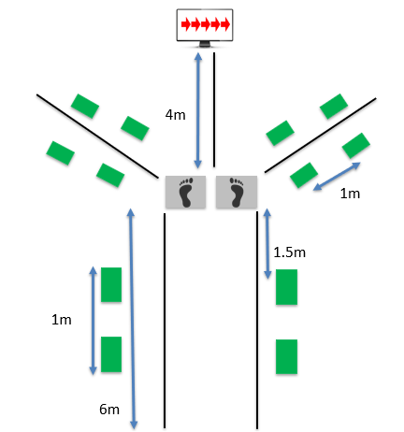
Figure 1. Testing set-up.



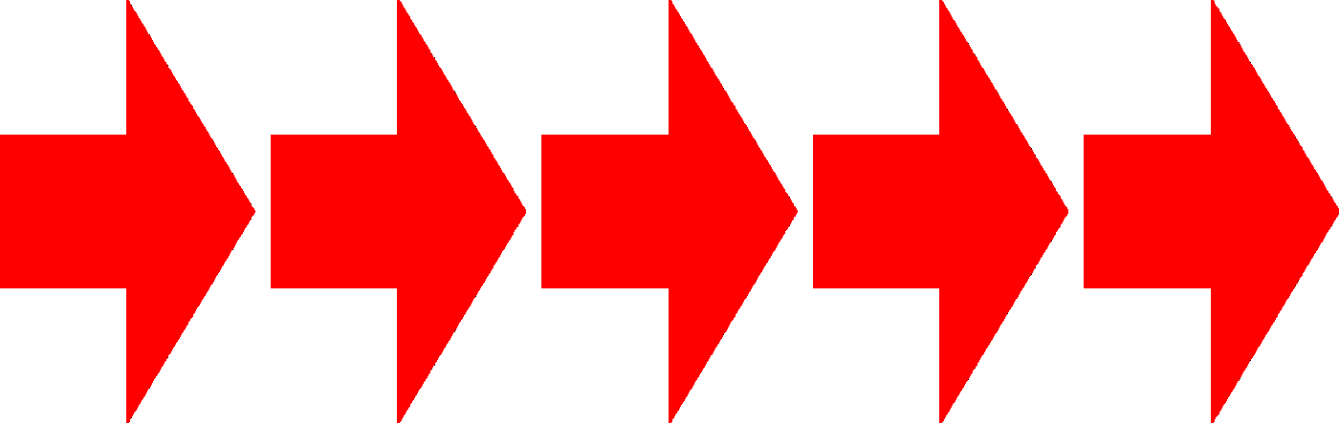

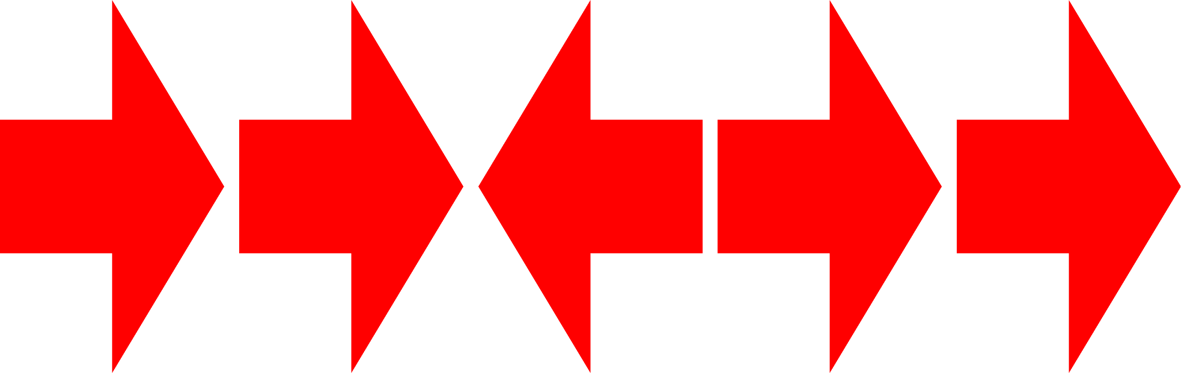

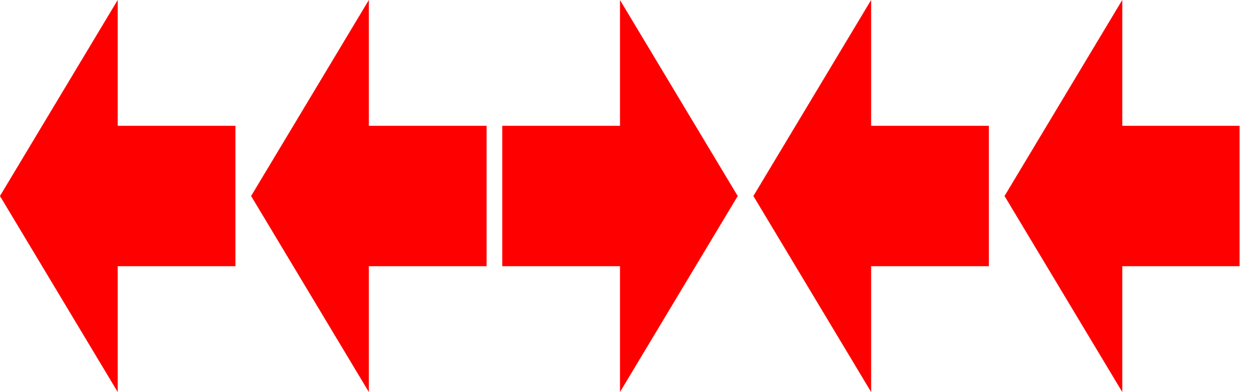

Figure 2. The visual stimulus that was displayed on the monitor. The arrows all pointing towards the same direction were the low cognitive demand. The arrows with the center arrow pointing in the opposite direction of the flanking arrows were used for the high cognitive demand.

Figure 3. Kinematic Ensemble curves. Comparison of the knee kinematics between the four different testing conditions from initial contact to final push off from the force platform.

Figure 4. Kinetic ensemble curve. Comparison of the knee between the four different testing conditions from initial contact to final push off from the force platform. Positive is indicative of an external knee abduction moment.

Appendix C: Informed Consent
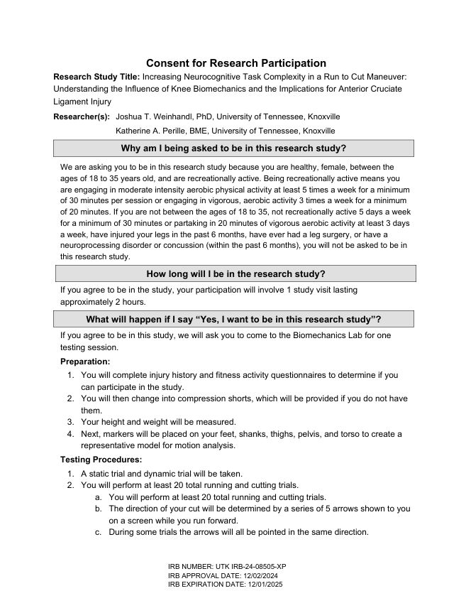
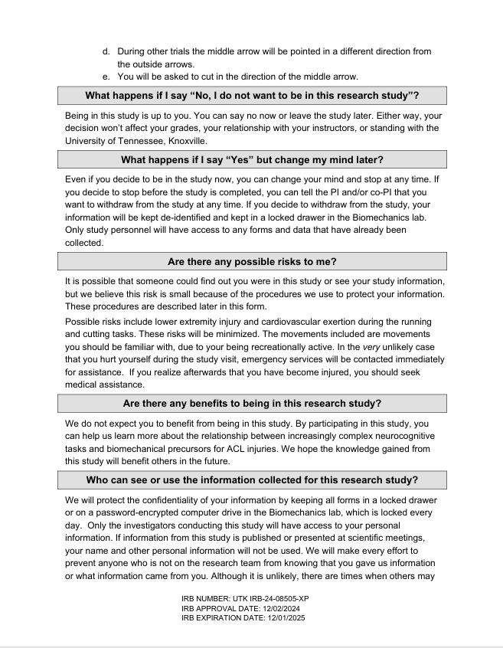
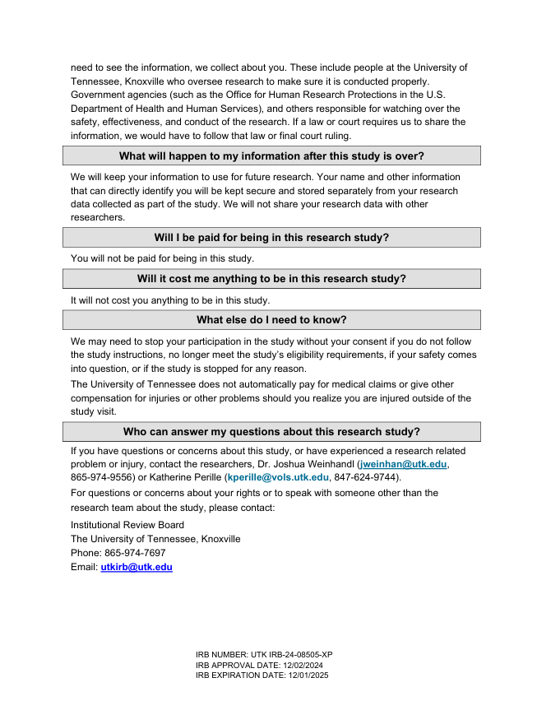
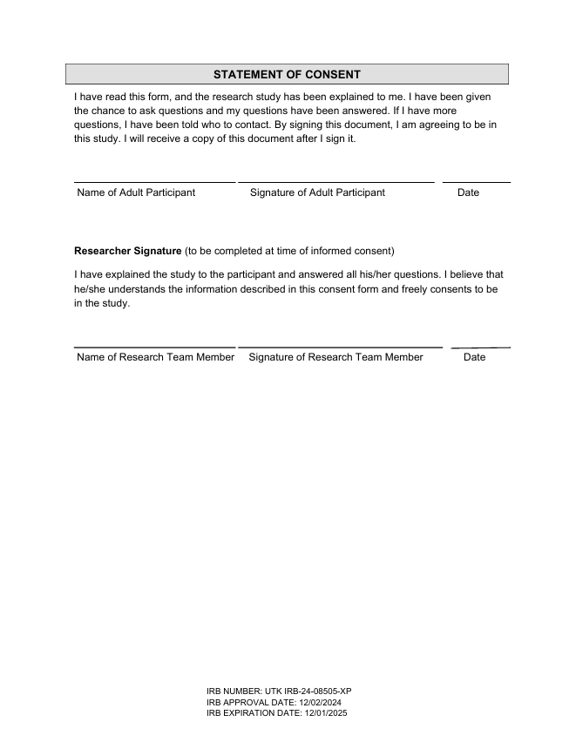

Appendix D: Lower Extremity Functional Scale


Appendix E: Fitness Activity Questionnaire
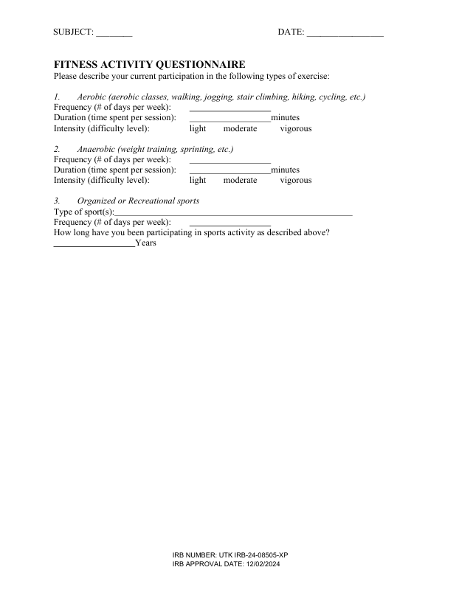

Appendix F: Musculoskeletal Injury History Questionnaire
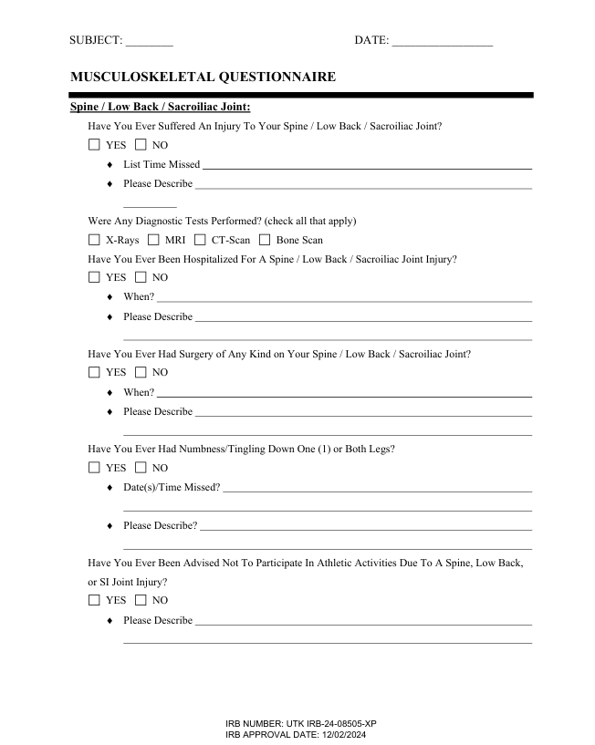
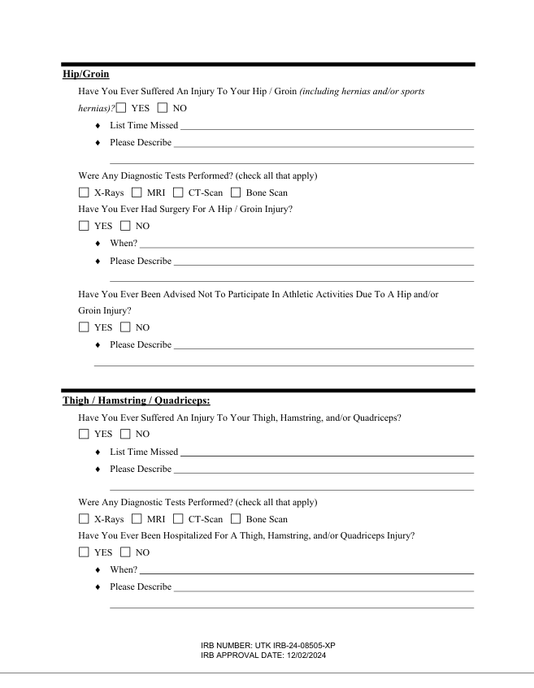


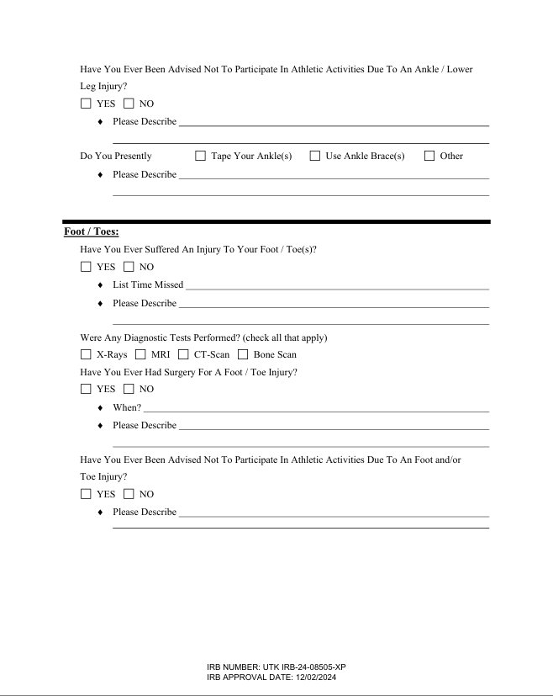

Appendix G: IRB Approval Letter
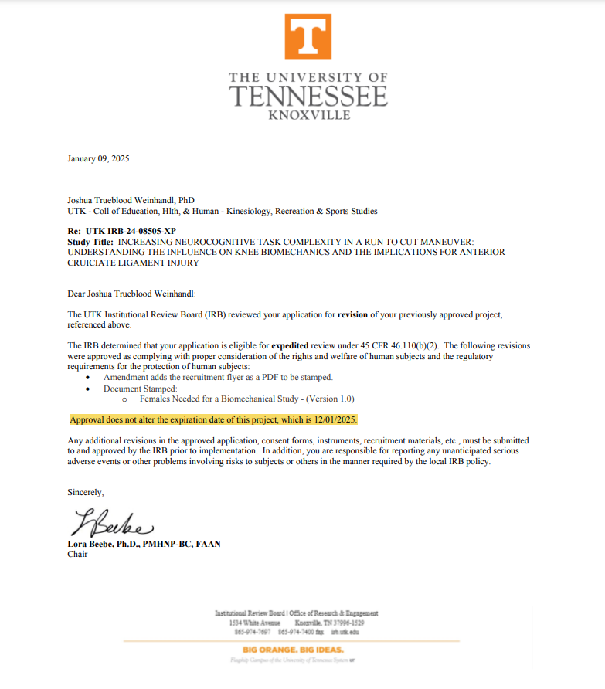

Appendix H: Individual Results for Select Variables
Table 4. Individual Participant Demographics.
Participant | Height (m) | Mass (kg) | Age (yrs) | LEFS | Kicking Leg
1 | 1.7 | 64.9 | 25 | 80 | R
2 | 1.6 | 67.8 | 23 | 77 | R
3 | 1.68 | 68.2 | 19 | 80 | R
4 | 1.7 | 62.4 | 18 | 80 | R
5 | 1.8 | 90 | 27 | 80 | R
6 | 1.63 | 61.2 | 21 | 80 | R
7 | 1.7 | 55.8 | 26 | 80 | R
8 | 1.65 | 60.37 | 22 | 74 | R
9 | 1.65 | 61.1 | 19 | 76 | R
10 | 1.63 | 70.36 | 23 | 76 | R
11 | 1.5 | 51.4 | 22 | 80 | R
12 | 1.63 | 63.5 | 23 | 80 | R
13 | 1.63 | 54.6 | 24 | 80 | R
14 | 1.68 | 59.04 | 20 | 78 | R
15 | 1.65 | 62.5 | 29 | 80 | R
16 | 1.73 | 74.6 | 22 | 80 | R

Table 5. Individual IC Knee Flexion Angles (°)
 | Left |  | Right
Participant | Low Demand | High Demand | Low Demand | High Demand
1 | -48.46 ± 8.56 | -43.78 ± 6.98 | -58.08 ± 7.23 | -69.57 ± 14.52
2 | -35.46 ± 7.87 | -37.97 ± 7.83 | -35.91 ± 26.44 | -35.26 ± 37.88
3 | -38.58 ± 6.00 | -38.41 ± 10.73 | -31.29 ± 10.09 | -46.52 ± 6.95
4 | -52.56 ± 4.22 | -71.12 ± 20.23 | -48.11 ± 5.28 | -56.56 ± 15.44
5 | -29.62 ± 3.46 | -33.31 ± 7.62 | -12.11 ± 4.05 | -26.00 ± 6.58
6 | -30.73 ± 4.18 | -27.11 ± 1.11 | -34.70 ± 5.33 | -32.00 ± 12.11
7 | -47.16 ± 18.09 | -53.64 ± 17.02 | -56.77 ± 8.17 | -60.15 ± 7.32
8 | -34.30 ± 4.96 | -32.46 ± 7.77 | -53.58 ± 11.38 | -36.45 ± 15.43
9 | -33.36 ± 12.85 | -38.27 ± 12.47 | -30.41 ± 8.53 | -43.40 ± 10.71
10 | -34.04 ± 12.85 | -27.10 ± 13.73 | -32.64 ± 6.20 | -32.21 ± 4.12
11 | -34.18 ± 17.44 | -45.84 ± 25.76 | -36.8 ± 22.62 | -28.85 ± 6.90
12 | -39.53 ± 21.41 | -36.03 ± 13.32 | -32.41 ± 7.01 | -33.52 ± 6.16
13 | -64.92 ± 18.41 | -50.81 ± 18.96 | -26.01 ± 18.46 | -35.94 ± 15.58
14 | -22.11 ± 13.85 | -17.67 ± 7.67 | -20.33 ± 9.69 | -23.85 ± 4.51
15 | -24.77 ± 6.15 | -31.66 ± 10.92 | -15.05 ± 6.51 | -23.38 ± 10.64
16 | -36.06 ± 10.31 | -41.59 ± 15.27 | -27.58 ± 7.23 | -29.13 ± 3.84

Table 6. Individual IC Knee Abduction Angles (°) (Abd (-), Add(+))
 | Left |  | Right
Participant | Low Demand | High Demand | Low Demand | High Demand
1 | -2.99 ± 1.74 | 1.46 ± 5.45 | -0.71 ± 2.75 | 0.46 ± 1.63
2 | 0.03 ± 2.29 | -1.73 ± 1.83 | -3.03 ± 5.96 | -0.26 ± 7.04
3 | -10.92 ± 1.56 | -10.21 ± 3.91 | -7.24 ± 4.03 | -8.96 ± 4.02
4 | -9.75 ± 2.40 | -12.90 ± 2.18 | -12.15 ± 1.46 | -14.99 ± 4.24
5 | -11.91 ± 1.60 | -11.89 ± 4.51 | -9.98 ± 1.60 | -13.57 ± 6.00
6 | 0.32 ± 1.32 | -1.89 ± 2.13 | -3.58 ± 1.83 | -4.55 ± 2.31
7 | -1.09 ± 1.80 | -1.90 ± 1.86 | -9.17 ± 1.44 | -8.83 ± 1.50
8 | 0.81 ± 0.61 | -0.65 ± 4.80 | 3.82 ± 2.16 | 2.08 ± 3.04
9 | -4.88 ± 3.39 | -5.84 ± 4.08 | -9.54 ± 4.09 | -10.00 ± 3.08
10 | -6.33 ± 0.99 | -7.98 ± 3.00 | -3.28 ± 2.86 | -2.31 ± 1.98
11 | -2.18 ± 2.30 | -3.13 ± 1.10 | 4.46 ± 1.19 | 3.24 ± 1.51
12 | -0.11 ± 1.10 | 0.11 ± 0.86 | 0.44 ± 2.27 | -0.27 ± 1.34
13 | -5.74 ± 3.21 | -7.43 ± 2.34 | -7.20 ± 3.41 | -9.90 ± 3.07
14 | -2.84 ± 3.27 | -2.48 ± 3.35 | -0.84 ± 1.95 | -1.10 ± 2.46
15 | -2.40 ± 1.99 | -4.77 ± 2.59 | -2.34 ± 1.71 | -2.39 ± 1.59
16 | -11.48 ± 3.04 | -12.71 ± 4.80 | -13.27 ± 2.04 | -13.53 ± 1.79

Table 7. Individual Peak Knee Flexion Angles (°)
 | Left |  | Right
Participant | Low Demand | High Demand | Low Demand | High Demand
1 | -61.45 ± 1.84 | -66.66 ± 5.43 | -62.43 ± 5.86 | -68.10 ± 6.65
2 | -57.38 ± 5.09 | -57.71 ± 1.88 | -57.49 ± 6.69 | -63.03 ± 4.38
3 | -57.31 ± 1.44 | -63.59 ± 3.86 | -48.53 ± 0.79 | -49.18 ± 6.91
4 | -55.75 ± 2.59 | -62.85 ± 6.08 | -49.96 ± 5.72 | -54.37 ± 2.72
5 | -45.44 ± 4.61 | -48.67 ± 3.46 | -43.82 ± 2.86 | -45.92 ± 2.37
6 | -52.54 ± 3.43 | -53.13 ± 1.11 | -54.57 ± 3.05 | -51.95 ± 4.04
7 | -62.90 ± 4.59 | -67.39 ± 12.82 | -61.13 ± 4.01 | -70.94 ± 8.08
8 | -49.96 ± 1.62 | -50.41 ± 4.35 | -56.92 ± 8.02 | -54.66 ± 1.33
9 | -55.55 ± 6.70 | -56.30 ± 5.39 | -56.50 ± 3.04 | -58.95 ± 6.19
10 | -42.66 ± 6.99 | -46.41 ± 7.59 | -51.86 ± 6.77 | -50.77 ± 4.86
11 | -48.82 ± 6.90 | -61.48 ± 2.49 | -52.05 ± 2.93 | -59.14 ± 0.98
12 | -60.23 ± 6.85 | -62.27 ± 3.54 | -52.88 ± 2.70 | -55.74 ± 3.01
13 | -50.44 ± 9.75 | -53.44 ± 5.87 | -47.19 ± 5.39 | -46.73 ± 5.94
14 | -58.87 ± 3.06 | -54.50 ± 4.63 | -49.85 ± 3.31 | -55.76 ± 7.19
15 | -44.12 ± 2.45 | -48.40 ± 6.45 | -34.16 ± 3.48 | -38.87 ± 0.57
16 | -50.92 ± 1.49 | -49.51 ± 4.56 | -52.59 ± 4.09 | -52.31 ± 3.60

Table 8. Individual Peak Knee Abduction Angles (°)
 | Left |  | Right
Participant | Low Demand | High Demand | Low Demand | High Demand
1 | -8.46 ± 1.78 | -5.00 ± 2.92 | -3.90 ± 3.91 | -4.94 ± 3.23
2 | -5.51 ± 4.13 | -6.90 ± 1.56 | -8.30 ± 4.96 | -7.47 ± 6.88
3 | -17.97 ± 2.84 | -17.96 ± 4.93 | -14.19 ± 3.14 | -13.56 ± 5.24
4 | -14.92 ± 2.23 | -16.77 ± 1.74 | -15.79 ± 1.63 | -19.74 ± 2.16
5 | -14.46 ± 2.34 | -15.96 ± 0.94 | -20.70 ± 3.71 | -20.11 ± 5.92
6 | -4.33 ± 3.03 | -5.44 ± 1.32 | -5.46 ± 2.03 | -6.38 ± 1.83
7 | -4.43 ± 1.76 | -3.75 ± 1.15 | -10.76 ± 1.69 | -11.39 ± 3.62
8 | -1.32 ± 0.75 | -4.58 ± 3.06 | -2.48 ± 1.69 | -3.80 ± 2.40
9 | -13.60 ± 2.31 | -14.66 ± 3.53 | -12.68 ± 4.26 | -13.52 ± 5.07
10 | -9.61 ± 1.20 | -8.99 ± 2.08 | -5.16 ± 3.59 | -4.13 ± 2.55
11 | -5.43 ± 1.97 | -4.08 ± 1.63 | 3.02 ± 1.82 | 1.84 ± 1.84
12 | -1.28 ± 2.26 | -0.84 ± 1.13 | -1.90 ± 1.62 | -1.70 ± 1.79
13 | -3.54 ± 3.58 | -14.98 ± 70 | -14.61 ± 1.34 | -17.08 ± 1.93
14 | -5.01 ± 3.82 | -5.36 ± 1.88 | -1.18 ± 2.11 | -4.59 ± 3.20
15 | -2.75 ± 0.44 | -6.01 ± 3.63 | -2.89 ± 1.33 | -2.59 ± 2.08
16 | -15.84 ± 2.87 | -17.67 ± 2.55 | -14.21 ± 4.45 | -17.20 ± 5.18

Table 9. Center of Mass Displacement (m)
 | Left |  | Right
Participant | Low Demand | High Demand | Low Demand | High Demand
1 | 0.32 ± 0.01 | 0.27 ± 0.09 | 0.28 ± 0.04 | 0.28 ± 0.06
2 | 0.22 ± 0.03 | 0.22 ± 0.07 | 0.31 ± 0.02 | 0.27 ± 0.03
3 | 0.24 ± 0.04 | 0.21 ± 0.07 | 0.14 ± 0.05 | 0.12 ± 0.07
4 | 0.32 ± 0.06 | 0.24 ± 0.07 | 0.27 ± 0.04 | 0.25 ± 0.12
5 | 0.33 ± 0.01 | 0.29 ± 0.03 | 0.28 ± 0.09 | 0.27 ± 0.04
6 | 0.23 ± 0.02 | 0.21 ± 0.03 | 0.33 ± 0.02 | 0.29 ± 0.02
7 | 0.27 ± 0.01 | 0.26 ± 0.06 | 0.27 ± 0.08 | 0.09 ± 0.13
8 | 0.45 ± 0.02 | 0.45 ± 0.15 | 0.49 ± 0.02 | 0.21 ± 0.05
9 | 0.35 ± 0.01 | 0.29 ± 0.03 | 0.28 ± 0.02 | 0.29 ± 0.06
10 | 0.34 ± 0.04 | 0.24 ± 0.12 | 0.25 ± 0.05 | 0.28 ± 0.03
11 | 0.33 ± 0.04 | 0.34 ± 0.06 | 0.33 ± 0.04 | 0.29 ± 0.05
12 | 0.36 ± 0.05 | 0.38 ± 0.1 | 0.31 ± 0.02 | 0.28 ± 0.06
13 | 0.33 ± 0.04 | 0.14 ± 0.12 | 0.21 ± 0.14 | 0.25 ± 0.07
14 | 0.29 ± 0.09 | 0.34 ± 0.07 | 0.23 ± 0.02 | 0.24 ± 0.07
15 | 0.26 ± 0.04 | 0.22 ± 0.01 | 0.26 ± 0.02 | 0.21 ± 0.06
16 | 0.31 ± 0.03 | 0.25 ± 0.08 | 0.25 ± 0.06 | 0.22 ± 0.04

Table 10. Peak External Knee Abduction Moment (Nm/kg)
 | Left |  | Right
Participant | Low Demand | High Demand | Low Demand | High Demand
1 | 0.20 ± 0.11 | 0.09 ± 0.08 | 0.21 ± 0.24 | 0.18 ± 0.16
2 | 0.28 ± 0.09 | 0.22 ± 0.21 | 0.42 ± 0.21 | 0.39 ± 0.26
3 | 0.35 ± 0.17 | 0.37 ± 0.21 | 0.49 ± 0.13 | 0.47 ± 0.17
4 | 0.37 ± 0.19 | 0.40 ± 0.08 | 0.36 ± 0.13 | 0.44 ± 0.19
5 | 0.46 ± 0.15 | 0.47 ± 0.16 | 0.72 ± 0.15 | 0.74 ± 0.15
6 | 0.33 ± 0.19 | 0.44 ± 0.19 | 0.33 ± 0.12 | 0.34 ± 0.25
7 | 0.19 ± 0.06 | 0.23 ± 0.15 | 0.69 ± 0.34 | 0.76 ± 0.20
8 | 0.05 ± 0.08 | 0.09 ± 0.06 | 0.20 ± 0.04 | 0.07 ± 0.05
9 | 0.23 ± 0.12 | 0.26 ± 0.10 | 0.90 ± 0.23 | 0.50 ± 0.19
10 | 0.29 ± 0.07 | 0.06 ± 0.13 | 0.12 ± 0.13 | 0.36 ± 0.29
11 | 0.15 ± 0.14 | 0.27 ± 0.04 | 0.25 ± 0.18 | 0.21 ± 0.15
12 | 0.06 ± 0.20 | 0.15 ± 0.01 | 0.34 ± 0.14 | 0.34 ± 0.15
13 | 0.34 ± 0.04 | 0.42 ± 0.09 | 0.50 ± 0.22 | 0.64 ± 0.06
14 | 0.14 ± 0.06 | 0.08 ± 0.12 | 0.30 ± 0.19 | 0.32 ± 0.16
15 | 0.17 ± 0.02 | 0.06 ± 0.15 | 0.47 ± 0.22 | 0.21 ± 0.12
16 | 0.45 ± 0.11 | 0.52 ± 0.24 | 0.61 ± 0.33 | 0.66 ± 0.26

Table 11. Average Entrance Velocities (m/s)
 | Left |  | Right
Participant | Low Demand | High Demand | Low Demand | High Demand
1 | 3.45 ± 0.12 | 3.38 ± 0.11 | 3.49 ± 0.06 | 3.41 ± 0.09
2 | 3.60 ± 0.13 | 3.56 ± 0.06 | 3.60 ± 0.16 | 3.66 ± 0.10
3 | 3.69 ± 0.05 | 3.70 ± 0.04 | 3.56 ± 0.18 | 3.58 ± 0.13
4 | 3.36 ± 0.06 | 3.37 ± 0.10 | 3.35 ± 0.06 | 3.42 ± 0.08
5 | 3.62 ± 0.07 | 3.67 ± 0.13 | 3.52 ± 0.19 | 3.59 ± 0.07
6 | 3.41 ± 0.06 | 3.46 ± 0.13 | 3.45 ± 0.08 | 3.54 ± 0.17
7 | 3.55 ± 0.17 | 3.61 ± 0.17 | 3.34 ± 0.10 | 3.46 ± 0.16
8 | 3.47 ± 0.18 | 3.37 ± 0.19 | 3.43 ± 0.09 | 3.38 ± 0.15
9 | 3.72 ± 0.01 | 3.65 ± 0.08 | 3.57 ± 0.16 | 3.46 ± 0.18
10 | 3.54 ± 0.22 | 3.47 ± 0.12 | 3.69 ± 0.07 | 3.59 ± 0.18
11 | 3.69 ± 0.04 | 3.60 ± 0.20 | 3.61 ± 0.07 | 3.64 ± 0.10
12 | 3.63 ± 0.13 | 3.68 ± 0.11 | 3.73 ± 0.02 | 3.70 ± 0.07
13 | 3.63 ± 0.13 | 3.52 ± 0.13 | 3.57 ± 0.19 | 3.63 ± 0.17
14 | 3.37 ± 0.13 | 3.36 ± 0.04 | 3.42 ± 0.11 | 3.41 ± 0.13
15 | 3.62 ± 0.19 | 3.59 ± 0.14 | 3.71 ± 0.02 | 3.60 ± 0.19
16 | 3.62 ± 0.11 | 3.57 ± 0.21 | 3.61 ± 0.14 | 3.52 ± 0.22

Table 12. Average Exit Velocities (m/s)
 | Left |  | Right
Participant | Low Demand | High Demand | Low Demand | High Demand
1 | 3.70 ± 0.00 | 3.53 ± 0.14 | 3.68 ± 0.05 | 3.50 ± 0.16
2 | 3.40 ± 0.11 | 3.38 ± 0.06 | 3.62 ± 0.15 | 3.72 ± 0.03
3 | 3.50 ± 0.11 | 3.55 ± 0.19 | 3.64 ± 0.13 | 3.64 ± 0.13
4 | 3.59 ± 0.18 | 3.41 ± 0.17 | 3.46 ± 0.19 | 3.49 ± 0.21
5 | 3.48 ± 0.20 | 3.43 ± 0.16 | 3.41 ± 0.17 | 3.41 ± 0.17
6 | 3.48 ± 0.16 | 3.33 ± 0.00 | 3.48 ± 0.20 | 3.41 ± 0.17
7 | 3.43 ± 0.19 | 3.36 ± 0.05 | 3.45 ± 0.17 | 3.41 ± 0.17
8 | 3.41 ± 0.17 | 3.48 ± 0.06 | 3.43 ± 0.19 | 3.33 ± 0.00
9 | 3.41 ± 0.17 | 3.38 ± 0.06 | 3.63 ± 0.11 | 3.46 ± 0.17
10 | 3.41 ± 0.17 | 3.33 ± 0.00 | 3.33 ± 0.00 | 3.40 ± 0.11
11 | 3.36 ± 0.05 | 3.36 ± 0.05 | 3.33 ± 0.00 | 3.38 ± 0.06
12 | 3.36 ± 0.05 | 3.43 ± 0.10 | 3.43 ± 0.16 | 3.65 ± 0.11
13 | 3.54 ± 0.15 | 3.47 ± 0.10 | 3.70 ± 0.00 | 3.50 ± 0.19
14 | 3.36 ± 0.05 | 3.58 ± 0.13 | 3.50 ± 0.14 | 3.46 ± 0.17
15 | 3.39 ± 0.12 | 3.36 ± 0.05 | 3.38 ± 0.11 | 3.33 ± 0.00
16 | 3.58 ± 0.13 | 3.50 ± 0.16 | 3.50 ± 0.11 | 3.38 ± 0.11

Table 13. COM-COP Distance at Heel Strike (m)

 | Left |  | Right
Participant | Low Demand | High Demand | Low Demand | High Demand
1 | 0.34 ± 0.02 | 0.33 ± 0.03 | 0.29 ± 0.03 | 0.31 ± 0.02
2 | 0.34 ± 0.04 | 0.35 ± 0.02 | 0.39 ± 0.04 | 0.30 ± 0.02
3 | 0.28 ± 0.04 | 0.25 ± 0.04 | 0.42 ± 0.05 | 0.36 ± 0.06
4 | 0.33 ± 0.04 | 0.27 ± 0.09 | 0.32 ± 0.04 | 0.30 ± 0.04
5 | 0.28 ± 0.02 | 0.29 ± 0.05 | 0.27 ± 0.05 | 0.32 ± 0.01
6 | 0.34 ± 0.01 | 0.35 ± 0.03 | 0.34 ± 0.02 | 0.35 ± 0.02
7 | 0.34 ± 0.04 | 0.36 ± 0.04 | 0.36 ± 0.01 | 0.33 ± 0.06
8 | 0.19 ± 0.03 | 0.23 ± 0.03 | 0.15 ± 0.04 | 0.25 ± 0.08
9 | 0.25 ± 0.05 | 0.28 ± 0.04 | 0.33 ± 0.01 | 0.27 ± 0.03
10 | 0.21 ± 0.04 | 0.26 ± 0.05 | 0.29 ± 0.05 | 0.34 ± 0.06
11 | 0.23 ± 0.02 | 0.06 ± 0.19 | 0.11 ± 0.14 | 0.21 ± 0.05
12 | 0.16 ± 0.13 | 0.16 ± 0.05 | 0.33 ± 0.02 | 0.34 ± 0.02
13 | 0.04 ± 0.01 | 0.05 ± 0.11 | 0.21 ± 0.12 | 0.24 ± 0.17
14 | 0.21 ± 0.03 | 0.20 ± 0.07 | 0.28 ± 0.02 | 0.30 ± 0.06
15 | 0.30 ± 0.02 | 0.29 ± 0.03 | 0.31 ± 0.02 | 0.33 ± 0.04
16 | 0.32 ± 0.03 | 0.37 ± 0.02 | 0.37 ± 0.02 | 0.38 ± 0.03

Table 14. Time in Stance Phase (s)

 | Left |  | Right
Participant | Low Demand | High Demand | Low Demand | High Demand
1 | 0.32 ± 0.02 | 0.38 ± 0.04 | 0.29 ± 0.03 | 0.33 ± 0.07
2 | 0.33 ± 0.01 | 0.36 ± 0.03 | 0.29 ± 0.02 | 0.36 ± 0.00
3 | 0.32 ± 0.01 | 0.38 ± 0.07 | 0.30 ± 0.02 | 0.31 ± 0.05
4 | 0.32 ± 0.02 | 0.35 ± 0.02 | 0.31 ± 0.03 | 0.34 ± 0.06
5 | 0.32 ± 0.03 | 0.34 ± 0.05 | 0.36 ± 0.04 | 0.38 ± 0.03
6 | 0.28 ± 0.02 | 0.30 ± 0.01 | 0.26 ± 0.01 | 0.26 ± 0.02
7 | 0.29 ± 0.03 | 0.29 ± 0.07 | 0.29 ± 0.02 | 0.31 ± 0.10
8 | 0.30 ± 0.02 | 0.41 ± 0.15 | 0.33 ± 0.06 | 0.36 ± 0.05
9 | 0.31 ± 0.05 | 0.32 ± 0.05 | 0.33 ± 0.04 | 0.37 ± 0.03
10 | 0.25 ± 0.02 | 0.30 ± 0.04 | 0.31 ± 0.03 | 0.31 ± 0.04
11 | 0.27 ± 0.04 | 0.37 ± 0.04 | 0.35 ± 0.04 | 0.38 ± 0.04
12 | 0.42 ± 0.03 | 0.47 ± 0.04 | 0.35 ± 0.03 | 0.41 ± 0.02
13 | 0.21 ± 0.12 | 0.47 ± 0.14 | 0.27 ± 0.11 | 0.33 ± 0.05
14 | 0.37 ± 0.04 | 0.41 ± 0.04 | 0.33 ± 0.02 | 0.42 ± 0.08
15 | 0.28 ± 0.02 | 0.3 ± 0.04 | 0.29 ± 0.02 | 0.31 ± 0.04
16 | 0.29 ± 0.02 | 0.30 ± 0.02 | 0.34 ± 0.07 | 0.35 ± 0.03

Vita
Katherine Perille was born in Arlington Heights, Illinois in 1998 to Steve and Tamara Perille. Katherine graduated from Rolling Meadows High School in 2017. She graduated from the University of Dayton in 2022 with a bachelor’s degree in mechanical engineering with a minor in human movement biomechanics. Throughout her undergrad, she was involved in various honors societies: National Collegiate Scholars, Tau Beta Pi Engineering Honor Society, and Pi Tau Sigma Engineering Society. Post undergraduate, she completed a M.S. in kinesiology with a concentration in biomechanics at the University of Tennessee, Knoxville in Spring 2025. She was recognized within the National Society of Leadership and Success. She will begin her professional career following graduation.

