Lithium-Aluminum Layered Double Hydroxide Chlorides: Structural and Thermodynamic Studies to Understand Dynamics, Functionality, and Applications in Lithium Adsorption

A Dissertation Presented for the
Doctor of Philosophy
Degree
The University of Tennessee, Knoxville

Sam Frederick Evans
August 2020

Copyright © 2020 by Sam Frederick Evans
All rights reserved.

ACKNOWLEDGEMENTS
I’d first like to thank my advisor Parans Paranthaman for giving me another chance at a Ph.D. His guidance and insatiable curiosity gave me the space not only to explore what is presented in this dissertation but over many areas and disciplines. Getting to this moment since I started graduate school in 2015 has been one of the most difficult and challenging times of my life but has changed and made me into a person that I will never regret becoming.
Many thanks to Dr. Suresh Babu, Dr. Claus Daniel, and Dr. Sheng Dai for their support as committee members and their thoughts on my dissertation. You all have broadened my mind and keep me questioning the limits of my own knowledge.
I’d like to thank my lab coworkers and mates from over the years. Dr. Craig Bridges, Dr. Tolga Aytug, Dr. Ling Li, Dr. Yunchao Li, Dr. Charl Jafta, Dr. Tej Lamichhane and many, many others who I have had the privilege to work, collaborate, share thoughts, and experience my Ph.D. with. Thanks to the interns that made their way through our labs during my time. I’ve always loved the curiosity, and renewed interest in my research that came from teaching and working with all of you, especially Marko, Yuniba, Ben, and Tessa.
There have been so many wonderful, brilliant, fun, and life-changing people I’ve met over the years on this journey. I have so many memories and stories from our times together, and of course I can’t recount them all here but just know I will always cherish the times we spent together. In particular I’d like to thank Santi, Claudia, Abe, Wes, Eric Muckley and Zach Hood for being there good times or bad. Also, thanks to my friends back in Charleston for always welcoming me back and making me feel like I never left home. Graham, Stephen, David, Evan, Christian and Zach Messick, thanks.
Finally, I must thank my family and partner. For the longest time growing up I never understood how amazing my parents were and why everyone always wanted to come to our home. As I’ve been away and growing up, I’ve realized that you are the greatest people I know. Unfailingly there to support, talk, and just being fun loving people to be around. I aspire to be like you. Thank you to my sister Reilly, I feel like we have both gone through life-shaping experiences together at the same time. You have always been there for me and I will always be there for you. I have to mention some companions that helped me along the way too: JoJo, Stormy, and Milli. And I especially have to thank my partner Sam, who has helped me grow, persevere, and love as I close this chapter in my life and start the next with her.
ABSTRACT
The invention of the Lithium-ion battery (LIB) has been a panacea for the development and adoption of renewable energy technologies, mobile energy storage, and electrified transportation. While LIBs have made an electrified future possible, questions have risen about the inherent “greenness” of the technology. Multiple precursor materials of LIBs are detrimental to the environment due to their production from conventional mining. This inherently contradicts the message of renewable technologies and electrification, where they are the substitute for polluting and climate altering fossil fuel industries. Without the development of sustainable and environmentally friendly processes of material extraction the “green revolution” will remove one harmful industry for another.
A promising material, lithium aluminum layered double hydroxide chlorides (LDH), has been found that offers a better way to extract the precursor material lithium. To bring this material to commercial scale use and replace other detrimental methods fundamental details about the material must be determined. Characterization of the material was performed via X-ray diffraction, Fourier Transform-Infrared spectroscopy, Thermogravimetric analysis, Differential Scanning Calorimetry, and neutron scattering. Testing of the material for lithium adsorption was performed at laboratory batch scale and column scale with analysis performed by Inductively Coupled Plasma-Optical Emission Spectrometry.
The combination of synthetic development, advanced characterization techniques, and systematic adsorption studies has allowed for the development of an environmentally friendly, cheap, and effective lithium ion adsorption material.

Table of Contents

Chapter 1: Introduction 1
1.1 Research Background 2
1.2 Objective 2
Chapter 2: Overview of Lithium Resources, and Supply Chain 4
2.1 Overview of Lithium 5
2.2 Existing Extraction Methods and Supply Chains 7
2.3 Alternative Sources 12
Chapter 3: Sorbents and Other Materials for Lithium Extraction 14
3.1 Hydrogen-Lithium Ion Exchange Materials 15
3.2 Lithium-Aluminum Layered Double Hydroxide Chlorides (LDH) 19
3.3 Other Methods of Lithium Ion Extraction 21
Chapter 4: Experimental and Characterization Techniques 23
4.1 Material Property Characterizations 24
4.1.1 X-ray Powder Diffraction 24
4.1.2 Fourier-transform Infrared Spectroscopy 25
4.1.3 Thermogravimetric Analysis/Differential Scanning Calorimetry 26
4.1.4 Acid Solution Calorimetry Measurements 27
4.1.5 Inelastic Neutron Scattering and Quasielastic Neutron Scattering 28
4.2 Lithium Adsorption Testing 30
4.2.1 Simulated Brine 30
4.2.2 Batch Scale 31
4.2.3 Column Scale 32
4.2.4 Inductively Coupled Plasma-Optical Emission Spectroscopy 33
Chapter 5: Thermodynamic effects of Lithium Chloride and Water Content on LDH 35
Abstract 36
5.1 Introduction 37
5.2 Sample Preparation 41
5.3 Characterization of LDH 44
5.4 Summary 57
Chapter 6: Neutron Vibrational Spectroscopy and Quasielastic Scattering of LDH 58
Abstract 59
6.1 Introduction 60
6.2 Experimental 65
6.3 Results and Discussion 68
6.4 Summary 79
Chapter 7: Iron-Doped Varients of LDH 80
Abstract 81
7.1 Introduction 82
7.2 Experimental 83
7.3 Results and Discussion 89
7.4 Comparison to LDH 101
7.5 Summary 109
Chapter 8: Concluding Remarks and Future Research 110
References 113
Appendix 122
Publication List (S. F. Evans) 123
Patent Applications, Invention Disclosures and Technical Reports (S. F. Evans) 125
Vita 126

List of Tables
Table 2.1: Reserves of lithium by country.⁶ 7
Table 2.2: Resources of lithium by country.⁶ 8
Table 2.3: Distribution of resources of lithium (circa 2017).⁷ 11
Table 2.4: Percentage of lithium production by country (circa 2017).⁷ 11
Table 3.1: Lithium manganese oxide sorbents of differing composition and adsorption performance. 16
Table 3.2: Lithium titanate adsorption performance and testing conditions. 18
Table 4.1: Brine Composition of the Salton Sea.⁶⁰ 30
Table 5.1: Sample composition, TG weight loss at 700°C, enthalpy of solution (ΔH_{sol}) in 5N HCl and the formation enthalpies of LDH (ΔH_{f}) by LiCl reacted with gibbsite and goethite. 43
Table 5.2: Thermodynamic cycle used to calculate the reaction enthalpies of LDH from lithium chloride and Aluminum hydroxide at 25°C. 47
Table 5.3: Composition and formation enthalpy of the LDH samples in addition to starting materials used for formation enthalpy calculations. 49
Table 5.4: Carbon content present in sorbents. 56
Table 6.1: Composition and formation enthalpy of the LDH samples in addition to starting materials used for formation enthalpy calculations. 70
Table 7.1: Composition and formation enthalpy of the LDH samples in addition to starting materials used for formation enthalpy calculations. 85
Table 7.2: Thermodynamic cycle used to calculate the reaction enthalpies of LDH from lithium chloride and Aluminum hydroxide at 25°C. 92
Table 7.3: Sample composition, TG weight loss at 700°C, enthalpy of solution (ΔH_{sol}) in 5N HCl and the formation enthalpies of LDH (ΔH_{f}) by LiCl reacted with gibbsite and goethite. 93
Table 7.4: Metal-ion concentrations and separation factors during column extraction with Li-Al LDH. Derived from Figure 7.10. 104
Table 7.5: Metal-ion concentrations and separation factors during a column extraction with Fe-LDH. Derived from Figure 7.10. 104

List of Figures
Figure 2.1: Brine resources in the U.S. by concentration of lithium. 13
Figure 3.1: Different possible compositions of LDH materials following the general formula [M^{z+}_{1-x} M³⁺_{x}(OH)₂]^{x+}(X^{n-}_{x/n})· mH₂O. Where M^{z+} can be replaced with mono, di, tri, and tetravalent elements, and X can be a variety of anions or guest species.⁵¹ 20
Figure 4.1: Visual representation of the interaction that Bragg’s law describes. The reflection of incoming radiation and determination of interlayer space using the equation: 2dsinƟ = nλ.⁵⁹ 25
Figure 4.2: Unloading preparation and brine trail testing for LDH sorbents. 31
Figure 4.3: Schematic of column scale extraction setup. 33
Figure 4.4: High salt solution nebulizer and (b) sample input, vaporization, energization, and detection area into the plasma source. Used from Hou et al.⁶¹ 34
Figure 5.1: Crystal structure of Li Al₂(OH)₆Cl (Ref. ICDD Coll. Code: 83509). Li, Al, Cl, O, and H represented as purple, grey, green, red, and white respectively. Water molecules are not shown in this structure. 38
Figure 5.2: XRD spectra of typical Li-LDH and Fe-LDH phases. 44
Figure 5.3: DSC-TG curves for Li contained LDH with formula Li_{x}Al₂(OH)₆Cl_{x}∙nH₂O. 46
Figure 5.4: Enthalpy of formation for LDHs vs. moles LiCl (x). 48
Figure 5.5: XRD patterns of the LDH samples (both ambient and oven dried). Starting precursor and decomposition products, gibbsite and alumina, are shown. 50
Figure 5.6: DSC-TGA for (a) LDH-Al₂O₃-A (b) LDH-Al₂O₃-O (c) LDH-Al(OH)₃-A (d) LDH-Al(OH)₃ -O and (e) Fe-LDH-A. 52
Figure 5.7: Formation enthalpies of LDH (blue squares and orange circles) and Fe-LDH (green triangles) vs. water content. The trend line correlates LDH water content (both ambient and oven dried) to formation enthalpy. 54
Figure 5.8. Formation enthalpies of gibbsite (blue) and alumina (orange) LDH (both ambient and oven dried) vs. LiCl content. 54
Figure 5.9: ATR FT-IR of both ambient and oven dried LDH samples, (a) and (b) highlight the presence of different features between alumina and gibbsite-based LDH. 56
Figure 6.1: A structure model of Li_{x}·Al₂(OH)₆Cl_{x}·nH₂O (LDH) (blue in polyhedra: Al, orange in polyhedra: Li, bright green: Cl, red: O, light pink: H). Hydrogen bonds between the water molecules and the hydroxyl groups are shown by dashed lines. 62
Figure 6.2: INS spectra of LDH-Al₂O₃ (Ambient-dried (A) vs. Oven-dried (O)), as well as the difference between them. 69
Figure 6.2: INS spectra of LDH-Al(OH)₃ (Ambient-dried (A) vs. Oven-dried (O)). Since LDH-Al(OH)₃-Ambient-dried contains bulk water, solid ice contribution is removed by subtracting a scaled reference spectrum. 71
Figure 6.3: INS spectra of two O samples (LDH-Al₂O₃ vs. LDH-Al(OH)₃). 73
Figure 6.4: Simulated INS spectrum based on the structure in Fig. 6.1, in comparison to the measured one for LDH-Al(OH)₃-O. 74
Figure 6.5: QENS spectra of Al(OH)₃-LDH (blue), Al₂O₃-LDH (red) and Fe-LDH (green) measured at 20, 400 and 500 K. Left hand side has logarithmic y-axes scale to show the entire elastic peak, and the right hand side has linear y-axes scale that has been truncated to the bottom to illustrate the QE broadening of the spectra. 75
Figure 6.6: HWHM of the Lorentzian function fits to the QENS spectra of Al(OH)₃-LDH (red) and Al₂O₃-LDH (navy) at 400 (triangles) and at 500 K (circles). 76
Figure 6.7: SEM images of (a) (c) Al(OH)₃ LDH, and (b) (d) Al₂O₃ LDH. 78
Figure 7.1: XRD spectra of typical Li-LDH and Fe-LDH phases. 89
Figure 7.2: DSC-TG curves for Fe-doped LDH with formula Li_{x}Al_{2-y}Fe_{y}(OH)₆Cl_{x}∙nH₂O. 91
Figure 7.3: Enthalpy of formation for Fe-LDH vs. Fe doping level (y). 95
Figure 7.4: XRD patterns of the LDH samples (both ambient and oven dried). Starting precursor and decomposition products, gibbsite and alumina, are shown. Figure is as presented in Chapter 5. 96
Figure 7.5: DSC-TGA for (e) Fe-LDH-A. 97
Figure 7.6: Formation enthalpies of LDH (blue squares and orange circles) and Fe-LDH (green triangles) vs. water content. The trend line correlates LDH water content (both ambient and oven dried) to formation enthalpy. Figure is as presented in Chapter 6. 98
Figure 7.7: INS spectra of Fe-LDH samples (Ambient-dried (A) vs. Oven-dried (O)). 100
Figure 7.8: QENS spectra of Al(OH)₃-LDH (blue), Al₂O₃-LDH (red) and Fe-LDH (green) measured at 20, 400 and 500 K. Left hand side has logarithmic y-axes scale to show the entire elastic peak, and the right hand side has linear y-axes scale that has been truncated to the bottom to illustrate the QE broadening of the spectra. Figure is as presented in Chapter 6. 101
Figure 7.9: Adsorption isotherms of LDH and Fe-LDH over various concentrations of simulated brines. 102
Figure 7.10: Calculated ppm concentrations from ICP-OES of various ions from simulated brine. Tables 7.4 and 7.5 look through the change in concentrations of the bed volumes through adsorption, washing and stripping stages of Li-Al and Fe-doped LDH adsorption trials. 103
Figure 7.11: TEM images of (a) Al(OH)₃ LDH, (b) Al₂O₃ LDH, and (c) Fe-LDH. With labelled facets of (118), (006), and (003), respectively. 105
Figure 7.12: HAADF-STEM image of Fe distribution in Fe-LDH, white areas denote areas of increased electron density containing iron. 106
Figure 7.13: A structure model of Li_{x}·Fe_{y}Al_{(2-y)} (OH)₆Cl_{x}·nH₂O (Fe-LDH) (blue in M-OH layer: Al, green in M-OH layer: Li, Brown: Fe, bright green: Cl, red: O, light pink: H). Hydrogen bonds between the water molecules and the hydroxyl groups are shown by dashed lines. 108

Chapter 1: Introduction

1.1 Research Background

Since the invention of the lithium-ion battery (LIB) more and more applications in mobile applications, electric vehicles, and renewable energy have been found. While development of LIBs has been able to keep pace to energize these developments and push the green revolution forward there has been a lack of progress in the extraction of LIB precursor materials. Harmful extractive processes including mining and brine evaporation dominate the industry in the quest to feed the ever-growing demand of batteries. Many precursors to battery components including cobalt, nickel, manganese, graphite, copper, and lithium all are collected and process with environmentally detrimental effects. While this dissertation is not able to address all of these materials a greener method of lithium extraction is developed and discussed.

1.2 Objective

In this dissertation the focus falls on determining important properties of LDH that correlate with high lithium adsorption and stability. Using these findings as a guide, metal doped LDH materials are developed and tested for their efficacy in lithium adsorption applications.
Chapter 1 provides the motivation and objectives of the study. In Chapter 2, an overview of lithium resources and supply chains is discussed, including the history of lithium use, current estimates on resources and production, existing methods of extraction, and alternative lithium sources. Chapter 3 provides an overview of materials and technologies developed for alternative lithium sources including hydrogen-lithium exchange materials, lithium-aluminum layered double hydroxides, and other methods of extraction. Chapter 4 provides an overview of the characterization and testing methods used in the development of LDH sorbent materials. Chapter 5 explores the first thermodynamic characterization of LDH using a combination of thermogravimetric, differential scanning calorimetry, and acid drop calorimetry. These results give insight into the synthetic factors that make LDH an effective lithium-ion sorbent. Chapter 6 uses advanced neutron characterization techniques including inelastic neutron and quasielastic neutron scattering to determine the structural and chemical environment of LDH. Both of which have important implications of the nature of LDH selectivity towards lithium and the mechanism of transport through the material. Chapter 7 uses the same characterization techniques to investigate a metal doped variant of LDH and is effects on structure and dynamic environment as well as lithium adsorption and selectivity performance. The final chapter concludes the dissertation and proposes further work to bring LDH sorbent materials into commercial use.

Chapter 2: Overview of Lithium Resources, and Supply Chain

2.1 Overview of Lithium

The element lithium was first detected in 1817 by Johan August Arfwedson while analyzing a petalite ore (LiAlSi₄O₁₀). Isolation of the element was not successful until 1821 when William Thomas Brande separated the element via electrolysis of lithium oxide. The development of lithium separation via electrolysis of lithium chloride salts brought about commercial production in 1923 in Germany. Throughout the years since production began lithium has been through many varied uses and applications. The metallic looking material first found use as a high-temperature greases in aircraft as well as a soap and lubricant for mining applications. With the advent of nuclear fusion weapons lithium production skyrocketed to feed the United States’ production of tritium and solid fusion fuel. This new use made the US the primary producer of lithium until the mid-1980s. Another main use during this time was the use of lithium to decrease the melting temperature of glass and to improve the melting behavior of aluminum oxide for the Hall-Heroult process. Finally, moving into the 2000s, the lithium-ion battery was developed. Lightweight portable electronics soon came to dominate everyone’s lives and by 2007 li-ion battery production took the largest share of raw materials. Multiple companies have been working the past 20 year to meet this growing demand, opening new mines, and brine extraction locations to power the “green” transition of the world.
As the world marches onward towards a “green revolution” built on renewable energy sources (wind and solar power) there has been increasing need for batteries. The mobility of personal devices and electrification of transportation require this. In fact, without the connection of wind and solar for energy, electrified cars emit the same amount of emissions as an internal combustion engine vehicle.¹ Providing the raw materials for these devices and vehicles, in addition to offering variable electricity storage for grid resiliency means that batteries are required. Meeting this demand requires timely and consistent sources of lithium from the supply chain.
The U.S. Department of Energy (DOE) has identified lithium as a “near-critical” element, meaning that sources and supplies of this material face uncertainty in within 10 years, making it essential to US energy security.² To develop additional material supply chains, new technologies, and enable U.S. companies to reestablish critical material based businesses the Critical Materials Institute was launched by the DOE in 2013.

2.2 Existing Extraction Methods and Supply Chains

Currently, there are two existing methods of lithium production that make up the majority of the supply. Hard-rock mining is performed on lithium rich deposits found in a variety of mineral resources such as spodumene, different pegmatites, and petalite.³ A breakdown of lithium reserves (currently mineable) and resources (discovered sources) can be seen in Table 2.1 and 2.2, respectively. Many different methods are employed to extract the lithium species of these materials including roasting and leaching,^{3, 4} along with mechanical separations and froth flotation.⁵ The majority of material mined in this fashion is produced in Australia and China with most of the material processing occurring in China. As lithium demand expands with the growth of energy storage and electric vehicles more hard rock mines are expected to open in other countries and continue to grow in Australia and China.

Table 2.1: Reserves of lithium by country.⁶
Country | Reserves (in millions of tons)
Chile | 8.6
Australia | 2.8
Argentina | 1.7
Other | 1.1
China | 1
United States | 0.63
Canada | 0.370

Brine pool evaporation produces the second highest amount of lithium in comparison to hard-rock mining. In this process, high concentration lithium brines are pumped up from salar brine fields into large evaporation ponds. Over the course of 12 – 18 months impurities, such as Na⁺, K⁺, and Ca²⁺, are removed from the solution via concentrated and then precipitation. The final step producing lithium carbonate for battery use and others. These operations mainly occur in South America, within the “lithium triangle” of Chile, Argentina, and Bolivia. With Chile producing the most lithium raw materials of the three in the area.⁷ Additional brine lakes are also found in China and have seen expanded production as China has been diversifying its lithium sources. Importantly, Bolivia purportedly contains more than half of the worlds lithium reserves (exploration is ongoing but is estimated to be almost 140 million tons) but does not have large scale production due to nationalization of the industry in the country.
Table 2.2: Resources of lithium by country.⁶
Country | Resources (in millions of tons)
Bolivia | 21
Argentina | 17
Chile | 9
United States | 6.8
Australia | 6.3
China | 4.5
Congo | 3

One final method that is seeing burgeoning use is lithium-ion battery recycling. While this constitutes less than 1% of lithium materials it is beginning to show promise as technologies develop and material prices begin to rise.⁸ Currently, the costliest metals are recovered from the battery, including cobalt, manganese and nickel.^{7, 8} It is possible to recover lithium species from the battery in high purity, but this is not always cost effective depending on the spot price of lithium. Since lithium makes up 5-7% of the battery,⁹ recycling will become more viable as virgin lithium becomes more expensive to produce, recycling methods will continue to develop to fill in these gaps in supply.
The current outlook for the United States’ domestic supply is currently less than 1-2%. Closure of the Kings’ Mountain and Bessemer City hard rock spodumene mines in North Carolina removed the majority of the U.S. domestic supply capabilities. This was due to the establishment of low-cost brine evaporation in Argentina and Chile.¹⁰ As lithium prices continue to grow the possibility of reopening the mines may become possible.
The distribution of lithium resources by type and country can be seen in Table 2.3 and 2.4, respectively. Around half of lithium production comes from hard rock mining,⁷ this is due to the speed that concentrates can be mined, treated, and converted to their battery grade lithium compounds, lithium carbonate (Li₂CO₃) and lithium hydroxide (LiOH). While consistent and timely methods to treat and extract lithium compounds from the mineral concentrates require large amounts of energy and a variety of toxic and dangerous chemicals. Mineral roasters often run from 700-1000 °C,^{4, 11} there are large amounts of gangue and slag waste, and there are uses of many concentrated forms of strong acids, hydrochloric, sulfuric, and hydrofluoric acids among them,⁴ which are detrimental to the environment if not disposed of properly. The other half of lithium materials are produced from brine evaporation processes. This method does not require the energy intensive roasting and detrimental chemical treatments of hard-rock processing. However, the time delay of evaporation, 12 – 18 months, makes the supply chain unpredictable which is one major drawback. Additionally, the ability to produce cheap lithium from this method is dependent on the need to just pump brines, evaporate water, and add a few salts for precipitation purposes. There are a variety of issues that have come up in South American lithium companies that bring into question the validity of this lithium source as “green” and fair to the inhabitants of the region. This included the intensification of droughts in the different Salars (Altacama, Uyuni, etc.) areas,^{12, 13} displacement of native peoples,¹³⁻¹⁵ and minimal efforts from the mining companies themselves to enrich communities they operate in.¹³⁻¹⁵

Table 2.3: Distribution of resources of lithium (circa 2017).⁷
Source | Percentage
Continental Brines | 59%
Hard Rock (Pegmatite, Spodumene) | 25%
Hectorite | 7%
Geothermal Brines | 3%
Oilfield Brines | 3%
Jaderite | 3%

Table 2.4: Percentage of lithium production by country (circa 2017).⁷
Country | Percentage of Production
Australia | 40.3%
Chile | 35.19%
Argentina | 11.43%
China | 6.62%
Zimbabwe | 2.71%
United States | 2.38%

2.3 Alternative Sources

There are some other sources of lithium that have not been exploited as heavily as hard-rock mining and brine evaporation. Geothermal brines, sedimentary clays, sea water, and oil field brines all contain appreciable concentrations of lithium that make them economically viable for extraction. Geothermal brines in particular are promising for U.S. domestic supplies of lithium. Sedimentary clays while viable still require the high temperature roasting and detrimental chemical treatments that conventional hard-rock mining performs. Sea water does contain an enormous supply of lithium but is extremely dilute, around 0.5 ppm, and is not currently economically viable, although there are electrochemical methods in development that may change this.¹⁶
In this dissertation the focus will be on the development of sorbent materials for lithium extraction from geothermal brines, specifically in the Salton Sea of southern California. In a recent survey multiple brine fields in the U.S. have been identified as economically viable based on high lithium concentrations.¹⁷ This can be seen visually in Figure 2.1.

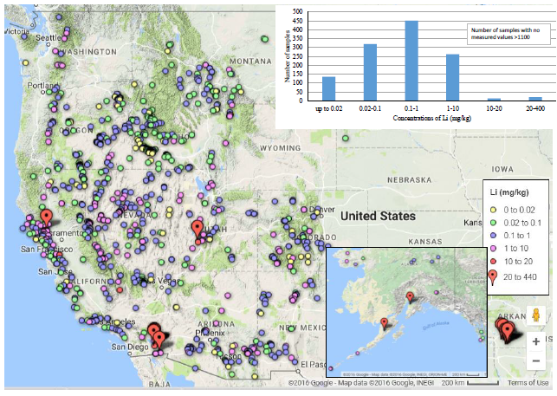
Figure 2.1: Brine resources in the U.S. by concentration of lithium.

These resources are promising for a variety of reasons. First, is that existing geothermal power infrastructure already exists in many of these locations. This makes the capital costs of installing a lithium uptake system much reduced compared to developing an entire plant. Next, there is a huge decrease in water use, in comparison to Salar brine evaporation, and no need for high temperature roasting and harsh chemicals, as with hard rock mining. Finally, the wait times for battery grade lithium species is far reduced compared to the evaporation times of the Salars and the extended shipping time of material from Australia and China. All these factors make this source of lithium highly important for development to establish a timely, cost-effective, domestic supply of battery grade material. Ensuring the U.S.’s ability to produce its own materials and green technologies.

Chapter 3: Sorbents and Other Materials for Lithium Extraction

3.1 Hydrogen-Lithium Ion Exchange Materials

The first class of sorbent materials of interest for lithium extraction are spinel manganese oxide, LiMn₂O₄ (MnO) and lithium titanium oxide, Li₂TiO₃ (LTO), systems. Both have been studied extensively for applications to lithium ion extraction and have their own benefits and drawbacks compared to other systems. Both operate via an identical mechanism, that being a lithium-hydrogen exchange pathway. Here positively charged lithium exchanges with positively charge hydrogen ions, due to higher binding affinity while present in geothermal brines. For manganese oxide the ions trade places and occupy octahedral interstices within the spinel structure.¹⁸ This process is facile and removal of lithium ions from the sorbent structure simply requires contact with acid to re-exchange hydrogen ions into the spinel structure. Unlike LTO the molar ratio of Li:Mn can vary, leading to multiple manganese oxide species that differ in composition, synthetic conditions, morphology, and adsorption performance. A few examples of MnO based sorbents and their adsorption capacities can be seen in Table 3.1
A variety of morphologies and solution parameters are represented in Table 3.1 including sorbent polymer composites,^{19, 20} nano-sized materials in a variety of shapes from nanowires²¹ and nanorods²² as well as larger nanoparticles around 200 nm.²³ This range makes MnO sorbents adaptable to different solutions including brines as well as dilute sources like seawater. There are two main drawbacks to using this class of sorbent material. For one the use of strong acid for removal of adsorbed lithium is not ideal, as this adds costs and is environmentally detrimental. Another factor is the degradation of the sorbent itself. Manganese exists in the sorbent in oxidation state (III) and (IV), there is an energetically favorable pathway where the sorbent degrades and begins to leach Mn(II). In this case the sorbent is lost over prolonged use, and re-synthesizing or re-calcining the material is the only way to regain full lithium adsorption capacity.

Table 3.1: Lithium manganese oxide sorbents of differing composition and adsorption performance.
Composition (before Li⁺/H⁺ exchange) | Capacity Range (mg/g) | References
H_{1.33}Mn_{1.67}O₄ H_{1.6}Mn_{1.6}O₄  (post acid treatment) | 27 - 30 | ²⁴
Li_{1.33}Mn_{1.67}O₄ | 23.5 - 54.7 | ^{19, 20}
LiMn₂O₄ | 16.8 - 23.9 | ^{21, 22}
Li_{1.6}Mn_{1.6}O₄ | 1.5 - 40 | ^{25, 26}
Li_{1.6}Mn_{1.6}O₄ Li_{1.16}Sb_{0.29}Mn_{1.54}O₄ | 26.9 - 42.1 | ^{22, 23}

LTO is the other well studies solid sorbent in lithium extraction applications. Once again, the mechanism for lithium removal is exchange with hydrogen ions in vacant octahedral sites of the TiO₂ metal layer. This material has garnered interest as an alternative to MnO sorbents due to its stability in acids as well as its environmental friendliness. Importantly the sorbent also has a much higher adsorption capacity, around 142.9 mg/g theoretically²⁷ and 94.5 mg/g in experiments.²⁸ This 75% maximum tested capacity of LTO reflects the actual limit of adsorption for the sorbent as 25% of the hydrogen sites present are not accessible for exchange.²⁹ As with MnO sorbents there are a variety of synthetic, morphological, and testing solutions for LTO sorbent, a few of which can be seen in Table 3.2. As with MnO based sorbents there is still a requirement for acid treatment to unload lithium from the structure leading to increase cost and environmental harm. LTO based sorbent also require around 24 hours to fully saturate in their respective solutions, this timing is not ideal for scale applications that operate on the order of hours for extraction processes. Testing of these sorbents is also still at the laboratory scale and has not been as robustly investigated as MnO based sorbents and layered double hydroxides, to be discussed in 3.2. Finally, the adsorption values for this sorbent seen in Table 3.2 may not be reflective of its performance in real world applications. Higher values of adsorption, i.e. 94.5 and 57.8 mg/g, are achieved in high concentration purely lithium solutions. In actual media the presence of competing ions, lower concentrations of lithium ions, and temperature differences all affect the adsorption capacity of the sorbent. A more reflective value of LTO performance would be from the samples tested in Salar brines and seawater, 32.6 and 30.3 mg/g respectively, which puts them right in the range of maximum MnO sorbent capacities.

Table 3.2: Lithium titanate adsorption performance and testing conditions.
Morphology | Testing Conditions  (Li⁺ conc.) | Capacity  (mg/g) | Reference
Plate like particles  (100 - 200 nm) | Li enrich Salt Lake brine from Salar de Uyuni, Bolivia (1.63 g/L) | 32.6 | ³⁰
20-70 nm particle size | LiOH solution  (2 g/L) | 57.8 | ³¹
LTO mixed with poly(vinyl alcohol) (PVA) and porous composite foam | Seawater | 30.3 | ³²
Plate like particle  (100 – 300 nm) | LiOH + LiCl solution | 94.5 | ²⁸
60-80 nm | LiOH solution  (4 g/L) | 27.4 | ³³

3.2 Lithium-Aluminum Layered Double Hydroxide Chlorides (LDH)

Layered double hydroxides, also known as “anionic clays” are a well-studied diverse class of materials. Natural and synthetic forms of LDHs have been known for more than 160 years.³⁴ The general structure of LDH is the presence of an infinite 2D layer of metal hydroxides, with a corresponding interlayer as separation containing charge balancing anions and water molecules. There exists a plethora of different metal hydroxide compositions that can be synthesized for LDHs. Any variety of metal cations across the periodic table can be combined to form these structures in the standard M(II)/M(III) LDH composition. Other metal cation combinations including M(II)/M(IV) and M(I)/M(III) LDHs are also possible, the full array of compositions that are possible can be seen in Figure 3.1. Importantly, the only known example of M(I)/M(III) LDHs is Li/Al LDH, which will be extensively discussed in subsequent chapters.
Naturally, the interchangeability of metal ions into the 2D hydroxide layer has led to a huge array of LDHs, tailored to specific applications based on choice of metal compositions. This presence of hydroxyl groups on the 2D layers of LDH offers a huge number of basic reaction sites, making them very effective in heterogeneous base catalysts. In addition to the metal hydroxide layer many different compounds and other transition metals can be incorporated into LDH through host-guest interactions via the interlayer space between metal layers. The variation of every component of the LDH structure has led to effective applications in electrocatalysis, photocatalysis, and photoelectrocatalysis.^{35, 36} Variability of this host-guest interaction can also be implemented to use LDH systems in photofunctional,³⁷⁻⁴⁰ biological,^{41, 42} electrochemical,⁴³⁻⁴⁶ and other multifunctional applications.⁴⁷⁻⁵⁰

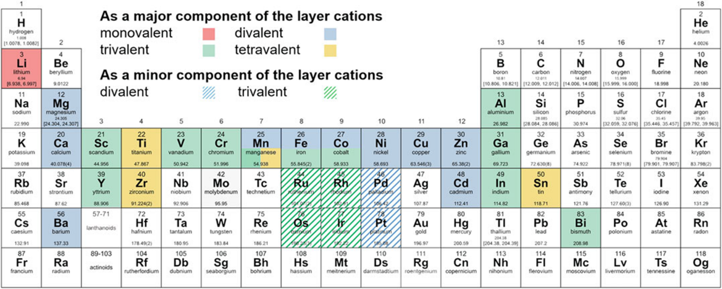
Figure 3.1: Different possible compositions of LDH materials following the general formula [M^{z+}_{1-x} M³⁺_{x}(OH)₂]^{x+}(X^{n-}_{x/n})· mH₂O. Where M^{z+} can be replaced with mono, di, tri, and tetravalent elements, and X can be a variety of anions or guest species.⁵¹

3.3 Other Methods of Lithium Ion Extraction

Solid sorbents are one thrust of research in lithium extraction among many. Owing to the importance of the future lithium supply there is a rich development of other methods. These include newer more selective precipitation processes,⁵² solvent extraction,⁵³ membranes,⁵⁴ centrifuges,⁵⁵ and other techniques.⁵⁶⁻⁵⁸ Development in these areas is also important in the larger scope of lithium hydroxide and carbonate processing but differs from the development of solid sorbents. The previously discussed LDH sorbents offer effective lithium adsorption and selectivity without the excessive use of materials, infrastructure, and liquid processing issues. The material use issue applies to precipitation methods and solvent extraction methods in particular. Use of liquids to adjust pH or solid powders to crash out unwanted metal species as well as the use of harmful organic solvents for solvent extraction all add cost and environmental difficulties. Methods involving centrifuges, ion-pumps and other systems bring up the issue of additional infrastructure. While effective the addition of capital costs is not always worthwhile depending on the concentration of lithium in the source as well as global costs. Finally, membranes offer liquid tolerance issues. So long as the source water of lithium is relatively particulate free there should not be much issues but many sources of lithium from brines to clays have an abundance of salt, silt, and other solid species. Membrane clogging becomes a very real issue in the case of unfiltered liquids. Each of these methods can play an important role in a multi-step purification of lithium, where more robust solid sorbents like LDH adsorb lithium from the direct source stream, with subsequent steps performed by membrane and solvent extraction.

Chapter 4: Experimental and Characterization Techniques

4.1 Material Property Characterizations

4.1.1 X-ray Powder Diffraction

X-Rays were discovered in 1895 by German physicist Wilhelm Röntgen. Initially the new electromagnetic phenomena were investigated for use in imaging and medical applications. The introduction of x-rays to chemistry and materials science began with the work of Max von Laue, who detected the first diffraction of X-rays through a copper sulfate crystal lattice. These results were taken by Laue and formed into a law to correlate x-ray scattering angles and the subsequent unit-cell spacings for crystals. Further work by William Henry Bragg and William Lawrence Brag led to the establishment of Bragg’s law, seen in Figure 4.1, which connects x-ray reflections with differently spaced planes of the crystal sample. This characterization technique allows for the determination of crystallinity, phase, and structure of our materials from differing synthesis and testing conditions. For iron doped variants of the material as well as LDHs with different interlayer anions, XRD allows for observation of interlayer distance changes of the material.

4.1.2 Fourier-transform Infrared Spectroscopy

Fourier-transform Infrared Spectroscopy (FT-IR) is a technique that can identify the functional groups of materials via infrared radiation. The technique can be used for any variety of phases of materials (gas, liquid, solid) with different sample environments. FT-IR instruments are also able to rapidly collect data allowing for quick identification and comparisons of samples. The region of detection for these instruments is in the infrared region (IR), generally in the mid-IR range 4000-400 cm⁻¹, of the electromagnetic spectrum. Identification of functional groups is dependent on whether the bonds in the studied materials or compounds are IR active. This requires interaction with the produces infrared beam in an asymmetric manner, meaning a net dipole moment is required. When symmetric molecules oscillate no net dipole moment is produced that the machine can detect, such as H₂. Different bonds within a compound are able to be identified by their characteristic vibrational frequency. This is used to detect functional group present in moieties of organic compounds, such as C-C, C-H, C-O, and O-H bonds. Instruments measures the amount of absorbed IR radiation as a measure of intensity.

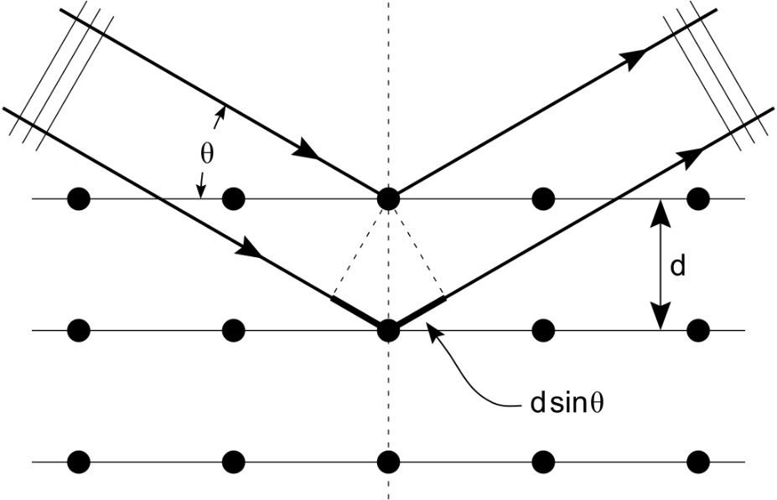
Figure 4.1: Visual representation of the interaction that Bragg’s law describes. The reflection of incoming radiation and determination of interlayer space using the equation: 2dsinƟ = nλ.⁵⁹

In the context of the study the instrument is useful for determine metal-oxygen bonding environment which provides insight into the structural character of the repeating metal oxide layer present in layered metal hydroxides. FT-IR also allows the identification of different interlayer anions due to their interaction with surface hydroxides on the surface of the metal layer which produces specific vibrational signatures. While other work has simply used FT-IR to characterize layered hydroxide samples this study utilized the technique to determine specific structural characteristics that led to improved lithium ion uptake and selectivity. This study is unique in its directed application of specific structural characteristics to performance in adsorption applications.

4.1.3 Thermogravimetric Analysis/Differential Scanning Calorimetry

Thermogravimetric Analysis (TGA) and Differential Scanning Calorimetry (DSC) are two techniques that are generally used in tandem to determine important physical information about materials. TGA is the use of temperature over time to measures changes in mass of the studied sample. This allows for the measurement of a variety of processes that can occur to samples including desorption of water, phase transitions, thermal decompositions, as well as chemical reactions. DSC determines the amount of heat required to increase the temperature of a material. This is done by comparison to a reference throughout the linear increase in temperature of the experiment. The technique is used to identify the exothermic or endothermic behavior of phase transitions in materials. Different processes such as melting, crystallization, glass transitions, and water loss. By combining TGA and DSC a variety of insights into materials can be gained. Since both techniques involve linearly increasing temperature, they can be compared to determine specific physical and chemical processes occurring in the material. In the scope of this research water loss is one of the most important, TGA allows for an accurate calculation of mass of water lost from the sample. This enables the use of acid solution calorimetry which is discussed in the next section. Additionally, it allows for the identification of desired chemical reactions whether that be for more or less water presence in the sample. This has a direct effect on the adsorption abilities of LDH for li-ion extraction. Thermodynamic events measured by DSC also allow for the identification of important structures present in LDH, mainly those of the metal hydroxide layer. Shifts in degradation temperatures play a critical role in determining more robust and possibly more effective sorbents.

4.1.4 Acid Solution Calorimetry Measurements

Acid Solution Calorimetry is a technique developed by Dr. Alexandra Navrotsky and other colleagues. The method utilizes the distinct heats of formation of materials to provide an accurate calculation of the enthalpy of formation of materials. This is done by taking materials and dropping them into an acid solution and precisely measuring the energy of dissolution into the solution. By recreating a compound from its precursor materials and including the effects of water from TGA/DSC analysis the overall heat of formation, Δ_{f}, is determined. The more negative the value of Δ_{f} the more stable the material is. Later chapters will explore the importance of these stabilities for LDH based li-ion sorbents in detail.

4.1.5 Inelastic Neutron Scattering and Quasielastic Neutron Scattering

Inelastic Neutron Scattering (INS) and Quasielastic Neutron Scattering (QENS) are two specialized methods of materials characterization owing to the limited amount of facilities and availability of beam lines. Access to Oak Ridge National Lab (ORNL) and funded user proposals has allowed the enhancement of this work with the powerful capabilities of neutron studies. Both techniques are highly suited to the study of LDH based sorbent materials due to the large cross section overlap of hydrogen atoms and neutrons. The water present in the interlayer and bulk as well as the hydroxides of the metal hydroxide layer all present opportunities to explore the structure and dynamics of LDHs. INS is able to resolve the change in kinetic energy between collided neutron and the sample. As a result, INS results can be viewed in a similar manner to conventional spectroscopic techniques, where intensity and energy are plotted. Simulation using INS spectra allows for accurate recreation of particular hydrogen motion, whether that be in water molecules, bonded hydroxides, or interaction between the two. QENS adds another layer of insight by elucidating the dynamic activity of the material. Here this is specifically the motion of water, observed through hydrogen, through the interlayer of the material. By combining both methods a structural snapshot as well as dynamic picture of LDH is possible giving novel and powerful insight into lithium-ion sorbents.

4.2 Lithium Adsorption Testing

4.2.1 Simulated Brine

Simulated brine formulations were made based on the actual composition of geothermal brines present in the Salton Sea, CA, seen in Table 4.1 at a Simbol test plant. All testing from batch scale to column scale were performed using these concentrations, so the formulated sorbent would best meet the operational demands at the Salton Sea test plant. In some testing cases the concentration of lithium in solution was altered to determine sorbent performance.

Table 4.1: Brine Composition of the Salton Sea.⁶⁰
Element | mg/kg
Na | 53,000
K | 20,000
Ca | 33,000
Li | 250
Mn | 1,500
Zn | 500
Cs | 20
Rb | 100
Cl | 180,000

4.2.2 Batch Scale

Bench scale testing was performed by first unloading the LDH samples to make them deficient in lithium for adsorption. This process, visualized in Figure 4.2, was done by adding 250 mg of sorbent to 5 mL of DI water followed by heating and stirring for 1 hour at 95°C. Once 40% of intercalated lithium had been removed, the sample was filtered and washed. Then adsorption testing was performed to determine an isotherm of loading capacity at a variety of lithium concentrations as well as lithium selectivity in simulated brine.

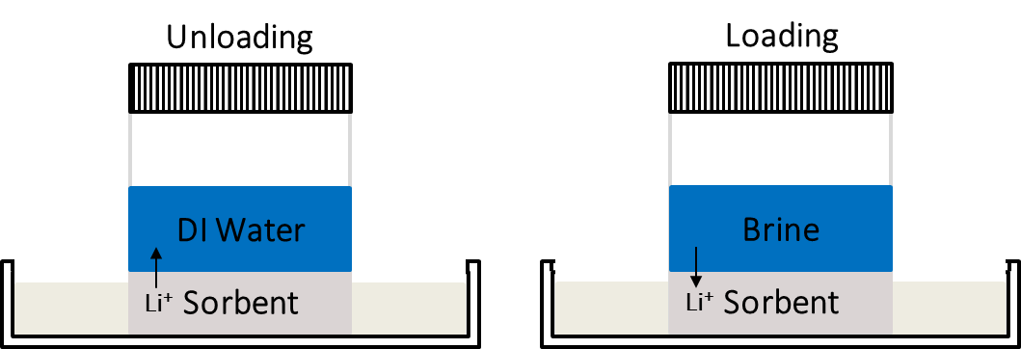
Figure 4.2: Unloading preparation and brine trail testing for LDH sorbents.

4.2.3 Column Scale

A breakdown of the column scale apparatus is from previous work⁶⁰ and shown in Figure 4.3. The column is run by packing of unloaded LDH sorbent followed by three different solution flows. The first, initial brine, flows the simulated Salton Sea brine, the lithium present in solution is adsorbed by the lithium deficient sorbent in this step. Second, the column is washed, here the washing allows the removal of any unwanted ions trapped in the sorbent (i.e. Na, K, Ca, etc.). Finally, the stripping solution contains a low concentration of pure LiCl that allows for the desorption of LiCl from the LDH sorbent into the stripping stream. The system is controlled automatically by computer and the liquids are kept at 95°C to better simulate full scale conditions. ICP-OES analysis is then performed to see the changes in concentrations of the different ions present during adsorption, washing, and stripping. From this ppm concentration data separation factors (SF) are calculated to determine the selectivity of other ions towards lithium based on the performance of the sorbent. Separation factor calculations were performed based on the following equation:

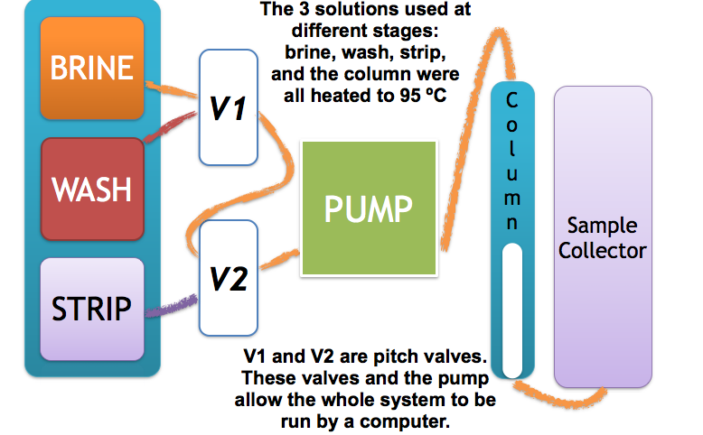
Figure 4.3: Schematic of column scale extraction setup.

$${SF}_{\frac{Li}{M}}= \frac{\left({\left[Li\right]strip}/{\left[Li\right]brine}\right)}{\left({\left[M\right]strip}/{\left[M\right]brine}\right)}$$

4.2.4 Inductively Coupled Plasma-Optical Emission Spectroscopy

This detection method enables all brine adsorption trial analysis to be completed accurately and quickly. ICP-OES is a powerful detection method that utilizes plasma to determine the concentrations of metals in solution. The solutions that are analyzed are passed through a high salt concentration nebulizer, see Figure 4.4(a), and sprayed into tiny droplets with an inert carrier gas. Now in Figure 4.4(b) the detection area can be seen. Droplets travel to this area and interact with electromagnetically generated plasma from argon to their elemental forms. Now heated to around 8000K the atomic emission spectra of the element is now fed through a series of mirrors, and photomultipliers through a slit of a wavelength selection device. The elemental lines of the ions present in solution are detected with a photomultiplier.⁶¹ The unique characteristic of each elemental line allows for multielement determinations of solutions. This analytical device is indispensable as it allows for analysis of multicomponent brine solutions as well as the low detection limits to find small concentrations of lithium in high concentration brines.

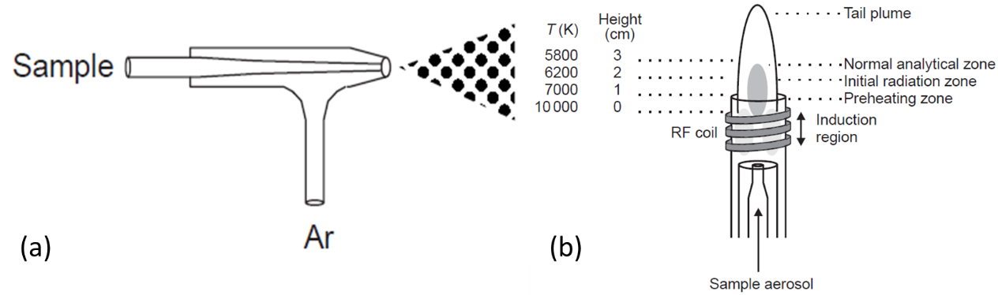
Figure 4.4: High salt solution nebulizer and (b) sample input, vaporization, energization, and detection area into the plasma source. Used from Hou et al.⁶¹

Chapter 5: Thermodynamic effects of Lithium Chloride and Water Content on LDH

Abstract

The application of layered double hydroxide chloride sorbents for selective extraction of lithium from geothermal brines is known, but thermodynamic considerations of the material explain the LDH adsorption system and open avenues for development of new materials.
The thermodynamic studies are reported based on the following journal articles published in The Journal of the American Ceramic Society (2019) and The Journal of Physical Chemistry C (2019):
L. Wu, L. Li, S.F. Evans, T.A. Eskander, B.A. Moyer, Z. Hu, P.J. Antonick, S. Harrison, M.P. Paranthaman, R. Riman, A. Navrotsky, Lithium aluminum-layered double hydroxide chlorides (LDH): Formation enthalpies and energetics for lithium ion capture, Journal of the American Ceramic Society, 102 (2019) 2398–2404.
L. Wu,* S. F. Evans,* Y. Cheng, A. Navrotsky, B. A. Moyer; S. Harrison, M. P. Paranthaman, Neutron Spectroscopic and Thermochemical Characterization of Lithium–Aluminum-Layered Double Hydroxide Chloride: Implications for Lithium Recovery. The Journal of Physical Chemistry C 2019, 123 (34), 20723-20729.

5.1 Introduction

Lithium is becoming a near critical element in the energy industry, which reflects the fast-growing demand for lithium-ion batteries.⁶² To meet the needs of the market, one must seek new economically viable sources of lithium. Extracting Li from brine, salt lakes, or sea water is a possible alternative to mining and processing lithium mineral ores. Though such waters are a large reservoir of lithium, its concentration is low compared to that of sodium and other ions. Technical innovation for selective lithium ion extraction is mainly focused on sorbents, ion exchangers, and other alternative extraction processes. Several materials such as H₂TiO₃ and LiMn₂O₄ have been proposed to be sorbents for Li-ion capture.²⁰ However, their costs associated with lithium loading and unloading steps and environmental concerns pose challenges to industrial scale applications.
Layered double hydroxide chloride (LDH) materials have become a candidate for Li-ion capture due to the two-dimensional structure, unique exchange capacity, low cost and low toxicity.^{20, 63-65} These LDH type materials have been developed as photocatalysts for water splitting, CO₂ reduction and pollutant degradation.⁶⁶⁻⁷¹ Li-LDH with composition Li_{x}Al₂(OH)₆Cl_{x}.nH₂O is a hydrotalcite-like compound which has a layered structure with Al(OH)₃ octahedra composing the layers (as shown in Figure 5.1). The crystal structure consists of two repeating layers, one layer consists of aluminum hydroxides and intercalated Li⁺ ions, while the other layer consists of water molecules and charge balancing Cl⁻ ions. The nominal composition is therefore Li_{x}·Al₂(OH)₆Cl_{x}·nH₂O, where the variable x represents the Li and Cl stoichiometry and n represents the moles of interlayer water.

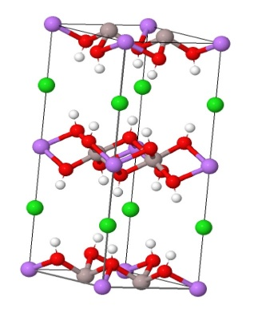
Figure 5.1: Crystal structure of Li Al₂(OH)₆Cl (Ref. ICDD Coll. Code: 83509). Li, Al, Cl, O, and H represented as purple, grey, green, red, and white respectively. Water molecules are not shown in this structure.

Li-ions fill the vacant octahedral sites and Cl⁻ ions are located between the layers. Typically, the Li and Cl ratios are close to 1:1 to retain charge balance within the LDH structure. The relatively weak interlayer interaction results in flexible interlayer distances,⁷² which indicates a moderate kinetic barrier for ion intercalation. The Li-LDH can be obtained directly from the reaction of Al(OH)₃ polymorphs with LiOH in mild temperature and pressure conditions.⁷² This synthesis method suggests a new route to extract Li ions from aqueous solution. A recent adsorption experiment using Li-LDH has found that 91 % of the lithium was recovered from a geothermal brine solution with high selectivity over Na and K ions.⁶⁰ This selectivity arises because larger alkali ions present cannot be accommodated in the octahedral sites of the LDH structure. The economic viability of the sorbent is improved through its reversibility. The extraction processes for loading with Li, washing away excess ions, and Li elution all improve cost, do not require any acid consumption, and produce no secondary waste.⁷³
However, the Li-LDH phase is retained only in a limited range of lithium chloride concentrations. It was observed that if LiCl is less than 125 mg/L in the stripping solution, the LDH phase decomposes to the Al(OH)₃ phase.⁶⁰ In addition, when the LiCl concentration is more than 360 mg/L, the LDH becomes saturated and no further adsorption occurs.⁶⁰ In addition to defining the capacity for Li ions, the stability of the LDH phases controls the cycling life and lithium recovery efficiency.⁷³ The presence of water in the Li-LDH structure may also play an important role in lithium uptake from the geothermal brine.
To elucidate the energetics of Li capture, enthalpies of LDH with different Li content have been measured by acid solution calorimetry. The formation enthalpies generally become less exothermic as the Li content increases, which indicates that Li intercalation destabilizes the structure, and the enthalpies seem to approach a limit after the Li content x = Li/(Li+Al) exceeds 1. Additionally, in a later study, to determine the role of water in LDH extraction of lithium LDH samples were synthesized from two different starting materials (alumina (Al₂O₃) and gibbsite (Al(OH)₃) and with two post-drying conditions (ambient-dried and oven-dried) and were also studied via acid solution calorimetry. The results reveal differences in stability of the LDH structure in relation to water, which could explain the different extraction capabilities of these materials. These findings on the properties of LDH have implications on their lithium extraction abilities and subsequent recovery. The goal of this study is to find out whether, based on thermodynamic considerations, there are optimum LDH compositions and water content for Li-ion capture.

5.2 Sample Preparation

Five Li-LDH samples with varying Li/Al ratios have been used for the first study on LiCl content⁶⁰ and four samples were prepared for the subsequent studies on starting material and water content.⁷⁴ The first five Li-LDH samples prepared by mixing γ-Al(OH)₃ (gibbsite) (Alfa Aesar > 76.5 %) and LiOH (Honeywell Fluka > 98.5 %) at 95 °C for 2 h. Following this, the LDH structure was fully saturated with lithium by mixing with 40 % LiCl (Sigma-Aldrich > 99%) in an acetic acid (Sigma-Aldrich > 99.7 %) and DI water mixture in a ratio of 6:4 mL, respectively. Loading of the structure with LiCl was completed when the pH of the solution reached 5.5. Acetic acid was used as the buffer solution to maintain the pH close to 5. To obtain the variety of LiCl values (x = 1.36 - 0.74 for LDH) unloading was performed at 95 °C at various times. The next eight samples were prepared using the same synthetic conditions with some variation in starting material and post-synthesis treatment. Half of the samples were prepared with a γ-Al₂O₃ (γ-alumina) (BASF, Florham Park, NJ >94%) starting material as opposed to Al(OH)₃. The Al(OH)₃ and Al₂O₃ derived samples then underwent two post-synthesis treatments. The two conditions were ambient drying (A) and oven drying (O). Ambient drying was performed at 25 °C in air, and oven drying was done at 95 °C. Both drying treatments were performed for 24 h. The LDH samples are labeled as LDH-Al₂O₃-A, LDH-Al₂O₃-O, LDH-Al(OH)₃-A, LDH-Al(OH)₃-O, respectively.
Samples have been characterized by X-ray powder diffraction (XRD) using a PANalytical Empyrean with Cu Kα radiation, all data was processed with HighScore Plus. Inductively coupled plasma – optical emission spectroscopy (ICP-OES) compositional analysis was performed to determine the Li and Al concentrations in all the samples with a Thermo Fischer iCAP Model 7400 ICP-OES Duo. Results of all the sample compositions are shown in Table 5.1. Differential scanning calorimetry and thermogravimetry (DSC-TG) analysis was performed on a Netzsch 449 instrument to determine the water content. Samples were heated from 25 to 800 °C at 10 °C/min in argon (see Table 5.1). To investigate the thermal behavior of LDH samples at higher temperatures, two LDH samples were analyzed using a Setaram Labsys instrument and heated to 1400 °C at 10 °C /min in argon. ATR FT-IR was data was gathered using a BRUKER VERTEX 70. FTIR spectra were recorded using a Bruker Alpha-P IR spectrometer with correction from an initial background collected before sampling to subtract the contribution from the ambient environment. After background collection, the solid sample (5-10 mg) was put on the diamond sensor. The spectra were collected at 100 − 4000 cm⁻¹ with resolution of 4 cm⁻¹ and scan time of 32 scans.

Acid solution calorimetry (CSC calorimeter model 4400) was applied to all LDH samples and component compounds (LiCl and gibbsite (γ-Al(OH)₃)). A typical procedure included weighing about 10 mg of sample powder, pressing the powder into a pellet and dropping it into 25 mL HCl solution (standard solution from Alfa Aldrich, 5N) in the calorimeter at 25 °C. The heat of solution was measured. The calorimeter was calibrated by the heat of dropping a KCl (NIST Standard) pellet in the same conditions. Several pellets of each composition were dropped (Table 5.1) and the errors are reported as two standard deviations of the mean. The procedure has been described in detail elsewhere.^{75, 76}

Table 5.1: Sample composition, TG weight loss at 700°C, enthalpy of solution (ΔH_{sol}) in 5N HCl and the formation enthalpies of LDH (ΔH_{f}) by LiCl reacted with gibbsite and goethite.

x(LiCl) | Sample name | Molecular formula | TG weight loss (%) | ΔH_{sol}(kJ/mol) | ΔH_{f}(kJ/mol)
1.36 | LDH1 | Li_{1.36}Al₂(OH)₆Cl_{1.36}.3.26H₂O | 43.92 | -227.93±1.01(6) | -21.68±2.13
0.97 | LDH2 | Li_{0.97}Al₂(OH)₆Cl_{0.97}.3.19H₂O | 41.42 | -209.13±1.23(7) | -27.04±2.00
0.90 | LDH3 | Li_{0.90}Al₂(OH)₆Cl_{0.90}.2.10H₂O | 39.61 | -205.74±1.14(6) | -28.01±1.22
0.76 | LDH4 | Li_{0.76}Al₂(OH)₆Cl_{0.76}.1.89H₂O | 41.58 | -192.11±2.45(6) | -36.82±2.19
0.74 | LDH5 | Li_{0.74}Al₂(OH)₆Cl_{0.74}.1.166H₂O | 35.48 | -188.31±0.761(6) | -39.93±1.76
 | Gibbsite | γ-Al(OH)₃ |  | -101.37±0.46(4)
 | Lithium chloride | LiCl |  | -34.46±1.90(6)

5.3 Characterization of LDH

Gibbsite based LDH has a variety of possible crystal structures, including hexagonal, rhombohedral, and monoclinic polymorphs. Here we confirm a monoclinic phase of LDH in Figure 5.2 based on previously reported data.⁷⁷ Detailed microstructure of LDH samples has been reported previously.⁶⁰ Further analysis by ICP-OES determined the sample compositions as reported in Table 5.1.

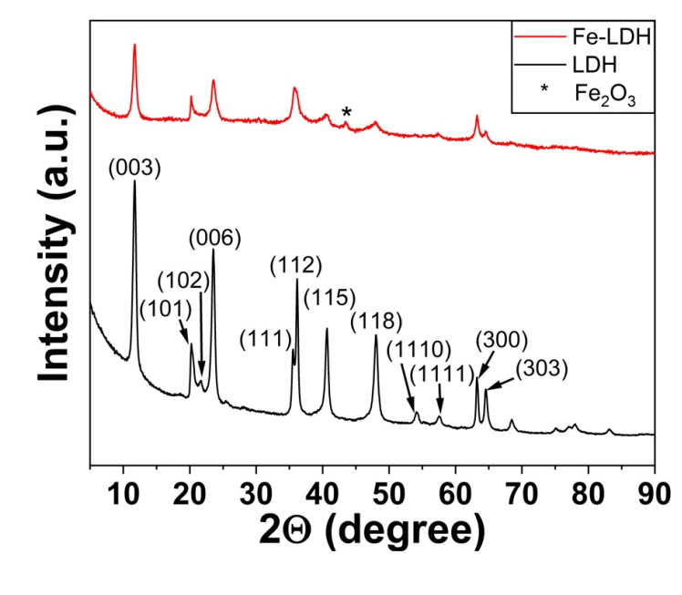
Figure 5.2: XRD spectra of typical Li-LDH and Fe-LDH phases.

According to the TG curves in Figure 5.3, all Li-LDH samples have major weight loss between 100 and 400 °C, accompanied by endothermic peaks on the corresponding DSC curves in the same temperature range, which result from the typical dehydration process of LDH materials.
Figure 5.3: DSC-TG curves for Li contained LDH with formula Li_{x}Al₂(OH)₆Cl_{x}∙nH₂O.

The DSC curves suggest stepwise dehydration behavior. The initial step (100 – 150 °C) corresponds to the removal of physically attached water molecules, the second step (200 – 250 °C) results from the removal of the chemically bonded water located between the layers, and the final weight loss (250 – 350 °C) comes from the dehydration of the hydroxyl groups coordinated to Al and Li atoms (co-intercalated water molecules). The dehydration process is accompanied by structure distortion. Similar observations are reported previously with LDH samples.⁷⁸ The LDH with x = 0.74 was scanned to 1400 °C and exhibit additional weight loss (about 5 %) at 900 – 1000 °C associated with small endothermic peaks, which may be ascribed to Li₂O evaporation.⁷⁹ There is another exothermic peak around 1300 °C without weight change which could be due to the recrystallization of a more stable phase assemblage. This was not investigated further.

Table 5.2: Thermodynamic cycle used to calculate the reaction enthalpies of LDH from lithium chloride and Aluminum hydroxide at 25°C.

Reactions used in the thermodynamic cycle are:
(1) xLiCl (s, 25°C) + 2Al(OH)₃(s, 25°C) + nH₂O(l, 25°C) LixAl₂(OH)₆Cl_{x}. nH₂O(s, 25°C) | ΔH_{f, LDH} | ΔH₁
(2) LiCl (s, 25°C) Li⁺ (aq, 25°C) +Cl⁻(aq, 25°C) | ΔH_{sol, LiCl} | ΔH₂
(3) Al(OH)₃(s, 25°C) + 3H⁺(aq, 25°C) Al³⁺ (aq, 25°C) + 3H₂O (aq, 25°C) | ΔH_{sol, Al(OH)3} | ΔH₃
(4) Li_{x}Al₂(OH)₆Cl_{x}. zH₂O(s, 25°C) + 3H⁺(aq, 25°C) x Li⁺(aq, 25°C) +xCl⁻(aq, 25°C) + 2Al³⁺(aq, 25°C) + (3+n)H₂O(aq, 25°C) | ΔH_{sol, LDH} | ΔH₄
(5) H₂O (l, 25°C) H₂O (aq, 25°C) | ΔH_{dil} | ΔH₅
ΔH_{f, LDH} =ΔH₁= xΔH₂ + 2ΔH₃ + nΔH₅ - ΔH₄
ΔH₅ is the dilution enthalpy of liquid water in 5 N HCl solution, since the effect is small, it has been neglected in this calculation.
The trends of the formation enthalpies with LiCl contents are shown in Figure 5.4. With increasing Li content, the formation enthalpies of LDH from solid lithium chloride and aluminum hydroxide and liquid water generally become less exothermic, with the change becoming less marked as x increases. Thus, the intercalation of LiCl appears to destabilize the LDH phases. The destabilizing effect may be explained by an increase in repulsion induced by the rising positive charge in the framework. This Li saturation proves useful for extraction, as saturation and destabilization of the LDH structure allow for loading, unloading, and sorbent reuse, thus increasing economic viability.
Figure 5.4: Enthalpy of formation for LDHs vs. moles LiCl (x).

As described in the previous section, the compositions of the four Li-Al LDH samples were determined by ICP-OES and DSC-TG, and the formation enthalpy was determined by acid solution calorimetry. These results are listed in Table 5.3. Figure 5.5 presents the XRD patterns of all four LDH samples. They are consistent with expected pattern for LDH, except that the LDH-Al(OH)₃-O sample contains a small fraction of Al(OH)₃, due to decomposition during oven drying. The Al(OH)₃ impurity is estimated to be less than 5% and therefore should not affect the main conclusions.

Table 5.3: Composition and formation enthalpy of the LDH samples in addition to starting materials used for formation enthalpy calculations.
# | Samples | Composition | n(H₂O) | ΔH_{sol}(kJ/mol) | ΔH_{f}(kJ/mol)
1 | LDH-Al₂O₃-A | Li_{0.732}Al₂(OH)₆Cl_{0.732}.2.24H₂O | 2.24 | -188.41±0.75 | -56.14±1.89
2 | LDH-Al(OH)₃-A | Li_{0.840}Al₂(OH)₆Cl_{0.840}.5.24H₂O | 5.24 | -239.23±1.40 | -10.07±2.35
3 | LDH-Al₂O₃-O | Li_{1.03}Al₂(OH)₆Cl_{1.03}.2.06H₂O | 2.06 | -177.68±1.42 | -60.56±2.62
4 | LDH-Al(OH)₃-O | Li_{0.770}Al₂(OH)₆Cl_{0.770}.3.70H₂O | 3.70 | -224.26±1.44 | -22.10±2.22
7 | LDH-Al₂O₃-O (previous work)⁸⁰ | Li_{1.03}Al₂(OH)₆Cl_{1.03}.0.55H₂O | 0.55 | -139.60±1.22 | -96.78±2.33
8 | LDH-Al(OH)₃-A | Li_{0.82}Al₂(OH)₆Cl_{0.82}.1.93H₂O | 1.93 | -192.28±0.56 | -55.01±2.35
9 | LDH-Al(OH)₃-A | Li_{0.94}Al₂(OH)₆Cl_{0.94}.4.36H₂O | 4.36 | -231.14±0.45 | -21.21±2.15
10 | LDH-Al₂O₃-A | Li_{0.9}Al₂(OH)₆Cl_{0.9}.4.42H₂O | 4.42 | -236.87±1.30 | -14.09±2.37
 | Lithium chloride (LiCl) |  |  | -34.46±1.90
 | Gibbsite (Al(OH)₃) |  |  | -109.27±0.50

The DSC-TGA measurements provide not only the water content, but also some indications of how the water molecules interact with the material. This is illustrated in Fig. 5.6. Specifically, LDH-Al₂O₃-A loses water gradually at temperature below 300 °C; there is a mild change of rate at temperature above 100 °C but it is not dramatic. In contrast, LDH-Al(OH)₃-A loses water in a steady rate at low temperature, and then there is a sudden loss of water between 150 and 250 °C (as indicated by the sharp peak in the blue curve and the large slope in the black curve). The DSC scans for the two LDH-Al₂O₃ samples exhibit primarily one endothermic process occurring at 340 °C, while the two LDH-Al(OH)₃ samples have two additional endothermic processes occurring earlier at 220 °C and 280 °C. This different behavior suggests that the water molecules in these four samples are not in the same structural or chemical state. Further weight loss at higher temperature up to 400 °C is due to decomposition of Al(OH)₃.

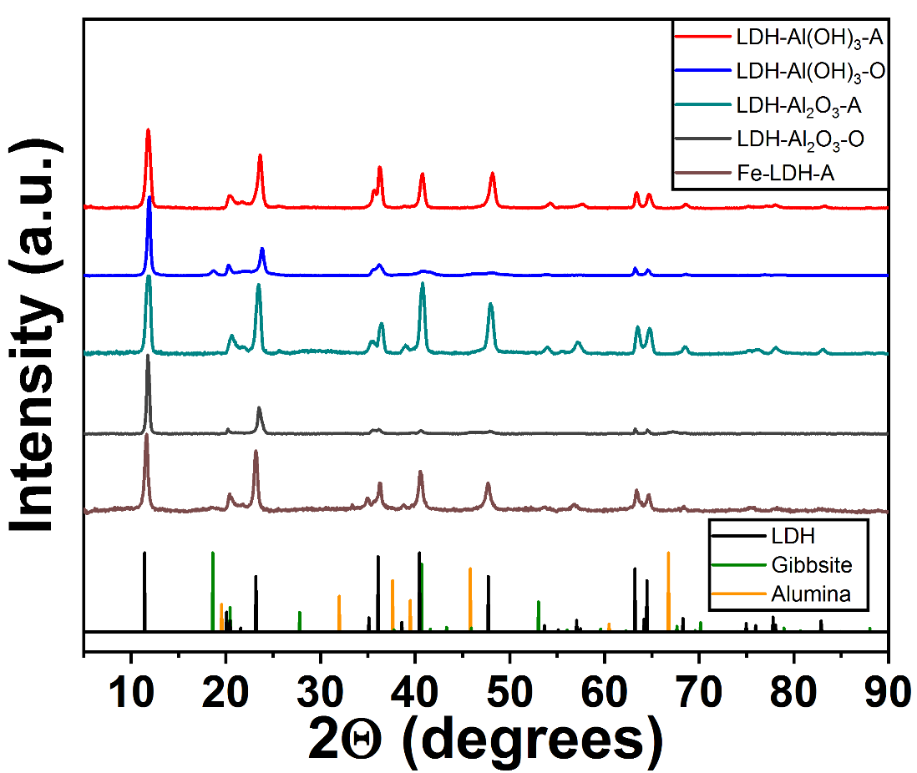
Figure 5.5: XRD patterns of the LDH samples (both ambient and oven dried). Starting precursor and decomposition products, gibbsite and alumina, are shown.

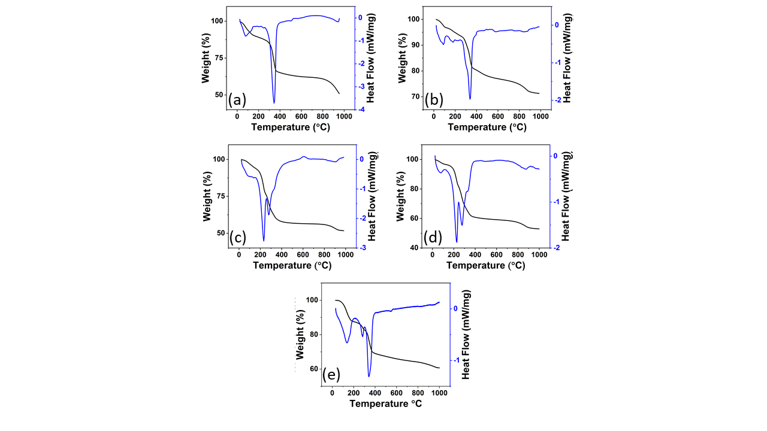
Figure 5.6: DSC-TGA for (a) LDH-Al₂O₃-A (b) LDH-Al₂O₃-O (c) LDH-Al(OH)₃-A (d) LDH-Al(OH)₃ -O and (e) Fe-LDH-A.

Acid solution calorimetry was also performed to determine the enthalpy of formation for the LDH samples. Figure 5.7 shows the formation enthalpy related with water content of LDHs synthesized from different Al sources. It shows that the water content is linearly related to the formation enthalpy of LDHs regardless of the drying routes and the starting form of Al. Further, high water content is associated with a destabilization of the LDH structure making reversible uptake of lithium facile. In Figure 5.8 the comparison of formation enthalpy and LiCl further corroborates the effects of water content and LiCl loading. An apparent maximum at the plot occurs at x = 0.84 for both alumina- and gibbsite-derived LDH, where the highest water content is present (Fig. 5.7). Thus, high water content decreases stabilization for both gibbsite and alumina samples. Alumina based LDH with lower or higher water content is far more stabilized in comparison. The data suggest that the chloride content of the interlayer controls the water content, where low loading (i.e., x < 0.84) brings less water into the structure and high loading squeezes water out.
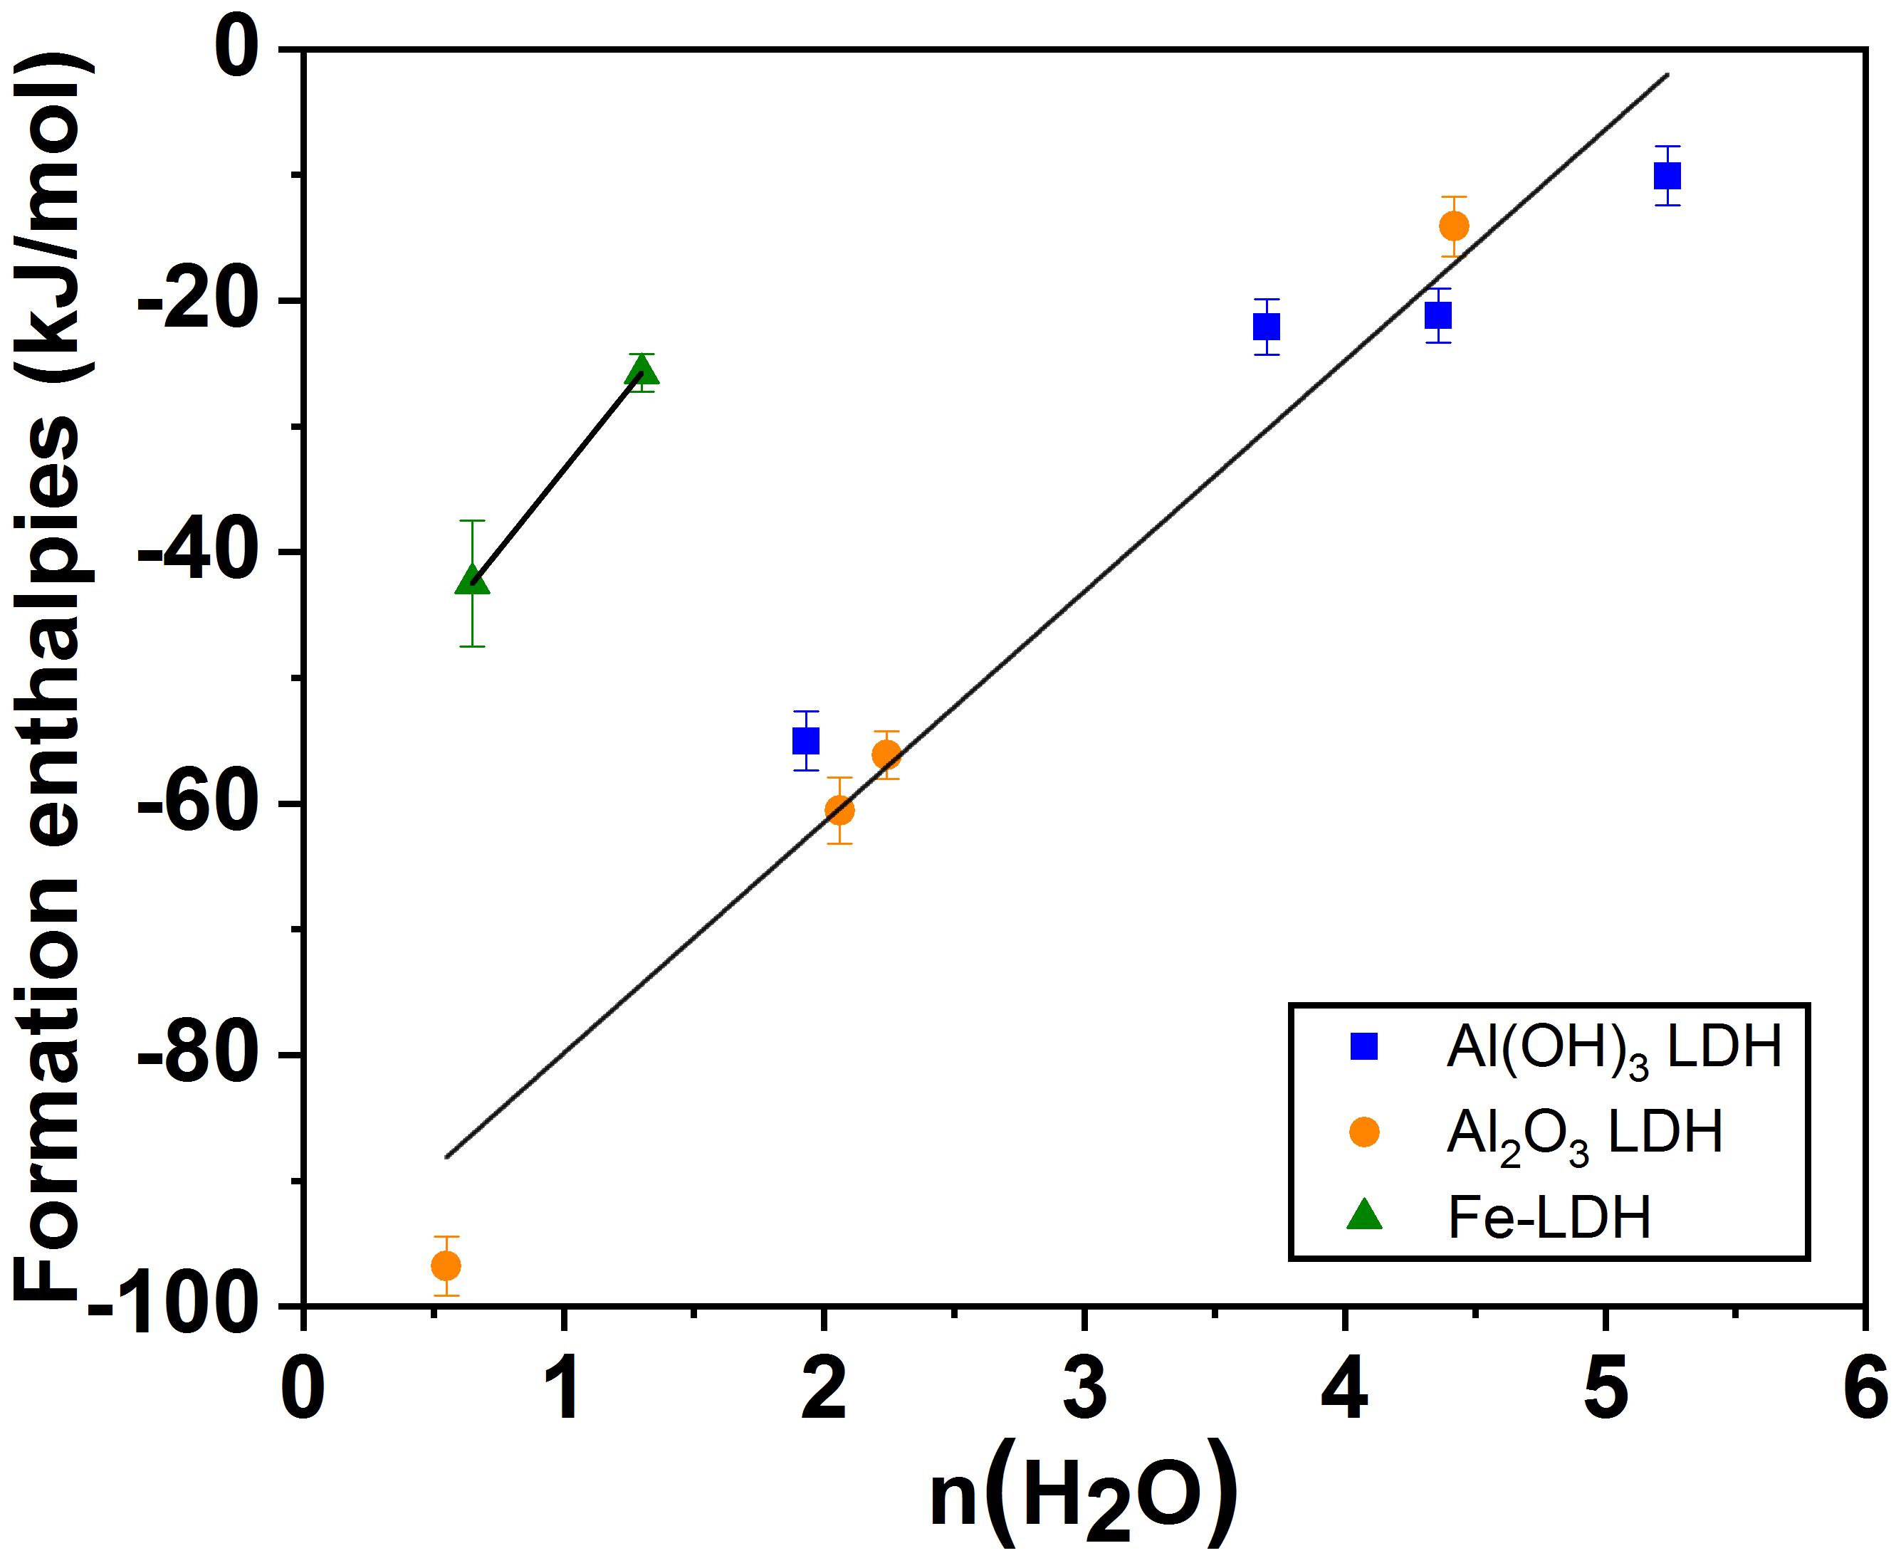

Figure 5.7: Formation enthalpies of LDH (blue squares and orange circles) and Fe-LDH (green triangles) vs. water content. The trend line correlates LDH water content (both ambient and oven dried) to formation enthalpy.

FT-IR ATR was also performed to identify the main bonding modes of the hydroxide layer, as well as the presence of interlayer species, seen in Figure 5.9. The peaks present at 950, and 510 cm⁻¹ have been identified as Al-OH and Al-O bonding modes, respectively. The peak at 375 cm⁻¹ also corresponds to hydrogen bonding within the material. Previous reports have stated that the 1645 cm⁻¹ trace, seen as (a) in Figure 5.9, accounts for interlayer anions, in this case carbonate.⁸¹

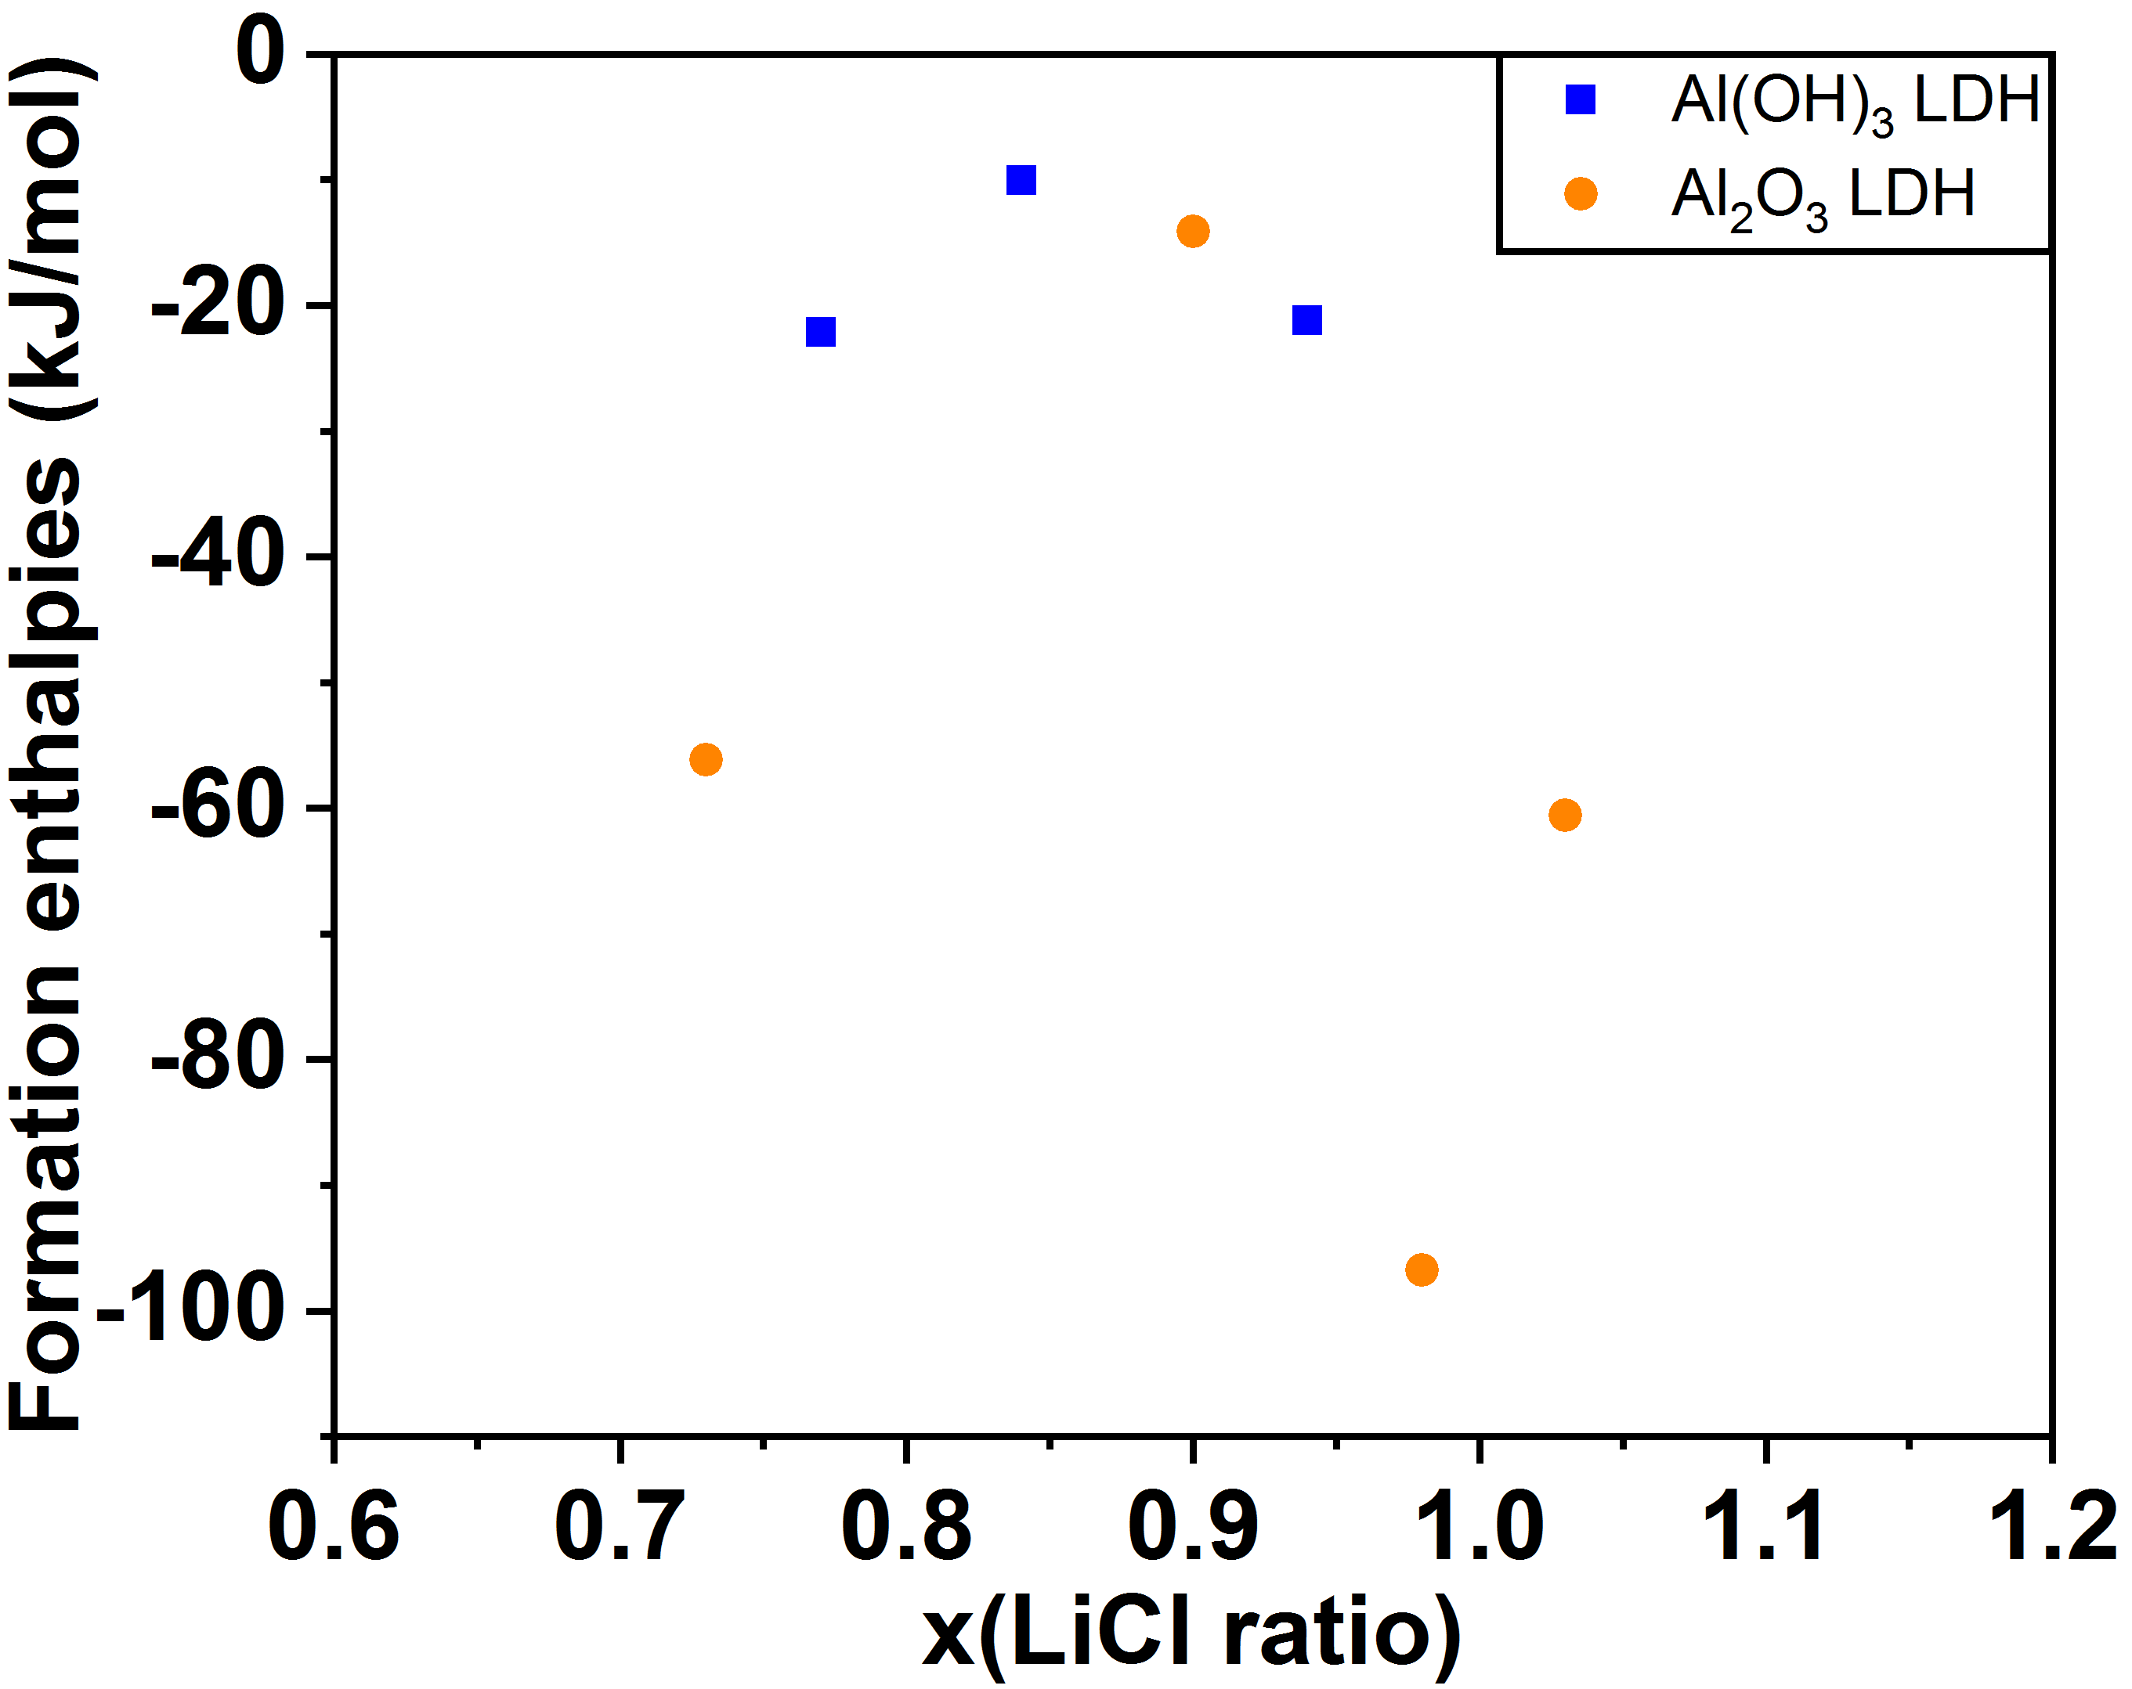
Figure 5.8. Formation enthalpies of gibbsite (blue) and alumina (orange) LDH (both ambient and oven dried) vs. LiCl content.

An additional peak for the Al-O bonding mode is seen at 675 cm⁻¹, seen as (b) in Figure 5.9 for LDH-Al(OH)₃. Results from inelastic neutron scattering, to be discussed in Chapter 6, lead us to believe that the feature present in FT-IR analysis is in relation to the ordering of interlayer water. Lithium-aluminum LDH structures are known to interact with ambient carbon dioxide to form interlayer carbonate species.⁸¹ To ensure that observed the observed the FT-IR were from ordered interlayer water and chlorine, and not carbonate species. Elemental carbon analysis was performed on the LDH samples by heating it in oxygen atmosphere to form the combustion byproducts such as CO₂ and the gases are then separated and quantified by an infrared detector. Table 5.4 displays the low carbon content present in the samples. This combined with similar relative intensities of the 1645 cm⁻¹ and 3400 cm⁻¹ hydroxide peaks further support the 1645 cm⁻¹ trace corresponding with ordered interlayer water and chlorine ions.

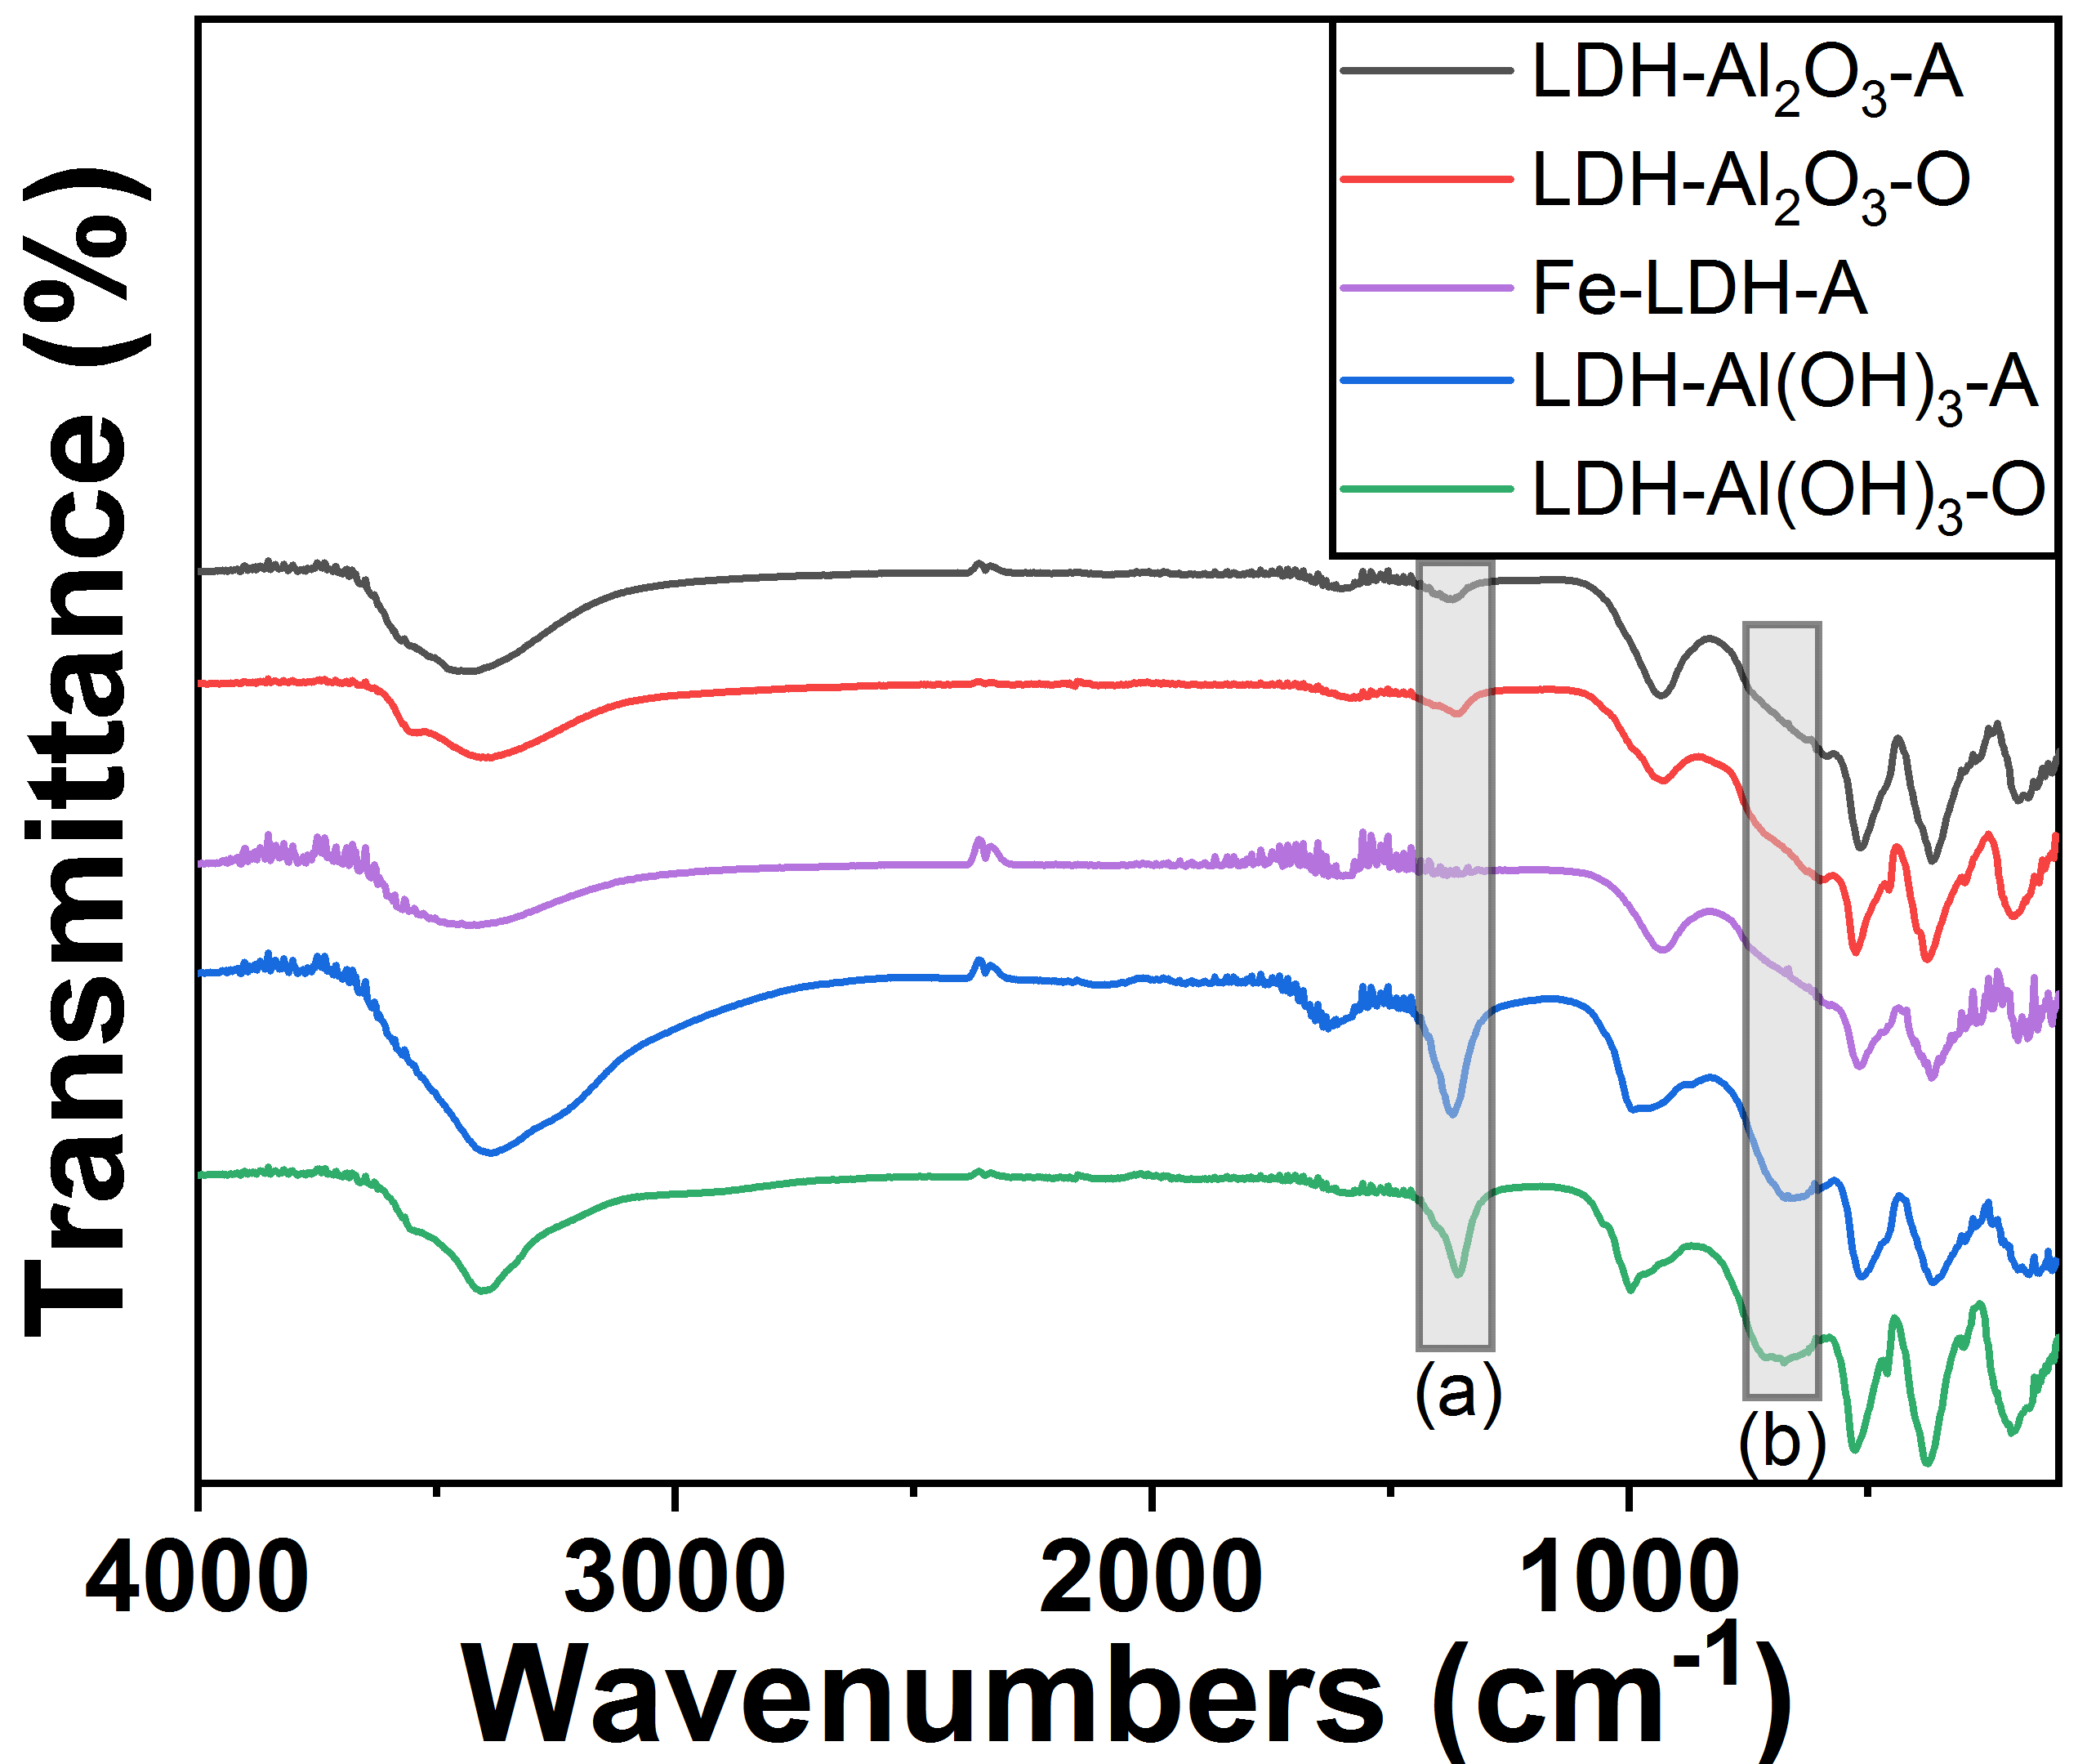
Figure 5.9: ATR FT-IR of both ambient and oven dried LDH samples, (a) and (b) highlight the presence of different features between alumina and gibbsite-based LDH.

Table 5.4: Carbon content present in sorbents.
Sample | Percent Carbon
LDH-Al(OH)₃-A | 1.48
LDH-Al(OH)₃-O | 0.5
LDH-Al₂O₃-A | 1.08
LDH-Al₂O₃-O | 1.49

5.4 Summary

This Chapter provides a quantitative energetic picture of Li-LDH with varying Li/Al ratios and varying water content. The results reveal the destabilizing effect of both LiCl and water. Our results suggest a promising approach to improve both the Li capacity and the stability of LDH materials by varying both the Li and water content. Further, FT-IR analysis elucidated the presence of different anion interlayer activity between Li-Al LDH derived from different starting materials (alumina and gibbsite), prompting further investigation. Specifically, this implies that higher concentrations of water present in LDH, regardless of starting material, will lead to the more facile lithium adsorption and desorption due to a decrease in thermodynamic barriers. This insight will enable the further improvement of effective Li-ion LDH sorbents as well as insights into other materials for lithium extraction.

Chapter 6: Neutron Vibrational Spectroscopy and Quasielastic Scattering of LDH

Abstract

Thermodynamic investigation of Li-Al Layered Double Hydroxides (LDH) including their LiCl and water content has raised questions. Specifically, the effects of interlayer anions, water and bulk water on the chemical structure of LDH. In this chapter, neutron studies including inelastic and quasielastic neutron scattering (INS and QENS, respectively) are used to further investigate the chemical structure and dynamics of water movement of Li-Al LDH.
The neutron studies presented in Chapter 6 are based on the following papers published in The Journal of Physical Chemistry C (2019) and another manuscript in preparation:
L. Wu,* S. F. Evans,* Y. Cheng, A. Navrotsky, B. A. Moyer; S. Harrison, M. P. Paranthaman, Neutron Spectroscopic and Thermochemical Characterization of Lithium–Aluminum-Layered Double Hydroxide Chloride: Implications for Lithium Recovery. The Journal of Physical Chemistry C 2019, 123 (34), 20723-20729.

6.1 Introduction

Global consumption of lithium has grown rapidly in recent years, due to the widespread use of lithium-ion batteries in electronics and increasingly in electric vehicles.⁸² Currently, battery grade lithium hydroxide and lithium carbonate are predominately produced from the concentration of LiCl in solar evaporation ponds in South America and from hard-rock mining in Australia.^{83, 84} Interest in alternative sources of lithium extraction have grown due to long evaporation times and questions of mineral rights in Chile, Argentina and Bolivia.⁸⁵ Hard rock mining also has more expense related to mining, processing and shipping of material.⁸² Geothermal brines have been identified as one possible alternative lithium source particularly in the United States of America.⁸⁶ A variety of sorbents have been developed to exploit this resource including layered double hydroxide chlorides⁸⁷ as well as layered oxides.⁸⁸⁻⁹⁰ Other, more sustainable, sources of lithium include recycling of end-of-life Lithium-ion batteries.^{7, 91} How to efficiently extract lithium from geothermal brines, other terrestrial sources of lithium, and from Lithium-ion battery waste streams, is a topic of great scientific and industrial interest to continue the “Lithium Revolution” and work towards a green, more sustainable future.^{2, 82, 84}
Lithium-aluminum layered double hydroxide chloride (LDH) is an attractive candidate for application in extraction of lithium from geothermal brine. The material has been used in a variety of applications including water remediation,⁹² removal of oxyanions,⁹³ and removal of radionuclides.⁹⁴ In our previous study, LDH recovered more than 91 % of the lithium from a simulated geothermal brine with high selectivity over Na and K ions in a single step.⁸⁷ LDH has various advantages for large-scale industrial plants due to its low cost, environmental-friendliness, and easy regeneration.⁶⁵ It has been found that the material’s ability to extract lithium varies with composition and preparation conditions.⁸⁷ Understanding the key factors that control the efficiency of lithium recovery and the underlying mechanism will therefore provide valuable insight and guidance for optimization and application of these materials.
Water in the LDH structure may be such a factor. A typical crystal structure of LDH is illustrated in Fig. 6.1. The crystal structure consists of two repeating layers, one layer consists of aluminum hydroxides and intercalated Li⁺ ions, while the other layer consists of water molecules and charge balancing Cl⁻ ions. The nominal composition is therefore Li_{x}·Al₂(OH)₆Cl_{x}·nH₂O, where the variable x represents the Li and Cl stoichiometry and n represents the moles of interlayer water. Structure study has revealed that Li-ions are intercalated in vacant octahedral sites of Al(OH)₃, here the limited geometry of the octahedral sites in the LDH structure imbues the observed lithium selectivity.⁸⁷ The stability of the LDH structure in this process is critical for reversible lithium extraction and recovery efficiency. This work also identified water content and LiCl concentration as important thermodynamic factors to improve stability, reversibility, and lithium adsorption capacity.⁸⁰ Further work has been carried out by other groups on the importance of LDH intercalated water dynamics⁹⁵ and host-guest intercalation.⁹⁶
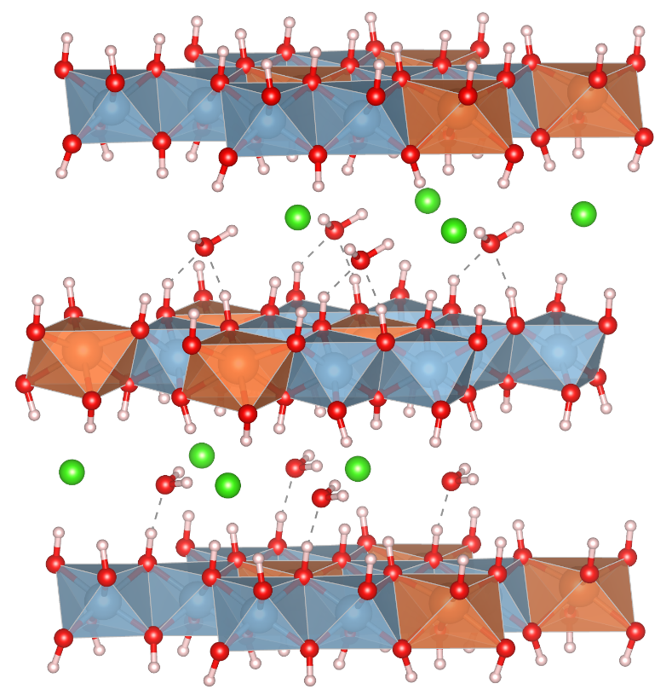
Figure 6.1: A structure model of Li_{x}·Al₂(OH)₆Cl_{x}·nH₂O (LDH) (blue in polyhedra: Al, orange in polyhedra: Li, bright green: Cl, red: O, light pink: H). Hydrogen bonds between the water molecules and the hydroxyl groups are shown by dashed lines.

The goal of this work, therefore, is to investigate the structure and bonding status of water molecules in LDH, as well as their potential connection with the material’s stability, reversibility, and efficiency for lithium recovery. The primary tool used for this research is neutron spectroscopy, or inelastic neutron scattering (INS), which has great advantages in studying water (or hydrogen-containing species in general) in bulk samples, owing to its sensitivity to hydrogen and ability to penetrate deep into the material. The neutron scattering cross-section of hydrogen is roughly one order of magnitude larger than the other elements in LDH, a small fraction of H present can result in significant changes in the INS spectrum. It can thus provide direct information on the water molecules in LDH, which cannot be readily obtained through other techniques.
Another valuable tool to understand the dynamics of water in LDH is quasielastic neutron scattering (QENS). This technique focuses on the broadening of the elastic peak, which can be observed when diffusive motions take place in the sample. Hydrogen possesses large incoherent neutron scattering cross-section of about 80 barns, one or two orders of magnitude larger compared to most other common elements. Therefore, when hydrogen is present in the sample, the QENS signal tends to dominate by the contribution arising from diffusion of hydrogen (or any species containing hydrogen, e.g., OH, H₂O). The data is modelled with elastic peak (delta function), one or more QE components (Lorentzian functions), and a lineal background term. The elastic peak, as well as the Lorentzian functions are convoluted numerically with the experimentally determined resolution function (low temperature measurement of each sample for the experiment). The width of the Lorentzian function is related to the time scale the diffusion occurs. Looking the Q dependent evolution of the Lorentzian width enables characteristics of the diffusion to be derived, i.e. diffusion coefficient, elementary steps along the diffusion path, and characteristics times. Here we report those findings and their impacts on Li-Al LDH structure and adsorption.

6.2 Experimental

Five Li-LDH samples with varying Li/Al ratios have been used for the first study on LiCl content⁶⁰ and four samples were prepared for the subsequent studies on starting material and water content.⁷⁴ The first five Li-LDH samples prepared by mixing γ-Al(OH)₃ (gibbsite) (Alfa Aesar > 76.5 %) and LiOH (Honeywell Fluka > 98.5 %) at 95 °C for 2 h. Following this, the LDH structure was fully saturated with lithium by mixing with 40 % LiCl (Sigma-Aldrich > 99%) in an acetic acid (Sigma-Aldrich > 99.7 %) and DI water mixture in a ratio of 6:4 mL, respectively. Loading of the structure with LiCl was completed when the pH of the solution reached 5.5. Acetic acid was used as the buffer solution to maintain the pH close to 5. To obtain the variety of LiCl values (x = 1.36 - 0.74 for LDH) unloading was performed at 95 °C at various times. The next eight samples were prepared using the same synthetic conditions with some variation in starting material and post-synthesis treatment. Half of the samples were prepared with a γ-Al₂O₃ (γ-alumina) (BASF, Florham Park, NJ >94%) starting material as opposed to Al(OH)₃. The Al(OH)₃ and Al₂O₃ derived samples then underwent two post-synthesis treatments. The two conditions were ambient drying (A) and oven drying (O). Ambient drying was performed at 25 °C in air, and oven drying was done at 95 °C. Both drying treatments were performed for 24 h. The LDH samples are labeled as LDH-Al₂O₃-A, LDH-Al₂O₃-O, LDH-Al(OH)₃-A, LDH-Al(OH)₃-O, respectively. Scanning electron microscopy (SEM) images were collected on a Zeiss Merlin with a gun acceleration of 5.0 kV.
The INS experiments were performed at the VISION beamline of the Spallation Neutron Source, Oak Ridge National Laboratory. Different, in principle, from optical spectroscopy such as IR, INS is very sensitive to the hydrogen species inside the material, and it is especially useful in revealing their structural orientation, bonding, local order, and quantity. About 2 g of each sample was loaded in a vanadium sample holder and measured at 5 K to collect the vibrational spectrum. The data were then analyzed using Mantid.⁹⁷ Complementary density functional theory (DFT) simulations were performed using the Vienna Ab initio Simulation Package (VASP).⁹⁸ The calculation used the Projector Augmented Wave (PAW) method^{99, 100} to describe the effects of core electrons, and Perdew-Burke-Ernzerhof (PBE)¹⁰¹ implementation of the Generalized Gradient Approximation (GGA) for the exchange-correlation functional. Energy cutoff was 1000 eV for the plane-wave basis of the valence electrons. The structure in Fig. 6.1 was used as the initial structure. The total energy tolerance for electronic energy minimization was 10⁻⁸ eV, and for structure optimization it is 10⁻⁷ eV. The maximum interatomic force after relaxation was below 0.005 eV/Å. The vibrational eigen-frequencies and modes were then calculated by solving the force constants and dynamical matrix using density functional perturbation theory (as implemented in VASP) and Phonopy.¹⁰² The OClimax software¹⁰³ was used to convert the DFT-calculated phonon results to the simulated INS spectra.
Neutron backscattering measurements were performed at BASIS spectrometer¹⁰⁴ at the Spallation Neutron Source of Oak Ridge National Laboratory, Oak Ridge, TN. Si111 analyzers were utilized and the center wavelength of neutron beam was 6.4 Å, giving energy resolution of 3.5 μeV (FWHM of the elastic peak), dynamic range of ±100 μeV and Q range from 0.2 to 2.0 Å⁻¹. With this configuration the time scales from 1 ps to about 1 ns can be observed, as well as length scale from about 3 up to 30 Å. Each sample was distributed in an aluminum foil pouch which was then wrapped inside a standard annular aluminum can. To determine the instrumental resolution function, each sample was first measured at 20 K, where all diffusive motions are essentially frozen in the measured time scale. Subsequently the samples were measured at number of higher temperatures ranging from 250 to 600 K to determine the characteristics of H diffusion in these samples from their Q dependence on inelastic scattering.

6.3 Results and Discussion

To further understand the state of water molecules (as well as the hydroxyl groups they are interacting with), INS experiments were performed, and the results are shown in the following figures. Specifically, Fig. 6.2 compares the INS spectra of LDH-Al₂O₃-A and LDH-Al₂O₃-O. Two main peaks can be seen between 400 cm⁻¹ to 800 cm⁻¹ and 800 cm⁻¹ to 1200 cm⁻¹. These peaks can be assigned to the liberation of H₂O and deformation of OH, respectively (details to be discuss later in this paper). Based on this assignment, three conclusions can be made on the two samples in Fig. 6.2.

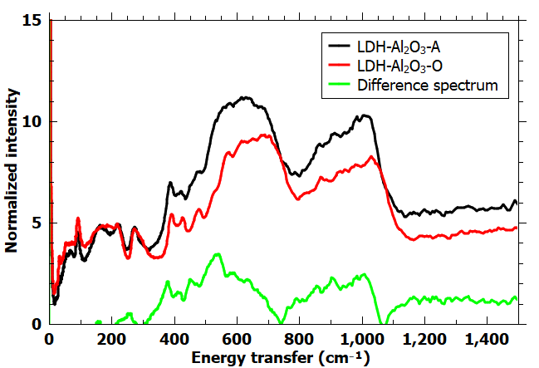
Figure 6.2: INS spectra of LDH-Al₂O₃ (Ambient-dried (A) vs. Oven-dried (O)), as well as the difference between them.

First, these peaks are broad and smooth, which means that the water molecules and hydroxyl groups are disordered. In other words, the local order and chemical environment vary considerably, so that the vibrational modes of H₂O and OH have frequencies distributed in a wide energy range. Second, not surprisingly, the A sample contains more water than the O sample, judging from the higher overall intensity of its spectrum.
This is consistent with the water content measured by DSC-TG, as listed in Table 6.1. Third, the peak positions are slightly different in the two samples. The A sample has its peaks at slightly lower frequencies. If we take the difference between the two spectra, the difference spectrum should reflect the contribution due to the additional water in the A sample. It can be seen that the additional water has its libration band centered around 500 cm⁻¹, much lower than that for the water in the O sample (600~700 cm⁻¹). This means these additional water molecules are weakly adsorbed/bonded and can be removed easily by moderate heating (90 °C) in the oven. The remaining water in the O, still structurally disordered, has stronger (hydrogen) bonding within the material (thus has higher vibrational frequencies and more difficult to remove).
An interesting comparison can be made with the INS spectra of the LDH-Al(OH)₃ samples shown in Fig. 6.2. First, the LDH-Al(OH)₃-A spectrum appears to be very different from the previous alumina sample, LDH-Al₂O₃-A. A comparison with the reference spectrum of solid ice (the Ih phase) measured at 5 K suggests that the LDH-Al(OH)₃-A sample contains bulk water (i.e., clustered water molecules forming crystalline ice at low temperatures). This is different from the LDH-Al₂O₃-A sample in which only adsorbed/bonded water molecules are observed. Since both samples were dried at the same temperature for the same duration, the result seems to suggest that LDH-Al(OH)₃ has a stronger capability to retain water.

Table 6.1: Composition and formation enthalpy of the LDH samples in addition to starting materials used for formation enthalpy calculations.
# | Samples | Composition | n(H₂O) | ΔH_{sol}(kJ/mol) | ΔH_{f}(kJ/mol)
1 | LDH-Al₂O₃-A | Li_{0.732}Al₂(OH)₆Cl_{0.732}.2.24H₂O | 2.24 | -188.41±0.75 | -56.14±1.89
2 | LDH-Al(OH)₃-A | Li_{0.840}Al₂(OH)₆Cl_{0.840}.5.24H₂O | 5.24 | -239.23±1.40 | -10.07±2.35
3 | LDH-Al₂O₃-O | Li_{1.03}Al₂(OH)₆Cl_{1.03}.2.06H₂O | 2.06 | -177.68±1.42 | -60.56±2.62
4 | LDH-Al(OH)₃-O | Li_{0.770}Al₂(OH)₆Cl_{0.770}.3.70H₂O | 3.70 | -224.26±1.44 | -22.10±2.22
7 | LDH-Al₂O₃-O (previous work)⁸⁰ | Li_{1.03}Al₂(OH)₆Cl_{1.03}.0.55H₂O | 0.55 | -139.60±1.22 | -96.78±2.33
8 | LDH-Al(OH)₃-A | Li_{0.82}Al₂(OH)₆Cl_{0.82}.1.93H₂O | 1.93 | -192.28±0.56 | -55.01±2.35
9 | LDH-Al(OH)₃-A | Li_{0.94}Al₂(OH)₆Cl_{0.94}.4.36H₂O | 4.36 | -231.14±0.45 | -21.21±2.15
10 | LDH-Al₂O₃-A | Li_{0.9}Al₂(OH)₆Cl_{0.9}.4.42H₂O | 4.42 | -236.87±1.30 | -14.09±2.37
 | Lithium chloride (LiCl) |  |  | -34.46±1.90
 | Gibbsite (Al(OH)₃) |  |  | -109.27±0.50

Indeed the data in Table 6.11 suggest that the water content in LDH-Al(OH)₃-A is more than twice that in LDH-Al₂O₃-A. Using the reference spectrum, one can remove the contribution of solid ice in the LDH-Al(OH)₃-A spectrum. After this procedure, the remaining spectrum can be attributed to adsorbed and bonded water, and it resembles the LDH-Al₂O₃-A spectrum in Fig. 6.2.
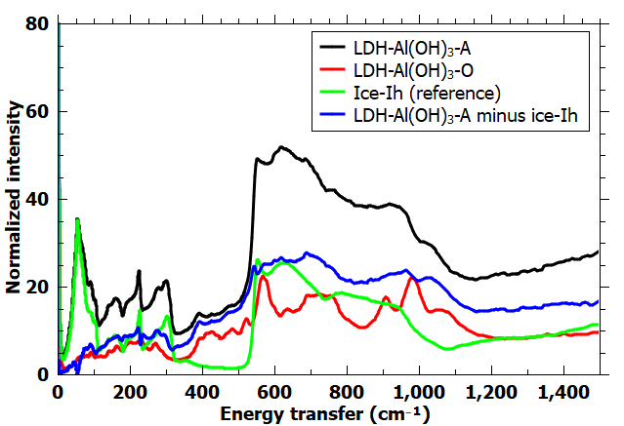
Figure 6.2: INS spectra of LDH-Al(OH)₃ (Ambient-dried (A) vs. Oven-dried (O)). Since LDH-Al(OH)₃-Ambient-dried contains bulk water, solid ice contribution is removed by subtracting a scaled reference spectrum.

The LDH-Al(OH)₃-O spectrum, however, is very different from that of LDH-Al₂O₃-O, as highlighted in Fig. 6.3. Most notably, instead of having two smooth bumps, one can see several sharp peaks in the same energy range. These sharp peaks can only form when the water molecules, and therefore the hydroxyl groups that interact with them, are structurally ordered with well-defined vibrational frequencies. In other words, the INS results in Fig. 6.3 show strong evidence that after oven-drying removes the bulk water and weakly adsorbed/bonded water molecules, the remaining ones in LDH-Al(OH)₃-O form an ordered layer in the crystal (similar to what is illustrated in Fig. 6.1). This is in stark contrast to the LDH-Al₂O₃-O, in which a smaller amount of water is distributed in a more disordered way. The ability to form an ordered water layer in LDH-Al(OH)₃ could be related to its ability to accommodate/retain more water.
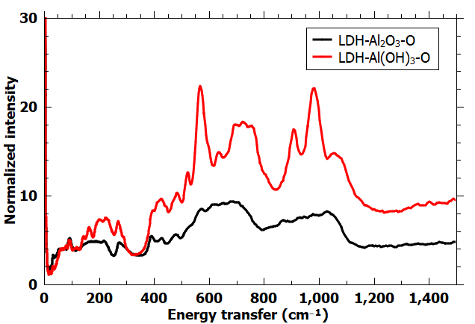
Figure 6.3: INS spectra of two O samples (LDH-Al₂O₃ vs. LDH-Al(OH)₃).

Now we discuss the assignment of the peaks. This study benefited from several advantages of neutron spectroscopy (compared with optical spectroscopy), such as its sensitivity to water, lack of selection rules, sample penetration depth, and being quantitative in the sense that the integrated peak intensities roughly scales with the total scattering power of the sample (which reflects the total amount of water in this case). Another advantage is that, knowing the structure of the material, its INS can be readily simulated so that unambiguous peak assignment can be made. In Fig. 6.4, the measured spectrum on LDH-Al(OH)₃-O is compared with the simulated INS from the structure shown in Fig. 6.1, which has an ordered arrangement of H₂O and presumably resembles the LDH-Al(OH)₃-O sample. The agreement is reasonably good considering that the ordering in the real sample must be less than the near-ideal case in simulation (and therefore with fewer and less sharp peaks). The two bands from 400 cm⁻¹ to 800 cm⁻¹ and from 800 cm⁻¹ to 1200 cm⁻¹ are well reproduced. The lower frequency band is dominated by H₂O liberation, whereas the higher energy band is dominated by OH deformation (in either the water molecules or the hydroxyl groups). Of course, this is a solid-state simulation and different parts/groups in the structure are interacting and coupled with each other, thus the modes are all mixed in nature, and the above description is only meant to capture the main character of the modes.

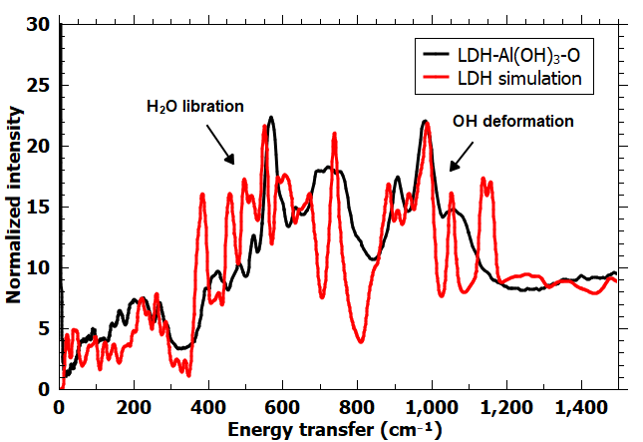
Figure 6.4: Simulated INS spectrum based on the structure in Fig. 6.1, in comparison to the measured one for LDH-Al(OH)₃-O.

Finally, QENS was performed on two samples, Al(OH)₃ and Al₂O₃ derived LDH. Figure 6.5 shows the QENS spectra for the measured samples at 3 selected temperatures, for Q averaged spectra. Each sample has significant temperature dependent QE broadening. First approximation to obtain information about the diffusion was obtained by fitting one Lorentzian function to the QE broadening. These fits provided indication about the character of the diffusion, but a more sophisticated model will be necessary for results describing the several dynamic processes present. This first approximation assumes only assumes one dynamic process in the sample, which is an average of the various processes taking place in the sample.

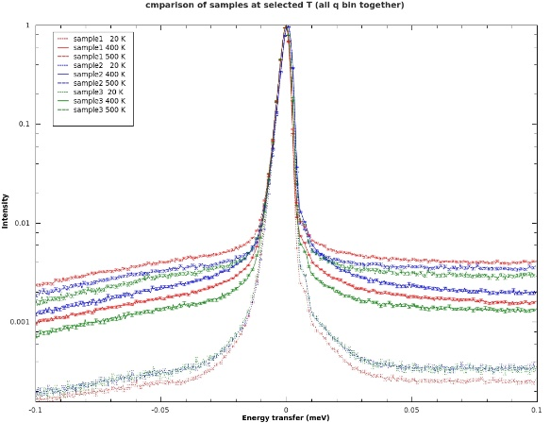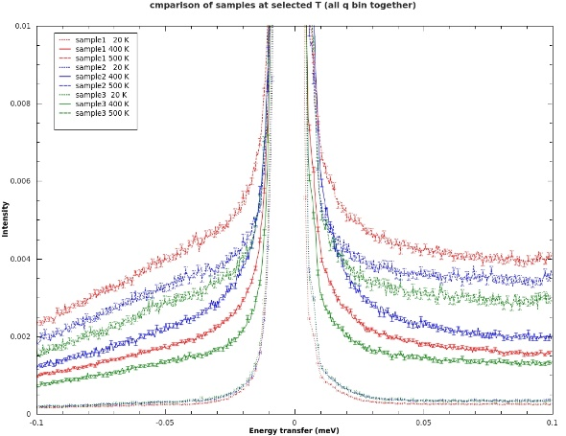
Figure 6.5: QENS spectra of Al(OH)₃-LDH (blue), Al₂O₃-LDH (red) and Fe-LDH (green) measured at 20, 400 and 500 K. Left hand side has logarithmic y-axes scale to show the entire elastic peak, and the right hand side has linear y-axes scale that has been truncated to the bottom to illustrate the QE broadening of the spectra.

Figure 6.6 illustrates Lorentzian HWHM as a function of Q² for sample 1 and sample 2 at 400 and 500 K. Each HWHM has Q dependent behavior indicating jump diffusion of hydrogenous species. The diffusion is increasing with temperature. To determine accurate diffusion coefficients and to explain the dynamic processes taking place in these samples, a more detailed model will be developed. The HWHM data presented in Figure 6.6 can be used to make some determinations about the microstructure and lithium uptake abilities of Al(OH)₃ vs. Al₂O₃ LDH. The change in HWHM indicates two points. First, that Al₂O₃ derived LDH is has a lower diffusion value at 400K compared to Al(OH)₃, upon increase in temperature the alumina derived sample has almost double the activity of the gibbsite sample. Secondly, gibbsite derived LDH only has a moderate change in HWHM values upon heating to 500K. This behavior can be explained in a few ways.

Figure 6.6: HWHM of the Lorentzian function fits to the QENS spectra of Al(OH)₃-LDH (red) and Al₂O₃-LDH (navy) at 400 (triangles) and at 500 K (circles).

Looking at figure 6.7 the SEM images of both Al₂O₃ and Al(OH)₃ LDH are shown. Here Al(OH)₃ LDH is seen to have a nanoplatelet structure, on the order of 200 nm in length, where Al₂O₃ LDH displays a much larger micron sized structure. This variation in microstructure between the two samples helps to explain the first large difference in HWHM values from 400K to 500K. Based on the larger crystallites of Al₂O₃ LDH there will be less microstrain in the structure. While hydrogens present in the material are stable at 400K they become much more mobile at 500K. Al(OH)₃ on the other hand has a nanocrystalline structure and more microstrain that the Al₂O₃ sample so the observed difference from 400 to 500K is much less. This also raises another point that Al(OH)₃-LDH displays higher diffusion values at 400K than Al₂O₃ LDH. Adsorption studies of the two materials have found that gibbsite based LDH is the only sample able to uptake lithium at normal testing conditions (95 °C). One possible explanation for this difference is surface diffusion effects, where previous thermodynamic results in this chapter have shown, where the Al₂O₃ LDH is too stabilized to allow facile movement of water and other ions. Al(OH)₃ on the other hand hits a “sweet spot” that allows for facile surface diffusion at both temperatures. This fact and the difference in HWHM raises an interesting point for the development of lithium sorbents. Tailoring water diffusion for different geothermal and brine samples is critical to successful adsorption of lithium. The particular range of diffusion that the gibbsite derived LDH structure enables gives the proper window of time to allow lithium molecules to flow along the dynamic water interlayer but still have enough time to interact with the hydroxyl surface of the metal LDH layers and intercalate into lithium deficient octahedral sites. The Al₂O₃ LDH has diffusion that is too fast for this interaction to occur hence the lack of lithium adsorption in trials. This finding confirms the importance of precursor and synthetic conditions which are of great importance for the development of metal doped LDH sorbents.

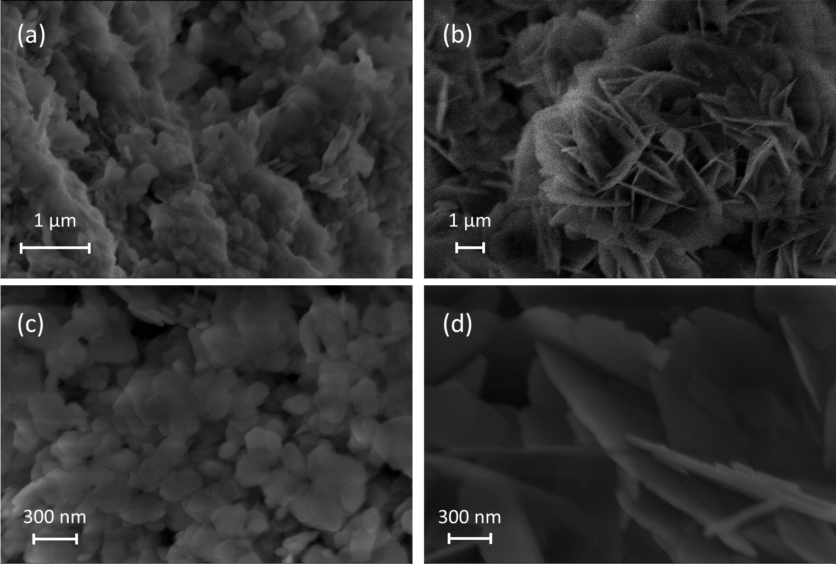
Figure 6.7: SEM images of (a) (c) Al(OH)₃ LDH, and (b) (d) Al₂O₃ LDH.

6.4 Summary

In summary, neutron spectroscopy and formation enthalpies were used to study LDH samples made from two different starting material (alumina (Al₂O₃) and gibbsite (Al(OH)₃) and with two different post-drying conditions (ambient-dried (A) and oven-dried (O)). It is found through inelastic neutron scattering and structural simulations that gibbsite derived LDH contains more ordered water than the corresponding alumina derived LDH. Thermodynamic analysis from Chapter 5 further correlates the water-retaining capability with the stability of the material, reversibility, and efficiency for lithium recovery. Specifically, this implies that higher concentrations of water present in LDH, regardless of starting material, will lead to the more facile lithium adsorption and desorption due to a decrease in thermodynamic barriers. QENS results have also provided a view into the effects of temperature on diffusion and the importance of synthetic conditions to tailoring sorbents to operate at specific temperatures. These insights will enable the further improvement of effective Li-ion LDH sorbents, in the form of metal doped analogues, as well as insights into other materials for lithium extraction.

Chapter 7: Iron-Doped Varients of LDH

Abstract

Thermodynamic and neutron studies in chapter 5 and 6 concurrently prompted investigation into alternative or derivative sorbents of Li-Al LDH. In this chapter, an iron doped variant of Li-Al LDH will be discussed. This includes all of the previously investigated thermodynamic and neutron work as well as comparison to the parent Li-Al LDH in terms of structure, dynamics, and lithium adsorption selectivity.
The thermodynamic studies and neutron studies presented in Chapter 7 are based on the following papers published in The Journal of the American Ceramic Society (2019), The Journal of Physical Chemistry C (2019), and another manuscript in preparation:
L. Wu, L. Li, S.F. Evans, T.A. Eskander, B.A. Moyer, Z. Hu, P.J. Antonick, S. Harrison, M.P. Paranthaman, R. Riman, A. Navrotsky, Lithium aluminum-layered double hydroxide chlorides (LDH): Formation enthalpies and energetics for lithium ion capture, Journal of the American Ceramic Society, 102 (2019) 2398–2404.
L. Wu,* S. F. Evans,* Y. Cheng, A. Navrotsky, B. A. Moyer; S. Harrison, M. P. Paranthaman, Neutron Spectroscopic and Thermochemical Characterization of Lithium–Aluminum-Layered Double Hydroxide Chloride: Implications for Lithium Recovery. The Journal of Physical Chemistry C 2019, 123 (34), 20723-20729.

7.1 Introduction

In this study, formation enthalpies of Li-LDH with a series of Li contents (x = 0.74~1.36 in Li_{x}Al₂(OH)₆Cl_{x}.nH₂O) have been investigated by acid solution calorimetry. Previous work on stabilizing LDH structures with metal ions¹⁰⁵⁻¹⁰⁷ prompted the identification of possible dopants to increase the stability of aluminum-based LDH. The selection of Fe³⁺ as a dopant prompted an investigation of the energetics of LDH with varying Fe³⁺ doping levels. The calorimetric results directly reflect the relationship between thermodynamic stability and doping level. The goal of this study is to find out whether, based on thermodynamic considerations, there are optimum Fe-LDH compositions for Li-ion capture.
Iron has been doped into LDH structures, such that Al³⁺ is partly replaced by Fe³⁺.¹⁰⁵ Low doping amounts from 0.22-0.30 were considered to prevent the formation of different crystalline phases¹⁰⁵ and retain the desired Li adsorbing Li-LDH structure. To increase fundamental understanding of these observations and design better Li-capture systems, the thermodynamics associated with LDH formation, metal ion doping, and lithium capture must be elucidated. Additionally, to determine the role of water in Fe-LDH samples underwent two post-drying conditions (ambient-dried and oven-dried) for thermodynamic study along with structural and dynamic studies using inelastic neutron scattering and quasielastic neutron scattering (INS and QENS, respectively).

7.2 Experimental

Three Fe-doped LDHs with different Fe compositions have been used in this study. Pure aluminum LDH samples were prepared by mixing Al(OH)₃ (Alfa Aesar > 76.5 %) and LiOH (Honeywell Fluka > 98.5 %) at 95 °C for 2 h. Following this, the LDH structure was fully loaded with lithium by mixing with 40 % LiCl (Sigma-Aldrich > 99%) in an acetic acid (Sigma-Aldrich > 99.7 %) and DI water mixture in a ratio of 6:4 mL, respectively. Loading of the structure with LiCl was completed when the pH of the solution reached 5.5. Acetic acid was used as the buffer solution to maintain the pH close to 5. Iron doped LDH synthesis were prepared by adding FeCl₃ (Sigma-Aldrich > 97 %) in 10 wt.% loading to a heated mixture of Al(OH)₃ followed by LiOH to ensure proper mixing of the metals that would compose the layered hydroxide double layer with iron replacing some aluminum species. Upon completion Fe-LDH was fully loaded with lithium by mixing with 40% LiCl acetic acid solution. To obtain the variety of LiCl values (x = 0.78 - 0.57 for Fe-LDH) unloading was performed at 95 °C at various times. Additionally, two Fe-LDH samples underwent two different post-synthesis treatments. The two conditions were ambient drying (A) and oven drying (O), t. Ambient drying was performed at 25 °C in air, and oven drying was done at 95 °C. Both drying treatments were performed for 24 h. The Fe-LDH samples are labeled as Fe-LDH-A, and Fe-LDH-O,
Samples have been characterized by X-ray powder diffraction (XRD) using a PANalytical Empyrean with Cu Kα radiation, all data was processed with HighScore Plus. Inductively coupled plasma – optical emission spectroscopy (ICP-OES) compositional analysis was performed to determine the Li and Al concentrations in all the samples with a Thermo Fischer iCAP Model 7400 ICP-OES Duo. Results of all the sample compositions are shown in Table 7.1. Differential scanning calorimetry and thermogravimetry (DSC-TG) analysis was performed on a Netzsch 449 instrument to determine the water content. Samples were heated from 25 to 800 °C at 10 °C/min in argon (see Table 7.1). To investigate the thermal behavior of LDH samples at higher temperatures, two LDH samples were analyzed using a Setaram Labsys instrument and heated to 1400 °C at 10 °C /min in argon. ATR FT-IR was data was gathered using a BRUKER VERTEX 70. FTIR spectra were recorded using a Bruker Alpha-P IR spectrometer with correction from an initial background collected before sampling to subtract the contribution from the ambient environment. After background collection, the solid sample (5-10 mg) was put on the diamond sensor. The spectra were collected at 100 − 4000 cm⁻¹ with resolution of 4 cm⁻¹ and scan time of 32 scans.
Acid solution calorimetry (CSC calorimeter model 4400) was applied to all LDH samples and component compounds (LiCl, goethite (α-FeOOH) and gibbsite (γ-Al(OH)₃)). A typical procedure included weighing about 10 mg of sample powder, pressing the powder into a pellet and dropping it into 25 mL HCl solution (standard solution from Alfa Aldrich, 5N) in the calorimeter at 25 °C. The heat of solution was measured. The calorimeter was calibrated by the heat of dropping a KCl (NIST Standard) pellet in the same conditions. Several pellets of each composition were dropped (Table 7.1) and the errors are reported as two standard deviations of the mean. The procedure has been described in detail elsewhere.^{75, 76}

Table 7.1: Composition and formation enthalpy of the LDH samples in addition to starting materials used for formation enthalpy calculations.
# | Samples | Composition | n(H₂O) | ΔH_{sol}(kJ/mol) | ΔH_{f}(kJ/mol)
1 | LDH-Al₂O₃-A | Li_{0.732}Al₂(OH)₆Cl_{0.732}.2.24H₂O | 2.24 | -188.41±0.75 | -56.14±1.89
2 | LDH-Al(OH)₃-A | Li_{0.840}Al₂(OH)₆Cl_{0.840}.5.24H₂O | 5.24 | -239.23±1.40 | -10.07±2.35
3 | LDH-Al₂O₃-O | Li_{1.03}Al₂(OH)₆Cl_{1.03}.2.06H₂O | 2.06 | -177.68±1.42 | -60.56±2.62
4 | LDH-Al(OH)₃-O | Li_{0.770}Al₂(OH)₆Cl_{0.770}.3.70H₂O | 3.70 | -224.26±1.44 | -22.10±2.22
5 | Fe-LDH-A | Li_{0.94}Al_{1.57}Fe_{0.43}(OH)₆Cl_{0.94}.1.30H₂O | 1.30 | -171.19±0.58 | -25.75±1.51
6 | Fe-LDH-O (previous work)¹⁴ | Li_{0.57}Al_{1.70}Fe_{0.30}(OH)₆Cl_{0.57}.0.65H₂O | 0.65 | -162.38±4.8 | -42.49±5.00
7 | LDH-Al₂O₃-O | Li_{1.03}Al₂(OH)₆Cl_{1.03}.0.55H₂O | 0.55 | -139.60±1.22 | -96.78±2.33
8 | LDH-Al(OH)₃-A | Li_{0.82}Al₂(OH)₆Cl_{0.82}.1.93H₂O | 1.93 | -192.28±0.56 | -55.01±2.35
9 | LDH-Al(OH)₃-A | Li_{0.94}Al₂(OH)₆Cl_{0.94}.4.36H₂O | 4.36 | -231.14±0.45 | -21.21±2.15
10 | LDH-Al₂O₃-A | Li_{0.9}Al₂(OH)₆Cl_{0.9}.4.42H₂O | 4.42 | -236.87±1.30 | -14.09±2.37
 | Goethite (FeOOH) |  |  | -43.44±0.95
 | Lithium chloride (LiCl) |  |  | -34.46±1.90
 | Gibbsite (Al(OH)₃) |  |  | -109.27±0.50
The INS experiments were performed at the VISION beamline of the Spallation Neutron Source, Oak Ridge National Laboratory. Different, in principle, from optical spectroscopy such as IR, INS is very sensitive to the hydrogen species inside the material, and it is especially useful in revealing their structural orientation, bonding, local order, and quantity. About 2g of each sample was loaded in a vanadium sample holder and measured at 5 K to collect the vibrational spectrum. The data were then analyzed using Mantid.⁹⁷ Complementary density functional theory (DFT) simulations were performed using the Vienna Ab initio Simulation Package (VASP).⁹⁸ The calculation used the Projector Augmented Wave (PAW) method^{99, 100} to describe the effects of core electrons, and Perdew-Burke-Ernzerhof (PBE)¹⁰¹ implementation of the Generalized Gradient Approximation (GGA) for the exchange-correlation functional. Energy cutoff was 1000 eV for the plane-wave basis of the valence electrons. The structure in Fig. 7.1 was used as the initial structure. The total energy tolerance for electronic energy minimization was 10⁻⁸ eV, and for structure optimization it is 10⁻⁷ eV. The maximum interatomic force after relaxation was below 0.005 eV/Å. The vibrational eigen-frequencies and modes were then calculated by solving the force constants and dynamical matrix using density functional perturbation theory (as implemented in VASP) and Phonopy.¹⁰² The OClimax software¹⁰³ was used to convert the DFT-calculated phonon results to the simulated INS spectra.
Neutron backscattering measurements were performed at BASIS spectrometer¹⁰⁴ at the Spallation Neutron Source of Oak Ridge National Laboratory, Oak Ridge, TN. Si111 analyzers were utilized and the center wavelength of neutron beam was 6.4 Å, giving energy resolution of 3.5 μeV (FWHM of the elastic peak), dynamic range of ±100 μeV and Q range from 0.2 to 2.0 Å⁻¹. With this configuration the time scales from 1 ps to about 1 ns can be observed, as well as length scale from about 3 up to 30 Å. Each sample was distributed in an aluminum foil pouch which was then wrapped inside a standard annular aluminum can. To determine the instrumental resolution function, each sample was first measured at 20 K, where all diffusive motions are essentially frozen in the measured time scale. Subsequently the samples were measured at number of higher temperatures ranging from 250 to 600 K to determine the characteristics of H diffusion in these samples from their Q dependence on inelastic scattering.

7.3 Results and Discussion

Strategies to understand this stability include doping the LDH structure with Fe³⁺ ions, replacing a fraction of Al³⁺ present in LDH. Greater electron density of Fe³⁺ compared to Al³⁺ increased the thermodynamic stability of the LDH.⁸⁰ X-ray analysis of iron-doped samples in Figure 7.1 confirmed the retention of the pure aluminum LDH structure with no discernable distortion in structure observed from doping. This provides direct evidence that Fe is replacing Al in LDH structure. The formation of Fe₂O₃ was seen due to the side reaction of FeCl₃ in the basic reaction mixture at elevated temperatures.

Figure 7.1: XRD spectra of typical Li-LDH and Fe-LDH phases.

TG-DSC analysis of Fe-LDH samples in Figure 7.2 displayed similar dehydration behavior to the parent Li-LDH. That being major weight loss between 100 and 400 °C, accompanied by endothermic peaks on the corresponding DSC curves in the same temperature range. Resulting from the typical dehydration process of LDH materials. The DSC curves suggest stepwise dehydration behavior. The initial step (100 – 150 °C) corresponds to the removal of physically attached water molecules, the second step (200 – 250 °C) results from the removal of the chemically bonded water located between the layers. Importantly, the final weight loss from the dehydration of hydroxyl groups coordinated to Al and Li atoms (co-intercalated water molecules) occurs in Li-LDH from 250 – 350 °C while Fe-LDH undergoes the same weight loss from 300 - 400 °C. This temperature shift implies the increased structural stability of iron doped LDH variant.
The formation enthalpies (ΔH_{f}) of Li-LDH and Fe-doped LDH from LiCl, γ-Al(OH)₃ and α-FeOOH are calculated through the thermodynamic cycle in Table 7.2 by using the solution enthalpies listed in Table 7.3. The formation enthalpies of Li-LDH (Li_{x}Al₂(OH)₆Cl_{x} with x = 0.74 to 1.36 range between -4.8 and -23.1 kJ/mol. The values for Fe-doped LDH (Li_{x}Fe_{y}Al_{2-y}(OH)₆Cl_{x} with y = 0.22 ~ to 0.30 and x = 0.57 to 0.78) range between -28.2 and -49.4 kJ/mol. All formation enthalpies for LDH are significantly negative, which indicate that reactions (1) and (6) (in Table 7.2) are thermodynamically favorable. The Fe-containing LDH compounds have more exothermic formation enthalpies, indicating that doping with iron is an effective way to thermodynamically stabilize the LDH phase.
The trends of the formation enthalpies with differing Fe content are shown in Figures 7.3. Previous studies on the structural stability of M(II)_{1-x} [M(III)_{x}(OH)₂]Cl_{x}.yH₂O (e.g., Mg-LDH) formation in solution have shown Fe(III) to have greater thermodynamic stability than Al(III) in the double hydroxide layer.¹⁰⁸
Figure 7.2: DSC-TG curves for Fe-doped LDH with formula Li_{x}Al_{2-y}Fe_{y}(OH)₆Cl_{x}∙nH₂O.

Table 7.2: Thermodynamic cycle used to calculate the reaction enthalpies of LDH from lithium chloride and Aluminum hydroxide at 25°C.
Reactions used in the thermodynamic cycle are:
(1) xLiCl (s, 25°C) + 2Al(OH)₃(s, 25°C) + nH₂O(l, 25°C) LixAl₂(OH)₆Cl_{x}. nH₂O(s, 25°C) | ΔH_{f, LDH} | ΔH₁
(2) LiCl (s, 25°C) Li⁺ (aq, 25°C) +Cl⁻(aq, 25°C) | ΔH_{sol, LiCl} | ΔH₂
(3) Al(OH)₃(s, 25°C) + 3H⁺(aq, 25°C) Al³⁺ (aq, 25°C) + 3H₂O (aq, 25°C) | ΔH_{sol, Al(OH)3} | ΔH₃
(4) Li_{x}Al₂(OH)₆Cl_{x}. zH₂O(s, 25°C) + 3H⁺(aq, 25°C) x Li⁺(aq, 25°C) +xCl⁻(aq, 25°C) + 2Al³⁺(aq, 25°C) + (3+n)H₂O(aq, 25°C) | ΔH_{sol, LDH} | ΔH₄
(5) H₂O (l, 25°C) H₂O (aq, 25°C) | ΔH_{dil} | ΔH₅
(6) xLiCl(s, 25°C) + (2-y)Al(OH)₃(s, 25°C) +yFeOOH(s, 25°C) + (y+z)H₂O(l, 25°C) LixAl_{2-y}Fe_{y}(OH)₆Cl_{x}. nH₂O(s, 25°C) | ΔH_{f, Fe- LDH} | ΔH₆
(7) LixAl_{2-y}Fe_{y}(OH)₆Cl_{x}. zH₂O(s, 25°C) + 3H⁺(aq, 25°C) xLi⁺(aq, 25°C) + xCl⁻(aq, 25°C) + (2-y)Al³⁺(aq, 25°C) + yFe³⁺(aq, 25°C)+ (3+n)H₂O(aq, 25°C) | ΔH_{sol,Fe- LDH} | ΔH₇
(8) FeOOH (s, 25°C)+ 3H⁺(aq, 25°C) Fe³⁺ (aq, 25°C) + 2H₂O (aq, 25°C) | ΔH_{sol,FeOOH} | ΔH₈
ΔH_{f, LDH} =ΔH₁= xΔH₂ + 2ΔH₃ + nΔH₅ - ΔH₄
ΔH_{f, Fe- LDH} =ΔH₆= xΔH₂ + (2-y)ΔH₃ + yΔH₈+(3+n)ΔH₅– ΔH₇
ΔH₅ is the dilution enthalpy of liquid water in 5 N HCl solution, since the effect is small, it has been neglected in this calculation.

Table 7.3: Sample composition, TG weight loss at 700°C, enthalpy of solution (ΔH_{sol}) in 5N HCl and the formation enthalpies of LDH (ΔH_{f}) by LiCl reacted with gibbsite and goethite.
x(LiCl) | Sample name | Molecular formula | TG weight loss (%) | ΔH_{sol}(kJ/mol) | ΔH_{f}(kJ/mol)
0.78 | Fe-LDH1 | Li_{0.777}Al_{1.771}Fe_{0.229}(OH)₆Cl_{0.777}·1.08H₂O | 34.18 | -157.24±0.95(7) | -59.01±2.06
0.77 | Fe-LDH2 | Li_{0.769}Al_{1.769}Fe_{0.221}(OH)₆Cl_{0.769}·0.67H₂O | 32.02 | -151.105±2.28(6) | -64.32±2.88
0.57 | Fe-LDH3 | Li_{0.566}Al_{1.70}Fe_{0.30}(OH)₆Cl_{0.769}0.65H₂O | 32.78 | -162.38±4.80(6) | -42.49±5.04
 | Goethite | FeO(OH) |  | -43.44±0.95(6)
 | Gibbsite | γ-Al(OH)₃ |  | -101.37±0.46(4)
 | Lithium chloride | LiCl |  | -34.46±1.90(6)

Co-precipitating of other M(II) ions for a mixed M(III)/M(II) LDH system was found to further stabilize the layered structure.¹⁰⁸ Here we focus on Fe(III) as the metal dopant as other M(II) species would add too much cost to be economically viable for scale up. Figure 7.3 confirms the desired stabilization effect of Fe but the formation enthalpies of the three LDH with various Fe doping levels become less exothermic as the doping increases. This trend suggests that the more iron-rich LDH is less stable than the less iron-rich ones. However, the more negative formation enthalpies of Fe-LDH compared to non-doped LDH but with similar Li content indicates that a small amount of iron doping may dramatically improve the thermodynamic stability of the LDH structure. This stabilization is also seen in the slightly higher dehydration temperature in the TG/DSC curves. Since a small degree of iron doping appears to stabilize the LDH more than greater doping (perhaps due to lattice strain resulting from size mismatch), the energetics suggest that there may be an optimum doping level for greatest stabilization. In this case y = 0.22 Fe-doping increased stability while also retaining the desired layered structure.

Figure 7.3: Enthalpy of formation for Fe-LDH vs. Fe doping level (y).
With iron doping of LDH found to increase the stability further thermodynamic study was performed to determine the effects of water content. The XRD spectra of oven ambiently dried Fe-LDH, seen in Figure 7.4, did not change drastically in comparison to the pure LDH samples. This is due to Fe³⁺ being of similar ionic radii as Al³⁺ and its occupation of the same octahedral sites within the structure.
TG/DSC analysis of the Fe-doped LDH seen in Figure 7.5 displayed prominent water loss at 110 °C that was not seen in the other LDH samples. This different behavior suggests that the water molecules in these three samples are not in the same structural or chemical state, with Fe-LDH retaining a higher amount of bulk water.
Figure 7.4: XRD patterns of the LDH samples (both ambient and oven dried). Starting precursor and decomposition products, gibbsite and alumina, are shown. Figure is as presented in Chapter 5.

Figure 7.5: DSC-TGA for (e) Fe-LDH-A.

In Figure 7.6 water content is linearly related to the formation enthalpy of LDHs, doped or non-doped, regardless of the drying routes and the starting form of Al. Further, high water content is associated with a destabilization of the LDH structure making reversible uptake of lithium facile. Upon iron doping, this trend shifts as the overall water content of the LDH decreases in addition to stabilization with the inclusion of iron into the lattice.
To further understand the state of water molecules (as well as the hydroxyl groups they are interacting with), INS experiments were performed as with the previously discussed LDHs in Chapter 6, the results are shown in Figure 7.7. The previous INS results showed strong evidence that after oven-drying removes the bulk water and weakly adsorbed/bonded water molecules, the remaining ones in LDH-Al(OH)₃-O form an ordered layer in the crystal (similar to what is illustrated in Fig. LDH model). This is in stark contrast to the LDH-Al₂O₃-O, in which a smaller amount of water is distributed in a more disordered way. This effect is also seen for Fe-LDH samples, implying that introduction of metal dopants to the structure may also influence water ordering. The ability to form an ordered water layer in LDH-Al(OH)₃ could be related to its ability to accommodate/retain more water.

Figure 7.6: Formation enthalpies of LDH (blue squares and orange circles) and Fe-LDH (green triangles) vs. water content. The trend line correlates LDH water content (both ambient and oven dried) to formation enthalpy. Figure is as presented in Chapter 6.

Finally, QENS was performed on Fe-LDH under the same temperature conditions that Al(OH)₃ and Al₂O₃ derived LDH underwent. Figure 7.8 shows the QENS spectra for the measured samples at 3 selected temperatures, for Q averaged spectra. Each sample has significant temperature dependent QE broadening. First approximation to obtain information about the diffusion was obtained by fitting one Lorentzian function to the QE broadening. These fits provided indication about the character of the diffusion, but a more sophisticated model will be necessary for results describing the several dynamic processes present. This first approximation assumes only assumes one dynamic process in the sample, which is an average of the various processes taking place in the sample. For these initial results it is clear that Fe-LDH has the lowest diffusion rates in comparison to the gibbsite and alumina derived LDH.

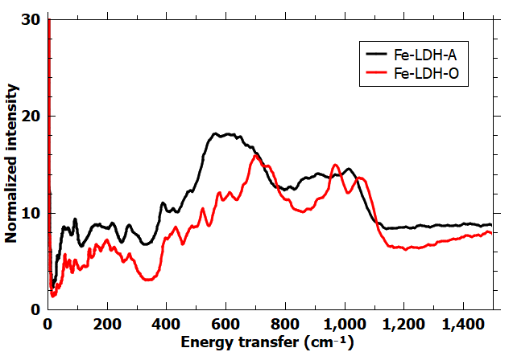
Figure 7.7: INS spectra of Fe-LDH samples (Ambient-dried (A) vs. Oven-dried (O)).

Figure 7.8: QENS spectra of Al(OH)₃-LDH (blue), Al₂O₃-LDH (red) and Fe-LDH (green) measured at 20, 400 and 500 K. Left hand side has logarithmic y-axes scale to show the entire elastic peak, and the right hand side has linear y-axes scale that has been truncated to the bottom to illustrate the QE broadening of the spectra. Figure is as presented in Chapter 6.

7.4 Comparison to LDH

With data collected on lithium adsorption and selectivity, physical characterization, and modelling of dynamic processes this section will compare the novel Fe-LDH to gibbsite (Al(OH)₃) and alumina (Al₂O₃) derived LDH. Adsorption comparisons are between Fe-LDH and gibbsite derived LDH since they were the only two to display lithium adsorption. Lithium adsorption tests were performed to compare the lithium uptake between LDH and Fe-LDH. Previous work⁸⁰ suggested that this was thermodynamically feasible. Bench scale testing confirmed this was true at ranges of 0-1000 ppm of simulated lithium containing brine solutions. Further, testing of different brine concentrations, seen in Figure 7.9, show that Fe-LDH has increased adsorption capacity from the 200-500 ppm range. This confirmed previous assumptions that iron doping would lead to increased lithium uptake due to an increase in electron density of the metal hydroxide layer.⁸⁰
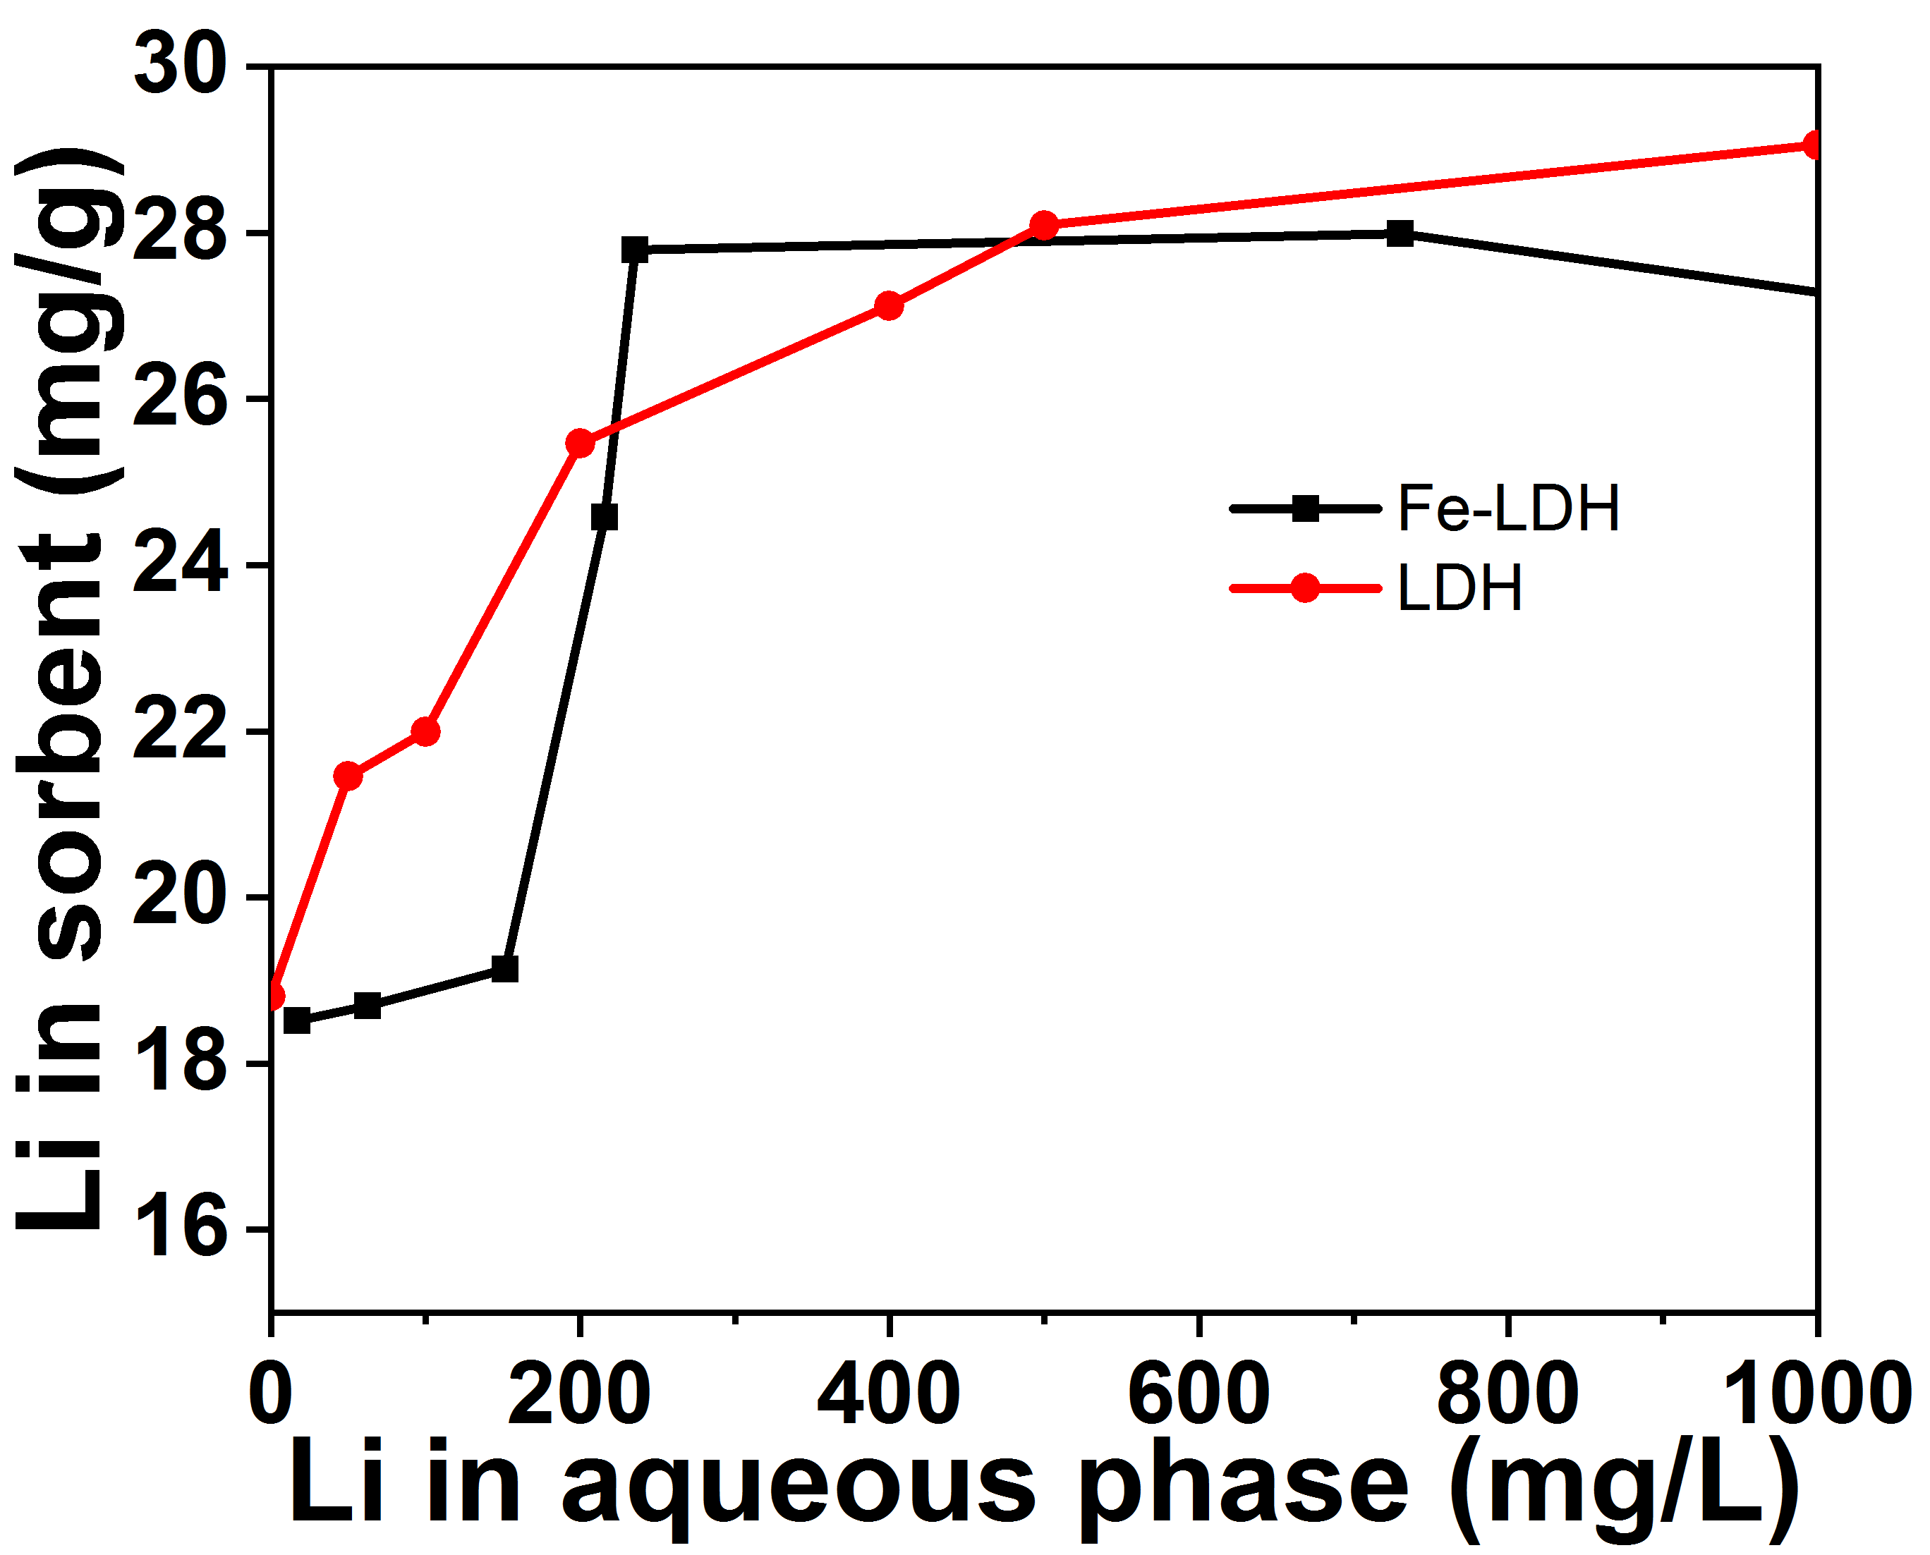
Figure 7.9: Adsorption isotherms of LDH and Fe-LDH over various concentrations of simulated brines.

Upon this confirmation of this increased uptake column testing with Fe-LDH sorbents were performed to determine differences in lithium selectivity compared to gibbsite based LDH, the column configuration was as previously reported.⁶⁰ The visual plot of adsorption, wash, strip column scale cycling for both Li-Al and Fe-LDH testing can be seen in Figure 7.10. Testing results and calculated separation factors are seen in Table 7.4 for Li-Al LDH and 7.5 for Fe-LDH. Here selectivity for the new variant of sorbent was seen to improve for Na, and Ca, remain the same for K and Mn, and decrease by a factor of 2 for boron. This is thought to come from favorable orbital interactions between the p orbitals of doped iron ions and s orbitals of boron, leading to an increased amount of boron insertion into unoccupied octahedra rather than the desired lithium.
Differences in the uptake and selectivity of Fe-LDH led us to further structural and mechanistic exploration. By utilizing high-resolution transmission electron microscopy (HR-TEM) we correlated the different interlayer spaces of LDH to different facets of their XRD patterns. There were some limitations in this analysis due to the orientation of different facets with different samples as well as sample interaction with the electron beam, but some insights can still be gained on the mechanism of lithium intercalation. Figure 7.11 showcases the different facets present in the materials and the corresponding miller indices that match with gathered XRD data. Additionally, we were able to confirm the distribution of iron doping in the sample, seen in Figure 7.12, which displays iron rich regions surrounded by more aluminum rich areas.

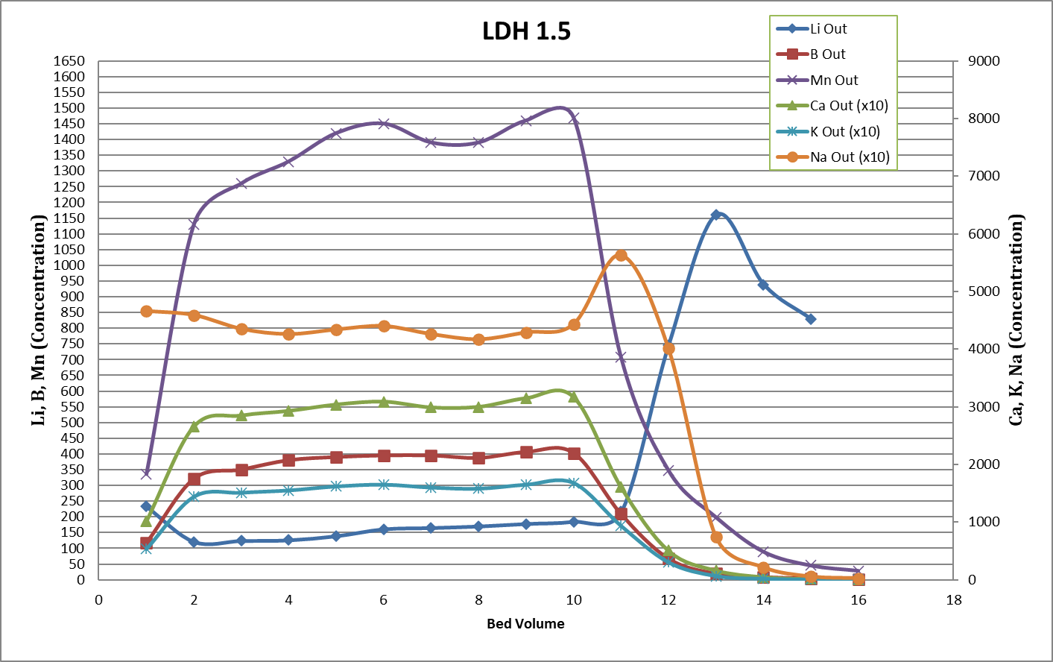
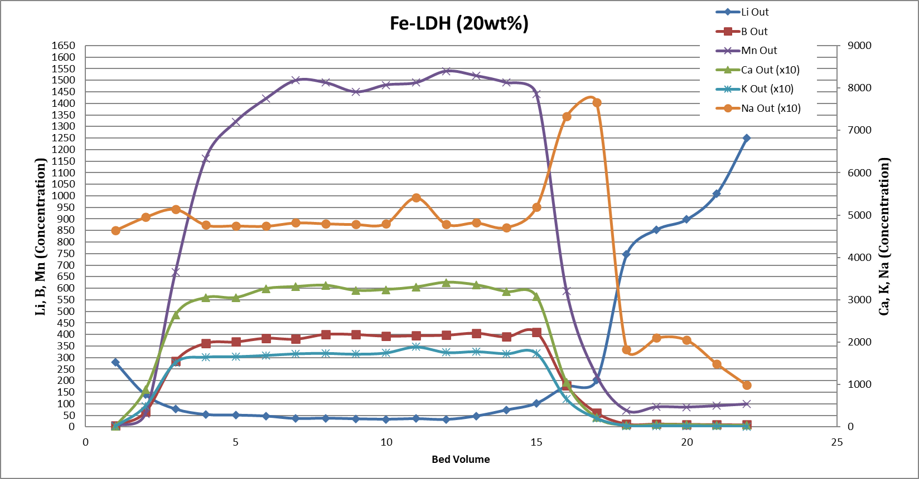
Figure 7.10: Calculated ppm concentrations from ICP-OES of various ions from simulated brine. Tables 7.4 and 7.5 look through the change in concentrations of the bed volumes through adsorption, washing and stripping stages of Li-Al and Fe-doped LDH adsorption trials.

Table 7.4: Metal-ion concentrations and separation factors during column extraction with Li-Al LDH. Derived from Figure 7.10.
Metal | Conc. in brine (mg/L) | Conc. @ BV13 (mg/L) | SF Li/M @ BV13 | Combined Conc. @ BV13-16 (mg/L) | Average Conc. @BV 13-16 (mg/L) | SF_{Li/M} @ BV13-16
Li | 360 | 2340 |  | 5079 | 1269.8
Na | 44000 | 7470 | 38.3 | 10474 | 2618.5 | 59.3
K | 16500 | 657 | 163.2 | 886 | 221.5 | 262.7
Ca | 30400 | 1660 | 119 | 2410 | 602.5 | 178
Mn | 1420 | 199 | 46.4 | 361 | 90.3 | 55.5
B | 390 | 19.5 | 130 | 35 | 8.8 | 156.3

Table 7.5: Metal-ion concentrations and separation factors during a column extraction with Fe-LDH. Derived from Figure 7.10.

Metal | Conc. in brine (mg/L) | Conc @ BV18 (mg/L) | SF Li/M @ BV18 | Combined Conc. @ BV18-22 (mg/L) | Average Conc. @BV 18-22 (mg/L) | SF Li/M @ BV18-22
Li | 360 | 746 |  | 4758 | 951.6
Na | 44000 | 1830 | 49.8 | 8468 | 1693.6 | 68.7
K | 16500 | 234 | 146.1 | 87.63 | 175.26 | 248.9
Ca | 30400 | 447 | 140.9 | 255.8 | 511.6 | 157.1
Mn | 1420 | 70.3 | 41.9 | 431.5 | 86.3 | 43.5
B | 390 | 12.9 | 62.6 | 56.93 | 11.386 | 90.5

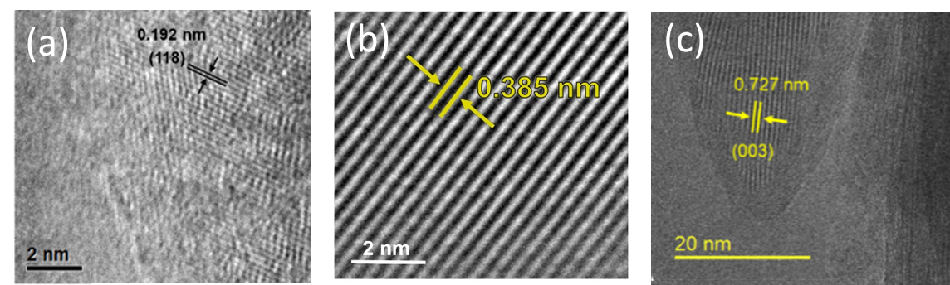
Figure 7.11: TEM images of (a) Al(OH)₃ LDH, (b) Al₂O₃ LDH, and (c) Fe-LDH. With labelled facets of (118), (006), and (003), respectively.

Figure 7.12: HAADF-STEM image of Fe distribution in Fe-LDH, white areas denote areas of increased electron density containing iron.

From the previously discussed QENS data in Figure 7.8 some structural details become clear. The hydrogens in Fe-LDH are less mobile in both temperature cases (400 and 500 K) than the other LDH samples tested. This implies that the increase in electron density upon inclusion of the Fe ion into the metal hydroxide interlayer decreases mobility of hydrogen containing species (i.e. water) and by proxy lithium. Additionally, by slowing the rate of diffusion of ions through the water interlayer, some selectivity for lithium is improved (Na and Ca), while some are worsened (as with Boron). This has also led to the revision of the structure of ordered interlayer water. Compared to the parent LDH, water molecules form hydrogen bonds with hydroxyl groups on one layer, with a bound length ~1.8 Å. In the Fe-LDH sample, there are water molecules that simultaneously form hydrogen bonds with hydroxyl groups on both layers (on both sides). As a result, the orientation of such water molecules are different (lying flat between two layers), and the hydrogen bond length is also slightly longer (~1.9 Å), as seen in Figure 7.13. These differences are relevant to the different mobility of water molecules in these two materials as well as their ability to retain water. Here the takeaway is that metal doped variant of the LDH system tailor the speed of diffusion and by proxy the lithium selectivity and uptake under certain conditions. This has huge implications on the development of sorbent technology for the dizzying array of brine compositions that are present and available for extraction.

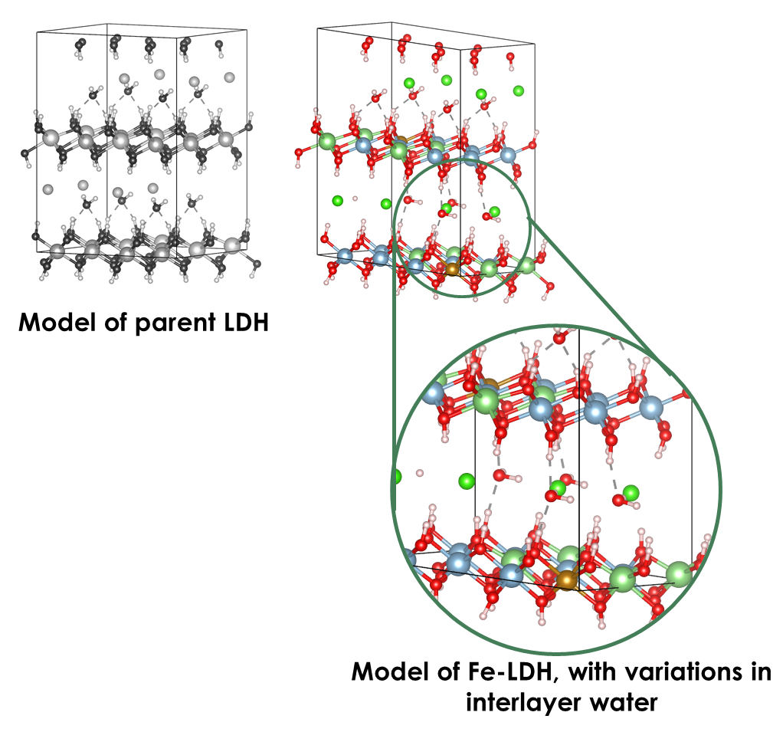
Figure 7.13: A structure model of Li_{x}·Fe_{y}Al_{(2-y)} (OH)₆Cl_{x}·nH₂O (Fe-LDH) (blue in M-OH layer: Al, green in M-OH layer: Li, Brown: Fe, bright green: Cl, red: O, light pink: H). Hydrogen bonds between the water molecules and the hydroxyl groups are shown by dashed lines.

7.5 Summary

This Chapter provides the first quantitative energetic picture of Li-LDH with varying Li/Al ratios and Fe-doped LDHs with different Fe contents. The results reveal the destabilizing effect of Li and the stabilizing effect of Fe. Full scale adsorption trials of these modified sorbents were also tested displaying differences in adsorption as well as selectivity. Further study of the microstructure and dynamic environment including microscopy and neutron studies has revealed the tailoring of properties that can be achieved with metal doping of Li-Al LDHs. This work preempts further development of sorbents to expand the range of lithium brine sources where these class of sorbents can be effectively utilized.

Chapter 8: Concluding Remarks and Future Research

The characterization and subsequent application of lithium-aluminum layered double hydroxide sorbents and iron doped variants were explored in this dissertation. Both have shown competent lithium adsorption values and an intimate look into the structure and dynamics of LDHs and their adsorption of lithium.
The stability of LDH and the destabilizing nature of LiCl uptake was the first important discovery. This allows for the continued use and reuse of the sorbent just through the use of thermal energy already present in geothermal brines. An elegant property that alleviates LDH sorbents of the need to use any additional solvent or materials for regeneration or processing.
The next part of the picture was water, without which adsorption would not occur. Sorbents with the highest contents of water were better able to swing between lithiation and de-lithiation due to its destabilizing effects. Neutron studies also provided a picture of the dynamic process of water movement in the interlayer, shuttling lithium ions along to their destination in unoccupied octahedra in the metal hydroxide layer.
While these studies have developed a fundamental understanding of LDH as a lithium adsorption material there is still work to be done if this sorbent is to reach industrial application. Collaboration with industrial partners helped to identify the major setback of the material in industrial use. In this case it is the particle size of LDH, pilot scale columns experience issues with pressure drops where brine was not able to pass through the sorbent quickly enough, leading to excessive pressure buildup and slow throughput. To circumvent these issues the powdered form of LDH must be combined with a host or polymer to form a composite material. By engineering LDH with supports and polymers the adsorption performance of LDH could still be retained but can be feasibly used in industrial application with size-controlled composites. This along with further fundamental studies of diffusion through liquid media, polymer networks, and ceramic adsorbents, all together, via neutrons opens a new way to understand a multitude of dynamic adsorption systems, not just those involving lithium. Without this critical development it is unlikely that the sorbent will find use as lithium demand drives production speeds higher to cost-effectively meet the needs of the green revolution.

                - References

1. Ellingsen, L. A.-W.; Singh, B.; Strømman, A. H., The size and range effect: lifecycle greenhouse gas emissions of electric vehicles. Environmental Research Letters 2016, 11 (5), 054010.
2. Chu, S., Critical materials strategy. DIANE Publishing: 2011.
3. Meshram, P.; Pandey, B.; Mankhand, T., Extraction of lithium from primary and secondary sources by pre-treatment, leaching and separation: A comprehensive review. Hydrometallurgy 2014, 150, 192-208.
4. Barbosa, L. I.; González, J. A.; del Carmen Ruiz, M., Extraction of lithium from β-spodumene using chlorination roasting with calcium chloride. Thermochimica acta 2015, 605, 63-67.
5. Tadesse, B.; Makuei, F.; Albijanic, B.; Dyer, L., The beneficiation of lithium minerals from hard rock ores: A review. Minerals Engineering 2019, 131, 170-184.
6. Jaskula, B. W. Lithium, Mineral Commodities Summaries; U.S. Geological Survey: 2020.
7. Swain, B., Recovery and recycling of lithium: A review. Separation and Purification Technology 2017, 172, 388-403.
8. Gaustad, G.; Krystofik, M.; Bustamante, M.; Badami, K., Circular economy strategies for mitigating critical material supply issues. Resources, Conservation and Recycling 2018, 135, 24-33.
9. Guo, Y.; Li, Y.; Lou, X.; Guan, J.; Li, Y.; Mai, X.; Liu, H.; Zhao, C. X.; Wang, N.; Yan, C., Improved extraction of cobalt and lithium by reductive acid from spent lithium-ion batteries via mechanical activation process. Journal of Materials Science 2018, 53 (19), 13790-13800.
10. Evans, R. K., An abundance of lithium. Santiago: World Lithium 2008.
11. Luong, V. T.; Kang, D. J.; An, J. W.; Kim, M. J.; Tran, T., Factors affecting the extraction of lithium from lepidolite. Hydrometallurgy 2013, 134, 54-61.
12. Liu, W.; Agusdinata, D. B.; Myint, S. W., Spatiotemporal patterns of lithium mining and environmental degradation in the Atacama Salt Flat, Chile. International Journal of Applied Earth Observation and Geoinformation 2019, 80, 145-156.
13. Liu, W.; Agusdinata, D. B., Interdependencies of lithium mining and communities sustainability in Salar de Atacama, Chile. Journal of Cleaner Production 2020, 120838.
14. Veen, S. v. d. Can the'green'economy also be'fair'? Environmental justice and corporate accountability in the process of lithium extraction in Jujuy. Argentina. 2017.
15. Revette, A. C., This time it’s different: lithium extraction, cultural politics and development in Bolivia. Third World Quarterly 2017, 38 (1), 149-168.
16. Yang, S.; Zhang, F.; Ding, H.; He, P.; Zhou, H., Lithium metal extraction from seawater. Joule 2018, 2 (9), 1648-1651.
17. Neupane, G.; Wendt, D. S. In Assessment of mineral resources in geothermal brines in the US, Proceedings of the 42nd Workshop on Geothermal Reservoir Engineering, Stanford University, Stanford, CA, USA, 2017; pp 13-15.
18. Ariza, M. J.; Jones, D. J.; Rozière, J.; Chitrakar, R.; Ooi, K., Probing the local structure and the role of protons in lithium sorption processes of a new lithium-rich manganese oxide. Chemistry of materials 2006, 18 (7), 1885-1890.
19. Xiao, G.; Tong, K.; Zhou, L.; Xiao, J.; Sun, S.; Li, P.; Yu, J., Adsorption and desorption behavior of lithium ion in spherical PVC–MnO2 ion sieve. Industrial & engineering chemistry research 2012, 51 (33), 10921-10929.
20. Ryu, T.; Haldorai, Y.; Rengaraj, A.; Shin, J.; Hong, H.-J.; Lee, G.-W.; Han, Y.-K.; Huh, Y. S.; Chung, K.-S., Recovery of lithium ions from seawater using a continuous flow adsorption column packed with granulated chitosan–lithium manganese oxide. Industrial & Engineering Chemistry Research 2016, 55 (26), 7218-7225.
21. Zhang, Q.-H.; Sun, S.; Li, S.; Jiang, H.; Yu, J.-G., Adsorption of lithium ions on novel nanocrystal MnO2. Chemical engineering science 2007, 62 (18-20), 4869-4874.
22. Sun, S.-Y.; Song, X.; Zhang, Q.-H.; Wang, J.; Yu, J.-G., Lithium extraction/insertion process on cubic Li-Mn-O precursors with different Li/Mn ratio and morphology. Adsorption 2011, 17 (5), 881-887.
23. Xiao, J.-L.; Sun, S.-Y.; Wang, J.; Li, P.; Yu, J.-G., Synthesis and adsorption properties of Li1. 6Mn1. 6O4 spinel. Industrial & Engineering Chemistry Research 2013, 52 (34), 11967-11973.
24. Li, L.; Qu, W.; Liu, F.; Zhao, T.; Zhang, X.; Chen, R.; Wu, F., Surface modification of spinel λ-MnO2 and its lithium adsorption properties from spent lithium ion batteries. Applied surface science 2014, 315, 59-65.
25. Ma, L.-W.; Chen, B.-Z.; Chen, Y.; Shi, X.-C., Preparation, characterization and adsorptive properties of foam-type lithium adsorbent. Microporous and mesoporous materials 2011, 142 (1), 147-153.
26. Chitrakar, R.; Kanoh, H.; Miyai, Y.; Ooi, K., Recovery of lithium from seawater using manganese oxide adsorbent (H1. 6Mn1. 6O4) derived from Li1. 6Mn1. 6O4. Industrial & engineering chemistry research 2001, 40 (9), 2054-2058.
27. Wang, S.; Li, P.; Cui, W.; Zhang, H.; Wang, H.; Zheng, S.; Zhang, Y., Hydrothermal synthesis of lithium-enriched β-Li 2 TiO 3 with an ion-sieve application: excellent lithium adsorption. RSC advances 2016, 6 (104), 102608-102616.
28. Lawagon, C. P.; Nisola, G. M.; Mun, J.; Tron, A.; Torrejos, R. E. C.; Seo, J. G.; Kim, H.; Chung, W.-J., Adsorptive Li+ mining from liquid resources by H2TiO3: Equilibrium, kinetics, thermodynamics, and mechanisms. Journal of industrial and engineering chemistry 2016, 35, 347-356.
29. Zhang, L.; Zhou, D.; He, G.; Wang, F.; Zhou, J., Effect of crystal phases of titanium dioxide on adsorption performance of H2TiO3-lithium adsorbent. Materials Letters 2014, 135, 206-209.
30. Chitrakar, R.; Makita, Y.; Ooi, K.; Sonoda, A., Lithium recovery from salt lake brine by H 2 TiO 3. Dalton Transactions 2014, 43 (23), 8933-8939.
31. He, G.; Zhang, L.; Zhou, D.; Zou, Y.; Wang, F., The optimal condition for H 2 TiO 3–lithium adsorbent preparation and Li+ adsorption confirmed by an orthogonal test design. Ionics 2015, 21 (8), 2219-2226.
32. Limjuco, L. A.; Nisola, G. M.; Lawagon, C. P.; Lee, S.-P.; Seo, J. G.; Kim, H.; Chung, W.-J., H2TiO3 composite adsorbent foam for efficient and continuous recovery of Li+ from liquid resources. Colloids and Surfaces A: Physicochemical and Engineering Aspects 2016, 504, 267-279.
33. Zhang, L.; Zhou, D.; Yao, Q.; Zhou, J., Preparation of H2TiO3-lithium adsorbent by the sol–gel process and its adsorption performance. Applied Surface Science 2016, 368, 82-87.
34. Rives, V.; Ulibarri, M. a. A., Layered double hydroxides (LDH) intercalated with metal coordination compounds and oxometalates. Coordination chemistry reviews 1999, 181 (1), 61-120.
35. Zhao, M.-Q.; Zhang, Q.; Zhang, W.; Huang, J.-Q.; Zhang, Y.; Su, D. S.; Wei, F., Embedded high density metal nanoparticles with extraordinary thermal stability derived from guest− host mediated layered double hydroxides. Journal of the American Chemical Society 2010, 132 (42), 14739-14741.
36. Morikawa, M.; Ahmed, N.; Yoshida, Y.; Izumi, Y., Photoconversion of carbon dioxide in zinc–copper–gallium layered double hydroxides: the kinetics to hydrogen carbonate and further to CO/methanol. Applied Catalysis B: Environmental 2014, 144, 561-569.
37. Yan, D.; Lu, J.; Wei, M.; Han, J.; Ma, J.; Li, F.; Evans, D. G.; Duan, X., Ordered Poly (p‐phenylene)/Layered Double Hydroxide Ultrathin Films with Blue Luminescence by Layer‐by‐Layer Assembly. Angewandte Chemie International Edition 2009, 48 (17), 3073-3076.
38. Yan, D.; Lu, J.; Wei, M.; Ma, J.; Evans, D. G.; Duan, X., Layer-by-layer assembly of ruthenium (II) complex anion/layered double hydroxide ordered ultrathin films with polarized luminescence. Chemical Communications 2009, (42), 6358-6360.
39. Zheng, S.; Lu, J.; Li, W.; Qin, Y.; Yan, D.; Evans, D. G.; Duan, X., The 2-phenylbenzimidazole-5-sulfonate/layered double hydroxide co-intercalation composite and its luminescence response to nucleotides. Journal of Materials Chemistry C 2014, 2 (26), 5161-5167.
40. Bendall, J. S.; Paderi, M.; Ghigliotti, F.; Li Pira, N.; Lambertini, V.; Lesnyak, V.; Gaponik, N.; Visimberga, G.; Eychmüller, A.; Torres, C. M. S., Layer‐by‐layer all‐inorganic quantum‐dot‐based LEDs: a simple procedure with robust performance. Advanced Functional Materials 2010, 20 (19), 3298-3302.
41. Oh, J.-M.; Park, D.-H.; Choi, S.-J.; Choy, J.-H., LDH nanocontainers as bio-reservoirs and drug delivery carriers. Recent Patents on Nanotechnology 2012, 6 (3), 200-217.
42. Kriven, W. M.; Kwak, S.-Y.; Wallig, M. A.; Choy, J.-H., Bio-resorbable nanoceramics for gene and drug delivery. Mrs Bulletin 2004, 29 (1), 33-37.
43. Peng, Y.; Chen, Z.; Le, Z.; Xu, Q.; Li, H.; Lu, Y., Mesoporous crystalline–amorphous oxide nanocomposite network for high-performance lithium storage. Chemical Communications 2015, 51 (60), 12056-12059.
44. Simon, P.; Gogotsi, Y., Materials for electrochemical capacitors. In Nanoscience and technology: a collection of reviews from Nature journals, World Scientific: 2010; pp 320-329.
45. Shao, M.; Wei, M.; Evans, D. G.; Duan, X., Hierarchical Structures Based on Functionalized Magnetic Cores and Layered Double‐Hydroxide Shells: Concept, Controlled Synthesis, and Applications. Chemistry–A European Journal 2013, 19 (13), 4100-4108.
46. Chen, H.; Hu, L.; Yan, Y.; Che, R.; Chen, M.; Wu, L., One-Step Fabrication of Ultrathin Porous Nickel Hydroxide-Manganese Dioxide Hybrid Nanosheets for Supercapacitor Electrodes with Excellent Capacitive Performance. Advanced Energy Materials 2013, 3 (12), 1636-1646.
47. Tadanaga, K.; Furukawa, Y.; Hayashi, A.; Tatsumisago, M., Direct ethanol fuel cell using hydrotalcite clay as a hydroxide ion conductive electrolyte. Advanced materials 2010, 22 (39), 4401-4404.
48. Fan, J.; Zhu, H.; Li, R.; Chen, N.; Han, K., Layered double hydroxide–polyphosphazene-based ionomer hybrid membranes with electric field-aligned domains for hydroxide transport. Journal of Materials Chemistry A 2014, 2 (22), 8376-8385.
49. Coronado, E.; Galán-Mascarós, J. R.; Martí-Gastaldo, C.; Ribera, A., Insertion of magnetic bimetallic oxalate complexes into layered double hydroxides. Chemistry of materials 2006, 18 (26), 6112-6114.
50. Lv, X.; Chen, Z.; Wang, Y.; Huang, F.; Lin, Z., Use of high-pressure CO2 for concentrating CrVI from electroplating wastewater by Mg–Al layered double hydroxide. ACS applied materials & interfaces 2013, 5 (21), 11271-11275.
51. Yan, H.; Zhao, X.-J.; Zhu, Y.-Q.; Wei, M.; Evans, D. G.; Duan, X., The Periodic Table as a Guide to the Construction and Properties of Layered Double Hydroxides. 2019.
52. Zhang, Y.; Hu, Y.; Wang, L.; Sun, W., Systematic review of lithium extraction from salt-lake brines via precipitation approaches. Minerals Engineering 2019, 139, 105868.
53. He, Q.; Williams, N. J.; Oh, J. H.; Lynch, V. M.; Kim, S. K.; Moyer, B. A.; Sessler, J. L., Selective Solid–Liquid and Liquid–Liquid Extraction of Lithium Chloride Using Strapped Calix[4]pyrroles. Angewandte Chemie International Edition 2018, 57 (37), 11924-11928.
54. Xing, L.; Song, J.; Li, Z.; Liu, J.; Huang, T.; Dou, P.; Chen, Y.; Li, X.-M.; He, T., Solvent stable nanoporous poly (ethylene-co-vinyl alcohol) barrier membranes for liquid-liquid extraction of lithium from a salt lake brine. Journal of Membrane Science 2016, 520, 596-606.
55. Shi, D.; Zhang, L.; Peng, X.; Li, L.; Song, F.; Nie, F.; Ji, L.; Zhang, Y., Extraction of lithium from salt lake brine containing boron using multistage centrifuge extractors. Desalination 2018, 441, 44-51.
56. Han, T.; Yu, X.; Guo, Y.; Li, M.; Duo, J.; Deng, T., Green recovery of low concentration of lithium from geothermal water by a novel FPO/KNiFC ion pump technique. Electrochimica Acta 2020, 350, 136385.
57. He, L.; Xu, W.; Song, Y.; Luo, Y.; Liu, X.; Zhao, Z., New Insights into the Application of Lithium-Ion Battery Materials: Selective Extraction of Lithium from Brines via a Rocking-Chair Lithium-Ion Battery System. Global Challenges 2018, 2 (2), 1700079.
58. Liu, G.; Zhao, Z.; Ghahreman, A., Novel approaches for lithium extraction from salt-lake brines: A review. Hydrometallurgy 2019, 187, 81-100.
59. Meyers, H.; Myers, H., Introductory solid state physics. CRC press: 1997.
60. Paranthaman, M. P.; Li, L.; Luo, J.; Hoke, T.; Ucar, H.; Moyer, B. A.; Harrison, S., Recovery of lithium from geothermal brine with lithium–aluminum layered double hydroxide chloride sorbents. Environmental science & technology 2017, 51 (22), 13481-13486.
61. Hou, X.; Amais, R. S.; Jones, B. T.; Donati, G. L., Inductively coupled plasma optical emission spectrometry. Encyclopedia of Analytical Chemistry: Applications, Theory and Instrumentation 2006, 1-25.
62. Sonoc, A.; Jeswiet, J., A review of lithium supply and demand and a preliminary investigation of a room temperature method to recycle lithium ion batteries to recover lithium and other materials. Procedia Cirp 2014, 15 (Supplement C), 289-93.
63. Williams, G. R.; Khan, A. I.; O'Hare, D., Mechanistic and kinetic studies of guest ion intercalation into layered double hydroxides using time-resolved, in-situ X-ray powder diffraction. In Layered double hydroxides, Springer: 2006; pp 161-192.
64. Evans, D. G.; Slade, R. C., Structural aspects of layered double hydroxides. In Layered double hydroxides, Springer: 2006; pp 1-87.
65. Li, F.; Duan, X., Applications of layered double hydroxides. In Layered double hydroxides, Springer: 2006; pp 193-223.
66. Mohapatra, L.; Parida, K., A review on the recent progress, challenges and perspective of layered double hydroxides as promising photocatalysts. Journal of Materials Chemistry A 2016, 4 (28), 10744-10766.
67. Nayak, S.; Mohapatra, L.; Parida, K., Visible light-driven novel gC 3 N 4/NiFe-LDH composite photocatalyst with enhanced photocatalytic activity towards water oxidation and reduction reaction. Journal of Materials Chemistry A 2015, 3 (36), 18622-18635.
68. Sahoo, D. P.; Nayak, S.; Reddy, K. H.; Martha, S.; Parida, K., Fabrication of a Co (OH) 2/ZnCr LDH “p–n” heterojunction photocatalyst with enhanced separation of charge carriers for efficient visible-light-driven H2 and O2 evolution. Inorganic chemistry 2018, 57 (7), 3840-3854.
69. Das, S.; Dash, S. K.; Parida, K., Kinetics, isotherm, and thermodynamic study for ultrafast adsorption of azo dye by an efficient sorbent: ternary Mg/(Al+ Fe) layered double hydroxides. ACS omega 2018, 3 (3), 2532-2545.
70. Mohapatra, L.; Parida, K., Dramatic activities of vanadate intercalated bismuth doped LDH for solar light photocatalysis. Physical Chemistry Chemical Physics 2014, 16 (32), 16985-16996.
71. Sahoo, M.; Parida, K., Pd (II) loaded on diamine functionalized LDH for oxidation of primary alcohol using water as solvent. Applied Catalysis A: general 2013, 460, 36-45.
72. Khan, A. I.; O’Hare, D., Intercalation chemistry of layered double hydroxides: recent developments and applications. Journal of Materials Chemistry 2002, 12 (11), 3191-3198.
73. Li, L.; Deshmane, V. G.; Paranthaman, M. P.; Bhave, R. R.; Moyer, B. A.; Harrison, S., Lithium recovery from aqueous resources and batteries: a brief review. Johnson Matthey Technology Review 2018, 62 (2).
74. Wu, L.; Evans, S. F.; Cheng, Y.; Navrotsky, A.; Moyer, B. A.; Harrison, S.; Paranthaman, M. P., Neutron Spectroscopic and Thermochemical Characterization of Lithium–Aluminum-Layered Double Hydroxide Chloride: Implications for Lithium Recovery. The Journal of Physical Chemistry C 2019, 123 (34), 20723-20729.
75. Hughes, J. T.; Navrotsky, A., MOF-5: Enthalpy of formation and energy landscape of porous materials. Journal of the American Chemical Society 2011, 133 (24), 9184-9187.
76. Akimbekov, Z.; Wu, D.; Brozek, C. K.; Dincă, M.; Navrotsky, A., Thermodynamics of solvent interaction with the metal–organic framework MOF-5. Physical Chemistry Chemical Physics 2016, 18 (2), 1158-1162.
77. Britto, S.; Kamath, P. V., Polytypism in the lithium–aluminum layered double hydroxides: the [LiAl2 (OH) 6]+ layer as a structural synthon. Inorganic chemistry 2011, 50 (12), 5619-5627.
78. Fogg, A. M.; Freij, A. J.; Parkinson, G. M., Synthesis and anion exchange chemistry of rhombohedral Li/Al layered double hydroxides. Chemistry of Materials 2002, 14 (1), 232-234.
79. Nayak, M.; Kutty, T.; Jayaraman, V.; Periaswamy, G., Preparation of the layered double hydroxide (LDH) LiAl2 (OH) 7· 2H2O, by gel to crystallite conversion and a hydrothermal method, and its conversion to lithium aluminates. Journal of Materials Chemistry 1997, 7 (10), 2131-2137.
80. Wu, L.; Li, L.; Evans, S. F.; Eskander, T. A.; Moyer, B. A.; Hu, Z.; Antonick, P. J.; Harrison, S.; Paranthaman, M. P.; Riman, R.; Navrotsky, A., Lithium aluminum-layered double hydroxide chlorides (LDH): Formation enthalpies and energetics for lithium ion capture. Journal of the American Ceramic Society 2019, 102 (5), 2398-2404.
81. Huang, L.; Wang, J.; Gao, Y.; Qiao, Y.; Zheng, Q.; Guo, Z.; Zhao, Y.; O'Hare, D.; Wang, Q., Synthesis of LiAl2-layered double hydroxides for CO2capture over a wide temperature range. J. Mater. Chem. A 2014, 2 (43), 18454-18462.
82. Kavanagh, L.; Keohane, J.; Garcia Cabellos, G.; Lloyd, A.; Cleary, J., Global Lithium Sources—Industrial Use and Future in the Electric Vehicle Industry: A Review. Resources 2018, 7 (3).
83. Grosjean, C.; Miranda, P. H.; Perrin, M.; Poggi, P., Assessment of world lithium resources and consequences of their geographic distribution on the expected development of the electric vehicle industry. Renewable and Sustainable Energy Reviews 2012, 16 (3), 1735-1744.
84. Martin, G.; Rentsch, L.; Höck, M.; Bertau, M., Lithium market research–global supply, future demand and price development. Energy Storage Materials 2017, 6, 171-179.
85. Barandiarán, J., Lithium and development imaginaries in Chile, Argentina and Bolivia. World Development 2019, 113, 381-391.
86. Sverdrup, H. U., Modelling global extraction, supply, price and depletion of the extractable geological resources with the LITHIUM model. Resources, Conservation and Recycling 2016, 114, 112-129.
87. Paranthaman, M. P.; Li, L.; Luo, J.; Hoke, T.; Ucar, H.; Moyer, B. A.; Harrison, S., Recovery of Lithium from Geothermal Brine with Lithium-Aluminum Layered Double Hydroxide Chloride Sorbents. Environ Sci Technol 2017, 51 (22), 13481-13486.
88. Xu, X.; Chen, Y.; Wan, P.; Gasem, K.; Wang, K.; He, T.; Adidharma, H.; Fan, M., Extraction of lithium with functionalized lithium ion-sieves. Progress in Materials Science 2016, 84, 276-313.
89. Li, L.; Deshmane, V. G.; Paranthaman, M. P.; Bhave, R.; Moyer, B. A.; Harrison, S., Lithium Recovery from Aqueous Resources and Batteries: A Brief Review. Johnson Matthey Technology Review 2018, 62 (2), 161-176.
90. Snydacker, D. H.; Hegde, V. I.; Aykol, M.; Wolverton, C., Computational Discovery of Li–M–O Ion Exchange Materials for Lithium Extraction from Brines. Chemistry of Materials 2018, 30 (20), 6961-6968.
91. Jo, C.-H.; Myung, S.-T., Efficient recycling of valuable resources from discarded lithium-ion batteries. Journal of Power Sources 2019, 426, 259-265.
92. Zubair, M.; Daud, M.; McKay, G.; Shehzad, F.; Al-Harthi, M. A., Recent progress in layered double hydroxides (LDH)-containing hybrids as adsorbents for water remediation. Applied Clay Science 2017, 143, 279-292.
93. Goh, K.-H.; Lim, T.-T.; Dong, Z., Application of layered double hydroxides for removal of oxyanions: a review. Water research 2008, 42 (6-7), 1343-1368.
94. Gu, P.; Zhang, S.; Li, X.; Wang, X.; Wen, T.; Jehan, R.; Alsaedi, A.; Hayat, T.; Wang, X., Recent advances in layered double hydroxide-based nanomaterials for the removal of radionuclides from aqueous solution. Environmental pollution 2018, 240, 493-505.
95. Chen, M.; Zhu, R.; Zhu, J.; He, H., Temperature-Dependent Structure and Dynamics of Water Intercalated in Layered Double Hydroxides with Different Hydration States. The Journal of Physical Chemistry C 2017, 121 (42), 23752-23762.
96. Kaassis, A. Y.; Xu, S.-M.; Evans, D. G.; Williams, G. R.; Wei, M.; Duan, X., Combined In Situ and In Silico Studies of Guest Intercalation into the Layered Double Hydroxide [LiAl2 (OH) 6] X· y H2O. The Journal of Physical Chemistry C 2015, 119 (32), 18729-18740.
97. Arnold, O.; Bilheux, J. C.; Borreguero, J. M.; Buts, A.; Campbell, S. I.; Chapon, L.; Doucet, M.; Draper, N.; Ferraz Leal, R.; Gigg, M. A.; Lynch, V. E.; Markvardsen, A.; Mikkelson, D. J.; Mikkelson, R. L.; Miller, R.; Palmen, K.; Parker, P.; Passos, G.; Perring, T. G.; Peterson, P. F.; Ren, S.; Reuter, M. A.; Savici, A. T.; Taylor, J. W.; Taylor, R. J.; Tolchenov, R.; Zhou, W.; Zikovsky, J., Mantid—Data analysis and visualization package for neutron scattering and μ SR experiments. Nuclear Instruments and Methods in Physics Research Section A: Accelerators, Spectrometers, Detectors and Associated Equipment 2014, 764, 156-166.
98. Kresse, G.; Furthmüller, J., Efficient iterative schemes for ab initio total-energy calculations using a plane-wave basis set. Physical Review B 1996, 54 (16), 11169-11186.
99. Kresse, G.; Joubert, D., From ultrasoft pseudopotentials to the projector augmented-wave method. Physical Review B 1999, 59 (3), 1758-1775.
100. Blöchl, P. E., Projector augmented-wave method. Physical Review B 1994, 50 (24), 17953-17979.
101. Perdew, J. P.; Burke, K.; Ernzerhof, M., Generalized Gradient Approximation Made Simple. Physical Review Letters 1996, 77 (18), 3865-3868.
102. Togo, A.; Tanaka, I., First principles phonon calculations in materials science. Scripta Materialia 2015, 108, 1-5.
103. Cheng, Y. Q.; Daemen, L. L.; Kolesnikov, A. I.; Ramirez-Cuesta, A. J., Simulation of Inelastic Neutron Scattering Spectra Using OCLIMAX. Journal of Chemical Theory and Computation 2019, 15 (3), 1974-1982.
104. Mamontov, E.; Herwig, K. W., A time-of-flight backscattering spectrometer at the Spallation Neutron Source, BASIS. Review of Scientific Instruments 2011, 82 (8), 085109.
105. Paranthaman, M. P.; Bhave, R. R.; Moyer, B. A.; Harrison, S., Composition for recovery of lithium from brines, and process of using said composition. Google Patents: 2019.
106. He, X.; Qiu, X.; Hu, C.; Liu, Y., Treatment of heavy metal ions in wastewater using layered double hydroxides: a review. Journal of Dispersion Science and Technology 2018, 39 (6), 792-801.
107. Sipiczki, M.; Kuzmann, E.; Homonnay, Z.; Megyeri, J.; Pálinkó, I.; Sipos, P., The structure and stability of CaFe layered double hydroxides with various Ca: Fe ratios studied by Mössbauer spectroscopy, X-ray diffractometry and microscopic analysis. Journal of Molecular Structure 2013, 1044, 116-120.
108. Boclair, J. W.; Braterman, P. S., Layered double hydroxide stability. 1. Relative stabilities of layered double hydroxides and their simple counterparts. Chemistry of Materials 1999, 11 (2), 298-302.

                - Appendix

Publication List (S. F. Evans)

- Z.D. Hood, S.P. Adhikari, S.F. Evans, H. Wang, Y. Li, A.K. Naskar, M. Chi, A. Lachgar, M.P. Paranthaman, Tire-derived carbon for catalytic preparation of biofuels from feedstocks containing free fatty acids, Carbon Resources Conversion, 1 (2018) 165–173.
- L. Wu, L. Li, S.F. Evans, T.A. Eskander, B.A. Moyer, Z. Hu, P.J. Antonick, S. Harrison, M.P. Paranthaman, R. Riman, A. Navrotsky, Lithium aluminum-layered double hydroxide chlorides (LDH): Formation enthalpies and energetics for lithium ion capture, Journal of the American Ceramic Society, 102 (2019) 2398–2404.
- S. F. Evans, M. R. Ivancevic, D. J. Wilson, Z. D. Hood, S. P. Adhikari, A. K. Naskar, C. Tsouris, M. P. Paranthaman. Carbon polyaniline capacitive deionization electrodes with stable cycle life, Desalination, 464 (2019) 25–32.
- S. F. Evans, M. R. Ivancevic, J. Yan, A. K. Naskar, A. M. Levine, R. J. Lee, C. Tsouris, M. P. Paranthaman. Magnetic adsorbents for selective removal of selenite from contaminated water, Separation Science and Technology, 54 (2019) 2138–2146.
- L. Wu,* S. F. Evans,* Y. Cheng, A. Navrotsky, B. A. Moyer; S. Harrison, M. P. Paranthaman, Neutron Spectroscopic and Thermochemical Characterization of Lithium–Aluminum-Layered Double Hydroxide Chloride: Implications for Lithium Recovery. The Journal of Physical Chemistry C 2019, 123 (34), 20723-20729.
- Z. D. Hood, Y. Cheng, S. F. Evans, S. P. Adhikari, M. P. Paranthaman. Unraveling the structural properties and dynamics of sulfonated solid acid carbon catalysts with neutron vibrational spectroscopy, Catalysis Today, 2020 (online-version available).
- C. L. Cramer, P. Nadwana, J. Yan, S. F. Evans, A. M. Elliott, C. Chinnasamy, and M. P. Paranthaman, Binder Jet Additive Manufacturing Method to Fabricate Near Net Shape Crack-free Highly Dense Fe-6.5 Wt.% Si Soft Magnets, Heliyon, 5 (2019) e02804.
- A. Ying,* S. F. Evans,* C. Tsouris, M. P. Paranthaman. Magnetic Sorbent for the Removal of Selenium (IV) from Simulated Industrial Wastewaters: Determination of Column Kinetic Parameters, Water, 12 (2020) 1234.
- P. Manikandan, V. G. Pol, S. F. Evans, K. Jackson, C. J. Jafta, C. A. Bridges, S. Dai, A. M. Levine, R. J. Lee, M. P. Paranthaman. Waste-tire derived carbon composite Sb/C and Sb2O3/C anodes for sodium-ion batteries, Sustainable Energy & Fuels, (2020).
- P. Wagh, S. Z. Islam, V. G. Deshmane, P. Gangavarapu, J. Poplawsky, G. Yang, R. Sacci, S. F. Evans, S. Mahajan, M. P. Paranthaman, B. A. Moyer, S. Harrison, and R. Bhave. Fabrication and characterization of Composite Membranes for the Concentration of Lithium Containing Solutions using Forward Osmosis, Advanced Sustainable Systems, submitted.
- S. F. Evans, Z. D. Hood, H. Jenkins, Y. Cheng, N. Jalarvo, B. A. Moyer, S. Harrison, M. P. Paranthaman. Layered Aluminum Lithium Double Hydroxide Sorbents and Iron Doped Variants as a Structurally Stable Material for Lithium Extraction, manuscript in preparation.

Patent Applications, Invention Disclosures and Technical Reports (S. F. Evans)

Patent Application: Adsorbents, systems and methods for the removal of heavy metals from contaminated water.

Invention Disclosure: Lithium extraction from geothermal brine solutions via nanoengineered polymer composite sorbent bead.

Invention Disclosure: Novel adsorbents for arsenic removal from contaminated water.

Invention Disclosure: Novel nano-adsorbents for removing heavy metals in modularized water treatments.

Technical Report: Economically Viable “Green” Carbon Anodes for Lithium-ion Batteries from Recycled Scrap Tires.

                - Vita
Samuel Frederick Evans was born in 1993 in Marietta, Georgia and then raised in Charleston, South Carolina. He attended the University of South Carolina (USC), Columbia in 2011 where he would earn a Bachelor’s Degree in Chemistry and a minor in music (with focus in trumpet performance). After graduating from the USC in 2015, he joined the Department of Chemistry and Biochemistry at the Georgia Institute of Technology (Georgia Tech) where he would earn a Master’s Degree in Chemistry. After graduating from the Georgia Tech in 2017, he joined the Bredesen Center for Interdisciplinary Graduate Education at the University of Tennessee, Knoxville (UTK) to pursue his PhD in Materials Chemistry with Dr. M. Parans Paranthaman at Oak Ridge National Laboratory. His research interest focused on selective sorbents for lithium ion extraction from geothermal brines, and carbon materials for water remediation, purification, and as electrode materials for Na-ion and K-ion batteries. He has developed new materials over these areas resulting in several high impact journal publications and multiple patents and invention disclosures.

