Team Tennessee Solar Decathlon: Living Light

HVAC System

Written By: Susan Reid, Brad Hight, Sam Felton, Kevin Kelly

4. HEATING, VENTILATION, AND AIR CONDITIONING 5
4.1 HEATING AND COOLING 5
4.1.1 Daikin Mini-Split Units 5
4.1.2 Heat Pump Grille Analysis 5
4.2 VENTILATION 5
4.2.1 Whole House Ventilation 5
4.2.2 Energy Recovery Ventilator (ERV) 5
4.2.3 Conduction Analysis through Interior Façade Window Panes 5

LIST OF FIGURES

Figure Page

4.1 Figure 4.1 Ducting Layout 4
4.2 Figure 4.2 ERV Ductwork 8
4.3 Figure 4.3 Computer Generated House Design 12
4.4 Figure 4.4 Sensible Cooling Rate without Blinds 13
4.5 Figure 4.5 Sensible Cooling Rate with Blinds 14
4.6 Figure 4.6 Transmitted Beam Solar without Overhang 15
4.7 Figure 4.7 Transmitted Beam Solar with Overhang 15
4.8 Figure 4.8 Monthly Heating and Cooling Energy for Nashville, TN 15
4.9 Figure 4.9 Heating and Cooling Energy for Simulated Competition Week 15
4.10 Figure 4.10 Heating and Cooling Comparison to Campbell Creek Houses 15
4.11 Figure 4.11 Dynamic Envelope Ventilation Strategy 15

LIST OF TABLES

Table Page

4.1 Table 4.1 Blind Analysis Results 11
4.2 Table 4.2 Shading Overhang Analysis 12
4.3 Table 4.3 Monthly Heating and Cooling Summary for Nashville, TN 18
4.4 Table 4.4 Yearly HVAC Load Comparisons 28
4.5 Table 4.5 Comparison of Airflow (Ft/min) for Mini Split Unit 29
4.6 Table 4.6 Annual Comparison of Conduction through Interior Window Panes 29

4. HEATING, VENTILATION, AND AIR CONDITIONING

The heating, ventilation, and air conditioning (HVAC) system of LIVING LIGHT is quite original. It is comprised of two mini-split heat pumps, an energy recovery ventilator (ERV), and a complex maze of ducting. The mini-splits are made by Daikin and consist of two parts each: a condenser located outside the building and a fan unit located inside the building which conditions the air and provides circulation within the space. Based upon the interior size of LIVING LIGHT, two interior units were used and two exterior units were used. More detail regarding this equipment can be viewed in section 4.1.1. The ERV is made by Ultimate Air and provides the space with fresh air from outside. The unit contains a heat exchanger which allows part of the energy of the conditioned interior air to be transferred to the fresh incoming air, thus increasing the HVAC system’s overall efficiency. More information regarding the ERV can be viewed in section 4.2.2. The ducting network required for this system has many roles. It allows fresh air to replace stale air, a quality that ductless mini-splits lack alone. It profits from solar energy through utilization of the double façade system. In the summer, fresh air is drawn in through the north façade as it will be cooler than the south façade. The cool stale air will be forced through the warmer south façade at this time of year. This approach cools the side of the house that will be under direct sunlight. In the winter, an opposite scheme is used; fresh air is drawn in through the warm south façade and warm stale air is exhausted through the cool north façade. And, just as in summer, the exhaust wall temperature will be favorably affected in that its temperature will more closely approach interior temperature. This system is called the Dynamic Façade System, and as expected, requires quite a bit of ducting. Figure 4.1 below illustrates the duct system as a whole. Figure 4.2 illustrates the duct work surrounding the ERV. Such a complex system is required to facilitate the three chosen modes of operation: heating, cooling, and ventilation. The ventilation setting will make use of the favorable outdoor temperature of the spring and fall. When the outdoor temperature and humidity are pleasant, the windows of the façade will be opened, and an inline fan will be turned on so that fresh and stale air flows through the dynamic system and into the house. No conditioning is required, so the mini-splits will not be operating. For further information on the modes of operation, please consult section 4.1 for heating and cooling and section 4.2 for ventilation.
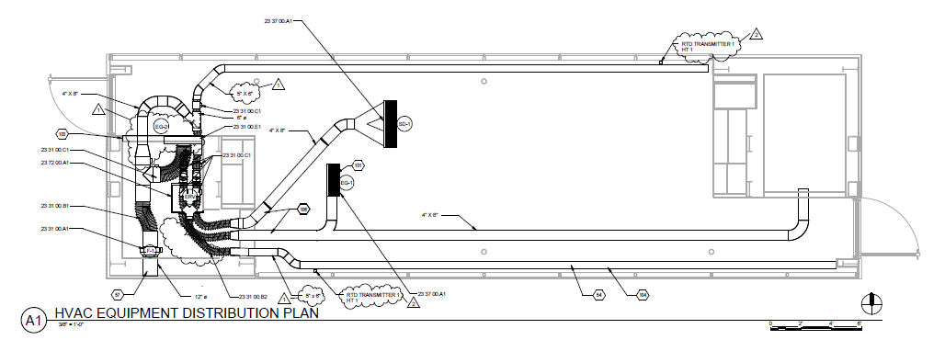

Fig. 4.1. Ducting Layout

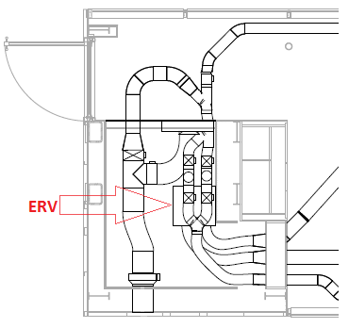

Fig. 4.2. ERV Ductwork

4.1 Heating and cooling

As discussed previously, the heating, cooling, and ventilation of Team LIVING LIGHT's house is based upon three main system components: the two Daikin Quaternity ductless mini-splits, the Ultimate Air Energy Recovery Ventilator, and LIVING LIGHT's unique dynamic double facade system. Each of the three components work in harmony to execute the desired system mode, which can be set for heating, cooling, or whole house ventilation. Tennessee's climate varies throughout the year with hot, humid days in the summer with temperatures in excess of 90°F to moderately cold winters having temperatures dropping well below freezing. LIVING LIGHT's HVAC system was designed to provide the upmost comfort in Tennessee's ever changing, multi-seasonal climate while minimizing energy consumption through the utilization of the natural environment and energy-saving technology.
The heating and cooling loads of the house were computed by LIVING LIGHT team member Steven Coley using the EnergyPlus Modeling and Simulation Program. EnergyPlus is a whole building simulation program that models energy systems such as heating, cooling, lighting, and ventilation based upon a computer generated design of the house (made by the user). The program is extremely useful in regards to the many options that may be included in its analysis. For example, material properties, shading percentages, and extremely variable time periods of study may be varied for study. While the program is extremely robust and useful, the unique double facade system of LIVING LIGHT’s house could not be directly modeled, which allowed for some error in calculations for the thermal loading of the house. Other assumptions had to also be made, such as the contribution of appliances, people, and infiltration. However, further study has been/will be done on the facade system using the UTZero Prototype which will greatly aid in our knowledge and functionality of the facade system. The loading of the house was done on the generated model in respect to the thermal loading of the facade and envelope (with shading/no shading, blinds/no blinds), and the internal loading from people and appliances (sensible and latent).
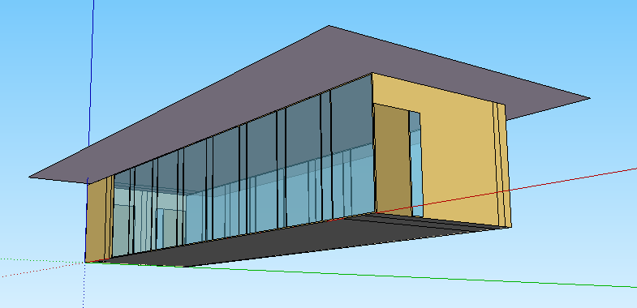
Figure 4.3. Computer Generated House Design. This is a picture of the house simulation used to calculate loadings for the LIVING LIGHT house.

Passive heating is controlled by an overhanging PV array, which shades the house during summer months when the sun is higher in the sky. Exterior blinds also greatly reduce the cooling load. The blind system was designed to be sandwiched within the outer and inner window panes of each of the facades, keeping them out of the conditioned space yet protected from harsh weather. The blinds serve to eliminate glare and reduce solar heat gain during the summer months by blocking solar radiation before it enters the conditioned space. An analysis was conducted comparing the cooling rates for the house with no blinds to the house with the blinds embedded facade.
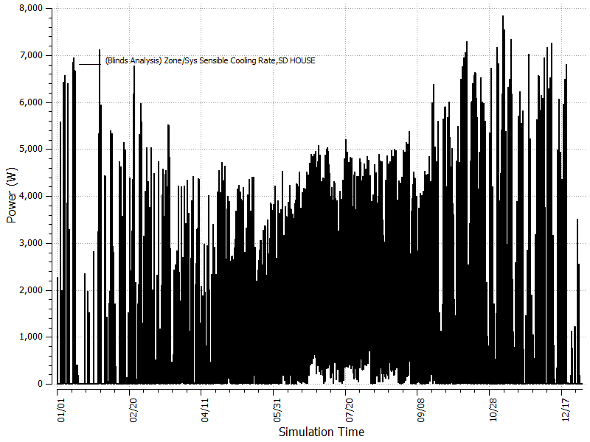
Figure 4.4. Sensible Cooling Rate of the LIVING LIGHT house with no blinds
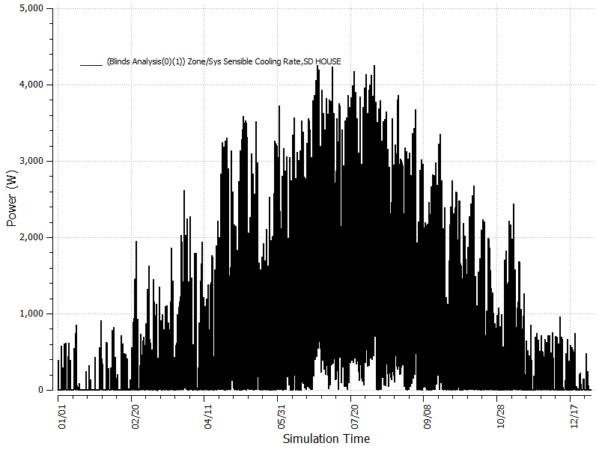
Figure 4.5. Sensible Cooling Rate of the LIVING LIGHT house with Exterior Blinds

Table 4.1. Blind Analysis Results
Energy Plus Results | Max Heating Load (Btu/hr) | Total Heating Energy (kBtu) | Max Cooling Load (tons) | % Difference in Max Cooling Load | Total Cooling Energy (ton-hrs) | % Difference in Cooling Energy
No Shading | 15,656 | 16,003 | 2.24 | 0 | 3,231 | 0
Exterior Shading | 15,419 | 16,185 | 1.26 | -43.8% | 1,700 | -47.4%

The study proved that the cooling loads of the house were greatly reduced by using exterior blinds. As may be seen from the graphs above, the peak cooling load was reduced from 8kW to ~4.5kW, a 44% decrease in maximum cooling load and a 47% decrease in total cooling energy required. The Solyndra Inc. cylindrically shaped PV modules were integrated into a shading overhang to passively shade the south façade and block unwanted solar radiation in the summer. Figures 4.5 and 4.6 show the benefit of the shading overhang as it reduces the cooling load of the house by 16.7% and reduces the cooling energy by 18% compared to the house with no overhang.
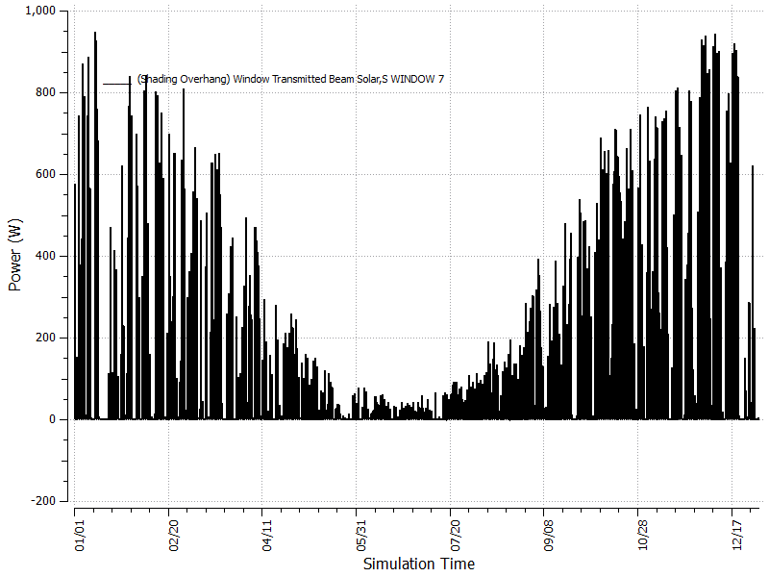
Figure 4.6. Transmitted Beam Solar through a South Façade Window with No Overhang
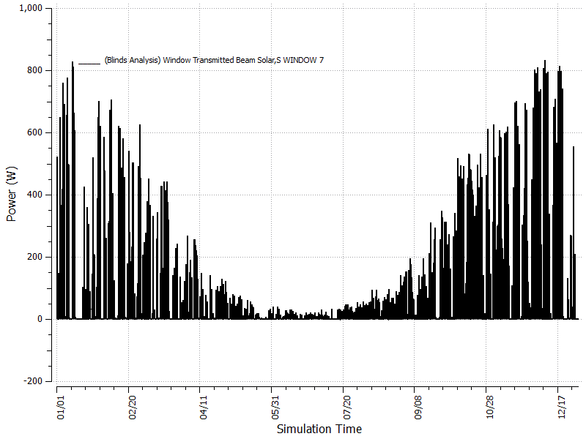
Figure 4.7. Transmitted Beam Solar through a Window with an Overhang that Shades 50% of the light

Table 4.2. Shading Overhang Analysis
 | Max Cooling Load (tons) | Total Cooling Energy (ton-hrs)
No Overhang | 2.69 | 3,940
PV Overhang (50% transmittance) | 2.24 | 3,231
Percent Difference (%) | 16.7% | 18%

The sizing of the HVAC system for a particular climate is essential for maximum efficiency. Since the house is being built both for competition in Washington D.C. and for use in Tennessee, EnergyPlus was used to perform yearly load calculations in those areas. The competition schedule was used to simulate conditions during the competition week so that the heating and cooling system of the LIVING LIGHT house could be sized appropriately to maintain the comfort zone conditions. Of particular interest was the load required to bring the LIVING LIGHT house back to temperature and humidity one hour after the public tour ends and during the measured contests when large internal heat gains are present.

Table 4.3. Monthly Heating and Cooling Summary for Nashville Tennessee
 | ZONE/SYS SENSIBLE COOLING ENERGY [ton-hrs] | ZONE/SYS SENSIBLE COOLING RATE {Maximum}[ton] | ZONE/SYS SENSIBLE HEATING ENERGY [kBtu] | ZONE/SYS SENSIBLE HEATING RATE {Maximum}[Btu/h]
January | 28.6 | 0.76 | 3314.1 | 13127
February | 35.45 | 0.87 | 2730.57 | 13022.93
March | 96.88 | 0.83 | 1151.68 | 8423.32
April | 139.36 | 1.03 | 847.42 | 8127.74
May | 218.25 | 1.09 | 210.05 | 5958.82
June | 304.63 | 1.26 | 39.52 | 2519.05
July | 361.79 | 1.28 | 0.35 | 334.95
August | 338.45 | 1.24 | 0.48 | 419.57
September | 239.05 | 1.14 | 102.05 | 2755.68
October | 169.21 | 1.01 | 659.34 | 6165.33
November | 97.73 | 1.02 | 1328.17 | 9056.3
December | 47.01 | 0.82 | 2666.62 | 11258.18
Annual Sum or Average | 2076.39 |  | 13050.34
Minimum of Months | 28.6 | 0.76 | 0.35 | 334.95
Maximum of Months | 361.79 | 1.28 | 3314.1 | 13127

Figure 4.8. Monthly Cooling and Heating Energy for Nashville Tennessee

As Figure 4.8 shows, the LIVING LIGHT house will need approximately 6000 W capacity to gain full points in the comfort zone competition. The spreading of measured competition tasks may help to eliminate certain troublesome conditions, such as the spike of 9,000 W on the second day of competition. A 2 ton system was selected from the given results. Although the weather of the competition week cannot be exactly known, a 2 ton system leaves enough room for error.

Figure 4.9. Heating and Cooling Loads for Simulated Competition Week

LIVING LIGHT's house was compared to a standard builder's test house from an Oak Ridge National Lab study, “Tennessee Valley Authority’s Campbell Creek Energy Efficient Homes Project: 2010 First Year Performance Report July 1, 2009–August 31, 2010”, which used a SEER 13single speed heat pump (in contrast to LIVING LIGHT's SEER 22 variable capacity, discussed later). Table 4.4 shows the contrast between the two houses for energy usage from heating and cooling. The total energy consumption data for an entire year in the Nashville Tennessee climate was found to be 2,360 kWh compared to 10,246 kWh for the Campbell Creek house. The LIVING LIGHT house data was normalized to be comparable to an equivalent 1000 ft² house.

Table 4.4. Yearly HVAC Loads Comparison
 | LIVING LIGHT House | Campbell Creek1 House
$$ft^{2}$$ | 740 | 2,400
Heating (kWh) | 1,228 | 3,894
Cooling (kWh) | 1,132 | 6,352
Total (kWh) | 2,360 | 10,246

Figure 4.10. Heating and Cooling Comparison of the LIVING LIGHT house to an Equivalent 1000 $ft^{2}$ Average Builder House.

4.1.1 Daikin Mini-Split Units

Two Daikin ductless mini splits control the climate in the house. The model being used is the FTXG12H_RXG12H. This model has a cooling capacity of one ton (12,000 Btu/hr.) and a heating capacity of 16,000 Btu/hr. Its seasonal energy efficiency ratio (SEER) is 22, which is significantly higher than the average of 13 or 14. The SEER rating is a measure of the system’s energy efficiency. It is inversely proportional to the energy usage of the system, meaning an air conditioner with a SEER rating of 22 will use half the energy consumed by one with a rating of 11. Hence, this system is almost twice as efficient as the average. The Daikin mini splits also remove moisture from the space at a rate of 4.1 Pt/hr, which helps control the relative humidity in the home.
The ductless mini split system consists of an indoor and outdoor unit, rather than the conventional single outdoor unit. Instead of conditioning air outdoors (at the condenser) and blowing it through a duct system to cool or heat a home, the mini splits condition air within the living space without ducts. This is done by positioning a condensing unit outside, which runs refrigerant to and from the indoor unit. The indoor unit pulls air from inside the space through a filter and conditions it using the refrigerant provided by the outdoor unit. The advantage to this setup is the ability to condition a space without the use of ducts. Ducts allow for a significant amount of heat transfer between the air traveling through them and the space surrounding the duct. That space is typically the crawl space below the house, or an attic. This means that heat transfer associated with ducts typically causes a loss in efficiency. Ducts can also develop holes and leaks that cause significant drops in efficiency.
Daikin also offered a 9,000 BTU/hr capacity system, which would normally be substantial enough to condition a 750 square-foot home. However, because the majority of the home’s exterior walls are glass, the team calculated that it would be more advantageous to use two 1-ton units. Another main reason the 1-ton units were selected was for dehumidification issues. The team calculated that, during the boiling water test in the competition, the 9,000 BTU/hr units would not be able to remove enough moisture out of the air to keep the relative humidity in the space below the required limit. The 9,000 BTU/hr units only removed 3.38 Pt/hr, which made them unfavorable against the 4.1 Pt/hr provided by the 1 ton units. There was not much of a disadvantage to this decision due to the fact that the SEER ratings for the units were equal.
It was decided to place the indoor mini split units on the interior walls, oriented to blow air along the length of the exterior glass walls. This setup would allow the conditioned air to circulate throughout the main living space while keeping the exterior areas conditioned. During the competition, it is very likely that the thermostat used for temperature testing will be placed in the center of the main living space. By blowing air parallel to the glass exterior walls, the mini splits will be capable of keeping the entire house conditioned and not just the center of the room. However, circulation due to pressure differences will force the conditioned air to move through the center of the room, which will be sufficient for the competition testing. An exhaust fan in the bathroom will also create a lower pressure zone, which will attract conditioned air to parts of the house that are out of reach of the mini splits.
Before the decision was made to use the Daikin units the team was also considering Mitsubishi MSZ series mini split units. These units had higher SEER ratings, which were 23 for the 1-ton units and 26 for the 9,000 BTU/hr units. There were several reasons why the team decided against the Mitsubishi units. The primary reason was the fact that both size systems had significantly less dehumidification capabilities. The dehumidification rate for the MSZ units ranged from 2.1 to 2.9 Pt/hr. Because dehumidification was so crucial to the team’s design, the Daikin mini splits’ 1-2 extra Pt/hr was a major advantage. Another issue with the Mitsubishi unit was the fact that it incorporated an IR scanner that would control the direction of the airflow based on an IR map of the floor area. This aspect was nice, but because the home’s design placed the units above other features of the house, the IR feature would not function properly. Another advantage of the Daikin unit was the wider angle at which it could direct airflow.

4.1.2 Heat Pump Grille Analysis

Another portion of the project required the analysis of a grille with moveable fins. The testing was performed in the zero energy prototype located in Humanities Plaza. A comparable heat pump was used as a substitute for the Daikin mini-split units. We constructed a box to surround the heat pump. The box was sealed to prevent additional airflow and also held the grille in front of the mini-split unit. A grid was constructed and measurements were taken at each node within the grid. We measured airflow using an anemometer with and without the grille on the box. The results are presented below in Table 4.5.
Table 4.5. Comparison of Airflow (Ft/min) for Mini Split Unit
Angle | No Grille | Grille | % Difference
Horizontal | 1660 | 1335 | 19.57831325
45° | 3395 | 2040 | 39.91163476
Vertical | 4635 | 3810 | 17.79935275
Total | 9690 | 7185 | 25.85139319

This study was conducted to determine the effects of covering the mini-split units with a grille. Covering the grille was determined to be more aesthetically pleasing, but produced results that were unfavorable in terms of restricting airflow and circulation. The effect of the grille was determined to be detrimental to the efficiency and effectiveness of the mini-split heat pump unit.

4.2 VENTILATION

Ventilation is a very important part of HVAC. It affects indoor air quality including regulation of allergens, pollutions, and humidity. The LIVING LIGHT house is expected have a tightly constructed envelope with minimal infiltration. Stale air will not be exhausted and fresh air will not be circulated without a ventilation system. The ERV supplies fresh air to the space as required by ASHRAE 62.2 shown below in equation 4.1.

$Q_{vent}=0.01A_{floor}+7.5\left(N_{br}+1\right)=0.01\left(730\right)+7.5\left(2+1\right)=30 cfm$ (4.1)

The LIVING LIGHT house uses the Dynamic Envelope strategy which utilizes the ERV and passive solar heating from the double glass façade comprising most of the north and south walls. The home automation and control system allows easily control of the three ventilation schemes including heating, cooling, and whole house ventilation.

In the cooling mode, fresh air will be introduced to the space through the north façade. It will be cooled slightly through the façade cavity and then exchange heat in the ERV with the stale air being exhausted from the space. In the heating mode, the air flows through these façades will reverse. Passive solar power will heat the south façade cavity so that fresh air pulled through it will increase in temperature. Stale air will be exhausted through the north façade which helps to buffer any additional heat losses. The heating and cooling modes of operation are depicted in Figure 4.10 below.

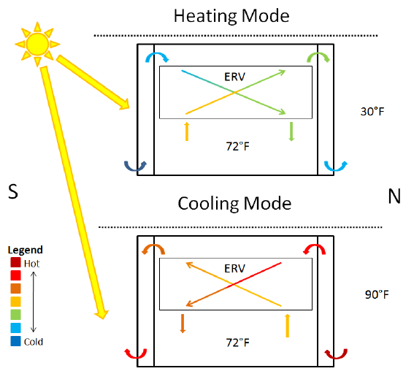
Fig. 4.11. Dynamic Envelope Ventilation Strategy including Heating and Cooling Modes of Operation

4.2.1 Whole House Ventilation

The whole house ventilation scheme takes advantage favorable outdoor conditions during which temperatures are between 60 and 70 °F. This comprises 20% of the year in Tennessee, a comparable weather pattern to Washington D.C. When these conditions arise, the automation system will alert the occupants of LIVING LIGHT that whole house ventilation is possible. Should the occupant wish to use this setting, they may open the operable windows of the façade, turn off the mini-splits, and allow a small duct fan to ventilate the entire house. The energy savings of this mode of operation is 1.5% of the sensible heating rate and 16% of the sensible cooling rate. This is an important feature of the LIVING LIGHT house and will provide impressive energy-savings.

4.2.2 Energy Recovery Ventilator (ERV)

The energy recovery ventilator (ERV) is used to ventilate while minimizing energy loss in the LIVING LIGHT house. The ERV exchanges sensible and latent heat between fresh and stale (exhaust) air streams. When the outside temperature is relatively low, the ERV will pre-heat and humidify the incoming fresh air. In the summer months or when the temperature is relatively high outside, the ERV will pre-cool and dehumidify the incoming fresh air. The utilization of the ERV in the LIVING LIGHT HVAC system helps to reduce heating and cooling costs normally associated with bringing in fresh, outdoor air.
It was debated whether to use an energy recovery ventilator or a heat recovery ventilator (HRV). The ERV and HRV both perform the task of exchanging heat between the incoming and outgoing air streams. The HRV only performs the task of exchanging heat between the airflows. The ERV also provides heat exchange plus the exchange of moisture between the two air flows. The first factor for the decision was the climate in which the LIVING LIGHT house was to be built. Since the Tennessee climate provides hot, humid summers, the ERV was the better choice based upon its ability to remove moisture from the incoming fresh air. Also, the exhaust air from the ERV would provide a smaller difference in humidity when compared to the outdoor conditions. The HRV would provide exhaust air that contains the same amount of latent heat as the indoor air, which could possibly cause condensation issues in the double façade envelope system. The second factor for selection involved the need for removal of moisture from the conditioned space. There are two main situations in which there is an abundance of moisture produced in the LIVING LIGHT house, cooking and bathing. Since both conditions require a removal of moisture, the ERV was a more suitable choice.
There were numerous factors that went into consideration for the selection of the ERV. There were two manufacturers that we had in mind, RenewAire and Ultimate Air. The two main considerations for ERV selection were to incorporate the ERV into the dynamic envelope ventilation strategy and to provide enough continuous fresh air exchanges defined by the ASHRAE 62.2 code. The dynamic envelope ventilation strategy requires the ERV to be independent of the other HVAC components. The Ultimate Air unit, RecoupAerator® 200DX, is smaller than the RenewAire models while it provides a greater range of airflow. The Ultimate Air unit utilizes a variable speed controller that will ensure the proper amount of ventilation for the LIVING LIGHT house. Also, the Ultimate Air unit provides a 95% energy transfer rate while the RenewAire unit provides 75% efficiency. The obvious choice was the Ultimate Air unit. Also, we received a personal recommendation from a former Solar Decathlete.
The Ultimate Air RecoupAerator® 200DX comes equipped with a five year warranty and is guaranteed to be free from defects in materials or workmanship from the date of purchase. The model is equipped with aluminum pre-filters and “filter pies” that can be regularly replaced to ensure adequate filtration. Ultimate Air’s instruction manual requires the filters to be checked every six months or when the Check Filter light comes on. It also recommends that the filters are cleaned every three to four months. The drive roller belt can also be replaced in the event of failure. There have been no studies on the reliability of the unit.
4.2.3 Conduction Analysis through Interior Façade Window Pane
As discussed in the previous section, the purpose of the ERV is to ventilate the house while reducing the overall energy costs. This study was used to find the total amount of conduction through the interior pane of glass in the double façade on both the north and south sides. It was used to determine the difference between ventilating the facades and leaving stagnant air (not ventilating) in both heating and cooling modes. An energy analysis was performed using EnergyPlus. The program produced values for every hour of every day over the course of a year for the climate of Tennessee. Using the dimensions of the LIVING LIGHT house, the program produced an outdoor dry bulb temperature, external solar incidents, and sensible heating and cooling loads with and without ventilation in the facades. The zone mean air temperature was considered to be a set value. Also, it was assumed that there was 50% sensible heat transfer efficiency from the ERV. Table 4.6 below presents an analysis of the values provided from the program.

Table 4.6. Annual Comparison of Conduction through Interior Window Panes
 | No Ventilation | With Ventilation | % Difference
Heating (kW) | 2772.701 | 2784.928 | -0.4409883
Cooling (kW) | 1299.767 | 1176.641 | 9.472940
Total (kW) | 4072.468 | 3961.569 | 2.7231364

The results provided in the table prove that ventilation of the north and south facades provides additional energy savings during heating and cooling modes. The cooling mode provides a much greater percent difference in terms of the conduction through the glass. This study was based upon conductive heat transfer, and the convective heat transfer surrounding the window panes was neglected.

aPPENDIX
Heat Pump Grille Analysis Data
- Presented below is airflow measurements in ft/min for the corresponding heat pump settings.
NO GRILL |  |  |  |  |  | GRILL
 | High Speed - Horizontal |  |  |  |  |  | High Speed - Horizontal
-205 | -220 | -215 | -185 | -175 | -160 | -205 | -230 | -230 | -230 | -250 | -185
-180 | -105 | -110 | -90 | -75 | -80 | 80 | -100 | -110 | -70 | -105 | -90
520 | 805 | 850 | 740 | 715 | -100 | 435 | 850 | 770 | 780 | 740 | 0
0 | 0 | 0 | 0 | 0 | -70 | 0 | 0 | 0 | 0 | 0 | -70
0 | 0 | 0 | 0 | 0 | 0 | -80 | -85 | -70 | -70 | -70 | -70
0 | 0 | 0 | 0 | 0 | 0 | 0 | 0 | 0 | 0 | 0 | 0
SUM | 1660 |  |  |  |  | SUM | 1335
 | High Speed- 45 |  |  |  |  |  | High Speed- 45
-220 | -240 | -210 | -215 | -215 | -185 | -240 | -290 | -245 | -215 | -230 | -220
-110 | -90 | -90 | -100 | 0 | -95 | -85 | -95 | -90 | -100 | -100 | -120
230 | 400 | 560 | 520 | -75 | -85 | 180 | 400 | 490 | 380 | 160 | -80
280 | 900 | 970 | 915 | 520 | -75 | 385 | 810 | 830 | 700 | 230 | 0
-110 | 220 | 110 | 200 | 145 | 0 | -85 | 170 | 0 | 0 | 0 | 0
-85 | -80 | -75 | -75 | -75 | -70 | -90 | -80 | -85 | -90 | -85 | -70
SUM | 3395 |  |  |  |  | SUM | 2040
 | High Speed - Vertical |  |  |  |  |  | High Speed - Vertical
-190 | -175 | -170 | -215 | -175 | -175 | -245 | -250 | -250 | -265 | -225 | -175
-135 | -95 | -90 | -100 | -90 | -125 | -150 | -85 | 0 | 0 | -100 | -130
-100 | -95 | -110 | -105 | -100 | -125 | -115 | -90 | -90 | -95 | -115 | -110
300 | 520 | 750 | 385 | 140 | -120 | 430 | 765 | 880 | 600 | 485 | -120
420 | 850 | 950 | 860 | 490 | -115 | 295 | 600 | 550 | 755 | 500 | 0
250 | 340 | 180 | 430 | 475 | -100 | 125 | 125 | 240 | 165 | 0 | -95
SUM | 4635 |  |  |  |  |  |  | 3810

