Regional Assessment of the Relationships of Conservation Practices to Northern Bobwhite and Other Priority Grassland Bird Breeding Populations

A Dissertation Presented for the

Doctor of Philosophy

Degree

The University of Tennessee, Knoxville

Christopher Manuel Lituma

May 2014

Copyright © 2013 by Christopher M. Lituma
All rights reserved.

ACKNOWLEDGEMENTS

There are a number of people who have contributed significantly to the completion of this dissertation. Firstly, I would like to thank the funding agencies; the Natural Resources Conservation Service, specifically Charles Rewa, and the American Bird Conservancy without whom the project would not have been supported. The Central Hardwoods Joint Venture, specifically Jane Fitzgerald and Dr. Todd Jones-Farrand, were instrumental in developing, and promoting this research project. They were also very helpful in providing insightful suggestions and logistical help and support throughout the entire process of my dissertation.
Additionally, I would like to thank Kentucky Department of Fish and Wildlife Resources, the Department of Defense and Fort Campbell Military Reservation, and private landowners in Livingston County, KY for allowing me access to areas to conduct off-road point count surveys. Specifically, I would like to thank Eric Williams, manager of Peabody Wildlife Management Area and Daniel Moss of Fort Campbell Military Reservation for their input about potential off-road survey areas.
There were 20 technicians without whom data used for this dissertation from roadside surveys in the Central Hardwoods Bird Conservation Region would not exist. Their hard work and dedication directly contributed to completion of this project.
I would like to thank my fellow graduate student and lab-mates. Our time together at the University of Tennessee has been fun, and our memories will last forever. I know that our career paths will continually cross, and that we will remain close for the rest of our lives. Many of you have contributed directly to my success, and brainstorming with peers over a beer is always more productive than alone in an office.
I would like to thank my three committee members, Drs. Paul Armsworth, Joe Clark, and Pat Keyser. Without all of their valuable input and guidance this dissertation would not have been possible. They were always receptive and available to my questions and concerns about the dissertation, and I was able to meet with them individually and collectively to brainstorm about my dissertation. I would especially like to thank my advisor Dr. Dave Buehler. Through our four years together we developed a true student-mentor relationship. His ability to always provide insightful comments and suggestions for the dissertation was priceless. His open-door policy and ability to lead by example make him and excellent mentor. I have learned invaluable lessons from Dr. Buehler about academia, research, education, and life. I am forever indebted to his guidance and oversight of this project.
Lastly, I would like to thank my supportive family for their patience and understanding as I completed my dissertation. It has been difficult at times and I know I have missed all of them as much as they have missed me. I would be remiss if I did not explicitly thank my wonderful, beautiful, and incredibly supportive wife. It is true that “behind every great man there stands a great woman”, and my wife is truly the greatest.

ABSTRACT

I documented populations of Northern Bobwhites (Colinus virginianus) and other priority grassland and early successional birds in the Central Hardwoods Bird Conservation Region (CHBCR), and determined whether conservation practices have been effective in positively impacting species occupancy and abundance. I designed and implemented a roadside survey by randomly locating five 15-km routes with 5-min unlimited distance point counts (30 counts/route), along secondary roads within Northern Bobwhite focal counties (n = 37) in the CHBCR. I also developed a survey to assess roadside biases for estimates of relative abundance (a), occupancy (ψ), detection probability (p), and associated land-cover for target species. Lastly, I monitored radio-tagged Northern Bobwhites to document the effects of spatial, temporal, and behavioral covariates on calling rates. I used occupancy estimation in program MARK 6.1 to model factors related to occupancy (ψ) and detection probability (p). I used a multi-season robust design occupancy module in program MARK 6.1 to model occupancy (ψ) relationships among years to conservation practices, colonization (γ), and detection probability (p). I used the general multinomial-Poisson mixture model in program R with the unmarked package to model species-specific abundance (a) relationships to conservation practices. Estimates of relative abundance, occupancy, and detection probability from roadside surveys for nine target grassland birds were unaffected by the presence of roads. For every species except Prairie Warbler, the addition of conservation covariates to top land-cover models improved model fit of occupancy models, though confidence intervals of beta estimates overlapped zero for all species except Dickcissel, Field Sparrow and Northern Bobwhite. Northern Bobwhite occupancy declined among years by >18% on survey points and declined by >4% in 2009 if a conservation practice was <2 km away from the survey point. Species occupancy and abundance were most strongly related to land-cover covariates, with the presence or amount of conservation at a point of secondary importance. These models can be used to prioritize conservation efforts in the CHBCR by focusing land-cover modeled relationships for occupancy and abundance on existing conservation points to optimize likelihood of increased species occupancy and abundance.

TABLE OF CONTENTS
INTRODUCTION 1
CHAPTER I: FACTORS AFFECTING NORTHERN BOBWHITE BREEDING SEASON DETECTION PROBABILITIES 4
ABSTRACT 5
INTRODUCTION 6
STUDY AREA 9
Radio-telemetry and off-road Point Count Surveys 9
Roadside Point Count Surveys 10
METHODS 11
Radio-telemetry Point Count Surveys 11
Off-road Point Count Surveys 12
Roadside Point Count Surveys 12
Vegetation Sampling Procedures 14
Analyses 14
RESULTS 19
Radio-telemetry Surveys 19
Off-road Surveys 20
Roadside Surveys 21
DISCUSSION 22
Radio-telemetry Surveys 23
Off-road Surveys 25
Roadside Surveys 26
MANAGEMENT IMPLICATIONS 27
LITERATURE CITED 29
APPENDIX I 36
CHAPTER II: ASSESSMENT OF ROADSIDE BIAS FOR HIGH-PRIORITY GRASSLAND AND EARLY SUCCESSIONAL BIRDS 46
ABSTRACT 47
INTRODUCTION 48
STUDYAREA 50
METHODS 52
Study Species 52
Vegetation Sampling Procedures 53
Analyses 53
RESULTS 56
Distance-from-raod Effects 56
Temporal Effects 58
Land-cover Effects 60
DISCUSSION 60
LITERATURE CITED 67
APPENDIX II 73
CHAPTER III: RELATIONSHIPS OF CONSERVATION PRACTICES TO GRASSLAND AND EARLY SUCCESSIONAL BIRD OCCUPANCY AND ABUNDANCE 80
ABSTRACT 81
INTRODUCTION 83
STUDY AREA 90
METHODS 92
Study Species 92
Route Selection 92
Roadside Point Counts 93
Land-cover Variables 94
Analyses 97
RESULTS 105
Multi-season Occupancy 106
Multinomial Poisson Abundance 110
DISCUSSION 112
LITERATURE CITED 123
APPENDIX III 135
CONCLUSION 164
VITA 168

LIST OF TABLES
CHAPTER I
Table 1.1 Major landcover types in the Central Hardwoods Bird Conservation Region.. 36
Table 1.2 Summary of occupancy model selection procedure results of radio-collared Northern Bobwhites 37
Table 1.3 Summary of occupancy model selection procedure results of Northern Bobwhites using off-road surveys 38
Table 1.4 Summary of removal model selection procedure results of Northern Bobwhites using roadside surveys 39
Table 1.5 Model averaged detection probability for Northern Bobwhites from roadside surveys 40
Table 1.6 Adjusted Northern Bobwhite estimates with key covariates 41
CHAPTER II
Table 2.1 Land cover types used to classify habitat during off-road surveys 73
Table 2.2 Mean percent cover of various cover types at point counts conducted in 3 distance-from-road (DFR) categories 74
Table 2.3 Relative abundance (individuals/point/visit) for focal species at on- and off-road point counts 75
Table 2.4 Akaiki’s Information Criterion adjusted for small sample sizes (AIC_{c}), for full model sets of occupancy model selection procedure results of target species using off-road point counts 76
Table 2.5 Target species visit specific unconditional and conditional detection probabilities (p) from off-road point counts 78
Table 2.6 Target species occupancy (ψ) and associated λ values from off-road point counts 79
CHAPTER III

Table 3.1 Species of interest and their North American Breeding Bird Survey trend information 135
Table 3.2 Akaiki’s Information Criterion adjusted for small sample sizes (AIC_{c}), for full model sets of multi-season occupancy model selection procedure results 136
Table 3.3 Descriptions of cover types included as covariates in multi-season occupancy and abundance analyses 140
Table 3.4 Akaiki’s Information Criterion adjusted for small sample sizes (AIC_{c}), for model sets of multinomial Poisson model selection procedure results 141
Table 3.5 Pearson’s correlation coefficient for the amount of conservation cover and percent of landcover type 144
Table 3.6 Species specific detection probability (p) from top multi-season occupancy models 145
Table 3.7 Beta values and confidence intervals for species and covariates of top models from multi-season occupancy model selection results 147
Table 3.8 Species specific occupancy (ψ) estimates and standard errors (SE) from top models from multi-season occupancy models 149
Table 3.9 Species specific colonization probability (γ) estimates with standard errors (SE) and confidence intervals from top models from multi-season occupancy models.. 151
Table 3.10 Species specific detection probability (p) from top multinomial Poisson abundance models 152
Table 3.11 Species specific abundance (a; individuals/point) estimates and standard errors (SE) from top models from multinomial Poisson models 154
Table 3.12 Beta values, standard errors (SE) and confidence intervals for species and covariates of top models from multinomial Poisson abundance model selection results 155

LIST OF FIGURES
CHAPTER I
Figure 1.1 Central Hardwoods Bird Conservation Region with roadside survey focal counties and focal areas for off-road and radio-telemetry surveys 42
Figure 1.2 Relationship of detection probability of radio-collared male Northern Bobwhites to the number of other male bobwhites calling 43
Figure 1.3 Relationship of detection probability of radio-collared Northern Bobwhites to minutes-since-sunrise (MSS) 44
Figure 1.4 Detection probability related to effective detection distance of Northern Bobwhite observations 45
CHAPTER III
Figure 3.1 Central Hardwoods Bird Conservation Region with focal counties for roadside surveys 157
Figure 3.2 Example of five roadside survey routes conducted in Sullivan County, IN, in the Central Hardwoods Bird Conservation Region 158
Figure 3.3 An example of a roadside route conducted in Sullivan County, IN, in the Central Hardwoods Bird Conservation Region 159
Figure 3.4 Total area (ha) of dominant conservation programs implemented in the Central Hardwoods Bird Conservation Region 160
Figure 3.5 Total area (ha) of dominant conservation practices implemented in the Central Hardwoods Bird Conservation Region 161
Figure 3.6 Dickcissel (Spiza americana) occupancy from 2009-2012 in the Ozark Highlands for points with conservation (Yes Conservation) and points without conservation (No Conservation) 162
Figure 3.7 Northern Bobwhite (Colinus virginianus) occupancy from 2009-2012 in the Ozark Highlands for points with conservation distance close to the point (0 km) and points with conservation the average distance from the point (2 km) 163

INTRODUCTION
An important component of effectively developing and implementing avian conservation strategies is understanding how conservation practices are linked to species occupancy and abundance. If current conservation strategies are going to continue to garner financial support, then definitive evidence of their positive effects on avian populations across a broad region is required. However, if current conservation strategies are ineffective, then alternative strategies should be identified for improving implementation and effectiveness.
For North American grassland and early-successional bird species, habitat loss is an important factor contributing to many species population declines. As a result, many federal conservation programs and practices are used to restore or manage existing grassland and early successional habitat. Conservation practices can positively affect local species densities and abundances, though measured responses are species and practice specific. Also, analyses utilizing coarse data showed increasing species population trends associated with increasing amounts of conservation. However, there is a need to relate the cumulative effect of conservation practices to large-extent species population parameters such as occupancy and abundance.
Models can be developed using expert opinion, or rigorous data collected with an explicit design can be used to statistically model species distributions. Hierarchical modeling techniques are powerful statistically rigorous tools which can use generalized linear models and include explanatory covariates. Inferences about distributional processes such as occupancy and abundance are derived from data collected by researchers, though distributional relationships to explanatory variables can be confounded by factors affecting the observational data. Thus, hierarchical models that explicitly and simultaneously account for variables influencing a process of interest while accounting for variability in the observational data will generate more accurate estimates of population parameters. Population-level inferences at a large-extent utilizing fine-grain data are most useful for conservation planning, and to determine species specific conservation impacts. These data can be difficult, time-consuming, and expensive to collect unless convenient surveys are implemented. Therefore, assessment of potential biases associated with conveniently collected data will provide a measure of confidence about conveniently collected data.
In Chapter I, my goal was to assess how different variables potentially affect breeding Northern Bobwhite (Colinus virginianus) detection probabilities to provide guidance for managers for optimizing survey efforts with respect to these important factors in the Central Hardwoods Bird Conservation Region (CHBCR). Detection probability (p) is the product (p = p_{p} x p_{a} x p_{d}) of the probability that an individual is present at the sampled location (p_{p}), available (p_{a}) for detection (i.e., calling, visible, etc.), and actually detected by an observer during a specified survey (p_{d}). My first objective was to determine if Northern Bobwhite availability for detection (p_{a}) was affected by time of the day, day of the breeding season, or conspecific calling, by documenting detectability using radio-marked birds. My second objective was to evaluate roadside survey bias in detection (p_{d}, p_{a}, p_{p}) and occupancy (ψ) estimates by comparing on-road versus off-road surveys. My third objective was to develop and assess the efficacy of a roadside-based removal survey method (p_{d}, p_{a}) for monitoring Northern Bobwhite breeding populations while incorporating important explanatory variables as per the results from the first 2 objectives. Lastly, I combined the results from each of the detection components to generate a comprehensive Northern Bobwhite abundance adjustment table based on detection probability differences under varying survey conditions.
In Chapter II, my goal was to further develop the second objective from Chapter I to assess potential roadside biases for occupancy (ψ) and detection probability (p) of a suite of high priority grassland and early successional passerine bird species in the CHBCR. I used a roadside versus off-road survey design to determine if relative abundance, occupancy, and detection probability of high priority grassland and early successional species in the CHBCR would be lower on roadside survey points, when compared to off-road survey points. I also hypothesized that occupancy would be affected by changes in land-cover among on- and off-road points.
In Chapter III, my goal was to use a fine-grain, large extent roadside-based survey design to evaluate the relationship between grassland and early-successional bird distribution and abundance, and National Resources Conservation Service practices in the CHBCR. My objectives were to 1) determine if the presence, amount, or distance to a practice at a survey point was related to species occupancy, 2) determine if the presence, amount, or distance to a practice at a survey point was related to species abundance, and 3) determine the relative importance of conservation practices in explaining avian distribution and abundance when modeled in conjunction with other landscape covariates in the CHBCR.

CHAPTER I
Factors affecting Northern Bobwhite Breeding season detection probabilities

ABSTRACT

Northern Bobwhite (Colinus virginianus) populations declined by 6.3% annually from 2001-2011 in the Central Hardwoods Bird Conservation Region. Monitoring Northern Bobwhite populations and developing accurate population estimates is an important component of the National Bobwhite Conservation Initiative. My goal was to provide guidance for managers on how to effectively survey Northern Bobwhite breeding populations. I monitored radio-tagged Northern Bobwhites to document calling rates by minutes-since-sunrise, day-of-year, and by influence of calling conspecifics. I designed and implemented a roadside survey by randomly locating five 15-km routes with 5-min unlimited distance point counts (30 counts/route), along secondary roads within Northern Bobwhite focal counties (n = 37) in the Central Hardwoods region. I conducted roadside and off-road point counts to assess roadside detection probability and occupancy bias. I used occupancy estimation in program MARK to model radio-tagged Northern Bobwhite calling availability and off-road detection probabilities and occupancy. I modeled roadside detection probabilities using Huggins closed-capture module in program MARK. I estimated an effective detection radius using program DISTANCE. Northern Bobwhite calling availability was affected by daily and seasonal temporal variables as well as abundance of conspecifics calling. Northern Bobwhite availability for detection differed between years, declined by 50% 4 hr after sunrise, and peaked when at least 4 other males were calling in the area. Based on n = 8,220 Northern Bobwhite detections in the roadside removal analysis, the key covariates related to detection were observer, distance (m) from the observer, and minutes-since-sunrise when a count was conducted. Detection probability by the best observer was 40% greater than detection by the poorest observer. Northern Bobwhite detection probability and occupancy were unrelated to whether counts were conducted on roadsides or off-road. Point occupancy on off-road surveys was 1, and Northern Bobwhite detection probability during the second visit (0.51, SE = 0.08) was 11% greater than the first and third visits (n = 270 points). Breeding surveys for Northern Bobwhite in the Central Hardwoods region can be roadside-based, should begin at sunrise and end at four hours after sunrise, should occur during peak calling period (1 June-1 July), and should account for differences in observer detection as well as the influence of conspecifics on Northern Bobwhite calling availability.
INTRODUCTION
The National Bobwhite Conservation Initiative (NBCI) was established in 2002 to implement species-specific conservation practices to meet a population recovery goal for the Northern Bobwhite (Colinus virginianus; Dimmick et al. 2002). Since, many state, federal, and private landowners have managed habitat to increase Northern Bobwhite populations throughout their range (Dimmick et al. 2002, Morgan 2008, Dailey et al. 2011). Managing Northern Bobwhite habitat can positively affect local populations (Brennan 1991, Dimmick et al. 2002, Morgan 2008), but evidence is lacking on the effectiveness of such management at broader population scales. Quantifying these regional management effects on Northern Bobwhite populations is difficult because currently the only breeding bird survey of large spatial extent is the North American Breeding Bird Survey (BBS). BBS is useful for documenting range-wide or statewide trends but loses resolution at finer spatial scales (Link and Sauer 1998, Sauer and Link 2011). Monitoring is necessary for tracking changes in populations through time and assessing effects of management (Hansen and Guthery 2001, Rusk et al. 2007, Murray et al. 2011). Passive monitoring strategies are typically either fall covey counts, (Wellendorf et al. 2004, Rusk et al. 2007, Riddle et al. 2008) or counts during the breeding season (Riddle et al. 2010, Murray et al. 2011, Duren et al. 2012). Breeding season call counts provide an index of breeding populations, but do not quantify reproductive success for a given year (Hansen and Guthery 2001, Riddle et al. 2010, Murray et al. 2011). Raw count data can be used to generate indices of relative abundance, or count data can be adjusted for various components of detection and survey area to estimate density.
An important component of contemporary monitoring strategies is adjusting raw count data for variability in detectability based on a variety of covariates (Riddle et al. 2010, Murray et al. 2011). Counted individuals do not necessarily represent a constant proportion of the population through space and time (MacKenzie 2005, Kissling and Garton 2006) thus, detection probabilities are needed to improve the accuracy of population parameter estimates, and should be incorporated into regional Northern Bobwhite population monitoring (Thompson 2002, Norvell et al. 2003, Diefenbach et al. 2007, Marques et al. 2007). Previous research has evaluated detection methods separately and simultaneously for Northern Bobwhite breeding season counts using double-observer, time-to-detection, removal models, and distance sampling, but estimates were either derived via localized surveys or rarely included spatial and behavioral covariates in models (Terhune 2009, Riddle et al. 2010, Murray et al. 2011). In addition, none of these previous studies have directly accounted for variability in Northern Bobwhite calling availability by including covariates, which can have a greater effect on monitoring results than observer effects (Riddle et al. 2010). There is a peak in Northern Bobwhite detection from June-July, and roadside surveys could bias counts because of a potential for road attraction or avoidance, and observer-induced behavioral changes (Terhune 2009, Murray et al. 2011). Although roadside surveys are commonly used because of their convenience, information about differences in Northern Bobwhite detection probability between on- and off-road surveys is largely lacking.
Detectability (p) is the product of three major components (p = p_{p} x p_{a} x p_{d}): the probability that an individual bird associated with the sample area is available (i.e., calling, visible, etc.) during the count (p_{a}), given it is present (p_{p}), and the probability it is detected by an observer given it is available and present (p_{d}) (Riddle et al. 2010). Distance sampling methods (Buckland 2001) generate estimates of p_{d}, removal sampling (Farnsworth et al. 2002) and time-of-detection (Alldredge et al. 2007) methods estimate p_{d} and p_{a}, and repeat survey sampling methods estimate p_{d}, p_{a}, and p_{p} (MacKenzie et al. 2002). I assessed the influence of spatial, temporal, and behavioral variables on detection probability estimates of Northern Bobwhite using a combination of these methods.
However, there is no comprehensive evaluation of factors affecting Northern Bobwhite breeding season detection probabilities. Existing research is piece-meal, incomplete, and does not provide useful information for future Northern Bobwhite monitoring designs. To address this glaring need, I used three novel approaches to: determine how Northern Bobwhite availability was related to temporal and behavioral variables, determine if roadside-based Northern Bobwhite detection probability and occupancy are biased, and determine the efficacy of a fine-grain large-extent survey for breeding Northern Bobwhite in the Central Hardwoods Bird Conservation Region (CHBCR).
My goal was to provide guidance for managers for optimizing survey efforts for Northern Bobwhite with respect to efficiency by identifying and incorporating factors affecting detection probability. My first objective was to determine if Northern Bobwhite availability for detection (p_{a}) was affected by time of the day, day of the breeding season, or conspecific calling, by documenting detectability using radio-marked birds. My second objective was to evaluate roadside survey bias in detection (p_{d}, p_{a}, p_{p}) and occupancy (ψ) estimates by conducting off-road surveys in an occupancy modeling framework while also accounting for land cover heterogeneity with covariates. My third objective was to develop and assess the efficacy of a roadside-based removal survey method for monitoring Northern Bobwhite breeding populations. Specifically, I wanted to assess differences in Northern Bobwhite detection (p_{d}) given availability (p_{a}) from a large extent, fine grain survey, with respect to observer and point-specific spatial variables in the CHBCR. Lastly, I combined significant explanatory variables from each approach to create an overall breeding season detection probability model for Northern Bobwhite.
STUDY AREA
Radio-telemetry and Off-road Point Count Surveys
I conducted radio-telemetry surveys and off-road surveys on Peabody Wildlife Management Area (PWMA), and additional off-road surveys on Fort Campbell Military Reservation, TN-KY and on private lands in Livingston County, KY. PWMA is an 18,854-ha reclaimed surface mine managed by Kentucky Department of Fish and Wildlife Resources (KDFWR) located in Ohio, Muhlenberg, and Hopkins counties, KY. Herbaceous cover established during reclamation was dominated by Sericea lespedeza, but also included big bluestem (Andropogon gerardii), little bluestem (Schizachyrium scoparium), indiangrass (Sorghastrum nutans), and switchgrass (Panicum virgatum). My focal area for surveys was a 3,321-ha unit comprised predominantly of mixed deciduous forest, open herbaceous, native warm-season grass, and scrub/shrub cover types.
Fort Campbell Military Reservation (FCMR) is a 41,842-ha U.S. Department of Defense (DoD) installation located on the Tennessee-Kentucky border. Topography is flat to gently rolling with open oak woodlands, planted pines, leased agricultural fields, and managed grasslands. I conducted my surveys in grasslands that ranged in size from 73 – 570 ha.
The private lands in Livingston County were planted to native warm-season grasses and were part of a Northern Bobwhite focus area developed by KDFWR (Morgan 2008). The total focal area is 12,860 ha, and I surveyed a subset of fields which ranged from 25 – 450 ha comprising 3.5% of the focal area.
Roadside Point Count Surveys
I conducted roadside point-count surveys in seven states throughout the CHBCR (Figure 1.1, all of the figures and tables are included in the appendix). The Central Hardwoods was historically characterized by open tall grass prairie intermixed with oak (Quercus spp.) and pine (Pinus spp.) woodlands (Nuzzo 1985). CHBCR encompasses 29,815,052 ha across portions of 10 central and mid-south states. More than 50% of the land has been converted to non-native grass pasture and hay production, typically tall fescue (Schedonorus arundinaceus), or planted to crops including corn (Zea mays), soybeans (Glycine max), sorghum (Sorghum bicolor), and wheat or oats (Triticum aestivum and Avena sativa; Dimmick et al. 2002).
My monitoring approach was based on surveying focal counties. Focal regions were originally identified from a Northern Bobwhite habitat potential model (Burger and Evans 2009). Focal areas were further defined during state workshops as part of the NBCI plan revision
(Burger and Evans 2009). I selected eight counties per state, unless the extent of the CHBCR region in a state was limited. These focal counties represent the best regions for Northern Bobwhite restoration, as defined by biologists and managers that participated in each state’s NBCI workshop. These focal areas were identified because of their existing Northern Bobwhite populations, were conducive for Northern Bobwhite restoration or both.

METHODS
Radio-telemetry Point Count Surveys
I used telemetry surveys conducted on PWMA in 2010 and 2011to document male calling rates, availability for aural detection by point counts, and effects of temporal, spatial and behavioral covariates. I randomly selected a male for location and observation from a sample of >50 male Northern Bobwhites radio-tagged as part of an ongoing telemetry study at PWMA (Tanner 2012). I located the observation point by homing to within 50 m of the target male. Once the observation point was established, I waited 1 min to allow for the potential disturbance of my arrival to subside, and to generally note locations of adjacent calling males. After the 1-min wait period ended, I used a time-of-detection survey (Alldredge et al. 2007) by recording the calling behavior of the target (telemetry-located) radio-collared male and adjacent males for ten 1-min segments. I recorded the number of times each individual radio-collared male called in each interval. After the 5th minute, I relocated the target male to confirm the correct male was being monitored before resuming the call counts for the remaining 5 minutes. I noted the location and calling rates of adjacent male Northern Bobwhites within audible range throughout the survey. I confirmed the final location of the target male and recorded the distance of the individual from the survey point when the survey was completed. I conducted surveys during all times of the day (sunrise until 17:07) from 3 May – 1 Aug 2010 and 2011. I recorded the date of the survey, time-of-day, and the method by which the individual was detected (aurally or visually).
I surveyed 287 points associated with 63 radio-collared males in 2010 and 2011. The mean number of point counts associated with each male was 4.43 (SE = 0.39), and I considered each point count as an independent event because they were recorded on separate days for any given male.
Off-road Point Count Surveys
I conducted >90% of off-road surveys on PWMA and FCMR in 2010 (1 other technician conducted the other 10%), and all of the surveys on PWMA and in Livingston County, KY in 2011. I located survey transects 300 m apart along a secondary road, and extended transects perpendicularly for 600 m away from the road. To avoid repeat detections of individuals, and spatial autocorrelation (Hutto et al. 1986, Fletcher and Koford 2002, Alldredge et al. 2006), I positioned 3 points on each transect located on the road, 300 m away from the road and 600 m away from the road. At each point I conducted a 100-m fixed-radius point count listening for and recording all individuals aurally or visually detected, within 5 minutes, constraining observations to within 100 m. I placed individuals in distance bands using a range finder ranging from: 0–25 m, 26–50 m, 51–75 m, 76–100 m. I surveyed each transect three times throughout the season to determine seasonal variation in detection and occupancy. Subsequent counts were separated by approximately 2-week intervals. I surveyed a total of 270 points on 90 off-road transects on 3 sites from 2010–2011.
Roadside Point Count Surveys
In 2008, 4 observers surveyed 121 routes in 25 counties in 4 states (IN, IL, KY, and TN; Figure 1.1). In 2009, 2 observers surveyed 60 routes in 12 counties in 3 states (AR, MO and OK; Figure 1.1). In 2010, 5 observers surveyed 181 routes in 37 counties in 7 states (AR, IN, IL, KY, MO, OK and TN). In 2011, 4 observers surveyed 146 routes in 23 counties in 5 states (IN, IL, KY, MO, and TN). In 2012, 5 observers surveyed 181 routes in 37 counties in 7 states (AR, IN, IL, KY, MO, OK and TN). Surveys were not conducted in MS, AL, and OH because those states had very limited area in the CHBCR.
I randomly located five 24.1-km routes along rural, secondary roads that crossed non-forested areas within each of the focal counties. To determine route starting locations, I overlaid a 9.65 × 9.65 km grid onto each county map. I randomly selected 5 blocks to be surveyed. If the selected block had >50% open land and sufficient room to locate a 24.1-km route (i.e., not covered by urban areas, forest, or water), the route was established. If a given block did not meet these criteria, I selected another. If a given block was suitable, I selected a starting point within 1.6 km of the northeast corner on a secondary road and traced a route around the block on secondary roads which remained primarily in open, undeveloped areas.
I placed point count stations ≥ 805 m apart along each route. Each route had 30 point count stations and was surveyed once per breeding season between 15 May and 15 July 2008–2012, covering the majority of the Northern Bobwhite breeding season. Routes were not surveyed consecutively within a county, but instead were visited rotationally throughout the course of the season so routes within a county were not temporally biased by consecutive visits. I conducted a 5-min, 500-m radius point count at each point, recording all Northern Bobwhite individuals encountered (aurally or visually). I considered each minute as a separate interval, and I assigned the individual to the minute interval it was initially detected. Northern Bobwhite are detectible up to 500 m (Stokes 1967); thus, I placed individuals in distance bands using a range finder: 0–25 m, 26–50 m, 51–75 m, 76–100 m, 101–250 m and 251–500 m. I surveyed routes beginning ≤30 min before sunrise, and continued until the route was completed, approximately 4 hr after sunrise. Different observers conducted surveys each year, though one observer surveyed for 2 years (2009–2010). I trained all observers in survey methodology for 5 days, including distance estimation, prior to initiation of surveys each year.

Vegetation Sampling Procedures
I visually estimated the percent cover of major land cover types at each on- and off-road point within a 100-m radius of the point center (Table 1.1) to include major land cover covariate influences for occupancy and detection probability models. I chose a 100-m radius to match the fixed-radius point count distance of off-road survey methodologies, and because observers had difficulty classifying cover types beyond 100 m.
Analyses
Radio-telemetry surveys.--I estimated detection probabilities (p_{a}) from the Occupancy module in program MARK 6.1 (White and Burnham 1999) and used Akaike’s Information Criterion (AIC) for model selection. I considered models with a ΔAIC_{c} ≤2 most influential in explaining variability. I assumed a constant occupancy of 1 because I definitively located individuals at each point via radio telemetry, and my objective was to evaluate detection probabilities. I assumed equal detection probability between one-minute intervals because intervals were equal in duration (Otis et al. 1978, Farnsworth et al. 2002). I used the Delta method to calculate period detection probabilities and Taylor series expansion to calculate standard errors (Williams et al. 2002). Though the count was conducted over a 10-min period, I used the encounter history during the first 5 min so analyses and results were comparable to my other methods. Detection probability for this analysis directly estimates the probability of availability for the radio-collared individual to call during a 5-min count (p_{a}). I knew the individual was present (p_{p} = 1) via radio telemetry and I assumed the observer would detect the individual if it called (p_{d} = 1) because of the proximity (<50 m) of the observer to the focal bird. I grouped surveys based on Year (temporal) and included minutes-since-sunrise (MSS, temporal), day-of-year (DOY, temporal) and the number of other Northern Bobwhites calling (behavioral) at the time of the survey (ABUN) as covariates. I quantified MSS based on a 24-hr period, and then determined the difference in minutes between daily sunrise and the survey start time. I quantified DOY by converting the actual dates to numeric values using the first sampling day for either year (3 May 2010) as the start value of 0. I re-scaled covariates in quadratic models by dividing MSS by 1,000, DOY by 100, and ABUN by 10 (Cooch and White 2009). I did not include observer effects because I presumed trained observers located target birds with telemetry and detected their calls, and detected the calls of adjacent birds with similar proficiency. I developed a suite of 17 a priori models based on my specific objectives (Table 1.2). I included additive quadratic models for each of the covariates and all combinations of the covariates. I included quadratic models because I suspected non-linear covariate relationships. To limit the total number of models evaluated, I did not include any models with interaction terms, and instead focused on additive effects. I present parameter estimates based on the mean covariate values for the most parsimonious models.
Assumptions associated with time-of-detection models include: 1) closed populations for the duration of the count, and 2) individuals are only counted once during the count, (Huggins 1989, Alldredge et al. 2007). Radio-telemetry results suggested that Northern Bobwhites, on average, did not move significant distances (<7 m) during a 5-min count, and I relocated individuals immediately following each count to ensure monitoring of the target individual.
Off-road surveys. —I estimated detection probabilities and site occupancy from the Royle-Nichols Repeated Count Data (Royle Biometrics) module in program PRESENCE 5.7 (Royle and Nichols 2003, Hines 2006). I used AIC for model selection; models with a ΔAIC_{c} ≤2 were considered most influential in explaining variability. The real parameters of the Royle-Nichols Repeated Count Data (Royle Biometrics) module are r (animal-specific detection probability) and λ (Poisson intensity parameter), and conditional detection probability (p) and occupancy (ψ) are derived parameters (Royle and Nichols 2003). I used parameter estimates that conditioned detection on occupancy to generate overall detection probability estimates (Royle and Nichols 2003). I grouped surveys based on year (Year, temporal) and distance from road (DFR, spatial) to evaluate year and distance from road effects on detection probability. I also generated
visit-specific detection probabilities to account for within-season temporal variation of detection (Visit, temporal). The first visit occurred from 19 May–3 June, the second from 1 June–25 June, and the third from 25 June–11 July. I did not include observer effects for detection probability, because >90% of point counts were conducted by one observer. I included distance from road (DFR, spatial) and year (Year, temporal) effects on occupancy. Additionally, I modeled heterogeneity in land cover on points by including percent land cover for 5 dominant cover types (cool-season grass [CG], forest [FO], grass mixture [GM], native warm-season grass [NG], and scrub-shrub [SC]; Table 1.1) that could positively or negatively influence Northern Bobwhite occupancy. I developed a suite of 18 a priori models based on my objectives (Table 1.3). Rather than include every potential combination of covariates for detection probability (p) and occupancy (ψ), I modeled variables influencing the parameter for occupancy (ψ) first, while holding detection probability (p) constant. I then improved the best model explaining occupancy (ψ) by including covariates to model detection probability (p). Because I was explicitly interested in DFR effects, I included all potential DFR models (Table 1.3). I limited the total number of models considered by not including any models with interaction terms. I present parameter estimates based on the mean covariate values for the most parsimonious models.
Assumptions associated with occupancy modeling include: 1) closed populations for the duration of the surveys, 2) individuals are never falsely detected at a site when absent, and may or may not be detected when they are present, and 3) detection of an individual at a site is independent of detection of individuals at other sites (MacKenzie et al. 2002, MacKenzie et al. 2003). I minimized immigration and emigration by surveying within a two-month window during the peak breeding season. I considered my population of interest largely closed because Northern Bobwhite typically moved <200 m in a breeding season on my study area (Unger et al. 2012), and point centers were 300 m apart. Only two experienced observers conducted the surveys to minimize false detections. My overall fixed-radius point counts were separated by 100 m, minimizing the possibility of movement of individuals among points, providing spatial independence.
Roadside surveys. —I estimated detection probabilities (p_{d}, p_{a}) from the Huggins Closed Capture module in program MARK 6.1 (White and Burnham 1999, Farnsworth et al. 2002). I used AIC for model selection (Anderson 2008). I considered models with a ΔAIC_{c} ≤2 most influential in explaining variability. I only included survey points in which a Northern Bobwhite was detected (p_{p} = 1). I used a dummy variable to code for and group surveys based on observer so I could evaluate observer (behavioral) or year (temporal) effects on detection. I assumed equal detection probability among 1-min intervals because intervals were equal in duration (Otis et al. 1978, Farnsworth et al. 2002). I included 4 covariates: distance (m) from the observer (DFO, spatial), percent forest and woodland cover (Table 1.1) within a 100-m radius of the point count (COV, spatial), whether the route was east or west of the Mississippi River (EW, spatial), and minutes-since-sunrise (MSS, temporal). I chose percent forest cover within 100 m because forested areas are less likely to have populations of Northern Bobwhite, and trees can impede sound transmission and affect detection. I did not include other land-cover covariates because I had no reason to expect that their structure would affect Northern Bobwhite calling sounds. I chose the EW covariate to test for spatial autocorrelation among points, accounting for broad ecological relationships. I included the MSS covariate to maintain consistency with radio-telemetry survey models. I did not include abundance because inclusion of abundance directly confounded estimates of detection by inflating the probability that any individual is detected at a point by an observer (p_{d}), simply because there are more birds at a point (McCarthy et al. 2012). To directly assess the effects of conspecifics on detection probability encounter histories specific to individuals, similar to the radio-telemetry surveys, are required. I developed a suite of 21 a priori models (Table 1.4), which included every combination of covariates with observer and year as grouping variables, and a null model that assumed constant detection probability. I set the recapture probabilities to zero for all of the models to properly estimate detection probabilities as a removal model (Cooch and White 2009). As above, I only considered models with additive effects and present parameter estimates based on the mean covariate values for the most parsimonious model(s).
Assumptions associated with removal models include: 1) the population is closed during the time of the survey, 2) individuals are accurately identified, recorded, and not double-counted at a single point, and 3) individuals have an equal probability of being detected; there is no individual heterogeneity of calling rates (Zippin 1956, Farnsworth et al. 2002). Based on the telemetry data, individuals were unlikely to move outside of my survey radius during 5-min point counts. Reduced movement also minimized potential for double-counting. I included covariates in my model to account for heterogeneity.
Distance. —I calculated an effective detection radius and p_{d} in Program DISTANCE 6.0 (Thomas et al. 2010). I grouped observations based on distance band categories described above. I used AIC for model selection; models with a ΔAIC_{c} ≤2 were considered most influential in explaining variability. I analyzed 4 combinations of key functions and series expansions (hazard-rate with cosine, uniform with cosine, uniform with simple polynomial, half-normal with hermite polynomial) that have been recommended for point-count analyses (Buckland 2001).
Assumptions associated with distance sampling include: 1) individuals located directly at the point of interest are counted, 2) individuals do not move in response to the surveyor, 3) individuals are accurately placed in distance bands, and 4) individuals in the spatial area of interest are randomly distributed (Buckland 2001). Radio-telemetry data suggested that individuals do not move in response to surveyors, or appreciably during a 5-min survey; thus, individuals located at a point were likely counted. I used a range-finder to ensure accuracy of distance band placement. For any surveying scheme, a key statistical assumption is the random distribution of samples. I accounted for this assumption by randomly placing starting points of routes and following roads in a random fashion through the landscape. There is always the potential for clumping individuals and biasing population parameter estimates. I also incorporated land-cover covariates to potentially explain any evidence of clumping based on spatial land-cover components.
RESULTS
Radio-telemetry Surveys
In 2010, 5 observers detected 341 unmarked Northern Bobwhite males associated with monitoring 53 radio-collared males, and in 2011, 6 observers detected 432 unmarked Northern Bobwhite males associated with monitoring 53 radio-collared males. The mean number of point counts associated with each male was 4.43 (SE = 0.39) Radio-collared males called on 87 of 287 points surveyed (30.0%) during the first 5-min interval. The furthest distance a radio-collared male moved during the 5-min survey period was 60 m ($\overline{x}$ = 6.2 m, SE, = 0.61, n = 287). Only one model for detection probability met the ΔAIC_{c} ≤2 criterion; this model included Year, ABUN and MSS and had strong support (AIC_{c} weight = 0.88, Table 1.2). Detectability from the top model was quadratically influenced by ABUN (β₁ = 10.91, SE = 1.51, 7.95 ≤ β₁ ≤ 13.87; β₂ = -13.85, SE = 2.88, -19.50 ≤ β₂ ≤ -8.19; Figure 1.2) and by MSS (β₃ = -7.44, SE = 1.97, -11.30 ≤ β₃ ≤ -3.57; β₄ = 7.52, SE = 3.30, 1.04 ≤ β₄ ≤ 14.00; Figure 1.3).
Based on the top model and mean covariate values (ABUN [$\overline{x}$ = 0.18, SE = 0.01] and MSS [$\overline{x}$ = 0.215, SE = 0.07, n = 287], detection probability (p_{a}) for a single one-minute interval in 2010 was 0.30 (SE = 0.024, 95% CI = 0.25 ≤ p ≤ 0.35), and in 2011 was 0.10 (SE = 0.015, 95% CI = 0.08 ≤ p ≤ 0.13). Detection probability for the full 5-min point count in 2010 was 0.97 (SE = 0.03) and in 2011 was 0.66 (SE = 0.05).
Off-road Surveys
In 2010, two observers detected 349 Northern Bobwhites and in 2011, one observer detected 288 Northern Bobwhites during off-road surveys. One model met my selection criterion of ΔAIC_{c} ≤2 among my set of candidate models and included visit as a group variable for detection probability, and FO and NG covariates affecting occupancy (AIC_{c} Weight = 0.5189, Table 1.3). Based on the top model, I used the mean covariate value of FO ($\overline{x}$ = 0.05, SE = 0.13, n = 270) and NG ($\overline{x}$ = 0.06, SE = 0.15, n = 270) to generate occupancy parameter estimates. Detection probability (p_{p}, p_{a}, p_{d}) was greater during the second visit than the first and third visits (β _{T1} = 0.06, SE = 0.11, -0.15 ≤ β _{T1} ≤ 0.27; β _{T2} = 0.28, SE = 0.10, 0.08 ≤ β _{T2} ≤ 48; β _{T3} = -2.15, SE = 0.36, -2.85 ≤ -1.03). Detection probability given occupancy for the first visit was 0.45 (SE = 0.08, 95% CI = 0.30 ≤ p ≤ 0.61), for the second visit was 0.51 (SE = 0.08, 95% CI = 0.35 ≤ p ≤ 0.67), and for the third visit was 0.43 (SE = 0.08, 95% CI = 0.28 ≤ p ≤ 0.59). The overall probability of an individual being heard after 3 visits was 0.85 (SE = 0.05). Occupancy was positively related to NG (β = 0.54, SE = 0.25, 0.05 ≤ β ≤ 1.03) and negatively related to FO (β = -0.87, SE = 0.39, -1.62 ≤ β ≤ -0.11). Inclusion of DFR in either the detection or occupancy components of the models did not yield better supported models (lower AIC_{c} values; Table 1.3).
Roadside Surveys
Greater than 94% of the survey routes had at least one Northern Bobwhite detection. Across all points and routes, observers detected 1,524, 874, 1,635, 2,090, and 2,278 Northern Bobwhites in 2008-2012, respectively. I used 8,220 of the detections for the removal analysis; 181 detections were omitted because of missing data. The number of Northern Bobwhite detections differed among observers, ranging from 139-872.
Three models for detection probability met my criterion for evaluation with ΔAIC_{c} ≤2 (Table 1.4). The best-supported model included differences in observer detection probabilities and DFO, MSS, and COV covariates. The top model had a 36% (AIC_{c} weight = 0.361) probability of being the best model among the set of candidate models and the relative likelihood of the model given the data and other candidate models was 1.00. Detection probability was negatively related to DFO (β = -0.0019, SE = 0.0002, -0.0023 ≤ β ≤ -0.0015), MSS (β = -1.1, SE = 0. 29, -1.63 ≤ β ≤ -0.48), and COV (β = -0.003, SE = 0.002, -0.007 ≤ β ≤ 0.001). The next two models similarly contained DFO and MSS covariates, but either excluded COV (AIC_{c} weight = 0.35), or included EW (AIC_{c} weight = 0.28). Confidence intervals overlapped zero for COV (β = -0.003, SE = 0.002, -0.007 ≤ β ≤ 0.001) and EW (β = 0.17, SE = 014, -0.10 ≤ β ≤ 0.44), thus they were excluded for parameter estimation.
Mean covariate values used to generate parameter estimates were DFO ($\overline{x}$ = 246 m, SE = 1.6, n = 8,220) and MSS ($\overline{x}$ = 0.16, SE = 0.001, n = 8,220). I defined the observer with the greatest detection probability as the “best” observer, and the observer with the lowest detection probability as the “poorest” observer. Overall detection (p_{a}, p_{d}), based on the 5-min count period, ranged from 0.74 (SE = 0.046) for the poorest observer to 0.99 (SE = 0.002) for the best observer (Table 1.5).
Distance.—Based on 8,220 Northern Bobwhite detections in the Program Distance analysis, the hazard-rate key function with the cosine expansion had a 100% probability of being the best model of the set of candidate models (ΔAIC_{c} ≤2). The effective Northern Bobwhite detection radius was 201 m (95% CI = 196 ≤ P ≤ 207, Figure 1.4).
DISCUSSION
Northern Bobwhite populations have declined precipitously (Sauer et al. 2012), such that major conservation action is warranted and is being implemented via the NBCI (Dailey et al. 2011). A comprehensive monitoring strategy is needed to track changes in Northern Bobwhite populations over time to evaluate the success of these conservation efforts. The BBS is one such population monitoring approach, however it is limited in its utility because of the inability to account for differences in detectability (Sauer et al. 1994) and its inability to link specific conservation actions to specific points on a route. I have developed and implemented for five years an alternative Northern Bobwhite monitoring strategy outlined above for the breeding season for the Central Hardwoods Bird Conservation Region.
My approach accounts for detectability adjusted for temporal, spatial, behavioral, and observer covariates to yield less-biased estimates of relative abundance. As outlined by Riddle et al. (2010), detection can be broken into three fundamental components: p_{a}, p_{d}, p_{p}. Previous research assessed differences in methodologies used to estimate some of these detection components, (Conway and Simon 2003, Kissling and Garton 2006, Thompson and La Sorte 2008, Murray et al. 2011, Reidy et al. 2011), although only Riddle et al. (2010) accounted for all three components. I estimated all three components of detection across very broad temporal and spatial extents, and included a variety of temporal, spatial, and behavior covariates to better understand the detection process for Northern Bobwhites. I then used those parameter estimates to demonstrate how point-specific relative abundance varies given my detection results (Table 1.6).
Radio-telemetry Surveys
Availability is difficult to account for, can be more of a limiting factor than observer ability (Riddle et al. 2010), and can best be assessed via radio telemetry (Murray et al. 2011). I directly measured Northern Bobwhite availability (p_{a}) by monitoring radio-collared birds calling rates. Riddle et al. (2010) indirectly separated the components of the detection process to estimate detection given availability (p_{d}) and availability (p_{a}) separately by combining dependent double observer with time-of-detection methods and computationally isolating p_{a}. My mean Northern Bobwhite availability (0.62) for a 5-min count was much lower than that derived by Riddle et al. (2010) from their field data (0.84). My methodology used real-time telemetry-based calling surveys conducted on a large sample of individual males, across a broad sampling period across two years, and included covariates to explain Northern Bobwhite calling behavior given temporal and behavioral changes. This approach represents a comprehensive evaluation of this parameter which has not been included in most Northern Bobwhite monitoring studies to date. Northern Bobwhite calling availability varied annually (Year), decreased with minutes-since-sunrise (MSS), and increased by the presence of other calling males in the area (ABUN). When I used mean MSS and ABUN, Northern Bobwhite availability was 50% greater in 2010 than in 2011, which translates into a population adjustment factor that is doubled in 2010 (n = 1.2) compared with 2011 (n = 2.4). If I held Year, and MSS constant, Northern Bobwhite availability increased by 49% when at least one other male Northern Bobwhite called during a point count, and increased by 69% when four other males called during a point count. Alternatively, if I held Year and ABUN constant, Northern Bobwhite availability declined by 34%. The number of conspecifics on my counts ranged from 0 to 6. The presence of conspecifics caused detection for a 5-min count to vary significantly, ranging from 12% to 62% in 2011. Wellendorf (2004) used radio-telemetry data from coveys to show a positive relationship between the number of other coveys calling, and covey calling availability. Duren et al. (2012) used female playback to elicit a breeding male calling response, but these results are confounded by the uncontrolled presence of other males calling during the playback, and his results are impractical because females rarely vocalize. Similarly Hansen and Guthrey (2001) used recordings of male Northern Bobwhite vocalizations to determine if playback affected calling rates. However, like Duren et al. (2012), their results are confounded by the lack of experimental control for surrounding males calling, and they did not have encounter histories associated with specific males thus their inferences were incorrect. Thus, my results are the first to definitively relate the effects of calling conspecifics to breeding Northern Bobwhite availability. Although Northern Bobwhites do not defend distinct territories per se, other researchers have commented on this relationship of conspecifics positively affecting calling rates (Wellendorf et al. 2004, Duren et al. 2012). Given the clear significance of this effect on detection, it clearly needs to be incorporated into routine point-count based monitoring for Northern Bobwhites.
Many bird species are most vocal early in the morning, thus most monitoring protocols recommend beginning point counts at or before sunrise (Kacelnik and Krebs 1983, Bibby et al. 2000). Most Northern Bobwhite surveys are conducted within 4 hours of sunrise, when calling frequency is greatest (Hansen and Guthery 2001). I corroborated these findings showing Northern Bobwhite availability was greatest at sunrise and declined as the day progressed. Northern Bobwhite availability was 34% lower when surveys were conducted 4 hr after sunrise and later, reducing the accuracy of a survey.
Actual changes in Northern Bobwhite abundance could be masked by the annual variability in availability from calling. Terhune et al. (2006) documented similar annual variability in Northern Bobwhite breeding call rates. I did not detect the same significant difference in detection probability between years for roadside surveys, thus I assume that annual variability in availability is significant, but becomes less so when observer differences are included. One way to account for annual variability is to always account for annual differences by including year effects on detection for population estimation. Similarly, variability can be reduced by using consistent standardized survey methodologies, and by using the same observers among years.
Off-road Surveys
Although roadside surveys are criticized because of the potential bias associated with the presence of roads and/or associated habitat features (Garton et al. 2005, Morrison et al. 2008), I did not observe any affect from these features on detection probability or occupancy of Northern Bobwhites. Occupancy was very high on my survey routes (>98% of routes occupied) and was weakly positively related to NG cover, and weakly negatively related to FO cover. There was <1% change in the occupancy estimate when NG cover was maximized and FO cover minimized along my routes which were selected because of their generally open landscapes in the first place. Relative abundance and species richness can be influenced by the presence of roads, but the effect of roads on detection probability is not well documented (Hutto et al. 1995, Rotenberry and Knick 1995, Keller and Scallan 1999). Roadside surveys are convenient for surveying areas of large spatial extent and avoid property access issues (Duren et al. 2011, McCarthy et al. 2012). A standardized roadside survey can be easily modified to add multiple species of interest. Within-season temporal variation was a more important variable in explaining variability of detection in my off-road models. I documented a peak in Northern Bobwhite calling rates during mid-June, likely correlated with breeding phenology, consistent with other studies (Hansen and Guthery 2001, Terhune 2009). Northern Bobwhite in the CHBCR begin breeding in May and continue breeding into September (Tanner 2012). Unmated males continue to call, seeking potential mates throughout the summer, and mated males continue calling when females are incubating (Stoddard 1931, Hansen and Guthery 2001). The spike in detection probability is likely correlated with a peak in these two nesting behaviors in mid-June (Terhune 2009).
Roadside Surveys
Observer effects were the most influential covariate related to detection probabilities of roadside surveys, though distance from observer and minutes-since-sunrise were also important covariates. Surveys at broad spatial scales often include multiple observers who can have different hearing and identification abilities (Sauer et al. 1994, Campbell and Francis 2011). I trained observers prior to surveys, but each person had unique hearing ability and experience. If only one Northern Bobwhite was detected at a point and was heard at 500 m, the detection probability for the ‘best’ observer was 33% greater than the detection probability for the ‘poorest’ observer. However, when relative abundance (Abun = 4) and distance from observer (DFO = 0 m) were optimized in the model, the observer effect became much less significant (no observable difference between observers). Relative abundance at a point count was positively related to detection probabilities on roadside surveys, consistent with my telemetry survey results.
My effective detection radius (201 m) was less than detection distances estimated by other researchers for Northern Bobwhites (Duren et al. 2012; 326 m, 331 m). Detection probability had a negative, sigmoidal relationship with distance from observer and declined drastically beyond the effective detection radius. Restricting observations or analyses to within the effective detection radius (201 m) will provide improved detection probability estimates, and in turn, more accurate population estimates. Northern Bobwhites were detected >65% of the time, given that they were present and available during a 5-min count, if I assumed the ‘poorest’ observer was capable of detecting one Northern Bobwhite within 200 m.
The greatest source of variability was from observers, which can be accounted for through an appropriate survey design such as the removal method used on my surveys. Resource managers interested in surveying Northern Bobwhites with multiple observers need to incorporate observer-specific detection probabilities to adjust raw count data and increase accuracy of their counts.
MANAGEMENT IMPLICATIONS
Researchers have reported detection probabilities using different methods from roadside-based surveys that are comparable to some of my overall detection probability estimates (Duren et al. 2011 for a 10-min occupancy survey and 3 visits p_{d}, p_{a}, p_{p} = 0.99; Murray et al. 2011 for a 6-min removal survey p_{d}, p_{a} = 0.93; Duren et al. 2012 for a 7-min distance survey p_{d} = 0.79) but there is a gap in information from existing results to explicitly providing guidance on how to account for underlying variability in detection probabilities based on significant explanatory variables. Although previous studies report interval-specific and subsequent overall detection probabilities, it is unclear to managers what to do with these parameter estimates to adjust their monitoring results. I used a comprehensive approach and combined my top explanatory variables for Northern Bobwhite detection from my analyses to generate a Northern Bobwhite detection adjustment table for the CHBCR. I generated a function that included the beta estimate of the median observer (n = 20) from roadside surveys, the beta estimates of the quadratic function explaining ABUN and MSS covariates from radio-telemetry surveys, and the beta estimates of the hazard-rate key function with cosine expansion explaining DFO (Table 1.6). I did not include year effects because observer effects were more important from roadside survey results, and to maximize detection I recommend conducting surveys in June. This table provides guidance for biologists and managers to evaluate the magnitude of effects of detection, given each of my most influential explanatory variables on accuracy of relative abundance estimates. The ability of managers to design surveys based on optimizing these variables will provide more accurate population estimates, as well as drive cost-efficient monitoring schemes. I recommend managers apply my results and methodologies to design surveys for areas of interest of Northern Bobwhite conservation and habitat management.

LITERATURE CITED
Alldredge, M. W., K. H. Pollock, and T. R. Simons. 2006. Estimating detection probabilities from multiple-observer point counts. Auk 123:1172–1182.
Alldredge, M. W., K. H. Pollock, T. R. Simons, J. A. Collazo, and S. A. Shriner. 2007. Time-of-detection method for estimating abundance from point-count surveys. Auk 124:653–664.
Anderson, D. R. 2008. Model based inference in the life sciences: a primer on evidence. Springer Science+Business Media LLC, New York, New York, USA.
Bibby, C. J., N. D. Burgess, D. A. Hall, and S. H. Mustoe. 2000. Bird census techniques. Second edition. Academic Press, San Diego, California, USA.
Brennan, L. A. 1991. How can we reverse the northern bobwhite population decline? Wildlife Society Bulletin 19:544–555.
Buckland, S. T., D. R. Anderson, K. P. Burnham, J. L. Laake, D. L. Borchers, and L. Thomas. 2001. Introduction to distance sampling. Oxford University Press, Oxford, UK.
Burger, L. W., and K. O. Evans. 2009. Mississippi State University (eds). Managing working lands for northern bobwhite: the USDA NRCS bobwhite restoration project. U. S. Department of Agriculture, Natural Resources Conservation Service. Washinton, DC.
Campbell, M., and C. M. Francis. 2011. Using stereo-microphones to evaluate observer variation in North American breeding bird survey point counts. Auk 128:303–312.
Conway, C. J., and J. C. Simon. 2003. Comparison of detection probability associated with burrowing owl survey methods. Journal of Wildlife Management 67:501–511.
Cooch, E., and G. White. 2009. Program Mark "A gentle introduction" 8th Edition.
Dailey, T. V., D. F. McKenzie, D. E. Figert, and J. G. Doty. 2011. State of the bobwhite 2011 report: grassland bird conservation at a crossroads. National Bobwhite Technical Committee Technical Publication, Knoxville, TN. 37 pp.
Diefenbach, D. R., M. R. Marshall, J. A. Mattice, and D. W. Brauning. 2007. Incorporating availability for detection in estimates of bird abundance. Auk 124:96–106.
Dimmick, R. W., M. J. Gudlin, and D. F. McKenzie. 2002. The northern bobwhite conservation initiative. Miscellaneous publication of the Southeastern Association of Fish and Wildlife Agencies, South Carolina. 96 pp.
Duren, K. R., J. J. Buler, W. Jones, and C. K. Williams. 2011. An improved multi-scale approach to modeling habitat occupancy of northern bobwhite. Journal of Wildlife Management 75:1700–1709.
Duren, K. R., J. J. Buler, W. L. Jones, and C. K. Williams. 2012. Effects of broadcasting calls during surveys to estimate density and occupancy of northern bobwhite. Wildlife Society Bulletin 36:16–20.
Farnsworth, G. L., K. H. Pollock, J. D. Nichols, T. R. Simons, J. E. Hines, and J. R. Sauer. 2002. A removal model for estimating detection probabilities from point-count surveys. Auk 119:414–425.
Fletcher, R. J., Jr., and R. R. Koford. 2002. Habitat and landscape associations of breeding birds in native and restored grasslands. Journal of Wildlife Management 66:1011–1022.
Garton, E. O., J. T. Ratti, and J. H. Guidice. 2005. Research and experimental design. Pages 43–71 in C. E. Braun, editor. Techniques for wildlife investigations and management. Sixth edition. The Wildlife Society, Bethesda, Maryland, USA.
Hansen, H. M., and F. S. Guthery. 2001. Calling behavior of bobwhite males and the call-count index. Wildlife Society Bulletin 29:145–152.
Hines, J. E. 2006. PRESENCE- Software to estimate patch occupancy and related parameters.United States Geological Survey-Patuxent Wildlife Research Center.
Huggins, R. M. 1989. On the statistical-analysis of capture experiments. Biometrika 76:133–140.
Hutto, R. L., S. J. Hell, J. F. Kelly, and S. M. Pletschet. 1995. A comparison of bird detection rates derived from on-road versus off-road point counts in northern Montana. USDA Forest Service General Technical Report PSW-GTR-149:103–110.
Hutto, R. L., S. M. Pletschet, and P. Hendricks. 1986. A fixed-radius point count method for nonbreeding and breeding season use. Auk 103:593–602.
Kacelnik, A., and J. R. Krebs. 1983. The dawn chorus in the great tit (Parus major): proximate and ultimate causes. Behaviour 83:287–309.
Keller, C. M. E., and J. T. Scallan. 1999. Potential roadside biases due to habitat changes along breeding bird survey routes. Condor 101:50–57.
Kissling, M. L., and E. O. Garton. 2006. Estimating detection probability and density from point-count surveys: a combination of distance and double-observer sampling. Auk 123:735–752.
Link, W. A., and J. R. Sauer. 1998. Estimating population change from count data: application to the North American breeding bird survey. Ecological Applications 8:258–268.
MacKenzie, D. I. 2005. What are the issues with presence-absence data for wildlife managers? Journal of Wildlife Management 69:849–860.
MacKenzie, D. I., J. D. Nichols, J. E. Hines, M. G. Knutson, and A. B. Franklin. 2003. Estimating site occupancy, colonization, and local extinction when a species is detected imperfectly. Ecology 84:2200–2207.
MacKenzie, D. I., J. D. Nichols, G. B. Lachman, S. Droege, J. A. Royle, and C. A. Langtimm. 2002. Estimating site occupancy rates when detection probabilities are less than one. Ecology 83:2248–2255.
Marques, T. A., L. Thomas, S. G. Fancy, and S. T. Buckland. 2007. Improving estimates of bird density using multiple-covariate distance sampling. Auk 124:1229–1243.
McCarthy, K. P., R. J. Fletcher, C. T. Rota, and R. L. Hutto. 2012. Predicting species distributions from samples collected along roadsides. Conservation Biology 26:68–77.
McCarthy, M. A., J. L. Moore, W. K. Morris, K. M. Parris, G. E. Garrard, P. A. Vesk, L. Rumpff, K. M. Giljohann, J. S. Camac, S. S. Bau, T. Friend, B. Harrison, and B. Yue. 2012. The influence of aundance on detectability. Oikos 122: 717–726.
Morgan, J. J., and B. A. Robinson. 2008. Road to recovery: the blueprint for restoring northern bobwhite in Kentucky. Kentucky Department of Fish and Wildlife Resources/Small Game Program. 34 pp.
Morrison, M. L., W. M. Block, M. D. Strickland, B. A. Collier, and M. J. Peterson. 2008. Wildlife study design. Second edition. Springer Science+Business Media, LLC, New York, New York, USA.
Murray, L. D., R. J. Gates, and R. M. Spinola. 2011. Evaluation of three methods to estimate density and detectability from roadside point counts. Journal of Wildlife Management 75:1072–1081.
Norvell, R. E., F. P. Howe, and J. R. Parrish. 2003. A seven-year comparison of relative-abundance and distance-sampling methods. Auk 120:1013–1028.
Nuzzo, V. A. 1985. Extent and status of midwest oak savannah: pre-settlement and 1985. The Natural Areas Journal 6:6–36.
Otis, D. L., K. P. Burnham, G. C. White, and D. R. Anderson. 1978. Statistical-inference from capture data on closed animal populations. Wildlife Monographs:7–135.
Reidy, J. L., F. R. Thompson, and J. W. Bailey. 2011. Comparison of methods for estimating density of forest songbirds from point counts. Journal of Wildlife Management 75:558–568.
Riddle, J. D., C. E. Moorman, and K. H. Pollock. 2008. A comparison of methods for estimating northern bobwhite covey detection probabilities. Journal of Wildlife Management 72:1437–1442.
Riddle, J. D., S. J. Stanislav, K. H. Pollock, C. E. Moorman, and F. S. Perkins. 2010. Separating components of the detection process with combined methods: an example with northern bobwhite. Journal of Wildlife Management 74:1319–1325.
Rotenberry, J. T., and S. T. Knick. 1995. Evaluation of bias in roadside point count surveys of passerines in shrubsteppe and grassland habitats in southwestern Idaho. USDA Forest Service General Technical Report PSW-GTR-149:99–101.
Royle, J. A., and J. D. Nichols. 2003. Estimating abundance from repeated presence-absence data or point counts. Ecology 84:777–790.
Rusk, J. P., F. Hernandez, J. A. Arredondo, F. C. Bryant, D. G. Hewitt, E. J. Redeker, L. A. Brennan, and R. L. Bingham. 2007. An evaluation of survey methods for estimating northern bobwhite abundance in southern Texas. Journal of Wildlife Management 71:1336–1343.
Sauer, J. R., J. E. Hines, J. E. Fallon, K. L. Pardieck, D. J. Ziolkowski, and W. A. Link. 2012. The North American Breeding Bird Survey, results and analysis 1966–2011. Version 12.13.2011. USGS Patuxent Wildlife Research Center, Laurel, MD.
Sauer, J. R., and W. A. Link. 2011. Analysis of the North American Breeding Bird Survey using hierarchical models. Auk 128:87-98.
Sauer, J. R., B. G. Peterjohn, and W. A. Link. 1994. Observer differences in the North American Breeding Bird Survey. Auk 111:50–62.
Stoddard, H. L. 1931. The bobwhite quail - its habits, preservation and and increase. Charles Scribner's Sons, New York, New York, USA. 559 pp.
Stokes, A. W. 1967. Behavior of bobwhite (Colinus virginianus). Auk 84:1–33.
Tanner, E. P. 2012. Northern bobwhite (Colinus virginianus) population ecology on reclaimed mined lands. Thesis, The University of Tennessee, Knoxville, USA.
Terhune, T. M., Richard G. Hamrick, D. Clay Sisson, H. Lee Stribling. 2009. Summer male call index relative to nesting chronology and autumn density of the northern bobwhite. in S. B. Cederbaum, B. C. Faircloth, T. M. Terhune, J. J. Thompson, J. P. Carroll editor. Gamebird 2006: Quail VI and Perdix XII. 31 May - 4 June 2006. Warnell School of Forestry and Natural Resources, Athens, GA, USA.
Thomas, L., S. T. Buckland, E. A. Rexstad, J. L. Laake, S. Strindberg, S. L. Hedley, J. R. B. Bishop, T. A. Marques, and K. P. Burnham. 2010. Distance software: design and analysis of distance sampling surveys for estimating population size. Journal of Applied Ecology 47:5–14.
Thompson, F. R., and F. A. La Sorte. 2008. Comparison of methods for estimating bird abundance and trends from historical count data. Journal of Wildlife Management 72:1674–1682.
Thompson, W. L. 2002. Towards reliable bird surveys: accounting for individuals present but not detected. Auk 119:18-25.
Unger, A. M., E. P. Tanner, C. A. Harper, P. D. Keyser, and J. J. Morgan. 2012. Northern bobwhite survival related to movement on a reclaimed surface coal mine. Proceedings of the National Quail Symposium 7:223–228.
Wellendorf, S. D., W. E. Palmer, and P. T. Bromley. 2004. Estimating calling rates of northern bobwhite coveys and measuring abundance. Journal of Wildlife Management 68:672–682.
White, G. C., and K. P. Burnham. 1999. Program MARK: survival estimation from populations of marked animals. Bird Study:120–138.
Williams, B. K., J. D. Nichols, and M. J. Conroy. 2002. Analysis and management of animal populations: modeling estimation and decision making. Academic Press, San Diego, California, USA.
Zippin, C. 1956. An evaluation of the removal method of estimating animal populations. Biometrics 12:163–189.

APPENDIX I
Table 1.1 Major land cover types used to classify habitat during roadside and off-road surveys conducted in the Central Hardwoods Bird Conservation Region.

Table 1.2 Summary of occupancy model selection procedure results for detection (p) with fixed occupancy probabilities (ψ), of radio-collared Northern Bobwhites using time-of-detection surveys, grouped by year, conducted from 2010–2011 in the Central Hardwoods Bird Conservation Region.
ªABUN = abundance of other calling NOBO, DOY = day-of-year, MSS = minutes-since-sunrise.

Table 1.3 Summary of occupancy model selection procedure results for detection (r) and occupancy (λ) of Northern Bobwhites using off-road point counts conducted in 2010 and 2011, in 3 different distance from road (DFR) categories, on FCMR, KY & TN; PWMA, KY; and Livingston County, KY.
ªCG = cool-season grass, FO = forest, GM = grass mixture, SC = scrub-shrub.

Table 1.4 Summary of removal model selection procedure results for detection (p) without re-detection probabilities (c), of Northern Bobwhites using roadside point counts grouped by observer, conducted from 2008–2012 in the Central Hardwoods Bird Conservation Region.
ªCOV = percent forest cover, DFO = distance from observer, EW = east/west of the Mississippi River, MSS = minutes-since-sunrise.
Table 1.5 Model averaged detection probability for Northern Bobwhites with mean covariate values (p) and re-detection probability (c) parameter estimates from the removal model results (Table 3) for each observer by year from surveys conducted from 2008–2012 in the Central Hardwoods Bird Conservation Region. Probability of detection represents the probability that an individual bird associated with the sample area is available (e.g., calls; p_{a}), and that it is detected given it is available and present (p_{d}) during the 5-minute count.

Table 1.6 Adjusted Northern Bobwhite estimates given a known count at a point (mean birds/point), with varying covariate values of relative abundance (ABUN), minutes-since-sunrise (MSS, min), and distance-from-observer (DFO, m) for the median observer. I constructed the overall model using the combined functions from my roadside and radio-telemetry surveys from 2008–2012 in the Central Hardwoods Bird Conservation Region.

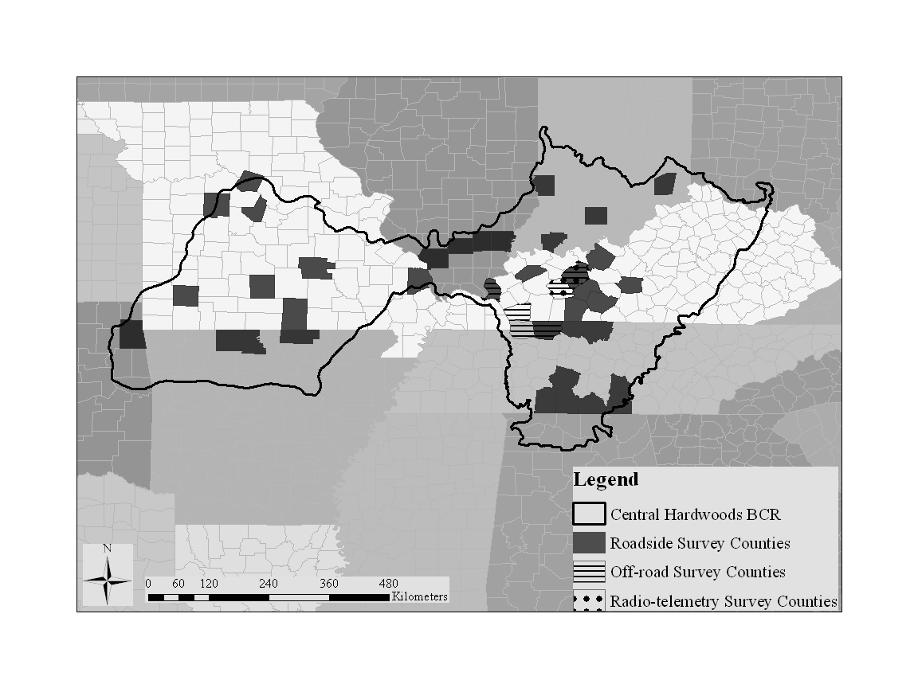Figure 1.1 Central Hardwoods Bird Conservation Region with focal counties for roadside surveys conducted from May–July, 2008–2012, and focal areas for off-road and radio-telemetry surveys conducted from May–July, 2010–2011.
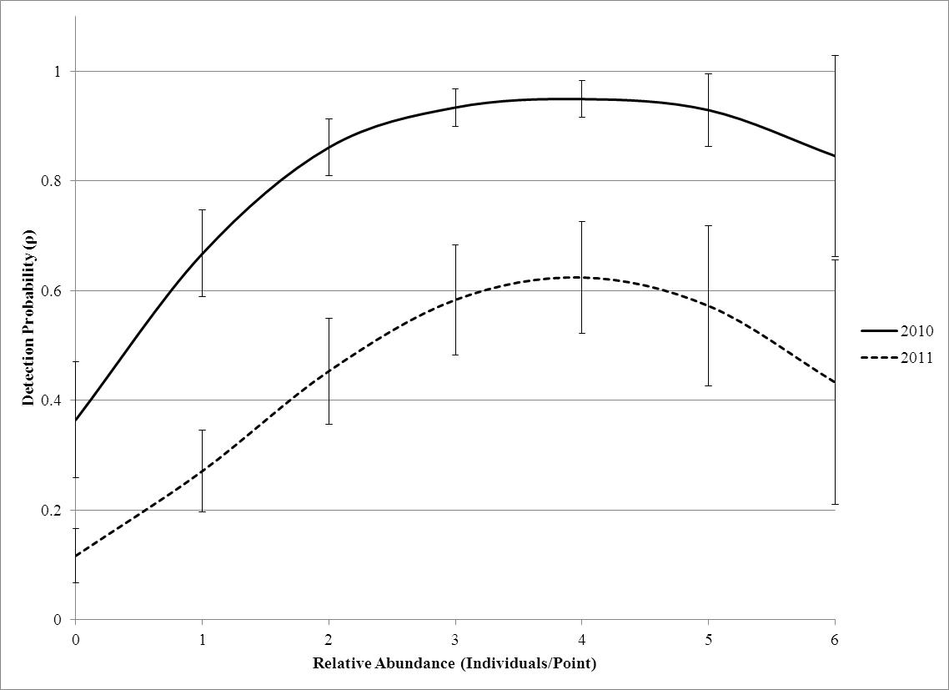
Figure 1.2 Relationship of detection probability of radio-collared male Northern Bobwhites to the number of other male Northern Bobwhites calling during a 5-minute point count on Peabody Wildlife Management Area from May–August 2010 (solid line) and 2011 (dashed line). Probability of detection represents the probability that the radio-collared male calls at least once during the 5-minute count while occupancy is held constant at 1. I used the occupancy analysis in program MARK, and I used mean values for minutes-since-sunrise in the model.

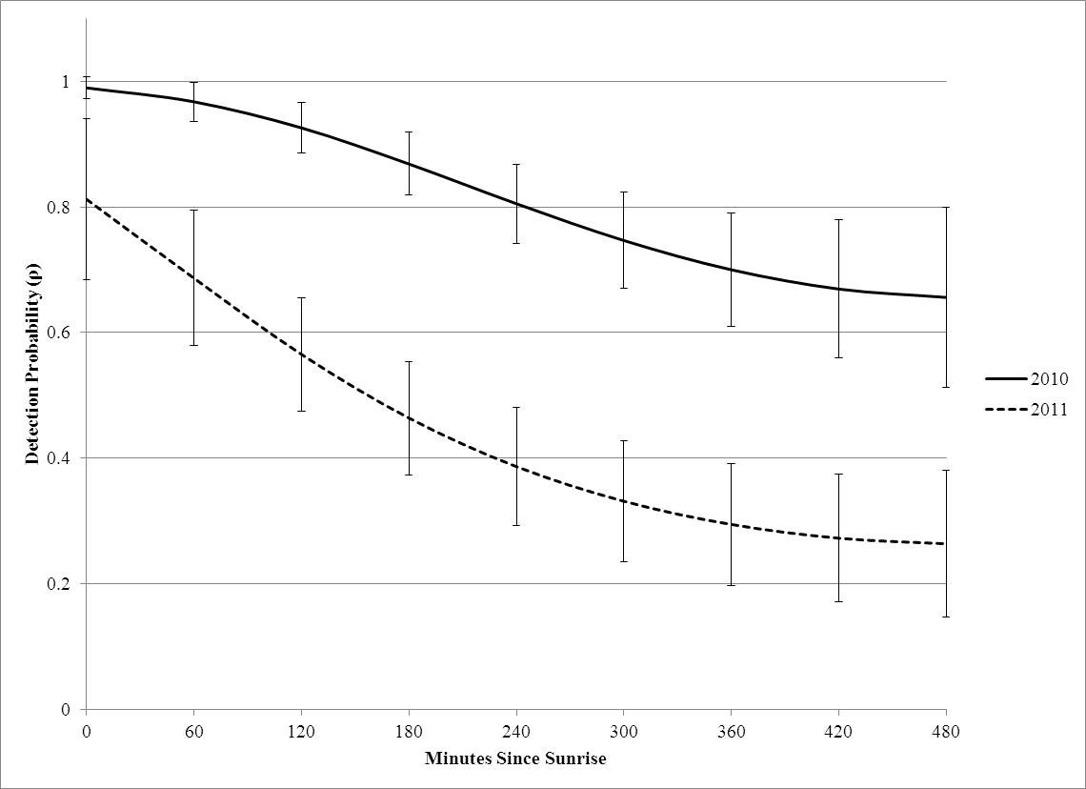
Figure 1.3 Relationship of detection probability of radio-collared Northern Bobwhites to minutes-since-sunrise (MSS) during a 5-minute point count on Peabody Wildlife Management Area from May–August, 2010 (solid line) and 2011 (dashed line). Probability of detection represents the probability that the radio-collared male calls at least once during the 5-minute count while occupancy is held constant at 1. I used the occupancy analysis in program MARK, and I used mean values for abundance in the model.

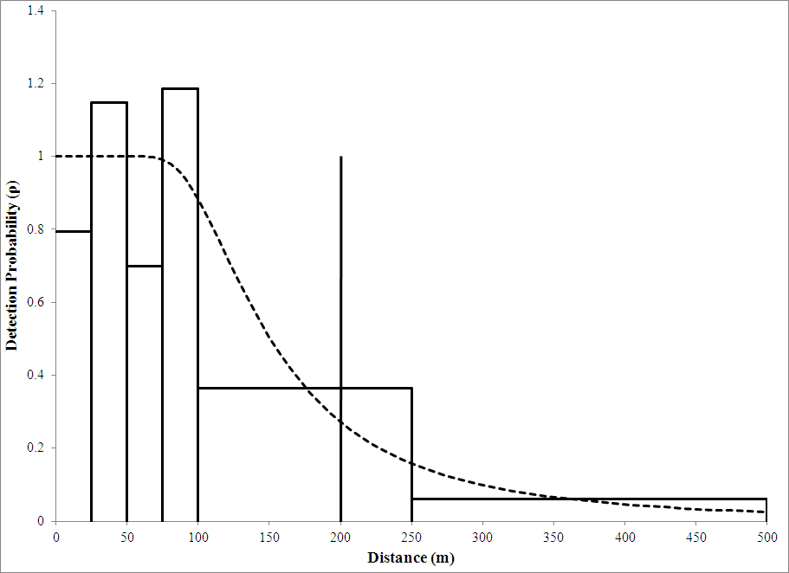
Figure 1.4 Detection probability related to effective detection distance of Northern Bobwhite observations, grouped into distance bands, from roadside surveys conducted from May–July, 2008 to 2012 in the Central Hardwoods Bird Conservation Region. Bars represent scaled frequencies of observed detections in each distance interval by the total area surveyed in a distance interval divided by the estimated density of all detections to calculate scaled frequencies (Buckland 2001).

CHAPTER II
ASSESSMENT OF ROADSIDE BIAS FOR HIGH-PRIORITY GRASSLAND AND EARLY SUCCESSIONAL BIRDS

ABSTRACT
Convenience sampling in wildlife biology is frequently used because researchers are limited by monetary resources, personnel, access to areas of interest, or even time. Roadside-based survey methodologies are convenient for monitoring a variety of wildlife taxa, including birds, amphibians and mammals. Accounting for and directly assessing known biases associated with roadside-based surveys could improve the accuracy and extend the inferences of roadside-based parameter estimates and, in turn, strengthen management application. I developed a survey to assess roadside biases for estimates of relative abundance, occupancy (ψ), detection probability (p), and associated land-cover for high priority grassland and early successional songbirds in the Central Hardwoods Bird Conservation Region (CHBCR). I located survey transects 300 m apart perpendicular to secondary roads, and on each transect, positioned 3 points located on the roadside, 300 m, and 600 m away from the road, on Peabody Wildlife Management Area, Fort Campbell Military Reservation, and on private lands in Livingston County, KY from 2010-2011. At each point I conducted a 5-min,100-m, fixed-radius point count listening for and recording eight Partners In Flight (PIF) designated high priority grassland songbird species: Bell’s Vireo (Vireo bellii), Dickcissel (Spiza americana), Eastern Kingbird (Tyrannus tryannus), Eastern Meadowlark (Sturnella magna), Field Sparrow (Spizella pusilla), Grasshopper Sparrow (Ammodramus savannarum), Henslow’s Sparrow (Ammodramus henslowii), and Prairie Warbler (Setohpaga discolor). I used a single-factor analysis of variance to compare relative abundance and percent land-cover of species among distance-from-road categories. I estimated species-specific detection probabilities and site occupancy from the Royle-Nichols Repeated Count Data module in program PRESENCE 5.7. None of the eight species examined differed in relative abundance among distance-from-road categories (P > 0.05), and distance-from-road was not maintained in any of the top species-specific models for occupancy (ψ) or detection probability (p, ΔAIC_{c} ≤2). Road-side surveys for grassland birds appear to produce estimates of relative abundance, occupancy, and detection probabilities which are representative for the broader landscape in the CHBCR.

INTRODUCTION
Convenience sampling methods for monitoring wildlife populations are often criticized because of apparent biases (e. g., Bart et al. 1995, Anderson 2001) but continue to be widely used (Garton et al. 2005, Morrison et al. 2008). Convenience sampling is when samples are taken in a non-probabilistic because researchers are limited by monetary resources, personnel, access to area(s) of interest, or time available for monitoring. Thus, these logistical constraints can justify the use of convenience sampling design methodologies in spite of their limitations
Roadside-based surveys are convenient for monitoring a diversity of wildlife taxa including snakes and turtles (Enge and Wood 2002, Steen and Smith 2006), anurans (Weir and Mossman 2005, Weir et al. 2005), songbirds (Peterjohn and Sauer 1999), raptors (Andersen et al. 1985), ungulates (Collier et al. 2007), and lepidopterans (Munguira and Thomas 1992). For some species such as white-tailed deer (Odocoileus virginianus), anurans, and many birds, the only trend data available are based on long-term roadside-based surveys. The North American Breeding Bird Survey (BBS) is perhaps the most well-known convenience sampling design in the ornithological research community. Since its establishment in 1966, a multitude of research articles and reports have been published utilizing BBS data (Ziolkowski et al. 2010, Sauer and Link 2011, Sauer et al. 2012).
Roadside bird surveys can have three potential problems wherein the data collected are not representative of the population at large: altered habitat conditions which affect avian distributions, altered avian behavior which may affect dectectability, and/or altered observer abilities to detect birds. Roadside surveys could potentially be biased if roadside surveys do not representatively sample land-cover types that occur off-road or if land-cover changes along a roadside survey route are disproportionate to off-road land-cover changes (Keller and Scallan 1999, Harris and Haskell 2007, McCarthy et al. 2012). Surveys conducted along roads in forested areas can generate biased estimates of species richness and relative abundance, (Hanowski and Niemi 1995, Keller and Scallan 1999) and roads can attract songbird nest predators (Heske et al. 2001) or limit patch dispersal (Desrochers and Hannon 1997, Laurance et al. 2004). However, results from previous research vary based on the species involved and the region being monitored (Rotenberry and Knick 1995, Reijnen et al. 1996, Keller and Scallan 1999, Forman et al. 2002). Indeed, surveys conducted in a grassland-dominated matrix for grassland passerines likely have different biases. In the western United States apparent road effects were minimal for Eastern Meadowlark (Sturnella magna), bobolink (Dolichonyx oryzivorus), and red-winged blackbird (Agelaius phoeniceus)(Clark and Karr 1979, Forman et al. 2002).
Noise caused by traffic can indirectly cause behavioral changes in birds. Road noise can affect the calling rate, frequency, and amplitude for certain species, contributing to reduced pairing and nesting success (Reijnen et al. 1996, Parris and Schneider 2009, Halfwerk et al. 2011). Noise effects from roads in grasslands may extend farther into the habitat than in forested landscapes, because grasslands lack dense vegetation to attenuate the background noise. For rural roads in an agricultural landscape, noise effects can extend up to 100 m from low volume traffic (5,000 cars/day) and 490 m for high volume traffic (≥50,000 cars/day) roads for skylarks (Alauda arvensis)(Reijnen et al. 1996, Forman et al. 2002).
My goal was to assess potential roadside biases for occupancy (ψ) and detection probability (p) of high priority grassland and early successional bird species in the Central Hardwoods Bird Conservation Region (CHBCR) using a roadside versus off-road survey design. I hypothesized that relative abundance, occupancy and detection probability of high priority grassland and early successional species in the CHBCR would be lower on roadside survey points, when compared to off-road survey points. I also hypothesized that occupancy would be affected by changes in land-cover among on- and off-road points.
STUDY AREA
I conducted surveys on three sites all located in western Kentucky and Tennessee, on Peabody Wildlife Management Area (PWMA), Fort Campbell Military Reservation (FCMR), TN-KY and on private lands in Livingston County, KY (LCKY). PWMA is an 18,854 ha reclaimed surface mine managed by Kentucky Department of Fish and Wildlife Resources (KDFWR) located in Ohio, Muhlenberg, and Hopkins counties, KY. Herbaceous cover established during reclamation was dominated by Sericia lespedeza, but also included; big bluestem (Andropogon gerardii), little bluestem (Schizachyrium scoparium), Indiangrass (Sorghastrum nutans), and switch grass (Panicum virgatum). My focal area for surveys was a 3,321 ha unit comprised predominantly of mixed deciduous forest, open herbaceous, native warm-season grass, and scrub/shrub cover types. FCMR is a 41,842 ha U.S. Department of Defense (DoD) installation located on the Tennessee-Kentucky state line. Topography is flat to gently rolling with open oak woodlands, planted pines, leased agricultural fields, and managed native grasslands. I conducted my surveys in native grasslands, cool-season grass patches, and mixed grass-forb areas that ranged in size from 73–570 ha. Private lands in LCKY were restored to native warm-season grasses and are part of a Northern Bobwhite (Colinus virginianus) focus area developed by KDFWR (Morgan 2008). The total focal area is 12,860 ha, and I surveyed a subset of fields which ranged in size from 25–450 ha comprising 3.5% of the focal area.
Average Annual Daily Traffic (AADT) is a metric used by transportation departments calculated as the volume of traffic based on a 24-hr two-directional count on a given road for a given location divided by 365 days. For secondary roads near FCMR in 2010, AADT ranged from 84–7,400 (TDOT 2012). Traffic volume on the actual roads surveyed on Fort Campbell were unavailable but based on direct observation during surveys, were likely in the low end of the range measured for nearby secondary roads. AADT for PWMA in 2010 ranged from 229–2,032 (KYTC 2011), and for LCKY in 2010, AADT ranged from 248–2,280 (KYTC 2011). Roads on FCMR were paved or gravel, roads on PWMA were gravel, and roads in LCKY were paved.
METHODS
I conducted roadside versus off-road surveys on PWMA (n = 36) and FCMR (n = 117) in 2010, and on PWMA (n = 93) and in LCKY (n = 24) in 2011. Surveys on FCMR were not conducted in 2011 because of access restrictions. I located survey transects 300 m apart along a secondary road, and extended transects perpendicularly for 600 m away from the road. To avoid repeat detections of individuals, and spatial autocorrelation (Hutto et al. 1986, Fletcher and Koford 2002, Alldredge et al. 2006), I positioned points (n = 3) on each transect at 0, 300 and 600 m away from the road. At each point I conducted a 5 minute 100-m fixed-radius point count listening for and recording all individuals aurally or visually detected. Using a range finder, I placed individuals in one of five distance bands: 0–25 m, 26–50 m, 51–75 m, 76–100 m, and >100 m. Observations >100 m from the road were censured from the analysis. I surveyed each transect three times at approximately 2-week intervals to determine seasonal variation in detection and occupancy. The first visit occurred from 19 May – 3 June, the second visit from 1 June – 25 June, and the third visit from 25 June – 11 July. I surveyed 270 points on 90 off-road transects from 2010–2011.
Study Species
I surveyed for high-priority grassland and early successional passerine species that are of conservation concern in the CHBCR. These species included: Bell’s Vireo (Vireo bellii, BEVI), Dickcissel (Spiza americana, DICK), Eastern Kingbird (Tyrannus tryannus, EAKI), Eastern Meadowlark (Sturnella magna, EAME), Field Sparrow (Spizella pusilla, FISP), Grasshopper Sparrow (Ammodramus savannarum, GRSP), Henslow’s Sparrow (Ammodramus henslowii, HESP), and Prairie Warbler (Setophaga discolor, PRAW).
Vegetation Sampling Procedures
I recorded the percent cover of eight land-cover types within a 100-m radius of the point center for all point count stations (Table 2.1). I chose a 100-m radius to match the fixed-radius point count distance survey methodology, and because observers had difficulty classifying cover types beyond 100 m.
Analyses
I calculated relative abundance for each species as the total individual detections/point/visit. I used a single-factor analysis of variance (ANOVA) to compare percent land-cover and relative abundance of species among the three distance-from-road categories (DFR). I Inspected Q-Q plots for normality of residuals and I tested for equality of variances via a Levene’s test. If test results violated normality or equality of variance assumptions, then I used non-parametric Kruskal-Wallis analysis to test for differences among categories (Zar 1996). I considered means different at α <0.05. I used Fisher’s LSD tests for post-hoc comparisons (IBM SPSS Statistics for Windows; Version 21.0. IBM Corp. Armonk, NY).
I estimated species-specific detection probabilities and site occupancy from the Royle-Nichols Repeated Count Data module in program PRESENCE 5.7 (Royle and Nichols 2003, Hines 2006). The real parameters of the Royle-Nichols Repeated Count Data module are r and λ, and conditional detection probability (p) and occupancy are derived parameters (ψ). Unconditional detection probability is considered an estimate of detection regardless of site occupancy, whereas conditional detection probability is conditioned on occupancy (Royle and Nichols 2003). To evaluate year and distance from road effects on detection probability, I grouped surveys based on year (Year) and distance-from-road (DFR). I also generated visit-specific detection probabilities to account for within-season temporal variation of detection (Visit). I did not include observer effects for detection probability, because >90% of the point counts were conducted by one observer. I included distance-from-road (DFR) and year (Year) effects on occupancy. Additionally, I evaluated heterogeneity in land-cover on points by including a covariate for percent land-cover for cover types that could influence species’ occupancy. I chose to include 8 different cover types based on life-history and knowledge about species’ preferences: (cool-season grass [CG], forest [FO], grass mixture [GM], native warm-season grass [NG], old field [OF], riparian [RI], scrub-shrub [SC], and woodland [WD]; Table 2.1).
I developed a suite of species-specific a priori models based on my specific objectives. I used Akaike’s Information Criterion adjusted for small sample sizes (AIC_{c}) for model selection. I considered models with a ΔAIC_{c} ≤2 to be the most influential in explaining the variability in the system (Burnham and Anderson 2002). Rather than include every potential combination of covariates for detection probability (p) and occupancy (ψ), I modeled covariates influencing the parameter for occupancy (ψ) first (DFR, Year, Cover Types), while holding detection probability (p) constant. I then improved the best model explaining occupancy (ψ) by including covariates (DFR, Visit, Year) to model detection probability (p). Additionally to examine explicit DFR effects, I modeled DFR in combination with covariates from top models for detection probability and occupancy and DFR effects singularly for each parameter. I did not include any models with interaction terms because I was interested only in additive effects. I used the most parsimonious model(s) to generate parameter estimates. I used the mean covariate values of land-cover types included in top models to generate occupancy parameter estimates. I used parameter estimates that conditioned detection on occupancy to generate overall detection probability estimates (Royle and Nichols 2003).
Assumptions associated with occupancy modeling include: 1) closed populations for the duration of the surveys, 2) individuals are never falsely detected at a site when absent and may or may not be detected when they are present, and 3) detection of an individual at a site is independent of detection of individuals at other sites (MacKenzie et al. 2002, MacKenzie et al. 2003). I minimized the likelihood of immigration and emigration by surveying within a two-month window during the peak breeding season. My populations of interest were largely closed, because these species establish distinct breeding territories and defend them during the breeding season. Some movement of individuals probably did occur if nests failed, but I assumed this had minimal effects on the results. I limited the number of species being surveyed to eight readily recognizable species and only used two experienced observers to conduct surveys, thereby minimizing false detections. My overall fixed-radius point counts were separated by 300 m minimizing the possibility of movement among them during counts, resulting in spatial independence.
RESULTS
Percent land-cover of OF and FO differed among DFR categories (Table 2.2) and there were no differences among DFR categories for species relative abundance (Table 2.3). The DFR covariate was not included in top models for detection probability or occupancy for any species (Table 2.4). For EAME there was one top model with ΔAIC_{c} ≤2. For BEVI, DICK, FISP, GRSP, HESP, and PRAW there were two competing models with ΔAIC_{c} ≤2, and for EAKI there were 5 competing models with ΔAIC_{c} ≤2 (Table 2.4). Confidence intervals of β estimates of added detection covariates for second-best BEVI and GRSP models overlapped 0, and EAKI detection models always included Year effects. Confidence intervals of β estimates of added occupancy covariates for secondary DICK, EAKI, FISP, HESP, and PRAW models overlapped zero, and EAKI occupancy models always included RI cover covariate.
Distance-from-road Effects
Cover types included in our analyses comprised 83% of land-cover on points (CG = 4.57%, FO = 4.80%, GM = 37.57%, NG = 6.88%, OF = 4.14%, RI = 2.53%, SC = 19%, WD = 3.69%; Table 2.1). Mean percent land-cover of OF (ANOVA, n = 270, F = 5.40, P < 0.01) was greater on points 600 m away from the road and mean percent land-cover of FO (ANOVA, n = 270, F = 16.12, P < 0.05) was greater on roadside points. No other land-cover comparisons differed among distance-from-road categories (P > 0.05, Table 2.2); neither FO nor OF were included in top occupancy models.
DICK ($\overline{x}$ = 1.32/point/visit, SE = 0.08, n = 270) and FISP ($\overline{x}$ = 1.32/point/visit, SE = 0.05, n = 270) were the most abundant species. HESP ($\overline{x}$ = 0.53/point/visit, SE = 0.05, n = 270), GRSP ($\overline{x}$ = 0.36/point/visit, SE = 0.03, n = 270), EAME ($\overline{x}$ = 0.35/point/visit, SE = 0.04, n = 270), BEVI ($\overline{x}$ = 0.33/point/visit, SE = 0.03, n = 270), and PRAW ($\overline{x}$ = 0.27/point/visit, SE = 0.02, n = 270) were moderately abundant having on average, at least one individual counted during 3 visits. EAKI ($\overline{x}$ = 0.10/point/visit, SE = 0.01, n = 270) was the least abundant species. DICK, EAKI, and GRSP did not meet assumptions of normality based on Levene’s Test (P < 0.05), thus I use a Kruskal-Wallis comparison. Species relative abundance did not differ (P > 0.05) for any of the eight species monitored among DFR categories (Table 2.3).
The DFR covariate was not included in any top models explaining detection probability or occupancy for any species, although DFR was included in second-best and third-best models for detection probability for EAKI and GRSP and in second-best models for occupancy for DICK, HESP, and PRAW. Confidence intervals of beta estimates for EAKI detection probabilities of the third-best model that included a Year and DFR effect on detection probability overlapped zero (β_{1,2010} = -1.03, SE = 0.55, -2.11 ≤ β ≤ 0.05; β_{2,2010} = -0.96, SE = 0.55, -2.03 ≤ β ≤ 0.12; β_{3,2010} = -0.81, SE = 0.54, -1.87 ≤ β ≤ 0.24; β_{1,2011} = 0.42, SE = 0.55, -0.66 ≤ β ≤ 1.49; β_{2,2011} = -1.11, SE = 0.61, -2.30 ≤ β ≤ 0.08). Confidence intervals of beta estimates for the DFR covariate for GRSP detection probabilities of the third-best model that included a Visit and DFR effect on detection probability overlapped zero for the first two distance categories (0 m = 0.49, SE = 0.29, -0.06 ≤ β ≤ 1.05; 300 m = -0.17, SE = 0.27, -0.70 ≤ β ≤ 0.36; 600 m = -0.54, SE = 0.25, 1.04 ≤ β ≤ 0.04). Confidence intervals of beta estimates for the DFR covariate for DICK occupancy of the second-best model that included GM and DFR effects on occupancy overlapped zero for the first two distance categories (0 m = -0.09, SE = 0.11, -0.31 ≤ β ≤ 0.11; 300 m = 0.07, SE = 0.10, -0.13 ≤ β ≤ 0.26; 600 m = 0.25, SE = 0.11, 0.04 ≤ β ≤ 0.47). Confidence intervals of beta estimates for the DFR covariate for HESP occupancy of the second-best model that included GM and DFR effects on occupancy overlapped zero (0 m = -0.23, SE = 0.15, -0.55 ≤ β ≤ 0.03; 300 m = -0.07, SE = 0.13, -0.34 ≤ β ≤ 0.19; 600 m = 0.28, SE = 0.19, -0.10 ≤ β ≤ 0.66). Confidence intervals of beta estimates for the DFR covariate for PRAW occupancy of the second-best model that included SC, GM, and DFR effects on occupancy overlapped zero (0 m = -0.23, SE = 0.19, -0.60 ≤ β ≤ 0.14; 300 m = -0.37, SE = 0.19, -0.74 ≤ β ≤ 0.01; 600 m = 0.44, SE = 0.26, -0.07 ≤ β ≤ 0.96).
Temporal Effects
Visit was the most common variable explaining detection probability, included in top models for every species except FISP in which Visit occurred in the second-best model. Year was also an important variable explaining detection probability and was included in top models for DICK, EAKI, EAME, FISP, GRSP, and HESP. Occupancy for all species models was influenced by combinations of Year, and/or land-cover covariates (Table 2.4).
Conditional detection probabilities for EAKI, EAME, and PRAW were greatest during the first visit and declined during the second and third visits (EAKI- β₁ = 0.59, SE = 0.31, -0.01 ≤ β ≤ 1.20; β₂ = 0.16, SE = 0.10, -0.15 ≤ β ≤ 0.27; β₃ = -1.44, SE = 0.46, -2.35 ≤ β ≤ -0.53; EAME- β₁ = 0.47, SE = 0.17, 0.13 ≤ β ≤ 0.81; β₂ = 0.30, SE = 0.17, -0.04 ≤ β ≤ 0.64; β₃ = -0.41, SE = 0.45, -1.30 ≤ β ≤ 0.48; PRAW-β₁ = 1.66, SE = 0.24, 1.20 ≤ β ≤ 2.13; β₂ = 0.76, SE = 0.23, 0.30 ≤ β ≤ 1.21; β₃ = -2.17, SE = 0.28, -2.73 ≤ β ≤ -1.62) Table 2.5). Conditional detection probabilities for BEVI (β₁ = 0.44, SE = 0.22, 0.01 ≤ β ≤ 0.88; β₂ = 0.89, SE = 0.23, 0.43 ≤ β ≤ 1.34; β₃ = -0.29, SE = 0.18, -0.65 ≤ β ≤ 0.07) and GRSP (β₁ = -0.29, SE = 0.19, -2.44 ≤ β ≤ 0.07; β₂ = 0.29, SE = 0.18, -1.85 ≤ β ≤ 0.64; β₃ = 0.11, SE = 0.27, -2.12 ≤ β ≤ 0.64) were greater during the second visit than during the first and third visits (Table 2.5). Conditional detection probabilities for DICK (β₁ = -0.27, SE = 0.11, -0.48 ≤ β ≤ -0.06; β₂ = 0.06, SE = 0.10, -0.15 ≤ β ≤ 0.27; β₃ = 0.23, SE = 0.15, -0.06 ≤ β ≤ 0.52) and HESP (β₁ = -0.43, SE = 0.14, -0.70 ≤ β ≤ -0.15; β₂ = 0.06, SE = 0.13, -0.20 ≤ β ≤ 0.32; β₃ = -2.14, SE = 0.23, -2.59 ≤ β ≤ -1.69) were greater during the second and third visits than the first visit (Table 2.5). FISP detection probability was unrelated to visit.
Conditional detection probabilities were greater in 2010 than 2011 for HESP (β = 1.27, SE = 0.17, 0.94 ≤ β ≤ 1.61). Conditional detection probabilities were greater in 2011 than 2010 for DICK (β = -0.32, SE = 0.15, -0.62 ≤ β ≤ -0.03), EAKI (β = -0.86, SE = 0.33, -1.50 ≤ β ≤ -0.21), EAME (β = -1.11, SE = 0.51, -2.11 ≤ β ≤ -0.11), and GRSP (β = -0.78, SE = 0.33, -3.08 ≤ β ≤ -0.13).
Occupancies were greater in 2010 than 2011 for EAME (87%; β = 2.73, SE = 0.37, 2.00 ≤ β ≤ 3.46) and GRSP (58%, β = 0.87, SE = 0.19, 0.51 ≤ β ≤ 1.24). Occupancies were greater in 2011 than 2010 for BEVI (63%; β = -1.31, SE = 0.19, -1.69 ≤ β ≤ -0.94) and FISP (4%; β = -0.23, SE = 0.16, -0.54 ≤ β ≤ 0.08). DICK, EAKI, HESP, and PRAW occupancies did not differ between years (Table 2.6).

Land-cover Effects
There were 3 percent land-cover covariates included in species occupancy models: GM ($\overline{x}$ = 0.40, SE = 0.19, n = 270), SC ($\overline{x}$ = 0.20, SE = 0.15, n = 270), and RI ($\overline{x}$ = 0.017, SE = 0.004, n = 270). Percent SC cover was positively related to occupancies of BEVI (β = 1.11, SE = 0.31, 0.50 ≤ β ≤ 1.73), FISP (β = 0.78, SE = 0.16, 0.47 ≤ β ≤ 1.09) and PRAW (β = 1.20, SE = 0.29, 0.63 ≤ β ≤ 1.77). Percent GM cover was positively related to occupancies of DICK (β = 1.59, SE = 0.14, 1.32 ≤ β ≤ 1.86), EAME (β = 2.17, SE = 0.22, 1.73 ≤ β ≤ 2.61), GRSP (β = 1.75, SE = 0.24, 1.28 ≤ β ≤ 2.22), and HESP (β = 1.67, SE = 0.18, 1.32 ≤ β ≤ 2.02) but negatively related to occupancy of PRAW (β = -1.35, SE = 0.33, -1.99 ≤ β ≤ -0.71). Percent RI cover was positively related to occupancy of EAKI (β = 3.51, SE = 1.10, 1.35 ≤ β ≤ 5.66).
DISCUSSION
Studies designed to monitor species populations often involve trade-offs between experimental design and logistical constraints (Garton et al. 2005). The ability to use a roadside-based survey design to effectively survey high priority grassland and early successional bird species could generate important information on population trends, species-specific land-cover relationships, and response to management actions. A roadside-based survey approach is important for surveying grassland species in the CHBCR because most of the land being surveyed is privately owned and gaining access across extensive survey areas is impractical. I designed a survey to assess the potential for roadside-based survey biases of relative abundance, occupancy, and detection probability for eight high-priority grassland and early successional bird species in the CHBCR.
Somewhat surprisingly, I detected no differences in relative abundance among distance-from-road categories, and there was little evidence of a roadside bias for occupancy or detection probability for any species. Based on simulated results from Royle and Nichols (2003), the power to detect differences among distance-from-road categories was likely adequate because of the relatively large sample size (n = 270), the number of surveys (T = 3), the lowest unconditional species detection probability (HESP; r = 0.26), and the lowest abundance (BEVI; λ = 0.59) should produce unbiased occupancy estimates (ψ), and low variance (σ_{c} = 0.17) of abundance (λ). I detected a distance-from-road effect in percent old field and forest cover, though neither of those cover types were supported in top occupancy models for any species. Thus, I failed to reject the null hypothesis that relative abundance, occupancy, and detection probability of high priority grassland and early successional species in the CHBCR would be lower on roadside survey points, when compared to off-road survey points. To my knowledge, this is the first study to directly assess within-season occupancy and detection probability roadside biases for the majority of these species. Forman et al. (2002) did find evidence of traffic volume effects of adjacent roads on Eastern Meadowlark distributions, in conjunction with size of fields, and amount of urbanization, but did not directly assess occupancy or include a measure of detection probability. I did not find evidence of a spatial roadside effect on relative abundance or occupancy; rather, land-cover at a point was the most influential variable affecting species point occupancy.
These results contrast sharply with a similar study in a forested matrix in which 24 species were more abundant along roads and only five species were more abundant on off-road counts (Hanowski and Niemi 1995). Population models for forested bird species using on-road and off-road data were comparable, and models that included vegetation cover and detectability accounted for variation in species occurrence predictions (McCarthy et al. 2012). McCarthy et al. (2012) recommended inclusion of land-cover covariates to generate population models for forest bird species from roadside survey data, conducting off-road monitoring to determine if roadside models can be extrapolated to off-road areas, and limiting or accounting for other sources of variability such as detection probability. Similar to my results, relative abundance did not differ between on and off-road surveys in an open shrub-steppe landscape in Idaho (Hanowski and Niemi 1995, Rotenberry and Knick 1995).
I observed annual variability in BEVI, EAME, FISP, and GRSP occupancies linked to land-cover variables. BEVI were uncommon on FCMR, and were common on PWMA, which is reflected in the greater point occupancy in 2011 due to an absence of points on FCMR and addition of points on PWMA and LCKY. Conversely, EAME and GRSP were very abundant on FCMR and were less common on PWMA contributing to the decreased point occupancy in 2011. These results are a likely product of the changes in sampling areas and subsequent changes in land-cover types on points from 2010 to 2011. Annual variation in point occupancy of FISP was minimal (4%), and occupancy was more influenced by SC cover.
Point occupancy was affected by percent of a given land-cover type at a point for all eight of my focal species. Thus, my hypothesis that occupancy was affected by changes in land-cover among on- and off-road points was partly confirmed, though in my case land-cover itself generally did not differ among distance-from-road categories. For DICK, HESP, and PRAW second-best occupancy models that included DFR covariates, effect sizes were very small among DFR categories (<13%), though, points on roads had the lowest occupancies for HESP and PRAW. Because top models included land-cover covariates, roadside-based surveys that incorporate these point-specific covariates will improve accuracy of occupancy parameter estimates. If land-cover differed significantly among on- and off-road points, then occupancy estimates could become biased. However, I did not detect statistically significant differences among land-cover types included in top species models among on- and off-road points on survey sites.
Contrary to my a priori hypotheses, I did not find evidence of species-specific reduced detection probability associated with on-road points when compared with off-road points. GRSP detection probability was always greater on roadside points than off-road points. In 2011, during the first visit, GRSP detectability at on-road points was 42% greater than at off-road points, although confidence intervals of estimates were wide and overlapped. Though I did not quantify noise associated with roadside surveys, I expected that traffic noise might reduce species-specific detection probabilities. Acoustic frequency for some species can shift in response to traffic noise levels, though rural roads may have a minimal effect on species acoustic frequency shifts and observer detection probabilities (Parris and Schneider 2009, Griffith et al. 2010). Because I did not find any differences in species detection probabilities between on- and off-road surveys, noise associated with roadside surveys in this study likely had a minimal effect on detection. My selection of secondary roads for the surveys apparently was successful in limiting noise effects.
Most previous research defined “off-road” points to be between 200 m and 400 m off the nearest road (Hanowski and Niemi 1995, Keller and Fuller 1995, Rotenberry and Knick 1995, Keller and Scallan 1999, McCarthy et al. 2012). Low traffic volume on secondary roads can have an audible distance of up to 100 m and audible noise associated with high traffic volumes can extend up to 560 m (Reijnen et al. 1996). The farthest off-road point on each transect was 600 m from the nearest road. As a result, this experiment was designed at an appropriate scale for assessing large-scale roadside effects. More local effects of roads (i.e., within 100 m), may have been missed by the survey design
Timing of the surveys can have a significant effect on parameter estimates, although no single two-week period maximized detectability for all eight species. These focal species have different breeding strategies, phenologies, and habitats and represent six taxonomically distinct Passeriformes families (Vireonidae. Cardinalidae, Tyranidae, Icteridae, Emberizidae, Parulidae). Three species (EAKI, EAME, and PRAW) detection probabilities declined as the breeding season progressed. PRAW detection probability declined the most, decreasing 64% from the first visit to the third visit. DICK and HESP detection showed an opposite trend, with respective detection probabilities increasing 11% and 33% after the first survey period. BEVI and GRSP detection probabilities were >16% greater in June than during May or July.
Also, there are inter-species detection probability differences. Two common species expected to be easily detectable, DICK and FISP, had overall unconditional detection probabilities >75% after 3 visits. Surprisingly, BEVI and GRSP unconditional detection probabilities were comparable at 90%, and 71% respectively. The most difficult species to detect after 3 visits were HESP (26%) in 2011 and EAKI (31%) in 2010. I would anticipate HESP and EAKI to be difficult to detect because their songs are cryptic and can be difficult to hear. Visiting points >3 times would improve detection probabilities for HESP and EAKI, though detection probabilities of each species during the other survey years were as much as 60% greater.
Differences in species-specific detection probabilities based on breeding phenological differences can bias population parameter estimates. In Denali National Park and Preserve, AK, passerine species detection probabilities were significantly affected by seasonal phenological shifts and peak detection probabilities did not overlap among species (Schmidt et al. 2013). Though the cause of shifts is speculated to be linked to mating and nesting phenology, information directly linking detection probabilities to breeding phenologies is absent for many species (Wilson and Bart 1985). Clearly, population parameter adjustments based on detection probabilities need to include a within-season temporal component or population parameter estimates will be biased (Schmidt et al. 2013). I recommend that surveys either be explicitly designed for a species of interest that target periods of peak detectability or that surveys account for species-specific temporal shifts in detection probabilities for the duration of a survey by bracketing surveys via some minima and maxima survey date.
Concerns about biases with convenience sampling can be addressed by explicitly designing surveys to test distance-from-road related hypotheses. Roadside-based surveys appear to be unbiased for making inferences about these eight high-priority grassland and early successional bird species across the CHBCR. Additional studies assessing potential roadside biases of species-specific occupancies and detection probabilities prior are needed. Continued use of hierarchical models in which sample and process variability are modeled simultaneously (Royle and Dorazio 2008)should also include careful consideration of spatially explicit covariates that could affect species occupancy along a roadside-based survey. Also results of this research further confirm recommendations of other researchers to account for temporal and observational variables while modeling detection probability (Sauer et al. 1994, Schmidt et al. 2013). If land-cover variables are accounted for, and surveys are conducted to account for seasonal variability in detection probability, then population models generated from roadside data should be representative of the population at large (McCarthy et al. 2012). Species-specific occupancy and detection probabilities were influenced by variables that can be easily collected and accounted for during roadside surveys. Survey efficiency can also be improved by utilizing convenience surveys. A trained observer can survey approximately twice as many on-road points (30 5-min point counts/4 hr) as off-road points (15 5-min point counts/4 hr). Using a roadside-based survey to monitor high-priority grassland and early successional bird species can be efficient, effective, and survey a large extent area while utilizing a fine-grain survey methodology.

LITERATURE CITED
Alldredge, M. W., K. H. Pollock, and T. R. Simons. 2006. Estimating detection probabilities from multiple-observer point counts. Auk 123:1172–1182.
Andersen, D. E., O. J. Rongstad, and W. R. Mytton. 1985. Line transect analysis of raptor abundance along roads. Wildlife Society Bulletin 13:533–539.
Anderson, D. R. 2001. The need to get the basics right in wildlife field studies. Wildlife Society Bulletin 29: 1294–1297.
Bart, J., M. Hofschen, and B. G. Peterjohn. 1995. Reliability of the breeding bird burvey: effects of restricting surveys to roads. Auk 112: 758–761.
Burnham, K. P., and D. R. Anderson. 2002. Model selection and multi-model inference: a practical information-theoretic approach. 2 edition. Springer-Verlag, New York, USA.
Clark, W. D., and J. R. Karr. 1979. Effects of highways on red-winged blackbird and horned lark populations. Wilson Bulletin 91:143-145.
Collier, B. A., S. S. Ditchkoff, J. B. Raglin, and J. M. Smith. 2007. Detection probability and sources of variation in white-tailed deer spotlight surveys. Journal of Wildlife Management 71:277-281.
Desrochers, A., and S. J. Hannon. 1997. Gap crossing decisions by forest songbirds during the post-fledging period. Conservation Biology 11:1204-1210.
Enge, K. M., and K. N. Wood. 2002. A pedestrian road survey of an upland snake community in Florida. Southeastern Naturalist 1:365-380.
Fletcher, R. J., Jr., and R. R. Koford. 2002. Habitat and landscape associations of breeding birds in native and restored grasslands. Journal of Wildlife Management 66:1011–1022.
Forman, R. T. T., B. Reineking, and A. M. Hersperger. 2002. Road traffic and nearby grassland bird patterns in a suburbanizing landscape. Environmental Management 29:782-800.
Garton, E. O., J. T. Ratti, and J. H. Guidice. 2005. Research and experimental design. Pages 43–71 in C. E. Braun, editor. Techniques for wildlife investigations and management. Sixth edition. The Wildlife Society, Bethesda, Maryland, USA.
Griffith, E. H., J. R. Sauer, and J. A. Royle. 2010. Traffic effects on bird counts on North American breeding bird surveys routes. Auk 127:387-393.
Halfwerk, W., L. J. M. Holleman, C. M. Lessells, and H. Slabbekoorn. 2011. Negative impact of traffic noise on avian reproductive success. Journal of Applied Ecology 48:210-219.
Hanowski, J. A. M., and G. J. Niemi. 1995. A comparison of on- and off-road bird counts: do you need to go off road to count birds accurately? Journal of Field Ornithology 66:469-483.
Harris, J. B. C., and D. G. Haskell. 2007. Land cover sampling biases associated with roadside bird surveys. Avian Conservation and Ecology 2.
Heske, E. J., S. K. Robinson, and J. D. Brawn. 2001. Nest predation and neotropical migrant songbirds: piecing together the fragments. Wildlife Society Bulletin 29:52-61.
Hines, J. E. 2006. PRESENCE- Software to estimate patch occupancy and related parameters.United States Geological Survey-Patuxent Wildlife Research Center.
Hutto, R. L., S. M. Pletschet, and P. Hendricks. 1986. A fixed-radius point count method for nonbreeding and breeding season use. Auk 103:593–602.
Keller, C. M. E., and M. R. Fuller. 1995. Comparison of birds detected from roadside and off-road counts in the Shenandoah National Park. USDA Forest Service General Technical Report PWS-GTR-149:111–115.
Keller, C. M. E., and J. T. Scallan. 1999. Potential roadside biases due to habitat changes along breeding bird survey routes. Condor 101:50–57.
Kentucky Transportation Cabinet [KYTC]. 2011. Division of Planning. Traffic Counts for Kentucky.
<http://transportation.ky.gov/Planning/Pages/count-maps.aspx> Accessed 17 Sep 2013.
Laurance, S. G. W., P. C. Stouffer, and W. E. Laurance. 2004. Effects of road clearings on movement patterns of understory rainforest birds in central Amazonia. Conservation Biology 18:1099-1109.
MacKenzie, D. I., J. D. Nichols, J. E. Hines, M. G. Knutson, and A. B. Franklin. 2003. Estimating site occupancy, colonization, and local extinction when a species is detected imperfectly. Ecology 84:2200–2207.
MacKenzie, D. I., J. D. Nichols, G. B. Lachman, S. Droege, J. A. Royle, and C. A. Langtimm. 2002. Estimating site occupancy rates when detection probabilities are less than one. Ecology 83:2248–2255.
McCarthy, K. P., R. J. Fletcher, C. T. Rota, and R. L. Hutto. 2012. Predicting species distributions from samples collected along roadsides. Conservation Biology 26:68–77.
Morgan, J. J., and B. A. Robinson. 2008. Road to recovery: the blueprint for restoring northern bobwhite in Kentucky. Kentucky Department of Fish and Wildlife Resources/Small Game Program. 34 pp.
Morrison, M. L., W. M. Block, M. D. Strickland, B. A. Collier, and M. J. Peterson. 2008. Wildlife study design. Second edition. Springer Science+Business Media, LLC, New York, New York, USA.
Munguira, M. L., and J. A. Thomas. 1992. Use of road verges by butterfly and butnet populations, and the effect of roads on adult dispersal and mortality. Journal of Applied Ecology 29:316-329.
Parris, K. M., and A. Schneider. 2009. Impacts of traffic noise and traffic volume on birds of roadside habitats. Ecology and Society 14.
Peterjohn, B. G., and J. R. Sauer. 1999. Population status of North American grassland birds from the North American breeding bird survey, 1966–1996. Studies in Avian Biology 19:27–44.
Reijnen, R., R. Foppen, and H. Meeuwsen. 1996. The effects of traffic on the density of breeding birds in Dutch agricultural grasslands. Biological Conservation 75:255-260.
Rotenberry, J. T., and S. T. Knick. 1995. Evaluation of bias in roadside point count surveys of passerines in shrubsteppe and grassland habitats in southwestern Idaho. USDA Forest Service General Technical Report PSW-GTR-149:99–101.
Royle, J. A., and R. M. Dorazio. 2008. Hierarchical modeling and inference in ecology. The analysis of data from populations, metapopulations and communicites. Academic Press, London, UK.
Royle, J. A., and J. D. Nichols. 2003. Estimating abundance from repeated presence-absence data or point counts. Ecology 84:777–790.
Sauer, J. R., J. E. Hines, J. E. Fallon, K. L. Pardieck, D. J. Ziolkowski, and W. A. Link. 2012. The North American Breeding Bird Survey, results and analysis 1966–2011. Version 12.13.2011. USGS Patuxent Wildlife Research Center, Laurel, MD.
Sauer, J. R., and W. A. Link. 2011. Analysis of the North American Breeding Bird Survey using hierarchical models. Auk 128:87-98.
Sauer, J. R., B. G. Peterjohn, and W. A. Link. 1994. Observer differences in the North American Breeding Bird Survey. Auk 111:50–62.
Schmidt, J. H., C. L. McIntyre, and M. C. MacCluskie. 2013. Accounting for incomplete detection: what are we estimating and how might it affect long-term passerine monitoring programs? Biological Conservation 160:130-139.
Steen, D. A., and L. L. Smith. 2006. Road surveys for turtles: consideration of possible sampling biases. Herpetological Conservation and Biology 1:9-15.
Tennessee Department of Transportation [TDOT]. 2012. Project Planning Division Travel Data Office. Annual Average Daily Traffic for Tennessee.
<http://www.tdot.state.tn.us/projectplanning/adt.asp>. Accessed 17 Sep 2013.
Weir, L. A., and M. J. Mossman. 2005. North American Amphibian Monitoring Program (NAAMP). Pages 307–313 in M. J. Lannoo, editor. Amphibian declines: conservation status of United States species. University of California Press, Berkley, USA.
Weir, L. A., J. A. Royle, P. Nanjappa, and R. E. Jung. 2005. Modeling anuran detection and site occupancy on North American Amphibian Monitoring Program (NAAMP) routes in Maryland. journal of Herpetology 39:627-639.
Wilson, D. M., and J. Bart. 1985. Reliability of singing bird surveys: effects of song phenology during the breeding-season. Condor 87:69-73.
Zar, J. H. 1996. Biostatistical Analysis. Prentice-Hall, London, England.
Ziolkowski, D. J., K. L. Pardieck, and J. R. Sauer. 2010. The 2003–2008 summary of the North American Breeding Bird Survey. Bird Populations 10:90–109.

APPENDIX II
Table 2.1 Land cover types used to classify habitat during off-road surveys conducted on Fort Campbell Military Reservation, KY-TN; Peabody Wildlife Management Area, KY; Livingston County, KY, 2010-2011.

Table 2.2 Mean percent cover of various cover types at point counts conducted in 3 distance-from-road (DFR) categories on Fort Campbell Military Reservation, KY-TN; Peabody Wildlife Management Area, KY; Livingston County, KY.
ªF and P-value statistics are from a single-factor Analysis of Variance
*Significant at P < 0.05

Table 2.3 Relative abundance (individuals/point/visit) for focal species at on- and off-road point counts conducted in 2010 and 2011 in 3 different distance-from-road (DFR) categories on Fort Campbell Military Reservation, KY-TN; Peabody Wildlife Management Area, KY; Livingston County, KY.
ªF and P-value statistics are from a single-factor Analysis of Variance
^{b}P-value statistics are from nonparametric Kruskal-Wallis Test
Table 2.4 Akaiki’s Information Criterion adjusted for small sample sizes (AIC_{c}), for full model sets of occupancy model selection procedure results for detection (r) and occupancy (λ) of target species using off-road point counts conducted in 2010 and 2011, with land cover covariates, on Fort Campbell Military Reservation, KY-TN; Peabody Wildlife Management Area, KY; Livingston County, KY.
Table #2.4 Continued.
ªDFR = distance from road, GM = grass mixture, RI = riparian, SC = scrub-shrub.
Table 2.5 Top model target species visit specific unconditional and conditional detection probabilities (p) from off-road point counts conducted in 2010 and 2011 on Fort Campbell Military Reservation, KY-TN; Peabody Wildlife Management Area, KY; Livingston County, KY.
Table 2.6 Top model target species occupancy (ψ) and associated λ values from off-road point counts conducted in 2010 and 2011 on Fort Campbell Military Reservation, KY-TN; Peabody Wildlife Management Area, KY; Livingston County, KY.

CHAPTER III
RELATIONSHIPS OF CONSERVATION PRACTICES TO GRASSLAND AND EARLY SUCCESSIONAL BIRD OCCUPANCY AND ABUNDANCE
ABSTRACT
North American grasslands have undergone substantial changes since European settlement causing declines in precipitous grassland and early successional bird species populations. The Conservation Reserve Program (CRP) is the largest federally-funded conservation cost-share program in the United States. Many grassland bird species respond to CRP management at the patch or field (practice) level but responses to CRP and other conservation programs at landscape (programmatic) scales are more difficult to assess. My goal was to evaluate the relationship between grassland and early successional bird distribution and abundance and conservation practices implemented through NRCS programs in the Central Hardwoods Bird Conservation Region (CHBCR). My objectives were to 1) determine if the presence of, amount of, or distance to a conservation practice at a survey point was related to species occupancy 2) the presence of, amount of, or distance to conservation at a survey point was related to species abundance, and 3) determine the relative importance of conservation practices in explaining avian distribution and abundance when modeled in conjunction with other landscape covariates. I designed and implemented a roadside survey by randomly locating five 15-km routes with 5-min unlimited distance point counts (30 counts/route), along secondary roads within focal counties (n = 37) in the CHBCR. I surveyed for 9 grassland and early successional focal species that have shown BBS population declines over the past 4 decades: Bell’s Vireo (Vireo bellii, BEVI), Dickcissel (Spiza americana, DICK), Eastern Kingbird (Tyrannus tryannus, EAKI), Eastern Meadowlark (Sturnella magna, EAME), Field Sparrow (Spizella pusilla, FISP), Grasshopper Sparrow (Ammodramus savannarum, GRSP), Henslow’s Sparrow (HESP), Northern Bobwhite (NOBO), and Prairie Warbler (Setophaga discolor, PRAW). I used National Agricultural Statistics Service (NASS) data layers to determine land cover and I used NRCS conservation practice information within a 200-m buffer of each point. I used a multi-season robust design occupancy module in program MARK 6.1 to model occupancy (ψ) among years, colonization (γ), and detection probability (p). I used the general multinomial-Poisson mixture model utilizing a removal count framework in program R with the unmarked package to model species-specific abundance (a). I modeled detection probabilities first, then occupancy and abundance. I included temporal and behavioral covariates as explanatory variables for detection probability. I used Akaike’s Information Criterion adjusted for small sample sizes (AIC_{c}) for model selection. I considered models with a ΔAIC_{c} ≤2 to be most influential in explaining the variability in the system. HESP was the least common species, detected on 1.5% of survey points across all years (n = 292) and FISP (45%; n = 9,240) was the most common species. Percent of points with a conservation practice within 200 m was similar among years (2008 = 4.4%, 2009 = 3.7%, 2010 = 4.8%, 2011 = 5.7%, and 2012 = 6.2%, n = 5,630), and the average area per conservation practice remained consistent among years (2008, $\overline{x}$ = 18.9 ha, SE = 2.5, n = 63; 2009, $\overline{x}$ = 25.8 ha, SE = 3.4, n = 29; 2010, $\overline{x}$ = 23.7 ha, SE = 1.7, n = 231; 2011, $\overline{x}$ = 22.4 ha, SE = 1.8, n = 229; 2012, $\overline{x}$ = 26.2 ha, SE = 1.6, n = 334). Land-cover covariates were most important in models for species occupancy and abundance models for most species. For every species except PRAW, the addition of conservation covariates to top land-cover models improved model fit (ΔAIC_{c} ≤2) of occupancy models. Effects of conservation practices on occupancy in these models were generally weak. No abundance models for any species included conservation covariates in top models. DICK occupancy decreased by 13% from 2010 to 2012 in Ozark Highlands, Interior Plateau, and Interior River Valleys and Hills. DICK occupancy of points in Ozark Highlands, Interior Plateau, and Interior River Valleys and Hills was 4% greater for points with conservation than points without conservation. EAKI occupancy decreased by >47% from 2010 to 2012. NOBO occupancy declined by as much as 28% in the Interior Plateau ecoregion each year, and overall declined by >18% on survey points. NOBO occupancy declined by >4% in 2009 in the Central Irregular Plains if a conservation practice was 2 km away from the survey point. If conservation cost-share programs are contributing significantly to grassland and early-successional bird population recoveries, then population level parameters such as species occupancy and abundance, should respond positively to the overall amount of conservation on the landscape. Part of the challenge in linking the effects of conservation practices to avian population response metrics at a landscape scale is that conservation occurs minimally throughout the landscape(4–6% of points), and conservation effects were swamped out by other land-cover covariates. The next step is to use these models to prioritize conservation efforts in the CHBCR by focusing land-cover modeled relationships for occupancy and abundance on existing conservation points to optimize likelihood of increased species occupancy and abundance.
INTRODUCTION
North American grasslands have undergone substantial changes since European settlement (Askins 1999, Samson et al. 2004). These changes can be attributed to increased row crop farming, increased cattle range expansion, suppressed fire regimes, urbanization and exotic grass species introduction (Askins 1999, Conner et al. 2001, Samson et al. 2004). State, federal and private conservation agencies have developed a variety of programs aimed at reversing the trend of native grassland loss.
The U.S.D.A. Natural Resource Conservation Service (NRCS) supervises and the Farm Service Agency (FSA) implements the Conservation Reserve Program (CRP) which is the largest conservation cost-share program in the United States ($1.6 Billion/Yr)(Klute et al. 1997, Cooper 2003, Roberts and Bucholtz 2005). The CRP was passed in the Farm Bill in 1985 with the initial goal of reversing soil erosion (USDA 2008). However, in later revisions of the Farm Bill, programmatic goals shifted to become more holistic, and encompass ecosystem and wildlife conservation objectives, and additional programs such as Environmental Quality Incentives Program (EQIP), and Wildlife Habitat Incentives Program (WHIP) were developed. A major goal of CRP and other conservation programs is to retire and convert agriculture land to grassland areas, predominately though not exclusively, native warm-season grasses (USDA 2008). In 2008, there were approximately 12.1 million ha enrolled in CRP-type programs in the United Sates (Wu 2000); currently (2013) there are 7.3 million ha enrolled.
Grassland and early successional birds are declining more than any other avian guild in North America (Askins 1993, Herkert 1995, Hunter et al. 2001, Vickery and Herkert 2001, Brennan and Kuvlesky 2005). Thirteen species have shown significant declines in the past 4 decades, and 9 of 14 grassland and early successional species that occur east of the Mississippi River have shown at least a 2% population decline per year over that same time period (Askins et al. 2007). Many of these declines can be attributed to a loss of breeding habitat within the breeding ranges of these species (Wiens 1985, Vickery and Herkert 2001, Murphy 2003, Rittenhouse et al. 2012).
As a result of these population declines, research intensified to relate species distributions to landscape and patch-level habitat characteristics to identify potential limiting factors. Results varied by species and by region, but some consistent patterns emerged. Grassland obligate bird species consistently use grass-dominated, treeless landscapes (Fletcher and Koford 2002, Ribic et al. 2009b), and early successional species occur in areas dominated by disturbance maintained early successional habitat associated with field/forest transitions (Hunter et al. 2001). One confounding factor among existing literature on grassland and early successional bird species was related to how a landscape scale was defined. Spatial scales can vary depending on the inference frame of interest and availability of avian and land-cover data. Breeding Bird Survey analyses have considered 25-km landscapes (Riffell et al. 2008), whereas many others have considered localized landscapes surrounding points or focal patches (200 m) or included a gradient of landscape effects up to 10 km (Cunningham and Johnson 2006, Fletcher et al. 2006, Murray et al. 2008a).
Generally, grassland obligate species respond to the structure of the grasslands and to the patch structure and composition in the landscape in which the grasslands occur. Dickcissel (Spiza americana) and Eastern Meadowlark (Sturnella magna) are positively affected by the presence and amount of grassland within a landscape (Murray et al. 2008a, Riffell et al. 2008, Jacobs et al. 2012) For Dickcissel, Grasshopper Sparrow (Ammodramus savannarum), and Northern Bobwhite (Colinus virginianus) the amount or presence of forest cover in a landscape can negatively affect distribution and abundance (Cunningham and Johnson 2006, Murray et al. 2008a, Riddle et al. 2008, Riffell et al. 2008, Osborne and Sparling 2013). Landscapes with larger contiguous grassland patches (Johnson and Igl 2001) were more likely to have populations of patch sensitive species like Eastern Meadowlark, Grasshopper Sparrow, and Henslow’s Sparrow (Ammodramus henslowii) (Herkert 1994a, Helzer and Jelinski 1999, Ribic et al. 2009b). Dickcissel, Eastern Meadowlark, Grasshopper Sparrow, and Henslow’s Sparrow also have greater daily predation rates resulting in reduced nest success in smaller patches (Herkert et al. 2003, Winter et al. 2006) though regional variation exists. Dickcissel and Henslow’s Sparrow abundances are reduced related to the amount of edge or shape of a habitat patch (Helzer and Jelinski 1999, Winter et al. 2000, Conover et al. 2009). Additionally, Eastern Meadowlark and Grasshopper Sparrow are more abundant in disturbed grassland patches with minimal vegetative structure. Dickcissel and Henslow’s Sparrow are more abundant in areas with dense vegetative structure and litter ground cover which can progress into early-successional habitat for species like Bell’s Vireo (Vireo bellii) and Prairie Warbler (Setophaga discolor)(Annand and Thompson 1997, Budnik et al. 2002). However, there is a continuum of distributional potential whereby some species including Eastern Kingbird (Tyrannus tyrannus), Field Sparrow (Spizella pusilla), and Northern Bobwhite overlap multiple vegetative types.
Complexities in species-specific habitat requirements at patch and landscape scales can affect distribution and abundance which makes it difficult to assess the effects of conservation practices at a broad scale and for multiple species. Differences in vegetation among conservation practice types and differences in the ‘success’ of the implementation of a given practice further confound species-specific responses. Several studies have evaluated individual species response at the practice scale (practice) level (Patterson and Best 1996, Hughes et al. 1999, McCoy et al. 2001, Fletcher and Koford 2002, Dykes 2005, Gill et al. 2006, Jacobs et al. 2012). Dickcissel, Field Sparrow, Grasshopper Sparrow, and Henslow’s Sparrow colonized new CRP fields (Gill et al. 2006), and Dickcissel and Grasshopper Sparrow densities were similar in CRP and native grasslands (Fletcher and Koford 2002). CRP buffers surrounding crop fields increased abundance of Dickcissel, Field Sparrow, and Northern Bobwhite but size and shape of buffers can cause different magnitudes of effects (Conover et al. 2009). Plant species composition of CRP plantings can affect abundance of Dickcissel, Eastern Meadowlark, Field Sparrow, Grasshopper Sparrow, Henslow’s Sparrow, and Northern Bobwhite and management disturbances can positively or negative affect species (Patterson and Best 1996, Fuhlendorf and Engle 2004, Jacobs et al. 2012, Osborne et al. 2012).
Responses to conservation practices at landscape (programmatic) scales (Best et al. 1997, Boyce 2006, Herkert 2007a, Pabian et al. 2013) are more difficult to assess than local responses. For Eastern Meadowlark, Field Sparrow, Grasshopper Sparrow, Henslow’s Sparrow, and Northern Bobwhite, occurrence or abundance was positively affected by the amount of CRP in a landscape (Herkert 1997, Riffell et al. 2008, Pabian et al. 2013). Additionally, North American Breeding Bird Survey (BBS) analyses suggested that increasing populations of Eastern Meadowlark, Field Sparrow, and Grasshopper Sparrow were in landscapes associated with a greater amount of CRP or rangelands (Veech 2006). Generally, information about the effects of conservation practices in CRP-type programs on early successional species like Bell’s Vireo and Prairie Warbler is lacking. Other early successional species like indigo bunting responded positively to CRP in the surrounding landscape, and indigo bunting (Passerina cyanea) density is greater in CRP buffers surrounding crop fields (Riffell et al. 2008, Conover et al. 2009).
Using BBS data to assess the effects of CRP and other conservation programs is problematic because the individual survey points have not been geo-referenced (Thogmartin et al. 2006, Veech 2006, Riffell et al. 2008). BBS data thus are of large spatial extent but course grained in nature. As a result, analyses of these data are limited to evaluation of relationships among avian distribution and abundance to landscape characteristics within a somewhat arbitrarily defined buffer of the 42-km BBS route. Collection and analysis of large extent, fine grain data may lead to more informative results relating conservation practices to avian distribution and abundance. The ability to more explicitly assess the effects of conservation practices from multiple programs on species-specific occupancies and abundances for a broad extent would help guide optimization and prioritization of future conservation.
Relating species distributions to environmental gradients is imperative to conservation planning and design. Conceptual and statistical models can explain fundamental relationships and studies are either designed to collect data for specific hypothesis testing, or data are used in an inductive fashion to create exploratory models. Habitat Suitability Indices have been developed to model landscape-level species-specific relationships (Tirpak et al. 2009). However, HSI model relationships are often based on expert opinion and may not actually be validated with field data, or perform poorly after validation (Murray et al. 2008b, Thogmartin 2010, Bonnot et al. 2013). Hierarchical models, in contrast, have been used to explain underlying processes utilizing rigorously collected data, while accounting for potential observational errors (Royle and Dorazio 2008). Rigorous approaches based on appropriate sampling frameworks and analyses are necessary to generate the underlying foundation for conservation designs. Hierarchical modeling which accounts for potential observation errors, while modeling the biological processes of interest, are the most powerful and effective analytical tool to this end (Jones-Farrand et al. 2011).
My goal was to evaluate the relationship between grassland and early successional bird distribution and abundance and conservation practices implemented through multiple NRCS programs in the Central Hardwoods Bird Conservation Region (CHBCR). My objectives were to 1) determine if the presence of, amount of, or distance to a conservation practice at a survey point was related to species occupancy 2) determine if the presence of, amount of, or distance to a conservation practice at a survey point was related to species abundance, and 3) determine the relative importance of conservation practices in explaining avian distribution and abundance when modeled in conjunction with other landscape covariates.
Based on other studies (Riffell et al. 2008, Pabian et al. 2013), I hypothesized that all species occupancies and abundances would be positively related to the presence and amount of conservation cover at a point. Also, I hypothesized that all species occupancies and abundances would decrease as the distance to the nearest conservation practice increased. Based on Fletcher and Koford (2008a), Riffell et al. (2008), and Jacobs et al. (2012), I hypothesized that a greater percent of grassland-cover at a point (grassland herbaceous, pasture, hay) would be positively related to grassland-obligate bird species occupancy and abundance, whereas greater percent forested cover would be positively related to early-successional obligate species (Hunter et al. 2001, Budnik et al. 2002, Bonnot et al. 2013). I also expected that grassland obligate bird species occupancy and abundance would be negatively related to the amount of deciduous forest, or the amount of row crops at a point whereas early successional species would be more tolerant of forest cover (Cunningham and Johnson 2006, Murray et al. 2008a, Ribic et al. 2009b). Based on Herkert (1994), Helzer and Jelinski (1999), and Winter and Faaborg (1999), I hypothesized that patch-size sensitive species like Dickcissel, Eastern Meadowlark, Grasshopper Sparrow, and Henslow’s Sparrow occupancy and abundance would be positively related to larger grass patches, minimal patch heterogeneity, or low land-cover richness at a point. Lastly, I hypothesized that an increase among years in grassland-cover and a positive change in the amount of conservation at a point will be positively related to the probability of point colonization for target species.
STUDY AREA
Roadside point-count surveys were conducted throughout the CHBCR (Figure 3.1). The Central Hardwoods was historically characterized by open tall grass prairie intermixed with oak and pine woodlands. It encompasses 29,815,052 ha across 10 central and mid-south states. More than 50% of the land post-European settlement has been converted to non-native grass pasture, hay, and range production, typically tall fescue (Schedonorus arundinaceus), and planted into crops such as, corn (Zea mays), soybeans (Glycine max), sorghum (Sorghum bicolor), wheat (Triticum aestivum) or oats(Avena sativa) (Nuzzo 1985, Dimmick et al. 2002).
My monitoring approach was based on surveying focal counties. Focal regions were originally identified from a Northern Bobwhite habitat potential model developed by Burger et al. (2006). Focal areas were then further defined during individual state workshops as part of the National Bobwhite Conservation Initiative (NBCI) plan revision (Dimmick et al. 2002, Burger et al. 2006, Dailey et al. 2011). In general, I selected eight counties per state, unless the CHBCR region in the state was limited. These focal counties represent the best regions for Northern Bobwhite restoration, based on the opinion of the biologists and managers that participated in the NBCI workshops in each state (Figure 3.1). Thus assessment of the effects of conservation programs in these counties might be considered a best-case scenario given the amount of conservation that has been implemented and the expected potential for a positive species response.
In 2008, 4 observers surveyed 3,448 points on 121 routes in 25 counties in 4 states (IN, IL, KY, and TN; Figure 3.1). In 2009, 2 observers surveyed 1,784 points on 60 routes in 12 counties in 3 states (AR, MO and OK; Figure 3.1). In 2010, 5 observers surveyed 5,324 points on 181 routes in 37 counties in 7 states (AR, IN, IL, KY, MO, OK and TN). In 2011, 4 observers surveyed 4,376 points on 146 routes in 23 counties in 5 states (IN, IL, KY, MO, and TN). In 2012, 5 observers surveyed 5,406 points on 181 routes in 37 counties in 7 states (AR, IN, IL, KY, MO, OK and TN). Surveys were not conducted in MS, AL, and OH because those states had very limited area in the CHBCR. Observers surveyed three counties in Arkansas (Boone, Fulton, Marion), four counties in Illinois (Franklin, Hamilton, Jackson, White) and Indiana (Orange, Ripley, Sullivan, Warrick), eight counties in Kentucky (Breckinridge, Butler, Hart, Livingston, Logan, Ohio, Warren, Webster) and Missouri (Cape Girardeau, Dent, Howard, Howell, Lawrence, Moniteau, Pettis, Wright), one county in Oklahoma (Delaware), and nine counties in Tennessee (Coffee, Franklin, Giles, Lawrence, Lincoln [1 route], Maury, Montgomery, Robertson, Sumner; Figure 3.1).
METHODS
Study Species
In 2008, I selected for monitoring grassland and early successional focal species that have shown BBS population declines over the past 4 decades: Dickcissel (Spiza americana, DICK), Field Sparrow (Spizella pusilla, FISP), Grasshopper Sparrow (Ammodramus savannarum, GRSP), Henslow’s Sparrow (HESP), Northern Bobwhite (NOBO), and Prairie Warbler (Setophaga discolor, PRAW). In 2009, I added Eastern Meadowlark (Sturnella magna, EAME), and in 2010 I added Bell’s Vireo (Vireo bellii, BEVI) and Eastern Kingbird (Tyrannus tryannus, EAKI) to the list of focal species at the request of state agencies. In 2011 and 2012 I included all focal species in surveys (Table 3.1).
Route Selection
Within each of the selected counties, I randomly located five 24.1-km routes along rural, secondary roads that crossed non-forested, undeveloped land (Figure 3.2). To locate routes within counties, I overlaid a 3 × 5 grid of 9.6 × 9.6 km blocks onto each county map. I rotated the grid so that it best fit the shape of the county. I used a random numbers table and selected 5 random numbers between 1 and 15 corresponding to the grid cell on the overlay. If the selected cell was >50% non-forested and had sufficient room to locate a route (i.e., not covered by urban or suburban areas, forest, or water), the route was surveyed. If a given cell looked marginal in terms of suitability, I randomly selected a replacement block. For suitable cells, I arbitrarily selected a starting point within 1.6 km of the northeast corner on a secondary road and traced a 24-km route around the block based on secondary road availability. I located point count stations (n = 30) 805 m apart along each route (Figure 3.3). I evaluated each point for suitability and did not survey points which lacked open, undeveloped habitat on at least one side of the road (>50% cover in open habitat). When I deemed a point unsuitable, I relocated the survey point to the next suitable patch of open habitat and located subsequent points 805 m from there.
Roadside Point Counts
I conducted surveys during the peak breeding season between 15 May and 15 July 2008 – 2012. Surveys began no earlier than 30 minutes before sunrise and ended no later than 5 hours after sunrise. I recorded the coordinates of each point from a global positioning system in decimal degrees (WGS84 datum). Routes within a county were visited throughout the course of the season to spread out temporal effects on county-level results.
At each point I conducted a 5-min, 500-m radius point count, recording all individuals of target species encountered (aurally or visually). I recorded the minute in which an individual was first detected, but then removed it from the rest of the survey. I kept track of individuals throughout the duration of the survey to prevent double-counting. Prior to the start of each point count, I used range finders to determine distances to field marks at each point to aid in distance estimation. Most passerine species have high detectability in open habitat to 50 m (Diefenbach et al. 2003) and Northern Bobwhite are detectible up to 500 m (Stokes 1967); thus, I placed individuals in distance bands: 0–25 m, 26–50 m, 51–75 m, 76–100 m, 101–250 m and 251–500 m. Surveys were not conducted on rainy or windy days (>16 kph). Different observers conducted surveys each year, though one observer surveyed for 2 years (2009–2010). I trained all observers in survey methodology for 5 days, including species identification, distance estimation, and habitat characterization prior to initiation of surveys each year.
Land-cover Variables
Because of the broad geographic distribution of points, and to account for potential spatial autocorrelation, I grouped points by ecoregions using the Eco Level III categorization (USEPA 2013). Points were located in 8 different ecoregions: Central Interior Plains (CIP; n = 138), Eastern Corn Belt Plains (ECP; n = 123), Interior Plateau (IP; n = 2094), Interior River Valleys and Hills (IRVH n = 1605), Mississippi Alluvial Plain (MAP; n = 44), Ozark Highlands (OH; n = 1270), Southwestern Appalachians (SWA n = 8), and Western Corn Belt Plains (WCP n = 21). Due to small sample sizes in MAP, SWA, and WCP, I included points from these regions with the closest neighboring ecoregion (MAP to OH, SWA to IP, and WCP to CIP).
I used ArcGIS 10.0 (ESRI, Redlands, CA, USA) to buffer point count locations each year. I used National Agricultural Statistics Service (NASS) data layers to determine land-cover within a 200-m buffer of each point. I chose NASS data because the data are generated annually, and include specific classifications for different crop cover types. I used data files from 2008-2012 to correspond with my survey years. NASS raster files from 2008-2009 were 56 × 56 m pixels and from 2010-2012 rasters were 30 × 30 m pixels. I considered each year separately and matched survey years with their respective raster files. I used the extract by mask feature in ArcGIS Spatial Analyst to isolate areas within the 200-m buffer. I used 200 m because NOBO effective detection radius is 200 m (C. Lituma, unpubl. data), and because other target species effective detection radii are approximately 100 m (C. Lituma, unpubl. data). I converted each raster to polygons and spatially joined those polygons to each survey point. Once land-cover polygon information was spatially linked to survey points, I computed annual point-specific covariates of interest including percent land-cover per cover type, maximum land-cover per cover type (ha), mean perimeter-to-area ratio (MPAR; a measure of point heterogeneity based on cover-specific polygon perimeter-area ratio), total edge (TE), sum of land-cover polygons (NumP), and polygon richness of land-cover types (PR).
I acquired spatially explicit conservation practice information from the NRCS. Data associated with each conservation point included: spatial coordinates (Latitude, Longitude), the NRCS program under which the conservation was implemented, the NRCS practice that was implemented, the date when it was implemented, and the amount of area that was enrolled in the conservation practice. I consulted with state agency and NRCS private lands biologists to select the conservation programs and practices to include in the analysis. NRCS contracts were initially established as 10-yr contracts, thus I used information for conservation from 2004-2012. Because the contracts covered at least ten years, the individual practices would not have rolled out of the programs during the course of my surveys. As a result, the number and acreage of conservation practices increased with each successive survey year. To allow for establishment of conservation practices and time for birds to respond, I censured conservation practices which had not been implemented at least1 year prior to when roadside surveys were conducted. Mid-contract management can be an important component in influencing quality of conservation for bird species (Osborne et al. 2012). However, I did not have access to landowner-specific information on mid-contract management, so this factor was not included in analyses. For analysis purposes, I defined conservation as either the presence (PCON) or the sum total area (CON; ha) of all appropriate conservation practices located within 200 m of survey points for each year, and the distance to the nearest conservation practice (NCON; km). I also assessed the landscape surrounding conservation practices by using a Pearson’s correlation coefficient between the amount of conservation at a point, and the percent cover of all cover types at a point.
I used Garmin GPS to maintain consistency and accuracy of point locations, although minor shifts in point locations were inevitable. I used the spatially and temporally explicit information associated with each point in a given year for conducting landscape analyses to model the relationships with conservation practices. Points within 200 m of one another among years were assumed to be the same relative spatial location for the purposes of generating multi-season occupancy estimates. This approach yielded 5,303 discreet points for the robust design multi-season occupancy analysis whereby each point was surveyed in at least 2 years. I coded years in which a point was not surveyed as missing data, so those histories were not used to generate parameter estimates.
Analyses
Multi-season Occupancy.— I used a multi-season robust design occupancy module in program MARK 6.1 (White and Burnham 1999) to model occupancy among years (MacKenzie et al. 2002, MacKenzie et al. 2003). I estimated occupancy (ψ), colonization (γ), and detection probability (p). I was interested in modeling covariates with colonization, so I chose to utilize the program MARK module that explicitly models colonization, and estimates extinction probability (ε) as a derived parameter. Because my focus was on colonization probability, I do not present extinction probability estimates. In some cases I could not estimate extinction, because colonization probability was 0. I considered a single-visit point count divided into five 1-min intervals to be secondary sampling occasions, and I considered years to be primary sampling occasions (Rota et al. 2009). I only included survey points that were surveyed at least twice during the four years (n = 5,303), though fewer points were included in the analysis for EAME (n = 5,159), and BEVI and EAKI (n = 5,075) because data collection began in 2009 for EAME, and in 2010 for BEVI and EAKI.
I used Akaike’s Information Criterion adjusted for small sample sizes (AIC_{c}) for model selection. I considered models with a ΔAIC_{c} ≤2 to be most influential in explaining the variability in the system (Burnham and Anderson 2002, Anderson 2008). Though there is an obvious lack of independence within the five one-minute survey periods, I directly modeled the removal detection function by estimating minute-specific detection probabilities. A benefit to removal surveys is that they directly account for potential lack of closure among secondary sampling occasions (Rota et al. 2009). I modeled changes in occupancy among primary occasions (years) as a Markov process (occupancy at time t is dependent on past occupancy of a point t -1) to account for potential temporal autocorrelation (MacKenzie et al. 2006). Temporal autocorrelation could be of concern because many songbird species are philopatric which could potentially bias occupancy relationships thorough time. I chose to estimate colonization (γ) directly so I could include potential changes in land-cover and conservation as covariates affecting colonization among years. Extinction probability (ε) can be derived by the equation: . I also modeled detection probability (p) with covariates to account for observation variability. Detection probability corresponds to the probability a species is detected (p_{d}) given it is available (p_{a}) and present (p_{p}) at a site from a traditional occupancy modeling framework (MacKenzie et al. 2002).
I generated a hypothesized list of species-specific a priori models (Table 3.2). For all species I first accounted for detection probabilities (p), and then modeled occupancy (ψ) and colonization (γ) parameters given the best detection probability model. I included temporal and observational covariates for detection probabilities. I modeled differences among secondary occasions (minutes) because the data were collected in a removal framework and the probability of detection in the final minute was reduced because individuals were not re-counted (i.e., were removed from the population). I did not include covariates associated with minute-by-minute detection probabilities because each minute interval was considered equal. I included an observer covariate (Obs) because differences in observer abilities can contribute substantially to variation in parameter estimates (Sauer et al. 1994). Additionally, I included a time-of-year (TOY) covariate that grouped observations into early (May 15th – June 1st), mid (June 2nd – June 25th), and late (June 26th – July 15th) time periods because differences in breeding phenologies throughout the breeding season can affect detection probabilities (Wilson and Bart 1985). To model detection probability (p) I tested each covariate singularly against the constant detection model, and then I added covariates to the top singular covariate until every combination was exhausted. I limited the number of covariates by excluding observer effects for models of species with sparse data where model convergence was problematic (BEVI, HESP, PRAW). Overall detection probabilities for a 5-min count were determined using the delta method (Williams et al. 2002).
Once I determined a top species-specific model explaining detection probability, I proceeded to model occupancy and colonization with spatial and temporal covariates. I grouped points based on ecoregions to examine differences among ecoregions. I used Pearson’s correlation coefficient to test for potential multi-collinearity among landscape covariates. Covariates with correlations >0.7 were deemed collinear (Fletcher and Koford 2002, Osborne and Sparling 2013). If multi-collinearity was detected, I included the covariates with the greatest AIC_{c} score when covariates were compared singularly. I only included cover-type covariates that comprised >1% of the total area covered by survey points (corn [CR], double crop winter wheat/soybean [DWW], deciduous forest [DF], developed low-intensity [DLI], developed open-space [DOS], grassland herbaceous [GH], other hay [OH], pasture grass/pasture hay [P], and soybean [SOY]; Table 3.3). I modeled the effects of percent cover type, and maximum patch size of each cover-type covariate singularly for occupancy, then I included additive combinations of the two most extensive cover types based on percent cover and maximum patch size. Once land-cover covariates were exhausted, I added patch heterogeneity covariates (MPAR, TE, PR) to the best land-cover models to determine if they improved model performance. Lastly, after land-cover and heterogeneity covariates were accounted for, I added conservation covariates to the top land-cover and heterogeneity models to determine if they improved top model performance. My primary interest was in assessing the relationship of either the presence/absence of (PCON), amount of (CON), or distance to nearest (NCON) conservation to species occupancies, but I wanted to account for all potential spatial explanatory covariates prior to including conservation covariates. Once occupancy was accounted for, I modeled colonization probabilities (γ) by evaluating models with annual differences in colonization, ecoregional differences in colonization, constant colonization, no colonization, and effects of changes in land-cover types on colonization. I assumed colonization probabilities on points surveyed in 2008 to 2010 to be equal to colonization probabilities from 2009 to 2010, because points surveyed from 2008 were not surveyed in 2009. Based on beta estimates from the best supported model, I used mean covariate values to generate occupancy (ψ), colonization (γ), and detection probability (p) parameter estimates. If there was only one model that received the majority of support, I did not model average parameter estimates. However, if there were multiple models with ΔAIC_{c} ≤2, I inspected beta values. If confidence intervals of beta values did not overlap zero, I considered the explanatory value to be important, and used multi-model inference model averaging (Anderson 2008). In cases where confidence intervals of beta estimates overlapped zero, I referred to those relationships as being weak.
Assumptions associated with the robust design multi-season occupancy model include: 1) no unmodeled heterogeneity in any of the rate parameters, 2) occupancy state at a site does not change among secondary sampling occasions, 3) detection of species and species detection histories at each location are independent, 4) replicate surveys at a site during secondary survey occasions are independent or dependency must be modeled, and 5) target species are never falsely detected (MacKenzie et al. 2006, Fiske and Chandler 2011). I accounted for potential unmodeled heterogeneity by including covariate effects on rate prameters. Occupancy likely did not change among secondary sampling occasions because of the use of 1-minute time intervals, but I have certainly violated the assumption that each minute was independent. However, I explicitly account for this dependence by modeling the decline in detection for each minute in the removal process. Detection of a species and species detection histories are independent because each individual was only counted once during a survey, and each point was only surveyed once in a year, and points were located far enough apart (>800 m) that individuals were not likely to have been double counted from movement among points. To account for the potential that a species could have been falsely detected at a point I accounted for heterogeneity in detection probability with covariates and trained observers for 5 days prior to sampling.
Multinomial Poisson Abundance.— I used the general multinomial-Poisson mixture model utilizing a removal count framework in program R with the unmarked package to model species-specific abundance (Fiske and Chandler 2011). I used Akaike’s Information Criterion adjusted for small sample sizes (AIC_{c}) for model selection. I considered models with a ΔAIC_{c} ≤2 to be most influential in explaining the variability in the system (Anderson 2008). Similar to the multi-season occupancy analysis, I generated a hypothesized list of species-specific a priori models (Table 3.4). For all species I first accounted for detection probabilities (p), and then modeled abundance (a) given the best detection probability (p) model. I included temporal and observational covariates for detection probabilities. Detection probabilities were directly modeled in a removal framework, whereby dependence among minute intervals was accounted for. I included a covariate for year (Yr) or observer (Obs), and day-of-year (DOY). I included year or observer because they are categorical covariates and could not be examined simultaneously in the model. I quantified DOY by considering May 15th as the first day of surveys (0) and numbered consecutive days. Sample sizes for some species did not allow for the inclusion of an observer covariate (i.e., there were too few detections by an observer), in which case I only considered Yr, and DOY effects on detectability. Overall detection probabilities for a 5-min count were determined using the delta method (Williams et al. 2002).
To model the abundance process I considered abundance given presence, and I excluded zero data from my modeling (Martin et al. 2005). Though zero-inflated models can be accommodated with some modeling techniques, the unmarked package does not yet have this capacity, so I chose to model occupancy and abundance as separate processes (Fiske and Chandler 2011). Count data are often Poisson or negative binomially distributed, thus I tested and visually inspected observed counts for each species to determine if they were Poisson distributed. Multinomial Poisson models explicitly incorporate this distribution into the model likelihood for abundance based on the count data. After I determined the best model for detection probability, I generated a list of models for each species to determine the effect of cover types that comprised >1% of the total area covered by survey points. Cover types were slightly different for each species and from multi-season occupancy models because I only included points where a target species was detected and omitted absence points (Table 3.3). I modeled the effects of percent cover type, and maximum patch size of each cover type singularly for abundance, and then I included additive combinations of the two most extensive cover types based on percent cover and maximum patch size. I also modeled abundance as a function of ecoregion (ECO), annual differences (Yr), and cover heterogeneity (MPAR, TE, NumP). Similar to the multi-season occupancy analysis my interest was in assessing the relationship of presence/absence (PCON), amount (CON), or nearest distance (NCON) of conservation to abundance. I used mean covariate values to generate abundance (a) and detection probability (p) parameter estimates. If there was only one model that received the majority of support I did not model average parameter estimates. However, if there were multiple models with ΔAIC_{c} ≤2, I inspected beta values. If confidence intervals of beta values did not overlap zero, I considered the covariate to be important, and used multi-model inference model averaging (Anderson 2008).
Assumptions associated with removal models include: 1) the population is closed during the time of the survey, 2) individuals are accurately identified, recorded, and not double-counted at a single point, and 3) individuals have an equal probability of being detected; there is no individual heterogeneity of calling rates (Zippin 1956, Farnsworth et al. 2002). Individuals were unlikely to move outside of my survey radius during 5-min point counts. Reduced movement also minimized potential for double-counting. I included covariates in my model to account for heterogeneity.
There are sophisticated hierarchical modeling techniques that can be used to first model occupancy and associated covariates as a Bernoulli-distributed process. Then, given occupancy, the abundance process can be modeled as a multinomial Poisson or negative binomial distribution incorporating detection probabilities in a removal framework. These models can also incorporate zero-inflation factors for occupancies and account for spatially autoregressed data with the inclusion of explanatory covariates. However, these analytical techniques have been developed in Hierarchical Bayesian frameworks which lack easily-implemented model selection tools. Also, they are complex and would require a substantial amount of computer runtime and code development. As a result, I chose not to use this approach in this dissertation.

RESULTS
I used 27% (n = 1422) of points from 2008 surveys, 15% (n = 783) of points from 2009 surveys, 91% (n = 4,826) of points from 2010 surveys, 77% (n = 4,059) of points from 2011 surveys, and 96% (n = 5,070) of points from 2012 surveys for multi-season occupancy analyses. Thus, each year there were missing data for some points, and 75% (n = 4,237) of points were surveyed in three of five years. Fewer points were surveyed in 2008 and 2009 because only half of the CHBCR was surveyed in each of those years.
HESP was the least common species, detected on 1.5% of survey points across all years (n = 292), BEVI (1.8%; n = 364), PRAW (4.4%; n = 897), EAKI (7.2%; n = 1,457), and GRSP (10.5%; n = 2,127), were also uncommon on survey points. NOBO (27%; n = 5,489), DICK (30.4%; n = 6,196), EAME (35.7%; n = 7,267), and FISP (45%; n = 9,240) were the most common species detected on survey points.
Percent of points with a conservation practice within 200 m of a point increased slightly each year after 2009 (2008 = 4.4%, 2009 = 3.7%, 2010 = 4.8%, 2011 = 5.7%, and 2012 = 6.2%), though the average area per conservation practice remained consistent among years (2008, $\overline{x}$ = 18.9 ha, SE = 2.5, n = 63; 2009, $\overline{x}$ = 25.8 ha, SE = 3.4, n = 29; 2010, $\overline{x}$ = 23.7 ha, SE = 1.7, n = 231; 2011, $\overline{x}$ = 22.4 ha, SE = 1.8, n = 229; 2012, $\overline{x}$ = 26.2 ha, SE = 1.6, n = 334). Mean distance to nearest conservation practice remained consistent among years (2008, $\overline{x}$ = 1.7 km, SE = 0.03; 2009, $\overline{x}$ = 2.5 km, SE = 0.03; 2010, $\overline{x}$ = 1.7 km, SE = 0.02; 2011, $\overline{x}$ = 1.6 km, SE = 0.02; 2012, $\overline{x}$ = 1.6 km, SE = 0.02). There were 5 conservation programs that comprised >98% of the total area from 2007-2011, within the CHBCR (Figure 3.4), and there were 7 conservation practices that comprised >96% of the area from 2007-2011 within the CHBCR (Figure 3.5). Conservation practices were most closely associated with pasture/grass pasture/hay cover types (Table 3.5).
Multi-season Occupancy
Detection Probability.—DICK, EAKI, EAME, FISP, GRSP, and NOBO detection probabilities differed among years, and observers (Table 3.6). EAKI detection probabilities were low among observers, whereas FISP detection probabilities were greatest among observers and species, though there was a lot of variability among species and observers (Table 3.6). BEVI detection probability differed among years, and was related to the time-of-year (TOY) covariate, and in every year except 2012 detection probability increased as the season progressed (Late Season 2010, β = 0.94, SE = 0.30, 0.34 ≤ β ≤ 1.5; Late Season 2011, β = 0.65, SE = 0.26, 0.13 ≤ β ≤ 1.2). PRAW detection probability did not differ among years, but declined by 14% from the early season interval (β = 0.20, SE = 0.08, 0.04 ≤ β ≤ 0.37) to the late season interval (β = -0.48, SE = 0.10, -0.68 ≤ β ≤ -0.28). HESP detection was unrelated to any covariates.
Occupancy.— For every species except PRAW, conservation covariates added to top models improved model fit (ΔAIC_{c} ≤2)(Table 3.2). BEVI occupancy from the top model was positively related to grassland herbaceous cover, and patch richness in 2011 and 2012, but negatively related to grassland herbaceous cover and patch richness in 2010 though confidence intervals of beta estimates overlapped zero (Table 3.7). Presence of conservation added to the top model improved model fit, though confidence intervals of beta estimates overlapped zero in 2010 and 2011. Sample sizes did not permit for evaluation of occupancy differences among ecoregions, thus I only assessed annual occupancy differences. BEVI occupancy differed among years (Table 3.8).
DICK occupancy from the top model differed among ecoregions, was positively related to the percent of pasture grass/pasture hay cover at a point in each year, but strongly negatively related to the percent of deciduous forest cover in each year (2008, β = -3.3, SE = 0.4, -4.1 ≤ β ≤ -2.5; 2009, β = -2.3, SE = 0.4, -3.2 ≤ β ≤ -1.5; 2010, β = -2.7, SE = 0.2, -3.2 ≤ β ≤ -2.3; 2011, β = -2.7, SE = 0.19, -3.1 ≤ β ≤ -2.3; 2012, β = -2.2, SE = 0.2, -2.6 ≤ β ≤ -1.8) and mean perimeter-to-area ratio at a point in all years (Table 3.7). Addition of the presence of conservation (PCON) covariate to the top model improved model fit; occupancy was positively related to PCON in all years (β = 0.18, SE = 0.09, 0.01 ≤ β ≤ 0.35). DICK occupancy decreased by 13% from 2010 to 2012 in Ozark Highlands, Interior Plateau, and Interior River Valleys and Hills; Table 3.8). DICK occupancy was greatest (>94%) in the Central Irregular Plains ecoregion. DICK occupancy in Ozark Highlands, Interior Plateau, and Interior River Valleys and Hills was 4% greater for points with conservation than points without conservation (Figure 3.6).
EAKI occupancy was positively related to percent cover of pasture grass/pasture hay and the amount of conservation in all years, but negatively related to the percent of deciduous forest cover at a point in each year (Table 3.7). EAKI occupancy decreased by >47% from 2010 to 2012 (Table 3.8), in all ecoregions except the Eastern Corn Belt Plains where occupancies wee low in each year (2010, ψ = 0.09, SE = 0.1; 2011, ψ = 0.01, SE = 0.01; 2012, ψ = 0.02, SE = 0.02). Model fit improved when amount of conservation was added to the top model, though confidence intervals of beta estimates overlapped zero (β = 0.03, SE = 0.02,-0.003 ≤ β ≤ 0.06; Table 3.7).
EAME occupancy was positively related to percent cover of pasture grass/pasture hay in each year, and negatively related to the maximum patch size of deciduous forest in every year (Table 3.7). Model fit improved when amount of conservation was added to the top model, though confidence intervals of beta estimates overlapped zero (β = 0.006, SE = -0.003, 0.09 ≤ β ≤ 0.0.02. EAME occupancy declined each year in every ecoregion; Table 3.8).
FISP occupancy was positively related to percent cover of pasture grass/pasture hay in every year except 2010, though confidence intervals of beta estimates overlapped zero except in 2011 and 2012 (Table 3.7). FISP occupancy was also positively related to the maximum patch size of deciduous forest, but negatively related to the percent cover of corn in every year (Table 3.7). Model fit improved when distance to nearest conservation was added to the top model (β = -0.06, SE = 0.03, -0.12 ≤ β ≤ -0.003; Table 3.2). FISP occupancy was 2% greater on points where the distance to nearest conservation was <2 km. FISP occupancy was greatest among species and ecoregions (ψ ≥ 72%), and dramatically increased to 99% in all ecoregions in 2012 (Table 3.8).
Sample sizes did not permit for evaluation of GRSP occupancy differences among ecoregions and years, thus I evaluated ecoregional and annual differences separately. GRSP occupancies did not vary among years (Table 3.8). GRSP occupancy did not differ among ecoregions, was positively related to percent cover of pasture grass/pasture hay in each year, and negatively related to mean perimeter-to-area ratio at a point in each year except 2009 (Table 3.7). Model fit improved when the amount of conservation covariate was added to the top model. GRSP occupancy was inconsistently related to the amount of conservation annually in terms of the direction of the relationship (positive or negative) and the strength of the relationship (i.e. β values with confidence intervals not overlapping 0): 2008 (β = -0.052, SE = 0.01, -0.07 ≤ β ≤ -0.03), 2009 (β = 0.001, SE = 0.0004, 0.0002 ≤ β ≤ 0.002), 2010 (β = 0.002, SE = 0.01, -0.017 ≤ β ≤ 0.02), 2011 (β = 0.04, SE = 0.017, 0.005 ≤ β ≤ 0.07), and 2012 (β = 0.001, SE = 0.007, -0.012 ≤ β ≤ 0.014; Table 3.7).
Sample sizes did not permit for evaluation of HESP occupancy differences among ecoregions and years, thus I evaluated ecoregional and annual differences separately. HESP occupancy did not differ among ecoregions and was positively related to the maximum patch size of pasture grass/pasture hay cover in all years (β = 0.06, SE = 0.03, 0.006 ≤ β ≤ 0.1). Model fit improved when presence of conservation was added to the top model, though the relationship was .weak, and confidence intervals of beta estimates overlapped zero (β = 0.3, SE = 0.25, -0.21 ≤ β ≤ 0.8; Table 3.7). HESP occupancy was greatest in 2011 (ψ = 0.09, SE = 0.01), and lowest in 2009 (ψ = 0.02, SE = 0.01; Table 3.8).
NOBO occupancy was positively related to percent cover of pasture grass/pasture hay in each year except 2011, but negatively related to maximum patch size of deciduous forest in each year (Table 3.7). When distance to nearest conservation was added to the top model, model fit improved (β = -0.19, SE = 0.01, -0.20 ≤ β ≤ -0.18). NOBO occupancy was the same in 2008 and 2009 among ecoregions, but different in successive years. NOBO occupancy declined by as much as 28% in the Interior Plateau ecoregion each year, and overall declined by >18% on survey points (Table 3.8). NOBO occupancy declined by >4% in 2009 in the Central Irregular Plains (Figure 3.7), and occupancy declined by as much as 9% in other ecoregions in other years if a conservation practice was <2 km away (Table 3.8).
PRAW occupancy was positively related to the maximum patch size of deciduous forest, maximum patch size of grassland herbaceous cover, and total edge at a point (Table 3.7). PRAW warbler occupancy showed little annual variation and was unrelated to conservation covariates (Table 3.8).
Colonization.—DICK colonization probabilities were positively related to a positive change in pasture grass/pasture hay cover in all years (β = 1.1, SE = 0.31, 0.46 ≤ β ≤ 1.7). EAKI (2010, β = -1.9, SE = 0.95, -3.7 ≤ β ≤ -0.007; 2011, unestimable), and HESP (2008/2009, β = 1.1, SE = 1.8, -2.4 ≤ β ≤ 4.5; 2010, β = 2.6, SE = 1.7, -0.8 ≤ β ≤ 6.0; 2011, β = -5.2, SE = 1.6, -8.4 ≤ β ≤ -1.9) colonization probabilities differed among years. EAKI colonization probability from 2011-2012 was unestimable, but from 2010-2011 colonization was 0.03 (SE = 0.03). DICK, EAME, GRSP, and NOBO colonization probability differed among ecoregions but not among years (Table 3.9). BEVI, and FISP colonization probabilities were zero. Colonization probabilities for PRAW did not differ among years or ecoregions, and were unrelated to any changes in land-cover types (Table 3.9).
Multinomial Poisson Abundance
Most species abundances were between 1.00 and 2.50 (Table 3.11).
Detection Probability.—Detection probabilities of all species were always related to a combination of observer and day-of-year covariates.
For DICK, EAKI, EAME, FISP, GRSP, NOBO, the best model explaining detection probability included observer (Obs), and day-of-year (DOY) covariates (Table 3.4). Given presence, detection probabilities of FISP and GRSP were generally greatest for all observers for FISP (p ≥ 0.85) and GRSP (≥ 0.75; Table 3.10). For HESP and PRAW the best model included year (Yr) and day-of-year (DOY), and for BEVI the best model included no covariates (Table 3.4). Given presence, detection probabilities of DICK, EAME, and NOBO were high for all observers (p ≥ 0.66; Table 3.10).
Abundance.—The addition of a conservation covariate to the best land-cover models did not improve model fit for any of the species except EAME (ΔAIC_{c} ≥ 2) which included nearest distance to conservation (NCON) in the top model though confidence intervals of beta estimates overlapped zero (β = -0.01, SE = 0.01, -0.03 ≤ β ≤ 0.0001; 3.4).
Land-cover variables explained most of the variability for abundance models for most species. BEVI abundance was weakly positively related to the number of land-cover patches (NumP), and percent grassland herbaceous cover (GH, Table 3.11). HESP abundance was weakly positively related to percent pasture grass/pasture hay cover (Table 3.11). EAKI and GRSP abundance were only to related annual differences. Year effects were also included in top abundance models for DICK, EAME, NOBO, and PRAW. FISP was the only species where abundance was related to ecoregional differences.
DICK abundance was positively related to percent pasture grass/pasture hay cover (β = 0.093, SE = 0.03, 0.03 ≤ β ≤ 0.15), but negatively related to percent deciduous forest (β = -0.75, SE = 0.07, -0.9 ≤ β ≤ -0.6; Table 3.11), and gradually increased each year (Table 3.12). EAME abundance was positively related to percent pasture grass/pasture hay cover (β = 0.43, SE = 0.03, 0.37 ≤ β ≤ 0.50) and negatively related to maximum patch size of deciduous forest (β = -0.03, SE = 0.006, -0.04 ≤ β ≤ -0.02). FISP abundance was positively related to percent deciduous forest cover of (β = 0.18, SE = 0.04, 0.10 ≤ β ≤ 0.27), percent grassland herbaceous cover (β = 0.63, SE = 0.22, 0.19 ≤ β ≤ 1.1), and total edge (β = 0.01, SE = 0.006, 0.004 ≤ β ≤ 0.02). HESP abundance was weakly positively related to percent pasture grass/pasture hay cover (β = 0.35, SE = 0.19, -0.02 ≤ β ≤ 0.72). NOBO abundance was negatively related to percent deciduous forest (β = -0.25, SE = 0.07, -0.38 ≤ β ≤ -0.12), and positively related to maximum grassland herbaceous cover (β = 0.108, SE = 0.03, 0.04 ≤ β ≤ 0.16), and weakly related to mean perimeter-to-area ratio (β = 0.16, SE = 0.08, 0.001 ≤ β ≤ 0.31). NOBO abundance increased from 1.47 (SE = 0.05) in 2010 to 1.79 (SE = 0.05) in 2012. PRAW abundance was weakly positively related to maximum deciduous forest cover (β = 0.02, SE = 0.01, -0.003 ≤ β ≤ 0.04).
DISCUSSION
Land-cover covariates were most important in explaining species occupancy and abundance in the CHBCR. Modeling results generally supported the conclusion that species occupancy and abundance were more strongly related to land-cover characteristics than to the presence or amount of conservation. The species-specific land-cover relationships in general confirmed what others have reported, but also identified some novel relationships. BEVI and PRAW occupancies were related to the presence of early-successional cover types, consistent with other studies (Bonnot et al. 2013). Both species occupancies were also related to the amount or size of grassland herbaceous cover at a point, characteristic of their typical habitats (Annand and Thompson 1997, Budnik et al. 2002). Similarly, BEVI abundance was positively related to the number of distinct cover patches at a point, and grassland herbaceous cover (Table 3.11). PRAW occupancy was also positively related to the amount of total edge and maximum patch of deciduous forest at a point. PRAW are often found along the forest-pasture edge or in overgrown hedgerows (Tirpak et al. 2009, Bonnot et al. 2013). PRAW abundance was unrelated to grassland herbaceous cover and instead was positively related to the maximum patch size of deciduous forest cover. This is consistent with HSI models developed by Tirpak et al. (2009) which hypothesized that strategic afforestation will promote PRAW population viability.
HESP are area sensitive (Herkert 1994a, Ribic et al. 2009b) and associated with dense grass-dominated vegetation (Cully and Michaels 2000, Bajema et al. 2001, McCoy et al. 2001). Not surprisingly HESP occupancy was positively related to maximum patch size of pasture grass/pasture hay cover variables, and amount of conservation within 200 m (Herkert 1994b, Helzer and Jelinski 1999, Cully and Michaels 2000). HESP abundance also was positively related to pasture grass/pasture hay cover at a point. Henslow’s Sparrows do not typically use pasture/grass fields because they are often overgrazed in the region and do not provide sufficient vegetation height and density (Powell 2006).
Mean perimeter-to-area ratio at a point was negatively related to DICK and GRSP occupancy which supports other studies that documented patch-size sensitivity for these species (Winter and Faaborg 1999, Winter et al. 2000, Thogmartin et al. 2006, Murray et al. 2008b). DICK, EAKI, EAME, and NOBO occupancies were positively related to the percent of pasture grass/pasture hay cover and negatively related to either the percent or maximum deciduous forest cover (Cunningham and Johnson 2006, Riffell et al. 2008). The magnitude of these relationships differed among ecoregions, species and years, but the directionalities were consistent. NOBO and EAME occupancy increased by as much as 20%, and EAKI occupancy increased by 40% if percent of pasture grass/pasture hay cover was >80% on a point (Table 3.7). NOBO occupancy declined by 50%, and EAME occupancy declined by as much as 80% if there was a patch of forest ≥10 ha within 200 m of a point (Table 3.7). DICK occupancy declined by as much as 40%, and EAKI occupancy declined by as much as 60% if deciduous forest cover was >80% on a point (Table 3.7). DICK and EAME had greater abundances in landscapes with more grassland (Murray et al. 2010), and NOBO abundance was negatively related to the amount of forest in the landscape across their range (Riffell et al. 2008).
FISP commonly occur along forested edges, especially those associated with pasture and hay fields (Evans et al. 2008) and responded to taller, denser grassland vegetation structure (Herkert 1994a, Jacobs et al. 2012). FISP occupancy was positively related to the percent of pasture grass/pasture hay cover, and the maximum patch of deciduous forest. Cunningham and Johnson (2006) also showed occupancy was positively related to amount of forest in the landscape. FISP abundance was positively associated with amount of deciduous forest and grassland herbaceous cover and total edge.
Covariates describing the presence or amount of deciduous forest were negatively related to occupancy and abundance for several focal species. The sampling strategy was generally stratified to avoid heavily forested areas for the purpose of maximizing detections of focal grassland species. Model results reinforce the importance of large grassland patches. The interspersion of deciduous forest generally negatively affected occupancies and abundances for many grassland bird species, even in largely non-forested landscapes.
My primary objective was to evaluate the relationships between conservation in the form of multiple NRCS practices and focal species occupancies and abundances while accounting for land-cover covariates and detection probability. If conservation cost-share programs and their associated practices are contributing significantly to grassland and early-successional bird population recoveries, then population parameters such as species occupancy and abundance, should respond positively to conservation on the landscape (Askins et al. 2007). Henslow’s Sparrow populations have increased in the CHBCR; HESP population increases elsewhere are often attributed to the presence of CRP on the landscape (Herkert 2007b). Veech (2006) used BBS trend data to show that route-level populations were increasing more than expected in areas with large amounts of CRP. Similarly, Riffell et al. (2008) used BBS survey data to examine the effects of CRP on bird abundances and found generally positive effects, though relationships varied by species and region. More recently, Pabian et al. (2013) documented mixed responses of grassland bird species at a smaller scale (200 m), whereby they were able to relate CREP locations within 250 m of a survey point, and 5,000 m of a survey route. However, they analyzed data from only one CREP focal areas in Pennsylvania, and results may not be applicable to other regions.
I have hypothesized that species occupancy and/or abundance should be positively related to several conservation metrics: the mere presence of conservation at a point, the actual amount (ha) of conservation at a point, or the distance from the point to the nearest conservation practice. Despite implementation of >200,000 ha of conservation practices in the CHBCR from 2004-2012, my results showed a very modest relationship between focal avian species occupancy and conservation practices. Furthermore, I was unable to document any positive relationship between focal species abundances and conservation practices at the scale at which I assessed it. Most of the species that I included in my research have shown field level responses to conservation practices in other studies (Patterson and Best 1996, Hughes et al. 1999, McCoy et al. 2001, Fletcher and Koford 2002, Gill et al. 2006, Jacobs et al. 2012).
DICK, EAME, FISP, GRSP, HESP, and NOBO have all shown either positive density or abundance responses to different conservation plantings and disturbance regimes (i.e., prescribed burning, grazing, mowing). Henslow’s Sparrows were found in greatest densities on CRP fields, and were absent from pastures in Wisconsin (Ribic et al. 2009a). In Maryland, FISP colonized CRP fields, and FISP densities were greater on CP33 buffers than compared to control crop fields (Gill et al. 2006, Evans et al. 2008). DICK and HESP nesting success was increased on CRP fields when compared with other pasture lands (Patterson and Best 1996, Ribic 2009a). Benefits of CRP for these species at a field-level scale are fairly well documented. In order for conservation implementation to ultimately achieve population goals of stabilizing or increasing regional to range-wide populations, conservation effects will have to extend beyond the borders of the individual conservation practices into the surrounding landscape. My study was designed to evaluate to what extent these landscape-level effects are occurring for a suite of focal species in the CHBCR. The study was designed to evaluate avian response in generally non-forested landscapes in counties deemed to have the best potential for Northern Bobwhite restoration through the NBCI plan revision process. The survey design was extensive in spatial scale (37 focal counties in 7 states) yet fine-grained, evaluating conservation effects within a 200-m buffer around over 5,000 individual monitoring points. As such, this approach was arguably the next logical step-up from evaluation of avian response within a given conservation patch, and occurred in areas where considerable conservation implementation was on-going.
There were differences in occupancy among ecoregions for DICK, EAKI, EAME, FISP, and NOBO, which partly accounts for the spatial structure and stratification of the survey design. Conservation practices implemented in different regions and in areas with different dominant land-cover types may not have the same effect on species occupancy and abundance. Whittingham et al. (2007) demonstrated that regional species-specific differences in habitat associations could affect species response to conservation in agricultural landscapes in England and Wales. Also, species occupancy and abundance may vary naturally because of eco-regional or rangewide differences. Riffell et al. (2008) evaluated species-specific responses to CRP by grouping BBS survey data by Bird Conservation Regions across the Northern Bobwhite range to account for geographical variation. Conservation practices on my survey points in the CHBCR were associated with pasture grass/pasture hay cover types, but conservation practices in other areas of the CHBCR may be associated with more hostile land-cover types. Therefore, it is unlikely that conservation located in inappropriate landscapes contributed to weak relationships to species occupancy and abundance.
A different possible explanation for the lack of a stronger conservation response is that the amount of conservation (occurring at 4-6% of the points) was insufficient to elicit population-level responses across a broad extent. Adding more conservation to the landscape could elicit a stronger occupancy or abundance response. However, given the monetary costs, uncertainty of fluctuating crop commodity prices, and instability of federal funding for conservation programs through the Farm Bill, increasing the amount of conservation may be unlikely. Alternatively, the implementation of conservation practices needs to be even more focused and strategically driven, so that a greater amount (i.e., >6%) of conservation is implemented in areas which have the greatest potential for grassland bird conservation. Landscape models, such as those developed in this study, could be effective tools for deciding which areas warrant this focused conservation implementation.
Another explanation for the lack of a strong conservation response may be related to the generally small size of conservation practices ($\overline{x}$ ≈ 22 ha). Area and patch-size sensitivity has been well documented for some grassland species (Winter and Faaborg 1999, Thogmartin et al. 2006, Murray et al. 2008b, Ribic et al. 2009b). A limited distribution of scattered, predominantly small-sized conservation practices may be ineffective at eliciting species occupancy and abundance responses. Small restored areas can also act as ecological traps for grassland birds, which may limit the persistence of the local populations in these small patches (McCoy et al. 1999, Seigel and Lockwood 2010), Lituma et al. 2012). Alternatively, despite nomadic life-history strategies for most grassland passerines, small restored areas on the landscape might have lower colonization and persistence rates by chance alone. Identification and implementation of conservation practices in new areas is a more risky conservation strategy, because if a species is not present in an area, the risk exists that even after conservation new areas will remain uncolonized. Colonization probabilities for DICK, EAME, GRSP, and NOBO were different among ecoregions. BEVI and FISP colonization probabilities were zero. There are two reasons why colonization probabilities could approach zero 1) species are rare, and the probability of an individual colonizing a point from one year to the next is minimal, or 2) species are so common that most points are occupied, and there are minimal opportunities for colonization. In the case of BEVI \the former is probably the case, whereas for FISP, the latter is the likely scenario. In Maryland, FISP colonized CRP fields (Gill et al. 2006, Evans et al. 2008), but colonization probabilities related to conservation practices for other species is difficult to document.
A final possible explanation related to the lack of a strong conservation effect may be related to the actual vegetation structure and composition of the practices implemented. Dykes (2005) visited a sample of CRP fields across Tennessee and noted that most did not provide appropriate structure for priority grassland birds, thus limiting the effectiveness of the conservation practice. It was impractical in my study to evaluate the quality of the implementation across >300 conservation points visited. I did include a one year lag-time post-establishment in the analysis to allow time for development of the practice vegetation. Other studies have documented that mid-contract management and disturbance regimes can affect grassland and early successional bird species occupancy, density or abundance (Granfors et al. 1996, Fuhlendorf and Engle 2004, Gill et al. 2006, Osborne et al. 2012). For this study, however, mid-contract management information was unavailable through NRCS at the programmatic level. Collection of data annuallyon the condition of individual practices could improve our understanding of why conservation programs fail or succeed. Improved implementation of practices and/or mid-contract management ultimately could increase the strength of the conservation response.
This research answers a call for the use of better quality data to analyze breeding bird distributions and incorporate the effects of conservation at a fine-grain scale across a large spatial extent (Brennan and Kuvlesky 2005, Veech 2006, Fitzgerald et al. 2009). I used a stratified, focal-species driven survey to describe factors influencing dynamic multi-season species occupancy models while accounting for important detection variables and assessing the effects of conservation. I then used a hierarchical modeling framework that accounted for detection probabilities to model areas where species were present to determine variables related to observed abundanceas.
Because these models were developed using spatially-explicit data and incorporated eco-regional differences, they can be used to develop models which identify areas in the CHBCR of high probability of occupancy and abundance. The next step is to use these models to prioritize conservation efforts in the CHBCR. This can be achieved by using land-cover modeled relationships for occupancy and abundance focused on existing conservation points in the BCR. If landscapes surrounding conservation points are suitable for a species of interest given model parameters then future conservation can be focused in those areas to improve species probabilities of occupancy, and abundance. Thus, the effectiveness of existing conservation can be assessed and future conservation prioritized to areas where occupancy and abundance are expected to be favorable.
Multi-season occupancy models are important because responses to conservation across the landscape are species specific and variable through time. If conservation programs and practices are going to be effective at reversing grassland and early successional bird population declines managers should consider how to improve occupancy and abundances of target species across broad landscapes. Documented proximate conservation effects are common (Best et al. 1997, Fletcher and Koford 2002, Murray et al. 2008a, Ribic et al. 2009a, Jacobs et al. 2012), but there is an apparent lack of cumulative effects across broad landscapes. Retrospective analyses detected regional population trend reversals correlated with increased conservation (Herkert 1997, Veech 2006) but such analyses were not at scales appropriate for informing future conservation implementation.
Year was also an important covariate for all species occupancy models except PRAW, highlighting the importance of temporal variation in grassland bird distributions. Annual changes in land-cover across the landscape will contribute to changes in species occupancy. All of these species occur in landscapes dominated by row-crop agriculture and grazing, which changes annually in location and extent. Though many grassland and early successional species are adapted to shifting land-cover mosaics, they are still limited by availability of suitable cover types. Shifts in global agriculture commodity markets can dramatically affect the amount or type of crop cover across a landscape. A dynamic multi-season occupancy model that can explicitly account for these changes can be a useful approach for capturing the dynamic nature of this system.
My results suggest that recent conservation implementation approaches have failed to elicit a strong population response for a variety of potential reasons from most priority grassland species in the Central Hardwoods Bird Conservation Region. Future conservation planning should utilize maps delineating focal species hot-spots overlapped with conservation to focus and identify priority areas for future conservation consideration. Areas with large amounts of conservation and appropriate species-specific land-cover characteristics should be targeted above others to optimize conservation opportunities. These baseline models are integral in conservation planning for a region because they can be used to assess the current status of a species, and provide guidance for future conservation direction. Thus, the next step for grassland bird conservation is utilizing these high-quality data to explicitly inform and prioritize future conservation efforts.

LITERATURE CITED
Anderson, D. R. 2008. Model based inference in the life sciences: a primer on evidence. Springer Science+Business Media LLC, New York, New York, USA.
Annand, E. M., and F. R. Thompson. 1997. Forest bird response to regeneration practices in central hardwood forests. Journal of Wildlife Management 61:159-171.
Askins, R. A. 1993. Population trends in grassland, shrubland, and forest birds in eastern North America. Pages 1–34 in D. M. Power, editor. Current Ornithology. Plenum Piblishing, New York, New York, USA.
Askins, R. A. 1999. History of grassland birds in eastern North America. Studies in Avian Biology 19:60–71.
Askins, R. A., F. Chavez-Ramirez, B. C. Dale, C. A. Haas, J. R. Herkert, F. L. Knopf, and P. D. Vickery. 2007. Conservation of grassland birds in North America: understanding ecological processes in different regions. Ornithological Monographs 64:1–46.
Bajema, R. A., T. L. DeVault, P. E. Scott, and S. L. Lima. 2001. Reclaimed coal mine grasslands and their significance for Henslow's sparrows in the American Midwest. Auk 118:422-431.
Best, L. B., H. Campa, K. E. Kemp, R. J. Robel, M. R. Ryan, J. A. Savidge, H. P. Weeks, and S. R. Winterstein. 1997. Bird abundance and nesting in CRP fields and cropland in the midwest: a regional approach. Wildlife Society Bulletin 25:864–877.
Bonnot, T. W., F. R. Thompson, J. J. Millspaugh, and D. T. Jones-Farrand. 2013. Landscape-based population viability models demonstrate importance of strategic conservation planning for birds. Biological Conservation 165:104-114.
Boyce, M. S. 2006. Scale for resource selection functions. Diversity and Distributions 12:269-276.
Brennan, L. A., and W. P. Kuvlesky, Jr. 2005. North American grassland birds: an unfolding crisis? Journal of Wildlife Management 69:1–13.
Budnik, J. M., F. R. Thompson, and M. R. Ryan. 2002. Effect of habitat characteristics on the probability of parasitism and predation of Bell's vireo nests. Journal of Wildlife Management 66:232-239.
Burger, L. W., D. McKenzie, R. Thackston, and S. J. Demaso. 2006. The role of farm policy in achieving large-scale conservation: Bobwhite and buffers. Wildlife Society Bulletin 34:986–993.
Burnham, K. P., and D. R. Anderson. 2002. Model selection and multi-model inference: a practical information-theoretic approach. 2 edition. Springer-Verlag, New York, USA.
Conner, R., A. Seidl, L. V. Tassell, and N. Wilkins. 2001. United States grasslands and related resources: an economic and biological trends assessment. Prepared under contract from the nature conservancy.
Conover, R. R., L. W. Burger, and E. T. Linder. 2009. Breeding bird response to field border presence and width. Wilson Journal of Ornithology 121:548-555.

Cooper, J. C. 2003. A joint framework for analysis of agri-environmental payment programs. American Journal of Agricultural Economics 85:976-987.
Cully, J. F., and H. L. Michaels. 2000. Henslow's Sparrow habitat associations on Kansas tallgrass prairie. Wilson Bulletin 112:115-123.
Cunningham, M. A., and D. H. Johnson. 2006. Proximate and landscape factors influence grassland bird distributions. Ecological Applications 16:1062-1075.
Dailey, T. V., D. F. McKenzie, D. E. Figert, and J. G. Doty. 2011. State of the bobwhite 2011 report: grassland bird conservation at a crossroads. National Bobwhite Technical Committee Technical Publication, Knoxville, TN. 37 pp.
Diefenbach, D. R., D. W. Brauning, and J. A. Mattice. 2003. Variability in grassland bird counts related to observer differences and species detection rates. Auk 120:1168–1179.
Dimmick, R. W., M. J. Gudlin, and D. F. McKenzie. 2002. The northern bobwhite conservation initiative. Miscellaneous publication of the Southeastern Association of Fish and Wildlife Agencies, South Carolina. 96 pp.
Dykes, S. A. 2005. Effectiveness of native grassland restoration in restoring grassland bird communities in Tennessee. Thesis, The University of Tennessee, Knoxville, USA.
Evans, K. O., W. Burger, M. D. Smith, and S. Riffell. 2008. Conservation Reserve Program: CP33-Habitat buffers for upland birds. Bird Monitoring and Evaluation Plan. 55 pp.
Farnsworth, G. L., K. H. Pollock, J. D. Nichols, T. R. Simons, J. E. Hines, and J. R. Sauer. 2002. A removal model for estimating detection probabilities from point-count surveys. Auk 119:414–425.

Fiske, I. J., and R. B. Chandler. 2011. Unmarked: An R Package for Fitting Hierarchical Models of Wildlife Occurrence and Abundance. Journal of Statistical Software 43:1-23.
Fitzgerald, J. A., W. E. Thogmartin, R. dettmers, T. Jones, C. Rustay, J. M. Ruth, F. R. T. III, and T. Will. 2009. Application of models t conservation planning for terrestrial birds in North America. in J. J. Millspaugh, andF. R. Thompson, editors. Models for Planning Wildlife Conservation in Large Landscapes.
Fletcher, R. J., Jr., and R. R. Koford. 2002. Habitat and landscape associations of breeding birds in native and restored grasslands. Journal of Wildlife Management 66:1011–1022.
Fletcher, R. J., Jr., R. R. Koford, and D. A. Seaman. 2006. Critical demographic paramters for declining songbirds breeding in restored grasslands. Journal of Wildlife Management 70:145–157.
Fuhlendorf, S. D., and D. M. Engle. 2004. Application of the fire-grazing interaction to restore a shifting mosaic on tallgrass prairie. Journal of Applied Ecology 41:604-614.
Gill, D. E., P. Blank, J. Parks, J. B. Guerard, B. Lohr, E. Schwartzman, J. G. Gruber, G. Dodge, C. A. Rewa, and H. F. Sears. 2006. Plants and breeding bird response on a managed Conservation Reserve Program grassland in Maryland. Wildlife Society Bulletin 34:944-956.
Granfors, D. A., K. E. Church, and L. M. Smith. 1996. Eastern meadowlarks nesting in rangelands and conservation reserve program fields in Kansas. Journal of Field Ornithology 67:222-235.
Helzer, C. J., and D. E. Jelinski. 1999. The relative importance of patch area and perimeter-area ratio to grassland breeding birds. Ecological Applications 9:1448–1458.
Herkert, J. R. 1994a. The effects of habitat fragmentation on midwestern grassland bird communities. Ecological Applications 4:461-471.
_____. 1994b. Status and habitat selection of the Henslow's sparrow in Illinois. Wilson Bulletin 106:35-45.
Herkert, J. R. 1995. An anaylsis of midwestern breeding bird population trends: 1966–1993. American Midland Naturalist 134:41–50.
Herkert, J. R. 1997. Population trends of the Henslow's sparrow in relation to the conservation reserve program in Illinois, 1975-1995. Journal of Field Ornithology 68:235-244.
_____. 2007a. Conservation reserve program benefits on Henslow's sparrows within the United States. Journal of Wildlife Management 71:2749–2751.
_____. 2007b. Evidence for a recent Henslow's sparrow population increase in Illinois. Journal of Wildlife Management 71:1229-1233.
Herkert, J. R., D. L. Reinking, D. A. Wiedenfeld, M. Winter, J. L. Zimmerman, W. E. Jensen, E. J. Finck, R. R. Koford, D. H. Wolfe, S. K. Sherrod, M. A. Jenkins, J. Faaborg, and S. K. Robinson. 2003. Effects of prairie fragmentation on the nest success of breeding birds in the midcontinental United States. Conservation Biology 17:587–594.
Hughes, J. P., R. J. Robel, K. E. Kemp, and J. L. Zimmerman. 1999. Effects of habitat on dickcissel abundance and nest success in conservation reserve program fields in Kansas. Journal of Wildlife Management 63:523–529.
Hunter, W. C., D. A. Buehler, R. A. Canterbury, J. L. Confer, and P. B. Hamel. 2001. Conservation of disturbance-dependent birds in eastern North America. Wildlife Society Bulletin 29:440-455.
Jacobs, R. B., F. R. Thompson, R. R. Koford, F. A. La Sorte, H. D. Woodward, and J. A. Fitzgerald. 2012. Habitat and landscape effects on abundance of Missouri's grassland birds. Journal of Wildlife Management 76:372-381.
Johnson, D. H., and L. D. Igl. 2001. Area requirements of grassland birds: a regional perspective. Auk 118:24–34.
Jones-Farrand, D. T., T. M. Fearer, W. E. Thogmartin, F. R. Thompson, M. D. Nelson, and J. M. Tirpak. 2011. Comparison of statistical and theoretical habitat models for conservation planning: the benefit of ensemble prediction. Ecological Applications 21:2269-2282.
Klute, D. S., R. J. Robel, and K. E. Kemp. 1997. Will conversion of Conservation Reserve Program (CRP) lands to pasture be detrimental for grassland birds in Kansas? American Midland Naturalist 137:206-212.

Lituma, C. M., M. L. Morrison, and J. D. Whiteside. 2012. Restoration of grasslands and nesting success of dickcissels (Spiza americana). Southwestern Naturalist 57:138-143.
MacKenzie, D. I., J. D. Nichols, J. E. Hines, M. G. Knutson, and A. B. Franklin. 2003. Estimating site occupancy, colonization, and local extinction when a species is detected imperfectly. Ecology 84:2200–2207.
MacKenzie, D. I., J. D. Nichols, G. B. Lachman, S. Droege, J. A. Royle, and C. A. Langtimm. 2002. Estimating site occupancy rates when detection probabilities are less than one. Ecology 83:2248–2255.
MacKenzie, D. I., J. D. Nichols, J. A. Royle, K. H. Pollock, and L. L. B. J. E. Hines. 2006. Occupancy estimation and modeling: inferring patterns and dynamics of species occurrence. Elsevier Inc.
Martin, T. G., B. A. Wintle, J. R. Rhodes, P. M. Kuhnert, S. A. Field, S. J. Low-Choy, A. J. Tyre, and H. P. Possingham. 2005. Zero tolerance ecology: improving ecological inference by modelling the source of zero observations. Ecology Letters 8:1235-1246.
McCoy, T. D., M. R. Ryan, L. W. Burger, and E. W. Kurzejeski. 2001. Grassland bird conservation: CP1 vs. CP2 plantings in Conservation Reserve Program fields in Missouri. American Midland Naturalist 145:1-17.
McCoy, T. D., M. R. Ryan, E. W. Kurzejeski, and L. W. Burger. 1999. Conservation reserve program: source or sink habitat for grassland birds in Missouri? Journal of Wildlife Management 63:530–538.
Murphy, M. T. 2003. Avian population trends within the evolving agricultural landscape of eastern and central United States. Auk 120:20-34.
Murray, L. D., C. A. Ribic, and W. E. Thogmartin. 2008a. Relationship of obligate, grassland birds to landscape structure in Wisconsin. Journal of Wildlife Management 72:463-467.
Murray, L. D., C. A. Ribic, W. E. Thogmartin, and M. G. Knutson. 2008b. Accuracy assessment of predictive models of grassland bird abundances in the prairie hardwood transition bird conservation region. Condor 110:747-755.
Nuzzo, V. A. 1985. Extent and status of midwest oak savannah: pre-settlement and 1985. The Natural Areas Journal 6:6–36.
Osborne, D. C., and D. W. Sparling. 2013. Multi-scale associations of grassland birds in response to cost-share management of conservation reserve program fields in Illinois. Journal of Wildlife Management 77:920-930.
Osborne, D. C., D. W. Sparling, and R. L. Hopkins. 2012. Influence of conservation reserve program mid-contract management and landscape composition on northern bobwhite in tall fescue monocultures. Journal of Wildlife Management 76:566-574.
Pabian, S. E., A. M. Wilson, and M. C. Brittingham. 2013. Mixed responses of farmland birds to the Conservation Reserve Enhancement Program in Pennsylvania. Journal of Wildlife Management 77:616-625.
Patterson, M. P., and L. B. Best. 1996. Bird abundance and nesting success in Iowa CRP fields: the importance of vegetation structure and composition. American Midland Naturalist 135:153–167.
Powell, A. F. L. A. 2006. Effects of prescribed burns and bison (Bos bison) grazing on breeding bird abundances in tallgrass prairie. Auk 123:183–197.
Ribic, C. A., M. J. Guzy, and D. W. Sample. 2009a. Grassland Bird Use of Remnant Prairie and Conservation Reserve Program Fields in an Agricultural Landscape in Wisconsin. American Midland Naturalist 161:110-122.
Ribic, C. A., R. R. Koford, J. R. Herkert, D. H. Johnson, N. D. Niemuth, D. E. Naugle, K. K. Bakker, D. W. Sample, and R. B. Renfrew. 2009b. Area sensitivity in North American grassland birds: patterns and processes. Auk 126:233-244.
Riddle, J. D., C. E. Moorman, and K. H. Pollock. 2008. A comparison of methods for estimating northern bobwhite covey detection probabilities. Journal of Wildlife Management 72:1437–1442.
Riffell, S., D. Scognamillo, and L. W. Burger. 2008. Effects of the Conservation Reserve Program on northern bobwhite and grassland birds. Environmental Monitoring and Assessment 146:309-323.
Rittenhouse, C. D., A. M. Pidgeon, T. P. Albright, P. D. Culbert, M. K. Clayton, C. H. Flather, J. G. Masek, and V. C. Radeloff. 2012. Land-Cover Change and Avian Diversity in the Conterminous United States. Conservation Biology 26:821-829.
Roberts, M. J., and S. Bucholtz. 2005. Slippage in the conservation reserve program or spurious correlation? A comment. American Journal of Agricultural Economics 87:244-250.
Rota, C. T., R. J. Fletcher, R. M. Dorazio, and M. G. Betts. 2009. Occupancy estimation and the closure assumption. Journal of Applied Ecology 46:1173-1181.
Royle, J. A., and R. M. Dorazio. 2008. Hierarchical modeling and inference in ecology. The analysis of data from populations, metapopulations and communicites. Academic Press, London, UK.
Samson, F. B., F. L. Knopf, and W. R. Ostlie. 2004. Great plains ecosystems: past present and future. Wildlife Society Bulletin 32:6–15.
Sauer, J. R., B. G. Peterjohn, and W. A. Link. 1994. Observer differences in the North American Breeding Bird Survey. Auk 111:50–62.
Seigel, A. B., and J. L. Lockwood. 2010. How increasing levels of private land enrollment in conservation agreements affect the population viability of grassland birds. Biodiversity and Conservation 19:2343-2357.
Stokes, A. W. 1967. Behavior of bobwhite (Colinus virginianus). Auk 84:1–33.
Thogmartin, W. E. 2010. Sensitivity analysis of North American bird population estimates. Ecological Modelling 221:173-177.
Thogmartin, W. E., M. G. Knutson, and J. R. Sauer. 2006. Predicting regional abundance of rare grassland birds with a hierarchical spatial count model. Condor 108:25-46.
Tirpak, J. M., D. T. Jones-Farrand, F. R. Thompson, D. J. Twedt, C. K. Baxter, J. A. Fitzgerald, and W. B. Uihlein. 2009. Assessing ecoregional-scale habitat suitability index models for priority landbirds. Journal of Wildlife Management 73:1307-1315.
US Environmental Protection Agency. 2013. Level III and IV ecoregions of the continental United States. U.S. EPA, National Health and Evironmental Effects Research Laboratory, Corvallis Oregon.
<http://www.epa.gov/wed/pages/ecoregions/level_iii_iv.htm.> Accessed 29 December 2013
USDA. 2008. Conservation Reserve Program. Summary and Enrollment Statistics:1-40.
Veech, J. A. 2006. A comparison of landscapes occupied by increasing and decreasing poulations of grassland birds. Conservation Biology 20:1422–1432.
Vickery, P. D., and J. R. Herkert. 2001. Recent advances in grassland bird research: where do we go from here? Auk 118:11–15.
White, G. C., and K. P. Burnham. 1999. Program MARK: survival estimation from populations of marked animals. Bird Study:120–138.
Whittingham, M. J., J. R. Krebs, R. D. Swetnam, J. A. Vickery, J. D. Wilson, and R. P. Freckleton. 2007. Should conservation strategies consider spatial generality? Farmland birds show regional not national patterns of habitat selection. Ecology Letters 10: 25–35.
Wiens, J. A., and J.T. Rotenberry. 1985. Response of breeding passerine birds to rangeland alteration in a North American shrubsteppe locality. Journal of Applied Ecology 22:655–668.
Williams, B. K., J. D. Nichols, and M. J. Conroy. 2002. Analysis and management of animal populations: modeling estimation and decision making. Academic Press, San Diego, California, USA.
Wilson, D. M., and J. Bart. 1985. Reliability of singing bird surveys: effects of song phenology during the breeding-season. Condor 87:69-73.
Winter, M., D.H. Johnson, J.A. Shaffer, T.M. Donovan, and W. D. Svedarsky. 2006. Patch size and landscape effects on density and nesting success of grassland birds. Journal of Wildlife Management 70:158–172.
Winter, M., and J. Faaborg. 1999. Patterns of area sensitivity in grassland-nesting birds. Conservation Biology 13:1424–1436.
Winter, M., D. H. Johnson, and J. Faaborg. 2000. Evidence for edge effects on multiple levels in tallgrass prairie. Condor 102:256–266.
Wu, J. J. 2000. Slippage effects of the conservation reserve program. American Journal of Agricultural Economics 82:979-992.
Zippin, C. 1956. An evaluation of the removal method of estimating animal populations. Biometrics 12:163–189.

APPENDIX III
Table 3.1 Species of interest and their North American Breeding Bird Survey trend information for the Central Hardwoods Bird Conservation Region with information from Partners in Flight priority rankings. A management action of 1 represents high concern.
Table 3.2 Akaiki’s Information Criterion adjusted for small sample sizes (AIC_{c}), for full model sets of multi-season occupancy model selection procedure results for occupancy (ψ), detection probability (p), and colonization probability (γ) of target species using roadside counts conducted from 2008–2012, with land-cover covariates, conservation and detection covariates in the Central Hardwoods Bird Conservation Region.

Table #3.2 Continued.

Table #3.2 Continued.

Table #3.2 Continued.
ªCON = conservation, CR = corn, DF = deciduous forest, Eco = ecoregions, GH = grassland herbaceous, MPAR = mean
perimeter-to-area ratio, MDF = maximum deciduous forest size (ha), MGH = maximum grassland herbaceous size (ha), MP = maximum pasture size (ha), NCON = distance to nearest conservation (km), P = pasture, PCON = presence of conservation, TE = total edge
Table 3.3 Descriptions of cover types included as covariates in multi-season occupancy and abundance analyses from the Central Hardwoods Bird Conservation Region.

Table 3.4 Akaiki’s Information Criterion adjusted for small sample sizes (AIC_{c}), for model sets of multinomial Poisson models for abundance (a) and detection probability (p) of target species using roadside counts conducted from 2008–2012, with land-cover covariates, conservation, and detection covariates in the Central Hardwoods Bird Conservation Region.

Table #3.4 Continued.

Table #3.4 Continued.
ªCON = conservation, CR = corn, DF = deciduous forest, DOS = developed open space, ECO = ecoregion, GH = grassland herbaceous, MPAR = mean perimeter-to-area ratio, MDF = maximum deciduous forest size (ha), MGH = maximum grassland herbaceous size (ha), MP = maximum pasture size (ha), P = pasture, MSoy = maximum soy size (ha), NCON = distance to nearest conservation (km), PCON = presence of conservation, SS= scrub-shrub, Soy = soy, TE = total edge.

Table 3.5 Pearson’s correlation coefficient for the amount of conservation cover and percent of land-cover type from points in the CHBCR for each year (2008/2009, n = 92; 2010, n = 231; 2011, n = 229; 2012, n = 334).
ªCR = corn, DF = deciduous forest, DLI = developed low intensity, DOS = developed open space, GH = grassland herbaceous, P = pasture, SOY = soy
Table 3.6 Species specific detection probability (p) from top multi-season occupancy models. Estimates were generated using mean covariate values from roadside surveys conducted from May 15 to July 15, 2008–2012. Observers and points surveyed by observers differed among years with the exception of one observer (see text).
Table #3.6 Continued.

Table 3.7 Beta values and confidence intervals for species and covariates of top models from multi-season occupancy model selection results. Blank spaces indicate that a model effects were additive, and thus the same for successive years.
Table #3.7 Continued.
ªCON = conservation, CR = corn, DF = deciduous forest, GH = grassland herbaceous, MPAR = mean perimeter-to-area ratio, MDF = maximum deciduous forest size (ha), MGH = maximum grassland herbaceous size (ha), MP = maximum pasture size (ha), NCON = distance to nearest conservation, NS = not surveyed, P = pasture, PCON = presence of conservation, TE = total edge.
^{b}OH = Ozark Highlands, CIP = Central Irregular Plains, ECP = Eastern Corn Belt Plains, IP = Interior Plateau.
Table 3.8 Species specific occupancy (ψ) estimates and standard errors (SE) from top models from multi-season occupancy models. Estimates were generated using mean covariate values from roadside surveys conducted from May 15 to July 15, 2008–2012.

Table #3.8 Continued.
ªOH = Ozark Highlands, CIP = Central Irregular Plains, ECP = Eastern Corn Belt Plains, IP = Interior Plateau, IRVH = Interior River Valleys and Hills, NS = not surveyed.
Table 3.9 Species specific colonization probability (γ) estimates with standard errors (SE) and confidence intervals from top models from multi-season occupancy models, excluding species where colonization was 0. Estimates were generated using mean covariate values from roadside surveys conducted from May 15 to July 15, 2008–2012.
ªOH = Ozark Highlands, CIP = Central Irregular Plains, ECP = Eastern Corn Belt Plains, IP = Interior Plateau, IRVH = Interior River Valleys and Hills.
^{b}Interval 1 is colonization from 2008 to 2009, Interval 2 is colonization from 2009 to 2010, and Interval 3 is colonization from 2010 to 2011, and Interval 3 is colonization from 2011 to 2012.
Table 3.10 Species specific detection probability (p) from top multinomial-Poisson abundance models. Estimates were generated using mean covariate values from roadside surveys conducted from May 15 to July 15, 2008–2012. Species detection probabilities were greater than multi-season occupancy modeling because probability a species is present (p_{p}) is 1 when absences are not included in the analysis (Farnsworth et al. 2002).
Table #3.10 Continued.

Table 3.11 Species specific abundance (a; individuals/point) estimates and standard errors (SE) from top models from multinomial Poisson models. Blank spaces represent a lack of annual differences in abundance. Estimates were generated using mean covariate values from roadside surveys conducted from May 15 to July 15, 2008–2012.
ªOH = Ozark Highlands, CIP = Central Irregular Plains, ECP = Eastern Corn Belt Plains, IP = Interior Plateau, IRVH = Interior River Valleys and Hills.
Table 3.12 Beta values, standard errors (SE) and confidence intervals for species and covariates of top models from multinomial-Poisson abundance model selection results.
Table #3.12 Continued.
ªDF = deciduous forest, GH = grassland herbaceous, MPAR = mean perimeter-to-area ratio, MDF = maximum deciduous forest size (ha), MGH = maximum grassland herbaceous size (ha), NCON = distance to nearest conservation, P = pasture, TE = total edge.
^{b}OH = Ozark Highlands, CIP = Central Irregular Plains, ECP = Eastern Corn Belt Plains, IP = Interior Plateau.

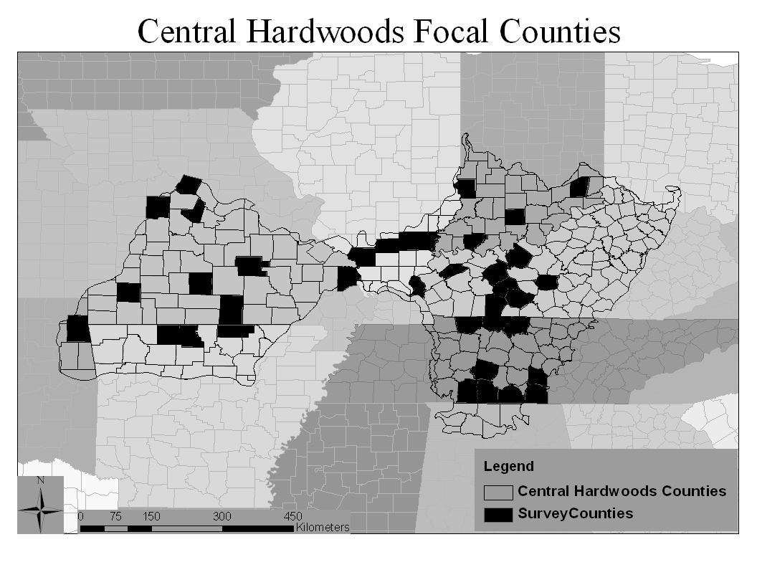
Figure 3.1 Central Hardwoods Bird Conservation Region with focal counties for roadside surveys conducted from May—July, 2008-2012.

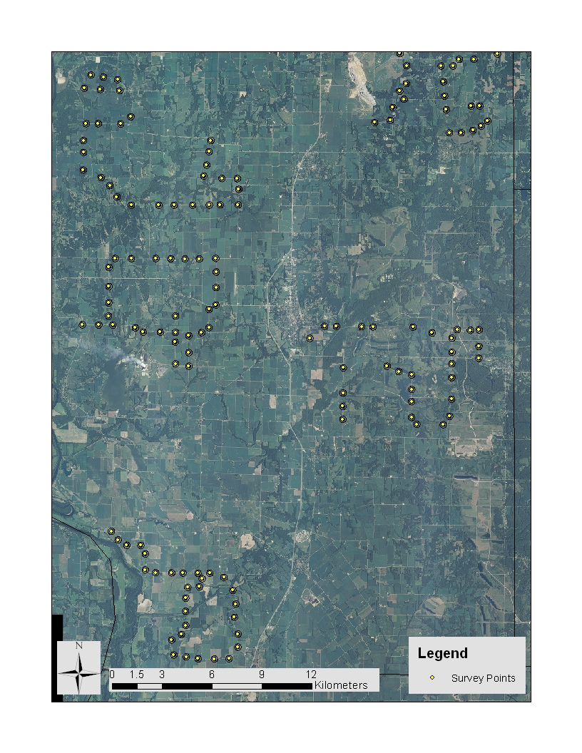
Figure 3.2 Example of five roadside survey routes conducted from May—July, 2008-2012, in Sullivan County, IN in the Central Hardwoods Bird Conservation Region.

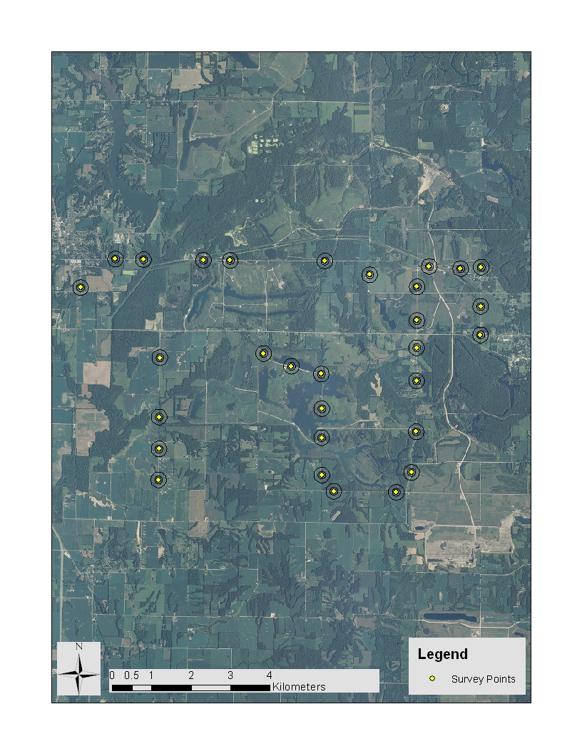
Figure 3.3 An example of a roadside route conducted in 2012 in Sullivan County, IN, in the Central Hardwoods Bird Conservation Region.
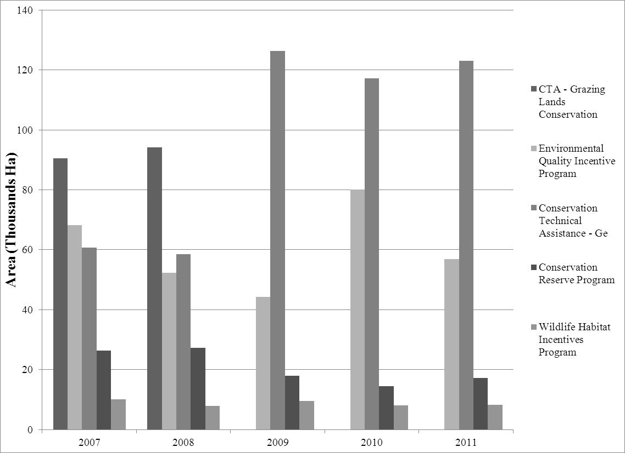
Figure 3.4 Total area (ha) of dominant conservation programs implemented and including a 1-year lag to allow for establishment, in the Central Hardwoods Bird Conservation Region.

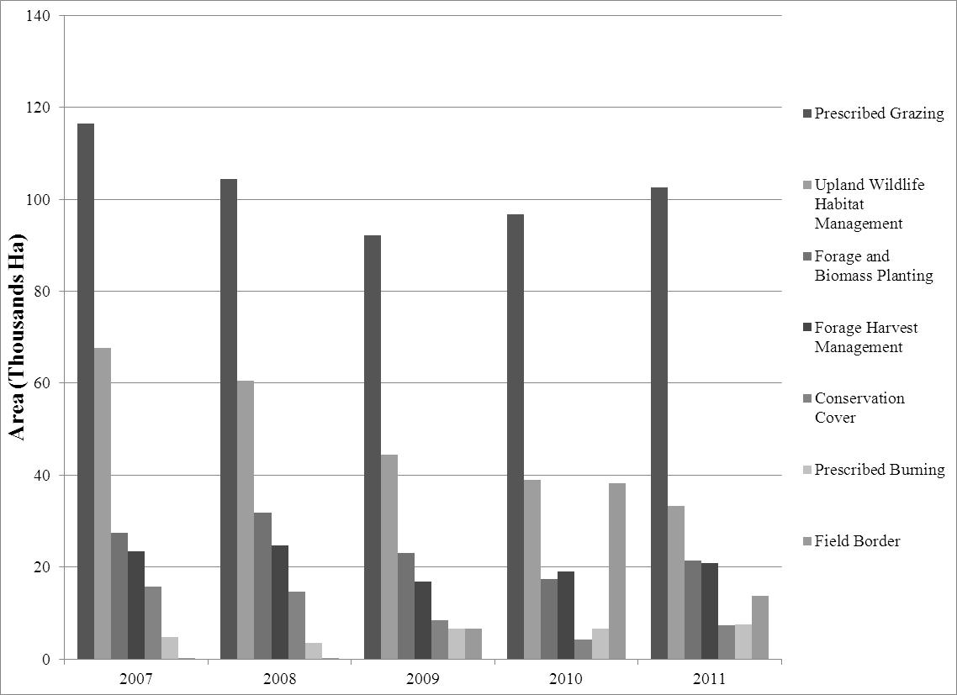
Figure 3.5 Total area (ha) of dominant conservation practices implemented and including a 1-year lag to allow for establishment, in the Central Hardwoods Bird Conservation Region.

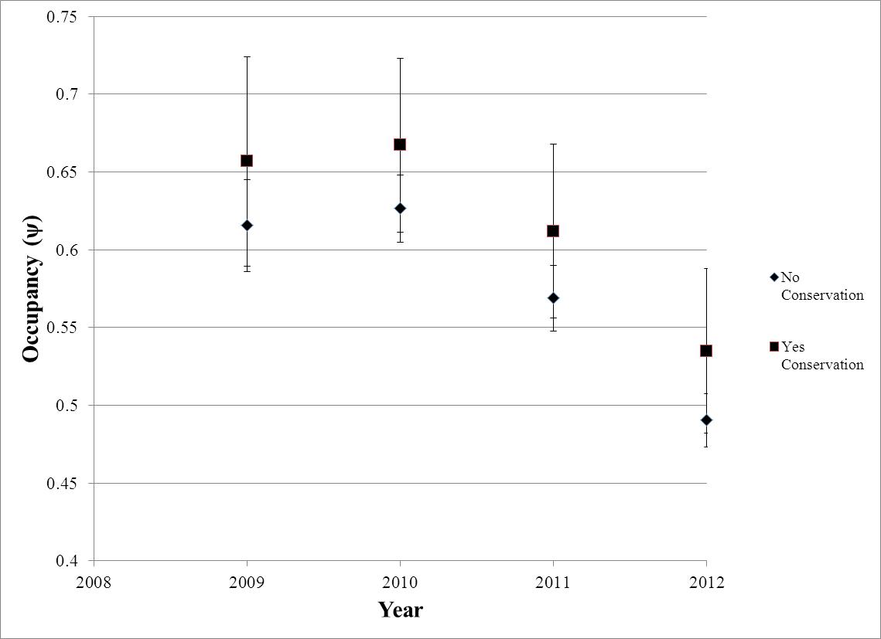
Figure 3.6 Dickcissel (Spiza americana) occupancy from 2009-2012 in the Ozark Highlands. Occupancy was estimated from the top model from multi-season occupancy modeling procedure for points with conservation (Yes Conservation) and points without conservation (No Conservation).

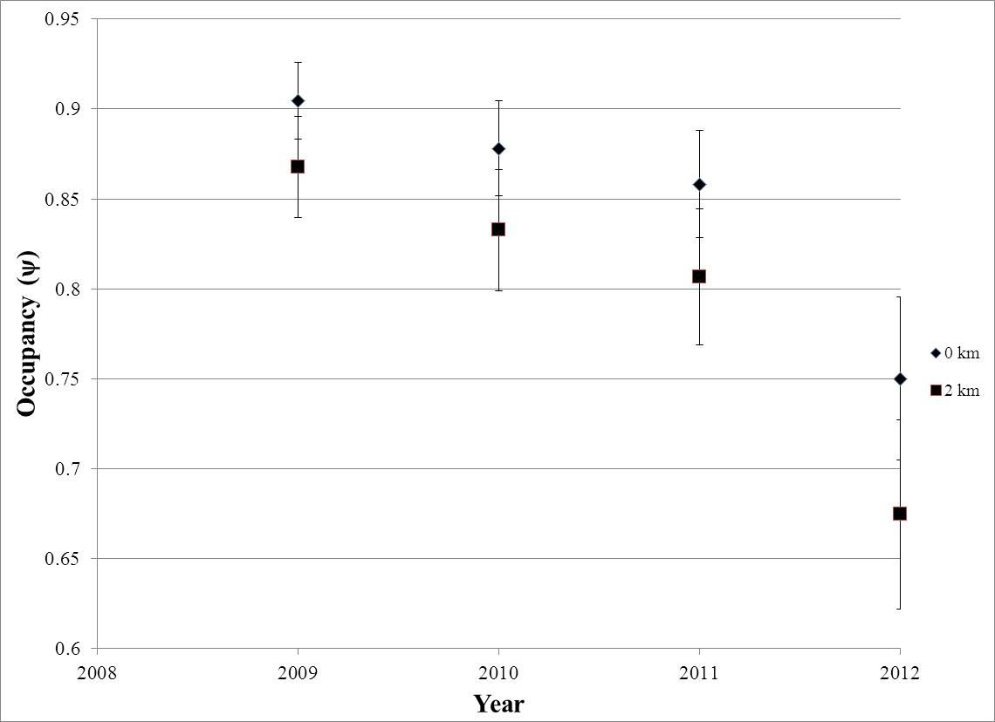
Figure 3.7 Northern Bobwhite (Colinus virginianus) occupancy from 2009-2012 in the Ozark Highlands. Occupancy was estimated from the top model from multi-season occupancy modeling procedure for points with conservation distance close to the point (0 km) and points with conservation the average distance from the point (2 km).
CONCLUSION
Determining and accounting for factors affecting detection probabilities for Northern Bobwhite spring surveys is imperative for developing appropriate Northern Bobwhite monitoring schemes. Northern Bobwhite detection probability:
- Was positively related to the number of other conspecifics calling during a point count;
- Was negatively related to the minutes-since-sunrise when a point count was conducted;
- Was negatively related to the distance from an observer at which an individual bird was detected;
- Was unrelated to the presence of roads; and
- Was affected by observer ability.
The ability to explicitly incorporate key factors listed above will improve population parameter estimation. This is the first comprehensive evaluation of factors affecting Northern Bobwhite detection probability, and the first time the effects of calling conspecifics on detection probability have been effectively modeled.
Roadside-based surveys that incorporate detection probabilities for Bell’s Vireo, Dickcissel, Eastern Kingbird, Eastern Meadowlark, Field Sparrow, Grasshopper Sparrow, Henslow’s Sparrow, and Prairie Warbler can be used to continue to monitor new conservation implementation strategies. I demonstrated that:
- Relative abundance and vegetation cover dids not differ among on- and off-road survey points;
- Species occupancy and detection probability did not differ among on- and off-road survey points;
- Land-cover covariates were more influential in determining species occupancy; and
- Temporal covariates were more influential than whether a point was located on or off-road, in determining species detection probability.
Similarly, species-specific occupancy estimates were more influenced by land-cover and land-heterogeneity covariates than the presence of secondary roads. These land-cover variables can be easily collected and accounted for during roadside surveys, and should be used in a hierarchical modeling framework to improve accuracy of occupancy and abundance estimates for these species. This study was the first to explicitly assess relationships of occupancy and detection probability to roadside and off-road surveys for these species.
Tracking high-priority grassland and early successional bird populations in the CHBCR is critical for assessing the impacts of conservation practices. Previous research has documented the response of various priority grassland birds to conservation practices within the actual area encompassed by the practice. My study evaluated to what extent this response is being expressed at a broader scale within the non-forested landscapes that grassland birds occur in. Overall:
- Land-cover characteristics were important covariates in explaining target species occupancy and abundance relationships;
- The strength of the relationships between species occupancy and abundance and conservation practices was weak, being swamped out by other land-cover covariates.
There are four potential explanations for these findings. Land-cover factors are more important in explaining species occupancy and abundance. Thus, landscape factors surrounding conservation practices could potentially reduce the effectiveness of practices at eliciting population responses. Conclusions could also be largely reflective of the relatively small amount (4-6% of points) and relatively small sizes ($\overline{x}$ ≈ 22 ha) of conservation practices that occur in these landscapes. Additionally, the actual structure and composition of the individual practices may be contributing to a lack of a strong species response to conservation.
Future conservation implementation strategies need to account for the landscape composition and structure first and foremost. Focal areas can be defined by utilizing models that identify areas on the landscape to optimize focal species probability of occupancy or abundance as conservation priority areas. Targeting high-probability occupancy areas based on land-cover variables could improve existing habitat in those areas. Similarly, targeting areas with a greater amount of existing conservation practices would create more relatively contiguous suitable habitat for target species. Lastly, continued use, assessment, and oversight of proper mid-contract management should positively affect species occupancies and abundances at large extents. When conservation practices are properly implemented and maintained, species abundance and density can be improved.
Continued monitoring is paramount totracking the effectiveness of alternative conservation implementation strategies in the CHBCR. If adaptive conservation strategies are adopted for the CHBCR, then monetary resources can be allocated appropriately to optimize grassland and early successional bird conservation and positively affect species populations.

VITA
Chris Lituma is from Fairless Hills, PA, though he was born in Englewood, NJ. In 2005 he received his B.S. degree in Biology with a concentration in Ecology from Millersville University of Pennsylvania. He designed an undergraduate research thesis under the direction of Dr. David A. Zegers, evaluating the impacts of streamside restoration on passerine communities. In 2009 he received his M.S. degree in Wildlife and Fisheries Sciences from Texas A&M University. His thesis research under the direction of Dr. Michael L. Morrison involved a comparison of avian assemblages between restored native grass fields and Bermuda grass fields in the Blackland Prairie region of east-central Texas. He also evaluated Dickcissel nesting success between field types. In 2010, he accepted a research assistantship at the University of Tennessee in Knoxville to continue his lifelong passion of ornithological conservation research under the direction of Dr. David A. Buehler. In the future, he would like to teach ornithology, conservation, and wildlife science at a university, while continuing to conduct research

