Augmented Reality to Teach Activities of Daily Living to Individuals with Intellectual and Developmental Disabilities Who Live Independently

A Dissertation Presented for the
Doctor of Philosophy
Degree
The University of Tennessee, Knoxville

Michael Clinton Morrow
August 2024

Copyright © 2024 by Michael C. Morrow
All rights reserved.

ACKNOWLEDGEMENTS

To my family, I am forever thankful. My wife and daughter are my reason for all things and have been in my corner through ups and downs, struggles and wins. My love for them is immeasurable. This moment would not have been possible without them. I will never be able to express with words how thankful I am to have them in my life.

To my mom and dad. My love for education and passion to teach was born with them. They showed me the power of learning and the importance of doing things right. To my Mom especially, for instilling in me the desire to do right by others, treat all around me with respect, and to try and leave the world better than how I found it.

To my brother and sister-in-law, for always encouraging me and being there in times when I needed a break. I count myself lucky to know that when that support is needed, it’s only an ask away.

To my committee. You have each coached me and provided clear and consistent guidance through this journey. From pushing me to return to school, maintain a job I could grow in and provide for my family, and in advancing my knowledge as a researcher and teacher. I could not have asked for a better team to lead me through this process.

Finally, to the staff, students, and colleagues that I have been so lucky to work with during my research. You know who you are, and I hope you know how much your time, energy, enthusiasm, and encouragement have meant to me. The Spring of ’24 while working with each of you has been one of the best stretches of time in my entire life. Your help and willingness helped make this dream become a reality.

Thank you.

ABSTRACT

Post-secondary educational opportunities continue to grow for individuals with intellectual and developmental disabilities (I/DD), with many providing options for independent living. This has increased the already high need to teach independent living skills to this population. Complex learning needs within this community of learners often necessitate unique teaching approaches. A single case, multiple probes across behaviors design was used to determine the effectiveness of an augmented reality (AR) video modeling system used on a mobile device as a learning approach. The goal of the study was to help participants living independently learn new skills and to determine the social acceptability of the system. Three individuals, ages 18 – 21, attending a post-secondary program on a large college campus, participated in the study. Results indicate that the AR video models were highly effective in teaching all participants new skills while also increasing their independence when completing new tasks. In addition, the AR video models were a socially acceptable means for students to learn and maintain the skills developed during the study.

TABLE OF CONTENTS

CHAPTER ONE THE SIGNIFICANCE OF THE PROBLEM AND POTENTIAL SOLUTIONS 1
Barriers to Post Secondary Transition for Individuals with Intellectual and Developmental Disabilities 1
Learning Challenges for Individuals with I/DD 2
Theoretical Framework 4
Technology as a Learning Tool 4
Extended Reality 5
Instructional Technology and Assistive Technology 6
Human Activity Assistive Technology Model (HAAT) 7
Universal Design for Learning 9
Connecting AR to IT, AT, and UDL 9
Affordance Theory and AR 11
Social/Observational Learning Theory and AR 12
Situated Learning Theory and AR 15
Experiential Learning and AR 16
Applied Behavior Analysis 17
CHAPTER TWO AUGMENTED REALITY: A REVIEW OF THE LITERATURE 20
Augmented Reality Interventions 20
AR Navigation 22
AR Literacy and Functional Academics 23
AR Activities of Daily Living 24
AR Vocational Skills 27
Practical Limitations of Augmented Reality 28
Cost and Access 30
Safety 30
Purpose of the Study 32
Post-Secondary Opportunities 32
Research Questions 33
CHAPTER THREE AUGEMENTED REALITY TO TEACH ACTIVITIES OF DAILY LIVING TO INDIVIDUALS WITH INTELLECTUAL AND DEVELOPMENTAL DISABILITIES LIVING INDEPENDENTLY 34
Methods and Materials 34
Participants 34
Setting 37
Materials 39
Research Design 42
Dependent Variables 43
Data Collection Procedures 43
Baseline 45
Pre-intervention Training 48
Independent Variable 48
Overview of Intervention 49
Maintenance 50
Interobserver Agreement 51
Treatment Integrity 53
CHAPTER FOUR RESULTS AND DISCUSSION 55
Results 55
Social Validity 58
Interobserver Agreement 62
Treatment Integrity 63
Discussion 64
CHAPTER FIVE CONCLUSIONS AND RECOMMENDATIONS 66
Summary 66
Limitations 67
Future Research 68
Conclusion 69
REFERENCES 70
APPENDICES 84
Appendix A. Prompting Protocol 84
Appendix B. Data Collection Sheets 85
Appendix C. Social Validity Student Interview Questions 87
Appendix D. Procedural Fidelity Checklist 88
VITA 90

LIST OF TABLES

Table 1. Student Information and SIS—A Index Ratings 38
Table 2. Materials for Food Preperation 41
Table 3. Task Analyses for ADL Chains 46

LIST OF FIGURES

Figure 1. SIS—A Rating Scale 38
Figure 2. Image of the Simulated Dorm Space 40
Figure 3. Image Depicting AR Trigger and Video with Controls 44
Figure 4. Prompt Hierarchy 52
Figure 5. Results for Jason 59
Figure 6. Results for Rohan 60
Figure 7. Results for Walter 61

CHAPTER ONE
The Significance of the Problem and potential solutions

Barriers to Post Secondary Transition for Individuals with Intellectual and Developmental Disabilities
The Individuals with Disabilities Education Act (IDEA, 2004) requires individualized educational programming (IEP) teams to take a collaborative approach to planning designed to help students prepare for and manage the many transitions they encounter following graduation. Many students with intellectual and developmental disabilities (I/DD) struggle to gain and maintain employment, and to live independently in their post-secondary lives. According to the United States Bureau of Labor Statistics (2023), only 21.3 % of adults with disabilities were employed in 2022. In addition to lower percentages of sustained employment, individuals with I/DD often have less community involvement and opportunities to live independently. Despite growing services and supports to create more inclusivity for individuals with I/DD, true social inclusion continues to be lacking (Amado et al., 2013). The American Association on Intellectual and Developmental Disability (2022) stated that the majority of individuals with I/DD in America do not live independently or have viable access to participate in community activities and benefit from available services.
Individuals with I/DD often exhibit deficits in a wide variety of areas: cognitive and adaptive skill differences; functional skills like completing activities of daily living; money management; and self-care routines; complex communication needs; and social and safety skill deficits. “Selecting and implementing interventions and treatments may be the most critical activity of practitioners committed to improving the outcomes and lives of individuals with intellectual and developmental disabilities” (Stoiber et al., 2016, p. 41). The goal of secondary and post-secondary programs for individuals with I/DD should be to prepare students to function independently in their surroundings as much as possible due to the myriad of challenges they face (LaRue et al., 2016).

Learning Challenges for Individuals with I/DD
Efforts to support learning for individuals with intellectual and developmental disabilities (I/DD) have always come with challenges. Researchers have established evidence-based and research-based practices in special education that continue to evolve and improve (Cook et al., 2019). As is often the case in education, teaching methods change and adapt to the times, but this is especially important in special education. The need for engaging, multi-faceted approaches that offer repeated practice is key to the learning successes of individuals with I/DD (Kellems et al., 2021).
The American Association on Intellectual and Developmental Disabilities (2022) defines I/DD as one having significant limitations in intellectual functioning and adaptive behavior with onset during the developmental period of life between birth and 22 years of age. Schalock et al. (2021) note that there are “five assumptions that are essential to the application of the definition;
- Limitations in present functioning must be considered within the context of community environments typical of the individual's age peers and culture.
- Valid assessment considers cultural and linguistic diversity as well as differences in communication, sensory, motor, and behavioral factors.
- Within an individual, limitations often co-exist with strengths.
- An important purpose of describing limitations is to develop a profile of needed supports.
- With appropriate personalized supports over a sustained period, the life functioning of the person with ID generally will improve” (pp. 439-440).
As a result of these deficits in cognitive and adaptive functioning, individuals with I/DD struggle to make progress in traditional academics, social/emotional and life skills, and functional academics, which necessitates individualized, and often times intensive and repeated learning opportunities (Brown & Percy, 2007). This can be further exacerbated over time when considering activities of daily living for people with I/DD. Often, family, friends, or peers want to complete tasks for a person with I/DD because they feel sorry for them or because they know they are struggling to complete a task, but this can create learned helplessness (Gacek et al., 2017). This can lead to persons with I/DD being unable to complete even simple tasks over time because they never had the chance to engage in effective learning models suited to their needs, or have the opportunity for repeated practice and instruction.
Independent Living
The opportunity to live independently, access the community, and have autonomy in daily choice, directly impacts factors associated with quality of life (Bridges et al., 2020). In 2021, the disability advocacy organization TASH (formerly known as The Association for Persons with Severe Handicaps) offered three major areas of access on which policymakers need to focus to increase opportunities for individuals with disabilities; inclusive education, employment, and community living. With regard to community living, Brigioli (2021) states, "all people have the right to live and participate in communities,” and to receive "person-centered planning, self-direction and supported decision making" that advance self-determination, choice, and independence (para. 4).

Theoretical Framework
Establishing a theoretical base to justify new or improved interventions in special education is key to understanding the complexities that lead us to meaningful student outcomes. According to Feuer et al. (2002), scientific endeavors in educational research should all: pose significant questions that can be investigated empirically; link research to relevant theory; use methods that permit direct investigation of the questions; provide a coherent and explicit chain of reasoning; yield findings that replicate and generalize across studies; and disclose research data and methods to enable and encourage professional scrutiny and critique” (p. 7).
Several theories, frameworks, and systems came together to support this research. Principles of assistive technology (AT), the Human, Activity, AT (HAAT) model, and universal design for learning (UDL) provide a foundation for this avenue of research. Pieces from a range of theoretical framings were also used to provide structure to the study. Those included Affordance Theory, first described by Gibson in 1977, Bandura’s (1979) Social/Observational Learning Theory (specifically how it relates to video modeling), Lave and Wenger’s (1991) Situated Learning Theory, and pieces Kolb’s (1984) Experiential Learning Theory. Finally, I will consider Applied Behavior Analysis (Lovaas, 1987) and its effects on learning to help better understand how behavior change takes place using the intervention.

Technology as a Learning Tool
Interventions and programming that incorporate technology have become commonplace in addressing skill deficits for individuals with I/DD. Several reviews have been conducted to examine technology-based interventions, including on vocational skills (Gilson et al., 2017; Muharib et. Al., 2021; Walsh et al., 2017), functional skills (Brandt et al., 2020) academic skills (Knight et al., 2013), and social skills (Whittenburg et al., 2020), though these tech-based interventions have limitations to keep in mind. Hedges and colleagues at Autism Focused Intervention Resources and Modules (AFIRM) at the University of North Carolina Chapel Hill report in 2018 that technology-aided instruction and interventions (TAII) meet the criteria of being an evidenced-based practice. TAII refers to instruction and intervention where a piece of technology is at the center in supporting a learner’s goals, and can be used to address social, communication, behavior, school-readiness, cognitive, adaptive, vocational, and academic outcomes, and has been effective with learners aged 3-22.
Technology has been used to provide models or prompts to engage in the behaviors being learned, to provide performance feedback or self-monitoring, to systematically teach skills or concepts through software presented on traditional desktop computers and to generate speech (Odom et al. 2015). Roberts-Yates and Silvera-Tawil (2019) argued that digital technology is central to the integrated learning experiences of individuals with I/DD and that it supports necessary learning to access social, community, and work-based opportunities and to ultimately succeed in the world outside of the traditional learning environments.

Extended Reality
Extended reality (XR) is an umbrella term that covers the range presented by AR, virtual reality (VR), and mixed reality (MR) (Chuah, 2018). AR is able to enhance a real world setting by bringing digital content together with what someone already sees and accesses in their direct surroundings (Kellems et al., 2021). VR involves full to partial immersion in an artificial world that can be completely abstract or an almost complete reproduction of a real-world setting or situation (Elmqaddem, 2019). These two forms of XR make up the bulk of the research centered on learning supports for individuals with I/DD. The contributions to the literature on AR and VR show they can be used as simulation tools in providing guided learning of skills to be generalized to everyday situations of real life (Montoya-Rodríguez et al., 2022).
Augmented reality, while still growing in its application in education, shows great promise in the teaching of specific skills to individuals with I/DD. AR incorporates virtual or digitized information into the real environment accessed through a variety of devices and platforms to provide the user with information (Cavus et al., 2021). Marker-based AR utilizes a printed marker, QR code, or a physical item in the environment to trigger visual or auditory media (video, picture, sound recording, etc.). AR based applications, downloaded to a phone or tablet, are used by orienting the camera on the device to the physical trigger, which activates the visual or auditory media for use (McMahon et al., 2016). Video modeling, an evidence-based practice that uses video recordings to support learning of an identified target skill, has been paramount in supporting the learning of a variety of skills for individuals with I/DD (Franzone & Collet-Klingenberg, 2008).

Instructional Technology and Assistive Technology
Instructional technology has been an important part of the educational landscape for decades. Instructional technology differs from assistive technology (AT) in that AT is utilized in order to improve the functional capabilities to alleviate difficulties face by individuals with disabilities using a range of services, strategies, devices and practices (Cook et al., 2020). More specifically, AT is defined as “any item, piece of equipment or product system, whether acquired commercially off the shelf, modified, or customized, that is used to increase, maintain or improve the functional capabilities of a child with a disability” (IDEA, 2004). The Technology-Related Assistance for Individuals with Disabilities Act of 1988 (amended in 1994 and again in 2004) amplified attention put on the needs of individuals with disabilities and the ways in which technology can improve access to a wide range of opportunity (Alper & Raharinirina, 2006).

Human Activity Assistive Technology Model (HAAT)
The HAAT model (Cook & Hussey, 2002) is an adaptation of Bailey’s (1989) human performance model (HPM), which is useful in the design of commercially available devices developed for use by persons without disabilities. “When a person with a disability is faced with an activity in a given context, he may require assistive technology to facilitate his performance” (Cook & Hussey, 2002, p. 37). The HAAT model focuses on two major changes to the HPM. First, the focus on context is magnified to include social and cultural aspects of the person with a disability, and also environments and conditions and how they relate to the other components of the performance system. Second, AT becomes a part of the model, and the technology utilized is discussed through its connections to each part of the model.
The HAAT model focuses on four primary components; the activity, the human, the context(s), and the assistive technology. Cook and Hussey (2002) explained each as it relates to the other components. The activity is the central element and shows the overall goal of an AT system, and it is what a person is doing that shows the result of human performance in daily functions. It is important to note that the goal is task performance – not use of the AT itself. The human is the individual with a disability who utilizes the system to accomplish the activity. The human has specific skills (their level of proficiency on a given task and experience with the AT) and abilities (a basic trait of a person in completing a task) that are considered in determining the right fit of AT within the model. Contexts are environmental factors that are barriers to completing an activity. Contexts include the setting (e.g., home, vocational, school, community), social contexts (e.g., with family/friends, unfamiliar members of the community, in isolation) cultural contexts, and physical contexts (e.g., temperature, light, sounds). Finally, the AT acts as an “extrinsic enabler” which serves as “the basis by which human performance is improved in the presence of disability” (Cook & Hussey, 2002, p. 44).
The HAAT model provides a basis for making informed choices to ensure the correct match is made between the setting, person, context, and AT features to create a purposeful connection. When time is taken to thoroughly consider this “match,” there is often success for the user going forward and a greater level of independence. However, challenges in the interactions between users, the AT, the activities, and the context can lead to the abandonment of the AT product (Sugawara et al., 2018). It is important to recognize the need for ongoing assessment of individual needs in the provision of AT services and matches to devices, as change over time is key to keeping users from abandoning their AT (Petrie et al., 2018). Phillips and Zhao (1993) provided four factors that lead to AT abandonment: not considering users’ opinions or feelings on device selection, issues obtaining the device, low performance of the device or system, and changes in the needs of the user. The HAAT model is a means by which practitioners and researchers can work to alleviate these and other issues related to abandonment through a purposeful assessment process that is revisited regularly to ensure the right fit.

Universal Design for Learning
First theorized and promoted in the United States by architect Ronald Mace, Universal Design was conceptualized as an approach to design that allowed things to be used by a wider range of people (Ostroff, 2011). In architecture, universal design was reflected in the vision that public spaces, buildings, and the like would meet the needs of everyone regardless of disability from the beginning of the design phase since the passing of the Americans with Disabilities Act in 1990 (Pisha & Coyne, 2001). Experts in education saw this approach to design as an opportunity to create learning environments and instructional opportunities that could meet the unique needs of all learners, giving rise to Universal Design for Learning (UDL).
According to CAST (formerly the Center for Applied Special Technology; 2018), the goal of UDL is to “support learners to become ‘expert learners’ who are, each in their own way, purposeful and motivated, resourceful and knowledgeable, and strategic and goal driven. UDL aims to change the design of the environment rather than to change the learner. When environments are intentionally designed to reduce barriers, all learners can engage in rigorous, meaningful learning” (para.1). UDL provides guidelines that can be utilized interchangeably in order to meet specific, individualized learning goals. Those guidelines include multiple means of engagement, representation, action and expression that suggest ways to increase access, build a wide range of supports and means of communicating knowledge, and to internalize information by empowering learners.

Connecting AR to IT, AT, and UDL
Rose et al. (2005) noted that if we only focus on AT design, we will create an environment that is so “poorly designed” and “barrier-ridden” that it will limit people and create ATs that are “extensive and expensive” (p. 510). On the same note, if universal design is the only consideration, we will lose sight of the needed adaptations for people to access environments and contexts and create “extensive and expensive” environments that are not conducive to all. IT, AT, and UDL are connected while all having very distinct properties that make them their own structures. Understanding each individually and as a whole, with unique differences and similarities highlighted, allows researchers and practitioners to better understand how to make connections that improve student outcomes through research and intervention. The functions of AR as an intervention tool are present inside each of these three principles.
Dunleavy and Dede (2014) discussed far-transfer, or the application of knowledge learned in one situation to a different context whose steps are closely associated, yet different. They went on to explain that a primary concern with traditional instruction is the lack of far-transfer, and that even the top students in a class or school often struggle to apply learning in real-world contexts. For learners with complex needs like those with I/DD, this is further exacerbated. AR has the potential to allow a user to access information repeatedly and offer increased opportunities for practice and application of near-transfer to prepare for future learning and application. These attributes offer researchers opportunities to focus on ways to incorporate personal learning on mobile device technologies into learning sessions, making the applications afforded by AR more meaningful. Walker et al. (2017) stated that, “The potential of AR is only limited to the user’s imagination, and is, therefore, one of the more innovative, exciting technologies that special educators can use in their classroom” (p.1).

Affordance Theory and AR
Gibson (1979) described affordances as the features that an environment provides to the animals in it. Steffen et al. (2019), in summarizing a quote from Chemero (2003), explained that there are relationships between the abilities of the organisms and the features of their environment, indicating that “the features of an environment may afford certain actions to some animals, but not others” (p. 688). Learners with I/DD and other disabilities can access opportunities through AR that might not be afforded to them through other, more traditional teaching methods as a result of their distinct learning differences (Yakubova et al., 2021).
Steffen et al. (2019) identified three specific reasons why we should examine AR through the lens of their affordances: first, affordances help us better understand a user’s goals; second, affordances are fairly generalizable and continuous across specific applications; and third, they enable examination of AR in contrast to the affordances of the real world. The range of actions that can be accomplished through AR can be grouped by those that are impossible in the real world and those that are possible, but with the addition of AR they can be done with added benefits, such as convenience and safety (Steffen et al., 2019). A major affordance of AR lies in the motivating factors of its usage in learning space (Dunleavy & Dede, 2014; Steffen et al., 2019). In summarizing research found in educational literature, Wu et al. (2013) outlined 5 features that AR could afford learners; “(1) learning content in 3D perspectives, (2) ubiquitous, collaborative and situated learning, (3) learners’ senses of presence, immediacy, and immersion, (4) visualizing the invisible, and (5) bridging formal and informal learning” (p. 43).

Social/Observational Learning Theory and AR
Bandura’s (1977) Social Learning Theory (SLT) is centered around the idea that learning takes place through observing and modeling. Observational learning, a primary component of SLT, happens via the principles of attention, retention, replication, and reinforcement. Bandura outlined these in his book, Social Learning Theory (1977): attention refers to the processes of attending to, and accurately perceiving modeled behavior by an observer; retention refers to the idea that in order for observers to gain skills or knowledge from observing models, the response patterns must be in their memory in a symbolic form through repeated opportunities to view the model and maintain their performance in their memory; replication refers to the observers ability to repeat the actions of the model appropriately; and reinforcement refers to outcomes observed through modeling and the subsequent replication of behavior by an observer and the resulting consequences, with the knowledge that people are “more likely to adopt modeled behavior if it results in outcomes they value than if it has unrewarding or punishing effects” (Bandura, 1977, p.28). Bandura (1986) explained that most human behavior is learned by observation via modeling, which can inform behaviors that are approximated by observers while being spared the struggles associated with learning new behaviors and skills on their own.
“Much social learning is fostered by observing the actual performances of others and the consequences for them” (Bandura, 1986, p. 47). Observational learning connects to operant conditioning in a purposeful way, in that, following observation, a learner applies that new knowledge to the task for themselves. After completing the task, they receive whatever consequence comes with that task, and will then be either more likely or less likely to repeat the task depending on the outcome consequence (Bandura, 1977). This matters to researchers and practitioners working with individuals with I/DD because it creates the second piece necessary in order to increase independence or develop new skill sets through observational learning; the consequence of completing the task learned through observing on their own will then increase the likelihood of them doing it again and continuing to build on their ability to complete that task independently.
Video modeling (VM) is a teaching tool that involves students viewing instructional videos showing performance of a targeted skill, with the subsequent direction to repeat that target behavior on their own (Alberto et al., 2005). Research supports VM as a strategy that is effective in developing a range of behaviors, and is an evidence-based practice for a myriad of skills, including instruction on activities of daily living (Bridges et al., 2020). There are a variety of ways to present a video model: (a) other as a model (a peer, an adult or teacher); (b) self-modeling (the individuals themselves acts as the model for the video); and (c) point-of-view, where a specific first-person view, often of the hands, acts as the model (Park et al., 2019). The different types of VM perspectives can be aligned to the participants preferences or to meet the specific function of the intervention itself (Bridges et al., 2020). VM shows a specified task performed in total, or broken down into purposeful sections, which allows the learner to see and take time to understand how to complete the task, along with the ability to access it for repeated instruction (Kellems et al., 2021).
VM is firmly situated in the theoretical framings of social and observational learning. Individuals with I/DD often have trouble learning in traditional models like direct instruction, as they require sustained attention and social interaction skills that can be deficits for many with I/DD (Kellems et al., 2021). VM offers an avenue around those difficulties by allowing learning to take place through a digitally accessible model as opposed to the traditional, face-to-face interactions required in direct instruction (Corbett & Abdullah, 2014). Bellini and Akullian (2007) explained that attention and motivation are key to observational learning, so VM should be viewed as a viable and effective means of learning for individuals with I/DD (particularly ASD) due to the usage of visuals, a paramount structure in support methods when teaching in this population of learners.
A useful and motivating means for the delivery of VM is AR. An enormous benefit of AR technology is in its ability to serve as a instructional tool for delivering instruction and intervention (Kellems et al., 2021). AR as a platform allows practitioners and researchers the ability to control the order and rate of content delivery for learners (Kellems et al., 2021). When paired with an AR capable device (mobile device, tablet, etc.), AR applications afford researchers the ability to create video models for nearly any skill that a student might need to learn. Marker-based AR applications allow for the creation of a digitally enhanced learning experience by matching a visual marker to trigger user-created content that can include pictures, video, and/or audio (Cihak et al., 2016). This can be accomplished utilizing tablets and mobile phones, and “the increasing accessibility of mobile devices and the advancement of AR technologies have led researchers to explore new ways for incorporating this technology into the lives of people with IDD” (Bridges et al., 2020, p. 4).
Marker-based AR interventions that utilize video models have shown great promise in the research literature. Skills taught using this mode of AR delivery include task chaining (Cihak et al., 2016), independent living skills (Bridges et al., 2020), social skills and problem solving (Root et al., 2021), and academics (Kellems et al., 2016; Kellems et al., 2021; McMahon et al., 2015). Furthermore, AR applications accessed via tablets and mobile phones reduce stigmas associated with receiving special services and accommodations while placing the power of learning access in the hands of the learner (Bridges et al., 2020).

Situated Learning Theory and AR
Situated learning theory focuses on the idea that learning best takes place embedded in situations that are in context and that the social and observational aspects of learning are connected to that context and encompass the learning of knowledgeable skills (Lave & Wenger, 1991). Lave and Wegner (1991) centered this thinking on a process they refer to as “legitimate peripheral participation,” which they defined as being, “a way to speak about the relations between newcomers, and old -timers, and about activities, identities, artifacts, and communities of knowledge and practice” (p. 29).
AR does not line up perfectly with situated learning, but it does have many of the most important features that places it with the central themes. The literature on AR as it relates to situated learning is limited, so some considerations have to be conceptual in making connections to application when working with learners with I/DD. A possible benefit of digital learning interfaces in terms of situated learning is in their ability to simulate real-world problems and contexts that provides for near-transfer learning and application of knowledge in the moment to build on future skill sets (Dunleavy & Dede, 2014). This provides a way to think about how AR fits within situated learning in terms of how learning takes place when providing interventions using the digital platforms.
For marker-based AR video models, a student with I/DD might be learning to complete a skill that is specific to that setting, like doing laundry in the laundromat or preparing a meal in their dorm room kitchen. As AR overlays digital information in the form of a video in this scenario, the learner is still able to access, engage with, and consider all aspects of both the real-life materials around them and the digitized information provided via the AR application. Through the use of expert modeling, AR initiated videos provide the learner with a collaborative experience (via the model in the video) that offers a less strenuous learning option as a result of sustained attention and social interaction deficits being lessened (Kellems et al., 2021).

Experiential Learning and AR
Experiential learning is deemed “the process whereby knowledge is created through the transformation of experience. Knowledge results from the combination of grasping and transforming experience” (Kolb 1984, p. 41). Kolb (1984) suggested that for learners to be effective, they must possess four kinds of abilities: concrete experience abilities, reflective observation abilities, abstract conceptualization abilities, and active experimentation abilities. For learners with I/DD focused on improving adaptive behaviors and gaining independence in activities of daily living, concrete experience is especially important, and repeated practice is paramount. Morris (2020) considered additions to the ideas central to defining “concrete experience” in his systematic review of the Experiential Learning Model, as he views the theory as “potentially applicable, but to date perhaps hugely unrealized, in a wide variety of educational contexts” (p. 1074). His analysis brought five themes to surface: “(a) learners are involved, active, participants; (b) knowledge is situated in place and time; (c) learners are exposed to novel experiences, which involves risk; (d) learning demands inquiry to specific real-world problems; and (e) critical reflection acts as a mediator of meaningful learning” (Morris, 2020, p. 1064).
AR has components that are aligned with the basis of experiential learning, but there are portions of the theory with which I disagree, primarily contending with the disregard for behaviorism. Experiential Learning Theory holds a different view of the learning process in comparison to behaviorism by placing life experience at the center of the learning process, primarily considering knowledge to be created via experience, despite a lack of empirical evidence in the research literature (Morris, 2020). Nevertheless, experience does play a role in the process of learning, especially for individuals with I/DD, who require repeated practice and “contextually rich” concrete experiences in order to learn, master, maintain and generalize skills (Morris, 2020).

Applied Behavior Analysis
The primary goal of Applied Behavior Analysis (ABA) is to improve upon socially significant behavior through the analysis of behavior and experimentation used to understand the variables that can lead to behavior change (Cooper et al., 2007). The primary principles of ABA that are relevant to this particular line of work lie in the manipulation of the antecedent, observation of participant behavior through the use of task analysis, and application of reinforcement (either positive or negative depending on the goal) following the behavior consequence (full, partial, or non-completion of the assigned task).
Antecedent change from baseline phase to intervention is an important adjustment made in the study presented. In baseline, a single prompt of, “Lets get started,” followed by the task chain being measured is the antecedent. During the intervention, the same prompt is provided, but students are provided with access to the video model activated via augmented reality. Changing the antecedent directly impacts the behavior participants exhibit, and in turn the consequence of the behavior.
Task analysis (TA) is another component of ABA that is often used in intervention research to support learning with individuals with an I/DD. TA involves the breakdown of a larger skill into smaller steps by sequencing them together to form a complete task chain (Cooper et al., 2007). The use of TA provides practitioners and researchers with some options for teaching skills through intervention. Steps can be chained forward or backward. Forward chaining means that a learner might complete the first step in the sequence while the rest are completed by a model for them to observe. This may be reversed in backward chaining. The learner might observe a model for the beginning of a task sequence and then complete the last step in a chain (which offers an opportunity for immediate reinforcement). In the case of a total task chain, the TA serves as the sequential steps to complete and naturally provide a system for collecting data to identify steps in a task chain that a learner has mastered, those that they need prompting to complete, and those that they need done for them so that a plan of teaching can be developed.
Reinforcement “occurs when a stimulus change immediately follows a response and increases the future frequency of that type of behavior in similar conditions” (Cooper et al., 2007, p. 702). Reinforcement as a part of intervention can come in different forms. Take for example a reinforcement system built into a behavior intervention plan. When a student engages in appropriate replacement behaviors as opposed to inappropriate behavior, they are provided with a reinforcer that is contingent upon the engagement in the appropriate behavior. In research intervention focused on improving daily living skills, there is often built in reinforcement that occurs as a natural consequence. In the case of working with adolescents and adults with I/DD on improving such skills, they are often motivated to do so in order to improve upon their ability to function and live independently. The natural outcome of learning and then completing the task independent of support from someone else serves as immediate positive reinforcement. Positive reinforcement also can come in the form of praise received from teachers, family, and peers following the completion of a task that one has been working towards mastering.
These foundational aspects of ABA provide for a structure to develop and systematically deliver interventions. This is especially the case for an AR-based video modeling intervention to help college-aged students with I/DD become more independent in daily living skills. Task analysis will allow for the clear vision of each selected skill, and reinforcement systems will provide a source of motivation for participants as they work to develop these skill sets.

CHAPTER TWO
Augmented Reality: A Review of the Literature

Augmented Reality Interventions
Two forms of AR exist in educational research literature. Dunleavy and Dede (2014) explain each: Markerless “AR presents digital media to learners as they move through a physical area with a GPS-enabled smartphone or similar mobile device,” while marker-based AR “presents digital media to learners after they point the camera in their mobile device at an object,” like a QR code or picture target (p.735). Both types of AR are accessed through a mobile device, be it a tablet, smartphone, or other form of AR-capable technology using applications made for AR. Marker-based AR applications allow practitioners or researchers to create an augmented reality experience by matching a visual marker to trigger user-created digital content that can include pictures, video, and/or audio (Cihak et al., 2016).
Baragash et al. (2020a) and Baragash et al. (2020b) conducted two separate meta-analyses on AR in special education; the first on single-subject design studies and the second on group design studies. In the first, the research team found 16 single-case design studies meeting inclusion criteria and determined AR applications to have a large effect size overall (ranging from 0.85 to 1.00) and to be statistically significant. Studies in this meta-analysis covered four primary categories of learning; social skills, living skills, physical skills, and learning skills. The results showed that the “use of AR among individuals with ID and ASD was found to offer them an engaging and cognitively demanding experience. The outcomes of this experience were believed to increase the sense of independence of users, improving their quality of life, and helping them overcome various problems in everyday life” (Baragash et al., 2020, p. 392).
In the second meta-analysis focused on group designs, Baragash et al. (2020) located seven group design studies and a total of 119 participants with varying disabilities who met criteria to be included. This meta-analysis focused primarily on functional skill acquisition, and used a random-effects model to conclude that AR applications have the likelihood of increasing the functional skill development of individuals with disabilities. Findings showed a significant and large effect size (g=1.694). The authors noted that these findings are encouraging for practitioners and researchers in providing meaningful interventions that allow participants with exceptional learning needs to practice a range of functional skills through AR’s ability to blend real-world and digital elements and that independence in completing such skills can be improved through AR enhanced learning environments (Baragash et al., 2020).
Additionally, in a systematic literature review of studies (n = 42), Cavus et al. (2021) examined AR technology use to build sustainable skills for individuals with disabilities. Similar to the single-subject meta-analysis by Baragash et al. (2020), Cavus et al. (2021) found AR literature in special education focused on five key skills; learning, daily living tasks, physical skills, social skills, and in the workplace. Their review noted that the majority of participants in studies involving AR had an Autism Spectrum Disorder (ASD) or an intellectual disability (ID), and that the most prominent skills addressed were in the domains of daily life tasks, learning, and social skills. The results of this study suggested that there continues to be a need for research on the usage of AR to support learning for those with a variety of disabilities, and in a variety of settings/situations. Future research is needed to explore the pros and cons, functional relations to dependent variables, generalizability of skills, and in a wide-variety of settings across skills, with regards to the use of AR for individuals with IDD (Bridges et al., 2020, p. 35).

AR Navigation
One markerless AR application is used to promote wayfinding skills, which involves projecting directions onto the screen of a phone or tablet using global positioning system (GPS) maps and location-based information in order to assist learners in finding their way to a location. Smith et al. (2017) used the application “Heads Up” to support college-aged students in their independent ability to navigate to locations throughout their direct community. The authors used an ABAB reversal design to show the difference between the learners’ navigational skills with and without the AR tool. For each participant, results indicated dramatic improvements in their ability to find specified locations within the community independently. This is in direct contrast to those without the support of the AR navigational tools, where students were unable to independently locate their destination. These findings are important for learners potentially trying to find their way to work sites, to a bus stop, or any other forms of community access.
McMahon et al. (2015) also examined AR as a navigational tool, focusing on the outcomes of three means of navigation to employment opportunities within the community. This study compared the usage of google maps, a paper map, and a triggered AR program application called Layer (2013) to locate employment options. Using an adapted alternating treatments design, the researchers determined that the AR treatment was the most effective for the learners in comparison to the Google and paper maps (McMahon et al., 2015). These findings are meaningful as they open the door of access to supported, but independent navigation in the community via AR. In addition, the social validity measures concluded that each participant in the study preferred the AR navigation tool over both of the other independent variables (IV) presented. This is important because it further shows the highly motivational aspects of AR-based applications of learning.

AR Literacy and Functional Academics
Legislative efforts (IDEA, 2004; NCLB, 2008) have led to changes in the ways we assess the learning of students with the most significant disabilities (Browder et al., 2014). Use of AR interventions to support the learning of core academic skills and functional academics have seen positive outcomes across ability levels and grade bands in education. Akçayır and Akçayır (2017) noted several advantages of AR as a learning tool: (1) in students’ learning outcomes (i.e. learning achievement, motivation and attitude), enhanced understanding of content, and decreased cognitive load; (2) in pedagogical contributions, like increasing engagement, enjoyment, and facilitating collaboration among learners; and (3) in enhancement of interactions between students-to-students, students-to-learning materials, and students-to-teachers.
Vocabulary acquisition and aptitude are primary important components in basic reading skills and comprehension (Bell & McCallum, 2008). Science vocabulary can be one of the most difficult curricular vocabulary sets to master, especially so for students with I/DD (McMahon et al., 2016). McMahon et al. (2016) used AR to support science vocabulary attainment with four adult-aged students, three with intellectual disabilities and one with ASD, participating in a post-secondary education program on a university campus. The intervention used targeted science vocabulary (bones, organs, and plant cells) and taught them using AR overlays that would activate layered videos. The videos provided the students with a definition of the word, and paired auditory readings of the definition with a visual of the term. Using a multiple probe across behaviors/skills design, students were prompted to define the term when engaging the AR marker with the iPad, which allowed for a six-second time delay before the AR video initiated. All participants showed significant gains in their acquisition of the vocabulary terms, showing that marker-based AR is a useful means for teaching science vocabulary.
Kellems et al. (2021) took an AR intervention and applied it to transition-related math skills, including the ability to calculate a unit price for an item, adjust measurement quantities for a recipe, and calculating daily, weekly, and monthly salaries using the pay rate per hour. Using a multiple probe across tasks design, the researchers examined the efficacy of an AR video prompting model, which differs from full-length videos of a task in that it provides videos for each individual step in a task, so that a learner has the opportunity to view each step in the process before moving to the next (Kellems et al, 2016). Videos were generated for each step or grouping of steps that made sense together, with the task analysis serving as a script for the model during filming. Following pretraining, intervention took place and each participant showed an immediate change in steps completed when compared to baseline, and in follow-up maintenance phases, all participants retained the skills. In addition, social validity measures indicated that all participants enjoyed this method of learning these new skills and that this would be beneficial to them in the daily lives.

AR Activities of Daily Living
McMahon et al. (2013) used an ABAB design to assess the effectiveness of students identifying potential food allergens using a trigger-based, mobile AR application called Red Laser. Here, the researchers determined that seven students with I/DD in a post-secondary education program at a university were able to scan packaged food items using the AR app. The information from the AR app provided ingredient lists in order to identify contents of the package to quickly identify if an allergen was present. In the baseline and intervention removal phases, participants were giving a list of allergens, various packaged food items, and a problem-based scenario to solve. This is an important vocationally relevant study as well, because many job opportunities for people with I/DD are found in the food production and restaurant industries. The ability to identify potential allergen risks for their own individual safety, or the safety of a customer, is a highly advanced skill for someone working in food service.
The potential AR has as an intervention tool in teaching daily living skills is shown in Cihak et al. (2016), the first published research on AR as a means of teaching task chains or life skills to this population. Using a multiple probe design across participants, the study included three male students with I/DD (ASD and moderate ID specifically) who received an intervention using a marker-based visual that initiated an AR video model to teach teeth-brushing. All three participants showed immediate improvements in task chain completion, and the study served as a starting point for teaching important life skills and task chains to individuals with I/DD using AR, though the literature base remains small.
Bridges et al. (2020) used marker-based AR video models to improve independent livings skills with adults who have I/DD living in dorm rooms on a major college campus as a part of a nine-week postsecondary education program. The research team selected three participants aged 19, 20, and 36 and employed a multiple-baseline design. The independent living skills selected were making a bed, setting an alarm clock, and ironing clothing. Markers were created to initiate the AR video models, and participants received pre-training on how to use their mobile devices to access the videos. Data were collected based on a task analysis for each skill. Visual analysis indicated that the AR intervention was effective in teaching each participant the targeted skills, and all participants found the intervention easy to use, though one did indicate that holding a tablet for a long video was difficult. An important limitation noted by Bridges et al. (2020) was that they were unable to “time-lag” the introduction of the intervention, causing them to not be able to demonstrate a functional relationship between the dependent and independent variables.
Wu and Tsai (2023), using a multiple-probe across participants’ design, taught school-age students with I/DD how to cook rice in a rice cooker. All participants learned how to accomplish the task using the AR video prompts. In addition, the participants maintained the skills over time and indicated that they found the intervention to have been a positive learning experience. Teacher feedback was also gathered, and the educators working with the students not only found the intervention beneficial, but also stated they would like to explore its use for other skills-based learning in the future.
An additional skill in which individuals with I/DD need to establish competency is money management, including accessing funds when needed. Kang and Chang (2019) used an AR intervention to teach three high school students with I/DD how to use an ATM machine to make withdrawals and transfers. A non-concurrent multiple baseline design was used, and the AR intervention was an interactive game. The game included an ATM simulation that functioned on an iPad and an AR based application that functioned on an iPhone. Step-by-step visuals were provided to the learners as prompts to complete the steps in the task analysis, and the app included a system to check whether the participants followed the correct steps or not. Embedded prompts were also provided to help them make corrections in real time. Following intervention, a maintenance phase was completed with same conditions as baseline, where students only interacted with the ATM simulation without support from the AR intervention. Each participant showed immediate improvement in their abilities, and also sustained the new skills during post-intervention maintenance sessions.

AR Vocational Skills
An understanding of how to teach employment skills is critical to advancing postschool outcomes, so research in the area of employment instruction is needed to support legislation and policy promoting integrated employment (Gilson et al., 2017). Chang et al. (2013) used a mobile-based responsive AR system to provide vocational task prompting to adults with I/DD. In the study, a multiple probe design across participants was used to evaluate effectiveness of the intervention on learners completed vocational tasks. Tasks involved food preparation skills in a short order kitchen on a university campus during off hours of business. Assistance of picture prompts, corrections when mistakes were made, and in the moment error corrections were used to support correct completion of the task using the ARCoach system. This system used moveable triggers and was presented as combinations of sound and picture cues to teach preparation of a specific item. With support of the AR technology, all participants exhibited a success rate of 100% in task completion, and maintained the skills when probed again at four weeks (Chang et al., 2013).
While some of the previously reviewed articles have components that can be considered relevant to vocational skills, there is a significant gap in the research literature addressing the impact AR can have on teaching job skills to individuals with I/DD. Benda et al. (2015) sought to teach individuals with I/DD skills to work in a horticultural setting. The intervention consisted of a location-based AR that provided video-based information to participants via mobile tablets triggered by GPS coordinates. Their findings were “not satisfactory,” and determined that the AR intervention was confusing for participants for a variety of reasons (orienting themselves correctly to trigger the video, orienting the tablet, attending to the videos). These findings, while disappointing, highlighted the need for further research in this area of support for adolescents and adults with I/DD in vocational settings. As a result of the role phones, tablets, and other forms of technology play in the world today, teaching skills with applicable digital tools offers new and motivating ways of learning vocational skills in school, on the job, and in their communities for students with I/DD (Gilson et al., 2017).

Practical Limitations of Augmented Reality
Technology has been a prominent component of intervention research in special education for decades (Odom et al., 2015). Technology-aided instruction and intervention is an evidence-based practice that provides learning opportunities for students to gain a wide range of skills across a multitude of disciplines (Steinbrenner et al., 2020). While technology-based interventions have been demonstrated as purposeful tools to support learning for students with and without disabilities, there remain limitations and concerns that need to be considered fully before employing less researched mediums like augmented reality.
The first time the general population likely recognized what augmented reality was, outside of the tech and research worlds, came in 2016 when Niantic, Inc. released Pokémon GO. Pokémon GO utilizes mobile device GPS systems and clocks to place the popular characters in the physical world wherever you might be (Walker et al., 2017). Pokémon GO would be considered a form of markerless AR, meaning that it is powered by location and uses the functions of a mobile device to show users digital information displayed from the device, onto the real world around them. This is best exemplified in special education research by two studies in which researchers utilized markerless AR to assist individuals with I/DD in navigational skills. Smith et. al. (2017) and McMahon et al. (2015) both employed markerless AR to teach navigational skills to post-secondary students locating points of interest, including potential employment options. In both studies, students were successful utilizing AR to locate areas in their direct community.
AR has distinct challenges that should be considered. Regenbrecht et al. (2002) pointed to three issues to providing a useful AR platform: first, providing a high-quality visual rendering of an object or task; second, to generate those objects/videos/visual in a precise manner when the AR capable device is oriented to the marker or location within the real-world setting; and third, to do this in real time interactively. As AR has progressed, the precision of interactions with real environments have improved, but there are still issues with triggering and maintaining the visual should the user move slightly away from the marker that triggers the interaction. These usability and cognitive overload challenges highlight concerns when working with special populations using AR-based interventions (Yenioglu et al., 2021).
Yakubova et al. (2021) conducted a survey of teaching professionals working with students with disabilities and their use of AR and VR in the classroom setting. The respondents (n = 257) in 45 states across the U.S. indicated a wide variety of reasons for not using AR and VR in the classroom setting. The top five concerns noted were a lack of financial resources, a lack of training or knowledge, perceived difficulty for students to utilize the systems, a lack of applicable materials, and the time-consuming nature of using either medium.

Cost and Access
Cost can be prohibitive due to the high prices of mobile devices and tablets often used for AR interventions. Materials development and access to functioning AR applications to build out video models and activate existing triggers are also noted issues, as is the time involved in creating all the materials necessary to implement such interventions. In addition to these findings, Individuals with complex physical needs might have a great deal of difficulty accessing AR platforms via mobile devices. In order to maintain a video triggered by an AR marker, one must be able to hold a device steady over the marker to keep the video going. Difficulty in doing so can slow the improvement of a skill and also develop a great deal of frustration for a learner. There have been hands-free modes of AR delivery that have been developed, Hololamp (cost not found), Hololens 2 (~$3500), and Google Glass Enterprise 2 (~$999). These options have either been far too costly for special education practitioners and researchers to justify, progress on their development has slowed, or they simply do not meet the individualized needs of exceptional learners.

Safety
Dangers exist for users in the context of learning and in real-world generalizations when learning to navigate throughout their community using AR (McMahon et al., 2015; Smith et al., 2017) and ironing clothing in a dorm setting (Bridges et al., 2020). The goal of such research is, in general, to improve the independent skills of individuals with I/DD. While provides some control over the learning environment, which promotes repeated practice to build skills, the skill must generalize to the real world for it to be effective and independent (Dixon et al., 2020). For many of the situations taught using XR, participants with I/DD require support from peers or practitioners on past the intervention study to ensure they remain safe.
Faccio and McConnell (2020) examined the cost that the AR game Pokémon GO had in one Indiana county. Over a period of about a year and a half (March 2015-November 2016), areas directly associated with the game as “PokéStops” saw dramatic increases in accidents, injuries, and even fatalities following the introduction of the game. While a large portion of the drivers involved in these crashes would likely be individuals without I/DD, and the old adage of “correlation does not equal causation” is also important to note, this report documents the impact distracted driving can have when the person operating the vehicle is distracted by AR. The effect of being distracted by digital overlays could create scenarios in any situation that involves potential harmful situations.
Taken the impacts noted by the Pokémon GO study researchers and practitioners must consider the issues that could arise when individuals with an I/DD are actively utilizing AR enhanced games, navigational tools, or systems independently of support from others who might be able to help maintain safety. This should prompt a lot of questions for practitioners and intervention researchers alike. Distractibility is a common concern for individuals with I/DD, so engagement with any system that requires attention to be placed in more than one place might create unsafe scenarios for someone with impaired decision-making skills. The same goes for the transfer of skills learned in immersive virtual settings. All factors simply cannot be accounted for when the lines of reality are blurred.

Purpose of the Study
A significant contributor to quality of life is independence in living and community access, but for a majority of individuals with intellectual and developmental disabilities (I/DD), this opportunity never comes to fruition (The American Association on Intellectual and Developmental Disabilities, 2022). Independent living can be challenging for anyone, but for those with deficits in adaptive skills, social interactions, and cognitive functioning, it can be even more so. Even with the difficulties in the above-mentioned, many with I/DD could live independently or with some level of autonomy in their own homes given the right supports. As students with I/DD near the end of their secondary schooling in the United States, those with individualized education plans (IEPs) become focused on transition planning (IDEA, 2004). Two major components of the transition plan are education and independent living. One such place for these goals to be addressed is in the traditional college setting on campus, living in dorms or apartments with peers as neighbors and potentially roommates.

Post-Secondary Opportunities
Think College (2021) reported that there are 308 colleges and/or universities with inclusive, postsecondary programs for individuals with I/DD across the United States. As a result of these expanding options following high school, students with I/DD can gain greater independence in activities of daily living, vocation, self-advocacy, and social skills accessing inclusive post-secondary opportunities (Scheef et al., 2020). There are several life skills that can be learned on a college campus, including community navigation, personal and group safety, social and personal competencies, money management, and a wide range of recreational and leisure activities. One such area that students with I/DD often struggle is in activities of daily living, especially those associated with living on their own. Given the increase in these opportunities for students with an I/DD, the need to explore ways in which those individuals can further their abilities to live more independently becomes paramount to supporting their success.

Research Questions
1. What are the effects of marker-based augmented reality video models on the acquisition and increased levels of independence of daily living skills of college students with I/DD living independently?
2. Do college students with I/DD find augmented reality video models to learn new daily living skills socially acceptable?

CHAPTER THREE
Augmented Reality to Teach Activities of Daily Living to Individuals with Intellectual and Developmental Disabilities Living Independently

Methods and Materials

Participants
Three male students enrolled in a post-secondary program for individuals with I/DD participated in this study. Students in this program participate in various learning scenarios across campus, including the opportunity to take classes and complete work within the program related to life and vocational skill development. In 2019, the University provided students enrolled in the program the opportunity to live on campus, a new option not previously available. In addition, some students in the program live independently off campus. Two students in this study live in on-campus dorm rooms, and one lives with roommates in an apartment off campus. Students receive daily support from staff as well as same-aged peer mentors during their time in the program in a variety of ways, including in classes, navigating campus, and with daily living skills. Peer mentors also work to support students in continued development of social skills and study skills, and by providing supports that help build independence in the daily activities of a college student.
To be included in this study, participants had to have a documented intellectual and/or developmental disability, have been enrolled in the University’s post-secondary program, and live independently at the time of participation. Each participant had prior experience using mobile devices (such as tablets, cell phones, etc.) to access and attend to videos. The researcher worked with the director of the program to identify students who lived independently and then ensured each potential participant met the additional inclusion criteria. The primary researcher then attended the programs independent living class, a weekly class for students currently living on their own, focused on improving independent living skills. He provided all students in the course with information regarding the study, and then allowed interested parties to follow-up with him after class. The primary researcher provided detailed information and a meeting upon request for conservators of students who expressed interest in the study, and assent along with conservator consent was granted for those participants. Participants of age majority gave their individual consent to participate.
As a part of the program application and admissions process, students are evaluated using the Supports Intensity Scale – Adult Version (SIS—A), developed by the American Association of Intellectual and Developmental Disabilities (AAIDD) (Thompson et al., 2015). The SIS—A supports person-centered planning by examining preferences, needs, and levels of support for individuals with intellectual and/or developmental disabilities. The scale is broken up into three sections, examining medical and behavioral needs, supports needs (e.g. home living, community living, employment), and advocacy and self-determination. Prior to consideration for living independently on campus in a dorm or off-campus in an apartment or other independent living setting, students in the program participate in this needs-based assessment. Program staff then develop individualized plans to inform the supports provided to each participant living independently.
Table 1 provides student information and SIS—A Support Needs Index Ratings for each of the study participants. Rankings correspond to the frequency, amount, and type of support needed for the stated activity and are represented on a scale of 0-4. Figure 1 shows the levels for each scale score. The composite score and overall percentile score in the support needs section of the assessment are highlighted as this section of the assessment considers activities of daily living in their home environment, their community, at school and work, and in their social and safety skill domains. The home living percentile scores are reported as they reflect upon operating home appliances and food preparation as key components. None of the participants in this study had medical or behavioral concerns that would impact access to independent living opportunities as outlined by the SIS—A. The score cutoff to be considered for independent living while attending the post-secondary program is 75 on the composite standard score. All three participants scored below this cut score, making them candidates for independent living.
Jason was 21 years old at the time of the study, in his second year with the program, and he has an intellectual disability. Jason lives in a dorm with a roommate on campus. His ratings on the SIS—A indicated that he was a good candidate for living independently with support. In the home living activities subsection of the assessment, it was reported that Jason would need monitoring when preparing food, at least once a month for less than 30 minutes. His overall composite score placed him at first percentile.
Rohan was 19 years old at the time of the study, is in his first year with the program, and is diagnosed with an Autism Spectrum Disorder. Rohan lives in an off-campus apartment with two roommates near campus. His ratings on the SIS—A indicated that he was a good candidate for living independently with support. In the home living activities subsection of the assessment, it was reported that Rohan would need monitoring when preparing food, at least once a week for less than 30 minutes. His overall composite score placed him below the first percentile.
Walter was 18 years old at the time of the study, in his first year with the program, and diagnosed with an Autism Spectrum Disorder and has an intellectual disability. Walter lives in a dorm with a roommate on campus. His ratings on the SIS—A indicated that he was a good candidate for living independently with support. In the home living activities subsection of the assessment, it was reported that Walter would need full physical assistance when preparing food, at least once a month for less than 30 minutes. His overall composite score placed him at fourth percentile.

Setting
This study took place in a small simulated dorm space (see Figure 2) on the campus of a large university in the Southeastern United States. The dorm space was set up with tables, shelving, and the materials needed to complete each task. Enrollment at the University at the time was approximately 36,000 students (undergraduate and graduate). The affiliated program had approximately 20 enrollees at the time of this study. The program was developed to provide access to the college experience for young adults with disabilities. Students enrolled in the program take college courses among their peers in areas of interest, in addition to coursework focused on daily living, social, and life skills. Students also work on vocational skill development in internship programming, partnering with community and on-campus organizations. Participants have support through peer mentors to assist them with physical access to facilities when needed, help with classes, and work on skill development.

Table 1
Student Information and SIS—A Index Ratings
SIS—A
Support Needs Index Rating
Participant Age |  |  | Home Living Percentile | Activity Subscale & Composite Standard Scores | Support Needs  Percentile Rank
Jason |  | 21 | 9% | 30 / 65-68 | 1%
Rohan |  | 19 | 2% | 27 / 38-64 | <1%
Walter |  | 18 | 16% | 137 / 74 | 4%

Type of Support | Frequency of Support | Daily Support Time
What kind of support should be provided?  0 = none  1 = monitoring  2 = verbal/gestural prompting  3 = partial physical assistance  4 = full physical assistance | How frequently is support needed for this activity?  0 = none or less than monthly  1 = at least once a month, but not once a week  2 = at least once a week, but not once a day  3 = at least once a day, but not once an hour  4 = hourly or more frequently | On a typical day when support in this area is needed, how much time should be devoted?  0 = none  1 = less than 30 minutes  2 = 30 minutes to less than 2 hours  3 = 2 hours to less than 4 hours  4 = 4 hours or more

Figure 1. SIS—A Rating Key

Materials
The activities of daily living selected for the study were centered on healthy breakfast items. These included overnight oats, fruit smoothies, and coffee. Materials for the preparation of the food items are presented in Table 2. The simulated dorm space was created using a small office space on campus near the offices of the post-secondary education program. The simulated dorm space was equipped with power, tables, and all necessary items to complete each activity as if the participants were in their own living spaces (see items in Table 2).
In order to facilitate consistency and prevent participants from using the intervention outside of study sessions, students used the same iPhone 13 to access the AR video model intervention. An adjustable, universal phone stand was provided for students to hold the mobile device in a fixed position to make viewing the video model more manageable if needed. Halo AR, an augmented reality application for mobile devices developed by LightUp (2020), was the platform for creating the AR tags and videos. All video models were recorded using the iPhone 13 and the PauseCam application (PauseVideo 2021).
A benefit of AR is that it allows a video model to be created specifically for an exact item. This allows for materials that are being used by the participants to be those depicted in the video models. Picture markers (see Figure 3) were created by the researcher to act as triggers for the initiation of the video models when the phone cameras were aimed at them. Videos depicted the tasks to be completed by the participants on the exact equipment used during the study. All videos had inactive time (e.g., time for water to heat up, blending of the smoothie), which varied between activities, edited out to save for time and were replaced with a prompt to pause the

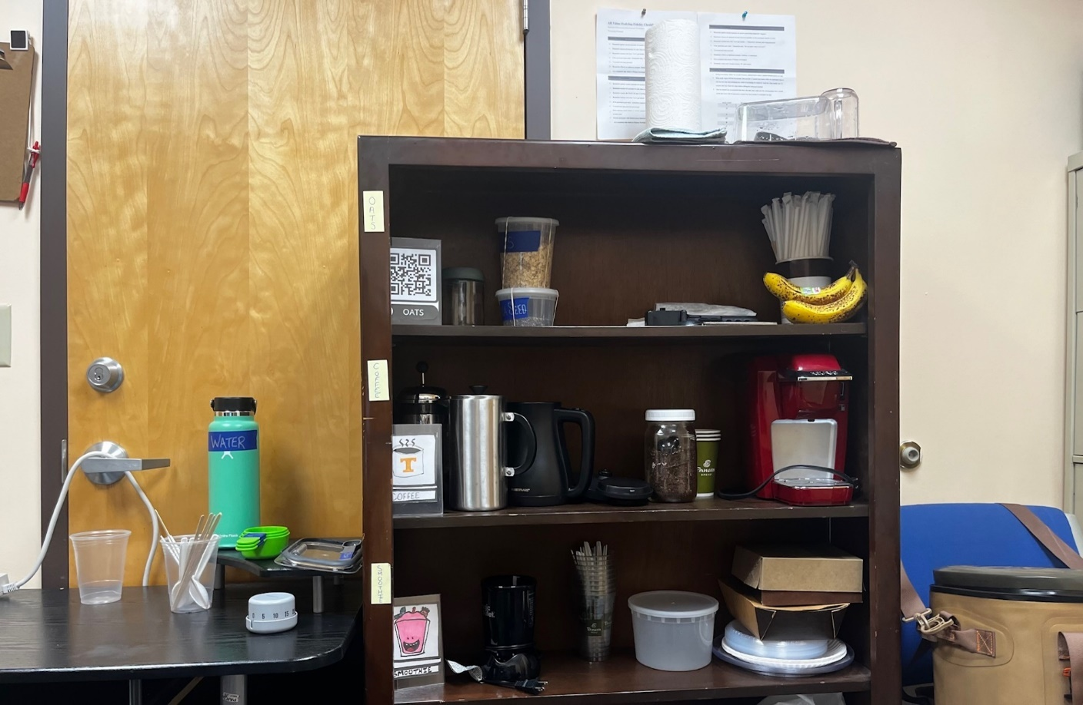
Figure 2. Image of the simulated dorm space

Table 2.
Materials for food preparation
Overnight Oats | Smoothie | Coffee
- Jars  - Lids  - Oats  - Water  - Chia Seeds  - Measuring cups/spoons  - Refrigerator  - Stir Sticks  - Funnel | - Blender  - Water  - Frozen Fruit  - Scoop  - Measuring cups/spoons  - Timer  - Cups  - Funnel | - French Press  - Electric Water Kettle  - Coffee  - Water  - Stir Stick  - Scoop  - Cups  - Lids  - Timer

Research Design
A multiple probe design across behaviors for three participants, a variant of the multiple baseline design first explored by Horner and Baer (1978), was used to determine the effectiveness of an AR intervention on identified daily living skills. The multiple probe design provided the researcher and participants flexibility and limited some frustrations that are often
associated with extended baseline studies where target behaviors are not currently in the learner’s repertoire (Morgan & Morgan, 2009). In addition to its flexibility, the multiple probe design is rigorous in assessment of threats to internal validity, and the design provides a practical means for practitioners and researchers to assess the effectiveness of interventions on dependent variables (Gast et al., 2018). Experimental control is demonstrated following stability in level and trend during baseline, and an immediate change in the dependent variable is observed with the introduction of the intervention. Effectiveness of the intervention is exhibited when the intervention successfully produces a significant behavior change while baseline levels remain stable. In the case of this study, changes were observed across various behaviors in the same class in a given setting (ADLs in the simulated dormitory setting) (Horner & Baer, 1978). This design is ethically sound, excluding the withdrawal of an effective intervention, which can lead to frustration for participants (Gast et al., 2018).
The three identified ADL tasks were functionally independent of one another, so as not to have a direct impact on the other skills once the intervention was presented, but were similar in behavior class. Participants’ ability to complete the steps of each task was measured over video and wait. Video models were created to allow the participants to pause, restart, and fast-forward/rewind 10-seconds as needed (see Figure 3). multiple days for each ADL skill set until an antitherapeutic trend was observed as evidenced by data collection using a task analysis for each behavior. Once three consecutive days of no improvement or a stable performance was seen for the first behavior, the AR intervention was introduced. The criterion for the first behavior to be considered mastered was three consecutive trials of 80% or more steps performed independently on the task analysis. In order for each skill to be successful during intervention, a prompting procedure was put in place to support students in reaching completion of all steps. The prompting procedure/hierarchy is outlined in Appendix A.

Dependent Variables
The dependent variables in this study were three distinct activities of daily living (ADLs). ADLs, a term first utilized by Sidney Katz (1950) in her research in geriatric care, encompass those fundamental skills necessary to live independently, including cooking, cleaning, and mobility (Edemekong et al., 2021). The activities selected were centered around healthy breakfast items. The number of steps completed independently for each behavior tier represented the dependent variable as a whole. The task chains addressed in this study were making overnight oats, making a smoothie using a blender, and making coffee using a French press. Task analyses were developed for each skill chain to ensure data collection procedures were consistently measured by observers (see Table 3).

Data Collection Procedures
Data were collected using the direct observation method of event recording procedures for each phase. Steps were assessed in each task analysis as completed correctly and independent of prompting from the researcher (Ayers & Gast, 2018). Three scoring options were utilized for
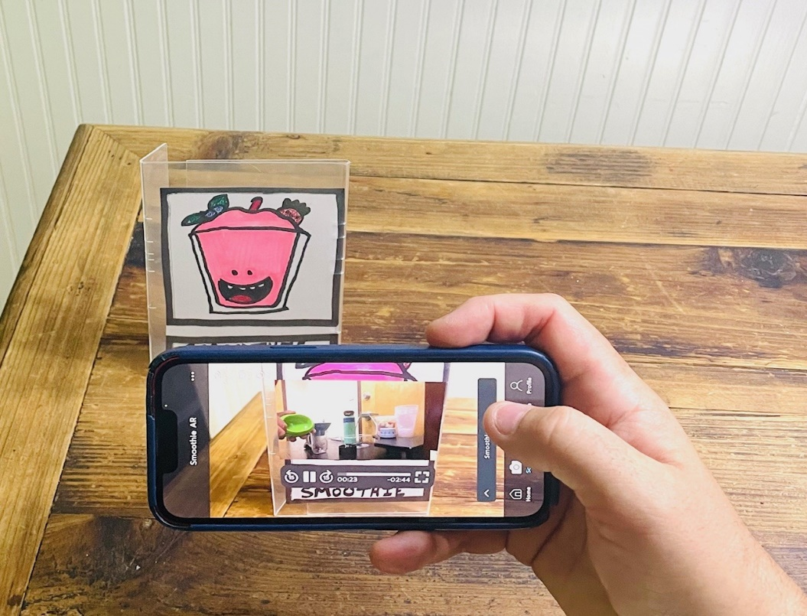
Figure 3. Image depicting AR trigger and video with controls
determining independence of a task; correct responses were circled on the data sheet, incorrect responses were marked with an “x,” and a prompted response was marked with a “P” and a note taken to indicate the level of prompt needed to accomplish a step (see data collection sheets in Appendix B). Prompting did not occur during the baseline phase, so data collection during this portion of the study only employed the correct and incorrect response marks.

Baseline
To combat maturation of skills and to avoid frustration and fatigue, multiple probes examining ADL task completion were staggered during the baseline phase. Each participant attempted each task over several days in the simulated dorm space to establish initial baseline data. Once an anti-therapeutic or stable trend was established for at least three probes, the introduction of the intervention phase for the first behavior began. Different behaviors were assigned to each participant for the initial intervention phase and materials in order to accomplish each task were provided. The variance in the introduction of skills served multiple purposes: to limit materials burden (e.g. 3 pots of coffee in one day, too many overnight oats, etc.); to limit observational effects among participants, increasing internal validity; and to allow for choice among participants in what task they engaged in first.
Participants were then instructed to complete the identified activity using the simple verbal prompt, “Let’s make…,” followed by the task being measured during that observation. A data sheet with the task analysis laid out step-by-step was utilized to determine correct and incorrect responses. If participants got stuck or were unable to complete a step in the task chain, they were asked if they knew what to do next. A 10-second time delay was then allowed for the participant to start the next step. No additional prompts were offered to the participant during the
Table 3.
Task analyses for ADL chains
Overnight Oats (2m25s) | Smoothie (3m8s) | Coffee (3m48s)
- Remove jar lid  - Place funnel on top of jar  - Get measuring cups/spoons  - Add ½ cup oats  - Add 2 tsp chia seeds  - Add ¾ cup water  - Get stir stick  - Stir all ingredients together  - Screw lid on jar  - Place in refrigerator | - Remove lid/blade  - Place funnel on cup  - Measure/add 1 cup liquid  - Measure/add 1 cup fruit  - Place lid on tight  - Turn cup over/check for leaks  - Put blender cup on base  - Push cup down/in place to blend  - Blend 1 minute/set timer  - Remove top and pour | - Fill electric kettle w/ water  - Place kettle on base  - Turn on/wait to boil  - Remove lid on press  - Fill with 4 scoops coffee  - Fill press w/ hot water  - Stir  - Put press lid on/set timer for 5 mins.  - Press coffee  - Pour into cups

baseline phase. No errors in the steps were corrected and feedback was not provided in regard to the participants’ performance (Bridges et al., 2020). A research assistant was also present periodically to collect data.
Task chains are such that each step must be complete in order for the entire process to be complete. Even if a participant can complete steps that follow an error or require a prompt, it is clear that the entirety of the chain cannot be accomplished without the support of someone else. As a result, the baseline phase did not include any prompting. Due to the nature of this study, prompting during baseline would have provided unintended instruction on the task chain. This would have made the impact of the intervention on participant learning less clear as a result of potential learning during the baseline phase. As each skill is intended to be completed independently, with or without intervention, prompting that would require direct interaction from another person was not included during baseline. If a step within the task chain is not accomplished, then the participant would no longer be independent of support and the task left incomplete. The ultimate goal was to understand the level of independence each participant had for the given task chain.
Data collection and visual analysis of graphed performance were used to establish the trend and determine when to move to the AR intervention phase. The other two behaviors for all participants continued in the baseline phase, but with periodic probes to ensure the task completion trend stayed stable, and did not improve when probed over time while the first behavior was receiving intervention (Gast et al., 2018).

Pre-intervention Training
After baseline data collection was completed, pre-intervention training was conducted in the simulated dorm room. Participants were provided with the iPhone 13 and taught how to unlock the phone, navigate to the Halo AR App, open the app, and scan an AR Marker to initiate a video. An AR marker was created that initiated a video congratulating the participant on successfully engaging the AR video. The primary investigator assisted students using the “I do, we do, you do” model of explicit instruction to activate the application and orient the camera to the AR trigger, activating the video. Each student was then given the opportunity to practice each step independently. The researcher also demonstrated how to use the additional functions of pause, restart, and rewind/fast-forward and provided practice time to the participants.

Independent Variable
The independent variable (IV) in this study was the AR intervention. An AR video model provides the user with a step-by-step instructional video that appears on the mobile device once the camera and trigger are oriented to one another while using a mobile phone application. One of the great benefits to AR is its ability to provide users with information while still actively engaged in the real world. This is a distinct difference from VR which fully immerses a user in the VR world. To engage the video support, participants opened the HALO AR application and oriented their camera to a physical “trigger.” Marker-based triggers were created by the researcher. Triggers were animated visuals of an associated item used to complete the task (e.g., a smoothie in a cup, a coffee cup, QR code for oats; depicted in Figure 3).
The video provided a point-of-view video showing the researchers hands completing the task chain following the task analysis while verbally providing step-by-step instructions. Once triggered, the video model of the task immediately played on the participants’ mobile device. The video model was available to them as many times as they needed, and participants had the option to pause, restart, or fast-forward/rewind the video models as needed. This addition to the IV was made to provide participants with the ability to quickly move to a desired point in the video, pause if they needed a chance to think through a step and then resume, or restart the entire video if they felt they needed to quickly get back to step one. The researcher ultimately wants users to be able to use a similar system in their living space independently, so these options make the AR more user friendly. These options would allow a user to use the video in a more personalized way as opposed to only being able to watch it all the way through, over and over again.

Overview of Intervention
Each participant, following stable baseline for the first task chain, entered into the intervention phase for the initial target behavior. Sessions took place in the simulated dorm room with the researcher. A second observer was also present in person or virtually for approximately 25% of sessions to collect data for the purposes of assessing interobserver agreement and monitor implementation fidelity. Time of day for sessions was established by coordinating schedules with the participants to accommodate for when they had work, class, or other personally scheduled events.
Students were instructed to access the AR videos in order to complete the given task by saying, “Let’s get started,” followed by the task they were currently working on. If assistance was needed to initiate the video model the first time, this was not counted as a prompted step as it did not directly impact completion of the targeted task. The sessions were initiated in identical fashion to baseline sessions, with a verbal prompt to execute the specific task. Should the participant get stuck on a step, the researcher utilized a prompt hierarchy that followed a system of least to most prompts (see Figure 4). Each level was afforded a 5-second wait time following the given prompt for the participants to engage in the next step. If they failed to move to the next step, the researcher would move to the next step in the prompt hierarchy. Following each task attempt, participants were provided with behavior specific praise and natural reinforcement. Natural reinforcement was available to students following task completion of the coffee and smoothie activities when they wanted to enjoy those items, or the following day if they wanted to have the overnight oats made the day prior.
Correct responses were defined by unprompted completion of the specified step in the task. Criterion for moving on to the next task was defined as having performed 80% of the steps on the task analysis independently three sessions in a row. Each task chain was to be initiated within 30 seconds of viewing the video model, and each step was to be completed within one minute of the step prior. Participants were allowed to initiate the AR triggered video as often as needed to observe the model completing the task. If the student used the video again, no matter how many times, a note was recorded to examine how often participants reengaged with the marker-based video model. The percentage of task completion was calculated by taking the total number of independent steps completed and dividing that number by the total number of steps to complete the entire task chain. See data sheets for details in Appendix B.

Maintenance
Once criterion levels were met, the goal was for the learner to be able to complete each targeted behavior chain independently. A maintenance probe was conducted on each behavior, for each participant, at least one week from the last time they performed the measured behavior in the intervention phase. If the participants needed to use the AR video model, they had access to it via the mobile device and the Halo App. The task was still considered to be completed independently if they used the video as they were completing the task chain without prompting or support from someone else. Sessions ended when the learner accomplished all steps in the task analysis to completion. Should students require support during a session, the researcher returned to the baseline prompting protocol. This allowed for the researcher to ask participants if they knew what to do next, but not provide any feedback or error correction. If the student used the video again, no matter how many times, a note was recorded to examine how often participants reengaged with the marker-based video model.

Interobserver Agreement
While the researcher collected data, a research assistant was present periodically to collect interobserver agreement (IOA) data during all phases of the study. One research assistant was an associate professor in special education and the other was a doctoral student in special education. Both had extensive experience working with students who have I/DD and collecting data on student behaviors. Both research assistants were trained in the data collection procedures and the researcher collected data during all sessions, while the RA collected data during a minimum of 25% of study conditions. The researcher stayed to one side of the participant within view of his actions and the research assistant was on the opposite side of the study setting. Both observers collected data simultaneously and separate from each other on the number of steps independently completed and those that required prompting. One RA took data in the same space

Data Code | Prompt Type | Prompt Directive
R | Reminder | “You could watch the video again.”
IV | Indirect Verbal Prompt | “Do you know what comes next?”
G | Gestural Prompt | Point to the items that should be used next.
DV | Direct Verbal Prompt | “You should… (follow task analysis step).”
M | Modeling | “I will show you, and then I want you to try.”
P | Physical | Provide the student with hand-over-hand assistance.
Figure 4. Prompt Hierarchy

as the primary researcher, while the second RA collected data on different days virtually. Virtual data were collected using a camera positioned directly above the station where students completed tasks using a computer and an online interfacing system. Virtual data collection was done live. No sessions were recorded.
Data collection was done on separate data sheets, and each step in the task analysis was compared following completion of the session to observe agreement. Disagreements in the data were marked on the main data sheets, and a note was made to signify the percentages of task completion for each participant when a disagreement occurred. The primary researcher used the data point that they recorded when a disagreement occurred, regardless of whether it was a higher or lower percentage on the task analysis.

Treatment Integrity
Treatment integrity data were collected using an implementation fidelity checklist (see checklist in Appendix D) which outlined the steps for each phase of the study. Each phase and the corresponding tasks were implemented with the exact same procedures in order to ensure the interventions were not influenced by external factors that could be controlled. The researcher implemented all phases of the study. The fidelity checklist provided a prescribed method for delivery of the intervention that included the gathering of needed materials for data collection and task, the verbal prompt to initiate the session, adherence to the prompting protocol, and session completion steps.
The same research assistants collected treatment integrity data for approximately 25% of intervention sessions. The research assistants had a printed copy of the fidelity checklist, and during each session that they were present, they collected treatment integrity data. The research assistant marked on the checklist each time a procedure was observed or if the primary researcher missed a step. Treatment integrity was determined by dividing the number of observed researcher behaviors by the number of anticipated instructor behaviors and multiplying by 100 (Billingsley, White, & Munson, 1980).

CHAPTER FOUR
Results and Discussion

Results
Participants’ exhibited different levels of performance on the various skills during baseline. Each had some knowledge of at least one of the tasks and how to complete it, but none could complete any of the three task chains from start to finish successfully or independently. Many of the correct responses in baseline came from the simplicity of that particular step (e.g., removing the lid on a jar, putting fruit into the blender), but the necessity to complete tasks in an order or to use specific measurements proved a roadblock for successful completion of all tasks for all participants. The mean for all baseline behaviors across participants was 17%. The means for all behaviors separately across participants in baseline were 3% for making coffee, 26% for making a smoothie, and 21% for making overnight oats.
Visual analysis of all data indicated that the AR video models were an effective method for teaching each skill. The mean for all intervention phases for each behavior across participants was 94%. The means for all behaviors separately across participants during intervention were 90% for making coffee, 94% for making a smoothie, and 98% for making overnight oats. Percentage of non-overlapping data (Scruggs et al., 1987; Scruggs & Mastropieri, 2001) was calculated between baseline and intervention for each task for all participants as well as across all tasks and all participants. PND was 100% for all behaviors across participants. A PND of 90% or greater is reflective of a highly effective intervention (Campbell & Herzinger,2010). Results for each individual participant follow.

Jason
Jason’s mean performance on each skill was as follows: smoothie (baseline 38%, intervention 87%), oats (baseline 35%, intervention 98%), and coffee (0%, 93%). His overall independent performance of all skills during baseline was a mean of 24% (range: 0% - 38%). Following implementation of the AR video model intervention, Jason’s completion of all behaviors increased to a mean of 93% (range: 87% - 98%). Once an antitherapeutic trend was established in baseline for the first skill measured, participants entered the first intervention phase. In intervention, the criterion for moving to the next skill was 80% of steps in the task analysis completed independently over three sessions. Jason reached criterion for all three skills within the first three sessions.
The PND for Jason for each task was 100%, making it a highly effective intervention for him. Maintenance probes for Jason were conducted at least one week after the final intervention session for each skill. During the maintenance probes, Jason completed all three tasks independently at 100%. Jason watched each AR video model in its entirety and then performed each task throughout the intervention and in the maintenance phases. During the maintenance phase, Jason used the pause and rewind options for making overnight oats. He watched the AR video model once through for the smoothie, not using any of the additional functions. He decided to not watch the AR video model when making the coffee, choosing to do this task from memory. Jason’s results are displayed in Figure 5.
Rohan
Rohan’s mean performance on each skill was as follows: smoothie (baseline 38%, intervention 84%), oats (baseline 24%, intervention 100%), and coffee (8%, 97%). His overall independent performance of all skills during baseline was a mean of 23% (range: 8% - 38%). Following implementation of the AR video model intervention, Rohan’s completion of all behaviors increased to a mean of 94% (range: 84% - 100%). Following implementation of the AR video model intervention, Rohan’s completion of all behaviors increased to a mean of 94% (range: 84% - 100%). Once an antitherapeutic trend was established in baseline for the first skill measured, participants entered the first intervention phase. In intervention, the criterion for moving to the next skill was 80% of steps in the task analysis completed independently over three sessions. Rohan reached criterion for the smoothie in four sessions, oats in three sessions, and coffee in three sessions.
The PND for Rohan for each behavior was 100%, making it a highly effective intervention for him. Maintenance probes for Rohan were conducted at least one week after the final intervention session for each skill. During the maintenance probes, Rohan completed all three tasks independently at 100%. Rohan elected to watch the entire AR video model and then complete the task chains, only re-engaging with the AR video models when he was unsure of a step. This was only done two times during the making of a smoothie to check the measurement amounts for fruit and liquid. In these instances, he would use the fast forward and rewind functions to find the step he needed to review. Rohan completed each maintenance probe by watching the AR video model one time through and then completing the skill. Rohan’s results are displayed in Figure 6.
Walter
Walter’s mean performance on each skill was as follows: smoothie (baseline 3%, intervention 98%), oats (baseline 4%, intervention 95%), and coffee (0%, 93%). His overall independent performance of all skills during baseline was a mean of 2% (range: 0% - 4%). Following implementation of the AR video model intervention, Walter’s completion of all behaviors increased to a mean of 95% (range: 93% - 98%). Once an antitherapeutic trend was established in baseline for the first skill measured, participants entered the first intervention phase. In intervention, the criterion for moving to the next skill was 80% of steps in the task analysis completed independently over three sessions. reached criterion for all three skills within the first three sessions.
The PND for Walter for each behavior was 100%, making it a highly effective intervention for him. Maintenance probes for Rohan were conducted at least one week after the final intervention session for each skill. During the maintenance probes, Walter completed all three tasks independently at 100%. Walter engaged with the intervention differently from Jason and Rohan. He would watch each step and then perform the step, using the pause feature to allow him to return to where he was in each task following completion of the step. If he was unsure of a step even after viewing it, he would careful rewind, view that step again, and then complete the step. He used this method throughout the intervention and maintenance phases. Walter’s results are displayed in Figure 7.

Social Validity
A social validity measure was delivered to participants by the researcher following their final maintenance probe (see full form in Appendix C). The first part of the survey was comprised of six Likert-style questions, with response of disagree (thumbs down), neutral (thumbs in the middle), and agree (thumbs up) The Likert-style questions revealed that all participants agreed that the intervention helpful, easy, and that AR video models would be a way
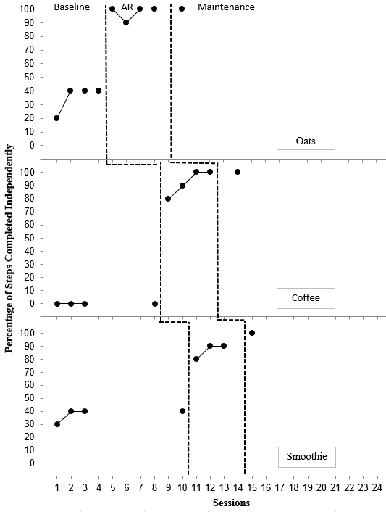
Figure 5. Results for Jason

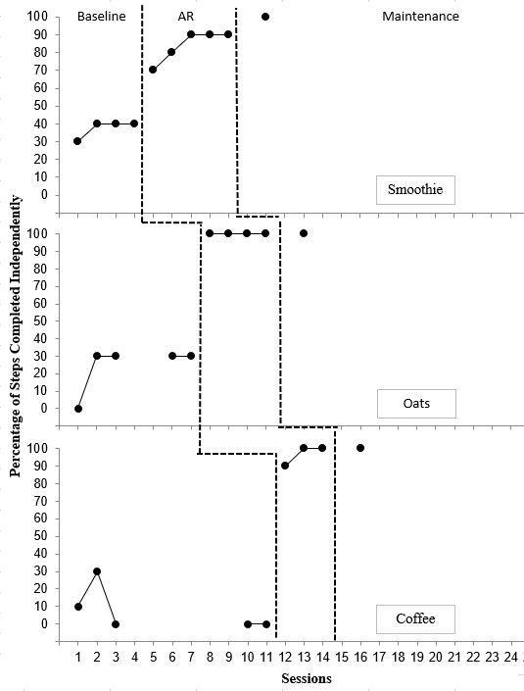
Figure 6. Results for Rohan

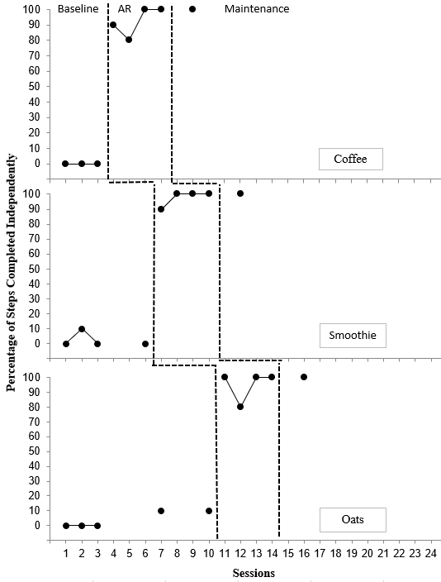
Figure 7. Results for Walter

they would like to learn new skills in the future. In addition to the Likert-scale responses, two open-ended questions were also asked. First, when asked what other skills participants thought they could learn using AR video models, they responded with things like cooking, work tasks, laundry, and cleaning. The second question asked why they liked or disliked the AR intervention. Replies focused on liking it because it helped them learn skills on their own and that it reminded them of using YouTube.

Interobserver Agreement
While the researcher collected data, a research assistant was present periodically to collect interobserver agreement (IOA) data during all phases of the study. One research assistant was an associate professor in special education and the other was a doctoral student in special education. Both had extensive experience working with students who have I/DD and collecting data on student behaviors. Both research assistants were trained in the data collection procedures and the researcher collected data during all sessions, while the RA collected data during a minimum of 25% of study conditions. The researcher stayed to one side of the participant within view of his actions and the research assistant was on the opposite side of the study setting. Both observers collected data simultaneously and separate from each other on the number of steps independently completed and those that required prompting. One RA took data in the same space as the primary researcher while assisting with IOA, while the second RA collected data on different days virtually. Virtual data were collected using a camera positioned directly above the station where students completed tasks using a computer and an online interfacing system. Virtual data collection was done live. No sessions were recorded.
Data collection was done on separate data sheets, and each step in the task analysis was compared following completion of the session to observe agreement. Disagreements in the data were marked on the main data sheets, and a note was made to signify the percentages of task completion for each participant when a disagreement occurred. The primary researcher used the data point that they recorded when a disagreement occurred, regardless of whether it was a higher or lower percentage on the task analysis. Disagreements were minimal, only being differences in single steps for a task when they occurred, and all came when using the virtual data collection method. There was not a pattern that showed a certain task or participant where disagreements occurred more often. The only observable pattern was in misinterpretations of a prompt given when it was inaudible to the RA collecting the IOA data. The percentage of IOA was calculated for each participant by adding the number of agreements, and dividing by the total number of agreements and disagreements, then multiplying that number by 100. The overall IOA was 87%.

Treatment Integrity
Treatment integrity data were collected using an implementation fidelity checklist (see checklist in Appendix D) which outlined the steps for each phase of the study. Each phase and the corresponding tasks were implemented with the exact same procedures in order to ensure the interventions were not influenced by external factors that could be controlled. The researcher implemented all phases of the study. The fidelity checklist provided a prescribed method for delivery of the intervention that included the gathering of needed materials for data collection and task, the verbal prompt to initiate the session, adherence to the prompting protocol, and session completion steps.
The same research assistants collected treatment integrity data for approximately 25% of intervention sessions. The research assistants had a printed copy of the fidelity checklist, and during each session that they were present, they collected treatment integrity data. The research assistant marked on the checklist each time a procedure was observed or if the primary researcher missed a step. Treatment integrity was determined by dividing the number of observed researcher behaviors by the number of anticipated instructor behaviors and multiplying by 100 (Billingsley, White, & Munson, 1980). The overall treatment integrity mean was 100%.

Discussion
The purpose of this study was to examine the effectiveness of an augmented reality intervention that used video models and whether or not participants found the intervention to be useful and socially acceptable. The aim was to teach students living on their own new daily living skills centered on making healthy breakfast items. Participants all had significant gains in their ability to complete all three tasks (making coffee, overnight oats, and a fruit smoothie) from baseline to intervention, and maintained their ability to access the AR without any support from the researcher. The nature of the AR intervention allows its users to learn and maintain skills independent of outside assistance from a family member or caregiver.
During baseline, Jason and Rohan both had some knowledge of how to make a smoothie, but both disregarded the use of measurement resulting in incomplete task achievement. Measurement was also a difficulty in the overnight oats as well, where Rohan and Jason also had some knowledge of how to start the task. Additionally, the method for making coffee was new to all participants, and while Rohan did attempt to make coffee, he could not progress past the third step in his best attempt during baseline. Walter would often examine all available material when asked to perform a task in baseline, but would quickly say he did not know how to do it and elect to not try.
A common theme among participants was a collective confusion about why they would be asked to do a task we knew they were unable to complete. A best effort was made to explain the process of the research design to each participant, but this acknowledgment from each participant does show one of the biggest drawbacks to designs with extended baseline phases. Once presented with the intervention, another shared theme among the participants was their excitement to learn using AR. While each student engaged with the AR intervention in their own way, all of them showed an immediate therapeutic change in the dependent variable (Gast et al., 2018).
The majority of the errors during intervention were simply small missed steps that didn’t prevent the participant from completing the task (e.g. not checking the blender cup for leaks or not pouring a cup of coffee). The PND for the entire study was 100%, signifying a highly effective intervention. Social validity results show that participants were motivated by this learning method and see themselves able to gain greater independence with other skills using AR. The overall perception of the AR intervention throughout the time of the study was a positive one. Participants regularly commented on how fun and beneficial it was to learn this way.

CHAPTER FIVE
Conclusions and Recommendations

Summary
This study extends the research base that examines the efficacy of augmented reality interventions using AR as a learning tool when teaching activities of daily living skills to individuals with I/DD (Bridges et al., 2020; Cihak et al., 2016; Kang & Chang, 2019; McMahan et al., 2013; Wu & Tsai, 2023). A powerful component of this study and the previous research using AR on mobile devices is in the social acceptability, portability, and relative ease of use and access that this learning tool provides. Opportunities exist in a variety of settings where AR could be used to increase independence skills in activities of daily living. A contributing factor for conducting this study with college students was the fact that most students, with or without disabilities, find themselves struggling to complete a myriad of tasks associated with living away from home for the first time. AR capable video models could provide instruction on a range of skills to assist in this transitional period for all individuals seeking to live more independently.
The findings in this study build upon those established by Bridges et al. (2020), using AR to improve the functional living skills for individuals with I/DD living independently while attending college. As post-secondary programs for individuals with I/DD continue to grow and offer options for on and off-campus housing, improvements in the supports provided to those students should also progress. The social validity data from this study and others provides a direction that program coordinators could consider in their individual support plans given the positive perceptions of AR interventions expressed by the individuals in comparable studies.

Limitations
While a functional relation was established between the independent variable and the dependent variable, there were still limitations to this study. The ability to see these connections is one of the most meaningful outcomes in single case design research as it allows us to see if and when interventions are truly effective. This study included a small number of participants (n=3). While this study adds to the research, larger scale replications of this and other AR applications would better represent the generalizability of the intervention.
Time and scheduling also proved to be limitations. College students have busy schedules, so finding opportunities to conduct even short sessions was challenging. Because of the researcher’s schedule and the class / break schedule, the intervention was started after spring break. It took quite a bit of time to cover baseline and intervention for three skills. Thus, the final sessions occurred near the end of the semester. Extending the study for a longer period of time would have allowed longer intervention periods, additional maintenance probes, and the opportunity to see if the skills would generalize to different settings, such as individual student living spaces. This study and others like it would benefit from extended time to see how well participants retain skills both for task completion and also using the AR functions on a mobile device.
Participant frustration during baseline can be looked at as a limitation, albeit a small one. While the researcher employed a multiple probe design, which helps limit frustration, there is no way to completely eliminate those feelings for participants. When asking them to attempt to complete skills multiple times while knowing that they are unable to do so will inevitably produce frustration. The affordance that a multiple probe design provides by removing continuous baseline probes, allowing for periodic data sessions, does help. However, it still leaves participants wondering why they are asked multiple times to complete a task they have indicated they are unable to perform.

Future Research
These findings further the evidence that AR is a meaningful tool for teaching and learning, and an effective tool when working with individuals with I/DD, but future research is still needed. An increase in participant numbers would provide greater insights into the usefulness of this line of research. Studies that continue to explore a variety of skills, especially those associated with activities of daily living and independence will add to the research base and further a growing evidence base for AR interventions in special education settings.
Conducting research in different settings would also be useful future research. Using the AR intervention in the actual dorm rooms or homes of the participant or in a work setting or commercial space would provide a new perspective on the intervention. Additionally, scaling the intervention up to include multiple post-secondary programs and their students who live independently would be an excellent way to examine the efficacy of the AR video models in a variety of environments and with a wider range of the special education population. This line of research could also serve as a platform looking at universal design for learning. Adding AR triggers to the living spaces of college freshmen with and without disabilities could be a way to target the skill deficits many young people face when living independently for the first time.
Comparison of the functions within the AR intervention used in this study and how students interacted with them would serve as meaningful future research. In examining the results, it would appear Walter, who used the embedded functionality of the AR intervention (e.g., pause, rewind/fast-forward), made the most significant gains from baseline through intervention. His approach generally allowed him to make sure each step was done correctly every time, but it also added time to his task completion that was not a concern for Jason and Rohan. Investigation into the benefits of the added functions could produce interesting findings for the research community. Additional comparison studies might include the exploration of similar interventions using different modalities of the extended reality continuum.

Conclusion
Augmented reality is a powerful learning tool, as evidenced by the growing number of highly effective educational interventions putting it to use. This is especially so for individuals with I/DD seeking to learn new skills and gain greater independence. As more opportunities for post-secondary inclusivity grow, so too does the need to help individuals with disabilities access those spaces with a greater level of independence. Due to the meteoric rise in the usage of mobile devices, it is no longer socially stigmatizing to use a device as a means to learn new skills. The prominence of video creation across our interconnected world, with its heavy dosage of do-it-yourself and learn how content, has made this method of learning accessible to all through the screen of a mobile device. While traditional teaching methodology remains key, new and innovative tools like AR are helping people learn, maintain, and generalize a myriad of skills. Technological additions to the learning landscape such as AR should energize those who work in the field of special education, as it blazes new pathways to a more inclusive world for all.

References
Akçayır, M., & Akçayır, G. (2017). Advantages and challenges associated with augmented reality for education: A systematic review of the literature. Educational Research Review, 20, 1–11. https://doi.org/10.1016/j.edurev.2016.11.002
Alberto, P. A., Cihak, D. F., & Gama, R. I. (2005). Use of static picture prompts versus video modeling during simulation instruction. Research in Developmental Disabilities, 26(4), 327–339. https://doi.org/10.1016/j.ridd.2004.11.002
Alper, S., & Raharinirina, S. (2006). Assistive technology for individuals with disabilities:A review and synthesis of the literature. Journal of Special Education Technology, 21(2), 47–64. https://doi.org/10.1177/016264340602100204
Amado, A., Stancliffe, R., Mccarron, M., & Mccallion, P. (2013). Social inclusion and community participation of individuals with intellectual/developmental disabilities. intellectual and developmental disabilities, 51, 360–375. https://doi.org/10.1352/1934-9556-51.5.360
American Association on Intellectual and Developmental Disabilities. (2022). FAQs on intellectual disability. AAIDD. Retrieved April 7, 2022, from https://www.aaidd.org/intellectual-disability/faqs-on-intellectual-disability
Ayers, K. & Gast, D. L. (2018). Dependent measures and measurement procedures. In D. A. Gast & J. Ledford (Eds.), Single case research methodology: Applications in special education and behavioral sciences (pp. 129–165). New York, NY: Routledge.
Bailey, R.W. (1989). Human performance engineering 2nd ed.). Prentice Hall.
Bandura, A. (1979). Social learning theory. Englewood Cliffs, NJ: Prentice Hall.
Bandura, A. (1986). Social foundations of thought and action: A social cognitive theory. Prentice-Hall, Inc.
Baragash, R. S., Al-Samarraie, H., Moody, L., & Zaqout, F. (2020). Augmented reality and functional skills acquisition among individuals with special needs: A meta-analysis of group design studies. Journal of Special Education Technology, 0162643420910413. https://doi.org/10.1177/0162643420910413
Baragash, R. S., Al-Samarraie, H., Alzahrani, A. I., & Alfarraj, O. (2020). Augmented reality in special education: A meta-analysis of single-subject design studies. European Journal of Special Needs Education, 35(3), 382–397. https://doi.org/10.1080/08856257.2019.1703548
Bell, S. M., & McCallum, R. S. (2008). Handbook of reading assessment. Boston: Pearson.
Bellini, S., & Akullian, J. (2007). A meta-analysis of video modeling and video self-modeling interventions for children and adolescents with Autism spectrum disorders. Exceptional Children, 73(3), 264–287. https://doi.org/10.1177/001440290707300301
Benda, P., Ulman, M., & Šmejkalová, M. (2015). Augmented reality as a working aid for intellectually disabled persons for work in horticulture. AGRIS on-Line Papers in Economics and Informatics, 7(4), 31–37. https://doi.org/10.7160/aol.2015.070403
Billingsley, F. F., White, O. R., & Munson, R. (1980). Procedural reliability: A rationale and an example. Behavioral Assessment, 2(2), 229-241.
Brandt, Å., Jensen, M. P., Søberg, M. S., Andersen, S. D., & Sund, T. (2020). Information and communication technology-based assistive technology to compensate for impaired cognition in everyday life: A systematic review. Disability and Rehabilitation: Assistive Technology, 15(7), 810–824. https://doi.org/10.1080/17483107.2020.1765032
Bridges, S. A., Robinson, O. P., Stewart, E. W., Kwon, D., & Mutua, K. (2020). Augmented Reality: Teaching Daily Living Skills to Adults With Intellectual Disabilities. Journal of Special Education Technology, 35(1), 3–14. https://doi.org/10.1177/0162643419836411
Brogioli, M. (2021, October 15). New TASH policy positions on inclusive education, competitive integrated employment and community living. Tash.org. Retrieved November 6, 2021, from https://tash.org/new-tash-policy-positions-on-inclusive-education-competitive-integrated-employment-and-community-living/
Browder, D. M., Wood, L., Thompson, J., & Ribuffo, C. (2014). Evidence-based practices for students with severe disabilities. Ceedar Document NO. IC-3. Ceedar Center.
Brown, I., & Percy, M. E. (Eds.). (2007). A comprehensive guide to intellectual and developmental disabilities. P. H. Brookes.
CAST (2018). Universal design for learning guidelines version 2.0. Wakefield, MA.
Cavus, N., Al-Dosakee, K., Abdi, A., & Sadiq, S. (2021). The utilization of augmented reality technology for sustainable skill development for people with special needs: A systematic literature review. Sustainability, 13(19), 10532. https://doi.org/10.3390/su131910532
Chang, Y. J., Kang, Y. S., & Huang, P. C. (2013). An augmented reality (AR)-based vocational task prompting system for people with cognitive impairments. Research in Developmental Disabilities, 34(10), 3049–3056. https://doi.org/10.1016/j.ridd.2013.06.026
Chemero, A. (2003) An outline of a theory of affordances. Ecological Psychology, 15, 181–195. https://doi.org/10.1207/S15326969ECO1502_5
Chuah, S. H. W. (2018). Why and who will adopt extended reality technology? literature review, synthesis, and future research agenda. SSRN Electronic Journal. https://doi.org/10.2139/ssrn.3300469
Cihak, D. F., Moore, E. J., Wright, R. E., McMahon, D. D., Gibbons, M. M., & Smith, C. (2016). Evaluating augmented reality to complete a chain task for elementary students with Autism. Journal of Special Education Technology, 31(2), 99–108. https://doi.org/10.1177/0162643416651724
Cook, B. G., Haggerty, N. K., & Smith, G. J. (2019). Leadership and instruction: Evidence-based practices in special education. In Handbook of Leadership and Administration for Special Education (2nd ed., Vol. 1, pp. 353–370). Routledge. https://doi.org/10.4324/9781315226378-21
Cook, A. M., & Hussey, S. M. (2002). Assistive technologies: Principles and practice (2nd ed.). Mosby.
Cooper, J. O., Heron, T. E., & Heward, W. L. (2007). Applied behavior analysis (2nd ed.). Pearson/Merrill-Prentice Hall.
Corbett, B. A., & Abdullah, M. (2014). Video modeling: Why does it work for children with autism? Journal of Early and Intensive Behavior Intervention, 2 (1), 2. https://doi.org/10.1037/h0100294
Dixon, D. R., Miyake, C. J., Nohelty, K., Novack, M. N., & Granpeesheh, D. (2020). Evaluation of an immersive virtual reality safety training used to teach pedestrian skills to children with Autism spectrum disorder. Behavior Analysis in Practice, 13(3), 631–640. https://doi.org/10.1007/s40617-019-00401-1
Dunleavy, M., & Dede, C. (2014). Augmented Reality Teaching and Learning. In J. M. Spector, M. D. Merrill, J. Elen, & M. J. Bishop (Eds.), Handbook of Research on Educational Communications and Technology (pp. 735–745). Springer New York. https://doi.org/10.1007/978-1-4614-3185-5_59
Elmqaddem, N. (2019). Augmented reality and virtual reality in education. myth or reality? International Journal of Emerging Technologies in Learning, 14(3), 234–242. https://doi.org/10.3991/ijet.v14i03.9289
Edemekong, P. F., Bomgaars, D. L., Sukumaran, S., & Levy, S. B. (2021). Activities of daily living. In StatPearls. StatPearls Publishing.
Faccio, M., & McConnell, J. J. (2020). Death by Pokémon GO: The Economic and Human Cost of Using Apps While Driving. Journal of Risk and Insurance, 87(3), 815–849. https://doi.org/10.1111/jori.12301
Feuer, M. J., Towne, L., & Shavelson, R. J. (2002). Scientific culture and educational research. Educational Researcher, 31(8), 4–14. https://doi.org/10.3102/0013189X031008004
Franzone, E., & Collet-Klingenberg, L. (2008). Overview of video modeling. Madison, WI: The National Professional Development Center on Autism Spectrum Disorders, Waisman Center, University of Wisconsin.
Gacek, M., Smoleń, T., & Pilecka, W. (2017). Consequences of learned helplessness and recognition of the state of cognitive exhaustion in persons with mild intellectual disability. Advances in Cognitive Psychology, 13(1), 42–51. https://doi.org/10.5709/acp-0205-6
Gast, D., Lloyd, B., & Ledford, J. (2018). Multiple baseline and multiple probe designs. In D. A. Gast & J. Ledford (Eds.), Single case research methodology: Applications in special education and behavioral sciences (pp. 239–281). New York, NY: Routledge.
Gibson, J. J. (1977). The theory of affordances. Hilldale, USA, 1(2), 67-82.
Gibson, J. J. (1979). The ecological approach to visual perception. Houghton Mifflin.
Gilson, C. B., Carter, E. W., & Biggs, E. E. (2017). Systematic review of instructional methods to teach employment skills to secondary students with intellectual and developmental disabilities. Research and Practice for Persons with Severe Disabilities, 42(2), 89–107. https://doi.org/10.1177/1540796917698831
Harrison, P., & Oakland, T. (2003). Adaptive behavior assessment system (ABAS-II). San Antonio, TX: The Psychological Corporation.
Hedges, S & AFIRM Team. (2018). Technology-aided Instruction & Intervention. Chapel Hill, NC: National Professional Development Center on Autism Spectrum Disorders, FPG Child Development Center, University of North Carolina. Retrieved from http://afirm.fpg.unc.edu/Technology-aided-instruction-and-intervention
Horner, & Baer, D. M. (1978). Multiple-probe technique: A variation of the multiple baseline. Journal of Applied Behavior Analysis, 11(1), 189–196. https://doi.org/10.1901/jaba.1978.11-189
Individuals with Disabilities Education Act (IDEA), 20 U.S.C. § 1400 (2004).
Kang, Y. S., & Chang, Y. J. (2020). Using an augmented reality game to teach three junior high school students with intellectual disabilities to improve atm use. Journal of Applied Research in Intellectual Disabilities, 33(3), 409–419.
Kellems, R. O., Cacciatore, G., Hansen, B. D., Sabey, C. V., Bussey, H. C., & Morris, J. R. (2021). Effectiveness of video prompting delivered via augmented reality for teaching transition-related math skills to adults with intellectual disabilities. Journal of Special Education Technology, 36(4), 258–270. https://doi.org/10.1177/0162643420916879
Kellems, R. O., Frandsen, K., Hansen, B., Gabrielsen, T., Clarke, B., Simons, K., & Clements, K. (2016). Teaching multi-step math skills to adults with disabilities via video prompting. Research in Developmental Disabilities, 58, 31–44. https://doi.org/10.1016/j.ridd.2016.08.013
Knight, V., McKissick, B. R., & Saunders, A. (2013). A review of technology-based interventions to teach academic skills to students with Autism spectrum disorder. Journal of Autism and Developmental Disorders, 43(11), 2628–2648. https://doi.org/10.1007/s10803-013-1814-y
Kolb, D (1984). Experiential Learning as the Science of Learning and Development. Englewood Cliffs, NJ: Prentice Hall
Kolb, D. A., Boyatzis, R. E., & Mainemelis, C. (2001). Experiential learning theory: Previous research and new directions. In R. J. Sternberg & L.-f. Zhang (Eds.), Perspectives on thinking, learning, and cognitive styles (pp. 227–247). Lawrence Erlbaum Associates Publishers.
LaRue, R. H., Manente, C. J., Dashow, E., & Sloman, K. N. (2016). Functional Skills. In N. N. Singh (Ed.), Handbook of Evidence-Based Practices in Intellectual and Developmental Disabilities (pp. 229–239). Springer International Publishing. https://doi.org/10.1007/978-3-319-26583-4_9
Lave, J., & Wenger, E. (1991). Situated learning: Legitimate peripheral participation. Cambridge University Press.
LightUp. (2020). Halo AR (Version 1.24) [Mobile App]. https://www.lightup.io/halo
Lovaas, O. I. (1987). Behavioral treatment and normal educational and intellectual functioning in young autistic children. Journal of Consulting and Clinical Psychology, 55(1), 3–9. https://doi.org/10.1037/0022-006x.55.1.3
McMahon, D. D., Cihak, D. F., Gibbons, M. M., Fussell, L., & Mathison, S. (2013). Using a mobile app to teach individuals with intellectual disabilities to identify potential food allergens. Journal of Special Education Technology, 28(3), 21–32. https://doi.org/10.1177/016264341302800302
McMahon, D., Cihak, D. F., & Wright, R. (2015). Augmented reality as a navigation tool to employment opportunities for postsecondary education students with intellectual disabilities and Autism. Journal of Research on Technology in Education, 47(3), 157–172. https://doi.org/10.1080/15391523.2015.1047698
McMahon, D. D., Cihak, D. F., Wright, R. E., & Bell, S. M. (2016). Augmented reality for teaching science vocabulary to postsecondary education students with intellectual disabilities and Autism. Journal of Research on Technology in Education, 48(1), 38–56. https://doi.org/10.1080/15391523.2015.1103149
Montoya-Rodríguez, M. M., de Souza Franco, V., Tomás Llerena, C., Molina Cobos, F. J., Pizzarossa, S., García, A. C., & Martínez-Valderrey, V. (2022). Virtual reality and augmented reality as strategies for teaching social skills to individuals with intellectual disability: A systematic review. Journal of Intellectual Disabilities, 17446295221089148. https://doi.org/10.1177/17446295221089147
Morgan, D. L. & Morgan, R. K. (2009). Multiple-baseline designs. In D. L. Morgan (Ed.),
Single-Case Research Methods for the Behavioral and Health Sciences (pp. 125-
160). Thousand Oaks, CA: SAGE Publications Inc.
Morris, T. H. (2020). Experiential learning – a systematic review and revision of Kolb’s model. Interactive Learning Environments, 28(8), 1064–1077. https://doi.org/10.1080/10494820.2019.1570279
Muharib, R., Ledbetter-Cho, K., Bross, L. A., Lang, R., Hinson, M. D., & Cilek, R. K. (2022). Handheld technology to support vocational skills of individuals with intellectual and developmental disabilities in authentic settings: A systematic review. Review Journal of Autism and Developmental Disorders, 9(1), 108–119. https://doi.org/10.1007/s40489-021-00247-w
No Child Left Behind Act of 2001, 20 U.S.C. § 6319 (2008).
Odom, S. L., Thompson, J. L., Hedges, S., Boyd, B. A., Dykstra, J. R., Duda, M. A., Szidon, K. L., Smith, L. E., & Bord, A. (2015). Technology-aided interventions and instruction for adolescents with Autism spectrum disorder. Journal of Autism and Developmental Disorders, 45(12), 3805–3820. https://doi.org/10.1007/s10803-014-2320-6
Ostroff, E. (2011). Universal design: An evolving paradigm. Universal design handbook, 2, 34-42.
Park, J., Bouck, E., & Duenas, A. (2019). The effect of video modeling and video prompting interventions on individuals with intellectual disability: A systematic literature review. Journal of Special Education Technology, 34(1), 3–16. https://doi.org/10.1177/0162643418780464
Parker, R. I., Vannest, K. J., Davis, J. L., & Sauber, S. B. (2011). Combining nonoverlap and trend for single-case research: TauU. Behavior Therapy, 42(2), 284–299. https://doi.org/10.1016/j. beth.2010.08.006.
PauseVideo. (2021). PauseCam (Version 6.1) [Mobile App]. https://pausevideo.me/
Petrie, H., Carmien, S., Lewis, A. (2018). Assistive technology abandonment: research realities and potentials. In: Miesenberger, K., Kouroupetroglou, G. Computers Helping People with Special Needs. ICCHP 2018. Lecture Notes in Computer Science, vol 10897. Springer, Cham. https://doi.org/10.1007/978-3-319-94274-2_77
Phillips, B., & Zhao, H. (1993). Predictors of assistive technology abandonment. Assistive Technology, 5(1), 36–45. https://doi.org/10.1080/10400435.1993.10132205
Pisha, B. & Coyne, P. (2001). Smart From the Start: The Promise of Universal Design for Learning. Remedial and Special Education, 22(4), 197–203. https://doi.org/10.1177/074193250102200402
Regenbrecht, Wagner, M., & Baratoff, G. (2002). MagicMeeting: A collaborative tangible augmented reality system. Virtual Reality: The Journal of the Virtual Reality Society, 6(3), 151–166. https://doi.org/10.1007/s100550200016
Roberts-Yates, C., & Silvera-Tawil, D. (2019). Better education opportunities for students with Autism and intellectual disabilities through digital technology. International Journal of Special Education, 34(1), 197–210.
Root, J. R., Cox, S. K., Davis, K., & Gonzales, S. (2021). Using augmented reality and modified schema-based instruction to teach problem solving to students with Autism. Remedial and Special Education, 1-13. https://doi.org/10.1177/07419325211054209
Rose, D. H., Hasselbring, T. S., Stahl, S., & Zabala, J. (2005). Assistive technology and universal design for learning: Two sides of the same coin. 507–518. Retrieved from http://citeseerx.ist.psu.edu/viewdoc/similar?doi=10.1.1.517.1325&type=cc
Schalock, R. L., Luckasson, R., & Tassé, M. J. (2021). An Overview of Intellectual Disability: Definition, Diagnosis, Classification, and Systems of Supports (12th ed.). American Journal on Intellectual and Developmental Disabilities, 126(6), 439–442. https://doi.org/10.1352/1944-7558-126.6.439
Scheef, A. Hollingshead, A., & Barrio, B. (2020). Supporting students with intellectual and developmental disability in postsecondary education. Journal of College Student Development, 61(4), 528–531. https://doi.org/10.1353/csd.2020.0044
Schrank F. A., Mather N., McGrew K. S. (2014). Woodcock-Johnson IV Tests of Achievement. Rolling Meadows, IL: Riverside.
Scruggs, T. E., Mastropieri, M. A., & Casto, G. (1987). The quantitative synthesis of single subject research: Methodology and validation. Remedial and Special Education, 8(2), 24–33.
Scruggs, T. E., & Mastropieri, M. A. (2001). How to summarize single-participant research: Ideas and applications. Exceptionality, 9, 227–244.
Smith, C. C., Cihak, D. F., Kim, B., McMahon, D. D., & Wright, R. (2017). Examining augmented reality to improve navigation skills in postsecondary students with intellectual disability. Journal of Special Education Technology, 32(1), 3–11.
Steffen, Gaskin, J. E., Meservy, T. O., Jenkins, J. L., & Wolman, I. (2019). Framework of affordances for virtual reality and augmented reality. Journal of Management Information Systems, 36(3), 683–729. https://doi.org/10.1080/07421222.2019.1628877
Steinbrenner, J. R., Hume, K., Odom, S. L., Morin, K. L., Nowell, S. W., Tomaszewski, B., Szendrey, S., McIntyre, N. S., Yucesoy-Ozkan, S., & Savage, M. N. (2020). Evidence- based practices for children, youth, and young adults with Autism. The University of North Carolina at Chapel Hill, Frank Porter Graham Child Development Institute, National Clearinghouse on Autism Evidence and Practice Review Team.
Stoiber, K. C., Purdy, S., & Klingbeil, D. A. (2016). Evidence-based practices. In N. N. Singh (Ed.), Handbook of Evidence-Based Practices in Intellectual and Developmental Disabilities (pp. 41–68). Springer International Publishing. https://doi.org/10.1007/978-3-319-26583-4_3
Sugawara, A. T., Ramos, V. D., Alfieri, F. M., & Battistella, L. R. (2018). Abandonment of assistive products: assessing abandonment levels and factors that impact on it. Disability and Rehabilitation: Assistive Technology, 13(7), 716–723. https://doi.org/10.1080/17483107.2018.1425748
Think College. (2021). College search. Retrieved October 30, 2021, from https://thinkcollege.net/college-search.
Thompson, J. R., Bryant, B., Schalock, R. L., Shogren, K. A., Tassé, M.J., Wehmeyer, M. L., Campbell, E. M., Craig, E. M., Hughes, C., & Rotholz, D. A. (2015). Supports Intensity Scale – Adult Version: Users Manual. American Association on Intellectual and Developmental Disabilities.
U.S. Department of Labor. Bureau of Labor Statistics. (2023, 2 23). Persons with a disability: Labor force characteristics – 2022. News Release.
Walker, Z., McMahon, D. D., Rosenblatt, K., & Arner, T. (2017). Beyond Pokémon: Augmented Reality Is a Universal Design for Learning Tool. SAGE Open, 7(4), 2158244017737815. https://doi.org/10.1177/2158244017737815
Walsh, E., Holloway, J., McCoy, A., & Lydon, H. (2017). Technology-aided interventions for employment skills in adults with autism spectrum disorder: A systematic review. Review Journal of Autism and Developmental Disorders, 4(1), 12–25. https://doi.org/10.1007/s40489-016-0093-x
Whittenburg, H. N., Taylor, J. P., Thoma, C. A., Pickover, G. S., & Vitullo, V. E. (2020). A systematic literature review of interventions to improve work-related social skills of individuals with Autism spectrum disorder. Inclusion, 8(4), 320–334. https://doi.org/10.1352/2326-6988-8.4.320
Wu, H.-K., Lee, S. W.-Y., Chang, H.-Y., & Liang, J.-C. (2013). Current status, opportunities and challenges of augmented reality in education. Computers & Education, 62, 41–49. https://doi.org/10.1016/j.compedu.2012.10.024
Yakubova, G., Kellems, R. O., Chen, B. B., & Cusworth, Z. (2021). Practitioners’ attitudes and perceptions toward the use of augmented and virtual reality technologies in the education of students with disabilities. Journal of Special Education Technology, 01626434211004445. https://doi.org/10.1177/01626434211004445
Yenioglu, Ergulec, F., & Yenioglu, S. (2021). Augmented reality for learning in special education: A systematic literature review. Interactive Learning Environments, 1–17. https://doi.org/10.1080/10494820.2021.1976802

Appendices

Appendix A. Prompting Protocol
Prompting Protocol

- During intervention, follow the prompt hierarchy outlined below when a student becomes stuck on a step.
- When stuck, begin with the first prompt, then provide a 5-second wait time to allow the participant time to start the next step once prompting has ended (if prompting the student to watch the video model, wait 10 seconds after they finish the video before offering the subsequent prompt.
- Once the student has accomplished the step in the task chain, make sure the corresponding item is scored on the data sheet with the appropriate prompt level they needed to accomplish the step.

Data Code | Prompt Type | Prompt Directive
R | Reminder | “You could watch the video again.”
IV | Indirect Verbal Prompt | “Do you know what comes next?”
G | Gestural Prompt | Point to the items that they should use next
DV | Direct Verbal Prompt | “You should… (follow task analysis step)
M | Modeling | “I will show you, and then I want you to try.”
P | Physical | Provide the student with hand-over-hand assistance

Appendix B. Data Collection Sheets
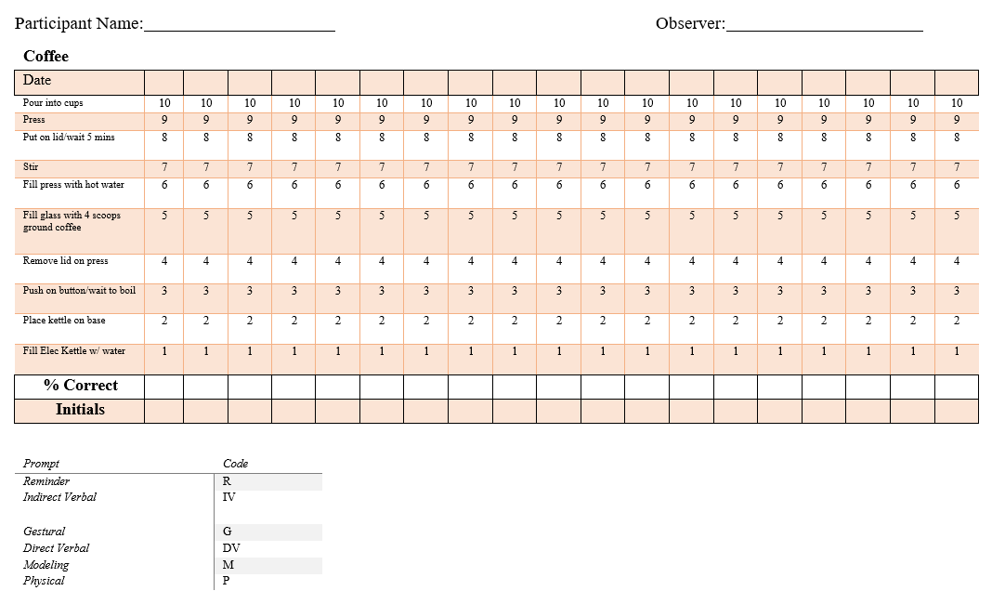

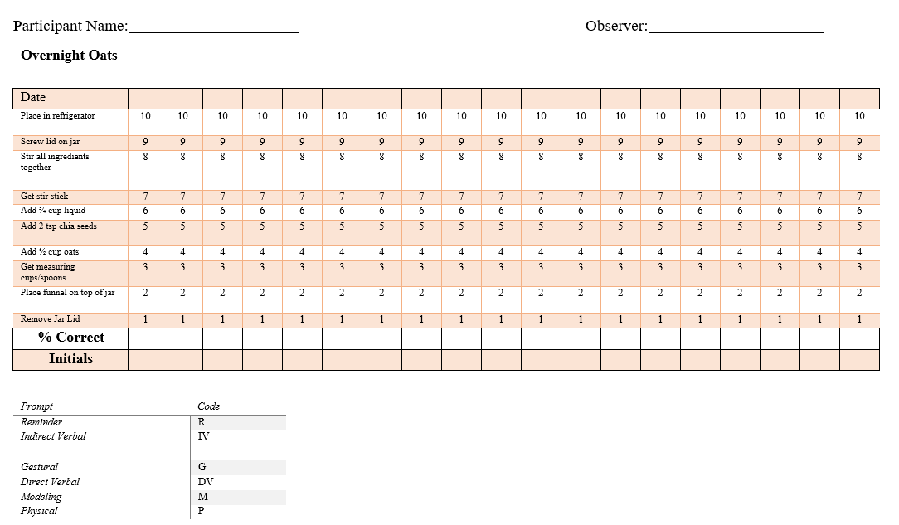
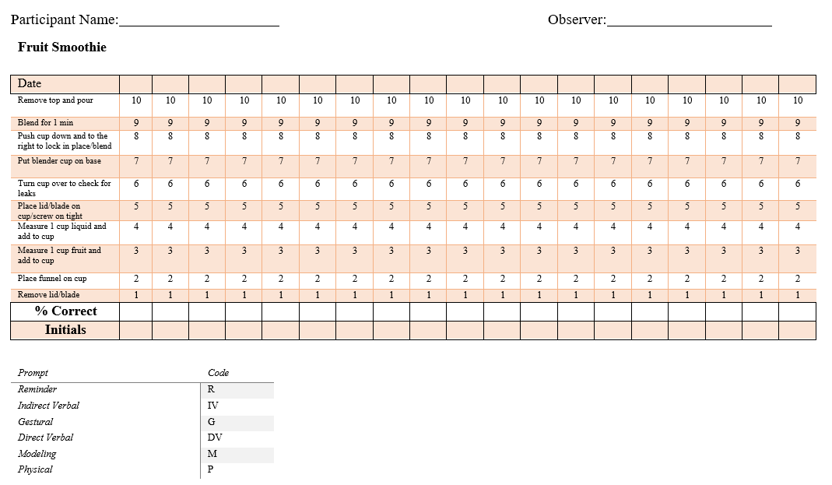

Appendix C. Social Validity Student Interview Questions
Questions

- I liked using augmented reality to learn new things | Disagree   | Neutral | Agree
- It was easy to get to the videos on the phone | Disagree | Neutral | Agree
- The videos were easy to watch | Disagree | Neutral | Agree
- I would like to use augmented reality to learn other things in my home | Disagree | Neutral | Agree
- I think augmented reality could help me learn other skills (like at work or at school) | Disagree | Neutral | Agree
- Technology is something I enjoy using when I learn | Disagree | Neutral | Agree
Open Ended Questions

- What other skills do you think you could learn using augmented reality?

- Why did you like or dislike using augmented reality to learn these skills?

Appendix D. Procedural Fidelity Checklist
Baseline Procedures

☐ | Researcher gathers needed materials for session (pencil/data sheets/AR Triggers)
☐ | Researcher ensures all materials for task chain are available for the participant (specific to trial)
☐ | Researcher initiates trial with, “Let’s get started…,” followed by the task chain being measured
☐ | If the participant gets stuck – Researcher asks, “Do you know what to do next?”
☐ | 10-second wait time provided
☐ | Researcher offered no additional prompts, feedback, or corrections.
☐ | Give completed data sheets to Primary Investigator
Intervention Procedures

☐ | Researcher gathers needed materials for session (pencil/data sheets/AR Triggers)
☐ | Researcher ensures all materials for task chain are available for the participant (specific to trial)
☐ | Researcher ensures the HALO AR app is working for the participant
☐ | Researcher initiates trial with, “Let’s get started…,” followed by the task chain being measured
☐ | If the participant gets stuck – researcher employs the prompting procedure
☐ | 5-second wait time provided per prompt
☐ | Data collection sheet marked w/ correct, incorrect, and prompted responses (marked by corresponding prompt code)
☐ | Provide participant with reinforcement (behavior specific praise, natural reinforcement)
☐ Give completed data sheets to Primary Investigator
Maintenance Procedures

☐ | Researcher gathers needed materials for session (pencil/data sheets/AR Triggers)
☐ | Researcher ensures all materials for task chain are available for the participant (specific to trial)
☐ | Researcher initiates trial with, “Let’s get started…,” followed by the task chain being measured
☐ | If the participant gets stuck – Researcher asks, “Do you know what to do next?”
☐ | 10-second wait time provided
☐ | Researcher offered no additional prompts, feedback, or corrections.
☐ | Give completed data sheets to Primary Investigator
☐ | Researcher made note if student utilized AR video model

Vita

Michael Morrow was born in Toledo, Ohio and moved to Knoxville, Tennessee at the age of 3 with his family. Morrow graduated from West High School in Knoxville in 2000. Michael attended the University of Tennessee, Knoxville where he graduated with Cum Laude with a Bachelor’s and Master’s Degrees in Comprehensive, Modified, and Early Childhood Special Education. Morrow worked as a high school special education teacher for Knox County Schools, teaching Algebra, English and Reading, and Life Skills in his first year, and then transitioned to working with students with low incidence disabilities in a comprehensive development classroom. Morrow then helped develop and then taught in a classroom for high school students with complex communication needs, Autism Spectrum Disorders, and behavioral support needs. This program acted as a bridge between alternative placements within the district, working with students from different schools while still in a less restrictive environment. Morrow then took a position at the district level as a Special Education Facilitator in Knox County. This administrative role saw him overseeing the programming for students with disabilities and supervising teachers throughout Knox County at the high school level, and supporting the secondary-level activity-based classrooms across the district for 3 years. Morrow then accepted a position with the Tennessee Behavior Supports Project at the University of Tennessee, Knoxville as an educational consultant. This grant team shifted it’s focused to the alignment of multi-tiered systems of support, changing directions and its name to The Tennessee Tiered Supports Center, where Morrow currently serves as an Educational Consultant. Michael also teaches coursework in the special education department at The University of Tennessee, Knoxville.

