Architectural element analysis and depositional model for

pre-vegetation braidplain and braid-delta environments:

Investigation of the Cambrian middle member of the

Wood Canyon Formation, southeastern California

and modern analogues

A Dissertation Presented for the

Doctor of Philosophy

Degree

The University of Tennessee, Knoxville

Jason Gerhard Muhlbauer

August 2020

Copyright © 2020 by Jason Gerhard Muhlbauer.
All rights reserved.

DEDICATION

To Mom, for always steadying my ladder,
to Dad, for helping me across rivers,

and

to Jeff Trop, who inspired my career in less than 82 minutes.

Thank you.

ACKNOWLEDGEMENTS

Thank you all for your help. However, this page is optional.

ABSTRACT

This is a sample Word document that can be used as a template in formatting your thesis/dissertation. It cannot exceed 350 words.

If you use any special characters (including superscripts and subscripts) in your abstract, you must write out the term in plain English in square brackets immediately following the first use of the character. For example: H2O [water] and µ [micron]. This has nothing to do with how common the term is in your field of study-- our catalogers have to enter the abstract in our records using a plain text format that cannot accommodate the special characters, but has no problem with word substitutes.

PREFACE

I have been lucky all through the years to work in the Basin and Range. The Basin and Range impresses me in terms of geology as does no other place in North America. It’s not at all easy, anywhere in the province, to say just what happened and when. Range after range—it is mysterious to me.

A lot of geology is mysterious to me.

–– Kenneth S. Deffeyes, in John McPhee, Basin and Range

TABLE OF CONTENTS

INTRODUCTION 1
Heading 2 1
Heading 2 1
Heading 3 1
Heading 3 1
Heading 2 1
CHAPTER I Architecture of a distal pre-vegetation braidplain: Cambrian middle member of the Wood Canyon Formation, southern Marble Mountains, California, USA 2
Abstract 3
Introduction 3
Geologic Setting 5
Methods 6
Facies Associations and Subenvironment Interpretations 7
Lithofacies and Architectural Elements 7
Facies Association 1 (FA1) 8
Description: Lithology 8
Description: Architecture 9
Interpretation 10
Facies Association 2 (FA2) 12
Description: Lithology 12
Description: Architecture 13
Interpretation 13
Facies Association 3 (FA3) 14
Description: Lithology 14
Description: Architecture 14
Interpretation 15
Stacking and Geometry of Facies Associations: Defining Units M1, M2, and M3 16
Discussion: Depositional System Synthesis 17
Conclusions 20
References 21
Appendix A-1 30
CHAPTER II Architecture of a fluvial-dominated, wave- and tidal-influenced, pre-vegetation braid delta: Cambrian middle member of the Wood Canyon Formation, southern Marble Mountains, California, USA 48
Abstract 49
Introduction 49
Geologic Setting 51
Methods 53
Facies Associations 53
Description: Facies Association 4 (FA4) 53
Architecture 54
Description: Facies Association 5 (FA5) 55
Architecture 56
Description: Facies Association 6 (FA6) 56
Architecture 57
Description: Facies Association 7 (FA7) 58
Architecture 59
Environmental Interpretation 60
FA4: Braidplain-to-delta Transition 60
FA5: Proximal Braid Delta 61
FA6: Distal Braid Delta 61
FA7: Upper Braid-delta Front 63
Discussion 64
Depositional Model 64
Sequence Stratigraphic Implications 66
Habitability Assessment 67
Conclusions 67
References 69
Appendix A-2 77
CHAPTER III Around the world in 800 braid deltas: Implications for classification, facies analysis, and the pre-vegetation rock record 98
CONCLUSION 99
Heading 2 99
Appendix A-4 100
VITA 101

LIST OF TABLES

Table 1.1: Summary of defining characteristics and interpretation of facies associations in the middle member of the Wood Canyon Formation. 30
Table 2.1: Lithofacies code definitions. 77
Table 2.2: Architectural element (AE) code definitions. 78
Table 2.3: Summary of facies association (FA) characteristics found in the middle member of the Wood Canyon Formation at the study area, based on detailed stratigraphic logging. 79

LIST OF FIGURES

Figure 1.1: Images and stratigraphic context for the study locality. A) Stratigraphic columns of the southern Marble Mountains (Fedo and Cooper, 1990) and Providence Mountains (Fedo and Cooper, 2001) displaying the stratigraphic relationships between cratonic sections and those more basinward. The middle member Wood Canyon Formation lies nonconformably on bedrock in the study area. SQ – Stirling Quartzite; lmWCF, mmWCF, umWCF – lower, middle, and upper member Wood Canyon Formation; ZQ – Zabriskie Quartzite B) View of the well-exposed outcrop in the southern Marble Mountains, examined in this study. C) Location of the field area in the Marble Mountains, California (34.534421, -115.474391). D) Generalized geological map of the study area and surroundings, with strike and dip measurements on bedding planes and joint sets. 31
Figure 1.2: Lithofacies observed in the middle member, codes from Miall (1985) and Tucker (2003). Scale in cm unless otherwise noted. A) St – transverse exposure of trough cross-stratified sandstone, paleoflow toward viewer. B) Sl – close up of low-angle foresets in cross-stratification. C) Sp – tabular planar set of cross-stratification with distinctive banded foresets. D) Sr – ripple cross-lamination on bedding sole. E) Fl – laminated green and red siltstone horizon. F) Fm – massive mudstone as desiccation chips on a bedding top. G) GSh – basal conglomerate unit of the middle member displaying massive framework-supported pebble conglomerate with interbedded cross-stratified sandstone. White band on Jacob’s staff is 10 cm. H) Sm – massive sandstone near the base of the formation. I) Sh – horizontally stratified banded sandstone units. 32
Figure 1.3: Architectural elements found in the middle member Wood Canyon Formation at the study area, with representative images. Elements from Miall (1985, 1996) and Long (2006, 2011), except VA, FP, and AO. Scale in cm, white band on Jacob’s staff is 10 cm. 33
Figure 1.4: Histograms representing the distribution of original dip angle for each order of surface in the middle member (restored for tectonic tilt), including A) foresets, B) scour surfaces of cross-beds, C) Barform/channel fill bases, and D) Facies Association (FA) boundaries. All measurements are true dip, recorded on the outcrop using a geologic compass. 34
Figure 1.5: Images of large-scale strata and sedimentary features within FA1. Scale in cm, white band on Jacob’s staff is 10 cm. A) Meter-scale cosets of trough cross-stratification, interpreted as longitudinal cross sections of unit bars. B) Erosional scour of FA1 into a finer grained interval of FA3 below. C) Outcrop of FA1 displaying lateral terminations of convex-up cosets of sandy bedforms (SB), interpreted as downstream-accreting (DA) barform edges, and a concave-up coset, interpreted as a small channel fill (CH). Imbedded desiccation clasts line the bedding plane that forms the base of the CH element. D) Comparison of longitudinal and transverse cross-sections of trough cross-stratification (white lines) in a single coset (yellow lines). E) Bedding plane (viewed from below) lined with angular decimeter-scale desiccation clast impressions. 35
Figure 1.6: Images of fine-scale strata and sedimentary characteristics within FA1, including photomicrographs. Scale in cm unless otherwise noted. A) Decimeter-scale coset of trough cross-stratification, paleoflow toward viewer. B) Planform view of trough cross-stratification on a bedding plane formed by a lunate dune with changing direction of migration. C) Compound cross-stratification formed by dunes accreting in the downstream direction near the angle of repose. D) Sigmoidal foresets in a set of cross-stratification. E) Finely laminated interval of fine-grained sandstone and siltstone between two barforms. F) Characteristic texture of poorly sorted coarse-grained sand and granules in cm-scale FA1 cosets. G) Representative thin section (Sample MM517-1) of FA1 under plane-polarized light (PPL). Note the poor sorting, very coarse sand grains, abundant quartz (Qtz), microcline (Mc), large phenocryst in rhyolite (VRF), and well-rounded mudstone grain. H) Representative thin section (Sample MM517-12) of FA1 under cross-polarized light (XPL). Extensive syntaxial overgrowths on quartz filled a majority of the pore space in the sandstone. 36
Figure 1.7: Thickness measurements of middle member architectural elements. A) Maximum and minimum preserved thicknesses of interpreted FA1 barforms and channel fills observed on stratigraphic panels. Maximum thicknesses range from 20-110 cm. Strong correlation suggests that most barforms will vary in thickness only ~10-30 cm when traced laterally. Histograms displaying the distribution of cross-set thicknesses in (B) FA1, (C) FA2, and (D) FA3 as measured from stratigraphic panels. 37
Figure 1.8: Facies Association 1 (FA1) locations (A) and (B) in unit M3 with stratigraphic panels (i) and corresponding stratigraphic columns (ii). Numbers in yellow circles on stratigraphic panels correspond to cosets (Cosets 1-2 on A, Cosets 1-3 on B), with matching yellow numbers labeling cosets on the stratigraphic columns. Interpretations are presented for each coset, based on displayed bounding surface orientations (iii). Restored measurements of dip direction on scour surfaces of cross-bedding displayed as gray rosettes, foresets displayed as black rosettes. Foreset dip directions approximate paleocurrent but may not represent a precise paleoflow, contingent on the measurement location relative to the trough axis of the three-dimensional dune. Panels are based on 3D outcrop models that are oriented with the primary face normal to the viewer. 38
Figure 1.9: Stratigraphic panel (i) and corresponding stratigraphic column (ii) for FA1 in unit M1. Numbers in yellow circles correspond to Cosets 1-7, with matching yellow numbers labeling cosets on the stratigraphic column. Interpretations are presented for each coset, based on displayed bounding surface orientations (iii). Restored measurements of dip direction on scour surfaces of cross-bedding displayed as gray rosettes, foresets displayed as black rosettes. Foreset dip directions approximate paleocurrent but may not represent a precise paleoflow, contingent on the measurement location relative to the trough axis of the three-dimensional dune. Panel is based on a 3D outcrop model that is oriented with the primary face normal to the viewer. 39
Figure 1.10: Stratigraphic panel (i) and corresponding stratigraphic column (ii) for FA1 and FA3 in unit M2. Numbers in yellow circles correspond to Cosets 1-6, with matching yellow numbers labeling cosets on the stratigraphic column. Cross-bedding in FA3 is labeled with a blue oval on the stratigraphic panel and in blue at the corresponding stratigraphic column location. Interpretations are presented for Cosets 1-6 and FA3, based on displayed bounding surface orientations (iii). Restored measurements of dip direction on scour surfaces of cross-bedding displayed as gray rosettes, foresets displayed as black rosettes. Foreset dip directions approximate paleocurrent but may not represent a precise paleoflow, contingent on the measurement location relative to the trough axis of the three-dimensional dune. Panel is based on a 3D outcrop model that is oriented with the primary face normal to the viewer. 40
Figure 1.11: Stratigraphic panel (i) and corresponding stratigraphic column (ii) for FA1 and FA2 in unit M2. Numbers in yellow circles correspond to Cosets 1-5 of FA1 and 6-8 of FA2, with matching yellow numbers labeling cosets on the stratigraphic column. Interpretations are presented for Cosets 1-8, based on displayed bounding surface orientations (iii). Restored measurements of dip direction on scour surfaces of cross-bedding displayed as gray rosettes, foresets displayed as black rosettes. Foreset dip directions approximate paleocurrent but may not represent a precise paleoflow, contingent on the measurement location relative to the trough axis of the three-dimensional dune. Panel is based on a 3D outcrop model that is oriented with the primary face normal to the viewer. 41
Figure 1.12: Block diagram of the middle member Wood Canyon Formation system at low discharge, including the subenvironments and representative features for each facies association (FA1-3). For architectural element abbreviations, see Figure 1.3. Approximate scale of diagram extent implied in top left. 42
Figure 1.13: Images of FA2 strata and sedimentary characteristics. Scale in cm unless otherwise noted. A) Partially exposed interval of FA2 in sharp contact with FA1 above. Thinly bedded red-orange sandstone and low-relief weathering identifies FA2 in outcrop. B) Red plane-bedded (Sp) FA2 sandstone below, orange FA2 cross-bed (St) displays mottled appearance above. C) Coset of trough cross-stratification (St) in FA2, bounded by yellow lines, similar to FA1 in texture. Indicates the input of high energy traction flow in the FA2 subenvironment. D) Close-up view of FA2 sandstone in outcrop, with red coloration and mottled, crumbly appearance. E) Representative thin section (Sample MM517-5) of FA2 under plane-polarized light (PPL). At lower left, medium-to-coarse sand grains of quartz (Qtz) and feldspar (Mc) are cemented by syntaxial overgrowths of quartz, similar to FA1. In the top right, a layer of iron-rich mudstone and poorly sorted sand. F) Representative thin section (Sample MM517-8) of FA2 under plane-polarized light (PPL). Very poorly sorted texture with diagenetic chlorite (Chl), hematite (Hem), and detrital muscovite (Mu). Note iron-rich siltstone matrix and increased angularity of the finer grain-size fraction. 43
Figure 1.14: Images of FA3 strata and sedimentary characteristics. Scale in cm, white band on Jacob’s staff is 10 cm. A) Approximately 3-m-thick interval of FA3 that marks the base of unit M2, with blocky weathering, rusty red-brown coloration, and large-scale trough cross-beds traced with white lines. B) Finely laminated and high-angle foresets of FA3 dune, truncated above by another set of trough cross-stratification. C) Evenly spaced, high angle tangential foresets in medium-grained sandstone. D) Close view of FA3 sandstone with foresets delineated by accessory mineral concentration that resembles pinstripe lamination in aeolian sediments. E) Representative thin section (Sample MM517-19) of FA3 under plane-polarized light (PPL). Quartz (Qtz) and feldspar (Or, Mc) framework grains of angular-to-subrounded, moderately sorted, fine- to medium-grained sand. Chlorite (Chl) pseudomatrix and clay matrix occur. Hematite (Hem) present both as primary detrital and secondary minerals. F) Representative thin section (Sample MM517-19) of FA3 under cross-polarized light (XPL). Moderately sorted fine-grained sandstone, framework grains of quartz (Qtz), microcline (Mc), rhyolite (VRF), and detrital muscovite (Mu). 44
Figure 1.15: Facies association (FA1-3) mapping and delineation of depositional units (X1-2, M1-3) within the full outcrop of middle member Wood Canyon Formation surveyed in this study. Dashed lines are inferred. Panel is based on a 3D outcrop model, captured via sUAS, that is oriented with the primary face normal to the viewer. Pink boxes indicate the location and figure name of a more detailed stratigraphic panel presented herein. 45
Figure 1.16: A) Hypothetical model of the larger system in which the studied strata were deposited; sediments in gray, water in blue. Corresponding facies associations (FA1-3) marked in each subenvironment. Scale modeled after modern braidplains, including the sandur plains of Iceland. Central Marble Mountains (MM), a site of future investigation, marked in the north of the diagram. B) Aerial view of Skeiðarársandur braidplain, Iceland, depicting subenvironent analogues for each facies association in a distal fluvial setting. Image courtesy of Phil Degginger, Degginger Photography. 46
Figure 1.17: Middle member Wood Canyon Formation paleocurrent measurements from Diehl (1979), Fedo & Cooper (1990) collected in the study area, and this study recorded from stratigraphic panels. The new NNW paleocurrent data conflict with prior W–NW paleocurrent measurements. 47
Figure 2.1: Stratigraphic and geographic context for the study locality. A) General stratigraphic columns illustrating the lateral relationship between the southern Marble Mountains (Fedo and Cooper, 1990) and Providence Mountains (Fedo and Cooper, 2001). Note the basal nonconformity and thinning of the middle member in the Marble Mountains. lmWCF, mmWCF and umWCF– lower, middle, and upper member Wood Canyon Formation, respectively; SQ– Stirling Quartzite; ZQ– Zabriskie Quartzite. B) Location of Sections N66 (this study) and S66 (Muhlbauer et al., 2020) in the Marble Mountains, California, USA. Image from Google™ Earth. 80
Figure 2.2: Images showing the study area and locations of recorded observations. A) Photograph of the southern Marble Mountains including the location of Section N66. B) Structure-from-Motion digital outcrop model of Section N66, with bedding oriented normal to the viewer. mmWCF and umWCF– middle and upper member Wood Canyon Formation, respectively; strat. column– stratigraphic column. White lines (solid or dashed) separate each facies association (FA4–7). Stratigraphic column (Fig. 2.3) logged along the orange lines. Trace of a large, left lateral, strike-slip fault is mapped with a yellow line. Locations of stratigraphic panels for each facies association are marked with red boxes. Red dots record the location of images presented in Figure 2.10. 81
Figure 2.3: Simplified stratigraphic column of Section N66, including the stratigraphic thicknesses of each facies association (FA4–7), sedimentary structures, and mudstone percentage calculated for each interval. Constructed via bed-by-bed stratigraphic logging; see additional information in Table 2.3. 82
Figure 2.4: Representative images for each lithofacies identified at Section N66 in the Marble Mountains, and corresponding codes (defined in Table 2.1). Fill colors correspond to those used to illustrate stratigraphic panels in this study (Figs. 2.6, 2.8, 2.11, 2.12, 2.14). Scale in cm; Jacob’s staff increments are 10 cm. 83
Figure 2.5: Images and photomicrographs of characteristic FA4 strata. Scale in cm unless otherwise noted. A) Trough cross-bedded (St), brown-to-tan, coarse-grained subarkose common to the middle member Wood Canyon Formation. B) Siltstone (Fl) layer with possible flame structures and a preserved rip-up clast inside a granular, cross-bedded, coarse-grained sandstone lag at the base of a coset. C) Bedding-top view of a mudstone veneer deposited over a pebble layer (Gh) at the top of the subjacent coset. D) “Bowtie-shaped” polygonal desiccation chips in cross-stratified, very coarse-grained subarkose. E) Poorly sorted, coarse-grained sandstone with monocrystalline and polycrystalline quartz (Qtz), microcline (Mc), syntaxial overgrowths on well-rounded quartz grains, and clay in matrix. Sample MM219-05. F) Fine-grained sandstone with quartz (Qtz), microcline (Mc), muscovite (Mu), and abundant clay in matrix. Concave grain boundaries on quartz indicate possible infill of authigenic clays between framework clasts. Sample MM219-28. 84
Figure 2.6: Stratigraphic panel representative of FA4 strata with corresponding orientation data. A) Three-dimensional digital outcrop model with bedding oriented normal to viewer. Orientation of the rock face noted in degrees. B) Stratigraphic panel with fill colors corresponding to lithofacies in Fig. 2.4 and described in Table 2.1. Fault with cm-scale offset marked in with a red line. Numbers correspond to C) areas 1–9 of restored orientation-measurement rosettes for foreset- and set-boundary (if any) dip directions, with interpretations where data permit. Orientation data are available in Appendix A-4. 85
Figure 2.7: Images and photomicrographs of characteristic FA5 strata. Scale in cm unless otherwise noted. A) White, quartz-cemented, coarse-grained subarkose with trough cross-sets (St). B) Horizontal-bedding (Sh) and ripple cross-lamination (Sr) in fine- to medium-grained sandstone. C) Planar siltstone bed (Fl) bed between two cosets. D) Curvilinear desiccation cracks in a mudstone veneer. E) Photomicrograph of fine-grained subarkose with quartz (Qtz), microcline (Mc), primary and diagenetic magnetite (Mt) in a heavy-mineral lag, and hematite-stained clay matrix. Bed was dark-brown in outcrop. Sample MM219-13. F) Monocrystalline and polycrystalline quartz (Qtz) with extensive syntaxial cement and apatite (Ap), in coarse-grained sandstone. Bed was white colored in outcrop. Sample MM219-12. 86
Figure 2.8: Stratigraphic panel representative of FA5 strata with corresponding orientation data. A) Three-dimensional digital outcrop model with bedding oriented normal to viewer. Orientation of the rock face noted in degrees. B) Stratigraphic panel with fill colors corresponding to lithofacies in Fig. 2.4 and described in Table 2.1. Numbers correspond to C) areas 1–10 of restored orientation-measurement rosettes for foreset- and set-boundary (if any) dip directions, with interpretations where data permit. Orientation data are available in Appendix A-4. 87
Figure 2.9: Images and photomicrographs of characteristic FA6 strata. Scale in cm unless otherwise noted. A) Symmetrical, oscillatory ripple marks resulting from east-west paleocurrent. B) Fluid-mud deposit with interbedded lens of fine- to medium-pebble conglomerate (Gm). C) Load-deformed mudstone (Fm) beneath a sandstone coset. D) Highly deformed mudstone rip-up clasts that were transported with tan, coarse-grained sand. E) Medium- to coarse-grained subarkose with quartz (Qtz), volcanic rock fragment (VRF), zircon (Zr), and diagenetic magnetite (Mt). Clay matrix is present between framework grains. Sample MM219-18. F) Sharp contact between a fluid mud layer (iron-stained mudstone) and a fine-pebble conglomerate interval with quartz (Qtz) and microcline (Mc) clasts. Note the pointed, concave grain boundaries on quartz clasts, similar to those in Figure 2.4F. Sample MM219-17. 88
Figure 2.10: Stratigraphic panels of sedimentary structures and facies relationships found within FA6. Scale in cm; Jacob’s staff increments are 10 cm. Panel notation defined in Fig. 2.6. Colors match the lithofacies codes on Fig. 2.4. Orientation data are available in Appendix A-4. A-B) Symmetrical sand wave in white-colored sandstone, with internal complexity in paleocurrent and accretion directions. C-D) Tabular cross-set (Sp) with southeast dip-direction of possible tidal origin. Overlying trough cross-beds have northward paleoflow indicators. E) Rippled sandstone (Sr) that injected into underlying fluid-mud deposit (Fl), deforming bedding planes. Below, mudstone is interbedded with fine-grained, horizontal-bedded sandstone (Sl). F) Pebble conglomerate (Gm) between two planar fluid-mud deposits (Fl). The interval is located between cosets of trough cross-sets (St) and low angle cross-bedding (Sl). Note that the upper fluid mud was scoured on the right of the image, removing both mudstone and subjacent conglomerate. 89
Figure 2.11: Stratigraphic panel representative of FA6 strata with corresponding orientation data, located at a stratigraphic height of 45 meters on the stratigraphic column. A) Three-dimensional digital outcrop model with bedding oriented normal to viewer. Orientation of the rock face noted in degrees. B) Stratigraphic panel with fill colors corresponding to lithofacies in Fig. 2.4 and described in Table 2.1. Numbers correspond to C) areas 1–4 of restored orientation-measurement rosettes for foreset- and set-boundary dip directions, with interpretations. Orientation data are available in Appendix A-4. 90
Figure 2.12: Stratigraphic panel representative of FA6 strata with corresponding orientation data, located near the upper boundary of the facies association. A) Three-dimensional digital outcrop model with bedding oriented normal to viewer. Orientation of the rock face noted in degrees. B) Stratigraphic panel with fill colors corresponding to lithofacies in Fig. 2.4 and described in Table 2.1. Numbers correspond to C) areas 1–5 of restored orientation-measurement rosettes for foreset- and set-boundary dip directions, with interpretations. Orientation data are available in Appendix A-4. 91
Figure 2.13: Images and photomicrographs of characteristic FA7 strata. Scale in cm; Jacob’s staff increments are 10 cm. A) Trough cross-bed of medium-grained sandstone (St) with rippled toesets and finely laminated foresets. B) Symmetrical ripple marks preserved on fine-grained sandstone bedding plane. C) Featureless medium-grained sandstone (Sm) bed at the base of FA7, 1.5 meters thick. D) Representative cf. Aulichnites trace fossil on a bedding plane of fine-grained sandstone. E) Hematite-stained mudstone and coarse-grained sandstone contact, with quartz (Qtz) and volcanic rock fragment (VRF). Clay matrix and syntaxial quartz overgrowths occur between framework grains. Sample MM219-21. F) Mudstone with quartz (Qtz) silt, muscovite (Mu), patchy hematite, and diagenetic magnetite (Mt) crystals. Sample MM219-24. 92
Figure 2.14: Stratigraphic panel representative of FA7 strata with corresponding orientation data. A) Three-dimensional digital outcrop model with bedding oriented normal to viewer. Orientation of the rock face noted in degrees. B) Stratigraphic panel with fill colors corresponding to lithofacies in Fig. 2.4 and described in Table 2.1. Numbers correspond to C) areas 1–9 of restored orientation-measurement rosettes for foreset- and set-boundary dip directions, with interpretations. Orientation data are available in Appendix A-4. 93
Figure 2.15: Block diagram of A) the overall middle member Wood Canyon Formation braid-delta system preserved at Section N66, with detailed environmental block diagrams of B) FA4, C) FA5, D) FA6, and E) FA7. See Table 2.2 for architectural element definitions. 94
Figure 2.16: Proposed fluidized-mud processes in the turbidity maximum zone, leading to the formation of thick mudstone beds with interbedded very fine- to medium-pebble conglomerate in FA6 and rarely in FA7 (e.g., Figs. 2.9B, 2.10F, 2.12B). A) In-channel fluidized mud alongside gravels transported by a high-energy thalweg. B) Fluid-mud migration over stranded gravels. C) Burial by subsequent barform migration that scours and deforms clasts of fluid mud before incorporation into the overlying sandstone coset. 95
Figure 2.17: Fluvial-dominated braid delta of the Pukaki River at Lake Pukaki, NZ. Dashed lines in white divide the setting into zones that resemble each middle member Wood Canyon Formation facies association (FA4–7). Image from Google™ Earth, captured September 18, 2019. 96
Figure 2.18: Lithostratigraphic panel linking Section N66 (Fig. 2.1) of the middle member Wood Canyon Formation (WCF), studied herein, to Section S66 (Fedo and Cooper, 1990; Muhlbauer et al., 2020) and associated paleocurrent data. Stratigraphic columns are hung on the base of the Zabriskie Quartzite. Units X1–2, M1–3 are based on facies-association stacking patterns at Section S66 (Fig. 2.1), described in Muhlbauer et al. (2020). The boundary between the braid delta and braidplain environments is hypothetical, as the relevant strata between the two sections are covered by rhyolitic flows. 97

INTRODUCTION

Heading 2
This is the introduction to the entire paper. It can be chapter one, or just a stand-alone introduction chapter. In any case, it isn’t just an introduction to part 1.
You may use single, double, or 1.5 spacing. You may use any font of your choosing, but you must be consistent.

Heading 2

Use subheadings consistently. Check spacing, capitalization, and punctuation.

Heading 3
Use of styles is helpful in generating a table of contents. This sample document uses the headings to automatically generate the table of contents, list of tables, and list of figures.

Heading 3
Once you use styles to generate the lists, you can update them quickly and easily. Use of styles is helpful in generating a table of contents. This sample document uses the headings to automatically generate the table of contents, list of tables, and list of figures. This document is set up to follow APA as well as UTK Guidelines. If you want to change formatting for the headings, you can highlight heading or other text you wish to change, then either change the font and then find whatever style you wish to change in the Styles window. Right click on that style and choose “Update [Style] to match selection.” Alternatively, you can choose “Modify” to change the style without choosing text.

Heading 2

Don’t forget to submit your thesis/dissertation to the thesis/dissertation consultant by the preliminary review deadline (this specific deadline can be found here: http://gradschool.utk.edu/ddategraduation.shtml)

CHAPTER I
Architecture of a distal pre-vegetation braidplain: Cambrian middle member of the Wood Canyon Formation, southern Marble Mountains, California, USA

A version of this chapter was originally published by Jason G. Muhlbauer, Christopher M. Fedo, and Jeffrey E. Moersch:

Jason G. Muhlbauer, Christopher M. Fedo, and Jeffrey E. Moersch. “Architecture of a distal pre‐vegetation braidplain: Cambrian middle member of the Wood Canyon Formation, southern Marble Mountains, California, USA.” Sedimentology 67 (2020): 1084–1113.

The following chapter is unmodified from the original peer-reviewed publication except regarding formatting changes. Christopher M. Fedo advised work on the project and collaborator Jeffrey E. Moersch provided small unmanned aircraft system piloting and a three-dimensional digital outcrop model of the study area.

Abstract
Architectural element analysis and detailed mapping of a 300 meter along-strike exposure of the middle member Wood Canyon Formation, southern Marble Mountains, California, USA, provides new evidence for extensive braided-fluvial channel-belt deposits with adjacent overbank environments. Three-dimensional models constructed using Structure-from-Motion techniques, combined with field-based observations, allowed interpretation of outcrop-scale trends, barforms, channel fills, and fine-scale features. The ~80-meter-thick member is divisible into five distinct units, including units M1-3 that form the bulk of the stratigraphy. Units are defined by stacking patterns of three facies associations, FA1-3, each representing the product of a subenvironment within the fluvial system. In FA1, stacked cosets, interpreted as low-relief fluvial bars and channel fills, preserve vertical- and downstream-accretion elements under unimodal NNW paleoflow, with minor lateral accretion near bar edges. Deposits of FA2-3, linked to overbank environments, are found only in unit M2, in the middle 27 meters of the middle member. Floodplains, represented by FA2, include crumbly red-orange intervals of fine- to medium-grained sandstone and thinner sets of cross-bedding than FA1, interbedded with thicker cross-stratification indicative of overbank splay or overland flow aggradation from adjacent channel belts during flood stage. Possible aeolian beds of FA3 preserve broad festooned trough cross-strata that average 23 centimeters in thickness; their small size, medium-grained sandstone, and iron oxide cement suggest a high water table. The diverse assemblage of interpreted subenvironments, paired with bedform and facies patterns, implies a perennial fluvial system that gradually built large sand bars as the channel belt migrated and avulsed across an unconfined braided-fluvial reach, leaving the overbank area on its flanks subject to weathering and aeolian transport. Despite the occurrence of strata deposited in low-energy and ponded settings, and a marine influence proposed for nearby sections of middle member, no ichnofossils were encountered.

Introduction
Prior to the radiation of vascular plants in the Devonian (Steemans et al., 2009; Gibling et al., 2014; Friedman, 2017) and accompanying sediment stabilization provided by root systems (McMahon and Davies, 2018a), extensive braidplains mantled the exposed continents (e.g., Cotter, 1978; Eriksson et al., 1998; Long, 2011), forming the main conduits that shuttled surface water to the oceans. Here, the term braidplain describes an unconfined expanse of braided-fluvial sediment transport. With no extensive root-bearing plant communities in the terrestrial landscape until the middle Paleozoic, braidplains reached continental size (Rainbird et al., 1992, 2017), and have no modern analogues of similar scale. Smaller present-day braided rivers contain many of the same elements used to classify ancient systems (e.g., Long, 2006) and compare directly to the architecture of ancient pre-vegetation deposits. As fluvial morphology is directly linked to climate, slope, sediment supply, and available accommodation space (Schumm, 1981), additional documentation of numerous pre-Devonian braided stream systems is needed to evaluate their diverse architecture and to identify any specific features that are not apparent in modern systems. Each pre-vegetation braidplain deserves detailed study, as each preserves a different set of fluvial characteristics reflecting its geologic setting.

The relative abundance of braided river deposits in pre-Devonian strata, hypothesized by Schumm (1968), was documented by Hereford (1977), Cotter (1978), and Long (1978). These authors suggested that the evolution of root-bearing plants provided the basis for establishing the cohesive banks that they claimed were essential to allow river meandering, and argued that without plant stabilization, rivers developed almost exclusively braided morphologies. Beyond initial interpretations, the complexity of subenvironments in these systems warrants continued detailed architectural analysis (e.g., Marconato et al., 2014; Santos et al., 2014; Ielpi et al., 2018). Depositional subenvironments are small localized components of an overall depositional environment, for example a floodbasin in a braided river system. Recent investigations (Davies et al., 2011; Ielpi and Rainbird, 2016a; Santos and Owen, 2016) identified diverse facies associations that occur within braidplain strata, including evidence for interspersed aeolian dune fields, floodplains, overflow channels, and paleosol development (Sarkar et al., 2012; Ielpi and Rainbird, 2015; Mazumder et al., 2015; Ielpi et al., 2018).

This study provides a detailed paleoenvironmental assessment of the Cambrian (Terreneuvian) middle member Wood Canyon Formation, first identified as the preserved expression of a braided fluvial system by Diehl (1979) and later by Fedo and Cooper (1990, 2001) and Fedo and Prave (1991). Work presented here focuses on a near-continuous exposure in the Marble Mountains of southeastern California (Fig. 1.1). Digital outcrop models (DOM), made using both small unmanned aircraft systems (sUAS) and handheld cameras, capture the multiple scales required for architectural element analysis of braidplain stratigraphy. Mapping the fine-scale architecture allows for bedform reconstructions and planform interpretation of the fluvial system, by providing details of bar accretion. On an outcrop scale, investigation of fluvial architecture permits documentation of changes in sedimentation style and preservation during deposition of the middle member. Specific aims of this study included: (1) description of barform, channel fill, and sandy bedform architecture in the middle member, (2) tracing the large-scale architecture of facies associations where possible, (3) reconstruction of depositional subenvironments and braidplain architecture, and (4) assessment of metazoan habitability. Major outcomes include evidence for deposits that represent overbank environments, including floodplains and aeolian sand sheets, and architecture that suggests perennial streamflow in channel belts.

Geologic Setting
Along the margin of western Laurentia, a Neoproterozoic-to-Paleozoic rift-to-drift sequence records the breakup of Rodinia, and subsequent formation of Laurentia (e.g., Prave, 1999; Fedo and Cooper, 2001; Karlstrom et al., 2018). By the latest Ediacaran (Levy and Christie-Blick, 1991), a mature passive margin developed along the (present day) western Laurentian margin at a near-equatorial latitude (Li et al., 2008). A continent-scale fluvial system prograded across Laurentia, depositing sediments that built the middle member Wood Canyon Formation (Fedo and Prave, 1991; Hogan et al., 2011; Schoenborn and Fedo, 2011; Schoenborn et al., 2012) and that thicken extensively to the northwest in response to post-rift subsidence and sediment loading (Stewart, 1970; Cooper and Fedo, 1993; Fedo and Cooper, 2001). The Wood Canyon Formation has three informal members: a shallow-marine lower member, an arkosic fluvial middle member, and a shallow-marine upper member overlain by the Zabriskie Quartzite (Fig. 1.1A; Stewart, 1966; Diehl, 1979; Prave, 1991; Fedo and Cooper, 2001). The middle member is constrained to the Terreneuvian (542-521 Ma) and lies between the Ediacaran-Cambrian boundary, which occurs in the lower member (Corsetti and Hagadorn, 2000), and Cambrian Series 2 fossils in the upper member (Mata et al., 2012).

On the craton, where the rocks of this study are located, an incompletely developed Wood Canyon Formation begins with the middle member nonconformably overlying ~1.4 and 1.7 Ga crystalline basement of the Mojave Province (Fig. 1.1A-B; Anderson and Bender, 1988; Fedo and Cooper, 1990; Farmer and Ball, 1997; Wooden et al., 2013). A widespread, meters-thick, weathering profile advanced into exposed bedrock and formed an essentially flat topographic surface just prior to deposition (Hogan et al., 2011). Locally derived Mojave Province detrital zircons occur only within the lowest several meters of the middle member, above which the primary source of zircon is overwhelmingly dominated by a 1.1 Ga age peak as observed across the Great Basin (e.g., Stewart et al., 2001; Schoenborn et al., 2012; Gehrels and Pecha, 2014; Muhlbauer et al., 2017). The 1.1 Ga ages are interpreted to indicate long-distance transport and rapid burial of a very low-relief, mature, geomorphic surface (Schoenborn et al., 2012; Muhlbauer et al., 2017). A distinct absence of incised paleovalleys developed on the underlying bedrock or within the middle member suggests deposition under limited accommodation space conditions, a concept supported by detailed sequence stratigraphic work on younger Cambrian units (e.g., Koerschner and Read, 1989; Montanez and Osleger, 1993) that accumulated in response to low-amplitude base-level oscillation.

Early investigations of the middle member described it as generally “shallow marine” (Stewart, 1970), or more specifically as a tidalite (deVries Klein, 1975). Later paleoenvironmental analysis indicated that at least part of the member was of braided-fluvial origin (Diehl, 1979). Fedo and Cooper (1990) provided a comprehensive facies-level interpretation of the middle and upper members of the Wood Canyon Formation, recognizing a fluvial-to-marine transition both vertically and laterally in the southern Marble Mountains. Foster (1991) revisited the tidalite interpretation based on the apparent occurrence of bimodal-bipolar foreset orientations, although these results were shown to be an artifact of measuring opposing limbs of trough cross-stratification by Fedo and Cooper (1991), an exchange that underscores the importance of understanding the three dimensionality of trough cross-beds when observed in oblique cross-sections (e.g., DeCelles et al., 1983).

A single, large, cliffside outcrop (Fig. 1.1B) of middle member Wood Canyon Formation in the southernmost Marble Mountains of southeastern California, USA (Fig. 1.1C-D) was selected for analysis of fluvial architecture. Situated approximately ~6 km cratonward of a middle member section interpreted as the product of a braid delta environment (Fedo and Cooper, 1990), the location represents the most distal reaches of the fluvial system, sensitive to even minor changes in base level. Mapped area measures approximately 300 meters along strike by 80 m in stratigraphic thickness. Exposures are oriented near-perpendicular to bedding, along a north-south trend. Outcrop geometry displays oblique longitudinal and transverse cross-sectional cuts through the fluvial system, with 3D exposure enhanced by fracture sets at approximately 000/30W, 330/60W, and 060/60N (Fig. 1.1D; Appendix A-4; Fedo and Cooper, 1991). Stratigraphic exposure is near continuous, from the basal nonconformity to the contact with the upper member. Scree slopes coupled with high-angle, low-displacement, oblique faults obscure and dissect a small part of the outcrop. Preexisting data from the site, including a detailed stratigraphic column with paleocurrent analysis (Fedo and Cooper, 1990), detrital-zircon provenance results (Schoenborn et al., 2012; Muhlbauer et al., 2017), and characterization of the lowermost stratigraphy up to a prominent discontinuous conglomerate (Hogan et al., 2011) provide context for new work.

Methods
Recent evaluation of sedimentary architecture has progressed with advances in digital photography and consumer electronics. Photomosaic techniques limit studies to well-exposed, tectonically undeformed strata found in planar exposures (e.g., Almeida et al., 2016b; Ielpi and Rainbird, 2016a; Lebeau and Ielpi, 2017). Structure-from-Motion (SfM), especially if implemented through the use of a sUAS, allows new perspectives, capturing stratigraphy at a larger scale and over complex topography (cf. Ghinassi and Ielpi, 2018). Current SfM techniques align thousands of images using photogrammetric software (Fabuel-Perez et al., 2009; Clapuyt et al., 2016; Chesley et al., 2017), generating a high-resolution 3D model of the target area. A DJI Phantom 3 Professional sUAS collected images of the site, flying a horizonal grid pattern oblique to the outcrop face. More than 4000 images cover the full exposure of the middle member with suitable overlap, from its unconformable base to its inferred contact with the upper member. Pix4Dmapper™ software assembled a georeferenced SfM model of the field area, providing a base map for locating areas of interest and facilitating tracing of large-scale features. Vertical resolution of the DOM is 6-7 cm, with a spatial resolution is 2-3 cm. In a separate SfM approach, images collected using a smartphone camera were imported into Agisoft™ Metashape to generate ultra-high resolution DOMs, suitable for detailed stratigraphic studies. Construction of each architectural panel required tracing of bounding surfaces in the field, collecting true dips of these bounding surfaces and primary fracture sets, determining lithofacies, and measuring a suitable stratigraphic column. Orientation measurements were restored to horizontal via stereonet to correct for a tectonic tilt of 50° to the east, determined from depositionally flat mudstone units in the upper member of the Wood Canyon Formation and the dip slope of the overlying Zabriskie Quartzite (Fig. 1.1D; Appendix A-4).

Facies Associations and Subenvironment Interpretations
Stratigraphic stacking patterns of facies associations provide boundaries that divide the middle member into five units (Fig. 1.1A), including the three major units detailed in this study named M1, M2, and M3. Units X1 and X2 that represent the lowest ~4.5 m of stratigraphy directly above to the nonconformity, were described by Fedo and Cooper (1990) as Facies C, and are not discussed herein. Subsequent sections describe three facies associations, recognized as FA1, FA2, and FA3 (Fig. 1.1A), with photographs, stratigraphic panels, and corresponding stratigraphic columns that illustrate distinctive features. Within the depositional system, FA1-3 each correspond to specific subenvironments and together represent the majority of Wood Canyon Formation braidplain sedimentation as part of units M1-3.

Lithofacies and Architectural Elements
Facies associations are assigned based on the identification of lithofacies and mapping of architectural elements in the field. Nine lithofacies were recognized in the middle member of the Wood Canyon Formation (Fig. 1.2), using terminology introduced by Miall (1985) and Tucker (2003). At the Marble Mountains the middle member is dominated by trough cross-stratification (St; Fig. 1.2A), low-angle cross-stratification (Sl; Fig. 1.2B), and planar tabular cross-stratification (Sp; Fig. 1.2C). Figure 1.2D shows a rare example of ripple cross-lamination (Sr) in sandstone. Grain sizes below fine sand are present locally as mm- to cm-scale layers of finely laminated mudstone (Fl; Fig. 1.2E), and as mudstone intraclasts (Fm; Fig. 1.2F). Hogan et al. (2011) documented the conglomerate, interstratified with beds and lenses of sandstone (GSh; Fig. 1.2G), that occurs near the base of unit M1. Horizontally laminated sandstone (Sh; Fig. 1.2H) and massive sandstone (Sm; Fig. 1.2I) are common in units X1 and X2, which Fedo and Cooper (1990) interpreted as sheet-flood deposits.

A summary of architectural elements recognized in the middle member Wood Canyon Formation is presented in Figure 1.3. Although most elements follow published work by Miall (1985, 1996) and Long (2006, 2011), several were developed specifically for this study, namely vertical accretion (VA), floodplain (FP), and aeolian (AO). This study proceeds by classifying surface orders after Miall (1985). Foresets of both low- and high-angle (Fig. 1.4A) cross-stratification or cross-lamination represent 0th order surfaces. Scour surfaces at the base of cross-beds or plane-parallel beds are 1st order surfaces that range from near-horizontal to steeply dipping (Fig. 1.4B). Low-relief (Fig. 1.4C) 2nd order surfaces separate cosets of cross-stratification. Because most coset boundaries and higher-order surfaces in the Wood Canyon Formation are near horizontal, and fluvial channel belts are presumed much wider than the total along-strike extent of the outcrop, it is difficult to reconcile existing categories of surface hierarchies (Miall,1985; Kelly, 2006) with high-order bounding surfaces in middle member rocks. Facies-association boundaries (Fig. 1.4D), possible 4th or 5th order surfaces, are inferred based on distinct facies-level variability detailed in the following results.

Facies Association 1 (FA1)

Description: Lithology
Facies Association 1 (Figs. 1.5, 1.6; Table 1.1) comprises the overwhelming majority of middle member Wood Canyon Formation stratigraphy, forms the entirety of units M1 (excluding the meter-thick, medium-pebble conglomerate near the base) and M3, and makes up approximately half of unit M2. Meter-scale, ledge-and-cliff outcrops expose roughly parallel beds (Fig. 1.5A) that can be traced for ~10-50 meters along strike between small-scale faults. Throughout FA1, 20-110 cm cross-stratified cosets (Figs. 1.5A, 1.6A, 1.6F, 1.7A; Appendix A-4) occur as part of multi-story gray-to-brown sandstone bodies (Fig. 1.5A-D). Boundaries between cosets commonly appear planar and horizonal, with dips similar to the local tectonic tilt (Fig. 1.5A). Only through bed tracing and detailed measurements can convex sandstone-body geometries (Fig. 1.5B-C) and relationships within cosets (Fig. 1.5D) be identified in outcrop.

Several types of distinct deposits floor the bases of cosets, in units ranging from a few mm to several cm thick, providing a basis for architectural mapping. Extensive single-clast-thick mud-chip horizons (Fig. 1.5E), reported by Diehl (1979) and Fedo and Cooper (1990), are embedded into the soles of some beds and can be followed along strike for up to tens of meters. One mud-chip horizon that crosses Fig. 1.5C can be traced along strike for approximately 50 m before it is lost under talus cover. Horizontal stratification is present in thin mudstone and fine-grained sandstone layers along certain coset boundaries (Fig. 1.6E). Mudstones are dominantly of silt grade. Exposed mudstones vary in color, and may be deep red, dark gray, or pale green. Other coset bases are lined with poorly sorted granule layers that may incorporate subrounded mud intraclasts or angular, flat mud chips.

Sets of cross-stratification, including St, Sp, and Sl (Fig. 1.2A-C; Table 1.1), average 10 cm in preserved thickness (Fig. 1.7B) and dominate FA1 stratigraphy (Fig. 1.6A-B). Longitudinal cross sections of trough cross-stratification appear tabular in places. Where fracture surfaces expose cross-beds transverse to flow direction, it becomes clear that St represents a vast majority of the observed cross-bedding (e.g., Fedo and Cooper, 1990). Architectural tracing in Figure 1.5D illustrates the effect along a well-exposed coset. Less abundant flow-related structures include: compound cross-stratification in tabular planar sets (Fig. 1.6C) and uncommon sinusoidal foresets (Fig. 1.6D). Asymmetric ripple marks and ripple cross-lamination occur rarely (Fig. 1.2D).

In thin section (Fig. 1.6G-H), FA1 is characterized by medium- to coarse-grained, poorly sorted, subarkosic sandstone, consistent with the findings of Fedo and Cooper (1990). Abundant well-rounded monocrystalline quartz, polycrystalline quartz, orthoclase, microcline, and rare chalcedony grains occur. Less abundant rhyolite rock fragments and phenocrysts of volcanic derived quartz are present in each sample (Fig. 1.6G-H). Rare well-rounded and angular mudstone grains found in the samples represent a further mud component in the middle member (Fig. 1.6G). Sandstones are framework supported, with negligible matrix. Extensive syntaxial quartz cement can in some cases exceed the size of the nucleating grain (Fig. 1.6H). Minor chlorite and iron oxide cements occur as grain coatings.

Description: Architecture

Multiple architectural panels (Figs. 1.8-11), illustrating surface tracing and orientation measurements (Appendix A-4) in each unit of the middle member, reveal the internal geometry, and hint at the external geometry, of the elements that form the middle member. Figure 1.8A illustrates the architecture of two cosets. Coset 1 (Fig. 1.8Ai) preserves high-angle tabular and compound cross-strata with set boundaries dipping to the northwest (Fig. 1.8Aiii). The tabular cross-stratification grades into troughs to the left of the diagram. The lower bounding surface of Coset 1 (Fig. 1.8Ai) dips steeply to the southwest and is floored by a gravel layer with embedded angular mud chips. Grain size within the coset is coarsest in the center, where very fine pebbly, very coarse-grained sandstone is found in cross-beds (Fig. 1.8Aii). Above, the 109 cm thick Coset 2 (Fig. 1.8Ai) preserves intricately stacked trough cross-bedding, typical of FA1. Foreset-dip azimuths trend to the northwest and northeast, whereas cross-set scours display no consistent pattern of dip directions (Fig. 1.8Aiii). A near-horizontal planar surface of laminated fine-grained sandstone forms the basal component of the coset. Orientation measurements on the upper boundary of the coset are also near-horizontal. The stratigraphic column (Fig. 1.8Aii) shows that grain size within the coset coarsens both in the core and in the gravel on the upper bounding surface.

Architecture outlined in Figure 1.8B incorporates three distinct cosets. In the lowest (Fig. 1.8Bi, Coset 1), trough cross-stratified medium- to very coarse-grained sandstone is floored by an extensive horizon of embedded mud-chips. Foresets dip to the northwest and cross-set scour surfaces exhibit no overall trend in dip orientation (Fig. 1.8Biii). Above, a 55 cm thick coset (Fig. 1.8Bi, Coset 2) of steeply dipping tabular cross-strata preserves a flow direction to the northeast. It scours into Coset 1, eroding it completely to the left of the image. In each set of tabular cross-strata, foresets decrease in thickness as grain size reduces to medium-grained sandstone of red color (Fig. 1.8Bii). Highest in the panel, a thin coset (Fig. 1.8Bi, Coset 3) with an irregular base scours into Coset 2 below, forming a concave-up erosional surface. Mud-chip casts line the base, and thin sets of trough cross-stratification indicate northward paleocurrent (Fig. 1.8Bii-iii).

Figure 1.9, illustrates the stratigraphy of seven cosets with trough cross-bedding in unit M1, where several beds can be observed to terminate laterally. Foresets dip to the north and northwest throughout (Fig. 1.9iii). Each coset has a relatively consistent grain size of medium- to coarse-grained sand, with dispersed very fine to fine pebbles (Fig. 1.9ii). Boundaries between cosets are marked by cm-scale intervals of siltstone, continuous mud-chip horizons, or areas of cover that likely represent fine-grained deposits (Fig. 1.9ii). Cross-set scour dips in Cosets 1-3 show no systematic orientation (Fig. 1.9iii). Coset 4 contains an abundance of cross-set boundaries that dip steeply to the east (Fig. 1.9iii). Above, Cosets 5-6 are truncated by Coset 7, which displays a concave-up geometry (Fig. 1.9i). Cross-set scours dip to the west in Coset 5 and to the south in Coset 6 (Fig. 1.9iii). Coset 7 has northeast dipping set boundary surfaces (Fig. 1.9iii), a set of sigmoidal cross-stratification (Fig. 1.9i), and an upper very fine pebble conglomerate cross-bed (Fig. 1.9ii).

Additional features of FA1 are displayed in Figure 1.10 and Figure 1.11. At the base of FA1 in Figure 1.10, a 74 cm thick concave-up coset (Fig. 1.10i, Coset 1) with angular mudstone intraclasts scours into fine-grained sandstone below. Above, Coset 2 has foresets uniformly dipping to the north and changes from shallowly dipping set boundaries to steeply northward-dipping (~10º) set boundaries along a south-to-north trend (Fig. 1.10iii). Cosets 3-4 are bounded by cm-scale intervals of siltstone or fine-grained sandstone where not obscured by talus. Grain size within each coset is consistent (Fig. 1.10ii), except where interspersed very fine pebbles are present. Figure 1.11 depicts FA1 Cosets 1-5 with a low variability in grain size, floored by mud-chip horizons or thin intervals of medium-grained sandstone with low-angle stratification (Fig. 1.11ii).

Interpretation

Sedimentologic and architectural characteristics of FA1 indicate that broad channel belts deposited most of the middle member Wood Canyon Formation. Cosets and sandy sheet-elements (SE) previously described for the middle member (Fedo and Cooper, 1990; Davies et al., 2011) are here interpreted as segments of barforms and channel fills that built much of the braidplain (Fig. 1.12). Absence of differentiating facies throughout much of the middle member makes separation of individual channel belts based on high-order bounding surfaces problematic. Amalgamated channel-belt deposits likely form the majority of the repetitive and laterally extensive stacked sheets of cross-stratified beds found in the middle member. Based on the experimental bedform work of Leclair and Bridge (2001) that correlates the preserved thickness of cross-beds to the height of the original dune, and measurements of cross-set and coset thickness (Fig. 1.7A-B) across multiple stratigraphic panels, barforms in the braidplain had an estimated relief of only 0.6-3.2 meters. Hydraulic profiles of this thickness are correlated to a channel width of ~20-105 meters in Precambrian deposits (Ielpi et al., 2017), but the near-absence of observable channel edges suggests they may have been wider. Vertical barform growth was limited by extensive erosion and sediment bypass in an accommodation-limited setting. The wide, shallow geometry of the channel belts and the small size of the outcrop compared to fluvial macroforms, which may reach 1000 m in lateral extent (Miall, 1996), preclude determination of the planform dimensions of macro-scale features.

In place of defining individual channel-belt deposits, this study documents unit bar and channel element segments using a methodology similar to that of Almeida et al. (2016a). Vertical accretion (VA) dominates the internal architecture of barforms and channel fills within FA1 stratigraphy (e.g., Fig. 1.8A, Coset 2; Fig. 1.9, Coset 2; Fig. 1.10, Coset 3; Fig. 1.11, Coset 5). Vertical accretion is not commonly described for barforms in the ancient record but is found in modern braided rivers (Miall, 1977; Bristow, 1993a; Best et al., 2003; Okazaki et al., 2015). A majority of examined barforms (9 of 17 barforms observed, 53%) appear to have accreted vertically (e.g., Fig. 1.5A), with cross-set scour dips only defined by the convex-up bases of individual dunes, without a preferential dip direction. Vertical accretion occurs at the cores of barforms that span tens of square meters (Fig. 1.12) based on lateral bed tracing. When bankfull flow escaped channels and overtopped low-relief barforms (Fig. 1.12), aggradation occurred as 3D dunes moved sand along their planar tops (e.g., Bristow, 1993a; Best et al., 2003; Bridge and Lunt, 2006; Ielpi and Rainbird, 2015; Went and McMahon, 2018).

Downstream-accreting (DA) elements are abundant (8 of 23 architectural elements observed, 35%) in FA1 (e.g., Fig. 1.8A, Coset 1) and typify low-sinuosity sandy braided rivers (Long, 2011). As barforms migrate and accrete in the flow direction, the deposits at their downstream margin are buried and preserved. Typically, large tabular avalanche faces form at bar lees (Fig. 1.12), such as those imaged in the Rio Paraná (Sambrook-Smith et al., 2009). The extensive DA elements in Coset 2 of Figure 1.8B, Cosets 2 and 6 of Figure 1.10, and Coset 3 of Figure 1.11 illustrate this style of deposition. Coset 2 of Figure 1.8B preserves striking evidence of reactivation surfaces as dunes migrated down an angle-of-repose avalanche face in the lee of a DA unit bar (e.g., Reesink et al., 2014). Nearly all channel fills (CH) observed have internal downstream-accreting (DA) surfaces (e.g., Fig. 1.8A, Coset 1). Within channels, large dunes accreted in the direction of flow, traversing the braidplain at the edges of the partially subaerial barforms and macroforms (Fig. 1.12), a process inferred in other fluvial rocks (e.g., Bridge and Lunt, 2006, Ielpi and Rainbird, 2016b; Ghinassi and Ielpi, 2018; Went and McMahon, 2018) and observed in modern systems (Skelly et al., 2003). Channel margins are rarely preserved and have low angles of approximately 5-10º that can be difficult to identify in outcrop (Figs. 1.3, 1.5C; Fig. 1.9i, Coset 7).

Pervasive NNW paleocurrent observed in the southern Marble Mountains outcrop implies that most cross sections of the strata are approximately longitudinal to overall channel-belt paleoflow direction. Consequently, lateral accretion (LA) is difficult to discern without orientation measurements on bounding surfaces. Restored dips and dip directions of internal barform surfaces reveal (e.g., Almeida et al., 2016a) LA elements from longitudinal exposures of the braidplain (Fig. 1.9iii, Cosets 4-5; Fig. 1.10iii, Coset 4). Presumably occurring at the margins of large barforms (Fig. 1.12; Bristow, 1993b; Ghinassi and Ielpi, 2018), these deposits are not abundant, suggesting either limited lateral migration or poor preservation. Upstream accretion (UA) is possibly observed through limited measurements in a single coset (Fig. 1.9iii, Coset 6). High sediment supply and rapid aggradation is required to preserve UA elements (Bristow, 1993a; Long, 2006), providing evidence of moderate sediment supply during deposition.

True substrates (Tipper, 2015; Davies and Shillito, 2018) are rarely preserved in the middle member. Rippled surfaces, in-situ desiccation cracks, and paleosols are not observed. In this highly erosive and low-accommodation setting, nearly all exposed surfaces would have been rapidly reworked. Absence of preserved stasis surfaces also indicates that very few preserved bedforms and barforms represent the full thickness of the original features. Although in-situ mud-cracked surfaces are not present, abundant evidence of desiccation occurs in the main channel belt as angular, commonly single-clast-thick mud-chips that form horizons representative of very minimal transport before burial (Fedo and Cooper, 1990). Desiccation chips and further transported subrounded mudstone intraclasts suggest that rapid avulsion or cutoff of channels in the active channel belt led to deposition and drying of suspended clays (Fig. 1.12). Thin siltstone and fine-grained sandstone lags at the bases of bars likely represent a separate process in which suspension fallout occurred in sheltered eddies downstream of large barforms (Fig. 1.12; e.g., Sambrook-Smith et al., 2009).

Facies Association 2 (FA2)

Description: Lithology

Interbedded between strata of FA1 in unit M2 are sandstone horizons with recessive weathering (Fig. 1.13A). Beds are commonly covered by talus blocks of FA1. Each interval is red-orange in color and thinly bedded (Fig. 1.13A-D); maximum cross-set thickness reaches only 16 cm (Fig. 1.7C; Table 1.1). The distinct appearance of the beds necessitates classification as FA2, despite representing only a minor component of the middle member. Scarcity and poor exposure of FA2 complicate lateral tracing and observation of relationships with other facies associations. Where visible, some FA2 contacts with FA1 appear sharp and planar (Fig. 1.13A), whereas others appear more gradational (Fig. 1.11i).

Where meter scale in thickness, FA2 intervals are organized into fining-upwards packages characterized by the transition from thick sets of St to thinly bedded St and Sr (Fig. 1.2; Fig. 1.11, Cosets 6-8; Table 1.1). Contacts between sets of cross-stratification appear sub-horizontal, rather than high-relief trough scour surfaces (Figs. 1.11i, 1.13B-C). Rare beds of plane-parallel stratification (Sh) occur in fine- to medium-grained sandstone (Fig. 1.11, Coset 6; Fig. 1.13B). Interbeds of cm-scale green or red mudstone (Fl) occur between sandstones (Fig. 1.2E), or as small weathered fragments beneath float blocks.

Strata of FA2 have an overall finer grain size than much of the middle member (Fig. 1.13E-F), with total absence of very coarse-grained sand and fine pebbles. Intervals of FA2 are poorly sorted, ranging from coarse-grained sandstone with granules to fine-grained sandstone. Weathered outcrop expressions are crumbly and mottled in appearance (Fig. 1.13D). Individual samples of sandstone are very poorly sorted, with silt to coarse-grained sand framework grains of quartz, orthoclase, microcline, and detrital muscovite (Fig. 1.13E-F). Discontinuous intervals of iron-rich mudstone with interspersed framework grains are present (Fig. 1.13E). Abundant hematite and chlorite contribute to the mottled texture and red-orange color of the rock (Fig. 1.13). Two distinct lithologies, fine- to medium-grained sandstone beds and coarser-grained cosets, comprise FA2. Finer beds contain pervasive hematite cement and clay matrix (Fig. 1.13E-F). Patches of hematite are mm-scale and in some cases stain chlorite grains (Fig. 1.13F). Coarser decimeter-scale cross-beds are medium- to coarse-grained subarkoses with large syntaxial quartz cements (Fig. 1.13E) and secondary chlorite.

Description: Architecture

Cosets 6-8 of the stratigraphic panel in Figure 1.11 form one of the most complete exposures of an FA2 interval found in the study location. The facies association is in sharp and planar contact with subjacent FA1. The upper contact with the base of an FA1 interval is potentially gradational but marked by increased grain size, thickness of cross-strata, and a change from red to tan color (Fig. 1.11ii). Where not covered by talus, beds preserve numerous thin sets of red-orange sandy bedforms (SB) with planar bounding surfaces that have an average thickness of 8 cm (Fig. 1.7C). Paleocurrent measurements (Fig. 1.11iii, Cosets 6-8) have a unimodal northward trend. Each coset is defined by ~1 m scale fining-upwards package of sediment (Fig. 1.11ii). Thin cross-bedded coarse-grained sandstones mark the base of observed fining upwards intervals.

Interpretation

Observations collected from FA2 suggest deposition in a floodplain subenvironment (FP; Table 1.1), similar to overbank splay and floodbasin rock-record examples in Ielpi et al. (2018). Absence of cross-sets over 16 cm and occurrence of fine- to medium-grained sandstone beds indicate minimal water-depths and low energy conditions (Labeau and Ielpi, 2017), sheltered from the active channel-belt on fluvial terraces (Fig. 1.12). Calm periods with shallow water and ponding occurred between flood-stage deposition from high-energy traction flows similar to those found in the channel belt (Ielpi and Rainbird, 2016a). Overbank flood inputs to the subenvironment built fining-upwards packages of sediment (e.g., Ielpi et al., 2018) that include plane-parallel and decimeter-scale trough cross-stratification grading to thin, finely bedded cross-strata (Fig. 1.11, Cosets 6-8). Although extensive desiccation chip horizons are not present, the occurrence of mud-chips implies that some suspension settling and desiccation occurred in the floodplain (Fig. 1.12). Thin laminated mudstone beds provide evidence of ponded water in abandoned channels formed before the channel belt migrated from the area (Fig. 1.12). No evidence of distinct channel banks or channel fills was found in FA2, an indication of the shallow depth of the channels and the scarcity of well-exposed examples.

Iron-rich fine-grained sandstone and mudstone is a common feature of floodplain deposits in pre-vegetation braidplain systems after the Great Oxidation Event (Fralick and Zaniewski, 2012; Ielpi and Rainbird, 2016a; Ielpi et al., 2018). Given the patchwork nature (Fig. 1.13F), the iron oxide present in FA2 is interpreted as the product of diagenesis; however, the timing of early versus late diagenetic redox reactions has not been studied in detail. Based on the consistent association between iron oxide and FA2 beds, some hematite may have formed early as part of interactions with a high water table. The chlorite is interpreted as a secondary phase, formed during burial diagenesis in the presence of iron and clays (Bartier et al., 1998; Chen et al., 2011). No clay cutans (e.g., Fralick and Zaniewski, 2012) or distinct paleosol horizons (e.g., Marconato et al., 2014) were identified in association with FA2, either because the high sediment input to the system prevented pedogenesis or because high-energy flood events or wind easily stripped away fine-grained weathering products. Sets of trough cross-stratification in medium- to coarse-grained sandstone and less abundant hematite (Fig. 1.13E) provide evidence for sediment input during overbank flooding.

Facies Association 3 (FA3)

Description: Lithology

Interbedded horizons of FA3 are comparatively rare in the outcrop, found only in unit M2. Across the study area, the characteristics of this facies association are consistent and easily identifiable. Exposures of FA3 are rust-colored flaggy sandstones organized into broad, meter-scale, trough cross-beds (St) (Fig. 1.14A-C; Table 1.1). Many foresets are steeply dipping and evenly spaced (Fig. 1.14B-C), truncated at high angles (Fig. 1.14B-C), and characterized by mm-scale alternations in grain size and changes of accessory mineral content (Fig. 1.14D). Mudstone layers and mud-chip horizons are absent. Where exposed, upper and lower bedding contacts with FA1 appear sharp and erosional (Figs. 1.5B, 10i). Because of its distinctive appearance, the thickest bed of FA3 can be traced along-strike across the full extent of the outcrop, and shows no change in texture, composition, or overall sedimentary architecture.

Thin sections of FA3 show angular to subrounded grains of moderately to well sorted fine- to medium-grained subarkose (Fig. 1.14E-F). Well rounded mudstone intraclasts and granules of quartz occur rarely. Detrital iron oxides and variations in grain size form thinly laminated foresets that do not display internal grain size trends. A matrix of hematite-rich clay is present in some samples (Fig. 1.14E). Hematite-stained chlorite pseudomatrix and primary hematite are abundant, with hematite coatings common on grain boundaries (Fig. 1.14E). Patches of secondary hematite are present but less extensive than those found in FA2 (Fig. 1.14E-F).

Description: Architecture

Figure 1.10i illustrates a 3-meter-thick representative exposure of FA3. In this location, a sharp and planar basal contact separates the festooned medium-grained sandstone (Fig. 1.10ii, FA3) troughs of FA3 from the FA1 that occurs below, whereas above FA3 is scoured by FA1 (Fig. 1.10, Coset 1). Broad trough cross-beds characteristic of FA3 are dominant, with little evidence for horizontal high-order bounding surfaces that define cosets. The average thickness of troughs in the panel is 23 cm (Fig. 1.7D; Table 1.1). Foreset dips (Fig. 1.10iii, FA3) are high angle (~35º) to nearly bedding parallel, dependent on the part of the cross-set exposed in cross-section. Elsewhere on the outcrop, beds of FA3 display the same set of distinct features (Fig. 1.14A-D).

Interpretation

Although distinctive, the restricted overall thickness of FA3 places limitations on the extent to which it may be interpreted. Several observations support the concept that FA3 represents the product of localized overbank aeolian deposition (AO; Table 1.1), along the flanks of the active fluvial system (Fig. 1.12). Foresets are finely laminated and evenly spaced, with pinstripe lamination (Fig. 1.14D; Fryberger and Schenk, 1988). Mud-chip horizons are not found within the cross-beds of FA3, indicating that surface waters rarely, if ever, flowed in this subenvironment. Absence of clear barform architecture, channel margins, and DA elements indicate that such features were not able to form. Instead, broad meter-scale troughs with upturned lees scour deeply into the cross-strata below (Fig. 1.10i, FA3; Fig. 1.14B). Moderately well-sorted medium sand grains with iron oxide coatings resemble those associated with pre-vegetation aeolian sediments (Lebeau and Ielpi, 2017). Although fine sand is generally associated with windblown deposits (Langford, 1989; Pye and Tsoar, 2009), aeolian sands sourced from proximal fluvial sediment are commonly not well sorted and are coarser, reaching medium- to coarse-grained sand in certain examples (Ielpi and Ghinassi, 2016; Lebeau and Ielpi, 2017). Texture, sorting, and composition are consistent across the outcrop and at all stratigraphic levels, a distinctive characteristic when compared to the variability expected from fluvial facies.

Uncertainties in the aeolian classification arise from several features of FA3 that do not fully align with those expected. Aeolian microforms, including adhesion ripples and wind ripples, are not identifiable on dune foresets. No evidence of interdune muds with desiccation structures or sands with adhesion warts is present. Paleocurrents in FA3 are dispersed, but overall unimodal northward (Fig. 1.10ii). Framework grains do not appear well rounded (Fig. 1.14E-F) and rare granules occur within the medium-grained sandstone. Nevertheless, coarsest grain sizes in dunes occur in toesets (Pye, 1982), where likelihood of preservation is highest, and examples of aeolian sediments with unexpectedly low textural maturity are recognized (e.g., Lea, 1990; Clemmensen and Dam, 1993). Despite uncertainties, the most plausible explanation of FA3 characteristics is deposition within incipient dune fields rather than a fluvial setting.

The presence of meter-thick sheets of aeolian sediment is consistent with dunes forming in a semiarid-to-humid environment with a high water table, where aeolian preservation occurs preferentially through interaction with high water tables and under increasing accommodation space (e.g., Eriksson et al., 1998; Davies and Gibling, 2010; Long, 2011). Water between sand grains limits the growth of dunes by increasing cohesion but increases their potential for accumulation and chance of preservation (Mountney and Russell, 2009). Iron cementation may occur when damp dunes are exposed to the surface for extended periods of time (e.g., Chakraborty and Chaudhuri, 1993). Increasing accommodation, possibly as part of minor base-level rise, reduces the stream power of the fluvial system even in low subsidence settings, sheltering dunes from later reworking. Based on relatively small-scale cross-beds and the minimal stratigraphic thickness of aeolian features compared to other pre-vegetation systems (e.g., Hadlari et al., 2006; Ielpi and Rainbird, 2016a; Lebeau and Ielpi, 2017), it is not likely that the area was arid. Fields of small dunes developed in sheltered areas of the braidplain under increasing, but still low, accommodation. Beyond the reach of overbank splays or overland flows (Fig. 1.12), they were rapidly stabilized from below by groundwater introduced by capillary action (e.g., Kocurek and Havholm, 1993; Mountney and Russell, 2009), limiting transport and preventing more distinct aeolian textures from forming.

Stacking and Geometry of Facies Associations: Defining Units M1, M2, and M3

Mapping of each facies association across the outcrop, displayed in Figure 1.15 alongside locations of the architecture panels discussed above, demonstrates the spatial extent of units M1, M2, and M3. Bed tracing reveals the lateral relationships of facies associations, and corresponding depositional subenvironments, in the middle member system. Beginning above the basal units X1-2, units M1, M2, and M3 are 27 m, 27 m, and 18 m thick, respectively. Unit M2 has a consistently sharp base that separates braid bars of FA1 from aeolian dunes of FA3. The boundary between unit M2 and unit M3, defined by the last occurrence of FA2 or FA3, varies slightly in stratigraphic elevation along strike. A discontinuous bed of massive granule conglomerate with Skolithos burrows, up to 2 m in thickness, marks the contact with the upper member Wood Canyon Formation (Fig. 1.15). Possible drivers for the facies association stacking patterns that define units M1-3, whether allogenic or autogenic, are not the focus of the present study.

Occurrence of all three facies associations within unit M2 allows for further investigation of the external geometry of braidplain components. Although lateral terminations of facies associations could not be located, their exact distribution in unit M2 across the outcrop is not identical along strike, so terminations must be obscured by faulting and scree slope cover. Considering the low-displacement of the high-angle faults (Fig. 1.15), much of the along-strike distribution of facies associations is probably controlled by autogenic fluvial processes. Thick, continuous bands of FA1 dominate the middle member (Fig. 1.15), representative of extensive migrating channel belts. Laterally continuous beds of FA2 are present interbedded between bands of FA1. Intervals of FA3 are rare above the initial bed but can be located higher in unit M2. In several areas, FA2 and FA3 are observed in close contact and appear to interfinger, suggesting that aeolian and overbank fluvial environments occurred in close association (Fig. 1.15). The sharp contact at the base of unit M2 suggests an abrupt change in depositional parameters. Above, intervals of FA2 are thinner on average than those of FA1. With increasing stratigraphic elevation in unit M2, beds of FA1 and FA2 both reduce in thickness, until the last occurrence of FA2. Unit M2 represents a gradational change from preservation of facies association variability to the return of stacked sandy sheet-elements (SE) in unit M3.

Discussion: Depositional System Synthesis

Architectural element analysis and detailed mapping of the middle member Wood Canyon Formation, southern Marble Mountains, reveals three distinct facies associations that represent coeval subenvironments of the braidplain (Figs. 1.12, 1.16; Table 1.1): broad channel belts (FA1) with low-relief barforms, thinly-bedded (Fig. 1.7C) and finer-grained (Fig. 1.13E-F) floodplain terraces (FA2) that activated during flooding, and small aeolian dune clusters (FA3) far removed from stream flow. Splay or overland flow deposits of FA2 match FA1 in sedimentary structures (Fig. 1.13C), texture, and composition (Fig. 1.13E), indicating direct input between adjacent subenvironments. Channel belts may have swept across the braidplain and reworked both floodplain and aeolian deposits, evidenced by the scour of FA1 into FA3 illustrated in Figure 1.10i. Along-strike mapping of facies association geometry (Fig. 1.15) provides the basis for the scale of braidplain barforms and channels in Figure 1.12. A hypothetical model at the kilometer scale, presented as Figure 1.16A, shows the overall small scale of the outcrop in comparison and the possible configuration of the braidplain relative to the paleo-shoreline. An average NNW (344º) dip direction of 382 foresets measured (Fig. 1.17) in five stratigraphic panels represents a more northerly paleocurrent when compared to results collected previously for the middle member (Fig. 1.17; Diehl, 1979; Fedo and Cooper, 1990), to overall westward regional paleoflow measurements recorded from time-averaged Cambrian fluvial rocks of the western Laurentian margin (e.g., Stewart, 1970, 2001; Fedo and Prave, 1991), and to provenance sources that lie to the east of the present location (Howard et al., 2015; Muhlbauer et al., 2017). Barring any unknown tectonic rotations, a complex shoreline geometry or channel belt orientation oblique to the coastline could explain local northward paleocurrent trends for the middle member in the Marble Mountains.

As the lateral extent of the outcrop does not expose full macroform cross-sections, developing such a diagram requires a suitable modern near-analogue on which to base the scale of braidplain features. Observations of the distal Skeiðarársandur outwash braidplain in southern Iceland help to calibrate the potential scale of subenvironments found in the middle member. Among the largest non-arid and minimally vegetated braidplains on Earth, Skeiðarársandur is generally comparable to a continent scale system. Within its multiple channel belts are channels typically 10s of meters across, similar to the 20- to 105-meter-wide channels approximated above by the equations of Ielpi et al. (2017) for the middle member Wood Canyon Formation system. The location shown in Fig. 1.16B suitably illustrates the scale and setting of proposed subenvironments. Sandy barforms (Boothroyd and Nummedal, 1978), tens of meters in longitudinal and lateral dimension, are elevated between multiple orders of shallow but high-energy unconfined channels. Outside of the main channel belt, channels are smaller, shallow ponds form in abandoned conduits, and more sediment is exposed to weathering processes at the surface. Beyond channel belt influence, braidplain sediments sit subaerially on low relief surfaces in areas analogous to those where Mountney and Russell (2009) reported aeolian features.

Middle member fluvial architecture demonstrates several characteristics suggestive of perennial flow in a system where below-bankfull discharge is capable of moving the bedload. Such a finding diverges from the work of Diehl (1979) and Fedo and Cooper (1990), studies that interpreted the middle member as having formed in a more ephemeral setting. Fluvial deposits with upper plane-bedding structures (Sh) and abundant interbedded aeolian dunes are typically ephemeral, experiencing monsoonal precipitation, with flashy hydrograph dynamics and unconsolidated sands causing rapid sediment movement during flood cycles (Long, 2011; Plink-Björklund, 2015; McMahon and Davies, 2018b). Data presented by Colombera and Mountney (2019) indicate that Sh most commonly occurs in channel deposits of dryland, not humid, vegetated fluvial systems. Fielding et al. (2018) proposed that rivers with the lowest coefficient of variation in discharge tend to preserve cross-stratification and barform bedding structures similar to deposits of the middle member. In the channel belt, which represents the highest-energy setting in the braidplain, cross-stratification formed under subcritical flow, with foresets in excess of 25° dip (Fig. 1.4A). No upper flow-regime structures are found in FA1 other than rare sigmoidal cross-beds and Sl that represents transitional flow regime (Figs. 1.2B, 1.6D; Long, 2011). Even in the most active setting on the braidplain, most 3D dunes had low relief and barforms show evidence of incremental construction indicative of vertical and downstream accretion (Figs. 1.8-11). Poorly sorted sand deposits indicate changing energy conditions during the movement of sediments across bars (Figs. 1.8-11). Multiple barforms in FA1 are documented to progress from finer sandstone, to coarser, than return to finer grain sizes (Fig. 1.8A, Coset 1; Fig. 1.9, Coset 2; Fig. 1.10, Coset 3). Gravel bedforms (GB) occur on the upper surface of some bars (Fig. 1.8A, Coset 2; Fig. 1.10, Coset 4). Both cases represent complex changes in energy as barforms and channel fills are deposited through time, not the fining-upwards deposits expected from individual flooding events.

Additional characteristics of the middle member suggest deposition under perennial conditions that powered consistent stream flows in channel belts. Aeolian features are limited in scale and extent within the braidplain. No paleosol horizons, typical of long-lasting stasis, occur in the middle member. Deposits of mudstone, indicative of suspension settling in stagnant water, are rare and at most several centimeters thick (Figs. 1.2E, 1.6E). Abundant extensive desiccation clast layers (Fig. 1.5E), representative of minimally reworked flats of subaerial mud, indicate brief but common periods of drying before rapid burial. Perennial streamflow matches the inferred equatorial climate of the Wood Canyon Formation system (Li et al., 2008; Merdith et al., 2017) where precipitation, with no evidence for nearby orographic effects, should be high. Hafnium analysis of abundant 1.1 Ga detrital zircons in the middle member indicate derivation from the present-day Llano Uplift of Texas (Howard et al., 2015), a downstream transport distance of ~1500 km. At this scale, the south-north watershed would have intersected the Inter-tropical Convergence Zone (Syvitski et al., 2014), lending it intense rainfall and stable sediment yields. Other early Cambrian sandstones from Laurentia preserve evidence of intense tropical storm activity in coastal settings (Herbers et al., 2016). Two Precambrian braidplains investigated by Ielpi et al. (2017), with watersheds over 1000 km in length, display evidence of perennial streamflow attributed to the extensive size of the catchments. The perennial nature of the middle member braidplain supports provenance work that suggests a continent-scale drainage (Muhlbauer et al., 2017) and negates hypotheses that propose more local sources (Amato and Mack, 2012) or deposition within a Cambrian rift basin (Yonkee et al., 2014).

Sedimentary aspects of the middle member conflict with those proposed for the furthest downstream reaches of continent-scale pre-vegetation rivers. Ielpi et al. (2017) described narrow channels for distal alluvial plains in intracratonic basins. Almeida et al. (2016b) and Santos et al. (2017) suggested deeper and more sinuous channels (e.g., Santos and Owen, 2016) are most common in distal alluvial environments before vascular plant emergence, as elevated accumulation of cohesive fine-grained sediments occurred near coastal areas with slope values lower than 0.003. Despite deposition near the marine realm (Fedo and Cooper, 1990), the middle member displays no deep, well-defined channeling (Fig. 1.7A). Mudstone is almost entirely absent from the stratigraphy, suggesting that the fine-sediment fraction bypassed the distal braidplain despite the low-gradient river profile. The deep channel-forms observed by Ielpi et al. (2017) in intractonic, rift, and foreland basins may not have developed on the slowly-subsiding passive margin of Laurentia. Limited subsidence in this on-craton setting (Fedo and Cooper, 2001; Hogan et al., 2011) prevented the deposition of thick successions of sediment and limited the depth of channelization in the middle member. Original barform thickness and topography were reduced and flattened by erosion and sediment bypass in the low-slope accommodation-limited setting.

Pathways and timing of metazoan terrestrial colonization remain a critical aspect of the coevolution of Earth and the biosphere. Conquering the transition from saltwater to freshwater was a necessary hurdle for marine organisms. Vertical trace fossils, discovered in off-craton exposures of basal middle member, were proposed by Kennedy and Droser (2011) to represent the Cambrian expansion of animals into the freshwater fluvial realm. After extensive and detailed examination of bedding tops and cross-sections in the southern Marble Mountains, this study identified no evidence of fossil traces in the distal fluvial environment. Such a conclusion reinforces the hypothesis that the reported trace fossils represent marine organisms that burrowed older fluvial sediments during periods of marine flooding (Davies and Gibling, 2012; McIlroy, 2012) and emphasizes the importance of gathering detailed architectural analysis and paleoenvironmental constraints when assessing the habitability of distal terrestrial environments. Near the coastline, braid deltas (McPherson et al., 1987) form tidally influenced areas of stagnant water that interfinger with the fluvial system and may harbor life (e.g., Hereford, 1977). Strata hypothesized to represent a tidally influenced braid delta with an ichnofossil assemblage, connected to the southern Marble Mountains middle member fluvial system, occurs ~6 km north of the study area (Fig. 1.16B; Fedo and Cooper, 1990).

Conclusions
Architectural element analysis and detailed mapping of the middle member Wood Canyon Formation, in the southern Marble Mountains, reveals the following:

- Structure-from-Motion techniques generate 3D models that, once combined with field-based observation and measurement, allow interpretation of architectural elements from bedform to outcrop scale.
- The ~80-meter-thick middle member divides into five distinct units (X1,2 and M1,2,3) Units M1-3, defined by the stacking patterns of facies associations FA1-3, make up the bulk of the braidplain strata.
- In FA1, stacked cosets interpreted as low-relief fluvial bars and channel fills preserve vertical-, downstream-, and lateral-accretion elements as part of a channel belt with unimodal NNW transport.
- Overbank subenvironments linked to FA2-3 are found only in the 27-meter-thick unit M2. Floodplains, represented by FA2, include crumbly red-orange sandstone with finer sand and thinner sets of cross-bedding than FA1. Interbedded thicker cross-beds indicate splay or overland flow input from the channel belt. Suspected aeolian beds of FA3 preserve broad festooned trough cross-stratification in medium-grained sand. Limited stratigraphic thickness and iron oxide cement suggest interaction with a high water table.
- Documentation of multiple depositional subenvironments, paired with bedform and facies pattern observations, implies a perennial fluvial system that gradually built large sand bars on a continental-scale braidplain, where overbank sediments were subject to weathering and aeolian transport. Despite proposed marine influence for nearby sections of middle member, no ichnofossils are reported.

References
Almeida, R.P., Freitas, B.T., Turra, B.B., Figueiredo, F.T., Marconato, A., and Janikian, L., 2016a, Reconstructing fluvial bar surfaces from compound cross-strata and the interpretation of bar accretion direction in large river deposits: Sedimentology, v. 63, p. 609–628.
Almeida, R.P., Marconato, A., Freitas, B.T., and Turra, B.B., 2016b, The ancestors of meandering rivers: Geology, v. 44, p. 203–206.
Amato, J.M. and Mack, G.H., 2012, Detrital zircon geochronology from the Cambrian-Ordovician Bliss Sandstone, New Mexico: Evidence for contrasting Grenville-age and Cambrian sources on opposite sides of the Transcontinental Arch: Geological Society of America Bulletin, v. 124, p. 1826–1840.
Anderson, J.L. and Bender, E.E., 1988, Nature and origin of Proterozoic A-type granitic magmatism in the southwestern United States of America: Lithos, v. 23, p. 19–52.
Bartier, D., Buatier, M., Lopez, M., Potdevin, J.L., Chamley, H., and Arostegui, J., 1998, Lithological control on the occurrence of chlorite in the diagenetic Wealden complex of the Bilbao anticlinorium (Basco-Cantabrian Basin, Northern Spain): Clay Minerals, v. 33, p. 317–332.
Best, J.L., Ashworth, P.J., Bristow, C.S., and Roden. J., 2003, Three-Dimensional Sedimentary Architecture of a Large, Mid-Channel Sand Braid Bar, Jamuna River, Bangladesh: Journal of Sedimentary Research, v. 73, p. 516–530.
Boothroyd, J.C. and Nummedal, D., 1978, Proglacial braided outwash: a model for humid alluvial-fan deposits. In: Fluvial Sedimentology (Ed. A.D. Miall), Canadian Society of Petroleum Geologists, Memoir, v. 5, p. 641–668.
Bridge, J.S. and Lunt, I.A., 2006, Depositional models of braided rivers. In: Braided Rivers, Processes, Deposits, Ecology and Management (Eds. G.H. Sambrook, J.L. Best, C.S. Bristow and G.E. Petts): International Association of Sedimentologists Special Publication, v. 36, p. 11–50.
Bristow, C.S., 1993a, Sedimentary structures exposed in bar tops in the Brahmaputra River, Bangladesh. Geological Society, London, Memoirs, v. 75, p. 277–289.
Bristow, C.S., 1993b, Sedimentology of the Rough Rock: a Carboniferous braided river sheet sandstone in northern England: Geological Society, London, Memoirs, v. 75, p. 291–304.
Chakraborty, T. and Chaudhuri, A.K., 1993, Fluvial-aeolian interactions in a Proterozoic alluvial plain: example from the Mancheral Quartzite, Sullavai Group, Pranhita-Godavari Valley, India: Geological Society, London, Memoirs, v. 72, p. 127–141.
Chen, G., Du, G., Zhang, G., Wang, Q., Lv, C., and Chen, J., 2011, Chlorite cement and its effect on the reservoir quality of sandstones from the Panyu low-uplift, Pearl River Mouth Basin: Petroleum Science, v. 8, p. 143–150.
Chesley, J.T., Leier, A.L., White, S., and Torres, R., 2017, Using unmanned aerial vehicles and structure-from-motion photogrammetry to characterize sedimentary outcrops: An example from the Morrison Formation, Utah, USA: Sedimentary Geology, v. 354, p. 1–8.
Clapuyt, F., Vanacker, V., and Van Oost, K., 2016, Reproducibility of UAV-based earth topography reconstructions based on Structure-from-Motion algorithms: Geomorphology, v. 260, p. 4–15.
Clemmensen, L.B. and Dam, G., 1993, Aeolian sand-sheet deposits in the Lower Cambrian Neksø sandstone formation, bornholm, Denmark: sedimentary architecture and genesis: Sedimentary Geology, v. 83, p. 71–85.
Colombera, L. and Mountney, N.P., 2019, The lithofacies organization of fluvial channel deposits: A meta-analysis of modern rivers: Sedimentary Geology, v. 383, p. 16–40.
Cooper, J.D. and Fedo, C.M., 1993, Extending the Proterozoic and Paleozoic continental crust through the Mojave Desert, California: COMMENT: Geology, v. 21, p. 669–670.
Corsetti, F.A. and Hagadorn, J.W., 2000, Precambrian-Cambrian transition: Death Valley, United States: Geology, v. 28, p. 299–302.
Cotter, E., 1978, The evolution of fluvial style, with special reference to the central Appalachian Palaeozoic. In: Fluvial Sedimentology (Ed. A.D. Miall): Canadian Society of Petroleum Geologists, Memoir, v. 5, p. 361–384.
Davies, N.S. and Gibling, M.R., 2010, Cambrian to Devonian evolution of alluvial systems: The sedimentological impact of the earliest land plants: Earth-Science Reviews, v. 98, p. 171–200.
Davies, N.S. and Gibling, M.R., 2012, Early Cambrian metazoans in fluvial environments, evidence of the non-marine Cambrian radiation: COMMENT: Geology, v. 40, p. e270.
Davies, N.S. and Shillito, A.P., 2018, Incomplete but intricately detailed: The inevitable preservation of true substrates in a time-deficient stratigraphic record: Geology, v. 46, p. 679–682.
Davies, N.S., Gibling, M.R., and Rygel, M.C., 2011, Alluvial facies evolution during the Palaeozoic greening of the continents: case studies, conceptual models and modern analogues: Sedimentology, v. 58, p. 220–258.
Decelles, P.G., Langford, R.P., and Schwartz, R.K., 1983, Two new methods of paleocurrent determination from trough cross-stratification: Journal of Sedimentary Petrology, v. 53, p. 629–642.
deVries Klein, G., 1975, Paleotidal Range Sequences, Middle Member, Wood Canyon Formation (Late Precambrian), Eastern California and Western Nevada. In: Tidal Deposits: A casebook of Recent Examples and Fossil Counterparts (Ed. R.N. Ginsburg) 1st edn, pp. 171–177. Springer-Verlag, New York.
Diehl, P. E., 1979, The stratigraphy, depositional environments, and quantitative petrography of the Precambrian-Cambrian Wood Canyon Formation, Death Valley region, California. PhD thesis, Pennsylvania State University, State College, 365 pp.
Dokka, R.K., 1989, The Mojave Extensional Belt of southern California: Tectonics, v. 8, p. 363–390.
Eriksson, P.G., Condie, K.C., Tirsgaard, H., Mueller, W.U., Altermann, W., Miall, A.D., Aspler, L.B., Catuneanu, O., and Chiarenzelli, J.R., 1998, Precambrian clastic sedimentation systems: Sedimentary Geology, v. 120, p. 5–53.
Fabuel-Perez, I., Hodgetts, D., and Redfern, J., 2009, A new approach for outcrop characterization and geostatistical analysis of a low-sinuosity fluvial-dominated succession using digital outcrop models: Upper Triassic Oukaimeden Sandstone Formation, central High Atlas, Morocco: AAPG Bulletin, v. 93, p. 795–827.
Farmer, G.L. and Ball, T.T., 1997, Sources of middle Proterozoic to early Cambrian siliciclastic sedimentary rocks in the Great Basin: A Nd isotope study: Geological Society of America Bulletin, v. 109, p. 1193–1205.
Fedo, C.M. and Cooper, J.D., 1990, Braided fluvial to marine transition; the basal Lower Cambrian Wood Canyon Formation, southern Marble Mountains, Mojave Desert, California: Journal of Sedimentary Research, v. 69, p. 220–234.
Fedo, C.M. and Cooper, J.D., 1991, Braided Fluvial to Marine Transition: The Basal Lower Cambrian Wood Canyon Formation, Southern Marble Mountains, Mojave Desert, California: REPLY: Journal of Sedimentary Petrology, v. 61, p. 1032–1035.
Fedo, C.M. and Cooper, J.D., 2001, Sedimentology and sequence stratigraphy of Neoptoterozoic and Cambrian units across a craton-margin hinge zone, southeastern California, and implications for the early evolution of the Cordilleran margin: Sedimentary Geology, v. 141–142, p. 501–522.
Fedo, C.M. and Prave, A.R., 1991, Extensive Cambrian braidplain sedimentation: insights from the southwestern U.S.A. Cordillera. In: Paleozoic Paleogeography of the Western United States – II (Eds. J.D. Cooper and C.H. Stevens): Pacific Section SEPM, v. 67, p. 227–235.
Fielding, C.R., 2007, Sedimentology and stratigraphy of large river deposits: recognition in the ancient record, and distinction from incised valley fills. In: Large Rivers: Geomorphology and Management (Ed. A. Gupta) 1st edn, pp. 97–108. J. Wiley & Sons, Chichester.
Fielding, C.R., Alexander, J., and Allen, J.P., 2018, The role of discharge variability in the formation and preservation of alluvial sediment bodies: Sedimentary Geology, v. 365, p. 1–20.
Foster, J.R. (1991) Braided fluvial to marine transition; the basal Lower Cambrian Wood Canyon Formation, southern Marble Mountains, Mojave Desert, California: DISCUSSION: Journal of Sedimentary Petrology, v. 61, p. 1029–1031.
Fralick, P. and Zaniewski, K., 2012, Sedimentology of a wet, pre-vegetation floodplain assemblage: Sedimentology, v. 59, p. 1030–1049.
Friedman, W.E., 2017, Insights into how the world turned green: New Phytologist, v. 215, p. 505–507.
Fryberger, S.G and Schenk, C.J., 1988, Pin stripe lamination: A distinctive feature of modern and ancient eolian sediments: Sedimentology, v. 55, p. 1–15.
Gehrels, G. and Pecha, M., 2014, Detrital zircon U-Pb geochronology and Hf isotope geochemistry of Paleozoic and Triassic passive margin strata of western North America: Geosphere, v. 10, p. 49–65.
Gibling, M.R., Davies, N.S., Falcon-Lang, H.J., Bashforth, A.R., DiMichele, W.A., Rygel, M.C., and Ielpi, A., 2014, Palaeozoic co-evolution of rivers and vegetation: a synthesis of current knowledge: Proceedings of the Geologists' Association, v. 125, p. 524–533.
Ghinassi, M. and Ielpi, A., 2018, Precambrian snapshots: Morphodynamics of Torridonian fluvial braid bars revealed by three-dimensional photogrammetry and outcrop sedimentology: Sedimentology, v. 65, p. 492–516.
Hadlari, T., Rainbird, R.H., and Donaldson, J.A., 2006, Alluvial, eolian and lacustrine sedimentology of a Paleoproterozoic half-graben, Baker Lake Basin, Nunavut, Canada: Sedimentary Geology, v. 190, p. 47–70.
Herbers, D.S., MacNaughton, R.B., Timmer, E.R., and Gingras, M.K., 2016, Sedimentology and ichnology of an Early-Middle Cambrian storm-influenced barred shoreface succession, Colville Hills, Northwest Territories: Bulletin of Canadian Petroleum Geology, v. 64, p. 538–554.
Hereford, R., 1977, Deposition of the Tapeats sandstone (Cambrian) in central Arizona: Geological Society of America Bulletin, v. 88, p. 199–211.
Hogan, E.G., Fedo, C.M., and Cooper, J.D., 2011, Reassessment of the Basal Sauk Supersequence Boundary across the Laurentian Craton-Margin Hinge Zone, Southeastern California: Journal of Geology, v. 119, p. 661–685.
Howard, A.L., Farmer, G.L., Amato, J.M., and Fedo, C.M., 2015, Zircon U–Pb ages and Hf isotopic compositions indicate multiple sources for Grenvillian detrital zircon deposited in western Laurentia: Earth and Planetary Science Letters, v. 432, p. 300–310.
Ielpi, A. and Ghinassi, M., 2016, A sedimentary model for Early Palaeozoic fluvial fans, Alderney Sandstone Formation (Channel Islands, UK): Sedimentary Geology, v. 342, p. 31–46.
Ielpi, A. and Rainbird, R.H., 2015, Architecture and morphodynamics of a 1.6 Ga fluvial sandstone: Ellice Formation of Elu Basin, Arctic Canada: Sedimentology, v. 62, p. 1950–1977.
Ielpi, A. and Rainbird, R.H., 2016a, Highly variable fluvial style recorded in the Nelson Head Formation of Brock Inlier, Northwest Territories: Canada: Journal of Sedimentary Research, v. 86, p. 199–216.
Ielpi, A. and Rainbird, R.H., 2016b, Reappraisal of Precambrian sheet-braided rivers: evidence for 1.9 Ga deep-channelled drainage: Sedimentology, v. 73, p. 1550–1581.
Ielpi, A., Rainbird, R.H., Ventra, D., and Ghinassi, M., 2017, Morphometric convergence between Proterozoic and post-vegetation rivers: Nature Communications, v. 8, p. 1–8.
Ielpi, A., Fralick, P., Ventra, D., Ghinassi, M., Lebeau, L.E., Marconato, A., Meek, R., and Rainbird, R.H., 2018, Fluvial floodplains prior to greening of the continents: Stratigraphic record, geodynamic setting, and modern analogues: Sedimentary Geology, v. 372, p. 140–172.
Karlstrom, K., Hagadorn, J., Gehrels, G., Matthews, W., Schmitz, M., Madronich, L., Mulder, J., Pecha, M., Giesler, D., and Crossey, L., 2018, Cambrian Sauk transgression in the Grand Canyon region redefined by detrital zircons: Nature Geoscience, v. 11, p. 438–443.
Kelly, S., 2006, Scaling and Hierarchy in Braided Rivers and their Deposits: Examples and Implications for Reservoir Modelling. In: Braided Rivers: Process, Deposits, Ecology and Management (Eds. G.H. Sambrook Smith, J.L. Best, C.S. Bristow and G.E. Petts): International Association of Sedimentologists Special Publication, v. 36, p. 75–106.
Kennedy, M.J. and Droser, M.L., 2011, Early Cambrian metazoans in fluvial environments, evidence of the non-marine Cambrian radiation: Geology, v. 39, p. 583–586.
Kocurek, G. and Havholm, K.G., 1993, Eolian Sequence Stratigraphy–A Conceptual Framework. In: Siliciclastic Sequence Stratigraphy: Recent Developments and Applications (Eds. P. Weimer and H. Posamentier): AAPG Special Publication, v. 58, p. 393–410.
Koerschner, W.F. and Read, J.F., 1989, Field and Modelling Studies of Cambrian Carbonate Cycles, Virginia Appalachians. Journal of Sedimentary Research, v. 59, p. 654–687.
Langford, R.P., 1989, Fluvial-aeolian interactions: Part I, modern systems: Sedimentology, v. 36, p. 1023–1035.
Lea, P.D., 1990, Pleistocene Periglacial Eolian Deposits in Southwestern Alaska: Sedimentary Facies and Depositional Processes: Journal of Sedimentary Research, v. 60, p. 582–591.
Lebeau, L.E. and Ielpi, A., 2017, Fluvial channel-belts, floodbasins, and aeolian ergs in the Precambrian Meall Dearg Formation (Torridonian of Scotland): inferring climate regimes from pre-vegetation clastic rock records: Sedimentary Geology, v. 357, p. 53–71.
Leclair, S.F. and Bridge, J.S., 2001, Quantitative interpretation of sedimentary structures formed by river dunes: Journal of Sedimentary Research, v. 71, p. 713–716.
Levy, M. and Christie-Blick, N., 1991, Tectonic subsidence of the early Paleozoic passive continental margin in eastern California and southern Nevada: Geological Society of America Bulletin, v. 103, p. 1590–1606.
Li, Z.X., Bogdanova, S.V., Collins, A.S., Davidson, A., De Waele, B., Ernst, R.E., Fitzsimons, I.C.W., Fuck, R.A., Gladkochub, D.P., Jacobs, J., Karlstrom, K.E., Lu, S., Natapov, L.M., Pease, V., Pisarevsky, S.A., Thrane, K., and Vernikovsky, V., 2008, Assembly, configuration, and break-up history of Rodinia: A synthesis: Precambrian Research, v. 160, p. 179–210.
Long, D.G.F., 1978, Proterozoic stream deposits: some problems of recognition and interpretation of ancient sandy fluvial systems. In: Fluvial Sedimentology (Ed. A.D. Miall): Canadian Society of Petroleum Geologists, Memoir, v. 5, p. 313–342.
Long, D.G.F., 2006, Architecture of pre-vegetation sandy-braided perennial and ephemeral river deposits in the Paleoproterozoic Athabasca Group, northern Saskatchewan, Canada as indicators of Precambrian fluvial style: Sedimentary Geology, v. 190, p. 71–95.
Long, D.G.F., 2011, Architecture and depositional style of fluvial systems before land plants: a comparison of Precambrian, early Paleozoic modern river deposits. In: From River to Rock Record: the Preservation of Fluvial Sediments and their Subsequent Interpretation (Eds. S. Davidson, S. Leleu and C. P North): SEPM Special Publication, v. 97, p. 37–61.
Marconato, A., Almeida, R.P., Turra, B.B., and Fragoso-Cesar, A.R.S., 2014, Pre-vegetation fluvial floodplains and channel-belts in the Late Neoproterozoic-Cambrian Santa Bárbara group (Southern Brazil): Sedimentary Geology, v. 300, p. 49–61.
Mata, S.A., Corsetti, C.A., Corsetti, F.A., Awramik, S.M., and Bottjer, D.J., 2012, Lower Cambrian anemone burrows from the upper member of the Wood Canyon Formation, Death Valley region, United States: Paleoecological and paleoenvironmental significance: PALAIOS, v. 27, p. 594–606.
Mazumder, R., Kranendonk, M.J.V., and Altermann, W., 2015, A marine to fluvial transition in the Paleoproterozoic Koolbye Formation, Turee Creek Group, Western Australia: Precambrian Research, v. 258, p. 161–170.
McIlroy, D., 2012, Early Cambrian metazoans in fluvial environments, evidence of the non-marine Cambrian radiation: COMMENT: Geology, v. 40, p. e269.
McMahon, W.J. and Davies, N.S., 2018a, Evolution of alluvial mudrock forced by early land plants: Science, v. 359, p. 1022–1024.
McMahon, W.J. and Davies, N.S., 2018b, High-energy flood events recorded in the Mesoproterozoic Meall Dearg Formation, NW Scotland; their recognition and implications for the study of pre-vegetation alluvium: Journal of the Geological Society, London, v. 175, p. 13–32.
McPherson, J.G., Shanmugam, G., and Moiola, R.J., 1987, Fan-deltas and braid deltas: Varieties of coarse-grained deltas: Geological Society of America Bulletin, v. 99, p. 331–340.
Merdith, A.S., Collins, A.S., Williams, S.E., Pisarevsky, S., Foden, J.D., Archibald, D.B., Blades, M.L., Alessio, B.L., Armistead, S., Plavsa, D., Clark, C., and Müller, R.D., 2017, A full-plate global reconstruction of the Neoproterozoic: Gondwana Research, v. 50, p. 84–134.
Miall, A.D., 1977, A review of the braided river depositional environment: Earth-Science Reviews, v. 13, p. 1–62.
Miall, A.D., 1985, Architectural-element analysis: a new method of facies analysis applied to fluvial deposits: Earth-Science Reviews, v. 22, p. 261–308.
Miall, A.D., 1996, The Geology of Fluvial Deposits. Springer-Verlag, New York, 582 pp.
Miall, A.D., 2006, How do we identify big rivers? And how big is big?: Sedimentary Geology, v. 186, p. 39–50.
Montanez, I.P. and Osleger, D.A., 1993, Parasequence Stacking Patterns, Third-Order Accommodation Events, and Sequence Stratigraphy of Middle to Upper Cambrian Platform Carbonates, Bonanza King Formation, Southern Great Basin. In: Carbonate Sequence Stratigraphy: Recent Developments and Applications (Eds. R.G. Loucks and J.F. Sarg): AAPG Memoirs, v. 57, p. 305–326.
Mountney, N.P. and Russell, A.J., 2009, Aeolian dune-field development in a water table-controlled system: Skeiđarársandur, Southern Iceland: Sedimentology, v. 56, p. 2107–2131.
Muhlbauer, J.M., Fedo, C.M., and Farmer, G.L., 2017, Influence of textural parameters on detrital-zircon age spectra with application to provenance and paleogeography during the Ediacaran–Terreneuvian of southwestern Laurentia: Geological Society of America Bulletin, v. 129, p. 1585–1601.
Okazaki, H., Kwak, Y., and Tamura, T., 2015, Depositional and erosional architectures of gravelly braid bar formed by a flood in the Abe River, central Japan, inferred from a three-dimensional ground-penetrating radar analysis: Sedimentary Geology, v. 324, p. 32–46.
Plink-Björklund, P., 2015, Morphodynamics of rivers strongly affected by monsoon precipitation: Review of depositional style and forcing factors: Sedimentary Geology, v. 323, p. 110–147.
Prave, A.R., 1991, Depositional and sequence stratigraphie framework of the Lower Cambrian Zabriskie Quartzite: Implications for regional correlations and the Early Cambrian paleogeography of the Death Valley region of California and Nevada: Geological Society of America Bulletin, v. 104, p. 505–515.
Prave, A.R., 1999, Two diamictites, two cap carbonates, two δ13C excursions, two rifts: The Neoproterozoic Kingston Peak Formation, Death Valley, California: Geology, v. 27, p. 339–342.
Pye, K., 1982, Negatively skewed aeolian sands from a humid tropical coastal Dunefield, Northern Australia: Sedimentary Geology, v. 31, p. 249–266.
Pye, K. and Tsoar, H., 2009, Aeolian Sand and Sand Dunes. Springer-Verlag, Berlin, 458 pp.
Rainbird, R.H., 1992, Anatomy of a large-scale braid-plain quartzarenite from the Neoproterozoic Shaler Group, Victoria Island, Northwest Territories, Canada: Canadian Journal of Earth Sciences, v. 29, p. 2537–2550.
Rainbird, R.H., Rayner, N.M., Hadlari, T., Heaman, L.M., Ielpi, A., Turner, E.C., and MacNaughton, R.B., 2017, Zircon provenance data record the lateral extent of pancontinental, early Neoproterozoic rivers and erosional unroofing history of the Grenville orogen: Geological Society of America Bulletin, v. 129, p. 1408–1423.
Reesink, A.J.H., Ashworth, P.J., Sambrook Smith, G.H., Best, J.L., Parsons, D.R., Amsler, M.L., Hardy, R.J., Lane, S.N., Nicholas, A.P., Orfeo, O., Sandbach, S.D., Simpson, C.J., and Szupiany, R.N., 2014, Scales and causes of heterogeneity in bars in a large multi-channel river: Río Paraná, Argentina: Sedimentology, v. 61, p. 1055–1085.
Sambrook-Smith, G.H., Ashworth, P.J., Best, J.L., Lunt, I.A., Orfeo, O., and Parsons, D.R., 2009, The sedimentology and alluvial architecture of a large braid bar, Río Paraná, Argentina: Journal of Sedimentary Research, v. 79, p. 629–642.
Santos, M.G.M. and Owen, G., 2016, Heterolithic meandering-channel deposits from the Neoproterozoic of NW Scotland: implications for palaeogeographic reconstructions of Precambrian sedimentary environments: Precambrian Research, v. 272, p. 226–243.
Santos, M.G.M., Almeida, R.P., Godinho, L.P.S., Marconato, A., and Mountney, N.P., 2014, Distinct styles of fluvial deposition in a Cambrian rift basin: Sedimentology, v. 61, p. 881–914.
Santos, M.G.M., Mountney, N.P., and Peakall, J., 2017, Tectonic and environmental controls on Palaeozoic fluvial environments: reassessing the impacts of early land plants on sedimentation: Journal of the Geological Society, v. 174, p. 393–404.
Sarkar, S., Samanta, P., Mukhopadhyay, S., and Bose, P.K., 2012, Stratigraphic architecture of the Sonia fluvial interval, India in its Precambrian context: Precambrian Research, v. 214–215, p. 210–226.
Schoenborn, W.A. and Fedo, C.M., 2011, Provenance and paleoweathering reconstruction of the Neoproterozoic Johnnie Formation, southeastern California: Chemical Geology, v. 285, p. 231–255.
Schoenborn, W.A., Fedo, C.M., and Farmer, G.L., 2012, Provenance of the Neoproterozoic Johnnie Formation and Stirling Quartzite, southeastern California, determined by detrital zircon geochronology and Nd isotope geochemistry: Precambrian Research, v. 206, p. 182–199.
Schumm, S.A., 1968, Speculations concerning paleohydraulic controls of terrestrial sedimentation: Geological Society of America Bulletin, v. 79, p. 1573–1588.
Schumm, S.A., 1981, Evolution and response of the fluvial system, sedimentologic implications. In: Recent and Ancient Nonmarine Depositional Environments: Models for Exploration (Eds. F.G. Ethridge and R.M. Flores): SEPM Special Publication, v. 31, p. 19–29.
Skelly, R.L., Bristow, C.S., and Ethridge, F.G., 2003, Architecture of channel-belt deposits in an aggrading shallow sandbed braided river: the lower Niobrara River, northeast Nebraska: Sedimentary Geology, v. 158, p. 249–270.
Steemans, P., Le Herissé, A., Melvin, J., Miller, M.A., Paris, F., Verniers, J., and Wellman, C.H., 2009, Origin and radiation of the earliest vascular land plants: Science, v. 324, p. 353.
Stewart, J.H., 1966, Correlation of Lower Cambrian and some Precambrian strata in the southern Great Basin, California and Nevada: USGS Professional Paper, v. 550–C, p. C66–C72.
Stewart, J.H., 1970, Upper Precambrian and Lower Cambrian Strata, in the Southern Great Basin California and Nevada: USGS Professional Paper., v. 620, p. 1–206.
Stewart, J.H., Gehrels, G.E., Barth, A.P., Link, P.K., Christie-Blick, N., and Wrucke, C.T., 2001, Detrital zircon provenance of Mesoproterozoic to Cambrian arenites in the western United States and northwestern Mexico: Geological Society of America Bulletin, v. 113, p. 1343–1356.
Syvitski, J.P.M., Cohen, S., Kettner, A.J., and Brackenridge, G.R., 2014, How important and different are tropical rivers? — An overview: Geomorphology, v. 227, p. 5–17.
Tipper, J.C., 2015, The importance of doing nothing: Stasis in sedimentation systems and its stratigraphic effects. In: Strata and Time: Probing the Gaps in Our Understanding (Eds. D.G. Smith, R.J. Bailey, P.M. Burgess and A.J. Fraser): Geological Society of London Special Publication, v. 404, p. 105–122.
Tucker, M.E., 2003, Sedimentary rocks in the field. J. Wiley and Sons, Chichester, U.K, 234 pp.
Wells, R.E. and Hillhouse, J.W., 1989, Paleomagnetism and tectonic rotation of the lower Miocene Peach Springs Tuff: Colorado Plateau, Arizona, to Barstow, California: Geological Society of America Bulletin, v. 101, p. 846–863.
Went, D.J. and McMahon, W.J., 2018, Fluvial products and processes before the evolution of land plants: Evidence from the lower Cambrian Series Rouge, English Channel region; Sedimentology, v. 65, p. 2223–2647.
Wooden, J.L., Barth, A.P., and Mueller, P.A., 2013, Crustal growth and tectonic evolution of the Mojave crustal province: Insights from hafnium isotope systematics in zircons: Lithosphere, v. 5, p. 17–28.
Yonkee, W.A., Dehler, C.D., Link, P.K., Balgord, E.A., Keeley, J.A., Hayes, D.S., Wells, M.L., Fanning, C.M., and Johnston, S.M., 2014, Tectono-stratigraphic framework of Neoproterozoic to Cambrian strata, west-central U.S.: Protracted rifting, glaciation, and evolution of the North American Cordilleran margin: Earth-Science Reviews, v. 136, p. 59–95.

Appendix A-1
Table 1.1: Summary of defining characteristics and interpretation of facies associations in the middle member of the Wood Canyon Formation.
Facies Association | Description | Lithotypes | Architectural elements | Cross-set  thickness (cm) | Interpretation
FA1 | Gray-brown medium- to coarse-grained sandstone, angular mud-clasts | St, Sp, Sl, Sh, Sr, Fl, Fm | CH, VA, DA, LA, UA, SB, GB | 2-78,  average 10 | Channel belt; low-relief fluvial bars and channel fills; perennial streamflow
FA2 | Red-orange, poorly-sorted sandstone, abundant chlorite | St, Sl, Sh, Fl | FP, VA, SB | 2-16,  average 8 | Floodplain environment with splays or overland flows from channel belt
FA3 | Red, festooned cross-beds, moderately- to well-sorted medium sandstone | St, Sl | AO | 7-62,  average 23 | Suspected incipient aeolian dunes; preservation via high water table

Lithotype abbreviations defined in Figure 1.2; Architectural elements defined in Figure 1.3.

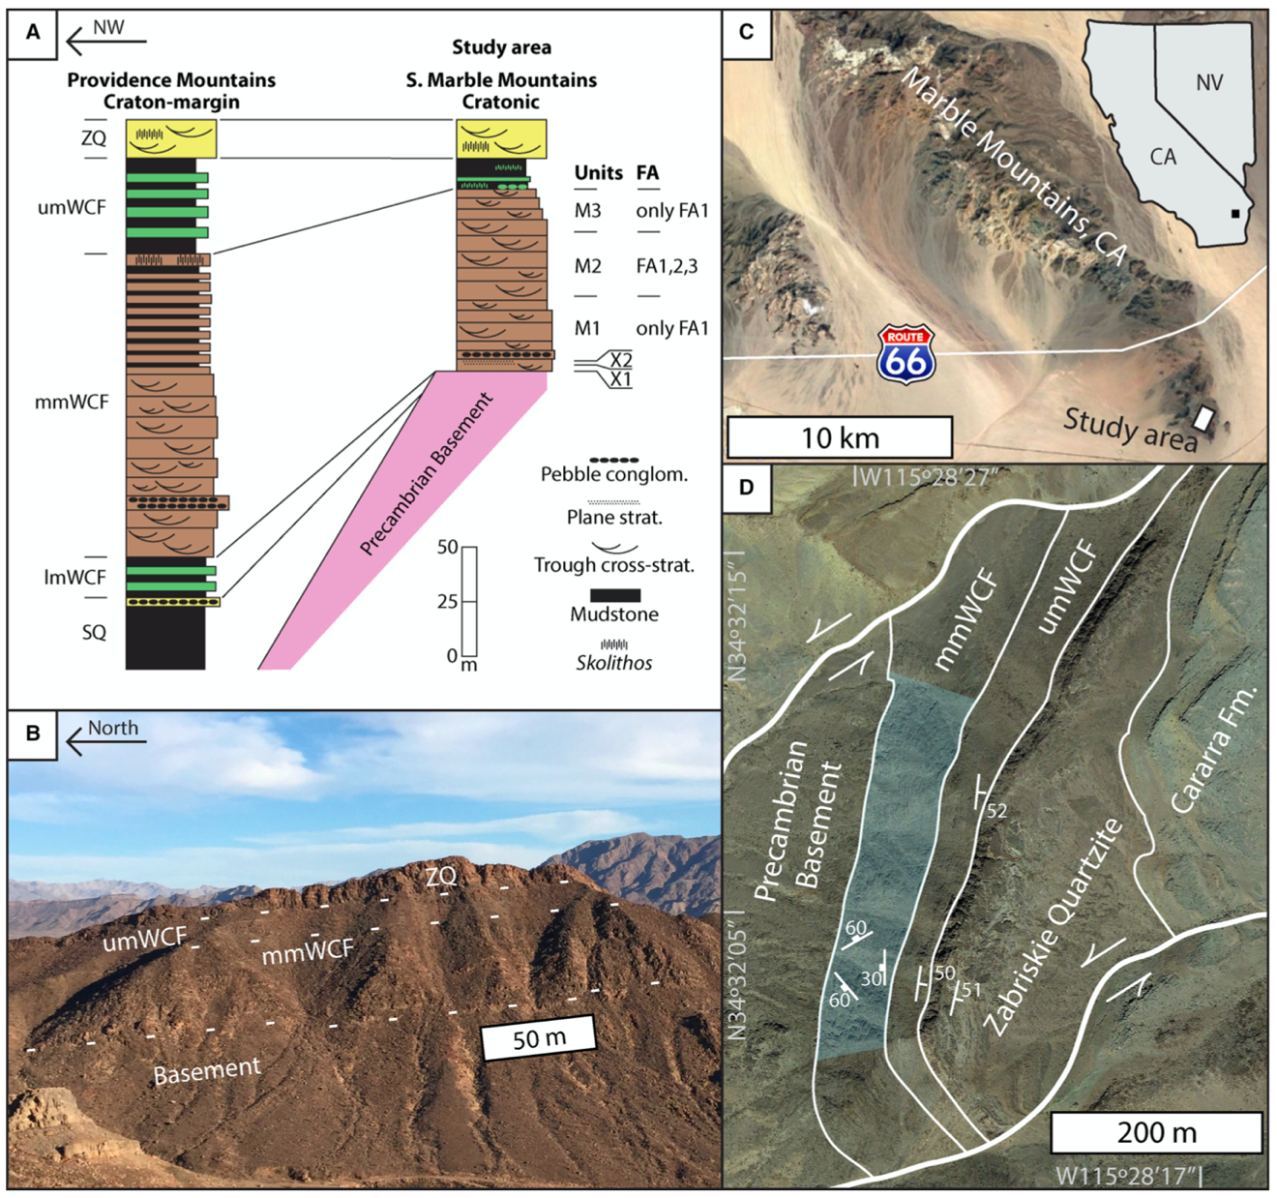
Figure 1.1: Images and stratigraphic context for the study locality. A) Stratigraphic columns of the southern Marble Mountains (Fedo and Cooper, 1990) and Providence Mountains (Fedo and Cooper, 2001) displaying the stratigraphic relationships between cratonic sections and those more basinward. The middle member Wood Canyon Formation lies nonconformably on bedrock in the study area. SQ – Stirling Quartzite; lmWCF, mmWCF, umWCF – lower, middle, and upper member Wood Canyon Formation; ZQ – Zabriskie Quartzite B) View of the well-exposed outcrop in the southern Marble Mountains, examined in this study. C) Location of the field area in the Marble Mountains, California (34.534421, -115.474391). D) Generalized geological map of the study area and surroundings, with strike and dip measurements on bedding planes and joint sets.

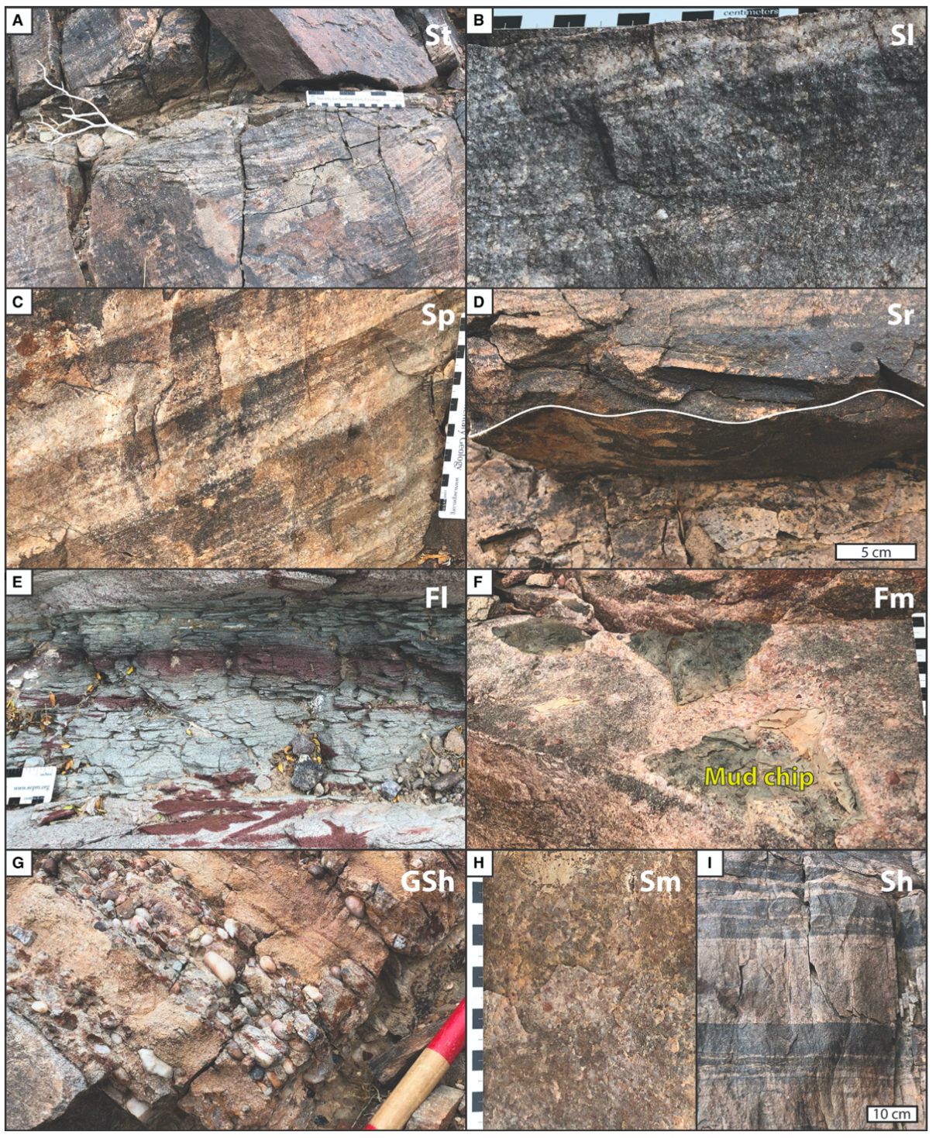
Figure 1.2: Lithofacies observed in the middle member, codes from Miall (1985) and Tucker (2003). Scale in cm unless otherwise noted. A) St – transverse exposure of trough cross-stratified sandstone, paleoflow toward viewer. B) Sl – close up of low-angle foresets in cross-stratification. C) Sp – tabular planar set of cross-stratification with distinctive banded foresets. D) Sr – ripple cross-lamination on bedding sole. E) Fl – laminated green and red siltstone horizon. F) Fm – massive mudstone as desiccation chips on a bedding top. G) GSh – basal conglomerate unit of the middle member displaying massive framework-supported pebble conglomerate with interbedded cross-stratified sandstone. White band on Jacob’s staff is 10 cm. H) Sm – massive sandstone near the base of the formation. I) Sh – horizontally stratified banded sandstone units.

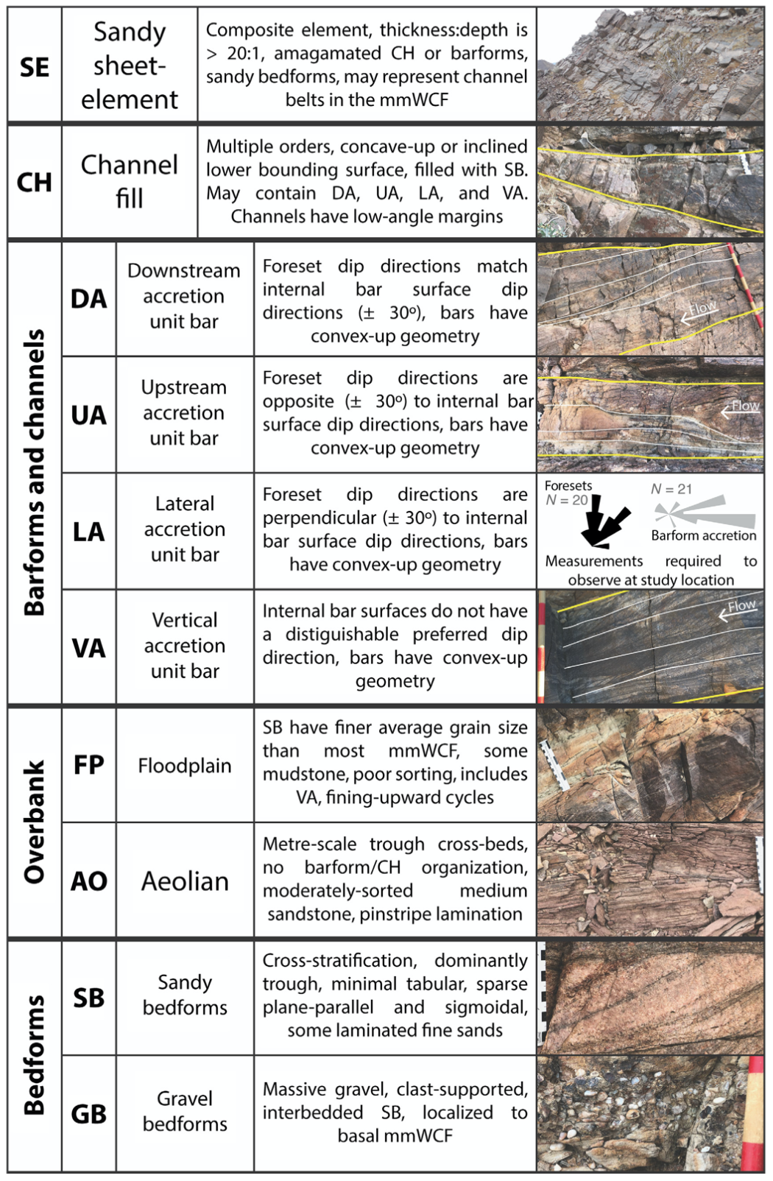
Figure 1.3: Architectural elements found in the middle member Wood Canyon Formation at the study area, with representative images. Elements from Miall (1985, 1996) and Long (2006, 2011), except VA, FP, and AO. Scale in cm, white band on Jacob’s staff is 10 cm.

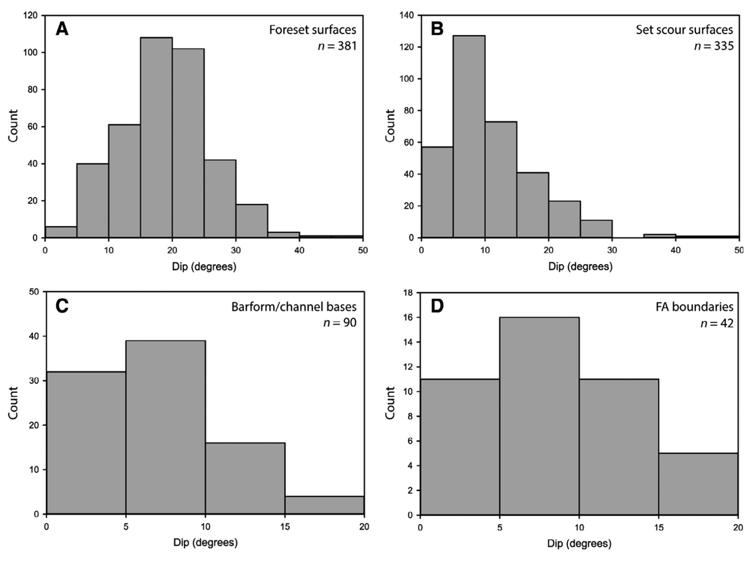
Figure 1.4: Histograms representing the distribution of original dip angle for each order of surface in the middle member (restored for tectonic tilt), including A) foresets, B) scour surfaces of cross-beds, C) Barform/channel fill bases, and D) Facies Association (FA) boundaries. All measurements are true dip, recorded on the outcrop using a geologic compass.

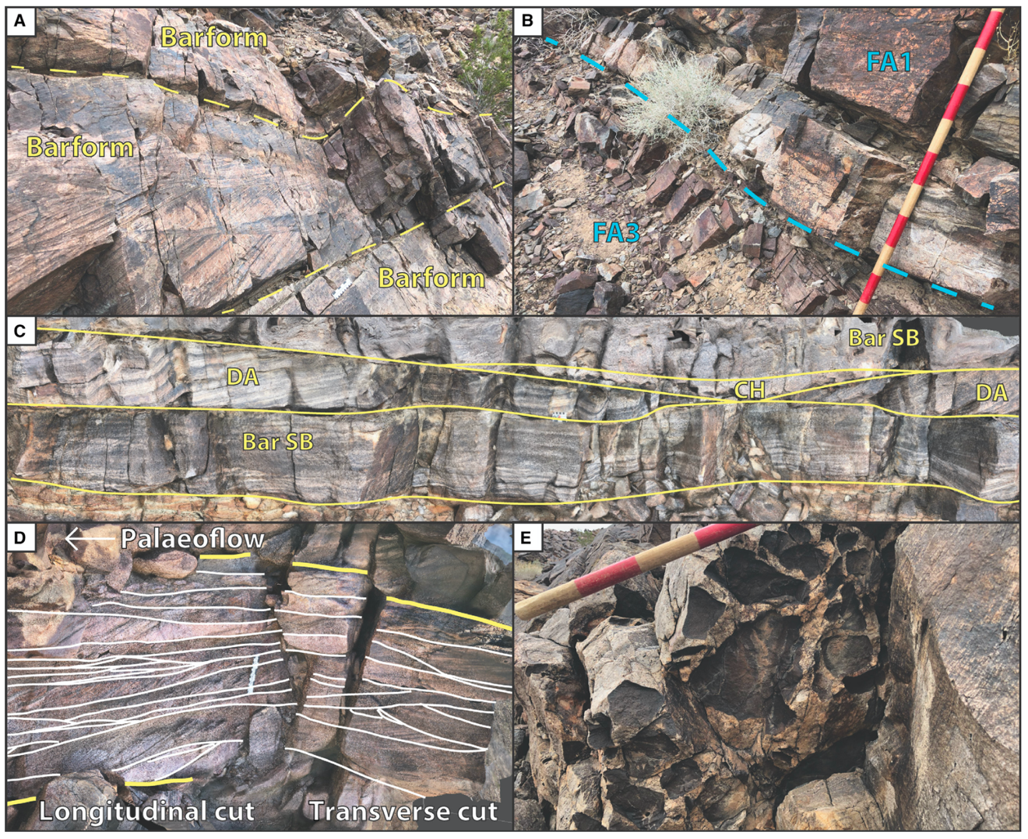
Figure 1.5: Images of large-scale strata and sedimentary features within FA1. Scale in cm, white band on Jacob’s staff is 10 cm. A) Meter-scale cosets of trough cross-stratification, interpreted as longitudinal cross sections of unit bars. B) Erosional scour of FA1 into a finer grained interval of FA3 below. C) Outcrop of FA1 displaying lateral terminations of convex-up cosets of sandy bedforms (SB), interpreted as downstream-accreting (DA) barform edges, and a concave-up coset, interpreted as a small channel fill (CH). Imbedded desiccation clasts line the bedding plane that forms the base of the CH element. D) Comparison of longitudinal and transverse cross-sections of trough cross-stratification (white lines) in a single coset (yellow lines). E) Bedding plane (viewed from below) lined with angular decimeter-scale desiccation clast impressions.

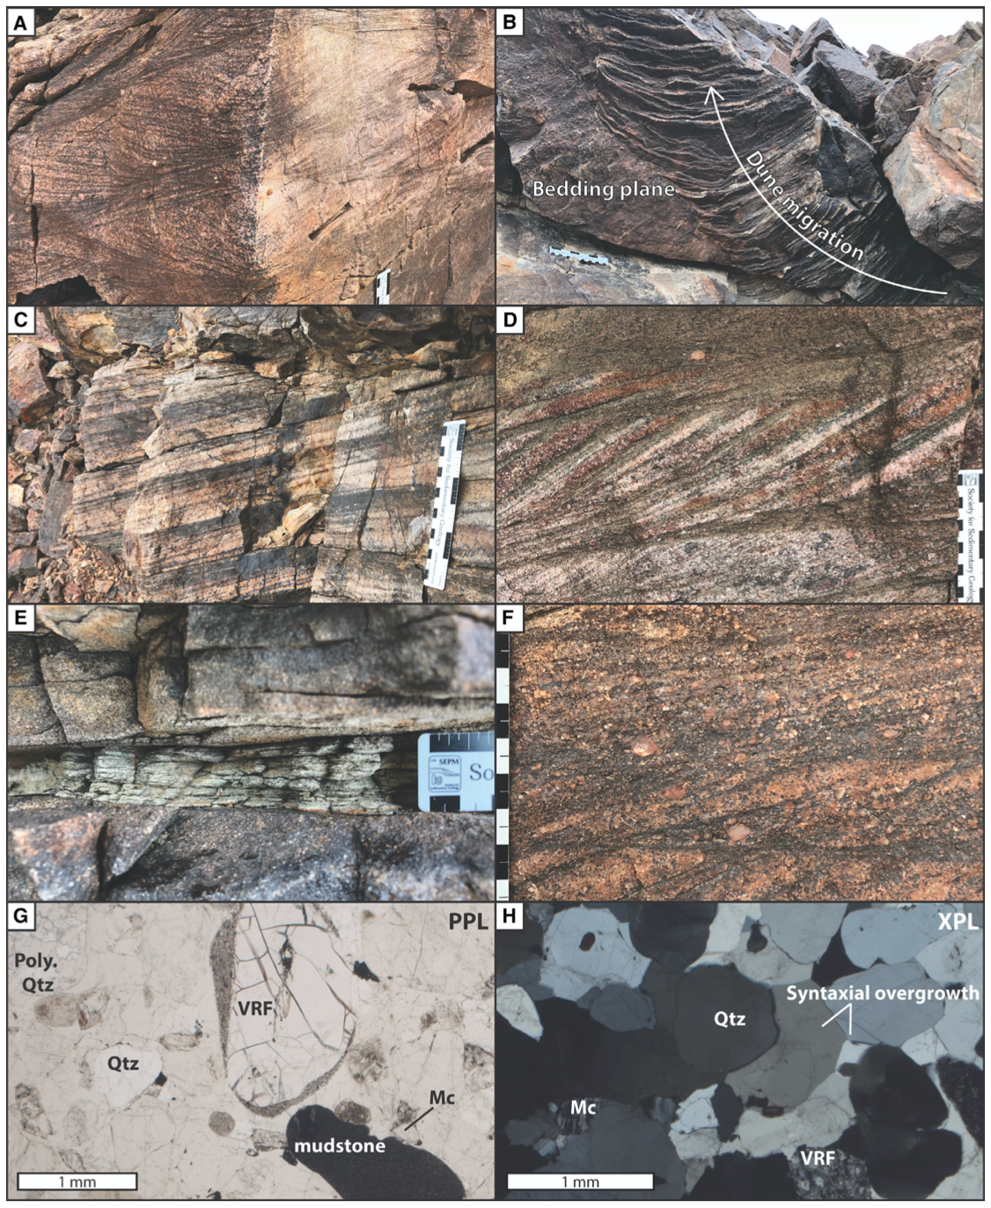
Figure 1.6: Images of fine-scale strata and sedimentary characteristics within FA1, including photomicrographs. Scale in cm unless otherwise noted. A) Decimeter-scale coset of trough cross-stratification, paleoflow toward viewer. B) Planform view of trough cross-stratification on a bedding plane formed by a lunate dune with changing direction of migration. C) Compound cross-stratification formed by dunes accreting in the downstream direction near the angle of repose. D) Sigmoidal foresets in a set of cross-stratification. E) Finely laminated interval of fine-grained sandstone and siltstone between two barforms. F) Characteristic texture of poorly sorted coarse-grained sand and granules in cm-scale FA1 cosets. G) Representative thin section (Sample MM517-1) of FA1 under plane-polarized light (PPL). Note the poor sorting, very coarse sand grains, abundant quartz (Qtz), microcline (Mc), large phenocryst in rhyolite (VRF), and well-rounded mudstone grain. H) Representative thin section (Sample MM517-12) of FA1 under cross-polarized light (XPL). Extensive syntaxial overgrowths on quartz filled a majority of the pore space in the sandstone.

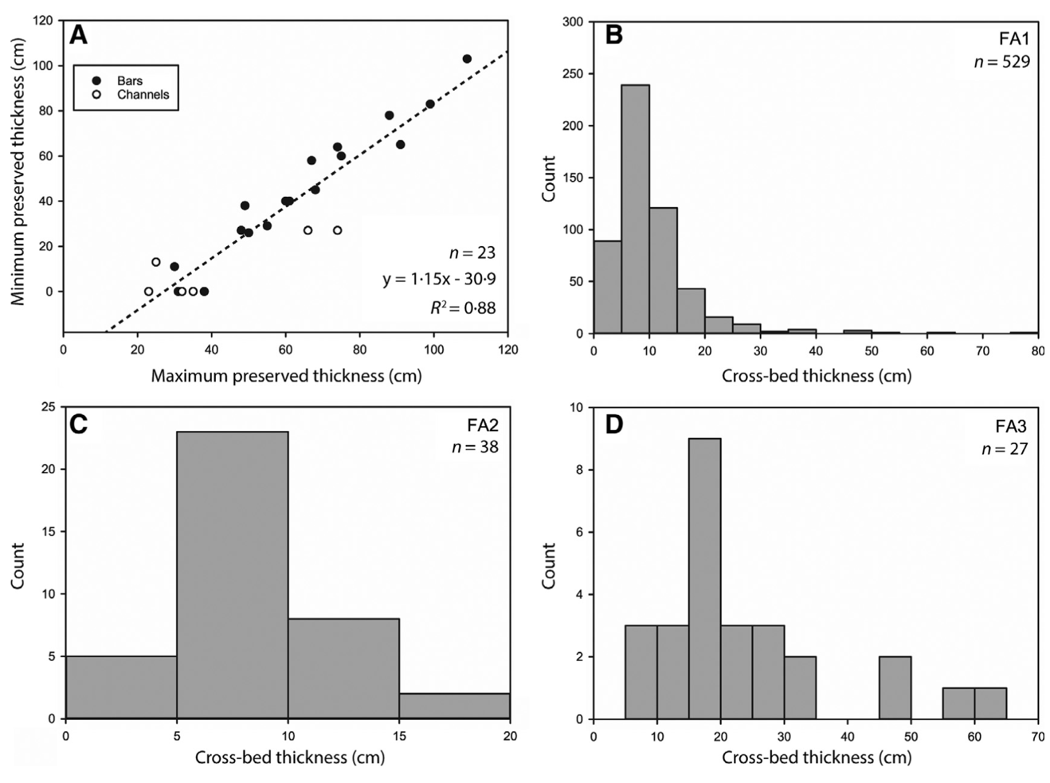
Figure 1.7: Thickness measurements of middle member architectural elements. A) Maximum and minimum preserved thicknesses of interpreted FA1 barforms and channel fills observed on stratigraphic panels. Maximum thicknesses range from 20-110 cm. Strong correlation suggests that most barforms will vary in thickness only ~10-30 cm when traced laterally. Histograms displaying the distribution of cross-set thicknesses in (B) FA1, (C) FA2, and (D) FA3 as measured from stratigraphic panels.

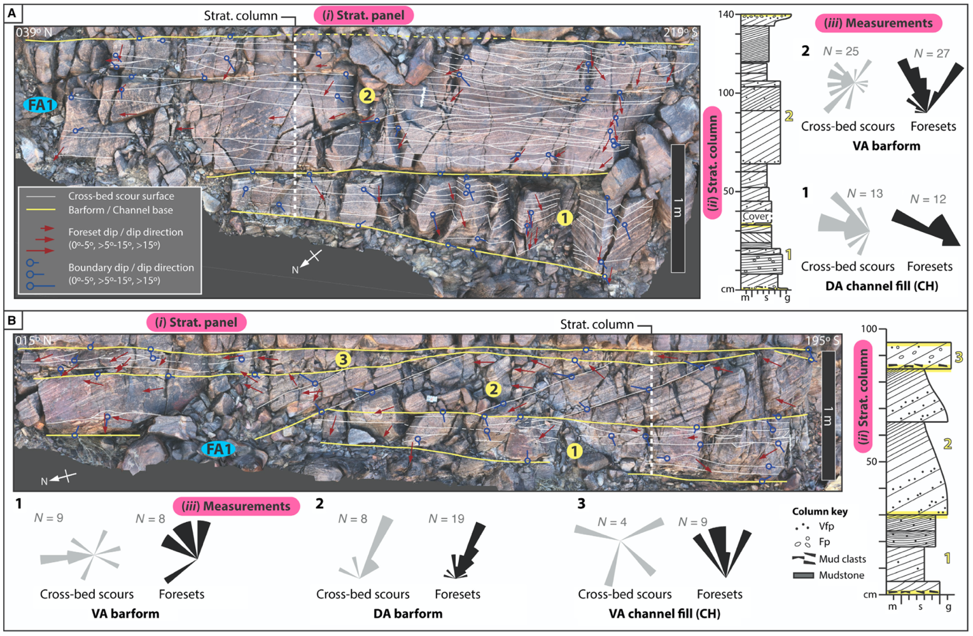
Figure 1.8: Facies Association 1 (FA1) locations (A) and (B) in unit M3 with stratigraphic panels (i) and corresponding stratigraphic columns (ii). Numbers in yellow circles on stratigraphic panels correspond to cosets (Cosets 1-2 on A, Cosets 1-3 on B), with matching yellow numbers labeling cosets on the stratigraphic columns. Interpretations are presented for each coset, based on displayed bounding surface orientations (iii). Restored measurements of dip direction on scour surfaces of cross-bedding displayed as gray rosettes, foresets displayed as black rosettes. Foreset dip directions approximate paleocurrent but may not represent a precise paleoflow, contingent on the measurement location relative to the trough axis of the three-dimensional dune. Panels are based on 3D outcrop models that are oriented with the primary face normal to the viewer.

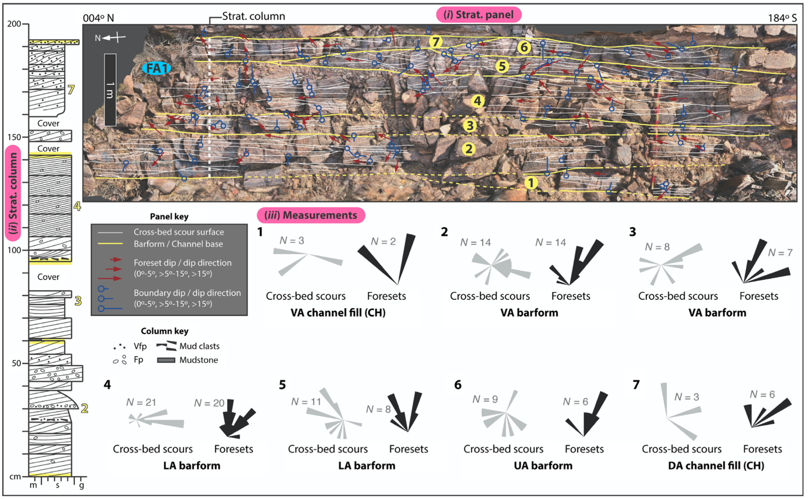
Figure 1.9: Stratigraphic panel (i) and corresponding stratigraphic column (ii) for FA1 in unit M1. Numbers in yellow circles correspond to Cosets 1-7, with matching yellow numbers labeling cosets on the stratigraphic column. Interpretations are presented for each coset, based on displayed bounding surface orientations (iii). Restored measurements of dip direction on scour surfaces of cross-bedding displayed as gray rosettes, foresets displayed as black rosettes. Foreset dip directions approximate paleocurrent but may not represent a precise paleoflow, contingent on the measurement location relative to the trough axis of the three-dimensional dune. Panel is based on a 3D outcrop model that is oriented with the primary face normal to the viewer.

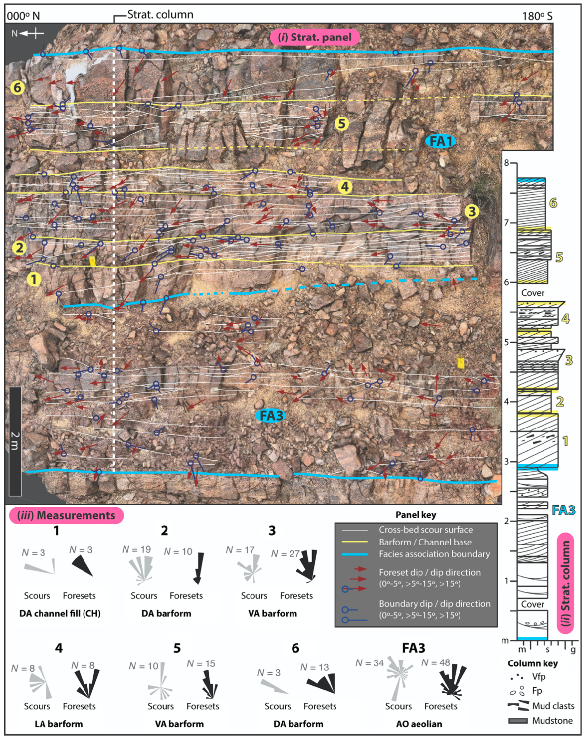
Figure 1.10: Stratigraphic panel (i) and corresponding stratigraphic column (ii) for FA1 and FA3 in unit M2. Numbers in yellow circles correspond to Cosets 1-6, with matching yellow numbers labeling cosets on the stratigraphic column. Cross-bedding in FA3 is labeled with a blue oval on the stratigraphic panel and in blue at the corresponding stratigraphic column location. Interpretations are presented for Cosets 1-6 and FA3, based on displayed bounding surface orientations (iii). Restored measurements of dip direction on scour surfaces of cross-bedding displayed as gray rosettes, foresets displayed as black rosettes. Foreset dip directions approximate paleocurrent but may not represent a precise paleoflow, contingent on the measurement location relative to the trough axis of the three-dimensional dune. Panel is based on a 3D outcrop model that is oriented with the primary face normal to the viewer.

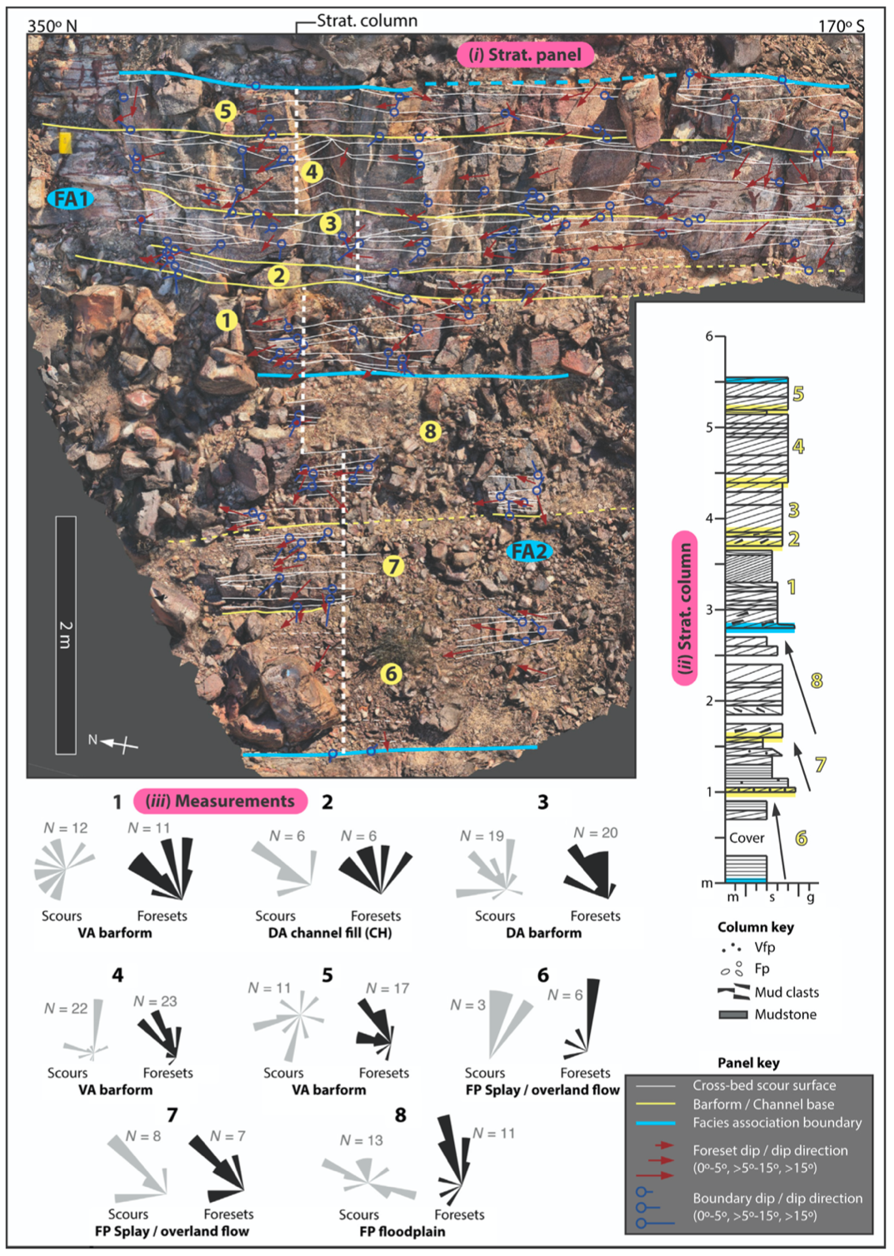
Figure 1.11: Stratigraphic panel (i) and corresponding stratigraphic column (ii) for FA1 and FA2 in unit M2. Numbers in yellow circles correspond to Cosets 1-5 of FA1 and 6-8 of FA2, with matching yellow numbers labeling cosets on the stratigraphic column. Interpretations are presented for Cosets 1-8, based on displayed bounding surface orientations (iii). Restored measurements of dip direction on scour surfaces of cross-bedding displayed as gray rosettes, foresets displayed as black rosettes. Foreset dip directions approximate paleocurrent but may not represent a precise paleoflow, contingent on the measurement location relative to the trough axis of the three-dimensional dune. Panel is based on a 3D outcrop model that is oriented with the primary face normal to the viewer.

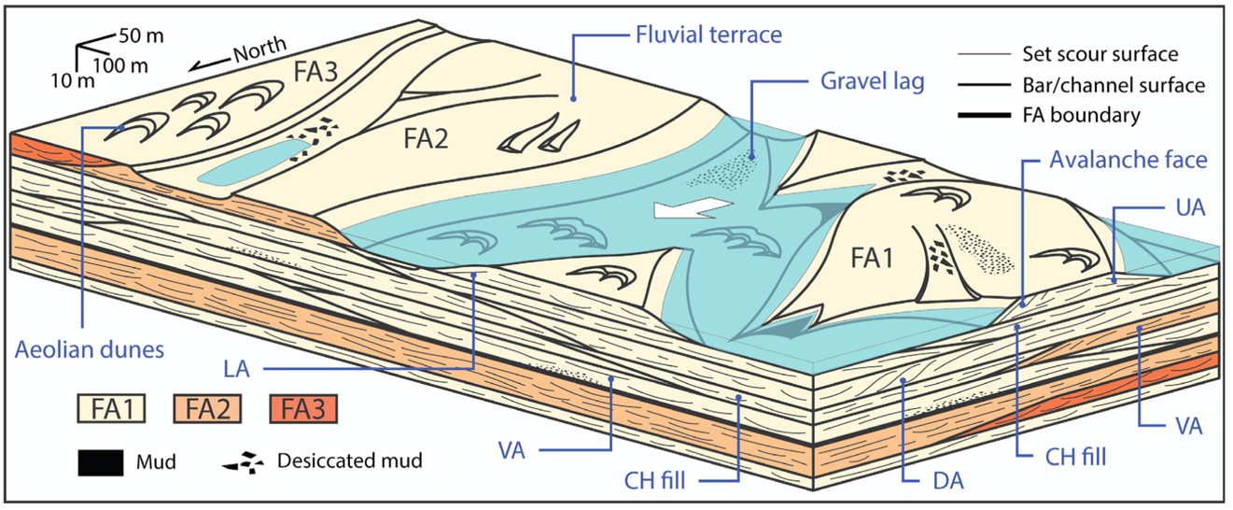
Figure 1.12: Block diagram of the middle member Wood Canyon Formation system at low discharge, including the subenvironments and representative features for each facies association (FA1-3). For architectural element abbreviations, see Figure 1.3. Approximate scale of diagram extent implied in top left.

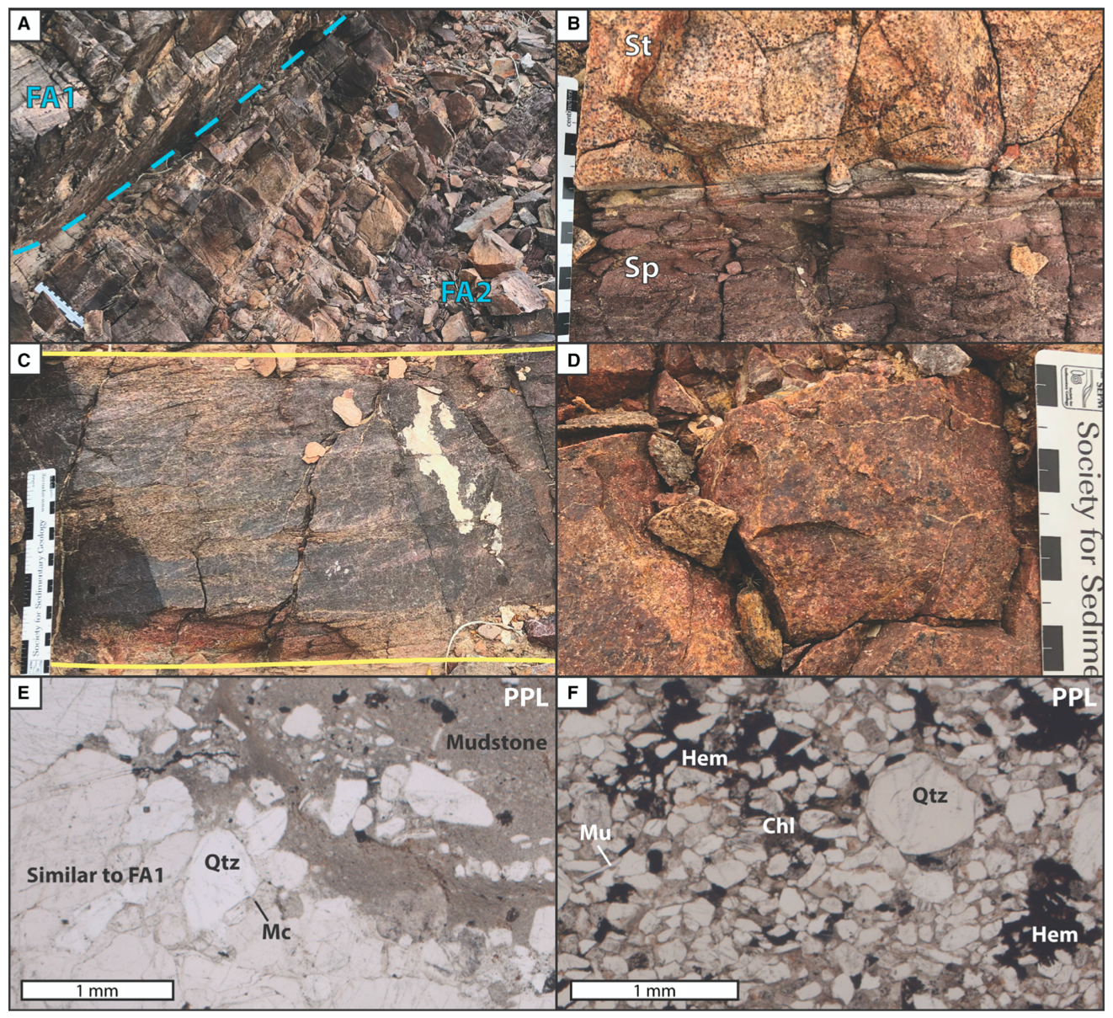
Figure 1.13: Images of FA2 strata and sedimentary characteristics. Scale in cm unless otherwise noted. A) Partially exposed interval of FA2 in sharp contact with FA1 above. Thinly bedded red-orange sandstone and low-relief weathering identifies FA2 in outcrop. B) Red plane-bedded (Sp) FA2 sandstone below, orange FA2 cross-bed (St) displays mottled appearance above. C) Coset of trough cross-stratification (St) in FA2, bounded by yellow lines, similar to FA1 in texture. Indicates the input of high energy traction flow in the FA2 subenvironment. D) Close-up view of FA2 sandstone in outcrop, with red coloration and mottled, crumbly appearance. E) Representative thin section (Sample MM517-5) of FA2 under plane-polarized light (PPL). At lower left, medium-to-coarse sand grains of quartz (Qtz) and feldspar (Mc) are cemented by syntaxial overgrowths of quartz, similar to FA1. In the top right, a layer of iron-rich mudstone and poorly sorted sand. F) Representative thin section (Sample MM517-8) of FA2 under plane-polarized light (PPL). Very poorly sorted texture with diagenetic chlorite (Chl), hematite (Hem), and detrital muscovite (Mu). Note iron-rich siltstone matrix and increased angularity of the finer grain-size fraction.

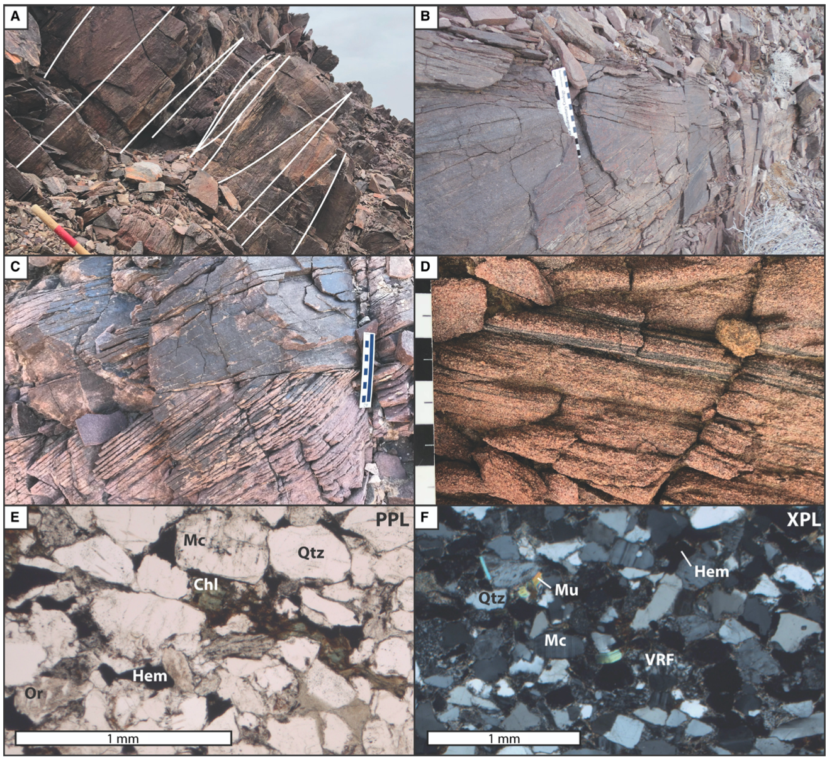
Figure 1.14: Images of FA3 strata and sedimentary characteristics. Scale in cm, white band on Jacob’s staff is 10 cm. A) Approximately 3-m-thick interval of FA3 that marks the base of unit M2, with blocky weathering, rusty red-brown coloration, and large-scale trough cross-beds traced with white lines. B) Finely laminated and high-angle foresets of FA3 dune, truncated above by another set of trough cross-stratification. C) Evenly spaced, high angle tangential foresets in medium-grained sandstone. D) Close view of FA3 sandstone with foresets delineated by accessory mineral concentration that resembles pinstripe lamination in aeolian sediments. E) Representative thin section (Sample MM517-19) of FA3 under plane-polarized light (PPL). Quartz (Qtz) and feldspar (Or, Mc) framework grains of angular-to-subrounded, moderately sorted, fine- to medium-grained sand. Chlorite (Chl) pseudomatrix and clay matrix occur. Hematite (Hem) present both as primary detrital and secondary minerals. F) Representative thin section (Sample MM517-19) of FA3 under cross-polarized light (XPL). Moderately sorted fine-grained sandstone, framework grains of quartz (Qtz), microcline (Mc), rhyolite (VRF), and detrital muscovite (Mu).

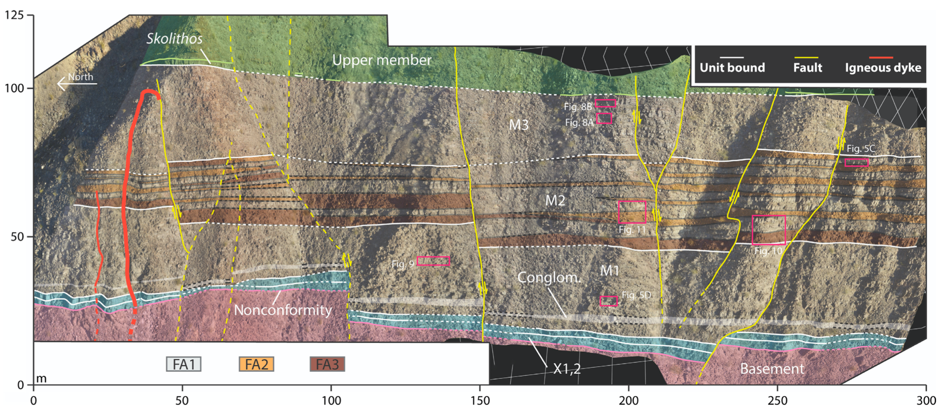
Figure 1.15: Facies association (FA1-3) mapping and delineation of depositional units (X1-2, M1-3) within the full outcrop of middle member Wood Canyon Formation surveyed in this study. Dashed lines are inferred. Panel is based on a 3D outcrop model, captured via sUAS, that is oriented with the primary face normal to the viewer. Pink boxes indicate the location and figure name of a more detailed stratigraphic panel presented herein.
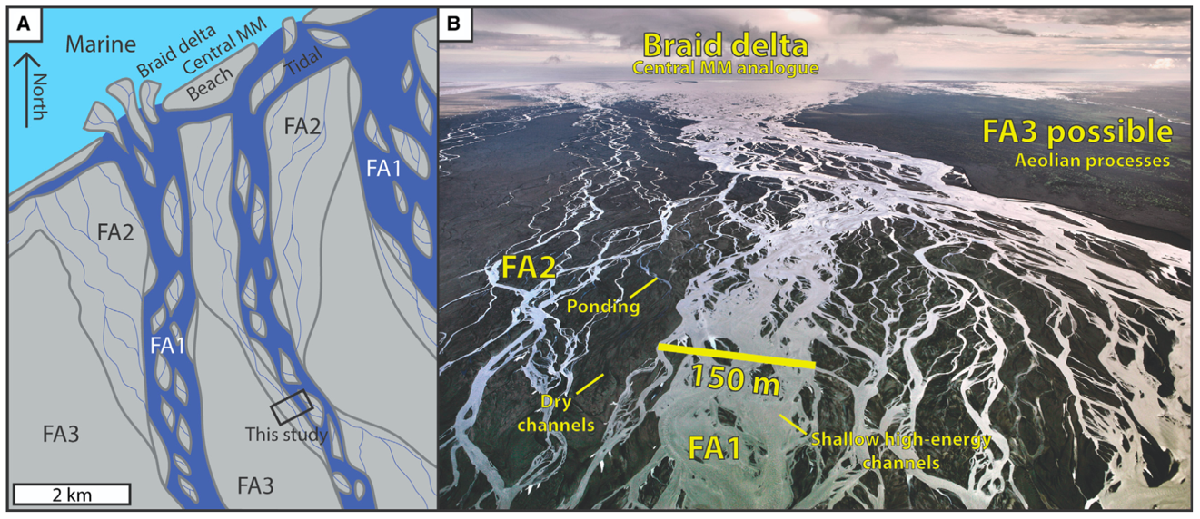
Figure 1.16: A) Hypothetical model of the larger system in which the studied strata were deposited; sediments in gray, water in blue. Corresponding facies associations (FA1-3) marked in each subenvironment. Scale modeled after modern braidplains, including the sandur plains of Iceland. Central Marble Mountains (MM), a site of future investigation, marked in the north of the diagram. B) Aerial view of Skeiðarársandur braidplain, Iceland, depicting subenvironent analogues for each facies association in a distal fluvial setting. Image courtesy of Phil Degginger, Degginger Photography.

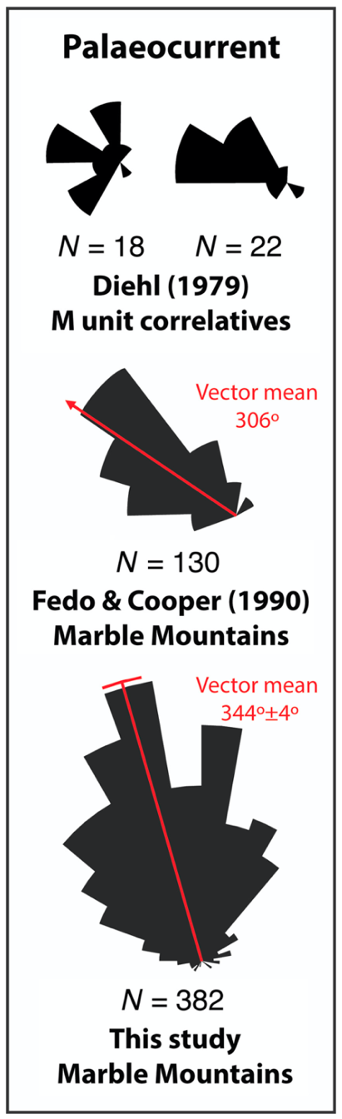
Figure 1.17: Middle member Wood Canyon Formation paleocurrent measurements from Diehl (1979), Fedo & Cooper (1990) collected in the study area, and this study recorded from stratigraphic panels. The new NNW paleocurrent data conflict with prior W–NW paleocurrent measurements.

CHAPTER II
Architecture of a fluvial-dominated, wave- and tidal-influenced, pre-vegetation braid delta: Cambrian middle member of the Wood Canyon Formation, southern Marble Mountains, California, USA
A version of this chapter was originally published by Jason G. Muhlbauer and Christopher M. Fedo:

Jason G. Muhlbauer and Christopher M. Fedo. “Architecture of a fluvial-dominated, wave- and tidal-influenced, pre-vegetation braid delta: Cambrian middle member of the Wood Canyon Formation, southern Marble Mountains, California, USA” Journal of Sedimentary Research (2020).

The following chapter is unmodified from the original peer-reviewed publication except regarding formatting changes. Christopher M. Fedo advised work on the project.

Abstract
Across the Mojave Desert of southeastern California, outcrops of the Cambrian middle member of the Wood Canyon Formation preserve the deposits of pre-vegetation braided-fluvial and braid-delta environments. One 78-meter-thick section in the southern Marble Mountains, documented here through detailed stratigraphic logging, facies analysis, architectural panels based on ‘Structure-from-Motion’ models, and a suite of paleocurrent and accretion-surface measurements, provides insight into the development of a fluvial-dominated, wave- and tidal-influenced braid delta at the distal end of a continent-scale braidplain. In contrast to other pre-Devonian braid-delta strata that are largely absent mudrock, the majority of the middle member system contains over 5% mudstone. Four facies associations, FA4-7, comprise the middle member section and represent (in order of stratigraphic height) a braidplain-to-delta transition (FA4), proximal braid delta (FA5), distal braid delta (FA6), and upper braid-delta front (FA7). The 20 meters of braidplain-to-delta transition strata are largely similar to those of fluvial middle member sections, containing approximately 2% mudstone, unimodal north-northwest paleoflow, and vertical, downstream, and downstream-lateral accretion elements representing compound barforms and channel-fills. Above, each braid-delta facies association (FA5-7) preserves high sinuosity paleocurrent indicators, 6–12% mudstone, and symmetrical, wave-formed sand waves. Decimeter-thick fluid-mud deposits found primarily in FA6 and less commonly in FA7 indicate the presence of a maximum turbidity zone that records brackish-water conditions in the distal braid delta. Trace fossils concentrated in FA7 suggest metazoans were confined the upper braid-delta front and could not tolerate the variable salinity of the braid delta. Increased marine influence with stratigraphic height requires gradual transgression during deposition of the middle member Wood Canyon Formation, possibly as part of a lowstand systems tract.

Introduction
Where braided rivers interface with base level, a braid delta forms, merging the depositional style of braided channels with marine or lacustrine processes. In modern river systems, braid-delta environments are common, but limited to arid and periglacial climates, or tectonically active areas with high rates of sediment supply. Each factor limits the establishment of rooting plant communities and allows for braided rivers to persist despite low slopes where vegetation typically stabilizes stream banks (Davies et al., 2011; McMahon and Davies, 2018). Ancient pre-Devonian systems, deposited before the emergence of channel-confining vascular land plants (Gibling et al., 2014; Friedman, 2017), consisted of relatively unconfined braidplains (e.g., Cotter, 1978; Eriksson et al., 1998; Long, 2011) that commonly reached the coastline (Eriksson et al. 1998), developing in a clastic fringe of adjacent braid deltas. Consequently, although “common delta” today refers to the delta of a meandering river, braid deltas were for the majority of Earth history the most abundant variety.

McPherson et al. (1987) introduced the term “braid delta,” proposed alongside a continuum with common deltas and (alluvial) fan deltas. Discussion with modification came afterword in Nemec and Steel (1988), with few studies completed on the environment since, compared to their common- and fan-delta counterparts. Nevertheless, several papers documenting units of Precambrian or Phanerozoic age include the term. A review of Precambrian clastic systems by Eriksson et al. (1998) includes braid deltas and suggests that such systems were common at the terminus of continental-scale braidplain systems. Case studies that either directly or indirectly observe braid deltas in the rock record include Hereford (1977), Fedo and Cooper (1990), Soegaard (1990), Schreiber and Eriksson (1992); DiBona and von der Borch 1993; Eriksson et al. (1995; 2006), MacNaughton et al. (1997), Fedo and Cooper (2001), Zhu et al. (2017), Levell et al. (2019), and Went (2019), and in the modern, McGowan and Sturman (1997) and Hart (2007). Tidal processes are regularly associated with the transition from braided fluvial to braid delta in the sedimentary record (e.g., Bradley et al., 2018), at odds with the rarity of braided-tidal systems today, as a result of steep slopes that prevent channel stabilization (Dalrymple and Choi, 2007). Despite the importance of such systems in the past, a full depositional model has not been developed, and sedimentology texts and depositional environment compilations overlook braid deltas. Detailed studies, when conducted, document important information about the processes and evolution of distal braided rivers and their terminal deltas, determine criteria to distinguish them from fan deltas and other marginal-marine environments, and provide datasets that are the basis for building a braid-delta facies model.

The present study includes stratigraphic architecture results for a section of the middle member of the Cambrian Wood Canyon Formation (Mojave Desert, California, USA) previously interpreted as a braid-delta deposit by Fedo and Cooper (1990). Primary goals of this study include: (1) classify the lithofacies and architectural elements of a proposed braid-delta environment, (2) distinguish fluvial sedimentary features from those that may be marine in origin, (3) develop a depositional model for the middle member Wood Canyon Formation beyond the first-order findings of Fedo and Cooper (1990) at the selected site, and (4) assess habitability potential of the braid-delta environment. The braid-delta strata represent a down-dip continuation of nearby, coeval, braidplain strata of the middle member (Muhlbauer et al., 2020). Together, the two locations capture the lateral extent of a distal fluvial system where it intersected the ancient coastline. Pairing Muhlbauer et al. (2020) with the results presented here provides the opportunity to investigate what detailed facies-level changes occur when a pre-vegetation fluvial system is modified by marine processes. Because the strata of the feeding braidplain preserve no distinguishable body/trace fossils, the search for evidence of habitable conditions must shift toward the connected transitional-marine realm.

Geologic Setting
Cropping out across the southern Great Basin of California, Nevada, and Arizona, the Wood Canyon Formation is a subarkosic sandstone deposited along the Cambrian margin of Laurentia in response to rifting or Rodinia (Stewart, 1970; Fedo and Cooper, 2001; Schoenborn et al., 2012; Muhlbauer et al., 2017). Three members comprise the formation (Fig. 2.1A; Stewart, 1966; Diehl, 1979; Fedo and Cooper, 2001): a marine-shelf lower member that preserves the Ediacaran-Cambrian boundary in a number of localities (Corsetti and Hagadorn, 2000), a fluvial-to-deltaic middle member, and a marine-shelf upper member that belongs to Cambrian Series 2 (Hollingsworth, 2005). Thus, biostratigraphic correlation of the Fallotopsis biozone (Mata et al., 2012; Peng et al., 2012) constrains the deposition of the middle member Wood Canyon Formation to the Terreneuvian (541-521 Ma), predominantly within Stage 2 (529-521 Ma). A vast braidplain, capable of transporting clastic sediment for hundreds to more than one thousand kilometers (Fedo and Prave, 1991; Hogan et al., 2011; Schoenborn and Fedo, 2011; Schoenborn et al., 2012; Muhlbauer et al., 2017), provided detritus that initially prograded across the craton-margin hinge zone following northwest (present day) paleoslope (Fedo and Cooper, 2001; Hogan et al., 2011) to build the middle member. As a result of differential post-rift subsidence and loading (Stewart, 1970; Cooper and Fedo, 1993; Fedo and Cooper, 2001), sections furthest northwest into the basin are thickest and most complete. Cratonic sections (Cooper and Fedo, 1993) thin significantly, with the lower member absent and the middle member lying nonconformable over 1.4 Ga granitic bedrock (Fig. 2.1A; Anderson and Bender, 1989; Farmer and Ball, 1997; Wooden et al., 2013).

A sequence stratigraphic framework by Fedo and Cooper (2001) presented the middle member Wood Canyon Formation as part of a transgressive systems tract (TST). Hogan et al. (2011) reinterpreted the middle member as falling stage (FSST) progressing to lowstand (LST) systems tract progradation under normal regression, placing it early within the Sauk Supersequence, but not at its base. Craton-hinge and off-craton sections, where the Wood Canyon Formation and subjacent units are thickest, heavily influenced sequence stratigraphic interpretations. Systems tract boundaries merge onto the craton compressing or eliminating stratigraphic units such that the middle member was deposited directly on a paleosol developed on Proterozoic granitic and gneissic bedrock (Anderson and Bender, 1989; Wooden and Miller, 1990) of the Mojave Province (Bennett and DePaolo, 1987). Given this relationship, there is a distinct likelihood that middle member deposition on the craton began during the LST, and only preserves the uppermost strata of basinward counterparts.

Near continental margins, an array of depositional environments and subenvironments interfinger across lateral distances of meter-to-kilometer scale; in the right conditions, such an array may produce comparable sedimentary sequences leading to difficulty in their interpretation. Unsurprisingly, much discussion over a marine (Stewart, 1970; deVries Klein, 1975; Foster, 1991) or fluvial (Diehl, 1979; Fedo and Cooper, 1990; 1991) origin for the middle member has occurred through time, resulting in a need to evaluate paleoenvironments at each exposure in order to refine the depositional history of the unit. The most recent interpretation of the rocks studied here (Section N66; Fig. 2.1B), by Fedo and Cooper (1990), suggested that the lowest 5–6 m of strata represent the products of a proximal braid delta, followed by 11 m of tidal flat, and finally capped by ~75 m of distal braid delta.

In a stratigraphically up-dip direction 8 km to the south, facies and architectural analysis of the middle member by Muhlbauer et al. (2020; Section S66; Fig. 2.1B), revealed a distal, perennial, braided-fluvial system with no influence from marine deposition. Three facies associations were developed by mapping 80 meters of stratigraphic section exposed for 300 meters along-strike. Stacked, coarse-grained, cross-stratified, sandstone cosets in Facies Association 1 (FA1) are interpreted as the deposits of barforms in shallow channels with unimodal north-northwest paleoflow. Facies Associations 2 (FA2) and 3 (FA3) occur as comparatively thin, discontinuous intervals interbedded within FA1. The thinly bedded, fine- to medium-grained sandstone of FA2 is hematite-rich, likely deposited by flood-related overbank splay or overland flow on fluvial terraces. Meter-scale trough cross-beds in rare FA3 deposits resemble localized aeolian dunes, representing windblown sediments winnowed from the alluvial plain. Mudstone is nearly absent from each facies association, with polygonal desiccation-chip horizons comprising the bulk of the clay content. Several factors imply that this pre-vegetation braidplain experienced perennial streamflow, including incremental compound-bar construction with reactivation surfaces and minimal evidence for upper flow-regime structures (Fielding et al., 2018). Despite the distal-fluvial setting, no marine trace fossils are found within the middle member at this location. Thus, given the proximity to the braid-delta strata of Section N66, significant variation in depositional environment is preserved nearing the Cambrian coastline.

North of State Route 66 in the steep-sided southern Marble Mountains, southeastern California, Section N66 of the Wood Canyon Formation crops out in a series of low hills and escarpments (Figs. 2.1B, 2.2A). Relatively undeformed areas between large sinestral slip-strike faults tilt 50–55º to the east. One such fault-bounded block defines the study area mapped in Figure 2.2B, ensuring that a stratigraphic column (Fig. 2.3) could be measured confidently and utilized during fieldwork. Wood Canyon Formation strata are exposed in entirety, from the nonconformity with bedrock, through the middle and upper members, to the contact with the overlying Zabriskie Quartzite (Prave, 1991). Talus cover limits the visible outcrop area of the basal contact and overlying ~20 meters of sandstone compared to the rest of the middle member. Small slip-strike faults with sub-meter offset crosscut the area. Two primary sets of fractures, oriented approximately 070º/65ºNW and 310º/60ºNE, form faces normal to bedding (Appendix A-4). Joint sets are also near-parallel or near-perpendicular to paleoslope, providing beneficial longitudinal and transverse cross sections of fluvial features. Lithologic observations and the general stratigraphic column presented in Fedo and Cooper (1990) provide context for renewed high-detail study of the site. Work conducted for Muhlbauer et al. (2020) allows for comparative architectural analysis between Sections N66 and S66.

Methods
Pairing extensive bounding-surface tracing with 3D digital outcrop models (DOM; e.g., Ghinassi and Ielpi, 2018, Muhlbauer et al., 2020), entirely while in the field, allows the creation of high-detail architecture panels that most accurately reflect the strata. Generated by processing images collected with a handheld camera through Structure-from-Motion (Fabuel-Perez et al., 2009; Clapuyt et al., 2016; Chesley et al., 2017) software package Agisoft™ Metashape (Agisoft LLC, St. Petersburg, Russia), DOMs provide sub-cm spatial resolution for meter-scale exposures. Creating stratigraphic panels required extensive field-based tracing of bounding surfaces, collection of thousands of paleocurrent and bounding surface orientations with a geologic compass, documentation of lithofacies, grain size, and sedimentary structures, measurement of the face orientation of the panel, and correction for local tectonic tilt via stereonet. The average orientation of planar beds of mudstone found across the site determined that the strike and dip of the Marble Mountains is 50º to 55º to the east depending on the location in the field area (Appendix A-4). A DJI Mavic 2 Pro (DJI, Shenzhen, China) small unmanned aircraft system (sUAS) conducted additional reconnaissance of the field area. Images from this platform facilitated construction of a 3D basemap (Fig. 2.2B) for the field area using Agisoft™ Metashape and provided rapid assessment of ideal locations for detailed stratigraphic panels.

Facies Associations
A stratigraphic column (Fig. 2.3), detailed architectural panels, and field observation recognized four facies associations, FA4–7, in Section N66 of the middle member Wood Canyon Formation (Fig. 2.2). Muhlbauer et al. (2020) previously described FA1–3 at Section S66 (Fig. 2.1). The stratigraphic column (83 m thick) was measured bed-by-bed in centimeter increments, ensuring the documentation of fine-scale sedimentary structures and thin mudstone beds. Stratigraphic logging marked a sharp break in slope at 78 m (Fig. 2.3), where dark colored-sandstone and increased mudstone abundance mark the onset of the upper member Wood Canyon Formation. Images of each lithofacies identified in the study area are provided in Figure 2.4. Tables 2.1 and 2.2 provide further definitions of the lithofacies and architectural elements discussed herein, respectively.

Description: Facies Association 4 (FA4)
Comprising the lowermost unit in the study area, FA4 represents the first 20 meters of the middle member above the basement nonconformity (Fig. 2.3; Table 2.3). Multistory, brown, gray, or white beds of sandstone are primarily parallel-bedded and show convex or concave geometries where terminations are located. Cosets of cross-stratified, coarse-grained subarkose (Fig. 2.5A, B), occur bounded by planar or low-amplitude sinuous surfaces (Fig. 2.5B) and are between 20–60 cm (n=34) in thickness for over 50% of examples (Table 2.3). Paleocurrent indicators observed in cross-beds are uniformly north-northwest directed. Trough cross-stratification (St; Figs. 2.4A, 2.5A), tabular cross-stratification (Sp; Fig. 2.4B) and low-angle cross-stratification (Sl; Fig. 2.4C) are most abundant (Table 2.1), minor lithofacies include crudely bedded sandstone (Sm; Fig. 2.4F), crudely bedded conglomerate (Gm; Fig. 2.4G), horizontal-bedded conglomerate (Gh; Fig. 2.4H), and trough cross-bedded conglomerate (Gt; Fig. 2.4I). Approximately 2% of the facies association is mudstone (Fl and Fm; Fig. 2.4J), predominantly siltstone, present between cosets and along set boundaries (Fig. 2.5B, C; Table 2.3). Mudstone layers are discontinuous and range from millimeter-scale veneers (Fig. 2.5B, C) to beds 5 cm in thickness. Between cosets, laminated beds of very fine- to fine-grained sandstone (Table 2.3), less than 5 cm in thickness, appear similar in outcrop appearance to mudstones because of desert varnish. Polygonal “bowtie-shaped” mudstone intraclasts were deposited within cross-beds (Fig. 2.5D), gravel layers, and along coset-bounding surfaces. Millimeter-scale layers of conglomerate, commonly single-clast-thick, line the soles and tops of cosets (Fig. 2.5C; Table 2.3), or comprise cross-sets. Because of the co-location of mudstone and gravel between sandstone cosets (Fig. 2.5C), the two lithologies may be paired by process, positioning mudstone lenses between layers of conglomerate in some examples.

Thin section photomicrographs (Fig. 2.5E, F) of FA4 samples confirm the characterizations from the stratigraphic column (Fig. 2.3) and provide additional details. Modal mineralogy of sandstone is similar to that previously reported for the Wood Canyon Formation (Fedo and Cooper 1990), including abundant quartz (monocrystalline and polycrystalline), microcline, and orthoclase, with microcrystalline quartz, rhyolite volcanic rock fragments, magnetite, and muscovite (Fig. 2.5E, F). Patchy hematite and epidote formed as epigenetic minerals. Coarse- to very coarse-grained sandstones are commonly cemented with syntaxial quartz overgrowths (Fig. 2.5E) that preserve original grain boundaries. Clay minerals are present as matrix in poorly sorted sandstones (Fig. 2.5F), especially those with framework grain sizes between very fine- and medium-grained sand. Some samples contain up to 10% clay-mineral matrix. Centimeter-scale mudstone layers are normal-graded siltstone, with clays and interbedded very-fine sandstone.

Architecture
Figure 2.6A and B, a representative architectural panel of FA4 oriented longitudinal to paleoslope, illustrates cosets with abundant trough cross-stratification (St) and tabular cross-stratification (Sp) in sandstone. Minor lithofacies components include mudstone (Fl), crudely bedded sandstone (Sm), crudely bedded conglomerate (Gm), horizontal-bedded conglomerate (Gh), and trough cross-bedded conglomerate (Gt). The sandstone and conglomerate lithofacies form sandy bedform (SB) and minor gravel bedform (GB) architectural elements (Table 2.2) that comprise each coset. Coset boundaries are marked by the presence of thin, discontinuous mudstone layers, angular mudstone clasts, and Sm, Gm, Gh, and Gt lithofacies (Fig. 2.4; Table 2.1). Each coset-bounding surface exhibits a low-amplitude wavy appearance. Paleocurrent measurements for all sets (Fig. 2.6C) are unimodal and consistently to the north-northwest, at an average of 329º (n=77). Rosettes illustrate that cosets in areas 2 and 3 (Fig. 2.6B, C) have no systematic orientation of set dip-directions, a characteristic of vertical accretion (VA; Table 2.2). Cross-sets of areas 4–8 (Fig. 2.6B, C), each part of a single coset, are alternating intervals of Sp and St, with steeply inclined set boundaries, downlapping foresets, and at least one inclined mudstone bed between sets. Paleoflow orientations of the tabular cross-beds (areas 5, 7; Fig. 2.6B, C) are northward, parallel to the accretion direction of the sets, defining a downstream accretion (DA) element (Table 2.2). Trough cross-stratified sets (area 6), layered between the tabular sets (Fig. 2.6B), have northwest foreset dip-directions (Fig. 2.6C) that suggest paleocurrent at an oblique angle to overall DA element migration, indicating downstream-lateral accretion (DLA; Table 2.2) and a change in current direction across the accretion face. Trough cross-beds in areas 4 and 8 (Fig. 2.6B, C) have no systematic orientation to set dip-directions, preserving VA alongside the DA element (Table 2.2) in a compound barform.

Description: Facies Association 5 (FA5)
Distinct facies and architecture over an interval of 20–38 meters, as measured on the stratigraphic column (Fig. 2.3), encompass FA5 (Table 2.3). The majority of sandstone cosets are parallel bedded, but wedge-shaped and convex geometries also occur. A wide sweep of paleocurrent orientations, from west to east, diverges up to ~90º from the inferred direction of paleoslope. Approximately 50% of cosets fall between 20–60 cm (n=28) in thickness (Table 2.3). Brown coloration is most common in outcrop, although white-colored units of coarse-grained sandstone represent approximately 25% of the facies association strata (Fig. 2.7A; Table 2.3). Sandstone lithofacies (Fig. 2.4; Table 2.1) are dominated by trough (St) and low-angle (Sl) cross-bedding, with planar cross-bedding (Sp), ripple cross-lamination (Sr), planar-bedding (Sh), and rare crudely-bedded sandstone (Sm). Ripple cross lamination (Fig. 2.4D) appears in association with horizontal-bedded (Sh), fine- to medium-grained sandstones (Fig. 2.7B), but ripple marks are nearly absent from bedding tops. Possible symmetrical sand waves with ~5 cm amplitudes occur draped by mudstone or fine-grained sandstone. Mudstone (Fl and Fm) comprises 6% of FA5 (Table 2.3) as mm-thick veneers and wedge-shaped to laterally continuous beds typically 3–10 cm in thickness (Fig. 2.7C). A mud-veneered sandstone surface with desiccation cracks (Fig. 2.7D) intersects the stratigraphic column (Fig. 2.3) at 34 m and potentially extends for 150 m along strike. Polygonal “bowtie-shaped” (Fig. 2.5D) and smaller, rounded mud clasts are found throughout FA5, either within sets of cross-stratification or along coset-bounding surfaces. Uncommon, very fine- to fine- pebble conglomerate (Gh) lines the soles and tops of several cosets (Table 2.3).

Thin-section photomicrographs from FA5 samples provide further insight into the sandstone and mudstone beds of the interval (Fig. 2.7E, F). Rounded to well rounded, poorly sorted, subarkosic sandstones form the framework-grain mineralogy of the middle member (Fedo and Cooper, 1990), with approximately 10% clay matrix (Fig. 2.7E). Grain-size details of each thin, black-colored bed (Fig. 2.7C) are difficult to assess on the outcrop because of ubiquitous desert varnish. Thin-section analysis of representative samples reveals a range of grain sizes, from clay to medium-grained sand (Fig. 2.7E), that form the dark-varnished beds. Mudstones are silty, with interbedded fine sand. The dark color of the layers is owed to patchy, diagenetic iron oxide and magnetite growth in matrix (Fig. 2.7E). White-colored sets are moderately sorted and coarse-grained sandstone, with negligible matrix and pervasive syntaxial quartz cement (Fig. 2.7F).

Architecture
Strata of FA5 in Figure 2.8A and B, approximately 30 meters above the nonconformity, comprise a stratigraphic panel oriented transverse to paleoslope. Planar or wedge-shaped cosets contain sandy bedforms (SB; Table 2.2) and are bounded by sharp erosional surfaces, mudstone veneers (Fm), or cm-thick siltstone layers (Fl). Cosets of trough cross-stratification (St) are common, but not dominant; low-angle cross-bedding (Sl; Fig. 2.8B; areas 2, 3, 5, 6, 10) occurs in equal proportion. Paleocurrent results for low-angle cross-beds (Fig. 2.8C) are inconclusive, as the measurements are strongly affected by tectonic tilt estimates and foresets are obscured by desert varnish. Trough cross-sets have both east (area 4) and west (areas 7, 8) paleoflow directions (Fig. 2.8B, C), with no systematic orientation of set boundaries, defining vertical accretion (VA) elements (Table 2.2). At the base of the panel (Fig. 2.8B; area 1), a horizontally stratified (Sh) bed of fine- to medium-grained sandstone preserves millimeter-scale interlayers of smeared-out ripple cross-lamination (Sr; Fig. 2.7B). A meter-thick set of white, coarse-grained sandstone with several tangential foresets and abundant cm-scale mudstone intraclasts (Fig. 2.8B, C; area 9) may represent an eastward moving DA element, but internal surfaces are too limited to make a definitive assessment. Featureless, massive sandstone (Sm) floors the base of the area 5 coset (Figs. 2.4F, 2.8B). Planar mudstone units (Fig. 2.8B; below areas 3, 4, 7, 8) appear alongside those with sinuous, load-deformed, bounding surfaces (below area 10). Beneath area 9 (Fig. 2.8B), a concave-up unit of Fl comprises a channel-fill element (CH; Table 2.2) that is 20 cm in thickness and floored with ripple marks.

Description: Facies Association 6 (FA6)
Lithofacies diversity is highest within FA6, which crops out between meters 38–60 on the stratigraphic column (Figs. 2.3, 2.9; Table 2.3). Parallel-bedded, wedge-shaped, and convex cosets of sandstone are between 20–60 cm (n=35) in thickness in 55% of measured examples (Table 2.3). Prominent sandstone lithofacies (Fig. 2.4; Table 2.1) are trough (St) and tabular (Sp) cross-bedding, with secondary low-angle cross-bedding (Sl), planar bedding (Sh), and crudely bedded intervals (Sm). White, coarse-grained sandstone, approximately 20% of FA6, interbeds with brown or tan subarkose (Table 2.3). Some white-colored sandstones are observed to display sand-wave geometries (Fig. 2.10A, B; Table 2.3), with flat bases and sinuous upper bounding surfaces commonly encased in mudstone. Paleocurrents display a primary north-northwest trend (349º, n=244), but outcrop observations reveal divergence from the direction of paleoslope. Additionally, rare tabular cross-sets have foresets that dip to the southeast (Fig. 2.10C, D), indicating paleoflow opposite of the overall system. Black, medium-grained sandstones comprise beds of ripple cross-lamination (Sr) and low-angle cross-stratification (Sl) throughout the facies association (Fig. 2.4). Horizontally bedded (Sh) fine-grained sandstones, up to 40 cm in thickness, are interbedded between coarser deposits (Table 2.3). Bedding tops preserve abundant symmetrical and interference oscillation ripple marks (Fig. 2.9A), with 16 examples recorded along the measured stratigraphic column (Table 2.3). Measurements of ripple crest orientations indicate both bidirectional east-west (100º–280º) paleocurrent and bidirectional southeast-northwest (160º–340º) paleocurrent. An occurrence of asymmetrical ripples was noted within the FA6 interval elsewhere on the outcrop. Mudstone layers (Fl and Fm), a maximum of 30 cm in thickness (Fig. 2.9B, C), make up 12% of FA6 strata (Table 2.3). Upper bounding surfaces of mudstone packages may be planar, rippled to wavy, or display evidence of deformation by loading (Fig. 2.9C). Additionally, 5–10-cm-thick intervals of highly deformed, elongate, mudstone intraclasts occur in white-to-tan, pebbly, coarse- to very coarse-grained sandstone (Fig. 2.9D; Table 2.3). Intraclasts reach up to 25 cm in long-axis dimension. Figure 2.10E demonstrates that sand injection into underlying cohesive, but unlithified, mud caused lamination disruption and formation of mud clasts. Crudely bedded, fine- to medium-pebble conglomerate (Gm) within FA6 is commonly associated with mudstone beds (Figs. 2.9B, 2.10F; Table 2.3) in a variety of relationships that include deposition subjacent, superjacent, or adjacent to mudstones, thin interbeds between mudstone layers, or pod-shaped agglomerations within mudstones.

Thin-section analysis of samples collected within FA6 provide additional petrographic information. Sandstone composition aligns with the reported framework-grain mineralogy for the middle member (Fig. 2.9E; Fedo and Cooper, 1990). Framework grains of very fine- to medium-pebble conglomerates are primarily quartz, microcline, orthoclase, chalcedony, and volcanic rock fragments of rhyolite (Fig. 2.9F). Tan-to-brown sandstones have 5–15% clay matrix with hematite stain (Fig. 2.9E) that is absent from separate, white-colored, coarse-grained sandstones. Two types of mudstone deposits are documented in FA6: those that are silty, with interbedded fine-grained sandstone, and others composed of claystone with iron-oxide stain (Fig. 2.9F).

Architecture
Two stratigraphic panels, oriented longitudinal to paleoslope, trace the features of FA6. Figure 2.11A and B, located approximately 45 m above the nonconformity, depicts four trough cross-bedded (St) cosets with minor planar-bedded (Sh), crudely bedded (Sm), and low-angle cross-bedded (Sl) sandstone (Fig. 2.4, Table 2.1). Cosets of areas 1 and 2 (Fig. 2.11B) pinch out against each other with concave-down bounding surfaces that expose the margins of middle member barforms. Above, a coset in area 3 is bounded by roughly parallel bedding-planes (Fig. 2.11B). The concave-up basal surface of the coset in area 4 (Fig. 2.11B) defines it as a channel fill (CH) element. Each coset is bounded by load-deformed and scoured layers of mudstone (Fm and Fl), up to 12 cm thick, rip-up chips, crudely bedded (Sm) sandy bedforms (SB; Table 2.2), or discontinuous, crudely bedded (Gm) gravel bedforms (GB; Table 2.2). Foreset orientations record a range of paleoflow directions from northwest to northeast (Fig. 2.11C). Sets of horizontally stratified sandstone (Sh) are interbedded within the area 3 coset (Fig. 2.11B). At the base of area 4, a white, low-angle, cross-bedded sandstone (Sl) with faint foresets forms a series of 10-cm-thick sand waves with embedded mudstone intraclasts (Fig. 2.11B). The upper surfaces of all mudstone layers appear convolute, and in certain locations (Fig. 2.11B; between areas 2 and 3; between areas 3 and 4), preserve rip-up formation or are reduced to mud-clast horizons. Enigmatic, rounded agglomerations of crudely bedded conglomerate (Gm) line the coset-bounding surface above area 2 (Fig. 2.11B).

Near the upper boundary of FA6, the internal complexity of the facies association is well illustrated (Fig. 2.12). The majority of the panel is comprised by three cosets of trough (St) and tabular (Sp) cross-stratification (Fig. 2.4) and two extensive intervals of mudstone in contact with pebble conglomerates. At the base of the panel, a 30-cm-thick mudstone bed contains a concave-up package of conglomerate that defines a channel-fill (CH) element (Fig. 2.12A, B; Table 2.2), though its featureless character (Gm) prevents assessment of paleoflow direction. Another gravel layer occurs within the convex-up coset of area 4 (Fig. 2.12A, B), overlain by a 30-cm-thick mudstone bed. The meter-thick coset in the center of the panel, formed by cross-sets of areas 1–3 (Fig. 2.12B), preserves a compound barform in which vertical accretion (area 1) gives way to downstream accretion (area 2) toward the north-northwest (Fig. 2.12C; Table 2.2). The DA element (area 2) is built from light-colored, tabular cross-bedded, coarse-grained sandstone, with downlapping foresets that are overlain by the trough cross-beds of area 3 (Fig. 2.12A, B). Irregular bounding-surface geometry at the base of area 1 appears to erode the thin mudstone layer above the conglomerate CH element (Fig. 2.12B), leaving only mudstone intraclasts. Several sets of southeast- and east-dipping cross-strata in area 4 indicate assembly of sandy bedforms (SB) under multiple current directions (Fig. 2.12B, C; Table 2.2). Area 5, located at the top of the panel, contains trough cross-beds (St) and intervals of ripple cross-lamination (Sr) in medium-grained sandstone (Fig. 2.12B). Set boundaries are planar and show no preferential orientation, suggesting vertical accretion (VA; Fig. 2.12C; Table 2.2).

Description: Facies Association 7 (FA7)
Facies Association 7, the upper 60–78 meters of middle member, is subjacent to the contact with the upper member Wood Canyon Formation (Fig. 2.3; Table 2.3). Sandstones are brown, tan, and white, with 65% of parallel-bedded and wedge-shaped cosets between 40–80 cm (n=22) in thickness (Table 2.3). None of the measured cosets were 10–20 cm thick. White-colored sandstone cross-sets represent 45% of observed strata (Table 2.3). Trough (St) and tabular (Sp) cross-sets (Fig. 2.4), and ripple cross-lamination (Sr), are common through the facies association (Fig. 2.4; Table 2.1). Although Sr is pervasive (Fig. 2.13A), preserved oscillation ripple marks with centimenter-scale wavelengths were identified only four times while measuring the stratigraphic column (Figs. 2.3, 2.13B). Flat-based symmetrical sand waves occur with mudstone drapes (Table 2.3). Foreset measurements indicate east and west paleoflow that diverged approximately 90º from primary north-northwest trending cross-strata that migrated down-slope. The base of the facies association on the stratigraphic column is marked by 1.5-meter-thick bed of massive medium-grained sandstone (Sm) that extends for 10s of meters along the outcrop before termination at faults (Fig. 2.13C). Continuous-to-discontinuous mudstone beds (Fm and Fl), up to 20 cm in individual thickness, comprise approximately 6% of FA7 (Table 2.3). Small, deformed and rounded, mudstone intraclasts were deposited with cross-bedded sandstones. Sparse conglomerate layers (Gm and Gh) line the tops and soles of cosets and pair rarely with mudstones. Ichnofossils are abundant within FA7 on the bedding planes of mudstone and fine-grained sandstone packages (Fig. 2.13D).

In thin section, samples of FA7 allow further characterization of the rocks observed on the stratigraphic column and panel. Subarkoses and pebble conglomerates reflect the framework grain mineralogy typical of the middle Wood Canyon Formation (Fig. 2.13E; Fedo and Cooper, 1990). Tan- to brown-colored sandstones are poorly sorted and contain 10–15% hematite-stained clay matrix, whereas white-colored beds are cemented by quartz cement that is absent of matrix. Chlorite, hematite, and magnetite comprise the diagenetic mineral assemblage of the collected samples. Mudstones are predominantly claystone (Fig. 2.13F), with interbedded quartz, feldspar, and muscovite silt-sized grains. Platy magnetite crystals, 10–20 μm in long axis measurement, are found throughout mudstone units (Fig. 2.13F).

Architecture
Figure 2.14A and B displays strata near the base of FA7 in transverse cross-section to paleoslope, including numerous trough (St) and tabular (Sp) cross-bedded cosets (Fig. 2.4; Table 2.1). Paleocurrent and accretion direction in the cosets is highly variable, ranging from east to west (Fig. 2.14C). Two tabular cross-bedded cosets (Fig. 2.14B, C; areas 4, 8) have paleocurrent directions divergent from paleoslope, as do trough cross-bedded cosets in areas 3 and 5 (Fig. 2.14B, C). Cosets of areas 1, 2, 5, 6, and 7 aggraded vertically (VA; Table 2.2), cosets of areas 3, 8, and 9 represent downstream accretion (DA; Table 2.2), and area 4 contains a thick DA element (Table 2.2) overlain by the sandy bedforms (SB) of a trough cross-bedded VA element (Fig. 2.14B, C; Table 2.2). Units of ripple cross-laminated, fine-grained sandstone (Sr; Fig. 2.13A), marked with green on Figure 2.14B, are interbedded in cross-bedded cosets or between coset boundaries (above and below area 3). Intervals of Sr were deposited both near the tops (areas 8, 9) and bases (area 7) of cosets (Fig. 2.14B). Continuous, planar mudstone beds and discontinuous, wavy mudstone layers, up to 6 cm in thickness, occur between cosets (Fig. 2.14B). At the base of the panel, a thick mudstone bed exhibits load deformation. Mudstone drapes and rounded mudstone intraclasts are present within trough cross-sets (Fig. 2.14B; areas 1, 7). Two gravel bedforms (GB; Table 2.2) of horizontally stratified conglomerate (Gh) are illustrated, one along the top surface of area 2, another at the base of area 4 in contact with a mudstone bed below (Fig. 2.14B). A bilobate trace fossil (cf. Aulichnites), pictured in Figure 2.13D, is preserved in negative epirelief on a bedding plane within trough cross-stratified, fine-grained sandstone (Fig. 2.14B). The ichnofossil may represent a gastropod grazing trail that is known from rocks of Ediacaran and Cambrian age (Crimes, 1992; MacNaughton and Narbonne, 1999).

Environmental Interpretation

FA4: Braidplain-to-delta Transition
Several lines of evidence indicate that FA4 strata preserve the transition from braidplain to braid delta (Fig. 2.15A, B), each with a relatively stable hydrograph during deposition. Facies and fluvial architecture in the strata are similar to the active braidplain subenvironment proposed by Muhlbauer et al. (2020) for intervals of Facies Association 1 (FA1) at Section S66, 8 km south of the study area (Fig. 2.1A, B). Low sinuosity (Fig. 2.15B), recorded by unimodal foreset dip-directions trending toward the north-northwest (329º; Fig. 2.6C) that resemble the measurements of paleocurrent in FA1 intervals (344º), suggests minimal change in the direction of paleoflow or fluvial style. Cosets of tan, brown, and gray subarkose organized into VA, DA, and DLA elements, reported in FA1, are also found within FA4 (Fig. 2.6B) and represent cross-sections of compound barforms or channel fills (e.g., Almeida et al., 2016a). Composed of repetitive trough and tabular cross-beds, cosets are the deposits of barforms and channel fills generated through multiple events of subcritical flow. Floodplain (FA2) and aeolian (FA3) environments reported by Muhlbauer et al. (2020) do not occur in the study area, so either development of stable, dry surfaces was limited, or not preserved near the coastline. Although angular desiccation chips are found within FA4 sandstone (Figs. 2.5D, 2.6B), extensive pavements of in situ polygonal mud clasts, found in FA1, are absent between cosets. Both properties are consistent with a stable, perennial hydrograph for a wide reach of active braided channels (Fig. 2.15A, B).

The primary difference between FA4 and FA1 is silty mudstone beds that make up 2% of FA4 strata (Fig. 2.5B; Table 2.3), whereas mudstone is present only at sub-percentage levels in the braidplain (FA1). Additionally, poorly sorted, coarse-grained sandstones contain up to 10% clay matrix (Fig. 2.5F), a characteristic not reported in the typically quartz-cemented middle member (Stewart, 1970; Fedo and Cooper, 1990). Throughout the rocks of the study area, authigenic clay growth is evident in sandstones and siltstones where framework grain boundaries are concave and forced apart by intruding clay matrix (Fig. 2.5F). However, total added volume of clay is minimal and not expected to unevenly impact the reported percentages of mudstone. Elevated mudstone is likely related to backwater effects that reduced flow velocity as the braided system approached base level (Colombera et al., 2016; Fernandes et al., 2016; Wu and Nitterour, 2019). Mud-draped foresets (Fig. 2.6B) indicate slackwater events during the migration of sandy bedforms (SB), when fine-grained sediments could fall from suspension. More extensive normal-graded siltstones between cosets (Fig. 2.5B) may form during channel avulsion or cutoff, on bar tops during waning flow, or in areas of localized flow expansion (Fig. 2.15B). The pairing of conglomerate and mudstone, specifically mudstone veneers between conglomerate (Fig. 2.5C), is explained by the development of gravel lags (e.g., Miall, 1977) along channel floors and gravel-armored surfaces formed on bar-tops during bankfull floods. During channel abandonment, a layer of suspended silt settled over fine pebbles formerly in the channel thalweg. Migrating barforms may cover the mudstone below with a gravel lag, trapping a thin layer of mudstone between conglomerates. Via common fluvial processes, the preservation of thin interbedded mudstones and conglomerates that represent multiple depositional events may be expected between sandstone cosets.

FA5: Proximal Braid Delta
Within FA5, occurrences of specific features require marine influence in a braid delta, proximal to the fluvial system (Fig. 2.15A). Figure 2.8 preserves highly sinuous paleoflow, in which multiple bedforms and DA elements migrated perpendicular to the overall north-northwest paleoslope (Fig. 2.15C). Despite high sinuosity, there are no obvious lateral-accretion (LA) elements (Miall, 1985) reported. Absence of LA elements and clear floodplain deposits support that the system remained a sandy braided river (Long, 2011), with channel segments, or links (Egozi and Ashmore, 2008), taking on higher sinuosity (Fig. 2.15C). The channel-fill in Figure 2.8B reveals that some channels in the system were shallow and, in some cases, filled with silt after abandonment (Fig. 2.15C). Conversely, a meter-thick set of tabular cross-bedding in Figure 2.8B (area 9) requires a channel several meters deep. The sinuosity increase in the system likely lowered flow-velocities locally, evidenced by the thick siltstone beds and fine- to medium-grained, planar-bedded to rippled sandstones found throughout FA5 (Figs. 2.7B, C, 2.8B, 2.15C; Table 2.3). Subaerial muds were desiccated in the system (Fig. 2.15C), evidenced by polygonal rip-up chips and one extensive bed of in-situ desiccation cracks (Fig. 2.7D). Rare symmetrical ripple surfaces imply transport of sand by low-energy, wave-driven processes (Fig. 2.8B; Table 2.3). Large cm-amplitude symmetrical sand waves (Table 2.3; Allen, 1980; Leckie, 1988) suggest reworking of sediments by waves in deeper water before burial beneath siltstone or fine-grained sandstone that indicates energy reduction in the fluvial system.

FA6: Distal Braid Delta
The presence of a maximum turbidity zone (Uncles et al., 2006; Dalrymple and Choi, 2007), located within the distal braid delta (Fig. 2.15A), is recorded in the strata of FA6. With a diverse facies assemblage (Figs. 2.9, 2.10; Table 2.3) uncommon to the Wood Canyon Formation, FA6 marks a definitive change from the braidplain depositional environment proposed by Muhlbauer et al. (2020). Vertical accretion and downstream-accreting avalanche faces (Reesink et al., 2014) are common in cross-bedded cosets. Architecture panels in Figures 2.11 and 2.12 record compound barform and channel-fill morphologies in cross section. Based on paleoflow measurements, sinuosity of this subenvironment remained high compared to the braidplain (Fig. 2.15D). Although both architecture panels record few paleocurrents migrating perpendicular to paleoslope (Figs. 2.11C, 2.12C), they do preserve localized instances of DLA and east- or west-dipping foresets. Variable paleocurrents are observed in several locations within the FA6 stratigraphic interval, including an area of the outcrop with several, meter-thick, tabular cross-sets with southeast-dipping foreset directions (Fig. 2.10C, D), indicating a reversal of flow in the system that may be tidal in origin. The structures are likely not antidunes (Plink-Björklund, 2015; Massari, 2017), as mudstone layers separate each set of southeast-trending cross-strata. The mudstone represents brief periods of hiatus that would not occur during a single, large, flooding event capable of generating standing waves.

Decimeter-thick beds of mudstone that make up 12% of the stratigraphic interval (Table 2.3) are the most distinctive feature of FA6, often found interbedded with pebble conglomerate between sandstone cosets (Figs. 2.9B, 2.10F, 2.12B). Repeated co-location of the finest and coarsest grain sizes in the system requires a process-based explanation. Fluidization of mud (Kineke et al., 1996; Dalrymple et al., 2003; Ichaso and Dalrymple, 2009, Peng et al., 2018), associated with transitional-marine environments, best explains the paired mudstone and conglomerate beds. In tidal, deltaic, and shelf systems, fluid muds form cohesive substrates at the bases of channels or on muddy flats, as a result of interactions between fresh and saline water (Ichaso and Dalrymple, 2009). Where the density-driven salt wedge forms in the system, turbidity is elevated due to enhanced flocculation driven by increased salt content and by trapping of particulate between the density gradient (Uncles et al., 2006; Dalrymple and Choi, 2003; 2007). This area, known as the maximum turbidity zone, occurs in brackish water where present-day salinity is approximately 20 ‰ (seawater is ~35 ‰; Dalrymple and Choi, 2007, Collins et al., 2020). Thus, with reasonable certainty, the distal braid-delta plain (Fig. 2.15D) preserved in the middle member had substantial area flooded with brackish water. The mudstones are clay-rich, with silt layers, typical of fluid mud examples reported by Ichaso and Dalrymple (2009) and Mackay and Dalrymple (2011). Fluidized muds are known to be structureless and thick compared to mudstones from suspension fall, over 5 millimeters for individual layers (Dalrymple et al., 2003; Ichaso and Dalrymple, 2009), consistent with those found in FA6 (Fig. 2.9F). No rhythmic patterns are observed in the inferred fluid-mud deposits, confirming that a tidal origin is unlikely (Gugliotta et al., 2015). Additionally, the presence of sandstones with 5–15% mud matrix (Fig. 2.9E) reveals that abundant suspended fines were transported in the turbid system and may have limited bedform height (Baas et al., 2015; Schindler, 2015). Figure 2.10E includes a location where sandstone deposited by traction flow appears injected into subjacent fluidized mud deposits, deforming them. Numerous, load-deformed upper bounding surfaces of mudstone beds (Fig. 2.9C) require soft, wetted mud before burial. Large blocks of mudstone, in coarse-grained sandstone, were scoured from the bed and plastically deformed (Figs. 2.9D, 2.16; Table 2.3), clearly indicating that they were not desiccation chips but rather rip-ups of bottom-hugging muds (Longhitano, 2012). Fluidized muds are commonly associated with pebble conglomerate, as both occupy channel floors (Figs. 2.15D, 2.16) where the thalweg transports coarse-grained material alongside muddy soupgrounds (Ichaso and Dalrymple, 2009). Pebbly gravel bedforms (GB) migrating into fluid muds may have been captured by the viscous material, forming the patchy agglomerations of conglomerate (Figs. 2.9B, 2.10F, 2.12B) that are found associated with FA6 mudstones.

Symmetrical and interference oscillation ripple marks (Fig. 2.9A; Table 2.3), observed in abundance on bedding planes in FA6, require reworking by wave processes in shallow water. Much of FA6 was likely submerged at all times, even when fluvial flow was locally reduced. Ripples may have formed on bar tops or within shallow channels (Fig. 2.15D). Large symmetrical sand waves (Allen, 1980; Leckie, 1988), floored or draped with mudstone, indicate that waves in deeper water also modified the sediments in the distal braid delta (Figs. 2.10A, B, 2.15D; Table 2.3). Representing preserved bedforms, sand waves are often white to tan, coarse- to very coarse-grained subarkose (Fig. 2.11B), with negligible clay matrix. Some white-colored cross-sets within FA6 (Table 2.3) may be linked to wave transport of sediments resuspending and removing clays from the sands of the system. Others, however, are likely formed via high-energy traction flows and on barform avalanche faces that deposited only bedload sediments. The occurrence of sand waves superjacent to thick mudstone intervals (Fig. 2.10A, B) suggests wave processes built sandy bedforms (SB) that migrated across in-channel fluidized muds (Fig. 2.15D).

FA7: Upper Braid-delta Front
Observations collected from FA7 place its deposition at the braid-delta front (e.g. Soegaard, 1990; MacNaughton et al., 1997; Levell et al., 2019; Went, 2019), along the shoreface of the system (Fig. 2.15A, E). Fluvial features typical of the middle member Wood Canyon Formation, including VA and DA elements (Fig. 2.14; Table 2.3), form as bars accrete through aggradation or migration with paleoflow. Greater coset thicknesses imply deeper water depth during deposition than elsewhere on the braid delta (Table 2.3). Sinuosity in FA7 is high, measured from bedforms that, in some examples, migrated perpendicular to paleoslope (Fig. 2.14B). Mouth bars (e.g., Harrison et al., 2017), possibly reworked by wave processes or longshore current, may explain the variation in paleocurrent (Fig. 2.15E). The 1.5-meter-thick bed of massive (Sm) medium-grained sandstone at the base of the facies association (Fig. 2.13C) resembles sandstones in the upper member Wood Canyon Formation (Fedo and Cooper, 1990) that may preserve large, longshore sand bars. Ripples formed between dunes that deposited trough cross-bedded medium-grained sandstones with ripple cross-laminated toesets (Fig. 2.13A). Symmetrical sand waves are identified (Allen, 1980), some draped with mudstone, but few bedding-top ripple marks are observed (Table 2.3), indicating wave reworking of sediments in shallow water that submerged much of the sediment during deposition. Despite the transitional-marine setting (Fig. 2.15A), definitive tidal sedimentary structures are not observed, consistent with the drop in tidal energy that occurs on delta fronts (Dalrymple et al., 1992; Dalrymple and Choi, 2007). With 6% mudstone (Table 2.3) and minor conglomerate-mudstone pairs or deformed rip-ups, fluidized mud production was limited seaward of the maximum turbidity zone. Numerous horizontal trace fossils (Fig. 2.13D), found throughout the field area in FA7, require an abundant metazoan community structure during sedimentation. However, unlike other sites (including Section S66; Fedo and Cooper, 2001; Muhlbauer et al., 2020) in which the top of the middle member is marked by a thick, heavily bioturbated pavement of Skolithos, no vertical trace fossils are present. The ichnofossils suggest that the salinity level of FA7 was close to that of seawater, because the vast majority of Cambrian-age metazoans were not adapted to survive brackish conditions (Buatois et al., 2005).

Discussion

Depositional Model
Taken together, the four facies associations identified in the study locality inform the depositional model, illustrated in Figure 2.15, that depicts the wide variety of subenvironments possible within Cambrian-age pre-vegetation braid deltas. Because the strata progress from transitional with the braidplain feeder system to upper braid-delta front, the depositional model is applicable to transgressive systems, distinguishing it from other braid-delta examples that are progradational (e.g., Counts et al., 2016). At the transition from braidplain to braid delta (FA4), sandstone strata show little change from the fully fluvial setting at Section S66. The difference is instead marked by a backwater-driven (Fernandes et al., 2016; Wu and Nitterour, 2019) increase in mudstone from negligible volume to 2% of the strata (Table 2.3), and the disappearance of extensive desiccation-chip pavements. Proximal braid-delta deposits (FA5) present strata that preserve clear differences from braidplain settings, most notably 6% mudstone content (Table 2.3). Beyond the increase in fine-grained deposits, paleocurrent and architectural-element orientations indicate increased channel sinuosity (Fig. 2.8B, C), conglomerate lags are uncommon (Table 2.3), white-colored, coarse-grained sandstone cross-sets represent ~25% of the strata (Fig. 2.7A; Table 2.3), and bedding planes with sand-wave geometry occur (Table 2.3). However, desiccation cracks (Fig. 2.7D) and polygonal mud-chips require that the proximal braid delta was not entirely submerged. Distal braid delta strata (FA6) are distinct from the braidplain and even other braid-delta subenvironments. Mudstones make up 12% of the strata (Table 2.3), commonly in decimeter-thick beds that are more clay-rich than FA4–5. The thickness of the mudstones, interbedded conglomerate within mudstone intervals, sand injection into subjacent mudstone layers, increased clay matrix in sandstones, and abundant, deformed rip-up clasts provide strong evidence that fluidized-mud processes (Dalrymple and Choi, 2007; Longhitano, 2012) operated in the turbid water of the distal braid delta (Figs. 2.9, 2.10). Symmetrical and interference oscillation ripple-marked bedding planes (Fig. 2.9A; Table 2.3) require that much of the setting was drowned beneath shallow water. Rare sand waves composed of white-colored sandstone (Figs. 2.10A, B, 2.11B) indicate that larger waves could have transported sediments. Tidal processes, preserved in several sets of cross-strata migrating opposite paleoslope (Fig. 2.10C, D), may have taken a minor role in reworking the delta. Increased abundance of pebble conglomerate (Table 2.3) within the strata may be related to elevated energy in the system from tidal currents (Dalrymple and Choi, 2007). The braid-delta front (FA7) appears similar to the proximal braid delta, with key differences. Cross-bedded cosets are thicker than the other facies associations (Table 2.3), suggesting deposition in deeper water than elsewhere on the braid delta. Sets of white-colored coarse-grained sandstone increase from ~25% in FA5–6 to 50% in FA7 (Table 2.3), lending credence to the possibility of marine, wave-induced formation. Finally, trace fossils (Fig. 2.13D) on bedding planes above mudstone or fine-grained sandstone record the activity of metazoans that occupied the saline water of the braid-delta front. The consistent architectural-element assemblage of the Wood Canyon Formation in the Marble Mountains, including channel-fill, VA, DA, and DLA elements of coarse-grained sandstone that comprise the bulk of the strata (Tables 2.2, 2.3), define a fluvial-dominated braid delta (Galloway, 1975; Liangquing and Galloway, 1991) with minor influence from wave and tidal processes, similar to deltas described from the Paleoproterozoic Burnside Formation (McCormick and Grotzinger, 1993) and Mesoproterozoic Açuruá Formation (Magalhães et al., 2015).

Perennial freshwater input into the delta is required to form the observed strata. Throughout the stratigraphy, in each location on the braid delta, there are examples of episodic accretion of compound barforms, changes in flow direction around barforms, mudstone lags within accretion surfaces, and an absence of upper flow regime structures. Such features are common to fluvial systems in which deposition is primarily controlled by bankfull floods, as opposed to larger floods in flashy, ephemeral systems (Fielding et al., 2018). Furthermore, desiccation structures and polygonal mud-clasts are rare in the distal braid delta and delta front, whereas ripple marks and symmetrical sand waves are common (Table 2.3), indicating near-complete submergence where the system approached the coastline. To develop the documented fluidized muds, a stable salt wedge must be maintained (Dalrymple and Choi, 2007; Longhitano, 2012), requiring consistent freshwater input.

Figure 2.17 depicts the perennial, non-vegetated, fluvial-dominated braid delta of the Pukaki River at Lake Pukaki, NZ, a near-analogue for the proposed middle member Wood Canyon Formation braid-delta system. Although periglacial and prograding into a controlled lake where no tidal modification is possible, the general scale and morphology of the delta mirror that observed in facies associations FA4–7 and presented in Figure 2.15A. The area representative of FA4 is a braidplain, generally not influenced by deltaic processes (Fig. 2.17). In the FA5 analogue zone, in-channel ponding occurs as a result of backwater effects in the proximal braid delta. Partial submergence of the distal braid delta characterizes FA6, whereas the fully submerged mouth bars on the braid-delta front resemble hypothetical FA7 bedforms.

Major differences between the middle-member braid-delta strata and other pre-vegetation examples are apparent after detailed facies and architectural analysis. Systems of similar age and older are commonly reported as nearly absent of delta-plain or delta-front mudstone (Went, 2019) and preserving clear tidal (Eriksson et al., 1995; Bradley et al., 2018; Levell et al., 2019) or wave (Plummer, 1990) influence represented in sedimentary structures. Examples commonly preserve mudstone facies interpreted as prodelta deposits (e.g., Junilla and Young, 1995; Røe, 1995; Stutenbecker et al., 2019) that are not found in the Wood Canyon Formation. Consequently, prevailing hypotheses suggest that braid deltas typically lack mudstone in the sedimentary record, similar to their fluvial counterparts (Long, 2011; Almeida et al, 2016b). Findings from the middle member Wood Canyon Formation do not support that all pre-vegetation braid deltas are without significant mudstone deposits or that fluvial dominance of ancient braid deltas is uncommon. The stable hydrograph of the fluvial system may result in both differences. Steady input of fresh water from an active channel belt caused the development of backwater effects (Fernandes et al., 2016; Wu and Nitterour, 2019) that forced the deposition of suspended fines. Density differences between fresh and saline water, paired with tidal processes (Nichols, 1984; Walsh and Ridd, 2008), formed a maximum turbidity zone (Dalrymple and Choi, 2007). Fluvial energy from the perennial system dominated deposition on the braid delta, overwhelming the influence of tide- and wave-driven processes that could actively rework sediments were the system an ephemeral one.

Sequence Stratigraphic Implications
The sequence stratigraphic framework for the middle member Wood Canyon Formation has positioned the base within a falling-stage systems tract (FSST) that progresses to a lowstand system tract (LST; Hogan et al., 2011). The gradual transgression recorded within the middle member in the studied section does not appear to align with prior findings that would expect progradation of the braid delta. The most plausible explanation for the discrepancy with prior interpretations is that the middle member is time transgressive, where southern Marble Mountains stratigraphic sections sitting landward of the craton-hinge zone (Cooper and Fedo, 1993; Cooper and Fedo, 2001), are marginally younger than those deposited further basinward (Fig. 2.1A). In the basin, middle member sections have gradational contacts with subjacent highstand systems tract (HST) lower member sediments (Fig. 2.1A), supporting progradation during the FSST (Hogan et al. 2011). But, once deposition began on the craton at the present-day Marble Mountains, sea level may have already reached the lowstand systems tract (LST). In this scenario, the braidplain at the Marble Mountains developed primarily under slow sea-level rise (Dalrymple, 2010), forming the observed transgressive facies patterns (Fig. 2.3).

Bridging Sections N66 and S66 (Fig. 2.1) is an important step of understanding the systems but is unfortunately interrupted by Cenozoic faulting, erosion, and rhyolitic flows covering the area between the localities (Fedo and Cooper, 1990). Still, broader stratigraphic order, basic lithology, and consistent overall paleoflow directions (Fig. 2.18) between the fluvial (FA1; 344º), braidplain-to-delta transition (FA4; 329º), and braid delta (FA5–7; 354º) indicate that each represent part of the same fluvial system. Although facies-association variability occurs at Section S66 (Fig. 2.18; Muhlbauer et al., 2020), it cannot be linked conclusively to the transgression recorded in the braid delta. Blum and Törnqvist (2000) suggested that change in marine base level is the primary control driving preservation a few tens of km upstream from the river mouth, the area occupied by the braid delta. Therefore, much of the facies heterogeneity found in Muhlbauer et al. (2020) likely resulted from autogenic processes in the braidplain, possibly migration of active channel belts (Hajek and Wolinsky, 2012). The absence of strata with FA4–7 characteristics at Section S66 (Fig. 2.18), specifically near the contact with the upper member, implies an abrupt change from fluvial to marine depositional environments. This complete drowning of the fluvial system was rapid enough that there was not time for deltaic deposition before the major transgression in the upper member. In Section N66, the transgression from the middle to upper member is gradational, as the braid delta was fully established by gradual sea-level rise before the time of the major transgression.

Habitability Assessment
Definitive trace fossils in the middle member, including cf. Aulichnites, are restricted to bedding planes above mudstone to fine-grained sandstone beds within FA7, the upper 18 m of the braid delta nearest to the marine upper member of the Wood Canyon Formation (Fig. 2.3; Table 2.3). The bedding-plane subparallel ichnofossils, and the fine-grained nature of the sediment, is indicative of organisms foraging for nutrients at the sediment-water interface in the delta front. No recognizable trace fossils are found within the braid delta, interpreted by fluidized-mud deposits to have contained brackish water, so the organisms that made the preserved traces on the braid-delta front were apparently not adapted to survive reduced or variable salinities (Buatois et al., 2005). Because braid deltas with perennial freshwater input can be expected to contain brackish water, adaptation to such conditions is a major barrier to ancient metazoans surviving in fresh water on the continents. Even in present-day deltaic and estuarine settings, the variable-salinity, high-turbidity zones of the system have the lowest biodiversity (Buatois et al., 1997; Dalrymple and Choi, 2007). Combining the salinity problem with rapid sedimentation, strong current, and high turbidity created a harsh environment for metazoan life attempting to traverse braid deltas in the early Cambrian. Reports of trace fossils within the middle member Wood Canyon Formation in the northern Nopah Range and Kingston Range of California, proposed by Kennedy and Droser (2011) to represent life adapted to survive fresh water, are concentrated near mudstone layers and the gradational boundary with the marine lower member. It is likely that these organisms were active in areas where marine salinity encroached into the fluvial system at its most distal reaches (Davies and Gibling, 2012; McIlroy, 2012), possibly within a braid-delta front setting (e.g., Fig. 2.15A).

Conclusions
Detailed stratigraphic logging, facies analysis, and stratigraphic panels of the middle member Wood Canyon Formation, north of Rt. 66 in the southern Marble Mountains, are presented herein. The following points improve on prior descriptions of depositional environment for the member and hold significance for the classification of other pre-vegetation distal fluvial or deltaic systems.
- A zone a braidplain-to-delta transition is recorded in FA4 above a nonconformity with basement rock, progressing through 20 m of the strata. Vertical, downstream, and downstream-lateral accretion of barforms and channel-fills remain similar to the corresponding braidplain but are distinguished by 2% siltstone in veneers or beds up to 5 cm in thickness.
- Between 20–38 meters, lithofacies and architecture in FA5 record more apparent marine influence in a proximal braid delta, including 6% mudstone, mud-cracks, elevated sinuosity recorded from paleocurrents, and bounding surfaces that display sand-wave geometry.
- In FA6, the strata between 38–60 meters, a variety of unique facies relationships represent a distal braid delta. Mudstone percentage is the highest in the middle member, at 12%, comprising decimeter-thick beds that show evidence for deposition as fluidized muds within the brackish waters of a maximum turbidity zone, a process not previously reported in pre-vegetation braid deltas. Abundant symmetrical and interference oscillation ripples indicate submergence of the distal braid delta beneath shallow water, and rare bedforms migrating opposite paleoslope may preserve minor tidal modification.
- The 18 meters of FA7 strata below the boundary with the marine upper member Wood Canyon Formation were deposited on a submerged braid-delta front. Increased coset thickness, wave-formed structures, horizontal trace fossils, and abundant sandstone beds without clay matrix resulted from deposition in submerged mouth bars.
- Bedding-plane subparallel ichnofossils discovered in FA7 on bedding planes of mudstone and fine-grained sandstone are traces of Terreneuvian organisms that lived on the braid-delta front in water of oceanic salinity. Unable to survive the brackish and turbid setting of the distal braid delta, metazoans did not migrate into the fluvial system.
- Progression from more fluvial to more marine settings with increasing stratigraphic height requires that the middle member experienced gradual sea-level rise during deposition, separating the strata from braid delta examples deposited under regression. Likely Cambrian Series 2 in age, the Marble Mountains sections of the Wood Canyon Formation may represent deposition during slowly rising sea levels in a lowstand systems tract. Additionally, the clear transgression in the study area suggests that facies level variability in connected fluvial strata 8 km to the south is linked to autogenic processes, as the stratigraphy does not record the same transgressive pattern.
- Unlike many other pre-vegetation braid deltas, the middle member Wood Canyon Formation system records significant mudstone landward of the delta front, over 10% of the strata in some intervals, and hosts few tidal sedimentary structures. In the case of perennial fluvial input, braid-delta strata can be distinguished from their fluvial counterparts through increases in mudstone deposition, sinuosity, coset thickness, and oscillatory flow structures. Upcoming study should focus on identifying similarities to middle member strata in other similar-age or older distal-fluvial formations and in modern analogues.

References
Allen, J.R.L., 1980, Sand waves: A model of origin and internal structure: Sedimentary Geology: v. 26, p. 281–328.
Almeida, R.P., Freitas, B.T., Turra, B.B., Figueiredo, F.T., Marconato, A., and Janikian, L., 2016a, Reconstructing fluvial bar surfaces from compound cross-strata and the interpretation of bar accretion direction in large river deposits: Sedimentology, v. 63, p. 609–628.
Almeida, R.P., Marconato, A., Freitas, B.T., and Turra, B.B., 2016b, The ancestors of meandering rivers: Geology, v. 44, p. 203–206.
Anderson, J.L. and Bender, E.E., 1989, Nature and origin of Proterozoic A-type granitic magmatism in the southwestern United States of America: Lithos, v. 23, p. 19–52.
Baas, J.H., Best J.L., and Peakall, J., 2015, Predicting bedforms and primary current stratification in cohesive mixtures of mud and sand: Journal of the Geological Society, v. 173, p. 12–45.
Bennett, V.C. and DePaolo, D.J., 1987, Proterozoic crustal history of the western United States as determined by neodymium isotopic mapping: Geological Society of America Bulletin, v. 99, p. 674–685.
Blum, M.D. and Törnqvist, T.E., 2000, Fluvial responses to climate and sea-level change: a review and look forward: Sedimentology, v. 47, p. 2–48.
Bradley, G.M., Redfern, J., Hodgetts, D., George, A.D., and Wach, G.D., 2018, The applicability of modern tidal analogues to pre‐vegetation paralic depositional models: Sedimentology, v. 65, p. 2171–2201.
Buatois, L.A., Mangano, M.G., Maples, C.G., and Lanier, W.P., 1997, The paradox of nonmarine ichnofacies in tidal rhythmites: integrating sedimentologic and ichnologic data from the late Carboniferous of eastern Kansas, USA: PALAIOS, v. 12, p. 467–481.
Buatois, L.A., Gingras, M.K., MacEachern, J., Mángano, M.G., Zonneveld, J., Pemberton, S.G., Netto, R.G., and Martin, A., 2005, Colonization of Brackish-Water Systems through Time: Evidence from the Trace-Fossil Record: PALAIOS, v. 20, p. 321–347.
Chesley, J.T., Leier, A.L., White, S., and Torres, R., 2017, Using unmanned aerial vehicles and structure-from- motion photogrammetry to characterize sedimentary outcrops: an example from the Morrison Formation, Utah, USA: Sedimentary Geology, v. 354, p. 1–8.
Clapuyt, F., Vanacker, V., and Van Oost, K., 2016, Reproducibility of UAV-based earth topography reconstructions based on Structure-from-Motion algorithms: Geomorphology, v. 260, p. 4–15.
Collins, D.S., Johnson, H.D., and Baldwin, C.T., 2020, Architecture and preservation in the fluvial to marine transition zone of a mixed‐process humid‐tropical delta: Middle Miocene Lambir Formation, Baram Delta Province, north‐west Borneo: Sedimentology, v. 67, p. 1–46.
Colombera, L., Shiers, M.N., and Mountney, N.P., 2016, Assessment of Backwater Controls On the Architecture of Distributary-Channel Fills In A Tide-Influenced Coastal-Plain Succession: Campanian Neslen Formation, U.S.A.: Journal of Sedimentary Research, v. 86, p. 476–497.
Cooper, J.D. and Fedo, C.M., 1993, Extending the Proterozoic and Paleozoic continental crust through the Mojave Desert, California: COMMENT: Geology, v. 21, p. 669–670.
Corsetti, F.A. and Hagadorn, J.W., 2000, Precambrian-Cambrian transition: Death Valley, United States: Geology, v. 28, p. 299–302.
Cotter, E., 1978, The evolution of fluvial style, with special reference to the central Appalachian Palaeozoic, in Miall, A.D., ed., Fluvial Sedimentology: Canadian Society of Petroleum Geologists, Memoir, v. 5, p. 361–384.
Counts, J.W., Rarity, F., Ainsworth, R.B., Amos, K.J., Lane, T., Morón, S., Trainor, J., Valenti, C. and Nanson, R., 2016, Sedimentological interpretation of an Ediacaran delta: Bonney Sandstone, South Australia: Australian Journal of Earth Sciences, v. 63, p. 257–273.
Crimes, T.P., 1992, Changes in the trace fossil biota across the Proterozoic-Phanerozoic boundary: Journal of the Geological Society, London, v. 149, p. 631–646.
Dalrymple, R.W., 2010, Interpreting Sedimentary Successions: Facies, Facies Analysis, and Facies Models, in James, N.P. and Dalrymple, R.W., eds., Facies Models 4: Geological Association of Canada, p. 3–18.
Dalrymple, R.W. and Choi, K.S., 2003, Sediment transport by tidal currents, in Middleton, G.V., ed., Encyclopedia of Sediments and Sedimentary Rocks: Dordrecht, Kluwer Academic Publishers, p. 606–609.
Dalrymple, R.W. and Choi, K., 2007, Morphologic and facies trends through the fluvial–marine transition in tide-dominated depositional systems: A schematic framework for environmental and sequence-stratigraphic interpretation: Earth-Science Reviews, v. 81, p. 135–174.
Dalrymple, R.W., Zaitlin, B.A., and Boyd, R., 1992, Estuarine facies models; conceptual basis and stratigraphic implications: Journal of Sedimentary Research, v. 62, p. 1130–1146.
Dalrymple, R.W., Baker, E.K., Harris, P.T., and Hughes, M.G., 2003, Sedimentology and Stratigraphy of a Tide-Dominated, Foreland-Basin Delta (Fly River, Papua New Guinea), in Sidi, F.H., Nummedal, D., Imbert, P., Darman, H., and Posamentier, H.W., eds., Tropical Deltas of Southeast Asia—Sedimentology, Stratigraphy, and Petroleum Geology: SEPM, Special Publication 76, p. 147–173.
Davies, N.S. and Gibling, M.R., 2012, Early Cambrian metazoans in fluvial environments, evidence of the non- marine Cambrian radiation: COMMENT: Geology, v. 40, p. e270.
Davies, N.S., Gibling, M.R., and Rygel, M.C., 2011, Alluvial facies evolution during the Palaeozoic greening of the continents: case studies, conceptual models and modern analogues: Sedimentology, v. 58, p. 220–258.
DiBona, P.A. and von der Borch, C.C., 1993, Sedimentary Geology and Evolution of an Outcropping Shelf-Margin Delta, Late Proterozoic Wonoka Formation, South Australia: AAPG Bulletin, v. 77, p. 963–979.
Diehl, P.E., 1979, The stratigraphy, depositional environments, and quantitative petrography of the Precambrian-Cambrian Wood Canyon Formation, Death Valley region, California [PhD Thesis]: Pennsylvania State University, State College, Pennsylvania, 365 p.
Egozi, R. and Ashmore, P., 2008, Defining and measuring braiding intensity: Earth Surface Processes and Landforms, v. 33, p. 2121–2138.
Eriksson, K.A., Simpson, E.L., and Mueller, W., 2006, An unusual fluvial to tidal transition in the mesoarchean Moodies Group, South Africa: A response to high tidal range and active tectonics: Sedimentary Geology, v. 190, p. 13–24.
Eriksson, P.G., Reczko, B.F.F., Boshoff, A.J., Schreiber, U.M., Van der Neut, M., and Snyman, C.P., 1995, Architectural elements from Lower Proterozoic braid-delta and high-energy tidal flat deposits in the Magaliesberg Formation, Transvaal Supergroup, South Africa: Sedimentary Geology, v. 97, p. 99–117.
Eriksson, P.G., Condie, K.C., Tirsgaard, H., Mueller, W.U., Altermann, W., Miall, A.D., Aspler, L.B., Catuneanu, O., and Chiarenzelli, J.R., 1998, Precambrian clastic sedimentation systems: Sedimentary Geology, v. 120, p. 5–53.
Fabuel-Perez, I., Hodgetts, D., and Redfern, J., 2009, A new approach for outcrop characterization and geostatistical analysis of a low-sinuosity fluvial-dominated succession using digital outcrop models: Upper Triassic Oukaimeden Sandstone Formation, central High Atlas, Morocco: AAPG Bulletin, v. 93, p. 795–827.
Farmer, G.L. and Ball, T.T., 1997, Sources of middle Proterozoic to early Cambrian siliciclastic sedimentary rocks in the Great Basin: a Nd isotope study: Geological Society of America Bulletin, v. 109, p. 1193–1205.
Fedo, C.M. and Cooper, J.D., 1990, Braided fluvial to marine transition; the basal Lower Cambrian Wood Canyon Formation, southern Marble Mountains, Mojave Desert, California: Journal of Sedimentary Research, v. 69, p. 220–234.
Fedo, C.M. and Cooper, J.D., 1991, Braided fluvial to marine transition: the Basal Lower Cambrian Wood Canyon Formation, Southern Marble Mountains, Mojave Desert, California: REPLY: Journal of Sedimentary Petrology, v. 61, p. 1032–1035.
Fedo, C.M. and Cooper, J.D., 2001, Sedimentology and sequence stratigraphy of Neoproterozoic and Cambrian units across a craton-margin hinge zone, southeastern California, and implications for the early evolution of the Cordilleran margin: Sedimentary Geology, v. 141–142, p. 501–522.
Fedo, C.M. and Prave, A.R., 1991, Extensive Cambrian braidplain sedimentation: insights from the southwestern U.S.A. Cordillera, in Cooper, J.D. and Stevens, C.H., eds., Paleozoic Paleogeography of the Western United States – II: Pacific Section SEPM, v. 67, p. 227–235.
Fernandes, A.M., Törnqvist, T.E., Straub, K.M., and Mohrig, D., 2016, Connecting the backwater hydraulics of coastal rivers to fluvio-deltaic sedimentology and stratigraphy: Geology, v. 44, p. 979–982.
Fielding, C.R., Alexander, J., and Allen, J.P., 2018, The role of discharge variability in the formation and preservation of alluvial sediment bodies: Sedimentary Geology, v. 365, p. 1–20.
Foster, J.R., 1991, Braided fluvial to marine transition; the basal Lower Cambrian Wood Canyon Formation, southern Marble Mountains, Mojave Desert, California: DISCUSSION: Journal of Sedimentary Petrology, v. 61, p. 1029–1031.
Friedman, W.E., 2017, Insights into how the world turned green: New Phytologist, v. 215, p. 505–507.
Galloway, W.E., 1975, Process Framework for Describing the Morphologic and Stratigraphic Evolution of Deltaic Depositional Systems, in Broussard, M.L., ed., Deltas: Models for Exploration: Houston Geological Society, 87–98.
Ghinassi, M. and Ielpi, A., 2018, Precambrian snapshots: morphodynamics of Torridonian fluvial braid bars revealed by three-dimensional photogrammetry and outcrop sedimentology: Sedimentology, v. 65, p. 492–516.
Gibling, M.R., Davies, N.S., Falcon-Lang, H.J., Bashforth, A.R., DiMichele, W.A., Rygel, M.C., and Ielpi, A., 2014, Palaeozoic co-evolution of rivers and vegetation: a synthesis of current knowledge: Proceedings of the Geologists' Association, v. 125, p. 524–533.
Gugliotta, M., Kurcinka, C.E., Dalrymple, R.W., Flint, S.S., and Hodgson, D.M., 2015, Decoupling seasonal fluctuations in fluvial discharge from the tidal signature in ancient deltaic deposits: an example from the Neuquén Basin, Argentina: Journal of the Geological Society, v. 173, p. 94–107.
Hajek, E.A. and Wolinsky, M.A., 2012, Simplified process modeling of river avulsion and alluvial architecture: Connecting models and field data: Sedimentary Geology, v. 257–260, p. 1–30.
Harrison, S.R., Bryan, K.R., Mullarney, J.C., 2017, Observations of morphological change at an ebb-tidal delta: Marine Geology, v. 385, p. 131–145.
Hart, D.E., 2007, River mouth lagoon dynamics on mixed sand and gravel barrier coasts: Journal of Coastal Research, 9th International Coastal Symposium, Proceedings, v. SI 50, p. 927 – 931.
Hereford, R., 1977, Deposition of the Tapeats sandstone (Cambrian) in central Arizona: Geological Society of America Bulletin, v. 88, p. 199–211.
Hogan, E.G., Fedo, C.M., and Cooper, J.D., 2011, Reassessment of the Basal Sauk Supersequence boundary across the Laurentian Craton-Margin Hinge Zone, Southeastern California: Journal of Geology, v. 119, p. 661–685.
Hollingsworth, J.S., 2005, The earliest occurrence of trilobites and brachiopods in the Cambrian of Laurentia: Palaeogeography, Palaeoclimatology, Palaeoecology, v. 220, p. 153–165.
Ichaso, A.A. and Dalrymple, R.W., 2009, Tide- and wave-generated fluid mud deposits in the Tilje Formation (Jurassic), offshore Norway: Geology, v. 37, 539–542.
Junilla, R.M. and Young, G.M., 1995, The Paleoproterozoic upper Gowganda Formation, Whitefish Falls area, Ontario, Canada: subaqueous deposits of a braid delta: Canadian Journal of Earth Sciences, v. 32, p. 197–209.
Kennedy, M.J. and Droser, M.L., 2011, Early Cambrian metazoans in fluvial environments, evidence of the non- marine Cambrian radiation: Geology, v. 39, p. 583–586.
Kineke, G.C., Sternberg, R.W., Trowbridge, J.H., and Geyer, W.R., 1996, Fluid mud processes on the Amazon continental shelf: Continental Shelf Research, v. 16, p. 667–696.
Leckie, D., 1988, Wave-formed, coarse-grained ripples and their relationship to hummocky cross-stratification: Journal of Sedimentary Research, v. 58, p. 607–622.
Levell, B.K., Johnson, H.D., Collins, D.S., and Cappelle, M., 2019, Deposition and preservation of fluvio‐tidal shallow‐marine sandstones: A re‐evaluation of the Neoproterozoic Jura Quartzite (western Scotland): Sedimentology, v. 67, p. 173–206.
Liangquing, X. and Galloway, W.E., 1991, Fan‐Delta, Braid Delta and the Classification of Delta Systems: Acta Geologica Sinica, v. 4, p. 387–400.
Long, D.G.F., 2006, Architecture of pre-vegetation sandy- braided perennial and ephemeral river deposits in the Paleoproterozoic Athabasca Group, northern Saskatchewan, Canada as indicators of Precambrian fluvial style: Sedimentary Geology, v. 190, p. 71–95.
Long, D.G.F., 2011, Architecture and depositional style of fluvial systems before land plants: a comparison of Precambrian, early Paleozoic modern river deposits, in Davidson, S., Leleu, S., and North, C.P., eds., From River to Rock Record: The Preservation of Fluvial Sediments and their Subsequent Interpretation: SEPM, Special Publication, v. 97, p. 37–61.
Longhitano, S.G., Mellere, D., Steel, R.J., and Ainsworth, R.B., 2012, Tidal depositional systems in the rock record: A review and new insights: Sedimentary Geology, v. 279, p. 2–22.
MacKay, D.A. and Dalrymple, R.W., 2011, Dynamic Mud Deposition In A Tidal Environment: The Record of Fluid-Mud Deposition In the Cretaceous Bluesky Formation, Alberta, Canada: Journal of Sedimentary Research, v. 81, p. 901–920.
MacNaughton, R.B. and Narbonne, G.M., 1999, Evolution and Ecology of Neoproterozoic-Lower Cambrian Trace Fossils, NW Canada: PALAIOS, v. 14, p. 97–115.
MacNaughton, R.B., Dalrymple, R.W., and Narbonne, G.M., 1997, Early Cambrian braid‐delta deposits, MacKenzie Mountains, north‐western Canada: Sedimentology, v. 44, p. 587–609.
Magalhães, A.J.C., Scherer, C.M.S., Raja Gabaglia, G.P., Catuneanu, O., 2015, Mesoproterozoic delta systems of the Açuruá Formation, Chapada Diamantina, Brazil: Precambrian Research, v. 257, p. 1–21.
Massari, F., 2017, Supercritical-flow structures (backset-bedded sets and sediment waves) on high-gradient clinoform systems influenced by shallow-marine hydrodynamics: Sedimentary Geology, v. 360, p. 73–95.
Mata, S.A., Corsetti, C.A., Corsetti, F.A., Awramik, S.M., and Bottjer, D.J., 2012, Lower Cambrian anemone burrows from the upper member of the Wood Canyon Formation, Death Valley region, United States: paleoecological and paleoenvironmental significance: PALAIOS, v. 27, p. 594–606.
McCormick, D.S. and Grotzinger, J.P., 1993, Distinction of marine from alluvial facies in the Paleoproterozoic (1.9 Ga) Burnside Formation, Kilohigok Basin, N.W.T., Canada: Journal of Sedimentary Research, v. 63, p. 398–419.
McGowan, H.A. and Sturman, A.P., 1997, Characteristics of aeolian grain transport over a fluvio‐glacial lacustrine braid delta, Lake Tekapo, New Zealand: Earth Surface Processes and Landforms, v. 22, p. 773–784.
McIlroy, D., 2012, Early Cambrian metazoans in fluvial environments, evidence of the non-marine Cambrian radiation: COMMENT: Geology, v. 40, p. e269.
McMahon, W.J. and Davies, N.S., 2018, Evolution of alluvial mudrock forced by early land plants: Science, v. 359, p. 1022–1024.
McPherson, J.G., Shanmugam, G., and Moiola, R.J., 1987, Fan-deltas and braid deltas: varieties of coarse-grained deltas: Geological Society of America Bulletin, v. 99, p. 331–340.
Miall, A.D., 1977, A review of the braided river depositional environment: Earth-Science Reviews, v. 13, p. 1–62.
Miall, A.D., 1985, Architectural-element analysis: a new method of facies analysis applied to fluvial deposits: Earth-Science Reviews, v. 22, p. 261–308.
Miall, A.D., 1996, The Geology of Fluvial Deposits: New York, Springer-Verlag, 582 p.
Muhlbauer, J.M., Fedo, C.M. and Farmer, G.L., 2017, Influence of textural parameters on detrital-zircon age spectra with application to provenance and paleogeography during the Ediacaran-Terreneuvian of southwestern Laurentia: Geological Society of America Bulletin, v. 129, p. 1585–1601.
Muhlbauer, J.M., Fedo, C.M., and Moersch, J.E., 2020, Architecture of a distal pre‐vegetation braidplain: Cambrian middle member of the Wood Canyon Formation, southern Marble Mountains, California: Sedimentology, v. 67, p. 1084–1113.
Nemec, W. and Steel, R.J., 1988, What is a fan delta and how do we recognize it?, in Nemec, W. and Steel, R.J., eds., Fan Deltas: Sedimentology and Tectonic Settings: Blackie and Son, p. 3–13.
Nichols, M.N., 1984, Fluid mud accumulation processes in an estuary: Geo-Marine Letters, v. 4, p. 171–176.
Peng, S., Babcock, L.E., and Cooper, R.A., 2012, The Cambrian Period, in Gradstein, F.M., Ogg, J.G., Schmitz, M.D., and Ogg, G.M., The Geologic Time Scale: Elsevier, p. 437–488.
Peng, Y., Steel, R.J., and Olariu, C., 2018, Amazon fluid mud impact on tide- and wave-dominated Pliocene lobes of the Orinoco Delta: Marine Geology, v. 406, p. 57–71.
Plink-Björklund, P., 2015, Morphodynamics of rivers strongly affected by monsoon precipitation: review of depositional style and forcing factors: Sedimentary Geology, v. 323, p. 110–147.
Plummer, P., 1990, Late Precambrian wave- to tide-dominated delta evolution in the west-central Adelaide Geosyncline, South Australia: Journal of the Geological Society of Australia, v. 16, p. 164–176.
Prave, A.R., 1991, Depositional and sequence stratigraphic framework of the Lower Cambrian Zabriskie Quartzite: implications for regional correlations and the Early Cambrian paleogeography of the Death Valley region of California and Nevada: Geological Society of America Bulletin, v. 104, p. 505– 515.
Reesink, A.J.H., Ashworth, P.J., Sambrook Smith, G.H., Best, J.L., Parsons, D.R., Amsler, M.L., Hardy, R.J., Lane, S.N., Nicholas, A.P., Orfeo, O., Sandbach, S.D., Simpson, C.J., and Szupiany, R.N., 2014, Scales and causes of heterogeneity in bars in a large multi-channel river: Río Paraná, Argentina: Sedimentology, v. 61, p. 1055–1085.
Røe, S.-L., 1995, Stacked fluviodeltaic cycles in the Upper Proterozoic Godkeila Member, Varanger Peninsula, northern Norway: Norsk Geologisk Tidsskrift, v. 75, p. 229–242.
Schindler, R.J., Parsons, D.R., Ye, L., Hope, J.A., Baas, J.H., Peakall, J., Manning, A.J., Aspden, R.J., Malarkey, J., Simmons, S., Paterson, D.M., Lichtman, I.D., Davies, A.G., Thorne, P.D., and Bass, S.J., 2015, Sticky stuff: Redefining bedform prediction in modern and ancient environments: Geology, v. 43, p. 399–402.
Schoenborn, W.A. and Fedo, C.M., 2011, Provenance and paleoweathering reconstruction of the Neoproterozoic Johnnie Formation, southeastern California: Chemical Geology, v. 285, p. 231–255.
Schoenborn, W.A., Fedo, C.M., and Farmer, G.L., 2012, Provenance of the Neoproterozoic Johnnie Formation and Stirling Quartzite, southeastern California, determined by detrital zircon geochronology and Nd isotope geochemistry: Precambrian Research, v. 206, p. 182–199.
Schreiber, U.M. and Eriksson, P.G., 1992, An early proterozoic braid-delta system in the Pretoria group, Transvaal sequence, south Africa: Journal of African Earth Sciences (and the Middle East), v. 15, p. 111–125.
Soegaard, K., 1990, Fan-delta and braid-delta systems in Pennsylvanian Sandia Formation, Taos Trough, northern New Mexico: Depositional and tectonic implications: Geological Society of America Bulletin, v. 102, p. 1325–1343.
Stewart, J.H., 1966, Correlation of Lower Cambrian and some Precambrian strata in the southern Great Basin, California and Nevada: USGS Professional Paper, v. 550–C, p. C66–C72.
Stewart, J.H., 1970, Upper Precambrian and Lower Cambrian Strata, in the Southern Great Basin California and Nevada: USGS Professional Paper, v. 620, p. 1–206.
Stutenbecker, L., Heubeck, C., Zeh, A., 2019, The Lomati Delta Complex: A prograding tidal delta in the Archean Moodies Group, Barberton Greenstone Belt: South African Journal of Geology, v. 122, p. 17–38.
Uncles, R.J., Stephens, J.A., and Law, D.J., 2006, Turbidity maximum in the macrotidal, highly turbid Humber Estuary, UK: Flocs, fluid mud, stationary suspensions and tidal bores: Estuarine, Coastal and Shelf Science, v. 67, p. 30–52.
deVries Klein, G., 1975, Paleotidal range sequences, Middle Member, Wood Canyon Formation (Late Precambrian), Eastern California and Western Nevada, in Ginsburg, R.N., ed., Tidal Deposits: A casebook of Recent Examples and Fossil Counterparts, 1st edn: New York, Springer-Verlag, p. 171–177.
Walsh, J.P. and Ridd, P.V., 2008, Processes, Sediments, and Stratigraphy of the Fly River Delta, in Bolton, B., ed., Developments in Earth and Environmental Sciences, v. 9: Elsevier, p. 153–176.
Went, D.J., 2019, Fluvial shoal water deltas: pre‐vegetation sedimentation through the fluvial–marine transition, Lower Cambrian, English Channel region: Sedimentology, v. 67, p. 330-363.
Wooden, J.L. and Miller, D.M., 1990, Chronologic and isotopic framework for Early Proterozoic crustal evolution in the eastern Mojave Desert region, SE California: Journal of Geophysical Research, v. 95, p. 20133–20146.
Wooden, J.L., Barth, A.P., and Mueller, P.A., 2013, Crustal growth and tectonic evolution of the Mojave crustal province: insights from hafnium isotope systematics in zircons: Lithosphere, v. 5, p. 17–28.
Wu. C. and Nitterour, J.A., 2019, Impacts of backwater hydrodynamics on fluvial–deltaic stratigraphy: Basin Research.
Zhu, X., Li, S., Wu, D., Zhu, S., Dong, Y., Zhao, D., Wang, X., and Zhang, Q., 2017, Sedimentary characteristics of shallow-water braided delta of the Jurassic, Junggar basin, Western China: Journal of Petroleum Science and Engineering, v. 149, p. 591–602.

Appendix A-2
Lithofacies code | Facies / Sedimentary structures
Gm | Very fine- to medium-pebble conglomerate, clast-supported, massive or crudely bedded. Massive
Gh | Very fine- to medium-pebble conglomerate, clast-supported, crudely bedded. Horizontal beds
Gt | Very fine- to medium-pebble conglomerate, clast-supported, stratified. Trough cross-sets
Sm | Very fine- to very coarse-grained sandstone, ± granules. Massive or faint lamination
Sh | Very fine- to very coarse-grained sandstone, ± granules. Horizontal lamination, parting lineation
St | Fine- to very coarse-grained sandstone, ± granules. Trough cross-sets
Sp | Fine- to very coarse-grained sandstone, ± granules. Tabular cross-sets
Sl | Fine- to very coarse-grained sandstone, ± granules. Low-angle cross-sets (less than 15º foreset dip angle)
Sr | Very fine- to coarse-grained sandstone, ± granules. Ripple cross-lamination
Fm | Claystone or siltstone. Massive, desiccation cracks
Fl | Claystone or siltstone. Fine lamination, small ripples
Table 2.1: Lithofacies code definitions.

Representative images in Figure 2.4. From Miall (1985).

Table 2.2: Architectural element (AE) code definitions.
AE code | AE | Description
CH | Channel fill | Multiple orders, concave-up or inclined lower bounding surface, filled with SB or GB. May contain VA, DA, or DLA elements. Channels have low angle margins
VA | Vertical accretion | Set boundaries within a coset do not have systematic dip-direction orientation, barforms have convex-up geometry
DA | Downstream accretion | Foreset dip directions match set-boundary dip directions within a coset (± 30º), barforms have convex-up geometry
DLA | Downstream-lateral accretion | Foreset dip directions are oriented 30º–60º oblique to set-boundary dip directions within a coset, barforms have convex-up geometry
SB | Sandy bedform | Bed of very fine- to very coarse-grained sandstone; St, Sp, Sl, Sh, Sm, or Sr lithofacies
GB | Gravel bedform | Bed of very fine- to medium-pebble conglomerate; Gm, Gh, or Gt lithofacies

From Miall (1985, 1996), Long (2006), and Muhlbauer et al. (2020).

Table 2.3: Summary of facies association (FA) characteristics found in the middle member of the Wood Canyon Formation at the study area, based on detailed stratigraphic logging.
FA | Stratigraphic interval (m) | Coset thickness range (cm) | % mud-stone | % fine-grained sandstone | # of conglom. beds | # chaotic mud-clast beds | # ripple mark surfaces | % white sandstone beds | # of sand waves | Paleocurrent trends | Lithofacies | AE | Interpretation
FA7 | 60–78 (18 m) | 20–155 | 6 | 2 | 6 | 2 | 4 | 46 | 3 | Variable | St, Sp, Sr, Sm, Fm, Fl, Gm, Gh | DA, DLA, VA, CH, SB, GB | Braid-delta front
FA6 | 38–60 (22 m) | 15–128 | 12 | 5 | 13 | 11 | 16 | 23 | 3 | Variable | St, Sp, Sl, Sh, Sm, Sr, Fl, Fm, Gm | DA, DLA, VA, CH, SB, GB | Distal braid delta; turbidity maximum zone
FA5 | 20–38 (18 m) | 15–130 | 6 | 3 | 5 | 0 | 1 | 27 | 2 | Variable | St, Sl, Sp, Sr, Sh, Sm, Fl, Fm | DA, DLA, VA, CH, SB | Proximal braid delta
FA4 | 0–20 (20 m) | 12–98 | 2 | 2 | 17 | 2 | 1 | 6 | 0 | Unimodal NNW | St, Sp, Sl, Sm, Fl, Fm, Gm, Gh, Gt | DA, DLA, VA, CH, SB, GB | Braidplain-to-delta transition

Lithofacies abbreviations defined in Table 2.1; Architectural elements (AE) defined in Table 2.2. The complete dataset is available in the included Appendix A-4.

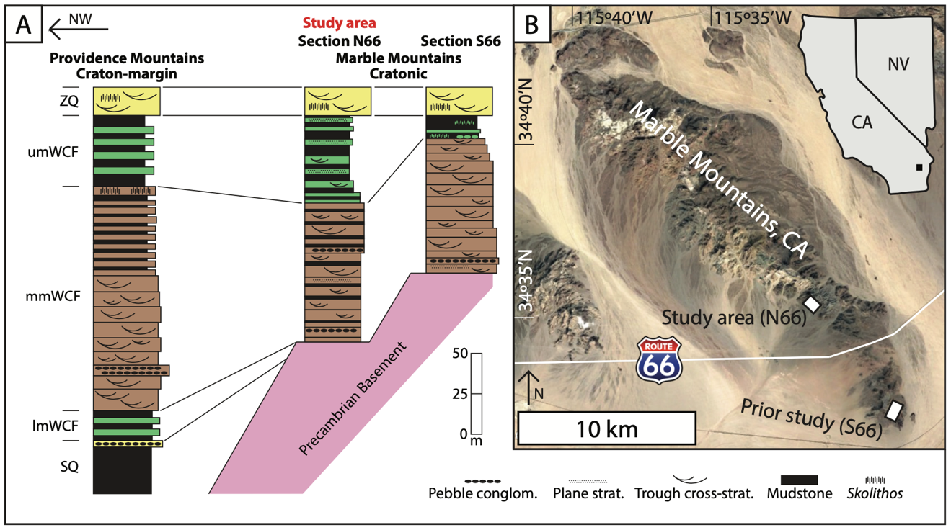
Figure 2.1: Stratigraphic and geographic context for the study locality. A) General stratigraphic columns illustrating the lateral relationship between the southern Marble Mountains (Fedo and Cooper, 1990) and Providence Mountains (Fedo and Cooper, 2001). Note the basal nonconformity and thinning of the middle member in the Marble Mountains. lmWCF, mmWCF and umWCF– lower, middle, and upper member Wood Canyon Formation, respectively; SQ– Stirling Quartzite; ZQ– Zabriskie Quartzite. B) Location of Sections N66 (this study) and S66 (Muhlbauer et al., 2020) in the Marble Mountains, California, USA. Image from Google™ Earth.

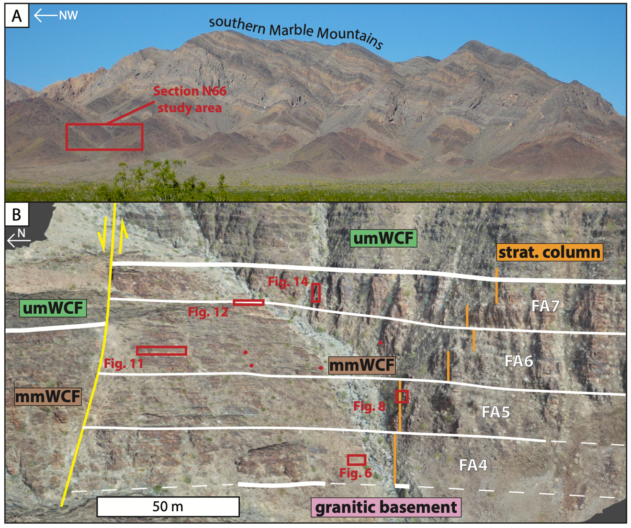
Figure 2.2: Images showing the study area and locations of recorded observations. A) Photograph of the southern Marble Mountains including the location of Section N66. B) Structure-from-Motion digital outcrop model of Section N66, with bedding oriented normal to the viewer. mmWCF and umWCF– middle and upper member Wood Canyon Formation, respectively; strat. column– stratigraphic column. White lines (solid or dashed) separate each facies association (FA4–7). Stratigraphic column (Fig. 2.3) logged along the orange lines. Trace of a large, left lateral, strike-slip fault is mapped with a yellow line. Locations of stratigraphic panels for each facies association are marked with red boxes. Red dots record the location of images presented in Figure 2.10.

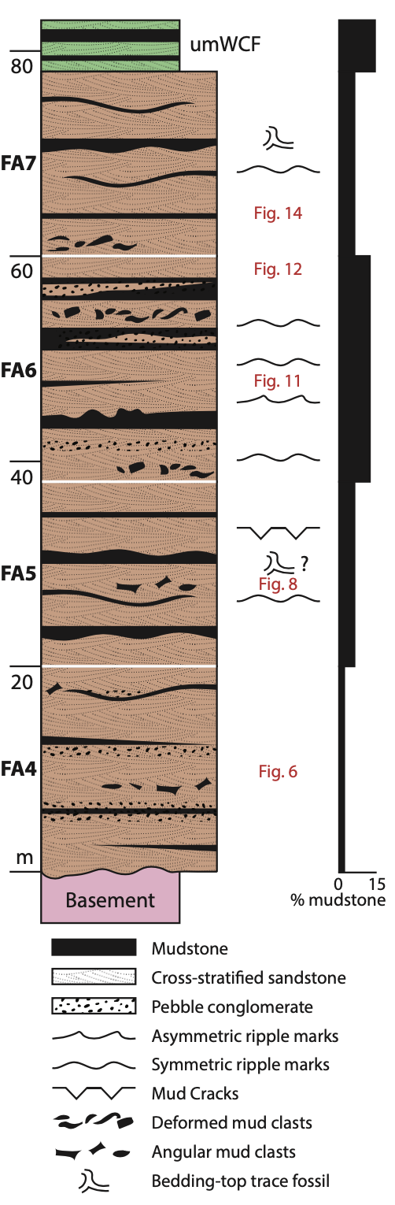
Figure 2.3: Simplified stratigraphic column of Section N66, including the stratigraphic thicknesses of each facies association (FA4–7), sedimentary structures, and mudstone percentage calculated for each interval. Constructed via bed-by-bed stratigraphic logging; see additional information in Table 2.3.

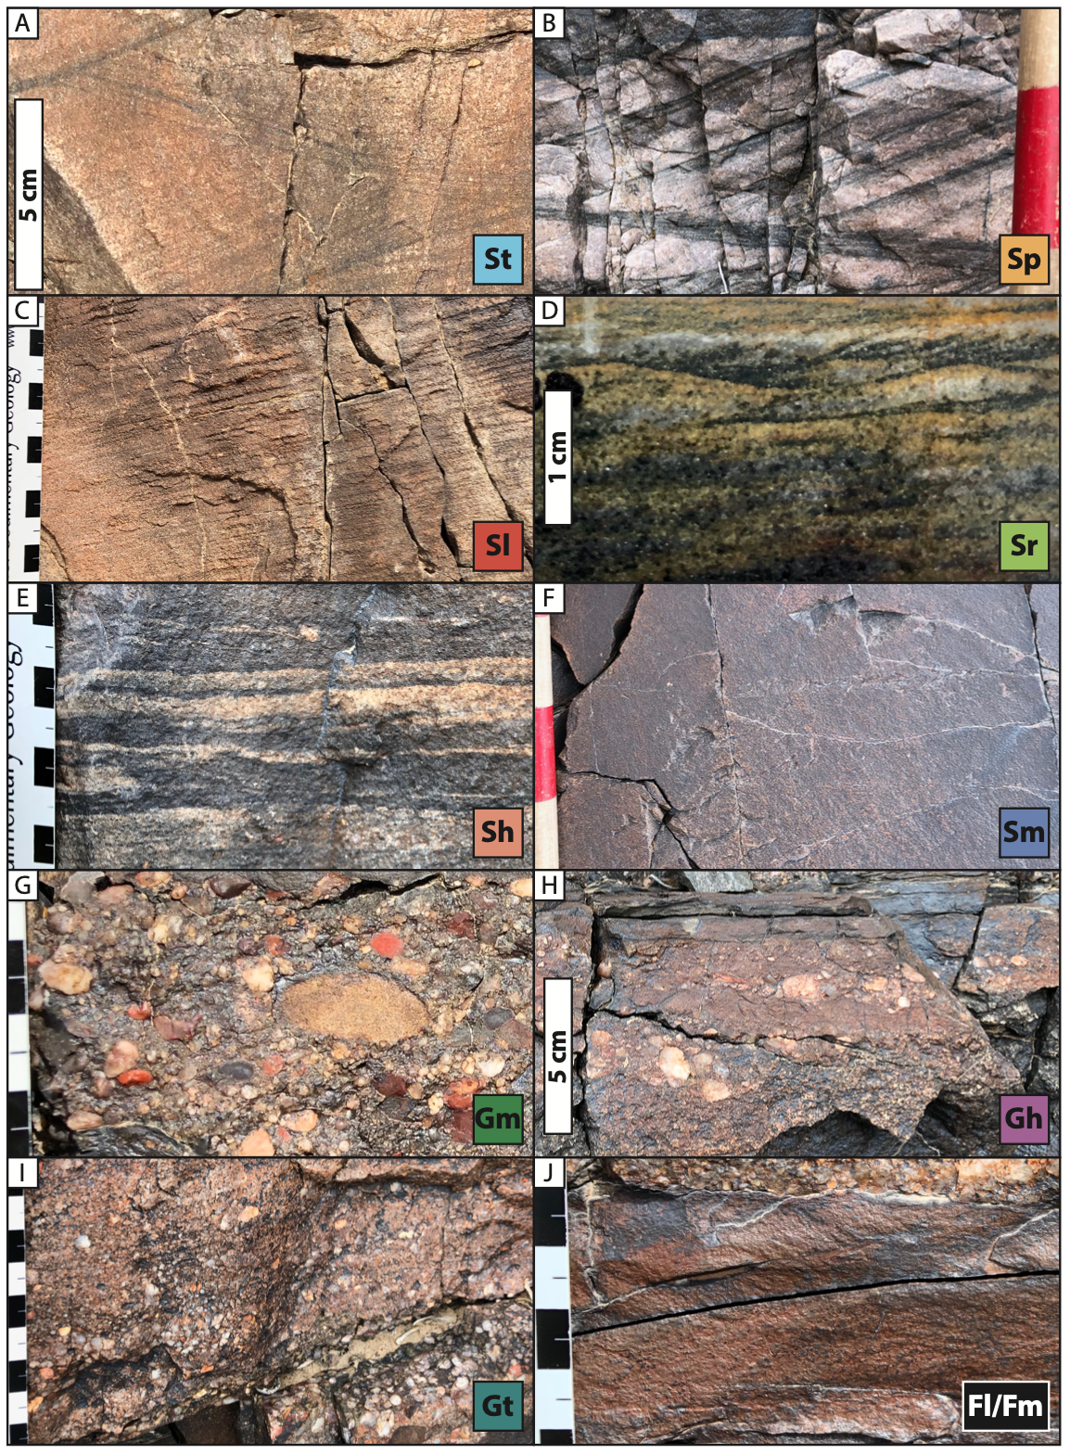
Figure 2.4: Representative images for each lithofacies identified at Section N66 in the Marble Mountains, and corresponding codes (defined in Table 2.1). Fill colors correspond to those used to illustrate stratigraphic panels in this study (Figs. 2.6, 2.8, 2.11, 2.12, 2.14). Scale in cm; Jacob’s staff increments are 10 cm.

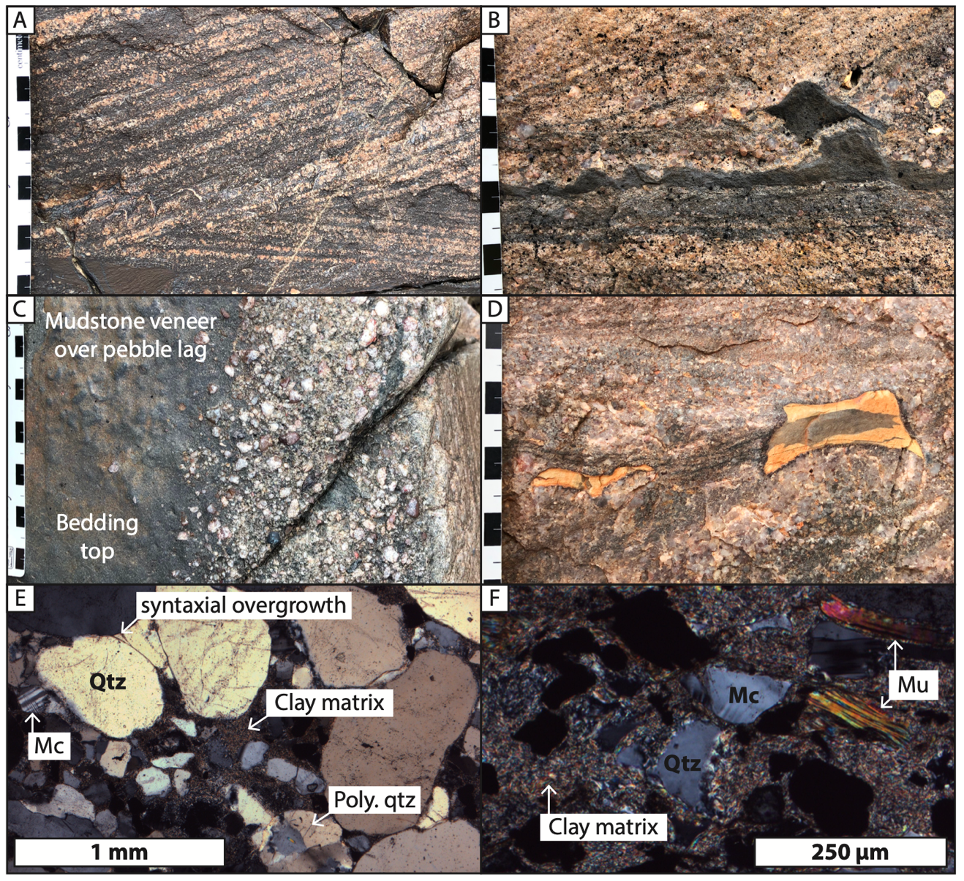
Figure 2.5: Images and photomicrographs of characteristic FA4 strata. Scale in cm unless otherwise noted. A) Trough cross-bedded (St), brown-to-tan, coarse-grained subarkose common to the middle member Wood Canyon Formation. B) Siltstone (Fl) layer with possible flame structures and a preserved rip-up clast inside a granular, cross-bedded, coarse-grained sandstone lag at the base of a coset. C) Bedding-top view of a mudstone veneer deposited over a pebble layer (Gh) at the top of the subjacent coset. D) “Bowtie-shaped” polygonal desiccation chips in cross-stratified, very coarse-grained subarkose. E) Poorly sorted, coarse-grained sandstone with monocrystalline and polycrystalline quartz (Qtz), microcline (Mc), syntaxial overgrowths on well-rounded quartz grains, and clay in matrix. Sample MM219-05. F) Fine-grained sandstone with quartz (Qtz), microcline (Mc), muscovite (Mu), and abundant clay in matrix. Concave grain boundaries on quartz indicate possible infill of authigenic clays between framework clasts. Sample MM219-28.

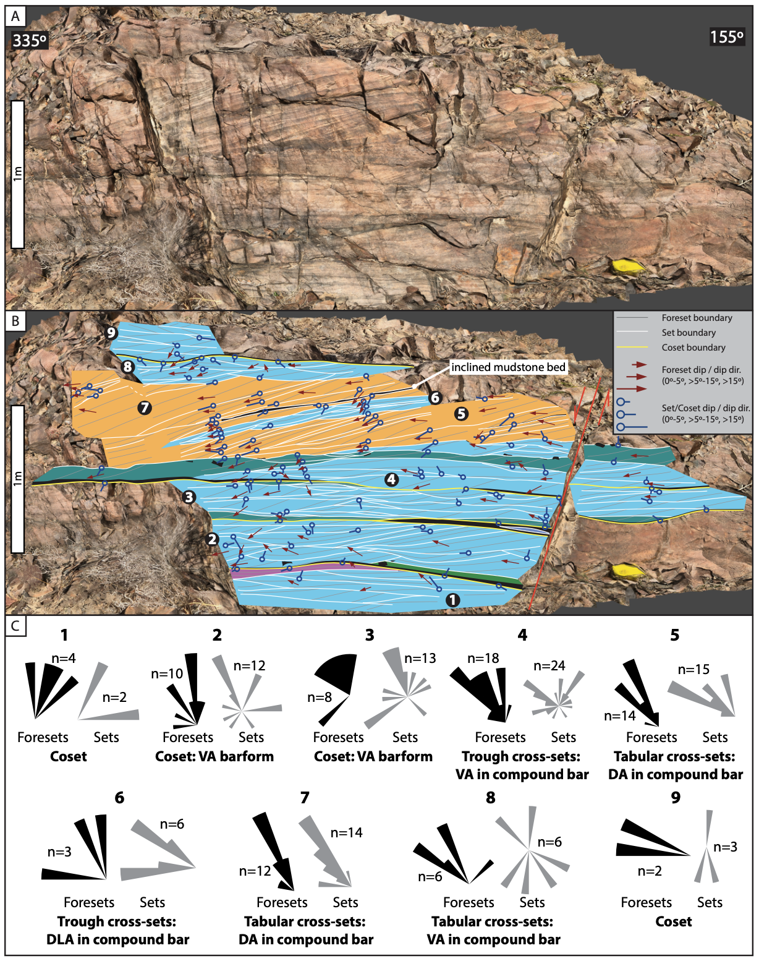
Figure 2.6: Stratigraphic panel representative of FA4 strata with corresponding orientation data. A) Three-dimensional digital outcrop model with bedding oriented normal to viewer. Orientation of the rock face noted in degrees. B) Stratigraphic panel with fill colors corresponding to lithofacies in Fig. 2.4 and described in Table 2.1. Fault with cm-scale offset marked in with a red line. Numbers correspond to C) areas 1–9 of restored orientation-measurement rosettes for foreset- and set-boundary (if any) dip directions, with interpretations where data permit. Orientation data are available in Appendix A-4.

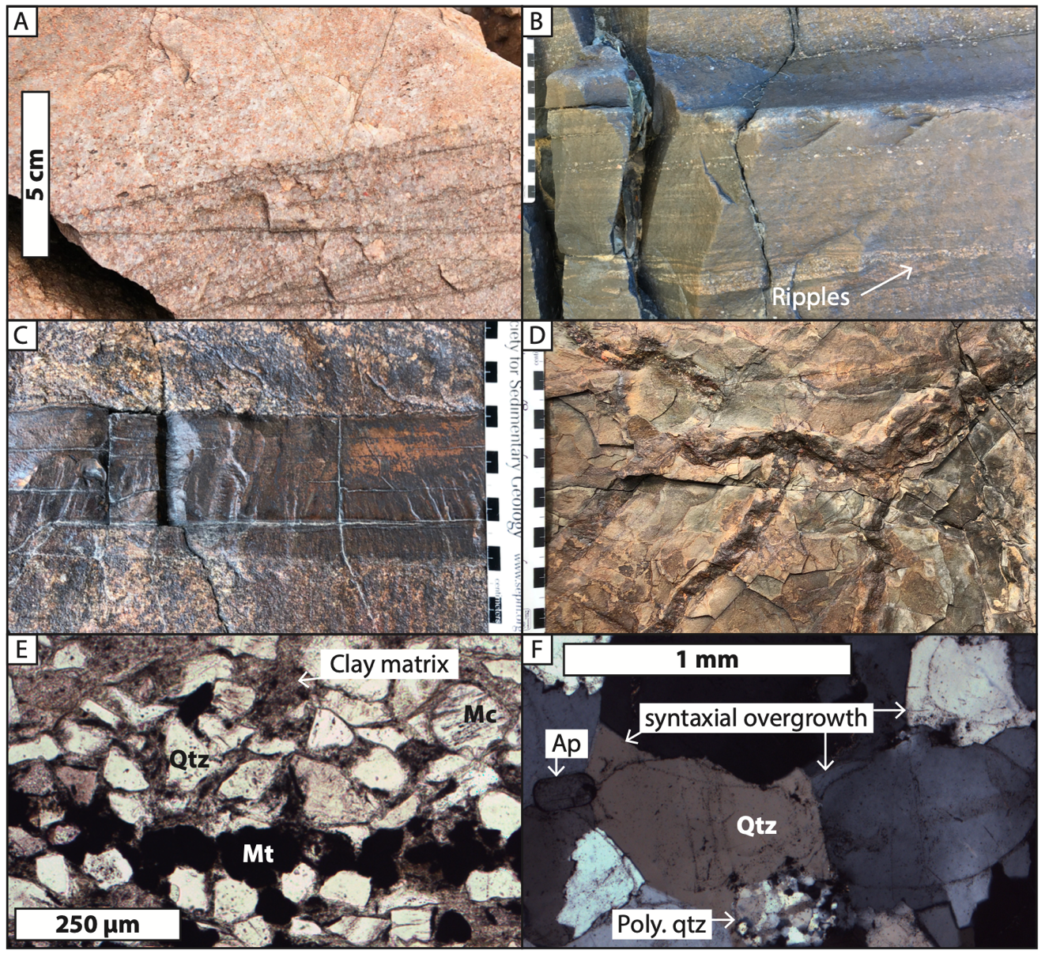
Figure 2.7: Images and photomicrographs of characteristic FA5 strata. Scale in cm unless otherwise noted. A) White, quartz-cemented, coarse-grained subarkose with trough cross-sets (St). B) Horizontal-bedding (Sh) and ripple cross-lamination (Sr) in fine- to medium-grained sandstone. C) Planar siltstone bed (Fl) bed between two cosets. D) Curvilinear desiccation cracks in a mudstone veneer. E) Photomicrograph of fine-grained subarkose with quartz (Qtz), microcline (Mc), primary and diagenetic magnetite (Mt) in a heavy-mineral lag, and hematite-stained clay matrix. Bed was dark-brown in outcrop. Sample MM219-13. F) Monocrystalline and polycrystalline quartz (Qtz) with extensive syntaxial cement and apatite (Ap), in coarse-grained sandstone. Bed was white colored in outcrop. Sample MM219-12.

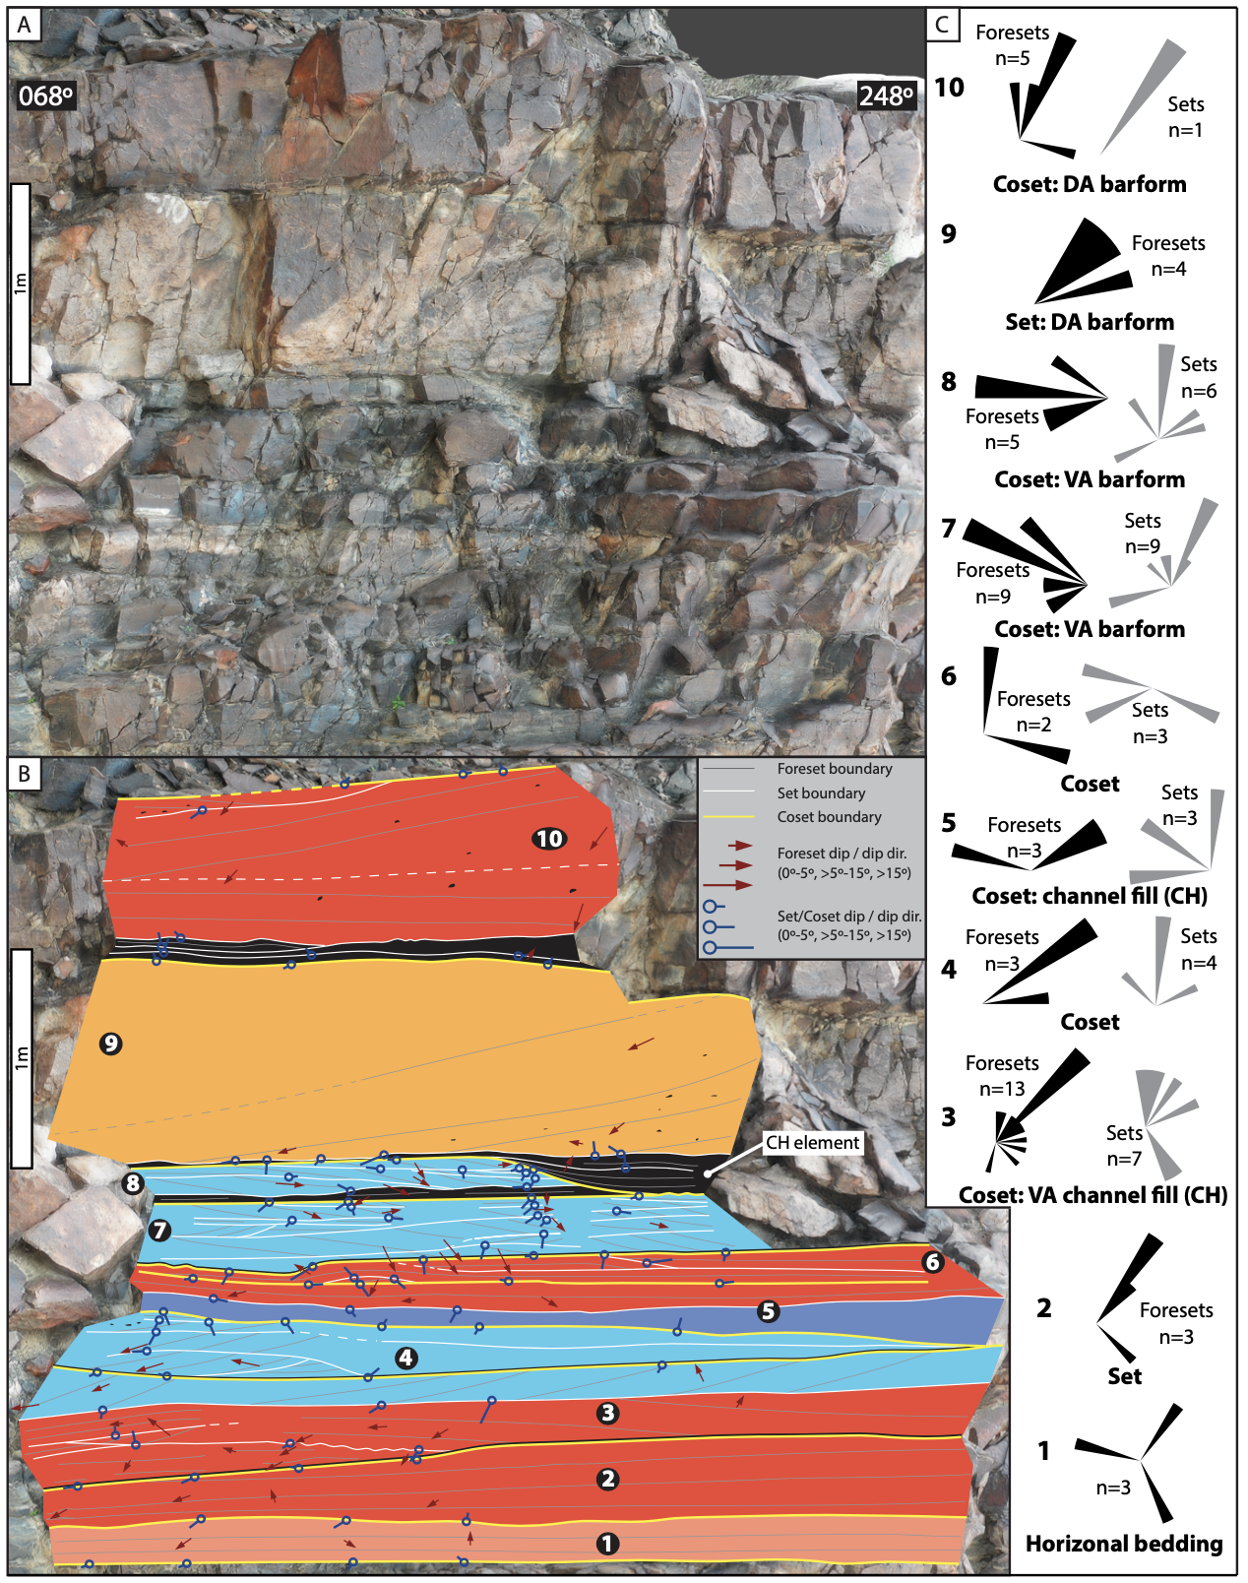
Figure 2.8: Stratigraphic panel representative of FA5 strata with corresponding orientation data. A) Three-dimensional digital outcrop model with bedding oriented normal to viewer. Orientation of the rock face noted in degrees. B) Stratigraphic panel with fill colors corresponding to lithofacies in Fig. 2.4 and described in Table 2.1. Numbers correspond to C) areas 1–10 of restored orientation-measurement rosettes for foreset- and set-boundary (if any) dip directions, with interpretations where data permit. Orientation data are available in Appendix A-4.

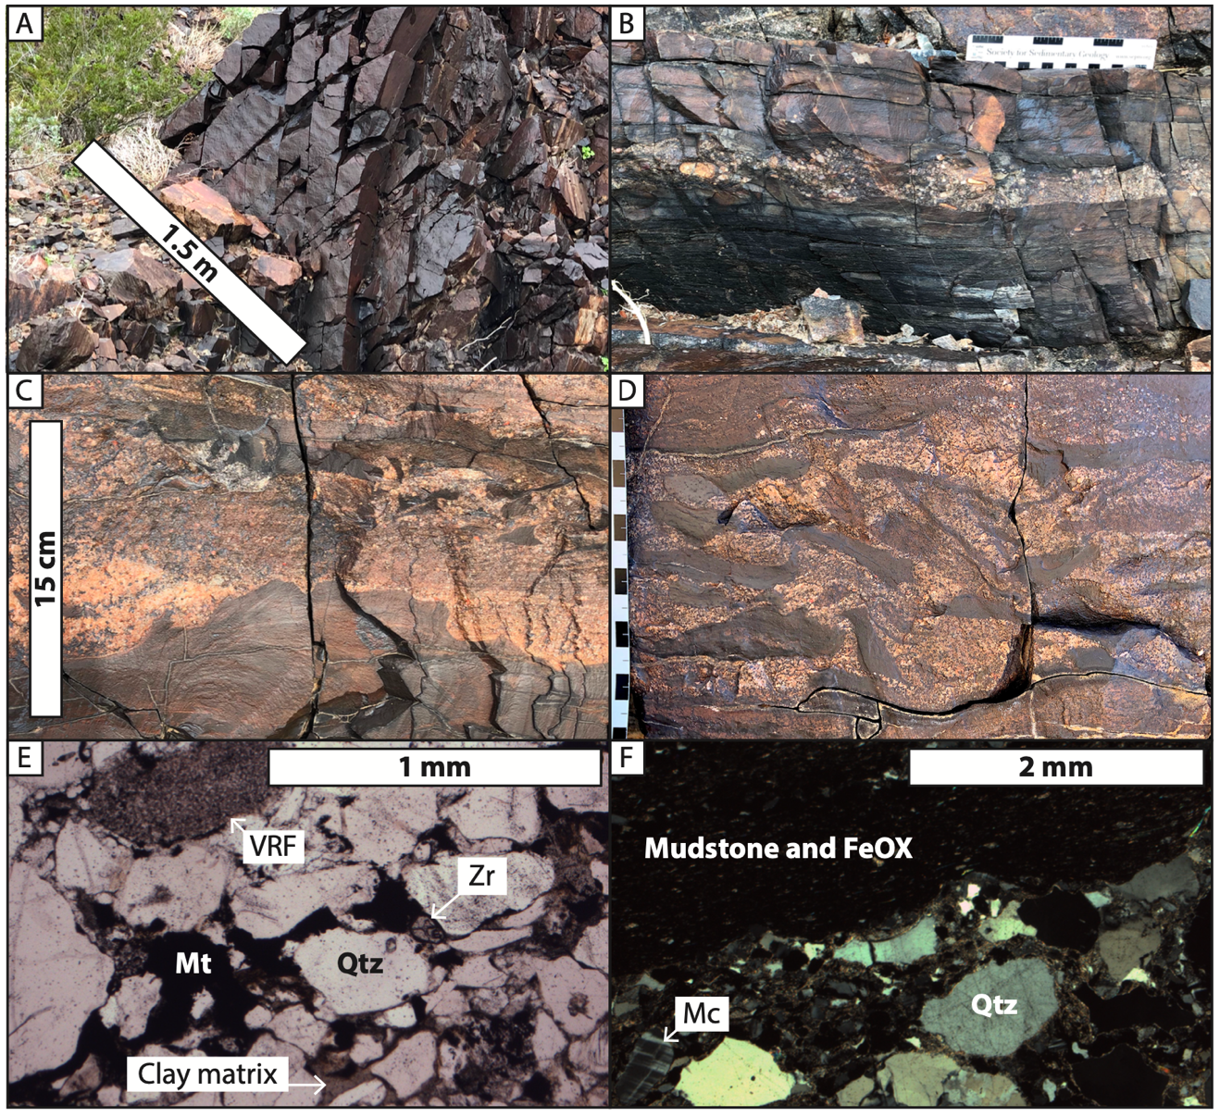
Figure 2.9: Images and photomicrographs of characteristic FA6 strata. Scale in cm unless otherwise noted. A) Symmetrical, oscillatory ripple marks resulting from east-west paleocurrent. B) Fluid-mud deposit with interbedded lens of fine- to medium-pebble conglomerate (Gm). C) Load-deformed mudstone (Fm) beneath a sandstone coset. D) Highly deformed mudstone rip-up clasts that were transported with tan, coarse-grained sand. E) Medium- to coarse-grained subarkose with quartz (Qtz), volcanic rock fragment (VRF), zircon (Zr), and diagenetic magnetite (Mt). Clay matrix is present between framework grains. Sample MM219-18. F) Sharp contact between a fluid mud layer (iron-stained mudstone) and a fine-pebble conglomerate interval with quartz (Qtz) and microcline (Mc) clasts. Note the pointed, concave grain boundaries on quartz clasts, similar to those in Figure 2.4F. Sample MM219-17.

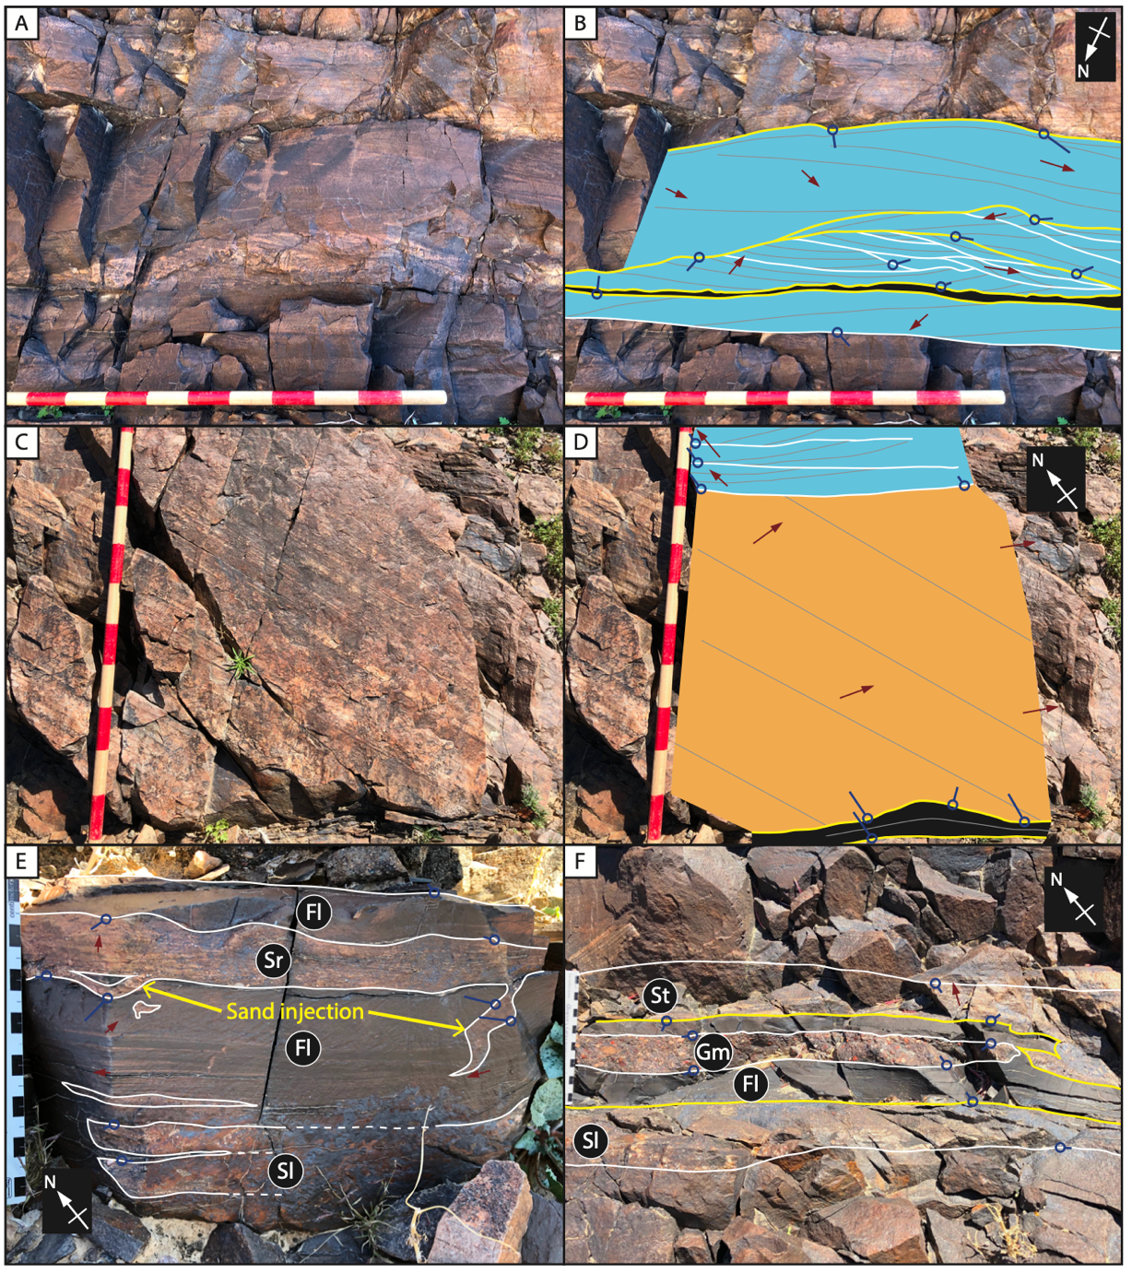
Figure 2.10: Stratigraphic panels of sedimentary structures and facies relationships found within FA6. Scale in cm; Jacob’s staff increments are 10 cm. Panel notation defined in Fig. 2.6. Colors match the lithofacies codes on Fig. 2.4. Orientation data are available in Appendix A-4. A-B) Symmetrical sand wave in white-colored sandstone, with internal complexity in paleocurrent and accretion directions. C-D) Tabular cross-set (Sp) with southeast dip-direction of possible tidal origin. Overlying trough cross-beds have northward paleoflow indicators. E) Rippled sandstone (Sr) that injected into underlying fluid-mud deposit (Fl), deforming bedding planes. Below, mudstone is interbedded with fine-grained, horizontal-bedded sandstone (Sl). F) Pebble conglomerate (Gm) between two planar fluid-mud deposits (Fl). The interval is located between cosets of trough cross-sets (St) and low angle cross-bedding (Sl). Note that the upper fluid mud was scoured on the right of the image, removing both mudstone and subjacent conglomerate.

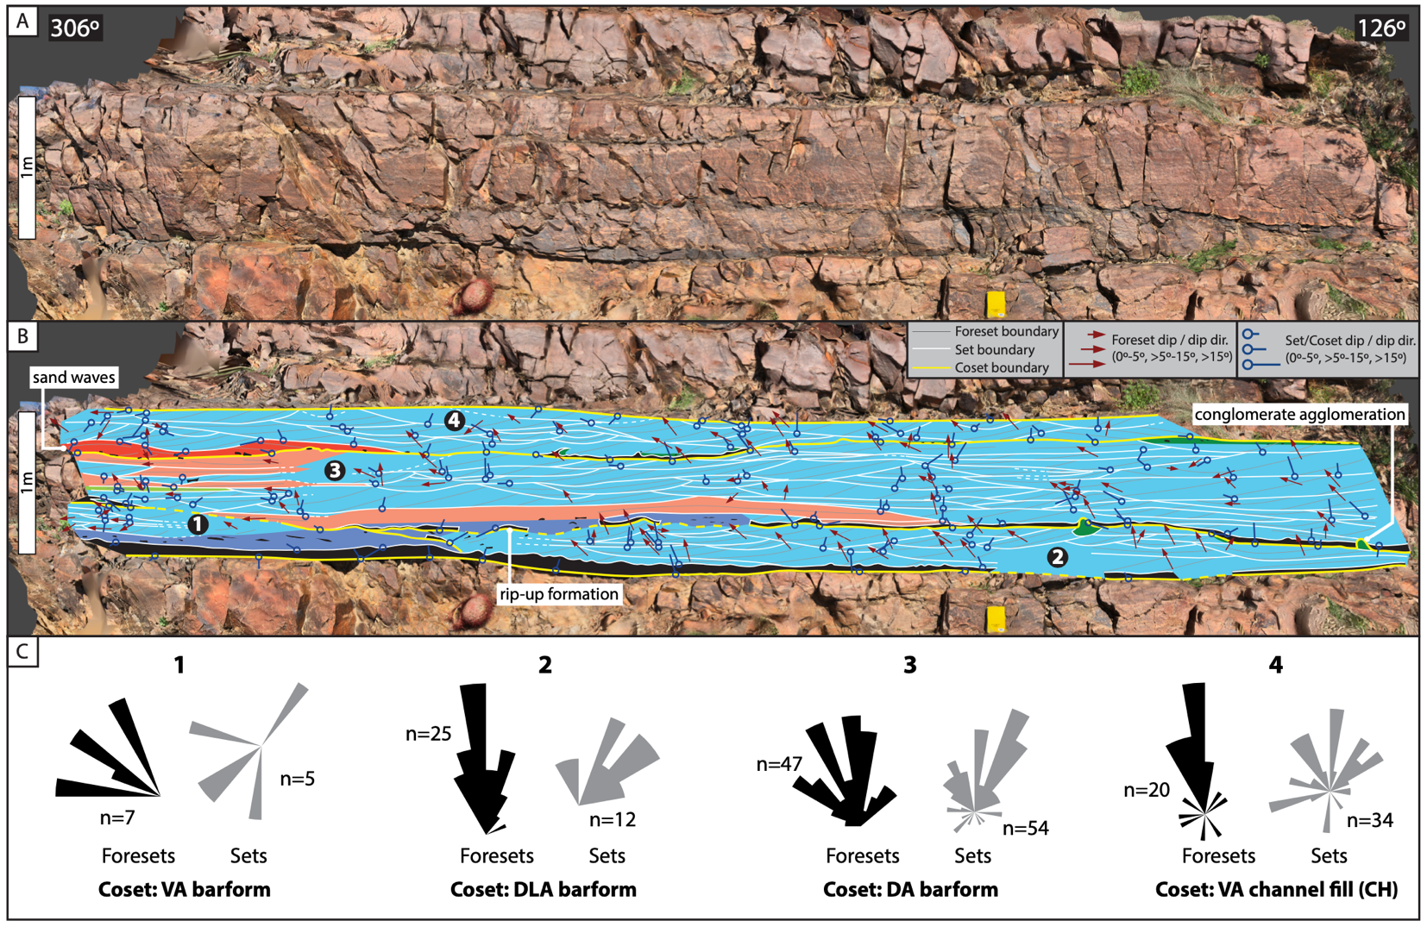
Figure 2.11: Stratigraphic panel representative of FA6 strata with corresponding orientation data, located at a stratigraphic height of 45 meters on the stratigraphic column. A) Three-dimensional digital outcrop model with bedding oriented normal to viewer. Orientation of the rock face noted in degrees. B) Stratigraphic panel with fill colors corresponding to lithofacies in Fig. 2.4 and described in Table 2.1. Numbers correspond to C) areas 1–4 of restored orientation-measurement rosettes for foreset- and set-boundary dip directions, with interpretations. Orientation data are available in Appendix A-4.
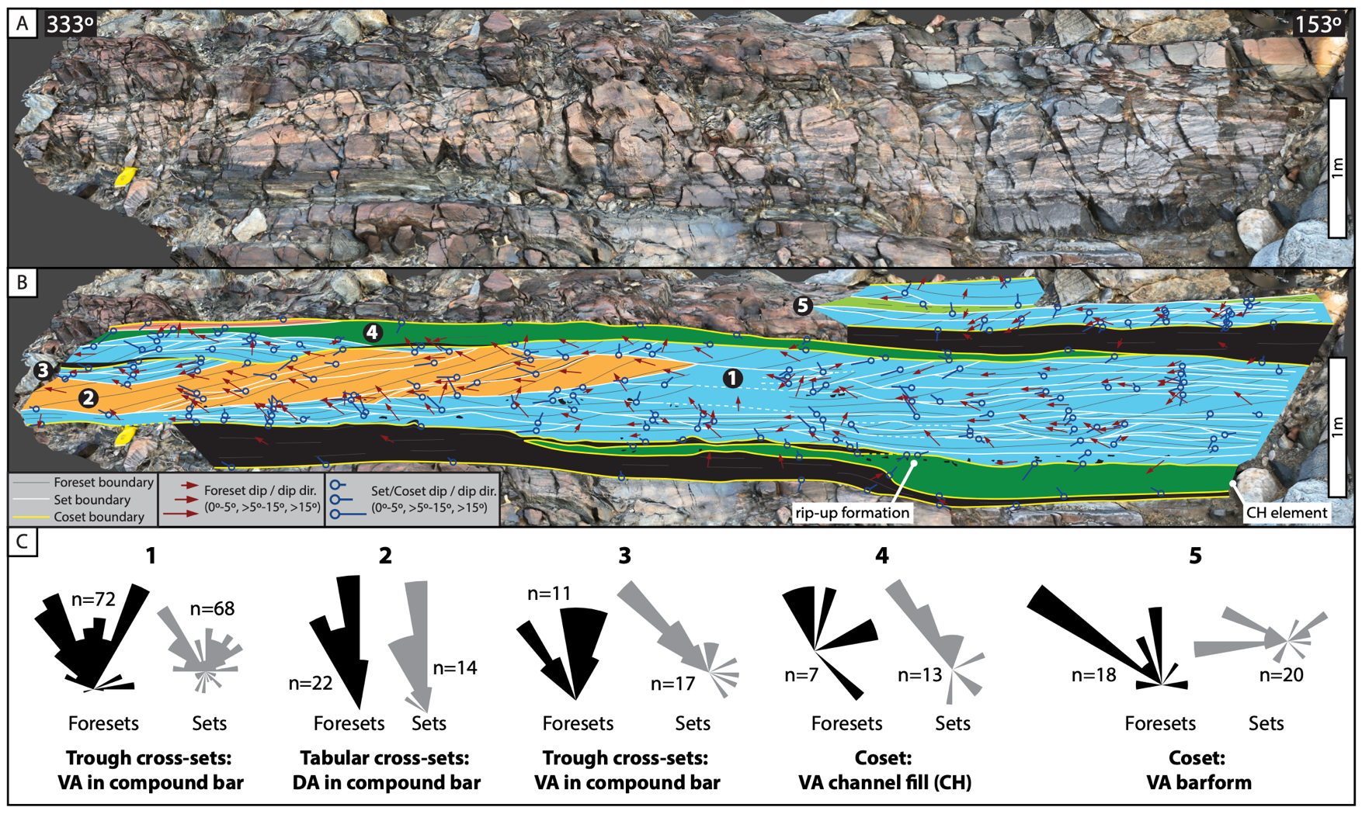
Figure 2.12: Stratigraphic panel representative of FA6 strata with corresponding orientation data, located near the upper boundary of the facies association. A) Three-dimensional digital outcrop model with bedding oriented normal to viewer. Orientation of the rock face noted in degrees. B) Stratigraphic panel with fill colors corresponding to lithofacies in Fig. 2.4 and described in Table 2.1. Numbers correspond to C) areas 1–5 of restored orientation-measurement rosettes for foreset- and set-boundary dip directions, with interpretations. Orientation data are available in Appendix A-4.

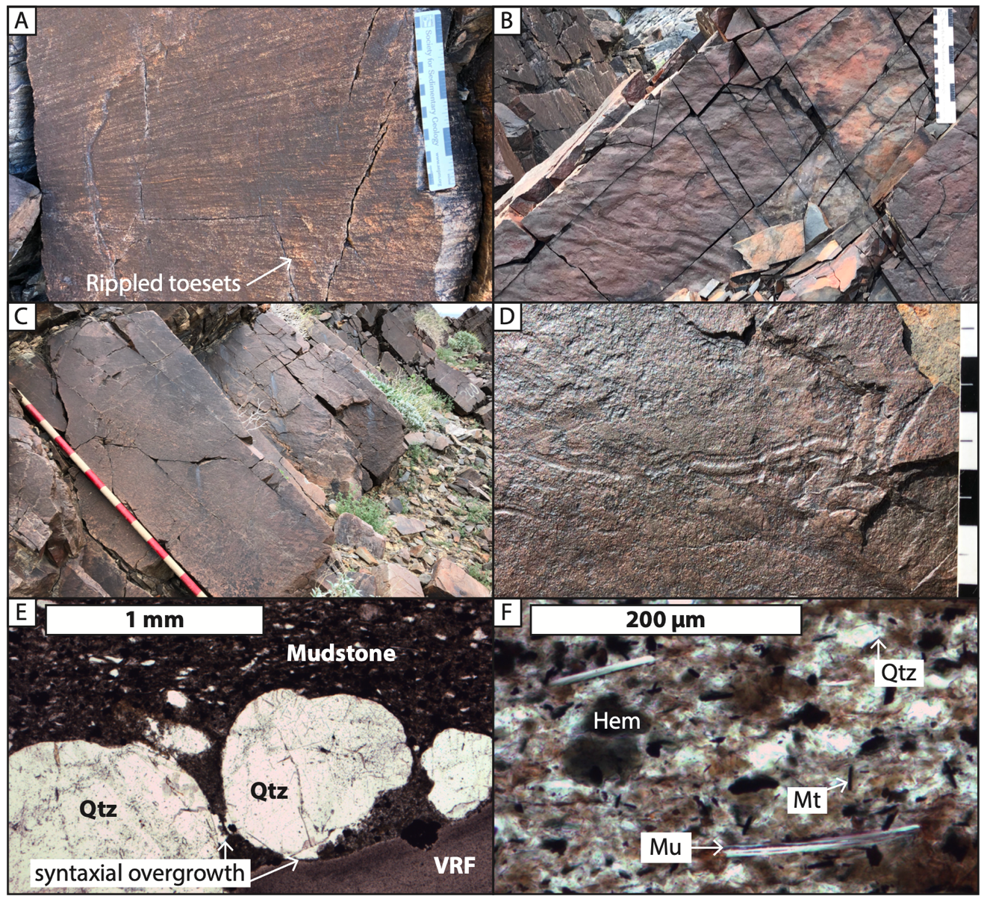
Figure 2.13: Images and photomicrographs of characteristic FA7 strata. Scale in cm; Jacob’s staff increments are 10 cm. A) Trough cross-bed of medium-grained sandstone (St) with rippled toesets and finely laminated foresets. B) Symmetrical ripple marks preserved on fine-grained sandstone bedding plane. C) Featureless medium-grained sandstone (Sm) bed at the base of FA7, 1.5 meters thick. D) Representative cf. Aulichnites trace fossil on a bedding plane of fine-grained sandstone. E) Hematite-stained mudstone and coarse-grained sandstone contact, with quartz (Qtz) and volcanic rock fragment (VRF). Clay matrix and syntaxial quartz overgrowths occur between framework grains. Sample MM219-21. F) Mudstone with quartz (Qtz) silt, muscovite (Mu), patchy hematite, and diagenetic magnetite (Mt) crystals. Sample MM219-24.

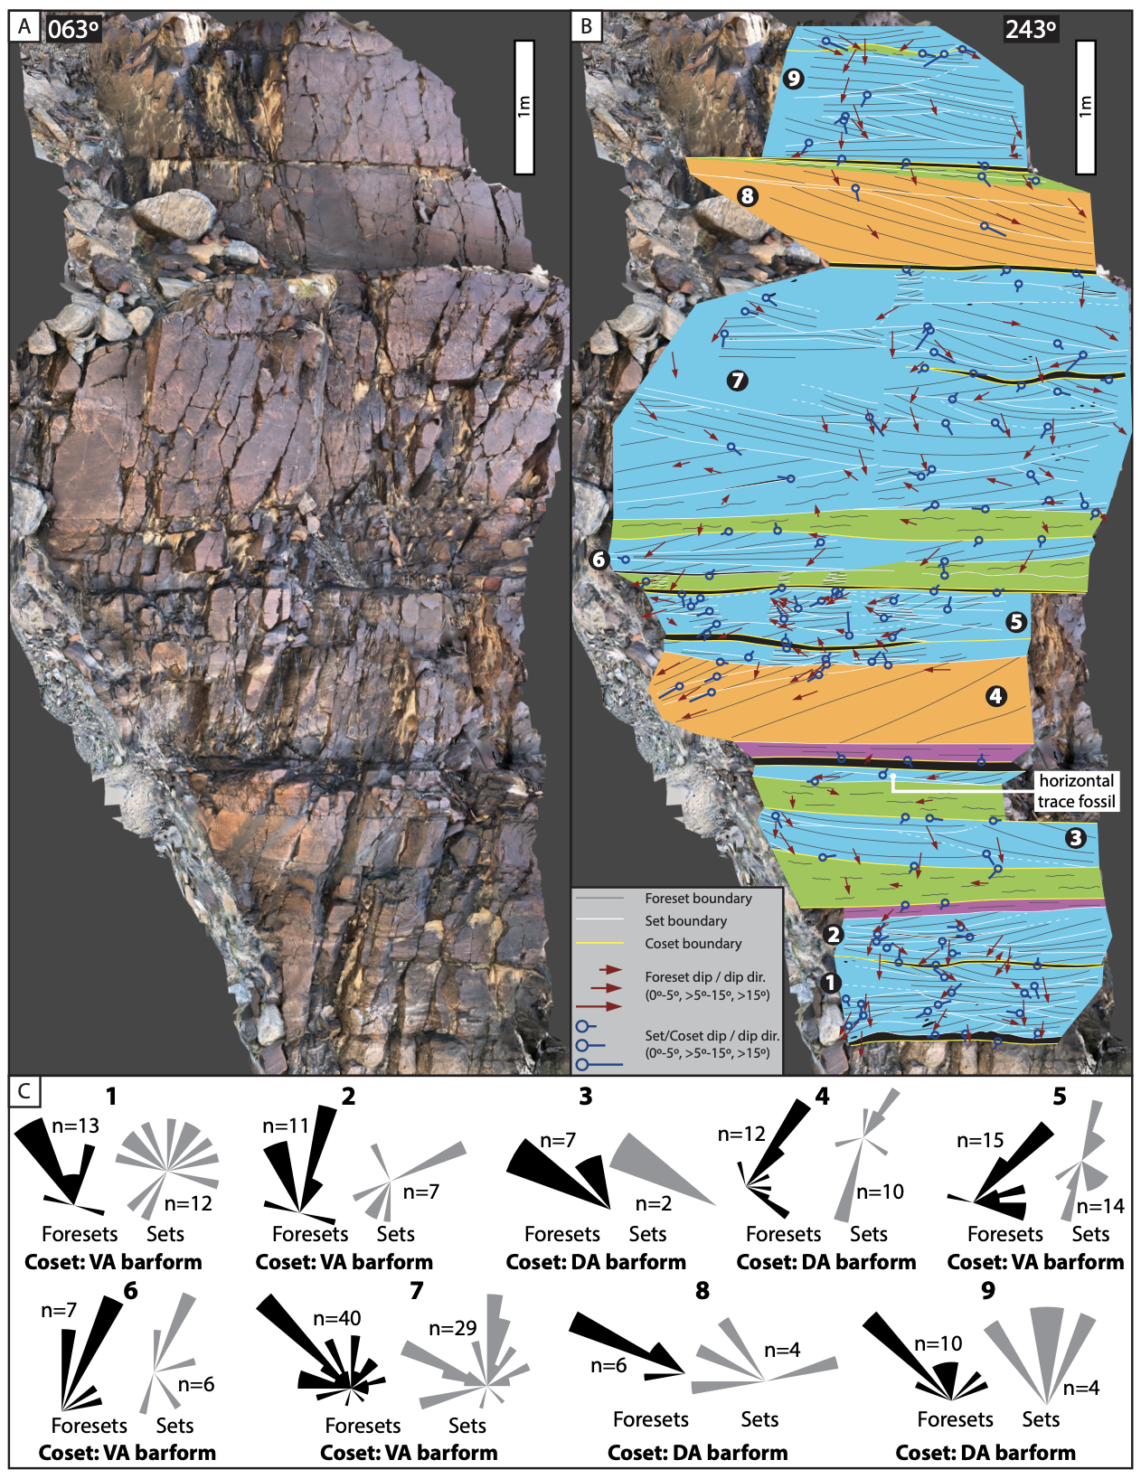
Figure 2.14: Stratigraphic panel representative of FA7 strata with corresponding orientation data. A) Three-dimensional digital outcrop model with bedding oriented normal to viewer. Orientation of the rock face noted in degrees. B) Stratigraphic panel with fill colors corresponding to lithofacies in Fig. 2.4 and described in Table 2.1. Numbers correspond to C) areas 1–9 of restored orientation-measurement rosettes for foreset- and set-boundary dip directions, with interpretations. Orientation data are available in Appendix A-4.

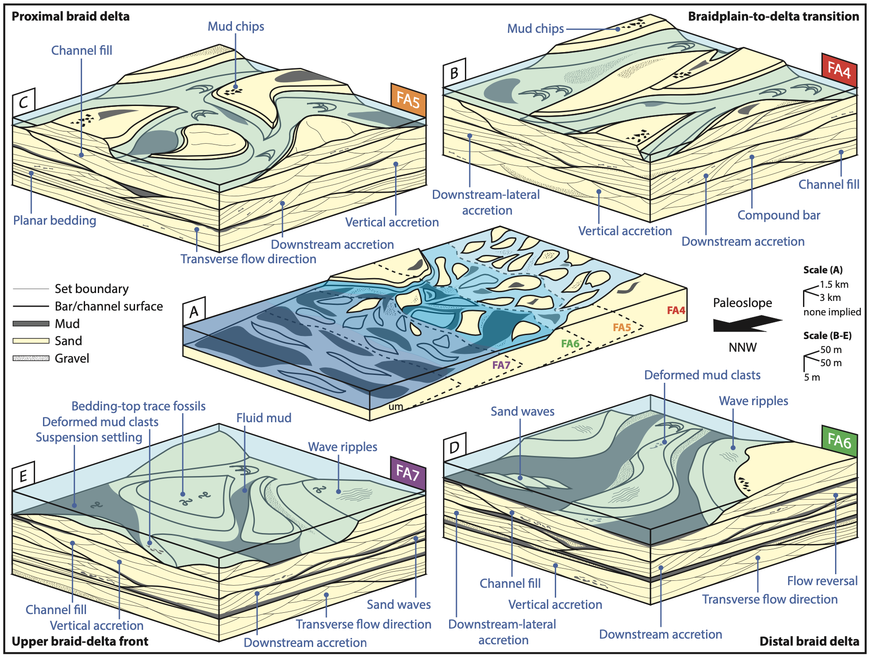
Figure 2.15: Block diagram of A) the overall middle member Wood Canyon Formation braid-delta system preserved at Section N66, with detailed environmental block diagrams of B) FA4, C) FA5, D) FA6, and E) FA7. See Table 2.2 for architectural element definitions.

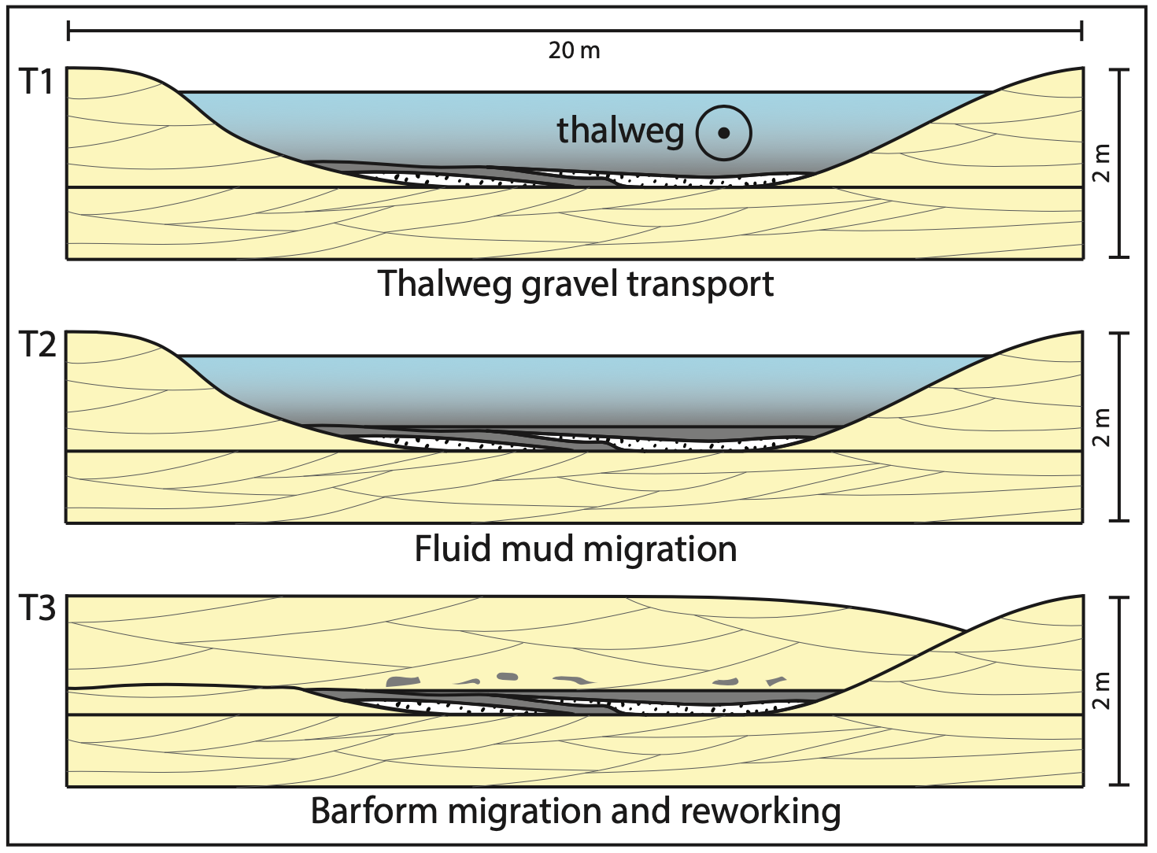
Figure 2.16: Proposed fluidized-mud processes in the turbidity maximum zone, leading to the formation of thick mudstone beds with interbedded very fine- to medium-pebble conglomerate in FA6 and rarely in FA7 (e.g., Figs. 2.9B, 2.10F, 2.12B). A) In-channel fluidized mud alongside gravels transported by a high-energy thalweg. B) Fluid-mud migration over stranded gravels. C) Burial by subsequent barform migration that scours and deforms clasts of fluid mud before incorporation into the overlying sandstone coset.

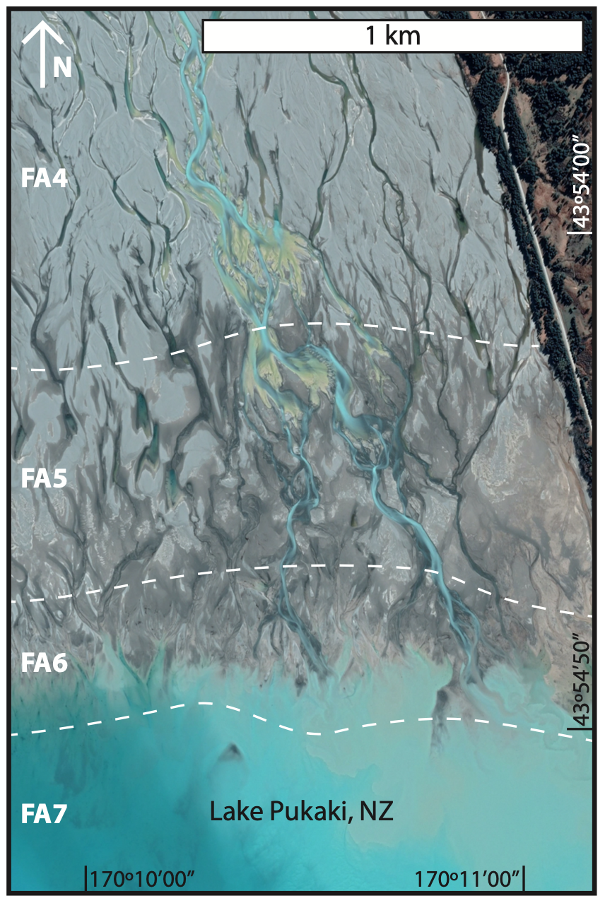
Figure 2.17: Fluvial-dominated braid delta of the Pukaki River at Lake Pukaki, NZ. Dashed lines in white divide the setting into zones that resemble each middle member Wood Canyon Formation facies association (FA4–7). Image from Google™ Earth, captured September 18, 2019.

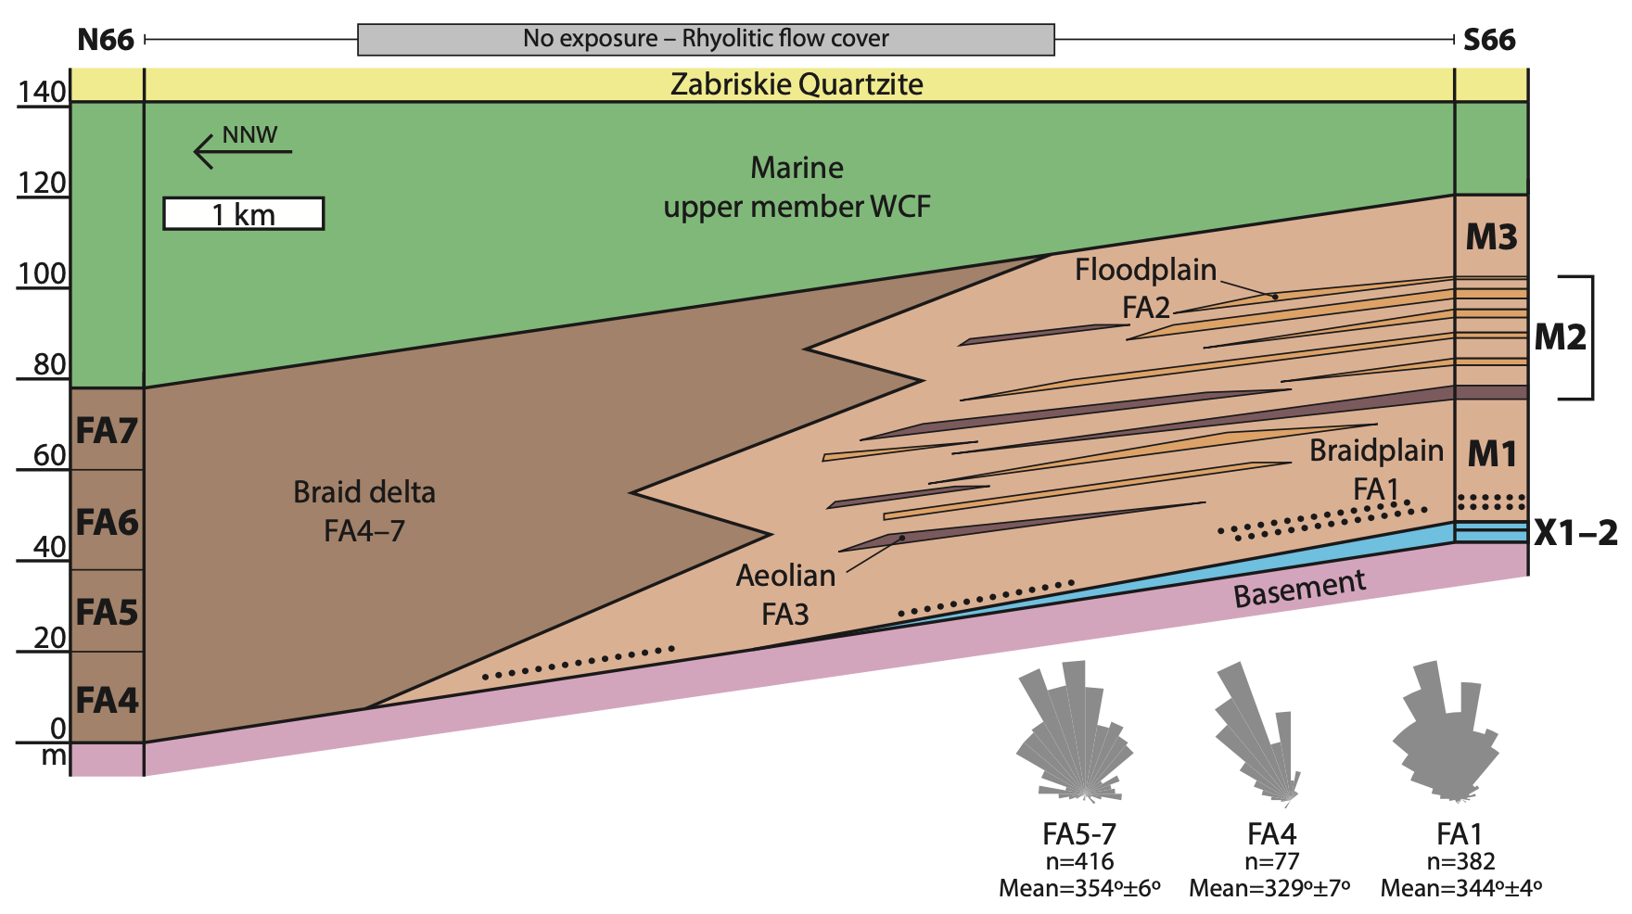
Figure 2.18: Lithostratigraphic panel linking Section N66 (Fig. 2.1) of the middle member Wood Canyon Formation (WCF), studied herein, to Section S66 (Fedo and Cooper, 1990; Muhlbauer et al., 2020) and associated paleocurrent data. Stratigraphic columns are hung on the base of the Zabriskie Quartzite. Units X1–2, M1–3 are based on facies-association stacking patterns at Section S66 (Fig. 2.1), described in Muhlbauer et al. (2020). The boundary between the braid delta and braidplain environments is hypothetical, as the relevant strata between the two sections are covered by rhyolitic flows.

CHAPTER III
Around the world in 800 braid deltas: Implications for classification, facies analysis, and the pre-vegetation rock record

CONCLUSION

This is the conclusion for the entire document. It can be a numbered chapter or it can stand alone. If you did not make your introduction a chapter and give it a number, you should not make the conclusion a numbered chapter. If you DID call your Introduction “Chapter 1”, you should give your conclusion a chapter number.

Heading 2
Write here.

Appendix A-4

VITA

Jane X. Doe was born. She wrote a thesis. She graduated. She followed instructions and wrote her vita in third person and paragraph form (as opposed to a resume or CV), which made her thesis consultant very happy. This page is required.

