To the Graduate Council:

I am submitting here with a thesis written by Robert Blake Lowe entitled “Changes in carbohydrates of Navy beans during hydration and subsequent thermal processing”. I have examined the final electronic copy of this thesis for form and content and recommend that it be accepted in partial fulfillment of the requirements for the degree of Master of Science, with a major in Food Science.

______________________________
Svetlana Zivanovic, Major Professor

We have read this thesis and recommend its acceptance:

______________________________
Federico M. Harte

______________________________
Faith J. Critzer

Accepted for the Council

______________________________
Carolyn R. Hodges
Vice Provost and Dean of the Graduate School

Changes in carbohydrates of Navy beans during hydration and subsequent thermal processing

A Thesis Presented for the

Master of Science

Degree

The University of Tennessee, Knoxville

Robert Blake Lowe

August 2012

Acknowledgments
To my advisor, Dr. Lana Zivanovic, I would like to say thank you for the opportunity to pursue my M.S and the faith you had in me. Thank you for your wisdom, guidance, patience, and kindness as well as the opportunity to both learn and teach as the Food Chemistry TA. Remember, “Thanks, Boss!!”
I would also like to thank my committee members, Dr. Federico Harte and Dr. Faith Critzer, as well as Dr. Adrienne Roach, Bush Brothers and Company Research Consultant for your invaluable input and wisdom along the way. Your attention to detail, teamwork, and kindness made this journey both easier and enjoyable!
I also owe a very special thank you to May Lamsen, Audra Wallis, and Lynsey Jones for the countless hours you each spent helping me with research. I would also like to thank Dr. Philipus Pangloli, Eric Goan, Stella Chen, Monica Crosby, Lydia Siebert, Sean Pendleton, Laurel Gann, Stephanie Schreiber, and Virginia Artegoitia, for their help, friendship, and endless laughs over the last year and half.
To the faculty, staff, and students of the Food Science Department, I would like to say thank you for making my last five years remarkable! In the words of Ray Trejo, “Stay thirsty my friends!”
To Dad, Mom, and Sis, thank you for your unwavering support, love, and friendship. You are my rock, and we made it together! Finally, ON TO MEDICAL SCHOOL!
“Success usually comes to those who are too busy to be looking for it” - Henry David Thoreau
Abstract

Navy beans were subjected to six different hydration protocols that varied in time, temperature, and methodology after which they were thermally processed in both a brine solution and a typical baked bean sauce. Beans, isolated starch, and hydration fluid were analyzed immediately after the completion of hydration protocols. Significant differences were noted between those protocols utilizing low heat (1 and 2) and those utilizing high heat methods (3-6). Bean from low heat protocols were firmer overall. Starch granules from low heat beans were smaller in overall size, experienced less surface damage retained birefringence, and could absorb more water (higher swell factor). Analysis of the hydration fluid showed no noticeable differences. Analysis of the canned products showed that intense thermal processing effectively caused gelatinization in all protocols as confirmed by DSC and light microscopy. Isolated starch had little to no abilities to retain water. Granules from all protocols in both mediums showed extensive damage, cracking, and possible leaching which is believed to be the cause of substantially lower amylose findings in starch isolated from canned as compared to hydrated beans. Analysis of brine solution revealed increased leaching of carbohydrates, amylose, and proteins. The Kramer compression shear cell detected significant texture differences in beans canned in brine that were hydrated by novel protocols 5 and 6 but not in novel protocol 4, the current protocol (3), and the traditional protocols (1 and 2). Likewise, a probe texture analyzer, determined beans hydrated by protocols 5 and 6 to have firmer skin and flesh overall as compared to the other protocols. The Kramer sheer press was not able to detect differences in beans canned in sauce while the probe texture analyzer was able to detect differences in beans from traditional protocol 1 compared to protocols 3-6. Overall, it was discovered that novel hydration protocols 5 and 6 produce firmer beans when canned in brine solution compared to the current (3) and traditional protocol (1). Beans hydrated by current (3) and novel protocols (4 – 6) show no significant differences in texture when canned in typical baked bean sauce.

Table of Contents

CHAPTER 1. Introduction and Literature Review 1
Legumes 2
Nutritional Value of Legumes 3
Dietary Fiber. 4
Starch. 6
Protein. 7
Phenolic Compounds 8
Pectin. 10
Hard-to-Cook Phenomena 12
Effects of Hydration and Thermal Processing 14
Effects of Hydration. 14
Effects of Thermal Processing. 15
Overall goals and objectives 16
References 17
CHAPTER 2 Changes in Carbohydrates of Navy Beans During Hydration 22
Abstract 23
Introduction 24
Materials and Methods 26
Hydration and Collection of Samples 26
Bean Analysis 27
Texture Analysis. 27
Moisture Content, Weight & Volume. 28
Starch Analysis 28
Starch Isolation 28
Defatting Samples. 30
Yield Determination 31
Density Determination 32
Moisture Content 32
Water Activity. 33
Granular Size and Morphology. 33
Swelling Factor 33
Differential Scanning Calorimetry (DSC). 34
Total Amylose. 35
Hydration Liquid Analysis. 35
Soluble Solids and pH. 36
Total Amylose. 36
Total Carbohydrate Concentration 36
Total Protein Concentration 37
Results and Discussion 38
Bean Analysis 38
Texture 38
Moisture Content, Weight & Volume 38
Starch Analysis 39
Starch Isolation Yield 39
Starch Density, Moisture Content & Water Activity 40
Granule Size and Morphology 41
Starch Swelling Factor (S_{F}) 42
DSC Measurements 43
Total Amylose 44
Hydration Liquid Analysis 45
Soluble Solids and pH 45
Total Amylose, Carbohydrate, and Protein Determination 46
Conclusion 47
Chapter 2 Appendix. 48
Sources 67
CHAPTER 3. Changes in Carbohydrates of Navy Beans During Thermal Processing 70
Abstract 71
Introduction 72
Materials and Methods 74
Canning and Collection of Samples 74
Bean Analysis 75
Texture Analysis 75
Weight.. 76
Starch Analysis 76
Starch Isolation. 76
Defatting Samples 78
Yield Determination 79
Density Determination 79
Moisture Content. 80
Water Activity 80
Granular Morphology. 80
Swelling Factor. 81
Differential Scanning Calorimetry (DSC). 81
Total Amylose 82
Hydration Liquid Analysis 83
Soluble Solids and pH 83
Total Amylose. 83
Total Carbohydrate Concentration. 84
Total Protein Concentration. 84
Results and Discussion 85
Bean Analysis 85
Texture 85
Weight 86
Starch Analysis 87
Starch Isolation Yield 87
Starch Density & Water Activity 88
Granule Size and Morphology 89
Starch Swelling Factor (S_{F}) 90
DSC Measurements 91
Total Amylose 91
Hydration Liquid Analysis 92
Soluble Solids and pH 92
Total Amylose, Protein, and Carbohydrate Determination 93
Conclusion 95
Chapter 3 Appendix 97
Sources 121
Chapter 4. Overall Conclusion 123
VITA 126

CHAPTER 1.

INTRODUCTION AND LITERATURE REVIEW

Legumes
Legumes, derived from the Latin word ‘legumen’ which translates as seeds harvested in pods (Aykroyd and Doughty 1982), are dicotyledonous seeds of plants that belong to the family Leguminosae which includes nearly ~19,000 species of plants (Allen and Allen 1981). Legumes are hardy plants cultivated throughout the world in climates ranging from temperate to tropical, humid to arid (Aykroyd and Doughty 1982). Since ancient times, legumes have served as a major food source for humans across the globe. In fact, the cultivation of legume crops rich in proteins and carbohydrates were essential in the evolution of mankind and advancement of civilization(Arora 1983). Today, legumes continue to be one of the most important sources of food supply globally and represent a broad area in human and animal feeds (Matthews 1989). Most common among legumes from a nutritional and economic standpoint are dry beans, green peas, faba beans, chickpeas, and lentils (Yañez-Farias et al 1997). Dry beans, genus Phaseolus vulgaris, contains over 50 species including navy, great northern, and lima beans and is the most important group of legumes worldwide (Gepts 2001). Dry beans play a critical dietary role for millions of people by serving as a chief source of protein and calories in developing regions where animal proteins are either unobtainable or unaffordable (Gepts 2001; Yañez-Farias et al. 1997). Hence, a general reciprocal relationship exists between income levels and the consumption of legumes with the exception of the United States. While income levels and meat consumption remain relatively high in the U.S., the per capita consumption of beans also remains relatively high averaging 6.5 pounds of beans per person per year ((USDA) 2011).
The commercial dry bean industry in America began in the late 1880’s in Michigan and enjoyed modest growth until the outbreak of the World War II (Robertson and Frazier 1978). Throughout and after the war, U.S. bean producers witnessed a dramatic increase in demand as beans became a staple of the C-rations of soldiers in 1942 and played an integral part of the United State’s food relief efforts in Europe ((USDBC) 2012). At that time, the U.S. was one of the largest producers of dry beans behind only Brazil. However, from 1950-1974, the U.S bean industry growth rate slowed significantly to a rate of approximately 11% while world production of dry beans increased dramatically by 71%. Since then, the American bean industry has grown modestly in an unsteady market often characterized by periods of robust growth, crop shortages and price spikes due to shortened growing seasons, and shrinking consumer demand. According to the United States Department of Agriculture ((USDA) 2011) the worldwide production of legumes topped 456,000 Ibs (1,000 cwt) in 2009. As of 2011, the U.S. bean industry was the sixth-leading producer of dry beans globally and produced over 25,000 Ibs (1,000 cwt) or 6% of the world’s output despite experiencing a 38% drop for the year in dry bean production, the smallest since 1994.
Globally and domestically, navy beans comprised the second largest crop among legumes while accounting for nearly 17% of the United States dry bean crop ((USDA) 2011) behind only pinto beans.

Nutritional Value of Legumes
As an affordable source of essential nutrients, such as proteins, vitamins and minerals, legumes offer a possible solution for meeting the nutritional needs for many vulnerable populations across the globe (Arora 1983). Navy beans, as well as the other biotypes of the dry bean family, are considered one of the most nutritionally complete foods available and play a critical role in global nutrition, especially in developing countries. Beans are considered healthy because they are high in complex carbohydrates, proteins, dietary fiber, and folate while being low in fat, sodium, and cholesterol-free.
Dietary Fiber. Dry beans, Phaseolus vulgaris, are composed of 24-68 % carbohydrates (Reddy et al 1984; Schumacher and Boland 2005). Of this, nearly 25% can be composed of complex carbohydrates, or dietary fiber, which are unavailable for digestion by the enzymes of the human gastrointestinal tract (Hornick and Weiss 2011; Thorne et al 1983b).
As a result, considerable degradation of these polysaccharides occurs within the human colon by normal microflora (Southgate 1991). These microflora are capable of degrading plant polysaccharides through fermentation which often produces gasses such as CO₂, H₂, and volatile fatty acids such as butyric and proprionic acids. Approximately 70% of the carbohydrates that enter the colon are fermented and two thirds of the energy produced becomes available for human use(Chesson 2006). With the growing obesity epidemic, the importance of dietary fibers is on the rise; increased intake of these polysaccharides has been associated with a plethora of health benefits. For example, the inability to digest fiber leads to an increase in the feeling of satiety which can help fight obesity; it decreases the glycemic response within the body which can help stave off the onset of diabetes; it has been shown to diminish many risk factors for cardiovascular disease; and it can promote good colon health against diverticular diseases (Anderson 1985; Anderson and Hanna 1999; Anderson et al 2009; Kutoš et al 2003; Thebaudin et al 1997). Dietary fiber found in navy beans can be classified into two categories: soluble and insoluble fiber. Soluble fiber contains water soluble oligosaccharides and polysaccharides that are capable of leaching from cell walls to form gels. Their benefits stem from their ability to increase viscosity which increases satiety, increases fecal bulk, helps the body handle fats, lower cholesterol, and delays the glycemic peak. Insoluble fiber such as cellulose and hemicelluloses provide “roughage” that does not alter the postprandial glucose response, helps in digestions, and can reduce the risk of some types of colonic cancers (Chesson 2006).
Cellulose, an insoluble, homeopolymer of 1,4-β-glucan, is the main carbohydrate in the seed coat of the bean and the principle contributor to structure of the bean. Linear chains often reach a length of 4000 to 6000 nm in length with a molecular weight often exceeding one million Daltons. Because of the length of such polymers, cellulose is able to form strong fibrils and crystalline regions that are resistant to enzymatic degradation through intra and inter chain hydrogen bonding (Chesson 2006; Srisuma et al 1991; Van Buren 1979). These long fibrils are most often embedded in a matrix of non-cellulose polysaccharides such as hemicelluloses, the second most abundant polysaccharide found in the seed coat (Eskin 1979). Hemicellulose is a heteropolysaccharide containing two to four different sugars such as xylans, mannans, or arabinose branching from a glucose backbone (Eskin 1979; Fry 1988; Southgate 1991). Through covalent and non covalent bonding, the outer branches of these neutral polysaccharides are able to crosslink with fibrils of cellulose forming very strong complexes that are resistant to hydrolysis by human enzymes (Van Buren 1979).
Starch. The majority (22-45%) of the carbohydrate content within navy beans comes in the form of starch (Hoover and Ratnayake 2002; Hoover and Sosulski 1991; Naivikul and D'Appolonia 1979). Starch serves as the primary source of stored energy within the bean and is also crucial for the texture of bean products (Thomas and Atwell 1999). Starch is a homopolymer composed of glucose, a six-carbon reducing sugar also known as D-glucose. These glucose are joined come in two polymeric forms, amylopectin and amylose. Amylopectin, the larger of the two polymers, composes ~75% of starch and is an α-1,4 linked backbone with α-1-6-branched glucose polymer. With up to 4-6% branching, amylopectin has an average molecular weight of 10⁸ Da (Tester et al 2004). Amylose (~25% of starch) has a linear structure of α-1,4 glucose units and has an average molecular weight of 10⁵ Da (Jackson 2003; Thomas and Atwell 1999).
Starch biosynthesis occurs within amyloplasts within the bean. An enzyme, starch synthase, catalyzes the addition of glucose, in the form of adenosine-diphosphate glucose (ADP-glucose), to the reducing end of an amylose chain (Tester et al. 2004). Branching enzymes are able to form highly branched amylopectin by detaching chains of glucose from amylose and then reattaching them at α-1,6 branch points along the amylose chain {Thomas, 1999, STARCHES: Practical Guide for the Food Industry}(Thomas and Atwell 1999). Despite being linear, amylose is typically found in a helical form that requires 6 glucose units per turn. This helix contains a hydrophobic core composed of hydrogen bonds which allows long chain fatty acids to bind within the helix to form a lipid/amylose complex (Tester et al. 2004). These lipid complexes can significantly affect the analysis of amylose due to their ability to block amylose/iodine binding which is crucial during many colorimetric analyses. Furthermore, these complexes have the ability to significantly increase gelatinization temperatures, affect texture, affect gelling capabilities of starch pastes, and retard retrogradation.
Amylose and amylopectin chains are arranged within a semi crystalline structure most often known as a starch granule. Although the mechanism of this arrangement is not completely understood, it is known that the short, exterior branches of amylopectin are able to closely interact with each other to form double helices which form tight, extensive crystalline regions (Tester et al. 2004; Thomas and Atwell 1999). Between these crystalline regions are amorphous regions which consist of long amylopectin chains that are not able to interact as closely, thus they cannot form crystalline regions. It is believed that amylose chains reside mainly in the amorphous regions but often interweave between the amorphous and crystalline regions of the granule. The preserved integrity of this crystalline region plays a critical role in the texture of beans. During treatment with moist heat, the crystalline region becomes hydrated which allows water to break hydrogen bonds between the crystallites. Thus gelatinization, or disordering of the crystalline regions, occurs. This is accompanied most often by a decrease in firmness.
Protein. Navy beans contain approximately 20 – 25% crude protein on a dry weight basis (Matthews 1989). They are considered an excellent, nonfat source of protein, with one cup providing as much as 16 grams of protein (Schumacher and Boland 2005). During development, proteins are stored in membrane bound organelles, vacuoles, or in the cotyledonal cells of the plant; in seeds these proteins serve as storage proteins, and the most abundant form of storage proteins in legumes belongs to the class of globulins (Duranti 2006). Proteins from legumes are excellent sources of amino acids lysine, leucine and arginine (Iqbal et al 2006). However, they are also characterized by insufficient concentrations of tryptophan and essential, sulfur containing amino acids such as methionine and cystine (Duranti 2006; Matthews 1989; Young and Pellett 1994). Therefore, legumes are often complemented with cereals, such as rice, which tend to be lower in lysine but contain adequate amounts of sulfur containing amino acids (Evans and Bandemer 1967). Furthermore, compact proteolysis-resistant structure of seed proteins as well as the presence of anti-nutritional compounds which effects digestibility of proteins alters the bioavailability of the proteins from legumes (Deshpande and Nielsen 1987; Liener 1994). These anti nutritional compounds, most often proteins, are found in legumes in small amounts and consist of protease inhibitors, amylase inhibitors, and lectins (Leterme et al 1992; Liener 1994). Fortunately, moderate heat effectively denatures most of these compounds and their effects are only apparent in uncooked legumes (Vidal-Valverde et al 1994).
Phenolic Compounds. Phenolics are frequently found in the cell walls of plants and commonly in seeds such as beans. Phenolics are frequently associated with their anti-oxidant and anti mutagenic properties; as a result, many studies have found that increased consumption of beans can significantly decrease the risk of cardiovascular disease as well as suppress the glycemic response (Madhujith and Shahidi 2005; Savelkoul et al 1992; Xu et al 2007). Phenolics can be divided into two main classes: lignins and phenolic esters. Lignins are produced from oxidative cross-linking of phenolic alcohols (Waldron et al 2003). Phenolic esters are commonly attached to cell wall polysaccharides and often produce cross linkages(Brett and Waldron 1996)
Lignin, often considered the second most abundant organic molecule on earth, is a complex, non-uniform polymer that is derived from the oxidative linkage of phenolic compounds such as phenolic esters: coumaric, ferulic, and sinapic acids (Compere and Griffith 2010; Ralph et al 2004). Lignin constitutes nearly 2% of the seed coat of navy beans and less than 1% in the cotyledon (Srisuma et al. 1991). Lignin increases the strength of the cell wall by forming complexes with cellulose fibrils. Because of its complexity and random linkages, the exact model or biosynthesis for lignin is not yet fully understood.
Major amounts of tannins, water soluble phenolic compounds, are located in the seed coat of beans with low or negligible amounts in the cotyledons (Guzmán-Maldonado et al 1996). As a result, de-hulling of the bean seeds almost completely removes tannins and their activity (Savelkoul et al. 1992). Navy beans are high in tannins which serve as antioxidants and anti mutagenic agents, and the consumption of a diet high in navy beans have been shown to reduce colon cancer in rats by up to 50% due to the presence of tannins (Bennink 2002; Oomah et al 2005). Conversely, tannins have been shown to bind with dietary protein and carbohydrates as well as enzymatic proteins such as proteases, thus forming enzyme resistant complexes making them less available for human consumption (Reddy et al 1985; Savelkoul et al. 1992).
Navy beans also contain approximately 0.5% hydroxycinnamic acids found most most often plant cell walls. These polyphenolic acids belong to the class of phenolic esters mentioned above. In navy beans, p-coumaric acid, ferulic acid and sinapic acid make up the majority of phenolic acids present (Luthria and Pastor-Corrales 2006). Coumaric acid is important to humans in that p-coumaric acid has been shown to not only inhibit human tyrosinase activity in vitro but also melanogenesis in cells exposed to sunlight (An et al 2010). Ferulic acid has been shown to possess potent antioxidant properties. It arises from the metabolism of phenylalanine and tyrosine and it occurs in seeds both in its free form and covalently linked to lignin and other biopolymers. Due to its phenolic nature and extended side chain ferulic acid has been shown to readily absorb UV light and form a stabilized phenol radical which accounts for its potent antioxidant potential(Graf 1992). Sinapic acid is also an effective scavenger of the peroxyl radical and inhibits oxidation (Koski et al 2003).
Pectin. Pectin and pectic substances are found in large concentrations in the soft, fast growing tissues of plants and play a major role in the structure and strength of plant cell walls. They are found throughout the primary cell wall and middle lamella where they play key roles in the mechanical strength of the wall, adhesion between cells, and control of water movement (Thakur et al 1997). Because pectic substances are more easily solubilized compared to other cell wall components, they are able to form a gel matrix interspersing the cellulose and hemicelluloses fibrils thus playing a key role in textural changes during ripening, storage, cooking, and senescence (Van Buren 1979; Waldron et al. 2003). Breakdown of pectin by pectin methyl esterase (PME) and polygalacturonase (PG) leads to decreased adhesion between cells during ripening (Waldron et al. 2003).
Pectin consists of chains of galacturonic acid residues linked by α (1,4) glycosidic bonds. The carboxyl groups of the galacturonic acid residues are extensively esterified with methyl alcohol groups with the degree of esterification ranging from 50 to 90% (Van Buren 1979). The three major pectic substances found in plants include homogalacturonan (HG), rhamnogalacturonan I (RG1), and rhamnogalacturonan II (RG2). Homogalacturonan contains long chains of galacturonic acid residues in which rhamnose residues are frequently inserted. HG is highly esterified (~80) and can be de-esterified by enzymatic activity. These long chains have been shown to covalently bind metal cations such as calcium and can also covalently complex with hemicelluloses (Thakur et al. 1997; Waldron et al. 2003). The insertion of rhamnose residues also provides an anchor point on which HG pectin can attach many side chains consisting of RG1 and RG2 pectins as well as oligosaccharides such as galactose, xylose, and arabinose. RG1 and RG2 are often complex compounds that contain many rhamnose and galacturonic acid repeats as well as many sugar side chains. The attachment of these pectic compounds and sugars form extensive “hairy” regions along that polymer that has been shown to be resistant to pectinases (Fry 1988).
Pectins also have the unique ability to form gels in the presence of calcium cations, sugar, and acid. Because of this property, they are important ingredients in many food products such as jellies and jams. They are able to form gels due to a continuous network and cross linking of pectin molecules (Thakur et al. 1997). Junctions zones form as pectin molecules join together while long sections of the molecules remain semi mobile. As this network forms, water is entrapped allowing a gel to form. The degree of methylation (DM) plays a big role in the gelling abilities of pection. Low methoxy pectin (25 to 50% DM) require the presence of calcium to gel by forming calcium bridges between two carboxyl groups from two different pectin chains(Fry 1988; Garnier et al 1994). This type of gelling is known as the egg box model. High methoxy pectin (50 to 80% DM) form gels only if the pH is below 3.6 and sugar is present in a concentration exceeding 55%. The sugar promotes gelation by stabilizing the junction zones and promoting hydrophobic interacts between methyl groups. Hydrogen bonds and hydrophobic interactions are believed to be responsible for gel formation in highly methylated pectins (Thakur et al. 1997). Pectin molecules can also undergo β-elimination under alkaline conditions which are accelerated under higher temperature. β-elimination cleaves only glycosidic bonds adjacent to an esterified carboxyl group and leads to softening (Thakur et al. 1997; Van Buren 1979). Therefore, low methoxyl pectin (LMP) is more resistant to β-elimination.

Hard-to-Cook Phenomenon

Prolonged storage in improper conditions such as high heat (30⁰ C) and humidity (85% RH) most often leads to what is called the hard-to-cook (HTC) beans(Hincks et al 1987). Beans that have been stored in such conditions often have poor soaking capabilities and fail to reach desired textures during cooking (Garcia et al 1998). The HTC defect can have major implications for both consumers and producers. Consumers have listed the HTC defect as the second most important bean characteristic (Van Herpen 1991). HTC also leads to decreased nutritive value for consumers through the loss of vitamins and decreased digestibility of dietary proteins. For producers, HTC results in economic losses when HTC beans are rejected or when increased energy is needed to overcome the difficulty of cooking (Garcia et al. 1998).
Studies have shown that cell separation is prevented in HTC beans thus leading to difficulty in hydration and cooking (Mattson 1948; Shomer et al 1990). Several factors have been proposed as the cause of this including the formation of insoluble pectin, decreased phytic acid content, oxidation of phenolic compounds by peroxidases, or a combined effect of all these (Hentges et al 1991; Hohlberg and Stanley 1987; Jones and Boulter 1983; Kon and Sanshuck 1981; Moscoso et al 1984).
FTIR scans have shown that up to 3.5 times more phenolic compounds, hydroxycinnamic acids, can be found in HTC beans when compared to normal beans (Garcia et al. 1998; Stanley and Plhak 1989). This is important since it has been shown that phenolic compounds have the ability to bind with cell wall polymers such as pectin which can lead to cross linking, changes in inter cell adhesion, and ultimately the inability of cells to separate during hydration and cooking (Selvendran et al 1989).
The formation of insoluble pectin has been hypothesized to occur through enzymatic activity. For example, pectin methyl esterase (PME), which could be activated by the high heat and humidity during improper storage, has the ability to de-methylate pectin strands, resulting in low methoxy pectin, (LMP). LMP easily forms very strong covalent bonds between strands using calcium ions, thus significantly affecting the texture and cellular separation of beans during hydration and cooking (Garcia et al 1993; Jones and Boulter 1983; Stanley and Aguilera 1985). Other studies have attempted to correlate the formation of insoluble pectin with decreased levels of phytic acid. It is hypothesized that during high heat and humidity storage, phytic acid, phytin, an intracellular chelator of calcium, is degraded by the activated enzyme phytase. Thus, calcium is released to freely bind pectin polymers resulting in pectin insolubility, altered adhesion, and cells are prevented from separating (Waldron et al. 2003). However, no strong correlation between phytin levels and HTC formation has been established despite numerous studies (Liu and Bourne 1995).

Effects of Hydration and Thermal Processing
Effects of Hydration. Beans are most often hydrated prior to cooking in order to shorten the cooking time (Abu-Ghannam and McKenna 1997; Kon 1979). However, the hydration of beans is a long process (12 – 16 hrs) which can be detrimental especially to industrial producers of canned bean goods. Therefore the effects temperature has on the rate of hydration as well as many alternative methods such as vacuum infiltration, seed coat pretreatment, and seed coat removal have been explored in hopes of finding quicker, more energy efficient hydration methods (Junek et al 1980; Kon 1979; Nordstrom and Sistrunk 1977; Quast and da Silva 1977; Smith et al 1961; Wang et al 1979).
Soaking has many advantageous effects on beans. Not only does soaking decrease cooking time, but it also helps to increase weight and produce beans that are more tender and uniform in texture (Nordstrom and Sistrunk 1977; Wang et al. 1979). Soaking, especially in high heat, begins to induce changes in the structure and physicochemical properties of the starch granules and protein composition of beans. Not only does this help to create the uniformity in texture but it also alters starch and protein digestibility. Soaking has been shown to increase the digestibility of protein through the inhibition of anti nutrients and hydrolysis (El-Adawy et al 2000). Starch and protein digestibility is often impeded by the relatively high fiber content of beans; however, it has been shown that soaking and processing leads to a significant decrease in fiber content which helps to make starch and protein more available for digestion by human enzymes (Kutoš et al. 2003; Thorne et al. 1983b)
An added benefit of soaking is the leaching or inhibition of many anti nutritional components such as trypsin and amylase inhibitors and hemagglutinin activity (Abd El-Hady and Habiba 2003; Sattar et al 1989). While many of these factors are of proteinous nature and are susceptible to denaturation by heat, it has been shown that soaking prior to cooking is necessary to destroy or inactivate all of the anti-nutritional factors in beans (Honavar et al 1962). It has been reported that up to 6% of trypsin inhibitors leached out of beans in ambient soak after 18 hrs while hemagglutinin activity was decreased by as much as 75% in that same soak (El-Adawy et al. 2000; Wang et al. 1979).
Soaking can also result in a lowered nutritional value of beans. For example, during soaking, up to 10% of bean solids can be leached out (Wang et al. 1979). This loss tends to be greater with extended lengths or elevated temperatures during hydration (Kon 1979). Proteins and soluble sugars such as fructose, sucrose, stachyose, and raffinose account for the majority of this lost material. However, the loss of oligosaccharides such as stachyose and raffinose, which may be up to 40%, may be beneficial in decreasing flatulence which is known for causing discomfort especially when beans are consumed in large amounts or by young children (Arora 1983; Iyer et al 1980; Kon 1979). The effects of soaking on the retention rates of key vitamins such as riboflavin (B₂) and tocopherol (E) were studied, and it was shown that because of water solubility, prolonged soaking lead to 30% loss in riboflavin while vitamin E was not affected (Nordstrom and Sistrunk 1977).
Effects of Thermal Processing. The effects of thermal processing are similar to those of hydration, only with more extreme results. Most thermal processes for canned bean goods utilize a process that reaches or exceeds 121⁰ C for an extended period. As a result, a greater amount carbohydrates, proteins, and vitamins are lost to the surrounding liquid leading to an ever bigger decrease in nutritive value.
At such high temperatures, complete starch gelatinization and protein denaturation occurs. Therefore, the complete destruction of the starch and protein structure leads to increased, uniform tenderness. Furthermore, the digestibility of dietary proteins and starch often exceeds 100% (Rehman and Shah 2005). Thermal treatment leads to a decreased total dietary fiber content, but it has been shown to increase the amount of resistance starch found in beans (Kutoš et al. 2003). Legume starches are typically high in amylose as compared to other sources. Therefore, during soaking and cooking, starch is gelatinized completely and then retrogrades extensively after cooling (Raben et al 1994).
Thermal processing has also been shown to be detrimental to vitamin levels. For example, a study by Farrell and Fellers (1942) showed that canning of green beans resulted in a 22 – 25% retention of ascorbic acid (vitamin C), 83% retention of thiamin (B₁), and 97% retention of riboflavin (B₂) (Farrell and Fellers 1942). A similar study with lima beans revealed that canning of green beans resulted in an average retention of 73 % ascorbic acid (vitamin C), 45 % thiamin (B₁), 81 % riboflavin (B₂), and 84 % niacin (B₃)(Wagner et al 1947). The specific canning medium can also play a role in vitamin retention. For example, canning in tomato sauce had no effect on levels of riboflavin (B₂) because of its stability in acidic conditions; however, losses in tocopherol (E) were seen due its instability in acidic conditions(Nordstrom and Sistrunk 1977).

Overall Goals and Objectives
The first objective of this study is to analyze beans immediately following hydration in order to compare effects of traditional, current and novel hydration protocols on the texture and physicochemical properties of navy beans. Then, the same analysis will be conducted on navy beans that have been canned in a brine solution and typical baked bean sauce. The goal will be to compare results from post hydration and post canning analysis in order to better understand what physicochemical changes happen during hydration that may have effects on final texture of beans canned in brine and sauce.

References

(USDA) USDoA. 2011. Dry Beans. In: Statistiscs and Market Information System, A. R. M. L., Cornell Univeristy, editor). Statistiscs and Market Information System, Albert R. Mann Library, Cornell Univeristy.
(USDBC) USDBC. 2012. Dry Bean History. Washington, D.C.: USDBC.
Abd El-Hady EA & Habiba RA. 2003. Effect of soaking and extrusion conditions on antinutrients and protein digestibility of legume seeds. LWT - Food Science and Technology 36(3):285-293.
Abu-Ghannam N & McKenna B. 1997. Hydration kinetics of red kidney beans (Phaseolus vulgaris L.). Journal of Food Science 62(3):520-523.
Allen EK & Allen ON. 1981. The Leguminosae: A Source book of Characteristics, Uses and Modulation. Madison Wisconsin: The University of Wisconsin Press.
An SM, Koh J-S & Boo YC. 2010. p-coumaric acid not only inhibits human tyrosinase activity in vitro but also melanogenesis in cells exposed to UVB. Phytotherapy Research 24(8):1175-1180.
Anderson JW. 1985. Physiological and metabolic effects of dietary fiber. Federation proceedings 44(14):2902-2906.
Anderson JW, Baird P, Davis Jr RH, Ferreri S, Knudtson M, Koraym A, Waters V & Williams CL. 2009. Health benefits of dietary fiber. Nutrition Reviews 67(4):188-205.
Anderson JW & Hanna TJ. 1999. Impact of nondigestible carbohydrates on serum lipoproteins and risk for cardiovascular disease. The Journal of nutrition 129(7 Suppl):1457S-1466S.
Arora SK. 1983. Chemistry and Biochemistry of Legumes. London, England: Edward Arnold Publishers Ltd.
Aykroyd WR & Doughty J. 1982. Legumes in Human Nutrition. Rome, Italy: Food and Agriculture Organization of the United Nations.
Bennink MR. 2002. Consumption of black beans and navy beans (Phaseolus vulgaris) reduced azoxymethane-induced colon cancer in rats. Nutrition and Cancer 44(1):60-65.
Brett C & Waldron K. 1996. Physiology and Biochemistry of Plant Cell Walls,2nd ed. London, UK: Chapman and Hall.
Chesson A. 2006. Dietary Fiber. Food Polysaccharides and Their Applications. CRC Press. p. 629-663.
Compere AL & Griffith WL. 2010. Preparation and Analysis of Biomass Lignins
Biofuels. In: Mielenz, J. R., editor). Humana Press. p. 185-212.
Deshpande SS & Nielsen SS. 1987. In vitro enzymatic hydrolysis of phaseolin, the major storage protein of Phaseolus Vulgaris L. Journal of Food Science 52(5):1326-1329.
Duranti M. 2006. Grain legume proteins and nutraceutical properties. Fitoterapia 77(2):67-82.
El-Adawy TA, Rahma EH, El-Bedawy AA & Sobihah TY. 2000. Effect of soaking process on nutritional quality and protein solubility of some legume seeds. Food / Nahrung 44(5):339-343.
Eskin NA. 1979. Plant Pigments, Flavors, and Textures: The chemistry and biochemistry of selected compounds. University Park, PA: Academic Press.
Evans RJ & Bandemer SL. 1967. Nutritive value of legume seed proteins. Journal of Agricultural and Food Chemistry 15(3):439-443.
Farrell KT & Fellers CR. 1942. Vitamin content of green snap beans. Influence of freezing, canning, and dehydration on the content of thiamin, riboflavin, and ascorbic acid 1,2. Journal of Food Science 7(3):171-177.
Fry SC. 1988. The Growing Plant Cell Wall: Chemical and Metabolic Analysis. Harlow, UK: Longman Group Limited.
Garcia E, Filisetti TMCC, Udaeta JEM & Lajolo FM. 1998. Hard-To-Cook Beans (Phaseolus vulgaris): Involvement of Phenolic Compounds and Pectates. Journal of Agricultural and Food Chemistry 46(6):2110-2116.
Garcia E, Lajolo FM & Swanson BG. 1993. A comparative study of normal and hard-to-cook Brazilian common bean (Phaseolus vulgaris): ultrastructural and histochemical aspects. Food structure. 12(2):147-154.
Garnier C, Axelos MAV & Thibault J-F. 1994. Selectivity and cooperativity in the binding of calcium ions by pectins. Carbohydrate Research 256(1):71-81.
Gepts P. 2001. Phaseolus vulgaris (Beans). Gepts Lab, Department of Agronomy and Range Science, University of California, Davis. Davis, CA: Academic Press. p. 1 - 2.
Graf E. 1992. Antioxidant potential of ferulic acid. Free Radical Biology and Medicine 13(4):435-448.
Guzmán-Maldonado H, Castellanos J & De Mejía EG. 1996. Relationship between theoretical and experimentally detected tannin content of common beans (Phaseolus vulgaris L.). Food Chemistry 55(4):333-335.
Hentges DL, Weaver CM & Nielsen SS. 1991. Changes of selected physical and chemical components in the development of the hard-to-cook bean defect. Journal of Food Science 56(2):436-442.
Hohlberg AI & Stanley DW. 1987. Hard-to-cook defect in black beans. Protein and starch considerations. Journal of Agricultural and Food Chemistry 35(4):571-576.
Honavar PM, Shih C-V & Liener IE. 1962. Inhibition of the growth of rats by purified hemagglutinin fractions isolated from Phaseolus vulgaris. The Journal of Nutrition 77(1):109-114.
Hoover R & Ratnayake WS. 2002. Starch characteristics of black bean, chick pea, lentil, navy bean and pinto bean cultivars grown in Canada. Food Chemistry 78(4):489-498.
Hoover R & Sosulski FW. 1991. Composition, structure, functionality, and chemical modification of legume starches: a review. Canadian Journal of Physiology and Pharmacology 69(1):79-92.
Hornick BA & Weiss L. 2011. Comparative Nutrient Analysis of Commonly Consumed Vegetables: Support for Recommending A Nutrition Education Approach Emphasizing Specific Vegetables to Improve Nutrient Intakes. Nutrition Today 46(3).
Iqbal A, Khalil IA, Ateeq N & Sayyar Khan M. 2006. Nutritional quality of important food legumes. Food Chemistry 97(2):331-335.
Iyer V, Salunkhe DK, Sathe SK & Rockland LB. 1980. Quick-cooking beans (Phaseolus vulgaris L.): II. phytates, oligosaccharides, and antienzymes. Plant Foods for Human Nutrition (Formerly Qualitas Plantarum) 30(1):45-52.
Jackson DS. 2003. Starch: Structure, Properties, and Determination. In: Macrae, R., Robinson, R. K. & Sadler, M. J., editors. Encyclopedia of Food Science and Technology and Nutrition. New York, NY: Academic Press. p. 4372 - 4377.
Jones PMB & Boulter D. 1983. The cause of reduced cooking rate in Phaseolus vulgaris following adverse storage conditions. Journal of Food Science 48(2):623-626.
Junek JJ, Sistrunk WA & Neely MB. 1980. Influence of process methodology on quality attributes of canned dry beans. Journal of Food Science 45(4):821-824.
Kon S. 1979. Effect of soaking temperature on cooking and nutritional quality of beans. Journal of Food Science 44(5):1329-1335.
Kon S & Sanshuck DW. 1981. Phytate content and its effect on cooking quality of beans Journal of Food Processing and Preservation 5(3):169-178.
Koski A, Pekkarinen S, Hopia A, Wähälä K & Heinonen M. 2003. Processing of rapeseed oil: effects on sinapic acid derivative content and oxidative stability. European Food Research and Technology 217(2):110-114.
Kutoš T, Golob T, Kač M & Plestenjak A. 2003. Dietary fibre content of dry and processed beans. Food Chemistry 80(2):231-235.
Leterme P, Monmart T & Théwis A. 1992. Varietal distribution of the trypsin inhibitor activity in peas (Pisum sativum L.). Animal Feed Science and Technology 37(3–4):309-315.
Liener IE. 1994. Implications of antinutritional components in soybean foods. Critical Reviews in Food Science and Nutrition 34(1):31-67.
Liu K & Bourne MC. 1995. Cellular, biological, and physicochemical basis for the hard‐to‐cook defect in legume seeds. Critical Reviews in Food Science and Nutrition 35(4):263-298.
Luthria DL & Pastor-Corrales MA. 2006. Phenolic acids content of fifteen dry edible bean (Phaseolus vulgaris L.) varieties. Journal of Food Composition and Analysis 19(2–3):205-211.
Madhujith T & Shahidi F. 2005. Beans: A Source of Natural Antioxidants. Phenolic Compounds in Foods and Natural Health Products. American Chemical Society. p. 83-93.
Matthews RH. 1989. Legumes. Chemistry, Technology, and Human Nutrition. New York, NY: Marcel Dekker, Inc.
Mattson S. 1948. The Cookability of Yellow Peas. Soil Science 66(1).
Moscoso W, Bourne MC & Hood LF. 1984. Relationships between the hard-to-cook phenomenon in red kidney beans and water absorption, puncture force, pectin, phytic acid, and minerals. Journal of Food Science 49(6):1577-1583.
Naivikul O & D'Appolonia BL. 1979. Comparison of legume and wheat flour carbohydrates. Il. Starch. Cereal chemistry. 56(1):24-28.
Nordstrom CL & Sistrunk WA. 1977. Effect of type of bean, soak time, canning media and storage time on quality attributes and nutritional value of canned dry beans. Journal of Food Science 42(3):795-798.
Oomah BD, Cardador-Martínez A & Loarca-Piña G. 2005. Phenolics and antioxidative activities in common beans (Phaseolus vulgaris L). Journal of the Science of Food and Agriculture 85(6):935-942.
Quast DC & da Silva SD. 1977. Temperature dependence of the cooking rate of dry legumes. Journal of Food Science 42(2):370-374.
Raben A, Tagliabue A, Christensen NJ, Madsen J, Holst JJ & Astrup A. 1994. Resistant starch: the effect on postprandial glycemia, hormonal response, and satiety. The American Journal of Clinical Nutrition 60(4):544-551.
Ralph J, Lundquist K, Brunow G, Lu F, Kim H, Schatz PF, Marita JM, Hatfield RD, Ralph SA, Christensen JH & Boerjan W. 2004. Lignins: Natural polymers from oxidative coupling of 4-hydroxyphenyl- propanoids. Phytochemistry Reviews 3(1):29-60.
Reddy N, Pierson M, Sathe S & Salunkhe D. 1985. Dry bean tannins: A review of nutritional implications. Journal of the American Oil Chemists' Society 62(3):541-549.
Reddy NR, Pierson MD, Sathe SK & Salunkhe DK. 1984. Chemical, nutritional and physiological aspects of dry bean carbohydrates—A review. Food Chemistry 13(1):25-68.
Rehman Z-u & Shah WH. 2005. Thermal heat processing effects on antinutrients, protein and starch digestibility of food legumes. Food Chemistry 91(2):327-331.
Robertson LS & Frazier RD. 1978. Dry Bean Production - Principles & Practices. East Lansing, MI: Ext. Bull. E-1251Coop. Ext. Serv. and Agric. Exper. Stn.
Sattar A, Durrani SK, Mahmood F, Ahmad A & Khan I. 1989. Effect of soaking and germination temperatures on selected nutrients and antinutrients of mungbean. Food Chemistry 34(2):111-120.
Savelkoul F, Poel A & Tamminga S. 1992. The presence and inactivation of trypsin inhibitors, tannins, lectins and amylase inhibitors in legume seeds during germination. A review. Plant Foods for Human Nutrition (Formerly Qualitas Plantarum) 42(1):71-85.
Schumacher S & Boland M. 2005. Dry edible bean profile. In: D., H., editor). Kansas State University: Agricultural Marketing Resource Center.
Selvendran RR, Verne AVF & Faulks RM. 1989. Methods for the analysis of dietary fiber. In: Linskens, H. F. & Jackson, J. F., editors. Modern Methods of Plant Analysis. Berlin, Germany: Springer. p. 235-259.
Shomer I, Paster N, Lindner RP & Vasilier R. 1990. The role of cell wall structure in the hard-to-cook phenomenon in beans (Phaseolus vulgaris, L.). Food Structure 9:139-149.
Smith A, Nash A & Wilson L. 1961. Water absorption of soybeans. Journal of the American Oil Chemists' Society 38(3):120-123.
Southgate DAT. 1991. Determination of Food Carbohydrates,2 ed. Barking, UK: Elsevier.
Srisuma N, Ruengsakulrach S, Uebersax MA, Bennink MR & Hammerschmidt R. 1991. Cell wall polysaccharides of navy beans (Phaseolus vulgaris). Journal of Agricultural and Food Chemistry 39(5):855-858.
Stanley DW & Aguilera JM. 1985. A review of textural defects in cooked reconstituted legumes - the influence of structure and composition. Journal of Food Biochemistry 9(4):277-323.
Stanley DW & Plhak LC. 1989. Fluorescence Intensity Indicates Bean Hardening. Journal of Food Science 54(4):1078-1079.
Tester RF, Karkalas J & Qi X. 2004. Starch—composition, fine structure and architecture. Journal of Cereal Science 39(2):151-165.
Thakur BR, Singh RK, Handa AK & Rao MA. 1997. Chemistry and uses of pectin — A review. Critical Reviews in Food Science and Nutrition 37(1):47-73.
Thebaudin JY, Lefebvre AC, Harrington M & Bourgeois CM. 1997. Dietary fibres: Nutritional and technological interest. Trends in Food Science &amp; Technology 8(2):41-48.
Thomas DG & Atwell WA. 1999. STARCHES: Practical Guide for the Food Industry. St. Paul, MN: Eaqau Press.
Thorne MJ, Thompson LU & Jenkins DJ. 1983. Factors affecting starch digestibility and the glycemic response with special reference to legumes. The American Journal of Clinical Nutrition 38(3):481-488.
Van Buren JP. 1979. The chemistry of texture in fruits and vegetables. Journal of Texture Studies 10(1):1-23.
Van Herpen TC. 1991. CIAT's research on consumer bean acceptance: consumer food acceptance research in developing countries as it is incorporated in an International Tropical Agriculture Research Centre. Toronto, Canada: Presented at the 8th World Congress of Food Science and Technology.
Vidal-Valverde C, Frias J, Estrella I, Gorospe MJ, Ruiz R & Bacon J. 1994. Effect of processing on some antinutritional factors of lentils. Journal of Agricultural and Food Chemistry 42(10):2291-2295.
Wagner JR, Strong FM & Elvehjem CA. 1947. Nutritive value of canned foods effect of commercial canning operations on the ascorbic acid, thiamine, riboflavin, and niacin contents of vegetables. Industrial & Engineering Chemistry 39(8):985-990.
Waldron KW, Parker ML & Smith AC. 2003. Plant Cell Walls and Food Quality. Comprehensive Reviews in Food Science and Food Safety 2(4):128-146.
Wang HL, Swain EW, Hesseltine CW & Heath HD. 1979. Hydration of whole soybeans affects solids losses and cooking quality. Journal of Food Science 44(5):1510-1513.
Xu BJ, Yuan SH & Chang SKC. 2007. Comparative analyses of phenolic composition, antioxidant capacity, and color of cool season legumes and other selected food legumes. Journal of Food Science 72(2):S167-S177.
Yañez-Farias GA, Moreno-Valencia JG, Falcón-Villa MdR & Barrón-Hoyos JM. 1997. Isolation and Partial Characterization of Starches from Dry Beans (Phaseolus vulgaris) and Chickpeas (Cicer arietinum), Grown in Sonora, Mexico. Starch - Stärke 49(9):341-345.
Young VR & Pellett PL. 1994. Plant proteins in relation to human protein and amino acid nutrition. The American Journal of Clinical Nutrition 59(5):1203S-1212S.

CHAPTER 2.

CHANGES IN CARBOHYDRATES OF NAVY BEANS DURING HYDRATION

Abstract
Navy beans were subjected to six different hydration protocols in order to compare two traditional hydration methods (Protocols 1 and 2), the current hydration method (Protocol 3), and three novel hydration methods (Protocols 4 – 6). Processes varied according to soak time, soak temperature, and methodology. The physicochemical properties were analyzed in an effort to correlate the differences in hydration with finished product attributes. The use of high temperature hydration resulted in a significant (p < 0.05) decrease in bean firmness in protocols 3- 6 compared to protocols 1 and 2, which utilized low heat and had a significantly firmer texture. Densities of the starch varied significantly with protocol 2 being the densest and protocol 3 being least dense. Under polarized light microscopy, granules from protocols 1 and 2 retained birefringence and were significantly smaller in length and width compared to protocols 3-6. SEM scans of starch showed smooth, elliptical granules with minimal surface damage in protocols 1 and 2 while protocols 3-6 caused moderate to extreme granular damage as most granules were flattened, fractured disks. Protocols 1 and 2 retained the ability to absorb significantly more water than those from protocol 3-6. DSC analysis confirmed that only protocols 1 and 2 retained gelatinization abilities. Protocol 3 contained significantly less amylose when compared to the other protocols. Analysis of the hydration water showed different protocols had no effect on the pH of the hydration water. A difference was seen in total soluble solids with liquid from protocol 1 showing a significantly higher amount of solids while 2 and 6 were very similar and protocols 3 -5 showed less amounts. Total amylose content of the leachate ranged from 0.02 to 0.09% with protocols 5 and 6 containing the highest amounts of leached amylose. Whereas protein content of the samples revealed amounts of 0.1 to 0.19% protein with protocols 1 and 2 containing the highest amount of protein. The carbohydrate content for all 6 protocols was 1.08 – 1.55% of the hydration liquid. Protocols 1, 3-6 were very similar; however, protocol 2 had the lowest amount of total carbohydrates in hydration fluid. In conclusion, there were no significant texture differences in beans hydrated by the current (3) and novel (4 -6) hydration protocols while significant differences were found in the texture of beans hydrated by tradition protocols (1 & 2) and current and novel protocols (3– 6). This is expected due to starch gelatinization.

Introduction
Due to price and accessibility, legumes continue to be one of the most consumed products around the world (Junek et al. 1980; Nordstrom and Sistrunk 1977). While some legumes are ready-to-eat products, others, such as dry beans, are mainly consumed after a lengthy, heat-moisture cooking process. A longstanding in-home preparation method of beans often involves the practice of pre-soaking, or hydration, which is usually an overnight process (Nordstrom and Sistrunk 1977). Much research has been conducted by the industrial and scientific communities to validate pre-soaking as an effective way to shorten the required cooking time for dry beans and uniformly increase softness. Currently, American producers of bean products continue to utilize lengthy pre-soaking measures to ultimately quicken the cooking process; however, competition and increased consumer demands have forced companies to seek quicker, more efficient methods of hydration versus the conventional three to twelve hour soak. Many studies have found that overnight (12- 14 hr) soaking was not necessary; navy beans and other Phaseolus vulgaris biotypes reached maximum water absorbance after two hours and continued soaking after 3-6 hr resulted in only in a small decrease in firmness (Junek et al. 1980; Morris et al 1950; Neely and Sistrunk 1979; Nordstrom and Sistrunk 1977). Furthermore, the use of long hydration protocols was found to be detrimental to both the company and the environment because of increased consumption of electricity and the production of more pollution. The basic operation of these protocols is less energy efficient, and the rising cost of pollution abatement adds to the financial burden. A study by Neely and Sistrunk found that a long soak times (12-14 hr) produced the same quality of bean when compared to a short soak time (3 hrs); however by increasing soak time from 3 to 12 hrs, it nearly doubled the amount of chemical oxygen demand (COD) and total phosphorous (TP) waste. Furthermore, it was found that the hydration of navy beans were especially high in pollutants. The long soak of navy beans resulted in ~3 times greater COD and nearly 8 times higher TP output when compared to the same treatment of Pinto or Red Kidney beans (Neely and Sistrunk 1979).
Companies often rely heavily on finished product attributes as the primary determinant of hydration treatment differences; however, it is important to understand what components of hydration treatments drive these observed differences. Therefore, this study aimed to examine changes in the carbohydrate contents of navy beans during traditional, current, and exploratory hydration protocols in order to better understand differences in finished product attributes. The effects of 6 hydration treatments were tested by analyzing whole hydrated navy beans, isolating starch from hydrated beans, evaluating the composition and physicochemical properties of the starch, and examining the hydration liquid itself. Protocols 1 and 2, the traditional protocols, utilized low heat and long soak times to achieve uniform hydration. Protocol 3, the current hydration protocol used by a local company, utilized a short soak time, mild heat, and a blanch step to achieve hydration. Protocols 4, a novel protocol, used a short soak and moderate heat followed by blanching. Protocols 5-6 utilized novel technology that subjected beans to a series of ultra short soak times and high heat. The water used for hydration also varied between protocols. For protocols 1 and 2, soft water was used. Protocol 3 utilized city water (with a hardness of 50 ppm as reported by the company personnel) with the addition of solid laden water (SLW). Protocol 4 used soft water with the addition of SLW, protocol 5 utilized soft water, and protocol 6 utilized soft water with the addition of SLW. Results from this study will help producers identify specific quality attributes affected by hydration processes as well as decide the fate of novel hydration protocols currently in limited use by the bean industry which could save costs, time, and decrease pollutants. The objectives of this study were to analyze beans, starch, and hydration water immediately following hydration in order to compare effects of traditional, current and novel hydration protocols.

Materials and Methods

Hydration and Collection of Samples

Navy beans grown across the Midwest during the 2010 growth season were harvested, mixed and stored in silos by Arthur Daniels Midland Company (ADM). A single lot of navy beans meeting production quality specifications was used for all studies. The beans were allotted into 6 equal batches of 50 lbs and subjected to a distinct hydration protocol at the Bush Brothers and Company Product Development Complex, Knoxville, TN (BB&C). During the hydration process large metallic vats which are capable of holding and heating 100 lbs of hydrated beans were used as soak tanks. Blanch tanks used heated water, near boiling, in order to attain quick softening of the bean in a short time. Quench tanks, which are used directly after blanching, quickly lowered the temperature of the beans to prepare for packing and the eventual addition of sauces. Following the completion of the hydration process for each protocol, production personnel obtained 2 kg batch of hydrated beans and 500 mL of hydration liquid in a consistent manner (Figure 2.1). From each batch, 400 g of beans were split into two 200 g subsets (A & B). Starch isolation was initiated at BB&C facilities immediately following hydration. Another 400 g of beans was used by BB&C technicians for immediate texture, moisture, and weight analysis. The third aliquot of 400 g beans was frozen using liquid nitrogen and stored in a -40ºC freezer. The hydration liquid was stored in 40 mL aliquots in a – 40ºC freezer. See Figure 2.2 for an analysis overview of the hydrated beans and liquid medium . This process was repeated for each protocol on three separate collection days and is denoted as collection days 1, 2, and 3.

Bean Analysis

Texture Analysis. Texture analysis was performed by BB&C technicians immediately upon completion of hydration processes. As reported, beans were poured onto a #8 sieve (2.36mm) and spread evenly to facilitate proper draining. Sieve was propped at a 45⁰ angle and allowed to drain for 2 min. After draining, 180 g of beans were placed in the Kramer Compression Shear Cell of the texture analyzer (TMS-Pro Food Texture Analyzer, Food Technology Corporation, Sterling, VA) and data was collected by Texture Lab Pro software®. Texture analysis was completed in triplicates per protocol for each collection day and was reported as pounds of force to compress 20 g beans.

Moisture Content & Weight & Volume. BB&C technicians determined the moisture content of hydrated beans immediately upon completion of hydration. As reported, 50 g of whole, un-fragmented beans were selected, rinsed and drained. Beans were placed in a blender and blended until beans were fragmented. An aluminum sample pan was tared in the Computrac Max 2000 Moisture Analyzer (Arizona Instrument Company, Chandler, AZ). A sample size of 3.5±0.5 g navy beans was added to the pan and analyzed. This was completed in triplicates for each protocol.

Weight of hydrated beans was reportedly determined by first selecting 100 whole, undamaged beans from each protocol and weighing them. Volume was determined by filling a 100 mL volumetric cylinder with 50 mL of D.I water and adding 100 whole, undamaged beans from each protocol. The displacement in volume was recorded. Volume and weight determination was completed in triplicates for each protocol.

Starch Analysis

Starch Isolation. Isolation was a step-wise process (Fig. 2.3) designed to remove unwanted bean contents such as proteins, lipids and dietary fiber and was modeled after the method used by Sathe and Salunkhe (Sathe and Salunkhe 1981). Each 200 g bean subset was blended with 1 L of cold de-ionized (D.I.) water for 5 min at 20,000 rpm in a Waring® Commerical Blendor (Waring Products, Torrington, CT). Samples were transferred to plastic bottles and 500 mL of cold D.I. water was used to rinse the blender and was added to the samples. Samples were placed on ice and transported to the University of Tennessee, Department of Food Science & Technology (Knoxville, TN) and stored overnight at 4⁰C. After ~12 hrs, beans were blended for additional 3 min in a Waring® blendor at 20,000 rpms and sieved using a combination of 80, 100, and #200 sieves (Thermo Fisher Scientific Inc., Waltham, MA). This correlates with filtration through openings of 0.18, 0.15, and 0.075 mm respectively. During filtration, sieves were rinsed with 500 mL of D.I. water. Pallet accumulated at the sieve surface was checked for remaining starch granules using an Olympus BX51 microscope (Olympus America, Center Valley, PA). Pallets containing large quantities of starch granules were rinsed with an additional 500 mL of D.I. water and rechecked under microscope. This was repeated until residual pallet was free of starch granules. Resultant filtrate was collected and transferred to 225 mL polycarbonate centrifuge bottles (Thermo Scientific, Waltham, MA) and centrifuged (Sorvall RC 5B Plus, Sorvall Centrifuge Co., Buckinghamshire, En) at 5,000 g-force (5,700 RPM) at 25⁰C for 20 min. Pellets were collected and mixed with 225 mL of 2% NaCl solution per bottle and stirred overnight at 4⁰C. After ~12 hrs, samples were centrifuged for 20 min at 5,000 g force and supernatant was decanted from centrifuge bottles. At this time, the presence of a dark, brown mucilage on the surface of the starch pellet was noted in some samples. Using iodine staining, it was shown not to be starch; therefore, if present during the extraction process it was subsequently removed using a spatula. Again, 225 mL of D.I. water was added to each bottle. pH of each sample was adjusted to 9.0 - 9.5 using 1N NaOH and samples were stirred overnight at 4⁰ C. After ~ 12 hrs, samples were again centrifuged for 20 min at 5,000 g and supernatant was decanted. Adjusting pH and centrifuging steps were repeated the following day. Aliquots of 225 mL of 95% ethanol were added to each bottle, placed in a water bath at 48⁰C, and shaken at 50 rpm for 1 hr. After the water bath, samples were stirred overnight at 4 ⁰C, transferred to 225 mL fluorinated ethylene propylene bottles (Thermo Scientific, Waltham, MA), and centrifuged at 4,000 g-force (5,100 RPM ) at 25⁰C for 20 min. Supernatant was decanted and 225 mL of acetone was added to each bottle, vigorously mixed, and stirred overnight at 4ºC. The following day, samples were placed in an ambient environment for 1 hr followed by centrifugation at 4,000 g-force for 12 min. Supernatant was discarded and the centrifuge bottles containing the pellet product were placed in a fume hood for 2-3 days. To eliminate residual contamination, each pellet was subjected to a purification process (Fig. 2.4) by rehydrating with 225 mL of D.I water, increasing pH to 9.0 – 9.5 using 1N NaOH, and stirring overnight at 4ºC. Following centrifugation, 20 min at 5,000 g-force, the supernatant was decanted and brown mucilage layer was removed using a spatula. This additional rehydration step was repeated until no further mucilage layer was detected after centrifugation. Once no further mucilage layer was detected, 225 mL of acetone was added to each bottle and stirred overnight at 4ºC. Samples were centrifuged at 4,000 g-force for 12 min, supernatant was discarded, and bottles containing the pallets were placed in the fume hood for 2-3 d. Extraction was performed in duplicates (A and B subsamples) for each of the three collection days.
Defatting Samples. Defatting of starch samples used for total amylose determination and DSC analysis was performed by following the procedure set forth by Hoover and Ratnayake (Hoover and Ratnayake 2001) which utilized the Soxhlet extraction apparatus(Fig. 2.5). Prior to defatting, however, the extracted starch samples were subjected to an additional round of purification. From each protocol, 5 g was transferred to 50 mL centrifuge tubes where 25 mL of 1% NaCl solution was added to each. Samples were mixed for 10 s by vortex. Walls of the tube were washed with additional 5 mL of salt solution. Samples were then placed in a sonicator bath for 90 s. The pH of the solution was adjusted within a range of 9.5 - 10.0 using 1N NaOH. Samples were again sonicated for 90 s, poured through a sieve #100, and centrifuged at 3,000 g-force (4,400 RPM) at 25⁰ for 5 min. Supernatant was discarded, and 25 mL of D.I. water was used to rehydrate the pellet. Samples were mixed for 30 s and underwent sonication for 90 s. Again samples were centrifuged and supernatant was discarded. Ethanol, 95%, was added to the pellet. Samples were mixed vortexed for 30 s, sonicated, and centrifuged at 3,000 g-force for 5 min. Thereafter, 25 mL of acetone was added to the pellets, mixed and sonicated for 90 s. A final centrifugation for 5 min at 3,000 g-force was performed. Centrifuge bottles containing the pallets were placed in fume hood overnight to allow acetone evaporation. The following day, each of the cleaned samples was placed in a 26 x 60mm Whatman® cellulose extraction thimble. Each thimble was covered with a wool plug and placed in the extraction chamber of the soxhlet apparatus. For the solvent, 125 mL of 75% n-propanol was utilized and heated to 32⁰C. Once the propanol solvent began to condense and fill the extraction chamber, the procedure was allowed to run for 7 hrs. Upon completion, thimble was removed and placed in fume hood for 48 hrs to allow complete evaporation of remaining solvent. Samples were weighed and stored in desiccators at room temperature until use. This procedure was completed for all protocols, subset A only, from collections days 2 and 3.
Yield Determination. Dried starch samples were crushed lightly using a mortar and pestle and were transferred to a weigh boat for determination of total yield. Using microscopic evaluation, preliminary experiments were conducted to ensure that starch granules were not being damaged during the crushing process of this analysis. It was revealed that only prolonged, vigorous grounding caused granular damage to dried starch product. This was repeated for both subsets of each protocol for collection days 1, 2, and 3.
Density Determination. Starch powder was ground lightly using a mortar and pestle. Afterward, powder was poured through stacked mini sieves #170 and #230 which correspond with openings of 90 and 63 µm respectively(Bel-Art Products, Wayne, NJ). A clean, dry graduated cylinder was tarred. Using a spatula, starch granules of uniform size trapped between the sieves was added to the cylinder up to 1mL mark. Tapping lightly helped to settle starch to ensure more accurate measurement. Weight of 1mL of starch was recorded. This was repeated for both subsets of each protocol for all three collection days.
Moisture Content. A Metrohm 795 KFT Titrino ( Metrohm USA, Riverview, FL) titration system was utilized to execute the Karl Fischer method for moisture analysis. Using HYDRANAL® Water Standard 10.0 (Sigma-Aldrich, Steinheim, Germany) a water titer determination was performed prior to testing starch samples to ensure the Karl Fischer reagents contained negligible amounts of water contamination. When testing starch samples, the titration vessel was filled with ~20 mL of 99% methanol and the solution was conditioned to the first endpoint by the apparatus. Exactly 0.1g of starch powder was added and moisture content was determined. Titration vessel was cleaned and wiped dry using Kimwipes® (Kimberly-Clark Global Sales, Roswell, GA) after three samples were tested. This was repeated for both subsets of each protocol for collection days 1, 2, and 3.
Water Activity. Water activity was determined by placing starch samples in water activity cups and placing in the chamber of the water activity meter (Aqua Lab, Pullman, Washington). This was repeated for both subsets of each protocol for collection days 1, 2, and 3.
Granular Size and Morphology. Granular morphology was determined using an Olympus BX51 microscope (Olympus America, Center Valley, PA). Two methods were required to positively identify starch granules due to the variance in thermal treatment. Polarized light capabilities were employed to positively determine starch granules by verifying bifringence in samples from protocols 1 and 2. For samples subjected to elevated thermal processing, such as those from protocols 3-6, iodine staining was used to determine starch granules through its ability to bind with amylose. The range of granule size was determined by measuring the length and width of 50 granules at 40x magnification, using an ocular micrometer. Granule surface was studied using scanning electron microscopy (SEM). This was performed by using double sided adhesive tape to adhere small samples of starch to specimen stubs. An ultrathin coating of electrically conducting material, in this case gold, was deposited on the samples by a low-vacuum SPI sputter coater and loaded into the Leo (Zeiss) 1525 FE-SEM (Carl Zeiss NTS, LLC., Peabody, MA). At least 6 images of each protocol for collection days 2 and 3 were captured with magnification ranging from 250 to 3,000x.
Swelling Factor. Starch swelling factor (S_{F}) was determined using samples from collection day 3. Exactly 500 mg of each starch sample was mixed with 4 mL of cold D.I. water in a 50 mL test tube. Samples were sonicated in a sonication bath (Branson 1510, Branson Ultrasonic Corporation, Danbury, CT) for 30 s to achieve uniform mixing of starch and water and avoid clumping of the granules. Samples were placed in refrigerator for a 20 min to allow starch granules to settle, and the initial volume of starch was recorded. Thereafter, samples were placed into a 30⁰C water bath (Precision Model 25, Thomas Scientific, Swedesboro, NJ) with reciprocal shaking at 50 rpm. Starch slurry within test tube was permitted to equilibrate to 30⁰C and then held at this temperature for 5 min with shaking. Volume of starch was recorded. Samples were further heated to 40⁰C and held for 5 min. Starch volume was recorded. Thereafter, temperature of samples was increased by 5⁰C increments and held for 5 min at each interval. Starch volume was recorded for each period. This was continued until samples reached 75⁰C. Temperature was then raised to 85⁰C and held again for 5 min. Volume was recorded. The S_{F} is reported as the ratio of the volume of swollen starch granules and the initial volume recorded past refrigeration. Four replications were performed.
Differential Scanning Calorimetry (DSC). Gelatinization onset (T_{O}), peak (T_{P}), conclusion (T_{C}) and enthalpy (∆H) were measured using the Differential Scanning Calorimeter Q2000 (Thermal Analysis Instruments, New Castle DE). A modified version of the method set forth by Lopez et al (1994) was used. In short, starch samples of 2 ± 0.1 mg were weighed directly into Tzero DSC Pans (Thermal Analysis Instruments) and 7 µl of D.I. water was added using a pipette. The pan was sealed with a Tzero hermetic lid and placed on a platform vortex to shake slowly for 1 hr to allow for equilibration at room temperature. The samples were scanned at a rate of 10⁰C/min from 0 to 130⁰C. An empty pan was used as the reference. Defatted samples from collection days 2 and 3 were ran in triplicates. Analysis was obtained directly with the software TA Instruments, version 4.4A.
Total Amylose. The amylose content of defatted samples was determined using colorimetric methods based on amylose-iodine complex formation potential (Hoover and Ratnayake 2001). First, 2 mg of starch was weighed into round bottom screw-cap tubes and 8 mL of 90% aq. dimethyl sulfoxide (DMSO) was added. Solutions were mixed by vortex for 15 s, and additional 2 mL of DMSO was used to wash side of test tube. Samples were autoclaved at 121⁰C for 15 min and allowed to cool to room temperature. During that time, an iodine solution (0.0025 M I₂/ 0.0065 M KI) was prepared in a dark, 1 L volumetric flask and left to stir until use. If no clear gel was present in the bottom of the test tubes after autoclaving, samples were then transferred to 25 mL volumetric flasks. Samples containing clear gel were discarded, remade, and autoclaved. Volume was adjusted with D.I. water up to 25 mL and mixed by vortex for 15 s. This was solution #1. Next, 1 mL of solution #1 was transferred to a 25 mL volumetric flask and 2.5 mL aliquots of iodine solution were added to each sample or water (control). Volume was adjusted using D.I. water up to 25 mL and solution was mixed by vortex for 15 s. Color was allowed to develop for 15 min, after which the absorbance (A) was measured at 600 nm using a spectrophotometer (UV-2101PC, Shimadzu, Columbia, MD). Pure amylose and amylopectin extracted from potato served as the standard solution for comparison. Defatted samples from each protocol for days 2 and 3 were analyzed in triplicates.

Hydration Liquid Analysis.
At assigned points along the hydration process, BB&C personnel collected 500 mL samples of post hydration water in addition to the bean samples in a consistent manner. For protocols 1 and 2, samples were collected after the respective soak period. Samples for protocols 3 and 4 were collected after the 5 min blanching process. For protocols 5 and 6, samples were collected after each batch of beans completed two cycles through an exclusive BB&C blanch treatment apparatus. All liquid samples were transferred to centrifuge tubes in 40 mL aliquots, placed in -40⁰ C storage conditions and stored until further analysis. For testing, three tubes of each protocol were thawed overnight at 4ºC to allow all tests to be run in triplicates.
Soluble Solids and pH. Contents of soluble solids (⁰Brix) was determined with the Pocket Digital Refractometer (Sper Scientific, Scottsdale, AZ) having a range of 0-65°. Hydration liquid was filtered using Miracloth® (EMD Biosciences, Inc., L Jolla, CA), and the refractometer was cleaned with D.I. water and dried with Kimwipes® between each sample.
The pH was determined using a pH meter (Fisher Scientific, Accumet, AB15 Columbus,Ohio). Prior to testing, the instrument was calibrated with buffer solutions with a pH of 4, 7, and 10 and probe was washed thoroughly with D.I. water following each sample.
Total Amylose. Total amylose content of the hydration solution was determined using the method previously described except a 5 mL sample from each protocol was used. The amount of DMSO used for each dilution did not change. Samples were analyzed in triplicates for collection days 2 and 3.
Total Carbohydrate Concentration. A 20 g sample of the brine solution was weighed out for each protocol. Aliquots of 20 mL of D.I water were added, and the solution was vortex for 30 s. After centrifuging at 3,800 g (5,000 rpm) for 10 min, the supernatant was transferred to a clean tube labeled ‘Tube 1’. Supernatant (1 mL) and 9 ml of D.I water was vortex for 30 s in ‘Tube 2’. From ‘Tube 2’, 0.5 mL of sample was transferred to a clean test tube and 4.5 ml of Anthrone reagent was added to the test tube and placed in an ice bath. This was repeated for each protocol. All tubes were placed in a boiling water bath simultaneously. Once solutions within the tubes reached 95⁰C, tubes remained in boiling bath for 10 min. All tubes were then placed in an ice bath and absorbance (A) was read at 620 nm. Glucose was used for preparation of the standard curve.
Total Protein Concentration. The concentration of proteins in hydration liquid was determined using the Lowry method modified to include 2.5% sodium dodecylsulfate (SDS) in the Lowry alkaline reagent (Lees and Paxman 1972; Lowry et al 1951). Bovine Serum Albumin (BSA) standards were prepared ranging from 1 to 100 mg/mL in D.I water. For each sample, standard or D.I. water control, 1 mL aliquots were added to a test tube, 5 mL Lowry was added and vortexed. This solution was incubated for 10 min at room temperature, 0.5 mL of dilute Folin Ciocalteu reagent (phosphomolybdate and phosphotungstate) was added, and mixed by vortex. This was incubated for 30 min at room temperature, mixed again by vortex, and the absorbance (A) was read at 660 nm.

Results and Discussion

Bean Analysis

Texture
Results of texture analysis found in Table 2.1 showed that the force (lb/ 20 g) required to shear bean samples decreased for those protocols that utilized higher hydration temperatures. These findings suggest that texture is dependent upon both temperature and soak time and are in agreement with other studies that have focused on the impact of soak time and temperature on the rate of hydration. A study on soybeans conducted by Wang et al (Wang et al. 1979) concluded that increasing hydration time from 0 to 3.5 hrs did in fact decrease texture by nearly half and decreased cook time by 1.5 hours. A similar study on black beans by Quast and Silva (1977) compared the initial texture of black beans (8.4 Ibf/g) versus texture of black beans subjected to increasing hydration times after fifteen minutes of cooking(Quast and Silva 1977). Two hours of hydration shortened the initial volume by approximately half (4.6 Ibf/g) while a sixteen hour soak decreased texture to 3.3 Ibf/g.

Moisture Content, Weight & Volume

Results for moisture content, weight, and volume of beans can be found in Table 2.2. Overall, the moisture content of bean samples increased only slightly as the temperature of the hydration medium increased. It has been demonstrated that moisture uptake by beans during soaking is dependent upon both the length and temperature of hydration (Pan and Tangratanavalee 2003; Sopade and Obekpa 1990; Wang et al. 1979). Since no statistical difference (p>0.05) was seen between protocols, it is expected that the length of hydration of protocol 1 and the elevated temperatures of hydration protocols 2-6 were able to produce equivalent hydration of the navy beans. Weight analysis showed that as the moisture content increased, generally the bean weight did also. Similar to moisture content, bean weight was not significantly different (p>0.05) among protocols. Bean volume was statistically the same with a range of 31 to 35 mL among the protocols with protocol 1 having beans with the largest volume and protocol 3 resulting in the smallest volume.

Starch Analysis

Starch Isolation Yield

Beans from all six protocols had 18 – 26% starch yield. Yield of isolated starch varied between protocols and between collection days (Table 2.3). Results from collection day 1 were dismissed due to high deviation as the isolation procedure had to be adjusted for each protocol. Thus these errors were rectified in days 2 and 3 which produced more uniform results. On average, the highest amount of starch was isolated from beans from protocol 2 while beans from protocol 6 yielded the least amount. This could be due to the loss of starch during the high heat hydration used for protocol 6. The data for yield is slightly lower than the 30-53% range of starch isolation seen in other legume studies that focused on chickpeas, black beans, lentils, faba beans, and mung beans (Fernandez and Berry 1989; Hoover and Sosulski 1991; Hoover and Ratnayake 2002; Lai and Varriano-Marston 1979; Naivikul 1977; Yañez-Farias et al. 1997). However, the results were consistent with those from other experiments focused on Phaseolus vulgaris biotypes which had a range of 21-32% starch extraction (Fernandez and Berry 1989; Hoover and Sosulski 1985; Hoover and Ratnayake 2002; Sathe and Salunkhe 1981; Yañez-Farias et al. 1997). Many studies, have found that the difficulty of extracting starch from Phaseolus vulgaris biotypes is due in part to their high fine fiber and protein content (Gujska et al 1994b; Hoover and Sosulski 1985; Hoover and Ratnayake 2002; Robertson and Frazier 1978; Sathe and Salunkhe 1981). Furthermore, it has been found that navy beans and black beans are especially high in fiber with complex carbohydrates such as raffinose, stachyose, verbascos, aribnose, xylose, cellulose, and hemicelluloses composing nearly 30% of the bean content (Kurtzman and Halbrook 1970; Rackis 1975; Srisuma et al. 1991). This high soluble fiber content tends to result in a lower starch yield (Hoover and Ratnayake 2002; Thorne et al 1983a; Gujska et al. 1994b). Following each aqueous alkali solution step of the extraction procedure, a brown mucilage layer of flocculent proteins and fiber was manifested atop the starch pellet following centrifugation and was removed manually using a spatula (Vasanthan 2001). Images captured by scanning electron microscopy (Fig 2.7 and 2.8) after the completion of extraction also showed evidence of this fiber/protein contamination.

Starch Density, Moisture Content & Water Activity

The density, moisture content, and water activity findings are shown in Table 2.3. Starch density showed significant differences (p<0.05) between the six protocols with a range of 0.52 to 0.28 g/mL. Starch from protocol 2 was the densest while starch from protocol 4 was least dense. A study conducted by Gujska and Khan (Gujska and Khan 1991) showed a similar range of values in density (0.55 - 0.44 g/cm³) of starch extracted from navy beans.
Starch from all protocols contained a low moisture content (2.1 - 1.4%) as well as a low level of water activity (A_{w}). This was expected since acetone was used in the final step of starch isolation to remove water and starch samples were stored in desiccators to prevent the reintroduction of moisture.

Granule Size and Morphology

Light and scanning electron microscopy revealed significant differences in the morphology of starch granules subjected to different hydration temperatures. Granular size (Table 2.4) was determined to range from a length of 28 - 30 µm and a width of 33 - 38 µm which was in agreement with ranges reported by Sathe and Salunkhe ( 12 -58 µm length and 12 – 40 µm width) as well as those reported by Naivikul and D’Appolonia (12 – 40 µm length and 12 – 36 µm width) (Naivikul and D'Appolonia 1979; Sathe and Salunkhe 1981). Granules from protocols 1 and 2 were significantly smaller in both length and width when compared to protocols 3- 6 which were all consistent in size. This is probably the result of starch swelling during hydration in protocols 3 – 6. Overall, granules from all protocols appeared to be oval in shape, and possessed hila. Some granules in protocols 5 and 6 were broader, flatter, and showed an absence of the hilum (Fig 2.6).
SEM images revealed even more differences among the treatments (Fig 2.7 and 2.8). Granules from protocols 1 and 2 were plump and elliptical in shape. Granular surface appears smooth and with minimal damage or fragmentation. Hila seen in light microscopy were not as prominent in SEM. This may be due to the hydrated state of the light microscopy samples versus the dehydrated state of the SEM samples. When compared to protocols 1 and 2, starch samples from protocols 3 and 4 were not as smooth, showed an increase in fragmented particles with a greater variance in shape, had an increased tendency to be flatter, and contained a greater amount of fiber/protein contamination. Protocols 5 and 6 significantly differed from protocols 1-4. Variance in shape decreased as nearly all granules were deflated and show evidence of cracking and fragmentation perhaps allowing contents leach out adding to the clumping matrix. Excessive amounts of contamination were seen.

Starch Swelling Factor (S_{F})

Results for swelling factor (S_{f}) obtained during heating of aqueous starch slurries from 30 -85⁰C can be found in Figure 2.9. These findings establish a relationship with the swelling factor and the temperature of the hydration medium. There was a significant difference in the S_{F} of those protocols that used temperatures, greater than 55⁰C (protocols 3 -6), compared to those hydrated at lower temperatures (protocols 1 and 2). The S_{F} remained constant (1.0) for all protocols up to 50⁰C, and slight swelling occurred up to 60⁰C where differences between protocols became visible. Volume for starch granules from protocols 1 and 2 began to increase almost linearly in size from 65 to 85⁰C. Starch from protocols 3-6 did not show this rapid increase in S_{F} and remained relatively flat. Overall, the S_{F} for protocols 1 and 2, which tripled during the incubation process, correlated to a 300% increase in volume while protocols 3-6 finished with nearly a 200% volume increase. This is similar to results related to granule size. Starch granules were well hydrated and swollen in protocols 3-6 which resulted in larger granules and less capacity to swell further (smaller S_{F}). Contrary, granules from protocols 1 and 2 did not swell during hydration, had smaller size when isolated, but more able to uptake large amounts of water, resulting in a high S_{F}.

DSC Measurements

Starch gelatinization which correlates with the hydration and subsequent disordering of amylopectin (AP) granule crystallites was determined by DSC analysis (Tester and Morrison 1990). Overall, gelatinization was seen in starches from protocols 1 and 2 starting at 72.0⁰C and 70.7⁰C, respectively (Table 2.5). Temperature of gelatinization (T_{p}) was 77.5⁰C and 76.6⁰C for protocols 1 and 2, respectively while the process ended at 85.1⁰C and 83.8⁰C. This is in agreement with findings from other studies such as that by Farias that found that navy bean starch gelatinized over a range of 70 to 75⁰C and by Hoover that found a similar range of 64 to 84⁰C (Hoover and Ratnayake 2002; Yañez-Farias et al. 1997). DSC analysis conducted prior to de-fatting of starch using the soxhlet apparatus showed the absence of gelatinization peaks in all protocols. It has been confirmed that amylose-lipid complexes have the ability to significantly hinder starch’s swelling capability which strongly suppresses the gelatinization abilities at temperatures below 94⁰C (Tester and Morrison 1990). Therefore, it was expected that amylose was bound in lipid complexes that prevented melting below 130⁰C. Figure 2.10 shows the differences in thermograms from protocols 1 and 2 taken prior to and after de-fatting of starch samples. As expected, starch from protocols 3-6 did not express an endothermic gelatinization peak (Fig. 2.11) due to the loss of crystalline structure and birefringence during high heat hydration processes.
Starch from protocol 2 had the lower onset of gelatinization (T_{O}) at 70.7⁰C than starch from protocol 1 with a T_{O} of 72⁰C. Several previous studies have provided possible explanation for this outcome. Studies by Noda and Takahata as well as Hoover and Ratnayake explored the effects of the molecular architecture of the crystalline region on starch gelatinization which corresponds to the distribution of AP short chains (Hoover and Ratnayake 2002; Noda et al 1998). They concluded that starches with higher gelatinization temperatures contained longer free end AP chains which increased the length of the helical crystalline structure. However, since all beans for this experiment originated from a single, uniform lot of dry beans no significant differences in the amylopectin content of the starch powder is expected. Therefore, it is expected that starch from protocol 2 showed lower onset temperature than starch from protocol 1 due to the mild heat hydration treatment which caused small amounts of disruption in the intricate hydrogen bonding between AP chains and therefore initiated gelatinization among the crystalline AP regions. In addition, a lower level of energy (∆H) was required to complete the gelatinization process during the DSC procedure (Varatharajan et al 2011).

Total Amylose

Amylose content findings for navy beans are displayed in Table 2.6. Starch from protocols 1 -2 and 4-6 contained similar amounts of amylose (42 to 52%) while starch from protocol 3 showed a significantly lower amount of amylose at ~36%. A similar study found amylose content in navy bean starches to be ~41%(Su et al 1998). Overall, the percentage of amylose from navy beans used in this study was considerably higher than those found in related studies by Gujska (1994), Hoover and Ratnayake (2002), and Naivikul and D’appolonia (1979) which determined navy beans contained 32, 28, and 22% amylose respectively. However a study comparing four navy bean cultivars showed that amylose content can vary significantly (p<0.05) between cultivars, but overall had a lower range (33 - 36%) compared to results from this study. Several explanations may exist for the high amylose content found during this experiment. Since all beans that were used in this experiment were from a single lot of navy beans, it may be possible that such a lot contained a high amylose cultivar. Also, differences in isolation procedures or methodology during analysis may account for some variation. Most importantly, outer branches of AP have the potential to bind with iodine to form a purple complex that could inadvertently cause an over estimation of amylose by the spectrophotometer (Hoover and Ratnayake 2002; Yun and Matheson 1990). It has been shown in rice that amylopectin with branches composed of long, external β-chains (degree of polymerization 55-75) was able to bind substantial amounts of iodine thus producing ambiguous, elevated amylose content findings(Radhika et al 1993).

Hydration Liquid Analysis

Soluble Solids and pH

Results for soluble solids and pH can be found in Table 2.7. Overall, there was no significant difference observed in the pH of hydration fluids with all protocol close to neutral pH. Total soluble solids expressed in ⁰Brix showed a difference in samples collected from protocols 1 and 2 versus the other protocols. However, the significance of this outcome is questionable. Samples for protocols 1 and 2 were taken directly from soak water where the beans were hydrated for multiple hours which allowed leaching of contents into the hydrating medium. However, the liquid samples from the other protocols were taken from blanch cycles which utilized fresh water therefore resulting in an underestimation of soluble solids. The higher ⁰Brix of protocol 6 versus protocol 5 was explained by the use of solid laden water (SLW) during the blanch step. SLW, identified as hydration water that contains bean fragments, was recycled from protocol 5 and reused in the blanch step of protocol 6.

Total Amylose, Carbohydrate, and Protein Determination

Hydration liquid was shown to contain minute amounts of both amylose and protein (Table 2.7). The high heat treatment of protocols 5 and 6 promoted the most amylose leaching from beans. However, there does not appear to be a significant difference between the treatments. The leaching of proteins from hydrated beans was also shown to be similar among the hydration protocols. However, the trend was a reversal of that seen for amylose leaching which indicated the need for heat in the liberation of amylose molecules. Amphiphilic proteins located in the seed coat and endosperm were able to escape into the aqueous medium more easily than the amylose chains entrapped in starch granules embedded inside the complex protein matrix of the endosperm. The high heat of protocols 5 and 6 was able to induce swelling and damage to starch granules which subsequently allowed amylose to leach through the damaged structures of the cell wall.

Conclusion
Beans were collected after being subjected to six different hydration protocols and physicochemical properties of the beans and isolated starch were analyzed to compare traditional and novel hydration protocols. Traditional hydration protocols (1 and 2) which utilized lengthy hydrations at ambient temperature were not able to induce gelatinization of starch within the bean. Therefore, these protocols produced a firmer bean when compared to current (3) and novel (4 – 6) protocols which showed softer beans with a higher tendency to split and fracture. Because birefringence and granular structural integrity was maintained in starch granules from protocols 1 and 2, isolated starch showed significantly higher swelling capabilities and maintained gelatinization capabilities. Starches from protocols 3-6 showed structural damage in SEM scans, limited swelling capabilities, and had no remaining gelatinization potential.
Overall, significant differences were seen when the traditional protocols (1 and 2) compared to the current and novel hydration protocols (3 – 6) which seem logical since length and temperature of hydration varied greatly among the two groups. However, when the current hydration protocol (3) is compared to the proposed, novel protocols (4 -6), it was determined that amylose content was the only significant difference.

Chapter 2 Appendix.

A
B
Figure 2.1 Collection schematic for the six target hydration protocols (A); Relative time and temperature regimes for hydration protocols (B)

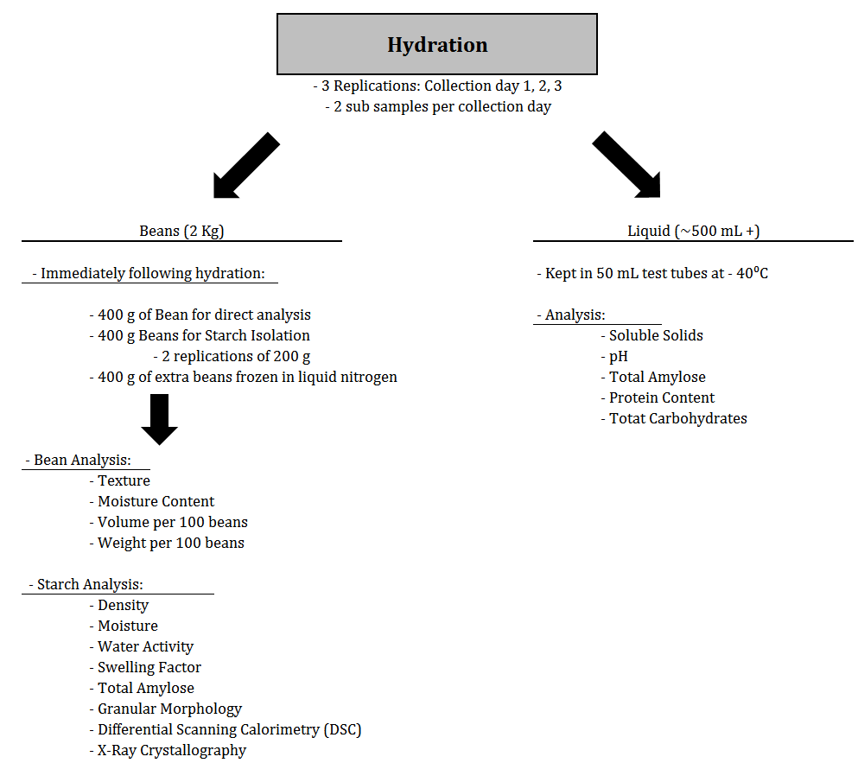

Figure 2.2 Outline for analysis of hydration protocols.

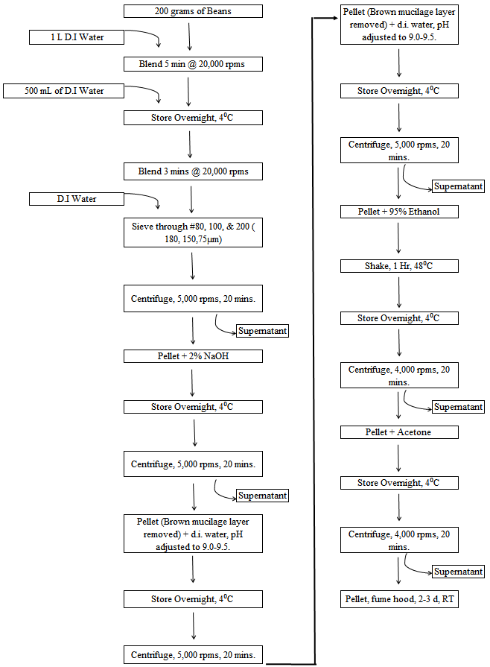
Figure 2.3 Procedural outline for the extraction of starch from navy beans.
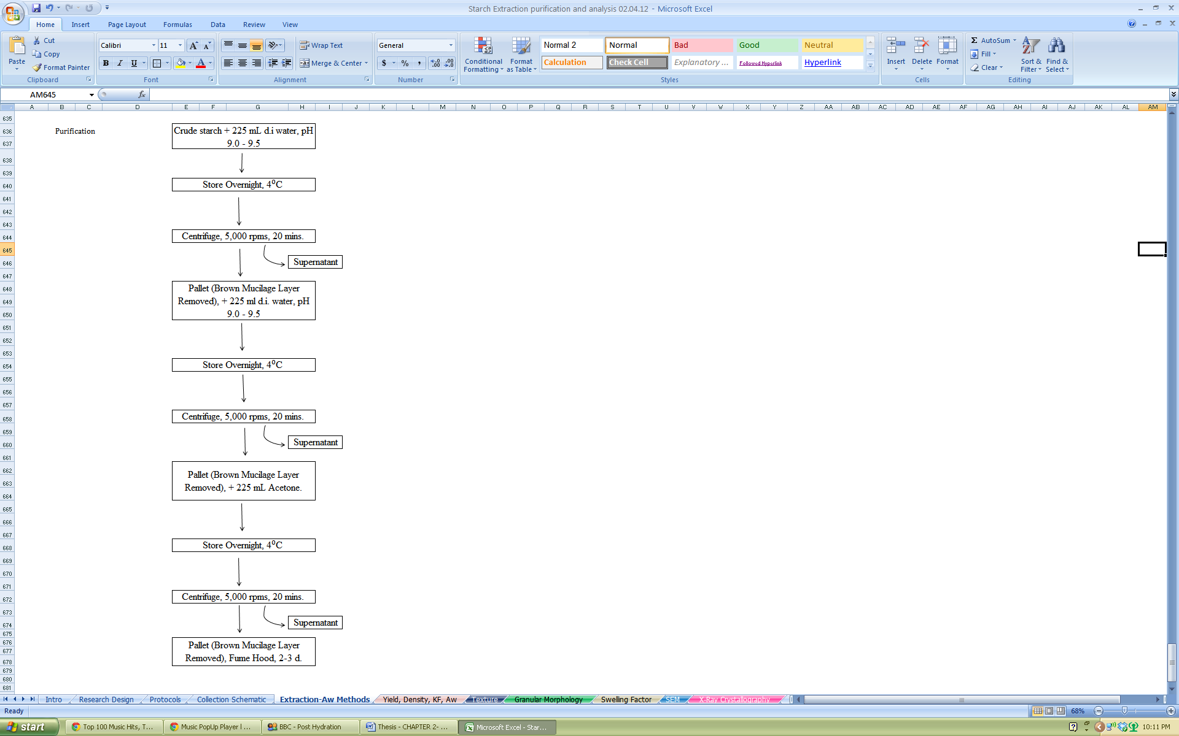

Figure 2.4 Procedural outline for the purification of extracted starch from navy beans.

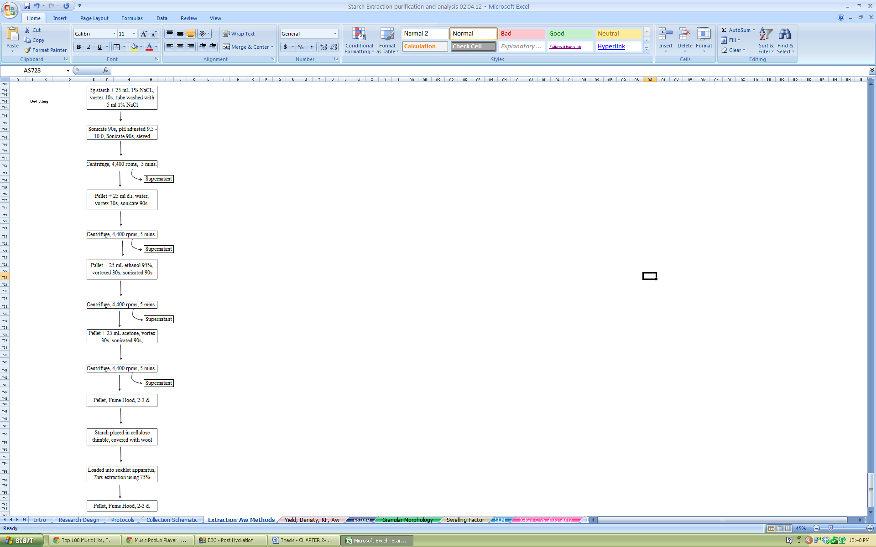

Figure 2.5 Procedural outline for the de-fatting of extracted starch from navy beans.

Table 2.1 Texture Analysis for hydrated bean samples completed in triplicates by analyzing 180 g sample for each of three collection days.

Table 2.2 Moisture, bean weight, and bean volume of hydrated bean samplesª
ª Completed in triplicates by analyzing one sample for each collection day. Values in a row followed by the same letter are not significantly different (α = 0.005)
^{b} Per 100 g of beans

Table 2.3 Yield, Density, Moisture, and Water Activity averages of isolated starch.ª

Completed in triplicates by analyzing one sample for each collection day. Values in row followed by the same letter are not significantly different (α = 0.005)

Table 2.4 Granular Size Averages for each Protocolª
ª Values reported are the average of 50 granules. Values in a row followed by the same letter are not significantly different (p<0.005)

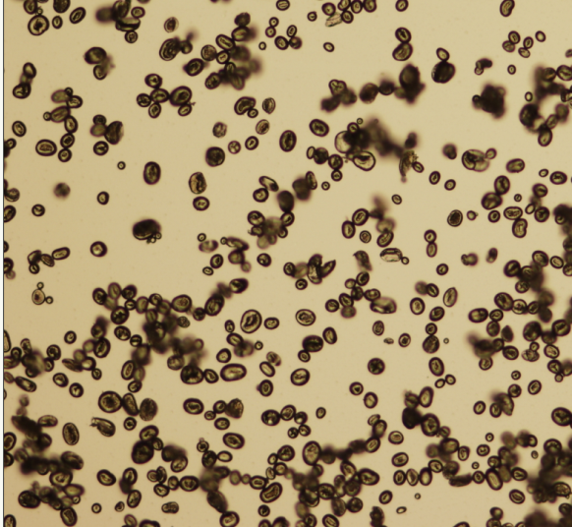 1 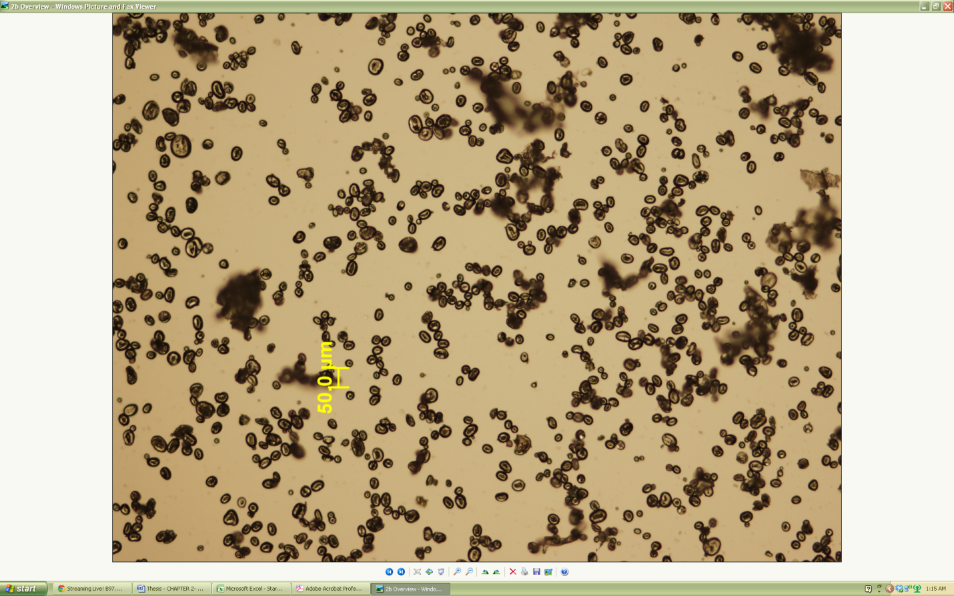 2
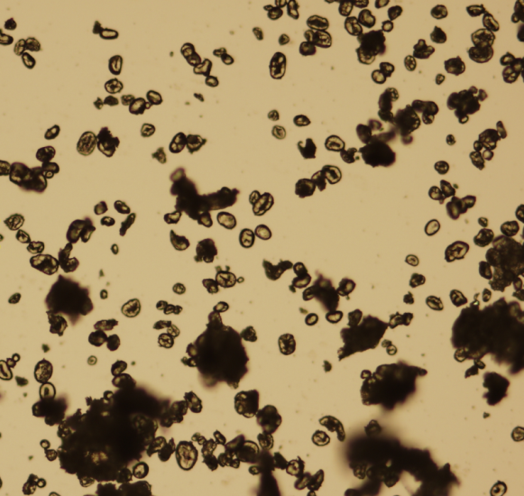 3 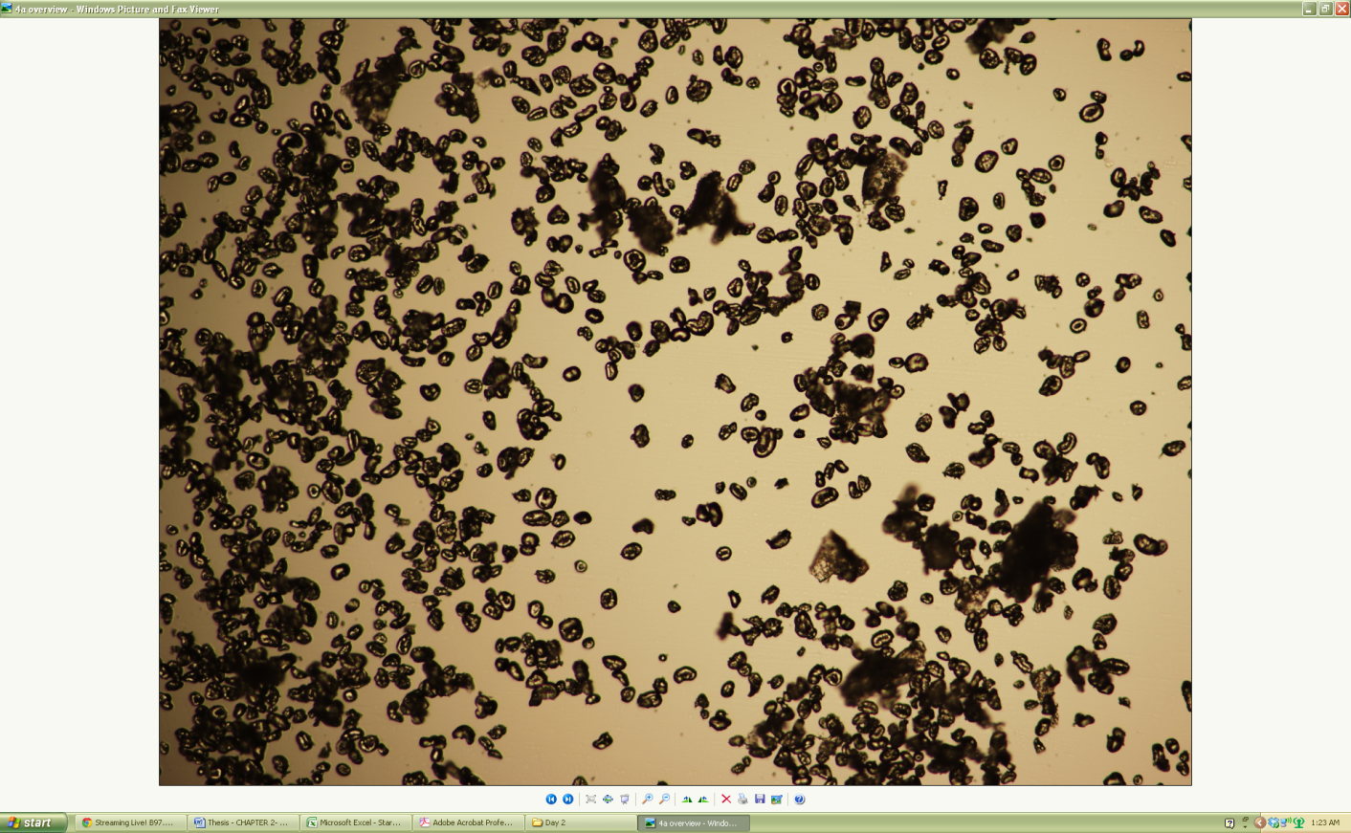 4
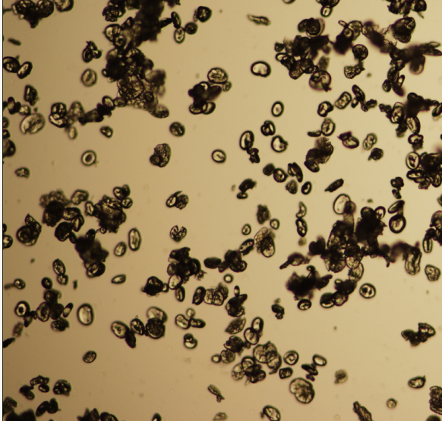 5 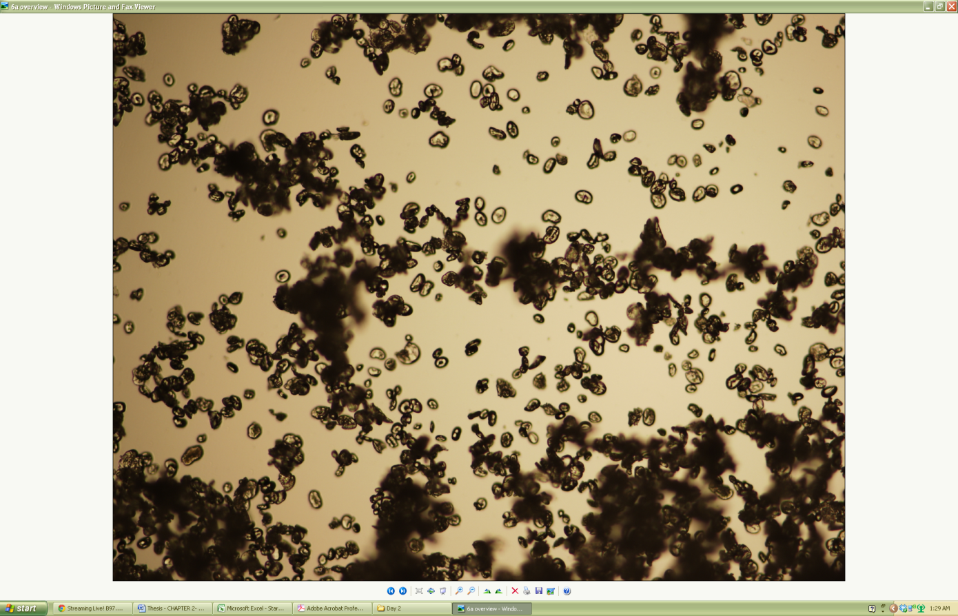 6
Figure 2.6 Starch granules from six hydration protocols captured by light microscopy at 40x magnification.
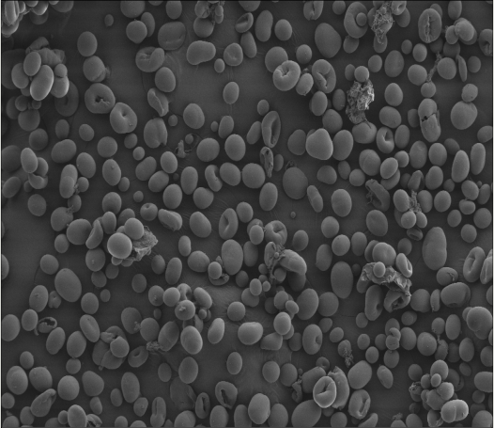 1 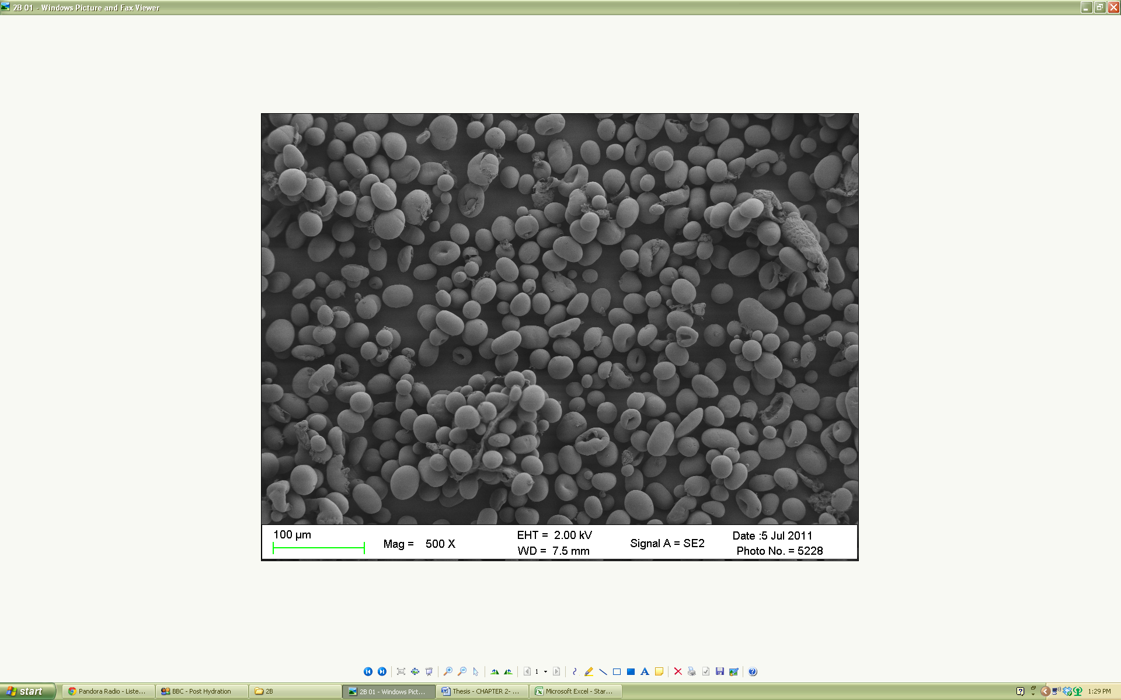 2
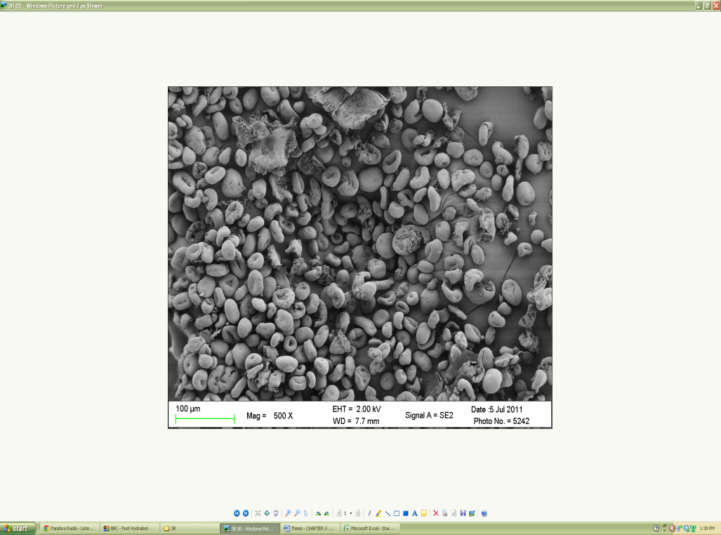 3 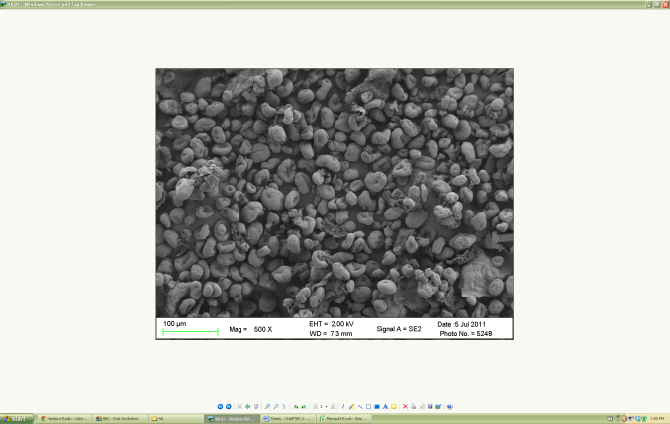 4
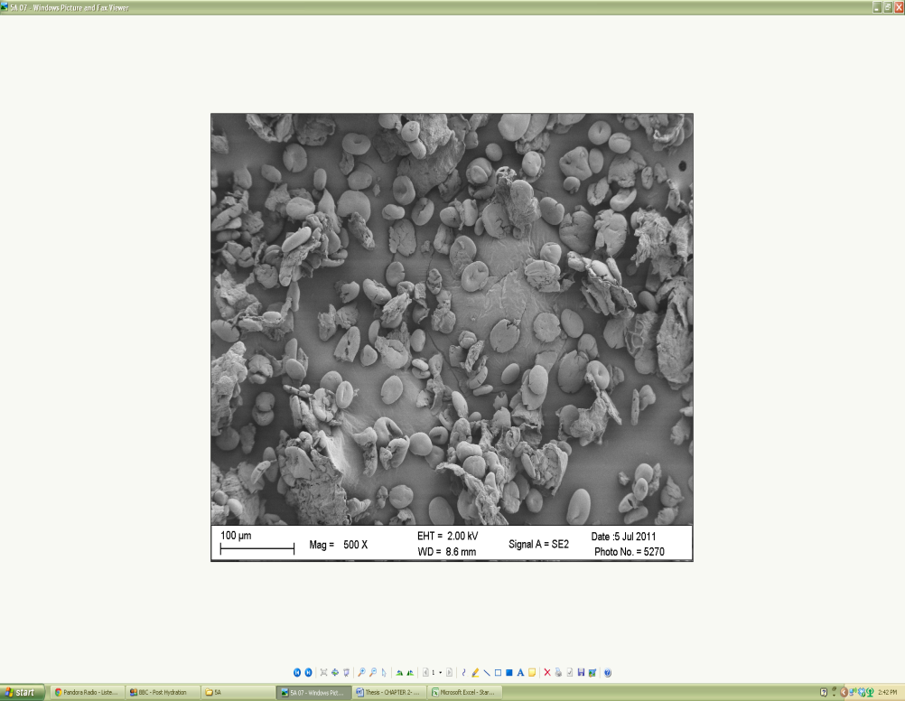 5 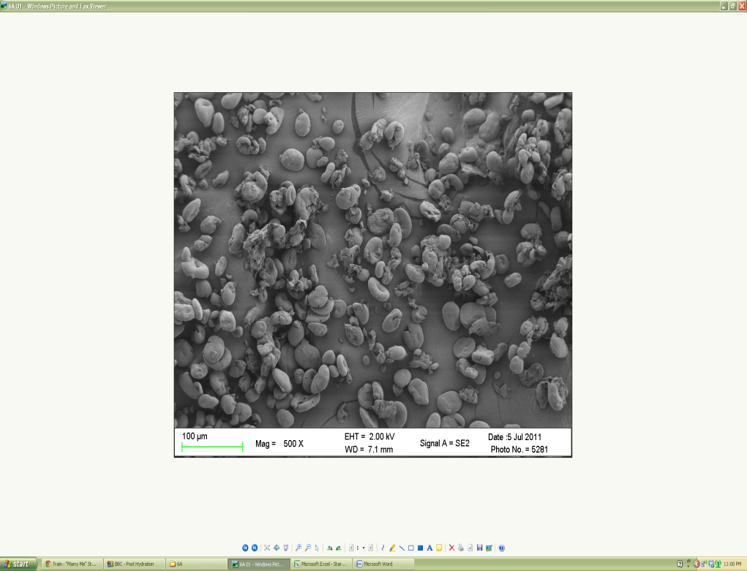 6
Figure 2.7 Starch granules from the six hydration protocols captured by SEM at 500X. The fiber/protein contamination is circled in each scan.
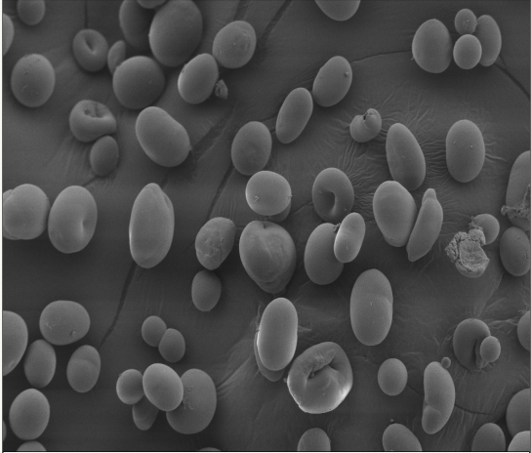 1 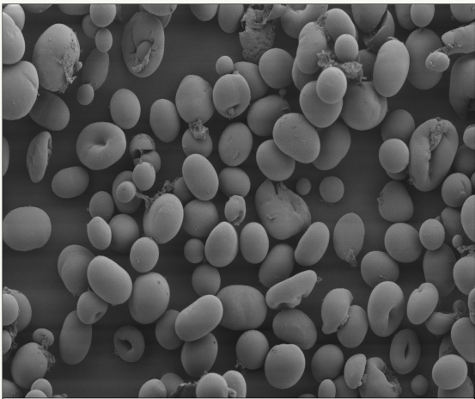 2
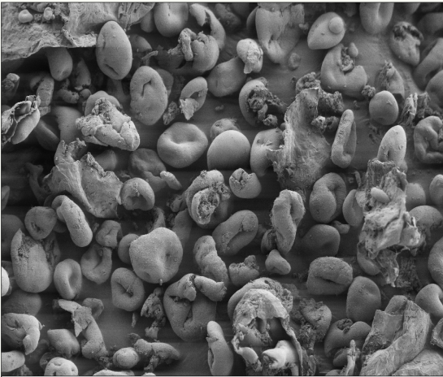 3 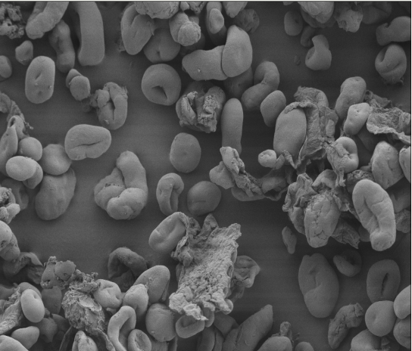 4
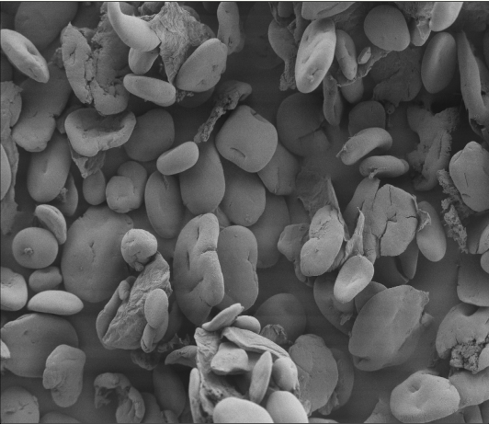 5 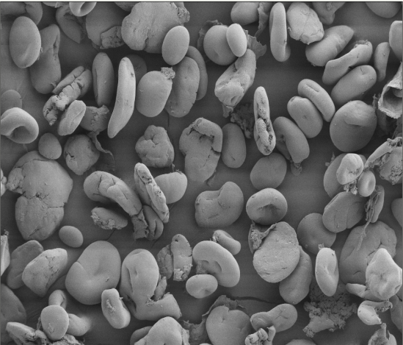 6
Figure 2.8 Starch granules from the six hydration protocols captured by SEM at 1,000X. The fiber/protein contamination is circled in each scan

Figure 2.9 Swelling Factor changes over a temperature range of 0-85⁰C. Values are presented as averages of triplicates.

Table 2.5 Gelatinization characteristics of starches from six hydration protocols.

 | Transition Temperatureª [⁰C] |  |  |  |  |  | T_{C} - T_{o} [⁰C]^{b} |  | ∆H^{c} [J/g]
 | T_{o} |  | T_{p} |  | T_{C}
1 | 72.0 |  | 77.5 |  | 85.1 |  | 13.2 |  | 4.6
2 | 70.7 |  | 76.6 |  | 83.8 |  | 13.1 |  | 3.6
3 | NO Gelatinization
4 | NO Gelatinization
5 | NO Gelatinization
6 | NO Gelatinization
ª T_{o}, T_{p}, and T_{c} indicate the temperatures of the onset, midpoint and end of gelatinization
^{b} T_{c} – T_{o} indicates the gelatinization temperature range
^{c} Enthalpy of gelatinization
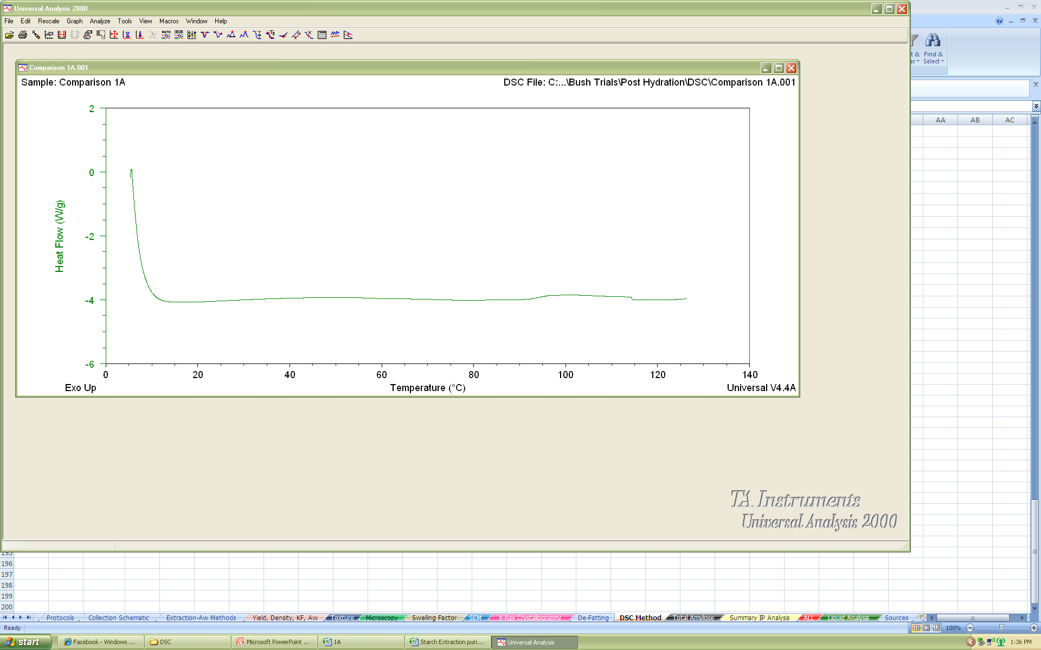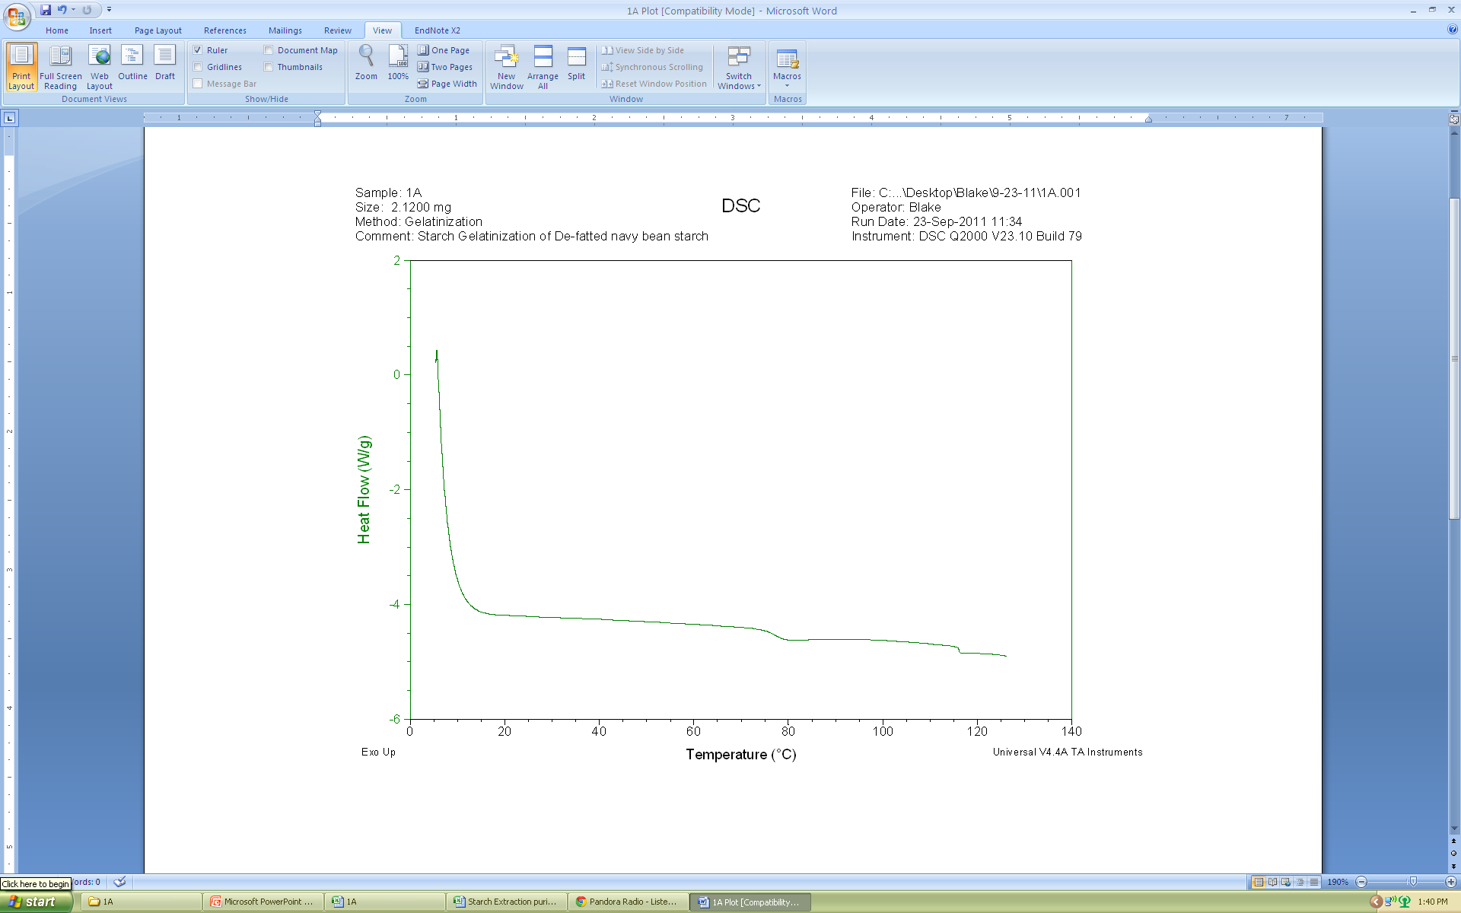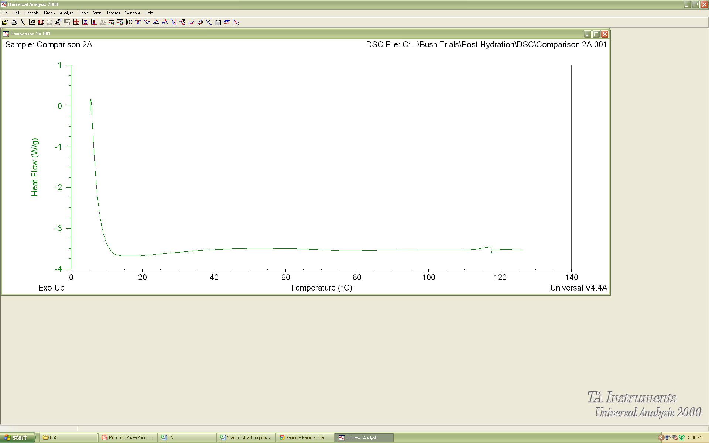
Protocol 1: De-Fatted
Protocol 2: Not De-Fatted
Protocol 1: Not De-Fatted
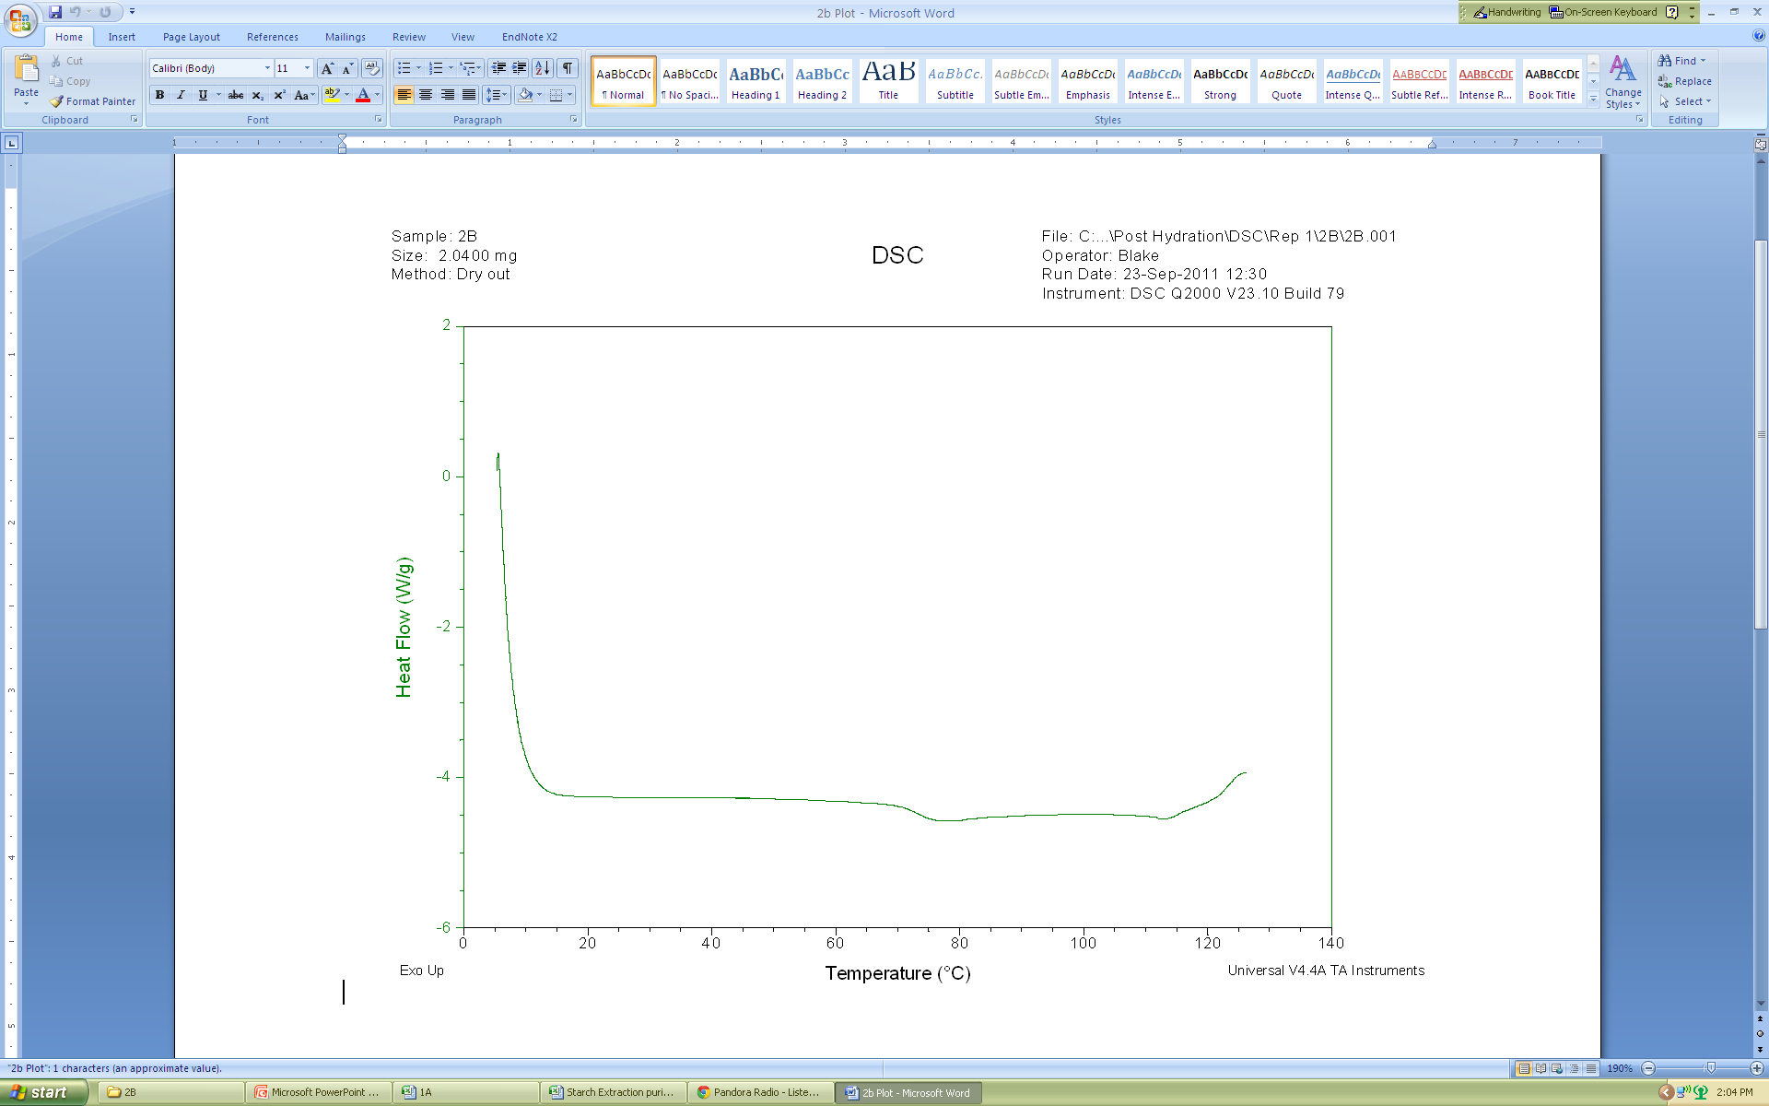
Protocol 2: De-Fatted
Figure 2.10 Gelatinization not seen in DSC samples without performing de-fatting procedure.
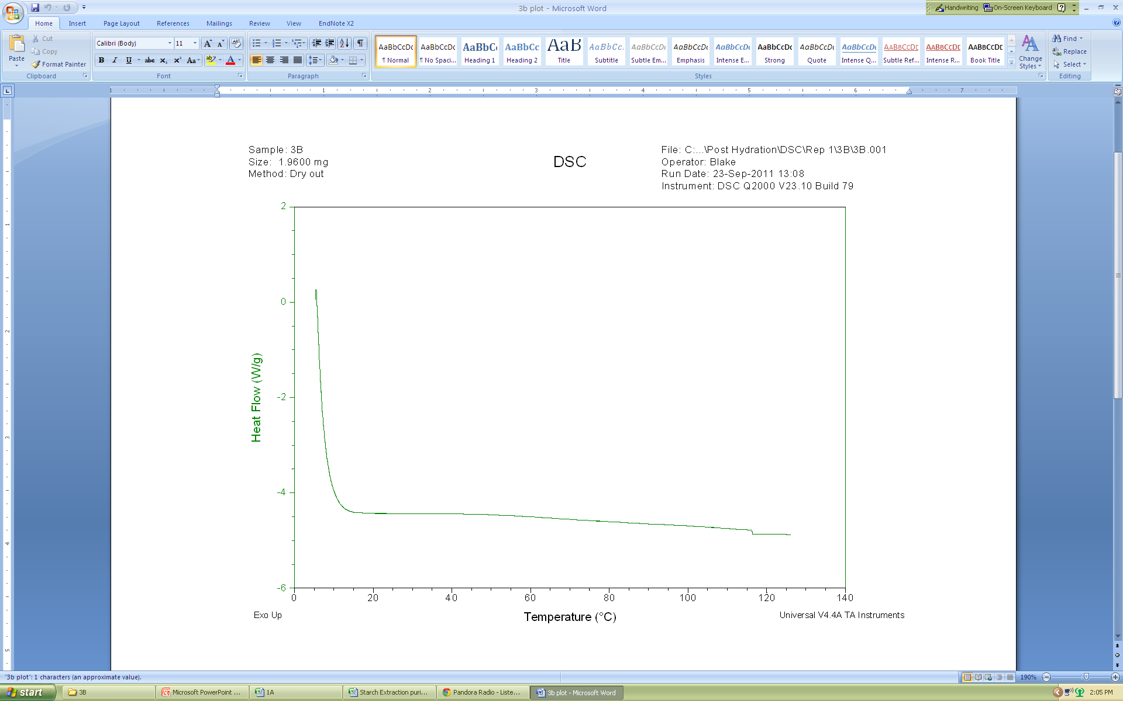
Protocol 3: De-Fatted
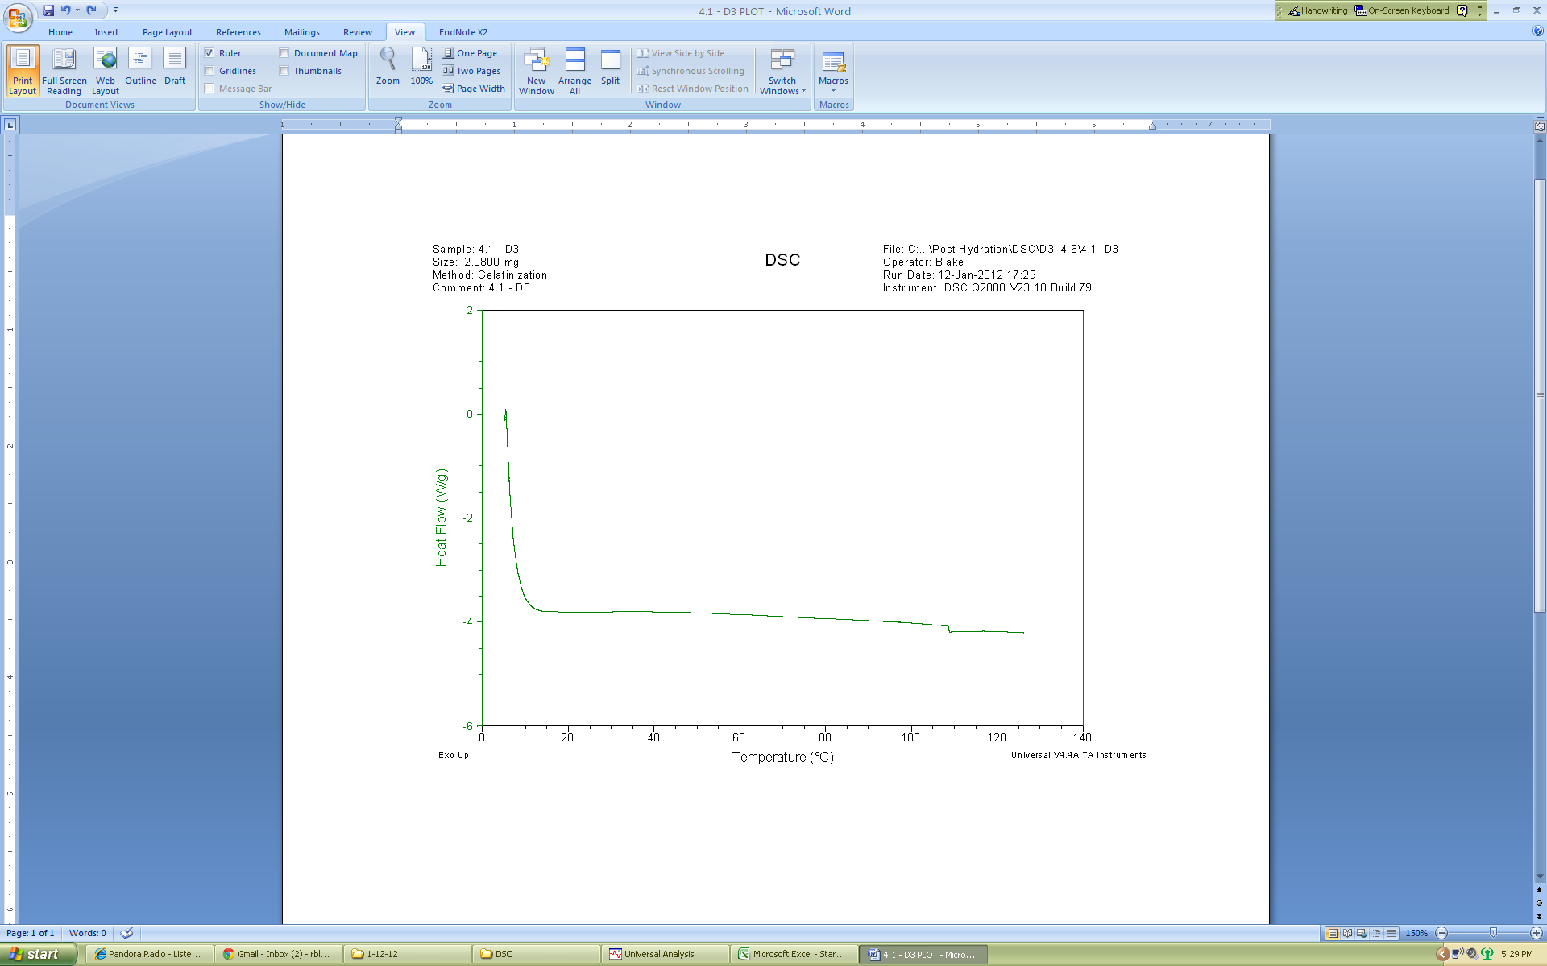
Protocol 4: De-Fatted
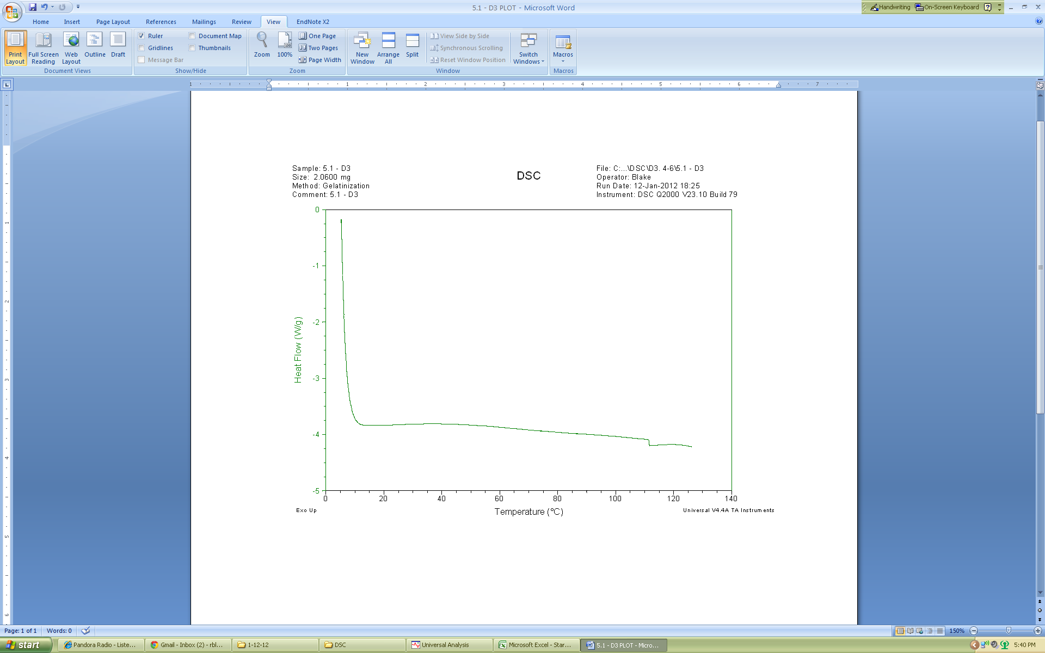
Protocol 5: De-Fatted
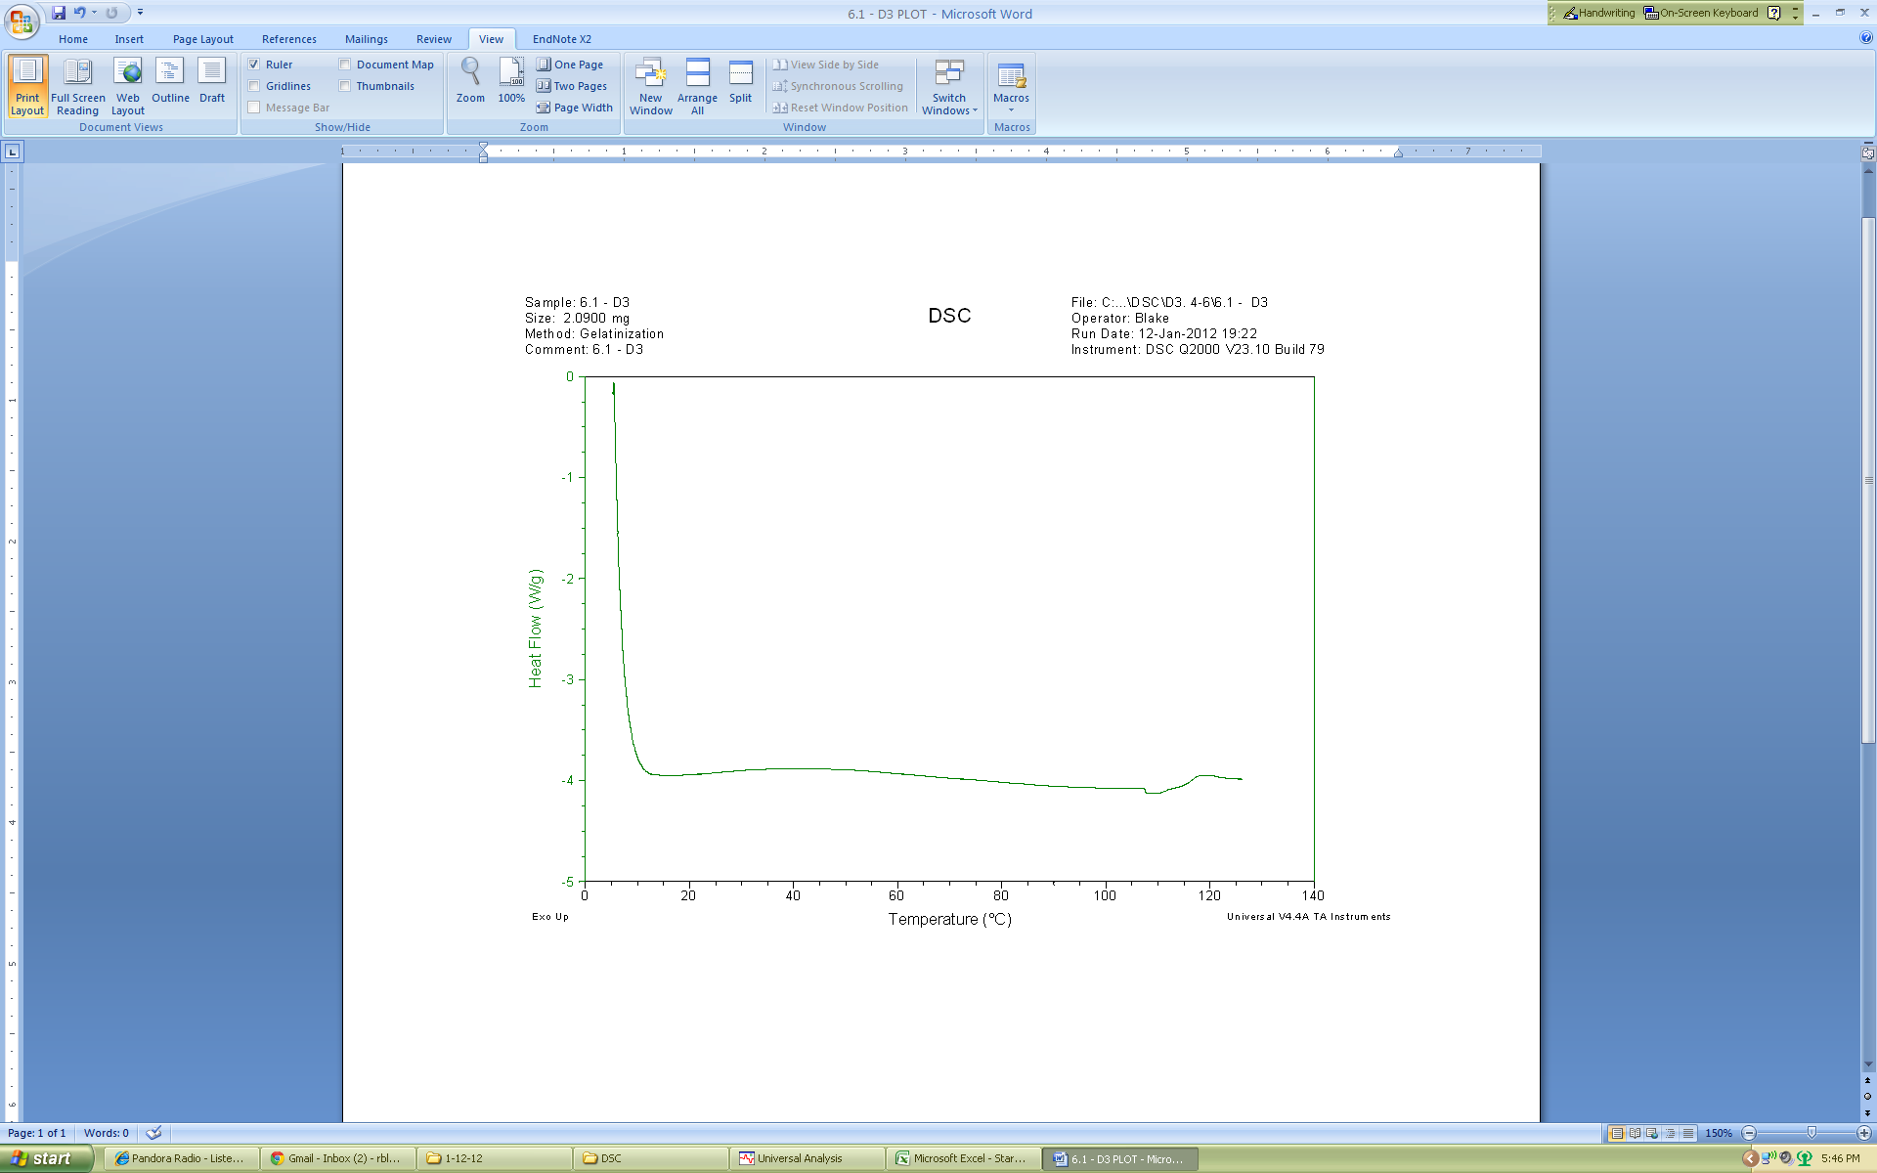
Protocol 6: De-Fatted
Figure 2.11 DSC analysis of starch from hydration protocols 3-6 show no gelatinization.

Table 2.6 Total amylose determination for extracted starch from six hydration protocols ª
ª Triplicates analyzed of each protocol for collection days 2 and 3 for a total of six samples of each protocol. Values followed by the same letter are not significantly different (p<0.05)

Table 2.7 pH, ⁰Brix, amylose, carbohydrate, and protein content values for hydration liquid from six protocols.ª
ª Completed in triplicates by analyzing one sample for each collection day.
^{b} Percent of hydration fluid after hydration as explained on page 14.

Sources
Colonna P, Buleon A & Mercier C. 1981. Pisum sativum and Vicia faba Carbohydrates: Structural Studies of Starches. Journal of Food Science 46(1):88-93.
Fernandez ML & Berry JW. 1989. The Effect of Germination on Chickpea Starch. Starch - Stärke 41(1):17-21.
Gujska E & Khan K. 1991. Feed Moisture Effects on Functional Properties, Trypsin Inhibitor and Hemagglutinating Activities of Extruded Bean High Starch Fractions. Journal of Food Science 56(2):443-447.
Gujska E, Reinhard W & Khan K. 1994. Physicochemical Properties of Field Pea, Pinto and Navy Bean Starches. Journal of Food Science 59(3):634-636.
Hoover R & Manuel H. 1996. Effect of heat moisture treatment on the structure and physicochemical properties of legume starches. Food Research International 29(8):731-750.
Hoover R & Ratnayake WS. 2001. Determination of Total Amylose Content of Starch. Current Protocols in Food Analytical Chemistry. John Wiley & Sons, Inc.
Hoover R & Ratnayake WS. 2002. Starch characteristics of black bean, chick pea, lentil, navy bean and pinto bean cultivars grown in Canada. Food Chemistry 78(4):489-498.
Hoover R & Sosulski F. 1985. Studies on the Functional Characteristics and Digestibility of Starches from Phaseolus vulgaris Biotypes. Starch - Stärke 37(6):181-191.
Hoover R & Sosulski FW. 1991. Composition, structure, functionality, and chemical modification of legume starches: a review. Canadian Journal of Physiology and Pharmacology 69(1):79-92.
Junek JJ, Sistrunk WA & Neely MB. 1980. Influence of process methodology on quality attributes of canned dry beans. Journal of Food Science 45(4):821-824.
Kurtzman RH & Halbrook WU. 1970. Polysaccharide from Dry Navy Beans, Phaseolus vulgaris: Its Isolation and Stimulation of Clostridium perfringens. Applied Microbiology 20(5):715-719.
Lai CC & Varriano-Marston E. 1979. Studies on the characteristics of black bean starch. Journal of Food Science 44(2):528-530.
Lees MB & Paxman S. 1972. Modification of the lowry procedure for the analysis of proteolipid protein. Analytical Biochemistry 47(1):184-192.
Lowry OH, Rosebrough NJ, Farr AL & Randall RJ. 1951. Protein measurement with the folin phenol reagent. Journal of Biological Chemistry 193(1):265-275.
Morris HJ, Olson RL & Bean RC. 1950. Processing quality of varitities and strains of dry beans. Food Technology. p. 247.
Naivikul O. 1977. The Carbohydrates Present in Flour Obtained from Various Types of Legumes. Fargo, ND.: North Dakota State University

Naivikul O & D'Appolonia BL. 1979. Comparison of legume and wheat flour carbohydrates. Il. Starch. Cereal chemistry. 56(1):24-28.
Neely M & Sistrunk WA. 1979. Influence of processing methodology on the strength of wastewater from canning dry beans. Journal of Food Science 44(2):407-410.
Noda T, Takahata Y, Sato T, Suda I, Morishita T, Ishiguro K & Yamakawa O. 1998. Relationships between chain length distribution of amylopectin and gelatinization properties within the same botanical origin for sweet potato and buckwheat. Carbohydrate Polymers 37(2):153-158.
Nordstrom CL & Sistrunk WA. 1977. Effect of type of bean, soak time, canning media and storage time on quality attributes and nutritional value of canned dry beans. Journal of Food Science 42(3):795-798.
Pan Z & Tangratanavalee W. 2003. Characteristics of soybeans as affected by soaking conditions. LWT - Food Science and Technology 36(1):143-151.
Quast DC & Silva SD. 1977. Temperature dependence of the cooking rate of dry legumes. Journal of Food Science 42(2):370-374.
Rackis JJ. 1975. Oligosaccharides of food legumes: Alpha-galactosidase activity and the flatus problem. Physiological Effects of Food Carbohydrates. American Chemical Society. p. 207-222.
Radhika RK, Zakiuddin AS & Bhattacharya KR. 1993. The fine structure of rice-starch amylopectin and its relation to the texture of cooked rice. Carbohydrate Polymers 22(4):267-275.
Robertson LS & Frazier RD. 1978. Dry Bean Production - Principles & Practices. East Lansing, MI: Ext. Bull. E-1251Coop. Ext. Serv. and Agric. Exper. Stn.
Sathe SK & Salunkhe DK. 1981. Isolation, Partial Characterization and Modification of the Great Northern Bean (Phaseolus vulgaris L.) Starch. Journal of Food Science 46(2):617-621.
Sopade PA & Obekpa JA. 1990. Modelling Water Absorption in Soybean, Cowpea and Peanuts at Three Temperatures Using Peleg's Equation. Journal of Food Science 55(4):1084-1087.
Srisuma N, Ruengsakulrach S, Uebersax MA, Bennink MR & Hammerschmidt R. 1991. Cell wall polysaccharides of navy beans (Phaseolus vulgaris). Journal of Agricultural and Food Chemistry 39(5):855-858.
Su HS, Lu W & Chang KC. 1998. Microstructure and Physicochemical Characteristics of Starches in Six Bean Varieties and Their Bean Paste Products. LWT - Food Science and Technology 31(3):265-273.
Tester RF & Morrison WR. 1990a. Swelling and gelatinization of cereal starches. I. Effects of amylopectin, amylose, and lipids. Cereal chemistry. 67(6):551-557.
Tester RF & Morrison WR. 1990b. Swelling and gelatinization of cereal starches. II. Waxy Rice Starches. Cereal Chemistry 67(6):558-563.
Thorne M, Thompson L & Jenkins D. 1983. Factors affecting starch digestibility and the glycemic response with special reference to legumes. The American Journal of Clinical Nutrition 38(3):481-488.
Varatharajan V, Hoover R, Li J, Vasanthan T, Nantanga KKM, Seetharaman K, Liu Q, Donner E, Jaiswal S & Chibbar RN. 2011. Impact of structural changes due to heat-moisture treatment at different temperatures on the susceptibility of normal and waxy potato starches towards hydrolysis by porcine pancreatic alpha amylase. Food Research International 44(9):2594-2606.
Vasanthan T. 2001. Overview of Laboratory Isolation of Starch from Plant Materials. Current Protocols in Food Analytical Chemistry. John Wiley & Sons, Inc.
Wang HL, Swain EW, Hesseltine CW & Heath HD. 1979. Hydration of whole soybeans affects solids losses and cooking quality. Journal of Food Science 44(5):1510-1513.
Yañez-Farias GA, Moreno-Valencia JG, Falcón-Villa MdR & Barrón-Hoyos JM. 1997. Isolation and Partial Characterization of Starches from Dry Beans (Phaseolus vulgaris) and Chickpeas (Cicer arietinum), Grown in Sonora, Mexico. Starch - Stärke 49(9):341-345.
Yun S-H & Matheson NK. 1990. Estimation of Amylose Content of Starches after Precipitation of Amylopectin by Concanavalin-A. Starch - Stärke 42(8):302-305.

CHAPTER 3.

CHANGES IN CARBOHYDRATES OF NAVY BEANS DURING THERMAL PROCESSING IN SAUCE AND BRINE SOLUTION

Abstract
Navy beans were subjected to 5 different hydration protocols and subsequently canned in a brine and baked bean sauce. After a storage time of ~9 months, the physicochemical properties were analyzed in an effort to correlate the differences in hydration methods with finished product attributes. Kramer sheer press texture analysis of beans canned in brine revealed significantly firmer beans from novel protocols (5 and 6) compared to current (3) and traditional protocols (1 and 2) while no significant differences were detected in bean samples canned in sauce. Texture analysis on individual beans was confirmed significant differences in beans canned in brine and was able to detect significant differences in beans canned in sauce with beans from protocols 3-6 being firmer than beans from protocols 1. The use of extreme thermal, processing in excess of 121ºC induced complete gelatinization in all protocols for both brine and sauce samples. This was confirmed by DSC and polarized light microscopy. SEM scans confirmed extensive granular damage and swelling factor testing showed starch from all protocols had diminished abilities to retain water further signifying starch damage. There was no significant difference in the amylose content of beans canned in brine; however, beans canned in sauce did have differences in amylose content with protocol 1 containing the most amylose and protocol 5 containing the least. In conclusion, full gelatinization occurred in all beans during thermal processing which negated many differences observed after hydration. The texture trend from post hydration analysis was reversed following thermal processing. For brined beans, novel protocols (5 & 6) had a significantly firmer, final texture compared to current (3) and traditional protocols. Texture analysis of beans canned in sauce revealed no differences in current (3) and novel protocols (4-6).

Introduction
In the 1790’s, during the Napoleonic wars, the French government offered a prize for the invention of an effective, cheap method for preserving food for extended periods of time for the country’s armed forces. In 1809, Frenchman Nicolas Appert won the prize when he demonstrated that animal and vegetable parts could be maintained for long periods of time after thermal treatment and anaerobic storage in jars (Heldman and Hartel 1999; Lopez 1987). By 1810, the practice of canning had spread to England, and by the 1820’s canning plants were appearing in the United States (Desrosier and Desrosier 1977) Beginning in the mid 1800’s, the industry began making many advancements toward improved large scale production of canned goods. Companies began to shift away from glass jars due to the invention of steel cans which were cheaper and easier to ship. Increasing demand by middle class civilians throughout the late 1800’s and armed forces during major military conflicts, WWI and WWII, served as the main driving forces for continued advancements up through the mid 1900’s. It eventually led to today’s light weight aluminum coated steel can and efficient retort machinery capable of producing mass quantities of canned goods in short periods of time.
The reason for the effectiveness of canning was not known at the time of its invention; however, Louis Pasteur’s discovery of microbes in 1864 as a causative agent of spoilage established the basic scientific understanding of canning and helped revolutionize the industry (Desrosier and Desrosier 1977; Heldman and Hartel 1999; Lopez 1987) Commercial sterilization began using an intense thermal process coupled with high pressure to reduce the population of spoilage microorganisms and pathogens such as Escherichia coli, Salmonella, and Listeria monocytogenes and in order to produce a safe, shelf stable product in metallic cans (Desrosier and Desrosier 1977; Singh and Heldman 2001). However, the discovery and characterization of spore forming bacteria such as Clostridium botulinum in the 1910’s and 1920’s became a major focus of control in the food manufacturing industry (Desrosier and Desrosier 1977). C. botulinum is an anaerobic bacterium capable of producing spores that can survive thermal processing. Surviving spores can sporulate into viable cells capable of producing a neurotoxin which is the causative agent of botulism, a disease characterized by quick debilitating paralysis or death (Wilson et al2011). Therefore, commercial canning processes incorporated thermal death times, total time required to accomplish a stated reduction in a population of microbes, that is reflective of the time required to reduce the C. botulinum population by 12 logs (Singh and Heldman 2001). Today, the thermal death time of C. botulinum is the standard for most canning processes(Lopez 1987; Singh and Heldman 2001).
Using a hydrostatic retort, Bush Brothers & Company subject canned products to a temperature of 125ºC for a pre-determined time period capable of reducing a C. botulinum population by 12 logs. Lethality of microorganisms occurs faster during convection heating inside the can rather than conduction heating (Desrosier and Desrosier 1977; Heldman and Hartel 1999). As a result, beans canned in a brine solution, which mostly heat due to convection, reach lethality in half the thermal processing time compared to beans canned in sauce. The brine solution contains fewer solids and is less viscous; therefore, it is able to conduct heat at a faster rate. Beans canned in sauce require a longer treatment due to the nature of the sauce. Additives such as starch and sugar significantly increase the viscosity of the sauce which impedes convection within the can and conduction becomes the primary heating mechanism. Conduction heating requires prolonged heating in order to accurately heat the center of the product to eliminate the threat of spoilage and pathogens. It is important to note that current processing times used by BB&C are much longer than lethality times in order to cook the product to specific texture and flavor benchmarks. The objectives of this study was to analyze beans canned in brine and typical baked bean sauce and compare with post hydration findings in order to understand what physicochemical changes happened during hydration that may have affected the final texture in canned beans

Materials and Methods

Canning and Collection of Samples
Navy Beans hydrated using the protocols previously described in Chapter 2 were uniformly packed by weight into aluminum cans on each collection day at the BB&C Product Development Complex (Knoxville, TN)(Figure 3.1). Cans were filled by weight with either a brine solution or a typical baked bean sauce, sealed, and sent to an Allpax® simulated hydrostatic retort process (Allpax Products, LLC, Covington, LA) a small scale model of the hydrostatic retort currently used by BB&C (Chestnut Hill, TN). Afterwards, beans were transported to the Food Science and Technology Department at the University of Tennessee (Knoxville, TN) and stored for ~ 9 months in ambient, dry conditions. Since protocol 2 was not a complete hydration step and was instead a half step for protocol 3, there were no canned products for protocol 2. Furthermore, to stay consistent with chapter 2, only cans from collection days 2 and 3 were analyzed.

Bean Analysis
Texture Analysis. Two forms of texture analysis were performed on canned products. Upon completion of canning processes BB&C technicians completed texture analysis on both brine and sauce samples. Beans were emptied from can into a gallon plastic pitcher and filled with 2.5 quarts of hot water. Beans and water were gently stirred for 30 s to liquefy rendered fat and to remove the sauce/brine from the solids. Beans were poured onto a #8 sieve (2.36mm) and spread evenly to facilitate proper draining. Sieve was propped at a 45⁰ angle and allowed to drain for two minutes. After which, 180 g of beans were measured and placed in the sample cell of the texture analyzer (TMS-Pro Food Texture Analyzer, Food Technology Corporation, Sterling, VA). This apparatus utilized a Kramer Compression Shear Cell to determine texture analysis of the sample. Data is collected by Texture Lab Pro software®. Texture analysis was completed in triplicates per protocol for each collection day and was reported by BB&C personnel as pounds of force per 20 g beans.
The second texture analysis was conducted on brine and sauce samples after cans were stored for ~9 months ambient, dry conditions. Using a texture analyzer (TA.XTPlus, Texture Technology, Scarsdale NY) fitted with a Jacobs® 1mm Hand-Tite keyless chuck and probe (Jacobs Chuck Manufacturing, Sparks MD) beans were tested individually. A can was opened for each protocol, and 50 beans (deformity free) were chosen for analysis. Care was taken to ensure the probe cleanly punctured bean without going all the way through the bean. If the probe caused smashing or cracking, the bean and results were discarded. The firmness of the bean skin was analyzed by determining force and distance required to puncture the skin. The firmness of the bean at a depth of approximately 2 mm and 4 mm was also determined. This was repeated for all three collection days giving a total of 150 beans sampled for each protocol. Analysis and results were completed and reported by the food protein lab in the Food Science Department at the University of Tennessee, Knoxville.

Weight. The weight of canned beans was reported as the washed drain weight. Beans and sauce/brine were emptied from can into a gallon pitcher filled with 2.5 q of hot water. Beans and water was gently stirred for 30 s to liquefy rendered fat and to remove the sauce or brine from the solids and poured onto a #8 sieve (2.36mm) and spread evenly to facilitate proper draining. Sieve was propped at a 45⁰ angle and allowed to drain for two minutes. Immediately, beans were weighed. Weight determination was completed in triplicates for each protocol.

Starch Analysis
Starch Isolation. Isolation was a step-wise process (Fig. 3.2) which contained steps designed to remove unwanted bean contents such as proteins, lipids and dietary fiber and was modeled after the method used by Sathe and Salunkhe (Sathe and Salunkhe 1981). Cans were opened and contents were poured on a #8 sieve (2.36mm). A sieve shaker was used for 2 min in order to remove as much sauce or brine as possible. Sauce and brine was placed in 40 mL aliquots and placed in -40⁰ freezer. Using a spatula, 200g of beans was measured from the sieve and blended with 1 L of cold de-ionized (D.I.) water for 5 min at 20,000 rpm in a Waring® Commerical Blendor (Waring Products, Torrington, CT). Samples were then transferred to plastic bottles and 500 mL of cold D.I. water was used to rinse the blender and was added to the samples. Samples were stored overnight at 4⁰C. After ~12 hrs, beans were blended for additional 3 min in a Waring® blendor at 20,000 rpms and sieved using a combination of 80, 100, and #200 sieves (Thermo Fisher Scientific Inc., Waltham, MA). This correlates with filtration through openings of 0.18, 0.15, and 0.075 mm respectively. During filtration, sieves were rinsed with 500 mL of D.I. water. Pallet accumulated at the sieve surface was checked for remaining starch using an Olympus BX51 microscope (Olympus America, Center Valley, PA). Pallets containing large quantities of starch granules, were rinsed with an additional 500 mL of D.I. water and rechecked under microscope. This was repeated until residual pallet was free of starch granules. Resultant filtrate was collected and transferred to 225 mL polycarbonate centrifuge bottles (Thermo Scientific, Waltham MA) and centrifuged (Sorvall RC 5B Plus, Sorvall Centrifuge Co., Buckinghamshire, England) at 5,000 g-force (5,700 RPM) at 25⁰C for 20 min. Pellets were collected and re-hydrated with 225 mL of 2% NaCl solution per bottle and stirred overnight at 4⁰C. After ~12 hrs, samples were centrifuged for 20 min at 5,000 g force and supernatant was decanted from centrifuge bottles. As previously decribed, the presence of dark, brown mucilage was in all samples on the surface of the starch pallet and subsequently removed using a spatula. Portions of 225 mL of D.I. water was added to each bottle, pH of each sample was adjusted to 9.0 - 9.5 using 1N NaOH, and samples were stirred overnight at 4⁰ C. After 12 hrs, samples were centrifuged for 20 min at 5,000 g and supernatant was decanted. This step was repeated for 4-6 days or until the absence of the brown mucilage layer. Then, 225 mL of 95% ethanol was added to each bottle and placed in a water bath at 48⁰C and shaken at 50 rpm for one hour. After the water bath, samples were stirred overnight at 4 ⁰C. Samples were transferred to 225 mL fluorinated ethylene propylene bottles (Thermo Scientific, Waltham MA) and centrifuged at 4,000 g-force (5,100 RPM) at 25⁰C for 20 min. Supernatant was decanted and 225 mL of acetone was added to each bottle and stirred overnight at 4ºC. The following day, samples were placed in an ambient environment for one hour followed by centrifugation at 4,000 g-force for 12 min. Supernatant was discarded and the centrifuge bottles containing the pellet product was placed in a fume hood for 2-3 days. Dried samples were then placed in a VirTis AdVantage Plus BenchTop freeze drier for two days (SP Industries, Warminster, PA). Isolation was performed for collection days 2 and 3 for both sauce and brine.
Defatting Samples. Defatting of starch samples used for total amylose determination and DSC analysis was performed by Hoover and Ratnayake (Hoover and Ratnayake 2001) which utilized the Soxhlet extraction apparatus (Fig. 3.3). Prior to defatting, however, the extracted starch samples were subjected to an additional round of purification. From each protocol, 5 g was transferred to 50 mL centrifuge tubes where 25 mL of 1% NaCl solution was added to each. Samples were vortexed 10 s. Walls of the tube were washed with additional 5 mL of salt solution. Samples were then placed in a sonicator bath for 90 s. The pH of the solution was adjusted within a range of 9.5 - 10.0 using 1N NaOH. Samples were again sonicated for 90 s and poured through a sieve #100. Samples were centrifuged at 3,000 x g (4,400 RPM) at 25⁰ for 5 min. Supernatant was discarded, and 25 mL of D.I. water was used to rehydrate the pellet. Samples were mixed for 30 s and underwent sonication for 90 s. Again, samples were centrifuged and supernatant was discarded. Ethanol, 95%, was added to the pellet. Samples were vortexed 30 s and sonicated prior to more centrifugation at 3,000 x g for 5 min. Thereafter, 25 mL of acetone was added to the pellets, mixed and sonicated for 90 s. A final centrifugation for 5 min at 3,000 x g was performed. Centrifuge bottles containing the pallets were placed in fume hood overnight to allow acetone evaporation. The following day, each of the cleaned samples was placed in a 26 x 60mm Whatman® cellulose extraction thimble. Each thimble was covered with Whatman® #42 filter paper and placed in the extraction chamber of the soxhlet apparatus. For the solvent, 4 L of 75% n-propanol was utilized and heated to 32⁰C. Once the propanol solvent began to condense and fill the extraction chamber, the procedure was allowed to run for 7 hrs. Upon completion, thimbles were removed and placed in fume hood for 48 hrs to allow complete evaporation of remaining solvent. Samples were weighed and stored in desiccators at room temperature until use. This procedure was completed for all protocols, from collection days 2 and 3 for both sauce and brine.
Yield Determination. Dried starch samples were crushed lightly using a mortar and pestle and were transferred to a weigh boat for determination of total yield. Using microscopic evaluation, preliminary experiments were conducted to ensure that starch granules were not being damaged during the crushing process of this analysis. It was revealed that only prolonged, vigorous grounding caused granular damage to dried starch product. This was repeated for each protocol for collection days 2 and 3 for both sauce and brine.
Density Determination. Starch powder was ground lightly using a mortar and pestle. Afterward, powder was poured through stacked mini sieves #170 and #230 which correspond with openings of 90 and 63 µm respectively (Bel-Art Products, Wayne, NJ). A clean, dry graduated cylinder was tarred. Using a spatula, starch granules of uniform size trapped between the sieves was added to the cylinder up to 1mL mark. Tapping lightly helped to settle starch to ensure more accurate measurement. Weight of 1mL of starch was recorded.
This procedure was completed for all protocols, from collection days 2 and 3 for both sauce and brine.
Moisture Content. A Metrohm 795 KFT Titrino ( Metrohm USA, Riverview, FL) titration system was utilized to execute the Karl Fischer method for moisture analysis. Using HYDRANAL® Water Standard 10.0 (Sigma-Aldrich, Steinheim, Germany) a water titer determination was performed prior to testing starch samples to ensure the Karl Fischer reagents contained negligible amounts of water contamination. When testing starch samples, the titration vessel was filled with ~20 mL of 99% methanol and the solution was conditioned to the first endpoint by the apparatus. Exactly 0.1g of starch powder was added and moisture content was determined. Titration vessel was cleaned and wiped dry using Kimwipes® (Kimberly-Clark Global Sales, Roswell, GA) after three samples were tested. This procedure was completed for all protocols, from collection days 2 and 3 for both sauce and brine.
Water Activity. Water activity was determined by placing starch samples in water activity cups and placing in the chamber of the water activity meter (Aqua Lab, Pullman, Washington). This procedure was completed for all protocols, from collection days 2 and 3 for both sauce and brine.
Granular Morphology. Granular morphology was determined using an Olympus BX51 microscope (Olympus America, Center Valley, PA). Polarized light capabilities were used to determine if starch granules retained bifringence. Thereafter, the range of granule size was determined by measuring the length and width of fifty granules at 40x magnification, measures using an ocular micrometer. Granule surface was studied using scanning electron microscopy (SEM). This was performed by using double sided adhesive tape to adhere small samples of starch to specimen stubs. An ultrathin coating of electrically conducting material, in this case gold, was deposited on the samples either by a low-vacuum SPI sputter coater. The samples were then irradiated and loaded into the Leo (Zeiss) 1525 FE-SEM (Carl Zeiss NTS, LLC., 1 Corporation Way, Peabody, MA). At least 6 images of each protocol for collection days 2 and 3 of both sauce and brine were captured with magnification ranging from 700 to 3,500x.
Swelling Factor. Starch swelling factor (S_{F}) was determined using samples from collection day 3 of both sauce and brine. First, 500 mg of each starch sample was mixed with 4 mL of cold D.I. water in a 50 mL test tube. Samples were then placed into a sonication bath (Branson 1510, Branson Ultrasonic Corporation, Danbury, CT) for 30 s. Samples were placed in refrigerator for a period of 20 min, and the initial volume of starch was recorded. Thereafter, samples were placed into a 30⁰C water bath with shaking at 50 rpm. Solution within test tube was permitted to equilibrate to 30⁰C and then held for 5 min. Volume of starch was recorded. Samples were further heated to 40⁰C and held for 5 min. Starch volume was recorded. Thereafter, temperature of samples was increased by 5⁰C increments and held for 5 min at each interval. Starch volume was recorded for each period. This was continued until samples reached 75⁰C. Temperature was then raised to 85⁰C and held again for 5 min. Volume was recorded. The S_{F} is reported as the ratio of the volume of swollen starch granules and the initial volume recorded past refrigeration. Three replications of this procedure were completed for all protocols, from collection days 2 and 3 for both sauce and brine.
Differential Scanning Calorimetry (DSC). Gelatinization onset (T_{O}), peak (T_{P}), conclusion (T_{C}) and enthalpy (∆H) were measured using the Differential Scanning Calorimeter Q2000 (Thermal Analysis Instruments, New Castle DE). A modified version of the method set forth by Lopez et al. (1994) was used. In short, starch samples of 2 ± 0.1 mg were weighed directly into Tzero DSC Pans (Thermal Analysis Instruments) and 7 µl of D.I. water was added using a pipette. The pan was sealed with a Tzero hermetic lid and placed on a platform vortex to shake slowly for 1 hr to allow for equilibration at room temperature. The samples were scanned at a rate of 10⁰C/min from 0 to 130⁰C. An empty pan was used as the reference. Defatted samples from collection day 2 for both sauce and brine were completed in triplicates. Analysis was obtained directly with the software TA Instruments, version 4.4A.
Total Amylose. The amylose content of defatted samples was determined using colorimetric methods based on amylose-iodine complex formation potential (Hoover and Ratnayake 2001). First, 2 mg of starch was weighed into round bottom screw-cap tubes and 8 mL of 90% aq. dimethyl sulfoxide (DMSO) was added. Solutions were vortexed 15 s, and additional 2 mL of DMSO was used to wash side of test tube. Samples were autoclaved at 121⁰C for 15 min and allowed to cool to room temperature. During that time, an iodine solution (0.0025 M I₂/ 0.0065 M KI) was prepared in a dark, 1 L volumetric flask and left to stir until use. If no clear gel was present in the bottom of the test tubes, samples were then transferred to 25 mL volumetric flasks. Volume was adjusted with D.I. water and vortexed 15 s. This was solution #1. Next, 1 mL of solution #1 was transferred to a 25 mL volumetric flask and 2.5 mL aliquots of iodine solution were added to each sample or water (control). Volume was adjusted using D.I. water and solution was vortexed for 15 s. Color was allowed to develop for 15 min, after which the absorbance (A) was measured at 600 nm using a UV-2101PC spectrophotometer (Shimadzu, Columbia, MD). Pure amylose and amylopectin extracted from potato served as the standard solution for comparison. Defatted samples from collection days 2 and 3, both sauce and brine were ran in triplicates.

Hydration Liquid Analysis
Bean products from each protocol were canned in both a brine solution and typical baked bean sauce. As previously described in Chapter 2, the pH, soluble solids, protein content, amylose content, and total carbohydrate content was determined for the brine solution. However, analysis on the sauce samples was not completed. It was decided that additives such as starch and sugar within in the sauce would skew results for all tests; therefore accurate testing could not be completed. For testing, three tubes of each protocol both brine and sauce were thawed overnight at 4ºC to allow all tests to be run in triplicates. Determination of pH and soluble solids was conducted by BB&C personnel after the canning and cooling process.
Soluble Solids and pH. Soluble solids expressed as ⁰Brix, was determined using the ATAGO® Brix% PAL- α Digital Refractometer (ATAGO U.S.A., Inc., Bellevue, WA). The refractometer was cleaned with D.I. water and dried with Kimwipes® between each sample.
The pH was determined using a VWR Symphony SR601C pH meter (VWR Corp, Radnor, PA). Prior to testing, the instrument was calibrated with buffer solutions with a pH of 4, 7, and 10 and probe was washed thoroughly with D.I. water following each sample.
Total Amylose. Total amylose content of the hydration solution was determined using the method previously described except a 5 mL sample from each protocol was used. Three replications of this procedure were completed for all protocols, from collection days 2 and 3 for both sauce and brine.
Total Carbohydrate Concentration. A 20 g sample of the brine solution was weighed out for each protocol. A 20 mL aliquot of D.I water was added, and the solution was vortexed 30 s. After centrifuging at 3,800 g (5,000 rpm) for 10 min, the supernatant was transferred to a clean tube labeled ‘Tube 1’. Supernatant (1 mL) and a 9 ml aliquot of D.I water was vortexed 30 s in ‘Tube 2’. From ‘Tube 2’, 0.5 mL of sample was transferred to a clean test tube and 4.5 ml of Anthrone reagent was added to the test tubes and submerged in an ice bath. This was repeated for each protocol. All tubes were placed in a boiling water bath simultaneously. Once solutions within the tubes reached 95⁰C, tubes remained in boiling bath for 10 min. All tubes were then placed in an ice bath and absorbance (A) was read at 620 nm. Glucose was used for the preparation of the standard curve.
Total Protein Concentration. The concentration of proteins in hydration liquid was determined using the Lowry method modified to include 2.5% sodium dodycylsulfate (SDS) in the Lowry alkaline reagent (Lees and Paxman 1972; Lowry et al1951). Bovine Serum Albumin (BSA) standards were prepared ranging from 1 to 100 mg/mL in D.I water. For each sample, 20 g of brine solution was weighed and 20 mL of D.I water was added and vortexed 30 s. Following centrifugation at 3,800 g (5000 RPM) for 10 min the supernatant was transferred to a clean test tube labeled ‘Tube 1’. 1 mL of brine was taken from ‘Tube 1’ and 9 mL of D.I water was added and vortexed 30 s. This is ‘Tube 2’. Again, 1 mL was taken from ‘Tube 2’ and 5 mL of freshly prepared Lowry Assay mix was added and vortexed 30 s. This was incubated for 10 min at room temperature, and 0.5 mL of diluted Folin-Ciocalteu reagent was added and vortexed immediately. This was incubated for 30 min at room temperature and vortexed 30 s. Absorbance (A) was read at 660 nm.

Results and Discussion

Bean Analysis

Texture
Texture analysis collected and reported by BB&C technicians revealed significant (p<0.05) differences in the texture among brine products (Table 3.1) but not in sauce products, (Table 3.2). Results for brine samples showed that the force (lb/ 20 g) required to compress canned bean samples hydrated by protocols 5 and 6 was significantly higher compared to protocols 1-4. The differences are expected to be from the harshness of the hydration treatment during protocols 5 and 6. The texture results from sauce products contained no significant differences. This is expected to be due to the length of thermal treatment. Because sauce samples were retorted for twice the length of brine products, all differences in texture were diminished. When compared to texture analysis collected after hydration, canned products required less than half the force due to increased degradation of the bean structure as a result of intensive thermal processing.
Texture analysis for beans canned in brine, as completed by the food protein lab (Table 3.3), was also able to identify significant (p<0.05) differences in the texture of beans. The results of the individual analysis indicated the overall texture of beans from protocols 5 and 6 was significantly firmer when compared to protocols 1- 4. Beans from protocol 5 and 6 had tougher skins (1st peak Force) (Figure 3.4) and required more force (g) for the probe to penetrate the bean flesh at 2 and 4 mm (2nd and 3rd peak Force respectively). Depth analysis indicated that the analyzing probe had to extend further to penetrate through the skins of beans from protocols 3 and 4. This may indicated that these beans either have increased elasticity or their skins are thicker and more preserved and less effected by the hydration and canning processes.
Texture analysis for beans canned in sauce, as completed by the food protein lab (Table 3.4), was also able to identify significant (p<0.05) differences in the texture of beans. The results of the individual analysis indicated the overall texture of beans from protocols 3 -6 was significantly firmer when compared to beans hydrated by protocol 1. However, there were no significant differences (p > 0.05) between the textures of beans from the current protocol (3) and the novel protocols (4- 6). Beans hydrated by protocol 6 had tougher skins (1st peak Force) (Figure 3.4) as compared to beans from the other protocols. However at depths of 2 and 4 mm (2nd and 3rd peak Force respectively), protocols 3-6 showed no significant differences in texture but were overall more firm than beans from protocol 1.

Weight
The weight of beans canned in both brine and sauce can be found in Table 3.5. For those samples canned in brine, beans hydrated by protocol 1 weighed significantly more at 8.23 g while beans hydrated by protocol 3-6 were statistically the same. For beans canned in the baked bean sauce, there was no significant weight differences observed. The reason for larger weight in brined beans hydrated by protocol 1 is probably in gelatinization of starch during thermal processing in cans. In other samples (from protocols 3 to 6) gelatinization was completed during hydration and starch granules remained with decreased swelling potential.

Starch Analysis

Starch Isolation Yield

The yield for starch isolated from beans canned in brine solution can be found in Table 3.6. On average, the highest amount of starch was isolated from beans from protocol 3 while beans from protocol 4 yielded the least amount; however, there were no significant differences determined in the yield from protocols. Results from products canned in sauce (Table 3.7) show that a very low amount of starch, when compared to post hydration and brine products, was isolated from all protocols. The yield for brine products was slightly lower than the 30-53% range of starch isolation seen in other legume studies that focused on chickpeas, black beans, lentils, faba beans, and mung beans (Fernandez and Berry 1989; Hoover and Sosulski 1991; Hoover and Ratnayake 2002; Lai and Varriano-Marston 1979; Naivikul 1977; Yañez-Farias et al1997). This was expected since the amount of starch isolated after hydration was also lower than expected. The amount of starch extracted from canned brine products were consistent with other experiments that focused on Phaseolus vulgaris biotypes and demonstrated a range of 21-32% starch extraction (Fernandez and Berry 1989; Hoover and Sosulski 1985; Hoover and Ratnayake 2002; Sathe and Salunkhe 1981; Yañez-Farias et al. 1997). The low amount of starch isolated from sauce products may be due to several factors. Prolonged thermal process, such as the one used for sauce products, could have facilitated a substantial leaching for amylose and amylopectin from starch granules into the sauce. Furthermore, the extreme treatment could have resulting in severely damaged starch granules which may have been excluded by the sieve step of the isolation process.
As with starch isolation from post hydration samples, the extraction of starch from navy beans was difficult which is expected to be the result of the high fine fiber and protein content (Gujska et al1994; Hoover and Sosulski 1985; Hoover and Ratnayake 2002; Robertson and Frazier 1978; Sathe and Salunkhe 1981). However, effects that the matrix of proteins and complex carbohydrates (30% of the bean) such as raffinose, stachyose, verbascose, aribnose, xylose, cellulose, and hemicelluloses plays on starch isolation is expected to be less due to damage of the matrix during the moist heat process (Kurtzman and Halbrook 1970; Rackis Joseph 1975; Srisuma et al1991; Thorne et al1983). Following each aqueous alkali solution step of the extraction procedure in both the brine and sauce samples, a brown mucilage layer of flocculent proteins and fiber was manifested atop the starch pellet following centrifugation and was removed manually using a spatula(Vasanthan 2001). Images captured by scanning electron microscopy (Fig 3.7 and 3.8) after the completion of extraction also showed evidence of this fiber/protein contamination.

Starch Density & Water Activity

The density and water activity findings for brine samples are shown in Table 3.6. Starch density showed no significant differences (p>0.05) between the 5 protocols with a range of 0.19 to 0.22 g/mL. When compared to density analysis following hydration, results from post processing indicate the densities of all protocols is nearly half that of post hydration. This may be indicative of extensive amylose leaching from the starch granule during thermal processing which would decrease the bulk density of starch(Marousis and Saravacos 1990). It was determined that all isolated starches contained low levels of water activity (A_{w}). This was expected since acetone was used in the final step of starch isolation to remove water, starch was freeze dried, and starch samples were stored in desiccators to prevent the reintroduction of moisture.
The density, moisture content, and water activity findings for sauce samples are shown in Table 3.7. Density of starch isolated all protocols showed similar densities in the range of 0.19 to 0.22 g/mL. Density results for sauce samples were very similar to brine samples. Similarly, it was determined that all protocols contained low levels of water activity (A_{w}). This was expected since acetone was used in the final step of starch isolation to remove water, starch was freeze dried, and starch samples were stored in desiccators to prevent the reintroduction of moisture.

Granule Size and Morphology

Light and scanning electron microscopy revealed no significant differences in the morphology of starch granules from each protocol in both the brine and sauce samples. Granular size (Table 3.8) for brine samples was determined to range from a length of 30 - 33 µm and a width of 29 - 33 µm while the averages for granule size of sauce samples ranged from a length of 31 - 33 µm and a width of 30 - 32 µm. These results were in agreement with ranges reported by Sathe and Salunkhe (12 -58 µm length and 12 – 40 µm width) as well as those reported by Navikul and D’Appolonia (12 – 40 µm length and 12 – 36 µm width) (Naivikul and D'Appolonia 1979; Sathe and Salunkhe 1981). Using polarized light, it was determined that all granules had gelatinized. While several granules from each protocol appeared to still possess hila, many granules showed heavy damage and cracking. Evidence of leaching was observed in many granules (Fig. 3.5 & 3.6). SEM images revealed little to no differences among the treatments in both the brine (Fig. 3.7) and sauce samples (Fig. 3.8). All protocols from the brine samples showed extensive granular damage which included extreme structural maniulation, cracking, and flattening. Few granules remain intact and appear to be trapped in a fibrous matrix of contamination of which the origin is not known. Overall, it appeared that protocol 1 contained the fewest number intact granules.
All protocols from sauce samples showed similar results. However, unlike brine samples, sauce samples showed less contamination, less fragmentation, and more uniformity in shape. Despite signs of damage that included cracking and fragmentation, overall, granules were more plum with less flattening.

Starch Swelling Factor (S_{F})

The results for swelling factor (S_{f}) obtained from isolated starches from the brine solutions can be found in Fig. 3.9 and swelling factor for starches from the sauce solutions can be found in Fig 3.10. There was no significant difference (p>0.05) between the S_{F} all protocol from the brine or sauce solutions. The S_{F} remained nearly constant (1.0) from 30 to 85⁰ C. Thus, findings from both the brine and sauce samples demonstrate that starch from all hydration protocols have diminished capabilities to retain water which suggests that completion of gelatinization or disordering of the granular structure occurred during canning (Hoover and Manuel 1996; Varatharajan et al2011). This was expected due to the extreme heat used during the canning process.

DSC Measurements

Starch gelatinization and indicator of the disordering of amylopectin (AP) granule crystallites by heat moisture treatment was determined by DSC analysis (Tester and Morrison 1990). The results from DSC analysis of starch isolated from beans canned in brine solution and sauce can be found in Table 3.9. As in chapter 2, DSC analysis was conducted after de-fatting of starch using the soxhlet apparatus in order to eliminate the effects of amylose-lipid complexes which have the ability to significantly hinder starch’s swelling capability and strongly suppress the gelatinization abilities at temperatures below 94⁰C (Tester and Morrison 1990). As expected, a gelatinization event was absent in all protocols for both brine (Fig. 3.11) and sauce (Fig. 3.12). This is expected due to the extreme retorting conditions that all cans undergo during processing. Canned brine products undergo a 36 min retoring process at 125⁰ C while sauce products undergo a retort of 72 min at 125⁰ C. This is well above the normal range of gelatinization (62 to 85⁰ C) for navy beans and could easily destroy the amylopectin crystalline structure (Colonna et al1981; Hoover and Manuel 1996; Hoover and Ratnayake 2002; Kim et al1997; Sathe and Salunkhe 1981; Su et al1998; Yañez-Farias et al. 1997).

Total Amylose

Amylose content findings for navy beans canned in brine solution are displayed in Table 3.10. There were significant differences in the amylose content of beans canned in brine solutuion with protocol 1 containing 31% amylose in isolated starch and protocol 3 containing only 21% in starch. For the baked beans products (Table 3.10) beans hydrated using protocol 1 contained the highest amount of amylose (16%) while beans hydrated using protocol 5 had the least amount of amylose (~7%). This is expected to be due to the compilation of effects from both the hydration and canning process. Protocol 1 incorporated ambient conditions with an overnight soak, and as witnessed in SEM scans from chapter 2 (Fig. 2.7 & 2.8), granules experienced little to no damage thus preserving higher amounts of amylose. Upon retorting, these granules were damaged and leached some amylose into solution. As witnessed in SEM scans from chapter 2 (Fig. 2.7 & 2.8), granules from protocols 3-6 were damaged extensively during hydration, thus upon retorting, these granules retained lower amounts of amylose. Overall, the percentage of amylose from navy beans canned in brine were in agreement with related studies by Hoover and Ratnayake (2002), Naivikul and D’appolonia (1979), and Gujska (1994) which determined navy beans contained 28, 22, and 32% amylose respectively. However, amylose contents for beans canned in sauce were considerably lower than the above mentioned studies and from beans canned in brine solution. This is expected to be from the differences in thermal processing times. As previously mentioned, sauce and brine samples were both processed at temperatures exceeding 121⁰C; however, sauce products were treated twice as long compared to brine products. Therefore, this prolonged treatment allowed a greater amount of amylose to leach from granules into the sauce medium(Sagum and Arcot 2000).

Hydration Liquid Analysis

Soluble Solids and pH

Results for soluble solids and pH of the brine solution as reported by BB&C personnel can be found in Table 3.11. Overall, there was no difference observed in the pH of hydration fluids with all protocols between 6.04 and 6.21.
Total soluble solids expressed in ⁰Brix showed a difference in samples collected from protocol 1 at 7.14 while all other protocols were between 6.13 and 6.52. This could be explained as result of the compilation of the hydration and canning process. Because protocols 3-6 received extensive damage during hydration, leaching began in hydration water prior to canning while damage and leaching in protocol 1 did not begin until the initiation of the canning process. Thus a greater amount of soluble solids escaped into the brine solution.

Total Amylose, Protein, and Carbohydrate Determination

Brine analysis from all protocols (Table 3.11) revealed that starch leaching into the brine was more extensive than seen after hydration. Brine from protocol 6 contained the most amylose at ~11% while the remaining protocols ranged from 2.58 – 5%. The amount of leached amylose in protocol 6 exceeds the determined ⁰Brix. This is could be due to the differences in analysis times. The ⁰Brix was calculated 1 week after thermal processing by BB&C personnel. The amylose content in the brine was tested ~ 9 months later. During that time, it is expected that beans and brine underwent equilibration. Therefore, current ⁰Brix is expected to be higher due to the escape of soluble solids, such as amylose, into the brine solution.
The leaching of proteins into the brine solution was similar in all protocols with a range of 1 - 1.2% of the brine solution being proteins. The amount of carbohydrates contained in the brine solution was uniform among protocols 3 -6 in a range of 0.8 to 1% while the concentration of carbohydrates was slightly higher for brine from protocol 1 at 1.34%. As described above, it is expected that beans and starch granules from protocol 1 experienced less damage during hydration and thus contained a higher amount of soluble carbohydrates capable of leaching into solution.

Conclusion
Navy beans were subjected to 5 different hydration protocols and then subsequently subjected to commercial thermal processing in excess of 121⁰C. Beans were canned in both a brine solution and a typical baked bean sauce. After ~9 months in ambient storage conditions, beans, isolated starch, and brine solution were analyzed to determine if differences in the end products existed. Overall, texture differences were detected by the Kramer shear cell in beans canned in brine solution. Likewise, the use of a texture analyzer fitted with a 1 mm probe on individual beans found significant differences in beans canned in brine solution. It was therefore concluded that beans from novel protocols (5 and 6) had a firmer texture when compared to novel protocol (4), current protocol (3), and traditional protocols (1 and 2). Since beans canned in sauce were subjected to a thermal treatment that was twice the length of brine products, it was expected that any textural differences would be negated. The Kramer sheer press, which tests beans in batches, did not find significant differences in the texture of beans canned in the baked bean sauce. However, individual bean analysis by the 1 mm probe was able to identify significant differences. Beans hydrated by protocol 1 were softer compared to beans hydrated by protocols 3 – 6. Importantly, no significant differences were observed between beans hydrated by the current protocol (3) and novel protocols (4 -6).
DSC and light microscopy confirmed that thermal treatment completely disrupted the amylopectin crystalline regions within starch granules from all protocols. As a result, granules had a diminished ability to absorb water which resulted in a low S_{F}. SEM scans showed starch granules with extensive damage, cracking, and possible leaching. Overall, beans hydrated by protocol 1 and then canned in a typical baked beans sauce contained more amylose when compared to the other protocols. However, no significant difference was seen in beans canned in the brine solution. Compared to post hydration analysis, samples from all protocols of both the brine and sauce had much lower amylose content findings. This is expected to be from the extensive granular damage and cracking which allowed amylose to leach into the canning medium during and after thermal processing. Further evidence of this logic was found during analysis of the soluble solids in brine solution. When compared to post hydration results, the brine solution contained substantially more soluble solids, and it contained bigger fractions of leached proteins and amylose.
For beans canned in brine, hydration by protocols 5 and 6 resulted in a firmer texture as determined by both Kramer sheer press and individual analysis. However, these changes were negated by the prolonged thermal treatment used in canning of sauce products. Therefore, no significant differences were determined between current (3) and novel protocols (4 – 6).

Chapter 3 Appendix

B
Figure 3.1 Collection schematic for the six target hydration protocols (A); Relative time and temperature regimes for hydration protocols (B)

Figure 3.2 Procedural outline for the extraction of starch from navy beans canned in brine and sauce solution.

Figure 3.3 Procedural outline for the de-fatting of extracted starch from navy beans canned in both brine and sauce

Table 3.1 Texture Analysis for bean samples canned in brine solution completed in triplicates by analyzing one sample for each of three collection days.

Table 3.2 Texture Analysis for bean samples canned in sauce completed in triplicates by analyzing one sample for each of three collection days.

Table 3.3. Texture analysis for bean samples canned in brine.ª
ª Completed by analyzed 50 beans per protocol for each of three production days (150 beans total). Values in a row followed by the same letter are not significantly different.

Table 3.4. Texture analysis for bean samples canned in sauce.ª
ª Completed by analyzed 50 beans per protocol for each of three production days (150 beans total). Values in a row followed by the same letter are not significantly different.

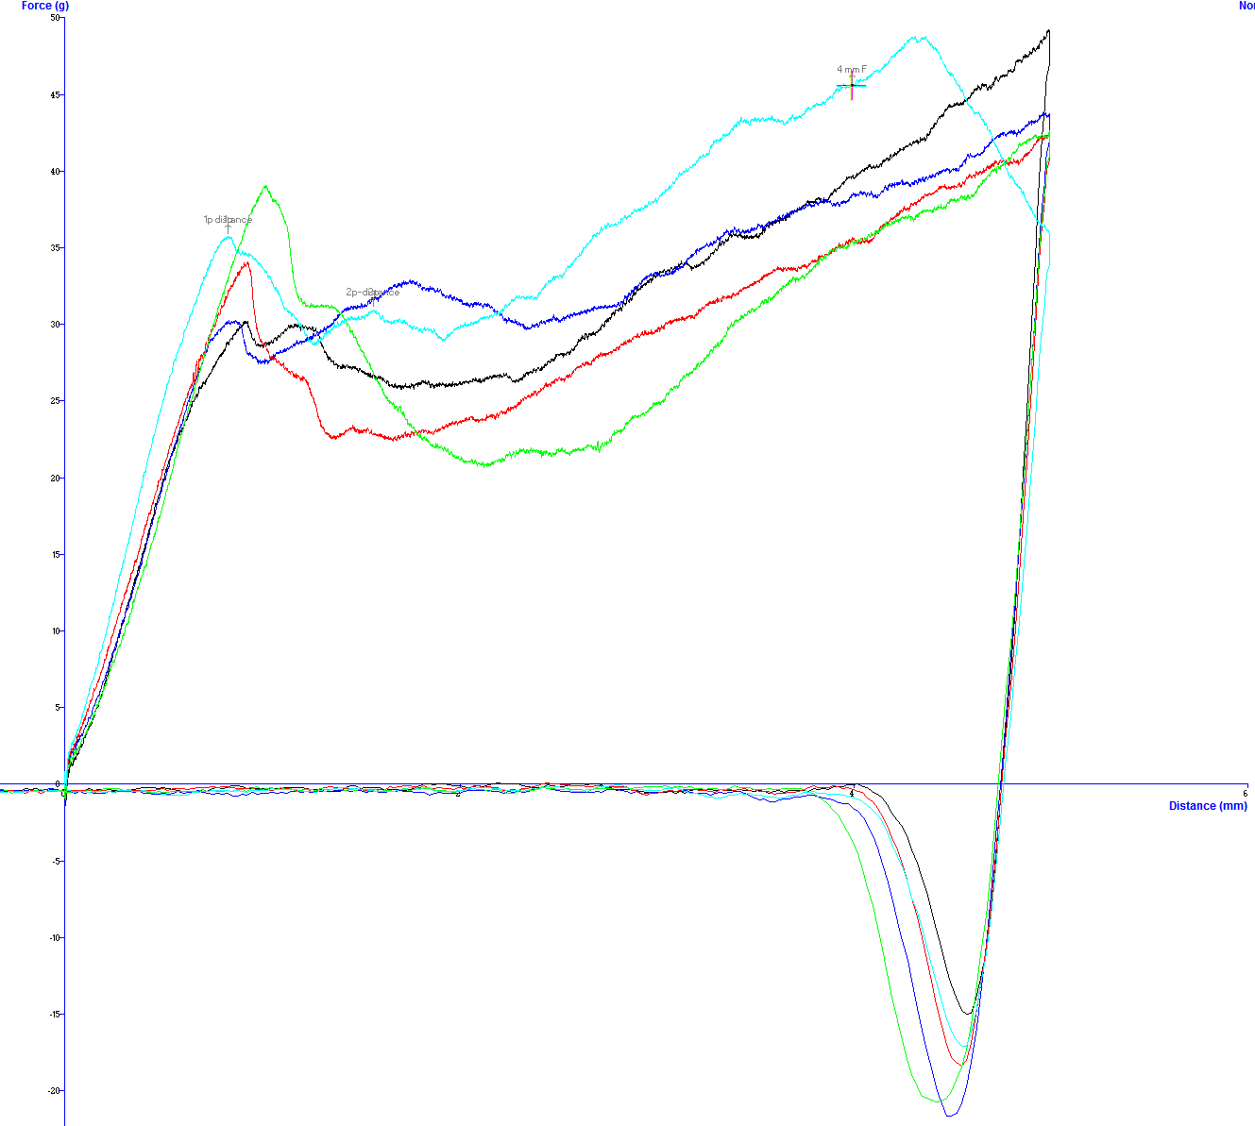
Figure 3.4. Sample graph of texture analysis by 1mm probe conducted on 5 beans from Brine, protocol 4

Table 3.5 Bean weight for beans canned in brine and baked bean sauceª
ª Completed in triplicates by analyzing one sample for each collection day. Values in a row followed by the same letter are not significantly different (α=0.005)

Table 3.6 Yield, Density, Moisture, and Water Activity averages of isolated starch from brine samples.ª

ª Completed in triplicates by analyzing one sample for each collection day. Values in a row followed by the same letter are not significantly different (α<0.005)

Table 3.7 Yield, Density, Moisture, and Water Activity averages of isolated starch from sauce samples.ª

ª Completed in triplicates by analyzing one sample for each collection day. Values in a row followed by the same letter are not significantly different (α<0.005)

Table 3.8 Granular Size Averages for each protocol canned in both brine and sauceª
ª Values reported are the average of 50 granules. Values in a row followed by the same letter are not significantly different (α<0.005)

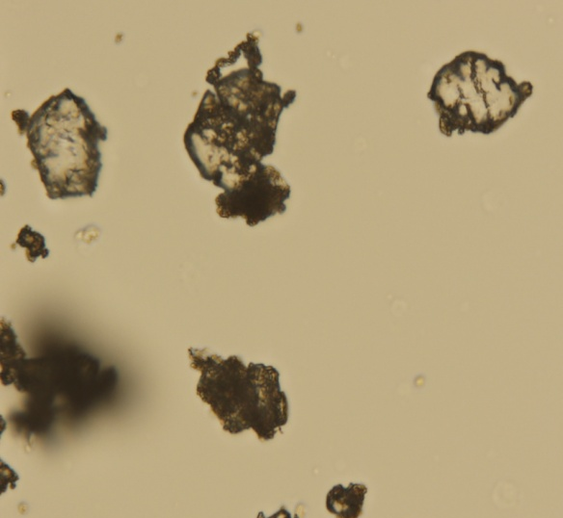 1 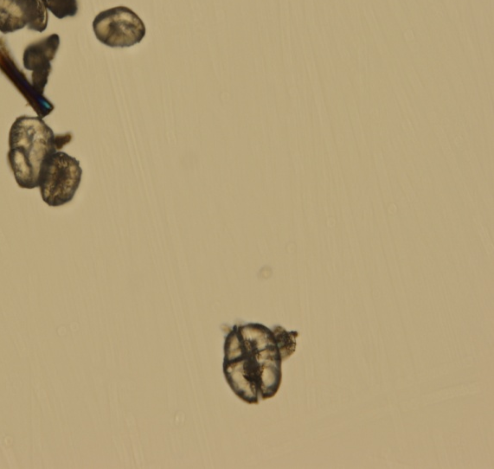 3 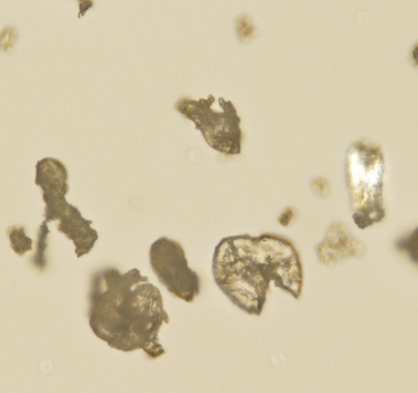 4 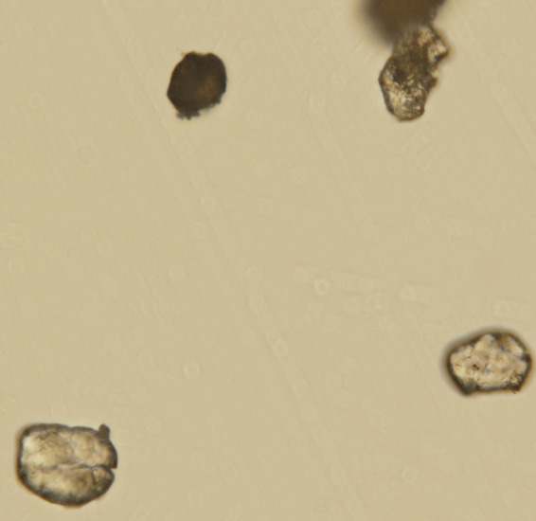 5 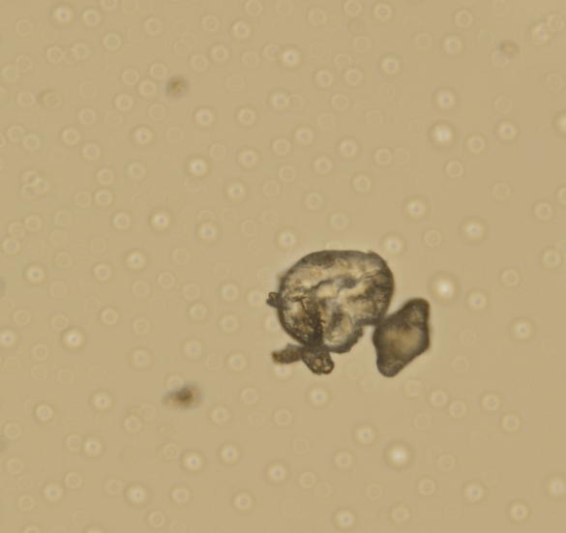 6
Figure 3.5 Starch granules from beans canned in brine captured by light microscopy at 100x magnification.
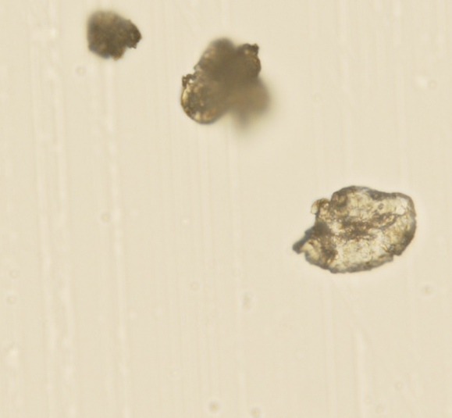 1 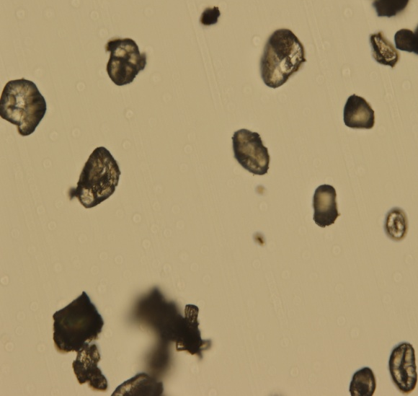 3 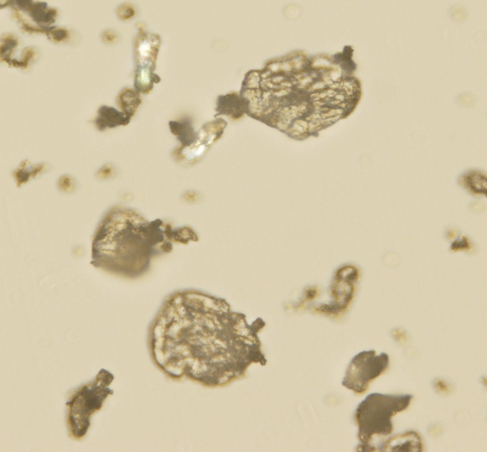 4 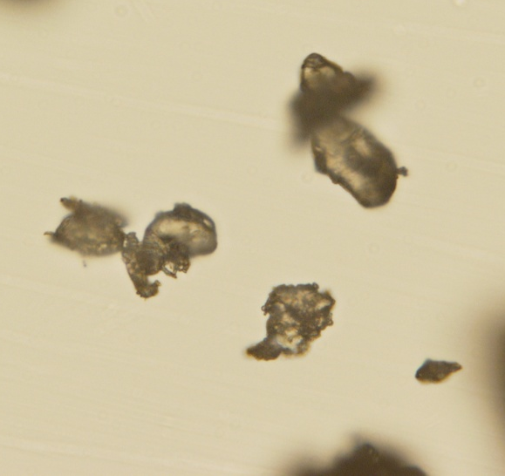 5 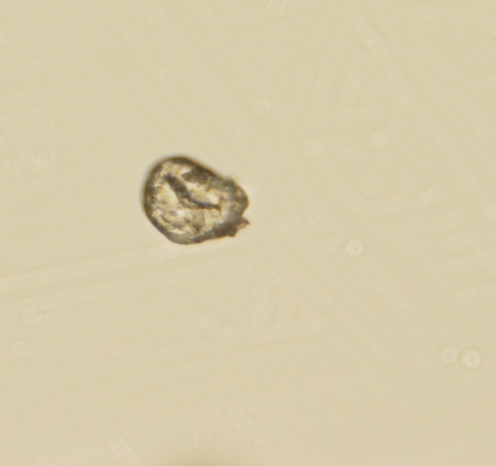 6
Figure 3.6 Starch granules from beans canned in sauce captured by light microscopy at 100x magnification.
1 3 4 5 6
Figure 3.7 Starch granules from the 5 protocols canned in brine solution captured by SEM at 700X.

1 3 4 5 6
Figure 3.8 Starch granules from the 5 protocols canned in sauce captured by SEM at 700X.

Figure 3.9. Swelling Factor changes over a temperature range of 0-85⁰C for starches canned in brine solution. Values are presented as averages of triplicates.

Figure 3.10 Swelling Factor changes over a temperature range of 0-85⁰C for starches canned in sauce. Values are presented as averages of triplicates.

Table 3.9 Gelatinization characteristics of starches canned in brine solution and baked bean sauce.

 | Transition Temperatureª [⁰C] |  |  |  |  |  | T_{C} - T_{o} [⁰C]^{b} |  | ∆H^{c} [J/g]
 | T_{o} |  | T_{p} |  | T_{C}
1 | NO Gelatinization
3 | NO Gelatinization
4 | NO Gelatinization
5 | NO Gelatinization
6 | NO Gelatinization
ª T_{o}, T_{p}, and T_{c} indicate the temperatures of the onset, midpoint and end of gelatinization
^{b} T_{c} – T_{o} indicates the gelatinization temperature range
^{c} Enthalpy of gelatinization

Figure 3.11 DSC analysis of starch from 5 protocols canned in brine shows no gelatinization.

Figure 3.12 DSC analysis of starch from 5 protocols canned in sauce shows no gelatinization.

Table 3.10 Total amylose determination for starch isolated in beans canned in both brine and sauce.
ª Triplicates analyzed of each protocol for collection days 2 and 3 for a total of six samples of each protocol. Values in a row followed by the same letter are not significantly different (α=0.005)

Table 3.11. pH, ⁰Brix, amylose, carbohydrate, and protein content values brine solution after canning for 5 protocols.ª
ª Completed in triplicates by analyzing one sample for each collection day.
^{b} Percent of brine solution after canning as described on page 83

Sources
Colonna P, Buleon A & Mercier C. 1981. Pisum sativum and Vicia faba Carbohydrates: Structural Studies of Starches. Journal of Food Science 46(1):88-93.
Desrosier NW & Desrosier JN. 1977. The Technology of Food Preservation,4th ed. Westport, CT: AVI Publishing Company, Inc.
Fernandez ML & Berry JW. 1989. The Effect of Germination on Chickpea Starch. Starch - Stärke 41(1):17-21.
Gujska E, D.-Reinhard W & Khan K. 1994. Physicochemical Properties of Field Pea, Pinto and Navy Bean Starches. Journal of Food Science 59(3):634-636.
Heldman DR & Hartel RW. 1999. Principles of Food Processing. New York: Aspen Publishers, Inc.
Hoover R & Manuel H. 1996. Effect of heat moisture treatment on the structure and physicochemical properties of legume starches. Food Research International 29(8):731-750.
Hoover R & Ratnayake WS. 2001. Determination of Total Amylose Content of Starch. Current Protocols in Food Analytical Chemistry. John Wiley & Sons, Inc.
Hoover R & Ratnayake WS. 2002. Starch characteristics of black bean, chick pea, lentil, navy bean and pinto bean cultivars grown in Canada. Food Chemistry 78(4):489-498.
Hoover R & Sosulski F. 1985. Studies on the Functional Characteristics and Digestibility of Starches from Phaseolus vulgaris Biotypes. Starch - Stärke 37(6):181-191.
Hoover R & Sosulski FW. 1991. Composition, structure, functionality, and chemical modification of legume starches: a review. Canadian Journal of Physiology and Pharmacology 69(1):79-92.
Kim YS, Wiesenborn DP & Grant LA. 1997. Pasting and thermal properties of potato and bean starches. Starch - Stärke 49(3):97-102.
Kurtzman RH & Halbrook WU. 1970. Polysaccharide from Dry Navy Beans, Phaseolus vulgaris: Its Isolation and Stimulation of Clostridium perfringens. Applied Microbiology 20(5):715-719.
Lai CC & Varriano-Marston E. 1979. Studies on the characteristics of black bean starch. Journal of Food Science 44(2):528-530.
Lees MB & Paxman S. 1972. Modification of the lowry procedure for the analysis of proteolipid protein. Analytical Biochemistry 47(1):184-192.
Lopez A. 1987. A Complete Course In Canning,12th ed. Baltimore, MD: The Canning Trade, Inc.
Lowry OH, Rosebrough NJ, Farr AL & Randall RJ. 1951. Protein measurement with the folin phenol reagent. Journal of Biological Chemistry 193(1):265-275.
Marousis SN & Saravacos GD. 1990. Density and porosity in drying starch materials. Journal of Food Science 55(5):1367-1372.
Naivikul O. 1977. The Carbohydrates Present in Flour Obtained from Various Types of Legumes. Fargo, ND.: North Dakota State University

Naivikul O & D'Appolonia BL. 1979. Comparison of legume and wheat flour carbohydrates. Il. Starch. Cereal chemistry. 56(1):24-28.
Rackis Joseph J. 1975. Oligosaccharides of Food Legumes: Alpha-Galactosidase Activity and the Flatus Problem. Physiological Effects of Food Carbohydrates. AMERICAN CHEMICAL SOCIETY. p. 207-222.
Robertson LS & Frazier RD. 1978. Dry Bean Production - Principles & Practices. East Lansing, MI: Ext. Bull. E-1251Coop. Ext. Serv. and Agric. Exper. Stn.
Sagum R & Arcot J. 2000. Effect of domestic processing methods on the starch, non-starch polysaccharides and in vitro starch and protein digestibility of three varieties of rice with varying levels of amylose. Food Chemistry 70(1):107-111.
Sathe SK & Salunkhe DK. 1981. Isolation, Partial Characterization and Modification of the Great Northern Bean (Phaseolus vulgaris L.) Starch. Journal of Food Science 46(2):617-621.
Singh PR & Heldman DR. 2001. Preservation Process. Introduction to Food Engineering. 3rd ed. San Diego, California: Academic Press. p. 333-366.
Srisuma N, Ruengsakulrach S, Uebersax MA, Bennink MR & Hammerschmidt R. 1991. Cell wall polysaccharides of navy beans (Phaseolus vulgaris). Journal of Agricultural and Food Chemistry 39(5):855-858.
Su HS, Lu W & Chang KC. 1998. Microstructure and physicochemical characteristics of starches in six bean varieties and their bean paste products. LWT - Food Science and Technology 31(3):265-273.
Tester RF & Morrison WR. 1990. Swelling and gelatinization of cereal starches. I. Effects of amylopectin, amylose, and lipids. Cereal chemistry. 67(6):551-557.
Thorne MJ, Thompson LU & Jenkins DJ. 1983. Factors affecting starch digestibility and the glycemic response with special reference to legumes. The American Journal of Clinical Nutrition 38(3):481-488.
Varatharajan V, Hoover R, Li J, Vasanthan T, Nantanga KKM, Seetharaman K, Liu Q, Donner E, Jaiswal S & Chibbar RN. 2011. Impact of structural changes due to heat-moisture treatment at different temperatures on the susceptibility of normal and waxy potato starches towards hydrolysis by porcine pancreatic alpha amylase. Food Research International 44(9):2594-2606.
Vasanthan T. 2001. Overview of Laboratory Isolation of Starch from Plant Materials. Current Protocols in Food Analytical Chemistry. John Wiley & Sons, Inc.
Wilson BA, Salyers AA, Whitt DD & Winkler ME. 2011. Bacterial Pathogenesis: A Molecular Approach,3rd ed. Washington, DC: American Society of Microbiology.
Yañez-Farias GA, Moreno-Valencia JG, Falcón-Villa MdR & Barrón-Hoyos JM. 1997. Isolation and Partial Characterization of Starches from Dry Beans (Phaseolus vulgaris) and Chickpeas (Cicer arietinum), Grown in Sonora, Mexico. Starch - Stärke 49(9):341-345.

Chapter 4.

OVERALL CONCLUSION

Immediately after hydration, significant differences in texture, swelling factor, gelatinization, and amylose content were seen in beans from traditional protocols (1 and 2) as compared to beans from the current (protocol 3) and novel protocols (4-6). Due to the low heat conditions in protocols 1 and 2, starch gelatinization was not induced which caused the beans to have a more firm texture and starch granules retained birefringence and swelling abilities. When the current protocol (3) was compared to the novel protocols (4 -6) the only significant difference observed was that protocol 3 had significantly lower amylose content.
Most of these differences were negated by commercial thermal processing during canning which induced full starch gelatinization in beans hydrated by all protocols. However, texture differences in beans canned in brine were not. Texture analysis by Kramer sheer cell which analyzed batches of beans at a time (180 g) determined that the texture trend observed after hydration were reversed in the final products canned in brine with novel protocols (5 and 6) being more firm than protocols 1 -4. Individual beans analysis using a texture analyzer with a 1 mm probe was able to verify the reversal of the texture trend found in hydration. Likewise, it also identified significant differences in texture of beans in brine hydrated by novel protocols 5 and 6 as they were significantly firmer when compared to novel protocol 4, the current protocol (3), and traditional protocols (1 and 2). Because starch granules from protocol 1 received little to no damage during hydration, it is expected that those granules were able to retain some structural integrity and thus able to retain more water (bean weight) during thermal processing which resulted in overall softer beans in brine.
Kramer sheer press was not able to identify significant differences in the texture of beans in sauce. However, individual bean analysis by a probe texture analyzer was able to detect significant differences in texture in protocol 1 compared to protocols 3-6. However, no significant differences were found between beans hydrated by current protocol (3) and novel protocols (4-6). Beans canned in sauce require twice the length of thermal processing in order to reach temperatures required to kill C. botulinum spores. Thus, this length of processing is expected to have negated any differences that may have been caused by different hydration methods.
For beans canned in brine, the novel protocols result in a more firm product as compared to beans hydrated by the current protocol. The extent to which these differences in texture can be detected by consumers and its effect on the products acceptability is uncertain.

VITA

Robert Blake Lowe was born in Knoxville, TN on October 10, 1988. He was raised in Scott County, Tennessee, and graduated as valedictorian of Scott County High School in 2007. In December 2010, Blake earned his Bachelor of Science degree in Food Science from the University of Tennessee, Knoxville, and he immediately began working toward his Master of Science degree in Food Science. Upon completion of his M.S degree in August 2012, he will pursue his life dream of becoming a physician by attending the Edward Via College of Osteopathic Medicine in Blacksburg, Virginia.

