Word Learning in Quiet and in Noise: A Preliminary Study

Grace Wholley
Advisor: Dr. Jessica Hay
Chancellor’s Honors Program
University of Tennessee

Abstract

Word learning involves finding words in continuous speech and mapping them onto novel objects. Previous research has demonstrated that infants can track the transitional probability (TP) between syllables (i.e., the likelihood two syllables will co-occur) in continuous speech to discover word boundaries. Here we ask whether infants can map sound sequences they have extracted from fluent speech onto novel objects. We used a naturally produced Italian corpus in which the TP between syllables was manipulated in 4 target words: two high TP (HTP; TP=1.0) words with component syllables only occurring within those words, and two low TP (LTP; TP=0.3) words with component syllables occurring in other words throughout the corpus. After familiarization with the corpus, 20- to 24-month-olds were trained to pair HTP and LTP words with novel objects. Following training, accuracy and reaction time to find the labeled object was tested. Preliminary results suggest that infants mapped both HTP and LTP words onto novel objects. In follow-up studies we are investigating how the presence of background noise affects infants’ ability to track and use statistical regularities during speech segmentation and word learning.
Keywords: statistical word learning, transitional probability

1. Introduction
Language acquisition in the first years of life is an impressive feat that the developing infant seems to overcome with ease. The process by which we acquire language is complex and not completely understood. Recent research (see Saffran, Werker, & Werner, 2006 for review) on language acquisition suggests that there are several mechanisms available to infants from an early age. One of the first obstacles to overcome in language learning is the ability to find words in fluent speech. The majority of speech heard by infants is spoken continuously with few reliable acoustic cues to word boundaries as words are rarely separated by identifiable pauses (Cole & Jakimik, 1980) or presented in isolation (Aslin et al., 1996; van de Weijer, 1998). Infants can use several cues for word segmentation such as phonotactic regularities (Freiderici & Wessels 1993; Mattys & Jusczyk, 2001), prosodic patterns (Jusczyk, Cutler, & Redanz, 1993; Polka, Sundara, & Blue, 2002), and allophonic variation (Christophe et al., 1994; Jusczyk, Hohne, & Bauman, 1999). However, these cues are language specific. Another mechanism that infants can use to track patterns in continuous speech is termed statistical learning (SL), and this mechanism is not language specific. Previous research in SL (see Romberg & Saffran, 2010 for a full review) has demonstrated that infants can track the transitional probability (TP) between syllables (i.e., the likelihood two syllables will co-occur) in continuous artificial (Saffran, Aslin, & Newport, 1996) and natural languages (Pelucchi, Hay & Saffran, 2009) to discover word boundaries. For example, in the phrase “pretty baby” the TP of pre/ty and ba/by (i.e. the within word TP) is much stronger than the between word TP (i.e. ty/ba). The TP can be calculated using the equation P(X/Y)= XY/X or the probability of event X followed by event Y is equivalent to the frequency of the consecutive event over the frequency of event X (Fig. 1).
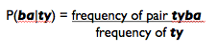
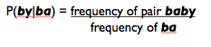

Figure 1: The TP of syllable pair “baby” is much higher than the TP of syllable pair “tyba.”

Infants as young as 8 months have been able to use SL to track syllable patterns and subsequently find word boundaries in fluent speech (Saffran, Aslin, Newport, 1996; Pelucchi, Hay, and Saffran, 2009).
Finding words in continuous speech is just the first step in word learning. Word learning also involves mapping newly extracted sound sequences to meaning. Previous research from our lab suggests that sound sequences that have stronger TP patterns do in fact make better object labels for 17-month-olds than those with weaker TP patterns (Hay, Pelucchi, Graf Estes, & Saffran, 2011). In this study, infants were familiarized to a naturally produced Italian corpus with 4 target words embedded in the corpus. Two of the target words had a TP of 1.0 (i.e. a strong TP) and two of the target words had a TP of 0.33 (i.e. a weak TP). Infants were then given an object-label association task using either the high TP (HTP) or low TP (LTP) words. Infants in the HTP condition were able to map the label to the object but infants in the LTP condition were not. Another experiment was run in which there were no statistical cues given to the infants. The infants in that condition were not able to map the words to their referents. This study indicates that word learning may be facilitated by the use of statistical patterns.
The environment in which an infant hears language and learns words is compounded by many background noises that may have an effect on their language acquisition, but most research performed on language acquisition is conducted in artificially quiet laboratory settings. Therefore, we are unsure if infants use statistical probabilities to find words in continuous speech and then map them onto objects in a real-life listening environment. In a study conducted in 2009, Newman found that the type of noise in the environment effects word recognition in 5-8.5 month olds. Infants were tested to see if they recognized their name in 3 noise conditions: single-talker, multi-talker babble, and single-talker played in reverse (to keep the acoustical properties of speech but to remove meaning). They found that the infants were able to recognize their name in the multi-talker babble condition, but not in either of the single-talker conditions, which indicates that infants have a difficulty in picking out words in speech streams that are acoustically similar to each other. When this study was run using adults, however, they showed the opposite pattern of recognition (i.e. worse recognition in multi-talker than in single-talker), meaning that there is some sort of development that happens after 9 months that allows us to differentiate between similar acoustic speech streams (Newman, 2009). Another study (Greico-Calub, Saffran, & Litovsky, 2009) tested both normal hearing children and children with cochlear implants (aged around 2 years) on recognition of familiar words in quiet and in two-talker babble background noise. While the normally hearing children outperformed the children with cochlear implants in both conditions, both groups performed worse in the background noise condition. The results of this study reveal that background does have some effect on word recognition and that a real world environment might slow language processing in young children.
Background noise influences word recognition in young language learners, but does it affect word learning? A study conducted in 2012 by Creel, Aslin, and Tanenhaus tested undergraduate students in vocabulary learning task in both quiet and in background noise. During the experiment, the students learned 16 vocabulary words as labels for novel objects in a no noise condition or in a white noise condition. They were then tested on their speed and accuracy of recognizing the novel object-label pairs in either quiet or noise. They found that students performed better when the testing noise condition matched the learning noise environment, which suggests that the learners formed a specific representation of those novel words based on their learning environment (Creel, Aslin, & Tanenhaus, 2012).
What is still unanswered is how background noise affects early language acquisition and specifically how it affects infant’s abilities to track statistical transitional probability in fluent speech and the use this output for subsequent word learning. The current study plans to address these questions and provide better insight on real life word learning conditions. Previous work by Hay et al (2011) used the Switch Paradigm, which provides only gross measures of dishabituation to mapping violations, and a between subjects design to measure word learning. In the current study, we seek to establish a paradigm that we can use to test how statistical learning feeds into subsequent word learning in more ecologically valid listening condition.

2. Methods
Purpose. The purpose of this preliminary study was to develop a sensitive within-subjects methodology to test the relationship between statistical learning and subsequent word learning. If successful in developing this methodology in a valid and reliable way, we hope to use this methodology in further studies to investigate the effect of background noise on statistical word learning. We predicted that the participants would learn the high transitional probability (HTP) words more successfully than the low transitional probability (LTP) words (i.e. the HTP words would make better object labels) as evidenced by greater accuracy and faster reaction to looking at the labeled object in the HTP as opposed to the LTP conditions.

Participants. This study tested twenty infants, (9 male, 11 female) aged 20-24 months (avg. 21.74 months) who were all monolingual English-learning, full term infants with no hearing or vision problems, and fewer than 5 prior ear infections with no experience with Italian or Spanish. The participants had an average vocabulary size of 42.3 words (n=16, 4 did not report data). We chose to use 20-24 month olds because they were an age group not currently being tested in our lab and also provided a wide age range in which to pilot our study. The participants were recruited from the greater Knoxville area using Child Development Research Group database. Data from 18 additional infants was excluded from analysis due to fussiness (n=8), not paying attention (n=6), equipment malfunction (n= 3), and experimenter error (n=1). Participants were assigned to one of 2 counterbalanced languages, Language 2A (n=12) or Language 2B (n=8).

Materials. We used a naturally produced Italian corpus in which the TP between syllables was manipulated in 4 target words: two high TP (HTP; TP=1.0) words with component syllables only occurring within those words, and two low TP (LTP; TP=.3) words with component syllables occurring in other words throughout the corpus. A female native Italian speaker produced 2 counterbalanced languages, Language 2A and 2B (see appendix for sentence lists), target novel words (casa, bici, fuga, and melo) in isolation, familiar words (shoe, book, baby and doggie) in isolation, and all English carrier phrases (e.g. Look at the) in isolation. The speaker was unaware of the purpose of the study and was simply directed to speak in a spirited voice as if speaking to an infant. In Language 2A, the HTP words were fuga and melo, and the LTP words were casa and bici. In Language 2B, the HTP words were casa and bici, and the LTP words were fuga and melo. Each HTP and LTP words appeared 6 times within the corpus (for a total of 12 HTP utterances and 12 LTP utterances). In order to lower the TP of the LTP words, the syllables making up those words were dispersed unpaired throughout the corpus. LTP syllables occurred 3 times more in the corpus than the HTP syllables. All audio stimuli were normalized using Adobe ® Audition ® to 65dB.

Procedure. Infants were first familiarized to one of the languages while watching an unrelated silent video (~2mins 15 sec). During that 2-minute interval, the language corpus was repeated 3 times for a total of 36 repetitions of each HTP and LTP words. Following familiarization, an “attention getter” image (e.g. a pinwheel) appeared on the screen. After the infant regained attention, the experimenter initiated the training phase. Infants were trained to pair 2 HTP and 2 LTP novel Italian words heard in the corpus to novel objects on the screen. The training trials were set up in 4 blocks. The beginning of each block began with one familiar trial in which a familiar object (e.g. dog, shoe, book, or baby) would appear on the screen. Each familiar trial was followed by 4 novel trials in which novel objects would appear on the screen (Fig. 2) to complete the block. In total, the infant received 16 novel trials (8 HTP and 8 LTP) and 4 familiar filler trials within the 4 blocks. Each trial began with an English carrier phrase (e.g. “Look at the”, or “See the”) and was followed by 2 repetitions of the target word. Each trial was 8 seconds long.
Finally, we used a Looking-While-Listening procedure (Fernald, Zangl, & Marchman, 2008), to test accuracy and eye-gaze patterns to find the labeled object. Order of test trials was counterbalanced across participants. After training, the pinwheel attention getter was again played to regain the infant’s attention. Once facing the screen, the experimenter initiated the testing phase. During the testing phase, two pictures would appear on the screen simultaneously, either 2 familiar pictures or 2 novel (again see Fig. 2). Each picture reached a height of about half of the screen and there was a large enough gap in between the two pictures in order to induce easily identifiable eye movements to either the left or right of the screen. The test phase began with 2 trials of familiar words followed by a pattern of 4 novel trials and 1 familiar trial, for a total of 32 trials (8 familiar and 24 novel- 12 HTP and 12 LTP words). For half of the participants (n=10) we added an additional filler trial, named a “Whoopee” trial, halfway through the testing phase. This trial consisted of 2 irrelevant yet stimulating videos side by side on the screen (to keep same format as the picture trials) and a fun phrase produced by a female native English speaker (e.g. “Good job! You’re doing great!”). We implemented this trial halfway through testing to try and reduce some of the attention difficulties we were experiencing (i.e. the participants ability to sit through the entire experiment). Each test trial was 8 seconds long (Fig. 3). The trials began with an English carrier phrase (e.g. “Find the” or “Where’s the”), followed by word onset at 2 seconds post trial (picture) onset). Infants then heard another repetition of the target word at 3.5 seconds after trial onset. The trials ended with an English phrase (e.g. “Do you see it?” or “Do you like it?”). In total, the entire experiment lasted for about 10 minutes.
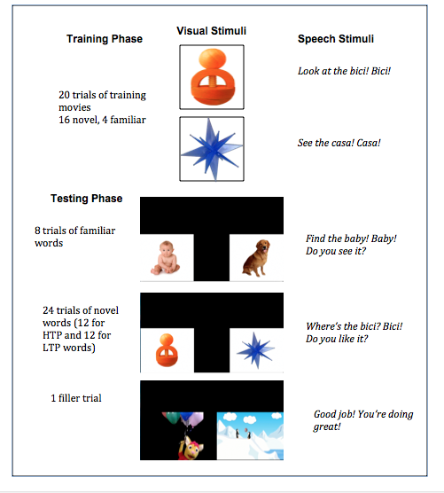
All participants were seated on their caregiver’s lap facing front toward the screen and were filmed inside of a soundproofed booth. The caregiver was given a pair of headphones to wear as a precaution to prevent their influence on their child’s looking behavior (Fig. 4). Eye movement was coded offline using the iCoder software (Fig. 5). The participant’s accuracy of looking to the target and reaction time were analyzed to assess learning. All caregivers were fully informed of the procedures of the experiment before testing and fully debriefed on the intention of the study following testing.

Figure 2: Visual and audio stimuli used in training and testing phases.
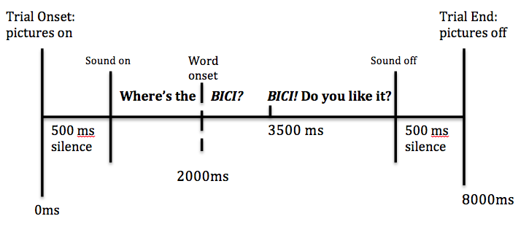

Figure 3: Schematic of a testing trial.
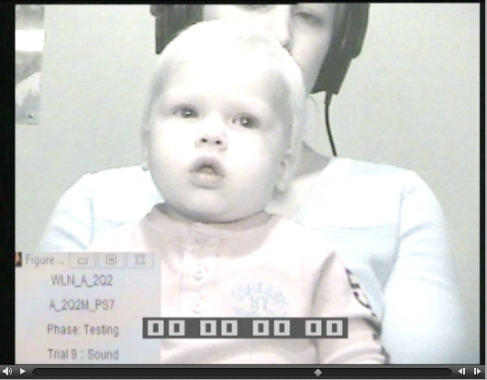
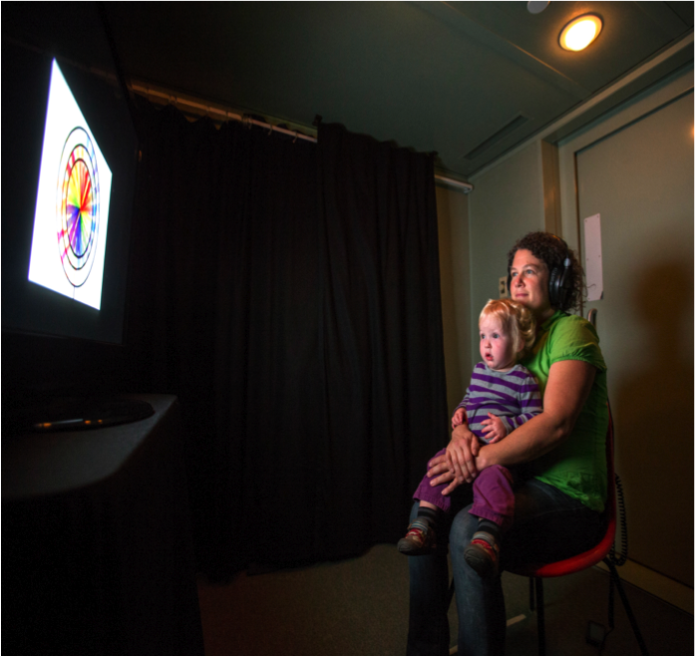

Figure 5: Infant’s eye movements are coded offline on the iCoder software.
Figure 4: Parent an child in the soundproofed booth.

3. Results
The participants’ learning was assessed by analyzing the accuracy of looking to the target and the reaction time. Accuracy and reaction time were measured during a target window of 300-2000 ms after word onset. Preliminary analyses revealed no effects of age, gender, counterbalanced language, order of presentation, or the addition of the “whoopee” filler trial on the infants accuracy of looking to the target. We found no significant effect of any of these conditions on accuracy, thus in all subsequent analyses, we collapsed the data across all variables. One sample t-tests (all the tests are 2-way) revealed accuracy that was significantly above chance in both the HTP (t(19)=2.260, p=0.036) and the LTP (t(19)=2.894, p=0.009) conditions (Fig. 6), suggesting that infants were successfully able to learn both the HTP and LTP words. To assess differences in accuracy between the HTP and LTP conditions, we performed a paired samples t-test and found that there was no significant difference in mean accuracy of proportion of looking time to the target between conditions (t(19)= -0.713, p=0.484) (Fig.7). The LTP condition (mean=0.591) seems to show a slightly higher proportion of looking to the target, but this result was not significant when compared to the HTP condition (mean=0.566). Figure 6 displays the average proportion of time looking to the target for each individual subject and the mean looking time for each condition. There was a wide spread of looking time, but most infants performed at an accuracy level above chance. Lastly, we ran a correlation between age, vocabulary size, HTP accuracy and LTP accuracy. We found only one correlation between vocabulary size and accuracy on LTP words (r(16)=0.570, p=0.021), indicating that the larger the vocabulary size infant, the greater their accuracy of looking to the target in the LTP condition.
The reaction time data gave us little information. There was no effect of age, gender, order of presentation, counterbalanced language, or whoopee on reaction time, so for subsequent analyses we collapsed the data across all variables. There was no correlation between vocabulary size and reaction time. A one paired comparison that revealed no significant difference in reaction time between HTP and LTP conditions (t(13)= -0.102, p=.92). Some participants (n=7) were not included in our reaction time analysis because they did not contribute enough data to be analyzed. We excluded any participant that contributed reaction time data for less than 6 trials in either the HTP or LTP condition.
Additionally, some useful information can be gleaned from exploring the data from where the infant was looking before word onset. At the beginning of each test trial, the infant may be looking at the distractor (distractor-onset) or the target (target-onset) picture by chance before target word onset without knowing which picture’s word label will be given. We can evaluate learning by looking at the correct responses from either the distractor-onset or the target-onset trials. In the distractor-onset trail, the correct response would be to quickly shift their gaze from the distractor picture to the target picture after words onset. In the target-onset trials, the correct response would be to stay on the target picture and to not shift away after word onset. We can examine onset-contingent (OC) plots to determine correct patterns of looking behavior.
Figure 8 is the OC plot for the distractor onset trials and target-onset trials for both the HTP and LTP conditions. The infants displayed significantly more shifts from the distractor to the target picture after word onset than from the target to the distractor after word onset in both conditions. This indicates that the infants were accurately able to map the object labels onto their referents. Further examination of the OC plot curves shows a wider split (i.e. a more significant difference in looking from the distractor to the target vs. the target to the distractor) in the LTP condition than in the HTP condition, which again indicates there may have been a slightly more successful pattern of learning in the LTP condition. Overall, the infants displayed successful word learning in mapping object labels to their referents in both the HTP and LTP conditions.
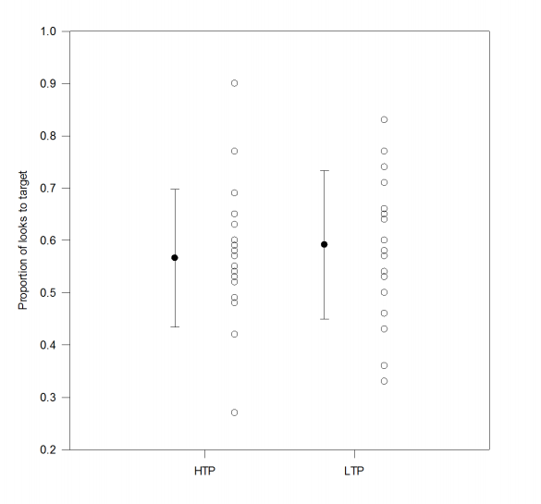
Individual and Mean Accuracy for HTP and LTP Conditions

Figure 6: Proportion of looking time to the target in individual subjects for the HTP and LTP trials. The black circles in the center represent the average looking time with standard error bars for both conditions. The mean accuracy of HTP and LTP words measured by proportion of time looking at target. Accuracy window was 300-2000ms following word onset. Error bar represent standard error of the mean.

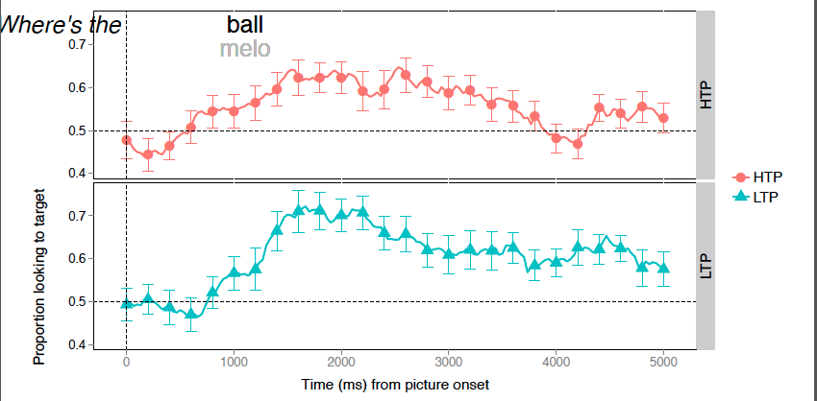

Target Window: 300-2000 ms

Figure 7: Eye-gaze plot shows the proportion of looking to the target across test trials. Both the HTP and LTP conditions show a pattern that indicates word learning. Again, the LTP seems to show a higher proportion of looking but it is not significantly higher than the HTP.
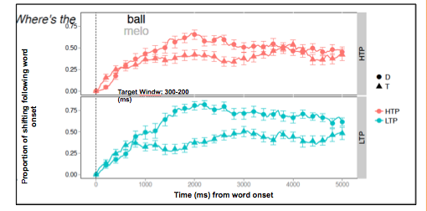

Figure 8: Onset-contingent (OC) plots- Proportion of shifting following word onset on target initial trials and on distractor initial trials. This graph shows the typical separation expected in word learning.

4. Discussion
We were successful in developing a within subjects design using the more sensitive Looking-While-Listening procedure. Infants were able to learn both HTP and LTP words from a novel natural language. However, our prediction that HTP words would make better object labels than LTP words was not supported.
Previous work (Hay et al., 2011) has demonstrated that HTP words make better object labels than LTP words. Why did our infants learn both the HTP and LTP words? There are several possible answers to that question. First, the infants tested in this study were much older (20-24 months) than those tested in the Hay et al. (2011) study (17 months). Children at this age could be at a developmental level that makes them better word learners. They may be adept at using several cues other than just statistical probability. Also, we did find a correlation between vocabulary size and accuracy performance in the LTP condition. Children at 20-24 months are expected to have a larger vocabulary size than children at 17 months and thus we would expect them to perform better in both conditions. Increased vocabulary size could also indicate a higher level of mastery of language, which again would explain the infants’ ability in this study to learn the words in the LTP condition.
Additionally, we provided referential support (i.e. English carrier phrases and familiar objects and labels) that was not used in the previous study. Referential support may have overridden the supportive effects statistical regularities have during early word learning. In a study conducted in 2010, Fennel and Waxman found that 14 month old infants were able to discriminate phonotactic detail in a word learning task when referential support was provided, but failed when the novel words were presented ambiguously in a Switch task (Fennel & Waxman, 2010). The Hay et al. 2011 study used a similar Switch paradigm with no referential support and therefore infants may have not been able to learn the LTP words because the referential status of those words were unclear. To address this issue, we would need to test infants using an unrelated corpus (i.e. one without statistical probability cues). If the infants are still able to learn the object label pairs with out the use of statistical cues, then the referential support might be strong enough that statistical learning becomes irrelevant.
However, referential support does not explain the trend of the infant’s apparent better performance in accuracy in the LTP condition. Syllable frequency could be the answer to this phenomenon. While the HTP words had a higher TP than the LTP, the LTP syllables appeared 3 times more often in the corpus than the syllables of the HTP words (in order to reduce the TP of the LTP words to 0.3). Thus, syllable familiarity may have been driving learning in this study. We didn’t predict that the increased syllable frequency of the LTP condition would have an effect on word learning because in previous research like the Saffran et al. 1996 study, syllable frequency didn’t seem to drive discrimination. To address the role of syllable frequency in word learning we have developed test words in which the TPs of the target words are violated, but the syllable frequency is maintained (e.g., pair the first syllable of one LTP word with the last syllable of another LTP word – caci and bisa instead of casa and bici). This experiment would help elucidate the relative roles of syllable frequency and transitional probability during early word learning.

5. Future Directions
After running the appropriate control conditions, we will present background noise during the familiarization phase to test the resilience of statistical learning. This will help us understand statistical learning and subsequent word learning in a more natural setting.
Some aspects to consider for moving forward are the effect of the learning environment on the testing phase and also what type of background noise to choose. In the Creel et al. (2012) study, they found that the learning environment affects the ability to learn words successfully, specifically that optimum performance occurs when the learning environment matches the testing environment. We may need to consider running experiments in which the testing environment also mirrors the noisy familiarization (i.e. learning) environment to accurately assess any differences in the use of statistical probabilities to learn the words. Also, some studies with noise such as Greico-Calub et al. (2009) and Newman (2009) used two-speaker or multi-speaker babble as background noise whereas Creel et al. (2012) chose to used a fixed white noise as an adverse listening condition. We will need to investigate many types of background noise in order to find an appropriate option that mirrors the real-world language learning environment most similarly in order to make our study more ecologically valid.
If successful in our future research, we will be better able to understand how the process of language acquisition, specifically statistical word learning, occurs in real life for normally developing children. We have already learned a lot about the development of language in artificially quiet laboratory settings, but it is imperative that we extend this research in a more ecologically valid setting before we can make any sound conclusions on how infants process language in the natural world. Additionally, if we can better understand how normally developing children learn language, we can then start to address the issues that underlie unsuccessful or delayed language acquisition in atypical populations such as those with hearing or vision impairments or children with intellectual or developmental disabilities.

Acknowledgements
We would like to extend a warm thank you to all participating families and the members of the Infant Language and Perceptual Learning Lab at the University of Tennessee, Knoxville.
This work was supported by a grant to JFH (1R01HD083312) from NICHD.

References
Aslin, R.N., Woodward, J.Z., LaMendola, N.P., Bever, T.G. Models of word segmentation in fluent maternal speech to infant. J.L. Morgan, K. Demuth (Eds.), Signal to syntax LEA, Mahwah, NJ (1996) pp. 117–134
Cole, R., & Jakimik, J. (1980). A model of speech perception. In R. Cole (Ed.), Perception and production of fluent speech (pp. 133–163). Hillsdale, NJ: Erlbaum.
Creel, S. C., Aslin, R. N., & Tanenhaus, M. K. (2012). Word learning under adverse listening conditions: Context-specific recognition. Language and Cognitive Processes, 27(7-8), 1021-1038. doi:10.1080/01690965.2011.610597
Christophe, A., Dupoux, E., Bertoncini, J., Mehler, J. Do infants perceive word boundaries? An empirical study of the bootstrapping of lexical acquisition. Journal of the Acoustical Society of America, 95 (1994), pp. 1570–1580
Grieco-Calub, T. M., Saffran, J. R., & Litovsky, R. Y. (2009). Spoken Word Recognition in Toddlers Who Use Cochlear Implants. J Speech Lang Hear Res Journal of Speech Language and Hearing Research, 52(6), 1390. doi:10.1044/1092- 4388(2009/08-0154)
Hay, J. F., Pelucchi, B., Estes, K. G., & Saffran, J. R. (2011). Linking sounds to meanings: Infant statistical learning in a natural language. Cognitive Psychology, 63(2), 93-106. doi:10.1016/j.cogpsych.2011.06.002
Fennell, C. T., & Waxman, S. R. (2010). What Paradox? Referential Cues Allow for Infant Use of Phonetic Detail in Word Learning. Child Development, 81(5), 1376- 1383. doi:10.1111/j.1467-8624.2010.01479.x
Fernald, A., Zangl, R., Portillo, A. L., & Marchman, V. A. (2008). Developmental Psycholinguistics: On-line methods in children’s language processing (I. A. Sekerina, E. M. Fernandez, & H. Clahsen, Eds.). Amsterdam: John Benjamins (pp. 97-135.). doi:10.1075/lald.44
Friederici, A.D., Wessels, J.M. Phonotactic knowledge and its use in infant speech perception. Perception & Psychophysics, 54 (1993), pp. 287–295
Jusczyk, P. W., Cutler, A., & Redanz, N. J. (1993). Infants' Preference for the Predominant Stress Patterns of English Words. Child Development, 64(3), 675. doi:10.2307/1131210
Jusczyk, P. W., Hohne, E. A., & Bauman, A. (1999). Infants’ sensitivity to allophonic cues for word segmentation. Perception & Psychophysics, 61(8), 1465-1476. doi:10.3758/bf03213111
Mattys, S. L., & Jusczyk, P. W. (2001). Phonotactic cues for segmentation of fluent speech by infants. Cognition, 78(2), 91-121. doi:10.1016/s0010-0277(00)00109-8
Newman, R. S. (2009). Infants’ listening in multitalker environments: Effect of the number of background talkers. Attention, Perception, & Psychophysics, 71(4), 822-836. doi:10.3758/app.71.4.822
Pelucchi, B., Hay, J. F., & Saffran, J. R. (2009). Statistical Learning in a Natural Language by 8-Month-Old Infants. Child Development, 80(3), 674-685. doi:10.1111/j.1467-8624.2009.01290.x
Polka, L., Sundara, M., & Blue, S. (2002, June 3–7). The role of language experience in word segmentation: A comparison of English, French, and bilingual infants.
Romberg, A. R., & Saffran, J. R. (2010). Statistical Learning and Language Acquisition. Cognitive Science, 1, 906-914. doi:10.1002/wcs.78
Saffran, J. R., Aslin, R. N., & Newport, E. L. (1996). Statistical Learning By 8-Month Old Infants. Science, 274(5294), 1926-1928. doi:10.1126/science.274.5294.1926 Saffran, J.R., Werker, J.F.,Werner, L.A.The infant’s auditory world: Hearing, speech, and the beginnings of language. R. Siegler, & D. Kuhn (Eds.), Handbook of child development, Vol. 6, Wiley, New York (2006), pp. 58–108
van de Weijer, J. (1998). Language input for word discovery. MPI series in psycholinguistics (No. 9). The Netherlands: Nijmegen.

Appendix A

A.1. Language 2A HTP = fuga & melo; LTP = casa & bici
^{1.} Spesso Lisa capita in fuga nella casa dove giaci gracile e tesa. ^{2.} Se cadi con la bici prima del bivio del melo cavo ti do dieci bigoli e una biro. ^{3.} Gli amici della cavia Bida poggiano le bici in bilico presso il melo per difesa dalla biscia. ^{4.} Sovente carico la spesa nel vicinato dopo una fuga con la bici nuova. ^{5.} Carola si è esibita in una fuga verso il melo perché offesa dagli amici scortesi. ^{6.} Se vai a casa in bici ti debiliti ma cali e non sei più obesa. ^{7.} Dietro la casa del capo ho sprecato i ceci sotto al melo ombroso. ^{8.} Se cuci subito sulla divisa bigia il distintivo col melo vado in casa a dormire. ^{9.} Teresa si abitua alla fuga da casa con la vecchia bici senza luci posteriori. ^{10.} Taci sulla fuga di Marisa con il caro lattaio. ^{11.} Il bel melo sta tra la casa dei Greci e la chiesa arcana dove hai giocato con le bilie. ^{12.} I soci della ditta Musa si danno alla fuga con la bici della maglia rosa.

A.2. Language 2B; HTP = casa & bici; LTP = Fuga & melo
^{1.}Roméro fu coinvolto in una futile fuga in bici verso il profumo del mélo ombroso. ^{2.} Il collega di Paolo Fusi trovò la bici per la fuga presso la casa del molo. ^{3.} La maga tiene in casa almeno un fuco, uno squalo e una tartaruga del Nilo. ^{4.} Il fuco procede parallelo alla casa sulla riga tracciata dalla cometa. ^{5.} Il gattone Refuso medita sul mélo presso casa ascoltando una fuga di Verdi. ^{6.} Il fu Medo Rossi ruppe la braga nella bici il mese scorso durante la gara. ^{7.} Giga ogni mese paga con zelo l’affitto per la casa con il melo in fiore. ^{8.}Meco prega il cielo che ogni fuga da casa termini sotto melo ombroso. ^{9.}Il delfino beluga si dimena tutto solo nella fuga verso il Nilo azzurro. ^{10.}Un pezzo di filo si è infilato nella bici appoggiata al melo dietro la méscita. ^{11.}Vi fu un tempo in cui la bici in lega non temeva il gelo del rifugio della Futa. ^{12.} La strega del melo fu vista in fuga sulla bici con un chilo di rametti.

