The Dynamics of Goal-Directed Visual-Manual Coordination to Multiple Feature Objects: An Embodiment Perspective

A Thesis Presented for the
Master of Arts Degree
The University of Tennessee, Knoxville

Asante James Knowles
July 2025
ACKNOWLEDGEMENTS
I would like to extend my deepest gratitude to Dr. Daniela Corbetta, my primary advisor, for her unwavering mentorship, guidance, and encouragement throughout the development of this project. Her insight, patience, and commitment to scientific rigor have profoundly shaped both this research and my growth as a scholar.
I am also thankful for the support and camaraderie of my lab colleagues, Dr. John P. Connell, Dr. Abigail DiMercurio, and Ju Pattanakul, whose collaborative spirit and constructive feedback helped bring this project to life.
I would like to acknowledge and sincerely thank my thesis committee members, Dr. David Sutterer and Dr. Caglar Tas, for their thoughtful questions, generous time, and valuable input during my thesis defense. Their support has been instrumental in refining the direction and clarity of this work.
Finally, I am grateful to everyone who contributed directly or indirectly to this journey. Your support has made a lasting impact.

ABSTRACT
Embodied cognition posits that cognitive processes are deeply intertwined with bodily experiences and interactions with the environment. It is not known how visual-manual coordination (visual: Initial Attention/Sustained Attention and Manual: action planning/selection/execution) changes dynamically across planning and executing goal-directed behaviors to objects with multiple features. Therefore, this study attempts to answer questions regarding how looking behavior responds to objects with multiple features, how manual reaching influences the visual selection of object properties, and what changes occur in visual-manual coordination before and during reaching. An embodied perspective is used to explain the role of goal-directed actions in the perception of multiple feature objects, resulting in visual-manual coordination. From an embodiment perspective, I suggest that pre-selection of the hand facilitates more efficient goal-directed coordination than looking behavior or object-feature-saliency alone. I further suggest that the role of object features is to facilitate more efficient and sophisticated visual-manual coordination, but only when the object features are aligned spatially with the intended motor command. Moreover, from an embodiment perspective, I suggest that shifts in looking behavior from action planning to execution are spatially and temporally contingent on the sensorimotor/proprioceptive aspects that are relevant to the goal of the task.
We explore the dynamic interplay between perception and action by having 18 right-handed adults (9 Females, 9 Males) participate in a series of 36 looking and reaching trials involving objects with various features, including shape, asymmetry, details (stickers), and spatial incongruence. Visual fixations were collected using remote eye-tracking.
This study's relevance lies in its contribution to the growing body of research on embodied cognition, providing valuable insights into how the human mind and body collaboratively adapt to the complexities of the surrounding environment. Understanding the mechanisms underlying visual-manual coordination has implications for various fields, including neuroscience, psychology, human-computer interaction, and rehabilitation sciences. By unraveling the intricacies of embodied cognitive processes, this research enhances our knowledge of human agency, paving the way for applications in fields where precise coordination suggests efficient goal-directed behaviors.

TABLE OF CONTENTS

CHAPTER ONE: INTRODUCTION ........................................................................................ 1
Eye-Hand Coordination .............................................................................................................. 1
Research Questions ...................................................................................................................... 3
CHAPTER TWO: LITERATURE REVIEW ........................................................................... 5
Embodied Cognition .................................................................................................................... 5
Looking Behavior ......................................................................................................................... 7
Manual Reaching and Goal-Directed Actions ........................................................................... 9
Visual-Manual Coordination and Feature Processing ........................................................... 11
Feature Saliency and Spatial Alignment in Action ................................................................. 14
The Role of Embodiment in Cognitive Dynamics ................................................................... 17
Purpose and Hypotheses ........................................................................................................... 20
CHAPTER THREE: METHODS ............................................................................................ 25
Participants ................................................................................................................................. 25
Materials ..................................................................................................................................... 26
Procedure .................................................................................................................................... 28
Behavior Coding and Analysis .................................................................................................. 30
Dependent Measures .................................................................................................................. 32
Statistical Analyses ..................................................................................................................... 33
CHAPTER FOUR: RESULTS ................................................................................................. 35
Gender Effects ............................................................................................................................ 35
Looking Behavior Across Object Conditions .......................................................................... 37
Reach Latency and Duration Analyses …................................................................................ 39
Feature-Matching and Spatial Alignment Effects .................................................................. 41
CHAPTER FIVE: DISCUSSION ............................................................................................. 45
Overview of Findings ................................................................................................................. 45
Looking Behavior and Feature Saliency .................................................................................. 46
Manual Reaching Stability and Motor Planning .................................................................... 47
Implications for Embodied Cognition ...................................................................................... 49
Potential Limitations ................................................................................................................. 51
Future Directions ....................................................................................................................... 52
Conclusion....................................................................................................................................53
REFERENCES ........................................................................................................................... 55
APPENDICES ............................................................................................................................ 51
VITA ........................................................................................................................................... 75

LIST OF TABLES
Table 1. Effects of Gender on Visual and Manual Dependent Variables ................................ 52
Table 2. Mean Total Looking Duration (ms) by Object Condition ......................................... 52
Table 3. Accumulated Looking to Object Features by Condition ....................................... …52
Table 4. Reach Latency Results by Object Condition and Hand (ms) ................................... .53
Table 5. Reach Duration Results by Object Condition and Hand (ms) .................................. 53
Table 6. Reach Duration by Feature-Matching and Hand .......................................................53
Table 7. Mixed Model Analysis: Feature Looking Duration ............................................ …..53
Table 8. Linear Mixed Model for Feature-Specific Looking (Objects 6 & 7) .........................54

LIST OF FIGURES
Figure 1. Objects presented by Condition .................................................................................... 60
Figure 2. Trial Timeline: 5 seconds of free looking, “GO” signal, and reach onset .................... 61
Figure 3. P-values for gender differences across dependent variables ........................................ 62
Figure 4. Mean looking times across object conditions (with 95% CIs) ..................................... 63
Figure 5. Accumulated looking percentages for Feature vs. End Rod across conditions ............ 64
Figure 6. Mean reach latency across object conditions ............................................................... 65
Figure 7. Mean reach duration by object ..................................................................................... 66
Figure 8. Mean reach duration by hand-feature spatial matching ............................................... 67
Figure 9. Effect of hand-feature alignment and hand use on looking behavior ........................... 68
Figure 10. Looking behavior for Objects 6 and 7 based on ball-hand spatial match .................. 69

CHAPTER ONE: INTRODUCTION
Eye-Hand Coordination
Our ability to perceive and act within the constraints of our bodies and the context of the environment is essential for us as humans to exercise our agency. Our day-to-day interactions with each other and the world are mediated by how we engage with objects in our environment. If you want to write a paper on your computer, you must be able to see the letters on the keyboard to know what keys to select and then you must be able to move your hands and fingers to the location of those keys in a goal-directed fashion to complete the task. For us to effectively accomplish our goals we must be able to control our perceptions (such as vision) and our actions (such as reaching). If a doctor desires to perform a successful surgery, then that doctor must be able to select what tool is necessary for the job and then coordinate their motor skills, and efficiently execute the actions. Even small errors in perception and action can lead to unfortunate mistakes that could risk the safety of the doctor’s patient. This means that it is crucial, that we understand what factors play a role in effective visual-manual coordination.
Healthy adults have developed and refined their eye-hand coordination to attend to and execute goal-directed actions in a detail-oriented task. In addition to exploring an object visually and orienting their eyes to the attended target, adults can detect features of an object visually and use them to organize their motor responses to manipulate an object. However, it is unknown What role do multiple feature objects play in visual-manual coordination? Embedded in this question are subsequent inquiries that need to be explained to provide a sufficient answer to the main question. The subsequent questions are as follows:
1. How does looking behavior (foveal fixations) respond to objects with multiple features?
2. How does manual reaching (hand movement) respond to objects with multiple features?
3. How do looking behavior and manual reaching coordinate or influence each other in response to objects with multiple features?
4. How do aspects of embodiment (manual motor behaviors) change the dynamics in goal-directed visual-manual coordination?
5. How do the effects of visual-manual coordination in the presence of objects with multiple features relate to perspectives of embodied cognition?
Before attempting to answer these questions, this paper will articulate empirical findings and theoretical perspectives in psychological research to invite the reader into a dialogue about what is already known about visual-manual coordination and what information is missing from the literature that needs to be explained. This paper will articulate how theories of Embodiment within psychology acknowledge the significant contribution that the body and the environment play in perception, cognition, and especially in the context of goal-directed behaviors. This paper will situate embodied cognition as a sensible perspective to investigate how the effects of the body play an important role in visual-manual coordination when the subjects’ direct perception is presented with objects that contain multiple features (shape, size, & details).

CHAPTER TWO: LITERATURE REVIEW
Embodied Cognition
Embodied cognition emphasizes the idea that cognitive processes are shaped by the body and its interactions with the environment (Wilson, 2002; Glenberg, 2010). This perspective stands in contrast to traditional views of cognition as disembodied computation. Embodied theories suggest that perception and action are not independent but co-constructed through sensorimotor experience.
There is ongoing debate within the field between moderate and radical versions of embodiment. Moderate embodiment accepts the use of internal representations to explain behavior, whereas radical embodiment argues that cognition can be fully accounted for by the dynamic interaction of the body with the environment, without invoking representational mechanisms (Shapiro, 2011). Our study does not attempt to resolve this debate but draws on embodiment to frame how motor commands and body orientation might modulate looking behavior.
Looking behavior
Looking behavior refers to the ability to selectively process and maintain awareness of relevant aspects of a visual scene (DeYoe & Van Essen, 2002). This attention can be allocated exogenously (driven by external stimuli), or endogenously (guided by internal goals) and expectations (Corbetta & Shulman, 2002). Frens and Erkelens (1991) and Sailer et al. (2000) proposed dual mechanisms for saccadic eye movements: one relying purely on visual stimuli (bottom-up) and the other integrating visual and cognitive information (top-down), particularly in coordinated eye and hand movements.
Treisman and Gelade’s (1980) Feature Integration Theory provides a foundational explanation for how looking behavior is initially captured by salient object features and then becomes more goal-driven with task familiarity. Their work indicates that as object complexity increases through shape, size, or additional detail, looking behavior is more likely to be drawn to conjunctions of features. Vatterott and Vecera (2012) extend this by demonstrating how attentional control evolves with task experience, suggesting that looking behavior operates along a continuum from stimulus-driven to goal-driven.
This distinction is central to the present study, which investigated how looking behavior is modulated by multi-featured objects before and during goal-directed reaching. Specifically, this study examined whether object features independently attracted attention before a motor action or whether the hand prompt (i.e., which hand is used) dynamically interacts with the feature to guide looking behavior.
Objects with high saliency (e.g., pop-out features) are known to attract visual fixations (Colombo, 2001). Additionally, Chen and Cave (2008) showed that attention to object features enhances sensory encoding and memory, particularly when features are task relevant. This supports the idea that looking behavior serves both perceptual and action-oriented functions. However, it remains unclear how these processes operate when looking behavior must be coordinated with a planned manual action. The current study tests this by presenting participants with multi-featured objects and hand-use prompts, observing how attention allocation shifts to task relevance and sensorimotor goals.
Vescera and Roper (2014) conducted studies looking into attentional control and concluded that attentional control came about through experience and supported the claim that looking behavioral control of objects begins as stimulus-driven and then later becomes goal-driven. These researchers interpreted their findings in such a way that they did not suggest that the bottom-up and top-down attentional processes were independent or isolated from one another. They stated that both processes operated on a continuum and were contingent on the temporal aspects of experience. The researchers had not examined these effects with objects containing varying levels of feature conditions, but they did mention that the complexity of features and details may inhibit experience from shifting stimulus-directed attention to goal-directed attention.
To account for this in the current study, we examined the effects of looking behavior shifts toward features on varying object conditions before and after an elicited goal was instructed for each trial. To explore this, we presented participants with multi-featured objects and instructed specific hand use across trials. We hypothesized that early in the task, attention would be drawn to salient features (consistent with bottom-up processing), but as the task progressed and participants internalized hand instructions, attention would become more strategically aligned with motor goals. Thus, this study directly builds on the literature while testing how attentional allocation shifts under embodied, goal-directed constraints.
Manual Reaching and Motor Control
Goal-directed reaching involves the coordination of multiple cognitive and sensorimotor processes. When reaching for an object, the brain engages in a hierarchical motor control system to plan, initiate, and execute the desired action. At the highest level of this hierarchy, motor planning involves selecting an action goal, generating a strategy, and sequencing movement components (Diedrichsen & Kornysheva, 2015; Haith & Bestmann, 2020). These high-level processes occur in brain regions such as the premotor cortex and supplementary motor area and are informed by perceptual input and task context.
Once the goal is established, motor commands are formulated and transmitted to lower motor systems responsible for implementing the physical movement. This includes activating specific muscles to achieve the intended reach, accounting for factors such as direction, force, and timing (Yokoi & Diedrichsen, 2019). The execution of these commands are shaped by body dynamics, environmental constraints, and ongoing feedback from sensory systems (Rosenbaum, 2009). Sensory feedback, particularly from visual and proprioceptive sources, plays a vital role in adjusting movement in real-time. Continuous perceptual-motor feedback loops allow individuals to refine their movements and ensure task success (Schmidt & Lee, 2011). This feedback is not only crucial during action but also influences how future movements are planned. For example, Schendel and Robertson (2004) showed that visual deficits could be temporarily alleviated when stimuli were within reach, suggesting spatial coupling between vision and action systems.
Recent studies highlight that the presence of the hand can modulate perceptual attention. Brockmole et al. (2013) found that when objects are near the hand, attention becomes more focused on target details and less distracted by irrelevant stimuli. Similarly, Abrams et al. (2008) demonstrated reduced inhibition of return near the hands, indicating prolonged attention at hand-proximal locations. These findings suggest that the spatial location of the hand may prioritize attentional allocation—a principle relevant for tasks involving object features and reaching behavior.
Furthermore, preparing for action can influence attentional distribution even before movement onset. Deubel et al. (1998) found that looking behavior is selectively directed toward the intended movement target in advance, enhancing perceptual discrimination at that location. This anticipatory alignment of attention and motor intention supports the hypothesis that manual reaching, and looking behavior are tightly coupled.
In this study, we investigate how these principles of motor control and spatial attention apply when participants are prompted to reach with a specific hand toward objects with varying features. By manipulating hand use and feature location, we explore how motor planning interacts with attention in the context of visual-manual coordination, providing an embodied view of perceptual-motor coordination.
Visual-Manual Coordination
Visual-manual coordination refers to the temporal and spatial coupling between eye movements (looking) and hand movements (reaching) during goal-directed actions. Looking is typically operationalized as foveal fixation and saccadic eye movements to specific object locations, while reaching refers to the physical movement of the hand toward a target. These two processes often function in synchrony to support successful interaction with objects in the environment, even in seemingly simple everyday activities such as making tea or reaching for a tool.
Land et al. (1999) demonstrated that during natural tasks, eye fixations typically precede hand movements by less than one second, suggesting that visual information is used to guide and prepare motor actions. In this view, the eyes act as the primary control system, with vision supplying the necessary spatial information to direct the hand to the target. This observation supports a more traditional, visual-dominant account of perception-action coordination, in which vision leads and informs motor behavior.
However, from the perspective of embodied cognition—particularly moderate embodiment—perception and action are co-constructed, with motor intentions and bodily constraints also influencing where and how looking behavior is deployed. Rather than vision unilaterally guiding action, the embodied view suggests that the motor system (e.g., which hand is intended for use) can shape perceptual processes such as visual fixations. In this sense, Land et al.'s interpretation contrasts with embodied approaches, which would expect looking behavior to reflect the influence of sensorimotor goals, not merely visual task demands. Nevertheless, their findings can still be compatible with embodiment if the visual fixations observed are understood as emergent from motor planning rather than solely perceptual strategies.
Similarly, Ballard et al. (1995) showed that participants directed their gaze to the location where they intended to act next, providing early evidence for the predictive role of gaze in motor planning. These studies, while foundational, did not precisely capture the spatial and temporal dynamics of gaze and hand coordination at the level of object features or action goals.
Johansson et al. (2001) addressed this gap by showing that participants' gaze was aligned more with the intended hand contact points on an object rather than with visually salient features. This suggests that sensorimotor demands, rather than visual complexity alone, drive looking behavior—a finding that aligns with embodied cognition perspectives. Eye movements serve not only to perceive features but also to support the physical requirements of upcoming actions.
Further supporting the tight linkage between eye and hand systems, Sailer et al. (2000) found strong correlations in the latency of eye and hand movements under intentional conditions, suggesting shared processing mechanisms. However, they also observed that errors in these systems were largely uncorrelated, implying that while planning may be linked to eye-hand coordination, hand movement, and execution may be operating through distinct, noisy motor pathways interfering with the coupling of the visual and manual motor systems. These findings support the view that coordination is strongest during goal specification and becomes more independent during movement execution.
From a neurocognitive standpoint, recent research distinguishes between the selection of motor goals (“what” to do) and the planning of movement execution (“how” to do it) (Wong et al., 2015; Haith & Bestmann, 2020). This aligns with the hierarchical model of motor control, where higher-order areas initiate action goals and lower systems manage implementation (Diedrichsen & Kornysheva, 2015; Yokoi & Diedrichsen, 2019).
Despite these advances, prior studies have not systematically examined how visual-manual coordination is influenced by objects with multiple visual features, nor how gaze patterns evolve across the transition from motor planning to execution. The current study addresses this gap by investigating how object features (e.g., size and detail) and hand-use instructions interact to shape gaze and reach behavior.
Anchored in the moderate embodiment perspective, this study proposes that top-down motor commands (e.g., hand-use instructions) modulate looking behavior when they are spatially aligned with bottom-up visual features. The prediction is that during the 5-second looking period prior to movement, participants will fixate more on object features that are congruent with the side of the instructed hand. In this context, the instructed hand represents a top-down, goal-directed motor plan, while the feature-based saliency of the object represents bottom-up attentional capture. Only when the spatial alignment between these two systems is congruent does the embodied interaction between attention and action become evident through enhanced looking at the target feature. This task design provides a unique test of how perceptual and motor systems co-regulate goal-directed behavior under moderate embodiment, where cognitive representation and bodily interaction jointly shape performance.
Hypotheses
Purpose
When deciding to reach for an object, there is a dynamic interaction between bottom-up object features (e.g., size, detail, and location) and top-down motor commands (e.g., hand-use instructions, motor goals). This dyadic exchange forms the basis of visual-manual coordination. Bottom-up processes, such as attention to salient features, guide perception, while top-down processes, such as instructed hand use, and direct-action planning (Treisman & Gelade, 1980; Corbetta & Shulman, 2002). The interplay between these two systems is central to understanding how gaze and manual action are co-regulated during intentional behaviors.
The current study explores this interaction by manipulating both object features (ball size and sticker detail) and the instructed hand (left or right). By varying the spatial alignment of these elements, we examine how looking behavior and reaching behavior are shaped by the congruence or incongruence between visual features and motor commands. Our study builds on work in looking behavior (Treisman & Gelade, 1980; Colombo, 2001), motor planning (Diedrichsen & Kornysheva, 2015), and visual-manual coordination (Johansson et al., 2001; Sailer et al., 2000), and contributes novel insight into how these systems interact under spatially aligned vs. misaligned conditions.
Research Questions and Hypotheses
Q1: How do object features influence looking behavior?
Hypothesis: Object features such as size or detail will elicit more accumulated looking to the object location that contains a visual feature. (Treisman & Gelade, 1980; Colombo, 2001).
Q2: How does instructed hand use (dominant vs. non-dominant) affect visual-manual coordination?
- Hypothesis: Reaching with the non-dominant hand will result in longer reach durations and potentially less accumulated looking compared to the dominant hand, possibly due to reduced motor fluency and increased planning demands (Awamleh et al., 2013). Looking behavior will be more distributed when using the non-dominant hand.
Q3: How does spatial congruence between object features and the instructed hand affect attention and reaching?
- Hypothesis: When the spatial location of object features aligns with the instructed hand (e.g., right hand and feature on the right location), looking behavior will be more focused on the feature, and reach durations will be more consistent and efficient (Johansson et al., 2001; Abrams et al., 2008). In conditions where features are placed on opposite sides of an object, attention will be more dispersed and reach durations more variable due to sensorimotor conflict.
- Predictions by Object Conditions
Feature-Based Object Conditions (see Figure 1 for Visual Depictions of Objects)
To test how spatial alignment between top-down motor plans (e.g., the instructed hand) and bottom-up visual features (e.g., ball or sticker) modulates visual-manual behavior, we grouped objects into five feature-based conditions based on the type and location of their features. These object conditions are illustrated in Figure 1 and described below:
Control Condition (Plain Rod)
- Looking Behavior: Fixations will be evenly distributed with shorter overall looking duration across each location of the object (left, middle, right).
- Manual Reaching: Reach durations will be short and consistent, reflecting minimal feature-driven modulation. Reach Latencies will be shorter than in other conditions.
Size Condition (Rod with Large Ball)
- Looking Behavior: There will be more accumulated looking at the ball, especially when feature is on the same side of the instructed hand.
- Manual Reaching: Longer reach durations reflecting motor adjustment to the larger object size, especially in trials where the hand used to reach and object features are in opposite locations. Reach latency will be longer.
Detail Condition (Plain Rod with Shiny Star or Heart Sticker on One End)
This condition consists of rods with a single sticker (shiny star or heart) placed on one end.
- Looking Behavior: It is predicted that participants will direct more gaze to the sticker, particularly when it is on the same side as the instructed hand (i.e., in spatially congruent trials).
- Manual Reaching: Reach durations are expected to be longer than those for the control condition (a completely plain rod) due to increased visual salience, but shorter than for objects with a ball. Reach latencies may also increase slightly due to visual targeting of the sticker.
Feature Incongruent Condition (Rod with Ball and Sticker on Opposite Ends)
In this condition, both a ball and a sticker are present, located at opposite ends of the rod (e.g., ball on left, sticker on right).
- Looking Behavior: Gaze is expected to be more distributed, with participants shifting attention between the two ends of the object.
- Manual Reaching: Reaching behavior is predicted to be more variable, with longer durations and increased latency, especially when the instructed hand aligns only with one feature. This condition is expected to yield the longest reach latencies due to spatial conflict between motor planning and feature positions.
Feature Congruent Condition (Rod with Ball and Sticker on the Same End)
This condition includes rods where both the ball and sticker are present on the same side (e.g., both left or both right).
- Looking Behavior: Gaze is predicted to concentrate more heavily and for longer durations on the feature-conjoined end, particularly when this side aligns with the instructed hand.
- Manual Reaching: Reach durations are expected to be longer than in the detail condition, as participants adjust motor output for a larger or more complex target. Reach latency is anticipated to be longer than in the detail condition but shorter than in the Incongruent condition.
This design allows us to test how the spatial alignment between top-down motor plans of the hand and bottom-up visual features modulates perceptual-motor behavior, contributing new evidence for the moderate embodiment framework.

CHAPTER THREE: METHODS
Methods
Participants
Eighteen neurologically healthy, visually unimpaired participants (9 females, 9 males) with a mean age of 24.00 years (SD = 1.64, range: 22–30) participated in the study. All participants were right-handed, as measured by the Edinburgh Handedness Inventory (Oldfield, 1971), a short version that includes 10 items, resulting in a mean Edinburgh Handedness Inventory score of 75.22 (SD = 20.97, range: 25-100). Data from two additional participants were excluded from analysis: one participant self-reported a visual impairment during screening, and another reported a neurodevelopmental diagnosis. For the remaining participants, individual trials in which a contralateral reach occurred (i.e., the participant reached with the hand opposite to the cued/preferred side) were removed from the dataset to avoid skewing the results. These trials were immediately repeated at the end of the session to ensure a complete dataset, and the same procedure was followed if eye-tracking calibration was misaligned. Only two participants required trial repetitions due to contralateral reaches. Participants were recruited via phone calls or an IRB-approved flyer. They received $5 compensation for their participation. The study procedures and documents were approved by the University of Tennessee, Knoxville’s Institutional Review Board.
Materials
The materials used in this study included 20 painted wooden objects (8 plain rods and 12 drumsticks with a ball and handle). Four control (plain rod), four detail (rod with a sticker), four size (drumstick with a large ball on one end with a rod on the other end), four detail/size incongruent (drumstick with a sticker on the opposite side), and 4 detail/size congruent (drumstick with a sticker and ball in the same object location). The objects were presented in four solid colors (blue, white, green, and red). The plain rods were 18.5 cm long by 1 cm wide, and the drumsticks were 13.5 cm long with a 1 cm diameter rod and a 5 cm diameter ball at one end. A Tobii X2-60 remote eye-tracker (Tobii Technology, Inc.) was used to measure foveal fixations, with a sampling rate of 60 Hz, positioned 60 cm from the participant's eyes. Eye gaze were overlaid onto a live video recording of the participant’s visual scene, captured by a digital camera placed right behind them. Additionally, a front-facing webcam recorded the participant’s facial expressions and upper-body movements.
Reaching behaviors were recorded using three cameras: the front-facing webcam positioned above the presentation area, and two additional side digital cameras that captured the participant’s arm movements from each side. The side videos were fed and integrated via a Digital Video Switcher (Datavideo Corp., USA) and recorded by a computer. A custom diode system synchronized the front-facing camera view with the side cameras views.
Arm movements were tracked with an electromagnetic motion tracker (Flock of Birds, Ascension Technology Corp.) capturing the 3D positions and 3 rotations angle via 8 mm wired markers at a rate of 120 Hz. The markers were affixed to the participants’ wrists using hypoallergenic tape. The system tracked markers within a 70 cm radius sphere in three-dimensional space across the X-, Y-, and Z-axes.
The experiment took place in a well-lit laboratory using a custom black trifold wooden theater designed to minimize distractions. A black Dell computer monitor was mounted behind the theater and fitted within the window opening of the theater for eye-tracker calibration. The theater was equipped with retractable curtains that were controlled by one experimenter hidden behind the theater to present the objects.
Procedure (see Figure 2 for Trial Timeline)
The total duration of each session was approximately 40 minutes. Upon arrival, participants signed a consent form and completed the Edinburgh Handedness Inventory and a demographic survey. Participants were then seated directly in front of the theater presentation window at a distance of 60cm form the eye-tracker, and the 8mm motion markers were affixed to their wrists. The eye-tracker calibration followed a five-point procedure, and a test trial with an object resembling a "dumbbell" was used to ensure the correct alignment of visual fixations. If calibration failed, the procedure was repeated until the alignment was satisfactory.
After calibration of the eye-tracker, the experimenter explained the task: participants were presented with objects at the center of the presentation window. They would hear a trial number and hand instruction (left-hand or right-hand) from an experimenter in an adjacent room, followed by a bell to signal the presentation of the object. All objects were presented horizontally to accommodate the lateralization of hand use.
After 5 seconds of free viewing of the objects presented at the center of the theater’s window, the experimenter would signal the participant to reach for and grasp the object with the instructed hand by saying “Go” and then place the object into one of two plastic buckets placed on each sides corresponding to the hand used.
Each participant completed 36 trials in a pseudo-randomized order over 2 blocks. The trial blocks were structured to ensure no more than three consecutive trials with the same hand.
Behavior Coding and Analysis
The main researcher coded looking behaviors and hand movements of all trials using Datavyu 1.4.3 (Databrary Project, New York University, New York, United States), and a secondary coder, blind to the study hypotheses, coded 20% of the trials for interrater reliability. Fixations were identified in predefined object areas, and the first hand-to-object contact was also coded. Interrater reliability was deemed acceptable, with an accuracy rate of at least 90% across the coded trials.
Plain rods were divided into three equivalent areas of interest such that when presented horizontally, there was a left, middle, and right region. The “drumsticks” contained three regions corresponding to a left or right sphere, a left or right rod end (depending on the object orientation), and the middle of the rod. Looking behavior was coded acutely by attributing looking to a related object area when the centers of the fixations were located on or within a 1cm margin of the object to account for minor fixation-object displacements. Fixation centers located on the edge of the object were still coded as object-directed fixations, but fixation centers outside of the object border or located on the hand of the experimenter holding the object were not. This coding procedure appeared to be effective in identifying where the center point of fixation was on the video, specifically in the area where the hand was holding the toy (Corbetta et al. 2014). If the hand holding the toy happened to move slightly, the coders could effectively track where the object boundaries were, and the independently coded point of hand-object contact could be exported later with the looking data integrated into the same spreadsheet.
Reaching movements were analyzed using the onset and offset of the reach as determined based on video frame counts once the hand began to move (onset) and when the hand made contact with the object (offset). Kinematics were used in the study but were not analyzed for this thesis study.
The primary dependent measures included:
- Accumulated Looking Duration: The accumulated looking time across the object’s areas of interest during the 5-second presentation.
- Feature Looking Duration: The accumulated looking time at the object feature (ball/sticker) during the 5-second presentation.
- Hand to Object Contact: The object area where the first hand-to-object contact occurred.
- Reach Latency: The time between the “go” signal and the initiation of movement.
- Reach Duration: The time taken for the hand to reach and contact the object.
Data were analyzed using a combination of statistical approaches tailored to each research question. A series of mixed-effects models was used to examine how visual and manual behaviors varied across object conditions and spatial alignment factors. In addition, one-way ANOVAs were conducted to assess the potential influence of gender on key dependent variables, such as trial duration, feature looking duration, and reach latency.. The model accounted for within-subject correlations due to multiple trials per participant. Additionally, a Pearson correlation was used to analyze the relationship between feature-looking durations and reach duration to explore how looking behavior to object features was related to manual reaching behavior.

CHAPTER FOUR: RESULTS
Gender Effects (Figure 3)
A one-way ANOVA was conducted in SPSS to examine the effects of gender on the following dependent variables: trial duration, looking behavior, feature-looking duration, last look shifts, reach duration, and reaching-hand behavior. The results indicated that gender did not have a significant effect on the dependent variables, except for last look shift.
There was no significant effect of gender on trial duration, F(1, 322) = 0.135, p = .714, indicating that male and female participants completed trials in similar amounts of time. Similarly, duration of looking at the scene did not significantly differ by gender, F(1, 322) = 3.483, p = .063. and so was the overall time spent looking at the object, F(1, 322) = 0.172, p = .679, indicating that both groups spent comparable time fixating on the objects.
Furthermore, the duration of feature looking did not significantly differ between genders, F(1, 322) = 0.178, p = .673, suggesting that the object features influenced looking behavior similarly across participants regardless of gender. Likewise, reach duration was not significantly impacted by gender, F(1, 322) = 1.240, p = .266, indicating that movement execution was not affected by gender differences.
Regarding motor behavior, hand match contact side did not show significant differences between male and female participants, F(1, 322) = 1.251, p = .264, suggesting that the alignment of hand contact with object features was not influenced by gender. Additionally, feature-matching reaching was not significantly affected by gender, F(1, 322) = 0.000, p = 1.000. (The note “a. Warning: Between-component variance is negative. It was replaced by 0.0 in computing these random effects measures” indicates that the between-component variance estimate was negative and automatically adjusted to 0.0 by SPSS during the random effects calculation.) These results indicate that both groups reached toward object features with comparable frequency.
The only significant gender effect was observed for last look shift to hand, F(1, 322) = 12.472, p < .001, indicating that females shifted their final fixation toward the reaching hand before initiating movement faster than males.
Although gender was not a central focus of the study's hypotheses, exploratory analyses were conducted to assess whether gender might have systematically influenced any of the key dependent variables—particularly looking behavior and reaching measures. The results indicated that gender did not significantly impact most of the looking behavior or motor measures, suggesting that male and female participants engaged with the task in largely comparable ways. The one exception was a significant difference in the timing of the final visual shift to the hand, with females shifting gaze later than males. However, because this difference did not correspond to significant differences in reaching duration or hand-matching behavior, it was interpreted as a subtle variation in visual strategy rather than a factor likely to influence motor outcomes. As such, gender was not included as a covariate in the primary statistical models.
Looking behavior Allocation Across Object Conditions (Figure 4)
A one-way repeated-measures ANOVA was conducted to examine whether the proportion of looking behavior (i.e., looking duration) allocated to the objects differed across object conditions. The within-subjects factor was Object Condition (with 5 levels, corresponding to each object type), and the dependent variable was total looking duration directed at each object during the trial. This analysis was used to assess whether different object types, based on their visual features or structural properties, elicited differential looking engagement from participants. This test was necessary to establish whether participants viewed each object condition similarly, ensuring that any subsequent effects on visual fixations to specific object features were not simply due to overall differences in object viewing time. By demonstrating that total object viewing did not significantly differ between conditions, we can more confidently attribute observed differences in feature-specific attention to the salience of object features rather than overall object exposure.
The analysis revealed no significant differences in the total duration of looking directed at the objects across the different object conditions, F(4, 319) = 0.828, p = .508. This finding suggests that participants spent a comparable amount of time fixating on the objects regardless of condition, indicating that the visual features or structural differences between object types did not systematically influence the overall duration of visual engagement with the objects during the task.
Descriptive statistics show that the mean of total looking duration at objects were relatively similar across conditions:
- Control (Plain Rod): M = 4140.64 ms, SD = 1637.30
- Shape (Rod with Ball): M = 4517.50 ms, SD = 1700.52
- Detail (Rod with Sticker): M = 4913.89 ms, SD = 3648.11
- Feature Incongruent (Sticker and Ball Opposite locations): M = 4669.78 ms, SD = 1397.98
- Feature Congruent (Sticker and Ball in the same location): M = 4490.74 ms, SD = 1650.19
This finding is essential for interpreting our study's broader research question, which investigates how object features influence looking behavior and reaching behavior. By confirming that participants looked at each object condition for approximately the same duration, we can rule out differences in overall object viewing times as a confounding factor. This strengthens the validity of subsequent analyses, allowing us to attribute differences in feature-specific looking behavior to object features rather than unequal object viewing time.
Effects of Object Condition on Accumulated Looking Behavior to Object Features (Figure 5)
To examine whether participants allocated more looking behavior to the location of the object features compared to the non-featured area of the object, we conducted a Wilcoxon Signed-Ranks Test followed by a Sign Test for each object condition. A nonparametric approach was chosen due to the non-normal distribution of the accumulated looking percentage data and the small sample size within each object condition. These data represent the proportion of time spent looking at specific object features, normalized by each participant’s total looking duration at the object per trial. This normalization allowed for comparisons across participants despite trial variability in looking time. This analysis was crucial for determining whether participants' gaze behavior was systematically biased toward salient object features. To isolate this effect, only looks directed at the extreme ends of the objects (i.e., where features like balls or stickers were placed) were included, while looks to the middle section of the objects were excluded. This approach helped determine whether object conditions influenced feature-based looking behavior.
Control Object: Plain Rod
For the Plain Rod, which did not contain size or detail features, a nonparametric Wilcoxon signed-rank test was conducted to compare the normalized accumulated looking percentage between either rod’s end locations (M = 51.70%, SD = 27.02, and M = 29.37%, SD = 28.39). This difference was not statistically significant, Z = -1.721, p = .085, indicating that looking behavior was not directed to one end more than the other.
The Sign Test was conducted to examine the direction of individual differences in looking behavior toward the rod ends. The test revealed a statistically significant result, Exact Sig. (2-tailed) = .031, suggesting that 14 participants tended to look longer at one end of the rod than the other. However, given that the object in Condition 1 (the Plain Rod) lacked any visual features, this result should be interpreted with caution. The absence of meaningful features means there was no consistent cue guiding gaze toward either end and the significant directional bias likely reflects random individual variation rather than a systematic attentional pattern driven by object features.
Shape Condition (End Rod and Ball)
A Wilcoxon Signed-Ranks Test showed that participants directed significantly more looking behavior to the feature location (M = 69.50, SD = 19.42) than to the non-featured area (EndRod) (M = 27.85, SD = 16.68), (Z = -3.332, p < .001). This suggests a clear tendency for gaze to be allocated toward the salient feature rather than evenly distributed across the object.
A Wilcoxon Signed-Rank Test was conducted to compare the percentage of looking time allocated to the feature area versus the non-feature area. Results indicated that participants looked significantly longer at the feature area than the non-feature area, Z = –3.38, p = .001 (Exact, 2-tailed). This confirms that gaze allocation was not random but systematically biased toward salient object features. Additionally, 16 out of 18 participants showed a higher percentage of looking to the feature area than to the non-feature area, while only 2 participants exhibited the opposite pattern. This participant-level trend is consistent with the signed-rank results and supports the hypothesis that salient object features strongly guide visual attention.

Detail Condition (End rod with sticker)
A Wilcoxon Signed-Ranks Test indicated that participants directed significantly more looking behavior to the feature location (M = 72.70, SD = 13.26) than to the non-featured area (EndRod: M = 27.30, SD = 13.26, Z = -3.680, p < .001). The near threefold difference in mean values suggests that participants' gaze behavior was highly biased toward the salient feature.
The Sign Test corroborated these findings, showing that 17 out of 18 participants allocated more attention to the feature area compared to the non-featured area (Exact Sig. (2-tailed) < .001). This supported the hypothesis that looking behavior is disproportionately captured by salient features rather than being evenly distributed across the object.
These results suggest a strong preference for looking towards the Feature location in Detail Condition, indicating that the sticker feature was significantly more attention-grabbing than the End Rod location.
Feature Incongruent Condition (incongruent condition with competing features, where a ball is at one end of the rod and a sticker is at the other rod end)
A Wilcoxon Signed-Ranks Test revealed a marginally significant difference between gaze allocation to the ball feature (M = 60.48, SD = 20.94) compared to the detail feature (M = 37.67, SD = 20.29) (Z = -1.938, p = .053). Although this difference was smaller than in the other object conditions, it suggests a moderate bias in gaze allocation in favor of the ball.
Thirteen out of 18 participants directed more looking behavior to the ball feature location. This distribution was not significant (Sign Test, Exact Sig. (2-tailed) = .096),
These findings suggest that, while there was a slight bias in gaze allocation, both features located at each end of the object competed for attention, thus reducing a strong preference for either location.
Feature Congruent Condition (congruent condition where both the ball and sticker are in the same location)
Participants spent more time looking at the object feature (M = 71.84, SD = 14.65) compared to the non-featured area (EndRod, M = 28.16, SD = 14.65). This was a significant difference between gaze allocation (Wilcoxon Signed-Ranks Test, Z = -3.594, p < .001). The double feature in the same location yielded the highest mean percentage of accumulated looking observed across all object conditions. The spatial congruency between both features location may have facilitated stronger attentional capture and sustained fixation on the feature location compared to the other conditions.
Sixteen out of 18 participants directed more looking behavior to the feature location. The Sign Test confirmed that this was a statistically significant distribution (Exact Sig. (2-tailed) = .001).
Between Objects Comparisons (Figure 5)
To further explore how different object configurations influenced visual engagement, a one-way repeated-measures ANOVA was conducted on the percentage of accumulated looking time directed toward the feature area across the five object conditions: PlainRod, BallFeature, DetailFeature, IncongruentBallDetail, and CongruentBallDetail. This analysis tested the hypothesis that objects with salient features would attract more looking behavior than the PlainRod control condition, which lacked any added features. Because the dependent variable was the proportion of looking time normalized by each participant’s total looking time during the exploration phase, differences reflect attentional prioritization rather than total viewing duration.
The main effect of Object Condition was significant, indicating that the amount of looking allocated to the feature area differed across object types, F(4, 90) = 15.72, p < .001. Pairwise comparisons using Bonferroni corrections revealed that the PlainRod condition (M = 29.40%, p <.001), attracted significantly less looking behavior than all other feature conditions: BallFeature (M = 40.13%, p < .001), DetailFeature (M = 43.33%, p < .001), IncongruentBallDetail (M = 31.11%, p < .001), and CongruentBallDetail (M = 42.47%, p < .001). No significant differences were observed between the four feature-based conditions, suggesting that once a salient feature was introduced—whether it was a ball, a sticker, or a combination—participants allocated relatively similar levels of visual attention to those areas. The relatively lower percentage of looking toward the ends of the PlainRod may appear contradictory, given earlier findings that total looking time across entire objects was similar across conditions. However, this analysis focuses on the distribution of attention within each object. Because the PlainRod had no visual features to anchor attention, gaze was more diffusely distributed across the object, resulting in lower percentages of time directed toward any one area. By contrast, feature-based objects drew gaze specifically to their salient locations, concentrating attention and increasing the rate of accumulated looking time to those areas.
Reach Latency Analysis (Figure 6)
A Linear Mixed Model on reach latency by object number (7) and by hand (2) was conducted to examine how object direction and hand use influenced reach latency, with the goal of identifying whether certain visual features or hand dominance affected the speed of motor initiation. For this analysis, we left out the object that had competing size/detail feature at both hands, in order to match the size of the feature with the side of the hand. Thus, the model included Object Number (7, instead of 9), Hand Use (2), and their interaction as fixed effects, with reach latency as the dependent variable. It was hypothesized that object conditions with additional or salient features (e.g., ball or sticker) would elicit longer reach latencies due to increased processing demands, and that the dominant hand would initiate reaches more quickly than the non-dominant hand. This analysis aimed to determine whether motor response times were modulated by visual complexity and hand-side use, contributing to our understanding of sensorimotor integration during goal-directed action.
The results indicated that Object Number did not have a significant effect on reach latency, F(7, 288) = 0.355, p = .927, suggesting that participants initiated their reaches at similar times across all object numbers. Similarly, Hand Use was not a significant predictor of reach latency, F(1, 288) = 0.661, p = .417, indicating that the time taken to initiate a reach did not differ based on whether the participant used their left or right hand. The interaction between Object Number and Hand Use was also non-significant, F(7, 288) = 0.666, p = .700, suggesting that the influence of object condition on reach initiation did not depend on which hand was used. Descriptive statistics further support these findings. Across all object numbers, the mean reach latency values were relatively stable, ranging between 248.25 ms and 255.03 ms. Additionally, the standard deviations were low, indicating minimal variability in reach initiation across conditions. The difference in mean reach latency between left-hand and right-hand trials was only 1.90 ms, further reinforcing the lack of a meaningful difference in reach initiation time between hands.
These findings suggest that reach latency remains stable regardless of object features and hand use, aligning with prior research indicating that motor control in adults relies more on pre-planned movement execution rather than bottom-up perceptual salience (Shadmehr & Wise 2005). Unlike infants, who exhibit greater variability in reach timing due to ongoing perceptual-motor learning, adults demonstrate greater consistency in motor initiation, likely due to more established predictive motor control strategies.
While the reach latency results suggest limited influence of object features on motor initiation, future research should explore whether object features impact later movement phases, such as movement trajectory or correction behaviors. Additionally, analyzing the temporal coordination between eye movements and reach onset could provide further insights into the role of looking behavior in action preparation.
Reach Duration Analysis (Figure 7)
Effects of Objects on Reach Duration
A Linear Mixed Model on reach duration—the time it took to complete a reach after movement onset – was conducted to examine if object condition (5) and hand use (2) as fixed factors influenced participants motor response. This analysis was motivated by theoretical predictions from embodied cognition, which suggest that salient visual features or object complexity might affect the motor system, potentially slowing or extending reach execution depending on the affordances presented. We hypothesized that objects with salient or competing features (e.g., a ball or ball-plus-sticker) would result in longer reach durations due to greater motor adjustment demands, while simpler objects might permit quicker, more automatic movements.
The model included Object Number (nine levels representing the nine unique objects) as the factor, rather than broader object conditions, because each object number was nested within its respective condition, Hand Use (left vs. right), and their interaction as fixed effects, with Reach Duration as the dependent variable.
The results indicated that Object Number did not significantly influence reach duration, F(8, 324) = 0.355, p = .927, suggesting that participants executed reaches at comparable speeds regardless of which object they interacted with. Similarly, Hand Use was not a significant predictor, F(1, 324) = 0.661, p = .417, indicating that left- and right-hand reaches were initiated and completed in similar timeframes. The Object × Hand Use interaction was also non-significant, F(8, 324) = 0.666, p = .700, suggesting that the effect of object structure on reach duration did not vary by which hand was used.
Descriptively, reach durations were highly consistent across object types. The longest reach duration was observed for Object 1 (Plain Rod) at M = 819.75 ms, while the shortest was for Object 6 at M = 756.44 ms. All objects had narrow standard errors (SE = 16.62) and overlapping confidence intervals, for example.
These patterns confirm that motor execution remained stable, even in conditions where visual attention was dynamically modulated by object features (see Figure 7). This dissociation between looking behavior and motor execution may reflect the structured nature of the task, in which participants were explicitly prompted which hand to use and given 5 seconds to visually engage with the object before movement initiation. This likely supported pre-planned, stable motor programs, reducing the influence of bottom-up visual variability on reach dynamics.
Effects of feature-matching and hand use on Reach Duration (Figure 8)
To examine the effects of feature-matching reaching and hand use on reach duration, a mixed-effects model was conducted with FeatureMatchingReaching (whether the reaching hand matched the feature location) and Hand (hand used: left or right) as fixed effects. Reach duration served as the dependent variable.
The linear mixed effects model revealed a significant main effect of feature-matching reaching, F(1, 324) = 4.048, p = .045, indicating that reach duration was influenced by whether the reaching hand corresponded with the object feature location. Post hoc pairwise comparisons (Bonferroni-corrected) showed that when the reaching hand matched the feature location (M = 802.89, SE = 7.95), participants took significantly longer to complete the reach compared to when the reaching hand did not match the feature location (M = 778.89, SE = 8.89), F(1, 324), p = .045). However, there was no significant main effect of hand use, F(1, 324) = 0.151, p = .698, suggesting that reach duration did not differ between left-hand and right-hand reaches (M = 793.21, SE = 8.44 for the left hand; M = 788.57, SE = 8.44 for the right hand).
The interaction between feature-matching reaching and hand use was not significant, F(1, 324) = 0.217, p = .642, indicating that the effect of feature-matching reaching on reach duration was not dependent on which hand was used.
These results suggest that reaching movements are subtly influenced by the spatial alignment between the object’s features and the reaching hand. Participants took slightly longer to reach when their hands matched the feature location. This could indicate an additional cognitive or motor adjustment process when the hand is directed toward a salient feature of the object, possibly due to an increased attentional focus on the feature.
Interestingly, hand dominance did not affect reach duration, which aligns with prior research suggesting that adults exhibit robust motor planning and execution strategies that are not easily disrupted by hand-use variations (Johansson et al., 2001). The lack of interaction may suggest the idea that feature-matching influences reach execution independently of the dominant or non-dominant hand.
These findings do not align with radical embodied cognition theories because while looking behavior is drawn to object features, motor execution remains relatively stable, likely due to the top-down control mechanisms in adult reaching behaviors. However, the findings may support more moderate embodied perspectives due to stable motor executions facilitated by top-down processes such as the instruction of hand use. Future research could explore whether these effects emerge more strongly in conditions that involve real-time movement corrections or perturbations, which may reveal more dynamic interactions between perception and action.
Effects of Hand-Feature Spatial Alignment and Object Condition on Looking behavior (Figure 9)
A Linear Mixed Model analysis was conducted on participants' looking behavior to object features, as measured by the duration of feature looking. to examine the effects of hand-feature spatial alignment (FeatureMatchingReaching), hand used (HandNum), and object condition (ObjectCondition). Feature matching was coded as a binary variable (1 = match, 0 = non-match), while hand use was classified as left (1) or right (2), and five object conditions were included. The model also tested two- and three-way interactions between these variables.
The analysis revealed a significant main effect of feature matching on looking behavior, F(1, 324) = 9.95, p = .002. Participants looked significantly longer at object features when the hand to be used matched the location of the object feature (M = 3397.18 ms, SE = 206.31) compared to when it did not match (M = 1739.49 ms, SE = 220.56), with a mean difference of 1657.70 ms, p < .001 (Bonferroni adjusted).
There was also a significant main effect of object condition, F(4, 324) = 4.73, p = .001. Pairwise comparisons showed that participants looked significantly less in Object Condition 1 compared to all other conditions (ps < .001), with no significant differences among Conditions 2 through 5 after Bonferroni correction.
The main effect of hand used was not statistically significant, F(1, 324) = 2.35, p = .126, though the descriptive means suggested a trend toward greater looking time when the left hand was used (M = 2844.20 ms) compared to the right hand (M = 2292.47 ms).
None of the interaction effects reached statistical significance. Specifically, the two-way interaction between feature matching and hand use was not significant, F(1, 324) = 2.79, p = .096, nor was the interaction between feature matching and object condition, F(2, 324) = 0.52, p = .594. The three-way interaction among feature matching, hand used, and object condition was also not significant, F(2, 324) = 0.44, p = .647.
These findings suggest that spatial alignment between the hand used and the feature location robustly influences looking behavior, regardless of the hand used or object condition. The absence of significant interactions implies that the attentional advantage for matching trials is stable across different object types and hand configurations.
To further clarify how object composition and the spatial alignment between the hand and visual features influence attention allocation, two additional linear mixed-effects models were conducted. These analyses were not repetitions of earlier models but were designed to isolate and compare effects more precisely. The first model included all object conditions (1–9) to assess the general influence of object number and feature-hand alignment on looking duration. The second model excluded conditions where feature structure was ambiguous or confounded—namely, the plain rod (Object 1) and Objects 6 and 7, which had overlapping features (ball and sticker on the same or opposite ends). This comparative approach allowed us to determine whether previously observed effects were robust across object types or disproportionately driven by certain object structures.
By specifying and comparing these models, we aimed to disentangle object-specific visual salience from general spatial alignment effects. The dependent variable in both models was feature-looking duration, with ObjectNumber, FeatureMatchingReaching (1 = spatial match, 0 = non-match), and their interaction entered as fixed effects.
Model 1: Full Object Set (Objects 1–9) Figure 9
The first model included all nine object types (n = 324 valid cases). A significant main effect of ObjectNumber was observed, F(8, 324) = 2.822, p = .005, indicating that feature-looking duration varied across objects. There was also a significant main effect of FeatureMatchingReaching, F(1, 324) = 9.93, p = .002. Specifically, participants looked longer at features that matched the side of the reaching hand (M = 3397 ms) than of the non-matching features (M = 1972 ms), a difference of 1425 ms. The interaction between ObjectNumber and FeatureMatchingReaching was not significant, F(5, 324) = 1.502, p = .189. This model contained potential confounds due to Object 1 being a plain rod, there was no potential for feature matching as the object did not contain any features resulting in an inflated number of matching trials compared to non-matching trials. In addition, Objects 6 and 7 are in the incongruent condition, therefore both of these objects contain features on both the left and right locations of the object further inflating the number of matching trials. To account for these potential confounds another mixed model analysis was conducted.
Model 2: Reduced Object Set (Excludes Objects 1, 6, 7) Figure 9
To isolate the effect of feature-hand alignment without confounds from objects with atypical properties (e.g., Object 1 lacked features, Objects 6 and 7 contained features on both the left and right locations), a second model was run excluding these objects. This model included only Objects 2, 3, 4, 5, 8, and 9 (n = 216 valid cases).
In this reduced dataset, ObjectNumber was no longer a significant predictor, F(5, 216) = 1.049, p = .390, suggesting more homogeneity across these object types. However, the main effect of FeatureMatchingReaching remained significant and was even stronger, F(1, 216) = 11.90, p < .001. Matching features received longer looking behavior (M = 3418 ms) than non-matching features (M = 2282 ms), a difference of 1136 ms. Again, the interaction term was not significant, F(5, 216) = 1.800, p = .114.
The significant object number effect in Model 1 suggests that looking behavior varies across the full set of objects, potentially due to differences in spatial layout, complexity, or salience. However, once Object 1 (a plain rod with no features) and Objects 6 and 7 (which contain consistently positioned features) were removed in Model 2, object-related variability was no longer significant. This pattern implies that those specific objects were driving much of the observed object-level differences in Model 1.
In both models, the hand-feature spatial alignment significantly influenced feature-looking durations. Interestingly, the matching effect was stronger in Model 2, despite the smaller dataset. This likely reflects reduced noise and greater consistency in the remaining objects, which allowed the attentional effects of sensorimotor alignment to emerge more clearly.
Further Analyses of Spatial Alignment Effects on Looking behavior (Figure 10)
Initial mixed model analyses showed that Object 1, the plain rod, did not contain any distinct features (e.g., a ball or sticker). However, participants still allocated their looking behavior selectively across the object. To better understand this pattern, we analyzed whether the area of the object most looked at aligned with the hand used to reach (left or right). A logistic regression was conducted to test whether hand side predicted whether participants primarily fixated on the left or right side of the plain rod.
Results indicated that the majority of participants looked most at the side of the object corresponding to their reaching hand, suggesting spatial alignment alone (even without features) influenced looking behavior. However, due to limited variability and cell counts in some hand-area combinations, the model did not converge to a significant effect (p = 1.00), though descriptive trends were clear.
Given this pattern, and recognizing that Object 1 lacked visual features, we conducted more targeted analyses on Objects 6 and 7, which included two spatially distinct features—a ball and a sticker placed on opposing ends of the rod. These objects allowed us to assess whether looking behavior to each feature was influenced by its alignment with the reaching hand.
Feature-Specific Looking behavior: Ball (Figure 10)
A linear mixed model was conducted using only Objects 6 and 7, with ball-looking duration as the dependent variable and ObjectNumber (6 & 7) and FeatureMatchingReaching (spatial match between ball and hand: yes/no) as fixed effects. There was a significant main effect of FeatureMatchingReaching, F(1, 72) = 11.90, p < .001. Participants looked longer at the ball when it was spatially aligned with the hand used to reach (M = 3418 ms) than when it was misaligned (M = 2282 ms). There was no significant effect of ObjectNumber, F(1, 72) = 1.05, p = .390, and no significant interaction, F(1, 72) = 1.80, p = .114.
Feature-Specific Looking behavior: Sticker
` A parallel analysis was conducted for the sticker-looking duration. In the original model, the alignment effect was significant, F(1, 72) = 6.19, p = .015, with longer durations when the sticker was aligned with the reaching hand (M = 2401 ms) compared to when it was misaligned (M = 269 ms). However, this effect may be driven by the presence of the ball for these objects. A follow-up model was conducted after controlling for looking at the ball. In this revised model, the effect of FeatureMatchingReaching was no longer significant, F(1, 72) = 0.038, p = .845, indicating that the previous effects may have been influenced by the presentation of multiple features across the objects. No other effects were significant.
These analyses demonstrate that spatial alignment between the hand and feature location reliably increases looking behavior to the ball, but not clearly to the sticker, across Objects 6 and 7. Combined with findings from the plain rod (Object 1), these results suggest that looking behavior is influenced not only by object features but also by the motor plan and spatial dynamics of the task. Even when no features are present (as in Object 1), participants tend to look at the part of the object they intend to interact with. When features are present and spatially distinct, attention is further modulated by whether those features are aligned with the intended action.
This pattern supports theories of moderate embodied cognition, indicating that visual and motor systems coordinate in goal-directed behavior, with attention dynamically tuned to action-relevant spatial locations.
CHAPTER FIVE: DISCUSSION
The present study investigated how object features and their spatial congruency influence looking behavior and manual reaching in goal-directed actions. Our predictions regarding looking behavior allocation were supported, as we found significant effects of object features on gaze behavior. Specifically, participants exhibited increased looking duration at the ball across all conditions, suggesting that it was the most salient feature. Additionally, when the ball and sticker were located in the same spatial position, looking behavior was even more sustained, further supporting the role of feature saliency in guiding gaze behavior. Additionally, when the ball and sticker were conjoined in the same spatial location on the object (i.e., congruent condition), participants exhibited more sustained looking behavior toward that shared feature area, suggesting that feature saliency and spatial convergence enhance looking behavior. However, in objects with competing features—where the ball and sticker were positioned on opposite ends (i.e., incongruent condition)—looking behavior was more distributed across both ends of the object. This divergence indicates that while feature saliency attracts gaze, spatial competition between salient features can reduce the dominance of any single feature in guiding sustained attention.
However, contrary to our predictions, the results for manual reaching duration did not show significant effects. That is, participants took approximately the same amount of time to reach for objects, regardless of object features, hand use, or spatial congruency. There were no significant interactions between feature location, hand use, or object number in reaching duration, suggesting that manual actions were not meaningfully modulated by object features in the way that looking behavior was.
This study closely follows the design of Corbetta et al. (2014), which examined how infants’ looking behavior and reaching behavior responded to object features. Infants, as bottom-up processors, are more susceptible to visual salience and exhibit greater variability in their reaching behaviors due to their developing motor control. Corbetta et al. found that infants’ reaching times were more variable and influenced by object features, suggesting that their perceptual-motor system is still integrating sensory information with goal-directed actions.
By contrast, the present study used adult participants, who possess more developed motor control and are more likely to rely on top-down processing to guide looking behavior and motor planning. This developmental difference is important because it suggests that the observed gaze and reaching behaviors may reflect goal-directed strategies shaped by cognitive expectations and task demands, rather than solely stimulus-driven responses as might be seen in infants or younger populations. This difference in cognitive and motor maturity may explain why looking behavior was strongly guided by object features in adults, yet reaching behavior remained unchanged across object conditions.
Adults may be more cognitively efficient in planning and executing reaches, making their motor actions more resistant to bottom-up influences. Thus, while infants’ reaching may be dynamically adjusted based on object salience, adults appear to prioritize stable motor plans over real-time visual modulations. Specifically, while looking behavior was strongly modulated by the presence and spatial alignment of object features, reaching behavior remained relatively stable across object types. These findings speak directly to theories of embodied cognition by illustrating how looking behavior and motor planning, though deeply interconnected, may operate under different levels of cognitive control in adults. Importantly, the study's design required participants to fixate on the object for five seconds before receiving a hand prompt and reaching cue. This anticipatory delay may have allowed participants to form stable, goal-directed motor plans before initiating action, thereby reducing the influence of bottom-up visual features on reaching behavior. If the task had omitted the hand prompt or allowed spontaneous reaching without a fixed looking period, it is possible that reaching would have been more dynamically responsive to visual salience—closer to what has been observed in infant studies.
Although reaching behavior remained relatively stable across object types, while looking behavior dynamically adjusted based on feature presence and spatial configuration, this pattern is still consistent with an embodied account of cognition. From a moderate embodiment perspective, cognitive processes are grounded in sensorimotor systems, but not wholly determined by them. In this view, looking behavior is closely coupled with the affordances of the environment—here, the ball and sticker features—allowing gaze behavior to flexibly adapt to salient or spatially congruent cues. However, motor actions like reaching may be guided by higher-level, goal-directed planning processes that, once formed, are relatively resistant to change, especially under conditions where action goals are clearly defined and time for pre-planning is provided.
This divergence in flexibility—fluid looking, stable reaching—reflects how different components of the perception-action loop can be differentially sensitive to environmental input depending on task demands and cognitive control. The hand prompt and 5-second viewing period likely allowed participants to decouple exploratory visual behavior from immediate action planning, resulting in a form of embodied interaction where perception continues to respond to salient features, but motor execution remains anchored to a pre-established intention. Thus, rather than refuting embodiment, these findings refine it—highlighting that embodiment does not necessitate a one-to-one influence of perception on action in all contexts, but that cognitive systems flexibly regulate how and when sensory input modulates motor plans.
The results demonstrating that looking behavior increased when the hand and the object feature were spatially aligned—and even more so when the feature was the ball—reinforce a moderate embodiment perspective. The ball likely provided stronger affordances for reaching due to its graspable and manipulable properties, thereby enhancing its influence on looking behavior. This pattern suggests that looking behavior was not solely driven by the bottom-up saliency of object features but was dynamically modulated by the top-down motor plan, specifically the spatial alignment between the intended reaching hand and the feature location. In other words, eye-hand coordination reflected a coupling of perceptual and motor systems, where the embodiment of the action goal shaped how visual information was prioritized. Such findings support a moderate embodiment framework in which cognition arises from the interaction between sensory input and motor intentions, rather than from either system in isolation.
Future research should manipulate these temporal and instructional parameters to assess how real-time sensorimotor contingencies contribute to the coordination of perception and action across developmental stages.
Implications
These findings reinforce the idea that looking behavior is highly sensitive to object saliency—particularly when visual features are spatially aligned with the prompted hand—while manual reaching behavior appears more resistant to such influences. This pattern suggests a potential dissociation between perceptual and motor systems in how they integrate visual information during goal-directed action. One possible explanation for this dissociation lies in the structure of the experimental task: participants were instructed to visually explore the object for five seconds before receiving a hand cue and initiating their reach. This temporal separation between visual inspection and motor execution may have encouraged participants to establish a pre-planned motor routine that was less influenced by moment-to-moment visual salience. Additionally, consistently prompting the hand prior to reach onset may have led to habitual motor responses that overrode spontaneous visual-motor adjustments. Under more naturalistic conditions—where reaching is not delayed and hand selection is not predetermined—manual behavior might exhibit greater sensitivity to visual salience. Therefore, while the current task design was effective in isolating visual attention mechanisms, it may have limited the expression of real-time visual modulation in motor planning, highlighting the need for further research using more dynamic reaching paradigms.
One interpretation of these results is that top-down motor control dominates reach execution, meaning that once a reach plan is initiated, it remains relatively invariant to changes in object saliency. This is consistent with prior research suggesting that reaching actions, especially in instructed paradigms, may be more influenced by motor planning and execution processes rather than real-time adjustments based on visual cues. The fact that reach duration was not significantly affected by feature saliency or spatial congruency suggests that visual and motor processes, while coordinated, may operate on different timescales and priorities.
Additionally, the finding that participants did not exhibit differential reach durations based on hand use suggests that, in instructed reaching tasks, primed hand use does not substantially impact movement timing. This result might differ in tasks requiring spontaneous hand choice, where participants could exhibit reach biases or strategic motor adjustments based on object saliency.
These findings also highlight the lack of significant hand-preference effects across reaching measures. In the context of this task, reaching is a relatively simple motor action for adults, especially when hand selection is pre-instructed and ample planning time is provided. Unlike fine motor tasks such as handwriting, which more readily reveal differences between dominant and non-dominant hands, gross motor reaching movements tend to be well-practiced and nearly symmetrical in adults (Awamleh et al., 2013). The 5-second visual exploration window likely allowed participants to pre-plan their movements, minimizing the influence of motor dominance on reach duration and latency. Thus, the absence of strong hand-preference effects in the current study aligns with the broader motor control literature suggesting that simple reaching tasks may not sufficiently challenge the non-dominant hand to reveal performance differences.
Potential Limitations
Several factors could have contributed to the lack of significant effects in reaching duration:
- Task Constraints & Instructional Control – Since participants were explicitly instructed which hand to use, motor execution may have been more rigid and less influenced by perceptual cues. Future studies could use a free-choice reaching task to examine whether spontaneous motor decisions are more sensitive to object saliency.
- Ceiling Effects in Reaching – It is possible that reaching duration was already optimized across all trials, meaning that variations in object features did not introduce meaningful delays or accelerations. If participants executed reaches at their natural movement speed, feature influences might be less pronounced than in more complex or time-sensitive reaching tasks.
- Temporal Resolution of Measurements – While fixation duration provided a fine-grained measure of looking behavior, reach duration alone may not have been the most sensitive measure of motor behavior. Future analyses could explore kinematic parameters, such as trajectory deviations, acceleration profiles, or time to peak velocity, which might reveal subtle feature-related modulations.
- Saliency Differences Between Features – While the ball was identified as a highly salient object feature, the sticker appeared to elicit weaker effects on motor behavior. This interpretation is supported by the statistical results: models examining feature-hand spatial alignment revealed that ball-related matching effects produced larger and more consistent differences in looking durations compared to sticker-related effects, which were not statistically significant when considered in isolation. Moreover, in the condition where both the ball and sticker were placed on the object (i.e., the double-feature condition), looking behavior appeared to be more heavily allocated to the ball, potentially diminishing the sticker’s influence. This suggests that in contexts involving multiple competing features, the more perceptually salient or spatially dominant feature—here, the ball—may overshadow subtler cues like the sticker, limiting their impact on attention or motor outcomes. Future studies could explore different types of feature manipulations, such as more pronounced texture, luminance, or 3D affordances.
Conclusions & Future Directions
Overall, these findings suggest that while looking behavior is strongly guided by object features, manual reaching duration remains largely invariant to these manipulations. This dissociation highlights a functional difference in how the perceptual and motor systems process object-related information in goal-directed actions.
This study, in comparison to Corbetta et al. (2014), highlights that infants' reaching behavior is more variable, whereas adults maintain stable reaching execution despite shifts in looking behavior. This distinction reinforces the idea that motor control in adults may be more rigidly planned and less influenced by bottom-up attention compared to infants, who rely more on real-time perceptual adjustments, Johansson et al. (2001).
Future research should consider:
- Allowing participants to freely choose their reaching hand to examine if saliency effects emerge in naturalistic behavior.
- Investigating more nuanced motor kinematics to determine whether object features influence movement in ways not captured by reach duration alone.
- Manipulating task demands (e.g., time constraints, object grasp affordances) to determine if object features influence reaching when participants must optimize their movements dynamically.
- Comparing across different age groups (infants, children, adults) to map how top-down versus bottom-up processes change with development.
These findings contribute to our understanding of embodied cognition and sensorimotor coordination, emphasizing that while looking behavior is highly sensitive to object saliency, motor execution may rely on more stable and context-independent control mechanisms.

REFERENCES

Abrams, R. A., Davoli, C. C., Du, F., Knapp, W. H., & Paull, D. (2008). Altered vision near the hands. Cognition, 107(3), 1035–1047.
Awamleh, A. A., Al-Khalidi, M. A., & Abu-Rumman, G. (2013). Effects of hand preference on motor performance. International Journal of Sport and Exercise Science, 5(1), 10–16.
Ballard, D. H., Hayhoe, M. M., Pook, P. K., & Rao, R. P. (1995). Deictic codes for the embodiment of cognition. Behavioral and Brain Sciences, 20(4), 723–742.
Brockmole, J. R., Davoli, C. C., Abrams, R. A., & Witt, J. K. (2013). The world within reach: Effects of hand posture and tool use on visual cognition. Frontiers in Psychology, 4, Article 885. https://doi.org/10.3389/fpsyg.2013.00885
Chen, Z. (2023). Attentional prioritization and memory encoding under feature competition. Journal of Experimental Psychology: Human Perception and Performance, 49(1), 45–61.
Chen, Z., & Cave, K. R. (2008). Reinstating perceptual objects in visual working memory. Psychonomic Bulletin & Review, 15(5), 1128–1134.
Colombo, J. (2001). The development of looking behavior in infancy. Annual Review of Psychology, 52, 337–367.
Corbetta, D., Thurman, S. L., Wiener, R. F., Guan, Y., & Williams, J. L. (2014). Mapping the feel of the arm with the sight of the object: on the embodied origins of infant reaching. Frontiers in psychology, 5, 576.
Corbetta, M., & Shulman, G. L. (2002). Control of goal-directed and stimulus-driven attention in the brain. Nature Reviews Neuroscience, 3(3), 201–215.
Deubel, H., Schneider, W. X., & Paprotta, I. (1998). Selective dorsal and ventral processing: Evidence for a common attentional mechanism in reaching and perception. Visual Cognition, 5(1–2), 81–107.
DeYoe, E. A., & Van Essen, D. C. (2002). Mapping functional areas in the human visual cortex. Trends in Neurosciences, 25(10), 535–542. https://doi.org/10.1016/S0166- 2236(02)02264-8
Diedrichsen, J., & Kornysheva, K. (2015). Motor skill learning between selection and execution. Trends in Cognitive Sciences, 19(4), 227–233.
Frens, M. A., & Erkelens, C. J. (1991). Coordination of hand movements and saccadic eye movements during a task involving both. Experimental Brain Research, 85(3), 681–692.
Glenberg, A. M. (2010). Embodiment as a unifying perspective for psychology. Wiley Interdisciplinary Reviews: Cognitive Science, 1(4), 586–596.
Haith, A. M., & Bestmann, S. (2020). Preparation of movement. Current Opinion in Behavioral Sciences, 36, 100–106.
Johansson, R. S., Westling, G., Bäckström, A., & Flanagan, J. R. (2001). Eye–hand coordination in object manipulation. Journal of Neuroscience, 21(17), 6917–6932.
Land, M. F., Mennie, N., & Rusted, J. (1999). The roles of vision and eye movements in the control of activities of daily living. Perception, 28(11), 1311–1328.
Oldfield, R. C. (1971). The assessment and analysis of handedness: The Edinburgh inventory. Neuropsychologia, 9(1), 97–113. https://doi.org/10.1016/0028-3932(71)90067-4
Rolfs, M., Lawrence, B. M., & Carrasco, M. (2013). Reach preparation enhances visual performance and appearance. Philosophical Transactions of the Royal Society B: Biological Sciences, 368(1628), 20130057.
Rosenbaum, D. A. (2009). Human motor control (2nd ed.). Academic Press.
Sailer, U., Flanagan, J. R., & Johansson, R. S. (2000). Eye–hand coordination during learning of a novel visuomotor task. Journal of Neuroscience, 20(13), 5280–5285.
Schendel, K. L., & Robertson, L. C. (2004). Reaching out to see: Arm position can attenuate human visual loss. Journal of Cognitive Neuroscience, 16(6), 935–943.
Schmidt, R. A., & Lee, T. D. (2011). Motor control and learning: A behavioral emphasis (5th ed.). Human Kinetics.
Shapiro, L. (2011). Embodied cognition. Routledge.
Treisman, A., & Gelade, G. (1980). A feature-integration theory of attention. Cognitive Psychology, 12(1), 97–136.
Vatterott, D. B., & Vecera, S. P. (2012). Experience-dependent attentional tuning of distractor rejection. Psychonomic Bulletin & Review, 19(5), 871–878.
Vecera, S. P., & Roper, Z. J. J. (2014). Attentional control of object-based selection. Psychonomic Bulletin & Review, 21(5), 1357–1373. https://doi.org/10.3758/s13423-014- 0622-4
Wilson, M. (2002). Six views of embodied cognition. Psychonomic Bulletin & Review, 9(4), 625–636.
Wong, A. L., Haith, A. M., & Krakauer, J. W. (2015). Motor planning. Neuroscientist, 21(4), 385–398.
Yokoi, A., & Diedrichsen, J. (2019). Neural organization of hierarchical motor sequence representations in the human neocortex. Neuron, 103(6), 1178–1190.e7.

APPENDICES

Table 1
Effects of Gender on Visual and Manual Dependent Variables
Dependent Variable | F(1, 322) | p | Interpretation
Trial Duration | 0.135 | .714 | NS (No gender effect)
Total Looking Duration | 3.483 | .063 | NS
Object Looking Duration | 0.172 | .679 | NS
Feature Looking Duration | 0.178 | .673 | NS
Reach Duration | 1.240 | .266 | NS
Hand-Match Contact Side | 1.251 | .264 | NS
Feature-Matching Reaching | 0.000 | 1.000 | NS
Last Look Shift to Hand | 12.472 | < .001 | Significant, females shifted gaze later
Note. NS = non-significant.

Table 2
Mean Total Looking Duration (ms) by Object Condition
Object Condition | M | SD
Control (Plain Rod) | 4140.64 | 1637.30
Shape (Rod with Ball) | 4517.50 | 1700.52
Detail (Rod with Sticker) | 4913.89 | 3648.11
Feature Incongruent (Ball & Sticker Opp.) | 4669.78 | 1397.98
Feature Congruent (Ball & Sticker Same) | 4490.74 | 1650.19
Note. One-way RM ANOVA: F(4, 319) = 0.828, p = .508 (NS).

Table 3
Accumulated Looking to Object Features by Condition
Condition | Feature M (%) | Feature SD | Non-Feature M (%) | Non-Feature SD | Wilcoxon Z | p
Plain Rod | 51.70 | 27.02 | 29.37 | 28.39 | -1.721 | .085
Shape (Ball) | 69.50 | 19.42 | 27.85 | 16.68 | -3.332 | < .001
Detail (Sticker) | 72.70 | 13.26 | 27.30 | 13.26 | -3.680 | < .001
Feature Incongruent | 60.48 | 20.94 | 37.67 | 20.29 | -1.938 | .053
Feature Congruent | 71.84 | 14.65 | 28.16 | 14.65 | -3.594 | < .001

Table 4
Reach Latency Results by Object Condition and Hand (ms)
Object | Left Hand M | SD | Right Hand M | SD
1 | 252.83 | 16.63 | 252.17 | 18.48
2 | 252.61 | 21.75 | 251.44 | 20.91
3 | 244.78 | 18.47 | 255.61 | 19.64
5 | 254.72 | 22.37 | 247.22 | 15.92
6 | 249.39 | 27.67 | 255.00 | 17.87
7 | 249.78 | 16.31 | 252.17 | 20.13
8 | 253.00 | 20.67 | 257.06 | 22.33
9 | 247.44 | 17.08 | 249.06 | 24.93
Note. Reach latency results by object and hand show stable response times across conditions. Values are in milliseconds (ms).

Table 5
Reach Duration Results by Object Condition and Hand (ms)
Object | Left Hand M | SD | Right Hand M | SD
1 | 828.33 | 65.54 | 811.17 | 94.56
2 | 746.78 | 100.60 | 783.11 | 73.54
3 | 781.50 | 118.30 | 839.44 | 114.30
4 | 896.00 | 96.17 | 734.94 | 77.86
5 | 758.56 | 99.11 | 807.44 | 85.02
6 | 746.17 | 90.04 | 766.72 | 45.21
7 | 777.28 | 129.73 | 817.72 | 74.73
8 | 822.78 | 199.36 | 784.50 | 98.58
9 | 749.00 | 101.86 | 808.61 | 97.12
Note. Reach duration results by object and hand show relatively stable execution times with slight variation across conditions. Values are in milliseconds (ms).

Table 6
Reach Duration by Feature-Matching and Hand
Feature Matching | Hand | M (ms) | SE
Match | Left | 802.89 | 7.95
Match | Right | 802.89 | 7.95
Non-Match | Left | 778.89 | 8.89
Non-Match | Right | 778.89 | 8.89

Table 7
Mixed Model Analysis: Feature Looking Duration
Hand | Object Condition | Mean (ms) | SD (ms)
Left | 1 | 56.11 | 238.06
Left | 2 | 3010.68 | 2930.65
Left | 3 | 3267.31 | 2755.13
Left | 4 | 3121.01 | 3451.71
Left | 5 | 3510.24 | 2775.87
Right | 1 | 166.78 | 707.58
Right | 2 | 2343.11 | 2335.75
Right | 3 | 2832.31 | 2605.01
Right | 4 | 3548.64 | 4066.07
Right | 5 | 2136.76 | 1712.55
Note. Table shows mean and standard deviation (SD) of feature-looking duration by hand and object condition from the mixed model analysis.

Table 8
Linear Mixed Model for Feature-Specific Looking (Objects 6 & 7)
Dependent Variable | Source | F(1, 72) | p | M Aligned (ms) | M Misaligned (ms)
Ball Looking Duration | FeatureMatchingReaching | 11.90 | < .001 | 3418 | 2282
 | ObjectNumber (6 vs 7) | 1.05 | .390 | — | —
 | Interaction | 1.80 | .114 | — | —
Sticker Looking Duration | FeatureMatchingReaching | 6.19 | .015 | 2401 | 269
 | Controlling for ball | 0.038 | .845 | — | —
 | ObjectNumber (6 vs 7) | n.s. | n.s. | — | —
 | Interaction | n.s. | n.s. | — | —
Note. Table summarizes linear mixed model results for feature-specific looking durations (ball and sticker) on Objects 6 and 7. Ball-looking showed a robust spatial alignment effect, whereas sticker-looking did not remain significant after controlling for ball.

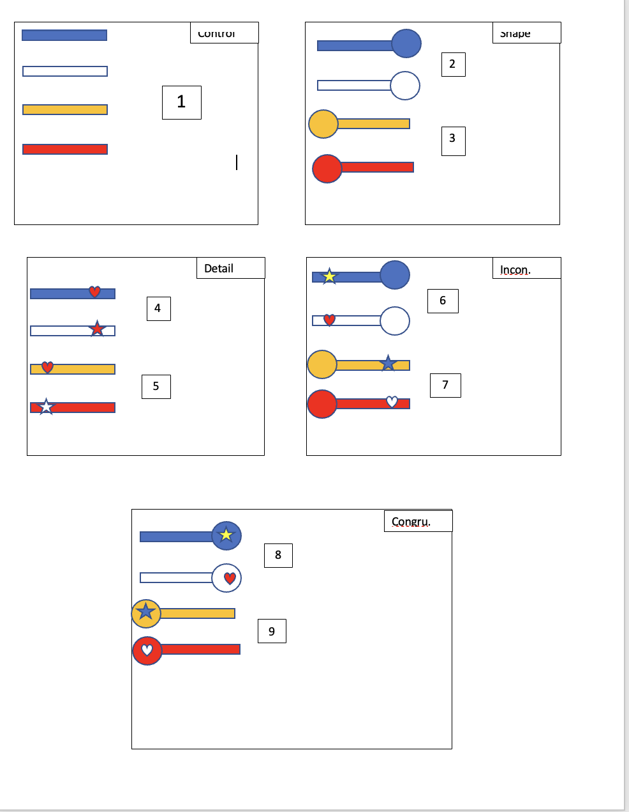
Figure 1. Objects presented by Condition

Figure 2. Trial Timeline: 5 seconds of free looking, after 5 seconds, the “GO” signal occurs, and then the onset of reaching begins. The trial stops after the participant contacts the object
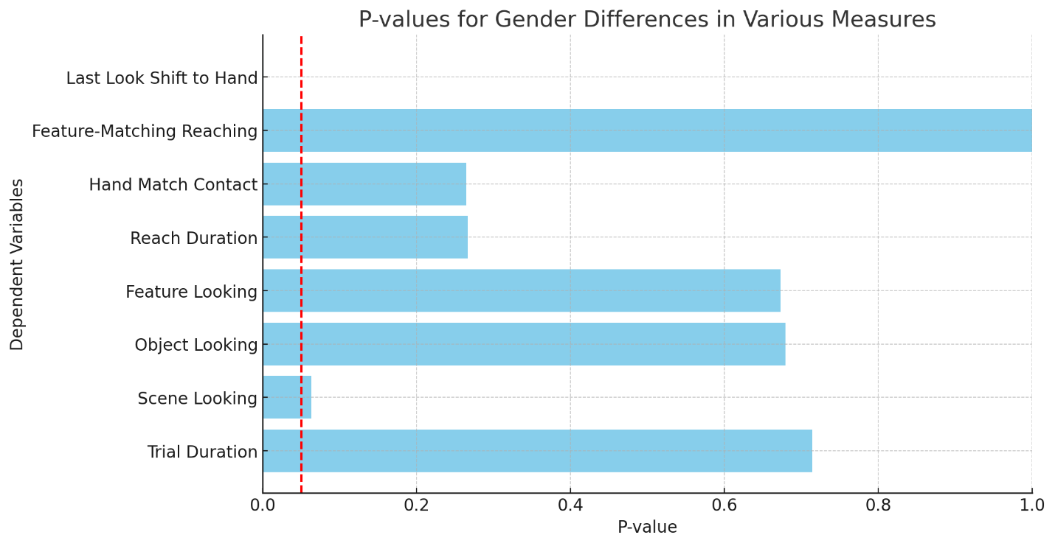
Figure 3. P-values for gender differences across various dependent variables. The red dashed line marks the significance threshold (p = 0.05). The only significant effect is observed for the "Last Look Shift to Hand," where the p-value is below the threshold. The other variables did not show significant gender differences.
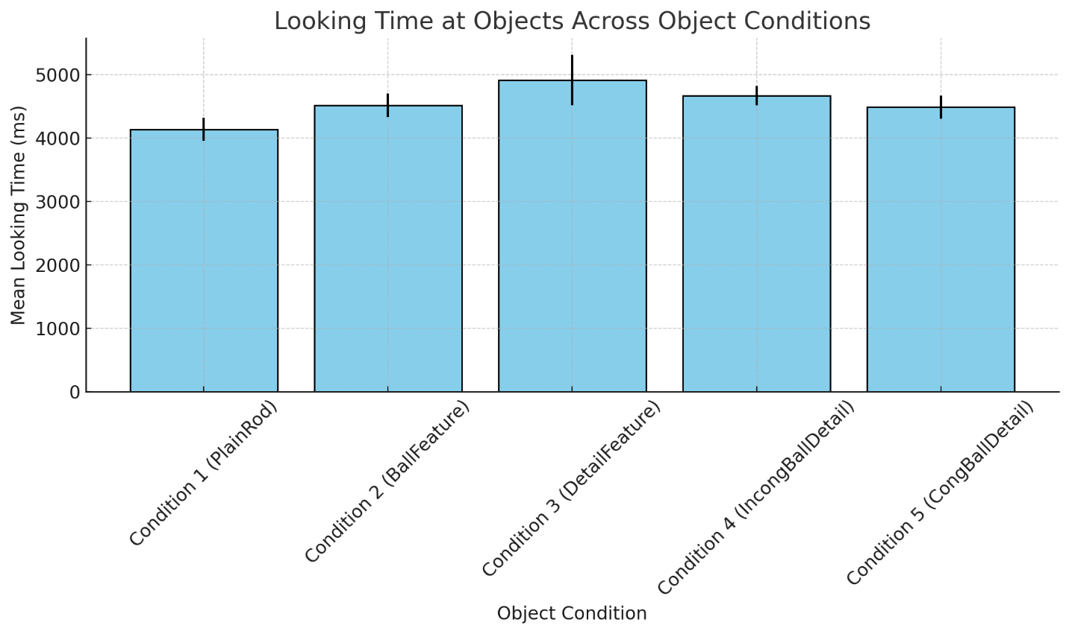
Figure 4. Bar graph representing the mean looking times at objects across different object conditions, with error bars showing the 95% confidence intervals. The bars illustrate that the looking times are similar across conditions.

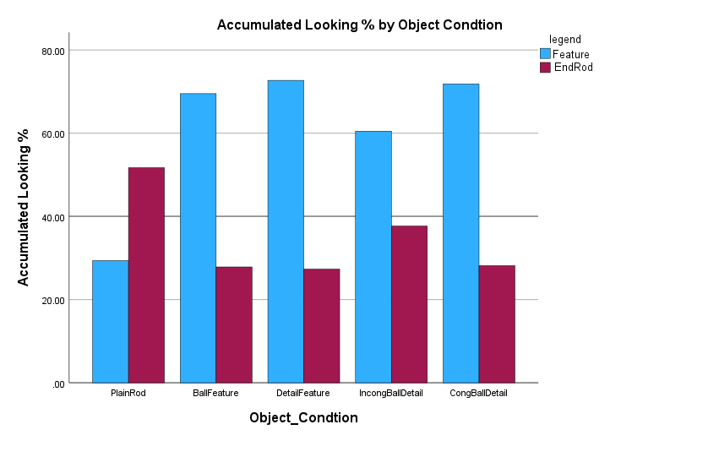
Figure 5. The accumulated looking percentages for the Feature and End Rod locations across different object conditions. For each condition (PlainRod, BallFeature, DetailFeature, IncongBallDetail, CongBallDetail), separate bars represent the looking percentages towards the Feature and End Rod.

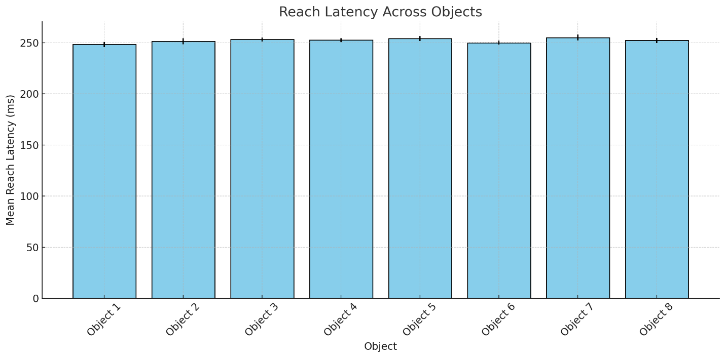
Figure 6. The bar graph shows the mean reach latency across different object conditions. The error bars represent the standard deviations, and the graph demonstrates that the reach latency remains consistent across all objects.
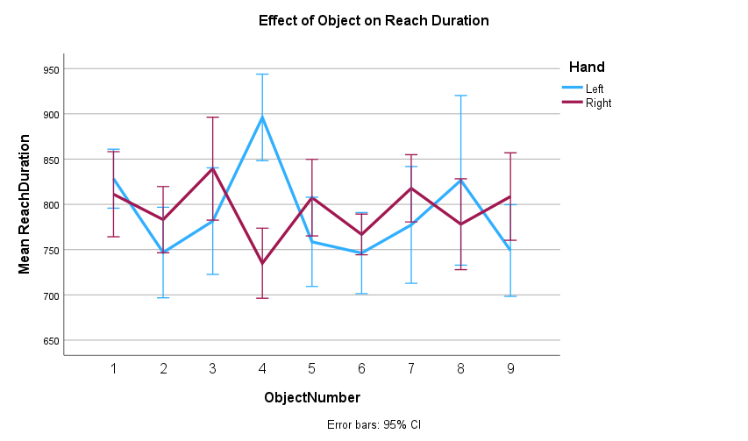
Figure 7. Line graph showing the mean reach duration by object. The error bars represent the standard errors. The graph indicates no significant difference in reach duration across all objects except Object 4, where there was a sticker on the left side of the object, resulting in a longer reach duration.
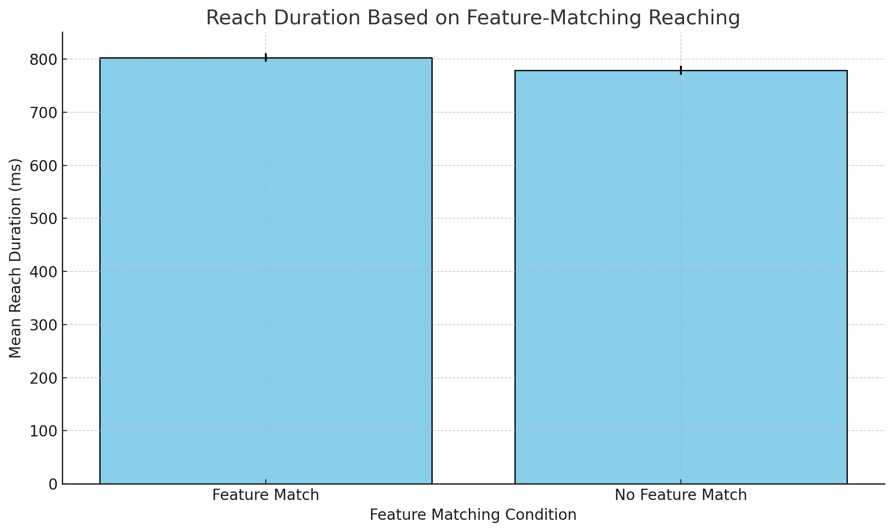
Figure 8. Bar graph showing the mean reach duration based on whether the reaching hand matched the feature location. The error bars represent the standard errors, and the graph indicates that participants took slightly longer to complete the reach when their hand matched the feature location.

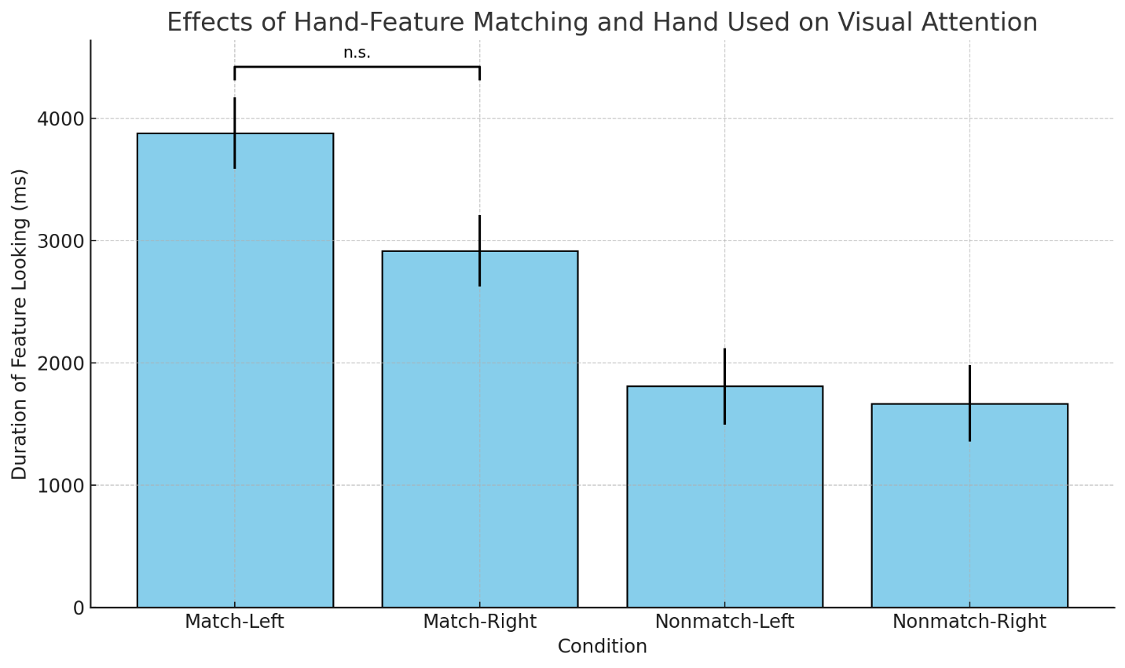
Figure 9. Bar graph illustrating the effects of hand-feature spatial alignment and hand use on looking behavior to object features. The error bars represent standard errors. The horizontal bracket between "Match-Left" and "Match-Right" indicates that their difference was not statistically significant (n.s.)
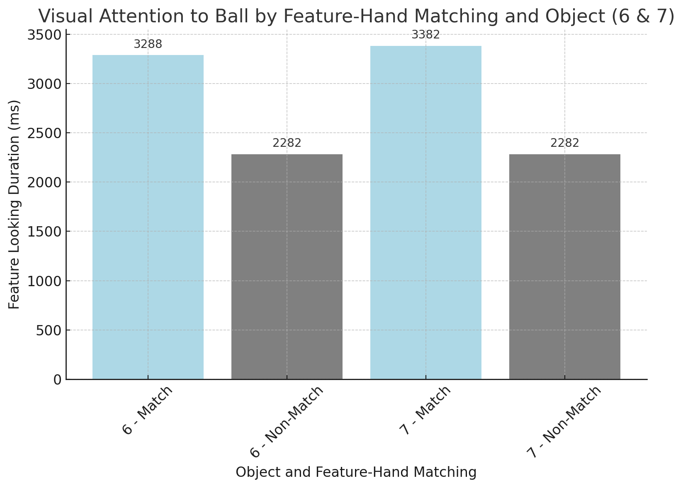
Figure 10: Bar graph for objects 6 and 7. It shows how looking behavior (feature-looking duration) varies based on whether the ball feature and the reaching hand were spatially matched or not. Match trials for both objects 6 and 7 show higher-looking durations. Non-match trials have notably lower-looking durations (based on the general non-match average).

VITA

Asante Knowles was born and raised in Memphis, Tennessee. He earned his Bachelor of Arts degree in Psychology from the University of Tennessee, Knoxville in 2019, where he developed an interest in developmental psychology and neuroscience. He later pursued his doctoral studies in Experimental and Clinical Psychology at the University of Tennessee, Knoxville, joining Dr. Corbetta’s Cognitive Developmental Laboratory. During his graduate training, he specialized in studying visual-manual coordination, embodied cognition, and the behavioral dynamics of goal-directed actions in adults and infants.
In addition to his research, Asante contributed to the department as a teaching assistant and actively participated in outreach programs promoting mental health awareness and community engagement. He has co-authored publications on neuroplasticity and developmental psychology and presented his work at regional and international psychology conferences.
After completing his Ph.D., Asante plans to continue combining research, clinical practice, and community-based initiatives to advance psychological science and improve mental health accessibility in underserved populations.

