Comparative Proteomics Characterization for Dissimilatory Metal Reducing Bacteria with Mass Spectrometry
PhD Thesis

June 20, 2014
Xiaoxin Liu

ABSRACT

Dissimilatory metal reducing bacteria (DMRB) is probably one of the most respiratory versatile microorganisms on earth. Their ability to use metal as terminal electron acceptor for energy conservation allows them to survive in severe environments (e.g. radionuclide contaminated soil). In addition to metal, many other organic and inorganic substrates could be utilized for DMRB respiration, including fumarate, nitrate, oxygen, etc. With the advent of high-throughput genomics techniques, the genome information for many DMRB species is available which reveals large numbers of c-type cytochrome encoding genes present in their genomes. For example, the genomes of three DMRBs, Anaeromyxobacter dehalogenans strain 2CP-C, Shewanella oneidensis strain MR-1, and Geobacter daltonii strain FRC-32, contain 69, 40, and 72 putative c-type cytochrome genes. Although mutagenesis techniques have determined the respiratory roles of several c-type cytochromes, gene disruption for majorities of the putative c-type cytochromes does not generate visible phonotypical alterations, and could not functionally link them to specific respirational activities. Thus, comprehensive proteome characterization for DMRBs is in urgent need to elucidate the molecular mechanisms underlying their respirational versatilities. In this dissertation, we utilized a mass spectrometry-based proteomics approach to interrogate the proteomes of A. dehalogenans strain 2CP-C, S. oneidensis strain MR-1, and G. daltonii strain FRC-32. We tested the proteomic responses of DMRBs to a wide range of electron acceptors, including soluble and insoluble ferric iron, manganese oxide, fumarate, nitrate, oxygen, and nitrous oxide. The in-depth proteomic characterizations comparatively revealed the c-type cytochrome profiles of DMRBs, providing evidence for the identities and expressions of all putative c-type cytochromes, and established the linkage between specific electron acceptor and individual c-type cytochromes. The entire proteome complements of DMRBs were also characterized, generating metabolic maps reflecting pathway-level activities responding to various electron acceptors. The results identified the core proteome carrying out the essential cellular machineries for each tested DMRB, and demonstrated clearly elevated energy metabolism for A. dehalogenans strain 2CP-C during respiration of metal electron acceptors.

Contents
Chapter One 3
Introduction to MS-based proteomics and its application on environmental microbiology 3
1.1 The “omics” tetralogy and systems biology 3
1.2 Proteomics - the apogee of the “omics” science 9
1.3 MS-based proteomics provides insight into environmental microbiology 12
1.4 Dissimilatory metal reducing bacteria and their environmental impact 16
1.5 c-Type cytochrome plays important role in respiratory versatilities of DMRBs 22
1.6 MS-based proteomics offers insight into DMRB studies unachievable by other techniques 25
1.7 Overview of this dissertation 27
Chapter Three 29
Mass spectrometry-based proteomic profiling of c-type cytochromes for dissimilatory metal reducing bacteria 29
3.1 Abstract 29
3.2 Introduction 30
3.2 Material and Methods 33
3.4 Results 38
3.5 Discussion 64
Chapter Four 72
MS-based proteomic characterization of Anaeromyxobacter dehalogenans strain 2CP-C reveals elevated energy metabolism in growth with metal electron acceptors 72
4.1 Abstract 72
4.2 Introduction 72
4.3 Experimental section 74
4.4 Results and discussion 77

Chapter One

Introduction to MS-based proteomics and its application on environmental microbiology

1.1 The “omics” tetralogy and systems biology
For centuries, research of biochemical, molecular, and cellular biology focused on the analysis of subsets of biomolecules and biochemical reactions in a given organism at a time, which achieved tremendous success in understanding cellular processes that reflect various aspects of living organisms. The foundation for life science research is the discovery of DNA (deoxyribonucleic acid) and its recognition as the carrier for genetic information [1-3]. Following the unveiling of the double-helix structure of DNA, the genetic code embedded in the DNA sequence was deciphered, leading to the establishment of central dogma for molecular biology which describes a framework in which genetic information is transcribed from DNA to RNA (ribonucleic acid) and translated to proteins [5, 6]. Obtaining the comprehensive genome sequence became desirable in that the whole genome sequence presents a blueprint of all functional potentials of an organism. Ever since the completion of the first whole genome sequence of the bacterium Haemophilus influenza [7], the field of genomics bloomed, expanding our knowledge about life science and revolutionized the way of conducting biological research. Biological research branched into large-scale analysis through the emerging ‘transcriptomics’, ‘proteomics’, and ‘metabolomics’ studies. While transcriptomics measures all RNAs expressed in a given organism, proteomics characterizes the protein complement in a given biological system, and metabolomics captures the related metabolites resulting from all cellular metabolic reactions. The burst of ‘omics’ studies compose a tetralogy which enabled the holistic view of biological systems such as a single living organism, a symbiotic system, or a microbial community. The system-level information offered by the “omics” studies was unachievable previously, giving rise to the discipline of “systems biology” (Figure 1.1).
Genomics is the very first chapter of the “omics” tetralogy, serving the basis for transcriptomics and proteomics. In the late 1970s, initial method (Sanger sequencing) for DNA sequencing was developed [8-10], providing a basis for the following sequence-driven researches. Continual technical refinement and improvement greatly reduced the cost and increased the speed and throughput for genome sequencing, allowing the whole genomes of more and more organisms being sequenced with high quality. The success of the first draft of human genome sequence [11, 12] is one of the greatest achievements in the 21st century, which unprecedentedly broadened the horizon toward the understanding of human being. Biomedical research was tremendously benefited, in that the genotyping of human health and diseases shed light into the underlying molecular mechanism for human disease (e.g. Huntington’s disease is caused by genetic disorder [13]). Nowadays, complete genome sequence is widely available for numerous organisms ranging from Prokaryote to Eukaryote. Genomics not only provides insight into the genetic makeup for single organisms, but also reveals the genetic diversity, evolution, and metabolic potential for microbial communities (metagenomics) [14]. The success of direct extraction and analysis of the collective genomic information for microbial communities expanded the scope of microbiology by providing insight into uncultured microorganisms which could not be characterized previously [15]. Metagenomics studies allow in situ characterization of the genomic elements in microbial consortia residing in diverse environmental settings such as ocean, soil, deep sea sediment, human gut, human oral cavity, etc. [16-20]. Genome cataloguing describes all functional potentials of the biological system under study. Information contained in the genetic content must be utilized through the expression of genes, generating transcripts and
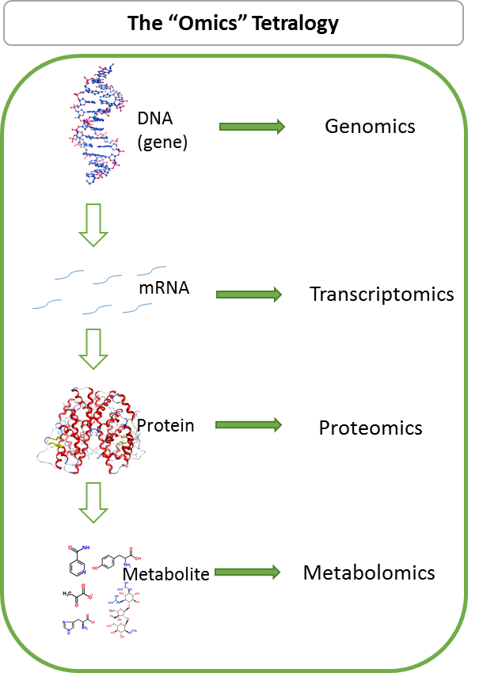
Figure 1.0.1. The “omics” tetralogy. The system-level information achieved by different levels of the “omics” sciences enable the comprehensive understanding of biological systems. Genomics describes the complete genetic makeup of a cell. Transcriptomics measures the complement of RNA transcripts expressed under certain conditions. Proteomics characterizes the entire repertoire of proteins present in the biological system. Metabolomics measures the suite of small molecules. Taken together, our understanding toward systems biology is enhanced through the “omics” tetralogy.

proteins for functional activities at the cellular level. Thus, in the post-genomic era, great efforts are put into the study of all the transcripts (transcriptome) and proteins (proteome) present in a biological system.
Transcriptomics emerged as an endeavor to reveal the functional dynamics of the genome, since gene expression directly leads to RNA transcription. While the genome of an organism is always constant, gene activity is dynamic, and only subsets of the genome get transcribed for subsequence functional roles. Comprehensive interrogation of the identity and quantity for the complete set of transcripts in a cell directly reflects the activation of functional elements in the genome in a certain developmental state or physiological condition. Two different approaches are available for transcriptomics profiling, one is based on hybridization (e.g. microarray) and the other is based on sequencing techniques (e.g. RNA-seq). Hybridization-based approach is high-throughput and generally low-cost, widely used for transcriptomics studies and successfully profiled gene expression for various biological systems [21-23]. Development of next-generation sequencing made it feasible to achieve deep sequencing of the transcriptome with high resolution, providing the benefit of larger dynamic range, independence from existing genome information, and clear determination of transcription boundaries [24]. Transcriptomics provides direct measurement for gene activity, which do not necessarily represent the functional aspect of gene expression, because the final product of gene expression is protein, not transcript. In addition, the constitutive expression and post-translational modifications of proteins, and proteins resulting from post-transcriptional modifications (e.g. alternative RNA splicing) could not be addressed by transcripts. In this regard, proteomics, generating the collective view of all the proteins, represents the functional activities at the cellular level.
Proteomics development started in late 20th century. In the early stage, the complete set of proteins in an organism is collected and separated by two-dimensional gel electrophoresis (2DE) [25, 26] which presents a proteome map containing spots of proteins with various charges and sizes. The identification of protein spots was resolved through the estimation of amino acid composition by matching the pI (isoelectric point) and molecular weight against the chemical properties of proteins in existing database for a certain organism [27]. Quantification of protein spots could be achieved by various staining methods, as represented by staining intensities. When mass spectrometry (MS) was implemented for protein analysis, protein identification from gel spots became much more confident and reliable owing to the determination of highly accurate protein mass by MS. The introduction of protein ionization methods, electrospray ionization (ESI) [28] and matrix assisted laser desorption/ionization (MALDI) [29], were the major driving force for MS-based protein analysis. MS protein identification following 2DE has been a popular approach for proteomics studies, and was widely used for proteomic interrogation in many biological settings [30]. The utilization of liquid chromatography (LC) for protein and peptide separation outperforms 2DE in that separation time is no longer limited, the dynamic range of measurable proteins is tremendously improved, and LC can directly connect in-line with MS [31]. The coupling of LC with MS ( termed LC-MS) enabled proteomic characterization of complex samples (e.g. peptide mixture from tryptic digests of plant proteome [32]). Nowadays, LC-MS is the preferred method for MS-based proteomics analysis, providing an unparalleled platform for comprehensive characterization for protein sequence identification and quantification. With the continual improvement of MS instrumentation, proteome measurement could be achieved with higher speed, resolution, accuracy, and dynamic range. The successful application of LC-MS for proteomics analysis presents the protein-level functional view for metabolic activities in various biological systems, from single bacteria isolate, to higher order eukaryotes, and to complex microbial communities [33-38]. Greater details for MS-based proteomics will be discussed in section 1.2.
Metabolomics is a recent established field that characterizes the complement of metabolites in a given biological system. Metabolites are small molecules being transformed during metabolism, which generally are the substrates or products of biological catalytic reactions driven by proteins [39]. The information provided by metabolomics is the readout of biochemical activities at the molecular level, and offers a different perspective for the systematic functional overview for biological research. Characterization of metabolome, similarly to proteomics, heavily relies on mass spectrometry. Although still in its infancy, metabolomic studies have provided deep fundamental molecular insight for biological systems such as human, microbial communities, etc. [40, 41]. Together with proteomics, metabolomics presents informative details for the metabolic activities responsible for cellular functions.
The “omics” tetralogy provides different layers of information for systems biology: genomics for the genetic makeup determination, transcriptomics for gene activity elucidation, proteomics for functional representation, and metabolomics for direct signatures of metabolic reaction. Each field is under rapid development and enhancement, and is generating tremendous information assets for biological research. Although mechanics for the integration of the “omics” tetralogy remains elusive at present, the information output gathered from all aspects of “omics” research will propel our understanding about life science.

1.2 Proteomics - the apogee of the “omics” science
As mentioned above, proteomics is best suited for the functional representation and physiological characterization of metabolic activities at the cellular level, as it directly measures proteins – the final gene functional product. Only through direct proteome characterization can we understand the identities, quantities, and modifications of gene functional carriers (proteins) accounting for the major metabolic units for cellular activities.
The LC-MS-based proteomics is the current state-of-the-art technique for comprehensive proteome characterization, and can be divided into two different types: top-down and bottom-up (Figure 1.2). In the top-down approach, proteins are analyzed in the intact form, giving the opportunity to study protein structure (e.g. post-translational modification (PTM)), protein-protein interaction (e.g. polymerization), and protein diversity (e.g. splice variants). In a typical LC-MS-based top-down proteomics measurement, the mixture of whole proteins are separated based on hydrophobicity and/or charge in the mobile phase of LC. The precise m/z value (mass to charge ratio) of the intact proteins is measured by a MS instrument generally of high-resolution, such as Fourier Transform Iron Resonance (FTICR) or LTQ Orbitrap (Thermo Scientific, Inc.). The intact proteins could be fragmented inside the mass spectrometer, and the m/z values for the fragment ions could be measured, generating tandem mass (MS/MS) spectra. The exact mass of the intact protein, along with the fragmentation pattern presented in the MS/MS spectra, provides information for protein sequence identification. The accurate mass of the intact protein is also useful to distinguish very precise mass differences of protein variations (e.g. protein isoforms). Several limitations still exist for the application of top-down approach in large-scale deep proteomics interrogation. First of all, the mass range of proteins present in a biological system is dynamic – the mass difference of the largest and the smallest protein in a proteome could be over several hundreds of kilo Daltons (kDa). Large protein molecules, such as
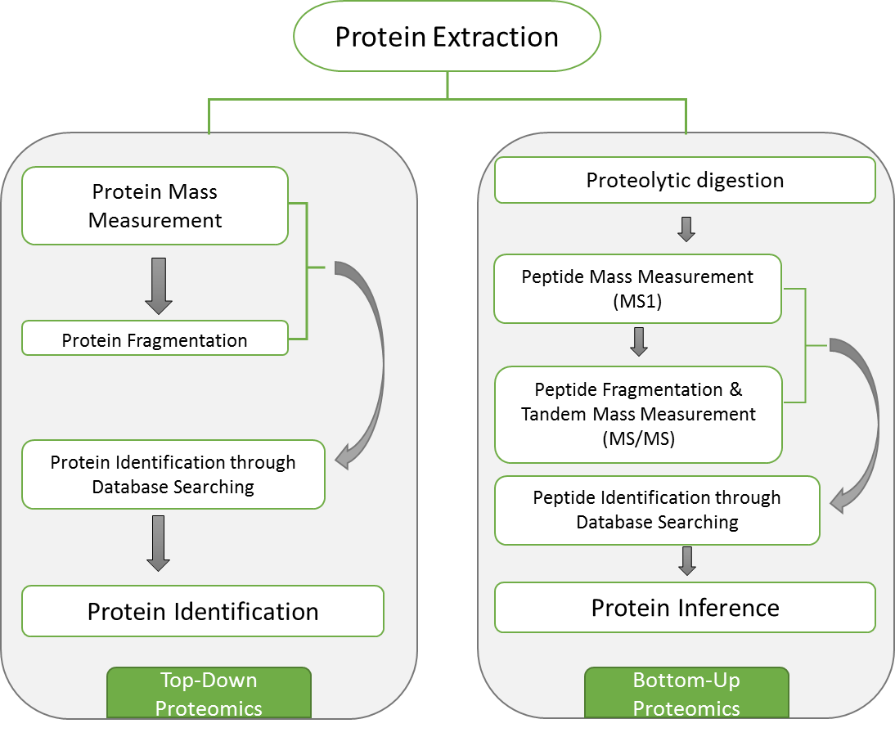
Figure 1.0.2. The top-down and bottom-up proteomics strategies. The top-down approach directly investigates intact proteins. The bottom-up approach measures digested proteins, and protein identification is achieved through identified peptide sequences.

those with a molecular mass greater than 50 kDa, propose difficulties for LC separation, ionization and MS detection [42]. Secondly, various protein modifications, such as PTMs and single nucleotide polymorphisms (SNPs), could induce changes to the molecular mass of intact proteins and challenge protein identification through top-down approach.
The bottom-up approach, also termed the “shotgun” approach, is more favorable for deep proteomic measurement at present time. The concept of shotgun proteomics is very similar to that of shotgun genome sequencing in which long DNA strand is divided into short segments, and the segment strands are sequenced individually and reassembled to present the complete DNA sequence. In shotgun proteomics, proteins are digested into peptides prior to separation and detection, and detected peptide sequences are used for protein identifications. The peptide mixture generated from proteome digestion greatly reduced the sample mass, which is beneficial for ionization and subsequent MS analysis. For example, an average tryptic peptide contains 10 amino acids, which is about 1 kDa in molecular mass. The increased complexity of peptide mixture could be a nightmare for gel electrophoresis separation, but can be easily resolved through chromatographic separation. The m/z values for the separated and ionized peptides (parent/precursor mass) are measured by MS, and the precursor ions can be fragmented and analyzed to obtain MS/MS spectra. For peptide identification, a protein database derived from the corresponding genome database is exploited. Proteins in the database are in silico digested to generate predicted peptides which are subsequently fragmented in silico to obtain predicted fragmentation pattern. The experimental precursor mass could be used to search for predicted peptides, and the experimentally generated MS/MS spectra can be matched to predicted fragmentation patterns to determine peptide sequences. Once the peptide sequences are determined, they are traced back to the originating proteins. Many computational software or algorithms are developed to automate the peptide sequence determination and protein inference for bottom-up proteomics, such as SEQUEST, MyriMatch, DTASelect, IDPicker, etc. [43-46]. The bottom-up strategy is routinely performed for many large-scale proteomics studies, although it does contain a limitation incurred by its peptide-centric nature. For higher order eukaryotes (e.g. human, plant) whose genome contains many redundancies, sequence homologies among different proteins is very common. Proteolytic digestion of the homologous proteins could lead to redundant, homologous, or isobaric peptide species, making it difficult to identify and quantify the originating proteins. Despite this issue with the higher order eukaryotes, the bottom-up strategy is currently the method of choice for large-scale proteomics studies and has achieved great success for proteomic characterizations for many biological systems [35, 37, 47-49].
In this dissertation, proteomic characterizations for microbial isolates were achieved using the bottom-up strategy, for which technical details will be provided in Chapter Two.

1.3 MS-based proteomics provides insight into environmental microbiology
Microorganism has the largest population on earth, accounting for 60% of the global biomass [50], and ubiquitously distributes every imaginable environment from soil, water, air to environments with extreme conditions (e.g. extreme pH, salinity, temperature, etc.) [51, 52], and to human bodies (e.g. microbial species present in human gut, oral cavity, skin surface, etc.) [53]. The activities of environmental microorganisms are very important for many ecological processes (e.g. the biogeochemical cycling of elements) as well as human health (e.g. pathogenic microbes cause disease conditions to human beings). Environmental microbiology, the study of environmental microorganisms, was pioneered by Beijerinck who developed the selective enrichment techniques which allowed cultivation of bacteria with specialized functions (e.g. nitrogen-fixation). The discovery of microbial biotransformation of nitrogen, carbon, sulfur, iron, and manganese by Beijerinck and Winogradsky initiated the field of environmental microbiology, and spurred following research on environmental microorganisms [54, 55].
Nowadays, there are essentially two ways to study environmental microorganisms. One is to isolate microbial species of interest from the environment, and study various aspects of the isolate under laboratory conditions to explore the physiological properties, metabolic activities, or the molecular mechanisms for specialized functions. In addition to studying single microbial species isolate, the laboratory-based strategy also includes the investigation of artificial mixtures of microbial isolates. In contrast, the other approach for environmental microbiological research is field-based, which investigates microorganisms (either isolates or communities) in their natural habitats, in an effort to unravel the microbial diversities in the ecological system, interactions and communications between microorganisms or with the environment, and the microbial functional contributions to the biosphere. For either strategy, laboratory-based or field-based, proteomics has played pivotal role in providing massive information to deepen our understandings about environmental microbiology.
The vast majority of environmental microbial proteomics studies are laboratory-based, focusing on model microorganisms with specialized properties of interest. Many microbial species are of interest due to their detoxification abilities, tolerance to extreme environmental conditions, respiratory versatilities, etc. Studies of their metabolic activities could lead to new biological discoveries (e.g. novel enzymes), or beneficial applications to the environment (e.g. bioremediation). Since next-generation sequencing made it quick and easy to achieve complete genome sequencing for numerous microbial isolate species, the available genome information made it straightforward to perform MS-based proteomics studies on microbial isolates. By investigating the repertoire of proteins expressed by microorganisms under monitored laboratory conditions, overall microbial physiological activities could be revealed, and could be exploited by comparative studies to uncover differential molecular processes responding to specific environmental perturbations. For example, the comparative proteomic analysis of Shewanella oneidensis revealed proteins essential for the regulation of chromate transformation [56, 57]. Proteomics has interrogated various microbial isolates and characterized the molecular machineries for their unique traits, including the flexible metabolism of Pseudomonas, methanogenesis property of Methylococcus capsulatus, denitrification ability of Paracoccus denitrificans, etc [58-60]. The proteomic information achieved for numerous microbial isolates not only profiles the protein repertoire under laboratory conditions, but also provides detail for strategic design of subsequent biological and environmental studies and applications (e.g. gene knockout experiments, environmental manipulations) [50, 61].
Since microorganisms do not live in isolation, and their natural environmental conditions are almost impossible to emulate in laboratory, to study microbial communities in their natural habitat became desirable. MS-based proteomic characterization for environmental microbial communities not only provides an in situ protein-level overview for the microbial community, but also allows investigation into the uncultivable microbial species which could not be achieved under laboratory conditions. Information about microbial community structure, diversity, functional activities could be achieved by metaproteomic characterization, and are of tremendous importance for the understanding of microbial interactions, adaptations, and ecological functions in the environment. The metaproteomic characterization for the acid mine drainage microbial biofilm community is a landmark for environmental community proteomics [47]. With more metagenomics studies providing genome information for environmental microbial communities, more and more metaproteomics studies have been exercised on microbial consortia in various environments (e.g. water, soil) providing insight into many important research areas, such as wastewater treatment, bioremediation, global warming [62-64].
Despite success applications of MS-based proteomics on environmental microbial communities, technical limitations impede the wide feasibility of field-based proteomics. Unlike microbial isolates whose genomes are widely available, metegenome information is limited and the quality may not be optimal, which directly affects the performance of metaproteomics identification. And strain-level differentiations are very difficult to achieve both at the metegenome and metaproteome level, due to the high complexity and unpredictability of environmental microbial communities. In addition, protein extraction from environmental samples is more difficult than from laboratory cultures because of interferences (e.g. humic acid in soil). In contrast, proteomic characterization for microbial isolates under laboratory conditions is a mature technique, and is routinely conducted in many research institutes. In this dissertation, the advantage of using MS-based proteomics on microbial isolates in laboratory conditions is exploited to provide insight into the metabolic activities of respirational versatile environmental microbial isolates.

1.4 Dissimilatory metal reducing bacteria and their environmental impact
Dissimilatory metal reducing bacteria (DMRB) is able to couple the dissimilatory reduction of metals with the oxidation of organic substrates or H₂, and the electron flow during this redox process directly relates to energy production [65]. The use of metal as terminal electron acceptor has been observed in microorganisms with diverse phylogeny, ranging from Bacteria to Archea domain. Most of the early identified DMRBs are within the delta subdivision of Proteobacteria such as Geobacter, Desulfuromonas, and Pelobacter, and later studies on microbial dissimilatory metal reduction extended DMRBs to the gamma and epsilon subdivisions of Proteobacteria (e.g. Shewanella, Geospirillum) as well as Acidobacteria (e.g. Geothrix) [66]. To date, more and more DMRBs are identified and their phylogeny spreads even broader throughout the Bacteria domain [67].
The diversity and ubiquity of DMRBs greatly impact the global biogeochemical distribution of metal elements. The valence transitions of metal elements can be abiotic or biotic, and the biotic enzymatic redox is considered the prevailing form of environmental metal transformation [68]. A large variety of metal elements could be respired by bacteria, including Fe(III), Mn(IV), U(VI), Se, Cr(VI) Hg(II), Tc(VII), V(V), Mo(VI), Cu(II), etc. [68], among which, dissimilatory reduction of Fe(III) is the most predominant, in that iron is the fourth most abundant element in earth crust [67]. The abundance of iron on early earth, as well as the prediction of ancestry iron-reducing microorganisms, proposed that microbial iron respiration is one of the first forms of metabolic activities for life origin [69-72]. Most Fe(III) reducing bacteria are also able to reduce Mn(IV), and the environmental Mn(IV) reduction is readily accompanied with Fe(III) reduction [73, 74]. Thus, extensive research interests have been focused on the naturally occurring bacterial dissimilatory Fe(III) and Mn(IV) reduction and the environmental impacts [75]. Bacteria that utilize U(VI), Se(VI), Cr(VI), and Hg(II) as terminal electron accepter for respiration are also of great significance. Although not as widely distributed as iron, contamination with these elements proposes hazardous threats to environments due to their radiation or toxicity. And microbial reduction of these metal elements could be exploited as a remediation strategy. For example, several Geobacter spp. are able to reduce U(VI) in contaminated soil and ground water, resulting in the immobilization of uranium which is amenable for subsequent removal and clean-up [76].
In addition to metal electron acceptors, many organic and inorganic compounds (e.g. fumarate, nitrate) could be utilized for respiration by DMRBs due to their respiratory versatilities. A range of electron donors could also be used as electron source for respiration, such as lactate, hydrogen, succinate, acetate, etc. The oxidation of organic matter coupled to dissimilatory reduction of metals is a very important mechanism for organic matter degradation in a variety of environments including aquatic sediments, submerged soils, and aquifers. The redox of various elements by DMRBs tremendously influences the geochemistry of metal and nutrient in the environment. As a result, water quality as well as soil composition could be interfered by microbial activities of DMRBs. In turn, plant growth and human food resource is also mediated by microorganisms. The ecological impacts of DMRBs are profound, in that their diverse respiratory activities significantly affect nutrient cycling, organic matter degradation, mineral dissolution, and weathering [67].
Many species within the Geobacter genus are identified as DMRBs such as G. sulfurreducens and G.metallireducens. Geobacter species are often used as model organisms for research on dissimilatory metal reduction because they are generally the most common and most abundant Fe(III) reducing bacteria in many soils and sediments where active iron reduction processes occur. In addition to Fe(III), the range of electron acceptors that could be respired by Geobacter species include Mn(IV), U(VI), Co(III), V(V), etc [77]. The electron donors available for Geobacter respiration is also diverse, including acetate, hydrogen, humics, Fe(II), U(IV), aromatic compounds, and other fatty acids [77]. Due to the predominant Fe(III) reduction in natural occurrence, the physiological aspects about Fe(III) reduction by Geobacter spp. are the most studied. Fe(III) is highly insoluble at the circumneutral pH in most natural environments, and generally present in various oxide forms (e.g. goethite, hematite). In order to reduce environmental Fe(III) which is not readily accessible to the cell, Geobacter spp. must develop a special strategy to transport electron to extracellular solid-phase Fe(III). Studies on the mechanism for extracellular electron transfer were mostly done for G. sulfurreducens. It is clear that G. sulfurreducens, and presumably other Geobacter species, produces electrically conductive pili structure, which is essential for Fe(III) reduction [78, 79]. The concept of metallic-like conductive pili responsible for long range electron transfer is still under investigation, but it has been proven that the pilin protein PilA is the essential structural protein required for extracellular Fe(III) reduction [80]. Reduction of Mn(IV) by Geobacter species is studied in less extend. But it is proposed that a generalized electron transfer mechanism, rather than specific and specialized energy conservation strategies, is developed by Geobacter spp. for the reduction of different metal ions [77].
Although much focus was put on G. sulfurreducens for the extracellular electron transfer mechanism of Geobacter, different species, and even different strains, have their unique physiological properties. For example, the G. sulfurreducens strain KN400 produces more current and reduces Fe(III) oxides at a faster rate than strain DL-1[81]. Thus, other species and strains of Geobacter need more extensive research to elucidate their individual functional roles in their natural environment. G. daltonii strain FRC-32 is isolated from the subsurface sediments with mixed waste of heavy metal, radionuclides and hydrocarbon contamination. Its high abundance in the contaminated site, together with the ability to reduce metal electron acceptors such as U(VI) and Fe(III), attracted research interests to understand its contribution to the in-site metal reducing activities and contaminant remediation. In order to provide insight into the metabolic activities and molecular machineries of G. daltonii strain FRC-32, proteomic characterization of this strain is achieved in this dissertation and will be presented in Chapter Three and Six.
Shewanella genus is another group of intensively studied facultative bacteria for its versatile dissimilatory metal reducing capability. First isolated in 1931 from rotten butter, Shewanella were initially characterized as Acromobacter, but soon reclassified as Pseudomonas and then Alteromonas based on its phenotypic traits. The genus Shewanella wasn’t established until 1985 when molecular taxonomical analysis based on 5S rRNA sequence were performed [82]. Our knowledge on Shewanella metal reducing capability started with the isolation of Shewanella oneidensis strain MR-1 from Lake Oneida, NY in 1988, where researchers found reduced form of manganese present in the aquatic environment on contrary to commonly found oxidized form [83]. Lab cultural experiments in this study proved the direct link between manganese reduction and S. oneidensis anaerobic respiration. This finding triggered many following studies on the anaerobic respiration of S. oneidensis MR-1, especially on other possible external electron acceptors. Many other species of Shewanella were also isolated and identified from a variety of geographical locations, mostly aquatic habitats in marine and sedimentary environment[84]. In these studies Shewanella spp. demonstrated remarkable versatility on utilizing a broad range of electron acceptors including metals such as Fe(III), U(VI), Cr(VI) as well as organic compound such as sulfite, thiosulfate, arsenate, fumarate etc.[84]. As a bacteria capable of growing with insoluble mineral oxide, S. oneidensis exhibits great potential for applications in bioremediation of heavy metal and radionuclide pollution sites as well as the development of microbial fuel cells. Studies with S. oneidensis strain MR-1 have revealed three possible routes that mediate the transfer of electrons to extracellular non-soluble mineral oxide (electron acceptors). Outer-membrane cytochromes MtrC and OmcA were firstly attributed with the capability of electron export via direct contact with extracellular solid surfaces[85]. S.oneidensis strain MR-1 also secretes soluble riboflavins to serve as “electron shuttles” to enable electron exchange to external surfaces without direct interaction[86]. Besides, S. oneidensis MR-1 is also capable of producing electronically conductive nanowires to connect cells as well to biofilm attached surfaces. The electron conductivity, however is lost upon the mutating of out-membrane cytochrome MtrC and OmcA genes [87]. Overall these findings suggested that Shewanella species possess sophisticated metabolic systems to harness diverse sources of external electron acceptors and hence empower the organism to survive in different harsh environments.
Anaeromyxobacter dehalogenans strain 2CP-C is recent addition to the DMRB family. Isolated from the Cameroon rain forest soil [88], A.dehalogenans strain 2CP-C has shown to be able to use a wide range of respiratory substrates including Fe(III), Mn(IV), fumarate, nitrate, oxygen, U(VI), ortho-substituted chlorophenols, etc. [88-90]. Anaeromyxobacter populations are also major participants in the U(VI), Fe(III), and chlorophenol reduction processes carried out in contaminated sites[91-93]. The chlororespiring activity of strain 2CP-C can be paralleled with consituitive Fe(III) reduction [88], and U(VI) reduction can be affected by the respiration of nitrate, nitrite, and Fe(III) [89], suggesting the presence of competitive interactions between different terminal electron-accepting processes in the environment. Thus, A.dehalogenans strain 2CP-C is an excellent model organism for research on the interference of competing respiratory substrates. In addition, the potential utilization and manipulation of A.dehalogenans strain 2CP-C for in situ bioremediation of radionuclides and chlorophenols provides a promising strategy for soil and water quality improvement. The studies on A.dehalogenans strain 2CP-C mostly focused on its phylogeny and physiology, and there is a knowledge gap for molecular mechanisms contributing to its respiratory versatility. Further molecular-level exploration is needed to reveal whether A.dehalogenans strain 2CP-C has a unique electron transfer system, or a similar strategy is developed as with Geobacter (pili strategy) or Shewanella (cytochrome strategy). This dissertation provides insight into the proteomic compositions of A.dehalogenans strain 2CP-C in Chapter Three and Four.

1.5 c-Type cytochrome plays important role in respiratory versatilities of DMRBs
One common characteristic of most DMRBs is the large number of c-type cytochrome encoding genes present in their genomes. For example, in G. sulfurreducens genome, 111 genes potentially encode putative c-type cytochrome proteins [94], which is the highest number reported by far. Although detailed mechanisms for metal reduction is under investigation, the wealth of c-type cytochromes in DMRB is thought to be involved in the reduction of electron acceptors.
c-Type cytochromes are proteins characterized by the covalent attachment of c-type heme on conserved heme-binding motif CXXCH in the protein sequence. Heme is a very common biological cofactor, typically existing as the prosthetic group of protein. Heme molecule is essentially protoporphyrin IX with iron; and the two vinyl groups of the c-type heme molecule is linked to two cysteine residues in the CXXCH motif via thioether bonds (Figure 1.3) [4]. In prokaryotes, many c-type cytochromes contain multiple c-type hemes in a single protein, each attaching to a distinct CXXCH motif. The c-type heme is thought to contribute to the stabilization of the protein as well as constructing “hardwires” for electron flow between molecules [95-98].
c-Type cytochromes play very important roles in various bacterial respiration pathways [98]. They participate in the electron transfer chain, which typically generates electron flow and proton gradient across cell inner membrane. And the proton gradient can be used for ATP synthesis, providing energy for various cell activities. Energy reservation through metal respiration is a key feature for DMRBs as mentioned in the previous chapter. The

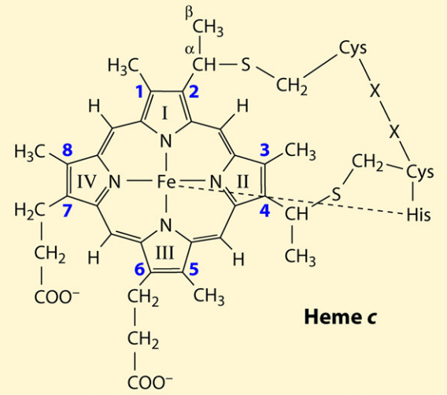
Figure 1.3. The molecular structure of c-type heme covalently binding to the conserved CXXCH motif on a polypeptide chain.
[4]
functional roles of DMRB c-type cytochromes during electron transfer and terminal metal reduction for energy conservation is the question that many studies are trying to answer.
The functional roles of many c-type cytochromes in Shewanella species have been extensively studied, and the molecular basis involving multiple c-type cytochromes has been proposed for the extracellular electron transfer process [99]. CymA (a teraheme c-type cytochrome) oxidizes menaquinol in the inner membrane and transfers electrons to the periplasm [100-102]. MtrA and MtrB form a porin-cytochrome complex on the outer membrane that passes electrons from the inside of the outer membrane to the outside [102]. The solid extracellular electron acceptor (e.g. Fe(III) oxide) is then reduced, most likely by receiving electrons from extracellular multi-heme cytochromes MtrC, MtrF, and OmcA [102]. As mentioned in the previous chapter, S. oneidensis strain MR-1 could produce conductive pili structured “nanowire” possibly relating to metal reduction. And the cytochrome MrtC and OmcA is essential for the conductivity of the “nanowire” [103].
As for Geobacter species, the c-type cytochrome OmcC was shown to play important role for Fe(III) reduction[104]. Three outer membrane c-type cytochromes OmcS, OmcT, and OmcE are important elements for metal oxide reduction but not essential for the respiration of chelated metal species [105]. And the cytochrome OmpJ are required for the reduction of Fe(III) and Mn(IV) [106]. Unlike S. oneidensis strain MR-1, studies on the involvement of c-type cytochromes to the conductive pili structure of G. sulfurreducens showed that electron transfer alongside pili is not mediated by c-type cytochromes [78, 79]. Instead of aiding the pili conductivity, cytochrome OmcS is proposed to facilitate the electron transfer from pili to Fe(III) oxide [107]. Multiheme c-type cytochromes of Geobacter species are hypothesized to function as capacitors which are able to temporarily store electrons when extracellular electron acceptor is not readily available [108, 109].
The specific electron transfer processes for DMRBs are still elusive, but taken together all the studies on various c-type cytochromes in different DMRB organisms, it is obvious that the high abundance of diverse c-type cytochromes present in all DMRBs is reflecting the highly branched respiratory systems. In this dissertation, the three DMRBs under investigation (A. dehalogenans strain 2CP-C, G. daltonii strain FRC-32, and S. oneidensis strain MR-1) all have high c-type cytochrome gene content in their genome based on genome sequence analysis. And majority of the predicted c-type cytochromes contain very high numbers of heme-binding motifs per protein [110, 111]. However, many of the putative c-type cytochromes, especially for A. dehalogenans strain 2CP-C and G. daltonii strain FRC-32, are not validated for their expression, interaction, and specific function. In order to gain insight into the utilization of c-type cytochromes during respiration, the comprehensive proteomic profiling of their c-type cytochrome repertoires is conducted and presented in Chapter Three.

1.6 MS-based proteomics offers insight into DMRB studies unachievable by other techniques
The studies about DMRBs mainly have been focused on the ecological and physiological properties, such as their population diversities and abundances in field samples, efficiency in metal reduction, current production, utilization of different electron acceptors and donors, etc. The environmental relevance of metal reduction processes by DMRBs is profound, and a significant number of bacterial species have been recovered and enriched in laboratories from various important environments (e.g. G. sulfurreducens and S. oneidensis as mentioned earlier). The isolation of DMRBs has led to deeper understanding of bacterial utilization and competition for different redox components, and revealed metabolic processes of individual species contributing to the environmental ecology.
While our knowledge about the physiological and ecological aspects of DMRBs is advanced, much effort needs to be made for the elucidation of precise mechanisms involved. With the advent of high throughput next-generation sequencing leading to the bloom of microbial whole genome sequencing, the complete genetic makeup for many isolated DMRBs are easily accessible. Functional predictions for DMRB genes were made through comparative genome analysis, and revealed many unprecedented potential metabolic features. For example, the genome of G. sulfurreducens and A. dehalogenans suggested motility function and aerobic metabolism, both of which were subsequently validated experimentally [94, 111, 112]. Among all the identified DMRBs, the complete genomes for S. oneidensis and G. sulfurreducens are the earliest available [94, 113]. Thus, the understanding about the molecular basis for respiratory activities of S. oneidensis and G. sulfurreducens are the most extensive due to well-constructed genetic systems [114, 115]. With the available genetic systems, progress has been made in identifying specific genes that are essential for selected biological processes using gene manipulation strategies, and many genes responsible for specific cellular functions were characterized. For example, some c-type cytochromes are essential for metal reduction, as mentioned in the previous section. However, mutant strain generation is technically difficult and time consuming. In addition, disruption of a particular gene often does not provide discernable phenotype, as exemplified by the mutagenesis studies on S. oneidensis and G. sulfurreducens [116, 117]. The metal respiration ability of S. oneidensis and G. sulfurreducens is only hampered and not eliminated by the disruption of a few c-type cytochrome genes [116, 117]. More comprehensive interrogations to the DMRB cellular activities and the detailed mechanisms are needed.
In the post-genomics era, transcriptomics and proteomics enable the functional overview of gene expression. Several transcriptomics and proteomics studies have been done on S. oneidensis and G. sulfurreducens [118]. The microarray analysis on S. oneidensis mRNAs identified 121 genes showing differential expression changes growing with different electron acceptors [119]. And the gene fur of S. oneidensis, a homolog to the iron uptake regulator in E. coli, was identified to be an important element in the regulation of energy metabolism and iron assimilation through transcriptomics and gel-based proteomics analysis [120, 121]. As discussed in section 1.1 and 1.2, transcriptomics is one step away from the final gene product – proteins, and comprehensive proteomics interrogation could provide the direct systematic functional overview for cellular activities. The unfractionated MS-based proteomic studies on S. oneidensis explored the proteome expression, and validated a significant proportion of the uncharacterized hypothetical proteins [122-124]. Proteomics characterization also provided insight into the global cellular activities of S. oneidensis and G. sulfurreducens toward different growth environments, stress conditions, etc. [125-128]. In all, characterization of the molecular metabolic activities provided by proteomics analysis could not be achieved through any other techniques. While S. oneidensis and G. sulfurreducens have been extensively explored, many other DMRBs with significant environmental influences should also be interrogated. And the MS-based proteomics analysis in this dissertation provided the metabolic overview for A. dehalogenans strain 2CP-C, G. daltonii strain FRC-32, and S. oneidensis strain MR-1, and comparative analysis revealed differential proteome expression profiles as well as differential c-type cytochrome utilizations.

1.7 Overview of this dissertation
This dissertation is aiming at the development and application of a high-performance MS-based proteomics technique to enhance the understanding of environmental microbiology and life science. The particular focus of the research presented in this dissertation is to comprehensively characterize the proteomes of three different species of DMRBs in an effort to reveal the molecular mechanisms underlying the cellular metabolic activities in relation to their respiratory versatilities.
Chapter Two will provide the in-depth proteomics experimental design for achieving comprehensive DMRB proteome characterizations, including details related to cell culture, proteome sample preparation methods, mass spectrometry instrumentation and experimental setup, protein identification strategy, and data normalization. Chapter Three will demonstrate deep protein expression profiling for the putative c-type cytochromes in A. dehalogenans strain 2CP-C, G. daltonii strain FRC-32, and S. oneidensis strain MR-1, providing the accurate details about the utilization of different sets of c-type cytochromes in response to different electron acceptors. The systematic proteome characterizations for A. dehalogenans strain 2CP-C will be presented in Chapter Four, which compares the regulation of different metabolic pathways toward the respiration of different electron acceptors. In Chapter Five, the multiheme c-type cytohcromes of A. dehalogenans strain 2CP-C are investigated for the actual occupancy of heme-binding motifs. The retention of heme group attachments on digested peptides being analyzed through mass spectrometry provides a means to validate the reality of high heme content of prokaryotic c-type cytochromes. Chapter Six focuses on the comprehensive proteomics characterization for G. daltonii strain FRC-32 and S. oneidensis strain MR-1under different electron-accepting conditions. And the proteome expression and represented metabolic pathways of G. daltonii strain FRC-32 and S. oneidensis strain MR-1is compared and contrasted to the proteome detection of A. dehalogenans strain 2CP-C. Chapter Seven will conclude the scientific achievements throughout this dissertation and the contributions made to the environmental microbiology field. The current status and on-going development of environmental microbiology through MS-based proteomics will also be discussed in Chapter Seven.

Chapter Three

Mass spectrometry-based proteomic profiling of c-type cytochromes for dissimilatory metal reducing bacteria

3.1 Abstract
The genomes of metabolically versatile, dissimilatory metal-reducing bacteria encode large numbers of c-type cytochromes, some of which contain up to 53 putative heme-binding motifs. Only a few of these c-type cytochromes have been assigned specific functions. To delineate c-type cytochrome expression patterns in response to growth with different electron acceptors including ferric ion, manganese oxide, nitrate, fumarate, and oxygen, the differential proteome expression of Anaeromyxobacter dehalogenans strain 2CP-C, Geobacter daltonii strain FRC-32, and Shewanella oneidensis strain MR-1 were characterized using a mass spectrometry - based proteomic approach. The analyses revealed a set of core c-type cytochromes expressed under all growth conditions tested, as well as c-type cytochromes unique to specific growth conditions, suggesting their potential utility as biomarkers to assess terminal electron-accepting processes (TEAPs). Many c-type cytochromes with multiple heme-binding motifs were detected, in particular for G. daltonii FRC-32 grown with the solid metal electron acceptor ferric oxyhydroxide, which supports the hypothesis that high heme content c-type cytochromes act as capacitors when electron acceptors are not readily available. A basic model for A. dehalogenans 2CP-C c-type cytochrome network was constructed to link cytochrome detection with corresponding TEAP. These findings suggest that a MS-based proteome approach is powerful for linking c-type cytochrome expression profiles with specific TEAPs, and provides significant insight into the fine-tunable control of bacterial electron transfer processes for different electron acceptors.

3.2 Introduction
Shewanella spp., Geobacter spp. and Anaeromyxobacter dehalogenans, are renowned for having well established respiratory chains that allow them to function under many different environmental conditions by utilizing a variety of electron acceptors and donors to sustain energy production. This is exemplified in studies of the microbial diversity in the uranium contaminated aquifer at the Integrated Field Research Challenge site at Oak Ridge, TN, which revealed that Anaeromyxobacter sp., Shewanella spp. and Geobacter spp. are key players for the in-situ bioremediation of uranium [129]. In addition to soluble electron acceptors like U(VI), these microbes are also able to reduce solid metals, such as iron oxide and manganese oxide[105, 130, 131]. In cases where the electron acceptor is insoluble, or soluble but not able to permeate into the cell (e.g. fumarate), the bacteria needs to have an extended electron transfer chain to transmit electrons from the inner membrane through the periplasm to the outer membrane or even to the outside of the cell [132].
DNA sequencing has revealed that the genomes of these genera harbor many c-type cytochrome genes. c-Type cytochromes are electron transfer proteins and are characterized by the presence of c-type hemes, which are covalently attached in specific binding motifs. The most common c-type heme-binding motifs are CXXCH, CXXXCH, and CXXXXCH [133]. Shewanella oneidensis strain MR-1 has a genome encoding for a total of 42 c-type cytochromes [110], and Geobacter sulfurreducens has a repertoire of over one hundred c-type cytochromes [94]. The structures and functions of selected c-type cytochromes of S. oneidensis strain MR-1 have been characterized by a variety of studies. For example, CymA transfers electrons from the inner membrane of S. oneidensis to the periplasm [100-102]. MtrA and MtrB form a porin-cytochrome complex on the outer membrane that passes electrons from the inner face of the outer membrane to the outside [134]. The solid extracellular electron acceptor is reduced, possibly by receiving electrons from extracellular multi-heme cytochromes MtrC, MtrF, and OmcA [134]. While there is limited information on c-type cytochromes in Geobacter daltonii strain FRC-32, another member of the Geobacter genus, Geobacter sulfurreducens strain PCA, has been extensively studied. There are 111 c-type cytochromes encoded by G. sulfurreducens, one of which contains 27 heme-binding motifs [94]. A current model of extracellular metal ion reduction by G. sulfurreducens highlights the type IV pili structure, which is electrically conductive [107]. It is believed that the pili receive electrons from the OmcE and OmcS complex and transport electrons directly to the electron acceptor [99]; however, a detailed characterization of this process has not been conducted. Although there are large numbers of putative c-type cytochrome genes present in the genomes of S. oneidensis and G. sulfurreducens, only a few have been validated and functionally characterized (as mentioned above). There are 68 c-type cytochrome encoding genes in lesser characterized Anaeromyxobacter dehalogenans strain 2CP-C, one of which contains as many as 40 heme motifs [111]. The expression and function of these c-type cytochromes of A. dehalogenans are virtually unknown. This suggests a critical need to better characterize factors influencing expression of the c-type cytochromes of A. dehalogenans and then compare and contrast them with the c-type cytochromes of S. oneidensis and G. daltonii.
To date, most studies on c-type cytochromes have focused on the analysis of the function and structures of a few specific types. The specificity of a c-type cytochrome for a certain electron acceptor is usually determined by mutant studies/gene-knockout experiments in which the knock-out mutants are examined for a discernible phenotype [117, 135]. However, eliminating a particular c-type cytochrome often does not provide a phenotype marker, which may indicate a large functional overlap between different c-type cytochromes in which the role of a specifically knocked-out cytochrome may be substituted by another one, resulting in no appearance of a phenotype marker. Thus, it is essential to study the complete repertoire of c-type cytochromes in order to obtain a more accurate and comprehensive overview. A few large-scale studies inspected c-type cytochrome gene expression at the transcriptome level for Shewanella and Geobacter [136-138]. These studies discovered that a few c-type cytochrome gene transcripts were elevated under metal-reducing conditions. However, c-type cytochrome proteins, not genes or transcripts, are the final functional units which directly constitute the electron transfer chain and carry out bacterial respirational ability. It is imperative to study the cytochrome proteins to characterize their expression and functional differences. Mass spectrometry is currently the method of choice to characterize protein expression in a high throughput and accurate manner. For example, a number of studies illustrated how mass spectrometry can be employed to characterize proteome expression profiles of a range of organisms, such as Pseudomonas, Ignicoccus, Populus [37, 38, 139]. Several proteomic studies have been conducted on S. oneidensis MR-1, but all of which only tested a few growth conditions and did not focus on the c-type cytochrome proteins [123, 126, 140].
In this study, we used high performance liquid chromatography coupled with tandem mass spectrometry to characterize the c-type cytochrome identities, abundance changes, and differential expression profiles of Anaeromyxobacter dehalogenans strain 2CP-C, Shewanella oneidensis strain MR-1, and Geobacter daltonii strain FRC-32 grown with a wide variety of different electron acceptors. In particular, this study is designed to be a global c-type cytochrome characterization for the aforementioned three strains with a focus on A. dehalogenans strain 2CP-C. The results reveal that the microbes adjust their c-type cytochrome expressions in response to the available electron acceptor. A number of “core” c-type cytochromes were identified that are expressed under all tested growth conditions, regardless of the electron acceptor provided and are likely essential for general ‘housekeeping’ activities. Additionally, “unique” c-type cytochromes were only detected in response to certain electron acceptors. These cytochromes may be used as specific biomarkers, which are required for the utilization of specific electron acceptors.

3.2 Material and Methods
Bacterial Strains and Culture Conditions. Anaeromyxobacter dehalogenans strain 2CP-C, Geobacter daltonii strain FRC-32, and Shewanella oneidensis strain MR-1 were grown in triplicates in 160 ml glass serum bottles containing 100 ml reduced bicarbonate-buffered mineral salts medium with a N₂/CO₂ headspace (80:20, vol/vol) [141, 142]. The serum bottles were closed with butyl rubber stoppers (Geo-Microbial Technologies, Inc., Ochelata, OK) and crimped with aluminum seals (Wheaton, Millville, NJ). When oxygen was used as an electron acceptor, the medium volume was reduced to 50 ml. Acetate (5 mM) or lactate (5 mM) was provided as an electron donor for A. dehalogenans /G. daltonii and S. oneidensis, respectively. The following electron acceptors were used (mM concentrations): ferric citrate (50, nominal), ferric oxyhydroxide (20, nominal), manganese oxide (20, nominal), 10 mM fumarate, 1/10 diluted tryptic soy broth (with additional 10 mM fumarate) (A. dehalogenans and S. oneidensis only), nitrate (2 mM) (A. dehalogenans and S. oneidensis only), 3% (vol/vol) oxygen in the headspace (A. dehalogenans and S. oneidensis only) were added as electron acceptors. Oxygen was added by filter-sterilizing the appropriate amount of air into the headspace of the serum bottle. All cultures were inoculated under anoxic conditions, i.e. a syringe is flushed with sterile N₂ gas before an inoculum is removed from a culture bottle and then injected into the fresh medium. Also, cultures were transferred at least twice in the same medium before inoculation into the final serum bottles that were subsequently harvested. Cells were grown at 30°C, shaken at 90 rpm until mid to late exponential phase. and harvested by centrifugation (4,700 x g for 20 min at 4°C). Cell pellets were instantly frozen and stored at -80°C. We did not culture G. daltonii FRC-32 with nitrate, tryptic soy broth, or oxygen as electron acceptors because FRC-32 was unable to grow under these conditions and thus provided no biomass for proteomics analysis. Roughly 5mg of cell pellet was collected for each strain grown with ferric citrate, nitrate, manganese oxide, tryptic soy broth, fumarate, or oxygen. Larger cell pellets were collected for ferric oxyhydroxide grown cultures in order to obtain more biomass due to the fact that cells cultured with ferric oxyhydroxide did not achieve effective growth as with the other electron acceptors.
Cell Lysis and Protein Extraction. For cells grown with tryptic soy broth, fumarate, ferric citrate, manganese oxide, nitrate, and oxygen, cell pellets were prepared for LC-MS/MS analysis using the SDS- trichloroacetic acid (TCA) method as previously described [143]. In brief, the cell pellet was re-suspended in 1.5 ml cell lysis buffer (5% (w/v) SDS, 50 mM Tris-HCI, pH 8.5; 0.15 M NaCl; 0.1 mM ethylenediaminetetraacetic acid (EDTA); 1 mM MgCl₂; 50 mM dithiothretiol (DTT)), and subjected to heat-assisted cellular lysis. Cell lysate was collected after centrifugation (21,000 x g for 15 min) and chilled 100% trichloroacetic acid (TCA) was added to a final concentration of 25% (v/v) and samples were incubated overnight at -10°C. Proteins were precipitated by centrifugation at 21,000 x g for 20 min, and the supernatant was discarded. Cell pellet were washed thrice with chilled acetone and centrifuged at 21,000 x g for 10 min after each acetone wash. Protein pellets obtained, were air-dried and solubilized in guanidine/DTT buffer (6 M guanidine HCl, 10 mM DTT in Tris CaCl₂ buffer (50 mM Tris, 10 mM CaCl₂, pH 7.6)) and incubated at 40°C for 4 hrs. Protein solutions were diluted 6-fold using Tris CaCl₂ buffer, pH 7.6, and subjected to trypsin proteolysis as described elsewhere (Thompson et al, 2006, Brown et al, 2006). The SDS method mentioned above did not provide effective protein extraction for the iron oxyhyroxide grown cultures. Thus, for cells grown with iron oxyhydroxide, the guanidine HCl method was used to prepare sample for LC-MS/MS as previously described [143]. Briefly, cell pellets were suspended in 2 ml guanidine/DTT buffer by vigorous vortexing, followed by incubation at 40°C for 4 hrs for cell lysis and protein denaturation. Protein solutions were diluted 6-fold using Tris CaCl₂ buffer, pH 7.6, followed by trypsin digestion. Following digestion, peptides were desalted and solvent exchanged into acidified water (0.1% formic acid in HPLC grade water; v/v) as describes earlier (Thompson et al, 2006, Sharma et al, 2013). All samples were filtered by Durapore PVDF filters, 0.45 µm (Millipore) and stored at -80°C.
Peptide Analysis by LC-MS/MS. Peptides were analyzed by two-dimensional liquid chromatography (Ultimate HPLC System, LC Packings, a division of Dionex, San Francisco, CA) coupled online with a linear ion trap mass spectrometer (LTQ XL, ThermoFisher Scientific, San Jose, CA ). A total of 53 runs were collected, which provided biological triplicates for all population. Peptides samples were loaded onto 5 cm Strong Cation Exchange (SCX) resins (Phenomenex, Torrance, CA) packed column, followed by offline wash to remove any lingering salt and contaminant and then connected online to a front column (PicoTip emitter, New Objective, Woburn, MA) packed with ~12 cm Reverse-Phase (RP) resins (Phenomenex, Torrance, CA). A 12-step 24-h Multidimensional Protein Identification Technology (MudPIT) was used to analyze peptides as previously described [144]. Briefly, a total of 11 incremental salt pulses were applied to separate peptides by charge. At each step, a gradient of solvent A (95% H₂O, 5% acetonitrile, 0.1% formic acid (v/v)) to solvent B (30% H₂O, 70% acetonitrile, 0.1% formic acid (v/v)) further separates peptides based on their hydrophobicity. LTQ XL was operated in a data dependent mode and one full MS scan was followed by five MS/MS scans. The m/z isolation width was set to 3 m/z. Dynamic exclusion repeat was set at 1 with a duration time of 60 sec.
Database Searching and Data Normalization. Experimental MS/MS spectra collected for A. dehalogenans strain 2CP-C, S. oneidensis strain MR-1, and G. daltonii strain FRC-32 were searched against FASTA protein databases specific to the respective bacteria. The FASTA protein database for each strain consists of corresponding predicted proteome database obtained from Joint Genome Institute (JGI, http://genome.jgi.doe.gov/, downloaded in July, 2011) and common contaminants such as trypsin, keratin, etc. A decoy database consisting of reversed sequences from corresponding proteome database was also appended to the FASTA protein database in order to calculate False Discovery Rate (FDR) at the protein level. The SEQUEST search algorithm was used for peptide identification. Identified peptides were filtered and assembled into proteins by DTASelect [44]. The DeltCN filter was set to 0.08. The cross-correlation score filtering process started with conservative criteria as following: XCorr: +1 = 1.8, +2 = 2.5, +3 = 3.5. The XCorr criteria were slightly altered to adjust FDR to ~1% for each sample. At least two peptides were required per protein identification, and at least one peptide had to be unique to that protein. Raw spectral counts were normalized by protein lengths and the total spectral counts using Normalized Spectral Abundance Factor (NSAF) as previously described [145]. Normalized spectral counts are then uniformly multiplied by a factor of 100,000 for better readability and comparability to raw spectral counts. Adjusted normalized spectral count is denoted as nSpC throughout this paper. The nSpCs for biological triplicates were averaged for each growth condition.
c-Type Cytochrome Prediction. Putative c-type cytochromes of A. dehalogenans strain 2CP-C, S. oneidensis strain MR-1 and G. daltonii strain FRC-32 were predicted by searching their respective protein databases followed by BLASTp against NCBI database. This process was automated using a customized perl script. Two criteria were used by the script to predict c-type cytochromes: 1) the protein sequence must contain at least one of the following common c-type cytochrome motifs: CXXCH, CXXXCH and CXXXXCH; 2) BLASTp result of this protein must contain at least one annotated c-type cytochrome.
Cellular Localization Prediction. Cellular localizations of the putative c-type cytochromes were predicted based on their protein sequences using Psortb.3.0 [146]

3.4 Results
c-Type Cytochrome Identification
A total of 69, 40, and 72 putative c-type cytochromes were predicted for A. dehalogenans strain 2CP-C, S. oneidensis strain MR-1, and G. daltonii strain FRC-32, respectively (Table 3.1). With results pooled across all growth conditions, the LC-MS/MS approach detected 53, 25, and 38 c-type cytochromes for strain 2CP-C, strain MR-1, and strain FRC-32, respectively (Table 3.1). Strain 2CP-C and strain MR-1 grown with nitrate as electron acceptor yielded the highest number of identified c-type cytochromes (37 and 20, respectively), while most c-type cytochromes (35) for strain FRC-32 were detected with fumarate provided as electron acceptor (Table 3.1). Cells grown with FeOOH yielded the least number of measureable c-type cytochromes for all three bacteria (Table 3.1), which may due to the recalcitrant growth and thus lower biomass of the microbes under FeOOH amendment conditions.

Table 3.1. c-Type cytochrome identification for A. dehalogenans 2CP-C, S. oneidensis MR-1 and G. daltonii FRC-32 grown under various redox conditions.
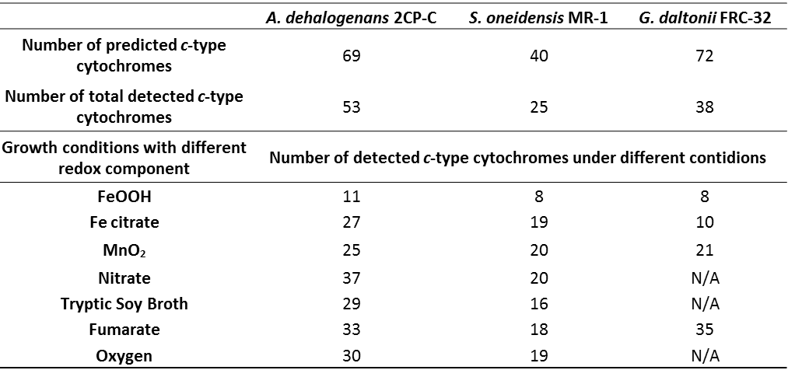
N/A: Geobacter growth could not be achieved under these conditions.
A hierarchical clustering of the c-type cytochrome abundance patterns in strain 2CP-C cultures in response to different growth conditions revealed a remarkable level of expression differentiation (Figure 3.1). The c-type cytochrome abundance patterns of the three metal electron acceptor conditions (FeOOH, MnO₂, Fe citrate; the three left-most columns) clustered together, while oxic growth (far right column) was the most distant from all anoxic conditions (Figure 3.1). Heat maps were also generated for c-type cytochromes in strain MR-1 and FRC-32 (Figure 3.2 and 3.3), and also revealed fined-tuned expression patterns that were somewhat distinct from strain 2CP-C. Although only four conditions were tested for strain FRC-32, the three conditions with metal electron acceptors clustered together, showing distinct c-type cytochrome expression patterns to growth with fumarate (Figure 3.3). For strain MR-1, the cytochrome expression patterns under metal electron acceptor conditions did not show similar trends, and were not clustered together as with strain 2CP-C and FRC-32 (Figure 3.2). All hierarchical clustering approaches reveal that the expression profiles of c-type cytochromes can be grouped into three categories: “core” (present in all conditions), “unique” (represented in only one condition), and non-detected.
“Core” c-Type Cytochromes
Proteomic measurements revealed several c-type cytochromes that were constitutively expressed under all growth conditions, suggesting that these constitute the “core” cytochromes that are required under all growth conditions. Six “core” cytochromes were detected in strain 2CP-C cultures: Adeh_0409, Adeh_0656, Adeh_1172 (CcoO), Adeh_2902 (NrfA), Adeh_2907, and Adeh_2963 (Table 3.2, Figure3.1). Strain MR-1 had seven “core” c-type cytochromes: SO_0264 (ScyA), SO_0970 (FccA), SO_1778 (MtrC/OmcB), SO_1779 (OmcA), SO_2178 (CcpA), SO_3980 (NrfA), and SO_4666 (CytcB) (Table 3.2, Figure 3.2), among which, the
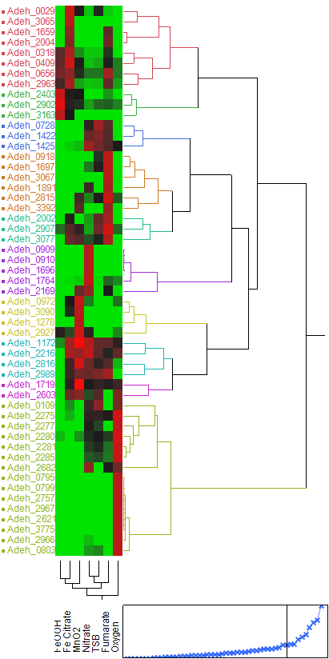
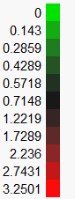
Figure 3.1. Hierarchical clustering of detected c-type cytochromes in A. dehalogenans 2CP-C cultures grown under various electron-accepting conditions. Hierarchical clustering and the heatmap of protein abundances were generated using JMP genomics 6.0 (SAS, Cary, NC). Hierarchical clustering was conducted using Ward algorithm. Each row was scaled so that the variance of each row is 1. The green-black-red scale on the top-right indicates scaled nSpCs (normalized spectral counts) for all c-type cytochromes.
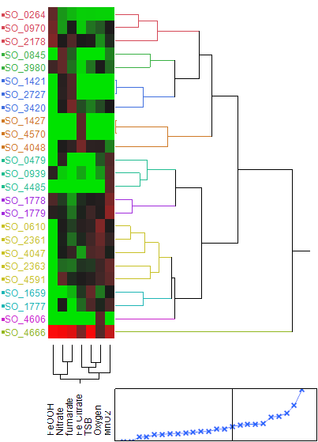
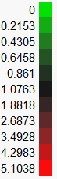
Figure 3.2. Hierarchical clustering of detected c-type cytochromes in S.oneidensis MR-1 cultures grown under various electron-accepting conditions. Hierarchical clustering and the heatmap of protein abundances were generated using JMP genomics 6.0 (SAS, Cary, NC). Hierarchical clustering was conducted using Ward algorithm. Each row was scaled so that the variance of each row is 1. The green-black-red scale on the top-right indicates scaled nSpCs (normalized spectral counts) for all c-type cytochromes.
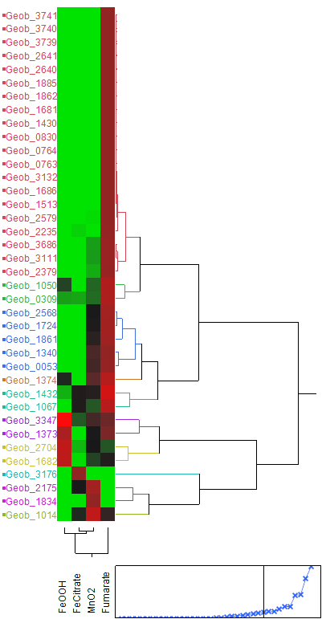
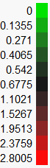
Figure 3.3 Hierarchical clustering of detected c-type cytochromes in G.daltonii FRC-32 cultures grown under various electron-accepting conditions. Hierarchical clustering and the heatmap of protein abundances were generated using JMP genomics 6.0 (SAS, Cary, NC). Hierarchical clustering was conducted using Ward algorithm. Each row was scaled so that the variance of each row is 1. The green-black-red scale on the top-right indicates scaled nSpCs (normalized spectral counts) for all c-type cytochromes.
Table 3.2. The ‘core’ c-Type cytochromes of A. dehalogenans 2CP-C, S. oneidensis MR-1 and G. daltonii FRC-32.
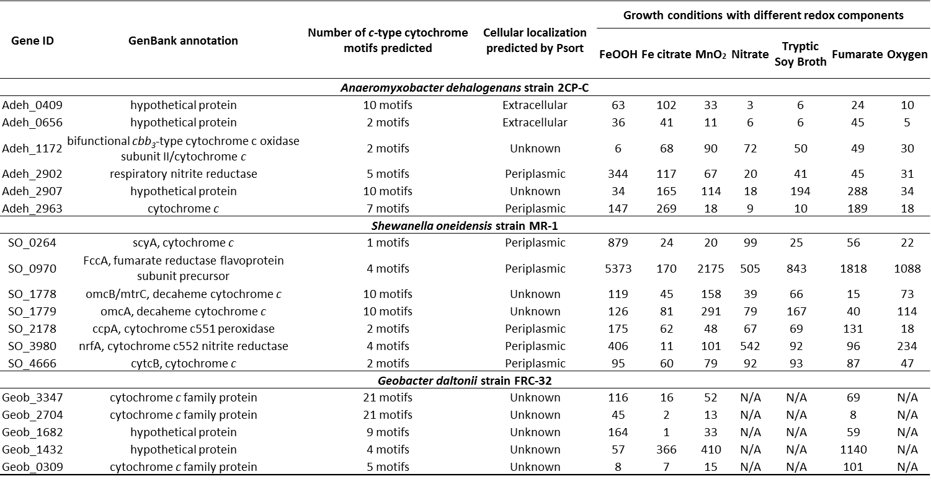
N/A: Geobacter growth could not be achieved under these conditions.
Numbers in cells are normalized spectral counts (nSpC).
abundance of FccA (SO_0970) is 10-100 fold higher in magnitude than the other “core” cytochromes under all the growth conditions tested. Three cytochrome c family proteins (Geob_0309, Geob_2704, and Geob_3347) and two hypothetical proteins (Geob_1432, and Geob_1682) were identified as “core” cytochromes in strain FRC-32 cultures (Table 3.2, Figure 3.3).
In strain 2CP-C, the “core” cytochrome Adeh_2902 encodes a pentaheme cytochrome c nitrite reductase (NrfA), which is the enzyme that directly reduces nitrite to ammonia. Although it is unclear whether NrfA contributes to the electron transfer chain, interestingly, in the other Proteobacteria such as Wolinella succinogenes and Desulfovibrio vulgaris, NrfA is involved in electron transfer from menaquinones to nitrite [147, 148]. The NrfA in strain MR-1 (SO_3980) is also detected under all growth conditions (Table 3.2). SO_3980 is predicted to contain four CXXCH heme-binding motifs, but a fifth atypical motif (CXXCK) has been identified [149], suggesting that both Adeh_2902 and SO_3980 contain five heme-binding motifs. Under nitrate amended growth condition, SO_3980 of strain MR-1 shows a very high abundance of detection compared to the other conditions (Table 3.2). However, the abundance of Adeh_2902 of strain 2CP-C in nitrate grown cells is the lowest among all the growth conditions tested (Table 3.2).
The c-type cytochrome Adeh_2963 of strain 2CP-C shares extremely high sequence similarity to the c-type cytochrome sulfite reductase SirA of strain MR-1 (encoded by SO_0479), based on Blastp search result (e-value: 0; bitscore: 645). SirA, previously designated MccA, catalyzes dissimilatory sulfite reduction in strain MR-1 [150]. SirA (SO_0479) is an octaheme c-type cytochrome containing seven CXXCH motifs and one atypical heme-binding motif CX₁₅CH [151]. Our prediction suggests that there are seven CXXCH motifs in Adeh_2963. But similar to SO_0479, an atypical motif CX₁₅CH is also present in Adeh_2963, which makes Adeh_2963 an octaheme c-type cytochrome. The protein sequences of both Adeh_2963 and SO_0479 contain an iron-binding motif (CXXCG) similar to rubredoxin, which is also an bacterial electron transfer component [152]. SO_0479 is only detected when MnO₂, nitrate, or oxygen is provided as electron acceptor (Supplementary table 2). However, Adeh_2963 is detected under all growth conditions in strain 2CP-C cells and its abundance is very low in MnO₂, nitrate, or oxygen amended growth conditions compared to that in Fe Citrate, fumarate, or FeOOH conditions (Table 3.2). Adeh_2963 may be required for iron reduction.
Three “core” c-type cytochromes of strain 2CP-C, Adeh_0409, Adeh_0656, and Adeh_2907, are annotated as “hypothetical proteins” in GenBank (Table 3.2). These proteins are consistently expressed in 2CP-C cells grown under all conditions, albeit detected at different abundances, suggesting that these putative c-type cytochromes are important for the electron transfer machinery of strain 2CP-C. Adeh_0409 and Adeh_2907 are both decaheme c-type cytochromes. Blastp results showed that Adeh_2907 shares very high sequence similarity with Adeh_0409 with 0 e-value, 1013 bitscore, and 68% sequence identity. Adeh_0409 is predicted to be an extracellular c-type cytochrome (Supplementary table 1). Both Adeh_2907 and Adeh_0409 share sequence similarity with many hypothetical proteins in other organisms such as other Anaeromyxobacter spp., Denitrovibrio acetiphilus, other Geobacter spp., other Shewanella spp., and Rhodoferax ferrireducens, which suggests that Adeh_2907 and Adeh_0409 may belong to a conserved uncharacterized protein family. Adeh_0656 shares sequence similarity with split-soret cytochrome c proteins in other organisms such as Desulfovibrio desulfuricans, Archaeoglobus veneficus, Thermodesulfovibrio yellowstonii, Thermincola potens, Melioribacter roseus, etc. These cytochromes are characteristic of possessing an unusual split at the Soret band in their visible absorption spectrum [153]. While the function of split-soret proteins is unclear, da Silva et al. proposed that the split-soret protein of D. desulfuricans is the electron input point for the electron transfer chain in the reduction of nitrate [154]. However, our prediction shows that Adeh_0656 is an extracellular c-type cytochrome, which is more likely a terminal reductase than an electron input point.
Adeh_1172 is annotated as the subunit II of the bifunctional cbb₃-type cytochrome c oxidase, which belongs to the heme-copper oxidase (HCO) superfamily. In many organisms, the protein complex of cbb₃-type cytochrome c oxidase is encoded by the ccoNOPQ operon [155, 156]. The Gene encoding for the subunit II and III (or subunit O and P) is named ccoO and ccoP. Typically, CcoO and CcoP contain one and two heme-binding sites, respectively. However, Adeh_1172 (CcoO) contains two CXXCH motifs. There is no other protein of A. dehalogenans annotated as other subunit of cbb₃-type HCO (e.g. CcoN, CcoP, etc.). However, the monoheme cytochrome Adeh_0799 contains a cbb₃ subunit III (CcoP) domain, and was only detected under oxygen amended condition (Figure 3.1, Supplementary table 1). We speculate that under low oxygen conditions, Adeh_1172 and Adeh_0799 form a protein complex which functions similarly as a cbb₃-type HCO for oxygen reduction and proton pumping, while under anoxic condition, Adeh_1172 works as electron transfer intermediate which receives and/or delivers electrons from/to other cytochromes in the electron transfer chain. In strain MR-1, we have also detected the expression of the ccoNOPQ operon. The CcoO (SO_2363) and CcoP (SO_2361) in strain MR-1 were expressed under all growth conditions except for FeOOH (Supplementary Table 2). We suspect its absence is due to the poor overall cellular growth in FeOOH amended culture. CcoN (SO_2364) was only detected under oxygen-amended condition (data not shown).

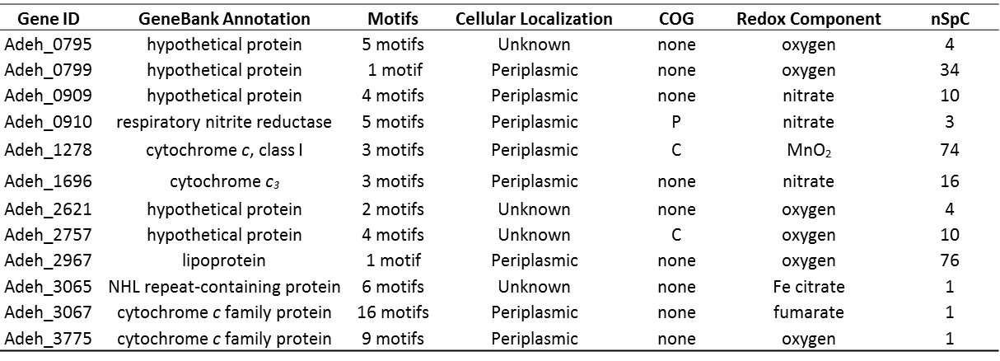
Table 3.3. The unique c-type cytochromes of A. dehalogenans 2CP-C expressed only in one growth condition
nSpC: normalized spectral counts.
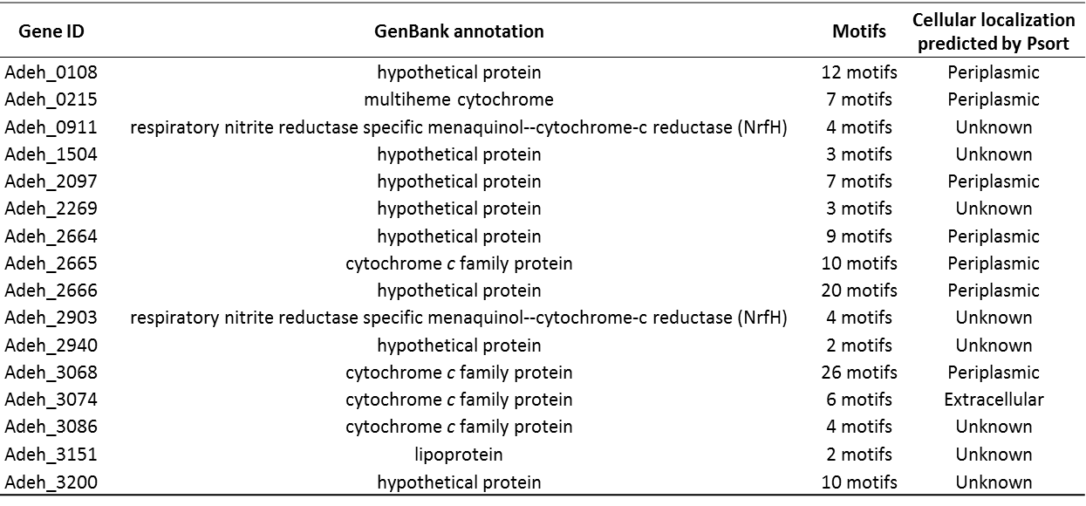
Table 3.5. The undetected c-Type cytochromes of A. dehalogenans 2CP-C
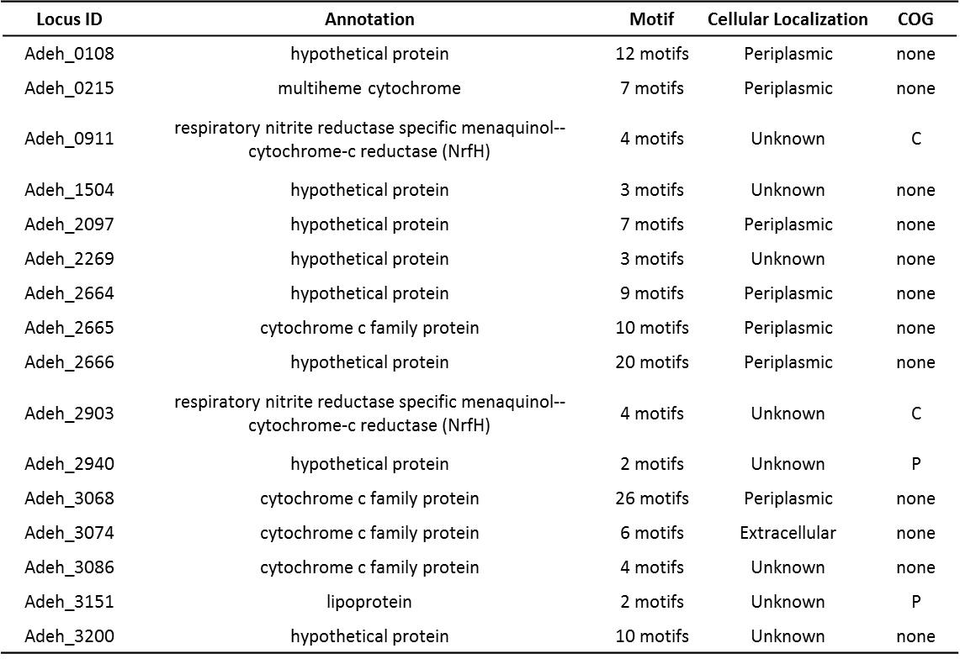
Table 3.6. The undetected c-Type cytochromes for A. dehalogenans 2CP-C
Unique c-Type Cytochromes
In contrast to the “core” c-type cytochromes, some c-type cytochromes were only detected under one or a few growth conditions. Twenty c-type cytochromes of strain 2CP-C were identified as unique cytochromes (Table 3.3, Figure 3.1). Adeh_0909, Adeh_0910 (NrfA), and Adeh_1696 were unique to nitrate grown cultures (Table 3.3, Figure 3.1). Six c-type cytochromes of strain 2CP-C were unique to growth under oxic conditions, among which, Adeh_0799 and Adeh_2967 (lipoprotein) were detected at a normalized spectral count (nSpC) of 34 and 76, respectively, which were very high levels (Table 3.3, Figure 3.1). Adeh_1278 was only expressed when MnO₂ was provided as electron acceptor (nSpC: 74) (Table 3.3, Figure 1). Likewise, unique c-type cytochromes were also revealed for strain MR-1 and FRC-32 with various expression levels (Table 3.4 and 3.5, Figure 3.2 and 3.3).
Adeh_0909 and Adeh_0910 are both predicted c-type cytochromes that were detected only in nitrate-grown A. dehalogenans cells (Table 3.3, Figure 3.1). Adeh_0909 is a protein with unknown function, while Adeh_0910 encodes for nitrite reductase (NrfA). Adeh_0910 is not identical to the other copy of NrfA encoded by Adeh_2902 (44% sequence identity), which was detected as a “core” cytochrome. The observation of Adeh_0910 only in nitrate grown cells suggests a role as a terminal nitrite reductase rather than a member of a more extensive electron transfer chain. Adeh_0909 and Adeh_0910 are located on the same operon, together with three other genes: Adeh_0907 (hypothetical protein), Adeh_0908 (NapA), and Adeh_0911 (NrfH). Adeh_0907 was also only detected in cells grown with nitrate (data not shown), Adeh_0908 was detected when grown with nitrate, ferric iron (FeOOH, Fe citrate), or MnO₂ (data not shown), and Adeh_0911 was not detected under any growth condition (Table 3.6). It is likely that Adeh_0907- 0910 are co-expressed when nitrate is the sole electron acceptor and are all involved in nitrite reduction to ammonium. When the electron acceptor is a metal, such as Fe(III) and Mn(IV), only NapA (Adeh_0908) was expressed.
Adeh_1278 contains three heme-binding motifs and is detected only when MnO₂ is the electron acceptor. This cytochrome c shares sequence similarity (e-value of 4e-39) to SO_4047, a SoxA-like diheme cytochrome c. Previous work indicated that SO_4047 is important for aerobic growth and Cr(VI) reduction [157]. Proteomic measurements showed that SO_4047 was expressed under all but FeOOH condition, and its expression level was highest under the low oxic condition (Supplementary Table 2). SO_4047 is located in the same operon as SO_4048, which is also expressed under all but FeOOH condition (Supplementary Table 2). This agrees with previous finding that the expression of SO_4047 and SO_4048 are not impacted by different environmental electron acceptors [136], although the specific functions of SO_4047 and SO_4048 remain unknown. There are two other predicted c-type cytochromes of strain 2CP-C annotated as SoxA (Adeh_2281) and SoxX (Adeh_2280). SoxA is detected under all growth conditions except metal growth conditions (Fe citrate, FeOOH, MnO₂) and SoxX is detected under all but Fe Citrate condition (Figure 3.1, Supplementary Table 1). SoxA and SoxX are postulated to form a complex for the binding of substrate to another carrier protein during sulfur oxidation [158]. Our result suggests that SoxA and SoxX of strain 2CP-C may also be involved in electron transfer in an independent manner, since they are not always co-expressed.

Non-detected c-Type Cytochromes
In strain 2CP-C cells, the 16 undetected c-type cytochromes include eight proteins annotated as hypothetical proteins, five annotated as cytochrome c, one as lipoprotein, and two as NrfH nitrite reductases (Figure 3.1, Table 3.6). The protein sequences of all 16 undetected c-type cytochromes of A. dehalogenans were inspected for their detectability by mass spectrometry. All of the undetected c-type cytochromes should yield tryptic peptides upon proteolysis with appropriate length and hydrophobicity for mass spectrometry detection. Thus, if these were expressed, they should have been detectable under our experimental conditions; however, we did not detect these proteins under any of the seven growth conditions (in any of the triplicates). Possible reasons could be that the expression levels of these proteins were too low for detection, or the proteins were not expressed under these growth conditions or in planktonic cells. For example, we did not detect MtrD and MtrF in S. oneidensis cells (Supplementary Table 2), which agrees with previous findings that the expression of MtrD and MtrF is more favorable in cells forming biofilms rather than planktonic cells [159]. It is possible that some of the undetected c-type cytochromes have unique functions in biofilm cells and thus were not detected in our experiments. Another possible reason could be that the expression of some undetected proteins is growth phase dependent. Since all the cells were harvested in late exponential / early stationary phase in our experiments, some c-type cytochromes may have been expressed earlier on and have been degraded by the time cells reached harvest time. Additionally, only seven growth conditions were tested in this study, which does not include all possible electron acceptor conditions these organisms can experience.
NrfH is believed to interact with NrfA during electron transfer. It is unclear why both copies of NrfH (Adeh_0911 and Adeh_2903) are not detected (Table 3.6), considering both copies of NrfA are detected. However, NrfH is not present in the genome of S. oneidensis; instead, the ‘NrfA function’ is replaced by CymA (SO_4591) [157]. It is likely that strain 2CP-C also possesses an atypical Nrf system similar to that of strain MR-1. Thus, both copies of NrfH in strain 2CP-C may not be expressed, and other proteins may replace their function.
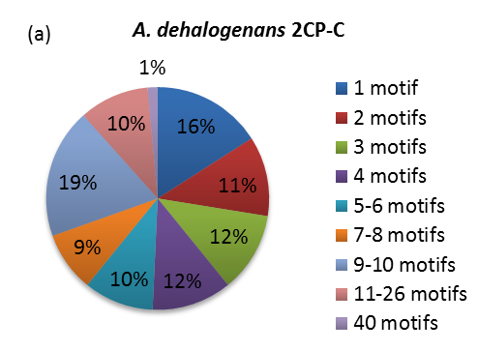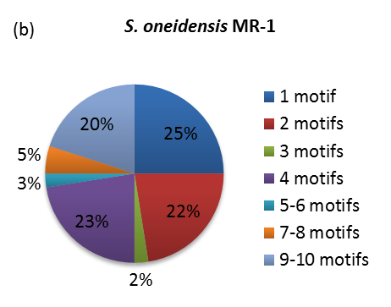
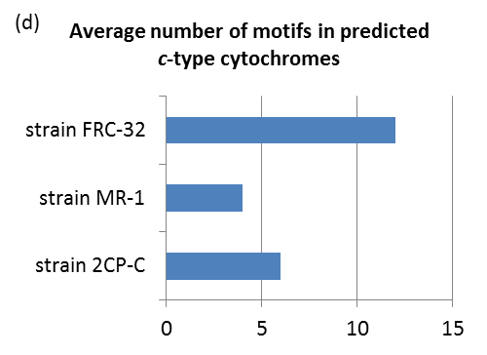
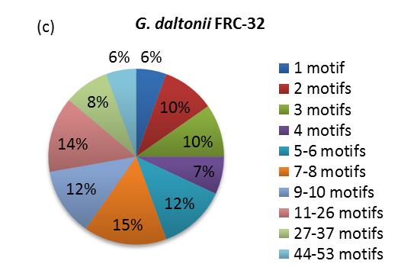
Figure 3.4. Heme-binding motifs of predicted c-type cytochromes of Anaeromyxobacter dehalogenans 2CP-C (a), Shewanella oneidensis MR-1 (b), and Geobacter daltonii FRC-32 (c). Average number of motifs in predicted c-type cytochromes (d) were calculated by multiply the number of motif with its corresponding percentage, and sum all the multiplications for each organism.

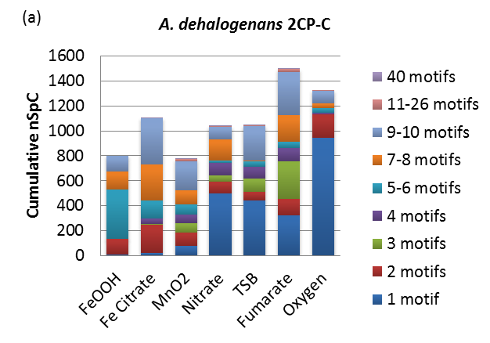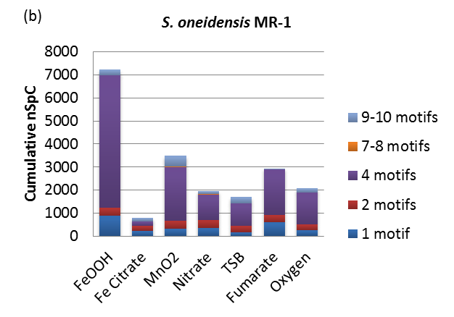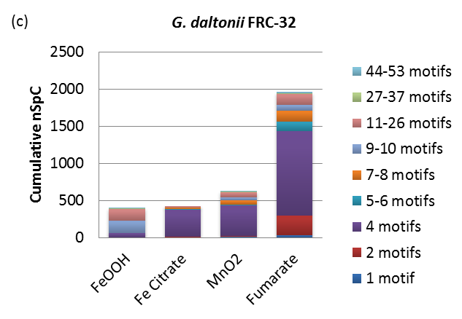
Figure 3.5. Abundances of detected c-type cytochromes grouped by the number of heme-binding motifs for (a.) A. dehalogenans 2CP-C, (b.) S. oneidensis MR-1 and (c.) G. daltonii FRC-32. Abundances are represented by cumulative nSpC of detected c-type cytochromes. nSpc: normalized spectral count.

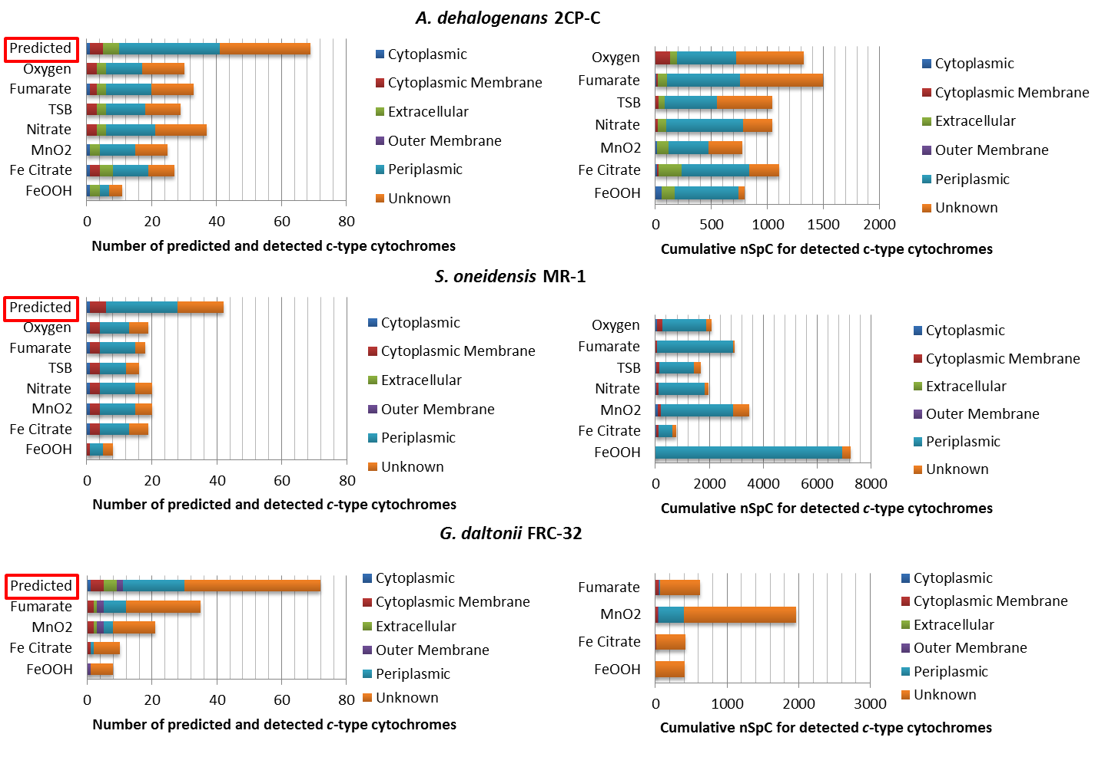
Figure 3.6. Cellular localization distribution for predicted and detected c-type cytochromes in A. dehalogenans 2CP-C, S. oneidensis MR-1 and G. daltonii FRC-32 . Cellular localizations were predicted using Psortb v3.0. The left panel shows predicted localizations for all predicted and detected putative c-type cytochromes for all strains. The right panel shows the abundance of all the detected c-type cytochromes of all localizations. nSpC: normalized spectral count.

Heme-binding Motifs of c-Type Cytochromes
Most of the predicted c-type cytochromes contained more than one heme-binding motif per protein (Figure 3.4). c-Type cytochromes of strain 2CP-C and FRC-32 were predicted to contain as many as 40 and 53 motifs, respectively, whereas in S. oneidensis, the highest number of heme-binding motifs for a c-type cytochrome was 10 (Figure 3.4). On average, the cytochromes in strain 2CP-C, MR-1, and FRC-32 contain 6, 4, and 12 CXXCH motifs (Figure 3.4d).
Monoheme c-type cytochromes constituted 25% of all the predicted c-type cytochromes of strain MR-1, which was the highest percentage among all strains (Figure 3.4). However, the measured abundances of monoheme c-type cytochromes of strain MR-1 culture were not as high as their counterparts in strain 2CP-C culture, especially in the oxygen grown cells (Figure 3.5). In strain 2CP-C cells grown with ferric iron (FeOOH, Fe Citrate) or MnO₂, monoheme c-type cytochromes were less abundant compared to other growth conditions (nitrate, TSB, or fumarate) (Figure 3.5). This abundance difference of monoheme c-type cytochromes in metal and non-metal growth conditions was not observed for strain MR-1 and FRC-32 (Figure 3.5).
Among all the predicted multiple heme-containing c-type cytochromes, tetraheme cytochromes were the largest proportion in strain MR-1 (23%), while in strain 2CP-C and MR-1, only 12% and 7% of the predicted c-type cytochromes had four predicted heme-binding motifs, respectively (Figure 3.4). However, the percentage of tetraheme c-type cytochromes expression in strain FRC-32 was similar to strain MR-1, as shown by cumulative normalized spectral counts (nSpC) (Figure 3.5). Both strain MR-1 and FRC-32 cultures were dominated by tetraheme c-type cytochromes under all growth conditions, while in strain 2CP-C tetraheme c-type cytochromes were only measured in low abundances under a few growth conditions (e.g. FeOOH, Fe Citrate, and oxygen) (Figure 3.5, Supplementary table 1).
In strain MR-1, only 28% predicted c-type cytochromes contained more than 4 heme-binding motifs (Figure 2), whereas 49% and 67% predicted c-type cytochromes with more than 4 heme-binding motifs were identified in strain 2CP-C and FRC-32, respectively (Figure 3.4). Even though the percentage/distribution of predicted >4 heme-containing c-type cytochromes in strain 2CP-C was not the highest among all three populations, their detection level was the most abundant among all organisms, as shown by the cumulative nSpC under all growth conditions (Figure 3.5). Under the metal conditions (FeOOH, Fe Citrate, and MnO₂), about 50 – 80% of the cumulative nSpC of the detected c-type cytochromes contained more than 4 heme-binding motifs (Figure 3.5). Cytochromes with 5-6 heme-binding motifs were not detected under any growth condition for strain MR-1; however, their expression was detected in FeOOH and Fe Citrate grown strain 2CP-C cells (Figure 3.5). We detected 7-10 heme-containing cytochromes at high abundances in all the growth conditions of strain 2CP-C but at very low abundances in strain MR-1 and FRC-32 (Figure 3.5). c-Type cytochromes of high heme content (>10) were only present in strain 2CP-C and FRC-32 cells (Figure 3.4). Cytochromes with 11-26 heme-binding motifs were detected in very low abundance in strain 2CP-C cells but were significantly more abundant in fumarate grown FRC-32 (Figure 3.5).
Both strain 2CP-C and FRC-32 have c-type cytochromes with more than 25 heme-binding sites based on computational predictions (Figure 2). For example, the highest number of hemes per cytochrome in strain 2CP-C was predicted to be 40 (Adeh_3077), and in strain FRC-32 was 53 (Geob_3739). The LC-MS/MS measurement yielded definitive identification of the expression of Adeh_3077 under all but FeOOH and oxygen conditions (Figure 3.1, Figure 3.5), whereas Geob_3739 was only detected in fumarate grown culture (Table 3.4). There were 10 c-type cytochromes in strain FRC-32 containing more than 26 heme-binding motifs, only 1 of which was not detected (Geob_2170). The remaining 9 were detected under various conditions (Figure 3.5, Supplementary Table 3).

Cellular Localization of c-Type Cytochromes
Computational prediction of cellular localization revealed that most of the putative c-type cytochromes of strain 2CP-C (45%), MR-1 (55%), and FRC-32 (26%) were periplasmic (Figure 3.6 left). While the c-type cytochromes of strain FRC-32 were predicted to localize at all cellular localizations, no outer membrane c-type cytochrome were predicted for either strain 2CP-C or MR-1, and no extracellular c-type cytochrome were predicted for strain MR-1 (Figure 3.6 left). Among all the detected c-type cytochromes of all three cultures, the majority was predicted to be either periplasmic or with an unknown location (Figure 3.6 right).
There was one cytochrome for each bacteria predicted to be cytoplasmic (Figure 3.6 left, Supplementary Table 1, 2, 3), although previous study suggests that cytochromes mature outside of the cytoplasm [160, 161]. The one cytoplasmic cytochrome of strain MR-1, SO_2363 (CcoO), was detected under all growth conditions except for FeOOH, whereas the one of strain FRC-32, Geob_1343, was not detected under any growth condition (Supplementary Table 2, 3). In strain 2CP-C cells, the cytoplasmic cytochrome Adeh_2403 was detected when FeOOH, Fe citrate, MnO₂, or fumarate was the electron acceptor, and its expression level under FeOOH condition (nSpC: 55) was about 3 to 11 fold of that under the other three conditions (Supplementary Table 1).
The c-type cytochromes predicted to be associated with the cytoplasmic membrane were detected under almost all growth conditions for all three cultures (Figure 3.6). However, their abundances were very low, with the exception of oxygen grown strain 2CP-C cells, as shown by cumulative nSpC (Figure 3.6 right).
Strain 2CP-C and FRC-32 have similar numbers of detected extracellular cytochrome c (Figure 3.6 left). Only one extracellular c-type cytochrome of strain FRC-32 was found under MnO₂ and fumarate growth conditions at very low abundances with nSpC of 1.9 and 4.3, respectively (Figure 3.6 right, Supplementary Table 3). In contrast, the extracellular c-type cytochromes of strain 2CP-C were detected at a relatively higher level with nSpCs ranging from 3.2 to 102.2 (Figure 3.6 right, Supplementary Table 1).

Clusters of Orthologous Groups (COG) Functional Categories of c-Type Cytochromes:
Most of the predicted c-type cytochromes of these bacteria could not be grouped into any functional category (none) (Figure 3.7 left). The detection of these c-type cytochromes dominated the cumulative nSpC of all c-type cytochromes in strain 2CP-C and FRC-32 cultures under all growth conditions (Figure 3.7 right). However, their abundance level in strain MR-1 was not as dominant (Figure 3.7 right).
The remainder of the c-type cytochromes of all three strains mainly fell into two COG functional categories: energy production and conversion (C), and inorganic ion transport and metabolism (P) (Figure 3.7). More “C” category c-type cytochromes were predicted and detected for S. oneidensis with higher abundances compared to that of strain 2CP-C and FRC-32 across all growth conditions (Figure 3.7). A few c-type cytochromes of each strain were grouped into the inorganic ion transport and metabolism category (P) (Figure 3.7 left). Overall, their

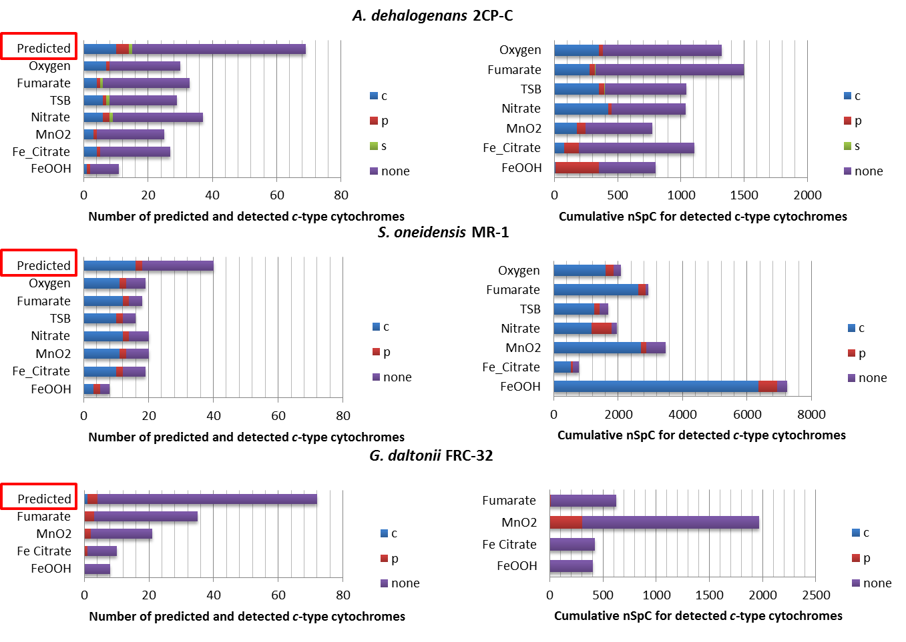
Figure 3.7. COG functional category distribution of predicted and detected c-type cytochromes in A. dehalogenans 2CP-C, S. oneidensis MR-1 and G. daltonii FRC-32 under various growth conditions. The left panel shows the COG functional categories of all predicted and detected c-type cytochromes. The right panel shows the abundance of detected c-type cytochromes in each COG category. Each alphabet represents one COG functional category. c (Energy production and conversion ), p (Inorganic ion transport and metabolism ), s (Unknown Function). nSpC: normalized spectral count.
expression levels were not as high as that of the “C” category c-type cytochromes or the “none” category c-type cytochromes. However, the “P” category c-type cytochromes are detected at high abundance in strain 2CP-C cells grown with FeOOH and strain FRC-32 cells grown with MnO₂ (Figure 3.7 right). One c-type cytochrome (Adeh_0728) of strain 2CP-C was grouped into the unknown function category (S) (Figure 3.7 left, Supplementary Table 1). The “S” category means proteins are clustered into an orthologous group but the function for that group is poorly characterized.

3.5 Discussion
The current models of electron transfer in S. oneidensis and G. sulfurreducens are constructed from information obtained from deletion mutants and heterologous expression studies under selective growth conditions [99, 102, 107]. In this study, cytochrome expression evaluated a wide range of additional electron acceptors, including solid metals (FeOOH, MnO₂), soluble metal (Fe citrate), and non-metal substrates (fumarate, nitrate, oxygen). In S. oneidensis, all the electron transfer models propose the inner membrane c-type cytochrome CymA as the initial electron carrier in the electron transfer chain, which receives electrons from the quinone pool and transfers them to periplasmic cytochromes [99]. During ferric iron reduction, the outer membrane protein complex containing c-type cytochrome OmcA and OmcB delivers electron to ferric iron [102, 162]. OmcA and OmcB were both core cytochromes expressed under all growth conditions tested, and CymA could tentatively be classified as a “core” c-type cytochrome since it was detected under all growth condition except in FeOOH-grown cultures (Supplementary Table 2Our results not only confirmed the role of OmcA, OmcA, and CymA in ferric iron reduction (Fe citrate), but also indicated their roles in electron transfer to other electron acceptors including nitrate, fumarate, oxygen, and manganese oxide. In strain MR-1, many other “core” c-type cytochromes (e.g. FccA, NrfA, etc.) were identified, but were not examined in detail in the scope of this study.
Based on the c-type cytochrome identification and cellular localizations predicted by PSORT, a basic model of the c-type cytochromes network was constructed for strain 2CP-C (Figure 3.8). The model spatially segregates c-type cytochromes into cellular localizations. Clear commonalities and differences between growth conditions can be easily delineated by highlighting the cytochromes detected (nitrate and fumarate growth shown as examples in Figure 3.8). With this model, one can begin to draw connections between c-type cytochromes and relate them to different electron acceptors. Caution must be exercised with PSORT predictions because, in a few cases, the predictions did not agree with previously reported findings. For example, PSORT was unable to determine the localization of OmcA and OmcB which are outer membrane proteins [102, 110]. But for most proteins, PSORT was able to predict their cellular localizations and presented an overview of all the cellular localizations for all c-type cytochromes.
The majority of the predicted c-type cytochromes of strain 2CP-C and strain FRC-32 were annotated as “hypothetical proteins” in GenBank (Supplementary Table 1 and 3). Although these proteins have conserved motifs or domains that permit them to be classified as c-type cytochromes, detailed functional information has been lacking. The unambiguous detection, identification, and abundance measurements with the MS approach verified that the “hypothetical proteins” were expressed and functional. Furthermore, many of these detected “hypothetical” putative c-type cytochromes were linked to specific growth conditions. Thus, in addition to information about the identities and relative abundances of these c-type cytochromes, this MS proteomic approach also provides information about under what experimental conditions these proteins appear. Obviously, further research needs to be conducted to more fully explore
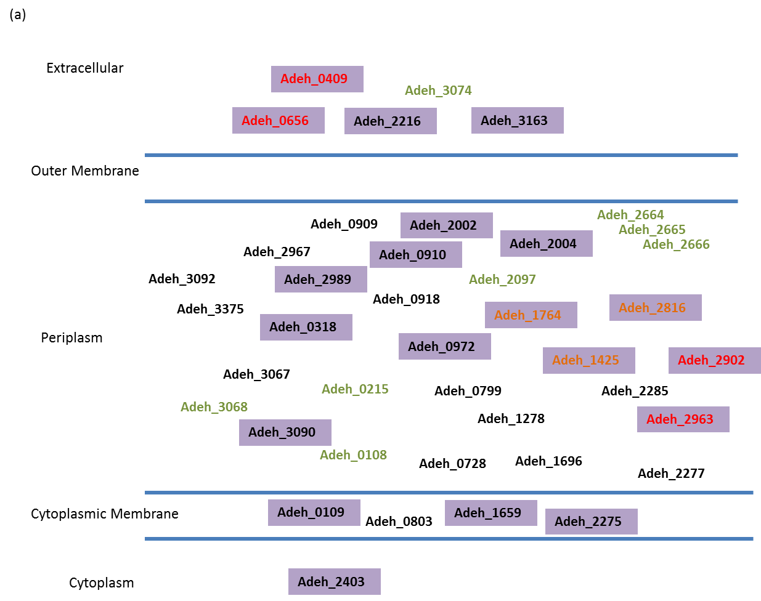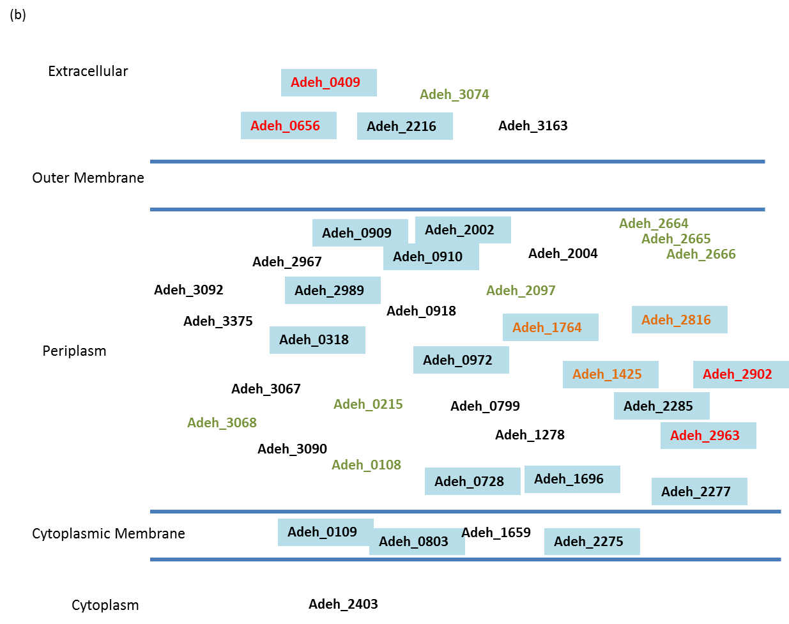
Figure 3.8. c-type cytochromes with locations predicted by Psort. Core cytochromes are in red. Proteins that are detected under all but FeOOH are in orange. Undetected proteins are in green. Detected proteins in fumarate cultures are highlighted in purple (a). Detected proteins in nitrate cultures are highlighted in blue (b).

Figure 3.9. Average number of heme-binding motif for c-type cytochromes detected under various growth conditions. Average number of heme-binding motif expressed under certain growth condition was calculated based on the percentage of cumulative normalized spectral count, P(nSpC). The motif number was multiplied to its corresponding P(nSpC). The sum of all the multiplications for all motif numbers was the average number of heme-binding motif for cytochromes detected under this growth condition.

their roles in electron transfer and detail their contributions for respiration of certain electron acceptors.
Of particular interest is the high number of heme motifs in some of the c-type cytochromes because such cytochromes in Geobacter species are hypothesized as ‘iron lungs’ [108, 109]. The iron lung theory proposes that the hemes in the periplasmic and outer-membrane c-type cytochromes provide a repertoire of heme groups with electron storage capacity [107-109], which is essential for the bacteria when there are limited electron acceptors in the environment. In this study, detected c-type cytochromes in FeOOH-grown FRC-32 cells contained more heme-binding motifs on average than grown with Fe citrate, MnO₂, or fumarate (Figure 3.5, Figure 3.9), supporting the ‘iron lung’ hypothesis. Higher electron storage capacity may be needed due to the low accessibility of the solid FeOOH, hence, c-type cytochromes with higher heme-content were expressed to provide electron-accepting capacity to temporarily store electrons before the FRC-32 cells can contact the solid electron acceptor. It is unclear why MnO₂, being another solid electron acceptor, did not show similar effect on the c-type cytochrome expression as FeOOH, but this might indicate a more amenable electron transfer environment.
In this study, the expression profile of c-type cytochrome proteins for each strain was significantly different among growth with various electron acceptors (Figure 3.1-3.3). The presence of a c-type cytochrome and its relative abundance could be associated with the available electron acceptor in the environment, and unique c-type cytochromes were only observed when certain electron acceptors were provided. Such unique c-type cytochromes should be informative as biomarkers to reflect the environmental redox conditions and responsive biological processes carried out by the microbes.
Although there are at least 40 or more predicted c-type cytochromes in the three bacterial strains discussed above, only a handful of these proteins had been functionally characterized and assigned specific roles in the electron transfer process. The proteomics approach outlined here provides a means of profiling large-scale c-type cytochrome expression simultaneously, providing both qualitative and abundance information about their expression changes in response to different growth conditions. The identification of specific cytochromes detected only under certain growth conditions suggests that these microbes have the ability to adjust their cytochrome expression for specific electron acceptors. Thus, the information provided here should enable the application of specific cytochromes as biomarkers of specific electron acceptor conditions in the growth environment. Due to the significant impact of microbes on the biogeochemistry of metals and minerals, c-type cytochrome biomarkers might provide a powerful toolset that can be used to assess and amend microbial activities in-situ. The results obtained in this large scale characterization study provide detailed information which would be difficult if not impossible to acquire elsewhere about which annotated or “functionally unknown” c-type cytochromes would be the best candidates to track in environmental microbiology studies.

Chapter Four

MS-based proteomic characterization of Anaeromyxobacter dehalogenans strain 2CP-C reveals elevated energy metabolism in growth with metal electron acceptors

4.1 Abstract
Anaeromyxobacter dehalogenans strain 2CP-C is a soil bacteria characterized by respiration and dissimilatory metal reduction. A mass spectrometry-based proteomics approach was implemented to characterize the proteome profiles of 2CP-C grown with various electron acceptors. A total of eight growth conditions were tested, providing a global survey of the proteome-wide responses of 2CP-C to seven different electron acceptors. The pan-proteome consists 2846 proteins, representing 65% of predicted open reading frames. The results also revealed a core proteome of 710 proteins sustaining major metabolic processes regardless of different electron-accepting environments. Unique proteins detected with fumarate growth represented exclusive lipid metabolism pathways. Quantitative analysis revealed that metal and non-metal electron acceptors have distinct effect on the proteome profiles of 2CP-C. Growth with metal electron acceptor resulted in higher energy production and overall more active metabolic activities compared to non-metal electron acceptor-growth.

4.2 Introduction
Anaeromyxobacter dehalogenans strain 2CP-C is a facultative gram-negative Myxobacteria isolated from soil [88]. Unlike other members in the Myxobacteria family which are considered obligate aerobes, A. dehalogenans is capable to survive in anaerobic and microaerophilic environment [88, 163]. The studies of anaerobic growth of strain 2CP-C revealed tremendous respiration versatility, represented by the ability to utilize a vast range of electron donors (e.g. acetate, hydrogen, pyruvate, lactate, succinate, formate) and electron acceptors (e.g. nitrate, fumarate, halogenated phenols, ferric iron, etc.) [88, 130, 164]. In particular, the dissimilatory metabolic reduction of metals and radionuclides by 2CP-C raised interest in implementing Anaeromyxobacter species for in situ bioremediation for soil and sediment with heavy metal or radionuclide contamination [89, 165, 166]. Indeed, field studies of uranium contaminated sites confirmed the bioremediation contribution of A. dehalogenans populations [91, 92, 129, 167, 168]. The increase of Anaeromyxobacter 16S rRNA gene copies in uranium reduction sediment after oxygen intrusion distinguished Anaeromyxobacter from other in situ dissimilatory uranium reducing bacteria (e.g. Geobacter), and hinted for maintaining the stability of immobilized uranium by competing with uranium reoxidation [169].
Despite the respiration versatility and profound environmental impact of A. dehalogenans strain 2CP-C, the physiology and metabolic basis that account for the electron donor/acceptor utilization is vastly unknown. Complete genome sequence of strain 2CP-C revealed genes responsible for many metabolic traits [111]. For example, the identification of 68 c-type cytochrome coding genes reflected the respiration versatility, and the aerobic growth ability was supported by genetic evidence of oxygen-respiration and detoxification system. The genome information provided metabolic potentials which need to be carried out by functional units – proteins. In order to understand how 2CP-C utilizes its genetic content for functional activities during growth under various redox conditions, proteomic characterization is desirable, in that proteins are the actual metabolic units that support the overall cellular-level activities. Thus, global proteome profiling is in need to provide insight into the functional machineries for bacterial physiology.
For comprehensive proteomic characterizations, mass spectrometry (MS) is currently the state-of-the-art technic and has achieve tremendous success for the proteomics studies on numerous biological systems [36, 140]. There are several approaches to perform MS-based proteomics on complex protein mixtures, which utilize different protein separation methods

4.3 Experimental section
Bacterial Strains and Culture Conditions. Anaeromyxobacter dehalogenans strain 2CP-C (ATCC BAA-259), was grown in triplicate in 160 mL glass serum bottles containing 100 mL reduced bicarbonate-buffered mineral salts medium with a N₂/CO₂ headspace (80:20, vol/vol) [141, 170]. When oxygen was used as electron acceptor, the medium volume was reduced to 50 mL. Acetate (5 mM) or lactate (5 mM) was provided as electron donor. The following electron acceptors were used: ferric citrate (50 mM), ferric oxyhydroxide (20 mM, nominal), manganese oxide (20 mM, nominal), 10 mM fumarate, 1/10 diluted tryptic soy broth (with additional 10 mM fumarate), nitrate (2 mM), 3% (vol/vol) oxygen in the headspace. Oxygen was added by injecting the appropriate volume of filter-sterilized air into the serum bottles. Cells were grown in 100 mL cultures at 30°C, shaken at 90 rpm until mid to late exponential phase, as determined by OD and qPCR (fumarate growth) metrics, and the entire volume was harvested by centrifugation (4,700 x g for 20 min at 4°C). Cell pellets were instantly frozen and stored at -80°C.
Cell Lysis and Protein Extraction. For cells grown with tryptic soy broth (TSB), fumarate, ferric citrate (Fe citrate), manganese oxide (MnO₂), nitrate, and oxygen, the cells were lysed to yield protein pellets for LC-MS/MS analysis using the sodium dodecyl sulfate (SDS)-trichloroacetic acid (TCA) method, as described previously [143]. Proteome samples were subjected to trypsin proteolysis as described (Thompson et al, 2006, Brown et al, 2006). The SDS method e did not provide effective protein extraction for the FeOOH grown cultures, presumably due to failure of separating the protein-iron particles adsorption by the TCA precipitation step. Thus, for cells grown with FeOOH, the guanidine HCl method was used to prepare samples for LC-MS/MS analysis as described [143]. Following trypsin digestion, peptides were desalted and the solvent exchanged (0.1% [v/v] formic acid in HPLC grade water) as described (Thompson et al, 2006, Sharma et al, 2013). All samples were filtered through Durapore PVDF filters, 0.45 µm (Millipore) and stored at -80°C.
LC-MS/MS. Peptides were analyzed by two-dimensional liquid chromatography (Ultimate HPLC System, LC Packings, a division of Dionex, San Francisco, CA) coupled online with a linear ion trap mass spectrometer (LTQ XL, ThermoFisher Scientific, San Jose, CA ), according to established protocol[143]. A total of 53 runs were collected, which comprised biological triplicates for all conditions tested. A 12-step 24-h Multidimensional Protein Identification Technology (MuDPIT) was used to analyze peptides as described [143, 144]. The LTQ XL was operated in a data dependent mode and one full MS scan was followed by five MS/MS scans. The m/z isolation width was set to 3 m/z and the dynamic exclusion repeat was set at 1 with a duration time of 60 sec.
Database Searching and Data Normalization. Experimental MS/MS spectra were searched against FASTA protein databases containing all predicted open reading frames of A. dehalogenans 2CP-C obtained from Joint Genome Institute (JGI, http://genome.jgi.doe.gov/, downloaded in July, 2011) and common contaminants such as trypsin, keratin, etc. A decoy database consisting of reversed sequences from the corresponding proteome database was also appended to the FASTA protein database in order to calculate False Discovery Rate (FDR) at the protein level. The SEQUEST search algorithm was used for peptide identification. Identified peptides were filtered and assembled into proteins by DTASelect [44]. The DeltCN filter was set to 0.08. The cross-correlation score filtering process started with conservative criteria as following: XCorr: +1 = 1.8, +2 = 2.5, +3 = 3.5. The XCorr criteria were slightly altered to adjust FDR to ~1% for each sample. At least two peptides were required per protein identification, and at least one peptide had to be unique to that protein. Raw spectral counts were normalized by protein lengths and the total spectral counts using Normalized Spectral Abundance Factor (NSAF) as previously described [145]. Normalized spectral counts are then uniformly multiplied by a factor of 100,000 for better readability and comparability to raw spectral counts. Adjusted normalized spectral count is denoted as nSpC throughout this paper. The nSpCs for biological triplicates were averaged for each growth condition. The nSpCs reflect abundances of detected proteins. Larger nSpC value represents higher abundance, and vice versa.
Hierarchical clustering and ANOVA analysis: In order to achieve quantifiable proteins for statistical analysis, a prevalence value (PV) was determined for each detected protein as previously described [171]. Since the PVs are derived from nSpCs of detected proteins, they reflect the abundances as well as reproducibility for detected protein. The PV for each protein was ranked from the largest to smallest. Substantive proteins representing top 95% of the total PVs were retained for statistical analysis. After proteins are filtered by their PVs, normalized data was log10-transformed for hierarchical clustering and ANOVA analysis. Hierarchical clustering was performed by JMP genomics v.6.0 (SAS Institute) using Ward clustering algorithm. The following settings: “scale row”, “center row” were applied to make the variance of each row to be 1, and center the mean of each row to 0. Each row contains transformed abundances for one protein in different growth conditions. ANOVA was conducted in JMP Genomics v.6.0 (SAS Institute), to compare protein abundances across all conditions with Benjamini & Hochberg FDR correction (alpha = 0.05).
Pathway analysis: Metabolic maps were generated by KEGG pathway mapping software iPATH 2.0 [172].
Cellular Localization Prediction: Cellular localizations were predicted based on protein sequences using PSORTb.3.0 [146].

4.4 Results and discussion
Characterization of the pan-proteome of A. dehalogenans 2CP-C
Mass spectrometry-based proteomics measurements were obtained for biological triplicates of A. dehalogenans 2CP-C cells grown with different electron acceptors. Approximately 2,000 proteins were identified for most of the growth conditions (Fe citrate, MnO₂, nitrate, tryptic soy broth, fumarate, and oxygen - Figure 4.1). When FeOOH was provided as the sole electron acceptor, the 2CP-C cell growth was significantly slower than all other tested growth conditions, and needed longer time to reach late exponential phase for harvesting. The recalcitrant growth with FeOOH as electron acceptor likely leaded to fewer proteins being expressed and a simpler protein mixture being sampled, which yielded the least protein identification (Figure 4.1). Although a different protein extraction strategy was applied on FeOOH grown cultures, the detected proteins were found to be distributed among all cellular localizations and clusters of orthologous group (COG) categories with highly comparable percentages among different growth conditions (Figure 4.2, 4.3), suggesting comprehensive sampling coverage and deep proteome measurement.
In total, 2,846 proteins were identified across all growth conditions, representing the pan-proteome, which corresponded to 65% of all the predicted open reading frames in 2CP-C genome. Compared to the number of proteins identified in each growth conditions (around 2,000,
Figure 4.1. Proteome identifications for A. dehalogenans 2CP-C grown with various redox components. Total identified protein numbers are pooled for biological triplicates of each growth condition.
Figure 4.2. Cellular localization distribution of A. dehalogenans 2CP-C proteome under growth with different redox components.

Figure 4.3. COG functional category distribution of A. dehalogenans 2CP-C proteome under growth with different redox components.

Figure 4.4. Cellular localization distribution of predicted (red) and detected (blue) proteomes of A. dehalogenans 2CP-C. Detected proteome is represented by pooled protein identifications of all replicates and all growth conditions.

as mentioned above), the pan-proteome exhibited only a slight increase in protein numbers, indicating a substantial overlap in the protein inventory between different growth conditions. The identified proteins distributed between all cellular localizations based on computational prediction (Figure 4.4). About 80% of the predicted cytoplasmic, periplasmic, outer membrane, and extracellular proteins were detected, whereas fewer predicted cytoplasmic membrane proteins (40%) and proteins with unknown localization (60%) were detected (Figure 4.4). Detected proteins belonged to all functional categories in the clusters of orthologous groups (COGs) classification database, with roughly even distributions (Figure 4.5). Proteins involved in energy metabolism, amino acid metabolism, translation, and transcription had relatively higher representations (6-7%), providing a solid foundation for all other cellular metabolic activities. Proteins that could not be classified into any COG functional categories (“none” category) were mostly annotated as “hypothetical proteins” in GenBank, and occupied the highest percentage of detected proteome (Figure 4.5). The “hypothetical protein” annotations were inferred from genome sequence analysis [173], but the reality of “hypothetical protein” is not validated. The non-targeted LC-MS/MS proteome characterization provided evidence for the actual expression, identities, abundances, and growth condition dependence of many of these “hypothetical proteins”.
The “Core” Proteome of Strain 2CP-C
Combining proteome measurements for all 2CP-C cultures revealed the “core” proteome, which consisted of 710 proteins shared among growth with all tested electron acceptors. The abundances of the core proteome represented a vast range, from 0.3 to 19272.6, as indicated by the normalized spectral counts (nSpCs). When sorted by the COG functional categories, the core proteome distributed almost all COG classifications with consistent abundances in each category
Figure 4.5. COG functional category distribution of detected proteome of A. dehalogenans 2CP-C. Detected proteome is represented by pooled protein identifications of all replicates and all growth conditions.
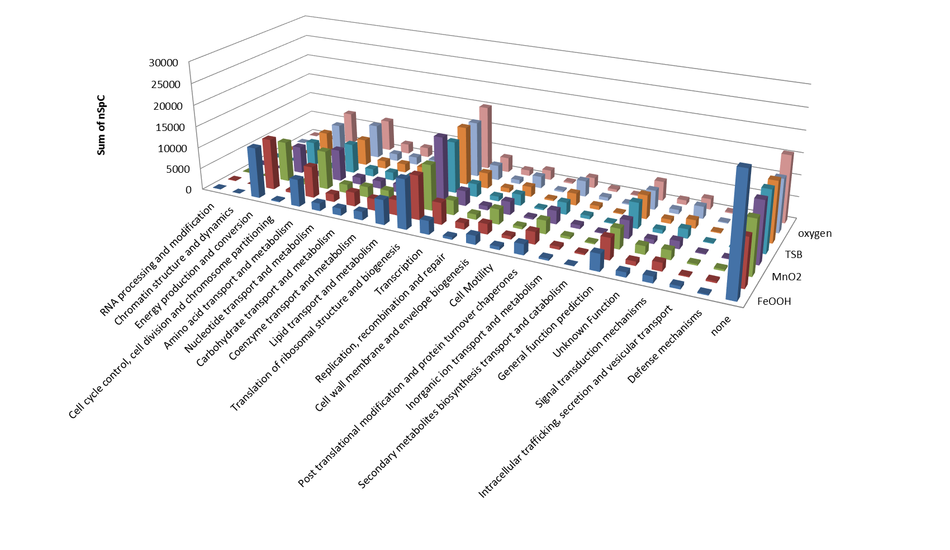
Figure 4.6. Quantitative distribution of A. dehalogenans 2CP-C core proteome by COG functional categories.

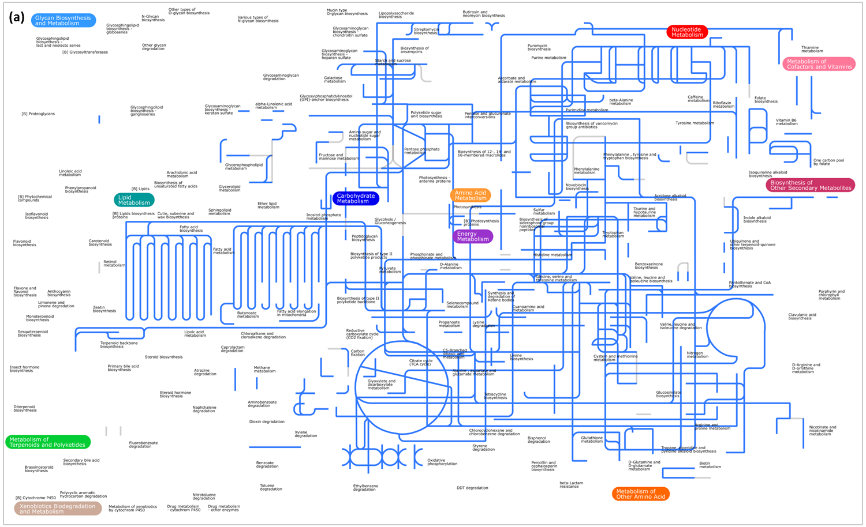
Figure 4.7. Metabolic pathways of detected A. dehalogenans 2CP-C proteome. The pan-proteome of 2CP-C consists detected proteins pooled across all growth conditions and all replicates. And the core proteome are proteins detected under all growth conditions. (a)The pan-proteome is mapped onto KEGG metabolic pathways and highlighted blue. (b)The core proteome represented pathways are highlighted in red.

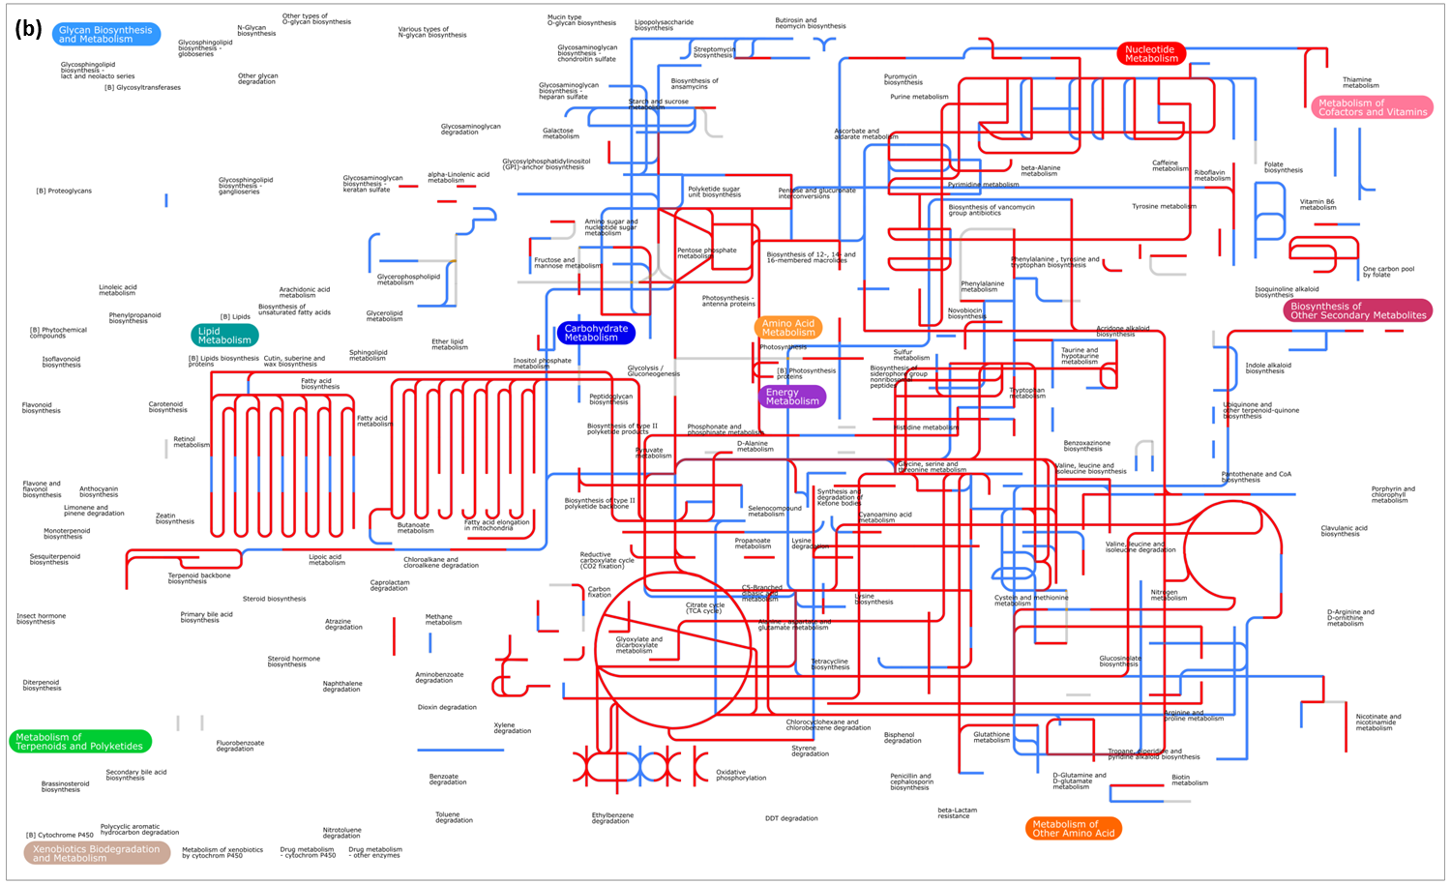
Figure 4.7. Metabolic pathways of detected A. dehalogenans 2CP-C proteome. The pan-proteome of 2CP-C consists detected proteins pooled across all growth conditions and all replicates. And the core proteome are proteins detected under all growth conditions. (a)The pan-proteome is mapped onto KEGG metabolic pathways and highlighted blue. (b)The core proteome represented pathways are highlighted in red.

across different growth conditions (Figure 4.6). Roughly 35-50% of the core proteome represent functions related to protein translation and metabolism, and energy production (Figure 4.6), which is probably not surprising in that the core proteome is essential to sustain the basic operational metabolism for cell survival.
To generate a more specific functional overview of the core proteome, iPath2.0 was used to map all the core proteins onto predicted metabolic pathways in the Kyoto Encyclopedia of Genes and Genomes (KEGG) database (Figure 4.7). The functional annotation provided by KEGG is not complete, only 1806 out of 4361 proteins in the entire predicted 2CP-C proteome have been assigned functions in KEGG database. None the less, KEGG provides a more high-resolution functional view as compared to the broad COG functional classifications. Out of the 1806 proteins whose KEGG functional annotations were available, 1383 were detected across various growth conditions, and were mapped to metabolic pathways using iPath2.0 (Figure 4.7a). In the core proteome, 441 of the 710 proteins have assigned functions in the KEGG database, and were mapped to metabolic pathways involved in the metabolism of lipid, carbohydrate, amino acid, nucleotides, etc. (Figure 4.7b). Although the core proteome is only 16% of the predicted proteome of 2CP-C, it contains well annotated proteins participating in almost all metabolic processes. The most readily represented pathways by the core proteome participate in energy metabolism, and lipid metabolism (Figure 4.7b). The conservation of most metabolic pathways by the core proteome among tested growth conditions further reinforce the essentiality of the core proteome, and suggests that different electron acceptors or donors, by in large, do not affect the overall cellular processes.

The Unique Proteins of Strain 2CP-C
The proteins uniquely detected under specific electron acceptor growth conditions are likely responsible for specific /specialized biological processes related to the utilization of corresponding electron acceptor. When 2CP-C cells were grown with FeOOH or N₂O, relatively few unique proteins were identified (12 and 16, respectively). Oxygen and Fe citrate-growth yielded the most unique proteins (77 and 57, respectively), while growth under the remaining conditions yielded around 40 unique proteins each. The unique proteins of each condition were grouped by their COG functional classifications according to their abundances (Figure 4.8). Under all growth conditions, proteins unable to be classified into any category (“none category”) had the highest representation. The MnO₂ grown cells generated the most abundant “energy production and conversion” protein detection. Proteins in the “post translational modification and protein turnover chaperones” category were most abundant in Fe citrate and tryptic soy broth grown cells. Unique proteins belonging to “inorganic ion transport and metabolism” and “signal transduction mechanisms” categories were both most abundant with growth in tryptic soy broth.
In a few cases, proteins unique to different growth conditions shared the same functional annotation (Table 4.1), suggesting that these functions can be carried out by multiple different proteins, and that different environmental factors require specific proteins performing similar functions. The unique proteins under each growth condition were mapped to KEGG pathways using iPath2.0 to visualize the represented pathways in the metabolic network (Figure 4.9). Due to limited KEGG annotations, a total of 98 out of all unique proteins in all growth conditions had available KEGG information, and were mapped to 27 (redundant) metabolic pathways. For example, the pathways unique to MnO₂ belonged to nucleotide metabolism, and a few amino acid metabolic pathways were represented by unique proteins in tryptic soy broth grown cells
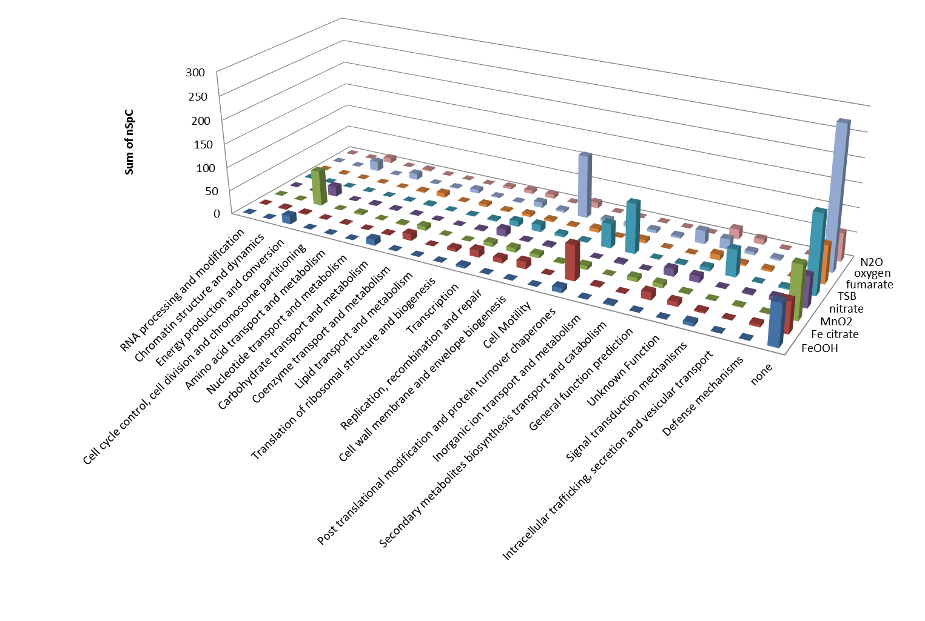
Figure 4.8. Quantitative distribution of detected A. dehalogenans 2CP-C proteins unique to certain growth conditions.
Table 4.1. Unique proteins from different growth conditions share overlapping functional annotations.
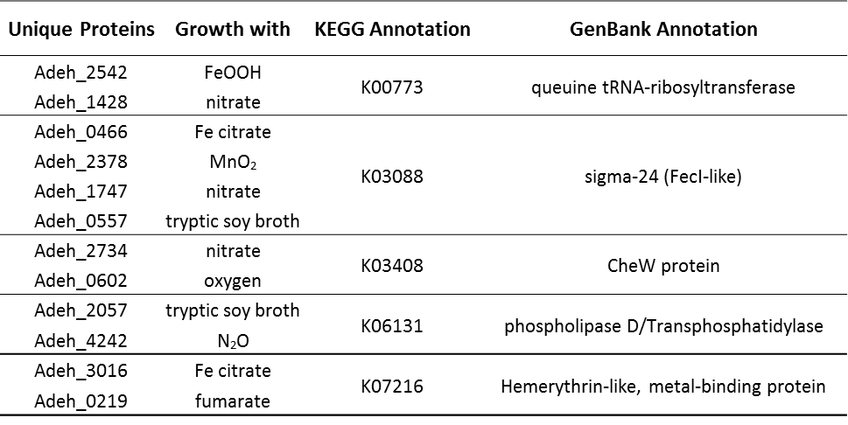
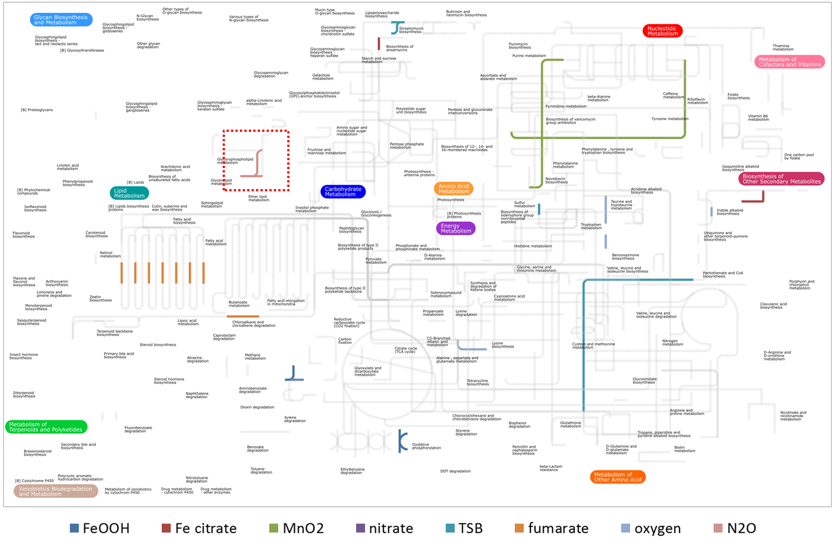
Figure 4.9. KEGG pathways represented by detected proteins of A. dehalogenans 2CP-C unique to certain growth condition. Pathways represented by unique proteins are highlighted in different colors by growth conditions. The proteins unique to nitrate do not map onto any of the metabolic pathways. The pathway in the dashed box is mapped by both unique proteins to tryptic soy broth and N₂O.

(Figure 4.9). Proteins unique to nitrate growth did not match any metabolic pathways, but were involved in regulatory pathways for cell motility and signal transduction (data not shown). In addition to the overlapping functional annotations between unique proteins, the same functional annotations could also be shared with the core proteins or other non-unique proteins. Thus, in most cases, the unique proteins represented pathways were not exclusive to the corresponding growth condition. As a result, the pathways highlighted by unique proteins could also be represented in the core metabolic network (Figure 4.7 and 4.9). Only fumarate resulted in the expression of fatty acid biosynthesis and terpenoid backbone biosynthesis pathways that were not represented by proteins detected under other growth conditions (Figure 4.9).
Quantitative Comparison of 2CP-C Proteome Expression Patterns
In order to quantitatively compare the proteomes of 2CP-C grown under different conditions, the proteomic data was filtered to remove low abundance proteins whose quantification is less robust due to the nature of peptide sampling [174]. The data was filtered by 95% prevalence value (PV) (see Experimental Section), resulting in 1554 quantifiable proteins representing ~55% of the total detection. The filtered data was analyzed using hierarchical clustering for overall quantitative distribution of protein expression across all tested growth conditions (Figure 4.10). The hierarchical clustering analysis generated a total of 10 protein clusters based on protein abundance patterns across growth conditions. The number of proteins within each cluster ranged from 59 (cluster 2) to 278 (cluster 3).
The protein clusters were dissected to reveal the quantitative contributions of each growth conditions (Figure 4.11a). The cumulative nSpC of each protein cluster was calculated for each
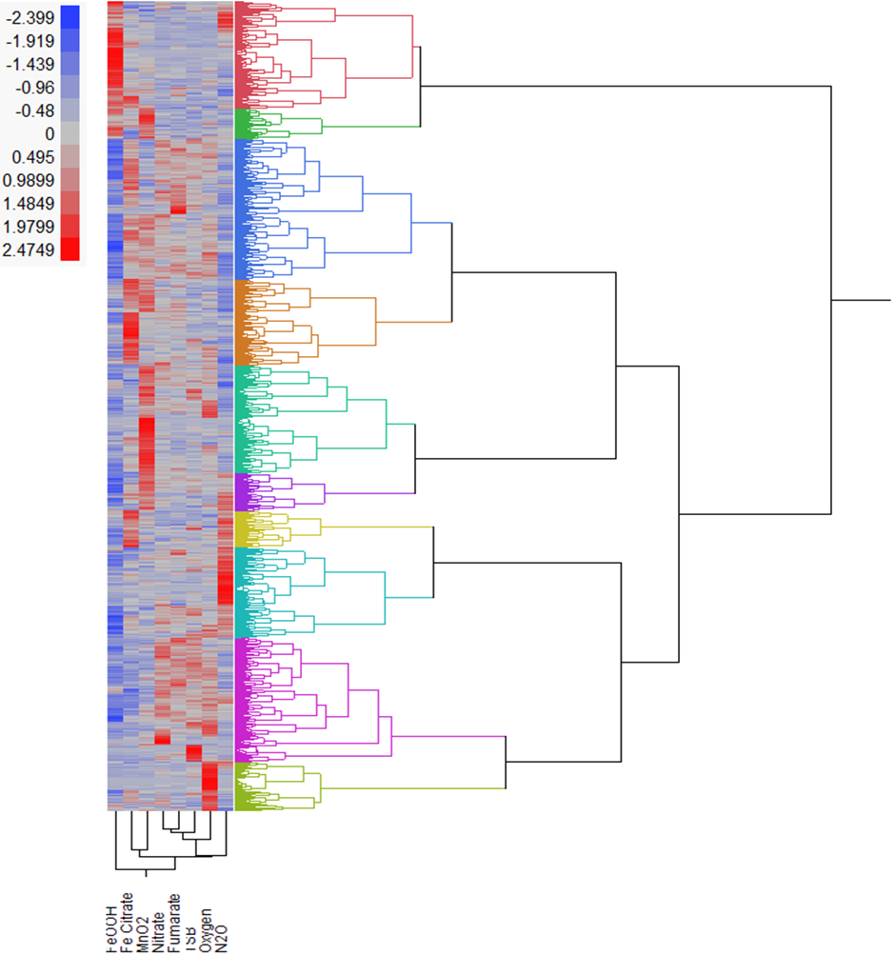
Figure 4.10. Hierarchical clustering of A. dehalogenans 2CP-C proteins and growth conditions. Quantifiable proteins were analyzed by hierarchical clustering to reveal the differential global proteome profiles. Protein abundances (nSpCs) were scaled so that the variance of each row is 1, and the mean of each row is centered to 0. The scaled and centered abundances ranged from -2.399 to +2.4749. Each hierarchical cluster contains detected proteins having similar abundance patterns across growth conditions. A total of 10 hierarchical clusters were generated, and denoted by different colors. From top to bottom are cluster 1 – 10. Different growth conditions were also clustered (bottom) based on the similarities of global proteome abundance patterns.
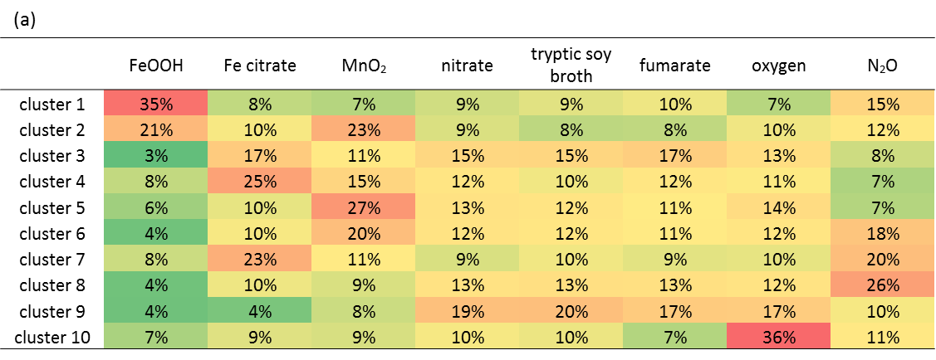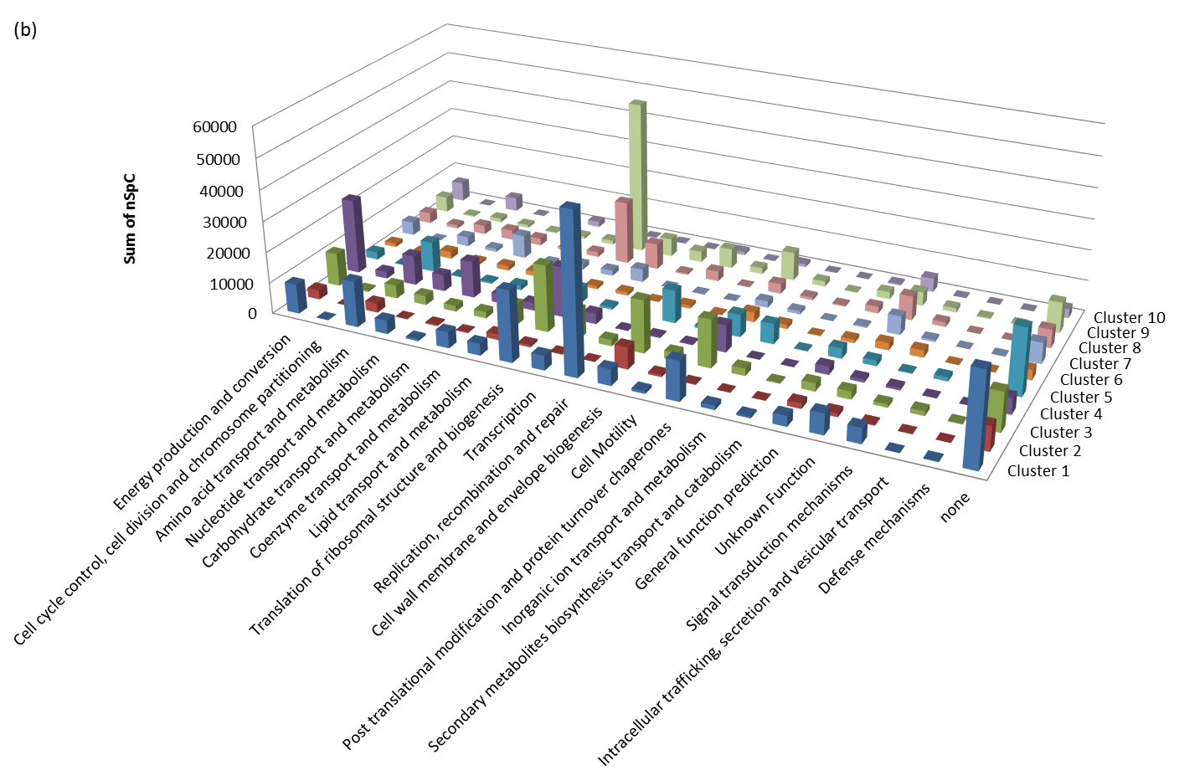
Figure 4.11. Quantitative distribution of A. dehalogenans 2CP-C protein hierarchical clusters by COG functional categories. (a)The quantitative contribution of proteins detected under each growth condition was determined for each hierarchical cluster. The quantitative contribution of each growth condition is represented by the percent share of the total nSpC in each protein cluster. The cells are color-coded (red:green::high:low) to visualize the degree of quantitative contributions. (b) Each hierarchical cluster contains detected proteins having similar abundance patterns across growth conditions. Proteins in each clusters (z axis) were classified into respective COG functional categories (x axis). The y axis represented sum of nSpCs of contributing proteins in each COG category in different clusters.

growth condition, and the relative percentages reflected the growth condition representations in each cluster. Several protein clusters were most abundant in certain conditions. In particular, the protein abundances of cluster 1 and 10 had the highest contribution (~35%) by growth with FeOOH and oxygen, respectively (Figure 4.11a). Growth with Fe citrate, MnO₂, and N₂O contributed over 25% to the total protein abundances in cluster 4, 5, and 8, respectively (Figure 4.11a). Since each cluster contains detected proteins with similar abundance patterns across growth conditions, and many clusters (e.g. cluster 1, 10) represents proteins predominantly detected under certain condition, the functional attribute of proteins within each cluster could be linked to specific electron acceptors. To functionally analyze the hierarchical clusters, the protein complement in each cluster was examined for their representing COG functional categories (Figure 4.11b). Each protein cluster demonstrated different abundance distributions across COG categories. For example, proteins predominantly detected with MnO₂ growth (cluster 4) mostly represented “energy production and conversion” and “translation of ribosomal structure and biogenesis”; whereas, for proteins most abundant with FeOOH growth (cluster 1), the highest functional representations were “replication, recombination and repair”, “translation of ribosomal structure and biogenesis”, and “none”. The “none” category refers to proteins that could not be classified into any COG functional category, and was abundant with FeOOH and MnO₂ growth (cluster 1 and 4, respectively) (Figure 4.11b). There were 52 and 22 proteins in the “none” category for cluster 1 and 4, respectively, most of which were annotated as “hypothetical protein” (40 and 17, respectively). Proteins are annotated as “hypothetical protein” because their corresponding genes do not have homologs with known functions [173]. Although caution needs to be exercised, a biological role could be inferred if the protein sequence contains conserved domains or have similarity to proteins with known function. In order to delineate the functions of detected “hypothetical proteins”, the protein sequences were queried against Pfam database for associated protein families [175]. Unfortunately, the most abundant hypothetical proteins in the “none” category of cluster 1 and 4 did not associate with any protein family in Pfam database and their function remained unclear.
In the hierarchical clustering, different growth conditions were also clustered based on the global protein abundance patterns (Figure 4.10). All the non-metal electron acceptors clustered away from the metal conditions, suggesting that the 2CP-C proteome responded to metal and non-metal electron acceptors by controlling the protein expression profiles. Among the tested non-metal electron acceptors, nitrate and fumarate resulted in the most similar proteome abundance patterns which clustered closely together. N₂O was the most distant non-metal electron acceptor in the hierarchical clustering, growth with which generated the most distinct protein abundances pattern. To our surprise, the global protein abundance pattern with oxygen growth did not show significant distinction to the other anaerobic growth. This suggests that the oxygen in microaerophilic condition tested do not cause toxicity (e.g. reactive oxygen species (ROS)) to the cell, and the cell could utilize low concentration of oxygen as electron acceptor without additional biological processes (e.g. detoxification of ROS). The soluble metal Fe citrate and solid metal MnO₂ were grouped together, suggesting that the overall protein expression pattern of 2CP-C is similar in response to different forms of metal electron acceptors. However, growth with another solid metal FeOOH resulted in a protein abundance pattern distinct from all other tested growth conditions, which could be attributed by the recalcitrant growth with FeOOH as electron acceptor.

Quantitative Differential Analysis of 2CP-C Proteome Responding to Different Electron Acceptors
To further delineate the detailed differentiations of proteome expression between different growth conditions, the semi-quantitation power of label-free shotgun proteomics was exploited through statistical analysis. Quantifiable detected proteins passing the 95% PV filter, as mentioned above, were analyzed by one-way ANOVA test, which generated a total of 28 pairwise comparisons for all eight tested growth conditions. Out of the 1554 analyzed proteins, the abundances of 1100 displayed significant differential change across various growth conditions. The number of significantly changed proteins in each pairwise comparison ranged from 54 (between fumarate and N₂O) to 658 (between FeOOH and oxygen) (Figure 4.12). In general, most proteins (450 - 658) demonstrated significant abundance change when growth with FeOOH is compared to growth with another electron acceptor, consistent with the distinction of FeOOH in the hierarchical clustering result (see above).
Three growth conditions analyzed included different forms of metal electron acceptors (FeOOH, Fe citrate, and MnO₂), and five conditions with non-metal electron acceptors (nitrate, fumarate, oxygen, and N₂O). The ANOVA analysis revealed 166 proteins whose abundance change is significant only when comparison is made between growth with metal and non-metal electron acceptors (Supplementary Table 4.2). In other words, these 166 proteins did not show significant abundance change in comparisons within the three metal electron acceptors, or within the five non-metal electron acceptors. Interestingly, out of the 166 differentially abundant proteins, 62 were consistently up-regulated in all metal electron accepter-growth, and 104 were consistently up-regulated in all non-metal electron acceptor-growth (Supplementary Table 4.2), suggesting that the effect of metal and non-metal electron acceptors on protein abundance is
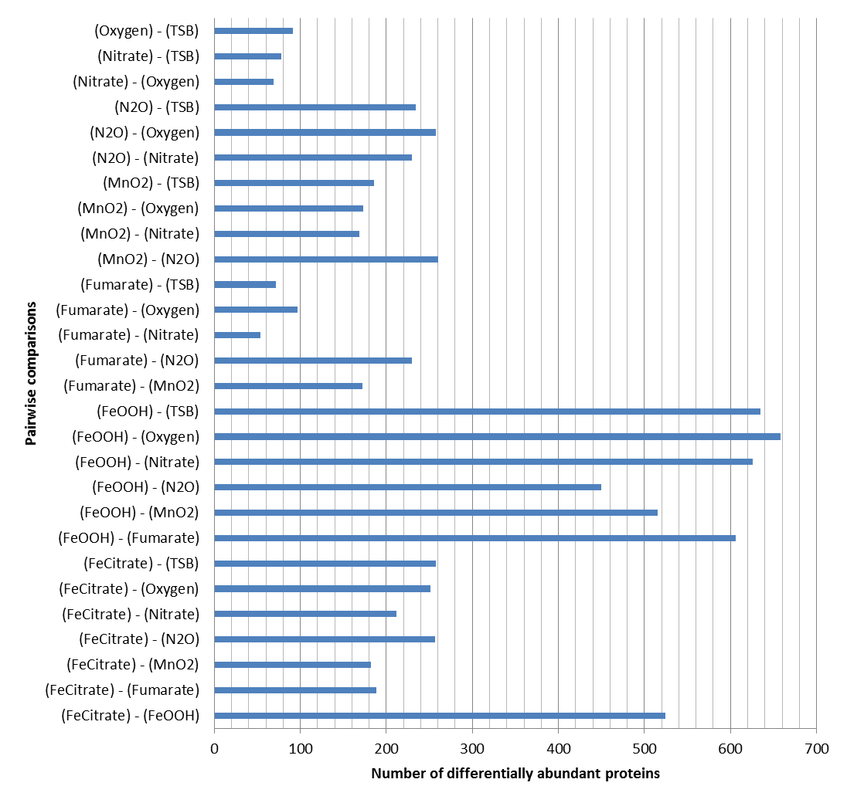
Figure 4.12. The number of differentially abundant proteins revealed by ANOVA test. The ANOVA test generated a total 28 pairwise comparisons (y axis) for all tested growth conditions. The number of proteins showing significant abundance differences (x axis) as determined by ANOVA test are plotted for each comparison.
Figure 4.13. COG functional category distribution for differentially abundant proteins. Proteins with differential abundances between metal and non-metal electron acceptor-growth are highlighted in red (more abundant with metal) or blue (more abundant with non-metal), and are plotted by the COG functional categories (x axis). The y axis represents the relative percentage of protein numbers in each functional category.

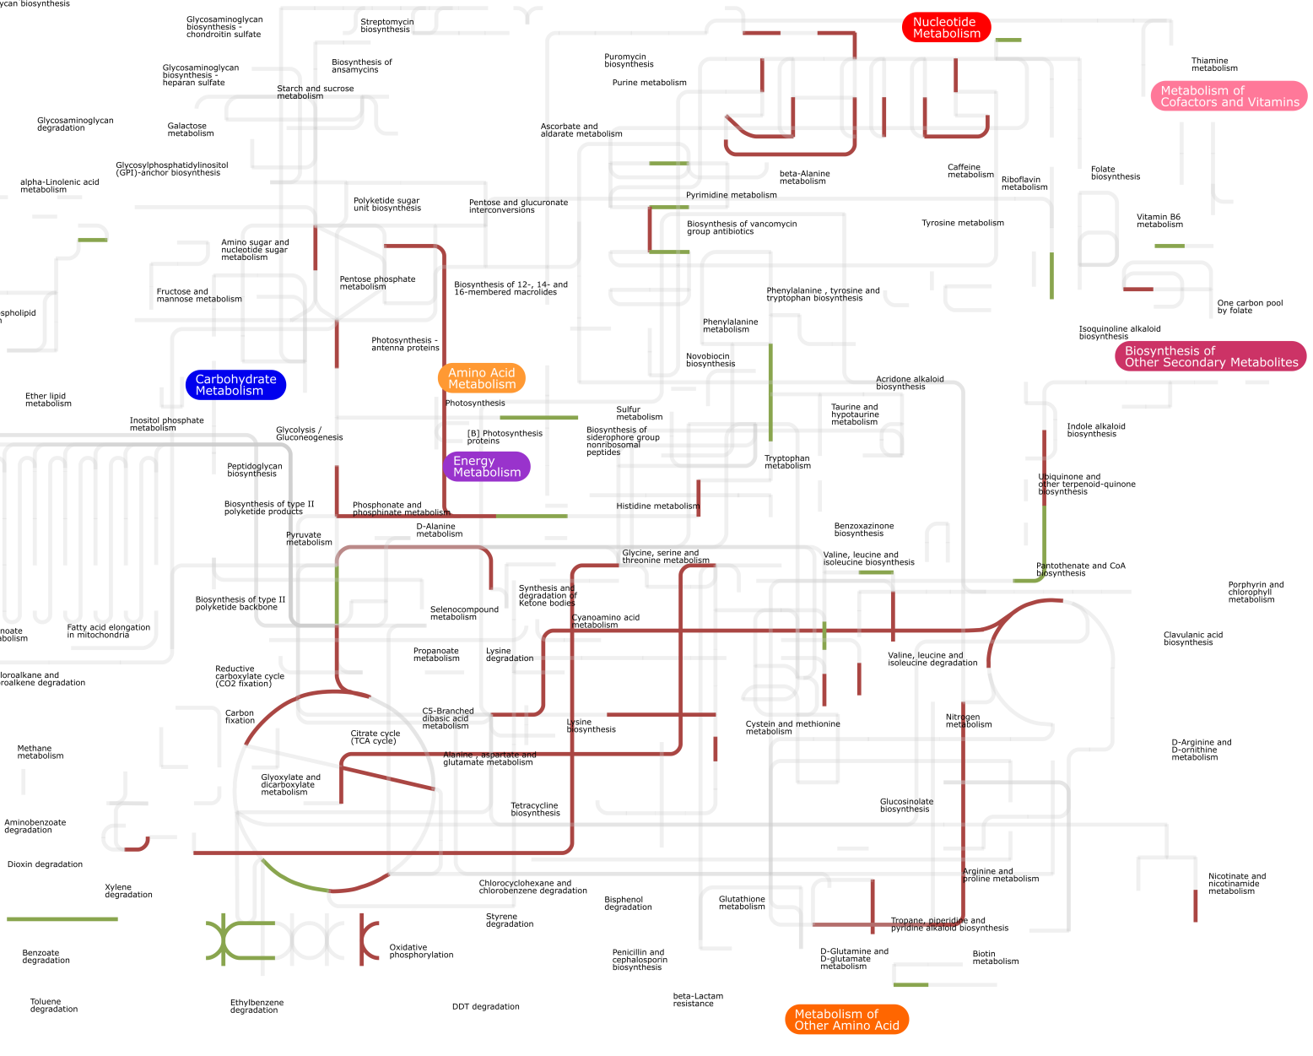
Figure 4.14. Metabolic pathways represented by differentially expressed proteins with metal and non-metal electron acceptor-growth. Proteins exhibiting significant abundance change determined by ANOVA analysis are mapped onto KEGG metabolic pathways. The pathways corresponding to up-regulated proteins in metal electron acceptor-growth are highlighted in red, and up-regulated pathways in non-metal electron acceptors are highlighted in green.

distinct and directional. The 62 proteins significantly more abundant with metal electron acceptor-growth mainly belong to the “energy production and conversion” and “amino acid transport and metabolism” functional categories in the COG database (Figure 4.13). The 104 proteins whose abundances are significantly higher with non-metal electron acceptor-growth all showed more than 10 fold change (lg(metal)-lg(non-metal)<-1) (Supplementary Table 4.2), and “none” and “translation of ribosomal structure and biogenesis” were the highest represented functional categories (Figure 4.13).
To better visualize the functional differences of proteins significantly changed between growth with metal and non-metal electron acceptors, differentially abundant proteins were mapped to metabolic pathways in KEGG database using iPath 2.0. Out of the 166 proteins with differential changes between metal and non-metal electron acceptor-growths, 92 were annotated in the KEGG database and 42 of which were mapped to 60 (redundant) metabolic pathways (Figure 4.14). The metabolic pathways represented by proteins up-regulated in metal electron acceptor growth were highlighted in red, and no overlap was observed with pathways represented by proteins up-regulated in non-metal electron acceptor growth (highlighted in green) (Figure 4.12). Proteins up-regulated in metal electron acceptor-growth mapped to metabolic pathways participating in TCA cycle, metabolism of amino acid, nucleotide and carbohydrate (Figure 4.12), whereas proteins up-regulated in non-metal electron acceptor growth mostly involved in regulatory pathways for translation and cell motility.
Metabolic pathways mapping clearly indicated elevated energy production in growth with metal electron acceptors. As shown in Figure 4.14, major components in TCA cycle (KEGG pathway KO00020) were significantly up-regulated, contributed by increased abundances of 2-oxoglutarate ferredoxin oxidoreductase subunit beta [EC:1.2.7.3], malate dehydrogenase [EC:1.1.1.37], and citrate synthase [EC:2.3.3.1]. In addition, other ATP producing processes, glycolysis (KEGG pathway KO00630) and oxidative phosphorylation (KEGG pathway KO00190), also exhibited significant up-regulation with metal electron acceptor-growth. Due to the up-regulation of many energy producing pathways, it was not surprising that porphyrin metabolism (KEGG pathway KO00860), a pathway related to heme production, was up-regulated in metal electron acceptor-growth as represented by increased abundance of glutamate-1-semialdehyde 2,1-aminomutase [EC:5.4.3.8]. Heme is an electron carrier component in many proteins involved in the electron transfer chain (e.g. cytochrome), which inextricably relates to energy production.
Amino acid and nucleotide metabolism also demonstrated up-regulation in metal electron acceptor-growth (Figure 4.12). Specifically, the following proteins responsible for amino acid synthesis all showed higher abundances with metal electron acceptor-growth: branched-chain amino acid aminotransferase [EC:2.6.1.42], shikimate dehydrogenase [EC:1.1.1.25], aspartate-semialdehyde dehydrogenase [EC:1.2.1.11], 3-deoxy-7-phosphoheptulonate synthase [EC:2.5.1.54], argininosuccinate synthase [EC:6.3.4.5], carbamoyl-phosphate synthase large subunit [EC:6.3.5.5], 4-hydroxy-tetrahydrodipicolinate reductase [EC:1.17.1.8], and aspartyl-tRNA(Asn)/glutamyl-tRNA(Gln) amidotransferase subunit A [EC:6.3.5.6 6.3.5.7]. For biosynthesis of purine and pyrimidine, increased abundances of purine-nucleoside phosphorylase [EC:2.4.2.1], ribonucleoside-diphosphate reductase alpha chain [EC:1.17.4.1], and phosphoribosylaminoimidazole-succinocarboxamide synthase [EC:6.3.2.6] in metal electron acceptor-growth was determined significant by ANOVA analysis and contributed to the elevation of nucleotide metabolism. The increased synthesis of amino acids and nucleotides could be a result of overall higher energy level in cells grown with metal electron acceptor.
The significantly increased proteins with non-metal electron acceptor-growth, on the other hand, only mapped to a few metabolic pathways for amino acid and nucleotide biosynthesis (e.g. KEGG pathway KO00400, KO00240), lipid metabolism (KEGG pathway KO00564), etc. However, most abundant proteins in non-metal electron acceptor-growth were ribosomal proteins involved in regulatory pathways for translation (KEGG pathway KO03010). Protein CheW was significantly more abundant in non-metal electron acceptor-growth, and was mapped to 10 elements in the regulatory pathways for chemotaxis (KO02030) and two-component system (KO02020).

1. Avery, O.T., C.M. MacLeod, and M. McCarty, Studies on the chemical nature of the substance inducing transformation of pneumococcal types induction of transformation by a desoxyribonucleic acid fraction isolated from pneumococcus type III. The Journal of experimental medicine, 1944. 79(2): p. 137-158.
2. Hershey, A.D. and M. Chase, Independent functions of viral protein and nucleic acid in growth of bacteriophage. The Journal of general physiology, 1952. 36(1): p. 39-56.
3. Watson, J.D. and F.H. Crick, Molecular structure of nucleic acids. Nature, 1953. 171(4356): p. 737-738.
4. Kranz, R.G., et al., Cytochrome c biogenesis: mechanisms for covalent modifications and trafficking of heme and for heme-iron redox control. Microbiology and Molecular Biology Reviews, 2009. 73(3): p. 510-528.
5. Crick, F., Central dogma of molecular biology. Nature, 1970. 227(5258): p. 561-563.
6. Crick, F.H., The origin of the genetic code. Journal of molecular biology, 1968. 38(3): p. 367-379.
7. Fleischmann, R.D., et al., Whole-genome random sequencing and assembly of Haemophilus influenzae Rd. Science, 1995. 269(5223): p. 496-512.
8. Sanger, F. and A.R. Coulson, A rapid method for determining sequences in DNA by primed synthesis with DNA polymerase. Journal of molecular biology, 1975. 94(3): p. 441-448.
9. Maxam, A.M. and W. Gilbert, A new method for sequencing DNA. Proceedings of the National Academy of Sciences, 1977. 74(2): p. 560-564.
10. Sanger, F., S. Nicklen, and A.R. Coulson, DNA sequencing with chain-terminating inhibitors. Proceedings of the National Academy of Sciences, 1977. 74(12): p. 5463-5467.
11. Venter, J.C., et al., The sequence of the human genome. Science, 2001. 291(5507): p. 1304-1351.
12. Lander, E.S., et al., Initial sequencing and analysis of the human genome. Nature, 2001. 409(6822): p. 860-921.
13. ANDERSON, M.A., et al., A polymorphic DNA marker genetically linked to Huntington's disease. Landmarks in Medical Genetics: Classic Papers with Commentaries, 2004. 51: p. 153.
14. Riesenfeld, C.S., P.D. Schloss, and J. Handelsman, Metagenomics: genomic analysis of microbial communities. Annu. Rev. Genet., 2004. 38: p. 525-552.
15. Handelsman, J., Metagenomics: application of genomics to uncultured microorganisms. Microbiology and Molecular Biology Reviews, 2004. 68(4): p. 669-685.
16. Williamson, S.J., et al., The Sorcerer II Global Ocean Sampling Expedition: metagenomic characterization of viruses within aquatic microbial samples. PloS one, 2008. 3(1): p. e1456.
17. Daniel, R., The soil metagenome–a rich resource for the discovery of novel natural products. Current opinion in biotechnology, 2004. 15(3): p. 199-204.
18. Pernthaler, A., et al., Diverse syntrophic partnerships from deep-sea methane vents revealed by direct cell capture and metagenomics. Proceedings of the National Academy of Sciences, 2008. 105(19): p. 7052-7057.
19. Gill, S.R., et al., Metagenomic analysis of the human distal gut microbiome. Science, 2006. 312(5778): p. 1355-1359.
20. Lazarevic, V., et al., Metagenomic study of the oral microbiota by Illumina high-throughput sequencing. Journal of microbiological methods, 2009. 79(3): p. 266-271.
21. DeRisi, J., et al., Use of a cDNA microarray to analyse gene expression patterns in human cancer. Nature genetics, 1996. 14(4): p. 457-460.
22. Spellman, P.T., et al., Comprehensive identification of cell cycle–regulated genes of the yeast Saccharomyces cerevisiae by microarray hybridization. Molecular biology of the cell, 1998. 9(12): p. 3273-3297.
23. Zhou, J., Microarrays for bacterial detection and microbial community analysis. Current opinion in Microbiology, 2003. 6(3): p. 288-294.
24. Wang, Z., M. Gerstein, and M. Snyder, RNA-Seq: a revolutionary tool for transcriptomics. Nature Reviews Genetics, 2009. 10(1): p. 57-63.
25. Klose, J., Protein mapping by combined isoelectric focusing and electrophoresis of mouse tissues. Humangenetik, 1975. 26(3): p. 231-243.
26. O'Farrell, P.H., High resolution two-dimensional electrophoresis of proteins. Journal of biological chemistry, 1975. 250(10): p. 4007-4021.
27. Wilkins, M.R., et al., From proteins to proteomes: large scale protein identification by two-dimensional electrophoresis and arnino acid analysis. Nature Biotechnology, 1996. 14(1): p. 61-65.
28. Fenn, J.B., et al., Electrospray ionization for mass spectrometry of large biomolecules. Science, 1989. 246(4926): p. 64-71.
29. Karas, M. and F. Hillenkamp, Laser desorption ionization of proteins with molecular masses exceeding 10,000 daltons. Analytical chemistry, 1988. 60(20): p. 2299-2301.
30. Gygi, S.P., B. Rist, and R. Aebersold, Measuring gene expression by quantitative proteome analysis. Current opinion in biotechnology, 2000. 11(4): p. 396-401.
31. Peng, J. and S.P. Gygi, Proteomics: the move to mixtures. Journal of mass spectrometry, 2001. 36(10): p. 1083-1091.
32. Abraham, P., et al., Defining the boundaries and characterizing the landscape of functional genome expression in vascular tissues of Populus using shotgun proteomics. Journal of proteome research, 2011. 11(1): p. 449-460.
33. Chourey, K., et al., Environmental proteomics reveals early microbial community responses to biostimulation at a uranium‐and nitrate‐contaminated site. Proteomics, 2013. 13(18-19): p. 2921-2930.
34. Nissen, S., et al., Comparative c-type cytochrome expression analysis in Shewanella oneidensis strain MR-1 and Anaeromyxobacter dehalogenans strain 2CP-C grown with soluble and insoluble oxidized metal electron acceptors. Biochemical Society Transactions, 2012. 40(6).
35. Verberkmoes, N.C., et al., Shotgun metaproteomics of the human distal gut microbiota. The ISME journal, 2009. 3(2): p. 179-189.
36. Young, J.C., et al., Phage-induced expression of CRISPR-associated proteins is revealed by shotgun proteomics in Streptococcus thermophilus. PloS one, 2012. 7(5): p. e38077.
37. Giannone, R.J., et al., Proteomic characterization of cellular and molecular processes that enable the Nanoarchaeum equitans-Ignicoccus hospitalis relationship. PloS one, 2011. 6(8): p. e22942.
38. Abraham, P., et al., Putting the pieces together: high-performance LC-MS/MS provides network-, pathway-, and protein-level perspectives in Populus. Molecular & Cellular Proteomics, 2013. 12(1): p. 106-119.
39. Patti, G.J., O. Yanes, and G. Siuzdak, Innovation: Metabolomics: the apogee of the omics trilogy. Nature reviews Molecular cell biology, 2012. 13(4): p. 263-269.
40. Sugimoto, M., et al., Capillary electrophoresis mass spectrometry-based saliva metabolomics identified oral, breast and pancreatic cancer-specific profiles. Metabolomics, 2010. 6(1): p. 78-95.
41. Bundy, J.G., M.P. Davey, and M.R. Viant, Environmental metabolomics: a critical review and future perspectives. Metabolomics, 2009. 5(1): p. 3-21.
42. Compton, P.D., et al., On the scalability and requirements of whole protein mass spectrometry. Analytical chemistry, 2011. 83(17): p. 6868-6874.
43. Eng, J.K., A.L. McCormack, and J.R. Yates, An approach to correlate tandem mass spectral data of peptides with amino acid sequences in a protein database. Journal of the American Society for Mass Spectrometry, 1994. 5(11): p. 976-989.
44. Tabb, D.L., W.H. McDonald, and J.R. Yates, DTASelect and Contrast: tools for assembling and comparing protein identifications from shotgun proteomics. Journal of proteome research, 2002. 1(1): p. 21-26.
45. Tabb, D.L., C.G. Fernando, and M.C. Chambers, MyriMatch: highly accurate tandem mass spectral peptide identification by multivariate hypergeometric analysis. Journal of proteome research, 2007. 6(2): p. 654-661.
46. Ma, Z.-Q., et al., IDPicker 2.0: Improved protein assembly with high discrimination peptide identification filtering. Journal of proteome research, 2009. 8(8): p. 3872-3881.
47. Ram, R.J., et al., Community proteomics of a natural microbial biofilm. Science, 2005. 308(5730): p. 1915-1920.
48. Denef, V.J., et al., Proteogenomic basis for ecological divergence of closely related bacteria in natural acidophilic microbial communities. Proceedings of the National Academy of Sciences, 2010. 107(6): p. 2383-2390.
49. Mueller, R.S., et al., Ecological distribution and population physiology defined by proteomics in a natural microbial community. Molecular systems biology, 2010. 6(1).
50. Benndorf, D. and U. Reichl, Proteomics in environmental and technical microbiology. Engineering in Life Sciences, 2014. 14(1): p. 27-46.
51. Cowan, D.A., The upper temperature for life–where do we draw the line? Trends in microbiology, 2004. 12(2): p. 58-60.
52. Baker-Austin, C. and M. Dopson, Life in acid: pH homeostasis in acidophiles. Trends in microbiology, 2007. 15(4): p. 165-171.
53. Turnbaugh, P.J., et al., The human microbiome project: exploring the microbial part of ourselves in a changing world. Nature, 2007. 449(7164): p. 804.
54. Madsen, E.L., Environmental microbiology: from genomes to biogeochemistry. 2011: John Wiley & Sons.
55. Paustian, T. and G. Roberts, Through the Microscope: Adventures in Microbiology. 2012, Textbook Consortia.
56. Chourey, K., et al., Comparative temporal proteomics of a response regulator (SO2426)-deficient strain and wild-type Shewanella oneidensis MR-1 during chromate transformation. Journal of proteome research, 2009. 8(1): p. 59-71.
57. Brown, S.D., et al., Molecular dynamics of the Shewanella oneidensis response to chromate stress. Molecular & Cellular Proteomics, 2006. 5(6): p. 1054-1071.
58. VerBerkmoes, N.C., et al., Determination and Comparison of the Baseline Proteomes of the Versatile Microbe Rhodopseudomonas p alustris under Its Major Metabolic States. Journal of proteome research, 2006. 5(2): p. 287-298.
59. Kao, W.-C., et al., Quantitative proteomic analysis of metabolic regulation by copper ions in Methylococcus capsulatus (Bath). Journal of biological chemistry, 2004. 279(49): p. 51554-51560.
60. Bergaust, L., et al., Denitrification response patterns during the transition to anoxic respiration and posttranscriptional effects of suboptimal pH on nitrogen oxide reductase in Paracoccus denitrificans. Applied and environmental microbiology, 2010. 76(19): p. 6387-6396.
61. Lacerda, C.M. and K.F. Reardon, Environmental proteomics: applications of proteome profiling in environmental microbiology and biotechnology. Briefings in functional genomics & proteomics, 2009. 8(1): p. 75-87.
62. Wilmes, P., et al., Community proteogenomics highlights microbial strain-variant protein expression within activated sludge performing enhanced biological phosphorus removal. The ISME journal, 2008. 2(8): p. 853-864.
63. Benndorf, D., et al., Functional metaproteome analysis of protein extracts from contaminated soil and groundwater. The ISME journal, 2007. 1(3): p. 224-234.
64. Graham, D.E., et al., Microbes in thawing permafrost: the unknown variable in the climate change equation. The ISME journal, 2011. 6(4): p. 709-712.
65. Fredrickson, J.K. and Y.A. Gorby, Environmental processes mediated by iron-reducing bacteria. Current opinion in biotechnology, 1996. 7(3): p. 287-294.
66. Lonergan, D.J., et al., Phylogenetic analysis of dissimilatory Fe (III)-reducing bacteria. Journal of Bacteriology, 1996. 178(8): p. 2402-2408.
67. Weber, K.A., L.A. Achenbach, and J.D. Coates, Microorganisms pumping iron: anaerobic microbial iron oxidation and reduction. Nature Reviews Microbiology, 2006. 4(10): p. 752-764.
68. Lovley, D.R., Dissimilatory metal reduction. Annual Reviews in Microbiology, 1993. 47(1): p. 263-290.
69. Vargas, M., et al., Microbiological evidence for Fe (III) reduction on early Earth. Nature, 1998. 395(6697): p. 65-67.
70. Cairns-Smith, A.G., A.J. Hall, and M.J. Russell, Mineral theories of the origin of life and an iron sulfide example, in Marine Hydrothermal Systems and the Origin of Life. 1992, Springer. p. 161-180.
71. Gold, T., The deep, hot biosphere. Proceedings of the National Academy of Sciences, 1992. 89(13): p. 6045-6049.
72. Seckbach, J., Origins: genesis, evolution and diversity of life. Vol. 6. 2004: Springer.
73. Lovley, D.R. and E.J. Phillips, Manganese inhibition of microbial iron reduction in anaerobic sediments. Geomicrobiology Journal, 1988. 6(3-4): p. 145-155.
74. Lovley, D.R. and E.J. Phillips, Novel mode of microbial energy metabolism: organic carbon oxidation coupled to dissimilatory reduction of iron or manganese. Applied and environmental microbiology, 1988. 54(6): p. 1472-1480.
75. Lovley, D., Dissimilatory Fe (III)-and Mn (IV)-reducing prokaryotes, in The prokaryotes. 2006, Springer. p. 635-658.
76. Wall, J.D. and L.R. Krumholz, Uranium reduction. Annu. Rev. Microbiol., 2006. 60: p. 149-166.
77. Rotaru, D.E.H., et al., Geobacter: the microbe electric’s physiology, ecology, and practical applications. Advances in microbial physiology, 2011. 59: p. 1.
78. Malvankar, N.S., et al., Tunable metallic-like conductivity in microbial nanowire networks. nature nanotechnology, 2011. 6(9): p. 573-579.
79. Reguera, G., et al., Extracellular electron transfer via microbial nanowires. Nature, 2005. 435(7045): p. 1098-1101.
80. Klimes, A., et al., Production of pilus‐like filaments in Geobacter sulfurreducens in the absence of the type IV pilin protein PilA. FEMS microbiology letters, 2010. 310(1): p. 62-68.
81. Yi, H., et al., Selection of a variant of< i> Geobacter sulfurreducens</i> with enhanced capacity for current production in microbial fuel cells. Biosensors and Bioelectronics, 2009. 24(12): p. 3498-3503.
82. MacDonell, M.T. and R.R. Colwell, Phylogeny of the Vibrionaceae, and Recommendation for Two New Genera, Listonella and Shewanella. Systematic and Applied Microbiology, 1985. 6(2): p. 171-182.
83. MYERS, C.R. and K.H. NEALSON, Bacterial Manganese Reduction and Growth with Manganese Oxide as the Sole Electron Acceptor. Science, 1988. 240(4857): p. 1319-1321.
84. Hau, H.H. and J.A. Gralnick, Ecology and Biotechnology of the Genus Shewanella. Annual Review of Microbiology, 2007. 61(1): p. 237-258.
85. Hartshorne, R., et al., Characterization of Shewanella oneidensis MtrC: a cell-surface decaheme cytochrome involved in respiratory electron transport to extracellular electron acceptors. JBIC Journal of Biological Inorganic Chemistry, 2007. 12(7): p. 1083-1094.
86. Marsili, E., et al., Shewanella secretes flavins that mediate extracellular electron transfer. Proceedings of the National Academy of Sciences, 2008. 105(10): p. 3968-3973.
87. El-Naggar, M.Y., et al., Electrical transport along bacterial nanowires from Shewanella oneidensis MR-1. Proceedings of the National Academy of Sciences, 2010. 107(42): p. 18127-18131.
88. Sanford, R.A., J.R. Cole, and J.M. Tiedje, Characterization and description of Anaeromyxobacter dehalogenans gen. nov., sp. nov., an aryl-halorespiring facultative anaerobic myxobacterium. Applied and environmental microbiology, 2002. 68(2): p. 893-900.
89. Wu, Q., R.A. Sanford, and F.E. Löffler, Uranium (VI) reduction by Anaeromyxobacter dehalogenans strain 2CP-C. Applied and environmental microbiology, 2006. 72(5): p. 3608-3614.
90. Löffler, F.E., J.M. Tiedje, and R.A. Sanford, Fraction of electrons consumed in electron acceptor reduction and hydrogen thresholds as indicators of halorespiratory physiology. Applied and environmental microbiology, 1999. 65(9): p. 4049-4056.
91. North, N.N., et al., Change in bacterial community structure during in situ biostimulation of subsurface sediment cocontaminated with uranium and nitrate. Applied and environmental microbiology, 2004. 70(8): p. 4911-4920.
92. Petrie, L., et al., Enumeration and characterization of iron (III)-reducing microbial communities from acidic subsurface sediments contaminated with uranium (VI). Applied and environmental microbiology, 2003. 69(12): p. 7467-7479.
93. He, Q. and R.A. Sanford, Induction characteristics of reductive dehalogenation in theortho-halophenol-respiring bacterium, Anaeromyxobacter dehalogenans. Biodegradation, 2002. 13(5): p. 307-316.
94. Methe, B., et al., Genome of Geobacter sulfurreducens: metal reduction in subsurface environments. Science, 2003. 302(5652): p. 1967-1969.
95. Moore, G. and G. Pettigrew, Cytochromes c. Evolutionary, Structural and Physicochemical Aspects. Springer-Verlag, Berlin, Heidelberg, New York, London, Paris, Tokyo, Hong Kong, Barcelona, 1990.
96. Ow, Y.-L.P., et al., Cytochrome c: functions beyond respiration. Nature reviews Molecular cell biology, 2008. 9(7): p. 532-542.
97. Ferguson, S.J., et al., Cytochrome< i> c</i> assembly: A tale of ever increasing variation and mystery? Biochimica et Biophysica Acta (BBA)-Bioenergetics, 2008. 1777(7): p. 980-984.
98. Richardson, D.J., Bacterial respiration: a flexible process for a changing environment. Microbiology, 2000. 146(3): p. 551-571.
99. Shi, L., et al., Respiration of metal (hydr) oxides by Shewanella and Geobacter: a key role for multihaem c‐type cytochromes. Molecular microbiology, 2007. 65(1): p. 12-20.
100. Myers, J.M. and C.R. Myers, Role of the tetraheme cytochrome CymA in anaerobic electron transport in cells of Shewanella putrefaciens MR-1 with normal levels of menaquinone. Journal of bacteriology, 2000. 182(1): p. 67-75.
101. Zargar, K. and C.W. Saltikov, Lysine-91 of the tetraheme c-type cytochrome CymA is essential for quinone interaction and arsenate respiration in Shewanella sp. strain ANA-3. Archives of microbiology, 2009. 191(11): p. 797-806.
102. Sophie, J.M., et al., A functional description of CymA, an electron-transfer hub supporting anaerobic respiratory flexibility in Shewanella. Biochemical Journal, 2012. 444(3): p. 465-474.
103. Gorby, Y.A., et al., Electrically conductive bacterial nanowires produced by Shewanella oneidensis strain MR-1 and other microorganisms. Proceedings of the National Academy of Sciences, 2006. 103(30): p. 11358-11363.
104. Leang, C., M.V. Coppi, and D. Lovley, OmcB, a c-type polyheme cytochrome, involved in Fe (III) reduction in Geobacter sulfurreducens. Journal of Bacteriology, 2003. 185(7): p. 2096-2103.
105. Mehta, T., et al., Outer membrane c-type cytochromes required for Fe (III) and Mn (IV) oxide reduction in Geobacter sulfurreducens. Applied and environmental microbiology, 2005. 71(12): p. 8634-8641.
106. Afkar, E., et al., A novel Geobacteraceae-specific outer membrane protein J (OmpJ) is essential for electron transport to Fe (III) and Mn (IV) oxides in Geobacter sulfurreducens. BMC microbiology, 2005. 5(1): p. 41.
107. Lovley, D., Long-range electron transport to Fe (III) oxide via pili with metallic-like conductivity. Biochemical Society Transactions, 2012. 40(6): p. 1186-1190.
108. Esteve‐Núñez, A., et al., Fluorescent properties of c‐type cytochromes reveal their potential role as an extracytoplasmic electron sink in Geobacter sulfurreducens. Environmental microbiology, 2008. 10(2): p. 497-505.
109. Lovley, D.R., Extracellular electron transfer: wires, capacitors, iron lungs, and more. Geobiology, 2008. 6(3): p. 225-231.
110. Meyer, T.E., et al., Identification of 42 possible cytochrome c genes in the Shewanella oneidensis genome and characterization of six soluble cytochromes. Omics: a journal of integrative biology, 2004. 8(1): p. 57-77.
111. Thomas, S.H., et al., The mosaic genome of Anaeromyxobacter dehalogenans strain 2CP-C suggests an aerobic common ancestor to the delta-proteobacteria. PloS one, 2008. 3(5): p. e2103.
112. Lin, W., M.V. Coppi, and D. Lovley, Geobacter sulfurreducens can grow with oxygen as a terminal electron acceptor. Applied and environmental microbiology, 2004. 70(4): p. 2525-2528.
113. Heidelberg, J.F., et al., Genome sequence of the dissimilatory metal ion–reducing bacterium Shewanella oneidensis. Nature Biotechnology, 2002. 20(11): p. 1118-1123.
114. Myers, J.M. and C.R. Myers, Genetic complementation of an outer membrane cytochrome omcB mutant of Shewanella putrefaciens MR-1 requires omcB plus downstream DNA. Applied and environmental microbiology, 2002. 68(6): p. 2781-2793.
115. Coppi, M.V., et al., Development of a Genetic System forGeobacter sulfurreducens. Applied and environmental microbiology, 2001. 67(7): p. 3180-3187.
116. Shelobolina, E.S., et al., Importance of c-type cytochromes for U (VI) reduction by Geobacter sulfurreducens. BMC microbiology, 2007. 7(1): p. 16.
117. Bretschger, O., et al., Current production and metal oxide reduction by Shewanella oneidensis MR-1 wild type and mutants. Applied and environmental microbiology, 2007. 73(21): p. 7003-7012.
118. Fredrickson, J.K. and M.F. Romine, Genome-assisted analysis of dissimilatory metal-reducing bacteria. Current opinion in biotechnology, 2005. 16(3): p. 269-274.
119. Beliaev, A.S., et al., Gene and protein expression profiles of Shewanella oneidensis during anaerobic growth with different electron acceptors. Omics: a journal of integrative biology, 2002. 6(1): p. 39-60.
120. Thompson, D.K., et al., Transcriptional and proteomic analysis of a ferric uptake regulator (fur) mutant of Shewanella oneidensis: possible involvement of fur in energy metabolism, transcriptional regulation, and oxidative stress. Applied and environmental microbiology, 2002. 68(2): p. 881-892.
121. Wan, X.-F., et al., Transcriptomic and proteomic characterization of the Fur modulon in the metal-reducing bacterium Shewanella oneidensis. Journal of Bacteriology, 2004. 186(24): p. 8385-8400.
122. Romine, M.F., et al., Validation of Shewanella oneidensis MR-1 small proteins by AMT tag-based proteome analysis. Omics: a journal of integrative biology, 2004. 8(3): p. 239-254.
123. Elias, D.A., et al., Global detection and characterization of hypothetical proteins in Shewanella oneidensis MR‐1 using LC‐MS based proteomics. Proteomics, 2005. 5(12): p. 3120-3130.
124. Kolker, E., et al., Global profiling of Shewanella oneidensis MR-1: expression of hypothetical genes and improved functional annotations. Proceedings of the National Academy of Sciences of the United States of America, 2005. 102(6): p. 2099-2104.
125. Fang, R., et al., Differential label-free quantitative proteomic analysis of Shewanella oneidensis cultured under aerobic and suboxic conditions by accurate mass and time tag approach. Molecular & Cellular Proteomics, 2006. 5(4): p. 714-725.
126. Thompson, M.R., et al., Dosage-dependent proteome response of Shewanella oneidensis MR-1 to acute chromate challenge. Journal of proteome research, 2007. 6(5): p. 1745-1757.
127. Ding, Y.-H.R., et al., The proteome of dissimilatory metal-reducing microorganism< i> Geobacter sulfurreducens</i> under various growth conditions. Biochimica et Biophysica Acta (BBA)-Proteins and Proteomics, 2006. 1764(7): p. 1198-1206.
128. Ding, Y.-H.R., et al., Proteome of< i> Geobacter sulfurreducens</i> grown with Fe (III) oxide or Fe (III) citrate as the electron acceptor. Biochimica et Biophysica Acta (BBA)-Proteins and Proteomics, 2008. 1784(12): p. 1935-1941.
129. Van Nostrand, J.D., et al., Dynamics of microbial community composition and function during in situ bioremediation of a uranium-contaminated aquifer. Applied and Environmental Microbiology, 2011. 77(11): p. 3860-3869.
130. He, Q. and R.A. Sanford, Characterization of Fe (III) reduction by chlororespiring Anaeromxyobacter dehalogenans. Applied and environmental microbiology, 2003. 69(5): p. 2712-2718.
131. Childers, S.E., S. Ciufo, and D.R. Lovley, Geobacter metallireducens accesses insoluble Fe (III) oxide by chemotaxis. Nature, 2002. 416(6882): p. 767-769.
132. Richter, K., M. Schicklberger, and J. Gescher, Dissimilatory reduction of extracellular electron acceptors in anaerobic respiration. Applied and environmental microbiology, 2012. 78(4): p. 913-921.
133. Allen, J.W., et al., C-type cytochromes: diverse structures and biogenesis systems pose evolutionary problems. Philosophical Transactions of the Royal Society of London. Series B: Biological Sciences, 2003. 358(1429): p. 255-266.
134. Richardson, D.J., et al., The ‘porin–cytochrome’model for microbe‐to‐mineral electron transfer. Molecular microbiology, 2012. 85(2): p. 201-212.
135. Carmona-Martinez, A.A., et al., Cyclic voltammetric analysis of the electron transfer of< i> Shewanella oneidensis</i> MR-1 and nanofilament and cytochrome knock-out mutants. Bioelectrochemistry, 2011. 81(2): p. 74-80.
136. Beliaev, A.S., et al., Global transcriptome analysis of Shewanella oneidensis MR-1 exposed to different terminal electron acceptors. Journal of bacteriology, 2005. 187(20): p. 7138-7145.
137. Holmes, D.E., et al., Transcriptome of Geobacter uraniireducens growing in uranium-contaminated subsurface sediments. The ISME journal, 2008. 3(2): p. 216-230.
138. Smith, J.A., D.R. Lovley, and P.-L. Tremblay, Outer cell surface components essential for Fe (III) oxide reduction by Geobacter metallireducens. Applied and Environmental Microbiology, 2013. 79(3): p. 901-907.
139. Thompson, D.K., et al., Proteomics reveals a core molecular response of Pseudomonas putida F1 to acute chromate challenge. BMC genomics, 2010. 11(1): p. 311.
140. Chourey, K., et al., Global molecular and morphological effects of 24-hour chromium (VI) exposure on Shewanella oneidensis MR-1. Applied and Environmental Microbiology, 2006. 72(9): p. 6331-6344.
141. Cole, J.R., B.Z. Fathepure, and J.M. Tiedje, Tetrachloroethene and 3-chlorobenzoate dechlorination activities are co-induced inDesulfomonile tiedjei DCB-1. Biodegradation, 1995. 6(2): p. 167-172.
142. Loffler, F.E., R.A. Sanford, and J.M. Tiedje, Initial Characterization of a Reductive Dehalogenase from Desulfitobacterium chlororespirans Co23. Applied and environmental microbiology, 1996. 62(10): p. 3809-3813.
143. Chourey, K., et al., Direct cellular lysis/protein extraction protocol for soil metaproteomics. Journal of proteome research, 2010. 9(12): p. 6615-6622.
144. Wolters, D.A., M.P. Washburn, and J.R. Yates, An automated multidimensional protein identification technology for shotgun proteomics. Analytical chemistry, 2001. 73(23): p. 5683-5690.
145. Zybailov, B., et al., Statistical Analysis of Membrane Proteome Expression Changes in Saccharomyces c erevisiae. Journal of proteome research, 2006. 5(9): p. 2339-2347.
146. Nancy, Y.Y., et al., PSORTb 3.0: improved protein subcellular localization prediction with refined localization subcategories and predictive capabilities for all prokaryotes. Bioinformatics, 2010. 26(13): p. 1608-1615.
147. Kern, M. and J. Simon, Production of recombinant multiheme cytochromes c in Wolinella succinogenes. Methods Enzymol, 2011. 486: p. 429-446.
148. Rodrigues, M.L., et al., Quinol Oxidation by< i> c</i>-Type Cytochromes: Structural Characterization of the Menaquinol Binding Site of NrfHA. Journal of molecular biology, 2008. 381(2): p. 341-350.
149. Hartshorne, S., D. Richardson, and J. Simon, Multiple haem lyase genes indicate substrate specificity in cytochrome c biogenesis. Biochemical Society Transactions, 2006. 34: p. 146-149.
150. Shirodkar, S., et al., The octahaem SirA catalyses dissimilatory sulfite reduction in Shewanella oneidensis MR‐1. Environmental microbiology, 2011. 13(1): p. 108-115.
151. Jorg, S., et al., Physiological function and catalytic versatility of bacterial multihaem cytochromes c involved in nitrogen and sulfur cycling. Biochemical Society Transactions, 2011. 39(6): p. 1864-1870.
152. Van Beilen, J.B., et al., Rubredoxins involved in alkane oxidation. Journal of bacteriology, 2002. 184(6): p. 1722-1732.
153. Devreese, B., et al., The Primary Structure of the Split‐Soret Cytochrome c from Desulfovibrio Desulfuricans ATCC 27774 Reveals an Unusual Type of Diheme Cytochrome C. European Journal of Biochemistry, 1997. 248(2): p. 445-451.
154. da Silva, S.M., I. Pacheco, and I.A.C. Pereira, Electron transfer between periplasmic formate dehydrogenase and cytochromes c in Desulfovibrio desulfuricans ATCC 27774. Journal of Biological Inorganic Chemistry, 2012: p. 1-8.
155. Pitcher, R.S., M.R. Cheesman, and N.J. Watmough, Molecular and Spectroscopic Analysis of the Cytochromecbb 3 Oxidase from Pseudomonas stutzeri. Journal of Biological Chemistry, 2002. 277(35): p. 31474-31483.
156. Buschmann, S., et al., The structure of cbb3 cytochrome oxidase provides insights into proton pumping. Science, 2010. 329(5989): p. 327-330.
157. Gao, H., et al., Reduction of nitrate in Shewanella oneidensis depends on atypical NAP and NRF systems with NapB as a preferred electron transport protein from CymA to NapA. The ISME journal, 2009. 3(8): p. 966-976.
158. Friedrich, C.G., et al., Prokaryotic sulfur oxidation. Current opinion in microbiology, 2005. 8(3): p. 253-259.
159. McLean, J.S., et al., Oxygen‐dependent autoaggregation in Shewanella oneidensis MR‐1. Environmental microbiology, 2008. 10(7): p. 1861-1876.
160. Thöny‐Meyer, L., D. Ritz, and H. Hennecke, Cytochrome c biogenesis in bacteria: a possible pathway begins to emerge. Molecular microbiology, 1994. 12(1): p. 1-9.
161. Kleingardner, J.G. and K.L. Bren, Comparing substrate specificity between cytochrome c maturation and cytochrome c heme lyase systems for cytochrome c biogenesis. Metallomics, 2011. 3(4): p. 396-403.
162. Shi, L., et al., The roles of outer membrane cytochromes of Shewanella and Geobacter in extracellular electron transfer. Environmental microbiology reports, 2009. 1(4): p. 220-227.
163. Dworkin, M., Biology of the myxobacteria. Annual Reviews in Microbiology, 1966. 20(1): p. 75-106.
164. He, Q. and R.A. Sanford, Acetate threshold concentrations suggest varying energy requirements during anaerobic respiration by Anaeromyxobacter dehalogenans. Applied and Environmental Microbiology, 2004. 70(11): p. 6940-6943.
165. Marshall, M.J., et al., Electron donor‐dependent radionuclide reduction and nanoparticle formation by Anaeromyxobacter dehalogenans strain 2CP‐C. Environmental microbiology, 2009. 11(2): p. 534-543.
166. Sanford, R.A., et al., Hexavalent uranium supports growth of Anaeromyxobacter dehalogenans and Geobacter spp. with lower than predicted biomass yields. Environmental microbiology, 2007. 9(11): p. 2885-2893.
167. Cardenas, E., et al., Microbial communities in contaminated sediments, associated with bioremediation of uranium to submicromolar levels. Applied and Environmental Microbiology, 2008. 74(12): p. 3718-3729.
168. Xu, M., et al., Responses of microbial community functional structures to pilot-scale uranium in situ bioremediation. The ISME journal, 2010. 4(8): p. 1060-1070.
169. Thomas, S.H., et al., Unique ecophysiology among U (VI)-reducing bacteria as revealed by evaluation of oxygen metabolism in Anaeromyxobacter dehalogenans strain 2CP-C. Applied and Environmental Microbiology, 2010. 76(1): p. 176-183.
170. Löffler, F.E., R.A. Sanford, and J.M. Tiedje, Initial Characterization of a Reductive Dehalogenase from Desulfitobacterium chlororespirans Co23. Applied and Environmental Microbiology, 1996. 62(10): p. 3809-3813.
171. Lochner, A., et al., Label-free quantitative proteomics for the extremely thermophilic bacterium Caldicellulosiruptor obsidiansis reveal distinct abundance patterns upon growth on cellobiose, crystalline cellulose, and switchgrass. Journal of proteome research, 2011. 10(12): p. 5302-5314.
172. Yamada, T., et al., iPath2. 0: interactive pathway explorer. Nucleic acids research, 2011. 39(suppl 2): p. W412-W415.
173. Sivashankari, S. and P. Shanmughavel, Functional annotation of hypothetical proteins–A review. Bioinformation, 2006. 1(8): p. 335.
174. Liu, H., R.G. Sadygov, and J.R. Yates, A model for random sampling and estimation of relative protein abundance in shotgun proteomics. Analytical chemistry, 2004. 76(14): p. 4193-4201.
175. Punta, M., et al., The Pfam protein families database. Nucleic acids research, 2012. 40(D1): p. D290-D301.

