To the Graduate Council:
I am submitting herewith a thesis written by Stephen Frederick Grayson entitled “Effects of Different Silvicultural Treatments on the Distribution and Quantity of Understory Light in Upland Hardwood Forest Stands of the Cumberland Plateau.” I have examined the final electronic copy of this thesis for form and content and recommend that it be accepted in partial fulfillment of the requirements for the degree of Master of Science, with a major in Forestry.
David S. Buckley, Major Professor

We have read this thesis
and recommend its acceptance:

Jason G. Henning

Callie Jo Schweitzer

Accepted for the Council:

Carolyn R. Hodges
Vice Provost and Dean of the Graduate School

(Original signatures are on file with official student records.)

Effects of Different Silvicultural Treatments on the Distribution and Quantity of Understory Light in Upland Hardwood Forest Stands of the Cumberland Plateau

A Thesis Presented for the
Master of Science
Degree
The University of Tennessee, Knoxville

Stephen Frederick Grayson
December 2010

Copyright © 2010 by Stephen Frederick Grayson
All rights reserved.

ACKNOWLEDGEMENTS

Thanks, many, many thanks, for the assistance provided by Dr. David Buckley, Dr. Jason Henning, Dr. Callie Schweitzer, Dr. Stacy Clark, William DeBord, John Johnson, Brien Ostby, Dr. Scott Schlarbaum, Leila Pinchot, Amy Sharp, the Daniel Boone National Forest - London Ranger District Staff, Dr. Sharon Jean-Philippe, Dr. Kurt Gottschalk , and Dr. David Loftis.

TABLE OF CONTENTS
ACKNOWLEDGEMENTS iii
Chapter 1. Understory light regimes created by different silvicultural treatments in central hardwood forests 8
Abstract 9
1.1 Introduction 10
1.2 Objectives 13
1.3 Methods 14
1.4 Results 22
1.5 Discussion and Conclusions 34
Literature Cited 39
Chapter 2. Impacts of alternative forest management practices on structural complexity and temporal and spatial variability in light 42
Abstract 43
2.1 Introduction 44
2.2 Objectives 47
2.3 Methods 47
2.4 Results 57
2.5 Discussion and Conclusions 69
Chapter 3. Quantifying understory PAR in central hardwood forests: results from single instantaneous measurements versus continuous measurements obtained over a 400 minute sampling period 80
Abstract 81
3.1 Introduction 82
3.2 Objectives 85
3.3 Methods 85
3.4 Results 93
3.5 Discussion and Conclusions 100
APPENDIX 106
Vita 116

LIST OF TABLES
Table 1-1. Mean percent canopy cover (n=180, df=177) and standard deviation (SD,used as a metric of variability in canopy cover) by treatment (n=9, df=6). Means with the same letters are not significantly different based on Tukey’s Honestly Significant Difference (HSD) (alpha = .05). 23
Table 1-2. Mean instantaneous percent ambient PAR by treatment (n=170, df=167) and standard deviation in instantaneous percent ambient PAR across sampling locations by treatment (n=9, df=6). Means with the same letters are not significantly different based on Tukey’s Honestly Significant Difference (HSD) (alpha = .05). 26
Table 1-3. Mean continuous percent ambient PAR by treatment (n=69, df=66) and standard deviation in continuous percent ambient PAR calculated across sampling locations within stands by treatment (n=9, df=6). Means with the same letters are not significantly different based on Tukey’s Honestly Significant Difference (HSD) (alpha = .05). 27
Table 1-4. Stand-level mean standard deviation in percent ambient PAR, continuous measurement across sampling period within stands (n=69, df=66). Treatment summaries were calculated from stand summaries. Means with the same letters are not significantly different based on Tukey’s Honestly Significant Difference (HSD) (alpha = .05). 28
Table 2-1. Mean percent canopy cover (n=180, df=177) and standard deviation (SD,used as a metric of variability in canopy cover) by treatment (n=9, df=6). Means with the same letters are not significantly different based on Tukey’s Honestly Significant Difference (HSD) (alpha = .05). 58
Table 2-2. Mean Plant Area Index (PAI) and standard deviation and coefficient of variation of PAI calculated over 0.5m slices of the full vertical profile, by treatment, for the plots sampled with LIDAR. 60
Table 2-3. Mean instantaneous percent ambient PAR by treatment (n=170, df=167) and standard deviation in instantaneous percent ambient PAR across sampling locations by treatment (n=9, df=6). Means with the same letters are not significantly different based on Tukey’s Honestly Significant Difference (HSD) (alpha = .05). 65
Table 2-4. Mean continuous percent ambient PAR by treatment (n=69, df=66) and standard deviation in continuous percent ambient PAR calculated across sampling locations within stands by treatment (n=9, df=6). Means with the same letters are not significantly different based on Tukey’s Honestly Significant Difference (HSD) (alpha = .05). 67
Table 2-5. Stand-level mean standard deviation in percent ambient PAR, continuous measurement across sampling period within stands (n=69, df=66). Treatment summaries were calculated from stand summaries. Means with the same letters are not significantly different based on Tukey’s Honestly Significant Difference (HSD) (alpha = .05). 68
Table 3-1. Mean instantaneous percent ambient PAR by treatment (n=170, df=167) and standard deviation in instantaneous percent ambient PAR across sampling locations by treatment (n=9, df=6). Means with the same letters are not significantly different based on Tukey’s Honestly Significant Difference (HSD) (alpha = .05). 94
Table 3-2. Mean continuous percent ambient PAR by treatment (n=69, df=66) and standard deviation in continuous percent ambient PAR calculated across sampling locations within stands by treatment (n=9, df=6). Means with the same letters are not significantly different based on Tukey’s Honestly Significant Difference (HSD) (alpha = .05). 95
Table 3-3. Stand-level mean standard deviation in percent ambient PAR, continuous measurement across sampling period within stands (n=69, df=66). Treatment summaries were calculated from stand summaries. Means with the same letters are not significantly different based on Tukey’s Honestly Significant Difference (HSD) (alpha = .05). 96

Table A- 1. Decagon PAR-80 and LP-80 Ceptometer Correction Factors, Y = b1X + b0. 106
Table A- 2. Pre/Post Treatment Basal Areas (BA) and Stems per Acre (SPA) of Units (Stands) studied. 107
Table A- 3. Treatment Averages: Pre/Post Treatment Basal Areas (BA) and Stems per Acre (SPA). 107
Table A- 4. Species Codes for accompanying Pre/Post Treatment Basal Area and Stems per Acre Tally for Shelterwood with Reserves, Thinning (Gingrich B-Line), and Controls of Cold Hill Area Stands Studied; Daniel Boone National Forest, London Ranger District. 108
Table A- 5. Controls (No Treatment): Pre/Post Treatment Basal Area and Stems per Acre Tally for Units (Stands) studied on Daniel Boone National Forest, London Ranger District, Cold Hill Area. 109
Table A- 6. Thinning (Gingrich B-Line)Treatment: Pre/Post Treatment Basal Area and Stems per Acre Tally for Units (Stands) studied on Daniel Boone National Forest, London Ranger District, Cold Hill Area. 110
Table A- 7. Shelterwood with ReservesTreatment: Pre/Post Treatment Basal Area and Stems per Acre Tally for Units (Stands) studied on Daniel Boone National Forest, London Ranger District, Cold Hill Area. 111

LIST OF FIGURES
Figure 1-1. Representative canopy images obtained with digital plant canopy imager at three plot locations within stands receiving the indicated treatment. 24
Figure 1-2. Scatterplot of stand-level mean percent ambient par (9 stand averages shown were calculated from from 20 instantaneous measurements in each of 9 stands at 3 treatment levels) versus the plot level basal area measured on a 1/10th acre plot at the same location. Line represents a simple linear regression with indicated equation and R². An F-test of the significance of the relationship had a p-value of 0.0002 29
Figure 1-3. Scatterplot of stand-level mean percent ambient par (9 stand averages shown were calculated from from 20 instantaneous measurements in each of 9 stands at 3 treatment levels) from instantaneous measurements) versus the plot level percent canopy cover (calculated from 20 canopy cover measurements in each of 9 stands at 3 treatment levels) measured on a 1/10th acre plot at the same location. Line represents a simple linear regression with indicated equation and R². An F-test of the significance of the relationship had a p-value of 0.0008 30
Figure 1-4. Scatterplot of stand-level mean percent ambient par (9 stand averages shown were calculated from 8 continuous measurements in each of 9 stands at 3 treatment levels) versus the plot level basal area measured on a 1/10th acre plot at the same location. Line represents a simple linear regression with indicated equation and R². An F-test of the significance of the relationship had a p-value of < 0.0001 31
Figure 1-5. Scatterplot of stand-level mean percent ambient par (9 stand averages shown were calculated from 8 continuous measurements in each of 9 stands at 3 treatment levels) versus the plot level percent canopy cover (calculated from 20 canopy cover measurements in each of 9 stands at 3 treatment levels) measured on a 1/10th acre plot at the same location. Line represents a simple linear regression with indicated equation and R². An F-test of the significance of the relationship had a p-value of < 0.0002 32
Figure 1-6. Scatterplot of stand-level mean percent canopy cover (9 stand averages shown were calculated from 20 canopy cover measurements in each of 9 stands at 3 treatment levels) versus the plot level basal area measured on a 1/10th acre plot at the same location. Line represents a simple linear regression with indicated equation and R². An F-test of the significance of the relationship had a p-value of 0.0004. 33
Figure 2-1. Representative canopy images obtained with digital plant canopy imager at three plot locations within stands receiving the indicated treatment. 59
Figure 2-2. Cumulative plant area index by height above the ground obtained from terrestrial LiDAR data using the method described in Henning and Radtke 2006 for two plots in each of the indicated treatments. 61
Figure 2-3. Three-dimensional scatterplots of terrestrial lidar interceptions created from six co-registerd scans taken on each of the indicated plots. 62
Figure 2-4. Digital plant canopy imagery from LIDAR plot centers, with associated stand and plot numbers, upper left: control stand 34 plot 7, upper right: control stand 34 plot 15, middle left: thinning stand 33 plot 3, middle right: thinning stand 33 plot15, lower left: shelterwood stand 35 plot 10, lower right: stand 35 plot17. 63
Figure 3-1. Comparison of instantaneous vs. continuous PAR measurement methods 98
Figure 3-2. Comparison of differences between instantaneous and continuous PAR measurement methods. 99

Figure A- 1. Unit (Stand) map, Cold Hill Study Area, DBNF; 11, 34 - Control; 12 - Shelterwood with Reserves. 112
Figure A- 2. Unit (Stand) map, Cold Hill Study Area, DBNF; 13 - Control; 18 – Thinning Gingrich B-line; 113
Figure A- 3. Unit (Stand) map, Cold Hill Study Area, DBNF; 12 - Shelterwood with Reserves. 114
Figure A- 4. Unit (Stand) map, Cold Hill Study Area, DBNF; 26 - Control. 115
Figure A- 5. Unit (Stand) map, Cold Hill Study Area, DBNF; 34 - Control; 33 – Thinning Gingrich B-line; 35 - Shelterwood with Reserves. 116

Abstract
The tripartite goal of this research was to: 1) document the understory light regimes created by different silvicultural treatments in central hardwood forests; 2.) study impacts of alternative forest management practices on structural complexity and temporal and spatial variability in light; and 3.) to compare two methods (instantaneous versus continuous) of acquiring understory photosynthetically active radiation (PAR) in forest stands. Instantaneous PAR measurements were compared with continuous PAR measurements acquired during a 400 minute sampling period. Amounts of canopy structure were reduced by silvicultural treatments, but variability in structure did not change across treatments. Silvicultural treatments increased understory PAR, and also resulted in four- to fivefold increases in variability in PAR over that in the controls. Results of comparisons of measurement methods suggested that instantaneous methods may suffice in forests with large amounts of canopy structure, whereas continuous methods may be more appropriate in forests in which canopy structure has been reduced through silvicultural treatments or natural disturbances.

Introduction

Light is a critical and determinative resource for forest stand development. Due to direct influences on plant growth and maintenance, light is frequently the most significant resource limiting development of tree seedlings, saplings, and the associated understory plant community (Lieffers and Stadt 1994, Pacala et al. 1994, Wright et al. 1998, Canham et al. 1990, Ricard et al. 2003). Photosynthetically active radiation (PAR) is the 400–700 nm portion of the electromagnetic spectrum that plants use for photosynthesis. PAR is measured in micromoles per square meter per second (μmol m⁻² s⁻¹). Effective silvicultural treatments enable PAR to reach the forest floor at appropriate intensities and for appropriate durations to facilitate establishment, growth, and development of preferred species. Preferred species may be desirable timber species or understory herbs, forbs, and shrubs beneficial to wildlife. Silvicultural treatments can also be applied to manage overall biodiversity. Various treatments enable control and modification of understory competition and composition, whereby recruitment of desired species will most likely be improved (Lieffers et al. 1999). Although the total available supply of incoming PAR above the canopy cannot be controlled (Smith et al. 1997), forest resource managers can certainly influence the input of PAR beneath the canopy with appropriate silvicultural practices. The amount and structure of residual canopy after harvesting can be adjusted to provide enough PAR to enable establishment of desired tree species, and simultaneously limit undesirable competitors and temperature extremes (Loftis 1990, Lieffers et al. 1999). The spatial arrangement of trees in stands following silvicultural treatments can affect the response and productivity of the understory, and limit or enhance regeneration of desired species (Baldocchi and Collineau 1994, Nicotra et al. 1999, Palik et al. 2003, Battaglia et al. 2002). If all other factors within stands are considered equal, creation of a favorable PAR environment is an objective that land managers can achieve via increased understanding of the specific quantities and distribution patterns of PAR that result from silvicultural manipulations.

Although it is intuitive that increases in PAR will accompany various levels of canopy removal, specific amounts of PAR resulting from different silvicultural treatments and PAR requirements for establishment, growth, and survival of many tree species have not been precisely determined. Studies involving quantification of understory PAR regimes and the rate of change of PAR availability during regeneration and subsequent stand development have been conducted (Beaudet and Messier 2002, Beaudet et al. 2004, Clark and Clark 1992, Clark et al. 1996), but relationships between different silvicultural treatments and PAR remain poorly understood for many forest types, geographic regions, and site types. Information on species-specific PAR requirements and responses to various levels of light is also incomplete, but has increased in recent years through physiological and eco-physiological research. Examples include studies of PAR interception efficiency and foliar physiological responses to PAR (Ashton and Berlyn 1994, Delagrange et al. 2006) and investigations of canopy light transmission and its relationship to the growth and spread of understory competition (e.g., Lieffers and Stadt 1994). Efficiency of capture and utilization of PAR for photosynthesis has been shown to depend on the intensity and duration of available PAR (Pearcy, 1990). The intensity of light and duration of full sunlight required to initiate photosynthesis have also been studied and differences have been discovered in the response time of woody and herbaceous species to increased light (Knapp and Smith, 1990). Once the requirements of many species and their physiological responses to different PAR levels have been determined, it should be possible to identify target understory PAR levels most appropriate for growth and survival of desired species. Such targets would enable managers to consistently and more efficiently achieve their management goals (Lieffers et al. 1999).

Implementation of specific targets will require reliable methods of equating a given desired light level to variables such as basal area that are more easily measured in the field. Previous research (e.g., Balandier et al. 2006, Buckley et al. 1999, Comeau et al., 1998, Hale 2003) suggests that reasonable relationships between understory PAR and basal area can exist. As a result, continued research on this relationship in additional forest types would be useful. The relevance of relationships between commonly measured silvicultural variables and PAR is increasing as researchers and forestry practitioners continue to explore alternative shelterwood methods for regenerating oak species (Loftis 1990, Brose et al. 1999 ), and other methods that involve retention of various components of canopy structure for at least a portion of the rotation (Kohm and Franklin 1997, Palik 2003 ).

The potentially detrimental effects of simplifying forest structure through the implementation of silvicultural practices has received increased attention in recent years (Atwell et al. 2008, Camprodon and Brotons 2006, Domke et al. 2007, Goodburn and Lorimer 1998, Ishii et al. 2004, Melick et al. 2007, Spies 1997). The primary concern is that reduced representation of certain age and diameter classes, and less complex understory and overstory structure may reduce heterogeneity in the availability of resources such as light and the overall diversity of habitats for plants and animals. This, in turn, may lead to reductions in species diversity. Structural changes resulting from silvicultural clearcutting, or conversion of a naturally regenerated uneven-aged hardwood stand to an artificially regenerated, even-aged conifer stand are quite obvious, but the effects of less intense silvicultural practices on forest structure are less straightforward. Further, changes in the distribution of foliage, branches and stems are easily detected, but related changes in the spatial and temporal patterns in microclimate factors and the distribution of resources such as light are much more subtle and difficult to infer. Spatial variability and temporal variability both contribute to level of heterogeneity in understory light regimes. Studies focused on spatial variability in light (e.g., Canham 1988, Canham et al. 1990, Jackson et al. 2006, Palik et al 2003, Runkle 1981) are far more common than those addressing the temporal distribution of light (e.g., Beaudet et al. 2004, Gendron et al. 2001, Messier and Puttonen 1995).

A body of research (e.g., Beaudet et al. 2004, Canham et al 1990, Gendron et al. 1998, Parent and Messier 1996) focused on light measurement techniques continues to develop due to the importance of light in forest management and the inherent difficulties in accurately quantifying the light regime in various locations. Temporal variability in light presents challenges in quantifying the mean light environment in a given understory microsite, and spatial variability adds to the complexity of characterizing light at the stand level. Studies comparing various light measurement techniques have been conducted mainly in the northern latitudes. Working in Canada, Messier and Puttonen, (1995) and Parent and Messier (1996) concluded that instantaneous light measurements on overcast days provide the best quantification of the true mean light environment of microsites in the understory. A subsequent comparison of several techniques conducted by Gendron et al. (1998) in British Columbia reported that single instantaneous light measurements taken at solar noon with a hand-held Ceptometer (Decagon Devices, Pullman, WA) on sunny days (days with completely clear skies), overestimated light in high-light conditions and underestimated light in low-light conditions. They also found a weak relationship between instantaneous light measurements taken at solar noon and continuous light measurements obtained in the same locations. Canham et al. (1990) reported significant differences in understory light between northern and southern hardwood forests, which were attributable to latitudinal variation in incident light. Most studies involving comparisons of measurement techniques have been conducted in unmanaged forests. A few comparisons of techniques have been made in both managed and unmanaged forests (e.g., Comeau et al. 1998, Ferment et al. 2001 Lhotka and Loewenstein 2006), but additional information is needed on ways comparability of different light measurement techniques may change between unmanaged and managed stands, and across different silvicultural treatments. In conjunction with differences in forest composition and the greater proportion of studies conducted in the northern latitudes, this suggests that additional research involving relationships between canopy structure and the distribution of understory light in southern forests is warranted.

A collaborative research project entitled “Maintaining Habitat Diversity, Sustaining Oak Systems, and Reducing Risk of Mortality from Gypsy Moth and Oak Decline on the Daniel Boone National Forest: Silvicultural Approaches and Their Operational Dimensions” was initiated during the summer of 2006 by the United States Forest Service (USFS). The treatments included: 1) shelterwood with reserves 10-15 ft²/ac (2.3-3.4 m²/ha) residual basal area to create a two-aged stand); 2) specialized shelterwood 60-75 ft²/ac (13.8-17.2 m²/ha) basal area with herbicide used to reduce stand density beneath the overstory; 3) thinning to the B-level of the Gingrich Stocking Chart (marking based on tree vigor and crown class); and 4) oak woodland 30-50 ft²/ac (6.9-11.5 m²/ha) basal area maintained with prescribed burning). Control stands receiving no treatment were also included in the design. The controls and treatments were each replicated six times. This project provided an excellent opportunity to pursue the research objectives outlined in the following section.

Understory light regimes created by different silvicultural treatments in central hardwood forests

Abstract
Although manipulation of the light regime is a common goal of silvicultural treatments, the specific light conditions created are poorly documented for many forest types and geographic locations. To help quantify effects of silivicultural treatments on light conditions, basal area, canopy structure, and photosynthetically active radiation (PAR), collected both instantaneously and across time, were measured in central hardwood forests following silvicultural treatments. These measurements were used to: 1.) investigate the magnitudes of differences in understory percent ambient PAR following implementation of shelterwood and thinning treatments; 2.) document the specific amount and variability of understory percent ambient PAR in shelterwood treatments (mean residual basal area=21 ft²/ac [4.8 m²/ha]), thinning (78 ft²/ac [17.9 m²/ha]), and untreated controls (18 ft²/ac[4.1 m²/ha); and 3.) Examine relationships between: basal area and canopy cover; basal area and measured percent ambient PAR; and canopy cover and measured percent ambient PAR. It was found that greater light levels resulted from greater canopy removals. Indexes of variability in light across time and among locations within a stand were higher in the shelterwood and thinning treatments than in the uncut control. Simple linear regression relationships were observed between basal area and PAR (r²= 0.8784 for instantaneous measurements, r²= 0.9697 for continuous measurements), and basal area and canopy cover (r²=0.8479). Such relationships provide a means for including light management in forest planning and application of silivicultural treatments.

Introduction
Light is a critical and determinative resource for forest stand development. Due to direct influences on plant growth and maintenance, light is frequently the most significant resource limiting development of tree seedlings, saplings, and the associated understory plant community (Canham et al. 1990, Lieffers and Stadt 1994, Pacala et al. 1994, Ricard et al. 2003, Wright et al. 1998). Photosynthetically active radiation (PAR) is the 400–700 nm portion of the electromagnetic spectrum that plants use for photosynthesis. PAR is measured in micromoles per square meter per second (μmol m⁻² s⁻¹). Effective silvicultural treatments enable PAR to reach the forest floor at appropriate intensities and for appropriate durations to facilitate establishment, growth, and development of preferred species. Preferred species may be desirable timber species or understory herbs, forbs, and shrubs beneficial to wildlife. Silvicultural treatments can also be applied to manage overall biodiversity. Various treatments enable control and modification of understory competition and composition, whereby recruitment of desired species will most likely be improved (Lieffers et al. 1999). Although the total available supply of incoming PAR above the canopy cannot be controlled (Smith et al. 1997), forest resource managers can certainly influence the input of PAR beneath the canopy with appropriate silvicultural practices. The amount and structure of residual canopy after harvesting can be adjusted to provide enough PAR to enable establishment of desired tree species, and simultaneously limit undesirable competitors and temperature extremes (Loftis 1990, Lieffers et al. 1999). The spatial arrangement of trees in stands following silvicultural treatments can affect the response and productivity of the understory, and limit or enhance regeneration of desired species (Baldocchi and Collineau 1994, Battaglia et al. 2002, Nicotra et al. 1999, Palik et al. 2003). If all other factors within stands are considered equal, creation of a favorable PAR environment is an objective that land managers can achieve via increased understanding of the specific quantities and distribution patterns of PAR that result from silvicultural manipulations.
Although it is intuitive that increases in PAR will accompany various levels of canopy removal, specific amounts of PAR resulting from different silvicultural treatments and PAR requirements for establishment, growth, and survival of many tree species have not been precisely determined. Studies involving quantification of understory PAR regimes and the rate of change of PAR availability during regeneration and subsequent stand development have been conducted (Beaudet and Messier 2002, Beaudet et al. 2004, Clark and Clark 1992, Clark et al. 1996), but relationships between different silvicultural treatments and PAR remain poorly understood for many forest types, geographic regions, and site types. Information on species-specific PAR requirements and responses to various levels of light is also incomplete, but has increased in recent years through physiological and eco-physiological research. Examples include studies of PAR interception efficiency and foliar physiological responses to PAR (Ashton and Berlyn 1994, Delagrange et al. 2006) and investigations of canopy light transmission and its relationship to the growth and spread of understory competition (e.g., Lieffers and Stadt 1994). Efficiency of capture and utilization of PAR for photosynthesis has been shown to depend on the intensity and duration of available PAR (Pearcy, 1990). The intensity of light and duration of full sunlight required to initiate photosynthesis have also been studied and differences have been discovered in the response time of woody and herbaceous species to increased light (Knapp and Smith, 1990). Once the requirements of many species and their physiological responses to different PAR levels have been determined, it should be possible to identify target understory PAR levels most appropriate for growth and survival of desired species. Such targets would enable managers to consistently and more efficiently achieve their management goals (Lieffers et al. 1999).
Implementation of specific targets will require reliable methods of equating a given desired light level to variables such as basal area that are more easily measured in the field. Previous research (e.g., Balandier et al. 2006, Buckley et al. 1999, Comeau et al., 1998, Hale 2003) suggests that reasonable relationships between understory PAR and basal area can exist. As a result, continued research on this relationship in additional forest types would be useful. The relevance of relationships between commonly measured silvicultural variables and PAR is increasing as researchers and forestry practitioners continue to explore alternative shelterwood methods for regenerating oak species (Loftis 1990, Brose et al. 1999), and other methods that involve retention of various components of canopy structure for at least a portion of the rotation (Kohm and Franklin 1997, Palik 2003).
A collaborative research project entitled “Maintaining Habitat Diversity, Sustaining Oak Systems, and Reducing Risk of Mortality from Gypsy Moth and Oak Decline on the Daniel Boone National Forest: Silvicultural Approaches and Their Operational Dimensions” was initiated during the summer of 2006 by the United States Forest Service (USFS). The treatments include: 1) shelterwood with reserves 10-15 ft²/ac (2.3-3.4 m²/ha) residual basal area to create a two-aged stand); 2) specialized shelterwood 60-75 ft²/ac (13.8-17.2 m²/ha) basal area with herbicide used to reduce stand density beneath the overstory; 3) thinning to the B-level of the Gingrich Stocking Chart (marking based on tree vigor and crown class); and 4) oak woodland 30-50 ft²/ac (6.9-11.5 m²/ha) basal area maintained with prescribed burning). Control stands receiving no treatment are also included in the design. The controls and treatments are each replicated six times. This project provided an excellent opportunity to pursue the research objectives outlined in the following section.

Objectives
Specific objectives of this research were to:
- Investigate the magnitudes of differences in understory percent ambient PAR following implementation of shelterwood and thinning treatments.
- Document specific amounts and variability in understory percent ambient PAR in shelterwood with reserves treatments, thinning to the Gingrich B-level treatments, and uncut controls
- Investigate relationships between: basal area and canopy cover; basal area and measured percent ambient PAR; and canopy cover and measured percent ambient PAR

Methods
The USFS project site is located in Laurel County in southeastern Kentucky, near London on the London Ranger District of the Daniel Boone National Forest, (37° 3’ 41” N, 84° 11’ 10” W) in upland oak forest type, predominantly white oak (Quercus alba), scarlet oak (Q. coccinea), black oak (Q. velutina), and red maple (Acer rubrum), typical of the Cumberland Plateau. Soils of the USFS project area are predominantly Shelocta-Latham and Whitley silt loams. Site indices for upland oaks are 65-80 ft (19.8-24.4 m) on sub-mesic sites and 50-65 ft (15.2-19.8 m) on sub-xeric sites (Smalley 1986). The treatments incorporated in the light regime study described here included shelterwood with reserves with10-15 ft²/ac (2.3-3.4 m²/ha) residual basal area to create a two-aged stand) and thinning to the B-level of the Gingrich Stocking Chart (marking based on tree vigor and crown class) treatments. The remaining two treatments planned for the overall USFS project had not been initiated at the time this light regime study was implemented, and thus were not incorporated into the experimental design. The measurements described below were collected in three stands representing each of the two treatments and three control stands receiving no treatment. Each stand contains twenty 0.1 acre (0.04 ha) vegetation measurement plots systematically arranged on a 132 ft (40 m) spacing to accommodate the size and shape of each stand (Appendix Figures A-, A-2, A-3, A-4 and A-5). These points were established by USFS crews prior to treatment implementation. All measurements were completed during the first full growing season after completion of silvicultural treatment.

Canopy Cover and Basal Area
Digital plant canopy imagery was collected at each 0.1 ac (0.04 ha) plot center in all stands sampled, using a CI-110 Digital Plant Canopy Imager (CID Bio-Science, Inc., Camas, WA, USA), and a laptop computer (pc). A single digital plant canopy image was acquired at each of the 20 sample locations in each stand. The imaging device was placed upon a tripod, leveled, oriented south (with a compass), and positioned approximately 3 ft (1 m) above the plot center. Images were collected without obstruction of the imaging device (i.e. the researcher was not included in the image). A laptop pc (Microsoft Windows XP Operating System) utilizing the CI-110’s image acquisition software, stored collected imagery. Canopy imagery was acquired during August and September of 2008 and 2009. Images were collected at various times during the day in an effort to reduce unfavorable imaging effects such as glare, vignetting, and overexposure. These problems were typically encountered in the Shelterwood with Reserves treatment. Imagery was analyzed, and canopy cover estimates were generated with CID’s CI110 image analysis software (Version 3.0.2.0, 16 August 2002). Stand-level mean percent canopy cover was calculated by averaging the 20 canopy cover measurements collected at sampling locations within each stand. Percent canopy cover was a measure of the area above the digital plant canopy imager that was not open sky. The sample standard deviation in percent canopy cover was calculated in a similar fashion.
Basal area was calculated from diameter at breast height (dbh) measurements of tally trees measured during pre-treatment inventory of 0.1 ac sample plots. Mean basal area was calculated over all 20 plots in each stand. The sample standard deviation was calculated similarly (Appendix, Tables A-2, A-3, A-4, A-5, A-6, and A-7).

Ambient PAR Measurements
Ambient PAR measurements were collected with a LI-COR LI-1400 Data Logger and a LI-COR LI-190 Quantum Sensor, mounted on a tripod. The tripod-mounted quantum sensor and logger assembly was placed in either of two hayfields that were proximate to stands where understory PAR sampling was conducted, leveled, and in a location that was exposed to maximum available ambient sunlight (ambient PAR). The sensor was never shaded by trees or other obstructions during logging of ambient PAR data. The LI-1400 data logger used an automated collection routine that enabled starting and stopping data collection at specific times. The instrument was usually set up early in the mornings, and data collection started automatically at the programmed time (typically about 9 AM Eastern Daylight Savings Time). To avoid time drift of the individual instrument’s internal clocks and time stamps, the LI-1400 Data Logger and the Decagon Ceptometer(s) were synchronized each morning prior to data collection. This ensured that a minute by minute comparison of PAR data would be possible during data analysis. Percent ambient PAR calculations for treatment and control sample locations were calculated by comparing PAR values recorded at similar times (at the same minute of the day) by the Ceptometer(s) within the sampled stands, with PAR data recorded by the ambient PAR data logging assembly (the LI-1400 and tripod-mounted LI-190 quantum sensor in the hay field). This ratio provides an estimate of the photosynthetically available light in the understory, and also provides an index of canopy light interception by the overstory.
Correction factors for individual Ceptometers allowed more accurate comparisons with the data collected by the ambient data logging assembly. Side by side simultaneous data collection beneath a shade cloth (a single layer and two layers of 50% shade cloth) and unshaded (i.e,. exposed to maximum available ambient PAR (ambient PAR), were collected during the last week of October and first week of November in 2008 and 2009, after field work was completed. Regression was used to determine the correction factor for each instrument, relative to the standard (the LI-1400 and LI-190 data logger assembly). The correction factors and regression variables are included in the Apppendix, Table A-1.

Instantaneous PAR Measurements
All instantaneous understory PAR measurements were collected with a PAR-80 Ceptometer (Decagon Devices, Inc., Pullman, WA. USA) because it was capable of recording specific details related to each sample location measurement. The Decagon Ceptometers use a linear array of 80 quantum sensors. The PAR-80 has a keypad that enables the user to enter pertinent plot details, whereas the later LP-80 Ceptometer (also Decagon Devices) lacks this capability. Both the PAR-80 and LP-80 Ceptometers measure photosynthetically active radiation (PAR), which is the 400-700 nm portion of the electromagnetic spectrum utilized by plants for photosynthesis. PAR is measured in micromoles per square meter per second (μmol m⁻² s⁻¹). Plot centers of 20 systematically arranged forest inventory plots, established by USFS crews before treatment implementation, were sampled in each of 3 stands per each of three treatments (n = 3 treatments x 3 repetitions per treatments x 20 plots per rep = 180 measurements) collected during the summers of 2008 and 2009, on the Daniel Boone National Forest, in Laurel County, Kentucky. Each stand (20 measurements per stand) was measured once. A single instantaneous understory PAR reading was recorded at each sample location. PAR measurements were centered on solar noon. Measurements were typically collected within the hour preceding and the hour after solar noon. The instrument (PAR-80 Ceptometer) was held level at waist height (at approximately 3 feet (1 meter) above the ground), with the PAR sensor array centered over the sample plot. The Ceptometer was pointed south, (oriented by compass), and leveled for each measurement. The researcher traveled afoot to each sampling location. Mean instantaneous percent ambient PAR was calculated over all 20 plots in each stand. The sample standard deviation in instantaneous percent ambient PAR was used as a metric of spatial variability of instantaneous PAR measurements within stands. Stand-level spatial variability was quantified as the standard deviation of the plot-level measurements of percent ambient PAR.
Data from 175 of 180 plots were utilized for analysis. Outliers greater than or equal to 110% of ambient PAR were discarded. Outliers were defined as Ceptometer measurements that were equal to, or greater than, 110% of ambient PAR value collected by the ambient PAR recording assembly (LI-COR LI-1400 data recorder and tripod-mounted LI-190 quantum sensor). Correction factors were generated for each Decagon Ceptometer to enable comparison of understory PAR data, collected with Ceptometers(s), to the ambient PAR data collected with the LI-COR LI-1400 data logger (see Appendix, Table A-1). Correction factors for the Decagon Ceptometers ranged from approximately 97% to 115%, with the mean being approximately 110% of ambient. The correction factors were generated after side by side simultaneous PAR collection with all instruments, beneath two layers of 50% shade cloth, and ambient (uncovered) conditions during Octobers of 2008 and 2009, following completion of fieldwork on the Daniel Boone National Forest. The correction factor assessment measurements were conducted at Fulton Bottoms Rugby Field, on the campus of the University of Tennessee, Knoxville in October, 2008, and in October, 2009 at the University of Tennessee Arboretum in Oak Ridge, Tennessee and Agricultural Experiment Station in Knoxville, TN. Microsoft Excel 2007 and Access 2007 were utilized to compile and match all data, and to generate regression lines and equations for PAR measurements, basal area, and canopy cover.

Continuous PAR Measurements
Continuous PAR measurements were collected at 7-8 plots in each stand (data from a total of 69 points were utilized in the analysis). Originally, collection of continuous PAR measurements at 8 points per stand was planned, but equipment malfunction reduced the number of points that were sampled during the fieldwork. The points of continuous PAR measurements corresponded with the points where instantaneous PAR measurements were collected. Outliers greater than or equal to 110% of ambient PAR were discarded, as they were for the instantaneous PAR measurements previously described. Therefore, 965 of 27484 total data points (approximately 3.5%) were discarded before analysis. Ceptometers were placed at the plot centers on tripods, oriented south (with compass), leveled and centered above the plot center pin on tripods. Otherwise methods were similar to those used for instantaneous PAR measurement collection.
For analysis, continuous PAR measurement over a 400 minute period, (200 minutes either side of approximate average solar noon, approximately 1:36 pm or 816 minutes into the day) during the data collection period were compared. 95 % of all continuous PAR measurements were collected during this time period (approximately 10:26 am to 4:56 pm EDST). The unattended instruments recorded PAR measurements once each minute during the collection period. The LI-1400 data logger also recorded ambient PAR data once each minute. Eight plot centers of continuous PAR measurement points were chosen from among the 20 possible plot centers in each stand sampled. Plot centers of continuous PAR measurement plots were at least 1 chain from painted and flagged stand boundaries, and were typically not placed directly adjacent to other plots chosen for continuous data collection. Plots were not equally distributed throughout each stand, primarily due to variation in topography within some of the stands. The plots were chosen from a stand map of plot centers, in an attempt to provide greatest uniformity of spatial coverage of the stand. Plot centers located in areas of stands that were very narrow were also avoided during layout of continuous PAR measurement locations.
Mean continuous percent ambient PAR was calculated over all measurements collected at a specific plot. These measurements, taken once each minute during the 400 minute sampling period, provided an estimate of continuous PAR for each plot. The PAR values collected at each of the plots (n=69) were used in conjunction with ANOVA to investigate differences among treatments in continuous percent ambient PAR. Mean standard deviation, across plots within stands (spatial variability) and over time (temporal variability, across the 400 minute plot sampling period) was used as a metric of variability in continuous PAR measurements.
In this study, spatial variability of continuous PAR refers to variation of continuous PAR measurements within a stand. Stand-level spatial variability was quantified as the standard deviation of the plot-level measurements of percent ambient PAR. The instantaneous plot-level measurements were a single measurement at each plot. The continuous plot-level measurements were the average of instantaneous measurements taken at each minute during the 400 minute sampling period centered on solar noon.
Hereafter, temporal variability of continuous PAR refers to the average variability of PAR within a stand across the sampling period. Stand-level temporal variability was quantified as the mean of plot-level measurements of temporal variability. The plot-level measurements of temporal variability were the standard deviation of instantaneous measurements taken at each minute during the 400 minute sampling period centered on solar noon. In an effort to avoid researcher bias, points to be sampled continuously (and alternative points) were chosen from the stand sample point map before commencement of sampling, and before sallying forth to the pre-chosen individual sample locations in the stand. This seemed like a practical way to limit bias during field work. In an attempt to evenly distribute the continuously sampled points throughout the stand, continuous PAR sample locations were chosen based upon two criteria: each sample point was at least 1 chain from the stand boundary, and where possible, was not located adjacent to another continuously sampled point.

Statistical Analyses
All data analyses were conducted in SAS 9.2 (SAS Institute Inc., Cary, NC, USA.). One-way Analysis of Variance (ANOVA), conducted with the General Linear Models Procedure was utilized to analyze differences among treatments in mean values for canopy cover, instantaneous percent ambient PAR, and continuous percent ambient PAR, and also differences among treatments in sample standard deviations calculated for these variables. ANOVA models appropriate for a completely randomized design were utilized. The Univariate Procedure was used to examine model assumptions, and no transformations were necessary. Tukey’s Honestly Significant Difference (HSD) was used for all pairwise comparisons. Simple linear regressions were conducted with the Regression Procedure in SAS 9.2. Model diagnostics, such as residual plots, were conducted for all regressions, and no transformations were necessary. Alpha was set to 0.05 for all statistical analyses and comparisons.

Results

Canopy Cover
Average percent canopy cover differed (P < 0.0001) among treatments and controls (Table 1-1, Figure 1-1). Mean canopy cover in the controls was approximately two times greater than that in the shelterwood (Table 1-1). Stand level variability (standard deviation among plots) in canopy cover did not differ (P = 0.2246) among treatments or controls (Table 1-1). Plot-level percent canopy cover measurements were averaged to determine stand-level estimates of canopy cover, while the standard deviation among plots represented the variability in canopy cover across stands (Table 1-1). The means of these values were used to detect differences between treatments in the amount and variability of canopy cover, respectively (Table 1-1, Summary of Treatment Means and Summary of Treatment Variability).

Table 1-1. Mean percent canopy cover (n=180, df=177) and standard deviation (SD,used as a metric of variability in canopy cover) by treatment (n=9, df=6). Means with the same letters are not significantly different based on Tukey’s Honestly Significant Difference (HSD) (alpha = .05).
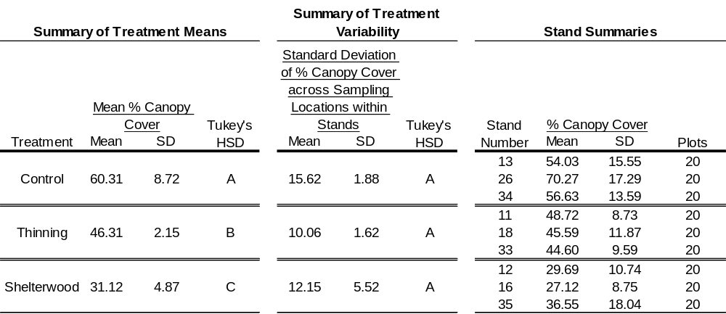

Figure 1-1. Representative canopy images obtained with digital plant canopy imager at three plot locations within stands receiving the indicated treatment.

Instantaneous Measurements
Mean instantaneous percent ambient PAR values differed (P < 0.0001) among treatments and controls (Table 1-2). Measured mean percent ambient PAR was approximately four times greater in thinnings than in controls, and approximately eight times greater in shelterwoods than in controls (Table 1-2). Standard deviation of instantaneous percent ambient PAR, calculated across sampling locations within stands, differed (P = 0.0006) between treatments and controls, but standard deviation of percent ambient PAR did not differ between the two treatments (Table 1-2). Standard deviation of instantaneous percent ambient PAR was more than four times greater in the treatments than in the controls (Table 1-2). Instantaneous percent ambient PAR measurements were averaged across sampling locations to determine stand-level estimates of PAR, while the standard deviation calculated across the sampling locations represented the variability in PAR from location to location within stands (Table 1-2). The means of these values were used to detect differences between treatments in the amount and variability of PAR, respectively (Table 1-2, Summary of Treatment Means and Summary of Treatment Variability).
Table 1-2. Mean instantaneous percent ambient PAR by treatment (n=170, df=167) and standard deviation in instantaneous percent ambient PAR across sampling locations by treatment (n=9, df=6). Means with the same letters are not significantly different based on Tukey’s Honestly Significant Difference (HSD) (alpha = .05).
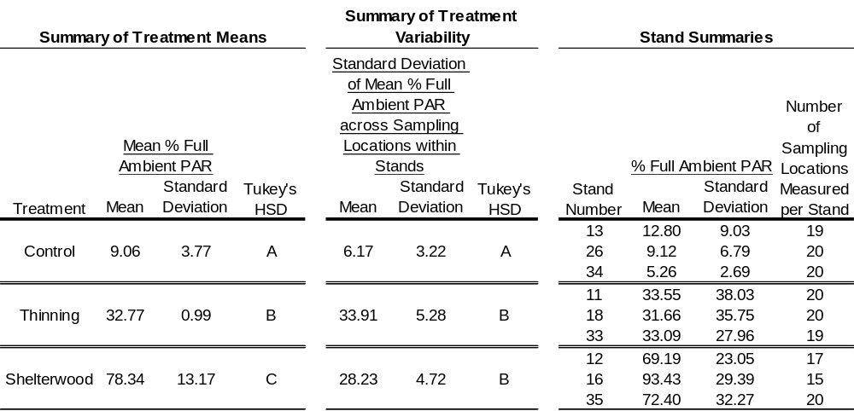

Continuous Measurements
Mean continuous percent ambient PAR differed (P < 0.0001) among treatments and controls. Measured mean values and magnitudes of differences in continuous mean percent ambient PAR across treatments (Table 1-3) were comparable to those for instantaneous percent ambient PAR (Table 1-2). Standard deviation of continuous mean percent ambient PAR calculated over sampling locations within stands did not differ (P= 0.1392) among treatments and controls (Table 1-3). Continuous percent ambient PAR measurements collected at each sampling location were averaged to determine stand-level estimates of PAR, while the standard deviation calculated over sampling locations represented the variability in PAR across stands (Table 1-3). The means of these values were used to detect differences between treatments in the amount and variability of PAR, respectively (Table 1-3 and Table 1-4, Summary of Treatment Means and Summary of Treatment Variability).
Table 1-3. Mean continuous percent ambient PAR by treatment (n=69, df=66) and standard deviation in continuous percent ambient PAR calculated across sampling locations within stands by treatment (n=9, df=6). Means with the same letters are not significantly different based on Tukey’s Honestly Significant Difference (HSD) (alpha = .05).
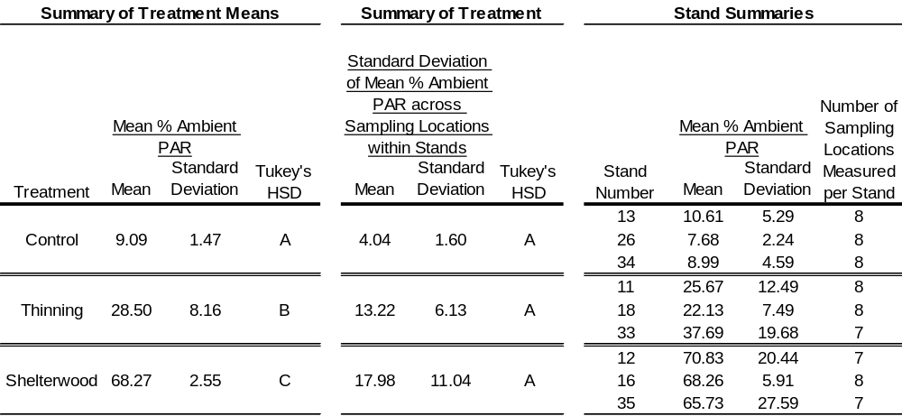
Standard deviation of continuous percent ambient PAR calculated over sampling time periods differed (P < 0.0001) between treatments and controls, but did not differ between treatments (Table 1-4).
Table 1-4. Stand-level mean standard deviation in percent ambient PAR, continuous measurement across sampling period within stands (n=69, df=66). Treatment summaries were calculated from stand summaries. Means with the same letters are not significantly different based on Tukey’s Honestly Significant Difference (HSD) (alpha = .05).
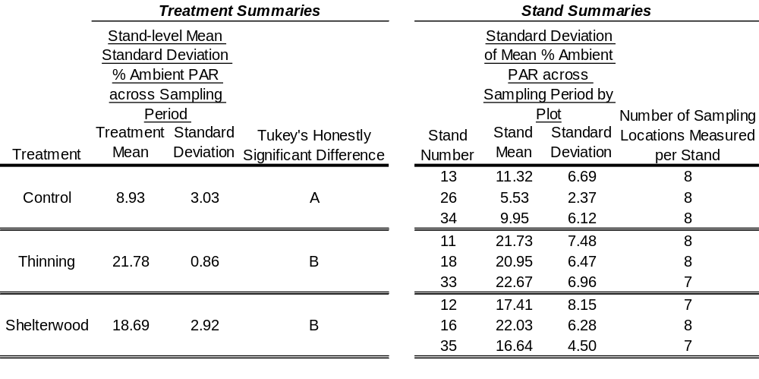

Regression Results
Simple linear regression analysis revealed a statistically significant (P = 0.0002) relationship between instantaneous mean percent ambient PAR and basal area (Figure 1-2). The relationship appeared strongly linear with increases in basal area resulting in decreased light availability at the forest floor. For the highest basal areas observed in this study (those in the uncut control) mean light levels were less than 15% of ambient and as low as 8% in one stand.

Figure 1-2. Scatterplot of stand-level mean percent ambient par (9 stand averages shown were calculated from from 20 instantaneous measurements in each of 9 stands at 3 treatment levels) versus the plot level basal area measured on a 1/10th acre plot at the same location. Line represents a simple linear regression with indicated equation and R². An F-test of the significance of the relationship had a p-value of 0.0002

Regression analysis revealed a significant (P = 0.0008) relationship between instantaneous mean percent ambient PAR and mean percent canopy cover. Mean percent canopy cover explained 81.69% of the variation in instantaneous mean percent ambient PAR (Figure 1-3).

Figure 1-3. Scatterplot of stand-level mean percent ambient par (9 stand averages shown were calculated from from 20 instantaneous measurements in each of 9 stands at 3 treatment levels) from instantaneous measurements) versus the plot level percent canopy cover (calculated from 20 canopy cover measurements in each of 9 stands at 3 treatment levels) measured on a 1/10th acre plot at the same location. Line represents a simple linear regression with indicated equation and R². An F-test of the significance of the relationship had a p-value of 0.0008

Regression analysis of continuous PAR data revealed a significant (P < 0.0001) relationship between mean continuous percent ambient PAR and basal area. Basal area explained 96.97% of the variation in average continuous percent ambient PAR (Figure 1-4).

Figure 1-4. Scatterplot of stand-level mean percent ambient par (9 stand averages shown were calculated from 8 continuous measurements in each of 9 stands at 3 treatment levels) versus the plot level basal area measured on a 1/10th acre plot at the same location. Line represents a simple linear regression with indicated equation and R². An F-test of the significance of the relationship had a p-value of < 0.0001

Regression analysis revealed a significant (P = 0.0002) relationship between continuous mean percent ambient PAR and mean percent canopy cover. Mean percent canopy cover explained 87.61% of the variation in continuous mean percent ambient PAR (Figure 1-5).
Figure 1-5. Scatterplot of stand-level mean percent ambient par (9 stand averages shown were calculated from 8 continuous measurements in each of 9 stands at 3 treatment levels) versus the plot level percent canopy cover (calculated from 20 canopy cover measurements in each of 9 stands at 3 treatment levels) measured on a 1/10th acre plot at the same location. Line represents a simple linear regression with indicated equation and R². An F-test of the significance of the relationship had a p-value of < 0.0002

Regression analysis revealed a significant (P = 0.0004) relationship between canopy cover and basal area. Basal area explained 84.79 % of the variation in mean canopy cover (Figure 1-6).

Figure 1-6. Scatterplot of stand-level mean percent canopy cover (9 stand averages shown were calculated from 20 canopy cover measurements in each of 9 stands at 3 treatment levels) versus the plot level basal area measured on a 1/10th acre plot at the same location. Line represents a simple linear regression with indicated equation and R². An F-test of the significance of the relationship had a p-value of 0.0004.

Discussion and Conclusions
Measurements of both instantaneous and continuous PAR provided an opportunity to compare and contrast patterns in each measure across treatments. Control, thinning (Gingrich B-level), and shelterwood with reserves treatments exhibited comparable measured means and magnitudes of differences across treatments in instantaneous and continuous PAR (Table 1-2 and Table 1-3). Analyses of the data collected one growing season post-treatment indicated differences among treatments in understory PAR. Similar amounts and magnitudes of difference were observed across treatments and controls for both instantaneous (Table 1-2) and continuous measurements (Table 1-3). Long-term continuous measurements, however, are thought to be superior for estimating the seasonal light environment for a given point in a stand (Lieffers et al.1999). Comeau et al. (1998) demonstrated greater strength in relationships between short-term averages and long-term averages calculated across the entire growing season as sampling periods increased from one to three hours. The strength of relationships observed in the study reported here suggests that further investigation of minimum numbers of sample locations and lengths of sample periods warrant further investigation.

Amounts of PAR measured in controls and treated stands represent a snapshot of PAR conditions in time. Substantial changes in the amounts and distribution of PAR accompany the processes of stand development and succession (Beaudet et al. 2004). However, conditions in the first growing season following silvicultural treatments are important in determining the composition and success of regeneration, and setting the future course of succession. Amounts of instantaneous percent ambient PAR measured in shelterwood with reserves and thinning treatments in this study were approximately 1.3 times greater than those measured in northern red oak stands with comparable basal areas in northern Lower Michigan (Buckley et al. 1999). Differences in stand composition and latitude may have contributed to the differences in mean percent ambient PAR reported in these studies.

Standard deviation in PAR measurements within stands was selected as a metric to assess variability in the understory PAR environment within stands. There was no difference in spatial variability (across sampling locations within stands) of continuous PAR between treatments and controls (Table 1-3), but significant differences in spatial variability in instantaneous PAR existed between treatments and controls (Table 1-2). This may have occurred due to the larger number of points (n=20 per stand) sampled for instantaneous PAR than for continuous PAR (n= 7-8 per stand). Comparisons of variability in continuous PAR over time (using standard deviation of mean percent ambient PAR as a measure of variability) indicated results similar to those for instantaneous spatial variability, namely that treatments (which were not significantly different in variability from one another) were significantly more variable than controls. This may have been due to a strong temporal component of variability in the instantaneous percent ambient PAR measurements, due to the time required to walk from one sampling location to another.
In the context of the practice of silviculture, mean PAR values may be suitable for an initial characterization of the understory PAR environment at the stand level, but are not necessarily indicative of the actual PAR environment at any specific location within the stand. Recent studies suggest patchiness associated with regeneration of oaks (e.g., Loftis 2004, Rozas 2003). Understanding this patchiness will enhance precision in creation of target PAR levels at specific locations within stands that are best suited for oak regeneration when planning overstory removal treatments. The spatial arrangement of residuals can have a profound effect on understory light at any specific location within the stand (Palik et al. 2003, Palik et al. 1997). The primary implication of this result for silviculturists is that mean PAR values at the stand-level must be interpreted with care. Stand-level mean understory PAR values, therefore, should be considered only as a general guideline when planning overstory removal treatments. Mean PAR values may not provide a sufficient level of detail regarding light levels at areas of stands where silvicultural treatments are most likely to achieve favorable results. For instance, the patchiness associated with oak regeneration (Loftis 2004) suggests that increased precision with respect to creation of target light levels via silvicultural treatments would be warranted. In this study, mean understory PAR values did not capture the true PAR environment at specific locations within a stand, and PAR values ranging from very low intensities to very high intensities are to be expected at different points within stands, whether those stands are controls or stands that have undergone overstory removal treatments.

Regression results from this PAR regime study suggested that basal area was a better predictor of instantaneous and continuous percent ambient PAR than canopy cover. In contrast, Lhotka and Loewenstein (2006) found that canopy closure, estimated with hemispherical photography, was a better predictor of percent ambient PAR (at 1.25 m above ground) than basal area in mixed-hardwood riparian forests in Georgia. Working in northern red oak stands in Michigan, Buckley et al. (1999) also found that canopy cover, measured with a spherical densiometer, was a better predictor of percent ambient PAR (at 1m above ground) than basal area (measured with a prism).
Some problems with the quality of digital plant canopy imagery used to determine canopy cover were observed and could have affected the accuracy of canopy cover measurements to some degree. Specifically, CID’s digital plant canopy imager CI110 image analysis software program (Version 3.0.2.0, 16 August 2002) was unable to differentiate between darker clouds and actual canopy in some instances, and this was particularly common in imagery obtained within the shelterwood with reserves treatments. This tended to result in overestimations of canopy cover. Nonetheless, reasonably strong relationships were indicated between canopy cover estimates and percent ambient PAR, and between basal area and canopy cover estimates. The stronger relationships between continuous percent ambient PAR and basal area and between continuous percent ambient PAR and canopy cover than the relationships between instantaneous percent ambient PAR and these variables were likely due to the more precise estimates of percent ambient PAR obtained with the continuous measurement method.
Collectively, the regression results suggest that forestry practitioners could use the regression equations presented as a reasonable guide for achieving a given level of canopy cover or mean amount of percent ambient PAR in similar stands with similar treatments within the region. Different relationships would be needed for stands differing in composition and geographic location, as evidenced by differences in the relationships found in this study and those published previously for northern forest types by Buckley et al. (1999).
If documented more extensively over physiographic regions and forest types, mean understory PAR values could prove useful to resource managers. Specific understory PAR target levels could be used as guidelines for achieving post-treatment PAR levels that would be most likely to meet their specific silvicultural objectives. Managers who are attempting to alter PAR levels to favor a species or group of species over other competitors could use more precise PAR averages to assist in predicting the response of vegetation to disturbance.
Literature Cited
Ashton PMS, Berlyn GP 1994. A comparison of leaf physiology and anatomy of quercus (section erythrobalanus-fagaceae) species in different PAR environments. American Journal of Botany 81(5): 589-597.

Balandier P, Sonohat G, Sinoquet H, Varlet-Grancher C, Dumas Y. 2006. Characterisation, prediction and relationships between different wavebands of solar radiation transmitted in the understorey of even-aged oak (Quercus petraea, Q-robur) stands. Trees-Structure and Function 20(3): 363-370.

Baldocchi, D and Collineau, S. 1994. The physical nature of solar radiation in heterogeneous canopies: Spatial and temporal attributes. In Exploitation of Environmental Heterogeneity by Plants Edited by M. M. Caldwell and R. W. Pearcy. Academic Press, Inc, San Diego. pp. 21-71.

Battaglia MA, Mou P, Palik B, Mitchell RJ. 2002. The effect of spatially variable overstory on the understory light environment of an open-canopied longleaf pine forest. Canadian Journal of Forest Research 32(11): 1984-1991.

Beaudet M, Messier C. 2002. Variation in canopy openness and light transmission following selection cutting in northern hardwood stands: an assessment based on hemispherical photographs. Agricultural and Forest Meteorology 110(3): 217-228.

Beaudet M, Messier C, Leduc A. 2004. Understorey light profiles in temperate deciduous forests: recovery process following selection cutting
Journal of Ecology 92(2): 328-338.

Buckley DS, Isebrands JG, Sharik TL. 1999. Practical Field Methods of Estimating Canopy Cover, PAR, and LAI in Michigan Oak and Pine Stands. Northern Journal of Applied Forestry 16(1): 25-32.

Brose P, Van Lear D, Roderick Cooper R. 1999. Using shelterwood harvests and prescribed fire to regenerate oak stands on productive upland sites. Forest Ecology and Management 113: 125-141

Canham CD, Denslow JS, Platt WJ, Runkle JR, Spies TA, White PS. 1990. Light regimes beneath closed canopies and tree-fall gaps in temperate and tropical forests. Canadian Journal of Forest Research 20(5): 620-631.

Clark DB, Clark DA, Rich, PM, Weiss S, Oberbauer SF. 1996. Landscape-scale evaluation of understory light and canopy structures: methods and application in a neotropical lowland rain forest. Canadian Journal of Forest Research 26(5): 747-757.

Clark DA, Clark DB. 1992. Life-history diversity of canopy and emergent trees in a neotropical rain-forest. Ecological Monographs 62: 315-344.

Comeau PG, Gendron F, Letchford T. 1998. A comparison of several methods for estimating light under a paper birch mixedwood stand. Canadian Journal of Forest Research 28 (12): 1843-1850.

Delagrange S, Montpied P, Dreyer E, Messier C, Sinoquet H. 2006. Does shade improve light interception efficiency? A comparison among seedlings from shade-tolerant and -intolerant temperate deciduous tree species New Phytologist 172(2): 293-304.

Hale, SE. 2003. The effect of thinning intensity on the below-canopy light environment in a Sitka spruce plantation. Forest Ecology and Management 179 (1-3): 341-349.

Knapp AK, Smith WK. 1990. Stomatal and photosynthetic responses to variable sunlight. Physiologia Plantarum 78(1): 160-165.

Kohm KA, Jerry F Franklin. 1997. Creating a forestry for the 21st century: the
science of ecosystem management. Island Press, Washington, D.C.

Lieffers VJ, Messier C, Stadt KJ, Gendron F, and Comeau PG. 1999. Predicting and managing light in the understory of boreal forests. Canadian Journal of Forest Research 29(6): 796-811.

Lieffers VJ, Stadt KJ. 1994. Growth of understory picea-glauca, calamagrostis-canadensis, and epilobium-angustifolium in relation to overstory light transmission. Canadian Journal of Forest Research 24(6): 1193-1198.

Lohtka JM, Loewenstein E. 2006. Indirect measures for characterizing light along a gradient of mixed-hardwood riparian forest canopy structures. Forest Ecology and Management 226: 310-318

Loftis DL. 2004 Upland Oak Regeneration and Management, Spetich, Martin A., ed. 2004. Upland oak ecology symposium: history, current conditions, and sustainability.
Gen. Tech. Rep. SRS–73. U.S. Department of Agriculture, Forest Service, Southern Research Station, Asheville, NC, 311 p.

Loftis DL. 1990. A Sheterwood Method for Regenerating Red Oak in the
Southern Appalachians. Forest Science 36 (4): 917-929.

Nicotra AB, Chazdon RL, and Iriarte SVB. 1999. Spatial heterogeneity of light and woody seedling regeneration in tropical wet forests. Ecology 80(6): 1908-1926.

Pacala SW, Canham CD, Silander JA, Kobe RK Jr. 1994. Sapling growth as a function of resources in a north temperate forest. Canadian Journal of Forest Research 24: 2172-2183.

Palik B, Mitchell RJ, Pecot S, Battaglia M, Pu M. 2003. Spatial distribution of overstory retention influences resources and growth of longleaf pine seedlings. Ecological Applications 13(3): 674-686.

Palik BJ, Mitchell RJ, Houseal G, Pederson N. 1997. Effects of canopy structure on resource availability and seedling responses in a longleaf pine ecosystem. Canadian Journal of Forest Research 27: 1458-1464.

Pearcy RW. 1990. Sunflecks and photosynthesis in plant canopies. Annu. Rev. Plant Physiol. Plant Mol. Biol. 41: 421-453.

Ricard JP, Messier C, Delagrange S, Beaudet M. 2003. Do understory saplings respond to both light and below-ground competition? A field experiment in a north-eastern American hardwood forest and a literature review. Annals of Forest Science 60(8): 749-756.

Rozas V. 2003. Regeneration patterns, dendroecology, and forest-use history in an old-growth beech–oak lowland forest in Northern Spain. Forest Ecology and Management 182: 175–194

Smith, DM, Larson BC, Kelty MJ, Ashton PMS. 1997. The practice of silviculture: applied forest ecology, 9th Edition. Wiley and Sons, New York.

Wright EF, Coates KD, Canham CD, Bartemucci P. 1998. Species variability in growth response to light across climatic regions in northwestern British Columbia. Canadian Journal of Forest Research 28(6): 871-886.

Impacts of alternative forest management practices on structural complexity and temporal and spatial variability in light

Abstract
The potentially detrimental loss of forest structural components following silvicultural treatments has received increased attention in recent years. The primary concern is that losses in structural components will ultimately lead to reductions in biodiversity. This concern may be compounded in upland forest ecosystems such as those found in the central United States, which contain myriad species and structure. Amounts and variability in horizontal canopy structure, vertical canopy structure, and understory photosynthetically active radiation (PAR) were quantified in controls and forest areas receiving silvicultural treatments in order to: 1.) Compare amounts of, and variability in, horizontal and vertical canopy structure among untreated control forests and forests receiving shelterwood with reserves and thinning treatments; 2.) Compare amounts of, and spatial and temporal variability in, understory light among untreated control forests and forests receiving shelterwood with reserves and thinning treatments. One year after treatment, data obtained from digital plant canopy imagery and ground-based light detection and ranging (LIDAR) indicated that silvicultural treatments resulted in decreased amounts of horizontal and vertical canopy structure. However, these treatments substantially increased variability in understory PAR. Amounts and variability of structure and amounts and variability of understory PAR were not well correlated, suggesting that losses of structural elements do not lead to losses of all components of habitat heterogeneity. The full consequences of trading amounts of canopy structure for amounts of PAR, or one type of complexity for another are poorly understood, however, and warrant further investigation.

Introduction
The potentially detrimental effects of simplifying forest structure through the implementation of silvicultural practices has received increased attention in recent years (Atwell et al. 2008, Camprodon and Brotons 2006, Domke et al. 2007, Goodburn and Lorimer 1998, Ishii et al. 2004, Melick et al. 2007, Spies 1997). The primary concern is that reduced representation of certain age and diameter classes, and less complex understory and overstory structure may reduce heterogeneity in the availability of resources such as light and the overall diversity of habitats for plants and animals. This, in turn, may lead to reductions in species diversity. Working in Costa Rican rainforest, Nicotra et al. (1999) compared understory light availability in old-growth, second-growth and selectively logged stands. They concluded that second-growth stands exhibited less heterogeneity, with respect to variation in available understory light, than old-growth or selectively harvested stands. Similar conclusions were drawn for structure in a comparison of old-growth, unmanaged second-growth, and managed northern hardwood forests in Michigan, in which the least structural heterogeneity occurred in unmanaged second growth (Crow et al. 2002). Linkages between the overstory and the understory herbaceous community were investigated by Gilliam et al. (1995). The authors concluded a mutual exchange of influence between overstory and understory, each having a pronounced effect on the other (Gilliam et al. 1995).
Many studies of post-harvest canopy heterogeneity (e.g., Jackson et al. 2006, Melick et al. 2007, Palik et al. 2002) have focused on horizontal (gap vs. non-gap) structure, whereas relatively few (e.g., Camprodon and Brotons 2006) have addressed both vertical and horizontal structure. Both vertical and horizontal structure influence understory light, and both dimensions of structure can be altered with silvicultural practices. Increases in heterogeneity of understory light have been documented following the creation of gaps through silvicultural treatments (Jackson et al. 2006), but differences in vertical structure and effects of vertical structure on understory light are less well-documented. One reason for this is that vertical structure can be efficiently quantified near the ground with devices such as cover boards, but it is difficult to quantify in the midstory and overstory with traditional techniques. Another is that traditional photography with fish-eye lenses, digital plant canopy imagers, and hand-held densiometers primarily capture variability in horizontal structure. Further investigations of the importance of vertical structure and methods for quantifying vertical structure are warranted due to its potentially important influence on light and other microsite characteristics.
Structural changes resulting from silvicultural clearcutting, or conversion of a naturally regenerated uneven-aged hardwood stand to an artificially regenerated, even-aged conifer stand are quite obvious, but the effects of less intense silvicultural practices on forest structure are less straightforward. Further, changes in the distribution of foliage, branches and stems are easily detected, but related changes in the spatial and temporal patterns in microclimate factors and the distribution of resources such as light are much more subtle and difficult to infer. Spatial variability and temporal variability both contribute to level of heterogeneity in understory light regimes. Studies focused on spatial variability in light (e.g., Canham 1988, Canham et al. 1990, Jackson et al. 2006, Palik et al 2003, Runkle 1981) are far more common than those addressing the temporal distribution of light (e.g., Beaudet et al. 2004, Gendron et al. 2001, Messier and Puttonen 1995).
A collaborative research project entitled “Maintaining Habitat Diversity, Sustaining Oak Systems, and Reducing Risk of Mortality from Gypsy Moth and Oak Decline on the Daniel Boone National Forest: Silvicultural Approaches and Their Operational Dimensions” was initiated during the summer of 2006 by the United States Forest Service (USFS). The treatments included: 1) shelterwood with reserves with10-15 ft²/ac (2.3-3.4 m²/ha) residual basal area to create a two-aged stand); 2) specialized shelterwood with 60-75 ft²/ac (13.8-17.2 m²/ha) basal area with herbicide used to reduce stand density beneath the overstory; 3) thinning to the B-level of the Gingrich Stocking Chart (marking based on tree vigor and crown class); and 4) oak woodland (30-50 ft²/ac basal area maintained with prescribed burning). Control stands receiving no treatment were also included in the design. The controls and treatments were each replicated six times. This project provided an excellent opportunity to pursue the research objectives outlined in the following section.

Objectives
The objectives of this research were to:
- Compare amounts of, and variability in, horizontal and vertical canopy structure among untreated control forests and forests receiving shelterwood with reserves and thinning treatments.
- Compare amounts of, and spatial and temporal variability in, understory light among untreated control forests and forests receiving shelterwood with reserves and thinning treatments.

Methods
The USFS project site is located in Laurel County in southeastern Kentucky, near London on the London Ranger District of the Daniel Boone National Forest, (37° 3’ 41” N, 84° 11’ 10” W) in upland oak forest type, predominantly white oak (Quercus alba), scarlet oak (Q. coccinea), black oak (Q. velutina), and red maple (Acer rubrum), typical of the Cumberland Plateau. Soils of the USFS project area are predominantly Shelocta-Latham and Whitley silt loams. Site indices for upland oaks are 65-80 ft (19.8-24.4 m) on sub-mesic sites and 50-65 ft (15.2-19.8 m) on sub-xeric sites (Smalley 1986). The treatments incorporated in the light regime study described here included shelterwood with reserves, 10-15 ft²/ac (2.3-3.4 m²/ha) residual basal area to create a two-aged stand) and thinning to the B-level of the Gingrich Stocking Chart (marking based on tree vigor and crown class) treatments. The remaining two treatments planned for the overall USFS project had not been initiated at the time this light regime study was implemented, and thus were not incorporated into the experimental design. The measurements described below were collected in three stands representing each of the two treatments and three control stands receiving no treatment. Each stand contains twenty 0.1 acre (0.04 ha) vegetation measurement plots systematically arranged on a 132 ft (40 m) spacing to accommodate the size and shape of each stand (Appendix Figures A-, A-2, A-3, A-4 and A-5). These points were established by USFS crews prior to treatment implementation. All measurements were completed during the first full growing season after completion of silvicultural treatment.

Canopy Cover
Digital plant canopy imagery was collected at each 0.1 ac (0.04 ha) plot center in all stands sampled, using a CI-110 Digital Plant Canopy Imager (CID Bio-Science, Inc., Camas, WA, USA), and a laptop computer. A single digital plant canopy image was acquired at each of the 20 sample locations in each stand. The imaging device was placed upon a tripod, leveled, oriented south (with a compass), and positioned approximately 3 ft (1 m) above the plot center. Images were collected without obstruction of the imaging device (i.e. the researcher was not included in the image). A laptop computer (Microsoft Windows XP Operating System) utilizing the CI-110’s image acquisition software, stored collected imagery. Canopy imagery was acquired during August and September of 2008 and 2009. Images were collected at various times during the day in an effort to reduce unfavorable imaging effects such as glare, vignetting, and overexposure. These problems were typically encountered in the Shelterwood with Reserves treatment. Imagery was analyzed, and canopy cover estimates were generated with CID’s CI110 image analysis software (Version 3.0.2.0, 16 August 2002). Stand-level mean percent canopy cover was calculated by averaging the 20 canopy cover measurements collected at sampling locations within each stand. Percent canopy cover was a measure of the area above the digital plant canopy imager that was not open sky. The sample standard deviation in percent canopy cover was calculated in a similar fashion.

Basal Area
Basal area was calculated from diameter at breast height (dbh) measurements of tally trees measured during a pre-treatment inventory of the 0.1 ac sample plots. Mean basal area was calculated over all 20 plots in each stand. The sample standard deviation was calculated similarly.

Vertical Structure
For the purposes of this study, structure (both vertical and horizontal), refers to the distribution and arrangement of the above-ground physical components of the forest. These structural components may be of natural and anthropic origins. Structure includes physical components associated with forests, including, but not limited to, biota. Examples of structure include: woody and non-woody plant material, fauna and their nesting structures (e.g. nests of squirrels, insects, and birds), and inorganic material (e.g. vinyl flagging, wind deposited plastic shopping bags, balloons (helium-filled and/or formerly helium-filled varieties), and sundry offal of human enterprise.
Terrestrial Light Detection and Ranging (LIDAR) data was collected on October 30-31, 2008. A Riegl 3D terrestrial laser scanner, model Z390i (RIEGL Laser Measurement Systems GmbH, Riedenburgstraße 48, A-3580 Horn, Austria) was used to collect ground based LIDAR data in one stand for each treatment and control. Two plots were scanned in each stand. Each plot was scanned from four positions: plot center, and three positions located 10m away from plot center at azimuths of 0°, 120°, and 240°. Two scans were conducted at each position (2 plots x 4 positions x 2 scans per position = 16 scans per stand). All scans of a plot were registered to a common coordinate system with Riegl RiScan Pro. The scan extents were 360º x 80º. One scan was taken with the 360º extent in the horizontal plane and one scan with the 360º extent in the vertical plane, to capture a complete spherical view at each position. The resolution was 0.012º between pulses, resulting in approximately 2,000,000 pulses obtained per scan, and a total of 16 million pulses obtained per plot. Plant area index (m² of leaf area plus area of living and nonliving wood and other matter per m² of ground) was estimated from registered plot data in 0.5 m vertical slices. All data within a vertical cylinder with a radius of 10 m, centered at plot center were analyzed. Plant area index was estimated using the number of loser pulses passing through and intercepted withi each 0.5 m cross-section of the cylinder using the methoddescribed in Henning and Radtke ( 2006).

Ambient Light Measurements
Ambient PAR measurements were collected with a LI-COR LI-1400 Data Logger and a LI-COR LI-190 Quantum Sensor mounted on a tripod. The tripod-mounted quantum sensor and logger assembly was placed in either of two hayfields that were proximate to stands where understory PAR sampling was conducted, leveled, and in a location that was exposed to maximum available ambient sunlight (ambient PAR). The sensor was never shaded by trees or other obstructions during logging of ambient PAR data. The LI-1400 data logger used an automated collection routine that enabled starting and stopping data collection at specific times. The instrument was usually set up early in the mornings, and data collection started automatically at the programmed time (typically about 9 AM Eastern Daylight Savings Time. To avoid time drift of the individual instrument’s internal clocks and time stamps, the LI-1400 Data Logger and the Decagon Ceptometer(s) were synchronized each morning prior to data collection. This ensured that a minute by minute comparison of PAR data would be possible during data analysis. Percent ambient PAR calculations for treatment and control sample locations were calculated by comparing PAR values recorded at similar times (at the same minute of the day) by the Ceptometer(s) within the sampled stands, with PAR data recorded by the ambient PAR data logging assembly (the LI-1400 and tripod-mounted LI-190 quantum sensor in the hay field). This ratio provides an estimate of the photosynthetically available light in the understory, and also provides an index of canopy light interception by the overstory.
Correction factors for individual Ceptometers allowed more accurate comparisons with the data collected by the ambient data logging assembly. Side by side simultaneous data collection beneath a shade cloth (a single layer and two layers of 50% shade cloth) and unshaded (i.e. exposed to maximum available ambient PAR (ambient PAR), were collected during the last week of October and first week of November in 2008 and 2009, after field work was completed. Regression was used to determine the correction factor for each instrument, relative to the standard (the LI-1400 and LI-190 data logger assembly). The correction factors and regression variables are included in the Apppendix, Table A-1.

Instantaneous Light Measurements
All instantaneous understory PAR measurements were collected with a PAR-80 Ceptometer (Decagon Devices, Inc., Pullman, WA. USA) because it was capable of recording specific details related to each sample location measurement. The Decagon Ceptometers use a linear array of 80 quantum sensors. The PAR-80 has a keypad that enables the user to enter pertinent plot details, whereas the later LP-80 Ceptometer (also Decagon Devices) lacks this capability. Both the PAR-80 and LP-80 Ceptometers measure photosynthetically active radiation (PAR), which is the 400-700 nm portion of the electromagnetic spectrum utilized by plants for photosynthesis. PAR is measured in micromoles per square meter per second (μmol m⁻² s⁻¹). Plot centers of 20 systematically arranged forest inventory plots, established by USFS crews before treatment implementation, were sampled in each of 3 stands per each of three treatments (n = 3 treatments x 3 repetitions per treatments x 20 plots per rep = 180 measurements) collected during the summers of 2008 and 2009, on the Daniel Boone National Forest, in Laurel County, Kentucky. Each stand (20 measurements per stand) was measured once. A single instantaneous understory PAR reading was recorded at each sample location. PAR measurements were centered on solar noon. Measurements were typically collected within the hour preceding and the hour after solar noon. The instrument (PAR-80 Ceptometer) was held level at waist height (at approximately 3 feet (1 meter) above the ground), with the PAR sensor array centered over the sample plot. The Ceptometer was pointed south, (oriented by compass), and leveled for each measurement. The researcher traveled afoot to each sampling location. Mean instantaneous percent ambient PAR was calculated over all 20 plots in each stand. The sample standard deviation in instantaneous percent ambient PAR was used as a metric of spatial variability of instantaneous PAR measurements within stands. Stand-level spatial variability was quantified as the standard deviation of the plot-level measurements of percent ambient PAR.
Data from 175 of 180 plots were utilized for analysis. Outliers greater than or equal to 110% of ambient PAR were discarded. Outliers were defined as Ceptometer measurements that were equal to, or greater than, 110% of ambient PAR value collected by the ambient PAR recording assembly (LI-COR LI-1400 data recorder and tripod-mounted LI-190 quantum sensor). Correction factors were generated for each Decagon Ceptometer to enable comparison of understory PAR data, collected with Ceptometers(s), to the ambient PAR data collected with the LI-COR LI-1400 data logger (see Appendix, Table A-1). Correction factors for the Decagon Ceptometers ranged from approximately 97% to 115%, with the mean being approximately 110% of ambient. The correction factors were generated after side by side simultaneous PAR collection with all instruments, beneath two layers of 50% shade cloth, and ambient (uncovered) conditions during Octobers of 2008 and 2009, following completion of fieldwork on the Daniel Boone National Forest. The correction factor assessment measurements were conducted at Fulton Bottoms Rugby Field, on the campus of the University of Tennessee, Knoxville, in October, 2008, and at the University of Tennessee Arboretum in Oak Ridge, Tennessee, and at the University of Tennessee Agricultural Experiment Station in Knoxville, TN, in October 2009. Microsoft Excel 2007 and Access 2007 were utilized to compile and match all data, and to generate regression lines and equations for PAR measurements, basal area, and canopy cover.

Continuous Light Measurements
Continuous PAR measurements were collected at 7-8 plots in each stand (data from a total of 69 points were utilized in the analysis). Originally, collection of continuous PAR measurements at 8 points per stand was planned, but equipment malfunction reduced the number of points that were sampled during the fieldwork. The points of continuous PAR measurements corresponded with the points where instantaneous PAR measurements were collected. Outliers greater than or equal to 110% of ambient PAR were discarded, as they were for the instantaneous PAR measurements previously described. Therefore, 965 of 27484 total data points (approximately 3.5%) were discarded before analysis. Ceptometers were placed at the plot centers on tripods, oriented south (with compass), leveled and centered above the plot center pin on tripods. Otherwise methods were similar to those used for instantaneous PAR measurement collection.
For analysis, continuous PAR measurement over a 400 minute period, (200 minutes either side of approximate average solar noon, approximately 1:36 pm or 816 minutes into the day) during the data collection period were compared. 95 % of all continuous PAR measurements were collected during this time period (approximately 10:26 am to 4:56 pm EDST). The unattended instruments recorded PAR measurements once each minute during the collection period. The LI-1400 data logger also recorded ambient PAR data once each minute. Eight plot centers of continuous PAR measurement points were chosen from among the 20 possible plot centers in each stand sampled. Plot centers of continuous PAR measurement plots were at least 1 chain from painted and flagged stand boundaries, and were typically not placed directly adjacent to other plots chosen for continuous data collection. Plots were not equally distributed throughout each stand, primarily due to variation in topography within some of the stands. The plots were chosen from a stand map of plot centers, in an attempt to provide greatest uniformity of spatial coverage of the stand. Plot centers located in areas of stands that were very narrow were also avoided during layout of continuous PAR measurement locations.
Mean continuous percent ambient PAR was calculated over all measurements collected at a specific plot. These measurements, taken once each minute during the 400 minute sampling period, provided an estimate of continuous PAR for each plot. The PAR values collected at each of the plots (n=69) were used in conjunction with ANOVA to investigate differences among treatments in continuous percent ambient PAR. Mean standard deviation, across plots within stands (spatial variability) and over time (temporal variability, across the 400 minute plot sampling period) was used as a metric of variability in continuous PAR measurements.
In this study, spatial variability of continuous PAR refers to variation of continuous PAR measurements within a stand. Stand-level spatial variability was quantified as the standard deviation of the plot-level measurements of percent ambient PAR. The instantaneous plot-level measurements were a single measurement at each plot. The continuous plot-level measurements were the average of instantaneous measurements taken at each minute during the 400 minute sampling period centered on solar noon.
Hereafter, temporal variability of continuous PAR refers to the average variability of PAR within a stand across the sampling period. Stand-level temporal variability was quantified as the mean of plot-level measurements of temporal variability. The plot-level measurements of temporal variability were the standard deviation of instantaneous measurements taken at each minute during the 400 minute sampling period centered on solar noon. In an effort to avoid researcher bias, points to be sampled continuously (and alternative points) were chosen from the stand sample point map before commencement of sampling, and before sallying forth to the pre-chosen individual sample locations in the stand. This seemed like a practical way to limit bias during field work. In an attempt to evenly distribute the continuously sampled points throughout the stand, continuous PAR sample locations were chosen based upon two criteria: each sample point was at least 1 chain from the stand boundary, and where possible, was not located adjacent to another continuously sampled point.

Statistical Analyses
All data analyses were conducted in SAS 9.2 (SAS Institute Inc., Cary, NC, USA.). One-way Analysis of Variance (ANOVA), conducted with the General Linear Models Procedure was utilized to analyze differences among treatments in mean values for canopy cover, instantaneous percent ambient PAR, and continuous percent ambient PAR, and also differences among treatments in sample standard deviations calculated for these variables. ANOVA models appropriate for a completely randomized design were utilized. The Univariate Procedure was used to examine model assumptions, and no transformations were necessary. Tukey’s Honestly Significant Difference (HSD) was used for all pairwise comparisons. Alpha was set to 0.05 for all statistical analyses and comparisons.

Results

Canopy Cover
Average percent canopy cover differed (P < 0.0001) among treatments and controls (Table 2-1, Figure 1-1). Mean canopy cover in the controls was approximately two times greater than that in the shelterwood (Table 2-1). Stand level variability (standard deviation among plots) in canopy cover did not differ (P = 0.2246) among treatments or controls (Table 2-1). Plot-level percent canopy cover measurements were averaged to determine stand-level estimates of canopy cover. The standard deviation among plots represented the variability in canopy cover across stands (Table 2-1). The treatment means of these values were used to detect differences between treatments in the stand-level amount and variability of canopy cover, respectively (Table 2-1, Summary of Treatment Means and Summary of Treatment Variability).
Table 2-1. Mean percent canopy cover (n=180, df=177) and standard deviation (SD,used as a metric of variability in canopy cover) by treatment (n=9, df=6). Means with the same letters are not significantly different based on Tukey’s Honestly Significant Difference (HSD) (alpha = .05).

Figure 2-1. Representative canopy images obtained with digital plant canopy imager at three plot locations within stands receiving the indicated treatment.

Vertical Structure (LIDAR)
In general, the control plots had the greatest amount of cumulative plant area (Figure 2-2). An exception to this was the amount of cumulative plant area in the Gingrich B-level Thinning - plot 3. However, much of this plant area was concentrated in the crown area of one or two tall trees (Figure 2-3). The fact that the standard deviation of plant area across 0.5 m vertical layers (Table 2-2) were similar across all treatments even though the amount PAI was greater in the control and thinning suggests the vertical structure was more evenly distributed throughout the depth of the canopy in the uncut control. This fact is further supported by the higher coefficient of variation seen among the 0.5 m layer in the treated stands than in the control (Table 2-2). The shelterwood with reserves treatment plots sampled had the least amount of cumulative plant area, and this was mainly concentrated above 20 m (Figure 2-2). Below 20 m, the uncut control plots sampled had the greatest amount of cumulative plant area. Images generated with the LIDAR data, and the digital plant canopy imagery from the plot centers where LIDAR data was collected, further illustrate the vertical structural differences between treatments and controls (Figure 2-3 and Figure 2-4).
Table 2-2. Mean Plant Area Index (PAI) and standard deviation and coefficient of variation of PAI calculated over 0.5m slices of the full vertical profile, by treatment, for the plots sampled with LIDAR.
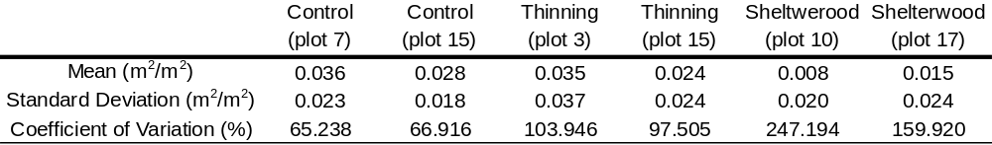
Figure 2-2. Cumulative plant area index by height above the ground obtained from terrestrial LiDAR data using the method described in Henning and Radtke 2006 for two plots in each of the indicated treatments.

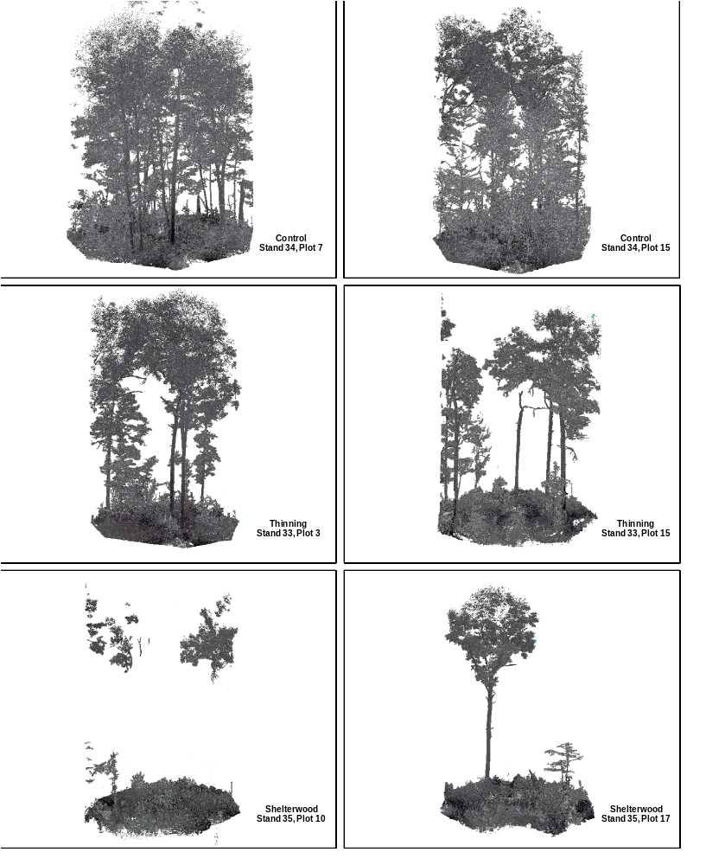
Figure 2-3. Three-dimensional scatterplots of terrestrial lidar interceptions created from six co-registerd scans taken on each of the indicated plots.
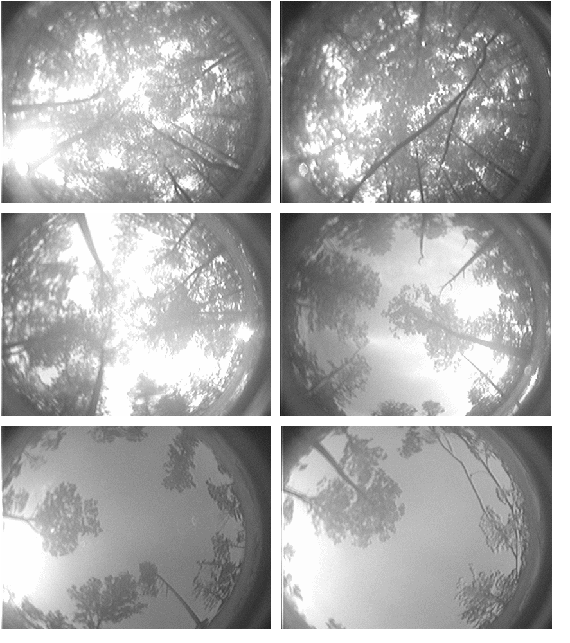
Figure 2-4. Digital plant canopy imagery from LIDAR plot centers, with associated stand and plot numbers, upper left: control stand 34 plot 7, upper right: control stand 34 plot 15, middle left: thinning stand 33 plot 3, middle right: thinning stand 33 plot15, lower left: shelterwood stand 35 plot 10, lower right: stand 35 plot17.

Instantaneous Measurements
Mean instantaneous percent ambient PAR values differed (P < 0.0001) among treatments and controls (Table 2-3). Measured mean percent ambient PAR was approximately four times greater in thinnings than in controls, and approximately eight times greater in shelterwoods than in controls (Table 2-3). Standard deviation of instantaneous percent ambient PAR, calculated across sampling locations within stands, differed (P = 0.0006) between treatments and controls, but standard deviation of percent ambient PAR did not differ between the two treatments (Table 2-3). Standard deviation of instantaneous percent ambient PAR was more than four times greater in the treatments than in the controls (Table 2-3). Instantaneous percent ambient PAR measurements were averaged across sampling locations to determine stand-level estimates of PAR, while the standard deviation calculated across the sampling locations represented the variability in PAR from location to location within stands (Table 2-3). The means of these values were used to detect differences between treatments in the amount and variability of PAR, respectively (Table 2-3, Summary of Treatment Means and Summary of Treatment Variability).
Table 2-3. Mean instantaneous percent ambient PAR by treatment (n=170, df=167) and standard deviation in instantaneous percent ambient PAR across sampling locations by treatment (n=9, df=6). Means with the same letters are not significantly different based on Tukey’s Honestly Significant Difference (HSD) (alpha = .05).

Continuous Measurements
Mean continuous percent ambient PAR differed (P < 0.0001) among treatments and controls. Measured mean values and magnitudes of differences in continuous mean percent ambient PAR across treatments (Table 2-4) were comparable to those for instantaneous percent ambient PAR (Table 2-3). Standard deviation of continuous mean percent ambient PAR calculated over sampling locations within stands did not differ (P= 0.1392) among treatments and controls (Table 2-4). Continuous percent ambient PAR measurements collected at each sampling location were averaged to determine stand-level estimates of PAR, while the standard deviation calculated over sampling locations represented the variability in PAR across stands (Table 2-4). The means of these values were used to detect differences between treatments in the amount and variability of PAR, respectively (Table 2-4 and Table 2-5, Summary of Treatment Means and Summary of Treatment Variability).
Table 2-4. Mean continuous percent ambient PAR by treatment (n=69, df=66) and standard deviation in continuous percent ambient PAR calculated across sampling locations within stands by treatment (n=9, df=6). Means with the same letters are not significantly different based on Tukey’s Honestly Significant Difference (HSD) (alpha = .05).
Standard deviation of continuous percent ambient PAR calculated over sampling time periods differed (P < 0.0001) between treatments and controls, but did not differ between treatments (Table 2-5).
Table 2-5. Stand-level mean standard deviation in percent ambient PAR, continuous measurement across sampling period within stands (n=69, df=66). Treatment summaries were calculated from stand summaries. Means with the same letters are not significantly different based on Tukey’s Honestly Significant Difference (HSD) (alpha = .05).

Discussion and Conclusions
In this study, digital plant canopy imagery collected one year post-treatment was used to estimate canopy cover, which is an index of horizontal canopy structure. The orientation of the camera, leveled, and pointed skyward, provided estimates of the amount and spatial arrangement of the structural components of the overstory such as leaves, branches, and limbs. The hemispherical photography utilized a fish-eye lens, so distortion of the canopy increased toward the periphery of the images. The forest canopy is a three dimensional space, and photographic imagery is a two-dimensional representation of that three-dimensional reality. Like all measurements, it is an approximation of reality. The skyward orientation of the camera, however, predominantly captured amounts and variability of canopy structure in the horizontal plane. Tree boles were also included in the images and are generally a more vertical component of overstory structure, but they also contribute to horizontal structure due to their cross-sectional area. Plant area index (measured in m² of leaf area plus area of living and nonliving wood and other matter per m² on the ground) was calculated from LIDAR data collected one year after treatment, and was used as an index of vertical canopy structure.
The removal of canopy trees in shelterwood and thinning treatments had a clear impact on amounts of horizontal (Table 2-1, Figure 2-1) and vertical (Table 2-2, Figures 2-2 and 2-3) canopy structure. Mean measured canopy cover was least in the shelterwood treatment, greatest in the control, and intermediate in the thinning treatment. Relative differences in plant area index across treatments and controls were comparable (Table 2-2, Figures 2-2 and 2-3). Cumulative plant area index was relatively similar across treatments and controls up to a height of about 5 m above the ground (Figures 2-2 and 2-3). There was very little vertical structure in the shelterwood with reserves treatment between approximately 5 and 20 m above the ground (Figures 2-2 and 2-3). Above 20 m, cumulative plant area index in the shelterwood with reserves treatment increased to approximately 0.4 - 0.9 m²/m² (Figure 2-2). The shelterwood with reserves cumulative plant area index was driven mainly by the crowns of the residual overstory trees (Figure 2-3). The thinning (Gingrich B-level) was similar to the shelterwood up to approximately 10 m above ground, then diverged from approximately 0.3 to 2.2 m²/m² (Figure 2-2). The controls had greater cumulative plant area index (0.25 – 0.75 m²/m²) than the treatments between approximately 5 and 20 m above the ground (Figure 2-2). Previous research suggests that the consequences of reductions in amounts of horizontal and vertical canopy structure for wildlife species will be mixed, depending on a host of factors ranging from site productivity to preferred characteristics and locations of roost trees (Adams et al. 2009, Atwell et al. 2008, Hartman et al. 2009, Johnson et al. 2009). Lhotka and Loewenstein (2008) measured canopy heights above underplanted seedlings in an attempt to quantify effects of amounts of vertical canopy structure on tree seedlings. Their results suggest that canopy height above seedlings may be an important factor in seedling growth and survival.
In contrast to the strong impacts of the shelterwood and thinning treatments on amounts of horizontal and vertical canopy structure, and variability in these structural elements did not differ across treatments (Tables 2-1 and 2-2), at least at the scale of locations for sampling canopy cover across stands and 0.5 m segments of the vertical canopy profile. It is possible that different results could have been obtained at smaller or larger scales of sampling than those utilized in this study. Estimates of mean differences in variability were calculated across sampling locations within forest stands in this study because managers typically manage forests at the scale of stands. Plots were arranged on an approximately 2 chain by 2 chain (20 m x 20 m) grid. Due to differences in the scale of habitats utilized by different plant and animal species, additional research on the effects of treatments on structural heterogeneity across a broader spectrum of scales than those addressed in this study would be instructive.
Due to the large, hemispheric area captured by the digital plant canopy imager, some overlap between adjacent samples likely occurred and may have reduced calculated standard deviation of canopy cover. Bunnell and Vales (1990) found that wider angles of view resulted in decreased standard deviation of mean crown completeness, especially with increased heights to the base of live crowns. Lhotka and Loewenstein (2006) also found that 180º hemispherical photography, similar to that used in this study, provided the least favorable estimate of understory light transmittance, relative to smaller angles of view.
Similar to the results for amounts of horizontal and vertical structure, results for instantaneous and continuous percent full ambient PAR suggest a large impact of treatments on amounts of understory PAR (Tables 2-3 and 2-4). This result is consistent with the removal of foliage, branches, limbs, and boles that would intercept light. The large amounts of understory PAR in the thinning and shelterwood treatments would promote the establishment and growth of moderately shade-tolerant and shade- intolerant plants (Burns and Honkala 1990). The influx of moderately shade-tolerant and shade-intolerant plant species, coupled with reductions in the level of plant stress induced by low light levels, should increase plant diversity (Barnes et al. 1998) in these shelterwood and thinning treatments.
Although there were no statistically significant differences between the two treatments, results for spatial variability in instantaneous PAR suggested that treatments produced magnitudes of spatial variability different from that in the control (Table 2-3). Changes in the species composition of canopy trees from location to location likely contributed to spatial variability in instantaneous PAR in control and treated stands alike (Canham et al. 1994), but the canopy gaps created during implementation of the thinning and shelterwood treatments likely contributed a great deal to the differences in the spatial variability of understory PAR between each treatment and the control. No statistically significant differences were found among treatments and controls in spatial variability of continuous understory PAR (Table 2-4), but the threefold to fourfold increases in mean standard deviation in the treatments over that for the control could be biologically significant.
The lack of statistically significant differences among treatments in the spatial variability of continuous PAR is probably attributable to a lesser number of points used for continuous sampling within each stand (7-8) as compared to the 15-20 points per stand used for spatial analysis of instantaneous understory PAR samples. An increased number of continuous sample locations may have more accurately estimated the spatial variation in mean continuous percent full ambient PAR in these stands. Limitations imposed by time and equipment, coupled with challenges presented by utilizing two models of Ceptometers (PAR-80 and LP-80) within stands while collecting continuous understory PAR data, precluded sampling of a greater number of continuous sample locations.
Significant differences in the variability of continuous understory PAR across the 400 minute sampling period occurred between the control and each treatment (Table 2-5). Temporal changes in understory PAR are related to factors such as solar elevation angle and cloud cover in the short term, and changes in leaf development, leaf pigmentation, and changes in canopy structure over the long term (Baldocchi et al. 1986, Domke et al. 2007, and Gendron et al. 2001). It can be argued that the differences among treatments in the variability of continuous percent full ambient PAR across the 400 minute sampling period observed in this study were primarily due to interactions between the different canopy structures present in each treatment and diurnal changes in solar elevation. Changes in cloud cover and other atmospheric conditions affecting incoming PAR were also observed over the 400 minute sampling periods, but analysis of percent full ambient PAR rather than raw PAR should have addressed these additional sources of temporal variability.
Changes in the canopy structure and variability observed in this study over greater time periods are likely as births, deaths, growth, and regeneration processes continue following treatment implementation. The persistence of the openings created is critical for successful regeneration of desired species, and inhibition of their competitors. Domke, et al. (2007) studied the rate of change of canopy gaps created after harvesting. In their chronosequence study in northern hardwood forests of Ontario, Canada, Domke et al. (2007) found that stands with the greatest amount of overstory removal, and initially the greatest amount of light, had, within 10 years, become stands with the least amount of light, when compared to other stands with less initial overstory removal. In the forests of the Cumberland Plateau, which have longer growing seasons, this type of reversal of relative understory light abundance may occur at an even faster rate. Research in tropical rainforests (Ediriweera et al. 2008, Nicotra et al. 1999) suggests that amounts of understory light are not different between second- growth and old-growth rainforests, but that the variability in understory light increased in old-growth due to the development of greater canopy height and complexity of the canopy strata over time.
Collectively, differences in the patterns of amounts of horizontal and vertical structure versus variability in horizontal and vertical structure across treatments suggest that amounts of canopy cover and plant area are not necessarily coupled with variability in the distribution of these structural components. Similarly, patterns in amounts of understory percent full ambient PAR are not necessarily coupled with variability in understory percent full ambient PAR. As a result, losses in the amounts of horizontal and vertical canopy structure brought about by the treatments investigated did not lead to simplification or losses of heterogeneity in either components of canopy structure or understory PAR in the central hardwood forests studied.
In ecosystem management, preservation of structural elements is thought to be of paramount importance in sustaining biodiversity and ecosystem functions (Atwell et al. 2008, Palik et al. 2003, Spies 1997). Results for this study conducted in central hardwood forests suggest that partial reductions in the amount of horizontal and vertical canopy structure brought about by the silvicultural treatments implemented are accompanied by increases in spatial and temporal variability in understory percent ambient PAR, which would tend to contribute to greater diversity in understory microsites for trees and other plants. Working in conifer forests in the Pacific Northwest, Ares et al. (2010) documented increases in understory plant richness after implementation of thinning. Complete rather than partial losses of canopy structure could conceivably eliminate heterogeneity in structure and PAR, but cases in which natural disturbances and forest management practices lead to total elimination of all canopy structure are limited. Although silvicultural clearcutting, the most intensive regeneration technique, greatly reduces the number of tree stems down to a specified diameter, there are still residual stems and herbaceous vegetation near the ground that modify the light environment. Few trees were left in the shelterwood with reserves treatment, but standard deviation of instantaneous PAR calculated over sampling locations and standard deviation of continuous PAR calculated over sampling periods were quite high, and differed from standard deviations calculated over sampling locations and periods in the control (Tables 2-3 and 2-5). It was noted during data collection that the response of herbaceous vegetation was most pronounced in the shelterwood treatments. By the end of the growing season, pokeweed (Phytolacca americana), pilewort (Erechtites hieracifolia), and horseweed (Erigeron canadensis) (all tall coarse prolific weedy herbs, that respond quickly to changes in available light) predominated, often to heights of 5-6 ft (2 m) or more.
Due to the relationships between incoming solar radiation and soil temperatures, soil moisture, air temperatures, and relative humidity, high variability in PAR in the treatments should also lead to increases in the diversity of understory microsites for animals. Clearly, the loss of various components of structure such as snags, particular bark characteristics of canopy trees, and certain crown characteristics could result in losses of food and cover for certain insect, mammal, and bird species, but the partial reductions in vertical and horizontal canopy structure accompanying the silvicultural treatments studied need not result in a net loss of biodiversity (Ares et al. 2010, McWethy et al. 2010). The full consequences of trading amounts of canopy structure for amounts of PAR, or one type of complexity for another are poorly understood, however, and warrant further investigation.

Literature Cited

Ares A, Neil AR, Puettmann KJ. 2010. Understory abundance, species diversity and functional attribute response to thinning in coniferous stands Forest Ecology and Management xxx (2010): xxx–xxx (in press)

Atwell RC, Schulte LA, Palik BJ. 2008. Songbird response to experimental retention harvesting in red pine (Pinus resinosa) forests, Forest Ecology and Management 255(10): 3621-3631.

Baldocchi D, Hutchison B, Matt D; McMillen R. 1986 Seasonal-variation in the statistics of photosynthetically active radiation penetration in an oak hickory forest. Agriculture and Forest Meteorology 36(4): 343-361

Barnes BV, Zak DR, Denton SR, Spurr SH. Forest Ecology, 4th Edition. Wiley and Sons, New York.

Beaudet M, Messier C, Leduc A. 2004. Understorey light profiles in temperate deciduous forests: recovery process following selection cutting. Journal of Ecology 92(2): 328 -338.

Bunnell FL, Vales DJ. 1990 Comparison of methods for estimating forest overstory cover: differences among techniques. Canadian Journal of Forest Research 20: 101-107.

Burns, R. M.; Honkala, B. H. 1990. Silvics of North America: 1. Conifers; 2. Hardwoods. Agriculture Handbook 654. U.S. Department of Agriculture, Forest Service, Washington, DC.

Canham CD 1988. An index for understory light levels in and around canopy gaps. Ecology 69(5): 1634-1638

Canham CD, Denslow JS, Platt WJ, Runkle JR, Spies TA, White PS. 1990. Light regimes beneath closed canopies and tree-fall gaps in temperate and tropical forests. Canadian Journal of Forest Research 20(5): 620-631.

Canham CD, Finzi AC, Pacala SW. 1994. Causes and consequences of resource heterogeneity in forests: interspecific variation in light transmission by canopy trees. Canadian Journal of Forest Research 24(2): 337-349.

Camprodon J, Brotons L. 2006. Effects of undergrowth clearing on the bird communities of the Northwestern Mediterranean Coppice Holm oak forests. Forest Ecology and Management 221(1-3): 72-82.

Crow TR, Buckley DS, Nauertz EA, Zasada JC. 2002. Effects of Management on the Composition and Structure of Northern Hardwood Forests in Upper Michigan. Forest Science 48(1): 129-145.

Domke GM, Caspersen JP, Jones TA. 2007. Light attenuation following selection harvesting in northern hardwood forests. Forest Ecology and Management 239(1-3): 182-190.

Ediriweera S, Singhakumara B M P, Ashton MS. Variation in canopy structure, light and soil nutrition across elevation of a Sri Lankan tropical rain forest. Forest Ecology and Management 256(6): 1339-1349.

Gendron F, Messier C, Comeau PG. 2001. Temporal variations in the understorey photosynthetic photon flux density of a deciduous stand: the effects of canopy development, solar elevation, and sky conditions. Agricultural and Forest Meteorology 106: 23-40.

Gilliam FS, Turrell NL, Adams MB. 1995. Herbaceous-layer and overstory species in clear-cut and mature central Appalachian hardwood forests. Ecological Applications 5 (4): 947-955.

Goodburn JM, Lorimer CG. 1998. Cavity trees and coarse woody debris in old-growth and managed northern hardwood forests in Wisconsin and Michigan. Canadian Journal of Forest Research 28: 427-438.

Hartman PJ, Maehr DS, Larkin JL. 2009. Habitat selection by cerulean warblers in eastern Kentucky. The Wilson Journal of Ornithology 121(3): 469-475.

Henning JG, Radtke PJ. 2006. Ground-based laser imaging for assessing three-dimensional forest canopy structure. Photogrammetric Engineering & Remote Sensing 72(12): 1349–1358.

Ishii HT, Tanabe S, Hiura T. 2004. Exploring the relationships among canopy structure, stand productivity, and biodiversity of temperature forest ecosystems. Forest Science 50(3): 342-355.

Jackson SW, Harper CA, Buckley DS, Miller BF. 2006. Short-term effects of silvicultural treatments on microsite heterogeneity and plant diversity in mature Tennessee oak-hickory forests Northern Journal of Applied Forestry 23(3): 197-203.

Johnson DM, Smith WK. 2006. Low clouds and cloud immersion enhance photosynthesis in understory species of a southern Appalachian spruce-fir forest (USA). American Journal of Botany 93(11): 1625-1632.

Kolb TE, Steiner KC, McCormick LH, Bowersox TW. 1990. Growth response of northern red-oak and yellow-poplar seedlings to light, soil moisture and nutrients in relation to ecological strategy. Forest Ecology and Management 38(1-2): 65-78.

Lohtka JM, Loewenstein E. 2008. Influence of canopy structure on the survival and growth of underplanted seedlings. New Forests 35(1): 89-104.

Lohtka JM, Loewenstein E. 2006. Indirect measures for characterizing light along a gradient of mixed-hardwood riparian forest canopy structures. Forest Ecology and Management 226: 310-318.

Messier C, and Puttonen P. 1995. Spatial and temporal variation in the light environment of developing Scots pine stands: the basis for a quick and efficient method of characterizing light. Canadian Journal of Forest Research 25(2): 343–354.
McWethy DB, Hansen AJ, Verschuyl JP. 2010. Bird response to disturbance varies with forest productivity in the northwestern United States. Landscape Ecology 25(4): 533-549.

Melick DR, Yang XF, Xu JC. 2007. Simplification of pine forests due to utilization by Tibetan villages in southwest China. Environmental Management 40(6): 866-879.

Nicotra AB, Chazdon RL, and Iriarte SVB. 1999. Spatial heterogeneity of light and woody seedling regeneration in tropical wet forests. Ecology 80(6): 1908-1926.

Palik BJ, Mitchell RJ, Hiers JK. 2002. Modeling silviculture after natural disturbance to sustain biodiversity in the longleaf pine (Pinus palustris) ecosystem: balancing complexity and implementation. Forest Ecology and Management 155 (1-3): 347-356.

Palik B, Mitchell RJ, Pecot S, Battaglia M, Pu M. 2003. Spatial distribution of overstory retention influences resources and growth of longleaf pine seedlings. Ecological Applications 13(3): 674-686.

Runkle JR 1981. Gap Regeneration in Some Old-growth Forests of the Eastern United States. Ecology 62(4): 1041-1051.

Spies T. 1997. Forest stand structure, composition, and function. In Creating a Forestry for the 21st Century. Edited by Franklin JE, Kohm KA. Island Press, Washington, DC.

Quantifying understory PAR in central hardwood forests: results from single instantaneous measurements versus continuous measurements obtained over a 400 minute sampling period

Abstract
The need to precisely quantify light environments created by silviculturists is increasing due to research and technology supporting more intensive management schemes, such as crop tree management, improved understanding and implementation of shelterwoods, and other methods involving partial retention of overstory trees. A body of research focused on light measurement techniques continues to develop, but previous studies have mainly been limited to natural, untreated forests in northern latitudes, particularly in northern hardwoods. The research presented here examines methods to improve assessment of the ecophysiological impacts of silvicultural treatments by comparing instantaneous and continuous measurements of photosynthetically active radiation (PAR) obtained in central hardwood forest stands of the Northern Cumberland Plateau. The PAR measurements were analyzed to: 1.) compare estimates of mean percent ambient PAR within shelterwood, thinning, and control treatments obtained with instantaneous versus continuous measurement methods; and 2.) compare the level of spatial and temporal variability in understory percent ambient PAR among central hardwood forests receiving silvicultural treatments (shelterwood and thinning) and untreated controls Instantaneous and continuous PAR measurements were most comparable in untreated stands, and diverged with increasing amounts of canopy removal. These results suggest that reasonable estimates of understory PAR can be obtained with instantaneous measurement methods in stands with large amounts of canopy structure, whereas continuous methods may be more appropriate in forests in which canopy structure has been reduced through silvicultural treatments or natural disturbances.

Introduction
A body of research (e.g., Beaudet et al. 2004, Canham et al 1990, Gendron et al. 1998, Parent and Messier 1996) focused on light measurement techniques continues to develop due to the importance of light in forest management and the inherent difficulties in accurately quantifying the light regime in various locations. Temporal variability in light presents challenges in quantifying the mean light environment in a given understory microsite, and spatial variability adds to the complexity of characterizing light at the stand level. Studies comparing various light measurement techniques have been conducted mainly in the northern latitudes. Working in Canada, Messier and Puttonen, (1995) and Parent and Messier (1996) concluded that instantaneous light measurements on overcast days provide the best quantification of the true mean light environment of microsites in the understory. A subsequent comparison of several techniques conducted by Gendron et al. (1998) in British Columbia reported that single instantaneous light measurements taken at solar noon with a hand-held Ceptometer (Decagon Devices, Pullman, WA) on sunny days (days with completely clear skies), overestimated light in high-light conditions and underestimated light in low-light conditions. They also found a weak relationship between instantaneous light measurements taken at solar noon and continuous light measurements obtained in the same locations. However, they concluded that averaging two readings taken before and after solar noon on sunny days is an acceptably accurate way to estimate microsite light availability (Gendron et al, 1998). Lieffers and Stadt (1994) addressed issues with spatial variability by averaging instantaneous measurements from numerous sample locations within stands. This method enabled accurate quantification of the stand-level light environment.
Canham et al. (1990) reported significant differences in understory light between northern and southern hardwood forests, which were attributable to latitudinal variation in incident light. In conjunction with differences in forest composition and the greater proportion of studies conducted in the northern latitudes, this suggests that additional research involving relationships between canopy structure and the distribution of understory light in southern forests is warranted. Most studies involving comparisons of measurement techniques have been conducted in unmanaged forests. A few comparisons of techniques have been made in both managed and unmanaged forests (e.g., Comeau et al. 1998, Ferment et al. 2001 Lhotka and Loewenstein 2006), but additional information is needed on ways comparability of different light measurement techniques may change between unmanaged and managed stands, and across different silvicultural treatments.
Advances in the understanding of hardwood physiology (e.g., Dillaway et al. 2007, Ediriweera et al. 2008, Gauthier and Jacobs, 2010), and the relative importance of different structural components (Canham et al. 1990, Domke et al. 2007, Palik et al. 2003) are likely to increase the specificity of management targets, which will also increase the demand for methods that will reliably achieve specific light levels. At the present time, research in which silvicultural variables such as basal area are equated with physiological variables such as photosynthetically active radiation (PAR) is extremely limited (Buckley et al.1999, Nicotra et al. 1999, Prevost 2008).
One factor that complicates the relationship between basal area and PAR is variability in factors such as the canopy characteristics of different species (Canham et al. 1990). A stand of shade-tolerant hardwoods, for example, would be expected to have many more strata interacting with PAR than a stand of shade-intolerant conifers having the same basal area. Buckley et al. (1999) found that greater amounts of red pine basal area were required to cast the same amount of shade produced by lesser amounts of northern red oak basal area. Either directly or indirectly, harvesting practices tend to reduce the numbers of vertical canopy layers, as well as overlap between adjoining crowns. As a result, lower structural complexity in managed forests may require less intensive measurements of light in order to adequately characterize the light environment. Thus, comparisons of the utility of light measurement techniques differing in terms of intensity and ultimately cost in uncut and harvested forests are warranted.
A collaborative research project entitled “Maintaining Habitat Diversity, Sustaining Oak Systems, and Reducing Risk of Mortality from Gypsy Moth and Oak Decline on the Daniel Boone National Forest: Silvicultural Approaches and Their Operational Dimensions” was initiated during the summer of 2006 by the United States Forest Service (USFS). This project provided a valuable opportunity to compare the effectiveness of less intensive instantaneous measurements of light with more intensive continuous light measurements across a gradient of harvesting intensity. The treatments included: 1) shelterwood with reserves (10-15 ft²/ac residual basal area to create a two-aged stand); 2) specialized shelterwood (60-75 ft²/ac basal area with herbicide used to reduce stand density beneath the overstory; 3) thinning to the B-level of the Gingrich Stocking Chart (marking based on tree vigor and crown class); and 4) oak woodland (30-50 ft²/ac basal area maintained with prescribed burning). Control stands receiving no treatment were also included in the design. The controls and treatments were each replicated six times.

Objectives
Specific objectives of this research were to:
- Compare estimates of stand-level mean percent ambient par obtained with instantaneous and continuous measurement methods across shelterwood, thinning, and control treatments.
- Compare the level of spatial and temporal variability in understory percent ambient PAR among central hardwood forests receiving silvicultural treatments (shelterwood and thinning) and untreated controls assessed with both continuous and instantaneous measurement methods.

Methods
The USFS project site is located in Laurel County in southeastern Kentucky, near London on the London Ranger District of the Daniel Boone National Forest, (37° 3’ 41” N, 84° 11’ 10” W) in upland oak forest type, predominantly white oak (Quercus alba), scarlet oak (Q. coccinea), black oak (Q. velutina), and red maple (Acer rubrum), typical of the Cumberland Plateau. Soils of the USFS project area are predominantly Shelocta-Latham and Whitley silt loams. Site indices for upland oaks are 65-80 ft (19.8-24.4 m) on sub-mesic sites and 50-65 ft (15.2-19.8 m) on sub-xeric sites (Smalley 1986). The treatments incorporated in the light regime study described here included shelterwood with reserves with 10-15 ft²/ac (2.3-3.4 m²/ha) residual basal area to create a two-aged stand) and thinning to the B-level of the Gingrich Stocking Chart (marking based on tree vigor and crown class) treatments. The remaining two treatments planned for the overall USFS project had not been initiated at the time this light regime study was implemented, and thus were not incorporated into the experimental design. The measurements described below were collected in three stands representing each of the two treatments and three control stands receiving no treatment. Each stand contains twenty 0.1 acre (0.04 ha) vegetation measurement plots systematically arranged on a 132 ft (40 m) spacing to accommodate the size and shape of each stand (Appendix Figures A-, A-2, A-3, A-4 and A-5). These points were established by USFS crews prior to treatment implementation. All measurements were completed during the first full growing season after completion of silvicultural treatment.

Ambient PAR Measurements
Ambient PAR measurements were collected with a LI-COR LI-1400 Data Logger and a LI-COR LI-190 Quantum Sensor, mounted on a tripod. The tripod-mounted quantum sensor and logger assembly was placed in either of two hayfields that were proximate to stands where understory PAR sampling was conducted, leveled, and in a location that was exposed to maximum available ambient sunlight (ambient PAR). The sensor was never shaded by trees or other obstructions during logging of ambient PAR data. The LI-1400 data logger used an automated collection routine that enabled starting and stopping data collection at specific times. The instrument was usually set up early in the mornings, and data collection started automatically at the programmed time (typically about 9 AM Eastern Daylight Savings Time. To avoid time drift of the individual instrument’s internal clocks and time stamps, the LI-1400 Data Logger and the Decagon Ceptometer(s) were synchronized each morning prior to data collection. This ensured that a minute by minute comparison of PAR data would be possible during data analysis. Percent ambient PAR calculations for treatment and control sample locations were calculated by comparing PAR values recorded at similar times (at the same minute of the day) by the Ceptometer(s) within the sampled stands, with PAR data recorded by the ambient PAR data logging assembly (the LI-1400 and tripod-mounted LI-190 quantum sensor in the hay field). This ratio provides an estimate of the photosynthetically available light in the understory, and also provides an index of canopy light interception by the overstory.
Correction factors for individual Ceptometers allowed more accurate comparisons with the data collected by the ambient data logging assembly. Side by side simultaneous data collection beneath a shade cloth (a single layer and two layers of 50% shade cloth) and unshaded (i.e. exposed to maximum available ambient PAR (ambient PAR), were collected during the last week of October and first week of November in 2008 and 2009, after field work was completed. Regression was used to determine the correction factor for each instrument, relative to the standard (the LI-1400 and LI-190 data logger assembly). The correction factors and regression variables are included in the Appendix, Table A-1.

Instantaneous Light Measurements
All instantaneous understory PAR measurements were collected with a PAR-80 Ceptometer (Decagon Devices, Inc., Pullman, WA. USA) because it was capable of recording specific details related to each sample location measurement. The Decagon Ceptometers use a linear array of 80 quantum sensors. The PAR-80 has a keypad that enables the user to enter pertinent plot details, whereas the later LP-80 Ceptometer (also Decagon Devices) lacks this capability. Both the PAR-80 and LP-80 Ceptometers measure photosynthetically active radiation (PAR), which is the 400-700 nm portion of the electromagnetic spectrum utilized by plants for photosynthesis. PAR is measured in micromoles per square meter per second (μmol m⁻² s⁻¹). Plot centers of 20 systematically arranged forest inventory plots, established by USFS crews before treatment implementation, were sampled in each of 3 stands per each of three treatments (n = 3 treatments x 3 repetitions per treatments x 20 plots per rep = 180 measurements) collected during the summers of 2008 and 2009, on the Daniel Boone National Forest, in Laurel County, Kentucky. Each stand (20 measurements per stand) was measured once. A single instantaneous understory PAR reading was recorded at each sample location. PAR measurements were centered on solar noon. Measurements were typically collected within the hour preceding and the hour after solar noon. The instrument (PAR-80 Ceptometer) was held level at waist height (at approximately 3 feet (1 meter) above the ground), with the PAR sensor array centered over the sample plot. The Ceptometer was pointed south, (oriented by compass), and leveled for each measurement. The researcher traveled afoot to each sampling location. Mean instantaneous percent ambient PAR was calculated over all 20 plots in each stand. The sample standard deviation in instantaneous percent ambient PAR was used as a metric of spatial variability of instantaneous PAR measurements within stands. Stand-level spatial variability was quantified as the standard deviation of the plot-level measurements of percent ambient PAR.
Data from 175 of 180 plots were utilized for analysis. Outliers greater than or equal to 110% of ambient PAR were discarded. Outliers were defined as Ceptometer measurements that were equal to, or greater than, 110% of ambient PAR value collected by the ambient PAR recording assembly (LI-COR LI-1400 data recorder and tripod-mounted LI-190 quantum sensor). Correction factors were generated for each Decagon Ceptometer to enable comparison of understory PAR data, collected with Ceptometers(s), to the ambient PAR data collected with the LI-COR LI-1400 data logger (see Appendix, Table A-1). Correction factors for the Decagon Ceptometers ranged from approximately 97% to 115%, with the mean being approximately 110% of ambient. The correction factors were generated after side by side simultaneous PAR collection with all instruments, beneath two layers of 50% shade cloth, and ambient (uncovered) conditions during Octobers of 2008 and 2009, following completion of fieldwork on the Daniel Boone National Forest. The correction factor assessment measurements were conducted at Fulton Bottoms Rugby Field, on the campus of the University of Tennessee, Knoxville, in October, 2008, and at the University of Tennessee Arboretum in Oak Ridge, Tennessee, and at the University of Tennessee Agricultural Experiment Station in Knoxville, TN, in October 2009. Microsoft Excel 2007 and Access 2007 were utilized to compile and match all data, and to generate regression lines and equations for PAR measurements, basal area, and canopy cover.

Continuous Light Measurements
Continuous PAR measurements were collected at 7-8 plots in each stand (data from a total of 69 points were utilized in the analysis). Originally, collection of continuous PAR measurements at 8 points per stand was planned, but equipment malfunction reduced the number of points that were sampled during the fieldwork. The points of continuous PAR measurements corresponded with the points where instantaneous PAR measurements were collected. Outliers greater than or equal to 110% of ambient PAR were discarded, as they were for the instantaneous PAR measurements previously described. Therefore, 965 of 27484 total data points (approximately 3.5%) were discarded before analysis. Ceptometers were placed at the plot centers on tripods, oriented south (with compass), leveled and centered above the plot center pin on tripods. Otherwise methods were similar to those used for instantaneous PAR measurement collection.
For analysis, continuous PAR measurement over a 400 minute period, (200 minutes either side of approximate average solar noon, approximately 1:36 pm or 816 minutes into the day) during the data collection period were compared. 95 % of all continuous PAR measurements were collected during this time period (approximately 10:26 am to 4:56 pm EDST). The unattended instruments recorded PAR measurements once each minute during the collection period. The LI-1400 data logger also recorded ambient PAR data once each minute. Eight plot centers of continuous PAR measurement points were chosen from among the 20 possible plot centers in each stand sampled. Plot centers of continuous PAR measurement plots were at least 1 chain from painted and flagged stand boundaries, and were typically not placed directly adjacent to other plots chosen for continuous data collection. Plots were not equally distributed throughout each stand, primarily due to variation in topography within some of the stands. The plots were chosen from a stand map of plot centers, in an attempt to provide greatest uniformity of spatial coverage of the stand. Plot centers located in areas of stands that were very narrow were also avoided during layout of continuous PAR measurement locations.
Mean continuous percent ambient PAR was calculated over all measurements collected at a specific plot. These measurements, taken once each minute during the 400 minute sampling period, provided an estimate of continuous PAR for each plot. The PAR values collected at each of the plots (n=69) were used in conjunction with ANOVA to investigate differences among treatments in continuous percent ambient PAR. Mean standard deviation, across plots within stands (spatial variability) and over time (temporal variability, across the 400 minute plot sampling period) was used as a metric of variability in continuous PAR measurements.
In this study, spatial variability of continuous PAR refers to variation of continuous PAR measurements within a stand. Stand-level spatial variability was quantified as the standard deviation of the plot-level measurements of percent ambient PAR. The instantaneous plot-level measurements were a single measurement at each plot. The continuous plot-level measurements were the average of instantaneous measurements taken at each minute during the 400 minute sampling period centered on solar noon.
Hereafter, temporal variability of continuous PAR refers to the average variability of PAR within a stand across the sampling period. Stand-level temporal variability was quantified as the mean of plot-level measurements of temporal variability. The plot-level measurements of temporal variability were the standard deviation of instantaneous measurements taken at each minute during the 400 minute sampling period centered on solar noon. In an effort to avoid researcher bias, points to be sampled continuously (and alternative points) were chosen from the stand sample point map before commencement of sampling, and before sallying forth to the pre-chosen individual sample locations in the stand. This seemed like a practical way to limit bias during field work. In an attempt to evenly distribute the continuously sampled points throughout the stand, continuous PAR sample locations were chosen based upon two criteria: each sample point was at least 1 chain from the stand boundary, and where possible, was not located adjacent to another continuously sampled point.

Statistical Analyses
All data analyses were conducted in SAS 9.2 (SAS Institute Inc., Cary, NC, USA.). One-way Analysis of Variance (ANOVA), conducted with the General Linear Models Procedure was utilized to analyze differences among treatments in mean values for canopy cover, instantaneous percent ambient PAR, and continuous percent ambient PAR, and also differences among treatments in sample standard deviations calculated for these variables. ANOVA models appropriate for a completely randomized design were utilized. The Univariate Procedure was used to examine model assumptions, and no transformations were necessary. Tukey’s Honestly Significant Difference (HSD) was used for all pairwise comparisons. Alpha was set to 0.05 for all statistical analyses and comparisons.

Results

Instantaneous Measurements
Mean instantaneous percent ambient PAR values differed (P < 0.0001) among treatments and controls (Table 3-1). Measured mean percent ambient PAR was approximately four times greater in thinnings than in controls, and approximately eight times greater in shelterwoods than in controls (Table 3-1). Standard deviation of instantaneous percent ambient PAR, calculated across sampling locations within stands, differed (P = 0.0006) between treatments and controls, but standard deviation of percent ambient PAR did not differ between the two treatments (Table 3-1). Standard deviation of instantaneous percent ambient PAR was more than four times greater in the treatments than in the controls (Table 3-1). Instantaneous percent ambient PAR measurements were averaged across sampling locations to determine stand-level estimates of PAR, while the standard deviation calculated across the sampling locations represented the variability in PAR from location to location within stands (Table 3-1) The means of these values were used to detect differences between treatments in the amount and variability of PAR, respectively (Table 3-1, Summary of Treatment Means and Summary of Treatment Variability).
Table 3-1. Mean instantaneous percent ambient PAR by treatment (n=170, df=167) and standard deviation in instantaneous percent ambient PAR across sampling locations by treatment (n=9, df=6). Means with the same letters are not significantly different based on Tukey’s Honestly Significant Difference (HSD) (alpha = .05).

Continuous Measurements
Mean continuous percent ambient PAR differed (P < 0.0001) among treatments and controls. Measured mean values and magnitudes of differences in continuous mean percent ambient PAR across treatments (Table 3-2) were comparable to those for instantaneous percent ambient PAR (Table 3-1). Standard deviation of continuous mean percent ambient PAR calculated over sampling locations within stands did not differ (P= 0.1392) among treatments and controls (Table 3-2). Continuous percent ambient PAR measurements collected at each sampling location were averaged to determine stand-level estimates of PAR, while the standard deviation calculated over sampling locations represented the variability in PAR across stands (Table 3-2). The means of these values were used to detect differences between treatments in the amount and variability of PAR, respectively (Table 3-2 and 3-3).
Table 3-2. Mean continuous percent ambient PAR by treatment (n=69, df=66) and standard deviation in continuous percent ambient PAR calculated across sampling locations within stands by treatment (n=9, df=6). Means with the same letters are not significantly different based on Tukey’s Honestly Significant Difference (HSD) (alpha = .05).
Standard deviation of continuous percent ambient PAR calculated over sampling time periods differed (P < 0.0001) between treatments and controls, but did not differ between treatments (Table 3-4).
Table 3-3. Stand-level mean standard deviation in percent ambient PAR, continuous measurement across sampling period within stands (n=69, df=66). Treatment summaries were calculated from stand summaries. Means with the same letters are not significantly different based on Tukey’s Honestly Significant Difference (HSD) (alpha = .05).

Comparison of Methods
Plot-level differences between the continuous and instantaneous measurement techniques were calculated by subtracting instantaneous mean percent ambient PAR measurements from continuous mean percent ambient PAR measurements. PAR is measured in micromoles per square meter per second (μmol m⁻² s⁻¹). The mean differences between the two measurement techniques were lowest in the controls with the continuous measurements of percent of ambient PAR being 0.51 higher than the instantaneous with a standard deviation of 7.70 percent of ambient PAR, across 24 plots. The mean difference was larger in thinnings with the continuous measurements being 2.17 higher than control on average. The standard deviation of differences between the measurement methods was relatively high in the thinning at 29.86 percent of ambient PAR across 23 measured plots. The mean difference between the two methods was greatest in the relatively high light conditions of the shelterwood treatment with the continuous measurements being on average 9.89 percent of ambient PAR greater than the instantaneous measurements. The differences between the methods exhibited variability comparable to that observed in the thinning at 27.91 percent of ambient PAR across 22 measured plots. A t-test for paired differences did not detect any difference between the two measurement techniques at the plot level for any of the treatments, however given the high levels of variability seen in the differences, this is not surprising.

The two measurement techniques showed the highest level of agreement when light levels were the lowest (Figure 3-1). However, the plot-level agreement became much more variable at even the relatively low light levels of approximately 30% of ambient PAR seen in the thinning treatment. For individual plots within the shelterwood treatments there were relatively few instances where the two measurement techniques did not differ by at least 20% of ambient PAR.

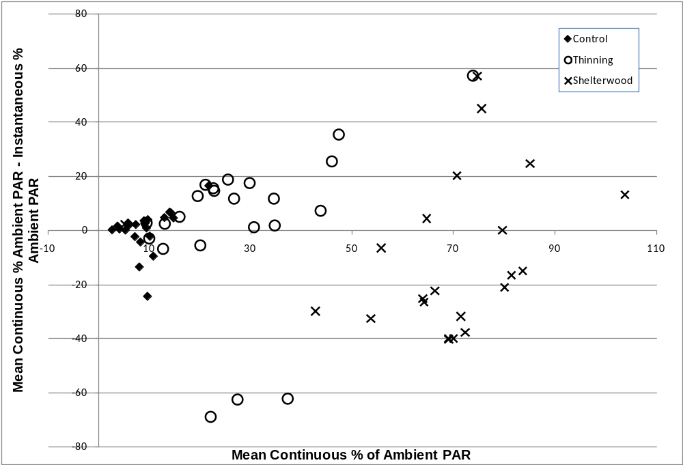
Figure 3-1. Comparison of instantaneous vs. continuous PAR measurement methods

One of the advantages of continuous measurements is that they can be used to average out variability across time. Since light conditions were more variable across time in the thinning and control treatments (Table 3-3) it was informative to examine how the differences between two measurement techniques corresponded to differences in the variability of light across time (Figure 3-2). As the variability across time increased to even relatively low levels of 10% of ambient par the correspondence between the two measurement techniques rapidly decreased for any given plot (Figure 3-2).
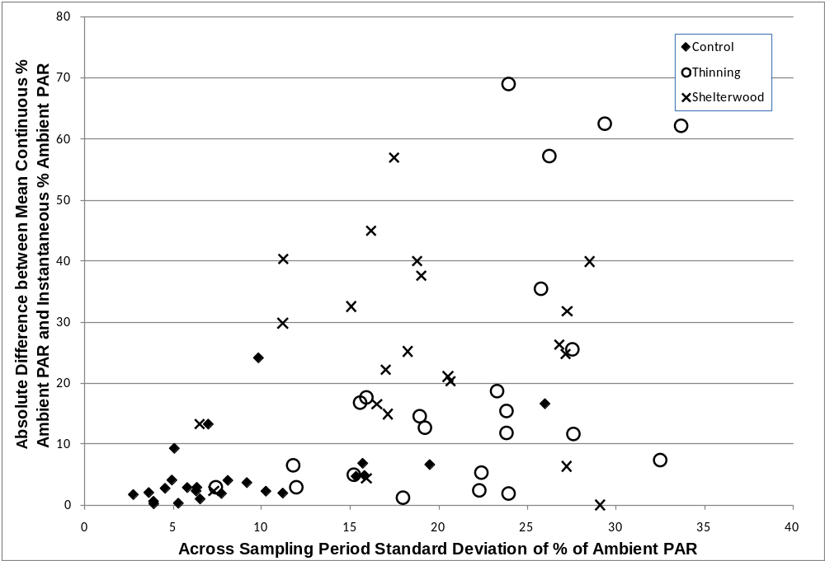
Figure 3-2. Comparison of differences between instantaneous and continuous PAR measurement methods.

Discussion and Conclusions
Measurements of both instantaneous and continuous PAR provided an opportunity to compare and contrast patterns in each measure across treatments. Control, thinning (Gingrich B-level), and shelterwood with reserves treatments exhibited comparable measured means and magnitudes of differences across treatments in instantaneous and continuous PAR (Tables 3-1 and 3-2). In the controls, the approximate mean amount of sunlight reaching the forest floor was 9% of ambient, compared to 31% in the thinning, and 72% of ambient in the shelterwood.

Long-term continuous measurements are thought to be superior for estimating the seasonal light environment for a given point in a stand (Lieffers et al.1999). Comeau et al. (1998) demonstrated greater strength in relationships between short-term averages and long-term averages calculated across the entire growing season as sampling periods increased from one to three hours. The comparability of results obtained with the instantaneous and continuous methods in the study reported here suggests that further investigation of minimum numbers of sample locations and lengths of sample periods warrant further investigation.

Spatial variability in instantaneous percent ambient PAR differed between treatments and controls, but there was no difference between treatments (Table 3-1). Variability in treatments was fourfold to fivefold the variability calculated for controls. In contrast, no significant differences in spatial variability in continuous understory PAR (Table 3-2) existed among treatments, most likely due to a lower number of continuous sample locations (7-8 points per stand for continuous measurements versus 20 points per stand for instantaneous measurements). The magnitudes of the mean differences, however, suggest a trend very similar to that of the variability estimates for instantaneous spatial variability. Calculated variability in thinnings was approximately threefold, and in shelterwoods was approximately fourfold, that of controls. The mean spatial variability measurements of continuous measurements were integrated, meaning that treatment averages were derived from sample period averages. Interestingly, patterns in temporal variability of continuous measurement paralleled those of the patterns in spatial variability of instantaneous measurements (Tables 3-1 and 3-3). It is possible that there was a temporal variability component inherent in the measurements of spatial variability in instantaneous PAR. This temporal component is likely attributable to the time required to walk between sample locations. Results for spatial and temporal variability across treatments suggest that treatments did not simplify the understory light environment, and that greater numbers of measurements would be required to adequately characterize the light environment in treated stands.
The two methods were most consistent under the low light levels of the control and indicated by the low mean difference (0.51% of ambient) and low variability of the differences (sd=7.70 % of ambient). However, under the higher light levels of the thinning and shelterwood the difference between the two measurement techniques were greater (2.17 and 9.89 % of ambient, respectively). More notably, variability in the differences increased to standard deviations of 29.86% of ambient for the thinning and 27.91% of ambient for the shelterwood, suggesting that at higher light levels the two measurement techniques are less consistent and perhaps instantaneous measurements should be taken at a much higher density than continuous measurements to assess mean stand light conditions (Figure 3-1 and Figure 3-2). The mean differences were not statistically different in any treatment. This lack of statistical difference is due to the enormous variability in the values of differences between measurement methods.
The instantaneous and continuous measurement methods differed in their characterization of variability across treatments and represented a contrasting approach to quantifying light regimes. Some studies have employed large numbers of measurements at only a few locations (e.g., Griffiths et al. 2007, Motsinger et al. 2010), while other studies have employed a single measurement taken at numerous locations (e.g. Clinton 2003, Pavlovic 2006). Gendron et al. (1998) found that averaging two instantaneous readings of understory PAR, centered on solar noon, provided a better estimate of growing season PAR estimate of light at a specific location than a single instantaneous measurement at solar noon (r² = 0.84 for the average of two measurements, r² = 0.67 for one measurement). Lieffers and Stadt (1994) obtained stand-level estimates by averaging instantaneous measurements from numerous sampling points within stands. Instantaneous measurements taken on overcast days provided better estimates of the seasonal average PAR than mid-day or day-long measurements on clear, sunny days (Messier and Puttonen 1995, Parent and Messier 1996, Gendron et al. 1998), but the daily mean light that penetrates canopies is essentially the same, whether the day is clear or overcast (Messier and Puttonen 1995; Parent and Messier 1996).
Overcast conditions, however, are difficult to clearly define, and are likely to be at least somewhat heterogeneous. Cloud depth and elevation of clouds above the earth’s surface may have a significant impact on incoming PAR. The research conducted by Messier and Puttonen (1995) and Parent and Messier (1996) that led to the recommendation of measuring PAR on overcast days, was conducted at a northerly latitude, where uniformly overcast days are more common than in the area where this study was conducted. Uniformly cloudy days in the area of this study are usually followed by rain, and are therefore unsuitable for unattended light measurements with instruments that are extremely susceptible to the effects of moisture.
Ever-increasing limitations in research funding and time have created the need for information regarding the optimum scale and intensity of understory light sampling that will effectively, efficiently, and economically quantify understory light in forest ecosystems under study. Results of this study suggest that instantaneous measurements are likely to provide reasonable estimates of localized and stand-level growing-season understory PAR in untreated central hardwood forests, but larger numbers of instantaneous measurements or continuous measurements may be required to accurately characterize understory PAR in stands in which silvicultural treatments have been implemented. The purpose of PAR measurement and the resources available are also important factors in selecting the most appropriate method.
Literature Cited
Beaudet M, Messier C, Leduc A. 2004. Understorey light profiles in temperate deciduous forests: recovery process following selection cutting
Journal of Ecology 92(2): 328-338.

Buckley DS, Isebrands JG, Sharik TL. 1999. Practical Field Methods of Estimating Canopy Cover, PAR, and LAI in Michigan Oak and Pine Stands. Northern Journal of Applied Forestry 16(1): 25-32.

Canham CD, Denslow JS, Platt WJ, Runkle JR, Spies TA, White PS. 1990. Light regimes beneath closed canopies and tree-fall gaps in temperate and tropical forests. Canadian Journal of Forest Research 20(5): 620-631.

Clinton BD. 2003. Light, temperature, and soil moisture responses to elevation, evergreen understory, and small, canopy gaps in the southern Appalachians. Forest Ecology and Management 186 (1-3): 243-255

Comeau PG, Gendron F, Letchford T. 1998. A comparison of several methods for estimating light under a paper birch mixedwood stand. Canadian Journal of Forest Research 28 (12): 1843-1850.

Ferment A, Picard N, Gourlet-Fleury S, Baraloto C. 2001. A comparison of five indirect methods for characterizing the light environment in a tropical forest. Annals of Forest Science 58 (8): 877-891.

Dillaway DN, Stringer JW, Rieske LK. 2007. Light availability influences root carbohydrates, and potentially vigor, in white oak advance regeneration. Forest Ecology and Management 250 (3): 227-233.

Domke GM, Caspersen JP, Jones TA. 2007. Light attenuation following selection harvesting in northern hardwood forests. Forest Ecology and Management 239(1-3): 182-190.

Ediriweera S, Singhakumara BMP, Ashton MS. 2008. Variation in canopy structure, light and soil nutrition across elevation of a Sri Lankan tropical rain forest. Forest Ecology and Management 256(6): 1339-1349.

Gauthier MM, Jacobs DF. 2010. Ecophysiological responses of black walnut (Juglans nigra) to plantation thinning along a vertical canopy gradient. Forest Ecology and Management 259(5): 867-874.

Gendron F, Messier C, Comeau PG. 1998. Comparison of various methods for estimating the mean growing season percent photosynthetic photon flux density in forests. Agricultural and Forest Meteorology 92: 55-70.

Griffiths ME, Lawes MJ, Tsvuura Z. 2007. Understorey gaps influence regeneration dynamics in subtropical coastal dune forest. Plant Ecology 189(2): 227-236.

Johnson DM, Smith WK. 2006. Low clouds and cloud immersion enhance photosynthesis in understory species of a southern Appalachian spruce-fir forest (USA). American Journal of Botany 93(11): 1625-1632.

Lohtka JM, Loewenstein E. 2006. Indirect measures for characterizing light along a gradient of mixed-hardwood riparian forest canopy structures. Forest Ecology and Management 226: 310-318

Lieffers VJ, Stadt KJ. 1994. Growth of understory picea-glauca, calamagrostis-canadensis, and epilobium-angustifolium in relation to overstory light transmission. Canadian Journal of Forest Research 24(6): 1193-1198.

Messier C, and Puttonen P. 1995. Spatial and temporal variation in the light environment of developing Scots pine stands: the basis for a quick and efficient method of characterizing light. Canadian Journal of Forest Research 25(2): 343–354.

Motsinger JR, Kabrick JM, Dey DC, Henderson DE, Zenner EK. 2010. Effect of midstory and understory removal on the establishment and development of natural and artificial pin oak advance reproduction in bottomland forests. New Forests 39(2): 195-213

Nicotra AB, Chazdon RL, and Iriarte SVB. 1999. Spatial heterogeneity of light and woody seedling regeneration in tropical wet forests. Ecology 80(6): 1908-1926.

Palik B, Mitchell RJ, Pecot S, Battaglia M, Pu M. 2003. Spatial distribution of overstory retention influences resources and growth of longleaf pine seedlings. Ecological Applications 13(3): 674-686.

Parent SM, Messier C. 1996. A simple and efficient method to estimate microsite light availability under a forest canopy. Canadian Journal of Forest Research 26(1): 151-154.

Pavlovic NB, Grundel R, Sluis W. 2006. Groundlayer vegetation gradients across oak woodland canopy gaps. Journal of the Torrey Botanical Society 133(2): 225-239

Prevost M. 2008. Effect of cutting intensity on microenvironmental conditions and regeneration dynamics in yellow birch – conifer. Canadian Journal of Forest Research 38(2): 317-330.

APPENDIX
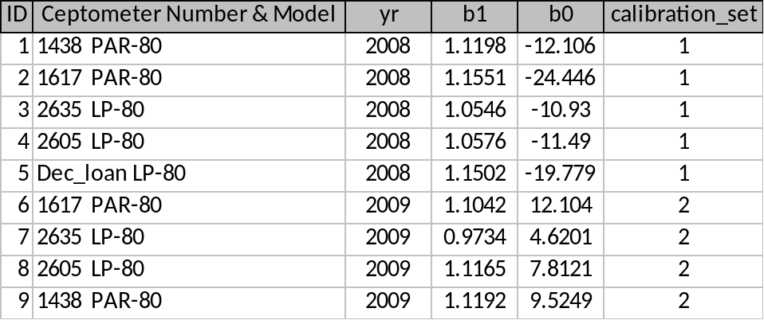
Table A- 1. Decagon PAR-80 and LP-80 Ceptometer Correction Factors, Y = b1X + b0.

Table A- 2. Pre/Post Treatment Basal Areas (BA) and Stems per Acre (SPA) of Units (Stands) studied.

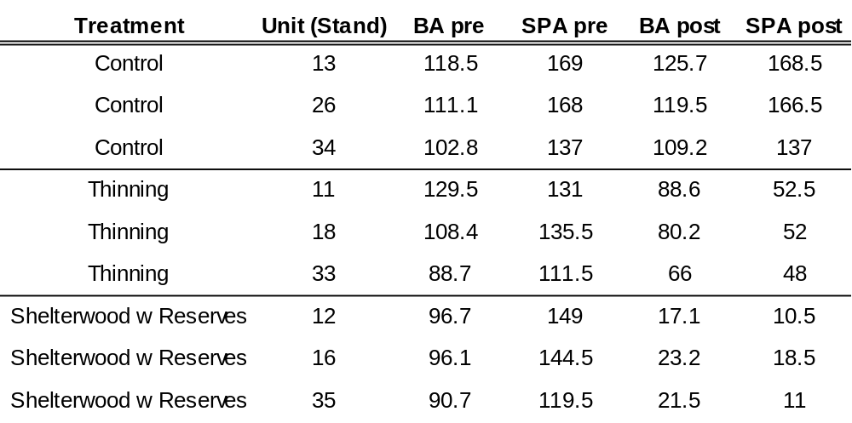

Table A- 3. Treatment Averages: Pre/Post Treatment Basal Areas (BA) and Stems per Acre (SPA).

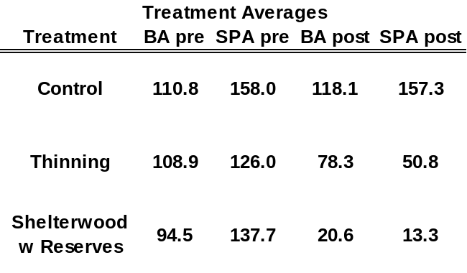

Table A- 4. Species Codes for accompanying Pre/Post Treatment Basal Area and Stems per Acre Tally for Shelterwood with Reserves, Thinning (Gingrich B-Line), and Controls of Cold Hill Area Stands Studied; Daniel Boone National Forest, London Ranger District.

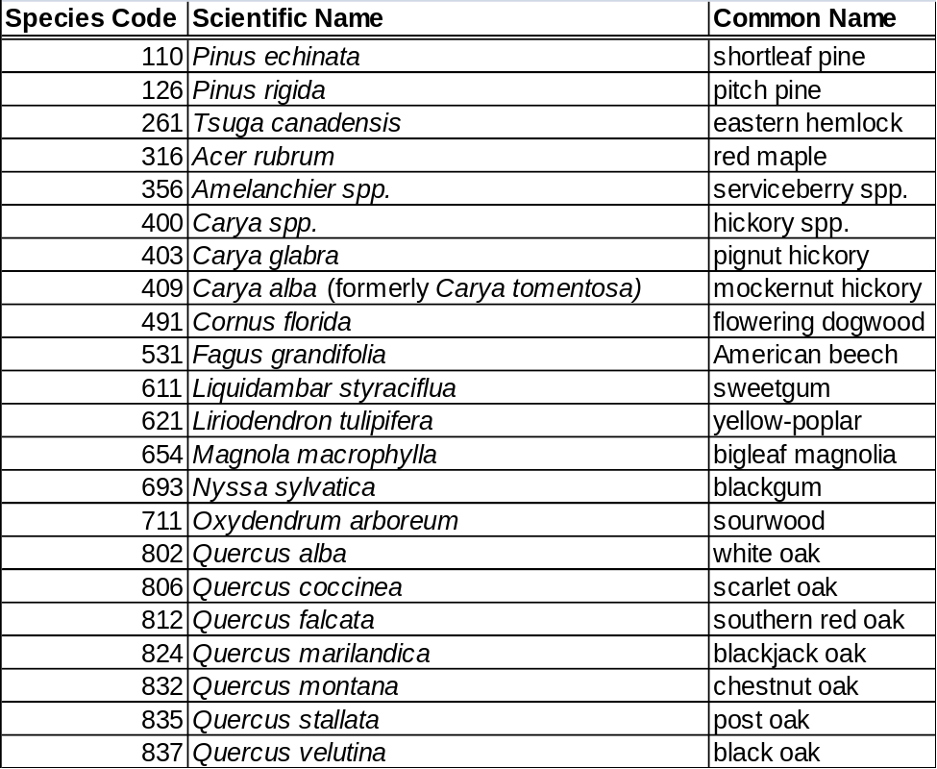

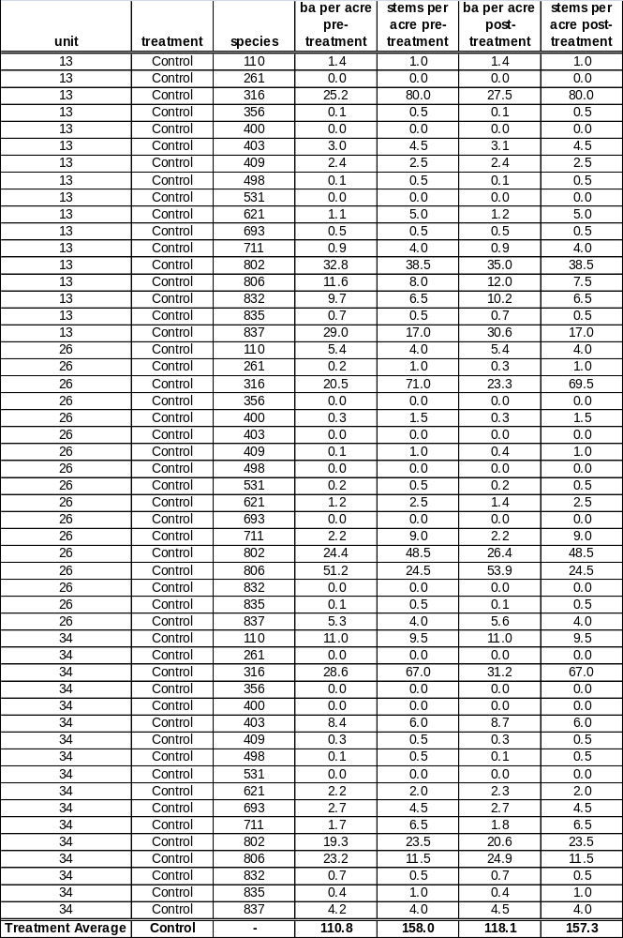
Table A- 5. Controls (No Treatment): Pre/Post Treatment Basal Area and Stems per Acre Tally for Units (Stands) studied on Daniel Boone National Forest, London Ranger District, Cold Hill Area.
Table A- 6. Thinning (Gingrich B-Line)Treatment: Pre/Post Treatment Basal Area and Stems per Acre Tally for Units (Stands) studied on Daniel Boone National Forest, London Ranger District, Cold Hill Area.
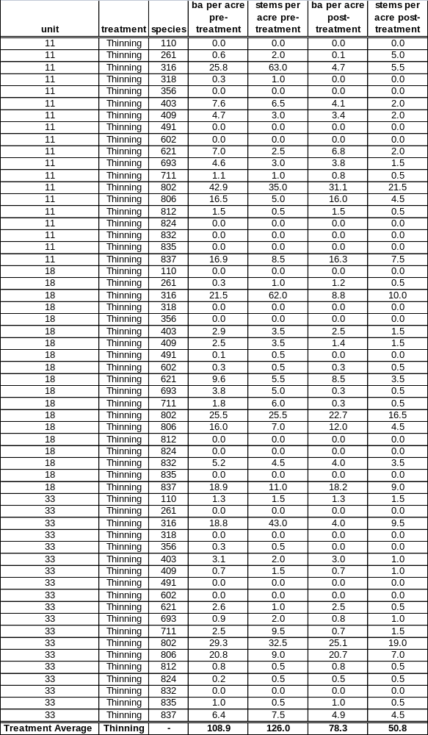
Table A- 7. Shelterwood with ReservesTreatment: Pre/Post Treatment Basal Area and Stems per Acre Tally for Units (Stands) studied on Daniel Boone National Forest, London Ranger District, Cold Hill Area.
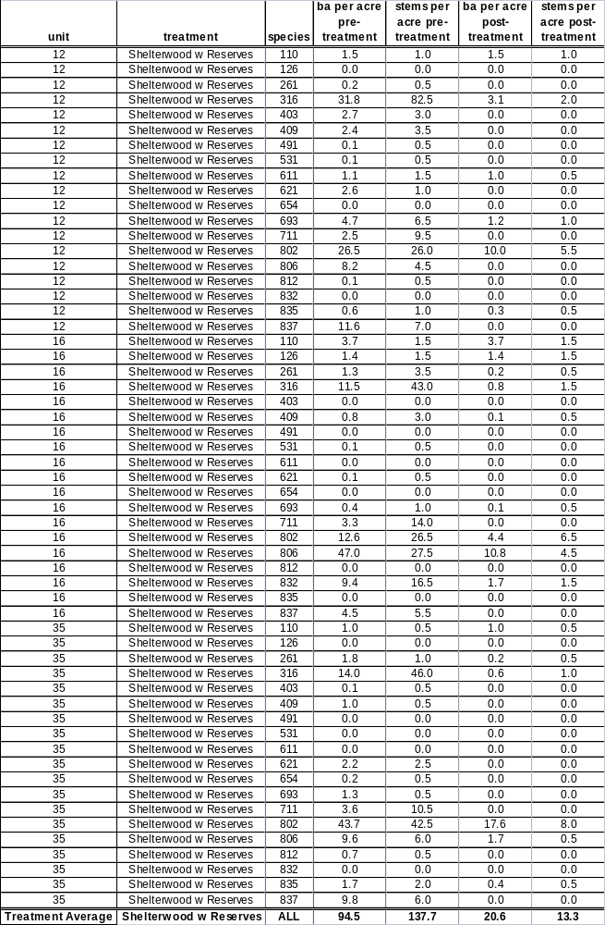
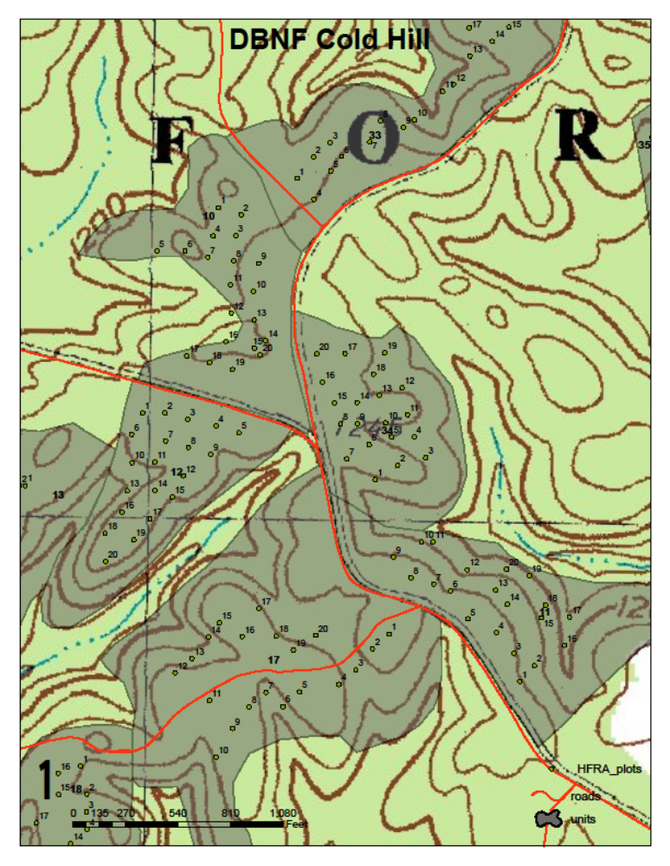
Figure A- 1. Unit (Stand) map, Cold Hill Study Area, DBNF; 11, 34 - Control; 12 - Shelterwood with Reserves.
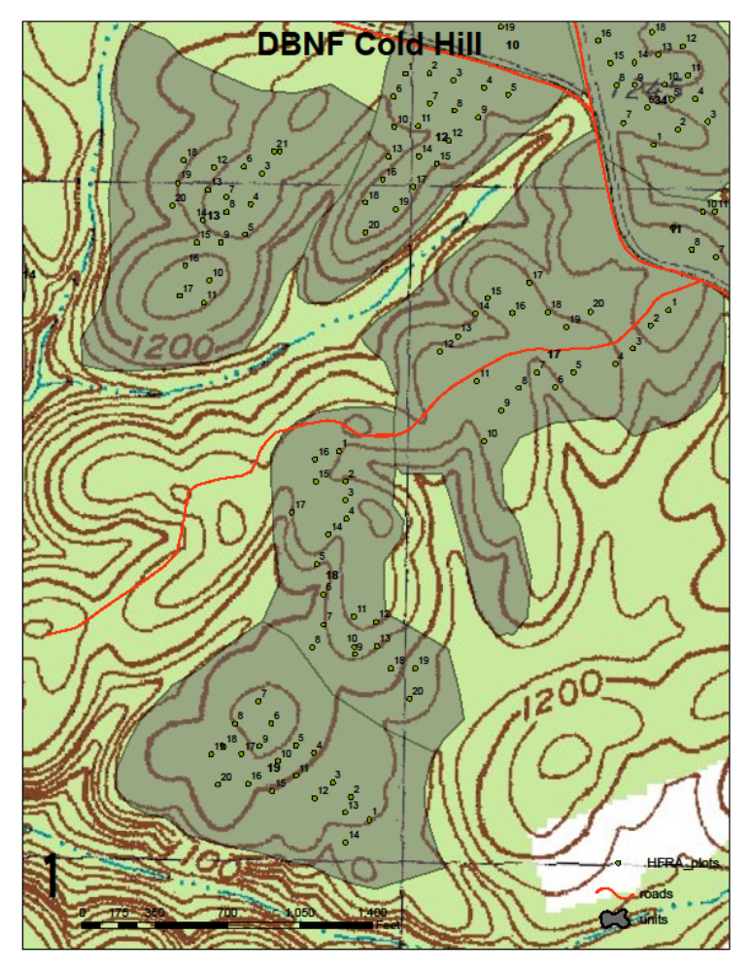
Figure A- 2. Unit (Stand) map, Cold Hill Study Area, DBNF; 13 - Control; 18 – Thinning Gingrich B-line;
12 - Shelterwood with Reserves.

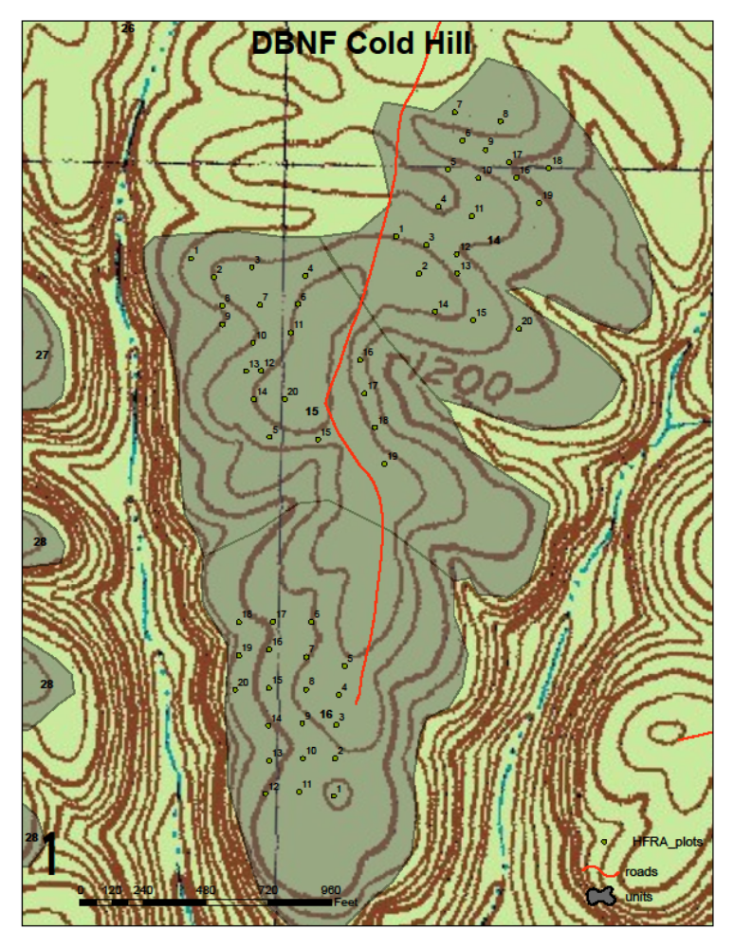
Figure A- 3. Unit (Stand) map, Cold Hill Study Area, DBNF; 12 - Shelterwood with Reserves.

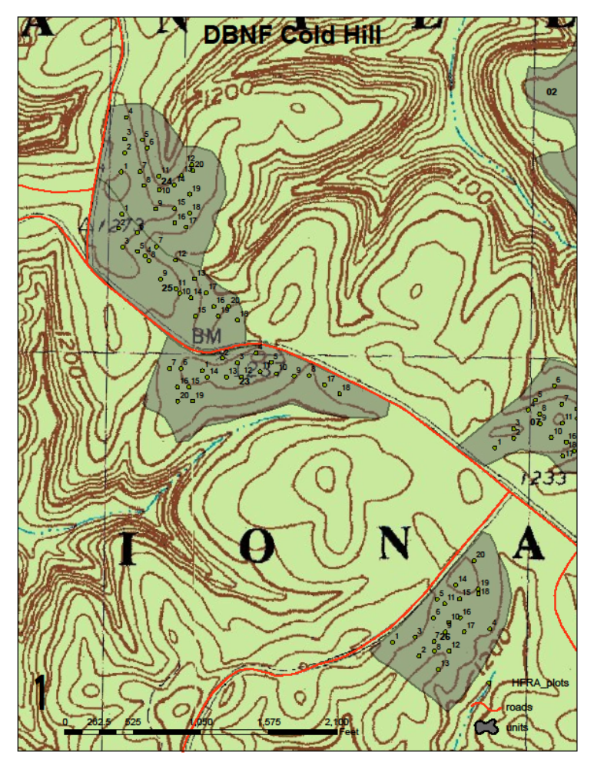
Figure A- 4. Unit (Stand) map, Cold Hill Study Area, DBNF; 26 - Control.
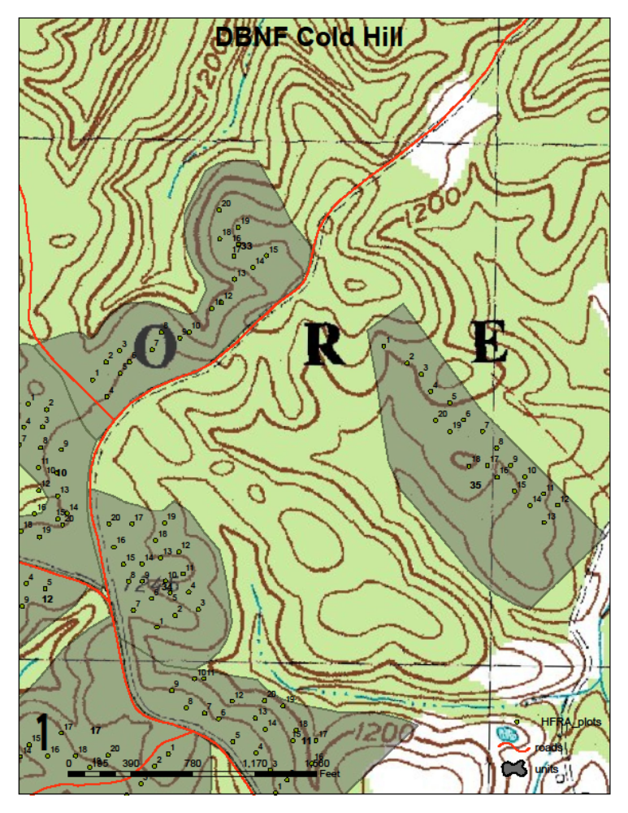
Figure A- 5. Unit (Stand) map, Cold Hill Study Area, DBNF; 34 - Control; 33 – Thinning Gingrich B-line; 35 - Shelterwood with Reserves.

Vita
Stephen Frederick Grayson was born in Charleston, West Virginia, on December 22, 1960. He worked as a forester for Community Forestry Development Program, Nepal, 1992-1994 with United States Peace Corps. He was State Forest Forester at Chickasaw State Forest, Tennessee Division of Forestry, 1995-1997. He was a forester for the Virginia Department of Forestry, 1997-2007. During that time he conducted forest inventory in beautiful Southwest Virginia. He earned a Bachelor of Arts, Psychology, in 1986; a Bachelor of Science, Forestry, in1991; and a Master of Science, Forestry, in 2010. All degrees were conferred by the University of Tennessee, Knoxville. He is the fortunate son of Lloyd F. and Theresa F. Grayson, and the most fortunate father of two children: his daughter Sofi Monet, and his son Avery Faulkner.

