Competitive Interactions Among Co-Infecting Symbionts in a Model Animal-Associated Microbiome

A Thesis Presented to
the Faculty of the Honors College
University of Tennessee, Knoxville

In Partial Fulfillment of the Requirements
to Graduate with Honors

By:
Justin Pritchett
May 2021

Supervised by Dr. Benjamin Parker
Introduction
Many insect species form symbiotic associations with microbes. These relationships are often classified into two types:obligate symbionts and facultative symbionts. Obligate symbionts typically perform essential roles in the host organism such as providing the host with vital nutrients only found in scarce quantities in the environment. Obligate symbionts are required for host survival, and some have been found to provide essential amino acids necessary for the host to survive (Feng, 2019). Alternatively, facultative symbionts are known to have a much wider array of effects such as manipulation of reproduction or benefits like protection against biotic or abiotic stressors (Ferrari, 2011). For example, the Gram-negative bacterial symbiont Serratia symbiotica offers protection to its aphid host from high environmental temperatures and Hamiltonella defensa offers protection from parasitoid wasps that parasitize pea aphids (Oliver et al. 2010). The different phenotypic effects that facultative symbiont species have on aphids likely contributes to individuals harboring different symbionts depending on their environment. Variable combinations of facultative symbionts are possible because these symbionts are not necessary for the host survival and are therefore able to affect host fitness by providing unique benefits.
Many insect hosts harbor multiple symbiont species that live in different tissues in the organism. Additionally, some insects host symbionts that coexist together with different strains of the same species will live in a host. Studies have shown that some insects have complex symbiont relationships that help give them vital nutrients (McCutcheon, 2007). However, the details of how symbiont strains and species interact within a host and their impact on host phenotypes is not well researched (McLean, 2016).
One important aspect of the aphid system is the transfer of symbionts to offspring (vertical transmission) and between different host lines (horizontal transmission), thus allowing for unique combinations of symbionts of varying titers. The different combinations may produce different phenotypic results that can increase or decrease fitness (McLean, 2016). For example, some combinations may increase strain on the host because more energy is required to maintain multiple symbiont species. While there are drawbacks like a weakened immune system and reduced reproductive capability, the host may gain extra benefits that increase the overall fitness of the organism. Understanding how the presence of one symbiont impacts the establishment of other symbionts as well as how the host regulates symbiont(s) is therefore important.
Pea aphids (Acyrthosiphon Pisum) are ideal organisms to use to study facultative symbiont community interactions because they have bacterial communities with a small number of facultative symbionts that provide well-studied benefits to the host. The small bacterial communities along with the fact that pea aphids are asexual means changes in phenotype as a result of the bacterial community are easily measured. It is thought that few pea aphids are coinfected with multiple symbiont species because of the fecundity costs associated with maintaining multiple symbiont species. However, some researchers argue that many pea aphids sustain coinfections that go undocumented because only a small number of symbionts are surveyed (Ferrari, 2012). Past research has shown different combinations of symbionts are more or less likely to happen than would normally occur based on chance (Ferrari, 2012). This means the symbiont populations are not controlled solely by chance. The aphid symbiont communities could be controlled by symbiont competition, the fitness provided to pea aphids by symbionts via selective pressure, or the aphid’s immune regulation. Some combination of these three factors could also be at play.
There is still much research that needs to be done to understand symbiont interaction and regulation within the host. This study analyzed coinfections in pea aphids to determine symbiont persistence in coinfections. We used aphids that had no symbionts and coinjected symbionts into the aphids. Two strains from different phylogenetic clades of Regiella insecticola and one strain of Hamiltonella defensa were used in this study. Regiella and Hamiltonella confer different benefits to the pea aphid host. Regiella protects against the fungal pathogen Pandora neoaphidis that infects and kills aphids, and Hamiltonella protects the aphid host from parasitoid wasps (Oliver, 2010). Regiella is taxonomically split into two distinct clades (Parker, 2017). The two different clades of Regiella were used because Clade 1, represented by .LSR in this study, maintains itself at low titers in the host while Clade 2, represented by .313, maintains itself at a higher titer in the hemolymph (Nichols, 2021). This could tell us whether the titer at which a symbiont lives in the host impacts that ability for a coinfection to happen. It is our hypothesis that symbionts living at higher titers put more strain on the host and make coinfections less likely to occur.
Methods
Aphid Rearing:
The aphid line (LSR1-01) used in this experiment was collected in Ithaca, NY, USA in 1999 (Genome, 2010). The symbionts were collected in the UK and USA. Regiella: LSR Regiella col. With LSR1 genotype; 313 was collected in the UK (Parker, 2021). Hamiltonella was collected in upstate NY (Chung, 2020). Aphids lines are maintained on Vicia faba plants and are kept under a light regime of 16L:8D at 20°C. The longer daylight regime makes the aphids reproduce via apomictic parthenogenesis, meaning the offspring are clones of the mother. This allows us to use genetically identical aphids throughout the study. All aphid lines were screened for seven common facultative symbionts before use in experiments as in Henry et al. (2013) Current Biology. Antibiotics were used to clear symbiont infections from lines, if needed, before use in experiments.
Symbiont injection protocols:
Bacterial symbionts were injected into symbiont-free aphids using a microcapillary needle. To do this, donor aphids that were confirmed to have either Regiella or Hamiltonella were used. In order to confirm the presence of the symbiont, DNA extraction was performed on the whole aphid followed by PCR. The PCR used symbiont-specific primers that were then visualized via gel electrophoresis. Hemolymph was removed from the donor aphids using the same capillary needle in an alternating fashion, and the fluid was then injected into the first instar symbiont-free aphids. Aphids were then allowed to generate offspring that were then tested for the presence of Regiella and Hamiltonella. All data collected is from the first generation of aphids following injection.
DNA Extraction Protocol:
DNA was extracted via the bender buffer technique. Aphids were placed in Eppendorf tubes and crushed using a pestle. 50 uL of Bender Buffer was added followed by 1.25uL of proteinase K. The tubes were then incubated at 65C for 1.5-2 hours. While tubes are warm, 7uL of 8M KoAc. Tubes were then vortexed and stored on ice for at least 30 minutes, but for better results overnight is best. Tubes are then centrifuged for 15 minutes and the supernatant was transferred to a new tube. 100uL of cold 100% EtOH was then added, vortexed, and allowed to sit for 5 minutes. Tubes were then centrifuged for 15 minutes. Remove all of the EtOH, being sure not to disturb the pellet at the bottom of the tube. Then add 100uL of cold 70% EtOH to wash the DNA, centrifuge for 5 minutes, and then again remove the EtOH. Finally, add 200uL of cold 100% EtOH, centrifuge, and remove all EtOH. Air dry the tubes overnight or air dry for 15 minutes, add 5uL of the resuspension media, and incubate at 55C for 15 minutes. Tubes can be stored at 4C.
Symbiont Screening and Identification:
Symbionts were screened withPCR using symbiont-specific primers. All primers were targeted towards specific regions of the 16s rRNA genes. The forward primer for both Hamilronella and Regiella used was 5’ - AGTTTGATCATGGCTCAGATTG - 3’, the reverse primer used for Hamiltonella was 5’ - AAATGGTATTSGCATTTATCG - 3’, and the reverse primer used for Regiella was 5’ - GGTAACGTCAATCGATAAGCA - 3’. Each aphid was screened for the presence of both symbionts using the following PCR protocol followed by gel electrophoresis. Amplification was achieved through a “touchdown” PCR ((94°C 2 min, 11 cycles of (94°C 20s, 56°C (declining 1°C each cycle) 50 s, 72°C 30 s), 25 cycles of 94°C 2 min, 45°C 50 s, 72°C 2 min and a final extension of 72°C 5 min).
Statistical design:
PCR results were analyzed using generalized linear models with a quasi-binomial error structure in Rstudio v.4.0.2. The presence or absence of each symbiont was analyzed separately. Treatment (co-infection vs. single injection) was modeled as a fixed effect, and statistical significance was determined using model comparisons via ANOVA and F-tests.
Results
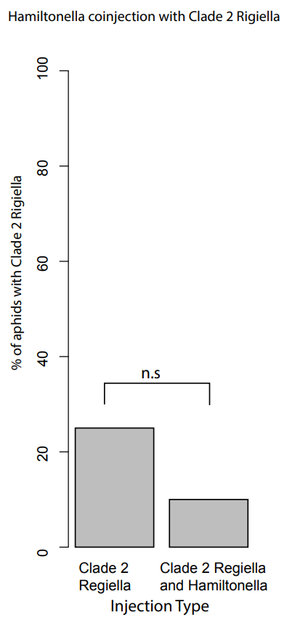
Figure 1: The success rate of Clade 2 was compared alone and in the presence of Hamiltonella. Hamiltonella had no significant effect on the rate of successful establishment of Clade 2 Regiella. Generalized linear regression model used along with F test and p test gave F = 0.7858, 1DF, p = 0.3859.
The first comparison made with the data yielded from the experiments was comparing successful Clade 2 Regiella establishment alone and in the presence of Hamiltonella. We found that Hamiltonella did not significantly change the establishment of Clade 2 Regiella when compared to single injections of solely Clade 2 Rigiella (F = 0.7858, 1DF, p = 0.3859). The presence of Hamiltonella does not have an impact on the establishment of Clade 2 Regiella.
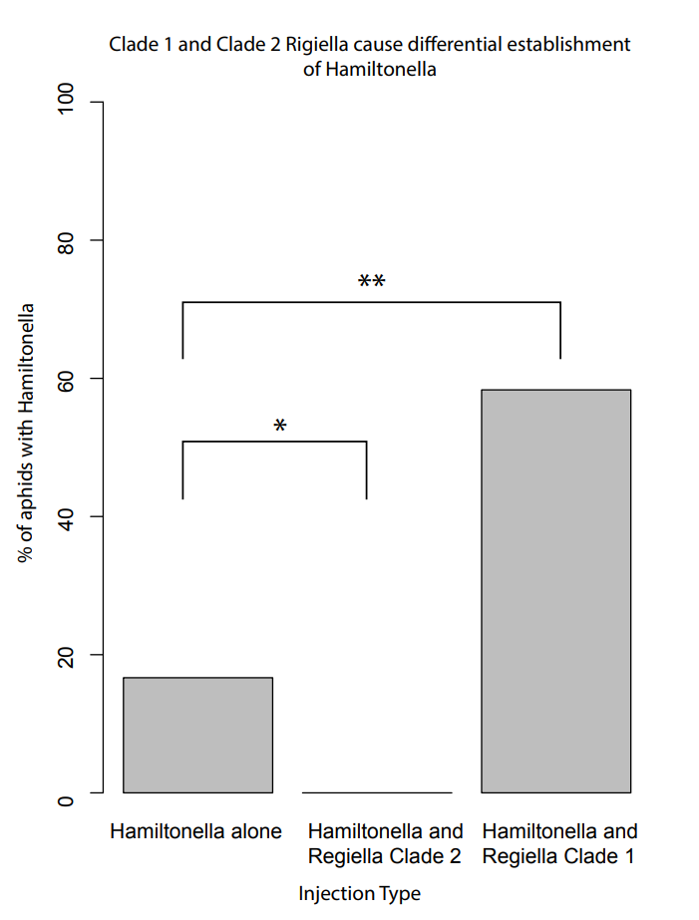
Figure 2: The percent establishment of Hamiltonella alone compared to its success in the presence of both Clade 1 and Clade 2 Regiella. A generalized linear model with binomial distribution was used along with F tests and p tests. For the comparison between Hamiltonella alone and clade 2, F = 4.11 and p = 0.05. In the comparison including Hamiltonella alone and clade 1, F = 5.292 and p = 0.029.
We also compared the establishment success of Hamiltonella in pea aphids alone as well as in the presence of both Clade 1 and 2 Regiella. Hamiltonella is significantly less likely to establish successfully in the presence of Clade 2 Regiella (F = 4.11, p = 0.05), the clade that naturally grows at a higher titer. However, Hamiltonella is more likely to establish itself in the hemolymph of pea aphids that also harbor Clade 1 Rigiella (F = 5.292, p = 0.029).
Discussion and Conclusions
The objective of this study was to determine if the presence of one symbiont would impact the establishment of another symbiont in the pea aphid model organism. To test this, uninfected pea aphids were simultaneously coinfected with two symbionts from donor aphids. We hope to use this data to not only provide a basis for future studies but also to expand the knowledge on the ecological dynamic of host-symbiont systems.
Hamiltonella does not impact whether Clade 2 Regiella will establish (Figure 1). What is most interesting about this relationship between Regiella and Hamiltonella is that the reverse is not true; the presence of Clade 2 Rigiella significantly decreases the chance that Hamiltonella will establish (Figure 2). One reason we believe Clade 2 Regiella influences Hamiltonella establishment but not the reverse is because Clade 2 Regiella naturally maintains itself at a much higher titer (Nichols, 2021). However, we do not know the exact mechanism as to why the higher titer prevents Hamiltonella from establishing. Possible explanations for the observed phenomena could be that Clade 2 Regiella prevents Hamiltonella from establishing by direct competition through chemical means, both Hamiltonella and Regiella require a specific biomolecule for metabolism and the higher titer of Rigiella uses all of the resources, or that the immune system of the aphid is limiting establishment through some immune response.
Even more interestingly, the establishment rate of Hamiltonella in the presence of Clade 1 Regiella is much higher than in Hamiltonella alone. This indicates that the symbionts are acting synergistically to have increased infectivity when paired together. One reason Hamiltonella coinfections with Clade 2 Regiella are more likely to persist could be from the increase in the bacterial burden, thus weakening the immune system. Pea aphids have simple immune systems, and it could be that the immune system is unable to deal with both symbionts and therefore allows Hamiltonella to establish.
Further investigations that could improve upon the data presented in this study includes the following. One aspect of the experiment that could have been analyzed but was not due to time constraints was to quantify the number of bacteria present rather than just the presence of the symbiont. This could have provided much more information and allowed us to draw more conclusions about what is happening in the host-symbiont system. Another example of something that could have been included in the study was the aphid reproductive capability and aphid lifespan among different types of infections. Lower fecundity when the aphid is sustaining multiple symbionts could indicate that the symbionts are a significant burden. Length of life could also provide information about why some combinations of symbionts are more likely to be seen in nature. If some symbiont combinations have higher survival costs, infected aphids would then have fewer offspring and the symbiont associated with a higher burden would have a lower occurrence.
One possible topic to investigate in future studies would be discerning the mechanisms behind why some symbionts are more viable during an infection. Insights on this topic found in the pea aphid model could potentially be applied to other insect species, thus allowing researchers to better understand ecological phenomena. For example, insights on the interactions of symbionts in pea aphids could prompt research focused on understanding more complex interactions in other insect species. It is widely accepted that many insects have relationships with symbionts. Better understanding the mechanisms behind how these relationships are controlled could be useful for many reasons. Data collected could be used to give insight into host-symbiont population dynamics, increase understanding of evolutionary pressures on tightly associated host-symbiont systems, and to better understand the immune systems of insects to name a few.
Citations
Chung, S. H., Parker, B. J., Blow, F., Brisson, J. A., & Douglas, A. E. (2020). Host and symbiont genetic determinants of nutritional phenotype in a natural population of the pea aphid. Molecular Ecology, 29(4), 848–858. https://doi.org/10.1111/mec.15355
Ferrari, Julia, and Fabrice Vavre. “Bacterial symbionts in insects or the story of communities affecting communities.” Philosophical transactions of the Royal Society of London. Series B, Biological sciences vol. 366,1569 (2011): 1389-400. doi:10.1098/rstb.2010.0226
Ferrari, J., West, J.A., Via, S. and Godfray, H.C.J. (2012), POPULATION GENETIC STRUCTURE AND SECONDARY SYMBIONTS IN HOST‐ASSOCIATED POPULATIONS OF THE PEA APHID COMPLEX. Evolution, 66: 375-390. https://doi.org/10.1111/j.1558-5646.2011.01436.x
Feng H, Edwards N, Anderson CMH, Althaus M, Duncan RP, Hsu Y-C, et al. Trading amino acids at the aphid–Buchnera symbiotic interface. Proc Natl Acad Sci. 2019;116(32):16003–11.
Genome Sequence of the Pea Aphid Acyrthosiphon pisum. (2010). PLoS Biology, 8(2). https://doi.org/10.1371/journal.pbio.1000313
McLean AHC, Parker BJ, Hrček J, Kavanagh JC, Wellham PAD, Godfray HCJ. Consequences of symbiont co-infections for insect host phenotypes. J Anim Ecol. 2018 Mar;87(2):478-488. doi: 10.1111/1365-2656.12705. Epub 2017 Jul 3. PMID: 28542979.
McCutcheon, John P, and Nancy A Moran. “Parallel genomic evolution and metabolic interdependence in an ancient symbiosis.” Proceedings of the National Academy of Sciences of the United States of America vol. 104,49 (2007): 19392-7. doi:10.1073/pnas.0708855104
Nichols, H. L., Goldstein, E. B., Saleh Ziabari, O., & Parker, B. J. (2021). Intraspecific variation in immune gene expression and heritable symbiont density. PLOS Pathogens, 17(4). https://doi.org/10.1371/journal.ppat.1009552
Oliver, K. M., Degnan, P. H., Burke, G. R., & Moran, N. A. (2010). Facultative Symbionts in Aphids and the Horizontal Transfer of Ecologically Important Traits. Annual Review of Entomology, 55(1), 247–266. https://doi.org/10.1146/annurev-ento-112408-085305
Parker, B. J., Hrček, J., McLean, A. H. C., Brisson, J. A., & Godfray, H. C. (2020). Intraspecific variation in symbiont density in an insect-microbe symbiosis. https://doi.org/10.1101/2020.11.03.365353
Parker, B. J., Hrček, J., McLean, A. H., & Godfray, H. C. (2017). Genotype specificity among hosts, pathogens, and beneficial microbes influences the strength of symbiont-mediated protection. Evolution, 71(5), 1222–1231. https://doi.org/10.1111/evo.13216

