Manganese Geochemistry and Plant Availability in Response to Agricultural Practices

A Thesis Presented for the
Master of Science
Degree
The University of Tennessee, Knoxville

Ashleigh R. Montgomery
August 2022

Acknowledgments

First, I would like to thank Dr. Sindhu Jagadamma for her guidance and support throughout the process of my MS. I would also like to thank her for supporting my project financially and for nominating me for awards. Thank you to my committee members, Dr. Elizabeth Herndon and Dr. Carl Sams, for always being willing to answer my questions. Beth, I am truly grateful for being included in the Mn-C group meetings as they have been a major source of inspiration and excitement that I’m sure will follow me for the rest of my career. Carl, thank you for your patience and kindness when answering my questions about plant nutrition, regardless of how mundane they were. Additionally, thank you to Dr. Herndon for providing funding for the soil chemistry analysis conducted in Chapter 2 and thank you to Dr. Sams and his lab manager, Jennifer Wheeler, for conducting the plant nutrient and carotenoid analysis in Chapter 1. I would also like to thank Dr. Micheal Essington for always being willing to answer my soil chemistry questions. Thank you to all of the Jagadamma lab members, particularly post docs Dr. Avishesh Neupane, Dr. Rachel Wooliver, and Dr. Patricia Lazicki who all took time out of their busy schedules to help me with sampling. Additionally, thank you to Wesley Wright, Lori Osburn, Shawn Hawkins, and Melanie Stewart for help with sampling, greenhouse management, allowing me to borrow equipment, and teaching me new methods. Thank you to my parents for their support and forgiveness for moving away from home, even when I promised I never would. Lastly, and perhaps most importantly, I’d like to thank my partner, Ethan Wetter, my dog, Bibbo, and my therapist for their constant emotional support. You are the best three-man team a girl could ask for and I quite literally may not have made it here without you.

Abstract

Manganese (Mn) is an essential plant micronutrient and exists in several different forms in the soil, which ultimately determines plant availability. Most Mn research has been conducted in forest ecosystems and Mn cycling in agricultural systems is understudied. Therefore, the objective of the experiment is to understand the effect of different agricultural management strategies on Mn cycling and plant availability. First, a greenhouse experiment was conducted to determine the effect of different application rates of two Mn fertilizers (MnSO₄ and MnEDTA) on soil geochemical properties and growth of corn (Zea mays) and soybean (Glycine max). The fertilizers were applied to soil at three different rates (Recommended, 10x, and 50x). Second, a field experiment was conducted to investigate the effects of contrasting land-use systems (Organic and Conventional Agriculture, Unmanaged Forest) on soil geochemical properties and Mn availability. For both experiments, soil analysis included a sequential extraction to understand the distribution of plant available and stabilized Mn. Plant concentrations of Mn and other nutrients was measured in the greenhouse experiment. In the greenhouse experiment, both fertilizer types increased available soil Mn in the soybean group. However, there was only an increase in plant concentrations in the MnSO₄ treatment. The MnEDTA treatment decreased Mn uptake with increased Mn application, likely due to competition with Fe. Overall, MnSO₄ has a stronger effect on plant Mn uptake and Mn cycling than MnEDTA. The field experiment showed depleted available Mn levels in the agricultural systems relative to the unmanaged system. Additionally, available Mn forms had a positive relationship with SOC, while unavailable forms had a negative relationship.

Table of Contents
Introduction and Literature Review 1
Mn Speciation in Soil 1
Role of Mn in Litter Decomposition 3
Mn as a Plant Nutrient 5
Motivations and Objectives of the Study 6
References 8
Chapter 1. Manganese Sources and Rates Impact Plant Mn Concentrations and Soil Mn Forms 11
Abstract 12
Introduction 12
Materials and Methods 15
Greenhouse Experiment Set-up 15
Plant Growth Measurements 17
Plant Harvesting 19
Soil Sampling and Analysis 20
Statistical Analysis 22
Results 22
Plant Response to Mn Applications 22
Soil Response to Mn Applications 25
Relationship Between Soil Mn Forms and Plant Mn Concentration 31
Discussion 32
Plant Response to Mn Additions 32
Soil Response to Mn Additions 35
Conclusion 37
References 39
Appendix 43
Appendix A. Tables 43
Appendix A. Figures 56
Supplemental Section 63
Chapter 2: Manganese Forms and Plant Availability Across Soil Depth in Contrasting Land Use Systems 65
Abstract 66
Introduction 66
Materials and Methods 70
Study Sites and Treatments 70
Soil Sampling and Processing 71
Laboratory Analysis 71
Statistical Analysis 72
Results 72
Soil pH, SOC, Total N, and WEOC 72
Soil Mn Fractions Across Sites and Depths 73
Discussion 75
Soil Chemical Properties Changes Across Sites and Soil Depths 75
Soil Mn Forms Changes Across Sites and Soil Depths 76
Relationship of Mn Forms with Soil C 79
Conclusion 81
References 82
Appendix 85
Appendix B. Tables 85
Appendix B. Figures 88
Conclusion and Future Work 91
Conclusion 91
Future Work 93
Vita 95

List of Tables
Table A.1. Baseline soil nutrient concentrations 43
Table A.2. Baseline soil physicochemical properties 43
Table A.3. Mn fertilizer application rates 44
Table A.4. Mn fertilizer application dates 44
Table A.5. Effect of fertilizer types and rates on leaf concentrations of nutrients (except Mn) in soybean 45
Table A.6. Effect of fertilizer types and rates on growth parameters in soybean 46
Table A.7. Effect of fertilizer types and rates on chlorophyll content in soybean 47
Table A.8. Effect of fertilizer types and rates on leaf concentrations of nutrients (except Mn) in corn 48
Table A.9. Effect of fertilizer types and rates on corn growth parameters 49
Table A.10. Effect of fertilizer types and rates on chlorophyll content in corn 49
Table A.11. Effect of fertilizer types and rates on soil bioavailable nutrients (except Mn) for soybean 50
Table A.12. Effect of fertilizer types and rates on sequentially-extracted soil Mn for soybean 51
Table A.13. Effect of Mn fertilizer types and rates on soil WEOC, SOC, total N and pH for soybean 52
Table A.14. Effect of fertilizer types and rates on soil bioavailable nutrients (except Mn) for corn 53
Table A.15. Effect of fertilizer types and rates on sequentially-extracted soil Mn forms for corn 54
Table A.16. Effect of fertilizer types and rates on soil WEOC, SOC, total N, and pH for corn 55
Table B.1. Soil properties of experimental field sites 84
Table B.2. Soil Mn form concentrations in the field sites 85
Table B.3. Mn forms as percentages of total Mn 86

List of Figures
Figure A.1. Soybean leaf Mn concentrations as affected by fertilizer types and application rates. 56
Figure A.2. Soybean leaf concentration of Fe (A) and Mo (B) as affected by fertilizer type and application rates at the April sampling point… 57
Figure A.3. Corn leaf Mn concentrations as affected by fertilizer type and application rates. 57
Figure A.4. Soil bioavailable-Mn (Bio-Mn) concentrations (Mehlich-1 extractable) as affected by fertilizer type and rate for soybean. 58
Figure A.5. Effect of fertilizer types and application rates on sequentially-extracted soil Mn forms in soybean. 58
Figure A.6. Soil bioavailable-Mn (Bio-Mn) concentrations (Mehlich-1 extractable) as affected by fertilizer type and rate for corn. 59
Figure A.7. Effect of fertilizer types and application rates on sequentially-extracted soil Mn form in the corn group. 60
Figure A.8. Relationship between leaf Mn concentrations and Mn soil forms in soybean. 61
Figure A. 9. Relationship between leaf Mn concentrations and Mn soil forms in corn. 62

List of Attachments
Table A.11. Effect of fertilizer types and rates on soil bioavailable nutrients (except Mn) for soybean (SBSoilNutrients.xlsx)
Table A.14. Effect of fertilizer types and rates on soil bioavailable nutrients (except Mn) for corn (CNSoilNutrients.xlsx)

Introduction and Literature Review
Mn serves as both a vital plant micronutrient and as a potential regulatory factor controlling C storage in soils. In plants, Mn plays a critical role in photosynthesis, biosynthesis of carbohydrates, lipids, and lignin, and serves as a cofactor for a variety of enzymes (Socha & Guerinot, 2014). Mn is the 13th most abundant element in soils and is present in several different species in soil (Mn²⁺, Mn³⁺, and Mn⁴⁺) (Essington, 2015). Each of these species are associated with different forms of Mn in soils that range from soluble Mn²⁺ to crystalline Mn-Oxide minerals. The predominant form of Mn present in the soil ultimately determines the availability of Mn to plants (Kabata-Pendias & Kabata-Pendias, 2010). In agricultural systems, Mn fertilizers are typically used to increase Mn availability in soil, and thus, to correct Mn deficiency in plants. Additionally, different forms of Mn, namely organically-bound Mn (OM-Mn) and Mn-Oxides, can control the oxidative activity of surface soils (Jones et al., 2020; Remucal & Ginder-Vogel, 2014), with increased Mn concentrations resulting in higher rates of late-stage residue decomposition (Berg et al., 2010; Keiluweit et al., 2015; Sun et al., 2019). The vast majority of Mn research has been focused on forest ecosystems. However, common practices in agricultural systems, such as N fertilizer, manure applications, and cover cropping, can alter Mn availability and distribution across forms.

Mn Speciation in Soil
In soils, Mn exists in several oxidation states, ranging from Mn²⁺ to Mn⁴⁺ (Essington, 2015). Each of these oxidation states is typically associated with different forms of Mn in soils. Bioavailable Mn, or Mn²⁺, is typically present as soluble or exchangeable forms (Kabata-Pendias & Kabata-Pendias, 2010). Another form of available Mn is Mn³⁺ bound to OM in soils (Hofrichter, 2002). Mn-Oxide minerals in soils contain Mn^{3+/4} (Post, 1999). Lastly, Mn is present in unweathered primary minerals, which is generally referred to as residual Mn and constitutes a significant portion of total soil Mn (Moreira et al., 2016; Obrador et al., 2007; Taylor & McKenzie, 1966; Wang et al., 2016).
Soil pH and redox conditions are the major factors that control Mn speciation in soils. In acidic (pH<5.5) soils, Mn is favored in its reduced (Mn²⁺), bioavailable form (Kabata-Pendias & Kabata-Pendias, 2010). At pH higher than 5.5, Mn is favored in its oxidized forms (Mn^{3+/4+}). For each unit increase in soil pH, Mn²⁺ concentrations decrease 100-fold (Fageria, 2002). This decrease in concentration is presumably due to the formation of Mn-Oxide minerals (Hue, 1988). In addition to the formation of Mn-Oxide minerals, high soil pH allows for increased adsorption of Mn onto soil particles due to the dispersion of soil organic colloids (Fageraia, 2002).
Alongside soil pH, changes in the redox conditions of the soil can alter the speciation of Mn. In a reducing environment, Mn²⁺ is the favored species, whereas Mn^{3+/4+} is favored in oxidizing environments that promote the precipitation of Mn-Oxide minerals (Remucal & Ginder-Vogel, 2014). Even at high pH levels, a reducing soil environment can be present and result in abundant Mn²⁺. Several different conditions can produce a reducing environment in soil including water saturation and enrichment of organic materials (Hue, 1988; Hue & Mai, 2002). A study by Hue (1988) proposed that the addition of organic materials through sewage sludge created a reducing soil environment, which favored the dissolution of Mn-Oxide minerals present in soil and increased the Mn²⁺ concentration in the soil.
Mn is naturally present in >30 Mn-Oxide and hydroxide mineral forms (Post, 1999) and can be found in a variety of geological settings. Mn-Oxides can be formed through both biotic and abiotic pathways, with oxidation by soil bacteria and fungi being the primary driver of formation across a variety of soil conditions (Remucal and Ginder-Vogel, 2014). Mn-Oxides can be present as fine-grained aggregates, nodules, concretions, or coatings on other mineral particles (Feng et al., 2007). Mn-Oxide minerals generally have an amorphous crystalline structure, providing them with large surface areas and high adsorption capacity, making them highly reactive (Post, 1999; Feng et al., 2008; Remucal and Ginder-Vogel, 2014). In fact, Mn-Oxides are thought to be among the strongest oxidants in the natural environment (Remucal and Ginder-Vogel, 2014). In the litter layer, Mn³⁺ bound to OM is the primary driver of the oxidative activity of the soil, whereas in deeper layers of the soil, oxidative activity is controlled by Fe-oxides (Jones et al., 2020). Because Mn²⁺ is contained in leaf litter and is rapidly oxidized upon decomposition (Herndon et al., 2014), oxidized Mn³⁺ tends to be maximized in the organic layer of soil. The high reactivity of Mn-Oxides can immobilize organic contaminants (Johnson et al., 2015; Remucal & Ginder-Vogel, 2014) and trace metals such as Co, Ni, and Cu (Cornu et al., 2005; Gasparatos, 2013; Taylor & McKenzie, 1966), which can become toxic to plants. Additionally, the high reactivity of Mn-Oxides has also been connected to decreased C storage in soils (Stendahl et al., 2017), as the oxidation of Mn²⁺ to Mn^{3+/4+} is coupled with C mineralization (Jones et al., 2018; Keiluweit et al., 2015).

Role of Mn in Litter Decomposition
Over the past decade, the role of Mn in leaf litter decomposition and, therefore, C storage, has been a major research area. In fact, Mn has become such a strong focus that studies have reported that “Mn concentration is the single main factor” governing litter decomposition (Berg et al., 2010). Many studies have corroborated this statement and identified potential mechanisms to explain the control of Mn on litter decomposition. Mn peroxidase (MnP) is an enzyme secreted by white-rot fungi. This enzyme oxidizes Mn²⁺ to the reactive Mn³⁺, promoting the breakdown of the lignin structure (Trum et al., 2011) which is typically the rate-limiting step of litter and OM decomposition (Berg et al., 2007). Additionally, Mn is a cofactor in the MnP enzyme, so Mn additions have resulted in increased MnP enzyme activity (Sun et al., 2019). The breakdown of the lignin structure by the MnP enzyme has been linked to increased C mineralization (Jones et al., 2018; Trum et al., 2011) and decreased C storage in soils (Kranabetter, 2019; Stendahl et al., 2017). Thus, litter degradation is “Mn-dependent” and relies on the activity of decomposers to promote the oxidation of Mn during decomposition (Keiluweit et al., 2015).
While litter decomposition is thought of as a major C destabilization mechanism, Mn-Oxides have also been connected to the stabilization of C, in soil through several mechanisms, including but not limited to, electrostatic interaction, cation bridging, coprecipitation, and physical trapping (Li et al., 2021). Electrostatic interaction occurs when there is an excess negative charge on the surface of the Mn-Oxide mineral, which allows for positively charged ions and functional groups to adsorb to the surface of the mineral (Keil & Mayer, 2014). These interactions are largely reversible and are highly dependent on soil pH, with lower pH typically having higher amounts of mineral-adsorbed OM (Gu et al., 1994). Despite being reversible, studies have reported that up to 90% of deep soil OM can be bound to mineral surfaces through electrostatic interactions (Mikutta et al., 2011). Cation bridging is very similar to electrostatic interaction, but instead of OM directly bonding to the mineral surface, polyvalent cations create a bridge between the negatively charged mineral surface and negatively charged functional groups (Keil & Mayer, 2014). This mechanism of stabilization is also pH dependent, reversible, and most common in soils dominated by Ca²⁺ and Al³⁺ cations (Lützow et al., 2006). Next, coprecipitation occurs when a mineral is formed in the presence of dissolved OM and results in a solid mixture of metals and OM, with OM residing inside the mineral structure (Mikutta et al., 2011). Coprecipitation has been shown to be more effective at stabilizing OM than electrostatic interaction or cation bridging (Chen et al., 2014). While coprecipitation has not been reported for Mn-Oxide minerals, it has been widely studied for Fe-Oxides, which have similar distributions and surface properties. Thus, it is likely that coprecipitation occurs with Mn-Oxides and OM (Li et al., 2021). Lastly, physical trapping occurs when OM binds to the surface of a Mn-Oxide and a new layer of Mn-Oxide precipitates over the mineral-bound OM, thereby trapping the OM between two layers of minerals (Johnson et al., 2015). While coprecipitation and physical trapping are more effective, all the four mechanisms discussed help to limit the microbial degradation of OM and, thus, can stabilize OM in soils (Li et al., 2021).

Mn as a Plant Nutrient
Mn, an essential plant micronutrient, serves several critical roles including photosynthesis and as a structural component of carbohydrates, enzymes, lipids, and lignin in plants (Marschner & Rengel, 2012). The role of Mn in photosynthesis is as a component of the oxygen-evolving complex in photosystem (PS) II (Socha & Guerinot, 2014). Specifically, Mn clusters found in a reaction center protein serves as a site of water oxidation. Photosynthetic processes can be interrupted by both a lack and an excess of Mn (Millaleo et al., 2010). A lack of Mn (or Mn deficiency) results in a decrease in net photosynthesis and chlorophyll content of plant leaves, appearing as interveinal chlorosis (Marschner & Rengel, 2012). Similarly, an excess of Mn (or Mn toxicity) can inhibit PS II due to the accumulation of oxidized Mn in the leaf apoplast (Fecht-Christoffers et al., 2003), resulting in decreased chlorophyll content, decreased biomass, and necrotic brown spots (Socha & Guerinot, 2014). Thus, it is critical to maintain sufficient amounts of Mn in plants to ensure adequate chlorophyll production. Additionally, insufficient Mn has been linked to decreased lignin content in plants, making plants vulnerable to damage by freezing temperatures or infection from pathogens (Brown et al., 1984). Through these various roles, Mn protects plants from oxidative stress, enables the biosynthesis of chlorophyll, and helps plants to adapt to environmental stressors (Millaleo et al., 2010).
Plant uptake of Mn is typically thought of as biphasic, with the initial uptake being rapid and reversible and the later phase being slow and reliant on plant metabolism (Millaleo et al., 2010). In the initial reversible phase of uptake, Mn is adsorbed on the negative surface of the cell walls. Once in the plant, Mn is first transported to the xylem and then to the phloem. Once in the phloem, Mn is relatively immobile and can sometimes lead to insufficient transport to grains (Rengel, 2001). Because of its immobility in the phloem, Mn toxicity and deficiency symptoms tend to appear in the newest (uppermost) leaves of the plant (Fageria et al., 2002). The rapid transport of Mn from roots to shoots through the xylem combined with the immobility of Mn in the phloem leads to Mn accumulation occurring primarily in the shoots of the plant, rather than the roots (Page and Feller, 2005). Additionally, high uptake of Mn can lead to deficiencies in other, competitive nutrients such as iron (Fe), copper (Cu), molybdenum (Mo), and zinc (Zn) due to interferences with the absorption and utilization of these elements by Mn (Fageria et al., 2002).

Motivations and Objectives of the Study
Most ecosystem studies involving Mn have been conducted in forest ecosystems, which are distinct from managed, agricultural systems in several ways. First, agricultural management practices often alter soil properties such as pH and OM content, both of which influence Mn availability to plants. Second, Mn fertilizers are often used in agricultural systems when Mn deficiency occurs in plants (Schulte & Kelling, 1999). Third, crop harvest removes a part of Mn contained in the plant biomass, in contrast to forest systems in which Mn cycles between soil and trees through leaf fall and litter decomposition. All these differences between forest and agricultural systems can exhibit differences in Mn biogeochemical processes in agricultural and forest soils, which ultimately affects Mn availability to plants. Additionally, different forms of Mn influence C cycling in different ways and with about one-third of atmospheric greenhouse gases coming from agricultural soils (Gilbert, 2012), it is critical to understand Mn and C interactions in agricultural systems. Thus, the overall objective of this study was to investigate the effect of different agricultural practices on Mn forms in soils, Mn availability to plants, and the relationship of Mn to C in contrasting management systems. This objective was investigated through two separate experiments. Experiment 1, described in Chapter 1, was a greenhouse study which aimed to investigate the effect of two common Mn fertilizers (MnSO₄ and MnEDTA) applied at three application rates (Recommended rate or 1x, 10x, and 50x) on leaf Mn concentrations in corn and soybean, and Mn forms in soil. Experiment 2, described in Chapter 2, was a field experiment which compared Mn forms in different soil depths and their relationship to C in three contrasting land use systems (organic agriculture, conventional agriculture, and unmanaged forest). Together, these two experiments attempt to capture the effect of various agricultural practices (i.e., fertilizer and manure applications, cover cropping, tillage, etc.) on how Mn is distributed across different forms in soils and to draw conclusions about how these practices influence Mn availability to plants.

References
Berg, B., Davey, M., Marco, A., Emmett, B., Faituri, M., Hobbie, S., Johansson, M.-B., Liu, C., McClaugherty, C., Norell, L., Rutigliano, F., Vesterdal, L., & Virzo De Santo, A. (2010). Factors influencing limit values for pine needle litter decomposition: A synthesis for boreal and temperate pine forest systems. Biogeochemistry, 100, 57-73. https://doi.org/10.1007/s10533-009-9404-y
Berg, B., Steffen, K. T., & McClaugherty, C. (2007). Litter decomposition rate is dependent on litter Mn concentrations. Biogeochemistry, 82(1), 29-39. https://doi.org/10.1007/s10533-006-9050-6
Brown, P. H., Graham, R. D., & Nicholas, D. J. D. (1984). The effects of managanese and nitrate supply on the levels of phenolics and lignin in young wheat plants. Plant and Soil, 81(3), 437-440. https://doi.org/10.1007/BF02323058
Chen, C., Dynes, J. J., Wang, J., & Sparks, D. L. (2014). Properties of Fe-Organic Matter Associations via Coprecipitation versus Adsorption. Environmental Science & Technology, 48(23), 13751-13759. https://doi.org/10.1021/es503669u
Cornu, S., Deschatrettes, V., Salvador-Blanes, S., Clozel, B., Hardy, M., Branchut, S., & Le Forestier, L. (2005). Trace element accumulation in Mn—Fe—oxide nodules of a planosolic horizon. Geoderma, 125(1), 11-24. https://doi.org/https://doi.org/10.1016/j.geoderma.2004.06.009
Essington, M. E. (2015). Soil and water chemistry an integrative approach (Second Edition ed.). CRC Press.
Fageria, N. K., Baligar, V., & Clark, R. B. (2002). Micronutrients in Crop Production. Advances in Agronomy, 77, 185-268. https://doi.org/10.1016/S0065-2113(02)77015-6
Fecht-Christoffers, M. M., Braun, H. P., Lemaitre-Guillier, C., VanDorsselaer, A., & Horst, W. J. (2003). Effect of Manganese toxicity on the proteome of the leaf apoplast in cowpea [Article]. Plant Physiology, 133(4), 1935-1946. https://doi.org/10.1104/pp.103.029215
Gasparatos, D. (2013). Sequestration of heavy metals from soil with Fe–Mn concretions and nodules. Environmental Chemistry Letters, 11(1), 1-9. https://doi.org/10.1007/s10311-012-0386-y
Gilbert, N. (2012). One-third of our greenhouse gas emissions come from agriculture. Nature. https://doi.org/10.1038/nature.2012.11708
Gu, B., Schmitt, J., Chen, Z., Liang, L., & McCarthy, J. F. (1994). Adsorption and desorption of natural organic matter on iron oxide: mechanisms and models. Environmental Science & Technology, 28(1), 38-46. https://doi.org/10.1021/es00050a007
Herndon, E. M., Martínez, C. E., & Brantley, S. L. (2014). Spectroscopic (XANES/XRF) characterization of contaminant manganese cycling in a temperate watershed. Biogeochemistry, 121(3), 505-517. https://doi.org/10.1007/s10533-014-0018-7
Hofrichter, M. (2002). Review: lignin conversion by manganese peroxidase (MnP). Enzyme and Microbial Technology, 30(4), 454-466. https://doi.org/https://doi.org/10.1016/S0141-0229(01)00528-2
Johnson, K., Purvis, G., Lopez-Capel, E., Peacock, C., Gray, N., Wagner, T., März, C., Bowen, L., Ojeda, J., Finlay, N., Robertson, S., Worrall, F., & Greenwell, C. (2015). Towards a mechanistic understanding of carbon stabilization in manganese oxides. Nature Communications, 6(1), 7628. https://doi.org/10.1038/ncomms8628
Jones, M. E., Nico, P. S., Ying, S., Regier, T., Thieme, J., & Keiluweit, M. (2018). Manganese-Driven Carbon Oxidation at Oxic–Anoxic Interfaces. Environmental Science & Technology, 52(21), 12349-12357. https://doi.org/10.1021/acs.est.8b03791
Kabata-Pendias, A., & Kabata-Pendias, A. (2010). Trace Elements in Soils and Plants. Taylor & Francis Group. http://ebookcentral.proquest.com/lib/utk/detail.action?docID=1446631
Keil, R. G., & Mayer, L. M. (2014). 12.12 - Mineral Matrices and Organic Matter. In H. D. Holland & K. K. Turekian (Eds.), Treatise on Geochemistry (Second Edition) (pp. 337-359). Elsevier. https://doi.org/https://doi.org/10.1016/B978-0-08-095975-7.01024-X
Keiluweit, M., Nico, P., Harmon, M. E., Mao, J. D., Pett-Ridge, J., & Kleber, M. (2015). Long-term litter decomposition controlled by manganese redox cycling. Proceedings of the National Academy of Sciences of the United States of America, 112(38), E5253-E5260. https://doi.org/10.1073/pnas.1508945112
Kranabetter, J. M. (2019). Increasing soil carbon content with declining soil manganese in temperate rainforests: is there a link to fungal Mn? Soil Biology and Biochemistry, 128, 179-181. https://doi.org/https://doi.org/10.1016/j.soilbio.2018.11.001
Li, H., Santos, F., Butler, K., & Herndon, E. (2021). A Critical Review on the Multiple Roles of Manganese in Stabilizing and Destabilizing Soil Organic Matter. Environmental Science & Technology, 55(18), 12136-12152. https://doi.org/10.1021/acs.est.1c00299
Lützow, M. v., Kögel-Knabner, I., Ekschmitt, K., Matzner, E., Guggenberger, G., Marschner, B., & Flessa, H. (2006). Stabilization of organic matter in temperate soils: mechanisms and their relevance under different soil conditions – a review. European Journal of Soil Science, 57(4), 426-445. https://doi.org/https://doi.org/10.1111/j.1365-2389.2006.00809.x
Marschner, P., & Rengel, Z. (2012). Chapter 12 - Nutrient Availability in Soils. In P. Marschner (Ed.), Marschner's Mineral Nutrition of Higher Plants (Third Edition) (pp. 315-330). Academic Press. https://doi.org/https://doi.org/10.1016/B978-0-12-384905-2.00012-1
Mikutta, R., Zang, U., Chorover, J., Haumaier, L., & Kalbitz, K. (2011). Stabilization of extracellular polymeric substances (Bacillus subtilis) by adsorption to and coprecipitation with Al forms. Geochimica et Cosmochimica Acta, 75(11), 3135-3154. https://doi.org/https://doi.org/10.1016/j.gca.2011.03.006
Millaleo, R., Reyes-Diaz, M., Ivanov, A. G., Mora, M. L., & Alberdi, M. (2010). Manganese as Essential and Toxic Element for Plants: Transport, Accumulation and Resistance Mechanisms. Journal of Soil Science and Plant Nutrition, 10(4), 476-494. https://doi.org/10.4067/S0718-95162010000200008
Moreira, S. G., Prochnow, L. I., de Castro Kiehl, J., Pauletti, V., & Martin-Neto, L. (2016). Chemical forms in soil and availability of manganese and zinc to soybean in soil under different tillage systems. Soil and Tillage Research, 163, 41-53. https://doi.org/https://doi.org/10.1016/j.still.2016.05.007
Obrador, A., Alvarez, J., Lopez-Valdivia, L., Gonzalez, D., Novillo, J., & Rico, M. (2007). Relationships of soil properties with Mn and Zn distribution in acidic soils and their uptake by a barley crop. Geoderma, 137(3-4), 432-443.
Post, J. E. (1999). Manganese oxide minerals: Crystal structures and economic and environmental significance. Proceedings of the National Academy of Sciences of the United States of America, 96(7), 3447-3454. https://doi.org/DOI 10.1073/pnas.96.7.3447
Remucal, C. K., & Ginder-Vogel, M. (2014). A critical review of the reactivity of manganese oxides with organic contaminants [10.1039/C3EM00703K]. Environmental Science: Processes & Impacts, 16(6), 1247-1266. https://doi.org/10.1039/C3EM00703K
Socha, A. L., & Guerinot, M. L. (2014). Mn-euveringmanganese: the role of transporter gene family members in manganese uptake and mobilization in plants. Frontiers in Plant Science, 5. https://doi.org/ARTN 106
10.3389/fpls.2014.00106
Stendahl, J., Berg, B., & Lindahl, B. D. (2017). Manganese availability is negatively associated with carbon storage in northern coniferous forest humus layers. Scientific Reports, 7(1), 15487. https://doi.org/10.1038/s41598-017-15801-y
Sun, T., Cui, Y. L., Berg, B., Zhang, Q. Q., Dong, L. L., Wu, Z. J., & Zhang, L. L. (2019). A test of manganese effects on decomposition in forest and cropland sites. Soil Biology & Biochemistry, 129, 178-183. https://doi.org/10.1016/j.soilbio.2018.11.018
Taylor, R., & McKenzie, R. (1966). The association of trace elements with manganese minerals in Australian soils. Soil Research, 4(1), 29-39. https://doi.org/https://doi.org/10.1071/SR9660029
Trum, F., Titeux, H., Cornelis, J.-T., & Delvaux, B. (2011). Effects of manganese addition on carbon release from forest floor horizons [Article]. Canadian Journal of Forest Research, 41(3), 643-648. https://doi.org/10.1139/X10-224
Wang, S., Wei, X., & Hao, M. (2016). Dynamics and Availability of Different Pools of Manganese in Semiarid Soils as Affected by Cropping System and Fertilization. Pedosphere, 26(3), 351-361. https://doi.org/https://doi.org/10.1016/S1002-0160(15)60048-0

Chapter 1. Manganese Sources and Rates Impact Plant Mn Concentrations and Soil Mn Forms

Abstract
Manganese (Mn) is an essential micronutrient for all organisms. In plants, Mn plays a critical role in photosynthesis and as a structural component of enzymes. In soils, Mn exists in a variety of forms, ultimately determining its availability to plants. To increase Mn availability to plants, Mn fertilizers can be used. However, the Mn added can be easily converted from available Mn (Mn²⁺) to a plant unavailable form. Therefore, the objective of this experiment is to understand the effect of Mn additions on changes in soil Mn forms and consequent plant Mn concentrations. A greenhouse experiment was conducted using three application rates (Recommended or 1x, 10x, and 50x) of two Mn fertilizers (MnSO₄ and MnEDTA) on two crops: corn (Zea mays) and soybean (Glycine max). The effect of these treatments on different soil Mn forms were investigated via a sequential Mn extraction procedure. Uptake of Mn by corn (Zea mays) and soybean (Glycine max) were evaluated through leaf nutrient analysis. Both fertilizer types increased available soil Mn, however, the effect on plants was only observed in soybean, not in corn. In soybean, leaf Mn concentration was increased by the MnSO₄ treatment and decreased by the MnEDTA treatment. Overall, MnSO₄ had a stronger effect on plant Mn concentration than MnEDTA, but neither fertilizer impacted plant biomass or chlorophyll content. There was no difference among treatments for corn plant attributes. The available Mn as a percent of total Mn across application rates and crops were 17 ± 0.8%, 16 ± 0.05%, and 14 ± 0.9% for MnSO₄, MnEDTA, and control, respectively, indicating most Mn in the soil is unavailable to plants.

Introduction
Manganese (Mn) is an essential micronutrient for all organisms. In plants, Mn is used as a structural component of photosynthetic proteins and enzymes (Millaleo et al., 2010). While Mn is needed by plants, it can become problematic for plant function when available in excess. Therefore, a careful balance between Mn deficiency and toxicity is crucial. To correct Mn deficiencies in crops, Mn fertilizers can be applied. However, over-application of Mn-fertilizers can lead to toxicity. Additionally, added Mn via fertilizers could potentially become oxidized, transforming it into an unavailable form (Socha & Guerinot, 2014). While the effectiveness of different Mn fertilizers on treating deficiencies has been tested previously, the coupled response of plants and soils are relatively understudied.
Manganese is sensitive to changes in both soil pH and redox conditions and can be easily transformed into plant unavailable forms. At low soil pH (pH<5.5) and/or reducing conditions, Mn²⁺ is the thermodynamically favored species of Mn and is present as the exchangeable or soluble form in soils (Kabata-Pendias & Kabata-Pendias, 2010). This is the primary bio-available form of Mn in soils. At high pH and/or oxidizing conditions, Mn^{3+/4+} are the favored species in soil. Mn^{3+/4+} are commonly found in Mn-oxide minerals or can be bound to organic matter (OM) in the soil. OM bound Mn can sometimes be plant available, depending on the type of bond between the OM and Mn (Moreira et al., 2016). Mn-oxide minerals are not plant available.
To increase Mn availability in soils, Mn fertilizers can be used. Mn-Sulfate (MnSO₄) and Mn Ethylenediamine tetraacetic acid (MnEDTA, commonly known as chelated-Mn) are the two most commonly used Mn fertilizers for crops (Schulte & Kelling, 1999). Both fertilizer types are formulated to keep Mn soluble and, therefore, easily useable by plants. Randall et al. (1975) compared the effect of MnSO₄ and MnEDTA to treat deficiency and increase yields for soybean. They found that MnEDTA fertilizer tended to exacerbate the deficiency and caused a 30% reduction in final plant biomass. Other studies demonstrated that MnEDTA can enhance Mn deficiency in soils that have high OM content (Knezek & Greinert, 1971; Perkins & Purvis 1954). Silva (2014) found no change in soybean yields with MnEDTA fertilizer applications. In contrast, the MnSO₄ fertilizer application in soil eliminated Mn deficiency symptoms and ultimately resulted in significantly higher yields of soybean than the control treatment (Randall et al., 1975). While not as effective as MnSO₄, MnEDTA is still commonly used because it requires less fertilizer per hectare, as the Mn is in a more readily available form than MnSO₄ (Schulte & Kelling, 1999). Therefore, it is very likely that different Mn fertilizer types can have different effects on plant growth and yield.
Like any plant nutrient, the levels of Mn must be carefully monitored in plants, as they can potentially exhibit deficiency or toxicity symptoms. For example, soybean can exhibit deficiency and toxicity at a lower concentration of Mn than corn (Mills & Bryson, 2015). The sufficiency range of Mn is 20-100 ppm and 20-180 ppm in soybean and corn, respectively. The most common characteristics of Mn toxicity include slow growth, chlorotic leaves, and necrotic leaf spots (Wissemeier & Horst, 1991). High Mn uptake has been shown to reduce the uptake of other nutrients such as iron (Fe), zinc (Zn), molybdenum (Mo), and copper (Cu), potentially leading to deficiencies of those nutrients and, thereby, exacerbating the effects of Mn toxicity (Fageria et al., 2002). The chlorotic and necrotic spots from Mn toxicity ultimately lead to reduced plant biomass (Marschner & Rengel, 2012). However, it is important to note that plants can still be experiencing toxicity and its detrimental effects even if toxicity symptoms are not present. Mn deficiencies can also result in interveinal chlorosis as well as tissue necrosis. Additionally, deficiency can cause decreased lignin levels in the shoots and roots of plants, which can lead to plant damage by freezing temperatures and susceptibility to root-infecting pathogens (Brown et al., 1984).
The objective of this study was to investigate the effects of different rates of two Mn fertilizers (MnSO₄ and MnEDTA) applied at three rates (recommended or 1x, 10x recommended, and 50x recommended) on soil Mn forms, plant growth attributes, and crop yield. We hypothesized that soybean would exhibit a greater response to the treatments than corn, with the strongest response to the MnSO₄ treatment. We also hypothesized that Mn applications would increase all forms of Mn in soil, including Mehlich-1 extracted, exchangeable, organically bound Mn, and Mn-Oxides.

Materials and Methods

Greenhouse Experiment Set-up
Corn and soybean were grown in a greenhouse at the University of Tennessee - Knoxville (UTK) for 24 weeks (December 2020 through June 2021). Corn seeds were planted in 11.8 L plastic containers and the corn variety used was Reid’s Yellow Dent Corn. Seeds were planted at a depth of 4.4 cm. For the soybean, 8.2 L plastic containers were used. Seeds of Ellis variety were planted at a depth of 2.54 cm. In each container for both crops, 3 seeds were planted and later thinned to retain the healthiest seedling. All seeds were planted on December 17th, 2020.
Soil from University of Tennessee’s Plateau AgResearch and Education Center, located in Crossville, TN was used to fill the containers. The soil is classified as a Lonewood series (Fine-loamy, siliceous, semiactive, mesic Typic Hapludults) (Soil Survey Staff, 2021). Approximately 6 kg and 9.5 kg soil were needed to fill each soybean and corn container, respectively. Three representative sub-samples were taken, air-dried, sieved (<2 mm), and stored for analysis of baseline soil properties. Sub-samples were sent to UTK’s soil testing laboratory (Soil, Plant, and Pest Center) in Nashville, TN for nutrient analysis (Table A.1). Additionally, other soil properties such as texture, soil organic carbon (SOC), water extractable organic carbon (WEOC), and pH were measured in-house (Table A.2). Soil texture was determined using a hydrometer (Huluka and Miller, 2014). Total SOC was determined by dry combustion method using a CN analyzer (Elementar vario MAX cube) on finely ground soils (Provin, 2014). WEOC was determined by extracting the dry, sieved soil with MilliQ water using 1:10 soil to water ratio. Briefly, 4 g of soil was weighed into a 50 mL centrifuge tube and 40 mL of MilliQ water was added to each tube. The mixture was shaken at 120 rpm for 5 minutes and then centrifuged at 1096 g for 1 hour. The suspension filtered through Whatman No. 42 filter paper (<2.5 µm) until clear prior to analysis and analyzed on a CN analyzer (Elementar vario TOC cube) (Jones & Willett, 2006). On dry and sieved soil, pH was measured using a 1:2 soil to water ratio (Sikora and Kissel, 2014). To begin, 5 g of soil was weighed into a 50 mL centrifuge tube. Then, 10 mL of MilliQ water was added to each sample, which was then shaken for 30 minutes at 200 rpm. After allowing the samples to settle for 10 minutes, the soil pH was measured using a pH meter.
Soil-filled containers were randomly arranged in 4 blocks for each of the two crops. All pots were checked daily and were watered using tap water if needed. For corn, ammonium nitrate was used as the nitrogen (N) fertilizer source, which was applied in liquid form at a rate of 250 kg N ha⁻¹, which was split into three equal doses. Soybean did not receive N fertilizer due to their N fixing ability. Based on initial soil test results, the soil had high P and K levels (Table A.1). Therefore, no fertilizers containing these nutrients were applied.
To determine if different fertilizers had different effects on corn and soybean response, two commonly used Mn fertilizers were selected (MnSO₄ and MnEDTA). To determine the occurrence and effects of Mn-toxicity, three fertilizer application rates were selected. These rates were:1x, 10x, and 50x the recommended rate (Table A.3). These rates were intended to represent the optimal condition, moderate toxicity, and extreme toxicity. The recommended rates of Mn were different by crop and fertilizer types (Table A.3) (Schulte and Kelling, 1999). There were 4 replicates of each treatment. Similar to N fertilizer application, Mn fertilizers were applied in liquid form, split into three equal doses (Table A.4). N fertilizers were applied at the same time as Mn fertilizers.

Plant Growth Measurements
Plant growth characteristics of both corn and soybean were measured. Due to differences in plant physiology, different growth traits were measured for corn and soybean. For corn, the characteristics measured were total plant height, stem height, stem circumference, and the number of leaves. For soybean, total height and number of leaves were recorded. All growth parameters were measured on a weekly basis until week 14 (VT to R1 growth stage) for corn and week 17 (R3 stage) for soybean.
In addition to the growth characteristics, the chlorophyll content of the leaves was measured. Starting on Week 6 of the experiment, a Chlorophyll Concentration Meter (Apogee MC-100) was used to measure leaf chlorophyll content. Measurements were taken bi-weekly until Week 16 (R3 stage) for both corn and soybean. All measurements were taken on the three newest leaves, as Mn toxicity should appear in the newest leaves first (Fageria et al., 2002). Measurements were taken on the bottom of the leaf and repeated from the base of the leaf towards the tip. To check the accuracy of the meter, chlorophyll content was also measured by the wet chemistry method. For this analysis and also for plant nutrient analysis, plant samples were removed at two time points (V12 and R2 stages for corn, and V3 and R2 stages for soybean) during the experiment. The first set of samples were collected 1 week and 2 weeks after the final dose of Mn fertilization for corn and soybean, respectively. The plant sample collection was done immediately after taking in-situ chlorophyll measurements with the Apogee meter, ensuring to remove the same leaf or section of the leaf in which the measurement was taken. About 3-6 g of leaf material was removed per plant and was analyzed for chlorophyll a and b concentrations, as well as nutrient concentrations. Plant samples were stored at -80°C prior to analysis.
To determine chlorophyll a and b concentrations, plant samples were rehydrated with 0.8 mL of MilliQ water and incubated for 20 minutes at 40°C. Then, 2.5 mL of tetrahydrofuran was added to the sample, which was then homogenized while immersed in ice, and centrifuged for 3 minutes at 500 x g. The resulting supernatant after centrifugation was removed and the extraction process was repeated about four times, or until a colorless supernatant was achieved. The final supernatant was reduced under a stream of nitrogen gas while in a water bath set to 40°C to a volume of 0.5 mL, which was then brought to a volume of 5 mL with methanol. The final sample was filtered through a 0.2 µm polytetrafluoroethylene filter prior to high-performance liquid chromatography (HPLC) analysis (Sams et al., 2011). To check the accuracy of the Apogee chlorophyll values, correlation coefficients were calculated using RStudio between the meter values and values obtained via wet chemistry analysis (Supplemental Figure 1). For the purposes of this study, only the chlorophyll content determined via wet chemistry analysis will be discussed.
Plant nutrient concentrations were determined by digesting 100 mg of plant sample in 10 mL of 70% nitric acid in a microwave digestion unit (Barickman et al., 2014). The temperature of the microwave was maintained according to the following scheme: 140°C for 5 minutes at 1000W and 2000 kPa, 210°C for 10 min at 1000W and 3000 kPa, 210°C for 10 minutes at 1000W and 4000 kPa, then cooled for 10 min at 0W and 2000 kPa until reaching a temperature of 20°C. After the digestion was complete, a 100 µL subsample of the digest was added to 9900 µL of a 2% HNO₃ and 0.5% HCl matrix. Samples were analyzed by inductively coupled plasma mass spectroscopy (ICP-MS).
The plant samples were also analyzed for C and N concentrations after drying them in an oven at 60±5°C for 3-4 days. After the leaves were dried, all samples were ground using a mortar and pestle and analyzed by dry combustion using a CN analyzer (Elementar vario MAX Cube) for total N and C concentrations.

Plant Harvesting
Plants were harvested at mature grain stage at week 21 (R6) and 23 (R8) for corn and soybean, respectively. Just prior to harvesting, a final height measurement was taken of each plant. Then, the plant was cut just above the soil surface. The grain was separated from the rest of the above-ground biomass and dried at 40°C for approximately 3-5 days, until a steady dry mass was achieved. The grains were then weighed, and the dry mass was recorded.
After removing the above-ground biomass, the soil block in each pot was broken up and intact roots were separated. The intact roots were washed on the day of harvesting. For this, the roots were rinsed thoroughly in a large bowl using the spray nozzle on a sink to remove any soil that was attached to the roots. The resulting mixture of soil and water in the bowl was then run through a set of sieves (4 mm, 2 mm, and 250 µm) to collect any roots that may have been lost in the water. This process was repeated 3x for each sample of roots. After the roots were thoroughly rinsed, they were air-dried for 5-7 days to remove excess water from the rinse. Then, roots were transferred to the oven and dried at 40°C for another 5-7 days until a steady mass was achieved. The dry biomass of the roots was recorded after drying was complete.

Soil Sampling and Analysis
Soil samples from each replicated treatment were collected at two timepoints. The first soil sampling occurred one day following the first plant sampling (10 and 12 weeks after planting corn and soybean, respectively; 1-2 weeks after the last fertilizer application). About 200-300 g of soil were taken from each of the pots about 5 cm deep without disrupting plant roots. The second sampling was done at the time of harvesting (Week 21 and 23 for corn and soybean, respectively). After removing the above-ground biomass and roots from the pot, about 500 g of soil was collected from each pot. Following collection, soil samples were air-dried and then sieved to <2 mm. The soil parameters analyzed include soil pH, SOC, WEOC, and Mehlich-1 extractable soil nutrients including Mn (defined as Bioavailable Mn or Bio-Mn). In addition to these analyses, a sequential extraction was done to quantify different forms of Mn in soil: exchangeable Mn (Ex-Mn), organically bound Mn (OM-Mn), and Mn-Oxides. Total Mn was also determined (protocols described below). To account for Mn that was not removed during the sequential extractions, the “other Mn” concentration was calculated using the following formula:
$$\text{Other} Mn=Total Mn-(ExMn+OMMn+MnOxide)$$
The sequential Mn extraction began with the extraction of the most soluble form (Ex-Mn) and proceed sequentially to the least soluble (Mn-Oxides). The Ex-Mn extraction method was adapted from Amacher et al. (1990) and Jin et al. (2010). To start, 0.5 g of dry and sieved soil was added to a 50 mL centrifuge tube. Additionally, one tube was prepared to serve as a blank. The first extractant used was 25 mL of 0.1 M BaCl₂-0.1 M NH₄Cl. The mixture was shaken for 15 minutes at 200 rpm, followed by centrifugation at 1096 x g for 20 minutes. The resulting supernatant was first filtered through a 0.45 µm syringe filter into a new 50 mL tube. The remaining soil was rinsed with 20 mL of MilliQ water, centrifuged at 900 x g for 5 minutes (Guest et al., 2002) and allowed to settle overnight. The next extraction step was to remove the Mn bound to soil organic matter (OM-Mn) (Jones et al., 2020; Qian et al., 2019). After pouring out the MilliQ water from the rinsed soil, 10 mL of 0.1 M Na-pyrophosphate (at pH 10) was added to the centrifuge tube. The suspension was shaken for 1 hour at 200 rpm and then centrifuged at 3000 x g for 30 minutes. Following centrifugation, the supernatant was filtered through a 0.45 µm syringe filter into a new 50 mL tube. The remaining soil solids were rinsed again to prepare for the third and final extraction for Mn-Oxides. To dissolve Mn-Oxides, 20 mL of 0.1 M NH₂OH•HCl solution was added to the rinsed soil (Chao, 1972). The mixture was vortexed to thoroughly mix, then placed on a shaker for 30 minutes at 200 rpm. The samples were then centrifuged at 3000 x g and filtered through a 0.45 µm into a new 50 mL centrifuge tube. A blank without soil was included for each of the three extractions. The resulting supernatant was filtered through 0.45 µm syringe filter until no longer cloudy. All samples were analyzed on Inductively Coupled Plasma – Optical Emission Spectrometer (ICP-OES).
In addition to the sequential extraction, a separate extraction was done to determine the concentration of Bio-Mn, as well as other plant nutrients. This extraction was done by adding 20 mL of Mehlich-1 (0.05 M HCl and 0.0125 M H₂SO₄) solution to 5 g of dried and sieved soil (Mylavarapu and Miller, 2014). The mixture was shaken at 180 rpm for 5 minutes, and the supernatant was filtered through Whatman No. 1 filter paper until filtrate was clear. Similar to the sequential extraction, a blank was prepared for comparison and all extracts were analyzed by ICP-OES. Lastly, total Mn was determined by digesting soils for 16 hours using 21 mL of 4 M HNO₃ in a digestion block (Chang et al., 1984). After digestion, the soil solution was brought a volume of 30 mL with DI water and mixed by hand. The resulting supernatant was filtered through filter paper and analyzed by ICP-OES.

Statistical Analysis
Significant differences in plant measurements and soil properties among treatments were determined for each crop separately using a non-linear mixed-effects model with application rates as a fixed effect and replicate as a random effect using R v. 4.0.2 and the lmer package (v.3.1-152; Pinheiro et al., 2021). Data from MnSO₄ and MnEDTA fertilizer treatments were analyzed separately to account for differences in the amount of Mn added. Estimated marginal means were calculated using the emmeans package (v.1.6.0; Lenth, 2021) and significant differences were determined using pairwise comparisons with the cld function in the mutlcomp package (v.1.4-19; Hothorn et al., 2008). Differences were determined to be significant at the p value of 0.05.

Results

Plant Response to Mn Applications
Effects of fertilizer type and rate on soybean nutrient concentration
The soybean leaf Mn concentration displayed a differential response to the two fertilizer sources (Fig. A.1). In the MnEDTA treatment, the 10x and 50x rates had lower (p<0.05) plant Mn concentration than control treatment. The same trend was observed at both sampling points. In contrast, in the MnSO₄ treatment, leaf Mn concentration was the greatest for 50x application rate (p<0.05) compared to all other treatments in March and compared to 1x rate in May. The 50x rate resulted in leaf Mn concentrations that surpassed the sufficiency range into the toxicity zone (>100 ppm) during March. The March sampling was conducted 2 weeks following the last fertilizer application and, thus, the excess Mn added to soil is reflected in the leaf concentrations. However, in May, leaf concentrations decreased to sufficient values, indicating the effect of fertilizer applications decreased with increased time after application. Additionally, this could be caused by dilution due to plant biomass at the second sampling point. Despite the toxic levels of Mn observed in March with 50x MnSO₄ application, no toxicity symptoms were observed in the plant.
To investigate the differential response to fertilizer type, we analyzed other nutrients which could be competing for plant uptake. In March, there were no significant differences among treatments for any of the analyzed nutrients (Table A.5). However, in April, some statistical differences were found. In the MnSO₄ treatment, the control had a higher concentration of Mo in the leaves than any of the treatments that received Mn (Fig. A.2). All plants still had levels of Mo within the sufficiency range for soybean (0.1-2 ppm; Mills & Bryson, 2015). When MnEDTA was applied, there were significant differences among application rates for both Fe and Mo concentration (Fig A.2). For Fe, the 50x treatment had significantly higher Fe leaf concentrations than the 1x and control treatments. For Mo, the response was similar to MnSO_{4,} with the control treatment exhibiting the greatest concentration. Therefore, Mo is negatively associated with Mn for both fertilizer types. In contrast, Fe only has a contrasting trend to Mn in the MnEDTA treatment.
Effects of fertilizer type and rate on soybean growth and photosynthesis
Despite the different trends in soybean leaf Mn concentration between the two fertilizer types, there were no significant differences in other measured plant growth parameters (Table A.6). There were no significant differences in total aboveground biomass and root biomass among treatments. Additionally, there were no statistical differences among treatments for the plant height, number of leaves, and number of pods. Plant chlorophyll content, determined by wet chemistry method, revealed no significant differences among application rates for either fertilizer type (Table A.7).
Effects of fertilizer types and rates on corn leaf Mn concentration
The corn plants displayed no significant differences in leaf Mn concentration among application rates for either fertilizer type (Fig. A.3). Analysis of other plant nutrients also revealed no statistically significant trends among Mn application rates for either fertilizer type (Table A.8). However, an exception to this is B in the MnEDTA treatment in March, where the 10x application rate had a higher B concentration than the control. No other differences were observed in B concentrations across application rates. In April, concentrations of B were about 5x higher than the upper limit of the sufficiency range for corn (B: 5-20 ppm; Mills & Bryson, 2015) in both fertilizer types. This high concentration was observed regardless of the application rates. The lack of response of corn to Mn treatments compared to moderate response of soybean supports that soybean is more sensitive to changes in Mn than corn and that corn is generally a more resilient crop to changes in soil Mn concentrations (Schulte and Kelling, 1999).
Effects of fertilizer types and rates on corn growth and photosynthesis
Despite no significant trends in leaf nutrient concentration, there was significant differences observed for final corn aboveground and belowground biomass (Table A.9). In the MnSO₄ treatment, the 1x application rate had the highest aboveground biomass. However, there was no significant trend in the root mass of the MnSO₄ treatment. In the MnEDTA treatment, the 50x application rate had significantly higher aboveground and root biomass (Table A.9). In either fertilizer type, there was no significant trend in final plant height (Table A.9). Consistent with the findings in soybean, chlorophyll content revealed no significant trends in Chlorophyll a, Chlorophyll b, or total Chlorophyll concentrations among the application rates in either fertilizer type (Table A.10).

Soil Response to Mn Applications
Effect of Mn fertilizer types and rates on soil nutrients for soybean
Soil extractions using Mehlich-1 solution followed by ICP analysis were used to determine the bioavailable concentrations of plant nutrients (Fig. A.4; Table A.11). Bioavailable Mn concentrations increased with increasing application rates in both fertilizer treatments (Fig. A.4). In the MnEDTA treatment, only the 50x application rate was statistically higher than the control. In the MnSO₄ treatment, Mn concentrations increased with increasing application rate. In March, both the 10x and 50x application rates were significantly higher than the control, indicating that MnSO₄ potentially does a better job of increasing bioavailable Mn concentrations than MnEDTA. However, in May, only the 50x application rate had significantly higher Mn concentration than the control. The concentration in the 50x treatment also decreased significantly from the March time point, which could be due to plant uptake removing the bioavailable Mn from the soils (Fig. A.1).
Some nutrients often considered as competing nutrients with Mn are Fe, Zn, and Cu (Mills & Bryson, 2015). In the MnSO₄ treatment, there were no significant differences in bioavailable Fe concentrations between application rates at either time point. In contrast, in the MnEDTA treatment, there was significantly higher Fe concentrations in the 50x application rate than all other treatments at both timepoints (Table A.11). This increase in Fe in the 50x application rate indicates that the chelating agent in the MnEDTA fertilizer preferentially bonds to Fe, thereby increasing the bioavailability of Fe (Liphadzi & Kirkham, 2006; Sekhon, 2003). This increased bioavailability of Fe in soil translated to increased Fe concentration observed in soybean leaves (Fig. A.2; Table A.5). There were no strong trends in the soil concentration of Zn or Cu amongst the different treatments (Table A.11).
Effect of Mn fertilizer types and rates on sequentially-extracted Mn forms in soils for soybean
The two fertilizer types had different effects on soil Mn forms (Table A.12; Fig. A.5). Generally, increased MnSO₄ fertilizer rates increased soil concentrations of all Mn forms more dramatically than MnEDTA. In the MnSO₄ treatment, both the 10x and 50x application rates increased Ex-Mn concentrations relative to the control at both time points (Table A.12). In the MnEDTA treatment, only the 50x application rate increased Ex-Mn. Therefore, MnEDTA would require a higher application rate than recommended to increase the soil concentration of Ex-Mn to match that of the MnSO₄ treatment. Ex-Mn accounted for 3.0-15.3% and 3.0-12.0% of total Mn in the MnSO₄ and MnEDTA treatments, respectively (Fig. A.5). Generally, this was the least abundant form of Mn in soils.
OM-Mn was significantly higher in the 50x application rate for both fertilizer types, but only in the March time point (Table A.12). In May, the MnEDTA application rates showed no significant differences in OM-Mn concentrations. In the MnSO₄ treatment, the only significant difference was between the 1x and 50x application rates, with the 50x application rate being significantly higher. Across the application rates and timepoints, OM-Mn accounted for 5.3-18.5% and 5.2-14.3% of total Mn in the MnSO₄ and MnEDTA treatments, respectively (Fig. A.5).
The Mn-Oxide was the most affected form of Mn, particularly by the MnSO₄ treatment (Table A.12). In the MnSO₄ treatment, during the March sampling, the 50x application rate had almost 4x the amount of Mn-Oxide than the control group. This indicates that it is likely a large amount of the Mn added via the MnSO₄ fertilizer was oxidized in the soil to a plant unavailable form of Mn. The concentration of Mn-Oxide in the 50x treatment decreased from 155.6 mg kg⁻¹ in March to 61.0 mg kg⁻¹ in May. However, Mn-Oxide in the 50x application rate was still higher than the rest of the application rates. In the MnEDTA treatment in March, the 50x application rate had higher Mn-Oxide than the rest of the application rates, but the difference between treatments was much smaller than was observed in the MnSO₄ treatment. In May, there was no significant difference in Mn-Oxide concentrations between the application rates of MnEDTA. Across the application rates and timepoints, Mn-Oxides composed 15.5-51.6% and 16.8-26.3% of total Mn in the MnSO₄ and MnEDTA treatments, respectively (Fig. A.5).
“Other” Mn, i.e., Mn that is not included in Ex-Mn, OM-Mn, and Mn-Oxide forms, made up the majority of all soil Mn, ranging from 30-75.9% in the MnSO₄ treatment and 55.1-3.7% in the MnEDTA treatment (Fig. A.5). This form could be from the partial dissolution of silicate minerals or highly crystalline Mn-Oxide minerals, which the hydroxylamine hydrochloride extractant used for Mn-Oxide extraction is less effective at removing (Chao, 1972). Most soil Mn belonged to either the “Other Mn” or Mn-Oxides, indicating that the vast majority of soil Mn is contained within forms unavailable to plants.
Total Mn was also differentially affected by fertilizer type (Table A.12). In March, both the MnEDTA and MnSO₄ treatments significantly increased the total Mn concentration of soil. However, the MnSO₄ fertilizer had a much stronger effect, with concentrations reaching 363.9 mg kg⁻¹ compared to 167.9 mg kg⁻¹ in the MnEDTA treatment. However, it is important to note that the MnSO₄ treatment received a higher dosage of Mn, based on recommendation (Table A.3), which could be influencing this result. In May, MnSO₄ treatment continued to have significantly higher Mn in the 50x application rate, whereas the MnEDTA treatment did not. Overall, it appears that the MnSO₄ fertilizer has a stronger effect on Mn forms than the MnEDTA treatment.

Effect of Mn on soil pH, WEOC, SOC, and total N in soybean
The Mn fertilizers had minimal effect on soil pH, with a soil pH of ~6 in March and ~5.5 in May(Table A.13). In March, there were no significant differences among application rates for either fertilizer type. In May, the MnSO₄ 50x application rate significantly increased soil pH compared to all other application rates. In the MnEDTA treatment, the 1x application rate had the highest pH, while the 10x application rate had the lowest pH. So, the effect of application rates of both fertilizers on soil pH is not consistent. Generally, there was a decrease in soil pH from the first to second sampling point, which could be due to N fixation by the soybean (Wang et al., 2016). The Mn fertilizer treatments had no significant effect on WEOC, SOC, or total N (Table A.13).
Effect of Mn fertilizer types and rates on soil nutrients for corn
The trends in bioavailable soil Mn concentrations, extracted by Mehlich-1 solution, in corn followed similar trends to that in soybean, but differences between treatments were weaker (Fig. A.6). In March, only the 50x application rate of MnSO₄ significantly increased the bioavailable Mn concentrations. In May, both the 10x and 50x application rates were significantly higher than the control. In the MnEDTA treatment, there was no differences between application rates in March. In May, the 50x treatment had significantly higher bioavailable Mn than the 1x treatment and the control. Similar to the soybean group, these results demonstrate that more MnEDTA has to be added to soil to increase soil Mn past the control values. In both fertilizer types, bioavailable Mn decreased from March to May, presumably from continued plant uptake after fertilizer applications ceased.
Similar to soybean study, the different Mn fertilizer application rates appear to affect the soil bioavailable Fe concentrations in corn study (Table A.14). However, in contrast to the soybean study, both fertilizer types increased Fe concentrations. In May, the 50x application rate had significantly higher bioavailable Fe than the rest of the application rates for both fertilizer types. While there were significant differences in Al and Cu soil concentrations, there was no clear trend across fertilizer types or rates. All other elements had no differences across fertilizer types and rates.
Effect of Mn fertilizer types and rates on sequentially-extracted Mn forms in soils for corn
Similar to the trends observed in the soybean study, the MnSO₄ treatment tended to have a stronger effect on soil Mn forms than the MnEDTA treatment (Table A.15). Soil Ex-Mn concentrations remained relatively constant among application rates in the MnEDTA treatment in March, whereas the MnSO₄ application resulted in a dramatic increase in the Ex-Mn concentration at the 50x application rate compared to the other application rates. In May, the 50x application rate was significantly higher than the rest of the application rates for both fertilizer types. Generally, the Ex-Mn concentrations decreased from March to May, with greater losses observed in the MnSO₄ treatment. Across application rates and timepoints, the Ex-Mn accounted for 2.2-15.8% and 3.0-10.2% of total soil Mn in the MnSO₄ and MnEDTA treatments, respectively (Fig. A.7). Similar to the soybean study, this was the least abundant form of sequentially-extracted Mn in our soils.
Soil OM-Mn concentrations showed very little response to fertilizer treatments (Table A.15). In the MnEDTA treatment, there was no significant differences among the application rates at either time point. In the MnSO₄ treatment in March, the 50x application rates was higher than the 1x and 10x application rates, but not higher than the control. In May, both the 1x and 50x application rates were higher than the control. Overall, OM-Mn accounted for 4.3-13.1% and 4.3-16.1% of total Mn in the MnSO₄ and MnEDTA treatments, respectively (Fig. A.7).
Soil Mn-Oxide concentration generally increased with increased fertilizer applications, with a greater increase occurring in the MnSO₄ treatment (Table A.15). In the MnSO₄ treatment, the 50x application rate was significantly higher than the rest of the application rates for both time points. However, there was a ~10 mg kg⁻¹ decrease between the March and May sampling. The pH of this fertilizer treatment was slightly lower in May (~5.8) (Table A.16), which is bordering the pH at which the dissolution of Mn-Oxides is thermodynamically favored (Kabata-Pendias & Kabata-Pendias, 2010). In March, the MnEDTA 50x treatment had significantly higher Mn-Oxide concentration than the 1x treatment only. However, in May, the 50x treatment was significantly higher than the rest of the application rates. The concentration of Mn-Oxide in the MnEDTA 50x treatment stayed relatively constant between the two time points (March: 43.1 mg kg⁻¹; May: 42.8 mg kg⁻¹). This could indicate that little dissolution of Mn-Oxides occurred between these two time points. This could be because pH of this treatment was ~6, which thermodynamically favors Mn-Oxides formation (Kabata-Pendias & Kabata-Pendias, 2010). Overall, Mn-Oxides accounted for 15.7-33.7% and 17.2-29.3% of total Mn in the MnSO₄ and MnEDTA treatments, respectively (Fig. A.7).
Total Mn concentrations were not as strongly influenced by fertilizer type as in the soybean study (Table A.15). The MnSO₄ treatment had a slightly stronger response in March, with the 50x application rate having higher Mn concentrations than the other application rates by ~70 mg kg⁻¹. However, in May, the differences between application rates decreased, with only the 50x and 1x application rates remaining statistically different. In the MnEDTA treatment, there was no difference between application rates in March and only the 50x and 10x application rates were statistically different in May.

Effect of Mn fertilizer on soil pH, WEOC, SOC, and total N in the corn
Similar to the soybean group, the fertilizer treatments had little effect on soil pH (Table A.16). In the soybean group, the pH was ~6 in March, but decreased down to ~5.5 in May. Despite N fertilizer applications which are known to decrease soil pH, the pH in the corn group stayed around ~6 for both fertilizer treatments and both timepoints. The only significant difference was observed in the MnSO₄ treatment in May, with the control having a significantly higher pH than the rest of the treatments. The slight (~0.4 pH units) decrease in this treatment with Mn applications could have contributed to the dissolution of Mn-Oxides, particularly in the 50x application rate. There was no significant difference in WEOC, SOC, or TN (Table A.16).

Relationship Between Soil Mn Forms and Plant Mn Concentration
To investigate the relationship of plant Mn concentration to soil Mn forms, linear regression analysis was conducted (Fig. A.8 and A.9). In the soybean group, the two fertilizer types have contrasting relationships with leaf Mn concentrations and soil Mn forms, with MnSO₄ displaying a positive relationship between the two parameters and MnEDTA displaying a negative relationship (Fig. A.8). The reason for the negative relationship in the MnEDTA treatment is likely the antagonistic relationship between Mn and Fe caused by the chelation of Fe. In the soybean MnSO₄ treatment, plant Mn concentration had a positive relationship with each of the Mn forms, with the Ex-Mn, OM-Mn, and Bio-Mn forms having stronger relationships (R²= 0.63, 0.65, and 0.67, respectively). Presumably, these Mn forms have the strongest relationship to plant Mn concentration because they represent the plant usable forms of Mn. However, even though Mn-Oxides are not a plant available form of Mn, there was still a positive relationship between this Mn form and plant Mn content. This indicates that plant uptake of Mn was not restricted by increased concentrations of Mn-Oxides with increased fertilizer applications. In the MnEDTA treatment, Ex-Mn, OM-Mn, and Bio-Mn also had stronger relationships with plant Mn concentration (R²= 0.46, 0.54, and 0.49, respectively). However, in contrast to the MnSO₄ group, the relationship of all Mn forms with leaf Mn concentration in MnEDTA was negative.
In the corn group, the regressions between plant Mn concentration and soil Mn forms were not statistically significant for either fertilizer group (Fig. A.9). While it appears the 50x application rates for both fertilizer treatments increased each of the Mn forms compared to the other application rates, this increase did not appear to translate to increased plant uptake of Mn. The lack of relationship between soil Mn concentrations and plant Mn forms is consistent with the lack of response of corn leaf Mn concentration to treatments (Fig. A.3).

Discussion

Plant Response to Mn Additions
In our experiment, we observed a differential response of corn and soybean to the two fertilizer types. Soybean was more responsive to Mn fertilizer application rates and types, with drastically different trends emerging between the MnSO₄ and MnEDTA treatments. In the MnSO₄ treatment, leaf Mn concentrations increased with increased Mn fertilizer application rates (Fig. A.1). In contrast, leaf Mn concentrations decreased with increased fertilizer applications in the MnEDTA treatment (Fig. A.1). Decreased Mn uptake as a result of EDTA applications has been found in other studies. For example, Köksal et al. (1999) evaluated the effects of several EDTA fertilizers (Fe-EDTA, Zn-EDTA, and MultiMetal-EDTA) and found decreased leaf Mn concentrations in all EDTA forms compared to the control treatment. Liphadzi & Kirkham (2006) found either no change or decreased Mn concentrations in the leaves, stems, and roots of sunflower plants grown in composted biosolids amended with EDTA. In contrast, there was increased Fe concentrations in the leaves, stems, and roots in the same treatment (Liphadzi & Kirkham, 2006). Similarly, our MnEDTA treatments showed an increase in leaf Fe concentrations where there was a decrease in leaf Mn concentrations (Table A.5; Fig. A.2). This relationship was likely due to competition between Fe and Mn, with EDTA preferring to chelate Fe over Mn (Sekhon, 2003). Additionally, MnEDTA fertilizers are more effective in high soil pH conditions (pH>6.5) (Liu & Hanlon, 2012). Thus, due to a combination of Fe and Mn competition and lower soil pH condition, the MnEDTA fertilizer rates showed a negative effect on plant Mn uptake. For corn, plant Mn concentration was unaffected by application rates for both fertilizer types (Fig. A.3). The lack of response in corn is consistent with the understanding that corn is less responsive to Mn than soybean (Schulte & Kelling, 1999).
Mn fertilizer applications also had a significant effect on soybean Mo content, with increasing applications of both fertilizer types resulting in a decrease in Mo uptake (Table A.5; Fig. A.2). This effect is likely due to Mn competition in the MnSO₄ treatment, or Fe competition in the MnEDTA treatment (Fageria et al., 2002), with the competetion of Mn or Fe resulting in inhibited Mo uptake. Again, there was no difference among treatments in Mo in corn. At our second sampling, leaf concentrations of B, Cu, and Zn dramatically increased, while Mn decreased compared to the March sampling in both fertilizer types (Table A.5; Fig. A.1). Since B, Cu, and Zn are competing nutrients with Mn (Fageria et al., 2002), the decreased Mn uptake may have allowed for more uptake of B, Cu, and Zn. Additionally, this trend could be explained by the timing of the fertilizer applications and plant sampling. The March plant sampling occurred 1-2 weeks following the fertilizer application, allowing for increased Mn uptake to occur. By the time of the second sampling, the effects of the fertilizer applications on available soil Mn were less strong and soil Mn concentrations decreased relative to March. Thus, timing of the sampling relative to fertilizer applications could have influenced the decreased Mn concentrations, but increased B, Cu, and Zn in the second sampling point. Despite the lack of significant difference in B, Cu, and Zn leaf concentrations among Mn fertilizer application rates, it appears as though Mn was still affecting competing nutrient uptake. Roughly the same trend was observed for both corn and soybean.
There was no significant difference in plant biomass (above or below-ground), plant height, or chlorophyll content across treatments for soybean (Table A.6; Table A.7). The lack of significance observed in all of these parameters indicates that the different application rates had an insignificant effect on plant growth, indicating that toxicity was unlikely in our treatments, even in the 50x application rate despite the positive effect of MnSO₄ application rate and soybean leaf Mn concentration. This is likely because leaf Mn concentrations remained around or below toxic levels of Mn in all treatments (Fig. A.1) (Mills & Bryson, 2015). Similarly, in corn, there were no significant differences in total biomass and chlorophyll concentrations (Table A.9, A.10). The lack of difference in chlorophyll content among treatments in both crops is likely due to sufficient Mn in all treatments despite differences in fertilizer application rates. Thus, photosynthesis was not inhibited by either the lack of Mn (deficiency) or an excess of Mn (toxicity), both of which would cause a decrease in chlorophyll content of the plant (Fecht-Christoffers et al., 2003; Marschner & Rengel, 2012). In the MnEDTA treatment for corn, the 50x application rate had significantly higher aboveground and root biomass (Table A.9).
Overall, both parts of our first hypothesis (MnSO₄ would result in a greater response than MnEDTA and soybean would display a stronger response than corn) were supported to some extent by our results by showing that, 1) MnSO₄ applications increased leaf Mn concentrations whereas MnEDTA decreased Mn concentrations in soybean and 2) no differential response in corn leaf Mn concentrations by fertilizer types and application rates. However, when considering plant growth attributes (e.g., biomass, height, and chlorophyll content), neither fertilizer type resulted in a significant and consistent response in both crops.

Soil Response to Mn Additions
Soil Mn fractions were significantly impacted by Mn fertilizer applications, with similar trends emerging for the two fertilizer types. Generally, each Mn fraction increased in concentration with increasing Mn fertilizer application rates. Overall, the response of Mn fractions was stronger in MnSO₄ treatment, with greater differences emerging among treatments (Table A.12). In the MnSO₄ group, Ex-Mn increased in both the 10x and 50x treatments and OM-Mn increased in the 50x treatment. Both the Ex-Mn and OM-Mn fractions can contribute to Mn availability to plants (Wei et al., 2008), which was reflected by the increase in Mehlich-1 extracted Bio-Mn in the MnSO₄ 50x treatment for soybean. This increase in available Mn in the 50x treatment led to increased leaf Mn concentrations in the 50x treatment (Fig A.1).
Available soil Mn forms and leaf Mn concentrations were only increased when 10x to 50x more MnSO₄ than recommended rate was applied. This indicates that recommended application rate of MnSO₄ fertilizer might not be sufficient for crops. Additionally, despite increased available Mn in the soil with increased fertilizer applications, leaf Mn concentration was not increased in corn (Fig. A.3), further supporting that MnSO₄ may not be an effective fertilizer for all crops. Several other studies have also reported no increase in leaf Mn concentrations despite increases in available Mn in soil (de Santiago et al., 2008; Moreira et al., 2016; Sutradhar et al., 2017). Foliar applications of MnSO₄ have shown to be more effective at increasing plant Mn concentrations and crop yields (Gettier et al., 1985; Mallarino et al., 2017). However, with Mn being immobile in plants, multiple foliar applications may be needed throughout the duration of the crop growth and foliar applications run the risk of leaf burn (Randall et al., 1975). We expected that soil application may be more effective in retaining available Mn longer in soil. However, our data showed that MnSO₄ soil applications is also not very effective because a large proportion of the applied Mn is converted to unavailable Mn (Mallarino et al., 2017; Socha & Guerinot, 2014), supported by the significant increase in Mn-Oxide concentrations in the 50x treatment (Table A.12). There are several past studies that support that available Mn is rapidly oxidized in soil (Herndon et al., 2014; Remucal & Ginder-Vogel, 2014). To our knowledge, no other studies have investigated Mn-Oxide response to MnSO₄ applications.
While the MnEDTA treatment had a weaker response than the MnSO₄ treatment, there was still a slight increase in the Ex-Mn and Bio-Mn fractions in the 50x application rate (Table A.12), contributing to available soil Mn. Unlike the MnSO₄ treatment, the increase in available Mn in the MnEDTA treatment did not result in an increase in leaf Mn concentrations. Presumably this is due to Fe and Mn competition in this treatment. Also, we did not see a strong increase in OM-Mn or Mn-Oxide concentrations. Since the applied Mn did not appear in our plants and only slightly increased in our soil, we are led to believe that some of the applied Mn was likely leached from the pots. EDTA fertilizers are designed to keep metals soluble in solution (Sekhon, 2003) and plants were watered directly after fertilizer applications, both of which would have allowed part of the MnEDTA applied to be leached from the soil.
The results of the sequential extraction showed that Mn forms were distributed across all treatments as follows: Other Mn > Mn-Oxide > OM-Mn > Ex-Mn. Available Mn (Ex-Mn + OM-Mn) comprised only about 15.3% of all soil Mn when averaged across all treatments (fertilizer types and rates) and timepoints. This means that ~84.7% of the Mn in our soil was unavailable for use by the plants. Similar distributions of Mn forms were reported in several other studies (Moreira et al., 2016; Obrador et al., 2007; Wang et al., 2016). For example, Moreira et al. (2016) found that about 13% of soil Mn was contained in the Ex-Mn or OM-Mn fractions, while 87% was found in residual (similar to our Other-Mn fraction) or Mn-Oxide fractions. Obrador et al. (2007) found the highest percentage of available Mn across these studies, with 23% of soil Mn being found in the Ex-Mn or OM-Mn fractions. Lastly, Wang et al. (2016) found less than 5% of soil Mn was in the Ex-Mn or OM-Mn fractions. Different values of available Mn percentages across studies are likely the result of differences in soil pH, OM content, and Mn additions. However, across all studies, the fractions contributing to available Mn were consistently the least abundant soil fractions, demonstrating that the vast majority of Mn in soils is unavailable to plants.
Overall, our hypothesis that fertilizer types would increase the concentration of all soil Mn forms was well supported by our results from MnSO₄ application. In the MnEDTA treatment, fertilizer applications resulted in increased concentrations of each of the Mn forms in the March sampling. However, in the May sampling, the OM-Mn, Mn-Oxide, and Total Mn concentrations were not affected by the different application rates. Thus, MnSO₄ was generally more effective at increasing soil Mn forms than MnEDTA.

Conclusion
In our experiment, we observed differential response of corn and soybean to Mn fertilizer additions. Soybean leaf Mn concentrations were significantly impacted by both MnSO₄ and MnEDTA fertilizers, with different trends emerging for the two fertilizer types. In the MnSO₄ treatment, increased fertilizer application rates led to an increase in Ex-Mn and OM-Mn in soil, translating to an increase in available soil Mn. The increase in available Mn led to increased leaf Mn concentrations, but no significant differences in plant biomass or chlorophyll content. Based on these measurements, we did not identify Mn deficiency or toxicity in our experiment. The MnSO₄ treatment also had a significant increase in Mn-Oxide concentrations, indicating that some of the applied Mn is likely converted to a plant unavailable form of Mn. In contrast, the MnEDTA treatment only resulted in a slight increase in Ex-Mn and no change in OM-Mn, leading to only a slight increase in available soil Mn. However, despite this slight increase in available Mn, there was decreased leaf Mn concentrations with higher MnEDTA applications, which is likely due to competition with Fe. This treatment also had no significant differences in biomass or chlorophyll content and no change in the Mn-Oxide concentrations. Since there were no increased leaf Mn values and only a slight increase in soil Mn in the MnEDTA treatment, it is likely that Mn was leached from the plant containers. Overall, corn was not significantly impacted by the Mn treatments.

References
Amacher, M. C., Henderson, R. E., Breithaupt, M. D., Seale, C. L., & Labauve, J. M. (1990). Unbuffered and buffered salt methods for exchangeable cations and effective cation-exchange capacity. Soil Science Society of America Journal, 54(4), 1036-1042. doi:10.2136/sssaj1990.03615995005400040018x
Barickman, T. C., Kopsell, D. A., & Sams, C. E. (2014). Impact of selenium fertilization on glucosinolate concentration in arabidopisis thaliana and rapid cycling brassica oleracea. Journal of Plant Nutrition, 37(3), 343-356. doi:10.1080/01904167.2013.810253
Brown, P. H., Graham, R. D., & Nicholas, D. J. D. (1984). The effects of managanese and nitrate supply on the levels of phenolics and lignin in young wheat plants. Plant and Soil, 81(3), 437-440. doi:10.1007/BF02323058
Chang, A. C., Warneke, J. E., Page, A. L., & Lund, L. J. (1984). Accumulation of Heavy Metals in Sewage Sludge-Treated Soils. Journal of Environmental Quality, 13(1), 87-91. doi:https://doi.org/10.2134/jeq1984.00472425001300010016x
Chao, T. T. (1972). Selective dissolution of manganese oxides from soils and sediments with acidified hydroxylamine hydrochloride. Soil Science Society of America Proceedings, 36(5), 764-&. doi:10.2136/sssaj1972.03615995003600050024x
de Santiago, A., Quintero, J. M., & Delgado, A. (2008). Long-term effects of tillage on the availability of iron, copper, manganese, and zinc in a Spanish Vertisol. Soil and Tillage Research, 98(2), 200-207. doi:https://doi.org/10.1016/j.still.2008.01.002
Fageria, N. K., Baligar, V., & Clark, R. B. (2002). Micronutrients in Crop Production. Advances in Agronomy, 77, 185-268. doi:10.1016/S0065-2113(02)77015-6
Fageria, N. K., Filho, M. P. B., Moreira, A., & Guimarães, C. M. (2009). Foliar Fertilization of Crop Plants. Journal of Plant Nutrition, 32(6), 1044-1064. doi:10.1080/01904160902872826
Fecht-Christoffers, M. M., Braun, H. P., Lemaitre-Guillier, C., VanDorsselaer, A., & Horst, W. J. (2003). Effect of Manganese toxicity on the proteome of the leaf apoplast in cowpea. Plant Physiology, 133(4), 1935-1946. doi:10.1104/pp.103.029215
Gettier, S., Martens, D., & Brumback Jr, T. (1985). Timing of Foliar Manganese Application for Correction of Manganese Deficiency in Soybean 1. Agronomy Journal, 77(4), 627-630.
Guest, C. A., Schulze, D. G., Thompson, I. A., & Huber, D. M. (2002). Correlating manganese X-ray absorption near-edge structure spectra with extractable soil manganese. Soil Science Society of America Journal, 66(4), 1172-1181. doi:10.2136/sssaj2002.1172
Herndon, E. M., Martínez, C. E., & Brantley, S. L. (2014). Spectroscopic (XANES/XRF) characterization of contaminant manganese cycling in a temperate watershed. Biogeochemistry, 121(3), 505-517. doi:10.1007/s10533-014-0018-7
Hothorn, T., Bretz, F., and Westfall, P. (2008). Simultaneous Inference in General Parametric Models. Biometrical Journal 50(3), 346--363.
Huluka, G. and Miller, R. (2014). Particle Size Determination by Hydrometer Method. In: F. J. Sikora and K. P. Moore, editors, Soil test methods from the southeastern United States. Southern Coop. Ser. Bull. 419. Clemson Univ. Clemson. Univ. www.clemson.edu/sera6/Methods-ManualFinalSERA6.pdf
Jin, L. X., Ravella, R., Ketchum, B., Bierman, P. R., Heaney, P., White, T., & Brantley, S. L. (2010). Mineral weathering and elemental transport during hillslope evolution at the Susquehanna/Shale Hills Critical Zone Observatory. Geochimica Et Cosmochimica Acta, 74(13), 3669-3691. doi:10.1016/j.gca.2010.03.036
Jones, D. L., & Willett, V. B. (2006). Experimental evaluation of methods to quantify dissolved organic nitrogen (DON) and dissolved organic carbon (DOC) in soil. Soil Biology and Biochemistry, 38(5), 991-999. doi:https://doi.org/10.1016/j.soilbio.2005.08.012
Jones, M. E., LaCroix, R. E., Zeigler, J., Ying, S. C., Nico, P. S., & Keiluweit, M. (2020). Enzymes, Manganese, or Iron? Drivers of Oxidative Organic Matter Decomposition in Soils. Environmental Science & Technology, 54(21), 14114-14123. doi:10.1021/acs.est.0c04212
Kabata-Pendias, A., & Kabata-Pendias, A. (2010). Trace Elements in Soils and Plants. Baton Rouge, UNITED STATES: Taylor & Francis Group.
Knezek, B. D., & Greinert, H. (1971). Influence of Soil Fe and MnEDTA Interactions upon the Fe and Mn Nutrition of Bean Plants1. Agronomy Journal, 63(4), 617-619. doi:https://doi.org/10.2134/agronj1971.00021962006300040031x
Köksal, A. İ., Dumanoğlu, H., & Güneş, N. T. (1999). The Effects of Different Amino Acid Chelate Foliar Fertilizers on Yield, Fruit Quality, Shoot Growth and Fe, Zn, Cu, Mn Content of Leaves in Williams Pear Cultivar ( Pyrus communis L.). Turkish Journal of Agriculture and Forestry, 23, 651-658.
Lenth, R. (2022). _emmeans: Estimated Marginal Means, aka Least-Squares Means_. R package version 1.7.4-1.
Liphadzi, M. S., & Kirkham, M. B. (2006). Availability and plant uptake of heavy metals in EDTA-assisted phytoremediation of soil and composted biosolids. South African Journal of Botany, 72(3), 391-397. doi:https://doi.org/10.1016/j.sajb.2005.10.010
Liu, G., & Hanlon, E. (2012). Understanding and applying chelated fertilizers effectively based on soil pH. EDIS, 2012(11).
Mallarino, A. P., Kaiser, D. E., Ruiz-Diaz, D. A., Laboski, C. A., Camberato, J. J., & Vyn, T. J. (2017). Micronutrients for soybean production in the north central region.
Marschner, P., & Rengel, Z. (2012). Chapter 12 - Nutrient Availability in Soils. In P. Marschner (Ed.), Marschner's Mineral Nutrition of Higher Plants (Third Edition) (pp. 315-330). San Diego: Academic Press.
Millaleo, R., Reyes-Diaz, M., Ivanov, A. G., Mora, M. L., & Alberdi, M. (2010). Manganese as Essential and Toxic Element for Plants: Transport, Accumulation and Resistance Mechanisms. Journal of Soil Science and Plant Nutrition, 10(4), 476-494. doi:10.4067/S0718-95162010000200008
Mills, H., & Bryson, G. (2015). Plant Analysis Handbook IV.
Moreira, S. G., Prochnow, L. I., de Castro Kiehl, J., Pauletti, V., & Martin-Neto, L. (2016). Chemical forms in soil and availability of manganese and zinc to soybean in soil under different tillage systems. Soil and Tillage Research, 163, 41-53. doi:https://doi.org/10.1016/j.still.2016.05.007
Mylavarapu, R. and Miller, R. (2014). Mehlich-1. In: F. J. Sikora and K. P. Moore, editors, Soil test methods from the southeastern United States. Southern Coop. Ser. Bull. 419. Clemson Univ. Clemson. Univ. www.clemson.edu/sera6/Methods-ManualFinalSERA6.pdf
Obrador, A., Alvarez, J., Lopez-Valdivia, L., Gonzalez, D., Novillo, J., & Rico, M. (2007). Relationships of soil properties with Mn and Zn distribution in acidic soils and their uptake by a barley crop. Geoderma, 137(3-4), 432-443.
Perkins, H.F., & Purvis, E. R. (1954). Soil and plant studies with chelates of ethylendiaminetetraacetic acid. Soil Science, 78(4), 325. Retrieved from https://journals.lww.com/soilsci/Fulltext/1954/10000/SOIL_AND_PLANT_STUDIES_WITH_CHELATES_OF.8.aspx
Pinheiro J, Bates D, DebRoy S, Sarkar D, R Core Team (2021). _nlme: Linear and Nonlinear Mixed Effects Models_. R package version 3.1-152.
Provin, T. (2014). Total Carbon and Nitrogen and Organic Carbon via Thermal Combustion Analyses. In: F. J. Sikora and K. P. Moore, editors, Soil test methods from the southeastern United States. Southern Coop. Ser. Bull. 419. Clemson Univ. Clemson. Univ. www.clemson.edu/sera6/Methods-ManualFinalSERA6.pdf
Qian, A., Zhang, W., Shi, C., Pan, C., Giammar, D. E., Yuan, S., . . . Wang, Z. (2019). Geochemical Stability of Dissolved Mn(III) in the Presence of Pyrophosphate as a Model Ligand: Complexation and Disproportionation. Environmental Science & Technology, 53(10), 5768-5777. doi:10.1021/acs.est.9b00498
R Core Team (2013). R: A language and environment for statistical computing. R Foundation for Statistical Computing, Vienna, Austria. URL http://www.R-project.org/.
Randall, G. W., Schulte, E. E., & Corey, R. B. (1975). Effect of Soil and Foliar-applied Manganese on the Micronutrient Content and Yield of Soybeans1. Agronomy Journal, 67(4), 502-507. doi:https://doi.org/10.2134/agronj1975.00021962006700040012x
Remucal, C. K., & Ginder-Vogel, M. (2014). A critical review of the reactivity of manganese oxides with organic contaminants. Environmental Science: Processes & Impacts, 16(6), 1247-1266. doi:10.1039/C3EM00703K
Sams, C. E., Panthee, D. R., Charron, C. S., Kopsell, D. A., & Yuan, J. S. (2011). Selenium Regulates Gene Expression for Glucosinolate and Carotenoid Biosynthesis in Arabidopsis. Journal of the American Society for Horticultural Science J. Amer. Soc. Hort. Sci., 136(1), 23. https://doi.org/10.21273/jashs.136.1.23
Schulte, E.E. and Kelling, K. A. (1999). Soil and applied manganese. Understanding Plant Nutrients, A2526.
Sekhon, B. (2003). Chelates for micronutrient nutrition among crops. Resonance, 8(7), 46-53.
Sikora, F. J. and Kissel, D. E. (2014). Soil pH. In: F. J. Sikora and K. P. Moore, editors, Soil test methods from the southeastern United States. Southern Coop. Ser. Bull. 419. Clemson Univ. Clemson. Univ. www.clemson.edu/sera6/Methods-ManualFinalSERA6.pdf
Silva, G., and Willson, W. (2014). Soybean response to foliar fertilizers containing manganese and sulfur. Retrieved from https://www.canr.msu.edu/news/soybean_response_to_foliar_fertilizers_containing_manganese_and_sulf ur.
Socha, A. L., & Guerinot, M. L. (2014). Mn-euveringmanganese: the role of transporter gene family members in manganese uptake and mobilization in plants. Frontiers in Plant Science, 5. doi:ARTN 106
Soil Survey Staff. 2014. Keys to Soil Taxonomy, 12th ed. USDA-Natural Resources Conservation Service, Washington, DC.
Sutradhar, A. K., Kaiser, D. E., & Behnken, L. M. (2017). Soybean response to broadcast application of boron, chlorine, manganese, and zinc. Agronomy Journal, 109(3), 1048-1059.
Wang, S., Wei, X., & Hao, M. (2016). Dynamics and Availability of Different Pools of Manganese in Semiarid Soils as Affected by Cropping System and Fertilization. Pedosphere, 26(3), 351-361. doi:https://doi.org/10.1016/S1002-0160(15)60048-0
Wei, X., Shao, M., Zhang, X., & Gao, J. (2008). Fraction distribution and availability of soil manganese as affected by landforms in the Loessial Gully Region. Plant Nutr Fert Sci (in Chinese), 14, 439-444.
Wissemeier, A. H., & Horst, W. J. (1991). Simplified Methods for Screening Cowpea Cultivars for Manganese Leaf‐Tissue Tolerance. Crop science, 31(2), 435-439. doi:10.2135/cropsci1991.0011183X003100020042x

Appendix

Appendix A. Tables
Table A.1. Baseline soil nutrient concentrations
Soil Properties | Concentrations*
 | mg kg⁻¹
Phosphorous | 14.1 (0.2)**
Potassium | 127 (2.5)**
Calcium | 1074 (3.9)
Magnesium | 143 (0.6)
Zinc | 1.13 (8.5E⁻³)
Iron | 5.94 (0.2)
Manganese | 14.2 (0.3)
Boron | 0.35 (9.6E⁻⁴)
Sodium | 3.83 (0.04)
*Determined by Mehlich-1 Extraction
**Classified as high by UTK Soil, Plant and Pest Center
Values in parentheses represent the standard error of the mean (n=3)

Table A.2. Baseline soil physicochemical properties
SOC | N | WEOC | pH | Texture
g kg⁻¹ | g kg⁻¹ | mg kg⁻¹ |  | % Sand | % Clay | % Silt
16.5 (0.2) | 1.54 (0.04) | 167 (2.0) | 6.6 (0.01) | 35.8 (0.5) | 22.4 (0.2) | 41.9 (0.3)
Values in parentheses represent the standard error of the mean (n=3)

Table A.3. Mn fertilizer application rates
Crop | Application Rate | Fertilizer Type
Crop | Application Rate | MnSO₄ | MnEDTA
Crop | Application Rate | kg ha⁻¹ | kg ha⁻¹
Soybean | 1x | 5.6 | 0.9
 | 10x | 56.0 | 9.0
 | 50x | 280.3 | 44.8
Corn | 1x | 3.4 | 0.6
 | 10x | 33.6 | 5.6
 | 50x | 168.2 | 28.0

Table A.4. Mn fertilizer application dates
Crop | Application Date
Crop | First Dose | Second Dose | Third Dose
Soybean | Jan. 21, 2021 | Feb. 22, 2021 | March 3, 2021
Corn | Jan. 4, 2021 | Jan. 21, 2021 | Feb. 22, 2021
*N fertilizers were applied on the same dates as Mn fertilizers for corn

Table A.5. Effect of fertilizer types and rates on leaf concentrations of nutrients (except Mn) in soybean
Fertilizer Type | Fertilizer Application Rate | Micronutrients
Fertilizer Type | Fertilizer Application Rate | B | Cu | Fe | Mo | Se | Zn
Fertilizer Type | Fertilizer Application Rate | ppm | ppm | ppm | ppm | ppm | ppm
 | March
MnSO₄ | Control | 17.0 (1.8) | 5.4 (1.1) | 114.3 (14.0) | 0.16 (0.03) | 0.89 (0.1) | 23.0 (2.9)
MnSO₄ | 1x | 18.0 (0.7) | 4.86 (0.6) | 101.8 (4.2) | 0.21 (0.05) | 0.53 (0.1) | 22.0 (1.4)
MnSO₄ | 10x | 17.7 (4.6) | 5.31 (1.0) | 115.5 (8.3) | 0.22 (0.04) | 0.87 (0.1) | 28.0 (2.3)
MnSO₄ | 50x | 21.8 (3.9) | 5.13 (0.5) | 103.0 (4.8) | 0.15 (0.12) | 0.70 (0.1) | 25.5 (1.6)
MnSO₄ | April
MnSO₄ | Control | 48.8 (8.5) | 12.1 (1.3) | 97.2 (7.5) | 0.23 (0.1)a | 0.89 (0.2) | 44.5 (6.4)
MnSO₄ | 1x | 50.1 (2.1) | 38.4 (59.1) | 95.2 (17.4) | 0.13 (0.03)b | 0.88 (0.2) | 46.4 (2.5)
MnSO₄ | 10x | 47.7 (4.6) | 10.9 (0.6) | 84.6 (3.5) | 0.12 (0.1)b | 0.57 (0.2) | 39.2 (3.1)
MnSO₄ | 50x | 54.2 (6.6) | 13.0 (1.3) | 94.6 (11.8) | 0.11 (0.01)b | 0.59 (0.2) | 49.5 (4.8)
 | March
MnEDTA | Control | 17.0 (1.8) | 5.4 (1.1) | 114.3 (14.0) | 0.16 (0.03) | 0.89 (0.2) | 23.0 (2.9)
MnEDTA | 1x | 19.1 (3.9) | 4.56 (0.5) | 112.3 (5.9) | 0.14 (0.05) | 0.88 (0.1) | 21.6 (2.9)
MnEDTA | 10x | 23.6 (4.0) | 5.09 (0.5) | 134.7 (21.6) | 0.21 (0.08) | 0.89 (0.2) | 26.0 (3.7)
MnEDTA | 50x | 20.2 (3.4) | 5.32 (0.8) | 125.4 (11.8) | 0.17 (0.02) | 0.76 (0.03) | 24.29 (2.1)
MnEDTA | April
MnEDTA | Control | 51.3 (8.5) | 12.3 (1.3) | 97.0 (7.5)b | 0.22 (0.05)a | 0.80 (0.2) | 46.8 (6.4)
MnEDTA | 1x | 50.6 (7.5) | 13.6 (2.9) | 95.3 (17.2)b | 0.10 (0.01)b | 0.79 (0.3) | 39.9 (5.8)
MnEDTA | 10x | 52.2 (5.5) | 12.2 (1.0) | 124.4 (7.9)ab | 0.13 (0.01)ab | 0.72 (0.3) | 42.0 (4.4)
MnEDTA | 50x | 47.4 (6.8) | 11.2 (1.2) | 139.7 (11.3)a | 0.09 (0.02)b | 0.82 (0.2) | 47.7 (4.0)
Values in parenthesis indicate standard error of the mean (n=4)
Different lowercase letters after the parenthesis indicate significant differences among application rates within each source and timepoint. No letters indicate that mean values are not significantly different at p<0.05.
Table A.6. Effect of fertilizer types and rates on growth parameters in soybean
Fertilizer Type | Fertilizer Application Rate | Aboveground Biomass* | Root Biomass* | Final Plant Height | Number of Leaves | Number of Pods
Fertilizer Type | Fertilizer Application Rate | g | g | cm
 | May
MnSO₄ | Control | 7.25 (1.4) | 2.16 (0.2) | 70.0 (6.9) | 28.8 (9.6) | 27.2 (9.4)
MnSO₄ | 1x | 9.91 (1.1) | 1.38 (0.1) | 73.1 (3.8) | 31.5 (10.6) | 33.8 (3.9)
MnSO₄ | 10x | 8.2 (1.3) | 1.38 (0.4) | 70.6 (8.2) | 34.0 (12.4) | 28.8 (4.3)
MnSO₄ | 50x | 8.31 (1.4) | 1.68 (0.2) | 77.4 (6.8) | 20.8 (13.8) | 36.0 (3.5)
 | May
MnEDTA | Control | 7.25 (1.4) | 2.17 (0.2) | 70.0 (6.9) | 28.8 (9.6) | 27.2 (9.4)
MnEDTA | 1x | 11.7 (1.8) | 1.63 (0.2) | 71.8 (2.1) | 51.5 (9.6) | 37.0 (4.5)
MnEDTA | 10x | 7.95 (1.0) | 1.6 (0.2) | 73.7 (5.0) | 38.0 (6.1) | 28.2 (3.4)
MnEDTA | 50x | 10.55 (2.8) | 1.62 (0.5) | 77 (9.4) | 40.2 (12.6) | 32.2 (7.0)
*Plant biomass is shown in dry weight
Values in parenthesis indicate standard error of the mean (n=4)
No letters indicate that mean values are not significantly different at p<0.05.

Table A.7. Effect of fertilizer types and rates on chlorophyll content in soybean
Fertilizer Type | Fertilizer Application Rate | Chlorophyll a | Chlorophyll b | Total Chlorophyll
Fertilizer Type | Fertilizer Application Rate | mg/g_{dw*} | mg/g_{dw*} | mg/g_{dw*}
MnSO₄ | Control | 17.6 (1.9) | 2.4 (0.2) | 19.9 (2.2)
MnSO₄ | 1x | 13.1 (0.9) | 1.8 (0.1) | 14.8 (1.0)
MnSO₄ | 10x | 12.8 (2.3) | 1.8 (0.2) | 14.6 (2.5)
MnSO₄ | 50x | 14.1 (1.3) | 2.3 (0.4) | 16.4 (1.7)
MnEDTA | Control | 17.3 (1.9) | 2.4 (0.2) | 19.6 (2.2)
MnEDTA | 1x | 13.6 (0.6) | 1.9 (0.1) | 15.5 (0.7)
MnEDTA | 10x | 12.8 (2.6) | 1.8 (0.1) | 14.6 (2.9)
MnEDTA | 50x | 13.2 (2.6) | 1.7 (0.2) | 14.9 (2.7)
*dw=dry weight of plant
Only data from March sampling are shown
Values in parenthesis indicate standard error of the mean (n=4)
No letters indicate that mean values are not significantly different at p<0.05.

Table A.8. Effect of fertilizer types and rates on leaf concentrations of nutrients (except Mn) in corn
Fertilizer Type | Fertilizer Application Rate | Micronutrients
Fertilizer Type | Fertilizer Application Rate | B | Cu | Fe | Mo | Se | Zn
Fertilizer Type | Fertilizer Application Rate | ppm | ppm | ppm | ppm | ppm | ppm
 | March
MnSO₄ | Control | 13.3 (2.3) | 8.6 (0.9) | 123.6 (14.8) | 0.24 (0.02) | 0.89 (0.24) | 18.9 (2.8)
MnSO₄ | 1x | 20.9 (4.0) | 8.7 (1.1) | 153.5 (23.0) | 0.26 (0.05) | 1.00 (0.14) | 22.7 (3.0)
MnSO₄ | 10x | 25.3 (6.4) | 7.9 (1.1) | 150.8 (19.6) | 0.32 (0.09) | 1.16 (0.16) | 19.2 (1.8)
MnSO₄ | 50x | 26.0 (4.6) | 8.5 (1.0) | 139.8 (24.4) | 0.19 (0.02) | 1.23 (0.20) | 19.7 (4.3)
MnSO₄ | April
MnSO₄ | Control | 116.1 (22.2) | 10.7 (3.4) | 42.1 (14.3) | 0.73 (0.25) | 0.67 (0.25) | 44.7 (11.0)
MnSO₄ | 1x | 119.9 (22.1) | 8.0 (1.5) | 42.3 (10.4) | 0.58 (0.08) | 0.70 (0.15) | 51.4 (6.3)
MnSO₄ | 10x | 155.3 (32.7) | 8.4 (1.02) | 41.2 (10.4) | 0.60 (0.09) | 0.79 (0.18) | 44.15 (7.7)
MnSO₄ | 50x | 98.3 (27.2) | 5.2 (1.5) | 38.6 (12.9) | 0.44 (0.11) | 1.06 (0.29) | 32.3 (3.5)
 | March
MnEDTA | Control | 13.3 (2.3)b | 8.6 (0.9) | 123.6 (14.8) | 0.24 (0.02) | 0.89 (0.24) | 18.9 (2.8)
MnEDTA | 1x | 21.5 (7.37)ab | 9.4 (0.9) | 152.3 (14.5) | 0.32 (0.08) | 1.12 (0.10) | 22.2 (2.5)
MnEDTA | 10x | 29.8 (6.3)a | 9.0 (1.0) | 147.4 (18.2) | 0.24 (0.02) | 1.19 (0.21) | 21.2 (2.7)
MnEDTA | 50x | 20.7 (4.2)ab | 8.8 (0.7) | 140.9 (8.0) | 0.23 (0.02) | 1.04 (0.12) | 24.3 (5.6)
MnEDTA | April
MnEDTA | Control | 116.1 (22.2) | 10.7 (3.4) | 42.1 (14.3) | 0.73 (0.25) | 0.67 (0.25) | 44.7 (11.0)
MnEDTA | 1x | 149.9 (27.7) | 8.0 (3.0) | 48.4 (11.0) | 0.45 (0.11) | 0.83 (0.11) | 47.0 (7.9)
MnEDTA | 10x | 115.6 (17.1) | 11.4 (3.6) | 58.9 (14.0) | 0.82 (0.20) | 0.74 (0.15) | 58.2 (16.7)
MnEDTA | 50x | 114.2 (17.8) | 7.2 (2.6) | 44.9 (10.3) | 0.46 (0.12) | 1.04 (0.05) | 39.0 (8.6)
Values in parenthesis indicate standard error of the mean (n=4)
Different lowercase letters after the parenthesis indicate significant differences among application rates within each source and timepoint. No letters indicate that mean values are not significantly different at p<0.05.
Table A.9. Effect of fertilizer types and rates on corn growth parameters
Fertilizer Type | Fertilizer Application Rate | Aboveground Biomass* | Root Biomass* | Final Plant Height
Fertilizer Type | Fertilizer Application Rate | g | g | cm
 | May
MnSO₄ | Control | 55.4 (7.9)b | 36.0 (14.5) | 184.8 (13.9)
MnSO₄ | 1x | 97.2 (4.3)a | 14.8 (1.5) | 203.0 (13.1)
MnSO₄ | 10x | 75.3 (1.2)ab | 23.2 (3.5) | 176.2 (18.0)
MnSO₄ | 50x | 63.4 (6.9)b | 18.5 (5.9) | 211.8 (16.2)
 | May
MnEDTA | Control | 55.4 (7.9)b | 36.0 (14.5)b | 184.8 (13.9)
MnEDTA | 1x | 55.9 (5.0)b | 17.9 (1.5)b | 201.6 (13.0)
MnEDTA | 10x | 64.4 (0.4)b | 20.0 (6.3)b | 184.5 (14.8)
MnEDTA | 50x | 101.5 (4.0)a | 126.1 (9.3)a | 194.2 (12.1)
*Plant biomass shown in dry weight
Values in parenthesis indicate standard error of the mean (n=4)
Different lowercase letters after the parenthesis indicate significant differences among application rates within each source and timepoint. No letters indicate that mean values are not significantly different at p<0.05.

Table A.10. Effect of fertilizer types and rates on chlorophyll content in corn
Fertilizer Type | Fertilizer Application Rate | Chlorophyll a | Chlorophyll b | Total  Chlorophyll
Fertilizer Type | Fertilizer Application Rate | mg/g_{dw*} | mg/g_{dw*} | mg/g_{dw*}
MnSO₄ | Control | 7.0 (0.3) | 2.2 (0.3) | 9.2 (0.6)
MnSO₄ | 1x | 8.6 (0.8) | 2.3 (0.1) | 10.9 (0.8)
MnSO₄ | 10x | 6.9 (0.7) | 2.0 (0.1) | 8.8 (0.8)
MnSO₄ | 50x | 7.2 (0.8) | 2.2 (0.2) | 9.5 (1.0)
MnEDTA | Control | 7.0 (0.3) | 2.2 (0.3) | 9.2 (0.6)
MnEDTA | 1x | 7.0 (0.8) | 2.0 (0.1) | 9.0 (0.8)
MnEDTA | 10x | 8.5 (1.3) | 2.2 (0.2) | 10.7 (1.6)
MnEDTA | 50x | 7.2 (1.3) | 2.2 (0.3) | 9.4 (1.6)
*dw=dry weight of plant
Values in parenthesis indicate standard error of the mean (n=4)
No letters indicate that mean values are not significantly different at p<0.05.

Table A.11. Effect of fertilizer types and rates on soil bioavailable nutrients (except Mn) for soybean
Table can be found as an attachment (SBSoilNutrients.xlsx)

Table A.12. Effect of fertilizer types and rates on sequentially-extracted soil Mn for soybean
Fertilizer Type | Fertilizer Application Rate | Mn Type
Fertilizer Type | Fertilizer Application Rate | Ex-Mn | OM-Mn | Mn-Oxide | Total Mn
Fertilizer Type | Fertilizer Application Rate | mg kg⁻¹ | mg kg⁻¹ | mg kg⁻¹ | mg kg⁻¹
 | Initial | 8.4 (0.3) | 11.6 (0.03) | 29.1 (1.1) | 149 (8.4)
 | March
MnSO₄ | Control | 5.6 (0.8)c | 10.0 (0.9)b | 34.7 (0.9)b | 142 (1.9)b
MnSO₄ | 1x | 9.4 (1.8)bc | 11.2 (0.8)b | 34.6 (5.1)b | 168 (9.4)b
MnSO₄ | 10x | 14.0 (1.0)b | 12.6 (1.0)b | 49.4 (1.9)b | 172 (3.0)b
MnSO₄ | 50x | 52.1 (7.6)a | 20.0 (1.8)a | 156 (39.6)a | 364 (57.4)a
MnSO₄ | May
MnSO₄ | Control | 7.0 (0.3)c | 6.9 (0.2)ab | 25.5 (0.7)b | 140 (4.3)b
MnSO₄ | 1x | 8.0 (0.1)bc | 6.1 (0.4)b | 30.2 (0.8)b | 146 (3.2)b
MnSO₄ | 10x | 9.4 (0.2)b | 6.8 (0.2)ab | 33.7 (1.2)b | 153 (3.5)b
MnSO₄ | 50x | 15.3 (1.5)a | 7.8 (0.3)a | 61.0 (5.4)a | 206 (4.9)a
 | March
MnEDTA | Control | 5.6 (0.8)b | 10.0 (0.9)b | 34.7 (0.9)bc | 142 (1.9)b
MnEDTA | 1x | 6.5 (0.2)b | 9.8 (0.1)b | 30.9 (1.7)c | 147 (4.8)b
MnEDTA | 10x | 7.9 (0.4)b | 11.9 (0.6)ab | 36.1 (1.1)b | 152 (2.0)b
MnEDTA | 50x | 15.7 (1.6)a | 13.3 (0.3)a | 40.5 (1.4)a | 168 (2.9)a
MnEDTA | April
MnEDTA | Control | 7.1 (0.3)b | 6.9 (0.2)a | 25.5 (0.7)a | 140 (4.3)a
MnEDTA | 1x | 6.9 (0.2)b | 7.3 (0.3)a | 26.8 (0.9)a | 134 (1.4)a
MnEDTA | 10x | 7.7 (0.3)ab | 6.9 (0.2)a | 27.2 (0.6)a | 139 (4.9)a
MnEDTA | 50x | 8.3 (0.2)a | 7.2 (0.4)a | 28.5 (1.0)a | 147 (4.2)a
Values in parenthesis indicate standard error of the mean (n=4)
Different lowercase letters after the parenthesis indicate significant differences among application rates within each source and timepoint. No letters indicate that mean values are not significantly different at p<0.05.

Table A.13. Effect of Mn fertilizer types and rates on soil WEOC, SOC, total N and pH for soybean
Fertilizer Type | Fertilizer Application Rate | WEOC | SOC | Total N | pH
Fertilizer Type | Fertilizer Application Rate | mg kg⁻¹ | g kg⁻¹ | g kg⁻¹
 | Initial | 167 | 16.49 (0.2) | 1.54 (0.04) | 6.5 (0.1)
 | March
MnSO₄ | Control | 126.9 (1.7) | 16.3 (0.3) | 1.49 (0.05) | 6.3 (0.1)
MnSO₄ | 1x | 123.4 (3.0) | 16.55 (0.10) | 1.49 (0.02) | 6.3 (0.1)
MnSO₄ | 10x | 114.8 (7.2) | 15.74 (0.31) | 1.43 (0.02) | 6.1 (0.1)
MnSO₄ | 50x | 126.0 (3.7) | 16.76 (0.36) | 1.50 (0.03) | 6.0 (0.03)
MnSO₄ | May
MnSO₄ | Control | 86.4 (1.5) | 16.52 (0.25) | 1.51 (0.02) | 5.3 (0.05)bc
MnSO₄ | 1x | 92.0 (4.5) | 16.60 (0.22) | 1.52 (0.02) | 5.3 (0.06)c
MnSO₄ | 10x | 86.8 (7.9) | 16.69 (0.22) | 1.50 (0.03) | 5.4 (0.01)b
MnSO₄ | 50x | 91.5 (2.6) | 16.29 (0.15) | 1.46 (0.02) | 5.6 (0.05)a
 | March
MnEDTA | Control | 126.9 (1.7) | 16.29 (0.36) | 1.49 (0.05) | 6.3 (0.1)
MnEDTA | 1x | 117.2 (10.0) | 16.10 (0.25) | 1.46 (0.02) | 6.3 (0.05)
MnEDTA | 10x | 121.8 (2.6) | 16.05 (0.27) | 1.44 (0.03) | 6.4 (0.05)
MnEDTA | 50x | 136.6 (4.9) | 16.24 (0.35) | 1.53 (0.04) | 6.1 (0.07)
MnEDTA | May
MnEDTA | Control | 86.4 (1.5) | 16.52 (0.25) | 1.51 (0.01) | 5.3 (0.05)b
MnEDTA | 1x | 90.3 (6.1) | 16.36 (0.06) | 1.49 (0.01) | 5.6 (0.02)a
MnEDTA | 10x | 89.7 (5.3) | 16.41 (0.22) | 1.50 (0.02) | 4.9 (0.07)c
MnEDTA | 50x | 110.5 (9.8) | 16.71 (0.46) | 1.51 (0.04) | 5.2 (0.05)b
WEOC: Water extractable organic carbon
SOC: Soil organic carbon
Values in parenthesis indicate standard error of the mean (n=4)
Different lowercase letters after the parenthesis indicate significant differences among application rates within each source and timepoint. No letters indicate that mean values are not significantly different at p<0.05.

Table A.14. Effect of fertilizer types and rates on soil bioavailable nutrients (except Mn) for corn
Table can be viewed as an attachment (CNSoilNutrients.xlsx)

Table A.15. Effect of fertilizer types and rates on sequentially-extracted soil Mn forms for corn
Fertilizer Type | Fertilizer Application Rate | Mn Type
Fertilizer Type | Fertilizer Application Rate | Ex-Mn | OM-Mn | Mn-Oxide | Total Mn
Fertilizer Type | Fertilizer Application Rate | mg kg⁻¹ | mg kg⁻¹ | mg kg⁻¹ | mg kg⁻¹
 | Initial | 8.4 (0.3) | 11.6 (0.3) | 29.1 (1.1) | 148.8 (8.4)
 | March
MnSO₄ | Control | 8.9 (2.5)b | 12.0 (0.8)ab | 36.5 (2.8)b | 156.7 (10.4)b
MnSO₄ | 1x | 7.1 (1.4)b | 9.8 (0.7)b | 32.9 (2.6)b | 158.1 (8.7)b
MnSO₄ | 10x | 13.9 (1.2)b | 11.5 (0.3)b | 34.1 (1.8)b | 164.1 (5.1)b
MnSO₄ | 50x | 25.8 (3.5)a | 15.1 (0.9)a | 62.5 (9.0)a | 229.7 (17.6)a
MnSO₄ | May
MnSO₄ | Control | 5.5 (0.3)b | 6.4 (0.4)c | 32.8 (1.4)b | 149.9 (7.6)ab
MnSO₄ | 1x | 5.8 (0.3)b | 8.6 (0.4)ab | 33.4 (0.9)b | 141.1 (1.7)b
MnSO₄ | 10x | 6.0 (0.4)b | 8.2 (0.5)bc | 37.6 (1.8)b | 144.7 (2.8)ab
MnSO₄ | 50x | 9.5 (0.3)a | 10.2 (0.5)a | 52.7 (1.1)a | 165.1 (5.6)a
 | March
 | Control | 8.9 (2.5) | 12.0 (0.8)a | 36.5 (2.8)ab | 156.7 (10.4)a
MnEDTA | 1x | 7.5 (0.3) | 10.4 (0.5)a | 29.4 (0.6)b | 150.8 (2.0)a
MnEDTA | 10x | 11.0 (0.6) | 12.7 (0.9)a | 34.7 (1.0)ab | 166.3 (6.4)a
MnEDTA | 50x | 12.5 (2.1) | 12.1 (1.2)a | 43.1 (4.0)a | 166.9 (8.1)a
MnEDTA | April
MnEDTA | Control | 5.5 (0.3)b | 6.4 (0.4)a | 32.8 (1.4)b | 149.9 (7.6)ab
MnEDTA | 1x | 5.6 (0.2)b | 10.7 (1.2)a | 33.9 (0.9)b | 148.0 (1.0)ab
MnEDTA | 10x | 5.5 (0.1)b | 10.2 (0.6)a | 34.3 (0.2)b | 144.0 (3.3)b
MnEDTA | 50x | 8.0 (0.3)a | 10.8 (1.4)a | 42.8 (1.5)a | 168.5 (4.6)a
Values in parenthesis indicate standard error of the mean (n=4)
Different lowercase letters after the parenthesis indicate significant differences among application rates within each source and timepoint. No letters indicate that mean values are not significantly different at p<0.05.

Table A.16. Effect of fertilizer types and rates on soil WEOC, SOC, total N, and pH for corn
Fertilizer Type | Fertilizer Application Rate | WEOC | SOC | Total N | pH
Fertilizer Type | Fertilizer Application Rate | mg kg⁻¹ | g kg⁻¹ | g kg⁻¹
 | Initial | 167 | 16.5 (0.2) | 1.54 (0.04) | 6.5 (0.1)
 | March
MnSO₄ | Control | 122 (3.9) | 16.2 (0.3) | 1.44 (0.03) | 6.1 (0.07)
MnSO₄ | 1x | 131 (11.8) | 16.4 (0.2) | 1.46 (0.02) | 6.2 (0.07)
MnSO₄ | 10x | 128 (4.0) | 16.5 (0.5) | 1.47 (0.03) | 6.1 (0.04)
MnSO₄ | 50x | 123 (6.6) | 16.7 (0.5) | 1.49 (0.02) | 6.0 (0.07)
MnSO₄ | May
MnSO₄ | Control | 128 (9.0) | 16.7 (0.4) | 1.47 (0.04) | 6.0 (0.04)a
MnSO₄ | 1x | 140 (13.7) | 16.5 (0.4) | 1.45 (0.02) | 5.6 (0.12)b
MnSO₄ | 10x | 142 (1.9) | 17.4 (4) | 1.51 (0.03) | 5.8 (0.02)b
MnSO₄ | 50x | 122 (11.4) | 17.1 (0.7) | 1.49 (0.04) | 5.8 (0.03)b
 | March
MnEDTA | Control | 122 (3.9) | 16.2 (0.3) | 1.44 (0.03)b | 6.1 (0.07)
MnEDTA | 1x | 126 (5.8) | 16.6 (0.3) | 1.51 (0.01)a | 6.3 (0.03)
MnEDTA | 10x | 121 (3.7) | 16.0 (0.2) | 1.44 (0.01)b | 6.3 (0.07)
MnEDTA | 50x | 138 (8.5) | 16.5 (0.2) | 1.48 (0.02)ab | 6.3 (0.05)
MnEDTA | May
MnEDTA | Control | 128(9.0) | 16.7 (0.4) | 1.47 (0.04) | 6.0 (0.07)
MnEDTA | 1x | 138 (8.3) | 17.1 (0.3) | 1.5 (0.02) | 5.9 (0.03)
MnEDTA | 10x | 123 (2.3) | 16.4 (0.2) | 1.45 (0.01) | 5.9 (0.07)
MnEDTA | 50x | 145 (9.9) | 16.8 (0.2) | 1.48 (0.02) | 6.0 (0.05)
WEOC: Water extractable organic carbon
SOC: Soil organic carbon
Values in parenthesis indicate standard error of the mean (n=4)
Different lowercase letters after the parenthesis indicate significant differences among application rates within each source and timepoint. No letters indicate that mean values are not significantly different at p<0.05.

Appendix A. Figures
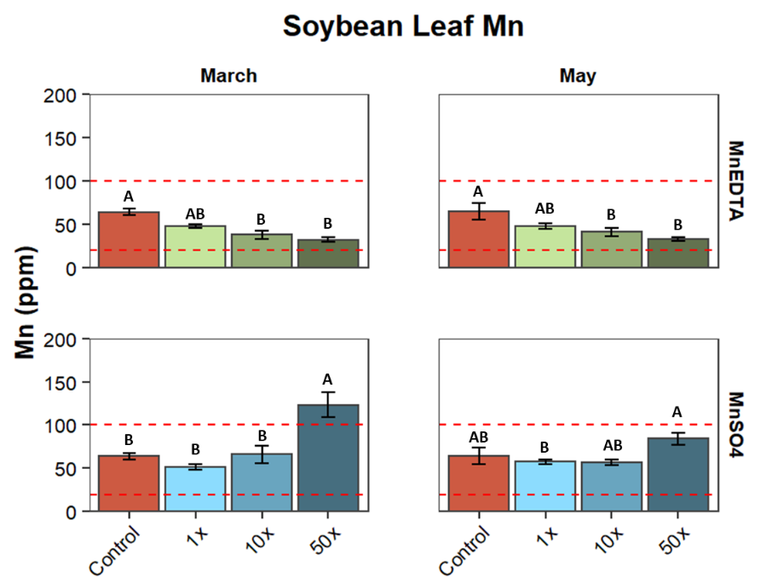
Figure A.1. Soybean leaf Mn concentrations as affected by fertilizer types and application rates. Bars represent the means with standard error shown by vertical lines (n=4). Red dashed lines denote the sufficiency range of Mn for soybean (Mills & Bryson, 2015).

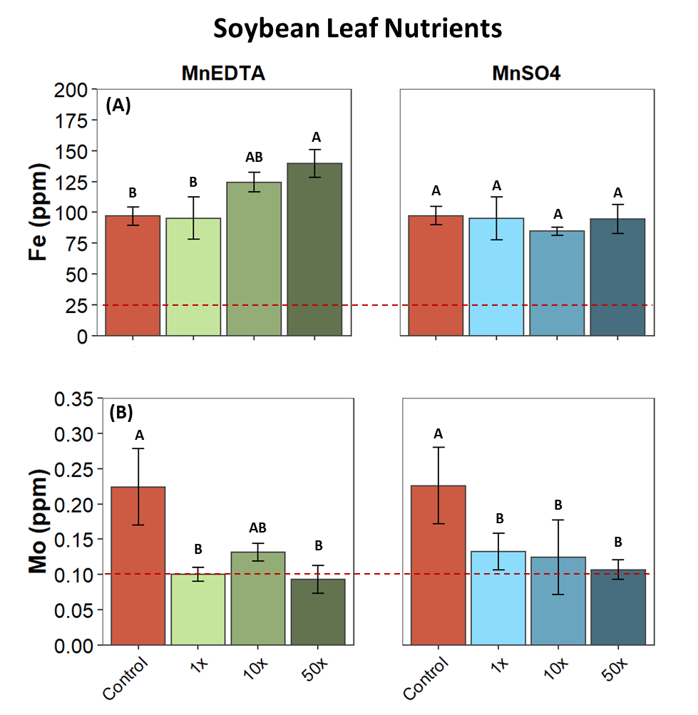
Figure A.2. Soybean leaf concentration of Fe (A) and Mo (B) as affected by fertilizer type and application rates at the April sampling point. Bars represent the means with standard error shown by vertical bars (n=4). Red dashed lines denote the sufficiency range of Fe and Mo for soybean (Mills & Byrson, 2015). Note: Fe and Mo y-axis are shown on different scales.

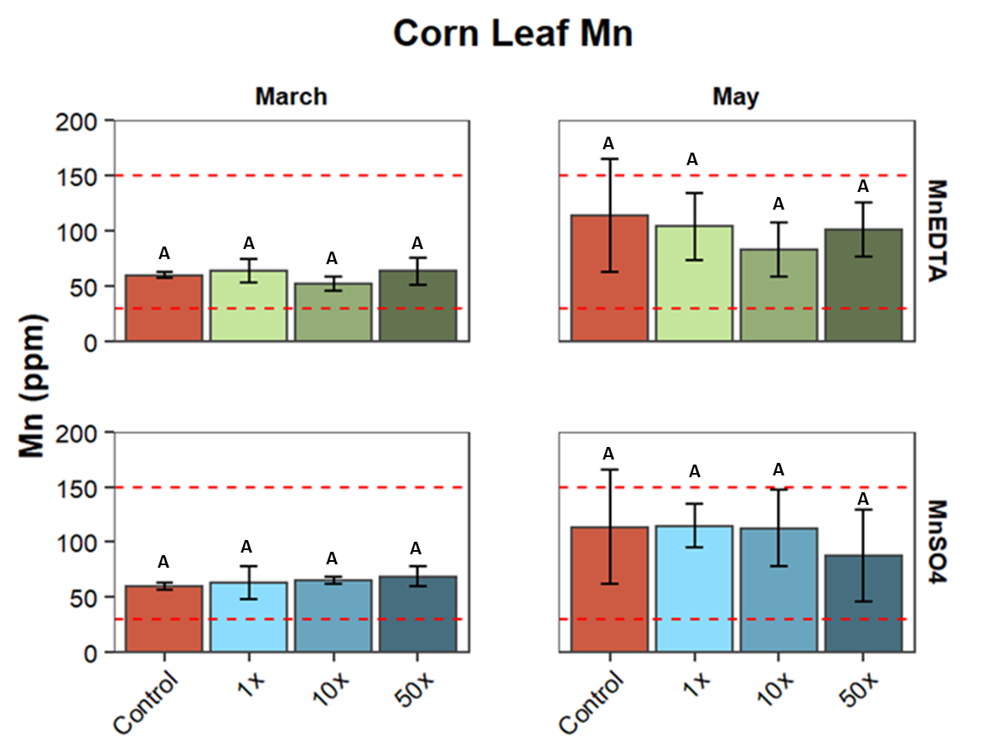
Figure A.3. Corn leaf Mn concentrations as affected by fertilizer type and application rates. Bars represent the means with standard error shown by vertical lines (n=4). Red dashed lines denote the sufficiency range of Mn for corn (Mills & Bryson, 2015).
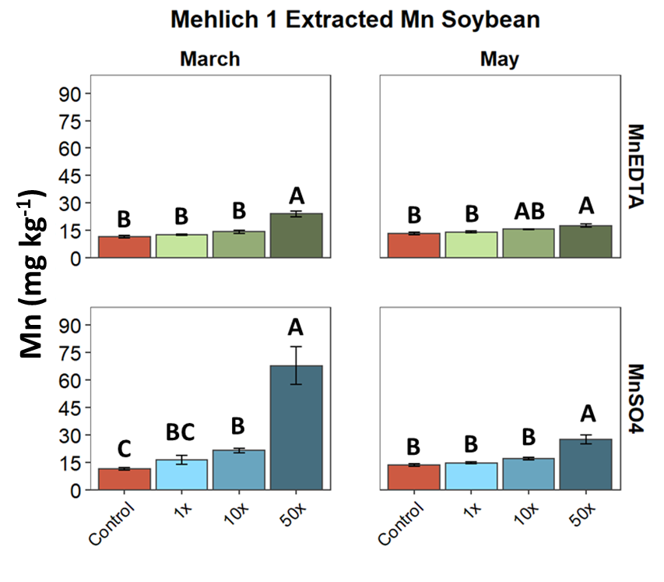
Figure A.4. Soil bioavailable-Mn (Bio-Mn) concentrations (Mehlich-1 extractable) as affected by fertilizer type and rate for soybean. Bars represent the means with standard error shown by vertical lines (n=4). Letters denote significant differences at p<0.05.

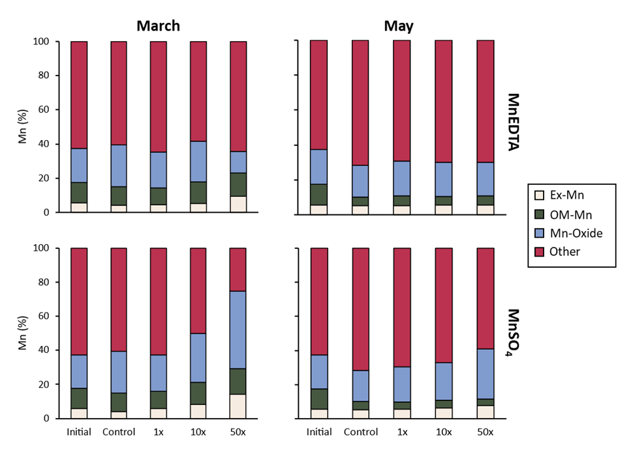
Figure A.5. Effect of fertilizer types and application rates on sequentially-extracted soil Mn forms in soybean. Mn shown in percent of Total Mn. “Other” represents the sum of Ex-Mn, OM-Mn, and Mn-Oxide subtracted from the Total Mn.
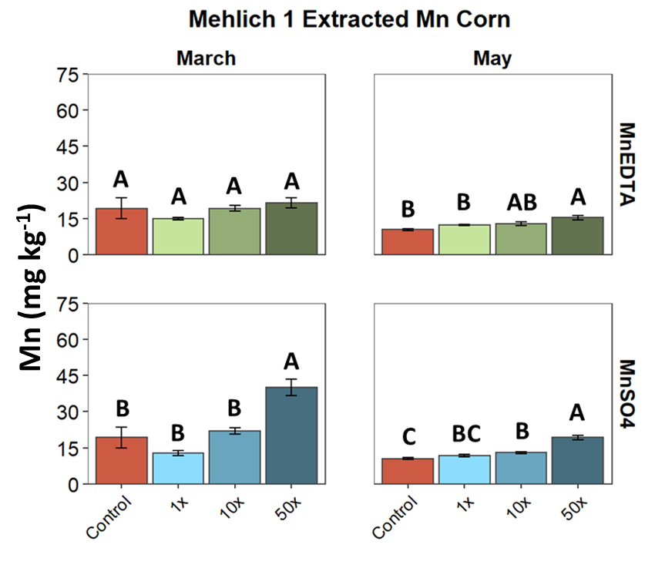
Figure A.6. Soil bioavailable-Mn (Bio-Mn) concentrations (Mehlich-1 extractable) as affected by fertilizer type and rate for corn. Bars represent the means with standard error shown by vertical lines (n=4). Letters denote significant differences at p<0.05.

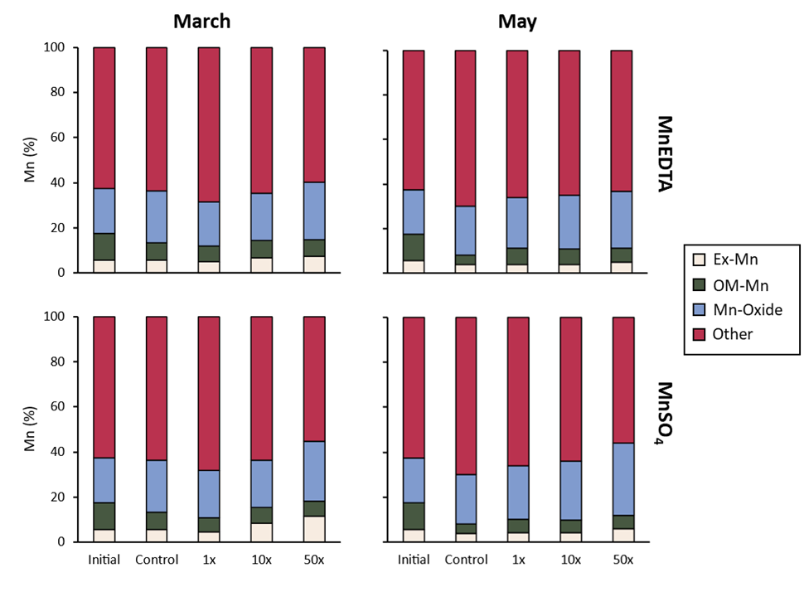
Figure A.7. Effect of fertilizer types and application rates on sequentially-extracted soil Mn form in the corn group. Mn Shown in percent of total Mn. “Other” represents the sum of Ex-Mn, OM-Mn, and Mn-Oxide subtracted from the Total Mn. Letters denote significant differences in Total Mn concentrations.
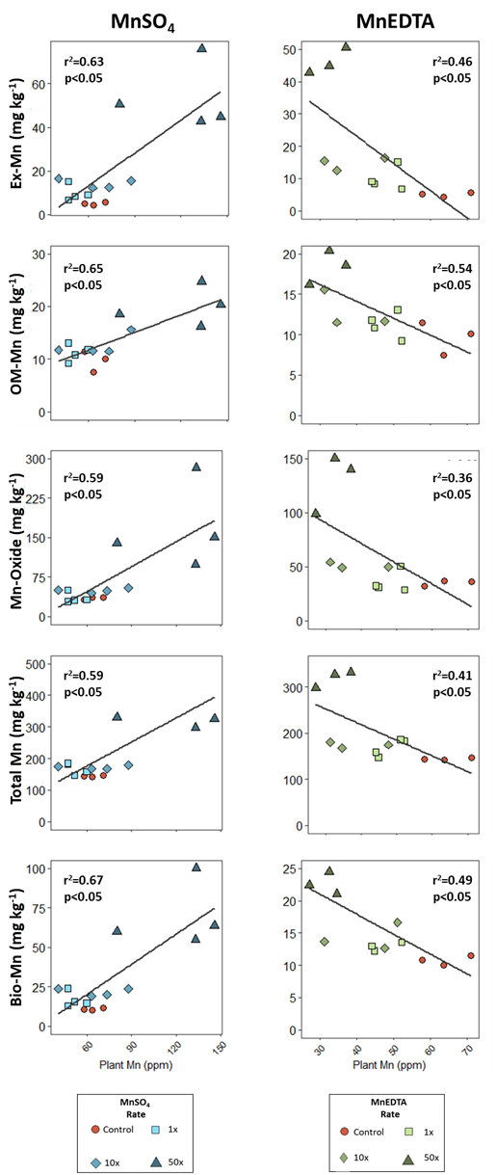
Figure A.8. Relationship between leaf Mn concentrations and Mn soil forms in soybean. Marker shape and color denote the fertilizer application rates. Note: Y-axis values are on different scales for the two fertilizer types.
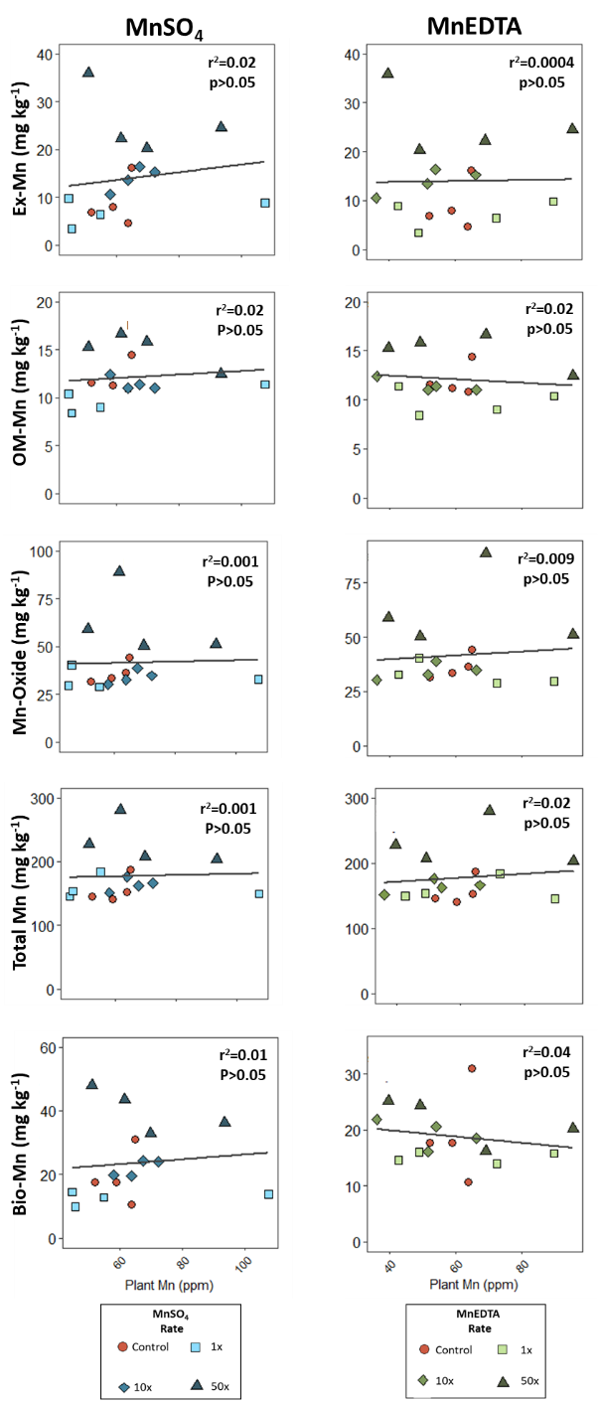
Figure A. 9. Relationship between leaf Mn concentrations and Mn soil forms in corn. Marker shape and color denote the fertilizer application rates. Note: Y-axis values are on different scales for the two fertilizer types.

Supplemental Section
The values obtained from the chlorophyll extractions were compared to the values obtained from the Apogee meter. When comparing the Apogee meter values to the total chlorophyll concentration determined by extraction, there was a negative relationship with an R² of 0.1162 (Supplemental Figure 1A), resulting in a relatively weak relationship between the two techniques. The Apogee values were also compared to the chlorophyll a:b ratio, which had almost no relationship at all, with an R² of 0.0082 (Supplemental Figure 1B). Thus, it was determined that the Apogee meter results were not reliable for comparison in chlorophyll content in response to treatments.

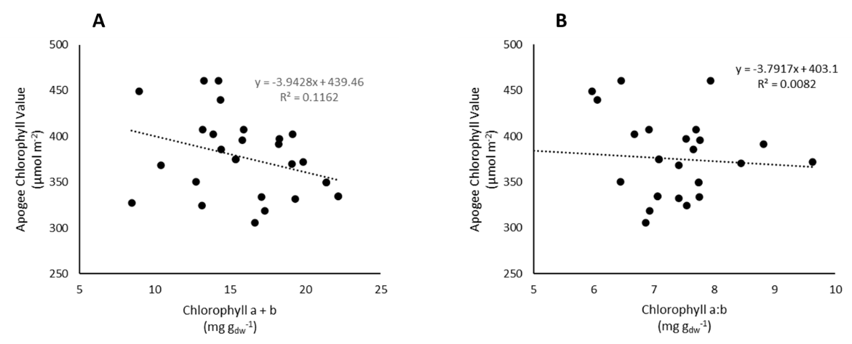
Supplemental Figure 1: Comparison of Apogee meter chlorophyll measurements and wet chemistry analysis. (A) Apogee chlorophyll value compared to total chlorophyll value from wet chemistry analysis. (B) Apogee chlorophyll values compared to chlorophyll a:b ratio determined via wet chemistry analysis.

Chapter 2: Manganese Forms and Plant Availability Across Soil Depth in Contrasting Land Use Systems

Abstract
Mn is an essential micronutrient for all living organisms, and its forms in soil and availability to plants depends largely on soil pH and redox conditions. The forms of Mn in soils range from readily available (e.g., bioavailable Mn, exchangeable Mn) to stabilized (Mn-Oxide minerals, Mn contained in silicates). Many agricultural practices can alter pH and organic matter (OM) content in soils, both of which are major contributors to Mn availability. Also, Mn has been deemed a major influence on C cycling in soils. Thus, this study aims to determine the effect of contrasting land use practices (organic agriculture, conventional agriculture, and unmanaged forest) on Mn forms across soil depth. In addition to total Mn content in soil, different Mn forms were evaluated using a sequential extraction targeting exchangeable-Mn, organically bound Mn, Mn-Oxides, and residual Mn. The relationship of different Mn forms with soil organic carbon (SOC) was also evaluated. Generally, the two agricultural sites had similar amounts of Mn forms. For example, both agricultural sites had lower available Mn (1.2-5.8% of total Mn) than the unmanaged system (5.6-41.2% of total Mn). Across all three systems, Mn generally decreased with increasing depth. Lastly, we observed a positive relationship between SOC and available Mn forms and a negative relationship between SOC and unavailable Mn forms, indicating different forms of Mn likely play different roles in C cycling.

Introduction
Mn is an essential micronutrient for all living organisms. While Mn is the 13th most abundant element in soil (Essington, 2015) with an average concentration of Mn of 488 mg kg⁻¹ (Kabata-Pendias & Kabata-Pendias, 2010), Mn availability to crops is still of significant concern in agricultural systems. Mn availability is governed by the redox and pH conditions of soils, both of which can be significantly impacted by agricultural practices. For example, conventional cropping systems receive synthetic nitrogen fertilizers, which lower soil pH. In contrast, organic farming practices rely heavily on manure application and cover crops, which increases the organic matter (OM) content of the soils. A change in both soil pH and OM content can alter Mn form and plant availability, thereby, making it important to understand how differences in land use practices affect Mn availability.
Some studies have evaluated the effect of agricultural practices on Mn form and availability (de Santiago et al., 2008; Gupta et al., 2008; Moreira et al., 2016; Wang et al., 2016). While the specific forms of Mn targeted varies across studies, generally, studies included soluble or exchangeable Mn (Ex-Mn), organically bound Mn (OM-Mn), and Mn-Oxide, with the soluble and/or Ex-Mn and OM-Mn fractions often considered to be plant available (Wei et al., 2008). Additionally, in agriculture studies, Mehlich-1 and Mehlich-3 solutions are commonly used to determine bioavailable Mn (Bio-Mn) (Mylavarapu and Miller, 2014; Zhang et al., 2014). Practices that increase SOM content, such as no tillage and manure applications, subsequently result in an increase in available Mn (de Santiago et al., 2008; Moreira et al., 2016; Wang et al., 2016). There are several mechanisms that could explain this positive relationship between available Mn and SOM. First, increased OM content can increase a soil’s cation exchange capacity, thereby, providing nutrients, including Mn, to plants (Krull et al., 2004). Second, chelation of Mn by OM can increase its availability while also inhibiting the precipitation of Mn-Oxide minerals (de Santiago et al., 2008). In addition to OM content, Mn availability can be largely impacted by soil pH, with acidic pH (pH<5.5) resulting in increased available Mn. In contrast, surface liming in no-till systems causes an increase in pH, resulting in reduced Mn content in soil and uptake by plants (Fávero Caires et al., 2008). However, to our knowledge, no studies have compared Mn geochemistry across contrasting management strategies on a similar geographic location or soil type. In addition, Mn forms are typically evaluated to a soil depth of 5-15 cm. However, it is important to understand subsoil Mn forms because of their potential impact on C cycling and OM stability, as several studies have attributed decreased soil organic carbon (SOC) storage to high Mn concentrations (Berg et al., 2010; Stendahl et al., 2017; Sun et al., 2019). Despite strong evidence to support this claim, to our knowledge, no studies have analyzed the relationship of various Mn forms on SOC and how these relationships can change with depth, as most of studies have been focused on the litter layer and the organic layer of soils.
Compared to agroecosystems, Mn cycling in unmanaged forest ecosystems has been more extensively studied. While trees can uptake larger amounts of available Mn from soil than annual crops (Herndon et al., 2015; Kruse et al., 2021; Richardson, 2017), forest systems experience continuous cycling of Mn through plant uptake and litter decomposition processes. Upon leaf fall and litter decomposition, the Mn contained within the leaves of the tree is returned to the soil surface, where much of the Mn is rapidly oxidized (Herndon et al., 2014). To access this unavailable Mn, roots can release exudates to locally modify soil pH, increasing available Mn in the rooting zone (Rengel, 2014). This continuous uptake and return of Mn to the soil surface during litter decomposition results in high Mn concentrations near the soil surface and rooting zones of forest systems. In contrast, Mn contained within plant biomass in agroecosystems is removed from the system, at least partially by crop harvest, thereby limiting the cycling of Mn in soil.
In forest systems, high Mn concentrations have also been connected to increased late-stage litter decomposition and decreased SOC storage (Berg et al., 2007; Keiluweit et al., 2015; Stendahl et al., 2017). Under Mn enrichment, Mn Peroxidase (MnP) enzyme activity is enhanced, which promotes the degradation of lignin, utlimately leading to increased litter decomposition and decreased SOC storage. Additionally, some Mn forms, namely Mn-Oxides and OM-Mn, in soils can contribute significantly to the oxidative activity of soils, which is a major control in OM decomposition processes (Jones et al., 2020; Li et al., 2021). However, Mn-Oxides also have the ability to stabilize OM through surface electrostatic interactions, coprecipitation, and physical trapping (Li et al., 2021). Clearly, Mn influences both stabilization and destabilization of SOC. With about a third of greenhouse gas emissions coming from agriculture (Gilbert, 2012), it is critical to understand if micronutrients such as Mn play a key role in C cycling in agroecosystems. To achieve this, we must first understand the distribution of Mn forms across the soil profile in these systems.
In this study, Mn available and unavailable forms were analyzed across different land management strategies on acidic soils in central Tennessee. The specific objectives were to study the effect of (1) three different management strategies (organic agriculture, conventional agriculture, and unmanaged forest) and (2) soil depth on different Mn forms in soil. Using these findings, we hope to draw conclusions about Mn availability to plants in these systems and investigate the effect of Mn forms on SOC content. The first hypothesis is that the agricultural systems (organic and conventional) will have decreased plant available Mn (e.g., Mehlich-1 extracted, Ex-Mn, OM-Mn) compared to the forest system due to the continuous removal of plant biomass in the agricultural systems, thereby, removing Mn contained within that plant. Between the two agricultural sites, we hypothesize that the organic site will have higher available Mn than the conventional site due to the application of manure and increased use of cover crops in the organic system, both of which increase SOM and subsequently lead to increased available Mn. The second hypothesis is that available Mn will decrease with increasing soil depth in all three systems, and in subsoil layers more Mn will be contained as Mn-Oxide or Residual Mn. Based on these two hypotheses, we predict that Mn availability will be the highest in surface soils in the unmanaged forest system, followed by the organic agricultural system, then the conventional agricultural system. Across all three systems, we predict that SOC content will be negatively associated with Mn concentrations at the surface and the relationship will weaken with increasing depth. While several other studies have investigated the effects of tillage and different fertilizer types, to our knowledge, there has been no investigation of depth-wise Mn geochemistry in contrasting land use systems on a similar soil type.

Materials and Methods

Study Sites and Treatments
This study used three different land use systems located in Orlinda, TN as treatments. Treatment 1 was an organically managed grain production system in Windy Acres Farm (36°35’24.0”N, 86°41’24.0”W) and has been managing a corn-soybean-small grains rotation for more than 20 years. Additionally, a multispecies grass and legume winter cover crop mixture was integrated into the rotation and poultry manure was applied prior to planting corn. At the time of soil sampling on 27 October 2021, the field had corn in the near harvest stage. This treatment will hereby be referred to as ‘Org-Ag’. Treatment 2 (36°35’26.4”N, 86°36’19.5”W) was a conventionally managed corn-soybean rotational system that uses pesticides, herbicides, and synthetic fertilizers and has been no-till for more than 10 years. A grass and legume winter cover crop mixture was grown in this system every two to three years. This treatment will be referred to as ‘Con-Ag’. Treatment 3 was an unmanaged forested area near the Windy Acres farm (36°35’47.9”N, 86°41’44.2”W) and will be referred to as ‘Unmanaged’. All three treatments lie on the Pembroke soil series (Fine-silty, mixed, active, mesic Mollic Paleudalfs). The Pembroke soils are characteristically deep (0-200 cm), well-drained, formed on a thin layer of loess underlain by limestone, have neutral to acidic pH, and are commonly found on level uplands and karst areas. Beginning around 23 cm depth, Mn concretions are typically found (USDA, 2021).

Soil Sampling and Processing
At each of the three sites, soil samples were collected to a depth of 60 cm and roughly divided by horizon: Ap- 0-25 cm, which is further divided into two (0-10 and 10-25 cm); Bt1 - 25-45 cm; and Bt2 - 45-60 cm). The samples were collected with a 7 cm diameter bucket auger. At both agricultural sites (Treatment 1 and 2), the field where the soil was mapped as Pembroke series was separated into five 0.5-ha sections, each representing one replication. Within those five replications, two samples per replication were collected to account for spatial heterogeneity, if any, and to ensure an adequate volume of soil for analysis (Fig. B.1A, B). After both samples were collected, the two samples per replication were homogenized prior to collecting a subsample. For the unmanaged site, an area of approximately 0.1 hectare was identified. In this area, soils were collected at five points, ensuring each point was at least 5 m from the previous sampling point (Fig. B.1C). Considering all treatments (three), soil depths (four), and replications (five), a total of 60 samples were collected. Upon returning to the lab, the soils were air-dried, sieved (<2 mm), and stored for analysis.

Laboratory Analysis
Most of the soil analysis followed the same protocols as described in Chapter 1, namely pH, SOC, WEOC, TN, Bio-Mn, Total Mn and other Mn forms derived by sequential Mn extraction (Ex-Mn, OM-Mn, Mn-Oxides). Additionally, the Residual Mn, i.e., Mn remaining after the sequential extraction, was measured following the method of Total Mn determination with a slight modification to ensure ICP detectable values (Chang et al., 1984). Specifically, the soils remaining from the sequential extraction (~0.4 g) were dried and transferred to glass tubes and weighed. Then, 10 mL of 4 M HNO₃ was added to the soil. The soils were then digested using a digestion block at 70°C for 16 hours. The remaining soil-acid solution was brought to a volume of 15 mL, mixed by hand, and filtered. All ICP samples were sent to the University of Georgia Soil, Plant & Water Laboratory for analysis.

Statistical Analysis
To determine significant differences in measured soil properties among land use treatments and depths, a non-linear mixed effects model was ran using lme function in the nlme package (v.3.1-157; Pinheiro and Bates, 2022) in R v. 4.0.2, with treatment (i.e., land use systems) and depth as fixed effects and replicate as a random effect. Treatment differences were considered significant when p<0.05. If a significant interaction was detected between treatment and depth, then estimated marginal means were calculated by depth using the emmeans package (v. 1.7.4-1; Lenth, 2022).

Results

Soil pH, SOC, Total N, and WEOC
Soil pH values varied across the three sites, with the unmanaged site having the lowest pH at all depths (Table B.1). Overall, the average pH of the unmanaged site was 1.7 units lower than the agricultural sites, demonstrating the stark differences among these sites. In the surface soils (0-10 cm), the Con-Ag had the highest pH. Beyond the 0-10 cm surface soils, there were no statistical differences between the Org-Ag and Con-Ag. At the Org-Ag site, soil pH was lower at the surface (0-10 cm) compared to the sub-surface soil depths.
Soil organic carbon (SOC) values also varied significantly among treatments (Table B.1). In the surface soils (0-10 cm), the unmanaged site had the highest SOC, followed by Org-Ag, and Con-Ag had the lowest SOC. At all three sites, SOC decreased with increasing depth. The unmanaged site had the highest SOC value at all depths, except at the 10-25 cm depth increment where it had statistical equal values with Org-Ag. However, past the 10-25 cm depth, the SOC of Org-Ag and Con-Ag sites had no statistical differences.
Soil total nitrogen values at 0-10 cm were the lowest at the Con-Ag site and there was no statistical difference between the Org-Ag and unmanaged sites. At the 10-25 cm depth, the Org-Ag site had the highest N value. However, at this depth, the N concentration decreased dramatically for all three sites, especially in the forest system (1.47 to 0.546 g kg⁻¹). Beginning at the 25-45 cm depth increment, no statistical differences among sites in N concentrations were found (Table B.1).
WEOC varied across treatments, with Org-Ag having the highest WEOC concentrations at most depths (Table B.1). At the surface, Org-Ag had higher WEOC concentrations than the unmanaged site, likely due to manure applications in Org-Ag. Generally, WEOC decreased with increasing depth.

Soil Mn Fractions Across Sites and Depths
Soil Mn fractions measured via sequential extraction varied across the three sites, with Mn-Oxide, Residual Mn, and Total Mn having the most variation (Table B.2). When averaged across all sites and depths, Mn fraction abundance was as follows: Residual > Mn-Oxide > OM-Mn = Ex-Mn. Across all sites and depths, the plant available fractions (Ex-Mn and OM-Mn) together comprised only 1.2-41% of all soil Mn. Across the three sites, the Org-Ag and Con-Ag sites had the highest total Mn concentration from 0-45 cm depth (Table B.2). At the 45-60 cm depth interval, there was no difference among the three sites. In the Org-Ag and Con-Ag sites, total Mn slightly decreased with increasing depth.
Table B.3 and Figure B.2 show the concentration of each Mn form as a percentage of total Mn of each land use treatment. Of the three sites, the unmanaged site had the highest Ex-Mn percentage at 0-45 cm, followed by the Org-Ag site. Org-Ag was only statistically different from Con-Ag at the 0-10 cm depth interval, with the Org-Ag having 3.5% Ex-Mn compared to 1.87% Ex-Mn in the Con-Ag. At the unmanaged site, Ex-Mn percentage increased with increasing depth. Contrastingly, at the Org-Ag, Ex-Mn percentage showed a decreasing trend with increasing depth. Ex-Mn did not change with depth at the Con-Ag. The average percent of Ex-Mn across all depths in the three systems were 6.48 ± 1.5, 2.02 ± 0.3, and 1.72 ± 0.2 for the unmanaged, Org-Ag, and Con-Ag sites, respectively.
The unmanaged site also had the highest percentage of OM-Mn at the surface and there was no difference between the Org-Ag and Con-Ag sites. At the unmanaged site, OM-Mn was the highest at 25-45 cm depth increment (27 ± 4.0 %), above and below which it is much lower (<13%). Similar to the Ex-Mn fraction, the OM-Mn fraction decreased slightly with depth in both the organic and conventional systems. In the forest, organic, and conventional systems, OM-Mn made up 7.1 ± 1.5, 1.3 ± 0.2, and 1.1 ± 0.1% of total soil Mn, respectively.
At the two shallowest depth intervals (0-10, 10-25 cm), there was no difference between Mn-Oxide percentages among the three sites. At the 25-45 cm depth increment, the unmanaged site had the highest Mn-Oxide percentage. The Con-Ag and Org-Ag sites had the highest Mn-Oxide percentage at the 45-60 cm increment. Mn-Oxide percent generally decreased with increasing depth. Overall, the percentage of Mn-Oxide relative to total Mn was relatively equal between the three sites (Forest: 46.5 ± 9.2, Organic: 45.0 ± 3.4, Conventional: 44.0 ± 2.9).
Residual Mn did not vary significantly across the three sites or with depth. The only exception to this was the 45-60 cm depth interval at the unmanaged site, which was significantly lower than the two agricultural sites and lower than the shallower depth increments at the unmanaged site. The average percentage of residual Mn in the unmanaged, Org-Ag, and Con-Ag sites were 23.0 ± 4.8, 35.2 ± 3.9, and 38.1 ± 5.6%, respectively.
Among the sites, Bio-Mn, determined separately from the sequential extraction, was lower at the 25-45 cm depth interval in the organic and conventional systems compared to the forest system. In both the Con-Ag and unmanaged system, Bio-Mn decreased significantly at the 45-60 cm depth interval. There was no change in Bio-Mn with depth in the organic system. The average Bio-Mn percentages for the unmanaged, Org-Ag, and Con-Ag sites were 9.5 ± 2.2, 5.1 ± 0.7, and 5.1 ± 0.6%, respectively.

Discussion

Soil Chemical Properties Changes Across Sites and Soil Depths
In the studied systems, surface (0-10 cm) concentrations of SOC varied as follows: Unmanaged > Org-Ag > Con-Ag (Table B.1). This is the expected trend based on the levels of organic inputs these sites receive and the degree of disturbance. The highest SOC in forest can be attributed to the decomposition of leaf litter and other organic inputs (decaying macrofauna etc.) and no anthropogenic land disturbance. The Org-Ag site had greater SOC than Con-Ag due to more weeds and cover crops in Org-Ag returning more C to soil, manure application, and inclusion of grass species in a 6-year rotation. Generally, SOC concentrations decreased with increasing depth. These trends with depth indicate that surface SOC values are more impacted by management practices than deeper soils (25-60 cm), but the entire profile in agricultural sites is depleted in SOC relative to the unmanaged forest system.
Typically, WEOC is reported to have higher concentrations in forest systems than in agricultural systems (Chantigny, 2003). However, in our study, WEOC in the unmanaged site was either equivalent or less than the agricultural sites. The exception to this trend occurred at the deepest depth interval where the forest had higher WEOC than the Con-Ag, but not the Org-Ag. Relatively high WEOC concentration in deep forest samples could be due to C leaching from surface layers to deeper in the soil profile.
Soil pH varied dramatically between the forest and the two agricultural sites (Table B.1). Even though both the application of manure and N fertilizer can decrease soil pH (Wang et al., 2016), the pH at both the Con-Ag and Org-Ag sites was higher than the unmanaged site, but still within the acidic range. In the surface soils (0-10 cm), the Con-Ag had the highest pH, likely due to the application of lime. Since this site is no-till, the lime applications would only affect the surface soils. However, unlike the current knowledge (Hue, 1988; Kabata-Pendias & Kabata-Pendias, 2010; Remucal & Ginder-Vogel, 2014), soil pH does not appear to be a controlling factor of Mn concentrations in our study, indicated by the lack of relationship between the two parameters (Fig. B.3). Instead, Mn concentration appears to be a function of site, rather than of soil pH, given that Mn concentrations were strongly clustered by site when plotted against soil pH. Even within each site, there was no relationship between soil Mn concentration and soil pH. The lack of relationship between these two parameters could indicate that the management strategies of each site are more likely to impact soil Mn concentrations than just pH alone, despite pH being a major determining factor of Mn concentration. Additionally, it may take longer for soil pH to influence Mn concentrations than the various management practices.

Soil Mn Forms Changes Across Sites and Soil Depths
Mn forms measured via sequential extraction and their distribution changed across the three sites and four soil depths. Generally, the distribution of Mn forms was as follows: Residual Mn > Mn-Oxide > OM-Mn = Ex-Mn. Other studies have reported similar distributions of Mn forms (Moreira et al., 2016; Obrador et al., 2007; Wang et al., 2016). In the Org-Ag and Con-Ag sites, Ex-Mn, OM-Mn, and Mn-Oxide decreased with increasing depth, particularly the plant available Mn fractions (Ex-Mn and OM-Mn) (Table B.3; Figure B.2). This indicates that external nutrient sources (i.e., fertilizer, manure, etc.) mainly contributed nutrients to the surface soils. Other studies have reported the strongest effects of manure additions on overall nutrient content occur in surface soils (Mikha et al., 2017; Miner et al., 2020). Winter cover crops grown in agricultural systems are also effective in mining nutrients from deeper soil layers and making them available at the soil surface when they are terminated. Additionally, in the conventional system, no-till management is practiced, due to which fertilizer applications should only influence surface soils. The organic system also follows a reduced tillage strategy (one tillage in 6 years), which also support nutrient stratification by soil depth.
When normalized to total Mn, the Org-Ag, Con-Ag, and unmanaged sites had 7.56, 8.02, and 12.1% Mehlich-1 extracted Bio-Mn, respectively, at the 0-10 cm depth increment. However, these mean values were not significantly different. Ex-Mn and OM-Mn fractions are also said to contribute to plant available Mn (de Santiago et al., 2008; Wei et al., 2008). In the surface soils (0-10 cm) of the Org-Ag and Con-Ag sites, the sum of Ex-Mn and OM-Mn made up 5.8 and 3.6 % of total Mn, respectively, which were also not significantly different to each other. However, the Org-Ag and Con-Ag sites had lower Ex-Mn and OM-Mn than the unmanaged site at this depth (17.1 %). Thus, in our system, it seems the Ex-Mn and OM-Mn fractions are lower in agricultural systems regardless of differences in management practices when compared to an unmanaged forest system. The decreased availability of Ex-Mn and OM-Mn could lead to limitations in Mn availability to plants in these systems.
Decreases in Ex-Mn, OM-Mn, and Bio-Mn have been reported in continuous cropping systems due to the continual plant uptake of Mn from soil and subsequent removal from the system through grains and other produce (Behera et al., 2009; Shambhavi et al., 2016; Wang et al., 2016). In contrast, manure usage has resulted in increases in OM-Mn content (Wang et al., 2016) and mixed effects on Bio-Mn and Ex-Mn (Miner et al., 2020; Wang et al., 2016).
In the unmanaged site, total Mn also decreased with increasing depth. Typically, we would expect total Mn concentrations to be the highest in the B horizon where Fe and Al accumulate. However, our results indicate that, instead, Mn accumulates on the surface soils. However, there was an increase in percentage of total Mn that is contributed by Ex-Mn and OM-Mn forms until 45 cm depth. This increase with depth could be due to tree uptake of available Mn from the surface layers, thereby, decreasing the available Mn concentrations at shallower depths. Compared to agricultural crops, trees have a greater capacity to uptake Mn from soils (Herndon et al., 2015; Kruse et al., 2021; Richardson, 2017), thereby, removing Mn from the soil in this system. Additionally, the soil sampling occurred before leaf fall. Thus, it is possible that significant amounts of available Mn were contained within the plant biomass and had not yet been returned to the soil surface via leaf litter decomposition. However, the concentration of Mn contained within tree biomass is likely too small to account for the ~600 mg/kg difference between unmanaged and agricultural sites. Another contributing factor could be high Mn-Oxide percent at the surface in the unmanaged site, which decreased with increasing depth. Thus, the oxidation of available Mn in decaying leaf litter at the soil surface (Herndon et al., 2014) could be contributing to the reduced amount of available Mn in the surface soils. Additionally, the low soil pH of the unmanaged site may promote leaching of available Mn to deeper in the soil profile.
At the unmanaged site, Bio-Mn comprised 16.2 % of total Mn, whereas Ex-Mn and OM-Mn made up 25%. Thus, in contrast to the organic and conventional systems, the Bio-Mn, extracted with Mehlich-1 solution, was higher than the sum of available Mn fractions contributed by Ex-Mn and OM-Mn. The dramatically higher Bio-Mn compared to the sum of Ex-Mn and OM-Mn fractions in the Org-Ag and Con-Ag sites could potentially be overestimating concentrations of available Mn in these soils. Several other studies observed no change in plant concentrations of Mn even when Bio-Mn increased have been reported (de Santiago et al., 2008; Moreira et al., 2016). Thus, standard methods of estimating available Mn (Mehlich-1, DTPA, etc.) has received some criticisms (Moreira et al., 2016; Sharpe & Parks, 1982).

Relationship of Mn Forms with Soil C
To determine the relationship between SOC and soil Mn forms, linear regression analysis was conducted. Most studies looking at the role of Mn in C cycling focus on surface soils, where Mn has a strong control on the oxidative activity of soils and, therefore, decomposition (Jones et al., 2020). Because of this known relationship in surface soils, relationships between Mn forms and SOC were determined for only the 0-10 cm depth increment (Fig. B.4). The Ex-Mn and OM-Mn had a positive relationship with SOC in the surface samples (R²=0.15 and 0.07, respectively; p<0.05). However, Bio-Mn, Mn-Oxide, Residual Mn, and Total Mn all had a negative relationship with SOC at the surface (R²=0.22, 0.31, 0.29, and 0.37, respectively; p<0.001). Both OM-Mn and Ex-Mn are often considered plant available fractions (Wei et al., 2008). The positive relationship between these Mn forms and SOC is consistent with our understanding that high SOC, and therefore high OM, would promote the chelation of Mn by OM and increase the CEC of a soil (Krull et al., 2004) that leads to more Ex-Mn. In contrast to our study, several other studies have reported negative relationship between Ex-Mn concentrations and SOC in forest ecosystems (Kranabetter, 2019; Stendahl et al., 2017). The negative relationship between Ex-Mn and SOC was attributed to Mn’s role as a cofactor in the MnP enzyme, which plays a significant role in lignin decomposition and decrease in SOC (Berg et al., 2010; Keiluweit et al., 2015). However, in our study, even when comparing Ex-Mn and SOC only for the unmanaged site, there was no relationship between the two parameters (R²=0.009; p>0.05).
The relationships of Bio-Mn, Mn-Oxide, Residual Mn, and Total Mn with SOC are more consistent with trends reported in the literature (Stendahl et al., 2017; Trum et al., 2011), with higher concentrations of soil Mn resulting in decreases in SOC. The oxidation of Mn²⁺ to more reactive Mn³⁺ has been connected to increased lignin degradation (Berg et al., 2007; Keiluweit et al., 2015), with the generation of Mn³⁺-Oxides coinciding with the loss of C as CO₂ (Jones et al., 2018). Additionally, increased total Mn has been linked to increased C mineralization, leading to a decrease in SOC (Trum et al., 2011). Thus, clear connections between Mn-Oxides and total Mn have been established in the literature. All the Mn forms that had a negative relationship with SOC (Bio-Mn, Mn-Oxide, Residual, and Total Mn) were also the forms of Mn least impacted by differences in management.
The regression analysis was also done at the 45-60 cm depth interval (Fig. B.5) which showed only Mn-Oxide and residual Mn had a significant, negative relationship with SOC (R²=0.11 and 0.12; p<0.05). However, these relationships are much weaker than those at the surface, indicating that Mn may play a less significant role in C cycling at depth. Thus, it is likely that Mn plays a significant role in C cycling in the surface soils of agricultural systems similar to that of forest ecosystems. However, more research on multiple sites, management scenarios, and cropping systems needs to be done to quantify the role of Mn in C storage in agricultural systems.

Conclusion
Across the three studied land use systems, the organic and conventional agricultural systems were relatively equivalent in the concentration of Mn forms and soil pH. Between the two agricultural sites, available Mn fractions (Ex-Mn + OM-Mn) only accounted for 3-5% of total soil Mn, indicating that it is likely Mn may be limited to crops in these systems. Regardless of differences in agricultural practices, agricultural systems seem to be depleting plant available Mn fractions in soil, possibly due to the continual removal of a portion of the Mn contained within plant biomass as harvested produce. In contrast to the agricultural systems, the unmanaged site had higher percentages (5-40%) of available Mn fractions, due to the continuous cycling of Mn through leaf litter decomposition and lower soil pH. However, there were no differences in Bio-Mn percentages among the three systems. The discrepancy between the two types of available Mn measurements indicates an overestimation of available Mn in the agricultural systems by the Mehlich-1 extraction method. Across all three systems, Mn form concentrations tended to decrease with increasing depth, with the exception of Residual Mn which did not change with depth. Lastly, in surface soils, Bio-Mn, Mn-Oxide, residual Mn, and total Mn all had a negative relationship with SOC, whereas Ex-Mn and OM-Mn had a positive relationship with SOC. This trend indicates that different Mn forms impact C cycling differently. Additionally, the relationship between Mn forms and SOC were consistent across all systems, indicating Mn is playing an important and likely similar role in C cycling in all the studied systems. However, much more research on specific mechanisms of Mn-C interaction need to be studied, especially in agricultural contexts.

References
Behera, S. K., Singh, D., & Swaroop Dwivedi, B. (2009). Changes in Fractions of Iron, Manganese, Copper, and Zinc in Soil under Continuous Cropping for More Than Three Decades. Communications in Soil Science and Plant Analysis, 40(9-10), 1380-1407. https://doi.org/10.1080/00103620902818054
Berg, B., Davey, M., Marco, A., Emmett, B., Faituri, M., Hobbie, S., Johansson, M.-B., Liu, C., McClaugherty, C., Norell, L., Rutigliano, F., Vesterdal, L., & Virzo De Santo, A. (2010). Factors influencing limit values for pine needle litter decomposition: A synthesis for boreal and temperate pine forest systems. Biogeochemistry, 100, 57-73. https://doi.org/10.1007/s10533-009-9404-y
Berg, B., Steffen, K. T., & McClaugherty, C. (2007). Litter decomposition rate is dependent on litter Mn concentrations. Biogeochemistry, 82(1), 29-39. https://doi.org/10.1007/s10533-006-9050-6
Chantigny, M. H. (2003). Dissolved and water-extractable organic matter in soils: a review on the influence of land use and management practices. Geoderma, 113(3), 357-380. https://doi.org/https://doi.org/10.1016/S0016-7061(02)00370-1
de Santiago, A., Quintero, J. M., & Delgado, A. (2008). Long-term effects of tillage on the availability of iron, copper, manganese, and zinc in a Spanish Vertisol. Soil and Tillage Research, 98(2), 200-207. https://doi.org/https://doi.org/10.1016/j.still.2008.01.002
Essington, M. E. (2015). Soil and water chemistry an integrative approach (Second Edition ed.). CRC Press.
Fávero Caires, E., José Garbuio, F., & Barth, G. (2008). Surface Application of Lime and Cover Black Oat and Corn Residues for No‐Till Soybean Production. Communications in Soil Science and Plant Analysis, 39(13-14), 2102-2118. https://doi.org/10.1080/00103620802135138
Gilbert, N. (2012). One-third of our greenhouse gas emissions come from agriculture. Nature. https://doi.org/10.1038/nature.2012.11708
Gupta, U. C., Wu, K., & Liang, S. (2008). Micronutrients in Soils, Crops, and Livestock. Earth Science Frontiers, 15(5), 110-125. https://doi.org/https://doi.org/10.1016/S1872-5791(09)60003-8
Herndon, E. M., Jin, L., Andrews, D. M., Eissenstat, D. M., & Brantley, S. L. (2015). Importance of vegetation for manganese cycling in temperate forested watersheds. Global Biogeochemical Cycles, 29(2), 160-174. https://doi.org/https://doi.org/10.1002/2014GB004858
Herndon, E. M., Martínez, C. E., & Brantley, S. L. (2014). Spectroscopic (XANES/XRF) characterization of contaminant manganese cycling in a temperate watershed. Biogeochemistry, 121(3), 505-517. https://doi.org/10.1007/s10533-014-0018-7
Jones, M. E., LaCroix, R. E., Zeigler, J., Ying, S. C., Nico, P. S., & Keiluweit, M. (2020). Enzymes, Manganese, or Iron? Drivers of Oxidative Organic Matter Decomposition in Soils. Environmental Science & Technology, 54(21), 14114-14123. https://doi.org/10.1021/acs.est.0c04212
Jones, M. E., Nico, P. S., Ying, S., Regier, T., Thieme, J., & Keiluweit, M. (2018). Manganese-Driven Carbon Oxidation at Oxic–Anoxic Interfaces. Environmental Science & Technology, 52(21), 12349-12357. https://doi.org/10.1021/acs.est.8b03791
Kabata-Pendias, A., & Kabata-Pendias, A. (2010). Trace Elements in Soils and Plants. Taylor & Francis Group. http://ebookcentral.proquest.com/lib/utk/detail.action?docID=1446631
Keiluweit, M., Nico, P., Harmon, M. E., Mao, J. D., Pett-Ridge, J., & Kleber, M. (2015). Long-term litter decomposition controlled by manganese redox cycling. Proceedings of the National Academy of Sciences of the United States of America, 112(38), E5253-E5260. https://doi.org/10.1073/pnas.1508945112
Kranabetter, J. M. (2019). Increasing soil carbon content with declining soil manganese in temperate rainforests: is there a link to fungal Mn? Soil Biology and Biochemistry, 128, 179-181. https://doi.org/https://doi.org/10.1016/j.soilbio.2018.11.001
Krull, E. S., Skjemstad, J. O., & Baldock, J. A. (2004). Functions of soil organic matter and the effect on soil properties. Cooperative Research Centre for Greenhouse Accounting Canberra.
Kruse, S., Rosenfeld, C., & Herndon, E. (2021). Manganese uptake by red maples in response to mineral dissolution rates in soil. Biogeochemistry, 155(2), 147-168. https://doi.org/10.1007/s10533-021-00817-4
Lenth, R. (2022). _emmeans: Estimated Marginal Means, aka Least-Squares Means_. R package version 1.7.4-1.
Li, H., Santos, F., Butler, K., & Herndon, E. (2021). A Critical Review on the Multiple Roles of Manganese in Stabilizing and Destabilizing Soil Organic Matter. Environmental Science & Technology, 55(18), 12136-12152. https://doi.org/10.1021/acs.est.1c00299
Mikha, M. M., Hergert, G. W., Benjamin, J. G., Jabro, J. D., & Nielsen, R. A. (2017). Soil Organic Carbon and Nitrogen in Long-Term Manure Management System. Soil Science Society of America Journal, 81(1), 153-165. https://doi.org/https://doi.org/10.2136/sssaj2016.04.0107
Miner, G. L., Delgado, J. A., Ippolito, J. A., Stewart, C. E., Manter, D. K., Del Grosso, S. J., Floyd, B. A., & D'Adamo, R. E. (2020). Assessing manure and inorganic nitrogen fertilization impacts on soil health, crop productivity, and crop quality in a continuous maize agroecosystem. Journal of Soil and Water Conservation, 75(4), 481-498. https://doi.org/10.2489/jswc.2020.00148
Moreira, S. G., Prochnow, L. I., de Castro Kiehl, J., Pauletti, V., & Martin-Neto, L. (2016). Chemical forms in soil and availability of manganese and zinc to soybean in soil under different tillage systems. Soil and Tillage Research, 163, 41-53. https://doi.org/https://doi.org/10.1016/j.still.2016.05.007
Mylavarapu, R. and Miller, R. (2014). Mehlich-1. In: F. J. Sikora and K. P. Moore, editors, Soil test methods from the southeastern United States. Southern Coop. Ser. Bull. 419. Clemson Univ. Clemson. Univ. www.clemson.edu/sera6/Methods-ManualFinalSERA6.pdf
Obrador, A., Alvarez, J., Lopez-Valdivia, L., Gonzalez, D., Novillo, J., & Rico, M. (2007). Relationships of soil properties with Mn and Zn distribution in acidic soils and their uptake by a barley crop. Geoderma, 137(3-4), 432-443.
Pinheiro, J., Bates, D., R Core Team (2022). _nlme: Linear and Nonlinear Mixed Effects Models_. R package version 3.1-157.
R Core Team (2022). R: A language and environment for statistical computing. R Foundation for Statistical Computing, Vienna, Austria. URL https://www.R-project.org/.
Rengel, Z. (2014). Availability of Mn, Zn and Fe in the rhizosphere. Journal of Soil Science and Plant Nutrition, 15. https://doi.org/10.4067/S0718-95162015005000036
Richardson, J. B. (2017). Manganese and Mn/Ca ratios in soil and vegetation in forests across the northeastern US: Insights on spatial Mn enrichment. Science of The Total Environment, 581-582, 612-620. https://doi.org/https://doi.org/10.1016/j.scitotenv.2016.12.170
Shambhavi, S., Padbhushan, R., Beura, K., Sharma, S. P., & Sharma, S. K. (2016). Fractions of Manganese in Soil under Long-Term Experiment and Their Contribution to Manganese Availability and Uptake by Maize-Wheat Cropping Sequence. Communications in Soil Science and Plant Analysis, 47(4), 470-486. https://doi.org/10.1080/00103624.2015.1123717
Sharpe, R. R., & Parks, W. L. (1982). A Comparative Evaluation of Three Tests for Determining Plant-Available Manganese in Soils1. Agronomy Journal, 74(5), 785-788. https://doi.org/https://doi.org/10.2134/agronj1982.00021962007400050004x
Stendahl, J., Berg, B., & Lindahl, B. D. (2017). Manganese availability is negatively associated with carbon storage in northern coniferous forest humus layers. Scientific Reports, 7(1), 15487. https://doi.org/10.1038/s41598-017-15801-y
Sun, T., Cui, Y. L., Berg, B., Zhang, Q. Q., Dong, L. L., Wu, Z. J., & Zhang, L. L. (2019). A test of manganese effects on decomposition in forest and cropland sites. Soil Biology & Biochemistry, 129, 178-183. https://doi.org/10.1016/j.soilbio.2018.11.018
Trum, F., Titeux, H., Cornelis, J.-T., & Delvaux, B. (2011). Effects of manganese addition on carbon release from forest floor horizons [Article]. Canadian Journal of Forest Research, 41(3), 643-648. https://doi.org/10.1139/X10-224
Wang, S., Wei, X., & Hao, M. (2016). Dynamics and Availability of Different Pools of Manganese in Semiarid Soils as Affected by Cropping System and Fertilization. Pedosphere, 26(3), 351-361. https://doi.org/https://doi.org/10.1016/S1002-0160(15)60048-0
Wei, X., Shao, M., Zhang, X., & Gao, J. (2008). Fraction distribution and availability of soil manganese as affected by landforms in the Loessial Gully Region. Plant Nutr Fert Sci (in Chinese), 14, 439-444.
Zhang, H., Hardy, D.H., Mylavarapu, R., and Wang, J.J. (2014). Mehlich-3. In: F. J. Sikora and K. P. Moore, editors, Soil test methods from the southeastern United States. Southern Coop. Ser. Bull. 419. Clemson Univ. Clemson. Univ. www.clemson.edu/sera6/Methods-ManualFinalSERA6.pdf

Appendix

Appendix B. Tables
Table B.1. Soil properties of experimental field sites
Site | Depth |  | Soil Properties
Site | Depth | pH |  | SOC | Total N | WEOC
Site | cm |  |  | g kg⁻¹ | g kg⁻¹ | mg kg⁻¹
Org-Ag | 0-10 | 6.22 (0.03)B,b |  | 13.9 (0.4)A,b | 1.43 (0.02)A,a | 113 (4.9)A,a
Org-Ag | 10-25 | 6.73 (0.03)A,a |  | 6.86 (0.2)B,a | 0.753 (0.01)B,a | 66.2 (1.2)B,a
Org-Ag | 25-45 | 6.68 (0.05)A,a |  | 2.92 (0.3)C,b | 0.375 (0.03)C,a | 44.0 (1.9)C,a
Org-Ag | 45-60 | 6.66 (0.05)A,a |  | 2.10 (0.2)D,b | 0.311 (0.02)C,a | 29.8 (1.6)C,a
Con-Ag | 0-10 | 6.59 (0.04)A,a |  | 9.35 (0.4)A,c | 0.99 (0.04)A,b | 91.7 (2.8)A,ab
Con-Ag | 10-25 | 6.69 (0.02)A,a |  | 4.83 (0.2)B,b | 0.593 (0.03)B,b | 53.0 (0.8)B,a
Con-Ag | 25-45 | 6.68 (0.02)A,a |  | 2.61 (0.2)C,b | 0.38 (0.02)C,a | 30.5 (1.0)C,a
Con-Ag | 45-60 | 6.68 (0.01)A,a |  | 2.12 (0.1)C,b | 0.355 (0.01)C,a | 15.9 (0.9)D,b
Unmanaged | 0-10 | 4.91 (0.12)AB,c |  | 17.84 (1.8)A,a | 1.47 (0.15)A,a | 71.0 (4.1)A,b
Unmanaged | 10-25 | 4.79 (0.10)B,b |  | 6.57 (0.3)B,a | 0.546 (0.01)B,b | 46.4 (4.9)B,a
Unmanaged | 25-45 | 4.84 (0.05)AB,b |  | 4.04 (0.3)C,a | 0.393 (0.02)C,a | 29.7 (0.8)BC,b
Unmanaged | 45-60 | 5.00 (0.06)A,b |  | 2.71 (0.3)D,a | 0.305 (0.02)D,a | 40.2 (2.2)C,a
SOC=Soil organic carbon
WEOC=Water extractable organic carbon
Values in parenthesis indicate the standard error of the mean (n=4)
Different uppercase letters after the parenthesis indicate significant differences among depths
Different lowercase letters after the parenthesis indicate significant differences among sites

Table B.2. Soil Mn form concentrations in the field sites
Site | Depth | Mn Type
Site | Depth | Ex-Mn | OM-Mn | Mn-Oxide | Residual Mn | Total Mn* |  | Bio-Mn*
Site | cm | mg kg⁻¹ | mg kg⁻¹ | mg kg⁻¹ | mg kg⁻¹ | mg kg⁻¹ |  | mg kg⁻¹
Org-Ag | 0-10 | 32.1 (3.6)A,a | 20.2 (2.1)A,a | 506 (82)A,a | 200 (14)A,a | 920 (103)A,a |  | 71.9 (11.4)A,a
Org-Ag | 10-25 | 14.5 (2.3)B,a | 9.98 (1.2)B,a | 454 (69)A,a | 270 (41)A,a | 790 (118)A,a |  | 41.1 (6.0)B,a
Org-Ag | 25-45 | 6.88 (0.6)BC,a | 2.98 (0.7)C,b | 187 (40)B,a | 203 (61)A,a | 520 (82)A,a |  | 16.0 (3.1)C,a
Org-Ag | 45-60 | 3.66 (0.7)C,a | 2.05 (0.4)C,a | 138 (40)B,ab | 218 (155)A,a | 494 (152)B,a |  | 9.94 (2.6)C,a
Con-Ag | 0-10 | 18.5 (2.8)A,b | 16.2 (1.5)A,a | 518 (58)A,a | 218 (73)A,a | 977 (121)A,a |  | 77.4 (5.5)A,a
Con-Ag | 10-25 | 15 (1.4)A,a | 9.74 (0.9)B,a | 403 (50)A,a | 210 (38)A,a | 909 (89)AB,a |  | 44.4 (2.5)B,a
Con-Ag | 25-45 | 6.57 (0.5)B,a | 2.62 (0.4)C,b | 183 (33)B,a | 286 (33)A,a | 578 (96)AB,a |  | 16 (1.9)C,a
Con-Ag | 45-60 | 6.11 (0.5)B,a | 2.3 (0.2)C,a | 222 (41)B,a | 338 (177)A,a | 679 (130)B,ab |  | 11.07 (0.9)C,a
Unmanaged | 0-10 | 29.5 (7.6)A,ab | 20.2 (2.5)A,a | 197 (34)A,a | 64.2 (12)A,b | 312 (43) A,b |  | 38.5 (6.1)A,b
Unmanaged | 10-25 | 9.89 (2.3)B,a | 12.2 (3.2)B,a | 76.1 (25)AB,b | 57.3 (11)A,b | 133 A,b |  | 15.9 (4.8)B,b
Unmanaged | 25-45 | 5.59 (3.0)B,a | 4.89 (0.6)C,b | 17 (6.3)B,b | 65 (11)A,b | 17.4 (43) A,b |  | 7.68 B,a
Unmanaged | 45-60 | NA** | 2.18 (0.4)D,a | 3.76 (0.6)B,b | 57.1 (11)A,b | 490 (198)A,a |  | 1.92 (0.3)B,a
Ex-Mn=Exchangeable Mn
OM-Mn=Organically bound Mn
Values in parenthesis indicate the standard error of the mean (n=4)
Different uppercase letters after the parenthesis indicate significant differences among depths
Different lowercase letters after the parenthesis indicate significant differences among sites
*Not measured as part of the sequential Mn extraction
**NA denotes values below level of detection on ICP-OES (ppm = 0.05)

Table B.3. Mn forms as percentages of total Mn
Site | Depth | Mn form as a percent of total Mn
 |  | Ex-Mn | OM-Mn | Mn-Oxide | Residual Mn | Bio-Mn*
 | cm | % | % | % | % | %
Org-Ag | 0-10 | 3.50 (0.3)A,b | 2.26 (0.2)A,b | 53.3 (5.3)A,a | 22.4 (5.2)A,a | 7.56 (1.2)A,a
 | 10-25 | 1.54 (0.2)B,b | 1.12 (0.1)AB,b | 49.9 (4.0)AB,a | 30.3 (7.1)A,a | 4.39 (0.5)A,a
 | 25-45 | 1.30 (0.3)B,b | 0.65 (0.1)B,b | 36.3 (5.1)AB,b | 44.2 (5.8)A,a | 3.22 (0.7)A,b
 | 45-60 | 0.80 (0.2)B,a | 0.36 (0.03)B,b | 33.8 (5.9)B,a | 41.4 (9.1)A,a | 2.86 (2.4)A,a
Con-Ag | 0-10 | 1.87 (0.3)A,c | 1.7 (0.1)A,b | 53.4 (2.5)A,a | 22.9 (4.9)A,a | 8.02 (0.4)A,a
 | 10-25 | 1.90 (0.2)A,b | 1.26 (0.1)AB,b | 51.0 (2.3)AB,a | 27.2 (5.3)A,a | 5.71 (0.4)AB,a
 | 25-45 | 1.20 (0.2)A,b | 0.49 (0.1)BC,b | 33.8 (5.6)B,b | 52.9 (14)AB,a | 2.85 (0.3)AB,b
 | 45-60 | 1.30 (0.6)A,a | 0.39 (0.2)C,b | 34.0 (2.4)B,a | 38.9 (13)A,a | 1.84 (0.6)B,a
Unmanaged | 0-10 | 9.03 (0.2)B,a | 6.72 (1.3)A,a | 63.1 (6.6)Aa | 21.3 (7.8)AB,a | 12.1 (0.7)A,a
 | 10-25 | 8.40 (1.8)B,a | 11.5 (1.5)A,a | 56.8 (3.8),Aa | 27.3 (2.0)A,a | 12.7 (2.8)A,a
 | 25-45 | 18.6 (0.7)A,a | 20.2 (7.3)A,a | 57.7 (2.9)A,a | NA** | 27.0 (4.0)A,a
 | 45-60 | NA** | 1.67 (11.5)B,a | 10.6 (9.9)B,b | 10.6 (1.6)B,b | 1.07 (10.0)B,a
Ex-Mn=Exchangeable Mn
OM-Mn=Organically bound Mn
Values in parenthesis indicate the standard error of the mean (n=4)
Different uppercase letters after the parenthesis indicate significant differences among depths
Different lowercase letters after the parenthesis indicate significant differences among sites
*Not measured as part of the sequential Mn extraction
**NA denotes values below level of detection on ICP-OES (ppm=0.05)

Appendix B. Figures
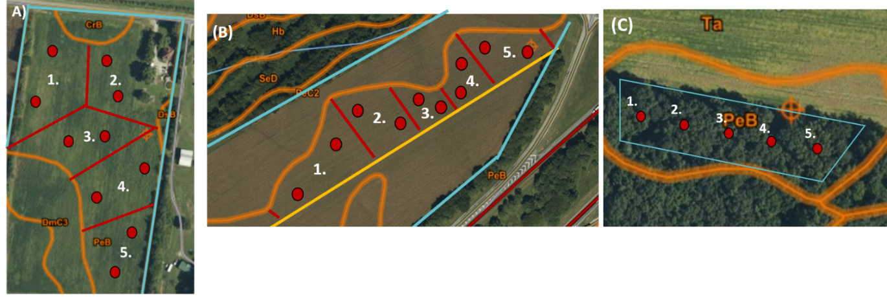
Figure B.1. Aerial view of each study site with approximate sampling locations marked with a red circle. A) Treatment 1: Organic-Ag, B) Treatment 2: Con-Ag, and C) Treatment 3: Unmanaged

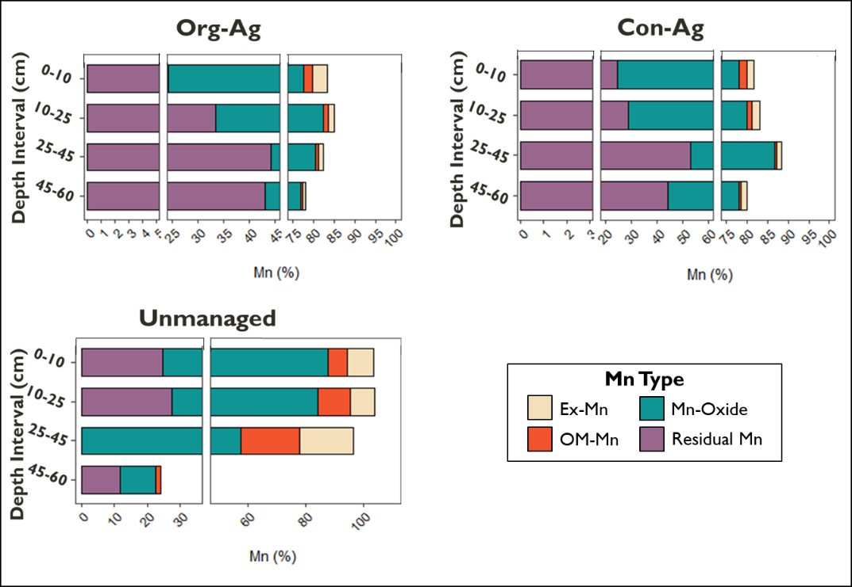
Figure B. 2. Sequentially-extracted Mn forms as a percent of total Mn across systems and depths.

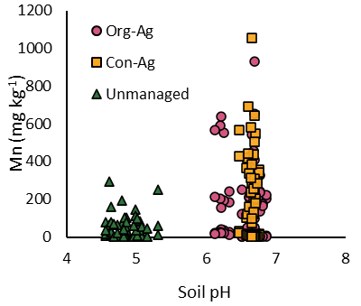
Figure B.3. Scatterplot showing the relationship between Mn and soil pH. All measured forms of Mn from all depths are included.

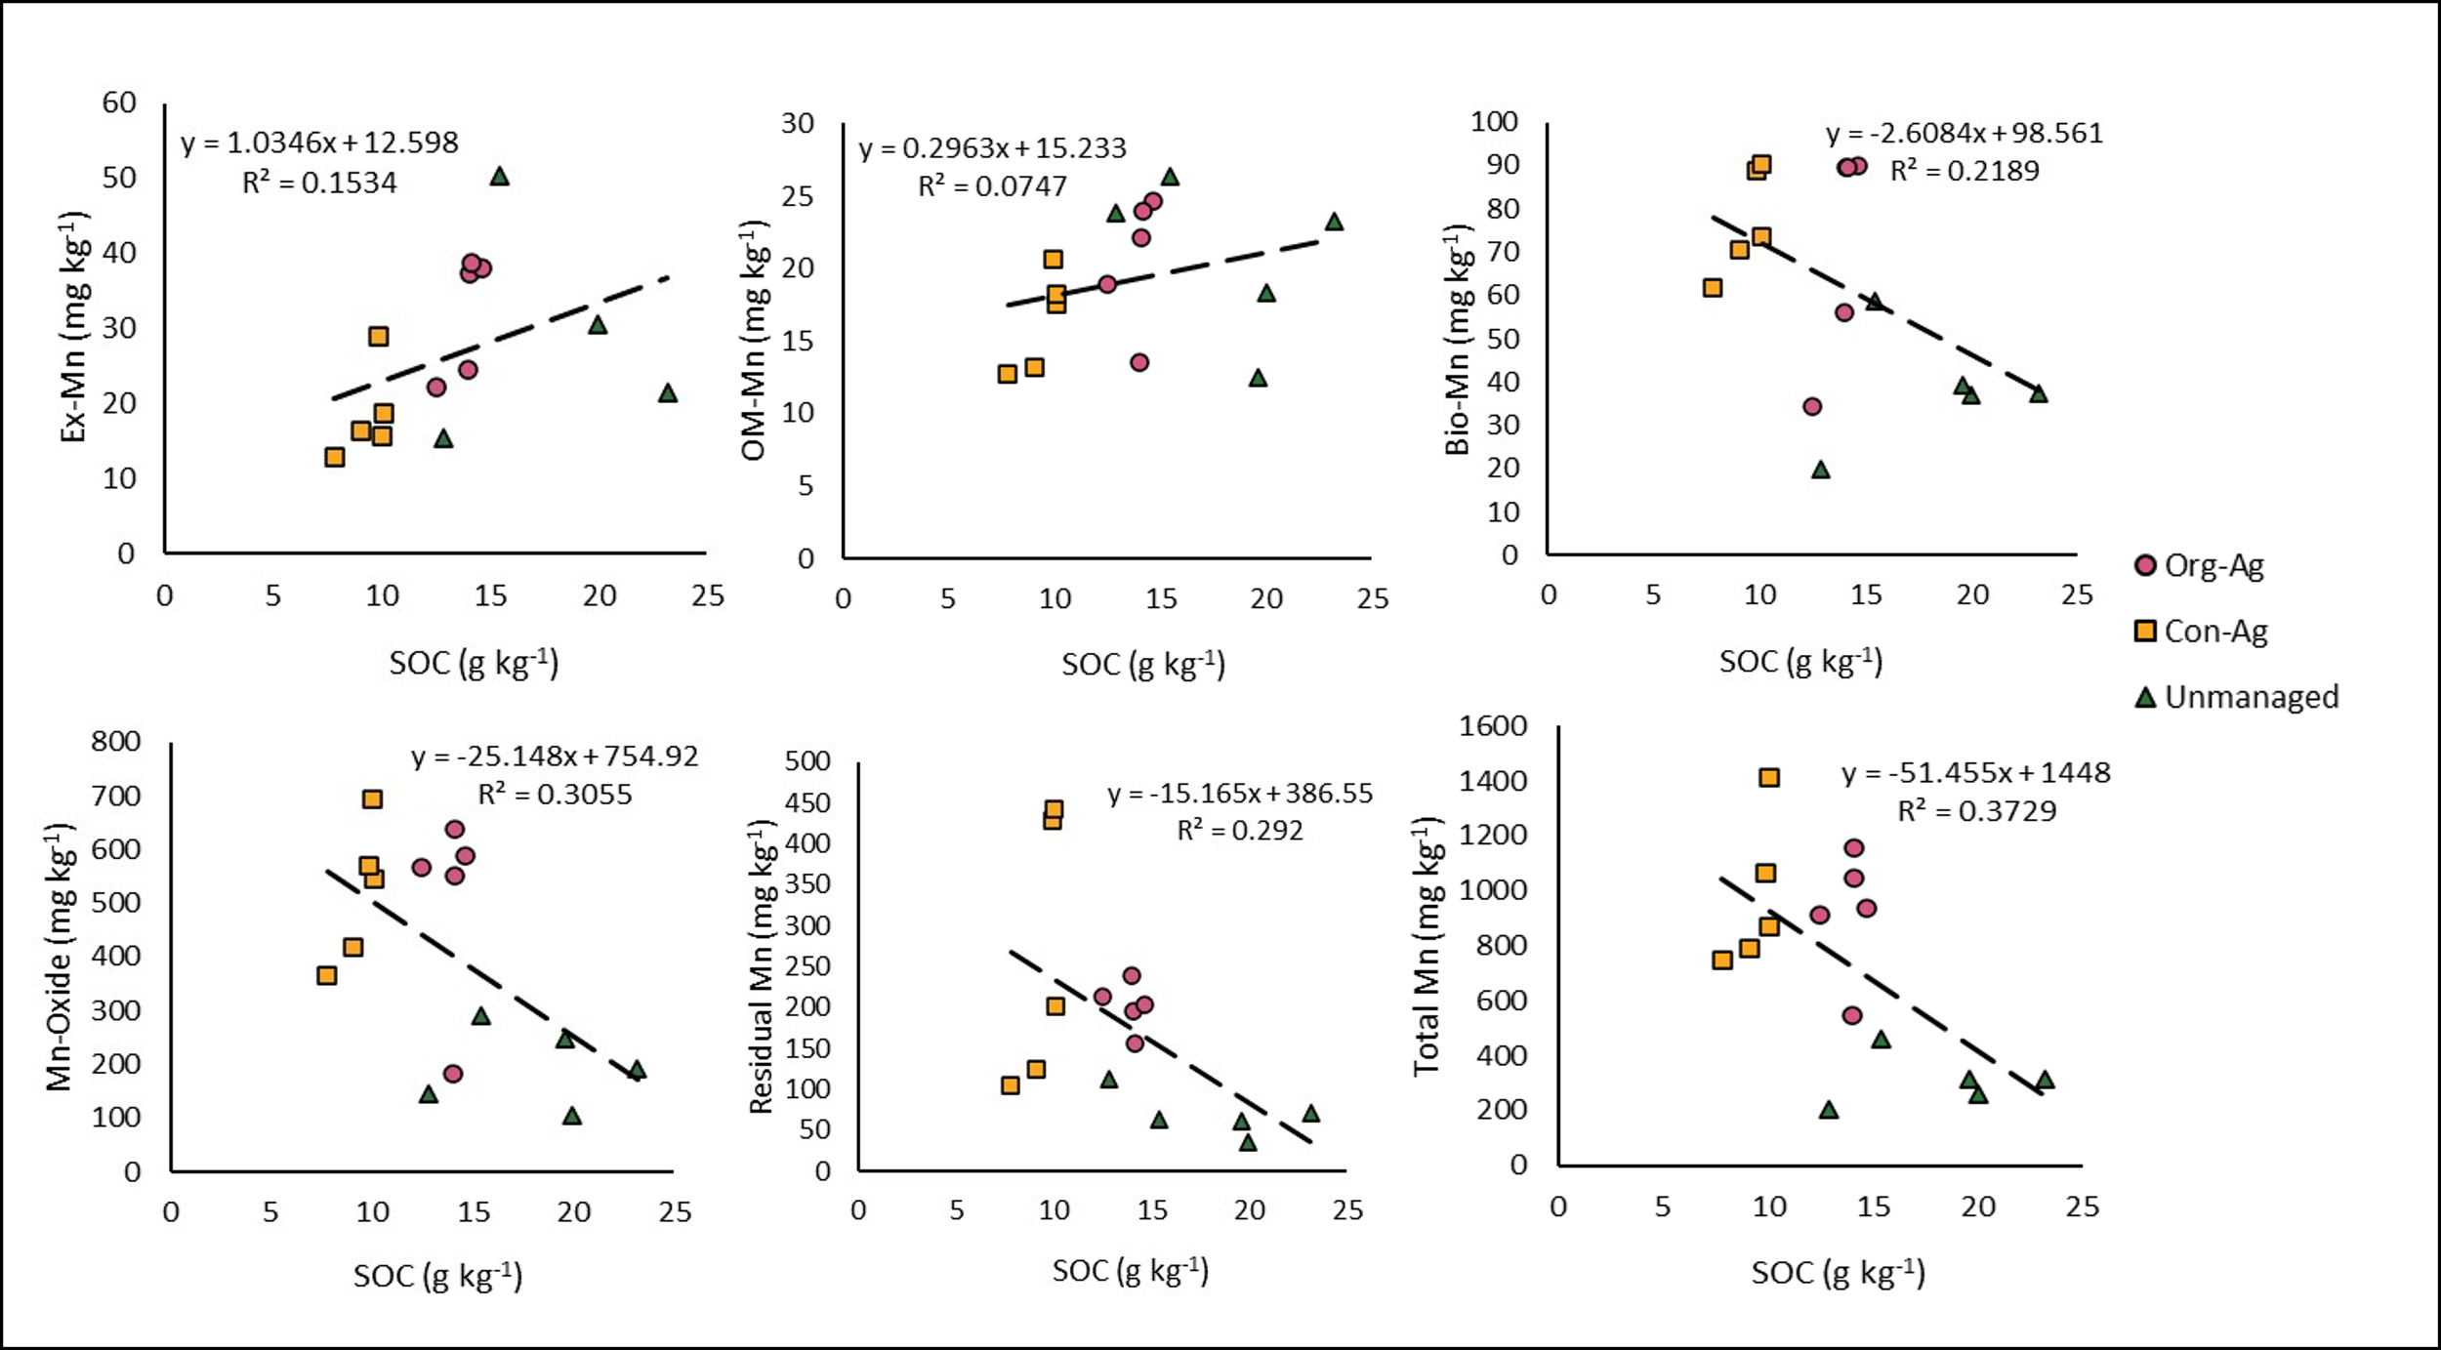
Figure B.4. Relationship between Mn forms and SOC for 0-10 cm soil depth. A) Ex-Mn; B) OM-Mn; C) Bio-Mn; D) Mn-Oxide; E) Residual Mn; and F) Total Mn. All regressions were statistically significant (p<0.05).

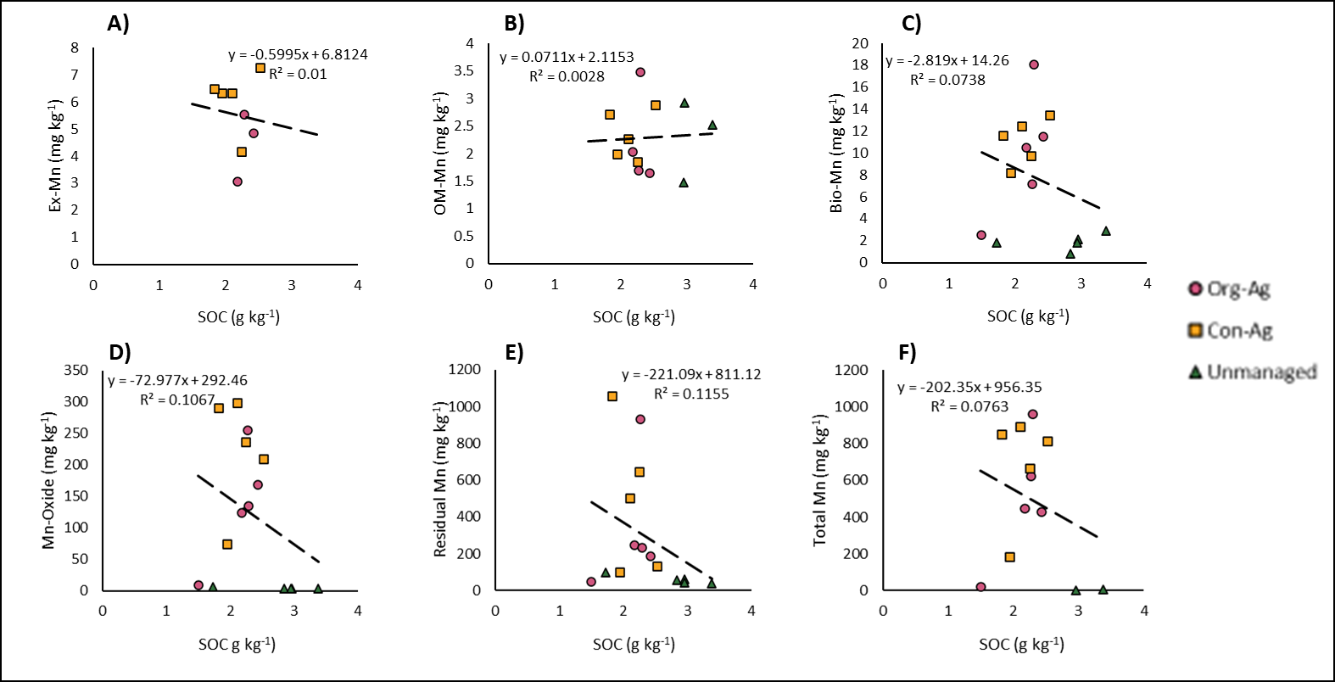
Figure B.5. Relationship between Mn forms and SOC for 45-60 cm soil depth. A) Ex-Mn; B) OM-Mn; C) Bio-Mn; D) Mn-Oxide; E) Residual Mn; F) Total Mn.

Conclusion and Future Work

Conclusion
Mn is an important plant micronutrient and Mn availability to plants is controlled by a variety of soil properties, including soil pH, redox, and OM concentrations. Additionally, Mn is considered a major controlling factor of litter decomposition and, thus, influences C cycling in soils. With most Mn studies focused on forest ecosystems, the current study aimed to fill the gap in our understanding of Mn cycling in agricultural systems. This was done through two separate experiments, each of which investigated different agricultural practices to determine their influence on Mn geochemical changes in soil and availability to plants.
In the greenhouse study, we observed a differential response of corn and soybean to the addition of two Mn fertilizers (MnSO₄ and MnEDTA), with leaf Mn concentrations in soybean being impacted by both fertilizers, while corn was not responsive to either fertilizer type. The two fertilizer types also resulted in varying distributions of soil Mn forms, which appeared to ultimately determine leaf Mn concentrations. The MnSO₄ treatment led to increased concentrations of Ex-Mn and OM-Mn, contributing to an increase in available Mn in soils. This increase in available Mn translated to increased leaf Mn concentrations in soybean. The MnSO₄ treatment also resulted in increased Mn-Oxide concentrations in soil, indicating that a portion of the Mn applied as fertilizer was likely oxidized to an unavailable form of Mn. However, leaf Mn concentrations were above sufficiency levels even in the control treatment which did not receive Mn, indicating that Mn availability in soils was still high enough to support plant growth despite the increase in Mn-Oxides. The MnEDTA treatment resulted in a slight increase in the Ex-Mn and OM-Mn forms, translating to only a slight increase in available Mn in soils. Additionally, the increase in available Mn forms only occurred in our 50x application rate, indicating that MnEDTA must be applied at substantially higher rates than recommended to increase Mn availability in soil. However, even though an increase in available Mn was observed, leaf Mn concentrations decreased with increased MnEDTA application rates. This trend was likely due to Fe and Mn competition in the MnEDTA treatment caused by Fe replacing Mn in the EDTA complex, thereby promoting the uptake of Fe over that of Mn. Despite significant responses to Mn fertilizer types and rates, there was no difference in plant biomass, height, or chlorophyll content across treatments, indicating that it is unlikely toxicity was occurring in any of the treatments.
In the field experiment, we observed decreased available Mn when normalized to Total Mn in both agricultural (Org-Ag and Con-Ag) systems, with only 3-5% of total soil Mn being in an available fraction. On the other hand, the unmanaged forest site had up to 40% of total Mn in available form. Thus, our agricultural systems appear to be depleted in available Mn when compared to the unmanaged site. The decreased Mn availability in the agricultural sites may be due to the continual removal of a portion of the Mn contained within plant biomass as harvested produce, thereby decreasing the amount of Mn returned to soils via plant residue decomposition. In the surface soils, we observed different relationships between SOC and various Mn forms. Bio-Mn, Mn-Oxide, Residual Mn, and Total Mn all had a negative relationship with SOC, supporting the narrative that high Mn concentrations are connected to decreased SOC concentrations. In contrast, Ex-Mn and OM-Mn had a positive relationship with SOC, which is likely due to high OM content contributing to increased soil CEC. The relationships between Mn forms and SOC were consistent across all three sites, indicating there is likely a similar influence of Mn on C cycling in all the studied systems. However, in the deep soils (45-60 cm), there was no relationship between the various Mn forms and SOC.

Future Work
This study is expected to serve as a foundation for further research on Mn cycling in agricultural systems. With this knowledge, future studies will be able to investigate the roles of specific Mn forms in C stabilization and destabilization mechanisms in agricultural systems, similar to what has been done in forests. Specifically, it could be interesting to see if Mn plays a role in the decomposition rates of different cover crops grown in agricultural systems similar to that of leaf litter decomposition in forests. If Mn accelerates residue decomposition and CO₂ release from all or some cover crop types, it will magnify the already large greenhouse gas outputs from agricultural systems. Manganese’s role in agricultural systems should also be investigated across of range of different soils including those with different soil pH, OM content, and different concentrations of soil Mn. The sequential Mn extraction we conducted for both experiments, though insightful, had some limitations. It defines different forms of Mn by functionality but are not necessarily specific to distinct species (Mn²⁺, Mn³⁺, Mn⁴⁺). The speciation of Mn is ultimately what determines Mn solubility and plant availability. Additionally, Mn oxidation is tightly coupled to OM degradation and can change throughout the degradation process. Thus, future studies should combine sequential extraction analysis with X-ray absorption near edge structure (XANES) to allow for more in-depth characterization of different Mn species. The results of our greenhouse study call for further research on ways to efficiently increase Mn availability in soils that leads to sufficient Mn uptake in plants. Our data indicates that a portion of the Mn applied as MnEDTA was lost from the plant containers, so future greenhouse studies should incorporate leachate collection to verify this loss. Collecting leachate would also allow for mass balance analysis to determine rates of plant uptake of Mn, conversion to Mn-Oxide, and leaching from containers. Despite our efforts in selecting the soil in Tennessee with the least Mn levels, the soils used in the greenhouse containers had sufficient Mn and may have masked the effect of the different rates of the two fertilizers. So, the experimental results may be different if conducted on low Mn soils. Also, the soils in our containers became compacted over time, which could be resolved by incorporating perlite to improve soil aeration and water infiltration.

Vita
Ashleigh R. Montgomery grew up in St. Louis, Missouri. She attended Saint Louis University (SLU) where she received a Bachelor of Science in Environmental Science with a minor in Biology. During her time at SLU, Ashleigh worked in the Dr. Elizabeth Hasenmueller’s Environmental Geochemistry lab where her passion for geochemistry and soil science grew. She also conducted an undergraduate independent research project studying the transport and effect of road salts on soil geochemistry. At the University of Tennessee, Knoxville, she is pursuing her Master of Science degree in Environmental Soil Science. Her research interests include studying the interaction of redox metals (ie., Mn and Fe) with soil carbon across a variety of ecosystems. After graduation, Ashleigh will be pursuing her Doctor of Philosophy degree in Plant and Soil Science at the University of Delaware. She is grateful for her family, partner, and dog for their emotional support while she pursues her science dreams.

