PETROLOGIC AND GEOTHERMAL PROFILE OF THE LITHOSPHERE BENEATH KILBOURNE HOLE BASED ON GEOCHEMICAL ANALYSIS OF A MANTLE AND CRUSTAL XENOLITH

A Thesis Presented for the
Master of Science
Degree
The University of Tennessee, Knoxville

Jena C. Samano
May 2024

Copyright © 2024 by Jena C. Samano
All rights reserved.

ACKNOWLEDGEMENTS

Words do not do justice the gratitude I have for the people who have given me so much to make this possible. Dr. Molly McCanta gave me room to question and explore. Dr. Nick Dygert challenged me and guided me through diffusion of calcium in olivine and modeling this in MATLAB. Allan Patchen, whose initial analysis and depth of knowledge in understanding the electron microprobe is only surpassed by the person who invented it, and I am almost certain that Allan knows the inventor, too. Dr. Jake Wittman, my R tutor, has helped me debug my code and ensure my thermometry and composition calculations are replicable by whomever comes after me. Dian Ji and Justin Hardin have been generous with their time and knowledge of MATLAB. Fellow grad students, Dr. Maggie Limbeck and Morgan Lewis, helped me put my research into perspective when I was feeling uncertain. Julie Coulombe has been a vital reason I was able to remain focused and not panic with her constant refrains of “What do you know? Write that.” My dogs Charles Wallace and Maggie whose loyalty and love of delicious treats were a light in the darkness. Finally, my little sister, Lorelea Samano, was there in the beginning, when I first mentioned returning to school. She has supported me all these years in each of my endeavors. It is fitting that she is here at the end. Lorelea is herself a Geologist, and I hope to be just like her when I grow up.

ABSTRACT

This study describes the geochemistry of an upper mantle and mid-crustal xenolith, both collected at Kilbourne Hole New Mexico (KBH). The mantle xenolith phase assemblage consists of forsterite, diopside, spinel, and enstatite. The mid-crustal quartz diorite xenolith phase assemblage is anorthite, quartz, diopside, and enstatite. The mantle xenolith exhibits grain and thin-section scale chemical variations which are interpreted as metasomatic alteration due to interaction with clinopyroxenite melt, in which chromium is being removed from spinel proximal to the vein. The magnesium number (Mg# (Mg number = 100 * [mols Mg /( mols Mg + mols Fe)) range of olivine is 85.5 on the right side of the vein and 87 on the left. The spinel chromium number (Cr number = 100 * [mols of Cr/(mols of Al + mols of Cr)] exhibits a negative correlation with titanium on the left side of the vein in contrast to both the right side of the vein and within the vein which show no correlation. Temperatures obtained using the Brey and Köhler (1990) two-pyroxene thermometer are on average 1149°C on the left of the clinopyroxenite vein and 1236°C on the right and are corroborated by calcium in orthopyroxene and calcium in olivine thermometry (Köhler and Brey, 1990) which record temperatures of 1132°C. The temperatures were used to constrain the diffusion of calcium in olivine, which in turn yielded a timescale of 0.5-10 years in which the clinopyroxenite melt interacted with the olivine. The clinopyroxenite is related to the basanite lava that erupted at KBH. This basanite likely infiltrated the upper mantle that contained the xenolith, causing the reaction rims in the clinopyroxene and generating the elevation of calcium concentration at the rims. The calcium-in-olivine signature indicates that the xenoliths were directly related to the rift extension, and a timescale for the disaggregation of the mantle could be constrained. The calculated equilibrium temperatures from both xenoliths, coupled with the pressures derived from the calcium-in-olivine thermobarometer, were used to calculate the depth and derive a geothermal gradient, which is steeper than previously believed.

TABLE OF CONTENTS

Chapter 1. Introduction 1
Chapter 2. Background 4
2.1. Mantle Xenoliths from Kilbourne Hole 6
2.2. Crustal Xenoliths from Kilbourne Hole 8
Chapter 3. Materials and Methods 9
3.1. Sample Preparation and Location Selection 9
3.2. Geochemical Data 11
3.3. Modal Abundance 12
3.4. Analysis in R 12
3.5. SCAn Barometer 13
3.5.1. WebPlotDigitizer 13
Chapter 4. Results 16
4.1. Petrology 16
4.2. Mantle Xenolith 17
4.3. Olivine (Forsterite) 20
4.4. Clinopyroxene (Diopside) 20
4.5. Orthopyroxene (Enstatite) 26
4.6. Spinel 26
4.7. Crustal Xenolith Petrology 33
4.8. Clinopyroxene and Orthopyroxene 37
4.9. Plagioclase 37
Chapter 5. Discussion 46
5.1. Mineral Equilibration 46
5.2. Mantle Petrology 46
5.2.1. Clinopyroxene 47
5.3. Mantle Xenolith Equilibration Conditions 47
5.4. Crustal Xenolith 52
5.5. The Significance of Calcium in Olivine Concentration Gradients 53
5.5.1. Effective Timespan Model 57
5.5.2. Timescale Significance 59
5.5.3. Significance of Pyroxenite Vein Composition for the Infiltrating Melt 60
5.5.4. Geothermal Gradient 63
5.5.4.1. Background 63
5.5.4.2. Calculation Complications. 63
5.5.4.3. Comparison of Results 63
Chapter 6. Conclusion 66
References 67
Vita 72

LIST OF TABLES

Table 1. SCAn thermometer calculation parameters from McCarthy and Douce (1998). 22
Table 2. Average size of each mineral phase in mm. 26
Table 3. Modal abundance of mantle xenolith phases ol-olivine, clinopyroxene-clinopyroxene, orthopyroxene-orthopyroxene, and spinel- spinel. 28
Table 4. Comparison of calcium in wt. % to Mg# in the olivine of the mantle xenolith. 30
Table 5. Minor element data calculated to observe the element data without the oxygen contribution (wt. %). 34
Table 6. Minor element and Mg# comparisons completed to observe correlation coefficient in clinopyroxene of the crustal xenolith. 'N/A' indicates that there is no correlation. Pearson’s Correlation Coefficient calculations were not completed. 46
Table 7. Minor element and Mg# comparisons in orthopyroxene. Most of the correlations are moderate to weak. 48
Table 8. Element pair comparisons for anorthite and bytownite in the crustal xenolith. 51
Table 9. Temperatures using all thermometers. All temperatures agree with each other within error(±50°C) 57

LIST OF FIGURES

Figure 1. Regional sketch of study area. Adapted from the sketch of the region made by Anthony et al. (1992), inset of the state of New Mexico sourced from Thompson et al. (2005). 5
Figure 2. Simplified sketch of a maar diatreme adapted from Vitarelli (2020). 7
Figure 3. Electron backscatter image of Mg content in the mantle xenolith sample. The greater the Mg content, the lighter the color. Olivine (forsterite) appeared as the brightest white, and clinopyroxene (diopside), which had the smallest ratio of magnesium, was black. 10
Figure 4. R Target workflow of this study mantle xenolith showing where master data was used, when functions were created, and how all of these were used to calculate and produce the graphics. The circle symbols indicate data frames and instances using the data frames. The triangles are functions that were created. All the analyses are “up-to-date” meaning all members of each chain have been run and work with each other and are not in error. 14
Figure 5 The only disequilibrium texture in the study area are reaction rims this image shows the reaction rims in different regions of the study area. The shown clinopyroxenite vein cannot be the only vein in the sample at site 20 the reaction rim is thick and localized at the bottom of the clinopyroxene crystal. 18
Figure 6. Mg# of olivine from the mantle xenolith on both sides of the vein. Border left Mg# there is a possibility of bimodal distribution evidenced by the notch on the right leg of the distribution curve. Density is represented as a whole number and indicates the frequency that a particular Mg# occurs. 22
Figure 7. Calcium in concentration measured in wt. % of the element. The green box at the bottom are the detection limits of the EPMA, error bars are the standard deviation from all the points in the line. This crystal reflects the rim being elevated calcium concentration of the site measured. 24
Figure 8. Pyroxene composition from the mantle xenolith. There is little variation in composition. Vein composition is slightly different and has some variation in composition. 25
Figure 9. Cr# compared to the element Ti in wt. % in a clinopyroxene of the mantle xenolith. Data from this study compared to Witt-Eickschen et al., 1998 (“Witt”) and Kil & Wendlandt, 2004 (“KIL_WEND”). 28
Figure 10. Minor element comparisons in CPX of mantle xenolith. The top two graphs compare titanium on the y-axis and the bottom two compare aluminum on the y-axis. Data from this study compared to Witt-Eickschen et al., 1998 (“Witt”) and Kil and Wendlandt, 2004 (“KIL_WEND”). 29
Figure 11. Comparing calcium to silicon content in the clinopyroxene of the mantle xenolith. No real correlation is apparent compared to the correlation of titanium to aluminum where there is a moderate positive correlation. 30
Figure 12. Comparing Cr# to titanium wt. % of the element in orthopyroxene of the mantle xenolith. 31
Figure 13. Calcium (wt. %) is compared to silicon (wt. %) content in orthopyroxene in the mantle xenolith. Calcium content is homogeneously distributed throughout the slide studied. 32
Figure 14. Cr # and Mg # comparisons on either side and inside the vein. 34
Figure 15. Chromium compared to titanium and aluminum in wt. % oxide in spinel of the mantle xenolith. 35
Figure 16. Temperatures calculated using two-pyroxene thermometer of the crustal xenolith 36
Figure 17. End member composition of orthopyroxene (enstatite) and clinopyroxene (diopside). Compared to the same phases in the mantle xenolith, these have increased iron content. 38
Figure 18. Minor element comparisons in the clinopyroxene of the crustal xenolith. This illustrates the weak, moderate correlations between the minor elements. 40
Figure 19. Minor element comparisons in orthopyroxene of the crustal xenolith. On the left, calcium and aluminum have no correlation. Potassium and silicon show a weak correlation (r = 0.15), and aluminum and titanium show a moderate correlation. 42
Figure 20. End member composition of the plagioclase phase in the mid-crustal xenolith. 43
Figure 21. Element comparison of potassium and silicon in bytownite of the crustal xenolith. This example is weakly correlated r = 0.05. 45
Figure 22. Concentration of chromium throughout the study area. The brighter the color, the more chromium is present in the phase. The brightest phases are the spinel phases. The chromium content is decreased in the spinel closest to the vein. 48
Figure 23. Concentration of aluminum throughout the mantle xenolith. Aluminum concentration is greater in the vein than outside the vein. 49
Figure 24. Ca versus Mg# indicated that the calcium elevation at the rim was not magmatic. 55
Figure 25. Numerical solution of concentration profiles of calcium in olivine with the data from KBH_5_pyx_line overlayed. There are two distinct domains of points— one showing a fast timescale and the other much slower. There was difficulty constraining the actual timescale. The first 0-300 micrometers are on the timescale of 1-10 years, and the final three appear to be on the 50- to 100-year timescale. 58
Figure 26. The timescale with error bars was added to determine the range of time when all isopleth points occurred within error. The time span within the error bar range was 0.5 to 10 years 61
Figure 27. Minor element comparisons illustrate the similarity of vein material to the basanite material that was erupted at KBH. Note how different the mantle xenolith clinopyroxene (gold triangle) was from the vein clinopyroxene (green square). The trend of similarity to the KBH basanite material was consistent for all minor elements. 62
Figure 28. The comparison of Cipar (2020) proposed geotherm, and P-T ranges of their mantle and lower-crustal xenoliths compared to this study. Errorbars are for the temperatures at ±50°C. 64

Introduction
A rift, as defined by Şengör and Natal’in (2001), is an extensional, geologic trough that is bound by faults. The action of extension thins the lithosphere beneath the rift, leading to volcanic activity with the potential to incorporate mantle material. The Rio Grande Rift (RGR) is one of approximately 81 rifts found in North America (Şengör & Natal’in, 2001). Throughout the RGR, there are multiple sections where volcanic activity has brought upper mantle materials to the surface. Kilbourne Hole (KBH) is one such locale.
KBH is a maar and in total, the eruptive volume of Kilbourne Hole is approximately 0.23 km³, making it one of the largest known eruptions of this type of volcanism (Vitarelli, 2020). The explosive energy required to form a maar of Kilbourne Hole's dimensions requires 5.21 x 10¹⁶ to 1.45 x 10¹⁷ Joule (J). This energy is believed to have been dispersed over multiple eruptive events (approximately 54 to 209 total) with an average explosive energy of 6.94 x 10¹⁴ J (Vitarelli, 2020). In comparison, one gram of trinitrotoluene (TNT) releases 4,000 J of energy. The explosive energy and geochemistry of the material surrounding the xenolith indicates that the xenolith's initial capture occurred at mantle depth and the subsequent force propelled it to the surface.
Previous research completed on the petrology of the mantle xenoliths at KBH indicates that most xenoliths from this region are lherzolite, harzburgite, or dunite with the dominant lithology being spinel lherzolite (Bussod, 1981; Perkins, 2010). Furthermore, many of the mantle xenoliths at KBH have been crosscut by clinopyroxenite veins (Bussod, 1981; Bussod and Williams, 1991; Perkins, 2010). Research characterizing the geochemistry of the mantle xenoliths, the magma they were entrained in, and the potential metasomatic alterations are plentiful. Nevertheless, little work has focused on characterizing the infiltrating melt's chemical effects on mantle xenolith composition.
At this time, there is some geochemical evidence that suggests the original mantle xenolith composition can be altered during magmatic transport or owing to clinopyroxenite veins running through it. The KBH xenoliths were entrained in magma as they were conveyed to the surface and show compositional changes at their rims in proximity to the melt they are entrained inside. However, additional changes are observed in xenolith clinopyroxene that are not in contact with the entraining magma. These clinopyroxenes, which are interpreted as precipitates of previously intruding basaltic (pyroxenite) melts, are depleted in iron (Fe), sodium (Na), and aluminum (Al) at the rim and elevated in calcium (Ca), magnesium (Mg), and chromium (Cr) when compared to the core (Perkins, 2010). This suggests both entraining magma and crosscutting veins may affect the chemistry of the mantle xenoliths at KBH.
The physical act of eruption decouples xenoliths from their original position in the mantle lithosphere. However, there is enough of the original composition and texture remaining to provide an estimate of the pressure and temperature regime they originated from. Bussod (1981) described two textural types of peridotites at KBH, with different textures corresponding to different temperatures and pressures of crystallization. The observed textures are either: a) fine-grained, b) tabular granoblastic, or c) coarse-grained protogranular. Furthermore, this research revealed that granoblastic xenoliths are sourced from a lower pressure, lower temperature (975-1015°C) and source from shallower depth of 34 to 54 km (Bussod & Williams, 1991). Alternatively, the granoblastic xenoliths have a higher Fe and light rare earth elements (LREE) content than protogranular textured xenoliths. Protogranular xenoliths are sourced from a higher temperature (1015-1050°C), deeper depths (50-67 km) and are mid-ocean ridge basalt related in their rare earth element (REE) and major element composition (Bussod & Williams, 1991). These texture and compositions suggest a layered mantle beneath KBH. While this research has been useful in characterizing regional changes in the mantle, additional research revealed localized changes.
Experiments demonstrate that mineral assemblages of basalt rocks change with moderate perturbation of temperature and pressure (Kushiro & Yoder, 1966). An example of this type of metamorphism occurs in spinel lherzolite. As pressure and temperature increase, plagioclase changes to spinel, and spinel changes to garnet (Perkins, 2010). The fact that there are differences in grain size and mineralogy that depend on temperature suggests compositional layering over a constrained range of depth within the mantle (Perkins, 2010). This research stipulates that the temperature and pressure alterations generate changes in phase in the mantle.
Chemical zonation in a mineral of either major or minor elements develops when there are changes in the environment in which it grows or resides. These changes can be related to pressure, temperature, or composition. Minor elements are found in such small quantities of a mineral that they can be highly sensitive to any perturbation. Diffusive exchange of a minor element between two different phases depends on both diffusion and partitioning behavior (Zhang, 2008). The partition coefficient of calcium in olivine is much less than the partition coefficient of calcium in clinopyroxene. Moreover, the temperature sensitive exchange of calcium between olivine and clinopyroxene is well-documented, and the basis for the calcium in olivine thermometer. This thermometer is employed in analysis to determine pressures for mantle xenoliths at KBH (Köhler & Brey, 1990; Kil & Wendlandt, 2004; Coogan et al., 2005; Smith, 2013). Because the relationship between calcium and diffusion speed is sensitive to thermal perturbations that are short-lived, it can be used to find the range of timescales for short-lived geologic events.
Constraining temperature variations throughout the lithosphere is vital for understanding geologic processes such as long-term tectonic deformation, seismicity, and geochemical reactions (Heckenbach et al., 2021). This current study has two aims. First, it seeks to characterize geochemical and textural alterations due to infiltration of a mantle xenolith by pyroxenite magma. Using this geochemical information, the second aim can be achieved: utilizing geochemical data from a mantle and crustal xenolith to constrain the thermal structure beneath KBH. Two-pyroxene solvus thermometry, which records temperature based on the exchange of calcium, iron, and magnesium between orthopyroxene and clinopyroxene, is applied (Brey & Köhler, 1990). When used in conjunction with the calcium in olivine thermometer, which responds faster to cooling compared to the two-pyroxene thermometer, temperature perturbations and the thermal rate of change with time at a specific depth can be determined. Together, these aims of the study will constrain disaggregation times within the mantle beneath KBH and the overlying crust.

Background
The region that contains KBH has a long tectonic history. Between approximately 1.7 to 1.6 billion years ago (Ga), the Mazatzal terrane accreted to Laurentia (Moncada-Gutierrez, 2016). This convergent boundary formed the Mazatzal orogeny. In the southern region of the Mazatzal orogeny during this same period, the continental crust that makes up the Rio Grande rift zone was formed. The period from 1.48 to 1.35 Ga was an active time of convergent boundary tectonism for southern New Mexico. This activity led to deformation of the region that culminated in the Grenville orogeny (Moncada-Gutierrez, 2016). Between 75 and 48 million years ago (Ma), there was a period of significant crustal shortening that resulted in basement and craton uplift. The craton uplift was accompanied by sediment deposition, forming a yoked basin. The extension that resulted in the formation of the Rio Grande began around 35 Ma with the Potrillo Volcanic Field forming approximately 900,000 to 40,000 years ago (Moncada-Gutierrez, 2016). This age was determined in part by the helium isotope ( ³He) surface exposure dating which, dates the lava at PVF between 80 thousand years ago (ka) to 17 ka (Anthony & Poths, 1992). This isotopic dating helps to bookend the timing of the placement of the xenoliths on the surface as a recent event.
Kilbourne Hole is a maar: a low-relief, broad volcanic crater resulting from a shallow phreatomagmatic eruption of basanite lava during the late Pleistocene. It is located 20 miles southwest of Las Cruces, New Mexico (Fig. 1), and according to Fritsch (1992), it is one of several maars that populate the Potrillo Volcanic Field . The petrology and petrography of the lithosphere beneath Kilbourne Hole is well-studied due to the bounty of mantle and lower crustal xenoliths present at the crater and their relationship to a multistage tectonic history (including the subduction zone, multiple orogenic events, rift region, and Potrillo Volcanic Field (e.g., Kil & Wendlandt 2007; Harvey et al., 2012). The age of the eruptive event can be constrained by relationship of the flow the xenoliths are entrained in compared to other flows in the region. The upper age limit of the basanite lava that the peridotites are entrained in is approximately 80 ka. Additionally, the lower limit is constrained by the event erupting through the Afton Flows, which are a series of basalt flows that pinch out proximal to the town of Afton. These flows pre-date the Kilbourne Hole eruption and are approximately 70 ka.

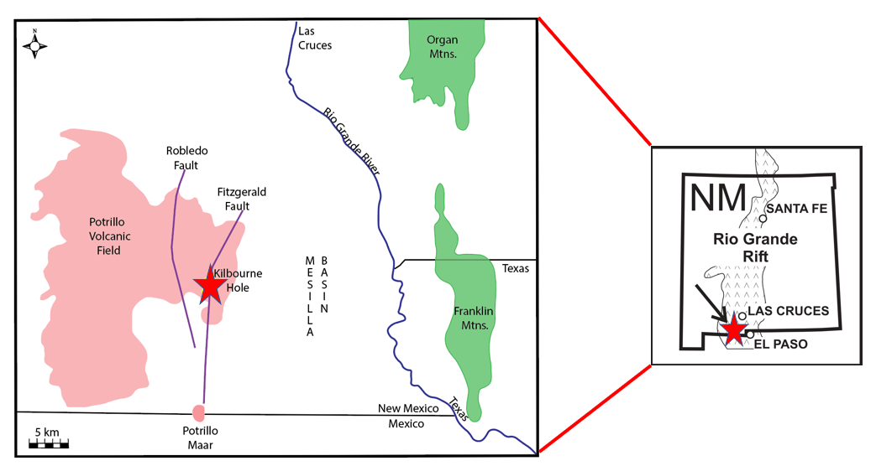
Figure 1. Regional sketch of study area. Adapted from the sketch of the region made by Anthony et al. (1992), inset of the state of New Mexico sourced from Thompson et al. (2005).

Therefore, as previous research (Poths, 1992; Harvey et al., 2012) suggests, the xenoliths found at Kilbourne Hole are relatively recently removed from their source and are theorized to represent current sub-continental lithospheric mantle conditions.
The xenoliths may be entrained in basanite host magma, but prior to this entrainment they were initially enrobed in highly alkalic magma (Perkins, 2010). This magma is higher in alkalic composition than the Afton Flows or any other Potrillo volcanic material, indicating entrainment of the xenoliths at a depth in the feeder dike where it would be sourcing material that is in the early stages of partial melting (Fig. 2).
The xenoliths from the mantle at KBH are well-studied because they provide the only source of mantle material for this region. While the focus of this study is the mantle xenolith, a crustal xenolith is used to constrain temperature and pressures of the crustal component of the lithosphere that overlays the mantle of KBH. This study sheds light on how mantle chemistry changes when new material is introduced. Specifically, it characterizes the geochemical and temperature changes leading to transitions in mantle xenolith phases when a vein of clinopyroxenite material is introduced. This geochemical evaluation supports previous findings suggesting layering of the mantle beneath the rift zone (Bussod, 1981; Kil & Wendlandt, 2004; Perkins, 2010). Using xenoliths from different pressure, temperature, and lithological regimes will allow this study to model the geothermal gradient beneath KBH.

Mantle Xenoliths from Kilbourne Hole
Mantle xenoliths of this region range from spinel lherzolite, harzburgite, dunite, and clinopyroxenite in composition (Irving, 1980; Bussod & Irving, 1981). Grain size varies from fine-grained equigranular, porphyroclastic, and protogranular and is interpreted to indicate stratification of the upper mantle beneath KBH (Bussod & Williams, 1991, Kil & Wendlandt, 2004). The finer-grained xenoliths are sourced from the shallow depths of 34 to 54 km, and the coarser-grained xenoliths are sourced from deeper depths of 50 to 67 km (Bussod & Williams, 1991). This thermo-barometric research supports the concept of a stratified upper mantle where a protogranular texture corresponds with a depth of 48 km, a porphyroclastic texture corresponds to a depth of 42 to 48 km, and an equigranular peridotite corresponds to a depth of 43 to 26 km (Kil & Wendlandt, 2004).
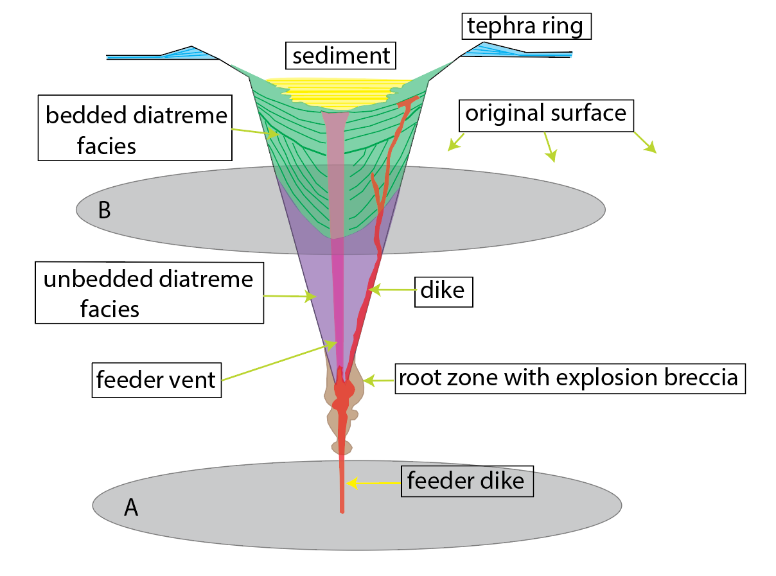
Figure 2. Simplified sketch of a maar diatreme adapted from Vitarelli (2020).

Clinopyroxenite veins and dikes are often present throughout the peridotites but are mostly found in fine-grained equigranular peridotites sourced from the 43 to 26 km depth (Hamblock et al., 2007). KBH is unusual in that it contains clinopyroxenite veins with a coarser-grained protogranular texture.

Crustal Xenoliths from Kilbourne Hole
Crustal xenoliths sourcing from the lower and mid-crust are abundant at KBH. Lower crustal xenolith phase assemblages include garnet-sillimanite granulite, two-pyroxene granulite, charnockite (Hamblock et al., 2007). Mid-crustal xenoliths are also present, and their phase assemblages include monzonite to monzogranite and diorite to quartz diorite in composition (Hamblock et al., 2007). Textures of the mid-crustal xenoliths range from undeformed to mylonitic (Chattopadhyay, 2003). These xenoliths indicate that there is an extensive unexposed plutonic complex beneath KBH (Hamblock et al., 2007). The mid-crustal xenoliths correspond with depths from 11 to 18 km and 0.3 to 0.5 GPa in pressure (Hamblock et al., 2007). The crustal xenolith in this study will aid in constraining the temperature and pressure regimen of the mid-crust.

Materials and Methods

Sample Preparation and Location Selection
The polished, thin section of mantle xenolith was provided by the Smithsonian Institution. The crustal xenolith was collected as part of a research expedition in New Mexico. The collection process used was a modified version of Section 4 EVA Sampling during Desert RATS field tests (Hurtado et al., 2013):
1) Place the tool on an outcrop for scale.
2) Take a picture with both the tool and sample visible.
3) Provide a sample description with contextual information in the log book.
4) Bag the sample, writing the standardized abbreviation created for the expedition, and number for the sample on the inside and outside.
5) Stow the bagged sample in a five-gallon plastic bucket, and retrieve the tool.
Thin sections of the crustal xenolith were assembled by cutting the xenolith parallel to its lineation and perpendicular to its foliation, using methods detailed by Grundmann and Sholz (2015) study.
Crystal locations of the mantle xenolith were assigned based on the proximity to the vein or side of the cross cutting clinopyroxenite vein they were found near to analyze what changes, if any, the vein intrusion caused. Using the magnesium content x-ray map from electron probe microanalysis (EPMA), sample phases were identified (Fig. 3). In the master data set, they were differentiated and labeled based on distance. ‘Right’ and ‘left’ were defined as the most distal sites from the vein. Moreover, BORDER_R and BORDER_L were proximal to the vein. The sample site was considered on the border of the vein if it was within the range of adjacent to the vein to approximately four millimeters (mm) away from the vein. Crystal locations of the crustal xenolith were taken randomly across the slide.
Grain sizes of the different mineral phases were measured in mm. Due to the irregular shape of most of the grains, length and width were measured and averaged to determine a rough grain size. Five sites were measured on each side of the vein, provided there were enough sites of each phase (e.g., minor phases within the study area such as spinel).
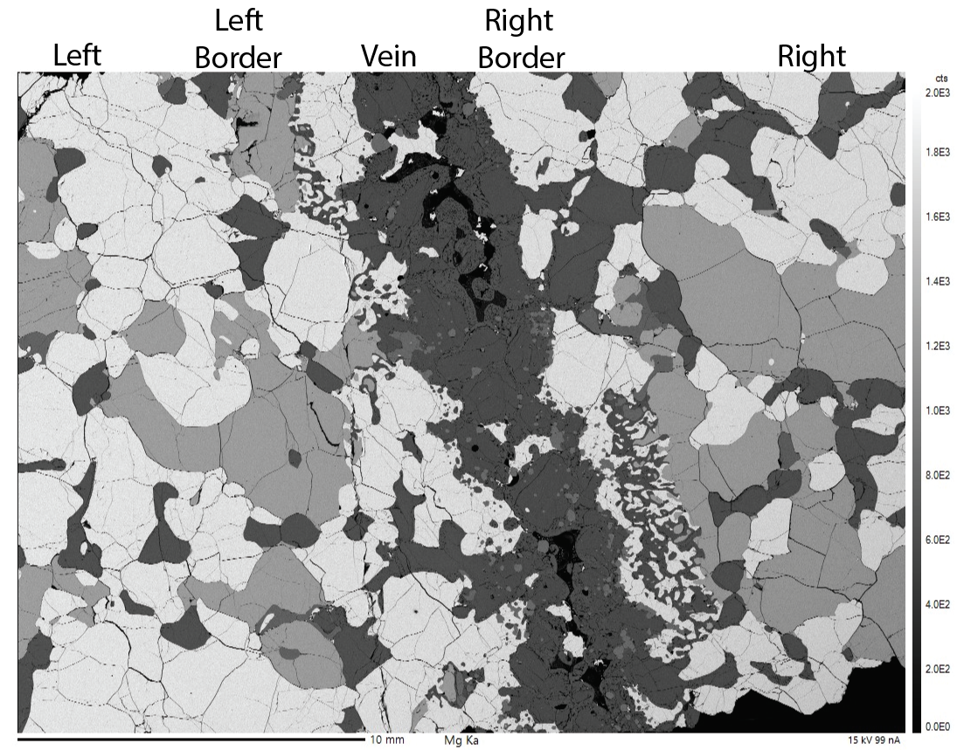
Figure 3. Electron backscatter image of Mg content in the mantle xenolith sample. The greater the Mg content, the lighter the color. Olivine (forsterite) appeared as the brightest white, and clinopyroxene (diopside), which had the smallest ratio of magnesium, was black.

Geochemical Data
Data points were gathered from mineral boundaries that had distinct or smooth grain boundaries with minimal to no reaction rim. To evaluate quality and ensure sample sites would meet the criteria discussed above, sites were initially evaluated using a petrographic microscope. Mineralogic and textural evidence was observed and evaluated for the detailed electron probe microanalysis. Then, both sample slides were carbon coated to conduct EPMA.
During EPMA analysis, compositions of mineral phases were characterized using backscattered electron (BSE) imaging and wavelength-dispersive spectrometry (WDS). WDS utilizes the unique x-ray emissions of elements to create a concentration map of each element. With WDS, detailed elemental maps for iron, calcium, chromium, titanium, and aluminum found within the samples were made. These maps allowed researchers to observe where changes in concentration occurred for these elements and determine where to acquire detailed data.
Major element data was acquired at the University of Tennessee, using a Cameca SX 100 electron microprobe operating under the PAP and a theoretical ZAF correction model. Analyses were calibrated employing both synthetic and natural standards. The standards were measured regularly throughout the data collection period to ensure consistency and accuracy of the gathered data. EPMA operating beam conditions were as follows: 15 kV accelerating voltage, 30 nA beam current, and a one-micron spot size. On-peak count times were equal to total off-peak count time and were based on elemental concentration of sodium, aluminum, magnesium, silicon, calcium, and titanium (20 sec), vanadium, chromium, manganese, iron, and nickel (30 sec), and calcium in olivine (40 sec). Data from the EPMA were considered valid if the total sum of the oxide components was greater than 98% and less than 102%.
Multiple points were sampled in each grain to obtain an average of the composition throughout the grain. In addition, transects were also completed on 20 grains of diopside, nine spinel, nine enstatite, and 20 olivine. These transects were hundreds of micrometers in length. This length was necessary as the grains were large, and the transect was needed to sample the composition if it changed from the rim to the core of the crystal. These transects were used to analyze geochemical homogenization and evaluate compositional profiles for each of the mineral phases. This data was also used to obtain the modal abundance of each mineral phase.

Modal Abundance
BSE images were obtained from the electron microprobe, employing point counting analysis to calculate the modal abundance of phases; a 0.25 inch² (in) grid was placed over the 7 x 9.5 in BSE magnesium content image, and the number of boxes that were taken up by each mineral were counted. The percentage of each mineral's abundance was calculated by dividing the total 0.25 in² grid spaces counted by the total area of the section.

Analysis in R
Code was written for R to compare EPMA data at individual sites and exclude outlying data (e.g., when data with the total from the EMP was less than 98 or greater than 102 wt.%). Outliers in raw data were also manually considered for elimination. Additionally, calculations and plots were created to evaluate:
- Composition;
- Temperature using the two-pyroxene, calcium-in-orthopyroxene, and Ca-in-olivine thermometry formulas derived by Brey and Köhler (1990);
- Magnesium number (Mg# = 100 * mols Mg /(mols Mg + mols Fe);
- Chromium number (Cr# = 100 * mols of Cr/(mols of Al + mols of Cr);
- Minor element concentration aluminum, chromium, titanium, and sodium in both pyroxenes, calcium and magnesium in olivine, chromium and titanium in spinel, and calcium in olivine for multiple individual sites and lines across a mineral.
All code was written using RStudio 4.1.2 created by the R Core Team (2020). Additionally, compositions were plotted using the R package ggtern generated by Hamilton and Ferry (2018). Tables were created and modified using the kableExtra package from R produced by Hao Zhu (2021). Utilizing the patchwork package designed by (Pedersen (2020), plots were combined for analysis. Lastly, Landau's (2021) R targets software was used to show workflow, facilitating replicability of research (Fig. 4).
Analysis necessitated the creation of several functions and two “Shiny” apps. When a calculation would be completed numerous times, functions were created to streamline the process. These functions were written following the process outlined by Grolemund (2017) in their research and include: composition of each phase, weight percent of each element, Mg#, Cr#, standard deviation of weight percent of elements, two-pyroxene formula derived by Brey and Köhler (1990), and ternary diagrams. Apps were created to streamline several processes (e.g., multiple layers of calculations and then plotting the results). Apps created include: a) a two-pyroxene thermometer high temperature formula created by Brey and Köhler (1990); b) a calcium in olivine thermometer high temperature formula for pressure solved to find the temperature derived by Köhler and Brey (1990); and c) a calcium-in-orthopyroxene thermometer. Functions were also completed to compute frequently used calculations that did not have a set formula (e.g., converting weight percent of an oxide to the weight percent of an element, Mg#, Cr#, and total cations to determine composition and plot on a ternary).

SCAn Barometer
Pressures for the crustal xenolith were calculated using SCAn geobarometer McCarthy and Douce (1998). The SCAn geobarometer uses the reaction CaTs + Qtz = An to obtain a pressure in kb. In their paper, McCarthy and Douce (1998) asserted that cation assignment and the activity of diopside and plagioclase should be applied as specified in table four of their paper to correctly implement their geobarometer (Table 2). Clinopyroxene and plagioclase compositions, in this study, were calculated in R using a normalized mineral analysis. The pyroxene cations were normalized to six oxygen and plagioclase to eight oxygen. These compositions were averaged across the sample which was used to calculate the ideal activity expressions for Ca-Ts and An.

WebPlotDigitizer
WebPlotDigitizer is a free online tool (https://automeris.io/WebPlotDigitizer/) which allows users to extract numerical data from images of graphics. To extract data, the researchers followed these steps:
- Upload an image. This study utilized Figure 4A from the Cipar et al. (2020) study.
- Choose two points that are the furthest distance apart from each other, and set the x and y axes. This aligns the pixels of the image to x and y coordinates on the plot.
- Extract datum by manually selecting points along the curve of interest, adding points along the curve until the general shape of the curve is revealed. This study selected 10 such points.
- Download the .csv file of the points, and plot them in MATLAB.

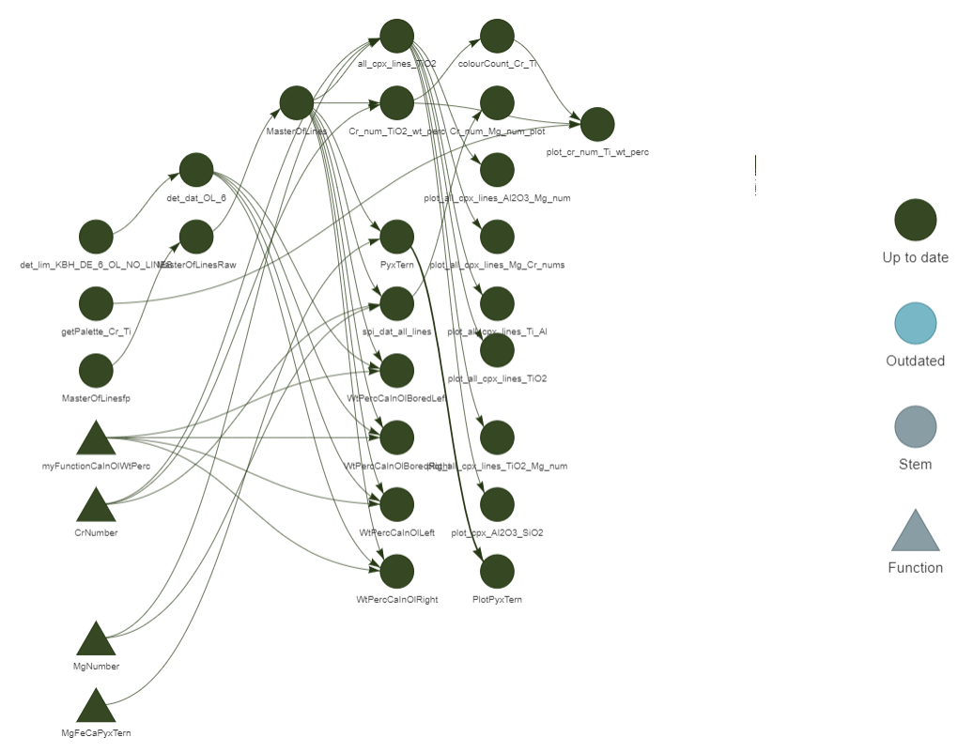
Figure 4. R Target workflow of this study mantle xenolith showing where master data was used, when functions were created, and how all of these were used to calculate and produce the graphics. The circle symbols indicate data frames and instances using the data frames. The triangles are functions that were created. All the analyses are “up-to-date” meaning all members of each chain have been run and work with each other and are not in error.

Table 1. SCAn thermometer calculation parameters from McCarthy and Douce (1998).

Clinopyroxene activity-composition relationships (Wood, 1979)
Cation assignment (recalculated on the basis of six oxygens)
Al^{iv} = 2 – Si
X Al^{M1} = Al - Al^{iv}
X Ca^{M2} = Ca
X Si^{iv} =Si / 2
X Al^{iv} = (2-Si)/2
A_{CaTs}^{Cpx} = 4 X Ca^{M2} X Al^{M1} X Al^{iv} X Si^{iv}

Plagioclase activity-composition relationships (Holland & Powell, 1992)
X_{An} = Ca / Ca + Na + K
X_{b} = 0.12 + 0.00038 T
X_{An,c} = X_{An}(1 + X_{An})² * ¼
I_{An} = -RT ln (X_{An,c} / X_{An}) – (W_{c} – W_{i}) (1 – X_{b})²
W_{c} = 1070.0 J mol⁻¹
W_{i} = 9790.0 J mol⁻¹
A_{An,c}^{Pl} = X_{An,c} exp ( 1 /RT [ W_{c} (1 - X_{An})² + I_{An} ])

Results

Petrology
Mineral compositions of both xenoliths were analyzed for geochemical variations. Additionally, end member calculations for all mineral phases were completed using the R application and functions created for this project. Samples were plotted in R using Brewer and Viridis color palettes to differentiate between locations: left, right, vein, border of vein left and right. ‘Left’ indicated distally left of the vein. ‘Left border’ indicated adjacent to the vein on the left side (Fig. 3). Shapes were used to symbolize different minerals or sources of data (this study’s dataset versus another study). The shape type is specified on all of the graphics where such clarification is required, and for clarity, remains constant from graphic to graphic.
The geochemical data were used to determine equilibration temperatures for the xenoliths, which required that analyzed phases be at or are close to equilibrium (Lucas et al., 2022). Due to the nature and aim of the study, we were especially interested in temperature-sensitive element oxides such as titanium oxide (TiO₂), calcium oxide ( CaO), and aluminum oxide (Al₂O₃) in both pyroxenes for comparison with other studies. Temperatures were calculated using R with associated uncertainty of ± 15°C (Brey & Köhler, 1990).
All phases—olivine, clinopyroxene, orthopyroxene, and spinel—are coarse-grained and anhedral. In the study area, olivine and orthopyroxene are the largest phases. All grains are different sizes, most are elongated, and all are in sufficient abundance to measure their size. For the olivine, clinopyroxene, and orthopyroxene, 10 sample sites total—five on each side of the vein—were taken. The spinel was measured at four sites in the study area with two sites on each side of the vein. The average size of the olivine was 3.0 mm, orthopyroxene was 2.8 mm, clinopyroxene was 1.4 mm, and spinel was 0.9 mm. A clinopyroxenite vein cut across the sample. Olivine and clinopyroxene on either side of the vein in the study area showed symplectic texture immediately adjacent to the vein.
The distal forsterite, enstatite, and spinel that are adjacent to other phases lacked a reaction rim. The diopside, which has the lowest melting point among the phases, had a reaction rim in different orientations and thickness throughout the study area. This reaction rim varied in thickness across the sample and in some locations was thicker on a side of the diopside oriented away from the intruding vein. This trend was observed in sample locations KBH_94_23_DE_ 5, KBH_94_23_DE_ 19, and KBH_94_23_DE_ 20 (Fig. 5).
Some sites were evaluated to measure the trend in the reaction rim thickness. In particular, location KBH_94_23_DE_5 was considered at the right border of the vein, but the thicker reaction rim was on the side of the mineral not facing the vein. At location KBH_94_23_DE_ 19, the reaction rim was confined to the bottom half of the clinopyroxene, though the side facing the vein was thicker. At location KBH_94_23_DE_ 20, the reaction rim was largely on the bottom of the grain with a small thinner band (45 μm) on the top of the clinopyroxene. The bottom reaction rim was much thicker, measuring 113.6 micrometers (μm), and this reaction rim was located just the side that was closest to the vein. In the vein, reaction rims were significantly larger on minerals than those outside of the vein. The largest reaction rim measured 450 μm, and the sites immediately adjacent to the vein reaction rims ranged from-11.76-235 μm. Midway to the edge of the study area, the reaction rim measured 33-111 μm, and at the most distal region of the slide, it varied from 45.44-113.6 μm. Proximity to the observed vein did not appear to govern the size or location of the reaction rim. If proximity to the vein was correlated to the reaction rim size, then KBH_94_23_DE_ 20 would not have had such a thick reaction rim, as it was most distal from the vein.

Mantle Xenolith
Overall, the major element composition of all four mineral phases present (olivine, clinopyroxene, orthopyroxene, and spinel) showed little inter- or intra-grain variations, indicating well-equilibrated compositions prior to the infiltration by pyroxenite melt. The xenolith grains consisted of large olivine and orthopyroxenes, with the largest averaging 2.05-2.38 mm in width and 2.38-2.43 mm in length. Clinopyroxene and spinel grains were smaller, averaging 0.92-1.03 mm in width and 0.55-1.35 mm in length (Table 2). The lack of disequilibrium textures suggest all phases were originally equilibrated for an extended period before the introduction of pyroxenite melt that generated disequilibrium textures (Fig. 3). This is evident as smaller disequilibrium textures were observed distal from the vein. Additionally, minor reaction rims and grain boundaries that appeared smooth in texture

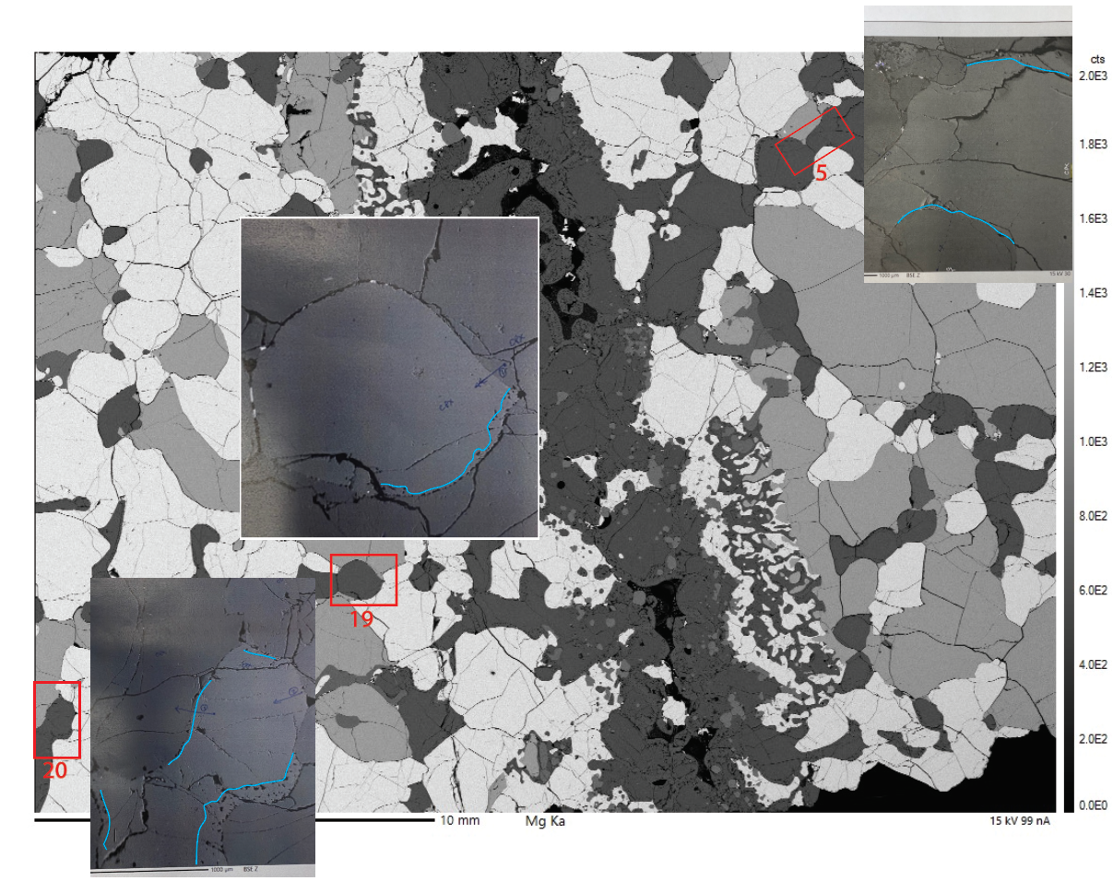
Figure 5 The only disequilibrium texture in the study area are reaction rims this image shows the reaction rims in different regions of the study area. The shown clinopyroxenite vein cannot be the only vein in the sample at site 20 the reaction rim is thick and localized at the bottom of the clinopyroxene crystal.

Table 2. Average size of each mineral phase in mm.
Average Mineral Sizes (mm)
Mineral | Width | Length
olivine (L) | 2.63 | 2.41
olivine (R) | 1.46 | 2.34
Average | 2.05 | 2.38
clinopyroxene (L) | 0.76 | 1.35
clinopyroxene (R) | 1.07 | 1.34
Average | 0.915 | 1.345
orthopyroxene (L) | 2.57 | 2.25
orthopyroxene (R) | 2.14 | 2.6
Average | 2.355 | 2.425
spinel (L) | 0.4 | 0.35
spinel (R) | 1.65 | 0.75
Average | 1.025 | 0.55

indicated minerals that were in equilibrium with each other prior to pyroxenite vein introduction and eventual eruption event (Kil & Wendlandt, 2004). Once the mineral boundaries were determined, point counting was completed to determine phase abundance, indicating that the xenolith material on alternate sides of the vein had different amounts of olivine and orthopyroxene present (Table 3). This supports previous research (Bussod, 1981;Perkins, 2010) that the mantle has different layers based on texture and composition of the phases present.

Olivine (Forsterite)
The average Mg# distribution was trimodal, depending on which side of the vein the sampled mineral was located. Olivine Mg# on the distal left side of the vein was 87, distal right side of the vein was 85.5, and left border of the vein was 86.2 (Fig.6). Calcium oxide was elevated at the rim for 12 of the 20 sampled olivine crystals. Olivine calcium oxide concentration was compared to Mg# for five large crystal samples and varied depending on location proximity and side of the vein (Table 4). Some sampled sites had concentrations that were homogenous with regard to calcium oxide and Mg# (CaO 0.07-0.010 wt. % and Mg# 87.2-87.3, respectively). Other sampled sites had calcium concentrations that were elevated at the rim with enough variation that it was outside of the detection limits of the EPMA and outside of the standard deviation of the other points on the same line (Fig. 7). The Mg# is not significantly different on either side of the vein and is not indicative of different layers of the mantle. Calcium concentration being elevated at the rims indicates a heating event as the calcium is sensitive to perturbations of heat (Watson, 1979; Coogan et al., 2005).

Clinopyroxene (Diopside)
Pyroxene end members of the mantle xenolith were plotted on the pyroxene composition ternary diagram to name the phases. The clinopyroxene within the mantle xenolith is diopside (Fig. 8). Clinopyroxene Mg# varied between 85-88, with the distal right side of the vein measuring the lowest at 85. Moreover, the distal left was bimodal,
Table 3. Modal abundance of mantle xenolith phases Ol-olivine, clinopyroxene-clinopyroxene, orthopyroxene-orthopyroxene, and spinel- spinel.

MODAL ABUNDANCE MANTLE XENOLITH
 | OLIVINE % | CLINOPYROXENE % | ORTHOPYROXENE % | SPINEL %
LEFT OF VEIN | 65.3 | 11 | 23 | 1.4
RIGHT OF VEIN | 48.5 | 18 | 32 | 2
INSIDE VEIN | 9 | 66 | 0 | 25
WHOLE SLIDE MODAL ABUNDANCE | 51 | 22 | 22 | 5

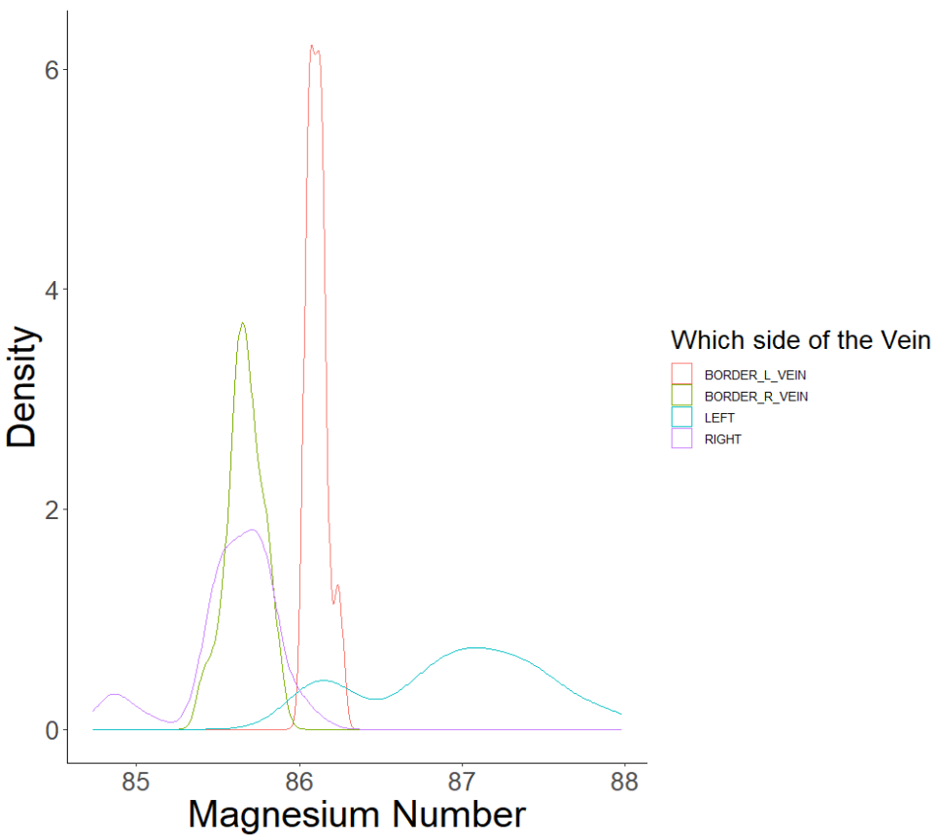
Figure 6. Mg# of olivine from the mantle xenolith on both sides of the vein. Border left Mg# there is a possibility of bimodal distribution evidenced by the notch on the right leg of the distribution curve. Density is represented as a whole number and indicates the frequency that a particular Mg# occurs.

Sample Site | Calcium in wt. % | M#
KBH_94_23-DE_23 | 0.07 - 0.08 | 86 - 86.4
KBH_94_23-DE_24 | 0.07 - 0.08 | 86.5 - 86.8
KBH_94_23-DE_26 | 0.07 - 0.10 | 87.2 - 87.3
KBH_94_23-DE_27 | 0.07 - 0.9 | 87.4 - 87.6
KBH_94_23-DE_5_pyx_LINE | 0.06 - 0.15 | 85.8 - 85.4
Table 4. Comparison of calcium in wt. % to Mg# in the olivine of the mantle xenolith.

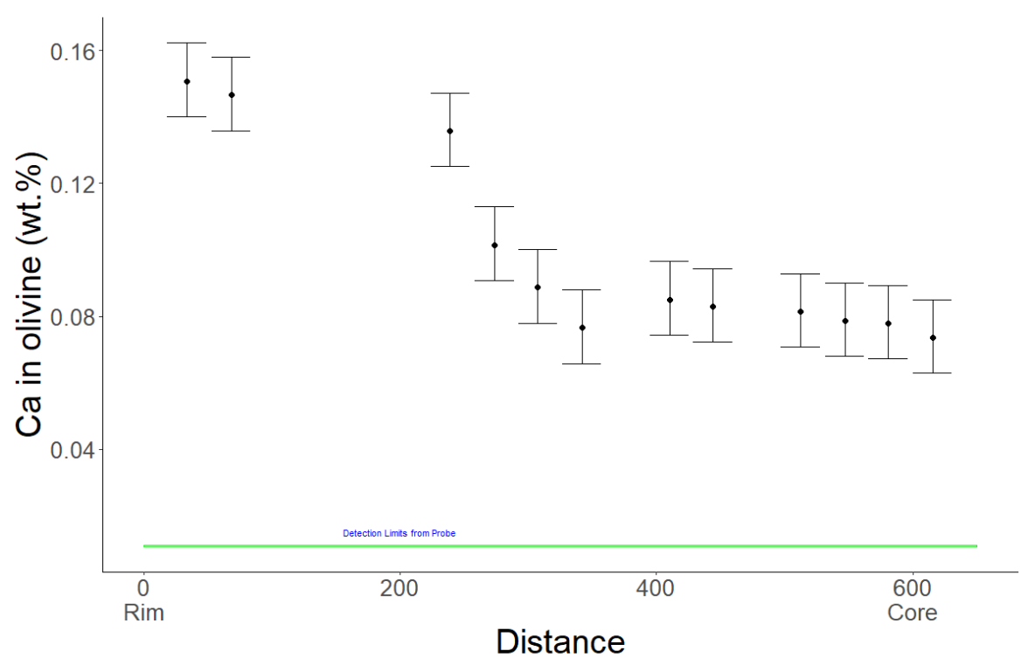

Figure 7. Calcium in concentration measured in wt. % of the element. The green box at the bottom are the detection limits of the EPMA, error bars are the standard deviation from all the points in the line. This crystal reflects the rim being elevated calcium concentration of the site measured.

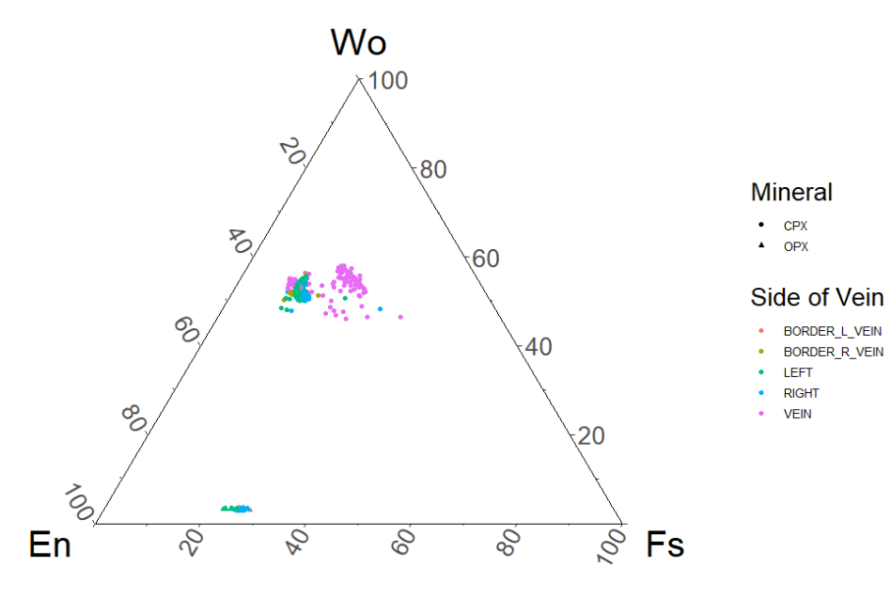
Figure 8. Pyroxene composition from the mantle xenolith. There is little variation in composition. Vein composition is slightly different and has some variation in composition.

measuring between 86-87.5, and the border right had the highest Mg# at 88. Clinopyroxene minor element compositions are given on Table 6. When compared to TiO₂, the Cr# in clinopyroxene displayed a negative correlation driven by which side of the vein the grain was located (Fig. 9). Within the vein, however, little to no correlation between TiO₂ and Cr# was observed. As the SiO₂ content of the clinopyroxenes increased, Al₂O₃, and TiO₂ both showed a clear negative correlation in material within the vein (Fig. 10). However, outside the vein, little variation was observed. Clinopyroxene calcium content was homogenous across the mantle xenolith (Fig. 11). Both Na₂O and Cr₂O₃ were elevated in the clinopyroxene outside the vein. The minor element correlations highlight the alteration that is originating from the clinopyroxenite vein intrusion.

Orthopyroxene (Enstatite)
Pyroxene end members of the mantle xenolith were plotted on the pyroxene composition ternary diagram to evaluate the phases. The orthopyroxene within the mantle xenolith is enstatite (Fig. 8). No orthopyroxene was observed within the vein. Orthopyroxene Mg# was trimodal with greater variation than the clinopyroxene, the distal left side of the vein Mg# varied between 86 – 88.5 and on distal right side of the vein the Mg# ranged from 86 – 88.5. The exception to this range was proximal to the vein on the left side which had a narrow Mg# range (86 – 86.5). A negative correlation between Cr# and titanium in wt. % was observed (Fig. 12). Within the vein, however, there was little to no correlation between titanium and Cr#. As the SiO₂ content of the orthopyroxenes increased, aluminum, and titanium both showed a clear negative correlation in material within the vein (Fig.12). However, outside the vein, little variation was measured. CaO was homogenous across the xenolith (Fig. 13). Both Na₂O and Cr₂O₃ were elevated outside the vein. The orthopyroxene was observed to have less alteration than the clinopyroxene due to the infiltration of the clinopyroxenite vein.

Spinel
Spinel composition showed significant variation as a function of location relative to the vein. Mg# varied from 72.5 inside the vein to 70.6 outside the vein. Cr# varied

Table 5. Minor element data calculated to observe the element data without the oxygen contribution (wt. %).

Minor Element  Wt. % | Vein wt. % | non-vein wt. %
Na | 0.017 | 0.02
Ti | 0.03 | 0.011
Al | 0.13 | 0.08
Cr | 0 | 0.005
Ca | 0.35 | 0.34
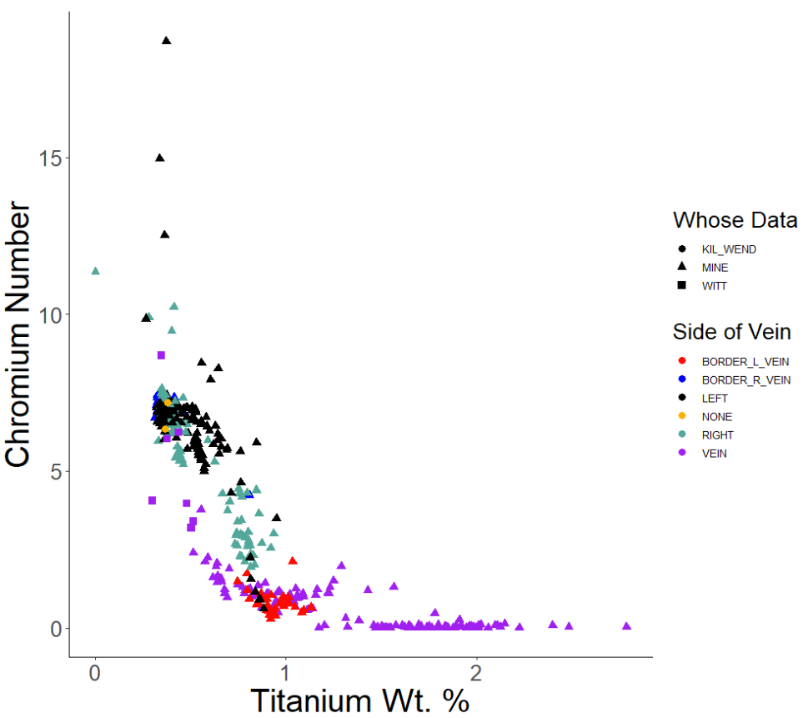

Figure 9. Cr# compared to the element Ti in wt. % in a clinopyroxene of the mantle xenolith. Data from this study compared to Witt-Eickschen et al., 1998 (“Witt”) and Kil & Wendlandt, 2004 (“KIL_WEND”).
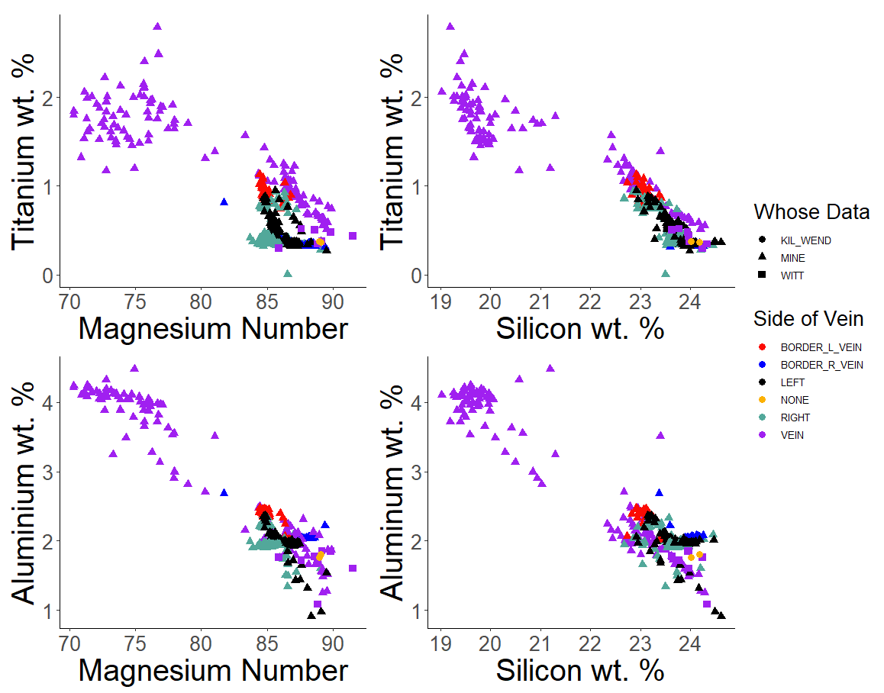

Figure 10. Minor element comparisons in CPX of mantle xenolith. The top two graphs compare titanium on the y-axis and the bottom two compare aluminum on the y-axis. Data from this study compared to Witt-Eickschen et al., 1998 (“Witt”) and Kil and Wendlandt, 2004 (“KIL_WEND”).
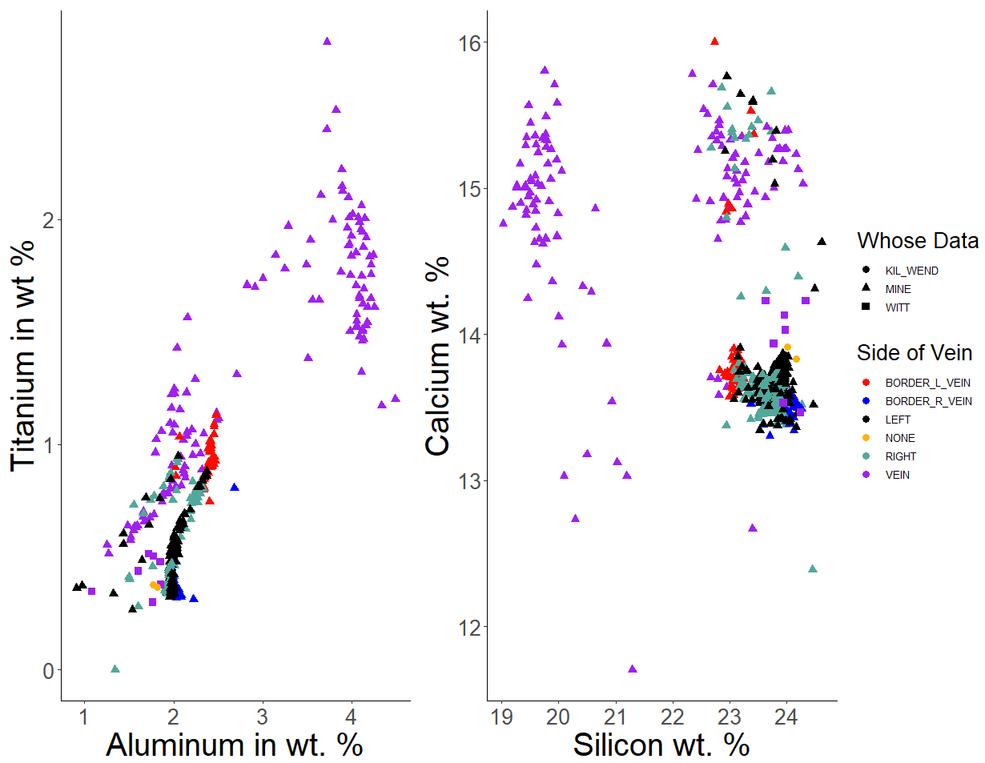

Figure 11. Comparing calcium to silicon content in the clinopyroxene of the mantle xenolith. No real correlation is apparent compared to the correlation of titanium to aluminum where there is a moderate positive correlation.
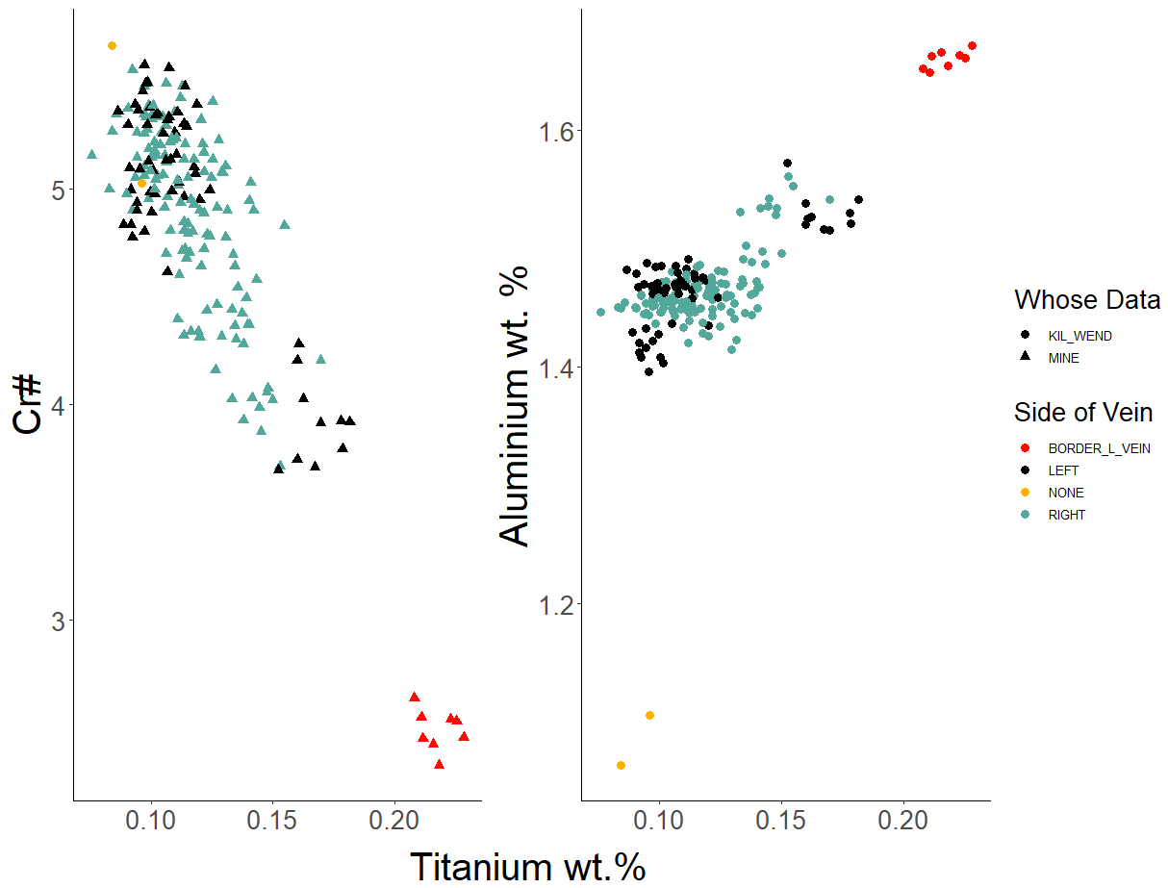

Figure 12. Comparing Cr# to titanium wt. % of the element in orthopyroxene of the mantle xenolith.
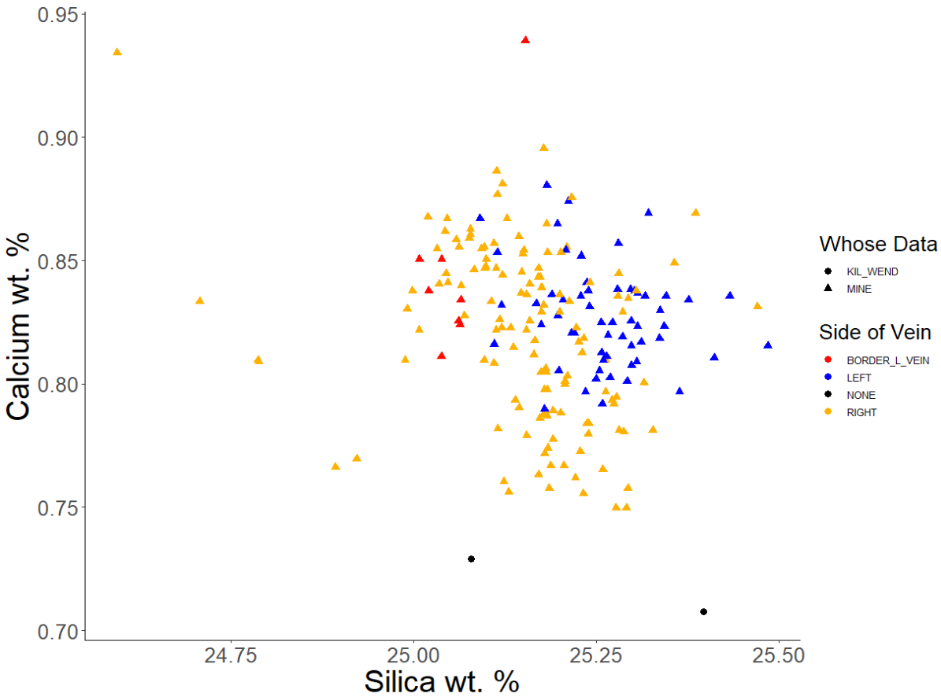

Figure 13. Calcium (wt. %) is compared to silicon (wt. %) content in orthopyroxene in the mantle xenolith. Calcium content is homogeneously distributed throughout the slide studied.
from an average 1.6 inside the vein and an average 7.4 outside the vein. The highest Cr# was observed in the spinel most distal from the vein at an average of 10.7. Cr# inside the vein was low and static, while a small range in spinel Mg# was observed. Furthest from the vein, the Cr# was high and static with a small Mg# range. Immediately adjacent to the vein, the most change was observed. Spinel Cr# varied at an average of approximately 4 to 10 throughout the crystal. The Mg# range remained small, spanning from 69.5-72.5 (Fig. 13). Chromium exhibited a negative correlation with aluminum (Fig. 14), as distal spinel had the most chromium while showing a small range of aluminum variation. A minor correlation between chromium and titanium was observed, depending on location relative to the vein. Within the vein and distal from the vein, the chromium was static, while the titanium changed. On the border of the vein, the titanium was static while the chromium changed (Fig. 15). Overall, the sample had a significant difference in the concentration of chromium and titanium.

Crustal Xenolith Petrology
The analyzed crustal xenolith was composed of clinopyroxene, orthopyroxene, and plagioclase with minor amounts of quartz, ilmenite, and apatite. Based on the overall modal abundance of mineral phases, the crustal xenolith was classified as quartz diorite and was likely sourced from the mid-crustal region of Kilbourne Hole. Mid-crustal xenoliths at Kilbourne Hole are interpreted to represent an extensive plutonic complex that is 26-27 millions of years ago (Ma) in age (Hamblock et al., 2007). Additionally, a minor phase composed of iron and titanium was identified as ilmenite. Overall, these mineral phases appeared to be in equilibrium, although some pyroxenes exhibited disequilibrium rim textures. There was one example of the plagioclase that had orthoclase exsolution. Temperatures were calculated with the Brey and Köhler two-pyroxene geothermometer and averaged 928°C (Fig. 16). Pressure was calculated to be 4.55 kb (0.45 GPa) using silica-Ca-tschermak-anorthite (SCAn) geobarometer (McCarthy & Douce, 1998). These pressures are similar to the values obtained by Hamblock et al. (2007) for mid-crust xenoliths.

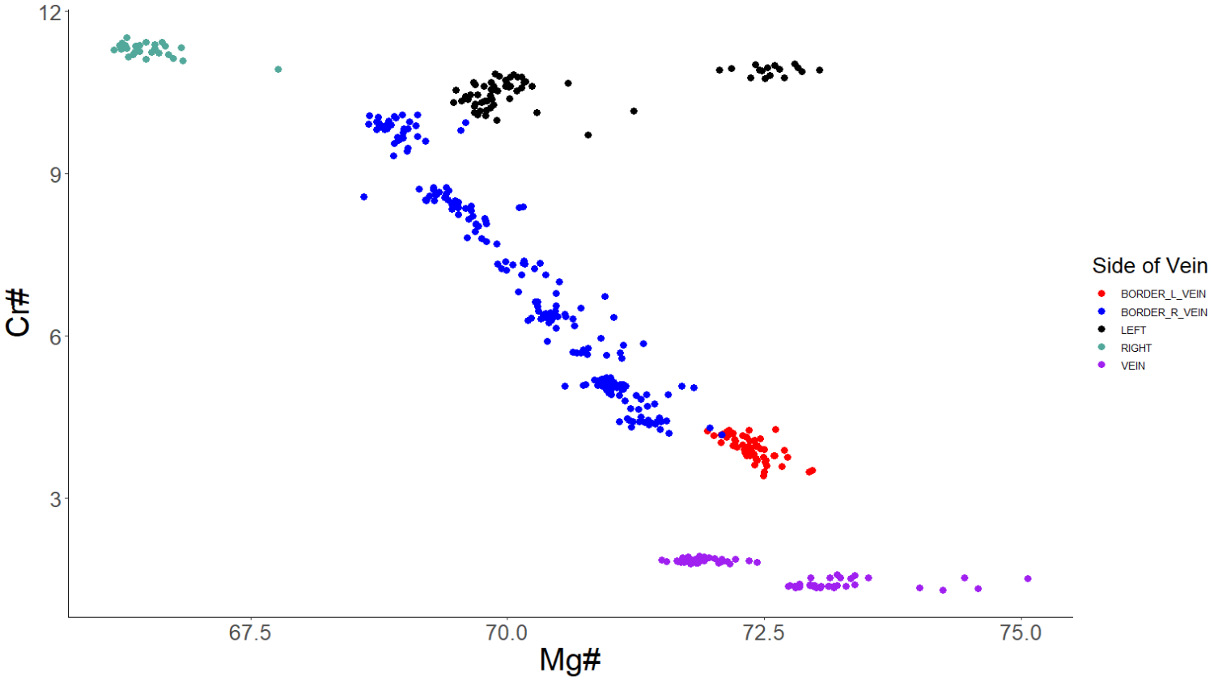

Figure 14. Cr # and Mg # comparisons on either side and inside the vein.
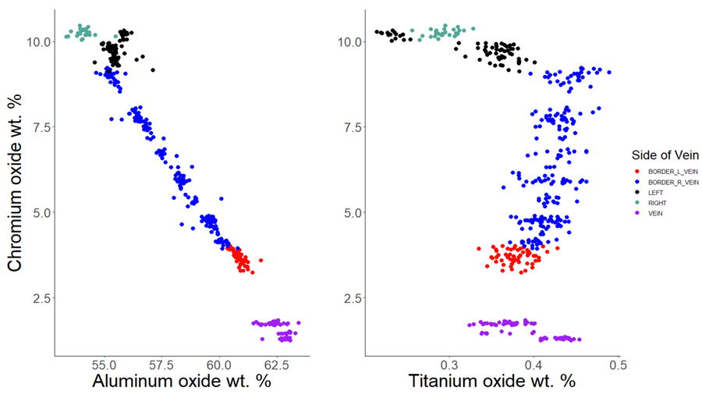
Figure 15. Chromium compared to titanium and aluminum in wt. % oxide in spinel of the mantle xenolith.

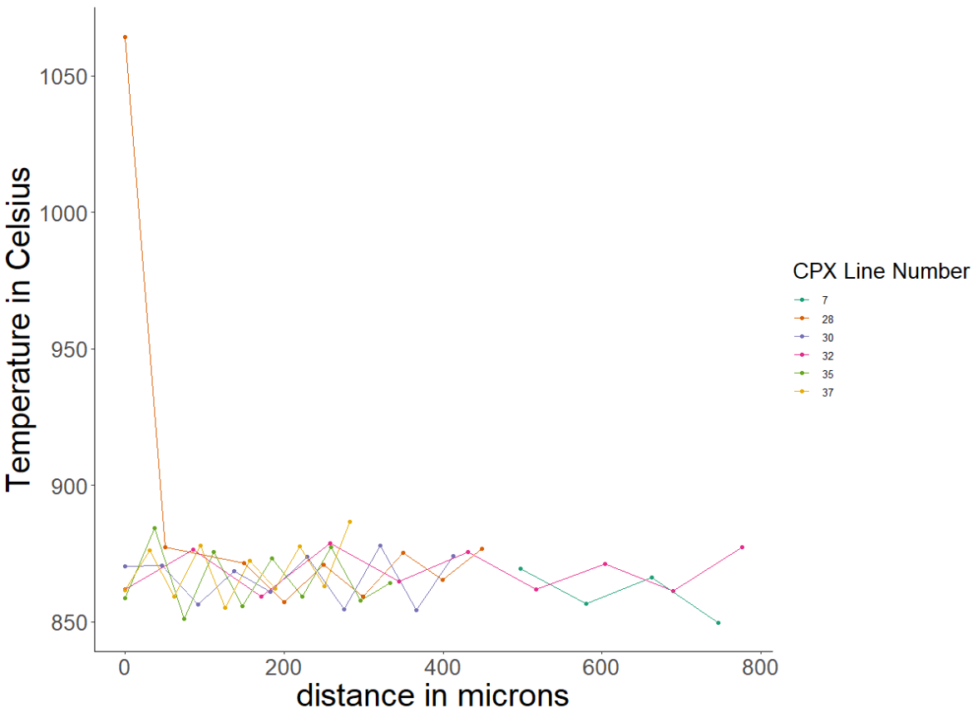
Figure 16. Temperatures calculated using two-pyroxene thermometer of the crustal xenolith

Clinopyroxene and Orthopyroxene
STOP Pyroxene end members of the crustal xenolith were plotted on the pyroxene composition ternary diagram to evaluate the phases. The clinopyroxene within the crustal xenolith was diopside (Wo_{41.64}, En₃₇, Fs_{21.39}) with little variation across the studied area (Fig. 17). Within the crustal xenolith's orthopyroxene, the enstatite (En_{49.6},Wo₂, Fs_{34.6}) was analyzed (Fig. 17). For both mineral phases, minor element comparisons of pairs of elements with a similar valence state, atomic radii and electronegativity, were completed. For element pairs, where some correlation was observed, the Pearson’s Correlation Coefficient value was calculated. The clinopyroxene Mg# varied from 62.3-63.8 in contrast to the Mg# for orthopyroxene which varied from 58-61. The clinopyroxene minor element comparisons appeared to have some correlation. However, once the correlation coefficient calculations were completed (Table 6), no significant correlation was observed (Fig. 18. The orthopyroxene minor element comparisons appeared to have some correlation, the Pearson’s Coefficient was calculated (Table 7), and similar to the clinopyroxene, no significant correlation was observed (Fig. 19 ). With no significant correlational relationships between the minor elements and a consistent Mg# the value of the crustal xenolith will be in comparing the temperature and pressure calculation to the mantle xenolith.

Plagioclase
Bytownite (An_{65.3}, Ab_{27.2}, Or_{7.6}), as calculated on the basis of eight oxygens, was analyzed in the crustal xenolith (Fig. 20). Element comparisons were completed, and for pairs of elements where some correlation was observed, the Pearson’s Correlation Coefficient was calculated (Table 8). Elements were analyzed and those that were observed to exhibit a weak correlation are shown in Figure 21. Comparisons in elements that were moderately correlated were: Ca to Na and Ca to Al. These comparisons have an inverse relationship. Where the Ca to Na has $r=-0.45$, the Ca to Al has $r=0.44$. Meanwhile, the calcium range was the same in both comparisons (5.4-6 wt. %).

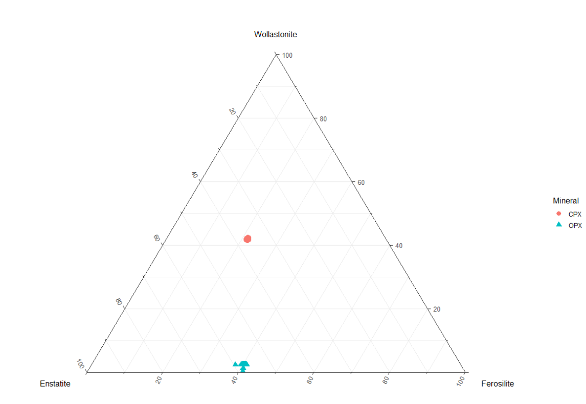

Figure 17. End member composition of orthopyroxene (enstatite) and clinopyroxene (diopside). Compared to the same phases in the mantle xenolith, these have increased iron content.
Table 6. Minor element and Mg# comparisons completed to observe correlation coefficient in clinopyroxene of the crustal xenolith. 'N/A' indicates that there is no correlation. Pearson’s Correlation Coefficient calculations were not completed.

Comparisons of CLINOPYROXENE in wt. % of minor elements for the Crustal Xenolith
Comparison in wt. % | Correlation | Correlation Coefficient
Cr to Ti | weak | 0.23
Ti to Si | none | n/a
Al to Si | weak | 0.3
Al to Na | weak | 0.05
Al to Ti | weak | 0.4
Si to Ti | none | n/a
K to Na | none | n/a
Ca to K | none | n/a
Ca to Na | weak | -0.33
K to Si | weak | -0.04
Mg# to Si | moderate | 0.62

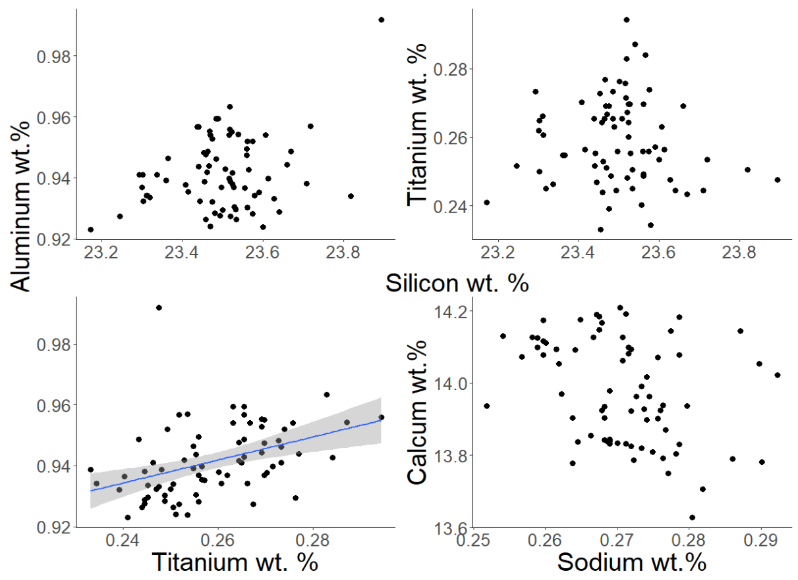
Figure 18. Minor element comparisons in the clinopyroxene of the crustal xenolith. This illustrates the weak, moderate correlations between the minor elements.

Table 7. Minor element and Mg# comparisons in orthopyroxene. Most of the correlations are moderate to weak.

Comparisons of ORTHOPYROXENE in wt. % of minor elements for the crustal xenolith
Comparison in wt. % | Correlation | Correlation Coefficient
Al to Na | weak | 0.1
Al to Si | moderate | 0.4
Al to Ti | moderate | 0.4
Ca to Na | none | 0
Ca to Al | none | 0
Cr to Ti | weak | -0.16
K to Na | weak | 0.1
K to Si | weak | 0.15
K to Ca | none | 0
Si to Ti | weak | 0.1
Mg# to Si | none | 0

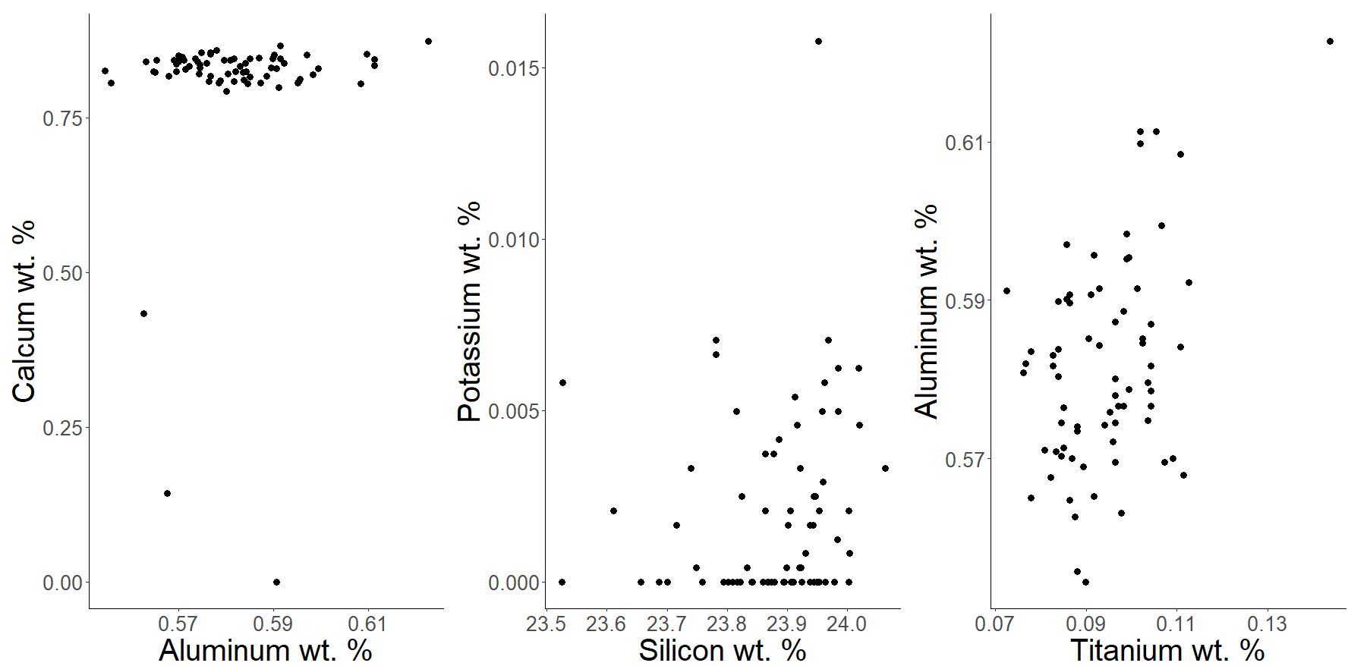

Figure 19. Minor element comparisons in orthopyroxene of the crustal xenolith. On the left, calcium and aluminum have no correlation. Potassium and silicon show a weak correlation (r = 0.15), and aluminum and titanium show a moderate correlation.
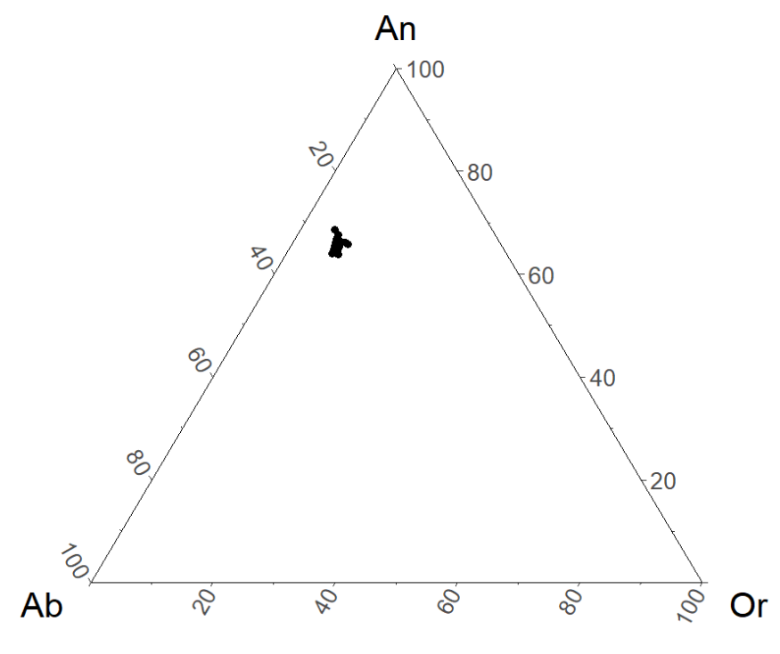
Figure 20. End member composition of the plagioclase phase in the mid-crustal xenolith.

Table 8. Element pair comparisons for Anorthite and Bytownite in the crustal xenolith.

Comparisons of bytownite in wt. % of minor elements for the crustal xenolith
Comparison in wt. % | Correlation | Correlation Coefficient
Cr to Ti | none | n/a
Al to Ti | none | n/a
Ti to Si | none | n/a
Al to Na | weak | -0.17
Ca to K | weak | -0.33
Al to Si | weak | -0.1
K to Si | weak | 0.06
K to Na | weak | -0.1
Ca to Na | moderate | -0.45
Ca to Al | moderate | 0.44

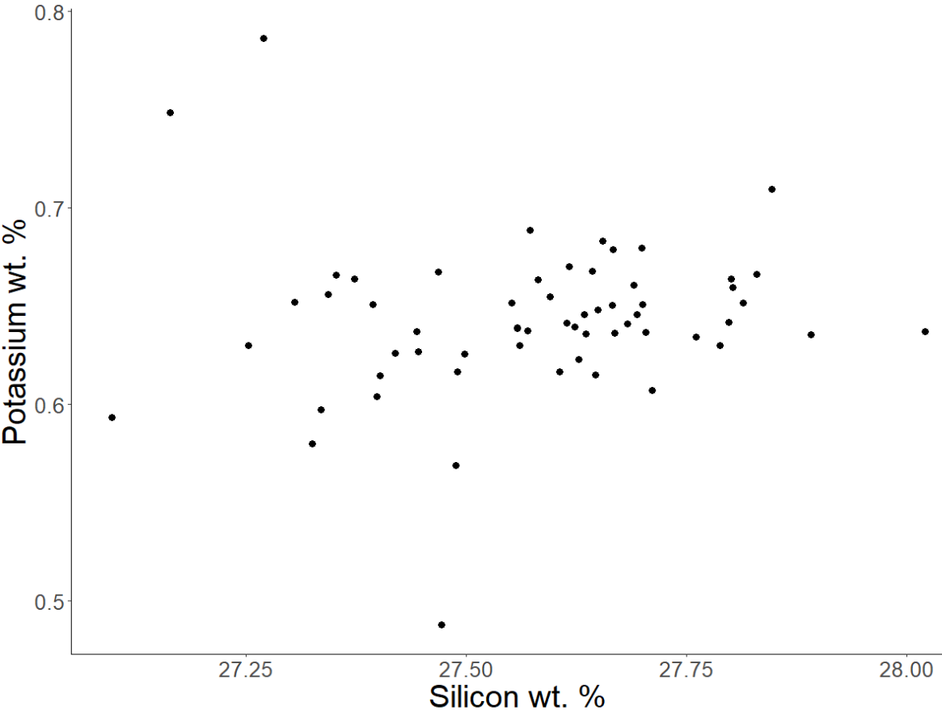

Figure 21. Element comparison of potassium and silicon in bytownite of the crustal xenolith. This example is weakly correlated r = 0.05.

Discussion

Mineral Equilibration
The thermobarometers used in this study require recover thermal histories from temperature-sensitive chemical exchange reactions and require mineral equilibration to provide meaningful constrains. A textural indication that phases are in equilibrium is an absence of a reaction rim between phases that are in contact with each other. While most phases are observed with no reaction rim, diopside has a reaction rim with varied thicknesses independent of the location to the vein. These variations may indicate multiple events of infiltration from different directions due to infiltration of the host magma (Pearson et al., 2014). When compared to the primary clinopyroxene, the secondary clinopyroxene is higher in calcium and lower in sodium, aluminum, and/or Mg# (Pearson et al., 2014). The reaction rim in this study was sampled at site KBH_94_23_DE_15_SpMid_1 — a single line with both ends terminating inside the reaction rim. The reaction rim at this site was found to be higher in CaO and lower in Na₂O and Al₂O_{3.} However, the Mg# was not lower; the Mg# on one end of the reaction rim was in accord with the Mg# of the primary clinopyroxene. At the other end of the line, Mg# was higher in the reaction rim of the secondary clinopyroxene than in the primary clinopyroxene. This points to infiltration of a host magma.

Mantle Petrology
The mantle xenolith displayed different textures, including protogranular, xenocryst, and poikilitic. By measuring grain size in two directions and taking the average of the two measurements, it was determined that the mantle xenolith is best described as coarse grained, where grain size averaged two or more millimeters. However, there are multiple instances in which the enstatite phase was fully enclosed by the diopside phase, and this could skew the grain sizes. Poikilitic texture was considered and eliminated, as there were not many small inclusions of different phases within a crystal. Moreover, xenocrystic texture was eliminated because a foreign material was not incorporated into the crystal. While there was a different phase inside each mineral, these phases were in accordance with spinel lherzolite rock composition. These rounded inclusions could be a textural artifact of ultramafic cumulates and a product of the mantle crystal history (Vernon, 2004).
The clinopyroxenite infiltration generated reaction rims that were independent of vein location. It altered the spinel by depleting the chromium concentration (Fig.22). The clinopyroxenite is elevated in aluminum concentration (Fig. 23).

Clinopyroxene
The clinopyroxene phase makes up 11% of the modal abundance, and the size and shape of the sample's crystals were relatively small, thin, and more elongated than the olivine and orthopyroxene phases. One interpretation for the composition and appearance of the clinopyroxene phase is that the mantle crystallized with a cumulate texture wherein the clinopyroxene phase filled gaps interstitially. However, the clinopyroxene found in the vein had a different minor and major element composition than the clinopyroxene in the xenolith on either side of that vein.

Mantle Xenolith Equilibration Conditions
The equilibration pressure of the mantle xenolith was initially assumed in order to calculate the temperature using the two-pyroxene thermometer (1) derived by Brey and Köhler (1990). The calcium in orthopyroxene thermometer (2) derived by Brey and Köhler (1990) was used to confirm the two-pyroxene thermometer values. The calculated temperature was then input into the calcium in olivine thermometer of Köhler and Brey (1990) (3) to calculate the pressures correlating to these temperatures. Table 5 contains calculated temperatures for the mantle xenolith sample.
$$T_{BKN}=\frac{23.664+(24.9+126.3* X_{Fe}^{cpx})P}{13.38+{ln⁡(K_{D}^{*})}^{2}+11.59* X_{Fe}^{opx}} (1)$$

Temperature (T_{BKN} ) is quantified in Kelvins and can be calculated by executing the following operations:
- K*_{D} is equal to (1 – Ca*) in the clinopyroxene.
- Then, this value is divided by (1 – Ca*) of the orthopyroxene.
- Ca* is defined as the calcium in the clinopyroxene chemical composition on the M2 site on a six-oxygen basis.
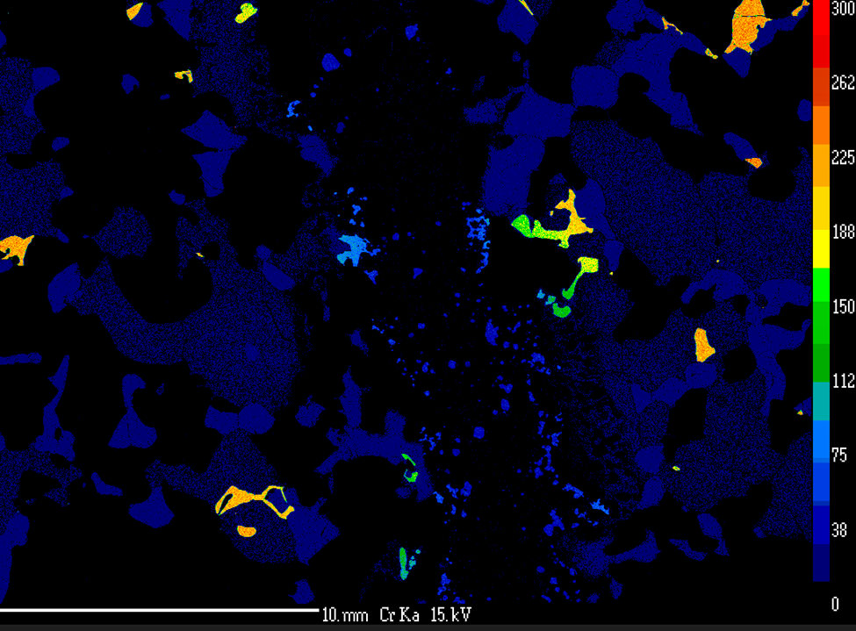

Figure 22. Concentration of chromium throughout the study area. The brighter the color, the more chromium is present in the phase. The brightest phases are the spinel phases. The chromium content is decreased in the spinel closest to the vein.

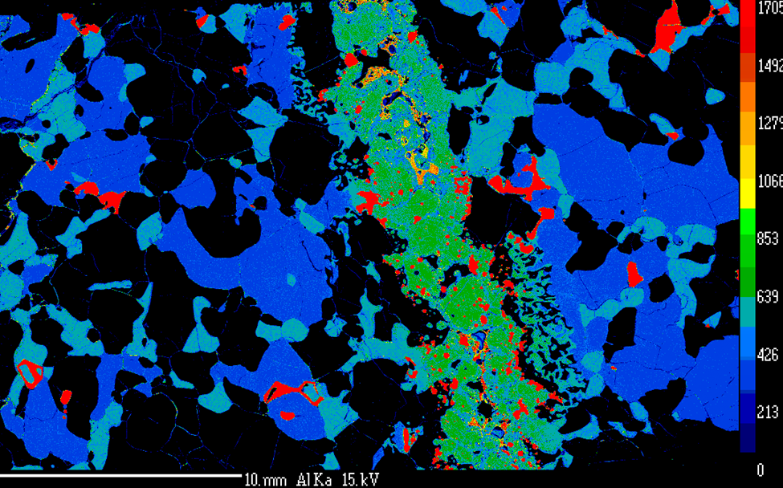

Figure 23. Concentration of aluminum throughout the mantle xenolith. Aluminum concentration is greater in the vein than outside the vein.

Table 9. Temperatures using all thermometers. All temperatures agree with each other within error(±50°C)
Thermometer Name | Side | Avg Temp K | Avg Temp C
Two-Pyroxene | L | 1386.58 | 1113.43
Two-Pyroxene | R | 1389.25 | 1116.1
Ca in orthopyroxene | L | 1394.1 | 1120.94
Ca in orthopyroxene | R | 1401.27 | 1128.12
Ca in olivine | L | 1425.52 | 1152.37
Ca in olivine | R | 1442.54 | 1169.39

- The calcium at the M2 site is then divided by (1 – sodium at the M2 site).
- The mol fraction of iron is equal to Fe / (Fe + Mg), and this is multiplied by pressure (P), which is measured in kilobars.

$$T_{Ca-in-OPX}\left(K\right)\frac{6424+26.4P}{-ln \left({Ca}^{opx}\right) +1.843} (2)$$

$$P \left[kb\right]=\frac{-T*ln \left(D_{Ca}\right) -11982+3.61T}{56.2} (3)$$

D_{Ca} is equal to the calcium in olivine divided by the calcium in immediately adjacent clinopyroxene. Furthermore, calcium in olivine and clinopyroxene are defined as atomic proportions of calcium using the structural formula for olivine based on four or six oxygens, respectively.
The pressures and temperatures calculated are in accord with a previous study by Kil and Wendlandt (2004) who observed temperatures in the Potrillo Volcanic Field to be between 1050-1100°C. The three different thermometers from this study gave temperatures ranging from 1101-1181°C. One location, KBH_94_23_DE_10_pyx_line, recorded a temp of 1355°C. Though higher than the average temperature, this value could not be eliminated as sampling error, e.g., sourcing from a different mineral phase. The anomalous temperature is the first point located on the rim of the crystal. For this sample site and other olivine sites on the sample, the rims of the olivine crystal recorded higher temperatures than the core. Kil and Wendlandt (2004) attributed this elevation to a late heating event.
While two-pyroxene solvus thermometry is an important tool for estimating temperatures, the calcium in olivine thermometer is based on the relatively faster diffusive exchange of calcium and magnesium between olivine and adjacent clinopyroxene. This causes the Ca-in-olivine thermobarometer to respond to short term heating events, or record low temperatures attained under subsolidus conditions for slowly cooled rocks (Köhler and Brey, 1990). Calcium diffusivity in the olivine increases as temperature increases; the olivine will exchange magnesium and iron for calcium with adjacent clinopyroxene according to the temperature sensitive Ca-Mg partition coefficient. Thus, Ca-in-olivine thermometry can be used to determine the timing of geologically brief heating events (Köhler and Brey, 1990). Multiple grains across the mantle xenolith were examined to demonstrate with reliability the equilibrated composition of the samples. Olivine calcium concentrations are similar throughout the mantle xenolith, ranging from 0.07-0.15 wt. % with elevation of calcium concentration at the rim of the crystal compared to the core.
The temperatures obtained by all three thermometers are similar. The two-pyroxene thermometer recorded a range of 1093-1146°C, calcium in olivine recorded a range of 1130-1181°C, and the calcium in orthopyroxene recorded a range of 1107-1145°C (Table 5).
Pressure was also calculated using the Brey and Köhler (1990) calcium-in-olivine thermobarometer with the temperature component required to complete this calculation obtained using the two-pyroxene thermometer. Pressure was calculated within grains on either side of the vein at multiple locations and found to average 10.9-13 kb. The pressure was used to calculate depth using the depth-pressure relationship (equation 4):
$depth=\frac{Pressure}{Density*Gravity} (4)$
For both xenoliths, gravity is constant at 9.8 m s⁻², but density varied. The mid-crustal xenolith employed the typical crustal density (2500 kg m⁻³). The mantle xenolith utilized a density of crust with basalt which was weighted by the percentage of the typical crustal and basalt values estimated to be above the mantle beneath KBH. Therefore, for the crust, the weight was 2500 kg m⁻³ * 0.75, which was equal to 1912.5 kg m⁻³, and the basalt weight was 3000 kg m⁻³ * 0.25, which was equal to 750 kg m⁻³. The two weighted densities were added together, resulting in a density of 2812.5 kg m⁻³. Calculated depths ranged from 49.8 km for the mantle xenolith to 18.57 km for the mid-crustal xenolith. The composition and textures of the mantle xenolith in this study indicates that it came from a pressure regime of 10.9-13 kb corresponding to a depth of approximately 49 km and a temperature range throughout the studied clinopyroxene that are best explained as a reaction to the infiltration of the clinopyroxenite.

Crustal Xenolith
The same process used to calculate temperatures in the mantle xenolith, using an assumed pressure, was used to calculate temperatures in the crustal xenolith. To determine the temperature, the Köhler and Brey, (1990) two-pyroxene thermometer was used with an assumed pressure of 10kb. The two-pyroxene thermometer yielded temperatures between 875 to 975°C (Fig. 10). The resulting temperature was input into the SCAn geobarometer to calculate the corresponding pressure of the crustal xenolith (McCarthy & Douce, 1998). The SCAn geobarometer is sensitive to temperature changes created by calcium in the diopside reaction with quartz to form anorthite. This geobarometer was used as this studies’ crustal xenolith does not contain garnet. Previous work has noted that SCAn geobarometer results provided pressures systematically higher than those given by other barometers (Chen, 2007; Török, 2012). These higher pressures were attributed to be due to a) lack of quartz in the tested assemblage (Török, 2012) or b) that the equilibration pressure of the lower crustal xenoliths was just naturally higher in the applied study region (Chen et al., 2007). On the other hand, Sawyer (2003) and Wenzel et al. (2002) both applied this geobarometer in their studies successfully.
The pressure in this study was calculated using the average composition of bytownite and diopside at four separate locations as well as the criteria in Table 1, resulting in an average obtained pressure of 4.6 kb. The highest pressure for a single crystal composition was 6.5 kb. After deriving the pressure, this was used to plot the geothermal gradient. Both of these pressures are in line with Hamblock et al. (2007) who recorded pressures ranging from 0.3-0.5 GPa for the plutonic complex, corresponding to approximately 11-18 km in depth. Moreover, the SCAn barometer was not observed to yield pressures higher than what could be reasonably expected in a mid-crustal xenolith.
In this study, depth was calculated by using the relationship of depth to density and pressure, specifically when density is a typical crustal value (2500 kg * m⁻³). The correlating depth was calculated as 18.57 km when pressure was 4.6 kb (0.46 GPa), and the depth was 26.5 km when pressure was 6.5 kb (0.65 GPa). This indicated that the mid-crust is at this depth beneath Kilbourne Hole.

The Significance of Calcium in Olivine Concentration Gradients
At several sites throughout the sample, EPMA analysis revealed that the calcium concentration in olivine was elevated at the rim relative to the core. Though the concentration of calcium varied depending on which side of the vein the olivine crystal was located, it was more pronounced on the right side of the vein. The weight percentage of calcium in olivine on the right ranged from 0.08 to 0.15 wt.%, and on the left, it ranged from 0.07 to 0.1 wt.%. This was possibly due to the greater proliferation of vein material, which had a high calcium concentration on the right side or the infiltration of additional clinopyroxenite veins outside of the studied sample.
The concentration of calcium in olivine can be explained by two different processes, either chemical or thermal. If the calcium concentration signature is due to the chemical process, then it could stem from melt intrusion and subsequent additional growth of olivine on the existing olivine crystals. On the other hand, if the calcium signature is due to thermal processes, heat related to the rift action of thinning lithosphere and close contact to the mantle, then heat facilitated the signature, and there is no new material on the edges of the olivine crystals.
Comparisons between the Mg# and concentration of calcium in olivine were used to evaluate if the calcium signature was the result of chemical or thermal processes. A magmatic indicator is apparent when the Mg# and calcium oxide concentration is opposite of one another. Therefore, if magmatic processes are responsible for the observed high calcium rim signature, the Mg# should be depressed at the rim compared to the core.
To isolate the cause of the calcium-in-olivine signature, the olivine calcium concentration was compared to the Mg#. Several sites across the slide with varying sizes and locations were selected to represent the whole investigation area. Utilizing the R tools previously discussed, we observed concentration gradients through olivine (Fig. 24) and compared this apparently diffusive behavior of Ca-in-olivine to the Mg#.
Five sites where the crystal size was at least 600 micrometers with a range of proximity from the vein were selected. Among the five sites tested, there was only one site where a magmatic indicator was initially noted. However, with further observation,
the Mg# was static, ranging from 86 to 86.5. The slope of the line was magnified in Figure 13, and it was determined that there was no statistically significant variation in Mg# there at all. The lack of anticorrelation between the calcium oxide and Mg# reduced the likelihood of a magmatic source for the elevated calcium concentration at the rim. However, the interpretation is nonunique and depends on the chemistry and mass of the infiltrating melt and the temperature-time path of the sample. The interpretation is inconsistent with the research of Kil and Wendlandt

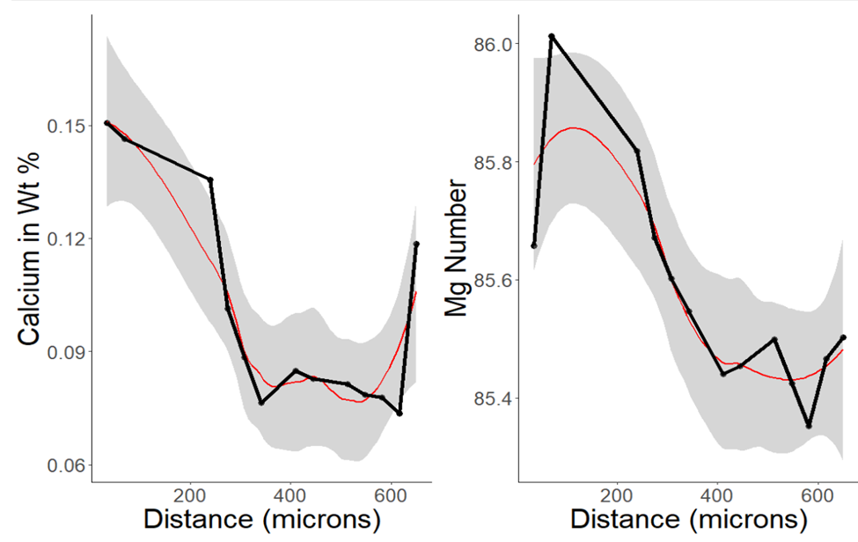
Figure 24. Ca versus Mg# indicated that the calcium elevation at the rim was not magmatic.
(2004), who theorized that the entrainment of the xenolith in melt alone yielded the elevated calcium in olivine concentrations.
Five sites where the crystal size was at least 600 micrometers with a range of proximity from the vein were selected. Among the five sites tested, there was only one site where a magmatic indicator was initially noted. However, with further observation,
the Mg# was static, ranging from 86 to 86.5. The slope of the line was magnified in Figure 13, and it was determined that there was no statistically significant variation in Mg# there at all. The lack of anticorrelation between the calcium oxide and Mg# reduced the likelihood of a magmatic source for the elevated calcium concentration at the rim. However, the interpretation is nonunique and depends on the chemistry and mass of the infiltrating melt and the temperature-time path of the sample. The interpretation is inconsistent with the research of Kil and Wendlandt (2004), who theorized that the entrainment of the xenolith in melt alone yielded the elevated calcium in olivine concentrations.
Of the five sites, the one selected for in-depth analysis was KBH_94_23_DE_5_pyx_line, which was located on the right side of the vein. MATLAB was employed to create a model of the diffusion of calcium through olivine, and this was compared to the KBH_94_23_DE_5_pyx_line site. Clinopyroxene is considered an infinite reservoir of calcium for the adjacent olivine, and thus, we used the semi-infinite half-space solution to create a model where the surface concentration of calcium was constant (Equation 5). This model was used to predict the exchange of calcium between adjacent clinopyroxene and olivine over varying times with a static temperature of 1600 kelvin (K).
$$Predicted conc.=\left(Ca at rim\right)+\left(Ca at core-Ca at the rim\right)*\operatorname{erf}\left(\frac{distance}{2\sqrt{Dt}}\right)(5)$$
The surface concentration of calcium was obtained via EPMA at the rim (0.2 wt. %), and the initial concentration of calcium was the amount observed at the core (0.11 wt.%). Distance refers to the numerical measurement in meters of the olivine between the rim and core. The t component is the duration of time, and a series of progressively larger time ranges were used for each iteration. D is defined as the diffusivity of calcium through olivine and is calculated using Equation 6:
$D=D_{0 }*e^{\left(\frac{-E}{RT}\right)} (6)$
Both D₀, which is a pre-exponential hypothetical rate of diffusion, and E, which is the activation energy, were obtained from Coogan et al. (2005). R is the noble gas constant, and T, which is held constant, is the temperature calculated from the two-pyroxene thermometer (1600 K).
Once the diffusion concentration model was complete, data from the KBH olivine were overlaid on top of modeled data. If the concentration of calcium and temperature were constant at the surface, then the overlaid datum should fit one isopleth. Instead, there were two distinct domains of data that fit multiple isopleths present within the single line. The first three points were consistent with an apparent rate of diffusion that was much faster than the remaining points. Furthermore, the “faster-diffusing” points correlated to a rough timescale of one to 10 years, and the “slower-diffusing” points correlated with a timescale of 50 to 1,000 years (Fig. 25). Overall, this model was a poor fit for the data, eliminating the possibility that the concentration gradient could be reproduced by a fixed boundary half-space solution and thereby by thermal perturbation alone.

Effective Timespan Model
The previous model proposed, did not fit the overlaid data points from the EPMA from the mantle xenolith, and therefore could not be used to describe the process that generated the elevated calcium concentration at the rims of the olivine. Thus, a second model was developed that assumed the clinopyroxenite infiltrate reacted with the olivine to precipitate a new rim on the olivine, which in turn began a diffusive exchange of calcium between the new rim and the old core of the olivine. The model used was an explicit, parabolic partial differential equation, forward difference method and the equations are based on those found in Burden, R. and Faires J.D. (2010). The solution was approximated using finite differences. X-axis step is defined as h(Δx in the code) = l/m, and the timestep is k(Δt). The grid is defined in points of space and time (x_{i},t_{j}) where x_{i}=ih for i=0,1,N and t_{j}=jk for j=0,1,…. The forward difference method is conditionally stable with the solutions converging. The far field boundary condition is a fixed Dirichlet boundary condition, to constrain the reaction to the concentration and timescale of the known calcium concentration diffusing through an olivine at site KBH_94_23_DE_5_pyx_line.
The difference method is obtained using the Taylor series in t to form the difference quotient:

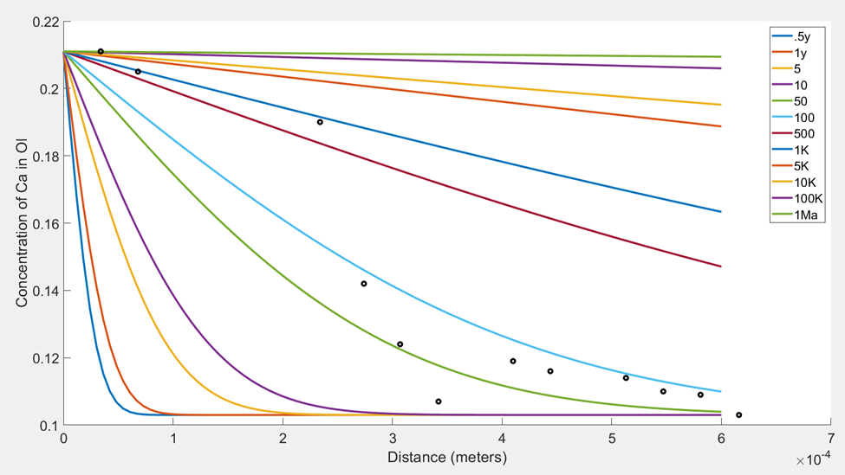
Figure 25. Numerical solution of concentration profiles of calcium in olivine with the data from KBH_5_pyx_line overlayed. There are two distinct domains of points— one showing a fast timescale and the other much slower. There was difficulty constraining the actual timescale. The first 0-300 micrometers are on the timescale of 1-10 years, and the final three appear to be on the 50- to 100-year timescale.

$\frac{∂^{2}u}{{∂x}^{2}}\left(x_{i},t_{j}\right)=\frac{1u\left(x_{i}+h,t_{j}\right)-2u\left(x_{i},t_{j}\right)+1u(x_{i}-h,t_{j})}{h^{2}}- \frac{h^{2}∂^{4}u}{12∂^{4}} (7)$
Where $\frac{h^{2}∂^{4}u}{12∂^{4}}$is essentially zero and is not part of the final equation. The parabolic partial differential equation suggests that the interior points of the iteration where I = 1,2,N-1 and for j = 1,2 there is:
$$\frac{∂u}{∂t}\left(x_{i},t_{j}\right)- α^{2}\frac{∂^{2}u}{∂x^{2}} \left(x_{i},t_{j}\right)=0 (8)$$
α² is defined as P in the code is dimensionless diffusivity and is defined by the following formula:
$${ α}^{2}\frac{k}{h^{2}}≤\frac{1}{2} (9)$$
The difference method using both the first and second partial derivative difference quotients is:
$$\frac{w_{i,j+1}-w_{i,j}}{k}-α^{2} \frac{w_{i+1,j}-{2w}_{i,j}+w_{i-1,j}}{h^{2}}=0 (10)$$

Solving for w_{i,j+1} generates the equation:
$$=\left(1- \frac{2α^{2}}{h^{2}}\right)w_{i,j}+α^{2}\frac{k}{h^{2}}\left(w_{i+1,j}+w_{i-1,j}\right) (11)$$
For every I = 1,2,N-1 and j = 1,2,…Now the w_{i,1} value is used to determine the w_{i,2} values. In this way the method is explicit; the approximate solution for one point is used to find the approximate solution for the next point. The solution also derives a time range for the duration of the event that yielded the observed calcium concentration signature that occurred within a one-half of one year or 10-year span (Fig. 26). Calcium is sensitive to heat perturbations, and having its concentration elevated at the rims and not the core indicates that a new rim is precipitating on the crystal and this new rim is interacting with the core of the olivine. The elevated calcium at the rim may reflect the temperature of the clinopyroxenite infiltration, it’s chemistry, or both.

Timescale Significance
Two separate iterations of the timescale model were developed to determine the range of time that best fit the diffusion scale of calcium in olivine. The initial iteration was based on the assumption of an olivine crystal that had a constant concentration of calcium at the surface until entrainment and transport. This iteration would have pointed to the geologic process that governed the elevated calcium-in-olivine signature. The second model assumed that the calcium concentration was variable and thus the timescale which generated the diffusion was short to moderate in range one half to 10 years (Fig. 26). The timescale recovered from the second model definitively pointed away from a tectonic process. It is unlikely that the calcium signature and thus the timescale was a product of the xenolith's entrainment in the melt and calcium diffusion on the way to the surface.
All previous studies of the phreatomagmatic eruption at KBH indicated an explosive event that was sustained over time by multiple eruptions depositing material and carrying xenoliths as well as magma to the surface. The environment as described at KBH, was constantly moving, with little opportunity for stagnation. This is supported by the results of Sach's (1993) study which indicated that assimilating a mantle xenolith into the melt it is entrained in is completed within a timescale of hours to days. The timescale of the xenolith indicates that olivine was diffusing calcium for six months to 10 years past the proposed time needed for assimilation. With this understanding, it has been accepted that the calcium-in-olivine timescale measured in the xenoliths at KBH recorded the time after the clinopyroxenite melt infiltrated the upper mantle and prior to entrainment in the melt. Then, they were rapidly transported to the surface, and thus, the alteration of geochemistry of the mantle was preserved.

Significance of Pyroxenite Vein Composition for the Infiltrating Melt
Minor element analyses of clinopyroxene inside and outside the vein were completed for the purpose of comparing the amounts of Cr, Ti, Al, Na, and Ca to each other. These comparisons would determine if their abundance was similar to potential infiltrating melts such as mid-ocean ridge or alkali basalt (Fig. 27). Minor element comparisons suggested that the vein material was related to the basanite material from KBH that brought the xenolith to the surface. For most of the minor elements, including calcium, the vein material plotted closely to the basanite material. We hypothesized that the mantle was infiltrated by a melt that was similar—if not identical—to the basanite lava that erupted at KBH. The basanite likely infiltrated the upper mantle that contained the xenolith, causing the reaction rims in the clinopyroxene and diffusing calcium in olivine along the way generating the elevation of calcium concentration at the rims.

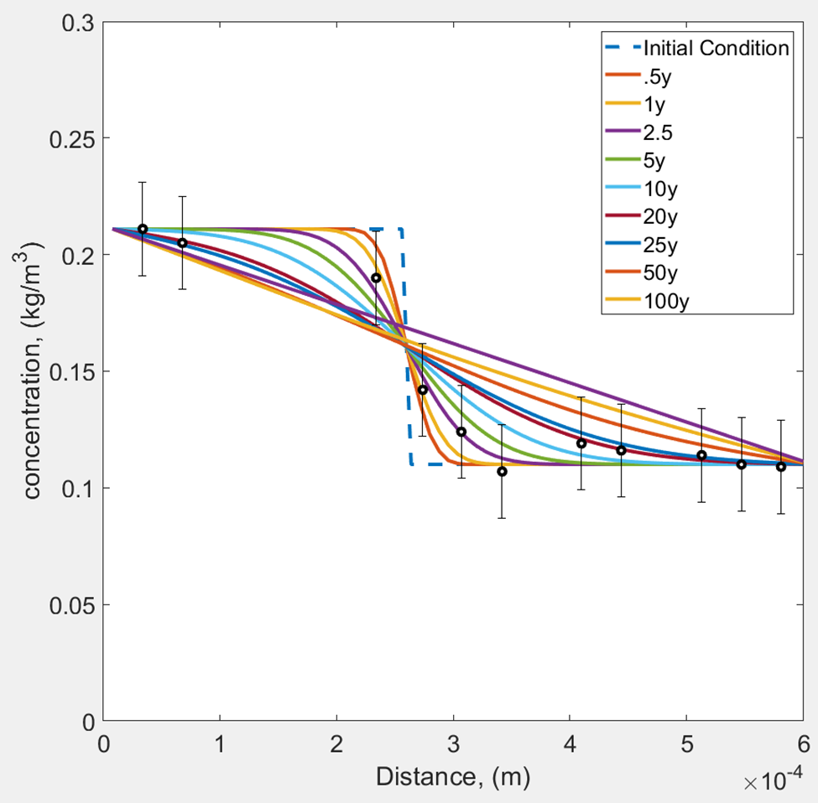
Figure 26. The timescale with error bars was added to determine the range of time when all isopleth points occurred within error. The time span within the error bar range was 0.5 to 10 years

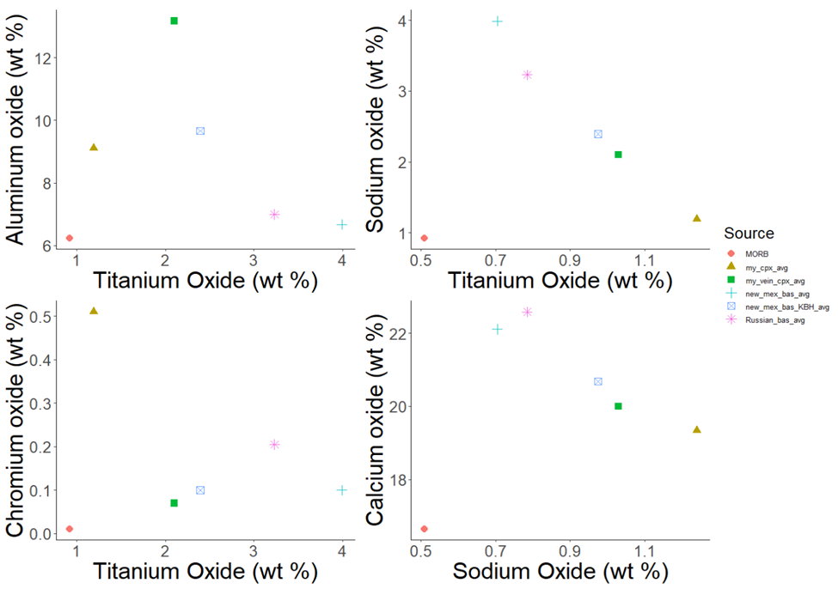

Figure 27. Minor element comparisons illustrate the similarity of vein material to the basanite material that was erupted at KBH. Note how different the mantle xenolith clinopyroxene (gold triangle) was from the vein clinopyroxene (green square). The trend of similarity to the KBH basanite material was consistent for all minor elements.

Furthermore, this basanite pulled the xenolith from the mantle, entrained it in the melt, and transported it to the surface quickly. The calcium-in-olivine signature indicated that the xenoliths were related to the rift extension, and a timescale for the disaggregation of the mantle could be constrained.

Geothermal Gradient

Background
For both the mantle and mid-crustal xenolith, temperatures and pressures were used to derive a depth of origin and compared to a theorized geothermal gradient (Cipar et al., 2020). This study’s xenoliths, which were calculated at 44 km and 18.57 km respectively, were compared to the Cipar et al. (2020) geotherm (Fig. 28). The WebPlotDigitizer was utilized to extract the x and y coordinates of steady-state geotherms from Figure 4a in Cipar et al.'s (2020) study . Finally, once the geotherms were successfully manifested, the resulting curve was utilized to plot and compare this current study’s results to those of Cipar et al. (2020).

Calculation Complications.
This study included the analysis of the steady-state geotherms for reference as the original graphic used them to derive their final iteration. The curve calculations were completed in MATLAB, using the following formula:
$Q=K \frac{ΔT}{ΔZ } (12)$
Where Q is equal to 100mWm⁻² and 90mWm⁻² , ΔT and ΔZ were derived from the changes in temperature and depth, leaving K, or thermal conductivity of rock, as the only remaining unknown in the equation. This final variable was then calculated. After K was determined, it was used to calculate and plot the steady-state geotherms.

Comparison of Results
When compared to the Cipar et al. (2020) study's results, the outcome from mid-crustal and mantle xenoliths’ analysis did not align well with the proposed geothermal gradient (Fig. 32). For Cipar et al. (2020) the mantle xenoliths range in temperature from 950°C to 1050°C and source from depths ranging from approximately 33 km to 44 km. For this study the temperatures range from 1113°C to 1152°C ± 50°C and range from 47-49.8 km in depth. It is unlikely that this could be due to a separate cooling history because though the mid-crustal xenoliths are believed to originate from an extensive plutonic complex, there is still a large regional thermal state that
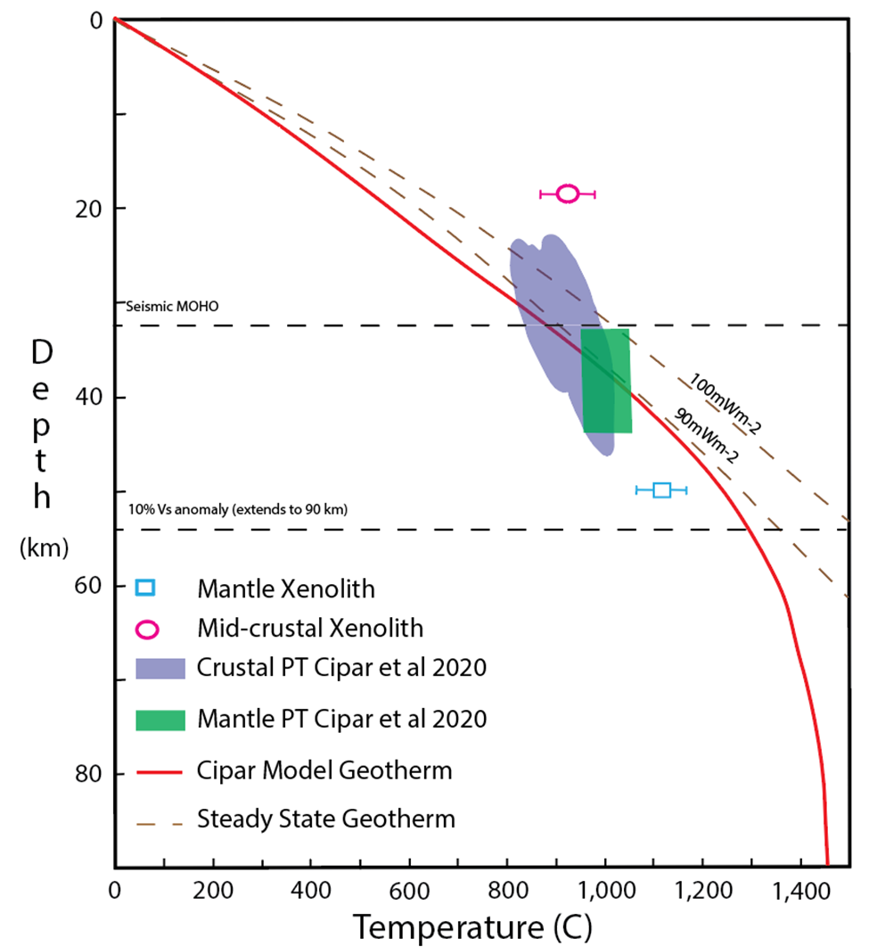
Figure 28. The comparison of Cipar (2020) proposed geotherm, and P-T ranges of their mantle and lower-crustal xenoliths compared to this study. Errorbars are for the temperatures at ±50°C.
would overprint any localized cooling history the pluton had. The results could stipulate that the geothermal gradient beneath KBH is steeper than originally proposed, and as it transitions from the crust to the mantle it is nonlinear

Conclusion
Prior research indicated that mantle xenoliths found at KBH experienced alteration to clinopyroxenite that were not in contact with the magma they were t entrained in, suggesting that cross cutting veins may affect the geochemistry of the mantle xenoliths at KBH prior to entrainment. This current study characterized geochemical and textural alterations due to infiltration of a mantle xenolith by clinopyroxenite magma by executing: minor element comparisons, calcium-in-olivine diffusion modeling, thermometry, and barometry to describe the processes the xenolith was subjected to that generated such alterations.
The mantle xenolith was originally equilibrated until infiltration, evidenced by lack of disequilibrium textures to grains distal from the vein. The compositions and textures of the mantle xenolith indicate that it came from a pressure regime of 10.9-13 kb and depth of 49 km. The calculated depths of the xenoliths were poorly fit to the proposed geothermal gradient suggesting that it is not as linear as previously thought. The heat flow beneath KBH is complex and the subsequent geothermal gradient is steeper beneath KBH.
The calcium in olivine was elevated at the rims when compared to the cores. Calcium-in-olivine diffusion was modeled first, with a constant concentration of calcium and when this generated a poor fit to the known data. The second model was created with a changing concentration of calcium at the surface of the crystal. Data from the EPMA overlaid the models to demonstrate that entrainment in the magma that brought the xenolith alone was not sufficient to generate the elevated concentration of calcium at the rim of the crystal compared to the core.
Minor element comparisons of the clinopyroxene both in and out of the vein suggest that the infiltrating clinopyroxenite in the vein is not related to the mantle xenolith. Furthermore, this infiltrating clinopyroxenite when compared to other mafic reservoirs and basanite compositions is similar to the basanite that erupted at KBH. The similarity of the basanite to the vein material suggests that the basanite likely infiltrated the upper mantle providing the calcium rich material that diffused through olivine generating the signature of elevation of calcium at the rims of the olivine. The xenolith was removed from the upper mantle and entrained in the melt before deposition on the surface during the eruption that created KBH. The calcium-in-olivine signature indicated that the xenoliths were related to the rift extension, and suggest a timescale for the disaggregation of the mantle of one half to ten years in duration.

References
Amato, J. M., Boullion, J., Serna, A., Sanders, A., Farmer, G., Gehrels, G., & Wooden, J. (2008). Evolution of the Mazatzal Province and the timing of the mazatzal orogeny; insights from U-Pb geochronology and geochemistry of igneous and metasedimentary rocks in southern New Mexico. Geological Society of America Bulletin, 120(3-4), 328–346. https://doi.org/10.1130/B26200.1
Anthony, E.Y., & Poths, J. (1992). ³He surface exposure dating and its implications for magma evolution in the Potrillo Volcanic Field, Rio Grande Rift, New Mexico, USA. Geochim Cosmochim Acta, 56(11), 4105–4108. https://doi.org/10.1016/0016-7037(92)90022-B
Anthony, E., Hoffer, J. M., Waggoner, W. K., & Chen, W. (1992). Compositional diversity in late cenozoic mafic lavas in the Rio Grande Rift and basin and range province, southern New Mexico. Geological Society of America Bulletin, 104(8), 973–979. https://doi.org/10.1130/0016-7606(1992)104<0973:CDILCM>2.3.CO;2
Brey, G. & Köhler, T. (1990). Geothermobarometry in four-phase lherzolites II. new thermobarometers, and practical assessment of existing thermobarometers. Journal of Petrology, 31(6), 1353–1378. https://doi.org/10.1093/petrology/31.6.1353
Bussod, G. Y. A., & Irving, A.J. (1981). Thermal and rheologic history of the upper mantle beneath the southern Rio Grande Rift; evidence from Kilbourne Hole xenoliths. Abstracts of Papers presented to the conference on Processes of Planetary Rifting. A Lunar and Planetary Institute Topical Conference, 457,145–148. https://adsabs.harvard.edu/full/1981LPICo.457..145B
Bussod, G. Y. A., & Williams, D. R. (1991). Thermal and kinematic model crustal and mantle xenoliths from Kilbourne Hole, New Mexico. Tectonophysics, 197(2-4), 373–389. https://doi.org/10.1016/0040-1951(91)90051-S
Burden, R., Faires, J.D. (2010). Numerical Analysis (Ninth Edition, 725-727). Cengage
Learning.
Chattopadhyay, I., 2003. Crustal xenoliths from Potrillo maar: implications for evolution of continental crust beneath the southern Rio Grande rift, Master’s thesis, Texas Tech University, pp. 148.
Chen, X., Lin, C., & Shi, L. (2007). Rheology of the lower crust beneath the northern part of North China: Inferences from lower crustal xenoliths from Hannuoba basalts, Hebei Province, China. Science In China Series D,50(8), 1128–1141. https://doi.org/10.1007/s11430-007-0047-3
Fritsch, E., & Scarratt, K. (1992). Natural-color non-conductive gray-to-blue diamonds. Gems & Gemology, 28(1), 35–42. https://www.gia.edu/doc/Natural-Color-Nonconductive-Gray-to-Blue-Diamonds.pdf
Grambling, N., Dygert, N., Boring, B., Marlon, M. J., & Kelemen, P .B. (2022). Thermal history of lithosphere formed beneath fast spreading ridges: Constraints from the mantle transition zone of the East Pacific Rise at Hess Deep and Oman Drilling Project, Wadi Zeeb, Samail Ophiolite. Journal of Geophysical Research: Solid Earth. 127(1) 1–27. https://doi.org/10.1029/2021JB022696
Grolemund, G., & Wickham, H. (2017). R for data science. O’Reilly Media.
Grundmann, G., & Scholz, H. (2015). Preparation methods in mineralogy & geology: the preparation of thin sections, polished sections, acetate foil prints. Preparation for elutriation analysis, and staining tests for the optical and electron microscopy. https://www.researchgate.net/publication/275948069_
Gutierrez, M. M. (2016). A geophysical investigation at Potrillo maar. (Publication Number: 10254896) [Master’s thesis, The University of Texas at El Paso]. ProQuest Dissertations and Theses Global.
Hamblock, J. M., Andronicos, C. L., Miller, K. C., Barnes, C. G., Ren, M.H., Averille, M. G., & Anthony, E.Y. (2007). A composite geologic and seismic profile beneath the southern Rio Grande Rift, New Mexico, based on the xenolith mineralogy, temperature, and pressure. Tectonophysics, 442(1-4), 14–48. https://doi.org/10.1016/j.tecto.2007.04.006
Hamilton, N.E., & Ferry, M. (2018). Ggtern: Ternary diagrams using ggplot2. Journal of Statistical Software, 87(3), 1–17. https://doi.org/10.18637/jss.v087.c03
Harvey, J., Yoshikawa, M., Hammond, S. J., & Burton, K. W. (2012). Deciphering the trace element characteristics in Kilbourne Hole peridotite xenoliths: Melt/rock interaction and metasomatism beneath the Rio Grande Rift, SW USA. Journal of Petrology, 53(8), 1709–1742. https://doi.org/10.1093/petrology/egs030
Huang, J., Hao, J., Huang, F., & Sverjensky, D. A. (2019). Mobility of chromium in high temperature crustal and upper mantle fluids. Geochemical Perspectives Letters, 12(1-6). https://www.geochemicalperspectivesletters.org/article1926/doi: 10.7185/geochemlet.1926
Irving, A. J. (1980). Petrology and geochemistry of composite ultramafic xenoliths in alkalic basalts and implications for magmatic processes within the mantle. American Journal of Science, 280(2), 389–426. https://earth.geology.yale.edu/~ajs/1980/ajs_280A_1.pdf/389.pdf
Karimov, A. A., Gornova, M. A., Belyaev, V. A., Medvedev, A. Y., & Bryanskiy, N. V. (2020). Genesis of pyroxenite veins in supra-subduction zone peridotites: Evidence from petrography and mineral composition of Egiingol massif (Northern Mongolia). China Geology, 3(2), 299–313.https://doi.org/10.31035/cg2020035
Kil, Y., & Wendlandt, R. F. (2007). Depleted and enriched mantle processes under the Rio Grande Rift: spinel peridotite xenoliths. Contributions to Mineralogy and Petrology, (154, 135–151). https://doi.org/10.1007/s00410-007-0183-y
Köhler, T. P., & Brey, G. (1990). Calcium exchange between olivine and clinopyroxene calibrated as a geothermobarometer for natural peridotites from 2 to 60 kb with applications. Geochimica et Cosmochimica Acta, 54(9), 2375–2388. https://doi.org/10.1016/0016-7037(90)90226-B
Landau, W. M. (2021). The targets R package: A dynamic make-like function-oriented pipeline toolkit for reproducibility and high-performance computing. Journal of Open Source Software, 6(57), 2959. https://doi.org/10.21105/joss.02959
Long, C. A. (1994). Geochemistry of the ultramafic mantle xenoliths from Kilbourne Hole, Potrillo Volcanic Field, southern New Mexico (Publication No. EP04599) [Master’s thesis, The University of Texas at El Paso]. ProQuest Dissertations & Theses Global.
Mercier, J. C., & Nicolas, A. (1975). Textures and fabrics of upper-mantle peridotites as illustrated by xenoliths from basalts. Journal of Petrology, 16(1), 454–487. https://doi.org/10.1093/petrology/16.1.454
Pearson, D. G., Canil, D., & Shirey, S. B. (2003). Mantle samples included in volcanic rocks: Xenoliths and diamonds. Treatise on geochemistry, 2, 171–275. https://doi.org/10.1016/B0-08-043751-6/02005-3
Pedersen, T. L. (2020). Patchwork: The Composer of Plots. R package version 1.1. 1. [Computer software]. Retrieved from: CRAN.
Perkins, D., & Anthony, E. Y. (2011). The evolution of spinel lherzolite xenoliths and the nature of the mantle at Kilbourne Hole, New Mexico. Contributions to Mineralogy and Petrology, 162, 1139–1157. https://doi.org/10.1007/s00410-011-0644-1
Putirka, K. D. (2008). Thermometers and barometers for volcanic systems. Reviews in Mineralogy and Geochemistry, 69(1), 61–120. https://doi.org/10.2138/rmg.2008.69.3
R Core Team, R. (2013). R: A language and environment for statistical computing [Computer software]. Retrieved from: CRAN
Rohatgi, A. (2017). WebPlotDigitizer: Web based tool to extract data from plots, images, and maps. Austin, TX [Computer software]. Retrieved from: http://arohatgi. info/WebPlotDigitizer.
Sengör, A. C., & Natal’in, B. A. (2001). Rifts of the world. Mantle plumes: Their identification through time, 352, 389-482.
Smith, D. (2013). Olivine thermometry and source constraints for mantle fragments in the Navajo Volcanic Field, Colorado Plateau, Southwest United States: Implications for the mantle wedge. Geochemistry, Geophysics, Geosystems, 14(3), 693–711. https://doi.org/10.1002/ggge.20065
Török, K. (2012). On the origin and fluid content of some rare crustal xenoliths and their bearing on the structure and evolution of the crust beneath the Bakony–Balaton Highland Volcanic Field (W-Hungary). International Journal of Earth Sciences, 101(6), 1581–1597. https://doi.org/10.1007/s00531-011-0743-2
Vitarelli, D. C. (2020). Eruptive volume and explosion energy estimates from Kilbourne Hole maar, south-central New Mexico (Publication No. 28255977) [Doctoral dissertation, New Mexico State University]. ProQuest Dissertations & Theses Global.
Watson, B. (1979). Calcium diffusion in a simple silicate melt to 30 kbar. Geochimica et Cosmochimica Acta, 43(3),313-322. https://doi.org/10.1016/0016-7037(79)90197-2
Wickham, H., Averick, M., Bryan, J., Chang, W., McGowan, L., François, R., & Yutani, H. (2019). Welcome to the tidyverse: Journal of Open Source Software, 4(43), 1686. https://joss.theoj.org/papers/10.21105/joss.01686
Wickham, H., & Wickham, H. (2016). Getting Started with ggplot2. ggplot2: Elegant graphics for data analysis, 11–31. (Springer, Cham). https://doi.org/10.1007/978-3-319-24277-4_2
Zhu, H., Travison, T., Tsai, T., Beasley, W., Xie, Y., Yu, G., & Salzer, B. (2019). KableExtra: Construct complex table with ’kable’ and pipe syntax [Computer software]. Retrieved from CRAN

Vita
Jena Samano resided for most of their life in California and earned a Bachelor of Arts degree in Psychology from UC Riverside in 2003. After working as a case manager for 11 years, they returned to academia to study geology, receiving a Bachelor of Science in Geology in 2021. Upon acceptance to the master’s program at the University of Tennessee- Knoxville, they continued their geochemistry research of a mantle xenolith, constraining the geothermal gradient beneath Kilbourne Hole in New Mexico under the supervision of their advisors, Dr. Nick Dygert and Dr. Molly McCanta.

