To the Graduate Council:

I am submitting here with a thesis written by Densu Aktas entitled “Enhancement of PROBEPIC Code and Application to Langmuir Probes.” I have examined the final electronic copy of this thesis for form and content and recommend that it be accepted in partial fulfillment of the requirements for the degree of Master of Science, with a major in Mechanical Engineering.

Trevor M. Moeller, Major Professor

We have read this thesis
and recommend its acceptance:

Roy Schulz

Gary Flandro

Accepted for the Council:

Carolyn R. Hodges
Vice Provost and Dean of the Graduate School

(Original signatures are on file with official student records.)

Enhancement of PROBEPIC Code and
Application to Langmuir Probes

A Thesis Presented for
The Master of Science
Degree
The University of Tennessee, Knoxville

Densu Aktas
May 2010

Copyright © 2010 by Densu Aktas
All rights reserved.

DEDICATIONS

This thesis is dedicated to my Mother,

Sara Alexis

Whom I love very much

“Happy indeed is the scientist who not only has the pleasures which I have enumerated, but who also wins the recognition of fellow scientists and of the mankind which ultimately benefits from his endeavors.“

-Irving Langmuir, inventor of the Langmuir Probe, also coined the term "plasma".

ACKNOWLEDGEMENTS

This thesis would not have been possible without the support of my friends and my grandma. I also want to thank the members of the First Baptist Church in Nashville, Tennessee, who provided important financial and spiritual support, especially Mr. Morris Early “grandpa.”
I would like to thank my major advisor, Dr. Trevor M. Moeller, for his assistance and guidance, and my committee for their patience and support.
I would also like to thank my mentor and friend, Mr. Paul Gloyer. Without his help, I never would have been able to make it through all of the challenges that I faced in the last two years. His guidance and council could never be repaid. He served as a wonderful example and showed me how to be a professional engineer.
Tanri hepsini korusun ve kutsasin.

ABSTRACT

The Langmuir probe is used as a diagnostic devise to determine the properties of plasma, which is a state of matter that is partially or wholly ionized gas containing free charged particles; free moving electrons and ions. This probe is used to determine plasma characteristics such as temperature and density by carefully analyzing the probe voltage-current (V-I) characteristics. However, real world effects, such as finite length geometry, cause the measurements from these probes to deviate from the theoretical predictions for ideal probes.
To understand these discrepancies and predict the performance of real probes, computer simulations using the Particle-in-Cell (PIC) and Monte Carlo techniques have been used. These simulations provide insight to help understand experiments that can provide detailed information that is difficult to measure, and help design new experiments and probes.
The current effort expands upon the thesis work performed by Thomas Markusic that resulted in the creation of a 2D/3V PIC code, PROBEPIC, in 1996 at UTSI, to simulate a Langmuir probe to analyze the plasma behavior. In the current effort, Markusic’s code is updated from C to C⁺⁺ and also converted into FORTRAN. In addition to resolving coding issues, this effort identified several opportunities to enhance the effectiveness of the tool. By adding a ray tracing model and modifying the boundary condition models, the accuracy of the tool was improved.
Chapter I provides an introduction to the effort, including a discussion of plasma characteristics and the Langmuir probe theory. This chapter also contains brief information about Markusic’s simulation, code upgrades and the code conversion process. Chapter II is focused on the description of the PIC code and the improvements and updates made in PROBEPIC. The issues encountered during the creation of the new version of the PROBEPIC code are also addressed along with their solutions. Chapter III presents the results that show the conversion was successful and that the new results are in agreement with both previous data and theoretical predictions. Finally, Chapter IV contains conclusions and some recommendations for future work.

TABLE OF CONTENTS
CHAPTER I 1
Introduction and General Information 1
1.1 Langmuir Probe Description 4
1.1.1 Langmuir Probe 5
1.1.2 Thomas Markusic’s Simulation 14
1.2 PIC Monte Carlo Description 17
1.3 Approach 21
1.3.1 Transformed Probe PIC to FORTRAN and the Changes Made 21
CHAPTER II 24
Description of POBEPIC 24
2.1 Details on Probe PIC 25
2.2 Improvements/Updates 27
2.3 Comparison of New/Old Langmuir Simulation 39
CHAPTER III 40
Results 40
CHAPTER IV 45
Conclusions and Recommendations 45
4.1 Conclusions 45
4.2 Recommendations 46
BIBLIOGRAPHY 47
APPENDICES 49
Vita 51

LIST OF TABLES

Table 1: Quiescent plasma simulation conditions in PROBEPIC [2] 17
Table 2: PROBEPIC sub-program description [2] 23
Table 3: A sample of editable parameter.txt 36

LIST OF FIGURES

Figure 1: A simple Langmuir probe set up [6] 7
Figure 2: Schematic of a typical Langmuir probe 8
Figure 3: Typical Voltage-Current (V-I) characteristic for a Langmuir probe 9
Figure 4: The view of the objects in a typical PIC code [2] 15
Figure 5: A typical cycle, a onetime step, in a particle simulation program (PIC) 20
Figure 6: PROBEPIC computational domain layout created [2] 26
Figure 7: Field boundary conditions and probe geometry in PROBEPIC 27
Figure 8: The computational grid in PROBEPIC (before correction) 28
Figure 9: The computational grid after the correction of grid.c in PROBEPIC 29
Figure 10: Particle ray tracing shown in animation window 32
Figure 11: The rectangular domain in the original PROBEPIC 33
Figure 12: Cylindrical domain boundary with particle injection over 90 degrees 34
Figure 13: The locations where the particles injected and hit the probe 38
Figure 14: Voltage-Current (V-I) characteristics of original and updated PROBEPIC code 41
Figure 15: Probe grid with 50 percent lower density 44

CHAPTER I

Introduction and General Information
Plasma can be defined as quasi-neutral ionized gas with a roughly equal number of positively and negatively charged particles. This collection of free-moving electrons and ions makes electromagnetic effects important for the plasma physical behavior. Unlike gasses, liquids or solids, plasma does not contain molecules. Instead, it is composed of ions and accounts for more than 99 percent of the known visible universe. Even the solar system is permeated with plasma, and the earth is completely surrounded by plasma trapped within its magnetic field.
The American chemist, Irving Langmuir, was the first scientist to apply the term “plasma” to describe an ionized gas in the mid-twenties. From his research, Langmuir invented a new probe device to measure the properties of plasma [1]. Even today, the Langmuir probe is still an important tool in plasma diagnostics and research. Furthermore, his basic work with this probe opened the door to the development of many other methods to measure the composition and thermodynamic properties of plasma, e.g. interferometer (optical and microwave), spectroscopy, spectral intensity and electrostatic probes [6].
With proper design and careful data analysis techniques, the Langmuir probe can provide important information concerning plasma parameters. This information includes the ion density, the plasma electron density, the plasma potential, the plasma electron temperature, and the plasma electron energy distribution function (EEDF) [8]. Langmuir’s method accomplishes this with the measurement of the electron and ion currents to a small metal electrode, i.e. Langmuir probe, as different voltages are applied to the probe. This yields a curve called the probe characteristic of the plasma (described in section 1.1.1).
Since the masses of electrons and ions are very different, they respond to forces on different time scales. This, combined with their opposite charges, produces the varying response seen in the probe characteristic curve. For example, large negative voltages produce a small magnitude current for the heavy slow positive ions, while large positive voltages produce a high magnitude current due to the fast electrons. However in all cases, the number of electrons equals the number of ions (i.e. ne = ni) in the plasma to satisfy the requirement of overall charge neutrality.
While the Langmuir probe theory provides an explanation of the ideal behavior of a Langmuir probe, the real world effects result in measurements that deviate from the ideal voltage-current characteristic curve [2]. Since these differences can impact the data interpretation and understanding of plasma, it is important to have the means to predict the real world effects prior to testing.
To accomplish this, researchers [2, 3, 7] have applied modern computational tools to simulate the interaction of a Langmuir probe with plasma. Using particle in cell (PIC) and Monte Carlo techniques, it is now possible to predict the probe characteristic curve to some degree of accuracy. A notable example of such a tool is the PROBEPIC code developed by Thomas Markusic and documented in his Master of Science Thesis [2]. PROBEPIC extends the work of previous treatments [3] by simulating the behavior of finite length probes. Markusic used this tool to conduct a parametric study on the Langmuir probe and interpret available experimental data [2]
The purpose of the current research presented in this thesis is to update and enhance the PROBEPIC code to improve its accuracy and operation on modern computers. Specifically, the code was updated from C language to C⁺⁺ and then transformed into FORTRAN to provide two updated versions of the PROBEPIC code. As part of this effort, a variety of minor issues were resolved and simple refinements were made. Additionally, the current research provided opportunities to refine underlying assumptions in the original code. These features were addressed by implementing enhanced models that improve the accuracy of the tool. With the enhanced version of PROPEPIC, updated voltage-current characteristics for a reference Langmuir probe were generated, and presented in Chapter III.

Langmuir Probe Description
As previously mentioned, many fundamental plasma parameters can be determined by placing a small conducting probe into the plasma and observing the current to the probe as a function of the difference between the probe and plasma space potentials (i.e. voltages). This simple electrostatic device is known as a Langmuir probe. In this section the Langmuir probe theory is explained, and the computational simulation of the Langmuir probe pursued by Thomas Markusic in PROBEPIC is described.

Langmuir Probe
In plasma, since the electrons have smaller masses, they have higher thermal speeds than ions at the same temperature. As a result the electrons will migrate to the probe faster than the ions, causing the probe to collect the electrons at a higher rate. Eventually, this process causes the floating potential of the probe to become less than the plasma potential, which is the potential of the plasma with respect to the walls of the device at a given location [4]. Although plasma potential, V_{p}, is usually a few volt positive with respect to the device walls, electron and ion densities are considered to be essentially equal to each other.
Between the uninterrupted neutral plasma and boundary wall (at a lower potential than the plasma) there is a region where the electrons are repelled and the positive ions are attracted. The thickness of this area is called Debye shielding length, λ_{D}. Debye shielding length is a characteristic distance in plasma beyond which the electric field of a charged particle is shielded by opposite sign charged particles and it is calculated by the following equation [5].
$$λ_{D}={\left(\frac{ε_{0}*k*T_{e}}{e^{2}*n_{e}}\right)}^{1/2}=7.4*{10}^{3}*{\left(\frac{T_{eV}}{n_{e}}\right)}^{1/2} (1.1)$$

$$T_{eV}=\frac{k*T_{e}}{e} (1.2)$$

where k is the Boltzmann constant, T_{e} is the electron temperature in Kelvin, T_{eV} is the electron temperature in electron volts (11,600 K $≡$ 1 eV), e is the electron charge and n_{e} is the electron density in (m⁻³).
Initially, it was thought that plasma potential could be determined by measuring the potential on the probe relative to one of the electrodes. However, later on, it was determined that the plasma potential had to be determined from the floating potential, V_{f}, of the probe. Although the plasma potential and the floating potential are completely different, the real difference between them could not be measured until Irving Langmuir and Harold Mott Smith provided an experimental method to determine the plasma potential in 1920s [2, 6]. From this work, they developed the Langmuir Probe to provide measurements of electron density, temperature and ion density from simple electric measurements.
A typical Langmuir probe set up uses a ramp voltage that is applied to the probe positioned in the plasma to generate a probe current, which is typically recorded with an oscilloscope, to determine the voltage-current (V-I). The data from the oscilloscope is then sent to a computer for further analysis which allows one to determine electron temperature and density. Figure1 shows the typical experimental set up for Langmuir probe applications.

Figure 1: A simple Langmuir probe set up [6]

In general, the Langmuir probe is nothing more than a sphere, cylinder or a disk which is made out of a conducting substance immersed into plasma. Figure2 illustrates the typical Langmuir probe shape. The typical construction of a Langmuir probe includes two sections, the probe shaft and the probe tip. The probe tip is usually a metal, such as tungsten, and is normally insulated by mica or quartz. Only a small section of the probe (i.e. probe tip) is exposed to the plasma and electrically biased with respect to a reference electrode to collect electron and/or positive ion currents. With this configuration, the probe is exposed to a large flux of ions and electrons, the magnitude of which depend upon the density and the temperature of the particles and the voltage applied to the probe. The charged plasma particles collide with the exposed probe surface and this allows the Langmuir probe to draw electrical current.
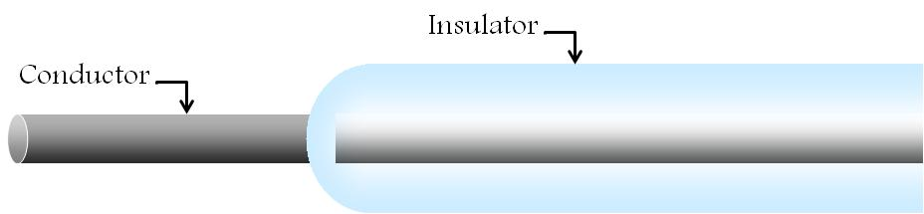
Figure 2: Schematic of a typical Langmuir probe

Irving Langmuir’s method consists of obtaining the voltage-current (V-I) characteristic of the probe when the bias voltage, the voltage between two electrodes, is swept from negative to the positive potential. Figure3 illustrates the typical current-voltage characteristic for a Langmuir probe. The probe current-voltage characteristic shown in Figure3 can be typically divided into several regions as described below [5].

Figure 3: Typical Voltage-Current (V-I) characteristic for a Langmuir probe

As seen in Figure3, the floating potential is the point where the current collected is zero, designated V_{f} (V=V_{f}). At this point, the ion and electron currents are equal and the probe current is zero. The floating potential can be found with the equation below [5].
$$V_{f}=-\frac{k*T_{e}}{e}*ln{\left(\frac{m_{i}}{4*π*m_{e}}\right)}^{1/2} (1.3)$$

where m_{i} is the mass of ion and m_{e} is the mass of electron.
If the probe potential is less than the floating potential, V < V_{f}, then the probe current is mainly positive ion current. Ion saturation occurs rapidly as V is reduced below V_{f}, as shown between points A and B (Figure 3). On the other hand, if the probe potential is greater than the plasma potential, V > V_{p}, the result is space charge limited electron current, indicating electron saturation, as shown between points C and D (Figure 3). However, if the probe potential is between the floating and the plasma potential, V_{f} < V < V_{p}, then the current is mostly due to electron-diffusion to the probe. While theory for a probe in ideal plasma indicates that the current in this region would vary linearly with the probe voltage, in reality the current varies exponentially with the probe voltage [5].
When the probe potential equals the plasma potential, V = V_{p}, the electrons and ions diffuse to the probe as if they were unaffected by its presence. The local zero condition is characterized by the lack of plasma sheath. On either sides of this point, the difference in voltage introduces electric forces that create a boundary region known as the plasma sheath, a region where charge neutrality does not exist.
When there is no plasma sheath, the charged particles can migrate to the probe freely due to their thermal velocities. In this case, it is assumed that the probe current, I_{p}, does not interrupt the plasma equilibrium, and the probe diameter, r_{p}, is considered less than the electron mean free path. Furthermore in this case, the electrons are considered to be in thermal equilibrium at a temperature T_{e} with a Maxwellian kinetic energy distribution. In this case the electron current diffusing to the probe can be found with the following equation [5].

$$I_{p}=\frac{1}{4}*A*n*e*\overline{υ} (1.4)$$
where n is the electron density in the immediate vicinity of the probe surface when V < V_{p}, A is the surface area of the probe, e is electron charge and $\overline{υ}$ is average electron speed. Here, n can be found using the following equation [5].

$$n=n_{e}*exp\left(\frac{-e*\left(V_{p}-V\right)}{k*T_{e}}\right)= n_{e}*exp\left(\frac{\left(V_{p}-V\right)}{k*T_{eV}}\right) (1.5)$$

where k is Boltzmann constant, T_{e} is electron temperature, V_{p} is plasma potential (also called space potential) and V is probe potential. The average electron speed can be calculated with the equation below [5].

$$\overline{υ}=\sqrt{\left(\frac{8*k*T_{e}}{π*m}\right)}=\sqrt{\left(\frac{8*e*T_{eV}}{π*m}\right)}=6.7x{10}^{5}\sqrt{T_{eV}} ms^{-1} (1.6)$$

Taking the natural logarithm of equation (1.5) and with the help of the equation (1.4), the following formula can be found [5].
$$\ln{I_{p}=\ln{I_{ps}-\frac{V_{p}}{T_{eV}}-\frac{V}{T_{eV}} \left(1.7\right)}}$$
where I_{ps} is the probe current when V = V_{p}, and it is calculated using the following equation [5].
$$I_{ps}=\frac{1}{4}*A*n_{e}*e*\overline{υ} (1.8)$$

Then the slope of the curve lnI_{p} versus probe potential, V, is given by the formula [5].

$$\frac{d\ln{I_{p}}}{dV}=\frac{1}{T_{eV}} (1.9)$$

By differentiating the logarithm of the electron current with respect to the probe voltage, V, for V < 0, the electron temperature can be obtained. In this case, the slope of voltage versus lnI_{p} is a straight line in the region between the plasma potential and the floating potential. It is important to note that the straight line is achieved only if the distribution is Maxwellian. Again, this slope determines the electron temperature using the equation (1.9). This equation also shows that the positive ion current is small and can be neglected in most of the region except very close the V_{f} [5]. Also using the value obtained for T_{eV}, the mean electron speed can be obtained from equation (1.6) and the electron density can be obtained from equation (1.8) [5].
The aim of this sub-section was to give the reader a brief description of the Langmuir probe and the basic theory to show how it is applied to determine properties of the plasma. More detailed information can be found in Markusic’s thesis [2].

1.1.2 Thomas Markusic’s Simulation
During his graduate study, Thomas Markusic created some Particle-in-Cell (PIC) simulations to show the behavior of the finite length Langmuir probes [2]. He used PIC as a computational method to simulate the plasma phenomena. The PIC contains particles, grids and boundaries. In PIC, many discrete particles are used to simulate the collective behavior of plasma to come as close to physical reality as possible. A spatial grid on which the electromagnetic fields are computed is superimposed on the computational domain. The charges of the particles in the grid cells are weighted to the grid nodes using Poisson’s equation; the electric field is calculated on the nodes; and the charge particles are accelerated by the electric field [7]. Figure4 illustrates the objects in the PIC code.
Markusic’s thesis work was related to probe simulations in quiescent plasmas and ion beams, and the simulations were shown to be in agreement with both theory and experimental results [2]. Markusic’s objective was to provide an accurate modeling of the physical processes using robust algorithms.
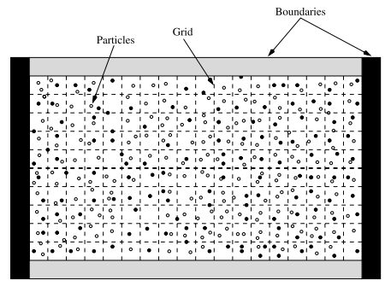
Figure 4: The view of the objects in a typical PIC code [2]

Based on electric probe theory, approximate solutions were available for two limiting cases during Markusic’s work. One was for very thin sheaths, and the other one was for very thick sheaths. According to the thin sheath case, space charge limited current collection must be assumed. For this case, any particles crossing the sheath are collected. Moreover, the Debye shielding length is much smaller than the probe radius (λ_{D}<<r_{p}). According to that approximation, the resulting voltage-current characteristic would have a very sharp knee at point C in Figure3.
For the very thick sheath case, orbital motion limited (OML) current collection must be assumed. OML current is the current collected by the probe when undisturbed particles are not capable of reaching the probe on the basis of kinetic energy and the intervening barrier of effective potentials. In this case, the influence of the sheath is neglected, and the particle orbits are computed using the space charge electric field of the probe. For this case, the Debye shielding length is much greater than the probe radius (λ_{D} >>r_{p}). With this approximation, the resulting voltage-current characteristic does not have a very sharp knee (at point C in Figure 3); rather, a very subtle change from positive to negative curvature occurs.
After examining the two limiting cases, Markusic chose to model the interactions of a probe with plasma that has properties consistent with the very thick sheath case, since OML theory was the most relevant to the Langmuir probe theory and analysis created by I. Langmuir. Table1 shows the plasma simulation conditions used in PROBEPIC simulation to determine the V-I characteristic and assess its accuracy [2].

Table 1: Quiescent plasma simulation conditions in PROBEPIC [2]
Hydrogen and mi/me=100 Conditions
N [cm⁻³]  T [eV]  Plasma potential [V]  Probe aspect ratio | 1.0x10^(9)  2.0  0.0  45.92

PIC Monte Carlo Description
The Monte Carlo method is a technique that involves using random numbers and probability to solve problems. Through the Monte Carlo method, many approximate solutions for a variety of mathematical problems can be performed via statistical sampling experiments on a computer. The method applies to problems with absolutely no probabilistic content, as well as to those with inherent probabilistic structure [9].
Modeling physical problems via Monte Carlo method allows the examination of very complex systems. Solving equations describing the interactions between two particles is a very simple process. However, solving the same equations for hundreds or thousands of particles is currently impossible. However, with Monte Carlo methods, a large system can be sampled in a number of random configurations, and that data can be used to describe the system as a whole.
For the PROBEPIC version developed in this thesis, standard random number generators were examined to determine their quality and usability. Based on this evaluation, the “random_number.c” algorithm used in the original PROBEPIC was replaced. In the new version of PROBEPIC, “random_number.c” [2] was changed to “random_number.cpp” for the C⁺⁺ version and “random_number.f90” for the FORTRAN version. These improved generators allow one to send an array of any size to be filled with random numbers of a uniform deviation. This allows one to store many values for later use rather than calculating them every time they are called in the PROBEPIC simulation. When all of the random numbers in the array are used, the array will be sent back to the algorithm random_number.cpp (or random_number.f90) with a new seed and initialization to generate another array of random numbers [2].
The particle simulation method has been studied for a long time and physicists working with the simulation of charged particles have developed the particle-in-cell (PIC) method based on the theory of charge assignment and force interpolation. This important theory has made it possible to obtain smooth distributions of charge density and current density needed for Maxwell’s equation of electromagnetic fields [7]. PIC and Monte Carlo plasma simulations have existed separately for several decades, with PIC applied primarily to hot fully ionized plasmas without collision, and Monte Carlo method applied to cool weakly ionized gases. However, these capabilities have now been merged together and can be applied to both plasmas with collisions and to electron flow in semiconductors [7].
A PIC program contains four main modules which are used to move the particles through the phase space (velocity and spatial coordinates). These modules are the particle mover, the charge weighter, the field solver and the force weighter. At each time step in time, each of these modules is executed sequentially (Figure 5) [7]. In a characteristic period of the plasma, there may be several thousands of time steps. The order of these modules is shown in Figure5 [7]. Every particle is moved; the charges and velocities of the particles are weighted to the grid cells to determine the charge density and current density on the grid points; the field solver then calculates the electromagnetic fields on the grid points; these field quantities are used to calculate the force on each particle; and then the cycle is repeated for the next time step.
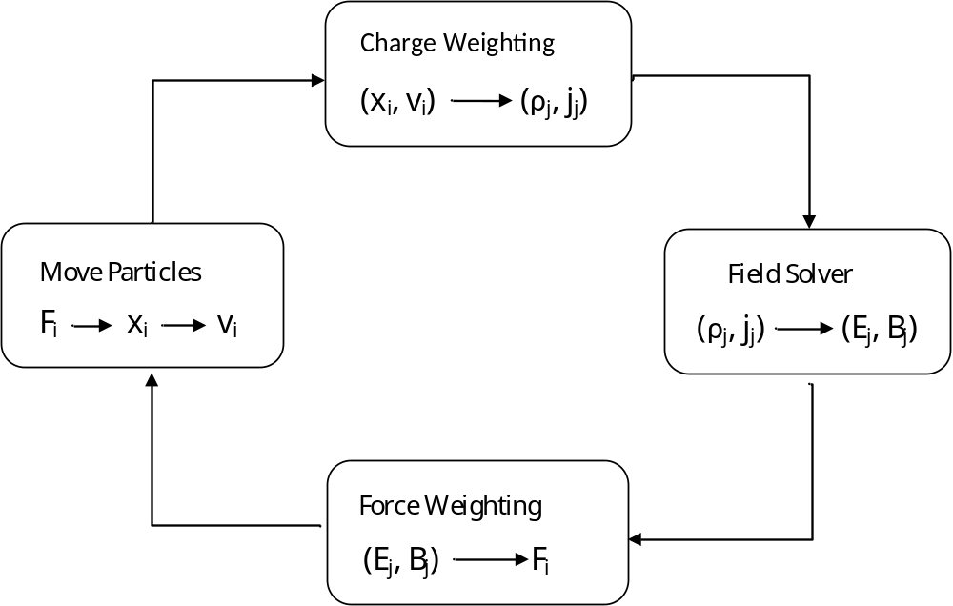

Figure 5: A typical cycle, a onetime step, in a particle simulation program (PIC) [7]

Monte Carlo simulation is a method for iteratively evaluating a deterministic model using sets of random numbers as inputs. Therefore, the generation of pseudo-random numbers is an important element of any PIC Monte Carlo simulation. The quality of the random number plays a very important role in the statistical accuracy of the simulation. The ability to generate uncorrelated numbers with a uniform deviation is determined by the quality of a random number generator. Note that the fastest generators take a lot of space in the computer memory [7, 9].

Approach
The first objective of this thesis work was to translate PROBEPIC, which was created in C code by T. Markusic in 1996 [2], into FORTRAN to improve its compatibility with other tools. Next, the effort refined the PROBEPIC code to improve its accuracy, and upgrades were made to assumptions in the earlier code. To verify the capabilities of the new PROBEPIC code, it was used to simulate a Langmuir probe reference case to create a voltage-current (V-I) plot that can be compared with theory for an ideal probe. An overview of the transformation of PROBEPIC to FORTRAN is discussed in this section, with a more detailed discussion provided in Chapter II.

Transformed Probe PIC to FORTRAN and the Changes Made
T. Markusic created the PIC code, PROBEPIC, for the simulation of a Langmuir probe to determine the plasma characteristics as described in his thesis [2]. His programming philosophy was to develop a concise, intuitively accessible code without much redundancy. He used the C programming language since it was a popular language that allowed for longer variable name lengths than other programming languages of the day. C code also allows for a complicated data structure, giving the programmer control over dynamic memory allocation.
PROBEPIC was comprised of twenty-two individual subprograms, each of which performs an individual task. He designed these functions to be independent of any external variables. Table2 shows these independent sub-programs with their functions listed next to them. To be able to run PROBEPIC with its sub-programs, Markusic was pushing the computational capabilities of the day requiring. The computations in Markusic’s thesis were primarily done with the C4 super computer at the AEDC high performance computer center. However, advances in computer technology now allow PROBEPIC to be run on a desktop computer in roughly the same amount of time. In the present effort, the sub-programs given in Table2 were debugged and upgraded to C⁺⁺ and then they were converted into FORTRAN with documentation so that they can be run by users familiar with either programming language. During the conversion process, some issues were encountered; these issues and their solutions are explained in detail in Chapter II. Appendix1 contains printed listings of these programs in both computer languages.
Table 2: PROBEPIC sub-program description [2]
Sub-program | Function
boundary.c  boundary_beam.c  charge_weight.c  field_solver.c  force_weight.c  graphics.c  grid.c  initialize.c  initialize_beam.c  inject_beam.c  inject_part.c  locate.c  make_LU.c  make_velocity_table.c  maxwell.c  mover.c  output_data.c  parameter.c  probepic.c  probepic.h  random_number.c  reset_grid.c | Handles particle/Boundary interactions for thermal particles  Handles particle/ Boundary interactions for beam particles  The charge weighter  The electric field solver  The force weighter  Graphical diagnostic output  Generates the computational grid  Distributes the initial loading of thermal super particles throughout the computational domain  Distributes the initial loading of beam super particles throughout the computational domain  Fluxes beam particles across boundaries into the computational domain  Fluxes thermal particles across boundaries into the computational domain  Determines what grid-cell a particle is in  Performs LU decomposition of difference matrix for subsequent use in field solver  Creates arrays of velocities with for fluxing into the computational domain  Creates arrays of velocities with for fluxing into the Maxwellian distribution  The mover  Generates PROBEPIC output file  Determines some necessary parameters used in other sub-programs from initial plasma conditions  PROBEPIC main program  Header file for PROBEPIC  Provides uniform random numbers for all PROBEPIC sub-programs  Resets charge density, electric field, etc. at grid-points to zero at beginning of each time-step

CHAPTER II

Description of POBEPIC

The charged particles making up plasma move under the influence of the electromagnetic fields that they generate, together with any external fields that may be present. Thus, in simulating the evolution of plasmas one seeks to model the mutual interaction of all particles and fields in a self-consistent manner. The Particle-in-Cell (PIC) method is a widely used technique for the modeling plasma systems; the method (detailed in the last chapter) simulates the motion of plasma particles and calculates all macro-quantities such as number density, current density, etc., from the position and velocity of these particles [7].
T. Markusic, using the PIC code, desired to simulate plasma movement without using an experimental set up and predict the results as close as possible to the real conditions. He coined the name as PROBEPIC in 1996 as the name of the code. With the present thesis work, his code is updated into C⁺⁺ and converted into FORTRAN. In this section, these processes are explained in detail. Additionally, a discussion is provided for the modeling improvements that were incorporated to update assumptions in the earlier code.

Details on Probe PIC
Markusic created PROBEPIC, which was a 2D/3V PIC code to simulate the behavior of a Langmuir probe. 2D/3V means that the electric field has two components while the particles are free to move in three dimensions [7]. The code contains of twenty-two independent sub-programs, which are listed in Table2.
The computational domain in PROBEPIC consists of a cylindrical region which contains a cylindrical Langmuir probe, as illustrated in Figure6. The probe consists of cylindrical conducting wire partially covered by an alumina insulator [2]. The computational domain surrounding the probe provides enough room for a plasma sheath to naturally form around the probe. Here, the sheath is generated by the interaction of the plasma within the boundary material.
In PROBEPIC it is assumed that the plasma is axisymmetric which allows the calculation for the fields only in the r and z direction on the half plane as shown in Figure7. In PROBEPIC, the computational grid plane can be divided into two sections; interior grid points and surface grid points. Here, the interior grid points lie within the plasma, probe conductor and insulator, while surface grid points lie at the edges of the computational domain and on the surface of the probe conductor and insulator [2]. Figure7 also contains the geometry of the probe (in meters) for the reference case used in this effort.

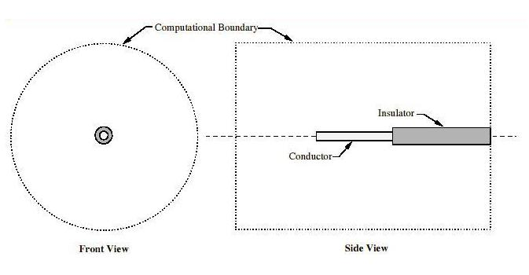
Figure 6: PROBEPIC computational domain layout created [2]

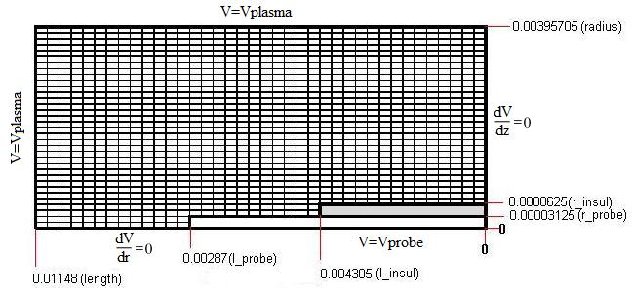
Figure 7: Field boundary conditions and probe geometry in PROBEPIC

Improvements/Updates
During the conversion of PROBEPIC, several complications occurred. These are described in this section, and their solutions are presented. It was thought that early discrepancies between the C⁺⁺ (and FORTRAN) version and the original C version occurred because of the technology differences between when the code was written in (in 1996) and the present or because the available electronic copy of the code was not the lastest version of PROBEPIC published in Markusic’s thesis. With several corrections to the available electronic version of the code, similar results to the original data presented in Markusic’s thesis [2] were obtained. These corrections are detailed below.
One of the problems occurred with “grid.c”, which is the code used to generate the computational grid. Two of the computational domain parameters, “cell1_count” and “cell6_count”, were hardcoded in this program instead of being set as parameters in “parameter.c”, which is the code used to specify necessary parameters used in other sub-programs to establish the initial plasma conditions. Before the correction of “parameter.c”, the value of “cell-width”, as originally set in “parameter.c”, leads to the domain illustrated below in Figure8, where the grid did not fill the domain. However, the solution was applied by setting the cell_width equal to length divided by ngp_horize-1, covering the entire domain by the grid as shown in Figure9.

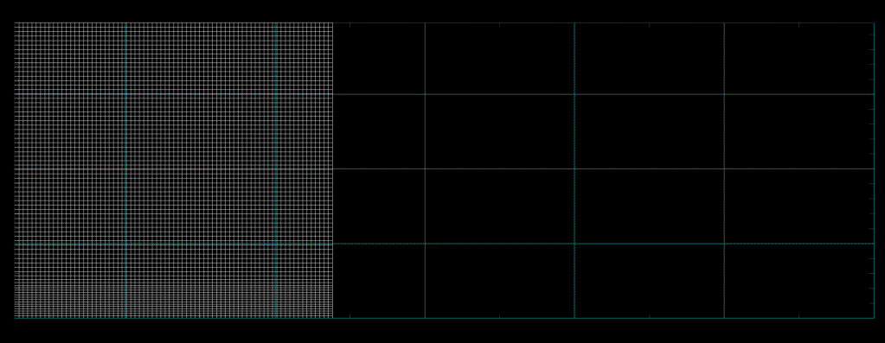
Figure 8: The computational grid in PROBEPIC (before correction)
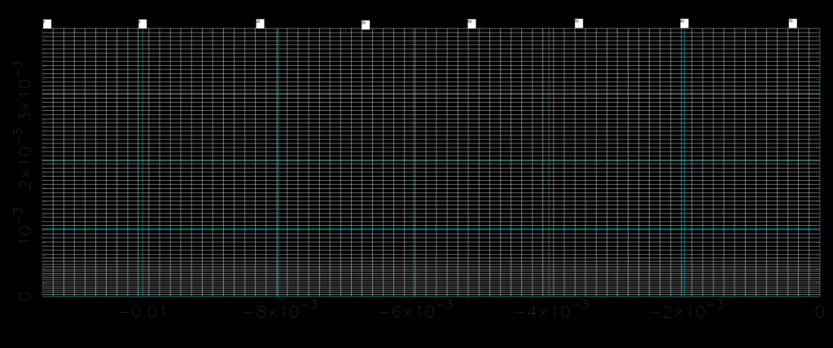

Figure 9: The computational grid after the correction of grid.c in PROBEPIC

The next issue was found in “inject_part.c”, which is a sub-program used to move (i.e. flux) the thermal particles across boundaries into the computational domain. The variable “count” had been constantly incremented and used as index in order to browse the array of uniform random numbers. At a certain point, “count” exceeds the dimension of “random_num” regardless of how big this was set. The solution to this problem was to constantly check the value of “count” and reset it to zero when it reaches the dimension of “random_num”, the length of the random number array.
Another issue occurred in “charge_weight.c”, which is used to weight charges on particles to the grid points. During the process of a call to “locatex” and “locatey” (used to determine which cell a particle is in), erroneous results for points near the upper bound of the grid were obtained. The solution is achieved by decreasing the value of second input parameter by one as locatex(.,ngp2-1,.,.) and locatey(.,ngp1-1,.,.), properly defining the boundary.
After these corrections were implemented, the code started running and the individual sub-programs gave the anticipated results. Note that some sub-programs were run separately in test programs to observe if they work properly. For example, did the particle velocity distribution function used in the injector provide the correct distribution.
However, when the subroutines were combined together under a main-program and run to create the simulation, the result was not as it was expected to be. Although the results did not match those in Markusic’s thesis, they followed an astonishing path; each point on the voltage-current characteristic was a factor of approximately -5/3 from the expected value (Markusic’s result). At first the scale difference was believed to be the result of an erroneous data entry, e.g. a wrong geometrical dimension such as the probe length or width, the computational domain, etc., or/and maybe a wrong physical constant. To address this issue, the values of ngp1, ngp2, numpart, NPTS and V_TABLE_RES, etc. in “lprobe60.h”, which is one of the header files in PROBEPIC regarding probe geometry were parametrically changed to observe the level of difference occurring in the program. Using this insight, some parameters were adjusted and the difference between the new simulation results and Markusic’s results became a factor of -1. The change from -5/3 to -1 is attributed to corrections in erroneous geometry input. It was tempting to assume that the -1 occurred because of a matter of sign convention in voltage-current characteristic, but the author was unsatisfied with this explanation.
At this point the original PROBEPIC code was reexamined, and some more issues were found in the logic of the program. The first of which was that the codes was not correctly detecting when the particle lies inside or outside the computational domain. This was resolved by making improvements in grid generation allowing higher density of cells in the vicinity of the probe.
However, in the original program, an important approximation had not been taken into consideration. A particle was considered to hit the probe when it falls exactly in a cell on the probe. In this case, probe current is generated, otherwise it is not. However, the high speed electrons and ions that have trajectories intersecting the probe and not residing in on a probe cell at the end of a time step were not being included in the probe current. This was resolved by adding a model to extend the particle trajectory in a straight line (i.e. particle ray tracing) to determine if it intersects the cylinder represented by the probe during a time step, see Figure10. With the inclusion of the particles intersecting the probe, the code started giving the correct results without an arbitrary -1 factor.

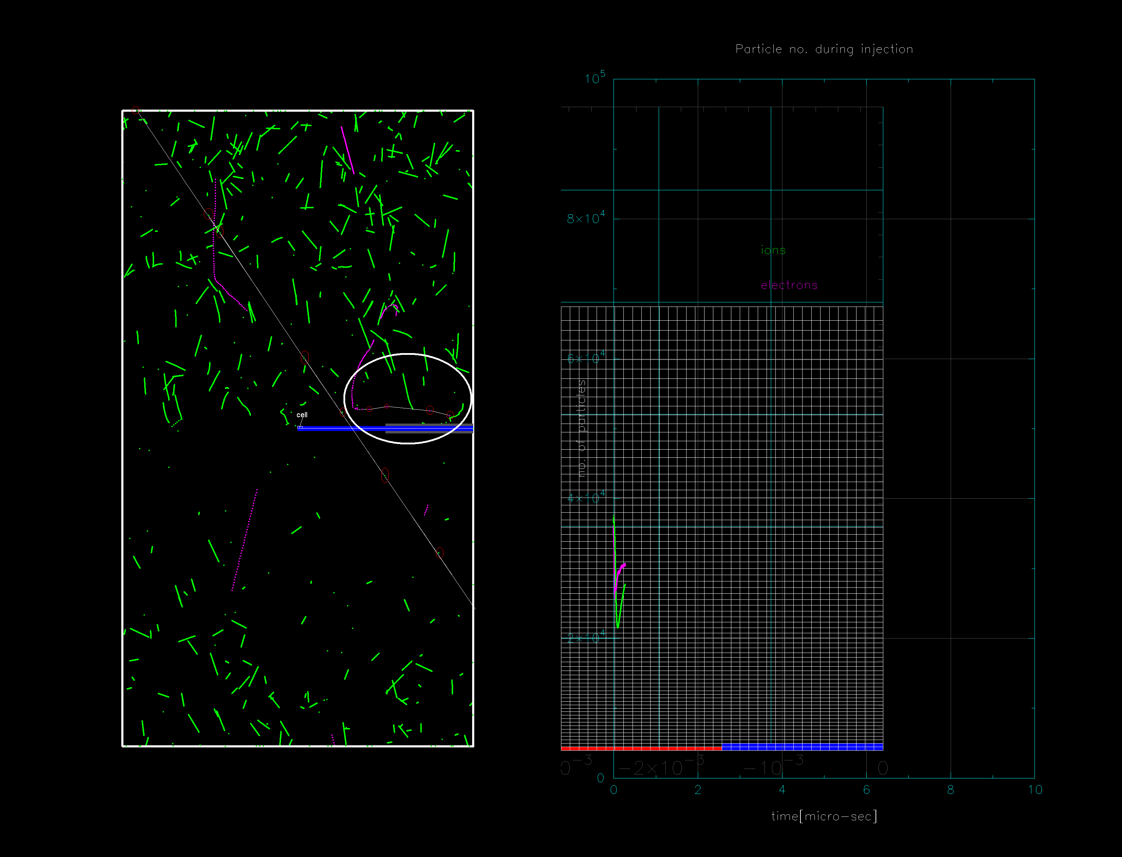
Figure 10: Particle ray tracing shown in animation window

While working on this particle collection issue, another logic issue was identified involving the particle injection. As mentioned previously, the PROBEPIC computational domain is a cylinder. The particle injection routine, “inject_part()”, was intended to place new particles on the domain boundaries from six directions, i.e. top/bottom, front/back, left side/right side, by using a virtual rectangular domain containing the cylinder; the particles were placed on the faces of this rectangular domain as shown in Figure11.

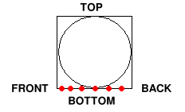
Figure 11: The rectangular domain in the original PROBEPIC

The particles will next travel for a “dt” interval of time, and then their new positions are checked to be inside/outside cylindrical domain. For a low speed particle, the “dt” interval may be too short for the particle to reach the cylindrical domain. For this case the particle is not actually injected into the domain, despite the initial intention. Only the particles fast enough to reach the domain will be injected into the cylinder, i.e. low velocities in the velocity distribution of the injected particles were underrepresented. Therefore, the “inject_part()” routine was modified to inject the new particles directly along the cylindrical domain boundary over an angle of 90 degrees as illustrated in Figure12.
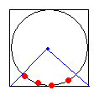
Figure 12: Cylindrical domain boundary with particle injection over 90 degrees
Then the rest of the circle will be covered by particles injected from three remaining sides of the virtual rectangular domain.
Additionally, a small issue was identified with the particle movement routine. In the original code, the particle movement under constant acceleration was implemented in the “mover()” routine using the equation below
$$S\left(t\right)=S_{0}+V_{0}t+A_{0}t^{2}$$
where A₀ is $(e*\vec{E}+υx\vec{B})/m$ in general and $(e*\vec{E})/m$ for the present case with no applied B - field. This equation was replaced with the following equation
$$S\left(t\right)=S_{0}+V_{0}t+A_{0}\frac{t^{2}}{2}$$
The time step parameter, “dt”, was chosen empirically to satisfy the condition that a particle not travel a distance greater than a cell size. This requirement is fulfilled on average.
Another item that was adjusted was that almost all of the parameters that control the simulation process that were hard coded in the original routine “parameter()” were moved to on an editable input file, “parameter.txt”, giving the user the option of performing multiple simulations without the requirement of recompiling the program each time it is run. A sample “parameter.txt” input file is listed in Table3. One can easily see that beside each numerical value contained in “parameter.txt”, explanation of the input is provided.
Table 3: A sample of editable parameter.txt
0.1  0.00003125  45.92  3  40000  6  6  12  40000  5  5  8  2.0  1.0e9  1.673e-27  1.6e-19  9.11e-31  -1.6e-19  0.019  0.0 | percent of particles displayed in animation, 0.0,...,100.0 ; 0.0 means NO animation  [m] probe radius  probe ASPECT RATIO: length/radius  num. of cells per probe radius  initial num. of ions in domain  num. of injected ions from BACK at each time step  num. of injected ions from FRONT at each time step  num. of injected ions from SIDE at each time step  initial num. of electrons in domain  num. of injected electrons from BACK at each time step  num. of injected electrons from FRONT at each time step  num. of injected electrons from SIDE at each time step  T[eV] temperature  [cm^(-3)] density number  m_ion  q_ion  m_elec  q_elec  [sec] wpdt  plasma potential

Additionally, the original program did not allow the probe to be divided into more than one cell in the radial direction. The routine “grid()” was modified to allow this to be increased, allowing the grid to be denser in the vicinity of the probe than the rest of the domain. A screen shot from the animation window is given in Figure13, which shows the electrons/ions trajectories, the locations where the particles are injected, and where they hit the probe.
The new version of the PROBEPIC now allows the user to update the code to run new geometries and plasma conditions without modifying and recompiling the code; the author put almost all parameters that control the simulation into the input file, “parameter.txt”. The user can simply change the parameter(s), such as “wpdt” for time step, or vertical grid density with “number of cells per probe radius”, etc. in the input file, and then the user can launch the PROBEPIC.
Note that, the horizontal (axial) grid density is hardcoded to 72 cells (73 points) in the file “lprobe60.cpp (lprobe60.F90)” by the variable called “ngp2”. If the horizontal grid density change is desired, then “ngp2” must be changed to a new value, and the program must then be re-compiled. This is the only situation when a re-compile is needed, and it can be done easily. If a change in the vertical grid is desired, then the 4th numerical value in the text file, “parameter.txt”, should be changed from 1 to 2, or 3, or 4, or more.

Figure 13: The locations where the particles injected and hit the probe

Comparison of New/Old Langmuir Simulation
The first version of the PIC code (PROBEPIC) has been updated and converted into C⁺⁺ and FORTRAN. Both the C⁺⁺ and FORTRAN versions of PROBEPIC are running properly together with their subroutines to provide results that are close to the theoretical model of the probe presented in Ref.2. The simulation results of the original and updated versions of PROBEPIC are similar to each other, providing verification that the code conversion was achieved properly. A comparison of the voltage-current characteristics is shown in Chapter III.

CHAPTER III

Results
In the original version of the PROBEPIC code, the simulations were conducted in a quiescent plasma in the OLM limit. Similarly, in the updated version of the code, the plasma conditions were also chosen to correspond to the orbital limited motion (OLM) domain used in Markusic’s thesis [2]. Theoretical results are readily available for this case. By comparing the new results with the results from the original version and the theoretical results for an ideal probe, the effectiveness of the updated PROBEPIC can be evaluated.
In Markusic’s thesis [2], simulations were conducted both for hydrogen plasma (ion to electron mass ratio of 1836) and a light ion simulation with an artificial ion to electron mass ratio of 100. The “Light ion” experiment was conducted to verify that the ion collection was being properly modeled with fewer time steps. However, an objective of this thesis was to determine if the code is error free and the conversion to FORTRAN was successful. For the updated version, due to time constraints only the Hydrogen plasma (1836 mass ratio) experiment was conducted to verify that the C⁺⁺ and FORTRAN versions of the code run properly side by side. Figure14 illustrates the updated simulation results on a voltage-current characteristic plot. The dashed and solid curves are the theoretical results for an ideal Langmuir probe in the OLM limit. Simulation results reported by Markusic [2] are shown as open squares and circles. The results from the updated code are shown as solid red squares.
As can be seen in Figure14, if the probe potential is less than the plasma potential, then the PROBEPIC results show good agreement with the Langmuir theory.

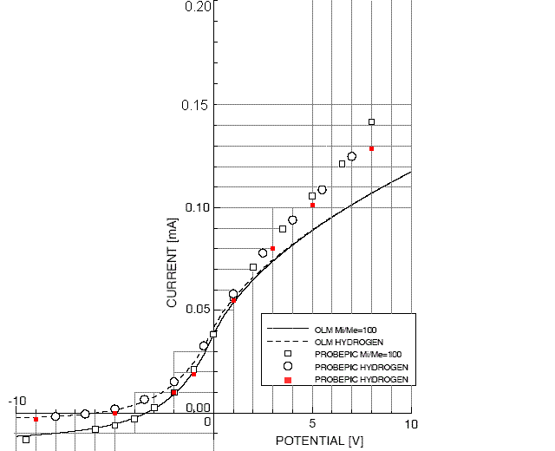
Figure 14: Voltage-Current (V-I) characteristics of original and updated PROBEPIC code
On the other hand, the PROBEPIC results diverge from the expected theoretical results in the electron saturation region (voltages above the plasma potential). The reason for this is that the Langmuir theory always gives the maximum current that could be measured since the ideal probe is assumed. Therefore, the PROBEPIC data should always appear below the upper orbital limited motion (OLM) threshold [2].

According to conclusion drawn by Markusic [2], the disagreement between the Langmuir theory and PROBEPIC had a physical reason. The Langmuir theory was developed for an infinitely long cylindrical probe. However, for PROBEPIC and the laboratory experiments [3], the finite length probes were used. This suggests that the probe aspect ratio may produce a significant difference in the voltage-current characteristic. Also the sharp edges on finite length probe tips on conductors may produce an intense electric field in the vicinity of the tip that more efficiently draws in charged particles than realized in an “infinite” length probe. Note that since both probe types exhibit orbital limited motion (OML) current collection, the resulting voltage-current characteristic does not have a sharp knee when the probe potential is equal to the plasma potential. Rather, there occurred a very smooth curve from positive to negative, as is expected (see Chapter I).
However, it should be noted that it appears that the enhancements made to PROBEPIC in the current effort did produce an improvement in the accuracy of the predictions. By comparing the new data points to the earlier data points the gap between the predictions and the Langmuir theory is reduced by about 30% in the electron saturation region. While some of this improvement appears to be from the enhanced particle collection and injection models, the difference between PROBEPIC predictions and Langmuir theory appears to be sensitive to grid density.
The lower grid density was examined to determine if the same results could be obtained in a shorter computational time. Grid density was lowered 50 percent as seen in Figure15. When the grid density was reduced, it was observed that the predicted current changed significantly, diverging away from the theoretical points. Although the grid change lessened the computational time, this experiment showed that lowering the grid density had a big impact on the result. Because of this observed sensitivity, it is not known if the baseline density is sufficient to provide the best current prediction. To determine the optimum grid density, it will be necessary to perform additional work.
In this future work, the number of injected particles should also be examined to determine the impact of this parameter on the current prediction, since the low grid density experiment also showed that the running time depends on the number of particles in the domain, rather than just the number of mesh points. This sensitivity is the result of the need to move and test for position of all the particles at each time step.

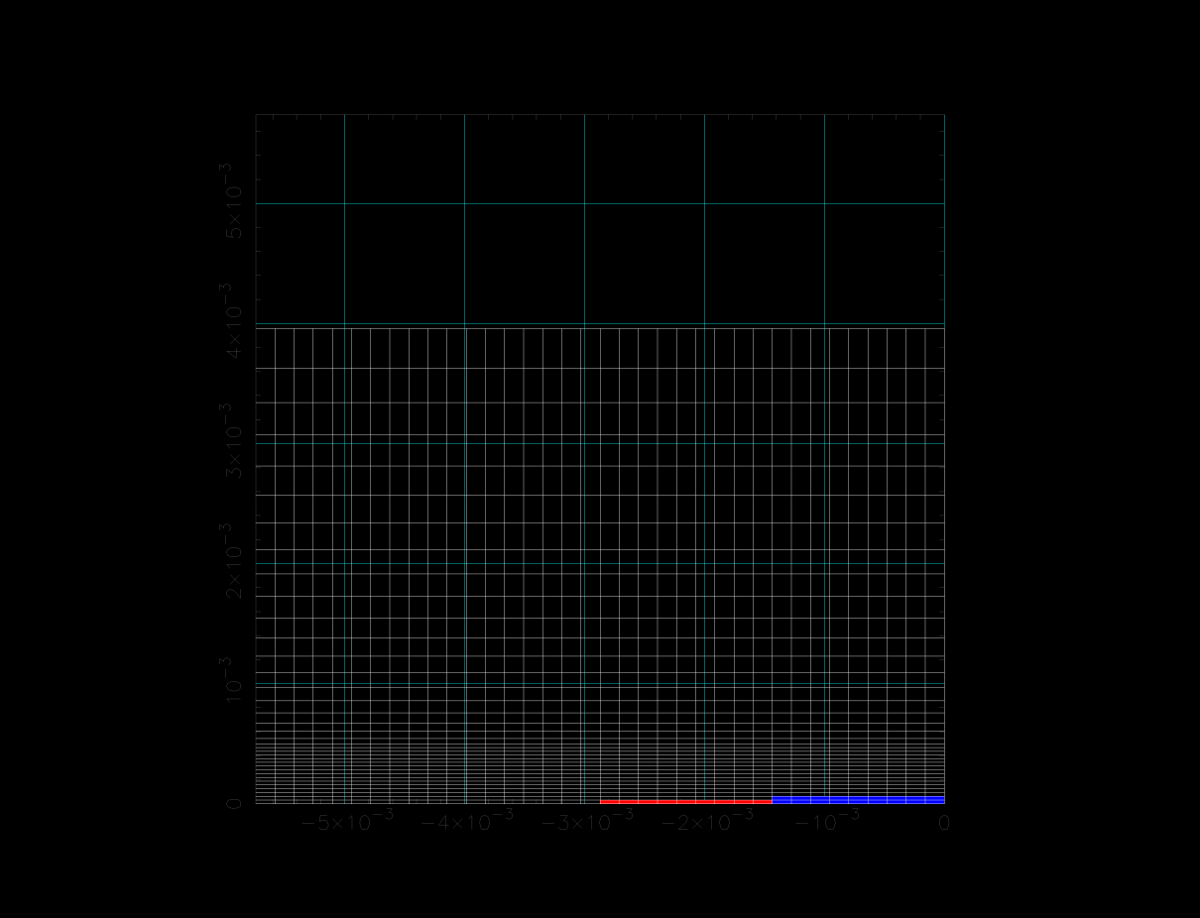
Figure 15: Probe grid with 50 percent lower density

CHAPTER IV

Conclusions and Recommendations

4.1 Conclusions
Markusic created the Particle-in-Cell code (PROBEPIC) to simulate the behavior of finite length Langmuir probes via particle simulation. In the present thesis work, Markusic’s code has been converted from C into C⁺⁺ and FORTRAN. During conversion to C⁺⁺ and FORTRAN, several errors in the available electronic version of Markusic’s code were identified and corrected. After the code conversions, the simulation of hydrogen plasma with parameters that correspond to the OML case showed that new version of PROBEPIC agrees well with Markusic’s original results. The correction of errors and code improvements in the updated version resulted in simulated currents closer to theory in the electron saturation region of the V-I characteristic, a region with the largest departure from theory. Also, the updated version is more user friendly with the addition of a user input file. Some changes were also made to allow the code to be more applicable to other probe geometries.

4.2 Recommendations
The updated version of PROBEPIC can be further improved in future work by enhancing code speed with the algorithm refinements. In addition modifying the code to include a hybrid model, i.e. implementing a fluid model for the electrons eliminating the need for two different time scales [2] should be considered. Additional simulations, such as simulating plasma/probe interactions in the thin sheath limit, are also of interest. Conducting simulations with alternate Langmuir probe geometries such as increasing the probe aspect ratio, and applying the code to other probe types, such as a Faraday probe, are recommended.
Finally, the lower grid density (50 percent less) was examined to see if the same results could be obtained in a shorter computational time. The results showed that lowering the grid density has a significant effect on the current prediction, causing it to diverge away from the theoretical results. In the future, different grid densities can be examined to find the optimum grid density to provide the best match between the predicted data points and the theoretical values. For this kind of experiments, higher capacity computer systems will be required.

BIBLIOGRAPHY

[1]H.Mott-Smith, Jr and I. Langmuir. Phys.Rev.28, 27. 1926.
[2]Markusic, Thomas. Particle Simulation of a Langmuir Probe in Quescient and
Flowing Plasmas. Masters Thesis. Tullahoma, 1996.
[3]Keefer, D. and D.D. Semak. "Measurements of Radial and Axial Distributions of Ion
Thruster Plasma Parameters Using a Langmuir Probe (unpublished).
[4]Merlino, Robert L. "Understanding Langmuir Probe Current-Voltage Characteristics."
2007.
[5]Hoag, J.B. and S.A. Korff. Electron and Nuclear Physics. New York: Van Norstrand,
1952.
[6]Fei, Yee Yue. "The I-V Ramp Circuit for Langmuir Probe." Techpos . 2004.
[7]Birdsall, C.K. and A.B. Langdon. Plasma Physics via Computer Simulation. New
York: Adam Hilger, 1991.
[8]Azooz, A. A. Four free parameter emprical parametrization of glow discharge Langmuir peobe data. Review of Scientific Instruments. American Institute of Physics, October 3, 2008.
[9]Wang, J. and J. Brophy. 3-D Monte-Carlo Particle-in-Cell Simulations of Ion Thruster Plasma Interactions. San Diego, CA: AIAA, 1995.

APPENDICES

Appendix-I

<<<The PROBEPIC code will be added in this section>>>

Vita

Denise Su (Densu) A. Aktas was born in 1987 in Istanbul. She finished her high school in 2001 and entered the university to study Electronic Engineering degree at Marmara University in Istanbul. She graduated from the university in 2005. During her studying engineering, she won several scholarships from honor organizations both in her country and abroad. Then she got her second degree in Electromechanical Engineering Technology at MTSU in 2007 to combine her electrical and mechanical knowledge for technical applications. Because of her professors’ recommendations, she entered the graduate school at UT Space Institute in 2007 to pursue Masters Degree. She completed the degree requirements for both Aviation Systems and Mechanical Engineering. She plans to pursue her PhD degree also in Mechanical Engineering specializing in electric propulsion.

