Messy Zoning and Studentification: Fort Sanders in Knoxville, Tennessee

A Thesis Presented for the
Master of Science
Degree
The University of Tennessee, Knoxville

Yael Uziel
May 2021

Copyright © 2021 by Yael Uziel. All rights reserved.

Abstract
This study explores the unique intersection of the current coronavirus pandemic and studentification by looking at college neighborhoods in cities through a case study of at University of Tennessee, Knoxville and the near-by Fort Sanders neighborhoods. It introduces the idea of "messy zoning" to characterize the unclear and conflicting land-use regulations and their applications by local and institutional actors contributing to further studentification. Using secondary data collection and archival urban planning documents from the City of Knoxville, this study works to question the reasons neighborhoods become studentified. Particularly, its fills the gap that is blaming HMO (Houses in multiple occupation) zoning and proximity to campuses as the main reasons for studentification. Additionally, it opens up conversations about how the pandemic has affected student neighborhoods. Knoxville’s Fort Sanders neighborhood stands as a representation of what conflicting land use regulations due to the stability of neighborhood.

Table of Contents
Chapter 1: Knoxville, the Pandemic, and a lot of Students
Introduction………………..…………..…………..…………..…………..…………..…1
Geographic Context……..…………..……..…………..………………………………...3
Methods……………………………………………………..…………...…….………….4
Impacts of COVID-19………………………………………………..……….………….4
Positionality……………………………………………………………………..………..5
Thesis Outline…………………………………………………………………...…….….6
Chapter 2: Research Article
Introduction………………………………………………………………..……….…….7
Background…………………………………………………………………..…….…….8
Knoxville and UTK………………………………………………..……………..8
Fort Sanders and Studentification…………..…………………….....…..……..9
Literature Review……………………….………………………….…………………..10
Studentification and HMO-ification………………………….……………….10
COVID-19 and students………………………………………………………..11
Methodology……………….………………………………………………...………….13
Results and Discussions……………………………………………….……….……….13
Messy Zoning and COVID-19……………………………..…………………..16
Messy Zoning Versus Mixed Use Zoning………………………………..……16
Conclusions……………….……………….…………………………………………….17
Chapter 3: Implications and Future Research
Introduction……………….……………………………………………………..……...20
Major Findings……………….……………….…………………………………..…….20
Implications……………………………………………………….…………………….21
Personal Lessons……………….……………………………………………………….22
Future Research Directions……………….……………….…………………………..23
Bibliography…………………………………………………………………………………….24
Appendix……………………………………………………………………...…………………31
Figures…………………………………………………………………………….……..31
Vita………………………………………………………………………………………………35

Chapter 1
Introduction
At the start of 2020 few in the United States were talking about the coronavirus pandemic. College students were home for winter break celebrating New Years with friends and already planning for this year’s crazy spring break. By March of 2020 it became clear that we were heading towards unprecedent times. As college students across the U.S were receiving e-mails alerting them that in-person classes would not resume after spring break, the population as whole was trying to navigate life with the mass spreading of the coronavirus disease (COVID-19). The coronavirus-19 disease is a respiratory disease caused by SARS-CoV-2, a new coronavirus discovered in 2019 (Coronavirus Disease 2019). By mid-2020 the World Health Organization declared COVID-19 a world-wide pandemic. To this day, March 2021, there have been around 123 million COVID-19 cases worldwide and 2.72 million deaths (COVID Data Tracker). The COVID-19 pandemic has not only caused tremendous loss, but it continues to affect all parts of the human experience. Knoxville, Tennessee’s Fort Sanders neighborhood serves as the case study setting in which the cause and effect of studentification is explored.
Studentification refers to the gentrification of neighborhoods due to an influx of off-campus student residents (Smith 2002). After World War II, due to the G.I bill, the University of Tennessee Knoxville’s population quadrupled forcing the University to place three hundred trailers on and off campuses to accommodate the large number of students (History of the University of Tennessee). “Trailer villages” as they were referred to, housed the large student population both on and off campus (History of the University of Tennessee). It could be argued that this was the very early signs of studentification in Knoxville’s Fort Sanders Neighborhood. Today Fort Sanders neighborhood is one of most densely populated neighborhoods in Knoxville and houses thousands of UTK students (Knox MPS 2010). High density student neighborhoods have faced new and unforeseen struggles amid the pandemic. In the summer of 2020, a study found that the highest incidences of COVID-19 in the U.S were amid young adults between the ages of 20 to 39 years old (Boehmer et al 2020). As Universities opened back up in the fall of 2020 college towns faced new challenges for higher risk of transmission (Walke et al 2020). At UTK the combination of both in person and hybrid classes along with the continued opening of college bars and other local business made this risk especially high. Due to the high risk of increased numbers of covid many scholars looked a collecting data about COVID-19 and student neighborhoods (Mangrum & Niekamp 2020). The attention on student neighborhoods has proven the importance of studying studentification and has become increasingly relevant. This study aims to understand how the Fort Sanders neighborhood has been affected by studentification using secondary and archival research. Data collected about the Fort is used to fill gaps about how we think about studentification during this time and help build a record of UTK during the pandemic. Additionally, this work has helped pinpoint reasons why the Fort may have been more suspectable to studentification and what this can mean for other student neighborhoods. In this thesis I aim to answer 1) How has COVID-19 shed light on issues of studentification, particularly in Knoxville? 2) What keeps the Fort Sanders a prominently student neighborhood today and how does this contribute to the larger conversation had about studentification?
This thesis explores the unique intersection between the pandemic, zoning, and studentification by looking at college neighborhoods through a case study of the Fort Sanders neighborhood close to the University of Tennessee, Knoxville. It also introduces the idea of "messy zoning" to characterize the unclear and conflicting land-use regulations and their applications by local and institutional actors contributing to student neighborhoods' rise. This thesis works to contribute to the early conversations about studentification and COVID-19, while also questioning the affect that poor planning can have on a neighborhood.

Geographic Context
Gentrification has long been studied in the field of geography and continues to be a thoroughly researched topic within both geographic and urban planning circles. Unlike gentrification research, studentification has only recently become a more common topic in these circles. The 2000s marked the beginning of studentification work as we know it today with Darren P. Smith’s studentification definition as gentrification caused by overbearing off-campus student housing (Smith 2002). Prior to Smith’s 2002 study the majority of studentification research focused on the economic effects of Universities on college towns and on student neighborhoods (Hall 1997). Additionally, this economic framework was used to look at money invested in off- and on-campus student housing developments and the ways it influenced the local economy (Rosie 2003). Today studentification studies have taken quite a shift as they often look at the experience of both students and local residents in the high-density neighborhoods (Woldoff et al. 2016, Woldoff & Weiss 2018). With the COVID-19 pandemic only being present on college campuses for a year at this point very few studies have looked at the intersect of studentification and the pandemic. This thesis makes efforts to be on the forefront of this conversation and to prove the ways the pandemic has exposed flaws in student gentrified neighborhoods.

Methods
Due to limitations caused by the COVID-19 pandemic and time constraints, which are outlined in the following section, this work primarily used secondary and archival data collections. Data collected using the University of Tennessee’s virtual library collections and Google scholar allowed for a thorough look into information about the documented history of Knoxville, UTK, and the Fort Sanders neighborhood. Additionally, key terms like studentification, student housing, college towns, Knoxville, gentrification, COVID-19 and students, zoning, Knoxville planning archives, Fort Sanders planning archives, Knoxville COVID-19, universities and COVID-19, and related researches helped to build a relatively comprehensive image of the ways Knoxville and specifically UTK have been handling the pandemic. Planning documents as well as zoning maps of the city of Knoxville helped with further analysis on the current state of the Fort Sanders neighborhood. Additionally, previous work I have done interviewing the Knoxville Heritage Society, City Council Women Gwen McKenzie, and the Knoxville Urban Planning department gave me insight in the types of information I should look for in my data collection. From these interview experiences I was made aware of the complicated zoning in the Fort and the ways it has caused difficulties for these and other organizations in the past.

Impacts of COVID-19
At the start of my master’s program, I had planned to pursue a thesis looking at overtourism in Smoky Mountains National Park, but by March of 2020 it became clear that my originally proposed thesis would no longer be an option due to rising concerns of the COVID-10 pandemic. The National Parks had closed and surveying large numbers of tourists was clearly no longer viable or safe. After working with my committee to look at a thesis option concerning the emotional labor of students during this time, I was facing my own emotional labor trying to work on that paper. In the meantime, I had been doing research looking at studentification in the Fort Sander neighborhood, a topic I was interested in since my first semester at graduate school. In January of 2021 I spoke with my committee members about pursuing this research topic which I had been continuously working on. It was then that I confirmed that I would look at studentification in Knoxville’s Fort Sanders neighborhood. This thesis change meant that I had only a couple months to collect data and write a detailed thesis. The pandemic and the time constrain it caused left me with few methodological options. While secondary data and archival work can sometimes be imperfect, they have proven to be very helpful in gentrification and studentification studies (Abubakar, Rimi, Dano 2019). All that being said, the current pandemic also helped work on studentification as more researchers and news outlets began discussing student neighborhoods and the ways they were impacting their surrounding residents. A New York Times study found that there was an increase in COVID-19 cases in counties that had at least 10% of their population comprised of college students (Watson et al 2020). As scholars continue to look at college neighborhoods this paper aims to advance scholarly understanding of studentification with the hope of bringing this topic into mainstream conversation.

Positionality
I am currently a master student at the University of Tennessee, Knoxville living in the Fort Sanders neighborhood. I have strived meet academic standards when collecting and reporting data found on studentification, the Fort Sander’s neighborhood, UTK, and Knoxville. In both my times in undergraduate school and graduate school I lived in student neighborhoods, contributed to student neighborhood culture, and am part of the problem with studentification. Throughout this work I made efforts to keep all this in mind and rely on facts presented in my data collection. I accept my positionality in this paper is close to the subject matter but hope that this also serves as a testament to the importance of this topic to me and potentially other students.

Thesis Outline
This thesis is divided into three chapters. The three chapters work together to reflect on my experience as a student researcher talking about studentification and unpacking the cases of studentification in Knoxville, Tennessee. The opening chapter works to provide background to the second chapter and discussing issues of positionality. The second chapter is the substantial research paper that explains the research process of studying studentification in Knoxville, It looks into the larger discussion of studentification and draws conclusions based secondary data collection and archival work studied on the topic. The conclusions and discussions made in chapter two introduce the term ‘messy zoning’ and begin discussions about the future of this work. Chapter three reflects on the findings from chapter two and looks at the future of this research. It focuses on the researcher’s own learnings, the limitations of this research, and the ways this studentification paper may be further developed in the future by myself or other scholars with interest.

Chapter 2- Research Article
Introduction
Knoxville as a College Town
The University of Tennessee, Knoxville (UTK) is placed right in the heart of Knoxville along the winding Tennessee River by World Fair Park and within walking distance from Knoxville’s downtown area. It’s rolling hills, orange brick buildings, and large football stadium have become iconic to locals. On UTK game days you can see much of Knoxville dressed in orange cheering on the Volunteers. In fact, in 2019 Knoxville, Tennessee was ranked in the top ten of Sports Illustrated’s best college football town list (Niesen 2019). A college town is “any city where a college or university and the cultures it creates exert a dominant influence over the character of the community” (Gumprecht 2003). In 2018 WalletHub ranked Knoxville as 46th best college town in the US and 11th amongst mid-size college cities (McCann 2020). Needless to say, many people locally and internationally associate the city of Knoxville with UTK. Across UTK, from 11th street to 22nd street, the Fort Sanders neighborhood is bustling with young college students (see figure 1). On a typical day in the Fort, one can hear the loud music blasting from speakers of a house party, college students playing catch in the street, property managers mowing the lawns of college apartments, and students having the American college experience. If you are looking to have the true college experience here in Knoxville, look no further than the Fort Sanders neighborhood.
On March 11th of 2020, as University students were enjoying their spring break, the World Health Organization characterized the coronavirus as a potential pandemic (COVID-19 Timeline 2020). This put a halt to the fun, loud, and social experience of being in the Fort. The bodega’s closed earlier, the bars shut down, and there was a weird quietness to the Fort. As UTK announced that in-person classes would not resume post spring break, scholars began looking into the ways that students and the communities in which they reside would be affected by this pandemic. At the start of the fall 2020 semesters, The University of Tennessee, Knoxville began collecting data on the spread of COVID-19 among its on-campus and in-person students and faculty. Efforts to increase distancing in the dorms, support the mental health of students by providing dorm check ins, and increase all on-campus cleaning services worked to address many had about the life of students during this time (Data Monitoring 2021). Additionally, services provided by the city of Knoxville, like grants to help renters through this tough time, apply primarily to long term residents in the city (COVID-19 Housing 2021). This limbo that off campus students live between being a part of the city, but also being left out of the conversation reflects back on the ways student neighborhoods are often perceived in college towns. Students living in the Fort are isolated, not geographically, but rather in their experience of Knoxville and UTK. Off-campus students in the Fort have created their own community and with COVID it felt like this sense of community was crumbling. This research looks into how student neighborhoods in Knoxville, particularly its Fort Sanders neighborhood, are born and sustained while questioning how the pandemic gives insights to the problems with student caused gentrification.

Background
Knoxville and UTK
Knoxville has been home to the University of Tennessee, originally knowns as Blount College, since 1794. UTK is one of the oldest Universities in the U.S, it wasn’t until 1945 that the University saw any major enrollment. Originally a “struggling higher education institution” the post war period brought a new influx of early new scholars due to the GI Bill (History 2020). Between 1945 and 1949 student enrolment quadrupled leaving the University with what were known as trailer villages. To accommodate the growing student population, 300 trailers were placed both on and off campus. This is the first record of major expansion happening at UTK. These trailer villages spread across what is known as the Hill on campus, Kingston Pike (now home to the agricultural campus), and as far off-campus as Sutherland Avenue. By 1969 dormitories were built along Clinch Avenue, expanding the campus and its housing into the Fort Sanders neighborhood (History 2020). This is first sign of a change of culture happening the in the Fort.
Fort Sanders and Studentification
Fort Sanders, or the Fort, is named after the Union fortress that stood there during United States Civil War. By 1880, the Fort Sanders neighborhood became home to many of Knoxville’s wealthier residents on its southern edge, while its northern edge housed factory and plant managers (Akchin & Akchin 1980). Post-WWII, UTK bought several properties along the southern edge of the Fort for University buildings. As students began living in the Fort, the once wealthy and quiet neighborhood, was have a cultural shift. Students looking to have fun, go out, and enjoy their college years left the Fort a little messier, trashier, and much louder. By 1980 residents worried about preserving the neighborhood nominated it to be listed on the National Register for Historic Districts. That same year it was put on the list. Inclusion in the register however did not stop the University and off-campus student housing from growing in the Fort (History 2020). This quick spread of student housing, developments, and off-campus is known as studentification or student-led gentrification (Smith 2002). Today the Fort is one of Knoxville’s most densely populated neighborhoods. It is an “ideal location for many residents,” yet it predominantly houses students (Knox MPS 2010).

Literature Review
Studentification & HMO-ization
Early studentification studies often focused on the economic perspective, this literature pioneered by Darren P. Smith now focus on all aspects of studentification (Hall 1997, Smith 2002, Smith 2005, Hubbard 2008). These aspects include looking at the social effects of studentification, cultural effects, and student life as a whole. Studies looking at reasons why certain neighborhoods become and remain studentified often mimic results of gentrification studies (Bromley 2006, Hubbard 2008). The main results conclude that university students are wanting to live in close proximity to the main campus causing nearby neighborhood to become student gentrified (Hubbard 2008, Pickren 2012). Once a student neighborhood is already established it often remains studentified because students want to live amongst people like themselves. Similar to gentrification studies where gentrifies prefer to live with “people like us”, (Butler & Robson 2003, Butler 2007) studentifiers want to live in an environment that is accepting of them. As put by Bridge (2001) students look for neighborhoods that house people similar to them and that give them a sense of belonging (Bridge 2001, Smith & Holt 2007). This continues the cycle of studentification.
HMO or houses of multiple occupancies is the building code for many off-campus student properties. In short, it means that multiple renters with separate contracts can occupy the same space. HMO-ization, as coined by Takashi Nakazawa (2017), refers to the recoding of family housing to HMO as cities try to better accommodate growing Universities. Many studies attribute the cause of studentification to HMO recoding pushed by developers, university, and local city planners (Smith 2005; Smith & Hubbard 2014). Nakazawa’s 2017 study argues that because HMO coding is often limited to pre-established student neighborhoods, it leaves students with little choices of where to live. This further progresses the studentification cycle (Nakazawa 2017). This phenomenon of using coding to keep certain neighborhoods studentified and to promote further studentification is addressed in my research of looking at the way the Fort Sanders neighborhood is managed. The focus of HMO coding does not illustrate the full problem pertaining to urban planning and zoning in student gentrified neighborhoods. My study dives deeper into the complexities of zoning and works to explain the occurrence that I term messy zoning.

COVID-19 and Students
New research on the ways COVID-19 is affecting colleges, students, teachers, and college towns is rapidly emerging, but few if any have discussed the intersect between COVID-19 and studentification. Many studies are looking into the ways students and their communities have been affected by the COVID-19 pandemic (Elmer et al 2020, Son et al 2020, Wu et al 2020). This work look into how students are coping through lockdown and the pandemic. Specifically, they point to the ways accessibility to mental health resources is lacking and was already lacking before the pandemic. My work uses the pandemic to analyze studentification in Knoxville today, but also analyze how student gentrification got to this point at the Fort. The pandemic has added stressors to all systems-from education systems, to urban planning system, to mental health systems and-has exposed the reality of how well these systems are functioning. The majority of studies pertaining to students and the pandemic look at mental health and ask whether e-learning is working or not during this time (Abbasi et al 2020, Adnan & Anwar 2020, Shahzad et al 2020). My findings have found no studies discussing studentification as it intersects with the pandemic, but gentrification studies have begun discussed affects due to the pandemic. This thesis work will begin the conversation between studentification and COVID-19. Research on COVID-19 and student living has focused on how high-density student neighborhoods are at higher risk of transmitting COVID-19. Research has shown that “COVID-19 risks to college students and staff and their surrounding communities are inevitably intertwined” (Walke et al 2020). Additionally, it shows that off-campus students often do not have the option to socially distance (Morris et al 2020). The pandemic exposes and exacerbates problems in studentified neighborhoods both in terms of how it affects surrounding communities but also in terms of how it affects the safety of the students themselves.

Methodology
This research used secondary data collection with the goals of learning about history pertaining to UTK’s expansion into the Fort, studentification throughout Knoxville, the current state of the Fort including current zoning codes and policies, and who is involved with zoning in the Fort neighborhood. Original plans for the methodologies did not specifically focus on zoning but it quickly became an apparent that the issues is important to the Fort’s continued studentification. The author used Google Scholar and the University of Tennessee’s virtual library to find resources about Knoxville, UTK, and the Fort’s history. Key words and phrases like studentification, UTK, Knoxville history, Fort Sanders, student housing UTK, and other relevant terms helped with the preliminary data collection. To understand the current state of the Fort, published archival documents by the City of Knoxville, Knox Heritage, and City of Knoxville urban planning departments were used. Analyzing the conflicting interests of Knox Heritage and the City of Knoxville helped with understanding the current zoning codes. Understanding the importance of zoning in the Fort led to further secondary data collection using terms like Studentification, student housing, College towns, Knoxville, gentrification, COVID-19 and students, zoning, Knoxville planning archives, Fort Sanders planning archives, Knoxville COVID-19, Universities and COVID-19, and HMOs. The collected data proved to be very useful in understanding the case of the Fort Sanders neighborhood and the way it has been affected by University of Tennessee, Knoxville.

Results and Discussions
As pointed out earlier, the Fort Sanders area saw the beginning of studentification post WWII when the University was overwhelmed with high enrollment levels. From 1960 to 1965, three new dormitory buildings opened to replace the aforementioned trailer villages. Then named Cumberland Hall, now known as Clement Hall, was the first building to extend student housing out to the Fort Sanders neighborhood (Pritchard 2019). The building of Cumberland Hall in the Fort most likely had to do with proximity at the time. Fort Sanders since then has been Knoxville’s neighborhoods with the most planning attention. As the University has continued to grow the city of Knoxville has been challenged with trying to accommodate for the wants and needs of both those students and the University as a whole. According to the City of Knoxville “Over the last 80 years more than 40 plans and studies have been produced” (Knox MPS 2010). Some of the most impactful changes come with the 1964 rezoning from R-2 to R-3 “to allow higher densities” (Knox MPS 2010), which promoted the early trend of studentification in the area. In 1978 those R-3 zones were bumped up to R-4 to allow for even higher densities and conversations about historic zoning began to appear. In that same year the first implementation of the Historic Conservation District zoning was put in place (Knox MPS 2010). Since its first zoning plan in 1930 the Fort has seen a number of zoning updates according to the City of Knoxville 2010 Fort Sanders Neighborhood District Long Range Planning Implementation Strategy (Knox MPS 2010) these updates include:
- Change from R-2 General Residential east of 17th Street to R-3 High Density Residential
- Required off street parking increased
- C-7 Pedestrian Commercial District created
- H-1 Historic Overlay District created
- NC-1 Neighborhood Conservation Overlay District established
These zoning updates display the early and current players involved in zoning the Fort Sanders neighborhood. Historic preservation efforts led by Knox Heritage Society have stayed consistent and active. Knox Heritage has continuously put the Fort on its Fragile and Fading list, which brings attention to the ways current maintenance of a house, road, or neighborhood is not ideal for preserving its historic charm and significance. The Fort Sanders neighborhood “suffer due it its close proximity to downtown Knoxville and The University of Tennessee (which) makes it an ideal location for dense housing developments” (Fragile and Fading 2020). HMO developments conflict with the traditional and historic landscape. As Knox Heritage has continued to collect funds and political votes their input on historic zoning has left the Fort a complicated place. The city appears to want to make continuous efforts to change the zoning regulations so as to accommodate higher density, often against suggestions from Knoxville’s Heritage Organization. The conflicting sides along with input and pressure from UTK have left the Fort Sanders neighborhood with so many zoning regulations it would be hard ever for a geographer to decipher the city’s long-term plans.
Currently the Fort Sanders neighborhood is split between the below zoning codes (Knox XMS 2010):

- Multi- Family Residential
- General Residential Neighborhood
- General Commercial
- Historic Zoning
- Infill Housing
- Neighborhood conservation
- Institutional on campus housing
- Single Family Residential Neighborhood
- and several others.
Since 2010 there has been no apparent proposition from Recode Knoxville, Knoxville’s Zoning and Coding department, to change any coding regulations at all in the Fort Sanders neighborhood to help private homeowners. It is clear that the city does not recognize the problems caused by these complicated zoning regulations, especially the ones that overlay historic zoning atop of multi-family residential neighborhood zoning and general residential neighborhood. Requiring historic preservation, which in the case seems to address more external aesthetic issues of homes and apartment complexes, often means that single families or smaller local developers cannot update the building in an affordable manner. This creates an opportunity for larger non-local developers to buy land and create primarily student apartments. Thus, puts certain areas within the Fort at much higher risk for studentification. I call this phenomenon ‘messy zoning’.

Messy Zoning & COVID-19.
The concept of messy zoning advances discussion of HMO-ization by noting other ways zoning may cause studentification or other forms of instability in neighborhoods. The COVID-19 pandemic made it evident that off-campus students are rarely provided the same resources as long-term residents and on-campus students. Off-campus students exist in this limbo of not being fully governed by University but also not the college town. In the case of Fort Sanders this limbo presents itself in the chaotic zoning regulations that are put on the neighborhood. Messy zoning offers a way to describe what is happening in the Fort and also speaks to ways that conflicting parties have shown very different interests for the Fort’s future. I argue that messy zoning calls for collaborative urban planning efforts to be made and a planning strategy that is meant to withstand decades. The Fort’s constantly changing zoning regulations- which fulfill pressures from the University, Knox Heritage, and the city- has led to the case of messy zoning here. With no current statements from the city about the future of the Fort, hopes of it de-student gentrifying seem far away.

Messy Zoning Versus Mixed Use Zoning
Current urban planning goals often tend to aim towards mixed-use zoning (Grant 2002). The goal of mixed-use zoning is balance. A balance between commercial spaces, residential spaces, green spaces, etc. Messy zoning is different because it doesn’t come from a collective goal. It comes from opposing goals for a community which results in chaos. There is no balance in messy zoning. In fact, it’s hard to see who benefits from messy zoning. In the case of the Fort the students don’t benefit because they are being overcrowded, commercial business don’t benefit because they have very limited space in the Fort, and the property owners don’t benefit because they are continuously having to adapt to the zoning changes. Mixed-use zoning looks to use high-density neighborhoods as an advantage for the city by providing jobs, grocery stores, activities, and community in these spaces. The Fort does not have those things. In fact, there is not a single grocery store in the Fort. Any sense of community established in the Fort is due to the social behavior of students not the work of the city or its urban planners. Messy zoning looks to call out chaos and ask for a change in the way these places are planned.

Conclusion
It can be argued that the Fort Sanders neighborhood was always at high risk for student gentrification due its close proximity to the University of Tennessee, Knoxville, but this study shows that it has remained studentified due its messy zoning and the lasting cultural changes that studentification has had on the Fort. This once mixed-use neighborhood is now a messy and loud student neighborhood. Previous studentification work that alludes to zoning issues often looked specifically at HMOs, but the case of the Fort shows a more complicated and chaotic situation. Additionally, the current COVID-19 pandemic has proven that off-campus students are included in less conversations about their living situations and overall quality of life in a college town. I argue that this pandemic has shed light on issues that already existed in student neighborhoods, but that are now more often studied and apparent. The goal of this study is introduce the concept of messy zoning, and to present that case of studentification in Knoxville’s Fort Sanders neighborhood. Using secondary data collection and the collection of archival planning and zoning document, this work has shown the need for collaborative zoning and planning in order for any progress to be made in the Fort Sanders neighborhood. Collaborative planning is the idea that relevant parties should come together to work towards an agreed upon goal for a building, neighborhood, city, or town (Huge 2009). Collaborative planning in the Fort would focus on understanding the goals of the University, the city of Knoxville, and the Knox Heritage Society. Having a clear image of what they assumptively hope the Fort will function and look like in the future allows for intentional and throughout planning, which would clear up the chaotic messy zoning that the Fort is currently experiencing. One way this may look is by following form-based zoning which would require developers to keep the external aesthetic of a building in line with historic preservation zoning code but allow for a mix of both residential and commercial spaces to function in these buildings (Hughen et al 2017). This is just one example of a solution that may benefit both Knox Heritage, the city, and the University. It would allow for historic preservation, intentional mixed use commercial buildings, and off-campus student housing.
Additionally, research about the Fort should not stop there. Studentification, like gentrification, often hurts certain demographics more than others. Future work about the Fort and student gentrified neighborhoods should look to study racial and socioecomoic consquences, especially as a new wave of studentification is emerging in many college towns. This second wave of studentification is the glamorization of student housing, which then begins to exclude a certain type of student from getting to have the college experience and the ability to live in student neighborhoods. This new wave of major student housing developments is already growing in the Fort, as can be seen in figure 3. While my study did not have the chance to acknowledge these issues it is important to note how both COVID and this new wave of studentification will affect tensions in student neighborhood, college towns, and Universities alike.

Chapter 3: Implications and Future Research
Introduction
The COVID-19 pandemic has added stressors to student neighborhoods. As the conversation continues about the lives of students, student neighborhoods, and Universities, it is important to bring studentification into the discussion. The mainstream media has focused on how students have been spreading the disease due to lifestyles or high-density living situation but have excluded studentification from their reporting (Curley 2020, New York Times 2020). This work aimed to examine why certain neighborhoods are susceptible to studentification using the Fort Sanders neighborhood near Knoxville’s University of Tennessee and to highlight the significance of studentification during the pandemic. This work aids in arguing for more work to be done about creating stable neighborhoods. Stable neighborhoods are neighborhoods that support the local community and prioritize the well-being of their long-term residents (Tighe & Ganning 2016). While this study focuses on studentification in Knoxville’s Fort Sanders neighborhood the implications of its findings span larger circles. As briefly addressed in Chapter 1 and further discussed in Chapter 2 this work speaks to both geographic and planning bodies of literature. The COVID-19 pandemic served as both the setting for this paper, but also attributes to many of its limitations. In this chapter, I will discuss the larger implications of my findings and the potential for future research that may be less limited to methodologies due to COVID-19.

Major Findings
Using secondary data and archival work I was able to pinpoint reasons why studentification has occured and continues to occur in the Fort. Its proximity to campus probably had a lot to do with its studentification, but my work argues that it has stayed studentified due to its inconsistent and complicated zoning. An array of regularly changing zoning regulations make it hard for local and private property to owners to keep up with building maintenance to match those zoning codes. Additionally, the current zones codes seem to favor student housing and high-density housing developments. The conflicting interests between the wants of the City of Knoxville against that of Knoxville’s Heritage Society are clear in the current zoning maps and through Knox Heritage’s inclusion of The Fort neighborhood on its fragile and fading list year after year. These conflicting planning and zoning goals have led to a neighborhood with messy zoning. Messy zoning refers to complicated zoning codes that often coincide with both studentification and gentrification work today. Additionally, it offers a reason to why some neighborhoods are more bound to instability in varying forms. Future work could look into the how messy zoning plays out in other neighborhoods that are seeing varying forms of instability.

Implications
This work contributes to the further understandings of causes for studentification and the importance of collaborative zoning. The phrase messy zoning can clearly be used in further studentification studies but has potential in helping us understand varying types of neighborhoods. I argue that if urban planners continue to study gentrification and studentification, they may run into situations of messy zoning and hopefully continue to build on this phenomenon. As studentification research continues to grow, I predict that this study will help especially in the conversation about the pandemic and studentification. Geographers have begun releasing studies on how the pandemic has affected gentrified neighborhoods (Hartley 2013, Cole et al 2020, Jelks et al 2021), but no work has been published specially addressing the unique concerns that student neighborhoods are faced with currently. This work aimed to point out how pandemic exposes the limbo that off-campus students have been facing during this time, and how that is reflected in student neighborhoods like the Fort. Additionally, this work can be used by city of Knoxville to question local zoning regulations and bring awareness to the issue that its current zoning of the Fort may be causing. It has the potential to save neighborhoods like South Knoxville that are just beginning to see signs of both gentrification and studentification. The University of Tennessee, Knoxville could also use this work to become aware of the limbo or liminal spaces that their off-campus students inhabit. Lastly, the works calls for action in the form of collaborative planning.

Personal Lessons
This experience of having to change my thesis and being limited by the pandemic has taught me to be flexible and persevere. Like many people, all aspects of my life were shifted during the pandemic and maintaining my good standing as a graduate student became difficult at times. Working on a thesis that I could see helping the lives of future Knoxville residents and students was comforting to my struggles. Additionally, the process of reading zoning and planning document helped me not only realize the importance of zoning regulation but have also helped prepare me for a possible career in city management or urban planning. Lastly, as a geographer I find that we are continuously asked to question our environments. As a student living in the Fort neighborhood pushing myself to be as unbiased as possible during the research taught me about questioning your environment to its limits.

Future Research Directions
As discussed in Chapter 1 the COVID-19 pandemic had major impacts on the timeline of this thesis. On average students are given around a year to work on a thesis and thesis proposal while I completed one in just a couple of months. To provide a timeline this thesis began as a class paper in November of 2020, was agreed upon by my committee in January 2021 and will be concluded as my master’s thesis by April 2021. This time constraint proved to be the most limiting factor in my research. For future work I would like to study several student neighborhoods in the Knoxville area to see how messy zoning, proximity, HMO-ization, and other factors may be affecting the area. Additionally, interviews with city planners and city councilwoman Gwen McKenzie about their goals for the Fort neighborhood may be helpful in explaining the current state of messy zoning. The city of Knoxville also has an archive of its city council meetings dating back to 2012. If given the opportunity I think looking into the subject matter in these meetings and learning about the goals the council has for Knoxville through the years could be very informative. Lastly, I see a large opportunity for an early studentification study in South Knoxville. Early signs of student developments have begun to show in that area as well as talk about UTK expanding in that direction. Doing research about a neighborhood that is in the process of becoming student gentrified, would be extremely helpful to both the City of Knoxville and local residents looking to protect their communities.

Bibliography

Abbasi, S., Ayoob, T., Malik, A., & Memon, S. I., “Perceptions of students regarding E-learning during Covid-19 at a private medical college”. Pakistan Journal of Medical Sciences, 36(COVID19-S4), (2020). S57.

Abubakar, Ismaila Rimi, and Umar Lawal Dano. "Sustainable urban planning strategies for mitigating climate change in Saudi Arabia." Environment, Development and Sustainability (2019): 1-24.

Adnan, M., & Anwar, K. “Online Learning amid the COVID-19 Pandemic: Students' Perspectives”. Online Submission, 2(1), (2020) pp: 45-51.

Akchin, Don and Akchin, Lisa “National Register of Historic Places Nomination Form for Fort Sanders Historic District” (1980)

Bridge, G. “Estate agents as interpreters of economic and cultural capital” The gentrification premium in the Sydney housing market” Internaitonal Journal of Urban and Regional Research, 25 (1), (2001) pp. 87-101.

Butler, T. “For gentrification?” Environment & Planning A, 39(1), (2007) pp. 162–181.

Butler, T., & Robson, G. “London calling: The middle classes and the remaking of inner London”. London: Berg. (2003).

Bromley, R. “On and off campus: Colleges and universities as local stakeholders.” Planning Practice and Research, 21(1), (2006) pp. 1–24.

Boehmer TK﻿, DeVies J﻿, Caruso E (2020) “Changing age distribution of the COVID-19 pandemic—United States, May–August 2020.” ﻿ MMWR Morb Mortal Wkly Rep. (2020) doi:10.15585/mmwr.mm6939e1

Cole, Helen VS, Isabelle Anguelovski, Francesc Baró, Melissa García-Lamarca, Panagiota Kotsila, Carmen Pérez del Pulgar, Galia Shokry, and Margarita Triguero-Mas. "The COVID-19 pandemic: power and privilege, gentrification, and urban environmental justice in the global north." Cities & Health (2020): 1-5.

“Coronavirus Disease 2019 (COVID-19),” Centers for Disease Control and Prevention, (2021) https://www.cdc.gov/dotw/covid-19/

“COVID Data Tracker,” Centers for Disease Control and Prevention, (2020) https://covid.cdc.gov/covid-data-tracker/

“COVID-19 Housing Assistance Program” City of Knoxville (2021) https://knoxvilletn.gov/government/city_departments_offices/housing_and_neighborhood_development/c_o_v_i_d-19_housing_assistance_program

“COVID-19 Timeline,” World Health Organization (2020) https://www.who.int/emergencies/diseases/novel-coronavirus-2019/interactive-timeline

“Data monitoring and contingency options” University of Tennessee, Knoxville (2021) https://www.utk.edu/coronavirus/guides/data-monitoring-and-contingency-options/

Elmer, T., Mepham, K., & Stadtfeld, C. Students under lockdown: Comparisons of students’ social networks and mental health before and during the COVID-19 crisis in Switzerland. Plos one, 15(7), (2020).

“Fragile and Fading” Knox Heritage Society (2020) https://knoxheritage.org/our-work/fragile-fading/

Grant, Jill, 2002. Mixed use in theory and practice: Canadian experience with implementing a planning principle. J. Am. Plann. Assoc. 68, 71–84, 1.

Hall. P, “The university and the city”, GeoJournal, 41 (1997): pp 301-309 (in)

Hartley, Daniel. "Gentrification and financial health." Economic Trends (2013).

“History of the University of Tennessee,” The University of Tennessee System (2020) https://tennessee.edu/history/

Hubbard. P, “Regulating the social impacts of studentification: a Loughborough case study, Environment and Planning” A, 40 (2): (2008) pp 323-341

Huge, Elijah. “Study as a Course of Practice: The Work of North Studio at Wesleyan University.” Journal of architectural education (1984) 62, no. 3 (2009): 65–70.

Hughen, W. Keener, and Dustin C Read. “Analyzing Form-Based Zoning’s Potential to Stimulate Mixed-Use Development in Different Economic Environments.” Land use policy 61 (2017): 1–11.

Jelks, Na’Taki Osborne, Viniece Jennings, and Alessandro Rigolon. "Green gentrification and health: A scoping review." International journal of environmental research and public health 18, no. 3 (2021): 907.

Knox MPS, “Ft. Sanders Neighborhood District Long Range Planning Implementation Strategy” (2010) https://agenda.knoxmpc.org/2010/june/FtSanders_2010.pdf

Mangrum, Daniel, and Paul Niekamp. "College student contribution to local covid-19 spread: Evidence from university spring break timing." Available at SSRN 3606811 (2020).

McCann, Adam “Best College Towns and Cities in America,” Wallet Hub (2020)

Morris, Alan, Emma Mitchell, and Gaby Ramia. "Why coronavirus impacts are devastating for international students in private rental housing." The Conversation 7 (2020).

Nakazawa, T. “Expanding the scope of studentification studies”. Geography Compass. (2017); 11:e12300. https://doi.org/10.1111/gec3.12300.

Niven, Rosie. "Communities forced out by influxes of students." Planning 1536 (2003): 4-4.

Niesen, J. “College Football’s Greatest College Towns” Sports Illustrated (2019)

New York Times, “Tracking the Coronavirus at U.S Colleges and Universities”, The New York (2020)

Pickren, Graham. "“Where can I build my student housing?” The politics of studentification in Athens-Clarke County, Georgia." Southeastern Geographer 52, no. 2 (2012): 113-130.

Pritchard, Tyler, “Housing History,” University of Tennessee, Knoxville, (2019) https://housing.utk.edu/2019/10/21/housing-history/

Shahzad, A., Hassan, R., Aremu, A. Y., Hussain, A., & Lodhi, R. N. (2020). Effects of COVID-19 in E-learning on higher education institution students: the group comparison between male and female. Quality & quantity, 1-22.

Smith, D.P. “Patterns and processes of 'Studentification' in Leeds.” The Regional Review 12(1): (2002) pp. 15-16.

-------, “Studentification: The gentrification factory?” In R. Atkinson, & G.
Bridge (Eds.), Gentrification in global context: The new urban cosmopolitanism. (2005) pp. 72–89.

-------, & Holt, L. “Studentification and ‘apprentice’ gentrifiers within Britain's provincial towns and cities: Extending the meaning of gentrification.” Environment & Planning A, 39(1), (2007). 142–161.

Son, C., Hegde, S., Smith, A., Wang, X., & Sasangohar, F. “Effects of COVID-19 on college students’ mental health in the United States: Interview survey study”. Journal of medical internet research, 22(9), (2020) e21279.

Tighe, J. Rosie, and Joanna P. Ganning. "Do shrinking cities allow redevelopment without displacement? An analysis of affordability based on housing and transportation costs for redeveloping, declining, and stable neighborhoods." Housing Policy Debate 26, no. 4-5 (2016): 785-800.

Walke, Henry T., Margaret A. Honein, and Robert R. Redfield. "Preventing and responding to COVID-19 on college campuses." Jama 324, no. 17 (2020): 1727-1728.
Watson, H.S., Gebeloff, D., Ivory, R.﻿ A new front in America’s pandemic: college towns. New York Times. (2020) https://www.nytimes.com/interactive/2020/us/covid-college-cases-tracker.html

Woldoff, Rachael A., and Karen G. Weiss. "Studentification and disorder in a college town." City & Community 17, no. 1 (2018): 259-275.

-------, Lisa M. Morrison, and Michael R. Glass. Priced out: Stuyvesant town and the loss of middle-class neighborhoods. NYU Press, 2016.

Wu, M., Xu, W., Yao, Y., Zhang, L., Guo, L., Fan, J., & Chen, J. “Mental health status of students’ parents during COVID-19 pandemic and its influence factors”. General Psychiatry, 33(4) (2020).

Appendix
Figures
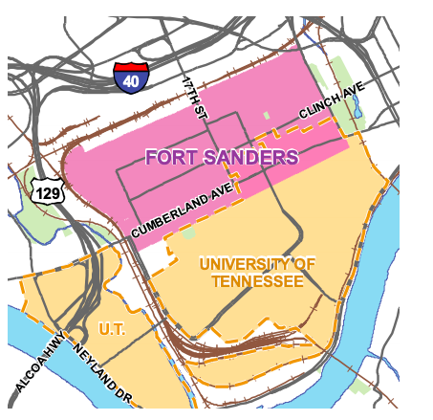
Figure 1: Map of the Fort Sanders neighborhood and UTK campus. Source: Ciy of Knoxville

Figure 2: Historic housing in the Fort Sanders Neighborhood. Source: Yael Uziel

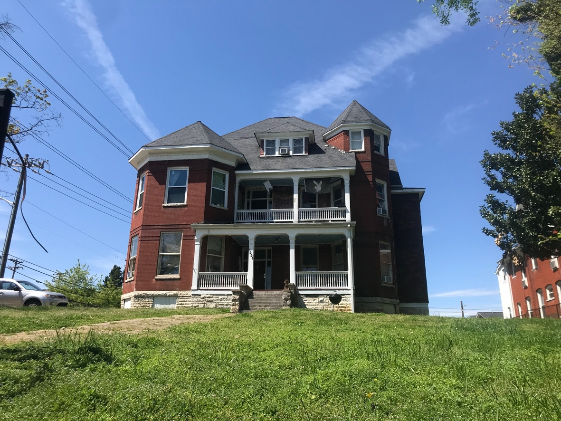

Figure 2: Historic home in Fort Sanders. Source: Yael Uziel
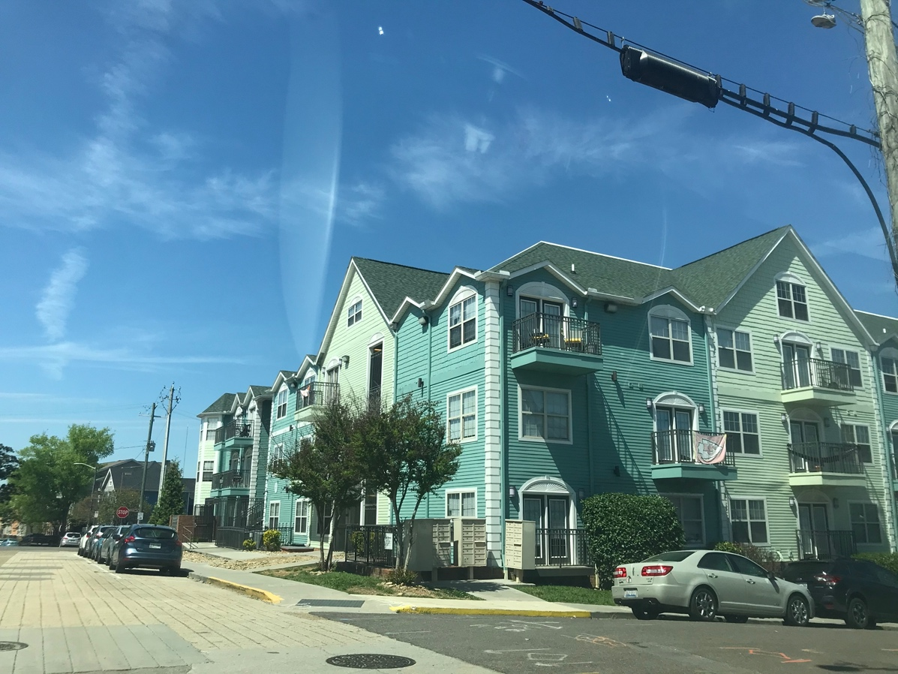
Figure 3: Student apartments in the Fort Sanders neighborhood. Source:Yael Uziel

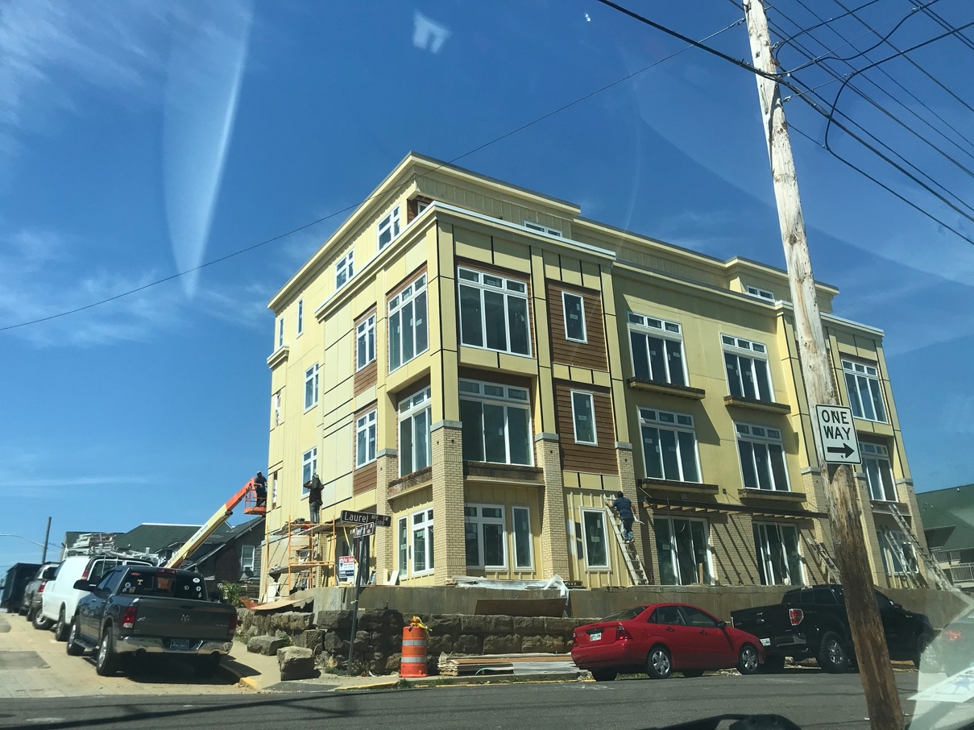
Figure 4: New luxury student apartment development being built in the Fort Sanders neighborhood. Source:Yael Uziel

Vita
Yael Uziel studied Geography in both her undergraduate studies at Illinois State University and in graduate school at the University of Tennessee, Knoxville. During her time as a student, she has focused on human geography and GIS, specifically looking emerging mapping techniques. Additionally, she is looking to go into urban planning and zoning geographies.

