Of Hosts and Habitats: The Ecological and Evolutionary Patterns of the Amphibian Skin Microbiome

A Dissertation Presented for the

Doctor of Philosophy

Degree

The University of Tennessee, Knoxville

Benjamin Houston Holt

May 2024

Copyright © 2024 by Benjamin Houston Holt
All rights reserved.

DEDICATION

To my parents, whose unwavering support and encouragement over the years and
to John Conner, who together, instilled in me what it means to appreciate, understand, and love nature.

To my siblings, Abby and Andrew, who struggle to fathom my obsession with salamanders but grant me unconditional support, nonetheless.

To my nephew, Hudson, and nieces Nora, Lily, and Caroline- may you never stop exploring the curiosities of the natural world.

Finally, to the wondrous, enigmatic salamanders of Southern Appalachia, who have given me the joy of a lifetime through the blessing of experience.

“Places and happenings, people and animals, winds at sea and on mountains, and all that I remember, it was no unpleasant path I trod when I followed this ‘questing beast’”
– Emmett Reid Dunn, 1926

ACKNOWLEDGEMENTS

While the work presented in this dissertation is written in the first person, it would not have been possible without the guidance and support of others. Specifically, thank you to my committee members, Xingli Giam, Brian O’Meara, and Ben Parker, for the assistance and feedback you have provided over the last six years. I also extend my gratitude to Jim Fordyce and Ben Keck for many thoughtful discussions and memorable experiences. To my advisor, Ben Fitzpatrick, whether it be writing, analyses, or fieldwork, I have learned a tremendous amount from you and am thankful for the experiences we have shared along the way. Your ability to think deeply and understand complex concepts has been most influential in my growth over the duration of this experience.

I would additionally like to thank Veronica Brown of the UTK Genomics Core, whose expertise in molecular techniques is exceeded only by her generosity and kindness. The fieldwork pertaining to this dissertation involved many long nights and hot days. As such, I am incredibly grateful to the following for their upbeat spirit and positive attitude: Todd Pierson, Tania DeWant, Briana Drake, Alex Funk, Bryce Wade, Michael Dunaway, JD Zimmerman, Arin Wildmann, and Jaci Baker. I also would like to thank Morgan Fleming, Amanda Wilson-Carter, Lauren Lyon, and Mali Hubert for their collaborative spirits, continuous support, and most of all, their friendship over the last six years.

Lastly, I would like to thank my Environmental Research Students and co-workers at the Baylor School, particularly R. Antonio Herrera, Mary Loveless, Louie Elliott, and Curtis Blair, whose support and collaboration have encouraged me to grow from ‘Mr. Almost Doctor Holt’ to ‘Dr. Holt’.

Funding of this dissertation came from ARAV Research Grant, GSMCA Campbell Memorial Fellowship, The University of Tennessee Graduate Student Grant, the Alexander Hollaender Fellowship, and the Weeks Family. This work was done under IACUC permits 2705-0619, 2676-0219, TWRA permits: 2645, 2518, and GRSM permit 2069.

ABSTRACT

The skin microbiome of amphibian hosts can inhibit growth of pathogenic fungi, contribute to anti-predator compounds in newts, and is linked with sex-specific scents in frogs. However, despite growing evidence of symbiont importance to amphibians, how symbionts are acquired and maintained on hosts remains poorly resolved. Microbiomes exist on a dynamic spectrum from casual assemblages to intricate systems, and community members vary in fidelity and association to hosts. The establishment of these communities involves complex interactions between symbionts, host traits, and source communities. I seek to enhance our understanding by assessing the spatial-temporal patterns of the salamander skin microbiome relative to their cover objects which are likely an important, but rarely investigated source of microbes for colonization onto host skin. In Chapter 1, I investigate small-scale similarity and differentiation between host species and cover objects along an aquatic and terrestrial interface to determine the effects of host species, habitat, and microhabitat. I find that bacterial communities associated with salamanders display differentiation according to host species, which is matched in cover object communities suggesting microhabitat rather than host traits determine bacterial presence and community composition in heavily divergent communities. To understand patterns of dissimilarity, in Chapter 2, I test whether heterogeneity between salamander hosts, other salamander hosts, and their cover objects can be explained by priority effects, host selection, or stochastic dispersal in aquatic or terrestrial habitats and find differences between salamander-associated communities are consistent with stochastic colonization and extinction of environmental microbes. In Chapter 3, I use the phenology of E. cf. wilderae to understand the temporal variability by sampling hosts seasonally for one year as hosts move between aquatic and terrestrial habitats. Host-associated communities show turnover seasonally that is exacerbated with habitat changes. However, a small subset shows evidence of non-random associations, some of which can produce antifungal metabolites, potentially providing a defensive function for hosts. These results that suggest stochastic processes dominate the amphibian skin microbiome with little evidence for deterministic structuring. Despite this high heterogeneity between hosts, we identify a few microbial taxa as candidates for investigating mechanisms that promote persistence on amphibian skin.

TABLE OF CONTENTS

INTRODUCTION 1
Symbiosis 1
The amphibian skin as a stage for symbiosis 4
Plethodontid salamanders as a system for intra and inter-specific differences in the skin microbiome 6
Fungal pathogens Batrachochytrium dendrobatidis and Batrachochytrium salamandrivorans and defensive symbionts 7
Chapter overviews 9
CHAPTER I: Similarity and Differentiation of Amphibian Skin Microbiomes by Habitat, Microhabitat, and Host Species 11
Abstract 12
Introduction 12
Materials and Methods 15
Field sampling 15
16S library preparation 15
Bioinformatics 16
Rarefaction and diversity 17
Beta diversity 18
Alpha diversity 19
Indicator species analysis and community composition 19
Results 19
Heterogeneity is high for salamander hosts 19
Hosts less diverse than cover objects 25
Indicator species analysis and community composition 25
CHAPTER II: Signatures of stochastic colonization and extinction dominate salamander skin microbiomes 35
Abstract 36
Introduction 36
Materials and Methods 40
Sample collection 40
Library preparation, sequencing, and bioinformatics 40
Diversity within and between samples 42
Null model for community assembly 43
Correlation of shared sequences and identification of indicator species 45
Results 45
Hosts harbor less species than cover objects 45
Stochasticity dominates host communities 47
Shared relative abundance is strongly correlated 50
Affinity for hosts restricted to a small subset of bacteria 52
Discussion 54
Chapter III: Temporal turnover and the core microbiome of eurycea cf. wilderae 61
Abstract 62
Introduction 62
Methods 66
Sample collection 66
Sample processing 67
Bioinformatics 67
Diversity within and between samples 69
Core microbiome 70
Results 71
Alpha diversity is consistent on hosts seasonally 71
Evenness increases with host habitat shifts 73
Turnover exacerbated by host habitat shifts 73
Common core reflects environmental reservoirs 78
Temporal core captures wide-ranging microbes 82
Anti-Bd taxa more represented in terrestrial hosts and habitats 82
Non-random associations uncovered by a host-associated core 84
Discussion 87
Conclusion 94
References 96
Appendix 118
VITA 141

LIST OF TABLES

Table 1: Results from dbRDA and anova.cca. Columns correspond to the tested hypothesis and rows indicate the dissimilarity metric. 24
Table 2: Taxonomic information of indicator species and the strength of association 29
Table 3: Species, habitat, and sample numbers used in Chapter 2. 41
Table 4: Hill Number taxonomic and phylogenetic alpha diversity estimates for aquatic/terrestrial salamanders and cover objects. Superscripts denote statistical significance (p<0.05). 46
Table 5: Salamanders sampled in each season and their habitat(s) 68
Table 6: Taxonomic and Phylogenetic diversity estimates by habitat. Superscripts denote statistical significance of paired comparisons. 72
Table 7: Seasonal taxonomic and phylogenetic diversity for salamander-associated assemblages. Superscripts denote statistical significance of paired comparisons. 74
Table A1: Multi-level pattern analysis identifying indicator species for groups. 118
Table A2: Variance Partitioning of salamanders and cover objects for each dissimilarity. Only values greater than zero are shown. 119
Table A3: Point biserial correlation coefficient used for identifying OTUs associated with salamanders. 126
Table A4: OTUs associated with anti-fungal capabilities and the detection on salamanders. 139

LIST OF FIGURES

Figure 1: Unconstrained ordinations of the Horn dissimilarity for all samples (top left), only cover objects (top right) and salamanders colored by habitat (lower left) and species (lower right) 21
Figure 2: Variance partitioning of variables. Values denote adjust r². All diagrams show partitioning of the Horn dissimilarity, except where denoted. 22
Figure 3: Boxplots of OTUs of pairwise Horn dissimilarity. "Same Microhabitat" means same salamander species. All comparisons are within a site. 23
Figure 4: Host phylogeny (left) and hierarchical clustering of the Horn dissimilarity (right). 26
Figure 5: Alpha Diversity estimates for communities on salamanders, terrestrial cover objects, and aquatic cover objects at three orders of diversity. 27
Figure 6: Distribution of point biserial correlation coefficients describing strength of association of ASVs and salamander hosts. 28
Figure 7: Possible scenarios driving community (dis)similarity between two salamanders (S1 and S2) and their respective cover objects (C1 and C2). 39
Figure 8: Similarity and Differences between Sample groups. Colors represent average Phylogenetic (BNTI) and Taxonomic (RC_{Horn}) values for each sample. 48
Figure 9: Correlation between relative abundance on salamanders (x-axis) and relative abundance on cover objects (y-axis). Gray points denote taxa detected in both salamander and cover object samples. Note the log-transformed x and y axes. 51
Figure 10: Distribution of point biserial correlation coefficients (r_{pb}) of sequence variants for salamanders and cover objects. Rug lines denote group membership 53
Figure 11: Evenness profile of communities on salamanders seasonally. 75
Figure 12: Unconstrained ordination of Horn and PhyloHorn dissimilarities of salamander-associated communities. 77
Figure 13: Pairwise turnover of salamander samples to other samples. 79
Figure 14: Relative abundance of the common ‘core’ microbiome on salamanders and cover objects. Red points denote core membership for that season, while blue indicate core OTUs for other seasons. 80
Figure 15: Relative abundance of the temporal core on salamanders and cover objects for each site. 83
Figure 16: Detection of defensive OTUs on salamander and cover objects. 85
Figure 17: Relative abundance of OTUs showing statistical affinity for salamanders. 86
Figure 18: Distribution of observed (blue) and simulated (black) correlation coefficients. 88
Figure A1: Scatterplot of richness and sequence variants for salamander and cover objects. 121
Figure A2: Alpha diversity estimations for 500 rarefactions. Statistical comparisons found no significant differences between species at each order of q for either habitat or species. 122
Figure A3: Fluctuation of point biserial correlation coefficients (r_{pb}) for 1000 rarefactions of the 21 sequence variants with an average r_{pb} >.20. The top black line corresponds to the sequence variant belonging to the genus Stenotrophomonas. 123
Figure A4: Facet plot of the 15 most abundant phyla in all sample types. Colors correspond to phylum. 124
Figure A5: Twenty most abundant families found in sample types. Colors correspond to phylum. 125
Figure A6: Unconstrained ordination of Horn and PhyloHorn dissimilarities between salamanders and cover objects, seasonally. 131
Figure A7: Variance partitioning of the Horn dissimilarity for salamander-associated assemblages. 132
Figure A8: Variance partitioning of the PhyloHorn dissimilarity for salamander-associated assemblages. 133
Figure A9: Heatmap showing relative abundance of ‘common core’ OTUs during spring sampling. Highlighted families are families with common OTUs shared across all sampling seasons. 134
Figure A10: Heatmap showing relative abundance of ‘common core’ OTUs during our summer sampling. Highlighted families are families with common OTUs shared across all sampling seasons. 135
Figure A11: Heatmap showing relative abundance of ‘common core’ OTUs during the fall sampling. Highlighted families are families with common OTUs shared across all sampling seasons. 136
Figure A12: Heatmap showing relative abundance of ‘common core’ OTUs during our winter sampling. Highlighted families are families with common OTUs shared across all sampling seasons. 137
Figure A13: Heatmap of relative abundance of temporal core OTUs at each site. 138

INTRODUCTION

Symbiosis
The term symbiosis, originally coined by Albert Bernhard Frank in 1877, refers to ‘the living together of unlike named organisms’ (Sapp, 1994). Anton de Bary extended this definition in 1879 to describe associations between unlike species living together in physical contact (Sapp, 1994). Though initially intended specifically for outcome-independent associations, confusion over terminology has since blurred the definition, with symbiosis often conflated with mutualisms (outcome-dependent positive benefits for both parties) (A. E. Douglas, 2021; Saffo, 1992). Some have argued an outcome-independent definition of symbiosis is ‘too broad to be useful’ (D. C. Smith, 1992) since defining criteria for ‘intimacy’ is sufficiently vague and rarely agreed upon by biologists. However, the broad definition, as originally intended, offers the benefit of flexibility given evolutionary consequences are often unknown, and the associations are often dynamic and difficult to distinguish. Empirical evidence over the last 150 years has confirmed the ubiquity of symbiotic associations in ecology and evolutionary biology, making symbiosis a pertinent concept for understanding inter-specific associations contributing to physiology, reproduction, ecosystem function, and natural selection (Margulis & Fester, 1991; Peacock, 2011).
Host-associated symbiotic associations are often studied in the context of multicellular hosts and prokaryotic, fungal, or unicellular symbionts that exist on a dynamic spectrum from pathogenic to mutualistic. Transmission of these symbionts can be either vertical (inherited from a parent) or horizontal, with horizontal transmission being either abiotic (from other hosts) or environmental (acquired from external reservoirs). Endosymbionts have been particularly valuable in understanding the evolutionary consequences and mechanisms of symbiosis, with vertically transmitted endocellular mutualists engaging in reciprocal, coordinated changes to facilitate cooperation for long periods of time (e.g. Buchnera and the pea aphid, 160 million years) (Hansen & Moran, 2011; Moran & Degnan, 2006). The evolutionary ramifications of cooperation can yield co-dependence and co-evolution, as evolutionary fates of hosts and mutualists become intricately linked and display congruence along host and symbiont phylogenies (Moran & Sloan, 2015). Vertically transmitted endocellular parasites, such as the ‘master manipulator’ Wolbachia, can remarkably affect host behavior and fitness, even shaping the evolutionary trajectories of species through an array of processes (Yeap et al., 2018). Environmentally acquired symbionts are more puzzling from an evolutionary perspective since the dynamics of partner fidelity (prolonged correlated associations) are not immediately clear. Environmentally acquired symbionts can engage positive feedback cycles for mutualistic benefits, whether it be through pleiotropic interactions, partner choice, or utilizing toxic host by-products (Shapiro & Turner, 2014). The maintenance of these symbiotic interactions might be explained by the theory of biological markets and game theory, in which commodities are exchanged between hosts and symbionts through cooperation and conflict (Hammerstein & Noë, 2016; Wilkinson & Sherratt, 2001). These scenarios could promote specialization and increase the fitness of hosts and symbionts without relying on vertical transmission to align the reproductive success of hosts and symbionts. This has been shown to occur through housing organs (e.g. Euprymna scolopes and Vibrio fischeri (Visick et al., 2021)), capture and ‘farming’ (e.g. Corals and Symbiodinium (Wooldridge, 2010)), or symbiont harboring through selective gut physiology (e.g. Coreoidae and Burkholderia (Takeshita & Kikuchi, 2020)). Alternatively, hosts and symbionts can interact through diffuse associations where benefits of either party can be obtained without specialization.
Recently, advancements in high throughput sequencing have launched the investigation of extracellular symbiotic prokaryotic and fungal communities associated with a host. Symbiotic communities associated with animal hosts (referred to as a microbiome) can influence host behavior, reproduction, digestion, ecological interactions, and even cognitive function through individual associations or symbiotic consortiums more broadly (Antwis et al., 2020; Kohl et al., 2016). This importance has led to proposed paradigm shifts in evolutionary theory, departing from genome and environmental interactions to theories encompassing the assemblage of prokaryote genes associated with hosts, referred to as a ‘holobiont’ or ‘extended genotype’ (Rosenberg & Zilber-Rosenberg, 2011). Central to this proposition is that hosts and microbial traits act as the fundamental unit of natural selection, which can be problematic for complex, environmentally derived microbiomes with diverse associations and fidelity (O’Brien et al., 2019). Animal hosts exhibit vast range of symbiotic relationships, ranging from inconsequential communities lacking residency (Hammer et al., 2017) to those pertinent for dietary capabilities and niche expansion (Kohl et al., 2016). Similarly, while metabolically active, most microbes appear to have neutral associations with host, implying complex microbiomes likely exhibit weak, if any, partner fidelity (Sieber et al., 2019). In these scenarios, host or bacterial benefits could be gained through diffuse associations rather than specialization (A. E. Douglas & Werren, 2016). As a result, a more testable framework for complex communities is to view host-associated assemblages (microbiomes) as ecological communities influenced by the relative strengths of host traits, microbial interactions, and environmental colonization. This does not downplay the potential role of symbiont contribution to host behavior, immunity, reproduction, and physiology, but acknowledges the complex ecological and evolutionary dynamics within and between host-associated communities.
Amphibians are a compelling model for studying external symbiotic communities. Ecological and physiologically resembling the earliest colonizers of land, amphibian porous skin is in constant contact with their environment. Copious secretory glands cover the integument, interacting with residing and colonizing microbes. Additionally, the skin microbiome, in tandem with host secretory profiles, acts as the first line of immune defense and can inhibit the growth of fungal pathogens Batrachochytrium dendrobatidis and Batrachochytrium salamandrivorans in laboratory assays. More recent discoveries have found symbionts are capable of toxin production in unpalatable newts and sex-specific methoxypyrazines in frogs, revealing potential evolutionary ties and links to host fitness (Brunetti et al., 2019, 2022; Vaelli et al., 2020). However, high environmental colonization is presumed to be the dominant way in which microbes are acquired for hosts, making host-specificity and physiological interdependency of the skin microbiome unclear in the context of host traits and ecological dynamics. This dissertation takes a high-resolution investigation of microbes on salamander skin across aquatic and terrestrial habitats, using paired sampling of host skin and cover object surfaces, to investigate the ecology of microbiomes that exist at the interface between host and environment. I describe similarity and differentiation between host species before investigating the patterns of dissimilarity in terms of community assembly processes, and finally explores temporal dynamics and the core microbiome concept for a migratory salamander over the course of one year. Below, I outline the amphibians as models for symbiotic investigations before introducing the specific aims of each chapter, which are explicated in subsequent chapter introductions.

The amphibian skin as a stage for symbiosis
The amphibian skin, functioning as an interface between an organism and its environment, possesses two distinct layers: the epidermis and the dermis. The epidermis is a permeable layer of squamosal epithelium divided into three sections: stratum corneum (outermost), stratum spinosum, and the basal stratum germinativum (Duellman & Trueb, 1994; Varga et al., 2019; Wells, 2010). The stratum corneum is keratinized and is routinely sloughed, and can be ingested, potentially acting as an inoculum for the gut microbiome or clearing chytridiomycosis (Meyer et al., 2012; Ohmer et al., 2015). Sloughed skin is then synchronously replaced by a keratinized layer of the stratum spinosum. Cell morphology is most diverse in the stratum germinativum, containing an array of immune and dendric cells (Colombo et al., 2015; Haslam et al., 2014; Woodhams et al., 2023a). Beneath the epidermis lies the dermis, divided into an upper layer (stratum spongiosum) and a lower layer (stratum compactum), connected via collagenous columns. The stratum spongiousm contains an array of glands, chromatophores, and lymphocytes while the compact layer contains mast cells associated with anti-parasitic responses (Marshall & Bienenstock, 1994; Varga et al., 2019).
Perhaps the most well-known attribute of the amphibian skin is the presence of mucosal, granular, and pheromone glands, responsible for a wide range of physiological, immunological, and behavioral processes. Nestled within the stratum spongiosum, mucosal glands are often smaller than granular glands and more uniformly distributed. These glands function to mediate physiological homeostasis including, but not limited to, oxygen diffusion, ion transport, water balance, and thermoregulation (Duellman & Trueb, 1994; Lewis et al., 2018; Sever & Siegel, 2015; Wells, 2010). While not extensively studied in caudates (salamanders), research in anurans (frogs and toads) and humans indicates the mucus component from these glands consists of around 95% water and contains complex networks of gel-forming mucins (Dubaissi et al., 2018). These large mucins create a medium approximately 6μm thick (in Xenopus tadpoles) and serve as the site of O-glycosylation through regions enriched in proline, threonine, and serine (PTS) residues (Dubaissi et al., 2018), though N-glycosylation has also been found in other Anurans (Barbosa et al., 2022). The attached sugars could provide a nutrient source for residing microbes or create a barrier for colonization. Additionally, the gel-forming mucin networks trap other molecules (lipids, peptides, metabolites) from the host and residing microbes, creating a landscape of interaction and signaling between hosts and symbionts (Van Rooij et al., 2015).
Granular glands have received more attention due to their bioactive relevance in predator deterrent, pathogen prevention, and potential medical uses for humans. These glands are larger and more sporadically distributed than mucosal glands, but are capable of secreting a cocktail of bioactive compounds such as amines, peptides, proteins, and sequestered alkaloids (Chen et al., 2003; Pukala et al., 2006). These compounds are multifunctional, aiding in defense through neuroactivity against animals and/or antimicrobial activity against fungal or bacterial pathogens (Brandon & Huheey, 1981; Conlon, 2011; Roelants et al., 2013). Peptides with antimicrobial capabilities exhibit α-helical or β-sheet conformations and exert effects via toroidal pore or carpet mechanisms and can act synergistically to elicit effects (Huan et al., 2020; Rollins-Smith, 2009). The evolution of these genes arose through duplication events, followed by modifications for skin deployment of short, complex sequences bioactive in both mature and cleaved states (Pukala et al., 2006; Roelants et al., 2013; X. Xu & Lai, 2015). While the signal portion of AMPs are highly conserved for storage and transport in the cell, bioactive portions are hypervariable and can differ within species and populations of the same species (Tennessen et al., 2009). Nearly 2,000 peptides have been cataloged from over 20 genera of anurans and can be broadly classified into 100 families according to amino acid sequences and predicted/observed function (X. Xu & Lai, 2015). In caudates, less research has been conducted, but evidence suggests most species possess the capacity to generate cytolytic compounds from granular glands (Fredericks & Dankert, 2000; Jiménez et al., 2022; Meng et al., 2013; Pereira et al., 2023; Sheafor et al., 2008; H. K. Smith et al., 2018; von Byern et al., 2017). Caudal courtship and mental glands also occur in plethodontid salamanders. These glands are associated with mating and vary seasonally regarding size and content and likely have limited relevance to the assembly of the skin microbiome outside of breeding season (Rupp & Sever, 2018; Sever & Siegel, 2015). Taken together, the intricate processes of mucosal, granular, and courtship glands within amphibian skin not only aid in physiological, immunological, and behavioral processes, but also present dynamic chemical and nutritional environments for symbiotic interactions between amphibian hosts and microbes residing on their skin.

Plethodontid salamanders as a system for intra and inter-specific differences in the skin microbiome
Southern Appalachia harbors at least 41 species of lungless salamanders belonging to the family Plethodontidae, with recent evidence suggesting the potential number to be even higher due to cryptic species (Pyron et al., 2022, 2023). Eastward migration into Southern Appalachia during the Paleocene and Eocene was followed by rapid Miocene species accumulation within genera leading to high diversity maintained by niche conservatism in a favorable climate (Kozak, 2017; Kozak & Wiens, 2010). Plethodontid salamanders are unique among amphibians in that all 350+ species lack lungs despite occupying a diversity of habitats and exhibiting a variety of life history strategies. Lung loss is not exclusive to Plethodontid salamanders, evolving three other times in tetrapods, once in another salamander genus (Onychodactylus), once in Gymnophiona (Typhlonectes eiselti), and once in anurans (Barbourula kalimantanensis) (Bickford et al., 2008; Lewis et al., 2018; Nussbaum & Wilkinson, 1995). The proposed adaptive significance is attributed to buoyancy reduction for larval salamanders occupying, high-gradient streams early in plethodontid evolution (Beachy & Bruce, 1992). In the absence of lungs, extrapulmonary respiration is thought to be facilitated by a paralogue of a protein associated with pulmonary gas exchange in tetrapods that decreases mucus thickness (Lewis et al., 2018) and presents the potential for unique associations with symbionts.
In Southern Appalachia, low-order streams and riparian zones offer a fine-grained system for studying the ecological and evolutionary drivers of host-associated microflora. Co-occurring species maintain high richness through interspecific competition and intraguild predation along aquatic-terrestrial gradients (Bruce, 2008; Crawford & Semlitsch, 2007; Hairston, 1986; Southerland, 1986). Thus, a single aquatic/terrestrial interface can contain as many as eight species of salamanders in close proximity. These organisms are the dominant vertebrate in headwater streams and can exist in abundances as high as 14.7 larvae+adults per m² (Davic, 1983) and an estimated 1.8 adults/m² in riparian zones (Petranka & Murray, 2001). The biomass contribution of salamanders to aquatic and terrestrial ecosystems is oftentimes the highest among vertebrate predators and effectively links biomass transfer between aquatic and terrestrial ecosystems through biphasic lifestyles and trophic cascades (Davic & Welsh, 2004). Salamanders occupying these areas serve as bioindicators of ecosystem health and also represent a unique system to study how symbionts are acquired and maintained on hosts, both similarly and differently, between host species at small geographical scales.

Fungal pathogens Batrachochytrium dendrobatidis and Batrachochytrium salamandrivorans and defensive symbionts
Global amphibian declines are occurring at an unprecedented scale, with 41% of species experiencing declines, over 100 species on the verge of extinction, and 9 species extinct since 1980 (Luedtke et al., 2023; Stuart et al., 2004). These declines are over 200 times historical background rates and can be attributed to an array of factors including land use change, commercial use, environmental contaminants, climate change, invasive species, infectious diseases, or combinations of these (Collins, 2010; Lips et al., 2008; Roelants et al., 2007; Skerratt et al., 2007; Stuart et al., 2004). Of particular concern are the rise and spread of two fungal pathogens, Batrachochytrium dendrobatidis (Bd) and Batrachochytrium salamandrivorans (Bsal), which cause chytridiomycosis in amphibians. These fungi are characterized by motile flagellated spores (zoospores) and inhabit freshwater and moist soils (Rollins-Smith & Le Sage, 2021). These zoospores have the propensity to spread quickly through amphibian communities since many amphibians congregate in wetlands for reproduction. When colonizing amphibian skin, zoospores encyst by absorbing the flagellum and developing a cell wall before germ tube develops and the mature sporangium discharges motile zoospores that penetrate the stratum corneum and stratum granulosum (Van Rooij et al., 2015). Protease and lipase secretions of Bd degrade skin integrity, disrupt physiological homeostasis, and decrease the expression of host genes for skin maintenance, oftentimes resulting in death (Abramyan & Stajich, 2012).
While Bd has been highly lethal to anurans, declines in North American plethodontid salamanders attributed to Bd have been less severe. Documented declines of plethodontid salamanders in Southern Appalachia were observed since the 1980s (Highton, 2005), but these declines seem unattributed to fungal pathogens, despite Bd being present in North America during this time (Muletz et al., 2014). Field surveys for Bd on Plethodon salamanders have only found 19 positive cases in over 2,000 individuals sampled spanning 12 species (Muletz et al., 2014). Of 976 samples of non-Plethodon plethodontid species occurring in Southern Appalachia, only 49 individuals sampled in the field tested positive for Bd (Desmognathus: 17/664, Eurycea: 25/232, Aneides: 6/41, Pseudotriton: 1/9, Gyrinophilus: 0/30) (Augustine & Neff, 2016; Blackburn et al., 2015; Chinnadurai et al., 2009; Gratwicke et al., 2011; Hossack et al., 2010; Jongsma et al., 2019; Spaulding et al., 2018). Susceptibility assays in the lab have shown Plethodontids are still susceptible to Bd and resulting chytridiomycosis, but susceptibility is lower than other amphibian clades (Chinnadurai et al., 2009; Vazquez et al., 2009). Rare detection in the wild and decreased susceptibility could be a result of plethodontid ecology, however, the skin microbiome of plethodontid salamanders also consistently contains microbes associated with anti-fungal capabilities (Harris et al., 2006; Loudon et al., 2014; Muletz et al., 2012a).
Bsal is currently restricted to Asia and Europe, but appears more lethal to salamanders and habitat modeling indicates southern Appalachia to be a high-risk area due to proximity to trade ports, abiotic characteristics, and amphibian species richness (Martel et al., 2014; H. K. Smith et al., 2018; G. Stegen et al., 2017; Yap et al., 2017). Early studies assessing the susceptibility of North American salamanders to Bsal found Eastern Newts (Notopthalmus viridescens) to be highly susceptible, similar to European salamandrids (Martel et al., 2014; H. K. Smith et al., 2018), whereas ambystomatids appear resistant to Bsal through potent skin activity (Barnhart et al., 2020; Pereira et al., 2023). Plethodontids show variation in their response, with Spelerpinae being more susceptible than Plethodontinae, with the exception of Gyrinophilus (Carter et al., 2020; DiRenzo et al., 2021; Jiménez et al., 2022; Martel et al., 2014). That said, the mechanisms involving susceptibility and resistance are not clear. Mucosome function is hypothesized to play a major role in Bd/Bsal susceptibility and resistance (Jiménez et al., 2022), but skin secretions from Desmognathus ocoee and Plethodon shermani facilitated the growth of Bsal in vitro, despite other members of these genera showing tolerance or resistance to Bsal infection (DiRenzo et al., 2021; Martel et al., 2014). Instead, resistance to chytridiomycosis from Bsal appears to be a result of complex interactions stemming from the synergistic associations of host secretory products and residing microflora. This could explain observed variation within genera and species regarding the susceptibility and lethality of Bsal (Carter et al., 2020).
Soil communities harbor high bacterial and fungal containing expansive interspecies interactions ranging from competition and predation to cooperation and mutualisms (Deveau et al., 2018). The evolutionary arms race of competing bacterial/fungal species has led to complex arsenals of secondary metabolites that have been transformative in medicine and agriculture (Dror et al., 2020; Vij et al., 2021). As a result, the antifungal capabilities are likely not restricted to amphibian-associated symbionts. Defensive symbionts associated with amphibian hosts show functional and phylogenetic redundancy in inhibiting the growth of Bd in laboratory assays. For example, Becker et al. (2015) noted approximately 75% of bacteria associated with Panamanian frogs were capable of inhibiting Bd during challenge assays. Similarly, Barnes et al. (2020) found Bd inhibition in bacteria isolated from salamander skin was represented across multiple bacteria phyla and showed little evidence of trait-associated phylogenetic relatedness, with high intra-genus variation in suppressing the growth of Bd in challenge assays. Together, this implies the anti-fungal capabilities of symbionts associated with amphibian skin are likely widespread in environmental reservoirs and could show affinity for host conditions but are not necessarily engaging in persistent mutualisms.

Chapter overviews
A growing body of evidence suggests hosts receive benefits from interacting with individual and collective symbionts, and thus a key step in understanding the associations and maintenance of symbionts is assessing the relative strengths of host traits and environmental colonization in structuring host-associated communities. Several authors have additionally noted the consistency of evolutionary history in explaining microbial community dissimilarity, implying a link between host traits and microbial assemblages (Lim & Bordenstein, 2020; Mazel et al., 2018). Host traits, such as genes of the major histocompatibility complex, antimicrobial peptides, and mucins can act as selective filters for microbes leading to non-random colonization and persistence (Belley et al., 1999; Davies et al., 2022; Falk et al., 1998). Communities associated with amphibians are hypothesized to be more influenced by habitat (Allison, 2012), but others have suggested community specificity pertaining to host genera and species (A. Hill et al., 2022; Osborne et al., 2024; Ramírez-Barahona et al., 2023). In Chapter 1, I assess the similarity and differentiation of host-associated communities for five species of salamanders and their immediate cover objects in an aquatic-terrestrial interface to determine the role habitat and host phylogeny play in shaping the amphibian skin microbiome.
Host-associated communities are comprised of varying strengths of deterministic and stochastic processes (Hubbell, 2005; Nemergut et al., 2013; Vellend, 2010). Results from Chapter 1 discovered amphibian-associated communities were statistically differentiated from cover objects and also displayed high inter-host dissimilarity, showing only subtle similarities in the form of indicator taxa. This refutes strong deterministic processes at the community level and suggests salamander-associated communities are environmentally acquired and weakly structured by host traits and microbial interactions. Ecological null models are a powerful tool for assessing such dissimilarities by comparing observed dissimilarity to expectations from probabilistically assembled communities while maintaining richness differences (Ning et al., 2020; J. C. Stegen et al., 2013; Zhou & Ning, 2017). To understand the assembly patterns of salamander-associated communities, in Chapter 2 I use a taxonomic and phylogenetic null ecological model as well as correlative relationships at varying taxonomic levels to evaluate signatures of stochastic and deterministic influences on salamander skin microbiomes from aquatically and terrestrially captured salamanders and their immediate cover objects.
Community stability describes the ability of a community to minimize variability or return to its original state after perturbation. As such, community stability is inherently related to disturbance and can be broken down into three linked facets: constancy, resistance, and recovery (de Bello et al., 2021). Disruption of host-associated communities can drive communities to a state of dysbiosis, which can have detrimental effects to hosts (Jiménez & Sommer, 2016). However, the extent of dysbiosis is dependent on the degree of the disturbance and the reliance of hosts to symbionts. In this regard, interpreting how a community might respond to disturbance events is defining expectations of ‘normal operating range’ for host-associated communities (Shade et al., 2012). According to my previous results, differences between salamander hosts appear largely random, consistent with stochastic colonization and extinction of environmentally acquired microbes. This implies most microbes found on salamanders are likely to be transient, making it unclear how and if microbes persist on hosts over the course of the year. In Chapter 3, I assess the temporal variation of the amphibian skin microbial and test four definitions of a ‘core’ microbiome to uncover candidates for future investigation that display non-random associations with salamander skin.

CHAPTER I:
Similarity and Differentiation of Amphibian Skin Microbiomes by Habitat, Microhabitat, and Host Species

Abstract
Host-associated communities exist on a spectrum ranging from casual assemblages to highly co-evolved systems. Casual, or transient, assemblages rely heavily on source pools and are thus expected to mirror environmental communities and vary with host habitats. Highly coevolved systems are dependent on host traits and thus remain relatively constant over time and space. However, diffuse mutualisms are likely to exhibit convergence when similar host species have similar interactions with microbes. To assess intrinsic (host traits) and environmental influences on amphibian-associated bacterial communities, we utilized the high diversity of Plethodontid salamanders in Great Smoky Mountains National Park. Salamanders and cover objects (their local environments) were sampled along an aquatic-terrestrial gradient and bacterial diversity was assessed using 16S rRNA meta-amplicon sequencing. Cover objects show strong ties to habitat (aquatic/terrestrial) with some evidence of microhabitat partitioning. Salamander-associated communities show high individual variation with little relationship to habitat, and only slight differences among salamander species. A subtle pattern of convergence among host species was suggested by the identification of 21 sequence variants with strong associations to salamanders, providing evidence for diffuse mutualisms, or microbes well suited for salamander skin. However, our results find little other evidence for salamander or species specificity, meaning ecological assembly patterns and environmental reservoirs largely drive symbiotic communities on salamander skin.

Introduction

Host-microbe interactions have become a focal point in ecology and evolution, as host associated microbes can have profound consequences for the evolution, behavior, and physiology of the host (Bordenstein & Theis, 2015; Huitzil et al., 2018; O’Hara et al., 2020). Microbes residing on the host can be thought to exist on a dynamic spectrum ranging from mutualistic to pathogenic (Steinert et al., 2000). In amphibians, the skin microbiome has garnered attention due to its ability to inhibit the growth of two chytrid fungi, Batrachochytrium dendrobatidis (Bd) and Batrachochytrium salamandrivorans (Bsal) through the production of antifungal metabolites in laboratory experiments (Lauer et al., 2007; Muletz et al., 2012a; Woodhams et al., 2014). These two chytrid fungi, associated with global amphibian declines, colonize the skin and disrupt physiological homeostasis by damaging host tissues, disrupting immunological response, and afflicting metabolic dysregulation (Fites et al., 2013; Grogan et al., 2018; Van Rooij et al., 2015). As a result, understanding how microbes are acquired and sustained on the host has important implications for understanding host-microbe relations and the conservation of amphibians.
To what extent amphibian hosts shape their cutaneous microbiome has been explored previously, with studies coming to predominantly three conclusions. First, across all studies, the environment was the largest influence in the cutaneous microbiome, acting as a reservoir through which continuous horizontal colonization can occur. This can be concluded from strong correlations between amphibians and their immediate cover objects and higher similarities among co-occurring species than between a single species from different geographical sites (Bird et al., 2018a; Fitzpatrick & Allison, 2014; Wolz et al., 2018). Differences in environmental pools are reflected in skin microbial communities, with elevation, pH, and temperature being the dominant drivers of free-living assemblages (Jiménez & Sommer, 2016; Kueneman et al., 2019).
Secondly, all studies also found that host-associated samples differ from environmental samples in relative abundance and tend to be slightly less diverse. These patterns suggest that while the environment offers a pool of microbes for colonization, amphibians may have filtering mechanisms such as skin sloughing (Meyer et al., 2012), secretory products (Myers et al., 2012; Rollins-Smith, 2009), ontogeny (Kueneman et al., 2014; Longo et al., 2015), diet (Antwis et al., 2014), and habitat selection (Bletz, Archer, et al., 2017). It is also plausible that ecological processes, such as priority effects, can facilitate or inhibit the colonization of immigrants through the metabolic activities of residing community members (Toju et al., 2018). A less often discussed possibility is that animal skin is a sink, an inhospitable habitat that free-living microbes fall upon by accident and gradually emigrate or die. In this case, differences between host samples and environmental samples would arise from differences in tolerance or mobility of microbial taxa. The observation of bacterial cell division on salamander skin via scanning electron microscopy shows that growth and reproduction can happen on the host (Lauer et al., 2007), but does not confirm that host-associated populations are self-sustaining.
Finally, some studies have emphasized the consistency of microbiomes within host species, and differences among host species (McKenzie et al., 2012; Prado-Irwin et al., 2017; Walke et al., 2014). Such patterns might be consistent with stabilizing selection on microbiome composition and have been interpreted as suggesting a defensive mutualism in which amphibians favor bacteria with anti-Bd metabolites (Loudon et al., 2016; Prado-Irwin et al., 2017). However, these interpretations remain speculative, and evidence for host-specificity is limited. Higher taxonomic comparisons have revealed significant differences between Anurans and Caudates, but perhaps blurred by microhabitat differences (Bletz, Perl, & Vences, 2017; Kueneman et al., 2014). McKenzie et al. (2012) showed statistical differences between frog and salamander larvae within the same ponds, but differences between frog species were subtle or absent. In terrestrial salamanders, the similarity of cutaneous communities was associated with co-occurrence rather than host species (Allison, 2012). Thus, any patterns of phylosymbiosis, where more closely related hosts have more similar microbial communities, is likely attributed more to differences in environmental source communities associated with different microhabitats rather than trait-based filtering, particularly of closely related hosts . However, recent analyses including salamanders in Southern Appalachia suggest some evidence otherwise (A. Hill et al., 2022; Osborne et al., 2024), concluding host species have higher explanatory power than environmental reservoirs.
Amphibian skin systems are porous, i.e., there is extensive opportunity for the movement of microbes between the skin and the external environment. This leads to a high likelihood that relationships are diffuse, i.e., many microbial species with similar effects on many host species. Mutualism in such diffuse and porous systems may promote specialization or generalism. Generalism is expected to result in community convergence, where different host species harbor similar assemblages of microbes that are non-random (filtered) draws from the environmental pool. Specialization is expected to result in distinctive microbial assemblages associated with each host species. Here, we attempt to evaluate convergence vs. differentiation by comparing microbial samples from the skin of several co-occurring salamander species across a terrestrial-aquatic interface.
The Southern Appalachians are a biodiversity hotspot for salamanders in the family Plethodontidae, making it an ideal region to study the effects of habitat and host species on the cutaneous microbiome. In this study, we sought to quantify differences in microbial communities of five salamander species spanning three genera within Great Smoky Mountain National Park. Our goal was to test the relative importance habitat (terrestrial vs. aquatic), microhabitat (cover objects), and host species in the formulation of the skin microbiome. Three of the sampled species (Desmognathus gvnigeusgwotli, Desmognathus monticola, and Desmognathus conanti), occupy different positions along an aquatic to semi-aquatic gradient, while the other two species (Plethodon teyahalee and Eurycea cf. wilderae) occupy neighboring terrestrial habitats in the summer (Petranka, 2010).

Materials and Methods

Field sampling
We sampled plots across three sites within Great Smoky Mountain National Park (GSMNP). All sites were low-order streams under 800m in elevation. Upon arriving at each site, a 10mx10m plot was set up evenly encompassing aquatic and terrestrial habitats. Up to ten salamanders of each species were captured with a gloved hand or net. Only salamanders with a snout-vent length (SVL) over 25mm were collected for swabbing due to difficulty in consistently swabbing organisms below this size class. Upon capture, salamanders were placed in a new Ziploc bag and transported to a central location for swabbing. At each salamander capture location, a flag was dropped to ensure organisms were returned to the exact location. Prior to swabbing, salamanders were rinsed with 50ml of sterile spring water to remove transient bacteria not considered part of the host microbiome (Lauer et al., 2007; Walker & Lawrence, 2015). After rinsing, salamanders were placed in a new Ziploc bag and swabbed 30 times (10 times on the dorsum, 10 times on the venter, and five times on each lateral side) with a sterile MW-113 Rayon-tipped swab (Medical Wire and Equipment, UK). Gloves were changed between the handling of each salamander. Swabs were stored in either 1.5ml or 2.0ml sterile centrifuge tubes and placed on dry ice. A swab of the cover object under which the salamander was found was also taken and stored in the same manner. At the end of each site, salamanders were released where collected. Swabs were stored at -80°C until extraction. For all sites, we had at least five biological replicates of at least three species occurring in aquatic or terrestrial habitats.

16S library preparation
DNA was extracted from the swabs using DNEasy PowerSoil Pro Kit (Qiagen), following the manufacturer’s protocol, with the addition of a five-minute incubation in solution C6 prior to the final spin column elution. The V3-V4 region of the 16S Ribosomal RNA gene was amplified with 341F-785R primers in triplicate. Polymerase chain reactions (PCR) reactions consisted of 6.25µl of KAPA HiFi HotStart ReadyMix, 2.5µl of forward primer, 2.5µl of reverse primer, and 2.5µl of template DNA. Cycles for PCR were as follows: 95 °C for 3 minutes, followed by 35 cycles of 95 °C (30s), 55 °C (30s), and 72 °C (30s), followed by a five-minute elongation step at 72 °C. Amplification was verified on a 1% agarose gel. Amplified triplicates were pooled and cleaned using AMPure beads (Beckman Coulter) and Nexterra XT sequencing primers containing distinct barcodes were added during a second PCR with following the same conditions, only with eight cycles. Purified products were quantified via nanodrop, pooled to equimolar concentrations, and sequenced PE 2x275 using a V3 600 flow cell on an Illumina Miseq with a 20% PhiX spike at the University of Tennessee Genomics Core.

Bioinformatics
Following sequencing, primers were removed from demultiplexed samples using Cutadapt and samples entered the DADA2 pipeline (Bolyen et al., 2018; Callahan et al., 2016; Martin, 2011). Reads were trimmed to a length 250 (forward) and 225 (reverse) and quality filtered with a maxEE score of three for both forward and reverse reads. MaxEE is considered to be a more accurate filtering scheme than the traditional Q score threshold, as accuracy is assessed for every base along a sequence, and rejection criteria are based on expected errors along each read (Edgar & Flyvbjerg, 2015). Reads were then merged, and chimeras removed. Sequences were then clustered using to 97% similarity using Vsearch and a SEPP fragment insertion tree was created using the Silva 128 database in qiime2 for both ASV and 97% clustering (Janssen et al., 2018). The phylogeny was then time-calibrated using TreePL (S. A. Smith & O’Meara, 2012) and taxonomy was assigned to the sequences via the IdTaxa algorithm, using the Silva SSU 132 database as a reference in R (Murali et al., 2018; Quast et al., 2013). Contamination from control samples (sterile water, extraction, and PCR blanks) were removed using the ‘decontam’ package (Davis et al., 2018). This resulted in the removal of 205 ASVs from our dataset. Following contamination removal, control samples and any sample with reads below the highest control library size were removed from the dataset. If this resulted in samples no longer being paired, the matching sample was also removed. Prior to analyses, reads assigned to Chloroplast and Mitochondria were removed as well as singletons, resulting in 3,124,159 reads mapped to 21,057 OTUs (97% clustering) and 62,065 ASVs in 165 samples.

Rarefaction and diversity
Estimating diversity for microbial assemblages from a single sample poses challenges for researchers, since each sample is only a momentary snapshot of a larger picture and thus true diversity is likely underestimated. Not only does sampling result in rare species going undetected, but also tends to inflate the unevenness of species abundances. These biases can be further exacerbated by PCR, and sequencing (Gohl et al., 2016; Pollock et al., 2018; Willis, 2019). Post sequencing, differences in library sizes can drastically affect diversity estimates, thus transformations are necessary to adequately compare differences within and between samples in a biologically and statistically meaningful manner. Scaling, rarefying, and log-transforming are three commonly used techniques to post-hoc standardize raw abundance data, but only rarefaction removes the effects of unequal library sizes (Weiss et al., 2017). Despite comparable raw library sizes between salamanders and cover objects, we observed differences in richness and a positive relationship between ASV richness and library size (Appendix Fig. A1). To ensure equal sampling for diversity estimations, we performed multiple rarefactions of all samples to the lowest sample library (2,785 reads) 500 times and estimated alpha diversity (a) and taxonomic pairwise dissimilarities (b diversity) for each rarefaction using the R packages vegan and vegetarian (Charney & Record, 2012; Oksanen et al., 2019).
Beyond biases associated with sequencing, a large proportion of rare sequences can distort the interpretation of alpha diversity. One remedy to this issue is estimating diversity using Hill numbers and assessing differences across orders of q (Chiu & Chao, 2014; M. O. Hill, 1973). This approach applies monotonic transformations to a standard formula, establishing an intuitive and comparable scale: effective number of species (Jost, 2007). Hill numbers also follow the replication principle, which states that diversity in N completely distinct communities of equal sizes, when pooled, must be N times the diversity of a single assemblage (Chiu & Chao, 2014). Hill Numbers have gained recent traction for estimating α diversity since their formulation in the 1970’s and have been extended to evaluate β diversity using a multiplicative β, allowing researchers to conveniently compare differences within and between samples in a unified framework (Jost, 2007).

Beta diversity
Our sampling scheme allows us to examine the relationship between salamanders and their immediate environment reservoir. We used multivariate ordination and variance partitioning to test whether bacterial assemblages were consistently different among salamander species and between aquatic and terrestrial habitats. Ordinations use pairwise dissimilarities, which we estimated corresponding to different orders of Hill Numbers. Sørensen dissimilarity uses the presence-absence of taxa in pairwise communities to represent the fraction of species in one community not shared with the other, corresponding to a q=0 β-diversity metric. The 1-Horn index of overlap (q=1) considers the relative abundance of each species using Shannon information, while the Morisita-Horn index for equally weighted communities, is a q=2 pairwise β-diversity metric reflecting the probability of identity (Hurlbert, 1971). The Horn contribution to the Morisita index keeps the pairwise dissimilarity values constrained between zero and one and all dissimilarities are transformations of multiplicative β (Horn, 1966; Jost, 2006). Dissimilarities were estimated for each rarefaction using the R packages vegan and vegetarian, and the mean dissimilarity across all rarefactions was used for analyses (Charney & Record, 2012; Oksanen et al., 2019). A phylogenetic-based dissimilarity incorporating relative abundance (Weighted Unifrac) was also estimated for 100 rarefactions on an ultrametric tree, with a mean standard deviation for pairwise comparisons of 0.0004 across all rarefactions (Lozupone et al., 2007).
We used variance partitioning and distance-based redundancy analyses (dbRDA) in vegan to assess clustering patterns and model performance. Variance partitioning assesses the explanatory power of each variable independently and tandemly via coefficients of determination (adjusted r²), which can then be modeled and tested via constrained dbRDA and permutation tests. Differences between salamanders and cover object samples was assessed first before breaking up the dataset to only salamanders or only cover object samples to test the effects of habitat and species (or microhabitat) within each dataset. Hypothesis testing was conducted using an anova.cca, with 1,000 permutations one level below the tested variable.

Alpha diversity
To test the prediction that host-associated assemblages are less diverse than free-living microbial communities, we compared Hill numbers at three orders of q. At q=0, the effective number of species is the estimated richness of a sample (given a rarefaction sample size). At q = 1, the Hill number is the exponential of Shannon entropy (a diversity measure accounting for relative abundance), while the inverse of Simpson’s concentration index is the Hill number at q=2 (a scaled probability of “interspecific encounter”). The changes in diversity between each additional q can be used to evaluate the evenness of species abundances within a given sample. We estimated alpha diversity at q=0, q=1, and q=2 for each rarefaction and compared group (salamander, aquatic/terrestrial environment) alpha diversity estimations using a Dunn’s test in the rstatix package (Kassambara, 2020).

Indicator species analysis and community composition
We used an indicator species analysis to identify sequence variants (ASVs) with strong association with a group (salamanders, aquatic environments, and terrestrial environments) (De Cáceres et al., 2010). ASVs were used to provide a finer resolution in identifying microbes associated with each salamander species or habitat. To do this, we rarefied our dataset 1,000 times and evaluated the distribution of mean point-biserial coefficients for each sequence. We then identified top candidates whose average point-biserial correlation coefficient for salamanders was equal or higher than 0.2. To assess species specificity and salamander specificity across sites, we used the ‘multipatt’ function, which allows for individual and multiple group attributions of indicators identified using the point biserial correlation coefficient. Finally, to investigate taxonomic distributions in our samples, we constructed composition plots for the top ten phyla as well as the top 20 most abundant families. All visualizations were made in R v4.2.0 using the MicEco, ggpubr, and phyloseq packages (Kassambara, Alboukadel, 2020; McMurdie, Paul J. & Holmes, 2013; R Core Team, 2022; Russel, 2020).

Results

Heterogeneity is high for salamander hosts
Using 97% clustered OTUs, we assessed dissimilarities at three different levels pertaining

to our research questions. The first assessed differences between salamanders and their environment (cover objects), while the other two were conducted on split datasets to analyze habitat and species on only cover objects and only salamanders. For each level tested, we visualized data dispersion using unconstrained ordinations (Fig. 1 for Horn Dissimilarity). We
then used variance partitioning to assess the explanatory power of each variable (Fig. 2). Site was important in explaining variation in our dataset for each dissimilarity (Table A1), and due to low biological replicates of Site, we conditioned our model to partial out these effects. This did not change the significance of any variable tested. To isolate and test only the effect of species, we additionally partialled out the effects of habitat as well. Our models explained anywhere from 5-36% of total inertia in our dataset, evaluated by the adjusted r² from variance partitioning. Salamander swabs were significantly different from cover object swabs and aquatic cover objects were significantly different from terrestrial cover objects, but aquatic and terrestrial salamanders were not significantly different. When comparing salamanders to cover objects, both Weighted Unifrac and all ecological-based dissimilarities were statistically significant (Table 1). Unconstrained ordinations illustrate the near absence of overlap between aquatic and terrestrial cover samples on the first two PC axes. Variance partitioning confirmed that aquatic vs terrestrial habitat accounts for the largest fraction of the variation overall and for cover objects, but for very little of the variation among salamanders (Fig. 2).
Swabs from different salamanders were not very similar. Pairwise turnover (Fig. 3) indicates that the signal of differentiation might be largely driven by consistency among cover object swabs from the same habitat rather than similarity among salamander samples. Salamander swabs were as different from each other or more, on average, as they were from most cover object swabs (Fig. 3). Salamanders, in general, exhibit more heterogeneity than cover objects but show subtle evidence of increased similarity to their immediate cover object and cover objects of the same species compared to those of differing species or habitat (Fig. 3). Further evidence of high dissimilarity between salamanders is evident in the average gamma diversity across rarefactions, which was 9,461 OTUs for all cover objects and 8,334 for all salamanders.
Swabs from different salamander species were somewhat differentiated. After partialling out the effects of habitat and site, both salamander species and the cover objects associated with

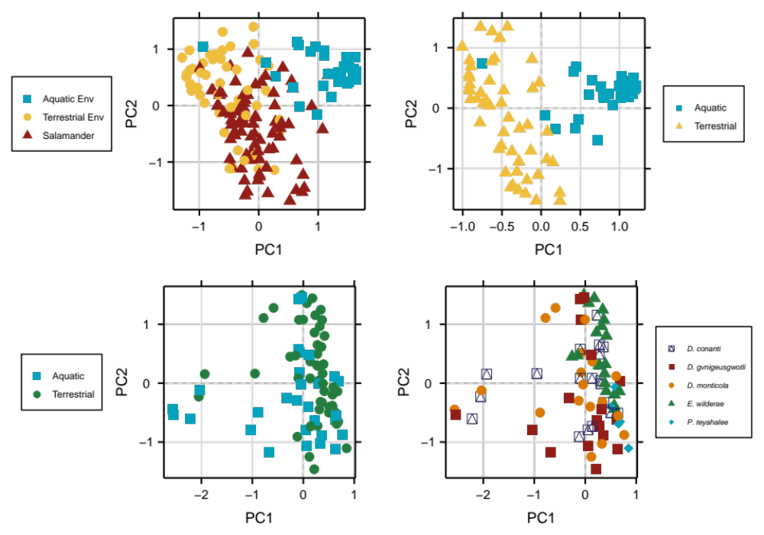
Figure 1: Unconstrained ordinations of the Horn dissimilarity for all samples (top left), only cover objects (top right) and salamanders colored by habitat (lower left) and species (lower right)
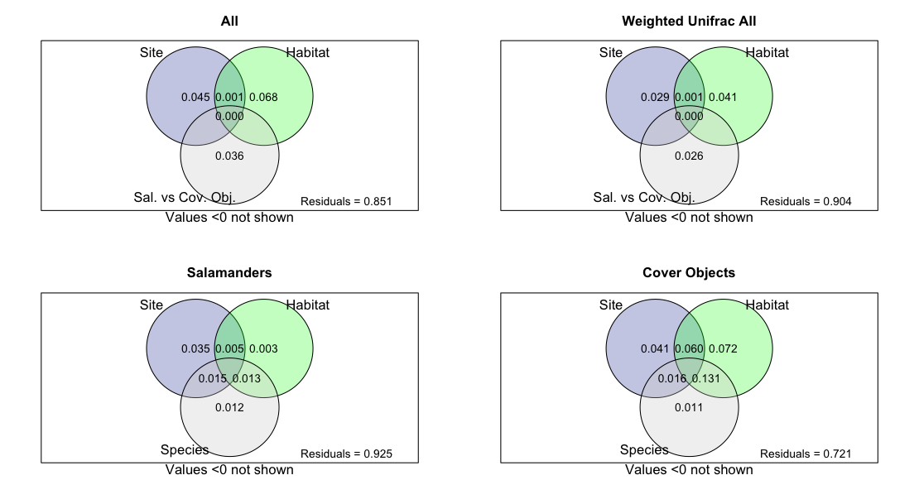
Figure 2: Variance partitioning of variables. Values denote adjust r². All diagrams show partitioning of the Horn dissimilarity, except where denoted.

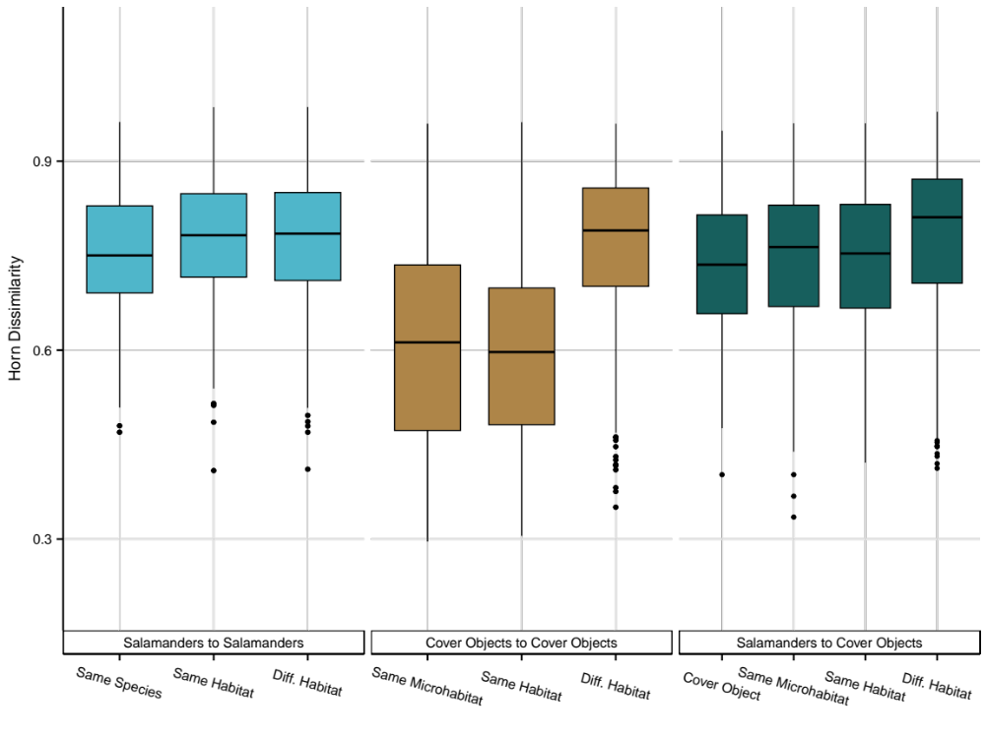
Figure 3: Boxplots of OTUs of pairwise Horn dissimilarity. "Same Microhabitat" means same salamander species. All comparisons are within a site.

 | Comparisons
Dissimilarity | Salamanders to Cover Objects | Cover Objects: Aquatic vs Terrestrial | Salamanders: Aquatic vs Terrestrial | Cover Objects of Different Salamander Species | Salamanders of Different Species
Sørensen | <0.001 | <0.001 | 0.1096 | 0.015 | 0.0222
Horn | <0.001 | <0.001 | 0.1378 | 0.0358 | 0.0338
Morisita-Horn | <0.001 | <0.001 | 0.1858 | 0.07899 | 0.1188
Weighted Unifrac | 0.001 | <0.001 | 0.5305 | 0.1628 | 0.1792
Table 1: Results from dbRDA and anova.cca. Columns correspond to the tested hypothesis and rows indicate the dissimilarity metric.
salamander species had significant differences only in Sørensen and Horn dissimilarity (Table 1), indicating the effects of species/microhabitats on patterns of differentiation stem largely from rare or lesser abundant OTUs. Hierarchical clustering of the Horn dissimilarity shows low agreement with the host species phylogeny (Fig. 4) and instead reflects widespread differentiation, with some resemblance to niche partitioning of salamander species along aquatic-terrestrial gradients within a site, particularly for E. cf. wilderae and D. gvnigeusgwotli. While the number of salamander species is far too small to support a statistical test of phylogenetic signal (Boettiger et al., 2012), the dissimilarity between species was only slightly greater, on average, than dissimilarity between individuals of the same species.

Hosts less diverse than cover objects
Host-associated samples were generally less diverse than samples from cover objects. Alpha diversity was assessed at three orders of diversity. Average richness across all salamanders was 362 OTUs, while the average richness on aquatic and terrestrial cover objects was 596 and 461, respectively. Diversity estimates at q=1 were 199 for salamanders, 248 for terrestrial cover objects, and 320 for aquatic cover objects. At every order of q, salamanders were less diverse than aquatic cover objects (Fig. 5, all p<0.05). Additionally, aquatic cover objects were more diverse, on average, than terrestrial cover objects at q=0 and q=1. Salamanders were significantly less diverse than terrestrial cover objects at q=0 and q=1, but not q=2.
Effective diversity decreased as the order of q increased for all salamanders, aquatic, and terrestrial samples as expected for assemblages without perfectly even abundances. However, salamanders exhibited the least decline of all groups, indicating a more even distribution of abundances on salamanders. When focusing only on salamanders, there were no statistically significant differences in alpha diversity between host species or host habitat (Fig. A2).

Indicator species analysis and community composition
The density distribution of point biserial correlation coefficients in our dataset pertaining to salamanders showed a bimodal distribution (Fig. 6). Of the over 62k sequences, only 21 possessed an average point biserial correlation coefficient greater than 0.2 across rarefactions (Fig. A3, Table 2). These ASVs amounted to a mean relative abundance of 0.02 on salamander samples and 0.0008 on cover objects. The top indicator, an unnamed sequence variant in the
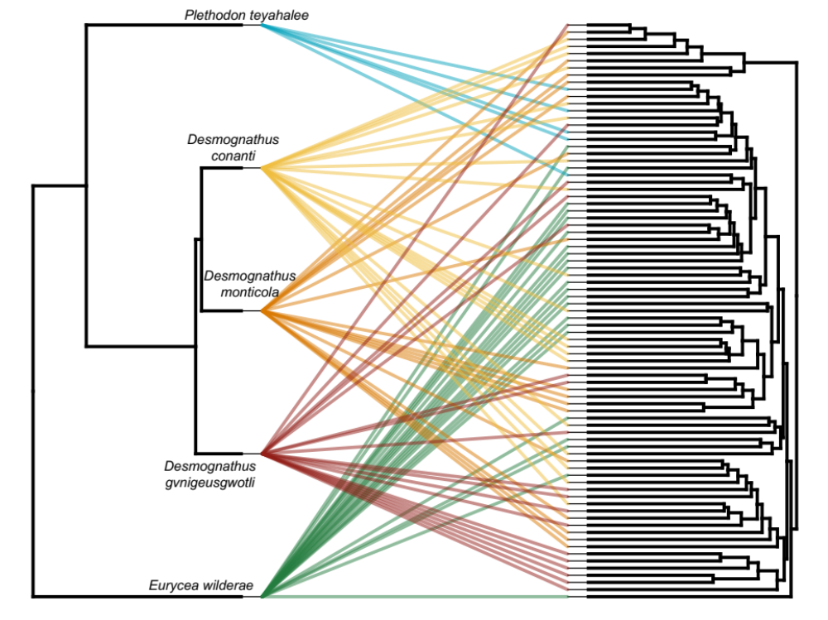
Figure 4: Host phylogeny (left) and hierarchical clustering of the Horn dissimilarity (right).

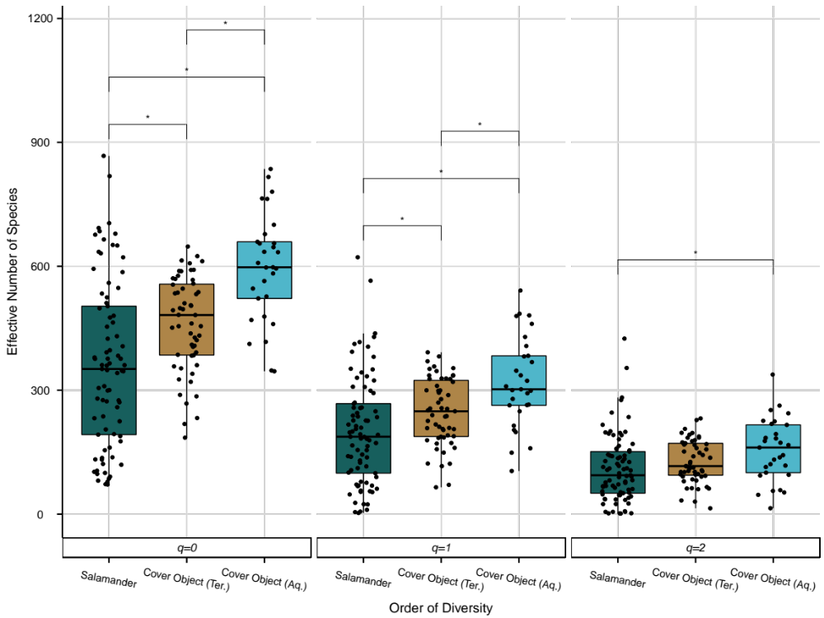
Figure 5: Alpha Diversity estimates for communities on salamanders, terrestrial cover objects, and aquatic cover objects at three orders of diversity.

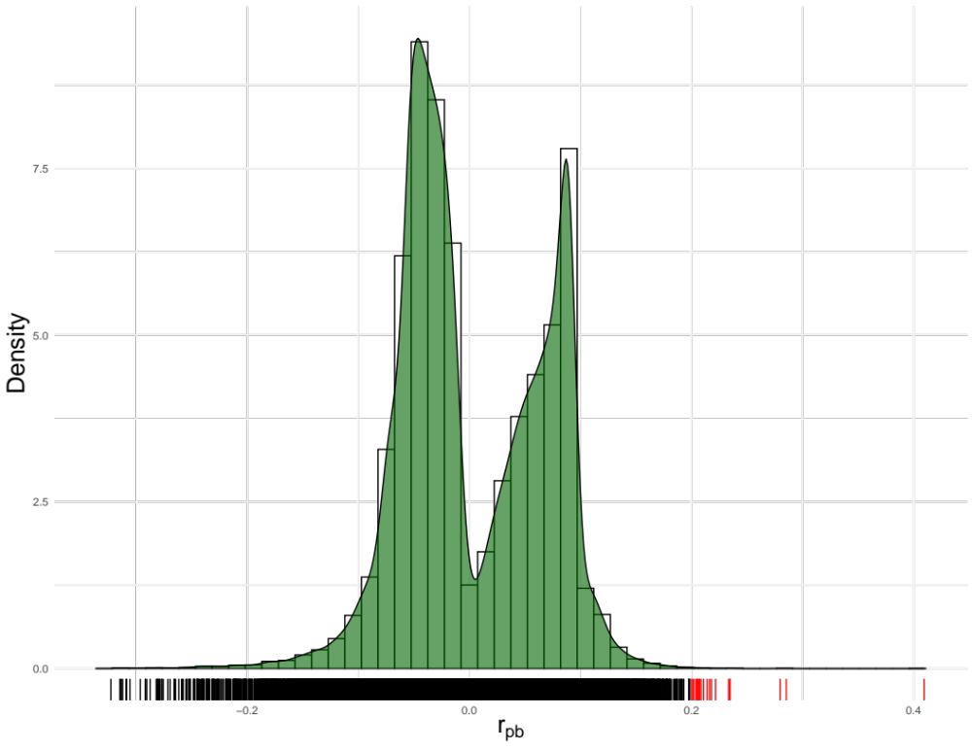
Figure 6: Distribution of point biserial correlation coefficients describing strength of association of ASVs and salamander hosts.
Table 2: Taxonomic information of indicator species and the strength of association

Order | Family | Genus | Mean r_{pb}
Xanthomonadales | Xanthomonadaceae | Stenotrophomonas | 0.40905203
Propionibacteriales | Propionibacteriaceae | Cutibacterium | 0.28534226
Cytophagales | Spirosomaceae | Flectobacillus | 0.28048033
Solirubrobacterales | Solirubrobacteraceae | Patulibacter | 0.23431044
Burkholderiales | Comamonadaceae | Variovorax | 0.235148
Sphingomonadales | Sphingomonadaceae | Sphingomonas | 0.23188597
Rhizobiales | Beijerinckiaceae | 1174-901-12 | 0.22252176
Sphingomonadales | Sphingomonadaceae | Novosphingobium | 0.2166361
Pseudomonadales | Moraxellaceae | Moraxella | 0.21541869
Pseudomonadales | Moraxellaceae | Acinetobacter | 0.21371188
Corynebacteriales | Mycobacteriaceae | Mycobacterium | 0.20907266
Rhizobiales | Beijerinckiaceae | NA | 0.20719538
Rhizobiales | Xanthobacteraceae | Tardiphaga | 0.20672952
Corynebacteriales | Mycobacteriaceae | Mycobacterium | 0.20563616
Verrucomicrobiales | Rubritaleaceae | NA | 0.20614392
Micromonosporales | Micromonosporaceae | Dactylosporangium | 0.20569715
Burkholderiales | Comamonadaceae | Ramlibacter | 0.2049049
Burkholderiales | Comamonadaceae | NA | 0.20517004
Sphingomonadales | Sphingomonadaceae | Sphingobium | 0.2016855
Enterobacterales | Erwiniaceae | Pantoea | 0.20240385
Rhizobiales | Beijerinckiaceae | Methylobacterium-Methylorubrum | 0.20135468

genus Stenotrophomonas and family Xanthomonadaceae was detected on nearly 75% of salamander samples, despite appearing in only four environmental samples (mean relative abundance 0.0076). This sequence consistently had a r_{pb} of greater than 0.4, and is a member of a genus known to produce anti-fungal metabolites (Barnes et al., 2020) and a family (Xanthamonadaceae) known for poor dispersal capabilities and tight relationships with hosts (Nemergut et al., 2013). This family was also found to have genetic differentiation and positive associations with other terrestrial salamander (Plethodon jordani) hosts (Fitzpatrick & Allison, 2014). Three sequences with high indicator values could not be identified at the genus level, but only one genus, Mycobacterium, had multiple sequences identified as indicators (2). At the family level, three members each of Comamonadaceae, Sphingomonadaceae, and Beijerinckiaceae had positive correlations. Taxa in Beijerinckiaceae have been shown to undergo strong seasonal variation in the frog cutaneous microbiome, with the highest abundance in summer (A. J. Douglas et al., 2020), while members of Comamonadaceae have been associated with potential anti-Bd capabilities in laboratory assays (Kruger, 2020). Spingomonadaceae is a family commonly found on amphibian skin, ranging from North America (Hernández-Gómez, Byrne, et al., 2020a), Europe (Sanchez et al., 2017), the tropics (Hughey et al., 2017), and Asia (L. Xu et al., 2020).
To assess whether these taxa are associated with a salamander species or the salamander skin characteristics more broadly, we conducted a multi-level pattern indicator species analysis using ‘multipatt’ in the R package indicspecies (De Cáceres et al., 2010). This identifies ASVs associated with specific groups but can also identify ASVs associated with combinations of groups, making it useful for understanding whether salamander hosts contain species-specific ASVs, or whether the small set of indicators described above is a result of convergence (i.e., recruitment by hosts of multiple species). Because P. teyahalee was poorly represented in sampling (5 samples from a single site), we removed these samples and their associated cover objects, leaving us with four species/microhabitat groupings across three sites. Results indicated each host salamander species possessed between 29-68 ASVs significantly associated with a single host species (Table A1). However, this number was dwarfed by the number of sequence

identified using the point-biserial correlation coefficient. These were the sequence variants belonging to the genera Stenotrophomonas, Dactylosporangium, Cutibacterium, and Methylobacterium-Methylorubrum. The results of both indicator species broadly show salamander skin microbiomes are enriched for a subset of microbes relatively uncommon in environmental swabs, but specificity is driven predominately by local effects, and evidence for ‘salamander-specific’ microbes is limited to a tiny subset of microbes.
The top 10 phyla in our samples encompassed 70% of all taxa in our dataset while capturing 95.6% of relative abundance in pooled aquatic cover object samples, 97.5% of relative abundance in pooled terrestrial cover object samples, 95.6 % of relative abundance in pooled aquatic salamander samples, and 95.5% of relative abundance in pooled terrestrial salamander samples. The dominant phyla in our samples, regardless of sample type, were Proteobacteria followed by Acidobacteriota, Actinobacteriota, Bacteroidota, and Verrucomicrobiota (Fig. A4). Plotting the top 20 most abundant families accounted for just over 26% of total taxa and resulted in 54.1%, 60.3%, 51.5%, and 55.5% of relative abundance in each pooled sample types, following the same order as above. While families share common trends across sample types, differences can be observed in the relative contribution of each family. Aquatic environmental samples contained a higher relative abundance of Comamonadaceae, Sphingomonadaceae, and Pedosphaeraceae, while terrestrial cover objects contained a higher relative abundance of Xanthobacteraceae, Acidobacteriaceae (Fig. A5). Both aquatic and terrestrial salamanders possessed a higher relative abundance of Pseudomonadaceae and Beijerinckiaceae than cover objects. Sequence variants in these families were identified to have strong associations with salamanders and are common symbionts found on amphibian skin. Pseudomonadaceae has been linked to TTX production in newts and sex-specific compounds in frogs, with certain members also possessing anti-Bd capabilities (Brunetti et al., 2019; Vaelli et al., 2020; Woodhams et al., 2015).
Discussion
With the growing awareness that host-associated microbiomes can affect host fitness, researchers have begun to examine how host ecology and evolution contribute to associated assemblages. Amphibian-associated communities have received attention due to the cutaneous microbiome’s contribution to host resistance to chytrid. Our results support the existing body of research describing amphibian microbiome as a complex ecological community heavily dependent on the environmental reservoir (Fitzpatrick & Allison, 2014; Loudon et al., 2014; Wolz et al., 2018). That is, host-associated and free-living bacterial samples are composed of largely the same taxa, and host-associated assemblages likely result from continuous horizontal colonization onto the host from the environment. Host-associated samples showed high heterogeneity among individual salamanders regardless of species and habitat utilization. We find only weak evidence of host species specificity, which is confounded by differences in host-species microhabitat. Convergence among hosts (across species and habitat) is suggested by the presence of a small number of indicator taxa, while the majority of the skin microbiome might reflect idiosyncrasies of stochastic colonization-extinction and priority effects.
Host species and site were more effective in explaining variance than habitat (aquatic vs terrestrial) in our analyses evaluating salamander-associated communities. Site characteristics such as geological and geographical factors (climate, elevation, latitude, slope) shape reservoirs at a site that is reflected on salamander communities. Site alone consistently explained between 2-5% of variation in salamander analyses and salamanders show subtle evidence of site-specificity in turnover analyses. Hernández-Gómez et al. (2017) found similar results with skin microflora of Eastern Hellbenders (Cryptobranchus alleganiensis alleganiensis) across latitude and elevation. Local effects were also found in attempts to explain global variation among amphibian cutaneous microbiomes (Kueneman et al., 2019). However, for cover objects, habitat designation (aquatic or terrestrial) explained more inertia than site in each dissimilarity tested, meaning the difference between aquatic and terrestrial environments was more important than geographic differences between sites for both the detection of taxa and the composition of communities of cover objects (i.e., aquatic cover objects were more similar to an aquatic cover object at a different site than a terrestrial cover object at the same site).
Host species explained a significant proportion of variation in our dataset for salamanders only at binary and q=1 ecological β diversity metrics, but not phylogenetic or Morisita-Horn dissimilarities. Phylosymbiosis, the notion that more closely related hosts have more similar microbial communities, can arise through deterministic or stochastic processes (Kohl, 2020). Deterministic phylosymbiosis refers to the concordance of host phylogeny and community dissimilarity stemming from the direct mediation of host traits on community structure (Lim & Bordenstein, 2020). Stochastic phylosymbiosis occurs when concordance exists as a byproduct rather than direct mediation from host traits. For example, closely related hosts occupying similar habitats could show strong resemblance because of exposure to similar microbial reservoirs and not selection of microbes due to host traits. While we lack adequate statistical power to test this hypothesis, our results suggest host species lack sufficient differentiation to support deterministic structuring at the community level, and only slight evidence in terms of ASV sequence specificity, which could be an artifact of sampling. In other words, the significant statistical pattern of species-specificity does not necessarily imply strong intrinsic differences between host species especially since cover objects associated with different species show similar trends. This suggests differences in microhabitats could drive differences between hosts and perhaps blur aspects of host-species specificity. Either way, these differences were subtle relative to the overall pattern of heterogeneity among individual salamanders in comparison to environmental samples from aquatic and terrestrial habitats, meaning salamander skin does not exert a coherent selection pressure at the community level.
Significant differences between salamander-associated assemblages and assemblages living on their own cover objects could be evidence that salamander skin is an alternative niche for certain microbes, or that salamander skin is simply better at inhibiting the growth of some microbes more than others. The skin of salamanders is an important organ for host physiological homeostasis. Histological studies in Desmognathus, Plethodon, and Eurycea, confirm the presence of mucosal and granular glands embedded within the dermal layer of the integument (Rupp & Sever, 2018; Sever & Siegel, 2015). Uniformly distributed mucus glands maintain physiological homeostasis through secretions of glycoproteins and mucopolysaccharides, which likely act as a nutrient source for host-associated microbes and pathogens (Austin, 2000; Elkan, 1968; Garbe & Collin, 2012). More notably, amphibian skin also possesses more sparsely distributed granular glands, which are responsible for a cocktail of neuroactive and cytolytic peptides. Some of these bioactive peptides are capable of inhibiting Bd and Bsal but can also facilitate the growth of resident microbes (Flechas et al., 2019). Thus, the amphibian skin might facilitate colonization or growth of "desirable" microbes, leading to dissimilarity between host-associated and free-living microbial assemblages. Such dissimilarity might also result from differential inhibition colonization or growth (these possibilities are not mutually exclusive).
Beyond the skin, differences between salamanders and their environment could be attributed to ecological processes such as diversity-area relationships and priority effects. The significant difference in alpha diversity could drive differences in beta diversity (Chase et al., 2011). In particular, if salamanders were all colonized by all species in the environmental pool, then independent random extinctions would make their assemblages more different from each other, while non-random extinctions would make them more similar to each other. The high observed turnover rates between individual salamander samples, despite clustering in ordinations, indicate that random extinction and/or priority effects could be important in amphibian-associated communities. For example, Toju et al. (2018) found priority effects to have lasting impacts on community composition in plants and Sprockett et al. (2018) identified priority effects to be key in the establishment of gut microbiome communities. In this sense, metabolic activities of members already residing on the host engage in cooperation, competition, and niche partitioning, and thus can facilitate or prohibit the colonization of new taxa (Burke et al., 2011; Coyte & Rakoff-Nahoum, 2019). Given the significant differences between microhabitats and the moderate turnover rate even within a microhabitat, heterogeneity of environmental communities and differential colonization success on hosts due to priority effects, in tandem with host physiology could explain the high heterogeneity of salamander-associated communities despite similar organismal filtering processes.
Finally, we identified 21 sequence variants with positive associations with salamanders, evidence of subtle convergence in the salamander skin microbiome. Many of these taxa were commonly found on amphibians in other studies and it is plausible these variants could play a role in host immunity, physiology, and/or establishment of other members if neutral to the host (Estrada et al., 2019; Sabino Pinto et al., 2017; Walke et al., 2020). From this standpoint, understanding the temporal constancy of these indicator taxa on hosts could prove valuable for understanding both the evolutionary and ecological processes dictating the community structure and potential function on hosts.

CHAPTER II:
Signatures of stochastic colonization and extinction dominate salamander skin microbiomes

Abstract
Symbiotic communities associated with animal hosts are widespread across the animal kingdom. The ramifications of these associations can affect host physiology and fitness but understanding the processes underlying community structure remains elusive for large, complex communities in the context of host ecology and physiology. In this study, we use the amphibian skin microbiome as a system for understanding the processes leading to differentiation between individual hosts, other host species, and their environmental reservoirs. Null ecological models were utilized to understand the relative strengths of host filtering, priority effects, environmental transmission, and random differences between individual salamanders, salamander species, and free-living assemblages in aquatic and terrestrial habitats. Results indicate community disparity among individual salamanders was greater than among environmental samples, suggesting widespread differentiation stemming from idiosyncratic, as opposed to salamander-specific, conditions. Apart from a small core community, the salamander skin microbiome is a product of weak and random ecological processes, with differentiation from cover objects stemming primarily from stochastic dispersal or random local extinction at the lowest taxonomic levels.

Introduction
The patterns and processes leading to the establishment of vertebrate-associated microbial communities are commonly understood through the lens of island biogeography and community assembly (McFall-Ngai et al., 2013; Nemergut et al., 2013; Sprockett et al., 2018). In particular, host-associated communities can be broken down into three linked facets resulting from stochastic and deterministic processes. First, a source community is needed to establish on or in the host, whether it be through vertical transmission from a parent or horizontally from other animals or the environment (Bright & Bulgheresi, 2010; Kouete et al., 2023; Nemergut et al., 2013). Environmental transmission is reminiscent of the mainland-island model of community ecology where dispersal makes local communities similar to regional communities while local extinctions make them more dissimilar (Wilson & MacArthur, 1967). Second, host-mediated effects can act as non-random barriers to colonization or causes of extinction (Lim & Bordenstein, 2020; Mazel et al., 2018). These effects may be direct (arising from host traits such as secretions) or indirect (arising from things like host habitat utilization or diet). These factors can make host-associated communities appear more similar to those of closely related hosts than expected by chance alone (Kohl, 2020). Alternatively, host-associated communities could be largely dissimilar from each other stemming from neutral processes such as drift. Finally, residing microbes competing for resources can shift the relative abundances of local communities through cooperation, interference, or exploitation. These ecological interactions can have varied effects on community composition between hosts depending on the complexity of interaction networks, resource availability, and niche space.
A less-often discussed structuring factor in host-associated communities is historical contingency, chiefly priority effects. Priority effects can shape a community through two mechanisms: niche preemption and niche modification. Niche preemption occurs when nutrient depletion from an early colonizer prevents colonization of microbes occupying the same niche (exploitative competition), thus the inhibitory relationship is dependent on the order of colonization if the two microbes are competitively similar (Debray et al., 2022). Alternatively, niche modification can be facilitative or inhibitory when early colonizers alter niche availability for later colonizers (Fukami, 2015). This type of priority effect is more likely for large, diverse communities with high dispersal rates from environmental reservoirs (Fukami, 2015; Kohl, 2020), and is expected to decrease similarity between hosts in the absence of strong selection or structuring hub taxa. Priority effects have lasting impacts on the function and taxonomic composition of the microbiome by mediating selection and dispersal as microbes on the host engage in competition or cooperation with potential colonizers (Furman et al., 2020; Jackrel et al., 2020; Martínez et al., 2018; Sprockett et al., 2018; Toju et al., 2018).
External microbiomes are in constant contact with environmental reservoirs and thus present an appealing system for studying assembly patterns. Host-associated communities could range from isolated islands inhospitable to dispersing microbes to entirely nested communities differing only in the number of species. The amphibian skin possesses a thin layer of gel-forming mucins hypothesized to act as both a nutrient source for residing microbes and a barrier for colonization and can result in the subsistence of microbes even in the absence of a reservoir (Loudon et al., 2016). More distantly distributed granular glands secrete a cocktail of bioactive molecules with varied effects on residing and dispersing microbes (Flechas et al., 2019; Pereira et al., 2023). However, amphibian skin microbiomes are generally heavily reliant on environmental reservoirs, with studies typically find hosts to be statistically ‘different’ from reservoirs in community dissimilarity analyses, implying potential alternative assembly processes (Bird et al., 2018b; Fitzpatrick & Allison, 2014; Kueneman et al., 2019; Prado-Irwin et al., 2017). Dissimilarity between amphibian hosts and environmental reservoirs could be a result of taxonomic replacement via host filtering mechanisms or community processes (priority effects, species interactions, or drift) (Whittaker, 1972). Alternatively, amphibian-associated communities are also typically less diverse than environmental reservoirs (Jiménez & Sommer, 2016). Because maximum similarity between two communities is limited by the less diverse sample (Chase et al., 2011), richness differences contributing to β diversity might lead to communities appearing ‘different’, but are in fact largely nested versions of a regional pool (Podani & Schmera, 2011). While this does not exclude potential fitness implications of host-associated microbes, it does limit the potential evolutionary interactions between host and symbionts.
Previously, we sampled plethodontid-associated communities along an aquatic-terrestrial interface in Southern Appalachian streams and found host-associated communities displayed subtle convergence for a small number of indicator taxa in otherwise divergent communities. While terrestrial and aquatic cover object communities showed strong ties to habitat, salamander-associated communities were more influenced by sampling location and host species. Importantly, statistically significant differentiation of host species was matched in communities found on cover objects pertaining to host species, indicating species specificity could be blurred by host microhabitat utilization. Furthermore, salamander-cover object comparisons were highly dissimilar, indicating a need to better understand the patterns of dissimilarity between hosts and environmental reservoirs as well as hosts and other hosts in the context of horizontal transmission, host filtering, and microbial interactions. In this study, we sought to address the relative strengths of random processes, environmental transmission, host filtering, and priority effects on the amphibian skin microbiome. For observational data alone, we can make the following predictions: a) Lower diversity on hosts, in tandem with strong host filtering should produce more similarities between host-associated communities than their respective cover objects (Fig. 7, panel 1); b) Priority effects, in combination with random dispersal events and the absence of strong host filtering, should produce more differences
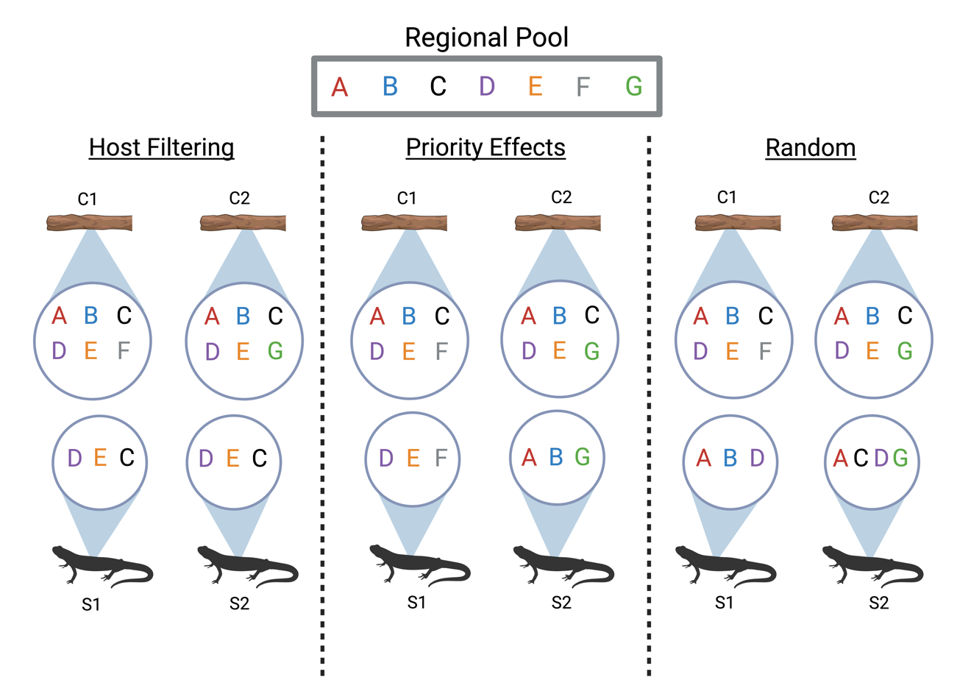
Figure 7: Possible scenarios driving community (dis)similarity between two salamanders (S1 and S2) and their respective cover objects (C1 and C2).
between hosts than their immediate cover object (Fig. 7, panel 2); c) Random chance should produce communities with incoherent patterns of similarity and differentiation, consistent with neutral or random assembly (Fig. 7, panel 3). The host species focused on for this study were sympatric plethodontid species Eurycea cf. wilderae, Desmognathus monticola, Desmognathus conanti, and Desmognathus gvnigeusgwotli, which partake in niche partitioning along aquatic and riparian habitats during summer months in low-order streams and are thus exposed to slightly different microbial species pools in a small area.

Materials and Methods

Sample collection
Four sites were sampled in Great Smoky Mountain National Park in low-order streams below 800m during the Summer of 2019. We focused on differences within a single habitat, thus sampling was done focusing on either aquatic or terrestrial habitats, with two replicates of each. Between five and eight salamanders of two species were captured wearing new nitrile gloves and placed in clean Ziplock bags. Salamanders were handled and swabbed as described previously. The cover object under which the salamander was found was also swabbed in the same manner. All salamanders were released where captured. Samples were stored in sterile 1.5ml centrifuge tubes in the field and kept on dry ice before storage at -80°C at the University of Tennessee, Knoxville. Table 3 lists the species, numbers, and habitat distribution at each Site used for analyses.

Library preparation, sequencing, and bioinformatics
DNA was extracted from the swabs using Qiagen DNEasy PowerSoil Kit, following the manufacturer’s protocol, with the addition of a five-minute incubation step before spin column elution. The V3-V4 region of the 16S Ribosomal RNA gene was amplified using 341F-785R primers in triplicate. Polymerase chain reactions (PCR) consisted of 6.25µl of KapaTaq Mastermix, 2.5µl of forward primer (10μM), 2.5µl of reverse primer (10μM), and 2.5µl of template DNA. PCR cycles were as follows: 95 °C for 3 minutes, followed by 35 cycles of 95 °C. (30s), 55 °C (30s), and 72 °C (30s), with a final five-minute elongation at 72 °C. Amplification was verified on a 1% agarose gel and amplified triplicates were pooled and
Site | Species | Habitat | Number of Salamander/Cover Object Pairs
1 | Desmognathus conanti | Terrestrial | 4
1 | Desmognathus monticola | Terrestrial | 6
2 | Desmognathus monticola | Terrestrial | 6
2 | Eurycea cf. wilderae | Terrestrial | 8
3 | Desmognathus conanti | Aquatic | 4
3 | Desmognathus monticola | Aquatic | 6
4 | Desmognathus monticola | Aquatic | 6
4 | Desmognathus gvnigeusgwotli | Aquatic | 6
Table 3: Species, habitat, and sample numbers used in Chapter 2.
purified using AMPure beads (Beckman Coulter). Unique sample barcodes and sequencing primers (Nexterra XT) were added during a second PCR with conditions the same conditions described previously, only with eight cycles. Purified products were quantified via nanodrop, pooled to equimolar concentrations, and sequenced on an Illumina MiSeq at the University of Tennessee Genomics Core. Paired-end 2 X 275 sequencing was carried out using a V3 600 flow cell with a 20% PhiX spike.
After removing primers, sequences were trimmed, quality filtered and merged in the same manner as previously described. Taxonomy was assigned via the Silva 132 database via the IdTaxa algorithm in R v2.4.0 (R Core Team, 2022) and a fragment insertion phylogeny was created using the Silva 128 reference database in qiime2 (Bolyen et al., 2019; Janssen et al., 2018) and time-calibrated using TreePL (S. A. Smith & O’Meara, 2012). We also clustered sequences at a 97% sequence similarity using VSEARCH (Rognes et al., 2016) with the same taxonomic classification and phylogenetic methods as described above. After removing chimeras, singletons, and contaminants associated with sterile water and laboratory blanks as well as any sample with lower reads than the highest control, the final dataset resulted in 1,731,197 reads mapped to 38,836 sequence variants in 46 environmental samples and 46 salamanders. Clustering to 97% similarity yielded 12,796 OTUs. OTUs were used for diversity analyses, while ASVs were used for our indicator species analysis, and both ASVs and OTUs were used for assessing the strength of relationship between relative abundance on cover objects and salamanders.

Diversity within and between samples
To evaluate whether microbiomes are less diverse than environmental reservoirs, we assessed alpha diversity both taxonomically and phylogenetically using three orders of Hill numbers, amounting to the richness (q=0), exponentiated Shannon index (as the limit approaches q=1), and inverse Simpson’s index (q=2) for taxonomic Hill Numbers (M. O. Hill, 1973; Jost, 2007). Phylogenetic diversity is associated with the diversity of traits in a microbial community. Despite horizontal gene transfer and rapid gene loss, bacteria show trait conservatism along their phylogeny, especially when a particular trait is associated with functional complexity (A. C. Martiny et al., 2013; J. B. H. Martiny et al., 2015). Thus, phylogenetic diversity can be informative for understanding the distribution of potential traits in the context of community resiliency and assembly. Phylogenetic alpha diversity using Hill Numbers represents the effective number of equally distinct lineages (Chao et al., 2016). At q=0, this is the commonly used Faith’s PD, while as the limit approaches q=1, it becomes an extension of Allen’s phylogenetic entropy and q=2 corresponds to Rao’s quadratic entropy (Chao et al., 2016). To estimate alpha diversity, we rarefied each sample to the lowest read count (2,354 reads) and obtained Hill Number estimates (q=0, q=1, and q=2) for each of 100 rarefactions and used the mean for statistical comparisons. To compare alpha diversity between paired samples, we used a paired Wilcoxon test in the rstatix package (Kassambara, 2020).

Null model for community assembly
To distinguish diversifying or homogenizing processes from random assembly and drift, we used the approach of Stegen et al. (2013), which incorporates phylogenetic relatedness and taxonomic dissimilarity in a null model context. This has been used previously to infer community assembly processes, but we adopted this framework to understand patterns of differentiation within and between groups and thus do not strictly adhere to the common verbiage associated with this analysis. Continuous random immigration should result in microbiomes that are statistically indistinguishable from environmental samples. Random colonization and extinction should result in microbiomes that are less diverse, but still a random subset of the environmental species pool. Strong host filtering should result in significant differences between host-associated and environmental samples and strong similarities among hosts. Priority effects should result in idiosyncratic differences among host-associated communities.
The approach uses null models to assess whether pairwise communities differ more or less than expected from a null distribution generated through probabilistically assembled communities- first phylogenetically, and then taxonomically (J. C. Stegen et al., 2013). The mean nearest taxon index (βNTI) for pairwise comparisons is evaluated by calculating the mean nearest taxon distance (βMNTD) before randomizing communities using tip shuffling and recalculating 999 times to produce a null distribution (J. C. Stegen et al., 2013; Webb et al., 2008). The deviation from the null distribution can then be used to identify pairwise comparisons with strong phylogenetic (dis)similarity. Values of |βNTI| >2 (two deviations from null distribution) imply strong phylogenetic ties, with βNTI > 2 indicating phylogenetically different, and βNTI < -2 indicate strong phylogenetic similarity. Alternatively, values of |βNTI| < 2 fall within the expected range of the null distribution, and differences can be assessed taxonomically.
The RC_{Bray} is a relative-abundance-based extension of the Raup-Crick (β_{RC}) index of pairwise β dissimilarity, which uses randomizations of a ‘species pool’ keeping α diversity consistent in each pairwise comparison of samples (Chase et al., 2011; J. C. Stegen et al., 2013). The resulting value can be interpreted as the difference between two samples not explained by differences in α diversity. In the RC_{Bray} format, alpha diversity for each randomized sample is drawn from a community pool, where the probability of drawing a given taxon is dependent on the number of samples containing that taxon. Once the random taxon list has been obtained, relative abundance is assembled, with the relative abundance being the relative abundance in the metacommunity of selected taxa. The number of iterated dissimilarities greater than observed plus ½ those which are equal are divided by the total number of iterations to produce a value, which can then be standardized between -1 and 1. Pairwise comparisons with a value less than -0.95 are considered to be more similar than expected under a null distribution, while comparisons >0.95 are considered to be more dissimilar than expected under a null distribution. Values < |0.95| fall into the category of undetermined, or not any more taxonomically similar/different than a probabilistically assembled community.
Both BNTI and β_{RC} were calculated using the iCAMP package in R 4.2.0 (Ning, 2022; R Core Team, 2022). We modified existing functions in iCAMP to produce a RC_{Horn} as opposed to RC_{Bray}, with the former representing the Horn (q=1) dissimilarity using relative abundance of pairwise communities. For our data, we considered the species pool to be any taxa observed within a given site, and estimated BNTI and RC_{Horn} on each of 50 rarefactions. Community pools (total number of available species) averaged from 3,867 to 4,554 OTUs. We then assessed each pairwise comparison of groups (salamanders to cover objects, salamanders to other salamanders, and cover object samples to other cover object samples) by calculating the proportion of comparisons falling into five categories: phylogenetically similar, taxonomically similar, phylogenetical different, taxonomically different, or random. Pairwise comparisons between cover objects were also included to provide context relative to salamander comparisons with the same sample size.

Correlation of shared sequences and identification of indicator species
If environmental transmission is the dominant driver of salamander skin communities, a strong correlation is expected between relative abundance of taxa on cover objects and relative abundance on salamanders (Fitzpatrick & Allison, 2014). However, if many differences exist, a weak correlation coefficient would be indicative of alternative symbiont acquisition and maintenance on hosts. We assessed the strength of the relationship between relative abundance on salamanders and on cover objects using Kendall’s tau correlation coefficient at four hierarchical levels: ASVs, 97% clustering, genus, and family level ‘glomming’. We divided our dataset to assess trends between aquatic and terrestrial samples. Sequences not assigned at the respective taxonomic level were assigned the taxonomy one level above to prevent spurious glomming resulting from classification failure.
Even if the dominant pattern is one of high correlation and no significant community dissimilarity between salamander skin and environmental samples, there might be a small number of salamander specialists (or microbes systematically excluded from salamander skin). Indicator species analysis is designed to identify such taxa (De Cáceres et al., 2010). We used the point biserial correlation coefficient in the R package ‘indicspecies’ following the methods described previously to screen for ASVs statistically associated with salamanders or cover objects. To ensure point biserial estimates were not a result of subsampling (rarefaction), we rarefied our dataset 1000 times and computed the point biserial correlation coefficient for each rarefaction. We then extracted the taxa with an average correlation coefficient greater than 0.25 for comparisons within a habitat and 0.20 for indicators of all salamanders (Varma, 2006).

Results

Hosts harbor less species than cover objects
Skin swabs from both terrestrial and aquatically captured salamanders had lower bacterial richness than their corresponding cover objects (Table 4, p<0.05, p<0.05). However, only aquatically captured salamanders had lower diversity than aquatic cover objects at q=1 and q=2
Table 4: Hill Number taxonomic and phylogenetic alpha diversity estimates for aquatic/terrestrial salamanders and cover objects. Superscripts denote statistical significance (p<0.05).
Order of Diversity | Group | Effective Species (Taxonomic) | Effective Species (Phylogenetic) | Samples
q=0 | Env T | 559.79 ^{A} | 361.39 ^{A} | 24
q=0 | Env W | 623.24 ^{B} | 445.59 ^{B} | 22
q=0 | Sal T | 390.30 ^{A} | 301.77 ^{A} | 24
q=0 | Sal W | 260.19 ^{B} | 247.31 ^{B} | 22
q=1 | Env T | 304.49 | 40.43 | 24
q=1 | Env W | 344.34 ^{C} | 47.44 ^{C} | 22
q=1 | Sal T | 237.71 | 41.69 | 24
q=1 | Sal W | 124.18 ^{C} | 36.21 ^{C} | 22
q=2 | Env T | 145.10 | 19.38 ^{D} | 24
q=2 | Env W | 170.99 ^{D} | 20.87 ^{E} | 22
q=2 | Sal T | 136.65 | 20.12 ^{D} | 24
q=2 | Sal W | 59.61 ^{D} | 18.89 ^{E} | 22

(p<0.05, p<0.05). At higher orders of diversity, terrestrial captured salamanders were not significantly different from terrestrial cover objects (p=0.128, p=0.63 for q=1 and q=2, respectively), meaning terrestrial cover objects contain comparable bacterial diversity to terrestrial salamander skin when diversity metrics take into account the abundances of taxa.
Phylogenetic alpha diversity showed similar trends to taxonomic alpha diversity regarding richness. Both terrestrial and aquatically captured salamanders had significantly fewer effective lineages at q=0 (p<0.05, p<0.05, Table 4). Assemblages on salamanders captured in water also had lower phylogenetic diversity than aquatic cover objects at q=1, while terrestrial salamander bacterial communities had slightly higher phylogenetic diversity than terrestrial cover objects (41.69 vs 40.43), but not significantly so. Interestingly, at q=2, corresponding to Rao’s quadratic entropy, terrestrial salamander samples had a significantly higher effective number of lineages than terrestrial cover objects, while aquatically captured salamanders had significantly fewer than their counterparts, indicating increased phylogenetic breadth on terrestrial captured salamanders. While there were no significant differences pertaining to sampling sites or between species of salamanders, salamanders captured in aquatic habitats had significantly less taxonomic diversity at all orders of q, but only significantly less phylogenetic diversity at q=1 (p=0.039), meaning comparable lineage representation despite taxonomic diversity differences.

Stochasticity dominates host communities
We assessed pairwise phylogenetic and taxonomic dissimilarity through βNTI and RC_{Horn} to disentangle abundance-based community dissimilarity. We focused on three comparisons for 97% clustered sequences and broke up samples into aquatic or terrestrial origin. The first compared each single cover object to other cover objects within the site. The second and third compared each salamander to their immediate cover object and to other salamanders captured within the site, respectively. Aquatic cover object comparisons found only 3/111 (2.7%) were more phylogenetically similar than expected under a null distribution, while 13/111 (11.7%) were phylogenetically more different (Fig. 8, facet 1, left). The remaining 95 comparisons were neither more phylogenetically similar nor different than expected and had to be parsed taxonomically. Of these, 22 (19.8%) were taxonomically similar while 16 were taxonomically
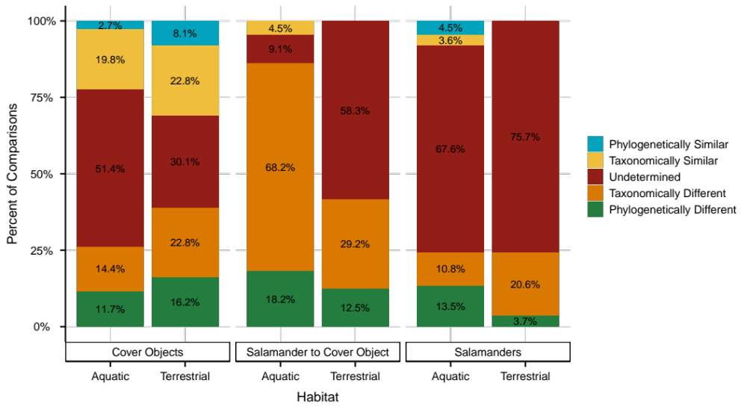
Figure 8: Similarity and Differences between Sample groups. Colors represent average Phylogenetic (BNTI) and Taxonomic (RC_{Horn}) values for each sample.
different (14.4%). The remaining 57 (51.4%) of comparisons were ‘Undetermined’ (not significantly different from their null distributions). Comparing terrestrial
cover objects to other terrestrial cover objects within a site (136 pairwise comparisons) yielded similar results, with only 11/136 (8.1%) of samples being more phylogenetically similar, compared to 22/136 (16.2%) being phylogenetically different (Fig. 8, facet 1, right). The remaining 103 comparisons needed to be parsed taxonomically. Nearly twenty-three percent of
these (31/136) were either taxonomically similar or taxonomically different and 30.1% (41/136) were undetermined, meaning they resembled similarity expected from a probabilistically assembled community. Thus, comparing cover objects to other cover objects reveals some heterogeneity associated with microhabitat across a small space, whether it be taxonomic or phylogenetically driven, and a substantial contribution of randomness.
Horizontal colonization from cover objects to salamanders is presumed to be the predominant way salamanders acquire microbes. However, salamander skin and microbial interactions have been hypothesized to result in differences between salamanders and cover objects. Aquatically captured salamanders had no ‘Phylogenetically Similar’ samples and only 4/22 (18.2%) being phylogenetically different (Fig. 8, facet 2, left). Fifteen of 22 comparisons (68.2%) were taxonomically different, while only one comparison was taxonomically similar and two comparisons were undetermined, respectively. Terrestrially captured salamanders showed slightly different trends. Of the 24 terrestrial salamander-cover object comparisons, none showed phylogenetic similarity, while only 3 (12.5%) were ‘Phylogenetically Different’ (Fig. 8, facet 2, right). When parsing the remaining (dis)similarities taxonomically, 7 (29.2%) were taxonomically different, while none were taxonomically more similar than expected under a null distribution. The majority of terrestrial salamander-cover object comparisons (14/24) were undetermined. Comparing salamanders to any other cover object within a site showed consistent patterns, with ‘Undetermined’ and ‘Taxonomically Different’ comprising the majority of group comparisons. Thus, salamanders are comprised of microbes that are phylogenetically similar to their cover objects, with differences arising at lower taxonomic levels. Differences between aquatically captured salamanders and their cover objects consistently showed taxonomic differences, while terrestrial comparisons are more stochastic. Finally, if salamanders exert strong selection for associated microbial communities, we expect convergent host-filtering
mechanisms to produce phylogenetically and/or taxonomically similar communities. For pairwise comparisons among aquatically captured salamanders, 13.5% (15/111) were phylogenetically different while only 5 (4.5%) were phylogenetically similar (Fig. 8, facet 3, left). Twelve comparisons (10.8%) were taxonomically different compared to just 4 (3.6%) being taxonomically similar. The remaining comparisons (75, 67.6%) were undetermined. In 136 terrestrial salamander comparisons, 5 (3.7%) were differentiated phylogenetically, with all being phylogenetically different (Fig. 8, facet 3, right). Taxonomic (dis)similarities revealed 28/136 (20.6%) were taxonomically more different than expected under a null distribution, while none were taxonomically similar. The remaining 103 (75.7%) of comparisons between terrestrial salamanders were undetermined, meaning they are as different taxonomically as probabilistically assembled communities. Together, this analysis finds little evidence for strong host-filtering mechanisms capable of producing community-level similarities in salamander-associated assemblages. Instead, random processes tend to be more common in salamander-salamander comparisons.

Shared relative abundance is strongly correlated
High environmental transmission is expected to produce strong correlations between the relative abundance in reservoirs and the relative abundance on hosts. Subtle differences between hosts and cover objects could arise via strain-level filtering, in which particular genotypes have greater success colonizing hosts. Prevalence of this would be evident by assessing the strength of association of hosts to their cover objects. The strength of relationships between relative abundance on salamanders and relative abundance of cover objects was assessed through Kendall’s tau at four levels. Using ASVs, we had 3,332 (14%) shared terrestrial sequence variants and 2,027 (11%) shared aquatic sequences out of 24,612 total terrestrial sequence variants and 18,409 aquatic. The strength of relationship between shared relative abundance was 0.19 (aquatic) and 0.26 (terrestrial) (Fig. 9). Clustering sequences at a 97% similarity yielded 33% and 26% of OTUs shared between terrestrial and aquatic paired samples, with correlation coefficients of 0.41 (terrestrial) and 0.24 (aquatic). Glomming at the genus taxonomic level produced tau coefficients of 0.62 and 0.46, with 72% and 69% of genera shared for terrestrial and aquatic comparisons, respectively. Finally, glomming at the family taxonomic level showed
Figure 9: Correlation between relative abundance on salamanders (x-axis) and relative abundance on cover objects (y-axis). Gray points denote taxa detected in both salamander and cover object samples. Note the log-transformed x and y axes.
a strong correlation between relative abundance on salamanders and cover objects (0.69, 0.57), with 79% and 75% of respective terrestrial and aquatic families shared. Taxonomic differences are widespread at the sequence level and the relationship between the relative abundance on salamanders and the relative abundance on cover objects increases with more inclusive clustering. Thus, the most abundant bacterial taxa on salamander skin tended to be the most abundant taxa in the environmental pool, however, many taxa observed on salamanders were not detected in environmental samples and the differences are most prevalent at the sequence level.

Affinity for hosts restricted to a small subset of bacteria
We used an indicator species analysis to identify sequence variants with positive correlation coefficients with salamanders compared to their cover objects for both aquatic and terrestrial samples. While beta diversity analyses found salamander communities were largely stochastically assembled, sequence variants showing positive associations with salamander hosts could be salamander specialists. To identify sequence variants associated with salamanders found both within a habitat and across all habitats, we first identified indicator taxa associated with salamanders from a particular habitat and then associated with all salamanders. Forty-five indicator species were identified for terrestrially captured salamanders, all having an average r_{pb} greater than 0.25, with values ranging from 0.25 to 0.37 (Fig. 10). Average cumulative relative abundance of all indicators in terrestrial salamander samples (45 sequence variants) was 0.02, compared to 0.004 average cumulative relative abundance in cover objects. Of the 45 sequence variants, five belonged to the family Xanthobacteraceae, while three each belonged to Oxalobacteraceae and Pseudonocardiaceae (Table A3). Aquatically captured samples had 75 taxa identified as indicators, with correlations ranging from 0.25 to 0.44 and an average cumulative relative abundance of 0.18 in salamanders and 0.002 in cover objects. Beijerinckiaceae was the most represented family, with 12 sequence variants, followed by Comamonadaceae and Microbacteriaceae with 6 and 4 sequence variants respectively. Of these 120 unique sequence variants, 9 displayed 97% sequence similarities to isolates capable of inhibiting Bd in laboratory assays, with Pseudomonadaceae and Xanthomonadaceae, and Comamonadaceae containing two sequences variants each (Woodhams et al., 2015). The other three belonged to Moraxellaceae, Microbacteriaceae, and an unidentified sequence in
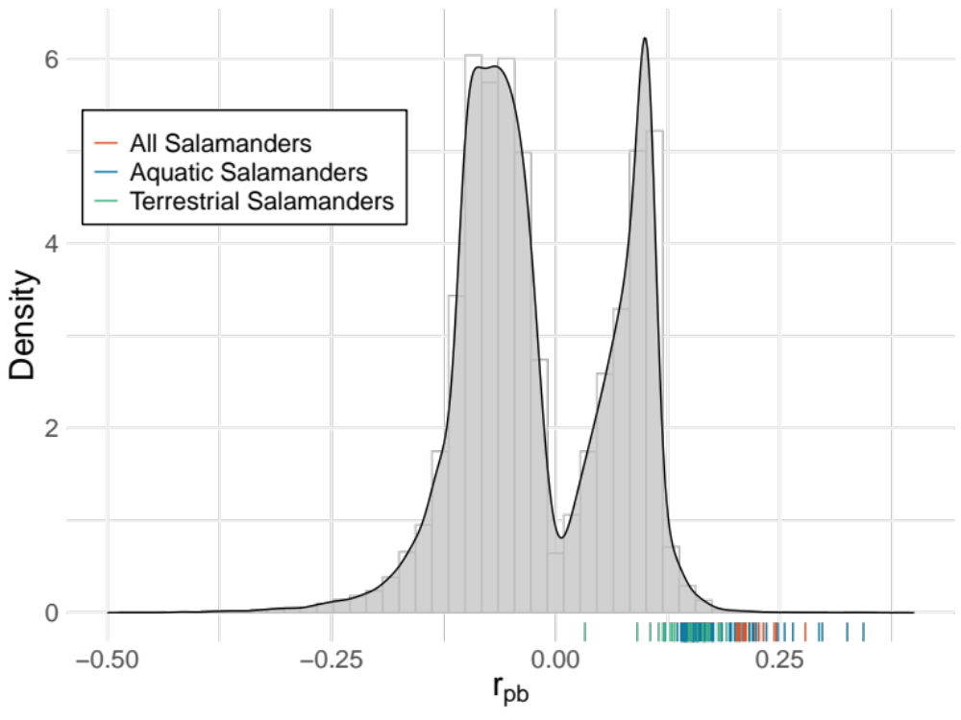
Figure 10: Distribution of point biserial correlation coefficients (r_{pb}) of sequence variants for salamanders and cover objects. Rug lines denote group membership
Enterobacterales. Eight of these came from aquatically captured salamanders, while only one
from terrestrially captured salamanders. Thirty-two sequence variants were identified as
indicators for all salamanders. Of 16 were previously identified with aquatic salamanders and three with terrestrial salamanders, leaving 13 sequence variants associated with all salamanders regardless of habitat. Three of these belonged to Microbacteriaceae while two belonged to the families, Acidobacteriaceae and Nocardioidaceae. Mean cumulative relative abundance of these indicators (13 sequence variants) was 0.005 for salamanders and 0.0008 for cover objects. Of the 32 sequences identified as having strong associations to all salamanders, four were matched isolates known to inhibit Bd, belonging to the genera Chryseobacterium, Comamonas, Stenotrophomonas, and Pseudomonas, with the latter two also included in the preceding paragraph.

Discussion
Untangling complex influences of host-associated communities is paramount to understanding both the ecological and evolutionary processes underlying a host’s microbiome. The amphibian skin microbiome is particularly important due to its potential to inhibit the growth of fungal pathogens associated with global amphibian declines (Barnes et al., 2020; Becker et al., 2015; Harris et al., 2009). As such, understanding the patterns of assembly and sources of differentiation between hosts and environmental reservoirs is important for developing conservation strategies and uncovering the contributions of microbes to host fitness. The amphibian skin microbiome appears both ‘heavily reliant’ yet ‘different’ from their environmental reservoirs, but the mechanisms driving these differences are poorly understood, as is the relationship between intra and interspecific differences observed on hosts (Belden et al., 2015; Bird et al., 2018b; Kueneman et al., 2014; Prado-Irwin et al., 2017). In this study, we assessed the patterns of differentiation between salamanders, other salamanders, and their cover objects in the context of small-scale microhabitat differences. We implemented null models classically used in community assembly to understand the degree to which stochastic and deterministic processes might explain differentiation of host microbiomes from each other and surrounding reservoirs. While salamander skin microbiomes are less diverse than their environmental reservoirs, diversity is not the sole reason for differentiation. Furthermore, differences between salamanders suggest idiosyncratic patterns of ecological assembly inconsistent with strong host filtering and more in line with random assembly stemming from random dispersal, weak host filtering, and weak priority effects.
Lower diversity within host-associated communities compared to environmental reservoirs with similar sampling efforts remains a consistent pattern in microbiome research. The underlying mechanisms driving this pattern for amphibian skin are likely linked to energy availability, surface area, and symbiont colonization. Energy availability is likely to affect the number of individuals that can survive at a site, and therefore the number of species that can maintain viable populations (More Individuals Hypothesis), or the promotion of specialists utilizing ‘rare’ resources (Niche Specialization Hypothesis) (Di Cecco et al., 2022). Diversity-area and diversity-energy relationships are well established in ecology, and have recently been shown in gut microbiomes (Godon et al., 2016), but are rarely applied to host-associated vs environment communities. External microbiomes (such as those on skin) are perhaps expected to be less diverse than free-living assemblages with open dispersal and equal sampling effort. Distribution of free-living assemblages is influenced by pH, moisture, elevation, latitude, and nutrient availability (Fierer & Jackson, 2006; Serna-Chavez et al., 2013). The nutrient-rich, acidic soil of Southern Appalachia boasts healthy microbial diversity, especially under cover objects where microbes aggregate in biofilm on rocks or crevices in logs and facilitate nutrient recycling and decomposition (McTammany et al., 2008; Osburn et al., 2021). Nutrient availability on salamander skin is likely more limited, as microbes have been documented clustering around mucus glands (Lauer et al., 2007). This smaller area with more limited resources would inevitably exacerbate competition and thus promote local extinctions through competitive exclusion. Aquatically captured salamanders had the least diversity, while aquatic cover objects had the highest number of effective species. Biofilm aggregation on aquatic cover objects could be resilient to water flow and potentially exposed to a higher diversity of microbes flowing from upstream sources. The low diversity on aquatically captured salamanders could also reflect failed colonization since flowing water would be more likely to wash microbes off the surface of the skin. Alternatively, less diversity recovered could be a product of sampling error, as our previous study found no significant difference between aquatically and terrestrially captured salamanders from the same site despite significant differences in cover object communities.
Despite having lower richness, terrestrial captured salamander skin samples were not significantly less diverse than terrestrial cover object samples at q=1 and q=2, and were, in fact, more phylogenetically diverse at q=2, indicating that a larger proportion of rare lineages was detected in terrestrial cover objects. Aquatically captured salamander samples were less taxonomically diverse than cover objects and all samples showed similar declines in effective species at increasing orders of diversity, indicating both salamanders and cover objects have an uneven distribution of abundances among microbes. 16S rRNA sequencing does not enable us to assess the percentage of dormant bacteria, however, other studies assessing dormancy have concluded a large proportion, sometimes up to 80% of taxa in soil communities can be dormant (Lennon & Jones, 2011; Sorensen & Shade, 2020). High temporal turnover of the amphibian skin microbiome and local extinction observed in laboratory experiments indicate colonization in wild amphibians is a continuous process (Loudon et al., 2016). Dormant bacteria, as well as taxa with poor dispersing capabilities, would be less likely to colonize the host, but would still be detected in cover object samples, which could explain the high richness in cover objects despite lower effective species at higher orders of diversity. Regardless, given the significant differences in richness between salamanders and cover objects, future research should be conscientious of the impacts of α diversity on inferences about β diversity, especially when using binary dissimilarity analyses (Jaccard or Sørensen).
To account for within sample diversity differences in our samples, we utilized a null model (RC_{Horn}) to assess the dissimilarity between samples not attributed to differences in diversity. Our results are consistent with previous inferences that salamanders acquire microbes predominantly from the environment via environmental transmission. While the differences are subtle, salamander skin assemblages are not merely passive samples from their immediate environment. In the extreme, we might expect unrestricted dispersal to result in statistical similarity between each salamander and the cover object it was captured under. This was not the case, as only a small proportion of such comparisons were taxonomically more similar than expected. Most aquatic salamander-cover object pairs were taxonomically differentiated, and terrestrial salamander cover-object pairs were often no more or less different than expected by chance. In addition to the pairwise comparisons, positive correlations of mean relative abundance at increasing taxonomic levels indicate most differences between salamanders and cover objects occur predominately, but not exclusively, at the lowest taxonomic levels. Only a small portion of comparisons (18% and 12%) were differentiated phylogenetically, similar to pairwise comparisons among cover objects. In other words, salamander-associated communities are differentiated from cover objects in the detection and relative abundance of OTUs along predominately shared phylogenies.
While salamanders are statistically ‘different’ from cover objects, salamanders show little similarity to other salamander hosts, as evident by high pairwise turnover rates and patterns of differentiation consistent with random sampling. Host secretory products act as the first line of immune defense against pathogens and form an ecological landscape for microbe colonization. Adaptation or tolerance to these secretory products appears to be common for functionally important symbionts (Brunetti et al., 2022; Loudon et al., 2016). While these stress-induced bioactive peptides are likely not constantly released on the skin, mucosal gland secretions responsible for regulating physiological homeostasis and preventing evaporative water loss likely play a more consistent role in shaping community interactions on amphibian skin. Recent investigations indicate these mucin-rich secretions contain an abundance of N- and O- linked oligosaccharides and can vary between anuran species (Barbosa et al., 2022). The gel-forming nature of this mucus presents a stage for symbiotic interactions between hosts, residing microbes, and potential colonizers, which has been hypothesized to result in ‘distinct’ amphibian communities attributed to host filtering. In the present study, we find little evidence for strong host filtering mechanisms. Our results suggest salamander skin could act as a selective medium promoting differentiation from cover objects at the lowest taxonomic levels but does not result in a predictable salamander-specific assemblage.
Previous studies have sometimes emphasized the detection of statistically significant differences between groups without evaluating heterogeneity (diversity turnover) within groups. Thus, it can be easy to misinterpret a statistically significant difference as proof that each group has a “distinct”, “predictable”, or “specific” microbial assemblage. In many cases, this is an unwarranted inferential leap. More detailed analyses of turnover and signatures of community assembly processes are needed to understand patterns of both differentiation and similarity among complex microbiomes composed of thousands of variants (J. C. Stegen et al., 2013).
Our results indicate differences between salamanders are largely due to neutral or weak processes. Colonization of microbes onto salamander skin is dependent on the dispersal ability of the microbe, tolerance for salamander conditions, and relationships with microbes already present. The diffuse relationships between host secretions and colonizers are further exacerbated by the diffuse interactions between residing microbes and new colonizers, meaning the appearance of random differences could be a product of weak priority effects and weak community interactions in tandem with weak host filtering and stochastic dispersal.
Using null models, the size of the regional pool can influence the deviation from randomized communities. A small regional pool can result in low deviation from a null community, while a large pool would drive RC_{Horn} values further from the null (J. C. Stegen et al., 2013). Our paired sampling design defined the regional pool as any microbe detected on a rarefied salamander or cover object sample at any given site. Moreover, pairwise comparisons among cover objects provide a valuable frame of reference for the interpretation of comparisons involving hosts. Given that cover objects possessed drastically fewer ‘Undetermined’ comparisons and even exhibited partitioning according to microhabitat utilization, our analyses were not underpowered for assessing the differences between salamanders and other salamanders. However, this analysis did reveal a subtle difference in the patterns of dissimilarity between salamanders and their associated cover object that requires contextualization. Aquatic salamander to cover object comparisons were predominately “Taxonomically Different”, while terrestrial salamander to cover object comparisons were “Undetermined”. Aquatic cover objects had higher effective diversity than terrestrial cover objects, while aquatically captured salamanders were, on average, less diverse than terrestrially captured salamanders. Average differences (Horn dissimilarity) in sites comparing aquatically captured salamanders to aquatic cover objects were higher (means: 0.84, 0.87) than in terrestrial sites (means: 0.73, 0.70). This variability, in conjunction with less diversity, and the mechanisms described in preceding paragraphs, could have driven null model estimates towards ‘Taxonomically Different’ as opposed to ‘Undetermined’. This also explains the weaker relationship between relative abundance between aquatic and terrestrial salamanders and their cover objects. While the null model controls for differences in alpha diversity, the increased dissimilarity would result in a larger community pool, which would inevitably affect the assembling of probabilistic communities. In this sense, aquatically captured salamanders show more differences to their cover objects, which is both an artifact of the analysis and a representation of our sampling. Regardless, the notion that salamander-associated communities are nested communities of cover objects, or display convergence through host filtering, is refuted at the community level.
While salamander skin shows little evidence of community-level convergence, we were able to identify 32 sequence variants strongly associated with salamander hosts, indicating that there may be salamander specialists or genotypes favored by conditions on salamander skin. This result might support the concept of a core community (Risely, 2020), but members of this group generally account for a small proportion (2-20%) of the bacteria in samples from salamander skin. Temporal studies have also found a detectible core microbiome across seasons and habitats, with members displaying temporal constancy often associated with functional capabilities on hosts (Le Sage et al., 2021; Walke et al., 2021). Correlations between shifts in bacterial communities and bacterial community metabolites post-disturbance have also been documented (Walke et al., 2015, 2021), indicating three-way interactions between the host secretory products, residing microbial metabolites, and new colonizers. This core community could be important in mediating priority effects by acting as hub taxa and facilitating or inhibiting the colonization of new microbes via niche modification. While network analyses are perhaps speculative for large communities, lab experiments manipulating introduction order in tandem with host secretions could be fruitful in understanding these interactions. Nonetheless, these indicator taxa present the most compelling candidates for future investigation of symbiotic interactions in amphibians.
Our results provide three pertinent conclusions regarding the assembly of the plethodontid skin microbiome. First, horizontal colonization from environmental reservoirs is the dominant way in which hosts acquire microbes. Relative abundance on hosts and cover objects is strongly correlated, especially at the higher taxonomic levels, underscoring the observation that the most abundant bacteria in the environment are often most abundant on salamander skin. Secondly, despite being less diverse than cover objects, salamander hosts are also comprised of statistically ‘different’ OTUs from cover objects stemming from an array of weak ecological assembly processes that result in communities being dissimilar to both cover objects and other salamanders. Finally, salamander skin lacks sufficient selective structuring ability to produce distinct community similarities between individual salamanders and salamander species. Instead, residing microbes, host secretions, and high environmental transmission produce largely divergent communities with only a small potential core community shared.

Chapter III: Temporal turnover and the core microbiome of eurycea cf. wilderae

Abstract
External microbiomes, such as the amphibian skin, are in constant contact with environmental reservoirs and experience high rates of immigration. Predicting the natural range of variation for such microbiomes is important for understanding how communities might respond to disturbance in addition to parsing transient associations from candidates linked to host benefits. In this study, we use the phenology of a migratory salamander (E. cf. wilderae) to understand seasonal changes in skin assemblages as hosts move between aquatic and terrestrial habitats. We additionally test the utility of a core microbiome concept using two commonly applied and two modified definitions. Seasonal heterogeneity was high between salamander hosts, but turnover was exacerbated when hosts changed habitats, consistent with immigration of microbes from a new regional pool. Potentially defensive microbes capable of inhibiting the growth of chytrid fungi were most abundant when hosts occupied terrestrial habitats but some showed persistence on hosts year-round despite low abundance in aquatic habitats. These results indicate the amphibian skin microbiome lacks temporal constancy but contains a few microbes with affinity for salamander conditions that also produce anti-fungal compounds. These non-random associations provide opportunities for deeper investigation into the mechanisms underlying persistence on hosts and the potential for reciprocal benefits in an external microbiome.

Introduction
Complex host-associated microbiomes, such as the skin and gut, consist of many individuals with diverse relationships to each other and the host. The assembly of these ecological communities is dependent on varying strengths of environmental colonization, host traits, and microbe-microbe interactions. Internal microbiomes are generally more resistant to immigrants due to an often-inhospitable gut environment and tight ecological networks (sometimes referred to as ‘colonization resistance’) (Shade et al., 2012; Sylvain et al., 2020). External microbiomes tend to be more porous and experience high rates of immigration from surrounding reservoirs, often resulting in heterogeneous communities that reflect local conditions. This reliance on external reservoirs makes parsing relationships to the host difficult for external microbiomes. Laboratory assays have found examples of hosts benefiting from individual and collective symbionts (Brunetti et al., 2019; Jani et al., 2021; Vaelli et al., 2020). However, these isolated interactions, while informative for how symbionts could impact host fitness, offer little insight into the dynamics of host-associated complex communities in nature. Salamander-associated communities show assembly patterns consistent with stochastic dispersal and extinction, with host communities heavily reliant on environmental reservoirs. As such, heterogeneous communities- even between co-occurring hosts- make it difficult to imagine when, if ever, a stable state is reached and what the ramifications might be for hosts after short-term (pulse) or long-term (press) disturbances.
Community stability describes the ability of a community to minimize variability or return to its original state after disturbance and can be broken down into three linked facets: constancy, resistance, and recovery (de Bello et al., 2021). For host-associated communities, disturbances are diverse in their severity and modes of action but can broadly fall into three non-mutually exclusive categories- those altering the sources (changing the immigrant pool), those directly altering the species interactions (immigrants or pathogens), and disturbances to the host that evoke physiological/immunological changes to the symbiotic landscape (host injury, stress, pathogens). Community responses to these disturbances can range from a return to a stable state (original composition), alternative stable states (different, but stable composition) (Ravel et al., 2011), or a regime shift (large change between alternative stable states) (Gonze et al., 2017). In amphibian-associated skin communities, disturbances have been evaluated in the context of disruption to the immigrant pool (Hernández-Gómez, Byrne, et al., 2020b; Jiménez et al., 2020), exposure to skin pathogens (Jani & Briggs, 2014; Weeks et al., 2020), or host harm (Hernández-Gómez, Wuerthner, et al., 2020), with host-associated communities typically showing increased group dispersion, rapid compositional changes, and loss of taxa linked with anti-fungal capabilities, indicating low resistance to all types of disturbances. Similarly, community recovery post-disturbance often fails to result in a return to the original state for amphibian-associated communities, but some evidence suggests alternative stable states, although potentially confounded by captive conditions (Jani et al., 2021). Given the global decline in amphibians stemming from land-use change, climate change, and fungal pathogens, understanding the dynamics predicting how communities respond to disturbances can aid in estimating the potential effects of emerging disturbances on hosts and external symbionts.
Of particular importance for interpreting community responses to disturbance events (pathogen, climate change) is defining expectations of ‘natural variation’ or ‘normal operating range’ for host-associated communities. Temporal community turnover of bacteria on hosts is generally high for amphibians, yet there is some evidence for ‘structural stability’ in the retention of taxa temporally, with ‘rare’ taxa being the most transient, while moderately abundant taxa fluctuate over time (Ellison et al., 2021; Walke et al., 2021). For studies focusing on temporal variation in a single habitat, high turnover is likely attributed to the continuous stochastic dispersal and extinction, with weaker effects of host physiology and microbial interactions.
The biphasic lifestyle of amphibians exposes them to aquatic and terrestrial reservoirs with significantly different compositions that are reflected in skin-associated microbial communities at small scales (A. J. Douglas et al., 2020). Habitat changes often coincide with phenology, particularly courtship, mating, metamorphosis, or overwintering, which are also linked to changes in skin physiology (e.g., ion regulation or desiccation resistance) and secretory products on the skin (Duellman & Trueb, 1994; Le Sage et al., 2021; Wells, 2010). The amphibian skin serves as a landscape for symbiotic interactions, meaning subtle changes in skin chemistry could alter nutrient availability on hosts (Hernández-Gómez & Hua, 2023; Krynak et al., 2016; Varga et al., 2019; Woodhams et al., 2023b). As such, biphasic transitions likely result in disturbance events for host-associated communities by changing both the immigrant pool and nutrient availability supplied by hosts (Bletz, Perl, Bobowski, et al., 2017; L. Xu et al., 2020). Microbial turnover during phenological habitat shifts, in tandem with host physiological changes, is predicted to be greater than fluctuations within a single habitat over time. Here we describe seasonal changes in salamander skin microbiomes as the hosts move between aquatic and terrestrial habitats to evaluate the effect of the environment on skin assemblages. We test whether a non-random component of the microbiome remains constant across the environmental transition, with particular attention to symbionts with potential defensive function against fungal pathogens.
Attention towards a ‘core’ microbiome has increased since 2007, when the launch of the Human Microbiome Project included a hunt for a ‘core’ microbiome- a group of microbial taxa/genes shared by most humans (Turnbaugh et al., 2007). Ecologists readily adopted this concept, seeking to identify groups of microbes associated with host species. Implicit in the concept is the notion that commonly detected, or more abundant taxa have important functional relationships with hosts. In some cases, this has been true, however, rare taxa can have profound consequences as well (Antwis et al., 2019). Furthermore, microbes do not have to be a part of a ‘core’ microbiome (whatever the definition may be) for the host to receive benefits from either individual symbionts or the microbial consortium more broadly. And finally, commonly detected or abundant taxa might simply be those that are abundant in the external environment. In this sense, commonly detected taxa on hosts could reflect environmental reservoirs and thus do not necessarily represent positive, or tight associations with hosts. Thus, it is critical to evaluate skin-associated microbiomes in comparison to relevant free-living assemblages (Fitzpatrick & Allison, 2014). In this study, we evaluate four definitions of the ‘core’ microbiome for salamander-associated communities by identifying common OTUs found within a given sampling period (common core), OTUs consistently detected within a site over the course of four sampling periods (temporal core), OTUs associated with anti-fungal capabilities (defense functional core), and OTUs showing high affinity for the host condition relative to environmental reservoirs (host-associated core).
The most researched contribution of amphibian-associated symbionts is the ability to inhibit the growth of fungal pathogens Batrachochytrium dendrobatidis (Bd) and Batrachochytrium salamandrivorans (Bsal) through secondary metabolites. These pathogens can have major impacts on amphibian survival, and the potential benefits of defensive symbiosis with antifungal bacteria could be enormous for the hosts (Harris et al., 2006, 2009). Anti-fungal metabolites are not exclusive to amphibian symbionts but instead likely reflect an evolutionary arms race between competing bacteria and fungi in soils. As such, anti-chytrid capabilities are phylogenetically widespread and could be functionally redundant in amphibian-associated communities (Barnes et al., 2020). The acquisition of these symbionts is presumed to be environmental colonization followed by persistence on hosts, though there has been some evidence for vertical transmission (Kouete et al., 2023; Walke et al., 2011). Importantly, certain defensive symbionts show persistence on amphibians in captivity and are resistant to host anti-microbial peptides, meaning that while defensive benefits could be widespread in nature, hosts might form reciprocal associations with a few species that can tolerate and supplement their own defensive arsenals (Flechas et al., 2019; Loudon et al., 2016).
Eurycea cf. wilderae is a brook salamander occupying higher elevation, high-gradient streams and is a paraphyletic member of the Eurycea bislineata species complex. While we refer to this species as Eurycea cf. wilderae, the populations in our study area are part of a well-delimited but undescribed species in the Blue Ridge (Pierson et al., 2021, 2023). Salamanders in this complex utilize streams for overwintering and nesting while occupying terrestrial uplands and riparian zones from late spring until late fall. Individuals are observed in October/November moving from terrestrial areas into aquatic habitats, with courtship and mating occurring along the way. While this genus has shown low susceptibility to Bd (25 positive samples of 232 field swabs), Eurycea is among the more susceptible Plethodontid genera to Bsal in lab experiments (Augustine & Neff, 2016; Bauer et al., 2018; Carter et al., 2020; DiRenzo et al., 2021; Jongsma et al., 2019; Muletz et al., 2014). Infection by these pathogenic fungi is most likely to occur when the animals are in their aquatic phases, therefore changes in the representation of skin symbionts with antifungal properties during and after transitions between water and land might be critical for host susceptibility. The goals of this study were to a) assess the temporal variability of skin bacteria in relation to host phenology (aquatic and terrestrial phases) and b) evaluate four definitions of the core microbiome to characterize host-microbe associations.

Methods

Sample collection
To assess the temporal constancy and core microbiome of E. cf. wilderae, we selected nine low-order streams within Great Smoky Mountain National Park and sampled each site seasonally for the course of one year in 2018-2019. We analyzed one salamander per site per season. Salamanders were captured, rinsed, and swabbed as described previously. The cover object where the salamander was found was also swabbed. Swabs were broken off into sterile 1.5ml centrifuge tubes and stored on dry ice in the field, before storage at -80°C in the lab. Across our nine sites sampled, six followed the anticipated seasonal habitat utilization of E. cf. wilderae, while two sites had salamanders on land in the Spring, and in water in the Fall during sampling. Additionally, one site had terrestrial captured salamanders for three seasons. Finally, we were unable to find salamanders during the Spring sampling at site N, and during the winter sampling of site K, resulting in seven sites with four samples (one in each season) and two sites with only three seasons represented (Table 5).

Sample processing
DNA was extracted using the Qiagen DNEasy Powersoil Kit following the manufacturer’s protocol with the exception of including a 5-minute incubation step at room temperature before spin column elution and a 50μl elution volume to compensate for expected low recoveries. The V3-V4 region of 16S rDNA was amplified using the 341F 785R primers in 27.5μl reactions containing 12.5μl KAPA HiFi HotStart PCR ReadyMix, 5μl forward primer (1μM), 5μl reverse primer (1μM), and 5μl template. Conditions for the PCR were as followed: 95°C for 3 minutes, followed by 30 cycles of 95°C for 30s, 55°C for 30s, and 72°C for 30s. The final elongation step was 72°C for five minutes and reactions were then held at 4°C. Amplified products were verified on a 1.5% agarose gel and purified using AMPure Beads (Beckman Coulter). Purified samples were assigned unique Nexterra barcodes in a multiplexing PCR using the same conditions described above, only with 8 cycles. Products were then purified again, quantified using a Nanodrop spectrophotometer (Thermo Fisher), and pooled to equimolar concentrations. Quality and amplicon size were confirmed and sequenced at the University of Tennessee Genomics Core on an Illumina Miseq PE250 flow cell with a 20% PhiX spike.

Bioinformatics
Demultiplexed sequences were processed using Qiime2 (Bolyen et al., 2019). Primers were removed with Cutadapt v3.5 and sequences then entered the DADA2 pipeline (Callahan et al., 2016; Martin, 2011). Forward reads were trimmed to 225 bases and reverse reads were trimmed to 215 base pairs. Quality filtering was carried out with a maxEE threshold of c(2,3) and after correcting errors, paired sequences were merged, dereplicated, and clustered at a 97% sequence similarity before formulating an OTU table and removing chimeras. A sepp-fragment insertion tree was then constructed using the Silva 128 reference database (Janssen et al., 2018), and the phylogeny was time-calibrated using TreePL (S. A. Smith & O’Meara, 2012). The OTU table was exported, and taxonomy was assigned using the IDTaxa algorithm in R v4.2.0 in the DECIPHER package (Murali et al., 2018; Quast et al., 2013). Following taxonomic assignment, reads assigned to Chloroplast and Mitochondria were removed, as were singletons and any
Table 5: Salamanders sampled in each season and their habitat(s)
 | Habitat
Season | Terrestrial | Aquatic
Spring | 1 | 7
Summer | 9 | 0
Fall | 8 | 1
Winter | 1 | 7

sequence not between 400 and 428bp long. We then used sterile water from the field and extraction/PCR blanks to assess contamination, which resulted in the removal of 23 OTUs using the decontam package (Davis et al., 2018). Additionally, any sample containing fewer reads than a ‘blank’ was discarded. The final dataset used for analyses contained 2,261,552 reads mapped to 17,667 OTUs in 67 samples, 33 of which were salamander cover object pairs in aquatic or terrestrial habitats seasonally.

Diversity within and between samples
Taxonomic and phylogenetic alpha diversity were used to assess the seasonal changes in within-sample diversity of salamander-associated communities and communities found on cover objects. Host-associated communities can vary seasonally from lower body temperature and host activity but could also reflect dormancy of environmental assemblages and decreased immigration (Le Sage et al., 2021; Shade et al., 2012; Tong et al., 2020). For taxonomic alpha diversity, we used three orders of diversity (Hill Numbers) representing the richness (q=0), exponentiated Shannon Index (q=1), and scaled probability of interspecific encounter (q=2) (M. O. Hill, 1973; Jost, 2006). For phylogenetic diversity, these orders correspond to Faith’s phylogenetic diversity (q=0), Allen’s entropy (q=1), and Rao’s quadratic entropy (q=2) and represent the effective lineages over time (Chiu & Chao, 2014). We compared differences in α diversity for three hypotheses: salamander-associated communities would be less diverse than their environmental reservoirs, alpha diversity would be lower on aquatically captured salamanders than terrestrially captured salamanders, and alpha diversity would be lowest in the winter for salamanders. Alpha diversity hypotheses were tested using either a paired t-test in the rstatix package for comparing salamanders to cover objects or an ANOVA with a Tukey Honest Significant Difference post-hoc test for parsing differences across seasons (Kassambara, 2020). Due to sampling biases arising from sampling/sequencing effort, we estimated diversity for each of 500 rarefactions and used the mean diversity estimate for each sample using the vegan package in R (Oksanen et al., 2019). Our rarefaction level was 13,407 reads, with rarefaction curves becoming asymptotic around 9,500 reads.
The effective number of species is a reflection of the number of species (richness) and the equitability of abundances (evenness) (Tuomisto, 2012). When richness and/or abundances vary, Chao et al. (Chao & Ricotta, 2019) proposed two requirements for a measure of evenness: a fixed interval with minimum and maximum (unrelatedness criterion), and evenness measures that perform consistently for absolute or relative species counts (scale invariance). A proposed measure fitting these criteria is to use the normalized absolute slope of Hill-number profiles, meaning evenness (between 0 and 1) represents the normalized ratio of higher-order diversities to richness. In this study, host habitat changes expose hosts to a different immigrant pool, potentially increasing evenness through local declines of resident taxa and colonization of new microbes filling niche space. To evaluate seasonal patterns of evenness for salamander and cover object-associated communities, we estimated the taxonomic evenness of a Hill number profile from q=0, q=1, and q=2 across 500 rarefactions.
For assessing beta diversity pertaining to our study design, we used variance partitioning of the Horn and PhyloHorn dissimilarities (q=1), partitioning by Site, Season, and Habitat (as well as interaction terms). The adjusted r² represents the inertia explained constrained models, which was then statistically assessed using dbRDA followed by an anova.cca in the package vegan. Due to the phenology of E. cf. wilderae, habitat and seasons are necessarily confounded, and we thus conditioned the model to remove variance associated with habitat while testing for variance seasonally. While post-hoc analyses for crossed-sampling designs requiring conditioning are currently unavailable, Alekseyenko (2016) developed a multivariate Welch t-test for distances (Alekseyenko, 2016). This method is robust to sample size differences and was used to statistically compare consecutive seasons in the context of habitat shifts, correcting for multiple comparisons with sequential Bonferroni. To apply a more nuanced approach for visualizing temporal turnover at the community level, we assessed turnover between salamanders and cover objects, salamanders and other salamanders, and cover objects and other cover objects.

Core microbiome
We implemented four definitions of the core microbiome (common, temporal, host-associated, and defensive functional) to identify relationships of OTUs to salamanders in relation to cover objects. We defined the common core (one for each sampling season) as OTUs detected on 80% of individuals within a given sampling season (across 9 sites). The temporal core was identified as OTUs detected on all salamanders within a given site across three or more sampling seasons. The defensive functional core was identified as any OTUs matching strains known to have antifungal properties in vitro (Woodhams et al., 2015) at a threshold of 99% similarity. Finally, our host-associated core identified OTUs with statistical associations with amphibian hosts relative to cover objects, which was assessed using an indicator species analysis using the stratassoc function (De Cáceres et al., 2010). To test whether the distribution of indicator values could be attributed to random community assembly, we simulated a ‘null’ distribution of expected associations, we probabilistically assembled to preserve the rarefied richness in each sample and shuffled group membership. In brief, a pool of OTUs was created and random taxa were selected, with the probability of each species dependent on the frequency of samples it was detected in. Relative abundance of taxa for each sample was then drawn from a probability distribution, with the probability being the relative abundance of the selected taxa in the metacommunity. This was done across 500 rarefactions and the distribution of correlation coefficients was plotted along with observed patterns. For each of the four ‘core’ definitions, we assessed the number of OTUs passing our threshold and plotted their relative abundance on amphibians and cover objects over the course of a year. All analyses were run in R v4.2.0 and graphics were created using the ggpubr, ggplot2, ggpubfigs packages (Kassambara, Alboukadel, 2020; Steenwyk & Rokas, 2021; Wickham, 2016).

Results

Alpha diversity is consistent on hosts seasonally
Studies analyzing the effects of seasonality on amphibian skin communities have often found that diversities on hosts decreased in cooler months, attributed to ambient temperatures, decreased host metabolisms, or higher dormancy in free-living assemblages. We first asked if salamanders had lower diversity than their cover objects in a particular habitat (aquatic or terrestrial), and then focused on seasonal trends on salamanders. Aquatic cover objects had significantly higher effective diversity than terrestrial cover objects at q=1 and q=2 (p<0.05), but microbial diversity in aquatic salamander communities was not significantly different from diversity in terrestrial salamander communities in any taxonomic order of diversity (Table 6) (q=1: 448.8 vs 432.5, p= 0.67). Similarly, we found no significant difference in the effective number of species on salamanders seasonally, though salamanders sampled in the fall had the
 | Taxonomic |  |  | Phylogenetic
Group | q=0 | q=1 | q=2 | q=0 | q=1 | q=2
Aquatic Cover Objects | 1206.9 | 548.8^{A} | 262.4^{B} | 428^{C} | 29.6^{D} | 16.9E
Aquatic Salamanders | 1028.3 | 448.8 | 194.2 | 400.4^{F} | 29.3 | 16.9
Terrestrial Cover Objects | 942 | 370.8^{A} | 158.1^{B} | 305.7^{C} | 25.3^{D} | 15.6E
Terrestrial Salamanders | 956.9 | 432.5 | 184.5 | 333.1^{F} | 27.6 | 16.6
Table 6: Taxonomic and Phylogenetic diversity estimates by habitat. Superscripts denote statistical significance of paired comparisons.
fewest effective species, while salamanders sampled in the Spring had the highest (p=0.085, Table 7).
Phylogenetic alpha diversity showed trends consistent with taxonomic assessments. While there were significantly higher effective lineages on aquatic cover objects compared to terrestrial cover objects in all phylogenetic diversity metrics (all p values <0.05), there were no significant differences between diversity in communities on salamanders and diversity in communities on cover objects for either habitat. Salamanders-associated communities tended to have slightly higher phylogenetic diversity than their cover objects (Table 6). Aquatic salamanders had significantly higher effective lineages at q=0 than terrestrial salamanders (400.4 vs 333.1, p=0.029), but not at q=1 or q=2 (p=0.18, p=0.92). Evaluating the effects of season on alpha diversity of salamander-associated communities found communities sampled in the Spring had significantly higher phylogenetic richness than salamanders sampled in the Fall (p=0.029), but this trend was not supported at higher orders of diversity, and no other seasonal comparisons were statistically significant.

Evenness increases with host habitat shifts
Standardized evenness metrics take on a maximum value of 1 (completely even) and a minimum value of 0. At q=0 (richness), evenness is defined as 1. Declines in the effective number of species were observed at increasing orders of diversity, implying inequity of abundances found on salamander and cover object samples. Both salamanders and cover objects show similar patterns of evenness from q=0 to q=2, with a mean evenness value of 0.45 for salamanders and 0.41 for cover objects at q=1, and 0.20 for salamanders and 0.18 for cover objects at q=2. For 7/9 sampling sites, salamanders underwent habitat shifts before Summer and Winter sampling. Evenness trends of these samples revealed salamander communities were more even in the Summer and Winter (means= 0.51, 0.49) than in Spring and Fall (means= 0.42, 0.40) at q=1 (Fig. 11), while cover objects showed no patterns in evenness seasonally.

Turnover exacerbated by host habitat shifts
Previously, we found that while salamander-associated communities were heterogenous even within a site, microhabitat utilization contributed to fine-scale differences between salamander species and aquatic and terrestrial habitats were highly differentiated. Given that our
Table 7: Seasonal taxonomic and phylogenetic diversity for salamander-associated assemblages. Superscripts denote statistical significance of paired comparisons.
 | Taxonomic |  |  | Phylogenetic
Salamanders | q=0 | q=1 | q=2 | q=0 | q=1 | q=2
Spring | 1218.9 | 520 | 220.9 | 426.23^{A} | 27.6 | 16.5
Summer | 983.1 | 486.1 | 214.6 | 334.5 | 28 | 16.7
Fall | 823.5 | 318.6 | 120.2 | 318.5^{A} | 28 | 16.9
Winter | 949.6 | 443.4 | 204.8 | 381.1 | 29.8 | 17.1

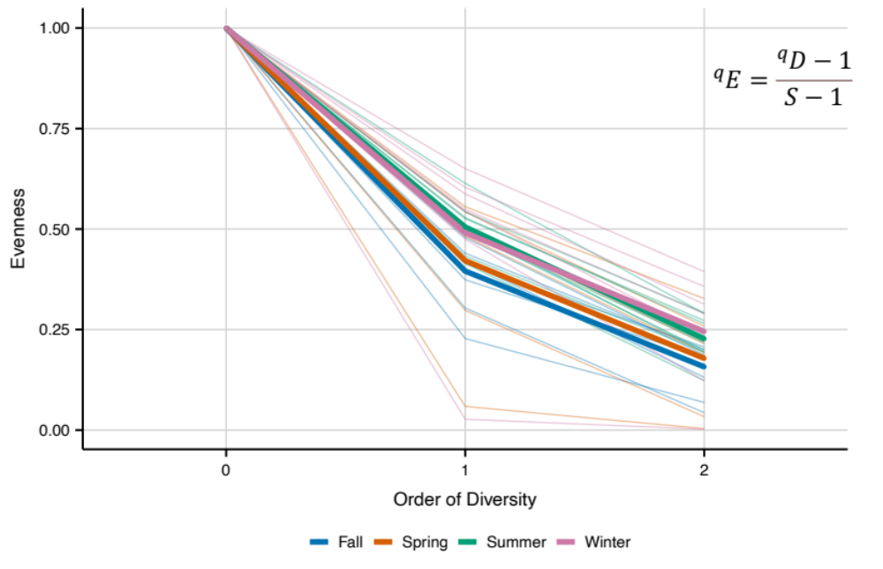
Figure 11: Evenness profile of communities on salamanders seasonally.

study sampled nine sites seasonally, we first addressed variance partitioning of the horn dissimilarity and tested variables with a dbRDA and anova.cca and then compared seasonal turnover with a multivariate Welch t-test with a Bonferroni correction.
Unconstrained ordination of the horn dissimilarity of salamander communities revealed clustering associated with habitat, with some evidence of Site and Season (Fig. 12, Fig. A6). Variance partitioning (adjusted r²) found variables explained 27% of inertia, with Site explaining 6%, Habitat explaining 5% and Season explaining 4%. The bulk of inertia explained came through the interaction term of Habitat and Season (12%), as expected given our sampling
scheme and research questions (Fig. A7). Phylogenetic turnover was considerably less than taxonomic turnover for salamanders. Our variables (Site, Habitat, and Season) explained 44% of inertia, with Site explaining 9%, Habitat 7%, and Season 8%. Similar to taxonomic turnover, the
interaction between Habitat and Season explained 20% of inertia (Fig. A8). For both taxonomic and phylogenetic β diversity, Habitat, Season, and Site explained a significant amount of inertia, even when partialling out significant interaction terms in our dbRDA and anova.cca (all p <0.05). The average taxonomic turnover between salamanders sampled in the same season (across sites) was 0.645, while the average turnover between salamanders sampled from the same site (across seasons) was 0.684. While subtle, these results indicate that seasonality within a site contributes more variation to host-associated communities at a small geographical scale than characteristics between sites, consistent with unconstrained ordination and variance partitioning.
To provide higher resolution hypothesis testing of turnover patterns seasonally, we used a Welch t-test for distances and corrected for multiple comparisons using a sequential Bonferroni. While all explanatory variables were statistically significant in dbRDA, the evenness and beta analyses suggested communities might stabilize after initial disturbance, meaning turnover within a habitat (but different seasons) would be lower than turnover between habitats (and between seasons). Multivariate Welch t-test found seasonal turnover of consecutive seasons was significantly higher when hosts either entered water (Fall to Winter, $T_{w}^{2}$: 2.80, p=0.001) or entered land (Spring to Summer: $T_{w}^{2}$=3.88, p=0.001) than when they remained on land (Summer to Fall: $T_{w}^{2}$=1.24, p=0.132) or in water (Winter to Spring: $T_{w}^{2}$=1.35, p=0.18). These results confirmed patterns of turnover within a site across seasons and habitats (Fig. 13) and confirmed
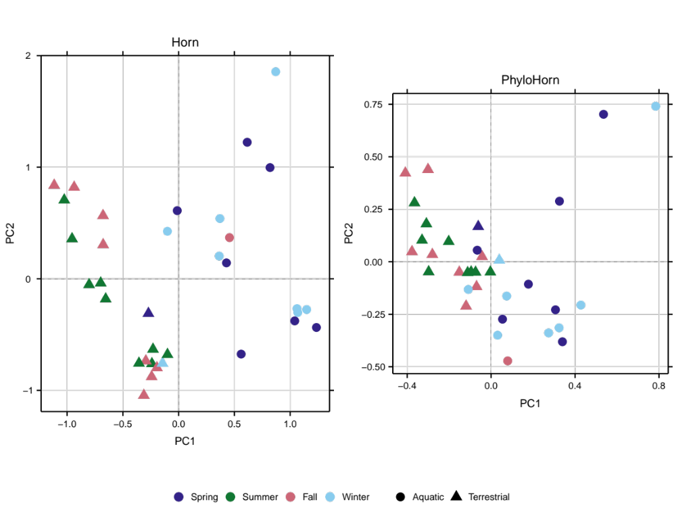
Figure 12: Unconstrained ordination of Horn and PhyloHorn dissimilarities of salamander-associated communities.
patterns of turnover within a site across seasons and habitats (Fig. 13) and phylogenetic dissimilarity showed identical trends (Spring to Summer: $T_{w}^{2}$=6.47, p=0.01, Fall to Winter: $T_{w}^{2}$=3.85, p=0.01, Summer to Fall: $T_{w}^{2}$=1.26, p=0.36, Winter to Spring: $T_{w}^{2}$=1.57 p=0.36).
Cover objects showed similar patterns as salamanders in terms of variance partitioning and unconstrained ordination. Site explained just 3% of inertia (adjusted r²) for cover objects, while Habitat and Season explained 15% and 6%, respectively. Similar to salamander samples, the interaction between Habitat and Season explained 37% of the variance. While Habitat and Season predicted a significant amount of variance in our dataset (p<0.01, p<0.01), Site did not (p=0.97), and our unconstrained ordination showed strong clustering associated with Habitat. Evaluating the pairwise turnover described above for assessing turnover within a site, cover objects had the lowest turnover (highest similarity) to cover objects in the same habitat (0.53) and showed the highest average dissimilarity to cover objects in a different habitat (0.825).

Common core reflects environmental reservoirs
The common core describes OTUs consistently detected on hosts in each sampling period. Our common core definition identified OTUs detected on 80% of salamander hosts in each sampling season (Spring, Summer, Fall, Winter). For the common core, we identified 260 OTUs (164 unique), with spring samples having 104 taxa, 43 in winter, 44 in fall, and 69 in summer. In spring, the 104 core taxa consisted of 50 taxonomic families and averaged 0.25 relative abundance on salamander samples and 0.23 in cover objects (Fig. 14). Across all sites, 67 of these 104 OTUs were in the top 100 most abundant OTUs on hosts in our Spring sampling period. The most abundant taxonomic families on salamander hosts- Chitinophagaceae, Pedosphaeraceae, Xanthobacteraceae, and Sphingomonadaceae – contained core OTUs (5, 5, 2, and 3), although the relative abundance of these families was not exclusively limited to core members. Sixty-nine OTUs were identified as core members for our summer sampling, spanning 34 taxonomically identified families. These taxa comprised an average cumulative relative abundance of 0.24 on salamanders and 0.25 on cover objects, and 54/69 OTUs were in the top 100 most abundant OTUs on salamanders during the summer sampling period. The most abundant families on salamanders were again heavily comprised of core OTUs, with Chitinophagaceae (6), Comamonadaceae (4), Xanthobacteraceae (4), and Sphingomonadaceae
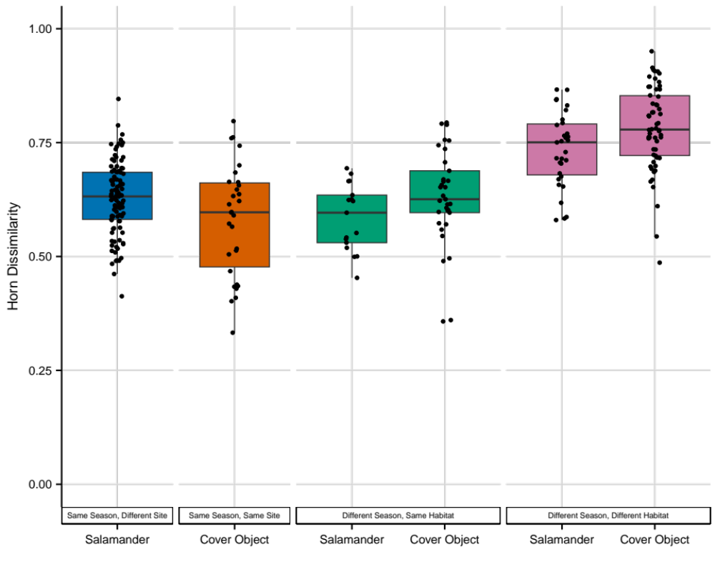
Figure 13: Pairwise turnover of salamander samples to other samples.

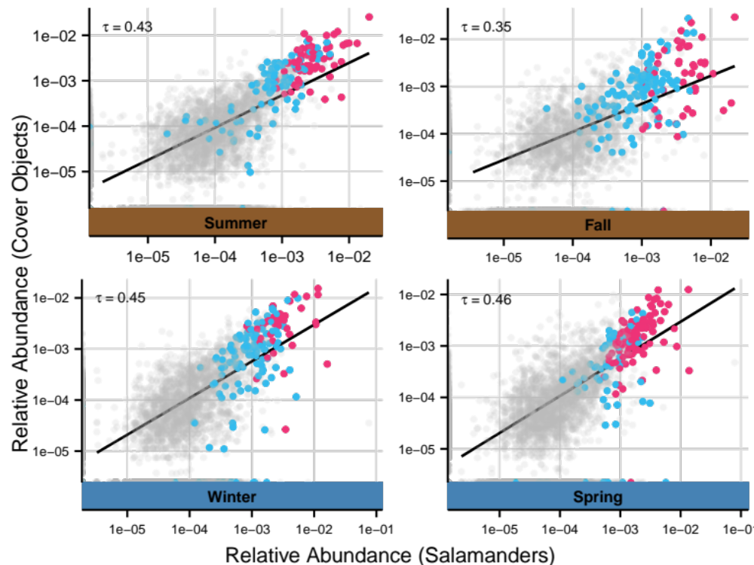
Figure 14: Relative abundance of the common ‘core’ microbiome on salamanders and cover objects. Red points denote core membership for that season, while blue indicate core OTUs for other seasons.

(5) constituting both the highest relative abundance on salamanders and core membership (Figs. A9-A10).
The common core associated with fall sampling contained 44 OTUs with an average relative abundance of 0.22 on salamanders and 0.17 on cover objects. These taxa consisted of 28 families, with Sphingobacteriaceae and Sphingomonadaceae containing three OTUs a piece, and only seven families containing more than one OTU. Community-level relative abundance again relied heavily on core members, with Chitinophagaceae being the most abundant taxonomic family and containing two core OTUs, followed by Comamonadaceae and Pseudomonadaceae
represented by just a single core member each, and Sphingomonadaceae and Xanthobacteraceae containing 3 and 2 core OTUs, respectively. Thirty-seven of our 44 common core OTUs for fall sampling were among the top 100 most abundant OTUs. Winter sampling found 43 common taxa detected across 80% of salamanders and were equally abundant on salamanders and cover objects, averaging 0.16 relative abundance. These taxa spanned 27 families, and contained
34 of our top 100 most abundant OTUs in winter. The most abundant family during our winter sampling was again Chitinophagaceae which only contained a single core member, followed by Sphingomonadaceae (3), Pedosphaeraceae (2), and Comamonadaceae, with Comamonadaceae being the most represented family in our winter common core with six OTUs (Figs. A11-A12).
Twelve out of 164 OTUs (7%) were shared common core taxa across all four seasons. Seventeen OTUs were members of the common core across three seasons, while an additional 26 were members in two seasons. Taxa detected on 80% of individuals across all four sampling seasons had an average relative abundance of 0.084 (min: 0.03, max: 0.16). Of the twelve OTUs, only the family Sphingomonadaceae had three members, while the remaining nine families had one. One OTU was unidentified and result from BLASTn (Camacho et al., 2009) indicated the closest identified sequence (99% similarity) belonged to the genus Devosia in the family Devosiaceae. One hundred and nine OTUs were found only in a single season, meaning the majority (66%) of OTUs identified as a common core fluctuated seasonally and were not necessarily persistent on salamander hosts over time and habitats. Mirrored representation on cover objects indicates these taxa are predominately abundant and highly detectible on salamanders due to horizontal transmission from cover objects.

Temporal core captures wide-ranging microbes
We defined the temporal core as OTUs detected on 75% (3/4) or more salamanders within a site over the course of one year. For each of our nine sites, the temporal core ranged from 50 to 313 OTUs, comprised of 120 taxonomically identified families, with 546 unique OTUs (3% of total OTUs). Cumulative relative abundance of these OTUs on salamanders within a given site ranged from 0.09 to 0.60, with a mean of 0.33 (Fig. 15). The same temporal core showed a slightly lower cumulative relative abundance on cover objects (mean 0.27), but a similar distribution (min: 0.06, max 0.55). At each site, the top 100 most abundant OTUs on
hosts over the course of the year were comprised of anywhere between 30 and 89 of our temporal core members. Ten families were responsible for an average of 0.25 relative abundance on salamanders across all sites (Fig. A13).
Only twelve out of the 546 OTUs were shared on salamanders across all sites. These twelve taxa comprised an average relative abundance of 0.07 on salamanders and 0.05 in cover
objects. Nine of these taxa were also members of the 12 OTUs detected across all four seasons in the common core. These nine taxa came from seven different taxonomic families, with Sphingomonadaceae containing 3 OTUs and a single representative from Rizobiaceae, Chitinophagaceae, Microbacteriaceae, Xanthobacteraceae, and Xanthomonadaceae, and Devosiaceae. An additional 13 OTUs were determined to be in the temporal core for 8 sites, while seven and six sites each had 20 OTUs. Two hundred and fifty-three OTUs (46%) were only found in a single site, while 105 OTUs were shared only between two sites, highlighting the role of geographic location on host-associated communities in detection-based assessment. The virtually matched relative abundance on cover objects likely indicates most temporal core members possess widespread distribution within a site with, in most cases, less evidence for subsistence on amphibians.

Anti-Bd taxa more represented in terrestrial hosts and habitats
The defense functional core was identified by pairing reference sequences of our dataset to the database of 16S sequences from isolates capable of producing anti-Bd metabolites in challenge assays (Woodhams et al., 2015). We allowed up to a 3 base-pair mismatch of our sequences, which had an average length of 417 nucleotides, meaning our threshold selected sequences higher than a 99% sequence similarity to the database. This resulted in 38 OUT reference
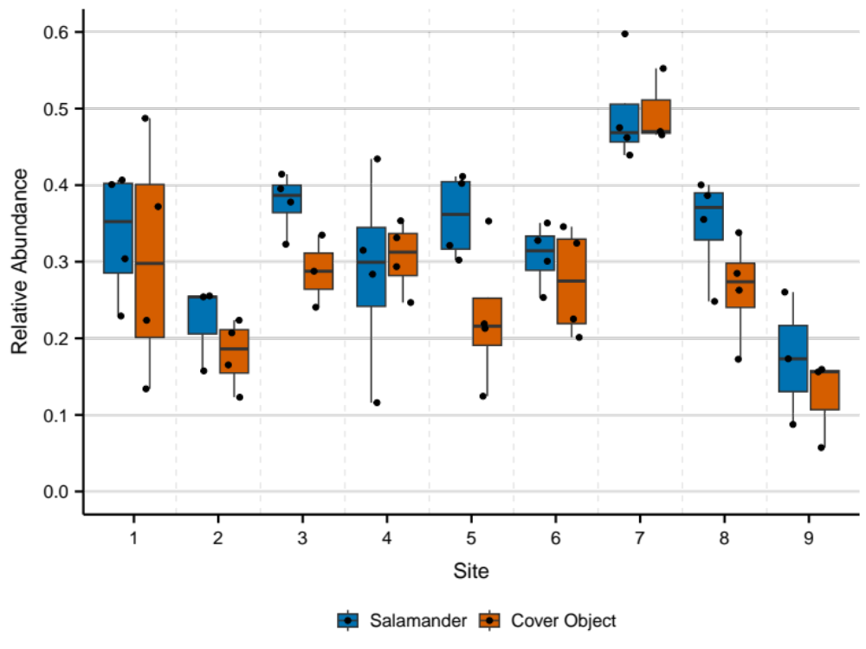
Figure 15: Relative abundance of the temporal core on salamanders and cover objects for each site.
sequence matches to 153 16S sequences in the database. Across 100 rarefactions, these OTUs averaged a collective 0.05 relative abundance on salamanders (min: 0.004, max: 0.23), and only 0.01 relative abundance in cover objects (min: 0, max: 0.20), signifying a potential high fidelity for functionally important taxa on salamander hosts. OTUs identified with anti-Bd capabilities were more prevalent and abundant in terrestrial habitats for both salamanders and cover objects. In other words, seasons where salamanders utilized a terrestrial habitat (Summer and Fall for 7/9 sites), were associated with a higher proportion of anti-fungal capable OTUs (Fig. 16). While these OTUs were less abundant in aquatic habitats, some persisted on salamanders over the course of the sampling seasons.
Our functional core consisted of five OTUs belonging to Pseudomonadaceae, four OTUs belonging to Xanthomonadaceae, Flavobacteriaceae, Enterobacteriaceae, and Moraxellaceae, five families with two anti-fungal OTUs, and seven families represented by a single OTU (Table A4). Of the 38 OTUs, three were detected on every salamander and belonged to the genera Pseudomonas, Rhizobium, and Stenotrophomonas. Janthinobacterium was additionally detected on 85% of salamanders. In total, 11 of 38 (29%) of OTUs were detected on half or more of salamanders, with only four OTUs being detected in only one sample. However, the majority of anti-Bd OTUs were also consistently detected in cover object samples. Only eight OTUs were not detected in cover object communities and those detected on every salamander were also detected on 22, 26, and 9 cover objects, suggesting that while salamanders could facilitate the maintenance of these symbionts between aquatic and terrestrial habitat transitions, they are not specific to amphibian hosts.

Non-random associations uncovered by a host-associated core
The host-associated core was defined as taxa showing a positive correlation with hosts. We identified OTUs using the ‘strassoc’ function in indicspecies, and selected OTUs with an average point biserial correlation coefficient higher than 0.3 across 1000 rarefactions. In total, 58 OTUs possessed a r_{pb} greater than 0.3. Average cumulative relative abundance of these taxa was 0.10 on salamanders (min: 0.02, max: 0.26) and 0.02 in cover objects (min 0.002, max: 0.10) (Fig. 17). Beijerinckiaceae and Sphingobacteriaceae were the two most prevalent families represented, each containing five OTUs. Of the 58 OTUs, only five were detected on every
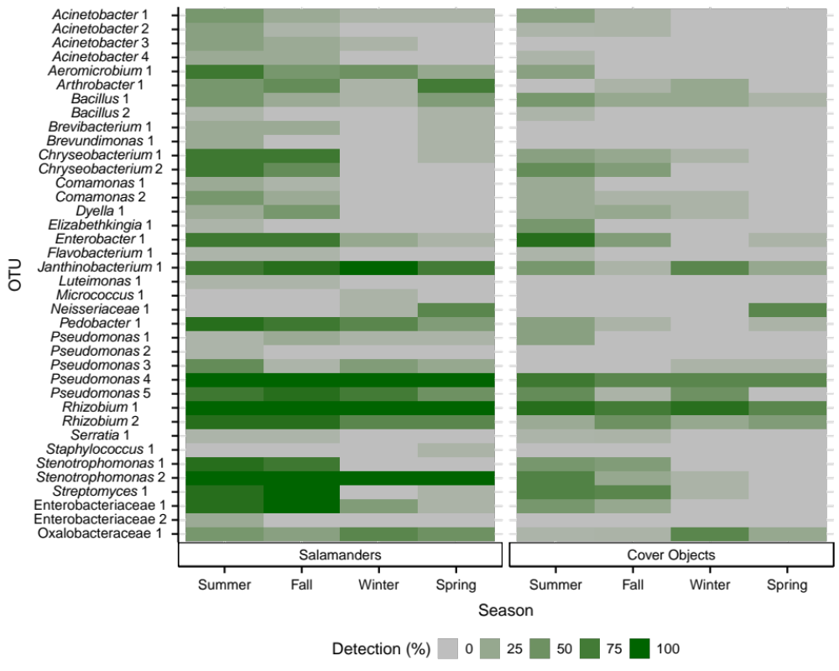
Figure 16: Detection of defensive OTUs on salamander and cover objects.

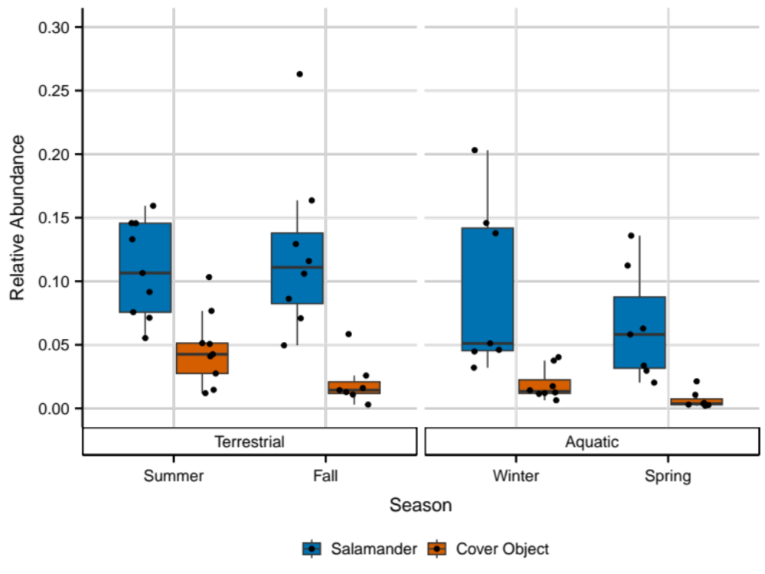
Figure 17: Relative abundance of OTUs showing statistical affinity for salamanders.
salamander and belonged to the genera Pseudomonas, Salinibacterium, Sphingomonas, Rhizobium, and Stenotrophomonas. Notably, these OTUs were additionally detected in between nine and thirty cover objects. Three of these five OTUs (Pseudomonas, Rhizobium, and Stenotrophomonas) were also in the other three core definitions. In total, 8 OTUs (14%) of the host-associated core were also capable of chytrid inhibition.
Kernel density estimates of observed and simulated null distributions produced contrasting patterns. Randomized communities exhibited a trimodal distribution of indicator species correlations, with the highest density centered on zero, while our observed samples showed a bimodal distribution with relatively low density around zero and peaks of higher density around 0.1 and -0.1, meaning a larger fraction of OTUs were moderately associated with either salamanders or cover objects than expected by chance (Fig. 18). This observed bimodality was concentrated in either a slightly negative or slightly positive association range and stems
from many OTUs having detection on only a few salamanders and no cover objects, or vice versa. OTUs negatively associated with salamanders could additionally reflect microbes with low relative abundance in cover objects and dormant microbes with low dispersal probability. In many cases, OTUs positively associated with salamander skin were not exclusive to salamander-associated communities but instead showed strong associations through differential abundance. For example, nineteen of our indicator OTUs were detected in ten or more cover objects, while 22 were found on two or fewer. In this regard, taxa in the host-associated core fall on a spectrum between OTUs disproportionately abundant on salamanders with similar detection rates on cover objects, and OTUs disproportionately detected on salamanders.

Discussion
External microbiomes are highly susceptible to immigration from environmental reservoirs, making it unclear how specific communities are to a host and which symbionts could be candidates for more intimate associations. We have previously shown that salamander-associated communities are differentiated by microhabitat utilization, with some evidence for microbes showing tolerance for the ‘salamander condition’. Even between co-occurring hosts, communities are highly heterogeneous, with differentiation consistent with neutral processes. In this study, we assessed the temporal constancy of skin bacterial assemblages of Eurycea cf.
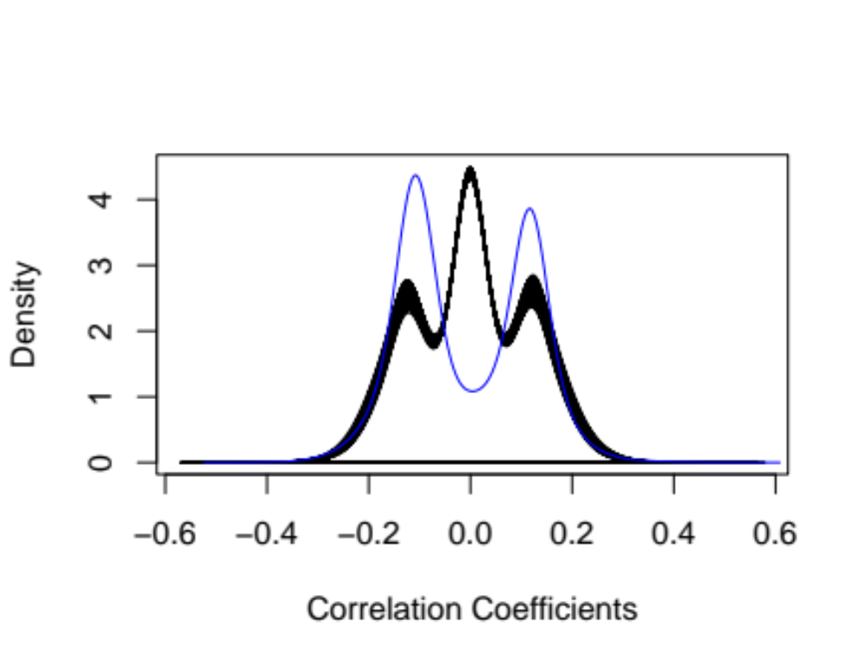
Figure 18: Distribution of observed (blue) and simulated (black) correlation coefficients.
wilderae over the course of four seasons as hosts move between aquatic and terrestrial habitats. We used taxonomic and phylogenetic turnover to assess community patterns and tested whether a non-random component of the skin microbiome remains consistent over habitat transitions using commonly applied ‘core’ microbiome definitions. Our results found high seasonal turnover of skin assemblages, particularly when salamanders shifted between aquatic and terrestrial habitats. In general, the most common bacteria on salamander skin were also common on cover objects, suggesting that a simplistic concept of a core microbiome as those taxa that are common on hosts is of limited value. However, there are bacteria with weak to modest statistical associations with salamander skin relative to cover objects, including some taxa with antifungal metabolites that could provide defensive benefits to the hosts. Thus, it is possible that there is a defensive functional core providing important or even essential services on salamander skin.
Seasonality and habitat utilization had little effect on the alpha diversity of E. cf.
wilderae, as we found subtle differences regarding the effective number of species between seasons or habitats, especially when taking relative abundance into account. The consistency of diversity seasonally and across habitats contrasts with seasonal studies on anurans, which typically find a decrease in alpha diversity of skin samples during cooler months (Hernández-Gómez & Hua, 2023; Le Sage et al., 2021; Tong et al., 2020). That said, the overwintering of Rana dybowskii occurs under ice where hosts undergo documented reduced metabolic rates. Similarly, the reduced alpha diversity observed in Lithobates palustris occurred in March, when amphibians had the lowest ambient body temperatures. Eurycea bislineata, a close relative to E. cf. wilderae, is known to be mobile and partake in nest guarding and foraging during the winter months in aquatic habitats (Ashton & Ashton, 1978). While activity is likely less, movement within microbe rich streams would still enable potential colonization from cover objects to hosts, which is additionally supplemented by flowing water. The observed increase in community evenness and turnover in the sampling season associated with changing habitats suggests salamander hosts are acquiring microbes year-round, even in the colder months. Thus, hosts are not metabolically reduced in such a way that prohibits the sustenance of resident populations, and microbes are not metabolically compromised to prevent dispersal and establishment on hosts in Southern Appalachian streams.
Bacterial communities on salamanders displayed high taxonomic and phylogenetic turnover, mirroring the results of other temporal studies of amphibians at varying sampling frequencies (Bletz, Perl, Bobowski, et al., 2017; Ellison et al., 2021; Sabino Pinto et al., 2017; Walke et al., 2021). While some of this could be attributed to the lack of repeated sampling of the same individuals, Bletz et al. (2017) observed equally high turnover rates temporally in the T. cristatus microbiome despite sampling the same individuals. Pairwise turnover appears to be consistently high between salamander hosts, and taxonomic and phylogenetic turnover in this study were significantly higher when hosts underwent habitat shifts. External microbiomes are sensitive to immigration, and host effects appear to be to be less influential than stochastic immigration from environmental reservoirs. While unconstrained ordinations of salamander samples show clustering associated with habitat, salamander-associated communities most resemble communities found beneath their immediate cover object, emphasizing the importance of immigration in shaping salamander-associated communities. Host-associated communities showed a subtle increase in evenness when hosts shifted habitats, consistent with habitat changes acting as an intermediate disturbance affecting both taxa represented and equity of abundances. This is consistent with stochastic immigration from a new regional pool (in the new habitat) coupled with declines and local extinction of resident species. Hosts remaining in the same habitat for consecutive sampling seasons had more uneven bacterial communities with shifts in relative abundance consistent with competition and continued immigration from the same or similar regional pool (in the same habitat). As a result, temporal constancy is restricted to broad-ranging taxa and a few OTUs displaying affinity for salamander conditions in otherwise transient communities. As such, any disturbance impacting the reservoir communities (land use change), or host habitat utilization will also be reflected in host-associated assemblages.
A ‘core microbiome’ describes an attempt to identify the ecologically and functionally important microbes associated with a host or environment and is often referenced for identifying important symbionts. Our results indicate phenomenological definitions of a common and temporal core microbiome based on the most abundant or prevalent taxa found on amphibian skin offer limited promise for identifying which microbes are candidates for potential positive associations with hosts, and the spatial/temporal trends of those associates. Instead, these definitions more broadly represent the most abundant microbes in reservoirs. We propose identifying symbionts using statistical procedures coupled with thorough sampling of both hosts and environmental reservoirs to parse signatures of positive associations from environmental colonization.
Temporal trends in anti-fungal bacteria associated with amphibian hosts are relevant to conservation biology given the global decline of amphibians owing to Bd/Bsal chytridiomycosis. The Blue Ridge ecoregion is of particular concern due to high amphibian richness and density, introduction risk, Bsal climatic suitability, and species susceptibility (Grisnik et al., 2023). Chytrid pathogens are more prevalent in aquatic environments and show evidence of temperature dependence making hosts particularly susceptible during cooler months in aquatic environments (Carter et al., 2021). Members of Eurycea have shown species and population variation in susceptibility and lethality to Bsal, ranging from susceptible yet experiencing no mortality (Eurycea lucifuga) to populational variability in susceptibility and mortality (Eurycea wilderae), with some variability confounded by captive-rearing (Carter et al., 2020). In the present study, temporal trends of microbes matching isolates associated with chytrid-inhibiting properties indicate varying patterns of environmental transmission and persistence. We found both a decrease in prevalence (detection) and relative abundance of anti-Bd on aquatically captured salamanders, with the relative abundance of defensive OTUs peaking on hosts in terrestrial sampling seasons (particularly fall) and then declining in the aquatic season. This suggests antifungal capabilities are more prevalent in terrestrial habitats in the Blue Ridge and that defensive OTUs are capable of colonizing the hosts from reservoirs.
Defensive OTUs were more scarce in aquatic habitats, and those that were detected were far less abundant. Despite the large turnover of the Eurycea skin microbiome seasonally and a decrease in anti-Bd richness on hosts in aquatic habitats, we found evidence for the persistence of defensive OTUs on salamander skin even when they were extremely rare in environmental samples. Salamander skin appears to actively or passively favor bacteria with antifungal metabolites. Twenty-one out of thirty-eight defensive OTUs showed lower temporal variability on salamanders than cover objects, and eight OTUs were statistically identified to have positive associations with hosts. Of these eight, four were in the top six most abundant anti-Bd taxa and belonged to Pseudomonas, Stenotrophomonas, Rhizobium, and Janthinobacterium. While some defensive OTUs may colonize hosts from aquatic habitats, others show persistence on hosts through affinity for salamander skin in the aquatic environment after colonizing from terrestrial reservoirs.
Five OTUs in our dataset (0.027% of all OTUs) were consistent across all four core definitions, indicating they are commonly found within a sampling period and across time and space while also having statistical associations with salamander skin and potential functional relevance to hosts. These OTUs belonged to the genera Janthinobacterium, Stenotrophomonas, Pseudomonas, and Rhizobium. Janthinobacterium isolated from a plethodontid salamander was the first documented host-associated isolate capable of inhibiting Bd in vitro and is commonly found in amphibian microbiome studies (Harris et al., 2009; Muletz et al., 2014). Observed bioactivity against Bd in Janthinobacterium isolates is hypothesized to be linked to violacein production, with three variable genes (vioB, vioC, and vioD) potentially leading to strain level differences in inhibition (Wax et al., 2023). Members of Stenotrophomonas have also been linked to antifungal capabilities (Barnes et al., 2020; Becker et al., 2015) but have also been associated with Bd susceptibility (Bates et al., 2022). This genus is consistently a dominant taxon on Plethodontid salamander hosts in Southern Appalachia (Ch. 1) and has been also linked to venom production in cone snails and providing nutrients and plant growth hormones in the rhizosphere (Ryan et al., 2009; Torres et al., 2017). Given its bioactivity in lab experiments, high fidelity on salamander hosts, and low intra-genus diversity, this genus warrants further investigation regarding what mechanisms could facilitate symbiosis with hosts and potential benefits from association for both parties.
Pseudomonas has been associated with anti-fungal capabilities for amphibian hosts, with Becker (2015) finding 73% of strains capable of Bd inhibitions. Similarly, nearly 40% of Pseudomonads isolated from salamander skin had defensive properties (Barnes et al., 2020). Host benefits attributed to Pseudomonas are not restricted to antifungal capabilities, with a recent study (Brunetti et al., 2022) finding Pseudomonas sp. resulting in sex-specific scents in frogs and isolates possessing genomic modifications adapted for anti-microbial peptide resistance. Even more, this isolate was also capable of metabolizing macrocyclic acylcarnitine, a major metabolite secreted by hosts, as its sole carbon and nitrogen source (Brunetti et al., 2023). Pseudomonas is a diverse clade, and tight associations are likely limited to select strains that could engage in reciprocal selection despite environmental transmission. Symbiont fitness could increase from enhanced dispersal by associating with a host and niche expansion in the ability to metabolize host secretory products, while host fitness could increase through sex-specific scents, antifungal, or predator deterrent compounds (Vaelli et al., 2020). The genus Rhizobium is associated with nitrogen fixation capabilities in plants as an endosymbiont but can also exist as a free-living saprophyte with antifungal compounds in soils and low dispersal capabilities (Nemergut et al., 2013; Pawar et al., 2014). It has been found on other amphibians, ranging from Europe to North America (Costa et al., 2016; A. J. Douglas et al., 2020), and can produce antifungal compounds in association with bats to combat white-nose syndrome (Grisnik et al., 2020).
Our results suggest symbionts associated with salamander hosts are largely transient and are not ‘distinct’ from environmental reservoirs with the exception of a few non-random associations uncovered by statistical associations and defensive capabilities. These genera represent the best candidates for investigating the possibility of intimate associations in otherwise transient communities. Potential benefits of skin symbionts for hosts include defense against predators (Vaelli et al., 2020), defense against skin pathogens like Bd and Bsal (Flechas et al., 2012; Muletz et al., 2012b), defense against opportunistic saprophytes that can infect eggs when left untended (Walke et al., 2011), and chemical signals affecting courtship (Brunetti et al., 2019). Potential benefits to skin symbionts from hosts include nutrition and enemy-free space (Brunetti et al., 2023), but reciprocal benefits are not necessary, and perhaps not to be expected in very open systems such as skin. Whether there is a ‘functional core’ set of microbes that are critical to host resistance to disease is an important question for conservation, and the genetic and ecological underpinnings of skin-microbe interactions are keys for understanding coevolution in complex communities. Our results, in combination with previous studies, point towards a few specific bacterial taxa that should be investigated in greater depth regarding what promotes persistence of environmentally derived symbionts on amphibian skin.

Conclusion

This dissertation took a high resolution spatial and temporal investigation of the amphibian skin microbiome in the context of environmental reservoirs. In Chapter one, I sought to clarify the role of host ecology and phylogeny by evaluating the similarities and differences between salamanders and cover objects pertaining to habitat, microhabitat, and host species. I found that salamander-associated assemblages are differentiated by host species; however, differentiation is not consistent with host-mediated selection, but instead most reflects differences in microhabitat utilization. I additionally show that while cover objects are strongly differentiated by habitat, salamander-associated communities are largely heterogenous and harbor little similarities. Microbes showing statistical affinity for salamander skin appear to be generally associated with ‘salamander conditions’ rather than species-specific conditions. More broadly, communities on salamanders tend to be most similar to their immediate cover objects suggesting high reliance on environmental reservoirs and ecological processes rather than host-specific traits. With the expansion of scientific explorations of microbial communities associated with hosts, much attention has been given to the role of host traits in shaping communities, but my results emphasize the influence of environmental colonization. These results highlight the critical need for thorough, high-resolution sampling of source communities when assessing the specificity of external microbiomes associated with a particular host species.
In Chapter two, I assessed the signatures of deterministic and stochastic processes between hosts, other hosts, and cover objects in the context of priority effects, salamander-mediated selection, and random environmental transmission. Ecological null models revealed that assemblages on cover objects were comprised of taxonomically and phylogenetically similar microbes characteristic of the microhabitat occupied by host species. Salamanders-associated communities, contrastingly, were as different as expected by chance, reflecting idiosyncratic, rather than salamander-specific, conditions. Communities on salamanders were differentiated from communities on cover objects, but differences between host and free-living communities were along a predominately shared phylogeny and most prevalent at the lowest taxonomic levels. This indicates the salamander skin microbiome is a product of weak and random ecological forces, apart from a small subset of microbes that is statistically associated with salamanders across habitats and sampling sites.
Finally, in Chapter three, I assessed the temporal constancy of the salamander skin microbiome by sampling a migratory salamander between aquatic and terrestrial habitats for the course of a year. I found high community turnover between samplings seasons which was exacerbated when hosts changed habitats, consistent with colonization from a different regional pool of microbes. Microbes consistently detected on salamanders during each sampling season were equally represented in source communities, as were microbes detectable on hosts over the course of a year. This corroborates results from previous chapters in that continuous environmental colonization is a consistent structuring component of external microbiomes. As such, changes to environmental reservoirs (captive rearing or land-use change) will manifest changes in communities associated with amphibians. The seasonal dynamics of defensive microbes is particularly relevant since chytrid is most prevalent in aquatic habitats and during cooler months. I found potential defensive OTUs capable of inhibiting the growth of chytrid were more prevalent in terrestrial habitats but showed persistence on salamander hosts over time and space. Five of these of these were statistically associated with salamanders and readily detectable, providing evidence for some non-random associations in an otherwise transient community.
To conclude, host-microbe associations can have profound consequences for evolutionary trajectories of hosts by mediating physiology, behavior, and reproduction. In intimate relationships, hosts and symbionts can engage in reciprocal interactions promoting co-dependence. Environmentally acquired symbionts are more puzzling from an evolutionary perspective but can still engage in positive benefits for hosts. We show that while most microbes found on salamander skin are consistent with environmental colonization from cover objects, a few taxa showing consistent affinity for salamander over time and space show promise for future investigation. Reciprocal benefits leading to co-evolutionary patterns are likely not to be expected for these symbionts, but mechanisms detailing persistence and partner benefits will enhance understanding of how engaging in symbiotic relations could promote mutual benefits for both parties.

References

Abramyan, J., & Stajich, J. E. (2012). Species-specific chitin-binding module 18 expansion in the amphibian pathogen Batrachochytrium dendrobatidis. mBio, 3(3), e00150-00112. https://doi.org/10.1128/mBio.00150-12
Alekseyenko, A. V. (2016). Multivariate Welch t-test on distances. Bioinformatics, 32(23), 3552–3558. https://doi.org/10.1093/bioinformatics/btw524
Allison, A. (2012). Diffuse interactions between symbiotic bacteria and salamanders. Thesis. University of Tennessee. https://www.semanticscholar.org/paper/Diffuse-interactions-between-symbiotic-bacteria-and-Allison/2923fdcae79974fb1167975d8b046d88e2503787
Antwis, R. E., Edwards, K. L., Unwin, B., Walker, S. L., & Shultz, S. (2019). Rare gut microbiota associated with breeding success, hormone metabolites and ovarian cycle phase in the critically endangered eastern black rhino. Microbiome, 7(1), 27. https://doi.org/10.1186/s40168-019-0639-0
Antwis, R. E., Harrison, X. A., & Cox, M. J. (Eds.). (2020). Microbiomes of Soils, Plants and Animals: An Integrated Approach. Cambridge University Press. https://doi.org/10.1017/9781108654418
Antwis, R. E., Haworth, R. L., Engelmoer, D. J. P., Ogilvy, V., Fidgett, A. L., & Preziosi, R. F. (2014). Ex situ Diet Influences the Bacterial Community Associated with the Skin of Red-Eyed Tree Frogs (Agalychnis callidryas). PLOS ONE, 9(1), e85563. https://doi.org/10.1371/journal.pone.0085563
Ashton, R. E., & Ashton, P. S. (1978). Movements and Winter Behavior of Eurycea bislineata (Amphibia, Urodela, Plethodontidae). Journal of Herpetology, 12(3), 295–298. https://doi.org/10.2307/1563609
Augustine, L., & Neff, M. (2016). Determining the prevalence of Amphibian Chytrid Fungus (Batrachochytrium dendrobatidis) and Ranavirus at Long Branch Nature Center in Arlington, Virginia. Catesbeiana, 36(1). http://ww.virginiaherpetologicalsociety.com/catesbeiana-pdf/cat36n1/v36n1-Determining_the_prevalence_of_Amphibian_Chytrid_Fungus_and_Ranavirus_at_Long_Branch_Nature_Center_in_Arlington_Virginia.pdf
Austin, R. (2000). Cutaneous microbial flora and antibiosis in Plethodon ventralis. The Biology of Plethodontid Salamanders, 451–461.
Barbosa, E. A., Alves, G. S. C., Coura, M. de M. A., Silva, H. de L. e, Rocha, F. S. da, Nunes, J. B., Watanabe, M. de S., Andrade, A. C., & Brand, G. D. (2022). A first look at the N- and O-glycosylation landscape in anuran skin secretions. Biochimie, 197, 19–37. https://doi.org/10.1016/j.biochi.2022.01.008
Barnes, E. M., Carter, E. L., & Lewis, J. D. (2020). Predicting Microbiome Function Across Space Is Confounded by Strain-Level Differences and Functional Redundancy Across Taxa. Frontiers in Microbiology, 11. https://doi.org/10.3389/fmicb.2020.00101
Barnhart, K., Bletz, M. C., LaBumbard, B., Tokash‐Peters, A., Gabor, C. R., & Woodhams, D. C. (2020). Batrachochytrium salamandrivorans elicits acute stress response in spotted salamanders but not infection or mortality. Animal Conservation, 23(5), 533–546. https://doi.org/10.1111/acv.12565
Bascompte, J., & Olesen, J. M. (2015). Mutualistic Networks in Mutualism. Oxford University Press.
Bates, K. A., Sommer, U., Hopkins, K. P., Shelton, J. M. G., Wierzbicki, C., Sergeant, C., Tapley, B., Michaels, C. J., Schmeller, D. S., Loyau, A., Bosch, J., Viant, M. R., Harrison, X. A., Garner, T. W. J., & Fisher, M. C. (2022). Microbiome function predicts amphibian chytridiomycosis disease dynamics. Microbiome, 10(1), 44. https://doi.org/10.1186/s40168-021-01215-6
Bauer, K. L., Steeil, J. C., Walsh, T. F., Evans, M. J., Klocke, B., Gratwicke, B., Siegal-Willott, J. L., & Neiffer, D. L. (2018). Batrachochytrium dendrobatidis in a captive collection of Green Salamanders (Aneides aeneus), Long-tailed salamanders (Eurycea longicauda) and Two-lined salamanders (Eurycea bislineata)
Journal of Zoo and Wildlife Medicine, 49(2), 454–459. https://doi.org/10.1638/2017-0174.1
Beachy, C. K., & Bruce, R. C. (1992). Lunglessness in Plethodontid Salamanders is Consistent with the Hypothesis of a Mountain Stream Origin: A Response to Ruben and Boucot. The American Naturalist, 139(4), 839–847.
Becker, M. H., Walke, J. B., Murrill, L., Woodhams, D. C., Reinert, L. K., Rollins-Smith, L. A., Burzynski, E. A., Umile, T. P., Minbiole, K. P. C., & Belden, L. K. (2015). Phylogenetic distribution of symbiotic bacteria from Panamanian amphibians that inhibit growth of the lethal fungal pathogen Batrachochytrium dendrobatidis. Molecular Ecology, 24(7), 1628–1641. https://doi.org/10.1111/mec.13135
Belden, L. K., Hughey, M. C., Rebollar, E. A., Umile, T. P., Loftus, S. C., Burzynski, E. A., Minbiole, K. P. C., House, L. L., Jensen, R. V., Becker, M. H., Walke, J. B., Medina, D., Ibáñez, R., & Harris, R. N. (2015). Panamanian frog species host unique skin bacterial communities. Frontiers in Microbiology, 6. https://doi.org/10.3389/fmicb.2015.01171
Belley, A., Keller, K., Göttke, M., & Chadee, K. (1999). Intestinal mucins in colonization and host defense against pathogens. The American Journal of Tropical Medicine and Hygiene, 60(4_suppl), 10–15. https://doi.org/10.4269/ajtmh.1999.60.10
Bickford, D., Iskandar, D., & Barlian, A. (2008). A lungless frog discovered on Borneo. Current Biology, 18(9), R374–R375. https://doi.org/10.1016/j.cub.2008.03.010
Bird, A. K., Prado-Irwin, S. R., Vredenburg, V. T., & Zink, A. G. (2018a). Skin Microbiomes of California Terrestrial Salamanders Are Influenced by Habitat More Than Host Phylogeny. Frontiers in Microbiology, 9. https://doi.org/10.3389/fmicb.2018.00442
Bird, A. K., Prado-Irwin, S. R., Vredenburg, V. T., & Zink, A. G. (2018b). Skin Microbiomes of California Terrestrial Salamanders Are Influenced by Habitat More Than Host Phylogeny. Frontiers in Microbiology, 9. https://www.frontiersin.org/article/10.3389/fmicb.2018.00442
Blackburn, M., Wayland, J., Smith, W., McKenna, J., Harry, M., Hamed, M., Gray, M., & Miller, D. (2015). First Report of Ranavirus and Batrachochytrium dendrobatidis in Green Salamanders (Aneides aeneus) from Virginia, USA. Herpetological Review, 46, 357–361.
Bletz, M. C., Archer, H., Harris, R. N., McKenzie, V. J., Rabemananjara, F. C. E., Rakotoarison, A., & Vences, M. (2017). Host Ecology Rather Than Host Phylogeny Drives Amphibian Skin Microbial Community Structure in the Biodiversity Hotspot of Madagascar. Frontiers in Microbiology, 8. https://doi.org/10.3389/fmicb.2017.01530
Bletz, M. C., Perl, R. G. B., Bobowski, B. T., Japke, L. M., Tebbe, C. C., Dohrmann, A. B., Bhuju, S., Geffers, R., Jarek, M., & Vences, M. (2017). Amphibian skin microbiota exhibits temporal variation in community structure but stability of predicted Bd -inhibitory function. The ISME Journal, 11(7), Article 7. https://doi.org/10.1038/ismej.2017.41
Bletz, M. C., Perl, R. G. B., & Vences, M. (2017). Skin microbiota differs drastically between co-occurring frogs and newts. Royal Society Open Science, 4(4), 170107. https://doi.org/10.1098/rsos.170107
Boettiger, C., Coop, G., & Ralph, P. (2012). Is Your Phylogeny Informative? Measuring the Power of Comparative Methods. Evolution, 66(7), 2240–2251. https://doi.org/10.1111/j.1558-5646.2011.01574.x
Bolyen, E., Rideout, J. R., Dillon, M. R., Bokulich, N. A., Abnet, C., Al-Ghalith, G. A., Alexander, H., Alm, E. J., Arumugam, M., Asnicar, F., Bai, Y., Bisanz, J. E., Bittinger, K., Brejnrod, A., Brislawn, C. J., Brown, C. T., Callahan, B. J., Caraballo-Rodríguez, A. M., Chase, J., … Caporaso, J. G. (2018). QIIME 2: Reproducible, interactive, scalable, and extensible microbiome data science (e27295v2). PeerJ Inc. https://doi.org/10.7287/peerj.preprints.27295v2
Bolyen, E., Rideout, J. R., Dillon, M. R., Bokulich, N. A., Abnet, C. C., Al-Ghalith, G. A., Alexander, H., Alm, E. J., Arumugam, M., Asnicar, F., Bai, Y., Bisanz, J. E., Bittinger, K., Brejnrod, A., Brislawn, C. J., Brown, C. T., Callahan, B. J., Caraballo-Rodríguez, A. M., Chase, J., … Caporaso, J. G. (2019). Reproducible, interactive, scalable and extensible microbiome data science using QIIME 2. Nature Biotechnology, 37(8), 852–857. https://doi.org/10.1038/s41587-019-0209-9
Bordenstein, S. R., & Theis, K. R. (2015). Host Biology in Light of the Microbiome: Ten Principles of Holobionts and Hologenomes. https://doi.org/10.1371/journal.pbio.1002226
Brandon, R. A., & Huheey, J. E. (1981). Toxicity in the plethodontid salamanders Pseudotriton ruber and Pseudotriton montanus (Amphibia, Caudata). Toxicon, 19(1), 25–31. https://doi.org/10.1016/0041-0101(81)90114-8
Bright, M., & Bulgheresi, S. (2010). A complex journey: Transmission of microbial symbionts. Nature Reviews. Microbiology, 8(3), 218–230. https://doi.org/10.1038/nrmicro2262
Bruce, R. C. (2008). Intraguild Interactions and Population Regulation in Plethodontid Salamanders. Herpetological Monographs, 22, 31–53.
Brunetti, A. E., Bunk, B., Lyra, M. L., Fuzo, C. A., Marani, M. M., Spröer, C., Haddad, C. F. B., Lopes, N. P., & Overmann, J. (2022). Molecular basis of a bacterial-amphibian symbiosis revealed by comparative genomics, modeling, and functional testing. The ISME Journal, 16(3), Article 3. https://doi.org/10.1038/s41396-021-01121-7
Brunetti, A. E., Lyra, M. L., Bauermeister, A., Bunk, B., Boedeker, C., Müsken, M., Neto, F. C., Mendonça, J. N., Caraballo-Rodríguez, A. M., Melo, W. G. P., Pupo, M. T., Haddad, C. F. B., Cabrera, G. M., Overmann, J., & Lopes, N. P. (2023). Host macrocyclic acylcarnitines mediate symbiotic interactions between frogs and their skin microbiome. iScience, 26(11), 108109. https://doi.org/10.1016/j.isci.2023.108109
Brunetti, A. E., Lyra, M. L., Melo, W. G. P., Andrade, L. E., Palacios-Rodríguez, P., Prado, B. M., Haddad, C. F. B., Pupo, M. T., & Lopes, N. P. (2019). Symbiotic skin bacteria as a source for sex-specific scents in frogs. Proceedings of the National Academy of Sciences, 116(6), 2124–2129. https://doi.org/10.1073/pnas.1806834116
Burke, C., Steinberg, P., Rusch, D., Kjelleberg, S., & Thomas, T. (2011). Bacterial community assembly based on functional genes rather than species. Proceedings of the National Academy of Sciences, 108(34), 14288–14293. https://doi.org/10.1073/pnas.1101591108
Callahan, B. J., McMurdie, P. J., Rosen, M. J., Han, A. W., Johnson, A. J. A., & Holmes, S. P. (2016). DADA2: High-resolution sample inference from Illumina amplicon data. Nature Methods, 13(7), Article 7. https://doi.org/10.1038/nmeth.3869
Camacho, C., Coulouris, G., Avagyan, V., Ma, N., Papadopoulos, J., Bealer, K., & Madden, T. L. (2009). BLAST+: Architecture and applications. BMC Bioinformatics, 10, 421. https://doi.org/10.1186/1471-2105-10-421
Carter, E. D., Bletz, M. C., Sage, M. L., LaBumbard, B., Rollins-Smith, L. A., Woodhams, D. C., Miller, D. L., & Gray, M. J. (2021). Winter is coming–Temperature affects immune defenses and susceptibility to Batrachochytrium salamandrivorans. PLOS Pathogens, 17(2), e1009234. https://doi.org/10.1371/journal.ppat.1009234
Carter, E. D., Miller, D. L., Peterson, A. C., Sutton, W. B., Cusaac, J. P. W., Spatz, J. A., Rollins-Smith, L., Reinert, L., Bohanon, M., Williams, L. A., Upchurch, A., & Gray, M. J. (2020). Conservation risk of Batrachochytrium salamandrivorans to endemic lungless salamanders. Conservation Letters, 13(1), e12675. https://doi.org/10.1111/conl.12675
Chao, A., Chiu, C.-H., & Jost, L. (2016). Phylogenetic Diversity Measures and Their Decomposition: A Framework Based on Hill Numbers. In R. Pellens & P. Grandcolas (Eds.), Biodiversity Conservation and Phylogenetic Systematics: Preserving our evolutionary heritage in an extinction crisis (pp. 141–172). Springer International Publishing. https://doi.org/10.1007/978-3-319-22461-9_8
Chao, A., & Ricotta, C. (2019). Quantifying evenness and linking it to diversity, beta diversity, and similarity. Ecology, 100(12). https://doi.org/10.1002/ecy.2852
Charney, N., & Record, S. (2012). vegetarian: Jost Diversity Measures for Community (R package version 1.2) [Computer software]. https://CRAN.R-project.org/package=vegetarian
Chase, J. M., Kraft, N. J. B., Smith, K. G., Vellend, M., & Inouye, B. D. (2011). Using null models to disentangle variation in community dissimilarity from variation in α-diversity. Ecosphere, 2(2), art24. https://doi.org/10.1890/ES10-00117.1
Chen, T., Farragher, S., Bjourson, A. J., Orr, D. F., Rao, P., & Shaw, C. (2003). Granular gland transcriptomes in stimulated amphibian skin secretions. Biochemical Journal, 371(Pt 1), 125–130. https://doi.org/10.1042/BJ20021343
Chinnadurai, S. K., Cooper, D., Dombrowski, D. S., Poore, M. F., & Levy, M. G. (2009). Experimental infection of native North Carolina salamander with Batrachochytrium dendrobatidis. Journal of Wildlife Diseases, 45(3), 631–636. https://doi.org/10.7589/0090-3558-45.3.631
Chiu, C.-H., & Chao, A. (2014). Distance-Based Functional Diversity Measures and Their Decomposition: A Framework Based on Hill Numbers. PLoS ONE, 9(7), e100014. https://doi.org/10.1371/journal.pone.0100014
Collins, J. (2010). Amphibian decline and extinction: What we know and what we need to learn. Diseases of Aquatic Organisms, 92(3), 93–99. https://doi.org/10.3354/dao02307
Colombo, B. M., Scalvenzi, T., Benlamara, S., & Pollet, N. (2015). Microbiota and Mucosal Immunity in Amphibians. Frontiers in Immunology, 6. https://doi.org/10.3389/fimmu.2015.00111
Conlon, J. M. (2011). Structural diversity and species distribution of host-defense peptides in frog skin secretions. Cellular and Molecular Life Sciences, 68(13), 2303–2315. https://doi.org/10.1007/s00018-011-0720-8
Costa, S., Lopes, I., Proença, D. N., Ribeiro, R., & Morais, P. V. (2016). Diversity of cutaneous microbiome of Pelophylax perezi populations inhabiting different environments. Science of The Total Environment, 572, 995–1004. https://doi.org/10.1016/j.scitotenv.2016.07.230
Coyte, K. Z., & Rakoff-Nahoum, S. (2019). Understanding Competition and Cooperation within the Mammalian Gut Microbiome. Current Biology: CB, 29(11), R538–R544. https://doi.org/10.1016/j.cub.2019.04.017
Crawford, J. A., & Semlitsch, R. D. (2007). Estimation of core terrestrial habitat for stream-breeding salamanders and delineation of riparian buffers for protection of biodiversity. Conservation Biology: The Journal of the Society for Conservation Biology, 21(1), 152–158. https://doi.org/10.1111/j.1523-1739.2006.00556.x
Davic, R. (1983). An investigation of salamander guild predation in a North Carolina steam: An experimental approach [Unpublished PhD dissertation]. Kent State University.
Davic, R., & Welsh, H. (2004). On the ecological role of salamanders. Annu Rev Ecol Syst. Annu. Rev. Ecol. Evol. Syst, 12, 405–434. https://doi.org/10.1146/annurev.ecolsys.35.112202.130116
Davies, C. S., Worsley, S. F., Maher, K. H., Komdeur, J., Burke, T., Dugdale, H. L., & Richardson, D. S. (2022). Immunogenetic variation shapes the gut microbiome in a natural vertebrate population. Microbiome, 10(1), 41. https://doi.org/10.1186/s40168-022-01233-y
Davis, N. M., Proctor, D. M., Holmes, S. P., Relman, D. A., & Callahan, B. J. (2018). Simple statistical identification and removal of contaminant sequences in marker-gene and metagenomics data. Microbiome, 6(1), 226. https://doi.org/10.1186/s40168-018-0605-2
de Bello, F., Lavorel, S., Hallett, L. M., Valencia, E., Garnier, E., Roscher, C., Conti, L., Galland, T., Goberna, M., Májeková, M., Montesinos-Navarro, A., Pausas, J. G., Verdú, M., E-Vojtkó, A., Götzenberger, L., & Lepš, J. (2021). Functional trait effects on ecosystem stability: Assembling the jigsaw puzzle. Trends in Ecology & Evolution, 36(9), 822–836. https://doi.org/10.1016/j.tree.2021.05.001
De Cáceres, M., Legendre, P., & Moretti, M. (2010). Improving indicator species analysis by combining groups of sites. Oikos, 119(10), 1674–1684.
Debray, R., Herbert, R. A., Jaffe, A. L., Crits-Christoph, A., Power, M. E., & Koskella, B. (2022). Priority effects in microbiome assembly. Nature Reviews Microbiology, 20(2), 109–121. https://doi.org/10.1038/s41579-021-00604-w
Deveau, A., Bonito, G., Uehling, J., Paoletti, M., Becker, M., Bindschedler, S., Hacquard, S., Hervé, V., Labbé, J., Lastovetsky, O. A., Mieszkin, S., Millet, L. J., Vajna, B., Junier, P., Bonfante, P., Krom, B. P., Olsson, S., van Elsas, J. D., & Wick, L. Y. (2018). Bacterial–fungal interactions: Ecology, mechanisms and challenges. FEMS Microbiology Reviews, 42(3), 335–352. https://doi.org/10.1093/femsre/fuy008
Di Cecco, G. J., Snell Taylor, S. J., White, E. P., & Hurlbert, A. H. (2022). More individuals or specialized niches? Distinguishing support for hypotheses explaining positive species–energy relationships. Journal of Biogeography, 49(9), 1629–1639. https://doi.org/10.1111/jbi.14459
DiRenzo, G. V., Link to external site, this link will open in a new window, Longo, A. V., Muletz-Wolz, C. R., Pessier, A. P., Goodheart, J. A., & Lips, K. R. (2021). Plethodontid salamanders show variable disease dynamics in response to Batrachochytrium salamandrivorans chytridiomycosis. Biological Invasions, 23(9), 2797–2815. https://doi.org/10.1007/s10530-021-02536-1
Douglas, A. E. (2021). The Symbiotic Habit. Princeton University Press.
Douglas, A. E., & Werren, J. H. (2016). Holes in the Hologenome: Why Host-Microbe Symbioses Are Not Holobionts. mBio, 7(2), e02099-15, /mbio/7/2/e02099-15.atom. https://doi.org/10.1128/mBio.02099-15
Douglas, A. J., Hug, L. A., & Katzenback, B. A. (2020). Composition of the North American wood frog (Rana sylvatica) skin microbiome and seasonal variation in community structure. bioRxiv, 2020.01.28.921544. https://doi.org/10.1101/2020.01.28.921544
Dror, B., Jurkevitch, E., & Cytryn, E. (2020). State-of-the-art methodologies to identify antimicrobial secondary metabolites in soil bacterial communities-A review. Soil Biology and Biochemistry, 147, 107838. https://doi.org/10.1016/j.soilbio.2020.107838
Dubaissi, E., Rousseau, K., Hughes, G. W., Ridley, C., Grencis, R. K., Roberts, I. S., & Thornton, D. J. (2018). Functional characterization of the mucus barrier on the Xenopus tropicalis skin surface. Proceedings of the National Academy of Sciences, 115(4), 726–731. https://doi.org/10.1073/pnas.1713539115
Duellman, W. E., & Trueb, L. (1994). Biology of Amphibians. Johns Hopkins University Press.
Edgar, R. C., & Flyvbjerg, H. (2015). Error filtering, pair assembly and error correction for next-generation sequencing reads. Bioinformatics (Oxford, England), 31(21), 3476–3482. https://doi.org/10.1093/bioinformatics/btv401
Elkan, E. (1968). Mucopolysaccharides in the anuran defence against desiccation. Journal of Zoology, 155(1), 19–53. https://doi.org/10.1111/j.1469-7998.1968.tb03028.x
Ellison, S., Knapp, R., & Vredenburg, V. (2021). Longitudinal patterns in the skin microbiome of wild, individually marked frogs from the Sierra Nevada, California. ISME Communications, 1(1), Article 1. https://doi.org/10.1038/s43705-021-00047-7
Ellison, S., Rovito, S., Parra-Olea, G., Vásquez-Almazán, C., Flechas, S. V., Bi, K., & Vredenburg, V. T. (2019). The Influence of Habitat and Phylogeny on the Skin Microbiome of Amphibians in Guatemala and Mexico. Microbial Ecology, 78(1), 257–267. https://doi.org/10.1007/s00248-018-1288-8
Estrada, A., Hughey, M. C., Medina, D., Rebollar, E. A., Walke, J. B., Harris, R. N., & Belden, L. K. (2019). Skin bacterial communities of neotropical treefrogs vary with local environmental conditions at the time of sampling. PeerJ, 7. https://doi.org/10.7717/peerj.7044
Falk, P. G., Hooper, L. V., Midtvedt, T., & Gordon, J. I. (1998). Creating and Maintaining the Gastrointestinal Ecosystem: What We Know and Need To Know from Gnotobiology. Microbiology and Molecular Biology Reviews, 62(4), 1157–1170.
Fierer, N., & Jackson, R. B. (2006). The diversity and biogeography of soil bacterial communities. Proceedings of the National Academy of Sciences, 103(3), 626–631. https://doi.org/10.1073/pnas.0507535103
Fites, J. S., Ramsey, J. P., Holden, W. M., Collier, S. P., Sutherland, D. M., Reinert, L. K., Gayek, A. S., Dermody, T. S., Aune, T. M., Oswald-Richter, K., & Rollins-Smith, L. A. (2013). The invasive chytrid fungus of amphibians paralyzes lymphocyte responses. Science (New York, N.Y.), 342(6156), 366–369. PubMed. https://doi.org/10.1126/science.1243316
Fitzpatrick, B. M., & Allison, A. L. (2014). Similarity and differentiation between bacteria associated with skin of salamanders (Plethodon jordani) and free-living assemblages. FEMS Microbiology Ecology, 88(3), 482–494. https://doi.org/10.1111/1574-6941.12314
Flechas, S. V., Acosta-González, A., Escobar, L. A., Kueneman, J. G., Sánchez-Quitian, Z. A., Parra-Giraldo, C. M., Rollins-Smith, L. A., Reinert, L. K., Vredenburg, V. T., Amézquita, A., & Woodhams, D. C. (2019). Microbiota and skin defense peptides may facilitate coexistence of two sympatric Andean frog species with a lethal pathogen. The ISME Journal, 13(2), 361–373. https://doi.org/10.1038/s41396-018-0284-9
Flechas, S. V., Sarmiento, C., Cárdenas, M. E., Medina, E. M., Restrepo, S., & Amézquita, A. (2012). Surviving Chytridiomycosis: Differential Anti-Batrachochytrium dendrobatidis Activity in Bacterial Isolates from Three Lowland Species of Atelopus. PLOS ONE, 7(9), e44832. https://doi.org/10.1371/journal.pone.0044832
Fredericks, L., & Dankert, J. (2000). Antibacterial and hemolytic activity of the skin of the terrestrial salamander,Plethodon cinereus. The Journal of Experimental Zoology, 287, 340–345. https://doi.org/10.1002/1097-010X(20001001)287:53.0.CO;2-9
Fukami, T. (2015). Historical Contingency in Community Assembly: Integrating Niches, Species Pools, and Priority Effects. Annual Review of Ecology, Evolution, and Systematics, 46(1), 1–23. https://doi.org/10.1146/annurev-ecolsys-110411-160340
Furman, O., Shenhav, L., Sasson, G., Kokou, F., Honig, H., Jacoby, S., Hertz, T., Cordero, O. X., Halperin, E., & Mizrahi, I. (2020). Stochasticity constrained by deterministic effects of diet and age drive rumen microbiome assembly dynamics. Nature Communications, 11(1), Article 1. https://doi.org/10.1038/s41467-020-15652-8
Garbe, J., & Collin, M. (2012). Bacterial hydrolysis of host glycoproteins—Powerful protein modification and efficient nutrient acquisition. Journal of Innate Immunity, 4(2), 121–131. https://doi.org/10.1159/000334775
Godon, J.-J., Arulazhagan, P., Steyer, J.-P., & Hamelin, J. (2016). Vertebrate bacterial gut diversity: Size also matters. BMC Ecology, 16. https://doi.org/10.1186/s12898-016-0071-2
Gohl, D. M., Vangay, P., Garbe, J., MacLean, A., Hauge, A., Becker, A., Gould, T. J., Clayton, J. B., Johnson, T. J., Hunter, R., Knights, D., & Beckman, K. B. (2016). Systematic improvement of amplicon marker gene methods for increased accuracy in microbiome studies. Nature Biotechnology, 34(9), 942–949. https://doi.org/10.1038/nbt.3601
Gonze, D., Lahti, L., Raes, J., & Faust, K. (2017). Multi-stability and the origin of microbial community types. The ISME Journal, 11(10), 2159–2166. https://doi.org/10.1038/ismej.2017.60
Gratwicke, B., Evans, M., Grant, E. H. C., & Greathouse, J. (2011). Low Prevalence of Batrachochytrium dendrobatidis Detected in Appalachian Salamanders from Warren County, Virginia, USA. Herpetological Review, 42(2), 217–219.
Grisnik, M., Bowers, O., Moore, A., Jones, B., Campbell, J., Walker, D., & Walker, D. (2020). The cutaneous microbiota of bats has in vitro antifungal activity against the white nose pathogen. https://doi.org/10.1093/femsec/fiz193/5710932
Grisnik, M., Gray, M. J., Piovia-Scott, J., Carter, E. D., & Sutton, W. B. (2023). Incorporating caudate species susceptibilities and climate change into models of Batrachochytrium salamandrivorans risk in the United States of America. Biological Conservation, 284, 110181. https://doi.org/10.1016/j.biocon.2023.110181
Grogan, L. F., Skerratt, L. F., Berger, L., Cashins, S. D., Trengove, R. D., & Gummer, J. P. A. (2018). Chytridiomycosis causes catastrophic organism-wide metabolic dysregulation including profound failure of cellular energy pathways. Scientific Reports, 8(1), Article 1. https://doi.org/10.1038/s41598-018-26427-z
Hairston, N. G. (1986). Species Packing in Desmognathus Salamanders: Experimental Demonstration of Predation and Competition. The American Naturalist, 127(3), 266–291.
Hammer, T. J., Janzen, D. H., Hallwachs, W., Jaffe, S. P., & Fierer, N. (2017). Caterpillars lack a resident gut microbiome. Proceedings of the National Academy of Sciences, 114(36), 9641–9646. https://doi.org/10.1073/pnas.1707186114
Hammerstein, P., & Noë, R. (2016). Biological trade and markets. Philosophical Transactions of the Royal Society B: Biological Sciences, 371(1687), 20150101. https://doi.org/10.1098/rstb.2015.0101
Hansen, A. K., & Moran, N. A. (2011). Aphid genome expression reveals host–symbiont cooperation in the production of amino acids. Proceedings of the National Academy of Sciences, 108(7), 2849–2854. https://doi.org/10.1073/pnas.1013465108
Harris, R. N., Brucker, R. M., Walke, J. B., Becker, M. H., Schwantes, C. R., Flaherty, D. C., Lam, B. A., Woodhams, D. C., Briggs, C. J., Vredenburg, V. T., & Minbiole, K. P. C. (2009). Skin microbes on frogs prevent morbidity and mortality caused by a lethal skin fungus. The ISME Journal, 3(7), Article 7. https://doi.org/10.1038/ismej.2009.27
Harris, R. N., James, T. Y., Lauer, A., Simon, M. A., & Patel, A. (2006). Amphibian Pathogen Batrachochytrium dendrobatidis Is Inhibited by the Cutaneous Bacteria of Amphibian Species. EcoHealth, 3(1), 53–56. https://doi.org/10.1007/s10393-005-0009-1
Haslam, I. S., Roubos, E. W., Mangoni, M. L., Yoshizato, K., Vaudry, H., Kloepper, J. E., Pattwell, D. M., Maderson, P. F. A., & Paus, R. (2014). From frog integument to human skin: Dermatological perspectives from frog skin biology. Biological Reviews, 89(3), 618–655. https://doi.org/10.1111/brv.12072
Hernández-Gómez, O., Byrne, A. Q., Gunderson, A. R., Jenkinson, T. S., Noss, C. F., Rothstein, A. P., Womack, M. C., & Rosenblum, E. B. (2020a). Invasive vegetation affects amphibian skin microbiota and body condition. PeerJ, 8, e8549. https://doi.org/10.7717/peerj.8549
Hernández-Gómez, O., Byrne, A. Q., Gunderson, A. R., Jenkinson, T. S., Noss, C. F., Rothstein, A. P., Womack, M. C., & Rosenblum, E. B. (2020b). Invasive vegetation affects amphibian skin microbiota and body condition. PeerJ, 8, e8549. https://doi.org/10.7717/peerj.8549
Hernández-Gómez, O., Hoverman, J. T., & Williams, R. N. (2017). Cutaneous Microbial Community Variation across Populations of Eastern Hellbenders (Cryptobranchus alleganiensis alleganiensis). Frontiers in Microbiology, 8. https://doi.org/10.3389/fmicb.2017.01379
Hernández-Gómez, O., & Hua, J. (2023). From the organismal to biosphere levels: Environmental impacts on the amphibian microbiota. FEMS Microbiology Reviews, 47(1), fuad002. https://doi.org/10.1093/femsre/fuad002
Hernández-Gómez, O., Wuerthner, V., & Hua, J. (2020). Amphibian Host and Skin Microbiota Response to a Common Agricultural Antimicrobial and Internal Parasite. Microbial Ecology, 79(1), 175–191. https://doi.org/10.1007/s00248-019-01351-5
Highton, R. (2005). Declines of Eastern North American Woodland Salamanders (Plethodon). Amphibian Declines: The Conservation Status of United States Species, 34–46. https://doi.org/10.1525/california/9780520235922.003.0008
Hill, A., Grisnik, M., & Walker, D. M. (2022). Bacterial Skin Assemblages of Sympatric Salamanders are Primarily Shaped by Host Genus [Preprint]. In Review. https://doi.org/10.21203/rs.3.rs-1325435/v1
Hill, M. O. (1973). Diversity and Evenness: A Unifying Notation and Its Consequences. Ecology, 54(2), 427–432. JSTOR. https://doi.org/10.2307/1934352
Holden, W. M., Hanlon, S. M., Woodhams, D. C., Chappell, T. M., Wells, H. L., Glisson, S. M., McKenzie, V. J., Knight, R., Parris, M. J., & Rollins-Smith, L. A. (2015). Skin bacteria provide early protection for newly metamorphosed southern leopard frogs (Rana sphenocephala) against the frog-killing fungus, Batrachochytrium dendrobatidis. Biological Conservation, 187, 91–102. https://doi.org/10.1016/j.biocon.2015.04.007
Horn, H. S. (1966). Measurement of “Overlap” in Comparative Ecological Studies. The American Naturalist, 100(914), 419–424. JSTOR.
Hossack, B. R., Adams, M. J., Grant, E. H. C., Pearl, C. A., Bettaso, J. B., Barichivich, W. J., Lowe, W. H., True, K., Ware, J. L., & Corn, P. S. (2010). Low Prevalence of Chytrid Fungus (Batrachochytrium dendrobatidis) in Amphibians of U.S. Headwater Streams. Journal of Herpetology, 44(2), 253–260.
Huan, Y., Kong, Q., Mou, H., & Yi, H. (2020). Antimicrobial Peptides: Classification, Design, Application and Research Progress in Multiple Fields. Frontiers in Microbiology, 11. https://www.frontiersin.org/articles/10.3389/fmicb.2020.582779
Hubbell, S. P. (2005). Neutral theory in community ecology and the hypothesis of functional equivalence. Functional Ecology.
Hughey, M. C., Pena, J. A., Reyes, R., Medina, D., Belden, L. K., & Burrowes, P. A. (2017). Skin bacterial microbiome of a generalist Puerto Rican frog varies along elevation and land use gradients. PeerJ, 5, e3688. https://doi.org/10.7717/peerj.3688
Huitzil, S., Sandoval-Motta, S., Frank, A., & Aldana, M. (2018). Modeling the Role of the Microbiome in Evolution. Frontiers in Physiology, 9. https://doi.org/10.3389/fphys.2018.01836
Hurlbert, S. H. (1971). The Nonconcept of Species Diversity: A Critique and Alternative Parameters. Ecology, 52(4), 577–586. https://doi.org/10.2307/1934145
Jackrel, S. L., Schmidt, K. C., Cardinale, B. J., & Denef, V. J. (2020). Microbiomes Reduce Their Host’s Sensitivity to Interspecific Interactions. mBio, 11(1). https://doi.org/10.1128/mBio.02657-19
Jani, A. J., & Briggs, C. J. (2014). The pathogen Batrachochytrium dendrobatidis disturbs the frog skin microbiome during a natural epidemic and experimental infection. Proceedings of the National Academy of Sciences, 111(47), E5049–E5058. https://doi.org/10.1073/pnas.1412752111
Jani, A. J., Bushell, J., Arisdakessian, C. G., Belcaid, M., Boiano, D. M., Brown, C., & Knapp, R. A. (2021). The amphibian microbiome exhibits poor resilience following pathogen-induced disturbance. The ISME Journal, 15(6), Article 6. https://doi.org/10.1038/s41396-020-00875-w
Janssen, S., McDonald, D., Gonzalez, A., Navas-Molina, J. A., Jiang, L., Xu, Z. Z., Winker, K., Kado, D. M., Orwoll, E., Manary, M., Mirarab, S., & Knight, R. (2018). Phylogenetic Placement of Exact Amplicon Sequences Improves Associations with Clinical Information. mSystems, 3(3), e00021-18. https://doi.org/10.1128/mSystems.00021-18
Janzen, D. H. (1980). When is it co-evolution? Evolution, 34, 611–612.
Jiménez, R. R., Alvarado, G., Sandoval, J., & Sommer, S. (2020). Habitat disturbance influences the skin microbiome of a rediscovered neotropical-montane frog. BMC Microbiology, 20(1), 292. https://doi.org/10.1186/s12866-020-01979-1
Jiménez, R. R., Carfagno, A., Linhoff, L., Gratwicke, B., Woodhams, D. C., Chafran, L. S., Bletz, M. C., Bishop, B., & Muletz-Wolz, C. R. (2022). Inhibitory Bacterial Diversity and Mucosome Function Differentiate Susceptibility of Appalachian Salamanders to Chytrid Fungal Infection. Applied and Environmental Microbiology, 88(8), e01818-21. https://doi.org/10.1128/aem.01818-21
Jiménez, R. R., & Sommer, S. (2016). The amphibian microbiome: Natural range of variation, pathogenic dysbiosis, and role in conservation. Biodiversity and Conservation, 26(4), 763–786. https://doi.org/10.1007/s10531-016-1272-x
Jongsma, G., Empey, M., Smith, C., Bennett, A., & McAlpine, D. (2019). High prevalence of the amphibian pathogen Batrachochytrium dendrobatidis in plethodontid salamanders in protected areas in New Brunswick, Canada. Herpetological Conservation and Biology, 14, 91–96.
Jost, L. (2006). Entropy and diversity. Oikos, 113(2), 363–375. https://doi.org/10.1111/j.2006.0030-1299.14714.x
Jost, L. (2007). Partitioning Diversity into Independent Alpha and Beta Components. Ecology, 88(10), 2427–2439.
Kassambara, A. (2020). rstatix: Pipe-Friendly Framework for Basic Statistical Tests. (R package version 0.6.0) [Computer software]. https://CRAN.R-project.org/package=rstatix
Kassambara, Alboukadel. (2020). ggpubr: “ggplot2” Based Publication Ready Plots. (0.4.0) [Computer software]. https://CRAN.R-project.org/package=ggpubr
Kohl, K. D. (2020). Ecological and evolutionary mechanisms underlying patterns of phylosymbiosis in host-associated microbial communities. Philosophical Transactions of the Royal Society B: Biological Sciences, 375(1798), 20190251. https://doi.org/10.1098/rstb.2019.0251
Kohl, K. D., Stengel, A., & Dearing, M. D. (2016). Inoculation of tannin‐degrading bacteria into novel hosts increases performance on tannin‐rich diets. Environmental Microbiology, 18(6), 1720–1729. https://doi.org/10.1111/1462-2920.12841
Kouete, M. T., Bletz, M. C., LaBumbard, B. C., Woodhams, D. C., & Blackburn, D. C. (2023). Parental care contributes to vertical transmission of microbes in a skin-feeding and direct-developing caecilian. Animal Microbiome, 5(1), 28. https://doi.org/10.1186/s42523-023-00243-x
Kozak, K. H. (2017). What Drives Variation in Plethodontid Salamander Species Richness over Space and Time? Herpetologica, 73(3), 220–228.
Kozak, K. H., & Wiens, J. J. (2010). Niche Conservatism Drives Elevational Diversity Patterns in Appalachian Salamanders. The American Naturalist, 176(1), 40–54. https://doi.org/10.1086/653031
Kruger, A. (2020). Frog Skin Microbiota Vary With Host Species and Environment but Not Chytrid Infection. Frontiers in Microbiology, 11. https://www.frontiersin.org/articles/10.3389/fmicb.2020.01330
Krynak, K. L., Burke, D. J., & Benard, M. F. (2016). Landscape and water characteristics correlate with immune defense traits across Blanchard’s cricket frog (Acris blanchardi) populations. Biological Conservation, 193, 153–167. https://doi.org/10.1016/j.biocon.2015.11.019
Kueneman, J. G., Bletz, M. C., McKenzie, V. J., Becker, C. G., Joseph, M. B., Abarca, J. G., Archer, H., Arellano, A. L., Bataille, A., Becker, M., Belden, L. K., Crottini, A., Geffers, R., Haddad, C. F. B., Harris, R. N., Holden, W. M., Hughey, M., Jarek, M., Kearns, P. J., … Vences, M. (2019). Community richness of amphibian skin bacteria correlates with bioclimate at the global scale. Nature Ecology & Evolution, 3(3), Article 3. https://doi.org/10.1038/s41559-019-0798-1
Kueneman, J. G., Parfrey, L. W., Woodhams, D. C., Archer, H. M., Knight, R., & McKenzie, V. J. (2014). The amphibian skin-associated microbiome across species, space and life history stages. Molecular Ecology, 23(6), 1238–1250. https://doi.org/10.1111/mec.12510
Lauer, A., Simon, M. A., Banning, J. L., André, E., Duncan, K., & Harris, R. N. (2007). Common Cutaneous Bacteria from the Eastern Red-Backed Salamander Can Inhibit Pathogenic Fungi. Copeia, 2007(3), 630–640. https://doi.org/10.1643/0045-8511(2007)2007[630:CCBFTE]2.0.CO;2
Le Sage, E. H., LaBumbard, B. C., Reinert, L. K., Miller, B. T., Richards-Zawacki, C. L., Woodhams, D. C., & Rollins-Smith, L. A. (2021). Preparatory immunity: Seasonality of mucosal skin defences and Batrachochytrium infections in Southern leopard frogs. Journal of Animal Ecology, 90(2), 542–554. https://doi.org/10.1111/1365-2656.13386
Lennon, J. T., & Jones, S. E. (2011). Microbial seed banks: The ecological and evolutionary implications of dormancy. Nature Reviews Microbiology, 9(2), Article 2. https://doi.org/10.1038/nrmicro2504
Lewis, Z. R., Dorantes, J. A., & Hanken, J. (2018). Expression of a novel surfactant protein gene is associated with sites of extrapulmonary respiration in a lungless salamander. Proceedings of the Royal Society B: Biological Sciences, 285(1888). https://doi.org/10.1098/rspb.2018.1589
Lim, S. J., & Bordenstein, S. R. (2020). An introduction to phylosymbiosis. Proceedings of the Royal Society B: Biological Sciences, 287(1922), 20192900. https://doi.org/10.1098/rspb.2019.2900
Lips, K. R., Diffendorfer, J., Iii, J. R. M., & Sears, M. W. (2008). Riding the Wave: Reconciling the Roles of Disease and Climate Change in Amphibian Declines. PLOS Biology, 6(3), e72. https://doi.org/10.1371/journal.pbio.0060072
Longo, A. V., Savage, A. E., Hewson, I., & Zamudio, K. R. (2015). Seasonal and ontogenetic variation of skin microbial communities and relationships to natural disease dynamics in declining amphibians. Royal Society Open Science, 2(7), 140377. https://doi.org/10.1098/rsos.140377
Loudon, A. H., Venkataraman, A., Van Treuren, W., Woodhams, D. C., Parfrey, L. W., McKenzie, V. J., Knight, R., Schmidt, T. M., & Harris, R. N. (2016). Vertebrate Hosts as Islands: Dynamics of Selection, Immigration, Loss, Persistence, and Potential Function of Bacteria on Salamander Skin. Frontiers in Microbiology, 7. https://doi.org/10.3389/fmicb.2016.00333
Loudon, A. H., Woodhams, D. C., Parfrey, L. W., Archer, H., Knight, R., McKenzie, V., & Harris, R. N. (2014). Microbial community dynamics and effect of environmental microbial reservoirs on red-backed salamanders (Plethodon cinereus). The ISME Journal, 8(4), Article 4. https://doi.org/10.1038/ismej.2013.200
Lozupone, C. A., Hamady, M., Kelley, S. T., & Knight, R. (2007). Quantitative and Qualitative β Diversity Measures Lead to Different Insights into Factors That Structure Microbial Communities. Applied and Environmental Microbiology, 73(5), 1576–1585. https://doi.org/10.1128/AEM.01996-06
Luedtke, J. A., Chanson, J., Neam, K., Hobin, L., Maciel, A. O., Catenazzi, A., Borzée, A., Hamidy, A., Aowphol, A., Jean, A., Sosa-Bartuano, Á., Fong G., A., de Silva, A., Fouquet, A., Angulo, A., Kidov, A. A., Muñoz Saravia, A., Diesmos, A. C., Tominaga, A., … Stuart, S. N. (2023). Ongoing declines for the world’s amphibians in the face of emerging threats. Nature, 622(7982), Article 7982. https://doi.org/10.1038/s41586-023-06578-4
Margulis, L., & Fester, R. (1991). Symbiosis as a source of evolutionary innovation: Speciation and morphogenesis. https://www.semanticscholar.org/paper/Symbiosis-as-a-source-of-evolutionary-innovation-%3A-Margulis-Fester/56f5c3b91ad5c3c44273f7e41bdbcf6a5cc25402
Marshall, J. S., & Bienenstock, J. (1994). The role of mast cells in inflammatory reactions of the airways, skin and intestine. Current Opinion in Immunology, 6(6), 853–859. https://doi.org/10.1016/0952-7915(94)90004-3
Martel, A., Blooi, M., Adriaensen, C., Van Rooij, P., Beukema, W., Fisher, M. C., Farrer, R. A., Schmidt, B. R., Tobler, U., Goka, K., Lips, K. R., Muletz, C., Zamudio, K. R., Bosch, J., Lötters, S., Wombwell, E., Garner, T. W. J., Cunningham, A. A., Spitzen-van der Sluijs, A., … Pasmans, F. (2014). Recent introduction of a chytrid fungus endangers Western Palearctic salamanders. Science (New York, N.Y.), 346(6209), 630–631. https://doi.org/10.1126/science.1258268
Martin, M. (2011). Cutadapt removes adapter sequences from high-throughput sequencing reads. EMBnet.Journal, 17(1), Article 1. https://doi.org/10.14806/ej.17.1.200
Martínez, I., Maldonado-Gomez, M. X., Gomes-Neto, J. C., Kittana, H., Ding, H., Schmaltz, R., Joglekar, P., Cardona, R. J., Marsteller, N. L., Kembel, S. W., Benson, A. K., Peterson, D. A., Ramer-Tait, A. E., & Walter, J. (2018). Experimental evaluation of the importance of colonization history in early-life gut microbiota assembly. eLife, 7, e36521. https://doi.org/10.7554/eLife.36521
Martiny, A. C., Treseder, K., & Pusch, G. (2013). Phylogenetic conservatism of functional traits in microorganisms. The ISME Journal, 7(4), Article 4. https://doi.org/10.1038/ismej.2012.160
Martiny, J. B. H., Jones, S. E., Lennon, J. T., & Martiny, A. C. (2015). Microbiomes in light of traits: A phylogenetic perspective. Science, 350(6261), aac9323. https://doi.org/10.1126/science.aac9323
Mazel, F., Davis, K. M., Loudon, A., Kwong, W. K., Groussin, M., & Parfrey, L. W. (2018). Is Host Filtering the Main Driver of Phylosymbiosis across the Tree of Life? mSystems, 3(5), e00097-18. https://doi.org/10.1128/mSystems.00097-18
McFall-Ngai, M., Hadfield, M. G., Bosch, T. C. G., Carey, H. V., Domazet-Lošo, T., Douglas, A. E., Dubilier, N., Eberl, G., Fukami, T., Gilbert, S. F., Hentschel, U., King, N., Kjelleberg, S., Knoll, A. H., Kremer, N., Mazmanian, S. K., Metcalf, J. L., Nealson, K., Pierce, N. E., … Wernegreen, J. J. (2013). Animals in a bacterial world, a new imperative for the life sciences. Proceedings of the National Academy of Sciences, 110(9), 3229–3236. https://doi.org/10.1073/pnas.1218525110
McKenzie, V. J., Bowers, R. M., Fierer, N., Knight, R., & Lauber, C. L. (2012). Co-habiting amphibian species harbor unique skin bacterial communities in wild populations. The ISME Journal, 6(3), Article 3. https://doi.org/10.1038/ismej.2011.129
McMurdie, Paul J., & Holmes, S. P. (2013). phyloseq: An R package for reproducible interactive analysis and graphics of microbiome census data. [Computer software]. PLoS ONE 8(4):e61217
McTammany, M. E., Benfield, E. F., & Webster, J. R. (2008). Effects of agriculture on wood breakdown and microbial biofilm respiration in southern Appalachian streams. Freshwater Biology, Vol. 53: 842-854. https://doi.org/10.1111/j.1365-2427.2007.01936.x
Meng, P., Yang, S., Shen, C., Jiang, K., Rong, M., & Lai, R. (2013). The First Salamander Defensin Antimicrobial Peptide. PLOS ONE, 8(12), e83044. https://doi.org/10.1371/journal.pone.0083044
Meyer, E., Cramp, R., Bernal, M., & Franklin, C. (2012). Changes in cutaneous microbial abundance with sloughing: Possible implications for infection and disease in amphibians. Diseases of Aquatic Organisms, 101(3), 235–242. https://doi.org/10.3354/dao02523
Moran, N. A., & Degnan, P. H. (2006). Functional genomics of Buchnera and the ecology of aphid hosts. Molecular Ecology, 15(5), 1251–1261. https://doi.org/10.1111/j.1365-294X.2005.02744.x
Moran, N. A., & Sloan, D. B. (2015). The Hologenome Concept: Helpful or Hollow? PLOS Biology, 13(12), e1002311. https://doi.org/10.1371/journal.pbio.1002311
Muletz, C. R., Caruso, N. M., Fleischer, R. C., McDiarmid, R. W., & Lips, K. R. (2014). Unexpected Rarity of the Pathogen Batrachochytrium dendrobatidis in Appalachian Plethodon Salamanders: 1957–2011. PLOS ONE, 9(8), e103728. https://doi.org/10.1371/journal.pone.0103728
Muletz, C. R., Myers, J. M., Domangue, R. J., Herrick, J. B., & Harris, R. N. (2012a). Soil bioaugmentation with amphibian cutaneous bacteria protects amphibian hosts from infection by Batrachochytrium dendrobatidis. Biological Conservation, 152, 119–126. https://doi.org/10.1016/j.biocon.2012.03.022
Muletz, C. R., Myers, J. M., Domangue, R. J., Herrick, J. B., & Harris, R. N. (2012b). Soil bioaugmentation with amphibian cutaneous bacteria protects amphibian hosts from infection by Batrachochytrium dendrobatidis. Biological Conservation, 152, 119–126. https://doi.org/10.1016/j.biocon.2012.03.022
Murali, A., Bhargava, A., & Wright, E. S. (2018). IDTAXA: A novel approach for accurate taxonomic classification of microbiome sequences. Microbiome, 6(1), 140. https://doi.org/10.1186/s40168-018-0521-5
Myers, J. M., Ramsey, J. P., Blackman, A. L., Nichols, A. E., Minbiole, K. P. C., & Harris, R. N. (2012). Synergistic Inhibition of the Lethal Fungal Pathogen Batrachochytrium dendrobatidis: The Combined Effect of Symbiotic Bacterial Metabolites and Antimicrobial Peptides of the Frog Rana muscosa. Journal of Chemical Ecology, 38(8), 958–965. https://doi.org/10.1007/s10886-012-0170-2
Nemergut, D. R., Schmidt, S. K., Fukami, T., O’Neill, S. P., Bilinski, T. M., Stanish, L. F., Knelman, J. E., Darcy, J. L., Lynch, R. C., Wickey, P., & Ferrenberg, S. (2013). Patterns and Processes of Microbial Community Assembly. Microbiology and Molecular Biology Reviews, 77(3), 342–356. https://doi.org/10.1128/MMBR.00051-12
Ning, D. (2022). iCAMP: Infer Community Assembly Mechanisms by Phylogenetic-Bin-Based Null Model Analysis (1.5.12) [Computer software]. https://cran.r-project.org/web/packages/iCAMP/index.html
Ning, D., Yuan, M., Wu, L., Zhang, Y., Guo, X., Zhou, X., Yang, Y., Arkin, A. P., Firestone, M. K., & Zhou, J. (2020). A quantitative framework reveals ecological drivers of grassland microbial community assembly in response to warming. Nature Communications, 11(1), Article 1. https://doi.org/10.1038/s41467-020-18560-z
Nussbaum, R. A., & Wilkinson, M. (1995). A New Genus of Lungless Tetrapod: A Radically Divergent Caecilian (Amphibia: Gymnophiona). Proceedings: Biological Sciences, 261(1362), 331–335.
O’Brien, P. A., Webster, N. S., Miller, D. J., & Bourne, D. G. (2019). Host-Microbe Coevolution: Applying Evidence from Model Systems to Complex Marine Invertebrate Holobionts. mBio, 10(1), e02241-18, /mbio/10/1/mBio.02241-18.atom. https://doi.org/10.1128/mBio.02241-18
O’Hara, E., Neves, A. L. A., Song, Y., & Guan, L. L. (2020). The Role of the Gut Microbiome in Cattle Production and Health: Driver or Passenger? Annual Review of Animal Biosciences, 8(1), 199–220. https://doi.org/10.1146/annurev-animal-021419-083952
Ohmer, M. E. B., Cramp, R. L., White, C. R., & Franklin, C. E. (2015). Skin sloughing rate increases with chytrid fungus infection load in a susceptible amphibian. Functional Ecology, 29(5), 674–682. https://doi.org/10.1111/1365-2435.12370
Oksanen, J., Blanchet, G., Friendly, M., Legendre, P., McGlinn, P. R., O’Hara, R. B., Simpson, G. L., Solymos, P., Stevens, M. H. H., Szoecs, E., & Wagner, H. (2019). vegan: Community Ecology Package. (R package version 2.5-6) [Computer software]. https://CRAN.R-project.org/package=vegan
Osborne, O., Jiménez, R., Byrne, A. Q., Gratwicke, B., Ellison, A., & Muletz-Wolz, C. R. (2024, January 4). Phylosymbiosis drives the distribution of pathogen-protective bacteria in Appalachian salamanders. https://doi.org/10.21203/rs.3.rs-3773072/v1
Osburn, E. D., Miniat, C. F., Elliott, K. J., & Barrett, J. E. (2021). Effects of Rhododendron removal on soil bacterial and fungal communities in southern Appalachian forests. Forest Ecology and Management, 496, 119398. https://doi.org/10.1016/j.foreco.2021.119398
Pawar, V. A., Pawar, P. R., Bhosale, A. M., & Chavan, S. V. (2014). Effect of Rhizobium on Seed Germination and Growth of Plants. Journal of Academia and Industrial Research (JAIR), 3(2).
Peacock, K. A. (2011). Symbiosis in Ecology and Evolution. In Philosophy of Ecology (pp. 219–250). Elsevier. https://doi.org/10.1016/B978-0-444-51673-2.50009-1
Pereira, K. E., Deslouches, J. T., Deslouches, B., & Woodley, S. K. (2023). In Vitro Investigation of the Antibacterial Activity of Salamander Skin Peptides. Current Microbiology, 80(7), 214. https://doi.org/10.1007/s00284-023-03320-1
Petranka, J. W. (2010). Salamanders of the United States and Canada (Illustrated edition). Smithsonian Books.
Petranka, J. W., & Murray, S. S. (2001). Effectiveness of Removal Sampling for Determining Salamander Density and Biomass: A Case Study in an Appalachian Streamside Community. Journal of Herpetology, 35(1), 36–44. https://doi.org/10.2307/1566020
Pierson, T. W., Fitzpatrick, B. M., & Camp, C. D. (2021). Genetic data reveal fine-scale ecological segregation between larval plethodontid salamanders in replicate contact zones. Evolutionary Ecology, 35(2), 309–322. https://doi.org/10.1007/s10682-020-10099-1
Pierson, T. W., Kozak, K. H., Glenn, T. C., & Fitzpatrick, B. M. (2023). River Drainage Reorganization and Reticulate Evolution in the Two-Lined Salamander (Eurycea bislineata) Species Complex. Systematic Biology, syad064. https://doi.org/10.1093/sysbio/syad064
Podani, J., & Schmera, D. (2011). A new conceptual and methodological framework for exploring and explaining pattern in presence – absence data. Oikos, 120(11), 1625–1638. https://doi.org/10.1111/j.1600-0706.2011.19451.x
Pollock, J., Glendinning, L., Wisedchanwet, T., & Watson, M. (2018). The Madness of Microbiome: Attempting To Find Consensus “Best Practice” for 16S Microbiome Studies. Applied and Environmental Microbiology, 84(7). https://doi.org/10.1128/AEM.02627-17
Prado-Irwin, S. R., Bird, A. K., Zink, A. G., & Vredenburg, V. T. (2017). Intraspecific Variation in the Skin-Associated Microbiome of a Terrestrial Salamander. Microbial Ecology, 74(3), 745–756. https://doi.org/10.1007/s00248-017-0986-y
Pukala, T. L., Bowie, J. H., Maselli, V. M., Musgrave, I. F., & Tyler, M. J. (2006). Host-defence peptides from the glandular secretions of amphibians: Structure and activity. Natural Product Reports, 23(3), 368. https://doi.org/10.1039/b512118n
Pyron, R. A., O’Connell, K. A., Duncan, S. C., Burbrink, F. T., & Beamer, D. A. (2023). Speciation Hypotheses from Phylogeographic Delimitation Yield an Integrative Taxonomy for Seal Salamanders (Desmognathus monticola). Systematic Biology, 72(1), 179–197. https://doi.org/10.1093/sysbio/syac065
Pyron, R. A., O’Connell, K. A., Lemmon, E. M., Lemmon, A. R., & Beamer, D. A. (2022). Candidate-species delimitation in Desmognathus salamanders reveals gene flow across lineage boundaries, confounding phylogenetic estimation and clarifying hybrid zones. Ecology and Evolution, 12(2), e8574. https://doi.org/10.1002/ece3.8574
Quast, C., Pruesse, E., Yilmaz, P., Gerken, J., Schweer, T., Yarza, P., Peplies, J., & Glöckner, F. O. (2013). The SILVA ribosomal RNA gene database project: Improved data processing and web-based tools. Nucleic Acids Research, 41(Database issue), D590–D596. https://doi.org/10.1093/nar/gks1219
R Core Team. (2022). R: A language and environment for statistical computing. [Computer software]. R Foundation for Statistical Computing. https://www.R-project.org/
Ramírez-Barahona, S., González-Serrano, F. M., Martínez-Ugalde, E., Soto-Pozos, A., Parra-Olea, G., & Rebollar, E. A. (2023). Host phylogeny and environment shape the diversity of salamander skin bacterial communities. Animal Microbiome, 5(1), 52. https://doi.org/10.1186/s42523-023-00271-7
Ravel, J., Gajer, P., Abdo, Z., Schneider, G. M., Koenig, S. S. K., McCulle, S. L., Karlebach, S., Gorle, R., Russell, J., Tacket, C. O., Brotman, R. M., Davis, C. C., Ault, K., Peralta, L., & Forney, L. J. (2011). Vaginal microbiome of reproductive-age women. Proceedings of the National Academy of Sciences, 108(supplement_1), 4680–4687. https://doi.org/10.1073/pnas.1002611107
Risely, A. (2020). Applying the core microbiome to understand host–microbe systems. Journal of Animal Ecology, 89(7), 1549–1558. https://doi.org/10.1111/1365-2656.13229
Roelants, K., Fry, B. G., Ye, L., Stijlemans, B., Brys, L., Kok, P., Clynen, E., Schoofs, L., Cornelis, P., & Bossuyt, F. (2013). Origin and Functional Diversification of an Amphibian Defense Peptide Arsenal. PLOS Genetics, 9(8), e1003662. https://doi.org/10.1371/journal.pgen.1003662
Roelants, K., Gower, D. J., Wilkinson, M., Loader, S. P., Biju, S. D., Guillaume, K., Moriau, L., & Bossuyt, F. (2007). Global patterns of diversification in the history of modern amphibians. Proceedings of the National Academy of Sciences, 104(3), 887–892. https://doi.org/10.1073/pnas.0608378104
Rognes, T., Flouri, T., Nichols, B., Quince, C., & Mahé, F. (2016). VSEARCH: A versatile open source tool for metagenomics. PeerJ, 4, e2584. https://doi.org/10.7717/peerj.2584
Rollins-Smith, L. A. (2009). The role of amphibian antimicrobial peptides in protection of amphibians from pathogens linked to global amphibian declines. Biochimica et Biophysica Acta (BBA) - Biomembranes, 1788(8), 1593–1599. https://doi.org/10.1016/j.bbamem.2009.03.008
Rollins-Smith, L. A., & Le Sage, E. H. (2021). Batrachochytrium fungi: Stealth invaders in amphibian skin. Current Opinion in Microbiology, 61, 124–132. https://doi.org/10.1016/j.mib.2021.04.002
Rosenberg, E., & Zilber-Rosenberg, I. (2011). The Hologenome Concept. In E. Rosenberg & U. Gophna (Eds.), Beneficial Microorganisms in Multicellular Life Forms (pp. 323–340). Springer. https://doi.org/10.1007/978-3-642-21680-0_24
Rupp, A. E., & Sever, D. M. (2018). Histology of mental and caudal courtship glands in three genera of plethodontid salamanders (Amphibia: Plethodontidae). Acta Zoologica, 99(1), 20–31. https://doi.org/10.1111/azo.12188
Russel, J. (2020). MicEco: Various functions for microbial community data. R package (0.9.9) [Computer software].
Ryan, R. P., Monchy, S., Cardinale, M., Taghavi, S., Crossman, L., Avison, M. B., Berg, G., van der Lelie, D., & Dow, J. M. (2009). The versatility and adaptation of bacteria from the genus Stenotrophomonas. Nature Reviews Microbiology, 7(7), Article 7. https://doi.org/10.1038/nrmicro2163
Sabino Pinto, J., Galán, P., Rodríguez, S., Bletz, M., Bhuju, S., Geffers, R., Jarek, M., & Vences, M. (2017). Temporal changes in cutaneous bacterial communities of terrestrial- and aquatic- phase newts (Amphibia). Environmental Microbiology, 19. https://doi.org/10.1111/1462-2920.13762
Saffo, M. B. (1992). Coming to Terms with a Field: Words and Concepts in Symbiosis. Symbiosis, 14, 17–31.
Sanchez, E., Bletz, M. C., Duntsch, L., Bhuju, S., Geffers, R., Jarek, M., Dohrmann, A. B., Tebbe, C. C., Steinfartz, S., & Vences, M. (2017). Cutaneous Bacterial Communities of a Poisonous Salamander: A Perspective from Life Stages, Body Parts and Environmental Conditions. Microbial Ecology, 73(2), 455–465. https://doi.org/10.1007/s00248-016-0863-0
Sapp, J. (1994). Evolution by Association: A History of Symbiosis. Oxford University Press.
Serna-Chavez, H. M., Fierer, N., & van Bodegom, P. M. (2013). Global drivers and patterns of microbial abundance in soil: Global patterns of soil microbial biomass. Global Ecology and Biogeography, 22(10), 1162–1172. https://doi.org/10.1111/geb.12070
Sever, D. M., & Siegel, D. S. (2015). Histology and ultrastructure of the caudal courtship glands of the red-backed salamander, Plethodon cinereus (Amphibia: Plethodontidae). Journal of Morphology, 276(3), 319–330. https://doi.org/10.1002/jmor.20342
Shade, A., Peter, H., Allison, S., Baho, D., Berga, M., Buergmann, H., Huber, D., Langenheder, S., Lennon, J., Martiny, J., Matulich, K., Schmidt, T., & Handelsman, J. (2012). Fundamentals of Microbial Community Resistance and Resilience. Frontiers in Microbiology, 3. https://www.frontiersin.org/articles/10.3389/fmicb.2012.00417
Shapiro, J. W., & Turner, P. E. (2014). The impact of transmission mode on the evolution of benefits provided by microbial symbionts. Ecology and Evolution, 4(17), 3350–3361. https://doi.org/10.1002/ece3.1166
Sheafor, B., Davidson, E. W., Parr, L., & Rollins-Smith, L. (2008). Antimicrobial peptide defenses in the salamander, Ambystoma tigrinum, against emerging Amphibian pathogens. Journal of Wildlife Diseases, 44(2), 226–236. https://doi.org/10.7589/0090-3558-44.2.226
Sieber, M., Pita, L., Weiland-Bräuer, N., Dirksen, P., Wang, J., Mortzfeld, B., Franzenburg, S., Schmitz, R. A., Baines, J. F., Fraune, S., Hentschel, U., Schulenburg, H., Bosch, T. C. G., & Traulsen, A. (2019). Neutrality in the Metaorganism. PLoS Biology, 17(6), e3000298. https://doi.org/10.1371/journal.pbio.3000298
Skerratt, L. F., Berger, L., Speare, R., Cashins, S., McDonald, K. R., Phillott, A. D., Hines, H. B., & Kenyon, N. (2007). Spread of Chytridiomycosis Has Caused the Rapid Global Decline and Extinction of Frogs. EcoHealth, 4(2), 125–134. https://doi.org/10.1007/s10393-007-0093-5
Smith, D. C. (1992). The Symbiotic Condition. Symbiosis, 14, 3–15.
Smith, H. K., Pasmans, F., Dhaenens, M., Deforce, D., Bonte, D., Verheyen, K., Lens, L., & Martel, A. (2018). Skin mucosome activity as an indicator of Batrachochytrium salamandrivorans susceptibility in salamanders. PLoS ONE, 13(7). https://doi.org/10.1371/journal.pone.0199295
Smith, S. A., & O’Meara, B. C. (2012). treePL: Divergence time estimation using penalized likelihood for large phylogenies. Bioinformatics, 28(20), 2689–2690. https://doi.org/10.1093/bioinformatics/bts492
Sorensen, J. W., & Shade, A. (2020). Dormancy dynamics and dispersal contribute to soil microbiome resilience. Philosophical Transactions of the Royal Society of London. Series B, Biological Sciences, 375(1798), 20190255. https://doi.org/10.1098/rstb.2019.0255
Southerland, M. T. (1986). The Effects of Variation in Streamside Habitats on the Composition of Mountain Salamander Communities. Copeia, 1986(3), 731–741. https://doi.org/10.2307/1444957
Spaulding, S. H., Cox, J. J., Maigret, T. A., Drayer, A. N., Richards, J. M., & Treanor, J. (2018). Low-level Batrachochytrium dendrobatidis Detection Persists in Plethodontid Salamanders Following Timber Harvest in Kentucky, USA. Herpetological Review, 49(2), 258–262.
Sprockett, D., Fukami, T., & Relman, D. A. (2018). Role of priority effects in the early-life assembly of the gut microbiota. Nature Reviews. Gastroenterology & Hepatology, 15(4), 197–205. https://doi.org/10.1038/nrgastro.2017.173
Steenwyk, J. L., & Rokas, A. (2021). ggpubfigs: Colorblind-Friendly Color Palettes and ggplot2 Graphic System Extensions for Publication-Quality Scientific Figures. Microbiology Resource Announcements, 10(44), e0087121. https://doi.org/10.1128/MRA.00871-21
Stegen, G., Pasmans, F., Schmidt, B., Rouffaer, L., Praet, S., Schaub, M., Canessa, S., Laudelout, A., Kinet, T., Adriaensen, C., Haesebrouck, F., Bert, W., Bossuyt, F., & Martel, A. (2017). Drivers of salamander extirpation mediated by Batrachochytrium salamandrivorans. Nature, 544, 353. https://doi.org/10.1038/nature22059
Stegen, J. C., Lin, X., Fredrickson, J. K., Chen, X., Kennedy, D. W., Murray, C. J., Rockhold, M. L., & Konopka, A. (2013). Quantifying community assembly processes and identifying features that impose them. The ISME Journal, 7(11), Article 11. https://doi.org/10.1038/ismej.2013.93
Steinert, M., Hentschel, U., & Hacker, J. (2000). Symbiosis and Pathogenesis: Evolution of the Microbe-Host Interaction. Naturwissenschaften, 87(1), 1–11. https://doi.org/10.1007/s001140050001
Stuart, S. N., Chanson, J. S., Cox, N. A., Young, B. E., Rodrigues, A. S. L., Fischman, D. L., & Waller, R. W. (2004). Status and trends of amphibian declines and extinctions worldwide. Science (New York, N.Y.), 306(5702), 1783–1786. https://doi.org/10.1126/science.1103538
Sylvain, F.-É., Holland, A., Bouslama, S., Audet-Gilbert, É., Lavoie, C., Val, A. L., & Derome, N. (2020). Fish Skin and Gut Microbiomes Show Contrasting Signatures of Host Species and Habitat. Applied and Environmental Microbiology, 86(16), e00789-20. https://doi.org/10.1128/AEM.00789-20
Takeshita, K., & Kikuchi, Y. (2020). Genomic Comparison of Insect Gut Symbionts from Divergent Burkholderia Subclades. Genes, 11(7), Article 7. https://doi.org/10.3390/genes11070744
Tennessen, J. A., Woodhams, D. C., Chaurand, P., Reinert, L. K., Billheimer, D., Shyr, Y., Caprioli, R. M., Blouin, M. S., & Rollins-Smith, L. A. (2009). Variations in the expressed antimicrobial peptide repertoire of northern leopard frog (Rana pipiens) populations suggest intraspecies differences in resistance to pathogens. Developmental and Comparative Immunology, 33(12), 1247–1257. https://doi.org/10.1016/j.dci.2009.07.004
Toju, H., Vannette, R. L., Gauthier, M.-P. L., Dhami, M. K., & Fukami, T. (2018). Priority effects can persist across floral generations in nectar microbial metacommunities. Oikos, 127(3), 345–352. https://doi.org/10.1111/oik.04243
Tong, Q., Hu, Z., Du, X., Bie, J., & Wang, H. (2020). Effects of Seasonal Hibernation on the Similarities Between the Skin Microbiota and Gut Microbiota of an Amphibian (Rana dybowskii). Microbial Ecology, 79(4), 898–909. https://doi.org/10.1007/s00248-019-01466-9
Torres, J. P., Tianero, M. D., Robes, J. M. D., Kwan, J. C., Biggs, J. S., Concepcion, G. P., Olivera, B. M., Haygood, M. G., & Schmidt, E. W. (2017). Stenotrophomonas-Like Bacteria Are Widespread Symbionts in Cone Snail Venom Ducts. Applied and Environmental Microbiology, 83(23), e01418-17. https://doi.org/10.1128/AEM.01418-17
Tuomisto, H. (2012). An updated consumer’s guide to evenness and related indices. Oikos, 121(8), 1203–1218. https://doi.org/10.1111/j.1600-0706.2011.19897.x
Turnbaugh, P. J., Ley, R. E., Hamady, M., Fraser-Liggett, C. M., Knight, R., & Gordon, J. I. (2007). The Human Microbiome Project. Nature, 449(7164), Article 7164. https://doi.org/10.1038/nature06244
Vaelli, P. M., Theis, K. R., Williams, J. E., O’Connell, L. A., Foster, J. A., & Eisthen, H. L. (2020). The skin microbiome facilitates adaptive tetrodotoxin production in poisonous newts. eLife, 9, e53898. https://doi.org/10.7554/eLife.53898
Van Rooij, P., Martel, A., Haesebrouck, F., & Pasmans, F. (2015). Amphibian chytridiomycosis: A review with focus on fungus-host interactions. Veterinary Research, 46. https://doi.org/10.1186/s13567-015-0266-0
Varga, J. F. A., Bui-Marinos, M. P., & Katzenback, B. A. (2019). Frog Skin Innate Immune Defences: Sensing and Surviving Pathogens. Frontiers in Immunology, 9. https://doi.org/10.3389/fimmu.2018.03128
Varma, S. (2006). Preliminary Item Statistics Using Point-Biserial Correlation and P-Values.
Vazquez, V., Rothermel, B., & Pessier, A. (2009). Experimental infection of North American plethodontid salamanders with the fungus Batrachochytrium dendrobatidis. Diseases of Aquatic Organisms, 84, 1–7. https://doi.org/10.3354/dao02026
Vellend, M. (2010). Conceptual synthesis in community ecology. The Quarterly Review of Biology, 85(2), 183–206. https://doi.org/10.1086/652373
Vij, R., Hube, B., & Brunke, S. (2021). Uncharted territories in the discovery of antifungal and antivirulence natural products from bacteria. Computational and Structural Biotechnology Journal, 19, 1244–1252. https://doi.org/10.1016/j.csbj.2021.02.003
Visick, K. L., Stabb, E. V., & Ruby, E. G. (2021). A lasting symbiosis: How Vibrio fischeri finds a squid partner and persists within its natural host. Nature Reviews Microbiology, 19(10), Article 10. https://doi.org/10.1038/s41579-021-00557-0
von Byern, J., Mebs, D., Heiss, E., Dicke, U., Wetjen, O., Bakkegard, K., Grunwald, I., Wolbank, S., Mühleder, S., Gugerell, A., Fuchs, H., & Nürnberger, S. (2017). Salamanders on the bench – A biocompatibility study of salamander skin secretions in cell cultures. Toxicon, 135, 24–32. https://doi.org/10.1016/j.toxicon.2017.05.021
Walke, J. B., Becker, M. H., Krinos, A., Chang, B., Santiago, C., Umile, T. P., Minbiole, K. P. C., & Belden, L. K. (2021). Seasonal changes and the unexpected impact of environmental disturbance on skin bacteria of individual amphibians in a natural habitat. FEMS Microbiology Ecology, 97.
Walke, J. B., Becker, M. H., Krinos, A., Chang, E. A. B., Santiago, C., Umile, T. P., Minbiole, K. P. C., & Belden, L. K. (2020). Seasonal changes and the unexpected impact of environmental disturbance on skin bacteria of individual amphibians in a natural habitat. FEMS Microbiology Ecology, fiaa248. https://doi.org/10.1093/femsec/fiaa248
Walke, J. B., Becker, M. H., Loftus, S. C., House, L. L., Cormier, G., Jensen, R. V., & Belden, L. K. (2014). Amphibian skin may select for rare environmental microbes. The ISME Journal, 8(11), 2207–2217. https://doi.org/10.1038/ismej.2014.77
Walke, J. B., Becker, M. H., Loftus, S. C., House, L. L., Teotonio, T. L., Minbiole, K. P. C., & Belden, L. K. (2015). Community Structure and Function of Amphibian Skin Microbes: An Experiment with Bullfrogs Exposed to a Chytrid Fungus. PLOS ONE, 10(10), e0139848. https://doi.org/10.1371/journal.pone.0139848
Walke, J. B., Harris, R. N., Reinert, L. K., Rollins‐Smith, L. A., & Woodhams, D. C. (2011). Social Immunity in Amphibians: Evidence for Vertical Transmission of Innate Defenses. Biotropica, 43(4), 396–400. https://doi.org/10.1111/j.1744-7429.2011.00787.x
Walker, D. M., & Lawrence, B. R. (2015). A Novel Protocol for Washing Environmental Microbes from Amphibian Skin. Herpetological Review, 46(3), 349–353.
Waser, N. M., Chittka, L., Price, M. V., Williams, N. M., & Ollerton, J. (1996). Generalization in Pollination Systems, and Why it Matters. Ecology, 77(4), 1043–1060. https://doi.org/10.2307/2265575
Wax, N., Walke, J. B., Haak, D. C., & Belden, L. K. (2023). Comparative genomics of bacteria from amphibian skin associated with inhibition of an amphibian fungal pathogen, Batrachochytrium dendrobatidis. PeerJ, 11, e15714. https://doi.org/10.7717/peerj.15714
Webb, C. O., Ackerly, D. D., & Kembel, S. W. (2008). Phylocom: Software for the analysis of phylogenetic community structure and trait evolution. Bioinformatics (Oxford, England), 24(18), 2098–2100. https://doi.org/10.1093/bioinformatics/btn358
Weeks, D. M., Parris, M. J., & Brown, S. P. (2020). Recovery and resiliency of skin microbial communities on the southern leopard frog (Lithobates sphenocephalus) following two biotic disturbances. Animal Microbiome, 2(1), 35. https://doi.org/10.1186/s42523-020-00053-5
Weiss, S., Xu, Z. Z., Peddada, S., Amir, A., Bittinger, K., Gonzalez, A., Lozupone, C., Zaneveld, J. R., Vázquez-Baeza, Y., Birmingham, A., Hyde, E. R., & Knight, R. (2017). Normalization and microbial differential abundance strategies depend upon data characteristics. Microbiome, 5(1), 27. https://doi.org/10.1186/s40168-017-0237-y
Wells, K. D. (2010). The Ecology and Behavior of Amphibians. University of Chicago Press.
Whittaker, R. H. (1972). Evolution and Measurement of Species Diversity. TAXON, 21(2–3), 213–251. https://doi.org/10.2307/1218190
Wickham, H. (2016). ggplot2: Elegant Graphics for Data Analysis. [Computer software].
Wilkinson, D. M., & Sherratt, T. N. (2001). Horizontally Acquired Mutualisms, an Unsolved Problem in Ecology? Oikos, 92(2), 377–384.
Willis, A. D. (2019). Rarefaction, Alpha Diversity, and Statistics. Frontiers in Microbiology, 10. https://doi.org/10.3389/fmicb.2019.02407
Wilson, E. O., & MacArthur, R. H. (1967). The Theory of Island Biogeography. Princeton University Press.
Wolz, C. R. M., Yarwood, S. A., Grant, E. H. C., Fleischer, R. C., & Lips, K. R. (2018). Effects of host species and environment on the skin microbiome of Plethodontid salamanders. Journal of Animal Ecology, 87(2), 341–353. https://doi.org/10.1111/1365-2656.12726
Woodhams, D. C., Alford, R. A., Antwis, R. E., Archer, H., Becker, M. H., Belden, L. K., Bell, S. C., Bletz, M., Daskin, J. H., Davis, L. R., Flechas, S. V., Lauer, A., Gonzalez, A., Harris, R. N., Holden, W. M., Hughey, M. C., Ibáñez, R., Knight, R., Kueneman, J., … McKenzie, V. (2015). Antifungal isolates database of amphibian skin-associated bacteria and function against emerging fungal pathogens. Ecology, 96(2), 595–595. https://doi.org/10.1890/14-1837.1
Woodhams, D. C., Brandt, H., Baumgartner, S., Kielgast, J., Küpfer, E., Tobler, U., Davis, L. R., Schmidt, B. R., Bel, C., Hodel, S., Knight, R., & McKenzie, V. (2014). Interacting Symbionts and Immunity in the Amphibian Skin Mucosome Predict Disease Risk and Probiotic Effectiveness. PLoS ONE, 9(4), e96375. https://doi.org/10.1371/journal.pone.0096375
Woodhams, D. C., McCartney, J., Walke, J. B., & Whetstone, R. (2023a). The adaptive microbiome hypothesis and immune interactions in amphibian mucus. Developmental & Comparative Immunology, 145, 104690. https://doi.org/10.1016/j.dci.2023.104690
Woodhams, D. C., McCartney, J., Walke, J. B., & Whetstone, R. (2023b). The adaptive microbiome hypothesis and immune interactions in amphibian mucus. Developmental & Comparative Immunology, 145, 104690. https://doi.org/10.1016/j.dci.2023.104690
Wooldridge, S. (2010). Is the coral-algae symbiosis really “mutually beneficial” for the partners? BioEssays : News and Reviews in Molecular, Cellular and Developmental Biology, 32, 615–625. https://doi.org/10.1002/bies.200900182
Xu, L., Xiang, M., Zhu, W., Zhang, M., Chen, H., Huang, J., Chen, Y., Chang, Q., Jiang, J., & Zhu, L. (2020). The Behavior of Amphibians Shapes Their Symbiotic Microbiomes. mSystems, 5. https://doi.org/10.1128/ mSystems.00626-20.
Xu, X., & Lai, R. (2015). The Chemistry and Biological Activities of Peptides from Amphibian Skin Secretions. Chemical Reviews, 115(4), 1760–1846. https://doi.org/10.1021/cr4006704
Yap, T. A., Nguyen, N. T., Serr, M., Shepack, A., & Vredenburg, V. T. (2017). Batrachochytrium salamandrivorans and the Risk of a Second Amphibian Pandemic. EcoHealth, 14(4), 851–864. https://doi.org/10.1007/s10393-017-1278-1
Yeap, H. L., Endersby-Harshman, N. M., & Hoffmann, A. A. (2018). The Effect of Nonrandom Mating on Wolbachia Dynamics: Implications for Population Replacement and Sterile Releases in Aedes Mosquitoes. The American Journal of Tropical Medicine and Hygiene, 99(3), 608–617. https://doi.org/10.4269/ajtmh.18-0178
Zhou, J., & Ning, D. (2017). Stochastic Community Assembly: Does It Matter in Microbial Ecology? Microbiology and Molecular Biology Reviews, 81(4), e00002-17, e00002-17. https://doi.org/10.1128/MMBR.00002-17

Appendix

Table A1: Multi-level pattern analysis identifying indicator species for groups.

Indicator Species (multipatt) | OTUs | Species and Cover Objects | All Salamanders
D. gvnigeusgwotli | 68 | 11 | 5
D. conanti | 29 | 7 | -
D. monticola | 49 | 8 | -
E. cf. wilderae | 23 | 5 | -
D. conanti (Cover) | 94 | - | -
D. monticola (Cover) | 223 | - | -
D. gvnigeusgwotli (Cover) | 239 | - | -
E. cf. wilderae (Cover) | 121 | - | -

Table A2: Variance Partitioning of salamanders and cover objects for each dissimilarity. Only values greater than zero are shown.

Dissimilarity | Comparison | Samples Used | Adjusted r²
Weighted Unifrac | All Samples | Site | 0.029
Weighted Unifrac | All Samples | Type | 0.026
Weighted Unifrac | All Samples | Habitat | 0.041
Weighted Unifrac | All Samples | Site x Habitat | 0.001
Weighted Unifrac | Cover Objects | Site | 0.039
Weighted Unifrac | Cover Objects | Habitat | 0.048
Weighted Unifrac | Cover Objects | Species | 0.006
Weighted Unifrac | Cover Objects | Site x Habitat | 0.058
Weighted Unifrac | Cover Objects | Site x Species | 0.021
Weighted Unifrac | Cover Objects | Habitat x Species | 0.094
Weighted Unifrac | Salamanders | Site | 0.021
Weighted Unifrac | Salamanders | Species | 0.012
Weighted Unifrac | Salamanders | Site x Habitat | 0.007
Weighted Unifrac | Salamanders | Site x Species | 0.005
Weighted Unifrac | Salamanders | Habitat x Species | 0.015
Sorensen | All Samples | Site | 0.028
Sorensen | All Samples | Type | 0.028
Sorensen | All Samples | Habitat | 0.045
Sorensen | All Samples | Site x Habitat | 0.002
Sorensen | Cover Objects | Site | 0.026
Sorensen | Cover Objects | Habitat | 0.046
Sorensen | Cover Objects | Species | 0.009
Sorensen | Cover Objects | Site x Habitat | 0.038
Sorensen | Cover Objects | Site x Species | 0.011
Sorensen | Cover Objects | Habitat x Species | 0.079
Sorensen | Salamanders | Site | 0.024
Sorensen | Salamander | Habitat | 0.002
Sorensen | Salamanders | Species | 0.008
Sorensen | Salamanders | Site x Habitat | 0.004
Sorensen | Salamanders | Site x Species | 0.006
Sorensen | Salamanders | Habitat x Species | 0.008

Morisita-Horn | All Samples | Site | 0.05
Morisita-Horn | All Samples | Type | 0.037
Morisita-Horn | All Samples | Habitat | 0.065
Morisita-Horn | Cover Objects | Site | 0.045
Morisita-Horn | Cover Objects | Habitat | 0.077
Morisita-Horn | Cover Objects | Species | 0.011
Morisita-Horn | Cover Objects | Site x Habitat | 0.064
Morisita-Horn | Cover Objects | Site x Species | 0.016
Morisita-Horn | Cover Objects | Habitat x Species | 0.145
Morisita-Horn | Salamanders | Site | 0.036
Morisita-Horn | Salamanders | Habitat | 0.004
Morisita-Horn | Salamanders | Species | 0.011
Morisita-Horn | Salamanders | Site x Habitat | 0.006
Morisita-Horn | Salamanders | Site x Species | 0.02
Morisita-Horn | Salamanders | Habitat x Species | 0.01
Table A2 continued

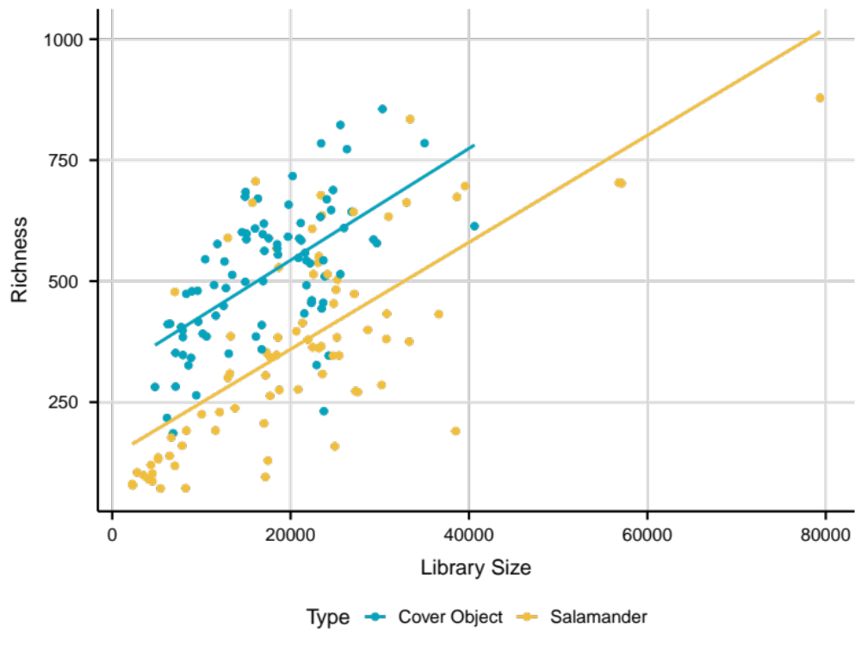
Figure A1: Scatterplot of richness and sequence variants for salamander and cover objects.

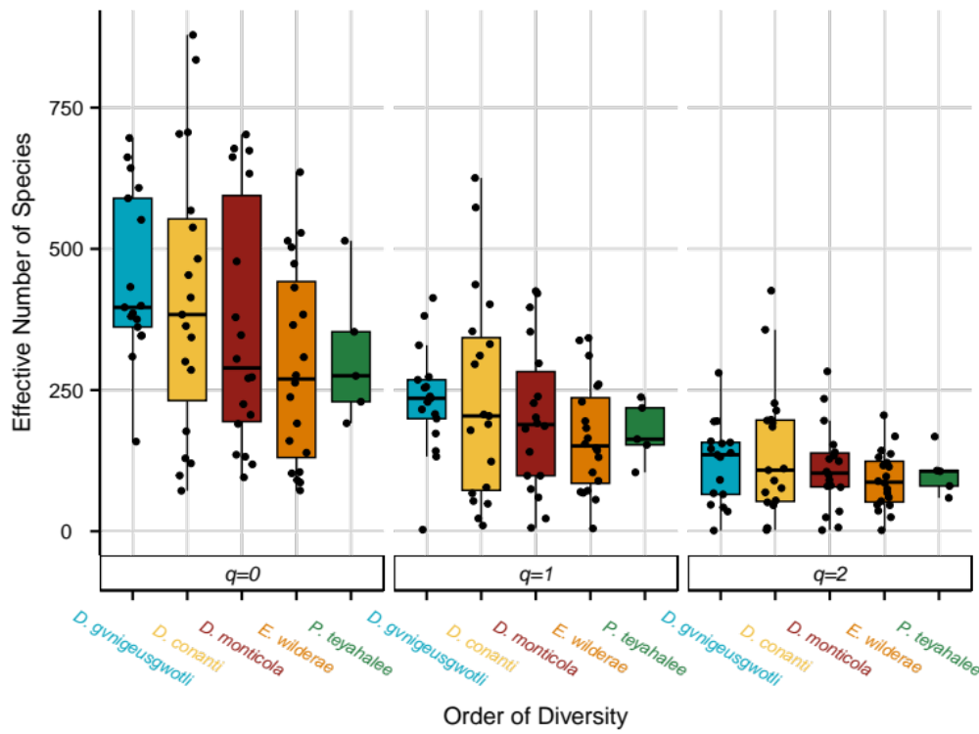
Figure A2: Alpha diversity estimations for 500 rarefactions. Statistical comparisons found no significant differences between species at each order of q for either habitat or species.

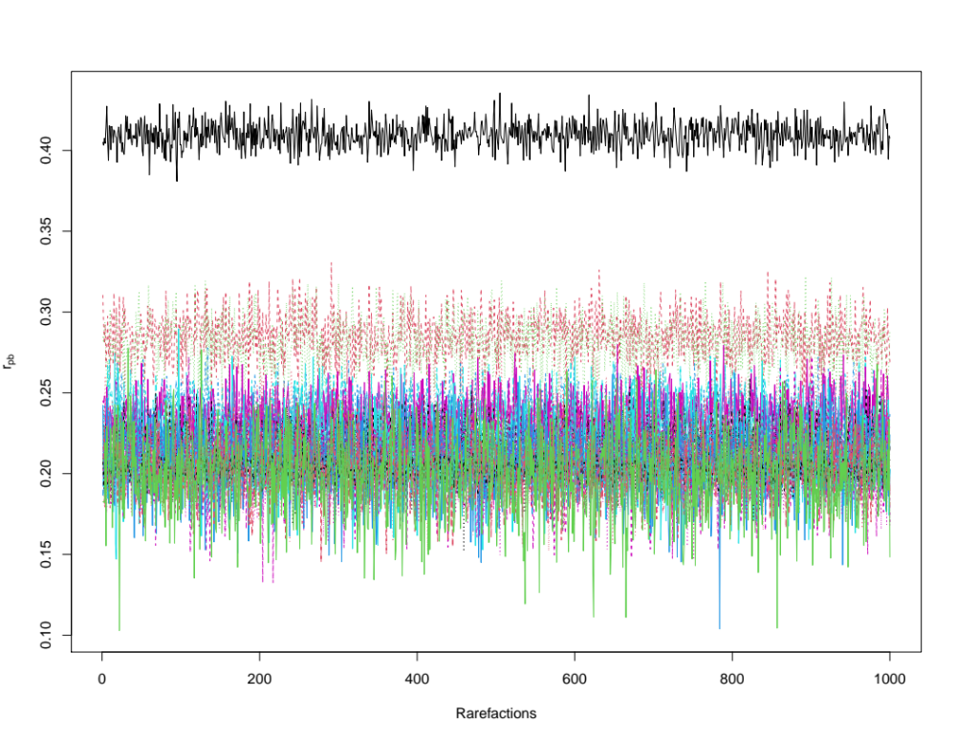
Figure A3: Fluctuation of point biserial correlation coefficients (r_{pb}) for 1000 rarefactions of the 21 sequence variants with an average r_{pb} >.20. The top black line corresponds to the sequence variant belonging to the genus Stenotrophomonas.

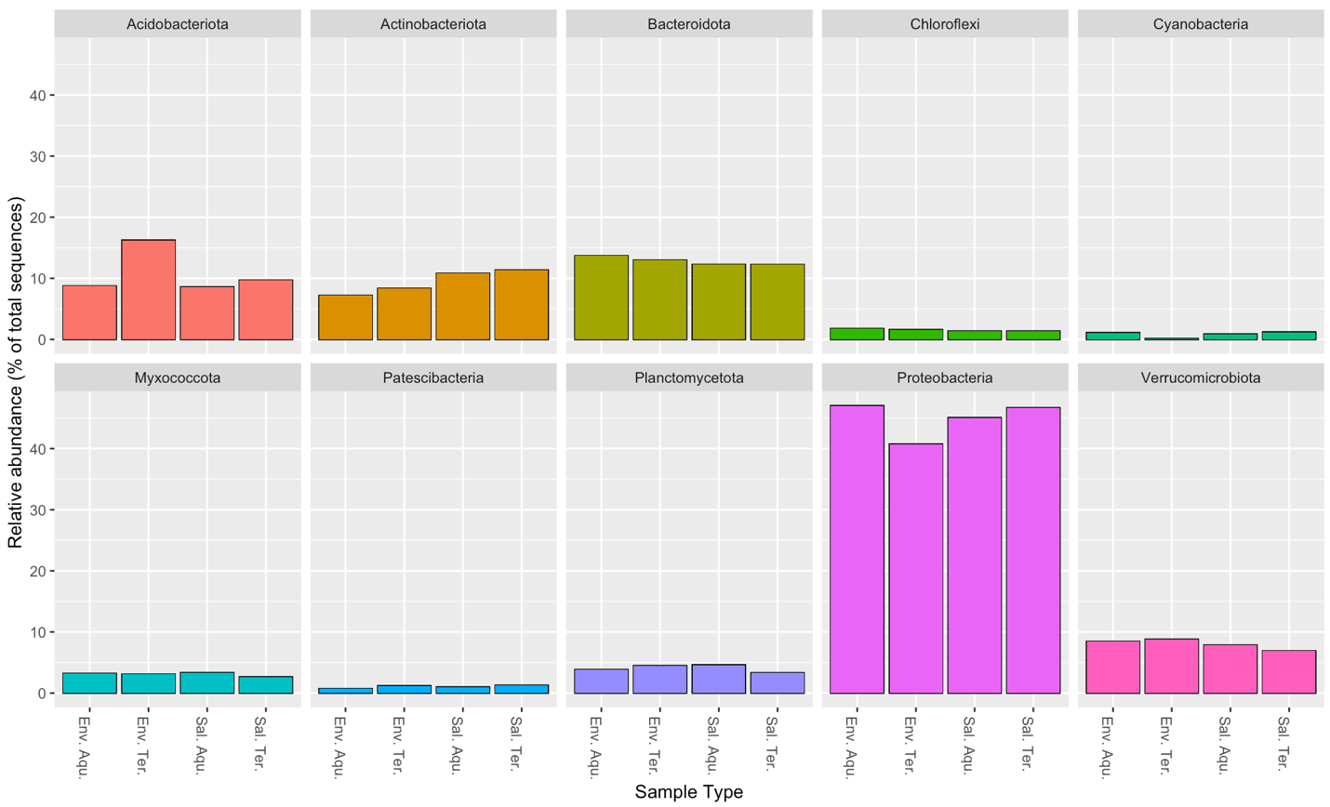
Figure A4: Facet plot of the 15 most abundant phyla in all sample types. Colors correspond to phylum.

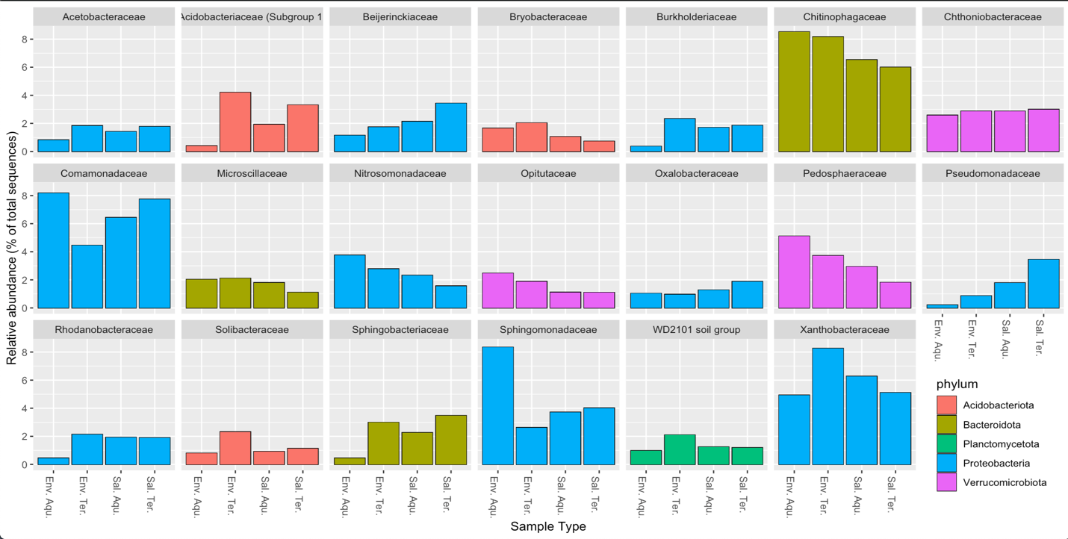
Figure A5: Twenty most abundant families found in sample types. Colors correspond to phylum.

Table A3: Point biserial correlation coefficient used for identifying OTUs associated with salamanders.
Family | Genus | Value | Group
Xanthobacteraceae | Tardiphaga | 0.2459 | All Salamanders
Beijerinckiaceae | Roseiarcus | 0.2163 | All Salamanders
Nocardioidaceae | Nocardioides | 0.2055 | All Salamanders
Nocardioidaceae | Nocardioides | 0.2227 | All Salamanders
Microbacteriaceae | NA | 0.2439 | All Salamanders
Microbacteriaceae | NA | 0.2267 | All Salamanders
Microbacteriaceae | NA | 0.2784 | All Salamanders
Acidobacteriaceae (Subgroup 1) | Terriglobus | 0.2316 | All Salamanders
Acidobacteriaceae (Subgroup 1) | Granulicella | 0.2016 | All Salamanders
Weeksellaceae | Chryseobacterium | 0.2094 | All Salamanders
Chitinophagaceae | Puia | 0.2109 | All Salamanders
Comamonadaceae | Comamonas | 0.2122 | All Salamanders
Pseudomonadaceae | Pseudomonas | 0.2037 | All Salamanders
Comamonadaceae | Rhizobacter | 0.2702 | All Salamanders/Aquatic Salamanders
Acetobacteraceae | Acidiphilium | 0.3149 | All Salamanders/Aquatic Salamanders
Beijerinckiaceae | Methylobacterium-Methylorubrum | 0.3329 | All Salamanders/Aquatic Salamanders
Beijerinckiaceae | Methylobacterium-Methylorubrum | 0.3876 | All Salamanders/Aquatic Salamanders
Beijerinckiaceae | Methylobacterium-Methylorubrum | 0.4030 | All Salamanders/Aquatic Salamanders
Beijerinckiaceae | NA | 0.3314 | All Salamanders/Aquatic Salamanders
Hyphomicrobiaceae | Hyphomicrobium | 0.3049 | All Salamanders/Aquatic Salamanders
Sphingomonadaceae | Sphingomonas | 0.3235 | All Salamanders/Aquatic Salamanders
Sphingomonadaceae | NA | 0.3350 | All Salamanders/Aquatic Salamanders

Table A3 Continued
Microbacteriaceae | NA | 0.2572 | All Salamanders/Aquatic Salamanders
Mycobacteriaceae | Mycobacterium | 0.3942 | All Salamanders/Aquatic Salamanders
Corynebacteriaceae | Corynebacterium | 0.3707 | All Salamanders/Aquatic Salamanders
Xanthomonadaceae | Stenotrophomonas | 0.3767 | All Salamanders/Aquatic Salamanders
Moraxellaceae | Acinetobacter | 0.3731 | All Salamanders/Aquatic Salamanders
Pseudomonadaceae | Pseudomonas | 0.3687 | All Salamanders/Aquatic Salamanders
NA | NA | 0.4457 | All Salamanders/Aquatic Salamanders
Paracaedibacteraceae | Candidatus Finniella | 0.2538 | All Salamanders/Terrestrial Salamanders
Xanthobacteraceae | NA | 0.3460 | All Salamanders/Terrestrial Salamanders
NA | NA | 0.3663 | All Salamanders/Terrestrial Salamanders
Rhodocyclaceae | Ferribacterium | 0.2590 | Aquatic Salamanders
Comamonadaceae | NA | 0.2588 | Aquatic Salamanders
Comamonadaceae | Delftia | 0.2562 | Aquatic Salamanders
Comamonadaceae | Comamonas | 0.2537 | Aquatic Salamanders
Comamonadaceae | NA | 0.2664 | Aquatic Salamanders
Sphingomonadaceae | NA | 0.2834 | Aquatic Salamanders
NA | NA | 0.2584 | Aquatic Salamanders
Acetobacteraceae | NA | 0.2675 | Aquatic Salamanders
Acetobacteraceae | NA | 0.2714 | Aquatic Salamanders
Beijerinckiaceae | Methylobacterium-Methylorubrum | 0.2722 | Aquatic Salamanders
Beijerinckiaceae | Methylobacterium-Methylorubrum | 0.2513 | Aquatic Salamanders
Beijerinckiaceae | Methylobacterium-Methylorubrum | 0.2945 | Aquatic Salamanders
NA | NA | 0.2648 | Aquatic Salamanders
Beijerinckiaceae | 1174-901-12 | 0.3206 | Aquatic Salamanders

Table A3 Continued
Beijerinckiaceae | 1174-901-12 | 0.2654 | Aquatic Salamanders
Beijerinckiaceae | 1174-901-12 | 0.2618 | Aquatic Salamanders
Beijerinckiaceae | 1174-901-12 | 0.2666 | Aquatic Salamanders
Beijerinckiaceae | NA | 0.2710 | Aquatic Salamanders
Sphingomonadaceae | NA | 0.2588 | Aquatic Salamanders
Sphingomonadaceae | NA | 0.2755 | Aquatic Salamanders
Rhizobiaceae | NA | 0.2986 | Aquatic Salamanders
NA | NA | 0.2505 | Aquatic Salamanders
Polyangiaceae | NA | 0.2600 | Aquatic Salamanders
Propionibacteriaceae | Cutibacterium | 0.2770 | Aquatic Salamanders
Nocardioidaceae | NA | 0.2565 | Aquatic Salamanders
Brevibacteriaceae | Brevibacterium | 0.2569 | Aquatic Salamanders
Microbacteriaceae | NA | 0.2618 | Aquatic Salamanders
Microbacteriaceae | NA | 0.2848 | Aquatic Salamanders
Microbacteriaceae | NA | 0.2622 | Aquatic Salamanders
Acidothermaceae | Acidothermus | 0.2731 | Aquatic Salamanders
Mycobacteriaceae | Mycobacterium | 0.2607 | Aquatic Salamanders
Mycobacteriaceae | Mycobacterium | 0.2816 | Aquatic Salamanders
Corynebacteriaceae | Corynebacterium | 0.2718 | Aquatic Salamanders
Corynebacteriaceae | Corynebacterium | 0.2845 | Aquatic Salamanders
Sphingobacteriaceae | NA | 0.2834 | Aquatic Salamanders
Sphingobacteriaceae | Mucilaginibacter | 0.2574 | Aquatic Salamanders
Bacteroidaceae | Bacteroides | 0.2550 | Aquatic Salamanders
Ruminococcaceae | Angelakisella | 0.2577 | Aquatic Salamanders
Staphylococcaceae | Macrococcus | 0.3051 | Aquatic Salamanders
NA | NA | 0.3070 | Aquatic Salamanders
NA | NA | 0.3079 | Aquatic Salamanders
NA | NA | 0.2814 | Aquatic Salamanders
NA | NA | 0.2725 | Aquatic Salamanders
Acidobacteriaceae (Subgroup 1) | NA | 0.2624 | Aquatic Salamanders
Acidobacteriaceae (Subgroup 1) | Granulicella | 0.2809 | Aquatic Salamanders
Flavobacteriaceae | NA | 0.2503 | Aquatic Salamanders
Flavobacteriaceae | Flavobacterium | 0.2885 | Aquatic Salamanders
Flavobacteriaceae | Flavobacterium | 0.3464 | Aquatic Salamanders

Table A3 Continued
Crocinitomicaceae | Fluviicola | 0.2508 | Aquatic Salamanders
Chitinophagaceae | Aurantisolimonas | 0.2574 | Aquatic Salamanders
Chitinophagaceae | Parafilimonas | 0.2503 | Aquatic Salamanders
Spirosomaceae | Flectobacillus | 0.2929 | Aquatic Salamanders
NA | NA | 0.2563 | Aquatic Salamanders
Comamonadaceae | Schlegelella | 0.2524 | Aquatic Salamanders
A21b | NA | 0.3099 | Aquatic Salamanders
Xanthomonadaceae | Stenotrophomonas | 0.2553 | Aquatic Salamanders
Pseudomonadaceae | Pseudomonas | 0.2587 | Aquatic Salamanders
Erwiniaceae | NA | 0.3117 | Aquatic Salamanders
NA | NA | 0.2786 | Aquatic Salamanders
Oxalobacteraceae | NA | 0.2823 | Terrestrial Salamanders
Oxalobacteraceae | NA | 0.2826 | Terrestrial Salamanders
Oxalobacteraceae | NA | 0.2817 | Terrestrial Salamanders
Nitrosomonadaceae | Ellin6067 | 0.2810 | Terrestrial Salamanders
Xanthobacteraceae | Rhodoplanes | 0.2865 | Terrestrial Salamanders
Xanthobacteraceae | Pseudolabrys | 0.2636 | Terrestrial Salamanders
Xanthobacteraceae | Rhodopseudomonas | 0.2617 | Terrestrial Salamanders
Xanthobacteraceae | Tardiphaga | 0.2660 | Terrestrial Salamanders
Beijerinckiaceae | NA | 0.2632 | Terrestrial Salamanders
NA | NA | 0.2515 | Terrestrial Salamanders
Devosiaceae | Devosia | 0.2923 | Terrestrial Salamanders
Solirubrobacteraceae | Conexibacter | 0.2543 | Terrestrial Salamanders
Solirubrobacteraceae | NA | 0.2667 | Terrestrial Salamanders
BIrii41 | NA | 0.2536 | Terrestrial Salamanders
BIrii41 | NA | 0.2618 | Terrestrial Salamanders
NA | NA | 0.3137 | Terrestrial Salamanders
Nocardioidaceae | Nocardioides | 0.2822 | Terrestrial Salamanders
Cellulomonadaceae | Cellulomonas | 0.2725 | Terrestrial Salamanders
Acidothermaceae | Acidothermus | 0.2508 | Terrestrial Salamanders
Acidothermaceae | Acidothermus | 0.2576 | Terrestrial Salamanders
Frankiaceae | Jatrophihabitans | 0.2882 | Terrestrial Salamanders
Pseudonocardiaceae | NA | 0.2574 | Terrestrial Salamanders
Pseudonocardiaceae | NA | 0.3111 | Terrestrial Salamanders
Pseudonocardiaceae | Pseudonocardia | 0.2542 | Terrestrial Salamanders

Table A3 Continued
Streptosporangiaceae | Herbidospora | 0.2784 | Terrestrial Salamanders
Chthonomonadaceae | Chthonomonas | 0.2747 | Terrestrial Salamanders
NA | NA | 0.2815 | Terrestrial Salamanders
Chthoniobacteraceae | Chthoniobacter | 0.2833 | Terrestrial Salamanders
Xiphinematobacteraceae | Candidatus Xiphinematobacter | 0.2666 | Terrestrial Salamanders
Xiphinematobacteraceae | Candidatus Xiphinematobacter | 0.2600 | Terrestrial Salamanders
Simkaniaceae | Candidatus Rhabdochlamydia | 0.2532 | Terrestrial Salamanders
NA | NA | 0.2503 | Terrestrial Salamanders
Pirellulaceae | Pir4 lineage | 0.2568 | Terrestrial Salamanders
NA | NA | 0.2640 | Terrestrial Salamanders
Microscillaceae | NA | 0.2714 | Terrestrial Salamanders
Chitinophagaceae | NA | 0.2571 | Terrestrial Salamanders
NA | NA | 0.2784 | Terrestrial Salamanders
Unknown Family_4 | Acidibacter | 0.2937 | Terrestrial Salamanders
Rhodanobacteraceae | Luteibacter | 0.2690 | Terrestrial Salamanders
Rhodanobacteraceae | Rhodanobacter | 0.2886 | Terrestrial Salamanders
Moraxellaceae | Acinetobacter | 0.2667 | Terrestrial Salamanders
Moraxellaceae | NA | 0.2640 | Terrestrial Salamanders

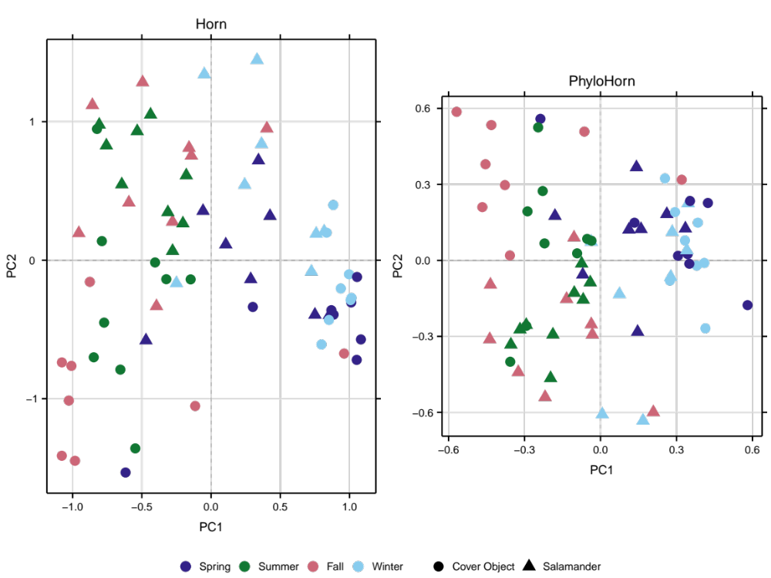
Figure A6: Unconstrained ordination of Horn and PhyloHorn dissimilarities between salamanders and cover objects, seasonally.

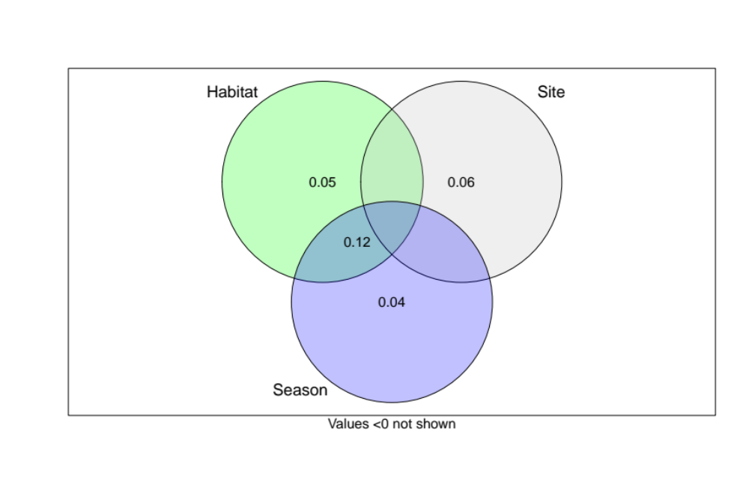
Figure A7: Variance partitioning of the Horn dissimilarity for salamander-associated assemblages.

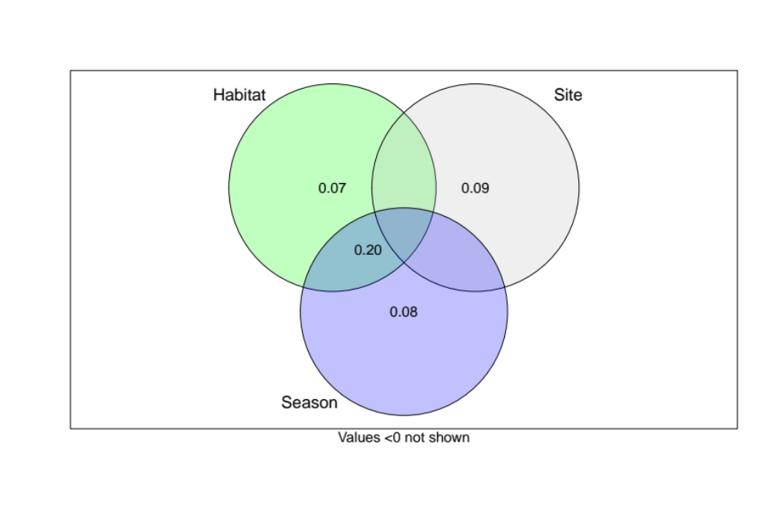
Figure A8: Variance partitioning of the PhyloHorn dissimilarity for salamander-associated assemblages.

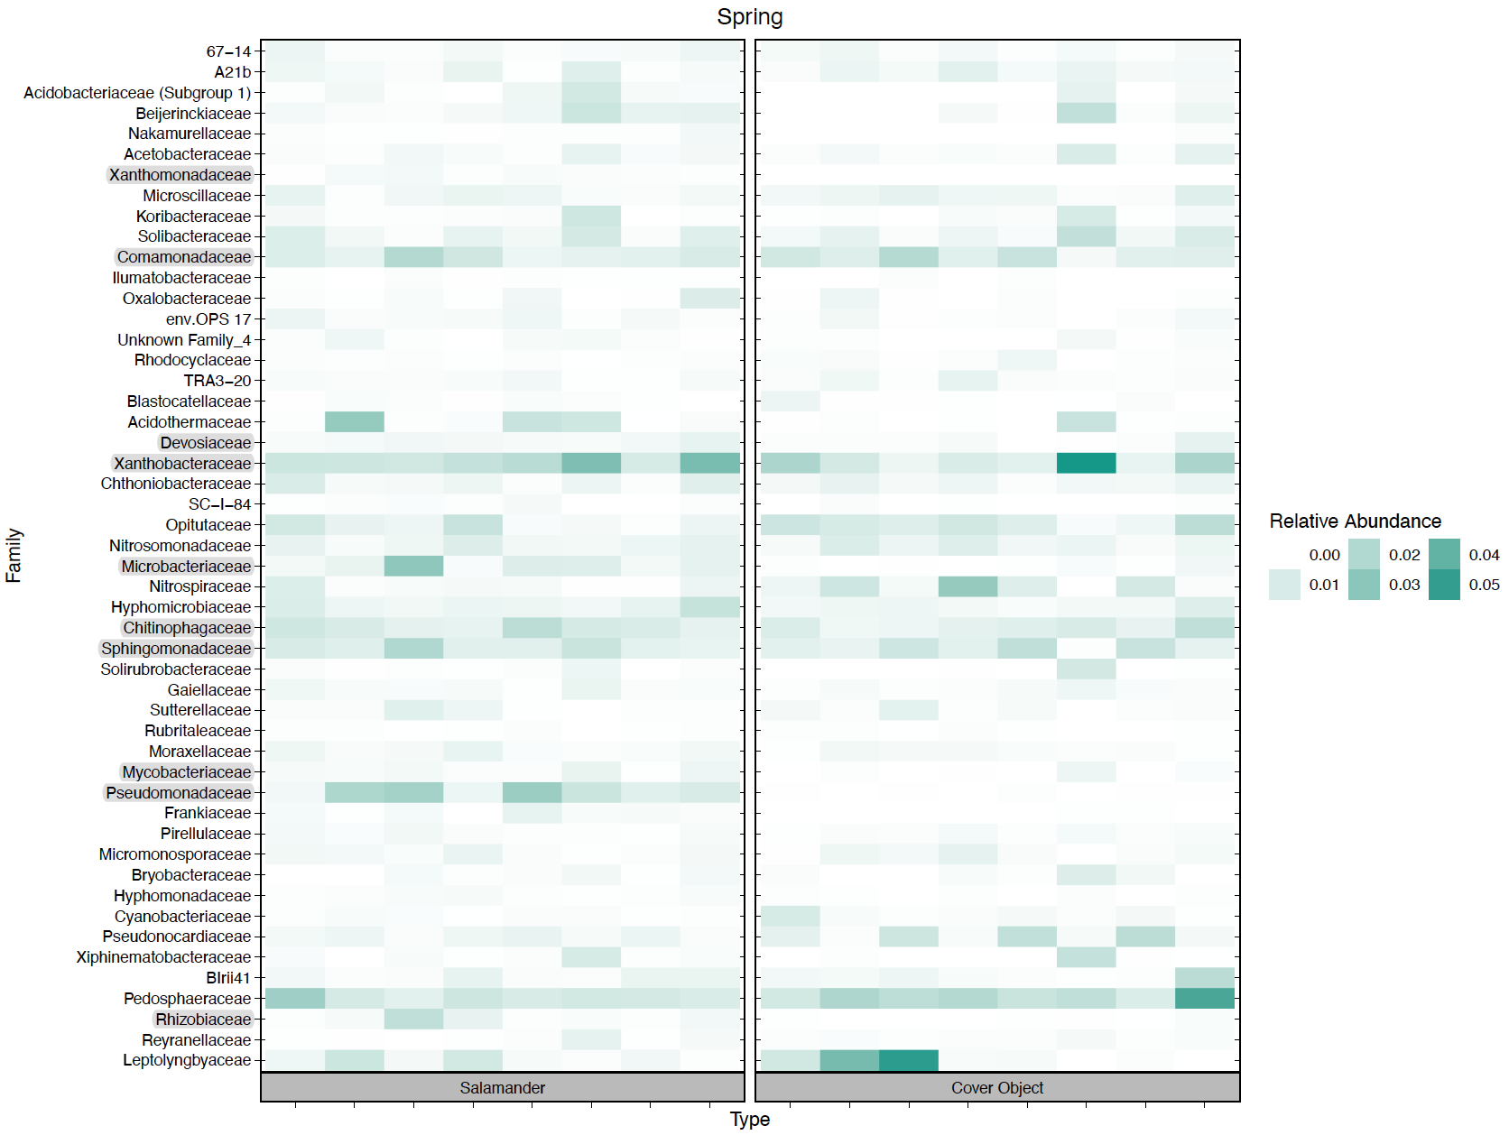
Figure A9: Heatmap showing relative abundance of ‘common core’ OTUs during spring sampling. Highlighted families are families with common OTUs shared across all sampling seasons.

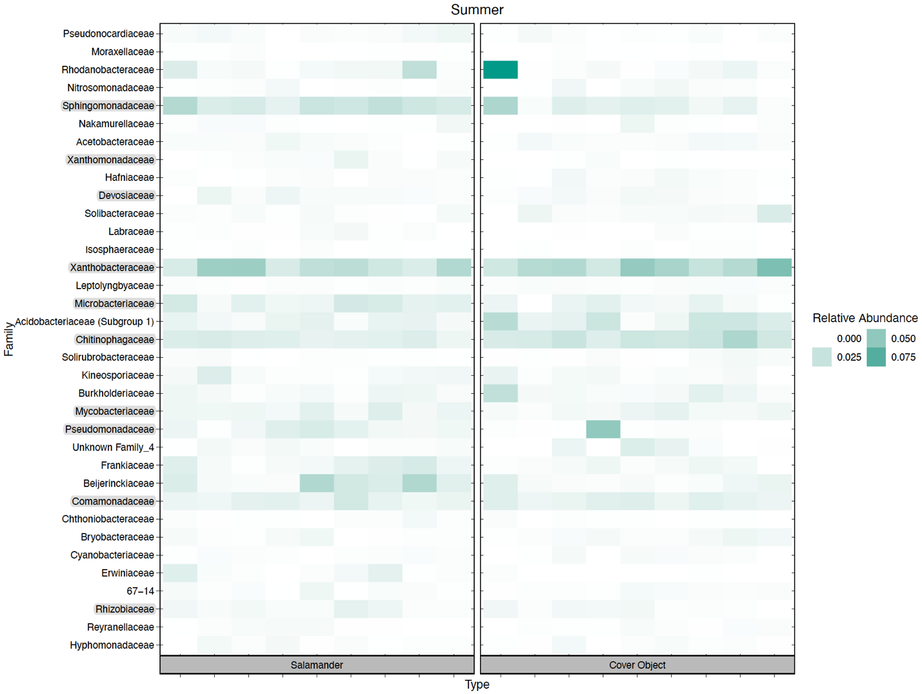
Figure A10: Heatmap showing relative abundance of ‘common core’ OTUs during our summer sampling. Highlighted families are families with common OTUs shared across all sampling seasons.
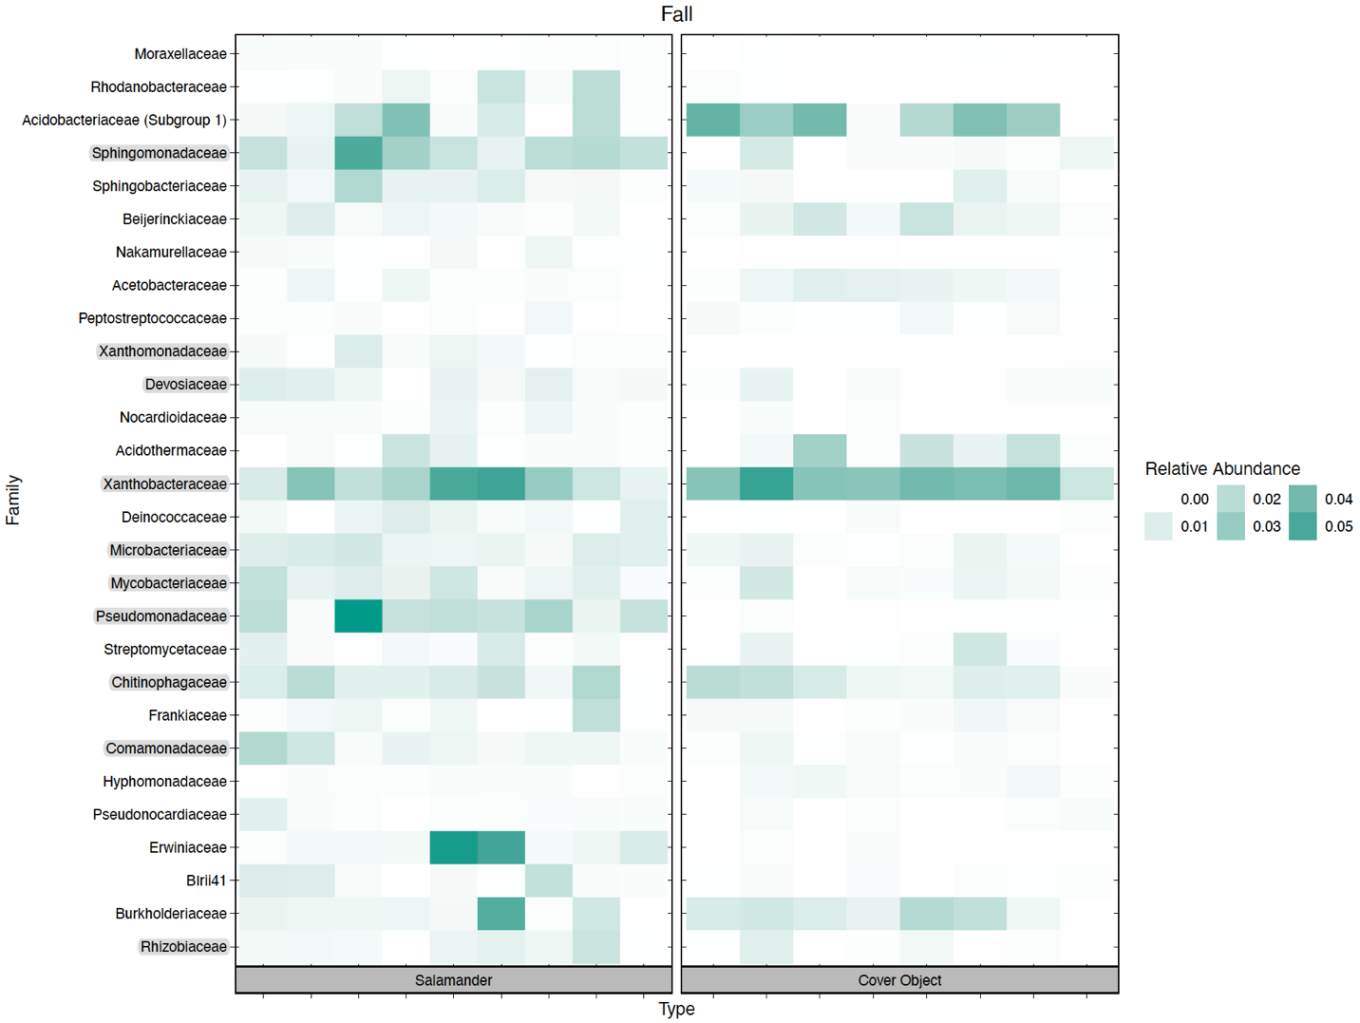
Figure A11: Heatmap showing relative abundance of ‘common core’ OTUs during the fall sampling. Highlighted families are families with common OTUs shared across all sampling seasons.

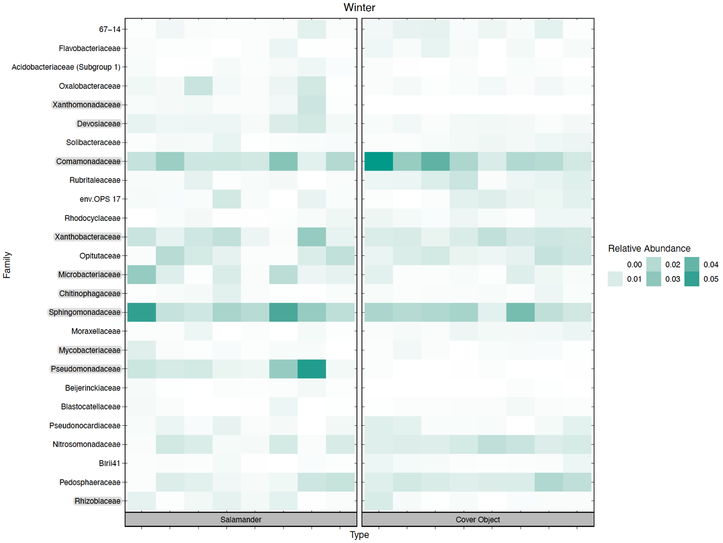
Figure A12: Heatmap showing relative abundance of ‘common core’ OTUs during our winter sampling. Highlighted families are families with common OTUs shared across all sampling seasons.

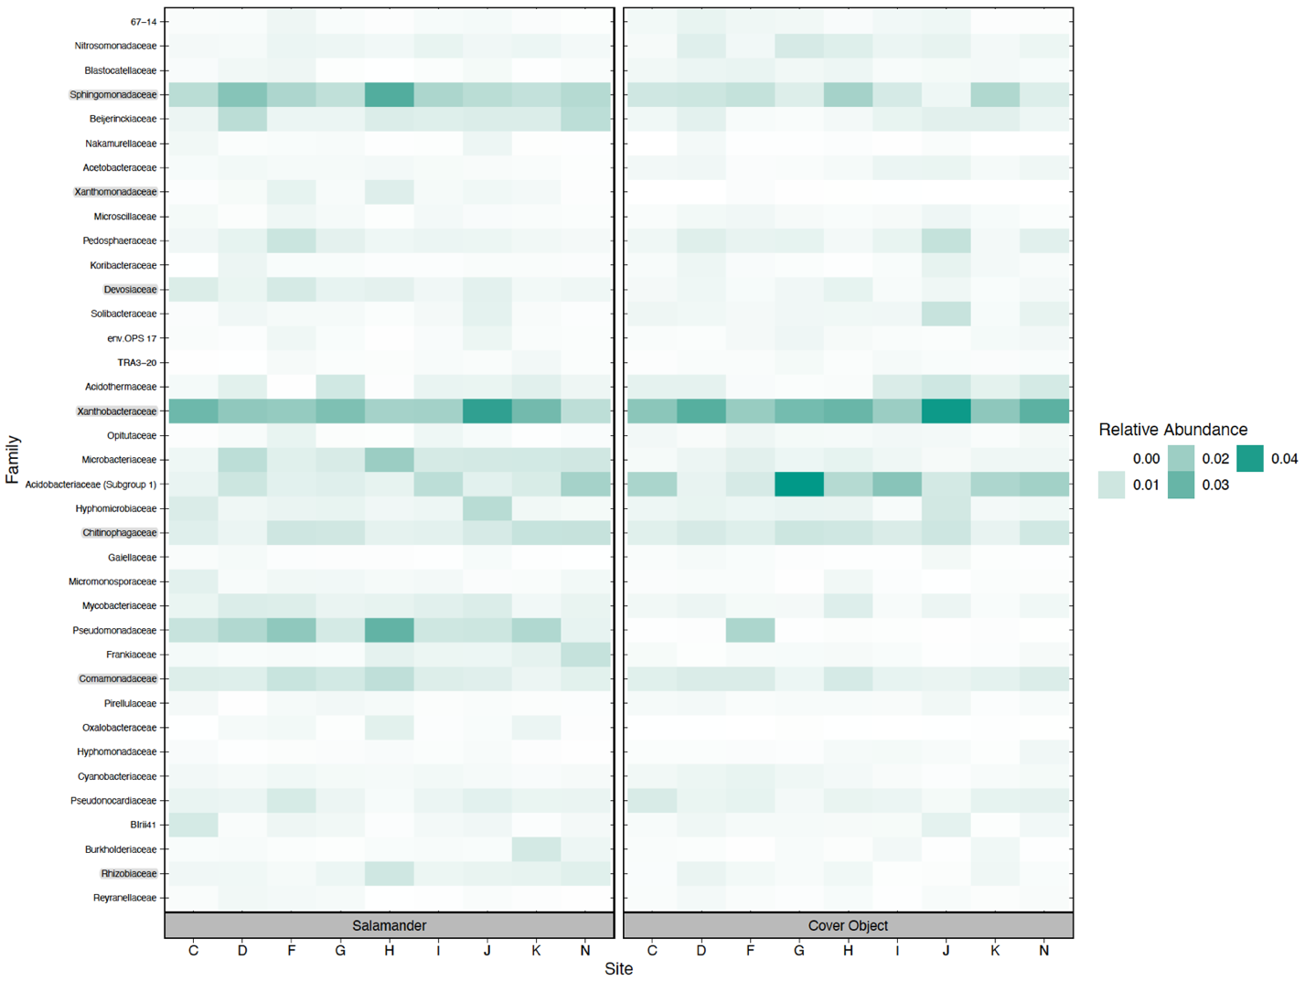
Figure A13: Heatmap of relative abundance of temporal core OTUs at each site.

Table A4: OTUs associated with anti-fungal capabilities and the detection on salamanders.
Order | Family | Genus | Proportion Detected on Hosts
Pseudomonadales | Pseudomonadaceae | Pseudomonas | 1
Rhizobiales | Rhizobiaceae | Rhizobium | 1
Xanthomonadales | Xanthomonadaceae | Stenotrophomonas | 1
Burkholderiales | Oxalobacteraceae | Janthinobacterium | 0.85
Rhizobiales | Rhizobiaceae | Rhizobium | 0.76
Pseudomonadales | Pseudomonadaceae | Pseudomonas | 0.74
Sphingobacteriales | Sphingobacteriaceae | Pedobacter | 0.68
Enterobacteriales | Enterobacteriaceae | Bacteria | 0.62
Actinomycetales | Streptomycetaceae | Streptomyces | 0.53
Enterobacteriales | Enterobacteriaceae | Enterobacter | 0.50
Actinomycetales | Nocardioidaceae | Aeromicrobium | 0.50
Actinomycetales | Micrococcaceae | Arthrobacter | 0.47
Burkholderiales | Oxalobacteraceae | NA | 0.47
Xanthomonadales | Xanthomonadaceae | Stenotrophomonas | 0.44
Flavobacteriales | Flavobacteriaceae | Chryseobacterium | 0.44
Flavobacteriales | Flavobacteriaceae | Chryseobacterium | 0.35
Pseudomonadales | Pseudomonadaceae | Pseudomonas | 0.32
Bacillales | Bacillaceae | Bacillus | 0.29
Pseudomonadales | Moraxellaceae | Acinetobacter | 0.24
Burkholderiales | Comamonadaceae | Comamonas | 0.18
Neisseriales | Neisseriaceae | NA | 0.18
Pseudomonadales | Moraxellaceae | Acinetobacter | 0.18
Xanthomonadales | Xanthomonadaceae | Dyella | 0.18
Actinomycetales | Brevibacteriaceae | Brevibacterium | 0.15
Pseudomonadales | Pseudomonadaceae | Pseudomonas | 0.15
Pseudomonadales | Moraxellaceae | Acinetobacter | 0.12
Pseudomonadales | Moraxellaceae | Acinetobacter | 0.12
Burkholderiales | Comamonadaceae | Comamonas | 0.09
Caulobacterales | Caulobacteraceae | Brevundimonas | 0.09
Bacillales | Bacillaceae | Bacillus | 0.06
Enterobacteriales | Enterobacteriaceae | Serratia | 0.06
Xanthomonadales | Xanthomonadaceae | Luteimonas | 0.06
Flavobacteriales | Flavobacteriaceae | Flavobacterium | 0.06
Enterobacteriales | Enterobacteriaceae | NA | 0.06
Pseudomonadales | Pseudomonadaceae | Pseudomonas | 0.03
Bacillales | Staphylococcaceae | Staphylococcus | 0.03
Flavobacteriales | Flavobacteriaceae | Elizabethkingia | 0.03
Actinomycetales | Micrococcaceae | Micrococcus | 0.03
Table A4 Continued

VITA

Benjamin Holt is originally from Knoxville, Tennessee, and received a B.S. in Biology from East Tennessee State University as well as a minor in Geographical Information Systems. While not doing fieldwork, his hobbies include hiking with his beloved Catahoula, Stella, and fly fishing. He uses a plethora of field and laboratory techniques in tandem with molecular and computational technologies to answer an array of questions spanning ecology and evolutionary biology, particularly organisms in freshwater environments.

