Measles in Germany: Past, Present, and Future of Outbreaks and Vaccination
Erin Sherwin
The University of Tennessee
Chancellor’s Honors Program
May 2016

Table of Contents:
Introduction 4

Global measles eradication initiatives 5

Vaccination in divided Germany 5

Current attitudes towards compulsory vaccination 6

Vaccination gaps 9

Immigration 11

Regional differences: How the outbreak in Bavaria differs from that in Berlin 12

Anti-vaccination propaganda 15

Conclusion 16

Tables and Figures 17

References 20

Abstract

The World Health Organization (WHO) has set the goal to eradicate measles by 2020. In order to do this, countries must reach a vaccination rate of 95 percent. However, some countries have been experiencing outbreaks of the disease in recent years. Germany has seen many cases of measles from 2014 to 2015. Contributing to these outbreaks are various vaccination attitudes (affected by different policies during the division of Germany), vaccination gaps among various age groups, and vaccination statuses of immigrants and refugees. Various regions of Germany, particularly Berlin and Bavaria, have experienced many cases of measles. Regional differences in the two states have played a role in why they have experienced outbreaks. Anti-vaccination propaganda, although it exists, may or may not contribute to lower vaccination rates. How Germany handles these outbreaks and strives towards the eradication of measles can provide insight into how the United States can follow suit.

Introduction
In recent years the United States has seen an increase in measles outbreaks. An anti-vaccination movement has been growing, led by those who believe that vaccinations somehow do more harm than good. Comparatively, Germany has seen greater measles epidemics, especially in such areas as Berlin and Bavaria. In 2015 there were nearly 2500 reported cases of measles (European Centre for Disease Prevention and Control). Are German parents simply refusing to vaccinate their children, or are there other factors at play? Researching the history of vaccination practices in Germany from the development of the measles vaccine (or the measles-mumps-rubella, MMR, vaccine) until today, as well as investigating current attitudes towards and opinions on vaccination, yields some insight. Some major factors contributing to German vaccination practices include the immigration history of Germany, vaccination policies during the division of Germany and today, and the tracking of vaccination gaps in the population. How the German government and community health care providers are handling the situation could provide ideas for how the United States can confront changing vaccination attitudes and practices.

Global measles eradication initiatives

The World Health Organization (WHO) announced at the 64th session of regional committee for Europe on September 18, 2014 its goal to eliminate vaccine-preventable diseases in Europe by 2020 (World Health Organization, 2014). The plan, named The European Vaccine Action plan, aligns with the WHO’s plan to eliminate these diseases globally. These plans are not limited to measles but include goals for polio and hepatitis B as well. In the proposal, the WHO defines guidelines and practices for reaching their goals. Overall, the WHO’s objectives for eliminating vaccine-preventable diseases are the following:
- All countries commit to immunization as a priority
- Individuals understand the value of immunization services and vaccines and demand vaccination
- The benefits of vaccination are equitably extended to all people through tailored innovative strategies
- Strong immunization systems are an integral part of a well-functioning health system
- Immunization programs have sustainable access to predictable funding and high-quality supply (World Health Organization, 2014).
Vaccination policies in divided Germany
Vaccination policies in Germany have been dynamic throughout history, even before the development and inception of the measles vaccine. In the mid-1960s, the measles vaccine was made available for use in Germany (Klein, Schönegberg, & Krause, 2012). This was during the division and occupation of Germany during the Cold War. In West Germany (the Bundesrepublik Deutschland, or BRD) in 1974, the policy towards vaccinating children for measles was Allgemeine Empfehlung, or general recommendation (Klein et al., 2012). In 1980 the complete MMR vaccine, first made available in 1971, was approved for use in the BRD (Klein et al., 2012). The policy continued to be general recommendation. In 1998 the government advised all unvaccinated adults working in pediatric facilities, such as daycares, to get vaccinated (Klein et al., 2012). For children in East Germany (the German Democratic Republic, or GDR), vaccination was voluntary and limited starting in 1966 (Klein et al., 2012). Vaccination was compulsory for those children entering day care services. In 1970, the GDR implemented the mass vaccination of all preschool and school children by way of a vaccination schedule (Klein et al., 2012). In 1983, they continued the compulsory vaccination policy and imposed secondary vaccinations for children two to sixteen years of age who had received their first dose in their first year of age (Klein et al., 2012). By 1983 the GDR reached an impressive 97% immunization rate for measles (Klein et al., 2012). There is no data for the BRD. Upon reunification, Germany adopted the tradition of West Germany, making vaccination recommended and voluntary rather than compulsory (Klein, et al., 2012). From 1991 to 2001, the age to receive the second dose of MMR was first lowered to six-years-old and again to two-years-old (Klein et al., 2012). Finally in 2010, the united German government advised vaccination for all those born after 1970 with either unclear or incomplete vaccination status (Klein et al., 2012).
Current attitudes on compulsory vaccination
Germans’ attitudes towards these recent measles outbreaks vary. Some of this variation can be attributed to the different policies of East and West Germany during division. A survey conducted by YouGov, a German online community that frequently conducts polls on various contemporary issues and shares the data collected, showed that the majority of Germans favor compulsory vaccination (Schmidt, 2015). The survey, which took place from February 23, 2015 to February 25, 2015 and included 1000 participants, showed that 40 percent of Germans strongly favored compulsory vaccination while 34 percent were somewhat in favor of compulsory vaccination (“Die Meisten Deutschen wollen die Impfpflicht,” 2015). The survey also asked participants to state in which region of Germany they live (East or West). These results (Figure 1) showed that 71 percent of Germans living in the West favored compulsory vaccination, whereas 24 percent were against it (Schmidt, 2015). Germans living in the East were 86 percent in favor of compulsory vaccination, and 12 percent were against it (Figure 1) (Schmidt, 2015). That Germans living in the East favor compulsory vaccination more overall could be due to the compulsory vaccination policy the German Democratic Republic held during Germany’s division.
Also contributing to varying attitudes towards compulsory vaccination are political party affiliations. Some of the major political parties in Germany are divided on the issue. The Christian Democratic Union (CDU), the party of which Chancellor Angela Merkel is head, favors compulsory vaccination for children for such diseases as measles, mumps, rubella, tetanus, diphtheria, chickenpox, polio, and whooping cough (“CDU-Beschlüsse: Flüchtlinge, Einwanderung, und Impfpflicht,” 2015). Hermann Gröhe (CDU), the current Federal Minister of Health, openly supports compulsory vaccination as a solution to the vaccination opposition (“Gesundheitsminister Gröhe droht mit Impfpflicht,” 2015). Social Democratic Party of Germany (SPD) leaders also support compulsory vaccination. German news source Zeit Online quoted SPD health politician and member of the Bundestag Dr. Karl Lauterbach, who stated that if the people’s willingness to be vaccinated does not increase, then compulsory vaccination is the next step to take (“Gesundheitspolitiker fordern Wiedereinführung der Impfpflict,” 2015). In opposition to compulsory vaccination are the Free Democratic Party (FDP), and the party known as Alliance ‘90/The Greens (often referred to as Die Grünen). Daniel Bahr, former Federal Minister of Health and present member of the FDP, stated that he prefers educative and persuasive methods to increase vaccination rates (“Bahr will Impflicht vermeiden,” 2013). Speaker of Health Policy for the Greens Birgitt Bender told Deutsche Ärzteblatt (The Journal of German Physicians) that the people’s free choice to be vaccinated should take priority (“Ein Pro und Contra zur Impfpflicht,” 2013). In the same article, president Dr. Wolfram Hartmann, of the Berufsverband der Kinder- und Jugendärzte (BVKJ), or the Occupational Union of Pediatricians, stated support for compulsory vaccination. He cited the success of compulsory vaccination against smallpox in 1976 as a reason Germany could consider reinstating such a policy for measles (“Ein Pro und Contra,” 2013). In a press release from the BVKJ (2015), Hartmann discussed the rights of children in healthcare. According to current policy, most of the rights of children lie with their parents (“Pressemitteilung Dr. med. Wolfram Hartmann”). Part of prevention is making sure children have access to the care they need. That January, an act to help children and young adults receive proper examinations found a majority (“Pressemitteilung,” 2015). The bill called for more action, stating that even in the wake of these measles outbreaks and even the death of a child, they must do more for prevention (Pressemitteilung,” 2015). Hartmann stated that, “Preventive vaccinations are not exclusively a private, individual medical measure,” and that, “children, who for medical reasons for all cannot be vaccinated with the usual live vaccine… have a right to the visit from predominant state-funded community services” (“Pressemitteilung,” 2015). These statements overall encourage the population to get vaccinated for the sake of those who cannot be vaccinated. When 95 percent of the population are vaccinated, those individuals benefit from “herd immunity.” If non-immunocompromised individuals are vaccinated, they protect the immunocompromised from potential outbreaks. Whether or not Germany will adopt a compulsory vaccination policy for measles is not yet definite. However, split opinions across political affiliations can play an important role in deciding how best to achieve a 95 percent vaccination rate.
Vaccination gaps
According to an article in the German publication Pharmazeutische Zeitung, more than one half of the measles cases in Germany since 2010 were among teenagers and young adults (Hohmann-Jeddi, 2015). The article identifies the main causes of these outbreaks were that many people, including the young adults and their parents, are not aware that they have or have not been vaccinated. The rate of children entering kindergarten who had received their second dose of the MMR vaccine was lower than that of children who received the first dose (Hohmann-Jeddi, 2015). In addition to not having the second dose, sometimes the case was that children did not receive the additional dose on time. The second dose is recommended for children between 15 and 23 months of age in Germany (Robert Koch Institute, 2015). According to Pharmazeutische Zeitung, another issue is reporting vaccination status. About eight percent of children entering kindergarten had unknown vaccination statuses (Hohmann-Jeddi, 2015). This information gap could be from a variety of causes. Like the United States, Germany allows citizens to refuse vaccination on the basis of personal or religious beliefs (Arenz, Kalies, Ludwig, Hautmann, Siedler, Liebl, Morlock, & von Kries, 2003). Dr. Jan Leidel, a representative from the Ständige Impfkommission (STIKO) at the Robert Koch Institute in Berlin, estimated that many children in kindergarten were not vaccinated, leading to five to nine percent of kindergarteners not having immunity from measles (Hohmann-Jeddi, 2015). Children who do not receive the second dose could be at risk of contracting and spreading measles because the second dose ensures immunity in the case that the first dose was ineffective. Additionally, if the second dose is administered too late, children risk having been exposed to measles before the second vaccination can be effective (Arenz et al., 2003).
A study published in the Pediatric Infectious Disease Journal (2005) emphasized the necessity and effectiveness of a second dose (Arenz, Schmitt, Tischer, & von Kries). In the early 2000s, the Bavarian town of Coburg experienced a massive measles outbreak. There were 1,191 reported cases, and the study’s results involved 43 children from that number (Arenz et al., 2005). Those who received two doses of the vaccine did not contract measles, but eight percent of children who received only one dose did contract measles (Arenz et al., 2005). Seventy-three percent total contracted measles, including 95 percent of those who were not vaccinated (Arenz et al., 2005). These results demonstrate the effectiveness of the vaccine when patients follow the recommended schedule and receive two doses. Overall, these results showed a vaccine effectiveness of 90 percent or higher, although this figure could be underestimated because parents who oppose vaccination may have been less likely to participate in the study (Arenz et al., 2005). In addition to professional recommendations that two doses are vital to complete vaccination coverage, these results provide concrete evidence in support.
STIKO representative Leidel stated several solutions to the issue of vaccination gaps in Pharmazeutische Zeitung. STIKO recommends that all people born after 1970 who had not been vaccinated get vaccinated, in addition to those who did not receive the second booster dose and those who were unsure of their vaccination statuses (Hohmann-Jeddi, 2015). STIKO particularly urges those who work in schools, daycares, healthcare institutions, or who work with immunocompromised individuals, to get vaccinated (Hohmann-Jeddi, 2015). Efforts for clear communication between doctors and parents will ensure that these gaps are closed. Doctors can use each visit with patients to clarify any misunderstandings about vaccination and to determine if patients should receive the vaccine. Doctors can also be a present force in encouraging vaccination in their communities (Hohmann-Jeddi, 2015).
Immigration
Due to the nature of world health, and the fact that not every region has the same vaccination rates or access to vaccines, immigration can play a role in spreading measles. Germany has a diverse history of immigration. In the 1950s and 60s, West Germany brought over immigrants known as Gastarbeiter, or guest workers, to fill a deficit in labor after World War II. Many of these immigrants were from Turkey. East Germany also had a similar program. These immigrants were subjected to the regular vaccination programs in West Germany, often in addition to having been vaccinated in their home countries. Turkey in particular had a similar vaccination program as in West Germany, administering the measles vaccine on a schedule with doses at 8 and 15 months of age until 1987 (Güriş, Bayazıt, Özdemirer, Buyurgan, Yalnız, Toprak, & Aycan). Since the 1950s and -60s, many people from countries in Eastern and Southern Europe, as well as refugees from countries like Bosnia, Syria, and Palestine, have immigrated or sought asylum in Germany. According to the article “Berlin Measles Cases Link Back to United States Outbreak” in Deutsche Welle (2015), some measles cases in Berlin in 2015 were linked to foreign visitors or immigrants (“Berlin Measles Cases”). Two of these cases link back to the United States. According to the article, “German officials… believe the current outbreak began with a child asylum seeker from Bosnia, as many of the following infections among refugees were genetically linked” (“Berlin Measles Cases,” 2015). Dr. Dirk Werber, the doctor from Berlin’s state health office who made the claim, also referred to low immunization rates among the forty-five and above age group as a contributing factor to the disease spreading to Berlin residents (“Berlin Measles Cases,” 2015). Health officials also suggested that vaccination programs failed during the Yugoslav Civil War in the 1990s (“Berlin Outbreak Blasts Hopes of Eradicating Measles in Germany by 2015,” 2015). Such failed programs would contribute to an increased risk of immigrants to introduce measles to a new population.
Regarding health care and immigration, health care providers must take care to inform the population. According to the Journal of Infectious Diseases (2011), “some reasons, such as lack of information and misconceptions on vaccine safety, are common to those [Roma, Travellers, and immigrants] among the general population” (Muscat). Many barriers exist to these immigrants: language barriers, discrimination, limited access to health care, and possibly lack of insurance coverage (Muscat, 2011). Not only should doctors be personally communicating with their patients to identify vaccination gaps and to educate their patients, but they must also take these cultural differences into account. The media can also help encourage vaccination among immigrant populations, and vaccination educational resources can make their materials available in multiple languages to reach broader demographics. Research on what approaches of education work best with immigrants and various cultures regarding health concerns could also be effective.
Regional differences: How the situation in Bavaria differs from that in Berlin
Like the United States of America, Germany is divided into regions called “Bundesländer.” These regions are significantly different in culture, dialect, and geography. Although many of the reports of measles outbreaks over the past couple years have been in Berlin, a large number of cases have occurred in Bavaria, a southern “Bundesland”. An article published March 30, 2015 in Die Welt titled “Zahl der Masern-Infektionen in Bayern verdoppelt”⁴ counted 75 cases of measles in Bavaria, a number that nearly doubled the amount of cases counted at the end of March 2014 (“Zahl der Masern-Infektionen”). Table 1 shows a comparison of cases in the United States, Berlin, Bavaria, and Europe overall from 2014-present. Numbers of cases in both Berlin and Bavaria were higher in the first few months of 2015 than at the same point in time in 2014 (“Zahl der Masern-Infektionen,” 2015). The history of measles outbreaks and vaccination in Bavaria is quite different from that of Berlin. Because Bavaria was part of West Germany during occupation after World War Two, that region never had a compulsory vaccination policy (Klein et al., 2012).
In the early 2000s, the Bavarian region of Coburg experienced a massive measles outbreak. Homeopathic doctors from the region who opposed the MMR vaccine were blamed for the outbreaks there (Smith, 2002). A 2003 study explored the causes behind a measles outbreak in 2001 in the Bavarian German town of Coburg and demonstrated statistical support for a solution (Arenz et al., 2003). There were 1,191 cases reported in Coburg during this period. Nine percent of these patients reported that they were vaccinated (Arenz et al., 2003). Vaccination coverage at the time in Coburg was 77 percent, a significant low compared to the surrounding towns each with 90 percent coverage (Figure 2, 3) (Arenz et al., 2003). These vaccination rates were far from the goal set by WHO to reach 95% coverage in Europe, at that time by 2007. The study showed that campaigns that address individuals directly can encourage people to get vaccinated. An increase in vaccination sales supported this conclusion (Arenz et al., 2003). Sale numbers climbed in the two months after doctors began adhering to the intervention policy (Figure 4). The majority of these cases in Coburg were in children under 15 years of age (Arenz et al., 2003). What surprised doctors was that in 11 percent of the validated cases of measles (the study involved evaluating patients based on symptoms to determine certainly that they had measles), patients had received at least one dose of the measles vaccine (Arenz et al., 2003). Part of the problem could have been that those vaccinated individuals contracted measles within a short frame of time after they had been vaccinated, or that the patients contracted a form of measles as a result of the vaccine (Arenz et al., 2003). Another reason given for the overall low vaccination rate in Coburg at the time was that many members of the community opposed vaccines (Arenz et al., 2003). The Sentinel der Arbeitsgemeinschaft Masern (AGM-Sentinel), or the Surveillance of Measles in the Working Community, registered that the increase in people getting vaccinated was especially surprising because 90 percent of parents in that region of Coburg rejected the measles vaccine compared to the regional average of 35% rejection across the country (Arenz et al., 2003). This ties back to how doctors can influence their communities and increase (or decrease) vaccination rates. If the doctors oppose vaccines and persuade patients and parents against them, the patients may trust them and make their decisions based on that trust. Assuming that the vaccine doses from those increased sales were used, researchers can infer that directly intervening with patients and educating them on vaccines does improve the vaccination rate in areas with low vaccination rates. To improve vaccination rates, doctors should be familiar with their patients’ vaccination statuses and should recognize vaccination gaps in children entering school. Doctors should speak directly with parents about the importance of getting their children vaccinated (Arenz et al., 2003).

Anti-vaccination propaganda
The anti-vaccination movement in Germany is also worth acknowledging, whether or not it has contributed significantly to decreased vaccination rates or increased outbreaks. One prominent anti-vaccination voice is the German website impfkritik.de. With frequent publications urging people against getting vaccinated and warning them of the perceived dangers of vaccines, this website gives an interesting look into how people can come to oppose vaccines. Overall, the complaints and warnings are similar to those heard and seen in American media: that vaccines contain harmful chemicals, that they can have harmful side effects or lead to behavioral disorders, or even that they are altogether ineffective. The documentary film Wir Impfen Nicht! Mythos und Wirklichkeit der Impfkampagnen, or in English, We Will Not Vaccinate! Myths and Reality of the Vaccination Campaigns explores all of these criticisms of vaccines (Figure 5). The conclusion of the film is that, “No fully stamped vaccination pass is important for health, but rather a natural upbringing with good water and healthy food” (Leitner).
In addition to this documentary, impfkritik.de also advertises several publications with such titles, translated to English, as “A Curious Trial: Is there a Measles Virus? Experiment of a Scientific Approach” (Figure 6), “Deadly Medicine and Organized Crime: How the Pharmaceutical Industry Corrupts Health Care” (Figure 7), and “The Measles Emperor’s New Clothes” (Figure 8). There is no evidence at this time to suggest a relationship between anti-vaccination propaganda and an increase in measles outbreaks in Germany. However, it is worth researching in the future, as well as taking it into account when working with patients.
Conclusion
In conclusion, the increase in measles outbreaks in recent years in Germany requires action. The vaccination rate has not yet reached the goal set by WHO to eradicate measles by 2020. Studies have shown that the contributing factors to measles outbreaks are vaccination gaps, unknown vaccination statuses of individual patients, failed vaccination initiatives in other countries (which lead to immigrants infecting an already susceptible population), and attitudes towards vaccination policies affected by the division of Germany during the Cold War. Also worth understanding is the influence of anti-vaccination propaganda. Many studies have supported various solutions to these contributing factors. These solutions include using mass media to educate the general population, providing educational materials in doctors’ offices, considering cultural differences and language barriers, and, most importantly, improving direct doctor-to-patient communication. One of the greatest issues contributing to vaccination gaps is that many children do not receive the second dose of MMR needed to complete the schedule. Informing the population of the importance of the second dose and encouraging people to check with their doctors and receive that second dose will be vital to improving vaccination rates.
Although the United States has not faced outbreaks proportional to those in Germany, understanding how the United States fits into global WHO initiatives and how countries like Germany are confronting outbreaks can provide ideas to U. S. health officials and even community health care providers on how to improve vaccination compliance.

Tables and Figures
Table 1: Comparison of measles outbreaks between 2014 and 2015 in Europe, Germany, Berlin, Bavaria, and the United States

 | 2014 | 2015
Europe | 3637⁵ | 3493⁶
Germany | 443⁵ | 2039⁶
Berlin | 132⁷ | 1243⁷
Bavaria | 114⁷ | 164⁷
United States | 667⁸ | 189⁸

⁵ European Centre for Disease Prevention and Control, 2014
⁶ European Centre for Disease Prevention and Control, 2015
⁷ Robert Koch Institute, 2016
⁸ Centers for Disease Control and Prevention, 2016

Figure 1: “The majority of Germans are in favor of compulsory vaccination”
“Are you for or against compulsory vaccination against severe diseases like measles?”

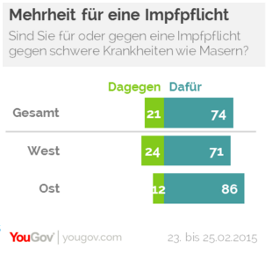
“Total: against, 21%; for, 74%”
“West: against, 24%; for, 71%”
“East: against, 12%; for, 86%”
(Schmidt, 2015).

Figure 2: Vaccination rates in and around Figure 3: Measles cases in and around Coburg
Coburg
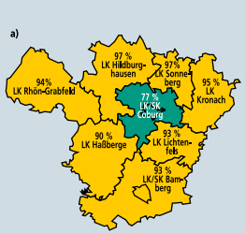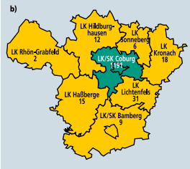

Coburg is shown in green. Please note that Hildburghausen and Sonneberg are not Bavarian states. They lie in Thuringen, which was East Germany during occupation (Images from Arenz et al., 2003).

Figure 4: “Vaccination dose sales” in Coburg over time, January 2001- September 2002

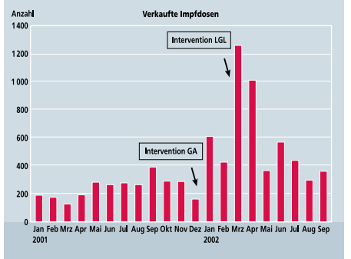

The graph shows two large increases in sales after two intervention periods in January 2002 and March 2002 (Arenz et al., 2003).

Figure 5: “We Won’t Vaccinate! Myths and Realities of the Vaccination Campaigns”
(Leitner).
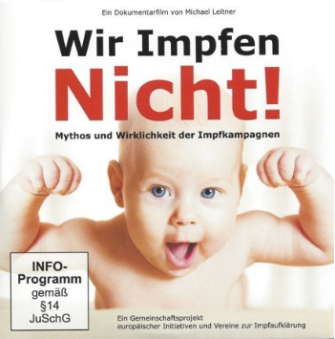

Figure 6: “A Curious Trial: Is there a Measles Virus? Experiment of a Scientific Approach”
(Tolzin, 2016).
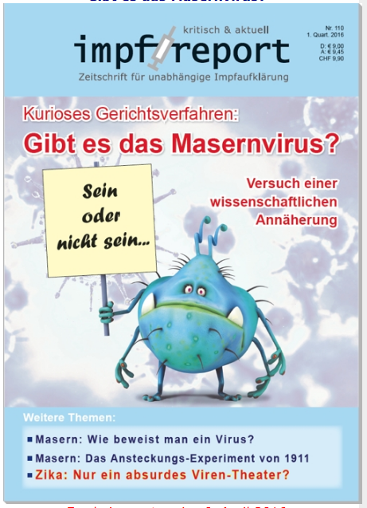

Above: The sign states, “To be or not to be….”

Figure 7: “Deadly Medicine and Organized Crime: How the Pharmaceutical Industry Corrupts Health Care”
(Gøtzsche).
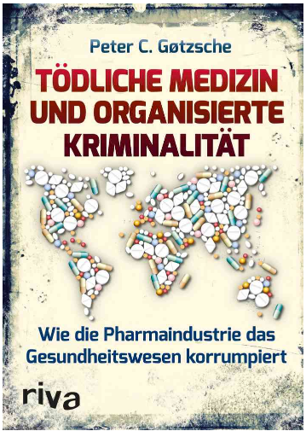

Figure 8: “The Measles Emperor’s New Clothes”
(Tolzin, 2015).
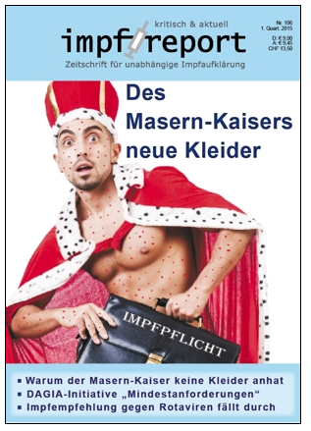

Above: His briefcase says, “Compulsory Vaccination.”

References

Arenz, S., Kalies, H., Ludwig, M. S., Hautmann, W., Siedler, A., Liebl, B., Morlock, G., & von Kries, R. (2003). Der Masernausbruch in Coburg. Deutsches Ärzteblatt, 100:49, A3245- A3249. Retrieved from http://edoc.rki.de/oa/articles/renBzIkDkHzQ/PDF/22215s7kqzuF2.pdf
Arenz, S., Schmitt, H. J., Tischer, A., & von Kries, R. (2005). Effectiveness of measles vaccination after household exposure during a measles outbreak: A household contact study in Coburg, Bavaria. The Pediatric Infectious Disease Journal, 24:8, 697- 699. doi:10.0197/01.inf.0000172900.70430.c2
“Bahr will Impfpflicht vermeiden.” (2013, Jul. 20). Frankfurter Allgemeine. Retrieved from http://www.faz.net/aktuell/politik/masern-bahr-will-impfpflicht-vermeiden- 12288926.html#/elections
“Berlin measles cases link back to United States outbreak.” (2015, Feb. 13). Deutsche Welle. Retrieved from http://www.dw.com/en/berlin-measles-cases-links-back-to-united-states- outbreak/a-18257470
“Berlin outbreak blasts hopes of eradicating measles in Germany by 2015.” (2015, Feb. 5). Deutsche Welle. Retrieved from http://www.dw.com/en/berlin-outbreak-blasts- hopes-of-eradicating-measles-in-germany-by-2015/a-18235648
“CDU-Beschlüsse: Flüchtlinge, Einwanderung, und Impfpflicht.” (2015, Dec. 15). Süddeutsche Zeitung. Retrieved from http://www.sueddeutsche.de/news/politik/parteien-cdu- beschluessefluechtlinge-einwanderung-und-impfpflicht-dpa.urn-newsml-dpa-com- 20090101-151214-99-327355
Centers for Disease Control and Prevention. (2016, May 2). “Measles: Cases and outbreaks.” Retrieved from http://www.cdc.gov/measles/cases-outbreaks.html
“Die meisten Deutschen wollen die Impfpflicht.” (2015, Feb. 26). Zeit Online. Retrieved from http://www.zeit.de/wissen/gesundheit/2015-02/masern-impfpflicht-gesetz-umfrage
“Ein Pro und Contra zur Impfpflicht.” (2013, Jul. 8). Deutsches Ärzteblatt. Retrieved from http://www.aerzteblatt.de/nachrichten/55073
European Centre for Disease Prevention and Control. (2015, Jul. 28). “
European Centre for Disease Prevention and Control. (2016, Apr. 15). “Surveillance Data.” Retrieved from http://ecdc.europa.eu/en/healthtopics/measles/epidemiological_data/Pages/measles_past1 2months.aspx
“Gesundheitsminister Grohe droht mit Impfpflicht.” (2015, Apr. 11). Zeit Online. Retrieved from http://www.zeit.de/politik/deutschland/2015-04/masern-impfflicht-groehe
“Gesundheitspolitiker fordern Wiedereinführung der Impfpflicht.” (2015, Feb. 23). Zeit Online. Retrieved from http://www.zeit.de/wissen/gesundheit/2015-02/debatte- impfpflicht-masern
Gøtzsche, P. C. Tödliche Medizin und organisierte Kriminalität: Wie die Pharmindustrie das Gesundheitswesen korrumpiert. Riva Verlag. Retrieved from http://tolzin- verlag.com/fbu113
Güriş, D., Bayazıt, Y., Özdemirer, Ü., Buyurgan, V., Yalnız, C., Toprak, İ., & Aycan, S. (2003). Measles epidemiology and elimination strategies in Turkey. The Journal of Infectious Diseases, 187, S230-S234. doi:10.1086/368115
Hohmann-Jeddi, C. (2015). Impflücken bei Erwachsenen. Pharmazeutische Zeitung. Retrieved from http://www.pharmazeutische-zeitung.de/index.php?id=56754
Klein, S., Schöneberg, I., & Krause, G. (2012). Vom Zwang zur Pockenschutzimpfung zum nationalen Impfplan: Die Entwicklung des Impfwesens vom Deutschen Kaiserreich bis heute. Bundesgesundheitsblatt - Gesundheitsforschung - Gesundheitsschutz, 55, 1512:1523. doi:10.1007/s00103-012-1539-7.
Leitner, M. Wir Impfen Nicht! Mythos und wirklichkeit der Impfkampagnen. Retrieved from http://tolzin-verlag.com/DVD149
Muscat, M. (2011). Who gets measles in Europe?. The Journal of Infectious Diseases, 204, S353-S365. doi:10.1093/infdis/jir067

“Pressemitteilung Dr. med. Wolfram Hartmann (Präsident des BVKJ) zum 21. Kongress Jugendmedizin.” (2015, Mar. 6). Berufsverband der Kinder- und Jugendärzte. Retrieved from http://www.bvkj.de/presse/pressemitteilungen/ansicht/article/pressemitteilung-zum-21- kongress-jugendmedizin/
Robert Koch Institute. (2015). Epidemiologisches Bulletin, 34, 327-362. doi:10.17886/EpiBull- 2015-001.2
Robert Koch Institute. (2016). [Graph illustration Tab. 2: Fallzahl und Inzidenzen pro 1 Mio Einwohner für die Jahre 2013 bis 2015 nach Bundesland]. Aktuelle epidemiologische Situation der Masern und Röteln in Deutschland. Retrieved from https://www.rki.de/DE/Content/Infekt/Impfen/Praevention/elimination_04_01.html
Schmidt, M. (2015, Feb. 26). Drei von vier Deutschen sprechen sich für Impfpflicht aus. YouGov Omnibus. Retrieved from https://yougov.de/news/2015/02/26/impfungen- uber-80-prozent-glauben-wirksamkeit/
Smith, L. “Homeopaths blamed for measles.” (2002, Mar. 6). Vaccination News. Retrieved from http://www.vaccinationnews.org/DailyNews/March2002/HomeopathsBlamedMeasles.ht m
Tolzin, H. U. P., ed. (2015, Mar. 9). Des Masern-Kaisers neue Kleider. Impf Report: Zeitschrift für unabhängige Impfaufklärung. Retrieved from http://www.impf- report.de/zeitschrift/archiv/impf-report106.html
Tolzin, H. U. P., ed. (2016, Apr. 6). Kurioses Gerichtsverfahren: Gibt es das Masernvirus? Versuch einer wissenschaftlichen Annäherrung. Impf Report: Zeitschrift für unabhängige Impfaufklärung. Retrieved from http://www.impf- report.de/zeitschrift/archiv/impf-report110.html
World Health Organization. (2014). European Vaccine Action Plan 2015-2020.
“Zahl der Masern-Infektionen in Bayern verdoppelt.” (2015, Mar. 30). Die Welt. Retrieved from http://www.welt.de/regionales/bayern/article138928202/Zahl-der-Masern- Infektionen-in-Bayern-verdoppelt.html

“Schutzimpfungen sind nicht ausschließlich eine private, individualmedizinische Maßnahme”
“Auch Kinder, die aus medizinischen Gründen vor allem mit den üblichen Lebendimpfstoffen…nicht geimpft werden können…haben ein Recht auf den Besuch von überwiegend staatlich finanzierten Gemeinschaftseinrichtungen.”
“Wichtig für die Gesundheit ist kein vollgestempelter Impfpass, sondern ein natürliches Aufwachsen mit gutem Wasser und gesundem Essen.”

