Evolution and Phylogeny of the Parasitoid Subfamily Phasiinae (Diptera: Tachinidae)

A Dissertation Presented for the
Doctor of Philosophy
Degree
The University of Tennessee, Knoxville

Jeremy D. Blaschke
August 2015

Copyright © 2015 by Jeremy Blaschke
All rights reserved.

Acknowledgements

Thank you all for your help.
Abstract

Chapter I: Evolution and Phylogeny of the Parasitoid Subfamily Phasiinae (Diptera: Tachinidae)

Table of Contents

Abstract 1
Introduction and Background 2
Tachinidae 3
Phasiinae 4
Taxonomy 5
Objectives 8
Materials and Methods 9
Collection 9
Genes 13
Extraction and Amplification 13
Phylogenetic Analysis 14
Ancestral State Reconstruction 15
Results 21
Sequence data 21
Trees 21
Outgroups 21
Tachininae + Exoristinae 25
Dexiinae 25
Phasiinae 26
Taxonomically ambiguous genera 29
Clade frequencies across all analyses 29
Phylogenetic informativeness of genes and codon positions 30
Discussion 32
Classification 32
Evolution of Tachinidae 38
Conclusions 51
References 52

Abstract

Phasiinae are endoparasitoid flies that attack Heteroptera, including a multitude of agricultural pests. A phylogenetically informed classification of the Phasiinae (Diptera: Tachinidae) has eluded systematists for over a century, primarily because of the conflicting character states and confusing morphology of certain taxa that indicate placement in multiple subfamilies. The unstable nature of phasiine taxonomy discourages important research into their classification, life history, and potential use in biological control. In hopes of resolving several longstanding taxonomic debates and encouraging future research into this important group of parasitoids, the first molecular systematic analysis of the Phasiinae is presented, estimated from 128 worldwide taxa (80 genera) and ~7.6 kb of nuclear data. A special emphasis is placed on taxonomically ambiguous groups. The resultant robust phylogenetic tree is used to reconstruct ancestral character states, trace the evolution of significant adaptive traits within the Tachinidae, and test hypotheses about the classification of Phasiinae. The subfamily placement of Eutherini, Epigrimyiini, and Litophasiini, Strongygastrini, and Parerigonini is confidently resolved, the former three within Dexiinae and the latter two within Phasiinae. The phylogenetic position of the Imitomyiini is more difficult to decipher, but they are ultimately placed among the Phasiinae. Phasiinae includes twelve tribes, with the genera of Phasiini and Parerigonini redistributed among multiple tribes. Three new tribes are proposed: Opesiini, Xystiini, and Zitini. Ancestral state reconstruction suggests a dominant and persistent trend in Phasiinae to evolve piercing structures used to insert eggs directly into host tissues. A single potential synapomorphy of Phasiinae is identified (elongated hypandrium), but a suite of characters is needed to differentiate Dexiinae.

Introduction and Background

The biological sub-discipline of taxonomy has been studied in various permutations for millennia by humans exploring, discovering, and organizing the diversity of life on earth. In addition to being essential for understanding biodiversity and conservation, taxonomic research creates a framework unencumbered by language barriers for investigating ecology, biomedicine, and biological control around the world. As such it is indispensable to both basic and applied research. A subtle but transformative change in taxonomy came about with the introduction of cladistics in the middle 20th century by Willi Hennig and its eventual acceptance among systematists (Hennig 1965; Wheeler et al. 2013). The traditional hierarchical classification of Linnaeus began to be informed by evolutionary hypotheses rather than simply nested similarity among organisms (phenetics). As a result, modern phylogenetics, both morphological and molecular, attempts to create “trees of life” that accurately reflect an organism’s evolutionary history and relationship with other organisms (Wiley & Lieberman 2011).
One hypothesis of evolutionary phylogenetics is that descendants of a common ancestor should have one or more shared derived traits that can be used to distinguish them from other clades and distant relatives/ancestors. Such traits are termed synapomorphies and form the cornerstone of cladistics (Mooi & Gill 2010). While synapomorphies can be fairly easy to identify in some clades (e.g., halteres of Diptera), biology rarely creates such neat and tidy groups. True synapomorphies are sometimes difficult to find as often exceptions abound in almost every clade. Contributing to this problem is the phenomena of parallel and convergent evolution (Wallace & Gibson 2002). Species in separate lineages often evolve the same or very similar morphological traits. When the same complex trait appears in two organisms, the most parsimonious explanation is that the two species shared a common ancestor who also possessed the same trait. This characteristic was then passed on to its descendants – providing an important clue as to the species’ ancestry. This explanation is beautiful in its simplicity as it requires only a single origin for a complex trait or behavior. However, it is not uncommon for evolution to produce similar complex traits in independent lineages (homoplasy), thus obscuring their evolutionary history. What are taxonomists to do then, when a species has competing homoplastic characters that imply an evolutionary relationship within different clades? A satisfying answer to this question is often difficult to obtain through morphological systematics alone because of these conflicting characters.
For centuries, taxonomy was built solely around the physical traits and behaviors of organisms, but with recent advances in DNA sequencing technology and phylogenetic algorithms, molecular systematics has risen to the forefront of biological classification. Molecular data offers an independent line of evidence for ancestry and evolution that is often able to resolve longstanding questions in classification for which the morphological data are equivocal. While the physical traits of two species evolve independently – sometimes diverging and sometimes converging until little phenotypic difference remains – the evolution of DNA mutations (unlinked to physical traits) steadily widens the genetic gap between the species. Over many generations then, the molecular data often show a consistent diverging pattern between taxa even when the morphology is nearly indistinguishable.
In this study, we present the first molecular systematic analysis focused on the agriculturally important parasitoid subfamily Phasiinae (Diptera: Tachinidae) – a group long characterized by uncertain taxonomy due to widespread homoplasy of morphological traits – and present new evidence for the subfamily and tribal affinities of several morphologically confusing taxa. A robust phylogenetic tree is created which is then used to reconstruct ancestral character states, trace the evolution of significant adaptive traits within the Tachinidae, and test hypotheses about the classification of Phasiinae.

Tachinidae
The family Tachinidae (Superfamily Oestroidea) is a fascinating and diverse group of endoparasitoid flies (Stireman et al. 2006). Tachinidae form a well-supported monophyletic clade defined in part by an enlarged subscutellum and obligate parasitism of arthropod hosts (Wood 1987; Pape 1992). With ~8,500 described species worldwide and perhaps an equal number still undescribed (O’Hara 2013), Tachinidae is considered to be the most speciose (second in described species to Tipulidae) and morphologically diverse family of Diptera (Crosskey 1980) and one of the largest insect parasitoid groups (Eggleton & Belshaw 1993). Tachinids have experienced such astounding adaptive success in part due to their varied choice in hosts. The family includes both generalist species and specialists that collectively attack a multitude of hosts from 14 different orders of arthropods. They primarily attack caterpillars, beetles, and bugs (Heteroptera) (Arnaud 1978), but also parasitize scorpions (Williams and Arnaud 1990), centipedes (Wood and Wheeler 1972), and spiders (Vincent 1985). By preying on insect plant pests like lepidopteran caterpillars and heteropteran bugs, tachinids play an important role in regulating pest populations in both natural ecosystems and controlled agricultural environments (Nishida 1966; Karban and English-Loeb 1997; Coombs 2004; Stireman and Singer 2003).
Despite their abundance and potential for use as biological control agents, the taxonomy of Tachinidae is well-known among insect systematists for being difficult and confusing (see O’Hara 2013 and Blaschke et al. 2015 for reviews). They appear to be a recent (minimum Oligocene, O’Hara et al. 2013) and actively radiating group of insects and this recent evolution has created substantial problems in reconstructing phylogenetic relationships (Guimaráes 1971; Stireman 2002; Cerretti et al. 2014; Winkler et al. 2015). Additionally, there is widespread homoplasy throughout the family resulting in very few clear synapomorphies that distinguish genera, tribes, or even subfamilies (Wood 1987).
Modern tachinid experts recognize four subfamilies: Phasiinae, Dexiinae, Exoristinae, and Tachininae (Herting 1984; Tschorsnig & Richter 1998; O’Hara and Wood 2004; Cerretti et al. 2014). However, relationships within and among the subfamilies are poorly understood and have undergone considerable rearrangement throughout their history (O’Hara 2013). The subfamilies Tachininae and Exoristinae are defined based on the presence of a collection of multiple character traits and/or life history traits that are difficult to identify and contain many exceptions (Wood 1987). Only Dexiinae and Phasiinae have potential synapomorphic character traits, both found in the male postabdomen (Dexiinae: hinged, membranous connection of basi/distiphallus; Phasiinae: elongated hypandrium) (Tschorsnig 1985). Therefore, a phylogeny that defines relationships even among a single subfamily like Phasiinae can contribute significant information to a broader picture of tachinid evolution and history.

Phasiinae
The subfamily Phasiinae is the smallest of the Tachinidae yet still contains ~600 species in ~100 genera (Crosskey 1973, 1976; Herting 1984; Tschorsnig 1985; Wood 1987; Herting and Dely-Draskovits 1993; Tschorsnig and Richter 1998; Ziegler 1998; Richter 2004; O’Hara et al. 2009; Blaschke et al. 2015). Even so, some of the most extreme morphological differences between genera within the Tachinidae can be found in Phasiinae. Phasiines differ dramatically in size and appearance, from one of the smallest tachinids (Catharosia Rondani: <2mm) to one of the largest (Lophosia Meigen: 18mm). Some phasiines are colored in simple blacks and greys while others display cryptic coloration patterns or mimic the bright colors that often indicate toxicity on other insects (aposematism). As a result, several genera resemble quite remarkably various hymenopteran species, most notably Polistiopsis Townsend, Formicophania Townsend, and the species Cylindromyia mirabilis Townsend. Most species in the tribes Cylindromyiini and Gymnosomatini (including Trichopodini) have bright red, orange, or black and yellow abdomens that mimic the warning colors of wasps and bees (Waldbauer et al. 1977).
The primary hosts for this group of parasitoids are heteropteran bugs – many of which are prominent agricultural pests including Nezara viridula L. (southern green stink bug), Euschistus servus Say (brown stink bug), and Lygus lineolaris Beauvois (tarnished plant bug) (Coquillet 1897; Arnaud 1978) as well as the invasive pests Halyomorpha halys (brown marmorated stink bug, Aldrich et al. 2007) and Megacopta cribraria (kudzu bug, Golec et al. 2013). Many phasiines identify potential hosts through the use of specialized antennal receptors that are extremely sensitive to host pheromones (Aldrich et al. 2006). Remarkably, many phasiines are more adept at locating host species than even their hosts are of locating each other (Aldrich et al. 1989). These phasiines are most commonly attracted to sexual aggregation pheromones of the male bugs and as a result generally parasitize more males than females. Because of their distinctive ability to use pheromone cues, phasiines hold great promise as biological control agents but have been underutilized as such due to their confusing taxonomy and difficult identification. A predictive and well-supported taxonomy of Phasiinae will provide fertile research ground for future studies in biological control, co-evolution of interspecies complexes, pheromone attractants, and tritrophic ecological interactions.

Taxonomy
The subfamily Phasiinae is taxonomically separated from other tachinid subfamilies by their reduced chaetotaxy, parasitism of heteropteran hosts, oviparity (i.e., laying of unembryonated eggs), possession of a piercer derived from either the 8th or 10th sternite (with exceptions), and an elongated hypandrium in the male postabdomen (Coquillet 1897; O’Hara 1985; Tschorsnig 1985; Stireman et al. 2006). Their closely related sister group, Dexiinae, is defined by potential synapomorphies in the male postabdomen including an entirely membranous and “hinged” (≤90˚) connection between basiphallus and distiphallus and platiform pregonites (Tschorsnig 1985; Tschorsnig & Richter 1998; O’Hara & Wood 2004; Cerretti et al. 2014). In contrast to the Phasiinae, dexiines primarily attack Coleoptera and Lepidoptera and are ovolarviparous (i.e., lay late developmental stage eggs or early instar larvae) (Wood 1987; Stireman et al. 2006). Given these definitions of Phasiinae and Dexiinae, several taxa cannot be confidently placed in either subfamily as they possess characters used to define both. The conflicting characters of these taxa are briefly introduced below.

Epigrimyiini – In favor of a placement in Phasiinae, the two genera of tribe Epigrimyiini (Epigrimyia Townsend and Beskia Brauer & Bergenstamm) parasitize Heteroptera (Guimarães 1977; Biehler & McPherson 1982; Sutherland & Baharally 2002), possess 8th sternite piercers, and have reduced chaetotaxy (Wood 1987). Beskia has a bright red/orange abdomen. However, Epigrimyiini do not possess the elongated hypandrium of Phasiinae. Rather, they share the male terminalia characters of the Dexiinae (membranous, hinged connection between basiphallus and distiphallus and platiform pregonites) (Tschorsnig 1985; O’Hara & Wood 2004) as well as that subfamily’s ovolarviparity (Townsend 1938).

Eutheriini – The Eutherini (Euthera Loew and Redtenbacheria Schiner) are heteropteran parasitoids, which indicates a placement within Phasiinae (Arnaud 1978; Nishayama 1995). They produce planoconvex eggs (membranous on ventral side, but thickened and convex on dorsal surface) (Herting 1966; Mesnil 1966) rather than the entirely membranous eggs of the Dexiinae (Stireman et al. 2006). However, even though their eggs are morphologically similar to those found in Phasiinae, the Eutherini are ovolarviparous rather than oviparous and do not have piercers (Townsend 1938; Cantrell 1983). They also possess the dexiine-like male terminalia trait of platiform pregonites, but the connection between basiphallus and distiphallus is neither hinged nor entirely membranous as in other dexiines (Tschorsnig 1985; Cerretti et al. 2014). However, neither do they possess a phasiine-like elongated hypandrium. Because of the Eutherini’s oviposition strategy and egg-type, the subfamily Exoristinae has also been proposed as a possible location for this enigmatic tribe (Cerretti et al. 2014).

Imitomyiini – Similarly, the Imitomyiini (Imitomyia Townsend, Proriedelia Mesnil, and Riedelia Mesnil) are found in a confusing morphological intermediacy between the Dexiinae and Phasiinae. Hosts are unknown, but Imitomyia females possess a 10th sternite piercer and the males an elongated hypandrium (females of other genera are unknown) – both uniquely phasiine traits (Townsend 1938; Tschorsnig 1985; O’Hara & Wood 2004). However, the Imitomyiini are ovolarviparous like the Dexiinae and possess all the characteristics previously mentioned of the dexiine male postabdomen except the ≤90˚ angle of the “hinged” connection of basiphallus to distiphallus (Tschorsnig 1985; O’Hara & Wood 2004; Cerretti et al. 2014).

Litophasia – The rare genus Litophasia Girschner possesses a piercing 8th sternite and has significantly reduced chaetotaxy, both of which indicate a placement in Phasiinae (Dear 1980), but its hosts and oviposition strategy are unknown. In contrast to these traits, Litophasia, like Imitomyia, has all the features of a dexiine male post abdomen except the hinged connection of basiphallus to distiphallus (Tschorsnig 1985). Litophasia is currently classified in Phasiinae: Catharosiini (Crosskey 1980; Herting 1983).

Strongygastrini/Rondaniooestrini – Three additional tribes have maintained a debated taxonomic position between Phasiinae and the subfamily Tachininae. Foremost among these are the tribes Strongygastrini (Strongygaster Macquart, Arcona Richter, and Melastrongygaster Shima) and the closely related tribe Rondaniooestrini (Rondaniooestrus Villeneuve). These genera align closely with Phasiinae in respect to the male genitalia (including elongated hypandrium) and overall habitus (Tschorsnig 1985, Cerretti 2014, pers. com.). The primary argument for placement in the Tachininae is a result of the unusual host range found in these taxa. Rondaniooestrus is the only known tachinid parasite of honeybees (Villeneuve 1924) and is not known to parasitize anything else. Strongygaster, on the other hand, parasitizes heteropterans, similar to other phasiines (Sabrosky & Braun 1970; Santos & Panizzi 1997; Panizzi & Oliveira 1999; Golec et al. 2013; pers. ops.), but also attacks a wide array of other insects including Orthoptera (Kevan & Koshnaw 1988), Coleoptera (Arnaud 1978), Hymenoptera (Eggleton & Belshaw 1992; Feener 2000), Lepidoptera (Sabrosky & Braun 1970), Dermaptera (Sabrosky & Braun 1970), and Diptera (Ferrar 1977). No other phasiine regularly exploits hosts outside of Heteroptera, and therefore Strongygaster’s host range would be unprecedented in the subfamily. Their unusual hosts coupled with the fact that these genera are ovolarviparous rather than oviparous indicates a placement in Tachininae rather than Phasiinae (Wood 1987).

Parerigonini – The Parerigonini are currently considered to be in Phasiinae (O’Hara et al. 2009; Wood & Zumbado 2010), but have historically been members of Tachininae (Townsend 1936, 1939; Guimarães 1971; Crosskey 1973, 1976; Crosskey & Cantrell 1989). Their external morphology is quite divergent from typical Phasiinae with strong correlations to the Tachininae tribe Linnaemyini. However, their male and female terminalia (elongated hypandrium – Tschorsnig 1985; piercers – Cantrell 1988) and hosts, when known, indicate a placement in Phasiinae (Mesnil 1970; Shima 2015).

Objectives
Representatives of each of the above potential phasiine tribes as well as genera from all widely accepted traditional phasiine tribes were included in this analysis in an attempt to clarify the confusion of phasiine classification. This research had the following objectives:
- Determine whether or not Phasiinae is monophyletic and if so, if there are any synapomorphies that define the clade.
- Assess the monophyly/validity of, and relationships between, tribes in Phasiinae.
- Infer the evolutionary relationships of the following taxonomically ambiguous taxa: Epigrimyiini, Eutheriini, Imitomyiini, Litophasia, Strongygastrini, Rondaniooestrini, and Parerigonini.
- Trace the evolution of important traits across the phylogeny to test hypotheses about subfamily synapomorphies and the evolution of Tachinidae.

Materials and Methods

Collection
An international collaboration was necessary to obtain representative genera of Phasiinae and other subfamilies from around the world. We are very grateful for the specimens and sequences provided by other researchers (see Acknowledgements section) without which this phylogeny would have been much more incomplete and less supported. Specimens were obtained through Malaise trapping and/or hand collecting. Malaise specimens were preserved in 95% ethanol. Manually collected tachinids were pinned to preserve intact morphological specimens for species identification. One to three right legs from each specimen were removed and placed in 95% ethanol for DNA extraction. For some very small specimens with known species identification, the entire fly was used. Post-extraction DNA samples were stored at -20°C. Voucher specimens are housed in the Blaschke Lab – Union University (TN), the Moulton Lab – University of Tennessee, the Stireman Lab – Wright State University (OH), the Canadian National Collection (Ottawa, CA), the Cerretti Lab – University of Rome (Sapienza), and the Tachi Lab – Kyushu University (Japan).
Our idealistic goal was to collect representative genera of every tribe within the diverse Phasiinae as well as species from every tribe with a debated subfamily position for which Phasiinae is a possible resting place. Remarkably, our goal was almost achieved – only the two extremely rare South American tribes Tarassini and Euscopoliopterygini (possible phasiines), which are known from only a few museum specimens, are absent from the phylogeny. A total of 126 specimens (80 genera, Table 1) were included in this study representing all seven widely accepted tribes of Phasiinae, an additional seven tribes with uncertain subfamily affiliations, eight tribes of Dexiinae, six tribes of Exoristinae, and five tribes of Tachininae. Also included as outgroup taxa were specimens of Calliphoridae (3 species), Rhinophoridae (3 species), Sarcophagidae (1 species), Oestridae (1 species), and Muscidae (1 species). All sequences for LGL, MAC, and MCS were processed in the Moulton Lab (University of Tennessee). A few taxa for CAD were processed in the Stireman Lab (Wright State University) or the Tachi Lab (Kyushu University) (see Table 1).

Table 1: List of taxa included and corresponding gene coverage. * indicates CAD sequences are from the Stireman Lab. ** indicates CAD sequences are from the Tachi Lab.
Tachinidae: Phasiinae
Tribe | Genus species | Country | CAD | LGL | MCS | MAC
Catharosiini | Catharosia nebulosa Coquillett | USA | x | x | x | x
 | Catharosia sp. | Australia | x | x | x | x
 | Catharosia sp. | Thailand | x | x | x | x
Cylindromyiini | Australotachina calliphoroides Curran 1 | Australia | x | x | x | x
 | Australotachina calliphoroides Curran 2 | Australia | x | x | x | x
 | Besseria atra Coquillett | Canada | x | x | x | x
 | Besseria sp. | South Africa | x | x | x | x
 | cf. Lophosia sp. 1 | Thailand | x | x | x | x
 | cf. Lophosia sp. 2 | Korea | x | x | x | x
 | cf. Pygidimyia sp. | Australia | x | x | x | x
 | Cylindromyia binotata Bigot | USA | x | x | x | x
 | Cylindromyia mirabilis Townsend | USA | x | x | x | x
 | Cylindromyia rufifrons Loew | Sardinia | x | x | x | x
 | Cylindromyia sp.** | Japan | x
 | Cylindromyia sp. 1 | Australia | x | x | x | x
 | Cylindromyia sp. 1 | South Africa | x | x | x | x
 | Cylindromyia sp. 2 | Australia | x | x | x | x
 | Cylindromyia sp. 2 | South Africa | x | x | x | x
 | Hemyda aurata Robineau-Desvoidy | USA | x | x | x | x
 | Huttonobesseria verecunda Hutton | New Zealand | x | x | x | x
 | Lophosia fasciata Meigen | Finland | x | x | x | x
 | Lophosia sp. | Thailand | x | x | x | x
 | Neobrachelia sp. | Ecuador | x | x | x | x
 | Phania funesta Meigen | Italy | x | x | x | x
 | Prolophosia petiolata Townsend | Burundi | x | x | x | x
 | Prolophosia sp. | Burundi | x | x | x | x
 | Pygidimyia sp. | Australia | x | x | x | x
Gymnosomatini | Acaulona sp. | Costa Rica | x | x | x | x
 | Cistogaster mesnili Zimin | Italy | x | x | x | x
 | Clytiomya dupuisi Kugler | Italy | x | x | x | x
 | Clytiomya sola Rondani | Italy | x | x | x | x
 | Ectophasia dupuisi | Italy | x | x | x | x
 | Ectophasia oblonga Robineau-Desvoidy | Israel | x | x | x | x
 | Eliozeta helluo Fabricius | Italy | x | x | x | x
 | Eliozeta pellucens Fallén | Slovenia | x | x | x | x
 | Euclytia flava Townsend | USA | x | x | x | x
 | Gymnoclytia immaculata Macquart | USA | x | x | x | x
 | Gymnoclytia occidua Walker | USA | x | x | x | x
 | Gymnoclytia sp. | Costa Rica | x | x | x | x
 | Gymnosoma clavatum Rohdendorf | Germany | x | x | x | x
 | Gymnosoma inornatum Zimin | Italy | x | x | x | x
 | Gymnosoma nitens Meigen | Slovenia | x | x | x | x
 | Gymnosoma par Walker | USA | x | x | x | x
 | Gymnosoma rotundatum L. | Italy | x | x | x | x
 | Gymnosoma sp. | Korea | x | x | x | x
 | Pentatomophaga latifascia Villeneuve** | Japan | x
 | Trichopoda lanipes Fabricius 1 | USA | x | x | x | x
 | Trichopoda lanipes Fabricius 2 | USA | x | x | x | x
 | Trichopoda pennipes Fabricius 1 | Fr. Polynesia |  | x | x | x
 | Trichopoda pennipes Fabricius 2 | USA | x | x | x | x
 | Trichopoda pennipes Fabricius 3 | USA |  | x | x | x
 | Trichopoda plumipes Fabricius | USA | x | x | x | x
 | Xanthomelanodes arcuatus Say | USA | x | x | x | x
 | Xanthomelanodes californicus Townsend | USA | x | x | x | x
Hermyini | cf. Formicophania sp. | Thailand | x | x | x | x
 | Hermya beelzebul** | Japan | x
 | Hermya sp. 1 | Burundi | x | x | x | x
 | Hermya sp. 2 | Malaysia | x | x | x | x
 | Imitomyia sugens Loew | USA | x | x | x | x
 | Penthosia satanica Bigot | USA | x | x | x | x
Imitomyiini | Penthosiosoma sp. | Thailand | x | x | x | x
Leucostomatini | Calyptromyia barbata Villeneuve** | Japan | x
 | Clairvillia biguttata Meigen | Israel | x | x | x | x
 | Clairvillia timberlakei Walton | USA | x | x | x | x
 | Clairvilliops breviforceps van Emden** | Japan | x
 | Labigastera nitidula Meigen | Italy | x | x | x | x
 | Leucostoma sp. 1 | USA | x | x |  | x
 | Leucostoma sp. 2 | USA | x | x | x | x
 | Weberia digramma Meigen | Israel | x | x | x | x
Opesiini | Opesia grandis Egger | Italy | x | x | x | x
Parerigonini | Parerigone sp.** | Japan | x
 | Zambesomima sp.** | Japan | x
Phasiini | Elomya lateralis Meigen | Israel | x | x | x | x
 | Phasia aurulans Meigen | USA | x | x | x | x
 | Phasia hemiptera Fabricius** | Japan | x
 | Phasia sp. 1 | South Africa | x | x | x | x
 | Phasia sp. 2 | South Africa | x | x | x | x
 | Phasia sp. 3 | Ecuador | x | x | x | x
 | Phasia sp. 4 | Japan | x
 | Phasia subcoleoptrata Linne | Israel | x | x | x | x
Strongygastrini | Rondaniooestrus apivorous Villeneuve | South Africa | x | x | x | x
 | Strongygaster robusta Townsend | USA | x | x | x | x
 | Strongygaster sp. | Thailand | x | x | x | x
 | Strongygaster triangulifera Loew | USA | x | x | x | x
Xystini | Xysta holosericea Fabricius | Israel | x | x | x | x
Zitini | cf. Leverella sp. | Australia | x | x | x | x
 | Leverella sp. | Australia | x | x | x | x
 | Zita sp. 1 | Australia | x | x | x | x
 | Zita sp. 2 | Australia | x | x | x | x
 | Zita sp. 3 | Australia | x | x | x | x
Tachinidae: Dexiinae
Tribe | Genus species | Country | CAD | LGL | MCS | MAC
Campylochetini | Campylochaeta semiothisae Brooks | USA | x | x | x | x
Dexiini | Billaea sp. | USA | x | x | x | x
 | Euchaetogyne roederi Williston* | Canada | x | x | x | x
 | Ptilodexia conjuncta Wulp | USA | x | x | x | x
Dufouriini | Oestrophasia sp. | USA | x | x | x | x
Epigrimyiini | Beskia aelops Walker | USA | x | x | x | x
 | Epigrimyia illinoensis Robertson | USA | x | x | x | x
Eutherini | Euthera tentatrix Loew | Australia | x | x | x | x
 | Euthera sp. 1 | USA | x | x | x | x
 | Euthera sp. 2** | Japan | x
Litophasiini | Litophasia sp. | South Africa | x | x | x | x
Rutiliini | Rutilia regalis Guérin-Méneville | Australia | x | x | x | x
Sophiini | Cordyligaster sp. | USA | x | x | x | x
Thelairiini | Thelaira americana Brooks | USA | x | x | x | x
Uramyini | Uramya pristis Walker | USA | x | x | x | x
Voriini | Voria ruralis Fallén | USA | x | x | x | x
Tachinidae: Exoristinae
Tribe | Genus species | Country | CAD | LGL | MCS | MAC
Blondeliini | Blondelia eufitchiae Townsend | USA | x | x |  | x
Acemyini | Ceracia dentata Coquillett | USA | x | x | x | x
Goniini | Hyphantrophaga hyphantriae Townsend | USA | x | x | x | x
Eryciini | Lespesia aletiae Riley | USA | x | x | x | x
Exoristini | Tachinomyia nigricans Webber | USA | x | x | x | x
Winthemiini | Winthemia sp. | USA | x | x | x | x
Tachinidae: Tachininae
Tribe | Genus species | Country | CAD | LGL | MCS | MAC
Tachinini | Epalpus signifer Walker | USA | x | x | x | x
Ernestiini | Panzeria ampellus Walker | USA | x | x | x | x
Siphonini | Siphona plusiae Coquillett | USA | x | x | x | x
Tachinini | Tachina sp.* | USA | x | x | x | x
Polideini | Homalactia harringtoni Coquillett* | USA | x | x | x | x
Outgroup taxa
Subfamily | Genus species | Country | CAD | LGL | MCS | MAC
Calliphoridae | Angioneura abdominalis Reinhard* | USA | x | x | x | x
Oestridae | Cuterebra austeni Sabrosky* | USA | x | x | x | x
Calliphoridae | Lucilia sericata Meigen* | USA | x | x | x | x
Rhinophoridae | Melanophora roralis L.* | USA | x | x | x
Calliphoridae | Pollenia pediculata Macquart* | USA | x | x | x | x
Rhinophoridae | Rhinomorinia sp.* | South Africa | x | x | x | x
Sarcophagidae | Macronychia sp.* | USA | x | x | x | x
Muscidae | Musca domestica L.* | USA | x | x | x | x
Rhinophoridae | Axinia sp.* | USA | x | x | x | x

Genes
The genes used in this study, carbamoyl-phosphate synthetase 2/rudimentary (CAD), lethal giant larvae (LGL), methyl-accepting chemoreceptor (MAC), and molybdenum cofactor sulfurase (MCS), were chosen specifically for their ability to resolve deeper nodes within a phylogeny of rapidly evolving lineages. CAD was first introduced by Moulton & Weigmann (2004), while the significant phylogenetic utility of LGL, MAC, and MCS recently debuted in Winkler et al. (2015). Each gene is a single copy nuclear protein coding gene that offers significantly more phylogenetic signal than more traditional markers such as COI/II, 28S, EF1-α, etc. (Winkler et al. 2015). The standard ribosomal and mitochondrial genes are easier to obtain, but do not contain enough nonsynonymous mutations to fully resolve the phylogeny of a young and diverse group like the Tachinidae. The additional effort required to amplify our target genes was rewarded with substantially better phylogenetic resolution at the subfamily level and for controversial taxa than what has been produced in previous attempts at tachinid molecular systematics (Stireman 2002; Shima 2010).

Extraction and Amplification
Genomic DNA was extracted using a ThermoScientific™ DNA extraction kit according to the manufacturer’s protocol with few minor modifications. Custom primers for CAD, LGL, MAC, and MCS were designed by JKM (Table 2). The target genes were amplified using 53µL PCR reactions in MasterCycler thermal cyclers (Eppendorf North America, Westbury, NY). PCR reactions combined 36µL of ultra-pure DI H₂O, 2µL of MgCl₂ (25mM), 5µL of 10x buffer solution, 3.5µL dNTPs solution, and 0.2µL of Taq polymerase (10x, dNTPs, and Taq from Hotstart Ex Taq kits (Takara Bio Inc., Shiga, Japan)) with 1-1.5μL (QQQ) of purified template DNA and 3μL (QQQ) each of forward and reverse primers. A three-step touchdown PCR program was used to amplify the genes. The parameters of the most commonly used program “56-51-46” were as follows: 30s denaturation at 94°C; 5 cycles of 94°C for 30s, 56°C for 15s and 72°C for 1.5 min; 5 cycles of 94°C for 30s, 51°C for 15s and 72°C for 1.5 min; 30 cycles of 94°C for 30s, 46°C for 15s and 72°C for 1.5 min, and a final extension for 5 min at 72°C. For some genes/taxa that were difficult to amplify, annealing temperatures were increased to “59-54-49” with all other parameters the same.
After PCR, the amplified gene products were electrophoresed through a 1% agarose gel at 115V for 25 min, excised from the gel, purified with (QQQ) gel extraction kits and eluted in 35μL of elution buffer (10mM Tris, pH 8.5). Purified PCR products served as templates for sequencing reactions using the same primers used in PCR reactions at 50% concentration. When required, both strands of each product were then cycle-sequenced using Big Dye Terminator Cycle Sequencing kits (Applied Biosystems, Carlsbad, California). Subsequent products were cleaned using Centri-sep purification columns (Princeton Separations, Adelphia, New Jersey) and sent to the Molecular Biology Resource Facility at the University of Tennessee for sequencing. Chromatograms of forward and reverse sequences were then reconciled and verified for accuracy using Sequencher 5.3 (Gene Codes Corp., Ann Arbor, Michigan). The boundaries of each intron were identified and the introns removed following the GT-AG rule and resulted in a continuous open reading frame of targeted exons (Rogers & Wall 1980). CAD and MAC had a single intron each, while LGL and MCS each contained two introns.

Phylogenetic Analysis
All phylogenetics analyses were performed through the online CIPRES Science Gateway (Miller et al. 2010). Alignment of nucleotides was completed using the parallel version of MAFFT v6 (Katoh et al. 2002; Katoh & Toh 2010). These alignments were visualized and final adjustments were made in Mesquite 3.03 (Madison & Madison 2015). Mesquite was also used to create partitions of codon positions for each gene.
Maximum likelihood (ML) analyses were performed using RAxML 7.0.3 (Stamatakis 2006; Stamatakis et al. 2008). Phylogenies were created of both partitioned and unpartitioned data for each individual codon position of every gene, each entire gene individually, and all data combined in a single matrix. In the final concatenated data matrix then, there were 12 distinct data partitions whose parameters were estimated separately but were analyzed together with joint branch length optimization. For each partition, the free model parameters, including base frequencies, were estimated by RAxML. GTR was chosen as the substitution matrix and GAMMA model parameters were estimated from the matrix. The statistical robustness of the phylogenies was measured by conducting 1000 bootstrap replicates and by comparing the tree topologies from each analysis.
Following the ML analysis, a Bayesian phylogeny using Markov Chain Monte Carlo methods was estimated with MrBayes 3.2.2 (Ronquist et al. 2012). Each gene was partitioned by codon position and evaluated separately. Additionally, a combined dataset containing all four genes with a total of twelve partitions was analyzed. Parameters were unchanged between phylogenies and included default priors. Nucleotide substation matrix, rate variation, gamma shape parameter, and base frequencies were estimated separately for each data partition (nst = mixed; rate = invgamma; unlink statefreq = (all); revmat = (all); tratio = (all); shape = (all); pinvar = (all); prset applyto = (all) ratepr = variable). Two runs with six chains each were run for a total of 30 million generations. Markov chains were sampled at intervals of 500 generations and the first 35% of trees discarded as burn-in prior to assembling a 50% majority rule consensus tree. Verification that stationarity had been reached was measured by the standard deviation of split frequencies (value = 0.0024, should be <.1), the Potential Scale Reduction Factor (value = 1.0, should approach 1.0 as runs converge), and the MrBayes output overlay plot which showed no directional trend for either run.

Ancestral State Reconstruction
Seven evolutionarily significant traits were chosen for Ancestral State Reconstruction (ASR) (Table 2 and Table 3). Each specimen was scored based on information extracted from published literature or physical examination of specimens. When necessary, information from congeneric species was used. Using Mesquite’s ASR package (v.2.74, Madison and Madison 2010), maximum likelihood (ML) methods were used to reconstruct hypothetical ancestral states. Traits were mapped onto phylogenies generated from the partitioned, concatenated ML analysis. Results were evaluated based on likelihood scores and potential evolutionary explanations for the trait evolution suggested by the ASR analysis.

Table 2: Coded character states for Tachinidae. ? = unknown state.
Phasiinae
Taxa | 1 | 2 | 3 | 4 | 5 | 6 | 7
Acaulona sp. CR | 1 | 0 | 0 | 1 | 0 | 0 | 0
Australotachina calliphoroides AUS1 | 3 | 0 | 0 | 1 | 0 | 0 | 0
Australotachina calliphoroides AUS2 | 3 | 0 | 0 | 1 | 0 | 0 | 0
Besseria atra CAN | 3 | 0 | 0 | 1 | 0 | 0 | 0
Besseria sp. SAfr | 3 | 0 | 0 | 1 | 0 | 0 | 0
Calyptromyia barbata JAP | 1 | 0 | 0 | 1 | 0 | 0 | 0
Catharosia nebulosa USA | 1 | 0 | 0 | 1 | 0 | 0 | 0
Catharosia sp. AUS | 1 | 0 | 0 | 1 | 0 | 0 | 0
Catharosia sp. THA | 1 | 0 | 0 | 1 | 0 | 0 | 0
cf Formicophania THA | 0 | 0 | 0 | 1 | 0 | 0 | 0
cf Leverella AUS | 3 | ? | 0 | 1 | 0 | 0 | 0
cf Lophosia THA | 3 | 0 | 0 | 1 | 0 | 0 | 0
cf Pygidimyia AUS | 3 | 0 | 0 | 1 | 0 | 0 | 0
Cistogaster mesnili ITA | 0 | 0 | 0 | 1 | 0 | 0 | 0
Clairvillia biguttata ISR | 1 | 0 | 0 | 1 | 0 | 0 | 0
Clairvillia timberlakei USA | 1 | 0 | 0 | 1 | 0 | 0 | 0
Clairvilliops breviforceps JAP | 1 | 0 | 0 | 1 | 0 | 0 | 0
Clytiomya dupuisi ITA | 0 | 0 | 0 | 1 | 0 | 0 | 0
Clytiomya sola ITA | 0 | 0 | 0 | 1 | 0 | 0 | 0
Cylindromyia binotata USA | 3 | 0 | 0 | 1 | 0 | 0 | 0
Cylindromyia mirabilis USA | 3 | 0 | 0 | 1 | 0 | 0 | 0
Cylindromyia rufifrons ITA | 3 | 0 | 0 | 1 | 0 | 0 | 0
Cylindromyia sp. AUS1 | 3 | 0 | 0 | 1 | 0 | 0 | 0
Cylindromyia sp. AUS2 | 3 | 0 | 0 | 1 | 0 | 0 | 0
Cylindromyia sp. JAP | 3 | 0 | 0 | 1 | 0 | 0 | 0
Cylindromyia sp. SAfr1 | 3 | 0 | 0 | 1 | 0 | 0 | 0
Cylindromyia sp. SAfr2 | 3 | 0 | 0 | 1 | 0 | 0 | 0
Ectophasia dupuisi ITA | 0 | 0 | 0 | 1 | 0 | 0 | 0
Ectophasia oblonga ISR | 0 | 0 | 0 | 1 | 0 | 0 | 0
Eliozeta helluo ITA | 0 | 0 | 0 | 1 | 0 | 0 | 0
Eliozeta pellucens SLV | 0 | 0 | 0 | 1 | 0 | 0 | 0
Elomya lateralis ISR | 0 | 0 | 0 | 1 | 0 | 0 | 0
Euclytia flava USA | 0 | 0 | 0 | 1 | 0 | 0 | 0
Gymnoclytia immaculata USA | 0 | 0 | 0 | 1 | 0 | 0 | 0
Gymnoclytia occidua USA | 0 | 0 | 0 | 1 | 0 | 0 | 0
Gymnoclytia sp. ECU | 0 | 0 | 0 | 1 | 0 | 0 | 0
Gymnosoma clavatum GER | 0 | 0 | 0 | 1 | 0 | 0 | 0
Gymnosoma inornatum ITA | 0 | 0 | 0 | 1 | 0 | 0 | 0
Gymnosoma nitens SLV | 0 | 0 | 0 | 1 | 0 | 0 | 0
Gymnosoma par USA | 0 | 0 | 0 | 1 | 0 | 0 | 0
Gymnosoma rotundatum ITA | 0 | 0 | 0 | 1 | 0 | 0 | 0
Gymnosoma sp. KOR | 0 | 0 | 0 | 1 | 0 | 0 | 0
Hemyda aurata USA | 3 | 0 | 0 | 1 | 0 | 0 | 0
Hermya beelzebul JAP | 0 | 0 | 0 | 1 | 0 | 0 | 0
Hermya sp. BUR | 0 | 0 | 0 | 1 | 0 | 0 | 0
Hermya sp. MAL | 0 | 0 | 0 | 1 | 0 | 0 | 0
Huttonobesseria verecunda NZ | 3 | 0 | 0 | 1 | 0 | 0 | 0
Imitomyia sugens USA | 3 | ? | 1 | 1 | 1 | 0 | 1
Labigastera nitidula ITA | 1 | 0 | 0 | 1 | 0 | 0 | 0
Leucostoma sp. USA1 | 1 | 0 | 0 | 1 | 0 | 0 | 0
Leucostoma sp. USA2 | 1 | 0 | 0 | 1 | 0 | 0 | 0
Leverella sp. AUS | 3 | ? | 0 | 1 | 0 | 0 | 0
Lophosia fasciata FIN | 3 | 0 | 0 | 1 | 0 | 0 | 0
Lophosia sp. KOR | 3 | 0 | 0 | 1 | 0 | 0 | 0
Lophosia sp. THA | 3 | 0 | 0 | 1 | 0 | 0 | 0
Neobrachelia ECU | 3 | 0 | 0 | 1 | 0 | 0 | 0
Opesia grandis ITA | 0 | 0 | 0 | 1 | 0 | 0 | 0
Parerigone sp. JAP | 1 | 0 | 0 | 1 | 0 | 0 | 0
Pentatomophaga latifascia JAP | 0 | 0 | 0 | 1 | 0 | 0 | 0
Penthosia satanica USA | 0 | 0 | 0 | 1 | 0 | 0 | 0
Penthosiosoma sp. THA | 0 | 0 | 0 | 1 | 0 | 0 | 0
Phania funesta ITA | 3 | 0 | 0 | 1 | 0 | 0 | 0
Phasia aurulans USA | 1 | 0 | 0 | 1 | 0 | 0 | 0
Phasia hemiptera JAP | 1 | 0 | 0 | 1 | 0 | 0 | 0
Phasia sp. ECU | 1 | 0 | 0 | 1 | 0 | 0 | 0
Phasia sp. JAP | 1 | 0 | 0 | 1 | 0 | 0 | 0
Phasia sp. SAfr1 | 1 | 0 | 0 | 1 | 0 | 0 | 0
Phasia sp. SAfr2 | 1 | 0 | 0 | 1 | 0 | 0 | 0
Phasia subcoleoptrata ISR | 1 | 0 | 0 | 1 | 0 | 0 | 0
Prolophosia petiolata BUR | 3 | 0 | 0 | 1 | 0 | 0 | 0
Prolophosia sp. BUR | 3 | 0 | 0 | 1 | 0 | 0 | 0
Pygidimyia sp. AUS | 3 | 0 | 0 | 1 | 0 | 0 | 0
Rondaniooestrus apivorous SAfr | 0 | 3 | 1 | 1 | 0 | 0 | 0
Strongygaster robusta USA | 0 | 3 | 1 | 1 | 0 | 0 | 0
Strongygaster sp. THA | 0 | 3 | 1 | 1 | 0 | 0 | 0
Strongygaster triangulifera USA | 0 | 3 | 1 | 1 | 0 | 0 | 0
Trichopoda lanipes USA1 | 0 | 0 | 0 | 1 | 0 | 0 | 0
Trichopoda lanipes USA2 | 0 | 0 | 0 | 1 | 0 | 0 | 0
Trichopoda pennipes FP | 0 | 0 | 0 | 1 | 0 | 0 | 0
Trichopoda pennipes USA1 | 0 | 0 | 0 | 1 | 0 | 0 | 0
Trichopoda pennipes USA2 | 0 | 0 | 0 | 1 | 0 | 0 | 0
Trichopoda plumipes USA | 0 | 0 | 0 | 1 | 0 | 0 | 0
Weberia digramma ISR | 1 | 0 | 0 | 1 | 0 | 0 | 0
Xanthomelanodes arcuatus USA | 0 | 0 | 0 | 1 | 0 | 0 | 0
Xanthomelanodes californicus USA | 0 | 0 | 0 | 1 | 0 | 0 | 0
Xysta holosericea ISR | 2 | 0 | 0 | 1 | 0 | 0 | 0
Zambesomima sp. JAP | 1 | 0 | 0 | 1 | 0 | 0 | 0
Zita sp. AUS1 | 3 | ? | 0 | 1 | 0 | 0 | 0
Zita sp. AUS2 | 3 | ? | 0 | 1 | 0 | 0 | 0
Zita sp. AUS3 | 3 | ? | 0 | 1 | 0 | 0 | 0
Dexiinae
Taxa | 1 | 2 | 3 | 4 | 5 | 6 | 7
Beskia aelops USA | 1 | 0 | 1 | 0 | 1 | 1 | 1
Billaea sp. USA | 0 | 2 | 1 | 0 | 1 | 1 | 1
Campylochaeta semiothisae CAN | 0 | 1 | 1 | 0 | 1 | 1 | 1
Cordyligaster sp. USA | 0 | 1 | 1 | 0 | 1 | 1 | 1
Epigrimyia sp. USA | 1 | 0 | 1 | 0 | 1 | 1 | 1
Euchaetogyne roederi USA | 0 | 2 | 1 | 0 | 1 | 1 | 1
Euthera sp. AUS | 0 | 0 | 0 | 0 | 0 | 0 | 1
Euthera sp. JAP | 0 | 0 | 0 | 0 | 0 | 0 | 1
Euthera tentatrix USA | 0 | 0 | 0 | 0 | 0 | 0 | 1
Litophasia sp. SAfr | 1 | ? | 1 | 0 | 1 | 0 | 1
Oestrophasia sp. USA | 1 | 2 | 1 | 0 | 1 | 1 | 1
Ptilodexia harpasa USA | 0 | 2 | 1 | 0 | 1 | 1 | 1
Rutilia regalis AUS | 0 | 2 | 1 | 0 | 1 | 1 | 1
Thelaira americana USA | 0 | 1 | 1 | 0 | 1 | 1 | 1
Uramya pristis USA | 0 | 1 | 1 | 0 | 1 | 1 | 1
Voria ruralis USA | 0 | 1 | 1 | 0 | 1 | 1 | 1
Exoristinae
Taxa | 1 | 2 | 3 | 4 | 5 | 6 | 7
Blondelia polita USA | 4 | 1 | 1 | 0 | 0 | 0 | 0
Ceracia dentata USA | 0 | 4 | 1 | 0 | 0 | 0 | 0
Hyphantrophaga hyphantriae USA | 0 | 1 | 1 | 0 | 0 | 0 | 0
Lespesia sp. USA | 0 | 1 | 1 | 0 | 0 | 0 | 0
Tachinomyia sp. USA | 0 | 1 | 0 | 0 | 0 | 0 | 0
Winthemia sp. USA | 0 | 1 | 0 | 0 | 0 | 0 | 0
Tachininae
Taxa | 1 | 2 | 3 | 4 | 5 | 6 | 7
Epalpus signifer USA | 0 | 1 | 1 | 0 | 0 | 0 | 0
Homalactia harringtoni USA | 0 | 1 | 1 | 0 | 0 | 0 | 0
Panzeria ampellus USA | 0 | 1 | 1 | 0 | 0 | 0 | 0
Siphona cristata USA | 0 | 1 | 1 | 0 | 0 | 0 | 0
Tachina sp. USA | 0 | 1 | 1 | 0 | 0 | 0 | 0

Table 3: Character matrix used for ASR analysis.
# | Character / States | 0 | 1 | 2 | 3 | 4
1 | Location of piercer | No piercer | 8th sternite, straight | 8th sternite, corkscrew | 10th sternite | 7th sternite
2 | Hosts | Heteroptera | Lepidoptera | Coleoptera | Hymenoptera | Orthoptera
3 | Oviposition strategy | Oviparity | Ovolarviparity
4 | Elongated hypandrium | Absent | Present
5 | Membranous basi/distaphallus | Absent | Present
6 | Hinged basi/distaphallus | Absent | Present
7 | Platiform pregonites | Absent | Present

Results

Sequence data
In total, the nucleotide data matrix consisted of 7651 aligned sites for 126 taxa with >91% gene by taxa coverage (97% coverage excluding additional taxa shared by the Tachi Lab used only for CAD) (Table 1). Sequence summary statistics can be found in Table 4 including information on total/average length and base frequencies.

Trees
The partitioned, concatenated Bayesian and ML analyses reconstructed identical phylogenies and had very similar support for each clade throughout their respective trees (Figure 1: transformed, Figure 2: proportional, Figure 3: Phasiinae tribes). This tree is hypothesized to be the best estimation of the evolutionary history of these taxa using these genes. Therefore, this phylogeny’s clade structure and node support will be described first, then used as a reference phylogeny for further investigation of the phylogenetic signal coming from individual genes and codon positions. Nodal support statistics are represented by “bs” (bootstrap) for ML and “pp” (posterior probability) for Bayesian analyses.

Outgroups
Nine outgroups were included in this phylogenetic analysis, with Musca domestica L. rooting the tree. The single sarcophagid (Macronychia sp. Rondani) and oestrid species (Cuterebra austeni Sabrosky) that were included formed a moderately supported sister group (bs = 53; pp = 96). Rhinophoridae are a potential sister group of the Tachinidae and three species were included here. These species expectedly formed a highly supported clade ((Axinia sp. + Melanophora roralis) + Rhinomorinia sp.) (bs = 100; pp = 100). However, this clade was not reconstructed as sister to the Tachinidae but was instead closely allied with the calliphorid sister taxa Angioneura abdominalis and Lucilia sericata (bs = 83; pp = 55). A third calliphorid species, Pollenia pediculata, was reconstructed as sister taxon of the Tachinidae with very high support (bs = 99; pp = 100). The family Tachinidae itself forms a distinctive monophyletic clade and excludes all outgroups (bs = 100; pp = 100).

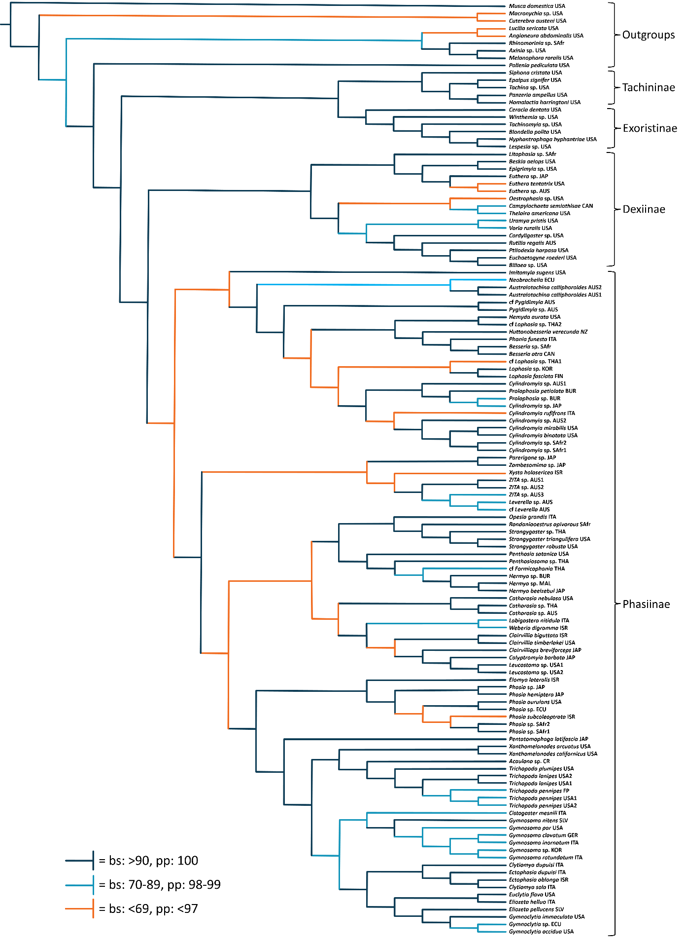
Figure 1: Transformed phylogeny estimating from concatenated and partitioned dataset.
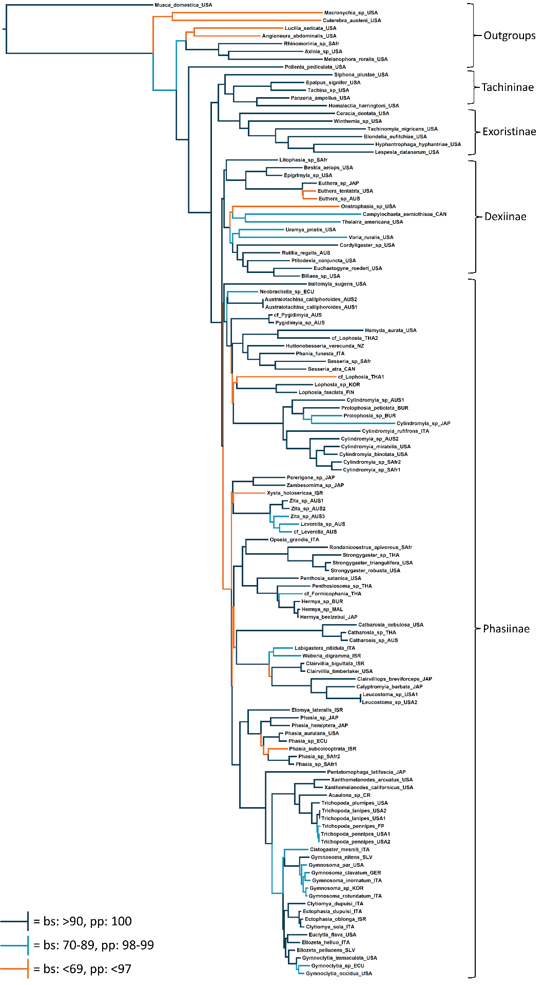
Figure 2: Proportional phylogeny estimating from concatenated and partitioned dataset.
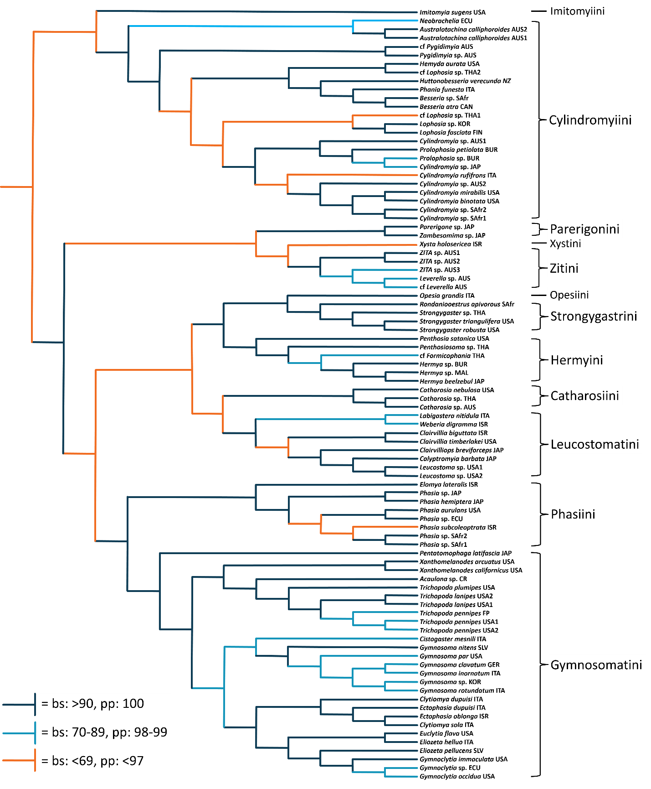
Figure 3: Transformed phylogeny estimating from concatenated and partitioned dataset. Only showing Phasiinae, with tribes labeled.

Tachininae + Exoristinae
The Tachinidae are represented in this phylogeny by two divergent lineages. The first clade is comprised of the subfamilies Tachininae + Exoristinae, and the second contains the subfamilies Dexiinae + Phasiinae. The Tachininae + Exoristinae clade is strongly supported (bs = 96; pp = 100) and is composed of two highly supported monophyletic clades corresponding to the two subfamilies (Tachininae: bs = 98; pp = 100, Exoristinae: bs = 100; pp = 100). The tribes of Tachininae and Exoristinae were represented by a single genus each except for the tribe Tachinini for which two common species were included (see Table 1). Tribal relationships within the subfamilies were strongly supported and consistent across ML and Bayesian analyses (bs/pp >80). The tribal structure of Tachininae was reconstructed as (((Polideini + Ernestiini) + Tachinini) + Siphonini). For the Exoristinae, the tribes were laddered as follows: (((((Eryciini + Goniini) + Blondeliini) + Exoristini) + Winthemiini) + Acemyini). The somewhat enigmatic taxa Ceracia dentata (Acemyini), which has historically been placed in both of these subfamilies, was reconstructed as a statistically established member of Exoristinae – sister to all other included exoristine taxa (bs = 100; pp = 100).

Dexiinae
The Dexiinae have previously been shown to have a close association with the Phasiinae (Cerretti et al. 2014; Winkler et al. 2015) and most taxonomically ambiguous genera considered here possess intermediate suites of morphological character states of these two subfamilies. In order to better assess the placement of these enigmatic groups, the Dexiinae were sampled more thoroughly than the Tachininae and Exoristinae. Eight tribes represented by ten genera comprised Dexiinae s. s. and formed a highly supported monophyletic clade (bs = 100; pp = 100). The three genera of tribe Dexiini (Billaea sp., Euchaetogyne roederi, and Ptilodexia harpasa) coalesced into their expected clade (bs = 100; pp = 100). Uramyini + Voriini formed a sister group (bs = 64; pp = 95), as did Thelairini + Campylochetini (bs = 79; pp = 95). Outside these clades, most inter-tribal relationships within the Dexiinae s. s. were laddered or only moderately supported (e.g., Dufouriini sister to clade Thelairini + Campylochetini and together forming a sister group to the rest of the tribes).
Most interestingly, the sister clade to Dexiinae s. s. was comprised of the tribes Eutherini and Epigrimyiini, as well as the genus Litophasia – here considered to belong to its own tribe Litophasiini – and was reconstructed as a highly supported monophyletic clade (bs = 91; pp = 100). Each of the genera included in this clade share morphological and/or behavioral traits with both Phasiinae and Dexiinae. Both genera of Epigrimyiini (Epigrimyia and Beskia) were represented (bs =100; pp = 100) and three species of Euthera represented the Eutherini (the only other genus in Eutherini is the rare Palearctic genus Redtenbacheria) (bs =100; pp = 100). Epigrimyiini and Eutherini were reconstructed as sister taxa with Litophasia sister to them. This clade forms the sister clade to Dexiinae s. s. and these two clades together form a monophyletic group that is here defined as the subfamily Dexiinae (bs = 99; pp = 100).

Phasiinae
The Phasiinae form a distinct monophyletic clade as well. However, support for their monophyly is low (bs = 60; pp = 84). Given the high statistical support for other clades throughout the tree, it is surprising that the target group Phasiinae was not highly supported. Interestingly, but not unexpectedly, this low support transforms to very high statistical support (bs = 95; pp = 100) when a single enigmatic taxon is excluded: Imitomyia sugens. Imitomyia is a strange fly whose characteristics are either unknown or contradict placement in either the Phasiinae or Dexiinae. The only analyses that place Imitomyia within the Phasiinae are the partitioned, concatenated ML and Bayesian analyses. Most phylogenies estimated from individual genes and individual codon positions place Imitomyia outside both Dexiinae and Phasiinae as the sister taxa to both subfamilies (ML trees) or as an unresolved polytomy comprised of Dexiinae, Phasiinae, and Imitomyia (Bayesian trees). It is clear that this single genus representing the tribe Imitomyiini has an unusual and difficult to decipher evolutionary history. Given the supportive genetic evidence, albeit low, the Phasiinae are defined here as a monophyletic clade including the Imitomyiini.
Within the Phasiinae, twelve molecular clades are defined here as the tribes Catharosiini, Cylindromyiini, Gymnosomatini, Hermyini, Imitomyiini, Leucostomatini, Opesiini (new tribe), Parerigonini, Phasiini, Strongygastrini, Xystiini (new tribe), and Zitini (new tribe). Every tribe was recovered with absolute support for their monophyly (bs = 100; pp = 100). Additionally, four clades are defined as subtribes: Cylindromyiina (bs = 29; pp = 51) and Phasiina (bs = 100; pp = 100), both belonging to Cylindromyiini, and Gymnosomatina (bs = 100; pp = 100) and Trichopodina (bs = 100; pp = 100) both belonging to Gymnosomatini. The tribes of Phasiinae aggregated into five “supertribal” clades with varying support: (Gymnosomatini + Phasiini): bs = 100; pp = 100, (Leucostomatini + Catharosiini): bs = 64; pp = 93, + (Strongygastrini + Opesiini) + Hermyini): bs = 100; pp = 100, ((Zitini + Xystini) + Parerigonini): bs = 39; pp = 80, and (Cylindromyiini + Imitomyiini): bs = 28; pp = 55.

(Gymnosomatini + Phasiini) – The tribe Gymnosomatini includes two evolutionary clades/subtribes: Gymnosomatina and Trichopodina. The Trichopodina are represented in this phylogeny as ((Trichopoda + Acaulona) + Xanthomelanodes). Most genera currently considered to belong in Phasiini (Cistogaster, Clytiomya, Ectophasia, Eliozeta, and Euclytia) were reconstructed as members of Gymnosomatini where they joined Gymnosoma and Gymnoclytia to create subtribe Gymnosomatina. Pentatomophaga latifascia was reconstructed as sister taxa to the two subtribal clades and is therefore left unplaced to subtribe. Two other nominal Phasiini, Opesia and Xysta, were placed rather distant from Phasiini as monotypic lineages (see below). The removal of most genera from Phasiini left this tribe with only two genera: Phasia and Elomya. These two genera form Phasiini sensu Blaschke et al. and are closely allied with the Gymnosomatini.

(Leucostomatini + Catharosiini) – The Catharosiini were represented by three species of Catharosia and the misclassified genus Litophasia. Catharosia species were reconstructed as sister to the Leucostomatini – here represented by six genera in two clades: (((Leucostoma + Calyptromyia) + Clairvilliops) + Clairvillia) and (Weberia + Labigastera). Litophasia was recovered in Dexiinae.

((Strongygastrini + Opesiini) + Hermyini) – Three Strongygaster species and the honeybee parasitoid Rondaniooestrus apivorous Villeneuve represented the Strongygastrini. Closely allied to the Strongygastrini was Opesia – a genus currently belonging to Phasiini s. s. but here removed from that tribe and placed in its own tribe Opesiini. The Strongygastrini and Opesiini formed a strongly supported clade as sister taxa of the Hermyini (bs = 100; pp = 100). The relatively small tribe Hermyini was thoroughly represented by three species of Hermya and three additional genera (cf. Formicophania, and Penthosiosoma, and Penthosia). The only New World genus, Penthosia, was recovered sister to the rest of Hermyini.

((Zitini + Xystini) + Parerigonini) – This analysis revealed three separate evolutionary lineages of Parerigonini s. s. consisting of 1) the Asian genera Parerigone and Zambesomima (here as Parerigonini sensu Blaschke et al.), 2) the Australian genera Zita and Leverella (here as the new tribe Zitini), and 3) the South American genus Neobrachelia coupled with the aberrant Australian genera Australotachina and Pygidimyia (reconstructed as members of Cylindromyiini).
The (Zitini + Xystiini) + Parerigonini clade is not strongly supported (bs = 39; pp = 80). The position and support of the Zitini is consistent across genes and codon positions, but Xysta (only member of Xystiini) and the Parerigonini are much more unstable. Current hypotheses place Xysta in Phasiini (Herting 1984), but it is here transferred to its own tribe Xystiini. Even though Xysta has never been associated with the Parerigonini s. s. it was reconstructed bisecting two lineages of that nominal tribe. In no analysis is Parerigonini sensu Blaschke et al. more closely related to Zitini than is Xysta. This is strong evidence that Parerigonini s. s. consists of multiple evolutionary lineages and that Xysta should be considered more closely aligned to them than to the Phasiini.

(Cylindromyiini + Imitomyiini) – Another lineage of Parerigonini s. s., composed of the South American genus Neobrachelia and the Australian genera Australotachina and Pygidimyia, was discovered to be closely allied with the Cylindromyiini (bs = 100; pp = 100). Neobrachelia and Australotachina were consistently recovered together in individual gene/codon analyses and in the complete dataset (bs= 70; pp = 85). Pygidimyia was more phylogenetically unstable than the other genera, but was ultimately reconstructed as sister to Cylindromyiini s. s (bs= 100; pp = 100).
Cylindromyiini s. s. form two subtribes for which the names of Herting (1983) are applied: Cylindromyiina and Phasiina. The Phasiina clade has absolute statistical support (bs = 100; pp = 100) and is composed of the genera Besseria, Phania, Huttonobesseria, Hemyda, and a single specimen tentatively identified as a Lophosia species, but is probably not a Lophosia at all. The Cylindromyiina enjoy far less statistical support (bs = 29; pp = 51) mainly due to a gradient of nominal Lophosia species which sometimes group with Pygidimyia rather than other Cylindromyiina. Other than Lophosia, the subtribe Cylindromyiina also includes the speciose genus Cylindromyia and Prolophosia – an African genus that appears synonymous with Cylindromyia. The Cylindromyiini clade was found to be sister to the unusual genus Imitomyia whose unstable phylogenetic position is discussed above.

Taxonomically ambiguous genera
A conclusive subfamily placement for almost all morphologically intermediate taxa received significant support from this phylogeny. Epigrimyiini and Litophasia were placed in Dexiinae rather than Phasiinae and Euthera was recovered in Dexiinae rather than Phasiinae or Exoristinae. Strongygaster and Rondanioestrus, as well as all genera of Parerigonini s. s., were firmly nested within Phasiinae rather than Tachininae. Although not overwhelmingly convincing, the best evidence from the phylogeny places Imitomyia as a member of Phasiinae rather than Dexiinae.

Clade frequencies across all analyses
A total of 28 phylogenies were generated for this study. Bayesian analyses included trees consisting of each gene partitioned individually (CADBayes, LGLBayes, MACBayes, and MCSBayes) as well as the concatenated and partitioned tree (CLMMBayes). Maximum likelihood analyses were more thorough. Five trees were created for each gene: three trees consisting of each individual codon position (e.g., CAD1, CAD2, CAD3), one tree with third positions removed (e.g., CAD12), and one tree with all positions included and partitioned separately (e.g., CAD123). A complete evidence ML phylogeny was created using twelve partitions and a concatenated dataset (CLMM123). Two additional ML trees were generated to reduce potential conflicting phylogenetic signal, one with Imitomyia excluded (not shown) and one with data from LGL excluded (CMM123).
The numerous trees created from a variety of independent lines of evidence provided helpful insights into which clades and which arrangements of clades were strongly vs. weakly supported. Third codons are often extremely variable and thus often have little phylogenetic signal at the deeper family/subfamily levels. Second positions rarely provide significant signal because of their genetic stability, and first positions typically have the most important amino acid (and therefore phylogenetic) changes. A clade supported by each codon position invites substantial confidence in the evolutionary validity of that clade – even more so if multiple genes are also providing similar signals. A summary of the relative frequency of each clade appearance across all phylogenies can be found in Figure 3.
A substantial amount of clades were present in over 70% of the trees. This is interpreted as considerable evidence that these clades accurately represent a reasonable evolutionary history. These clades include Catharosiini, Strongygastrini, Trichopodina, Gymnosomatini, (Epigrimyiini + Eutherini), Hermyini, Leucostomatini, Zitini, Gymnosomatina, Phasiina, Exoristinae, and Rhinophoridae – the first five of which are only absent from one or two low-signal partitions. Most other clades are consistently recovered in complete gene analyses, but are more unstable with less informative partitions (codon position 2 across all genes, LGL codon positions) as would be expected. With the inclusion of Imitomyia, Phasiinae and Dexiinae are rarely recovered as monophyletic. However, with Imitomyia removed, these clades are almost always fully resolved.

Phylogenetic informativeness of genes and codon positions
MCS proved to be the single most important gene for this phylogenetic analysis, recovering ~85% of the final clades by itself. The utility of MCS was closely followed by MAC, CAD, and lastly LGL. LGL was unable to recover several significant clades on its own, especially outside the Phasiinae. A comparison of the ability of each gene and each codon position to reconstruct clades is shown in Figure 4.

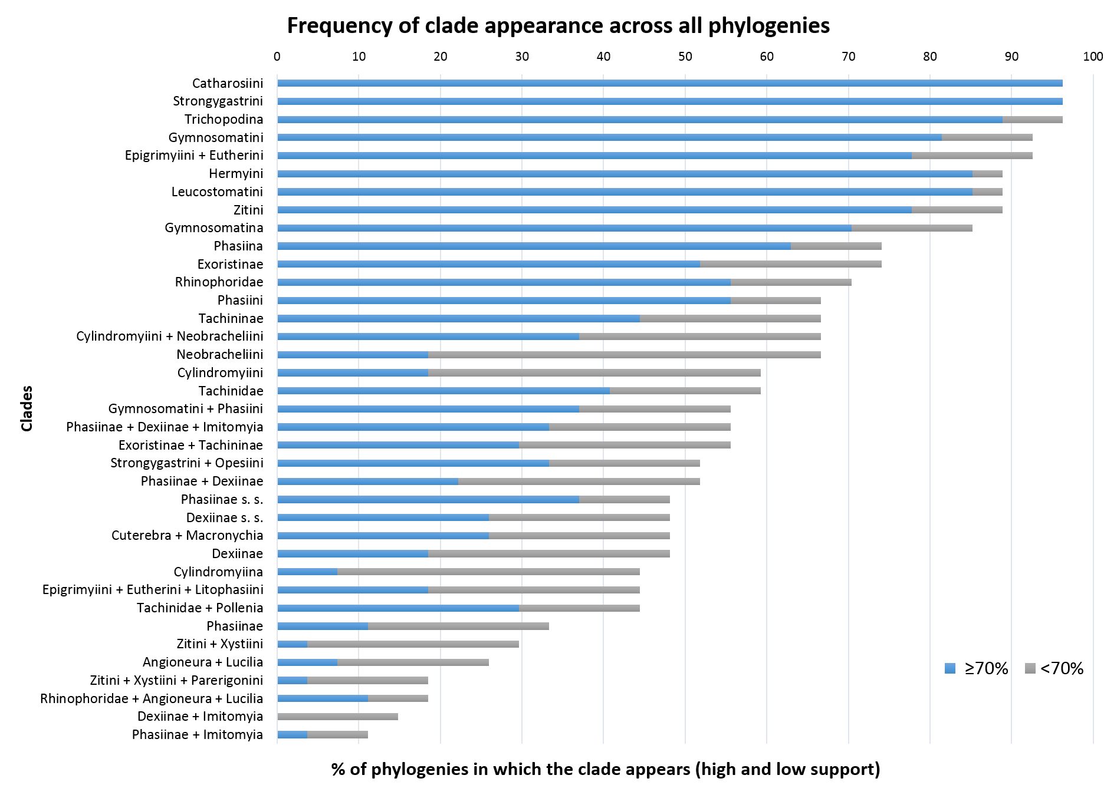
Figure 4: Frequency of clade appearance across all phylogenies as a percent of total.

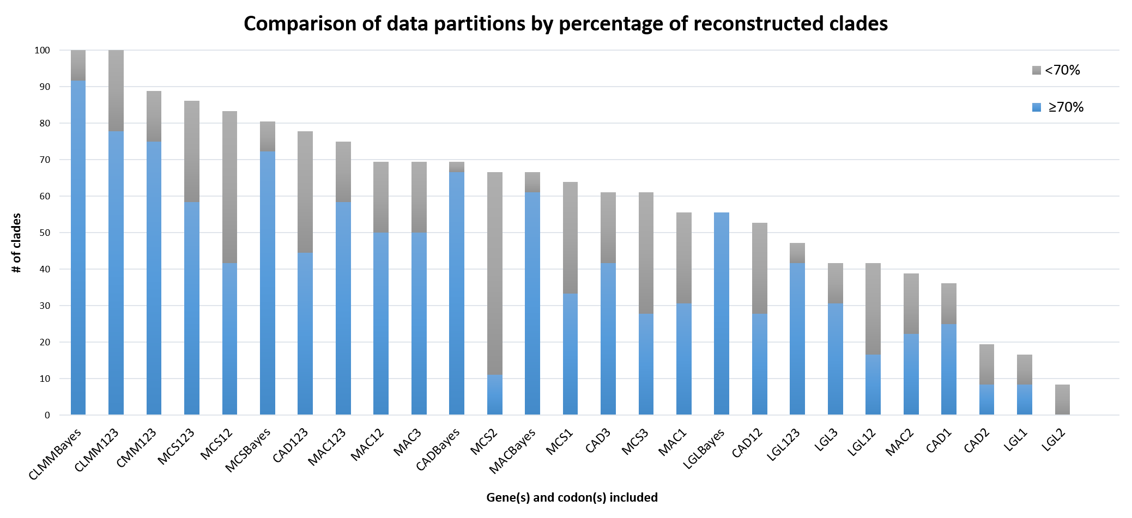
Figure 5: Comparison of genetic data partitions by percentage of reconstructed clades.

Discussion

This study is the largest molecular analysis of Tachinidae to date and the first to consider the classification and evolution of the agriculturally important subfamily Phasiinae (Stireman 2002; Shima 2010; Winkler et al. 2015). Certain historical hypotheses gained substantial evidence in their favor and several novel ideas about phasiine taxonomy and evolution were generated. In general, this molecular phylogeny agrees remarkably well with current concepts of phasiine classification. However, several significant revisions to tribal classifications within Phasiinae are suggested by these evolutionary relationships. Most notably, Parerigonini and Phasiini were shown to consist of three and four different evolutionary lineages respectively. These tribes, and several others, deserve proper consideration and discussion of their historical taxonomy and the morphological and molecular evidences for their specific evolution within Phasiinae. There is not the space for such a thorough analysis here, as this present work is devoted to the phylogenetic placement of taxonomically difficult genera and tracing the evolution of traits within Tachinidae. Instead, in a separate paper, this molecular phylogeny is used as a framework for updated and revising the classification of all worldwide genera of Phasiinae (Blaschke et al. 2015).
Here, phasiine relationships are briefly summarized. Next, the molecular evidence for the subfamily placement of several taxonomically ambiguous genera is presented. As a result of their critical phylogenetic placement for the evolution of Tachinidae, the taxonomic history of the dexiine tribes Epigrimyiini, Eutherini, and Litophasiini is explored and discussed in a phylogenetic context. Lastly, the evolution of important and/or potentially synapomorphic characters traits is applied to the phylogeny and discussed.

Classification
As a result of the molecular evidence, the Phasiinae are represented here by twelve tribes, including the Imitomyiini, Strongygastrini (including Rondaniooestrus), and Parerigonini, but excluding the Epigrimyiini, Eutherini, and Litophasia. Morphologically, the Phasiinae can be defined by the synapomorphic trait of an elongated hypandrium of the male postabdomen. Specifically, the median plate of the hypandrium is elongated to such an extent that the pregonites are attached at the back (first identified by Tschorsnig 1985). All tachinids with a piercer derived from the 10th sternite (postgenital plate) are found in Phasiinae. However, not all phasiines have reduced chaetotaxy, are oviparous, possess piercers, or even parasitize Heteroptera. Furthermore, some tachinid genera that do parasitize Heteroptera and/or have piercers derived from the 8th sternite are placed in the Dexiinae rather than the Phasiinae, making these traits homoplastic and of little use phylogenetically (except at the family level). Female, and especially male, terminalia characters were shown to be significantly better indicators of evolutionary history than external morphology, host range, or oviposition strategy. Several phasiine tribes were identified as unnatural groupings of genera and need to be repositioned into more evolutionarily meaningful clades (see results).
Convincing corroborative evidence that the Strongygastrini (including Rondaniooestrus), all lineages of Parerigonini, and the Imitomyiini belong in Phasiinae was recovered. Recent molecular and morphological analyses have placed Strongygastrini within Phasiinae (Cerretti et al. 2014, Winkler et al. 2015) and the debate about its subfamily affinities should now be completely resolved. Multiple genera of Parerigonini have never been analyzed phylogenetically, but Cerretti et al. (2014) found support for a placement in Phasiinae for the lone genus Parerigone. Despite their tachinine-like appearance, all parerigonine genera were found to be convincingly phasiines – thus resolving another long-standing issue in tachinid classification. Imitomyia’s position is more unstable and its taxonomy may still be debated. However, molecular evidence has now been added to the morphological evidences that place Imitomyia within the Phasiinae. Because these tribes belong in Phasiinae, their taxonomic history and classification is more thoroughly discussed with other phasiine taxa in Blaschke et al. (2015).
In contrast to the taxa above, Epigrimyiini, Eutherini, and Litophasiini were found to be allied with Dexiinae rather than Phasiinae. While this affinity has been previously hypothesized (Tschorsnig 1985; O’Hara & Wood 2004), this is the first molecular evidence and the first strong phylogenetic evidence that these taxa belong in Dexiinae. Cerretti et al.’s (2014) morphological analysis of Tachinidae found Litophasia to be a “basal” phasiine, while the Eutherini were most often recovered within the Exoristinae (Epigrimyiini were not represented). Here, Epigrimyiini and Eutherini were recovered as sister taxa in almost every partition and represent one of the strongest supported clades in this analysis. The close relationship between these two tribes has not been suggested before and is an unexpected result from the genetic evidence. The taxonomic history and phylogenetic affinities of each of these tribes is discussed below.

Epigrimyiini – Epigrimyiini includes two genera (Beskia and Epigrimyia), both endemic to the Western Hemisphere (O’Hara 2011). Historically, they have been considered members of the Phasiinae (Townsend 1936, 1938; Sabrosky & Arnaud 1965; Guimarães 1971, 77), but have been recently associated with Dexiinae due to distinctive secondary structures of the male postabdomen (Tschorsnig 1985, O’Hara & Wood 2004). The classification of Epigrimyiini has never been analyzed phylogenetically until now.
Epigrimyia was the sole member of Epigrimyiini from Townsend’s initial designation of the tribe (1908) until O’Hara & Wood (2004) included the additional genus Beskia. However, their close morphological association with each other and to the modern phasiine tribe Cylindromyiini was noted by many previous authors (Brauer & Bergenstamm 1889; Wulp 1903; Townsend 1891, 1938; Sabrosky & Arnaud 1965; Herting 1984). Townsend originally placed Epigrimyiini in the now outdated subfamily Pyrrhosiinae, which also included genera in the very different modern tribes of Leskiini and Leucostomatini, but he also commented on Epigrimyia’s close affinity with the subfamily Phaniinae (= Cylindromyiini/Hermyini). Beskia was placed with Ocyptera (= Cylindromyia) in the Ocypterinae (= Cylindromyiini). Although he initially positioned Epigrimyia in its own tribe, Townsend later moved the genus to the Cylindromyiini along with Beskia (Townsend 1919). It should be noted that Malloch (1929) insightfully did not consider Beskia to belong in the same tribe as Cylindromyia. In Townsend’s 1936 key to the Cylindromyiini, Epigrimyia and Beskia share a terminal couplet based on their elongated proboscises.
In addition to their external habitus, which is more reminiscent of Cylindromyia and relatives than any member of Dexiinae, Epigrimyia and Beskia also share host similarity with other phasiines. All phasiines with known hosts, except Rondaniooestrus, are parasitoids of heteropteran bugs and it has been proposed that this could be a synapomorphy of Phasiinae (Wood 1987; Stireman et al. 2006). Such an argument maintains Epigrimyiini in the Phasiinae as Epigrimyia attacks Galgupha ovalis (Hemiptera: Corimelaenidae) (Biehler & McPherson 1982) and Beskia attacks multiple species of Pentatomidae, most notably the rice stink bug (Oebalus pugnax) (Guimarães 1977; Sutherland & Baharally 2002). Additional evidence for a placement of Epigrimyiini in Phasiinae can be found in the female postabdomen where both genera share a modified 8th sternite used as a piercing structure for direct oviposition into a host (Townsend 1938).
Although at a glance Epigrimyia and Beskia seem strongly reminiscent of Phasiinae, recent morphological evidence indicates a position within the Dexiinae. Tschorsnig (1985) examined the various structures of the male postabdomen and concluded that Epigrimyia and Beskia belonged in the Dexiinae based on the membranous connection of the basiphallus to the distiphallus (among other secondary structures) that he proposed were synapomorphic of Dexiinae. Additionally, Tschorsnig identified an elongated hypandrium as a potential synapomorphy of Phasiinae. This trait was not found in either Epigrimyia or Beskia. The placement of Epigrimyiini in Dexiinae gains considerable support from this molecular analysis, which recovered a strongly supported Epigrimyiini (composed of Beskia and Epigrimyia) as part of a monophyletic Dexiinae sister to the Eutherini.

Eutherini – Similar to the Epigrimyiini, the Eutherini share morphological and behavioral traits with both the Phasiinae and Dexiinae. As a result, their taxonomic placement has been debated over the decades by dipterologists. Two genera are included in the tribe. Euthera is a unique tachinid whose coloration mimics deerflies (Tabanidae: Chrysops spp.). It is rarely found in collections, but has a worldwide distribution (O’Hara 2013). Reviews of the taxonomic history of Euthera Loew can be found in Bezzi (1925), Cantrell (1983), and O’Hara (2012). The only other genus in the Eutherini is Redtenbacheria Schiner, which is a rare fly found only in the Palearctic (Herting 1984). Three species of Euthera were included in this molecular phylogeny.
The similarity of these two genera was first recognized by Stein (1924) who placed them in his “Gruppe Trixa”, and most modern tachinid experts have considered Euthera and Redtenbacheria to share a close affinity (Herting 1984; Ziegler 1998; Richter 2004; O’Hara et al. 2009; although see Crosskey 1976). Significant evidence for this relationship comes from the specialized shape of the phallus (Tschorsnig 1985) and the posterodorsal “window” on their eggs (Cerretti et al. 2014), which are both synapomorphies of the tribe. Eutherini’s subfamily placement is more controversial, however, with various experts preferring Phasiinae (Guimaráes 1971; Crosskey 1977; Crosskey 1980; Herting 1984; Tschorsnig 1985; Cantrell & Crosskey 1989; Tschorsnig & Herting 1994; Tschorsnig & Richter 1998) or recently Dexiinae (Shima 1989, 1999; O’Hara & Wood 2004; Shima 2006; O’Hara et al. 2009; Cerretti 2010).
The most convincing reason for placing the Eutherini in Phasiinae is their parasitism of heteropteran hosts (Euthera – Arnaud 1978; Redtenbacheria – Nishayama 1995), which has long been considered a distinctive trait of Phasiinae. They also produce planoconvex eggs (Herting 1966; Mesnil 1966) rather than the entirely membranous eggs of the Dexiinae (Stireman et al. 2006) and share this trait only with Phasiinae and some Exoristinae. However, the development and oviposition of these eggs is unlike any phasiine outside the Strongygastrini.
Phasiinae lack any kind of uterus and are therefore oviparous (i.e., lay unincubated eggs). In contrast, the Eutherini are ovolarviparous (i.e., lay incubated eggs or early instar larvae, Cantrell 1983). If included in the Phasiinae, the Eutherini would not be alone in having this trait as the Strongygastrini are also ovolarviparous, but these two groups are not closely related and such a classification would require the non-parsimonious explanation of ovolarviparity evolving in two separate lineages within the Phasiinae. In addition to their oviposition strategy, several other important morphological traits indicate a placement in Dexiinae for the Eutherini.
When O’Hara & Wood (2004) moved the Eutherini from Phasiinae to Dexiinae, they did so based on Tschorsnig’s analysis of male postabdomen structures (1985) and their own examination of Euthera’s male terminalia. These authors identified several morphological traits shared between the Eutherini and the Dexiinae including the shape and location of the pregonites, postgonites, sternite 5, and distiphallus (see also Cerretti et al. 2014). However, unlike the Epigrimyiini discussed above, the Eutherini do not possess a hinged membranous connection between basiphallus and distiphallus – a trait considered to be the most convincing synapomorphic character trait of the Dexiinae. To further confuse the issue, however, neither do they possess the elongated hypandrium characteristic of Phasiinae. This evidence led Shima (1989) to conclude that the Eutherini represented the only extant taxa of the Dexiinae that retained the primitive trait of sclerotized basi/distiphallus connection. As with the Epigrimyiini, the hypothesis that Eutherini belongs in Dexiinae and may have retained some ancestral traits throughout its evolution is strongly supported by this molecular phylogeny. Interestingly, these two phasiine-like dexiines were recovered as monophyletic sister groups in the phylogenetic analysis.
The molecular phylogenetic evidence stands in contrast to an earlier morphological phylogeny that surprisingly reconstructed the Eutherini nested within the Exoristinae (Cerretti et al. 2014). While the monophyly of the Eutherini was strongly supported, its placement in the Exoristinae was largely a result of their egg type and oviposition strategy and was not recovered in every analysis. The Tachinidae contains widespread homoplasy throughout the family and Cerretti et al.’s morphological analysis highlights the difficulty of reconstructing the evolutionary history of such a group using solely morphological characters. Under different weighting schemes numerous trees were obtained that sometimes differed dramatically, especially for the taxonomically ambiguous groups like the Eutherini. Some of these trees agreed quite well with the molecular evidence, and in situations with extremely high morphological homoplasy, it is perhaps best to trust the genetically inferred trees rather than the structural traits. Therefore, Eutherini is considered here to be an extant tribe within Dexiinae that possesses several significant symplesiomorphic characters states.

Litophasiini – The atypical genus Litophasia Girschner is a diminutive and rarely observed fly known only from one species in the Palearctic region and one from South Africa (Herting 1984; Crosskey 1984). Initially thought to belong to the Rhinophoridae (van Emden 1945, Crosskey 1977), Litophasia is now considered a tachinid that lacks the almost universal traits of an enlarged subscutellum and meral bristles (Wood 1987; Tschorsnig & Richter 1998). Females, however, possess a piercer (8th sternite) very similar to those found in the phasiine tribes Catharosiini Leucostomatini and not found in any known Rhinophoridae (Dear 1980). As a result of this unique trait and other morphological similarities, Herting considered it a member of Catharosiini (cf. Dear 1980), an opinion that Dear (1980) agreed with and subsequent authors have followed (Crosskey 1980, 1984; Herting 1984; Belshaw 1993; Herting & Dely-Draskovits 1993).
However, the male terminalia of Litophasia were not examined comparatively until Tschorsnig (1985). In the Tachinidae, the traits of the male postabdomen seem to be more phylogenetically informative than those of the female postabdomen, eggs, larvae, or behavioral traits. As with the Epigrimyiini and Eutherini, Litophasia possesses dexiine-type characters in the male postabdomen, including the distinctive membranous connection between basiphallus and distiphallus (Tschorsnig 1985) and does not have the phasiine-type elongated hypandrium. Given its taxonomic ambiguity, it is not surprising that in Cerretti et al.’s (2014) morphological phylogeny Litophasia was inconsistently placed as either sister to Phasiinae or sister to Dexiinae under different weighting schemes. However, strong supporting evidence for a position within Dexiinae comes from this molecular phylogenetic analysis where Litophasia was reconstructed with high support as sister to Epigrimyiini + Eutherini. This clade in turn was sister to the rest of Dexiinae and therefore Litophasia is here included in that subfamily in its own tribe Litophasiini.

Evolution of Tachinidae
Any analysis of trait evolution using a phylogeny is only as good as the tree itself. If even a single clade is misplaced it can often have negative reverberations for ancestral state reconstruction throughout the tree, resulting in incorrect evolutionary theories and misplaced relationships. The phylogeny presented here was recovered with very high statistical support throughout the tree and largely corroborates current taxonomic hypotheses. As a result, this phylogeny was used to trace the evolution of important tachinid traits/behaviors and visually analyze any potential synapomorphies of Phasiinae and Dexiinae. The robustness of this phylogeny provides confidence in the analysis, but central to the ancestral state reconstruction is the phylogenetic position of the “phasiine-like dexiines”: Epigrimyiini, Eutherini, Litophasia, and Imitomyia. With their curious amalgamation of traits, the phylogenetic position of these taxa heavily influence any potential subfamily synapomorphies as well as the evolution of Tachinidae in general. Each trait analyzed will be discussed individually below.
In summary, according to this analysis, the ancestor of Phasiinae can most likely be characterized by the homoplastic traits of parasitism of Heteroptera and oviparity, along with the pleisiomorphic trait of lacking a piercer. The only synapomorphy of Phasiinae is an elongated hypandrium in the male postabdomen. In contrast, the Dexiinae cannot be defined by a “true” synapomorphy. None of the potentially synapomorphic traits of the male postabdomen were recovered exclusively in Dexiinae – mainly due to Imitomyia’s placement in Phasiinae. The ancestor of Tachinidae was reconstructed with the following traits: lacking a piercer of any kind, parasitizing Lepidoptera, ovolarviparous, and not possessing any trait or combination of traits in the male postabdomen that could be used to define either Phasiinae or Dexiinae.

Piercers – Used to inject eggs or larvae directly into the body cavity of hosts, piercers have evolved several times throughout tachinid evolution and appear in many diverse tribes. However, not all piercers are created equal. Those found in the Exoristinae (e.g., Blondeliini) are derived from the 7th sternite, while those in the Phasiinae have been adapted from either the 8th or 10th sternite (Figure 5). Parsimoniously, it is expected that there would be three evolutions of the piercer – one for each type. Remarkably though, each type of piercer appears to have evolved independently in several different lineages. The focus of this analysis was on the Phasiinae, and therefore only the evolution of the 8th and 10th sternites is discussed here.
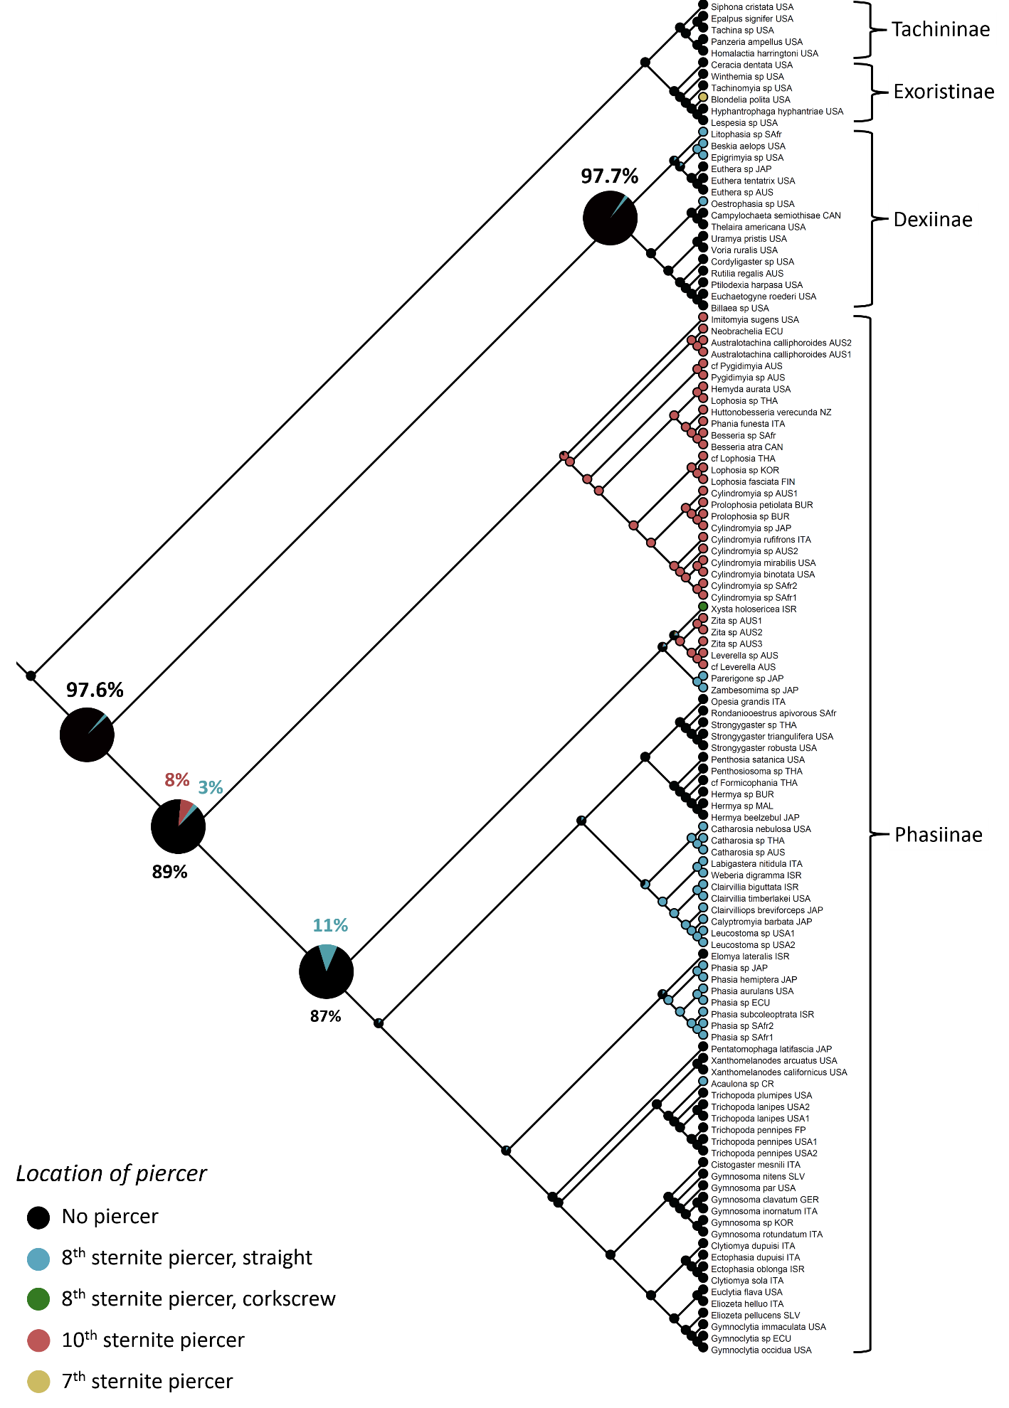
Figure 6: Ancestral state reconstruction of piercer location in Tachinidae.
Three phasiine tribes possess 10th sternite piercers (Imitomyiini, Cylindromyiini, and Zitini) (Townsend 1938; Herting 1983, Cantrell 1988). It is partially this trait that morphologically supports the inclusion on Imitomyia in Phasiinae as no other tachinid subfamily is known to have this unique trait. According to this phylogeny, the 10th sternite piercer evolved once in the ancestor of (Imitomyiini + Cylindromyiini) and then separately in the ancestor of Zitini. This non-parsimonious explanation was unexpected given that the genera of Zitini (Zita and Leverella) have historically been closely allied with Pygidimyia, Australotachina, and Neobrachelia in Parerigonini. The latter three genera were recovered in the Cylindromyiini as a paraphyletic sister group to Cylindromyiini s. s. Morphologically, the simplest classification would be to include the Zitini in Cylindromyiini with the other former parerigonines possessing 10th sternite piercers or as a separate tribe sister to Cylindromyiini. However, no molecular analysis with any gene or codon position supports that naturally parsimonious explanation. Therefore, the Zitini are left in their own tribe apart from Cylindromyiini and the 10th sternite is hypothesized to have arisen independently in the two lineages.
The evolution of the 8th sternite piercer is quite remarkable. This adaptive trait appears in both the Dexiinae and Phasiinae, with at least three separate evolutions in the former and four in the latter, as evidenced by the non-piercing ancestor of Phasiinae (89%) and Dexiinae (97.7%). Eight tribes can be wholly or partially defined by the presence of the 8th sternite piercer: Dexiinae – Litophasiini, Epigrimyiini, and Dufouriini (here represented by Oestrophasia); Phasiinae – Xystiini, Catharosiini, Leucostomatini, Parerigonini sensu Blaschke et al., and Phasiini. Additionally, two individual genera of Gymnosomatini (Trichopodina) possess 8th sternite piercers (Acaulona, included, and Cylindrophasia, not included). Within the Phasiini, an interesting state is found. Of the two genera included, Phasia possesses the typical 8th sternite piercer, but the 8th sternite of Elomya is not developed into a fully functional piercer. Rather, Elomya uses its uniquely shaped “narrow point” 8th sternite to firmly insert its eggs into the intersegmental membranes of the host, but the 8th sternite does not actually pierce the exoskeleton (Herting 1960; Tschorsnig & Richter 1998). This may represent an evolutionarily intermediate state between piercing and non-piercing forms.
Given the numerous independent evolutions of the 8th and 10th sternite piercers, the possession of such a trait seems to be highly selected for within phasiine populations. In contrast to most other tachinids that generally attack soft-bodies immature insects, phasiines exploit adult hosts with hardened exoskeletons. Attaching an egg to the outside of the host requires the phasiine larvae to utilize powerful chitinase-degrading proteins and/or specialized mandibles to break through the cement-like exoskeleton to feast on the host’s inner nutrients. There is also substantial risk for the exposed egg from predation, desiccation, and physical removal by the host itself. A piercer solves these problems by bypassing the host’s cuticle altogether. As such, natural selection would most likely encourage the evolution of postabdominal sclerites toward a piercing structure, perhaps via a morphology similar to Elomya’s. Once evolved, it seems unlikely that a piercer would be lost through natural selection. This reconstruction supports that hypothesis. Even with ten different piercer evolutions theorized, there is no significant evidence of a loss of a piercer in any lineage.
The unique morphology of Xysta deserves special mention here. While derived from the 8th sternite, the piercer of Xysta is significantly divergent from other phasiine piercers. The 8th tergite of Xysta includes special modifications that are thought to be inserted between the host’s body segments and expanded, thus exposing the inner cavity of the host to the fly’s piercer. The 8th sternite then protrudes from between the structures of the 8th tergite and injects the eggs into the body cavity of the host (Herting 1957). Most phasiine piercers are simple and needle-like, most often slightly curved but sometimes surprisingly straight. However, Xysta’s piercer is curved around itself like a corkscrew and rotates on its axis when inserted, thus “drilling” into the host rather than stabbing. These unusual morphologies strongly indicate an independent evolution of the piercer unrelated to other phasiine piercers.
Consequently, Xysta has been uniquely coded here for the piercer state. Due to its important phylogenetic position, coding Xysta independently as opposed to lumping it into an “8th sternite piercer” character state significantly changes the ASR analysis. With it included as just another 8th sternite piercer, the evolution of piercers is greatly confused. The ancestor of Phasiinae is split almost equally between the three states (non-piercer: 38%; 8th piercer: 34%; 10th piercer: 28%, not shown), and ancestral nodes throughout the Phasiinae are recovered as most likely possessing an 8th sternite piercer. Such a reconstruction requires multiple gains and losses of piercers throughout the Phasiinae, with Zitini specifically losing the 8th sternite piercer and gaining the 10th sternite piercer during a very short evolutionary time. This creates a nightmare for both parsimony and logic, and therefore provides additional evidence that the piercer of Xysta, while homologous to other phasiine piercers, is independently derived and justifies its unique character coding.

Hosts – The diverse host range of Tachinidae, characterized by multiple host shifts and rapid exploitation of new hosts, has made speculating about the original tachinid host difficult. Lepidoptera is often seen as the “default” hypothesis as a majority of tachinids utilize lepidopterans as hosts (Cerretti 2010) and caterpillars are exploited by an enormous array of other insect parasitoids, which indicates they are an easy group to invade. However, the morphological phylogeny of Tachinidae conducted by Cerretti et al. (2014) did not find strong evidence to support a lepidopteran host in the ancestral tachinid population, instead finding some support for a coleopteran host. This was inferred primarily as a result of the coleopteran parasitoid taxa Gnadochaeta and the Palpostomatini being reconstructed sister to all other tachinid genera and a parsimony ASR analysis. These genera were not included here and that specific hypothesis remains unverified. In support of the historical views on host evolution, the maximum likelihood ASR analysis presented here recovered moderate support (67%) for Lepidoptera as the original host of Tachinidae (Figure 6). From there, tachinids radiated into Heteroptera, Coleoptera, and ever further into Lepidoptera. A more comprehensive molecular phylogeny of Tachinidae, already in progress (Stireman et al. 2013), will allow a more confident theory of host evolution within the Tachinidae to be constructed.
The ancestor of the (Phasiinae + Dexiinae) clade was reconstructed as a parasitoid of Heteroptera (80%) along with the individual ancestral nodes for each subfamily (Phasiinae: 99.9%; Dexiinae: 80%). Thus, parasitism of Heteroptera most likely arose once in this ancestral population and was retained in Phasiinae, Epigrimyiini, Eutherini, and therefore probably Litophasia as well (host are unknown). Inferring from this result, the ancestor of Dexiinae s. s. (i.e., excluding Epigrimyiini, Eutherini, and Litophasiini) switched hosts from Heteroptera to Lepidoptera and later, the tribes Dexiini and Dufouriini diverged from attacking Lepidoptera to parasitizing Coleoptera. The Voriini, Uramyini, Siphonini, Thelairini, and Campylochetini retain their ancestral parasitism of Lepidoptera. These hypotheses stand in contrast to those endorsed by Cerretti et al. (2014) whose morphological phylogeny found Phasiinae s. s. to be derived from a paraphyletic clade of Dufouriini (coleopteran parasitoids) and thus recovered Heteroptera as a derived rather than ancestral state and having been evolved independently in Phasiinae and Eutherini. These conflicting results are due to the phylogenetic placement of the ((Epigrimyiini + Eutherini) + Litophasiini) clade. The Epigrimyiini, Eutherini, and Litophasiini are extremely difficult to resolve morphologically but are consistently recovered together as members of
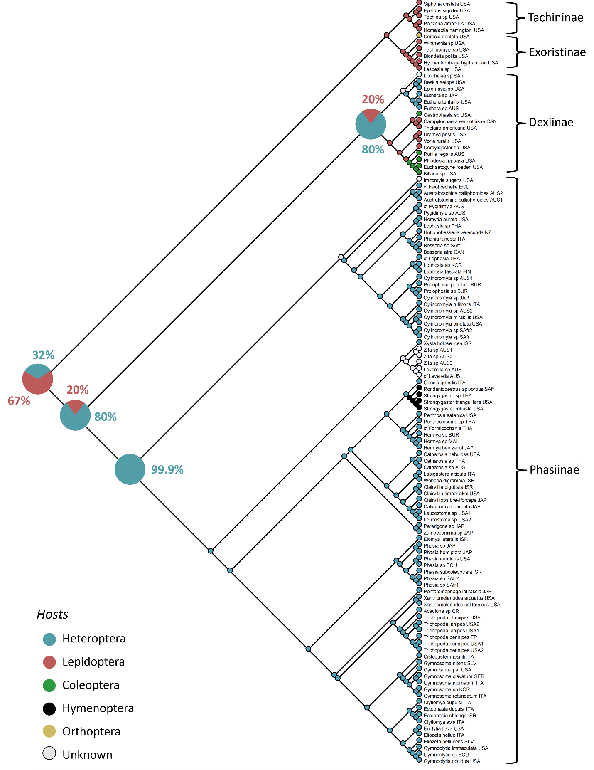
Figure 7: Ancestral state reconstruction of host use in Tachinidae.
Dexiinae in molecular analyses, lending support to a heteropteran parasitoid ancestor of (Phasiinae + Dexiinae).
The Phasiinae have long been characterized by their parasitism of heteropteran hosts (Dupuis 1963; Wood 1987; Tschorsnig & Richter 1998), but here that trait is found within Dexiinae as well, making that trait symplesiomorphic. Additionally, the inclusion of Strongygastrini in Phasiinae means that not all phasiines are parasitoids of Heteroptera. Strongygaster parasitizes a plethora of hosts, including bugs, beetles, and caterpillars, while Rondaniooestrus exclusively parasitizes honeybees (see introduction). Heteroptera is retained as the primary host in all other phasiine lineages with known hosts. Hosts are unknown for Litophasia, but given its phylogenetic position belonging to a clade including the Epigrimyiini and Eutherini, it is hypothesized that Litophasia parasitizes small members of Heteroptera.

Oviposition strategy – Another way in which the Strongygastrini are exceptional in respect to Phasiinae is their method of oviposition. Phasiinae as a whole is characterized by oviparity (i.e., laying unembryonated eggs), but the Strongygastrini possess uteri and are therefore ovolarviparous (i.e., lay embryonated eggs or early instar larvae). Phasiinae represent one of the largest oviparous lineages (others are found in Exoristinae) and are characterized by an oviparous ancestor (82%, Figure 7). Consequently, ovolarviparity most likely evolved secondarily in the Strongygastrini as well as in the Imitomyiini.
Ovolarviparity requires significant modifications to the female reproductive system in order to incubate eggs (Herting 1957; Wood 1987). As a result, oviparity has historically been considered the more primitive condition of Tachinidae (Herting 1960; Tschorsnig & Richter 1998; Stireman et al. 2006; Tachi & Shima 2010). However, Cerretti et al. (2014) found all oviparous lineages to be nested within ovolarviparous lineages, thus implying that ovolarviparity may have characterized the tachinid ancestor. This ASR analysis provides corroborating molecular evidence to support this somewhat counterintuitive hypothesis. Ovolarviparity was recovered at the ancestral node of (Dexiinae + Phasiinae) (96%) and Tachinidae as a whole (99.5%). Unlike reconstructing Lepidoptera as an ancestral host – which had only moderate support and was missing crucial taxa – there is very strong statistical support for an ovolarviparous tachinid ancestor. Furthermore, this result seems unlikely to change with more taxa included as most tachinid lineages not represented are ovolarviparous.
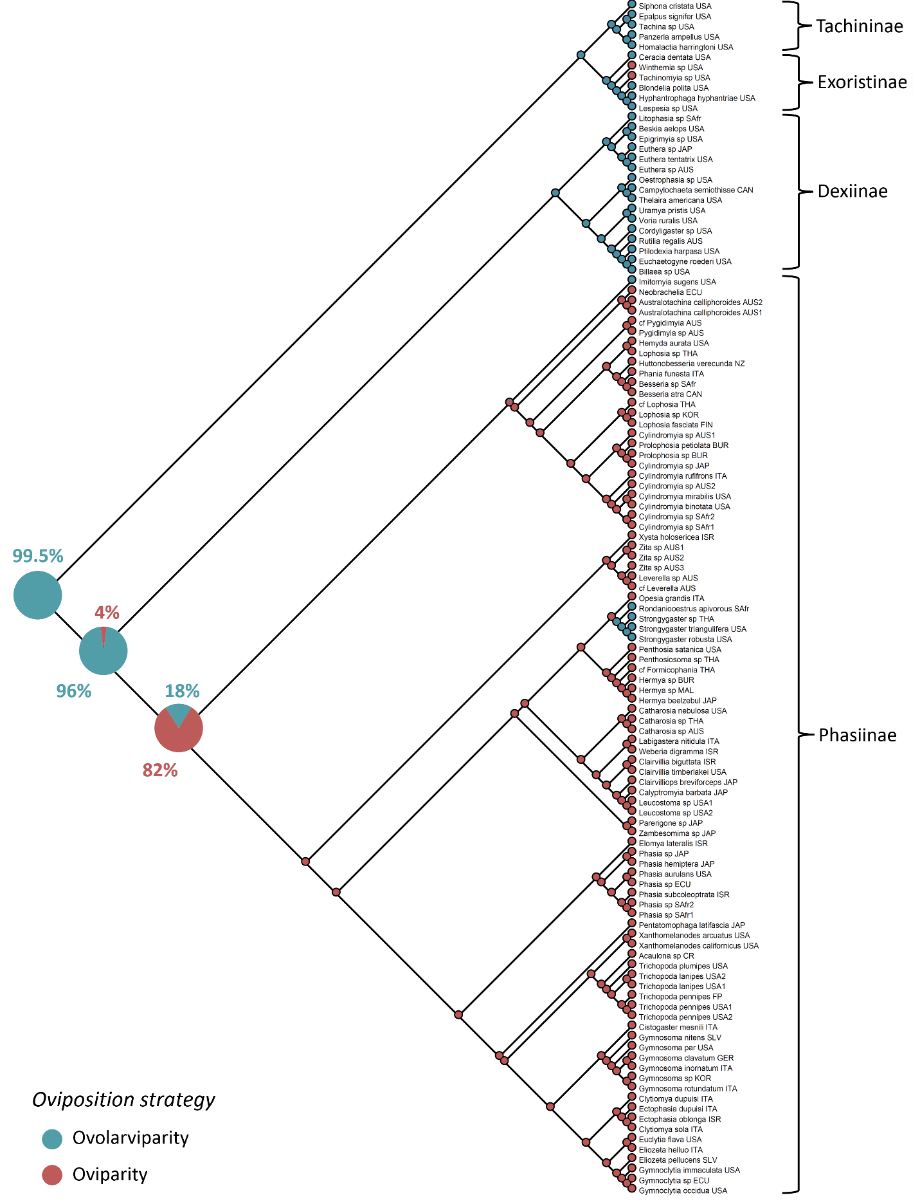
Figure 8: Ancestral state reconstruction of oviposition strategy in Tachinidae.
Synapomorphies of Phasiinae/Dexiinae – The placement of several taxonomically ambiguous genera within a robustly supported phylogeny allows potential synapomorphic character traits of Phasiinae and Dexiinae to be explored in a phylogenetic context for the first time. As already discussed, neither oviparity nor parasitism of heteropteran hosts can be used to define Phasiinae synapomorphically. In fact, there seems to be only a single trait that is synapomorphic for Phasiinae: an elongated hypandrium in the male postabdomen.
The elongated hypandrium was first identified as a distinguishing feature of Phasiinae by Tschorsnig (1985) and is here visualized with ASR analysis (Figure 8). Imitomyia deserves special mention as it possesses a suite of traits that characterize the dexiine male postabdomen as well as the phasiine-like elongated hypandrium. It many respects (ovolarviparous, platiform pregonites, and membranous basi/distiphallus), Imitomyia aligns more closely with Dexiinae than Phasiinae. However, given its elongated hypandrium, 10th sternite piercer, and moderate molecular support as sister to Cylindromyiini, Imitomyia is here considered to belong to Phasiinae and thus making the elongated hypandrium the only known synapomorphy of Phasiinae.
Dexiinae has historically been considered a monophyletic group primarily characterized by three features of the male postabdomen: connection between basiphallus and distiphallus membranous (1) and joined at a right angle or “hinged” (2) and platiform pregonites (3). Taking into consideration the novel hypothesis about the phylogenetic placement of the ((Epigrimyiini + Eutherini) + Litophasiini) clade, each of these three characters was visualized with ASR analysis to see if any of them represent true synapomorphies of Dexiinae (Figures 9-11). Each trait is a derived trait not present in the ancestor of (Phasiinae + Dexiinae) and all Dexiinae s. s. possess these traits.
The membranous and hinged connection of basiphallus to distiphallus is the most often cited potential synapomorphy of Dexiinae. However, mapping these states onto this phylogeny reveals that attempting to make a taxonomy based on the monophyly of one or both of these characters results in confusion. This is clearly seen in a summary of these states across taxa: the connection between the basiphallus and distiphallus is characterized in the “Dexiinae” as membranous and hinged, in the Phasiinae (excluding Imitomyia) as non-membranous and not hinged, in Litophasia and Imitomyia as membranous but not hinged, in the Epigrimyiini as membranous and hinged, and in the Eutherini and non-membranous and not hinged. Using only
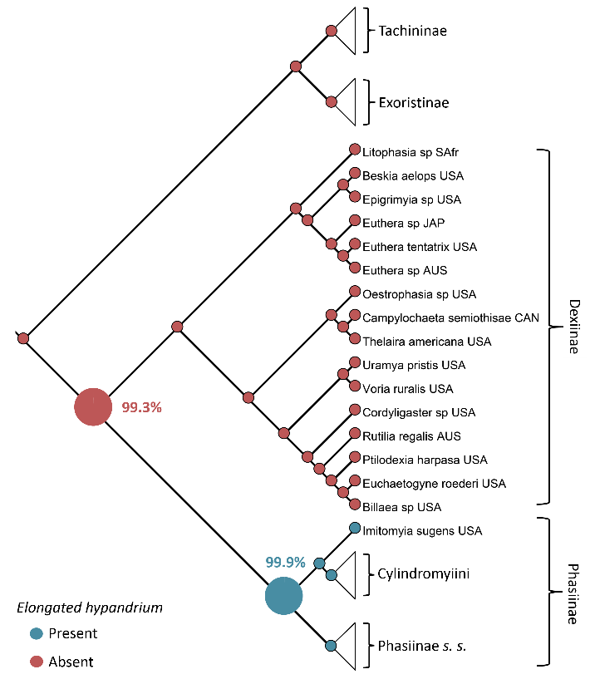
Figure 9: Ancestral state reconstruction of an elongated hypandrium in Tachinidae.
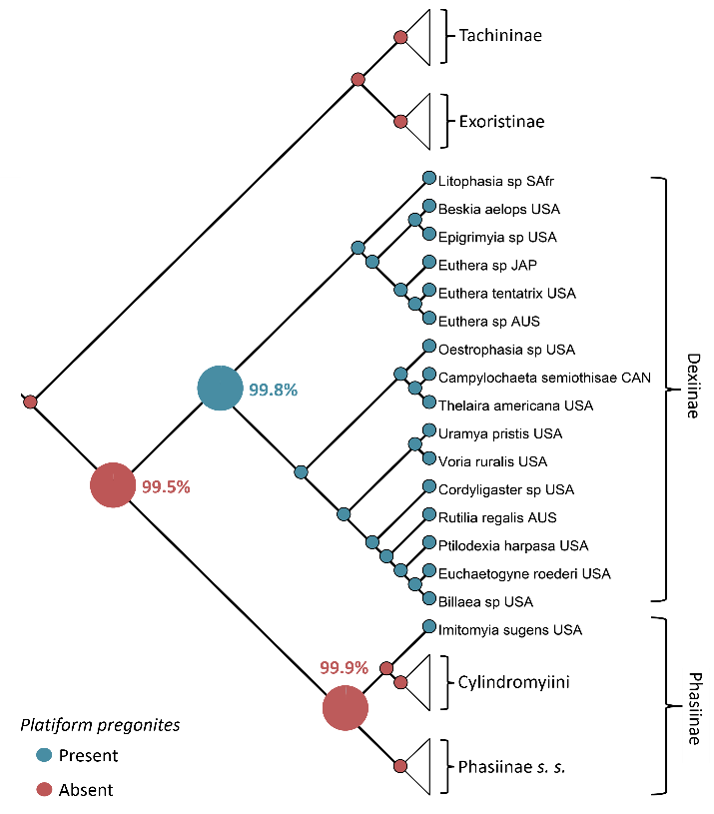
Figure 10: Ancestral state reconstruction of platiform pregonites in Tachinidae.
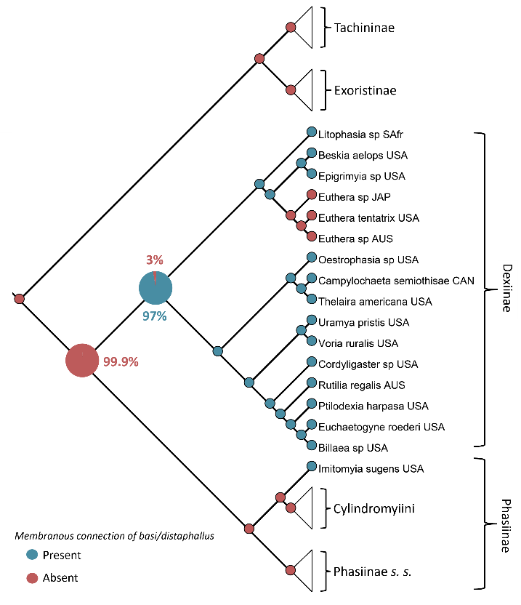
Figure 11: Ancestral state reconstruction of membranous connection of basiphallus to distiphallus in Tachinidae.
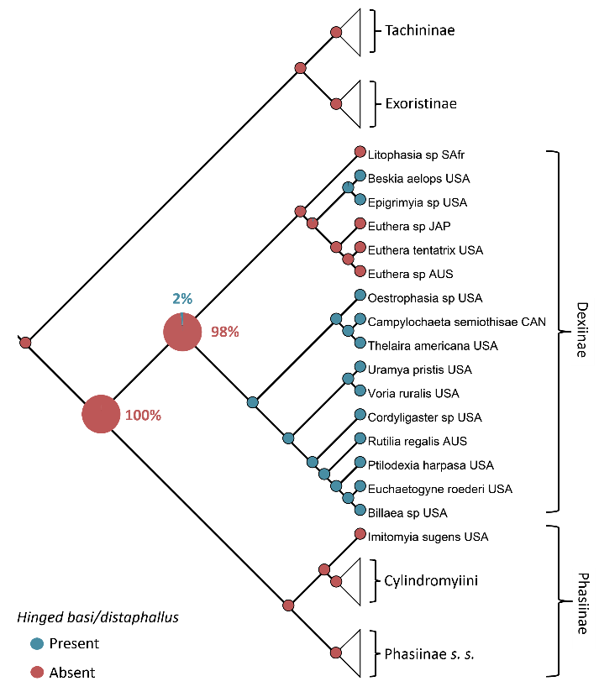
Figure 12: Ancestral state reconstruction of hinged connection of basiphallus to distiphallus in Tachinidae.

these characters, Eutherini would align with Phasiinae while Epigrimyiini has all the features of Dexiinae. Litophasia and Imitomyia are intermediate.
Platiform (strap-like) pregonites present an easier character to discuss. Litophasia, Epigrimyiini and Eutherini all possess platiform pregonites and at first glance it looks like this could be a synapomorphic trait for Dexiinae in the same way an elongated hypandrium is for Phasiinae. Unfortunately, the aberrant genus Imitomyia also possesses platiform pregonites. In this analysis, no single trait stands out as a true synapomorphy for Dexiinae. However, when taken together as a whole, it seems that possessing most or all of a suite of characters (including additional secondary characters like position and morphology of the epiphallus and postgonites) can be used to define the “gestalt” of dexiine male terminalia. The only genus this definition would not apply to is Imitomyia. Nevertheless, Imitomyia also possesses the phasiine elongated hypandrium, and perhaps the possession of this trait taxonomically “trumps” other features of the male terminalia.

Conclusions
Molecular systematics has been shown to be a useful tool for reconstructing the evolution of Tachinidae and has contributed important information to several longstanding taxonomic debates. The subfamily placement of Eutherini, Epigrimyiini, Litophasiini, Strongygastrini, and Parerigonini has been all but completely resolved. The Imitomyiini were shown to be as difficult to decipher molecularly as they are morphologically, but the sum genetic and phenotypic evidence suggests a placement in Phasiinae. Ancestral state reconstruction suggests a dominant and persistent trend in Phasiinae to evolve piercing structures used to insert eggs directly into host tissues. A single potential synapomorphy of Phasiinae is identified, but a suite of characters is needed to differentiate Dexiinae. Finally, a robust framework of phasiine classification is provided for use in future revisionary work in the subfamily.

References

Aldrich JR, Khrimian A, Zhang A, & Shearer PW. 2006. Bug pheromones (Hemiptera, Heteroptera) and tachinid fly host-finding. Denisia 19:1015–1031.
Aldrich JR, Lusby WR, Marron BE, Nicolaou KC, Hoffmann MP, & Wilson LT. 1989. Pheromone blends of green stink bugs and possible parasitoid selection. Naturwissenschaften, 76 (4), 173-175.
Aldrich, J. R., Khrimian, A., & Camp, M. J. (2007). Methyl 2, 4, 6-decatrienoates attract stink bugs and tachinid parasitoids. Journal of chemical ecology, 33(4), 801-815.
Arnaud PH Jr. 1978. A Host-Parasite Catalog of North American Tachinidae (Diptera). USDA Miscellaneous Publications. 1319. 860 pp.
Arnaud PH Jr. 1978. A Host-Parasite Catalog of North American Tachinidae (Diptera). USDA Miscellaneous Publications. 1319. 860 pp.
Arnaud PH Jr. 1978. A Host-Parasite Catalog of North American Tachinidae (Diptera). USDA Miscellaneous Publications. 1319. 860 pp.
Belshaw R. 1993. Tachinid flies. Diptera: Tachinidae. Handbooks for the identification of British Insects. London: R. Entomol. Soc. London 10, Part 4a (i). 170 pp.
Bezzi, M. 1925. On the tachinid genus Euthera (Diptera), with description of new species from Australia, Africa and South America. Proceedings of the Linnaean Society of New South Wales, 50: 275–283.
Biehler JA, & McPherson JE. 1982. Life history and laboratory rearing of Galgupha ovalis (Hemiptera: Corimelaenidae), with descriptions of immature stages. Annals of the Entomological Society of America, 75 (4): 465-470.
Blaschke et al. 2015. Evolution and Phylogeny of Phasiinae (Diptera: Tachinidae)
Brauer, F. & Bergenstamm, J.E. von. 1889. Die Zweiflügler des Kaiserlichen Museums zu Wien. IV. Vorarbeiten zu einer Monographie der Muscaria schizometopa (exclusive Anthomyidae). Pars I. Denkschriften der Kaiserlichen Akademie der Wissenschaften in Wien. Mathematisch-Naturwissenschaftliche Classe 56 (1): 69-180 + 11 pls.
Cantrell BK & Crosskey RW. 1989. Family Tachinidae. In Catalog of the Diptera of the Australasian and Oceanian Regions, ed. NL Evenhuis, pp. 733–84. Bishop Mus. Spec. Publ. 86. Honolulu/ Leiden: Bishop Mus. Press & Brill. 1155 pp.
Cantrell BK. 1983. Revision of the Australian species of Euthera Loew (Diptera: Tachinidae). Australian Journal of Entomology, 22 (1), 53-59.
Cantrell BK. 1988. The comparative morphology of the male and female postabdomen of the Australian Tachinidae (Diptera), with descriptions of some first-instar larvae and pupae. Invertebrate Systematics, 2 (1), 81-221.
Cerretti P, & Tschorsnig HP. 2010. Annotated host catalogue for the Tachinidae (Diptera) of Italy. Stuttgarter Beiträge zur Naturkunde, A, Neue Serie, 3, 305-340.
Cerretti, P., O'HARA, J. E., Wood, D. M., Shima, H., Inclan, D. J., & STIREMAN, J. O. (2014). Signal through the noise? Phylogeny of the Tachinidae (Diptera) as inferred from morphological evidence. Systematic Entomology, 39(2), 335-353.
Coombs M. 2004. Overwintering survival, starvation resistance, and post-diapause reproductive performance of Nezara viridula (L.) (Hemiptera: Pentatomidae) and its parasitoid Trichopoda giacomellii Blanchard (Diptera: Tachinidae). Biological Control, 30 (2), 141-148.
Coquillett DW. 1897. Revision of the Tachinidae of America north of Mexico: A family of parasitic two-winged insects (No. 7). Govt. print. off.
Crosskey RW. 1973. A conspectus of the Tachinidae (Diptera) of Australia, including keys to the supraspecific taxa and taxonomic and host catalogues. Bulletin of the British Museum of Natural History Entomology Supplement 21. 221 pp.
Crosskey RW. 1976. A taxonomic conspectus of the Tachinidae (Diptera) of the Oriental Region. Bulletin of the British Museum of Natural History Entomology Supplement 26. 357 pp.
Crosskey RW. 1977. A review of Rhinophoridae (Diptera) and a revision of the Afrotropical species. Bulletin of the British Museum of Natural History Entomology Supplement 36. 66 pp.
Crosskey RW. 1980. Family Tachinidae. In Catalogue of the Diptera of the Afrotropical Region, ed. RW Crosskey, pp. 822–82. London: British Museum of Natural History 1437 pp.
Crosskey RW. 1984. Annotated keys to the genera of Tachinidae (Diptera) found in tropical and southern Africa. Annals of the National Museum 26: 189–337.
Dear JP. 1980. A new species of Litophasia Girschner from South Africa (Diptera: Tachinidae). Annals of the Natal Museum (Print) (Pietermaritzburg: Natal Museum) 24: 217–220.
Dupuis, C. 1963. Essai monographique sur les Phasiinae (Diptères Tachinaires parasites d'Hétéroptères). Mémoires du Muséum National d'Histoire Naturelle, Sér. A, Zoologie 26: 1–461.
Eggleton P & BelshawR. 1992. Insect parasitoids: an evolutionary overview. Philosophical Transaction of the Royal Society of London B. Biological Sciences, 337:1–20.
Feener Jr DH. 2000. Is the assembly of ant communities mediated by parasitoids?. Oikos, 90 (1), 79-88.
Ferrar, P. 1977. Parasitism of other adult Diptera by Tachinidae in Australia. Journal of Australian Entomological Society 16: 397-401.
Golec, J. R., Hu, X. P., Ray, C., & Woodley, N. E. (2013). Strongygaster triangulifera (Diptera: Tachinidae) as a parasitoid of adults of the invasive Megacopta cribraria (Heteroptera: Plataspidae) in Alabama. Journal of Entomological Science, 48(4), 352-354.
Guimaráes JH. 1971. Family Tachinidae (Larvaevoridae). In A Catalogue of the Diptera of the Americas South of the United States. Vol. 104. São Paulo: Museum of Zoology, University of São Paulo. 333 pp.
Guimaráes JH. 1977. Host-parasite and parasite-host catalogue of South American Tachinidae (Diptera). Arquivos de Zoologia. São Paulo 28:1–131.
Hennig, W. (1965). Phylogenetic systematics. Annual review of entomology,10 (1), 97-116.
Hennig, W. (1965). Phylogenetic systematics. Annual review of entomology,10 (1), 97-116.
Herting B, Dely-Draskovits A. 1993. Family Tachinidae. In Catalogue of Palaearctic Diptera. Vol. 13: Anthomyiidae–Tachinidae, ed. A´ Soo´s, L Papp, pp. 118–458. Budapest: Hung. Natural History Museum 624.
Herting B. 1957. Das weibliche Postabdomen der calyptraten Fliegen (Diptera) und sein Merkmalswert für die Systematik der Gruppe. Zeitschrift für Morphologie und Ökologie der Tiere, 45 (5), 429-461.
Herting B. 1960. Biologie der westpalarktischen Raupenfliegen. Dipt., Tachinidae. Monographien zur Angewandten Entomologie. 16, 188 pp.
Herting B. 1983. 64c. Phasiinae. In Die Fliegen der palaearktischen Region, ed. E Lindner, pp.1–88. Stuttgart: Schweiz. Verl.
Herting B. 1984. Catalogue of Palearctic Tachinidae (Diptera). Stuttgarter Beitraege zur Naturkunde Serie A (Biologie), 369:1–228.
Karban R, English-Loeb G. 1997. Tachinid parasitoids affect host plant choice by caterpillars to increase caterpillar survival. Ecology, 78:603–11.
Katoh, K., & Toh, H. (2010). Parallelization of the MAFFT multiple sequence alignment program. Bioinformatics, 26(15), 1899-1900.
Katoh, K., Misawa, K., Kuma, K. I., & Miyata, T. (2002). MAFFT: a novel method for rapid multiple sequence alignment based on fast Fourier transform.Nucleic acids research, 30(14), 3059-3066.
Kevan, DK & Koshnaw RTB. 1988. Hyalomyodes (Diptera; Tachinidae), an endoparasitoid of Tetrigoidea (Orthoptera). Entomologist's Record and Journal of Variation, 100: 55–57.
Maddison, W. P. and D.R. Maddison. 2015. Mesquite: a modular system for evolutionary analysis. Version 3.03 http://mesquiteproject.org
Malloch, J. R.(1929).-Notes on Australian Diptera. XX. Proc. Lim, 283-343.
Mesnil LP. 1970. Descriptions de nouveaux Tachinaires de l'ancien monde, et notes synonymiques (Dipt. Tachinidae). Mushi, 44: 89-123.
Mesnil, L.P. (1966) 64g. Larvaevorinae (Tachininae). Die Fliegen der Palaearktischen Region, 10 (Lieferung 263), 881–928.
Miller MA, Pfeiffer W, and Schwartz T. 2010. Creating the CIPRES Science Gateway for inference of large phylogenetic trees. In Proceedings of the Gateway Computing Environments Workshop (GCE), 14 Nov. 2010, New Orleans, LA pp 1 - 8.
Mooi, R. D., & Gill, A. C. (2010). Phylogenies without synapomorphies–a crisis in fish systematics: time to show some character. Zootaxa, 2450, 26-40.
Mooi, R. D., & Gill, A. C. (2010). Phylogenies without synapomorphies–a crisis in fish systematics: time to show some character. Zootaxa, 2450, 26-40.
Moulton JK, & Wiegmann BM. 2004. Evolution and phylogenetic utility of CAD (rudimentary) among Mesozoic-aged Eremoneuran Diptera (Insecta). Molecular Phylogenetics and Evolution 31 (1), 363–378.
Nishida T. 1966. Behavior and mortality of the southern stink bug Nezara viridula in Hawaii. Researches on Population Ecology, 8 (1), 78-88.
O’Hara JE, Shima H, & Zhang C. 2009. Annotated catalogue of the Tachinidae (Insecta: Diptera) of China. Zootaxa, 2190, 1-236.
O’Hara JE, Wood DM. 2004. Catalogue of the Tachinidae (Diptera) of America north of Mexico. Memoirs of the International Entomological Society. 18. 410 pp.
O’Hara, J. E. (1985). Oviposition strategies in the Tachinidae, a family of beneficial parasitic flies. Agriculture and Forestry Bulletin, 8, 31-34.
O’Hara, J. E. (2011). World genera of the Tachinidae (Diptera) and their regional occurrence.
O’Hara, J.E. 2013a. Where in the world are all the tachinid genera? The Tachinid Times 26: 10–16.
O’Hara, J.E. 2013b. History of tachinid classification (Diptera, Tachinidae). ZooKeys 316: 1–34.
O'Hara JE. 2012. Review of Euthera (Diptera: Tachinidae) in North America with the description of a new species. The Canadian Entomologist, 144 (02), 206-215.
Panizzi AR, & Oliveira ÉD. 1999. Seasonal occurrence of tachinid parasitism on stink bugs with different overwintering strategies. Anais da Sociedade Entomológica do Brasil, 28 (1), 169-173.
Pape T. 1992. Phylogeny of the Tachinidae family-group. Tijdschrift voor Entomologie, 135:43–86.
Richter VA. 2004. Family Tachinidae – tachinids. In: Key to the insects of Russian Far East. Sidorenko VS., Editor. Vol. VI. Diptera and Siphonaptera. Part 3. Dal’nauka, Vladivostok. 659 pp. [In Russian.]
Rogers J & Wall J. 1980. A mechanism for RNA splicing. Proceedings of the National Academy of Sciences (USA), 77, 1877–1879.
Ronquist, F., Teslenko, M., van der Mark, P., Ayres, D. L., Darling, A., Höhna, S., ... & Huelsenbeck, J. P. (2012). MrBayes 3.2: efficient Bayesian phylogenetic inference and model choice across a large model space.Systematic biology, 61(3), 539-542.
Sabrosky CW & Arnaud PH Jr. 1965. Family Tachinidae (Larvaevoridae). In A Catalog of the Diptera of America North of Mexico, ed. A Stone, CW Sabrosky, WW Wirth, RH Foote, JR Coulson, pp. 961– 1108. USDA Handbook 276. 1696 pp.
Sabrosky CW, & Braun BH. 1970. A tachinid parasite of fireflies. Entomological News, 81, 185-187.
Santos CH, & Panizzi AR. 1997. Tachinid parasites of adult Megalotomus parvus West. (Hemiptera: Alydidae). Anais da Sociedade Entomológica do Brasil, 26 (3), 577-578.
Shima H. 1989. Parasitic way of life in tachinid flies. Insectarium 26:4–9; 46–51; 88–94; 120–26.
Shima H. 2006. A host-parasite catalog of Tachinidae (Diptera) of Japan. Societas Dipterologica. 2006.
Shima H. 2015. New Host records of Japanese Tachinidae (Diptera). Acta Dipterilogica. No. 26: 9-19.
Shima, H. (1999). Host-parasite catalog of Japanese Tachinidae (Diptera).Makunagi/Acta Dipterologica, 1, 1-108.
Shima, H. (2015). Melastrongygaster, a new genus of the tribe Strongygastrini (Diptera: Tachinidae), with five new species from Asia. Zootaxa, 3904(3), 427-445.
Stamatakis A. 2006. RAxML-VI-HPC: Maximum Likelihood-based Phylogenetic Analyses with Thousands of Taxa and Mixed Models. Bioinformatics, 22 (21), 2688–2690.
Stein P. 1924. Die verbreitetsten Tachiniden Mitteleuropas nach ihren Gattungen und Arten. Archiv fur Naturgeschichte Abt. A, 90 (6): 1–271.
Stireman III JO, O'Hara JE, & Wood DM. 2006. Tachinidae: evolution, behavior, and ecology. Annual Review of Entomology, 51, 525-555.
Stireman III, J. O., O’Hara, J. E., Moulton, J. K., Cerretti, P., & Winkler, I. S. (2013). Progress towards a phylogeny of world Tachinidae. Year 1. The Tachinid Times, 26, 4-9.
Stireman JO III, Singer MS. 2002. Spatial and temporal heterogeneity in the parasitoid assemblage of an exophytic polyphagous caterpillar. Ecological Entomology 27:588–600.
Stireman JO III, Singer MS. 2003. Determinants of parasitoid-host associations: insights from a natural tachinid-lepidopteran community. Ecology 84:296–310.
Stireman JO III. 2002. Phylogenetic relationships of tachinid flies in subfamily Exoristinae (Tachinidae: Diptera) based on 28S rDNA and elongation factor-1α. Syst. Entomol. 27:409–35
Sutherland, J. P., & Baharally, V. (2002). Spatio-temporal distribution of Beskia aelops (Walker)(Diptera: Tachinidae) and its potential for the biocontrol of Oebalus poecilus (Dallas)(Hemiptera: Pentatomidae). Biocontrol Science and Technology, 12(4), 513-517.
Tachi, T., & Shima, H. (2010). Molecular phylogeny of the subfamily Exoristinae (Diptera, Tachinidae), with discussions on the evolutionary history of female oviposition strategy. Systematic Entomology, 35(1), 148-163.
Townsend CHT. 1891. Notes on North American Tachinidæ sens. str. with Descriptions of New Genera and Species. Paper II. Transactions of the American Entomological Society (1890-), 18(4), 349-382.
Townsend CHT. 1908. The taxonomy of the muscoidean flies, including descriptions of new genera and species (Vol. 51, No. 2). Smithsonian institution.
Townsend, CHT. 1919. Note on leskiine synonymy (Dipt.). Proceedings of the Entomological Society of Washington 21: 20.
Townsend, CHT. 1936a. Manual of myiology in twelve parts.
Townsend, CHT. 1938. Manual of myiology in twelve parts. Part VII. Oestroid generic diagnoses and data. Gymnosomatini to Senostomatini. São Paulo: 434 pp.
Tschorsnig H-P, Richter VA. 1998. Family Tachinidae. In Contributions to a Manual of Palaearctic Diptera (with Special Reference to Flies of Economic Importance). Vol. 3: Higher Brachycera, ed. Papp L & Darvas B. pp. 691–827. Budapest: Sci. Herald. 880 pp.
Tschorsnig H-P. 1985. Taxonomie forstlich wichtiger Parasiten: Untersuchungen zur Struktur des m¨annlichen Postabdomens der Raupenfliegen (Diptera, Tachinidae). Stuttg. Beitr. Naturkunde Ser. A 383:1–137.
Tschorsnig, H. P., & Herting, B. (1994). The tachinids (Diptera: Tachinidae) of central Europe: identification keys for the species and data on distribution and ecology. Stuttgarter Beiträge zur Naturkunde, Serie A (Biol.), 506, 170.
Van Emden, F. I. (1945, March). 23. Keys to the Ethiopian Tachinidæ.—I. Phasiinæ. In Proceedings of the Zoological Society of London (Vol. 114, No. 4, pp. 389-436). Blackwell Publishing Ltd.
Van Emden, F. I. (1945, March). 23. Keys to the Ethiopian Tachinidæ.—I. Phasiinæ. In Proceedings of the Zoological Society of London (Vol. 114, No. 4, pp. 389-436). Blackwell Publishing Ltd.
Villeneuve J. 1924. Contribution à la classification des "Tachinidae" Paléarctiques. Annls Sci. nat., Zool., (10) 7: 5-39.
Vincent LS. 1985. The first record of a tachinid fly as an internal parasitoid of a spider (Diptera: Tachinidae; Araneae: Antrodiaetidae). Pan-Pacific Entomologist, 61:224–25.
Waldbauer GP, Sternburg JG, & Maier CT. 1977. Phenological relationships of wasps, bumblebees, their mimics, and insectivorous birds in an Illinois sand area. Ecology, 583-591.
Wallace, R. S., & Gibson, A. C. (2002). Evolution and systematics. Cacti: biology and uses. University of California Press, Berkeley, 1-21.
Wallace, R. S., & Gibson, A. C. (2002). Evolution and systematics. Cacti: biology and uses. University of California Press, Berkeley, 1-21.
Wheeler, Q., Assis, L., & Rieppel, O. (2013). Phylogenetics: Heed the father of cladistics. Nature, 496(7445), 295-296.
Wheeler, Q., Assis, L., & Rieppel, O. (2013). Phylogenetics: Heed the father of cladistics. Nature, 496(7445), 295-296.
Wiley, E. O., & Lieberman, B. S. (2011). Phylogenetics: theory and practice of phylogenetic systematics. John Wiley & Sons.
Wiley, E. O., & Lieberman, B. S. (2011). Phylogenetics: theory and practice of phylogenetic systematics. John Wiley & Sons.
Williams SC, Arnaud PH, Lowe G. 1990. Parasitism of Anuroctonus phaiodactylus (Wood) and Vaejovis spinigerus (Wood) (Scorpiones: Vaejovidae) by Spilochaetosoma californicum Smith (Diptera: Tachinidae), and a review of parasitism in scorpions. Myia, 5:11–27.
Winkler, I. S., Blaschke, J. D., Davis, D. J., Stireman, J. O., O’Hara, J. E., Cerretti, P., & Moulton, J. K. (2015). Explosive radiation or uninformative genes? Origin and early diversification of tachinid flies (Diptera: Tachinidae).Molecular phylogenetics and evolution, 88, 38-54.
Wood DM & Wheeler AG. 1972. First record in North America of the centipede parasite Loewia foeda (Diptera: Tachinidae). The Canadian Entomologist, 104 (09), 1363-1367.
Wood DM & Zumbado MA. 2010. Tachinidae (tachinid flies, parasitic flies). Manual of Central American Diptera, 2, 1343-1417.
Wood, D.M. 1987. Tachinidae. Pp. 1193–1269. In: McAlpine, J.F., Peterson, B.V., Shewell, G.E., Teskey, H.J., Vockeroth, J.R. and Wood, D.M., eds., Manual of Nearctic Diptera. Volume 2. Agriculture Canada Monograph 28: i–vi, 675–1332.
Wulp, FM van der. 1903. Supplement [to the Muscidae Calypterae]. Pp. 433–486 + pl. 13 (figs. 7-19) in Godman, F.D. & Salvin, O. (eds.), Biologia Centrali-Americana, or, contributions to the knowledge of the fauna and flora of Mexico and Central America. Zoologia-Insecta-Diptera. London: Vol. 2, 489 pp. + 13 pls.
Ziegler J. 1998. Die Morphologie der Puparien und der larvalen Cephalopharyngealskelette der Raupenfliegen (Diptera, Tachinidae) und ihre phylogenetische Bewertung. Stud. Dipterol. Suppl. 3. 244 pp.

Chapter II: Historical Systematics in a Modern Phylogenetic Context: Creating a Global Classification of Phasiinae (Diptera: Tachinidae) in Light of New Molecular and Morphological Evidence

Table of Contents

Abstract 1
Introduction and Background 2
Methods 7
Results and Discussion 9
Subfamily Dexiinae 9
Tribe Epigrimyiini 9
Tribe Eutherini 10
Tribe Litophasiini 13
Subfamily Phasiinae 14
Tribe Catharosiini 14
Tribe Cylindromyiini 15
Subtribe Cylindromyiina 18
Subtribe Neobracheliina 19
Subtribe Phasiina 21
Unplaced to subtribe 23
Tribe Euscopoliopterygini 23
Tribe Gymnosomatini 25
Subtribe Gymnosomatina 29
Subtribe Trichopodina 31
Unplaced to subtribe 33
Tribe Hermyini 33
Tribe Imitomyiini 36
Tribe Leucostomatini 39
Tribe Opesiini 43
Tribe Parerigonini 44
Tribe Phasiini 46
Tribe Strongygastrini 47
Tribe Tarassini 50
Tribe Xystiini 51
Tribe Zitini 52
References 54

Abstract

Historical hypotheses about the classification of the endoparasitoid subfamily Phasiinae (Diptera: Tachinidae) are reviewed and compared to phylogenetic trees inferred from modern phylogenetic analyses of nucleotide sequences. An updated classification of worldwide genera and tribes is created and includes discussions on each tribe’s taxonomic and evolutionary history. Several historical theories about relationships within Phasiinae are confirmed and many novel phylogenetic hypotheses are presented. Significant findings include the following: Epigrimyiini, Eutherini, and Litophasiini are placed in Dexiinae rather than Phasiinae. Imitomyiini are placed in Phasiinae rather than Dexiinae. Parerigonini and Strongygastrini/Rondaniooestrini are placed in Phasiinae rather than Tachininae. Taxa previously belonging in Parerigonini are divided between three tribes: Parerigonini, Zitini, and Cylindromyiini. Taxa previously found in Phasiini are split into four lineages: Phasiini, Gymnosomatini, Opesiini, and Xystiini. Trichopodini is regarded as a subtribe of Gymnosomatini (Trichopodina). Litophasiini is described as a new tribe including Litophasia Girschner, 1887. Opesiini is described as a new tribe including Opesia Robineau-Desvoidy, 1863. Xystiini is described as a new tribe including Xysta Meigen, 1924. Zitini is described as a new tribe including Zita Curran, 1928 and Leverella Baranov, 1934. Prolophosia Townsend, 1932 is synonymized with Cylindromyia Meigen, 1803. Eleuthromyia Reinhard, 1964 is synonymized with Neobrachelia Townsend, 1931.

Introduction and Background

Importance of Taxonomy
Taxonomy – the discovering, naming, and organizing of life on earth – is among humanity’s most ancient professions. This daunting task has been appreciated by philosophers and naturalists throughout recorded history from Aristotle to Linnaeus to Darwin. Through centuries of diverse thought and research, the purpose and importance of classification has persisted almost unchanged. Taxonomy has three primary purposes: 1) discover and document what plants and animals are valuable to humans, as food, medicine, clothing, labor, aesthetics, or companionship; 2) identify organisms that are potentially harmful to humans, including predators, parasites, and those that are venomous, poisonous, or passively or aggressively defensive; and 3) organize life into predictive categories into which new species can be easily placed and that bridges cultural and linguistic barriers to ensure all of humanity has access to the same tree of knowledge. These practical benefits of classification are well-known and incredibly important, but there is an additional, often undervalued reason to study taxonomy: scientific curiosity.
Humans are the only creatures on earth known to enjoy the diversity of nature itself as beauty and art. Among the diversity of humans, there have always been those who are deeply compelled to explore and describe, and often complete these tasks not out of obligation to produce something useful to humanity, but out of excitement and passion for the task itself. Taxonomy is, therefore, a profession that provides an exciting and interesting vocation coupled with important practical applications. As such, it has been an occupation or hobby of choice for some of the brightest minds and deepest thinkers throughout history (Theophrastus, Shen Nung, John Ray, Lamarck, etc.) However, naming and organizing all life on earth is a prodigious task. Given the diversity still unknown in certain groups like prokaryotes and arthropods, it is possible that classifying all life on earth will never be a completed project. Even so, significant progress has been made throughout history and it is fascinating to examine how new ideas and new discoveries have provided clarity to puzzling taxonomic relationships.
With the ultimate goal of creating a predictive and comprehensive classification of their study taxa, modern taxonomists are challenged in two ways. First, with the recent introduction and popularization of molecular systematics, the past few decades have seen significant changes to historical hypotheses of classification based on newly acquired genetic evidence. Therefore, phylogenetic trees generated using modern techniques and statistics should be compared to classical taxonomic hypotheses to create the best total-evidence, evolutionarily meaningful classification. Second, the level of inter-continental collaboration, cooperation, and communication in our modern world is unprecedented. This allows for synthesis of scientific research across biogeographic regions and the creation of truly worldwide taxonomic hypotheses. In this paper, these two challenges of modern taxonomy are applied to the agriculturally important parasitoid fly subfamily Phasiinae (Diptera: Tachinidae). The taxonomic history of Phasiinae is reviewed and compared to recent molecular and morphological phylogenies and a new classification of Phasiinae is presented that includes all worldwide genera placed in phylogenetic context with discussions of inter and intra-tribal evolutionary relationships.

Phasiinae
The Phasiinae are an intriguing group of insects to study. As internal parasitoids, these diverse flies primarily attack true bugs (Heteroptera) (Wood 1987) and many genera use their host’s own aggregation pheromones to locate their prey (Aldrich et al. 2006). As a result, phasiines have untapped potential for use as biological control agents for both natural (e. g. Euschistus servus Say, Coquillet 1897; Lygus lineolaris Beauvois, Arnaud 1978) and invasive crop pests (e. g. Halyomorpha halys Ståhl, Aldrich et. al 2007; Megacopta cribraria Fabricius, Golec et al. 2014). One genus in particular, Trichopoda Berthold, has been extensively used around the world to control Nezara viridula (Harris & Todd 1981; Sands & Coombs 1999), but use of other genera for biological control is hampered by the difficult and confusing taxonomy of Phasiinae. Also, within Phasiinae are found numerous interesting evolutionary adaptations, including specialized piercers used to inject eggs directly into host tissue (Stireman et al. 2006), aposematic mimicry colors/patterns (Waldbauer et al. 1977), and a remarkably variable external and internal morphology (Crosskey 1976; Tschorsnig 1985). Analyzing phasiine relationships in a rigorous phylogenetic context will provide a crucial foundation for both applied research in biological control and theoretical research into the evolution of unique character traits.
Historically, the classification of Phasiinae has been unstable, with numerous genera and tribes maintaining a debated placement within Phasiinae based on contradicting morphological and/or life history evidences (see Blaschke et al. 2015). Phasiine taxonomy is further complicated by significant dissonance between the classification systems of the six biogeographic regions of the world (O’Hara 2013). Currently, there is no checklist of world Phasiinae and there is considerable disagreement among experts as to which genera even belong in the subfamily. Of the seventeen tribes discussed here, nine have had a volatile taxonomic history with various lines of evidence indicating placement into Phasiinae or one of the other three subfamilies of Tachinidae (e.g. Dexiinae, Exoristinae, or Tachininae). However, recent morphological (Cerretti et al. 2014) and molecular (Blaschke et al. 2015) phylogenies have provided significant statistical support for tribal and generic relationships within Phasiinae. These studies have established the necessary robust phylogenetic framework on which to build an unprecedented, evolutionarily informed worldwide classification of the Phasiinae and help resolve several longstanding debates within dipteran systematics.
Using these phylogenies as a framework, the taxonomic history of each recognized and potential phasiine tribe is reviewed and updated, if necessary. Three tribes of Dexiinae (Epigrimyiini, Eutherini, and Litophasiini) are also included because of their close historical association with Phasiinae. A global list of phasiine genera is included. This is not meant to be a complete revision of the subfamily, which would require extensive examination of type specimens, but rather a gathering of historical and current taxonomic hypotheses blended with modern phylogenetic evidence. The goal is to provide an evolutionary informed classification that can be used for testing hypotheses about trait evolution and biogeography, while highlighting areas in need of future systematic research. A cladogram of proposed tribal relationships can be found in Figure 1 and a complete cladogram of all Phasiinae is presented in Figure 2.

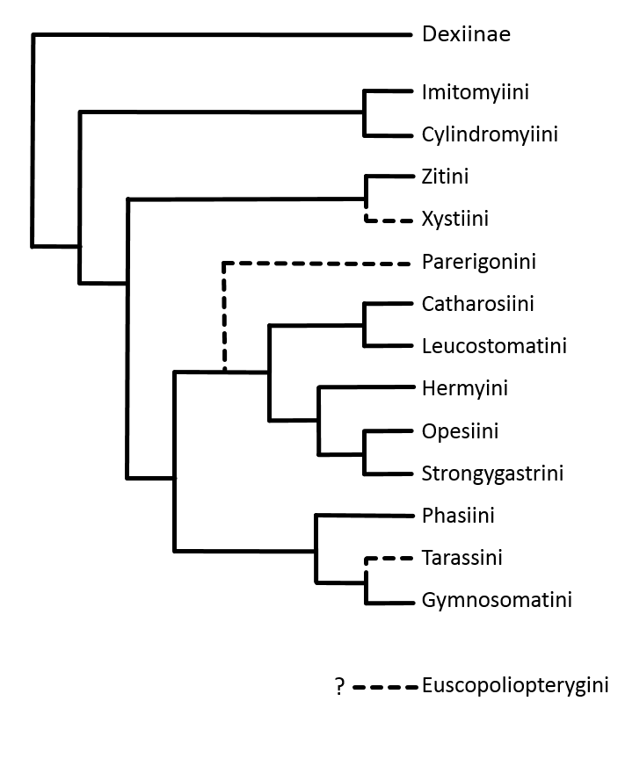
Figure 1: Cladogram of proposed tribal relationships within the Phasiinae. Solid lines indicate significant molecular and/or morphological support; dotted lines in the cladogram indicate weakly supported or hypothetical relationships. Euscopoliopterygini are currently incertae sedis.
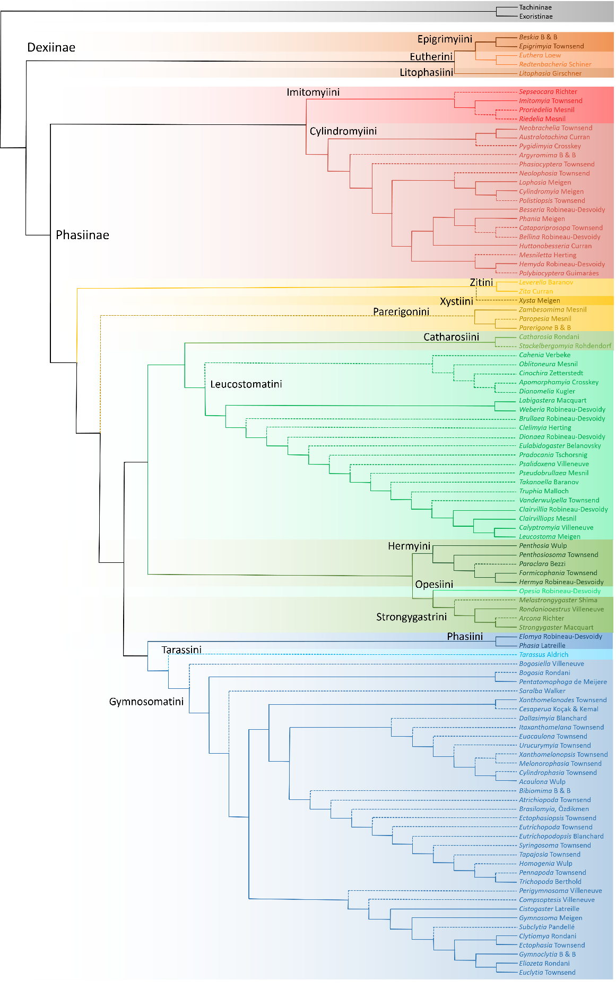
Figure 2: Cladogram of Phasiinae with all genera included except the Euscopoliopterygini. Solid lines indicate significant molecular and/or morphological support, dotted lines indicate weakly supported or hypothetical relationships.

Methods

A global list of genera belonging to the tachinid subfamily Phasiinae was compiled from the most recent catalogs of every major biogeographic region. These regional catalogs served as indispensable primary sources for this work and are as follows:
Afrotropical Region Crosskey 1980
Australasian Region Cantrell & Crosskey 1989
Nearctic Region O’Hara & Wood 2004
Neotropical Region Guimarães 1971
Oriental Region Crosskey 1976, 1977
Palearctic Region Herting & Dely-Draskovits 1993
China O’Hara et al. 2009
A preliminary list of genera was then cross-referenced against the world list of tachinid genera found in O’Hara 2011 (v. 8, Nov. 2014) and updated to reflect recent synonyms and name changes. Global species counts for each genus were documented by comparing species names and numbers across regional catalogs and creating an inclusive list of worldwide species. When relevant, generic revisions published in the years since the catalogs were first written were used to determine current estimates on species diversity. Phasiine genera that have been recently reviewed systematically include the following:
Arcona Richter Richter 1988
Besseria Robineau-Desvoidy Cerretti et al. 2010
Cylindromyia Meigen (Neotropical) Guimarães 1976
Cylindromyia Meigen (Australia) Cantrell 1984
Cylindromyia Meigen (Palearctic) Sun & Marshall 1995
Cylindromyiini Herting 1979
Ectophasiopsis Townsend Dios 2014
Euthera Loew (Nearctic) O'Hara 2012
Euthera Loew (Australia) Cantrell 1983
Lophosia Meigen (China) Sun 1995
Melastrongygaster Shima Shima 2015
Parerigone Brauer & Bergenstamm Shima 2011
Paropesia Mesnil Shima 2014
Phania Meigen Gilasian et al. 2013
Phasia Latreille Sun & Marshall 2003
Sepseocara Richter Richter 1986
Trichopoda Berthold Dios 2014
Zambesomima Mesnil Wang et al. 2014

To understand the taxonomic history of these genera and ultimately place them in a phylogenetic context, several landmark papers on tachinid morphological systematics were closely examined, most notably Townsend’s (1936, 1938) diagnoses of adults and immatures, Herting’s (1957) analysis of the female postabdomen, Tschorsnig’s (1987) research on the male postabdomen, and Zeigler’s (1998) work on tachinid puparia and larvae. Insightful discussions of tachinid history and systematics were found throughout Crosskey’s publications (1973, 1976, 1977, 1980, and 1984) and in more current literature (Wood 1987; Tschorsnig & Richter 1998; Stireman et al. 2006; Wood & Zumbado 2010; O’Hara 2013).
Modern phasiine systematics has benefited greatly from two recent phylogenetic analyses. Cerretti et al. (2014) provided the first cladistic analysis of Tachinidae using modern morphological techniques, while Blaschke et al. (2015) established a statistically sound phylogeny of Phasiinae generated from multiple nuclear protein coding genes. Blaschke et al.’s molecular phylogeny is used here as the framework for the subfamily and tribal structure of Phasiinae and is compared to the historical theories of phasiine classification to create a predictive and evolutionarily meaningful classification of world Phasiinae.

Results and Discussion

Subfamily Dexiinae
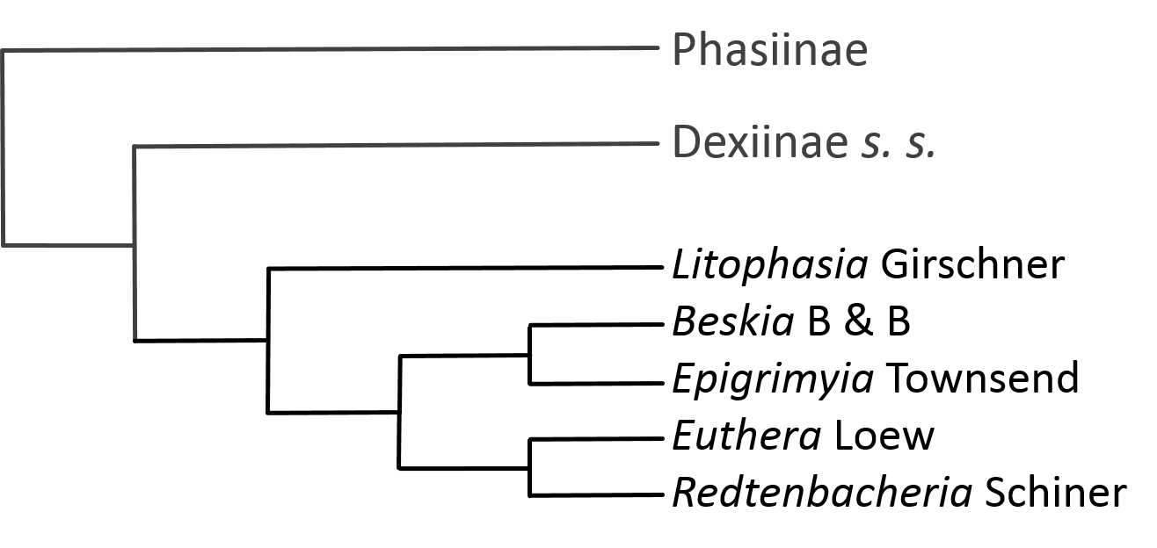

Tribe Epigrimyiini (2 genera, 3 species)
Beskia Brauer & Bergenstamm, 1889 (1 species)
Epigrimyia Townsend, 1891 (2 species)

Phylogenetics and Classification
The two tachinid genera included in the tribe Epigrimyiini are endemic to the Western Hemisphere (O’Hara 2011: 26) and occupy a unique morphological space intermediate between Dexiinae and Phasiinae (see also Eutherini and Litophasiini). Historically, Beskia Brauer & Bergenstamm and Epigrimyia Townsend have been considered members of the Phasiinae, but have recently been transferred to the Dexiinae due to distinctive secondary structures of the male postabdomen (Tschorsnig 1985: 128, O’Hara & Wood 2004: 42).
Epigrimyia was the sole member of Epigrimyiini from Townsend’s first diagnosis of the tribe (1908: 76) until O’Hara & Wood (2004) included the additional genus Beskia. However, their close morphological association with each other and to the modern phasiine tribe Cylindromyiini was noted by many previous authors (Brauer & Bergenstamm 1889; Wulp 1903; Townsend 1891, 1938; Sabrosky & Arnaud 1965; Herting 1984). Townsend’s 1908 version of tachinid taxonomy includes many families and subfamilies that have been merged together and/or renamed over the past century. Townsend originally placed Epigrimyiini in the subfamily Pyrrhosiinae, which also included genera in the very different modern tribes of Leskiini and Leucostomatini, but he also commented on Epigrimyia’s close affinity with the subfamily Phaniinae (= Cylindromyiini/Hermyini). Beskia was placed with Ocyptera (= Cylindromyia) in the Ocypterinae (= Cylindromyiini). Although he initially positioned Epigrimyia in its own tribe, Townsend later moved the genus to the Cylindromyiini along with Beskia (Townsend 1919). It should be noted that Malloch (1929) did not consider Beskia to belong in the same tribe as Cylindromyia. In Townsend’s 1936 key to the Cylindromyiini, Epigrimyia and Beskia share a terminal couplet based on their elongated proboscises.
In addition to their external habitus, which is more reminiscent of Cylindromyia and relatives than any member of Dexiinae, Epigrimyia and Beskia also share host similarity with other phasiines. All phasiines (except Rondaniooestrus Villeneuve and possibly Arcona Richter) with known hosts are parasitoids of heteropteran bugs and it has been proposed that this could be a synapomorphy of Phasiinae (Wood 1987; Stireman et al. 2006). Such an argument maintains Epigrimyiini in the Phasiinae as Epigrimyia attacks Galgupha ovalis (Hemiptera: Corimelaenidae) (Biehler & McPherson 1982) and Beskia attacks multiple species of Pentatomidae, most notably the rice stink bug (Oebalus pugnax) (Guimarães 1977; Sutherland & Baharally 2002). Additional evidence for a placement of Epigrimyiini in Phasiinae can be found in the female postabdomen where both genera share the phasiine distinctive of having sternite 8 modified into a piercing structure for direct oviposition into a host (Townsend 1938).
Although initially Epigrimyia and Beskia seem strongly reminiscent of Phasiinae, recent morphological and molecular evidence indicates a position within the Dexiinae. Tschorsnig (1985) examined the various structures of the male postabdomen and concluded that Epigrimyia and Beskia belonged in the Dexiinae based on the membranous connection of the basiphallus to the distiphallus (among other secondary structures) that he proposed were synapomorphic of Dexiinae. Additionally, Tschorsnig identified an elongated hypandrium as a potential synapomorphy of Phasiinae. This trait was not found in either Epigrimyia or Beskia. The placement of Epigrimyiini in Dexiinae gained considerable support from a recent molecular analysis (Blaschke et al. 2015) which recovered a strongly supported Epigrimyiini (composed of Beskia and Epigrimyia) as part of a monophyletic Dexiinae. The potential morphological synapomorphies of the male postabdomen are therefore corroborated by phylogenetics. Epigrimyiini is included in the Dexiinae in the present proposed classification as a result of this supporting evidence.

Tribe Eutherini (2 genera, 14 species)
Euthera Loew, 1866 (13 species)
Redtenbacheria Schiner, 1861 (1 species)

Phylogenetics and Classification
Similar to the Epigrimyiini and Litophasiini, the Eutherini share morphological and behavioral traits with both the Phasiinae and Dexiinae. As a result, their taxonomic placement has been debated over the decades by dipterologists. Reviews of the taxonomic history of Euthera Loew can be found in Bezzi (1925), Cantrell (1983), and O’Hara (2012). Euthera is a unique tachinid whose coloration mimics deerflies (Tabanidae: Chrysops spp.). It is rarely found in collections, but has a worldwide distribution (O’Hara 2013). The other genus included in the Eutherini is Redtenbacheria Schiner, which is found only in the Palearctic (Herting 1984).
The similarity of these two genera was first recognized by Stein (1924: 178-179) who placed them in his “Trixa Group”, and most modern tachinid experts have considered Euthera and Redtenbacheria to share a close affinity (Herting 1984; Ziegler 1998; Richter 2004; O’Hara et al. 2009; although see Crosskey 1976). Significant evidence for this relationship comes from the specialized shape of the phallus (Tschorsnig 1985) and the posterodorsal “window” on their eggs (Cerretti et al. 2014), which are both synapomorphies of the tribe. Eutherini’s subfamily placement is more controversial, however, with various experts preferring Phasiinae (Guimaráes 1971; Crosskey 1977; Crosskey 1980; Herting 1984; Tschorsnig 1985; Cantrell & Crosskey 1989; Tschorsnig & Herting 1994; Tschorsnig & Richter 1998) or recently Dexiinae (Shima 1989, 1999; O’Hara & Wood 2004; Shima 2006; O’Hara et al. 2009; Cerretti 2010).
The most convincing reason for placing the Eutherini in Phasiinae is their parasitism of heteropteran hosts (Euthera – Arnaud 1978; Redtenbacheria – Nishayama 1995), which has long been considered a distinctive trait of Phasiinae. They also produce planoconvex eggs (membranous on ventral side, but thickened and convex on dorsal surface) rather than the entirely membranous eggs of the Dexiinae (Stireman et al. 2006) and share this trait only with Phasiinae and some Exoristinae. However, the development and oviposition of these eggs is unlike any Phasiinae outside the Strongygastrini.
Phasiinae lack any kind of uterus and are therefore oviparous (i.e. lay unincubated eggs). In contrast, the Eutherini are ovolarviparous (i.e. lay incubated eggs or early instar larvae, Cantrell 1983). If included in the Phasiinae, the Eutherini would not be alone in having this trait as the Strongygastrini are also ovolarviparous, but these two groups are not closely related and such a classification would require the non-parsimonious explanation of ovolarviparity evolving in two separate lineages within the Phasiinae. In addition to their oviposition strategy, several important morphological traits indicate a placement in Dexiinae for the puzzling Eutherini.
When O’Hara & Wood (2004) moved the Eutherini from Phasiinae to Dexiinae, they did so based on Tschorsnig’s analysis of male postabdomen structures (1985) and their own examination of Euthera’s male terminalia. These authors identified several morphological traits shared between the Eutherini and the Dexiinae including the shape and location of the pregonites, postgonites, sternite 5, and distiphallus (see also Cerretti et al. 2014). However, unlike the Epigrimyiini discussed above, the Eutherini do not possess a hinged membranous connection between basiphallus and distiphallus – a trait considered to be the most convincing synapomorphic character trait of the Dexiinae. To further confuse the issue, neither do they possess the elongated hypandrium characteristic of Phasiinae. This evidence led Shima (1989) to conclude that the Eutherini represented the only extant taxa of the Dexiinae that retained the primitive trait of sclerotized basi/distiphallus connection. As with the Epigrimyiini, the hypothesis that Eutherini belongs in Dexiinae and may have retained some ancestral traits throughout its evolution is strongly supported by molecular evidence (Blaschke et al. 2015). Interestingly, the two tribes that have an uncertain classification between the Dexiinae and Phasiinae (Epigrimyiini and Eutheriini) were recovered as monophyletic sister groups in the phylogenetic analysis. This clade also included Litophasia Girschner, another similarly enigmatic taxa, and was reconstructed as sister to the rest of Dexiinae.
The molecular phylogenetic evidence stands in contrast to an earlier morphological phylogeny that surprisingly reconstructed the Eutherini nested within the Exoristinae (Cerretti et al. 2014). While the monophyly of the Eutherini was strongly supported, its placement in the Exoristinae was largely a result of their egg type and oviposition strategy and was not recovered in every analysis. The Tachinidae contains widespread homoplasy throughout the family and Cerretti et al.’s morphological analysis highlights the difficulty of reconstructing the evolutionary history of such a group using solely morphological characters. Under different weighting schemes numerous trees were obtained that sometimes differed dramatically, especially for the taxonomically ambiguous groups like the Eutherini. Some of these trees agreed quite well with the molecular evidence, and in situations with extremely high morphological homoplasy, it is perhaps best to trust the nucleotide and amino acid inferred trees rather than the structural traits. Therefore in this checklist, Eutherini is considered to be an extant tribe within Dexiinae that possesses several significant symplesiomorphic characters states.

Tribe Litophasiini (1 genera, 2 species)
Litophasia Girschner, 1887 (2 species)

Phylogenetics and Classification
The atypical genus Litophasia Girschner is a diminutive and rarely observed fly known only from one species in the Palearctic region and one from South Africa (Herting 1984; Crosskey 1984). Initially thought to belong to the Rhinophoridae (Emden 1954, Crosskey 1977), Litophasia is now considered a tachinid that lacks the almost universal traits of an enlarged subscutellum and meral bristles (Wood 1987; Tschorsnig & Richter 1998). Females, however, possess a piercer (8th sternite) very similar to those found in the phasiine tribes Catharosiini and Phasiini and not found in any known Rhinophoridae (Dear 1980). As a result of this unique trait and other morphological similarities, Herting considered it a member of Catharosiini (cf. Dear 1980), an opinion that Dear (1980) agreed with and subsequent authors have followed (Crosskey 1980, 1984; Herting 1984; Belshaw 1993; Herting & Dely-Draskovits 1993).
However, the male terminalia of Litophasia were not examined in a phylogenetic context until Tschorsnig (1985). The traits of the male postabdomen seem to be more phylogenetically informative than those of the female postabdomen, eggs, larvae, or behavioral traits (Blaschke et al. 2015; see Epigrimyiini and Eutherini above). As with the Epigrimyiini and Eutherini, Litophasia possesses dexiine-type characters in the male postabdomen, including the distinctive membranous connection between basiphallus and distiphallus (Tschorsnig 1985) and does not have the phasiine-type elongated hypandrium. Given its taxonomic ambiguity, it is not surprising that in Cerretti et al.’s (2014) morphological phylogeny Litophasia was inconsistently placed as either sister to Phasiinae or sister to Dexiinae under different weighting schemes. However, strong supporting evidence for a position within Dexiinae comes from a molecular phylogenetic analysis where Litophasia was reconstructed with high support as sister to Epigrimyiini + Eutherini (Blaschke et al. 2015). This clade in turn was sister to the rest of Dexiinae and therefore Litophasia is here included in that subfamily in its own tribe Litophasiini.
Hosts are unknown for Litophasia, but given its phylogenetic position belonging to a clade including the Epigrimyiini and Eutherini, it is hypothesized that Litophasia parasitizes small members of Heteroptera (see Blaschke et al. 2015 for a discussion on evolution of host use). The phasiine-like piercer of Litophasia is shared by both members of Epigrimyiini (Townsend 1938) and may represent an ancestral character state for Dexiinae + Phasiinae.

Subfamily Phasiinae

Tribe Catharosiini (2 genera, 13 species)
Catharosia Rondani, 1868 (12 species)
Stackelbergomyia Rohdendorf, 1948 (1 species)

Phylogenetics and Classification
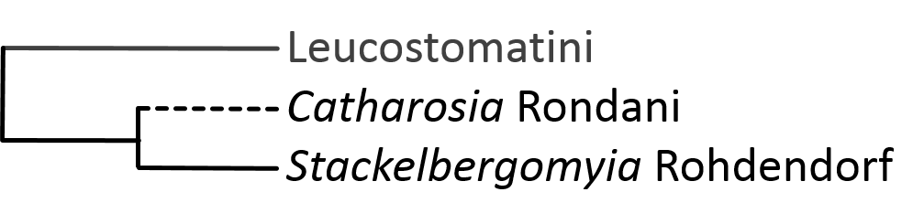
The tribe Catharosiini dates back to Townsend (1932) and has been little changed since its creation. Catharosia Rondani species occur worldwide and are among the smallest tachinids – some measuring <2mm (Tschorsnig & Richter 1998). The only other genus included is Stackelbergomyia Rohdendorf, which contains a single Palearctic species (Herting 1984). Until Herting (1981) added this strange, sand-digging genus the tribe primarily contained only Catharosia, albeit with numerous synonyms (Townsend 1936; Herting 1957; Crosskey 1980, 1984; Tschorsnig 1985; Herting & Dely-Draskovits 1993; Tschorsnig & Herting 1994; O’Hara 2004). Some authors have also included the rare Litophasia in this tribe due to the shared terminalia and wing venation (Crosskey 1980, 1984; Belshaw 1993; Herting & Dely-Draskovits 1993; Tschorsnig & Herting 1994), but that genus has here been transferred to its own tribe in Dexiinae following Tschorsnig (1985) (see section on Litophasiini for discussion). The reduced wing venation and atypical postscutellum of Stackelbergomyia influenced Rohdendorf (1948) to place this unique genus in its own family Stackelbergomyiidae. Herting (1981) later examined the fly and noted similarities between it and Catharosia, specifically the small calypters, partly membranous postscutellum, reduced proboscis, and male genitalia. He subsequently suggested including Stackelbergomyia in the Catharosiini.
Catharosia females use their 8th sternite, which has been modified into a piercer, to inject unincubated eggs into their hosts (Herting 1957). This trait is shared with many other phasiine tribes (e. g. Leucostomatini, Phasiini) and is a different evolutionary adaptation then the 10th sternite (postgenital plate) piercer of the Cylindromyiini. According to Tschorsnig (1985), males of Catharosiini (Catharosia and Stackelbergomyia included) can be distinguished from other phasiines by the following post-abdominal characters: surstyli completely reduced, aedeagus bent towards back, and arms of sternite 6 fused with sternite 7 + 8. Molecular phylogenetics places the Catharosiini (only Catharosia spp. included) in the Phasiinae as sister to the Leucostomatini (Blaschke et al. 2015). Stackelbergomyia has yet to be included in a modern phylogenetic analysis and its hosts and female genitalia are unknown. Its systematic position in the Catharosiini should be verified by future molecular and morphological research.

Tribe Cylindromyiini (17 genera, 198 species)
Subtribe Cylindromyiini (4 genera, 154 species)
Cylindromyia Meigen, 1803 (~122 species)
Lophosia Meigen, 1824 (30 species)
Neolophosia Townsend, 1939 (1 species)
Polistiopsis Townsend, 1915 (2 species)
Subtribe Neobracheliina (3 genera, 7 species)
Australotachina Curran 1834 (1 species)
Neobrachelia Townsend 1931 (5 species)
Pygidimyia Crosskey, 1967 (1 species)
Subtribe Phasiini (9 genera, 38 species)
Bellina Robineau-Desvoidy, 1863 (1 species)
Besseria Robineau-Desvoidy, 1830 (15 species)
Catapariprosopa Townsend, 1927 (4 species)
Hemyda Robineau-Desvoidy, 1830 (6 species)
Huttonobesseria Curran, 1927 (1 species)
Mesniletta Herting, 1979 (1 species)
Phania Meigen, 1824 (6 species)
Polybiocyptera Guimaráes, 1979 (1 species)
Unplaced to subtribe (2 genera, 2 species)
Argyromima Brauer & Bergenstamm, 1889 (1 species)
Phasiocyptera Townsend, 1927 (1 species)

Phylogenetics and Classification
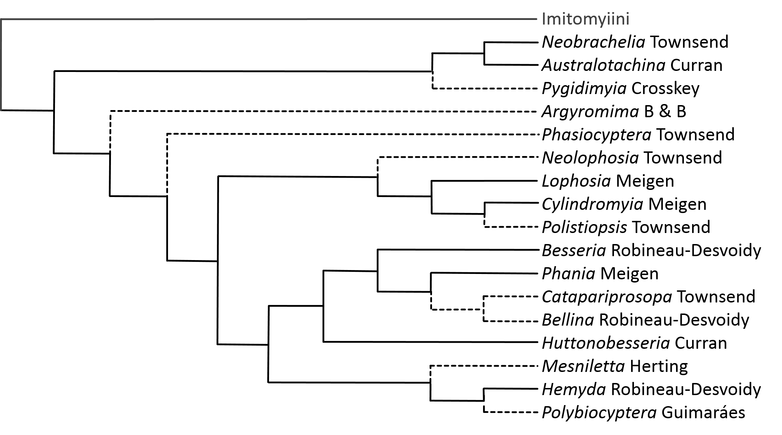
The worldwide tribe Cylindromyiini is the most speciose of the phasiine tribes, with the extremely diverse and common Cylindromyia Meigen accounting for over 100 species alone. It is also one of the oldest recognized groups within Tachinidae. The Cylindromyiini (as various forms of Ocypterinae) have been associated with the Phasiinae for most of their taxonomic history (Villeneuve 1924; Townsend 1936; Mesnil 1939), often as a tribe but sometimes as a separate but closely related subfamily (Herting 1957). Morphologically, the Cylindromyiini could be considered dexiine-like Phasiinae in the same way that the Epigrimyiini (historically included in the Cylindromyiini) are considered phasiine-like Dexiinae. These tribes form part of an abstract morphological “bridge” between the two subfamilies as dexiine characters merge into phasiine characters (i.e. Dexiinae s. s. – Dufouriini – Epigrimyiini/Eutherini/Litophasiini – Cylindromyiini – Phasiinae s. s.). The unique gradation of morphological features between these tribes has made creating an evolutionarily informed classification of the Phasiinae/Dexiinae nearly impossible. Recent advances in molecular phylogenetics however, have provided support for historical hypotheses and offered new insights into the systematics of these insects (Blaschke et al. 2015).
Most cylindromyiines have elongated, subcylindrical abdomens with enlarged terminal segments that are often curved beneath the abdomen (Crosskey 1976). Many are fantastic mimics of various wasp species (Townsend 1938). Although very distinct from other cylindromyiines in coloration and abdominal structure, two of the most striking mimics, Ichneumonops mirabilis Townsend and Clinogaster notabilis Wulp, have been synonymized with Cylindromyia (Herting 1979). A third mimic, Polistiopsis Townsend, still remains in its own genus (Arnaud 1966; Herting 1979) even though Malloch (1929) doubted it was truly different from Cylindromyia. The synonymy of Ichneumonops to Cylindromyia has been confirmed molecularly (Blaschke et al. 2015) and indicates a remarkable adaptive potential in ancestral Cylindromyia populations to mimic sympatric wasp species.
Unlike many phasiine tribes, the Cylindromyiini are an easy group to define morphologically. Except for the closely related Imitomyiini and Zitini, the Cylindromyiini are the only phasiines whose females possess piercers derived from the 10th sternite (postgenital plate) rather than the 8th sternite (Herting 1957). Herting (1983) further defined Cylindromyiini by the fusion of tergite 7 and sternite 7 which together contain a pair of hooks used for prying open the host’s sclerites during oviposition. This fusion characterizes all cylindromyiines except those found in the subtribe Neobracheliina in which the fusion is incomplete and probably represents a pleisiomorphic state.
Tschorsnig (1985: Cylindromyia, Lophosia Meigen, Phania Meigen, Hemyda Robineau-Desvoidy, and Besseria Robineau-Desvoidy examined) characterized the males of Cylindromyiini by a horseshoe shaped basal-hypandrium and by the unique structures found in the membrane between the hypandrium and sternite 6. He also found synapomorphic characters that further divided the Cylindromyiini into two monophyletic groups corresponding to Herting’s (1983) subtribes the “Cylindromyiina” and the “Phasiina”. In the Cylindromyiina (Cylindromyia and Lophosia), the pre/post gonites and part of the hypandrium form a “guide cone” to the female postabdominal cavity during copulation, while in the Phasiina (Phania, Hemyda, and Besseria) the surstyli perform this function (Tschorsnig 1985). The molecular phylogenies of Blaschke et al. (2015) support the monophyly of the Cylindromyiini as well as the two clades of Herting/Tschorsnig discussed above. A third subtribe is here added to the Cylindromyiini based on new molecular and morphological evidence. The Neobracheliina is composed of three genera formerly included in Parerigonini. Each clade is discussed individually below.

Subtribe Cylindromyiina
The molecularly defined Cylindromyiina clade of Blaschke et al. (2015) incorporated multiple species each of Cylindromyia and Lophosia, as well as representatives from the nominal genera Ichneumonops and Prolophosia Townsend. These analyses also confirmed the synonymy of Ichneumonops with Cylindromyia and identified another potential generic synonymy between Prolophosia and Cylindromyia.
First described from South Africa in 1932, Prolophosia petiolata Townsend was placed near Cylindromyia in the Cylindromyiini. Concurrently, Curran (1934) was describing the same fly as two new species of Cylindromyia: C. atypica and C. ugandana – both from Uganda. After studying the variable forms of these species, Emden (1945) synonymized Curran’s species with Prolophosia and conveyed his opinion that Prolophosia may be morphologically distinct enough from Cylindromyia to warrant generic or sub-generic rank. Crosskey retained Prolophosia as a separate genus in his Afrotropical catalog (1980) and keys (1984). The primary morphological distinction of Prolophosia is a gentle bend in wing vein R4+5 that is somewhat reminiscent of the condition seen in Phasia (Emden 1945). Molecular evidence places Prolophosia petiolata and an undescribed Prolophosia species firmly within the Cylindromyia clade (Blaschke et al. 2015). Townsend was a notorious splitter of tachinid taxa. Many of his genera have since been synonymized, but some still await scrutiny via a modern systematic study. It is not very surprising then to find that Prolophosia is not genetically distinct enough from Cylindromyia to merit its own generic ranking. Given the molecular evidence and a taxonomic history that has considered merging the two taxa together, Prolophosia is here formally synonymized with Cylindromyia.
Although not included in the molecular analysis, Neolophosia shannoni Townsend is also included in this “Cylindromyiina” clade. Little is known about this fly other than what can be gleaned from Townsend’s original description (1939). Townsend conveyed that the genus would key out to Paralophosia (= Lophosia Crosskey 1976) but is actually closer to Malayia – a genus that is now in Rhinophoridae (Pape & Shima 1993, Cerretti et al. 2014). It seems probable that Townsend was erroneous in this hypothesized connection to Malayia because he describes Neolophosia as having a large hypopygium with a piercer derived from what he interpreted could be the 9th sternite (most likely the 10th). No rhinophorids possess these characters but they are typical of Cylindromyiini. I therefore assume Neolophosia’s rightful systemic position is near Lophosia and thus suggest its placement here until type specimens can be examined. The wasp mimic Polistiopsis is also included here in the Cylindromyiina based on its close morphological similarity to Cylindromyia (Malloch 1929).

Subtribe Neobracheliina
The unique Australian genera Australotachina Curran and Pygidimyia Crosskey are here included with the South American genus Neobrachelia Townsend in the subtribe Neobracheliina. This grouping is a result of molecular evidence that strongly indicates a close evolutionary relationship between the three genera and places them as a paraphyletic sister group to the Cylindromyiini (Blaschke et al. 2015). This novel evolutionary hypothesis has since been confirmed by morphological evidence (Cerretti, O’Hara, Stireman 2015 pers. com.). Formerly members of Parerigonini and closely associated with the Zitini, these unusual genera look very different from other cylindromyiines. Their bristly appearance and tachinine-like head shape seem to contradict a placement in Cylindromyiini and it was these features that led early authors to place them in the Tachininae (Townsend 1938; Guimaraes 1971; Crosskey 1973).
In contrast to their external morphology, a placement within Phasiinae is supported by male and female terminalia. In females, the Neobracheliina possess the distinctive 10th sternite (postgenital plate) piercers found only in Phasiinae (Townsend 1940, as Xenopyxis; Cantrell 1988). In his examination of terminal segments of Australian tachinids, Cantrell (1988) was the first to identify that the piercers of Pygidimyia, Australotachina and Zita (Zitini), were derived from the 10th sternite rather than the 8th and were thus strongly reminiscent of the Cylindromyiini – indicating a placement for these taxa in Phasiinae rather than Tachininae. This hypothesis was confirmed by molecular analyses that placed Pygidimyia, Neobrachelia, and Australotachina within a monophyletic clade including Cylindromyiini s. s. (Blaschke et al. 2015).
The most distinctive characteristic of the Cylindromyiini is the complete fusion of tergite 7 and sternite 7 into a complete “ring” segment (Herting 1957, 1983). Interestingly, these segments are only partially fused in the Neobracheliina (Cantrell 1988, Cerretti, O’Hara, Stireman 2015 pers. com.), and thus the Neobracheliina can be separated from other cylindromyiines by this unique pleisiomorphic character. Molecular data indicates a fairly close relationship between Pygidimyia and various Lophosia species, sometimes reconstructing them together in the same clade (see Blaschke et al. 2015). It is this association with Lophosia that prevents a monophyletic Neobracheliina. These taxa are understudied and there are undescribed species waiting to be discovered and in collections waiting to be described. Including some of these additional taxa in future phylogenies may help delineate the two groups through more accurate reconstruction of ancestral states and thus possibly result in a monophyletic Neobracheliini. However, as a consequence of their current molecular paraphyly, the Neobracheliina are here included in an expanded Cylindromyiini and form a subtribe therein rather than being considered as their own tribe.
A few notes about the unique genera of Neobracheliina are warranted. Although most modern tachinid experts consider Neobrachelia a parerigonine (Wood & Zumbado 2010; O’Hara 2014 pers. com.), the genus was initially placed in its own monotypic tribe: Neobracheliini. The most recent catalog of South America (Guimarães 1971) included the Neobracheliini in the subfamily Tachininae. About the same time, DM Wood was relaying his thoughts to Mesnil (see Mesnil 1970) on the similarities of Neobrachelia to the Parerigonini and suggesting these taxa should share a systematic relationship. Mesnil, and later Herting (1974), agreed with Wood’s assessment and realized that including Neobrachelia in Parerigonini finally added crucial host information for the tribe. No hosts were known for any Parerigonini except Neobrachelia, and because Neobrachelia parasitizes Heteroptera, the debate about subfamily placement of the Parerigonini swung in favor of the Phasiinae (for a more detailed history of Parerigonini see their section below).
Townsend (1940) described the confusing systematic position of Neobrachelia (as Xenopyxis Townsend) as follows:
“This genus has the weak abdominal macrochaetae of the Ernestiini, the head of the Linnaemyiini, the thoracic chaetotaxy of the Germariini and Schineriini, the male hypopygium of the Melanophryctini, the general characters of the Aphriini, the wide front of all the above tribes and the female hypopygium of none of them.”
Ultimately, he decided to place the Neobracheliini near the Aphriini and Linnaemyiini in his Pyrrhosiinae (Tachininae) (Townsend 1931). However, morphological evidence for a placement in Phasiinae comes from Tschorsnig (1985) who identified the elongated hypandrium characteristic of Phasiinae in Neobrachelia and Parerigone. Interestingly, Tschorsnig did not find much in common between these two genera other than the structures of the pregonites and postgonites which he found to be similar to the Leucostomatini as well.
Neobrachelia was once thought distinct enough to warrant its own tribe. Australotachina as well has long been seen as an aberrant parerigonine – one that most authors retained in Parerigonini solely for convenience until a more thorough analysis of the genus could be made (Crosskey 1973, 1976; Cantrell 1988). The last genus here included in the Neobracheliina is Pygidimyia. Crosskey (1976) considered it “undoubtedly” parerigonine and placed it in that tribe in the Tachininae (Crosskey 1973, 1976). However, the enlarged hypopygium that gave Pygidimyia its name, has strong similarity to the postabdomens found in Cylindromyiini and has hinted at a placement in Cylindromyiini for almost a century even before the internal anatomy of the genitalia was thoroughly examined.
In the course of this study, the Mexican species Eleuthromyia inusitata Reinhard, 1964 was found to be synonymous with Neobrachelia (O’Hara 2015 pers. com.). Eleuthromyia was described from a single male specimen and placed in the Linnaemyini (Reinhard 1962). However, Reinhard mentioned that the male genitalia were “strikingly different” than any known member of that tribe. Inspection of the type specimen (by JE O’Hara) housed in the Canadian National Collection (Ottawa, CA) showed that the specimen, including the unusual genitalia, was congeneric with Neobrachelia.

Subtribe Phasiina
The molecular phylogenetic clade corresponding to Herting’s “Phasiina” provides corroborative evidence of a close relationship between Phania, Besseria, and Hemyda (Blaschke et al. 2010). Additionally, the genus Huttonobesseria (originally Phania Hutton) was placed molecularly in the Phasiina. This rare New Zealand fly differs from Besseria by only a few characters (e.g. strong lateral bristles on abdomen, R4+5 open in wing margin near wing tip, and the presence of palpi (Curran 1927)), so its presence in this clade was expected. The genera Catapariprosopa Townsend, Bellina Robineau-Desvoidy, Mesniletta Herting, and Polybiocyptera Guimarães were not included in the molecular phylogeny but are included here in the Phasiina due to significant morphological similarity with other members of the subtribe.
The taxonomic history of the genus Catapariprosopa is quite confusing and I am not completely convinced that the genus can truly be differentiated from Phania. Townsend first described Catapariprosopa curvicauda from “Formosa” in 1927 and treated it as a cylindromyiine distinct from Lophosia. Meanwhile, a new species of the same genus was described by Villeneuve (1932) as Weberia rubiginans (subgenus Chaetoweberia) and by Emden (1945) as Phania edwarsi. Villeneuve (1937) again described what he thought to be a new genus (actually Catapariprosopa) as Hemiphania trispana, which he placed near Phania. This resulted in four separate generic concepts and names for what was ultimately the same genus. Herting (1979) later synonymized Emden’s Phania edwarsi and Villeneuve’s Hemiphania to Catapariprosopa. To further confuse matters, the generic title “Weberia” has been used to describe species of Phania – a genus whose type specimen bears the same species name as the type for Catapariprosopa: curvicauda (Herting & Dely-Draskovits 1993). Most of these authors (Townsend, Villeneuve, and Emden) did not have our modern definition of Phania with which to compare their specimens. These genera, if truly separate, are not geographically sympatric and thus no tachinid cataloger has, to my knowledge, examined both genera comparatively (Crosskey 1976, 1977, 1980, 1984; Herting 1984; Herting & Dely-Draskovits 1993; O’Hara et al 2009). However, when Herting (1979) synonymized Hemiphania and Phania edwardsi with Catapariprosopa, he surely would have had Phania s. s. in mind and would have merged the genera together at that time if warranted. He did not, however, so neither do I – especially without having examined the type specimens. Regardless, Catapariprosopa is undoubtedly very similar to Phania and so belongs in the Phasiina.
Another puzzling genus is Bellina which was described from India in 1863. The type specimens were subsequently lost and the species has never been identified again. Based on the original description, Townsend (1936, 1938) placed Bellina in Cylindromyiini. Crosskey (1976) agreed that it was a cylindromyiine and hypothesized that Bellina should be placed near Catapariprosopa. On that basis alone is Bellina included here in the subtribe Phasiina next to Catapariprosopa and Phania.
Mesniletta is a relatively recently described genus created from the previously named Gymnosoma ventricosum de Meijere from Java. Herting (1979) examined the specimen and concluded based on the genitalia that the species certainly did not belong to Gymnosoma, but was rather a cylindromyiine. The species was different enough from other Cylindromyiini to justify a new genus, but the postabdomen was reminiscent of Besseria, Phania, and Hemyda. With this association, Mesniletta is here placed in the subtribe Phasiina. Similarly, the wasp mimic Polybiocyptera is included in the Phasiina due to its affinites with Hemyda. Guimarães (1979) initially considered the genus near Polistiopsis and Cylindromyia. However, Herting (1979) classified the genus near Hemyda based in part on the indentation of the eye and similarity of postabdominal characters.

Unplaced to subtribe
Several genera are only known from their original descriptions and thus their systematic placement within the Cylindromyiini is uncertain. Argyromima mirabilis Brauer & Bergenstamm was described in 1889 from a single South American specimen and has not been rediscovered (Townsend 1928, 1938; Guimarães 1971). This unique genus is an apparent dolichopodid-counterfeit (of Argyra Macquart), does not have palpi (Aldrich 1925: 122), and was placed in Cylindromyiini by Townsend (1936, 1938) and Guimarães (1971). Similarly, the only published discussion of the Brazilian species Phasiocyptera punctata Townsend was by Townsend, who placed it in Cylindromyiini (1927, 1936, and 1938) where it was retained by Guimarães (1971). These two genera remain incertae sedis within Cylindromyiini.
Finally, the aberrant Tachinophasia transita Townsend is worth mentioning. This unusual genus was placed in the Cylindromyiini (Townsend 1936; Guimaráes 1971) but then moved to the Linnaemyini (Tachininae) by Herting (1979). Most recently, Tachinophasia was not placed in any subfamily (O’Hara 2013) and it is uncertain what ultimate systematic position this strange tachinid will occupy. Because of the uncertainty surrounding its classification, I have also excluded it from the Cylindromyiini and therefore the Phasiinae.

Tribe Euscopoliopterygini (2 genera, 2 species)
Euscopoliopteryx Townsend, 1917 (1 species)
Shannonomyiella Townsend, 1939 (1 species)

Phylogenetics and Classification
Very little information is available on these enigmatic tachinids and no molecular work has been done due to their rarity. The two genera found in Euscopoliopterygini are monotypic and found only in South and Central America. Euscopoliopteryx Townsend was described from a single damaged male specimen taken from a spider’s web (another male specimen, as Dictya externa Fabricius was later examined by Townsend, 1931) and Shannonomyiella Townsend described from one male and one female (Townsend 1917, 1939). Townsend (1931, 1936) relates that Weidemann considered Euscopoliopteryx an acalyptrate fly in the “Cypseloidea”. Townsend included the Euscopoliopterygini in his family Gymnosomatidae (mostly modern Phasiinae, but including some Dexiinae and Tachininae) and Guimarães (1971) maintained their position in the Phasiinae in his South American catalog. It is unknown if Guimarães examined types of these species when considering their classification. Wood & Zumbado (2010) considered Euscopoliopteryx to be in Phasiinae but gave no indication about relationships to other genera within the subfamily. In their key to Central American Tachinidae, Euscopoliopteryx can be found in the midst of other phasiines (due to its mostly bare parafacial) and is coupled with Phasia, primarily due to the petiolate wing venation. However, Euscopoliopteryx also has slightly plumose arista which is only rarely found in Phasiinae and is considered a pleisiomorphic trait (Wood & Zumbado 2010 op. cit.).
In his original description, and indicated by its name, Townsend (1917) related Euscopoliopteryx to Euscopolia Townsend – a genus that for a time was placed in the Cylindromyiini (Sabrosky & Arnaud 1965). Euscopolia was moved to the Linnaemyini (Tachininae) by Herting (1979) and now rests in the Polideini (Tachininae) (O’Hara 2002). It may be that the Euscopoliopterygini also belong in the Tachininae, but without examining specimens or molecular markers, the tribe is maintained in the Phasiinae due to taxonomic precedence and until such an examination can be conducted. Unfortunately, no one has ever indicated where within the Phasiinae Euscopoliopterygini belongs, and therefore the tribe is left unresolved.

Tribe Gymnosomatini (35 genera, 174 species)
Subtribe Gymnosomatina (10 genera, 71 species)
Cistogaster Latreille, 1829 (7 species)
Clytiomya Rondani, 1861 (4 species)
Compsoptesis Villeneuve, 1915 (3 species)
Ectophasia Townsend, 1912 (9 species)
Eliozeta Rondani, 1856 (2 species)
Euclytia Townsend, 1908 (1 species)
Gymnoclytia Brauer & Bergenstamm, 1893 (14 species)
Gymnosoma Meigen, 1803 (30 species)
Perigymnosoma Villeneuve, 1929 (2 species)
Subclytia Pandellé, 1894 (1 species)
Subtribe Trichopodina (21 genera, 94 species)
Acaulona Wulp, 1884 (5 species)
Atrichiopoda Townsend, 1931 (1 species)
Bibiomima Brauer & Bergenstamm, 1889 (1 species)
Brasilomyia Özdikmen, 2010 (1 species)
Cesaperua Koçak & Kemal, 2010 (2 species)
Cylindrophasia Townsend, 1916 (4 species)
Dallasimyia Blanchard, 1944 (1 species)
Ectophasiopsis Townsend, 1915 (3 species)
Euacaulona Townsend, 1908 (1 species)
Eutrichopoda Townsend, 1908 (6 species)
Eutrichopodopsis Blanchard, 1966 (4 species)
Homogenia Wulp, 1892 (8 species)
Itaxanthomelana Townsend, 1927 (1 species)
Melonorophasia Townsend, 1934 (1 species)
Pennapoda Townsend, 1897 (1 species)
Syringosoma Townsend, 1917 (1 species)
Tapajosia Townsend, 1934 (1 species)
Trichopoda Berthold, 1827 (36 species)
Urucurymyia Townsend, 1934 (1 species)
Xanthomelanodes Townsend, 1892 (12 species)
Xanthomelonopsis Townsend, 1917 (3 species)
Unplaced to subtribe (4 genera, 9 species)
Bogosia Rondani, 1873 (5 species)
Bogosiella Villeneuve, 1923 (1 species)
Pentatomophaga de Meijere, 1917 (2 species)
Saralba Walker, 1865 (1 species)

Phylogenetics and Classification
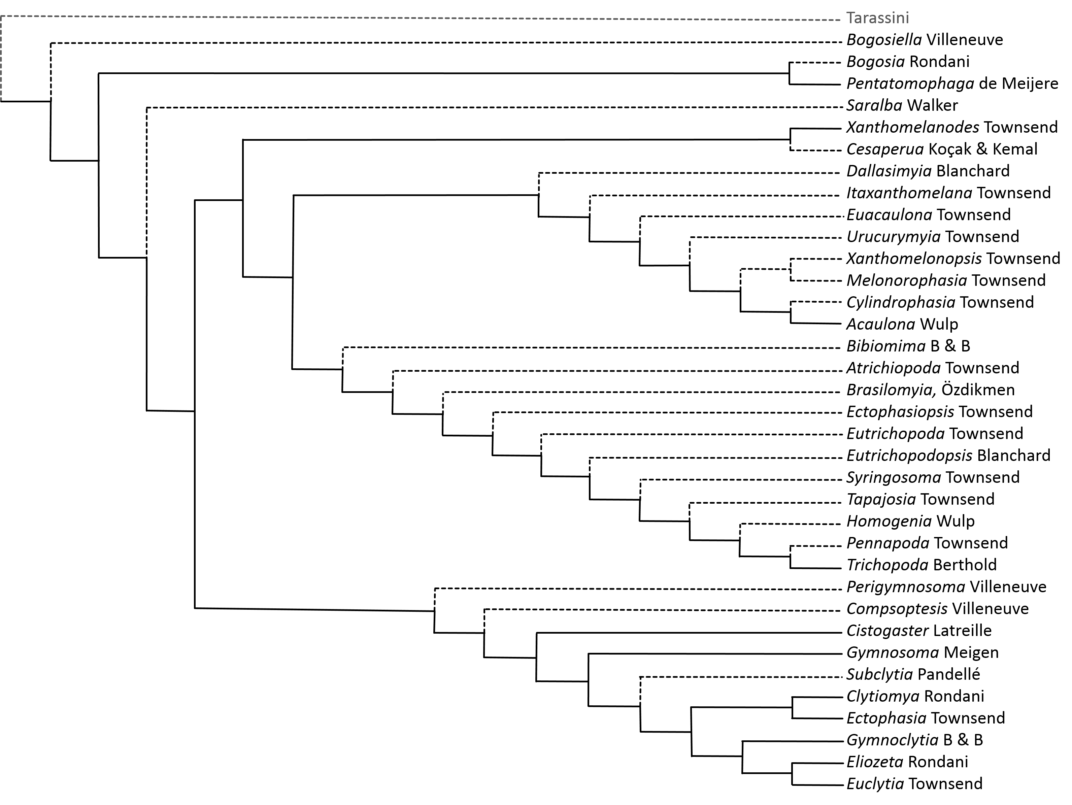
As presented here, the Gymnosomatini follow the proposed classification of Gymnosomatini sensu Tschorsnig (1985) and thus include species from Phasiini sensu Townsend (1936), Gymnosomatini sensu Townsend (1936), and Trichopodini sensu Townsend (1908). As a result, the Gymnosomatini form by far the largest phasiine tribe in number of genera – more than doubling the diverse Cylindromyiini. The Gymnosomatini are divided into two subtribes that are each individually corroborated by morphological and molecular evidence. The clade Gymnosomatina includes genera of Gymnosomatini sensu Townsend as well as most genera currently considered in Phasiini sensu Herting (1984) (excluding only Phasia Latreille and Elomya Robineau-Desvoidy). The Trichopodina are comprised of the Neotropical genera formerly of Trichopodini sensu Townsend. Four additional gymnosomatine genera cannot be confidently placed within either subtribe at the present.
The three nominal tribes Phasiini, Gymnosomatini, and Trichopodini have shared an interwoven and convoluted taxonomic history. Species are found worldwide and regional experts have typically followed their own regional taxonomic precedent when considering tribal placement for their local genera without considering global patterns of diversity. Over the past century or more, this has led to a confusing picture of phasiine classification. Nearctic experts have recognized Gymnosomatini and Trichopodini as separate tribes distinct from the Phasiini since Townsend (1908, 1936) first established the tribes (Guimaráes 1971; O’Hara & Wood 2004). However, Palearctic experts and the authors of the Afrotropical, Australasian, and Oriental tachinid catalogs did not recognize them as valid taxonomic units (Crosskey 1976, 1977, 1980, 1984; Herting 1984; Cantrell & Crosskey 1989; Richter 2004; O’Hara et. al 2009).
In his Australian catalog, Crosskey (1973) initially followed Townsend’s concept of Trichopodini and included Saralba Walker and Pentatomophaga de Meijere in the Trichopodini. However, after examining more species from around the world, Crosskey found Perigymnosoma Villeneuve to be morphologically intermediate between Gymnosoma Meigen and typical Phasiini and Pentatomophaga as intermediate between Trichopoda Berthold and Ectophasia Townsend (in his view a typical Phasiini). In Crosskey’s opinion, three distinct tribes were not justifiable and in his Oriental catalog he therefore merged Pentatomophaga (and thus Trichopodini) into Phasiini based primarily on morphological homology (Crosskey 1976). However, this “lumping” was based solely on adult characters and it is interesting that Crosskey also recognizes that with an expanded Phasiini it becomes difficult to even discern that tribe from the Cylindromyiini – an obviously different evolutionary lineage. This hints at the futility of relying solely on tachinid external morphology for an evolutionarily meaningful taxonomy. As has been crucial for other tachinid tribes, terminalia characters and molecular evidence have recently provided a framework of taxonomic stability for the Phasiini, Gymnosomatini, and Trichopodini.
Tschorsnig (1985) was the first to consider the phylogenetic utility of male postabdomen characters for delineating phasiine groups and was able to examine species from around the globe including representative members of Gymnosomatini sensu Townsend (Gymnosoma), Phasiini sensu Townsend (Ectophasia, Eliozeta Rondani, Subclytia Pandellé, Phasia, and Elomya), and Trichopodini sensu Townsend (Trichopoda Berthold, Bogosia Rondani, and Bogosiella Villeneuve). He discovered that Phasia and Elomya clearly belonged to a separate lineage, but all other genera examined were united by a very strong synapomorphy: three rigid, tubular spermatic ducts. Consequently, this group was defined as the Gymnosomatini sensu Tschorsnig. In his pupal and larval diagnostic guide, Zeigler (1998) followed Tschorsnig in recognizing a Gymnosomatini distinct from the Phasiini based on non-adult characters, but also considered Trichopodini a separate tribe. However, other experts have been more conservative about splitting the Phasiini into separate tribes even though the distinction between Gymnosomatini and Phasiini s. s. appears to be evolutionarily significant and strongly supported (Tschorsnig & Herting 1994; Richter 2004; O’Hara et al. 2009; Shima 2014). Whether or not Gymnosomatini itself should be divided into two tribes (Gymnosomatini and Trichopodini) is less certain.
In his revision of the “Acaulona complex” within the Trichopodini, Toma (2003) related the morphological work of Tschorsnig to an expanded group of trichopodines including Homogenia Wulp, Brasilomyia Özdikmen (as Platyphasia Townsend), Bibiomima Brauer & Bergenstamm, Xanthomelanodes Townsend, and Cesaperua Koçak & Kemal (as Xenophasia Townsend). His analysis corroborated the spermatic duct synapomorphy suggested by Tschorsnig in the male terminalia of Gymnosomatini. However, Toma also found a small yet consistent difference between the structure of the elongated hypandrium between his study taxa and Tschorsnig’s (see Toma 2003 [in Portuguese]) suggesting a natural division within the Gymnosomatini.
In modern phylogenetic analyses, Gymnosomatini sensu Tschorsnig has been consistently recovered as a monophyletic group separate from Phasiini s. s. In Cerretti et al.’s (2014) morphological analysis of Tachinidae, they included Gymnosoma, Ectophasia, Clytiomya, and Trichopoda and separated the clade Gymnosomatini from Phasiini by the synapomorphic sclerotized sperm ducts. However, because only a single representative of Trichopodini was included (Trichopoda), nothing could be inferred about the phylogenetic validity of separating the Trichopodini from the Gymnosomatini. The molecular phylogenetic studies of Blaschke et al. (2015) included multiple gymnosomatine and trichopodine genera and established a statistically strong phylogenetic structure of the Gymnosomatini. The Gymnosomatini were recovered as sister tribe to the Phasiini (composed of Phasia and Elomya) and within this strongly supported monophyletic clade, two additional clades were reconstructed with absolute statistical support. The first corresponds to Gymnosomatini s. s. and included Cistogaster, Clytiomya, Ectophasia, Eliozeta, Euclytia, Gymnoclytia, and Gymnosoma. The second clade corresponds to the Trichopodini s. s. and included Trichopoda, Xanthomelanodes, and Acaulona.
Phylogenetically, these two clades reflect well the statistical support, diversity, and relative age of other tribes in Phasiinae and at first glance seem to be clearly deserving of tribal status. However, inclusion of Pentatomophaga – the same genus whose morphological ambiguity prompted Crosskey (1976) to merge the Trichopodini into the Phasiini – in the molecular analysis resulted in an enlightening phylogenetic placement. Pentatomophaga was reconstructed as the sister group to the gymnosomatines plus the trichopodines. This phylogenetic placement provides the final piece of evidence for an inclusive Gymnosomatini concept. If retained in either Trichopodini or Gymnosomatini, its host tribe necessarily becomes paraphyletic with respect to the other tribe – a taxonomic situation that should be avoided if possible. Consequently, given the morphological evidence that provides a strongly synapomorphic trait to the Gymnosomatini and the molecular evidence that clearly places all the genera into a single highly supported – albeit large – monophyletic clade, I endorse an inclusive concept of the tribe Gymnosomatini in which the Gymnosomatini are composed of the two subtribes Gymnosomatina and Trichopodina as well as a few unplaced genera.

Subtribe Gymnosomatina
The recent phylogenetic analyses of Cerretti et al. (2014) and Blaschke et al. (2015) have provided overwhelming support for dividing the Phasiini sensu Townsend/Herting into two separate groups. Phasia and Elomya are left in the Phasiini and are treated in the Phasiini section below. All other genera are here transferred to the subtribe Gymnosomatina. Molecularly, the Gymnosomatina is supported by genetic evidence sequenced from Cistogaster, Clytiomya, Ectophasia, Eliozeta, Euclytia, Gymnoclytia, and Gymnosoma. These genera create a perfectly supported monophyletic clade that provides the framework for the Gymnosomatina (Blaschke et al. 2015). Morphological support for the Gymnosomatina comes from Tschorsnig (1985) who grouped Ectophasia, Gymnosoma, Eliozeta, and Subclytia together, Tschorsnig & Herting (1994), who found a shared larval trait between Gymnosoma and Ectophasia (ventral margin of their labrum serrated), and Cerretti et al. (2015) who recovered a morphologically supported clade including Ectophasia, Clytiomyia, and Gymnosoma.
The molecularly supported Gymnosomatini and the formal removal of several genera from the Phasiini solves a taxonomic difficulty that has been discussed since Townsend first established the Gymnosomatini as a tribe consisting of Gymnosoma, Perigymnosoma, and Stylogymnomyia (=Gymnosoma) and the Phasiini as a tribe including Gymnoclytia, Euclytia, Eliozeta, Ectophasia, Clytiomya, Cistogaster, Phasia, and Elomya. Even in his diagnoses, Townsend recognized that there were two groups within the Phasiini – those with piercers and those without. This difference in reproductive morphology was widely known to divide the Phasiini into the “Phasia complex” and the “Gymnosoma complex” (Brooks 1946), but most experts continued to use the established taxonomy in the hopes that future revisionary work would be possible on a global scale (Sabrosky 1950). This division within Phasiini was quantitatively defined by Herting (1957, female postabdomen) and Tschorsnig (1985, male postabdomen, discussed above). Herting separated Ectophasia (as Phasia), Clytiomya, and Gymnosoma from Phasia based on the functionality of the 8th sternite as a piercer (functional in Phasia, non-functional in others). Interestingly, Herting suggests that the blunt 8th sternite of the Gymnosoma group may have been derived from the functional piercer of Phasia – a hypothesis that is supported by the molecular phylogeny.
Two more genera historically of the Phasiini, Perigymnosoma and Compsoptesis, are here included in the Gymnosomatini for the following reasons. Both of these genera are endemic to Southeast Asia where little is known about their habits or characters. Their original diagnoses did not include pertinent genitalia characters that seem to be essential for delineated between Phasiini and Gymnosomatini (Villeneuve 1915, 1929). The abdominal segments of Perigymnosoma are fused together as in Gymnosoma and the abdomen is yellow/orange as in most Gymnosomatini (Crosskey 1976). Compsoptesis has very unusual wing venation (closed R4 +5 cell) when compared to Phasia and also has golden coloration on the abdomen (Malloch 1930; Dear & Crosskey 1982). Genetic evidence or direct investigation of the male and female genitalia will allow us to place these genera with confidence, but until such diagnoses can be made, they seem to align more closely with the Gymnosomatina than with the Phasiini.

Subtribe Trichopodina
In contrast to the Cylindromyiini, whose diversity in species and morphology positively correlate with their apparent antiquity, the Trichopodina appear to be an actively radiating and relatively new evolutionary clade within Phasiinae. This creates a unique problem in the taxonomy of Trichopodina. Many genera seem to be in the midst of speciation events – individual species are not quite diverse enough to be justifiably maintained in their own distinct genera, but they are not similar enough to be congeneric either. A further complication is that this speciose group is characterized by a significant reduction of morphological characters typically used to differentiate genera of tachinids (i.e. chaetotaxy, terminalia) while at the same time they possess an abundance of visually striking colors and patterns that at first glance seem ideal for species delimitation. Unfortunately, patterns vary, stripes fade, and colors tarnish given even a modest amount of time – both as the fly is living and after a lengthy museum repose – all but erasing potential taxonomic characters (Townsend 1897, Blanchard 1966, pers. obs.). As a result, the taxonomic history of this clade is characterized by various experts wrestling with where to draw species and genus lines around an extremely limited repository of specimens whose morphology weaves irascibly around and between other taxa.
As was his propensity, Townsend chose to split the trichopodines into finer and finer taxonomic units and left future researchers with primarily monotypic genera and no acceptable keys for identification (Townsend 1908, 1917, 1936, 1938). Most of his taxa still remain valid even though many are undoubtedly synonymous. Sabrosky (1950) attempted to organize the group into three “complexes” (Trichopoda Berthold, Acaulona Wulp, and Xanthomelanodes Townsend), but admitted there was little evolutionary significance to the distinction between the two largest groups (Trichopoda and Acaulona) and it was primarily a classification of convenience. Dupuis (1963) provided a classification that accounted for egg, larval, and female terminalia characters. Again, three groups were formed (subtribes Trichopodina, Acualonina, and Cylindrophasiina), with only minor differences between Dupuis’ and Sabrosky’s subgroupings. Blanchard (1966) and Toma (2003) also contributed new species, records, and synonyms to the Trichopodina, with the latter providing the most recent modern revision of the “Acaulona complex”. The characters used by these authors to organize the trichopodines into various subgroups might have potential generic value if a more inclusive “genus concept” within the Trichopodina was endorsed. For this checklist, it is unnecessary to subdivide the Trichopodina into smaller and smaller “clades” of ambiguous distinction, so I will only mention a few relationships within the subtribe that warrant comment and leave all other genera in a phylogenetic puddle.
There are 21 genera included in the Trichopodina. From these, two genera, Xanthomelanodes and Cesaperua, can be easily characterized as sister taxa by their long, widely diverging scutellar bristles and distinctively asymmetric male terminalia (Sabrosky 1950, Toma 2003). Next, in contrast to all other Trichopodina, Acaulona and Cylindrophasia Townsend both have piercers derived from the 8th sternite with which they inject eggs into their hosts (Townsend 1936, Sabrosky 1950, Dupuis 1963). These two genera are split by Sabrosky and Dupuis between the Acaulona complex/Acualonina and the Trichopoda complex/Cylindrophasiina, but because the female piercer is a character that has significant phylogenetic signal throughout the Phasiinae, I consider these two genera closely related until a more thorough examination can be made. The other 17 trichopodine genera can be broadly classified as either Trichopoda-like or Acaulona-like. In the former are the taxa Atrichiopoda Townsend, Bibiomima, Brasilomyia, Eutrichopoda Townsend, Ectophasiopsis Townsend, Eutrichopodopsis Blanchard, Homogenia, Syringosoma Townsend, Pennapoda Townsend, Tapajosia Townsend, and Trichopoda. Ectophasiopsis was placed in Phasiini by Guimarães (1971, 1977) but Townsend (1915) initially considered it near Ectophasia and Trichopoda (as Trichopodopsis Townsend). Dios (2014) revised the genus and placed it back in Trichopodini as a close relative of Trichopoda.
The Acaulona-like trichopodines include Dallasimyia Blanchard, Euacaulona Townsend, Itaxanthomelana Townsend, Melonorophasia Townsend, Urucurymyia Townsend, and Xanthomelonopsis Townsend. Melonorophasia and Xanthomelonopsis share similarities in egg morphology (Dupuis 1963). Future systematics research should focus on minimizing the nomenclatural challenges of this group and creating effective and consistent identification keys. This is a clade ripe for molecular systematics as genetics may be the only avenue through which the evolutionary relationships within the Trichopodina can be confidently elucidated.

Unplaced to subtribe
The four remaining genera are unplaced to subtribe for various reasons. Molecular evidence necessitates Pentatomophaga is placed in an isolated position and because Bogosia is very closely related, if not synonymous, with Pentatomophaga (Crosskey 1973, 1976; Barraclough 1985), it too is unplaced. Bogosiella is an African genus that was synonymized with Phasia by Sun & Marshall (2003), but the synonymy has not been accepted by other tachinid experts (O’Hara 2015 pers. com.) and so I am uncertain where to place the seemingly intermediate fly. Finally, Saralba most likely fits within the Trichopodina given its general morphology, but because it would be the only non-Neotropical genus in the subtribe, I think it best to leave it unplaced without more specific morphological or molecular clues as to ancestry.
When the biogeography of Gymnosomatini is evaluated, an interesting picture emerges that relates subtribes and unplaced genera to specific regions of the world. The Trichopodina are primarily Neotropical and are restricted to the New World (Guimarães 1971, O’Hara & Wood 2004), except for a few species that have been purposefully or accidently introduced in other regions for biological control (i.e. Trichopoda spp.). The Gymnosomatina are distributed worldwide, but enjoy the most abundance and diversity in the Palearctic (Herting 1984) with only a few genera outside this range. The genera that lie phylogenetically outside either tribe are found only in Africa (Bogosia and Bogosiella) or Australasia (Pentatomophaga and Saralba). This diversity in endemism supports a separate origin for each clade and may indicate that Australasia was the ancestral home of the Gymnosomatini. The Gymnosomatina could have radiated from Australia into the Palearctic, while the Trichopodina happily discovered the New World and exploited the new habitats and hosts there. Pentatomophaga/Bogosia and Bogosiella would then be representative of the original ancestral stock and would share pleisiomorphic traits with the closely allied tribe Phasiini as is supported by their morphology and phylogenetic relationships.

Tribe Hermyini (5 genera, 23 species)
Formicophania Townsend, 1916 (1 species)
Hermya Robineau-Desvoidy, 1830 (18 species)
Paraclara Bezzi, 1908 (2 species)
Penthosia Wulp, 1892 (1 species)
Penthosiosoma Townsend, 1926 (1 species)

Phylogenetics and Classification
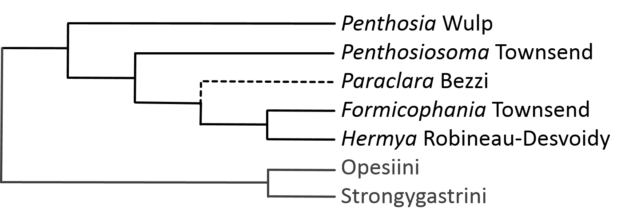
Historically affiliated with the Cylindromyiini, the Hermyini share many external traits with the familiar Cylindromyia and Lophosia. Both tribes contain species with elongated subcylindrical abdomens and quite a few remarkable hymenopteran mimics. In the Hermyini, Formicophania elegans Townsend has an appearance reminiscent of the social wasp Ropalidia binghami (Crosskey 1967) and Penthosia satanica Wulp is a rare jet black fly known only from a few New World localities (Guimarães 1971; O’Hara & Wood 2004). Except for Penthosia, the Hermyini are found throughout Africa (Emden 1945; Crosskey 1980, 1984) and eastern Asia/Oceania (Crosskey 1976, 1977; O’Hara et al. 2009). However, only the relatively speciose genus Hermya Robineau-Desvoidy is distributed throughout this range. Most other genera are monotypic and are known from only a few localities.
Because of their close morphological and behavioral affinity to Cylindromyia and allies, the members of Hermyini were originally placed in the Cylindromyiini (Townsend 1936, 1938). This designation was followed by Crosskey in his Afrotropical (1980, 1984) and Oriental (1967, 1977) catalogs (also Dear & Crosskey 1982) and by other English speaking authors (Guimarães 1971; O’Hara & Wood 2004). However, according to Sabrosky (1999), the family group name Hermyini dates back to Dupuis (1958, Hermyina) and Mesnil (1980, Hermyini). I have been unable to read these papers in their original language, but the impetus for these authors to separate Hermyini from Cylindromyiini probably stemmed from Herting’s (1957) analysis of female postabdomen characters. Herting placed his “Gruppe Hermyia [sic]/Clara (= Paraclara Bezzi)” in the Phasiinae, excluding them from his subfamily Ocypterinae (= tribe Cylindromyiini) because they lacked the characteristic 10th sternite piercers that defined the Ocypterinae. Since then, Palearctic authors have maintained two distinct phasiine tribes (Herting 1983, 1984; Tschorsnig 1985; Herting & Dely-Draskovits 1993; O’Hara et al. 2009, Tachi & Shima 2010), and this two-tribe system is currently accepted by worldwide tachinid experts (O’Hara 2014 pers. com.).
Even though many earlier authors combined the Hermyini and Cylindromyiini, most also commented on the similarities of the modern hermyine genera to each other and their differences from cylindromyiines. In his diagnoses and descriptions of tachinid tribes/genera, Townsend (1938) documented the telescopic female terminalia in Hermya and Paraclara, which differ substantially from the greatly enlarged terminalia of the Cylindromyiini. He also noted that Formicophania was very similar to Liancosmia Speiser (= Hermya). Elsewhere, Townsend (1926, 1928) also suggested that Hermya and Penthosiosoma Townsend were near Penthosia. Crosskey (1976, 1984) mentioned that both Formicophania Townsend and Paraclara should probably be synonymized with Hermya because of the obvious similarities between the genera. He chose to maintain their generic status until more specimens could be examined. Crosskey (1976) also associated Penthosiosoma with Hermya based on their strongly similar abdomens but noted that they were still distinct genera. Additionally, he identified “Hermya and allies” as a distinct group of the Cylindromyiini based on the presence of palpi and the open posteroventral declivity in the thorax. In summary, the genera belonging in Hermyini have long been associated with each other apart from Cylindromyiini s. s. by tachinid experts – whether placed in an official tribe or otherwise.
Further support for a tribal status for these genera comes from molecular phylogenetics. Blaschke et al. (2015) recovered a monophyletic Hermyini (Hermya, Penthosia, Penthosiosoma, and cf. Formicophania included) which was placed rather far from the Cylindromyiini as sister group to the Strongygastrini + Opesiini. This relationship supports several interesting hypotheses from the morphological analyses of Herting (female terminalia, 1957) and Tschorsnig (male terminalia, 1985). According to Herting, this clade contains those genera who have the primitive condition of retaining a terminal tergite, either heavily developed (Hermya, Paraclara, and Opesia examined) or reduced but not absent (Strongygaster). Additionally, Herting hypothesized that the broad and blunt 8th sternite of Strongygaster could have been derived through reduction from the spoon-shaped 8th sternite of Hermya/Paraclara (Herting characterized the Hermyini by this distinctive feature). This hypothesis is not rejected by the molecular evidence. For his part, Tschorsnig (op. cit.) identified the extreme flattening of the basiphallus as a distinguishing character of Hermyini. Notably, Tschorsnig characterized the structure of the hypandrium and pre/postgonites as being more similar to the Phasiini than the Cylindromyiini. More work is needed to answer questions on generic synonymy, but for now, the Hermyini represent a robustly supported phasiine tribe, closely allied with the Strongygastrini and Opesia.

Tribe Imitomyiini (3 genera, 8 species)
Imitomyia Townsend, 1912 (6 species)
Proriedelia Mesnil, 1953 (1 species)
Riedelia Mesnil, 1942 (1 species)

Phylogenetics and Classification
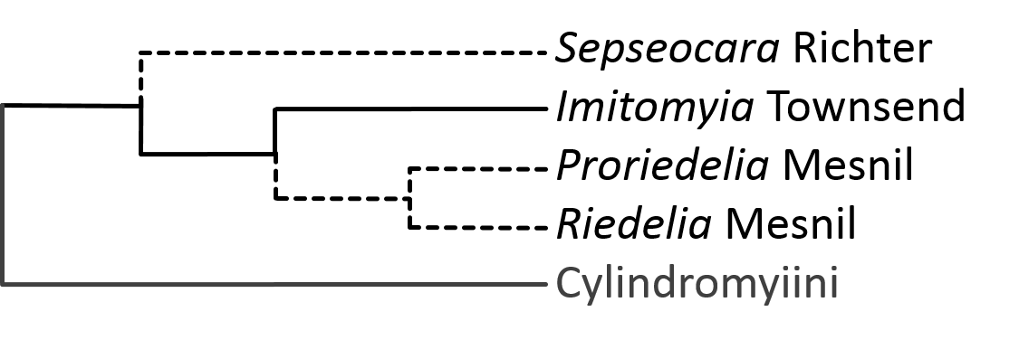
The tribe Imitomyiini presents one of the most indecipherable taxonomic difficulties within all Tachinidae. Morphologically, imitomyiines maintain traits of both the Dexiinae and Phasiinae, and unlike other tribes whose classification has greatly benefited from statistically significant molecular work, the Imitomyiini remain somewhat ambiguous even genetically. Three genera are currently included in the Imitomyiini: Imitomyia Townsend (extremely rare but with an almost worldwide distribution), Riedelia Mesnil (Palearctic), and Proriedelia Mesnil (East Asia). Nothing is known about the female morphology, biology, or genetics of Proriedelia and Riedelia and no hosts are known for any imitomyiine. Imitomyia must therefore stand as representative of the whole tribe for purposes of classification hypothesizing. Fortunately, the male and female terminalia are known from Imitomyia and there is a substantial amount of molecular data for the genus as well. Unfortunately, the available evidence is largely equivocal. After considering both morphological and molecular evidence, the most appropriate placement for Imitomyiini seems to be within the Phasiinae as sister to the Cylindromyiini.
Townsend (1908) was the first to assign Imitomyia (as Himantostoma Loew) a taxonomic position, placing it near Clistomorpha (= Strongygaster) in the Clistomorphini (Phasiidae) probably due to similarities in overall habitus and size. When Townsend replaced the preoccupied Himantostoma with Imitomyia (1912) he placed Imitomyia without comment in Eutherini (Exoristidae: Psuedodexiinae) possibly due to the prominent facial carinas present in both genera (Aldrich 1919). Later in his career, Townsend (1936) once again repositioned Imitomyia to the Gymnosomatidae (= mostly Phasiinae) but this time in its own tribe Imitomyiini. Crosskey, the only author to eventually examine all three Imitomyiini genera, placed the tribe in the subfamily Dufouriinae in his Afrotropical (1980, 1984) and Oriental catalogs (1976, 1977). This classification followed that of Emden (1945) who included Diplopota Bezzi (= Imitomyia) in the tribe Dufouriini (Phasiinae). Crosskey (1976: 41-43) provided the most complete hypothesis of the evolution and classification of Imitomyiini up to that time. He considered them as potentially derived from the Prosenini (Dexiinae) with perhaps coleopterous hosts. Accordingly, Riedelia and Proriedelia with their plumose arista and shorted proboscises, represent a more pleisiomorphic habitus than does Imitomyia who has gently pubescent (not plumose) antennae and a much elongated proboscis.
The best morphological evidence that suggests a position among the Phasiinae for Imitomyia is found in the female terminalia. Townsend (1936: 75-77; 1938: 178-179) describes the unique postabdomen of Imitomyia, most notably the piercer derived from he calls the 9th sternite. A drawing of this structure can be found in Townsend (1942, fig. 477) and indicates that the same structure identified by him as the 9th sternite is actually the 10th sternite (postgenital plate) of modern authors (see comparison of Cylindromyiini abdomens on same plate, e. g. fig. 473). If so, this provides very strong evidence for phasiine affinity as the 10th sternite piercer is only found in the closely related phasiine tribes Cylindromyiini and Zitini (Blaschke et al. 2015). The Imitomyiini were subsequently placed in Phasiinae by Herting (1984) and Herting & Dely-Draskovits (1993).
In contrast to the evidence above, Imitomyia is ovolarviparous (O’Hara & Wood 2004) which suggests a closer relationship with Dexiinae than with Phasiinae. Additionally, the male terminalia of tachinids has provided excellent phylogenetic information for many confusing tribes (Eutherini, Epigrimyiini, and Litophasiini) and for these characters, Imitomyia seems to have more in common with Dexiinae than with Phasiinae. Tschorsnig (1985) examined Imitomyia (as Diplopota) and identified many similarities shared with other dexiine taxa, including the distinctive membranous connection between basiphallus and distiphallus. However, he also noted that this connection on Imitomyia is not as “hinged” as in other dexiines (a trait shared with Litophasia). Imitomyia was also found to possess the secondary hypandrial characters of the Phasiinae which may be a more phylogenetically important character and Tschorsnig ultimately retained Imitomyia in Phasiinae. Wood & O’Hara (2004) on the other hand, considered Tschorsnig’s diagnosis of Imitomyiini, examined Imitomyia personally, and decided the tribe fit better in Dexiinae, saying that Imitomyia has “somewhat dexiine-like genitalia”.
In modern phylogenetic analyses, there has been limited but consistent support for a placement within Phasiinae for Imitomyia. In their morphological phylogeny, Cerretti et al. (2014) recovered a weakly supported clade of Phasiinae including Imitomyia that was supported by two non-homoplasious apomorphies (medial plate of hypandrium elongated and pregonite posteriorly connected to hypandrium). Under different weighting schemes however, Imitomyia appeared somewhat unstable phylogenetically. Similarly, molecular evidence places Imitomyia with moderate support in a monophyletic Phasiinae (Blaschke et al. 2015). This analysis used four different nuclear genes under both maximum likelihood and Bayesian models. When examined individually, each gene tree pushed Imitomyia out of both the Dexiinae and Phasiinae and reconstructed it as sister to both subfamilies (maximum likelihood analyses) or created an unresolved polytomy composed of Imitomyia and the dexiine and phasiine lineages (Bayesian analyses). Only when all genes were analyzed together did Imitomyia take up a position in a monophyletic clade sister to Cylindromyiini in the Phasiinae.
Although statistical support for a monophyletic Phasiinae including Imitomyia is relatively low in both morphological and molecular analyses, this classification is supported by the synapomorphic phasiine-like elongated hypandrium in the male and the uniquely formed 10th sternite piercer of the female which is only found in Phasiinae. Consequently, Imitomyia (and therefore the tribe Imitomyiini) is here considered a phasiine taxa that has preserved several pleisiomorphic characters (plumose arista, ovolarviparity, and dexiine-like features of basi/distiphallus) from before the ancestral population of Phasiinae/Dexiinae diverged. As an indirect result of this phylogenetic placement, the unknown hosts of Imitomyia and relatives most likely belong to Heteroptera rather than Coleoptera.
The rare Russian genus Sepseocara Richter is also included here in the Imitomyiini, although this association is only loosely supported. When first describing the genus, Richter (1986 [in Russian]) conveyed that Sepseocara possesses some features of the Catharosiini (wing venation, spiracle shape) but is excluded from that tribe by the piercing 10th sternite (postgenital plate). As a result, Richter placed Sepseocara in the Cylindromyiini with other genera that share this feature. However, other than the piercer, Sepseocara shares little in common morphologically with Cylindromyiini and noticeably lacks the fusion of tergite/sternite 7 that characterizes that tribe (Richter 1986, Fig. 16). Additionally, the abdomen is not recurved as in most Cylindromyiini, r4 + 5 is long petiolate, and the head is distinctly non-cylindromyiine. These characteristics are more reminiscent of Catharosiini as Richter already noted, or maybe better – Imitomyia and allies. Perhaps this unique genus is a pleisiomorphic (or highly derived) cylindromyiine, but given its general habitus and 10th sternite piercer, Sepseocara appears more closely allied with the Imitomyiini than any other phasiine tribe and is therefore gently placed here for now.

Tribe Leucostomatini (21 genera, 59 species)
Apomorphomyia Crosskey, 1984 (1 species)
Brullaea Robineau-Desvoidy, 1863 (1 species)
Cahenia Verbeke, 1960 (2 species)
Calyptromyia Villeneuve, 1915 (1 species)
Cinochira Zetterstedt, 1845 (2 species)
Clairvillia Robineau-Desvoidy, 1830 (8 species)
Clairvilliops Mesnil, 1959 (1 species)
Clelimyia Herting, 1981 (1 species)
Dionaea Robineau-Desvoidy, 1830 (4 species)
Dionomelia Kugler, 1978 (1 species)
Eulabidogaster Belanovsky, 1951 (1 species)
Labigastera Macquart, 1834 (3 species)
Leucostoma Meigen, 1806 (25 species)
Oblitoneura Mesnil, 1975 (1 species)
Pradocania Tschorsnig, 1997 (1 species)
Psalidoxena Villeneuve, 1941 (1 species)
Pseudobrullaea Mesnil, 1957 (1 species)
Takanoella Baranov, 1935 (1 species)
Truphia Malloch, 1930 (1 species)
Vanderwulpella Townsend, 1919 (1 species)
Weberia Robineau-Desvoidy, 1830 (1 species)

Phylogenetics and Classification
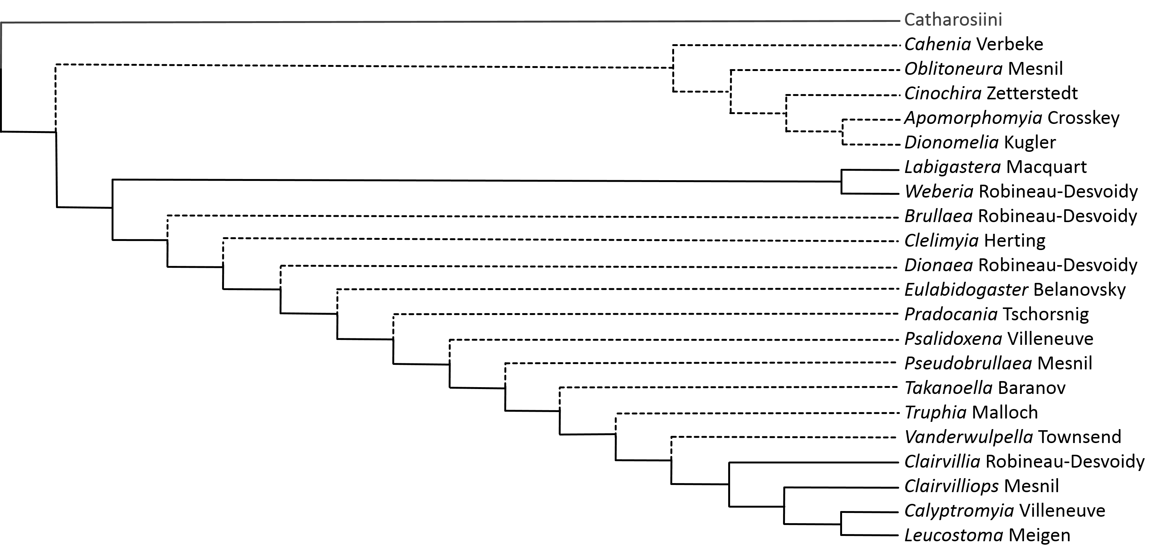
The Leucostomatini are distributed worldwide but are by far the most diverse in the Palearctic region (Herting 1984). They represent one of the few phasiine lineages that possesses an easily discernable synapomorphy and as a result their classification has been historically stable since Townsend (1908) first designated the tribe. Female leucostomatines possess unique horizontal pincers as extensions of the 6th tergite (Herting 1957) that are used to ensure cohesion of copulatory organs during mating (Tschorsnig 1985). These pincers are often discernable without dissection and have allowed researchers to confidently place genera within the Leucostomatini with little debate for over a century (Townsend 1936, Crosskey 1976, 1980; Herting 1984; O’Hara & Wood 2004; O’Hara et al. 2009). Female leucostomatines also possess piercers derived from the 8th sternite (Herting 1957, Leucostoma Meigen, Dionaea Robineau-Desvoidy, and Cinochira Zetterstedt examined) and share this trait with the closely related tribe Catharosiini among others. Phylogenetically, the Leucostomatini are consistently recovered as a monophyletic group both morphologically (Cerretti et al. 2014, Weberia Robineau-Desvoidy, Brullaea Robineau-Desvoidy, and Clairvillia Robineau-Desvoidy included) and molecularly (Blaschke et al. 2015, Leucostoma, Clairvillia, Calyptromyia Villeneuve, Clairvilliops Mesnil, Labigastera Macquart, and Weberia included) where they are reconstructed as sister to the Catharosiini.
Intratribal relationships within the Leucostomatini remain largely unexplored. Mesnil (1966) divided the group into three tribes – Leucostomina, Takanoellina, and Calyptromyina –but these artificial groups were never corroborated by other authors. In his analysis of the tachinid male postabdomen, Tschorsnig (1985) found that in most Leucostomatini the pincers are used to grasp a constricted part of the male terminalia between the epandrium and cerci (Leucostoma, Clairvillia, Takanoella Baranov, Eulabidogaster Belanovsky, Brullaea, and Truphia Malloch examined). Exceptions occur in Labigastera which uses its pincers to grasp the hypandrium and in Weberia whose pincers extend between the hypandrium and the genital membrane (Tschorsnig op. cit.). Two genera require further verification as to their placement within the Leucostomatini. Pseudobrullaea Mesnil was considered by Crosskey (1976) as potentially intermediate between the Leucostomatini and the Cylindromyiini, particularly in regard to head shape and chaetotaxy. However, this genus possesses the leucostomatine pincers and therefore most likely resides within the tribe. The females of Vanderwulpella Townsend, on the other hand, are unknown and so a clear tribal placement cannot be ascertained. Townsend placed Vanderwulpella in the Leucostomatini, but Crosskey (1973) considered the placement most likely an error. These genera are left within the Leucostomatini until types can be examined.
In describing the aberrant tachinid genus Cahenia Verbeke, Verbeke (1960: 340-342) erected the tribe Cinochirini to house Cahenia and Cinochira based on certain similarities of the male genitalia between the two genera. Although noting that Cinochirini was doubtfully distinct from the Leucostomatini, Crosskey (1984) included his new genus Apomorphomyia Crosskey in the Cinochirini and provided an insightful synopsis of the taxonomic relationship between the two nominal tribes. As discussed here, the Cinochirini group encompasses the genera Cinochira, Cahenia, Apomorphomyia, Oblitoneura Mesnil, and Dionomelia Kugler (Crosskey 1984; Kugler 1978). These genera are loosely united by various reductions in external morphology that remarkably seem to form a bridge between the Leucostomatini s. s. and the Catharosiini. All display some degree of reduced wing venation compared to Leucostomatini s. s., from the straight M vein and missing apical crossvein of Cinochira and Dionomelia, to the drastically reduced wing venation of Apomorphomyia. Cinochira, Cahenia, and Oblitoneura share the absence of a lunula, while Apomorphomyia and Dionomelia both possess extraordinarily reduced lower calypters. Apomorphomyia also lacks an enlarged subscutellum and only shares this reduced feature with the rare Litophasia (Litophasiini: Dexiinae) which has been historically allied with the Catharosiini.
Given the shared morphological reductions, it is tempting to place these genera in a separate tribe or subtribe. However, the females of Cinochira, Apomorphomyia, and Dionomelia possess the distinctive pincers found only in Leucostomatini as well as 8th sternite piercers (Crosskey 1984) and thus probably represent an evolutionary clade nested within Leucostomatini s. s. The Middle Eastern genus Oblitoneura occupies a phylogenetically intriguing position between these genera and the Catharosiini. While possessing a piercer derived from the 8th sternite, the female genitalia of Oblitoneura are reminiscent of both Catharosia and Clairvillia (Mesnil 1975; see Crosskey 1984) and it is unclear if it possesses a leucostomatine pincer (Mesnil [in French] relates that there are two small triangles through which the piercer extrudes). Mesnil (1975) placed this rare fly in the Leucostomatini near Cinochira, but Crosskey (1984) considered the genus without a doubt to be closer to Catharosia than Cinochira or Apomorphomyia. When considered collectively, the Leucostomatini s. s. merge seamlessly into the Cinochirini which are in turn linked with the Catharosiini through the morphological intermediacy of Oblitoneura. In light of this, future phylogenetic analyses may uncover evidence that justifies a complete merger of the tribes Leucostomatini and Catharosiini.
Lastly, from the Cinochirini group, and indeed all of Tachinidae, Cahenia stands in isolation. Originally associated with Cinochira based on similarities in the male terminalia (Verbeke 1960), Cahenia shares little in common with the external morphology of either Leucostomatini or Catharosiini. Unfortunately, the phylogenetically essential characters of the females as well as potential hosts of Cahenia remain unknown. Further obscuring its systematic position, Cahenia possesses the pleisiomorphic characters of plumose arista, 3 postsutural dc bristles, and strongly developed leg chaetotaxy (Crosskey 1984). It is possible that Cahenia belongs in another subfamily altogether (similar to Litophasia’s history) and I suspect that if Cahenia is evolutionarily related to the Leucostomatini it would be as sister taxa to an inclusive Leucostomatini + Catharosiini clade.

Tribe Opesiini (1 genera, 4 species)
Opesia Robineau-Desvoidy, 1863 (4 species)

Phylogenetics and Classification
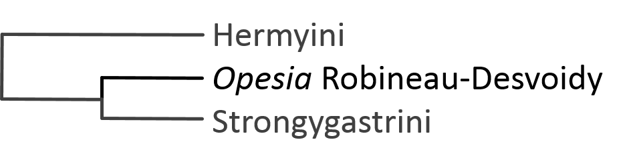
The rarely collected genus Opesia Robineau-Desvoidy contains three Palearctic/Asian species (Herting & Dely-Drasvkovits 1993; O’Hara et al. 2009) and one western Nearctic species (O’Hara & Wood 2004). It has spent its entire modern taxonomic history closely allied with Phasia in the tribe Phasiini (Herting 1984; Tschorsnig 1985; Belshaw 1993; Herting & Dely-Drasvkovits 1993; Tschorsnig and Richter 1998; O’Hara & Wood 2004; O’Hara et al. 2009). However, several authors have noted peculiarities within the genus that separate it from other phasiines.
Herting (1957) noted a strong terminal tergite in Opesia cana. He commented that this trait is shared with Hermya and Clara (= Paraclara) and potentially represented a primitive trait of Phasiinae. More significantly, Herting discovered that the 8th sternite of Opesia cana was completely reduced (this is the sternite from which the modified piercer of Phasia is derived). This unique reduction of the 8th sternite in Opesia cana was confirmed by Tschorsnig & Richter (1998) and establishes a distinctive trait for the Opesiini. In males, Opesia differs from Phasia, Elomya, and Xysta (Phasiini sensu Tschorsnig 1985) by the location of spiracle 6, the lack of lateral epandrial lobes, the shortened surstyli, and the particularly small processus longi (Tschorsnig 1985). It should also be noted that in Tschorsnig’s analysis he was unable to find significant synapomorphies to define Phasiini (Elomya, Phasia, Opesia, and Xysta included).
In their morphological analysis of Tachinidae, Cerretti et al. (2014) did not recover the Phasiini (Phasia, Opesia, and Xysta included) as a monophyletic group under any weighting schemes. This lends support to the herein proposed division of Phasiini into separate tribes. Substantial evidence for Opesia forming its own tribe distinct from Phasiini was discovered using molecular systematics. Blaschke et al. (2015) recovered a monophyletic Phasiini that only included Phasia and Elomya. Opesia was reconstructed as a well-supported sister group of the Strongygastrini. This clade together formed the sister clade to the Hermyini and supports Herting’s (1957) comments on the morphological similarities of Opesia to Hermya/Paraclara. As a result, Opesia is here removed from the Phasiini and is considered to belong to the newly established monotypic tribe Opesiini, closely allied with Strongygastrini and Hermyini.

Tribe Parerigonini (3 genera, 17 species)
Parerigone Brauer 1898 (11 species)
Paropesia Mesnil, 1970 (4 species)
Zambesomima Mesnil, 1967 (2 species)

Phylogenetics and Classification
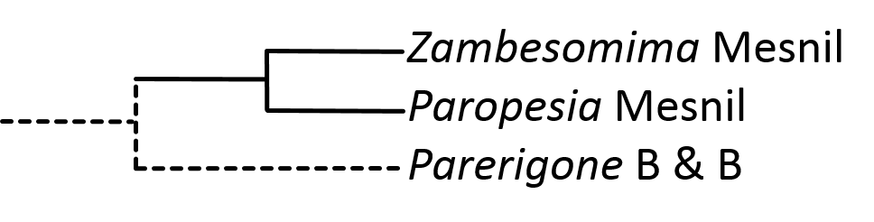
The Parerigonini sensu Mesnil (1966), Crosskey (1973, 1976), and Wood & Zumbado (2010) include eight genera: Parerigone Brauer & Bergenstamm, Paropesia Mesnil, Zambesomima Mesnil, Zita Curran, Leverella Baranov, Pygydimyia Crosskey, Australotachina, and Neobrachelia. This diverse group of geographically isolated genera from around the world have never been comparatively examined in a global context and the tribe is taxonomically unstable. Recent molecular evidence indicates that this assortment of unusual taxa includes three separate evolutionary lineages (Blaschke et al. 2015) and this suggested classification is followed here. Australotachina, Neobrachelia, and Pygidimyia are considered members of Cylindromyiini and are discussed above. The final five genera are separated here into two tribes corresponding to biogeography and the location of piercers in the female flies. The tribe Parerigonini s. s. includes genera found only in eastern Asia and have piercers derived from the 8th sternite (Parerigone, Paropesia, and Zambesomima), while the newly established tribe Zitini contains those genera with piercers derived from the 10th sternite (postgenital plate) and are found only in Australia (Zita and Leverella, see section below).
When early authors first described these genera, they routinely judged the flies based on external characters and did not place much importance on the morphology of the postabdomen (or could not discern the characters easily) (Brauer 1898; Malloch 1930; Mesnil 1957). Consequently, these unusual phasiines were initially thought to belong in Tachininae due to the similarity in head shape, chaetotaxy, and other characters that seem unlike traditional phasiine morphology but link them to genera of the Linnaemyini. A placement within Tachininae in or near the Linnaemyini has been a consistent theme in all regional catalogs since that time (Townsend 1936, 1939; Guimarães 1971; Crosskey 1973, 1976; Crosskey & Cantrell 1989) – although it should be noted that Townsend (1936, 1939) placed Zita and Pygidia Malloch (= Pygidimyia) in the Leucostomatini (Gymnosomatidae) for largely unjustified reasons (Crosskey 1976).
Even though superficially they appear more similar to tachinines than phasiines, tachinid experts have considered Parerigonini as potentially aberrant phasiines since Mesnil first described the new genus Paropesia (1970) which is considered very closely related to Parerigone (Shima 2014). Mesnil noted that Paropesia and Parerigone both possess piercers derived from the 8th sternite – a common trait among Phasiinae. Hosts were unknown for Parerigonini at that time (hosts are now known for Parerigone and Zambesomima: Heteroptera: Urostylididae, Shima 2015), but due to the parasitism of Heteroptera by the closely related Neobrachelia, Mesnil (and DM Wood, pers. com. Mesnil 1970) suggested that Parerigonini may belong in Phasiinae. Herting (1981) also commented on the similarity of Parerigone’s piercing structure to the piercers found in Leucostomatini. The third genus of Parerigonini, Zambesomima, was described by Mesnil (1967) who found it difficult to classify (male only) and placed it near Pelatachina (Tachininae). But this genus also possesses a piercer similar to those found in Parerigone and Paropesia and seems to be a firmly established member of Parerigonini (Wang et al. 2014). The most recent regional tachinid catalog follows this pattern and considers Parerigonini to belong in Phasiinae (O’Hara et al. 2009).
Phylogenetic evidence that Parerigonini should rest in Phasiinae can be found in both morphological and molecular analyses. Morphologically, Cerretti et al. (2014) recovered Parerigone near Hermya and the Leucostomatini within the Phasiinae. Molecularly, phylogenetic reconstructions placed Parerigone firmly in Phasiinae but its placement in relation to other tribes was equivocal (Blaschke et al. 2015). Evidence from a single gene (CAD) placed Parerigone and Zambesomima as either close to Xysta and Zitini (maximum likelihood analyses) or near Leucostomatini and/or Catharosiini (Bayesian analyses). Statistically, there was slightly more support for the former classification, but considering the weight of the morphological evidence and especially the similarity in piercers between the Parerigonini and Leucostomatini/Catharosiini, I here suggest that the Parerigonini be placed in the Phasiinae as sister to the diverse clade of ((Leucostomatini + Catharosiini) + (Hermyini + (Opesiini + Strongygastrini)).

Tribe Phasiini (2 genera, 76 species)
Elomya Robineau-Desvoidy 1830 (1 species)
Phasia Latreille, 1804 (75 species)

Phylogenetics and Classification
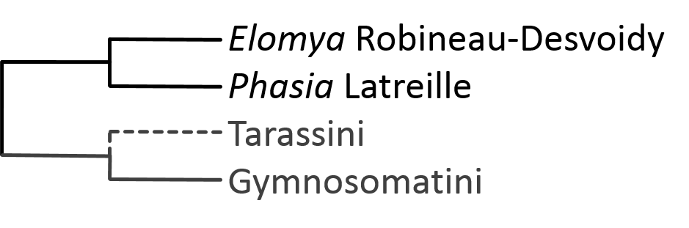
This proposed classification of Phasiinae differs substantially from previous hypotheses in the structure of the Phasiini. Molecular analyses of the subfamily have revealed the historically defined Phasiini to be comprised of multiple evolutionary lineages that do not form a single monophyletic group (Blaschke et al. 2015). Consequently, this once large tribe is here reduced to two genera: Phasia and Elomya. The genera Eliozeta, Euclytia, Ectophasia, Clytiomya, Cistogaster, Subclytia, Perigymnosoma, and Compsoptesis are transferred to the Gymnosomatini while Opesia and Xysta each form their own tribe with systematic positions relatively far from the Phasiini (see sections on Gymnosomatini, Opesiini, and Xystiini for discussion).
The taxonomic history of Phasia is long and extremely varied (see Sun & Marshall 2003) with numerous generic synonymies, but its position in Phasiini alongside Elomya (when present) has been a constant (Herting 1957, 1960; Guimaráes 1971; Crosskey 1977; Crosskey 1980; Herting 1984; Tschorsnig 1985; Cantrell & Crosskey 1989; Belshaw 1993; Herting & Dely-Drasvkovits 1993; Tschorsnig and Herting 1994; O’Hara & Wood 2004; O’Hara et al. 2009). In Phasia, the 8th sternite forms the characteristic piercing structure found in many phasiine tribes (Herting 1957). However, the 8th sternite in Elomya does not form a strongly sclerotized and curving piercer. Herting (1957, 1960) describes it as a "narrow point" that Elomya uses to deposit eggs into host body niches (intersegmental membranes, Tschorsnig & Richter 1998). This trait is distinct from the piercer of Phasia and may be an intermediate form between non-piercing sternites and fully functional host-stabbing piercers.
Along with the molecular evidence for their close evolutionary history, these two genera also share the following morphological traits of the male postabdomen which can be used to separate them from other Phasiini sensu Tschorsnig (1985): tergite 6 is platiform in shape and easy to discern, the confluence of tergite 6 and sternite 7 +8 forms a nearly acute angle, the lobes of sternite 5 are developed into cone-shaped structures (most Phasia species), and the surstyli are longer than cerci (Tschorsnig 1985). The Phasiini also share the absence of teeth on the apex of the first instar larval mouth hook (Dupuis 1963; Sun & Marshall 2003).

Tribe Strongygastrini (5 genera, 20 species)
Arcona Richter, 1988 (2 species)
Melastrongygaster Shima, 2015 (5 species)
Rondaniooestrus Villeneuve, 1924 (1 species)
Strongygaster Macquart, 1834 (8 species)

Phylogenetics and Classification
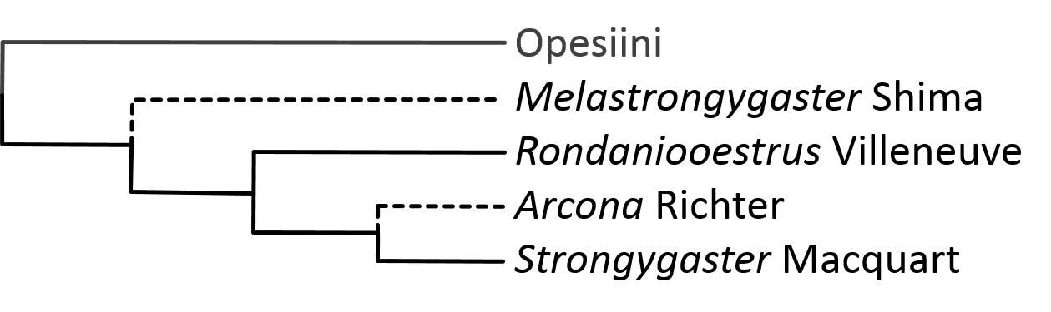
Possessing traits and behaviors of both the Phasiinae and Tachininae, the Strongygastrini is yet another puzzling tachinid tribe with uncertain taxonomic affinities. Distributions vary considerably throughout the group. The type genus Strongygaster Macquart is found worldwide, Rondaniooestrus Villeneuve is an African species (O’Hara 2012), and Arcona Richter and Melastrongygaster Shima are known only from Russia and eastern Asia (Shima 2015). A position in Phasiinae is easy to support superficially as most of the genera are very similar to the phasiine genera Opesia and Phasia in overall appearance (head shape, chaetotaxy, and wing venation). Herting (1957) considered Tamiclea and Hyalomyiodes (both = Strongygaster) to be primitive phasiines based on host use and egg, larval, and female postabdomen characters. However, Dupuis (1963) chose to exclude the Strongygastrini from his monograph on Phasiinae.
In morphological studies of male terminalia, Verbeke (1962) identified his “POS-type” distiphallus in Strongygaster –a trait shared with the phasiines Cylindromyia and Phasia, and (Tschorsnig 1985) recognized the characteristic elongated hypandrium of the Phasiinae in Strongygaster. Consequently, the historical classification of Strongygaster as a member of Phasiinae (Townsend 1936, as Gymnosomatidae) has been followed by many taxonomists (Mesnil 1966; Guimaráes 1971; Herting 1984; Tschorsnig 1985; Shima 1989; Richter 1993; Tschorsnig & Herting 1994; Shima 2006, 2015). Recently, the newly discovered genus Melastrongygaster was described and associated with Strongygaster and Arcona based on considerable homology of the male terminalia even though the genus is otherwise morphologically uncharacteristic of Strongygastrini (Shima 2015). The female Melastrongygaster differs from other Strongygastrini in that the eighth sternite is modified into a piercing structure. This character strongly implies a phasiine ancestry as similar piercers are found throughout the Phasiinae and occur almost nowhere else in Tachinidae (e. g. Epigrimyiini, Dufouriini).
In contrast to the characters above, Strongygaster develops eggs in a uterus (Wood 1987) and is ovolarviparous (lays incubated eggs or early instar larvae), thus setting it apart from the oviparous Phasiinae – although Herting (1960) considered this a derived feature. Strongygaster also differs from other Phasiinae in its choice of hosts. It commonly attacks the phasiine staple of heteropterans (Sabrosky & Braun 1970; Santos & Panizzi 1997; Panizzi & Oliveira 1999; Golec et al. 2013; Blaschke 2014 pers. ops.) but also attacks a wide array of other insects including Orthoptera (Kevan & Koshnaw 1988), Coleoptera (Arnaud 1978), Hymenoptera (Eggleton & Belshaw 1992; Feener 2000), Lepidoptera (Sabrosky & Braun 1970), Dermaptera (Sabrosky & Braun 1970), and Diptera (Ferrar 1977). As a result of these evidences, many recent authors have chosen to associate Strongygaster with the Tachininae (O’Hara & Wood 2004; Stireman et al. 2006; Cerretti et al. 2009; Cerretti 2010; Inclan & Stireman 2011).
The genera of Strongygastrini have also been historically aligned with the Dufouriini (Dexiinae). The genera Rondania and Campogaster (= Microsoma), now in Dufouriini (Herting 1984), was considered a member of the Strongygastrini by Townsend (1936), Rondaniooestrus was initially placed in the Dufouriina (in Phasiinae) (Mesnil 1939), and Dear & Crosskey (1982) positioned Strongygaster in the subfamily Dufouriinae. However, this relationship does not have any specific morphological synapomorphies in its favor.
Hosts are unknown for Melastrongygaster and Arcona (although see Richter 1998 [in Russian] for possible mention of hosts), and Rondaniooestrus is the only known tachinid parasite of honey bees (Villeneuve 1924). If included in the Phasiinae then, Rondaniooestrus would be the only phasiine with known hosts that do not include heteropterans. This distinction in part led Mesnil (1980) and Crosskey (1984) to maintain Rondaniooestrus in its own tribe Rondaniooestrina/i in the Tachininae, although Herting (1983) considered it belonging to Strongygastrini. Evidence for the inclusion of Rondaniooestrus in Strongygastrini comes from molecular phylogenetics which places the genus with high support as sister to Strongygaster and the entire clade firmly within Phasiinae (Blaschke et al. 2015). The male terminalia of Rondaniooestrus, Arcona, and Melastrongygaster contain the same reduced phallus and other derived characters identified in Strongygaster (Tschorsnig 1985) and which help define the Strongygastrini (Richter 1988; Cerretti 2014 pers. com.; Shima 2015). The molecular phylogeny also revealed a close relationship with the genus Opesia which was recovered as sister to the Strongygastrini (Blaschke op. cit.). Morphological phylogenetics provides additional confirmatory evidence that the Strongygastrini belong in Phasiinae (Cerretti et al. 2014).
The evolution of this clade within the Phasiinae is unique in a number of ways. First, it represents the only evolution of ovolarviparity within the subfamily – a complex reproductive strategy that dominates the Dexiinae and Tachininae. Second, the Strongygastrini includes a species not known to parasite Heteroptera (Rondaniooestrus) and a species with one of the widest host ranges of all Tachinidae (Strongygaster). These traits are unknown in other phasiines. Third, if Melastrongygaster does belong to the Strongygastrini, its piercer probably represents an ancestral character for the tribe. The piercer was most likely lost in the ancestor of Strongygaster + Arcona + Rondaniooestrus after the ancestor of Melastrongygaster diverged. The loss of the piercer is a potential factor in the explosion of host diversity in these genera as the flies were no longer specialized to attack hosts with hardened cuticles (Blaschke et al. 2015). Discovering additional hosts of Strongygasterini, especially Arcona and Melastrongygaster, could shed light on this interesting evolutionary question.

Tribe Tarassini (1 genus, 1 species)
Tarassus Aldrich, 1933 (1 species)

Phylogenetics and Classification
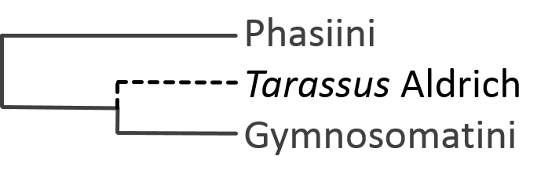
The unique genus Tarassus Aldrich was named from the Greek work tarassein meaning to “stir up trouble, throw into confusion” (Aldrich 1933) and is an apt moniker for this unusual fly. Described from a single female specimen, Tarassus lacks the usual tachinid characters of enlarged calypters, meral bristles, and enlarged subscutellum. As a result, Townsend (1935) did not even consider it belonging to Calyptratae (Guimaráes 1971). Other experts however, including Malloch and Aldrich (see Aldrich 1933) and Hennig and Guimarães (see Guimarães 1971) considered it an anomalous tachinid.
Aldrich (1933) originally suggested a new subfamily for Tarassus near “Trichiopodinae”. Guimarães (1971) only bestowed tribal status on the fly and placed it near the Trichopodini in Phasiinae. The gestalt of Tarassus is certainly Tachinidae and in my opinion it looks like a much-reduced trichopodine (Figure 3). Given the dark coloration of its body and wings, the virtual absence of stout macrochaetae, and the almost petiolate abdomen, Tarassus may be evolving toward mimicry with a sympatric wasp species (cf. Cylindromyia mirabilis or Polistiopsis for another example of exceptional wasp mimicry in Phasiinae).
The only specimens known to me include the one Aldrich originally described from Brazil housed in the National Museum of Natural History (Smithsonian Institute, Washington, USA) and one from Columbia housed in the National History Museum (London, UK). There may be others scattered throughout regional museums but this is undoubtedly an extremely rare and fascinating fly. Genetic evidence would undoubtedly place this genus with more certainty. Unfortunately, such rare species are difficult to obtain for molecular analysis. Therefore, Tarassus is left here in its own tribe near Trichopodini until further research is completed.
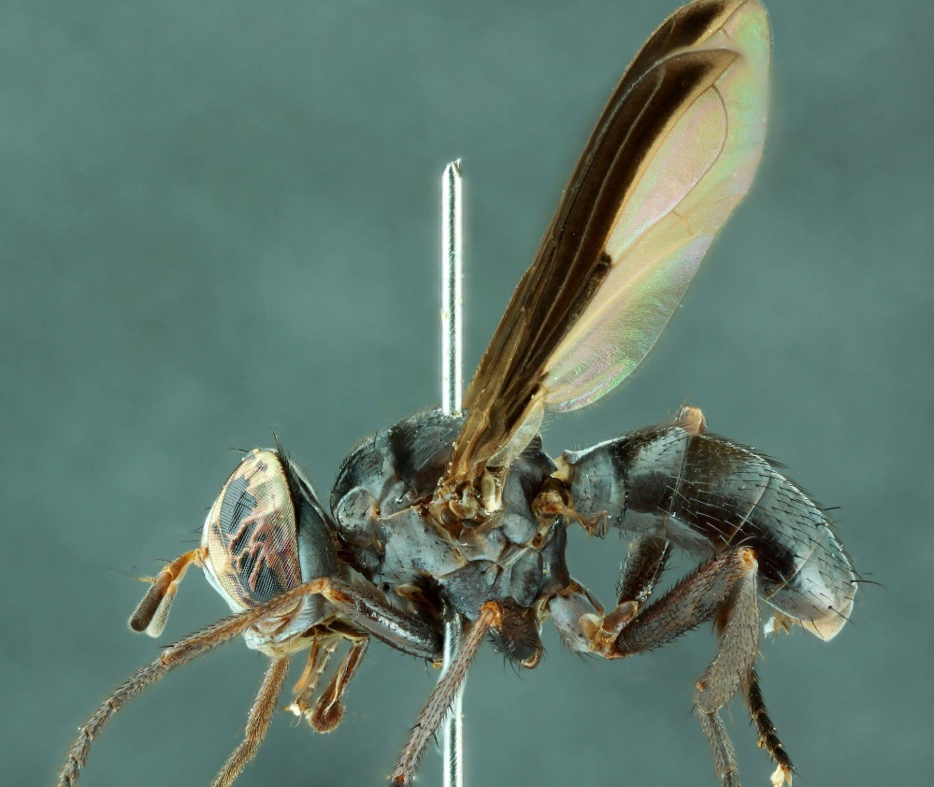
Figure 3: Tarassus shannoni collected from Columbia, housed in NHM. Photo by Chris Raper.

Tribe Xystiini (1 genus, 1 species)
Xysta Meigen, 1924 (1 species)

Phylogenetics and Classification
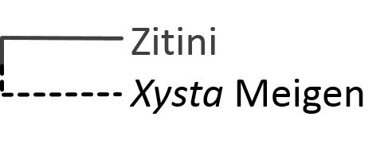
The general habitus of Xysta Meigen is strongly reminiscent of fellow phasiine genera Phasia and Opesia. As a result, Xysta has been included in the tribe Phasiini for most of its taxonomic history (Herting 1957, 1984; Tschorsnig 1985; Herting & Dely-Draskovits 1993). However, when internal structures are examined Xysta contains notable differences from these taxa that set it apart as unique.
In his examination of female terminalia, Herting (1957) commented that Xysta held a very isolated position within the Phasiinae. Unlike any other phasiine, Xysta possesses a normally developed postgenital plate which Herting suggested could be an ancestral trait of Phasiinae. Additionally, Herting hypothesized that Xysta’s uniquely shaped eighth tergite was used by the fly to spread open its host’s elytra during oviposition. Xysta’s characteristic corkscrew ovipositor (8th sternite) would then penetrate the host and deposit eggs. Similarly, Tschorsnig (1985) examined the male postabdomen of Xysta and found it to be quite distinctive when compared with other Phasiini. Probably as a direct consequence of the corkscrew ovipositor and the mating requirements for such a modification to the abdomen, Xysta males have a uniquely asymmetrical postabdomen. These traits are not found anywhere else in the Tachinidae.
Molecular phylogenetics supports the hypothesis that Xysta occupies an isolated position within the Phasiinae and suggests a closer evolutionarily history with the Zitini rather than the Phasiini (Blaschke et al. 2015). As a result, this unique genus is here removed from the Phasiini and placed in its own tribe Xystiini.

Tribe Zitini (2 genera, 4 species)
Leverella Baranov, 1934 (2 species)
Zita Curran, 1928 (2 species)

Phylogenetics and Classification
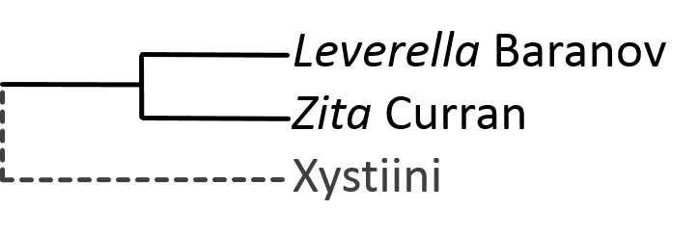
The Zitini are here established as a new tribe housing the understudied Australian genera Zita Curran and Leverella Baranov. Formerly of the Parerigonini (see their section above), these genera are distinct from the Parerigonini s. s. by their geography (Australia vs. Asia) and more importantly by their possession of female piercers derived from the 10th sternite rather than the 8th (Cantrell 1988). No hosts are known for Zita or Leverella, few specimens have been caught, and there are undoubtedly new species waiting to be described. Externally, Zita and Leverella do not appear phasiine-like but rather share tachinine-like affinities similar to the Parerigonini, with Zita initially related to Arctophyto Townsend (= Ateloglossa Coquillett, Dexiini) by Curran (1928). The Zitini were therefore placed in Tachininae by Townsend (1936, see section on Parerigonini for full history), but now reside firmly in Phasiinae (Blaschke et al. 2015).
Molecular phylogenetic analyses have positioned Zita and Leverella, along with some unknown species near these genera, in the Phasiinae as sister to all other phasiine tribes outside of clade Cylindromyiini + Imitomyiini (see Blaschke et al. 2015). The three tribes Imitomyiini, Cylindromyiini, and Zitini share the unique positioning of the female piercer (10th sternite) that is not found anywhere else in Tachinidae (Cantrell 1988) and may have characterized the early phasiine ancestor. The Zitini are also closely related to Xysta, another unusual tachinid with an aberrant piercer (derived from 8th sternite, but is corkscrew unlike other phasiine piercers). Surprisingly, Pygidimyia, another Australian genera formerly of Parerigonini and closely associated with Zita and Leverella, was not reconstructed within the Zitini but was rather placed within Cylindromyiini (see Cylindromyiini section for discussion), leaving only Zita and Leverella strongly supported members of Zitini. These genera are distinct from the Cylindromyiini morphologically by the lack of fusion of sternite 7 and tergite 7 which is a characteristic feature of Cylindromyiini (Cantrell 1988).

References

Aldrich JM. 1925. Notes on some types of American muscoid Diptera in the collection of the Vienna Natural History Museum [cont.]. Annals of the Entomological Society of America 18: 107–130 [cont.].
Aldrich JM. 1933. A remarkable new genus of Tachinidae (Diptera) from Brazil.
Aldrich JR, Khrimian A, Zhang A, & Shearer PW. 2006. Bug pheromones (Hemiptera, Heteroptera) and tachinid fly host-finding. Denisia 19:1015–1031.
Aldrich, J. R., Khrimian, A., & Camp, M. J. (2007). Methyl 2, 4, 6-decatrienoates attract stink bugs and tachinid parasitoids. Journal of chemical ecology, 33(4), 801-815.
Arnaud PH Jr. 1978. A Host-Parasite Catalog of North American Tachinidae (Diptera). USDA Miscellaneous Publications. 1319. 860 pp.
Arnaud, P. H. (1966). A revision of the parasitic fly genus Polistiopsis Townsend (Diptera, Tachinidae). American Museum novitates; no. 2241.
Barraclough, D. A. (1985). The Afrotropical genus Bogosia Rondani, 1873 (Diptera: Tachinidae). Natal Museum.
Belshaw R. 1993. Tachinid flies. Diptera: Tachinidae. Handbooks for the identification of British Insects. London: R. Entomol. Soc. London 10, Part 4a (i). 170 pp.
Bezzi, M. 1925. On the tachinid genus Euthera (Diptera), with description of new species from Australia, Africa and South America. Proceedings of the Linnaean Society of New South Wales, 50: 275–283.
Biehler JA, & McPherson JE. 1982. Life history and laboratory rearing of Galgupha ovalis (Hemiptera: Corimelaenidae), with descriptions of immature stages. Annals of the Entomological Society of America, 75 (4): 465-470.
Blanchard, E. E. 1966. Nuevos triquiopodinos argentinos, panisitos de hemipteros nocivos (Dipt. Gymnosomatidae). Rev. Invest. Agropecu., Ser. 5, 3: 59- 97.
Blaschke et al. 2015. Evolution and Phylogeny of Phasiinae (Diptera: Tachinidae)
Brauer, F. & Bergenstamm, J.E. von. 1889. Die Zweiflügler des Kaiserlichen Museums zu Wien. IV. Vorarbeiten zu einer Monographie der Muscaria schizometopa (exclusive Anthomyidae). Pars I. Denkschriften der Kaiserlichen Akademie der Wissenschaften in Wien. Mathematisch-Naturwissenschaftliche Classe 56 (1): 69-180 + 11 pls.
Brauer, F. (1898) Beiträge zur Kenntnis der Muscaria schizometopa. I. Bemerkungen zu den Originalexemplaren der von Bigot, Macquart und Robineau-Desvoidy beschriebenen Muscaria schizometopa aus der Sammlung des Herrn G. H. Verrall. Zweite Folge. Sitzungsberichte der Mathematisch-Naturwissenschaftlichen Classe der Kaiserlichen Akademie der Wissenschaften in Wien, Abteilung I, 107, 329–546.
Brooks AR. 1946. A revision of the North American species of the Rhodogyne complex (Diptera, Larvaevoridae). Canadian Entomologist 77(1945): 218–230.
Cantrell BK & Crosskey RW. 1989. Family Tachinidae. In Catalog of the Diptera of the Australasian and Oceanian Regions, ed. NL Evenhuis, pp. 733–84. Bishop Mus. Spec. Publ. 86. Honolulu/ Leiden: Bishop Mus. Press & Brill. 1155 pp.
Cantrell BK. 1983. Revision of the Australian species of Euthera Loew (Diptera: Tachinidae). Australian Journal of Entomology, 22 (1), 53-59.
Cantrell BK. 1988. The comparative morphology of the male and female postabdomen of the Australian Tachinidae (Diptera), with descriptions of some first-instar larvae and pupae. Invertebrate Systematics, 2 (1), 81-221.
Cantrell, B. K. (1984). Synopsis of the Australian Phasiinae, including revisons of Gerocyptera Townsend and the Australian species of Cylindromyia Meigen (Diptera: Tachinidae). Australian Journal of Zoology, 32(102), 1-60.
Cerretti P, & Tschorsnig HP. 2010. Annotated host catalogue for the Tachinidae (Diptera) of Italy. Stuttgarter Beiträge zur Naturkunde, A, Neue Serie, 3, 305-340.
Cerretti P, De Biase A, & Freidberg A. 2009. Systematic study of the genus Rossimyiops Mesnil (Diptera: Tachinidae). Zootaxa, 1984, 31-56.
Cerretti P., Giudice, G. L., & Mei, M. (2010). A new Besseria Robineau-Desvoidy (Diptera: Tachinidae) from Israel. ISRAEL JOURNAL OF ENTOMOLOGY, 40, 187-194.
Cerretti, P. 2010. I tachinidi della fauna italiana (Diptera Tachinidae) con chiave interattiva dei generi ovestpaleartici.Volumes I & II. Centro Nazionale Biodiversità Forestale, Verona. 573 pp. (Vol. I) + 339 pp. (Vol. II)+ CD ROM.
Cerretti, P., Logiudice, G., & Pape, T. (2014). Remarkable Rhinophoridae in a growing generic genealogy (Diptera: Calyptratae, Oestroidea). Systematic Entomology, 39(4), 660-690.
Cerretti, P., O'HARA, J. E., Wood, D. M., Shima, H., Inclan, D. J., & STIREMAN, J. O. (2014). Signal through the noise? Phylogeny of the Tachinidae (Diptera) as inferred from morphological evidence. Systematic Entomology, 39(2), 335-353.
Coquillett DW. 1897. Revision of the Tachinidae of America north of Mexico: A family of parasitic two-winged insects (No. 7). Govt. print. off.
Crosskey RW. 1973. A conspectus of the Tachinidae (Diptera) of Australia, including keys to the supraspecific taxa and taxonomic and host catalogues. Bulletin of the British Museum of Natural History Entomology Supplement 21. 221 pp.
Crosskey RW. 1976. A taxonomic conspectus of the Tachinidae (Diptera) of the Oriental Region. Bulletin of the British Museum of Natural History Entomology Supplement 26. 357 pp.
Crosskey RW. 1977. A review of Rhinophoridae (Diptera) and a revision of the Afrotropical species. Bulletin of the British Museum of Natural History Entomology Supplement 36. 66 pp.
Crosskey RW. 1980. Family Tachinidae. In Catalogue of the Diptera of the Afrotropical Region, ed. RW Crosskey, pp. 822–82. London: British Museum of Natural History 1437 pp.
Crosskey RW. 1984. Annotated keys to the genera of Tachinidae (Diptera) found in tropical and southern Africa. Annals of the National Museum 26: 189–337.
Curran CH. 1927. Some new Australasian and African Diptera of the families Muscidae and Tachinidae (Dipt.). Entomologische Mitteilungen, 16, 345-357. Dal'nauka, Vladivostok. 659 pp.
Curran, C. H. (1934). X.—The African species of Cylindromyia Meigen (Diptera, Tachinidæ). Journal of Natural History, 14(79), 121-142.
Dear JP. 1980. A new species of Litophasia Girschner from South Africa (Diptera: Tachinidae). Annals of the Natal Museum (Print) (Pietermaritzburg: Natal Museum) 24: 217–220.
Dear, J. P., & Crosskey, R. W. (1982). A taxonomic review of the Tachinidae (Insecta, Diptera) of the Philippines. Zoologisk Museum.
Dios, R. D. V. P. (2014). Revisão taxonômica das espécies neotropicais dos gêneros Trichopoda Berthold, 1827 e Ectophasiopsis Townsend 1915 (Diptera, Tachinidae, Phasiinae) (Doctoral dissertation, Universidade de São Paulo).
Dupuis, C. 1958. Dates de publication des Diptères du Turkestan de Loew; cas particulier du genre Apostrophus Loew 1871. Contribution à l'Etude des Phasiinae cimicophages, XXII. Beiträge zur Entomologie 8: 692–696.
Dupuis, C. 1963. Essai monographique sur les Phasiinae (Diptères Tachinaires parasites d'Hétéroptères). Mémoires du Muséum National d'Histoire Naturelle, Sér. A, Zoologie 26: 1–461.
Eggleton P & BelshawR. 1992. Insect parasitoids: an evolutionary overview. Philosophical Transaction of the Royal Society of London B. Biological Sciences, 337:1–20.
Feener Jr DH. 2000. Is the assembly of ant communities mediated by parasitoids?. Oikos, 90 (1), 79-88.
Ferrar, P. 1977. Parasitism of other adult Diptera by Tachinidae in Australia. Journal of Australian Entomological Society 16: 397-401.
Gilasian, E., Talebi, A. A., Ziegler, J., & Manzari, S. (2013). A review of the genus Phania Meigen, 1824 (Diptera: Tachinidae: Phasiinae) in Iran with the description of a new species. Zoology and Ecology, 23(1), 13-19.
Golec, J. R., Hu, X. P., Ray, C., & Woodley, N. E. (2013). Strongygaster triangulifera (Diptera: Tachinidae) as a parasitoid of adults of the invasive Megacopta cribraria (Heteroptera: Plataspidae) in Alabama. Journal of Entomological Science, 48(4), 352-354.
Guimaráes JH. 1971. Family Tachinidae (Larvaevoridae). In A Catalogue of the Diptera of the Americas South of the United States. Vol. 104. São Paulo: Museum of Zoology, University of São Paulo. 333 pp.
Guimaráes JH. 1977. Host-parasite and parasite-host catalogue of South American Tachinidae (Diptera). Arquivos de Zoologia. São Paulo 28:1–131.
Guimarães, J. H. (1976). A revision of the genus Cylindromyia Meigen in the Americas south of the United States (Diptera, Tachinidae). Arquivos de Zoologia, 27(1), 1-50.
Harris VE, Todd JW. 1980. Male-mediated aggregation of male, female, and 5th instar southern green stink bugs and concomittant attraction of a tachinid parasite, Trichopoda pennipes. Entomologia Experimentalis et applicata, 27 (2), 117-126.
Herting B, Dely-Draskovits A. 1993. Family Tachinidae. In Catalogue of Palaearctic Diptera. Vol. 13: Anthomyiidae–Tachinidae, ed. A´ Soo´s, L Papp, pp. 118–458. Budapest: Hung. Natural History Museum 624.
Herting B. 1957. Das weibliche Postabdomen der calyptraten Fliegen (Diptera) und sein Merkmalswert für die Systematik der Gruppe. Zeitschrift für Morphologie und Ökologie der Tiere, 45 (5), 429-461.
Herting B. 1960. Biologie der westpalarktischen Raupenfliegen. Dipt., Tachinidae. Monographien zur Angewandten Entomologie. 16, 188 pp.
Herting B. 1974. Revision der von J. Egger, JR Schiffner, F. Bauer und JE Bergenstamm beschriebenen europäischen Tachiniden und Rhinophorinen (Diptera). Naturkundliches Jahrbuch der Stadt Linz, 1974, 129-145.
Herting B. 1983. 64c. Phasiinae. In Die Fliegen der palaearktischen Region, ed. E Lindner, pp.1–88. Stuttgart: Schweiz. Verl.
Herting B. 1984. Catalogue of Palearctic Tachinidae (Diptera). Stuttgarter Beitraege zur Naturkunde Serie A (Biologie), 369:1–228.
Herting, B. (1981). Revision of the types of several palearctic Tachinidae (Diptera) and description of new species. Stuttgarter Beitraege zur Naturkunde aus dem Staatlichen Museum fuer Naturkunde in Stuttgart. Serie A (Germany, FR).
Herting, B. 1979. Revision einiger nicht-paläarktischer Arten aus der Tribus Cylindromyiini (Dipt. Tachinidae, Phasiinae). Stuttgarter Beiträge zur Naturkunde Serie A (Biologie) 326: 1–15.
Inclan DJ, & Stireman III JO. 2011. Tachinid (Diptera: Tachinidae) parasitoid diversity and temporal abundance at a single site in the northeastern United States. Annals of the Entomological Society of America, 104 (2), 287-296.
Kevan, DK & Koshnaw RTB. 1988. Hyalomyodes (Diptera; Tachinidae), an endoparasitoid of Tetrigoidea (Orthoptera). Entomologist's Record and Journal of Variation, 100: 55–57.
Kugler J. 1978. Leucostoma edentata n. sp. and Dionomelia hennigi n. gen., n. sp., two new Leucostomatini from Israel (Dipt: Tachinidae, Phasiinae). Entomologica germ., 4: 344-348.
Malloch JR. Diptera Calyptratae of the Federated Malay States. (Third paper). J. fed. Malay St. Mus., 16: 119-153.
Malloch, J. R.(1929).-Notes on Australian Diptera. XX. Proc. Lim, 283-343.
Mesnil LP (1939) Essai sur les tachinaires (Larvaevoridae). Monographies publiées par les Stations et Laboratoires de Recherches Agronomiques 7: 67.
Mesnil LP. 1957. Nouveaux Tachinaires d'Orient (deuxième série). Mém. Soc. r. ent. Belg., 28: 1-80.
Mesnil, L.P. 1966. 64g. Larvaevorinae (Tachininae). Die Fliegen der Palaearktischen Region. Lieferung 263, p. 881-928.
Mesnil LP. 1967. Tachinaires paléarctiques inédits (Diptera). Mushi, 41: 37-57.
Mesnil LP. 1970. Descriptions de nouveaux Tachinaires de l'ancien monde, et notes synonymiques (Dipt. Tachinidae). Mushi, 44: 89-123.
Mesnil LP. 1975. Deux espèces de Tachinaires (Dipt. Tachinidae). Nouvelles et interessantes. Stuttg. Beitr. Naturk., No. 277: 1-5.
Mesnil LP. 1980. 64f. Dexiinae. In: Lindner, E. (ed.) Die Fliegen der palaearktischen Region, 9: 1-52.
Nishayama M, Iwasa M, & Hori K. 1995. Parasitism by tachinid flies (Diptera, Tachinidae) of heteropterous insects in Tokachi, Hokkaido. 63 (1), 159-165.
O’Hara JE, Shima H, & Zhang C. 2009. Annotated catalogue of the Tachinidae (Insecta: Diptera) of China. Zootaxa, 2190, 1-236.
O’Hara JE, Wood DM. 2004. Catalogue of the Tachinidae (Diptera) of America north of Mexico. Memoirs of the International Entomological Society. 18. 410 pp.
O’Hara JE. 2002. Revision of the Polideini (Tachinidae) of America north of Mexico. Studia dipterologica. Supplement 10: 170 pp.
O’Hara, J. E. (2011). World genera of the Tachinidae (Diptera) and their regional occurrence.
O’Hara, J.E. 2013a. Where in the world are all the tachinid genera? The Tachinid Times 26: 10–16.
O’Hara, J.E. 2013b. History of tachinid classification (Diptera, Tachinidae). ZooKeys 316: 1–34.
O'Hara JE. 2012. Review of Euthera (Diptera: Tachinidae) in North America with the description of a new species. The Canadian Entomologist, 144 (02), 206-215.
Özdikmen, H. 2010. Brasilomyia nom. nov., a new name for the preoccupied tachinid genus Platyphasmia Townsend, 1935 (Diptera: Tachinidae). Munis Entomology & Zoology 5: 293–294.
Panizzi AR, & Oliveira ÉD. 1999. Seasonal occurrence of tachinid parasitism on stink bugs with different overwintering strategies. Anais da Sociedade Entomológica do Brasil, 28 (1), 169-173.
Pape, T., & Shima, H. (1993). A new genus of Tachinidae from the Philippines (Diptera). Tijdschrift voor Entomologie, 136, 77-81.
Reinhard HJ. 1964. Mexican Tachinidae (Diptera). Acta Zoologica Mexicana 7 (2): 1–21.
Richter VA. 1993. New and little known tachinids (Diptera, Tachinidae) of Transbaikalia and Far East. Entomologicheskoe Obozrenie, 72, 422-440.
Richter VA. 2004. Family Tachinidae – tachinids. In: Key to the insects of Russian Far East. Sidorenko VS., Editor. Vol. VI. Diptera and Siphonaptera. Part 3. Dal’nauka, Vladivostok. 659 pp. [In Russian.]
Richter, V. A. (1998). New and Little Known Species of Tachinids (Diptera, Tachinidae) of the Fauna of Russia and Neighboring Countries.ENTOMOLOGICAL REVIEW C/C OF ENTOMOLOGICHESKOE OBOZRENIE,78, 620-626.
Richter, V.A. 1986. On the fauna of tachinids (Diptera, Tachinidae) of the Far East. [In Russian.] USSR Academy of
Richter, V.A. 1988. New Palearctic genera and species of tachinids (Diptera, Tachinidae). [In Russian.] Systematika Nasekomikh i Kleshchei 70: 202–212.
Rohdendorf BB. 1948. A new family of parasitic muscoid Diptera from the sands of the Volga region. Dokl. Akad. Nauk SSSR, 63: 455-458.
Sabrosky CW & Arnaud PH Jr. 1965. Family Tachinidae (Larvaevoridae). In A Catalog of the Diptera of America North of Mexico, ed. A Stone, CW Sabrosky, WW Wirth, RH Foote, JR Coulson, pp. 961– 1108. USDA Handbook 276. 1696 pp.
Sabrosky CW, & Braun BH. 1970. A tachinid parasite of fireflies. Entomological News, 81, 185-187.
Sabrosky CW. 1950. Notes on Trichopodini (Diptera, Larvaevoridae), with description of a new parasite of cotton stainers in Puerto Rico. Journal of the Washington Academy of Sciences 40: 361–371.
Sabrosky CW. 1999. Family-group names in Diptera. An annotated catalog. Myia 10: 1–360.
Sands DPA & Coombs MT. 1999. Evaluation of the Argentinian Parasitoid, Trichopoda giacomellii (Diptera: Tachinidae), for Biological Control of Nezara viridula (Hemiptera: Pentatomidae) in Australia. Biological Control, 15 (1), 19-24.
Santos CH, & Panizzi AR. 1997. Tachinid parasites of adult Megalotomus parvus West. (Hemiptera: Alydidae). Anais da Sociedade Entomológica do Brasil, 26 (3), 577-578.
Shima H. 1989. Parasitic way of life in tachinid flies. Insectarium 26:4–9; 46–51; 88–94; 120–26.
Shima H. 2006. A host-parasite catalog of Tachinidae (Diptera) of Japan. Societas Dipterologica. 2006.
Shima H. 2015. New Host records of Japanese Tachinidae (Diptera). Acta Dipterilogica. No. 26: 9-19.
Shima, H. (1999). Host-parasite catalog of Japanese Tachinidae (Diptera).Makunagi/Acta Dipterologica, 1, 1-108.
Shima, H. (2011). Notes on Parerigone with a description of a new species from Nepal (Diptera: Tachinidae). The Canadian Entomologist, 143(06), 674-687.
Shima, H. (2014). The parerigonine genus Paropesia Mesnil (Diptera, Tachinidae), with descriptions of three new species from East Asia. Zootaxa,3827(4), 576-590.
SHIMA, H. (2015). Melastrongygaster, a new genus of the tribe Strongygastrini (Diptera: Tachinidae), with five new species from Asia. Zootaxa, 3904(3), 427-445.
Stein P. 1924. Die verbreitetsten Tachiniden Mitteleuropas nach ihren Gattungen und Arten. Archiv fur Naturgeschichte Abt. A, 90 (6): 1–271.
Stireman III JO, O'Hara JE, & Wood DM. 2006. Tachinidae: evolution, behavior, and ecology. Annual Review of Entomology, 51, 525-555.
Sun, X. (1995). Studies on the genus Lophosia Meigen from China (Diptera: Phasiinae). Acta Zootaxonomica Sinica, 21(1), 95-106.
Sun, X.-k. & Marshall, S.A. (1995) Two new species of Cylindromyia Meigen (Diptera, Tachinidae), with a review of the eastern Palaearctic species of the genus. Studia Dipterologica, 2, 189–202
Sun, X.-k. and Marshall, S.A. 2003. Systematics of Phasia Latreille (Diptera: Tachinidae). Zootaxa 276: 1–320.
Sutherland, J. P., & Baharally, V. (2002). Spatio-temporal distribution of Beskia aelops (Walker)(Diptera: Tachinidae) and its potential for the biocontrol of Oebalus poecilus (Dallas)(Hemiptera: Pentatomidae). Biocontrol Science and Technology, 12(4), 513-517.
Tachi, T., & Shima, H. (2010). Molecular phylogeny of the subfamily Exoristinae (Diptera, Tachinidae), with discussions on the evolutionary history of female oviposition strategy. Systematic Entomology, 35(1), 148-163.
Toma, R. 2003. Estudo das especies do “complexo Acaulona” sensu Sabrosky (Diptera, Tachinidae). Revista Brasileira de Entomologia 47: 267–282.
Townsend CHT. 1891. Notes on North American Tachinidæ sens. str. with Descriptions of New Genera and Species. Paper II. Transactions of the American Entomological Society (1890-), 18(4), 349-382.
Townsend CHT. 1897. Contributions from the New Mexico Biological Station. No. II. (continued). On a collection of Diptera from the lowlands of the Rio Nautla, in the state of Vera Cruz. II. Annals and Magazine of Natural History, Ser. 6, 20: 19–33, 272–291.
Townsend CHT. 1908. The taxonomy of the muscoidean flies, including descriptions of new genera and species (Vol. 51, No. 2). Smithsonian institution.
Townsend CHT. 1912. A readjustment of muscoid names. Proceedings of the Entomological Society of Washington, 14, 45-53.
Townsend CHT. 1915. New Neotropical muscoid flies. Proceedings of the United States National Museum 49 [= No. 2115]: 405–440.
Townsend, C. H. (1927). New muscoid flies in the collection of the Deutsches Entomologisches Institut in Berlin. Entomologische Mitteilungen, 16, 277-287.
Townsend, C. H. (1927). Synopse dos generos muscoideos da regiao humida tropical da America, com generos e especies novas. Revista do Museu Paulista 15: 203-385.
Townsend, CHT. 1911. Announcement of further results secured in the study of muscoid flies. Annals of the Entomological Society of America 4: 127–152.
Townsend, C. H. T. (1926). New muscoid flies of the Oriental, Australian and African faunas. Philippine Journal of Science, 29, 529-544.
Townsend, C. H. 1932. Notes on Old-World oestromuscoid types. Part II. Annals and Magazine of Natural History, Ser. 10, 9: 33–57.
Townsend, C.H.T. (1932) New genera and species of Old World oestromuscoid flies.Journal of the New York Entomological Society, 40: 439–479.
Townsend, C. H. (1928). On the rare occurrence of certain American muscoid forms of striking character. Journal of the New York Entomological Society, 83-93.
Townsend CHT. 1935. Manual of Myiology Part II: Muscoid classification and habits. Sao Paulo: Townsend & Filhos.
Townsend, CHT. 1936a. Manual of myiology in twelve parts.
Townsend, CHT. 1919. Note on leskiine synonymy (Dipt.). Proceedings of the Entomological Society of Washington 21: 20.
Townsend CHT. 1917. Second paper on Brazilian Muscoidea collected by Herbert H. Smith. Bulletin of the American Museum of Natural History 37: 221–233.
Townsend CHT. 1931. New genera and species of American oestromuscoid flies. Revista de Entomologia 1: 313–354, 437–479.
Townsend CHT. 1940. New oestroid flies from Brazil. Revista de Entomologia 11: 889-894.
Townsend CHT. 1942. Two new reared South American flies. Revista de Entomologia 13: 438-439.
Townsend CHT. 1939. New and striking Melanophorid tribe and Gymnosomatid genera from Rio de Janeiro (Diptera Oestromuscaria). Rev ent. 10 1
Townsend CHT. 1935. Manual of Myiology Part II: Muscoid classification and habits. Sao Paulo: Townsend & Filhos.
Townsend CHT. 1942. Manual of Myiology Part XII: General Consideration of the Oestromuscaria, 365 pp., 82 pls. Sao Paulo: Townsend & Filhos.
Townsend, CHT. 1938. Manual of myiology in twelve parts. Part VII. Oestroid generic diagnoses and data. Gymnosomatini to Senostomatini. São Paulo: 434 pp.
Tschorsnig H-P, Richter VA. 1998. Family Tachinidae. In Contributions to a Manual of Palaearctic Diptera (with Special Reference to Flies of Economic Importance). Vol. 3: Higher Brachycera, ed. Papp L & Darvas B. pp. 691–827. Budapest: Sci. Herald. 880 pp.
Tschorsnig H-P. 1985. Taxonomie forstlich wichtiger Parasiten: Untersuchungen zur Struktur des m¨annlichen Postabdomens der Raupenfliegen (Diptera, Tachinidae). Stuttg. Beitr. Naturkunde Ser. A 383:1–137.
Tschorsnig, H. P., & Herting, B. (1994). The tachinids (Diptera: Tachinidae) of central Europe: identification keys for the species and data on distribution and ecology. Stuttgarter Beiträge zur Naturkunde, Serie A (Biol.), 506, 170.
Van Emden, F. I. (1945, March). 23. Keys to the Ethiopian Tachinidæ.—I. Phasiinæ. In Proceedings of the Zoological Society of London (Vol. 114, No. 4, pp. 389-436). Blackwell Publishing Ltd.
Van Emden, F. I. (1945, March). 23. Keys to the Ethiopian Tachinidæ.—I. Phasiinæ. In Proceedings of the Zoological Society of London (Vol. 114, No. 4, pp. 389-436). Blackwell Publishing Ltd.
Verbeke J. 1962. Contribution `a l’´etude des Tachinidae africains (Diptera). R´esult. Sci. Explor. Hydrobiol. Lacs Kivu E´douard Albert 3 (4):77– 187.
VERBEKE, J. -- 1960. Diptera Tachinidae. -- Ann. Mtts. Roy. Congo Beige, Sci. Zool., 88, 333-3~4,
Villeneuve J. 1915. Nouveaux Myodaires supérieurs de Formose. Annls hist.-nat. Mus. natn. hung., 13: 90-94.
Villeneuve J. 1916. A new species of tachino-oestrid from South Africa. Annals of the South African Museum, 15, 465-468.
Villeneuve J. 1924. Contribution à la classification des "Tachinidae" Paléarctiques. Annls Sci. nat., Zool., (10) 7: 5-39.
Villeneuve J. 1929. Myodaires supérieurs nouveaux. Bull. Annls Soc. r. ent. Belg., 69: 61-68.
Villeneuve J. 1932. Descriptions Myodaires supérieurs (Larvaevoridae) nouveaux de Formose. Bull. Soc. ent. Fr., 37: 268-271.
Villeneuve J. 1932. Notes diptérologiques. Bulletin de la Société Entomologique de France 37: 271–272.
Villeneuve J. 1937. Descriptions de Myodaires supérieurs. Revue. Zool. Bot. afr., 29: 205-212.
Waldbauer GP, Sternburg JG, & Maier CT. 1977. Phenological relationships of wasps, bumblebees, their mimics, and insectivorous birds in an Illinois sand area. Ecology, 583-591.
Wang, Q., Wang, X., & Zhang, C. (2014). Review of the Genus Zambesomima Mesnil, 1967 (Diptera: Tachinidae) from China. The Pan-Pacific Entomologist,90(3), 138-146.
Wood DM & Zumbado MA. 2010. Tachinidae (tachinid flies, parasitic flies). Manual of Central American Diptera, 2, 1343-1417.
Wood, D.M. 1987. Tachinidae. Pp. 1193–1269. In: McAlpine, J.F., Peterson, B.V., Shewell, G.E., Teskey, H.J., Vockeroth, J.R. and Wood, D.M., eds., Manual of Nearctic Diptera. Volume 2. Agriculture Canada Monograph 28: i–vi, 675–1332.
Wulp, FM van der. 1903. Supplement [to the Muscidae Calypterae]. Pp. 433–486 + pl. 13 (figs. 7-19) in Godman, F.D. & Salvin, O. (eds.), Biologia Centrali-Americana, or, contributions to the knowledge of the fauna and flora of Mexico and Central America. Zoologia-Insecta-Diptera. London: Vol. 2, 489 pp. + 13 pls.
Ziegler J. 1998. Die Morphologie der Puparien und der larvalen Cephalopharyngealskelette der Raupenfliegen (Diptera, Tachinidae) und ihre phylogenetische Bewertung. Stud. Dipterol. Suppl. 3. 244 pp.

Chapter III: Species Inventory and DNA Barcoding of the Phasiinae (Diptera: Tachinidae) of Great Smoky Mountains National Park, USA

Table of Contents

Abstract 1
Introduction and Background 1
Materials and Methods 3
Results 5
Discussion 6
Appendix I: Identification Keys and Distributions of Eastern Nearctic Species of Phasiinae 14
Tribe Catharosiini 15
Genus Catharosia Rondani, 1868 15
Tribe Cylindromyiini 16
Genus Besseria Robineau-Desvoidy, 1830 16
Genus Hemyda Robineau-Desvoidy, 1830 16
Genus Cylindromyia Meigen, 1803 17
Tribe Gymnosomatini 22
Genus Gymnoclytia Brauer & Bergenstamm, 1893 22
Genus Gymnosoma Meigen, 1803 25
Genus Euclytia Townsend, 1908 27
Tribe Leucostomatini 28
Genus Leucostoma Meigen, 1803 28
Tribe Phasiini 30
Genus Phasia Latreille, 1804 30
Tribe Strongygastrini 35
Genus Strongygaster Macquart, 1834 35
Tribe Trichopodini 37
Genus Trichopoda Berthold, 1827 37
Genus Xanthomelanodes Townsend, 1893 39
References 41

Abstract

In contribution to the All Taxa Biodiversity Inventory, a survey of the subfamily Phasiinae (Diptera: Tachinidae) was conducted in Great Smoky Mountains National Park. Phasiines are brightly colored, endoparasitoid flies that attack true bugs (Heteroptera) and can be important pollinators in meadow habitats. Collections were made from August to October over a two year period at two sites: Purchase Knob (2013: NC: Haywood Co.) and Cades Cove, Hyatt Lane (2014: TN: Blount Co.). Phasiines were collected by hand and with the aid of malaise traps baited with host pheromone lures. Collected specimens were brought back to the Moulton Lab at the University of Tennessee for sorting and identification. The three right legs of each specimen were removed and placed in 95% ethanol for molecular analysis. Species identifications were made using morphological keys and confirmed by nine hundred base pairs of the gene MCS. A total of 221 specimens representing 26 phasiine species were collected. Of these, 21 species are new to the park, four are new to Tennessee, and two are new records for North Carolina. All 12 eastern Nearctic phasiine genera were collected. The genus Gymnoclytia was shown to be exceptionally attracted to pheromones of the brown stink bug (Euschistus spp.). Updated identification keys and DNA barcoding sequences are provided for future researchers to quickly and inexpensively identify phasiine species. The abundant diversity discovered in the park holds great promise for future research in the ecology, systematics, and behavior of phasiine parasitoids.

Introduction and Background

Great Smoky Mountains National Park
Containing over 1400 species of native trees and vascular plants, Great Smoky Mountains National Park (GSMNP) is one of the most biologically diverse temperate areas in the world and a protected International Biosphere Reserve (Nichols and Langdon 2007). However, the persistence of the park’s diversity and beauty is threatened by habitat fragmentation and pollution (Sharkey 2001). In 1998, GSMNP and Discover Life in America began the All Taxa Biodiversity Inventory. This project has the ambitious goal of identifying and cataloging every species in the park in order to better protect and steward this valuable natural resource. Since its inception, over 8000 species have been identified as new to the park, with a remarkable 952 of these being new to science as of March 2015 (Nichols and Langdon 2007; Nichols pers. com.). The inventory relies extensively on professional taxonomists who mainly identify organisms in their personal group of expertise. As a result, many taxa still await their own specialist for identification. Among these understudied groups are the Phasiinae (Diptera: Tachinidae), a diverse subfamily of insects composed entirely of endoparasitoid flies.

Phasiinae
Phasiines vary significantly in size (2mm-17mm) and color (drab to vivid) but the average phasiine is a medium-sized brightly colored fly with a red/orange abdomen often accented by various black markings. They are commonly observed feeding on flowering plants, especially Queen Anne’s lace (Daucus carota) and goldenrod (Solidago spp.). Phasiines attack a variety of insects in the suborder Heteroptera (Hemiptera), from minute tarnished plant bugs (Lygus spp.) to leaf-footed bugs (Leptoglossus spp.), including several important agricultural and invasive pests (Nezara viridula, Halyomorpha halys, Megacopta cribraria etc.) (Arnaud 1978; Robinson et. al 2014). Host location is accomplished through specialized antennal receptors that are extremely sensitive to their host’s pheromones (Aldrich et al. 2006). Many phasiines deposit eggs on the external cuticle of their prey, but others have a modified piercing structure that enables them to inject eggs directly into the host’s tissue (Wood 1987).
Phasiines are unique and important members of their habitat. They serve two primary roles in the ecosystem as secondary consumers and pollinators. As secondary consumers, phasiines help regulate populations of plant damaging insects and thereby affect the health and diversity of the plants themselves. This can be especially useful in agricultural systems where they can achieve almost 100% parasitization rates of target pests (Davis 1964). As pollinators, phasiines contribute to the continued reproductive health of flowering plants (Nihei and Schwarz 2011) and could serve as valuable indicators of environmental contamination from pesticides.
Although phasiines are ecologically important and can be quite abundant and diverse in the right habitat, this is the first attempt at a comprehensive inventory of Phasiinae in GSMNP. There are currently five unofficial records of Phasiinae from the park (Nichols pers. com.) but actual phasiine diversity is undoubtedly much higher. In the Eastern US, there are 47 species of Phasiinae organized into 12 genera and 7 tribes (O’Hara & Wood 2004, plus the inclusion of Strongygaster). Some of these species are known from only a single location (e.g. Catharosia frontalis), but it is probable that a majority of eastern Nearctic phasiine species inhabit GSMNP.

Materials and Methods

Site Selection
Collections were made over a two year period (2013-2014) at two separate sites, one site per year: Purchase Knob (2013: NC: Haywood Co. ~4500 ft. elevation) and Cades Cove, Hyatt Lane (2014: TN: Blount Co. ~1900 ft. elevation). These sites were chosen to maximize potential climatic variability in phasiine species as an increase in elevation provides a similar change in species abundance and diversity as would an increase in latitude (Rahbek 1995). Both sites contained meadow habitats with abundant flowering plants that are attractive to phasiines (Apiaceae and Asteraceae) surrounded by forest and nearby streams. Because species diversity is greatest at the borders of habitats the collections at Cades Cove were made along a mown corridor through a meadow that bordered Abrams Creek that provided a natural flight way and helped concentrate the phasiines along the path. There were no such natural corridors at Purchase Knob so collections were made throughout the meadow and along the forest and road edge.

Collection
A Malaise trap was placed at each site and monitored eight to ten times over the fall collecting season (mid-August to mid-October). Because many phasiines exploit pentatomid bugs as hosts, the Malaise trap at Purchase Knob was baited with pheromones from Euschistus spp. (brown stink bug) and Hyalomyodes halys (brown marmorated stink bug) purchased from AgBio (AgBio, Inc., Westminster, CO). The flight intercept trap was operated for six weeks, the first three without pheromone lures and the last three with pheromone lures.
Malaise traps are incredibly useful for catching diverse species of flying insects, but unfortunately, phasiines are rarely caught in them- even if locally abundant. In addition to malaise trapping then, manual collecting of phasiines using an aerial sweep net was conducted during each visit to the selected sites to maximize species capture. Specimens were frozen, pinned, and brought back to the Moulton Lab at the University of Tennessee for sorting and identification. The three right legs of each specimen were removed and placed in 95% ethanol for potential molecular barcoding.

Identification
Phasiines belong to the diverse family Tachinidae, one of the largest and most morphologically variable families of insects. External morphology in the Tachinidae has only a limited ability to distinguish subfamilies, tribes, and even genera due to the widespread homoplasy of character traits throughout the family (Wood 1987). Identification keys to genera are by necessity long, cumbersome, and difficult to use for all but the most experienced dipterist. Although dichotomous keys may be unwieldy, the Nearctic genera of Phasiinae can be relatively easily recognized without keys by their general habitus, size, and coloration. Identifying specimens to species, however, remains a challenge.
Identifying species of Phasiinae required a thorough search of the literature to find the most recent keys and generic revisions, some of which are close to a hundred years old. These manuscripts were then examined for generic and species synonymies and updated to reflect the decades of taxonomic work since their publication. The following keys were used in this study for non-monotypic eastern Nearctic genera: Cylindromyia- Aldrich (1926); Gymnosoma and Gymnoclytia- Brooks (1945); Leucostoma- Reinhard (1956); Phasia- Sun & Marshall (2003); Trichopoda- Coquillett (1897); and Xanthomelanodes- Sabrosky (1950). The modified species keys to eastern Nearctic genera of Phasiinae used in this study are included in Appendix I. Specimens were first sorted by morpho-species, then keyed out using the literature listed above and assigned a tentative identification when possible. When dissection of the postabdomen was necessary (Cylindromyia and Gymnosoma), terminalia were cleared using lactic acid according to the protocols found in O’Hara (2002). Several specimens did not fit descriptions provided in the keys and were set aside as “unknowns”. Specimens were then selected from each morpho-group that would best encompass the variation found within the group (i.e. smallest/largest specimens, various localities). The previously removed ethanol-preserved legs from each corresponding specimen was then used for a DNA barcoding analysis. When possible, the gene sequences obtained were compared to sequences from known species that were positively identified by tachinid experts and used to determine a final species identification.
There are three main benefits to this thorough method of identification. First, confidence can be placed in the final species identification as it will have both morphological and molecular evidence supporting it. Second, this initial barcoding analysis will provide reference sequences for future researchers who can then quickly and cheaply identify phasiine species. Third, it has the potential to reveal cryptic species diversity, provide phylogenetic insight into each phasiine genus, and highlight areas that are in need of future research.

Barcoding
DNA barcoding was carried out on 59 morphologically diverse specimens from GSMNP and 13 specimens with known species identifications. Fifty-five other phasiine specimens from around the world were included to provide phylogenetic context and test species ranges. Approximately 900bp of the nuclear gene MCS was sequenced. This gene was chosen over the more traditional “barcoding gene” COI/II for this specific analysis due to the inconsistency of COI/II when used for distinguishing species of Diptera (Meier et al. 2005) and the much greater phylogenetic informativeness of MCS (Winkler et al. 2015). Ideally, both genes would have been sequenced and our phylogeny created from multiple independent genetic lineages, but time prohibited us from such an analysis for now.

Phylogenetics
Genomic DNA was extracted with a Thermo Scientific™ DNA extraction kit and amplified using the forward primers 446F (QQQ), CYL2F (QQQ), and GTX2F (QQQ), and the reverse primer 838R (QQQ) in a Scientiis Inc. thermal cycler using the following reaction: QQQ. Final sequences were obtained from the Molecular Biology Research Facility at the University of Tennessee. Chromatograms were inspected in Sequencher 5.3 and aligned using the MAFFT algorithm (Kotah et al. 2005) through the online CIPRES portal (Miller et al. 2010). Phylogenetic relationships were reconstructed using the maximum likelihood program RAxML (Stamakis 2014) and visualized in FigTree v1.4.2.

Results

Inventory (Tribes, Genera, Species)
Over a two year period (2013-2014) a total of 518 tachinids were collected from GSMNP at Purchase Knob, NC and Cades Cove, TN. Two hundred and twenty-one of these belonged to the subfamily Phasiinae, representing 8 tribes, 12 genera, and 26 species (Table 1). Two additional species (Beskia and Epigrimyia) that have historically been classified in Phasiinae but are currently placed in the closely related subfamily Dexiinae were collected and are here included. Of these, 23 species are new to the park, five are new state records for Tennessee, and two are newly recorded from North Carolina. All 12 eastern Nearctic phasiine genera (O’Hara & Wood 2004, including Strongygaster) were collected in a relatively short time from only a few sites, indicating remarkable biodiversity in the park.
Purchase Knob displayed the most species diversity (20 species, 7 unique) compared to Cades Cove (14 species, 3 unique) but excluding the pheromone traps had less total specimens than Cades Cove (76 vs. 99). Many of the species collected at Purchase Knob were represented by only a single specimen. The most commonly encountered phasiines were Gymnoclytia occidua (78 specimens), Gymnosoma cf. par (31), Trichopoda pennipes (26 specimens), and Cylindromyia binotata (17 specimens). These four species represent almost 70% of the phasiines collected. Sixteen species were represented by two or fewer specimens.

Barcoding
Phylogenetic trees provided corroborative evidence for preliminary morpho-species identifications and in some cases revealed additional species. In the tribe Cylindromyiini, 16 specimens from GSMNP representing four morpho-species yielded five distinct phylogenetic clades (Figure 1). Specimens from the extra clade were dissected and identified as Cylindromyia euchenor, a species that is externally indistinguishable from C. binotata. In the tribe Trichopodini, 11 specimens representing four morpho-species yielded only three phylogenetic species (Figure 2). Trichopoda lanipes and T. pennipes form a single monophyletic clade rather than two independent evolutionary groups. In the Gymnosomatini there is significant morphological variety within species, therefore 32 specimens representing the morphological extremes of 12 potential morpho-species were included. These 12 different groups formed seven separate phylogenetic species (Figure 3). One Gymnosoma sp. remains unknown.

Pheromones
Most phasiines (158) were hand collected as they visited flowers, primarily Solidago spp. and Daucus spp., but the Malaise trap provided a unique opportunity to study pheromone lures. The aggregation pheromones from Euschistus spp. that were placed in the Malaise trap at Purchase Knob attracted 44 specimens of Gymnoclytia occidua over a three week period. No Gymnoclytia specimens were found in the Malaise trap during the first three weeks when the lures were not in use.

Discussion

Usefulness of barcoding
Even though the ATBI is over a decade in progress and nearing 10,000 known species in the park, the Phasiinae are a group that has received little attention. From personal observation in this study, phasiines were found to be among the most abundant floral visitors outside of common hymenopterans in GSMNP. All tribes and over half of all known eastern Nearctic species of Phasiinae were found to inhabit the park. Such diversity accents their importance as pollinators in meadow ecosystems and highlights the diversity that is still undocumented in GSMNP. Because little research has been conducted on phasiine diversity in the park, almost all species discovered are new records for the park.
One of the primary reasons phasiines are often overlooked as research subjects is the difficulty of genus and species identification. As with many insects, species keys are difficult to find, outdated, and unwieldy. Additionally, many phasiines require dissecting genitalia for confident species placement- a difficult task for amateur entomologists. Accurate species identification is essential for future research in biodiversity, pollinator populations, or biological control of heteropteran crop pests. To that end, the available keys to phasiine species have been collected, updated, and will soon be available as an online photographic key. Another excellent resource for species identification is DNA barcoding which has the potential to accurately identify phasiine species while at the same time providing insight into evolutionary relationships and cryptic speciation.
This is the first attempt at creating a reference database of phasiine barcodes. In total, 131 sequences for MCS will be uploaded to GenBank to serve as reference sequences for future researchers. By using a combined morphological and molecular species identification method, fewer specimens required dissection, which potentially harms the pinned insect, and several areas of future research were illuminated. The Trichopoda pennipes/lanipes complex deserves further scrutiny into their apparent interbreeding populations. This is the first molecular evidence that these two species may not be as distinct as currently thought. It is also well known that Gymnosoma species are highly variable and difficult to differentiate (Zimin 1966). Many of its species may be genetically similar enough to warrant synonymy. The phasiine barcodes will aid future research into each species’ evolutionary history, their relationship to other species, and provide an inter-linguistic resource for experts in other countries.

Collecting techniques
Hand collecting phasiines with an aerial net yielded more specimens and species diversity than the Malaise traps. However, one disadvantage of using a net is the overreliance on sight and dexterity to catch phasiines, many of which are small, dark, and easily missed. As a result, larger phasiines in the tribes Cylindromyiini, Gymnosomatini, and Trichopodini were disproportionately represented in this study (90%). Thirteen species were only caught by hand compared with three species that were found only in Malaise traps: Catharosia nebulosa, Gymnosoma occidentale, and Xanthomelanodes arcuatus. The flight intercept traps were more successful in regard to the inconspicuous phasiines like the species above and those found in the tribes Phasiini and Leucostomatini.
The Phasiini and Leucostomatini are among the most common and speciose groups of phasiines, but only eight specimens representing four morpho-species were found during this study. There are undoubtedly more species of these tribes in GSMNP than were collected here. It may be possible to target these flies with yellow pan traps or random sweep netting through grass. Because of the lack of diversity and specimens collected, species identifications were difficult and remain “cf. species” until they can be compared with a larger museum collection of known species.

Pheromones
Pheromones for the stink bugs Euschistus spp. and Halyomorpha halys were placed in the Malaise trap at Purchase Knob to test phasiine attraction to these pheromones. Gymnoclytia occidua exhibited an almost immediate attraction to the pheromones and numerous individuals were caught in the baited Malaise traps. As Euschistus is a known host for Gymnoclytia (Arnaud 1978), this pheromone was probably the predominant attractant. Unexpectedly, the vast majority of these specimens were male rather than female flies (42 males vs. 2 females). This unusual result is difficult to explain as these pheromones are host pheromones that are expected to draw in large numbers of gravid females (Krupke & Brunner 2003; Aldrich et al. 2006). Males seem to be as sensitive to host pheromones as females, if not more so, perhaps as a way to increase mating opportunities. Pheromones of other host species would increase Malaise trap yield and allow for research into pheromone strains of phasiine species.
An interesting observation was made during the collecting trip of September 17, 2014 at Cades Cove. A cluster of the invasive kudzu bug (Megacopta cribraria) was found on a goldenrod plant. Thirteen individuals were collected alive, fed with green beans, and monitored daily until they died. After four days, parasitic larvae had emerged from two specimens and pupated. Ten and eleven days later, adult flies emerged and were identified as the generalist phasiine parasitoid Strongygaster triangulifera. Three other kudzu bugs that were dissected after eventual death had parasitic larvae in the abdominal cavity. This new host relationship was recently discovered in Alabama (Golec et al. 2013), and is here confirmed. This is a remarkable example of a native species quickly adapting to a new invasive host and provides encouragement that biological control of the damaging kudzu bug may be possible using endemic species.

Table 1: Identification and specimen counts of Tachinidae (primarily Phasiinae) collected in GSMNP from 2013-2014. PK= Purchase Knob, CC= Cades Cove.
Subfamily Phasiinae |  |  | Net |  | Malaise |  | Total | New to:
Tribe | Genus | Species | PK | CC | PK | CC | Total | GSMNP | NC | TN
Catharosiini | Catharosia | nebulosa |  |  | 1 |  | 1 | 1
Cylindromyini | Besseria | atra | 1 |  |  |  | 1 | 1
 | Cylindromyia | binotata | 6 | 11 |  |  | 17 | 1
 | Cylindromyia | euchenor | 2 |  |  |  | 2 | 1
 | Cylindromyia | fumipennis | 1 | 1 | 2 |  | 4 | 1
 | Cylindromyia | interrupta |  | 6 |  |  | 6 | 1
 | Cylindromyia | nana |  | 1 |  |  | 1 | 1 |  | 1
 | Hemyda | aurata | 1 |  |  |  | 1
Gymnosomatini | Gymnoclytia | immaculata |  | 1 |  |  | 1 | 1
 | Gymnoclytia | minuta |  | 10 | 2 |  | 12 | 1
 | Gymnoclytia | occidua | 14 | 19 | 44 | 1 | 78 | 1
 | Gymnoclytia | unicolor |  | 2 |  |  | 2 | 1 |  | 1
 | Gymnosoma | cf. filiola |  | 1 |  |  | 1 | 1
 | Gymnosoma | occidentale |  |  |  | 1 | 1 | 1 |  | 1
 | Gymnosoma | cf. par | 21 | 9 | 1 |  | 31 | 1 | 1 | 1
 | Euclytia | flava | 1 |  |  |  | 1 | 1 | 1
Leucostomatini | Leucostoma | cf. acirostre | 1 |  | 1 |  | 2 | 1
 | Leucostoma | cf. simplex | 1 |  | 1 |  | 2 | 1
Phasiini | Phasia | cf. aurulans | 1 |  | 1 |  | 2
 | Phasia | cf. purpurascens | 1 |  | 1 |  | 2 | 1
Strongygastrini | Strongygaster | triangulifera | 2 | 6 | 3 | 2 | 13
Trichopodini | Trichopoda | lanipes | 1 | 2 |  |  | 3 | 1
 | Trichopoda | pennipes | 6 | 19 |  | 1 | 26
 | Trichopoda | plumipes | 1 |  |  |  | 1 | 1
 | Xanthomelanodes | arcuatus |  |  | 1 |  | 1 | 1
 | Xanthomelanodes | atripennis |  | 7 |  |  | 7
Subfamily Dexiinae |  |  | Net |  | Malaise |  | Total | New to:
Tribe | Genus | Species | PK | CC | PK | CC | Total | GSMNP | NC | TN
Epigrimyiini | Beskia | aelops |  | 1 |  |  | 1 | 1 |  | 1
 | Epigrimyia | sp. | 1 |  |  |  | 1 | 1
Totals: 8 | 14 | 28 | 63 | 95 | 59 | 4 | 221 | 23 | 2 | 5

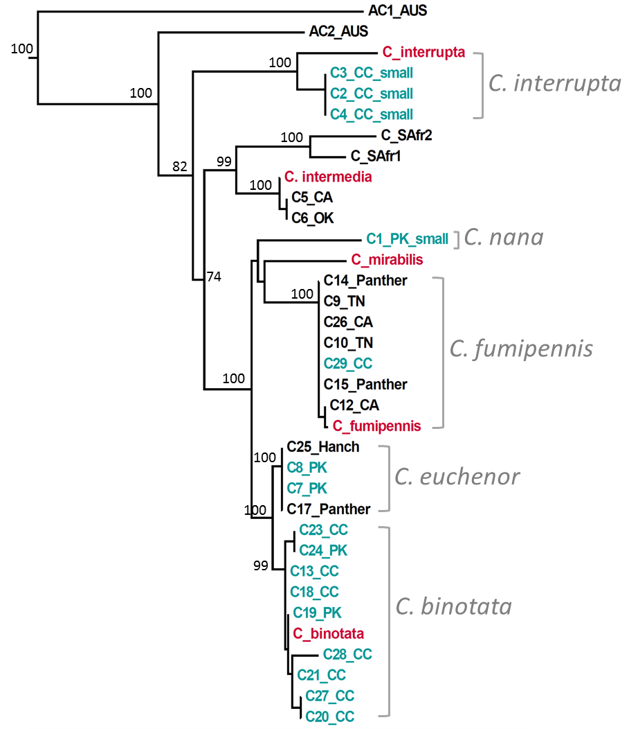
Figure 1: Maximum Likelihood tree of Cylindromyia species. Aqua = specimen from GSMNP; Red = specimen with known species ID. Bootstrap support is shown on significant nodes.
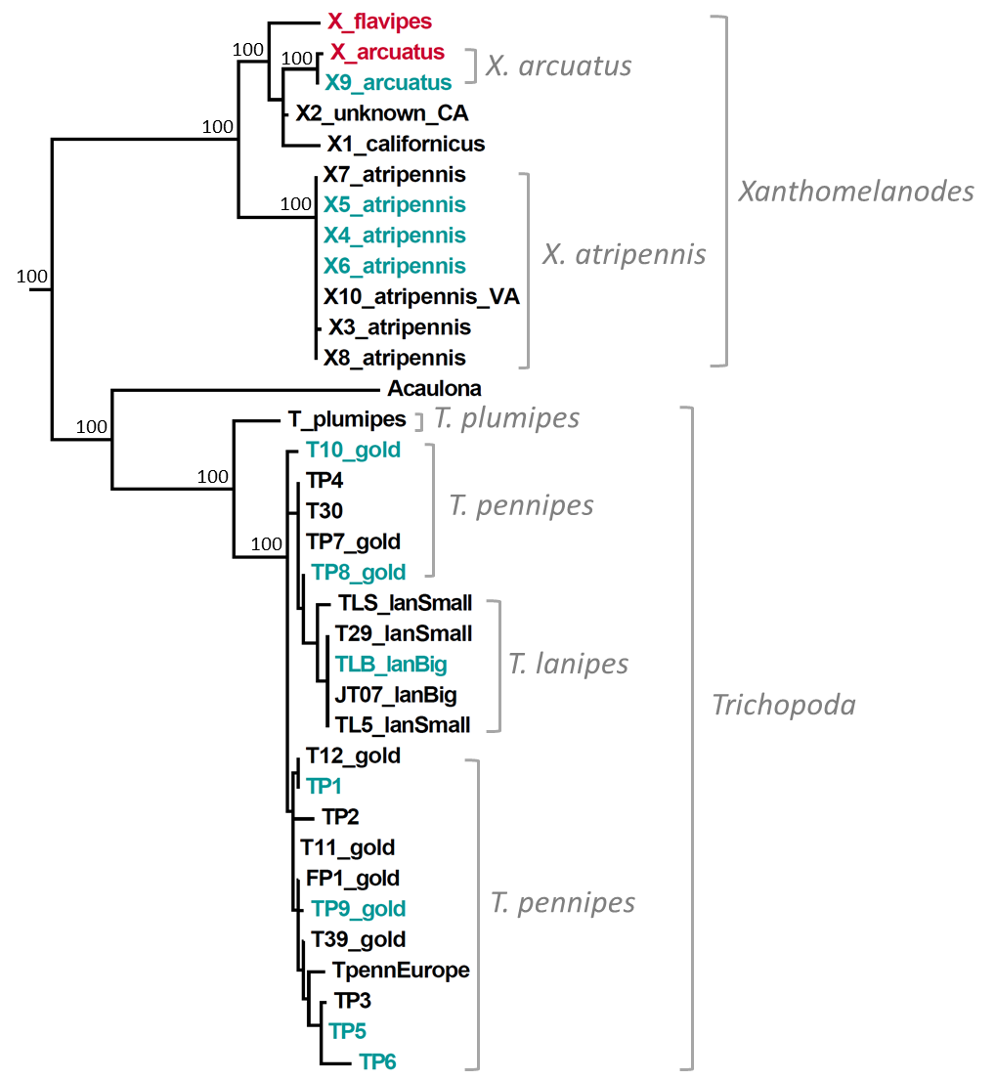
Figure 2: Maximum Likelihood tree of tribe Trichopodini. Aqua = specimen from GSMNP; Red = specimen with known species ID. Bootstrap support is shown on significant nodes.
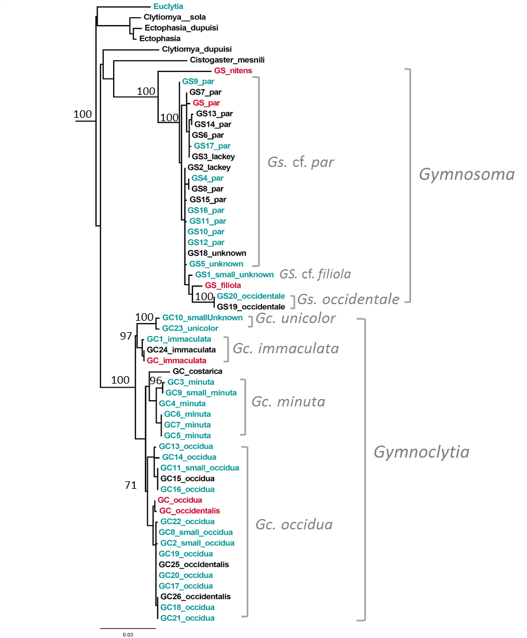
Figure 3: Maximum Likelihood tree of tribe Gymnosomatini. Aqua = specimen from GSMNP; Red = specimen with known species ID. Bootstrap support is shown on important nodes.

References

Arnaud PH Jr. 1978. A Host-Parasite Catalog of North American Tachinidae (Diptera). USDA Miscellaneous Publications. 1319. 860 pp.
Nichols, B. J., and Langdon, K. R. (2007). The Smokies all taxa biodiversity inventory: history and progress. Southeastern Naturalist, 6 (sp2), 27-34.
O’Hara JE, Wood DM. 2004. Catalogue of the Tachinidae (Diptera) of America north of Mexico. Memoirs of the International Entomological Society. 18, 410 pp.
Sharkey MJ. 2001. The all taxa biological inventory of the Great Smoky Mountains National Park. Florida Entomologist, 84 (4), 556-564.
Rahbek, C. (1995). The elevational gradient of species richness: a uniform pattern?. Ecography, 18(2), 200-205.
Davis, C. J. (1964). The introduction, propagation, liberation, and establishment of parasites to control Nezara viridula variety smaragdula (Fabricius) in Hawaii (Heteroptera: Pentatomidae). In Proc. Hawaii. Entomol. Soc (Vol. 18, pp. 369-75).
Reinhard HJ 1956. A synopsis of the tachinid genus Leucostoma (Diptera). Journal of the Kansas Entomological Society 29: 155–168.
Aldrich JM 1926b. North American two-winged flies of the genus Cylindromyia Meigen (Ocyptera of authors). Proceedings of the United States National Museum 68 (Art. 23) [= No. 2624]: 1–27 + 1 pl.
Brooks AR. 1946. A revision of the North American species of the Rhodogyne complex (Diptera, Larvaevoridae). Canadian Entomologist 77 (1945): 218–230.
Brooks AR. 1942. Clistomorpha, Psalidopteryx and allies (Diptera, Tachinidae). Canadian Entomologist 74: 140–150.
Coquillett DW. 1897. Revision of the Tachinidae of America north of Mexico. A family of parasitic two-winged insects. United States Department of Agriculture. Division of Entomology. Technical Series 7: 1–156.
Sun X & Marshall SA. 2003. Systematics of Phasia Latreille (Diptera: Tachinidae). Zootaxa 276: 1–320.
Meier, R., Shiyang, K., Vaidya, G., & Ng, P. K. (2006). DNA barcoding and taxonomy in Diptera: a tale of high intraspecific variability and low identification success. Systematic biology, 55 (5), 715-728.
O’Hara, JR. 2002. Revision of the Polideini (Tachinidae) of America north of Mexico. Studia dipterologica. Supplement 10: 170 pp.
Kearns, C. A. (2001). North American dipteran pollinators: assessing their value and conservation status. Conservation Ecology, 5 (1), 5.
Golec, J. R., Hu, X. P., Ray, C., & Woodley, N. E. (2013). Strongygaster triangulifera (Diptera: Tachinidae) as a parasitoid of adults of the invasive Megacopta cribraria (Heteroptera: Plataspidae) in Alabama. Journal of Entomological Science, 48 (4), 352-354.
Aldrich, J. R., Khrimian, A., Zhang, A., & Shearer, P. W. (2006). Bug pheromones (Hemiptera, Heteroptera) and tachinid fly host-finding1, 2.
Krupke, C. H., & Brunner, J. F. (2003). Parasitoids of the consperse stink bug (Hemiptera: Pentatomidae) in North Central Washington and attractiveness of a host-produced pheromone component. Journal of Entomological Science, 38 (1), 84-92.
Wood, D. M., & Zumbado, M. A. (2010). Tachinidae (tachinid flies, parasitic flies). Manual of Central American Diptera, 2, 1343-1417.
Cerretti, P., O'Hara, J. E., Wood, D. M., Shima, H., Inclan, D. J., & Stireman, J. O. (2014). Signal through the noise? Phylogeny of the Tachinidae (Diptera) as inferred from morphological evidence. Systematic Entomology, 39(2), 335-353.
Miller, M.A., Pfeiffer, W., and Schwartz, T. (2010) "Creating the CIPRES Science Gateway for inference of large phylogenetic trees" in Proceedings of the Gateway Computing Environments Workshop (GCE), 14 Nov. 2010, New Orleans, LA pp 1 - 8.
Stamatakis, A. (2014) RAxML Version 8: A tool for Phylogenetic Analysis and Post-Analysis of Large Phylogenies. Bioinformatics 10.1093/bioinformatics/btu033
Katoh, K., Kuma, K., Toh, H. and Miyata, T. (2005) "MAFFT version 5: improvement in accuracy of multiple sequence alignment." Nucl. Acids Res. 33:511-518.

Appendix I: Identification Keys and Distributions of Eastern Nearctic Species of Phasiinae

The following species keys were used to identify phasiines of eastern North America: Cylindromyia- Aldrich (1926); Gymnosoma and Gymnoclytia- Brooks (1945); Leucostoma- Reinhard (1956); Phasia- Sun & Marshall (2003); Trichopoda- Coquillett (1897); and Xanthomelanodes- Sabrosky (1950). The species names in these keys were cross-referenced against the most recent catalog of North American tachinids (O’Hara & Wood 2004, online revision 2013) and updated to reflect taxonomic revisions and species synonyms since they were first published. All species with entirely western Nearctic distributions were removed to create a more manageable sized geographic-specific key to eastern North American Phasiinae. Summaries of nomenclatural changes begins each new genus in the key below.
Morphological terminology was updated to reflect the most recent terms in dipterology (Wood & Zumbado 2010; Cerretti et al. 2014; O’Hara 2015 pers. com.). A summary of significant vocabulary changes is as follows: sternopleuron/al = katepisternum/al; macrochaetae = bristles; anterior forceps (male) = surstyli; posterior forceps (male) = cerci; last genital segment (Cylindromyia, female) = T8; genital hooks (Cylindromyia, female) = hooks of T8; third antennal segment = postpedicel; apical cell = cell r4+5; pollen (pollenosity) = pruinescence; forceps (Leucostoma, female) = posterior clasping lobes; cheek groove = genal dilation; front = frons.
Tribes are presented alphabetically. Monotypic eastern Nearctic genera do not have individual keys. Distributions of each species can be found following the species keys. These were created by following the official distributions of these species through the literature listed above to the catalog of Sabrosky & Arnaud (1965) and verified in O’Hara & Wood (2004). The distribution maps are essentially a visual representation of the states and ranges listed in the above literature with syntax maintained. New state records for Tennessee and North Carolina are included and verified with a literature search for the species name and the state.
Each of these genera is in need of modern revision both morphologically and molecularly. This key is not meant to be such a revision but merely provides a workable identification key for general entomologists and a foundation for future taxonomic research.

Tribe Catharosiini

Genus Catharosia Rondani, 1868

Distribution of Catharosia in America north of Mexico

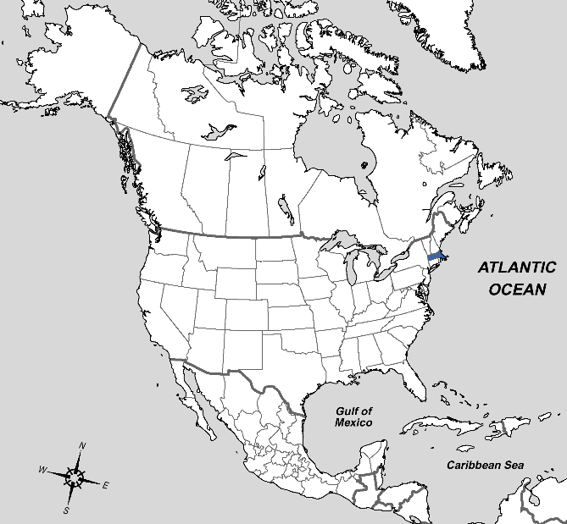
Figure 4: Distribution of Catharosia frontalis Smith, 1917.– Massachusetts.

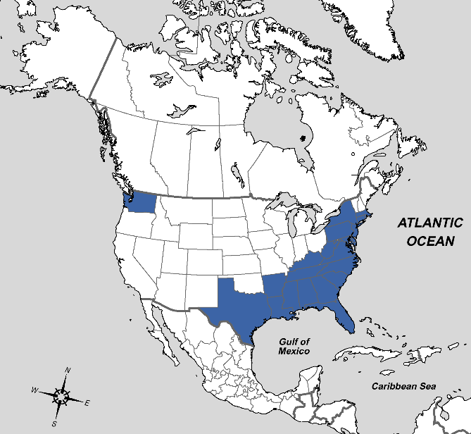
Figure 5: Distribution of Catharosia nebulosa Coquillett, 1897.– Massachusetts to Texas and Florida, Washington.

Tribe Cylindromyiini

Genus Besseria Robineau-Desvoidy, 1830

Distribution of Besseria in America north of Mexico

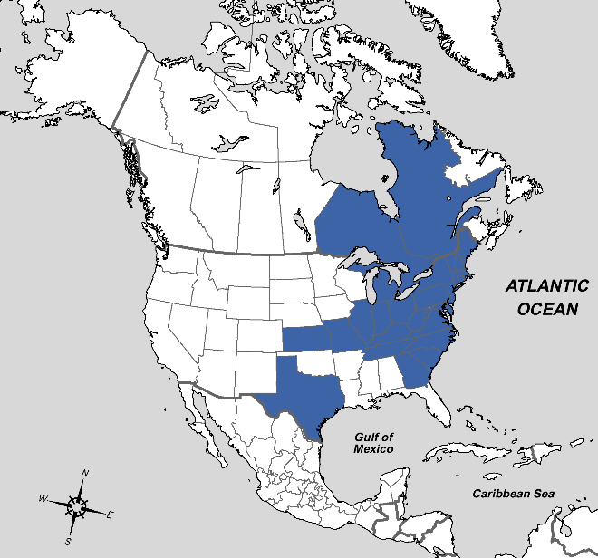
Figure 6: Distribution of Besseria atra Coquillett, 1897.– Québec and Maine to Kansas and Georgia, also Texas, Ontario.

Genus Hemyda Robineau-Desvoidy, 1830

Distribution of Hemyda in America north of Mexico

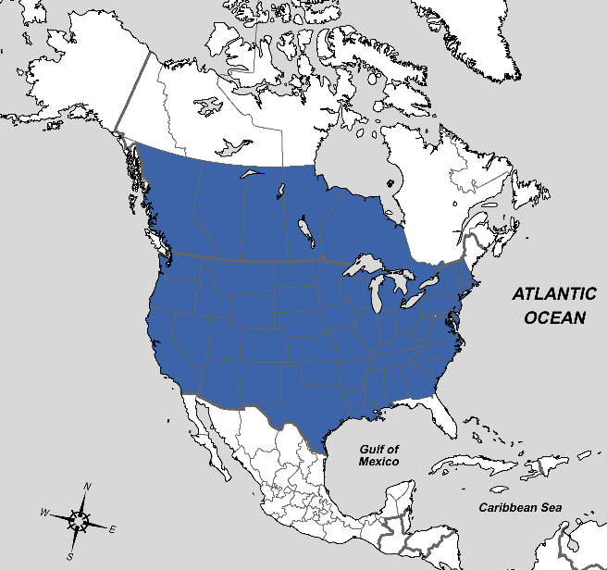
Figure 7: Distribution of Hemyda aurata Robineau-Desvoidy, 1830.– British Columbia to New Hampshire, south to California, Mexico, and Georgia.

Genus Cylindromyia Meigen, 1803

Key to species of eastern Nearctic Cylindromyia

Adapted from Aldrich (1926) including dosiades (=interrupta), nigra (=propusilla), argentea (=binotata), and vulgaris (=fumipennis). Some species can be identified with external morphology, but most require dissecting the genitalia.

1) Scutellum with only one pair of bristles. Abdomen with discal bristles………………………...
………………………………..……………………...…….….Subgenus Neocyptera interrupta

Scutellum with two pairs of bristles- a small crossed apical pair and another much larger pair not far from them. ...……………………………………………….……….…………………...2

Scutellum with three pairs of bristles, the additional pair being near the base at the sides….……………………………………………..…………………………………………..3

2) Abdomen without red on sides, wholly black. Front basitarusus shorter than the four following joints.. …...……………………………………………………………………..……...propusilla

Abdomen broadly red on sides. Female with distinct, symmetrical hooks on T8 which are placed quite far apart. Male with the front basitarsus as long as the following four joints and concave on outer side. Hind tibia villous on inner side.. ……Subgenus Calocyptera intermedia

3) Males ……………………………..…………………………………………………………….4

Females…………………………………………………………………...……………………8

4) Cerci long and soft, basal half swollen, suddenly reduced at middle, the apical portion reaching almost to tips of surstyli……………. ……..…………………………………….……...binotata

Cerci short and greatly swollen, soft and cushion-like but suddenly contracted into a small apical beak. Sternite 6 with a wide, shallow emargination in the middle………….......euchenor

Cerci not as described...……………………………..………………………………………….5

5) Cerci and surstyli yellow, shining, alike in consistency, cerci chitinized. Both small and somewhat concealed by the thin yellow expanded margin of T8.....Subgenus Apinocyptera nana

Cerci much less chitinized than surstyli which are hard and shining ………..…………………6

6) Surstyli broad apically, broader than at the base, subtruncate…………………..….…...armata

Surstyli tapering apically ………………………………………………..……………………..7

7) Cerci short and in profile rather thick, but not strikingly swollen, about half as long as surstyli which are grooved behind at the bend. Back of head with some black hair on each side of the occipital region above ……...……………………………………...………………….….decora

Cerci more than two-thirds as long as surstyli which are not grooved behind at the bend. Back of head with only pale hair inside the orbital row…………..……………………..….fumipennis

8) Third abdominal segment ventrally with large crescent shaped area of short stubby spines on a prominence behind which is a concavity. Terminal hooks of T8 unsymmetrical on only one present ………….………………………………………………..……………………...….nana

Third abdominal segment ventrally lacking such spiny protuberances. Terminal hooks of T8 symmetrical ………………………………………………………………..………………..….9

9) The hooks of T8 attached below a square upper apical shoulder of the segment….…………..10

T8 without such shoulder, sloping down to the hook ………………………….………..…….12

10) Only two katepisternal bristles ………………………………………………………….decora

Three katepisternal bristles …………………………………………………………………....11

11) Hooks of T8 pointing decidedly forward gradually turned upward ..………..………....armata

Hooks of T8 turned upward from base standing close to shoulder the tips divergent………………………………………………………………………..……...euchenor

12) Usually with less than six bristles on fifth abdominal tergite segment. Hooks of T8 small……. .....................................................................................................................................….binotata

With more than six bristles on fifth abdominal tergite. Hooks of T8 large……….….fumipennis

Distribution of Cylindromyia in America north of Mexico

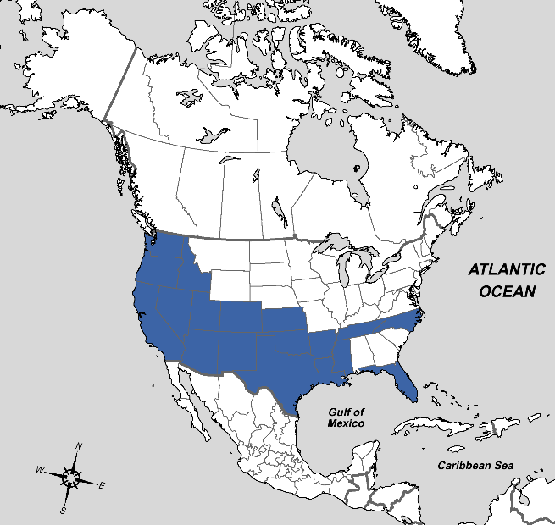
Figure 8 : Distribution of Cylindromyia nana Townsend, 1915.– Washington to Kansas, south to California, Mexico, and Mississippi, also North Carolina, Florida, and Tennessee (new record).
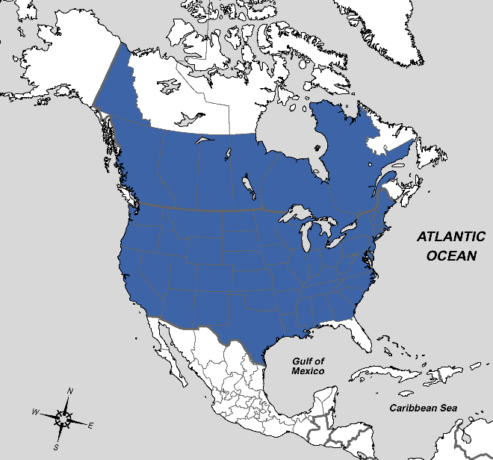
Figure 9: Distribution of Cylindromyia intermedia Meigen, 1824.– Palearctic, British Columbia to Québec and Maine, south to California, Texas, South Carolina, Yukon.

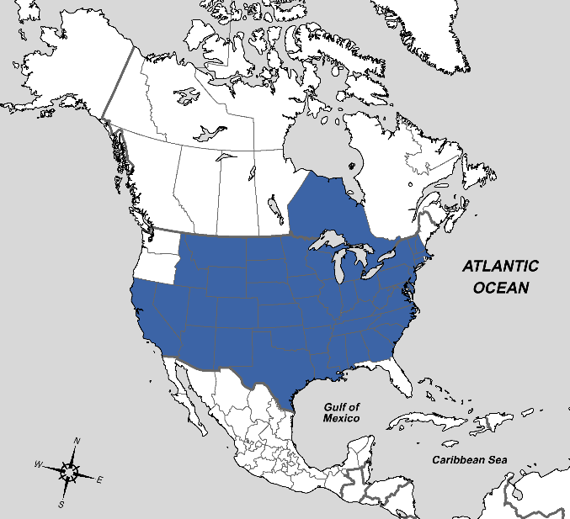
Figure 10: Distribution of Cylindromyia armata Aldrich, 1926.– Montana, California to Kansas and New Mexico, Michigan, Massachusetts to Georgia, Texas, Jamaica, Arizona, Idaho, South Dakota, Ontario, New Hampshire.
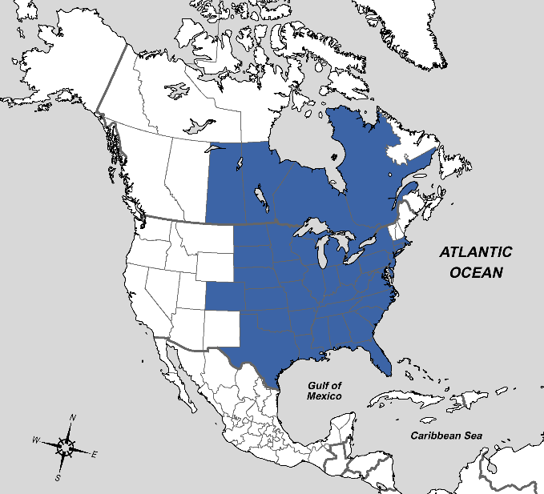
Figure 11: Distribution of Cylindromyia binotata Bigot, 1878.– Manitoba, Colorado and South Dakota to New York, south to Texas and Florida, Saskatchewan, Ontario, Québec, Massachusetts,

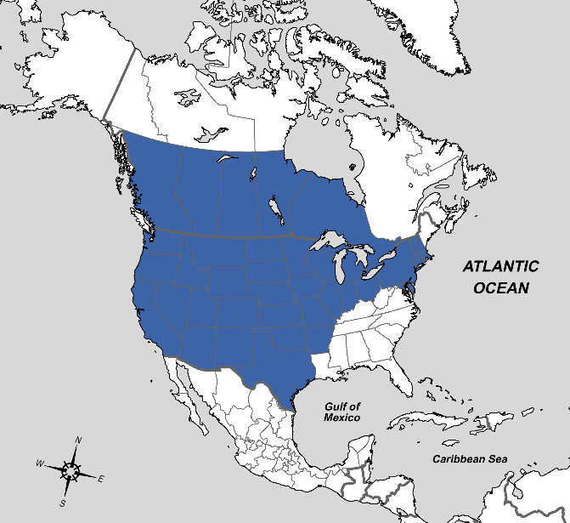
Figure 12: Distribution of Cylindromyia decora Aldrich, 1926.– British Columbia to New Hampshire, Maryland, south to California, Texas, Mexico.
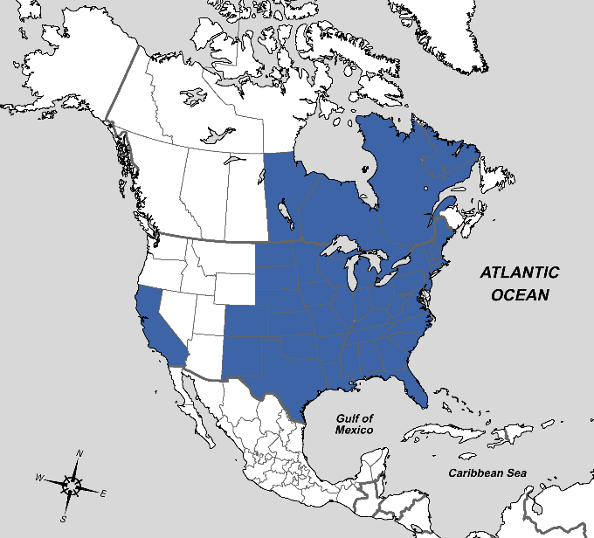
Figure 13: Distribution of Cylindromyia euchenor Walker, 1849.– Minnesota to Newfoundland, south to New Mexico and Florida, also California, Mexico, Manitoba, North Dakota.

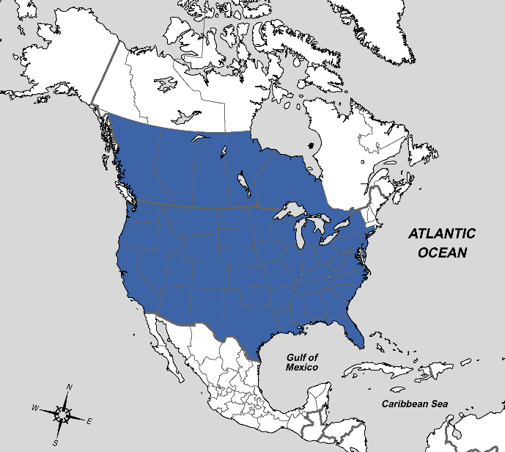
Figure 14: Distribution of Cylindromyia fumipennis Bigot, 1878.– British Columbia to Connecticut, south to California and Florida, Mexico.
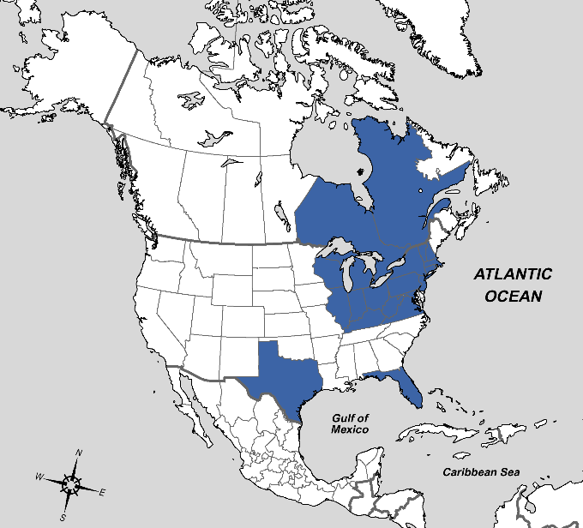
Figure 15: Distribution of Cylindromyia propusilla Sabrosky & Arnaud, 1965.– Wisconsin to Massachusetts, south to Virginia, also Mexico, Texas, Florida, Ontario, Québec, New Hampshire, Kentucky.

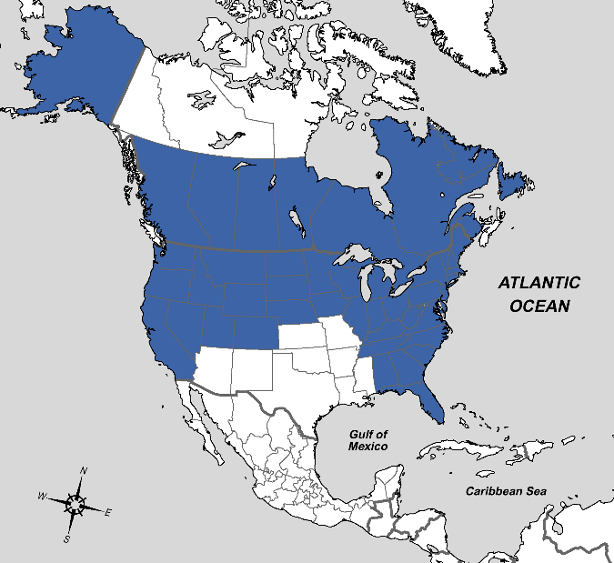
Figure 16: Distribution of Cylindromyia interrupta Meigen, 1824.– Palearctic, Yukon, British Columbia, Wyoming east to New Brunswick, south to Iowa and Florida, California, Nevada, Utah, Colorado, Nova Scotia.

Tribe Gymnosomatini

Key to separating Nearctic Gymnosomatini

1) With marginal bristles on abdomen….…………………………………………………..Euclytia

Without marginal bristles on abdomen.. ..…………..…………………………………………..2

2) Postpedicel elongated, nearly as long as face. Without crossed apical scutellar bristles…………. ……………………………………………………………………………………..Gymnosoma

Postpedicel not elongated, almost oval in shape. With crossed apical scutellar bristles……..……………………………………………………………..…………………Gymnoclytia

Genus Gymnoclytia Brauer & Bergenstamm, 1893

Key to species of eastern Nearctic Gymnoclytia

Adapted from Brooks (1945) as Gymnoclytia (minuta and occidua), Procistogaster (immaculata and unicolor), and Siphopallasia (dubia).

1) Cell r4+5 narrowly open, closed, or with a short petiole which is not longer than the length of the small crossvein. When present, the petiole is bent forward in line with M1. One katepisternal bristle …………………………………………..……………………………………………….2

Cell r4+5 closed with a long petiole distinctly longer than small crossvein, bent forward but not in line with M1 ………………………………………………………..…………………..……3

2) Species about 4mm. Cell r4+5 closed in wing margin. Parafrontal of female with one row of hairs outside the frontal row …………………….………...……………………………...minuta

Species 6-7mm. Cell r4+5 open, closed, or with a short petiole in line with M1. Parafrontal of female with two or more rows of hairs outside the frontal row………………………….occidua

3) Antennae and palpi wholly black. Lower facial margin strongly and abruptly warped forward beyond antennal prominence. One katepisternal bristle ……………………………..…….dubia

Antennae and palpi largely reddish. Lower facial margin not warped beyond antennal prominence. Two katepisternal bristles ………………………………………...………………4

4) Male...…………………………………………………………………..………………………5

Female… …………………………………………………………………………………….....6

5) Postpedicel deep black on apical two thirds. Abdomen wholly reddish with golden or greyish pruinescence .....................................................................................................................unicolor

Postpedicel reddish (dorsal anterior edge sometimes black). Abdomen reddish or with black markings, pruinescence grey/yellow-grey.……………………………………..…...immaculata

6) Postpedicel deep black except at base. Abdomen wholly reddish. Genital segments black. Pruinescence golden or greyish. ......................................................................................unicolor

Postpedicel reddish, dark apically and dorsally. Abdomen partly or wholly black. Pruinescence greyish ........................................................................................................................immaculata
Distribution of Gymnoclytia in America north of Mexico

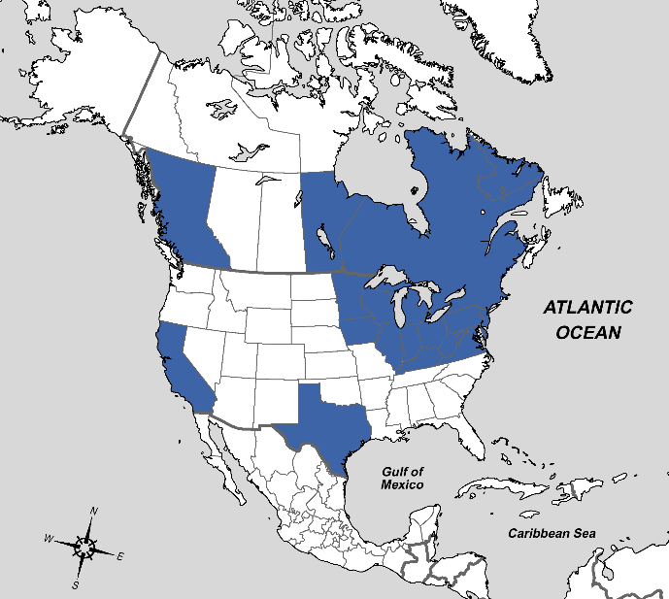
Figure 17: Distribution of Gymnoclytia dubia West, 1925.– Manitoba to Nova Scotia, south to Virginia, also ?California, British Columbia, Texas.

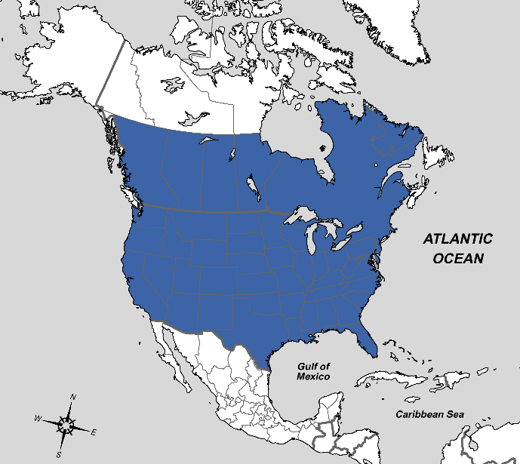
Figure 18: Distribution of Gymnoclytia immaculata Macquart, 1844.– British Columbia to Québec, entire United States, Mexico.

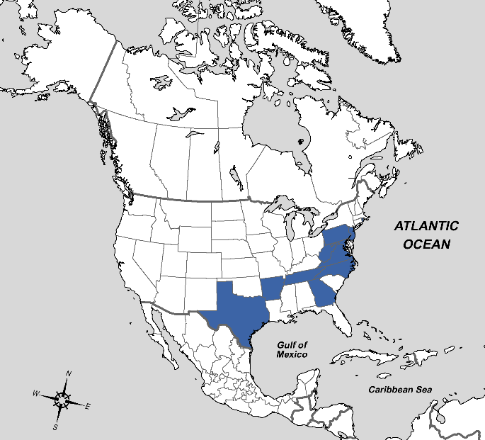
Figure 19: Distribution of Gymnoclytia minuta Brooks, 1946.– New Jersey, District of Columbia, Virginia, Texas, Arkansas, Tennessee, Georgia, North Carolina, Rhode Island.
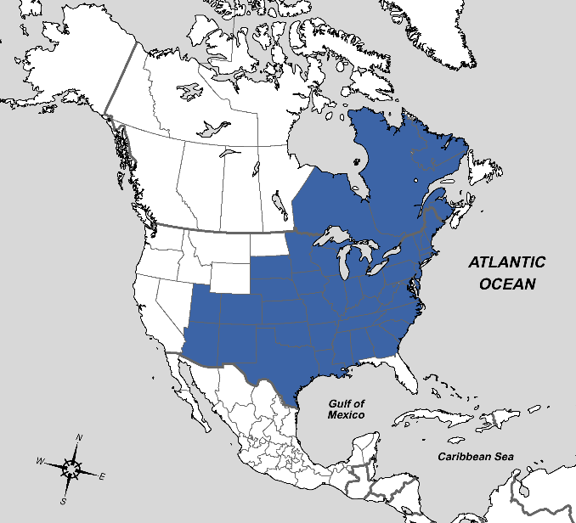
Figure 20: Distribution of Gymnoclytia occidua Walker, 1849.– Michigan to Nova Scotia, southwest to Arizona, Mexico, and Georgia, Illinois to Virginia, Texas.
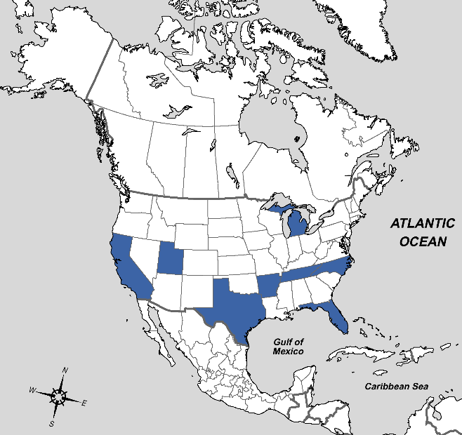
Figure 21: Distribution of Gymnoclytia unicolor Brooks, 1946.– California, Utah, Texas, Arkansas, North Carolina, Florida, Michigan, and Tennessee (new record).

Genus Gymnosoma Meigen, 1803

Key to species of eastern Nearctic Gymnosoma

Adapted from Brooks (1945) as Rhodogyne (occidentalis, canadensis, filiola, fuliginosa, and par). Different keys are provided for males and females. Identification relies almost exclusively on genitalia characters.

Males

1) Species <5mm. Abdomen red with isolated black spots, rarely connected. Surstyli long and narrow, strongly curved dorsally.. ...…………………………………………….…..occidentale

Species >5mm. Surstyli not as above…………………………………………….….…………2

2) Surstyli large and bulky, broadly triangular with a blunt tip, convex to flat dorsally. Abdomen red with small connected spots. 7mm…. …………………………………………….canadense

Surstyli concave to flat dorsally, short triangular or elongate and parallel-sided….…………...3
3) Surstyli long and nearly parallel-sided with a rounded-truncate tip that is slightly turned up. Abdominal spots small and rounded, never connected. 5.5-6.5 mm. ……………………..filiola

Surstyli short triangular…...……………………………………………………………………4

4) Surstyli very broad, short triangular with rounded tip. Abdominal spots rarely connected. 7mm... ...………………………………………………………………………….…………fuliginosum

Surstyli narrower, acute. Abdominal spots usually connected. 5.5-6mm.……………………par

Females

1) Species <5mm. Sternite 8 not triangular, sparsely haired…………………………….occidentale

Species >5mm…...……………………………………….……………………………………..2

2) Cerci very large, curved up at the tips. Sternite 8 large and triangular, evenly haired on the margin. Sternite 9 abruptly constricted before the tip. Abdomen black with at most the narrow lateral edges reddish…………………………………………………………………..canadense

Cerci not curved up at the tips. Sternite 9 not constricted. Abdomen generally red with black spots or triangles…. …………………………………………………………………………….3

3) Sternite 8 not triangular, evenly haired on the margin. Abdomen red with small, isolated black spots. ..…………………………………………………………..…………………………filiola

Sternite 8 triangular and with a bunch of heavier bristles at the apex of the triangle….................4

4) Tergites 6 and 7 mostly black, sternite 9 short and broad, rounded acute. Abdominal spots broadly triangular and widely connected. 5.5-6mm……………………………….…………par

Tergites 6 and 7 mostly red. Sternite 9 longer, equibroad or widened towards the tip. Abdominal spot small, separated or only narrowly connected. 7mm..…………………………...fuliginosum
Distribution of Gymnosoma in America north of Mexico

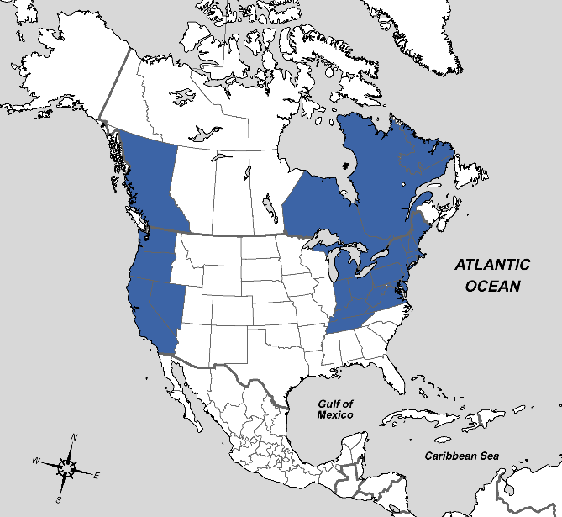
Figure 22: Distribution of Gymnosoma canadense Brooks, 1946.– Michigan to Québec and Nova Scotia, south to North Carolina, also British Columbia to Nevada, California, Tennessee.
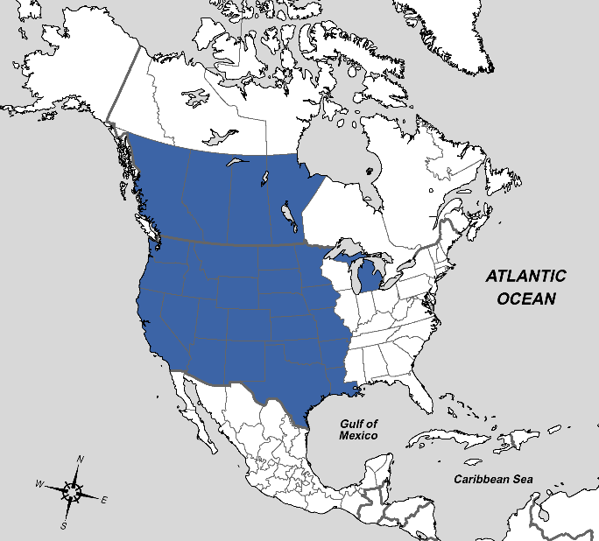
Figure 23: Distribution of Gymnosoma filiola Loew, 1872.– British Columbia to Manitoba, south to California and Louisiana, also Michigan.
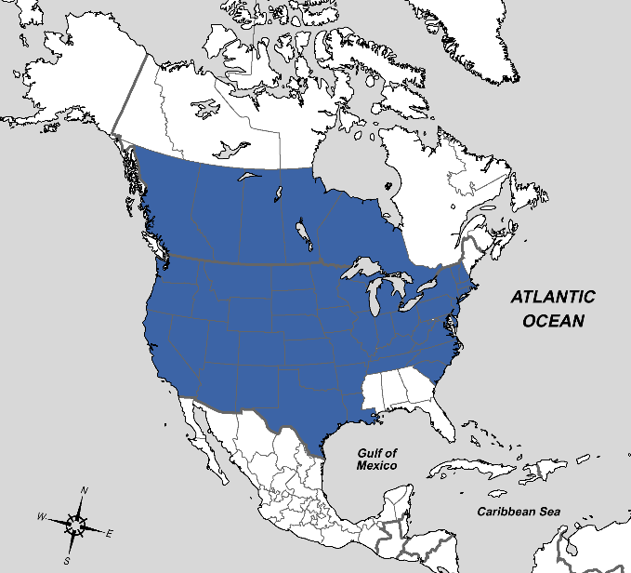
Figure 24: Distribution of Gymnosoma fuliginosum Robineau-Desvoidy, 1830.– British Columbia to New Hampshire, south to California, Mexico, and South Carolina.
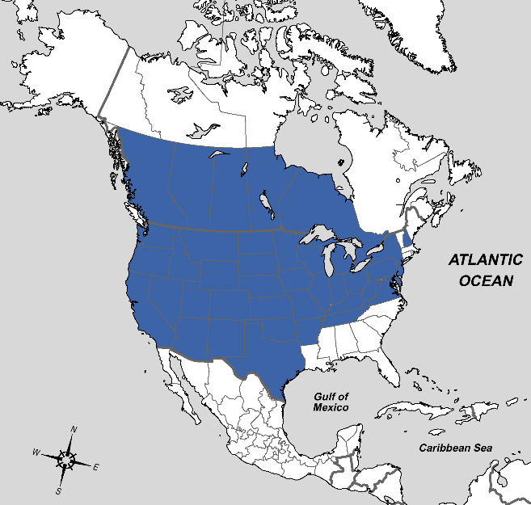
Figure 25: Distribution of Gymnosoma occidentale Curran, 1927.– British Columbia to Ontario, south to California, Texas, and Virginia, New Hampshire, and Tennessee (new record).
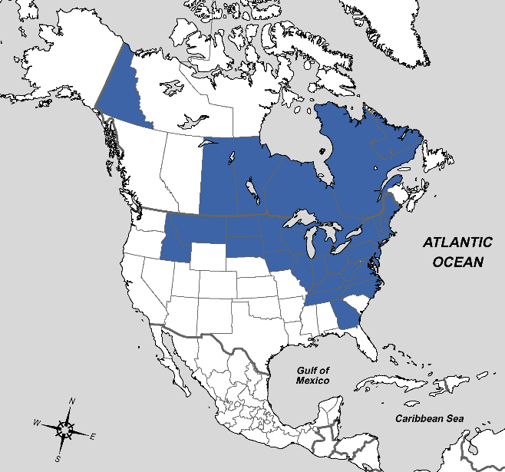
Figure 26: Distribution of Gymnosoma par Walker, 1849.– Idaho, Saskatchewan to Nova Scotia, south to Virginia, also Georgia, Yukon, Tennessee (new record, and North Carolina (new record).

Genus Euclytia Townsend, 1908

Distribution of Euclytia in America north of Mexico

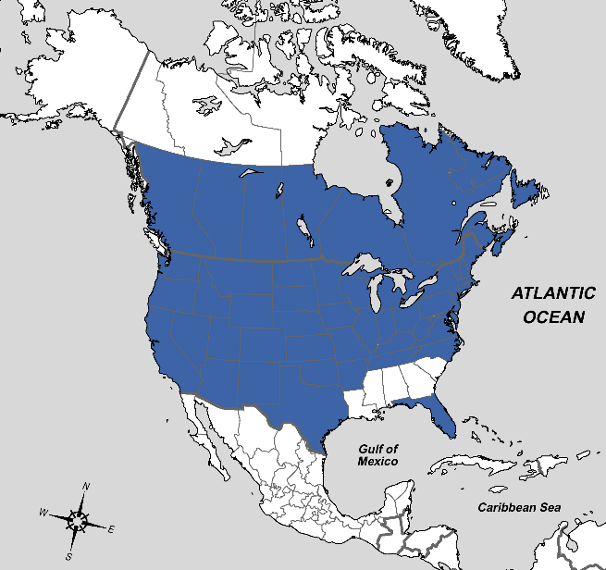
Figure 27: Distribution of Euclytia flava Townsend, 1891.– British Columbia, California to Maine, south to Texas and Virginia, Alberta to Nova Scotia, Labrador, also Utah, Arizona, New Mexico, Florida, and North Carolina (new record).

Tribe Leucostomatini

Genus Leucostoma Meigen, 1803

Key to species of eastern Nearctic Leucostoma

Adapted from Reinhard (1956). Different keys are provided for males and females. Females are easily distinguished from males by the easy to spot posterior clasping lobes at the end of the abdomen.

Males
1) Abdomen without pruinescence, wholly shining. Palpi yellow, postpedicel tinged with red………………………………….………………….…………………………....……simplex

Abdomen with one or more segments pollinose……………………..………………….………2

2) Abdominal pruinescence confined to basal half or less of last three segments. Hairs on intermediate abdominal segments appressed. Head pruinescence silvery. Surstyli tapering sharply to middle leaving a slender curved beak which is as long as broader basal part…acirostre

Abdominal pruinescence not as described above …………….………………..……………….3

3) Fore tibia with two posterolateral bristles. Frontal vitta wider than parafrontal which is lightly dusted with gray pruinescence on a blackish subshiny background. Last three abdominal segments thinly gray pollinose. Calypters not much enlarged …………………………gravipes

Fore tibia with one median posterolateral bristle. Two katepisternal bristles. Abdomen narrowed to apex, last two segments silvery pollinose. Surstyli rather narrow, gradually tapering from base to apex and transversely rounded or convex on hind side ………..……….aterrimum

Females
1) Abdomen longer and narrower than usual, tapering gradually from base to apex. Three katepisternal bristles. Arms of posterior clasping lobes strongly bowed inward and bearing a series of minute teeth on ventral edge on inner margin ………………………………aterrimum

Abdomen ordinary in form, segments two and three much broader than long ...........................2

2) Abdomen with silvery pruinescence on narrow basal margin of intermediate segments. Calypters moderately enlarged, opaque white. Posterior clasping lobes slender, strongly bowed inward and with only fine hairs on inner margin ............................................................acirostre

Abdomen without pruinescence, wholly shining black ...............................................................3

3) Fore tibia with two posterolateral bristles. Calypters not enlarged. Posterior clasping lobes strongly bowed inward with a series of stubby dentations on inner ventral edge…...…...gravipes

Fore tibia with only one median posterolateral bristle. Calypters enlarged. Posterior clasping lobes denticulate on inner margin .....................................................................................simplex
Distribution of Leucostoma in America north of Mexico

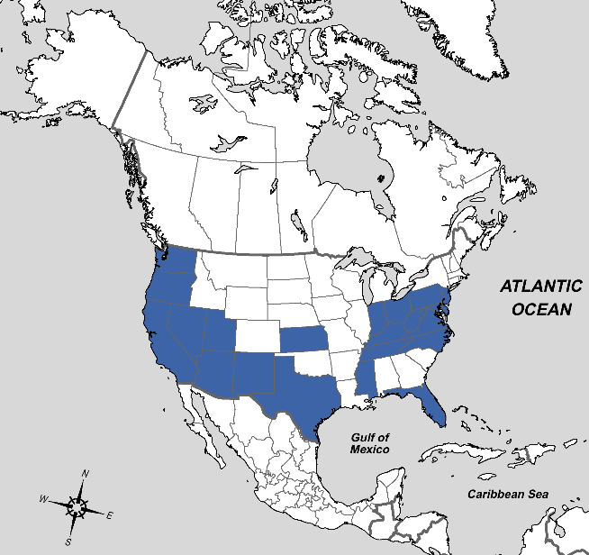
Figure 28: Distribution of Leucostoma acirostre Reinhard, 1956.– Washington to California and Texas, also Indiana to New Jersey and Virginia, Mississippi, Florida, ?Kansas, ?Tennessee.
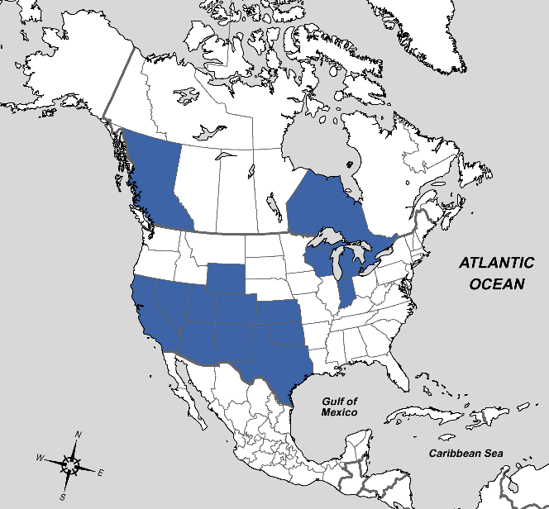
Figure 29: Distribution of Leucostoma aterrimum Villers, 1789.– Europe, California to Wyoming and Kansas, south to Mexico and Texas, also Wisconsin, Michigan, Indiana, British Columbia, Ontario.

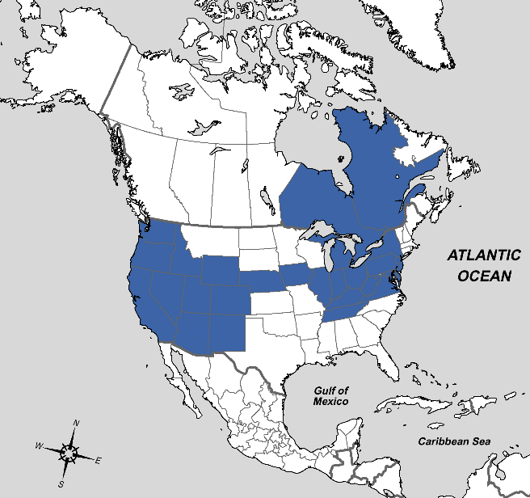
Figure 30: Distribution of Leucostoma gravipes van der Wulp, 1890.– Washington to Nebraska, south to California, Mexico, and Texas, also Michigan to New York, south to Virginia, Iowa, Illinois, Tennessee, Ontario, Québec.
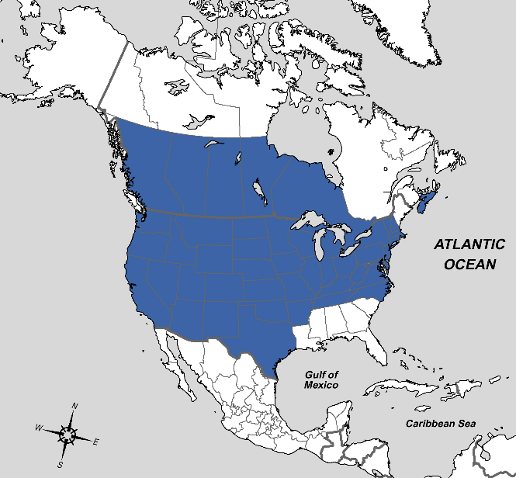
Figure 31: Distribution of Leucostoma simplex Fallén, 1815.– Palearctic, British Columbia to New Hampshire, south to California, Texas, and Virginia, Prince Edward Island.

Tribe Phasiini

Genus Phasia Latreille, 1804
Key to species of eastern Nearctic Phasia

Adapted from Sun & Marshall (2003). Species are first keyed to species-group than keys to eastern Nearctic members of each species-groups are provided.

1) Fronto-orbital plate bare laterally. Lower margin of face weakly to moderately prominent. Sublunular bulla usually not developed. Subscutellum evenly rounded, not extended beyond the scutellar apex. Male without scale-like setae….………………….Phasia pusilla species-group

Fronto-orbital plate haired laterally… ……………………...………………………………….2

2) Fronto-orbital plate densely haired, haired area sometimes reaching eye or nearly so.. …………………………………………………..……………Phasia hemiptera species-group

Fronto-orbital plate with only a few rows of hairs, usually less than 3-4; never reaching eye.. .…………………………………………………..………Phasia subcoleoptrata species-group

Phasia pusilla species-group

1) Hind tibia strongly arched, shorter than hind femur. Presutural supraalar seta absent. Sternite 6 of female extremely long, longer than the total length of the previous sternites……..punctigera

Hind tibia straight or slightly arched, as long as hind femur. Presutural supraalar seta usually present; sternite 6 of female shorter than the total length of other sternites……………………..2

2) Male- dorsum of abdomen with a purple shining area. Female- abdomen greyish yellow pruinose, hair spots very distinct. Sternite 7 long. Frontal vitta less than 1.5 times as wide as Fronto-orbital plate anteriorly..……………………………………….………...…purpurascens

Male- dorsum of abdomen without purple shining area. Surstylus ball-like. Female- abdomen greyish white pruinose, hair spots indistinct. Sternite 7 short..................................……aldrichii

Phasia hemiptera species-group (different keys are provided for males and females)

Males

1) Mesoscutum with a distinct golden pruinose spot, at least on the median postsutural part; tergite 5 with V-shaped golden pruinosity posterolaterally. Lower margin of face strongly projecting, pruinose spot usually limited to postsutural scutum; surstylus straight; distiphallus swollen, not branched………………………………………………………………………………………….aurulans

Mesoscutum evenly pruinose, or with vitta-like pattern; tergite 5 without such pruinosity……2

2) Two or three katepisternal bristles ……………………………………………………………...3

One or fewer katepisternal bristles ..........................................................………………………4

3) M1 meeting R4+5 at acute angle. Syncercus deeply notched posteriorly..………………grandis

M1 meeting R4+5 almost at right angle. Syncercus not or shallowly notched posteriorly… ……………………………………………………………………………..……diversa (in part)

4) Phallus not haired; abdomen always uniformly thinly grey pruinose except syntergite 1+2……………………………………………………………………………...diversa (in part)

Phallus haired; tergites and terminalia not as above. ………………………………….……….5

5) Abdominal tergites clearly transversely grey pruinose; Fronto-orbital plate yellow pruinose; wing not enlarged.…………………………………………………………………..…subopaca

Abdominal tergites shining, or not pruinose as above; Fronto-orbital plate grey or yellow pruinose; wing enlarged or not. Ventrolateral process of distiphallus bent, and hook-like…………………………………………………………………………………...robertsonii

Females

1) Sternite 7 bent, apex directed ventrally. Ovipositor bent, apex slightly or strongly directed ventrally. …………………………………………………………………..……………aurulans

Sternite 7 straight, or bent but apex directed dorsally... ……………………………………….2

2) Posterior margin of sternite 7 rounded or linear in ventral view. Sternite 7 short and wide, boat-like…………………………………………………………………………….……………………diversa

Posterior margin of sternite 7 pointed in ventral view….……………..……………………….3

3) Two katepisternal bristles. Lower margin of face perpendicular. Gena greyish yellow pruinose. Sternite 7 bent upward gradually.………………………………………………………..grandis

One katepisternal bristle. Lower margin of face strongly projecting, visible in profile. ………4

4) Abdomen silvery pruinose, always with black longitudinal vitta; abdomen with black transverse vittae posteriorly (at least tergite 3); sternite 7 thin, triangular, apex pointed……………………….………………….……………………………………..subopaca

Abdomen black, shining purple, or grey (or yellowish grey) pruinose; if pruinosity present, black longitudinal vitta and transverse vitta absent or indistinct. Sternite 7 tapered.……………………………………....………………………………………robertsonii

Phasia subcoleoptrata species-group

1) One katepisternal bristle. Tibia and usually femora yellow, at least tibia. Thorax and abdomen greyish yellow pruinose. Female- Sternite 7 abruptly bent ventrally. ………………...fenestrata

Two or more katepisternal bristles. Legs black. Female- lower margin of face perpendicular, nor projecting.…………………………………………………………...……………...chilensis
Distribution of Phasia in America north of Mexico

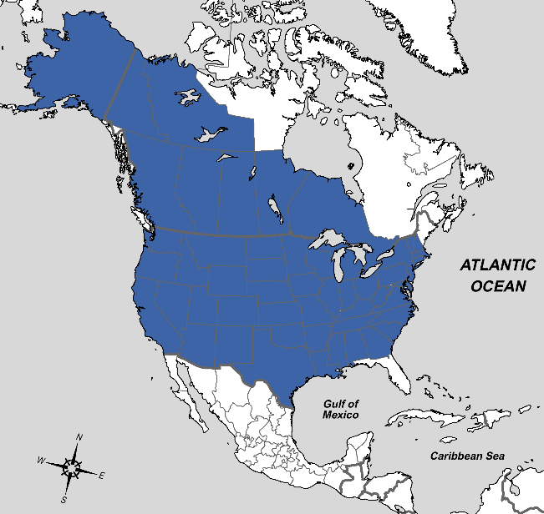
Figure 32: Distribution of Phasia aldrichii Townsend, 1891.– Alaska, Northwest Territories, British Columbia to New Hampshire, south to California, Mexico and Georgia, also Hungary, Russia, Kazakhstan and Mongolia.
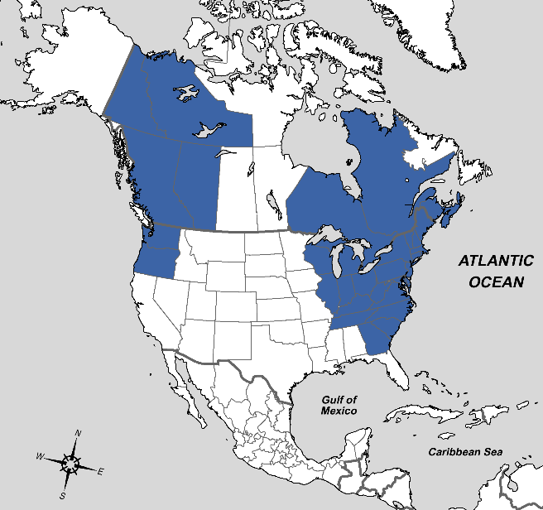
Figure 33: Distribution of Phasia aurulans Meigen, 1824.– Ontario to Nova Scotia, south to Tennessee and Georgia, also Northwest Territories, British Columbia, Alberta, Washington, Oregon
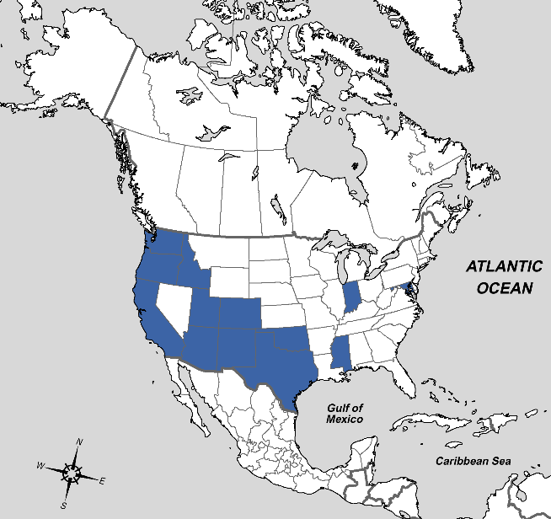
Figure 34: Distribution of Phasia chilensis Macquart, 1851.– Washington, Idaho, Oregon, California, Utah, Arizona, Colorado, New Mexico, Oklahoma, Texas, Mississippi, Indiana, District of Columbia, Maryland, Mexico, South America.
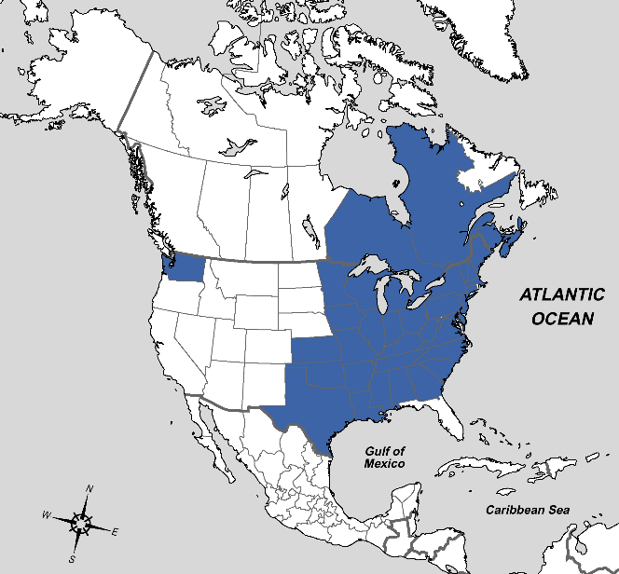
Figure 35: Distribution of Phasia diversa Coquillett, 1897.– Ontario to Nova Scotia, south to Texas and Georgia, also Washington.

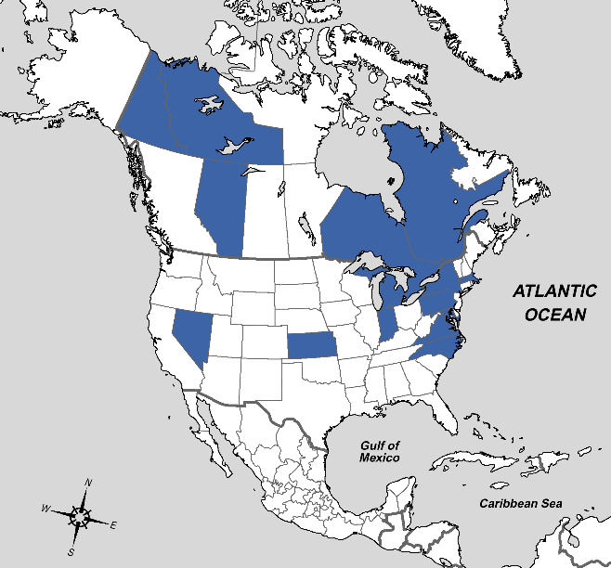
Figure 36: Distribution of Phasia fenestrata Bigot, 1889.– Northwest Territories, Alberta, Nevada, Kansas, Indiana, Michigan, Ontario, Québec, New York, Massachusetts, Pennsylvania, District of Columbia, Virginia, North Carolina.
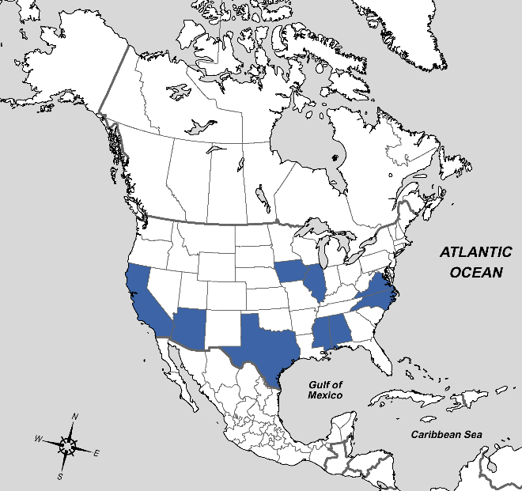
Figure 37: Distribution of Phasia grandis Coquillett, 1897.– California, Arizona, Texas, Mississippi, Alabama, Iowa, Illinois, Virginia, North Carolina.

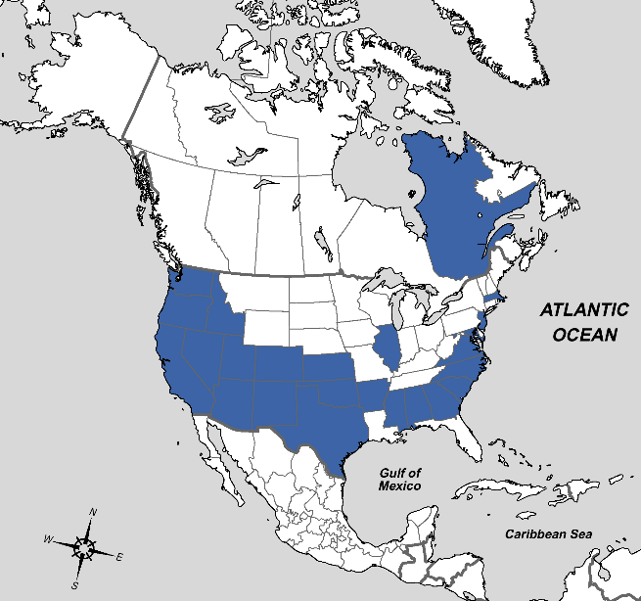
Figure 38: Distribution of Phasia punctigera Townsend, 1891.– Washington, Idaho, Oregon, California, Nevada, Utah, Arizona, Colorado, New Mexico, Kansas, Oklahoma, Texas, Arkansas, Mississippi, Indiana, Québec, Massachusetts, New Jersey, District of Columbia, Maryland, Virginia, North Carolina, South Carolina, Alabama, Georgia, Mexico.

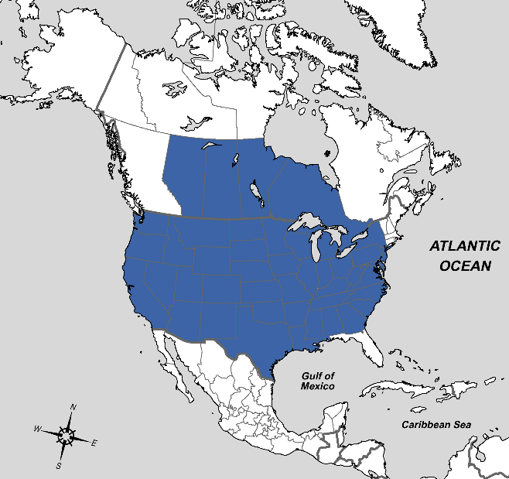
Figure 39: Distribution of Phasia purpurascens Townsend, 1891.– Washington and Alberta to Ontario and New York, south to California and Georgia.
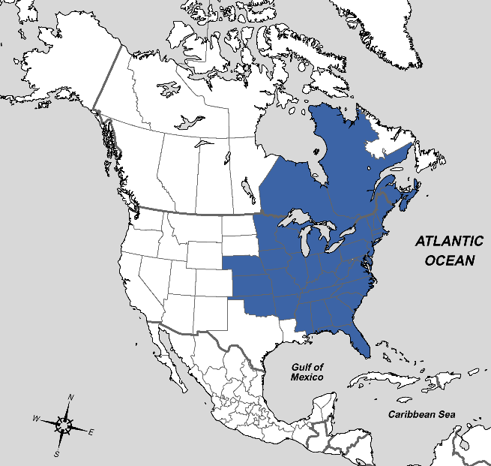
Figure 40: Distribution of Phasia robertsonii Townsend, 1891.– Nebraska, Minnesota and Ontario east to Nova Scotia, south to Oklahoma, Mississippi and Florida.
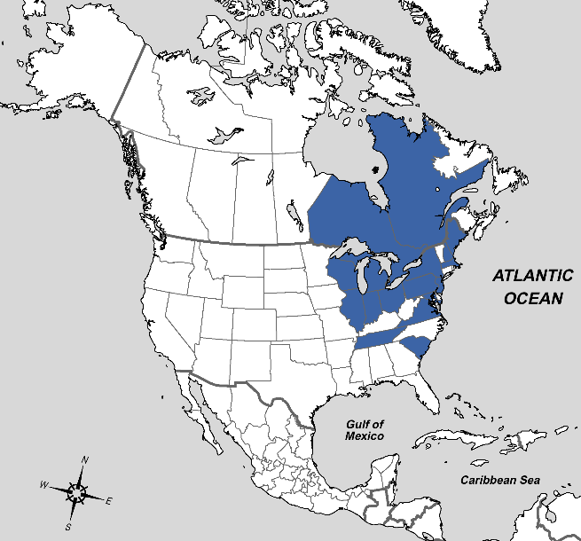
Figure 41: Distribution of Phasia subopaca Coquillett, 1897.– Ontario, Wisconsin, Illinois, Indiana, Michigan, Ohio, Québec, Maine, New Hampshire, New York, Massachusetts, Pennsylvania, New Jersey, Maryland, Virginia, Tennessee, South Carolina.

Tribe Strongygastrini

Genus Strongygaster Macquart, 1834

Key to species of eastern Nearctic Strongygaster

Adapted from Brooks (1942) as Clistomorpha (didyma) and Hyalomyodes (robusta and triangulifera)

1) Cell r4+5 ending in wing margin or extremely short petiolate…………...…………… didyma

Cell r4+5 long petiolate.………………………………………………...…………………….2

2) Parafacials broad (more than 0.5 clypeal length); lower facial margin broadly triangular and warped forward. First abdominal segment with pruinescence. Third aristal segment abruptly enlarged at the base………………………….…………………………………………...robusta

Parafacials narrow (0.2 to 0.25 as wide as distance between vibrissae); lower facial margin not distinct; First abdominal segment without pruinescence..…………………..…..…triangulifera
Distribution of Strongygaster in America north of Mexico

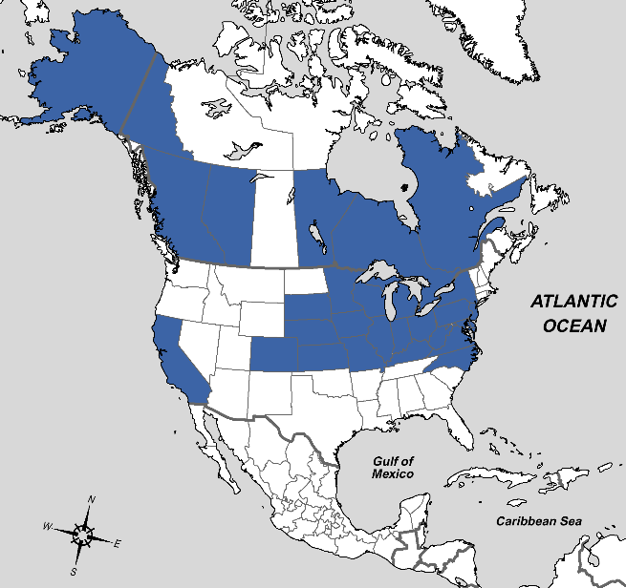
Figure 42: Distribution of Strongygaster didyma Loew, 1863.– California, Alberta, South Dakota to New York, south to Colorado and Virginia, Alaska, Yukon, British Columbia, Manitoba, Ontario, Québec.
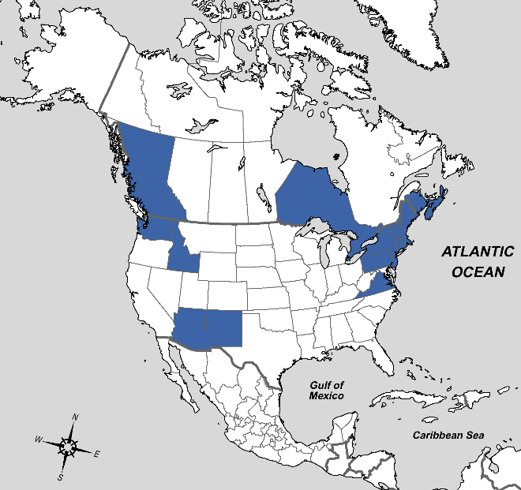
Figure 43: Distribution of Strongygaster robusta Townsend, 1908.– British Columbia, Washington, Idaho, Arizona, New Mexico, Nova Scotia to Pennsylvania, Ontario, New Brunswick, North Carolina.
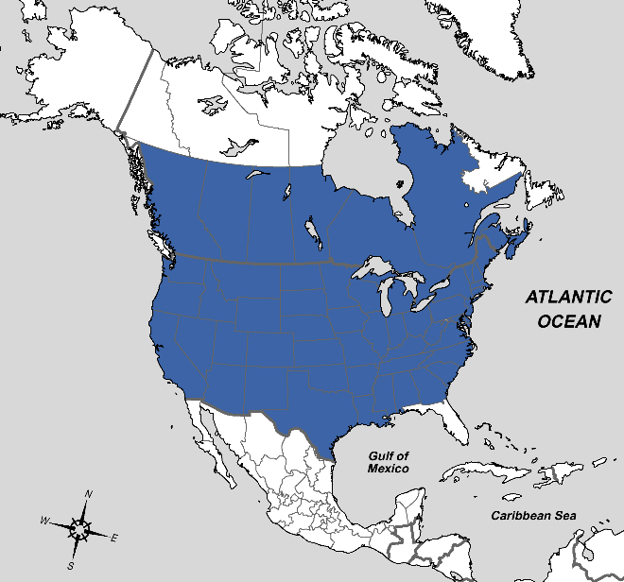
Figure 44: Distribution of Strongygaster triangulifera Loew, 1863.– British Columbia to Nova Scotia, south to California, Mexico, and Georgia.

Tribe Trichopodini

Genus Trichopoda Berthold, 1827

Key to species of eastern Nearctic Trichopoda

Modified from Coquillett (1897) including cilipes (=pennipes) and formosa (=lanipes).

1) Abdomen black with golden pruinose spots.…………………...……………………….plumipes

Abdomen variable, orange to dark brown. Without spotted golden pruinosity… …………..…2

2) Post sutural markings golden, usually a “w” in shape (three longitudinal lines, one transverse), often with similar markings on mesoscutum..……………………………………..……pennipes

Post sutural markings silver, almost always in “u” shape (two longitudinal lines, one transverse).………………………………………………….……………………………lanipes
Distribution of Trichopoda in America north of Mexico

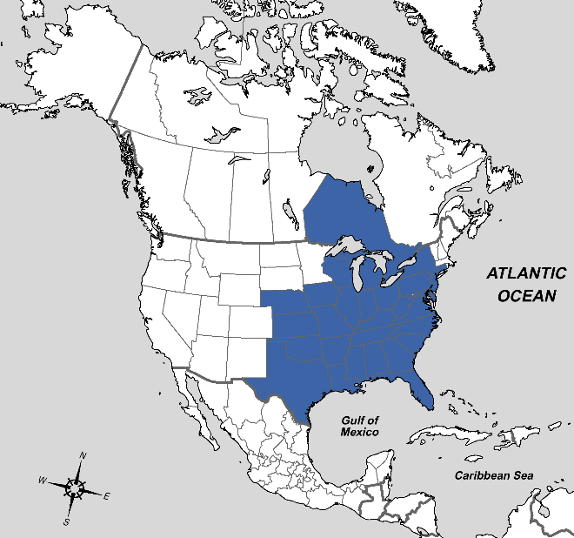
Figure 45: Distribution of Trichopoda lanipes Fabricius, 1805.– Kansas to Connecticut, south to Mexico and Florida, Iowa, Ontario.
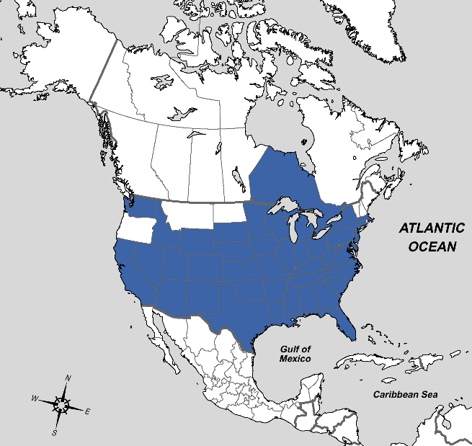
Figure 46: Distribution of Trichopoda pennipes Fabricius, 1781.– Washington (introduced), California to Ontario and Massachusetts, south to Mexico and Florida, Idaho.
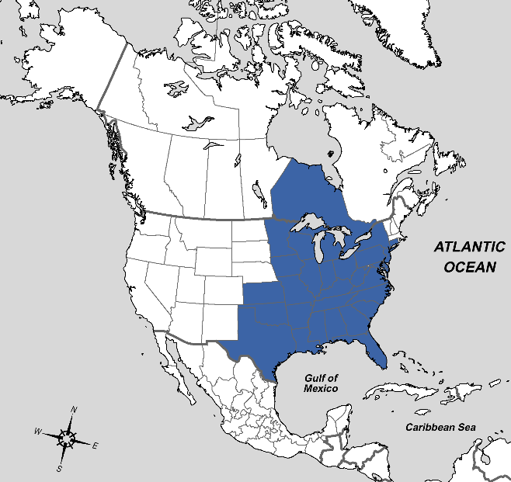
Figure 47: Distribution of Trichopoda plumipes Fabricius, 1805.– Kansas to Connecticut, south to Texas and Florida, Ontario.

Genus Xanthomelanodes Townsend, 1893

Key to species of eastern Nearctic Xanthomelanodes

1) Legs and antennae predominantly orange….………………….………………..……...flavipes

Legs and antennae predominantly black………………………………………..….…… …...2

2) Abdominal segments with distinct black markings on dorsal surface, last two-three segments completely black, usually with three katepisternal bristles. Frons relatively narrow, avg. 0.21 times the width of the head…...……………………………………………………….arcuatus

Abdominal segments sometimes with light black markings on dorsal surface, last two-three segments rarely completely black, usually with two katepisternal bristles. Frons broader, avg. 0.25 times the width of the head….......……………………………………….……atripennis
Distribution of Xanthomelanodes in America north of Mexico

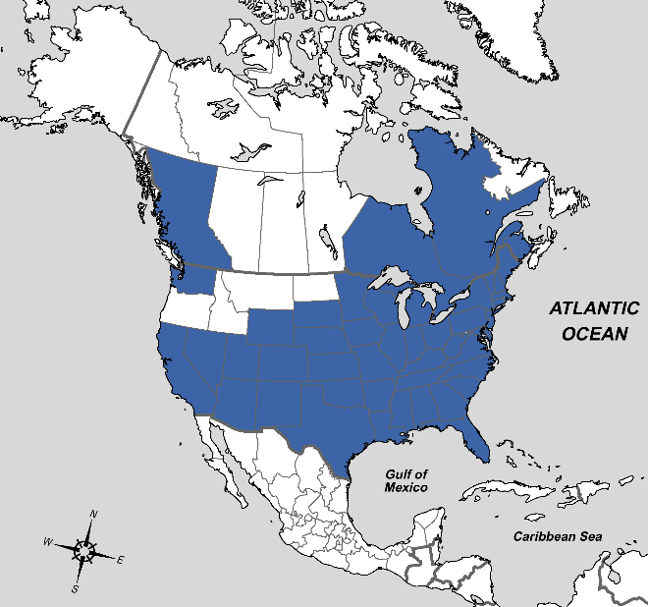
Figure 48: Distribution of Xanthomelanodes arcuatus Say, 1829.– Washington, California to Wisconsin to New Hampshire, south to Mexico and Florida, Ontario to New Brunswick and Maine, also British Columbia.
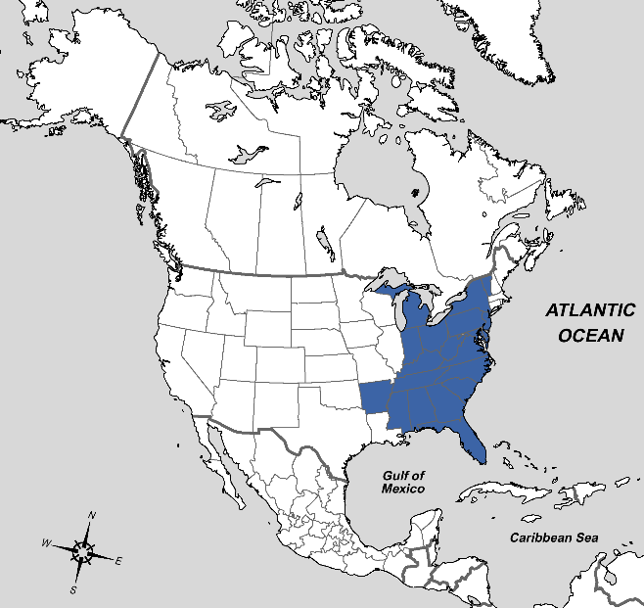
Figure 49: Distribution of Xanthomelanodes atripennis Say, 1829.– Michigan to Vermont, south to Arkansas and Florida, also ?Mexico.
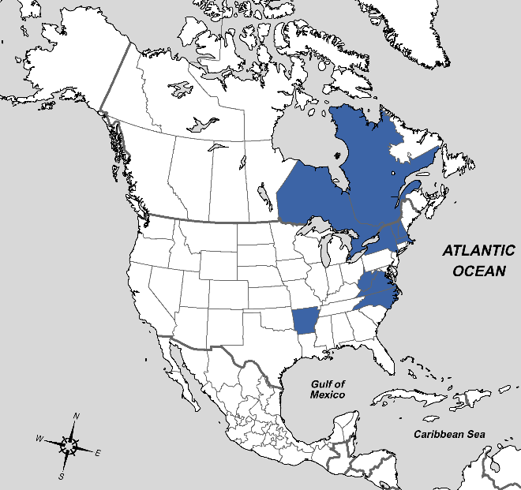
Figure 50: Distribution of Xanthomelanodes flavipes Coquillett, 1897.– Québec, New York, Vermont, Massachusetts, Virginia, Arkansas, Ontario, New Hampshire, West Virginia, Virginia.

Vita
Jane X. Doe was born. She wrote a thesis. She graduated. She followed instructions and wrote her vita in third person and paragraph form (as opposed to a resume or CV), which made her thesis consultant very happy. This page is required.

