Reproduction and bioconfinement of miR156 transgenic switchgrass (Panicum virgatum L.)

A Thesis Presented for the
Master of Science
Degree
The University of Tennessee, Knoxville

Chelsea Renai Johnson
August 2017

Copyright © 2017 by Chelsea Renai Johnson
All rights reserved.

Acknowledgements
I would like to thank Neal Stewart for being an incredible advisor and boss since the beginning of my college career. Also thanks to Reggie Millwood for all your advice, both work related and not. I wouldn’t be the scientist I am today without your guidance. Thanks to Marcus Laxton, Ben Wolfe, and Chance Losher for your friendship and helping keep my sanity these past years. Thanks to my dad, mom, and brother for believing in me. Finally, thanks to Eric for all your love, patience, and laughs.

Abstract
Genetic engineering of switchgrass (Panicum virgatum L.), an emerging cellulosic bioenergy feedstock, has been performed to alter cell walls for improved biofuel conversion. However, gene flow from transgenic switchgrass presents regulatory issues that may prevent commercialization of the genetically engineered crop in the eastern United States. Depending on its expression level, microRNA156 (miR156) can reduce, delay or eliminate flowering, which may be useful to mitigate transgene flow. However, flowering transition is dependent upon both environmental and genetic cues. In this study of transgenic switchgrass, two low (T14 and T35) and two medium (T27 and T37) miR156 overexpressing ‘Alamo’ lines and nontransgenic control plants were used. Growth chamber studies assessed temperature and photoperiod effects on flowering and reproduction across a simulated latitudinal cline. A two-year field experiment was performed to compare flowering, reproduction, and biomass yield in eastern Tennessee, U.S.A.
In the field, medium miR156 overexpression line T37 resulted in the best overall combination of bioconfinement and biomass production. Though line T37 did flower, not all plants produced panicles, and panicle production was delayed in both years. Line T37 also produced fewer panicles, with a 65.9% reduction in year one and 23.8% reduction in year two over controls. T37 panicles produced 70.6% less flowers than control panicles during the second field year with commensurate decreased seed yield: 1205 seeds per plant vs. 18,539 produced by each control. These results are notable given that line T37 produced equivalent vegetative aboveground biomass as controls.
In latitudinal simulation growth chambers, elevated temperatures and decreased daylength promoted flowering of the miR156 transgenic switchgrass lines. As temperatures increased and day lengths decreased, more plants in lines T35, T37, and controls produced panicles. The simulated (Ecuador) tropical conditions were the only chambers in which the flowering phenotypes of all transgenic lines except T27 were ‘rescued’.
These results suggest that miR156 overexpression levels found in transgenic line T37 can be useful for bioconfinement, but the plants can significantly reproduce in tropical conditions, which would enable plant breeding for line improvement. Furthermore, the study suggests additional ways that miR156 can be manipulated to improve both biomass production and bioconfinement.

Table of Contents
Acknowledgements iii
Abstract iv
Chapter 1 : Literature Review 1
Introduction 2
Risk and deregulation of genetically engineered crops 4
Bioconfinement 7
miR156 switchgrass 8
Chapter 2 : Field-grown miR156 transgenic switchgrass reproduction, yield, global gene expression analysis and bioconfinement 10
Abstract 11
Background 11
Results 12
Conclusions 12
Keywords 13
Background 14
Methods 16
Field design and plant materials 16
Biomass and morphological characterization 17
Seed collection and germination 18
Cell wall characterization 18
Transcriptomic analysis 19
Statistical analysis 20
Results 21
miR156 overexpression levels affect flowering timing and reproductive effort 21
Seed germination 22
Aboveground vegetative biomass production and plant morphology 22
Transcriptomic analysis 23
Discussion 24
SPL downregulation causes delayed flowering in the field 25
SPL downregulation results in altered plant phenotype 27
Conclusions 28
Declarations 28
Ethics approval and consent to participate 28
Consent for publication 28
Availability of data and material 29
Competing interests 29
Funding 29
Acknowledgements 29
Chapter 3 : Light and temperature effects on miR156 transgenic switchgrass flowering: a simulated latitudinal study 31
Keywords 33
Introduction 34
Materials and methods 36
Plants, experimental design and growth conditions 36
Plant characterization 37
Statistical analysis 38
Results and discussion 38
Flowering phenotype 38
Biomass and phenotypes 39
Conclusion 41
Acknowledgements 41
Chapter 4 Conclusions 42
List of References 45
Appendices 64
Appendix 1: List of tables 65
Appendix 2: List of figures 79
Vita 93

List of Tables
Table 1. Flowering and reproduction of miR156-overexpressing switchgrass and the nontransgenic control in the field. Lines T14 and T35 have low overexpression of miR156 whereas lines T27 and T37 have moderate levels of overexpression of the transgene. 65
Table 2. Year one (2015) and year two (2016) end-of-season vegetative morphological data and cell wall characterization of miR156-overexpressing switchgrass and the wild-type control in the field. CWR, cell wall residue; S/G, syringyl/guaiacyl. 66
Table 3. Summary of transcriptomic analysis of transgenic lines using gene-specific Affymetrix microarray genechips. SPL, Squamosa Promotor Binding Protein-Like; FT, Flowering Locus T; FTL, Flowering Locus T-Like; FPF, Flowering Promoting Factor; FPFL, Flowering Promoting Factor-Like; PFT, Phytochrome and Flowering Time regulatory protein; AP, Apetala; MADS, MADS-box genes; AGL, Agamous-Like; SEP, Sepallata; LEA, Late Embryogenesis Abundant; SAG, Senescence-Associated Genes; PI, Pistillata; AG, Agamous; STK, Seedstick; SVP, Short Vegetative Phase; DIA, AGL61/Diana; ERD, Early Responsive to Dehydration; SOC, Suppressor of Overexpression of Constans; COL, Constans-Like. 67
Table 4. The minimum, maximum, and average season length, temperature, and photoperiod settings for each of the three growth chamber experiments. Temperature and day length settings were changed weekly to mimic season fluctuation. 76
Table 5. Growth chamber regimes simulated sub-tropical and cool-temperate conditions. Tropical settings were static the entire 52 week period (35/25⁰C day/night temperature, 12:00 hr day length). Some night temperatures reached below 14⁰C (highlighted), but no settings below 14⁰C were used due to growth chamber setting restrictions. 77
Table 6. Phenotypic characterization of miR156 transgenic switchgrass plants under tropical, sub-tropical, and cool-temperate growth chamber settings. 78

List of Figures
Figure 1. Explanation of each step in the tiered test process. Studies usually begin small scale with high exposure and hazard factors (Tier I). As the scale increases, the exposure and hazard levels adjust closer to more natural, expected levels (Tier IV). Adapted from Wilkinson et al. (2003). 79
Figure 2. Images of the field site located in Oliver Springs, Tennessee, USA. A) Google Earth image showing the heavily forested border of the field. Satellite image was taken on March 07, 2017. The red line represents a 20 m length. B) View of the experimental plots from the NE corner facing SW during year two on June 14, 2016. 80
Figure 3. Complete randomized field design for open-flowering miR156-overexpressing transgenic switchgrass in Oliver Springs, TN, USA. In each of the 20 plots, two ‘Alamo’ ST2 clones (X’s) act as pollen recipient plants and are surrounded by 10 pollen donor plants (filled black circles). Donor plants are either one of the four transgenic lines (T14, T35, T27, or T37) or the ‘Alamo’ control (C). Low overexpression lines are labeled in green, and medium overexpression plots are in blue. 81
Figure 4. Representative images of each line in the field. Pictures were taken in year two on August 11, 2016. A) Nontransgenic ‘Alamo’. B) Low overexpression line T14. C) Low overexpression line T35. D) Medium overexpression line T27 surrounding easily visible ST2 nontransgenic plants in the center of the plot. E) Medium overexpression line T37. 82
Figure 5. Time to first flower in the field for miR156 transgenic switchgrass lines and wild-type control. A) Year one (2015) weeks to first panicle emergence for each line after planting on June 05, 2015 (Wk 0). B) Year two (2016) weeks to first flower for each line after plant vegetative growth began on March 30, 2016 (Wk 0). 83
Figure 6. Flower number per panicle in year two (2016). A) Image of closed and open switchgrass flowers. Taken with a Nikon D90, 60 mm micro lens (Nikon USA, Melville, N.Y.). B) Letters represent signiﬁcant differences between means (Fisher’s LSD, P < 0.05). Error bars represent standard error of the means. P = < 0.0001. 84
Figure 7. Number of seeds produced by plant for each transgenic line. Lines include the control (C), low miR156 overexpression lines (T14 and T35), and medium miR156 overexpression lines (T27 and T37). A) Capital letters represent significant differences between means in year one (2015) (P = <0.0001), and lowercase letters represent significant differences between means in year two (2016) (P = <0.0001; Fisher’s LSD, P < 0.05). Error bars represent standard error of the means. B) Visual representation of the average number of seeds produced per plant in year two (2016). Penny used for scale. 85
Figure 8. End-of-season dry biomass and height of miR156 transgenic switchgrass and control field grown in East Tennessee for two years. Capital letters represent significant differences between means in year one (2015), and lowercase letters represent significant differences between means in year two (2016) (Fisher’s LSD, P < 0.05). Error bars represent standard error of the means. Year one growing season took place from June 05 – November 24, 2015. Year two growing season took place from March 30 – November 18, 2016. A) Dry biomass of both vegetative and reproductive tissues. Year one P = 0.0066; year two P = <0.0001. B) Dry biomass without panicles. Year one P = 0.002; year two P = <0.0001. C) Tallest part of the plant before panicle removal. P = <0.0001 for both years. D) Plant height after panicle removal. P = <0.0001 for both years. 86
Figure 9. Relative mature miR156 expression results from qRT-PCR. The expression level of miR156 was normalized using miR390 expression. Combined leaf and tiller tissue from V3 stage tillers were used for mRNA extraction. Letters represent signiﬁcant differences between means (Fisher’s LSD, P < 0.05). Error bars represent standard error of the means. P = 0.0103. 87
Figure 10. qRT-PCR results of combined V3 tiller and leaf tissue using the PvSPL primers. Error bars represent ± standard error of the means. No significant differences were found between means of any of the four target SPL genes. A) SPL1 expression (P = 0.7374; ANOVA). B) SPL2 expression (P = 0.4402; ANOVA). C) SPL3 expression (P = 0.8544). D) SPL6 expression (P = 0.7508; ANOVA). 88
Figure 11. Growth chamber study with a randomized complete block design. Each experiment was replicated in two growth chambers, and each contained four replicates of each line. Lines are color-coded, which include a nontransgenic control (C) shown in black, low overexpression lines T-14 and T-35 (blue), and two medium overexpression lines T-27 and T-37 (green). A) Arrangement of pots from beginning of the season to mid-season. B) Pots were re-arranged in a different randomized design from mid-season to end of season. 89
Figure 12. Time to first flower and number of plants flowering throughout the A) tropical, B) sub-tropical, and C) cool-temperate growing seasons. Lines labeled in blue (T-14 and T-35) represent low miR156 overexpression, and lines labeled in green (T-27 and T-37) represent medium miR156 overexpression. 90
Figure 13. Biomass production per pot of miR156 transgenic switchgrass and controls grown in tropical, sub-tropical, or cool-temperate conditions. Error bars represent SE. Letters denote statistical differences within each growth condition at P = 0.05, Fisher’s LSD. 91
Figure 14. Switchgrass lines overexpressing miR156 at Low (T-14 and T-35) and medium (T-27 and T-37) levels and nontransgenic ‘Alamo’ control plants grown in three different climate simulations. 92

: Literature Review

Introduction
Pollen-mediated transgene flow from plants has been a topic of concern since the 1990s, the era of pre-and post-commercialization of transgenic crops. Pollen dispersal depends on multiple environmental factors such as wind speed and direction, temperature, humidity, and the location and density of related plant populations (Beckie and Hall 2008). The reproductive biology of both the crop and nearby congeners are also important and include features such as the timing and perpetuation of flower production, pollen viability and longevity, pollen size, and mode of pollen dispersal (Chandler and Dunwell 2008; Beckie and Hall 2008). Many cases of gene flow and hybridization between transgenic crops and sympatric weedy relatives, progenitors, or nontransgenic fields have been documented, such as with rice (Oryza sativa) (Chen et al. 2004; Messeguer et al. 2001; Song et al. 2003; Gealy et al. 2003), members of the Brassica genus or Brassicaceae family (Warwick and Martin 2013; Knispel et al. 2008; Hansen et al. 2001; Beckie et al. 2003; Warwick et al. 2008; Warwick et al. 2003; Hall et al. 2000; Rieger et al. 2002), lettuce (Lactuca sativa) (Giannino et al. 2008; Hooftman et al. 2005), and carrot (Daucus carota Apiaceae) (Mandel et al. 2016) to name a few. If the transgene provides fitness-enhancing benefits, hybrids could have negative ecological impacts on local plant communities by altered competitive plant interactions, possible extinction of species populations, or the development of weedy populations (Raybould and Gray 1994; Stewart et al. 2003; Mannasse 1992; Ellstrand et al. 1999; Kwit et al. 2011). Transgene introgression is also a risk. The occurrence of introgression depends on multiple factors such as fitness advantages from either intended or unintended effects of the transgene, strength of environmental selection pressures, pollinator overlap, the location of planting, and natural selective advantage traits associated with the crop or its weedy relatives (Chandler and Dunwell 2008; Stewart et al. 2003; Chapman and Burke 2006; Kwit et al. 2011).
Examples of gene flow can be found in grass crop species. Grasses are notorious for their high amounts of gene flow because they commonly have a perennial life-cycle, are obligate outcrossers, and produce small pollen grains that can travel long distances via wind (Kausch et al. 2010). Many cases have been documented that describe the scope of gene flow in grasses. Studies on herbicide resistant creeping bentgrass (Agrostis stolonifera) have shown successful hybridization with related wild species such as Agrostis capillaris, Agrostis castellana, Agrostis gigantea, and Agrostis exarata at distances between 2 - 3.8 km, and creeping bentgrass pollen can travel up to 21 km (Belanger et al. 2003; Watrud et al. 2004; Reichman et al. 2006). Controlled field studies have also been conducted for both herbicide resistant annual ryegrass (Lolium rigidum) (Busi et al. 2008) and herbicide resistant barnyardgrass (Echinochloa crus-galii) (Bagavathiannan and Norsworthy 2014). Ryegrass pollen can travel up to 3 km from an experimental source plot (Busi et al. 2008). Barnyardgrass gene flow decreased exponentially as distance increased, but pollen was still detected at 50 m (Bagavathiannan and Norsworthy 2014). These studies show that pollen mediated gene flow in grass species can occur at far distances.
While the grass species above are mainly grown for turf or forage, there are other grass species that are candidates for widespread cultivation as biofuel feedstocks. One such grass is switchgrass (Panicum virgatum). Switchgrass is a North American perennial grass that has been the subject of intensive research as a biofuel feedstock because of its large biomass and energy production, amenability to be grown on marginal lands not conducive for growing row crops, conservative nutrient usage, and low input needs (Parrish and Fike 2005; McLaughlin and Kszos 2005; Sage et al. 2015). Under field conditions it has been observed that transgenic switchgrass pollen can travel at least 100 m and is viable for pollination (Millwood et al. 2017). Models suggest switchgrass pollen can travel as far as 6.5 km under certain wind conditions (Ecker et al. 2013). Switchgrass pollen can also remain viable for 20 – 150 minutes depending on atmospheric conditions (Ge et al. 2011). Taken together, these studies suggest that switchgrass could be a significant vector for transgene spread under relevant agricultural environments.
Although many traits of switchgrass are favorable for bioenergy production, its cell walls contain high levels of lignin that interfere with cell wall degradation and subsequent biofuel production (Nigam and Singh 2011; Yang and Wyman 2008). It is becoming apparent that switchgrass will likely require altered cell wall chemistry, at least a decrease in lignin, to lower the economic barrier for effective processing of switchgrass biomass into biofuels. Moreover, genetic engineering is likely required to significantly change cell walls toward that end (Gressel 2008; Fu et al. 2011; Shen et al. 2013; Wuddineh et al. 2016). The likelihood of gene flow from transgenic switchgrass might trigger regulatory positions that could jeopardize commercialization of genetically engineered germplasm, at least in eastern North America where switchgrass is indigenous (Raghu et al. 2006; Stewart 2007; Kwit and Stewart 2012). Therefore, the elimination or mitigation of gene flow may be required for deregulation of transgenic switchgrass (Kausch et al. 2010; Sang et al. 2013).

Risk and deregulation of genetically engineered crops
Risk is generally defined as the probability of both hazard and exposure, where a hazard is any trait that may cause adverse effects, and exposure is the release of the hazard into the environment (Risk = Probability [Hazard x Exposure]) (Johnson et al. 2007; Andow and Zwahlen 2006; Wilkinson et al. 2003). Both hazard and exposure must occur or be probable for risk to transpire. Risk is specifically determined for each transgenic plant on a case-by-case basis because the hazard and exposure depend on the transgene phenotype, transgene composition on a molecular level, target plant, and area of desired cultivation (Craig et al. 2008; Auer 2008).
Genetically engineered (GE) crops are put through the most exhaustive and comprehensive safety assessment of any other crop in history; they must pass an extensive multistep risk analysis to ensure consumer and environmental safety before they can be commercially produced (Prado et al. 2014). First, to ensure all putative GE crop trait hazards have been tested, scientific experiments are carried out and generally follow a tiered framework (Figure 1) (Raybould and Cooper 2005; Wilkinson et al. 2003). This framework begins with hazard identification and small-scale lab experiments to identify and assess the probability of adverse effects occurring; it ends after large-scale greenhouse and field studies are conducted to quantify the amount of risk associated with the transgene (Wilkinson et al. 2003; Andow and Zwahlen 2006). If the results from the tiered tests show a low probability of adverse effects, the GE crop begins the process of deregulation which starts with an environmental risk assessment (ERA). The ERA uses information gathered during the research stages to determine whether introduction of the transgene into the environment can increase the risk of ecological harm, increase the plant susceptibility to pests, or enhance the weedy characteristics of the plant (Prado et al. 2014). ERA results are used to determine (1) if the plant is safe for release (no/low risk), (2) what kind of management practices should be applied (moderate risk), or (3) if approval of the crop should be withheld (high risk) (Craig et al. 2008). If any portion of the crop will be consumed by livestock or humans, a food and feed safety assessment will also be performed. This involves a comparison of the transgene, both its amino acid sequence and the protein encoded, to human and animal allergens and toxins to screen for similarities (Prado et al. 2014).
Plant fitness could also be increased when the transgene is combined with certain inherent characteristics of the target plant, especially if those traits are associated with weediness. Weedy traits include 1) the ability to germinate in many environments, 2) the ability to reproduce by seed or vegetative tissues, 3) seed dormancy and longevity, 4) rapid growth/phase change and continuous seed production, 5) self-compatible reproduction, 6) multiple methods of pollination if cross-pollinated, 7) small pollen produced in large amounts, 8) a large, fibrous root system, and 9) a high photosynthetic rate (Baker 1965; Stewart 2004). These weedy traits have been removed from most food crops over years of selective breeding; however, plant species that have gained popularity for use as biofuels are often not highly domesticated and thus display many of these weedy traits (Raghu et al. 2006). In fact, the very traits that cause these plants to be considered weedy are the traits that make them useful as biofuel crops (Raghu et al. 2006). Switchgrass shows promise as a biofuel feedstock because of its ability to be vegetatively propagated, ability to grow on marginal land in various environments, rapid growth, and large root system; all of these traits are also considered to be weedy characteristics. These weedy traits, whether inherent or enhanced by the presence of a transgene, may be desired for a biofuel crop, but their dispersal into the environment is not because of hard to predict and potentially negative environmental effects.

Bioconfinement
Many methods have been proposed that could lower or eradicate gene flow in transgenic crops. Field isolation, fences, border plants, or flower removal could be used to reduce or eliminate pollen dispersion, but these methods are often labor and cost intensive (Moon et al. 2010). A biological mode of confinement (bioconfinement) is thought to be the most efficient technique. Many approaches have been tested (reviewed in Moon et al. 2010; Liu et al. 2013; Sang et al. 2013; Ding et al. 2014; Gressel 2015) and include methods such as pollen- and seed-specific sterility (Pedersen et al. 2003; Ishimaru et al. 2006; Kobayashi et al. 2006; Wang et al. 2012; Millwood et al. 2016), transgene excision (Zhang et al. 2003; Luo et al. 2007; Moon et al. 2011), and a delayed or non-flowering phenotype (Chuck et al. 2011; Fu et al. 2012; Jensen et al. 2013). A highly efficient engineering-based mechanism was described in Millwood et al. (2016). In this case, engineered tobacco (Nicotiana tabacum) expressed the restriction endonuclease EcoRI under a pollen specific promoter. Pollen ablation occurred in cells expressing EcoRI, and this method resulted in over 99-100% transgene bioconfinement via selective plant male sterility (Millwood et al. 2016). Using tobacco as a model, transgene excision in pollen was tested using a CinH-RS2 recombination system (Moon et al. 2011). Plants were engineered to express a green fluorescent protein (GFP) in pollen which the CinH-RS2 recombination system was designed to excise (Moon et al. 2011). In three transgenic events, less than 1% of the pollen produced expressed GFP when CinH-RS2 was present (Moon et al. 2011). While these two bioconfinement methods would be useful for crops where seed production is vital, biofuel feedstocks grown solely for their biomass and would benefit more from a delayed or non-flowering phenotype because it has the potential to reduce gene flow while simultaneously boosting biomass production (Jakob et al. 2009; Kwit et al. 2011). This idea is supported in a study focused on the biofuel grass Miscaunthis sacchariflorus, a parent of the hybrid Miscanthus x giganteus, in which a delay of flowering for 61 days resulted 52% more biomass (Jensen et al. 2013). With this in mind, it is possible that a non-flowering phenotype could lead to increased biomass with the added benefit of no gene flow via pollen. Seed production would likely be reduced if flowering overlap and/or seed maturation time were decreased, and no seeds would be produced if flowering did not occur. For some crops a nonflowering phenotype would pose a problem because seeds would be required planting the next year, but because switchgrass can be vegetatively propagated, a switchgrass field could be transplanted. Switchgrass is also a perennial, so the field would not need to be re-planted the next season. If flowers were needed for breeding purposes, it is possible flowering and seed production might be performed in latitudes outside of the switchgrass production zone (Balasubramanian et al. 2006; Sherry et al. 2007; McClung et al. 2016).

miR156 switchgrass
A delayed or non-flowering phenotype can be achieved by overexpressing microRNAs (miRNAs) that are involved in regulating the vegetative-to-floral transition. Previous research has generated switchgrass lines that overexpress the maize (Zea mays) gene Corngrass1 (Cg1), a member of the miR156 class of miRNAs (Chuck et al. 2011). During this study, no transgenic lines flowered during the two-year field study, and low Cg1 overexpression resulted in higher biomass production and saccharification efficiency (Chuck et al. 2011). In a separate study, Fu et al. (2012) engineered switchgrass to overexpress at various levels a rice pre-OsmiRNA156b gene. Low and medium overexpression levels resulted in increased switchgrass biomass production, which was comprised, variably, of an increase in tiller number and similar plant height compared to the control. High miR156 overexpression led to plants that were also heavily tillered, but no increase in biomass was observed due to severe dwarfism (Fu et al. 2012). Low miR156 overexpression plants flowered normally whereas medium and high overexpression plants had suppressed flowering (Fu et al. 2012).
The goal of my thesis research was to further characterize various Fu et al. (2012) miR156 overexpressing switchgrass lines with different transgene expression levels under several environmental conditions, with a special emphasis on flowering. I performed field experiments for two years, and three growth chamber experiments, representing one growing season each. Specific questions investigated included: 1) Does the overexpression of miR156 cause a significant delay in flowering or prevent flowering in the field? 2) If a change in flowering time occurs in the transgenic switchgrass, is it significant enough to reduce the amount of transgenic progeny via gene flow? 3) Does the amount of biomass produced by miR156 transgenic switchgrass exceed or match that of the wild-type switchgrass? 4) Do warmer temperatures, long days, or a combination cause normal flowering to occur in the miR156 transgenic switchgrass lines?

: Field-grown miR156 transgenic switchgrass reproduction, yield, global gene expression analysis and bioconfinement

CRJ drafted the manuscript, carried out the field study, collected phenotypic measurement data, and performed quantitative RT-PCR. RJM assisted in experimental design, coordination of the study, and revisions to the manuscript. YT and JG performed the microarray. RWS, GBT, and MFD completed the lignin and sugar release assays. YS contributed to the development of the study and writing of the grant proposal. ZYW provided the original plant clones and helped develop the study. CNS conceived of the study and its design and coordination and revised the manuscript. All authors contributed to text and data analysis and interpretation. All authors read and approve the final version of the manuscript.
Field-grown miR156 transgenic switchgrass reproduction, yield, global gene expression analysis and bioconfinement
Chelsea R. Johnson¹, Reginald J. Millwood^{1,2}, Yuhong Tang^{2,3}, Jiqing Gou^{2,3}, Robert W. Sykes^{2,4}, Geoffrey B. Turner^{2,4}, Mark F. Davis^{2,4}, Yi Sang¹, Zeng-Yu Wang^{2,3}, C. Neal Stewart, Jr.^{1,2}
¹Department of Plant Sciences, University of Tennessee, Knoxville, Tennessee, USA
²BioEnergy Science Center, Oak Ridge National Laboratory, Oak Ridge, Tennessee, USA
³Noble Research Institute, Ardmore, Oklahoma, USA
⁴National Renewable Energy Laboratory, Golden, Colorado, USA

Abstract

Background
Genetic engineering has been effective in altering cell walls for biofuel production in the bioenergy crop, switchgrass (Panicum virgatum). However, regulatory issues arising from gene flow may prevent commercialization of engineered switchgrass in the eastern United States where the species is native. Depending on its expression level, microRNA156 (miR156) can reduce, delay or eliminate flowering, which may serve to decrease transgene flow. In this unique field study of transgenic switchgrass that was permitted to flower, two low (T14 and T35) and two medium (T27 and T37) miR156 overexpressing ‘Alamo’ lines with the transgene under the control of the constitutive maize (Zea mays) ubiquitin promoter (Ubi1), along with nontransgenic control plants, were grown in eastern Tennessee over two seasons.

Results
miR156 expression was positively associated with decreased and delayed flowering in switchgrass. Line T27 did not flower during the two-year study. Line T37 did flower, but not all plants produced panicles. Flowering was delayed in T37 and resulted in 70.6% fewer flowers than controls during the second field year with commensurate decreased seed yield: 1205 seeds per plant vs. 18,539 produced by each control. These results are notable given that line T37 produced equivalent vegetative aboveground biomass to the controls. miR156 transcript abundance of field-grown plants was congruent with greenhouse results. The five miR156 SQUAMOSA PROMOTER BINDING PROTEIN-LIKE (SPL) target genes had suppressed expression in one or more of the transgenic lines. Line T27, which had the highest miR156 overexpression, showed significant downregulation for all five SPL genes. On the contrary, line T35 had the lowest miR156 overexpression and had no significant change in any of the five SPL genes.

Conclusions
Because of the research field’s geographical features, this study was the first instance of any genetically engineered trait in switchgrass, in which experimental plants were allowed to flower in the field in the eastern U.S.; USDA-APHIS-BRS regulators allowed open-flowering. We found medium overexpression of miR156, e.g., line T37, resulted in delayed and reduced flowering accompanied by high biomass production. We propose induced miR156 expression could be further developed as a transgenic switchgrass bioconfinement tool to enable eventual commercialization.

Keywords: bioconfinement, floral transition, miR156, switchgrass, gene flow

Background
Switchgrass (Panicum virgatum L.) is a native North American perennial prairie grass mostly known for its use as a biofuel feedstock. The high biomass production, low input requirements, and its ability to be productive on marginal land are some features that make switchgrass an attractive cellulosic feedstock (Sage et al. 2015; McLaughlin and Kszos 2005). However, the significant lignification of secondary cell walls inhibits biomass conversion to fermentable sugars and biofuel in switchgrass, which, in turn, is an economic barrier to biofuel production (Parrish and Fike 2005; McLaughlin and Kszos 2005; Sage et al. 2015; Nigam and Singh 2011; Yang and Wyman 2008). Genetic engineering to reduce lignin levels in switchgrass cell walls appears to be essential for its optimal use as a biofuel crop (Stewart 2007; Gressel 2008; Jakob et al. 2009). Indeed, there are several success stories in producing transgenic switchgrass with altered lignification, which resulted in higher biofuel yield from field-grown biomass (e.g., Baxter et al. 2014; 2015), but the prospects of transgene flow from genetically engineered switchgrass is a regulatory concern. Transgene flow from switchgrass will likely need to be severely curtailed to facilitate the commercialization of transgenic varieties (Stewart 2007; Kausch et al. 2010). This situation is especially pertinent in the eastern United States where switchgrass is endemic and common (Kwit and Stewart 2012). Research has investigated several bioconfinement strategies, which include pollen ablation (Mariani et al. 1990; Luo et al. 2007; Millwood et al. 2016) and removal via site-specific recombinases (Moon et al. 2011; Somleva et al. 2014). In addition, the delay or elimination of flowering itself could promote simultaneous improvements for a transgenic biomass crop such as switchgrass: it could decrease or eliminate pollen while simultaneously potentially increasing vegetative biomass (Jakob et al. 2009; Kwit et al. 2011).
MicroRNAs (miRNAs) are an extensive class of small (20-24 nucleotides), regulatory RNAs that could be useful in genetic engineering to improve biofuel feedstocks by targeting stress responses, biomass production, and lignin content (Reinhart et al. 2000; Lagos-Quintana et al. 2001; Lau et al. 2001; Lee and Ambros 2001; Bartel 2004; Zhang et al. 2006; Auer and Frederick 2009; Sun 2012; Zhou and Luo 2013; Cui et al. 2014; Trumbo et al. 2015; Zhang and Wang 2015; Djami-Tchatchou et al. 2017). Specifically, miR156 targets the SQUAMOSA PROMOTER BINDING PROTEIN-LIKE (SPL) transcription factor family, which is involved in the transition from vegetative to reproductive phases (Rhoades et al. 2002; Poethig 2009; Wu et al. 2009; Matts et al. 2010). Overexpression of miR156 in switchgrass at low and moderate levels led to increased biomass and a non-flowering phenotype in the greenhouse (Fu et al. 2012). When two low and two moderate overexpressing lines were grown in the field, three of the lines flowered and one of these lines produced more biomass than the control (Baxter et al. 2017). These results indicate that growth environment and gene expression play significant roles in the phenology of switchgrass.
Our research objectives in this study were to deploy a range of miR156 overexpressing switchgrass in a relevant field situation to closely examine flowering, reproduction, and biomass. A field on the Cumberland Plateau in Tennessee that is surrounded by forest enabled a two-year study in which U.S. regulators allowed plants to reproduce. In assessing a delayed/decreased flowering strategy for bioconfinement of switchgrass, it was imperative to obtain two full flowering cycles in the field to gauge practical utility of this strategy. A transcriptomic study of the field-grown plants was performed to assess the influence of downstream genes impacted by miR156 expression, as well as any potential off-target effects, which are important for designing next-generation transgenic plants to further fine-tune the spatio-temporal expression of miR156 in switchgrass.

Methods

Field design and plant materials
Plants were grown in a field site in Oliver Springs, Tennessee, USA for two years under USDA-APHIS-BRS release permits (13-046-104r-a1 and 16-056-103r). This highly secluded field on the hilly Cumberland Plateau is surrounded by a natural forest border (Figure 2), which allowed for open flowering and seed production of the transgenic switchgrass lines under permit conditions. The switchgrass plants were transplanted on June 05, 2015 into a twenty-plot complete randomized design (Figure 2 and 3). Four transgenic and two nontransgenic parent ‘Alamo’ switchgrass lines were used to comparatively examine the phenotypic effects of miR156 overexpression (Figure 4). The four transgenic lines were engineered to overexpress the rice (Oryza sativa) pre-miR156b gene under the control of the maize (Zea mays) Ubi1 promoter as described in Fu et al. (2012) at relatively low- (lines T14 and T35) or medium- (lines T27 and T37) overexpression levels. All transgenic plant replicates were clones obtained through vegetative propagation of tillers from the respective transgenic event. Each of the deployed lines were clonally replicated in the greenhouse prior to field transplantation. Two replicates of a second nontransgenic clone (ST2) were included as pollen donors for the surrounding ten clones representing single lines per plot (Figure 3). Within plots, plants were spaced 0.76 m from each other, and each plot measured 2.29 m × 1.52 m. The entire field site was 21.59 m × 13.72 m. Plants were hand watered for four weeks after establishment. No fertilizer or pesticide treatments were applied during the experiment. Weeds were manually removed.

Biomass and morphological characterization
Plants were checked weekly for the presence of panicles during both growing seasons, and first-date-to-flower was recorded. Aboveground biomass was harvested 10 cm above soil level after first frost (November) with plots pooled into a single harvest bag; the two ST2 plants from each plot were bagged separately from the surrounding plants per plot. All harvested biomass was oven-dried at 40⁰C for 168 h, then dry biomass was tallied on a per plot basis and data presented on a per plant basis. Panicles were removed prior to harvest due to permit restrictions and bagged separately. Bags were stored in a greenhouse and allowed to air dry. Total panicle weights were recorded, averaged, and added to the average vegetative biomass weight to give total aboveground biomass production.
Panicles were counted during the removal process, and the lengths were measured for two randomly chosen panicles from each of five randomly-selected plants per plot. A subsample of three panicles at the R4 stage of reproduction (Moore et al. 1991) were collected in September 2016 (year two) from each plot to tally flowers and spikelets per panicle.
The number of tillers per plant was tallied at each end-of-season harvest. Plant height (apex) was measured both before and after panicle removal. Leaf length, leaf width, stem diameter, and node number were taken at the end of the season on the two tallest tillers of each plant sampled. Leaf blade length and width was taken on the flag leaf or top-most mature leaf of each of the selected tillers. Tiller node number was counted from the soil line up, and representative internode diameter was taken using a Maxwell 150 mm digital caliper between the third and fourth nodes.

Seed collection and germination
After mature seeds were harvested from panicles, three subsamples per plant were tallied for 100-seed weight, then averaged. Seed number per plant was then derived by bulk seed weight and 100-seed weight. Seeds collected from transgenic lines or nontransgenic ‘Alamo’ controls were placed on solid MS-basal media (Murashige and Skoog 1962), and germination percentage was calculated at two weeks after plating.

Cell wall characterization
End-of-season vegetative dry biomass was chipped to approximately 10 cm segments using a CS-4325 chipper shredder (Troy-Bilt, Valley City, Ohio) and then milled with a Wiley mill (Thomas Scientific, Model 4, Swedesboro, N.J.) through a 1 mm screen. Milled material was used to analyze the lignin content, syringyl to guaiacyl (S/G) ratio, and sugar release of the cell walls of each line by the National Renewable Energy Laboratory standard protocols. Lignin content and the S/G ratio were determined by pyrolysis molecular beam mass spectrometry as described in Sykes et al. (2009) on an Extrel single quadrupole molecular beam mass spectrometer. The peak intensities of lignin precursors were summed and used to estimate total lignin content. The S/G ratio was calculated by dividing the intensity of the syringyl peaks by the intensity of the guaiacyl peaks.
Sugar release was determined using methods described in Selig et al. (2010). Hydrolysis took place using the Ctec2 enzyme cocktail (Novozymes North America, Franklinton, NC). Released glucose levels were measured using the D-Glucose Assay Kit (glucose oxidase/peroxidase; GOPOD), and released xylose levels were determined by the D-Xylose Assay Kit (xylose dehydrogenase; XDH; Megasyme Intl., Bray, Ireland). Sugar release data was reported as grams of released sugar per gram of cell wall residue.

Transcriptomic analysis
Microarray analysis was performed to determine downstream gene expression effects of miR156 overexpression. Three tillers were collected from each plot, resulting in four biological replicates for each of the four transgenic and ‘Alamo’ nontransgenic control lines. Total RNA was extracted from the combined tissues of randomly selected V3 stage tillers, as defined in Hardin et al. 2013, from each line harvested on September 10, 2015 between 11:00 am and 1:00 pm. RNA was extracted using Tri-Reagent (Invitrogen, Carlsbad, Calif.) and subsequently cleaned and concentrated with the RNeasy® MinElute Cleanup Kit (Qiagen, Valencia, Calif.). Purified RNA (100 ng) was used for the expression analysis of each sample using a custom-designed switchgrass cDNA chip Pvi_cDNAa520831 (Affymetrix, Santa Clara, CA). Probe labeling, chip hybridization, and scanning were performed according to the manufacturer’s instructions for 3’ IVT PLUS Kit (Affymetrix). Data normalization among chips was conducted using the robust multichip average (RMA; Irizarry et al. 2003). Gene selections based on Associative T-test (Dozmorov and Centola 2003) were made using Matlab (MathWorks, Natick, MA). In this method, the background noise presented between replicates and technical noise during microarray experiments was measured by the residual presented among a group of genes whose residuals are homoscedastic. Genes whose residuals between the compared sample pairs that are significantly higher than the measured background noise level were considered to be differentially expressed. A selection threshold of 2 for transcript ratios and a Bonferroni-corrected P value threshold of 5.84201E-07 were used. The Bonferroni-corrected P value threshold was derived from 0.05/N in these analyses, where N is the number of probes sets on the chip. Microarray data will be available in the ArrayExpress database (http://www.ebi.ac.uk/arrayexpress).
Quantitative RT-PCR (qRT-PCR) analysis was used to assess transcript abundance of miR156 and its known target SPL genes. Total RNA was extracted using Tri-Reagent (Invitrogen) from V3 stage tillers collected mid-day on July 26, 2016. RNA samples were cleaned with the RNeasy® Mini Kit (Qiagen). The mature miR156 levels was determined using a highly sensitive stem-loop pulsed reverse transcription procedure (Varkonyi-Gasic et al. 2007) using a miR156 specific stem-loop primer. RT-PCR for SPL expression was performed using the High Capacity cDNA Reverse Transcription Kit (Applied Biosystems, Foster City, Calif.). SYBR Green (Applied Biosystems) was used as the reporter dye during qRT-PCR, and a QuantStudio™ 6 Flex Real-Time PCR System (Applied Biosystems) was used. The miR156 target gene transcript abundance qRT-PCR analysis included PvSPL1, PvSPL2, PvSPL3, and PvSPL6. miR156 expression was normalized using miR390 expression, and switchgrass PvUbq1 transcript abundance was used for normalization of data from each target gene with appropriate primers (Fu et al. 2012). Delta Cycle threshold (ΔCt) was calculated by subtracting the target gene Ct from Ct of the housekeeping gene (Housekeeping Ct – Target Ct = ΔCt).

Statistical analysis
SAS version 9.4 (SAS Institute Inc., Cary, NC) was used for all statistical analyses. A one-way ANOVA with Fisher’s least significant difference was used to compare means among lines within each year. Differences were considered significant when P-values were less than or equal to 0.05.

Results

miR156 overexpression levels affect flowering timing and reproductive effort
The medium overexpression lines (T27 and T37) had notably decreased numbers of flowers that were also produced in a delayed floral transition phase (Figures 5 and 6). Line T27 never produced flowers in the field, but had attenuated biomass production. Only a subset of T37 plants flowered in the field in either growing season. The plants that did flower were delayed 12 weeks after the control in year one and two weeks in year two (Figure 5). T37 panicle number per plant was reduced 65.9% in year one and 23.8% in year two compared to the control, and the panicles were shorter (Table 1). The delayed and diminished flowering phenotype led to a commensurate and drastic reduction in both flower and seed production per plant in line T37 compared with the control (Figures 6 and 7). In year one, seed production was reduced 88.2% in T37 plants compared with the control, and in year two seed production was 93.5% less in T37 plants.
All plants in the low overexpression lines flowered both years. T35 flowering phenology was delayed by six weeks relative to the control in year one, but was not delayed in year two (Figure 5). T35 produced 22.1% fewer panicles, but were no different in length than the control (Table 1). The opposite was found in year two; T35 and the control produced the same number of panicles, but T35 panicles were shorter. However, T35 plants produced fewer flowers and seeds than the control for both years (Figures 6 and 7). Line T14 flowered at the same time as the control in year one and two weeks before the control in year two (Figure 5). Although panicles emerged early in the season, they were fewer and smaller than control panicles (Table 1). T14 also produced fewer flowers and seeds than the control (Figures 6 and 7).

Seed germination
Seeds from the ‘Alamo’ non-transgenic control and transgenic lines were also collected and germinated. T35 was the only line to differ from the control in year one (18% higher germination), but there were no differences among transgenic lines in year 2, all of which had lower germination frequency than the control (Table 1).

Aboveground vegetative biomass production and plant morphology
Low expressing line T35 most closely resembled the control in the field: they had equivalent dry biomass production at the end of both seasons (Figure 8a), as well as other traits (Table 2; Figure 8). T35 did produce wider leaves and tillers with a greater stem diameter than the control in year two. Lines T14 and T27 produced less biomass, but line T27 produced the most tillers in year one and was matched only by T37 in year two. T27 plants were shorter (Figure 8c-d) and with diminutive stem diameters (Table 2), which resulted in very low biomass production (Figure 8a-b). The biomass of T27 plants was actually reduced by approximately 10 g in the second season (Figure 8a-b). T14 plants were shorter than the control, and they produced few, slender tillers. Line T37 plants and controls produced equivalent biomass in year one, but the control outperformed T37 in year two (Figure 8a). However, when panicles are removed from the biomass data, T37 and the control produced statistically equivalent biomass in both years, which is important from a commercialization perspective (Figure 8b). The difference in plant height is also less drastic when panicles were removed (Figure 8d). T37 plants had smaller diameter tillers with smaller leaves than the control (Table 2), but the increased tillering of T37 compensated for the stem and leaf traits, contributing to the high biomass production of T37.
Cell wall composition (lignin content, digestibility, and sugar release) of the transgenic switchgrass lines had a few notable changes compared with the control. In both seasons, line T14 plant cells contained more lignin than the control (Table 2). T14, along with line T35 (both low overexpression lines), had higher S/G ratios than the control which suggests they are more easily digestible (Table 2). Both medium overexpression lines (T27 and T37) had lower S/G ratios than the control in both seasons. Transgenic lines did not differ from the control in sugar release (Table 2).

Transcriptomic analysis
The level of mature miR156 transcript was examined using quantitative RT-PCR, and results were congruent with results of the same clonal lines grown under greenhouse conditions (Fu et al. 2012) and in the field in which panicle removal was required (Baxter et al. 2017). Lines categorized as low overexpressors (T14 and T35) had two- and three-times increase respectively in miR156 levels compared to control plants in the field. Medium overexpression lines (T27 and T37) show eight- and 10-times increase respectively in mature miR156 levels compared to the control (Figure 9).
The expression level of four SPL genes (PvSPL1, PvSPL2, PvSPL3, and PvSPL6) were also examined using quantitative RT-PCR to determine the effects of miR156 overexpression on its target genes in field-grown plants. All expression levels were examined on V3 stage vegetative tillers collected in year two (2016). The high variation among biological replicates resulted in no statistically-significant differences for the expression levels of any SPL genes. Line T27 had the highest miR156 expression and showed the lowest PvSPL expression in general (Figure 10).
The V3 stage tillers collected from the field in year one (2015) represent relevant mid-year aboveground biomass for the global transcriptomic analysis (microarrays). Total RNA from all four transgenic lines and the ‘Alamo’ wild-type control was analyzed using Affymetrix microarray chips. Of the 85,587 probe sets examined, 14,507 were significantly up- or down-regulated for one or more of the transgenic lines. Genes related to the miR156 pathway and flowering were chosen for further examination. Of 49 probe sets annotated as SPL according to known Arabidopsis thaliana and rice SPL sequences, eight SPL probes were found to be downregulated in open flowering field conditions (Table 3). SPL down regulation was negatively correlated to mature miR156 overexpression (Figure 9 and 10). For the highest miR156 overexpression line T27, all eight SPL gene annotations were significantly downregulated (Table 3). Six SPL gene annotations were downregulated in T37, which had the second highest miR156 overexpression. The expression of SPL genes appeared to have similar patterns to nontransgenics in the low overexpression lines; only two SPL gene annotations were downregulated in T14, and none were downregulated in T35 (Table 3). Probes corresponding to other important genes involved in flowering pathways, such as Arabidopsis AtFT (Flowering Locus T)/ rice OsFTL (Flowering Locus T-Like) genes, were also significantly affected in miR156 overexpressing switchgrass (Table 3).

Discussion
Regulation of gene expression by miRNAs could be useful in the genetic engineering of biofuel feedstocks to enhance desired traits such as abiotic and biotic stress responses, biomass yield, and lignin content (Zhang et al. 2006; Auer and Frederick 2009; Sun 2012; Zhou and Luo 2013; Cui et al. 2014; Trumbo et al. 2015; Zhang and Wang 2015). miR156 targets the SQUAMOSA PROMOTER BINDING PROTEIN-LIKE (SPL) transcription factor family which is involved in many plant developmental processes including the vegetative to reproductive phase developmental transition (Rhoades et al. 2002; Poethig 2009; Wu et al. 2009; Matts et al. 2010; Preston and Hileman 2013). The overexpression of miR156 has been shown to delay flowering and increase biomass yield in multiple plant species (Schwab et al. 2005; Wu and Poethig 2006; Chuck et al. 2011; Fu et al. 2012; Zheng et al. 2016). Arabidopsis thaliana plants engineered to overexpress miR156 had a moderate delay in flowering and an increase in total leaf number when grown under long days (Schwab et al. 2005). A similar phenotype was seen in red clover (Trifolium pratense L.) engineered to overexpress miR156; transgenic red clover plants had an increased number of shoots and delayed flowering (Zheng et al. 2016). Switchgrass engineered to overexpress maize Corngrass1, a gene in the miR156 class of miRNAs, did not flower in the field, and weak overexpression levels did not affect biomass production (Chuck et al. 2011). Transgenic switchgrass that overexpressed a rice miR156 precursor produced no flowering lines when grown in the greenhouse, and the low and medium overexpression lines produced more biomass than the control (Fu et al. 2012).

SPL downregulation causes delayed flowering in the field
Latitudinal origin and divergence of traits such as flowering time, growth and phenotype architecture, and disease susceptibility are used to classify switchgrass into either upland or lowland ecotypes (McMillan 1965; Porter 1966; Van Esbroeck et al. 1998; Casler et al. 2004, 2007; Casler 2005; Kiniry et al. 2013; Milano et al. 2016; Grabowski et al. 2017). Lowland switchgrass typically flowers later than varieties that originated in the north due to an elongated growth period (Grabowski et al. 2017). ‘Alamo,’ a lowland ecotype of switchgrass, typically flowers in mid-late June when grown in the southern United States (Van Esbroeck et al. 1998). This study observed nontransgenic ‘Alamo’ switchgrass panicle production in mid- to late-June for both growing seasons. Because the ‘Alamo’ nontransgenic control flowered in the same period as past studies (Van Esbroeck et al. 1998; Grabowski et al. 2017), a delayed flowering phenotype observed in transgenic lines can be contributed to miR156 overexpression rather than environmental effects. Transgenic lines T14, T35, and T37 flowered in the field. While this phenotype was different than the previous greenhouse study (Fu et al. 2012), the same was reported in a field study in Knoxville, Tenn. using the same miR156 overexpressing plants (Baxter et al. 2017). Over the course of three years, T27 was the only line that did not produce panicles (Baxter et al. 2017). SPL3 is an important upstream activator of floral meristem identity genes such as LEAFY, FRUITFULL, and APETALA1 (Yamaguchi et al. 2009), and the microarray revealed significant down-regulation of SPL3 and APETALA1 in line T27 and T37 (Table 3). The medium overexpression lines were the only transgenic lines to have significant down-regulation in SPL3, SPL4, and SPL5, which have overlapping functions to promote floral induction and transform the vegetative meristem to an inflorescence meristem (Khan et al. 2014; Xu et al. 2016). This down-regulation of important SPL genes explains the delayed and non-flowering phenotypes of these two transgenic lines.
We observed all transgenic lines produced shorter panicles than the control in year two, and lines T14 and T37 were also shorter in year one (Table 1). Overexpression of miR156 in rice resulted in short panicles with reduced spikelet and grain number (Xie et al. 2006). Line T37 was the only transgenic line to consistently produce fewer panicles and seeds than the control. While Xie et al. (2006) found no difference in seed fertility, all miR156 switchgrass transgenic lines had lower seed germination than the control in year two (Table 1).

SPL downregulation results in altered plant phenotype
The trend in overexpression of miR156 in field grown plants was consistent with that of previous greenhouse and field studies, as was the inverse relationship between miR156 and SPL gene target abundance (Figure 9 and 10; Fu et al. 2012; Baxter et al. 2017). Medium overexpression lines (T27 and T37) produced a high number of tillers which is a common occurrence in plants overexpressing miR156 (Schwab et al. 2005; Chuck et al. 2011; Fu et al. 2012; Zheng et al. 2016; Baxter et al. 2017). The high tiller number and short stature of T27 is most likely caused by a reduction in SPL1 and SPL2 expression (Figure 10; Table 3) which are important for side tiller initiation and internode elongation (Wu et al. 2016). T27 and T37 tillers were thin compared to the control, and the leaves were smaller in both length and width for both lines (Table 2). When Arabidopsis thaliana was engineered to constitutively express miR156, plants produced leaves that were like young leaves in size, shape, and trichome production (Wu et al. 2009). miR156 promotes the expression of juvenile leaf traits by repressing SPL genes involved in plant maturation, such as SPL2/10 and SPL3/4/5, all of which were reduced in T27 and T37 (Table 3; Wu and Poethig 2006; Shikata et al. 2009; Wu et al. 2009; Khan et al. 2014; Wu et al. 2016; Xu et al. 2016). The trend in vegetative biomass, height (without panicles), and tiller number were similar in ranking for year two data between this study and Baxter et al. (2017), even though the latter study required panicle removal as a federal regulatory requirement in the field release permit. The high tiller number of line T37 without a reduction in height ‘rescued’ its biomass production.

Conclusions
This two-year field study of miR156 overexpressing transgenic switchgrass is the first field experiment in the eastern U.S. in which USDA-APHIS-BRS regulators allowed open-flowering. Thus, the present study was the first opportunity to closely examine the dynamics of switchgrass reproduction in the field using transgenic lines with a range of a miR156 expression. We found medium overexpression levels of miR156 such as those in line T37 resulted in delayed and reduced flowering accompanied by high biomass production. Panicle size, seed production, and seed germination were also significantly reduced compared to the control. This outcome is the result of the down-regulation of important miR156 SPL gene targets including SPL2/10 and SPL3/4/5. If miR156 overexpression were tied to developmental or environmental cues via conditional expression, then it could further optimize the use of miR156 overexpression as a bioconfinement tool.

Declarations

Ethics approval and consent to participate
Not applicable

Consent for publication
Not applicable

Availability of data and material
The datasets used and analyzed during the current study are available from the corresponding author upon request. Microarray data will be deposited in the ArrayExpress database (http://www.ebi.ac.uk/arrayexpress).

Competing interests
Authors report no competing interests.

Funding
Funding support was supplied by the Biotechnology Risk Assessment Grants Program (BRAG) grant 2013-33522-20997 to CNS. The BRAG program is part of the United States Department of Agriculture – National Institute of Food and Agriculture. The transgenic plants were produced under the auspices of the BioEnergy Science Center (BESC), and some of the analyses were funded by BESC, which is a U.S. Department of Energy Bioenergy Research Center supported by the Office of Biological and Environmental Research in the DOE Office of Science. USDA Hatch funding also supported the research.

Acknowledgements
The authors acknowledge Kevin Hoyt, Martin Schubert, and the staff at the Forest Resources and AgResearch and Education Center for their help in field maintenance. Thanks to Ben Wolfe, Marcus Laxton, Chance Losher, and Hayley Rideout for their assistance in data collection in the field. Thanks to Stacy Allen of Genomics Core at Noble Research Institute, LLC for microarray data generation. Thanks to Mitra Mazarei and Wusheng Lui for their indispensable advice and guidance.

: Light and temperature effects on miR156 transgenic switchgrass flowering: a simulated latitudinal study
CRJ performed the experiments, analyzed the data and drafted the manuscript. RJM assisted in experimental design and data analysis. ZYW produced the transgenic plants and conceived the experiments. CNS conceived the experiments and oversaw the project. All authors participated in manuscript preparation and agree to its content.
Light and temperature effects on miR156 transgenic switchgrass flowering: a simulated latitudinal study
Chelsea R. Johnson¹, Reginald J. Millwood^{1,2}, Zeng-Yu Wang^{2,3}, C. Neal Stewart, Jr.^{1,2}
¹Department of Plant Sciences, University of Tennessee, Knoxville, Tennessee, USA
²BioEnergy Science Center, Oak Ridge National Laboratory, Oak Ridge, Tennessee, USA
³Noble Research Institute, Ardmore, Oklahoma, USA

Abstract
The control of flowering in perennial grasses is an important trait, especially biofuel feedstocks. Lignocellulosic biomass may be increased commensurate with decreased or delayed flowering as the plant allocates energy for stems and leaves harvested for bioenergy at the end of the growing season. For transgenic feedstocks, such as switchgrass (Panicum virgatum L.) grown in its geographic center of distribution, it is foreseeable that regulators may require greatly decreased gene flow frequencies to enable commercialization. Transgenic switchgrass with various overexpression levels of a rice (Oryza sativa) microRNA gene, miR156, when grown in field conditions, holds promise for decreased flowering, yielding high biomass, and altered cell wall traits, which renders it as a potential crossing partner for further breeding with switchgrass lines for decreased recalcitrance. In the current research, we simulated various climatic conditions—from northern temperate, to sub-tropical, to tropical to assess climate and photoperiod effects of flowering and reproduction among transgenic lines with low (T-14 and T-35) to moderate (T-27 and T-37) overexpression of miR156. Elevated temperatures and decreased daylength promoted flowering of the miR156 transgenic switchgrass lines. Tropical conditions rescued the flowering phenotype in all transgenic lines except T-27. Higher numbers of plants in lines T-35 and T-37 and controls produced panicles, which also occurred earlier in the study as temperatures increased and day length decreased. Line T-14 was the exception as more plant replicates flowered in cool-temperate conditions. Increased biomass was found in transgenic lines T-35 and T-37 in tropical conditions. No difference in biomass was found in sub-tropical chambers, and two lines (T-14 and T-35) produced less biomass than the control in cool-temperate conditions. Our findings suggest that warm temperatures and short days such as those found in tropical climates may be useful for breeding of switchgrass plants genetically engineered for decreased flowering phenotypes.

Keywords: Flower timing, latitudinal cline, bioenergy, switchgrass, perennial grasses

Introduction
Switchgrass (Panicum virgatum L.) cultivars can be divided into either lowland or upland ecotypes based on latitudinal origin (Porter 1966; Casler et al. 2004). Lowland ecotypes tend to mature later than uplands because of a longer growing season/later flowering date (Porter 1966; Casler et al. 2004; Casler 2012; Milano et al. 2016). Switchgrass populations within ecotypes can sufficiently perceive day-length and temperature, and growing them more than one USDA hardiness zone north or south of their adaptive zone can affect their flowering, vigor, and survival (Hopkins et al. 1995; Casler 2005; Wullschleger et al. 2010; Kiniry et al. 2013). With this in mind, it stands to reason that switchgrass plants genetically engineered for delayed flowering might have altered flowering phenology depending on latitude and temperature.
Plants heavily depend on endogenous cues, photoperiod, and temperature to correctly time their change from vegetative to reproductive state (Srikanth and Schmid 2011; Penfield 2008; Franklin 2009). There are numerous examples of temperature or photoperiod effects of flowering. Balasubramanian et al. (2006) showed that a 2-4 ⁰C increase in growing temperature was just as effective at flower induction as a change in day length for Arabidopsis thaliana. Flowering in Arabidopsis is normally inhibited in a short-day cycle, but plants flowered at approximately the same rate in short day periods at 25 or 27 ⁰C as Arabidopsis plants being grown in long-day cycles at 16 ⁰C in growth chambers (Balasubramanian et al. 2006). A review by McClung et al. (2016) surveyed temperature effects on flower initiation; the effects can be mediated or confounded by temperature stress conditions. When various plant species were examined for environmental effects of reproductive timing, Sherry et al. (2007) found that field-grown switchgrass in Oklahoma had accelerated flowering under a 4 ⁰C increase in growing temperature, which was further exacerbated with increased water availability. Some switchgrass cultivars flower the same time each year regardless of temperature differences which suggests that switchgrass may be more sensitive to photoperiod than some other environmental factors (Hopkins et al. 1995; Sanderson and Wolf 1995; Van Esbroeck et al. 2003). Studies have shown a change in flower initiation due to altered photoperiods in both upland (Castro et al. 2011) and lowland (Van Esbroeck et al. 2003; Alexander et al. 2014) switchgrass cultivars.
Besides exogenous cues, there are genetic determinants of flower timing. These have been studied recently using reverse genetics experiments. Switchgrass has been genetically engineered for altered flowering phenotypes. When miR156 was overexpressed in switchgrass (cv. ‘Alamo’) the level of expression appeared to convey several phenotypic effects, including altering flower timing (Chuck et al. 2011; Fu et al. 2012). Depending on the transgenic event the plant biomass, architecture, as well as flowering time ranged from undiscernible from the nontransgenic parent to extreme dwarf plants that never flowered when miR156 was highly overexpressed (Fu et al. 2012).
From a bioenergy feedstock perspective, the desirable phenotype is maximal biomass production with low inputs, low-to-decreased flowering, and cell walls that are readily converted to sugars. While delayed/non-flowering phenotype would be beneficial from a transgenic-regulatory standpoint in that gene flow would be decreased (Kausch et al. 2010; Sang et al. 2013), plant breeders would likely need some sexual reproductive capacity for conventional switchgrass improvement; i.e., seed production and the establishment of commercial fields (Wolfe and Fiske 1995; McLaughlin and Kszos 2005). Fu et al. (2012) performed a greenhouse experiment mimicking summertime cool-temperate conditions: (16 hr days, 26⁰C average temperature), but it is possible that a change in temperature, day length, or a combination of the two could reinstate a flowering phenotype suitable for seed production.
To test this hypothesis, switchgrass plants genetically engineered to overexpress miR156 (Fu et al. 2012), a regulatory microRNA that is involved in the flower induction pathway, were grown in growth chambers that simulated the daylength, temperature, and season length of climates outside the adaptation zone of ‘Alamo’ switchgrass. The settings were based on the average weekly climate conditions of representative areas that included tropical (Guayaquil, Ecuador), sub-tropical (Laredo, Texas, USA), and cool-temperate (Brattleboro, Vermont, USA) along with their day lengths for each week of the year (Table 4). The high temperature and constant 12 hr (short, for switchgrass) day-length of the tropical growing conditions resulted in panicle production in the control and all but one of the transgenic lines. It is possible that switchgrass plants with delayed or non-flowering phenotypes could be grown in tropical climate conditions for seed production based on flower initiation in tropical growth chamber conditions.

Materials and methods

Plants, experimental design and growth conditions
miR156 low overexpression lines T-14 and T-35, medium overexpression lines T-27 and T-37, and one nontransgenic line from Fu et al. (2012) were used for each of the growth chamber experiments. All lines originated from the lowland switchgrass cultivar ‘Alamo,’ and transgenic lines have been characterized and described previously in the greenhouse (Fu et al. 2012) and a Knoxville, Tenn. USA field (Baxter et al. 2017). Plants were grown in Percival PCG-15 growth chambers (Percival Scientific, Perry, IA) with temperature and photoperiod settings that corresponded to tropical, sub-tropical, or cool-temperate growing conditions from published day length and temperature highs and lows for each day of their respective growing seasons (Table 4 and 5). Typically, the lowland switchgrass growing season begins with vegetative flushes, which occur when weekly average temperatures are above 15/10˚C for day/night and ends when weekly minimum temperatures average below 15˚C (Sanderson and Wolf 1995; Gu et al. 2015). All experiments were started on the same day. Plants were culled to three tillers per pot, cut back to 20.32 cm, and grown in 12 L pots. Each growing condition was replicated in two growth chambers, and four clones of each line were randomly placed in each chamber (5 lines x 4 clones = 20 plants/chamber; Figure 11A). The pot was the experimental unit. Pot locations within the chamber were randomized again at mid-season to avoid any positional growing effects (Figure 11b). Plants were watered one to three times per week and fertilized with Peters 20-20-20 fertilizer (J.R. Peters Inc., Allentown, Penn. USAA) once every two weeks.

Plant characterization
The date for first flower emergence of each plant was recorded, and panicles were counted and removed throughout the growing season. Plant height was measured from the level of potting mix to the tallest point of the plant. The two tallest tillers were used to measure leaf length and width, node number, and internode diameter. The flag leaf or top-most mature leaf was used for length and width measurements. Internode diameter was measured using a Maxwell 150 mm digital caliper between the third and fourth nodes from the potting-mix level. All but 10 cm of aboveground biomass was harvested at the end of the experiment. The biomass by pot was placed in a drying oven at 43⁰C for 300 hr prior to taking dry weight data. Tillers were tallied at harvest.

Statistical analysis
Statistical analysis was performed using SAS version 9.4 (SAS Institute Inc., Cary, NC). A one-way ANOVA with Fisher’s least significant difference was used to compare means among lines within each treatment if the P-value was less than 0.05 for the ANOVA.

Results and discussion

Flowering phenotype
The nontransgenic control and low miR156 overexpression line T-35 were the only lines to flower under all three growing conditions. The medium overexpression line T-27 did not produce any panicles under any of the growth chamber conditions tested, as previously observed in greenhouse experiments (Fu et al. 2012) and during a three-year field experiment in Knoxville, Tenn. USA (Baxter et al. 2017). These findings suggest that the nonflowering phenotype of line T-27 is conferred by the relatively high miR156 overexpression and not growth conditions; i.e., genetics is more important than environment at a critical expression level (Baxter et al. 2017). The tropical regime was the only one in which all lines, excluding T-27, produced panicles; line T-14 produced so few panicles that the average panicle number per plant was statistically zero (Table 6). Switchgrass flowering time appears to be more dependent on photoperiod than temperature (Sanderson and Wolf 1995), therefore the constant 12-hr day length in the tropical growth chambers may be responsible for more lines flowering compared to the sub-tropical and cool-temperate growth chambers, which had longer days during the growth season. The earliest flowering time was observed in sub-tropical-condition growth chambers, which is most similar to where ‘Alamo’ would be cultivated; all flowering lines produced panicles by week five (Figure 12B). The high ambient temperature of the sub-tropical conditions most likely promoted flowering, especially during the short photoperiods in the beginning of the season (Table 5; Li et al. 2015). Short-day plants such as switchgrass have shown accelerated flowering when treated with warmer temperatures (Hartman and Nippert 2013; Cleland et al. 2006; Van Esbroeck et al. 2003; Sherry et al. 2007; Alexander et al. 2014).
The control was the only line to have all plants transition to the reproductive stage in sub-tropical conditions, and all replicates of the control and line T-35 began flowering by week 15 in the tropical chambers (Figure 12A and B). The control was also the only line in which all replicates flowered in the cool-temperate experiment (Figure 12C).
Although some data cannot be directly compared among experiments because of differences in season length, it is interesting to note the average number of panicles produced was higher in the tropical and sub-tropical experiments (short days) than the cool-temperate (long days) for all flowering lines except T-14 (Table 6). In general, switchgrass is thought to be a facultative short-day plant (Porter 1966; Van Esbroeck et al 2003; Alexander et al. 2014), but there is evidence suggesting upland cultivars may have a long-day flowering response (Casler 2012; Castro et al. 2011). The increase in panicle number, combined with other phenotypic traits of line T-14 grown under cool-temperate conditions, suggests that T-14 may behave more like an upland switchgrass ecotype.

Biomass and phenotypes
In general, the latitudinal cline simulation illuminated the integrated day length-seasonality-temperature effects of the transgene expressed in switchgrass. Biomass production followed tropical>sub-tropical>temperate, which corresponded to tillering and height (Table 6, Figure 13 and 14). When grown under tropical temperature and day length settings, transgenic lines T-35 and T-37 produced two- and three-fold more biomass than the control, respectively (Figure 13). The high biomass yield was most likely because of the increased tiller number of both T-35 and T-37 (Table 6), which could have been driven by high temperature (Hartman and Nippert 2013; Kandel et al. 2013). Increased tillering also appears to be a pleiotropic effect from overexpressing miR156 in switchgrass (Fu et al. 2012; Chuck et al. 2011; Baxter et al 2017) and red clover (Zheng et al. 2016) as well as other species (reviewed in Trumbo et al. 2014). No differences were observed in biomass production in the sub-tropical experiment compared to control plants (Figure 13). None of the four transgenic lines produced significantly more biomass than the control under cool-temperate conditions, but both low miR156 overexpression lines (T-14 and T-35) produced significantly less biomass (Figure 13).
While none of the transgenic lines was taller than controls, lines T-14 and T-27 were of significantly shorter in all growth conditions (Table 6). T-27 is commonly shorter than control lines in both sub-tropical and cool-temperate conditions as was observed in both greenhouse and field conditions (Baxter et al. 2017; Fu et al. 2012). Line T-35 was shorter in cool-temperate settings (Table 6). Leaf length differed significantly only in the cool-temperate experiment with all transgenic leaves being shorter than the control (Table 6), and this was the first time a difference in leaf length was reported for the transgenic lines (Fu et al. 2012). For leaf width, differences were found only under sub-tropical and cool-temperate conditions. Lines T-27 and T-37 leaves had smaller widths than the control in both conditions, and T-14 leaf widths were smaller than the control only in the cool-temperate experiment (Table 6). These results suggest that perhaps the short day-length of the tropical conditions resulted in wide leaf production as Fu et al. (2012) also reported a decrease in leaf width for medium overexpression lines. Node number did not differ between lines when grown in cool-temperate settings, but T-37 and T-27 had significantly more nodes than the control in tropical and sub-tropical conditions, respectively (Table 6). The internode diameter of line T-35 did not differ from the control in any of the experimental settings, but medium overexpression lines T-27 and T-37 had tillers with decreased diameter than the control in all conditions. Line T-14 internode diameter was smaller than the control only in the tropical experiment (Table 6).

Conclusion
These experiments show that photoperiod and temperature can be used to alter the expected phenotype of switchgrass that has been genetically modified to flower late or not at all. If switchgrass plants overexpressing miR156 were grown in an area with short days and high temperatures, such as tropical Ecuador, flowering can occur and seed set may be possible.

Acknowledgements
The authors would like to thank Marcus Laxton and Hayley Rideout for their assistance in data collection. We also show our appreciation to Mitra Mazarei and Yi Sang for their help in preparation of the plants for the study. Funding support was supplied by the Biotechnology Risk Assessment Grants Program (BRAG) grant 2013-33522-20997 to CNS. The BRAG program is part of the United States Department of Agriculture – National Institute of Food and Agriculture. The transgenic switchgrass was produced as part of the BioEnergy Science Center. The BioEnergy Science Center is a U.S. Department of Energy Bioenergy Research Center supported by the Office of Biological and Environmental Research in the DOE Office of Science.

Conclusions

Switchgrass (Panicum virgatum L.) is an important biofuel feedstock candidate. The perennial nature of the plant, high biomass yield on marginal land not suitable for conventional crops, and low input need are all advantages of using switchgrass as a renewable energy source. However, its highly lignified cell walls decrease its biofuel conversion efficiency. Genetic modification techniques have been successful to alter the cell wall lignin content and composition, but the environmental release of transgenic switchgrass poses regulatory issues, especially if the transgenic switchgrass is grown in the eastern United States, where it is native. Gene flow from transgenic switchgrass to neighboring wild or nontransgenic switchgrass could cause negative ecological impacts. Gene flow of transgenic switchgrass must be addressed before commercial production can occur.
Transgene bioconfinement could allow for the mitigation of pollen mediated gene flow without the loss of desired traits in switchgrass. One such method would be to delay or inhibit flowering. This technique would be useful because it could simultaneously boost biomass production while reducing or eliminating pollen and seed production. The overexpression of microRNA-156 (miR156), which is a miRNA involved in the plant transition from a vegetative to reproductive phase, in switchgrass has been shown to delay flowering while producing sufficient amounts of biomass when grown in the greenhouse (Fu et al. 2012). Because environmental effects also play a key role in the induction of flowers in plants, plants engineered for delayed flowering were grown across multiple latitudinal climates through a field study and a simulated growth chamber studies. Studied were switchgrass lines overexpressing miR156 at low (T14 and T35) and moderate (T27 and T37) levels under the control of the maize (Zea mays) ubiquitin promotor (Ubi1), as well as an ‘Alamo’ nontransgenic control.
Medium overexpression of miR156 at levels such as those found in line T37 resulted in delayed flowering; reduced panicle, flower, and seed number per plant; and equal amounts of biomass compared to the control when grown in a field site in the normal climate of switchgrass production areas. It appears that environmental factors played an influential role in the differences found between our field study and the results of the greenhouse study conducted by Fu et al. (2012). Environmental factors could be used as cues for bioconfinement however, if they were connected to the engineered miR156 overexpression. For example, if an inducible promotor were used rather than the maize Ubi1 constitutive promotor, it may be possible to delay flowering further into the plant’s lifecycle without affecting other traits such as biomass.
The purpose of the growth chamber studies was to simulate tropical, sub-tropical, and cool-temperate climate conditions via changing temperature and photoperiod settings throughout the experiment and observe the effects on flowering. The results suggest that warm temperatures and short days such as those found in tropical climates promoted flowering of the transgenic lines more than the other two climate conditions. While both low overexpression lines (T14 and T35) flowered in all three climate simulations, tropical growth chambers were the only ones in which the moderate miR156 overexpressing line T37 flowered. These results suggest that tropical climate areas may be useful for breeding of switchgrass plants genetically engineered for decreased flowering phenotypes. This study provides preliminary data needed to design large scale studies to fully characterize the effects of short day, high temperature conditions for miR156 switchgrass breeding purposes.

List of References

Alexander, L.W., Haynes, E.R., Burris, J., Jackson, S., Stewart, C.N., Jr. (2014). Cultural treatments for accelerated growth and flowering of Panicum virgatum. Biofuels 5: 771-780.
Andow, D.A., Zwahlen C. (2006). Assessing environmental risks of transgenic plants. Ecology Letters 9: 196-214.
Auer, C. (2008). Ecological risk assessment and regulation for genetically-modified ornamental plants. Critical Reviews in Plant Sciences 27: 255-271.
Auer, C., Frederick, R. (2009). Crop improvement using small RNAs: applications and predictive ecological risk assessments. Trends in Biotechnology 27: 644-651.
Bagavathiannan, M.V., Norsworthy, J.K. (2014). Pollen-mediated transfer of herbicide resistance in Echinochloa crus-galli. Pest Management Science 70: 1425-1431.
Baker, H.G. (1965). Characteristics and modes of origin of weeds. In Baker, H.G., Stebbins, G.L., editors. The Genetics of Colonizing Species. New York: Academic Press Inc. p.147-168.
Balasubramanian, S., Sureshkumar, S., Lempe, J., Weigel, D. (2006). Potent induction of Arabidopsis thaliana flowering by elevated growth temperature. PLoS Genetics 2: e106.
Bartel, D.P. (2004) MicroRNAs: genomics, biogenesis, mechanism, and function. Cell 116: 281-297.
Baxter, H.L., Mazarei, M., Labbe, N., Kline, L.M., Cheng, Q., Windham, M.T., Mann, D.G.J., Fu, C., Ziebell, A., Sykes, R.W., Rodriguez, M. Jr, Davis, M.F., Mielenz, J.R., Dixon, R.A., Wang, Z-Y., Stewart, C.N., Jr. (2014). Two-year field analysis of reduced recalcitrance transgenic switchgrass. Plant Biotechnology Journal 12: 914-924.
Baxter, H.L., Poovaiah, C.R., Yee, K.L., Mazarei, M., Rodriguez, M. Jr, Thompson, O.A., Shen, H., Turner, G.B., Decker, S.R., Sykes, R.W., Chen, F. (2015). Field evaluation of transgenic switchgrass plants overexpressing PvMYB4 for reduced biomass recalcitrance. BioEnergy Research 8: 910-921.
Baxter, H.L., Mazarei, M., Dumitrache, A., Rodriguez, M., Natzke, J., Gou, J., Fu, C., Sykes, R.W., Turner, G.B., Davis, M.F., Brown, S., Davison, B., Dixon, R.A., Wang, Z-Y., Stewart, C.N., Jr. (2017). Transgenic miR156 switchgrass in the field: growth, recalcitrance and rust susceptibility. Plant Biotechnology Journal, doi:10.1111/pbi.12747.
Beckie, H. J. Hall, L.M. (2008). Simple to complex: modelling crop pollen-mediated gene flow. Plant Science 175: 615-628.
Beckie, H.J., Warwick, S.I., Nair, H., Seguin-Swartz, G. (2003). Gene flow in commercial fields of herbicide-resistant canola (Brassica napus). Ecological Applications 13: 1276-1294.
Belanger, F.C., Meagher, T.R., Day, P.R., Plumley, K., Meyer, W.A. (2003). Interspecific hybridization between Agrostis stolonifera and related Agrostis species under field conditions. Crop Science 43: 240-246.
Busi, R., Yu, Q., Barrett-Lennard, R., Powles, S. (2008). Long distance pollen-mediated flow of herbicide resistance genes in Lolium rigidum. Theoretical and Applied Genetics 117: 1281-1290.
Casler, M.D. (2005). Ecotypic variation among switchgrass populations from the northern USA. Crop Science 45: 388-398.
Casler, M.D. (2012). Switchgrass breeding, genetics, and genomics. In Switchgrass (pp. 29-53). Springer London.
Casler, M.D., Vogel, K.P., Taliaferro, C.M., Wynia, R.L. (2004). Latitudinal adaptation of switchgrass populations. Crop Science 44: 293-303.
Casler, M.D., Vogel, K.P., Taliaferro, C.M., Ehlke, N.J., Berdahl, J.D., Brummer, E.C., Kallenbach, R.L., West, C.P., Mitchell, R.B. (2007). Latitudinal and longitudinal adaptation of switchgrass populations. Crop Science 47: 2249-2260.
Castro, J.C., Boe, A., Lee, D.K. (2011). A simple system for promoting flowering of upland switchgrass in the greenhouse. Crop Science 51: 2607-2614.
Chandler, S., Dunwell, J.M. (2008). Gene Flow, Risk Assessment and the Environmental Release of Transgenic Plants. Critical Reviews in Plant Sciences 27: 25-49.
Chapman, M.A., Burke, J.M. (2006). Letting the gene out of the bottle: the population genetics of genetically modified crops. New Phytologist 170: 429-443.
Chen, L.J., Lee, D.S., Song, Z.P., Suh, H.S., Lu, B-R. (2004). Gene flow from cultivated rice (Oryza sativa) to its weedy and wild relatives. Annals of Botany 93: 67-73.
Chuck, G.S., Tobias, C., Sun, L., Kraemer, F., Li, C., Dibble, D., Arora, R., Bragg, J.N., Vogel, J.P., Singh, S., Simmons, B.A., Pauly, M., Hake, S. (2011). Overexpression of the maize Corngrass1 microRNA prevents flowering, improves digestibility, and increases starch content of switchgrass. Proceedings of the National Academy of Sciences USA 108: 17550-17555.
Cleland, E.E., Chlarlello, N.R., Loarle, S.R., Mooney, H.A., Field, C.B. (2006). Diverse responses of phenology to global changes in a grassland ecosystem. Proceedings of the National Academy of Sciences USA 103:13740-13744.
Craig, W., Tepfer, M., Degrassi, G., Ripandelli, D. (2008). An overview of general features of risk assessments of genetically modified crops. Euphytica 164: 853-880.
Cui, L-G., Shan, J-X., Shi, M., Gao, J-P., Lin, H-X. (2014). The miR156-SPL9-DFR pathway coordinates the relationship between development and abiotic stress tolerance in plants. The Plant Journal 80: 1108-1117.
Ding, J., Duan, H., Deng, Z, Zhao, D., Yi, G., McAvoy, R., Li, Y. (2014). Molecular strategies for addressing gene flow problems and their potential applications in abiotic stress tolerant transgenic plants. Critical Reviews in Plant Sciences 33: 190-204.
Djami-Tchatchou, A.T., Sanan-Mishra, N., Ntushelo, K., Dubery, I.A. (2017). Functional roles of microRNAs in agronomically important plants – potential as targets for crop improvement and protection. Frontiers in Plant Science 8.
Dozmorov, I., Centola, M. (2003). An associative analysis of gene expression array data. Bioinformatics 19: 204-11.
Ecker, G., Meyer, T., Auer, C. (2013). Pollen longevity and dispersion models for switchgrass. Crop Science 53: 1120-1127.
Ellstrand, N.C, Prentice, H.C., Hancock, J.F. (1999). Gene flow and introgression from domesticated plants into their wild relatives. Annual Review of Ecological Systems 30: 539-563.
Franklin, K.A. (2009). Light and temperature signal crosstalk in plant development. Current Opinion in Plant Biology 12:63-68.
Fu, C., Mielenz, J.R., Xioa, X., Ge, Y., Hamilton, C., Rodriguez, M., Chen, F., Foston, M., Ragauskas, A., Bouton, J., Dixon, R.A., Wang, Z-Y. (2011). Genetic manipulation of lignin reduces recalcitrance and improves ethanol production from switchgrass. Proceedings of the National Academy of Sciences USA 108: 3803-3808.
Fu, C., Sunkar, R., Zhou, C., Shen, H., Zhang, J-Y., Matts, J., Wolf, J., Mann, D.G.J., Stewart, C.N., Jr., Tang, Y., Wang, Z-Y. (2012). Overexpression of miR156 in switchgrass (Panicum virgatum L.) results in various morphological alterations and leads to improved biomass production. Plant Biotechnology Journal 10: 443-452.
Ge, Y., Fu, C., Bhandari, H., Bouton, J., Brummer, E.C., Wang, Z-Y. (2011). Pollen viability and longevity of switchgrass (Panicum virgatum L.). Crop Science 51: 2698-2705.
Gealy, D.R., Mitten, D.H., Rutger, J.N. (2003). Gene flow between red rice (Oryza sativa) and herbicide-resistant rice (O. sativa): implications for weed management. Weed Technology 17: 627-645.
Giannino, D., Nicolodi, C., Testone, G., Di Giacomo, E., Iannelli, M.A., Frugis, G., Mariotti, D. (2008). Pollen-mediated transgene flow in lettuce (Lactuca sativa L.). Plant Breeding 127: 308-314.
Grabowski, P.P., Evans, J., Daum, C., Deshpande, S., Barry, K.W., Kennedy, M., Ramstein, G., Kaeppler, S.M., Buell, C.R., Jiang, Y., Casler, M.D. (2017). Genome-wide associations with flowering time in switchgrass using exome-capture sequencing data. New Phytology 213: 154-169.
Gressel, J. (2008). Transgenics are imperative for biofuel crops. Plant Science 174: 246-263.
Gressel, J. (2015). Dealing with transgene flow of crop protections traits from crops to their relatives. Pest Management Science 71: 658-667.
Hall, L., Topinka, K., Huffman, J., Davis, L, Good, A. (2000). Pollen flow between herbicide-resistant Brassica napus is the cause of multiple-resistant B. napus volunteers. Weed Science 48: 688-694.
Hansen, L.B., Siegismund, H.R., Jorgensen, R.B. (2001). Introgression between oilseed rape (Brassica napus L.) and its weedy relative B. rapa L. in a natural population. Genetic Resources and Crop Evolution 48: 621-627.
Hardin, C.F., Fu, C., Hisano, H., Xiao, X., Shen, H., Stewart, C.N., Jr., Parrott, W., Dixon, R.A., Wang, Z-Y. (2013) Standardization of switchgrass sample collection for cell wall and biomass trait analysis. Bioenergy Research 6: 755-762.
Hartman, J.C., Nippert, J.B. (2013). Physiological and growth responses of switchgrass (Panicum virgatum L.) in native stands under passive air temperature manipulation. GCB Bioenergy 5: 683-692.
Hooftman, D.A.P., Oostermeijer, J.G.B., Jacobs, M.M.J., Den Nijs, H.C.M. (2005). Demographic vital rates determine the performance advantage of crop-wild hybrids in lettuce. Journal of Applied Ecology 42: 1086-1095.
Hopkins, A.A., Vogel, K.P., Moore, K.J., Johnson, K.D., Carlson, I.T. (1995). Genotypic variability and genotype x environment interactions among switchgrass accessions from the midwestern USA. Crop Science 35: 565-571.
Irizarry, R.A., Hobbs, B., Collin, F., Beazer-Barclay, Y.D., Antonellis, K.J., Scherf, U., Speed, T.P. (2003). Exploration, normalization, and summaries of high density oligonucleotide array probe level data. Biostatistics 4: 249-264.
Ishimaru, K., Takada, K., Watanabe, S., Kamada, H., and Ezura, H. (2006). Stable male sterility induced by the expression of mutated melon ethylene receptor genes in Nicotiana tabacum. Plant Science 171: 355-359.
Jakob, K., Zhou, F., Paterson, AH. (2009). Genetic improvement of C4 grasses as cellulosic biofuel feedstocks. In Vitro Cellular and Developmental Biology—Plant 45: 291-305.
Jensen, E., Robson, P., Norris, J., Cookson, A., Farrar, K., Donnison, I., Clifton-Brown, J. (2013). Flowering induction in the bioenergy grass Miscanthus sacchariflorus is a quantitative short-day response, whilst delayed flowering under long days increases biomass accumulation. Journal of Experimental Botany 64: 541-552.
Johnson, K.L., Raybould, A.F., Hudson, M.D., Poppy, G.M. (2007). How does scientific risk assessment of GM crops fit within the wider risk analysis? Trends in Plant Science 12: 1360-1385.
Kandel, T.P., Wu, Y., Kakani, G. (2013). Growth and yield responses of switchgrass ecotypes to temperature. American Journal of Plant Sciences 4: 1173-1180.
Kausch, A.P., Hague, J., Oliver, M., Li, Y., Daniell, H., Mascia, P., Watrud, L.S., Stewart, C.N., Jr. (2010). Transgenic perennial biofuel feedstocks and strategies for bioconfinement. Biofuels 1: 163-176.
Khan, M.R.G., Ai, X-Y., Zhang, J-Z. (2014). Genetic regulation of flowering time in annual and perennial plants. Wiley Interdisciplinary Reviews: RNA 5: 347-359.
Kiniry, J.R., Anderson, L.C., Johnson, M.-V.V., Behrman, K.D., Brakie, M., Burner, D., Cordsiemon, R.L., Fay, P.A., Fritschi, F.B., Houx, J.H., Hawkes, C., Juenger, T., et al. (2013). Perennial biomass grasses and the Mason-Dixon Line: comparative productivity across latitudes in the southern Great Plains. BioEnergy Research 6: 276-291.
Knispel, A.L., McLachlan, S.M., Van Acker, R.C., Friesen, L.F. (2008). Gene flow and multiple herbicide resistance in escaped canola populations. Weed Science 56: 72-80.
Kobayashi, K., Munemura, I., Hinata, K., Yamamura, S. (2006). Bisexual sterility conferred by the differential expression of Barnase and Barstar: a simple and efficient method of transgene containment. Genetic Transformation and Hybridization 25: 1347-1354.
Kwit, C., Stewart, C.N., Jr. (2012). Gene flow matters in switchgrass (Panicum virgatum L.), a potential widespread biofuel feedstock. Ecological Applications 22: 3–7.
Kwit, C., Moon, H.S., Warwick, S.I., Stewart, C.N., Jr. (2011). Transgene introgression in crop relatives: molecular evidence and mitigation strategies. Trends in Biotechnology 29: 284-293.
Lagos-Quintana, M., Raunhut, R., Lendeckel, W., Tuschl, T. (2001). Identification of novel genes coding for small expressed RNAs. Science 294: 853-858.
Lau, N.C., Lim, L.P., Weinstein, E.G., Bartel, D.P. (2001). An abundant class of tiny RNAs with probable regulatory roles in Caenorhabditis elegans. Science 294:858-862.
Lee, R.C., Ambros, V. (2001). An extensive class of small RNAs in Caenorhabditis elegans. Science 294: 862-864.
Li, L., Li, X., Liu, Y., Liu, H. (2016). Flowering responses to light and temperature. Science China Life Sciences 59: 403-408.
Liu, W., Yuan, J.S., Stewart, C.N., Jr. (2013). Advanced genetic tools for plant biotechnology. Nature Reviews Genetics 14: 781-793.
Luo, K., Duan, H., Zhao, D., Zheng, X., Deng, W., Chen, Y., Stewart, C.N., Jr., McAvoy, R., Jian, X., Wu, Y., He, A., Li, Y. (2007). ‘GM-gene-deletor’: fused loxP-FRT recognition sequences dramatically improve the efficiency of FLP or CRE recombinase on transgene excision from pollen and seed of tobacco plants. Plant Biotechnology Journal 5: 263-274.
Mandel, J.R., Ramsey, A.J., Iorizzo, M., Simon, P.W. (2016). Patterns of gene flow between crop and wild carrot, Daucus carota (Apiaceae) in the United States. PLoS ONE 11: 1-19.
Mannasse, R.S. (1992). Ecological risks of transgenic plants: effects of spatial dispersion on gene flow. Ecological Applications 2: 431-438.
Mariani, C., Debeuckeleer, M., Truettner, J., Leemans, J., Goldberg, R.B. (1990). Induction of male sterility in plants by a chimaeric ribonuclease gene. Nature 347: 737–741.
Matts, J., Jagadeeswaran, G., Roe, B.A., Sunkar, R. (2010). Identification of microRNAs and their targets in switchgrass, a model biofuel plant species. Journal of Plant Physiology 167: 896-904.
McClung, C.R., Lou, P., Hermand, V., Kim, J.A. (2016). The importance of ambient temperature to growth and the induction of flowering. Frontiers in Plant Science 7: 1266.
McLaughlin, S.B., Kszos, L.A. (2005). Development of switchgrass (Panicum virgatum) as a bioenergy feedstock in the United States. Biomass and Bioenergy 28: 515-535.
McMillan, C. (1965). Ecotypic differentiation within four North American prairie grasses. II. Behavioral variation within transplanted community fractions. American Journal of Botany 52: 55-65.
Messeguer, J., Fogher, C., Guiderdoni, E., Marfa, V., Catala, M.M., Baldi, G., Mele, E. (2001). Field assessments of gene flow from transgenic to cultivated rice (Oryza sativa L.) using a herbicide resistance gene as tracer marker. Theoretical Applied Genetics 103: 1151-1159.
Milano, E.R., Lowry, D.B., Juenger, T.E. (2016). The genetic basis of upland/lowland ecotype divergence in switchgrass (Panicum virgatum). G3: Genes, Genomes, Genetics 6: 3561-3570.
Millwood, R.J., Moon, H.S., Poovaiah, C.R., Muthukumar, B., Rice, J.H., Abercrombie, J.M., Abercrombie, L.L., Green, W.D., Stewart, C.N., Jr. (2016). Engineered selective plant male sterility through pollen-specific expression of the EcoRI restriction endonuclease. Plant Biotechnology Journal 14: 1281-1290.
Millwood, R.J., Nageswara-Rao, M., Ye, R., Terry-Emert, E., Johnson, C.R., Hanson, M., Burris, J., Kwit, C., Stewart, C.N., Jr. (2017). Pollen-mediated gene flow from transgenic to non-transgenic switchgrass (Panicum virgatum L.) in the field. BMC Biotechnology, doi: 10.1186/s12896-017-0363-4.
Moon, H.S., Abercrombie, J.M., Kausch, A.P., Stewart, C.N., Jr. (2010). Sustainable Use of Biotechnology for Bioenergy Feedstocks. Environmental Management 46: 531-538.
Moon, H.S., Abercrombie, L.L., Eda, S., Blanvillian, R., Thomson, J.G., Ow, D.W., Stewart, C.N., Jr. (2011). Transgene excision in pollen using a codon optimized serine resolvase CinH-RS2 site-specific recombination system. Plant Molecular Biology 75: 621-631.
Moore, K.J., Moser, L.E., Vogel, K.P., Waller, S.S., Johnson, B.E., Pedersen, J.F. (1991). Describing and quantifying growth stages of perennial forage grasses. Agronomy Journal 83: 1073-1077.
Murashige, T., Skoog, F. (1962). A revised medium for rapid growth and bio assays with tobacco tissue cultures. Physiologia Plantarum 15: 473-497.
Nigam, P.S., Singh, A. (2011). Production of liquid biofuels from renewable resources. Progress in Energy and Combustion Science 37: 52-68.
Parrish, D.J., Fike, J.H. (2005). The Biology and Agronomy of Switchgrass for Biofuels. Critical Reviews in Plant Sciences 24: 423-459.
Pedersen, J.F., Marx, D.B., Funnell, D.L. (2003). Use of A₃ cytoplasm to reduce risk of gene flow through sorghum pollen. Crop Science 43: 1506-1509.
Penfield, S. (2008). Temperature perception and signal transduction in plants. New Phytologist 179: 615-628.
Poethig R.S. (2009). Small RNAs and developmental timing in plants. Current Opinion in Genetics & Development 19: 374-378.
Porter, C.L. (1966). An analysis of variation between upland and lowland switchgrass, Panicum virgatum L., in central Oklahoma. Ecology 47: 980-992.
Prado, J.R., Segers, G., Voelker, T. Carson, D., Dober, R., Phillips, J., Cook, K., Cornejo, C., Monken, J., Grapes, L., Reynolds, T., Martino-Catt, S. (2014). Genetically engineered crops: from idea to product. Annual Review Plant Biology 65: 769-790.
Preston, J.C., Hileman, L.C. (2013). Functional evolution in the plant SQUAMOSA-PROMOTER BINDING PROTEIN-LIKE (SPL) gene family. Frontiers in Plant Science 4: 80.
Raghu, S., Anderson, R.C., Daehler, C.C., Davis, A.S., Wiedenmann, R.N., Sumberloff, D., Mack, R.N. (2006). Adding Biofuels to the Invasive Species Fire? Science 313: 1742.
Raybould, A.F., Cooper, I. (2005). Tiered tests to assess the environmental risk of fitness changes in hybrids between transgenic crops and wild relatives: the example of virus resistant Brassica napus. Environmental Biosafety Resource 4: 127-140.
Raybould, A.F., Gray, A.J. (1994). Will hybrids of genetically modified crops invade natural communities? Trends in Ecology and Evolution 9: 85-89.
Reichman, J.R., Watrud, L.S., Lee, E.H., Burdick, C.A., Bollman, M.A., Storm, M.J., King, G.A., Mallory-Smith, C. (2006). Establishment of transgenic herbicide-resistant creeping bentgrass (Agrostis stolonifera L.) in nonagronomic habitats. Molecular Ecology 15: 4243-4255.
Reinhart, B.J., Weinstein, E.G., Rhoades, M.W., Bartel, B., Bartel, D.P. (2000). MicroRNAs in plants. Genes & Development 16: 1616-1626.
Rhoades, M.W., Reinhart, B.J., Lim, L.P., Burge, C.B., Bartel, B., Bartel, D.P. (2002). Prediction of plant microRNA targets. Cell 110: 513-520.
Rieger, M.A., Lamond, M., Preston, C., Powles, S.B., Roush, R.T. (2002). Pollen-mediated movement of herbicide resistance between commercial canola fields. Science 269: 2386-2388.
Sage, R.F., Peixoto, M., Friesen, P., Deen, B. (2015). C₄ bioenergy crops for cool climates, with special emphasis on perennial C₄ grasses. Journal of Experimental Botany 66: 4195-4212.
Sanderson, M.A., Wolf, D.D. (1995). Morphological development of switchgrass in diverse environments. Agronomy Journal 87: 908-915.
Sang, Y., Millwood, R.J., Stewart, C.N., Jr. (2013). Gene use restriction technologies for transgenic plant bioconfinement. Plant Biotechnology Journal 11: 649-658.
Schwab, R., Palatnik, J.F., Riester, M., Schommer, C., Schmid, M., Weigel, D. (2005). Specific effects of microRNAs on the plant transcriptome. Developmental Cell 8: 517-527.
Selig, M.J., Tucker, M.P., Sykes, R.W., Reichel, K.L., Brunecky, R., Himmel, M.E., Davis, M.F., Decker, S.R. (2010). Lignocellulose recalcitrance screening by integrated high-throughput hydrothermal pretreatment and enzymatic saccharification. Industrial Biotechnology 6: 104-111.
Shen, H., Poovaiah, C.R., Ziebell, A., Tschaplinski, T.J., Pattathil, S., Gjersing, E., Engle, N.L., Katahira, R., Pu, Y., Sykes, R., Chen, F., Ragauskas, A.J., Mielenz, J.R., Hahn, M.G., Davis, M., Stewart, C.N., Jr., Dixon, R.A. (2013). Enhanced characteristics of genetically modified switchgrass (Panicum virgatum L.) for high biofuel production. Biotechnology for Biofuels 6: 1-15.
Sherry, R.A., Zhou, X., Gu, S., Arnone, J.A., Schimel, D.S., Verburg, P.S., Wallace, L.L., Luo, Y. (2007). Divergence of reproductive phenology under climate warming. Proceedings of the National Academy of Sciences USA 104: 198-202.
Shikata, M., Koyama, T., Mitsuda, N., Ohme-Takagi, M. (2009). Arabidopsis SBP-box genes SPL10, SPL11, and SPL2 control morphological change in association with shoot maturation in the reproductive phase. Plant Cell Physiology 50: 2133-2145.
Somleva, M.N., Xu, C.A., Ryan, K.P., Thilmony, R., Peoples, O., Snell, K.D., Thomson, J. (2014). Transgene autoexcision in switchgrass pollen mediated by the Bxb1 recombinase. BMC Biotechnology 14: 79.
Song, Z.P., Lu, B-R., Zhu, Y.G., Chen, J.K. (2003). Gene flow from cultivated rice to the wild species Oryza rufipogon under experimental field conditions. New Phytologist 157: 657-665.
Srikanth, A., Schmid, M. (2011). Regulation of flowering time: all roads lead to Rome. Cellular and Molecular Life Sciences 68: 2013-2037.
Stewart, C.N., Jr. (2004). Genetically Modified Planet. New York (NY): Oxford University Press.
Stewart, C.N., Jr. (2007). Biofuels and biocontainment. Nature Biotechnology 23: 283-284.
Stewart, C.N., Jr., Halfhill, M.D., Warwick, S.I. (2003). Transgene introgression from genetically modified crops to their wild relatives. Nature Reviews Genetics 4: 806-817.
Sun, G. (2012). MicroRNAs and their diverse functions in plants. Plant Molecular Biology 80: 17-36.
Sykes, R., Yung, M., Novaes, E., Kirst, M., Peter, G., Davis, M. (2009). High-throughput screening of plant cell-wall composition using pyrolysis molecular beam mass spectroscopy. In: Mielenz JR, editor. Biofuels: Methods and Protocols. New York City: Humana Press. p. 169-183.
Trumbo, J.L., Zhang, B., Stewart, C.N., Jr. (2015). Manipulating microRNAs for improved biomass and biofuels from plant feedstocks. Plant Biotechnology Journal 13: 337-354.
Van Esbroeck, G.A., Hussey, M.A., Sanderson, M.A. (2003). Variation between Alamo and Cave-in-Rock switchgrass in response to photoperiod extension. Crop Science 43: 639-643.
Varkonyi-Gasic, E., Wu, R., Wood, M., Walton, E.F., Hellens, R.P. (2007). Protocol: a highly sensitive RT-PCR method for detection and quantification of microRNAs. Plant Methods 3: 12.
Wang, X., Singer, S.D., Lin, Z. (2012). Silencing of meiosis-critical genes for engineering male sterility in plants. Plant Cell Reports 31: 747-756.
Warwick, S.I., Martin, S.L. (2013). Gene flow from transgenic oilseed Brassica junecea (L.) Czern. into weedy Sinapis arvensis L. (wild mustard). Plant Breeding 132: 688-693.
Warwick, S.I., Simard, M.J., Legere, A., Beckie, H.J., Braun, L., Zhu, B., Mason, P., Seguin-Swartz, G., Stewart, C.N., Jr. (2003). Hybridization between transgenic Brassica napus L. and its wild relatives: Brassica rapa L., Raphanus raphanistrum L., Sinapis arvensis L., and Erucastrum gallicum (Willd.) O.E. Schulz. Theoretical Applied Genetics 107: 528-539.
Warwick, S.I., Legere, A., Simard, M.J., James, T. (2008). Do escaped transgenes persist in nature? The case of an herbicide resistance transgene in a weedy Brassica rapa population. Molecular Ecology 17: 1387-1395.
Watrud, L.S., Lee, E.H., Fairbrother, A., Burdick, C., Reichman, J.R., Bollman, M., Storm, M., King, G., Van de Water, P.K. (2004). Evidence for landscape-level, pollen-mediated gene flow from genetically modified creeping bentgrass with CP4 EPSPS as a marker. PNAS 101: 14533-14538.
Wilkinson, M.J., Sweet, J., Poppy, G.M. (2003). Risk assessment of GM plants: avoiding gridlock? Trends in Plant Science 8: 208-212.
Wolfe, D.D, Fiske, D.A. (1995). Planting and managing switchgrass for forage, wildlife, and conservation. Virginia Polytechnic Institute and State University, Virginia Cooperative Extension Publication 418-013, Blacksburg, VA.
Wu, G., Poethig, R.S. (2006). Temporal regulation of shoot development in Arabidopsis thaliana by miR156 and its target SPL3. Development 133: 3539-3547.
Wu, G., Park, M.Y., Conway, S.R., Wang, J-W., Weigel, D., Poethig, R.S. (2009). The sequential action of miR156 and miR172 regulates developmental timing in Arabidopsis. Cell 138: 750-759.
Wu, Z., Cao, Y., Yang, R., Qi, T., Hang, Y., Lin, H., Zhou, G., Wang, Z-Y., Fu, C. (2016). Switchgrass SBP-box transcription factors PvSPL1 and 2 function redundantly to initiate side tillers and affect biomass yield of energy crop. Biotechnology for Biofuels 9: 101.
Wuddineh, W.A., Mazarei, M., Zhang, J-Y., Turner, G.B., Sykes, R.W., Decker, S.R., Davis, M.F., Udvardi, M.K., Stewart, C.N., Jr. (2016). Identification and overexpression of a Knotted1-like transcription factor in switchgrass (Panicum virgatum L.) for lignocellulosic feedstock improvement. Frontiers in Plant Science, doi: 10.3389/fpls.2016.00520.
Wullschleger, S.D., Davis, E.B., Borsuk, M.E., Gunderson, C.A., Lynd, L.R. (2010). Biomass production in switchgrass across the United States: database description and determinants of yield. Agronomy Journal 102: 1158-1168.
Xie, K., Wu, C., Xiong, L. (2006). Genomic organization, differential expression, and interaction of SQUAMOSA Promoter-Binding-Like transcription factors and microRNA156 in Rice. Plant Physiology 142: 280-293.
Xu, M., Hu, T., Zhao, J., Park, M-Y., Earley, K.W., Wu, G., Yang, L., Poethig, R.S. (2016). Developmental functions of miR156-regulated SQUAMOSA PROMOTER BINDING PROTEIN-LIKE (SPL) genes in Arabidopsis thaliana. PLoS Genetics 12: e1006263.
Yamaguchi, A., Wu, M-F., Yang, L., Wu, G., Poethig, R.S., Wagner, D. (2009). The microRNA-regulated SBP-box transcription factor SPL3 is a direct upstream activator of LEAFY, FRUITFULL, and APETALA1. Developmental Cell 17: 268-278.
Yang, B. Wyman, C.E. (2008). Pretreatment: the key to unlocking low-cost cellulosic ethanol. Biofuels, Bioproducts and Biorefining 2: 26-40.
Zhang, B., Wang, Q. (2015). MicroRNA-based biotechnology for plant improvement. Journal of Cellular Physiology 230: 1-5.
Zhang, W., Subbarao, S., Addae, P., Shen, A., Armstrong, C., Peschke, V., Gilbertson, L. (2003). Cre/lox-mediated marker gene excision in transgenic maize (Zea mays L.) plants. TAG Theoretical and Applied Genetics 107: 1157-1168.
Zhang, B., Pan, X., Cobb, G.P., Anderson, T.A. (2006). Plant microRNA: a small regulatory molecule with big impact. Developmental Biology 289: 3-16.
Zheng, Q., Liu, J., Goff, B.M., Dinkins, R.D., Zhu, H. (2016). Genetic manipulation of miR156 for improvement of biomass production and forage quality in red clover. Crop Science 56: 1199-1205.
Zhou, M., Luo, H. (2013). MicroRNA-mediated gene regulation: potential applications for plant genetic engineering. Plant Molecular Biology 83: 59-75.

Appendices

Appendix 1: List of tables
Table 1. Flowering and reproduction of miR156-overexpressing switchgrass and the nontransgenic control in the field. Lines T14 and T35 have low overexpression of miR156 whereas lines T27 and T37 have moderate levels of overexpression of the transgene.
Year | Line | Panicle number per plant | Panicle length (cm) | Spikelets per panicle | Percent seed germination
2015 | C | 29.0 ± 1.6ª | 54.33 ± 1.69ª | N/a | 4.75 ± 3.47^{b}
2015 | T14 | 22.2 ± 1.1^{b} | 49.80 ± 1.29^{b} | N/a | 5.50 ± 1.89^{b}
2015 | T35 | 22.6 ± 1.7^{b} | 51.55 ± 1.67^{ab} | N/a | 22.75 ± 3.97ª
2015 | T27 | 0.0 ± 0.0^{d} | N/a | N/a | N/a
2015 | T37 | 9.9 ± 1.7^{c} | 26.77 ± 2.07^{c} | N/a | 0.25 ± 0.25^{b}
2016 | C | 103.5 ± 4.0ª | 73.34 ± 0.66ª | 27.5 ± 0.4ª | 34.75 ± 6.30ª
2016 | T14 | 60.6 ± 3.0^{c} | 61.46 ± 0.91^{c} | 24.6 ± 0.7^{c} | 15.25 ± 1.93^{b}
2016 | T35 | 98.8 ± 4.7ª | 68.01 ± 0.78^{b} | 25.8 ± 0.5^{bc} | 19.25 ± 3.33^{b}
2016 | T27 | 0.0 ± 0.0^{d} | N/a | N/a | N/a
2016 | T37 | 78.9 ± 7.5^{b} | 40.78 ± 1.26^{d} | 26.4 ± 1.0^{ab} | 18.25 ± 2.06^{b}
Values represent averages ± standard error. Letters indicate significant differences (P < 0.05) within year and trait using Fisher’s LSD. Data sets were not compared between years. N/a, not applicable since there was no flowers produced.

Table 2. Year one (2015) and year two (2016) end-of-season vegetative morphological data and cell wall characterization of miR156-overexpressing switchgrass and the wild-type control in the field. CWR, cell wall residue; S/G, syringyl/guaiacyl.
Year | Line | Tiller number | Leaf length (cm) | Leaf width (cm) | Node number | Internode diameter (mm) | Lignin (% CWR) | S/G ratio | Sugar release (g/g CWR)
2015 | C | 47.5 ± 3.7^{c} | 52.5 ± 1.1ª | 1.47 ± 0.02ª | 5.4 ± 0.1^{b} | 4.73 ± 0.08ª | 20.4 ± 0.4^{b} | 0.66 ± 0.01^{b} | 0.47 ± 0.00^{ab}
2015 | T14 | 30.9 ± 2.5^{c} | 36.6 ± 0.6^{c} | 1.15 ± 0.02^{c} | 4.9 ± 0.1^{c} | 4.25 ± 0.09^{b} | 21.3 ± 0.2ª | 0.69 ± 0.01ª | 0.44 ± 0.01^{b}
2015 | T35 | 41.2 ± 3.6^{c} | 48.2 ± 1.3^{b} | 1.34 ± 0.02^{b} | 5.1 ± 0.1^{bc} | 4.95 ± 0.11ª | 21.0 ± 0.1^{ab} | 0.69 ± 0.01ª | 0.49 ± 0.01ª
2015 | T27 | 193.2 ± 11.7ª | 15.3 ± 0.5e | 0.34 ± 0.01e | 5.5 ± 0.2^{b} | 1.27 ± 0.03^{d} | 20.5 ± 0.3^{b} | 0.59 ± 0.01^{c} | 0.44 ± 0.01^{b}
2015 | T37 | 106.0 ± 5.5^{b} | 27.3 ± 0.9^{d} | 0.73 ± 0.02^{d} | 7.8 ± 0.2ª | 3.04 ± 0.06^{c} | 20.5 ± 0.2^{b} | 0.59 ± 0.01^{c} | 0.49 ± 0.03ª
2016 | C | 112.2 ± 5.0^{b} | 52.6 ± 1.1ª | 1.17 ± 0.02^{b} | 8.0 ± 0.2^{c} | 5.36 ± 0.07^{b} | 23.2 ± 0.1^{b} | 0.66 ± 0.01^{ab} | N/a
2016 | T14 | 66.1 ± 3.7^{c} | 31.9 ± 1.1^{b} | 0.86 ± 0.03^{c} | 7.0 ± 0.2^{d} | 4.18 ± 0.13^{c} | 25.0 ± 0.2ª | 0.70 ± 0.02ª | N/a
2016 | T35 | 108.6 ± 6.8^{b} | 48.5 ± 0.8ª | 1.26 ± 0.03ª | 7.7 ± 0.1^{cd} | 5.79 ± 0.07ª | 23.1 ± 0.1^{b} | 0.64 ± 0.03^{b} | N/a
2016 | T27 | 172.7 ± 16.0ª | 9.6 ± 0.4^{c} | 0.22 ± 0.01e | 8.8 ± 0.3^{b} | 0.99 ± 0.03e | 21.4 ± 0.4^{c} | 0.57 ± 0.00^{c} | N/a
2016 | T37 | 182.2 ± 6.6ª | 29.8 ± 1.1^{b} | 0.58 ± 0.02^{d} | 11.1 ± 0.2ª | 3.37 ± 0.06^{d} | 22.8 ± 0.2^{b} | 0.58 ± 0.01^{c} | N/a
Values represent averages ± standard error. Letters indicate significant differences (P < 0.05) within year and trait using Fisher’s LSD. Data sets were not compared between years.

Table 3. Summary of transcriptomic analysis of transgenic lines using gene-specific Affymetrix microarray genechips. SPL, Squamosa Promotor Binding Protein-Like; FT, Flowering Locus T; FTL, Flowering Locus T-Like; FPF, Flowering Promoting Factor; FPFL, Flowering Promoting Factor-Like; PFT, Phytochrome and Flowering Time regulatory protein; AP, Apetala; MADS, MADS-box genes; AGL, Agamous-Like; SEP, Sepallata; LEA, Late Embryogenesis Abundant; SAG, Senescence-Associated Genes; PI, Pistillata; AG, Agamous; STK, Seedstick; SVP, Short Vegetative Phase; DIA, AGL61/Diana; ERD, Early Responsive to Dehydration; SOC, Suppressor of Overexpression of Constans; COL, Constans-Like.
Probe set | Annotation | Short name | T-14/Ctrl | T-35/Ctrl | T-27/Ctrl | T-37/Ctrl
Pavir.2NG503700.1_at | Best-hit-arabi-name=AT3G15270.1 / Best-hit-rice-name=LOC_Os07g32170.1 | AtSPL5 / OsSPL13 | 0.36 | - | 0.24 | -
Pavir.2NG503500.1_at | Best-hit-arabi-name=AT1G53160.1 / Best-hit-rice-name=LOC_Os07g32170.1 | AtSPL4 / OsSPL13 | 0.41 | - | 0.24 | 0.43
Pavir.2KG430000.1_at | Best-hit-arabi-name=AT2G33810.1 / Best-hit-rice-name=LOC_Os07g32170.1 | AtSPL3 / OsSPL13 | - | - | 0.21 | 0.48
Pavir.2KG430400.1_at | Best-hit-arabi-name=AT3G15270.1 / Best-hit-rice-name=LOC_Os07g32170.1 | AtSPL5 / OsSPL13 | - | - | 0.21 | 0.33
Pavir.1NG028400.1_x_at | Best-hit-arabi-name=AT1G27370.3 / Best-hit-rice-name=LOC_Os02g04680.2 | AtSPL10 / OsSPL3 | - | - | 0.31 | 0.37
Pavir.1NG028400.2_x_at | Best-hit-arabi-name=AT1G27370.3 / Best-hit-rice-name=LOC_Os02g04680.2 | AtSPL10 / OsSPL3 | - | - | 0.31 | 0.37
Pavir.1KG076500.1_at | Best-hit-arabi-name=AT5G43270.3 / Best-hit-rice-name=LOC_Os06g45310.1 | AtSPL2 / OsSPL11 | - | - | 0.38 | -
Pavir.1KG043600.1_at | Best-hit-arabi-name=AT1G27370.3 / Best-hit-rice-name=LOC_Os02g04680.2 | AtSPL10 / OsSPL3 | - | - | 0.29 | 0.41
Pavir.5NG100600.1_at | Best-hit-arabi-name=AT1G65480.1 / Best-hit-rice-name=LOC_Os01g11940.1 | AtFT / OsFTL1 | 0.45 | - | 0.14 | -
Pavir.5NG198400.1_x_at | Best-hit-arabi-name=AT1G65480.1 / Best-hit-rice-name=LOC_Os05g44180.1 | AtFT / OsFTL10 | 0.48 | - | 0.41 | 2.43

Table 3. Continued.
Probe set | Annotation | Short name | T-14/Ctrl | T-35/Ctrl | T-27/Ctrl | T-37/Ctrl
Pavir.3KG344200.1_x_at | Best-hit-arabi-name=AT1G65480.1 / Best-hit-rice-name=LOC_Os05g44180.1 | AtFT / OsFTL10 | - | - | - | 4.70
Pavir.3KG349500.1_x_at | Best-hit-arabi-name=AT1G65480.1 / Best-hit-rice-name=LOC_Os05g44180.1 | AtFT / OsFTL10 | - | - | - | 4.70
Pavir.5KG284600.1_s_at | Best-hit-arabi-name=AT1G65480.1 / Best-hit-rice-name=LOC_Os06g35940.1 | AtFT / OsFTL12 | - | - | 0.44 | -
Pavir.4KG264600.1_at | Best-hit-arabi-name=AT1G65480.1 / Best-hit-rice-name=LOC_Os06g35940.1 | AtFT / OsFTL12 | - | - | 0.43 | -
Pavir.5KG751900.1_at | Best-hit-arabi-name=AT5G24860.1 / Best-hit-rice-name=LOC_Os01g70730.1 | AtFPF1 / OsFPFL1 | - | 0.50 | - | -
Pavir.4KG047800.1_at | Best-hit-arabi-name=AT1G65480.1 / Best-hit-rice-name=LOC_Os06g06320.1 | AtFT / OsFTL2 | - | - | 0.20 | -
Pavir.J024900.1_at | Best-hit-arabi-name=AT5G10625.1 / Best-hit-rice-name=LOC_Os02g26210.1 | AtFPF1 / OsFPFL1 | - | - | 0.46 | -
Pavir.5KG166700.1_at | Best-hit-arabi-name=AT5G24860.1 / Best-hit-rice-name=LOC_Os01g15340.1 | AtFPF1 / OsFPFL1 | - | - | 2.01 | -
Pavir.5KG029000.1_at | Best-hit-arabi-name=AT1G65480.1 / Best-hit-rice-name=LOC_Os01g11940.1 | AtFT / OsFTL1 | - | - | 0.36 | -
Pavir.2KG594700.1_x_at | Best-hit-arabi-name=AT5G24860.1 / Best-hit-rice-name=LOC_Os07g47450.1 | AtFPF1 / OsFPFL1 | - | - | - | 2.78
Pavir.2NG627900.1_at | Best-hit-arabi-name=AT5G24860.1 / Best-hit-rice-name=LOC_Os07g47450.1 | AtFPF1 / OsFPFL1 | - | 2.52 | - | 3.60
Pavir.J167400.1_s_at | Best-hit-arabi-name=AT1G25540.2 / Best-hit-rice-name=LOC_Os09g13610.1 | AtPFT1 / OsPFT1 | 2.15 | - | - | -

Table 3. Continued.
Probe set | Annotation | Short name | T-14/Ctrl | T-35/Ctrl | T-27/Ctrl | T-37/Ctrl
Pavir.J167400.2_s_at | Best-hit-arabi-name=AT1G25540.2 / Best-hit-rice-name=LOC_Os09g13610.1 | AtPFT1 / OsPFT1 | 2.15 | - | - | -
Pavir.4NG331800.1_at | Best-hit-arabi-name=AT3G54340.1 / Best-hit-rice-name=LOC_Os06g49840.1 | AtAP3 / OsMADS16 | 0.11 | - | 0.01 | -
Pavir.6KG379800.1_x_at | Best-hit-arabi-name=AT1G24260.1 / Best-hit-rice-name=LOC_Os08g41950.2 | AtAGL9, AtSEP3 / OsMADS7 | 0.14 |  | 0.06
Pavir.6NG327400.1_at | Best-hit-arabi-name=AT1G24260.1 / Best-hit-rice-name=LOC_Os08g41950.2 | AtAGL9, AtSEP3 / OsMADS7 | 0.19 | - | 0.04 | -
Pavir.1KG449500.1_at | Best-hit-arabi-name=AT2G45650.1 / Best-hit-rice-name=LOC_Os02g45770.1 | AtAGL6 / OsMADS6 | 0.19 | - | 0.05 | 0.43
Pavir.2NG422200.1_at | Best-hit-arabi-name=AT1G24260.1 / Best-hit-rice-name=LOC_Os09g32948.1 | AtAGL9, AtSEP3 / OsMADS8 | 0.20 | - | 0.03 | -
Pavir.2NG419400.2_s_at | Best-hit-arabi-name=AT1G24260.2 / Best-hit-rice-name=LOC_Os09g32948.1 | AtAGL9, AtSEP3 / OsMADS8 | 0.22 | - | 0.02 | -
Pavir.2NG419400.3_s_at | Best-hit-arabi-name=AT1G24260.2 / Best-hit-rice-name=LOC_Os09g32948.1 | AtAGL9, AtSEP3 / OsMADS8 | 0.22 | - | 0.02 | -
Pavir.5NG221200.1_at | Best-hit-arabi-name=AT4G02380.1 / Best-hit-rice-name=LOC_Os01g21250.1 | AtLEA5, AtSAG21 | 0.23 | 0.26 | - | -
Pavir.1NG424900.2_s_at | Best-hit-arabi-name=AT2G45650.1 / Best-hit-rice-name=LOC_Os02g45770.1 | AtAGL6 / OsMADS6 | 0.24 | - | 0.10 | -
Pavir.1NG424900.1_x_at | Best-hit-arabi-name=AT2G45650.1 / Best-hit-rice-name=LOC_Os02g45770.1 | AtAGL6 / OsMADS6 | 0.27 | - | 0.12 | -
Pavir.1NG424900.3_x_at | Best-hit-arabi-name=AT2G45650.1 / Best-hit-rice-name=LOC_Os02g45770.1 | AtAGL6 / OsMADS6 | 0.27 | - | 0.12 | -
Table 3. Continued.
Probe set | Annotation | Short name | T-14/Ctrl | T-35/Ctrl | T-27/Ctrl | T-37/Ctrl
Pavir.J149100.1_s_at | Best-hit-arabi-name=AT5G20240.1 / Best-hit-rice-name=LOC_Os05g34940.2 | AtPI / OsMADS4 | 0.27 | - | 0.10 | -
Pavir.9NG641900.1_at | Best-hit-arabi-name=AT3G02310.1 / Best-hit-rice-name=LOC_Os03g11614.1 | AtAGL4, AtSEP2 / OsMADS1 | 0.28 | - | 0.20 | -
Pavir.J149100.2_x_at | Best-hit-arabi-name=AT5G20240.1 / Best-hit-rice-name=LOC_Os05g34940.3 | AtPI / OsMADS4 | 0.28 | - | 0.10 | -
Pavir.J149100.3_x_at | Best-hit-arabi-name=AT5G20240.1 / Best-hit-rice-name=LOC_Os05g34940.2 | AtPI / OsMADS4 | 0.28 | - | 0.10 | -
Pavir.5NG045000.1_s_at | Best-hit-arabi-name=AT4G18960.1 / Best-hit-rice-name=LOC_Os01g10504.3 | AtAG / OsMADS3 | - | - | 0.03 | -
Pavir.5NG045000.2_s_at | Best-hit-arabi-name=AT4G18960.1 / Best-hit-rice-name=LOC_Os01g10504.2 | AtAG / OsMADS3 | - | - | 0.03 | -
Pavir.5NG045000.3_x_at | Best-hit-arabi-name=AT4G18960.1 / Best-hit-rice-name=LOC_Os01g10504.1 | AtAG / OsMADS3 | - | - | 0.04 | -
Pavir.5NG045000.4_x_at | Best-hit-arabi-name=AT4G18960.1 / Best-hit-rice-name=LOC_Os01g10504.1 | AtAG / OsMADS3 | - | - | 0.04 | -
Pavir.5NG045000.5_x_at | Best-hit-arabi-name=AT4G18960.1 / Best-hit-rice-name=LOC_Os01g10504.1 | AtAG / OsMADS3 | - | - | 0.04 | -
Pavir.5KG667500.1_s_at | Best-hit-arabi-name=AT5G20240.1 / Best-hit-rice-name=LOC_Os01g66030.1 | AtPI / OsMADS2 | - | - | 0.09 | -
Pavir.5KG676500.1_s_at | Best-hit-arabi-name=AT5G20240.1 / Best-hit-rice-name=LOC_Os01g66030.1 | AtPI / OsMADS2 | - | - | 0.09 | -
Pavir.4NG059400.1_s_at | Best-hit-arabi-name=AT1G24260.2 / Best-hit-rice-name=LOC_Os06g06750.1 | AtAGL9, AtSEP3 / OsMADS5 | 0.36 | - | 0.17 | 0.44

Table 3. Continued.
Probe set | Annotation | Short name | T-14/Ctrl | T-35/Ctrl | T-27/Ctrl | T-37/Ctrl
Pavir.4NG059400.2_s_at | Best-hit-arabi-name=AT1G24260.1 / Best-hit-rice-name=LOC_Os06g06750.1 | AtAGL9, AtSEP3 / OsMADS5 | 0.36 | - | 0.17 | 0.44
Pavir.9NG415300.1_at | Best-hit-arabi-name=AT3G54340.1 / Best-hit-rice-name=LOC_Os06g49840.2 | AtAP3 / OsMADS16 | 0.37 | - | 0.04 | -
Pavir.9KG622200.1_at | Best-hit-arabi-name=AT3G02310.1 / Best-hit-rice-name=LOC_Os03g11614.1 | AtAGL4, AtSEP2 / OsMADS1 | 0.43 | - | 0.45 | -
Pavir.4KG066600.1_s_at | Best-hit-arabi-name=AT1G24260.1 / Best-hit-rice-name=LOC_Os06g06750.1 | AtAGL9, AtSEP3 / OsMADS5 | 0.43 | - | 0.17 | 0.38
Pavir.8KG297500.1_at | Best-hit-arabi-name=AT1G71190.1 / Best-hit-rice-name=LOC_Os01g73120.1 | AtSAG18 | 0.44 | 0.13 | 0.22 | 0.35
Pavir.5NG475300.1_x_at | Best-hit-arabi-name=AT4G09960.2 / Best-hit-rice-name=LOC_Os01g52680.1 | AtAGL11, AtSTK / OsMADS32 | 0.45 | - | 0.46 | -
Pavir.3KG063200.1_at | Best-hit-arabi-name=AT4G18960.1 / Best-hit-rice-name=LOC_Os12g10540.1 | AtAG / OsMADS13 | - | - | 0.32 | -
Pavir.J610400.1_x_at | Best-hit-arabi-name=AT4G18960.1 / Best-hit-rice-name=LOC_Os05g11414.1 | AtAG / OsMADS58 | - | - | 0.35 | -
Pavir.3KG091900.1_x_at | Best-hit-arabi-name=AT4G18960.1 / Best-hit-rice-name=LOC_Os05g11414.1 | AtAG / OsMADS58 | - | - | 0.42 | -
Pavir.3KG091900.2_x_at | Best-hit-arabi-name=AT4G18960.1 / Best-hit-rice-name=LOC_Os05g11414.1 | AtAG / OsMADS58 | - | - | 0.42 | -
Pavir.3KG523200.1_s_at | Best-hit-arabi-name=AT3G02310.1 / Best-hit-rice-name=LOC_Os03g54170.1 | AtAGL4, AtSEP2 / OsMADS34 | - | - | 0.34 | 0.43
Pavir.3KG523200.2_s_at | Best-hit-arabi-name=AT3G02310.1 / Best-hit-rice-name=LOC_Os03g54170.1 | AtAGL4,SEP2 / OsMADS34 | - | - | 0.34 | 0.43
Table 3. Continued.
Probe set | Annotation | Short name | T-14/Ctrl | T-35/Ctrl | T-27/Ctrl | T-37/Ctrl
Pavir.5KG517700.1_x_at | Best-hit-arabi-name=AT4G09960.2 / Best-hit-rice-name=LOC_Os01g52680.1 | AtAGL11, AtSTK / OsMADS32 | - | 2.54 | - | -
Pavir.5KG517700.2_x_at | Best-hit-arabi-name=AT4G09960.2 / Best-hit-rice-name=LOC_Os01g52680.1 | AtAGL11, AtSTK / OsMADS32 | - | 2.54 | - | -
Pavir.5KG518600.1_s_at | Best-hit-rice-name=LOC_Os01g52680.1 | OsMADS32 | - | 2.76 | - | -
Pavir.2KG220600.2_at | Best-hit-arabi-name=AT5G45890.1 / Best-hit-rice-name=LOC_Os09g38920.1 | AtSAG12 | - | - | 2.23 | -
Pavir.5KG736600.3_at | Best-hit-arabi-name=AT4G11880.1 / Best-hit-rice-name=LOC_Os01g69850.1 | AtAGL14 / OsMADS65 | - | 2.51 | - | -
Pavir.4NG131700.1_at | Best-hit-arabi-name=AT2G22540.1 / Best-hit-rice-name=LOC_Os02g52340.1 | AtAGL22, AtSVP / OsMADS22 | - | - | 0.39 | -
Pavir.5KG518600.2_x_at | Best-hit-rice-name=LOC_Os01g52680.1 | OsMADS32 | - | 3.35 | - | -
Pavir.1NG073400.1_at | Best-hit-arabi-name=AT5G24930.1 / Best-hit-rice-name=LOC_Os02g08150.1 | AtCOL4 | - | - | 0.18 | -
Pavir.5KG325100.1_at | Best-hit-arabi-name=AT4G02380.1 / Best-hit-rice-name=LOC_Os05g29930.1 | AtLEA5, AtSAG21 | - | 5.05 | - | 3.17
Pavir.2KG531900.1_at | Best-hit-arabi-name=AT1G69120.1 / Best-hit-rice-name=LOC_Os07g41370.1 | AtAGL7, AtAP1 / OsMADS18 | - | 0.43 | - | -
Pavir.3KG523400.1_x_at | Best-hit-arabi-name=AT1G69120.1 / Best-hit-rice-name=LOC_Os03g54160.2 | AtAGL7, AtAP1 / OsMADS14 | - | - | 0.21 | -
Pavir.3KG523400.2_x_at | Best-hit-arabi-name=AT1G69120.1 / Best-hit-rice-name=LOC_Os03g54160.2 | AtAGL7, AtAP1 / OsMADS14 | - | - | 0.21 | -
Table 3. Continued.
Probe set | Annotation | Short name | T-14/Ctrl | T-35/Ctrl | T-27/Ctrl | T-37/Ctrl
Pavir.J371200.1_x_at | Best-hit-arabi-name=AT1G69120.1 / Best-hit-rice-name=LOC_Os03g54160.2 | AtAGL7, AtAP1 / OsMADS14 | - | - | 0.24 | -
Pavir.9NG097300.1_x_at | Best-hit-arabi-name=AT1G69120.1 / Best-hit-rice-name=LOC_Os03g54160.2 | AtAGL7, AtAP1 / OsMADS14 | - | - | 0.17 | -
Pavir.9NG097300.2_x_at | Best-hit-arabi-name=AT1G69120.1 / Best-hit-rice-name=LOC_Os03g54160.2 | AtAGL7, AtAP1 / OsMADS14 | - | - | 0.17 | -
Pavir.2KG001200.1_s_at | Best-hit-arabi-name=AT1G69120.1 / Best-hit-rice-name=LOC_Os07g01820.3 | AtAGL7, AtAP1 / OsMADS15 | - | - | 0.13 | -
Pavir.2KG001200.2_s_at | Best-hit-arabi-name=AT1G69120.1 / Best-hit-rice-name=LOC_Os07g01820.3 | AtAGL7, AtAP1 / OsMADS15 | - | - | 0.13 | -
Pavir.2NG003000.1_at | Best-hit-arabi-name=AT1G69120.1 / Best-hit-rice-name=LOC_Os07g01820.3 | AtAGL7, AtAP1 / OsMADS15 | - | - | 0.06 | -
Pavir.1NG490300.1_x_at | Best-hit-arabi-name=AT2G22540.1 / Best-hit-rice-name=LOC_Os02g52340.1 | AtAGL22, AtSVP / OsMADS22 | - | - | 2.21 | -
Pavir.1NG470600.1_s_at | Best-hit-arabi-name=AT2G22540.1 / Best-hit-rice-name=LOC_Os02g52340.1 | AtAGL22, AtSVP / OsMADS22 | - | - | 2.53 | -
Pavir.1NG121800.1_x_at | Best-hit-arabi-name=AT5G45890.1 / Best-hit-rice-name=LOC_Os04g01710.1 | AtSAG12 | - | - | - | 7.91
Pavir.4NG227400.1_x_at | Best-hit-arabi-name=AT2G24840.1 / Best-hit-rice-name=LOC_Os06g30810.1 | AtAGL61, AtDIA / OsMADS75 | - | 2.59 | 2.81 | -
Pavir.J027700.1_x_at | Best-hit-arabi-name=AT5G45890.1 / Best-hit-rice-name=LOC_Os09g21370.1 | AtSAG12 | - | 2.04 | - | 7.11

Table 3. Continued.
Probe set | Annotation | Short name | T-14/Ctrl | T-35/Ctrl | T-27/Ctrl | T-37/Ctrl
Pavir.9NG775900.1_at | Best-hit-arabi-name=AT2G45660.1 / Best-hit-rice-name=LOC_Os10g39130.1 | AtAGL20, AtSOC1 / OsMADS56 | - | - | 2.27 | -
Pavir.9KG649500.1_s_at | Best-hit-arabi-name=AT2G22540.1 / Best-hit-rice-name=LOC_Os03g08754.1 | AtAGL22, AtSVP / OsMADS47 | - | - | 4.12 | -
Pavir.4NG227400.3_x_at | Best-hit-arabi-name=AT2G24840.1 / Best-hit-rice-name=LOC_Os06g30810.1 | AtAGL61, AtDIA / OsMADS75 | - | 3.31 | 3.35 | 2.06
Pavir.1KG377300.1_at | Best-hit-arabi-name=AT5G57660.1 / Best-hit-rice-name=LOC_Os02g39710.1 | AtCOL5 | - | - | 2.05 | -
Pavir.1NG122000.1_x_at | Best-hit-arabi-name=AT5G45890.1 / Best-hit-rice-name=LOC_Os09g21370.1 | AtSAG12 | - | - | - | 8.04
Pavir.4NG172100.4_x_at | Best-hit-rice-name=LOC_Os12g10540.4 | OsMADS13 | 2.10 | - | 2.33 | -
Pavir.1NG002100.1_s_at | Best-hit-arabi-name=AT2G45660.1 / Best-hit-rice-name=LOC_Os02g01355.1 | AtAGL20, AtSOC1 | 2.17 | - | - | -
Pavir.1NG002100.2_s_at | Best-hit-arabi-name=AT2G45660.1 / Best-hit-rice-name=LOC_Os02g01355.1 | AtAGL20, AtSOC1 | 2.17 | - | - | -
Pavir.3KG523600.1_at | Best-hit-arabi-name=AT5G45890.1 / Best-hit-rice-name=LOC_Os03g54130.1 | AtSAG12 | - | 3.90 | - | -
Pavir.4NG227400.2_x_at | Best-hit-arabi-name=AT2G24840.1 / Best-hit-rice-name=LOC_Os06g30810.1 | AtAGL61, AtDIA / OsMADS75 | 2.17 | 3.04 | 2.95 | 2.04
Pavir.4NG227400.4_x_at | Best-hit-arabi-name=AT2G24840.1 / Best-hit-rice-name=LOC_Os06g30810.1 | AtAGL61, AtDIA / OsMADS75 | 2.17 | 3.04 | 2.95 | 2.04
Pavir.4NG327000.1_at | Best-hit-arabi-name=AT2G17840.1 / Best-hit-rice-name=LOC_Os06g50330.1 | AtERD7 | 2.26 | - | - | -
Table 3. Continued.
Probe set | Annotation | Short name | T-14/Ctrl | T-35/Ctrl | T-27/Ctrl | T-37/Ctrl
Pavir.4NG172100.1_x_at | Best-hit-rice-name=LOC_Os12g10540.1 | OsMADS13 | 2.31 | - | 3.14 | 2.43
Pavir.6NG327900.1_s_at | Best-hit-arabi-name=AT4G11880.1 / Best-hit-rice-name=LOC_Os08g41960.1 | AtAGL14 / OsMADS37 | 2.35 | - | - | -
Pavir.6NG327900.2_s_at | Best-hit-arabi-name=AT4G11880.1 / Best-hit-rice-name=LOC_Os08g41960.1 | AtAGL14 / OsMADS37 | 2.35 | - | - | -
Pavir.3NG137200.1_at | Best-hit-arabi-name=AT4G02380.1 / Best-hit-rice-name=LOC_Os05g29930.1 | AtLEA5, AtSAG21 | - | 9.04 | 0.33 | 6.18
Pavir.9KG649500.2_at | Best-hit-arabi-name=AT2G22540.1 / Best-hit-rice-name=LOC_Os03g08754.2 | AtAGL22, AtSVP / OsMADS47 | 2.43 | - | 3.80 | -
Pavir.4NG172100.6_x_at | Best-hit-rice-name=LOC_Os12g10540.2 | OsMADS13 | 2.71 | - | 3.69 | 2.74
Pavir.4KG233600.1_at | Best-hit-arabi-name=AT2G24840.1 / Best-hit-rice-name=LOC_Os06g30810.1 | AtAGL61, AtDIA / OsMADS75 | 3.44 | - | - | -
Pavir.6NG327900.3_at | Best-hit-arabi-name=AT4G11880.1 / Best-hit-rice-name=LOC_Os08g41960.1 | AtAGL14 / OsMADS37 | 3.64 | - | - | -

Table 4. The minimum, maximum, and average season length, temperature, and photoperiod settings for each of the three growth chamber experiments. Temperature and day length settings were changed weekly to mimic season fluctuation.
 | Tropical (Guayaquil, Ecuador) | Sub-Tropical  (Laredo, TX) | Cool-Temperate (Brattleboro, VT)
Growth Season Length
 | 52 Weeks | 41 Weeks | 23 Weeks
Temperature (Day/Night ˚C)
Minimum | 33/25 | 20/14 | 16/14
Maximum | 33/25 | 40/26 | 29/17
Average | 33/25 | 33/21 | 24/14
Photoperiod (Hour: Minute)
Minimum | 12:00 | 10:37 | 11:47
Maximum | 12:00 | 13:52 | 15:20
Average | 12:00 | 12:34 | 14:11

Table 5. Growth chamber regimes simulated sub-tropical and cool-temperate conditions. Tropical settings were static the entire 52 week period (35/25⁰C day/night temperature, 12:00 hr day length). Some night temperatures reached below 14⁰C (highlighted), but no settings below 14⁰C were used due to growth chamber setting restrictions.
Sub-tropical (Laredo, TX, USA) |  |  | Cool-temperate (Brattleboro, VT, USA)
Week | Avg. Temp. (D/N) ˚C | Day length | Week | Avg. Temp. (D/N) ˚C | Day length
1 | 21/9 | 11:18 | 1 | 16/3 | 14:00
2 | 26/14 | 11:28 | 2 | 20/6 | 14:18
3 | 25/13 | 11:40 | 3 | 21/8 | 14:34
4 | 24/11 | 11:52 | 4 | 21/12 | 14:48
5 | 27/14 | 12:03 | 5 | 25/13 | 15:00
6 | 31/17 | 12:15 | 6 | 22/10 | 15:09
7 | 28/17 | 12:26 | 7 | 23/11 | 15:16
8 | 32/19 | 12:37 | 8 | 26/12 | 15:20
9 | 33/18 | 12:49 | 9 | 27/14 | 15:20
10 | 31/18 | 12:59 | 10 | 29/17 | 15:17
11 | 34/19 | 13:09 | 11 | 29/16 | 15:11
12 | 32/20 | 13:19 | 12 | 29/17 | 15:01
13 | 34/20 | 13:28 | 13 | 27/15 | 14:50
14 | 32/19 | 13:35 | 14 | 27/15 | 14:36
15 | 35/23 | 13:42 | 15 | 27/14 | 14:20
16 | 37/24 | 13:47 | 16 | 25/13 | 14:04
14 | 37/24 | 13:50 | 14 | 25/12 | 13:46
18 | 38/26 | 13:52 | 18 | 27/13 | 13:27
19 | 38/26 | 13:52 | 19 | 26/15 | 13:07
20 | 36/26 | 13:51 | 20 | 23/9 | 12:48
21 | 38/25 | 13:47 | 21 | 20/6 | 12:28
22 | 36/25 | 13:42 | 22 | 19/7 | 12:07
23 | 37/25 | 13:36 | 23 | 20/10 | 11:47
24 | 39/26 | 13:29
25 | 40/26 | 13:20
26 | 40/26 | 13:11
27 | 39/26 | 13:01
28 | 38/26 | 12:51
29 | 39/26 | 12:40
30 | 37/25 | 12:29
31 | 38/25 | 12:17
32 | 35/23 | 12:06
33 | 33/23 | 11:55
34 | 34/22 | 11:44
35 | 33/22 | 11:32
36 | 33/21 | 11:22
37 | 31/20 | 11:11
38 | 30/19 | 11:01
39 | 30/18 | 10:52
40 | 27/17 | 10:44
41 | 20/12 | 10:37

Table 6. Phenotypic characterization of miR156 transgenic switchgrass plants under tropical, sub-tropical, and cool-temperate growth chamber settings.
 |  | Panicle number | Tiller number | Plant height (cm) | Leaf length (cm) | Leaf width (cm) | Node number | Internode diameter (mm)
Tropical | Control | 25 ± 3.1ª | 31 ± 2.5^{b} | 169.3 ± 4.5ª | 28.1 ± 4.3^{ab} | 0.6 ± 0.1^{ab} | 10 ± 0.8^{b} | 2.35 ± 0.15ª
Tropical | T-14 | 0 ± 0.2^{b} | 6 ± 1.0^{b} | 101.4 ± 14.8^{b} | 26.0 ± 5.9^{ab} | 0.7 ± 0.1ª | 7 ± 1.6^{b} | 1.66 ± 0.20^{b}
Tropical | T-35 | 18 ± 2.6ª | 68 ± 6.3^{b} | 157.1 ± 3.7ª | 39.5 ± 2.4ª | 0.8 ± 0.1ª | 7 ± 0.4^{b} | 2.74 ± 0.14ª
Tropical | T-27 | 0^{b} | 194 ± 41.2ª | 113.1 ± 8.7^{b} | 24.9 ± 1.5^{b} | 0.3 ± 0.04^{b} | 8 ± 0.3^{b} | 0.81 ± 0.14^{b}
Tropical | T-37 | 3 ± 2.0^{b} | 226 ± 24.2ª | 146.3 ± 5.9ª | 18.7 ± 1.4^{b} | 0.3 ± 0.04^{b} | 13 ± 0.8ª | 0.81 ± 0.15^{b}
Sub-tropical | Control | 13 ± 2.0ª | 30 ± 2.9^{b} | 163.4 ± 6.4ª | 28.9 ± 3.1ª | 0.8 ± 0.1ª | 11 ± 0.7ª | 3.61 ± 0.16^{ab}
Sub-tropical | T-14 | 2 ± 1.0^{b} | 16 ± 3.2^{b} | 118.7 ± 13.0^{cd} | 30.8 ± 2.9ª | 0.8 ± 0.1ª | 8 ± 0.7^{ab} | 2.53 ± 0.15^{bc}
Sub-tropical | T-35 | 3 ± 1.1^{b} | 48 ± 7.9^{b} | 154.9 ± 3.9^{ab} | 32.1 ± 3.3ª | 0.8 ± 0.1ª | 8 ± 0.5^{ab} | 3.91 ± 0.14ª
Sub-tropical | T-27 | 0^{b} | 168 ± 34.6ª | 97.2 ± 5.8^{d} | 27.1 ± 1.3ª | 0.2 ± 0.02^{b} | 7 ± 0.3^{b} | 0.66 ± 0.09^{d}
Sub-tropical | T-37 | 0^{b} | 161 ±16.8ª | 128.8 ± 6.9^{bc} | 26.4 ± 3.3ª | 0.5 ± 0.04^{b} | 9 ± 0.6^{ab} | 1.42 ± 0.04^{cd}
Cool-temperate | Control | 2 ± 0.6^{ab} | 24 ± 2.2^{c} | 160.9 ± 3.9ª | 65.2 ± 1.8ª | 1.3 ± 0.04ª | 5 ± 0.3^{ab} | 4.62 ± 0.21ª
Cool-temperate | T-14 | 3 ± 0.7ª | 18 ± 2.2^{c} | 128.8 ± 4.7^{b} | 42.5 ± 1.4^{c} | 1.1 ± 0.1^{b} | 5 ± 0.2ª | 3.96 ± 0.17^{ab}
Cool-temperate | T-35 | 1 ± 0.2^{bc} | 17 ± 2.2^{c} | 139.2 ± 5.5^{b} | 56.6 ± 1.3^{b} | 1.2 ± 0.04^{ab} | 4 ± 0.2^{b} | 4.07 ± 0.23ª
Cool-temperate | T-27 | 0^{c} | 196 ± 8.2ª | 101.8 ± 3.2^{c} | 26.6 ± 1.0^{d} | 0.3 ± 0.02^{d} | 5 ± 0.2ª | 1.20 ± 0.07^{c}
Cool-temperate | T-37 | 0^{c} | 197 ± 8.2^{b} | 137.0 ± 3.4^{b} | 45.2 ± 1.8^{c} | 0.8 ± 0.03^{c} | 5 ± 0.2ª | 2.97 ± 0.10^{b}
All data was taken at the end of the respective season. The topmost leaf was used to measure leaf blade length and width, and internode three was used for internode diameter. Two tillers were measured for each replicate. Values are mean +/- SE (n = 8). Letters indicate significant difference at P < 0.05, Fisher’s LSD

Appendix 2: List of figures
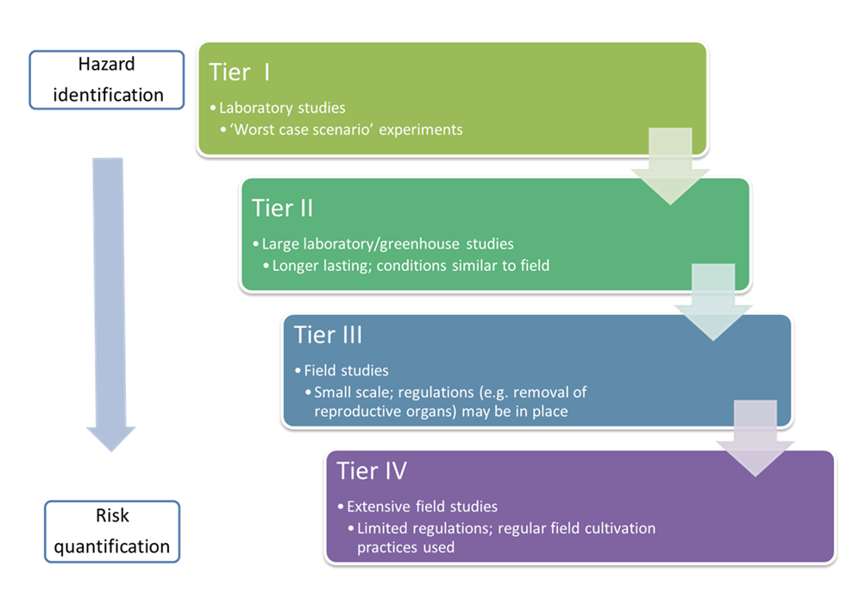
Figure 1. Explanation of each step in the tiered test process. Studies usually begin small scale with high exposure and hazard factors (Tier I). As the scale increases, the exposure and hazard levels adjust closer to more natural, expected levels (Tier IV). Adapted from Wilkinson et al. (2003).
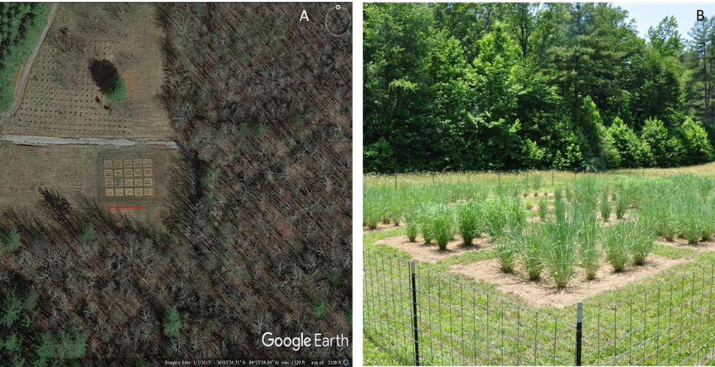
Figure 2. Images of the field site located in Oliver Springs, Tennessee, USA. A) Google Earth image showing the heavily forested border of the field. Satellite image was taken on March 07, 2017. The red line represents a 20 m length. B) View of the experimental plots from the NE corner facing SW during year two on June 14, 2016.

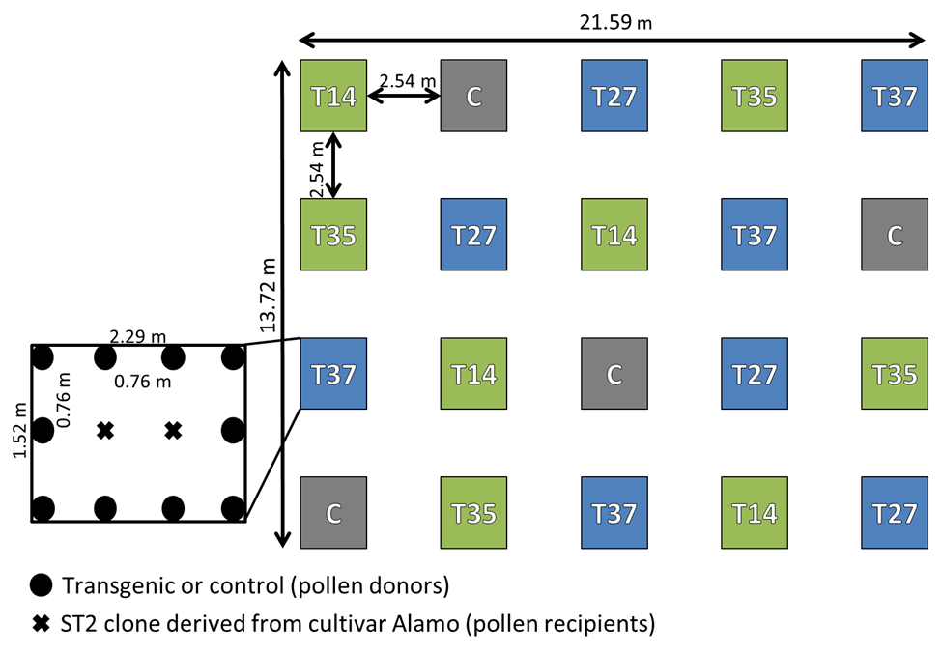
Figure 3. Complete randomized field design for open-flowering miR156-overexpressing transgenic switchgrass in Oliver Springs, TN, USA. In each of the 20 plots, two ‘Alamo’ ST2 clones (X’s) act as pollen recipient plants and are surrounded by 10 pollen donor plants (filled black circles). Donor plants are either one of the four transgenic lines (T14, T35, T27, or T37) or the ‘Alamo’ control (C). Low overexpression lines are labeled in green, and medium overexpression plots are in blue.
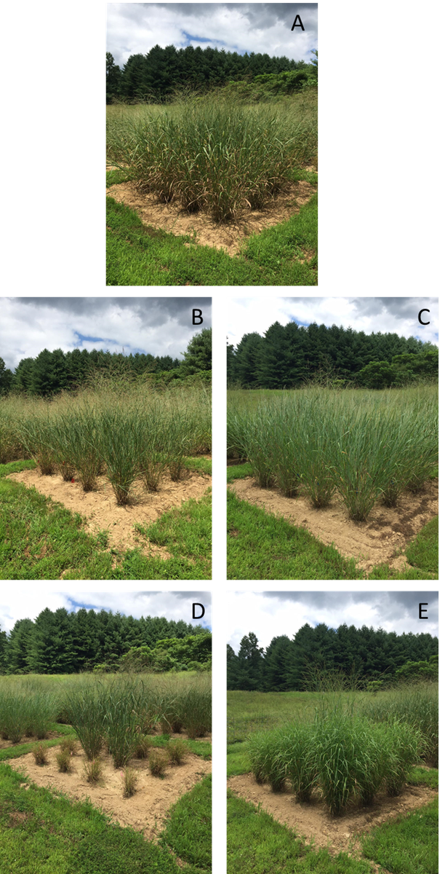
Figure 4. Representative images of each line in the field. Pictures were taken in year two on August 11, 2016. A) Nontransgenic ‘Alamo’. B) Low overexpression line T14. C) Low overexpression line T35. D) Medium overexpression line T27 surrounding easily visible ST2 nontransgenic plants in the center of the plot. E) Medium overexpression line T37.

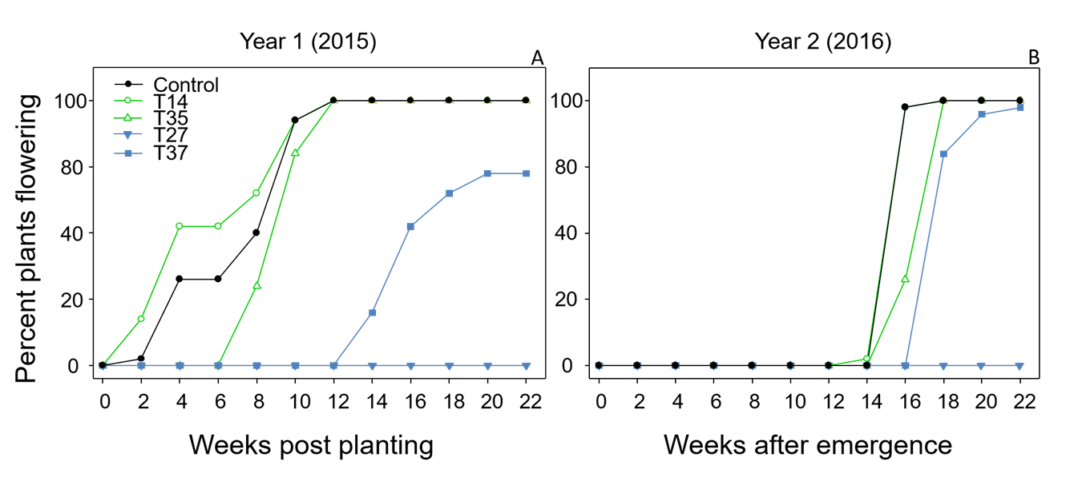
Figure 5. Time to first flower in the field for miR156 transgenic switchgrass lines and wild-type control. A) Year one (2015) weeks to first panicle emergence for each line after planting on June 05, 2015 (Wk 0). B) Year two (2016) weeks to first flower for each line after plant vegetative growth began on March 30, 2016 (Wk 0).
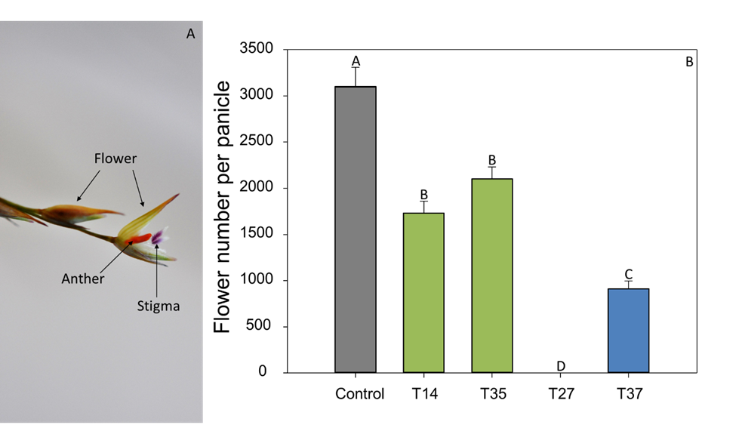
Figure 6. Flower number per panicle in year two (2016). A) Image of closed and open switchgrass flowers. Taken with a Nikon D90, 60 mm micro lens (Nikon USA, Melville, N.Y.). B) Letters represent signiﬁcant differences between means (Fisher’s LSD, P < 0.05). Error bars represent standard error of the means. P = < 0.0001.
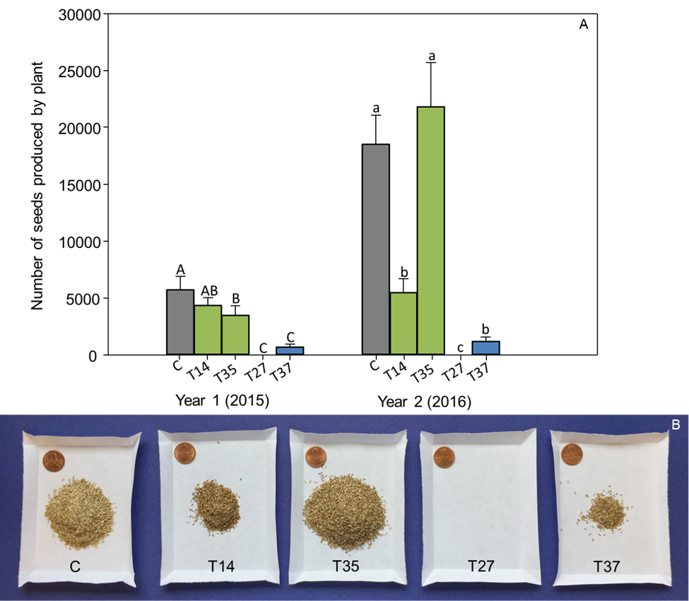
Figure 7. Number of seeds produced by plant for each transgenic line. Lines include the control (C), low miR156 overexpression lines (T14 and T35), and medium miR156 overexpression lines (T27 and T37). A) Capital letters represent significant differences between means in year one (2015) (P = <0.0001), and lowercase letters represent significant differences between means in year two (2016) (P = <0.0001; Fisher’s LSD, P < 0.05). Error bars represent standard error of the means. B) Visual representation of the average number of seeds produced per plant in year two (2016). Penny used for scale.
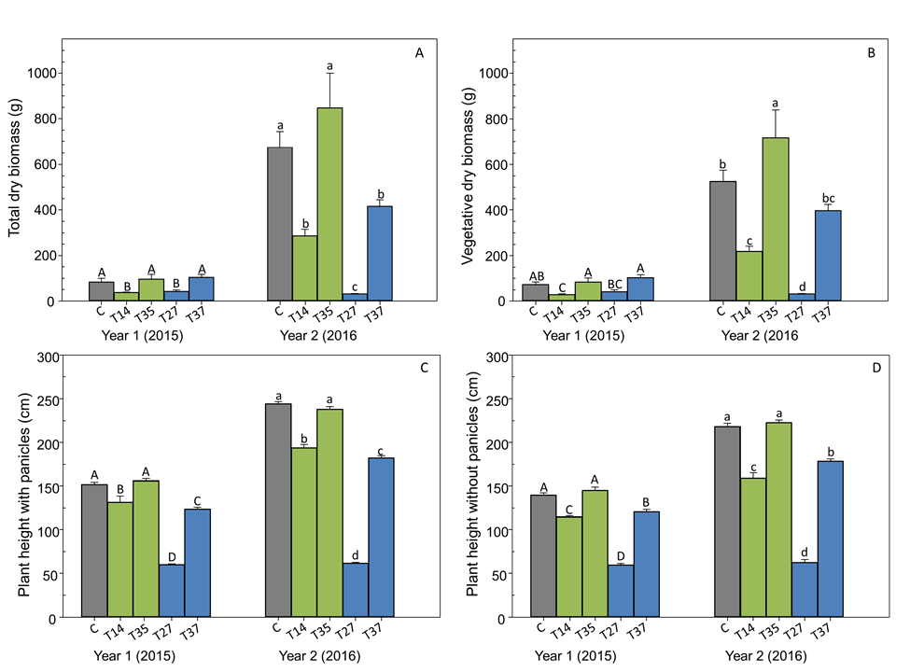
Figure 8. End-of-season dry biomass and height of miR156 transgenic switchgrass and control field grown in East Tennessee for two years. Capital letters represent significant differences between means in year one (2015), and lowercase letters represent significant differences between means in year two (2016) (Fisher’s LSD, P < 0.05). Error bars represent standard error of the means. Year one growing season took place from June 05 – November 24, 2015. Year two growing season took place from March 30 – November 18, 2016. A) Dry biomass of both vegetative and reproductive tissues. Year one P = 0.0066; year two P = <0.0001. B) Dry biomass without panicles. Year one P = 0.002; year two P = <0.0001. C) Tallest part of the plant before panicle removal. P = <0.0001 for both years. D) Plant height after panicle removal. P = <0.0001 for both years.
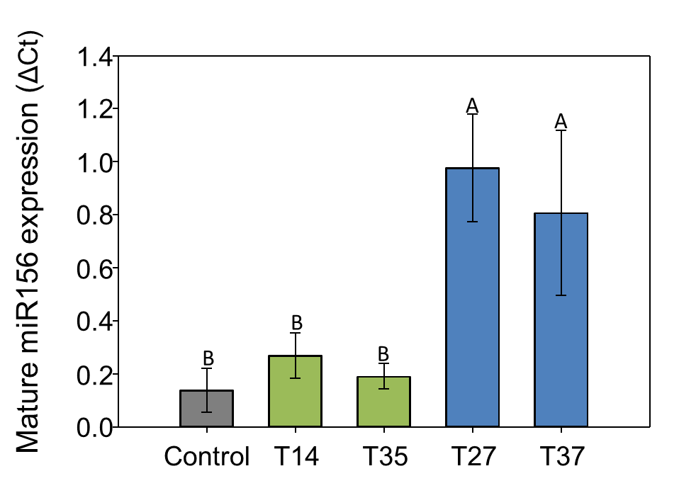
Figure 9. Relative mature miR156 expression results from qRT-PCR. The expression level of miR156 was normalized using miR390 expression. Combined leaf and tiller tissue from V3 stage tillers were used for mRNA extraction. Letters represent signiﬁcant differences between means (Fisher’s LSD, P < 0.05). Error bars represent standard error of the means. P = 0.0103.
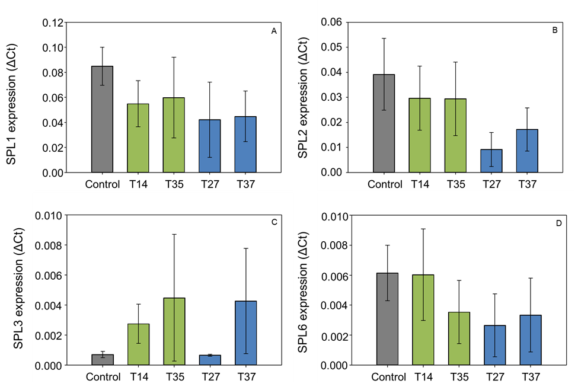
Figure 10. qRT-PCR results of combined V3 tiller and leaf tissue using the PvSPL primers. Error bars represent ± standard error of the means. No significant differences were found between means of any of the four target SPL genes. A) SPL1 expression (P = 0.7374; ANOVA). B) SPL2 expression (P = 0.4402; ANOVA). C) SPL3 expression (P = 0.8544). D) SPL6 expression (P = 0.7508; ANOVA).
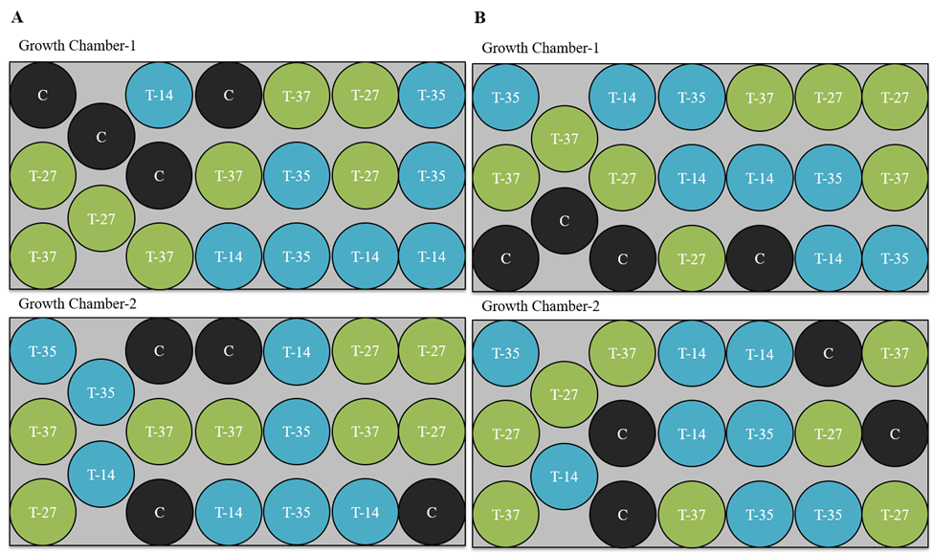
Figure 11. Growth chamber study with a randomized complete block design. Each experiment was replicated in two growth chambers, and each contained four replicates of each line. Lines are color-coded, which include a nontransgenic control (C) shown in black, low overexpression lines T-14 and T-35 (blue), and two medium overexpression lines T-27 and T-37 (green). A) Arrangement of pots from beginning of the season to mid-season. B) Pots were re-arranged in a different randomized design from mid-season to end of season.
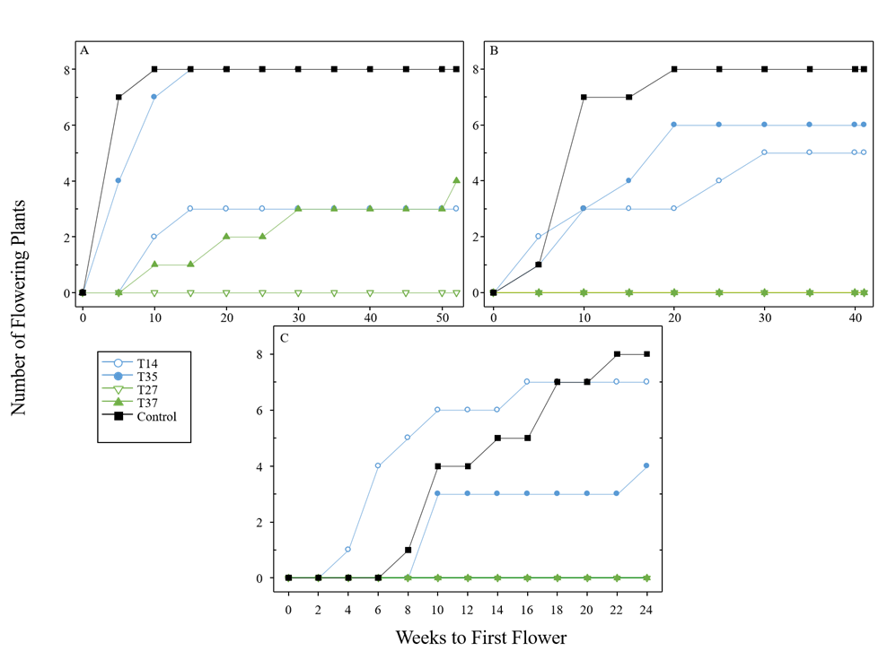
Figure 12. Time to first flower and number of plants flowering throughout the A) tropical, B) sub-tropical, and C) cool-temperate growing seasons. Lines labeled in blue (T-14 and T-35) represent low miR156 overexpression, and lines labeled in green (T-27 and T-37) represent medium miR156 overexpression.
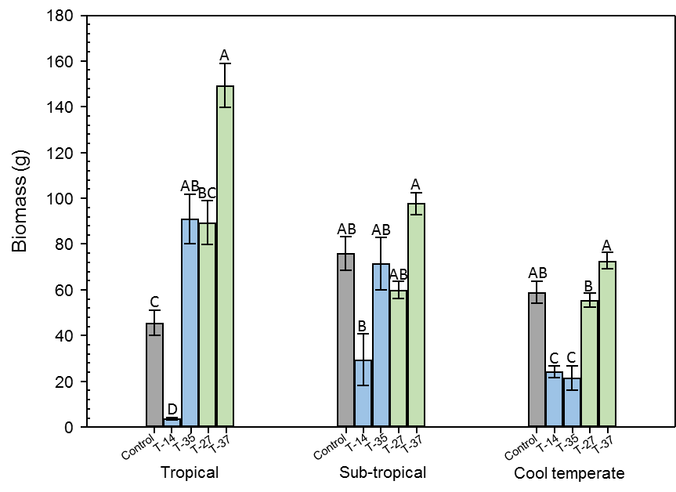
Figure 13. Biomass production per pot of miR156 transgenic switchgrass and control grown in tropical, sub-tropical, or cool-temperate conditions. Error bars represent SE. Letters denote statistical differences within each growth condition at P = 0.05, Fisher’s LSD.
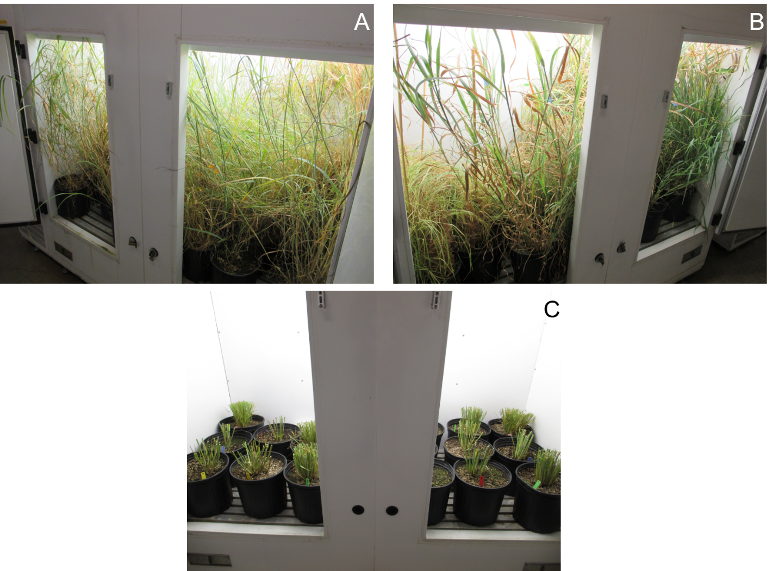
Figure 14. Switchgrass lines overexpressing miR156 at Low (T-14 and T-35) and medium (T-27 and T-37) levels and nontransgenic ‘Alamo’ control plants grown in three different climate simulations.

Vita
Chelsea Renai Johnson was born May 18, 1992 to Bill and Renai Johnson and grew up in Flintville, TN. She graduated from Lincoln County High School with Honors in 2010 and began her undergraduate education at the University of Tennessee that fall. She earned her Bachelor of Science in Plant Sciences with a concentration in Biotechnology in the fall of 2014. Wasting no time, she began work on her Master of Science in Plant Science, Plant Molecular Genetics in January 2015. After completing her master’s, she plans to move back home with her fiancé, Eric, to begin their life together.

