Current perceptions, use, and field implementation of Precision Poultry Farming technologies

A Thesis Presented for the
Master of Science
Degree
The University of Tennessee, Knoxville

Tanner A. Thornton
May 2024

Copyright © 2024 by Tanner A. Thornton
All rights reserved.

ACKNOWLEDGEMENTS
I would like to express my gratitude to Dr. Zhao for supporting me over the past two years, and foremost for the opportunities he has provided for me as a researcher. I have grown so much over these past two years, and I look forward to using what he has taught me. I would also like to thank my family for their unending support throughout my program.
Furthermore, I would like to thank Drs. Tabler, Burns, and Hawkins, for their support not only in my research, but in my life. I appreciate the opportunities I was able to learn poultry from the lens of not only great researchers but great people. I would also like to thank USDA-NIFA for funding me during these past two years and providing me with the opportunity to do this research.
Finally, I would like to express my thanks to my lab mates and coworkers Mustafa Jaihuni, Xuan Dung Nguyen, Shengyu Zhou, Terri Klingenburg, Susan Schnexnyder, Alex Anderson, and Supun Chathuranga Nabadawa Hewage, Brandon and Lebron Conley, Xiao Yang and my parents for always supporting me.

Abstract
The agricultural sector is experiencing a profound shift driven by technological advancements and the imperative for sustainable food production. Within this context, Precision Livestock Farming (PLF) has emerged as a transformative approach to animal management (Berckmans, 2017), leveraging data-driven decision-making, automation, and monitoring systems to enhance livestock production efficiency while minimizing resource usage and environmental impact. This thesis delves into a comprehensive examination of PLF as applied to broiler farming, particularly focusing on current usage perceptions, needs, and its potential to revolutionize the poultry industry.
Research in Precision Livestock Farming has steadily increased since 2000, with a growing percentage of publications focusing on poultry. However, a significant portion of this literature centers on prototype products, with limited exploration of PLF perceptions. The primary objective of this thesis is to gauge the current perceptions, usage, and needs of PLF systems among academia. An online survey was conducted, targeting Animal Scientists, Engineers, and Veterinarians. Results indicated a consensus among poultry researchers regarding the future potential of PLF to enhance poultry production. While most respondents were familiar with PLF terminologies (92%), only about half reported current utilization of PLF technologies (55%). Cost and usability emerged as the primary barriers to implementation, cited by 93% and 88% of respondents, respectively. Notably, opinions varied based on experience with PLF technologies, with current users expressing greater confidence in PLF's potential to expand research opportunities.
The thesis also includes a field implementation project, testing the Scout® PLF system in a commercial broiler house. Scout® is a rail-mounted robot system designed for mortality detection and environmental monitoring. Regression analysis revealed strong linear relationships between Scout® measurements and reference sensors for temperature (R² = 0.88) and relative humidity (R² = 0.86), albeit with discrepancies outside expected sensor accuracy. Mortality detection accuracy was modest (15%), with unexpected clustering between feed and water lines. Bird occlusion was identified as a contributing factor, supported by experiments showing higher detection rates for birds within pens. In summary, addressing barriers such as cost, usability, and improving environmental monitoring systems are critical for the widespread adoption and success of PLF in the industry.

TABLE OF CONTENTS
CHAPTER 1 1
LITERATURE REVIEW 1
Precision Livestock Farming: Concept and Components 1
Historical Evolution of PLF 1
Key Aspects of PLF 1
Current Usage Perceptions and Needs of PLF 2
Adoption Trends and Challenges 2
Economic Considerations and Stakeholder Perceptions 3
Precision Livestock Farming in the Poultry Industry 3
Poultry Production Landscape 3
Current Applications of PLF in Poultry Farming 4
Future Possibilities and Research Gaps 5
CHAPTER 2 5
CURRENT PERCEPTIONS, USE, AND NEEDS OF PRECISION POULTRY FARMING SYSTEMS AMONGST ACADEMIA 6
Abstract 7
Introduction 8
Material and Methods 9
Results and Discussion 9
Conclusions 11
CHAPTER 3 12
EVALUATING PERFORMANCE OF A RAIL-MOUNTED ROBOT IN SOUTHEASTERN U.S. BROILER HOUSE 12
Abstract 13
Introduction 15
Materials and Methods 16
Results and Discussion 19
Conclusions 21
CHAPTER 4 23
GENERAL DISCUSSION AND CONCLUSIONS 23
LIST OF REFERENCES 25
APPENDICES 30
VITA 54

LIST OF TABLES
Table 3.1 Total number of responses is 68. This table provides a general summary of survey responses…………………………………………………………………………30
Table 3.2 Table indicates the level of agreement/disagreement in response to statements………………………………………………………………………………..31

List of Figures
Figure 4.1 Scout system installed in commercial house…………………………………32
Figure 4.2 Example producer report……………………………………………………..33
Figure 4.3 Reference HOBO at scout height…………………………………………….34
Figure 4.4 Reference HOBO at bird height……………………………………………...35
Figure 4.5 Calibration of HOBO temp and RH measurements in climate control chamber…………………………………………………………………………………..36
Figure 4.6 Breakdown of Mortality Zones in ft. Zone 1 is between feed and drinker lines………………………………………………………………………………………37
Figure 4.7a Pen placed directly under the path of Scout®………………………….…...38
Figure 4.8a Pen placed in between feed and water lines………………………….……..39
Figure 4.9a Pen placed along wall………………………………………………...…..…40
Figure 4.10 Landscape markers used to locate blind spots……………………..………..41
Figure 4.11 Temperature by challenging sensor “scout” vs. reference sensor “HOBO” at scout level (stationary)(°C)………………………………………………………………42
Figure 4.12 Humidity by challenging sensor “Scout” vs. reference sensor “HOBO” at scout level (stationary) (%)…………………………………………………………………………………….….43
4.13 Temperature by challenging sensor “scout” vs. reference sensor “HOBO” at bird level (°C)…………………………………………………………………………...…….44
Figure 4.14 Humidity by challenging sensor “Scout” vs. reference sensor “HOBO” at scout level (stationary) (%)………………………………………………………..….….45
Figure 4.15 Mortalities by day for two flocks……………………………………..….…46
Figure 4.16 Locations of collected mortalities 1-2 time per week over the span of two flocks……………………………………………………………………………………..47
Figure 4.17 Number of mortality detections by Scout® over the span of two flocks…...48
Figure 4.18 Potential blindspots due to low resolution of side cameras………….…..….49
Figure 4.19 Example of limited area of coverage of Scout side. Mortalities are indicated with an x and separated by 1ft each……………………………………………..…….…50
Figure 4.20 Comparison of thermal image before and after brooding period…….…..…51
Figure 4.21 Number of mortality identifications by camera……………………..….…..52
Figure 4.22 Number of detections for staged mortalities………………………..………53

Chapter 1

Literature Review

Precision Livestock Farming: Concept and Components

Historical Evolution of PLF
The historical evolution of PLF represents a significant transformation in livestock management practices and is driven by technological advancements and the need for sustainable and efficient livestock production (Hostiou et al., 2017). Traditional livestock farming faces challenges, such as inefficient resource utilization, disease management, and labor-intensive processes. The evolution of how PLF became an emerging idea in agriculture can be seen through technological milestones. Before the term PLF began being used, the first successful “smart technology” in animal agriculture became electronic milk meters, which allowed for the tracking of individual cow’s milk production in the late 1970s (Firk et al., 2002; Halachmi et al., 2019). This was followed by estrus detection systems (Firk et al., 2002). Electronic Identification Systems (EID) were introduced in the in the 1990s and provided producers with the ability to better monitor individual animals and improve their management and health practices (Mcallister et al., 2000). During this time frame, the term PLF was coined and the major advances in sensor technologies also made data on individual animals and their environments obtainable and in real time (Ahrendt et al., 2011; Hemeryck & Berckmans, 2015;Huybrechts et al., 2014). In 2003 the first conference on PLF research was held (Cox, 2003). The primary shift from “smart agriculture” to PLF involves the ability to use data to make early predictions, or better management decisions (Wathes et al., 2008). Now the focus of PLF seems to be centered on the integration of artificial intelligence (AI), machine learning, and deep learning into monitoring animal behaviors in real-time for early disease detection and welfare quantification (Schillings et al., 2021; Rowe et al., 2019).

Key Aspects of PLF
The ability of PLF systems to take in data continuously and provide producers with reports or management considerations allows producers to better manage today’s larger farms, get more detailed information on their animals and the environment that a producer may not normally notice, and provide labor cost and time saving to the producer (Norton & Berckmans, 2018). Not only does this benefit the producer by making their farm potentially more efficient, but it also promotes better animal welfare practices and more transparency for consumers (Elliott & Werkheiser, 2023; Erian & Phillips, 2017). The underlying assumption is that when an animal encounters suboptimal conditions, it will manifest initial responses through changes in behavior (Gonyou 1994). For example, poultry in high ammonia environments may walk aimlessly through the house due to blindness, or distressed or weak chicks may vocalize when approached in the house, giving early indications of health problems(Olanrewaju et al., 2007; Manteuffel et al., 2004). These preliminary indications of issues can be observed using PLF sensing technologies such as image and/or sound analyses or sensors located on or in the body (Norton & Berckmans, 2018). This ability to bring producers “closer to the animal” while not being present will be increasingly important as the number of animals per farm continues to increase (Norton et al, 2019). Another key principle of PLF determined by Berckmans is that its goal is not to replace the farmer (Berckmans, 2017). Werkheiser has also investigated and determined the human-animal relationship is something that is key to production and welfare, and PLF systems raise some ethical concerns as it is perceived as eroding this relationship (Werkeiser, 2018, 2020). Another aspect that PLF has potential use is monitoring climate impact through mitigation strategies, for example, improved fertility monitoring which allows producers to reduce nonproductive animals.(Tullo et al., 2019). The use of precision technology in the management of animals provides for a detailed picture of all resources being used as precision feeding and drinking systems allow producers to better monitor the feed intake of their animals and reduce waste (Gaillard et al., 2020).

Current Usage Perceptions and Needs of PLF

Adoption Trends and Challenges
Precision Livestock Farming research has increased every year since the early 2000s, however, implementation on farms has lagged due to data privacy concerns, lack of affordable equipment, and little economic research to support PLF investments (Banhazi et al., 2012). There is also no research involving producer or integrator perceptions that identifies the main barriers of implementation in the United States. Further hindering implementation is the continued inability for PLF systems to meaningfully influence animal welfare, as well as a lack of validity in regarding positive welfare indicators as positive indicators for production as well (Schillings et al., 2021). Also, producers still have questions about the relevance of technology, data security/trust, familiarity of the equipment, as well as not being aware PLF equipment is available (Makinde, 2020). Furthermore, too much information, especially if unnecessary, can be inefficient so it is important to focus on data tailored only for the producers needs to make reports easy to interpret (Rojo-Gimeno et al., 2018). A study by Van Hertem et al. (2017) also showed the importance of training for PLF equipment to ensure efficient use. Still many producers have reservations and concerns about the usefulness of and return on investment of PLF equipment.
Main barriers of implementation in Europe are expense and usability of the technology (Hartung et al., 2017; Lima et al., 2018). Because cost is a factor, the return on investment (ROI) plays a large role in implementation (Lima et al., 2018). Producers who see a clear ROI are much more likely to implement PLF (Hartung et al., 2017; Lima et al., 2018). Producers who already have some level of experience using technologies are also more likely to implement PLF (Abeni et al., 2019). PLF research overall has been much more common in Europe, most likely due to cultural differences regarding animal welfare practices, as well as policy changes necessitating adoption. The European Union has been steadily passing new welfare requirements since the early 2000s and recently announced the use of animal-based measures to monitor and quantify animal welfare (Norton et al., 2016). If we follow the trends of policy changes these new requirements may become U.S. policy within the next 10 years (Vogeler, 2021). It is expected that when these changes do arrive the economic burden on producers will be substantial, therefore proper preparation is needed to assist producers in this challenge, to keep protein prices low. The recent trend in the global market indicates a consolidation of retailers, with fewer players operating internationally (Hendrickson & Heffernan, 2007). Given the retail sector's heavy reliance on price competition, livestock farmers are experiencing a continual decrease in profit margins per animal (Albrecht, 1998). Consequently, they are compelled to optimize efficiency and capitalize on economies of scale to remain viable. This shift is driving a reduction in the overall number of farms, accompanied by an increase in the animal population per farm (Marquer et al., 2014).

Economic Considerations and Stakeholder Perceptions
Precision livestock farming presents many challenges and opportunities for poultry producers. The initial startup cost as well as the ROI are very important to producers and there are no researchers currently addressing this issue. As agricultural producers struggle with problems related to labor shortages, PLF could replace manual labor while reducing operating cost (Banhazi et al., 2012). The use of PLF to monitor animals also presents marketing opportunities for producers. Consumers are the most important stakeholder in meat production and with consumer opinions shifting towards a focus on improving welfare, producers are presented with an opportunity to demonstrate how they maintain good welfare conditions for their animals (Krampe et al., 2021). Animal welfare groups and policymakers have also been working together to integrate new welfare policies into law which will require producers to find ways to prove their animals are in good welfare (Miele et al., 2013). Two groups of stakeholders that are overlooked are investors and the technology companies themselves. If PLF is to have a significant impact on animal production and cost and efficiency, then the PLF companies will need to work with investors to create products that not only are affordable, but that are able to withstand the tough conditions on a farm. Finally, the producer’s perspective needs to be carefully considered. Producers often respond to changes in consumer or integrator demands, however, it is important to maintain a balanced view of the potential for PLF technologies from the producer’s perspective as well.

Precision Livestock Farming in the Poultry Industry

Poultry Production Landscape
The poultry industry is the fastest growing livestock industry in the world (Mottet & Tempio, 2017). Poultry production in the United States primarily expanded between 2013 and 2022, driven by the desire of producers to satisfy both domestic and international consumer needs. Broiler production experienced a notable 22% increase, while egg production saw a growth of 10% (USDA NASS, 2014). As the world population continues to increase, poultry will be an increasingly important animal industry in meeting the protein demands. Currently, the industry struggles with problems such as labor shortages, consumer pressure to improve animal welfare, and policy changes requiring more intensive monitoring and welfare practices (Mottet & Tempio, 2017; Simonin & Gavinelli, 2019). The U.S. poultry industry is divided into layer, broiler, and breeder production sectors, respectively, with much of the poultry population being broiler chickens. The U.S. broiler industry is vertically integrated, which means that the company who sells the meat usually controls all aspects of growing of the birds (Macdonald, 2008). Farmers are given contracts to be growers, providing labor, utilities, waste management, and maintenance, while the integrator provides the birds, feed, transportation, and marketing. This model has led the U.S. industry to be very efficient and low cost (Lasley, 1983; Putman et al., 2017). This rapid growth in production through genetic selection also caused a number of unwanted side effects that may cause welfare issues such as lameness, ascites, sudden death syndrome, and contact dermatitis in broilers (Julian, 1998; Bessei, 2006; Knowles et al., 2008).

Current Applications of PLF in Poultry Farming
Precision Livestock Farming aims to change poultry farming through its diverse applications, enhancing efficiency, welfare, and sustainability. Automated monitoring systems, equipped with sensors, ensure real-time data collection on environmental parameters like temperature, humidity and air quality, optimizing conditions for poultry health (Maharjan & Liang, 2020). Precision livestock farming’s pivotal role in health monitoring employs wearable devices and smart sensors to track individual bird behavior, enabling early detection of health issues and minimizing disease outbreaks. Researchers have also extensively researched PLF opportunities to improve poultry welfare. For example, microphones have been used to determine the weight of broilers through sound analysis (Fontana et al., 2015). Research is also underway to improve early disease detection through sound analysis, using sneezes, abnormal sounds, and eating sounds (Carpentier et al., 2019; Du et al., 2018; Huang et al., 2021). Research has shown potential in sound analysis and many common sound frequencies have been characterized, but more research is needed to understand how to use each sound do determine health and welfare (Yang et al., 2021). Furthermore, a vast amount of research has been done using image processing, for instance, behavior analysis, feed and drinking time analysis, activity analysis and weight determination (Li et al., 2019; Nasiri et al., 2023; Mortensen et al., 2016). Wearable sensors have also been studied for use in poultry and show promising results, however, their application in commercial settings is limited due to the scale of production. Accelerometers were examined by Mei et al. (2023) for early disease detection of aflatoxin-poisoned broilers which resulted in a higher detection rate than traditional detection. Researchers have also been able to classify walking, resting, feeding, and drinking behaviors using accelerometers (Yang et al., 2021). Precision feeding systems, utilizing automated technology, facilitate precise control over feed quantity and composition, improving feed efficiency and promoting optimal growth (Li et al., 2020). The integration of data analytics and decision support systems allows farmers to make informed decisions based on real-time insights, enhancing overall farm management. Additionally, robotics and automation find applications in egg collection, cleaning, and feed delivery, reducing labor requirements and improving operational efficiency, these technologies are in the initial stages of development. (Li et al., 2020; Maharjan & Liang, 2020). Increased activity is also perceived as better for broiler welfare (Manning et al., 2007). As a result, robots like the T-Moov (The Octopus Robots, 2019; Cholet, France) have been introduced for commercial use. Investigating the effectiveness of using robots to promote activity, two studies done by Parajuli et al. (2020; 2021) in suggested poultry get used to robots within a couple weeks in both a ground based and aerial approach. Precision livestock farming contributions to environmental monitoring and sustainability includes tracking waste management and resource usage and ensuring compliance with regulatory standards (Li et al., 2020; Olejnik et al., 2022). Furthermore, monitoring particle transmission within and exiting the poultry house could be important in reducing the chance of disease transmission (Zhao et al., 2021), as research has shown avian influenza to have the ability to survive on dust particles (Nguyen et al., 2021). Overall, the current applications of PLF in poultry farming signify a transformative shift towards data-driven, efficient, and sustainable practices.

Future Possibilities and Research Gaps
The future possibilities of PLF technologies to improve poultry production are immense. Unfortunately, PLF implementation in the U.S. poultry industry has not yet occurred on a notable scale. More research needs to be done to determine what the main barriers of implementation. Surveys are needed to analyze what technologies producers would like to see being researched and what animal-based indicators they believe are important. Using the combined efforts of producers and researchers to tailor PLF technology for the industry, in theory, will speed up implementation. As research and development of PLF continues it is imperative more research is done on technology within a commercial setting to ensure proper system performance within the harsh broiler barn environment.

Chapter 2

CURRENT PERCEPTIONS, USE, AND NEEDS OF PRECISION POULTRY FARMING SYSTEMS AMONGST ACADEMIA

T. Thornton¹, Y. Zhao^{1,*}, T. Tabler¹, R. Burns² and S. Hawkins²
¹Department of Animal Science, University of Tennessee, 2506 River drive, Knoxville, TN 37996, USA
²Department of Biosystems Engineering and Soil Sciences, University of Tennessee, 2506 E.J. Chapman Drive, Knoxville, TN 37996, USA
*Corresponding author: Yang Zhao, yzhao@utk.edu

This chapter has been published in the Conference Proceedings of the 2nd US Precision Livestock Farming Conference 2023
Citation: Thornton T., Zhao Y., Tabler T., Burns R., Hawkins S., In proceedings of 2nd US Precision Livestock Farming Conference, May 21-24, 2023, Knoxville, Tennessee, USA. Page 10-16.

Abstract
Precision Livestock Farming (PLF) technologies offer a way to improve animal production and labor efficiency while also addressing consumer welfare concerns. There is a lack of knowledge on the current perceptions and need for PLF technologies within academia. The objective of this study was to design a survey to understand the perceptions of and need for PLF within poultry production across academia. To meet this need, an online survey was designed via Qualtrics consisting of 25 questions. The survey was distributed via email to 276 U.S. poultry researchers. The survey was made available for one month and yielded 68 total responses (N=68). Respondents were separated into groups based on job type (extension specialist, researcher, both) and field of study (animal science, engineer, veterinarian). Results were analyzed using a chi-square test, frequency analysis, and by Monte Carlo simulations to account for the relatively small sample size. Amongst researchers, 92% agreed that cost influences a grower’s decision to implement PLF technology and 86% agreed that usability influences a farmer’s decision to implement PLF technologies. Most poultry researchers were familiar with the term PLF (92%), though only 55% of respondents have or currently use PLF technologies. Researchers agreed that PLF will improve poultry production (97%) and health and welfare (91%). Engineers agreed more than animal scientists that PLF will be important to improve production efficiency, with 61% of engineers strongly agreeing compared to only 34% of animal scientists (p=0.02). Furthermore, researchers who already use PLF strongly agree that PLF will allow them to expand their research (57%) compared to researchers who do not use PLF in which only 13.3% strongly agreed (p=0.01). In summary, researchers are optimistic about the future of PLF, however, implementation faces several challenges and is still slow amongst researchers.
Keywords: perceptions, precision livestock farming, health and welfare, production, academia

Introduction
The demand for poultry products continues to increase along with the world’s population (FAO 2022). To meet the nutritional needs of the world, we will need to drastically increase food production, especially protein production (United Nations, 2013). The poultry industry can meet increasing meat protein demand more efficiently than other livestock sectors, primarily because the poultry industry can produce protein at an exceptional feed conversion ratio at a large scale on a small amount of land (Mottet et al., 2017). In recent years, however, the poultry industry has come under scrutiny from consumers and animal rights groups concerning animal welfare practices. Of these complaints, lameness, disease, excessive growth rates and stocking densities, and antibiotic use are the most prominent concerns (Erian et al., 2017). The European Union recently began requiring farmers to show that their flocks are raised with good welfare throughout the production cycle and is currently investigating the viability of animal-based welfare indicators (Simonin and Gavinelli, 2019). It appears likely that the U.S. poultry industry will have to adapt to these same consumer demands in the future. Researchers have proposed to do this using precision livestock farming technologies (PLF).
Precision livestock farming is defined as real-time monitoring of animals to measure health and well-being via cameras, sensors, GPS systems, microphones, and IoT devices (Berckmans, 2014). Precision livestock farming could prove to be an effective solution for welfare monitoring as it allows farmers to continuously monitor their flocks and simultaneously reduce the need for expensive and scarce manual labor. A review study completed in 2019 has shown an increase in PLF publications targeting poultry production recently, especially in the last 10 years. However, of the 254 papers the author reviewed, only 10 were found to have commercially available products (Rowe et al., 2019). The focus of most of this research is on testing new technologies entering the markets. However, very little is known about farmers opinions regarding PLF, and the few papers that have been published involve research mainly in the European market (Hartung et al., 2017; Abeni et al., 2019; Lima et al., 2018). Currently, there are no papers focusing on poultry producers’ opinions of PLF in the U.S. This is concerning, considering that there are important differences in growth environment and regulation between the U.S. and the E.U. Due to this there is necessity in conducting a survey to gauge the perspectives of researchers in the U.S. regarding PLF technologies and systems. Such insights would highlight the potential for future adoption and enable the targeting of technologies towards areas that align with the preferences of U.S. poultry growers.
In the E.U. producer surveys that have been completed, the major takeaways from farmers are that their biggest barriers of implementation include the high cost of technology, the usability of the technology, and uncertainty regarding how PLF will improve their operation (Hartung et al., 2017; Abeni et al., 2019; Lima et al., 2018). Consumer surveys have shown scepticism and the concern for abuse of PLF systems and reduced physical presence on the farm by growers and workers (Krampe et al., 2021). Perceptions from researchers are expected to be similar to those of consumers and producers, however, no studies have examined this. Further knowledge on how similar and different perceptions are amongst researchers and producers could lead to increased collaboration and acceptance of PLF. The first objective of this study is to identify current perceptions, use and needs of PLF amongst poultry researchers. A second objective is to identify differences amongst professional field, research type, and level of experience with PLF.

Material and methods
Survey design
The Survey was targeted towards poultry academia using a Qualtrics online survey. The survey consisted of 23 multiple choice questions and two matrix tables (five statements each) to be answered on a Likert scale ranging from strongly disagree to strongly agree. The first section of the survey consisted of background questions related to the researcher’s field, job type, years of experience, industry, style of record collection (digital, paper) (phone, computer) and which areas within poultry production they would like to see PLF technologies applied for production improvement. The second section assessed respondent technology use and skill and familiarity with the PLF process. Responses were collected for a month following the initial invite to participate, yielding 68 total responses, Incomplete surveys were not included for analysis.
Data analysis
The results collected from the survey were exported to SPSS for statistical analysis. Answer choices were recorded to numerical results. For example, in a yes or no question option "1" would be assigned to represent "yes" and “2" to represent "no". Descriptive statistics were performed including frequency analysis to yield a general summary of results based on various criteria such as job type, research type, and levels of experience with technology. Crosstabs analysis was performed by comparing job type, research type, level of experience with technology, and familiarity with PLF, with respondents’ level of agreement to 10 statements.

Results and discussion
Survey Respondents
Of the survey respondents, 63% identified themselves as a researcher, 16% identified themselves as an Extension specialist, while 21% identified as both. When asked what best represents their professional field, 58% identified as animal scientist, 34% identified as engineers, and 6% identified as veterinarians. Every aspect of the poultry industry was represented in the survey response pool, with 89% working with broilers, 57% with layers, and 29% collaborating with breeders. The number of years the respondent has been involved in poultry research was also diverse at 61% for those involved for 0-20 years, 34% for those involved for 20-40 years, and 4% have been involved in poultry research for more than 40 years.

Chi-square test and correlation
The chi-square test was performed to examine significant differences among groups, particularly in response to Likert scale questions. When comparing job types (Extension specialist, researcher, both), minimal differences were generally found, except in opinions about PLF's usability in commercial poultry settings. Researchers were more inclined to strongly agree (45%) that current PLF technologies were applicable in a commercial production setting, compared to only 17% with an Extension background (P = 0.055). Similarly, grouping respondents by professional field (animal science, engineer, veterinarian) revealed little difference in PLF's perceived usability in a commercial setting, with veterinarians (50%) and engineers (61%) strongly agreeing compared to animal scientists (34%) (P = 0.017). Opinions varied significantly regarding whether technology cost influenced a farmer's purchase decision (P = 0.007), with 92% of researchers agreeing to some degree. Significant differences also arose based on respondents' skill level with technology, notably in usability’s effect on implementation with 69% of highly skilled respondents disagreeing usability influences purchase decisions (P = 0.04). Familiarity with PLF prior to the survey also led to significant differences in opinions about its importance for future poultry production (P = 0.01), with familiarity with PLF technologies tending to make respondents more positive with respect to the application of PLF technologies in commercial production. Furthermore, significant differences were found in opinions about PLF's potential to expand research, with current PLF users more likely to strongly agree PLF helps them expand (84%) (P=0.01).
Discussion
The results from this study show that though poultry research is done in many distinct roles or job types there is general agreement amongst researchers that PLF can improve poultry production in the future. Most researchers were familiar with the term prior to taking this survey (92%), however, only a little over half (55%) are using PLF technologies. This indicates there is a need for more research to expand knowledge of PLF application in poultry production. The results also show, in alignment with previous studies, that researchers believe the greatest barrier to implementation for growers is the cost of the technology and the usability of technology (93% and 88%, respectively) (Hartung et al., 2017; Abeni et al., 2019; Lima et al., 2018). Some producers and researchers also believe the role of PLF is to replace the farmer in the barn, even though that is not the goal. A core principle of PLF is that it is not intended to replace the farmer, even so concerns exist from integrators regarding the amount of time producers will spend in the house if PLF systems are installed. The perception of researchers aligned with the principle of PLF with 74% of respondents disagreeing to the statement “PLF can replace the farmer in the barn”.
The survey reveals that there is a general agreement amongst researchers regarding the best indicators for poultry productivity, health, and welfare, as few significant differences were found when the results were analysed across job types and research areas. It will be important for future studies to analyze the differences in opinions between researchers and growers. It is interesting to note that of the researchers that currently use PLF technologies, 57% strongly agree that PLF will help them expand their research, compared to 13% for those who do not currently use PLF. This demonstrates the confidence that producers have in PLF after they have used it. It can be assumed that the same trend we see in studies done with European producers (regarding usability being a large factor in their willingness to implement) is found in researchers. Though this trend is somewhat paralleled with the results, it was determined that researchers with high technology skills disagreed with this 69%. This is interesting as one could assume usability will be an increasing factor in implementation, especially as the number of poultry growers who do not use English as a first language is increasing which can be seen in the USDA Farm census (2022).

Conclusions
This paper aimed to bridge the gap in understanding between PLF perceptions and usage amongst researchers in the U.S. poultry industry. It was hypothesized that cost of technology and usability of PLF would be considered the largest barriers of implementation by researchers, and this is supported with 92% of respondents agreeing to some degree. It was also concluded that even though 92% of respondents are familiar with PLF only 55% implement PLF currently. This demonstrates lagging implementation which is also seen in the commercial industry. It was also concluded that many agree that PLF will be important for future poultry production (97%), however, opinions regarding the future usage of PLF were more positive if the respondent has previously used PLF technologies. With the extreme lack of knowledge that is currently present in the field regarding PLF perceptions, this paper should serve as a great baseline for perceptions and use of PLF research amongst poultry academia. The next step in this research is to examine the differences in perceptions and usage between poultry growers and researchers to create collaboration on research that will have a higher chance of commercial implementation.

Chapter 3

EVALUATING PERFORMANCE OF A RAIL-MOUNTED ROBOT IN SOUTHEASTERN U.S. BROILER HOUSE

T. Thornton¹, Y. Zhao^{1,*}, T. Tabler¹, R. Burns² and S. Hawkins²
¹Department of Animal Science, University of Tennessee, 2506 River drive, Knoxville, TN 37996, USA
²Department of Biosystems Engineering and Soil Sciences, University of Tennessee, 2506 E.J. Chapman Drive, Knoxville, TN 37996, USA
*Corresponding author: Yang Zhao, yzhao@utk.edu
This chapter is being submitted in the transactions of ASABE 2024
Citation: Thornton T., Zhao Y., Tabler T., Burns R., Hawkins S., Transactions of ASABE, July 28-31, 2024, Anaheim, California, USA.

Abstract
Robotics for poultry production have been advancing rapidly in response to the escalating challenges posed by labor shortages, the demanding nature of working in harsh animal environments, and the imperative for continuous measurements in modern livestock farming practices. This study presents an evaluation of a rail-mounted robot (Scout®), deployed in a commercial broiler house for three consecutive flocks. The robot was installed 1.5 m above the floor and was equipped to gather data on temperature, relative humidity (RH), ammonia concentration, welfare indicators, and mortality counts and locations through a computer vision system. Data collected by Scout® was compared with reference-grade sensors (for environmental factors) and manual observation (for mortality rates). Linear regressions of the Scout® data with reference sensors mounted at the same height as Scout® displayed a slope was 0.90 and an intercept of 1.72°C for temperature (R²=0.88) and a slope of 0.92 with an intercept of 8.0% for RH (R²=0.86). Linear regressions of the Scout® data with reference sensors at bird level (app. 0.2 m above the floor) displayed a slope of 0.86 and an intercept of 2.27°C for temperature (R²=0.92), and a slope of 0.76 and an intercept of 26% for RH (R²=0.90). Regressed Scout® data intercepts were outside of the reported sensors accuracy ranges (±1.5°C and ±3.5%RH). In conclusion, the findings suggest that the robot environmental sensors yield accurate measurements in overhead spaces within the broiler house after appropriate data corrections. Scout® displayed a false positive mortality rate of 38% and accurately reported only 15% of manually located mortalities. Further investigation revealed bird occlusion played a role in low mortality identification. In an experiment with manually placed mortalities, one placed inside a isolating pen and the other approximately 3 m (10ft) away outside the pen, Scout® identified mortalities inside the pen at a higher rate (78%) compared to the mortalities outside the pen (23%). The results indicate that, in a commercial broiler house setting, mortality detection systems require improvements to compensate for occlusion caused by live birds and house infrastructure, including feed and water lines.
Keywords: Robotics, assessment, validation, sensor accuracy, dead bird detection

Introduction
Animal production serves as a cornerstone in meeting the global demand for food production, with the poultry industry emerging as the fastest-growing sector among livestock industries (FAO, 2012). Projections indicate that by the year 2050, global population will be 9.2 billion (FAO, 2012), which will cause an increase in food demand between 35 to 56% (vanDijk et al., 2021). As the scale of livestock farming intensifies to meet escalating demand, the imperative for continuous monitoring of animals and their environment becomes paramount in safeguarding their health and well-being.
The soaring demand has propelled the poultry sector to lead livestock industries, making poultry meat a dietary staple globally. This shift is evident in the consumption trend, with poultry surpassing red meat in 2019 and maintaining its position as the most consumed meat to date.
The poultry industry has undergone remarkable growth in recent decades, driven by factors such as population expansion, rising incomes, and dietary shifts favoring protein-rich foods. Advancements in breeding, nutrition, and management practices have contributed to significant improvements in production efficiency and yield, with the harvest body weight of broilers at 35 days increasing significantly between 1985 and 2010, improving from 1.4kg to 2.4kg (Siegel, 2014). The inflation-adjusted price of poultry meat experienced a yearly decrease of 3% from 1980-2005 (Narrod et al., 2012). Moreover, technological innovations, including automated feeding systems, climate-controlled housing, and genetic selection for desirable traits, have enabled poultry producers to meet consumer demand for high-quality products while optimizing resource utilization (Magkos et al., 2006). However, alongside these advancements, the intensification of poultry farming has introduced new challenges, such as disease outbreaks, environmental concerns, and labor shortages, underscoring the need for innovative solutions to sustainably manage and monitor poultry production systems. The issue related to the reduction of available human resources is also amplified based on the current trend in animal agriculture which demonstrates a decrease in the total number of farms, and an increase in number of animals per farm (USDA NASS, 2023).
The dwindling availability of farm labor and other abovementioned challenges accentuate the urgency for solutions capable of monitoring livestock environments autonomously, thereby relieving the burden on scare farm labor resources. This is amplified through the consolidation of resources which has led to an increase in the number of animals per farm, but a decrease in overall farm numbers (Marquer et al., 2014). In response to these pressing challenges, technological innovations, particularly robotic systems, offer promising avenues for efficiency and automation in monitoring livestock and their surroundings. Poultry production robotic systems could further enhance productivity and welfare and alleviate labor constraints inherent in traditional flock monitoring practices. In addition, the reduction of workers present on farm decreases the risk of disease transmission.
Current robotic systems in livestock farming are characterized by their emphasis on object detection, environmental monitoring, and data analytical methods that inform management decisions. These technologies represent a paradigm shift towards precision farming, where real-time data acquisition and analysis empower farmers with actionable insights for optimized resource allocation and improved animal welfare outcomes. While the integration of robots in animal agriculture may appear as a novel concept, it builds upon existing applications in other sectors. Notably, the dairy industry has pioneered the use of stationary robots for milking operations since the early 1990s (Ipema et al., 1992). Similarly, within the poultry industry, innovations such as the PoultryBot have been deployed in layer houses to mitigate floor egg incidences, as well as collect floor eggs (The Octopus Robots, 2019; Cholet, France). This company also produces the Octopus Poultry Safe (OPS), which provides enhanced sanitation in poultry houses ensuring hygiene and disease prevention (The Octopus Robots, 2019; Cholet, France). Moreover, robotic systems have been trialed to promote movement among birds in layer facilities, thereby reducing the prevalence of floor eggs (Tibot Technologies, 2019). In the broiler industry, robots have been employed to stimulate activity, thereby improving broiler welfare, though little validation of these systems in commercial settings has taken place (Yang et al., 2019). While these robots offer potentially good solutions for promoting activity and efficient house cleaning, they operate as ground robots, which have difficulty navigating across a floor covered with litter and present a risk to bird welfare through unexpected collisions and increased stress.
Rail-mounted robots, which are not in contact with litter, are also in development. Scout® is a commercial example of a rail mounted robotic system that is capable of environmental and welfare measurements and observing and reporting bird mortalities, bad droppings, and floor wet spots. Current environment measurement in commercial farms only use 5-10 stationary sensors to record ammonia, RH, temperature, which may not represent the entire house. Sentient type railed mounted robots such as Scout®, which traverse through the house, provide data throughout the house over time, though the accuracy measurements relative to bird level are unknown. The objective of this research is to evaluate and validate the environmental data (RH and temperature) collected by an example rail mounted robotic system, Scout®, and to evaluate the accuracy of the Scout® mortality detection system. To achieve this goal, Scout® was placed and evaluated within a commercial broiler house in the southern U.S.

Materials and Methods
The Scout® system was installed within a commercial broiler house located near Cleveland, TN, measuring 152 meters in length and 16.5 meters in width with an east to west orientation. This facility embodies the standard environment found in U.S. broiler production operations. Each flock accommodates approximately 38,800 birds which typically undergoes a rearing period of 35 to 40 days. The structure features solid side walls and employs tunnel ventilation. Heating is facilitated by suspended brooders. Birds are brooded in one half of the house for approximately the first 7 days of the grow out, full house access is provided following the brooding period.

Scout robot
The rail-mounted robot system, known as Scout® is produced by Cumberland (AGCO), and is designed for utilization in both broiler and layer houses (figure 4.1). Operating on a closed loop rail circuit, Scout® autonomously navigates the house, docking at a fixed station to recharge after completing one trip around the closed loop rail. Manual intervention is unnecessary unless technical issues arise. The primary function of Scout® is twofold: the real-time collection and mapping of environmental data throughout the house, and utilizing image processing to detect mortalities, “bad” droppings, and leaking drinkers. Scout® reports ammonia concentrations, airspeed, carbon dioxide concentration, effective temperature, heat stress index, humidity, humidex, light intensity, noise level, temperature, suspicious droppings, mortalities, free usable space, and defective drinkers. Additionally, Scout® employs a laser to stimulate bird movement. Scout® features an LED lighting system to enhance visibility under low light conditions and is equipped with thermal and RGB cameras on the left, right, and bottom of the robot. Producers receive daily reports highlighting crucial data that can accessed online (figure 4.2). A website stores data for multiple flocks, provides a live feed from Scout®, and displays stored images of detected mortalities or poor droppings for producer review, including their location within the production house (figure 4.2).
Reference Sensors
Temperature and humidity data were continuously collected utilizing HOBO onset data loggers with an accuracy of ±0.25˚C and ±2.5% RH, respectively. Two sensors were deployed at the height of the Scout® robot (1.5m), while four additional sensors were placed along the water lines to monitor conditions at bird level (figure 4.3 & 4.4). Scout® utilizes an Epulse EE 160 sensor to measure RH and temperature with an accuracy of 2.5% RH and 0.3˚C, respectively. Due to the relatively low accuracy of the HOBO data loggers, a Vaisala HMP3 probe connected to a Vaisala Indigo 80 handheld indicator, with an accuracy of 0.8% RH and 0.1˚C, was used to further calibrate the HOBO data loggers. A climate-controlled chamber (figure 4.5) was utilized in which both the HOBO loggers and The Vaisala probe were placed to record data on 1 second intervals. A humidifier was used to increase RH levels and a dehumidifier was used to reduce RH levels. After stabilization, RH and wet bulb temperature from both sensors was collected at 20%, 40%, 60%, and 80%, respectively. The resulting data from the HOBO loggers and Vaisala was then integrated, and a calibration factor was applied. To determine if Scout’s sensors were within expected accuracy the average difference between Scout and the reference sensors was calculated. Furthermore, sensors were evaluated using a linear regression model with Scout as the response variable and HOBO as the explanatory variable.
Mortality Validation
The mortalities were categorized into three zones, between the wall and outside drinker lines, between the feed line and paired drinker lines, and between the center drinking lines (Figure 4.6). Mortalities were manually collected for the purpose of evaluating Scout one to two times a week. As the house was walked and mortalities were collected, the location of each mortality was laser located using a Leico Disto D2 laser distance monitor. A total of 140 mortalities were mapped over the course of two flocks. To validate the percentage of false positives, 944 images were examined by 2 reviewers, and each mortality was confirmed.
Mortalities were manually located one to two times per week to evaluate the Scout® mortality identification system within three zones: between the wall and outside drinker lines, between the feed line and paired drinker lines, and between the center drinking lines (Figure 4.6). As the house was walked and mortalities were collected, the location of each mortality was laser located using a Leico Disto D2 laser distance monitor. A total of 140 mortalities were mapped over the course of two flocks. To validate the percentage of false positives, 944 images were examined by 2 reviewers.
The occlusion effects by live birds and by feeder and drinker lines on the Scout® mortalities identification system were evaluated in a third flock. In addition, the field of view of the robot in detecting mortality was also determined to evaluate whether that was a limiting factor in mortalities identification. To evaluate the occlusion effect by birds, pens to isolate mortalities from surrounding birds were installed, four pens at specific locations throughout the house to evaluate mortality identification limiting factors, such as occlusion by birds or house infrastructure. One pen was placed directly underneath the path of the robot (figure 4.7), two were placed between the feed and water line approximately 1.5 to 2.4 m (five to eight ft) to the left or right of the robotic rail (figure 4.8), and one pen was placed between the drinker lines and the wall (figure 4.9). The location of the pens moved length and widthwise across the house each week, however, each pen stayed in the same reference point in the path of Scout (i.e., directly under rail, against wall). Manually located mortalities were placed inside of each pen and a paired mortality was placed outside of the pen to test the effect of occlusion on the detection ability. To determine the field of view Landscape markers were also placed in a line (1 ft apart) across the width of the house (figure 4.10). The field of vision was determined by watching a livestream of Scout® from each camera as it made a round through the house. Scout® made 190 rounds during the third grow out.
Data Analysis
JMP Pro 16 was used to analyze the data, specifically using a linear regression model in which the challenging sensor (Scout®) data was fit on the Y axis and to data collected from the reference HOBO sensors on the X axis. The same method was used for the analysis of overall mortality counts, with the manually collected mortalities placed on the X axis. To validate the effect of bird occlusion on mortality identification, the number of recorded mortalities found in pens were compared to how a paired bird was located outside the pen. To validate the rate of false positives, the total number of images was counted and the number of images with false mortalities was divided by the total number of images. To analyze mortality identification as affected by location, three distinct areas were investigated within the poultry house and the square footage of each area was calculated. Based on the total amount of mortalities compared to the square footage of each location, an expected mortality count was generated and compared against observed values. Additionally, to determine the accuracy of Scout’s mapping ability, the total number of mortalities that were within 1.5m (5 ft) of the real mortality were determined and divided by the total number of Scout-determined mortalities.

Results and Discussion
Environmental Sensors
Linear regression analyses revealed significant relationships between the robot's sensors and the reference HOBO sensors at two different heights: robot height and bird level (approximately 0.2 meters above the floor). At robot height, temperature measurements exhibited a slope of 0.98°C (P<.0001) and an intercept of 1.65°C (R²=0.88) (P=.070) (figure 4.11), while relative humidity (RH) measurements displayed a slope of 0.93% (P<.0001) and an intercept of 1.78% (P=.46) (R²=0.86) (figure 4.12). Similarly, at bird level, temperature measurements demonstrated a slope of 1.07 (P<.0001) and an intercept of -0.32˚C(P=.667) (R²=0.92) (figure 4.13), whereas RH measurements exhibited a slope of 1.18% (P<.0001) and an intercept of -24.1% (P<.0001) (R²=0.90) (figure 4.14). These results indicate strong linear relationships between the robot's sensors and the reference HOBO sensors at both heights as indicated by high R², however accuracy was below the sensors expected accuracy (±0.3°C, ±2.5% RH), with results indicating accuracies at the Scout level of ±1.5°C and ±3.5%, respectively. Comparison of sensors at the bird level yielded similar results with accuracies of ±1.5°C and 10.6% RH, respectively. The most likely reason for significant differences being present in every slope is likely due to comparing stationary reference sensors to the continuous (1 measurement/second) measurements Scout makes. Temperature and RH levels can vary not only by height, but also section of the house (i.e., cool cells, exhaust fan, brooders). These results highlight the importance of PLF systems to be aware of spatial differences in environmental factors to be sure they accurately represent the bird environment.
Mortality detection
Over the course of 2 flocks, the total number of mortalities was recorded. Mortality for each flock was compared with the US average mortality for broilers of 5.7% (USDA, 2023). The results show mortality was 3.5% for flock 1, and 3.7% for flock 2. These values are lower than the US average, however, it is important to note the number of days per flock can vary from each farm and each flock. Most mortalities occurred in the first week, and thereafter decreased by 84% by day 15, after which time the number of mortalities in the house stayed consistent over time (figure 4.15).
The spatial mortality distribution was analyzed based on three distinct areas of the house (figure 4.16). with 45% of mortalities located between the feed and water lines and 34% found along the walls. The areas of these three zones were determined, and their respective mortality densities (mortality/m^2) were calculated. The mortality densities were 0.0768 for zone 1, 0.0546 for zone 2, and 0.0461 for zone 3. This analysis reveals that the mortality density is highest between the feed and water lines. This result is consistent with findings reported by Tabler et al. (2002) who also found more mortalities near feeder and drinker lines as compared to other areas in the broiler houses. This uneven distribution of mortality highlights potential areas of focus for further investigation and management strategies.
The analysis revealed a low overall ability (15%) for Scout® to accurately detect mortalities. A previous study, in a lab environment, indicated that as population density decreases the ability to detect mortalities increase with 90% of mortalities being found in a high stocking density situation compared to 95% for low stocking density situations (Muvva et al., 2018). Examination of mortality images indicated a significant disparity in detections among the cameras, with the bottom camera capturing 660 mortality images, whereas the right and left cameras captured 146 and 147 images, respectively. This is most likely due to the angle and resolution of the side cameras which hindered the distance in which birds could be identified. Lower resolution decreases the ability to recognize details and this challenge increases with distance away from the camera. This is demonstrated greatly in (Gu et al., 2015) which shows how the same image reduces in detail dependent on resolution and distance from the camera. Due to low resolution (800x600 pixels) the distance in which the side cameras can detect a mortality appears to be limited to only 2-3 ft. This leads to blind spots in the path of the robot as shown in figure 4.18 and 4.19. This compounded with bird and equipment occlusion issues most likely explains the low overall detection ability. The false positive rate, falsely identifying an object (e.g., live bird, feeder pan) as a dead bird, for mortalities was determined to be 37.65%. Notably, most false positives occurred when chicks were less than 2 weeks of age (97%). One theory for why this occurs is due to the high heat levels in the house interfering with the thermal camera’s effectiveness. This is demonstrated by the image comparison in figure 4.20. High rates of false positives can lead to producers wasting time to check on issues identified by the system, for instance, if a high concentration of mortalities is found in a concentrated area.
Additionally, when analyzing the effect of bird population density on mortality identification, birds separated by a pen were located more frequently (78%) compared to paired mortalities outside the pen (23%) (P<.0001). Among the staged mortalities, birds placed in pens directly under the path of the robot were located 90% of the time, while the pens placed on the right or left sides of the robot between the feed and drinker lines were located 4% of the time, while the pen along the wall had a detected 6% of staged mortalities (P<.0001) (figures 4.21 & 4.22). These results indicate that the main hindrance in finding mortalities by Scout in a commercial broiler house is primarily due to occlusion issues from equipment, high densities of birds, and suboptimal camera resolution or placement especially for side-view cameras.
Further considerations
Despite the initial optimism surrounding the implementation of Precision Livestock Farming (PLF) technologies, this study highlights several significant real-world challenges encountered during field deployment. While environmental sensors showcased good performance, the data collected often failed to fall within expected accuracy standards, most likely due to comparison of data being collected in separate areas of the house. It is imperative manufacturers understand the dynamic spatial distribution of environmental factors in a broiler house. This ensures optimal bird welfare is being measured and accurate data is being provided to producers. Moreover, several challenges were identified as potential causes for the mortality detection system's low efficacy. Bird occlusion issues were seen as the most common hinderance to detection and should be the most prominent consideration when developing a mortality detection system for commercial use. Furthermore, challenges such as equipment occlusion, and temperature fluctuations from brooders, (which create too much noise for the thermal camera to process accurately) should be considered when developing an identification system. Manufacturers must also balance the cost of the system with cameras that have a high enough resolution to ensure coverage in all areas of the house.
One of the most prominent hurdles in integrating PLF into commercial poultry houses is the challenging environment itself (Jones et al., 1984). Commercial settings present a multitude of factors that PLF systems must contend with to operate effectively. Notably, high levels of humidity, dust and ammonia accumulation within the house accelerate equipment degradation, posing a persistent challenge (Jones et al., 1984). The amount of equipment already in the house (feed lines, water lines, brooders), limits the amount of operable space for PLF equipment.
Additionally, bird density within the house complicates mortality detection, as live birds frequently obscure the view of Scout. Despite attempts to mitigate this with a red laser to encourage bird dispersion, its effectiveness was limited, with birds quickly becoming accustomed to its presence. Furthermore, birds acclimated to the Scout® system within a remarkably short timeframe and did not move as it passed overhead, typically within one week of age, diminishing its efficacy at dispersing birds so that mortalities can be more clearly in view of the system cameras. This may be negatively affecting the accuracy of mortality detection, as well as the perceived welfare benefit of walking the birds using this system. Further research should be done to find methods that can aid rail robotic systems in promoting bird activity. Another critical environmental factor affecting PLF systems is the low light levels typically observed in commercial U.S. broiler houses, particularly in the later stages of the grow-out period. Illumination levels may drop to as low as five or 10 lux, severely impacting the performance of optical systems. While Scout is equipped with supplementary lighting to address this issue, any mechanical failures significantly impair their effectiveness. For example, a week period in which Scout’s light failed resulted in no mortality detections in an approximate 10-lux environment. Based on this observation, supplemental lighting is crucial for performance in a commercial setting.

Conclusions
This study validates the effectiveness of the Scout system’s performance regarding environmental monitoring and mortality identification. The findings of this study show Scout® performs well when monitoring temperature and humidity, however, results did not meet expected accuracy standards. Significant differences were found in the slope of the two sensors at Scout level at 0.98°C (P<.0001) and 0.93% (P<.0001) and at bird level with slopes of 1.07°C (P<.0001) and 1.18% (P<.0001). This highlights the importance of planned spatial monitoring to account for the varied distribution of environmental factors throughout the house. Scout struggled with overall mortality detection, only recording 15% of total mortalities. However, Scout was a much more effective at finding mortalities when isolated in a pen (78%) (P<.0001) compared to 22% for mortalities not isolated. These results indicate the important need for mitigation methods to solve bird occlusion problems in image processing. Scout was also much more successful at locating mortalities when placed in direct view of the bottom camera (93%) (P<.0001) compared to other staged mortalities (7%). This highlights the importance rail placement and distance from the camera plays in detection. As mortalities are located farther away from the rail, detections correspondingly decrease. The results of this study further reinforce the need for validation of PLF systems in commercial environments. “Real world” application testing will allow manufacturers to determine issues and challenges their systems face which can then be addressed and better marketed to producers. Addressing these challenges is essential for the successful integration of PLF technologies into commercial poultry production, highlighting the need for ongoing research and innovation in this field.

Chapter 4

General Discussion and Conclusions
This thesis aimed to determine and analyze the current perceptions, use, and field implementation of precision poultry farming technologies. A survey of poultry researchers was conducted to understand current perceptions and use of PLF. It was determined that researchers have a very optimistic outlook on PLF for use in the poultry industry. Furthermore, researchers who are already using PLF indicated it allowed them to expand their research further enforcing the perceived time-saving benefit of PLF. Researchers responded similarly to producer studies finding cost as a major barrier of implementation. Researchers’ perceptions were also in line with the PLF core principle of it only being a tool, not something to replace the farmer spending time in the poultry house. While perceptions of PLF were high, implementation still lags even among researchers with only 55% using PLF currently. Researchers who are highly experienced with technology also, contrary to previous research, don’t believe usability is a main factor in a producer’s decision to implement PLF. This demonstrates the need for collaboration amongst non-tech savvy professionals to ensure production of usable PLF equipment for producers. This is demonstrated further by the findings of Chapter 3 of this thesis.
Scout, a commercially available robot, was validated in a commercial broiler house. Scout can test numerous environmental parameters and spatially distribute the values in the house and includes a mortality identification system. The environmental sensors performed outside of the expected accuracy of Scout; however, this is most likely attributed to Scout’s data being recorded in different locations of the house than the reference sensor. The differences found between Scout and the reference sensor, both at bird and Scout level, underscore the need for proper sensor placement as environmental factors can differ greatly throughout the house. The mortality detection system did not perform well when tested for overall analysis, only finding 15% of mortalities. When tested further though, Scout performed better when mortalities were separated from the flock inside a pen, and further excelled in finding separated mortalities located directly under the bottom camera. This indicates possible room for improvement by increasing paths in the house or improving the bottom camera field of view. The bottom camera superiority in finding mortalities was further reinforced by its reporting of 660 mortalities while the right and left cameras found 146 and 147 respectively. The findings of this study further stress the need for additional research and validation of PLF products for commercial use to improve implementation and trust among producers.
Precision livestock farming faces numerous challenges in its effort to increase implementation. The first step in this effort should be to understand grower’s perceptions of PLF. If researchers are familiar with the challenges that producers face and what they view as possible solutions to the problem, then research can be focused on products that will be relevant and useful to the producer. Furthermore, as new technology is researched it is imperative to test and produce validation results before making the product available to producers. This will increase producer confidence and allow them to see the clear ROI that is needed to garner interest. Furthermore, more research is needed on the economic impacts of PLF and clearly define if PLF systems can save producers money or time. The implications of this research could provide a firm base for researchers and manufacturers, to further the implementation of PLF in academia and industry.

List of References
Berckmans, D. (2017). General introduction to precision livestock farming. Animal Frontiers, 7(1), 6-11.
Hostiou, N., Fagon, J., Chauvat, S., Turlot, A., Kling, F., Boivin, X., & Allain, C. (2017). Impact of precision livestock farming on work and human-animal interactions on dairy farms. A review. Bioscience, Biotechnology and Biochemistry, 21, 1-8.
Firk, R., Stamer, E., Junge, W., & Krieter, J. (2002). Automation of oestrus detection in dairy cows: a review. Livestock Production Science, 75(3), 219-232.
Halachmi, I., Guarino, M., Bewley, J., & Pastell, M. (2019). Smart animal agriculture: application of real-time sensors to improve animal well-being and production. Annual review of animal biosciences, 7, 403-425.
McAllister, T. A., Gibb, D. J., Kemp, R. A., Huisma, C., Olson, M. E., Milligan, D., & Schwartzkopf-Genswein, K. S. (2000). Electronic identification: Applications in beef production and research. Canadian Journal of Animal Science, 80(3), 381-392.
Ahrendt, P., Gregersen, T., & Karstoft, H. (2011). Development of a real-time computer vision system for tracking loose-housed pigs. Computers and Electronics in Agriculture, 76(2), 169-174.
Hemeryck, M., & Berckmans, D. (2015). 5.4. Pig cough monitoring in the EU-PLF project: First results. In Precision livestock farming applications (pp. 199-208). Wageningen Academic.
Huybrechts, T., Mertens, K., De Baerdemaeker, J., De Ketelaere, B., & Saeys, W. (2014). Early warnings from automatic milk yield monitoring with online synergistic control. Journal of dairy science, 97(6), 3371-3381
Cox, S. (Ed.). (2003). Precision livestock farming. Brill | Wageningen Academic.
Wathes, C. M., Kristensen, H. H., Aerts, J. M., & Berckmans, D. (2008). Is precision livestock farming an engineer's daydream or nightmare, an animal's friend or foe, and a farmer's panacea or pitfall?. Computers and electronics in agriculture, 64(1), 2-10.
Schillings, J., Bennett, R., & Rose, D. C. (2021). Exploring the potential of precision livestock farming technologies to help address farm animal welfare. Frontiers in Animal Science, 2, 639678.
Rowe, E., Dawkins, M.S., and Gebhardt-Henrich, S.G. (2019). A Systematic Review of Precision Livestock Farming in the Poultry Sector: Is Technology Focused on Improving Bird Welfare? Animals 9, 614.
Norton, T. O. M. Á. S., & Berckmans, D. A. N. I. E. L. (2018). Precision livestock farming: the future of livestock welfare monitoring and management. Animal welfare in a changing world, 130.
Elliott, K. C., & Werkheiser, I. (2023). A Framework for Transparency in Precision Livestock Farming. Animals, 13(21), 3358.
Erian, I., & Phillips, C. J. (2017). Public understanding and attitudes towards meat chicken production and relations to consumption. Animals, 7(3), 20.
Gonyou, H. W. (1994). Why the study of animal behavior is associated with the animal welfare issue. Journal of animal science, 72(8), 2171-2177.
Olanrewaju, H. A., Thaxton, J. P., Dozier Iii, W. A., Purswell, J., Collier, S. D., & Branton, S. L. (2008). Interactive effects of ammonia and light intensity on hematochemical variables in broiler chickens. Poultry science, 87(7), 1407-1414.
Manteuffel, G., Puppe, B., & Schön, P. C. (2004). Vocalization of farm animals as a measure of welfare. Applied Animal Behaviour Science, 88(1-2), 163-182.
Norton, T., Chen, C., Larsen, M. L. V., & Berckmans, D. (2019). Precision livestock farming: Building ‘digital representations’ to bring the animals closer to the farmer. Animal, 13(12), 3009-3017.
Werkheiser, I. (2018). Precision livestock farming and farmers’ duties to livestock. Journal of Agricultural and Environmental Ethics, 31, 181-195.
Werkheiser, I. (2020). Technology and responsibility: a discussion of underexamined risks and concerns in precision livestock farming. Animal Frontiers, 10(1), 51-57.
Tullo, E., Finzi, A., & Guarino, M. (2019). Environmental impact of livestock farming and Precision Livestock Farming as a mitigation strategy. Science of the total environment, 650, 2751-2760.
Gaillard, C., Brossard, L., & Dourmad, J. Y. (2020). Improvement of feed and nutrient efficiency in pig production through precision feeding. Animal Feed Science and Technology, 268, 114611.
Banhazi, T. M., Lehr, H., Black, J. L., Crabtree, H., Schofield, P., Tscharke, M., & Berckmans, D. (2012). Precision livestock farming: an international review of scientific and commercial aspects. International Journal of Agricultural and Biological Engineering, 5(3), 1-9.
Makinde, A. (2020). Investigating perceptions, motivations, and challenges in the adoption of precision livestock farming in the beef industry (Doctoral dissertation, University of Guelph).
Rojo-Gimeno, C., van der Voort, M., Niemi, J. K., Lauwers, L., Kristensen, A. R., & Wauters, E. (2019). Assessment of the value of information of precision livestock farming: A conceptual framework. NJAS-Wageningen Journal of Life Sciences, 90, 100311.
Van Hertem, T., Rooijakkers, L., Berckmans, D., Fernández, A. P., Norton, T., & Vranken, E. (2017). Appropriate data visualisation is key to Precision Livestock Farming acceptance. Computers and electronics in agriculture, 138, 1-10.
Hartung J., Banhazi T., Vranken E., and Guarino M., (2017). European farmers' experiences with precision livestock farming systems, Animal Frontiers 7(1), 38–44.
Lima, E., Hopkins, T., Gurney, E., Shortall, O., Lovatt, F., Davies, P., Williamson, G., and Kaler, J. (2018). Drivers for precision livestock technology adoption: A study of factors associated with adoption of electronic identification technology by commercial sheep farmers in England and Wales. PLOS ONE 13(1), e0190489.
Abeni, F., Petrera, F., and Galli, A. (2019). A Survey of Italian Dairy Farmers’ Propensity for Precision Livestock Farming Tools. Animals 9, 202.
Norton, T., Vranken, E., Exadaktylos, V., Berckmans, D., Lehr, H., Vessier, I., ... & Berckmans, D. (2016). Implementation of Precision Livestock Farming (PLF) technology on EU farms: results from the EU-PLF project.
Vogeler, C. S. (2021). Politicizing farm animal welfare: A comparative study of policy change in the United States of America. Journal of Comparative Policy Analysis: Research and Practice, 23(5-6), 526-543.
Hendrickson, M., & Heffernan, W. (2007). Concentration of agricultural markets. Columbia, Missouri: Department of Rural Sociology, University of Missouri.
Albrecht, D. E. (1998). The industrial transformation of farm communities: Implications for family structure and socioeconomic conditions. Rural Sociology, 63(1), 51-64.
Marquer, L., Gaillard, M. J., Sugita, S., Trondman, A. K., Mazier, F., Nielsen, A. B., ... & Seppä, H. (2014). Holocene changes in vegetation composition in northern Europe: why quantitative pollen-based vegetation reconstructions matter. Quaternary Science Reviews, 90, 199-216.
Krampe, C., Serratosa, J., Niemi, J.K., and Ingenbleek, P.T.M. (2021). Consumer Perceptions of Precision Livestock Farming—A Qualitative Study in Three European Countries. Animals 2, 1221.
Miele, M., & Lever, J. (2014). Improving animal welfare in Europe: Cases of comparative bio-sustainabilities. In Sustainable Food Systems (pp. 143-165). Routledge.
Mottet, A. and Tempio, G. (2017). Global poultry production: Current state and future outlook and challenges. World's Poultry Science Journal 73(2), 245-256.
NASS, U. (2014). Census of agriculture preliminary report highlights: US farms and farmers. United States Department of Agriculture, National Agricultural Statistics Service.
Simonin, D. and Gavinelli, A. (2019). The European Union legislation on animal welfare: state of play, enforcement and future activities. Animal Welfare: From Science to Law 1, 59-70.
MacDonald, J. M. (2008). The economic organization of US broiler production.
Lasley, F. A. (1983). The US poultry industry: Changing economics and structure (No. 502). US Department of Agriculture, Economic Research Service.
Putman, B., Thoma, G., Burek, J., & Matlock, M. (2017). A retrospective analysis of the United States poultry industry: 1965 compared with 2010. Agricultural Systems, 157, 107-117.
Julian, R. J. (1998). Rapid growth problems: ascites and skeletal deformities in broilers. Poultry science, 77(12), 1773-1780.
Bessei, W. (2006). Welfare of broilers: a review. World's Poultry Science Journal, 62(3), 455-466.
Knowles, T. G., Kestin, S. C., Haslam, S. M., Brown, S. N., Green, L. E., Butterworth, A., ... & Nicol, C. J. (2008). Leg disorders in broiler chickens: prevalence, risk factors and prevention. PloS one, 3(2), e1545.
Maharjan, P., & Liang, Y. (2020). Precision livestock farming: the opportunities in poultry sector. J. Agric. Sci. Technol. A, 10(2), 45-53.
Manning, L., Chadd, S. A., & Baines, R. N. (2007). Key health and welfare indicators for broiler production. World's Poultry Science Journal, 63(1), 46-62.
Fontana, I., Tullo, E., Carpentier, L., Berckmans, D., Butterworth, A., Vranken, E., ... & Guarino, M. (2017). Sound analysis to model weight of broiler chickens. Poultry science, 96(11), 3938-3943.
Carpentier, L., Vranken, E., Berckmans, D., Paeshuyse, J., & Norton, T. (2019). Development of sound-based poultry health monitoring tool for automated sneeze detection. Computers and electronics in agriculture, 162, 573-581.
Du, X., Lao, F., & Teng, G. (2018). A sound source localisation analytical method for monitoring the abnormal night vocalisations of poultry. Sensors, 18(9), 2906.
Huang, J., Zhang, T., Cuan, K., & Fang, C. (2021). An intelligent method for detecting poultry eating behaviour based on vocalization signals. Computers and Electronics in Agriculture, 180, 105884.
Yang, X., Zhao, Y., Qi, H., & Tabler, G. T. (2021). Characterizing sounds of different sources in a commercial broiler house. Animals, 11(3), 916.
Li, G., Zhao, Y., Chesser, G. D., Lowe, J. W., & Purswell, J. L. (2019). Image processing for analyzing broiler feeding and drinking behaviors. In 2019 ASABE Annual International Meeting (p. 1). American Society of Agricultural and Biological Engineers.
Nasiri, A., Zhao, Y., & Gan, H. (2024). Automated detection and counting of broiler behaviors using a video recognition system. Computers and Electronics in Agriculture, 221, 108930.
Mortensen, A. K., Lisouski, P., & Ahrendt, P. (2016). Weight prediction of broiler chickens using 3D computer vision. Computers and Electronics in Agriculture, 123, 319-326.
Mei, W., Yang, X., Zhao, Y., Wang, X., Dai, X., & Wang, K. (2023). Identification of aflatoxin-poisoned broilers based on accelerometer and machine learning. Biosystems Engineering, 227, 107-116.
Yang, X., Zhao, Y., Street, G. M., Huang, Y., To, S. F., & Purswell, J. L. (2021). Classification of broiler behaviours using triaxial accelerometer and machine learning. Animal, 15(7), 100269.
Li, N., Ren, Z., Li, D., & Zeng, L. (2020). Automated techniques for monitoring the behaviour and welfare of broilers and laying hens: towards the goal of precision livestock farming. animal, 14(3), 617-625.
Poultry robotics by OCTOPUS. (2021, September 17). https://www.octopusbiosafety.com/
Parajuli, P., Huang, Y., Tabler, T., Purswell, J. L., DuBien, J. L., & Zhao, Y. (2020). Comparative evaluation of poultry-human and poultry-robot avoidance distances. Transactions of the ASABE, 63(2), 477-484.
Parajuli, P. (2021). Development and evaluation of ground and aerial robotic systems in commercial poultry houses. Mississippi State University.
Olejnik, K., Popiela, E., & Opaliński, S. (2022). Emerging precision management methods in poultry sector. Agriculture, 12(5), 718.
Zhao, Y., Richardson, B., Takle, E., Chai, L., Schmitt, D., & Xin, H. (2019). Airborne transmission may have played a role in the spread of 2015 highly pathogenic avian influenza outbreaks in the United States. Scientific reports, 9(1), 11755.
Nguyen, X. D., Zhao, Y., Lin, J., Purswell, J. L., Tabler, T., Voy, B., ... & Evans, J. D. (2023). Modeling long-distance airborne transmission of highly pathogenic avian influenza carried by dust particles. Scientific Reports, 13(1), 16255.
United Nations Department of Economic and Social Affairs, Population Division. (2013). World Population Prospects: The 2012 Revision, Volume II, Demographic Profiles (ST/ESA/SER.A/345) United Nations: New York, NY, USA.
Berckmans D. (2014). Precision livestock farming technologies for welfare management in intensive livestock systems. Revue Scientifique et Technique (International Office of Epizootics) 33, 189–196.
USDA - National Agricultural Statistics Service - Census of Agriculture. (n.d.). https://www.nass.usda.gov/AgCensus/
Home | Food and Agriculture Organization of the United Nations. (n.d.). FAOHome. https://www.fao.org/home/en
Van Dijk, M., Morley, T., Rau, M. L., & Saghai, Y. (2021). A meta-analysis of projected global food demand and population at risk of hunger for the period 2010–2050. Nature Food, 2(7), 494-501.
World Food and Agriculture – Statistical Yearbook (2022).
Siegel, P. B. (2014). Evolution of the modern broiler and feed efficiency. Annu. Rev. Anim. Biosci., 2(1), 375-385.
Narrod, C., Zinsstag, J., & Tiongco, M. (2012). A one health framework for estimating the economic costs of zoonotic diseases on society. EcoHealth, 9, 150-162.
Magkos, F., Arvaniti, F., & Zampelas, A. (2006). Organic food: buying more safety or just peace of mind? A critical review of the literature. Critical reviews in food science and nutrition, 46(1), 23-56.
Tabler, G. T., Berry, I. L., Xin, H., & Barton, T. L. (2002). Spatial distribution of death losses in broiler flocks. Journal of applied poultry research, 11(4), 388-396.
Muvva, V. V., Zhao, Y., Parajuli, P., Zhang, S., Tabler, T., & Purswell, J. (2018). Automatic Identification of Broiler Mortality Using Image Processing Technology. In 10th International Livestock Environment Symposium (ILES X) (p. 1). American Society of Agricultural and Biological Engineers.
Gu, K., Liu, M., Zhai, G., Yang, X., & Zhang, W. (2015). Quality assessment considering viewing distance and image resolution. IEEE Transactions on Broadcasting, 61(3), 520-531.

                - Appendices
Table 3.1 Total number of responses is 68. This table provides a general summary of survey responses.

Survey Section | Question | Response
PLF Knowledge | Familiarity with PLF | 92.4% of respondents indicated familiarity
 | Most common methods of learning PLF | Peers (43.1%), Conferences (21.5%)
PLF Technology Usage | Percentage of researchers who use/have used PLF technologies | 55%
 | Top 5 PLF technologies currently being used | Temperature sensors (78.4%), Video cameras (75.7%), Humidity sensors (75.7%), Thermal cameras (64.9%), Gas sensors (54.1%)
Indicators for Poultry Productivity | Top 3 indicators for poultry productivity | Poultry weight gain (92.5%), Poultry feed and water intake (79.1%), Poultry activity (46.3%)
Indicators for Poultry Health and Welfare | Top 3 indicators for poultry health and welfare | Poultry footpad health (86.6%), Poultry activity (80.6%), Poultry gait score (76.1%)
PLF Technologies for Improving Productivity | Top 3 PLF technologies to improve poultry productivity | Sensors (77.6%), Cameras (74.6%), Data management systems (71.6%)
PLF Technologies for Poultry Research | Top 3 PLF technologies to aid poultry research | Cameras (79.4%), Sensors (76.5%), Data management systems (64.7%)
Acceptable Price Range | Industry Use: Percentage of respondents indicating acceptable price ranges | $0-20,000 (68.8%), $20,000-50,000 (23.4%), > $50,000 (7.8%)
 | Research Use: Percentage of respondents indicating acceptable price ranges | $0-20,000 (63.5%), $20,000-50,000 (23.8%), > $50,000 (12.7%)
Statements on PLF | Percentage of respondents agreeing/disagreeing with statements about PLF | See below
Demographics | Age Range of Respondents | 20-29 (6.4%), 30-39 (21.2%), 40-49 (25.8%), 50-59 (22.7%), > 60 (24.2%)
 | Highest Level of Education | Advanced Degrees (100%)
 | Gender Distribution | Male (67.7%), Female (26.2%), Preferred not to say (6.2%)
Table 3.2 Table indicates the level of agreement/disagreement in response to statements.

Statement | Agreement (%) | No Opinion (%)
PLF can replace the farmer in the barn | 73.8 | 7.7
PLF technology can increase farmer's social/free time | 23.4 | 40.6
Cost of technology influences farmer's decision to purchase | 92.2 | 4.7
Time to learn PLF influences farmer's decision to purchase | 87.6 | 7.7
PLF technology will allow respondents to expand their research | 81.5 | 15.4
PLF can provide cost savings | 64.6 | 30.8
PLF can improve poultry production | 97 | 1.5
PLF can improve poultry health and welfare | 91 | 6.1
PLF is usable in a commercial setting | 78.7 | 16.7
PLF can provide cost savings in a commercial setting | 87.8 | 10.6

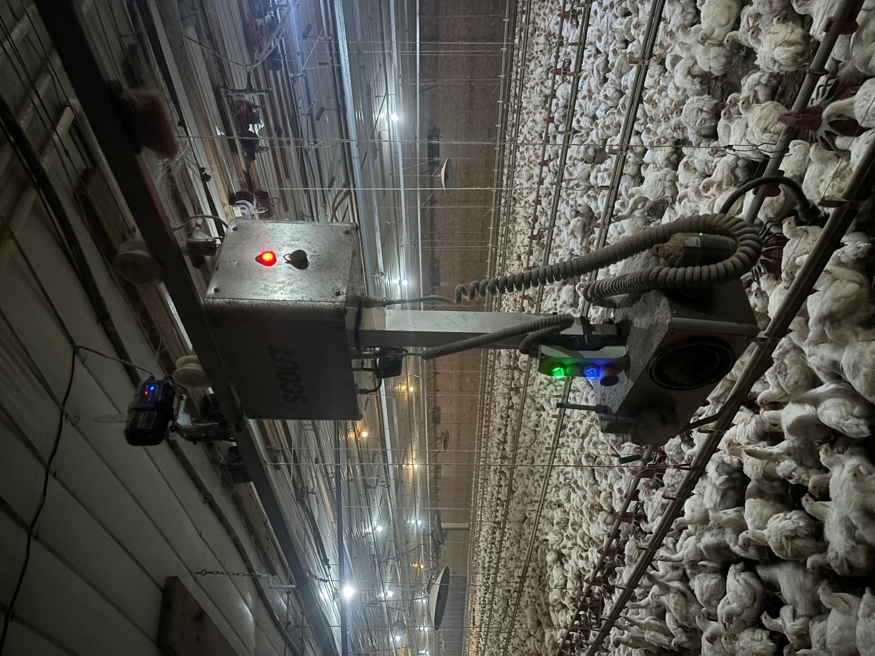
Figure 4.1 Scout system installed in commercial house.

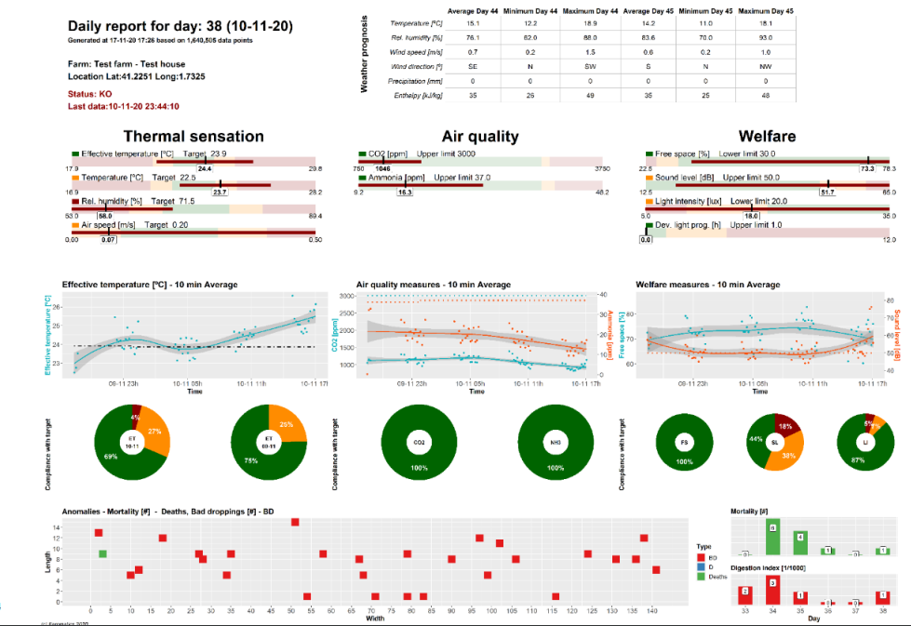
Figure 4.2 Example producer report.

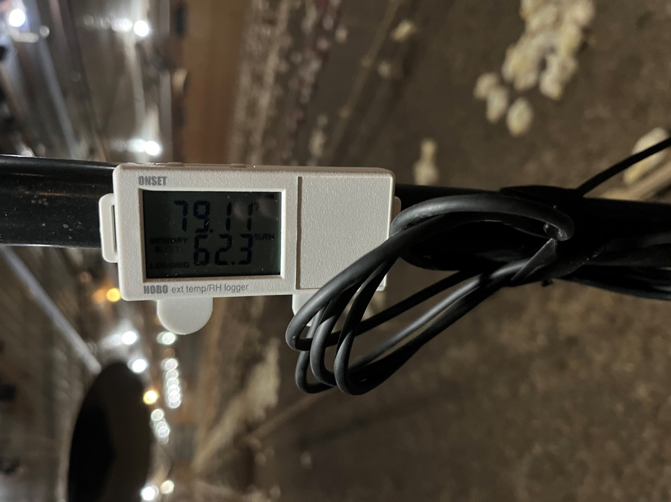
Figure 4.3 Reference HOBO at scout height.

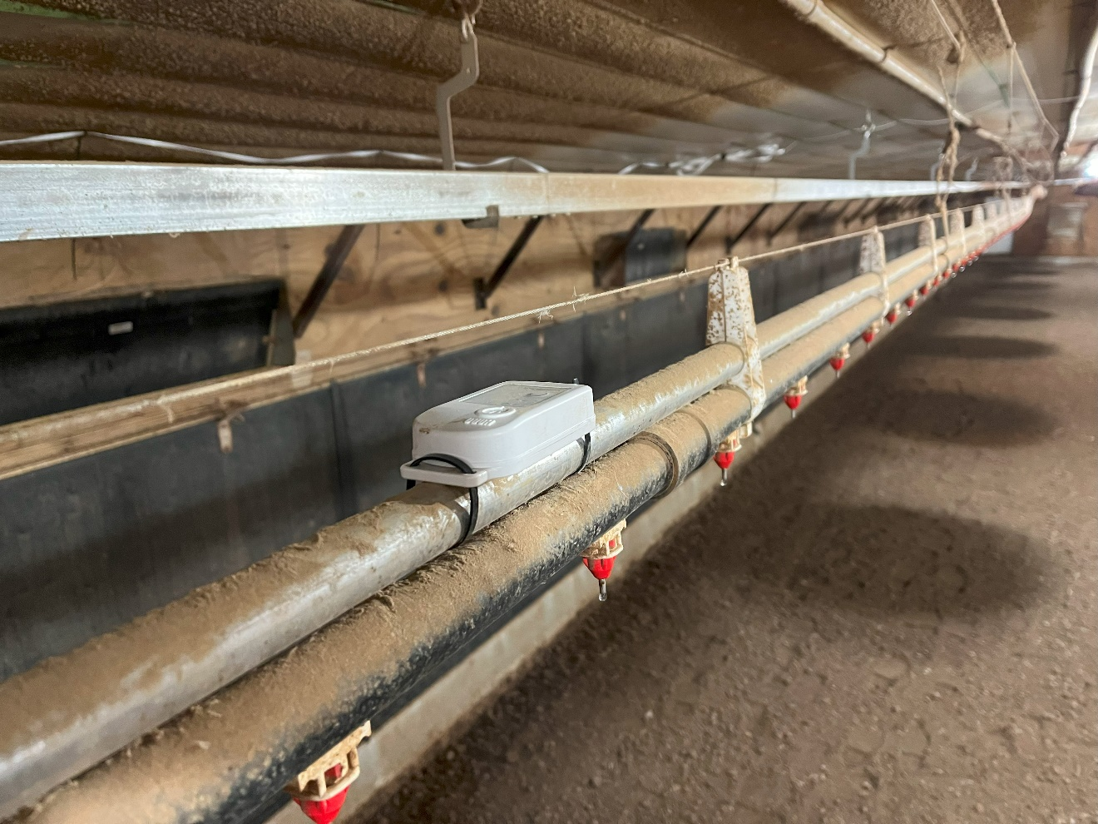
Figure 4.4 Reference HOBO at bird height.


Figure 4.5 Calibration of HOBO temp and RH measurements in climate control chamber.

Figure 4.6 Breakdown of Mortality Zones in ft. Zone 1 is between feed and drinker lines. Zone 2 is between wall and the first drinker line. Zone 3 is between the center drinking lines.

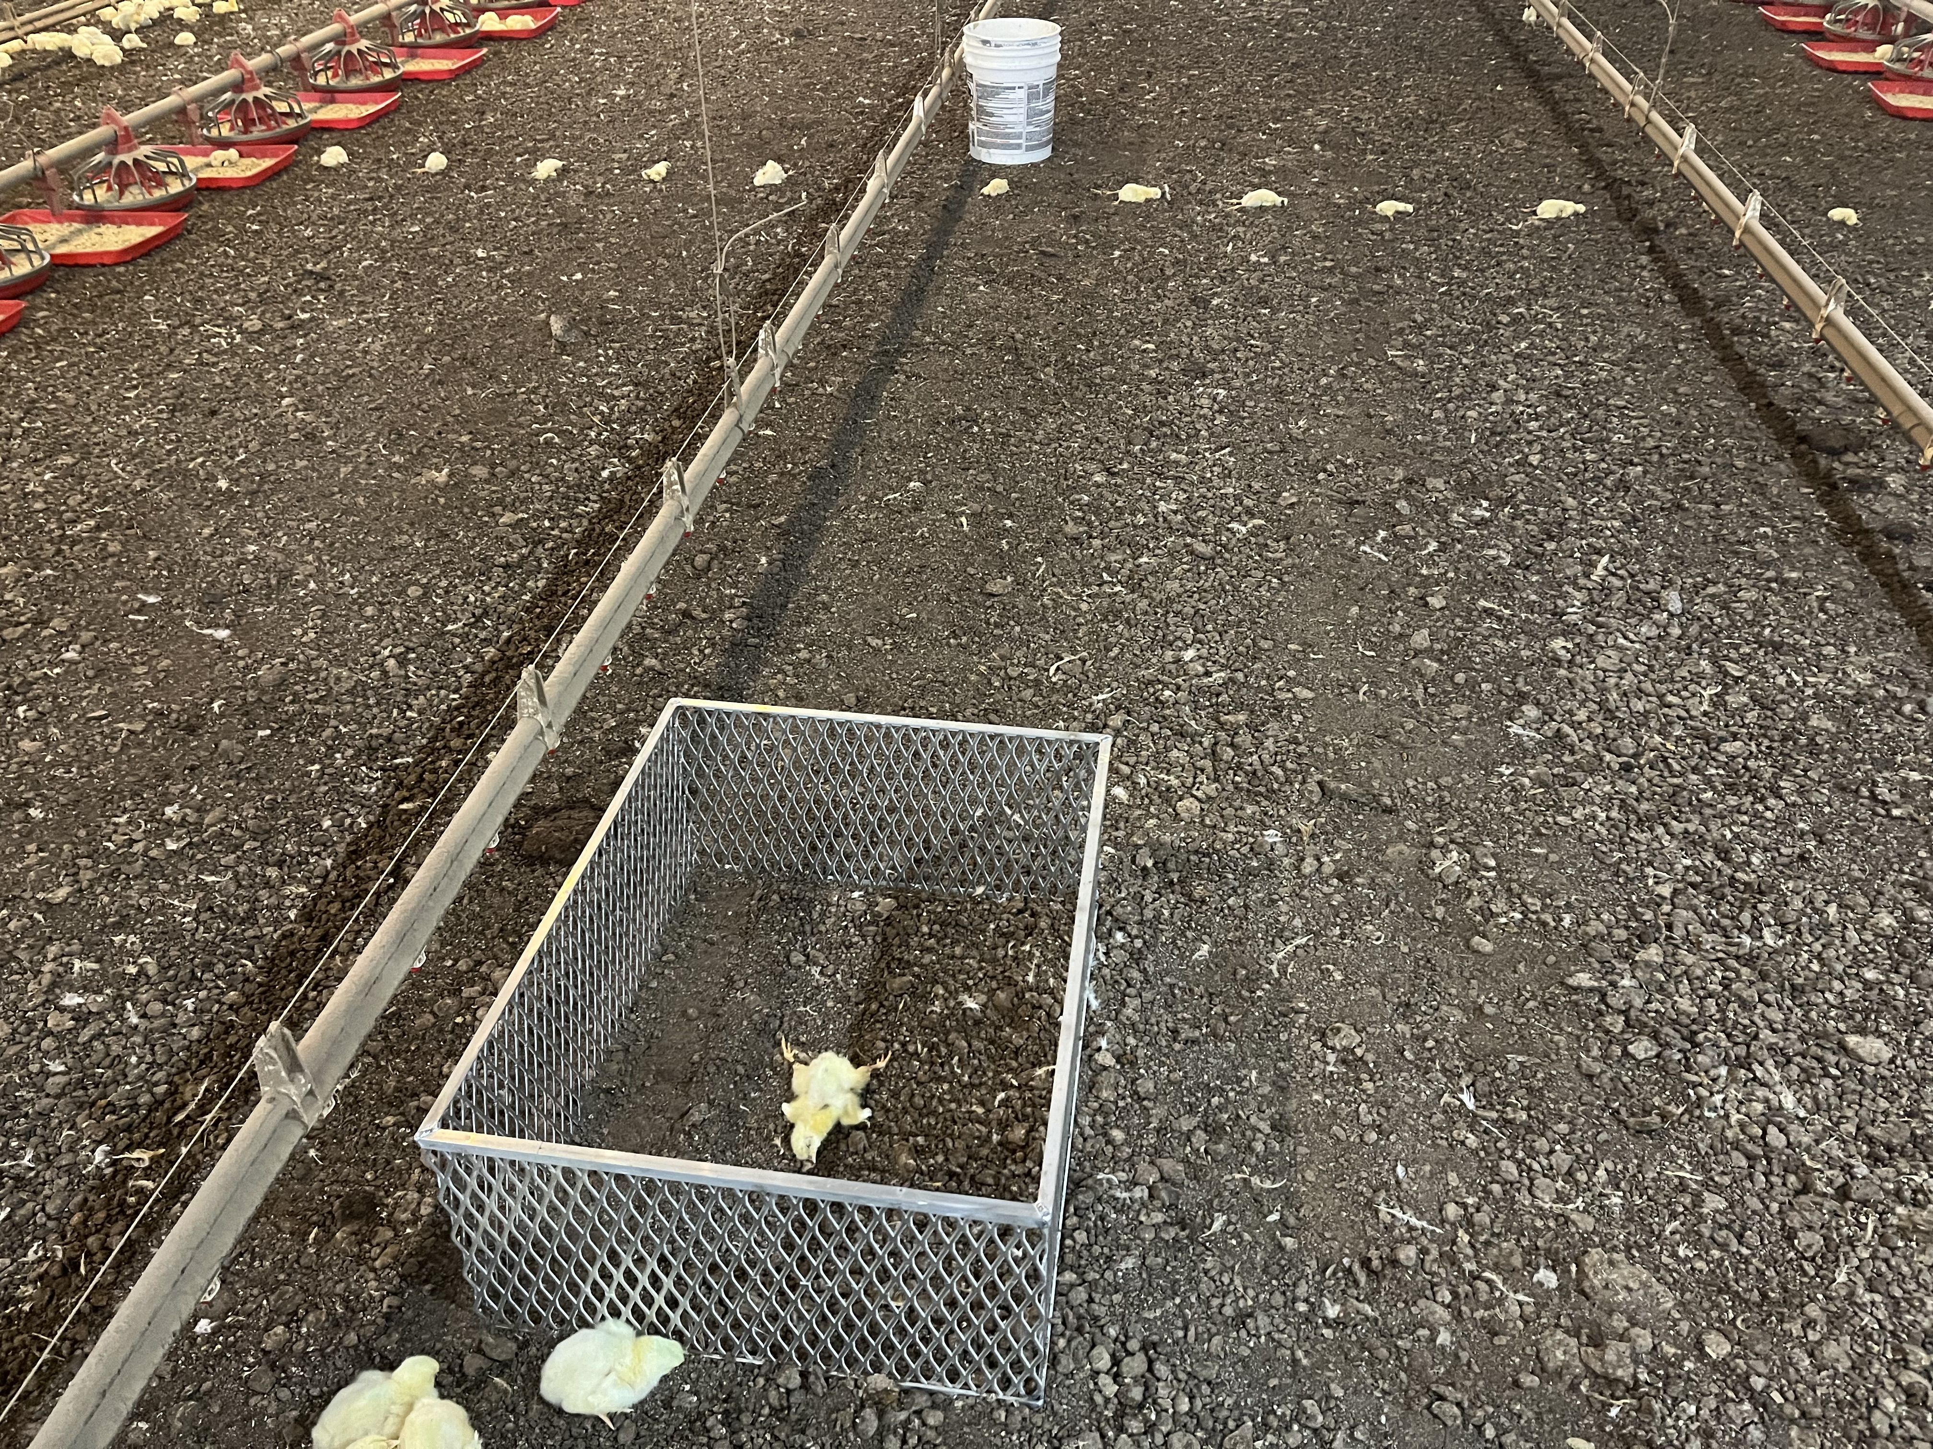
A
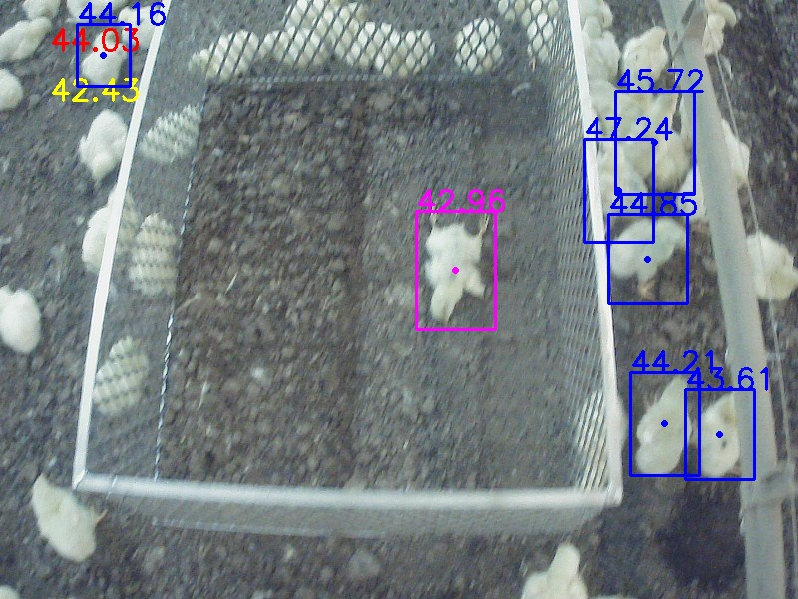
B
Figure 4.7 Pens placed directly under the path of Scout from in person view(A) and Camera view (B)

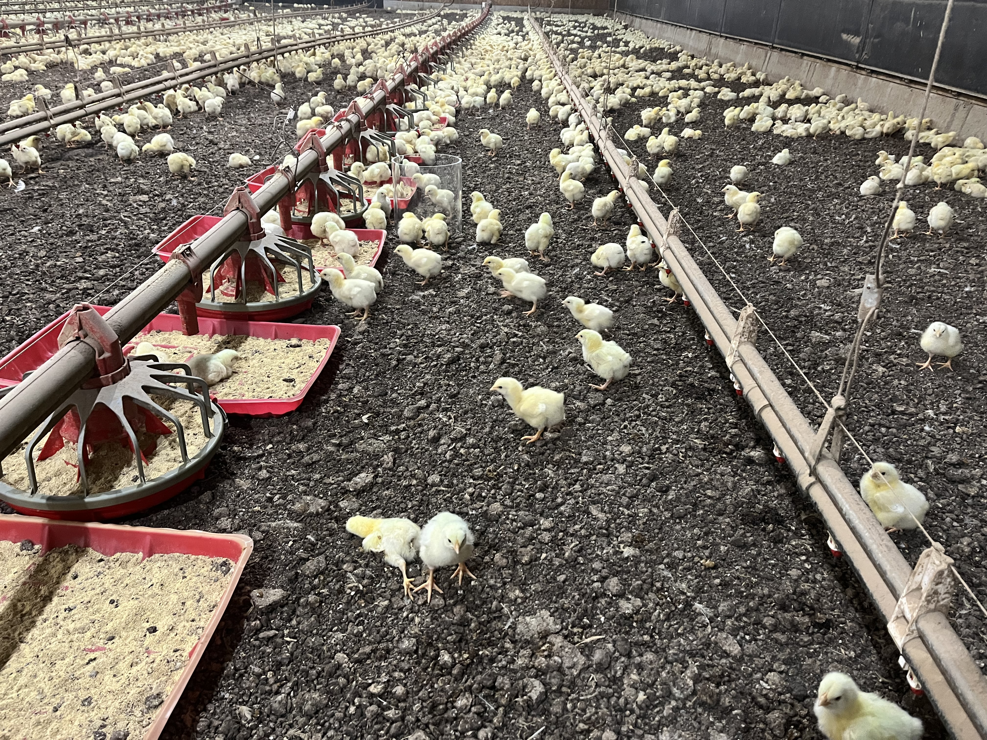
A
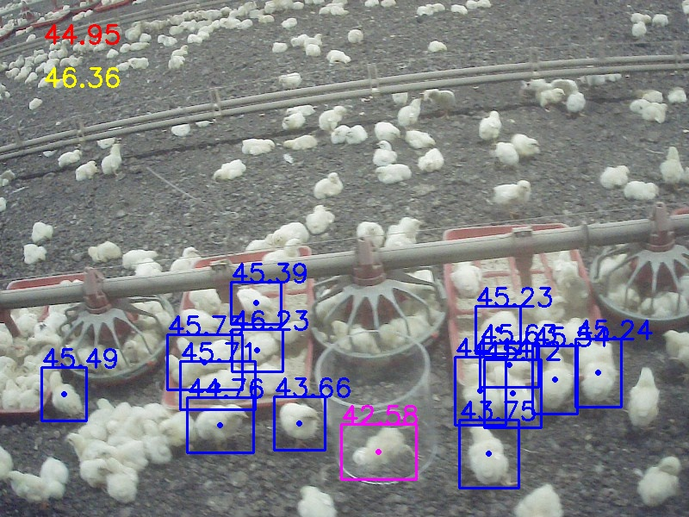
B
Figure 4.8 Pens placed in between feed and water lines to the sides of Scout from in person view(A) and Camera view (B)
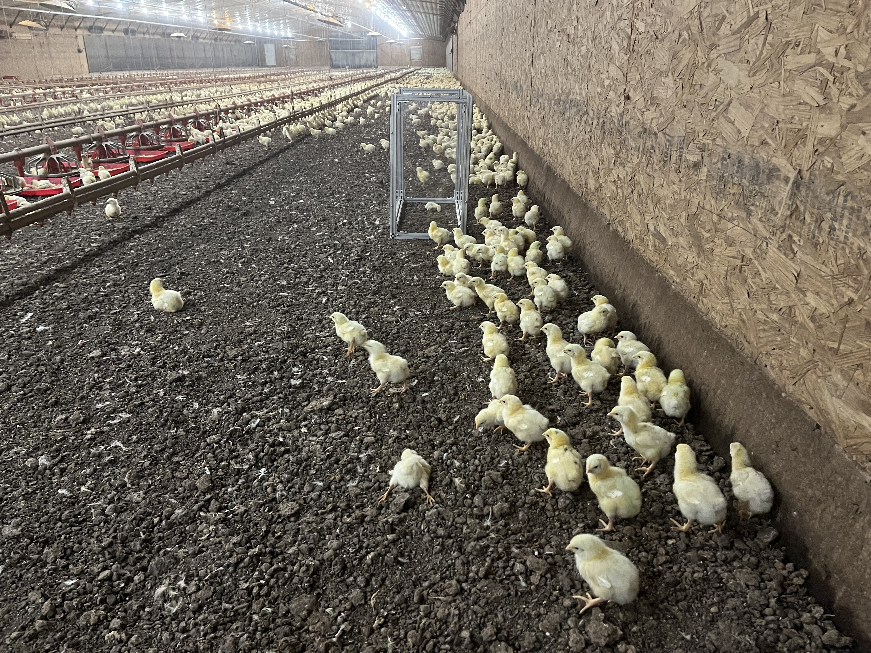
A
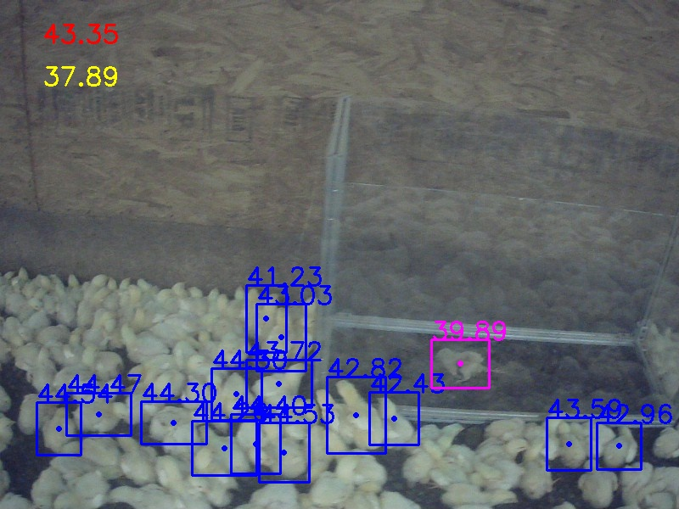
B
Figure 4.9 Pen placed along wall. View from in person view (A) and side camera of Scout®(B).

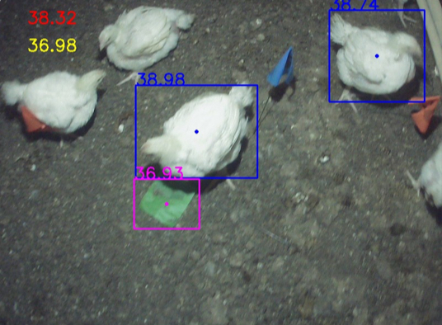
Figure 4.10 Landscape markers used to locate blind spots.

Figure 4.11 Temperature by challenging sensor “scout” vs. reference sensor “HOBO” at scout level (stationary)(°C).

Figure 4.12 Humidity by challenging sensor “Scout” vs. reference sensor “HOBO” at scout level (stationary) (%).

4.13 Temperature by challenging sensor “scout” vs. reference sensor “HOBO” at bird level (°C).

Figure 4.14 Humidity by challenging sensor “Scout” vs. reference sensor “HOBO” at scout level (stationary) (%).

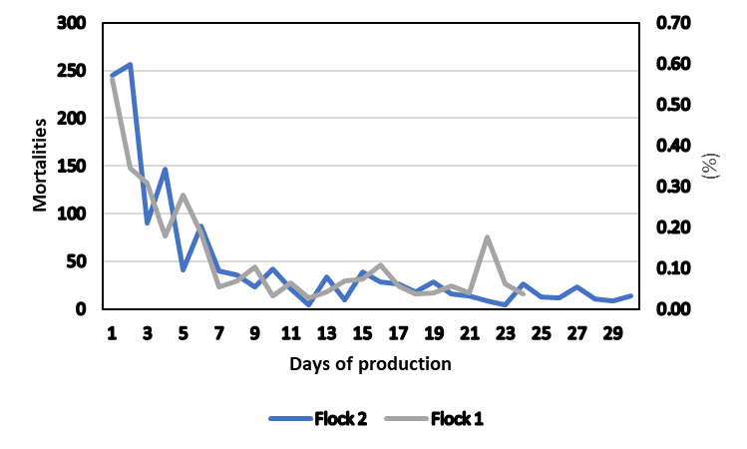
Figure 4.15 Mortalities by day for two flocks.

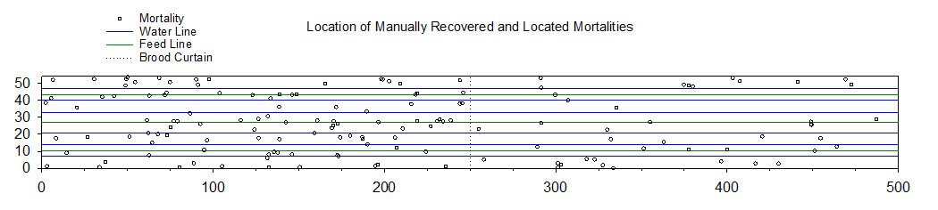

Figure 4.16 Locations of collected mortalities 1-2 time per week over the span of two flocks.

Figure 4.17 Number of mortality detections by Scout® over the span of two flocks.

Figure 4.18 Potential blindspots due to low resolution of side cameras.
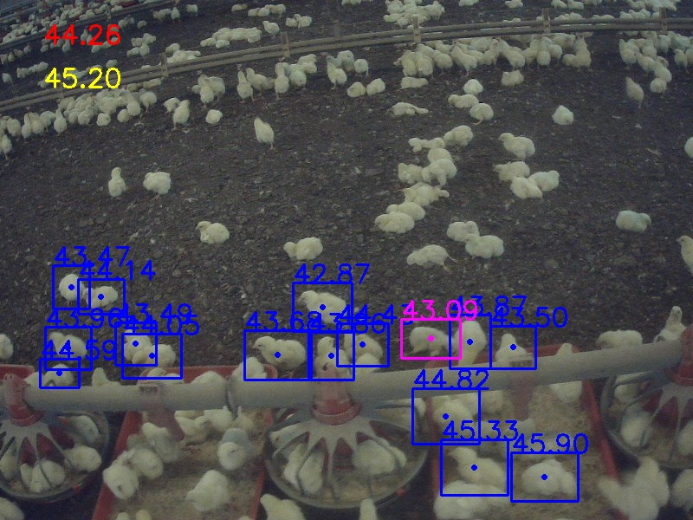
Figure 4.19 Example of limited area of coverage of Scout side. Mortalities are indicated with an x and separated by 1ft each.

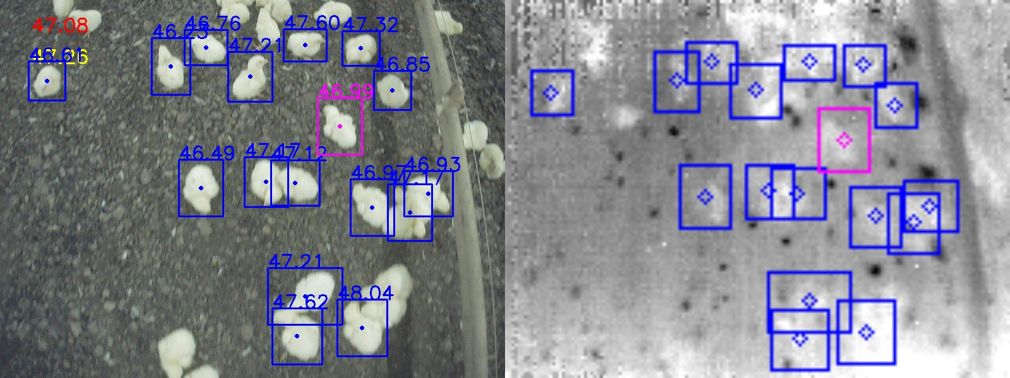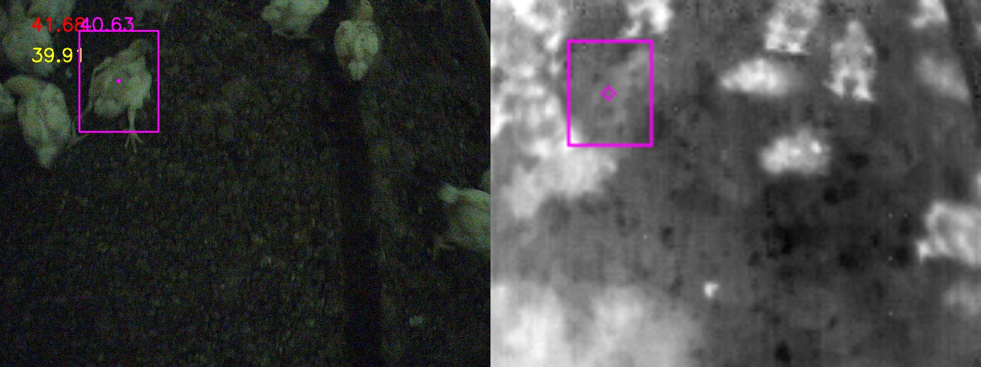 Figure 4.20 Comparison of thermal image before and after brooding period.

Figure 4.21 Number of mortality identifications by camera.

Figure 4.22 Number of detections for staged mortalities.

Vita
Tanner Thornton was born in Knoxville, TN. He did his Undergraduate program in animal science at the University of Tennessee. He worked for two years as a Graduate research associate with his research focusing on poultry science. His Continuing focus is on the improvement of technology in the poultry industry for the betterment of growers.

