How is the Stock Market like Stephen Curry?
Non-Parametric Techniques for Identifying Persistence in Runs
Mariah P. Beane
Faculty Advisor: Phillip Daves, Ph. D.

- Introduction and Literature Review
Stephen Curry, a point guard for the Golden State Warriors, set the NBA’s single-season threes record at 272 during the 2012-13 season (ESPN). Curry has continued to surpass his own record during the 2014-2015 and 2015-2016 seasons. Many may think that Steph Curry is an example of the hot hand in basketball, which is the phenomenon that success will tend to follow success opposed to a chance process. A 1985 study provided original evidence that the hot hands phenomenon was a fallacy; shooting data did not support that a basketball player had better odds of making his next shot had he made his previous two shots opposed to missing them (Gilovich, et al).

A recent paper by Miller and Sanjurjo counters this fallacy (2015). Previous studies compare the bias between the conditional relative frequencies following runs of hits and following the same length run of misses. Miller and Sanjurjo counter that this bias should be investigated as a selection bias due to the nature of sequential data; this is done through the comparison of conditional probabilities to the true probability under Bernoulli assumptions.

This study has implications when considering the structure of the financial markets. Between and within each day, it is presumed that stock prices will go up or down. If there is a selection bias in how prices will react given recent performances, financial analysts may craft different decision rules that improve their success rate.

- Runs Test
A runs test is a non-parametric statistical test used to detect randomness in sequential data (Bradely). A run is defined as a continuous sequence of either like objects or similar events. This test is defined with a null hypothesis that the sequence was produced randomly and an alternative hypothesis that the sequence was not produced randomly. Mood (1940) provides the expected number of runs (a.1) in a set and its variance (a.2) as
(a.1) $E\left(r_{1i}\right)=(n_{2}+{1)}^{\left(2\right)} n_{1}^{\left(i\right)}/n^{(i+1)}$,
(a.2) $σ_{ii}=\frac{n_{2}^{\left(2\right)}(n_{2}+{1)}^{(2)}n_{1}^{(2i)}}{n^{(2i+2)}}+\frac{(n_{2}+{1)}^{\left(2\right)}n_{1}^{\left(i\right)}}{n^{\left(i+1\right)}}(1-\frac{(n_{2}+{1)}^{\left(2\right)}n_{1}^{\left(i\right)}}{n^{\left(i+1\right)}})$.

Within these equations, $n_{2}$ represents the count of a type of event, and $n_{1}$represents all other events; $n_{2}+n_{1}=n$, and $n$ is the count of all elements. The number of runs of event a of length i is denoted by $r_{1i}$.

- Efficient Market Hypothesis Examined through Runs
Fama (1970) asserted the theory of efficient markets with the conclusion that ‘prices always “fully reflect” available information.’ Ultimately, efficient markets do not permit arbitrage as there are not inefficiencies from which to profit. Samuelson (1965) provided foundation for Fama to use the random walk theory to establish the efficient market hypothesis (EMH). A random walk is a description of stock prices’ movements not providing for future predictions, and the proof Samuelson gave founded that efficient markets would follow a random walk. A runs test is Fama’s chosen method to analyze a random walk. Categorizing the empirical work from which he founded this theory, three levels of market information are studied in different tests for efficiency: strong-form tests, semi-strong-form tests, and weak form tests. The following describes the differences in these forms:
- Strong form: current prices fully reflect all available information; no individual has monopolistic access to information;
- Semi-strong form: current prices reflect all obvious, public information;
- Weak form: current prices reflect historic prices without bias; a random walk of no serial correlation among prices is present.
Being the most extensively studied pre- and post- Fama’s establishment of the EMH, weak form tests require relatively less information than the other categories; they utilize historical prices or sequences of returns to gauge market efficiency. For the purpose of this study, returns will be utilized, causing focus to narrow on this category in reviewing the literature. In Fama’s own analysis as well as in his review of empirical studies, run tests to indicate correlation among sequential stock prices show no dependence at a weekly or higher basis and is contradictory at a daily basis.

Subsequent research evaluates weak form efficiency in differing markets to the US stock markets, which were used as empirical evidence for EMH. To determine weak form efficiency of the money market, a runs test on yield changes proved to be more appropriate than a comparison of serial correlations; further, this concluded that typically money markets are weak form efficient (McInish and Puglisi, 1982). More recent research has analyzed the weak form efficiency of founded and emerging financial markets utilizing runs tests for analysis. Ananzeh (2014) concluded inefficient markets of Jordan’s stock exchange. A study of seven Asia Pacific developed markets concluded markets in China, India, and Pakistan were not weak form efficient (Nisar & Hanif, 2012). Contrasting, the newly developed UAE stock market was shown to be weak form efficient (Burns, 2006). A study of the Karachi Stock Exchange supports weak form efficiency (Shaikh, 2013). Studies of developing countries (e.g. Thailand) conclude inefficient markets likely due to the lack of an established financial system (Islam and Watanapalachaikul, 2005). Recent studies of particular markets vary in their conclusions regarding the persistence of weak form market efficiency.

- Momentum
Tversky and Kahneman (1971) consider the Gambler’s Fallacy in their research on the law of small numbers. Many perceive that a corrective bias in the future will reverse what happens more than expected earlier in a sequence. De Bondt and Thaler (1985) concluded that tendencies of people to overreact to information in the stock market causes market inefficiencies. This inefficiency can be seen in prior stock market losers outperforming the market, and vice versa for prior winners. Complimenting this study, Jegadeesh and Titman (1993) conclude parallel results through the realization that investors’ behaviors coincide with the previous theory rising two hypotheses for why systematically biased investor behavior is cause for inefficient markets:
- “Transactions by investors who buy past winners and sell past losers move prices away from their long-run values temporarily and thereby cause prices to overreact.” Or,
- “The market underreacts to information about their long-term prospects. … Given that the nature of the information available about the firm’s short-term prospects is different from the nature of the more ambiguous information used to asses a firm’s longer-term prospects.”
In this research, the concept of stocks’ momentum is described as stock persistence to continue to go up or down in the future if having done so for testing at the time period of 6 months; however, over longer periods of time these returns dissipate.

The same pair of researchers later conclude that momentum founded earlier in the 1990s remained persistent throughout the decade (Jegadeesh and Titman, 2001). Other studies find that momentum also persists in international markets, namely European markets (Rouwenhorst, 1998). Much research in rejecting the efficient market hypothesis centers on momentum to highlight inefficiencies that generate excess profits; however, a consistent consensus on its existent is not present among the research. The methodology utilized in these analyses of momentum is abnormal portfolio returns over the time period of months.

The persistence of stocks to be over or undervalued for greater than a month is attributed much investors’ sentiment being unpredictable, resulting in arbitrage failing to fix mispricing (De Long et al., 1990). As one attempts to arbitrage prices, reverting returns back to the mean, investor’s sentiment remains unpredictable in how they choose to respond to news. Barberis (1998) considers that returns do follow a random walk; however, investors do not effectively perceive this. Increased strength of news released cause overreaction by investors relative to the weight the event actually held.

- Intraday Market Efficiency
While research on momentum highlights abnormalities in portfolio returns over months, curiosity remains around abnormal returns of stocks over time lengths of minutes. Some researchers have examined specific questions as it relates to intraday efficiency. Stock prices of the auto industry from the first six months of 1971 showed efficient price changes in reaction to industry news with a time interval ranging at more than ten minutes but less than an hour (Epps, 1979). Busse and Green (2001) measured the length of time required for news to be incorporated into stock prices following announcement on the financial television network CNBC. Traders acting within fifteen seconds to positive news are able to make some profits, yet it takes around one minutes for information to be reflected properly in stock prices. Negative news has the same impact; however, it is a more gradual process, taking around fifteen minutes for prices to properly fall. This insinuates that active traders who remain cognizant of new information are promoters of efficient markets.

Chorida, Roll, & Subrahmanyam (2005) investigated short horizon returns and whether or not there is predictability from previous orders. While acknowledging weak form efficiency of the New York Stock Exchange (NYSE) exists on day horizons, Chorida et al. were curious on the time length stocks required in order to achieve weak form efficiency. They analyzed order imbalances on the NYSE in three non-sequential years, and time lengths to reach efficiency were greater than five minutes yet less than an hour. As the years became more close to the present, technological advances likely contributed to these time horizons being relatively shorter. Conclusions centered on the curious nature of stocks having no consistent inefficiencies at time length of thirty minutes while momentum studies documented inefficiencies at six months. They conclude that stocks are more predictable at longer terms.

Chordia et al. (2008) consider the role liquidity plays in enhancing intraday market efficiency. Liquidity is shown to be a factor in reaching efficiency. As smaller tick sizes are considered, autocorrelation of stock returns decreases. Ultimately, the more liquid stocks absorb information more efficiently; thus, there are lower autocorrelation at smaller tick sizes but increased variance ratios as information is more quickly reflected in stock prices.

Matías and Reboredo (2012) analyze what models best forecast intraday returns of stocks. Their conclusions lead to belief that nonlinear models are most appropriate in forecasting. With the models they investigate, time horizons of 5, 10, 20, 30, and 60 minutes are compared for which ones best allows for forecasting. In their sample of intraday data of the S&P 500, serial correlation was withdrawn at intervals above 10 minutes. Shorter time periods of 5 minutes were the most effective in forecasting in and out of sample.

- Thesis Topic
If the hot hand phenomena is seen in financial data, a curious pattern would be present within a market’s microstructure in providing liquidity. Being able to buy or sell a sufficient quantity of shares quickly and at a low cost denotes liquidity; there is low impact upon the market’s price. As the willingness of a buyer to purchase and a seller to trade spreads, the price is more likely to be affected, and this price affect would be seen over a longer period of time.
Miller and Sanjurjo’s working paper establishes a different way to consider the randomness of a run. Weak form efficient market hypothesis literature typically considers the count of runs in financial data as a key metric for determining efficiency. Intraday efficiency literature has concluded that efficiency can occur within minutes. Curiosity remains around how financial data acts at a micro-level, as liquidity is being reached. Specifically, this paper is concerned with seeing if a “hot hand” is present in financial data; further, this study investigates for what time scale and length a “hot hand” would be present and maintained. To evaluate this, the conditional probability of continuing a run given the run’s length will be compared to the null probability of continuing a run. Different sampling intervals will be evaluated to investigate this (e.g., tick-by-tick, millisecond, second).

This study hypothesizes the following as the behavior of the conditional probability of continuing a run given the run’s length and the time interval at which prices are observed.
- For tick-by-tick data, bid-ask spread dominates the length of positive and negative runs; the conditional probability of continuing a no change run will be greater than the null.
- There is a time interval spaced widely enough so that the market can easily respond to market changes and provide liquidity; runs would be no more or less than would be expected by chance.
- Some middle time interval (e.g., millisecond) will see the effects of herding behavior result in a conditional probability of continuing a run that is above the null probability for some time length until liquidity is provided.

- Data
Gilead Sciences (GILD) is a pharmaceutical company that is traded on the New York Stock Exchange. Transaction data for GILD during the year of 2014 were collected. The use of one stock during this study establishes procedures upon which a larger investigative study may be subsequently preformed.

During the study, GILD’s tick-by-tick prices for 2014 are analyzed from 0930 to 1600 hours. Prices are also looked at on different intervals of time longer than transaction data. These intervals are 0.001 seconds, 0.01 seconds, 0.1 seconds, 1 second, 10 seconds, and 100 seconds.

- Methodology
Positive runs are defined as runs within financial data in which the price is increasing. Negative runs are defined as runs in which the price is decreasing. No change runs are defined as runs in which the price remains constant.

The count of positive, negative, and no change runs at run lengths of 1 to 400 is calculated for GILD during the year of 2014. The run length is tabulated out to 400 due to the bid-ask spread yielding longer runs of no change in price. The observed count of runs, at each length, is compared to the expected count of runs and standardized by the standard deviation of the run length in order to detect when markets begin behaving as expected. This is evaluated at varying time lengths: tick-by-tick, millisecond, 0.01 seconds, 0.1 seconds, second, 10 seconds, and 100 seconds. Mood (1940) provides formulas for the expected number of runs (1) in a set and its variance (2) as
(1) $E\left(r_{1i}\right)=(n_{2}+{1)}^{\left(2\right)} n_{1}^{\left(i\right)}/n^{(i+1)}$,
(2) $σ_{ii}=\frac{n_{2}^{\left(2\right)}(n_{2}+{1)}^{(2)}n_{1}^{(2i)}}{n^{(2i+2)}}+\frac{(n_{2}+{1)}^{\left(2\right)}n_{1}^{\left(i\right)}}{n^{\left(i+1\right)}}(1-\frac{(n_{2}+{1)}^{\left(2\right)}n_{1}^{\left(i\right)}}{n^{\left(i+1\right)}})$.

Within these equations, $n_{2}$ represents the count of a type of event, and $n_{1}$represents all other events; $n_{2}+n_{1}=n$, and $n$ is the count of all elements. The number of runs of event a of length i is denoted by $r_{1i}$.

Null probabilities of continuing a run are calculated for no autocorrelation being present among prices. The probability of a positive tick following any previous action in prices is represented as ${np}_{it}^{p}.$The subscripts i and t represent run length and day, respectively.
$${np}_{it}^{p}=\frac{r_{t}^{p}{- m}_{i}}{n_{t}-m_{i}}$$
Further, $r_{t}^{p}$is the count of positive ticks during the sampling interval of a given day; $n_{t}$ is the total number of observation during the sampling interval of a given day; and, $m_{i}$ indexes the probability so that considers the run length. The probability of a zero change tick,${ p}_{it}^{z}$, and a negative tick,${ p}_{it}^{n}$, are calculated in the same manner by considering number of zero changes and downward ticks, respectively, along the sampling interval of a given day.

Conditional probabilities,${ cp}_{it}^{p}$, of continuing positive runs are contingent upon the length of the run. Again, the subscripts i and t represent run length and day, respectively.
$${cp}_{it}^{p}=\frac{\sum_{i}^{n}{c_{(i+1)t}^{p}}}{\sum_{i}^{n}{l_{it}^{p}}}$$
Further, $l_{it}^{p}$is the count of positive runs during the sampling interval of a given day at an indicated run length, i; $c_{(i+1)t}^{p}$ is the count of positive runs that are continued from the base run length, i. The conditional probability is seen as the ratio of the sum of the number of times a run is continued compared to the sum of the number of times it is both continued and not continued. This property holds for the condition probability of continuing a no change run, ${cp}_{it}^{z}$, and the conditional probability of continuing a negative run, ${cp}_{it}^{n}$. However, the run counts considered per conditional probability are no change and negative runs, respectively.

Following a visual interpretation of potential bias between the null and conditional probabilities, a Kolmogorov-Smirnov test is used to gauge if the two probability distributions are equivalent. The test is performed by use of NCSS Statistical Software, and output is interpreted for a null hypothesis that the two distributions are equal.

- Results and Discussion
At time intervals tested, the count for runs of one length are different from what would be expected. For positive and negative runs, this difference is seen as more runs than would be expected; for no change runs, this difference is seen as less runs than would be expected. Appendix 1 highlights these statistics.

Not interestingly, the observed count of runs and the expected count of runs for each run length but length 1 is statistically the same at the 100 second interval for positive and negative runs. However, at that 100 second interval, no change runs do persist at a greater count than would be expected for runs of length 2 through 4. The same behavior occurs at a 10 second interval, but no change runs are at a different, greater level for run lengths up to 10. A 10th of a second is the interval in which a difference in observed count of positive and negative runs from what would be expected persists to the greatest run length (i.e., length of 10). At these levels of significant differences for positive and negative runs for all intervals, the difference is such that the observed count of runs is less than what would be expected; conversely, the observed count of no change runs exceeds what would be expected. This indicates that prices are prone to remain at their current level following a rise or decline.

Appendix 2 contains the same statistics previously discussed; however, the time interval of 0.1 seconds is analyzed at thirty minute intervals in order to understand how runs within a day act. Appendix 3 provides insight into the amount of observations that took place in each 30 minute interval over a course of a year; these observations are observed on a 0.1 second scale. The time span from 09:30 AM – 10:00 AM sees the most trades; 14:30 PM – 15:00 PM sees the least trades. The deviation from expected count of runs are at the longest and shortest run length during both of these time intervals. The 9:30 AM – 10:00 AM time interval sees run counts that are less than would be expected for up to run lengths of 10. Contrarily, the 14:30 PM – 15:00 PM time interval sees run counts that are less than would be expected only up to run lengths of 6. The same nature for positive, negative, and zero change runs holds from previous discussion in when the difference is less than would be expected and more than would be expected.

Considering the 9:30 AM – 10:00 AM interval, the less than expected count for runs highlights that prices during that time interval are more likely to stay the same. The 14:30 PM – 15:00 PM interval shows that prices are more quickly adjusting to expected randomness.

In comparing the conditional and null probabilities for positive, negative, and zero change runs of varying lengths, a scale of 10 seconds is a range in which positive and negative runs see their probabilities at varying run lengths to be similar to what is expected. Appendix 4 displays conditional and null probabilities for positive runs at time scales of tick-by-tick, 0.1 seconds, and 10 seconds. This same information is provided for negative runs in appendix 5 and zero change runs in appendix 6.

Both positive and negative runs see their probability being less than would be expected in tick-by-tick data at a likely insignificant level up to run lengths of 5. Above run lengths of 5, the probability seen in tick-by-tick data exceeds what would be expected. When looking at zero change runs, the probability of these runs exceeds what would be expected. This gives evidence to certify the hypothesis that bid-ask spread dominates the length of positive and negative runs and that the conditional probability of continuing no change run will be greater than the null.

The hypothesis concerning a time interval being widely spread in order to see liquidity in the market is certified by looking at the graphs of positive and negative runs at 10 second intervals. The bias between the null and conditional probabilities is practically negligible.

The Kolmogorov-Smirnov test is run in order to provide statistical significance to the above assumptions (Appendix 7). In all instances for zero change runs, the conditional probabilities for runs is statistically higher than what would be expected. There are longer no change runs than would be expected. For tick-by-tick and 10 second interval transaction data, the deviation between the conditional and expected probabilities is not statistically different. There is a statistically significant difference at a 0.1 second time interval.

The following addresses the study’s hypotheses:
- Practically, tick-by-tick data sees expected positive and negative runs that are dominated by bid-ask spread; however, the conditional probabilities for positive and negative runs at varying lengths are not considered different than the null probabilities. No change runs experience a conditional probability that is greater than the null.
- 10 seconds appears to be an appropriate time length for liquidity to enter the market. This is given through both conditional probabilities and observed run counts not varying from what is expected. Regarding run counts, the observed is different for only small run lengths, and it does not persist.
- A time length of a tenth of a second was chosen as a middle time interval in which herding would alter prices’ expected behavior due to its deviation of expected runs being the most persistent relative to other time intervals. The hypothesized outcome of a conditional probability being above the null holds true for no change runs, but this outcome holds true at the other measured time intervals. For positive and negative runs, the conditional probabilities are statistically different from the null. It is unlikely that herding behavior is the cause of this outcome due to expected counts for positive and negative runs being higher than observed.

- Conclusions
The study concludes that a “hot hand” is seen among no change runs. This persists for an extended period of time in all time intervals observed. A 10th of a second is an interesting time interval that sees conditional probabilities statistically varying from the null probabilities at all run types. The expected count for positive and negative runs is greater than that which is observed, countering a “hot hand” being found among the financial data in regards to its price increase of decrease.

Ten seconds appears as an appropriate time length for liquidity to enter the market, as hypothesized. Tick-by-tick data sees many no change runs; however, this is present at all intervals as well. The impact this has on positive and negative runs is negligible for tick-by-tick data.

In seeing that a 10th of a second has persistent observed deviations, for the longest run lengths, analyzing the data at varying times of the day provides curious insight into trader behavior.
The 9:30 AM – 10:00 AM time span sees the most trades during the day. It also sees run counts that are less than would be expected for up to run lengths of 10; this shows that prices during heavy frequency trading times are more likely to stay the same. Contrarily, the 14:30 PM – 15:00 PM time span sees the least trades while having run counts that are less than would be expected only up to run lengths of 6. During less frequent trading times, prices are quicker to adjust to expected randomness.

This study’s limitations involve the use of a single stock for analysis. Looking at multiple stocks would provide better insight regarding market behavior. Further, analysis of stock behavior during traditionally volatile days may also provide interesting insight into market activity. This would require financial data over several years in order to make clear interpretations.

In summary, financial data sees transactions that persist at no change for longer than would be expected. This is likely due to bid-ask spread dominating the length of positive and negative runs for a time span greater than initially anticipated. Further, high volume trading times see this same behavior, while low volume trading times see expected response in prices.

Bibliography
Ananzeh, I. (2014). Testing the Weak Form of Efficient Market Hypothesis: Empirical Evidence from Jordan. International Business and Management, vol. 9, no. 2, pp. 119-123.
Barberis, N., Shleifer, A., & Vishny, R. (1998). A Model of Investor Sentiment. Journal of Financial Economics, vol. 49, no. 2, pp. 307-343.
Bradley, J. (1968). Distribution-Free Statistical Tests (pp. 271-277). Englewood Cliffs, NJ: Prentice Hall.
Busse, J., & Green, T. (2002). Market Efficiency in Real Time. Journal of Financial Economics, vol. 65, no. 3, pp. 415-437.
Chorida, T., Roll, R., & Subrahmanyam, A. (2005). Evidence on the Speed of Convergence to Market Efficiency. Journal of Financial Economics, vol. 76, no. 2, pp. 271-292.
De Bondt, W., & Thaler, R. (1985). Does the Stock Market Overreact? The Journal of Finance, vol. 40, no. 3, pp. 793-805.
De Long, J., Shleifer, A., Summers, L., & Waldmann, R. (1990). Noise trader risk in financial markets. The Journal of Political Economy, vol. 98, no. 4, pp. 703—738.
Epps, T. (1979). Comovements in Stock Prices in the Very Short Run. Journal of the American Statistical Association, vol. 74, no. 366, pp. 291-300.
ESPN. (n.d.). Stephen Curry Stats. Retrieved from espn.go.com/nba/player/stats/_/id/3975/stephen-curry
Fama, E. (1970). Efficient Capital Markets: A Review of Theory and Empirical Work. The Journal of Finance, vol. 25, no. 2, pp. 383-417.
Gilovich, T., R. Vallone, and A. Tversky (1985): “The Hot Hand in Basketball: On the Misperception of Random Sequences,” Cognitive Psychology, 17, 295–314.
Islam, S., & Watanapalachaikul, S. (2005). Are Emerging Financial Markets Efficient? Some Evidence from the Models of the Thai Stock Market. Financial Modelling Program,, Centre for Strategic Economic Studies, Victoria University, Melbourne.
Jedadeesh, N., & Titman, S. (1993). Returns to Buying Winners and Selling Losers: Implications for Stock Market Efficiency. The Journal of Finance, vol. 48, no. 1, pp. 65-91.
Jedadeesh, N., & Titman, S. (2001). Profitability of Momentum Strategies: An Evaluation of Alternative Esplanations. The Journal of Finance, vol. 56, no. 2, pp. 699-720.
Matías, J., & Reboredo, J. (2012). Forecasting Performance of Nonlinear Models for Intraday Returns. Journal of Forecasting, vol. 31, no. 2, pp. 172-188.
McInish, T., & Puglisi, D. (1982). The Efficiency of the International Money Markets. Journal of Business Finance & Accounting, vol. 9, no. 2, pp. 167-177.
Miller, J., & Sanjurjo, A. (2015). Surprised by the Gambler’s and Hot Hand Fallacies? A Truth in the Law of Small Numbers. Working Paper.
Mood, A. M., “The Distribution Theory of Runs,” Annals of Mathematical Statistics, 11 (1940), 367-392.
Nisar, S., & Hanif, M. (2012) Testing Market Efficiency: Empirical Evidence from Developed Markets of Asia Pacific. World Applied Sciences Journal, vol. 18, no. 4, pp. 414-427.
Rouwenhorst, K. (1998). International Momentum Strategies. The Journal of Finance, vol. 53, no. 1, pp. 267-284.
Samuelson, P. (1965). Proof that properly anticipated prices fluctuate randomly. Industrial Management Review, vol. 6, pp. 41-50.
Shaikh, S. (2013). Analysis & Test of Market Efficiency: A Case Study of KSE. Working Paper.
Tversky, A., & Kahneman, D. (1971) Belief in the Law of Small Numbers. Psychological Bulletin, vol. 76, no. 2, pp. 105-110.

Appendix 1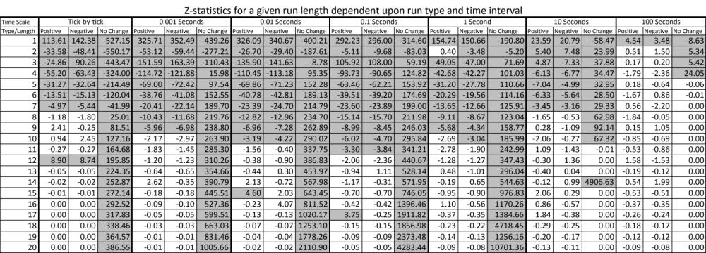
*Shaded boxes represent z-scores that are above +/- 3.

Appendix 2
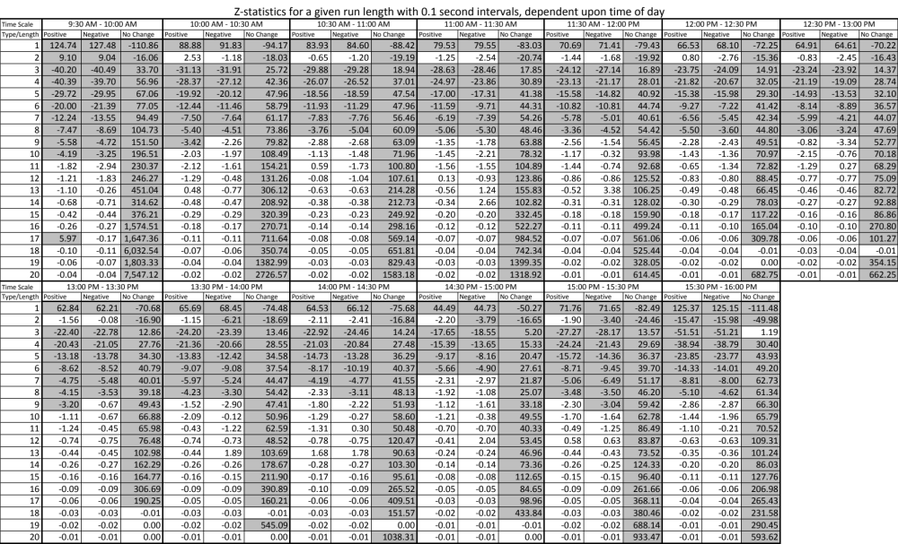
*Shaded boxes represent z-scores that are above +/- 3.

Appendix 3
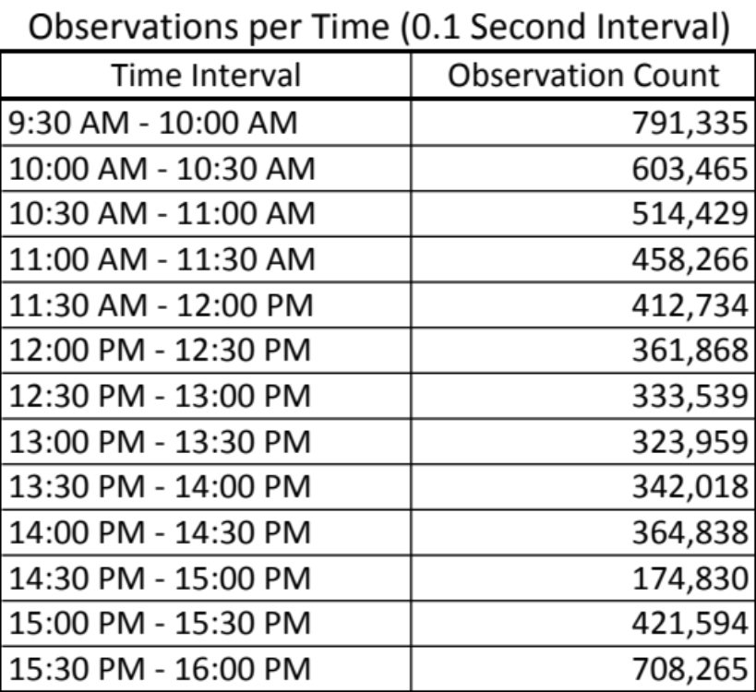

Appendix 4
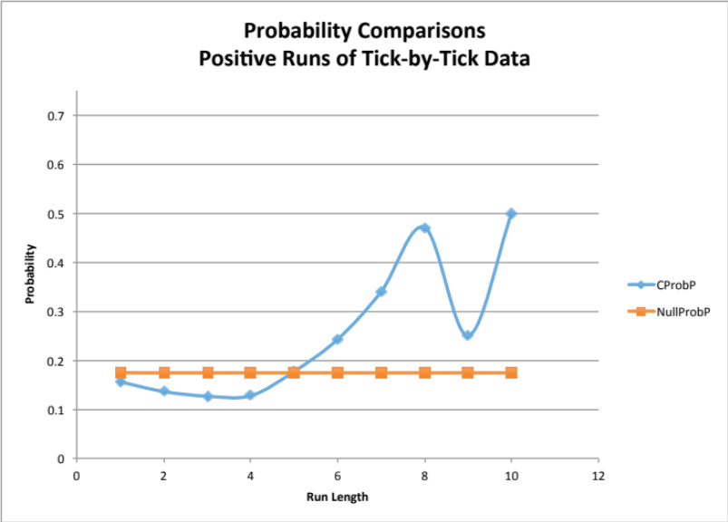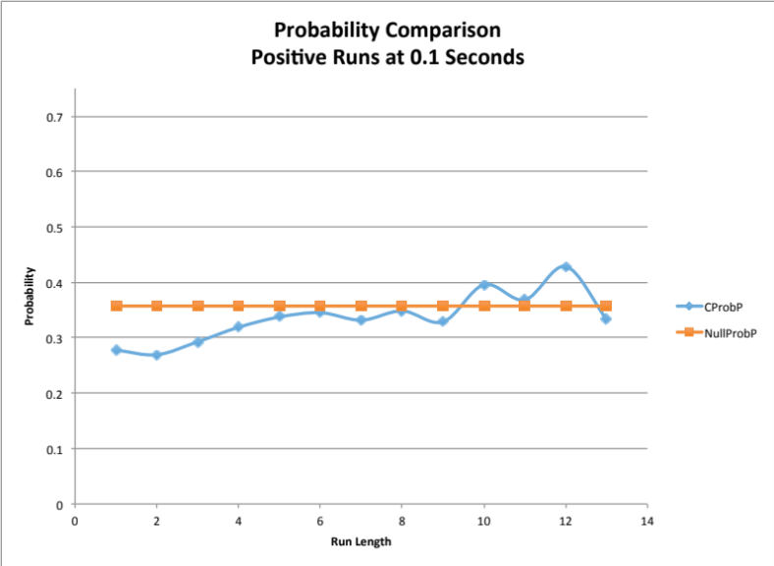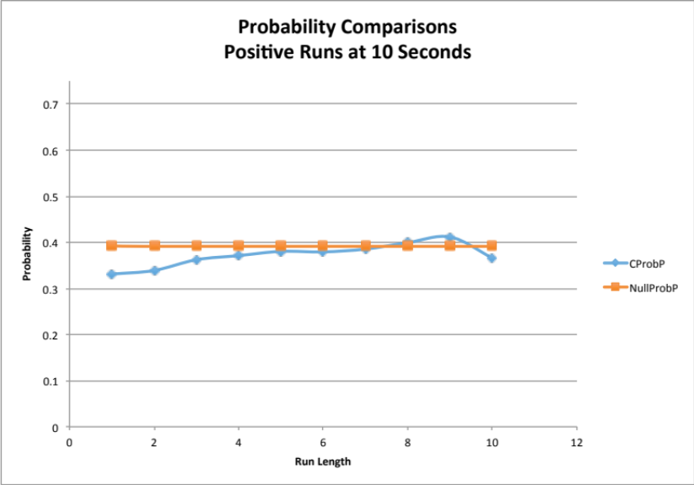

Appendix 5
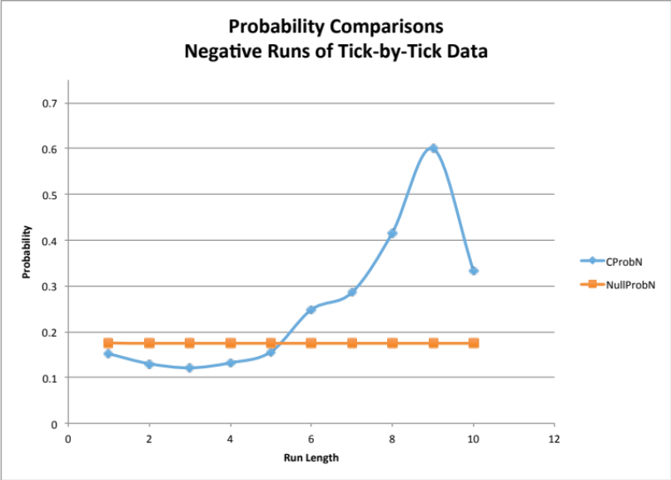
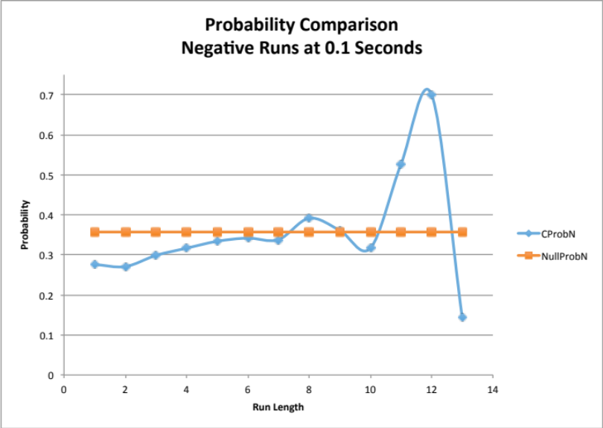
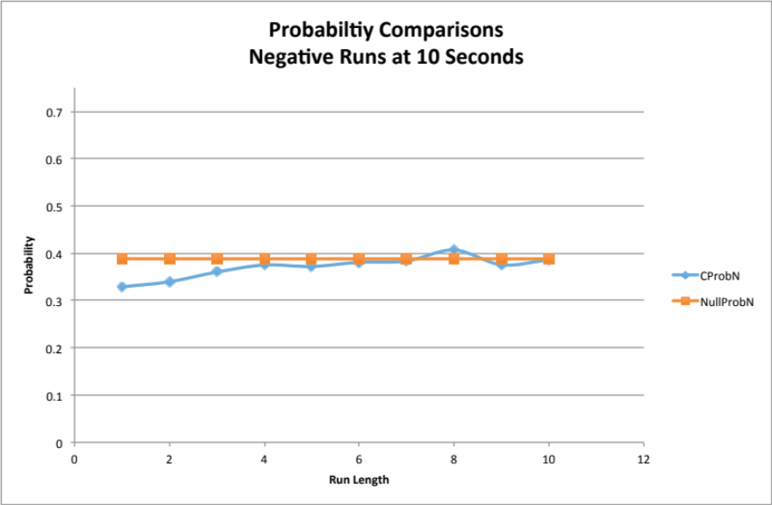

Appendix 6
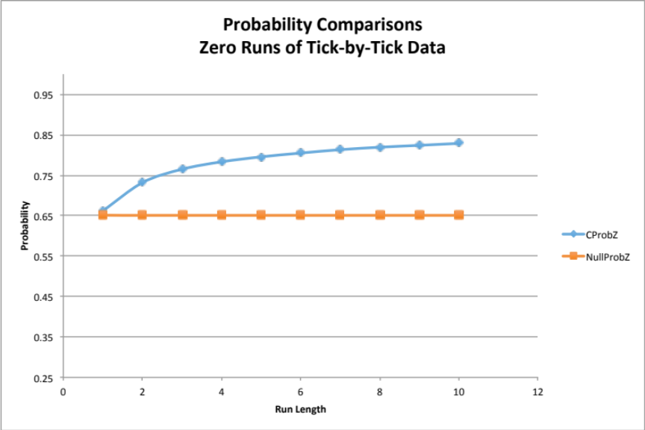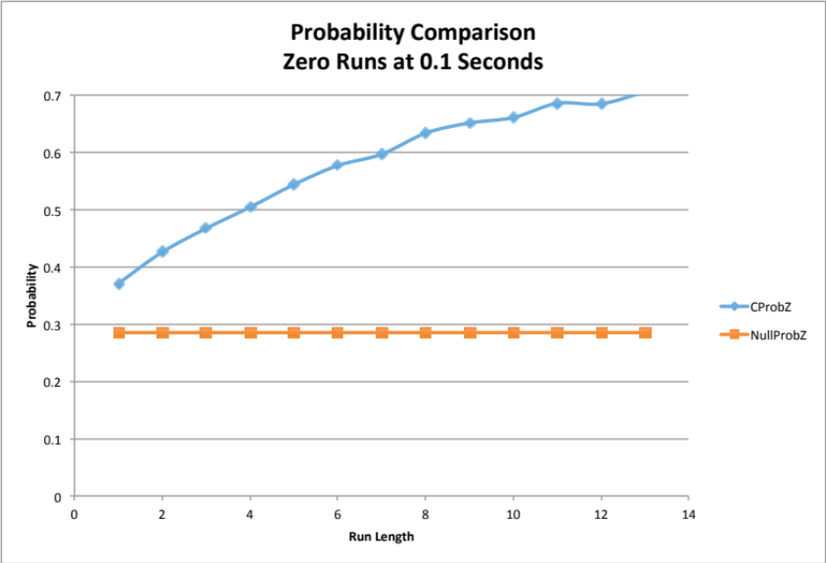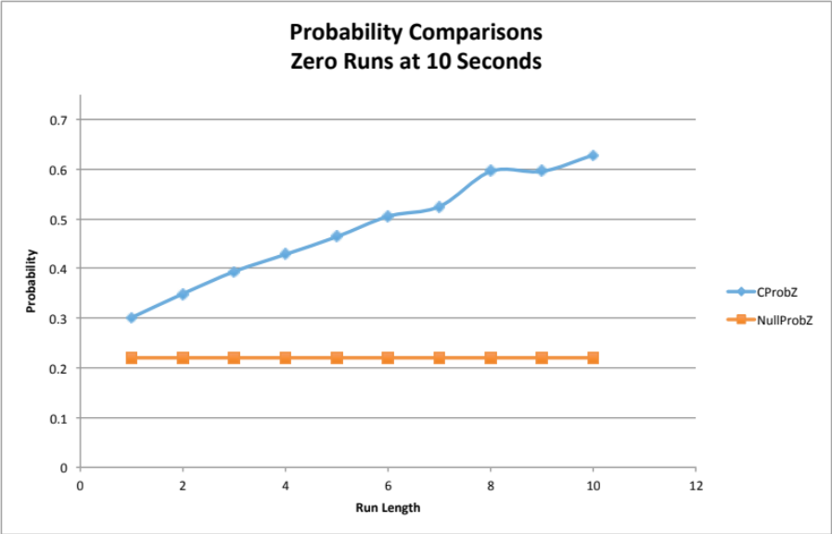

Appendix 7
