A Systems Biology approach to Exploring the Impacts of Prescribed Fires on Soil Microbial Communities in Southern Appalachian Forests: Insights into Burn Frequency, Fuel Types, and Microbial Dynamics

A Dissertation Presented for the
Doctor of Philosophy
Degree
Department of Civil & Environmental Engineering
The University of Tennessee, Knoxville

Sa’ad Abd Ar Rafie
November 6, 2023

Copyright © 2023 by Sa’ad Abd Ar Rafie.
All rights reserved.

Acknowledgements
This work would not have been possible without the initial funding provided by a FUSION opportunity grant from the Office of Research and Engagement at the University of Tennessee, Knoxville awarded to Sally Horn, Terry Hazen, Kevin Hoyt, Martin Schubert, Kim Carter and Liem Tran. I would also like to acknowledge the financial support I received from The University of Tennessee, Knoxville, through the Institute for a Secure & Sustainable Environment (ISSE) and the Tennessee Fellowship for Graduate Excellence that made my stay in Knoxville a whole lot less stressful.
I must thank my committee members, Dr. Terry Hazen, Dr. Sally Horn, Dr. Qiang He, and Dr. Jon Hathaway, for their help and feedback during this journey. Each of your expertise helped to shape and make my research better, and I am truly grateful for your time. A special thanks to Dr. Jennifer Franklin and Dr. Sally Horn, who have helped me with sampling plans and fieldwork on more occasions than I can thank them for. To say that I had an inkling about fire ecology and working with soil would be an overstatement, and I am glad I got to work with you two to get to where I am now. I would especially like to thank Dr. Hazen, who served as my primary advisor during my time here at the University of Tennessee. Thank you for allowing me to explore and pursue projects I was genuinely passionate bout and for challenging me to grow as a researcher. Your constant guidance and weekly “safety” checks during meetings have gone a long way to making me feel appreciated and less like an imposter. Getting to work on such a HOT topic as a dissertation will go a long way to help me in my career.
I want to thank the lifelong friends I have made during my time here, and I was fortunate enough to have met you all. From the Annual 6 AM HAZWOPER Refreshers with Andrew to troubleshooting the occasional line of code with Ye to spending lunch reminiscing about gloriously over-the-top food dishes with Dom and Zabrenna, the Hazen Lab team felt like an ever-growing family. I would be remiss to not mention Mafer and Ann-Marie; you both were the best mentors I could have asked for during my early years in Knoxville. You were my guiding light as I fumbled around trying to stick a landing in grad school. Dan, the savior of my sequencing runs, where would I be without you! Kurt, your endless patience with my questions never went unnoticed. Isis and Diliya, you’re a truly exceptional bunch; I'm grateful our paths crossed. I want to thank my family for being understanding when I went weeks at a time, forgetting to reach out to them during busy work stretches. Ma, your steadfast support, and the countless sacrifices you've made are the pillars of my journey, and for them, I am deeply thankful. And to my late father-in-law, Dr. M.A. Rashid Sarkar, your generous spirit, unwavering kindness, and inspiration live on in all of us.
I want to thank my wife, Anika Sarkar, for always being there for me and keeping me going when things got tough. I'm excited about the life we'll create together in the future, knowing that your presence will make every step of the journey even more beautiful.

Abstract

Prescribed fires in Southern Appalachian forests are vital in ecosystem management and wildfire risk mitigation. However, understanding the intricate dynamics between these fires, soil microbial communities, and overall ecosystem health remains challenging. This dissertation addresses this knowledge gap by comprehensively exploring selected aspects of this complex relationship across three interconnected chapters.
The first chapter investigates the immediate effects of prescribed fires on soil microbial communities. It reveals subtle shifts in porewater chemistry, such as increased acetate, sodium, and nitrate concentrations, and identifies significant increases in microbial species richness. These findings offer valuable insights into the interplay between prescribed fires, soil properties, and microbial responses during the early stages following a prescribed fire.
The second chapter delves into the long-lasting impacts of controlled burns on soil carbon and nitrogen isotopic compositions. It showcases diverse carbon and nitrogen concentrations in soil cores, emphasizing increased carbon content for specific treatments. Stable isotope analyses showed shifts in δ¹³C and δ¹⁵N values, with measurable differences in postfire δ¹⁵N for various fuel types. The loss of isotopically light carbon during the fire event is attributed to burning soil organic carbon.
The third chapter explores the influence of fire frequency on soil microbial communities and nutrient dynamics. It highlights the substantial impacts of burn frequency on microbial biomass carbon (MBC), emphasizing the importance of recovery periods between burns. A detailed examination of bioavailable nutrient concentrations, total carbon, nitrogen content, and pH uncovers the intricate relationship between fire frequency and soil properties. This research underscores the role of different fire-frequency regimes in shaping these relationships and their importance in informed land management for preserving Southern Appalachian mixed forests.
In conclusion, this dissertation provides significant insights into the relationships between prescribed fires, soil microbial communities, and soil nutrient cycling in Southern Appalachian mixed forests. Land managers can make more informed decisions about when and where to implement fire as a management tool in these forests by understanding the impact of prescribed fires on soil microbial communities and nutrient cycling. This research highlights the importance of considering fuel types and fire frequency to promote healthy ecosystem functioning and maintain biodiversity. Overall, the findings of this dissertation contribute to the field of fire ecology and provide valuable knowledge for conserving these crucial ecosystems.

Table of Contents
Table of Contents vii
List of Tables ix
List of Figures x
Chapter 1 Introduction 1
Background and Rationale 2
Research Objectives 7
Scientific Contribution to the Field 7
Overarching Hypothesis 8
Specific Aims and Sub-hypotheses 8
References 10
Chapter 2 Prescribed fire-induced changes in soil microbial community structure during a short-term study in a Southern Appalachian Forest clearcut 2
Abstract 3
Introduction 4
Materials and Methods 7
Site Description 7
Sampling 9
Soil Geochemistry 9
Genomic DNA extraction and PCR amplification 11
16S rRNA gene amplicon sequencing 11
Statistical analyses 12
Results 12
Physicochemical Parameters of Soil 12
Sequencing quality and microbial community structure 13
Discussion 22
Conclusion 28
References 29
Chapter 3 Investigating the Effects of Controlled Burns on Bulk Carbon and Nitrogen Stable Isotope Signatures in Temperate Mixed Forest Soils 38
Abstract 39
Introduction 41
Statistical analyses 45
Materials and Methods 46
Results 47
Discussion 56
Conclusions 59
References 61
Chapter 4 Impact of Fire Frequency on Soil Microbial Community and Soil Nutrients in a Southern Appalachian Forest 65
Abstract 66
Introduction 67
Materials and Methods 70
Site Selection Criteria 70
Study Area 70
Moisture Content 72
Total, Organic and Microbial Biomass Carbon 72
Genomic DNA extraction and PCR amplification 73
16S rRNA gene amplicon sequencing 73
Statistical Analyses 74
Results 74
Carbon and Nitrogen Stock and Distribution 74
Soil Nutrients and Exchangeable Ions, pH 79
Bacterial Community Analysis 83
Discussion 98
Conclusions 102
References 104
Chapter 5 Summary and Conclusions 109
Vita 110

List of Tables
Table 3.1. Comparison of Carbon and Nitrogen Concentrations and Stable Isotopic Ratios 53
Table 3.2. Summary Statistics for δ¹³C and δ¹⁵N. 54
Table 3.3. Summary of Statistical Tests for the effects of timepoint and slash fuel type on Soil Parameters. 55
Table 4.1. Summary Statistics for selected soil chemistry parameters grouped by Burn Frequency 76
Table 4.2. ANOVA Analysis summary for all Environmental parameters including Available Nutrients, Soil Moisture, Carbon, and Nitrogen Stock, and pH. 77
Table 4.3. PERMANOVA Analysis of using beta diversity metrics within the microbial communities within treatment groups. 88

List of Figures
Figure 1.1. Prescribed burn area has increased substantially in the South but is flat in all other regions (Burke et al., 2021) 3
Figure 1.2 Carbon Cycling in a fire-affected deciduous forest (Adapted from Dixon et al., 2019; Certini, 2005; Lucas-Borja er al., 2019; Hart et al., 2005). Created with BioRender.com. 6
Figure 2.1. Map of FREEC burn sites with fuel loading. Three treatments (no added fuel, added hardwood, and added pine) were set up in triplicate blocks (color-coded). “No-fire” control plots can be the fourth treatment (the last plot of every block). 8
Figure 2.2. Soil core sampling and research methods overview. Created with BioRender.com. 10
Figure 2.3. Temporal Variation in Soil porewater geochemistry, pH, Total Carbon (TC), and Total Nitrogen (TN) Levels. Different letters indicate significant differences in abundance (p < 0.05). 14
Figure 2.4. Temporal Variation in Shannon diversity index across different fuel treatments (T0, T1, T2, T3). Different letters indicate significant differences in abundance (p < 0.05). 15
Figure 2.5. Temporal Variation in Chao1 measure across different fuel treatments (T0, T1, T2, T3). Different letters indicate significant differences in abundance (p < 0.05). 16
Figure 2.6. Temporal Variation in Observed diversity across different fuel treatments (T0, T1, T2, T3). Different letters indicate significant differences in abundance (p < 0.05). 17
Figure 2.7. Non-metric Multidimensional Scaling(nMDS) ordination based on weighted Unifrac distance, showing the bacterial community structures derived from relative abundance based on phylum level across the different samples. The stress value denotes the goodness of fit. 18
Figure 2.8. Redundancy Analysis (RDA) tri-plot Illustrating Multivariate Associations Between Environmental Factors and Community Composition. The axes represent the principal components of environmental variables, with their lengths indicating the strength of influence. The vectors denote specific environmental factors, showcasing their direction and magnitude in relation to microbial community structure. 19
Figure 2.9 Taxonomic Abundance Plot and Differential Relative Abundance Using ANOVA. These bar charts provide insights into the distribution of taxonomic groups among samples and identify significant differences (p < 0.05) denoted by distinct letters, elucidating shifts in microbial community composition. 21
Figure 2.10. FAPROTAX heat map depicting statistically significant environmental variables and their association with predicted microbial functions. The number of asterisks (*) denoting varying levels of confidence—ranging from the highest (***, p < 0.001) to the lowest (*, p < 0.05). 23
Figure 3.1. Bar plot showing variations in δ¹³C over time for different slash fuels. 49
Figure 3.2. Bar plot showing variations in δ¹⁵N over time for different slash fuels. 50
Figure 3.3. PCA Biplot for Stable Isotope Analysis dataset ( δ¹³C, δ¹⁵N, TC, TN, C: N). 52
Figure 4.1. Study Site at the University of Tennessee Highland Rim Forestry Experiment Station, Tullahoma, TN near Franklin County. 71
Figure 4.2. Relationship between microbial biomass carbon (MBC) and soil moisture, with linear model trend lines. 78
Figure 4.3. Variation of main soil characteristics in the 0–5 cm layer for Unburnt(Control), Periodic and Annual Prescribed Burn treatments: Soil Organic Carbon (a), Microbial Biomass Carbon (b), Total Carbon (c), Toral Nitrogen (d), and pH (e). 80
Figure 4.4. Variation of extractable element concentrations in the 0–5 cm layer for Unburnt(Control), Periodic and Annual Prescribed Burn treatments: P (a), K (b), Mn (c), Ca (d), Na (e) and Mg (f). 81
Figure 4.5. Variations in extractable micro-nutrient concentrations in the 0–5 cm layer for Unburnt(Control), Periodic and Annual Prescribed Burn treatments: Fe (a), Mn (b), Cu (c), Zn (d), B (e) and Co (f). 82
Figure 4.6. Taxa bar plot illustrating the top 10 phyla relative abundances, grouped by Burn Frequency: Annual, Periodic, and Control. Different colors represent each phylum. 85
Figure 4.7. Differential Relative Abundance of the top 10 phyla presented in a bar plot, grouped by Fire treatment. Significant differences (p < 0.05) denoted by distinct letters, elucidating shifts in microbial community composition. 86
Figure 4.8. Differential Relative Abundance of the top 10 phyla presented in a bar plot, grouped by Burn Frequency treatments. Significant differences (p < 0.05) denoted by distinct letters, elucidating shifts in microbial community composition. 87
Figure 4.9. Variation in Chao1 richness estimator (non-parametric) across samples grouped by Burn Frequency. Significant differences (p < 0.05) denoted by distinct letters, elucidating shifts in microbial community composition. 90
Figure 4.10. Variation in Observed species richness across samples grouped by Burn Frequency. Significant differences (p < 0.05) denoted by distinct letters, elucidating shifts in microbial community composition. 91
Figure 4.11. Variation in Shannon diversity index across samples grouped by Burn Frequency. Significant differences (p < 0.05) denoted by distinct letters, elucidating shifts in microbial community composition. 92
Figure 4.12. Variation in ACE (Abundance-based Coverage Estimator) richness estimator (non-parametric) across samples grouped by Burn Frequency. Significant differences (p < 0.05) denoted by distinct letters, elucidating shifts in microbial community composition. 93
Figure 4.13. PERMANOVA analysis of Weighted Unifrac distance for all samples, grouped by Burn Frequency. Significant differences (p < 0.05) denoted by distinct letters, elucidating shifts in microbial community composition. 94
Figure 4.14. PERMANOVA analysis of Weighted Unifrac distance for all samples, grouped by Fire. Significant differences (p < 0.05) denoted by distinct letters, elucidating shifts in microbial community composition. 95
Figure 4.15. RDA Triplot for most abundant phyla (represented with red vector lines) and Environmental variables (black vector lines). Data points are distinguished by Burn Frequency (Control, Annual, Periodic) using color and by Fire (burnt, Unburnt) using shape, with confidence ellipses revealing groupings based on Burn Frequency. 96
Figure 4.16. Correlation Heatmap illustrating the associations between environmental variables and abundant phyla in the microbial community. The color gradient ranges from red (increasingly positive) to blue (increasingly negative). 97

Introduction

Background and Rationale
Fires are a natural ecological process in forest biomes whose regular occurrence is essential for the maintenance of ecological processes and biodiversity conservation. Wildfire activity has increased worldwide four-fold in the USA, a worrisome trend that is not helped by the long history of fire suppression leading to forest fuel accumulation. In the southeastern US, thousands of hectares of land are subjected to controlled burns to manage its forests and grasslands to maintain wildlife habitat and native plant growth and reduce wildfire risks (Figure 1.1). In this region's pine and hardwood forests, high-severity fire events have occurred in greater frequency over the past few decades (Flannigan, Amiro et al. 2006, Flannigan, Cantin et al. 2013, Lafon, Naito et al. 2017, Burke, Driscoll et al. 2021), a problem that is aggravated as the climate changes and drought and fire become more common events occurring with much higher frequency. Fire, plays a pivotal role in controlling carbon (C) cycling and primary production within ecosystems (Czimczik, Preston et al. 2003, Veraverbeke, Rogers et al. 2015). Despite this knowledge, the comprehensive effects of fire on nutrient cycles in the subsurface remain uncertain, particularly concerning how fire-induced changes in Carbon and Nitrogen availability influence microbial community composition and activity (Alexis, Rasse et al. 2007).
In this context, my dissertation, titled "A Systems Biology approach to Exploring the Impacts of Prescribed Fires on Soil Microbial Communities in Southern Appalachian Forests: Insights into Burn Frequency, Fuel Types, and Microbial Dynamics," aims to provide a deeper understanding of these multifaceted relationships. The overall understanding of fire impacts on ecosystems suggests that high-severity wildfires can lead to significant losses in nutrient pools within the topsoil, primarily due to volatilization, erosion, and leaching (Gómez-Rey, Couto-Vázquez et al. 2013, Nyman, Sheridan et al. 2013).
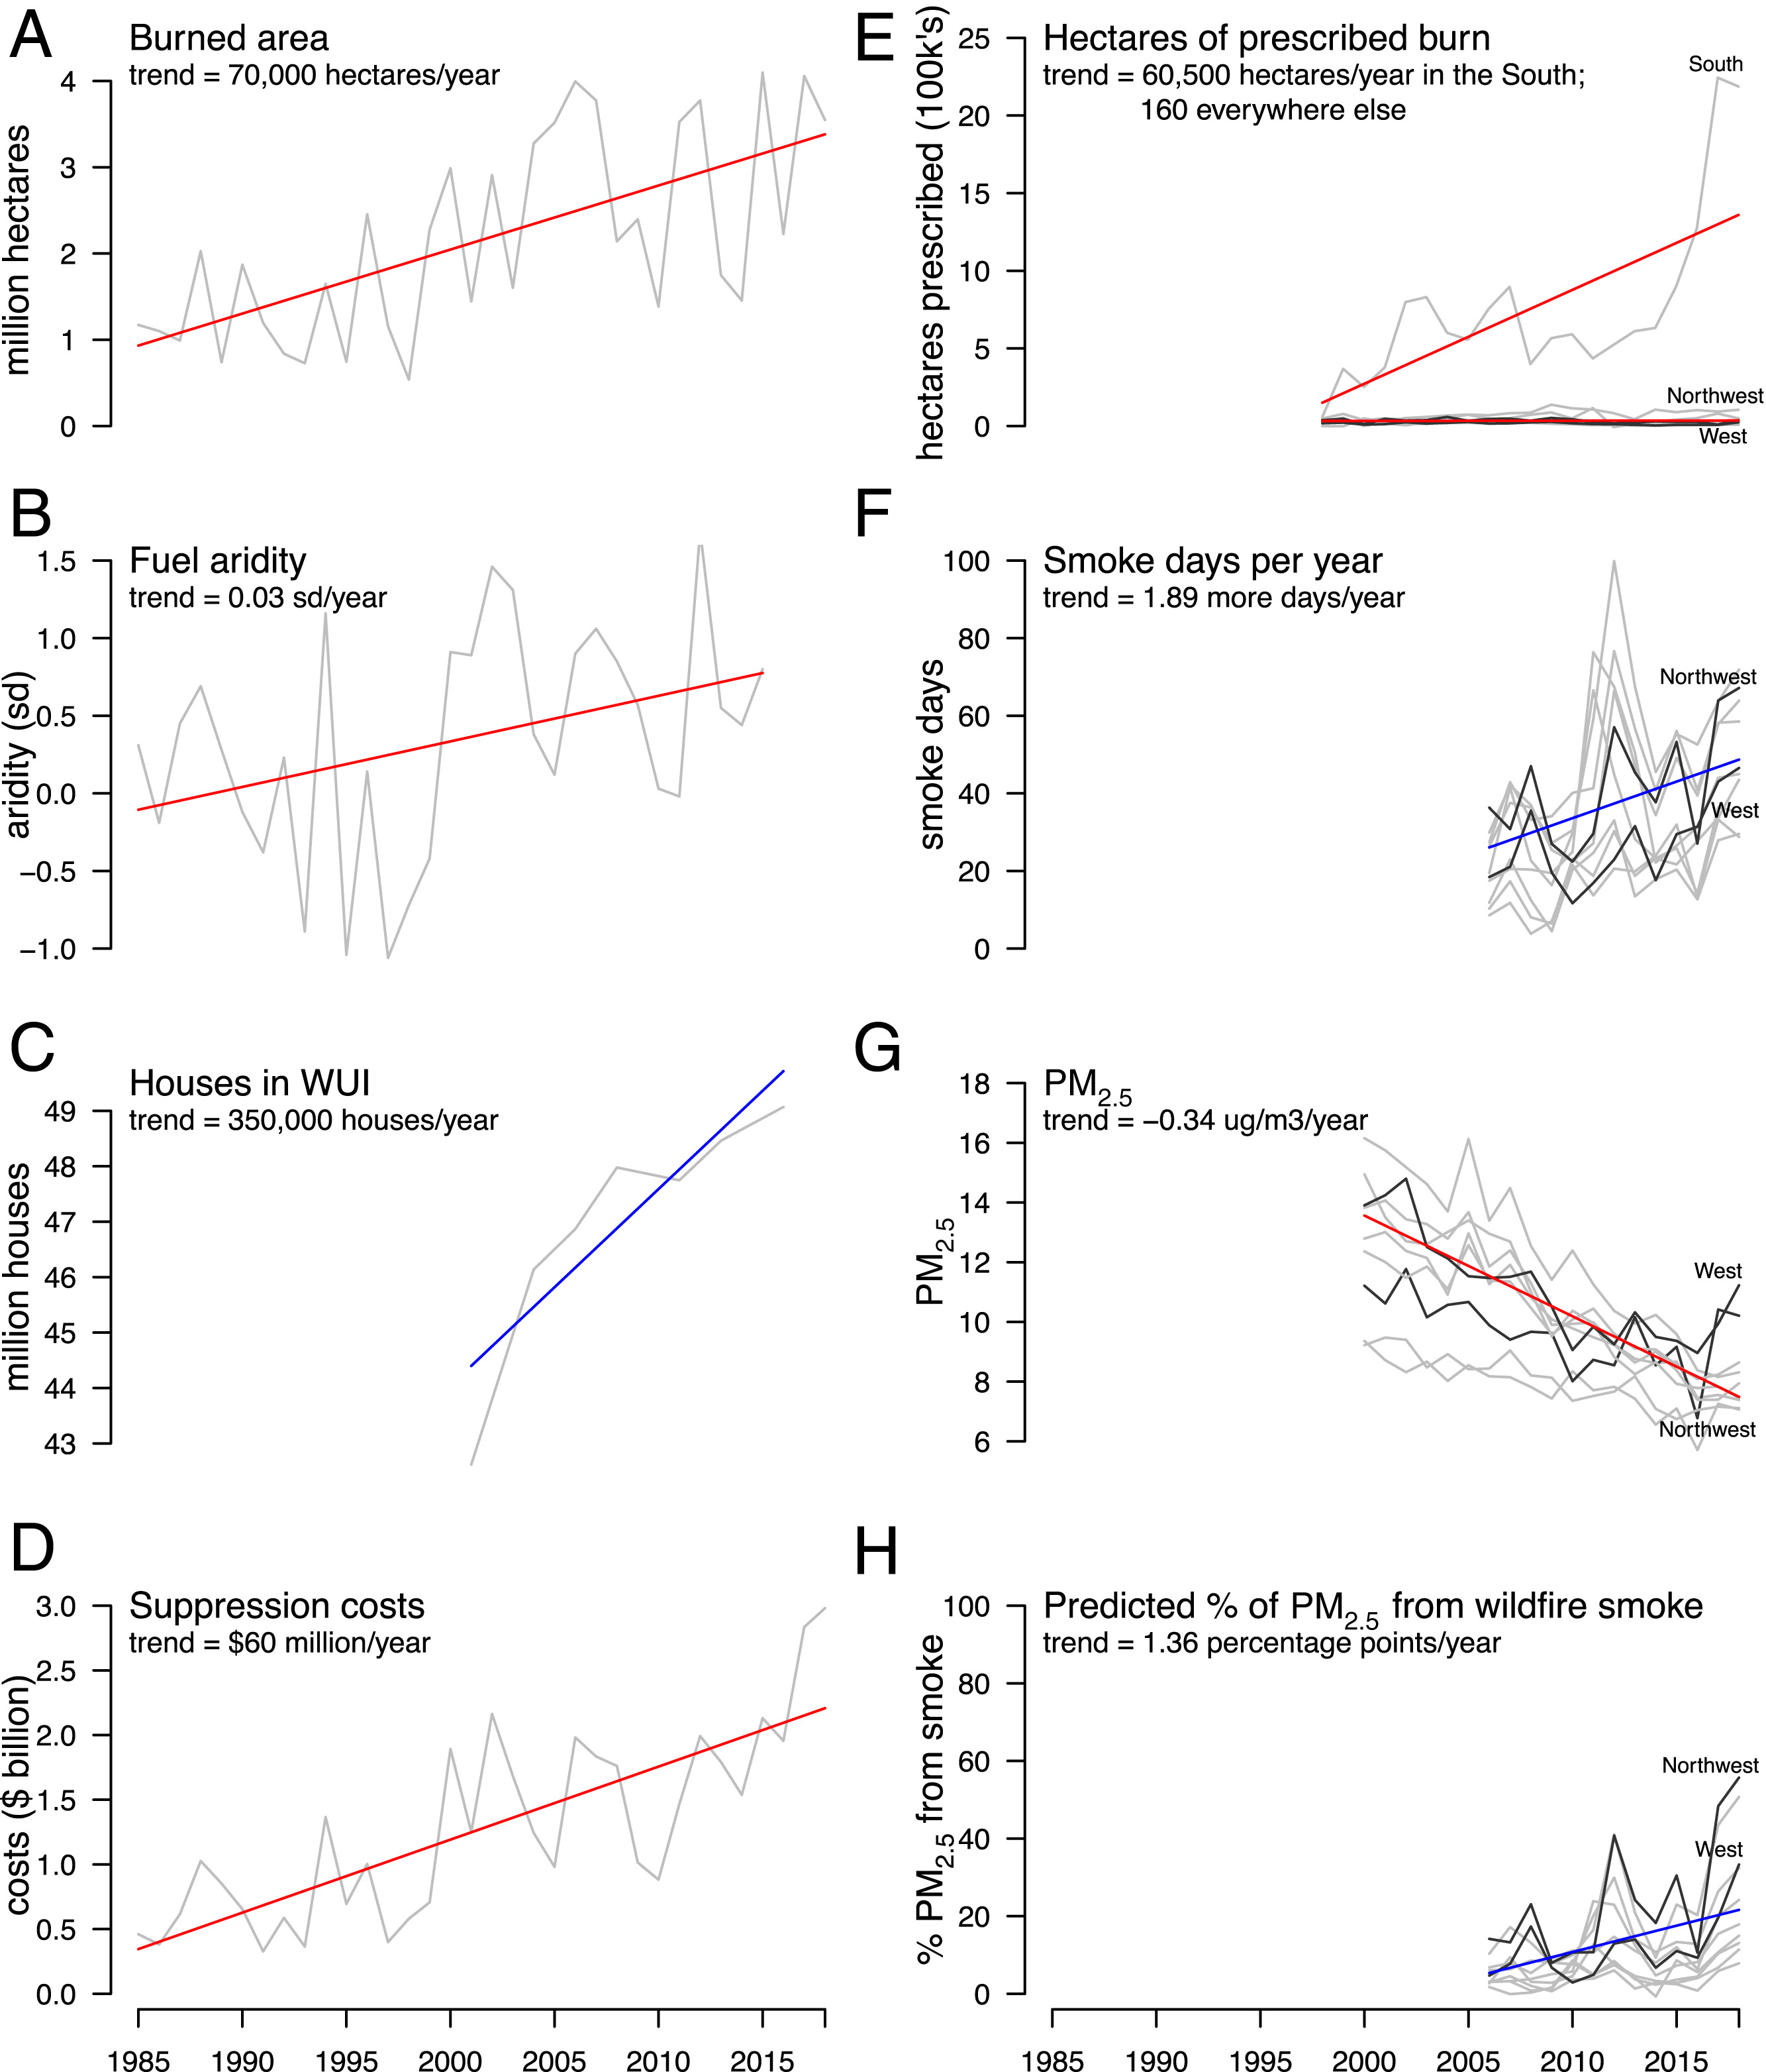
Figure 1.1. Prescribed burn area has increased substantially in the South but is flat in all other regions (Burke et al., 2021)

The problem with high-severity wildfires is that they affect multiple facets of the natural environment, from soil nutrient pool losses to slope erosion (Morris & Moses, 1987) to surface water contamination. Wildfire has been linked to tree seedling regrowth and negatively affects hydrological properties like infiltration in a watershed in US forests (Hubbert, Busse et al. 2015, Beals, Scearce et al. 2022)). High-severity wildfires often result in the loss of nutrients from the topsoil layer due to organic matter volatilizing, eroding, or leaching– all transient processes while the soil vegetation and microbiome recover. Belowground mechanisms for nutrient cycling and ecological recovery are intrinsically linked, but the number of studies assessing this remains few.
Conversely, prescribed fires, characterized by lower severity, present a less explored area of study. It is still poorly understood how these fires, differing from high-severity wildfires, impact subsurface systems, especially those receiving recharge through burned areas where soil loss due to erosion is not prevalent.
Fires manifest variable impacts on nutrient cycling in surface soils, a phenomenon closely associated with the percentage and type of fuels consumed (Johnson and Curtis 2001). The aftermath of low-severity fires may see intact roots swiftly taking up nutrients to support the production of new above-ground biomass. In contrast, more intense fires can raise surface soil temperatures to lethal levels, temporarily diminishing the influence of soil biota on nutrient fluxes. Fire-induced changes to soil properties and nutrient bioavailability can have short- and long-term effects on microbial community structure and activity. Subsequent recolonization of burned soils may be stimulated by short-term increases in soluble carbon and nutrient pools, leading to higher abundances of heterotrophic bacteria and increased basal respiration rates (Meiklejohn 1955, Ahlgren 1974, Badía and Martí 2003). However, once the bioavailable organic carbon pools are depleted and replaced by more recalcitrant carbon pools, bacterial populations often return to pre-fire conditions as vegetation recovers (Mataix-Solera, Guerrero et al. 2009).
Microbial communities within the soil regulate the nutrient pool and play a key role in maintaining the ecological processes of the soil microbiome. High-severity fires kill off microbial life incapable of withstanding higher temperatures, thereby indirectly affecting their ecological role in nutrient cycle dynamics (Hart, DeLuca et al. 2005, Saenz de Miera, Pinto et al. 2020, Adkins and Miesel 2021). Despite extensive investigations into soil microbial communities across various fire-impacted ecosystems, there is a gap in understanding the metabolic capacity and functional profile of the surface microbiome in response to temporal biogeochemical changes caused by fire (Lucas-Borja, Miralles et al. 2019, Pressler, Moore et al. 2019). There is a critical knowledge gap regarding microbiome response to fire across the type of slash fuel used and frequency of burning in the Southern Appalachian region, issues that this research proposal will focus on.
Surface-scale disturbances following fires encompass variations in nutrient, carbon, and metal pools, and microbial community composition. These changes are expected to have diverse effects on the transport of nutrients, carbon, and trace metals within the subsurface. However, the impact of this potential influx of carbon, nutrients, and metals on the subsurface microbiome, and its influence on the transformation and fate of critical biogeochemical elements, including carbon, nitrogen, metals, and PAHs, remains largely unknown. Therefore, comprehending how changes in fire regimes will alter surface and subsurface microbe-mediated biogeochemical cycling processes is imperative for predicting ecosystem-scale shifts.
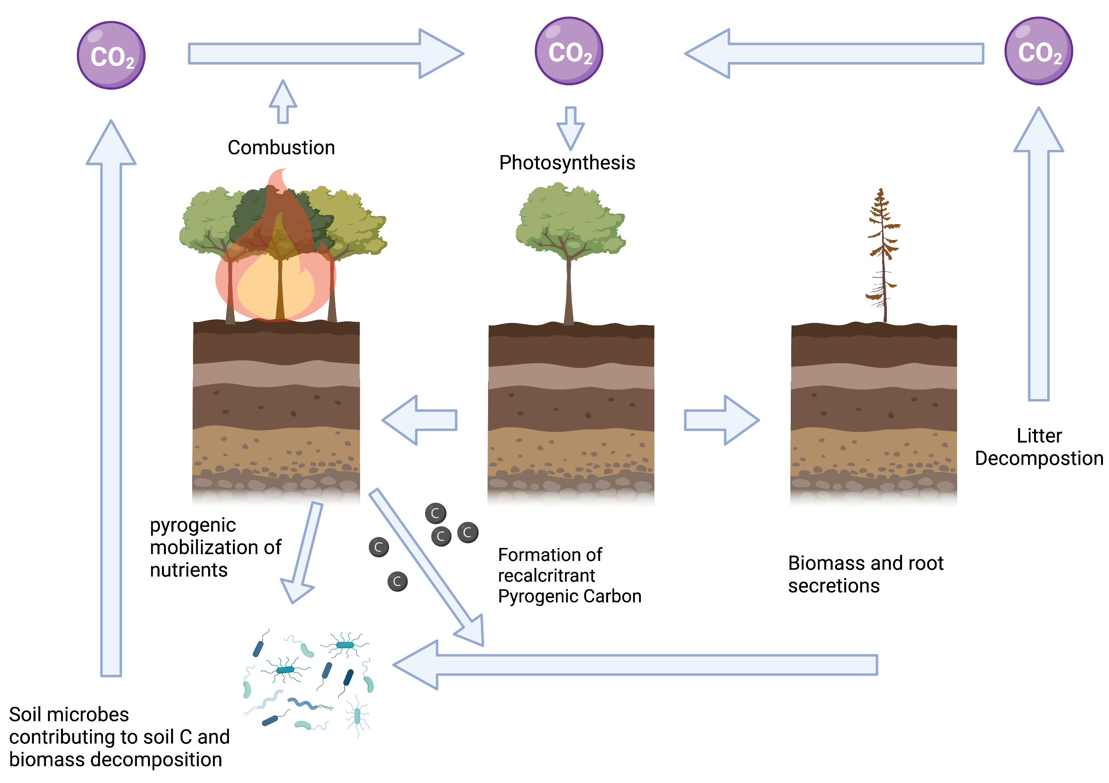
Figure 1.2 Carbon Cycling in a fire-affected deciduous forest (Adapted from Dixon et al., 2019; Certini, 2005; Lucas-Borja er al., 2019; Hart et al., 2005). Created with BioRender.com.
While there is documented evidence of fire effects on surface plant, tree, and some microbial communities, with research in this area, the focus has been significantly less directed towards the impacts on subsurface communities in temperate forest ecosystems. This disparity in attention may be attributed to the inherent complexities of linking subsurface microbial dynamics to surface-scale processes. This uncharted territory will be explored by integrating genomic and geochemical field-based observations and measurements to decipher fire-induced alterations in soil and groundwater geochemistry, microbiome composition, and microbial activity. Changes in fire regimes will alter processes of microbe-mediated biogeochemical cycling processes at the surface and subsurface, and understanding these processes is imperative for predicting ecosystem-scale shifts.

Research Objectives

Scientific Contribution to the Field
This dissertation contributes significantly to the understanding of how prescribed fires affect soil ecosystems in Southern Appalachian mixed forests. The specific contributions of this research to the scientific field include:
- Advancing Knowledge of Soil Microbial Responses to Fire: Chapter 2 provides insights into the short-term impacts of prescribed fires on soil microbial communities in temperate mixed forest soils. This knowledge enhances our understanding of the immediate effects of fire on these communities, allowing for more informed decisions in forest management based on fire ecology.
- Unraveling Fire-Induced Changes in Stable Isotope Signatures: Chapter 3 explores the alterations in stable isotope signatures in soil carbon and nitrogen in temperate mixed forest soils, shedding light on how fire influences soil biogeochemistry. This has implications for our understanding of nutrient cycling and ecosystem dynamics, particularly in temperate mixed forests that have received limited attention in prior studies.
- Investigating the Long-Term Effects of Fire Frequency: Chapter 4 delves into the effects of fire frequency on soil microbial communities and nutrient dynamics in temperate mixed forest soils. This perspective on fire-frequency regimes in Southern Appalachian forests offers valuable insights into the ecosystem-level impacts of different fire management strategies.
Collectively, this research provides valuable insights into the management of fires in Southern Appalachian mixed forests. It contributes to the development of more evidence-based and ecologically sound fire management practices, supporting conservation efforts and sustainable ecosystem use.

Overarching Hypothesis
The overarching hypothesis of this dissertation is: prescribed fire treatments significantly influence soil microbial communities and nutrient dynamics in Southern Appalachian mixed forest ecosystems. It is proposed that prescribed fires, administered at different frequencies, will lead to discernible short-term changes in soil microbial community structure and composition. These alterations will be linked to shifts in stable isotope signatures, impacting the cycling of carbon and nitrogen within the soil.

Specific Aims and Sub-hypotheses
To facilitate a thorough exploration of the multifaceted interplay between fire, soil, and microbial communities in Southern Appalachian mixed forests, this study is structured around three specific aims, each with accompanying sub-hypotheses. These aims and sub-hypotheses provide a framework to investigate various aspects of the impact of fire on soil ecosystems.
Aim 1. Investigating the Relationship Between Soil Chemistry and Post-fire Microbial Community Structure in Mixed Forest Soils.

H1: Different types of slash fuels used in controlled burns result in distinct shifts in soil microbial community structure.
H2: The time elapsed between controlled burns is associated with changes in the diversity and resilience of soil microbial communities.
H3: The combined impact of varying fuel types and time intervals between controlled burns leads to complex and interactive changes in soil microbial community dynamics.

Aim 2. Analyze Stable Isotope Signatures to Understand Fire-Induced Changes in Soil Carbon and Nitrogen Dynamics.
H4: Stable isotope analysis identifies isotopic shifts that indicate changes in soil properties following controlled burns.
H5: Changes in stable isotopes correspond to variations in the composition and functional traits of soil microbial communities.

Aim 3. Assess the Effects of Fire Frequency on Soil Microbial Communities and Nutrient Dynamics
H6: Fire-frequency regimes shape post-fire soil microbial communities.
H7: Annual and periodic prescribed burns lead to distinctive variations in soil nutrient dynamics.

References
Adkins, J. and J. R. Miesel (2021). "Post-fire effects of soil heating intensity and pyrogenic organic matter on microbial anabolism." Biogeochemistry 154(3): 555-571.
Ahlgren, I. F. (1974). "The effect of fire on soil organisms." Fire and ecosystems: 47-72.
Alexis, M., D. P. Rasse, C. Rumpel, G. Bardoux, N. Péchot, P. Schmalzer, B. Drake and A. Mariotti (2007). "Fire impact on C and N losses and charcoal production in a scrub oak ecosystem." Biogeochemistry 82(2): 201-216.
Badía, D. and C. Martí (2003). "Effect of simulated fire on organic matter and selected microbiological properties of two contrasting soils." Arid Land Research and Management 17(1): 55-69.
Beals, K. K., A. E. Scearce, A. T. Swystun and J. A. Schweitzer (2022). "Belowground mechanisms for oak regeneration: Interactions among fire, soil microbes, and plant community alter oak seedling growth." Forest Ecology and Management 503.
Burke, M., A. Driscoll, S. Heft-Neal, J. Xue, J. Burney and M. Wara (2021). "The changing risk and burden of wildfire in the United States." Proceedings of the National Academy of Sciences of the United States of America 118(2).
Czimczik, C. I., C. M. Preston, M. W. Schmidt and E. D. Schulze (2003). "How surface fire in Siberian Scots pine forests affects soil organic carbon in the forest floor: Stocks, molecular structure, and conversion to black carbon (charcoal)." Global Biogeochemical Cycles 17(1).
Flannigan, M., A. S. Cantin, W. J. De Groot, M. Wotton, A. Newbery and L. M. Gowman (2013). "Global wildland fire season severity in the 21st century." Forest Ecology and Management 294: 54-61.
Flannigan, M. D., B. D. Amiro, K. A. Logan, B. J. Stocks and B. M. Wotton (2006). "Forest fires and climate change in the 21 st century." Mitigation and adaptation strategies for global change 11(4): 847-859.
Gómez-Rey, M., A. Couto-Vázquez, S. García-Marco, J. Vega and S. González-Prieto (2013). "Reduction of nutrient losses with eroded sediments by post-fire soil stabilisation techniques." International Journal of Wildland Fire 22(5): 696-706.
Hart, S. C., T. H. DeLuca, G. S. Newman, M. D. MacKenzie and S. I. Boyle (2005). "Post-fire vegetative dynamics as drivers of microbial community structure and function in forest soils." Forest Ecology and Management 220(1-3): 166-184.
Hubbert, K. R., M. Busse, S. Overby, C. Shestak and R. Gerrard (2015). "Pile burning effects on soil water repellency, infiltration, and downslope water chemistry is Lake Tahoe Basin, USA." Fire Ecology 11(2): 100-118.
Johnson, D. W. and P. S. Curtis (2001). "Effects of forest management on soil C and N storage: meta analysis." Forest Ecology and Management 140(2-3): 227-238.
Lafon, C. W., A. T. Naito, H. D. Grissino-Mayer, S. P. Horn and T. A. Waldrop (2017). "Fire history of the Appalachian region: a review and synthesis." Gen. Tech. Rep. SRS-219. Asheville, NC: US Department of Agriculture, Forest Service, Southern Research Station. 219: 1-97.
Lucas-Borja, M. E., I. Miralles, R. Ortega, P. A. Plaza-Alvarez, J. Gonzalez-Romero, J. Sagra, M. Soriano-Rodríguez, G. Certini, D. Moya and J. Heras (2019). "Immediate fire-induced changes in soil microbial community composition in an outdoor experimental controlled system." Science of the Total Environment 696.
Mataix-Solera, J., C. Guerrero, F. García-Orenes, G. M. Bárcenas and M. P. Torres (2009). Forest fire effects on soil microbiology. Fire effects on soils and restoration strategies, CRC press: 149-192.
Meiklejohn, J. (1955). "The effect of bush burning on the microflora of a Kenya upland soil." Journal of Soil Science 6(1): 111-118.
Nyman, P., G. J. Sheridan, J. A. Moody, H. G. Smith, P. J. Noske and P. N. Lane (2013). "Sediment availability on burned hillslopes." Journal of Geophysical Research: Earth Surface 118(4): 2451-2467.
Pressler, Y., J. C. Moore and M. F. Cotrufo (2019). "Belowground community responses to fire: meta‐analysis reveals contrasting responses of soil microorganisms and mesofauna." Oikos 128(3): 309-327.
Saenz de Miera, L. E., R. Pinto, J. J. Gutierrez-Gonzalez, L. Calvo and G. Ansola (2020). "Wildfire effects on diversity and composition in soil bacterial communities." Science of the Total Environment 726.
Veraverbeke, S., B. Rogers and J. Randerson (2015). "Daily burned area and carbon emissions from boreal fires in Alaska."

Prescribed fire-induced changes in soil microbial community structure during a short-term study in a Southern Appalachian Forest clearcut

Note: This paper is under review in Frontiers in Microbiology.
S.A.A Rafie, L. Blentlinger, A. D. Putt, D. E. Williams⁾, D. C. Joyner, M. F. Campa, M. J. Schubert, K. P. Hoyt, S. P. Horn, J. A. Franklin, T. C. Hazen*. Submitted. Impact of Prescribed Fire on Soil Microbial Communities in a Southern Appalachian Forest Clearcut. Frontiers in Microbiology 10/15/2023

Abstract
Escalating wildfire frequency and severity, exacerbated by shifting climate patterns, pose significant ecological and economic challenges. Prescribed burns, a common forest management tool, aims to mitigate wildfire risks and protect biodiversity. Nevertheless, understanding the impact of prescribed burns on soil and microbial communities in temperate mixed forests, considering temporal dynamics and slash fuel types, remains crucial. Our study, conducted at the University of Tennessee Forest Resources AgResearch and Education Center in Oak Ridge, TN, employed controlled burns across various treatments, and the findings indicate that low-intensity prescribed burns have none or minimal short-term effects on soil parameters but may alter soil nutrient concentrations, as evidenced by significant increases in porewater acetate, sodium, and NO₃⁻concentrations. These burns also induce shifts in microbial community structure and diversity, with Proteobacteria and Acidobacteria increasing significantly post-fire, possibly aiding soil recovery. In contrast, Verrucomicrobia showed a notable decrease over time, and other specific microbial taxa correlated with soil pH, porewater NO₃⁻, NH₄⁺ and PO₄³⁻ concentrations. Our research contributes to understanding the intricate relationships between prescribed fire, soil dynamics, and microbial responses in temperate mixed forests in the Southern Appalachian Region, which is valuable for informed land management practices in the face of evolving environmental challenges.

Introduction
The frequency and severity of wildfires are expected to increase with the changing climate, which can have significant ecological and economic consequences. Prescribed burns are commonly used in grassland and forest management to reduce the risk of wildfires and maintain wildlife habitats, particularly in the Southern Appalachian region (Lafon, Naito et al. 2017). However, the occurrence of large, severe wildfires during droughts in the region highlights the need to understand the effects of burning on the biogeochemical characteristics of soils. Over the past three decades, the extent of wildfire destruction has surged by a factor of four, with a concomitant rise in high-severity fires documented by the Monitoring Trends in Burn Severity (MTBS) study (MTBS Project 2022). This trend is notably prominent in the Southeastern region of the United States, which has experienced a substantial expansion in prescribed burn areas compared to relatively stable conditions in other regions, as outlined in a study by Burke and collaborators (Burke, Driscoll et al. 2021).
Numerous studies have examined the causes of fire events in the Southern Appalachian region. One key factor is that the region is characterized by hot, humid summers and mild, wet winters. This climate creates favorable wildfire conditions, particularly during drought (Wear and Greis 2013). Human activities, such as campfires and intentional burning, can also contribute to regional fire events (Abatzoglou and Williams 2016). In terms of the ecological effects, wildfires can have both positive and negative impacts. Some research has shown that wildfires can be essential for maintaining the diversity of plant and animal species in the region, while other work has highlighted the negative impacts on soil health, water quality, and air quality (Coogan, Robinne et al. 2019, Jaffe, O'Neill et al. 2020, Pivello, Vieira et al. 2021, Paul, LeDuc et al. 2022). For example, wildfires can increase erosion and sedimentation rates, impacting water quality and aquatic habitats (Sankey, Kreitler et al. 2017). The economic and social impacts of wildfires in the Southern Appalachian region have also been studied extensively. These impacts can be significant, particularly for communities that rely on tourism or agriculture, since wildfires can damage or destroy homes, businesses, and other infrastructure, inflicting long-lasting economic consequences (Paveglio, Kooistra et al. 2016). Studies have shown that management practices can help reduce the severity of wildfires in the Southern Appalachian region (Hiers, Jackson et al. 2016). Prescribed burning can reduce the fuel available for fires, lowering the risk of severe wildfires. Other management practices, such as thinning and fuel reduction, have also been effective (Waldrop, Phillips et al. 2010).
The extent and severity of fire can vary depending on the fuel type and burn history and these factors can impact the rate and trajectory of post-fire soil recovery. Understanding these relationships is critical for predicting the long-term effects of wildfires on ecosystem function and resilience. Fires in forests dominated by coniferous trees can lead to more significant soil erosion and nutrient loss than in mixed or deciduous forests (Neary, Klopatek et al. 1999, Certini 2005, Moody and Kinner 2006). Coniferous forests tend to have less protective ground cover or exposed mineral soil, which can lead to greater soil disturbance during a fire. The burn history of an area can also affects post-fire soil recovery. Repeated burning can change soil organic matter content, nutrient availability, and microbial communities (Fonturbel, Carrera et al. 2021). These changes can impact the trajectory and rate of post-fire soil recovery. Areas that have experienced frequent fires may have lower soil organic matter content, leading to lower soil fertility and slower recovery rates.
The interaction between fuel type and burn history in post-fire soil recovery is complex, especially when considering regions with varying fire histories (Keeley and Syphard 2019). Recent changes in climate appear to have increased the frequency and severity of droughts and fires in various regions of North America. The impacts of fires on nutrient cycling in surface soils can vary depending on the percentage of fuels consumed. For instance, post-fire nitrogen (N) content in the soil may considerably decrease due to the loss of fuel N amounts, while short-term increases in soil ammonium (NH⁴⁺⁾ and nitrate (NO₃⁻) may occur (Knoepp and Swank 1993, Certini 2005, Ramirez, Lauber et al. 2010, Alcaniz, Outeiro et al. 2018, Taylor and Midgley 2018). While low-severity fires can facilitate the rapid uptake of nutrients by intact roots to produce new above-ground biomass, greater fire severity may cause surface soils to reach lethal temperatures, temporarily reducing the influence of soil biota on nutrient fluxes. Moreover, the changes in soil properties and nutrient bioavailability brought about by fires can also have short- and long-term effects on the structure and activity of the soil microbial community (Schimel and Schaeffer 2012, Alcaniz, Outeiro et al. 2018, Huffman and Madritch 2018, Fischer, Patel et al. 2023). A reduction in microbial biomass due to heat is often observed in the soil surface layer (0–5 cm) following a fire (Alcaniz, Outeiro et al. 2018, Barreiro and Diaz-Ravina 2021).
The influence of fire on soil properties and microbial communities, intricately linked to burn severity, has been the focus of previous research, as highlighted by (Adkins and Miesel 2021). However, within the context of temperate mixed forests, there is a notable deficiency in our understanding of how prescribed fire events impact the functional potential and metabolic capacity of the soil microbiome. Studying microbial responses to environmental stressors in extreme environments offers valuable insights into microbial adaptability and emphasizes the role of microbial diversity and metabolic capabilities in ecosystem resilience (Chivian, Brodie et al. 2008, Hemme, Deng et al. 2010).
Research on microbial responses primarily concentrates on soils within specific ecosystems, such as Mediterranean, Coniferous, and Boreal Forest soils (Mataix-Solera, Guerrero et al. 2009, Tas, Prestat et al. 2014, Adkins and Miesel 2021). While the effects of fire on soil properties and microbial communities have been extensively studied in these ecosystems, there remains a substantial gap in our understanding of these intricate relationships within the context of temperate mixed forests. These unique ecosystems, with their distinctive characteristics, call for a more comprehensive exploration of the impacts of prescribed fire, soil dynamics, and microbial responses. This study aims to investigate the impacts of prescribed fire on soil properties, microbial communities, and their interactions in a temperate mixed forest in the Southern Appalachian region. It focuses explicitly on how time and slash fuel types influence these effects. Our hypotheses are as follows: (i) prescribed burns will result in minimal impacts on overall soil chemistry but may lead to changes in soil nutrient concentrations; (ii) prescribed burns will induce alterations in microbial community structure and diversity, potentially enhancing functional redundancy within soil bacterial communities; and (iii) specific microbial taxa will exhibit significant associations with soil properties.

Materials and Methods

Site Description
The study site (Figure 2.1) at the University of Tennessee Forest Resources AgResearch and Education Center (FRREC) in Oak Ridge, TN was established in 2017 on a former clear-cut. Before cutting, the site was a mixed hardwood forest (52% white oak, 36% red oak, 8% poplar, 5% other hardwoods, and <1% pine). Controlled burns were carried out in late Fall (November) 2017 and Spring (March) 2019 across three treatments (no added fuel, added hardwood, and added pine) in triplicate blocks (for example -1, 1-2, 1-3)." No-burn" control plots were also established and serve as the fourth treatment. The quarter-acre plots were subjected to controlled burns using the ring-fire technique, while fire intensity was monitored with a thermal imaging.
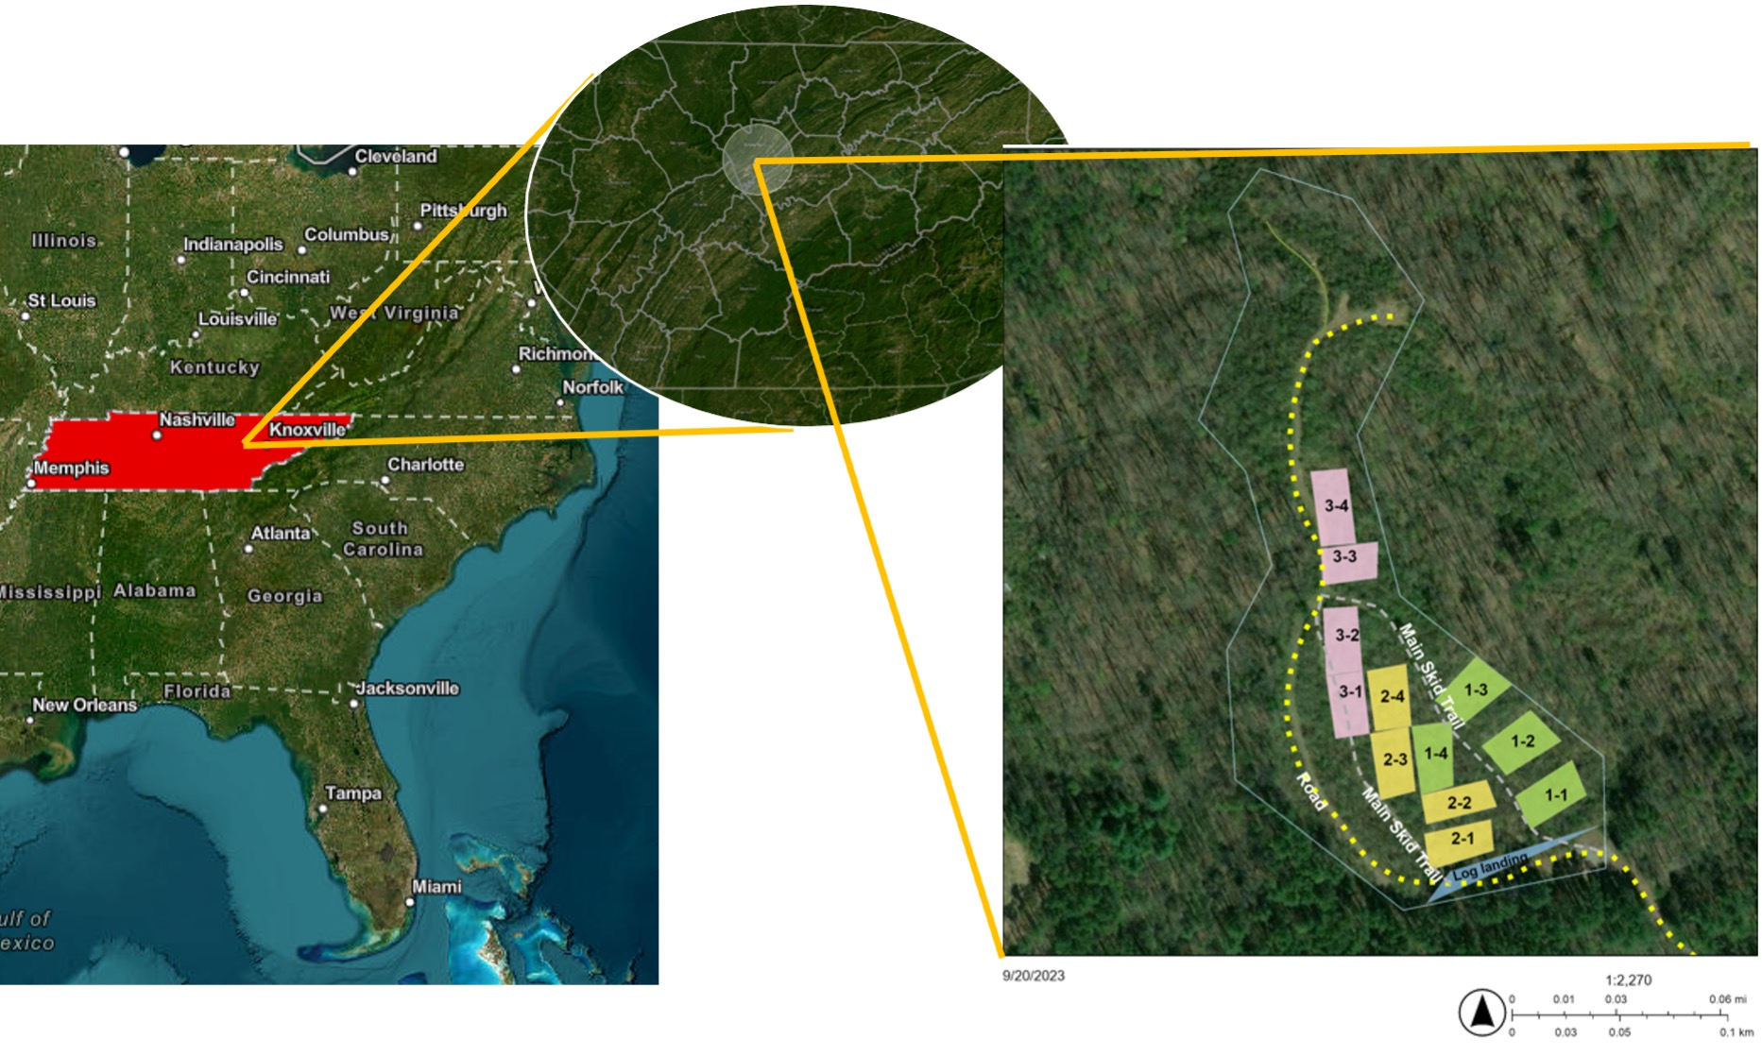
Figure 2.1. Map of FREEC burn sites with fuel loading. Three treatments (no added fuel, added hardwood, and added pine) were set up in triplicate blocks (color-coded). “No-fire” control plots can be the fourth treatment (the last plot of every block).

(FLIR) camera. These controlled burns resulted in very low-intensity fires, with patches of charred slash remains.

Sampling
Pre-fire, five samples were collected from each plot, with the locations being randomly chosen (from generated random points based on what can be measured from the central post). Only the top 5 cm of the soil was to be considered for the study, and the sampling depth was chosen to ensure the O- to A- horizons collection and incorporate burned leaf litter and topsoil. Samples were cored out using sterile and truncated 50 ml syringes, which were immediately put on dry ice and then stored at -80°C until extraction was needed. These samples were subsequently used for microbial and soil geochemical analyses. Samples were collected at four different time points: T0 – Pre-Burn, T1- Immediately After Burn, T2- 3 Months After Burn, and T3- 17 Months after Burn.

Soil Geochemistry
Chemical analyses were conducted following (Kalra and Maynard 1991). Soil pH in 0.01 M CaCl₂ was determined using a 1:1 soil-to-solution ratio and an electronic pH meter. Anions and organic acids were measured on pore water sample collected by filtration through 0.22 μm pore-sized filters. (Figure 2.2). The filtered samples were then diluted and stored in 1.0 ml vials for subsequent analysis. Concentrations of anions were determined using a Dionex™ ICS 5000+ series (Thermo Fisher Scientific, Waltham, MA, USA) equipped with an AS11HC column operated at 35°C, with a KOH effluent gradient ranging from 0 to 60 mM at a flow rate of 1.3 ml/min. The working range for anion concentrations was set at 0.1-200 mg/l. Likewise, organic acids were quantified using the same system with a working range of 5-200 μM.
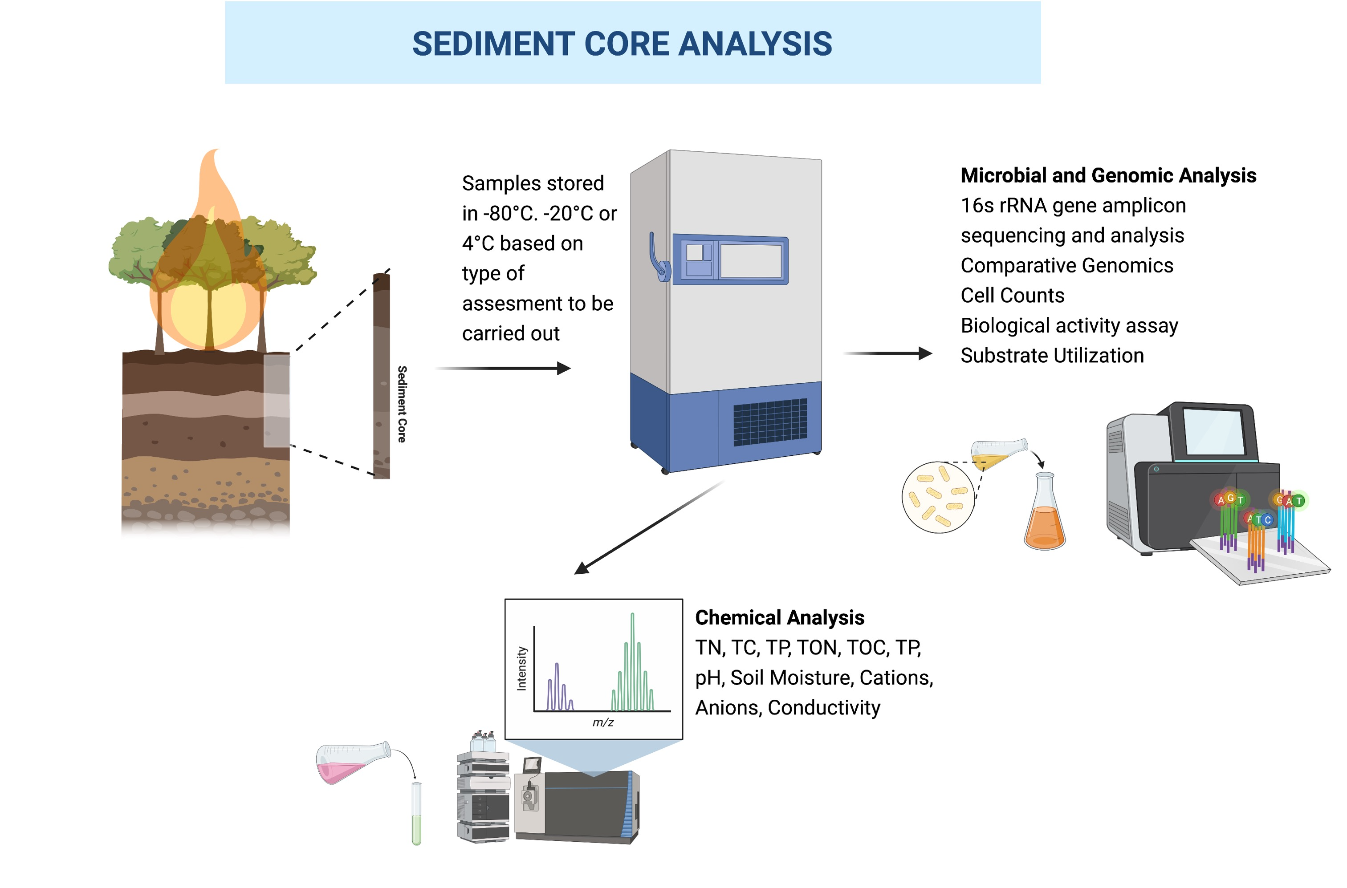
Figure 2.2. Soil core sampling and research methods overview. Created with BioRender.com.

Cations were determined using a Dionex™ ICS 5000+ series with a CS12-A column at 35°C, using an isocratic 20 mM methanesulfonic acid effluent at a flow rate of 1 ml/min. The working range for cation concentrations was 5 μg/l - 500 mg/l. Before analysis, samples were acidified with a 10-vol% 1 M HCl solution to ensure the stability of the analytes.

Genomic DNA extraction and PCR amplification
This study employed a DNA amplification approach, per the protocol described by (Wu, Wen et al. 2015). The amplification process involved a two-step polymerase chain reaction (PCR) to increase the quantity of extracted DNA. In the first step, 16S rDNA was amplified for 10 cycles, utilizing the primers 515F and 806R. Subsequently, the product obtained from the first step was subjected to an additional 20 amplification cycles in the second step. The second amplification step employed primers containing spacers to increase base diversity, barcodes (Illumina, San Diego, CA, USA) adaptor and sequencing primers, and the target primers, 515F and 806R. The efficiency of the amplification process was assessed through agarose gel electrophoresis.

16S rRNA gene amplicon sequencing
The PCR products were combined in equimolar concentrations and subjected to purification following amplification. Sequencing library preparation was conducted per the guidelines provided in the MiSeq™ Reagent Kit Preparation Guide (Illumina, San Diego, CA, USA) as outlined by (Caporaso, Lauber et al. 2012). The sequencing process involved forward, index, and reverse reads over 251, 12, and 251 cycles. Sequencing was performed on an Illumina MiSeq platform, utilizing a 500-cycle v2 MiSeq reagent cartridge.
Sequencing analysis was performed using Qiime2 (version 2020.11) (Bolyen, Rideout et al. 2019). Briefly, the 16S reads were imported into Qiime2 and dereplicated using DADA2 (Callahan, McMurdie et al. 2016)with the paired-end setting. The 16S representative ASVs were assigned to the SILVA 132 pre-trained gene databases (Quast, Pruesse et al. 2013) respectively, producing taxonomy tables. Microeco (Liu, Cui et al. 2021), Vegan (Oksanen, Simpson et al. 2016), and phyloseq (McMurdie and Holmes 2013) packages were used in R (R Core Team 2021) for community analysis. Raw reads used in this study can be found in the NCBI Sequence Read Archive (SRA) under the BioProject accession number PRJNA1027882.

Statistical analyses
All statistical analyses were performed using R v.4.2.3 software (R Core Team 2021). Analysis of variance (ANOVA) was conducted to determine the changes in soil properties over time with a significance threshold of p < 0.05. Principal Coordinate Analysis (PCoA) was performed to explore the relationships between soil variables (pH, total C, total N, C: N ratio, porewater cations, and organic acids). Beta diversity analyses included non-metric multidimensional scaling (NMDS) based on the weighted-Unifrac distances. Permutational multivariate analysis of variance (PERMANOVA) was performed on the weighted Unifrac distance matrix with the "vegan" package (Oksanen, Simpson et al. 2016). Redundancy analysis (RDA) was performed to investigate the relationship between soil variables (soil pH, total C, total N, C: N, porewater cations, and organic acids) and soil bacterial community.

Results

Physicochemical Parameters of Soil
Due to the low-intensity burn, very few soil parameters (Figure 2.3) were significantly affected. Porewater chemistry shows minimal changes in post-burn samples, with minor differences across fuel types or collection time. Significant increases were observed for acetate, sodium, and nitrate concentrations in the extracted porewater. The porewater concentration in the soil cores ranged from 1.23% to 6.98%, while nitrogen concentration had a smaller range of 0.07% and 0.30 %. Total carbon content (% wt.) in the soil cores appeared to increase for two treatments (Pine Slash and No Added Slash) post-burn and then decreased when measured 17 months later.

Sequencing quality and microbial community structure
(Figure 2.4, 2.5 and 2.6) shows the alpha diversity variation in the microbial community across different time points (T0 – Pre-Burn, T1- Immediately After Burn, T2- 3 Months After Burn, T3- 17 Months after Burn). The study revealed a significant increase in species richness from the initial (T0) to the final time point (T3). The Observed richness (ASVs) exhibited a significant rise, with counts increasing from 2051 at T0 to 2595 at T3 (p = 0.003). The Chao1 richness estimator mirrored this trend, with the estimate increasing from 2053 at T0 to 2598 at T3. The Shannon index showed variations between time points but did not reach statistical significance (p = 0.16). PerMANOVA was applied to the differential test of weighted Unifrac distances among groups and showed that there was a significant difference across time points (R²= 0.118, F= 3.64, p = 0.001) but not for the different types of additional slash fuel (R²= 0.061, F= 3.64, p = 0.018). Violin plots comparing alpha diversity index can be found in the Appendix.
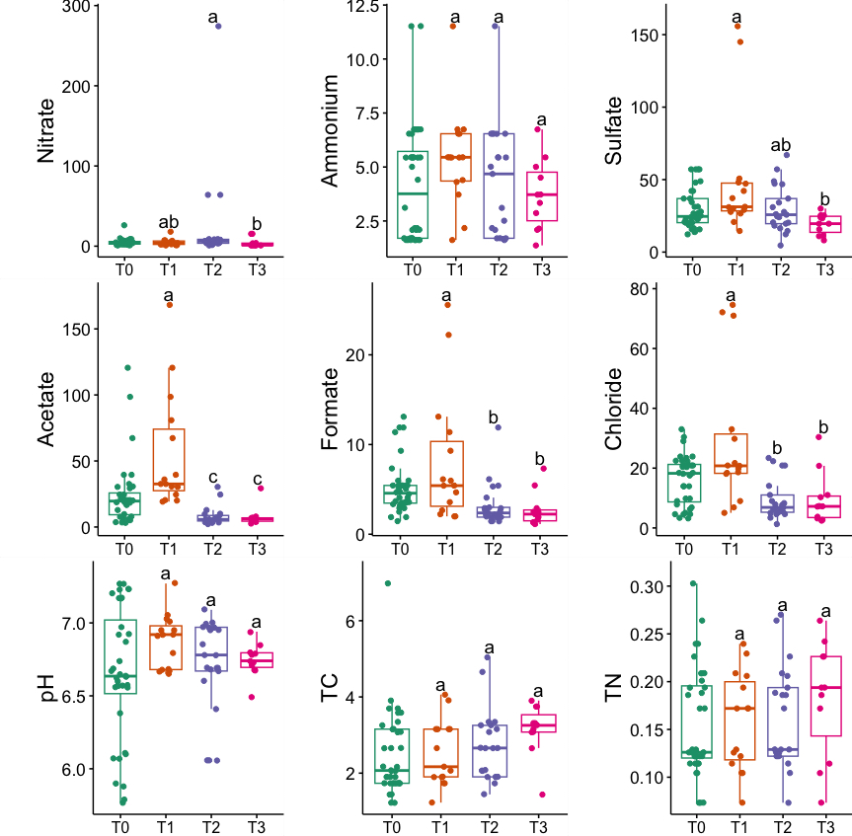
Figure 2.3. Temporal Variation in Soil porewater geochemistry, pH, Total Carbon (TC), and Total Nitrogen (TN) Levels. Different letters indicate significant differences in abundance (p < 0.05).

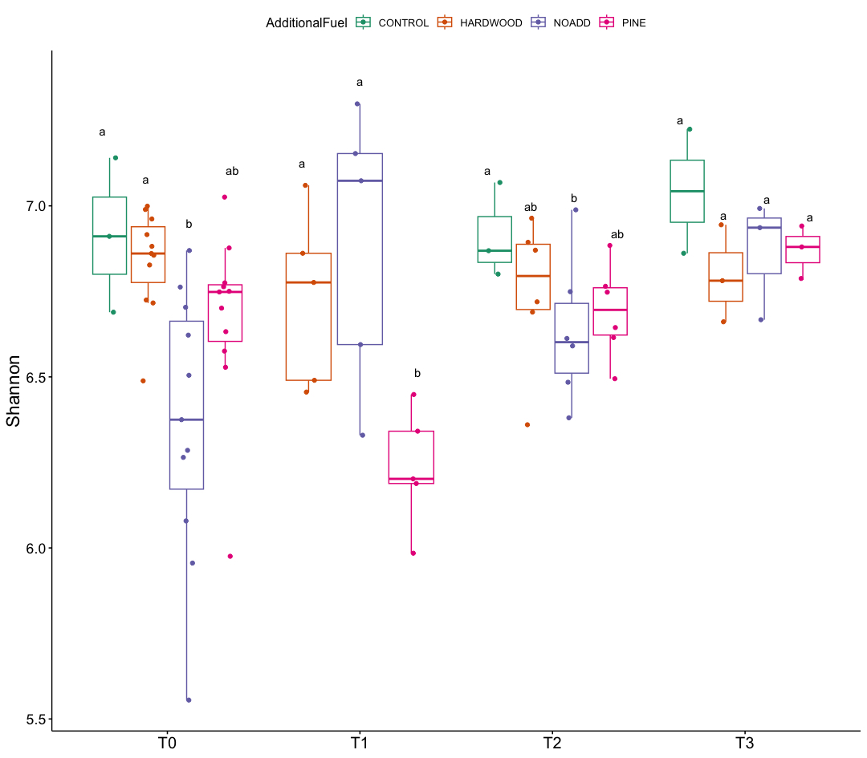
Figure 2.4. Temporal Variation in Shannon diversity index across different fuel treatments (T0, T1, T2, T3). Different letters indicate significant differences in abundance (p < 0.05).
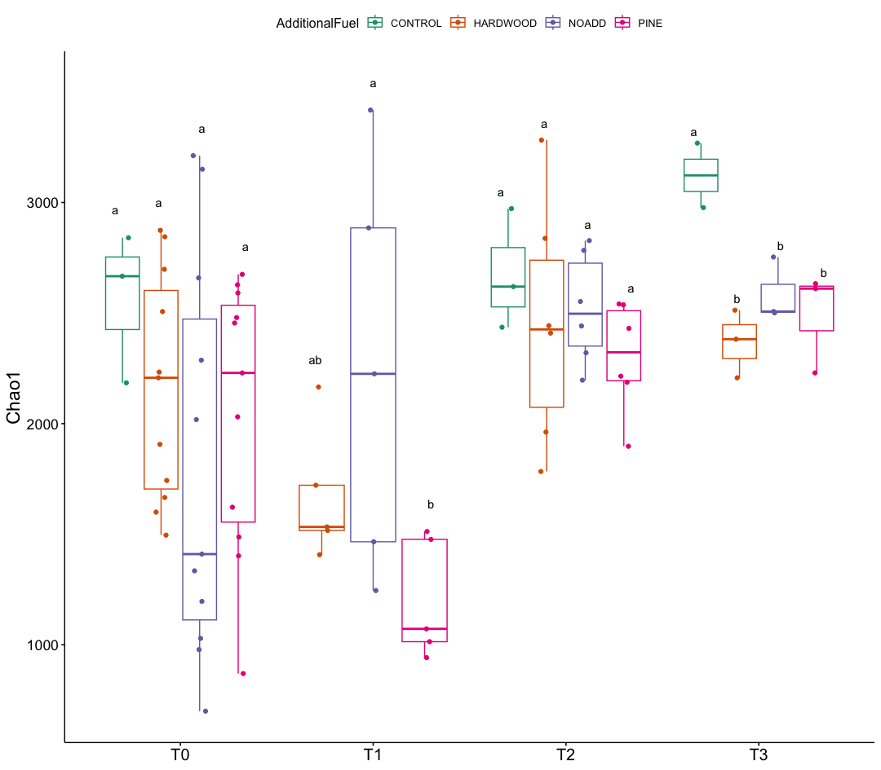
Figure 2.5. Temporal Variation in Chao1 measure across different fuel treatments (T0, T1, T2, T3). Different letters indicate significant differences in abundance (p < 0.05).
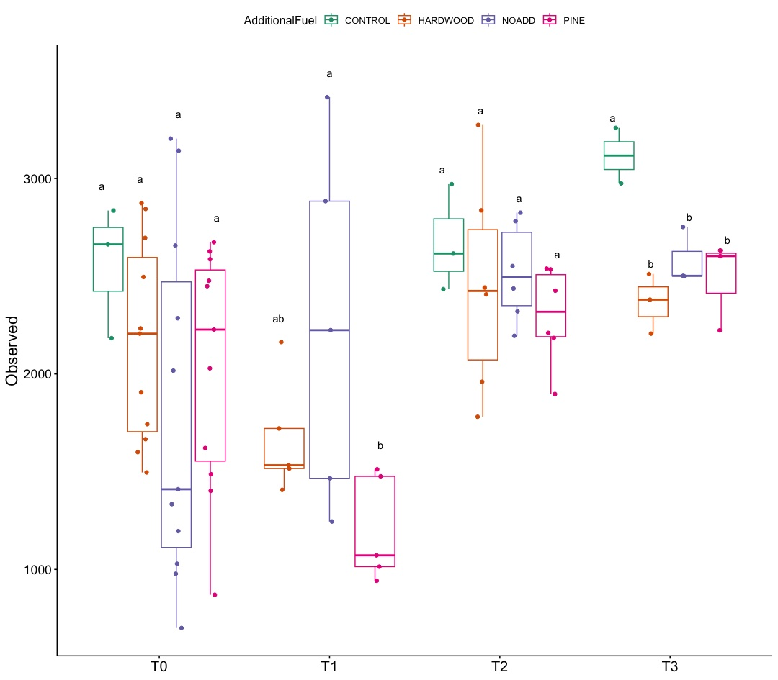
Figure 2.6. Temporal Variation in Observed diversity across different fuel treatments (T0, T1, T2, T3). Different letters indicate significant differences in abundance (p < 0.05).

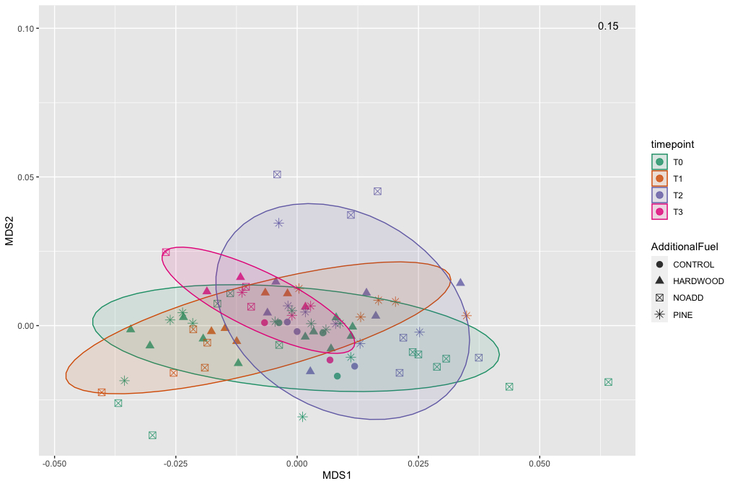
Figure 2.7. Non-metric Multidimensional Scaling(nMDS) ordination based on weighted Unifrac distance, showing the bacterial community structures derived from relative abundance based on phylum level across the different samples. The stress value denotes the goodness of fit.

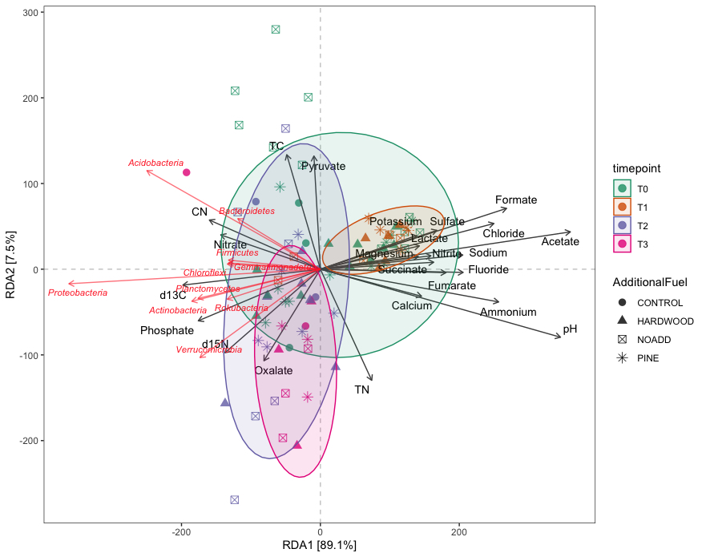

Figure 2.8. Redundancy Analysis (RDA) tri-plot Illustrating Multivariate Associations Between Environmental Factors and Community Composition. The axes represent the principal components of environmental variables, with their lengths indicating the strength of influence. The vectors denote specific environmental factors, showcasing their direction and magnitude in relation to microbial community structure.

Figure 2.9. A and B illustrate the Taxonomic Relative Abundance and Differential Relative Abundance using ANOVA. Different letters indicate significant differences in abundance (p < 0.05). Considering the taxonomic abundance across different time points, the three most predominant phyla are Proteobacteria, Acidobacteria, and Actinobacteria, with mean relative abundances of 29%, 25%, and 13%, respectively. Differential abundance analysis using ANOVA showed distinct community differences across groups. Small but significant increases were observed between post-fire time points for Proteobacteria (T0 – 28.96%, T2 – 31.64%) and Acidobacteria (T0 – 22.04%, T3 – 28.04%) (p < 0.05). The relative abundance of the bacterial phylum Verrucomicrobia decreased from 8.21% at T0 to 5.55% % at T3 (p< 0.05).
Microbial communities at different time points all clustered together, implying no differences in the pre- and post-fire microbial communities. The RDA and correlation analyses revealed significant (p ≤ 0.05) correlations between specific bacterial phyla (illustrated in Figure 6) and soil properties. Only the significant correlations are elaborated upon here. Soil pH was positively correlated with the Acidobacteria, Azohydromonas, and Chloroflexi phyla while exhibiting a negative correlation with the Acidothermus, Acidipila, Mycobacterium, and Bradyrhizobium genera. Sodium concentrations were significantly positively correlated to Azohydromonas, Solimonas, and Raoultibacter. Furthermore, porewater NO₃⁻ concentrations positively correlated with the Verrumicrobium, Anaerocolumna, and Methanosaeta genera. In contrast, porewater PO₄³⁻ concentrations exhibited positive correlations with various genera, including Ferrovibrio, Labilithrix, and Uliginosibacterium (Supplementary Materials, Figure 2A). No significant differences were observed in terms of correlation between Total C and N concentrations concerning different taxa.

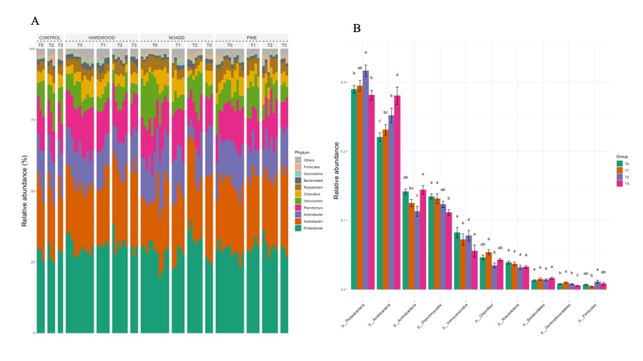
Figure 2.9 Taxonomic Abundance Plot and Differential Relative Abundance Using ANOVA. These bar charts provide insights into the distribution of taxonomic groups among samples and identify significant differences (p < 0.05) denoted by distinct letters, elucidating shifts in microbial community composition.

Functional profiles of the microbial community were analyzed using FAPROTAX. Taxonomic information of prokaryotes identified in this study was matched to the FAPROTAX database to predict the traits based on geochemical roles Figure 2.10. Significant correlations were noticed between acetate concentrations and sulfate/sulfur respiration (p < 0.05). At the same time, pH and NH₄⁺ showed a significant correlation (p < 0.001) with nitrogen cycling processes.

Discussion
The findings demonstrate that the low intensity burn had limited effects on soil parameters. Porewater composition exhibited a notable degree of stability, with minor variations discernible across different fuel types and time points. Nevertheless, significant increases were conspicuously observed in acetate, sodium, and NO₃⁻ concentrations, implying discernible modifications in the solute chemistry of the soil because of the fire event. These changes in solute chemistry may have been caused by the release of organic compounds during the burn, leading to increased acetate levels. The presence of sodium and NO₃⁻ in higher concentrations could be attributed to the heat-induced transformation of soil organic matter, resulting in the release of these ions into the porewater. An immediate increase in NH₄⁺ concentration and the subsequent return to baseline levels over an extended time was reported in multiple different studies (Knoepp and Swank 1993, Elliott and Vose 2005, Hubbert, Busse et al. 2015, Klimas, Hiesl et al. 2020), in case of low intensity burns the organic nitrogen fraction tends to be more affected than the inorganic fraction as has been reported by multiple studies and our results seemingly concur (Wan, Hui et al. 2001, Taylor and Midgley 2018). NH₄⁺ and NO₃⁻ concentrations in soil usually increase following a fire event due to the incomplete combustion of nitrogenous materials, including vegetation and denatured soil proteins (Certini 2005, Johnson, Johnson et al. 2011, Fontúrbel, Barreiro et al. 2012). This corroborates our study's findings,
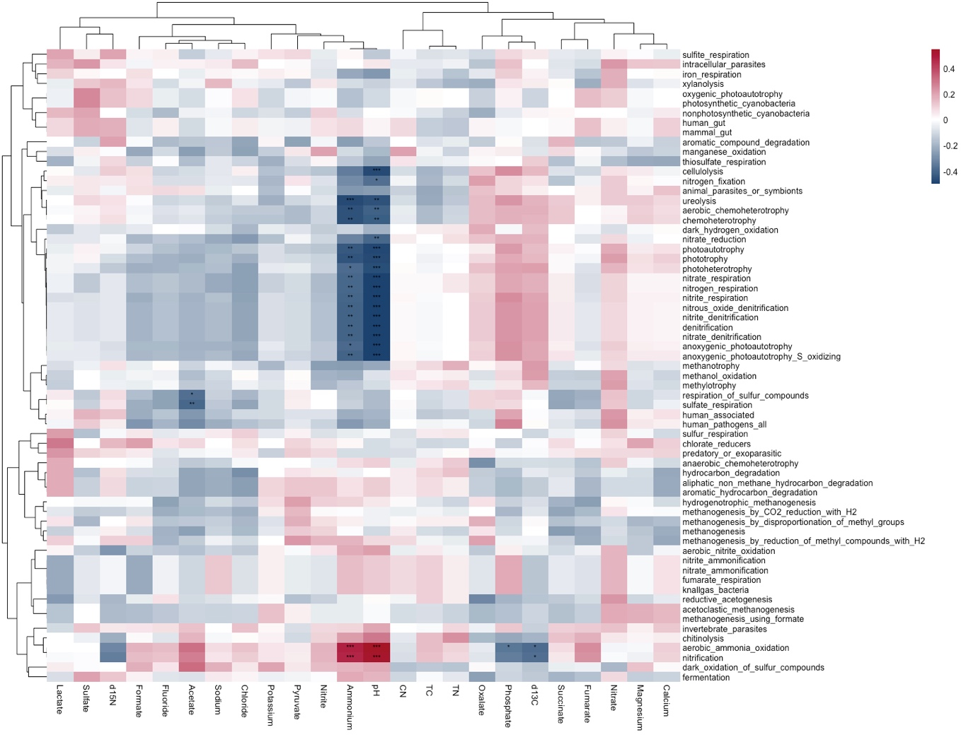

Figure 2.10. FAPROTAX heat map depicting statistically significant environmental variables and their association with predicted microbial functions. The number of asterisks (*) denoting varying levels of confidence—ranging from the highest (***, p < 0.001) to the lowest (*, p < 0.05).

where we noticed similar statistically significant changes in NO₃⁻ and NH₄⁺ porewater concentration. Changes in soil porewater concentration of the base cations in this study can be attributed to ash incorporation soil or location-specific characteristics (Neary, Klopatek et al. 1999, Certini 2005, Taylor and Midgley 2018). The total carbon content showed an initial increase post-burn for Pine Slash and No Added Slash treatments, followed by a decline at the 17-month mark, indicating dynamic changes in organic carbon turnover in response to fire. The modification of soil carbon content in response to wildfires can be attributed to the introduction of novel carbon sources, notably charred organic matter and plant debris (Certini 2005). The observed oscillations in total carbon content within our study context may allude to dynamic shifts in the equilibrium between carbon inputs, including plant-derived materials and organic substrates, and carbon outputs, which predominantly manifest through microbial decomposition processes within the post-fire landscape.
Our observations reveal shifts in alpha diversity following prescribed fires, reflecting fluctuations in the Shannon index, Chao1 estimator, and observed richness. These findings align with research suggesting microbial community structure and diversity alterations following fire events (Balser and Firestone 2005). While the Shannon index displayed variations between time points, it did not reach statistical significance, indicating that changes in diversity were influenced by complex ecological processes. The Chao1 estimator mirrored the trend observed in observed richness, implying an increase in potential taxonomic richness over time and implications for the functional diversity of soil bacterial communities (Tripathi, Stegen et al. 2018). The trends in observed richness and the Chao1 richness estimator support this notion, and these findings align with previous studies that have reported increases in microbial diversity following fire disturbances (Staddon, Trevors et al. 1998, Fonturbel, Barreiro et al. 2012).
Although the Shannon index exhibited variations across time points, it did not reach statistical significance, likely due to the subtle and multifaceted nature of alpha diversity measures (Dini-Andreote, Stegen et al. 2015). These findings suggest that prescribed fires can potentially enhance functional redundancy within soil bacterial communities (Delgado-Baquerizo, Oliverio et al. 2018). Increased alpha diversity can introduce additional microbial taxa with similar functional traits, ensuring the continuity of essential ecosystem functions even in disturbances. This redundancy enhances the stability and resilience of ecosystem processes, such as organic matter decomposition and nutrient cycling (Allison and Martiny 2008, Philippot, Andersson et al. 2010).
Furthermore, shifts in alpha diversity following prescribed fires may lead to more diverse functional traits within soil bacterial communities. This diversification broadens the range of ecological functions, including the breakdown of complex organic matter, nitrogen fixation, and disease suppression (Schimel and Schaeffer 2012, Louca, Jacques et al. 2017). Thus, the impact of prescribed fires extends beyond mere diversity shifts, playing a crucial role in shaping the functional dynamics of soil ecosystems.
The taxonomic composition analysis reveals that Proteobacteria, Acidobacteria, and Actinobacteria were the dominant phyla in the microbial communities across all time points. Furthermore, differential abundance analysis indicates significant shifts in the relative abundance of specific phyla. Proteobacteria and Acidobacteria showed small but significant increases in relative abundance between pre-fire and post-fire time points, suggesting their potential roles in post-fire soil recovery. In contrast, Verrucomicrobia exhibited a significant decrease in relative abundance over time. Our PerMANOVA analysis revealed significant differences in microbial community structure across the four-time points. The variation observed in community structure emphasizes the dynamic nature of soil microbial communities following prescribed burns.
However, it is noteworthy that the additional slash fuel had a limited impact on microbial communities, suggesting that other factors, such as fire severity or soil properties, might exert stronger influences on post-burn microbial community structure. Furthermore, the clustering of microbial communities in NMDS ordination and RDA analysis (Figure 2.7 and Figure 2.8) at different time points indicates that the overall pre- and post-fire microbial communities remained consistent (For PCoA ordination plot please see supplementary material). This resilience of soil microbial communities may be attributed to factors such as resilient microbial taxa or the rapid post-fire recolonization of microbes (Whitman, Pepe-Ranney et al. 2016, Whitman, Whitman et al. 2019). Specific taxa did respond to fire-induced changes in soil properties, but the overall structure and function of the microbial community remained consistent. Such stability could be attributed to microbial populations' resilience and ability to adapt to changing conditions.
The taxonomic composition of soil microbial communities revealed Proteobacteria, Acidobacteria, and Actinobacteria as the dominant phyla. Changes in the relative abundance of these phyla following prescribed burns provide insights into their roles in post-fire soil ecosystems. Proteobacteria and Acidobacteria exhibited small but significant increases post-burn. Proteobacteria are known for their versatility in colonizing new niches, suggesting their potential role in responding to post-fire resource availability. Acidobacteria, on the other hand, are often associated with soil organic matter decomposition, indicating their possible involvement in the post-fire nutrient cycling (Jones, Robeson et al. 2009, Moyano, Manzoni et al. 2013).
In contrast, Verrucomicrobia decreased in relative abundance, highlighting the selective pressures exerted by prescribed burns on specific microbial phyla. This decline may be related to their sensitivity to environmental changes, as Verrucomicrobia are known to be associated with more stable and undisturbed soil conditions (Bergmann, Bates et al. 2011). These findings are consistent with previous studies that have reported shifts in the relative abundances of these phyla in response to fire disturbances (Lauber, Strickland et al. 2008, Weber, Lockhart et al. 2014).
Our correlation analyses revealed significant associations between specific bacterial phyla and soil properties. Soil pH, a fundamental soil characteristic, exhibited positive correlations with Acidobacteria and Chloroflexi, emphasizing their potential preference for specific pH ranges (Fierer and Jackson 2006, Aponte, Galindo-Castaneda et al. 2022). Conversely, Acidothermus, Acidipila, Mycobacterium, and Bradyrhizobium genera displayed negative correlations with soil pH, suggesting their sensitivity to pH fluctuations. These correlations highlight the complex interplay between microbial community composition and soil pH (Lauber, Strickland et al. 2008).
Porewater NO₃⁻ concentrations positively correlated with Verrucomicrobium, suggesting their potential involvement in nitrogen cycling in post-fire soils (Bergmann, Bates et al. 2011, Mohammadi, Pol et al. 2017). In contrast, porewater PO₄³⁻ concentrations positively correlated with genera such as Ferrovibrio and Uliginosibacterium, indicating their potential roles in phosphorus dynamics. These correlations underscore the importance of specific microbial taxa in mediating nutrient cycling processes in response to prescribed burns (Cederlund, Wessen et al. 2014).

Conclusion
Our study of the impacts of slash fuel type and time on prescribed fire in Southern Appalachian Forest soils echoes the findings of similar studies. The prescribed burns triggered transient changes in specific soil properties and microbial communities, which reverted to their pre-fire conditions over a 17-month observation period. While bacterial communities and composition exhibited resilience to these prescribed burns, noteworthy alterations were observed in the relative abundance of specific microbial taxa. These results substantiate the prevailing view that prescribed fires have limited effects on soil microbial community diversity and composition, especially within ecosystems well-adapted to fire. Prescribed fires are a common management practice in fire-adapted ecosystems, and understanding their effects on soil microbial communities is crucial for ecosystem management. The observed alterations in the relative abundance of specific microbial taxa suggest that prescribed fires may have selective effects on certain microbial groups, potentially influencing ecosystem processes such as nutrient cycling and plant-microbe interactions. While our study has provided valuable insights into the time and slash-fuel-type impacts of prescribed fire on temperate mixed forests, it is essential to acknowledge that its effects on soil properties and microbial communities are complex and multifaceted. Our research adds to the growing body of knowledge on the subject, emphasizing the resilience of these ecosystems to low-intensity prescribed burns. However, to fully grasp the long-term implications and sustainability of prescribed fire as a forest management tool, further investigation into the extended impacts of repeated burning events on nutrient cycling and ecosystem dynamics in temperate mixed forests is imperative. Such studies will aid in developing informed land management strategies that balance ecological conservation with the need for forest health and resilience in the face of evolving environmental challenges.

References
Abatzoglou, J. T. and A. P. Williams (2016). "Impact of anthropogenic climate change on wildfire across western US forests." Proceedings of the National Academy of Sciences of the United States of America 113(42): 11770-11775.
Adkins, J. and J. R. Miesel (2021). "Post-fire effects of soil heating intensity and pyrogenic organic matter on microbial anabolism." Biogeochemistry 154(3): 555-571.
Alcaniz, M., L. Outeiro, M. Francos and X. Ubeda (2018). "Effects of prescribed fires on soil properties: A review." Science of the Total Environment 613: 944-957.
Allison, S. D. and J. B. H. Martiny (2008). "Resistance, resilience, and redundancy in microbial communities." Proceedings of the National Academy of Sciences of the United States of America 105: 11512-11519.
Aponte, H., T. Galindo-Castaneda, C. Yanez, M. Hartmann and C. Rojas (2022). "Microbial Community-Level Physiological Profiles and Genetic Prokaryotic Structure of Burned Soils Under Mediterranean Sclerophyll Forests in Central Chile." Frontiers in Microbiology 13.
Balser, T. C. and M. K. Firestone (2005). "Linking microbial community composition and soil processes in a California annual grassland and mixed-conifer forest." Biogeochemistry 73(2): 395-415.
Barreiro, A. and M. Diaz-Ravina (2021). "Fire impacts on soil microorganisms: Mass, activity, and diversity." Current Opinion in Environmental Science & Health 22.
Bergmann, G. T., S. T. Bates, K. G. Eilers, C. L. Lauber, J. G. Caporaso, W. A. Walters, R. Knight and N. Fierer (2011). "The under-recognized dominance of <i>Verrucomicrobia</i> in soil bacterial communities." Soil Biology & Biochemistry 43(7): 1450-1455.
Bolyen, E., J. R. Rideout, M. R. Dillon, N. A. Bokulich, C. C. Abnet, G. A. Al-Ghalith, H. Alexander, E. J. Alm, M. Arumugam, F. Asnicar, Y. Bai, J. E. Bisanz, K. Bittinger, A. Brejnrod, C. J. Brislawn, C. T. Brown, B. J. Callahan, A. M. Caraballo-Rodriguez, J. Chase, E. K. Cope, R. Da Silva, C. Diener, P. C. Dorrestein, G. M. Douglas, D. M. Durall, C. Duvallet, C. F. Edwardson, M. Ernst, M. Estaki, J. Fouquier, J. M. Gauglitz, S. M. Gibbons, D. L. Gibson, A. Gonzalez, K. Gorlick, J. Guo, B. Hillmann, S. Holmes, H. Holste, C. Huttenhower, G. A. Huttley, S. Janssen, A. K. Jarmusch, L. Jiang, B. D. Kaehler, K. Bin Kang, C. R. Keefe, P. Keim, S. T. Kelley, D. Knights, I. Koester, T. Kosciolek, J. Kreps, M. G. I. Langille, J. Lee, R. Ley, Y.-X. Liu, E. Loftfield, C. Lozupone, M. Maher, C. Marotz, B. D. Martin, D. McDonald, L. J. McIver, A. V. Melnik, J. L. Metcalf, S. C. Morgan, J. T. Morton, A. T. Naimey, J. A. Navas-Molina, L. F. Nothias, S. B. Orchanian, T. Pearson, S. L. Peoples, D. Petras, M. L. Preuss, E. Pruesse, L. B. Rasmussen, A. Rivers, M. S. Robeson, II, P. Rosenthal, N. Segata, M. Shaffer, A. Shiffer, R. Sinha, S. J. Song, J. R. Spear, A. D. Swafford, L. R. Thompson, P. J. Torres, P. Trinh, A. Tripathi, P. J. Turnbaugh, S. Ul-Hasan, J. J. J. van der Hooft, F. Vargas, Y. Vazquez-Baeza, E. Vogtmann, M. von Hippel, W. Walters, W. Walters, Y. Wan, M. Wang, J. Warren, K. C. Weber, C. H. D. Williamson, A. D. Willis, Z. Z. Xu, J. R. Zaneveld, Y. Zhang, Q. Zhu, R. Knight and J. G. Caporaso (2019). "Reproducible, interactive, scalable and extensible microbiome data science using QIIME 2 (vol 37, pg 852, 2019)." Nature Biotechnology 37(9): 1091-1091.
Burke, M., A. Driscoll, S. Heft-Neal, J. Xue, J. Burney and M. Wara (2021). "The changing risk and burden of wildfire in the United States." Proceedings of the National Academy of Sciences of the United States of America 118(2).
Callahan, B. J., P. J. McMurdie, M. J. Rosen, A. W. Han, A. J. A. Johnson and S. P. Holmes (2016). "DADA2: High-resolution sample inference from Illumina amplicon data." Nature Methods 13(7): 581-+.
Caporaso, J. G., C. L. Lauber, W. A. Walters, D. Berg-Lyons, J. Huntley, N. Fierer, S. M. Owens, J. Betley, L. Fraser, M. Bauer, N. Gormley, J. A. Gilbert, G. Smith and R. Knight (2012). "Ultra-high-throughput microbial community analysis on the Illumina HiSeq and MiSeq platforms." Isme Journal 6(8): 1621-1624.
Cederlund, H., E. Wessen, K. Enwall, C. M. Jones, J. Juhanson, M. Pell, L. Philippot and S. Hallin (2014). "Soil carbon quality and nitrogen fertilization structure bacterial communities with predictable responses of major bacterial phyla." Applied Soil Ecology 84: 62-68.
Certini, G. (2005). "Effects of fire on properties of forest soils: a review." Oecologia 143(1): 1-10.
Chivian, D., E. L. Brodie, E. J. Alm, D. E. Culley, P. S. Dehal, T. Z. DeSantis, T. M. Gihring, A. Lapidus, L.-H. Lin, S. R. Lowry, D. P. Moser, P. M. Richardson, G. Southam, G. Wanger, L. M. Pratt, G. L. Andersen, T. C. Hazen, F. J. Brockman, A. P. Arkin and T. C. Onstott (2008). "Environmental genomics reveals a single-species ecosystem deep within earth." Science 322(5899): 275-278.
Coogan, S. C. P., F.-N. Robinne, P. Jain and M. D. Flannigan (2019). "Scientists' warning on wildfire - a Canadian perspective." Canadian Journal of Forest Research 49(9): 1015-1023.
Delgado-Baquerizo, M., A. M. Oliverio, T. E. Brewer, A. Benavent-Gonzalez, D. J. Eldridge, R. D. Bardgett, F. T. Maestre, B. K. Singh and N. Fierer (2018). "A global atlas of the dominant bacteria found in soil." Science 359(6373): 320-+.
Dini-Andreote, F., J. C. Stegen, J. D. van Elsas and J. F. Salles (2015). "Disentangling mechanisms that mediate the balance between stochastic and deterministic processes in microbial succession." Proceedings of the National Academy of Sciences of the United States of America 112(11): E1326-E1332.
Elliott, K. J. and J. M. Vose (2005). "Initial effects of prescribed fire on quality of soil solution and streamwater in the southern Appalachian mountains." Southern Journal of Applied Forestry 29(1): 5-15.
Fierer, N. and R. B. Jackson (2006). "The diversity and biogeography of soil bacterial communities." Proceedings of the National Academy of Sciences of the United States of America 103(3): 626-631.
Fischer, M. S., N. J. Patel, P. J. de Lorimier and M. F. Traxler (2023). "Prescribed fire selects for a pyrophilous soil sub-community in a northern California mixed conifer forest." Environ Microbiol.
Fontúrbel, M., A. Barreiro, J. Vega, A. Martín, E. Jiménez, T. Carballas, C. Fernández and M. Díaz-Raviña (2012). "Effects of an experimental fire and post-fire stabilization treatments on soil microbial communities." Geoderma 191: 51-60.
Fonturbel, M. T., A. Barreiro, J. A. Vega, A. Martin, E. Jimenez, T. Carballas, C. Fernandez and M. Diaz-Ravina (2012). "Effects of an experimental fire and post-fire stabilization treatments on soil microbial communities." Geoderma 191: 51-60.
Fonturbel, T., N. Carrera, J. A. Vega and C. Fernandez (2021). "The Effect of Repeated Prescribed Burning on Soil Properties: A Review." Forests 12(6).
Hemme, C. L., Y. Deng, T. J. Gentry, M. W. Fields, L. Y. Wu, S. Barua, K. Barry, S. G. Tringe, D. B. Watson, Z. L. He, T. C. Hazen, J. M. Tiedje, E. M. Rubin and J. Z. Zhou (2010). "Metagenomic insights into evolution of a heavy metal-contaminated groundwater microbial community." ISME Journal 4(5): 660-672.
Hiers, J. K., S. T. Jackson, R. J. Hobbs, E. S. Bernhardt and L. E. Valentine (2016). "opinion The Precision Problem in Conservation and Restoration." Trends in Ecology & Evolution 31(11): 820-830.
Hubbert, K. R., M. Busse, S. Overby, C. Shestak and R. Gerrard (2015). "Pile burning effects on soil water repellency, infiltration, and downslope water chemistry is Lake Tahoe Basin, USA." Fire Ecology 11(2): 100-118.
Huffman, M. S. and M. D. Madritch (2018). "Soil microbial response following wildfires in thermic oak-pine forests." Biology and Fertility of Soils 54(8): 985-997.
Jaffe, D. A., S. M. O'Neill, N. K. Larkin, A. L. Holder, D. L. Peterson, J. E. Halofsky and A. G. Rappold (2020). "Wildfire and prescribed burning impacts on air quality in the United States." Journal of the Air & Waste Management Association 70(6): 583-615.
Johnson, B. G., D. W. Johnson, W. W. Miller, E. M. Carroll-Moore and D. I. Board (2011). "The Effects of Slash Pile Burning on Soil and Water Macronutrients." Soil Science 176(8): 413-425.
Jones, R. T., M. S. Robeson, C. L. Lauber, M. Hamady, R. Knight and N. Fierer (2009). "A comprehensive survey of soil acidobacterial diversity using pyrosequencing and clone library analyses." Isme Journal 3(4): 442-453.
Kalra, Y. P. and D. G. Maynard (1991). Methods manual for forest soil and plant analysis.
Keeley, J. E. and A. D. Syphard (2019). "Twenty-first century California, USA, wildfires: fuel-dominated vs. wind-dominated fires." Fire Ecology 15.
Klimas, K., P. Hiesl, D. Hagan and D. Park (2020). "Prescribed fire effects on sediment and nutrient exports in forested environments: A review." Journal of Environmental Quality 49(4): 793-811.
Knoepp, J. D. and W. T. Swank (1993). "Site Preparation Burning to Improve Southern Appalachian Pine Hardwood Stands - Nitrogen Responses in Soil, Soil-Water, and Streams." Canadian Journal of Forest Research-Revue Canadienne De Recherche Forestiere 23(10): 2263-2270.
Lafon, C. W., A. T. Naito, H. D. Grissino-Mayer, S. P. Horn and T. A. Waldrop (2017). "Fire history of the Appalachian region: a review and synthesis." General Technical Report - Southern Research Station, USDA Forest Service(SRS-219): v + 97 pp.-v + 97 pp.
Lauber, C. L., M. S. Strickland, M. A. Bradford and N. Fierer (2008). "The influence of soil properties on the structure of bacterial and fungal communities across land-use types." Soil Biology & Biochemistry 40(9): 2407-2415.
Liu, C., Y. Cui, X. Li and M. Yao (2021). "<i>microeco</i>: an R package for data mining in microbial community ecology." Fems Microbiology Ecology 97(2).
Louca, S., S. M. S. Jacques, A. P. F. Pires, J. S. Leal, D. S. Srivastava, L. W. Parfrey, V. F. Farjalla and M. Doebeli (2017). "High taxonomic variability despite stable functional structure across microbial communities." Nature Ecology & Evolution 1(1).
Mataix-Solera, J., C. Guerrero, F. García-Orenes, G. M. Bárcenas and M. P. Torres (2009). Forest fire effects on soil microbiology. Fire effects on soils and restoration strategies, CRC press: 149-192.
McMurdie, P. J. and S. Holmes (2013). "phyloseq: An R Package for Reproducible Interactive Analysis and Graphics of Microbiome Census Data." Plos One 8(4).
Mohammadi, S. S., A. Pol, T. van Alen, M. S. M. Jetten and H. J. M. O. den Camp (2017). "Ammonia Oxidation and Nitrite Reduction in the Verrucomicrobial Methanotroph <i>Methylacidiphilum fumariolicum</i> SoIV." Frontiers in Microbiology 8.
Moody, J. A. and D. A. Kinner (2006). "Spatial structures of stream and hillslope drainage networks following gully erosion after wildfire." Earth Surface Processes and Landforms 31(3): 319-337.
Moyano, F. E., S. Manzoni and C. Chenu (2013). "Responses of soil heterotrophic respiration to moisture availability: An exploration of processes and models." Soil Biology & Biochemistry 59: 72-85.
MTBS Project. (2022). "Monitoring Trends in Burn Severity." Retrieved June 18, 2022, from http://mtbs.gov/.
Neary, D. G., C. C. Klopatek, L. F. DeBano and P. F. Ffolliott (1999). "Fire effects on belowground sustainability: a review and synthesis." Forest Ecology and Management 122(1-2): 51-71.
Oksanen, J., G. Simpson, J. Weedon, P. Solymos, E. Szocs, P. Legendre, B. Bolker, R. FitzJohn, M. Barbour, H. Bengtsson, F. Van Dunne and A. Stier (2016). "vegan: CRAN relase 2.3-3." Zenodo.
Paul, M. J., S. D. LeDuc, M. G. Lassiter, L. C. Moorhead, P. D. Noyes and S. G. Leibowitz (2022). "Wildfire Induces Changes in Receiving Waters: A Review With Considerations for Water Quality Management." Water Resources Research 58(9).
Paveglio, T. B., C. Kooistra, T. Hall and M. Pickering (2016). "Understanding the Effect of Large Wildfires on Residents' Well-Being: What Factors Influence Wildfire Impact?" Forest Science 62(1): 59-69.
Philippot, L., S. G. E. Andersson, T. J. Battin, J. I. Prosser, J. P. Schimel, W. B. Whitman and S. Hallin (2010). "The ecological coherence of high bacterial taxonomic ranks." Nature Reviews Microbiology 8(7): 523-529.
Pivello, V. R., I. Vieira, A. V. Christianini, D. B. Ribeiro, L. d. S. Menezes, C. N. Berlinck, F. P. L. Melo, J. A. Marengo, C. G. Tornquist, W. M. Tomas and G. E. Overbeck (2021). "Understanding Brazil's catastrophic fires: Causes, consequences and policy needed to prevent future tragedies." Perspectives in Ecology and Conservation 19(3): 233-255.
Quast, C., E. Pruesse, P. Yilmaz, J. Gerken, T. Schweer, P. Yarza, J. Peplies and F. O. Glockner (2013). "The SILVA ribosomal RNA gene database project: improved data processing and web-based tools." Nucleic acids research 41(Database issue): D590-596.
R Core Team, R. (2021). R: A language and environment for statistical computing. URL https://www.R-project.org/.
Ramirez, K. S., C. L. Lauber, R. Knight, M. A. Bradford and N. Fierer (2010). "Consistent effects of nitrogen fertilization on soil bacterial communities in contrasting systems." Ecology 91(12): 3463-3470.
Sankey, J. B., J. Kreitler, T. J. Hawbaker, J. L. McVay, M. E. Miller, E. R. Mueller, N. M. Vaillant, S. E. Lowe and T. T. Sankey (2017). "Climate, wildfire, and erosion ensemble foretells more sediment in western USA watersheds." Geophysical Research Letters 44(17): 8884-8892.
Schimel, J. P. and S. M. Schaeffer (2012). "Microbial control over carbon cycling in soil." Frontiers in Microbiology 3.
Staddon, W. J., J. T. Trevors, L. C. Duchesne and C. A. Colombo (1998). "Soil microbial diversity and community structure across a climatic gradient in western Canada." Biodiversity and Conservation 7(8): 1081-1092.
Tas, N., E. Prestat, J. W. McFarland, K. P. Wickland, R. Knight, A. A. Berhe, T. Jorgenson, M. P. Waldrop and J. K. Jansson (2014). "Impact of fire on active layer and permafrost microbial communities and metagenomes in an upland Alaskan boreal forest." Isme Journal 8(9): 1904-1919.
Taylor, Q. A. and M. G. Midgley (2018). "Prescription side effects: Long-term, high-frequency controlled burning enhances nitrogen availability in an Illinois oak-dominated forest." Forest Ecology and Management 411: 82-89.
Tripathi, B. M., J. C. Stegen, M. Kim, K. Dong, J. M. Adams and Y. K. Lee (2018). "Soil pH mediates the balance between stochastic and deterministic assembly of bacteria." Isme Journal 12(4): 1072-1083.
Waldrop, T., R. A. Phillips and D. A. Simon (2010). "Fuels and Predicted Fire Behavior in the Southern Appalachian Mountains After Fire and Fire Surrogate Treatments." Forest Science 56(1): 32-45.
Wan, S. Q., D. F. Hui and Y. Q. Luo (2001). "Fire effects on nitrogen pools and dynamics in terrestrial ecosystems: A meta-analysis." Ecological Applications 11(5): 1349-1365.
Wear, D. N. and J. G. Greis (2013). "The southern forest futures project: technical report." General Technical Report-Southern Research Station, USDA Forest Service(SRS-178).
Weber, C. F., J. S. Lockhart, E. Charaska, K. Aho and K. A. Lohse (2014). "Bacterial composition of soils in ponderosa pine and mixed conifer forests exposed to different wildfire burn severity." Soil Biology & Biochemistry 69: 242-250.
Whitman, T., C. Pepe-Ranney, A. Enders, C. Koechli, A. Campbell, D. H. Buckley and J. Lehmann (2016). "Dynamics of microbial community composition and soil organic carbon mineralization in soil following addition of pyrogenic and fresh organic matter." Isme Journal 10(12): 2918-2930.
Whitman, T., E. Whitman, J. Woolet, M. D. Flannigan, D. K. Thompson and M.-A. Parisien (2019). "Soil bacterial and fungal response to wildfires in the Canadian boreal forest across a burn severity gradient." Soil Biology & Biochemistry 138.
Wu, L., C. Wen, Y. Qin, H. Yin, Q. Tu, J. D. Van Nostrand, T. Yuan, M. Yuan, Y. Deng and J. Zhou (2015). "Phasing amplicon sequencing on Illumina Miseq for robust environmental microbial community analysis." Bmc Microbiology 15.

Investigating the Effects of Controlled Burns on Bulk Carbon and Nitrogen Stable Isotope Signatures in Temperate Mixed Forest Soils

Abstract
The escalation in catastrophic wildfires has raised concerns about economic and ecological consequences. Despite the potential of controlled burns in fire management, their ecological impacts remain underexplored. This chapter investigates the effects of controlled burns on nutrient cycling, focusing on nitrogen and carbon isotopes in soils. We explore the relationship between the soil microbiome, and Carbon and Nitrogen isotopic compositions, utilizing stable isotope analysis as a powerful tool. Controlled burn experiments were conducted at the University of Tennessee Forest Resources AgResearch and Education Center (FRREC) in Oak Ridge, TN. Soil samples from different burn treatments were collected, and stable isotope analysis was performed on soil samples to investigate carbon and nitrogen isotopes. Our study revealed substantial variations in bulk carbon concentration within soil cores, ranging from 1.23% to 6.98%. Nitrogen concentration had a narrower range, between 0.07% and 0.30%. Notably, Pine Slash and No Added Slash treatments displayed an increase in total carbon content immediately following the burn, which decreased 17 Months later. Stable isotope analysis showed a wide range of δ¹³C and δ¹⁵N values within soil cores, reflecting carbon and nitrogen isotope variations. Values for δ¹⁵N were lower after the burn, and measurable differences were observed in postfire δ¹⁵N for different fuel types. The PCA Biplot analysis indicated that additional slash fuel significantly contributed to 70.1% of the variance, with δ¹³C, TN, and TC playing prominent roles. Generally, fires cause an enrichment in N isotopes but in our study, the opposite trend was observed. This could be explained by the low severity fires experienced by our study site which resulted in lower heating of the bulk soil. Isotopically light carbon is lost during the fire event because of the burning of soil labile organic carbon. However, since our analysis was carried on unacidified samples, the observed enrichment in heavier carbon isotopes might result from carbonate minerals present, which typically have higher δ¹³C than organic matter. This chapter provides valuable insights into the dynamics of controlled burns on soil Carbon and Nitrogen Stable Isotope geochemistry. While the findings did not yield statistically significant differences in relation to slash fuel type and time elapsed, they form a robust foundation for future research. This research underscores the broader ecological consequences of controlled burns and their implications for ecological conservation and land management practices in fire-prone ecosystems.

Introduction
The occurrence of extraordinary wildfires has become more frequent over the past few years and raises concern regarding economic and ecological consequences of these events. The recent fires in California and Oregon (2018) almost overwhelmed fire control measures while leaving behind swaths of scorched land. The Chimney Tops fire (2016) that began in Great Smoky Mountains National Park and spread, with devastating consequences, to the adjacent wildland-urban interface has focused attention on fire as a disturbance in forests of the southeastern US. The increased interest in the occurrence, effects, history, and future of fire in our region parallels increased scientific and policy interest in fire nationally and internationally. Controlled burns are a viable option for fire management, but their ecological impacts are not much different.
Fires play a significant role in controlling carbon (C) cycling and primary production in ecosystems, but little is known about how fire affects subsurface microbiome composition and activity for nutrient, metal, and C cycling. As climate regimes change, one outcome is that droughts and fires are predicted to be more frequent and severe, impacting regions of North America (Burke, Driscoll et al. 2021).
Fires can have variable impacts on nutrient cycling in surface soils, closely related to the percentage of fuels consumed. For example, soil nitrogen (N) content post-fire may significantly decrease (58%) due to the loss of fuel N amounts, while short-term increases in soil ammonium (NH4+, 94%) and nitrate (NO3−, 152%) may occur. Changes in the ¹⁵N/¹⁴N and ¹³C/¹²C isotope ratios in the soil also accompany burning (Knicker 2007, Araya, Fogel et al. 2017). Following low-severity fires, intact roots can rapidly take up nutrients for the production of new above-ground biomass (Laclau, Sama-Poumba et al. 2002), while greater fire severity may heat surface soils to lethal temperatures, temporarily reducing the influence of soil biota on nutrient fluxes. Fire-induced changes to soil properties and nutrient bioavailability can also cause short- and long-term effects on soil microbial community structure and activity (Certini 2005).
A robust and adaptable tool in modern ecosystem studies, stable isotope analysis can help researchers understand complicated ecological processes (Post 2002, Michener and Lajtha 2007). Stable isotopes allow us to examine the non-radioactive forms of chemical elements, shedding light on the nutrient cycle, trophic interactions, and the entire ecosystem. Stable isotope analysis enables the monitoring of essential elements within ecosystems, such as carbon (C) and nitrogen (N). Organic matter contains significant amounts of carbon in two stable forms: carbon-12 (¹²C) and carbon-13 (¹³C). In contrast, nitrogen undergoes transformations, resulting in two isotopes: nitrogen-14 (¹⁴N) and nitrogen-15 (¹⁵N). These isotopic variations traverse the food web, illuminating trophic connections and nutrient pathways (Ohkouchi, Chikaraishi et al. 2017).
Carbon and nitrogen isotopes are essential for answering fundamental concerns about the origins and flows of nutrients within ecosystems. Carbon isotopes enable plants to distinguish between carbon sources, such as carbon from the atmosphere (CO₂) and soil organic matter (Fry 2006). Similarly, nitrogen isotopes can assist in determining where nitrogen compounds come from, such as atmospheric deposition, symbiotic nitrogen fixation, or mineralization of soil organic matter (Boutton 1996). The acquisition of this skill holds particular significance in elucidating the impact of disturbances, such as controlled burns, on the dynamics of nutrient flux within forest ecosystems. Stable isotope analysis has proven to be quite valuable in evaluating the effects of disturbances on many aspects of ecosystems, such as soil microbial communities. By studying isotopic compositions, researchers can get practical knowledge regarding how organisms react to alterations in their surrounding environment. Controlled fires in forest ecosystems cause various disturbances, and stable isotopes serve as a helpful tool for investigating potential connections between changes in microbial populations and shifts in food availability or organic matter turnover.
Furthermore, stable isotope analysis serves as a valuable tool for assessing the current state of ecosystems and facilitates the reconstruction of previous ecosystem dynamics. By analyzing stable isotope ratios in well-preserved materials or long-lived species, scholars can acquire valuable knowledge regarding past environmental conditions and alterations in ecological processes (Savard 2010, Hyodo, Kusaka et al. 2013). A retrospective method establishes a connection between historical and contemporary states of ecosystems, hence facilitating the development of a holistic comprehension of the enduring impacts of disturbances.
Within the realm of stable isotopes, using carbon isotope ratios offers valuable insights into the provenance and ultimate destiny of carbon sources within an ecosystem (Dawson, Mambelli et al. 2002). As an illustration, a decline in δ¹³C levels can signify a transition from C3 to C4 plants, indicating alterations in the botanical makeup. In the context of controlled fires, using carbon isotopes aids in understanding the effects on carbon sources and the consumption of various pools of organic matter by soil microbial communities (Balesdent, Mariotti et al. 1987, Trumbore 2000). In a similar vein, the utilization of nitrogen isotopes plays a crucial role in the investigation of nutrient cycling and trophic dynamics within ecosystems (Hobbie and Hobbie 2008). According to Handley, Austin et al. (1999), the presence of elevated δ¹⁵N values may indicate a potential rise in nitrogen availability or alterations in the trophic composition of microbial communities. According to Chen, Diamond et al. (2019), using nitrogen isotopes in soil investigations provides valuable insights into alterations in microbial nutrient utilization and the possible impacts of controlled burns on the nitrogen cycle.
In addition, stable isotope analysis allows for examining microbial interactions concerning environmental alterations. Investigating isotope fractionation patterns enables tracking the usage of carbon and nitrogen sources, hence providing insights into the adaptive responses of microbial communities to disturbances such as controlled burns (Kramer, Dibbern et al. 2016). By carefully examining alterations in stable isotope ratios, scientists can identify critical microbial species or functional groupings that hold significant importance in ecological processes (Parnell, Inger et al. 2010). This methodology is crucial in elucidating the microbiological factors that contribute to the restoration of soil and the dynamics of nitrogen cycling following a fire event.
Research on the ecological impacts of prescribed fires and their effects on stable isotope carbon and nitrogen relations in soil ecosystems is still limited despite their crucial role in contemporary land management. While numerous studies have explored the consequences of wildfires, which are often high-intensity and uncontrollable (Knicker 2007), prescribed burns—controlled fire events—have received less attention, particularly concerning stable isotope dynamics. Comparing the influence of wildfires and prescribed burns, Stephan, Kavanagh et al. (2015) found that prescribed burns led to fewer alterations in δ¹⁵N values and N concentrations in terrestrial and aquatic ecosystem components compared to wildfires, indicating a more moderate impact of controlled burns. These findings underline the need for a more comprehensive understanding of the nuanced consequences of prescribed burns on stable isotope relations. Additionally, the use of stable nitrogen isotopes to investigate nitrogen cycling in the aftermath of fires has remained limited. There are noteworthy instances, such as Grogan, Bruns et al. (2000), which identified a substantial enrichment of plant foliage on burned sites. This enrichment was attributed to a post-fire shift towards NH₄⁺ reliance, stemming from soil organic matter enriched in nitrogen isotopes.
Considering the existing knowledge gaps in understanding the effects of controlled burns on soil composition and the intricate interactions between stable isotopes and soil microbial communities, our research aims to shed light on these critical ecological processes. Guided by two overarching hypotheses, our study seeks to uncover the multifaceted dynamics resulting from controlled burns. The first hypothesis posits that stable isotope analysis will show significant shifts in soil composition following these burns. Through rigorous analyses of δ¹³C and δ¹⁵N values, we will examine the isotopic signatures before and after controlled burns, exploring whether they alter soil properties. Our second hypothesis delves into the relationship between stable isotopes and soil microbial communities. We hypothesize that changes in stable isotopes will correspond to variations in these microbial communities' composition and functional traits. By integrating stable isotope data with microbial community data from Chapter 2, we will employ statistical analysis to decipher these intricate correlations.

Statistical analyses
All statistical analyses were performed using R v.4.2.3 software (R Core Team 2021). Analysis of variance (ANOVA) was conducted to determine the changes in soil properties over time with a significance threshold of p < 0.05.

Materials and Methods
The controlled burn experiments were conducted at our study site in the University of Tennessee Forest Resources AgResearch and Education Center (FRREC) in Oak Ridge, TN. The study site, described in Chapter 2, was established in 2017 on a former clear-cut. Prior to cutting, the site was a mixed hardwood forest. For a comprehensive overview of the study site, including a detailed description of its topography, climate, and flora, please refer to Chapter 2. Five randomly selected samples were collected from each plot, focusing on the top 5 cm of soil to encompass O- to A-horizons, incorporating burned leaf litter and topsoil (0–3 cm). Sterile 50 cc syringes were used for coring, followed by immediate dry ice storage at -80°C until extraction was needed. These samples were subsequently used for microbial, geochemical, and isotopic analyses.
For stable isotopic analysis, 4 g of soil was chosen from each of the five samples collected from each plot and composited into a single representative sample (20 g) for each plot. The soil was then freeze-dried in a Labconco FreeZone 6 Freeze Dry System. The composite freeze-dried samples were ground to a fine fraction (retained on a No. 100 Mesh Sieve), and then approximately 20 mg of soil was encapsulated within tin (Sn) capsules to allow for complete combustion of the samples during isotopic analysis. The sample was then converted to CO₂(g) and N₂(g) for isotope and bulk carbon and nitrogen analysis using a Costech elemental analyzer, which was interfaced with a Thermo-Finnigan Delta^{PLUS}XL isotope ratio mass spectrometer. The δ-values were normalized against three laboratory standards calibrated to international standards provided by the USGS. The reported δ¹³C values are relative to the Peedee Belemnite Limestone (PDB) and δ¹⁵N relative to air N₂. Analytical precision for bulk wt. % C and δ¹³C was ± 3.1% and ± 0.16‰, respectively, while for % N and δ¹⁵N ± 4.5% and ±0.2 ‰.

Results
The bulk carbon concentration in the soil cores exhibited a wide range, spanning from 1.23% to 6.98%. In contrast, the nitrogen concentration had a narrower range, ranging from 0.07% to 0.30%. Analyzing the soil cores' total carbon content (% wt.) revealed an interesting trend. Specifically, two treatments, Pine Slash and No Added Slash, showed increased total carbon content following the burn event. However, when measured 17 Months later, there was a notable decrease in total carbon content for these treatments (Table 3.1.).
A similar pattern emerged when considering the soil core's total nitrogen content (% wt.). The application of hardwood slash displayed a distinct pattern among the burn treatments. It exhibited an opposing rate of change between the pre-fire and immediate post-fire periods compared to the other burn treatments (Table 3.1.). We better examined the carbon-to-nitrogen ratio (C: N ratio) to understand the bulk carbon and nitrogen content changes. It became evident that this ratio increased after the burns and subsequently declined.
The stable isotope analysis revealed interesting variations in δ¹³C and δ¹⁵N values within the soil cores. The bulk δ¹³C value ranged from -26.47 to -28.22‰, reflecting the variations in carbon isotopes within the soil cores. Similarly, δ¹⁵N values displayed a range from + 0.01 to + 5.26‰, signifying the diversity in nitrogen isotopes (Figure 3.1. and 3.2.). Notably, the most prominent variations in δ¹³C and δ¹⁵N values were observed for the soil cores subjected to the Hardwood slash treatment (Figure 3.3.).
Figure 3.4. shows a PCA Biplot for the stable isotope dataset and reveals that additional slash fuel significantly contributes to 70.1% of the variance. Key variables, such as δ¹³C, TN, and TC, primarily influence PC1, while δ¹⁵N is more prominent in shaping PC2. Pine Slash samples exhibit tighter, less varied ellipses, indicating more uniform behavior, whereas Hardwood and No Additional Fuel samples display broader ellipses, signifying greater variability in their responses.
Following the prescribed burn, there was a trend of soil enrichment in lighter carbon and nitrogen isotopes, characterized by more negative δ¹³C and δ¹⁵N values. However, it is essential to highlight an intriguing shift in the Hardwood and Pine Slash treatments. These soils became enriched in heavier ¹³C isotopes 17 Months after the burn. Particularly for Pine Slash, the δ¹⁵N value exhibited a drastic decrease immediately after the burn and displayed a gradual enrichment in ¹⁵N isotopes over the following 17 Months.

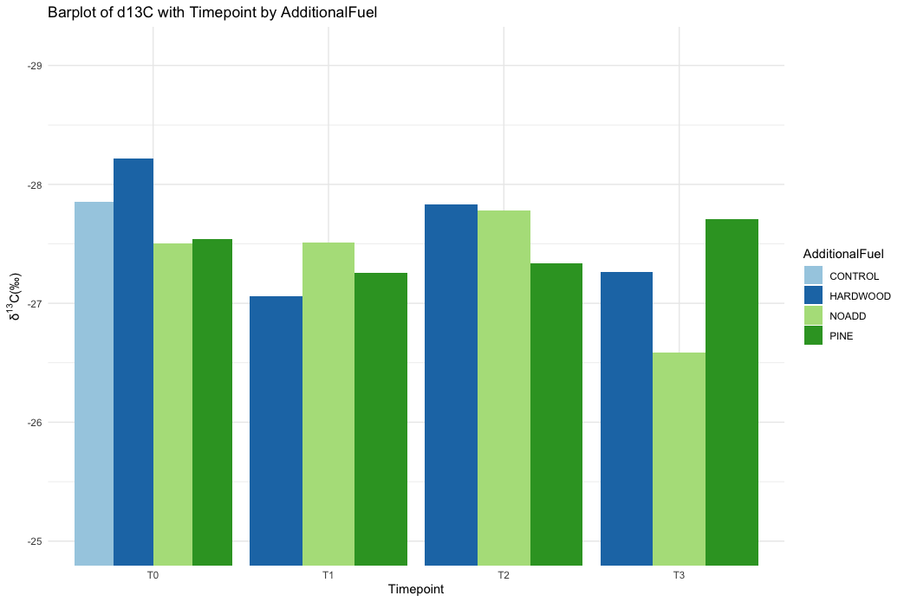
Figure 3.1. Bar plot showing variations in δ¹³C over time for different slash fuels.

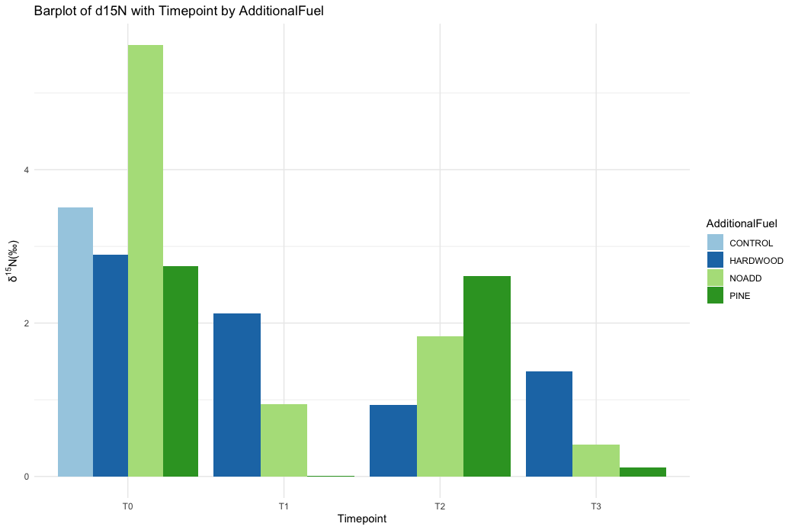
Figure 3.2. Bar plot showing variations in δ¹⁵N over time for different slash fuels.

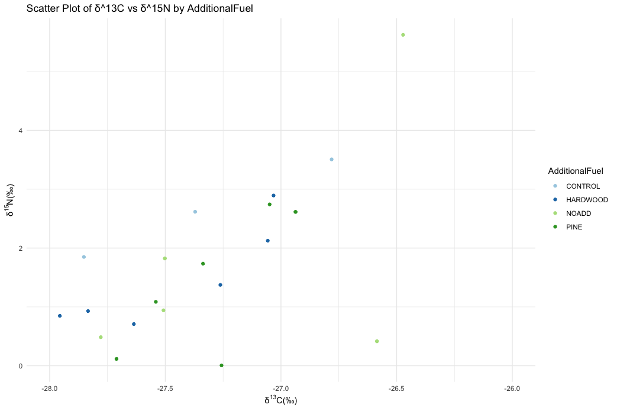
Figure 3.1. Scatterplot of δ¹³C vs. δ¹⁵N showing the distribution of isotopic ratios (grouped by type of slash fuel treatment used).

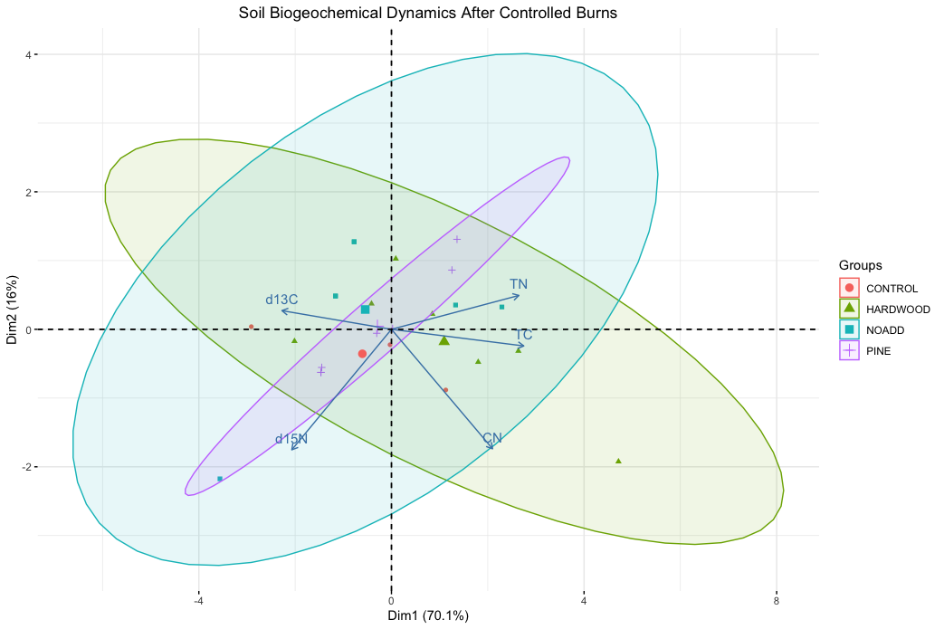
Figure 3.3. PCA Biplot for Stable Isotope Analysis dataset ( δ¹³C, δ¹⁵N, TC, TN, C: N).

Table 3.1. Comparison of Carbon and Nitrogen Concentrations and Stable Isotopic Ratios
PlotID | Additional Fuel | timepoint | δ¹³C | δ¹⁵N | TC | TN | C:N
11 | Hardwood | T0 | -27.96 | 0.85 | 6.98 | 0.30 | 23.05
11 | Hardwood | T1 | -27.06 | 2.13 | 3.16 | 0.21 | 15.32
11 | Hardwood | T3 | -27.26 | 1.37 | 3.31 | 0.23 | 14.64
12 | Pine | T0 | -27.54 | 1.09 | 2.17 | 0.13 | 17.22
12 | Pine | T1 | -27.26 | 0.01 | 3.91 | 0.23 | 17.03
12 | Pine | T3 | -27.71 | 0.12 | 3.75 | 0.24 | 15.49
13 | No add | T0 | -26.59 | 0.42 | 2.66 | 0.17 | 15.46
13 | No add | T1 | -27.51 | 0.94 | 4.06 | 0.24 | 16.95
13 | No add | T3 | -26.59 | 0.42 | 2.66 | 0.17 | 15.46
14 | Control | T0 | -27.85 | 1.85 | 3.58 | 0.19 | 18.48
21 | Pine | T0 | -27.05 | 2.74 | 2.08 | 0.13 | 16.47
21 | Pine | T2 | -27.34 | 1.74 | 3.08 | 0.19 | 16.55
22 | Control | T0 | -27.37 | 2.62 | 3.35 | 0.21 | 16.02
23 | Hardwood | T0 | -28.22 | 1.02 | 3.70 | 0.20 | 18.40
23 | Hardwood | T2 | -27.64 | 0.71 | 3.25 | 0.19 | 17.28
24 | No add | T0 | -26.47 | 5.62 | 1.23 | 0.07 | 16.74
24 | No add | T2 | -27.78 | 0.49 | 4.65 | 0.26 | 17.63
31 | Pine | T0 | -26.94 | 2.62 | 2.06 | 0.12 | 16.89
31 | Pine | T2 | -26.94 | 2.62 | 2.06 | 0.12 | 16.89
32 | Hardwood | T0 | -27.03 | 2.89 | 1.73 | 0.11 | 15.17
32 | Hardwood | T2 | -27.83 | 0.93 | 5.05 | 0.27 | 18.68
33 | Control | T0 | -26.78 | 3.51 | 1.44 | 0.10 | 13.81
34 | No add | T0 | -27.50 | 1.82 | 1.90 | 0.13 | 14.74
34 | No add | T2 | -27.50 | 1.82 | 1.90 | 0.13 | 14.74

Table 3.2. Summary Statistics for δ¹³C and δ¹⁵N.
Additional Fuel | timepoint | Mean δ¹³C | SD δ¹³C | Mean δ¹⁵N | SD δ¹⁵N | Mean C:N
Control | T0 | -27.33 | 0.54 | 2.66 | 0.83 | 16.11
Hardwood | T0 | -27.74 | 0.62 | 1.59 | 1.13 | 18.87
Hardwood | T1 | -27.06 |  | 2.13 |  | 15.32
Hardwood | T2 | -27.74 | 0.14 | 0.82 | 0.16 | 17.98
Hardwood | T3 | -27.26 |  | 1.37 |  | 14.64
No add | T0 | -26.85 | 0.56 | 2.62 | 2.69 | 15.65
No add | T1 | -27.51 |  | 0.94 |  | 16.95
No add | T2 | -27.64 | 0.20 | 1.15 | 0.95 | 16.19
No add | T3 | -26.59 |  | 0.42 |  | 15.46
Pine | T0 | -27.18 | 0.32 | 2.15 | 0.92 | 16.86
Pine | T1 | -27.26 |  | 0.01 |  | 17.03
Pine | T2 | -27.14 | 0.28 | 2.18 | 0.62 | 16.72
Pine | T3 | -27.71 |  | 0.12 |  | 15.49

Table 3.3. Summary of Statistical Tests for the effects of timepoint and slash fuel type on Soil Parameters.
Kruskal-Wallis
 | δ¹³C | δ¹⁵N | TC | TN | CN
p (Timepoint) | 0.76 | 0.09 | 0.28 | 0.13 | 0.34
p (Additional Fuel) | 0.40 | 0.29 | 0.55 | 0.48 | 0.67
ANOVA
 | δ¹³C | δ¹⁵N | TC | TN | CN
F value | 0.41 | 2.09 | 0.56 | 1.74 | 0.69
p-value | 0.75 | 0.13 | 0.65 | 0.19 | 0.57
F value | 1.12 | 0.67 | 1.32 | 1.09 | 0.86
p-value | 0.37 | 0.58 | 0.30 | 0.38 | 0.48

The relationships between independent variables (timepoint and additional fuel type) and the dependent variables (δ¹³C, δ¹⁵N, TC, TN) were investigated through Kruskal-Wallis tests and ANOVA analyses. The results indicated that these statistical tests did not yield statistically significant differences, as seen in Table 3.3.
Incorporating our soil microbial community data from Chapter 2, the RDA biplot revealed positive correlations between δ¹³C and δ¹⁵N values and several dominant phyla, including Chloroflexi, Proteobacteria, Actinobacteria, and Verrucomicrobia. Our correlation analysis using Pearson's method also identified specific genera, such as Ferrovibrio and Planctomycetes, which displayed a strong positive correlation with δ¹³C values. However, these results are at odds with our prior functional profile analysis using FAPROTAX, which showed a significant negative correlation between δ¹³C values and aerobic ammonia oxidation (p < 0.05). This discrepancy underscores the complexity of the relationship between stable isotopes and microbial communities, inviting further exploration into their ecological implications.

Discussion
Our study site, representing an open system, inherently introduces complexities in interpreting the stable isotope patterns following controlled burns. The susceptibility of the experiment to kinetic isotope fractionation is a crucial consideration in understanding the observed changes. Kinetic isotope fractionation occurs when isotopes are sorted differently during chemical reactions, resulting in variations in isotopic ratios.
Prior studies have highlighted several processes contributing to changes in the isotopic composition of soils after fire events. These processes include the preferential combustion of specific carbon functional groups, increased nitrogen mineralization, and nitrogen leaching (Christensen 1973, Bauhus, Khanna et al. 1993, Wan, Hui et al. 2001). The δ¹³C values in the pre-burn samples, representing the local vegetation, indicate that our study's predominant vegetation and slash material was of C3 origin (Araya, Fogel et al. 2017).
Following a prescribed burn, an increase in organic carbon content in soils is commonly observed (Rashid 1987). The low severity of the burn in our study suggests that the surface layer of leaves and litter was reduced to ashes and only charred the exposed extremes of the slash fuel. The combustion of dense layers of partially decomposed slash and tree debris, such as pine needles, contributed to soil ash (Pellegrini, Ahlström et al. 2018). Topsoils, known for their high organic material content and low clay content, are more susceptible to changes during a fire event (Araya et al., 2017).
Araya et al. (2017) and related studies indicate slight distillation of soil organic matter at temperatures below 150°C and charring at temperatures above 350°C, aligning with our prior explanation (Certini 2005). This accounts for the spike in total carbon content in the burned soil. However, the subsequent decrease in total carbon content after 17 Months can be attributed to the return of microbial flora and fauna, which utilize organic carbon as nutrients. After the initial increase post-burn, the decrease in the C: N ratio may be explained by converting nitrogen into pyrogenic organic matter, often called "black N" (Certini, Nocentini et al. 2011).
Typically, fires lead to an increase in nitrogen isotopes, but our investigation revealed a contrasting pattern. This phenomenon may be attributed to the mild nature of the fires experienced in our study area, which limited the extent of soil heating. During the fire event, there is a loss of lighter carbon isotopes, primarily due to the combustion of easily decomposable organic carbon in the soil. However, as our analysis was conducted on non-acidified samples, the observed rise in heavier carbon isotopes could potentially be linked to the presence of carbonate minerals, known for their higher δ¹³C values compared to organic matter.
The carbon isotope data provides essential insights into the dynamics of labile carbon loss during fire events. The observed loss of isotopically light carbon, associated with the depletion of labile carbon, has significant implications for the soil's microbial communities. Labile carbon is a crucial carbon source for microbial communities, supporting their growth and metabolic activity (Cleveland and Liptzin 2007, Garcia-Pausas and Paterson 2011). Post-fire, the soil's carbon pool may become enriched in more refractory carbon compounds, which are inherently less digestible for microbes. This shift towards refractory carbon compounds can reduce the availability of easily metabolizable carbon sources for microbial communities, potentially affecting their structure and composition (Schimel and Weintraub 2003).
The insights provided by our microbial community data, as explored in Chapter 2, offer a valuable perspective on the intricate interplay between stable isotopes and soil microbial communities. The RDA biplot unveiled noteworthy positive correlations between δ¹³C and δ¹⁵N values and some of the most abundant phyla, including Chloroflexi, Proteobacteria, Actinobacteria, and Verrucomicrobia. Interestingly, our correlation analysis, conducted using Pearson's method, further unveiled specific genera, such as Ferrovibrio and Planctomycetes, that exhibited a strong positive correlation with δ¹³C values. However, our findings might appear paradoxical when considered alongside the results of our prior functional profile analysis using FAPROTAX, where we observed a significant negative correlation between δ¹³C values and aerobic ammonia oxidation. This discrepancy raises intriguing questions regarding the implications of these correlations. Notably, the observed negative correlation with ammonia oxidation aligns with the enrichment of lighter δ¹⁵N isotopes, as indicated by more negative δ¹⁵N values. The dynamics of soil microbial communities and their metabolic activities may be influenced by the changes in isotopic compositions, particularly in the context of nitrogen cycling and ammonia oxidation. These findings underscore the complex relationship between stable isotopes and microbial communities and invite further exploration into their ecological consequences.

Conclusions
In summary, our investigation aimed to unravel the intricate dynamics governing stable isotopes, carbon and nitrogen concentrations, and microbial communities in a forest ecosystem following controlled burns, with a central focus on comprehending the ramifications of these burns on soil biogeochemistry. Our results and analyses have illuminated the complexities inherent in open system dynamics, kinetic isotope fractionation, and the intricate relationships that bind stable isotopes, carbon and nitrogen dynamics, and microbial communities within this ecological framework.
A critical dimension that emerged in our exploration was the susceptibility of our study site to kinetic isotope fractionation, a consideration of paramount importance for interpreting the observed alterations in soil isotopic patterns. These encompassed the preferential combustion of distinct carbon functional groups, heightened nitrogen mineralization, and nitrogen leaching from the ecosystem. Furthermore, our investigation of pre-burn δ¹³C values uncovered insights into the dominance of C3 vegetation within the study area, underlining the baseline conditions.
Our findings underscored the role of labile carbon loss during fire events, its potential implications for microbial communities, and, by extension, carbon and nitrogen cycling within post-fire soil ecosystems. Labile carbon, a linchpin of microbial communities, underpins their growth and metabolic activity. The loss of labile carbon during fire events was pivotal in reshaping the soil's carbon composition, enriching it with more refractory carbon compounds that become less accessible to microbial utilization. The associated changes in microbial communities bore implications for the intricacies of carbon and nitrogen cycling within post-fire soil environments.
Incorporating microbial community data into our analysis unearthed intriguing positive correlations between δ¹³C and δ¹⁵N values and several dominant phyla. Nevertheless, the paradoxical nature of these correlations became evident when viewed in conjunction with our previous functional profile analysis. The discerned negative correlation between δ13C values and aerobic ammonia oxidation implies potential repercussions for Carbon and Nitrogen fractionation within the ecosystem. Our findings underscored the multidimensional aspects of post-fire soil ecosystems. It is important to note that the analysis revealed that differences in δ¹³C and δ¹⁵N values were not statistically significant when scrutinized in relation to the additional fuel used and time, accentuating the subtleties and complexities of the responses. Considering these outcomes, our findings serve as a solid foundation for future research endeavors—the nuances of observed changes in soil biogeochemistry over extended temporal horizons merit further exploration. Moreover, the broad ecological implications of controlled burns on entire ecosystems, spanning bacterial and fungal communities and wildlife, warrant deeper investigation.
Further detailed microbial functional analyses offer the potential to unravel the specific roles affected microbial groups play in the intricate dynamics of carbon and nitrogen cycling. Consequently, the quest for mitigation strategies to mitigate the impacts of controlled burns on soil biogeochemistry while upholding their ecological benefits emerges as a pressing challenge. This approach holds the promise of enhancing the sustainability of land management practices in fire-prone ecosystems, bringing into sharp focus the potential implications of our findings for future ecological conservation and land use.

References
Araya, S. N., M. L. Fogel and A. A. Berhe (2017). "Thermal alteration of soil organic matter properties: a systematic study to infer response of Sierra Nevada climosequence soils to forest fires." Soil 3(1): 31-44.
Balesdent, J., A. Mariotti and B. Guillet (1987). "NATURAL C-13 ABUNDANCE AS A TRACER FOR STUDIES OF SOIL ORGANIC-MATTER DYNAMICS." Soil Biology & Biochemistry 19(1): 25-30.
Bauhus, J., P. K. Khanna and R. J. Raison (1993). "The effect of fire on carbon and nitrogen mineralization and nitrification in an Australian forest soil." Australian Journal of Soil Research 31(5): 621-639.
Boutton, T. W. (1996). Stable carbon isotope ratios of soil organic matter and their use as indicators of vegetation and climate change.
Burke, M., A. Driscoll, S. Heft-Neal, J. Xue, J. Burney and M. Wara (2021). "The changing risk and burden of wildfire in the United States." Proceedings of the National Academy of Sciences of the United States of America 118(2).
Certini, G. (2005). "Effects of fire on properties of forest soils: a review." Oecologia 143(1): 1-10.
Certini, G., C. Nocentini, H. Knicker, P. Arfaioli and C. Rumpel (2011). "Wildfire effects on soil organic matter quantity and quality in two fire-prone Mediterranean pine forests." Geoderma 167-68: 148-155.
Chen, Y., C. W. Diamond, E. E. Stueken, C. Cai, B. C. Gill, F. Zhang, S. M. Bates, X. Chu, Y. Ding and T. W. Lyons (2019). "Coupled evolution of nitrogen cycling and redoxcline dynamics on the Yangtze Block across the Ediacaran-Cambrian transition." Geochimica Et Cosmochimica Acta 257: 243-265.
Christensen, N. L. (1973). "Fire and the nitrogen cycle in California Chaparral." Science 181(4094): 66-68.
Cleveland, C. C. and D. Liptzin (2007). "C:N:P stoichiometry in soil:: is there a "Redfield ratio" for the microbial biomass?" Biogeochemistry 85(3): 235-252.
Dawson, T. E., S. Mambelli, A. H. Plamboeck, P. H. Templer and K. P. Tu (2002). "Stable Isotopes in Plant Ecology." Annual Review of Ecology and Systematics 33(1): 507-559.
Fry, B. (2006). Stable isotope ecology, Springer.
Garcia-Pausas, J. and E. Paterson (2011). "Microbial community abundance and structure are determinants of soil organic matter mineralisation in the presence of labile carbon." Soil Biology & Biochemistry 43(8): 1705-1713.
Grogan, P., T. D. Bruns and F. S. Chapin (2000). "Fire effects on ecosystem nitrogen cycling in a Californian bishop pine forest." Oecologia 122(4): 537-544.
Handley, L. L., A. T. Austin, G. R. Stewart, D. Robinson, C. M. Scrimgeour, J. A. Raven, T. H. E. Heaton and S. Schmidt (1999). "The <emph type="7">15</emph>N natural abundance (&#948;<emph type="7">15</emph>N) of ecosystem samples reflects measures of water availability." Functional Plant Biology 26(2): 185-199.
Hobbie, E. A. and J. E. Hobbie (2008). "Natural abundance of <SUP>15</SUP>N in nitrogen-limited forests and tundra can estimate nitrogen cycling through mycorrhizal fungi:: A review." Ecosystems 11(5): 815-830.
Hyodo, F., S. Kusaka, D. A. Wardle and M.-C. Nilsson (2013). "Changes in stable nitrogen and carbon isotope ratios of plants and soil across a boreal forest fire chronosequence." Plant and Soil 367(1-2): 111-119.
Knicker, H. (2007). "How does fire affect the nature and stability of soil organic nitrogen and carbon? A review." Biogeochemistry 85(1): 91-118.
Kramer, S., D. Dibbern, J. Moll, M. Huenninghaus, R. Koller, D. Krueger, S. Marhan, T. Urich, T. Wubet, M. Bonkowski, F. Buscot, T. Lueders and E. Kandeler (2016). "Resource Partitioning between Bacteria, Fungi, and Protists in the Detritusphere of an Agricultural Soil." Frontiers in Microbiology 7.
Laclau, J. P., W. Sama-Poumba, J. D. Nzila, J. P. Bouillet and J. Ranger (2002). "Biomass and nutrient dynamics in a littoral savanna subjected to annual fires in Congo." Acta Oecologica-International Journal of Ecology 23(1): 41-50.
Michener, R. and K. Lajtha (2007). Stable Isotopes in Ecology and Environmental Science SECOND EDITION Introduction.
Ohkouchi, N., Y. Chikaraishi, H. G. Close, B. Fry, T. Larsen, D. J. Madigan, M. D. McCarthy, K. W. McMahon, T. Nagata, Y. I. Naito, N. O. Ogawa, B. N. Popp, S. Steffan, Y. Takano, I. Tayasu, A. S. J. Wyatt, Y. T. Yamaguchi and Y. Yokoyama (2017). "Advances in the application of amino acid nitrogen isotopic analysis in ecological and biogeochemical studies." Organic Geochemistry 113: 150-174.
Parnell, A. C., R. Inger, S. Bearhop and A. L. Jackson (2010). "Source Partitioning Using Stable Isotopes: Coping with Too Much Variation." Plos One 5(3).
Pellegrini, A. F. A., A. Ahlström, S. E. Hobbie, P. B. Reich, L. P. Nieradzik, A. C. Staver, B. C. Scharenbroch, A. Jumpponen, W. R. L. Anderegg, J. T. Randerson and R. B. Jackson (2018). "Fire frequency drives decadal changes in soil carbon and nitrogen and ecosystem productivity." Nature 553(7687): 194-198.
Post, D. M. (2002). "Using stable isotopes to estimate trophic position: Models, methods, and assumptions." Ecology 83(3): 703-718.
R Core Team, R. (2021). R: A language and environment for statistical computing. URL https://www.R-project.org/.
Rashid, G. H. (1987). "Effects of fire on soil carbon and nitrogen in a Mediterranean oak forest of Algeria." Plant and Soil 103(1): 89-93.
Savard, M. M. (2010). "Tree-ring stable isotopes and historical perspectives on pollution - An overview." Environmental Pollution 158(6): 2007-2013.
Schimel, J. P. and M. N. Weintraub (2003). "The implications of exoenzyme activity on microbial carbon and nitrogen limitation in soil: a theoretical model." Soil Biology & Biochemistry 35(4): 549-563.
Stephan, K., K. L. Kavanagh and A. Koyama (2015). "Comparing the Influence of Wildfire and Prescribed Burns on Watershed Nitrogen Biogeochemistry Using <SUP>15</SUP>N Natural Abundance in Terrestrial and Aquatic Ecosystem Components." Plos One 10(4).
Trumbore, S. (2000). "Age of soil organic matter and soil respiration: Radiocarbon constraints on belowground C dynamics." Ecological Applications 10(2): 399-411.
Wan, S. Q., D. F. Hui and Y. Q. Luo (2001). "Fire effects on nitrogen pools and dynamics in terrestrial ecosystems: A meta-analysis." Ecological Applications 11(5): 1349-1365.

Impact of Fire Frequency on Soil Microbial Community and Soil Nutrients in a Southern Appalachian Forest

Abstract
This study investigates the impact of varying burn frequencies on soil microbial dynamics and nutrient availability in Southern Appalachian forest ecosystems, focusing on a 7.3-hectare area within the University of Tennessee Forest Resources Research and Education Center, located near Tullahoma, Tennessee, in Franklin County (coordinates 35°30’N 86°15’W). Controlled prescribed fires have been conducted at both 1-year and 5-year intervals on specific plots within this site for six decades. The research findings reveal that annual burn frequency reduces microbial biomass carbon (MBC) and organic matter availability due to recurrent fire disturbances, while periodic burn frequency shows a slight increase in MBC because of extended recovery periods. Despite lower MBC and SOC in periodic burn plots, total carbon stock is higher, suggesting the presence of less stable carbon forms. Increased moisture content in periodic burn sites impacts MBC by influencing microbial activity, organic matter access, and microbial community composition, and basic pH is attributed to incomplete fuel combustion. The study further identifies shifts in microbial community composition and the enrichment of resilient phyla in burnt soils, emphasizing the adaptive capacity of specific microbial groups to fire-induced changes. Understanding these dynamics is crucial for managing microbial diversity and ecosystem resilience in the face of increasing fire frequency and informing post-fire restoration efforts. However, it is essential to consider that this study's findings are specific to the examined forest ecosystem and may not directly apply to others, warranting further research in diverse ecosystems and the long-term consequences of frequent fire disturbances on soil fertility and ecosystem processes.

Introduction
Fire is a natural ecological process that has shaped forest ecosystems for millions of years. In fire-prone regions, such as the Southern Appalachian forests, fire plays a vital role in ecosystem dynamics, nutrient cycling, and biodiversity maintenance. However, human intervention and land management practices have altered fire regimes, leading to changes in fire frequency and severity. Understanding the impact of fire frequency on soil chemical properties is essential for effective land management and conservation strategies in these fire-adapted ecosystems. Fire frequency, defined as the average number of fires occurring within a specific time, is a critical factor influencing soil chemistry. Frequent fires can significantly modify soil properties by affecting organic matter content, nutrient availability, pH, and microbial community composition. These alterations, in turn, influence various ecosystem functions, including nutrient cycling, carbon storage, and plant community dynamics.
Previous studies have highlighted the role of fire frequency in shaping microbial diversity and community structure (Hart, DeLuca et al. 2005, Gómez-Rey, Couto-Vázquez et al. 2013). High fire frequency has been associated with reduced microbial biomass and shifts in microbial community composition (Neff et al., 2005). These shifts in microbial communities are of ecological importance because soil microbes drive essential biogeochemical processes, including nutrient cycling and organic matter decomposition (Fierer and Jackson 2006, Rousk, Bååth et al. 2010). In upland oak forests, the frequency of prescribed burning exerts notable effects on soil and litter properties. A 20-year study by Williams, Hallgren et al. (2012) examined burn frequencies of 0, 2.5, and 5 fires per decade (FPD). Low-frequency burning (2.5 FPD) had minor soil impacts, while high-frequency burning (5 FPD) caused substantial changes. It reduced soil organic matter and carbon and increased bulk density. Litter nitrogen decreased, and the carbon-to-nitrogen (C/N) ratio increased, slowing decomposition. High frequency burning also altered the soil microbial community, notably reducing Gram-negative bacteria. An increase in fire frequency consistently affects total carbon levels and nitrification rates within the examined ecosystems. Furthermore, the time elapsed since the last fire was identified as a significant driving factor behind alterations in soil properties and microbial communities (Albert-Belda, Hinojosa et al. 2023).
Despite these valuable insights, there remains a notable research gap pertaining to the long-term consequences of fire frequency on soil microbial communities in Southern Appalachian mixed forests. Most existing studies have focused on post-fire responses in single events or at short-term intervals. Therefore, the long-term dynamics of soil microbial communities under different fire frequency regimes remain understudied.
Frequent fires have been shown to reduce soil carbon stocks and alter nutrient availability. Frequent burns can result in the depletion of essential soil nutrients, such as nitrogen, and changes in soil pH (Yarwood, Bach et al. 2020). These findings underscore the potential consequences of altered fire frequency on soil properties. The history of fire frequency in ecosystems may influence the resistance of bacterial communities to fire; for example Ponderosa pine soils, which experience more frequent fires, might have developed a community structure that resists significant changes in richness in response to fire (Weber, Lockhart et al. 2014).
However, despite these advancements, the interplay between fire frequency, soil chemistry, and microbial communities in Southern Appalachian mixed forests presents an intriguing and underexplored research gap. Specifically, limited research has tackled the long-term alterations in soil microbial community structure and function induced by fire frequency and how these changes relate to shifts in soil chemistry. This chapter addresses this knowledge gap by focusing on the impact of fire frequency on soil microbial communities and soil chemistry in Southern Appalachian mixed forests, striving to provide a comprehensive understanding of how the two interact within this ecosystem.
In summary, this chapter contributes to the ongoing discourse concerning the intricate relationships between fire, soil, and microbial communities in Southern Appalachian mixed forests. It aims to elucidate how varying fire frequency regimes influence soil microbial community dynamics and soil chemistry, filling a significant research gap in the ecological management of these diverse and ecologically vital forests. By examining the long-term effects of fire frequency on soil ecosystems, this research provides insights into the conservation and sustainable management of Southern Appalachian mixed forests. We hypothesize that different fire frequencies will lead to distinct patterns in soil chemistry, including changes in nutrient availability, pH, and organic matter content. Understanding these patterns is crucial for informing land management practices and predicting the long-term effects of fire on ecosystem functioning. To achieve this goal, we collected soil samples from sites with varying fire frequencies, including areas subjected to annual burns, periodic burns (occurring every 10-15 years), and unburned control sites. A comprehensive analysis of soil chemical properties, including pH, nutrient availability, organic matter content, and microbial biomass carbon, was conducted to elucidate the effects of fire frequency on soil chemistry.
By investigating the impact of fire frequency on soil chemical properties and microbial community changes, this study contributes to our understanding of the complex interactions between fire, soil, microbes, and nutrient dynamics in Southern Appalachian forests. The findings of this research have implications for fire management strategies, ecosystem restoration efforts, and the conservation of biodiversity in fire-adapted ecosystems.

Materials and Methods

Site Selection Criteria
The study sites were selected based on criteria including fire frequency (e.g., periodic, annual, or no fire), age of stand, and wood fuel type (Pine/Hardwood).

Study Area
The study area is situated at coordinates 35°30’N 86°15’W, covering 7.3 hectares within the University of Tennessee Forest Resources Research and Education Center, near Tullahoma, Tennessee, in Franklin County. This site is a part of the larger 860-acre University of Tennessee Highland Rim Forestry Experiment Station, located on the Eastern Highland Rim of the Interior Low Plateaus Province in middle Tennessee. The expansive station has been the focus of controlled prescribed fire management for 60 years, with fires implemented at both 1 year and 5-year intervals on specific plots.

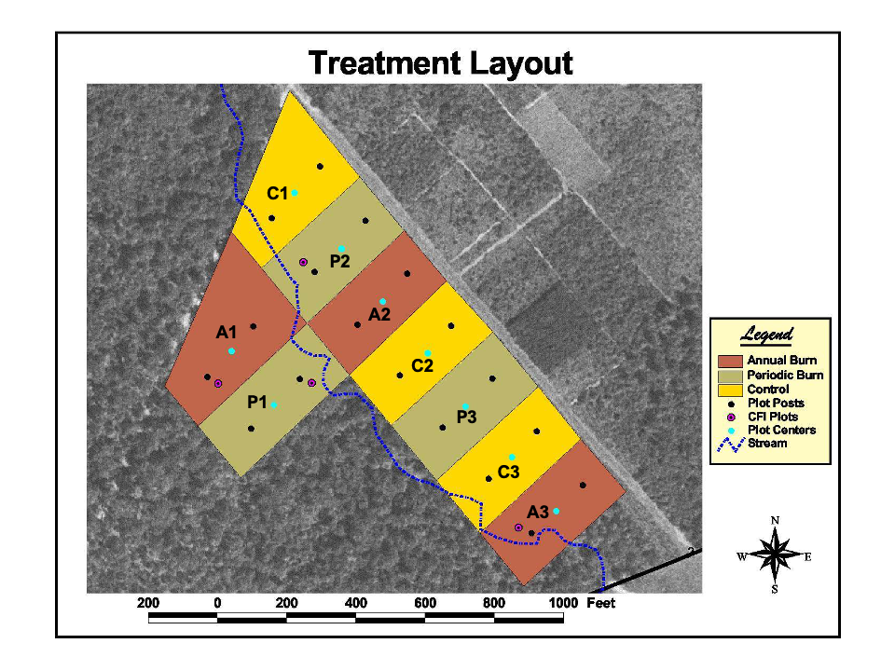
Figure 4.1. Study Site at the University of Tennessee Highland Rim Forestry Experiment Station, Tullahoma, TN near Franklin County.

Moisture Content
Soil moisture content, determined by drying soils at 105°C for 48 h, was used to adjust all analytical chemistry values to grams per dry weight of soil.

Total, Organic and Microbial Biomass Carbon

Total Carbon
The composited field-moist soil was sieved through a 4 mm sieve and a subsample was stored under 4℃ until MBC analysis. The remaining soil was air-dried and sieved through a 2 mm sieve to analyze basic properties, SOC, and functional C fractions. The air-dried and 2 mm sieved samples were further pulverized using a vial rotator (SampleTek model 200) and used for the determination of total SOC concentration (SOC_{con}) using an Elementar vario MAX cube CN analyzer (Elementar, Hanau, Germany).

Direct chloroform fumigation for Microbial Biomass
Soil MBC was determined by following the modified chloroform fumigation and extraction procedure (Vance, Brookes et al. 1987). Fresh 4 mm sieved 15 g soils were fumigated for 48 h in the dark. After fumigation, soils were extracted with 45 ml 0.5 M K₂SO₄ solution, followed by shaking at 200 rpm for 1 h, centrifuging for 2 min at 2500 rpm, and filtering the supernatant using Whatman no. 42 filter paper. On the day of incubation, 15 g of the unfumigated soil samples were extracted using the same protocol. The fumigated and unfumigated filtrates were analyzed for C concentration using Elementar vario TOC cube CN analyzer in liquid mode (Elementar, Hanau, Germany). Microbial biomass C was determined as the difference in measured C concentration between fumigated and unfumigated samples and divided by the extraction efficiency coefficient of 0.45(Beck, Joergensen et al. 1997).

Genomic DNA extraction and PCR amplification
This study employed a DNA amplification approach, per the protocol described by (Wu, Wen et al. 2015). The amplification process consisted of a two-step polymerase chain reaction (PCR) designed to increase the quantity of isolated DNA. In the initial phase, 16S rDNA underwent ten cycles of amplification using the 515F and 806R primers. Subsequently, the product obtained from the first step was subjected to an additional twenty cycles of amplification in the second step. The second amplification step incorporated primers that included spacers to enhance base diversity, barcodes from Illumina (San Diego, CA, USA), adaptor and sequencing primers, along with the target primers, 515F and 806R. The efficiency of the amplification process was evaluated through agarose gel electrophoresis.

16S rRNA gene amplicon sequencing
The PCR products were combined in equimolar concentrations and subjected to purification following amplification. Sequencing library preparation was conducted per the guidelines provided in the MiSeq™ Reagent Kit Preparation Guide (Illumina, San Diego, CA, USA) as outlined by (Caporaso, Lauber et al. 2012). The sequencing process involved forward, index, and reverse reads over 251, 12, and 251 cycles. Sequencing was performed on an Illumina MiSeq platform, utilizing a 500-cycle v2 MiSeq reagent cartridge.
Sequencing analysis was performed using Qiime2 (version qiime2-amplicon-2023.9) (Bolyen, Rideout et al. 2019). Briefly, the 16S reads were imported into Qiime2 and dereplicated using DADA2 (Callahan, McMurdie et al. 2016)with the paired-end setting. The 16S representative ASVs were assigned to the SILVA 132 pre-trained gene databases (Quast, Pruesse et al. 2013) respectively, producing taxonomy tables. Microeco (Liu, Cui et al. 2021), Vegan (Oksanen, Simpson et al. 2016), and phyloseq (McMurdie and Holmes 2013) packages were used in R (R Core Team 2021) for community analysis. Raw reads used in this study can be found in the NCBI Sequence Read Archive (SRA) under the BioProject accession number PRJNA1035790.

Statistical Analyses
All statistical analyses were performed using R v.4.2.3 software (R Core Team 2021). Analysis of variance (ANOVA) was conducted to determine the changes in soil properties over time with a significance threshold of p < 0.05. Principal Coordinate Analysis (PCoA) was performed to explore the relationships between soil variables (pH, total C, total N, C: N ratio, porewater cations, and organic acids). Beta diversity analyses included non-metric multidimensional scaling (NMDS) based on the weighted-Unifrac distances. Permutational multivariate analysis of variance (PERMANOVA) was performed on the weighted Unifrac distance matrix with the "vegan" package (Oksanen, Simpson et al. 2016). Redundancy analysis (RDA) was performed to investigate the relationship between soil variables (soil pH, total C, total N, MBC,) and soil bacterial community.

Results

Carbon and Nitrogen Stock and Distribution
Analysis of carbon and nitrogen-related parameters demonstrated significant variations in response to different burn frequencies. From Table 4.1 and 4.2 and Figure 4.6, Total carbon (TC) and total nitrogen (TN) displayed statistically significant differences among the treatments (p ≤ 0.05). TC exhibited a change from 2.05% in unburnt soil to 1.84% in annual burns and 2.57% in periodic burns, while TN showed significant variations (p ≤ 0.05), with values ranging from 0.102% in unburnt soil to 0.0929% in annual burns and 0.147% in periodic burns. Furthermore, microbial biomass carbon (MBC) and soil organic carbon (SOC) were found to be particularly responsive to burn frequency, with MBC increasing from 39.1 mg kg⁻¹ in unburnt soil to 71.6 mg kg⁻¹ in periodic burns, and SOC experiencing a notable fall from 39.37 mg kg⁻¹ in unburnt soil to 32.24 mg kg⁻¹ in periodic burns.
The examination of soil moisture, represented as gravimetric moisture content, and its association with Microbial Biomass Carbon (MBC) across different burn frequencies reveals noteworthy trends, see Figure 4.2. Within the Annual burn frequency category, moisture fluctuates between 0.29 and 0.49, corresponding to MBC levels spanning from 9.15 mg kg⁻¹ to 126.56 mg kg⁻¹. In the Periodic burn frequency group, we observe a similar range of Moisture (0.28 to 0.36) but a broader spectrum of MBC (ranging from 16.69 mg kg⁻¹ to 150.06 mg kg⁻¹).
This suggests a more pronounced response of MBC to changes in soil moisture within this group. In contrast, the Control group maintains higher and relatively consistent soil moisture levels (0.28 to 0.41) with MBC values ranging from 46.39 mg kg⁻¹ to 183.07 mg kg⁻¹. These distinct trends underscore the sensitivity of MBC to variations in soil moisture content.
Burn Frequency | Moisture (fraction) | SOC  (mg kg⁻¹) | MBC  (mg kg⁻¹) | TN  (% wt) | TC  (% wt) | pH
Annual | 0.35 | 17.57 | 39.05 | 0.09 | 1.84 | 5.60
Periodic | 0.31 | 32.24 | 71.65 | 0.15 | 2.57 | 4.99
Unburnt | 0.37 | 39.37 | 87.49 | 0.10 | 2.03 | 5.04

Table 4.1. Summary Statistics for selected soil chemistry parameters grouped by Burn Frequency

Table 4.2. ANOVA Analysis summary for all Environmental parameters including Available Nutrients, Soil Moisture, Carbon, and Nitrogen Stock, and pH.
Response | F value | Pr | Significance
Al | 1.185 | 0.323
B | 8.160 | 0.002 | **
Ca | 1.683 | 0.207
Cr | 1.459 | 0.252
Cu | 0.953 | 0.400
Fe | 2.458 | 0.107
K | 1.426 | 0.260
Mg | 4.117 | 0.029 | *
Mn | 2.147 | 0.139
Na | 4.907 | 0.016 | *
Ni | 32.244 | 0.000 | ***
P | 1.878 | 0.175
Pb | 2.688 | 0.088
Moisture | 3.179 | 0.060
OC | 3.231 | 0.057
MBC | 3.231 | 0.057
TN | 7.071 | 0.004 | **
TC | 3.891 | 0.034 | *
pH | 28.404 | 0.000 | ***
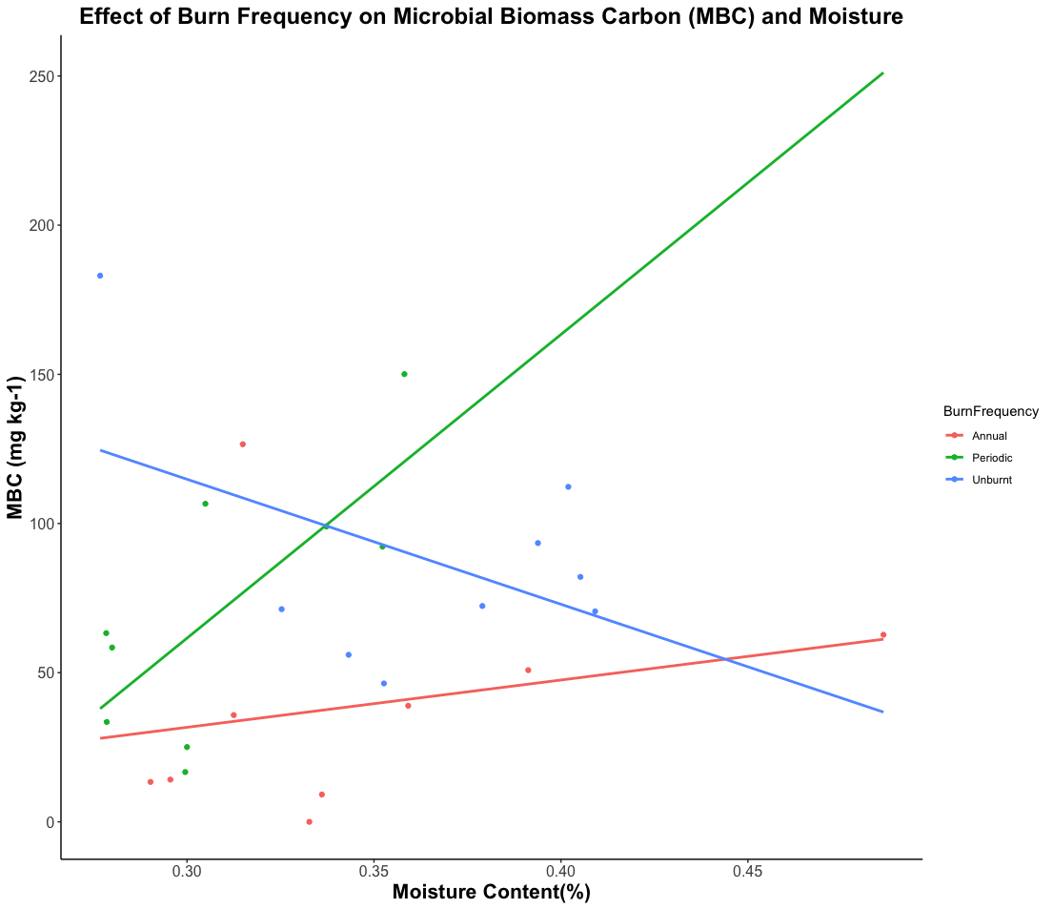
Figure 4.2. Relationship between microbial biomass carbon (MBC) and soil moisture, with linear model trend lines.

Soil Nutrients and Exchangeable Ions, pH
For macro nutrients, Figure 4.7, significant variations were detected, with potassium (K) and sodium (Na) displaying statistically significant differences (p ≤ 0.05). Specifically, K demonstrated a value of 54.91 mg kg⁻¹ in annually burnt soil compared to 64.24 mg kg⁻¹ in periodic burns, while Na exhibited a fall from 24.39 mg kg⁻¹ in unburnt soil to 25.93 mg kg⁻¹ in periodic burns (annual was at 17.7mg kg⁻¹). Both manganese (Na) and magnesium (Mg) also showed notable variations (p ≤ 0.05), with Mn reducing from 41.02 mg kg⁻¹ in unburnt soil to 27.35 mg kg⁻¹ in periodic burns, and Mg being lowered from 30.52 mg kg⁻¹ in unburnt soil to 22.95 mg kg⁻¹ in periodic burns. Conversely, phosphorus (P) and the rest of the macro nutrients did not reveal significant variations across different burn frequency treatments. However, it is worth highlighting that calcium (Ca) exhibited substantial variability, surging from 106.90 mg kg⁻¹ in unburnt soil to 172.66 mg kg⁻¹ in annual burns and falling to 103.61 mg kg⁻¹ in periodic burns.
Micro-nutrients, see Figure 4.8, encompassing elements such as nickel (Ni) presented variations (p ≤ 0.05) within the study. Ni exhibited a substantial decrease from 0.246 mg kg⁻¹ in unburnt soil to 0.0.091 mg kg⁻¹ in Annual burns. Micro-nutrients including iron (Fe), copper (Cu), and chromium (Cr) did not reveal significant distinctions across burn frequency treatments. It is worth highlighting that iron (Fe) showcased a marked variability, surging from 31.93 mg kg⁻¹ in unburnt soil to 38.08 mg kg⁻¹ in periodic burns (p ≤ 0.05). Soil pH demonstrated significant variations in response to burn frequency (p ≤ 0.05). It changed from 5.04 in unburnt soils to 5.60 in annual burns and 4.99 in periodic burns.

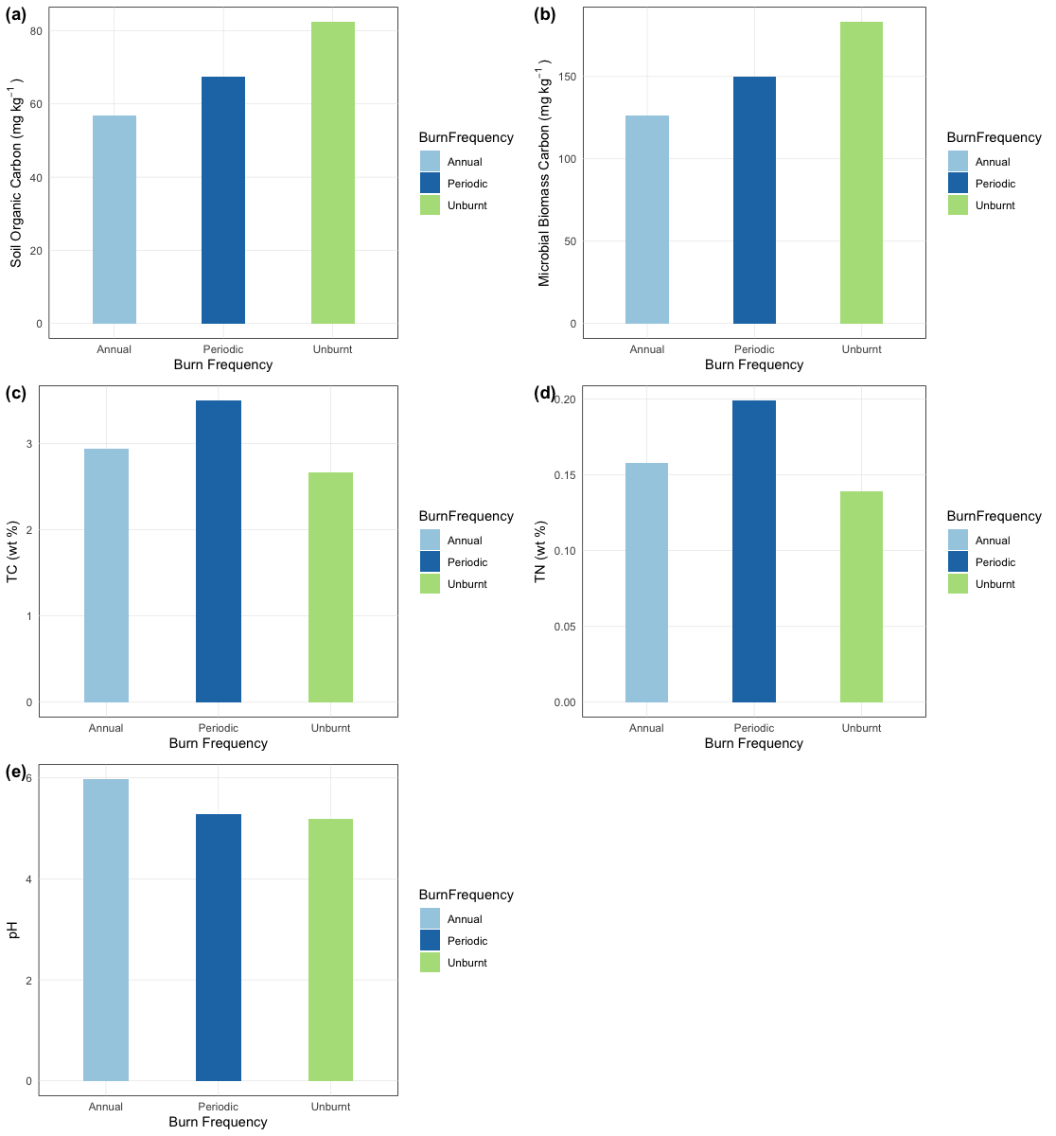

Figure 4.3. Variation of main soil characteristics in the 0–5 cm layer for Unburnt(Control), Periodic and Annual Prescribed Burn treatments: Soil Organic Carbon (a), Microbial Biomass Carbon (b), Total Carbon (c), Toral Nitrogen (d), and pH (e).
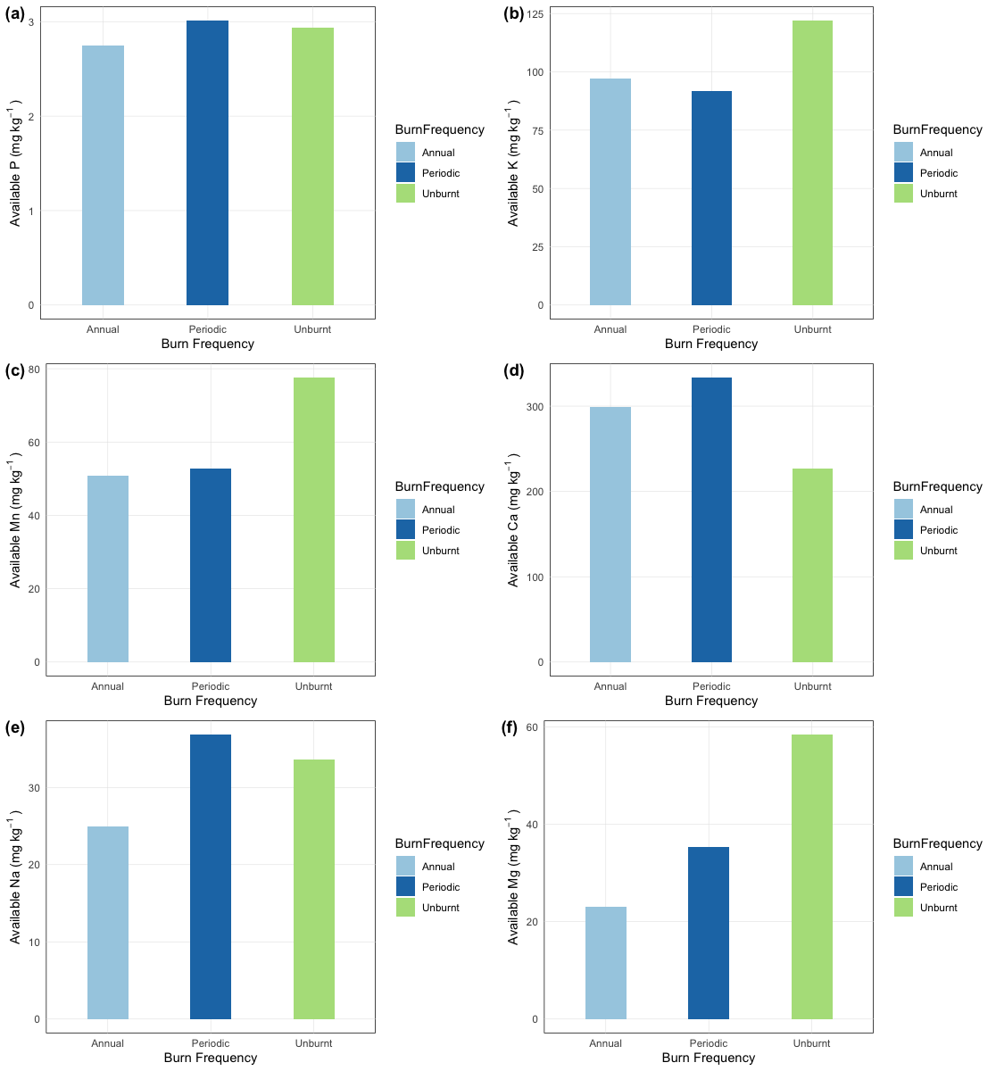

Figure 4.4. Variation of extractable element concentrations in the 0–5 cm layer for Unburnt(Control), Periodic and Annual Prescribed Burn treatments: P (a), K (b), Mn (c), Ca (d), Na (e) and Mg (f).

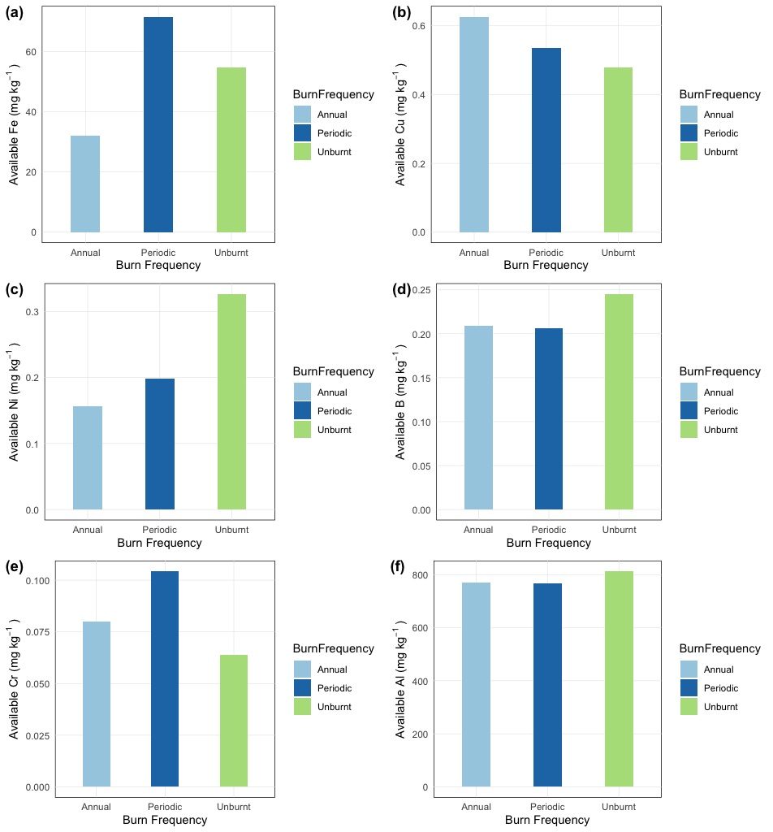

Figure 4.5. Variations in extractable micro-nutrient concentrations in the 0–5 cm layer for Unburnt(Control), Periodic and Annual Prescribed Burn treatments: Fe (a), Mn (b), Cu (c), Zn (d), B (e) and Co (f).

Bacterial Community Analysis
In this study, we investigated how fire influences the soil microbiome, categorizing soils as either "Burnt" or "Unburnt." We explored the relative abundance of microbial taxa in response to different burn frequencies (Annual, Control, and Periodic), with the 'Control' group serving as the baseline. Notably, the same top three phyla, Acidobacteriota, Proteobacteria, and Planctomycetota, exhibited substantial variation in response to burn frequencies and fire conditions. Acidobacteriota showed significantly higher abundance in the 'Control' group compared to the 'Annual' and 'Periodic' groups, while Proteobacteria exhibited distinct patterns, with the 'Annual' group exhibiting increased abundance compared to the 'Control' group, and the 'Periodic' group displaying the highest levels. Planctomycetota demonstrated significant differences among all groups, with the 'Control' group showing the highest abundance. Interestingly, these taxa exhibited significant differences between soils categorized by the two burn conditions. Acidobacteriota and Proteobacteria showed higher abundance in the "Unburnt" soils compared to the "Burnt" soils, while the Planctomycetota were significantly more abundant in the "Burnt" soils. The significance level of these differences was consistent (p < 0.05).
Alpha diversity was assessed using Chao1, ACE, Shannon, and Observed metrics to compare soil microbial community diversity across different burn frequencies: Annual, Control, and Periodic. From Figures 4.9 to 4.12, no significant differences were observed among these groups. Control soils exhibited the highest estimated species richness with a mean Observed value of 1702 ASVs, Chao1 of 1702 ASVs, and ACE of 1702 ASVs. In contrast, the Annual and Periodic soils displayed lower species richness, with mean Observed values of 1383 ASVs and 1654 ASVs, Chao1 of 1383 ASVs and 1655 ASVs, and ACE of 1383 ASVs and 1654 ASVs, respectively. The Shannon diversity index, measuring both richness and evenness, also did not show significant differences, with Control soils having a mean diversity of 6.54, like the Annual (6.50) and Periodic (6.55) soils.
We conducted PERMANOVA analysis to assess the differential microbial community composition in soils under different fire conditions. Two key comparisons were made: Burnt vs. Unburnt and Burn Frequency. Figure 4.13, 4.14 and Table 4.1 shows the beta diversity analysis output after applying PERMANOVA to the differential test of distances among groups via the adonis2 function of vegan package. For Burnt vs. Unburnt, the results revealed a highly significant difference in microbial community composition (p-value < 0.001). This indicates that fire significantly influences the soil microbiome, leading to distinct community compositions between burnt and unburnt soils. In the Burn Frequency comparison, we observed varying degrees of significance in community composition. The comparison between Annual and Control groups showed high significance (p-value = 0.001), indicating substantial differences in community composition. However, the comparison between Annual and Periodic (p-value = 0.305, not significant) and Periodic and Control (p-value = 0.001) groups displayed varying levels of significance.
In our Redundancy Analysis (RDA), Figure 4.15 we sought to unravel the intricate interplay between microbial community composition and key environmental factors, namely, Burn Frequency and Fire. The RDA results revealed valuable insights into the impact of these variables on the microbial community structure.

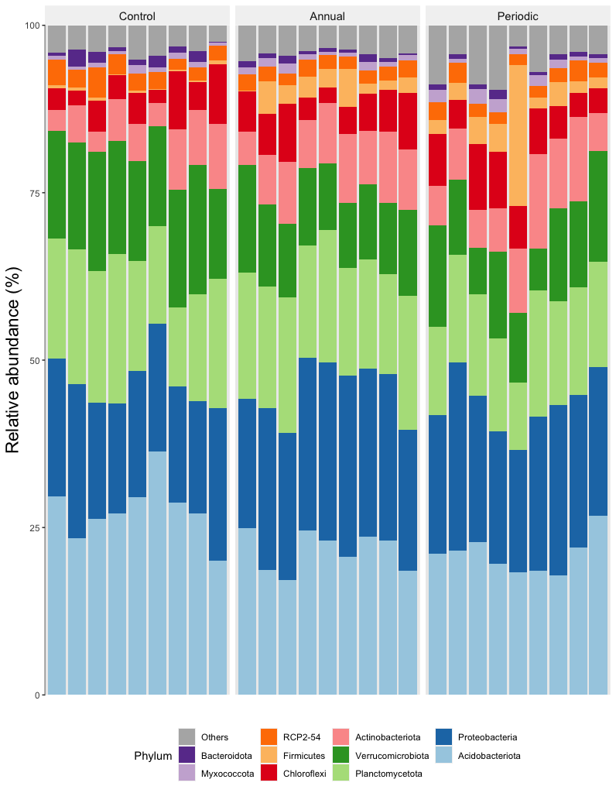
Figure 4.6. Taxa bar plot illustrating the top 10 phyla relative abundances, grouped by Burn Frequency: Annual, Periodic, and Control. Different colors represent each phylum.
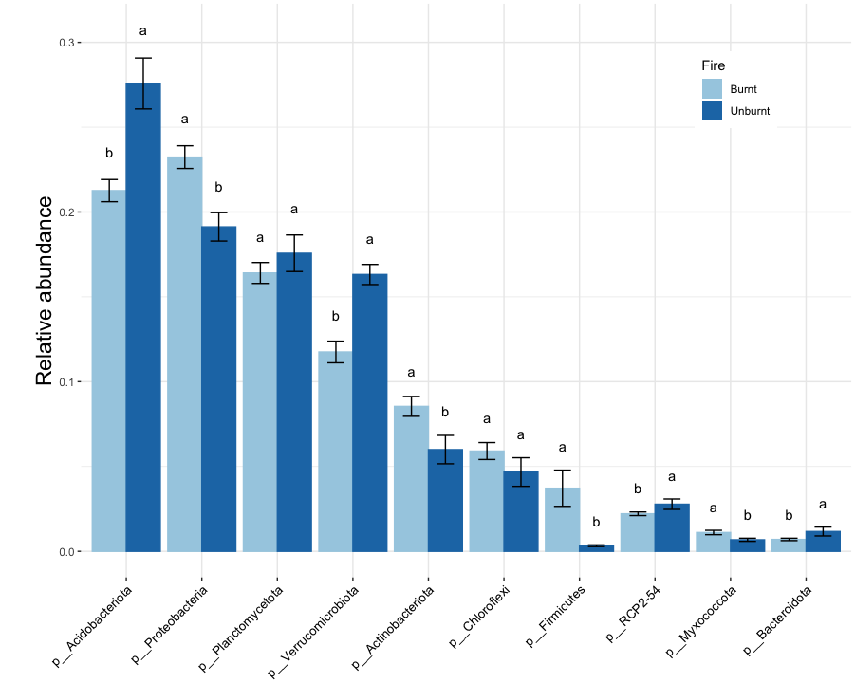
Figure 4.7. Differential Relative Abundance of the top 10 phyla presented in a bar plot, grouped by Fire treatment. Significant differences (p < 0.05) denoted by distinct letters, elucidating shifts in microbial community composition.

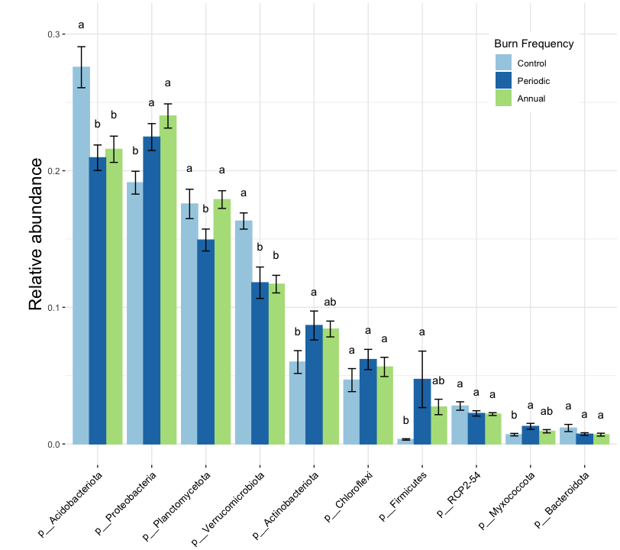
Figure 4.8. Differential Relative Abundance of the top 10 phyla presented in a bar plot, grouped by Burn Frequency treatments. Significant differences (p < 0.05) denoted by distinct letters, elucidating shifts in microbial community composition.

Table 4.3. PERMANOVA Analysis of using beta diversity metrics within the microbial communities within treatment groups.
Groups | Measure | F | R² | p-value | p-adjusted | significance
Annual vs Periodic | Weighted Unifrac | 1.103 | 0.064 | 0.305 | 0.305
Annual vs Control | Weighted Unifrac | 4.894 | 0.234 | 0.001 | 0.002 | **
Periodic vs Control | Weighted Unifrac | 3.986 | 0.199 | 0.001 | 0.002 | **
Burnt vs Unburnt | Weighted Unifrac | 5.251 | 0.174 | 0.001 | 0.001 | ***

Constrained by Burn Frequency and Fire, a substantial proportion of the total variance, amounting to 79.25%, was accounted for, highlighting their significant roles in shaping the microbial landscape.
RDA eigenvalues further emphasized the relative importance of each axis in explaining this variation. The first constrained axis (RDA1) appeared particularly influential, explaining 72.9% of the total variance, signifying the dominant role of these factors in structuring the microbial community. Unconstrained axes, on the other hand, represented the remaining of the total variance, indicating variability that was not explicitly explained by Burn Frequency and Fire. Distinct clustering patterns can also be observed among the data points, reflecting the interplay between microbial community composition and the environmental factors. soils subjected to annual burning exhibited a tight cluster with considerable overlap with the periodic burning category, suggesting the presence of a distinct microbial community structure. Conversely, a noticeable overlap was observed in clusters between Control and Periodic burns, underscoring their shared similarities, distinct from the Annual burn data. Notably, the ellipses on the RDA plot were narrower for annual burning, accentuating the specificity and coherence of its microbial community. In the upper left quadrant, the vectors for Proteobacteria, Chloroflexi, and Actinobacteriota closely associate with the vector for Available Calcium. This suggests that variations in Available Calcium levels might influence the abundance of these microbial phyla. Meanwhile, the Planctomycetota vector resides close to the Soil Organic Carbon (SOC) vector, with similar vector lengths, indicating a potential link between Planctomycetota and SOC. Changes in SOC content may, in turn, impact the relative abundance of Planctomycetota.
In the lower left quadrant, Acidobacteriora and Verrucomicrobiota vectors extend alongside vectors representing moisture and multiple available nutrients such as Phosphorus (P), Potassium

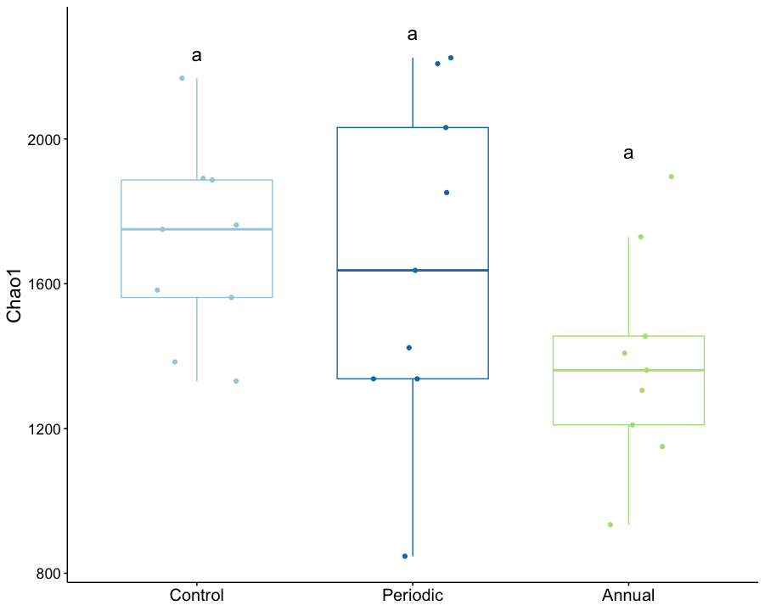
Figure 4.9. Variation in Chao1 richness estimator (non-parametric) across samples grouped by Burn Frequency. Significant differences (p < 0.05) denoted by distinct letters, elucidating shifts in microbial community composition.
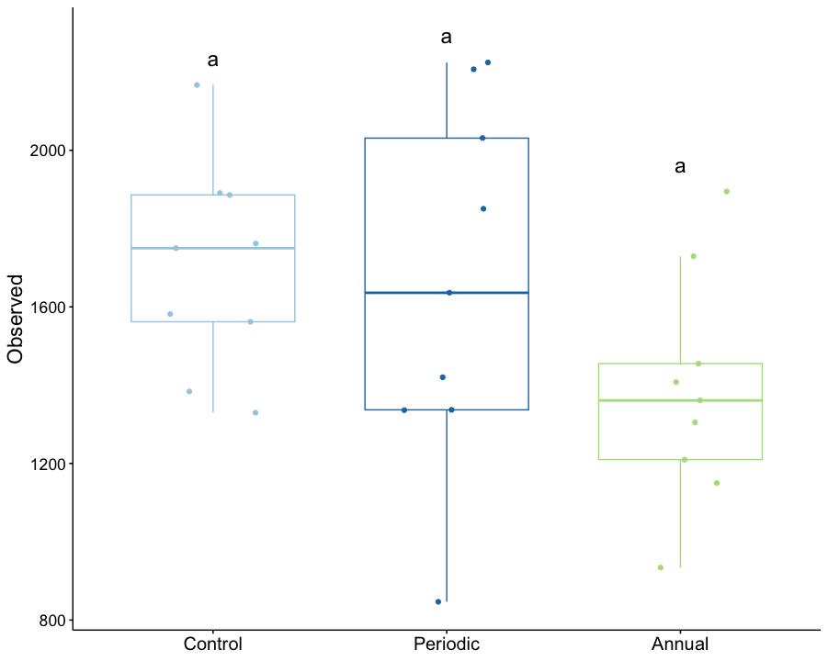
Figure 4.10. Variation in Observed species richness across samples grouped by Burn Frequency. Significant differences (p < 0.05) denoted by distinct letters, elucidating shifts in microbial community composition.
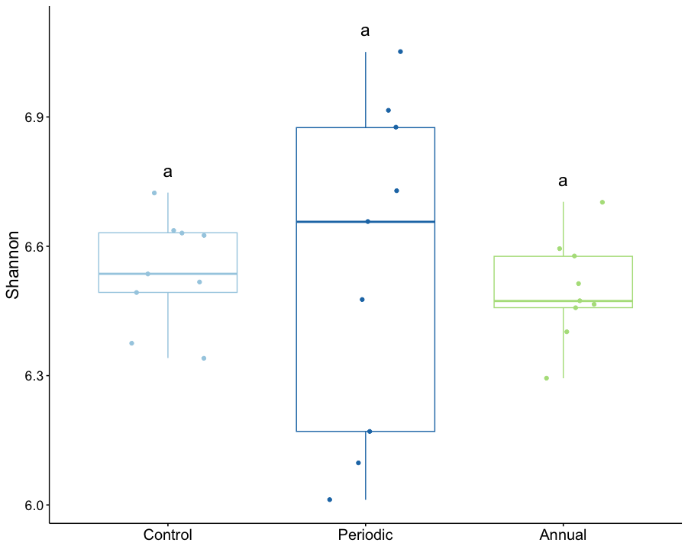
Figure 4.11. Variation in Shannon diversity index across samples grouped by Burn Frequency. Significant differences (p < 0.05) denoted by distinct letters, elucidating shifts in microbial community composition.
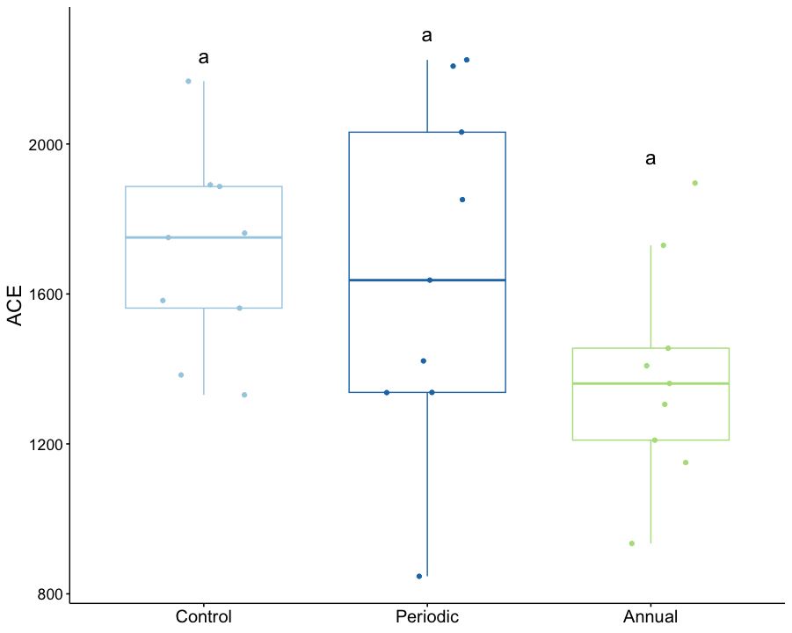
Figure 4.12. Variation in ACE (Abundance-based Coverage Estimator) richness estimator (non-parametric) across samples grouped by Burn Frequency. Significant differences (p < 0.05) denoted by distinct letters, elucidating shifts in microbial community composition.

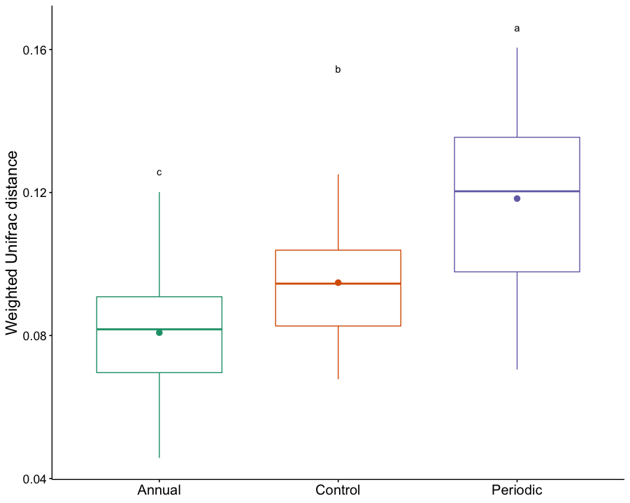
Figure 4.13. PERMANOVA analysis of Weighted Unifrac distance for all samples, grouped by Burn Frequency. Significant differences (p < 0.05) denoted by distinct letters, elucidating shifts in microbial community composition.
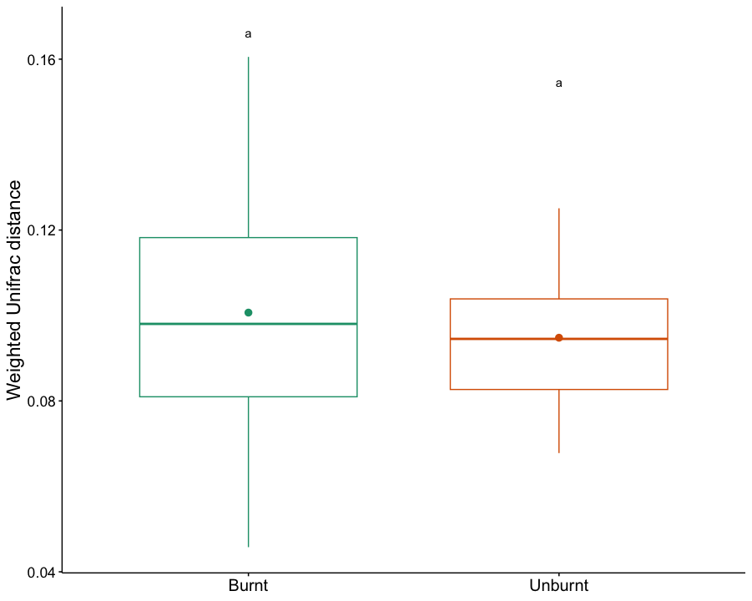
Figure 4.14. PERMANOVA analysis of Weighted Unifrac distance for all samples, grouped by Fire. Significant differences (p < 0.05) denoted by distinct letters, elucidating shifts in microbial community composition.
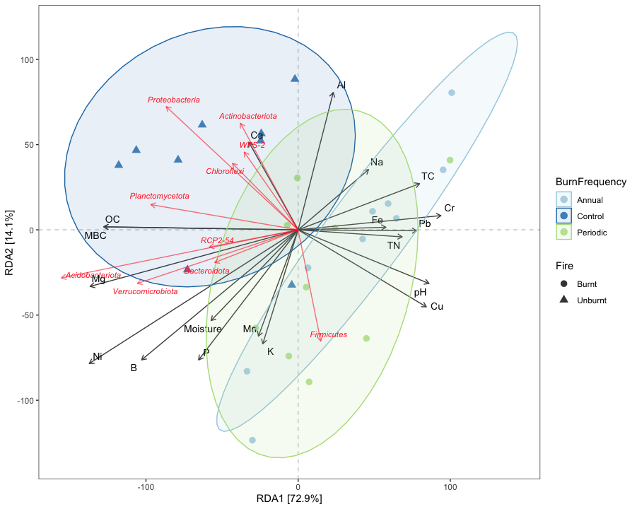
Figure 4.15. RDA Triplot for most abundant phyla (represented with red vector lines) and Environmental variables (black vector lines). Data points are distinguished by Burn Frequency (Control, Annual, Periodic) using color and by Fire (burnt, Unburnt) using shape, with confidence ellipses revealing groupings based on Burn Frequency.

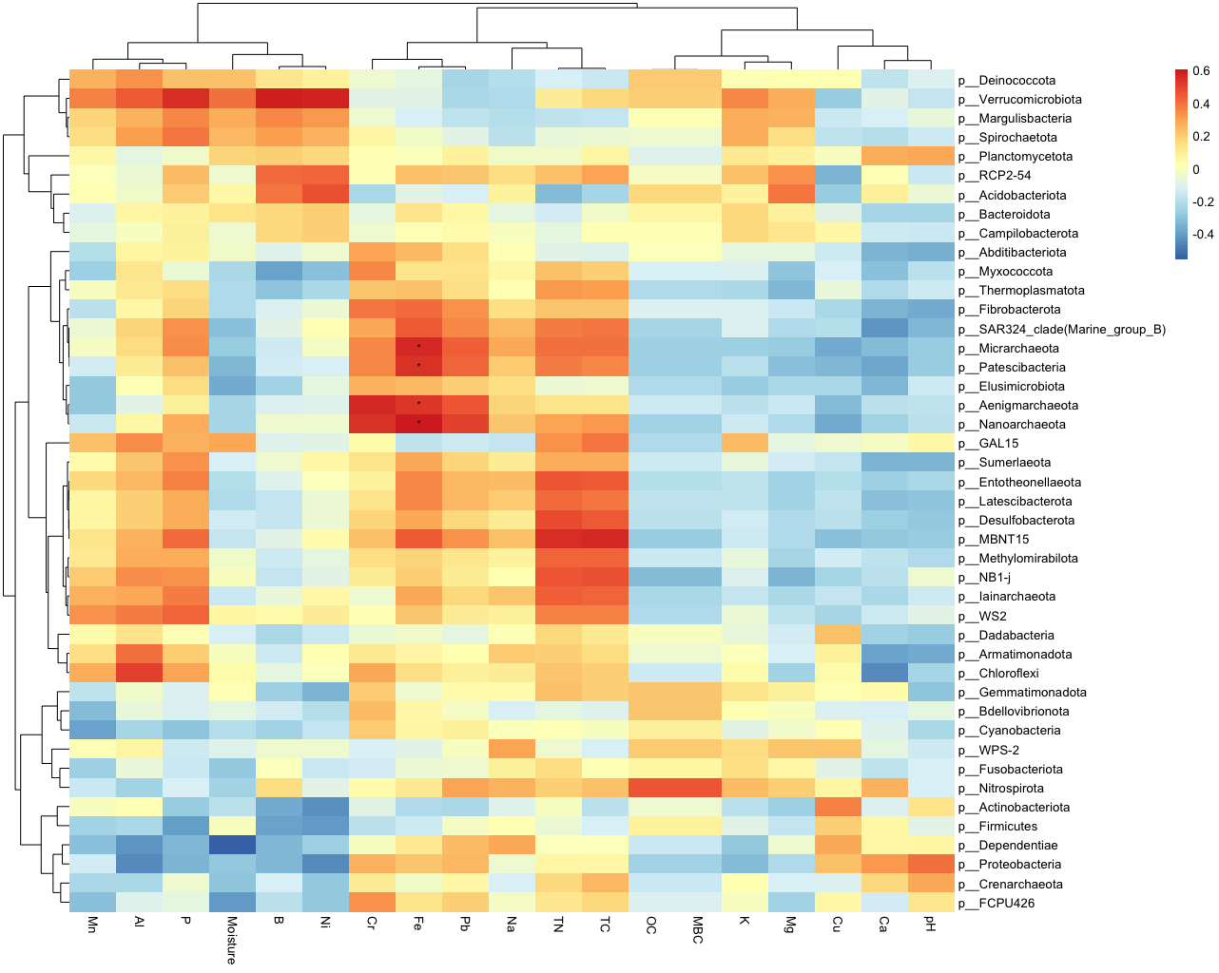
Figure 4.16. Correlation Heatmap illustrating the associations between environmental variables and abundant phyla in the microbial community. The color gradient ranges from red (increasingly positive) to blue (increasingly negative).

(K), Manganese (Mn), and Magnesium (Mg). This positioning suggests that alterations in moisture and nutrient availability may correlate with shifts in the abundance of Acidobacteriora and Verrucomicrobiota. Higher moisture levels and nutrient availability could potentially trigger changes in the composition of these microbial phyla. In the second quadrant, we observe vectors representing pH, Available Copper (Cu), and Total Nitrogen (TN). The close proximity of these vectors implies that they may be linked to differentiation in the community with respect to Firmicutes.
Correlation analysis (Figure 4.16) of the samples showed positive correlations between Available Fe concentrations and Micrarchaeota and Patescibacteria (p<0.05), and Aenigmarchaeota and Nanoarchaeora (p<0.05).

Discussion
Annual burn frequency decreased microbial biomass carbon (MBC) due to recurring fire disturbances. Fire leads to the combustion of plant litter and organic material on the forest floor. During combustion, a portion of the organic matter is converted into carbon dioxide (CO₂), which is released into the atmosphere. The loss of organic matter through combustion can result in a decrease in overall levels of Carbon in the soil, which supports our observation(Debano 1991). Periodic burn frequency showed slightly higher MBC, which can be attributed to longer recovery periods between burns. The build-up of a large and active soil microbial biomass improves the pool of available nutrients, therefore, is an important factor for maintaining nutrient availability. Unburnt soils had higher MBC levels due to the absence of fire-related disturbances and organic matter accumulation. The higher soil organic carbon (SOC) content observed in periodic burn sites compared to annual burn sites can be attributed to several factors. Periodic burning, with a less frequent fire return interval, allows for a longer period of vegetation regrowth and litter accumulation between fires. This extended recovery time enables more plant biomass to be produced, contributing to a greater input of organic matter to the soil in the form of litter and root exudates. Over time, this continuous addition of organic material can lead to an accumulation of SOC.
Additionally, variations in TC and TN reflect alterations in carbon and nitrogen availability, thereby impacting soil fertility and ecosystem processes. TN values for Annual burn sites were lower than Control plots with a markedly higher mean value noticed for Periodic Burn plot. Nitrogen is quite prone to being easily lost through volatilization when temperatures exceed 120°C, and this accumulation in Periodic Burn plots indicates that more nitrogen is fixed into the soil by post-fire microbial activity than the loss due to fire events. Curiously, total carbon stock was higher after long term periodic burn treatments compared to annual burn treatment despite MBC and SOC values being consistently lower for periodic vs control (unburnt) plots. This suggests that while there is an increase in total carbon content, it may predominantly comprise less stable carbon forms or be less accessible to soil microbes in the periodic burn plots.
Moisture content showed a marked increase in MBC for Periodic Burn sites and this increase was also observed, albeit less pronounced for Annual plots. A reverse trend was observed for the control sites where an increase in soil moisture actually showed lower MBC values. Microbes are highly sensitive to changes in soil moisture, as it affects their metabolic activity and ability to access organic matter. In environments with higher moisture content, microbial populations may thrive, leading to higher MBC levels. Conversely, in drier conditions, microbial activity may be limited (Fierer, Schimel et al. 2003). Another important consideration would have to be the decomposition of plant litter and organic matter. Moisture content affects the breakdown of organic materials, making them more accessible to microbes. This, in turn, can lead to higher MBC levels in soils with varying moisture content. Another important fact to consider here is that The composition of the microbial community can also influence the response of MBC to moisture. Some microbial taxa may be more resilient to moisture fluctuations and better adapted to utilizing available resources, contributing to higher MBC levels in specific conditions (Rahman, Hamid et al. 2021). Large scale studies of soil microbial biomass have shown a key role being played by soil moisture along with nutrient concentrations(Serna-Chavez, Fierer et al. 2013). Annual burn plots being more basic compared to the other treatments can be explained by the incomplete combustion of fuel leading to the formation and accumulation of ash and the subsequent release of basic cations (Prieto-Fernández, Carballas et al. 2004).
The prominence of the specific phyla Acidobacteriota, Proteobacteria, and Planctomycetota in this study's soil microbiome analysis can be attributed to their sensitivity and adaptability to fire-induced environmental changes. Acidobacteriota showed significantly higher abundance in the 'Control' group compared to the 'Annual' and 'Periodic' burn groups. This suggests that Acidobacteriota may thrive in unburnt soil conditions, where they benefit from the relatively stable and undisturbed environment. This is in line with the known preferences for acidic conditions preferred by the phylum (Kalam, Basu et al. 2020) . Proteobacteria displayed distinct patterns, with increased abundance in the 'Annual' burn group compared to the 'Control' group and the highest levels in the 'Periodic' burn group. Firmicutes, Actinobacteria, and Chloroflexi showed increased relative abundance between Burnt and Unburnt plots. Similar observations have been made by at least three other studies which corroborate the findings of this study(Li, Niu et al. 2019, Aponte, Galindo-Castaneda et al. 2022).
There was an overall decrease in species richness and alpha diversity metrics for burn treatments compared to the control plot soil samples. Annual burn treatment over decades at the study site has resulted in a markedly lower species richness in the soil microbial community. It is important to note here that this study focuses on Prescribed fire impacts, and as such the fires usually taking place at the study site are milder in intensity than wildfires on an average. As such, it is easy to understand that while there were quite larger differences in the alpha diversity index values for the burnt plots, they were not statistically significant as noted similarly by Ammitzboll, Jordan et al. (2021).
This study utilized taxonomic(at ASV level) and phylogenetic indexes to compare the distances between bacterial communities: Bray Curtis and weighted UniFrac. The Unifrac phylogenetic index, using the phylogenetic tree generated by qiime2 in case of this study, analyzes the amount of overlap between the various branches of the microbial communities. Distance matrices created using bacterial community components demonstrate a strong correlation with both the frequency of fire occurrence and the fire status (burnt or unburnt). The results obtained from the PERMANOVA analysis consistently indicated statistical significance for the matrices and the two factors, Table 4.1. Fire significantly influences the soil microbiome, leading to distinct community compositions between burnt and unburnt soils. Annual burns lead to distinct microbial communities compared to the control group, while periodic burns show similarities with the control group in terms of microbial composition. Principal coordinates analysis (PCoA) and non-metric multidimensional scaling (nMDS) analysis of the beta diversity index (weiUni) suggest that the first axis serves as a reliable indicator of fire frequency(explaining more than 24% of the total variance between the samples). Samples were clustered distinctly by Fire Frequency for the second axis in case of both nMDS and PcoA plots, but Fire was a secondary factor for sample clustering.
Constrained by Burn Frequency and Fire, a substantial proportion of the total variance, amounting to 79.25%, was accounted for, highlighting their significant roles in shaping the microbial landscape. The first constrained axis (RDA1) appeared particularly influential, explaining 72.9% of the total variance, signifying the dominant role of these factors in structuring the community. The dominant role of the first constrained axis (RDA1) in explaining variance in microbial community composition aligns with the significance of the primary axis in explaining ecological variation. Annual and periodic burning treatments exhibited distinct microbial community structures, while control and periodic burns shared similarities, separate from annual burns. The clustering of samples on the RDA plot were narrower for annual burning, emphasizing its microbial community specificity. Environmental factors like Available Calcium, Soil Organic Carbon (SOC), moisture, and nutrient availability were associated with specific microbial phyla, suggesting potential links between these environmental factors and microbial composition. The separation of microbial communities in response to different fire frequencies is reminiscent of the findings of (Dooley and Treseder 2012, Goberna, García et al. 2012, Weber, Lockhart et al. 2014) .Positive correlations between Available Iron concentrations and select microbial taxa suggest potential nutrient-driven microbial dynamics.

Conclusions

This study investigated the effects of different burn frequencies on soil microbial dynamics and nutrient availability in forest ecosystems. By analyzing microbial biomass carbon (MBC), total carbon (TC), total nitrogen (TN), and microbial community composition, we sought to understand the impact of fire disturbances on soil fertility and ecosystem processes. Annual burn frequency led to a discernible reduction in microbial biomass carbon (MBC) because of recurrent fire disturbances, consequently leading to decreased availability of organic matter within the soil matrix. In contrast, the periodic burn frequency regimen exhibited a marginal elevation in MBC due to an extended recovery period. In the absence of fire-related disturbances, unburnt soils gradually accumulated organic matter in the soil, showcasing the pivotal role of fire frequencies in shaping soil microbial dynamics and nutrient availability. TN levels were higher in periodic burn plots, suggesting nitrogen fixation by post-fire microbial activity. Despite lower MBC and SOC values in periodic burn plots compared to control (unburnt) plots, total carbon stock was higher in long-term periodic burn treatments, possibly indicating an increase in less stable carbon forms or less accessible carbon for soil microbes.
Increased moisture content, particularly in periodic burn sites, influenced MBC levels by impacting microbial metabolic activity, organic matter access, and microbial community composition. The more basic pH for more frequent burn treatment was attributed to incomplete fuel combustion, resulting in ash formation and the release of basic cations.
The analysis of the microbial community in response to varying burn frequencies revealed several vital conclusions. First, an increase in burn frequency, particularly in annual burn treatments, led to a notable decrease in alpha diversity, reducing species richness within the soil microbial community. This observation aligns with the findings of previous studies and underscores the impact of frequent fire disturbances. Similarly, beta diversity analysis demonstrated distinct shifts in microbial community composition, further emphasizing the influence of burn frequency. Moreover, our study identified significant enrichment of more resilient phyla in burnt soils. These findings shed light on the adaptive capacity of specific microbial groups to fire-induced environmental changes, contributing to the overall understanding of the microbial response to fire in forest ecosystems. Understanding the adaptive capacity of microbial communities to fire-induced environmental changes is crucial for predicting the long-term effects of frequent fire disturbances on forest ecosystems. This knowledge can inform management strategies to preserve microbial diversity and ecosystem resilience in the face of increasing fire frequency.

The findings of this study have important implications for forest ecosystem management. The decrease in microbial biomass carbon (MBC) and organic matter availability in response to frequent fire disturbances highlights the vulnerability of soil fertility to fire frequency. By understanding the adaptive capacity of specific microbial groups to fire-induced environmental changes, we can develop strategies to preserve microbial diversity and enhance ecosystem resilience in the face of increasing fire frequency. Additionally, identifying more resilient phyla in burned soils opens possibilities for harnessing the resilience of specific microbial groups in post-fire restoration efforts. While this study provides valuable insights into the effects of burn frequency on soil microbial dynamics, it was conducted in a specific forest ecosystem, and the findings may not be directly applicable to other ecosystems. Future research could explore the effects of burn frequency in different ecosystems and investigate the long-term implications of frequent fire disturbances on soil fertility and ecosystem processes.

References
Albert-Belda, E., M. B. Hinojosa, V. A. Laudicina and J. M. Moreno (2023). "Soil biogeochemistry and microbial community dynamics in<i> Pinus</i><i> pinaster</i> Ait. forests subjected to increased fire frequency." Science of the Total Environment 858.
Ammitzboll, H., G. J. Jordan, S. C. Baker, J. Freeman and A. Bissett (2021). "Diversity and abundance of soil microbial communities decline, and community compositions change with severity of post‐logging fire." Molecular Ecology 30(10): 2434-2448.
Aponte, H., T. Galindo-Castaneda, C. Yanez, M. Hartmann and C. Rojas (2022). "Microbial Community-Level Physiological Profiles and Genetic Prokaryotic Structure of Burned Soils Under Mediterranean Sclerophyll Forests in Central Chile." Frontiers in Microbiology 13.
Beck, T., R. G. Joergensen, E. Kandeler, F. Makeschin, E. Nuss, H. R. Oberholzer and S. Scheu (1997). "An inter-laboratory comparison of ten different ways of measuring soil microbial biomass C." Soil Biology & Biochemistry 29(7): 1023-1032.
Bolyen, E., J. R. Rideout, M. R. Dillon, N. A. Bokulich, C. C. Abnet, G. A. Al-Ghalith, H. Alexander, E. J. Alm, M. Arumugam, F. Asnicar, Y. Bai, J. E. Bisanz, K. Bittinger, A. Brejnrod, C. J. Brislawn, C. T. Brown, B. J. Callahan, A. M. Caraballo-Rodriguez, J. Chase, E. K. Cope, R. Da Silva, C. Diener, P. C. Dorrestein, G. M. Douglas, D. M. Durall, C. Duvallet, C. F. Edwardson, M. Ernst, M. Estaki, J. Fouquier, J. M. Gauglitz, S. M. Gibbons, D. L. Gibson, A. Gonzalez, K. Gorlick, J. Guo, B. Hillmann, S. Holmes, H. Holste, C. Huttenhower, G. A. Huttley, S. Janssen, A. K. Jarmusch, L. Jiang, B. D. Kaehler, K. Bin Kang, C. R. Keefe, P. Keim, S. T. Kelley, D. Knights, I. Koester, T. Kosciolek, J. Kreps, M. G. I. Langille, J. Lee, R. Ley, Y.-X. Liu, E. Loftfield, C. Lozupone, M. Maher, C. Marotz, B. D. Martin, D. McDonald, L. J. McIver, A. V. Melnik, J. L. Metcalf, S. C. Morgan, J. T. Morton, A. T. Naimey, J. A. Navas-Molina, L. F. Nothias, S. B. Orchanian, T. Pearson, S. L. Peoples, D. Petras, M. L. Preuss, E. Pruesse, L. B. Rasmussen, A. Rivers, M. S. Robeson, II, P. Rosenthal, N. Segata, M. Shaffer, A. Shiffer, R. Sinha, S. J. Song, J. R. Spear, A. D. Swafford, L. R. Thompson, P. J. Torres, P. Trinh, A. Tripathi, P. J. Turnbaugh, S. Ul-Hasan, J. J. J. van der Hooft, F. Vargas, Y. Vazquez-Baeza, E. Vogtmann, M. von Hippel, W. Walters, W. Walters, Y. Wan, M. Wang, J. Warren, K. C. Weber, C. H. D. Williamson, A. D. Willis, Z. Z. Xu, J. R. Zaneveld, Y. Zhang, Q. Zhu, R. Knight and J. G. Caporaso (2019). "Reproducible, interactive, scalable and extensible microbiome data science using QIIME 2 (vol 37, pg 852, 2019)." Nature Biotechnology 37(9): 1091-1091.
Callahan, B. J., P. J. McMurdie, M. J. Rosen, A. W. Han, A. J. A. Johnson and S. P. Holmes (2016). "DADA2: High-resolution sample inference from Illumina amplicon data." Nature Methods 13(7): 581-+.
Caporaso, J. G., C. L. Lauber, W. A. Walters, D. Berg-Lyons, J. Huntley, N. Fierer, S. M. Owens, J. Betley, L. Fraser, M. Bauer, N. Gormley, J. A. Gilbert, G. Smith and R. Knight (2012). "Ultra-high-throughput microbial community analysis on the Illumina HiSeq and MiSeq platforms." Isme Journal 6(8): 1621-1624.
Debano, L. F. (1991). "The Effect of Fire on Soil Properties." Proceedings - Management and Productivity of Western-Montane Forest Soils 280: 151-156.
Dooley, S. R. and K. K. Treseder (2012). "The effect of fire on microbial biomass: a meta-analysis of field studies." Biogeochemistry 109: 49-61.
Fierer, N. and R. B. Jackson (2006). "The diversity and biogeography of soil bacterial communities." Proceedings of the National Academy of Sciences of the United States of America 103(3): 626-631.
Fierer, N., J. P. Schimel and P. A. Holden (2003). "Influence of drying-rewetting frequency on soil bacterial community structure." Microbial Ecology 45(1): 63-71.
Goberna, M., C. García, H. Insam, M. Hernández and M. Verdú (2012). "Burning fire-prone Mediterranean shrublands: immediate changes in soil microbial community structure and ecosystem functions." Microbial ecology 64: 242-255.
Gómez-Rey, M., A. Couto-Vázquez, S. García-Marco, J. Vega and S. González-Prieto (2013). "Reduction of nutrient losses with eroded sediments by post-fire soil stabilisation techniques." International Journal of Wildland Fire 22(5): 696-706.
Hart, S. C., T. H. DeLuca, G. S. Newman, M. D. MacKenzie and S. I. Boyle (2005). "Post-fire vegetative dynamics as drivers of microbial community structure and function in forest soils." Forest Ecology and Management 220(1-3): 166-184.
Kalam, S., A. Basu, I. Ahmad, R. Z. Sayyed, H. A. El-Enshasy, D. J. Dailin and N. L. Suriani (2020). "Recent Understanding of Soil Acidobacteria and Their Ecological Significance: A Critical Review." Frontiers in Microbiology 11.
Li, W. K., S. K. Niu, X. D. Liu and J. M. Wang (2019). "Short-term response of the soil bacterial community to differing wildfire severity in <i>Pinus tabulaeformis</i> stands." Scientific Reports 9.
Liu, C., Y. Cui, X. Li and M. Yao (2021). "<i>microeco</i>: an R package for data mining in microbial community ecology." Fems Microbiology Ecology 97(2).
McMurdie, P. J. and S. Holmes (2013). "phyloseq: An R Package for Reproducible Interactive Analysis and Graphics of Microbiome Census Data." Plos One 8(4).
Oksanen, J., G. Simpson, J. Weedon, P. Solymos, E. Szocs, P. Legendre, B. Bolker, R. FitzJohn, M. Barbour, H. Bengtsson, F. Van Dunne and A. Stier (2016). "vegan: CRAN relase 2.3-3." Zenodo.
Prieto-Fernández, A., M. Carballas and T. Carballas (2004). "Inorganic and organic N pools in soils burned or heated:: immediate alterations and evolution after forest wildfires." Geoderma 121(3-4): 291-306.
Quast, C., E. Pruesse, P. Yilmaz, J. Gerken, T. Schweer, P. Yarza, J. Peplies and F. O. Glockner (2013). "The SILVA ribosomal RNA gene database project: improved data processing and web-based tools." Nucleic acids research 41(Database issue): D590-596.
R Core Team, R. (2021). R: A language and environment for statistical computing. URL https://www.R-project.org/.
Rahman, N. S. N. A., N. W. A. Hamid and K. Nadarajah (2021). "Effects of Abiotic Stress on Soil Microbiome." International Journal of Molecular Sciences 22(16).
Rousk, J., E. Bååth, P. C. Brookes, C. L. Lauber, C. Lozupone, J. G. Caporaso, R. Knight and N. Fierer (2010). "Soil bacterial and fungal communities across a pH gradient in an arable soil." The ISME journal 4(10): 1340-1351.
Serna-Chavez, H. M., N. Fierer and P. M. van Bodegom (2013). "Global drivers and patterns of microbial abundance in soil." Global Ecology and Biogeography 22(10): 1162-1172.
Vance, E. D., P. C. Brookes and D. S. Jenkinson (1987). "AN EXTRACTION METHOD FOR MEASURING SOIL MICROBIAL BIOMASS-C." Soil Biology & Biochemistry 19(6): 703-707.
Weber, C. F., J. S. Lockhart, E. Charaska, K. Aho and K. A. Lohse (2014). "Bacterial composition of soils in ponderosa pine and mixed conifer forests exposed to different wildfire burn severity." Soil Biology & Biochemistry 69: 242-250.
Williams, R. J., S. W. Hallgren and G. W. T. Wilson (2012). "Frequency of prescribed burning in an upland oak forest determines soil and litter properties and alters the soil microbial community." Forest Ecology and Management 265: 241-247.
Wu, L., C. Wen, Y. Qin, H. Yin, Q. Tu, J. D. Van Nostrand, T. Yuan, M. Yuan, Y. Deng and J. Zhou (2015). "Phasing amplicon sequencing on Illumina Miseq for robust environmental microbial community analysis." Bmc Microbiology 15.
Yarwood, S. A., E. M. Bach, M. Busse, J. E. Smith, M. A. Callaham, C.-H. Chang, T. R. Chowdhury and S. D. Warren (2020). "Forest and rangeland soil biodiversity." Forest and Rangeland Soils of the United States Under Changing Conditions: A Comprehensive Science Synthesis: 75-97.

Summary and Conclusions
The dissertation concludes that prescribed fires have limited effects on soil microbial community diversity and composition in Southern Appalachian Forest soils. The study found that transient changes in specific soil properties and microbial communities following prescribed burns reverted to pre-fire conditions over a 17-month observation period. The research emphasizes the resilience of these ecosystems to low-intensity prescribed burns and highlights the need for further investigation into the extended impacts of slash burning on nutrient cycling and ecosystem dynamics in temperate mixed forests.
Prescribed burns significantly impact soil biogeochemistry, stable isotopes, carbon and nitrogen dynamics, and microbial communities in forest ecosystems. The study found that controlled burns led to altered soil isotopic patterns, labile carbon loss, changes in microbial communities, and implications for carbon and nitrogen cycling. The research highlights the complexities and nuances of post-fire soil ecosystems. It calls for further research to explore the specific roles of affected microbial groups and develop mitigation strategies to balance the ecological benefits of controlled burns with their impacts on soil biogeochemistry.
The burn frequency of these prescribed fires significantly affects soil microbial dynamics and nutrient availability in Southern Appalachian Forest ecosystems. The study found that annual burn frequency led to a reduction in microbial biomass carbon and decreased availability of organic matter within the soil. In contrast, periodic burn frequency exhibited a marginal elevation in microbial biomass carbon due to an extended recovery period. The research also identified shifts in microbial community composition and decreased species richness with increased burn frequency. The findings highlight the vulnerability of soil fertility to fire frequency and the importance of preserving microbial diversity and enhancing ecosystem resilience in the face of increasing fire frequency.
Overall, the dissertation provides valuable insights into the impacts of prescribed fires and burn frequency on soil microbial communities, soil biogeochemistry, and ecosystem processes in mixed and hardwood forest ecosystems. The research contributes to the growing body of knowledge on these topics and emphasizes further investigation to inform land management strategies that balance ecological conservation with the need for forest health and resilience.

Vita
Sa’ad Abd Ar Rafie was born in December 1993 in Dhaka, Bangladesh. He received his B. Sc. in Civil Engineering from Bangladesh University of Engineering and Technology in 2016. After graduation, He worked as an Environmental Engineer at Kingsley Engineering Services Corporation Ltd. and later on as a Research Associate at the Center for Climate Change and Environmental Research at BRAC University. After a year of work experience, he started his Ph.D. study in Civil and Environmental Engineering at the University of Tennessee, Knoxville, under the direction of Dr. Terry Hazen in August 2017. His research is focused on investigating the impact of fire on interactions between the subsurface microbiome and nutrient cycling processes.

