Electronic Energy Loss of Heavy Ions and Its Effects in Ceramics

(Draft 04/10/2015)

A Dissertation Presented for the
Doctor of Philosophy
Degree
The University of Tennessee, Knoxville

Ke Jin

May 2015
Copyright © 2015 by Ke Jin
All rights reserved.

DEDICATION

To my father, Weishi Jin, my mother, Xiaoxin Dai, and my girlfriend, Xiruo Song, for their love and support

ACKNOWLEDGEMENTS
I would like to express my sincere appreciation to Dr. Yanwen Zhang, my advisor, and Dr. William J. Weber for their scientific guidance, encouragement and kindness throughout my study, my research, and the completion of this dissertation.
I am grateful to Dr. Zihua Zhu, Sandeep Manandhar, Dr. Vaithiyalingam Shutthanandan, and Dr. Suntharampillai Thevuthasan from Pacific Northwest National Laboratory (PNNL). They provided tremendous help in both work and life during my visit at PNNL.
I am grateful to all my fellow graduate students and staff members in the Department of Materials Science and Engineering, The University of Tennessee, Knoxville, for the wonderful time we spent together. Especially, I want to thank Haizhou Xue and Chien-hung Chen, graduate students in Dr. Zhang and Dr. Weber’s group, for providing me enormous help in my research. It was impossible for me to finish all this research by myself. and I cherish the friendship with them.
I am grateful to Dr. Hongbin Bei and Dr. Lawrence H. Heilbronn for serving on my committee, and for their valuable comments and suggestions.
I am also grateful to Dr. Helmut Paul and Dr. Jianming Xue, for the helpful discussions and insightful suggestions to my research.

ABSTRACT
Energy loss of medium energy heavy ions (i.e. Cl, Br, I, and Au) in thin compound foils containing light elements (i.e. silicon carbide and silicon dioxide) is directly measured using a time-of-flight elastic recoil detection analysis (ToF-ERDA) technique. An improved data analysis procedure is proposed to provide the experimentally determined electronic stopping powers. This analysis procedure requires reliable predictions of nuclear stopping. Thus, the nuclear stopping predicted by the Stopping and Range of Ions in Matter (SRIM) code is validated by measuring the angular distribution of 1 MeV Au ions after penetrating a thin silicon nitride foil, using a secondary ion mass spectrometry (SIMS). In order to validate our derived electronic stopping power values, Rutherford backscattering spectrometry (RBS) and SIMS are utilized as complementary techniques to measure the depth profiles of implanted Au ions in SiC. Moreover, the original version of the SRIM code, TRIM-85, is modified to adopt our derived electronic stopping powers to predict ion distributions. The comparison studies show that the ion distributions predicted based on our derived electronic stopping powers agree well with the experimental results, but exhibit considerable discrepancies with the SRIM predictions.
The large deviation from SRIM predictions is further observed in other materials. The distributions of implanted Au ions with various energies from 1 to 15 MeV are measured in Si and MgO. The electronic stopping powers for Au ions in Si are estimated based on the measured ion ranges. For Au ion irradiation in MgO, significant channeling effects on the ion and damage profiles are observed for the irradiations along both axial and planar channels.
Furthermore, the effect of electronic energy deposition from medium energy heavy ions (i.e. 21 MeV Ni) on the damage evolution in MgO, in which the initial defects are induced using1 MeV Au, is studied. The evolution in damage level and damage structure under the irradiations is characterized using RBS/ion channeling technique combined with transmission electron microscopy (TEM).

TABLE OF CONTENTS
Chapter 1 INTRODUCTION 1
1.1 Quantification of stopping power 2
1.1.1 Nuclear stopping power 2
1.1.2 Electronic stopping power 4
1.2 Ion irradiation induced damage evolution in ceramics 11
1.2.1 Effects of nuclear energy deposition 11
1.2.2 Effects of electronic energy deposition 12
1.2.3 Puzzles in MgO 13
1.3 References 15
Chapter 2 Experimental methods 18
2.1 ToF-ERDA measurement 19
2.2 Correction of effective nuclear energy loss 21
2.3 Measurement of angular distribution of Au ions penetrating a Si₃N₄ thin foil. 23
2.4 Measurement of the depth profile of implanted ions 24
2.5 Ion channeling measurement of the damage profile in single crystals 26
2.6 Ion irradiation and fluence calibration 28
2.7 References 29
Appendix 2.1 30
Chapter 3 Electronic stopping powers for heavy ions in SiC and SiO₂ 40
3.1 Introduction 41
3.2 Experimental 42
3.3 Electronic stopping power values 43
3.4 Ion range and ion distribution 44
3.5 References 48
Appendix 3.1 50
Chapter 4 Angular distribution and recoil effect for 1 MeV Au⁺ ions through a Si₃N₄ thin foil 57
4.1 Introduction 58
4.2 Experimental 59
4.3 Irradiation induced thinning of the Si₃N₄ foils 59
4.4 Angular distribution of scattered ions 61
4.5 References 63
Appendix 4.1 64
Chapter 5 Depth profile of Au ion irradiation in Si and MgO 68
5.1 Introduction 69
5.2 Experimental 70
5.3 Electronic stopping power derived from the Au ion profiles in Si 70
5.4 Channeling effects on the depth profile of Au ions irradiated in MgO 72
5.5 Channeling effects on the damage profile of MgO under Au ion irradiation 74
5.6 Electronic stopping power for Au ions in MgO 75
5.7 References 77
Appendix 5.1 79
Chapter 6 Effects of nuclear and electronic energy deposition on defect evolution in MgO 86
6.1 Introduction 87
6.2 Experimental 87
6.3 Defect evolution in MgO under nuclear energy deposition 88
6.4 Defect evolution in MgO under electronic energy deposition 90
6.5 References 93
Appendix 6.1 95
Chapter 7 CONCLUSION 101
Publications since 2011 104
VITA 106

LIST OF TABLES
TABLE 3.1. Fitting coefficients [Eq. 3.1] to the stopping data (keV/(μg/cm²)) for the corresponding validating energy (keV/u) region. 50

LIST OF FIGURES
Fig. 1.1 Comparison between the Universal Screening function and previous models [Ziegler et al, The stopping and range of ions in solids, 1985] 3
Fig. 1.2. Si detector response to different ion irradiations: energy of various ions versus the corresponding pulse height from the detector (channel number) 8
Fig. 1.3. Ratio of nuclear stopping power to electronic stopping power for ions in SiC given by SRIM 9
Fig. 1.4. Stopping cross sections for the C/Si combination (top), and the Al/Au combination (bottom). [Sigmund, Reciprocity in the electronic stopping of slow ions in matter, Euro. Phys. J. D 2008] 10
Fig. 1.5. The damage profile (yellow, solid line) is overlaid on top of the TEM image for 2 MeV Au ion irradiation in GaN. The corresponding Au ion distributions predicted by SRIM (dash line) and measured by SIMS (triangles) are also plotted for comparisons. [Zhang et al, Damage and microstructure evolution in GaN under Au ion irradiation, J. Phys. D: Appl. Phys., 2010] 11
Fig. 1.6. (top) RBS/channeling spectra of SrTiO₃ irradiated with 900 keV Au⁺ to different ion fluences. (bottom) Relative disorder as a function of local dose at the damage peak in SrTiO₃ 12
Fig. 1.7. Annealing effect of 21 MeV Si ions on the 4H-SiC single crystal pre-damaged by 900 keV Si ions. [Zhang et al, Competing effects of electronic and nuclear energy loss on microstructural evolution in ionic-covalent materials, Nucl. Instrum. Methods Phys. Res. B, 2014 ] 13
Fig. 2.1. Schematic illustration of the experimental configuration of a ToF-ERDA system for energy loss measurements 30
Fig. 2.2. (a) Contour map of the ToF-Si detector correspondence for He ions, with and without the stopping foil. (b) Time diagram at channel 2000 from the Si detector. 31
Fig. 2.3 Comparisons of electronic stopping powers for He ions in (a) SiC and (b) SiO₂ between the measured results and the SRIM predictions. 32
Fig. 2.4. Ions in SiC: (a) SRIM prediction of the mean energy loss (solid line) of the ions detected by the Si detector, with the nuclear stopping power (dash dot), electronic stopping power (dash), and total stopping power (dot) of Au, I, and Br ions in SiC. (b) Comparison between uncorrected (Exp), effective nuclear stopping corrected (Exp-Eff Sn) and total nuclear stopping corrected (Exp-Tot Sn) data of measured electronic stopping power for Au ions in SiC; along with the SRIM predictions. 33
Fig. 2.5. (a) Schematic illustration and (b) a photo of the setup to collect scattered Au ions penetrating a Si₃N₄ thin foil. The penetrated Au ions are collected in a Si wafer located at the rear of the metal frame. The suspended Si₃N₄ foil (0.25 mm × 0.25 mm) at the center of the Si wafer is defined as the “window region” and the rest of Si₃N₄ thin film is defined as “supported region”. 34
Fig. 2.6. A photo of a Si wafer after lateral scan by ToF-SIMS depth profiling 35
Fig. 2.7. An example of the energy calibration of the Si detector in response to He ions 36
Fig. 2.8. Illustration of the principle of the RBS depth profiling 37
Fig. 2.9. Illustration of the dechanneling mechanism by point defects. [Feldman, Materials Analysis by Ion Channeling, 1982] 38
Fig. 2.10. RBS spectrum of Si implanted with 2.25 MeV Au²⁺ ions to an intended fluence of 6.1×10¹⁵ cm⁻². The measured spectrum is fit using SIMNRA, indicating 6.3×10¹⁵ cm⁻² as the actual implanted fluence. 39
Fig. 3.1. Measured mean electronic stopping power of Cl, Br, I and Au ions in SiC (left) and SiO₂ (right) with the trend lines (Eq. 3.1) and the SRIM predictions. 51
Fig. 3.2. Comparison of the electronic stopping power for I ions in SiO₂ between the measured data and the predictions by LSS theory, reciprocity theory and SRIM. 52
Fig. 3.3. Contour map of the Time-Energy correspondence for (a) He, (b) Cl, and (c) Au ions penetrating through the SiC stopping foils. ToF (channel) represents the energy before penetration; Si detector (channel) represents the energy after the penetration. The point density is represented in logarithmic scale. The insets are the time (corresponding to energy) distribution profiles for each selected Si detector channel (shown as vertical lines). It is clear that lighter ions have much better time (energy) resolution. 53
Fig. 3.4. Comparison between the measured data and the SRIM, LSS theory and reciprocity theory predicted electronic stopping powers for the Au ions in SiC. The red line is our derived trend line (Eq. 3.1). The solid line parts are the measured data (> 30 keV/u) or reciprocity predicted (<5 keV/u). The dash line is the extrapolation for connection between 5-30 keV/u. 54
Fig. 3.5. Ranges of Au ions with different energies in SiC measured by SIMS (triangle) and RBS (star) as well as ion ranges predicted by SRIM (dash line) and this study (solid line). The SIMS results are the density corrected values assuming the 15% volume swelling. The inset shows the relative deviation between SRIM predictions and experimental results. 55
Fig. 3.6. Comparisons of ion distribution profiles for (a) 1, (b) 7, and (c) 12 MeV Au in SiC with measurements (RBS and SIMS), SRIM and M-TRIM predictions. 56
Fig. 4.1. Lateral distributions of the scattered Au ions implanted into the Si wafer with different irradiation fluences: (a) 1×10¹⁶ cm⁻², (b) 2×10¹⁵ cm⁻² and (c) 1×10¹⁵ cm⁻². Two types of spots indicate the two perpendicular scans along diameters. 64
Fig. 4.2. The thickness measured by ToF-SIMS for both window regions (irradiated) and supported regions (virgin) of each sample with different fluences: (a) virgin sample, (b) 1×10¹⁵ cm⁻², and (c) 2×10¹⁵ cm⁻². 65
Fig. 4.3. SEM measurements on the thickness of window regions for (a) virgin sample and the samples after (b) 1×10¹⁵ cm⁻² and (c) 2×10¹⁵ cm⁻² irradiations. TEM measurements on the thickness of the supported regions of these three samples (d-f). In (d), the upper (left) and lower (right) boundaries are determined by adjusting the contrast. 66
Fig. 4.4. Comparisons between the measurements and the SRIM predictions for the deflection angle of the transmitted ions with fluences of (a) 2×10¹⁵ cm⁻² and (b) 1×10¹⁵ cm⁻² 67
Fig. 5.1. SIMS and RBS measured depth profiles of implanted Au ions with (a) 1 MeV and (b) 6 MeV. SRIM predicted results are also shown for comparison. 79
Fig. 5.2. Peak positions of the depth profiles of Au ions with different energies in Si, measured by SIMS (blue triangles) and predicted by SRIM (red squares). The ion ranges predicted by SRIM is shown as the solid line. The SIMS results are the density corrected values assuming the 3% volume swelling. 80
Fig. 5.3.Electronic stopping powers calculated based on the data in Fig. 5.2 (Red triangles). The predictions from SRIM (black line) and the reciprocity theory (green line) are also shown for comparisons. 81
Fig. 5.4. (a) Geometric configuration of the rotations of the MgO sample. (b), (c) Contour maps of the 2-D angular scan (θ as horizontal and φ as vertical axes) of MgO (100) and (110), respectively. The scanning range is ±1.44° and the step length is 0.072° 82
Fig. 5.5. (a) Depth profiles of 1 MeV Au ions irradiated in MgO (100) along various directions, measured by RBS. (b) Depth profile of 4 MeV Au ions irradiated in MgO (100) along (θ, φ) = (7°, 2°), measured by ToF-SIMS. The SRIM prediction is presented for comparison. The solid lines are to guide the eyes. 83
Fig. 5.6. (a) RBS channeling spectra, (b) derived disorder profile from (a), and (c) SIMS measured depth profiles of 1 MeV Au ions irradiated in MgO (110) along the directions of axial channel, planar channel, and off channel. The irradiation fluence is 1×10¹⁴ cm⁻². The solid lines are to guide the eyes. 84
Fig. 5.7. Electronic stopping powers for Au ions in MgO predicted by SRIM, LS model and reciprocity theory. 85
Fig. 6.1. RBS/channeling spectra of MgO (110) single crystal irradiated with 1 MeV Au ions at room temperature. The Au fluences range from 2×10¹³ to 5×10¹⁵ cm⁻². 95
Fig. 6.2. HRTEM images and the corresponding diffraction patterns from FFT of the MgO (110) irradiated with 1 MeV Au ions at the fluence of 2.5×10¹⁵ cm⁻². The images are taken at the depth of ~120-160 nm, corresponding to the dpa peak region (10 dpa), where the decrease in damage level is observed by RBS/channeling technique. 96
Fig. 6.3. SRIM predicted and SIMS measured depth profiles of 1 MeV Au ions irradiated in MgO 97
Fig. 6.4. Disorder level as a function of ion fluence for MgO irradiated with 1 MeV Au ions. The disorder levels are taken at the damage peak in the accumulation stage. 98
Fig. 6.5. RBS/channeling spectra of MgO (110) single crystal irradiated with 1 MeV Au ions at low temperature only (green squares), 21 MeV Ni ions at room temperature only (red opposite triangles), and the 21 MeV Ni ions at different fluences after the pre-damage induced by the Au ion irradiation. 99
Fig. 6.6.Cross-sectional TEM image of MgO irradiated with 1 MeV Au ions to the fluence of 1×10¹⁴ cm⁻² at low temperature, followed by the 21 MeV Ni ion irradiation to the fluence of 6.5×10¹⁵ cm⁻². 100

Chapter 1
INTRODUCTION

The energy deposition for energetic ions travelling in matter is generally described by two mechanisms, nuclear energy loss and electronic energy loss. Nuclear energy loss is attributed to the elastic collisions with target nuclei, results in the displacement of atoms and dominates in the low energy regime. Electronic energy loss is attributed to the inelastic collisions with target electrons, results in the excitation and ionization of the target electrons, and dominates in the high energy regime. Stopping power (sometimes termed as stopping force) is defined as the energy loss per unit path length.
(1.1)

1.1 Quantification of stopping power
As summarized by Sigmund,¹ quantitative knowledge of stopping power is of critical importance not only in fundamental research in physics and materials science, but also in broad applications such as ion beam modification, ion beam analysis, semiconductor fabrication, nuclear engineering, radiation therapy, space exploration, etc. Thus, quantification of stopping power has been a subject of long-standing experimental and theoretical interest since the early twenty century.

1.1.1 Nuclear stopping power
ZBL universal potential and SRIM
Nuclear stopping can be theoretically treated as the elastic two-body scattering between screened particles. According to the conservation of energy and momentum of the system, the elastic energy transfer T can be described as²:
, (1.2)
where M₁ and M₂ are the masses of the projectile and target atoms, respectively, E_{i} is the incident energy of the projectile, and θ* is the scattering angle in the center-of-mass frame.
In order to obtain the cross-section of the energy transfer, or the nuclear stopping power, the probability for each final scattering angle must be known. The key issue thus becomes the calculation of the interatomic potentials concerning different screening functions.³ Four important pioneering models: the Sommerfeld approximation of the Thomas-Fermi potential⁴, the Moliere approximation,⁵ the Lenz-Jensen,^{6,7} and the Bohr potential⁸ have been compared to the one of the most widely used potentials at present, the Ziegler-Biersack-Littmark (ZBL) universal screening potential.³ The later one shows the highest overall accuracy.³ The ZBL universal screening function, as shown in Fig. 1.1, is based on the calculation of solid-state interatomic potentials of 522 randomly chosen pairs of atoms over the range 1-82 for Z₁ and Z₂, expressed as:
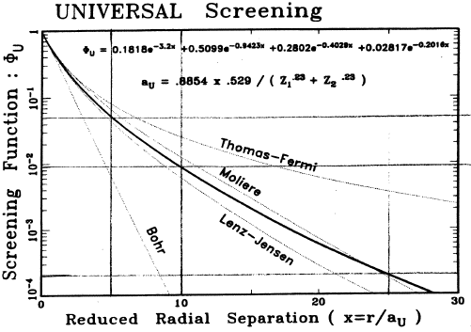

Fig. 1.1 Comparison between the Universal Screening function and previous models [Ziegler et al, The stopping and range of ions in solids, 1985]
(1.3)
whereis the normalized radius, r is the radius, and is the screening length.
Connor et al.⁹ compared the universal potential with more than a hundred experimental data, and on overall discrepancy within 5% is estimated. The ZBL universal potential is used in the code named The Stopping and Range of Ions in Matter (SRIM) by Ziegler et al³ to provide the nuclear stopping power values and to simulate the scattering process when ions penetrating a target. SRIM has been the most widely used since late 1980s, contributing to more than 700 publications per year as estimated in 2010.¹⁰
Remaining issues on nuclear stopping power
Due to the relative theoretical simplicity and the existed experimental evidence (e.g. Ref.⁹ ), the validity and accuracy of SRIM nuclear stopping have been generally accepted. However, at least two issues exist. Firstly, the nuclear stopping calculation assumes neutral ions and target atom in its normal crystalline state; these assumptions make for errors, and may make the nuclear stopping power too large for low energies.¹¹ Secondly, the previous experimental validations have limitations. For example, the experimental data used in Connor’s comparison study⁹ are mostly limited to alkali metals and rare gas targets. Few direct transmission measurements on angular distribution of very heavy ions (e.g. Au) through solid films existed, except the ones by Geissel et al.¹² This is possibly due to two difficulties. The first one is the difficulty in fabricating strong and thin enough foils to bear the slow heavy ion irradiation. The second one is the difficulty in detecting very heavy ions compared to light and medium heavy ions, such as helium and carbon ions, especially when using semiconductor detectors.¹³⁻¹⁶ Geissel’s experiments utilized a continuously rotatable ToF spectrometer that is, unfortunately, not a standard instrument in most ion beam laboratories.

1.1.2 Electronic stopping power
Early theoretical efforts
The theoretical description of electronic stopping is far more complex than nuclear stopping, since both ions and targets continuously change during the ions’ passage³: 1) the charge states are continuously changing with ion energy and electron density of the target, and this process is almost impossible to be directly measured; 2) the target electrons polarize in front of and around the ion, changing the local electron density, and the ion charge density also polarizes and change its shape; 3) the electrons of ions penetrating the target electron cloud are subjected to Pauli promotion since its fully occupied electron shells merge with the shells of fully occupied target atom shells; and 4) for semiconductors, the band gaps reduce the available excitation levels that are open for the electrons, reducing the absorption of energy from the ions.
The effort of theoretically quantifying stopping power has been made for more than a century. It can be dated back to Bohr¹⁷ in 1913 who developed a theory in which the stopping power and ion range were predicted using classical mechanics. Pioneers have established a profound system of theories to treat electronic stopping power from classical to quantum mechanics, from light ions to heavy ions, and from slow ions to swift ions. As the most influential examples, Bethe, Bloch, and Muller¹⁸⁻²² established the quantum mechanics treatments of electronic stopping and derived the Bethe-Bloch formula to describe the electronic stopping power of swift ions; Fermi formed the idea of the treatment of target electrons as plasma;²³ Lindhard derived the famous Lindhard-Scharff (LS) formula^{24,25} that is substantially applied for slow heavy ions:
, (1.4)
where (1.5)
S_{e} (E) is given in units of 10⁻¹⁵ eVcm²/atom and E is in keV². Besides, Lindhard developed a generalized treatment of interaction between swift light ions²⁶⁻²⁸ and electron gas (Lindhard gas). Those theories, especially the Lindhard’s theories have been thoroughly and comprehensively reviewed by Ziegler,³ and Sigmund.^{1,29}
In the recent years, first principle calculations, such as the time-dependent density functional theory method (TD-DFT), have been developed to acquire accurate electronic stopping power, but they are strongly limited to the simplest cases, such as low energy light ions due to the extreme computational expense.³⁰⁻³² Because an accurate theoretical description of inelastic process for ions in materials is extremely complex, especially for semiconductors, empirical or semi-empirical descriptions based on the experimental results are still the most common approaches up-to-date.
SRIM’s integration
The Lindhard’s free electron gas theory combing the local density approximation³³ is the key of calculating the electronic stopping power of the proton in SRIM, which is the foundation of the calculation for all other ion-solid combinations. SRIM uses “scaling” method to simplify the calculation of heavy ion electronic stopping power. In this method heavy ion stopping power is calculated from the light ion stopping power at the same velocity in the same medium. For helium ions, the equivalent H stopping is multiplied by the He effective charge at the same velocity
, (1.6)
where γ is the fractional effective charge.
(1.7)
where a_{i} are fitting parameters. For E<1 keV/u, S_{e} ~ the velocity of ions.
It is important to note that strictly speaking keV/u is not a unit of either energy or velocity, and “specific energy” is probably a more accurate term. However, the terms in the literature have not been consistent. In this dissertation, the “specific energy” is abbreviated as energy for convenience.
For ions heavier than He, the scaling approach is different in three energy regimes. 1) for low velocity ions (<25 keV/u, except when Z₁<19 in band gap target with very low energy), the Lindhard treatment is employed that Se is generally proportional to the velocity of ions. However the numeric input (e.g. constant of proportionality) could be significantly changed by fitting the experimental data;¹ 2) for high velocity ions (>200 keV/u), the Thomas-Fermi scaling rules are used to generalized the heavy ions stopping power; 3) for medium velocity ions (25 keV/u<E<200 keV/u), the theory proposed by Brandt and Kitagawa³⁴ is adopted to scale the heavy ion stopping power to proton stopping power. In any of the cases, the final values given by SRIM, as well as other empirical codes (e.g. MSTAR^{35,36}), are based on fitting and extrapolating experimental data.³⁷
SRIM’s accuracy for light ions
It can be naturally expected from the descriptions above that the accuracy of electronic stopping power given by SRIM strongly depends on the amount and quality of experimental values, and this is one of the reasons why the electronic stopping power in SRIM updates regularly.¹
The most abundant and consistent experimental data exist for helium ions (much more than any others, including proton).³ This is mainly attributed to the development of Rutherford backscattering spectrometry (RBS) technique since 1970s,^{38,39} in which the helium ions from a few hundred keV to a few MeV is the predominantly used particle. Since there have been hundreds of experimental measurements available on the stopping power for light and medium heavy (e.g. from Li to Ar) ions and new measurements are still rapidly updating, it is too hard to comprehensively review them in a single work. Fortunately, since 1990s, Paul⁴⁰ and his colleagues have built and are continuously updating a web-database (“https://www-nds.iaea.org/stopping/” available at present), in which the experimental results, as well as the theoretical models (SRIM is one of the major models) are collected, commented, compared, and plotted. In addition, the accuracy of existed models (or, programs) is statistically tested. It is shown^{40,41} that the accuracy of the SRIM predicted electronic stopping power for He ions is high, as expected due to the large amount of available data. The mean normalized differences between the SRIM values and over 2000 experimental data points for He ions in 16 kinds of elemental solids and ~150 condensed compounds are less than (1±7)%. For medium heavy ions stopping, there are also more than a thousand experimental data points in total, and, as expected, the SRIM predictions hold a similar accuracy comparing to light ions.
Difficulties in stopping measurements for heavier ions
While the electronic stopping powers for light ions have been extensively measured and validated, the measurement for very heavy ions (e.g. Au) in the low and medium energy regime has been a long-standing challenge. The direct measurement of electronic stopping power can be generally done with two geometries: backscattering⁴² and transmission⁴³, while in each geometry there are numerous specific ways of producing the ions, locating the target, and detecting the ions.⁴⁴ Backscattering geometry is used mainly for light ions in heavy targets due to the kinematic restriction. For heavy ions in light target, transmission geometry is usually needed. In transmission geometry, due to the difficulties of manufacturing high-quality thin stopping foils, previous measurements mainly focused on high energies. For example, in Jokinen’s stopping work⁴⁵ on Au ions in C, a ~1000 nm C foil was used and the stopping power could only be measured down to 11 MeV. On the other hand, the determination of the density and the thickness of stopping foils are essential to the measured stopping power values and, for a very thin foil, the error in thickness becomes increasingly critical.^{43,46}
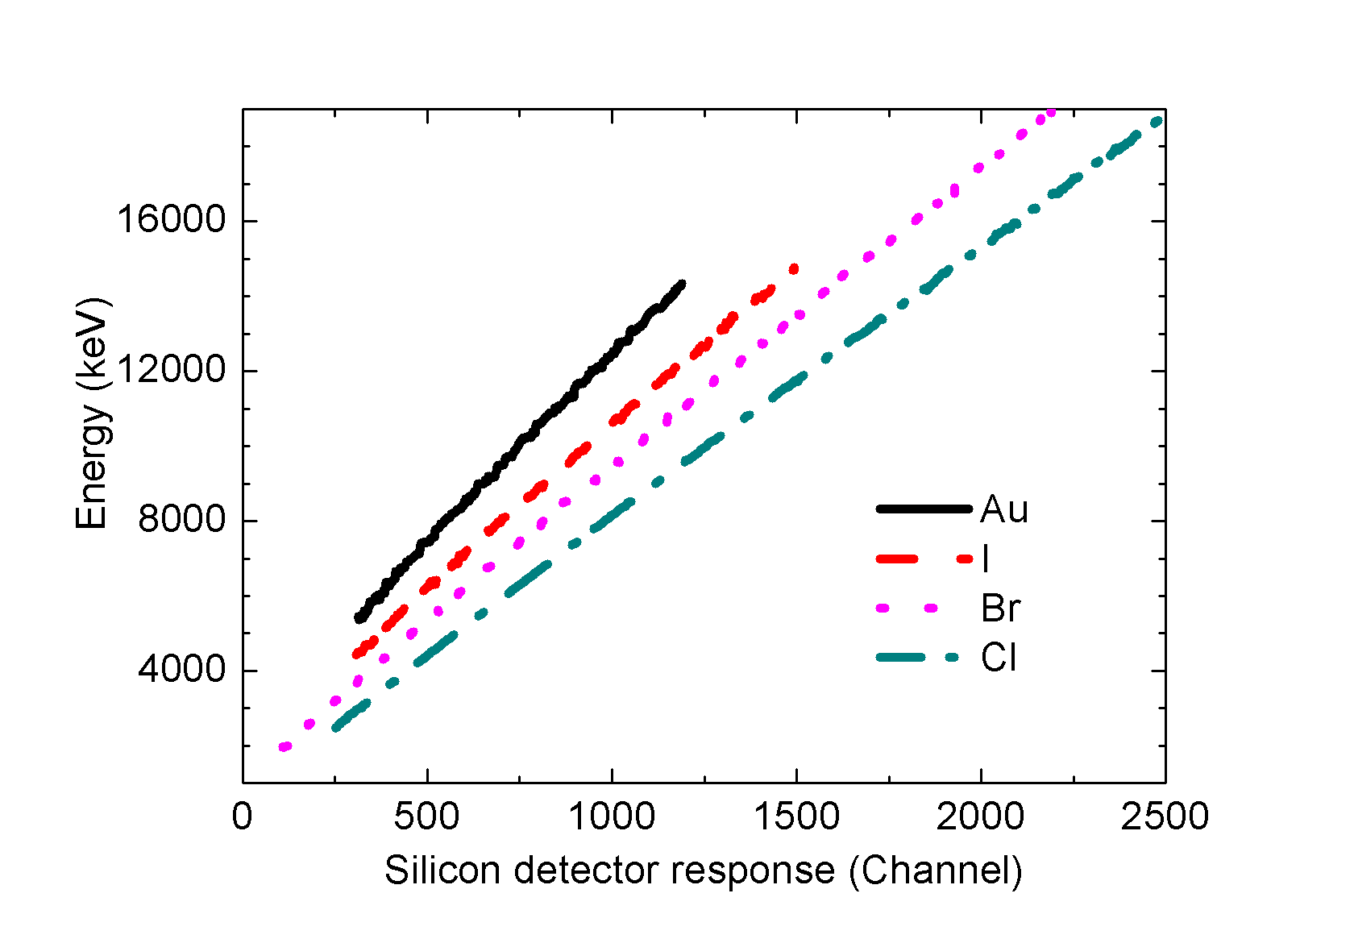
Fig. 1.2. Si detector response to different ion irradiations: energy of various ions versus the corresponding pulse height from the detector (channel number)
There are two additional issues that make the difficulties of measurements significantly increase with increasing mass of ions, leading to very limited available experimental data. Firstly, the energy determination of semiconductor detectors becomes more problematic for heavier ions and the calibration becomes challenging.¹³⁻¹⁶ For example, the pulse height defect (PHD)⁴⁷, as shown in Fig. 1.2, is normally defined as the difference between the true energy of the heavy ion and its apparent energy in Si detector, such that heavier ions have lower pulse height than light ions with the same energy. In addition, small deviations from linear behavior for heavy ions also exist and make the conventional method of calibrating a Si detector challenging.^{14,15}
Secondly, as stated above, nuclear stopping dominates in the low energy regime and electronic stopping dominates in the high energy regime. In the medium energy regime, the situation becomes complex: although electronic energy loss is the dominating process, the nuclear energy loss cannot be neglected when the ions penetrate the stopping foils. The ratio of nuclear stopping power to electronic stopping power, given by SRIM, for Cl, Br, I and Au ions in SiC is shown in Fig. 1.3 in the energy regime of a few MeV. The ratios of nuclear stopping power to electronic stopping power in SiC are less than 2% for ions lighter than Cl and with energies higher than 3 MeV. The nuclear energy loss is, therefore, negligible for lighter ions in the total energy loss measurement. For heavier ions, the ratios at 3 MeV are 0.23, 0.65 and 0.89 for Br, I and Au ions, respectively. As a result, a correction of contributing nuclear energy loss is necessary when measuring electronic stopping power for these ions in this energy regime. As was reported by Paul,¹¹ a few previous measurements neglected the nuclear stopping contribution and concluded that the measured electronic stopping power is similar or larger than the SRIM prediction. However, these results^{45,48,49} are not supported by ion distribution and damage profile measurements, which will be discussed in detail in the following chapters. Previous studies⁵⁰ have attempted to correct the nuclear stopping power using Monte-Carlo simulation with a Moliere interaction, but the potential choice and thus the corrected results have been questioned.⁵¹
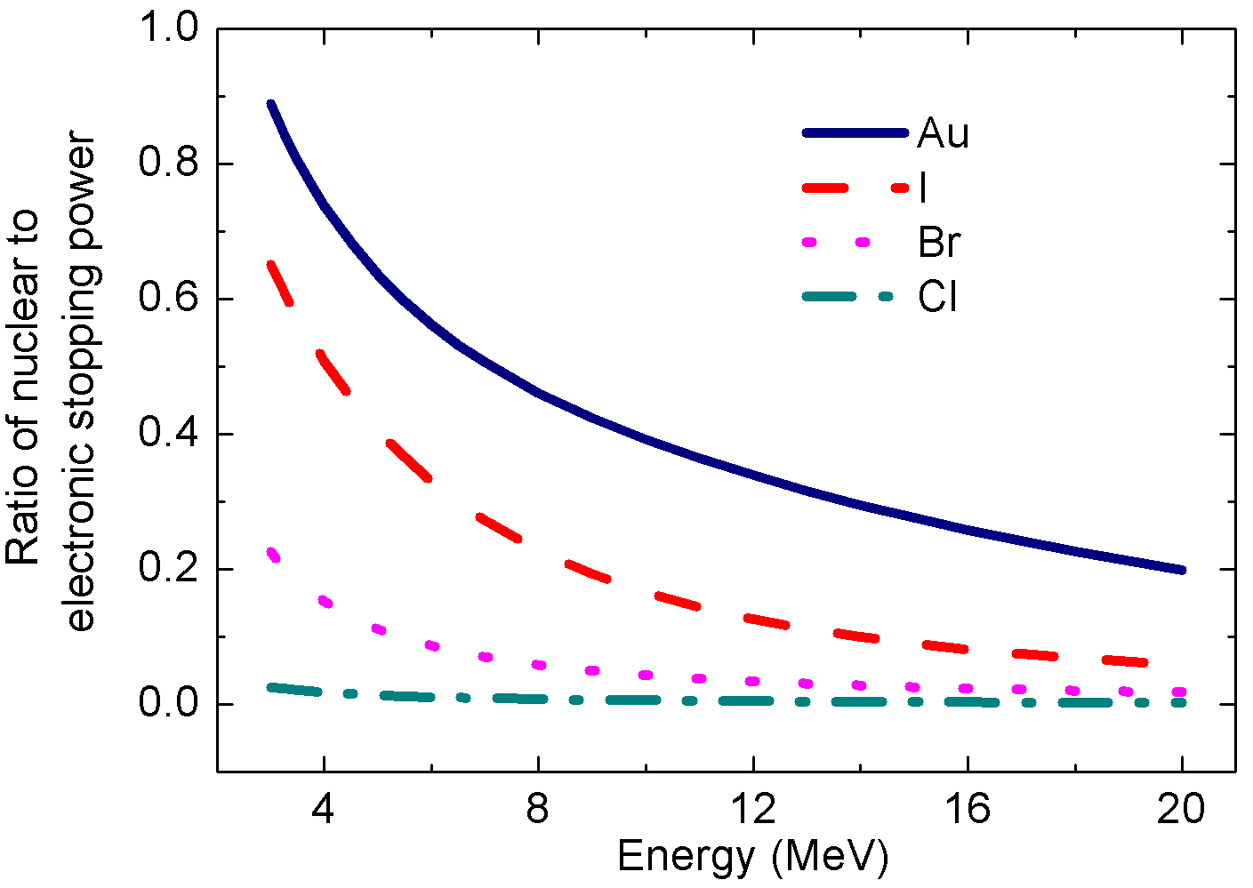
Fig. 1.3. Ratio of nuclear stopping power to electronic stopping power for ions in SiC given by SRIM

Besides direct measurements, deduction from range measurements is another way of determining the electronic stopping power. For example, Zhai et al.⁵² deduced the electronic stopping power for Au ions in Si by fitting their measured ion range to LSS theory. However, their result indicates that the electronic stopping power is constant with the increase of energy from ~1-3 MeV, which seems questionable. It is important to note that this questionable result does not necessarily question the LSS model or the removal of nuclear stopping power, because RBS was the only utilized technique, and this makes the range values less validated.
Problems in SRIM predicted electronic stopping power for heavy ions
Due to the lack of experimental support, reduced accuracy is expected in the prediction of electronic stopping power by SRIM for very heavy ions. Actually, both theoretical and experimental evidence have indicated considerable error. Theoretically, Sigmund³⁷ introduced a reciprocity criteria to compare the electronic stopping power with the roles of projectile and target interchanged. The reciprocity theory states that, in the low energy region (<25 keV/u), where the projectiles are neutral and the probability for electron loss is small, the electronic stopping cross-section (in the unit of 10⁻¹⁵eVcm²) remains invariant when interchanging the projectile and the target (at the same velocity, or the same energy in keV/u). This theory can be utilized as a criterion for examining the values from both models and experiments. An example is shown in Fig. 1.4³⁷ (top), where the Si/C combination agrees with the reciprocity theory very well. However, dramatic deviation is observed when the combination between very heavy ions (e.g. Au) and light elements (e.g. Al) is examined (Fig. 1.4 bottom), indicating the electronic stopping power by SRIM is probably too large by an order of magnitude. It needs to be noted that in the case of Au in Al no experimental data has been available. On the other hand the MSTAR code only provides ions no heavier than Ar, limiting further judgment on SRIM.
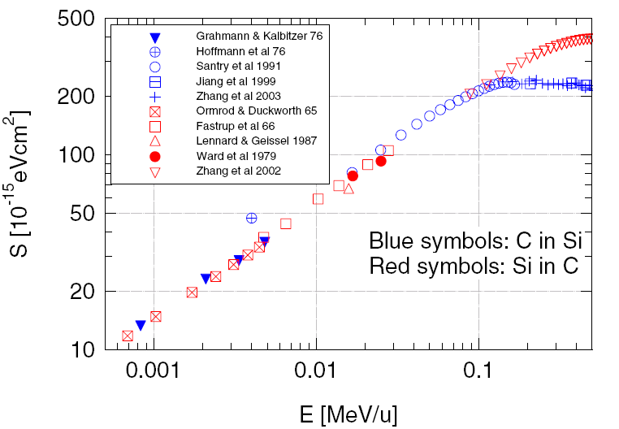
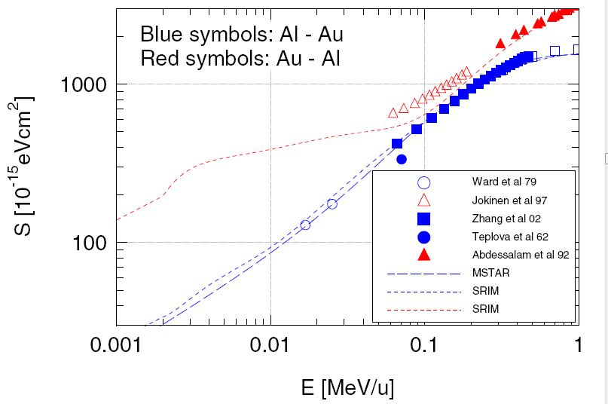
Fig. 1.4. Stopping cross sections for the C/Si combination (top), and the Al/Au combination (bottom). [Sigmund, Reciprocity in the electronic stopping of slow ions in matter, Euro. Phys. J. D 2008]
Experimentally, considerable discrepancies have been observed in SRIM-predicted ion ranges and disorder profiles in comparison with experimental values for very heavy ions in light targets.⁵³⁻⁵⁹ For example, in the case of 2 MeV Au irradiation in GaN, as shown in Fig. 1.5,⁵⁹ both damage range measured by TEM and the implanted Au range measured by time-of-flight secondary ion mass spectrometry (ToF-SIMS) are considerably deeper than the prediction by SRIM. The underestimate of ion range indicates the overestimate of stopping power, i.e. electronic stopping power, if the nuclear stopping power is considered accurate. In a direct measurement, using a monoenergy beam, the electronic stopping power of Au in C with the energy ~4 MeV was found to be 6.07 keVμg⁻¹cm²,⁵⁰ much smaller than the SRIM value of 14.8 keVμg⁻¹cm². Although this is a single data point and the nuclear stopping correction may bear criticism,⁵¹ the error shown in SRIM prediction is far beyond the experimental uncertainty.
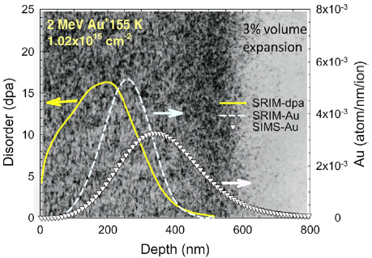
Fig. 1.5. The damage profile (yellow, solid line) is overlaid on top of the TEM image for 2 MeV Au ion irradiation in GaN. The corresponding Au ion distributions predicted by SRIM (dash line) and measured by SIMS (triangles) are also plotted for comparisons. [Zhang et al, Damage and microstructure evolution in GaN under Au ion irradiation, J. Phys. D: Appl. Phys., 2010]

In general, despite the long history of extensive study, the understanding and description on electronic stopping power, especially for heavy ions in compounds containing light elements has far not been adequate. “There is less to read and more to do for those engaging in heavy-ion stopping.”¹

1.2 Ion irradiation induced damage evolution in ceramics

1.2.1 Effects of nuclear energy deposition
The effect of energy deposition on defect production and evolution is one of the major subjects in the study of materials applied in irradiation environment. Due to high damage rates, irradiation with heavy ion in the low and medium energy regime has been commonly used to simulate the damage evolution induced by extreme nuclear radiation environments.^{60,61}
The ion channeling technique based on RBS is one of the most commonly applied methods to study irradiation damage in ceramics by slow heavy ions. The damage range is usually a few tens to hundreds of nanometers from surface, and the build-up of point defect concentration is the first damage stage for most of materials responding to nuclear energy deposition. Several references are listed here of the studies since 2000 on GaN,⁶² SiC,⁶³ ZnO,⁶⁴ Al₂O₃,⁶⁵ SrTiO₃,⁶⁶ ZrO₂, ⁶⁷ and Gd₂Ti₂O₇.⁶⁸ Despite the fact that sometimes the damage evolution appears confusing after the point defects achieve a certain concentration in some ionic ceramics,^{64,67} the understanding on the materials response to nuclear stopping has been relatively well established. In brief, the elastic energy transfer to target atoms can result in the displacement of atoms from their original sites, creating atomic-scale defects in the structure. An example is shown in Fig. 1.6, demonstrating the amorphization process in SrTiO₃ under 900 keV Au ion irradiations.
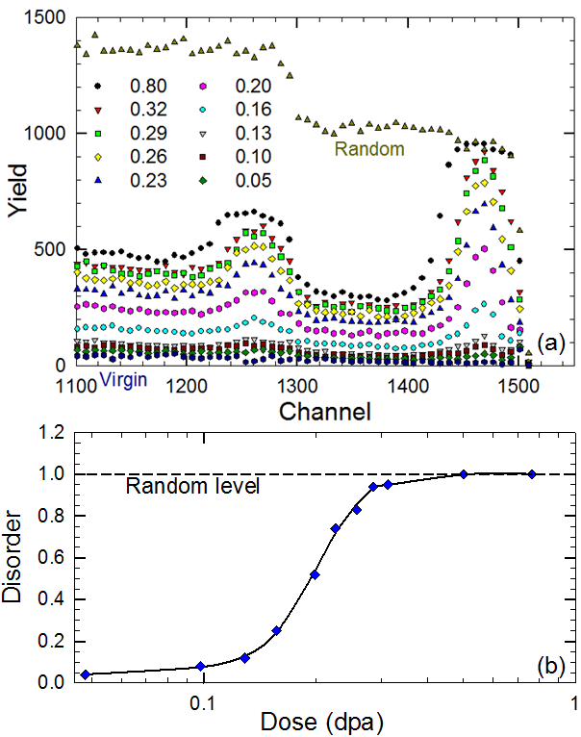
Fig. 1.6. (top) RBS/channeling spectra of SrTiO₃ irradiated with 900 keV Au⁺ to different ion fluences. (bottom) Relative disorder as a function of local dose at the damage peak in SrTiO₃

1.2.2 Effects of electronic energy deposition
In contrast to the nuclear energy deposition, much less understanding has been achieved on the defect response to electronic energy deposition in ceramics, especially from ions in the medium energy regime (tens of MeV). The complexity is mainly attributed to the fact that electronic energy deposition plays conflicting roles in the damage dynamics of heavy ion irradiated ceramics.⁶⁹ On one hand, damage induced by inelastic collision may be created near the ion track. On the other hand, electronic energy deposition can enhance the mobility of point defects and thus promote the recovery of displacement damage. As a result, the response of a pre-damaged material to the electronic stopping power is highly desired.
In some materials, e.g. ZrO₂,^{70,71} and SiO₂,⁷² the damage production from electronic energy loss and nuclear energy loss are primarily simple additive and little synergetic effect is observed. In contrast, the electronic energy loss induced annealing, or recrystallization, has been observed in SiC from two kinds of study strategy: 1) dual beam irradiation, including a nuclear stopping dominant beam (e.g. 900keV I) and a electronic stopping dominant beam (e.g. 36 MeV W)^{70,71} and 2) using a nuclear stopping dominant beam to create initial damage, and then using a electronic stopping dominant beam at the same location to “anneal” the pre-damage.⁷³ The advantage of the first strategy could be the better simulation of the real irradiation environment, while the advantage of second could be the convenience of separating, and elucidating the effect of each kind of energy deposition. Fig. 1.7 shows the annealing effect of 21 MeV Si ions on the pre-damaged SiC single crystal.⁷³ The diamonds indicate the damage profile after 900 keV Si ion (nuclear stopping dominant) irradiation, well the up-triangles indicate the damage profile at the same spot after subsequent 21 MeV Si ion irradiation (electronic stopping dominant). The damage level is clearly decreased after the electronic energy deposition.
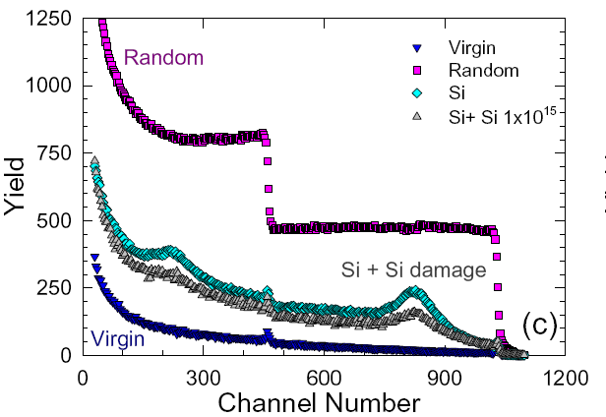
Fig. 1.7. Annealing effect of 21 MeV Si ions on the 4H-SiC single crystal pre-damaged by 900 keV Si ions. [Zhang et al, Competing effects of electronic and nuclear energy loss on microstructural evolution in ionic-covalent materials, Nucl. Instrum. Methods Phys. Res. B, 2014 ]

1.2.3 Puzzles in MgO
Comparing to the cases mentioned above, the damage evolution of MgO has been more confusing under either nuclear or electronic energy deposition. Under the irradiation from nuclear stopping dominant beam (e.g. 3 MeV Au and 100 keV Ar), a few previous experiments⁷⁴⁻⁷⁷ have observed that after the defect concentration reaches certain levels, further irradiation may reduce the damage level (from the perspective of ion channeling) and the damage profile could be unexpectedly deeper than the implanted ion profile. There have been several conjectures on the possible cause of these phenomena. At least two papers^{74,75} attribute this observation to the annealing effect due to the electronic stopping from the incident ions. However, this explanation is doubtable because the electronic stopping power of both 3 MeV Au and 100 keV Ar are low; let alone at the depth close to damage peak, the energy of ions is further lower and the electronic stopping power is negligible. Other explanations^{74,78,79} include the migration of oxygen interstitial, the strain release, the formation of dislocation or cluster, etc. However, there has been insufficient evidence to conclusively demonstrate any one of those explanations.
Under dual beam irradiation,^{70,71} a similar phenomenon compared to SiC has been observed in MgO that the damage level is lower under the simultaneous irradiation of two beams together than under the low energy beam alone. However, the mechanisms can be expected to be significantly different between SiC and MgO. In SiC, nuclear energy deposition leads to the accumulation of defects (either point defects or clusters) till fully amorphization. The reduction in damage level induced by electronic energy deposition, especially in the two-step irradiation experiment (see Fig. 1.7),⁷³ could be attributed to the healing, or recombination of the pre-existed defects. In MgO, as mentioned above, the nuclear energy deposition could not lead to amorphization. Clusters or dislocation loops could be formed under nuclear energy deposition, which could also reduce the damage levels from the perspective of ion channeling.⁷⁴⁻⁷⁷ As a result, the RBS analysis itself on only one dual beam experiment is difficult to elucidate the mechanism of these findings.

1.3 References
¹ P. Sigmund, Nucl. Instrum. Methods Phys. Res. B 135, 1 (1998).
² G. S. Was, Fundamentals of Radiation Materials Science: Metals and Alloys. (Springer, 2007).
³ J. F. Ziegler, J. P. Biersack, and M. D. Ziegler, SRIM - The Stopping and Range of Ions in Matter. (SRIM Co., Chester, MD, USA, 2008).
⁴ A. Sommerfeld, Z. Physik 78, 283 (1932).
⁵ G. Moliere, Z. Naturforschung 2, 133 (1947).
⁶ W. Lenz, Z. Physik 77, 713 (1932).
⁷ H. Jensen, Z. Physik 77, 722 (1932).
⁸ N. Bohr, Mat. Fys. Medd. Dan. Vid. Selsk 18 (1948).
⁹ D. J. O'Connor and J. P. Biersack, Nucl. Instrum. Methods Phys. Res. B 15, 14 (1986).
¹⁰ J. F. Ziegler, M. D. Ziegler, and J. P. Biersack, Nucl. Instrum. Methods Phys. Res. B 268, 1818 (2010).
¹¹ H. Paul, AIP Conf. Proceedings 1525, 309 (2013).
¹² H. Geissel, W. N. Lennard, H. R. Andrews, D. P. Jackson, I. V. Mitchell, D. Philips, and D. Ward, Nucl. Instrum. Methods Phys. Res. B 12, 38 (1985).
¹³ R. Ghetti, B Jakobsson, and H. J Whitlow, Nucl. Instrum. Methods Phys. Res. A 317, 235 (1992).
¹⁴ H. J. Whitlow and Y. Zhang, Nucl. Instrum. Methods Phys. Res. B 190, 375 (2002).
¹⁵ Y. Zhang and H. J. Whitlow, Nucl. Instrum. Methods Phys. Res. B 190, 383 (2002).
¹⁶ Y. Zhang and W. J. Weber, Phys. Rev. B 82, 075202 (2010).
¹⁷ N. Bohr, Philos. Mag. 25, 10 (1913).
¹⁸ F. Bloch, Zeitschrift für Physik 81, 363 (1933).
¹⁹ F. Bloch, Ann. der Phys. 16, 285 (1933).
²⁰ H. Bethe, Annalen der Physik 397, 325 (1930).
²¹ H. Bethe, Zeitschrift für Physik 76, 293 (1932).
²² C. Møller, Ann. Physik 406, 531 (1932).
²³ E. Fermi, Phys. Rev. 57, 485 (1940).
²⁴ J. Lindhard and M. Scharff, Phys. Rev. 124, 128 (1961).
²⁵ J. Lindhard, M. Scharff, and H.E. Schioett, Mat. Fys. Medd . Dan. Vid. Selsk 33, 1 (1963).
²⁶ J. Lindhard and M. Scharff, Matematisk-Fysiske Meddelelser Kongelige Danske Videnskabernes Selskab 27, 1 (1953).
²⁷ J. Lindhard, Matematisk-Fysiske Meddelelser Kongelige Danske Videnskabernes Selskab 28, 1 (1954).
²⁸ J. Lindhard and A. Winther, Mat. Fys. Medd . Dan. Vid. Selsk 34, 1 (1964).
²⁹ P. Sigmund, Phys. Scripta 28, 257 (1983).
³⁰ M. Zeb, J. Kohanoff, D. Sánchez-Portal, A. Arnau, J. Juaristi, and E. Artacho, Phys. Rev. Lett. 108, 225504 (2012).
³¹ J. Pruneda, D. Sánchez-Portal, A. Arnau, J. Juaristi, and Emilio Artacho, Phys. Rev. Lett. 99, 235501 (2007).
³² M. Draxler, S. Chenakin, S. Markin, and P. Bauer, Phys. Rev. Lett. 95, 113201 (2005).
³³ G. J. Iafrate and J. F. Ziegler, J. Appl. Phys. 50, 5579 (1979).
³⁴ W. Brandt and M. Kitagawa, Phys. Rev. B 25, 5631 (1982).
³⁵ H. Paul and A. Schinner, Nucl. Instrum. Methods Phys. Res. B 179, 299 (2001).
³⁶ H. Paul and A. Schinner, Nucl. Instrum. Methods Phys. Res. B 195, 166 (2002).
³⁷ P. Sigmund, Euro. Phys. J. D 47, 45 (2008).
³⁸ W-K Chu, J. W. Mayer, and M. A Nicolet, Backscattering Spectrometry. (Academic Press, Inc., 1978).
³⁹ L. C. Feldman, J. W. Mayer, and S. T. Picraux, Materials Analysis by Ion Channeling. (Academic Press, 1982).
⁴⁰ H. Paul, (https://www-nds.iaea.org/stopping/, 2012).
⁴¹ H. Paul and A. Schinner, Nucl. Instrum. Methods Phys. Res. B 227, 461 (2005).
⁴² P. Bauer, Nucl. Instrum. Methods Phys. Res. B 27, 301 (1987).
⁴³ P. Mertens, Nucl. Instrum. Methods Phys. Res. B 27, 315 (1987).
⁴⁴ H. Geissel, H. Weick, C. Scheidenberger, R. Bimbot, and Gardes Gard, Nucl. Instrum. Methods Phys. Res. B 195, 3 (2002).
⁴⁵ J. Jokinen, Nucl. Instrum. Methods Phys. Res. B 124, 447 (1997).
⁴⁶ K. Arstila, P. Tikkanen, and J. Keinonen, Nucl. Instrum. Methods Phys. Res. B 136-138, 98 (1998).
⁴⁷ G. F. Knoll, Radiation Detection and Measurement, 3rd ed. (Wiley, New York, 2000).
⁴⁸ M. Barbui, D. Fabris, M. Lunardon, S. Moretto, G. Nebbia, S. Pesente, G. Viesti, M. Cinausero, G. Prete, V. Rizzi, K. Hagel, S. Kowalski, J. B. Natowitz, L. Qin, R. Wada, and Z. Chen, Nucl. Instrum. Methods Phys. Res. B 268, 20 (2010).
⁴⁹ Y. Zhang, W. Weber, and C. Wang, Phys. Rev. B 69, 205201 (2004).
⁵⁰ W. N. Lennard, H. Geissel, D. P. Jackson, and D. Philips, Nucl. Instrum. Methods Phys. Res. B 13, 127 (1986).
⁵¹ Lev G. Glazov and P. Sigmund, Nucl. Instrum. Methods Phys. Res. B 207, 240 (2003).
⁵² Y. Zhai, X. Lu, T. Zheng, Z. Xia, and D. Shen, Nucl. Instrum. Methods Phys. Res. B 135, 128 (1998).
⁵³ Y. Zhang, I. T. Bae, K. Sun, C. Wang, M. Ishimaru, Zi. Zhu, W. Jiang, and W. J. Weber, J. Appl. Phys. 105, 104901 (2009).
⁵⁴ E. Friedland, S. Kalbitzer, M. Hayes, C. Klatt, G. Konac, and C. Langpape, Nucl. Instrum. Methods Phys. Res. B 136, 147 (1998).
⁵⁵ P. L. Grande, P. F. P. Fichtner, M. Behar, and F. C. Zawislak, Nucl. Instrum. Methods Phys. Res. B 35, 17 (1988).
⁵⁶ M. Behar, P. F. Fichtner, C. A. Olivieri, J. P. De Souza, F. C. Zawislak, and J. P. Biersack, Nucl. Instrum. Methods Phys. Res. B 6, 453 (1985).
⁵⁷ L. Palmetshofer, M. Gritsch, and G. Hobler, Mater. Sci. Eng. B 81, 83 (2001).
⁵⁸ H. Z. Xue, Y. Zhang, Z. Zhu, W. M. Zhang, I. T. Bae, and W. J. Weber, Nucl. Instrum. Methods Phys. Res. B 286, 114 (2012).
⁵⁹ Y. Zhang, M. Ishimaru, J. Jagielski, W. M. Zhang, Z. Zhu, L. Saraf, W. Jiang, L. Thome, and W. J. Weber, J. Phys. D: Appl. Phys 43, 085303 (2010).
⁶⁰ J. C. Dran, Solid State Phenomena 30-31, 367 (1992).
⁶¹ Y. Zhang, J. Lian, C. Wang, W. Jiang, R. Ewing, and W. Weber, Phys. Rev. B 72, 094112 (2005).
⁶² S. O. Kucheyev, J. S. Williams, C. Jagadish, J. Zou, and G. Li, Phys. Rev. B 62, 7510 (2000).
⁶³ W. Jiang and W. J. Weber, Phys. Rev. B 64, 125206 (2001).
⁶⁴ S. O. Kucheyev, J. S. Williams, C. Jagadish, J. Zou, C. Evans, A. J. Nelson, and A. V. Hamza, Phys. Rev. B 67, 094115 (2003).
⁶⁵ C. S. Schnohr, E. Wendler, K. Gartner, W. Wesch, and K. Ellmer, J. Appl. Phys. 99, 123511 (2006).
⁶⁶ Y. Zhang, J. Lian, C. M. Wang, W. Jiang, R. Ewing, and W. J. Weber, Phys. Rev. B 72, 094112 (2005).
⁶⁷ S. Moll, L. Thome, G. Sattonnay, A. Debelle, F. Garrido, L. Vincent, and J. Jagielski, J. Appl. Phys. 106, 073509 (2009).
⁶⁸ S. Moll, G. Sattonnay, L. Thome, J. Jagielski, C. Decorse, P. Simon, I. Monnet, and W. J. Weber, Phys. Rev. B 84, 064115 (2011).
⁶⁹ S. J. Zinkle, V. A. Skuratov, and D. T. Hoelzer, Nucl. Instrum. Methods Phys. Res. B 191, 758 (2002).
⁷⁰ L. Thomé, A. Debelle, F. Garrido, P. Trocellier, Y. Serruys, G. Velisa, and S. Miro, Appl. Phys. Lett. 102, 141906 (2013).
⁷¹ L. Thome, G. Velisa, A. Debelle, S. Miro, F. Garrido, P. Trocellier, and Y. Serruys, Nucl. Instrum. Methods Phys. Res. B 326, 219 (2014).
⁷² M. Toulemonde, W. J. Weber, G. Li, V. Shutthanandan, P. Kluth, T. Yang, Y. Wang, and Y. Zhang, Phys. Rev. B 83, 054106 (2011).
⁷³ Y. Zhang, T. Varga, M. Ishimaru, P. D. Edmondson, H. Xue, P. Liu, S. Moll, F. Namavar, C. Hardiman, S. Shannon, and W. J. Weber, Nucl. Instrum. Methods Phys. Res. B 327, 33 (2014).
⁷⁴ E. Wendler, K. Gärtner, and W. Wesch, Nucl. Instrum. Methods Phys. Res. B 257, 488 (2007).
⁷⁵ H. Ogiso, S. Nakano, and J. Akedo, Nucl. Instrum. Methods Phys. Res. B 206, 157 (2003).
⁷⁶ E. Friedland, Nucl. Instrum. Methods Phys. Res. B 80-81, 128 (1993).
⁷⁷ E. Friedland and M. Hayes, Nucl. Instrum. Methods Phys. Res. B 65, 287 (1992).
⁷⁸ L. Gea, C. R. A. Catlow, S. M. M. Ramos, B. Canut, and P. Thevenard, Nucl. Instrum. Methods Phys. Res. B 65, 282 (1992).
⁷⁹ S. Moll, Y. Zhang, A. Debelle, L. Thomé, J. P. Crocombette, Z. Zihua, J. Jagielski, and W. J. Weber, Acta Mater. 88, 314 (2015).

Chapter 2
Experimental methods

2.1 ToF-ERDA measurement
In this study, the energy loss measurements are performed using a time-of-flight elastic recoil detection analysis (ToF-ERDA) system, shown in Fig. 2.1. The setup consists of a ToF spectrometer followed by a Si detector.¹
Monoenergetic ions are produced using a tandem accelerator, and scattered by a Au target into the ToF spectrometer with a continuous range of energies. The energy of each ion is determined by the ToF spectrometer following a linear calibration relationship:
(2.1)
In order to obtain accurate time calibration, two complementary methods are used. Firstly, a time calibration module (ORTEC module 462) is used to generate pulse signals with equal time intervals. Multiple series of measurements could give an accurate value on the time slope a₁. Secondly, the largest energy of the detected ions can be determined by
, for the recoils, and (2.2)
, for the projectiles, (2.3)
where φ is the scattering angle, E_{i} is the incident energy, M₁, and M₂ are the masses of projectile and target, respectively. In this study, the projectile is used for analysis. The high-energy edges of different elements scattered from the sample surface are used to calibrate the time offset a₀.
Stopping foils are mounted on a push-rod that can be reproducibly moved into and out of the ion path between the ToF spectrometer and the Si detector. With the stopping foil out of the ion path, the Si detector directly measures the energy (E_{Si1}) of the ions leaving from the ToF spectrometer (E_{T1}); each channel of the Si detector is, therefore, calibrated by the corresponding ToF energy.¹ In this way, the calibration difficulties of Si detector in response to heavy ions are eliminated. Since the ions lose energy when passing through the C_{out} film (Fig. 2.1) before leaving the ToF, a correction for the small energy loss (E_{C1}) is included:
. (2.4)
With a stopping foil in the ion path, each ion exiting from the ToF and detected in the Si detector has energy:
(2.5)
where, x is the thickness of the stopping foil and E is the energy loss in the stopping foil. Using Eqs. (2.4) and (2.5) and considering the two ToF energies that yield the same energy in the Si detector (i.e., E_{Si1}=E_{Si2}), the stopping power (with small x) is given by:
(2.6)
at the corresponding energy of $(E_{T2}^{'}+E_{T1}^{'})/2$.
An example of He ion stopping is shown in Fig. 2.2. In Fig. 2.2 (a), two correspondence curves are shown between the Si detector and the ToF with and without the stopping foil. Fig. 2.2 (b) shows the ToF time responses for He ions at the pulse height channel 2000 from the Si detector. The difference in energy determined by ToF is considered as the energy loss in the stopping foil.
In this measurement, two self-supported stopping foils are used. The SiO₂ foil ($36 {μg cm}^{-2}$) was produced by physical vapor deposition (Luxel Corporation, WA 98250, USA), and the SiC foil ($82 {μg cm}^{-2}$) was prepared by high-temperature, low-pressure chemical vapor deposition (FLX Micro, Cleveland, OH, USA). The thickness of the foils is determined by measuring the electronic energy loss of He ions in these foils as demonstrated in previous studies.²⁻⁴ The value of the thickness is adjusted so that the determined stopping power agreed with SRIM. The experimentally determined values and the SRIM results for electronic stopping power for He ions in both SiC and SiO₂ are shown in Figs. 2.3 (a) and (b), respectively. The foundation of this method is the fact, stated in chapter 1, that the SRIM prediction of electronic stopping power of He ions has been extensively validated by numerous experiments and is considered accurate. In this way, the error in measuring the foil thickness, including the density uncertainty and the roughness, is minimized.

2.2 Correction of effective nuclear energy loss
As discussed in chapter 1, the contribution of nuclear energy loss in the measurements has to be corrected to derive realistic electronic stopping power values. However, the tabled nuclear stopping power cannot be directly subtracted from the measured results. In the measured energy loss, the contribution from electronic energy loss is assumed to have negligible dependence on collision scattering angle, but the nuclear energy loss is strongly dependent on the collision scattering geometry. With the stopping foil in place, ions that encounter large-angle scattering will not be detected within the small solid angle constrained by the collimator, as shown in Fig. 2.1. Thus, only ions with smaller scattering angles, corresponding to the ions with smaller nuclear energy loss in the foil, can be detected by the Si detector. For example, based on SRIM simulations, only ~47% and 75% of the Au ions with incident energies of 6 and 10 MeV on SiC, respectively, can be detected by the Si detector. The remaining ions, which encountered larger angle scattering, will be stopped by the collimator. Another example for I ions penetrating an Al foil was discussed by Paul,⁵ and a similar result was observed. In this work, the effective nuclear energy loss is defined as the average nuclear energy loss for the ions that can be detected for a specific geometry determined by the experimental setup, and the total nuclear energy loss is referred to the average of all ions that is given by SRIM (in the Stopping / Range Tables).
The correction of the effective nuclear energy loss is determined by the following steps: 1) apply SRIM simulations to determine the exit angle and position for an ion penetrating through the stopping foil; 2) determine the position when the ion reaches the Si detector based on the present experimental configuration (relative location of the stopping foils and the Si detector) and compare the radius with the diameter of the collimator located in front of the Si detector to determine whether the ion is within the collimator and will be detected; 3) perform such simulations for a large number of ions with different incident energies (~50,000 per energy); and 4) for each incident energy, calculate the mean energy loss of those detectable ions for the corresponding ion energy (average of the energy before and after penetrating the stopping foil), and obtain a continuous curve fit of mean energy loss (S_{e}+Eff S_{n}) as a function of ion energy, shown by solid curves in Fig. 2.4(a). The effective nuclear energy loss is the difference between these curves and those of electronic energy loss. The final step is: 5) subtract the effective nuclear energy loss from the measured values.
This correction method is based on the assumption that SRIM provides a reasonable prediction of nuclear stopping powers and has little correlation with SRIM predicted electronic stopping powers. In this correction method, 1) the error on electronic stopping power for each energy is cancelled out in step (5) based on the independence of electronic stopping power with the scattering angle, as well as the small difference in the ion path-length in the thin foils; and 2) this correction is not based on “incident energy” but on an “average energy” that is shown as the smooth curve obtained in step (4). In other words, for ions with the same average energy, their nuclear stopping power and thus their scattering behavior are the same regardless of the incident or exit energy. The error on electronic stopping power that mainly affects the slowing down process, therefore, has minimal effects on this correction.
As shown in Fig. 2.4(a), the effective nuclear energy loss is a significant contribution to the total energy loss for Au ions, and becomes less significant but not negligible for Br ions. The results in Fig. 2.4(b) show the electronic stopping powers with and without the effective nuclear stopping correction, as well as with total nuclear stopping subtraction. The SRIM predicted results are also included for comparison. It is evident that the correction is crucial to the final results. The key issue of the reliability of this correction is whether the SRIM predicted angular distribution of ions penetrating a thin foil is correct. As discussed in chapter 1, the nuclear stopping power predicted by SRIM has been generally accepted but the direct experimental validations of such angular distributions are still limited by the requirement of unique equipments. In this study, a newly designed experiment is performed for this validation (see section 2.3 and chapter 4). The result shows that the SRIM predictions on angular distribution are reasonable, and thus our effective nuclear stopping correction is reliable.

2.3 Measurement of angular distribution of Au ions penetrating a Si₃N₄ thin foil.
The angular distribution measurements mainly consist of two parts, ion irradiation and ToF-SIMS measurement. The setup of ion irradiation is shown in Fig. 2.5. Low stress LPCVD (Low Pressure Chemical Vapor Deposition) Si₃N₄ foils are deposited on a Si substrate by Norcada Inc (Edmonton, AB, Canada). The foils range from 95 to 103 nm in thickness, and the actual thickness of each foil was measured independently by ToF-SIMS, scanning electron microscopy (SEM) and transmission electron microscopy (TEM). The density of the foils is provided by the manufacturer as 3.1 g cm⁻³, which has been confirmed by areal density measurement with RBS in combination with the SEM and TEM results. The Si₃N₄ foils are grown on a Si substrate (5 mm × 5 mm, 200 μm thick) that is thick enough to block the incoming beam. A window in the central area of the silicon substrate, 0.25 mm × 0.25 mm, is created by etching⁶ and is taken as the beam spot size. The Si₃N₄/Si window is mounted on the front of a metal frame with a thickness of 14.2 mm, and a Si wafer is mounted at the back of this frame. The 1 MeV Au ion irradiations are performed using a tandem accelerator. The Au beam covers the whole 0.25 mm window region, and the transmitted ions are collected by the Si wafer.
The Si wafers implanted with Au ions are subsequently analyzed by ToF-SIMS. As shown in Fig. 2.6, depth profiling is performed across the Si wafer with steps of 0.5 mm. The size of each crater is 0.3 mm × 0.3 mm. At each position, the Au depth profile is integrated to calculate the implanted fluence and is normalized to the ³⁰Si⁻ signal in order to minimize the effects from current fluctuations. In order to locate the center of Au beam, three line scans are performed on each sample: the first scan is performed from a rough center of the wafer; the second scan starts from the Au peak position of the first scan along a direction perpendicular to the first scan; and the third scan starts from the Au peak position of the second scan along a direction perpendicular to the second scan (parallel to the first scan). Following such approach, the distributions from the second and the third scan are ensured along the diameters of the Au distribution.
In order to evaluate the thickness change of the foils under ion irradiation, ToF-SIMS depth profiling is performed on both the window (the suspended foil without the Si substrate: irradiated area) and the supported region (the film supported by the Si substrate: virgin area) of each sample under different irradiation fluences. The sputtering rate is determined by the crater depth measured by a Dektak 150 profilometer.
Both SEM and TEM methods are applied to measure the thickness of the foils. The SEM measurements are carried out with FEI Helios 600 Nanolab FIB/SEM. Thin layers of sputtered Au are introduced on both sides of the wafer to enhance the clarity of the Si₃N₄ surfaces. Images are taken under immersion mode at a tilt angle of 52º. TEM measurements are carried out at 200 keV with a Zeiss Libra 200MC TEM/STEM. The detector is equipped with 2K × 2K CCD-camera. The cross-sectional TEM samples are prepared by mechanical polishing following by ion milling. The energy resolution is ~0.15 eV.

2.4 Measurement of the depth profile of implanted ions
In this study, two techniques are used to measure the depth profile of implanted ions: RBS and ToF-SIMS.
RBS is one of the major ion beam analysis techniques used in surface and near surface analysis in solids. A target is bombarded with ions in the energy regime from a few hundreds of keV to a few MeV. The projectiles that are backscattered by the atoms in the solids, from either surface or bulk, are recorded by an energy sensitive detector. In this study, Si detector and He ions are used.
In order to achieve good accuracy in RBS measurements, energy calibration is of critical importance. The energy calibration is usually performed by measuring the maximum energy of the backscattered ions from known elements at a certain scattering angle, corresponding to the backscattering by the atoms at surface.⁷ These maximum energies are determined by Eq. (2.3). Using different calibration samples with known composition, and using different ion energies are two commonly used methods for practical energy calibration. Usually, the energy and channel have a linear relationship. Sometimes, a second order polynomial function is needed. An example of is shown in Fig. 2.7. In this case, a few elements and four energies of He ions are tested and all the data points follow well a linear energy-channel relationship. It has been introduced in chapter 1 (see. Fig. 1.2) that energy calibration is different for different types of incident ions, and the linearity may be compromised for heavy ions.
For the signals of a certain element, different exit energies of He ions indicate different depth where the collision happens. The energy-depth convert is based on the electronic stopping power of He ions in the samples, and the values given by SRIM are widely used. Since the stopping power is energy dependent, accurate analysis usually requires a numerical method combining a slabs model.⁷ In this model, the total depth, x shown in Fig. 2.8, is divided into many small slabs with equal depth x. Thus, it can be reasonably assumed that in each slab the stopping power is uniform, and the energies only change at the boundaries between two slabs:
(2.7)
where, _{n}E and (dE/dx)|_{nE} are the energy and stopping power of He ions in the nth slab, respectively, the θ_{1,2} are the angles between the surface normal direction and the incident or outgoing directions of He beam, respectively. Minus sign is used for incident beam, and the plus sign is used for outgoing beam. Note that there is an abrupt change in energy when the collision happens, following Eq. (2.3). Following this way, the exit energy of He ions can be calculated by adjusting the depth x. In other words, the depth can be derived from the known exit energy.
ToF-SIMS⁸ is a powerful instrument in depth profiling trace elements in materials. In brief, the sample of interest is sputtered with a beam of primary ions; the secondary ions formed during the sputtering process are extracted and analyzed with a ToF spectrometry. In this study, the dual beam mode is used to measure the depth profile of implanted ions. A 2.0 keV Cs⁺ sputter beam with ~130 nA is used to remove materials from sample surfaces in a reasonable rate, while a 25 keV Bi⁺ beam with ~1 pA is used for data collection.
The data analysis of ToF-SIMS depth profile is more straightforward comparing to RBS. With stable current of the sputtering beam, the sputter rate is considered either constant or lineally changed. The values are determined by measuring the depth of the crater after the complete sputtering process with a known sputtering time, using ZYGO NewView 200 and Dektak 6 M profilometers.
Comparing with RBS, the advantage of ToF-SIMS includes the excellent detection limit (~ppm level) and the ultra high depth resolution (a few angstroms). However, SIMS is a destructive measurement (due to the sputtering). Besides, SIMS measures the absolute depth (e.g. unit in nm), while the RBS measure the area density (e.g. unit in 10¹⁵ atoms/cm²). In theoretical predictions, the areal density can be directly calculated from the stopping cross-section but the density of the sample is needed to calculate the absolute depth. In practical, volume swelling (i.e. the density decrease) can be induced by large fluence heavy ion irradiation. In SiC, such volume swelling can be as large as 15%⁹, which has to be corrected when comparing the experimental and theoretical results.

2.5 Ion channeling measurement of the damage profile in single crystals
In this study, ion channeling technique is used to study the damage of MgO under ion irradiation. Channeling¹⁰ is referred to the influence of crystal lattice on the trajectories of energetic particles (usually 1-4 MeV He ions). When the incident beam is well aligned with crystal lattice axes or planes (so called in channeling direction), the close-encounter probability between ions and target atoms will be dramatically reduced. As a result, the backscattering yield from channeling ions is very low (~5%) comparing with that from the ions in “random” directional or the ions in an amorphous material.
The imperfections (defects, distortion, etc.) can compromise the low backscattering yield. Normally, point defects (interstitials) have two effects¹⁰ on the incident beam in channeling directions, as shown in Fig 2.9 (top). Firstly, the ions can be directly backscattered, since the interstitials do not sit on the lattice sites. Secondly, the ions can be dechanneled, that is, the channeled ions are scattered into non-channeled directions, behaving the same as a random beam afterwards. As a result, the incident beam can be divided into two fractions, the channeled fraction and the random fraction, as shown in Fig. 2.9 (middle). Similarly, as shown in Fig. 2.9 (bottom), the RBS yield of a damaged sample, χ_{D,} can also be divided into two fractions. The yield from channeled beam is resulted from the direct backscattering by the defects, as shown in the shaded area. The dechanneling yield, shown as χ_{R}, is resulted from the dechanneled (random) fraction of the beam. It is important to note that the effect of direct backscattering is restricted within the damage region, but the effect of dechanneling is extended to larger depth. This is why a peak is formed in the channeling spectrum but yield cannot decrease to the virgin level even though no defect exists in the material at larger depth beyond the damage region.
The principle of deducing the damage level from the RBS spectra is described as follows.¹⁰ The damage yield is expressed as:
, (2.8)
where, n_{D} is the defect density, n is the atomic density of sample, f is called the defect scattering factor. Conventionally, f=0 for pure dechanneling defects, e.g. dislocations; f=1 for randomly displaced atoms (interstitials). As stated above, χ_{R} is the dechanneling fraction which cannot be directly measured. Omitting the derivation process, χ_{R} can be expressed as:
, (2.9)
where σ_{D} is called the dechanneling factor and χ_{v} is the yield for the virgin sample.
Combining Eq. (2.8) and (2.9), the defect density n_{D} can be derived using iteration method from χ_{D} and χv, if σ_{D} is known. However, the dechanneling factor is not a pre-known value, and its determination is based on many assumptions and has not been well understood. As a result, a commonly accepted treatment is making the σ_{D} a tuning factor.¹¹ By tuning σ_{D}, the χ_{R} curve is correspondingly changed. The proper σ_{D} is reached when the χ_{R} curve overlaps with χ_{D} at the depth after which the defect density is considered zero.

2.6 Ion irradiation and fluence calibration
The ion irradiation and implantation are performed using the 3 MV tandem accelerators at both University of Tennessee (UT)¹² and the Pacific Northwest National Laboratory (PNNL). The details of the UT ion beam materials laboratory are introduced in Ref. ¹². The key of successful ion irradiation in damage accumulation and evolution study is well controlling the fluences. Several fluence calibrations have been performed. Au ions are selected in the calibrations due to the achievable high beam current and high backscattering cross section of He on Au. One example of fluence calibration is illustrated in Fig. 2.10, where a Si sample is implanted with 2.25 MeV Au²⁺ ions. After the Au ion implantation to the fluence of 6.1×10¹⁵ cm⁻², RBS is performed using 2.0 MeV He ions. As shown in Fig. 2.10, the concentration of Au shown in the RBS spectrum is determined by fitting the data to the simulation using SIMNRA software¹³. The diamonds are the data from the RBS measurement, and the dashed line is the fit from SIMNRA. In this example, while the intended fluence is 6.1×10¹⁵ cm⁻², the fluence determined by SIMNRA simulation is 6.3×10¹⁵ cm⁻². Such fluence calibration has been performed several times using Au ion with different energies in different targets, and the uncertainty of our irradiation fluence is within ±10%.

2.7 References
¹ Y. W. Zhang, Nucl. Instrum. Methods Phys. Res. B 196, 1 (2002).
² Y. Zhang, W. Weber, and C. Wang, Phys. Rev. B 69, 205201 (2004).
³ Y. Zhang, W. J. Weber, D. E. McCready, D. A. Grove, J. Jensen, and G. Possnert, Appl. Phys. Lett. 87, 104103 (2005).
⁴ J. F. Ziegler, SRIM-2013 (www.srim.org).
⁵ H. Paul, AIP Conf. Proceedings 1525, 309 (2013).
⁶ N. E. Flowers-Jacobs, S. W. Hoch, J. C. Sankey, A. Kashkanova, A. M. Jayich, C. Deutsch, J. Reichel, and J. G. E. Harris, Appl. Phys. Lett. 101, 221109 (2012).
⁷ W-K Chu, J. W. Mayer, and M. A Nicolet, Backscattering Spectrometry. (Academic Press, Inc., 1978).
⁸ J. C. Vickerman and D. Briggs, ToF-SIMS: Surface Analysis by Mass Spectrometry. (Manchester and IM Publications, 2001).
⁹ I. T. Bae, W. J. Weber, and Y. Zhang, J. Appl. Phys. 106, 123525 (2009).
¹⁰ L. C. Feldman, J. W. Mayer, and S. T. Picraux, Materials Analysis by Ion Channeling. (Academic Press, 1982).
¹¹ L. Shao and M. Nastasi, Appl. Phys. Lett. 87, 064103 (2005).
¹² Y. Zhang, M. L. Crespillo, H. Xue, K. Jin, C. H. Chen, C. L. Fontana, J. T. Graham, and W. J. Weber, Nucl. Instrum. Methods Phys. Res. B 338, 19 (2014).
¹³ M. Mayer, SIMNRA, http://home.rzg.mpg.de/~mam/. (2014).

Appendix 2.1

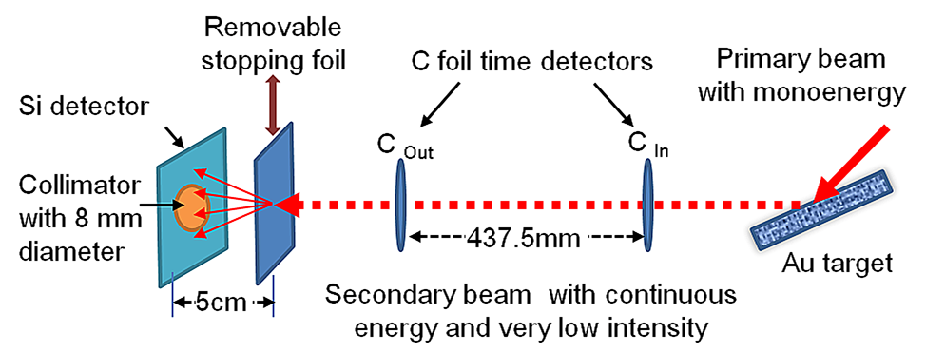
Fig. 2.1. Schematic illustration of the experimental configuration of a ToF-ERDA system for energy loss measurements

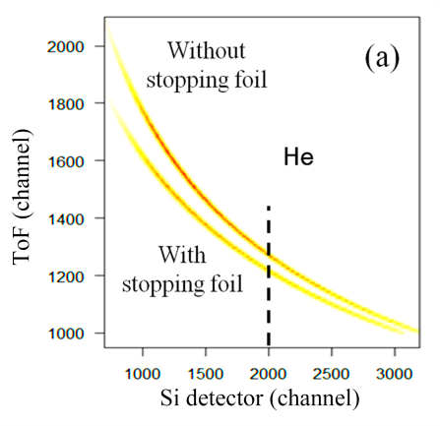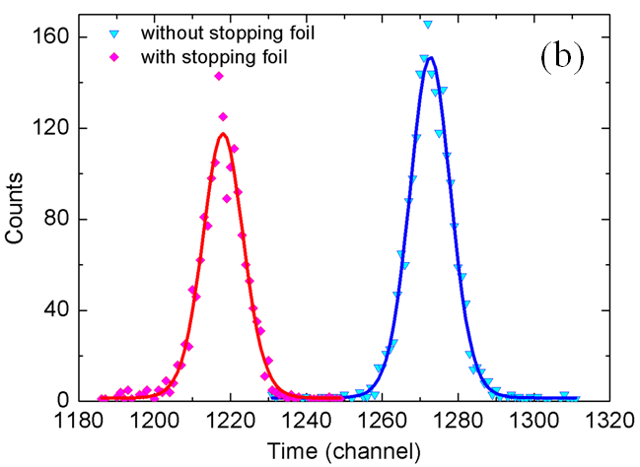
Fig. 2.2. (a) Contour map of the ToF-Si detector correspondence for He ions, with and without the stopping foil. (b) Time diagram at channel 2000 from the Si detector.

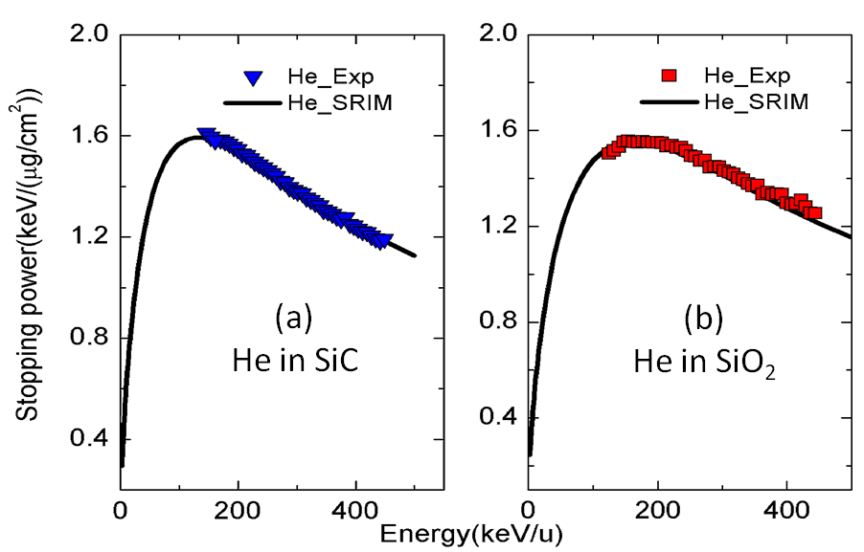
Fig. 2.3 Comparisons of electronic stopping powers for He ions in (a) SiC and (b) SiO₂ between the measured results and the SRIM predictions.

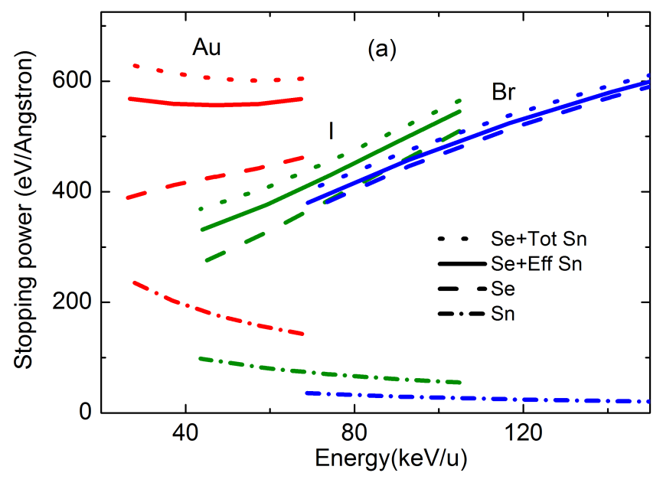
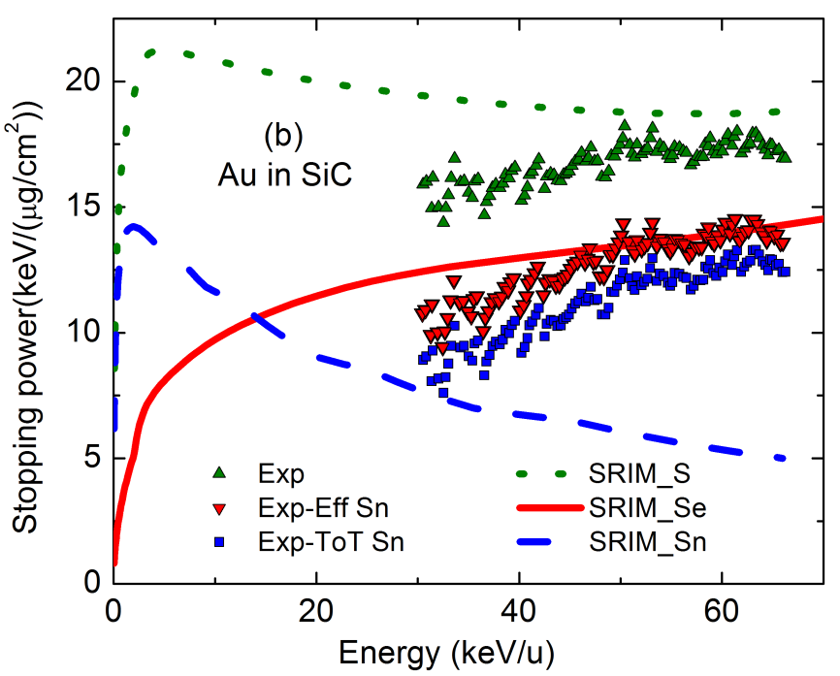
Fig. 2.4. Ions in SiC: (a) SRIM prediction of the mean energy loss (solid line) of the ions detected by the Si detector, with the nuclear stopping power (dash dot), electronic stopping power (dash), and total stopping power (dot) of Au, I, and Br ions in SiC. (b) Comparison between uncorrected (Exp), effective nuclear stopping corrected (Exp-Eff Sn) and total nuclear stopping corrected (Exp-Tot Sn) data of measured electronic stopping power for Au ions in SiC; along with the SRIM predictions.

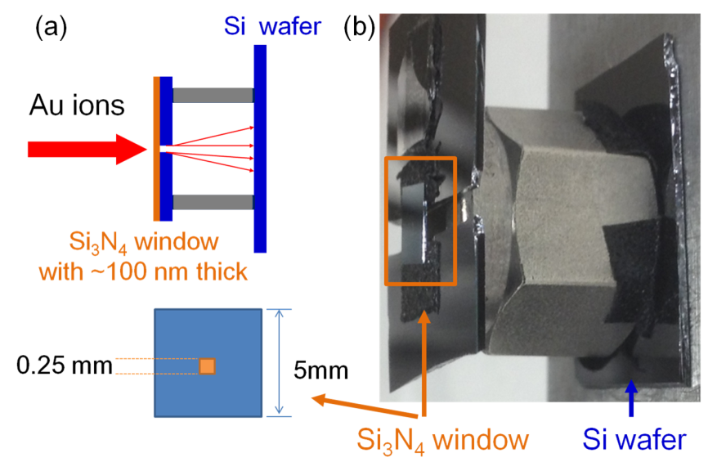
Fig. 2.5. (a) Schematic illustration and (b) a photo of the setup to collect scattered Au ions penetrating a Si₃N₄ thin foil. The penetrated Au ions are collected in a Si wafer located at the rear of the metal frame. The suspended Si₃N₄ foil (0.25 mm × 0.25 mm) at the center of the Si wafer is defined as the “window region” and the rest of Si₃N₄ thin film is defined as “supported region”.

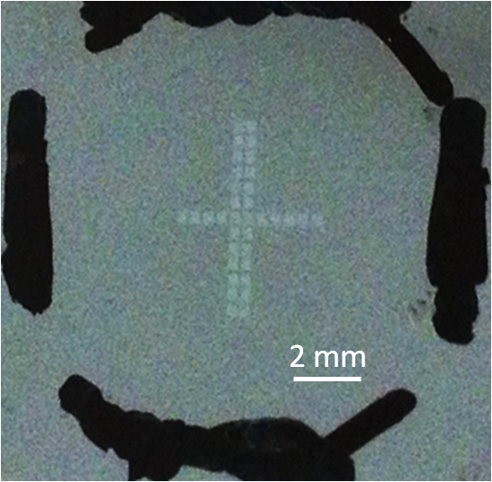
Fig. 2.6. A photo of a Si wafer after lateral scan by ToF-SIMS depth profiling

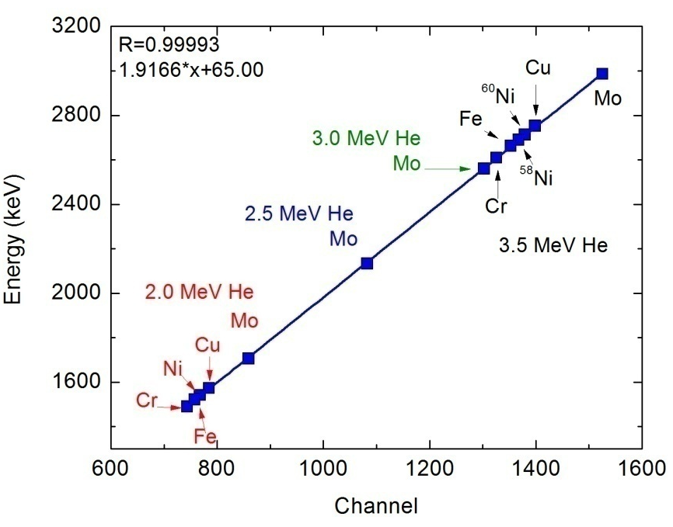
Fig. 2.7. An example of the energy calibration of the Si detector in response to He ions

Fig. 2.8. Illustration of the principle of the RBS depth profiling

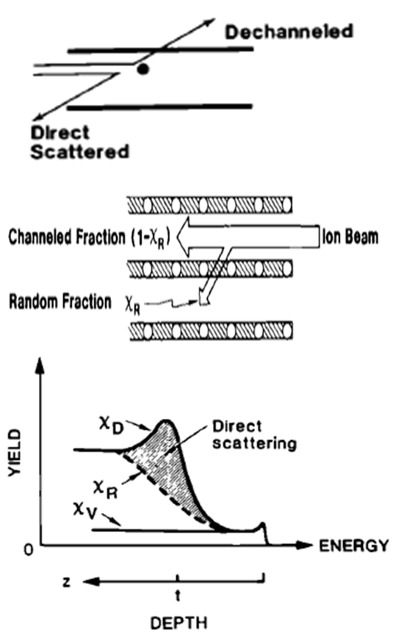
Fig. 2.9. Illustration of the dechanneling mechanism by point defects. [Feldman, Materials Analysis by Ion Channeling, 1982]

Fig. 2.10. RBS spectrum of Si implanted with 2.25 MeV Au²⁺ ions to an intended fluence of 6.1×10¹⁵ cm⁻². The measured spectrum is fit using SIMNRA, indicating 6.3×10¹⁵ cm⁻² as the actual implanted fluence.

Chapter 3
Electronic stopping powers for heavy ions in SiC and SiO₂

3.1 Introduction
Accurate information on energy transfer from energetic ions to materials is essential for fundamental research, electronic and optical device fabrication, and prediction of the performance of materials subject to high irradiation environments.¹⁻¹³
As important materials used in electronic devices, SiO₂ and SiC are often subjected to ion implantation, which is a key technique to selectively introduce dopants to modify electronic properties.⁵⁻⁷ Accurate information of electronic stopping power is fundamental to precisely control dopant concentrations over well-defined depth distributions. MeV heavy ions have recently been applied to produce ion tracks in SiO₂/Si systems that can be etched to form nanostructures in thin films for microelectronic devices or waveguide applications, and the electronic stopping power is an important input in the inelastic thermal spike model^{3,14} to predict the track radii.
Reliable performance under energetic ion bombardments is also critical for advanced electronic devices used in space exploration, where a large variety of energetic particles, from protons to very heavy ions, may interact with the electronic components. Single ion events induced by the electronic energy deposition from heavy ions can be a hazard for information storage in microprocessors and memory elements, and may lead to destructive burnout and rupture of gate dielectrics in power devices. Accurate knowledge on electronic stopping power and a correct model of materials response to energetic charged particles are the scientific foundation to evaluate the survival of advanced electronics to single ion events.¹¹⁻¹³
In addition, due to the excellent chemical, physical and mechanical properties, SiC is widely considered for use in advanced nuclear energy systems. For example, SiC is proposed as a structural layer in the tri-structural isotropic coated fuel to retain the fission products;^{15,16} While not a nuclear material, SiO₂ is the major component of borosilicate glasses proposed for the immobilization of nuclear waste from advanced nuclear fuel cycles.^{8,9} In such nuclear applications, these materials are exposed to extreme radiation environments.⁸⁻¹⁰ Due to high damage rates, very heavy ions, such as Au, are commonly used to simulate damage evolution induced by extreme nuclear radiation environments.^{17,18} Models of nuclear materials performance rely highly on accurate electronic stopping power data.
As discussed in detail in chapter 1, despite intense studies on the stopping of ions in matter over the past century, electronic stopping power, especially for slow heavy ions in targets with light elements, has not been adequately understood and described. Current theories and models provide significantly inconsistent predictions, and experimental results have shown large error in prediction of ion range and damage profile based on the SRIM predicted electronic stopping power. Due to the long-standing challenge in direct stopping measurement for very heavy ions in low energy regime, reliable data with experimental validation of electronic stopping power for slow heavy ions in light compounds has not been available.
In this chapter, electronic stopping powers for Cl, Br, I, and Au ions are experimentally determined in SiC and SiO₂, based on a single ion technique, and new electronic stopping power values are derived over the energy regime from 0 to 15 MeV, where large deviations from the SRIM predictions are observed. As an experimental validation, RBS and SIMS are utilized to measure the depth profiles of implanted Au ions in SiC for energies from 700 keV to 15 MeV. The measured ion distributions by both RBS and SIMS are considerably deeper than the SRIM predictions, but agree well with the predictions based on our derived electronic stopping powers.

3.2 Experimental
The energy loss of the ions penetrating the stopping foils are measured using a ToF-ERDA system, as described in Sec. 2.1. The data analysis procedures are mostly introduced in Sec. 2.1, while the correction of effective nuclear energy loss is described separately in Sec. 2.2. The ion distributions are measured using RBS and ToF-SIMS, as described in Sec. 2.4.

3.3 Electronic stopping power values
Mean electronic stopping powers for heavy ions, after the correction of effective nuclear energy loss, in SiC and SiO₂ are summarized in Fig. 3.1. The trend lines can be well described over a wide range by the following expression:
$\frac{dE}{dx}=\frac{a_{0}{+a}_{1}×E+a_{2}×E^{2}+a_{3}×E^{3}}{a_{4}×E+a_{5}×E^{2}+a_{6}×E^{3}}$ (3.1)
Due to the lack of reliable experimental data currently available and the huge disagreements between existing theoretical predictions, the fitting parameters and the corresponding energy regions are listed in Table 1 for convenient implementation in other applications. The coefficients for He are also included.
For Cl ions, the SRIM prediction underestimates the electronic stopping power at energies higher than 200 keV/u for both materials. Below this energy, the measured data agree well with or are slightly lower than the SRIM prediction. This result follows the trend for lighter ions observed previously: it has been found¹⁹ that for O, F, and Si ions in SiO₂, the SRIM prediction provides reasonable estimates or slightly overestimates at lower energies while noticeably underestimating at higher energies. This trend appears more obvious for heavier ions. For example, Si ions have a similar trend as that of Cl ions. For Br ions, the underestimation of the SRIM prediction is more significant and the overlapping point between the measured data and the SRIM prediction moves down to 50 keV/u.
For I ions, especially in SiO₂, the deviation from the SRIM prediction is unexpectedly large. The results from LSS theory and a prediction based on the reciprocity theory²⁰ are included in Fig. 3.2 for comparisons. Even though the LSS formula is normally treated as a crude estimation of electronic stopping power in the low energy regime,^{20,21} it is clear from Fig. 3.2 that both LSS and reciprocity predictions agree to each other up to 40 keV/u and they are smoothly extended to the measured data at ~40 keV/u. In the low energy regime, SRIM also agrees with the other two theoretical predictions. The unexpected curvature shown at ~20 keV/u may be attributed to the improper parameters fitting the experimental data in different energy regions.
For Au ions, the SRIM prediction overestimates the electronic stopping power in the low energy regime in both targets, and slightly underestimates at higher energy region in SiO₂. Detailed discussion in Au stopping power is in Sec 3.4. The stopping data for heavier ions have higher statistical variation, which is clearly observable in Fig. 3.1. Raw data of the Time-Energy correspondence of He, Cl and Au ions are shown as contour maps in Fig. 3.3. As expected, the broadening with increasing ion mass is significant. Besides the lower counting statistics to avoid heavy-ion damage in the Si detector, one important contribution is the intrinsic energy loss straggling of heavier ions, in both the Si detector and the stopping foil. The energy loss straggling is qualitatively described by Bohr’s equation²²:
, (3.2)
where Z₁ and Z₂ are the projectile and target atomic numbers, respectively, e is the electronic charge and N is the target atomic density. According to Eq. 3.2, the straggling increases significantly with increasing ion masses.

3.4 Ion range and ion distribution
Quick calculation of projected ion range R_{p} for heavy ions in the energy range of this study is based on the method developed by Lindhard and coworkers²³ that:
(3.3)
where M₁ and M₂ are the masses of the projectile and target atoms, respectively, and R is the total ion path:
(3.4)
In order to calculate R, the nuclear stopping power S_{n} is obtained from the SRIM code. For electronic stopping power S_{e}, we derive new values shown in Fig. 3.4. Our measured data are used for the high energy range (≥ 30 keV/u). The reciprocity theory prediction, which has been regarded as working well in the low energy region, is used in the low energy regime (≤ 5 keV/u). An extrapolation (dash line) from 5 to 30 keV/u is made to smoothly connect the measured data and the reciprocity theory prediction. The abnormal curvature change (> 5 keV/u range) in the reciprocity curve is abandoned. The prediction from LSS theory is also shown in Fig. 3.4. The large disagreement between different predictions further indicates the necessity of careful stopping measurements and experimental validations.
Experimentally measured and theoretically predicted ion ranges for Au ions in SiC with different energies are shown in Fig. 3.5. Experimentally, the depth profiles of the implanted Au ions are measured by both RBS and SIMS. The ion ranges are calculated from the fitted curves as
$R_{p}=\sum{R_{i}n_{i}/N}$, (3.5)
where $n_{i}$ is the amount of ions with the range of $R_{i}$, and N is the total amount of ions. It should be mentioned that the density issue needs to be considered before making a quantitative comparison of ion ranges between different techniques and the theoretical predictions. For convenient comparison, the density of virgin SiC (3.21 g/cm³) is applied in both the RBS data analysis and the SRIM simulations in this study. As a result, the SIMS profiles need to be corrected for the volume swelling^{24,25} due to the amorphization after the high-fluence (up to ~$5×{10}^{15}/{cm}^{2}$) heavy ion irradiation. The quantitative analysis of volume swelling for heavy ions in SiC has been discussed in detail in previous studies^{24,25} and 15% volume swelling is observed in this study. The corrected SIMS results agree well with the RBS results. Theoretically, the ion ranges are calculated based on the nuclear stopping power predicted by SRIM and the electronic stopping powers derived in this study.
Our predicted results agree well with the experimental results, while SRIM clearly underestimates the ion ranges. The largest errors (~23%) for SRIM calculations appear between 2 and 5 MeV (see inset of Fig. 3.5), because the nuclear stopping power dominates at lower energies and the error of electronic stopping power reduces at higher energies.
A more intuitive and accurate method to validate the electronic stopping power, especially for the extrapolation region, is to directly compare the ion distribution profiles between experimental results and simulated results using our derived electronic stopping powers. The current SRIM code is not an open-source program, and it doesn’t allow users to input their own electronic stopping power values. The original version TRIM-85²⁶ is, however, an open source code. We have modified the source code of TRIM-85 to include our derived stopping power values. This M-TRIM code is used to predict the profiles of implanted ion distribution. Based on the Monte-Carlo process in TRIM code, the electronic stopping power is a direct input and can be modified independently, while the nuclear stopping power is indirectly determined by the binary collision processes between each free-flight-path using the Universal Potential. Comparing TRIM-85 and the current SRIM, the electronic stopping power has been thoroughly changed and the nuclear stopping power has been modified by changing the parameters in the empirical formulas. However, the core concept of TRIM has remained unchanged and considered to be reliable over the years.
In order to compare the ion range with different electronic stopping powers, the electronic stopping power used in TRIM-85 is replaced by either the values from the current SRIM code or the values derived in this study (Fig. 3.4, trend line). By using the current SRIM electronic stopping power, the nuclear stopping parameters in the M-TRIM code are refined such that the ion-distribution profiles overlap with current SRIM predictions. Since this refined nuclear stopping power provides results equivalent to the current SRIM code, it is used in M-TRIM and named “equivalent” SRIM nuclear stopping power. This equivalent nuclear stopping power is then kept unchanged, and the electronic stopping powers derived by this study are used in the M-TRIM code to predict ion distributions for comparison with the experimental results. For Au energies of 1, 7 and 12 MeV, comparisons between SRIM predictions, RBS results, density corrected SIMS results, and new M-TRIM predictions using both SRIM stopping powers and our derived stopping powers are shown in Fig. 3.6. With the equivalent SRIM nuclear stopping power and the SRIM electronic stopping power, the M-TRIM predicted ion distributions overlap with the SRIM predictions. However, with equivalent SRIM nuclear stopping power and our derived electronic stopping power, the M-TRIM predicted ion distributions agree well with the experimental results. The 1 MeV results indicate the reliable prediction by the reciprocity theory for energies below 5 keV/u. The 7 MeV results indicate that the extrapolation proposed in the present study is reasonable, and the 12 MeV results validate the stopping power measurements.
The use of reciprocity theory relies on the accurate stopping data for light ions (given by SRIM, in this work). Although, as stated above, SRIM usually provides reasonable predictions of the electronic stopping power for light ions, some previous evidence (both theoretical and experimental) indicates an underestimate of the electronic stopping power for C ions in Au (see the stopping data plot for C on Au in Paul’s database)²⁷ for ion energies larger than 5 keV/u. This may explain why the reciprocity prediction deviates from our derived values over 5 keV/u.
Since nuclear stopping power dominates in the low energy region, even a small difference in ion range corresponds to a large error in electronic stopping power. Using 1 MeV Au in SiC as an example, the SRIM prediction on ion range is only 20% lower than the experimental result, but its prediction of electronic stopping powers are 2.5 times larger than the our derived values. As a comparison, the range error for energies larger than 10 MeV Au is mainly from the accumulation of electronic stopping power error in lower energy range, while the SRIM prediction on stopping power for the higher energy region seems reasonable.
The Au-SiC system is an extreme case among the ion-target combinations investigated in this work, because Au is the heaviest ion. In this case, the direct measurement of electronic stopping power and the theoretical prediction are linked together, and the new stopping power values have been successfully crosschecked with depth profiles. The same approach and strategy demonstrated in this work can be used to develop new stopping power curves for other ion-target combinations.

3.5 References
¹ A. Molvik, H. Kollmus, E. Mahner, M. Covo, M. Bellachioma, M. Bender, F. Bieniosek, E. Hedlund, A. Krämer, J. Kwan, O. Malyshev, L. Prost, P. Seidl, G. Westenskow, and L. Westerberg, Phys. Rev. Lett. 98 (2007).
² M. Backman, F. Djurabekova, O. H. Pakarinen, K. Nordlund, and M. Toulemonde, MRS Proceedings 1264, 5 (2011).
³ M. Toulemonde, W. J. Weber, G. Li, V. Shutthanandan, P. Kluth, T. Yang, Y. Wang, and Y. Zhang, Phys. Rev. B 83, 054106 (2011).
⁴ Y. Zhang and W. J. Weber, Phys. Rev. B 82, 075202 (2010).
⁵ J. B. Casady and R. W. Johnson, Solid-State Electronics 39, 1409 (1996).
⁶ C. Raynaud, J. Non-Crystal. Solids 280, 1 (2001).
⁷ D. Wesch, D. Kabelitz, K. Friese, and K. Pechhold, Eur. J. Immunol. 26, 557 (1996).
⁸ W. J. Weber, R. C. Ewing, C. R. A. Catlow, T. D. de la Rubia, L. W. Hobbs, C. Kinoshita, H. Matzke, A. T. Motta, M. Nastasi, E. K. H. Salje, E. R. Vance, and S. J. Zinkle, J. Mater. Res. 13, 1434 (1998).
⁹ W. J. Weber, A. Navrotsky, S. Stefanovsky, E. R. Vance, and E. Vernaz, MRS bulletin 34, 46 (2009).
¹⁰ T. Nozawa, T. Hinoki, A. Hasegawa, A. Kohyama, Y. Katoh, L. L. Snead, C. H. Henager, and J. B. J. Hegeman, J. Nucl. Mater. 386-388, 622 (2009).
¹¹ N. V. Kuznetsov, R. A. Nymmik, and N. M. Sobolevsky, Adv. Space Res. 30, 985 (2002).
¹² S. Duzellier, Aerospace Science and Technology 9, 93 (2005).
¹³ Y. Zhang and W. J. Weber, Nucl. Instrum. Methods Phys. Res. B 267, 1705 (2009).
¹⁴ A. Dallanora, T. L. Marcondes, G. G. Bermudez, P. F. P. Fichtner, C. Trautmann, M. Toulemonde, and R. M. Papaléo, J. Appl. Phys. 104, 024307 (2008).
¹⁵ Y. Katoh, L. L. Snead, I. Szlufarska, and William J. Weber, Curr. Opin. Solid State Mater. Sci. 16, 143 (2012).
¹⁶ H. Y. Xiao, Y. Zhang, L. L. Snead, V. Shutthanandan, H. Z. Xue, and W. J. Weber, J. Nucl. Mater. 420, 123 (2012).
¹⁷ J. C. Dran, Solid State Phenomena 30-31, 367 (1992).
¹⁸ Y. Zhang, J. Lian, C. Wang, W. Jiang, R. Ewing, and W. Weber, Phys. Rev. B 72, 094112 (2005).
¹⁹ Y. Zhang, W. J. Weber, D. E. McCready, D. A. Grove, J. Jensen, and G. Possnert, Appl. Phys. Lett. 87, 104103 (2005).
²⁰ P. Sigmund, Euro. Phys. J. D 47, 45 (2008).
²¹ M. Zeb, J. Kohanoff, D. Sánchez-Portal, A. Arnau, J. Juaristi, and E. Artacho, Phys. Rev. Lett. 108, 225504 (2012).
²² N. Bohr, Mat. Fys. Medd. Dan. Vid. Selsk 18 (1948).
²³ J. Lindhard, V. Nielsen, and M. Scharff, Matematisk-Fysiske Meddelelser Udgivet Af Det Kongelige Danske Videnskabernes Selskab 36, 3 (1968).
²⁴ I. T. Bae, W. J. Weber, and Y. Zhang, J. Appl. Phys. 106, 123525 (2009).
²⁵ C. J. McHargue and J. M. Williams, Nucl. Instrum. Methods Phys. Res. B 80-81, 889 (1993).
²⁶ J. F. Ziegler, J. P. Biersack, and U. Littmark, The stopping and range of ions in solids. (Per-gamon Press, New York, 1985).
²⁷ H. Paul, (https://www-nds.iaea.org/stopping/, 2012).

Appendix 3.1
TABLE 3.1. Fitting coefficients [Eq. 3.1] to the stopping data (keV/(μg/cm²)) for the corresponding validating energy (keV/u) region.
- Ions in SiC
Ions | Au | I | Br | Cl | He**
E_{min} (keV/u) | 30* | 40 | 40 | 80 | 120
E_{max} (keV/u) | 70 | 120 | 250 | 500 | 500
a₀ | -3.676×10¹ | 1.464×10² | 4.672×10¹ | -1.707×10⁶ | -8.479×10²
a₁ | 1.512×10³ | -1.783×10³ | -4.239×10² | 4.696×10⁴ | 8.808×10²
a₂ | 7.681×10² | 2.773×10³ | 6.424×10² | -1.444×10³ | 1.326×10²
a₃ | 1.486×10¹ | 2.520×10² | 1.071×10² | 2.495×10¹ | 2.373×10⁻²
a₄ | 2.453×10³ | -5.985×10² | -2.520×10² | -7.466×10³ | 2.961×10³
a₅ | 8.979 | 1.153×10³ | 5.386×10² | 1.123×10² | 4.649×10¹
a₆ | 1.191 | 4.778 | 1.754 | 9.061×10⁻¹ | 1.547×10⁻¹

- Ions in SiO₂
Ions | Au | I | Br | Cl | He**
E_{min} (keV/u) | 30* | 40 | 40 | 80 | 120
E_{max} (keV/u) | 70 | 120 | 250 | 500 | 500
a0 | -6.253 | 1.091×10² | 1.019×10² | -1.707×10⁶ | -7.238×10¹
a1 | 4.786×10¹ | 6.833×10¹ | -6.689×10² | 4.696×10⁴ | 7.042×10¹
a2 | 2.550×10¹ | 1.840×10² | 4.967×10² | -1.444×10³ | 9.492
a3 | -2.224×10⁻¹ | 5.359 | 6.961×10¹ | 2.495×10¹ | -4.260×10⁻⁴
a4 | 7.468×10¹ | 2.206×10² | -3.976×10² | -7.466×10³ | 2.699×10²
a5 | -9.011×10⁻² | 3.517×10¹ | 3.961×10² | 1.123×10² | 3.316
a6 | -2.827×10⁻³ | 3.464×10⁻² | 9.580×10⁻¹ | 9.061×10⁻¹ | 8.539×10⁻³

* For Au ions, the extrapolation allows the E_{min} down to 1keV/u.
**The validating energy ranges listed are based on the measurement; Eq. (3.1) with these coefficients fits the SRIM value well for energies from 0 to over 800 keV/u.

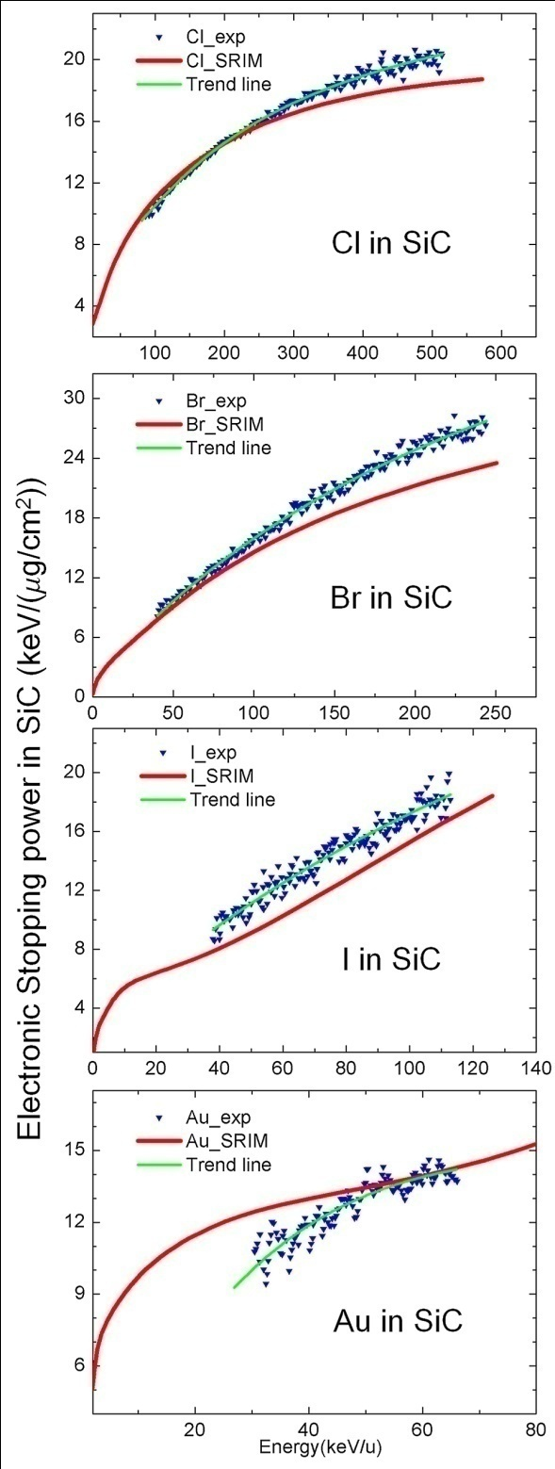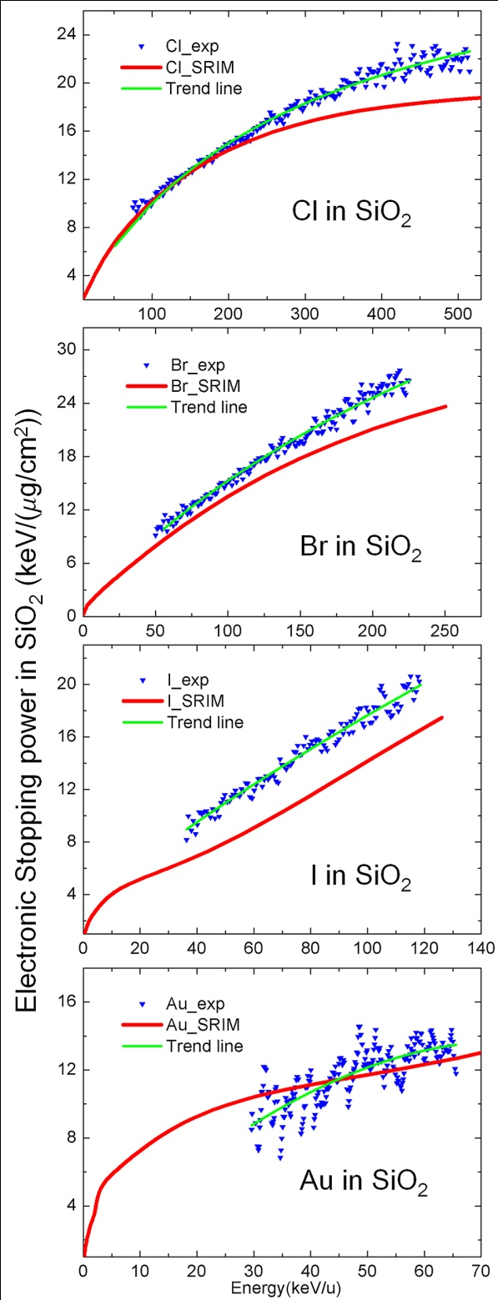
Fig. 3.1. Measured mean electronic stopping power of Cl, Br, I and Au ions in SiC (left) and SiO₂ (right) with the trend lines (Eq. 3.1) and the SRIM predictions.

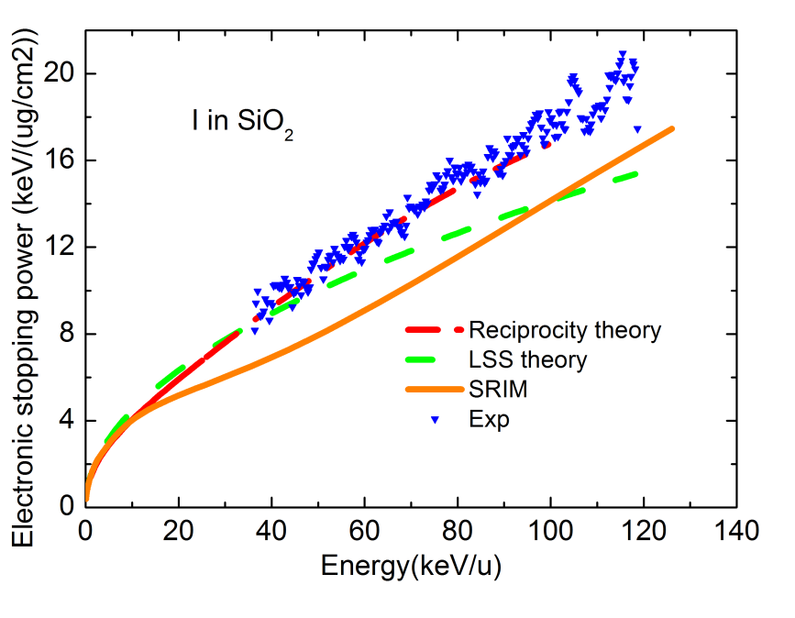
Fig. 3.2. Comparison of the electronic stopping power for I ions in SiO₂ between the measured data and the predictions by LSS theory, reciprocity theory and SRIM.

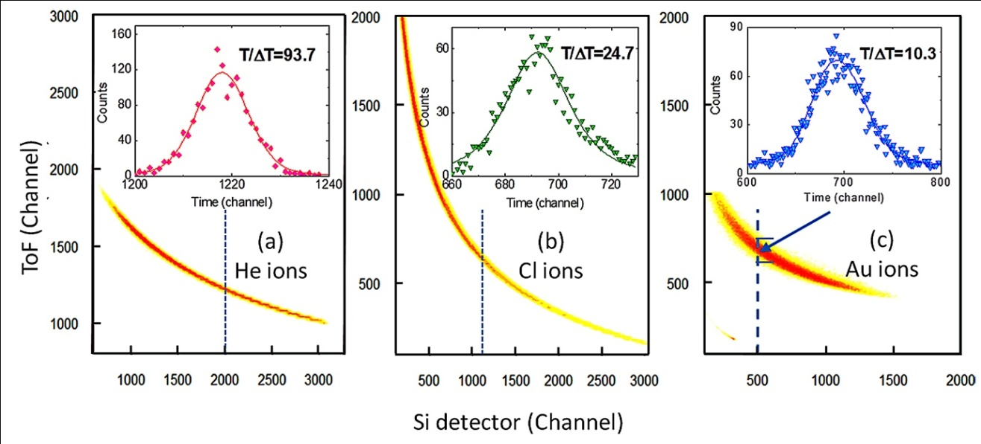
Fig. 3.3. Contour map of the Time-Energy correspondence for (a) He, (b) Cl, and (c) Au ions penetrating through the SiC stopping foils. ToF (channel) represents the energy before penetration; Si detector (channel) represents the energy after the penetration. The point density is represented in logarithmic scale. The insets are the time (corresponding to energy) distribution profiles for each selected Si detector channel (shown as vertical lines). It is clear that lighter ions have much better time (energy) resolution.

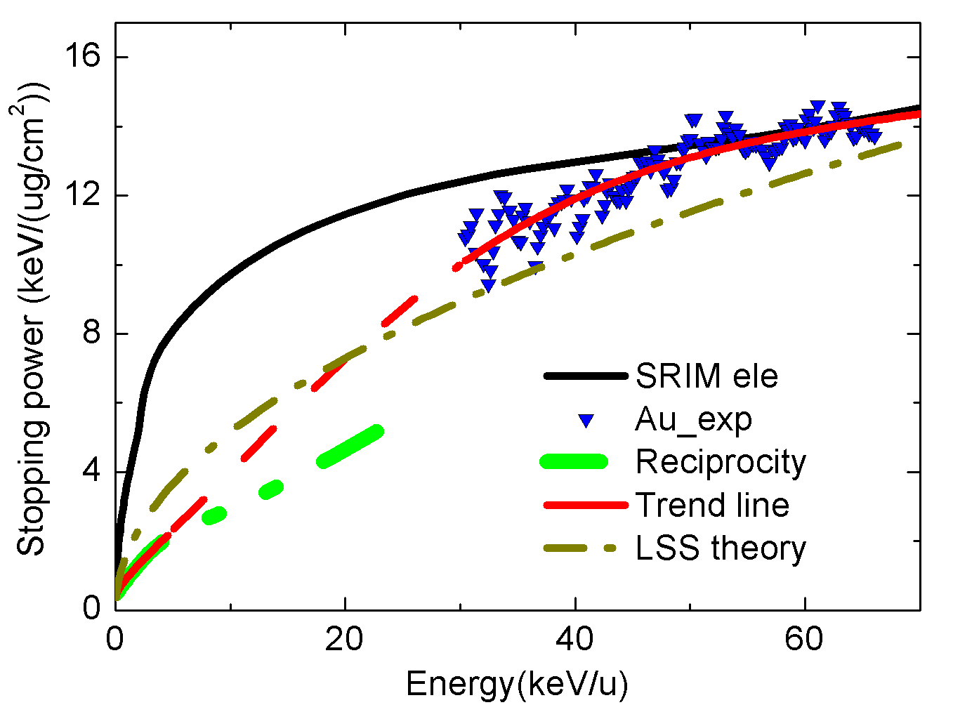
Fig. 3.4. Comparison between the measured data and the SRIM, LSS theory and reciprocity theory predicted electronic stopping powers for the Au ions in SiC. The red line is our derived trend line (Eq. 3.1). The solid line parts are the measured data (> 30 keV/u) or reciprocity predicted (<5 keV/u). The dash line is the extrapolation for connection between 5-30 keV/u.

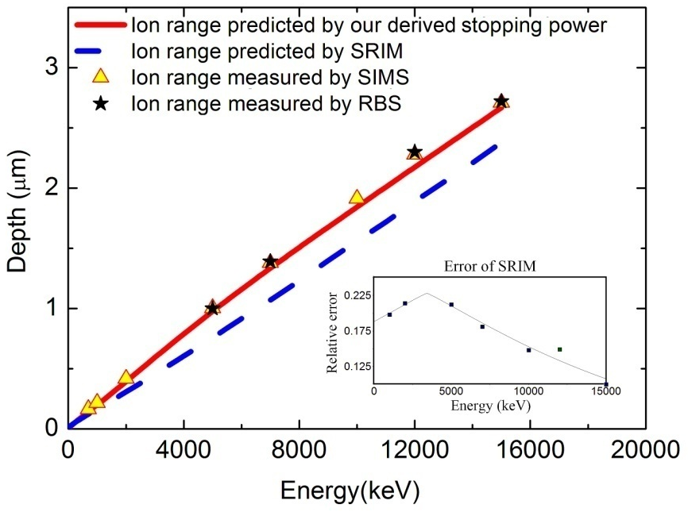
Fig. 3.5. Ranges of Au ions with different energies in SiC measured by SIMS (triangle) and RBS (star) as well as ion ranges predicted by SRIM (dash line) and this study (solid line). The SIMS results are the density corrected values assuming the 15% volume swelling. The inset shows the relative deviation between SRIM predictions and experimental results.

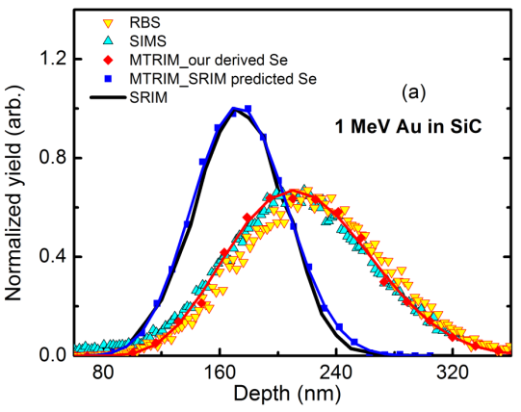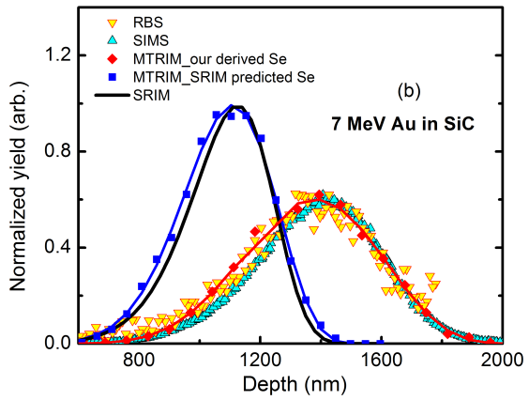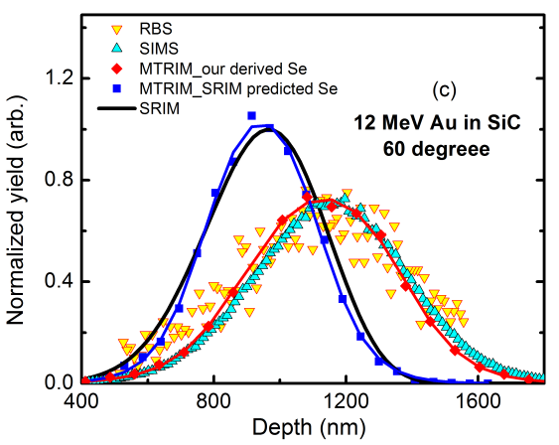
Fig. 3.6. Comparisons of ion distribution profiles for (a) 1, (b) 7, and (c) 12 MeV Au in SiC with measurements (RBS and SIMS), SRIM and M-TRIM predictions.

Chapter 4
Angular distribution and recoil effect for 1 MeV Au⁺ ions through a Si₃N₄ thin foil

4.1 Introduction
Transmission setups have been developed to directly measure the electronic stopping power.¹⁻³ The energy of ions before and after penetrating a thin foil is measured to determine the energy loss. Electronic stopping power can be determined directly by this method for light ions (H, He) and medium heavy ions (C, Si and etc.). For very heavy ions,^{3,4} however, nuclear energy loss is not negligible, and must be subtracted from the measured values in order to determine the correct electronic stopping power. In addition, due to the restriction of the collimator placed in front of the Si detector (as shown in Fig. 2.1), only part of the ions within a certain scattering angle can be detected. In order to accurately determine the electronic stopping power, reliable predictions of scattering angle and nuclear stopping power are critically important. Furthermore, due to the thickness limit of the stopping foil, in the lower energy regime (e.g., < 5 MeV), where the electronic stopping powers predicted by SRIM have been shown to have larger errors, the current transmission setup is not able to directly measure the stopping power. As an alternative approach, by measuring the depth distributions of implanted ions with different energies, total stopping power (nuclear plus electronic stopping power) can be derived. With accurate information of nuclear stopping power, the electronic stopping power can be reasonably estimated.³
The SRIM code has been widely used to predict the scattering process and the nuclear stopping power for decades.^{5,6} However, the predicted nuclear stopping powers of slow heavy ions may be overestimated due to the assumption of neutral atoms.⁷ Direct experimental validation of SRIM predicted nuclear stopping power and scattering angles, especially for very heavy ions in low energy regime, is insufficient. Recently, the reliability of SRIM predicted nuclear stopping power for slow heavy ions has been questioned,⁷ which makes direct measurement of angular scattering distributions critically important.
Historically, position-sensitive detectors were used to measure the angular distribution of light ions and medium heavy ions.⁸ However, the conventional detectors (i.e. Si detector) are problematic for measuring very heavy ions.⁹⁻¹¹ A time-of-flight spectrometer that could be continuously rotated was used to measure the angular distribution of Bi ions with 0.8 Bohr velocity though a C foil.¹² Unfortunately, this is not a standard instrument for most ion beam laboratories.
In this chapter, a new method is developed to measure the angular distribution of 1 MeV Au ions through a Si₃N₄ thin foil using ToF-SIMS. In addition, the thickness of the suspended Si₃N₄ foils under ion irradiation is measured as a function of ion fluence by ToF-SIMS, SEM and TEM.

4.2 Experimental
The experimental design and procedure are described in Sec. 2.3.

4.3 Irradiation induced thinning of the Si₃N₄ foils
The lateral distributions of the scattered Au ions implanted into the Si wafers with different fluences are shown in Fig. 4.1. Gaussian distributions are applied to fit the curves. Apparently, the distributions become narrower with increasing ion fluence. This trend is due to the thickness reduction of the suspended Si₃N₄ foils under ion irradiation.
ToF-SIMS is used to measure the thickness of both window and supported regions of each foil irradiated to different ion fluences. The measured thickness of a suspended foil by ToF-SIMS is always slightly smaller than the actual value, as the foil will break under sputtering when it is thinner than a certain value. In order to minimize this error, a virgin window is tested and the results are shown in Fig. 4.2 (a). The measured thickness of window region is ~3 nm less than that of the supported region, which indicates that the foil is broken under the sputtering condition when it is thinner than 3 nm. Figs. 4.2 (b) and (c) show the thickness differences between the window region and the supported region of the foils under 1 MeV Au irradiation with 1×10¹⁵ and 2×10¹⁵ cm⁻². After 1×10¹⁵ cm⁻² irradiation, the window region is 15 nm thinner than the virgin film (supported region). Considering the ~3 nm critical thickness, the film was thinned by ~12 nm during the irradiation (from 101 nm to ~89 nm). The window region after 2×10¹⁵ cm⁻² irradiation is 27 nm thinner than the virgin region, which means the foil was thinned by ~24 nm during the irradiation (from 99 nm to ~75 nm). The decrease in thickness is proportional to the ion fluences and the loss rate is ~112 atom/ion. The foil was completely destroyed after 1×10¹⁶ cm⁻² irradiation, which also supports this trend.
Although ToF-SIMS depth profiling measurements are simple and the above results seem straightforward, the uncertainty of the “critical foil thickness to break” in ToF-SIMS is a potential problem. To confirm the results from the ToF-SIMS measurements, SEM and TEM are used to investigate this thinning effect. Another virgin sample and a set of samples irradiated with 1×10¹⁵ and 2×10¹⁵ cm⁻² Au ions are prepared for the microscopy measurement. SEM is employed to measure the thickness of the window region of each sample, and the results are shown in Fig. 4.3 (a-c). TEM is employed to measure the thickness of the corresponding supported film of each sample, and the results are shown in Fig. 4.3 (d-f). For the virgin sample, the TEM measured thickness of the virgin region is 102.8 nm; the SEM measured window thickness of the region is 102 nm. For the sample under the 1×10¹⁵ cm⁻² irradiation, the virgin region is 95.2 nm thick, while the window region is 84 nm. For the sample under the 2×10¹⁵ cm⁻² irradiation, the virgin region is 100.8 nm thick, while the window region is 78 nm. The results clearly show that the thickness of the suspended Si₃N₄ foil is decreased by 11.2 nm under the 1×10¹⁵ cm⁻² irradiation, and by 22.8 nm under the 2×10¹⁵ cm⁻² irradiation. The measured change in thickness is also proportional to the ion fluence, and the loss rate is ~102 atom/ion. This value is only slightly smaller (9%) than the ToF-SIMS results, which is within the error range of the measurements.
Further measurements by ToF-SIMS show that the thickness change of the supported film under the same irradiation conditions is negligible compared to the window region (less than 1.5 nm under 1×10¹⁵ cm⁻² irradiation). This result reveals that the sputtering effect on the front surface (the surface facing the incoming beam) is negligible for 1 MeV Au ion perpendicular irradiation; the change in thickness is predominately due to the forward recoils from the back surface of the thin foil, similar to the electron beam drilling reported by previous work.¹³

4.4 Angular distribution of scattered ions
Comparisons between the measured angular distribution of scattered ions and the SRIM simulated results are shown in Fig. 4.4 for the fluence of 1×10¹⁵ and 2×10¹⁵ cm⁻². The deflection angles are determined by the radius in the Si wafer and the distance between the Si wafer and the Si₃N₄ foil (14.2 mm). Considering the thickness change of the foils, the average thicknesses before and after the irradiations (95 nm for 1×10¹⁵ cm² and 87 nm for 2×10¹⁵ cm⁻²) are used in the SRIM simulation. The distribution for the irradiation fluence of 1×10¹⁶ cm⁻² is not compared with SRIM, because the foil is totally destroyed and thus the average thickness cannot be identified. The error bars in Fig. 4.4 are mainly attributed to the background signal and the uncertainty in mass window selection during the SIMS measurement.
For both comparisons, SRIM reasonably predicts the angular distribution; however, the SRIM predicted distribution seems slightly wider than the measured distribution, indicating that SRIM may slightly overestimates the nuclear stopping power for 1 MeV Au in Si₃N₄. Previous experimental studies^{12,14} with a different measurement method showed a similar result: for Bi ions at 0.8 Bohr velocity (~4.2 MeV) penetrating through a 13.7 μg cm⁻² C foil, the SRIM predicted angular distribution is slightly wider than the measured result. In the comparisons with lighter Ne and Ar ions at the same velocity, these same authors found that the SRIM prediction is in better agreement.¹⁴
One factor that may lead to this overestimation is that the electronic stopping power for Au ions in compounds containing light elements is significantly overestimated by SRIM.³ Although the electronic stopping power contributes little to the angular scattering process, the average energy of ions penetrating the foils is underestimated by SRIM, which may cause the overestimation in scattering angles. Another important factor is that, as stated in Ref. ⁷, on the SRIM code: “In all cases of nuclear stopping, it is assumed that the ion is neutral and the target atom is in its normal crystalline state. All these assumptions make for errors, and make the nuclear stopping too large for low energies”. The observations in the present study provide experimental evidence that supports this statement. Considering the error in electronic stopping power stated above, the SRIM predicted nuclear stopping powers may be slightly larger (<10%) than the actual values, which is within the claimed error range by SRIM (18% for all ion-target combinations).^{6,7} Further theoretical work is needed to provide more accurate nuclear stopping powers for slow heavy ions. However, within the stated error range, SRIM is reliable to simulate the angular scattering process and to provide nuclear stopping power data.
It should be mentioned that, compared with the previous technique of angular distribution measurements,¹² the new method demonstrated in this work can be performed in most accelerator and ToF-SIMS laboratories with no special facility requirement, which can contribute to the development of the stopping database.

4.5 References
¹ Y. W. Zhang, Nucl. Instrum. Methods Phys. Res. B 196, 1 (2002).
² Y. Zhang, W. Weber, and C. Wang, Phys. Rev. B 69, 205201 (2004).
³ K. Jin, Y. Zhang, H. Xue, Z. Zhu, and W. J. Weber, Nucl. Instrum. Methods Phys. Res. B 307, 65 (2013).
⁴ temp.
⁵ J. F. Ziegler, SRIM-2013 (www.srim.org).
⁶ J. F. Ziegler, J. P. Biersack, and U. Littmark, The stopping and range of ions in solids. (Per-gamon Press, New York, 1985).
⁷ H. Paul, AIP Conf. Proceedings 1525, 309 (2013).
⁸ H. Krause, J. Barrett, S. Datz, P. Dittner, N. Jones, J. Gomez del Campo, and C. Vane, Phys. Rev. A 49, 283 (1994).
⁹ H. J. Whitlow and Y. Zhang, Nucl. Instrum. Methods Phys. Res. B 190, 375 (2002).
¹⁰ Y. Zhang and H. J. Whitlow, Nucl. Instrum. Methods Phys. Res. B 190, 383 (2002).
¹¹ Y. Zhang and W. J. Weber, Phys. Rev. B 82, 075202 (2010).
¹² H. Geissel, W. N. Lennard, H. R. Andrews, D. P. Jackson, I. V. Mitchell, D. Philips, and D. Ward, Nucl. Instrum. Methods Phys. Res. B 12, 38 (1985).
¹³ D. G. Howitt, S. J. Chen, B. C. Gierhart, R. L. Smith, and S. D. Collins, J. Appl. Phys. 103, 024310 (2008).
¹⁴ R. N. Sagaidak, V. K. Utyonkov, and F. Scarlassara, Nucl. Instrum. Methods Phys. Res. A 700, 111 (2013).

Appendix 4.1
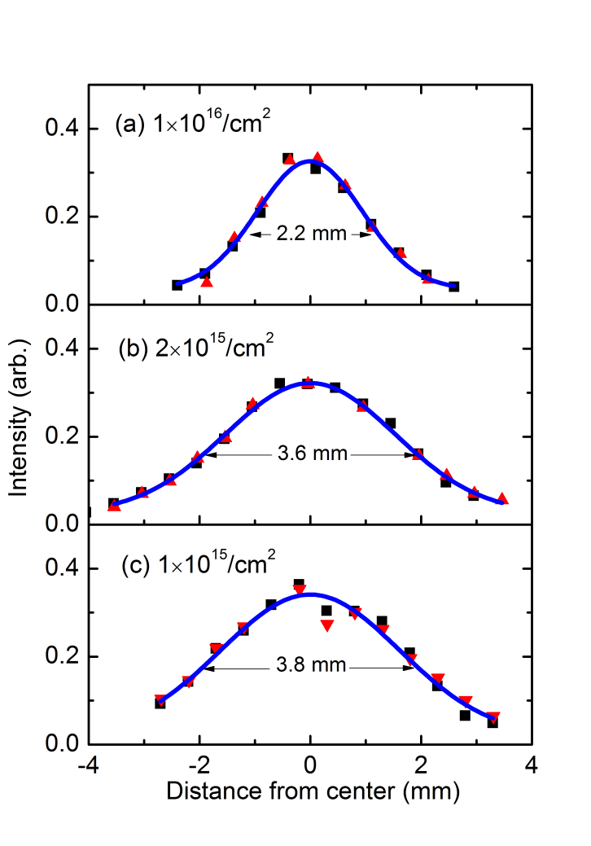
Fig. 4.1. Lateral distributions of the scattered Au ions implanted into the Si wafer with different irradiation fluences: (a) 1×10¹⁶ cm⁻², (b) 2×10¹⁵ cm⁻² and (c) 1×10¹⁵ cm⁻². Two types of spots indicate the two perpendicular scans along diameters.

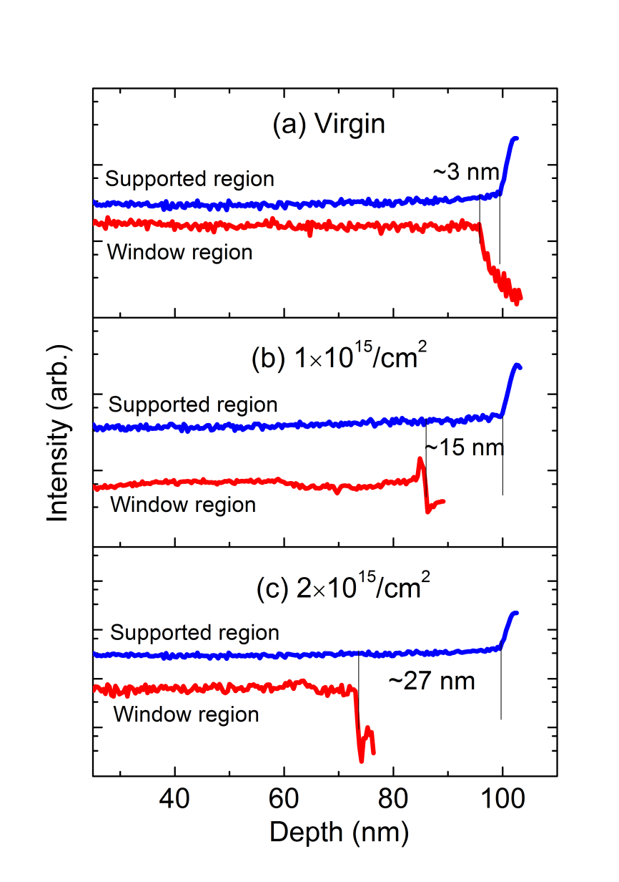
Fig. 4.2. The thickness measured by ToF-SIMS for both window regions (irradiated) and supported regions (virgin) of each sample with different fluences: (a) virgin sample, (b) 1×10¹⁵ cm⁻², and (c) 2×10¹⁵ cm⁻².

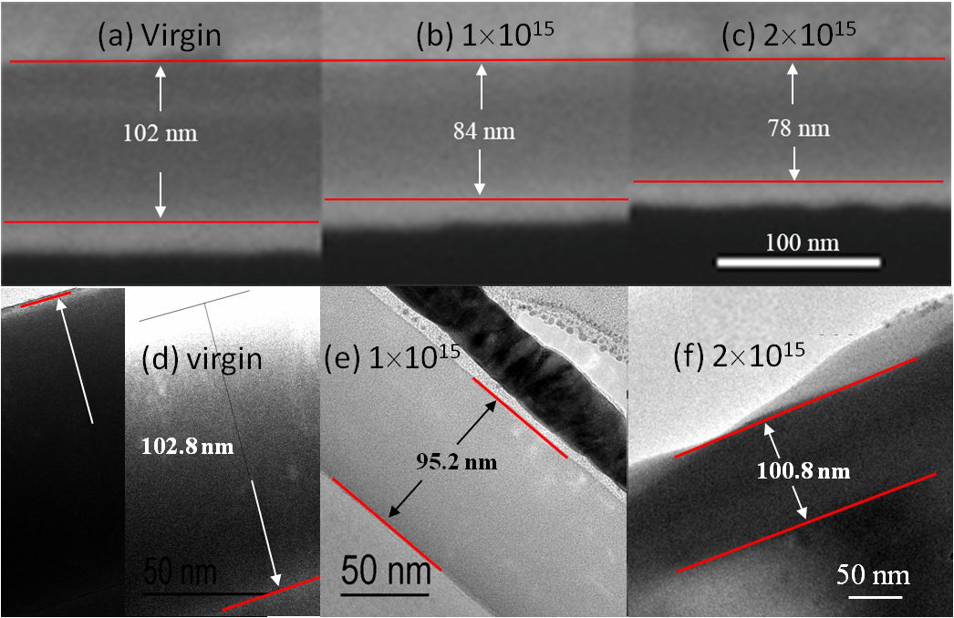
Fig. 4.3. SEM measurements on the thickness of window regions for (a) virgin sample and the samples after (b) 1×10¹⁵ cm⁻² and (c) 2×10¹⁵ cm⁻² irradiations. TEM measurements on the thickness of the supported regions of these three samples (d-f). In (d), the upper (left) and lower (right) boundaries are determined by adjusting the contrast.

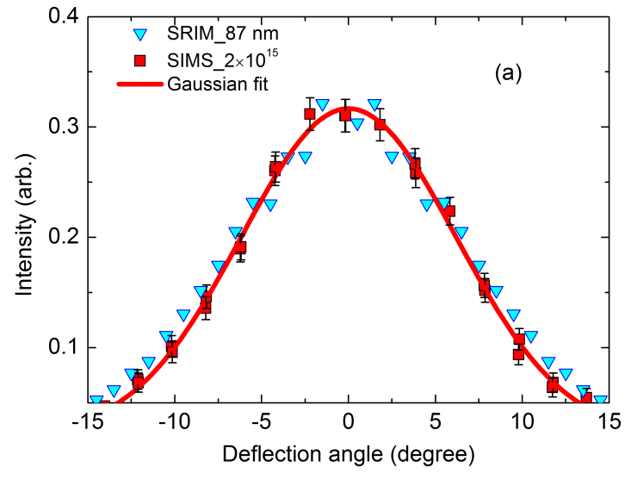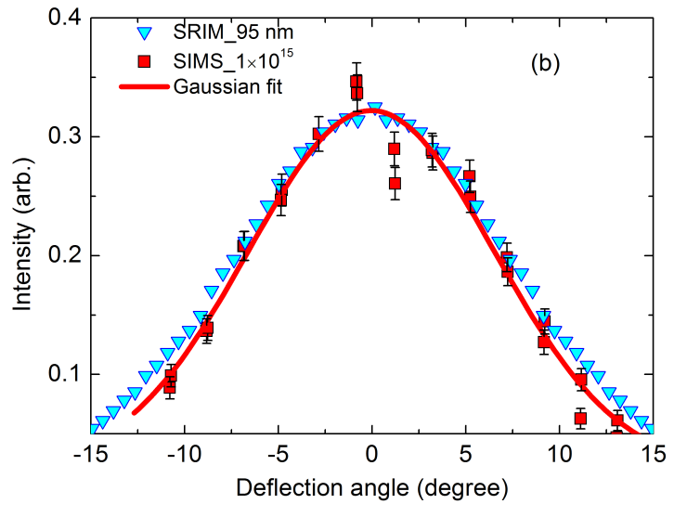
Fig. 4.4. Comparisons between the measurements and the SRIM predictions for the deflection angle of the transmitted ions with fluences of (a) 2×10¹⁵ cm⁻² and (b) 1×10¹⁵ cm⁻²

Chapter 5
Depth profile of Au ion irradiation in Si and MgO

5.1 Introduction
Experimental determination of electronic stopping power for heavy ions in ceramics containing light elements is highly desired.^{1,2} However, due to the experimental difficulties such as the challenge of fabricating high-quality thin foils and the easy oxidation of materials, the direct measurements of electronic stopping power for slow heavy ions is sometimes unavailable. In such cases, alternative approaches providing experimental electronic stopping power values are needed. As discussed in chapter 3, the depth profile (or range) of implanted ions is directly correlated to the total (electronic + nuclear) stopping power. On the other hand, the nuclear stopping power provided by SRIM has been generally considered reliable^{3,4} and it has also been experimentally validated in chapter 4 for 1 MeV Au ions through a Si₃N₄ thin foil. As a result, electronic stopping power can be derived from the depth profile of ions implanted into materials at different energies.⁵
It has been reported⁶⁻⁹ that the depth profile of both ions and defects may shift to deeper region if the ions are irradiated along low-index axial channels. Regarding the derivation of electronic stopping power, this channeling effect does not require much concern in the materials that are readily amorphized under ion irradiation such as Si¹⁰ and SiC.¹¹ This is because the measurement of ion distributions usually requires relatively high fluences to achieve good statistics, and thus most of the ions travel in amorphous targets. However, in some other materials that are hardly amorphized under ion irradiation at room temperature, e.g. MgO,¹²⁻¹⁴ the channeling effect must be carefully considered when analyzing the measured ion or damage profiles.
Although the channeling effects of low energy ion irradiation along axial channels have been extensively studied, the effect of MeV-ion irradiation along planar channels, especially its effects on the damage profile has not drawn adequate attention. This issue cannot be ignored in MgO due to its open rock-salt structure. For example, increased skewness is observed in the depth profiles of implanted ions in previous studies in MgO¹⁴⁻¹⁶, which is not commonly observed in most other materials of interest (see the comparison between the Fig.1 for MgO and Figs. 2 and 3 for SrTiO₃ and LiNbO₃ in Ref. ¹⁵). Previous experimental results^{15,17} have demonstrated that the distributions of implanted Au and Ag ions are not changed after 1 hour thermal annealing at 600 °C and 900 °C, respectively, indicating that the asymmetric ion profile is not attributed to the thermal migration of the implanted ions. Instead, it can be reasonably expected that the channeling effect may be a major contribution.
In this chapter, RBS and ToF-SIMS are utilized to measure the implanted Au ion distribution in Si from 1 to 15 MeV. The electronic stopping power for Au ions in Si is estimated based on the measured ion profiles. In addition, the ion and damage profiles are measured for Au ions irradiated in MgO single crystals along various directions. The channeling effects are studied for the irradiations along axial and planar channels.

5.2 Experimental
The depth profile measurements by both RBS and ToF-SIMS are described in Sec. 2.4. The ion channeling technique is described in Sec. 2.5. The ion irradiation is described in Sec. 2.6.
Specifically in this chapter, the Si wafers are implanted with Au ions with energies of 1, 2, 4, 6, 10 and 15 MeV, at the fluence of 5×10¹⁵ cm⁻². 3.5 MeV He ion is used for RBS measurements. The (100)-oriented (CrysTec, Berlin, Germany) and (110)-oriented (MTI Corporation, Richmond, CA, USA) MgO are implanted with 1 and 4 MeV Au ions. The fluences were chosen at 5×10¹⁵ and 1×10¹⁴ cm⁻². The high fluence is used to achieve good statistics of the RBS yield from Au signals, while the low fluence is used to keep the sample at relatively low damage level to avoid the shift of defect distribution^{18,19} (see detail in chapter 6). Various irradiation directions are chosen for comparisons and will be discussed in detail in Sec. 5.4. 2.0 MeV He ion is used for RBS measurements on Au ion distribution while 3.0 MeV He ion is used for RBS channeling measurements on the MgO damage profile.

5.3 Electronic stopping power derived from the Au ion profiles in Si
Au ion distributions in Si
Fig. 5.1 shows the SIMS and RBS measured depth profiles of implanted Au ions in Si with the energies of 1 and 6 MeV. The SRIM predictions are also shown for comparisons. Comparing RBS and SIMS results, ~3% difference in peak positions is observed. As discussed in chapter 3, this difference is mainly attributed to the volume swelling induced by high fluence ion irradiations, which agrees with the previous studies on Si irradiated with Si ions.²⁰ Considering this volume swelling, the RBS and SIMS measurements agree well with each other, but the SRIM predicted ion distributions for both energies are considerably shallower than the measured results.
The peak positions of the Au ion distributions from 1 to 15 MeV measured by SIMS are shown in Fig. 5.2. The SRIM calculated peak positions and the ion ranges are also plotted for comparisons. The density of pre-irradiated Si, 2.321 g/cm³, is used in SRIM calculations for convenient comparison with literatures. Thus, the SIMS results are correspondingly corrected by 3% volume swelling for consistency. The minor difference between the peak positions and the ion ranges shown in SRIM is attributed to the slight asymmetry in the ion profiles, which does not affect the comparisons in this study. It is clearly shown that SRIM underestimates the ranges of implanted Au ions. This result agrees with the study of Au ions in SiC, demonstrated in chapter 3.
Electronic stopping power for Au ions in Si
The relationship between electronic stopping power and ion ranges is described by Eq. (3.3) and (3.4). According to these equations, the difference in ion ranges (or in the peak positions of ion distributions) between two energies is proportional to the reciprocal of the “average” total stopping power within this energy interval. This relationship has been experimentally demonstrated for Au ions in SiC:⁵ the ratios of SRIM predicted to measured peak position difference between two energies agree well with the ratios of the measured to SRIM predicted average total stopping power within the corresponding energy intervals. Using this relationship, the “average” electronic stopping power between two adjacent energies can be derived by comparing the measured peak positions of these two energies with the SRIM predictions. Although this is a crude estimate method, it can provide a general trend of the electronic stopping power curve as a function of energy for the ion-solid combinations in which the direct measurement is not available.
Fig. 5.3 shows the electronic stopping powers calculated from the data shown in Fig. 5.2. The nuclear stopping values in this calculation are based on SRIM prediction. A smooth curve is made to show the trend. The electronic stopping power curves from the predictions of SRIM and reciprocity theory²¹ are also shown for comparisons. The results show that SRIM significantly overestimates the electronic stopping power in the low energy regime, while the SRIM prediction and our derived curve match well at the Au energies of ~10 MeV. On the other hand, our derived electronic stopping power curve follows the trend of reciprocity from the low energy regime, while the unusual curvature in the reciprocity curve is believed to be an error from the SRIM predicted electronic stopping power for Si ions in Au, as discussed in chapter 3.
Regarding the comparisons between our derived curve and SRIM as well as the reciprocity theory predictions, the result in this study agrees well with the case of Au ions in SiC, as shown in Fig. 3.4. This good agreement demonstrates that the direct measurement of energy loss and the indirect derivation from the ion profile can be used as complementary methods to determine the electronic stopping power. This is beneficial to enrich the experimental database of the electronic stopping power for heavy ions in solids.

5.4 Channeling effects on the depth profile of Au ions irradiated in MgO
Sample stages in regular ion beam analysis laboratories allow rotations along three orthogonal axes, as shown in Fig. 5.4 (a). Figs. 5.4 (b) and (c) show the 2-D angular scans of <100> and <110>-oriented MgO samples mounted on the sample holder with their edges parallel or perpendicular to the rotation axes. The low-index axial and planar channels can be clearly seen in the Figs. 5.4(b) and (c) with the rotation of θ and φ.
Fig. 5.5 (a) shows the depth-profiles of 1 MeV Au ions irradiated into MgO (100) at the fluence of 5×10¹⁵ cm⁻² along various directions, measured by RBS. The two angle values of each ion profile indicate the rotation of samples along θ and φ during implantation (see Fig. 5.4 (a)). The ion profiles are clearly divided into three groups: (0°, 0°), (7°, 0°)/ (7°, 2°), and (7°, 5°)/ (15°, 5°)/ (15°, 7°). These three groups are corresponded to the irradiations along the axial channel, planar channel and “off-channel” directions, respectively. This result clearly demonstrates that the range and skewness of implanted ion distributions are both increased in both axial and planar channeling irradiation.
Note that the (7°, 2°) spectrum overlaps with the (7°, 0°) spectrum rather than the (7°, 5°) spectrum. In fact, the width of planar channel is generally proportional to (Z/E)^{1/2} ${(Z/E)}^{1/2}$, where Z and E are the atomic number and the energy of incident ions²². The critical angle of the (100) planar channel in MgO for 2.0 MeV He ions is 0.245°.²² Thus, it can be expected that the half angle for 1 MeV Au is ~2.4°, making the (7°, 2°) irradiation fall into the planar channel.
Fig. 5.5 (b) shows the depth profile measured by ToF-SIMS for 4 MeV Au irradiated MgO (100) with the rotation of (7°, 2°). Although the ion range is much deeper than the SRIM prediction (will be discussed in detail in Sec. 5.6), no observable channeling effect is shown in the depth profile. The difference in the ion distributions along the same direction between the two energies can be explained by the fact that the critical angle for 4 MeV Au is about a half of that for 1 MeV Au, i.e. ~1.2°. Consequently, the rotation of (7°, 2°) can fully avoid the (100) planar channels.
It is necessary to mentioned that, for 1 MeV Au, observable “tail” even exists in the irradiations along (7°, 5°), (15°, 5°) and (15°, 7°), so-called “off channel” angles. This could be attributed to two contributions. Firstly, when rotating large φ in order to fully avoid the (100) planar channel, the ions could fall into other higher index planar channels (which may not be obviously seen in Fig. 5.4) due to the large critical angles. Secondly, due to the open structure of MgO, the off channel ions may fall into a channel after several collision or scattering events (so-called the post-collision channeling effect). Despite multiple attempts in this study on rotating the samples, the channeling effect could not be fully eliminated for 1 MeV Au. As a result, if the purpose of a research requires strict “random” irradiation condition, either higher energy or lighter ions may be necessary.
MgO samples are usually cut with edges parallel to the main crystalline axes. While the main axial channel may be avoided by solely rotating either θ or φ, the wide planar channels may not be completely avoided, as shown in both Figs. 5.4(b) and (c). Thus, although “a few degrees (usually 7°) off axial channel)” is a regular method to minimize the channeling effect in previous literatures,^{23,24} rotating both θ and φ simultaneously and sufficiently is necessary to avoid both axial and planar channels.

5.5 Channeling effects on the damage profile of MgO under Au ion irradiation
Channeling irradiations in MgO along axial and planar channels not only affect the ion distribution but also affect the damage level and damage range. Fig. 5.6 (a) shows the RBS channeling spectra for 1 MeV Au ion irradiated MgO (110) at the fluence of 1×10¹⁴ cm⁻² along different irradiation directions. The disorder levels derived from these spectra are shown in Fig. 5.6 (b). It is clearly observed that the irradiations along both axial and planar channels significantly reduce the damage level. Comparing with the off channel irradiation, the peak damage level is decreased by ~30% in the planar irradiation, while the decrease for axial channel is ~60%. In addition, the damage ranges of channeling irradiations are larger than that in the off channel irradiation. The corresponding implanted ion profiles, measured by SIMS, are shown in Fig. 5.6 (c).
The decrease of the peak damage level indicates the decrease of nuclear energy deposition or nuclear stopping power, which is also accounted for the deeper penetration of the ions. Previous studies have also shown that the electronic stopping power is smaller in channeling irradiation for the light ions (e.g. He²⁵), but further experiments are needed to examine this issue for the heavy ion cases in MgO.
It is also important to note that the channeling irradiation effect on the ion channeling profile in MgO appears similar to the effect of thermal migration to some extent. Comparing with previous results, e.g. Fig. 1 in Ref. ²⁴, two features are observed in both channeling effect and thermal annealing effect: (1) the damage level is decreased and (2) the damage is extended to deeper region. Thus, misinterpretation may happen if the channeling irradiation (especially along planar channels) is not avoided, or its effect is not taken into account.

5.6 Electronic stopping power for Au ions in MgO
As stated in Sec. 5.4, large discrepancy is observed between the SRIM predicted and the measured ion distributions for 4 MeV Au in MgO (Fig. 5.5 (b)) although the channeling irradiation effect is not observed. The projected ion range predicted by SRIM is 578 nm, while the value determined by the SIMS measurement is ~773 nm (∑R_{i}n_{i}/N_{i}, where n_{i} is the amount of ions with the range of R_{i}, and N is the total amount of ions), which is slightly smaller (<3%) than the peak position of 795 nm. Taking the potential irradiation-induced volume swelling (up to ~3%²⁶) into consideration, the underestimation by SRIM value is still ~23-25%, which is far beyond the experimental uncertainties. For the case of 1 MeV Au ions, only the peak position rather than the ion range from the measured result should be used for evaluation because of the residual channeling effect (i.e. the existence of the “tail”). Fig. 5.5 (a) shows that the peak position of 1 MeV Au ions in MgO (100) is ~167 nm as determined by RBS (corrected for the tilted angles during implantation). The SIMS determined value for 1 MeV Au ions in MgO (110) is 172 nm (Fig. 5.6 (c)). Considering the possible volume swelling and the experimental uncertainties, the SIMS result is in consistent with the RBS result. In contrast, the SRIM predicted peak position for 1 MeV Au in MgO is ~158 nm (the ion range is 154 nm), which is ~8% less than the measured values.
Although no data from direct measurement of the electronic stopping power for Au ions in MgO in this energy regime is available, some theoretical models can be used for comparison. Fig. 5.7 shows the electronic stopping power for Au ions in MgO predicted by SRIM²⁷, LS model²⁸ and the reciprocity theory²¹. Apparently, these three commonly used theories provide significantly inconsistent predictions. Note that the use of reciprocity theory relies on the reliable stopping power data for the light ions. SRIM usually provides reasonable predictions on the electronic stopping powers for light ions. However, it has been found that the SRIM predicted electronic stopping power for Mg ions in Au is significantly smaller than the experimental results²⁹ in the energy region of interest. This may be the reason why the predicted values from reciprocity theory appear too low.
According to Eq. (3.3) and (3.4), the calculated ion ranges of 1 and 4 MeV Au in MgO are 173 and 668 nm based on the electronic stopping power values from the LS model. For 1 MeV Au, the calculated value agrees with the measured values, indicating the electronic stopping power in LS model may be reasonable with energies lower than 1 MeV. For 4 MeV Au, the calculated value is still smaller than the measured values but is much closer to the experiments than the SRIM predictions, indicating that the electronic stopping power given by the LS model may be slightly larger than the actual value but is more reasonable than the SRIM prediction. This result qualitatively agrees with the study for Au ions in SiC¹.

5.7 References
¹ K. Jin, Y. Zhang, Z. Zhu, D. A. Grove, H. Xue, J. Xue, and W. J. Weber, J. Appl. Phys. 115, 044903 (2014).
² P. Sigmund, Nucl. Instrum. Methods Phys. Res. B 135, 1 (1998).
³ D. J. O'Connor and J. P. Biersack, Nucl. Instrum. Methods Phys. Res. B 15, 14 (1986).
⁴ H. Geissel, W. N. Lennard, H. R. Andrews, D. P. Jackson, I. V. Mitchell, D. Philips, and D. Ward, Nucl. Instrum. Methods Phys. Res. B 12, 38 (1985).
⁵ K. Jin, Y. Zhang, H. Xue, Z. Zhu, and W. J. Weber, Nucl. Instrum. Methods Phys. Res. B 307, 65 (2013).
⁶ F. Schrempel, T. Steinbach, Th Gischkat, and W. Wesch, Nucl. Instrum. Methods Phys. Res. B 266, 2958 (2008).
⁷ Z. Zolnai, A. Ster, N. Q. Khanh, G. Battistig, T. Lohner, J. Gyulai, E. Kotai, and M. Posselt, J. Appl. Phys. 101, 023502 (2007).
⁸ Dearnale.G, J. H. Freeman, G. A. Gard, and M. A. Wilkins, Can. J. Phys. 46, 587 (1968).
⁹ M. Posselt, M. Mader, R. Grotzschel, and M. Behar, Appl. Phys. Lett. 83, 545 (2003).
¹⁰ S. Roorda, W. C. Sinke, J. M. Poate, D. C. Jacobson, S. Dierker, B. S. Dennis, D. J. Eaglesham, F. Spaepen, and P. Fuoss, Phys. Rev. B 44, 3702 (1991).
¹¹ W. Jiang and W. J. Weber, Phys. Rev. B 64, 125206 (2001).
¹² E. Friedland, Nucl. Instrum. Methods Phys. Res. B 80-81, 128 (1993).
¹³ E. Wendler, K. Gärtner, and W. Wesch, Nucl. Instrum. Methods Phys. Res. B 257, 488 (2007).
¹⁴ H Ogiso, S Nakano, and J Akedo, Nucl. Instrum. Methods Phys. Res. B 206, 157 (2003).
¹⁵ K. Takahiro, A. Kunimatsu, S. Nagata, S. Yamaguchi, S. Yamamoto, Y. Aoki, and H. Naramoto, Nucl. Instrum. Methods Phys. Res. B 152, 314 (1999).
¹⁶ Z. Mao, Z. He, D. Chen, W. Y. Cheung, and S. P. Wong, Solid State Communications 142, 329 (2007).
¹⁷ R. L. Zimmerman, C. I. Muntele, and D. Ila, Surf. Coat. Technol. 196, 85 (2005).
¹⁸ I. O. Usov, P. N. Arendt, and K. E. Sickafus, Nucl. Instrum. Methods Phys. Res. B 268, 622 (2010).
¹⁹ E. Friedland, Nucl. Instrum. Methods Phys. Res. B 80/81, 128 (1993).
²⁰ P. K. Giri, V. Raineri, G. Franzo, and E. Rimini, Phys. Rev. B 65, 012110 (2001).
²¹ P. Sigmund, Euro. Phys. J. D 47, 45 (2008).
²² S. D. Mukherjee and D. W. Palmer, Phys. Lett. 69A (1979).
²³ E. Friedland and M. Hayes, Nucl. Instrum. Methods Phys. Res. B 65, 287 (1992).
²⁴ I. O. Usov, P. N. Arendt, J. R. Groves, L. Stan, and R. F. DePaula, Nucl. Instrum. Methods Phys. Res. B 243, 87 (2006).
²⁵ L. Shao and M. Nastasi, Appl. Phys. Lett. 87, 064103 (2005).
²⁶ G. F. Hurley, J. C. Kennedy, Jr. F. W. Clinard, R. A. Youngman, and W. R. McDonell, J. Nucl. Mater. 103-104, 761 (1981).
²⁷ J. F. Ziegler, (www.srim.org).
²⁸ J. Lindhard, M. Scharff, and H.E. Schioett, Mat. Fys. Medd. K. Dan. Vidensk. Selsk. 33, 1 (1963).
²⁹ K. Arstila, J. Keinonen, and P. Tikkanen, Phys. Rev. B 41, 6117 (1990).

Appendix 5.1

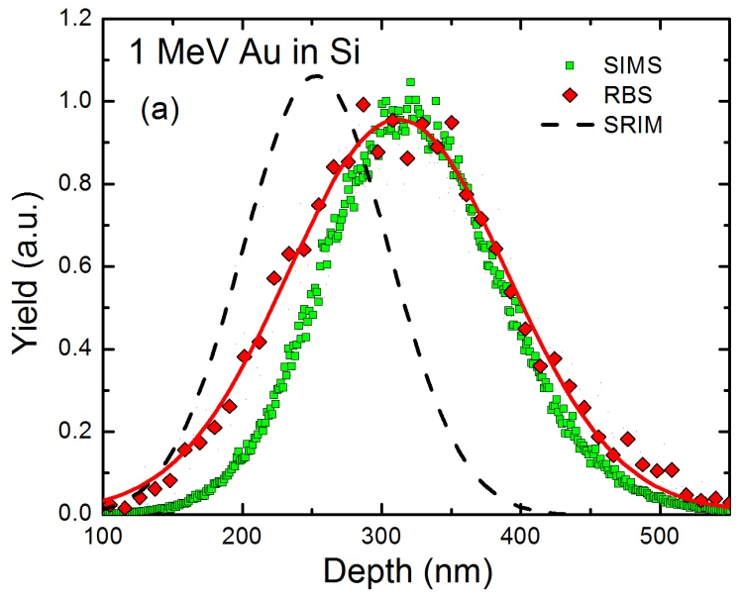
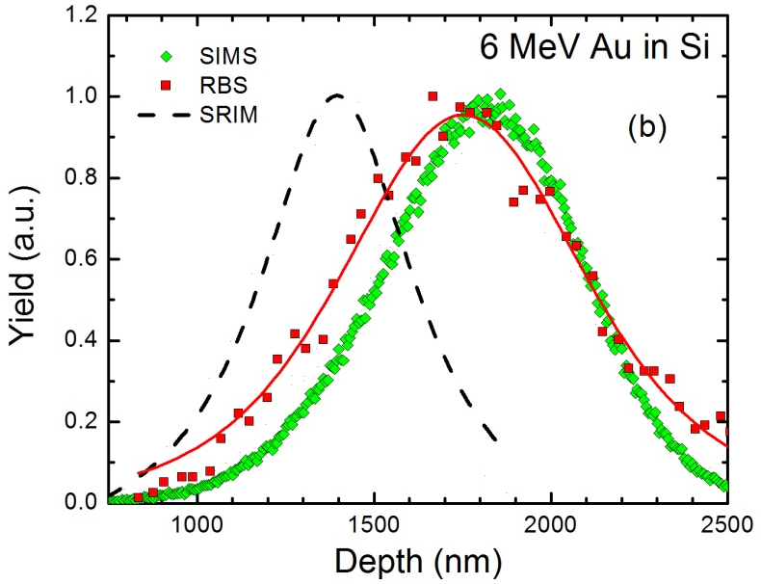

Fig. 5.1. SIMS and RBS measured depth profiles of implanted Au ions with (a) 1 MeV and (b) 6 MeV. SRIM predicted results are also shown for comparison.

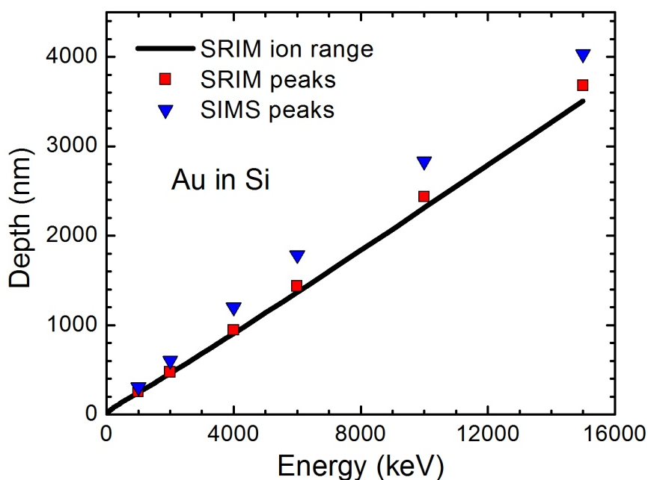
Fig. 5.2. Peak positions of the depth profiles of Au ions with different energies in Si, measured by SIMS (blue triangles) and predicted by SRIM (red squares). The ion ranges predicted by SRIM is shown as the solid line. The SIMS results are the density corrected values assuming the 3% volume swelling.

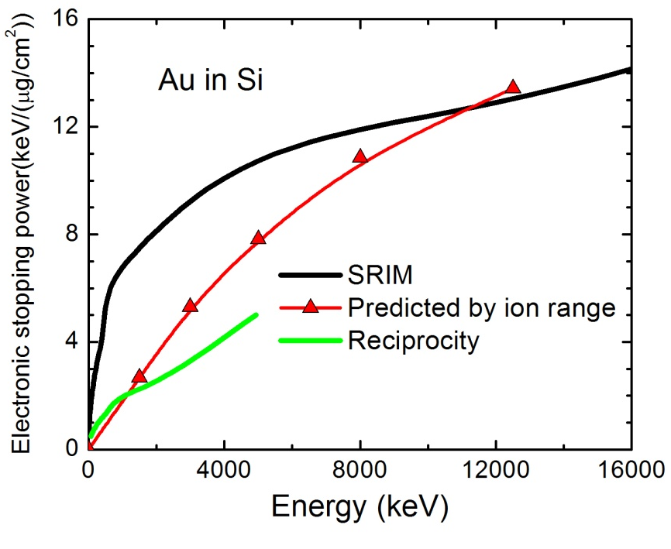
Fig. 5.3.Electronic stopping powers calculated based on the data in Fig. 5.2 (Red triangles). The predictions from SRIM (black line) and the reciprocity theory (green line) are also shown for comparisons.

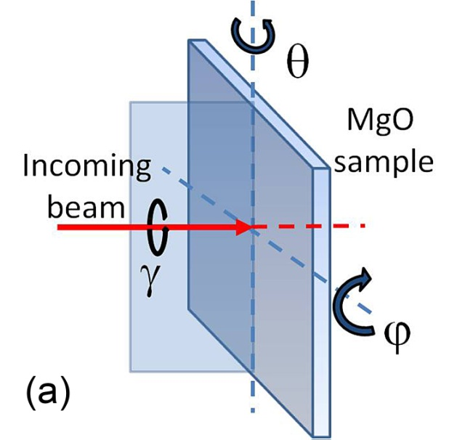
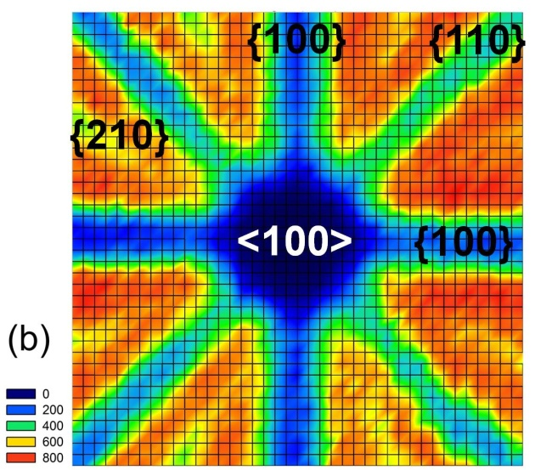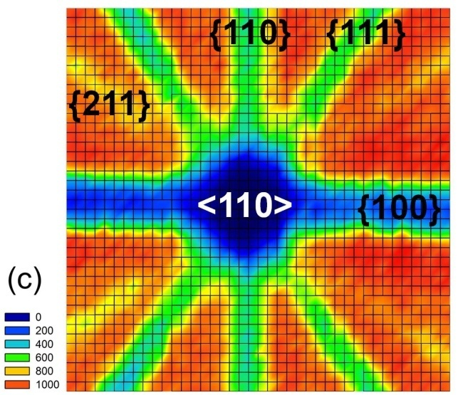
Fig. 5.4. (a) Geometric configuration of the rotations of the MgO sample. (b), (c) Contour maps of the 2-D angular scan (θ as horizontal and φ as vertical axes) of MgO (100) and (110), respectively. The scanning range is ±1.44° and the step length is 0.072°

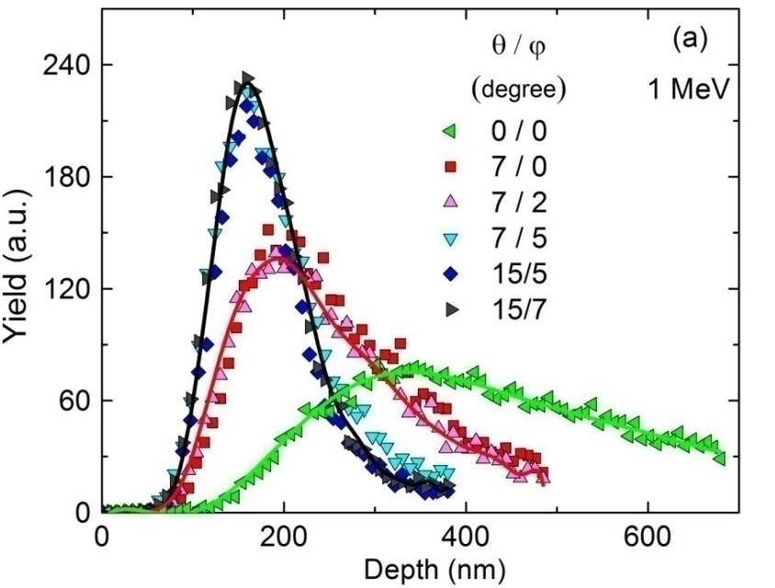
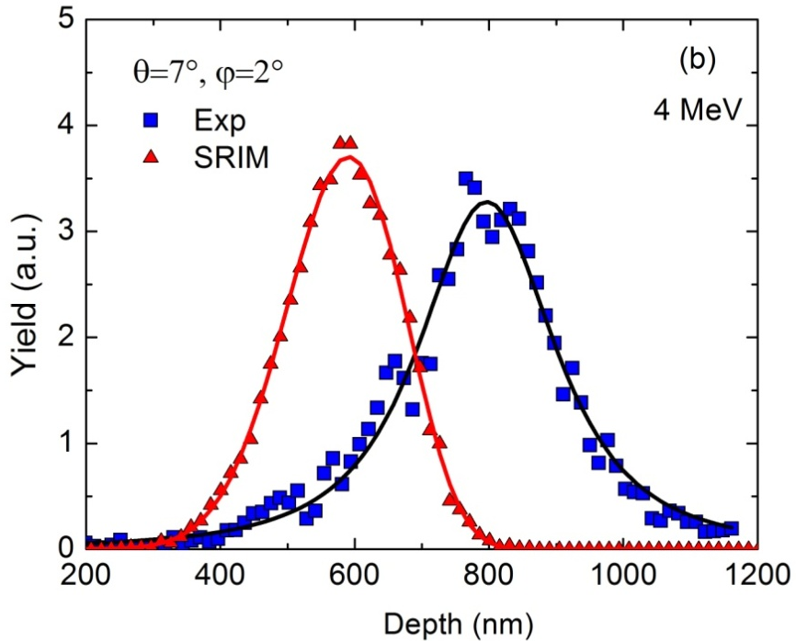
Fig. 5.5. (a) Depth profiles of 1 MeV Au ions irradiated in MgO (100) along various directions, measured by RBS. (b) Depth profile of 4 MeV Au ions irradiated in MgO (100) along (θ, φ) = (7°, 2°), measured by ToF-SIMS. The SRIM prediction is presented for comparison. The solid lines are to guide the eyes.

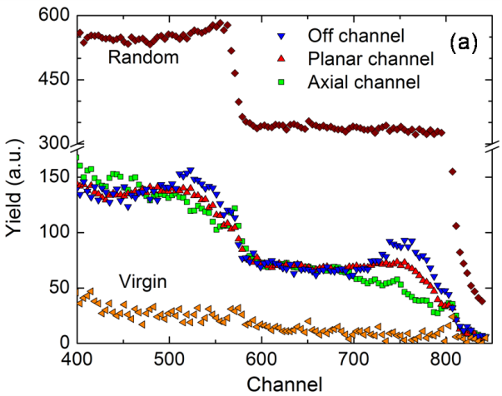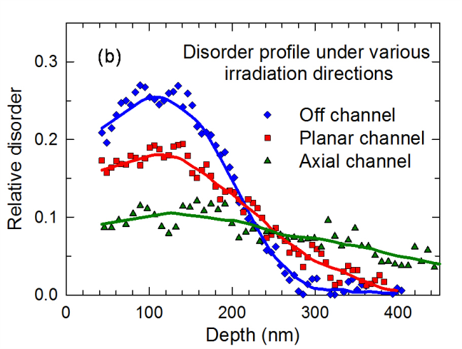
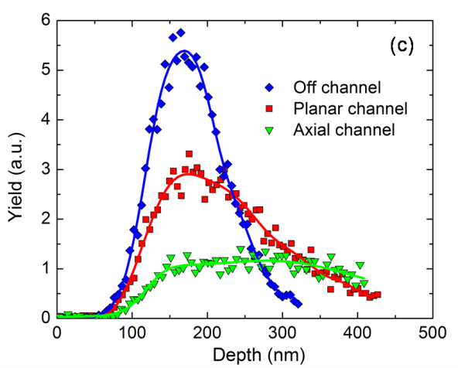
Fig. 5.6. (a) RBS channeling spectra, (b) derived disorder profile from (a), and (c) SIMS measured depth profiles of 1 MeV Au ions irradiated in MgO (110) along the directions of axial channel, planar channel, and off channel. The irradiation fluence is 1×10¹⁴ cm⁻². The solid lines are to guide the eyes.

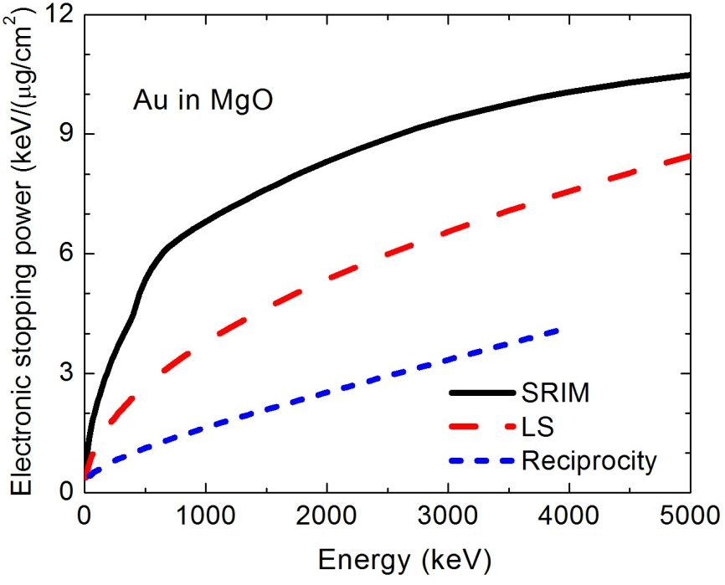
Fig. 5.7. Electronic stopping powers for Au ions in MgO predicted by SRIM, LS model and reciprocity theory.

Chapter 6
Effects of nuclear and electronic energy deposition on defect evolution in MgO

6.1 Introduction
Irradiation effects of MgO have been extensively studied for decades (e.g. ¹⁻¹³) for its promising applications in nuclear engineering. For example, MgO is proposed as a candidate material used in inert matrix fuel due to its high melting temperature, high thermal conductivity, and high irradiation tolerance^{14,15}. MgO is also a typical modeling ionic ceramic in the studies of ion-solid interaction, due to its simple chemical and crystalline structure.
However, as is discussed in chapter 1, understanding the defect evolution in MgO is a long-standing challenge. Heavy ion irradiation induces complex damage process involving point defects, dislocations, and randomly disordered region^{10,16}. Significantly deeper than expected damage range has been reported under high fluence irradiations with different ions at different energies.^{1,5,13,17} No agreement has been achieved on interpreting these results.
In contrast to the extensive studies on the damage evolution induced by nuclear energy deposition, the effects of electronic energy deposition on the defect evolution in MgO have not been well studied. Competitive effect between nuclear and electronic energy deposition has recently been observed under dual beam irradiations,^{18,19} while the mechanism underneath has not been adequately understood.
In this chapter, the defect evolution under nuclear and electronic energy deposition is studied using RBS channeling technique. Cross-sectional TEM is applied as a complementary technique to interpret the ion channeling results.

6.2 Experimental
The defect evolution under heavy ion irradiation is studied under two modeling circumstances: nuclear energy loss dominant and electronic energy loss dominant. 1.0 MeV Au ion is selected for the first case, while 21 MeV Ni ion is used for the second one. According to SRIM, the nuclear and electronic stopping powers of 1 MeV Au in MgO is 4.7 and 2.4 keV/nm, respectively. However, according to the result in chapter 5, this electronic stopping power value is not reliable. Instead, the LSS value, 1.3 keV/nm, is more convincing. For 21 MeV Ni, the SRIM predicted values of nuclear and electronic stopping power are 0.08 and 9.4 keV/nm. In this case, most (>99%) of the energy deposition is from the electronic stopping.
In order to study the defect build-up and evolution under nuclear energy deposition, 1 MeV Au ions are irradiated to the fluences ranging from 2×10¹³ to 5×10¹⁵ cm⁻². In order to study the effects of electronic energy deposition on the evolution of existing defects in MgO, 1 MeV Au ions are irradiated into MgO at the fluence of 1×10¹⁴ cm⁻² to induce the initial damage. The initial damage is induced at both room temperature (~300 K) and low temperature (~193 K). The damaged samples are further irradiated with 21 MeV Ni ions under room temperature to the fluence up to 6.5×10¹⁵ cm⁻².
The technical details of ion irradiations are described in Sec. 2.6. The ion channeling studies are described in Sec. 2.5. TEM observations were carried out at 200 keV with a Zeiss Libra 200MC TEM/STEM.

6.3 Defect evolution in MgO under nuclear energy deposition
Fig. 6.1 shows the RBS/channeling spectra of MgO irradiated at various fluences at room temperature. There appear two stages in the damage evolution within this fluence range. The first stage ranges from 2×10¹³ to ~2.5×10¹⁴ cm⁻², corresponding to the peak dose from 0.08 to 1 dpa. In this stage, damage accumulation is observed. Since the damage peak exists in the channeling spectra, the defect type can be expected to include point defects or local amorphous regions, which agrees with the previous experimental results.¹ With further irradiations after 2.5×10¹⁴ cm⁻², two phenomenon are observed. Firstly, the damage level is decreased at the depth of dpa peak and where closer to the sample surface. Secondly, the damage peak appears to shift to deeper region. For example, with the fluence of 2.5×10¹⁵ cm⁻², 10 times higher than the fluence corresponding to the maximum damage, the damage peak is shifted to ~320 nm which is much deeper than that for low fluences.
Ion channeling technique is strong at quantifying point defects and providing the depth information. However, it provides limited information on the detailed structural information of higher dimensional defects, especially when different types of defect are mixed together. As a result, cross-sectional TEM is employed to further investigate the defect structure. Fig. 6.2 shows the high resolution (HR) TEM images and the corresponding diffraction patterns from Fast-Fourier-Transform (FFT) of the MgO irradiated with 1 MeV Au ions at the fluence of 2.5×10¹⁵ cm⁻². The images are taken at the depth of ~120-160 nm, corresponding to the dpa peak region (~10 dpa), where the decrease in damage level is observed by RBS/ channeling technique. Typical Moiré patterns are clearly observed in Fig. 6.2 (a) and (c). More Moiré patterns are observed at different locations at the same depth in several parallel samples, while they are not observed in pristine samples or the samples irradiated at low fluences. Moiré patterns show the interfering of the two sets of lattice that have nearly common periodicities.²⁰ In other words, it results from slight lattice mismatch, translation, or rotation in lattice orientations.²¹ Fig. 6.2 (b) and (d) indicate two situations corresponding to the cases of lattice translation or lattice rotation.
In molecular-dynamic simulations,²² interstitial clusters with rock-salt structure are observed to be aggregated from randomly distributed Frankel pairs in MgO. These “structural” defect clusters can be expected in experiments to have slight mismatch in orientations, or displacement comparing to their parent lattice. Such mismatch may result in the observation of Moiré patterns from TEM. Besides, this can also explain the decrease in damage level observed in RBS channeling study because the organized defects contribute less to the direct backscattering yield of incident He ions comparing to the randomly distributed interstitials.²³
As discussed in chapter 1, the significantly deeper-than-expected damage range (or damage peak) in MgO has been reported by several studies using different heavy ions since 1990s.^{5,13,17} One of the proposed explanations is the diffuse or migration of defects,^{17,24,25} which can explain why defects appear at the depth where no implanted ions reach based on the simulations.
Although defect migration may contribute to such observations, there is another factor that cannot be ignored. As discussed in chapter 5, channeling irradiation effects can hardly be fully avoided despite the attempts of rotating the samples. In the case of 1 MeV Au ion irradiation in MgO, based on the SIMS measurement as shown in Fig. 6.3, considerable amount of implanted Au ions (>10% comparing to the peak concentration) arrive at the depth over 300 nm. On the other hand, Fig. 6.4 shows the disorder level (based on the ion channeling result shown in Fig. 6.1) as a function of ion fluence. As discussed above, the damage level is decreased after a critical dose due to the clustering of interstitials. As a result, it is reasonable to expect that with high irradiation fluences, the damage level at the dpa peak drops, while the deep region may reach the fluence corresponding to the maximum damage level. Consequently, the damage peak appears to move into the deep region.
It is necessary to emphasize that this contribution may be easily ignored if the measured depth profile is only compared with the SRIM predictions because SRIM assumes amorphous materials, and such channeling irradiation induced “tail” will not be observed. As a result, using SRIM to predict or describe the damage and ion profile requires more caution on the materials in which channeling effects are significant. In such cases, it may be necessary to measure the real depth profile of implanted ions to interpret the observed damage profile.

6.4 Defect evolution in MgO under electronic energy deposition
Fig. 6.5 shows the ion channeling spectra of the MgO irradiated initially with 1 MeV Au ions at low temperature (~193 K) and subsequent with 21 MeV Ni ions at room temperature. With only Au ion irradiation, a damage peak is observed with a relative disorder of ~0.25. No significant change is observed after subsequent Ni ion irradiation till the fluence of 1×10¹⁴ cm⁻². With further Ni ion irradiation, the damage level around the original defect peak is decreased, while the Ni ion irradiation itself could induce damage on the pristine MgO (see also Fig. 6.5). In addition to the decease of damage level, the shape of channeling spectra is changed. The “damage peak” disappears after high fluence Ni ion irradiations (larger than 1×10¹⁵ cm⁻²). The measurement of Ni ion annealed MgO after the initial Au irradiation at room temperature (lower initial damage) shows a similar result in the damage evolution as this case.
It has been introduced in chapter 2 that the RBS/channeling yield of a material containing defects includes two parts: dechanneling part and direct backscattering part. Generally speaking,²³ for point defects, the contributions of both direct backscattering and dechanneling are significant. As a result, a “peak” in RBS/channeling profile is usually observed. Typical examples of this feature include Si,²⁶ SiC,²⁷ SrTiO₃,²⁸ etc. In contrast, for some other defects, e.g. dislocations, the contribution from direct backscattering is negligible comparing with that from dechanneling. In such cases, the “peak” is not seen or not significant. This is usually observed in ion irradiated metals.²⁹ It has also been observed in some ceramics in which dislocation is the dominant type of defects, e.g. ZrO₂.³⁰
The electronic energy deposition has conflicting effects on defect evolution, as discussed in detail in chapter 1. It has been well studied in SiC and a significant annealing effect is observed: the pre-induced damage level is decreased after the electronic energy deposition from high energy ion beam irradiations (See Fig. 1.7).³¹ The behavior in SiC appears similar with MgO, except that the “shape” of the channeling spectra in SiC is not changed a lot. In other words, the “damage peak” is remained during the ion annealing process. This difference suggests that the mechanism of ion annealing process between SiC and MgO may be different. It can be reasonably expected that the change in the type of defects exists in MgO during the 21 MeV Ni ion irradiations.
TEM is utilized to study the defect structure of Ni ion annealed MgO. Fig. 6.6 shows the cross-sectional TEM image of the MgO irradiated with 1 MeV Au ions at 1×10¹⁴ cm⁻² at 193 K, followed by the 21 MeV Ni ion irradiation to the fluence of 6.5×10¹⁵ cm⁻² at room temperature. The image is taken at the depth close to the damage peak of the Au ion irradiation. Different from the high dose 1 MeV Au ion irradiation, Moiré pattern is not observed. Instead, dislocation loops with the size of a few nm are observed.
This TEM observation supports the findings from RBS channeling because dislocation loops contribute little to direct backscattering yield but large dechanneling yield.²³ Dislocations have been observed in MgO by TEM in neutron irradiation at elevated temperature (430 K).³² It can be reasonably expected that the local elevated temperature induced by the electronic energy deposition through electron-phonon coupling enhances the mobility of point defects and thus promotes the formation of such dislocation loops. The findings in this work also agree well with the competitive effects observed between the nuclear and electronic energy deposition from the dual beam irradiation experiments.^{18,19}

6.5 References
¹ E. Friedland, Nucl. Instrum. Methods Phys. Res. B 80-81, 128 (1993).
² H. Matzke, A. Turos, P. Rabette, and O. Meyer, J. Phys. C: Solid State Phys. 14, 3333 (1981).
³ E. R. Vance, Surf. Interface Anal. 12, 509 (1988).
⁴ K. Takahiro, A. Kunimatsu, S. Nagata, S. Yamaguchi, S. Yamamoto, Y. Aoki, and H. Naramoto, Nucl. Instrum. Methods Phys. Res. B 152, 314 (1999).
⁵ H Ogiso, S Nakano, and J Akedo, Nucl. Instrum. Methods Phys. Res. B 206, 157 (2003).
⁶ R. L. Zimmerman, C. I. Muntele, and D. Ila, Surf. Coat. Technol. 196, 85 (2005).
⁷ I. O. Usov, P. N. Arendt, J. R. Groves, L. Stan, and R. F. DePaula, Nucl. Instrum. Methods Phys. Res. B 243, 87 (2006).
⁸ Z. Mao, Z. He, D. Chen, W. Y. Cheung, and S. P. Wong, Solid State Communications 142, 329 (2007).
⁹ E. Wendler, K. Gärtner, and W. Wesch, Nucl. Instrum. Methods Phys. Res. B 266, 2872 (2008).
¹⁰ I. O. Usov, P. N. Arendt, and K. E. Sickafus, Nucl. Instrum. Methods Phys. Res. B 268, 622 (2010).
¹¹ L. Thomé, A. Debelle, F. Garrido, P. Trocellier, Y. Serruys, G. Velisa, and S. Miro, Appl. Phys. Lett. 102, 141906 (2013).
¹² G. B. Krefft, J. Vac. Sci. Technol. 14, 533 (1977).
¹³ E. Friedland and M. Hayes, Nucl. Instrum. Methods Phys. Res. B 65, 287 (1992).
¹⁴ E. A. C. Neeft, K. Bakker, R. L. Belvroy, W. J. Tams, R. P. C. Schram, R. Conrad, and A. van Veen, J. Nucl. Mater. 317, 217 (2003).
¹⁵ S. Miwa, Y. Ishi, and M. Osaka, J. Nucl. Mater. 389, 402 (2009).
¹⁶ E. Friedland, Nucl. Instrum. Methods Phys. Res. B 80/81, 128 (1993).
¹⁷ E. Wendler, K. Gärtner, and W. Wesch, Nucl. Instrum. Methods Phys. Res. B 257, 488 (2007).
¹⁸ L. Thomé, A. Debelle, F. Garrido, P. Trocellier, Y. Serruys, G. Velisa, and S. Miro, Appl. Phys. Lett. 102, 141906 (2013).
¹⁹ L. Thome, G. Velisa, A. Debelle, S. Miro, F. Garrido, P. Trocellier, and Y. Serruys, Nucl. Instrum. Methods Phys. Res. B 326, 219 (2014).
²⁰ D. B. Williams and C. B. Carter, The Transmission Electron Microscope. (Springer US, 1996), pp.392.
²¹ A. J. Martinez-Galera, I. Brihuega, A. Gutierrez-Rubio, T. Stauber, and J. M. Gomez-Rodriguez, Sci. Rep. 4, 7314 (2014).
²² D. S. Aidhy, P. C. Millett, D. Wolf, S. R. Phillpot, and H. Huang, Scripta Mater. 60, 691 (2009).
²³ L. C. Feldman, J. W. Mayer, and S. T. Picraux, Materials Analysis by Ion Channeling. (Academic Press, 1982).
²⁴ S. Moll, Y. Zhang, A. Debelle, L. Thomé, J. P. Crocombette, Z. Zihua, J. Jagielski, and W. J. Weber, Acta Mater. 88, 314 (2015).
²⁵ L. Gea, C. R. A. Catlow, S. M. M. Ramos, B. Canut, and P. Thevenard, Nucl. Instrum. Methods Phys. Res. B 65, 282 (1992).
²⁶ S. Roorda, W. C. Sinke, J. M. Poate, D. C. Jacobson, S. Dierker, B. S. Dennis, D. J. Eaglesham, F. Spaepen, and P. Fuoss, Phys. Rev. B 44, 3702 (1991).
²⁷ W. Jiang and W. J. Weber, Phys. Rev. B 64, 125206 (2001).
²⁸ Y. Zhang, J. Lian, C. M. Wang, W. Jiang, R. Ewing, and W. J. Weber, Phys. Rev. B 72, 094112 (2005).
²⁹ J. A. Borders and J. M. Poate, Phys. Rev. B 13, 969 (1976).
³⁰ S. Moll, L. Thome, G. Sattonnay, A. Debelle, F. Garrido, L. Vincent, and J. Jagielski, J. Appl. Phys. 106, 073509 (2009).
³¹ Y. Zhang, T. Varga, M. Ishimaru, P. D. Edmondson, H. Xue, P. Liu, S. Moll, F. Namavar, C. Hardiman, S. Shannon, and W. J. Weber, Nucl. Instrum. Methods Phys. Res. B 327, 33 (2014).
³² F. W. Clinard, G. F. Hurley, and L. W. Hobbs, J. Nucl. Mater. 108, 655 (1982).

Appendix 6.1
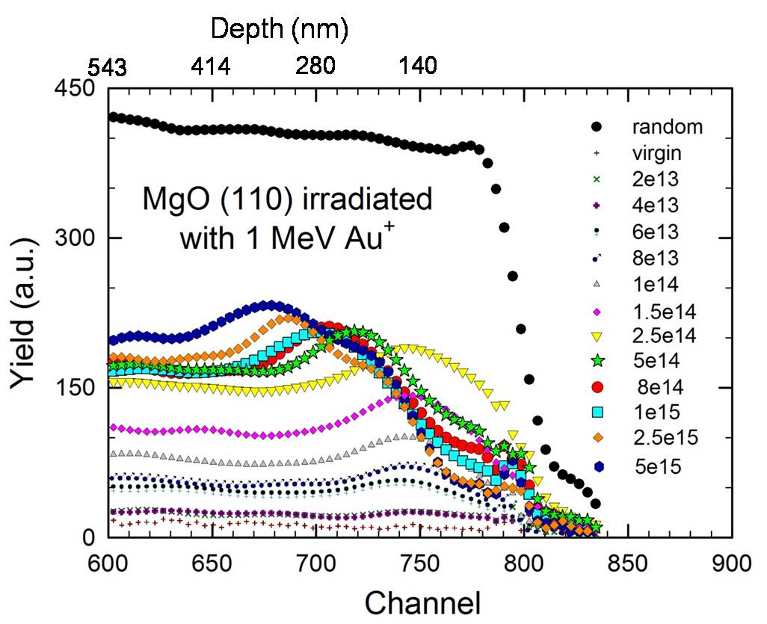
Fig. 6.1. RBS/channeling spectra of MgO (110) single crystal irradiated with 1 MeV Au ions at room temperature. The Au fluences range from 2×10¹³ to 5×10¹⁵ cm⁻².

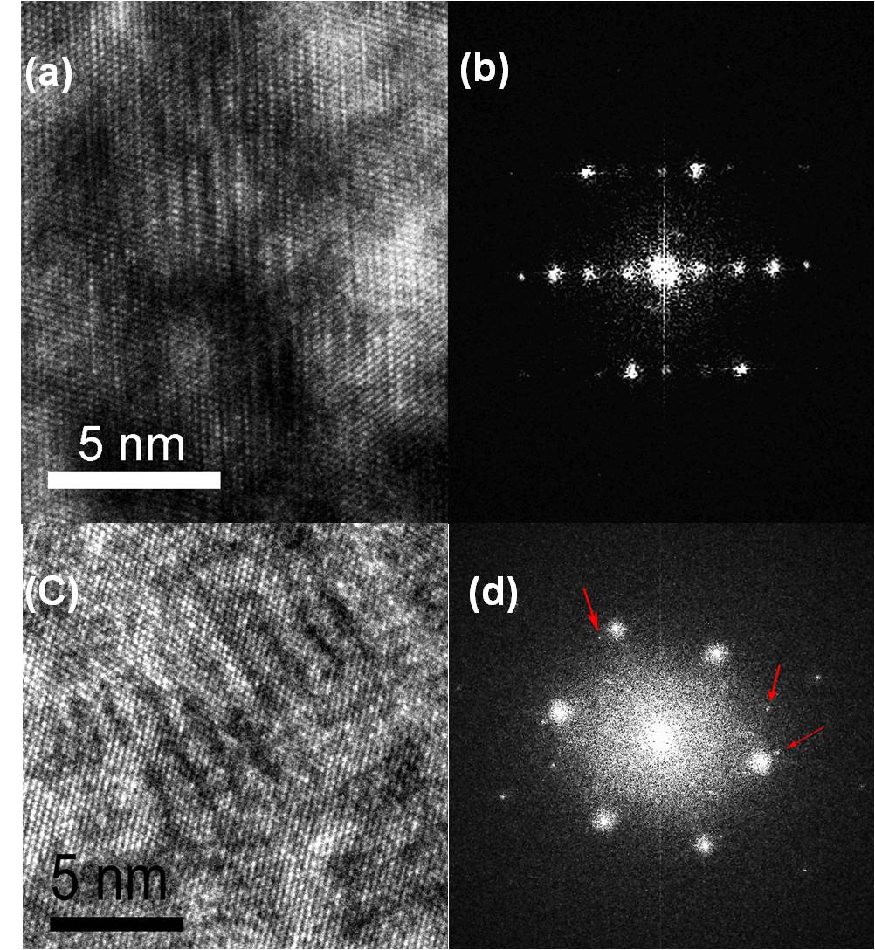
Fig. 6.2. HRTEM images and the corresponding diffraction patterns from FFT of the MgO (110) irradiated with 1 MeV Au ions at the fluence of 2.5×10¹⁵ cm⁻². The images are taken at the depth of ~120-160 nm, corresponding to the dpa peak region (10 dpa), where the decrease in damage level is observed by RBS/channeling technique.

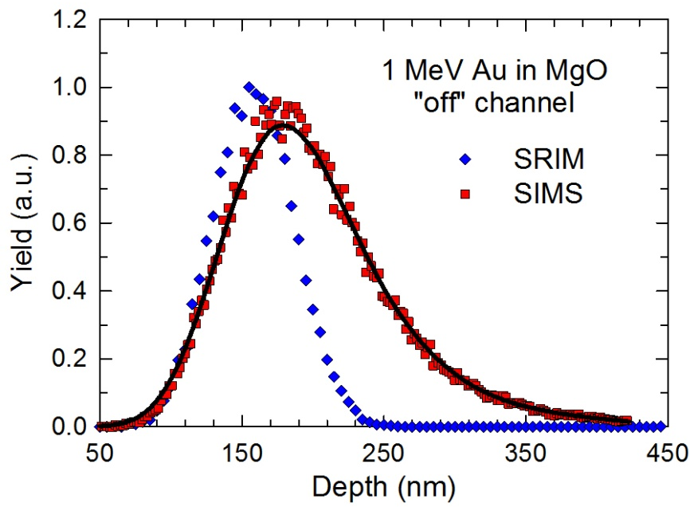
Fig. 6.3. SRIM predicted and SIMS measured depth profiles of 1 MeV Au ions irradiated in MgO

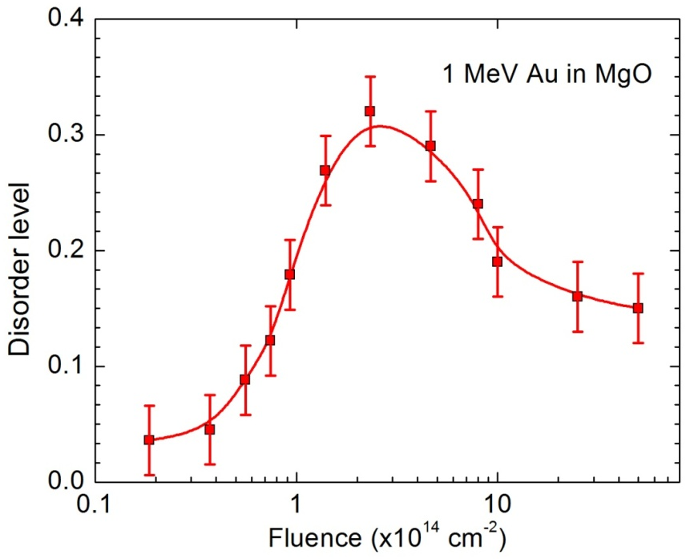
Fig. 6.4. Disorder level as a function of ion fluence for MgO irradiated with 1 MeV Au ions. The disorder levels are taken at the damage peak in the accumulation stage.

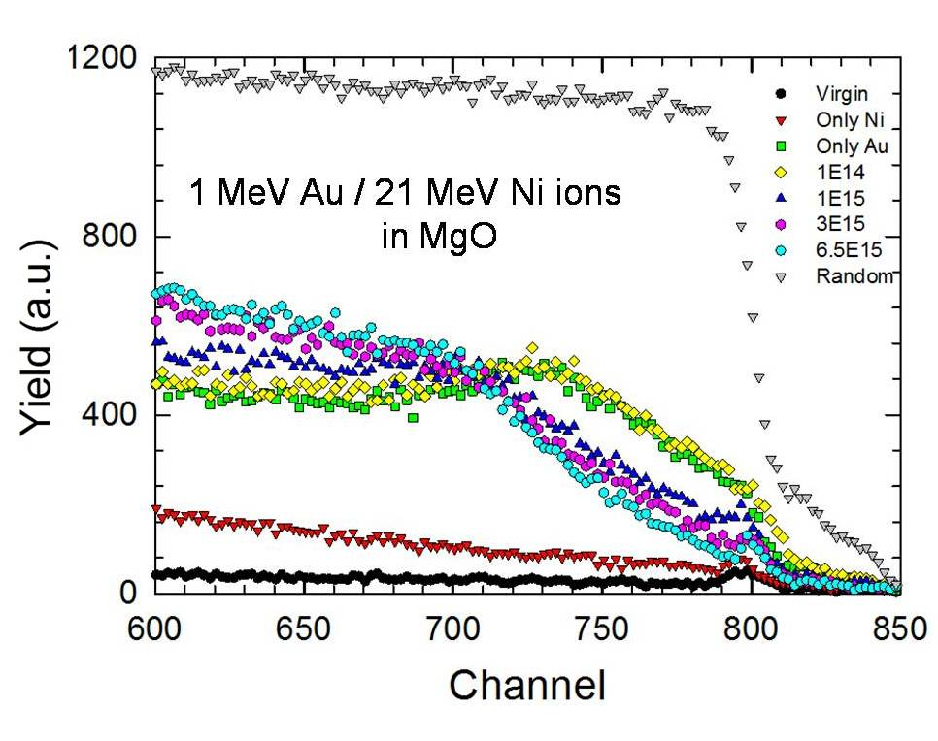
Fig. 6.5. RBS/channeling spectra of MgO (110) single crystal irradiated with 1 MeV Au ions at low temperature only (green squares), 21 MeV Ni ions at room temperature only (red opposite triangles), and the 21 MeV Ni ions at different fluences after the pre-damage induced by the Au ion irradiation.

Fig. 6.6.Cross-sectional TEM image of MgO irradiated with 1 MeV Au ions to the fluence of 1×10¹⁴ cm⁻² at low temperature, followed by the 21 MeV Ni ion irradiation to the fluence of 6.5×10¹⁵ cm⁻².

Chapter 7
CONCLUSION

In this dissertation, the electronic stopping powers for heavy ions (i.e. Cl, Br, I and Au) in SiC and SiO₂ have been determined over a continuous energy regime. Considerable error is observed in SRIM predictions, especially for the Au ion. By combining the reciprocity theory with experimental results, new electronic stopping power curves are derived, and a modified TRIM code is made that can utilize our derived electronic stopping power values. RBS and ToF-SIMS have been applied to measure the depth profile of Au ions in SiC. The measured ion range-energy relationship and the ion distributions agree well with the predictions from our modified TRIM code, validating our derived electronic stopping power values.
In order to experimentally examine the nuclear stopping predicted in SRIM which is important to the stopping measurement, a new approach that can be performed using regular instruments in common ion beam laboratories has been demonstrated to measure the angular distributions of MeV ions penetrating thin foils. The angular distribution of 1 MeV Au ions after penetrating a Si₃N₄ thin foil has been measured. The experimental results agree with the SRIM predictions within a 10% error range. Thinning effect in suspended thin foils due to the forward recoils induced by heavy ion irradiation has been observed.
In addition to the direct measurements in SiC and SiO₂, the electronic stopping power for Au ions in Si has been derived from the measurement of ion distributions at different energies ranging from 1 to 15 MeV. The derived electronic stopping powers in the low energy regime are significantly lower than the predictions from SRIM, which agrees with the results of Au ions in SiC and SiO₂.
Significant channeling effects have been observed for Au ion irradiation in MgO. Irradiations along both axial and planar channels lead to deeper ion and damage distribution, as well as lower peak damage level. The channeling effect is hardly fully avoided for 1 MeV Au ion irradiation, despite the attempts of sample rotation. Along with the clustering of point defects, this could contribute to the observations of the unusual deeper damage in MgO after high fluence ion irradiations.
The defect evolution in pre-damaged MgO under 21 MeV Ni ion irradiations has been studied using RBS/channeling technique combined with TEM observation. It has been observed that the damage level in MgO is decreased after the Ni ion irradiations, which is probably due to the forming of dislocation loops promoted by the electronic energy deposition.

Publications since 2011
Some of the results in this dissertation have been published. Here, the publication information and the contributions from Ke Jin are listed.

The results in chapter 3 have been published in Publication 2; the results in chapter 4 have been published in Publication 3.

1. K. Jin, H.Y. Xiao, Y. Zhang, and W.J. Weber, “Effects of boron-nitride substrates on Stone-Wales defect formation in graphene: an ab initio molecular dynamics study” Appl. Phys. Lett. 104 (2014) 203106
K. Jin’s involvement: proposed and performed the simulation, analyzed the results and wrote the paper.
2. K. Jin, Y. Zhang, Z. Zhu, D. A. Grove, H. Xue, J. Xue, and W. J. Weber, “Electronic stopping powers for heavy ions in SiC and SiO₂” J. Appl. Phys. 115 (2014) 044903
K. Jin’s involvement: proposed the critical data analysis procedure, performed the experimental data analysis, modified the TRIM-85 code to connect the electronic stopping power and the ion distributions, and wrote the paper.
3. K. Jin, Z. Zhu, S. Manandhar, J. Liu, C. Chen, V. Shutthanandan, S. Thevuthasan, W. J. Weber and Y. Zhang, “Angular distribution and recoil effect for 1 MeV Au⁺ ions through a Si₃N₄ thin foil” Nucl. Instr. Meth. Phys. Res., Sect. B 332 (2014) 346
K. Jin’s involvement: proposed and designed the experiments, prepared the samples, performed SIMS measurements, performed data analysis and wrote the paper.
4. K. Jin, Y. Zhang, H. Xue, Z. Zhu and W.J. Weber, “Ion distribution and electronic stopping power for Au ions in silicon carbide” Nucl. Instr. Meth. Phys. Res., Sect. B 307 (2013) 65
K. Jin’s involvement: proposed the critical data analysis procedure, performed the experimental data analysis, and wrote the paper.
5. Z. Wang, K. Jin, Y. Zhang, F. Wang, and Z. Zhu, “ToF-SIMS depth profiling of insulating samples, interlaced mode or non-interlaced mode?” Surf. Interface Anal. (2014) DOI: 10.1002/sia.5419
K. Jin’s involvement: performed some SIMS measurements to assist seeking the optimized strategy of depth profiling of MgO.
6. Y. Zhang, M.L. Crespillo, H. Xue, K. Jin, C.H. Chen, C.L. Fontana, J.T. Graham, and W.J. Weber, “New ion beam materials laboratory for materials modification and irradiation effects research” Nucl. Instr. Meth. Phys. Res., Sect. B 338 (2014) 19
K. Jin’s involvement: as one of the major operators in the ion beam materials laboratory, performed the ion beam irradiation and RBS/channeling analysis shown in Figs. 5, 8, 10 and 12.
7. W. J. Weber, E. Zarkadoula, O. H. Pakarinen, R. Sachan, M. F. Chisholm, P. Liu, H. Xue, K. Jin, and Y. Zhang, “Synergy of elastic and inelastic energy loss on ion track formation in SrTiO₃” Sci. Rep. 5 (2015) 7726
K. Jin’s involvement: performed part of the ion irradiations and RBS analysis.
8. Y. Zhang, D.S. Aidhy, T. Varga, S. Moll, P.D. Edmondson, F. Namavar, K. Jin, C. N. Ostrouchov, and W.J. Weber, “The effect of electronic energy loss on irradiation-induced grain growth in nanocrystalline oxides” Phys. Chem. Chem. Phys. 16 (2014) 8051
K. Jin’s involvement: assisted the data analysis
9. G. Cao, D. J. Singh, X. Zhang, G. Samolyuk, L. Qiao, C. Parish, K. Jin, Y. Zhang, H. Guo, S. Tang, W. Wang, J. Yi, C. Cantoni, W. Siemons, E. Payzant, M. Biegalski, T. Z. Ward, D. Mandrus, G.M. Stocks, and Z. Gai “Ferromagnetism and nonmetallic transport of thin-film α-FeSi₂: a stabilized metastable material” Phys. Rev. Lett. 114 (2015) 147202
K. Jin’s involvement: performed RBS analysis to study the sample composition.

VITA

Ke Jin was born in Beijing, China in 1988. After graduating from Beijing National Day School, Beijing, China in 2006, Ke was enrolled in Peking University, Beijing, China, where he earned his Bachelor’s Degree in Physics in 2010. Then he went to the University of Florida, Gainesville, FL, in the same year and earned his Master’s Degree in Materials Science and Engineering in 2011. Since then, he started to pursue a doctorate in Materials Science and Engineering at the University of Tennessee, under the guidance of Dr. Yanwen Zhang.

