ELUCIDATING THE PATHOGENESIS OF BATRACHOCHYTRIUM SALAMANDRIVORANS CHYTRIDIOMYCOSIS

A Dissertation Presented for the
Doctor of Philosophy
Degree
The University of Tennessee, Knoxville

Wesley C. Sheley
May 2022

Copyright © 2022 by Wesley C. Sheley.
All rights reserved.

ACKNOWLEDGEMENTS

I would like to thank the National Science Foundation (NSF EEID Grant #1814520) as well as the USDA National Institute of Food and Agriculture (Hatch project 1012932) for funding this research. I would also like to thank the University of Tennessee College of Veterinary Medicine Comparative and Experimental Medicine program for providing me with tuition and administrative support. Additionally, thank you to Alex Anderson of the East Tennessee Research and Education Center for access to research facilities at the Johnson Animal Research and Teaching Unit (JARTU). Thank you to Chris Ramsey and Aimee Hebrard for their analysis and interpretation of blood work samples. Also, thank you to Dr. Kurt Ash for instructing me on plasma protein electrophoresis techniques, and to Dr. Agata Grzelak for designing standard operating procedures for amphibian blood collection and analysis.
I would like to express my gratitude to all of the members of my committee. First, I would like to thank Dr. Deb Miller for all of her incredible mentorship throughout the years beginning in veterinary school and continuing throughout my graduate school training. I would also like to thank Dr. Carolyn Cray for being an unbelievable resource for all things protein electrophoresis and clinical pathology. I sincerely appreciate her time and efforts in being a member of my committee. I would like to thank Dr. Mark Wilber for his incredible support throughout my statistical analyses. I could not have asked for a more patient and helpful mentor throughout this process. Finally, I would like to thank Dr. Matt Gray for all of his assistance with study design, results interpretation, and general mentorship.
I would like to thank all of the current and former members of the UTIA Amphibian Disease Lab, specifically Dr. Ana Towe, Joe DeMarchi, Dr. Tan Watcharaanantapong, Markese Bohanon, Christian Yarber, Carlin Frost, Megan Wilson, Caleb Keoho, Alex Funk, Merrie Urban, and Carmen Merolle. I could not have achieved any of this work without their support. I would especially like to thank Davis Carter for being a great lab mate and also friend. His genuine passion for research, conservation, and helping others is unmatched. I would also like to especially thank Adri Tompros for always providing me with positivity and motivation. She has been a wonderful lab mate and is now an even better friend. Finally, thank you to Jan Day and Matthew Sheley for always being my biggest supporters.

ABSTRACT

Amphibian species worldwide are facing severe threats to their biodiversity including infectious disease, climate change, and habitat destruction. With these increasing threats, there is a growing need to explore disease pathogenesis and understand amphibian health. One of the most important emerging infectious diseases of amphibians is caused by the fungal pathogen Batrachochytrium salamandrivorans (Bsal). Bsal was recently discovered and is of global concern due to its potential to cause high mortality in amphibians, primarily salamander species. We investigated disease pathogenesis using two newt species with known susceptibility to Bsal chytridiomycosis (Notophthalmus viridescens and Taricha granulosa) as models. Taricha granulosa were exposed to Bsal and allowed to reach various stages of disease progression. Blood was collected immediately postmortem for hematological and biochemical analysis as well as plasma protein electrophoresis. Histologic skin lesions associated with Bsal infection were quantified and graded for each animal. Electrolyte imbalances and dehydration due to epidermal damage were shown to likely be the primary cause of morbidity and mortality in diseased T. granulosa. In a separate study, N. viridescens were exposed to one of four Bsal zoospore doses at one of three environmental temperatures. Individuals exposed at 14°C had increased lesion counts compared to those exposed at 6°C. Individuals exposed at 22°C did not become infected. Also, increased lesion counts were associated with decreased survival rate, and the most common anatomic sites for lesions of any grade were the hindlimbs, cloacal region, and tail. Independent of Bsal investigations, protein electrophoresis was performed on plasma collected from one anuran and six urodelan species that were clinically normal. This study provided novel representative electrophoretograms for each species and lay groundwork for future studies to establish reference intervals in these as well as other amphibian species. Overall, the findings of my research provide insight into the pathogenesis of Bsal chytridiomycosis and provide evidence that plasma protein electrophoresis may be a useful diagnostic tool in amphibians. This information can be used to identify possible disease mitigation options for Bsal chytridiomycosis in captive settings, provide guidance for Bsal surveillance programs, and will be helpful in future amphibian health investigations.

TABLE OF CONTENTS
INTRODUCTION 1
REFERENCES 3
1. CHAPTER I: ELECTROLYTE IMBALANCES AND DEHYDRATION PLAY A KEY ROLE IN BATRACHOCHYTRIUM SALAMANDRIVORANS CHYTRIDIOMYCOSIS 5
Abstract 6
1. Introduction 6
2. Methods 7
Ethics Statement 7
Animals 7
Experimental Design 8
Experimental Infection 8
Sample Collection 9
Hematobiochemical Analyses 9
Plasma Protein Electrophoresis 9
Histopathology 10
Quantitative Polymerase Chain Reaction (qPCR) 10
Statistical Analysis 10
3. Results 13
Biochemical Values 13
Hematological Values 13
Plasma Protein Electrophoresis 13
Anatomic Pathology 14
4. Discussion 14
REFERENCES 20
APPENDICES 25
Appendix A: Tables 25
Appendix B: Figures 27
2. CHAPTER II: ENVIRONMENTAL TEMPERATURE AND PATHOGEN DOSE HAVE A SIGNIFICANT EFFECT ON HISTOLOGIC LESION COUNT AND SEVERITY IN NOTOPHTHALMUS VIRIDESCENS INFECTED WITH BATRACHOCHYTRIUM SALAMANDRIVORANS 42
Abstract 43
1. Introduction 43
2. Methods 45
Ethics Statement 45
Animals 45
Experimental Design 46
Fungal Culture 46
Experimental Infection 46
Histopathology 46
Quantitative Polymerase Chain Reaction (qPCR) 47
Statistical Analyses 47
3. Results 49
Lesion Counts 49
Probability of Lesion Presence 50
Lesion Grade 50
Survival Analysis 50
Internal Organ and Dermal Gland Examination 50
4. Discussion 51
REFERENCES 55
APPENDICES 59
Appendix A: Tables 59
Appendix B: Figures 62
3. CHAPTER III: PLASMA PROTEIN ELECTROPHORESIS IN ONE ANURAN AND SIX URODELAN SPECIES 69
Abstract 70
1. Introduction 70
2. Methods 71
Animals 71
Blood/Sample Collection 72
Blood Processing and Analysis 73
Statistical Analysis 73
3. Results 73
4. Discussion 74
REFERENCES 77
APPENDICES 79
Appendix A: Tables 79
Appendix B: Figures 82
CONCLUSION 84
REFERENCES 86
VITA 87

LIST OF TABLES

Table 1.1 Anatomic location associated with each of ten standardized sections examined histologically for lesion counts and grading in Batrachochytrium salamandrivorans infected Taricha granulosa. 26
Table 1.2 Description of histologic lesion grading system (1–5) used in Batrachochytrium salamandrivorans infected Taricha granulosa. 26
Table 2.1 Anatomic location associated with each of ten standardized sections examined histologically for lesion counts and grading in Batrachochytrium salamandrivorans infected Notophthalmus viridescens. 60
Table 2.2 Description of histologic lesion grading system (1–5) used in Batrachochytrium salamandrivorans infected Notophthalmus viridescens. 60
Table 2.3 Akaike information criterion (AIC) for candidate statistical models included in survival analysis in Notophthalmus viridescens exposed to one of four Bsal zoospore doses. 61
Table 3.1 Protein fraction results for each clinically normal individual amphibian. 80
Table 3.2 Protein fraction results for individual Crytobranchus alleganiensis (hellbenders). 81

LIST OF FIGURES

Figure 1.1 Batrachochytrium salamandrivorans exposed, clinically diseased Taricha granulosa with severe, multifocal skin sloughing especially prominent on the chin, neck, legs, feet, and tail. (TW49) 28
Figure 1.2 Batrachochytrium salamandrivorans exposed, clinically diseased Taricha granulosa with multifocal hemorrhage on the chin, legs, and feet. (TW25) 28
Figure 1.3 Taricha granulosa with multiple, characteristic erosive to ulcerative Batrachochytrium salamandrivorans induced skin lesions. (TW14) 29
Figure 1.4 Examples of histologic lesion grading scheme used for Taricha granulosa infected with Batrachochytrium salamandrivorans (Bsal) including Grade 1 (A), Grade 2 (B), Grade 3 (C), and Grade 4 (D). Grade 1 lesions were limited to Bsal organisms within the stratum corneum, grade 2 lesions included Bsal organisms and associated cellular damage which extended into the mid-epidermis, grade 3 lesions included Bsal organisms and associated cellular damage which extended full thickness through the epidermis, grade 4 lesions included coalescing/large lesions in which Bsal organisms and associated cellular damage extended full thickness through the epidermis and were <1 millimeter in length. 30
Figure 1.5 Principal component analysis (PCA) for blood chemistry data. In the biplot on the left, individuals in the same space as the arrowhead had higher values of the blood parameter, and individuals in the opposite direction had lower levels of the blood parameter. The length and color of each arrow represent the strength of the relationship. The plot on the right is showing how the individuals clustered together using K means clustering. The majority of Taricha granulosa in cluster 1 (red) were Batrachochytrium salamandrivorans (Bsal) infected, clinically diseased individuals, and the majority of T. granulosa in cluster 2 (blue) were controls or Bsal-infected, non-clinically diseased individuals. Sodium = Na; Chloride = Cl; Cholesterol = cholest; Blood urea nitrogen = logBUN; Phosphorous = Phospho; Alkaline phosphatase = AlkPhos; Magnesium = Magnes; the residuals of potassium (K) regressed on hemolytic index (H) = (K_H_resid); the residuals of creatinine (CK) regressed on H = (K_H_resid); the residuals of lactate dehydrogenase (LDH) regressed on H = (K_H_resid). 31
Figure 1.6 Principal component analysis (PCA) for the complete blood count (CBC) data. In the plot on the left, individuals in the same space as the arrowhead had higher values of the blood parameter, and individuals in the opposite direction had lower levels of the blood parameter. The length and color of each arrow represent the strength of the relationship. The plot on the right is showing how the individuals clustered together using K means clustering. The majority of Taricha granulosa in cluster 1 (red) were Batrachochytrium salamandrivorans (Bsal) infected, clinically diseased individuals, and the majority of T. granulosa in cluster 2 (blue) were controls or Bsal-infected, non-clinically diseased individuals. Absolute count of lymphocytes = logACLymphs; absolute count of monocytes = logACMonos; absolute count of eosinophils = logACEos; absolute count of band neutrophils = logACBands; absolute count of segmented neutrophils = logACSegNeut; absolute count of basophils = logACBasos. 32
Figure 1.7 Principal component analysis (PCA) for the plasma protein electrophoresis data. In the plot on the left, individuals in the same space as the arrowhead had higher values of the blood parameter, and individuals in the opposite direction had lower levels of the blood parameter. The length and color of each arrow represent the strength of the relationship. The plot on the right is showing how the individuals clustered together using K means clustering. The majority of Taricha granulosa in cluster 1 (blue) were controls or Batrachochytrium salamandrivorans (Bsal) infected, non-clinically diseased individuals, and the majority of T. granulosa in cluster 2 (red) were Bsal-infected, clinically diseased individuals. 33
Figure 1.8 Boxplots comparing each blood chemistry variable for cluster 1 (Batrachochytrium salamandrivorans (Bsal) infected, clinically diseased Taricha granulosa) in red and cluster 2 (control and Bsal-infected, non-clinically diseased T. granulosa) in blue. Each box represents the interquartile range (IQR), the horizontal line within each box represents the median, vertical lines represent 1.5 * IQR, and dots represent outliers. Alkaline phosphatase = AlkPhos; sodium = Na; chloride = Cl; bicarbonate = CO2; the residuals of lactate dehydrogenase (LDH) regressed on hemolytic index (H) = LDH_H_resid; the residuals of potassium (K) regressed on H = K_H_resid. 34
Figure 1.9 Plots of sodium (Na), chloride (Cl), the residuals of potassium (K) regressed on hemolytic index (H) (K_H_resid), and anion gap (y-axis) and the log of Batrachochytrium salamandrivorans qPCR load at time of necropsy + 1 (x-axis). Additional analysis showed that there was significant evidence for a non-linear quadratic effect of log(Bsal Load + 1) on chemistry values (log(Bsal Load + 1)² (effect from PERMANOVA: F=6.98, p=0.001). 35
Figure 1.10 Boxplots comparing each complete blood count variable for cluster 1 (Batrachochytrium salamandrivorans (Bsal) infected, clinically diseased Taricha granulosa) in red and cluster 2 (controls and Bsal-infected, non-clinically diseased T. granulosa) in blue. Each box represents the interquartile range (IQR), the horizontal line within each box represents the median, vertical lines represent the 1.5 * IQR, and dots represent outliers. Absolute count of segmented neutrophils = ACSegNeuts; absolute count of band neutrophils = ACBands; absolute count of monocytes = ACMonos; absolute count of eosinophils = ACEos. 36
Figure 1.11 Packed cell volume for five control, two Batrachochytrium salamandrivorans-exposed/non-clinically diseased, and two Batrachochtyrium salamandrivorans- exposed/clinically diseased Taricha granulosa. 37
Figure 1.12 Boxplots comparing each protein electrophoresis fraction for cluster 1 (Batrachochytrium salamandrivorans (Bsal) infected, clinically diseased Taricha granulosa) in red and cluster 2 (controls and Bsal-infected, non-clinically diseased T. granulosa) in blue. Each box represents the interquartile range (IQR), the horizontal line within each box represents the median, vertical lines represent 1.5 * IQR, and dots represent outliers. 38
Figure 1.13 Representative protein electrophoretograms from a control (A) and a Batrachochytrium salamandrivorans infected, clinically diseased (B) Taricha granulosa. 39
Figure 1.14 Food consumption over time (days) post-exposure in control (red) versus Batrachochytrium salamandrivorans exposed (blue) Taricha granulosa. 40
Figure 1.15 Plot of log10(Lesion count + 1) (y-axis) and log10(Bsal load + 1) (x-axis). Black points represent histologic lesion count at each of 10 standardized anatomical sections examined for each Batrachochytrium salamandrivorans (Bsal) infected Taricha granulosa. Red lines represent individual level relationships. As each individual only had one Bsal qPCR load (at necropsy), but multiple lesion counts due to the multiple sections, a unique slope cannot be inferred for the relationship between Bsal load and lesion count for each individual. 41
Figure 2.1 Anatomic location associated with each of the ten standardized sections examined histologically for lesion counts and grading in Batrachochytrium salamandrivorans infected Notophthalmus viridescens. 63
Figure 2.2 Examples of histologic lesion grading scheme used for Notophthalmus viridescens infected with Batrachochytrium salamandrivorans (Bsal) including Grade 1 (A), Grade 2 (B), Grade 3 (C), and Grade 4 (D). Grade 1 lesions were limited to Bsal organisms within the stratum corneum, grade 2 lesions included Bsal organisms and associated cellular damage which extended into the mid-epidermis, grade 3 lesions included Bsal organisms and associated cellular damage which extended full thickness through the epidermis, grade 4 lesions included coalescing/large lesions in which Bsal organisms and associated cellular damage extended full thickness through the epidermis and were <1 millimeter in length. 64
Figure 2.3 Plot of the expected histologic lesions per average cross section (y-axis) for each Batrachochytrium salamandrivorans (Bsal) zoospore dose (x-axis) and temperature (6°C = red; 14°C = blue) treatment combination in Bsal-infected Notophthalmus viridescens. Each point within a zoospore dose represents a section in numerical order from section 1–section 10. Error bars are showing the 95% confidence intervals around the predicted response. 65
Figure 2.4 Plot of the expected probability of histologic lesions being present (y-axis) across each Batrachochytrium salamandrivorans (Bsal) zoospore dose (x-axis) and temperature (6°C = red; 14°C = blue) treatment combination in Bsal-infected Notophthalmus viridescens. Error bars are showing the 95% confidence intervals around the predicted response. 66
Figure 2.5 Plot of the expected histologic lesion density per unit of cross section (y-axis) for each Batrachochytrium salamandrivorans (Bsal) zoospore dose (x-axis) and temperature (6°C = red; 14°C = blue) treatment combination in Bsal-infected Notophthalmus viridescens. Each point within a zoospore dose represents a lesion grade in numerical order from Grade 1–Grade 4 along with an associated shape (Grade 1 = circle; Grade 2 = triangle; Grade 3 = square; Grade 4 = +). Black points represent the observed mean lesion density for each lesion grade within a zoospore dose and temperature. Error bars are showing the 95% confidence intervals around the predicted response. 67
Figure 2.6 Survival curves representing the mortality rate of Notophthalmus viridescens exposed to one of four Batrachochytrium salamandrivorans zoospore doses (5 x 10^{3–6}). 68
Figure 3.1 Representative agarose gel electrophoresis (AGE) electrophoretograms of heparinized plasma from a Cuban tree frog (A), three-toed amphiuma (B), eastern newt (C), greater siren (D), hellbender (E), a three-lined salamander (F), a spring salamander (G), serum from a canine with multiple myeloma (H), and serum from a human control (I). The y-axis represents the size of each protein fraction, and the x-axis represents the migration distance of each protein fraction from the anode (left) to cathode (right). 83

INTRODUCTION

We are currently in the process of a sixth mass extinction (Ceballos et al., 2020), with Amphibia being the vertebrate class experiencing the most severe declines (IUCN, 2022). Amphibians are extremely important as they are indicators of overall ecosystem health (Hocking & Babbitt, 2014; Welsh & Ollivier, 1998), are crucial for insect control, have critical roles in the food chain, are used as models in biomedical research, and have cultural importance to many societies (Hocking & Babbitt, 2014). Therefore, it is imperative that we work to decrease the threats amphibians are currently facing as well as obtain a better understanding of ways to monitor their health, in order to maintain their biodiversity.
The main threats to amphibians include climate change, habitat degradation and loss, pollution, overexploitation through their use as food and in the pet trade, introduction of invasive species, and emerging infectious diseases (IUCN, 2022). Among emerging infectious disease threats, the most significant is chytridiomycosis, which has been responsible for what has been referred to as the greatest documented loss of vertebrate biodiversity due to a pathogen (Scheele et al., 2019). There are two species of chytrid fungi which have been described as pathogenic to amphibians. These include the well-known species Batrachochytrium dendrobatidis (Bd), and the recently described species Batrachochytrium salamandrivorans (Bsal). Both infect the skin of amphibians, and either primarily cause proliferative (Bd) or ulcerative (Bsal) lesions. As the skin of amphibians is responsible for electrolyte balance, osmoregulation, as well as respiration, damage to this organ is detrimental (Wells, 2007).
While Bd has been documented on every continent that has amphibians, Bsal has not yet been identified in North America (Waddle et al., 2020). Due to suitable environmental conditions, a large number of susceptible host species, high prevalence of Bsal in internationally-traded amphibian species, and few trade regulations to reduce the risk of further global introductions, risk of invasion of Bsal into North America is high (Basanta et al., 2019; Carter et al., 2021; Grant et al., 2017; Richgels et al., 2016; Yap et al., 2015; Yap et al., 2017). Given that Bsal primarily infects urodelan species, and North America is a global hotspot for urodelan biodiversity (Yap et al., 2015), it is imperative that we understand how this pathogen causes morbidity and mortality in its hosts prior to its arrival. My dissertation fills three important gaps in our current knowledge surrounding Bsal and amphibian health: (1) the mechanisms of Bsal pathogenesis, (2) the effects of environmental temperature on disease progression, and (3) the use of protein electrophoresis as a diagnostic tool in amphibians.
Much work has been done to elucidate the pathogenesis of Bd; however, limited research on the mechanisms of Bsal exist. Therefore, Chapter I covers my investigation into the pathogenesis of Bsal chytridiomycosis through the use of anatomic and clinical pathology in Bsal-infected Taricha granulosa. By incorporating biochemical and hematological analyses along with plasma protein electrophoresis and histopathology, I investigated how Bsal causes morbidity and mortality in its hosts. Results of my research revealed the similarities and differences between Bsal and Bd chytridiomycosis. Additionally, my results provide potential options for disease mitigation in Bsal-infected amphibians in captive settings.
In Chapter II, I evaluated how environmental temperature and Bsal zoospore dose affect disease development and progression in Notophthalmus viridesens. I also evaluated anatomic sites of predilection for Bsal lesion development. The results from this portion of my research provide an understanding of how environmental conditions can influence the rate of Bsal chytridiomycosis development. They also provide guidance for Bsal surveillance programs by identifying anatomic locations within the skin that display the highest lesion counts associated with Bsal chytridiomycosis. This information can be used to increase the chances of pathogen detection through skin swabbing for Bsal qPCR.
Finally, Chapter III reports efforts to begin to provide basic parameters for health in amphibians using protein electrophoresis. Protein electrophoresis has proven to be very useful in mammalian as well as other non-mammalian species (Cray, 2021). It can be used to assist in diagnosis of many disease processes and in evaluation of overall health status. Very limited studies have investigated its usefulness in amphibians. Therefore, we analyzed plasma protein electrophoretograms from clinically normal individuals of one anuran and six urodelan species. The results from this chapter in combination with results from Chapter I support the usefulness of this diagnostic tool in amphibians and provide groundwork for future investigations to develop reference intervals in these and other amphibian species which can be used to monitor amphibian health.
Overall, the findings reported in my dissertation significantly advance our understanding of the pathogenesis of Bsal chytridiomycosis and how environmental temperature affects disease progression. I also provide a new model for a multimodal diagnostic approach to the study of Bsal chytridiomycosis. Additionally, I provide evidence for the utility of a practical diagnostic tool which can be used to monitor amphibian health and assist in diagnosis of many disease processes, including Bsal chytridiomycosis.

REFERENCES
Basanta, M. D., Rebollar, E. A., & Parra-Olea, G. (2019). Potential risk of Batrachochytrium salamandrivorans in Mexico. Plos One, 14(2), e0211960. doi:10.1371/journal.pone.0211960
Carter, E. D., Bletz, M. C., Le Sage, M., LaBumbard, B., Rollins-Smith, L. A., Woodhams, D. C., Miller, D. L., & Gray, M. J. (2021). Winter is coming-Temperature affects immune defenses and susceptibility to Batrachochytrium salamandrivorans. PLoS Pathog, 17(2), e1009234. doi:10.1371/journal.ppat.1009234
Ceballos, G., Ehrlich, P. R., & Raven, P. H. (2020). Vertebrates on the brink as indicators of biological annihilation and the sixth mass extinction. Proc Natl Acad Sci U S A, 117(24), 13596-13602. doi:10.1073/pnas.1922686117
Cray, C. (2021). Protein electrophoresis of non-traditional species: A review. Vet Clin Pathol, 50(4), 478-494. doi:10.1111/vcp.13067
Grant, E. H. C., Muths, E., Katz, R. A., Canessa, S., Adams, M. J., Ballard, J. R., Berger, L., Briggs, C. J., Coleman, J. T. H., Gray, M. J., Harris, M. C., Harris, R. N., Hossack, B., Huyvaert, K. P., Kolby, J., Lips, K. R., Lovich, R. E., McCallum, H. I., Mendelson, J. R., Nanjappa, P., Olson, D. H., Powers, J. G., Richgels, K. L., Russell, R. E., Schmidt, B. R., Spitzen-van der Sluijs, A., Watry, M. K., Woodhams, D. C., & White, C. L. (2017). Using decision analysis to support proactive management of emerging infectious wildlife diseases. Frontiers in Ecology and the Environment 15(4), 214-221.
Hocking, D. J., & Babbitt, K. J. (2014). Amphibian contributions to ecosystem services. Herpetological Conservation and Biology, 9(1), 1-17.
IUCN. (2022). International Union for Conservation of Nature, The IUCN red list of endangered species. Retrieved from https://www.iucn.org/
Richgels, K. L., Russell, R. E., Adams, M. J., White, C. L., & Grant, E. H. (2016). Spatial variation in risk and consequence of Batrachochytrium salamandrivorans introduction in the USA. R Soc Open Sci, 3(2), 150616. doi:10.1098/rsos.150616
Scheele, B. C., Pasmans, F., Skerratt, L. F., Berger, L., Martel, A., Wouter, B., Acevedo, A. A., & Canessa, S. (2019). Amphibian fungal panzootic causes catastrophic and ongoing loss of biodiversity. Wildlife Disease 363 1459-1463
Waddle, J. H., Grear, D. A., Mosher, B. A., Grant, E. H. C., Adams, M. J., Backlin, A. R., Barichivich, W. J., Brand, A. B., Bucciarelli, G. M., Calhoun, D. L., Chestnut, T., Davenport, J. M., Dietrich, A. E., Fisher, R. N., Glorioso, B. M., Halstead, B. J., Hayes, M. P., Honeycutt, R. K., Hossack, B. R., Kleeman, P. M., Lemos-Espinal, J. A., Lorch, J. M., McCreary, B., Muths, E., Pearl, C. A., Richgels, K. L. D., Robinson, C. W., Roth, M. F., Rowe, J. C., Sadinski, W., Sigafus, B. H., Stasiak, I., Sweet, S., Walls, S. C., Watkins-Colwell, G. J., White, C. L., Williams, L. A., & Winzeler, M. E. (2020). Batrachochytrium salamandrivorans (Bsal) not detected in an intensive survey of wild North American amphibians. Sci Rep, 10(1), 13012. doi:10.1038/s41598-020-69486-x
Wells, D. K. (2007). The Ecology and Behavior of Amphibians: World Scientific.
Welsh, H. H., & Ollivier, L. M. (1998). Stream amphibians as indicators of ecosystem stress: a case study from California’s redwoods. Ecological Applications, 8, 1118-1132.
Yap, T. A., Koo, M. S., Ambrose, R. F., Wake, D. B., & Vredenburg, V. T. (2015). Averting a North American biodiversity crisis. Science, 349(6247), 481-482. doi:10.1126/science.aab1052
Yap, T. A., Nguyen, N. T., Serr, M., Shepack, A., & Vredenburg, V. T. (2017). Batrachochytrium salamandrivorans and the Risk of a Second Amphibian Pandemic. Ecohealth, 14(4), 851-864. doi:10.1007/s10393-017-1278-1

CHAPTER I: ELECTROLYTE IMBALANCES AND DEHYDRATION PLAY A KEY ROLE IN BATRACHOCHYTRIUM SALAMANDRIVORANS CHYTRIDIOMYCOSIS

Abstract
One of the most important emerging infectious diseases of amphibians is caused by the fungal pathogen Batrachochytrium salamandrivorans (Bsal). Bsal was recently discovered and is of global concern due to its potential to cause high mortality in amphibians, especially salamander species. To date, little has been reported on the pathophysiological effects of Bsal; however, studies of a similar fungus, B. dendrobatidis (Bd), have shown that electrolyte losses and immunosuppression likely play a key role in morbidity and mortality associated with this disease. The goal of this study was to investigate pathophysiological effects and immune responses associated with Bsal chytridiomycosis using 49 rough-skinned newts (Taricha granulosa) as the model species. Taricha granulosa were exposed to a 1 x 10⁷ per 10 mL dose of Bsal zoospores and allowed to reach various stages of disease progression before being humanely euthanized. At the time of euthanasia, blood was collected for biochemical and hematological analyses as well as protein electrophoresis. Ten standardized body sections were histologically examined, in which Bsal-induced skin lesions were counted and graded on a scale of 1–5 based on severity. Results indicated that electrolyte imbalances and dehydration induced by damage to the epidermis play a major role in the pathogenesis of Bsal chytridiomycosis in this species. Additionally, Bsal-infected, clinically diseased T. granulosa exhibited a systemic inflammatory response identified through alterations in complete blood counts and protein electrophoretograms. Overall, these results provide integral information on the pathogenesis of this disease and highlight the differences and similarities between Bsal and Bd chytridiomycosis.

1. Introduction
Over the past five decades, chytridiomycosis has been responsible for the decline of >500 amphibian species, and the extinction of nearly 90 amphibian species, culminating in what has been described as the greatest documented loss of vertebrate biodiversity due to a pathogen (Scheele et al., 2019). The culprit behind the majority of these drastic declines and extinctions has been the chytrid fungus Batrachochytrium dendrobatidis (Bd) which was first detected in the 1990s (Scheele et al., 2019). In 2013, a novel chytrid fungus, Batrachochytrium salamandrivorans (Bsal), was first discovered in fire salamanders (Salamandra salamandra) and is causing mass die-offs of urodeles in multiple European countries (Lotters et al., 2020; Martel et al., 2013; Stegen et al., 2017). This pathogen mainly infects urodeles; however, it has also been shown to infect anuran species (Nguyen et al., 2017; Stegen et al., 2017; Towe et al., 2021).
Bsal presumably originated in Asia and is thought to have spread to Europe through the pet amphibian trade (Martel et al., 2014). This pathogen has not yet been detected in North America (Waddle et al., 2020). However, studies report that likelihood of Bsal invasion is high due to suitable environmental conditions, a large number of susceptible host species, high prevalence of Bsal in heavily-traded amphibian species, and few pet trade regulations to reduce the risk of further global introductions (Basanta et al., 2019; Carter et al., 2021; Grant et al., 2017; Richgels et al., 2016; Yap et al., 2015; Yap et al., 2017). Despite recognition of the severe threat that Bsal poses to global amphibian biodiversity, we still know little about the mechanisms of its pathogenesis, limiting our ability to develop effective therapeutics to treat infected individuals.
While limited information has been reported on the pathophysiological effects of Bsal, studies of Bd have provided significant information on chytrid fungus pathophysiology. Studies of Bd, have shown that electrolyte imbalances occur in amphibians due to loss of osmoregulation through extensive skin pathology (Campbell et al., 2012; Marcum et al., 2010; Voyles et al., 2007; Voyles et al., 2009; Young et al., 2012). These electrolyte losses have been shown to lead to cardiac arrest which is likely the ultimate cause of mortality in Bd-infected individuals (Voyles et al., 2009).
Bd and Bsal are closely related to each other yet differ in the type of skin lesions they induce (Farrer et al., 2017; Martel et al., 2013). Amphibians infected with Bd typically develop proliferative epidermal lesions that result in thickening of the skin, whereas amphibians infected with Bsal develop erosive to ulcerative, necrotizing lesions that create holes in the skin (Martel et al., 2013; Van Rooij et al., 2015). Although the type of skin injury is different for each pathogen, it is hypothesized that the mechanisms by which each pathogen causes morbidity and mortality have similarities because they are both impacting skin function. However, differences such as potential secondary bacterial infections and dermal gland invasion in Bsal-infected amphibians are also suspected (Bletz, 2013; Ossiboff et al., 2019). Additionally, it has also been shown in previous studies that anorexia may play a role in Bsal pathogenesis (Carter et al., 2019). Here, I compared clinical presentation along with clinical and anatomic pathology changes in diseased versus control individuals by measuring blood cell counts, biochemical values, and plasma protein levels in combination with histologic examination of all organs. By combining histological and molecular techniques along with clinical presentation, my goal was to gain new understanding of how Bsal chytridiomycosis causes morbidity and mortality in susceptible hosts.

2. Methods

Ethics Statement
Husbandry as well as euthanasia procedures followed recommendations provided by the American Veterinary Medical Association and the Association of Zoos and Aquariums. Additionally, they were approved by the University of Tennessee Institutional Animal Care and Use Committee (protocol #2623). Taricha granulosa that reached euthanasia endpoints were humanely euthanized via transdermal exposure to benzocaine hydrochloride.

Animals
A total of 49 Taricha granulosa (rough-skinned newts) were wild-caught by California Department of Fish and Wildlife and shipped to the University of Tennessee. Taricha granulosa were used due to their known susceptibility to Bsal (Martel et al., 2014) and their relatively large size which allowed a sufficient amount of blood to be collected from each individual. Upon arrival to the laboratory, individuals were each given an individual ID (“TW1”-“TW49”). We confirmed that all T. granulosa were Bd negative by using quantitative polymerase chain reaction (qPCR) methods similar to those described by Boyle et al. (2004). All animals were then heat-treated for 10 days at 30°C to clear any potential pre-existing Bd infections which may have not been detected by qPCR (Bletz, 2013; Chatfield & Richards-Zawacki, 2011). Co-infection with Bd can influence disease outcomes in Bsal chytridiomycosis (Longo et al., 2019); however, previous infection and clearance of Bd does not seem to have an effect on susceptibility to Bsal in other urodelan species (Longo et al., 2019). We again confirmed that all T. granulosa were Bd negative prior to the beginning of the trial by testing skin swabs using qPCR. The pre-trial swabs as well as all skin swabs performed throughout the study consisted of 10 swipes along the ventrum and 5 swipes on the bottom of each foot. After heat treatment, T. granulosa were acclimated for two weeks to a temperature of 14°C, which has been found to be the optimal temperature for Bsal growth and infection of urodelan species (Carter et al., 2021; Martel et al., 2013). Animals were individually housed in an environmental growth chamber (Conviron, Winnipeg, Canada) and temperature was maintained at 14°C throughout the entire study. The environmental growth chamber also provided light/dark cycles reflecting the corresponding season associated with the environmental temperature (spring/fall = 14 hours dark). Individual housing consisted of sterilized 710-cm³ containers that included a moist paper towel and PVC cover object. All containers, paper towels, and cover objects were replaced with new ones every three days. Diet consisted of medium-sized crickets (amount based on 4% of each animal’s body weight measured at the beginning of study) given at each water change and food consumption was noted at the following water change.

Experimental Design
The 49 T. granulosa were randomly assigned to either a control (n=8) or Bsal-exposed (n=41) treatment group. Animals were monitored twice daily for signs of chytridiomycosis. Detailed notes regarding lesion coverage, skin sloughing, and degree of lethargy were taken and graded at each of these timepoints (skin sloughing and lesion coverage: 0 = none; 1 = < 25% body coverage, 2 = 25–50% body coverage, 3 = 51–75% body coverage, 4 = >75% body coverage; Lethargy grade: 0 = none; 1 = mild; 2 = moderate; 3 = severe). Examples of skin sloughing (Figure 1.1), hemorrhage (Figure 1.2), and multifocal epidermal ulcerations (Figure 1.3) are provided in the Appendix. Those individuals who reached a pre-determined euthanasia endpoint (loss of righting ability), were humanely euthanized through transdermal administration of benzocaine. Others were euthanized at various stage of disease progression or at the end of the study (60 days). Bsal-exposed T. granulosa were classified as “clinically diseased” if they exhibited evidence of moderate to severe lethargy (loss of righting reflex) at the time of euthanasia. Control T. granulosa as well as T. granulosa which were Bsal-exposed; however, exhibited no to mild lethargy at the time of euthanasia were classified as “non-clinically diseased”.

Experimental Infection
Bsal was isolated from a fire salamander (Salamandra salamandra) in the Netherlands and provided to my lab (isolate AMFP13/1, (Martel et al., 2013). Cultures were maintained at the University of Tennessee Center for Wildlife Health laboratory and zoospores were enumerated as previously described by Carter et al. (2019).
Bsal-exposed individuals were exposed to a dose of 1x10⁷ zoospores per 10 mL by being individually placed into a 100-mL plastic tube containing a mixture of Bsal zoospores and sterile water for 24 hours in the environmental incubators. Control animals were placed into 100-mL plastic tubes containing 10-mL of sterile water under the same time and environmental conditions as the exposed individuals.

Sample Collection
Post-exposure, animals were skin swabbed once every 3 days throughout the study for an estimate of pathogen load. Additionally, skin swabs were collected for all animals at the time of necropsy. Immediately following euthanasia, tissues overlying the heart were carefully dissected using sterile instruments, and blood was collected directly from the heart using a sterile, heparinized capillary tube. Three to 5 microliters of blood were transferred onto a glass slide to make a blood smear using a gentle smear technique, five microliters of blood were pipetted into 995 microliters of filtered Natt-Herrick solution in a 1.5 milliliter sterile plastic conical tube, and the remaining blood sample was placed into a sterile 1.5 milliliter plastic conical tube. Blood samples in conical tubes were kept in a cooler on ice immediately after collection and transported to the University of Tennessee College of Veterinary Medicine (UTCVM) clinical pathology laboratory for processing. A sample of skin from the ventrum as well as a toe from each animal were collected and placed into separate 1.5 milliliter conical tubes. All skin swabs along with the skin and toe samples were placed immediately into a -80°C freezer. Carcasses were placed whole into 10% neutral buffered formalin.

Hematobiochemical Analyses
We processed all blood samples in the University of Tennessee College of Veterinary Medicine (UTCVM) clinical pathology lab. Packed cell volume (PCV) was assessed using whole blood samples. White blood cell differentials were performed on blood smears stained with Wright’s Giemsa stain, and white blood cell/red blood cell/platelet counts were performed on the blood in the Natt-Herrick solution using a hemocytometer as outlined in Nardini et al. (2013). Cell counts were performed within 48 hours of blood being mixed with Natt-Herrick solution. Whole blood was spun in an Eppendorf 5424R centrifuge at 2170 G for 3 minutes to separate plasma. Plasma was analyzed using a Roche cobas c501 analyzer assessing the sodium (Na), potassium (K), chloride (Cl), bicarbonate (CO2), total protein, magnesium (Mg), calcium (Ca), phosphorous, alkaline phosphatase (ALP), creatinine kinase (CK), cholesterol, blood urea nitrogen (BUN), glucose, lactate dehydrogenase (LDH), as well as the hemolytic, lipemic, and icteric indices. Remaining plasma was stored in a 2°C refrigerator until it was used for agarose gel electrophoresis (<24 hours after collection).

Plasma Protein Electrophoresis
Plasma samples were analyzed in accordance with instructions provided by the Helena QuickGel system with the use of Split Beta gels (Helena Laboratories, Inc., Beaumont, Texas 77707, USA). Samples were run in duplicate (average mean variance between duplicates = 0.006) and with a known human control sample. Gels were scanned and analyzed using software provided by Helena.

Histopathology
Carcasses were stored in 10% neutral buffered formalin for a minimum of 48 hours prior to processing. Transverse sections through the entire body were taken and placed into tissue cassettes following the protocol listed in the Appendix (Table 1.1). Cassettes containing tissues were decalcified for 24 hours using a formic acid solution. Tissues were then routinely processed and stained with hematoxylin and eosin (H&E). Histopathology consisted of examining all tissues for any abnormalities as well as performing lesion counts and grading on all sections. Lesion grading consisted of scoring each lesion on a scale of 1–5 based on its depth as well as length. Grade 1 lesions were limited to Bsal organisms within the stratum corneum, grade 2 lesions included Bsal organisms and associated cellular damage which extended into the mid-epidermis, grade 3 lesions included Bsal organisms and associated cellular damage which extended full thickness through the epidermis, grade 4 lesions included coalescing/large lesions in which Bsal organisms and associated cellular damage extended full thickness through the epidermis and were <1 millimeter in length, grade 5 lesions included coalescing/large lesions in which Bsal organisms and associated cellular damage extended full thickness through the epidermis and were ≥ 1 millimeter in length (Table 1.2 & Figure 1.4). In order to standardize measures of lesion counts to counts per unit area of cross section, the perimeter of each section was determined using Excelis Accu-Scope software.
Presence or absence of inflammation associated with skin lesions was documented for each exposed individual. Additionally, inflammation within each Bsal-associated lesion was estimated as mild (<30% of the lesion infiltrated by inflammatory cells), moderate (30–60% of the lesion infiltrated by inflammatory cells), or severe (>60% of the lesion infiltrated with inflammatory cells), and an overall severity grade was assigned to each individual based on which grade of inflammation occurred most frequently. Also, areas of inflammation associated with Bsal but not bacteria were counted for each individual.

Quantitative Polymerase Chain Reaction (qPCR)
To detect Bsal and estimate loads, genomic DNA was extracted from each skin swab using the QIAamp 96 DNA QIAcube HT kit (Qiagen, Hilden, Germany) and qPCR was performed similar to Blooi et al (2015) using the Applied Biosystems Quantstudio 6 Flex qPCR instrument (Thermo Fisher Scientific Inc). All samples were run in duplicate and declared positive if both replicates reached cycle threshold prior to 50 amplification cycles (Carter et al., 2019).

Statistical Analysis
Biochemical, Hematological, and Plasma Protein Electrophoresis Measurands
To determine how clinical disease status affected biochemical values, I performed a principal component analysis (PCA) using biochemical values followed by a multivariate analysis of variance (MANOVA) to determine which values were significantly different between clinically diseased and non-clinically diseased T. granulosa. Biochemical values included in the analysis were alkaline phosphatase (ALP), blood urea nitrogen (BUN), phosphorous, calcium, glucose, protein, cholesterol, sodium (Na), chloride (Cl), bicarbonate (CO2), anion gap, magnesium, creatinine kinase (CK), lactate dehydrogenase (LDH), and potassium (K). Hemolytic index (H) was also measured for each sample. Increased hemolysis in a sample can lead to artifactual elevations in CK, LDH, and K. Therefore, I independently regressed CK on H, LDH on H, and K on H and extracted the residuals of these regressions. These residuals account for the variation in CK, LDH, and K not described by changes in hemolytic index (H). I used these new variables in place of original CK, LDH, and K values in my analyses. Shapiro-Wilk normality tests were performed on all variables to assess for normality, and variables which failed this test were log transformed. If the variable still failed the normality test once log transformed, then the original value was used.
I scaled my data (e.g., zero mean and standard deviation of one) and used K means clustering with the elbow method to determine the optimal number of clusters to use in order to group individuals based on similarity in their blood chemistry values (Yuan & Yang, 2019). A PCA performed on these clusters highlighted that the majority of clinically diseased animals clustered together, and the majority of non-clinically diseased animals clustered together (Figure 1.5). I then ran a MANOVA to test which blood chemistry values significantly differed between clinically diseased and non-clinically diseased animals. Wilks’ statistic was used to interpret the overall significance of the MANOVA due to its robustness towards lack of normality and homogeneity of variance (Ates et al., 2019). I examined significant differences between each blood chemistry value for diseased and non-diseased individuals. To account for type I error rate, I used false discovery rate to correct p-values obtained from the MANOVA for specific chemistry variables (Benjamini & Hochberg, 1995). I used a family-wise type I error rate of α = 0.05 for all analyses. Arithmetic means for each value were compared between clusters. All analyses were run in R (version 4.1.1).
To determine how Bsal qPCR load at the time of necropsy affected changes in biochemical values, a permutational multivariate analysis of variance (PERMANOVA) was performed using the vegan package (Oksanen et al., 2020). Biochemical values were used as the dependent variable and Bsal load at the time of necropsy as the independent variable. The log of Bsal load +1 was used as some of the load values were 0. I followed this analysis with correlation tests between each individual variable and Bsal load using Pearson’s product moment correlation and corrected with false discovery rate.
A similar set of analyses as described above was performed for hematological values (PCA presented in Figure 1.6) and for plasma protein electrophoresis values (PCA presented in Figure 1.7). Hematological values included in the analysis were absolute counts of segmented neutrophils (ACSegNeut), band neutrophils (ACBands), lymphocytes (ACLymphs), monocytes (ACMonos), eosinophils (ACEos), and basophils (ACBasos). For variables which included zeros, the log of the variable +1 was used. Plasma protein electrophoresis results included 8 fractions (Avr1–8). Increased hemolysis in a sample can lead to artifactual alterations in various plasma protein fractions in other species (Cray, 2021). Therefore, I independently regressed each fraction on the hemolytic index of the sample (H). For each regression in which H was determined to significantly explain variation in the plasma protein fraction (fractions 3, 5, and 8), I extracted the residuals of these regressions. These residuals account for the variation in each of these fractions not described by changes in hemolytic index (H). I used these new variables in place of the original protein fractions in my analyses. A Shapiro-Wilk normality test was performed on all variables to assess for normality, and variables which failed this test were log transformed.

Food Consumption
To determine how treatment (control versus Bsal-exposed) affected food consumption in T. granulosa, I fit a binomial generalized linear mixed effects model where the response variable was the combined vector of food consumed and food not consumed, and the predictor variable was the interaction term of time and treatment with the random effect of individual ID. I fit the model using the lme4 package in R (version 4.1.1). I fit two candidate models to the data including a model similar to the one described above; however, time and treatment were included as main effects instead of as an interaction term. The two models were compared using Akaike information criteria (AIC), where lower AIC indicates better predictive performance. Only exposed, clinically diseased animals and controls were included in this analysis due to variations in survival time of exposed, non-clinically diseased individuals.

Lesion Count
To determine how Bsal qPCR load at the time of necropsy affected lesion count, I fit a negative binomial generalized linear model where the response variable was lesion count per cross section perimeter and the predictors were log(Bsal load), section number, and the random effect of individual ID. Section number included sections 1–10, corresponding to different regions of the animal’s body (Table 1.1). I used a negative binomial distribution to describe lesion counts as initial analyses showed that lesion counts were over-dispersed relative to a Poisson distribution. In addition, lesion counts were obtained from histological cross sections with different perimeters, where a larger perimeter could lead to a higher number of counted lesions than a smaller perimeter even if the density of lesions per unit perimeter were the same. To account for this, I included an offset term of log(total perimeter) in the negative binomial regression (Faraway, 2016), which allowed me to model the mean density of lesions per cross section rather than the total abundance. I fit the lesion count model using the brms package in R (Burkner, 2017) (version 4.1.1), with a weakly regularizing prior on the effect sizes for the predictor variables log(Bsal load) and section number. When fitting the models, I ensured all convergence by visually examining chains and checked that R_hat (the potential scale reduction factor) < 1.01 and effective sample size > 400 for all parameters (Vehtari et al., 2020). I fit five candidate models to the data and selected the best predictive model using Pareto smoothed importance sampling leave-one-out information (PSIS-LOO) (Vehtari et al., 2016). Models with lower PSIS-LOO indicate better predictive performance. I compared models including the following combinations of predictors to my final model described above: 1) log(Bsal load), 2) log(Bsal load) and section number, 3) log(Bsal load) and the random effect of individual ID, and 4) the interaction term of log(Bsal load) and section number along with the random effect of individual ID.

3. Results

Biochemical Values
There was a significant difference in biochemical values between the two clusters corresponding to clinically diseased and non-diseased individuals (MANOVA: Wilks’ statistic = 0.13, p= 2.27e-06). Na (F= 53.76, p = 1.21e-08), Cl (F= 52.99, p = 1.42e-08), CO2 (F= 17.99, p= 0.0001), and cholesterol (F= 9.79, p=0.0035) were significantly decreased on average in clinically diseased animals compared to non-clinically diseased animals (Figure 1.8) and K (F= 11.01, p= 0.0021), ALP (F= 24.65, p= 1.673e-05), anion gap (F= 29.97, p=3.5e-06), total protein (F= 10.41, p= 0.00027), and LDH (F= 4.91, p=0.0332) were significantly increased (Figure 1.8).
There was a significant relationship between biochemical values and Bsal load (PERMANOVA: F= 14.97, p = 0.01). The variables Na, Cl, K, and anion gap were significantly correlated with Bsal load at the time of necropsy (Na: r=-0.51 95%CI: -0.71– -0.22 Cl: r=-0.53, 95%CI: -0.73– -0.26; K: r=0.45, 95%CI: 0.15–0.67; Anion gap: r=0.45, 95%CI: 0.15–0.67). As necropsy Bsal load increased, K and anion gap increased, and Na and Cl decreased (Figure 1.9).

Hematological Values
There was a significant difference in hematological values between diseased and non-diseased clusters (MANOVA: Wilks’ statistic: 0.22, p = 2.26e-10). Segmented neutrophils (F = 27.84, p = 4.59e-06), band neutrophils (F= 54.07, p = 5.26e-09), monocytes (F= 12.64, p = 0.0009), and eosinophils (F= 17.98, p = 0.0001) were significantly increased in the majority of clinically diseased animals compared to non-clinically diseased animals (Figure 1.10).
Mild toxic change was identified in neutrophils of 3 exposed, clinically diseased along with 1 control T. granulosa. Döhle bodies (1+) were identified in 1 exposed, clinically diseased and 1 control T. granulosa. While trends in the means of PCV showed differences between controls, exposed/non-clinically diseased and exposed/clinically diseased T. granulosa (Figure 1.11), only two clinically diseased individuals had PCV measurements and thus a formal statistical analysis was not performed. Small sample size for PCV analysis was due to limitations with blood volume collected.

Plasma Protein Electrophoresis
There was a significant difference in plasma protein electrophoresis values between the diseased and non-diseased clusters (MANOVA: Wilks’ statistic: 0.17, p = 8.884e-12). Protein fractions two (F= 20.74, p=1.1e-04) and three (F= 40.67, p = 7.51e-07) were on average significantly increased in clinically diseased animals compared to non-clinically diseased animals, and fractions one (F=14.24, p=6.37e-04), five (F= 34.53, p= 2.05e-06), six (F= 18.32, p= 1.99e-04), seven (F= 15.45, p= 4.75e-04), and eight (F= 7.54, p= 9.96e-03) were decreased (Figure 1.12). Figure 1.13 shows an example electrophoretogram from a clinically diseased and a control T. granulosa.

Food Consumption
I identified a strong interaction between time and Bsal exposure on food consumption in control versus clinically diseased T. granulosa (E: -0.92, z-value = -2.59, p = 0.0094). The food consumption of control individuals remained consistent over time, while food consumption of Bsal-exposed individuals decreased (Figure 1.14). This was supported by our model comparison – the AIC of the model including time*treatment was 5.44 units lower than the model including time + treatment.

Anatomic Pathology
Lesion Counts
A significant positive relationship was identified between lesion count and Bsal load at necropsy (Figure 1.15), with the best model (i.e., the model with the lowest PSIS-LOO) including log₁₀(Bsal load), section number, and the random effect of individual ID as predictors. Other candidate models included the following predictors, with the difference in PSIS-LOO between the best model and each candidate model listed: (1) log₁₀(Bsal load)*section number + random effect of individual ID = 1.1, (2) log₁₀(Bsal load) + random effect of individual ID = 18.5, (3) log(Bsal load) = 349.4, (4) log₁₀(Bsal load) and section number = 354.2. My model predicted that a one unit increase in log₁₀(Bsal load) led to a 2.84X increase in lesion count (95% CI: 2.01–4.45).

Inflammation Associated with Skin Lesions
Inflammation was associated with Bsal skin lesions in 46% of Bsal-exposed individuals. Inflammation was frequently associated with Bsal lesions which also had secondary bacterial invasion. All inflammatory lesions associated with Bsal infection consisted of mononuclear as well as granulocytic inflammatory cells.

Dermal Glands and Internal Organs
Varying degrees of dermal gland invasion by Bsal organisms (from 1–13 glands total) were identified histologically in 75% of clinically diseased T. granulosa. Dermal gland invasion was only documented in one individual that was not classified as clinically diseased; however, did exhibit mild skin sloughing. This individual had Bsal organisms present in 4 dermal glands. All areas of dermal gland invasion had Bsal organisms and associated cellular damage in the overlying dermis and epidermis which was variably eroded to ulcerated. No lesions related to Bsal chytridiomycosis were identified in internal organs.

4. Discussion
The objective of this study was to elucidate the pathogenesis of Bsal chytridiomycosis through comparison of clinical presentation as well as clinical and anatomic pathology changes in diseased versus control individuals. I identified that electrolyte imbalances and dehydration likely play a key role in disease. I also found evidence of a systemic inflammatory response which may be in response to the Bsal organism itself, or due to secondary bacterial infection of Bsal-induced skin lesions.
Clinically diseased T. granulosa had significantly decreased blood Na and Cl levels and increased blood K levels compared to control and aclinically infected T. granulosa. Changes in Na and Cl are similar to those reported in Bd chytridiomycosis (Marcum et al., 2010; Voyles et al., 2007; Voyles et al., 2009). However, in contrast to my findings in Bsal chytridiomycosis, previous studies have reported decreased K levels in clinically diseased individuals with Bd chytridiomycosis compared to control and aclinically infected individuals (Marcum et al., 2010; Voyles et al., 2007; Voyles et al., 2009).
The difference in distribution of lesions within the epidermal layers between Bd and Bsal, along with primarily immature sporangia infecting this critical layer in Bd infections, may contribute to the differences noted in potassium alterations between the two pathogens. Bd thalli infect epidermal cells of the stratum corneum and stratum granulosum, with mature sporangia infecting cells of the stratum corneum and immature sporangia infecting the stratum granulosum (Berger et al., 2005). The stratum granulosum is the layer of the epidermis most prominently involved in the active transport of electrolytes and regulates electrolyte balance and osmoregulation in amphibians (Campbell et al., 2012; Larsen, 1991). In contrast, Bsal thalli including mature forms frequently extend into deeper layers of the epidermis and in severe lesions, the epithelial layer is absent due to ulceration (Pessier, 2018). Therefore, the extent of damage to this layer of the epithelium is likely more extensive in Bsal-infected individuals, which may lead to the differences in K values seen between these two pathogens.
Additionally, studies investigating electrolyte imbalances with Bd chytridiomycosis have utilized anurans as the model species as the majority of Bd chytridiomycosis declines have occurred in these species (Scheele et al., 2019). However, my study used a urodelan as the model, since urodelans have been shown to be more susceptible to Bsal infection (Martel et al., 2014). It has been shown that ion transport characteristics, particularly involving potassium, can vary between species and also with environmental conditions in amphibians (Nagel & Hirschmann, 1980). Additionally, the vast majority of what we know about electrolyte transport within amphibian epidermal cells is based on studies in anurans. Therefore, it is possible that there are innate differences in epidermal electrolyte transport between the species used in these studies.
Another important finding in clinically diseased T. granulosa was increased total protein in biochemical analyses along with increased fractions 2 and 3 and secondarily decreased fractions 1, 5, 6, 7, and 8 in plasma protein electrophoretograms. Fraction 2 is believed to represent albumin based on an extrapolation of what is known in mammalian and more well-studied non-mammalian species. Increase in this fraction is most commonly associated with dehydration, especially in conjunction with increased total protein (Zaias & Cray, 2002). Previous studies with Bd have not shown changes in total protein levels in clinically diseased individuals (Marcum et al., 2010; Voyles et al., 2007; Voyles et al., 2009). However, some studies have shown evidence that dehydration may play a role in Bd chytridiomycosis pathogenesis. Young, et al. (2012) found that fluid therapy is useful to incorporate in successful treatment regimens for Bd chytridiomycosis. Additionally, another study provided evidence that clinically diseased Litoria ranifomis experienced slower rates of rehydration than aclinically infected individuals after Bd exposure, which may provide evidence that aquaporin pumps within the skin are impaired in diseased individuals (Carver et al., 2010).
Plasma protein fraction 3 in T. granulosa corresponds with the alpha-1 globulin fraction in other species. An increase in alpha-1 globulins is associated with either acute inflammation or parasitism in avian species (Zaias & Cray, 2002). As no parasites were identified in T. granulosa in this study, acute inflammation is the most likely cause of this trend seen in clinically diseased individuals. This premise is also supported by the complete blood count results. Clinically diseased T. granulosa had increased segmented neutrophils, band neutrophils, monocytes, and eosinophils compared to control and aclinically diseased T. granulosa. These increases likely represent an acute inflammatory response; however, it is uncertain whether this response is due to the Bsal infection itself or to a secondary bacterial infection (Bletz et al., 2018).
One particularly interesting feature of the alterations identified in complete blood counts of clinically diseased T. granulosa is that they exhibited a left shift with increased numbers of band (immature) neutrophils in circulation. The presence of a left shift is most commonly associated with inflammation, and occurs when inflammatory cytokines stimulate neutrophil production and release of mature and immature neutrophils from hematopoietic tissues (Latimer & Duncan, 2011; Stacy et al., 2022). The increase in band neutrophils in addition to increase in segmented (mature) neutrophils and other complete blood cell count findings further support this as an inflammatory response.
Another indication of an inflammatory response was that mild toxic change was identified in neutrophils of three clinically diseased T. granulosa, and a small number of Döhle bodies were identified in another clinically diseased T. granulosa. Toxic change in non-mammalian vertebrate species is similar to that in mammalian species and is caused by rapid release of neutrophils from hematopoeitic tissues into circulation which shortens their maturation time (Stacy et al., 2022). Toxic change and a left shift often occur simultaneously as signs of an inflammatory response (Stacy et al., 2022). Döhle bodies can also be an indication of accelerated maturation. All the clinically diseased T. granulosa who had a mild toxic change or the presence of Döhle bodies also had a left shift. Mild toxic change and a small number of Döhle bodies were also identified in two separate control individuals. Therefore, the significance of these findings is uncertain. Phagocytosed material or artifactual granulation due to suboptimal sample handling, etc. can be mistaken for Döhle bodies. Additionally, suboptimal sample handling or staining can lead to other characteristics of toxic change. Therefore, further investigation of these changes is warranted to determine their significance.
To the author’s knowledge, this is the first study investigating changes in complete blood count values associated with Bsal chytridiomycosis. Studies with Bd chytridiomycosis have shown mixed results regarding alterations in circulating white blood cells associated with infection. Davis, et al. (2010) and Peterson, et al. (2013) showed neutrophilia and eosinopenia in Bd-infected animals. Peterson, et al. (2013) also showed lymphocytopenia. Woodhams, et al. (2007) showed neutropenia and eosinopenia with basophilia in response to Bd infection. Overall, none of these previous studies with Bd have identified a similar inflammatory pattern to that seen in this study.
Previous studies of Bd and Bsal chytridiomycosis have shown no to minimal inflammation associated with skin lesions histologically. Overall, inflammation is uncommon, and when seen, is often associated with Bd tolerant species or with secondary bacterial or fungal infections (Pessier, 2018). In this study, inflammation was identified histologically within Bsal-associated skin lesions in 46% of Bsal-exposed T. granulosa. The vast majority of inflamed lesions also contained bacteria. Inflammation was frequently more severe in individuals that developed lesions, shed/sloughed their skin and re-developed lesions without developing any evidence of lethargy or hemorrhage, whereas inflammation was mild to absent in clinically diseased individuals. It is uncertain whether this inflammatory response was directed at the Bsal organisms, or to the intralesional bacteria identified. Hence, it remains unclear whether bacteremia could contribute to Bsal pathogenesis (Bletz et al., 2018).
The majority of clinically diseased animals either died or were euthanized within 13 days post-exposure, and these individuals all either died or were euthanized within 24 hours of the onset of clinical disease. Therefore, it is possible that in these individuals, the immune system did not have time to appropriately respond to infection. Previous studies have provided evidence that Bd causes dysregulation of the local immune response within the skin, and that Bsal also possesses similar properties (Rollins-Smith, 2020; Rollins-Smith et al., 2022). It is possible that as the local immune response was inadequate to fight off the infection, the systemic immune response was initiated; however, the immune cells did not have time to reach their destination prior to mortality of the individual. This hypothesis is supported by the increase in circulating leukocytes along with a left shift identified in clinically diseased animals. It is also possible, however, that this immune response was secondary to bacterial infection.
Other alterations seen in biochemical values which are of interest include an increase in anion gap, LDH, and ALP, along with a decrease in bicarbonate and cholesterol in clinically diseased T. granulosa. Changes in anion gap and bicarbonate cannot be fully evaluated without the incorporation of blood gas analysis which was not performed in this study. This is because blood gas analysis evaluates the respiratory component of the acid-base status as well as the pH of the animal. Therefore, I can only make speculations based on the information I have.
Potential reasons for increased anion gap in clinically diseased T. granulosa include increased albumin due to dehydration or increased accumulation of lactic acid due to cellular damage (e.g., skin damage). Additionally, if respiration is compromised due to epidermal damage, increased carbon dioxide within the body could contribute to a respiratory acidosis (Latimer & Duncan, 2011). Reasons for decreased bicarbonate could include either an increase in carbon dioxide secondary to respiratory compromise, or metabolic acidosis (Latimer & Duncan, 2011). These results suggest that cutaneous respiration could be compromised in salamanders with Bsal chytridiomycosis, which may have minimal effects on species with lungs (as in our study) but could be a substantial contributor to pathogenesis in lungless species. Metabolic acidosis could be due to an increase in acids such as lactic acid or a loss of bicarbonate through the gastrointestinal tract or kidneys. As no abnormalities were identified in the gastrointestinal or renal tract, this is unlikely in this case. Overall, future studies should incorporate blood gas analysis into diagnostic investigations of Bsal chytridiomycosis to further investigate the significance of these findings.
Lactate dehydrogenase can be increased due to tissue damage (e.g. skin damage) (Latimer & Duncan, 2011). It can also be increased in cases of liver or muscle injury and in some cases of neoplasia (Latimer & Duncan, 2011). No evidence of liver or muscle injury was identified; however, it is possible that hypoperfusion to these organs secondary to dehydration was occurring and leading to damage which was not yet visible histologically. Additionally, alkaline phosphatase can be increased in liver disease, particularly cholestasis (Fernandez & Kidney, 2007). It can also be increased in association with increases in corticosteroids due to stress in some species such as dogs (Fernandez & Kidney, 2007). Liver disease which was not evident histologically or increased corticosteroids secondary to the stress of being diseased could have contributed to this increase in clinically diseased T. granulosa. Measurement of corticosteroid levels would be useful in future investigations to help understand the contribution that stress could have on biochemical as well as complete blood count values in Bsal-infected individuals.
Clinically diseased T. granulosa had decreased cholesterol compared to control and aclinically infected T. granulosa. This is suspected to be secondary to decreased food intake, as exposed, clinically diseased individuals consumed less food over time than control individuals in this study. This is an important finding, because malnutrition due to decreased food consumption in Bsal-infected individuals could contribute to morbidity and mortality (Carter et al., 2019).
The strong, positive relationship between Bsal qPCR load at necropsy and histologic lesion count shows that qPCR results are a good indicator of disease severity in T. granulosa. This is important as qPCR can be used as an antemortem diagnostic test which is non-invasive since samples are easily collected through swabbing the skin. It has been shown previously that enumeration of grossly visible skin lesions associated with Bsal infection is only weakly, positively correlated with Bsal qPCR load at the time of necropsy in Taricha granulosa as well as three other salamander species including Notophthalmus viridescens, Notophthalmus meridionalis, and Notophthalmus perstriatus (Wilber et al., 2021). As tolerance and resistance to infection can vary among species, it is important for additional studies to utilize histologic lesion counts along with qPCR results in Bsal studies across multiple species (Thomas et al., 2018).
Another important result related to Bsal qPCR load at necropsy is that as load increased, Na and Cl decreased, and K and anion gap increased. This further confirms the proposed pathogenesis of Bsal chytridiomycosis involving increased pathogen load leading to increased lesion count. Increased epidermal damage due to increased lesion count, then leads to alterations in blood chemistry and ultimately clinical disease.
As has been reported in previous chytridiomycosis studies, no internal lesions related to Bsal infection were identified (Pessier, 2008; Van Rooij et al., 2015). This further supports the hypothesis that skin lesions are the primary cause of morbidity and mortality in Bsal chytridiomycosis. Histologic lesions associated with electrolyte imbalances and dehydration are often not present in internal organs especially in acute cases of morbidity and mortality as was seen in this study. Indeed, the lack of internal lesions provides important insight into Bsal pathogenesis.
Another potential contributor to Bsal disease pathogenesis is damage to the dermal glands. Seventy-five percent of clinically diseased T. granulosa had some degree of dermal gland invasion, whereas among aclinically diseased T. granulosa, only one individual had evidence of dermal gland invasion. Dermal glands serve important functions such as maintaining moisture level of the skin, secreting antimicrobial peptides to inhibit infections, and producing toxins to deter predators (Varga et al., 2018). Previous studies have shown infection of dermal glands can occur in eastern newts (Notophthalmus viridescens) with Bsal chytridiomycosis, and it is suspected that this may play a role in disease progression (Ossiboff et al., 2019). Investigation of compromise to dermal gland function with Bsal infection is warranted in future studies to better understand the role this may play in disease pathogenesis.
Overall, this study provides insight into the pathogenesis of Bsal chytridiomycosis through utilization of multiple diagnostic techniques which have not yet been used together in investigation of this disease. Based on my findings, there is evidence that Bsal-induced skin lesions lead to electrolyte imbalance and dehydration. It is possible that secondary bacterial infections and damage to dermal glands play a role in pathogenesis as well. Similar investigations involving additional species with various levels of Bsal infection tolerance are warranted to better understand the host response to disease. Additionally, studies utilizing additional diagnostic techniques, such as blood gas analysis and corticosteroid measurement, would be useful to determine what role respiratory compromise and stress response play in disease progression.

REFERENCES
Ates, C., Ozlem, K., Kale, H. E., & Tekindal, M. A. (2019). Comparison of test statistics of nonnormal and unbalanced samples for multivariate analysis of variance in terms of type-1 error rates. Computational and Mathematical Methods in Medicine. doi:10.1155/2019/2173638
Basanta, M. D., Rebollar, E. A., & Parra-Olea, G. (2019). Potential risk of Batrachochytrium salamandrivorans in Mexico. Plos One, 14(2), e0211960. doi:10.1371/journal.pone.0211960
Benjamini, Y., & Hochberg, Y. (1995). Controlling the false discovery rate: a practical and powerful to multiple testing. Journal of the Royal Statistical Society, Series B, 57, 289-300.
Berger, L., Hyatt, A. D., Speare, R., & Longcore, J. E. (2005). Life cycle stages of the amphibian chytrid Batrachochytrium dendrobatidis. Dis Aquat Organ, 68(1), 51-63. doi:10.3354/dao068051
Bletz, M. C. (2013). Probiotic bioaugmentation of an anti-Bd bacteria, Janthinobacterium lividum, on the amphibian, Notophthalmus viridescens: Transmission efficacy and persistence of the probiotic on the host and non-target effects of probiotic addition on ecosystem components. James Madison University, Harrisonburg, VA.
Bletz, M. C., Kelly, M., Sabino-Pinto, J., Bales, E., Van Praet, S., Bert, W., Boyen, F., Vences, M., Steinfartz, S., Pasmans, F., & Martel, A. (2018). Disruption of skin microbiota contributes to salamander disease. Proc Biol Sci, 285(1885). doi:10.1098/rspb.2018.0758
Burkner, P. (2017). brms: An R package for Bayesian multilevel models using stan. Journal of Statistical Software, 80(1), 1-28.
Campbell, C. R., Voyles, J., Cook, D. I., & Dinudom, A. (2012). Frog skin epithelium: electrolyte transport and chytridiomycosis. Int J Biochem Cell Biol, 44(3), 431-434. doi:10.1016/j.biocel.2011.12.002
Carter, E. D., Bletz, M. C., Le Sage, M., LaBumbard, B., Rollins-Smith, L. A., Woodhams, D. C., Miller, D. L., & Gray, M. J. (2021). Winter is coming-Temperature affects immune defenses and susceptibility to Batrachochytrium salamandrivorans. PLoS Pathog, 17(2), e1009234. doi:10.1371/journal.ppat.1009234
Carter, E. D., Miller, D. L., Peterson, A. C., Sutton, W. B., Cusaac, J. P. W., Spatz, J. A., Rollins-Smith, L. A., Reinert, L. K., Bohanon, M., Williams, L. A., Upchurch, A., & Gray, M. J. (2019). Conservation risk of Batrachochytrium salamandrivorans to endemic lungless salamanders. Conservation Letters, 0(0). doi:e12675
Carver, S., Bell, B. D., & Waldman, B. (2010). Does chytridiomycosis disrupt amphibian skin function? Copeia, 487-495.
Chatfield, M. W., & Richards-Zawacki, C. L. (2011). Elevated temperature as a treatment for Batrachochytrium dendrobatidis infection in captive frogs. Dis Aquat Organ, 94(3), 235-238. doi:10.3354/dao02337
Cray, C. (2021). Protein electrophoresis of non-traditional species: A review. Vet Clin Pathol, 50(4), 478-494. doi:10.1111/vcp.13067
Faraway, J. J. (2016). Extending the Linear Model with R: Generalized Linear, Mixed Effects and Nonparametric Regression Models (Second ed.). Boca Raton, FL: Taylor & Francis Group.
Farrer, R. A., Martel, A., Verbrugghe, E., Abouelleil, A., Ducatelle, R., Longcore, J. E., James, T. Y., Pasmans, F., Fisher, M. C., & Cuomo, C. A. (2017). Genomic innovations linked to infection strategies across emerging pathogenic chytrid fungi. Nat Commun, 8, 14742. doi:10.1038/ncomms14742
Fernandez, N. J., & Kidney, B. A. (2007). Alkaline phosphatase: Beyond the liver Veterinary Clinical Pathology, 36(3), 223-233.
Grant, E. H. C., Muths, E., Katz, R. A., Canessa, S., Adams, M. J., Ballard, J. R., Berger, L., Briggs, C. J., Coleman, J. T. H., Gray, M. J., Harris, M. C., Harris, R. N., Hossack, B., Huyvaert, K. P., Kolby, J., Lips, K. R., Lovich, R. E., McCallum, H. I., Mendelson, J. R., Nanjappa, P., Olson, D. H., Powers, J. G., Richgels, K. L., Russell, R. E., Schmidt, B. R., Spitzen-van der Sluijs, A., Watry, M. K., Woodhams, D. C., & White, C. L. (2017). Using decision analysis to support proactive management of emerging infectious wildlife diseases. Frontiers in Ecology and the Environment 15(4), 214-221.
Larsen, E. H. (1991). Chloride transport by high-resistance heterocellular epithelia. Physiol Rev, 71(1), 235-283. doi:10.1152/physrev.1991.71.1.235
Latimer, K. S., & Duncan, J. R. (2011). Duncan & Prasse’s Veterinary Laboratory Medicine: Clinical Pathology (K. S. Latimer Ed. 5th ed.). Chichester, West Sussex, UK: Wiley-Blackwell.
Longo, A., Fleischer, R. C., & Lips, K. R. (2019). Double trouble: co-infections of chytrid fungi will severely impact widely distributed N. viridescens. Biological Invasions, 21. doi:doi.org/10.1007/s10530-019-01973-3
Lotters, S., Veith, M., Wagner, N., Martel, A., & Pasmans, F. (2020). Bsal-driven salamander mortality pre-dates the European index outbreak. Salamandra, 56, 239-242.
Marcum, R. D., St-Hilaire, S., Murphy, P. J., & Rodnick, K. J. (2010). Effects of Batrachochytrium dendrobatidis infection on ion concentrations in the boreal toad Anaxyrus (Bufo) boreas boreas. Dis Aquat Organ, 91(1), 17-21. doi:10.3354/dao02235
Martel, A., Blooi, M., Adriaensen, C., Van Rooij, P., Beukema, W., Fisher, M. C., & Pasmans, F. (2014). Recent introduction of a chytrid fungus endangers Western Palearctic salamanders Science 346, 630-631.
Martel, A., Spitzen-van der Sluijs, A., Blooi, M., Bert, W., Ducatelle, R., Fisher, M. C., Woeltjes, A., Bosman, W., Chiers, K., Bossuyt, F., & Pasmans, F. (2013). Batrachochytrium salamandrivorans sp. nov. causes lethal chytridiomycosis in amphibians. Proc Natl Acad Sci U S A, 110(38), 15325-15329. doi:10.1073/pnas.1307356110
Nagel, W., & Hirschmann, W. (1980). K+-permeability of the outer border of the frog skin (R. temporaria). J Membr Biol, 52(2), 107-113. doi:10.1007/BF01869115
Nguyen, T. T., Nguyen, T. V., Ziegler, T., Pasmans, F., & Martel, A. (2017). Trade in wild anurans vectors the urodelan pathogen Batrachochytrium salamandrivorans into Europe. . Amphibia-Reptilia 38(4). doi:10.1163/15685381-00003125
Oksanen, J., Blanchet, F. G., Friendly, M., Kindt, R., Legendre, P., McGlinn, D., Minchin, P. R., O’Hara, R. B., Simpson, G. L., Solymos, P., Henry, M., Stevens, H., Szoecs, E., & Wagner, H. (2020). Vegan: community ecology pacakge. R package version 2.5-7. https://CRAN.R-project.org/package=vegan.
Ossiboff, R. J., Towe, A. E., Brown, M. A., Longo, A. V., Lips, K. R., Miller, D. L., Carter, E. D., Gray, M. J., & Frasca, S., Jr. (2019). Differentiating Batrachochytrium dendrobatidis and B. salamandrivorans in Amphibian Chytridiomycosis Using RNAScope((R)) in situ Hybridization. Front Vet Sci, 6, 304. doi:10.3389/fvets.2019.00304
Pessier, A. P. (2008). Amphibian chytridiomycosis. In M. E. Fowler & E. R. Miller (Eds.), Zoo and Wildlife Animal Medicine. Current Therapy (pp. 137-143). St. Louis: Elsevier.
Pessier, A. P. (2018). Amphibia. In K. A. Terio, D. McAloose, & J. St. Leger (Eds.), Pathology of Wildlife and Zoo Animals (pp. 915-944). San Diego, CA: Elsevier.
Richgels, K. L., Russell, R. E., Adams, M. J., White, C. L., & Grant, E. H. (2016). Spatial variation in risk and consequence of Batrachochytrium salamandrivorans introduction in the USA. R Soc Open Sci, 3(2), 150616. doi:10.1098/rsos.150616
Rollins-Smith, L. A. (2020). Global amphibian declines, disease, and the ongoing battle between Batrachochytrium fungi and the immune system. Herpetologica, 76(2), 178-188. doi:10.1655/0018-0831-76.2.178
Rollins-Smith, L. A., Reinert, L. K., Le Sage, M., Linney, K. N., Gillard, B. M., Umile, T. P., & Minbiole, K. P. C. (2022). Lymphocyte Inhibition by the Salamander-Killing Chytrid Fungus, Batrachochytrium salamandrivorans. Infect Immun, 90(3), e0002022. doi:10.1128/iai.00020-22
Scheele, B. C., Pasmans, F., Skerratt, L. F., Berger, L., Martel, A., Wouter, B., Acevedo, A. A., & Canessa, S. (2019). Amphibian fungal panzootic causes catastrophic and ongoing loss of biodiversity. Wildlife Disease 363 1459-1463
Stacy, N. I., Hollinger, C., Arnold, J. E., Cray, C., Pendl, H., Nelson, P. J., & Harvey, J. W. (2022). Left shift and toxic change in heterophils and neutrophils of non-mammalian vertebrates: A comparative review, image atlas, and practical considerations. Vet Clin Pathol, 51(1), 18-44. doi:10.1111/vcp.13117
Stegen, G., Pasmans, F., Schmidt, B. R., Rouffaer, L. O., Van Praet, S., Schaub, M., Canessa, S., Laudelout, A., Kinet, T., Adriaensen, C., Haesebrouck, F., Bert, W., Bossuyt, F., & Martel, A. (2017). Drivers of salamander extirpation mediated by Batrachochytrium salamandrivorans. Nature, 544(7650), 353-356. doi:10.1038/nature22059
Thomas, V., Blooi, M., Van Rooij, P., Van Praet, S., Verbrugghe, E., Grasselli, E., Lukac, M., Smith, S., Pasmans, F., & Martel, A. (2018). Recommendations on diagnostic tools for Batrachochytrium salamandrivorans. Transbound Emerg Dis, 65(2), e478-e488. doi:10.1111/tbed.12787
Towe, A. E., Gray, M. J., Carter, E. D., Wilber, M. Q., Ossiboff, R. J., Ash, K., Bohanon, M., Bajo, B. A., & Miller, D. L. (2021). Batrachochytrium salamandrivorans Can Devour More than Salamanders. J Wildl Dis. doi:10.7589/JWD-D-20-00214
Van Rooij, P., Martel, A., Haesebrouck, F., & Pasmans, F. (2015). Amphibian chytridiomycosis: a review with focus on fungus-host interactions. Vet Res, 46, 137. doi:10.1186/s13567-015-0266-0
Varga, J. F. A., Bui-Marinos, M. P., & Katzenback, B. A. (2018). Frog Skin Innate Immune Defences: Sensing and Surviving Pathogens. Front Immunol, 9, 3128. doi:10.3389/fimmu.2018.03128
Vehtari, A., Gelman, A., Simpson, D., Carpenter, B., & Burkner, P. (2020). Rank-normalization, folding, and localization: An improved R.hat for assessing convergence of MCMC (with discussion) Bayesian Analysis, 16(2), 667-718. doi:10.1214/20-BA1221
Vehtari, A., Mononen, T., Tolvanen, V., & Sivula, T. (2016). Bayesian leave-one-out cross-validation approximations for Gaussian latent variable models. Journal of Machine Learning Research, 17, 1-38.
Voyles, J., Berger, L., Young, S., Speare, R., Webb, R., Warner, J., Rudd, D., Campbell, R., & Skerratt, L. F. (2007). Electrolyte depletion and osmotic imbalance in amphibians with chytridiomycosis. Dis Aquat Organ, 77(2), 113-118. doi:10.3354/dao01838
Voyles, J., Young, S., Berger, L., Campbell, C., Voyles, W. F., Dinudom, A., Cook, D., Webb, R., Alford, R. A., Skerratt, L. F., & Speare, R. (2009). Pathogenesis of chytridiomycosis, a cause of catastrophic amphibian declines. Science, 326(5952), 582-585. doi:10.1126/science.1176765
Waddle, J. H., Grear, D. A., Mosher, B. A., Grant, E. H. C., Adams, M. J., Backlin, A. R., Barichivich, W. J., Brand, A. B., Bucciarelli, G. M., Calhoun, D. L., Chestnut, T., Davenport, J. M., Dietrich, A. E., Fisher, R. N., Glorioso, B. M., Halstead, B. J., Hayes, M. P., Honeycutt, R. K., Hossack, B. R., Kleeman, P. M., Lemos-Espinal, J. A., Lorch, J. M., McCreary, B., Muths, E., Pearl, C. A., Richgels, K. L. D., Robinson, C. W., Roth, M. F., Rowe, J. C., Sadinski, W., Sigafus, B. H., Stasiak, I., Sweet, S., Walls, S. C., Watkins-Colwell, G. J., White, C. L., Williams, L. A., & Winzeler, M. E. (2020). Batrachochytrium salamandrivorans (Bsal) not detected in an intensive survey of wild North American amphibians. Sci Rep, 10(1), 13012. doi:10.1038/s41598-020-69486-x
Wilber, M. Q., Carter, E. D., Gray, M. J., & Briggs, C. J. (2021). Putative resistance and tolerance mechanisms have little impact on disease progression for an emerging salamander pathogen. Functional Ecology, 35, 847-859. doi:10.1111/1365-2435.13754
Yap, T. A., Koo, M. S., Ambrose, R. F., Wake, D. B., & Vredenburg, V. T. (2015). Averting a North American biodiversity crisis. Science, 349(6247), 481-482. doi:10.1126/science.aab1052
Yap, T. A., Nguyen, N. T., Serr, M., Shepack, A., & Vredenburg, V. T. (2017). Batrachochytrium salamandrivorans and the Risk of a Second Amphibian Pandemic. Ecohealth, 14(4), 851-864. doi:10.1007/s10393-017-1278-1
Young, S., Speare, R., Berger, L., & Skerratt, L. F. (2012). Chloramphenicol with fluid and electrolyte therapy cures terminally ill green tree frogs (Litoria caerulea) with chytridiomycosis. J Zoo Wildl Med, 43(2), 330-337. doi:10.1638/2011-0231.1
Yuan, C., & Yang, H. (2019). Research on K-value selection method of K-means clustering algorithm. Multidisciplinary Scientific Journal, 2(16), 226-235.
Zaias, J., & Cray, C. (2002). Protein electrophoresis: A tool for the reptilian and amphibian practitioner. Journal of Herpetological Medicine and Surgery, 12(1), 30-32.

APPENDICES

Appendix A: Tables

Table 1.1 Anatomic location associated with each of ten standardized sections examined histologically for lesion counts and grading in Batrachochytrium salamandrivorans infected Taricha granulosa.

Section Number | Anatomic Location
1 | Cranial to eye
2 | Caudal to eye
3 | Cranial to thoracic limbs
4 | Caudal to thoracic limbs
5 | Left forelimb
6 | Right hindlimb
7 | Mid-body
8 | Cranial to hindlimbs
9 | Caudal to hindlimbs
10 | Caudal 3 cm of the tail

Table 1.2 Description of histologic lesion grading system (1–5) used in Batrachochytrium salamandrivorans infected Taricha granulosa.

Lesion Grade | Description
1 | Lesion/Organisms extending into the stratum corneum only
2 | Lesion/organisms extending to the level of the mid-epidermis
3 | Lesion/organisms extending through the full thickness of the epidermis
4 | Coalescing/large lesion which extends full thickness of the epidermis and is <1 millimeter in length
5 | Coalescing/large lesion which extends full thickness of the epidermis and is ≥ 1 millimeter in length

Appendix B: Figures

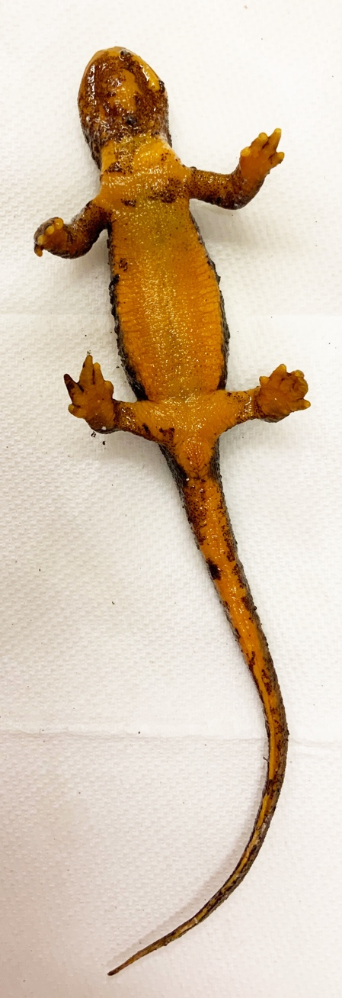

Figure 1.1 Batrachochytrium salamandrivorans exposed, clinically diseased Taricha granulosa with severe, multifocal skin sloughing especially prominent on the chin, neck, legs, feet, and tail. (TW49)

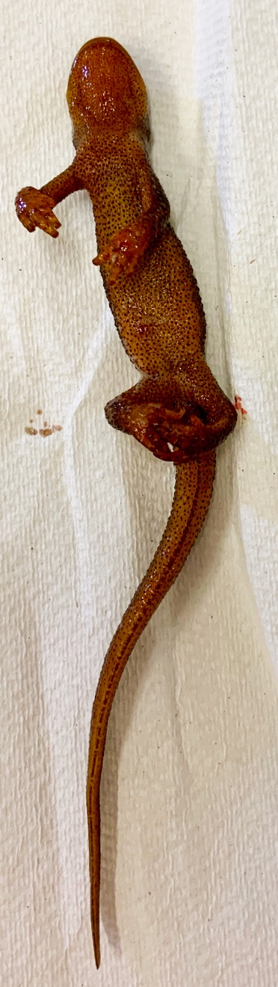

Figure 1.2 Batrachochytrium salamandrivorans exposed, clinically diseased Taricha granulosa with multifocal hemorrhage on the chin, legs, and feet. (TW25)

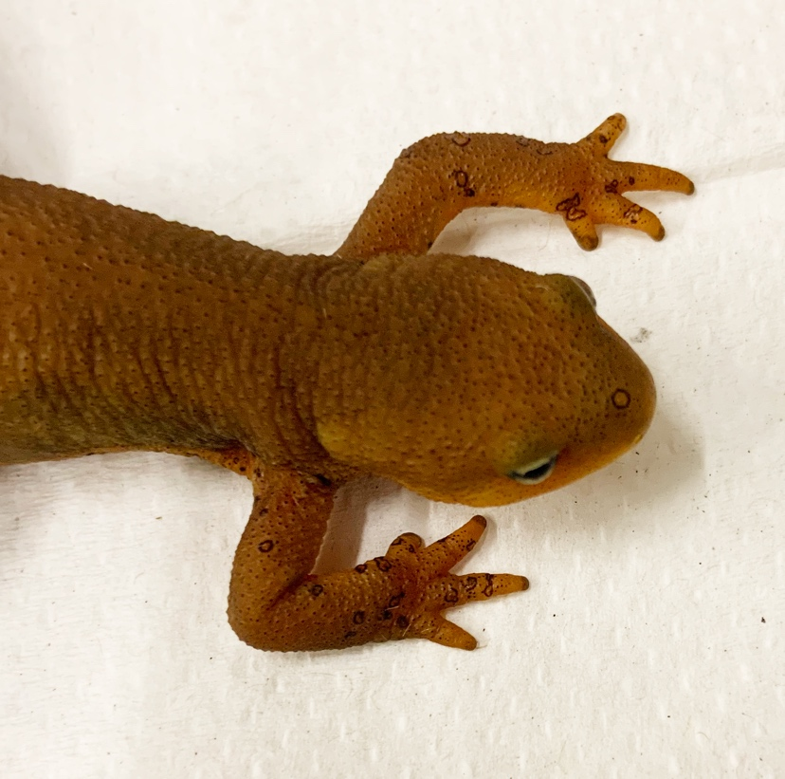

Figure 1.3 Taricha granulosa with multiple, characteristic erosive to ulcerative Batrachochytrium salamandrivorans induced skin lesions. (TW14)

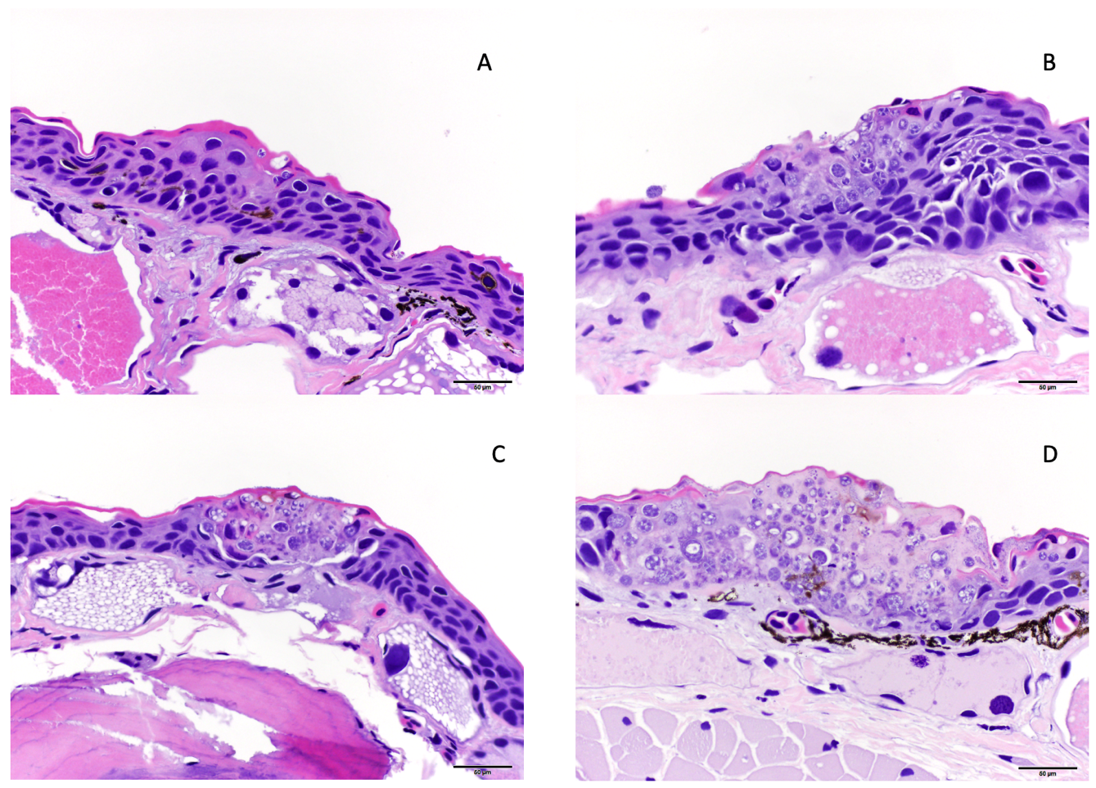

Figure 1.4 Examples of histologic lesion grading scheme used for Taricha granulosa infected with Batrachochytrium salamandrivorans (Bsal) including Grade 1 (A), Grade 2 (B), Grade 3 (C), and Grade 4 (D). Grade 1 lesions were limited to Bsal organisms within the stratum corneum, grade 2 lesions included Bsal organisms and associated cellular damage which extended into the mid-epidermis, grade 3 lesions included Bsal organisms and associated cellular damage which extended full thickness through the epidermis, grade 4 lesions included coalescing/large lesions in which Bsal organisms and associated cellular damage extended full thickness through the epidermis and were <1 millimeter in length.

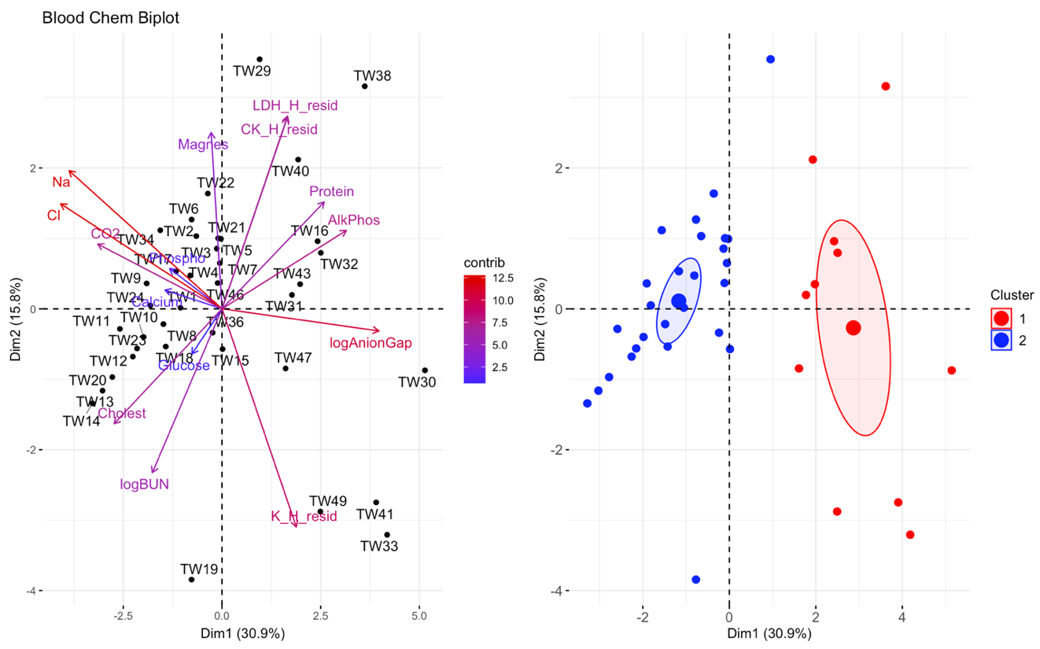

Figure 1.5 Principal component analysis (PCA) for blood chemistry data. In the biplot on the left, individuals in the same space as the arrowhead had higher values of the blood parameter, and individuals in the opposite direction had lower levels of the blood parameter. The length and color of each arrow represent the strength of the relationship. The plot on the right is showing how the individuals clustered together using K means clustering. The majority of Taricha granulosa in cluster 1 (red) were Batrachochytrium salamandrivorans (Bsal) infected, clinically diseased individuals, and the majority of T. granulosa in cluster 2 (blue) were controls or Bsal-infected, non-clinically diseased individuals. Sodium = Na; Chloride = Cl; Cholesterol = cholest; Blood urea nitrogen = logBUN; Phosphorous = Phospho; Alkaline phosphatase = AlkPhos; Magnesium = Magnes; the residuals of potassium (K) regressed on hemolytic index (H) = (K_H_resid); the residuals of creatinine (CK) regressed on H = (K_H_resid); the residuals of lactate dehydrogenase (LDH) regressed on H = (K_H_resid).

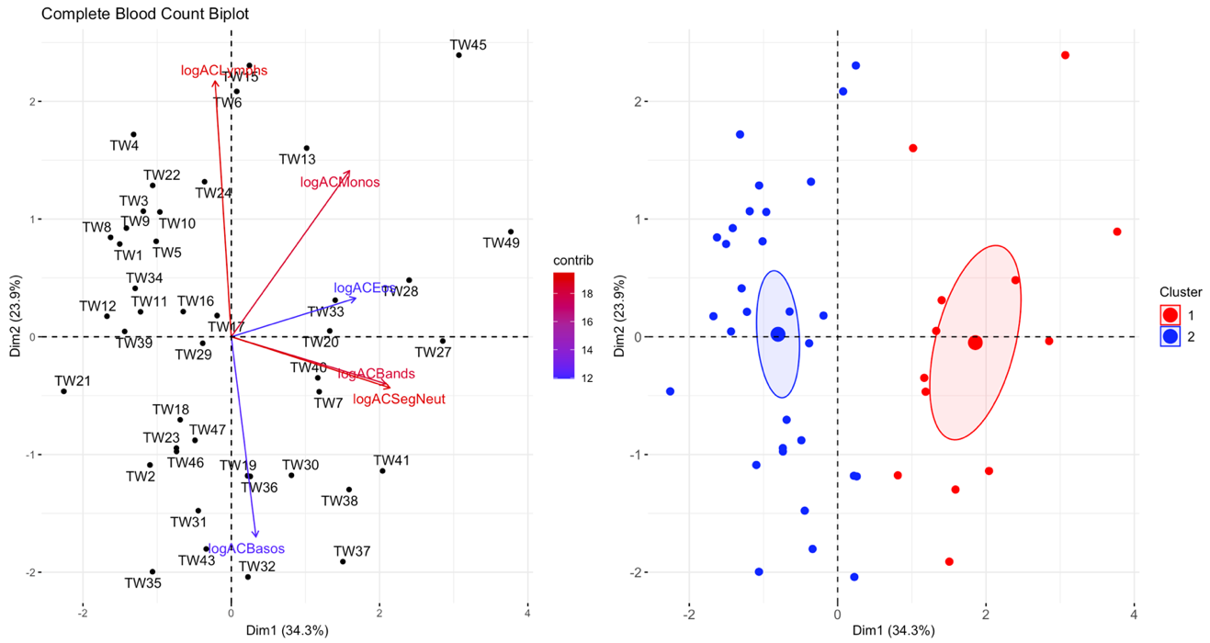

Figure 1.6 Principal component analysis (PCA) for the complete blood count (CBC) data. In the plot on the left, individuals in the same space as the arrowhead had higher values of the blood parameter, and individuals in the opposite direction had lower levels of the blood parameter. The length and color of each arrow represent the strength of the relationship. The plot on the right is showing how the individuals clustered together using K means clustering. The majority of Taricha granulosa in cluster 1 (red) were Batrachochytrium salamandrivorans (Bsal) infected, clinically diseased individuals, and the majority of T. granulosa in cluster 2 (blue) were controls or Bsal-infected, non-clinically diseased individuals. Absolute count of lymphocytes = logACLymphs; absolute count of monocytes = logACMonos; absolute count of eosinophils = logACEos; absolute count of band neutrophils = logACBands; absolute count of segmented neutrophils = logACSegNeut; absolute count of basophils = logACBasos.

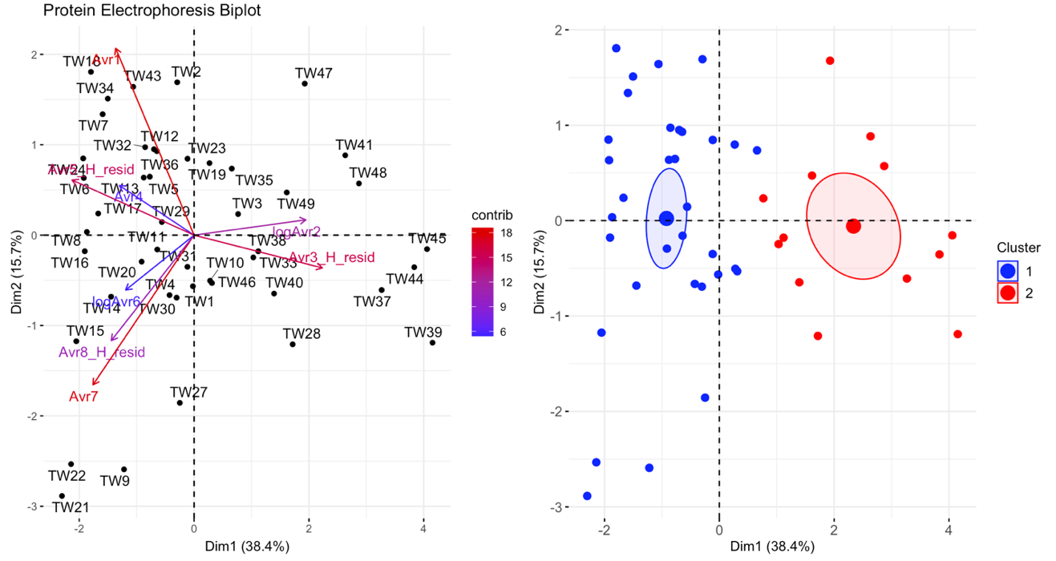

Figure 1.7 Principal component analysis (PCA) for the plasma protein electrophoresis data. In the plot on the left, individuals in the same space as the arrowhead had higher values of the blood parameter, and individuals in the opposite direction had lower levels of the blood parameter. The length and color of each arrow represent the strength of the relationship. The plot on the right is showing how the individuals clustered together using K means clustering. The majority of Taricha granulosa in cluster 1 (blue) were controls or Batrachochytrium salamandrivorans (Bsal) infected, non-clinically diseased individuals, and the majority of T. granulosa in cluster 2 (red) were Bsal-infected, clinically diseased individuals.

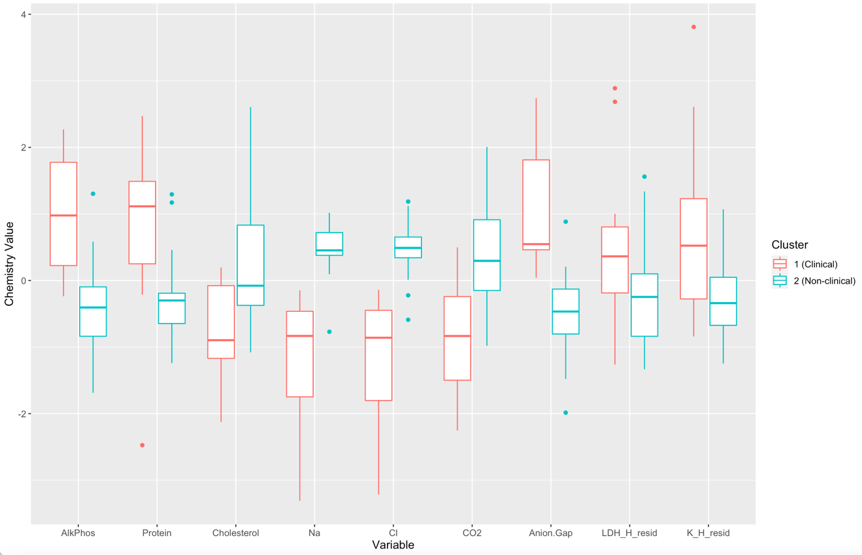

Figure 1.8 Boxplots comparing each blood chemistry variable for cluster 1 (Batrachochytrium salamandrivorans (Bsal) infected, clinically diseased Taricha granulosa) in red and cluster 2 (control and Bsal-infected, non-clinically diseased T. granulosa) in blue. Each box represents the interquartile range (IQR), the horizontal line within each box represents the median, vertical lines represent 1.5 * IQR, and dots represent outliers. Alkaline phosphatase = AlkPhos; sodium = Na; chloride = Cl; bicarbonate = CO2; the residuals of lactate dehydrogenase (LDH) regressed on hemolytic index (H) = LDH_H_resid; the residuals of potassium (K) regressed on H = K_H_resid.

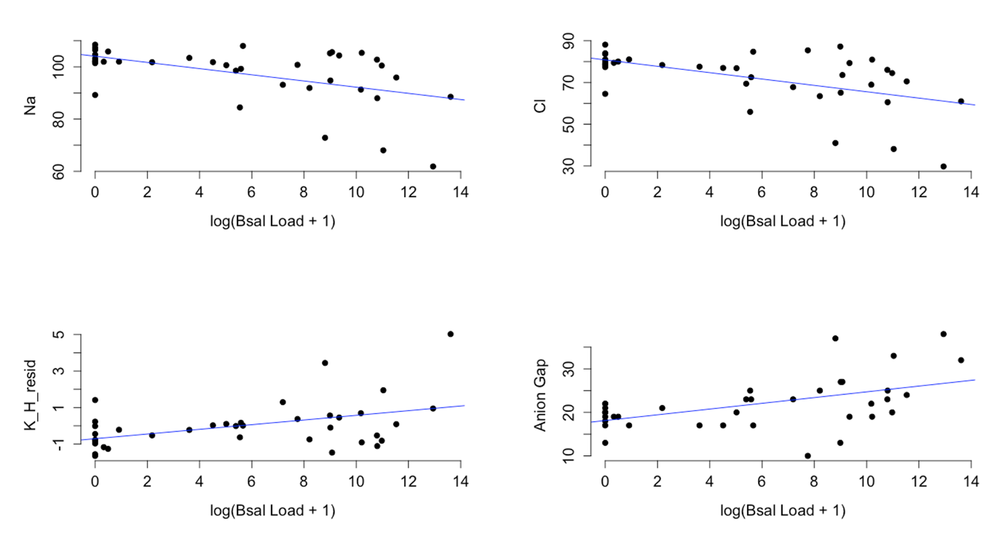

Figure 1.9 Plots of sodium (Na), chloride (Cl), the residuals of potassium (K) regressed on hemolytic index (H) (K_H_resid), and anion gap (y-axis) and the log of Batrachochytrium salamandrivorans qPCR load at time of necropsy + 1 (x-axis). Additional analysis showed that there was significant evidence for a non-linear quadratic effect of log(Bsal Load + 1) on chemistry values (log(Bsal Load + 1)² (effect from PERMANOVA: F=6.98, p=0.001).

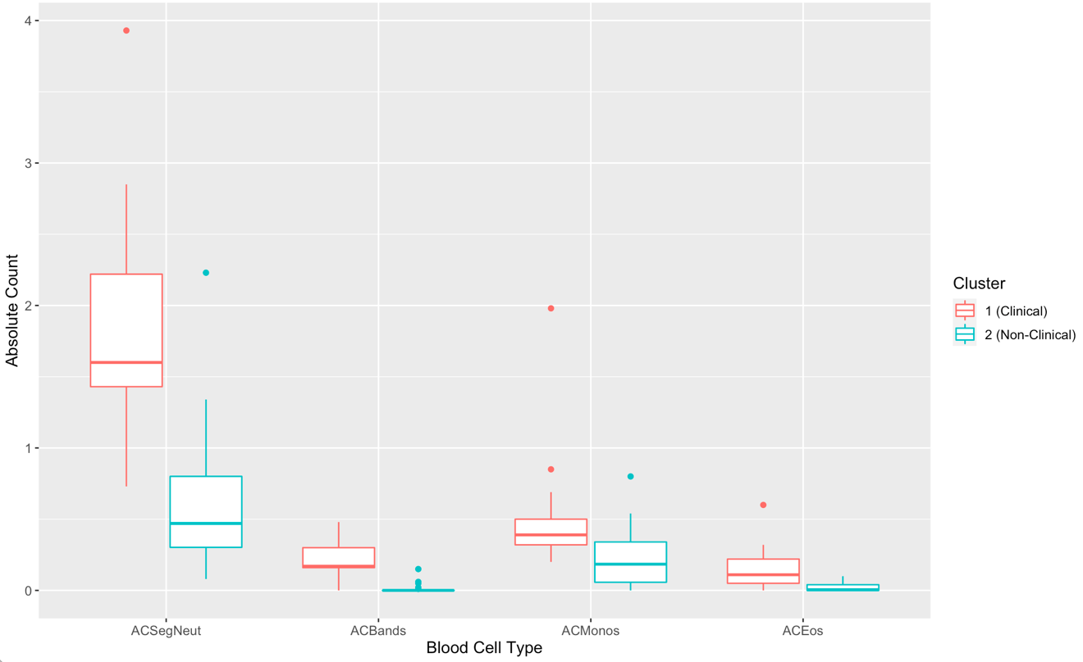

Figure 1.10 Boxplots comparing each complete blood count variable for cluster 1 (Batrachochytrium salamandrivorans (Bsal) infected, clinically diseased Taricha granulosa) in red and cluster 2 (controls and Bsal-infected, non-clinically diseased T. granulosa) in blue. Each box represents the interquartile range (IQR), the horizontal line within each box represents the median, vertical lines represent the 1.5 * IQR, and dots represent outliers. Absolute count of segmented neutrophils = ACSegNeuts; absolute count of band neutrophils = ACBands; absolute count of monocytes = ACMonos; absolute count of eosinophils = ACEos.

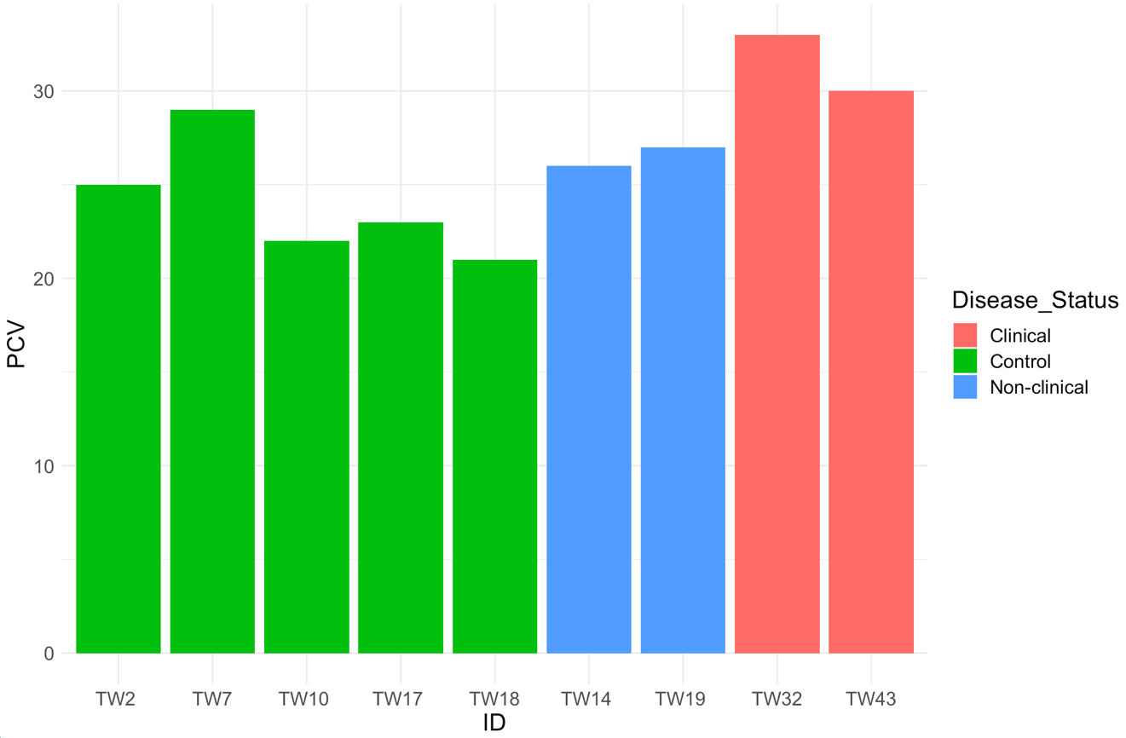
Figure 1.11 Packed cell volume for five control, two Batrachochytrium salamandrivorans-exposed/non-clinically diseased, and two Batrachochtyrium salamandrivorans- exposed/clinically diseased Taricha granulosa.

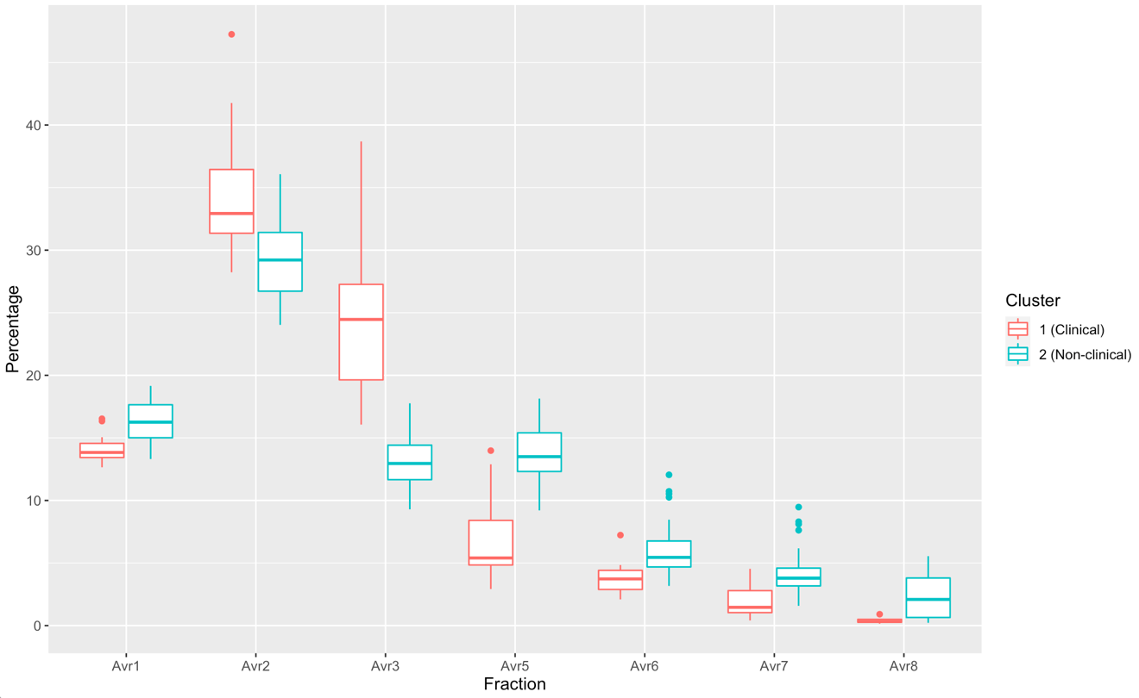

Figure 1.12 Boxplots comparing each protein electrophoresis fraction for cluster 1 (Batrachochytrium salamandrivorans (Bsal) infected, clinically diseased Taricha granulosa) in red and cluster 2 (controls and Bsal-infected, non-clinically diseased T. granulosa) in blue. Each box represents the interquartile range (IQR), the horizontal line within each box represents the median, vertical lines represent 1.5 * IQR, and dots represent outliers.

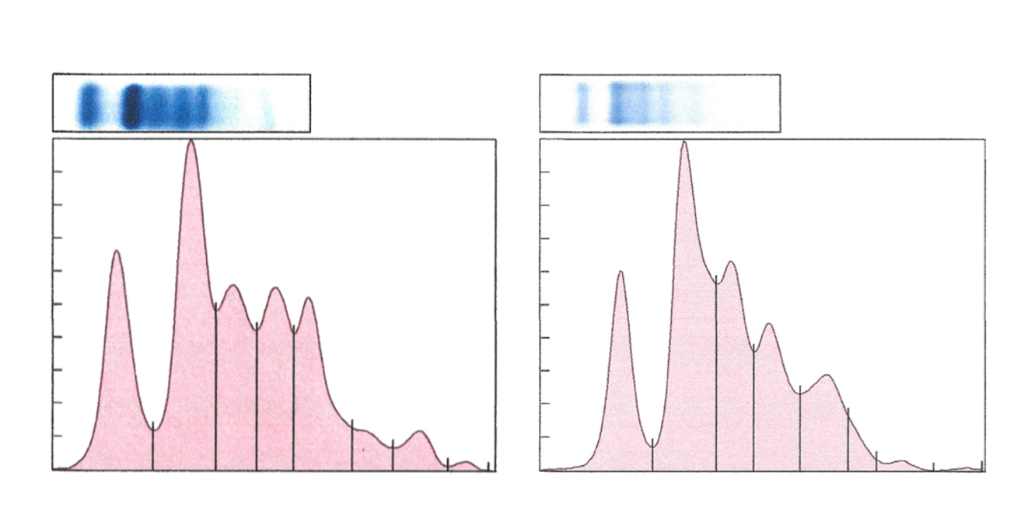
Figure 1.13 Representative protein electrophoretograms from a control (A) and a Batrachochytrium salamandrivorans infected, clinically diseased (B) Taricha granulosa.

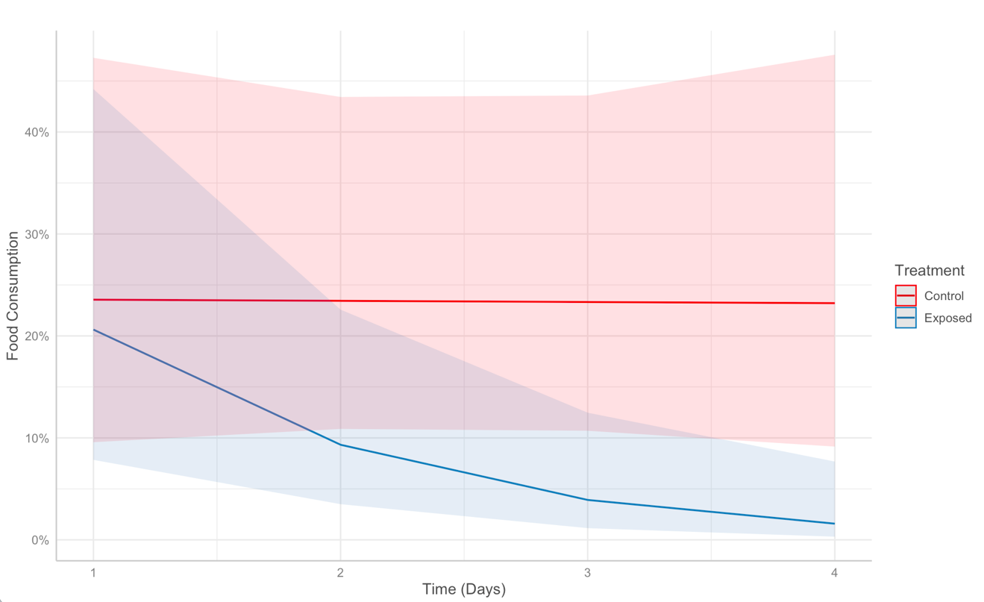

Figure 1.14 Food consumption over time (days) post-exposure in control (red) versus Batrachochytrium salamandrivorans exposed (blue) Taricha granulosa.

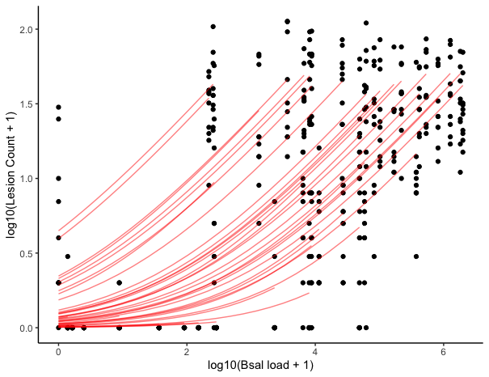

Figure 1.15 Plot of log10(Lesion count + 1) (y-axis) and log10(Bsal load + 1) (x-axis). Black points represent histologic lesion count at each of 10 standardized anatomical sections examined for each Batrachochytrium salamandrivorans (Bsal) infected Taricha granulosa. Red lines represent individual level relationships. As each individual only had one Bsal qPCR load (at necropsy), but multiple lesion counts due to the multiple sections, a unique slope cannot be inferred for the relationship between Bsal load and lesion count for each individual.

CHAPTER II: ENVIRONMENTAL TEMPERATURE AND PATHOGEN DOSE HAVE A SIGNIFICANT EFFECT ON HISTOLOGIC LESION COUNT AND SEVERITY IN NOTOPHTHALMUS VIRIDESCENS INFECTED WITH BATRACHOCHYTRIUM SALAMANDRIVORANS

Abstract
The pathogenic fungus, Batrachochytrium salamandrivorans (Bsal), was discovered a decade ago in Europe, where it is emerging and decimating salamander populations. North America is a global hotspot for salamander biodiversity and there is concern that Bsal could be introduced through trade or other pathways. One of the most abundant salamanders in eastern North America is the eastern newt (Notophthalmus viridescens), and it is highly susceptible to Bsal. Previous studies suggest that eastern newts will play a major role in Bsal epidemiology if it is introduced, and environmental temperature may influence its invasion potential. What is less known is how environmental temperature contributes to Bsal pathogenesis, and the interaction between Bsal loads, skin lesion development, and morbidity. The goal of this study was to compare Bsal-induced lesions in eastern newts among four Bsal zoospore doses (5x10^{3–6} per 10 mL) and maintained at three environmental temperatures (6, 14, and 22°C). Adult eastern newts were exposed to Bsal at one of the three target temperatures and chytridiomycosis was allowed to develop until either predetermined euthanasia endpoints were met, or the study period was completed. Following euthanasia, animals were preserved in 10% neutral buffered formalin, and standardized histology sections were taken across the body. Bsal-associated lesions were counted in each skin section, and lesions were graded for severity on a scale of 1–5. Additionally, dermal glands were examined for Bsal invasion, and all internal organs were assessed for abnormalities. Newts exposed at 22°C did not become infected by Bsal. I found that newts exposed at 14°C had increased lesion counts across all zoospore doses compared to those exposed at 6°C. For the lowest three zoospore doses, as zoospore dose increased, so did histologic lesion count. Additionally, there was a strong negative relationship between lesion count and survival, and the most common sections for histologic lesions overall were the hindlimbs, cloacal region, and tail. No significant abnormalities related to Bsal chytridiomycosis were identified in internal organs; further supporting the hypothesis that morbidity and mortality in infected individuals is directly related to skin lesions. These results provide insight into the pathogenesis of Bsal chytridiomycosis, and how environmental temperature can impact disease progression. Additionally, these results indicate swabbing the hindlimbs, cloacal region, and tail might increase detection of Bsal on infected animals due to increased lesion development at these locations.

1. Introduction
Emerging fungal diseases have recently caused unprecedented declines and extinctions in both plant and wildlife species (Fisher et al., 2012). Among affected wildlife species, amphibians have experienced the most devastating losses (Scheele et al., 2019). An emerging fungal disease involved in these declines is chytridiomycosis caused by two species of chytrid fungus, Batrachochytrium dendrobatidis (Bd) and Batrachochytrium salamandrivorans (Bsal) (Scheele et al., 2019).
Bd was discovered in 1998 and is responsible for the majority of these declines (Berger et al., 1999; Yap et al., 2015). Bsal, which was more recently discovered in 2013, is more pathogenic to salamanders, and is quickly emerging (Scheele et al., 2019). It presumably originated in Asia and spread to Europe through the pet trade (Martel et al., 2014; Yap et al., 2017), where it is currently causing large die-offs in multiple salamander species (Lotters et al., 2020; Martel et al., 2014; Martel et al., 2020).
Bsal has not yet been identified in North America (Waddle et al., 2020). However, due to multiple factors including environmental suitability, species susceptibility, and presence of Bsal in the pet trade, it is likely only a matter of time before Bsal spreads to regions other than Asia and Europe (Carter et al., 2021; Carter et al., 2019; Grant et al., 2017; Gray et al., 2015; Yap et al., 2017). We know little about how Bsal chytridiomycosis manifests and progresses in susceptible species under varying environmental conditions. Addressing this knowledge gap will inform disease identification in susceptible individuals and can be used to better understand the mechanisms of resistance and tolerance to this emerging pathogen.
Environmental temperature is especially important for amphibians as many physiologic functions, including the immune response, can be significantly affected by changes in temperature (Rollins-Smith, 2017, 2020; Wells, 2007). Previous studies have shown the pathogenicity of Bsal can change with changing temperatures in both eastern newts as well as fire salamanders (Salamandra salamandra) (Beukema et al., 2021; Blooi et al., 2015a; Carter et al., 2021; Stegen et al., 2017). Carter et al. evaluated the survival rate of Bsal-infected adult eastern newts across 6, 14, and 22°C and revealed a difference in survivability as well as Bsal qPCR load at time of necropsy between the three temperatures (Carter et al., 2021). However, no previous study has evaluated the number, distribution, and severity of histologic lesions in Bsal-infected hosts across multiple temperatures.
Incorporating histologic analysis of skin lesions in Bsal chytridiomycosis studies is imperative to fully understand the host-pathogen interaction (Thomas et al., 2018). This is important for two reasons. First, positive qPCR results alone do not confirm that infection with a pathogen is inducing disease. Some urodelan species are much more tolerant to Bsal infection than others (Wilber et al., 2021). Therefore, a Bsal qPCR load that corresponds with severe disease in one species or individual, may correspond with mild or no disease in another. Consequently, it is important to correlate qPCR results with histologic lesion analysis to determine disease causality and severity.
Second, it has been shown that enumeration of grossly visible skin lesions associated with Bsal infection in multiple urodelan species is not predictive of survival and only weakly positively correlated with Bsal qPCR load (Wilber et al., 2021). This may be because lesions are being missed without the use of histology. It has been shown that for Bd, qPCR-positive amphibians with no clinical signs or grossly apparent skin lesions can still have chytrid-induced skin lesions histologically (Borteiro et al., 2019). Therefore, incorporating histologic lesion counts and grades can provide a much better overall picture of disease progression in the animal than gross examination alone (Thomas et al., 2018).
A previous study investigating site predilection for Bsal-induced skin lesions did not incorporate lesion grade (Ossiboff et al., 2019). Higher lesion grade typically corresponds with increased numbers of intralesional Bsal organisms. Therefore, by incorporating lesion grade into histologic analysis, we can more effectively determine the best anatomical locations to collect diagnostic samples in order to optimize pathogen detection in Bsal-infected amphibians.
Previous studies have investigated the effect of various Bsal zoospore doses on survival rate and determined that this pathogen causes dose-dependent mortality in multiple species (Carter et al., 2021; Carter et al., 2019). By replicating these studies with the addition of histologic lesion count, we can begin to elucidate how this pathogen leads to decreased survival rates in the individuals at higher doses. Overall, the aim of this study was to compare disease progression among multiple environmental temperatures and pathogen doses to better understand how Bsal causes morbidity in susceptible amphibian species.

2. Methods

Ethics Statement
Husbandry as well as euthanasia procedures followed recommendations provided by the American Veterinary Medical Association and the Association of Zoos and Aquariums. Additionally, they were approved by the University of Tennessee Institutional Animal Care and Use Committee (protocol #2623). Taricha granulosa that reached euthanasia endpoints were humanely euthanized via transdermal exposure to benzocaine hydrochloride.

Animals
A total of 75 Notophthalmus viridescens (eastern newts) were used in this study. Eastern newts were chosen as they have a wide distribution throughout North America (IUCN, 2020), and are known to be susceptible to Bsal chytridiomycosis (Carter et al., 2021; Longo et al., 2019; Martel et al., 2014). Animals were collected from Tennessee (TN Scientific Collection Permit #1504).
Animal care was similar to that of adult newts described by Carter, et al. (2021). At arrival into the laboratory, animals were heat-treated at a temperature of 30°C for 10 days to clear any potential Bd infection obtained in the wild (Bletz, 2013; Chatfield & Richards-Zawacki, 2011). After heat treatment, animals were skin swabbed following a standardized protocol of 10 swipes along the ventrum and 5 swipes along the plantar surface of each foot. DNA was extracted from the swabs, and Bd qPCR was performed following the protocol by Boyle et al. (2004). All animals were confirmed to be qPCR negative for Bd and underwent a one-week acclimation period to their assigned experimental temperature prior to the start of the study.
Animals were individually housed in sterilized, circular, 2000-cm³, plastic containers filled with 300 mL of dechlorinated water along with a PVC cover object. Containers were changed and water replaced once every three days. Feeding took place every three days 24 hours prior to each water change and consisted of bloodworms (Chironomus plumosus) at 4% of their starting body weight. Individual containers were kept in an environmental growth chamber (Conviron, Winnipeg, Canada) set to their assigned temperature along with light/dark cycles which reflected the season corresponding with the environmental temperature (winter=8 hours light; spring/autumn=10 hours light; summer=12 hours light).

Experimental Design
Experimental design was similar to that described by Carter et al. (2021). Animals were randomly assigned to one of four zoospore exposure doses (5x10³, 5x10⁴, 5x10⁵, or 5x10⁶ per 10 mL) along with one of three temperatures (6, 14, and 22°C). Five animals were assigned to each treatment group along with five control animals (n=25 for each temperature trial). Animals were monitored twice daily for development of clinical signs and were euthanized when they reached humane disease endpoints (including loss of righting ability or unresponsiveness) or at the end of the study. Study duration was 60 days.

Fungal Culture
Bsal was isolated from a fire salamander (Salamandra salamandra) in the Netherlands and shared with my lab (isolate AMFP13/1, (Martel et al., 2013)). Cultures were maintained at the University of Tennessee Center for Wildlife Health laboratory and zoospores were enumerated according to previously described methods by Carter, et al. (2019).

Experimental Infection
Bsal-exposed individuals were exposed to either a dose of 5x10³, 5x10⁴, 5x10⁵, or 5x10⁶ zoospores per 10 mL by being individually placed into a 100-mL plastic tube containing a mixture of Bsal zoospores and 9-mL autoclaved dechlorinated water for 24 hours in the environmental incubators. Control animals were placed into 100-mL plastic tubes containing 10-mL of autoclaved dechlorinated water under the same time and environmental conditions as the exposed individuals.

Histopathology
Carcasses were stored in 10% neutral buffered formalin for a minimum of 48 hours prior to processing. Transverse sections through the entire body were taken at approximately 3-mm intervals and legs were removed at either the scapulohumeral or coxofemoral joint. Ten standardized sections were placed into tissue cassettes following the protocol listed in the appendix in Table 2.1 & Figure 2.1. Cassettes containing tissues were decalcified for 24 hours using a formic acid solution. Tissues were then routinely processed and stained with hematoxylin and eosin (H&E). Histologic examination consisted of examining all tissues for abnormalities as well as performing Bsal lesion counts and lesion grading in the skin for each of the 10 sections. Lesion grading consisted of scoring each lesion on a scale of 1–5 based on severity (Grade 1 = Bsal organisms within the stratum corneum, Grade 2 = Bsal organisms/associated cellular damage extending to the mid-epidermis, Grade 3 = Bsal organisms/associated cellular damage extending through the epidermis to the basement membrane, Grade 4 = coalescing/large Bsal lesions extending through the epidermis to the basement membrane which were <1 millimeter long, Grade 5 = coalescing/large Bsal lesions extending through the epidermis to the basement membrane which were ≥1 millimeter long (Table 2.2 & Figure 2.2). Perimeter of each section was measured using Excelis Accu-Scope software to standardize measures of lesion counts to counts per unit area of cross section.

Quantitative Polymerase Chain Reaction (qPCR)
To detect Bsal and estimate loads, genomic DNA was extracted from each skin swab using the QIAamp 96 DNA QIAcube HT kit (Qiagen, Hilden, Germany) and qPCR performed similar to Blooi et al. (2015) using the Applied Biosystems Quantstudio 6 Flex qPCR instrument (Thermo Fisher Scientific Inc). All samples were run in duplicate and declared positive if both replicates reached cycle threshold prior to 50 amplification cycles (Carter et al., 2019).

Statistical Analyses
Lesion Counts
To determine how temperature and Bsal zoospore dose affected the number of lesions per histologic cross section, I fit a negative binomial generalized linear model where the response variable was lesion count per cross section perimeter and the predictor variables were temperature, Bsal zoospore dose, an interaction term between temperature and Bsal zoospore dose, and section number. Environmental temperature included 6°C and 14°C, Bsal zoospore dose included four levels 10^{3–6}, and section number included sections 1–10, corresponding to different regions of the animal’s body (Table 2.1 and Figure 2.1). I used a negative binomial distribution to describe lesion counts as initial analyses showed that lesion counts were over-dispersed relative to a Poisson distribution. In addition, lesion counts were obtained from histological cross sections with different perimeters, where a larger perimeter could lead to a higher number of counted lesions than a smaller perimeter even if the density of lesions per unit perimeter were the same. To account for this, I included an offset term of log(total perimeter) in the negative binomial regression (Faraway, 2016). I fit the lesion count model using the brms package in R (Burkner, 2017), with a weakly regularizing prior on the effect sizes for the predictor variables temperature, Bsal zoospore dose, and section number. When fitting the models, I ensured all convergence by visually examining chains and checked that R_hat (the potential scale reduction factor) < 1.01 and effective sample size > 400 for all parameters (Vehtari et al., 2020). I fit five candidate models to the data and selected the best predictive model using Pareto smoothed importance sampling leave-one-out information (PSIS-LOO, (Vehtari et al., 2016). Models with lower PSIS-LOO indicate better predictive performance. I compared models including the following combinations of predictors to my final model described above: 1) temperature and Bsal zoospore dose, 2) temperature, Bsal zoospore dose, and temperature and Bsal zoospore dose as an interaction term, and 3) temperature, Bsal zoospore dose, and section number.

Probability of Lesion Presence
To determine how temperature and Bsal zoospore dose affected the probability of lesion presence, I fit a Bernoulli generalized linear model where the response variable was lesion presence and the predictor variables were Bsal zoospore dose, temperature, an interaction term between Bsal zoospore dose and temperature, and the scaled log(perimeter) as a covariate rather than an offset term in this analysis. However, the log(perimeter) covariate effectively acted as an offset, accounting for the fact that larger cross sections had a higher probability of lesion presence, all else being equal. I used a Bernoulli distribution to describe lesion presence as I was interested in the probability of a lesion being present at each Bsal zoospore dose/temperature treatment combination. I fit the model using the brms package in R (Burkner, 2017), with a weakly regularizing prior on the effect sizes for the predictor variables temperature, Bsal zoospore dose, and perimeter. When fitting the models, I ensured model convergence using the previously described methods. I fit four candidate models to the data and selected the best predictive model using PSIS-LOO. I compared models including the following combinations of predictors to my final model described above: 1) the scaled log(perimeter), 2) Bsal zoospore dose, temperature, and scaled log (perimeter), 3) Bsal zoospore dose, temperature, Bsal zoospore dose and temperature as an interaction term, scaled log(perimeter), and section number.

Lesion Grades
To determine how temperature and Bsal zoospore dose affected the expected lesion density of each lesion grade per unit cross section, I fit a generalized linear model where the response variable was lesion count, and the predictor variables were lesion grade, the interaction term of lesion grade and temperature, the interaction term of lesion grade and Bsal zoospore dose, the interaction term of lesion grade and section number, and the random effect of animal ID. Lesion grade consisted of lesion grades 1–5. This model was an extension of a multinomial regression model where lesion grades were the multinomial categories, re-expressed as a Poisson or negative binomial log-linear model (Faraway, 2016). I originally included lesion grades 1–5 in the model; however, grade 5 lesions were dropped from the analysis due to their relative rarity leading to issues with separability. I fit models with both a Poisson and negative binomial distribution of lesion counts, and the negative binomial was preferred due to the overdispersion of lesion counts. Additionally, I included an offset term of log(total perimeter) in the log-linear regression as described in the lesion count analysis.
I fit the model using the brms package in R (Burkner, 2017), with a weakly regularizing prior on the effect sizes for the predictor variables temperature, Bsal zoospore dose, and lesion grade ([prior = 0,3]; all continuous covariates were standardized to a mean of 0 and a standard deviation of 1 before fitting). When fitting the models, I ensured model convergence using the previously described methods. I fit eight candidate models to the data and selected the best predictive model using PSIS-LOO. I compared models including the following combinations of predictors (using both a negative binomial distribution and a Poisson distribution for each) to my final model described above: 1) lesion grade and individual ID as a random effect, 2) lesion grade, lesion grade and temperature as an interaction term, lesion grade and Bsal zoospore dose as an interaction term, and individual ID as a random effect, 3) lesion grade, lesion grade and temperature as an interaction term, lesion grade and Bsal zoospore dose as an interaction term, the combination of lesion grade, temperature, and Bsal zoospore dose as an interaction term, and individual ID as a random effect. For potentially influential observations with a Pareto smoothing k > 0.7, I temporarily excluded these values to see if they affected my model selection. My model selection was unaffected by these potentially influential observations, and they were included in our model inference. Finally, Bsal zoospore dose was replaced with Bsal qPCR load at the time of necropsy in all models and were compared to original models using PSIS-LOO.

Survival Analysis
To determine how Bsal zoospore dose and lesion count affected survival rate, I fit a Cox proportional hazards model where the response variable was days survived and the predictor variables were Bsal zoospore dose and lesion count, where lesion count was transformed as log(lesion count + 1). In my experiment, some of the N. viridescens were euthanized and others died. I considered euthanized individuals as right-censored. When fitting the models, I ensured the proportional hazards assumption was met by confirming a non-significant relationship between Schoenfeld residuals for each covariate and time (Klein & Moeschberger, 2003). I checked overall goodness-of-fit by plotting cumulative hazard against Cox-Snell residuals and visually assessed for clear outliers by plotting deviance residuals against observation number. Additionally, I compared models including Bsal zoospore dose to models including Bsal qPCR load at the time of necropsy using Akaike information criteria (AIC), where lower AIC indicates better predictive performance. Models including Bsal zoospore dose were determined to be a better predictor of survival. All models were fit with using the coxph function in the `survival` package in R (version 4.1.1, (Therneau & Lumley, 2015).

3. Results

Lesion Counts
Across all Bsal zoospore doses, N. viridescens exposed at 14°C had a higher expected lesion count per average cross section than those exposed at 6°C (Fig. 2.3), though the effect of temperature changed with zoospore dose (Difference in PSIS-LOO for models with and without the temperature by zoospore dose interaction = 41.2; Fig. 2.3). Notophthalmus viridescens exposed to the 5 x 10⁵ zoospore dose at 14°C had the overall highest expected lesion count per average cross section (Expected number of lesions per average cross section for the 10⁵/14°C treatment: E: 77.24, 95%CI: 55.70–109.15; Fig 2.3). Due to the significant interaction between temperature and zoospore dose, individuals exposed to the 5 x 10⁶ zoospore dose at 14°C had lower expected lesion counts than those at 5 x 10⁵ doses (Difference between 10⁵ and 10⁶ at 14°C: E: 41.92, 95%CI: 22.31–69.78; Fig. 2.3). Across all zoospore dose and temperature combinations, sections 6 (hindlimb), 9 (cloacal region) and 10 (tail) had the highest expected lesion counts relative to the baseline of Section 1 (effect sizes relative to Section 1: [(section 6 = E: 0.57; 95%CI: 0.2–0.95); (section 9 = E: 0.57; 95%CI: 0.18–0.98); (section 10 = E: 0.85; 95%CI: 0.48–1.23)]; Fig. 2.3).

Probability of Lesion Presence
Notophthalmus viridescens exposed to the two lowest zoospore doses had a greater probability of having Bsal-associated skin lesions at 14°C than at 6°C (Estimate of difference between the probability of lesion presence at 14°C minus the probability of lesion presence at 6°C for 10³: E: 0.62, 95% CI: 0.46–0.75; Estimate of difference between the probability of lesion presence at 14°C minus the probability of lesion presence at 6°C for 10⁴: E: 0.15, 95%CI: 0.07–0.27; Fig. 2.4). Notophthalmus viridescens exposed to the two highest zoospore doses had an approximately equal probability of having Bsal-associated skin lesions regardless of temperature (95% CI of difference between the probability of lesion presence at 14°C minus the probability of lesion presence at 6°C for 10⁵: -0.02–0.03; [95% CI of difference between the probability of lesion presence at 14°C minus the probability of lesion presence at 6°C at 10⁶: -0.02–0.02]; Fig. 2.4). Finally, N. viridescens exposed to zoospore doses 5 x 10^{4–6} were more likely to have lesions present than those exposed to a zoospore dose of 5 x 10³ regardless of the temperature (Fig. 2.4).

Lesion Grade
Regardless of temperature, I found that Grade 1 lesions were the most common at the lowest zoospore dose, Grade 3 lesions were the most common at the 5 x 10⁴ and 5 x 10⁶ zoospore doses, and Grade 2 lesions were the most common at the 5 x 10⁵ zoospore dose (Fig. 2.5). Grade 5 lesions were the least common grade of lesion across all zoospore dose/temperature combinations (Total number of grade 5 lesions observed from N. viridescens across all zoospore dose/temperature combinations = 83). Grade 4 lesions were the second least common grade of lesion across all zoospore dose/temperature combinations (Fig. 2.5). Similar to my analysis on overall lesion counts, section number (sections 6 and 10) was an important predictor of lesion grade, particularly for Grade 4 and Grade 5 lesions (Difference in PSIS-LOO for models with and without Section as a factor = 579.9). As determined previously, temperature also had a significant effect on lesion count; however, the magnitude of the effect varied with lesion grade (Fig. 2.5).

Survival Analysis
A strong negative relationship was identified between lesion count and survival duration, with increasing lesion count correlating with decreased survival (Hazard ratio: 1.65; 95%CI: 1.46-1.86 for the lesion count effect). This strong relationship persisted after accounting for either Bsal zoospore dose or Bsal infection intensity at necropsy, indicating that lesions were describing variability in host survival beyond exposure or infection intensity (Table 2.3). Notophthalmus viridescens exposed to the 5 x 10⁶ zoospore dose had the shortest survival time followed by 5 x 10⁵, 5 x 10³, and 5 x 10⁴ zoospore doses (Fig. 2.6).

Internal Organ and Dermal Gland Examination
No lesions associated with Bsal chytridiomycosis were identified in internal organs. The only abnormalities identified in both control and exposed individuals included variable amounts of melanomacrophage hyperplasia in the liver as well as various parasites within the coelomic cavity, gastrointestinal tract, and skeletal muscle. Parasites included mesomycetozoans, trematodes, nematodes, and cestodes, and were associated with minimal to no inflammatory response. For the 6°C animals, dermal gland invasion was identified in 1–2 dermal glands in one 10³, one 10⁴, two 10⁵, and one 10⁶ individual(s). For the 14°C animals, dermal gland invasion was identified in 1–4 dermal glands in two 10⁴, one 10⁵, and two 10⁶ individual(s). All areas of dermal gland invasion had Bsal organisms and associated cellular damage in the overlying dermis and epidermis which was variably eroded to ulcerated.

4. Discussion
The main objective of this study was to determine how environmental temperature and pathogen dose relate to disease progression in Bsal-exposed N. viridescens. Environmental temperature as well as Bsal zoospore exposure dose were both shown to have a significant effect on histologic lesion development. Notophthalmus viridescens exposed at 22°C did not become infected at any Bsal zoospore dose. Notophthalmus viridescens exposed at 14°C had increased lesion counts compared to those exposed at 6°C across all zoospore doses. These findings support those from a previous study, which determined that N. viridescens exposed to Bsal at 14°C had overall lower survival rates than those exposed at 6°C or 22°C (Carter et al., 2021). Lower survival rates in environmental conditions associated with higher lesion counts supports the hypothesis of Bsal chytridiomycosis having a similar pathogenesis to Bd chytridiomycosis, involving pathogen-induced epithelial damage being the primary cause of morbidity and mortality in infected individuals (Voyles et al., 2009).
The reason for these differences between exposure temperatures is likely multifactorial and due to variations in both the host response to infection and the pathogenicity of the fungus. Carter et al. (2021) showed that N. viridescens exposed at 6°C tend to survive longer and with a lower Bsal qPCR load at necropsy than those exposed at 14°C, likely indicating a decreased infection tolerance at this temperature. A similar trend was also identified in a separate study involving S. salamandra (Stegen et al., 2017). In my study, histologic lesion count at the time of death/euthanasia was lower in 6°C animals than in 14°C animals, supporting the theory of decreased infection tolerance at this temperature (i.e. animals are dying with fewer lesions). This may be due in part to a decreased immune response to the pathogen, as colder temperatures have been shown to lead to decreased immune system function in amphibians (Rollins-Smith, 2017).
Carter et al. (2021) identified another potential method of host response to Bsal infection in that N. viridescens housed at 6°C had a larger amount of total recovered proteins on their skin than those housed at 14°C. They proposed that these proteins may have inhibitory effects against Bsal zoospores which could have led to decreased rate of disease progression in the 6°C animals. Decreased histologic lesion counts at this temperature compared to at 14°C also support this theory. By incorporating histologic lesion counts in my study, I have gained an understanding of disease progression, which Carter et al. (2021) was not able to assess without the use of histology.
In regard to changes in the pathogenicity of the fungus itself, it has been determined that the optimal temperature for maximum growth of Bsal in vitro is between 10°C and 15°C, with reduced growth at lower temperatures (Martel et al., 2013). Therefore, at 6°C, Bsal replication rate may have been reduced compared to at 14°C. This may have also contributed to decreased lesion numbers on N. viridescens exposed at this temperature. Previous studies have shown that S. salamandra housed at 25°C can clear Bsal infection with heat treatment alone, (Blooi et al., 2015a) and at 20°C in combination with antibiotic and antifungal agents (Blooi et al., 2015b). This study as well as a study by Carter et al. (2021) also confirmed no infection when N. viridescens were exposed to Bsal at 22°C.
The probability of lesion presence being equal between 6°C and 14°C at the two highest Bsal zoospore doses indicates that when N. viridescens are exposed to a high enough load of the pathogen, they will become infected regardless of the environmental temperature at 6 or 14°C. This is supported by the decreased survival rate seen in the two highest zoospore doses in this study. Additionally, similar survival rate findings were reported in a previous study (Carter et al., 2021).
Across all 6°C and 14°C temperature and zoospore dose combinations, grade 5 lesions were the rarest, followed by grade 4 lesions. These lesion grades occurred most at the higher zoospore doses in the 14°C temperature group. As these are the most severe lesion grades, it is likely that once lesions this severe begin to develop, mortality occurs shortly after.
The hindlimbs, cloacal region, and tail were identified as the most common sites for lesion development across all 6°C and 14°C temperature and zoospore dose combinations. Additionally, the hindlimbs and tail were where the most severe lesions occurred. The hindlimbs and tail were also identified to be predilection sites for Bsal-associated lesions histologically in a previous study in N. viridescens; however, this study did not investigate lesion grade (Ossiboff et al., 2019). This information is very important for disease surveillance efforts as it provides knowledge regarding the best anatomic location to collect diagnostic samples to obtain the highest chance of detecting the pathogen in Bsal-infected animals. Additionally, these sections are of particular importance when examining an animal grossly for Bsal-associated skin lesions. Since these sites have the most numerous and most severe lesions, they are more likely to be visible without microscopic examination. It is important to note that additional studies investigating Bsal skin lesion distribution in naturally infected animals should be performed as exposure method could affect lesion distribution in experimental studies.
At 14°C, N. viridescens exposed to the second highest zoospore dose had the greatest expected lesion density per cross section. This is an interesting finding as the highest zoospore dose might be expected to have the highest lesion count. However, the reasoning for this is that although more lesions were present in animals at the 10⁵ dose, the lesions were more commonly less severe than those present in the 10⁶ animals. Therefore, the 10⁶ animals had a lower expected lesion density with overall more severe lesions.
Histologic lesion count was determined to have a strong negative correlation with survival time after accounting for Bsal infection intensity, with increasing lesion counts leading to decreased probability of survival. A previous study assessing gross rather than histologic lesion count showed that lesion count was not predictive of survival (Wilber et al., 2021). This highlights the importance of incorporating histology into Bsal chytridiomycosis studies to fully understand the impact of infection (Thomas et al., 2018).
Invasion of dermal glands with Bsal zoosporangia was identified in at least one N. viridescens from the majority of zoospore dose treatments within the 6°C and 14°C treatment groups. Amphibians possess two types of glands within their dermis classified as either granular glands or mucous glands. These glands have many important functions including maintaining moisture and permeability of the skin, producing and secreting antimicrobial peptides as a key component of the innate immune response, and producing substances to deter predators (Varga et al., 2018). Infection of dermal glands in Bsal chytridiomycosis has been reported previously (Ossiboff et al., 2019), and has been proposed as a potential unique component of Bsal pathogenesis (Chapter I), as this does not occur in cases of Bd chytridiomycosis (Berger et al., 2005; Longcore et al., 1999). Carter et al. (2021) found that at two months post Bsal exposure, N. viridescens exposed at 6°C had significantly less defensive hydrophobic molecules produced through skin secretions than control N. viridescens, which could also be supportive of damage to these glands being an aspect of disease pathogenesis (Carter et al., 2021). Secretion of these defensive molecules has also been shown to be associated with stress as well as other types of injury and infection (Varga et al., 2018). Therefore, future studies assessing impaired function of these glands associated with Bsal infection are warranted.
As in other chytridiomycosis studies, no internal lesions directly related to chytridiomycosis were identified. Varying amounts of melanomacrophage hyperplasia were noted within the liver of both control and exposed N. viridescens; however, this is a non-specific finding. Multiple types of parasites were documented within the coelomic cavity, gastrointestinal tract, and skeletal muscle; however, they incited no to minimal inflammation and were considered incidental. Lack of internal lesions provides further support to the proposed pathogenesis of chytridiomycosis primarily involving damage to the skin cells leading to electrolyte imbalances and cardiac arrest (Voyles et al., 2009). Death associated with electrolyte imbalances is often very acute, and therefore, histologic lesions frequently do not have time to develop in internal organs such as the heart.
Overall, findings confirm that histologic lesion count and grade are influenced by both environmental temperature as well as zoospore dose in Bsal-infected N. viridescens. Additionally, my results provide support for the pathogenesis of chytridiomycosis primarily involving damage to the epidermal cells (Chapter I). I also provide further evidence that dermal gland invasion could potentially play a role in Bsal chytridiomycosis disease pathogenesis (Ossiboff et al., 2019), as invasion of glands was identified in multiple individuals across treatment groups.
Future studies should assess the effect of temperature and zoospore dose on histologic lesion count in additional amphibian species, as each species responds differently to infection (Martel et al., 2014). This will further our knowledge of host-pathogen interactions as well as increase our understanding of pathogen tolerance (Wilber et al., 2021). Additionally, future studies incorporating other diagnostic methods such as complete blood cell counts, blood gas evaluation, and plasma protein electrophoresis would be useful to better understand what disturbances are occurring in the host and leading to morbidity and mortality associated with skin lesions (Chapter I).

REFERENCES
Berger, L., Hyatt, A. D., Speare, R., & Longcore, J. E. (2005). Life cycle stages of the amphibian chytrid Batrachochytrium dendrobatidis. Dis Aquat Organ, 68(1), 51-63. doi:10.3354/dao068051
Berger, L., Speare, R., & Hyatt, A. (1999). Chytrid fungi and amphibian declines: overview, implications and future directions. In C. A (Ed.), Declines and Disappearances of Australian Frogs (pp. 22-33): Canberra ACT: Environment Australia.
Beukema, W., Pasmans, F., Van Praet, S., Ferri-Yanez, F., Kelly, M., Laking, A. E., Erens, J., Speybroeck, J., Verheyen, K., Lens, L., & Martel, A. (2021). Microclimate limits thermal behaviour favourable to disease control in a nocturnal amphibian. Ecol Lett, 24(1), 27-37. doi:10.1111/ele.13616
Bletz, M. C. (2013). Probiotic bioaugmentation of an anti-Bd bacteria, Janthinobacterium lividum, on the amphibian, Notophthalmus viridescens: Transmission efficacy and persistence of the probiotic on the host and non-target effects of probiotic addition on ecosystem components. James Madison University, Harrisonburg, VA.
Blooi, M., Martel, A., Haesebrouck, F., Vercammen, F., Bonte, D., & Pasmans, F. (2015a). Treatment of urodelans based on temperature dependent infection dynamics of Batrachochytrium salamandrivorans. Sci Rep, 5, 8037. doi:10.1038/srep08037
Blooi, M., Pasmans, F., Rouffaer, L., Haesebrouck, F., Vercammen, F., & Martel, A. (2015b). Successful treatment of Batrachochytrium salamandrivorans infections in salamanders requires synergy between voriconazole, polymyxin E and temperature. Sci Rep, 5, 11788. doi:10.1038/srep11788
Borteiro, C., Kolenc, F., Verdes, J. M., Martinez Debat, C., & Ubilla, M. (2019). Sensitivity of histology for the detection of the amphibian chytrid fungus Batrachochytrium dendrobatidis. J Vet Diagn Invest, 31(2), 246-249. doi:10.1177/1040638718816116
Burkner, P. (2017). brms: An R package for Bayesian multilevel models using stan. Journal of Statistical Software, 80(1), 1-28.
Carter, E. D., Bletz, M. C., Le Sage, M., LaBumbard, B., Rollins-Smith, L. A., Woodhams, D. C., Miller, D. L., & Gray, M. J. (2021). Winter is coming-Temperature affects immune defenses and susceptibility to Batrachochytrium salamandrivorans. PLoS Pathog, 17(2), e1009234. doi:10.1371/journal.ppat.1009234
Carter, E. D., Miller, D. L., Peterson, A. C., Sutton, W. B., Cusaac, J. P. W., Spatz, J. A., Rollins-Smith, L., Reinert, L., Bohanon, M., Williams, L. A., Upchurch, A., & Gray, M. J. (2019). Conservation risk of Batrachochytrium salamandrivorans to endemic lungless salamanders. Conservation Letters, 13(1), e12675.
Chatfield, M. W., & Richards-Zawacki, C. L. (2011). Elevated temperature as a treatment for Batrachochytrium dendrobatidis infection in captive frogs. Dis Aquat Organ, 94(3), 235-238. doi:10.3354/dao02337
Faraway, J. J. (2016). Extending the Linear Model with R: Generalized Linear, Mixed Effects and Nonparametric Regression Models (Second ed.). Boca Raton, FL: Taylor & Francis Group.
Fisher, M. C., Henk, D. A., Briggs, C. J., Brownstein, J. S., Madoff, L. C., McCraw, S. L., & Gurr, S. J. (2012). Emerging fungal threats to animal, plant and ecosystem health. Nature, 484(7393), 186-194. doi:10.1038/nature10947
Grant, E. H. C., Muths, E., Katz, R. A., Canessa, S., Adams, M. J., Ballard, J. R., Berger, L., Briggs, C. J., Coleman, J. T. H., Gray, M. J., Harris, M. C., Harris, R. N., Hossack, B., Huyvaert, K. P., Kolby, J., Lips, K. R., Lovich, R. E., McCallum, H. I., Mendelson, J. R., Nanjappa, P., Olson, D. H., Powers, J. G., Richgels, K. L., Russell, R. E., Schmidt, B. R., Spitzen-van der Sluijs, A., Watry, M. K., Woodhams, D. C., & White, C. L. (2017). Using decision analysis to support proactive management of emerging infectious wildlife diseases. Frontiers in Ecology and the Environment 15(4), 214-221.
Gray, M. J., Lewis, J. P., Nanjappa, P., Klocke, B., Pasmans, F., Martel, A., Stephen, C., Parra Olea, G., Smith, S. A., Sacerdote-Velat, A., Christman, M. R., Williams, J. M., & Olson, D. H. (2015). Batrachochytrium salamandrivorans: The North American Response and a Call for Action. PLoS Pathog, 11(12), e1005251. doi:10.1371/journal.ppat.1005251
IUCN. (2020). The IUCN Red List of Threatened Species. Retrieved from
Klein, J. P., & Moeschberger, M. L. (2003). Survival Analysis: Techniques for Censored and Truncated Data (2nd ed.). New York: Springer.
Longcore, J. E., Pessier, A. P., & Nichols, D. K. (1999). Batrachochytrium dendrobatidis gen. et sp. nov., a chytrid pathogenic to amphibians. Mycologia, 91, 219-227. doi:10.1080/00275514.1999.12061011
Longo, A., Fleischer, R. C., & Lips, K. R. (2019). Double trouble: co-infections of chytrid fungi will severely impact widely distributed N. viridescens. Biological Invasions, 21. doi:doi.org/10.1007/s10530-019-01973-3
Lotters, S., Veith, M., Wagner, N., Martel, A., & Pasmans, F. (2020). Bsal-driven salamander mortality pre-dates the European index outbreak. Salamandra, 56, 239-242.
Martel, A., Blooi, M., Adriaensen, C., Van Rooij, P., Beukema, W., Fisher, M. C., & Pasmans, F. (2014). Recent introduction of a chytrid fungus endangers Western Palearctic salamanders Science 346, 630-631.
Martel, A., Spitzen-van der Sluijs, A., Blooi, M., Bert, W., Ducatelle, R., Fisher, M. C., Woeltjes, A., Bosman, W., Chiers, K., Bossuyt, F., & Pasmans, F. (2013). Batrachochytrium salamandrivorans sp. nov. causes lethal chytridiomycosis in amphibians. Proc Natl Acad Sci U S A, 110(38), 15325-15329. doi:10.1073/pnas.1307356110
Martel, A., Vila-Escale, M., Fernandez-Giberteau, D., Martinez-Silvestre, A., Canessa, S., Van Praet, S., Pannon, P., Chiers, K., Ferran, A., Kelly, M., Picart, M., Piulats, D., Li, Z., Pagone, V., Perez-Sorribes, L., Molina, C., Tarrago-Guarro, A., Velarde-Nieto, R., Carbonell, F., Obon, E., Martinez-Martinez, D., Guinart, D., Casanovas, R., Carranza, S., & Pasmans, F. (2020). Integral chain management of wildlife diseases. Conservation Letters, 13, e12707.
Ossiboff, R. J., Towe, A. E., Brown, M. A., Longo, A. V., Lips, K. R., Miller, D. L., Carter, E. D., Gray, M. J., & Frasca, S., Jr. (2019). Differentiating Batrachochytrium dendrobatidis and B. salamandrivorans in Amphibian Chytridiomycosis Using RNAScope((R)) in situ Hybridization. Front Vet Sci, 6, 304. doi:10.3389/fvets.2019.00304
Rollins-Smith, L. A. (2017). Amphibian immunity-stress, disease, and climate change. Dev Comp Immunol, 66, 111-119. doi:10.1016/j.dci.2016.07.002
Rollins-Smith, L. A. (2020). Global amphibian declines, disease, and the ongoing battle between Batrachochytrium fungi and the immune system. Herpetologica, 76(2), 178-188. doi:10.1655/0018-0831-76.2.178
Scheele, B. C., Pasmans, F., Skerratt, L. F., Berger, L., Martel, A., Wouter, B., Acevedo, A. A., & Canessa, S. (2019). Amphibian fungal panzootic causes catastrophic and ongoing loss of biodiversity. Wildlife Disease 363 1459-1463
Stegen, G., Pasmans, F., Schmidt, B. R., Rouffaer, L. O., Van Praet, S., Schaub, M., Canessa, S., Laudelout, A., Kinet, T., Adriaensen, C., Haesebrouck, F., Bert, W., Bossuyt, F., & Martel, A. (2017). Drivers of salamander extirpation mediated by Batrachochytrium salamandrivorans. Nature, 544(7650), 353-356. doi:10.1038/nature22059
Therneau, T. M., & Lumley, T. (2015). Package ‘survival’. R Topics Documented, 128.
Thomas, V., Blooi, M., Van Rooij, P., Van Praet, S., Verbrugghe, E., Grasselli, E., Lukac, M., Smith, S., Pasmans, F., & Martel, A. (2018). Recommendations on diagnostic tools for Batrachochytrium salamandrivorans. Transbound Emerg Dis, 65(2), e478-e488. doi:10.1111/tbed.12787
Varga, J. F. A., Bui-Marinos, M. P., & Katzenback, B. A. (2018). Frog Skin Innate Immune Defences: Sensing and Surviving Pathogens. Front Immunol, 9, 3128. doi:10.3389/fimmu.2018.03128
Vehtari, A., Gelman, A., Simpson, D., Carpenter, B., & Burkner, P. (2020). Rank-normalization, folding, and localization: An improved R.hat for assessing convergence of MCMC (with discussion) Bayesian Analysis, 16(2), 667-718. doi:10.1214/20-BA1221
Vehtari, A., Mononen, T., Tolvanen, V., & Sivula, T. (2016). Bayesian leave-one-out cross-validation approximations for Gaussian latent variable models. Journal of Machine Learning Research, 17, 1-38.
Voyles, J., Young, S., Berger, L., Campbell, C., Voyles, W. F., Dinudom, A., Cook, D., Webb, R., Alford, R. A., Skerratt, L. F., & Speare, R. (2009). Pathogenesis of chytridiomycosis, a cause of catastrophic amphibian declines. Science, 326(5952), 582-585. doi:10.1126/science.1176765
Waddle, J. H., Grear, D. A., Mosher, B. A., Grant, E. H. C., Adams, M. J., Backlin, A. R., Barichivich, W. J., Brand, A. B., Bucciarelli, G. M., Calhoun, D. L., Chestnut, T., Davenport, J. M., Dietrich, A. E., Fisher, R. N., Glorioso, B. M., Halstead, B. J., Hayes, M. P., Honeycutt, R. K., Hossack, B. R., Kleeman, P. M., Lemos-Espinal, J. A., Lorch, J. M., McCreary, B., Muths, E., Pearl, C. A., Richgels, K. L. D., Robinson, C. W., Roth, M. F., Rowe, J. C., Sadinski, W., Sigafus, B. H., Stasiak, I., Sweet, S., Walls, S. C., Watkins-Colwell, G. J., White, C. L., Williams, L. A., & Winzeler, M. E. (2020). Batrachochytrium salamandrivorans (Bsal) not detected in an intensive survey of wild North American amphibians. Sci Rep, 10(1), 13012. doi:10.1038/s41598-020-69486-x
Wells, D. K. (2007). The Ecology and Behavior of Amphibians: World Scientific.
Wilber, M. Q., Carter, E. D., Gray, M. J., & Briggs, C. J. (2021). Putative resistance and tolerance mechanisms have little impact on disease progression for an emerging salamander pathogen. Functional Ecology, 35, 847-859. doi:10.1111/1365-2435.13754
Yap, T. A., Koo, M. S., Ambrose, R. F., Wake, D. B., & Vredenburg, V. T. (2015). Averting a North American biodiversity crisis. Science, 349(6247), 481-482. doi:10.1126/science.aab1052
Yap, T. A., Nguyen, N. T., Serr, M., Shepack, A., & Vredenburg, V. T. (2017). Batrachochytrium salamandrivorans and the Risk of a Second Amphibian Pandemic. Ecohealth, 14(4), 851-864. doi:10.1007/s10393-017-1278-1

APPENDICES

Appendix A: Tables

Table 2.1 Anatomic location associated with each of ten standardized sections examined histologically for lesion counts and grading in Batrachochytrium salamandrivorans infected Notophthalmus viridescens.

Section Number | Anatomic Location
1 | Cranial to eye
2 | Caudal to eye
3 | Cranial to thoracic limbs
4 | Caudal to thoracic limbs
5 | Left forelimb
6 | Right hindlimb
7 | Mid-body
8 | Cranial to hindlimbs
9 | Caudal to hindlimbs
10 | Caudal 3 cm of the tail

Table 2.2 Description of histologic lesion grading system (1–5) used in Batrachochytrium salamandrivorans infected Notophthalmus viridescens.

Lesion Grade | Description
1 | Lesion/Organisms extending into the stratum corneum only
2 | Lesion/organisms extending to the level of the mid-stratum spinosum
3 | Lesion/organisms extending through the full thickness of the epidermis
4 | Coalescing/large lesion which extends full thickness of the epidermis and is <1 millimeter in length
5 | Coalescing/large lesion which extends full thickness of the epidermis and is ≥ 1 millimeter in length

Table 2.3 Akaike information criterion (AIC) for candidate statistical models included in survival analysis in Notophthalmus viridescens exposed to one of four Bsal zoospore doses.

Statistical Model | AIC
Days Survived ~ Lesion count | 1482.70
Days survived ~ Lesion count + Bsal load at necropsy | 1463.86
Days survived ~ Lesion count + Bsal zoospore dose | 1440.03

Appendix B: Figures

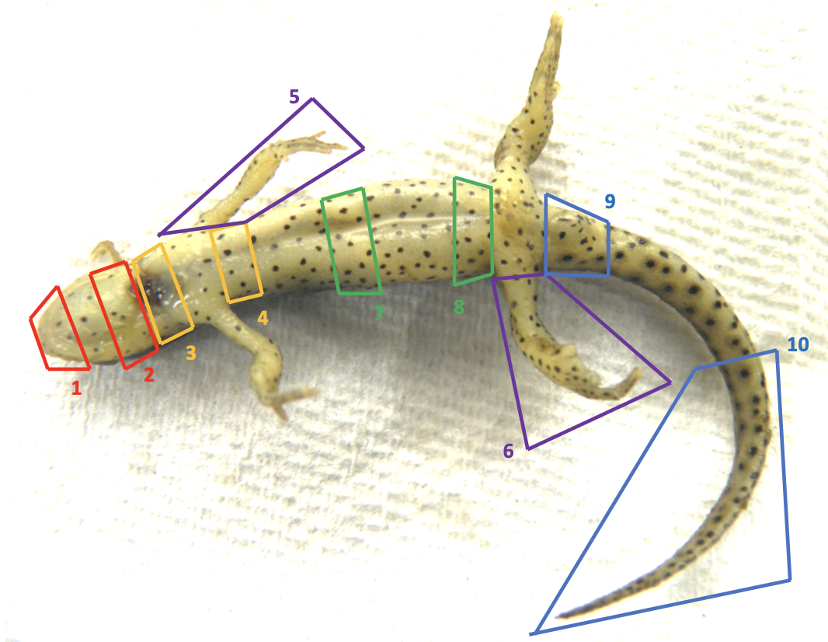

Figure 2.1 Anatomic location associated with each of the ten standardized sections examined histologically for lesion counts and grading in Batrachochytrium salamandrivorans infected Notophthalmus viridescens.

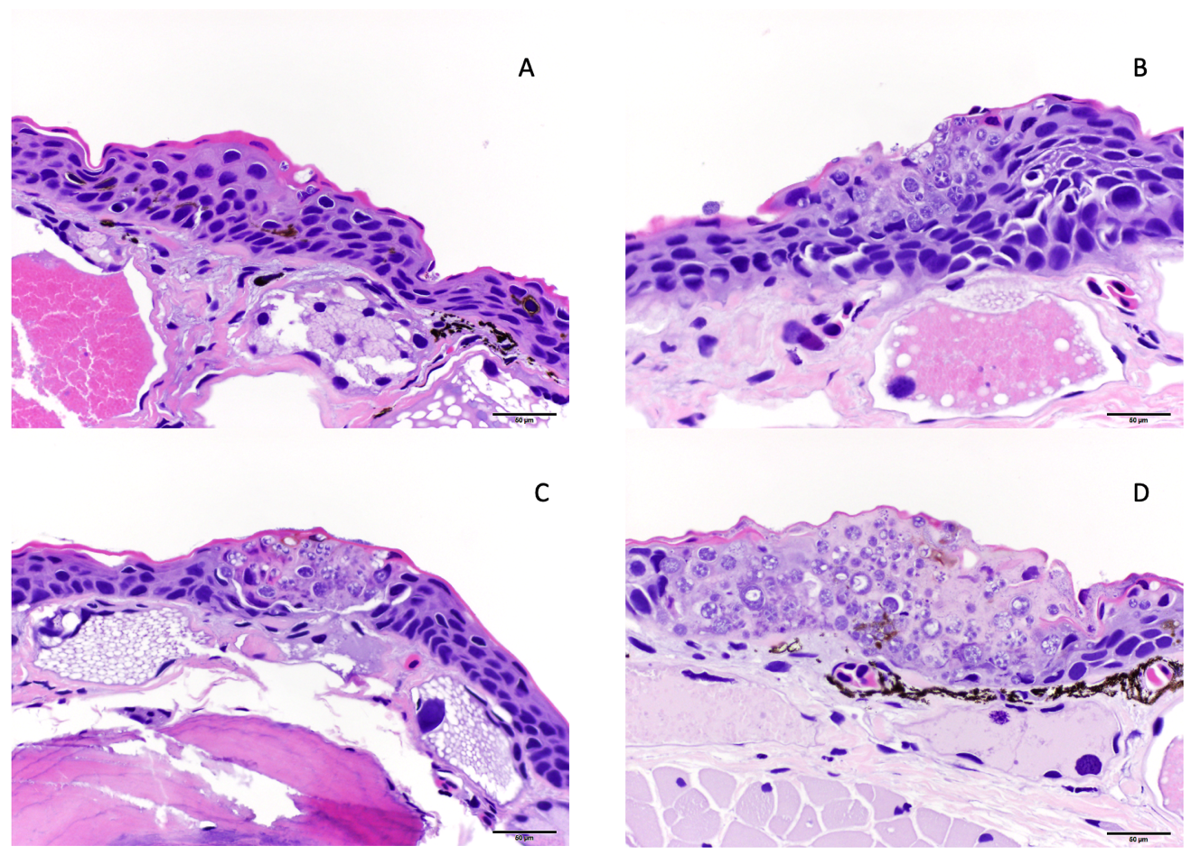

Figure 2.2 Examples of histologic lesion grading scheme used for Notophthalmus viridescens infected with Batrachochytrium salamandrivorans (Bsal) including Grade 1 (A), Grade 2 (B), Grade 3 (C), and Grade 4 (D). Grade 1 lesions were limited to Bsal organisms within the stratum corneum, grade 2 lesions included Bsal organisms and associated cellular damage which extended into the mid-epidermis, grade 3 lesions included Bsal organisms and associated cellular damage which extended full thickness through the epidermis, grade 4 lesions included coalescing/large lesions in which Bsal organisms and associated cellular damage extended full thickness through the epidermis and were <1 millimeter in length.

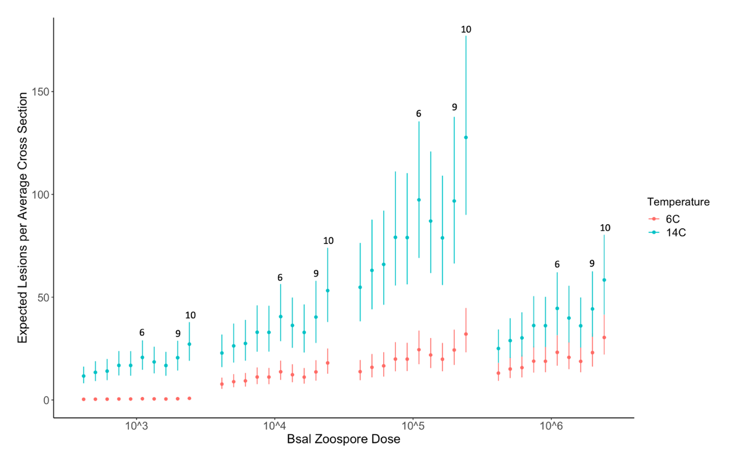

Figure 2.3 Plot of the expected histologic lesions per average cross section (y-axis) for each Batrachochytrium salamandrivorans (Bsal) zoospore dose (x-axis) and temperature (6°C = red; 14°C = blue) treatment combination in Bsal-infected Notophthalmus viridescens. Each point within a zoospore dose represents a section in numerical order from section 1–section 10. Error bars are showing the 95% confidence intervals around the predicted response.

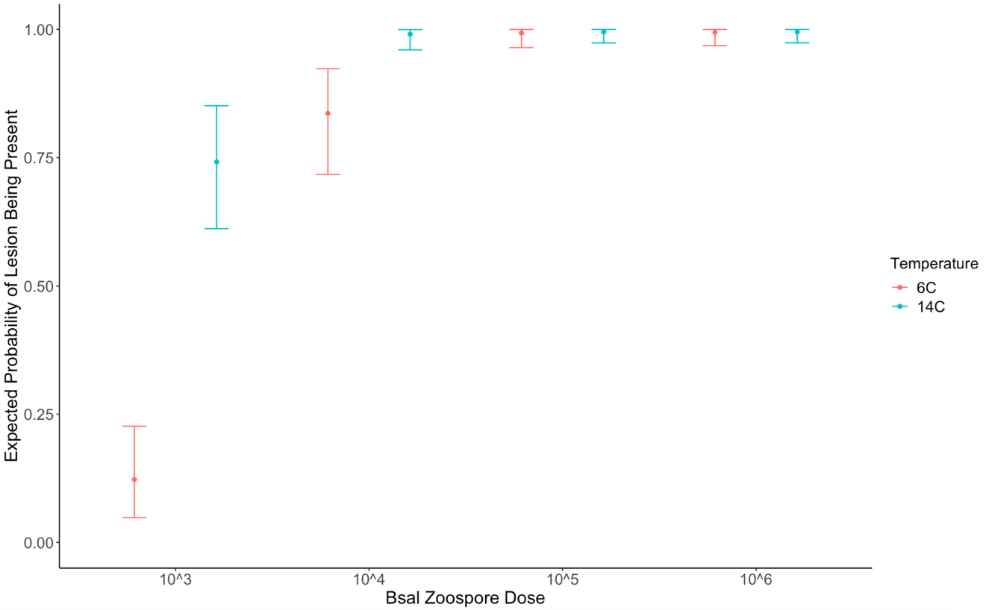

Figure 2.4 Plot of the expected probability of histologic lesions being present (y-axis) across each Batrachochytrium salamandrivorans (Bsal) zoospore dose (x-axis) and temperature (6°C = red; 14°C = blue) treatment combination in Bsal-infected Notophthalmus viridescens. Error bars are showing the 95% confidence intervals around the predicted response.

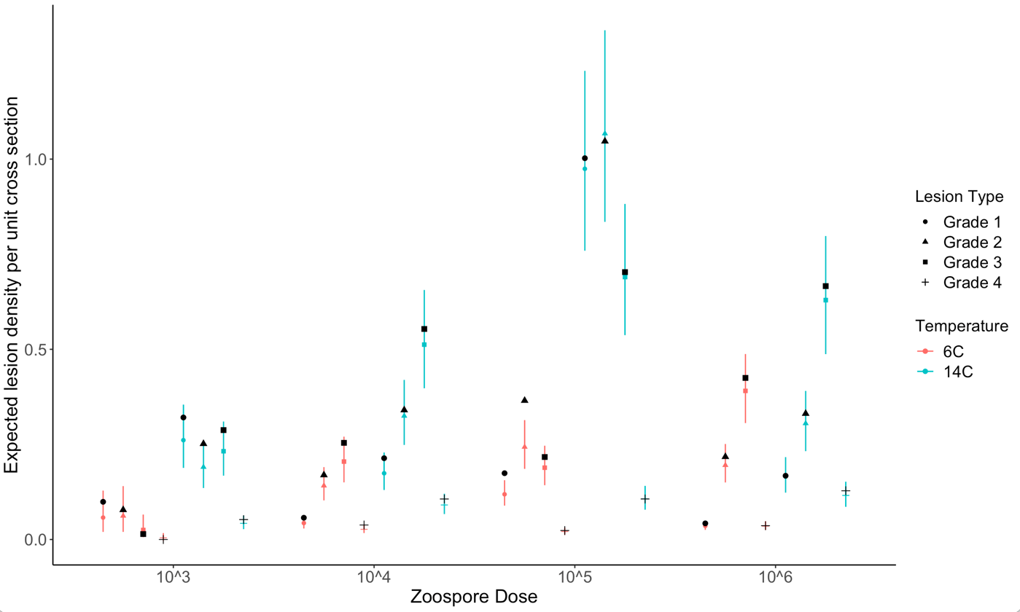

Figure 2.5 Plot of the expected histologic lesion density per unit of cross section (y-axis) for each Batrachochytrium salamandrivorans (Bsal) zoospore dose (x-axis) and temperature (6°C = red; 14°C = blue) treatment combination in Bsal-infected Notophthalmus viridescens. Each point within a zoospore dose represents a lesion grade in numerical order from Grade 1–Grade 4 along with an associated shape (Grade 1 = circle; Grade 2 = triangle; Grade 3 = square; Grade 4 = +). Black points represent the observed mean lesion density for each lesion grade within a zoospore dose and temperature. Error bars are showing the 95% confidence intervals around the predicted response.

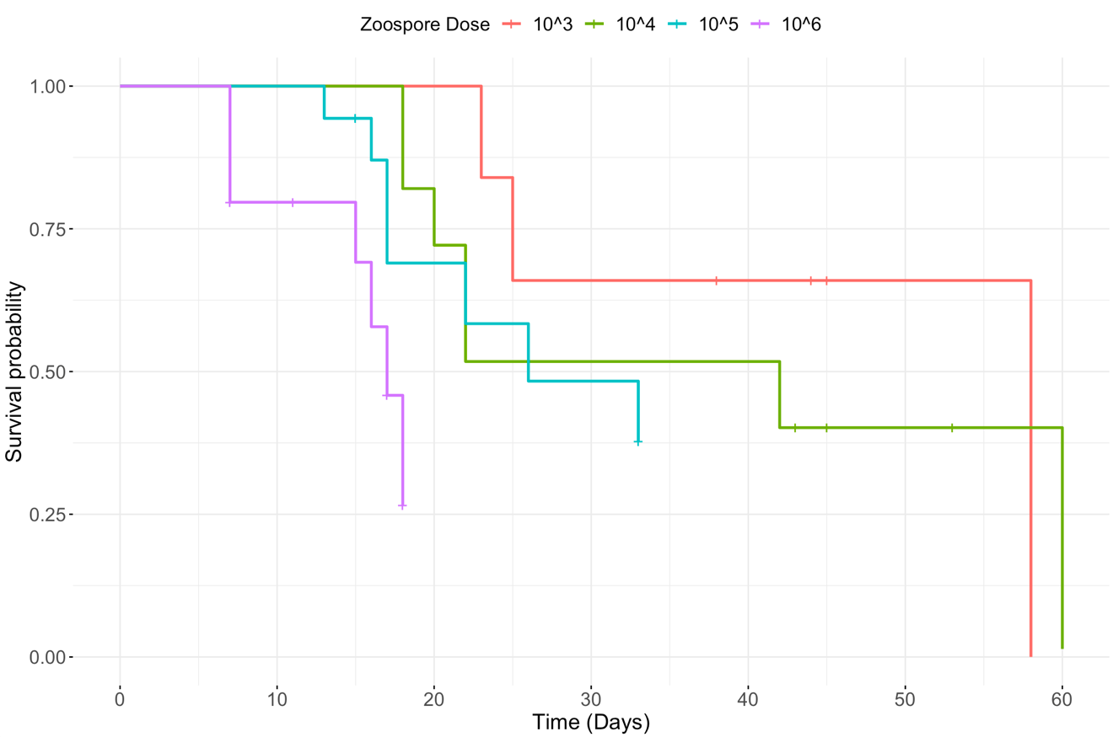

Figure 2.6 Survival curves representing the mortality rate of Notophthalmus viridescens exposed to one of four Batrachochytrium salamandrivorans zoospore doses (5 x 10^{3–6}).

CHAPTER III: PLASMA PROTEIN ELECTROPHORESIS IN ONE ANURAN AND SIX URODELAN SPECIES

Abstract
As threats to amphibian health increase, there is an increasing need for diagnostic tools to assess and monitor their health status. One such tool which has undergone very little investigation in amphibians but has proven to be useful in other non-mammalian species is plasma protein electrophoresis. For this diagnostic tool to be useful in amphibians, we must first define the amphibian electrophoretogram and then obtain baseline reference intervals across species. I aim to provide representative plasma protein electrophoretograms for clinically normal amphibian(s) of seven different species, which have not been described previously. Blood samples were collected immediately postmortem by cardiocentesis from clinically normal individuals of each of the following species: Osteopilus septentrionalis (Cuban tree frog, n=2), Gyrinophilus porphyriticus (spring salamander, n=1), Notophthalmus viridescens (eastern newt, n=1), Eurycea guttolineata (three-lined salamander, n=2), and Amphiuma tridacylum (three-toed amphiuma, n=2). Blood samples were collected antemortem via venipuncture of the ventral tail vein from Cryptobranchus alleganiensis (hellbender, n=5) and Siren lacertina (greater siren, n=6). Agarose gel electrophoresis was performed using plasma collected from each species. Electrophoretograms varied in the total number of fractions between each species; however, the number of fractions was consistent within a species. An albumin migrating fraction (predominant fraction in normal plasma samples of other species) was consistently observed in all species. Additionally, a pre-albumin migrating fraction was identified in species which primarily use other organs aside from the skin for respiration. These results provide a representative yet preliminary example of a normal plasma protein electrophoretogram for seven amphibian species. As electrophoretograms were observed to vary greatly among amphibian species, it is important for future studies to establish reference intervals and further classify protein fractions to fully evaluate protein electrophoresis as a useful tool in amphibian health investigations.

1. Introduction
Amphibians are currently facing severe threats to their biodiversity with at least 41% of amphibian species threatened with extinction (IUCN, 2020). With rates of amphibian declines increasing due to various factors, including emerging infectious disease, climate change, and habitat destruction (IUCN, 2020), it is now more important than ever to develop diagnostic tools to study amphibian health. One diagnostic tool which lacks appropriate investigation in amphibian species and can be used to assess health status is plasma protein electrophoresis.
Plasma protein electrophoresis is a routinely performed clinical test in numerous mammalian species, including humans (Tothova et al., 2016). This assay measures proteins in the blood as a means to characterize the health status of an individual, and in some cases, identify certain diseases such as inflammatory processes, lymphoproliferative processes, and abnormalities in multiple organ systems including the gastrointestinal tract, kidneys, and liver (Cray, 2021; Forzan et al., 2017). More recently, protein electrophoresis has become well-described in avian species and is becoming more commonly used in reptiles (Cray, 2021). Although the plasma proteins of amphibians have not been studied using modern electrophoresis tools and no reference intervals have been calculated for any amphibian species, we can extrapolate data collected from other species to make generalizations about protein electrophoresis profiles in amphibians (Zaias & Cray, 2002).
Protein electrophoresis may be particularly useful in amphibians for two reasons. First, plasma protein electrophoresis can be performed on very small amounts of blood. Due to their frequently small size, blood volumes which can safely be obtained from live amphibians are often less than 0.5 ml depending on the species (Forzan et al., 2017). While this small amount of blood is limiting for many diagnostic tests, plasma protein electrophoresis offers a feasible diagnostic option in amphibians, including in antemortem settings. Second, protein electrophoresis provides a much more accurate measurement of plasma proteins than commonly used methods such as bromocresol green (BCG) methods (Cray, 2021). BCG methods, which are commonly used in mammalian species to quantitate albumin (the predominant fraction in normal plasma samples), have been shown to be inaccurate in non-mammalian species due to binding of BCG to albumin as well as globulins (Cray, 2021).
As in other non-mammalian species, plasma protein profiles in amphibians can vary greatly among species (Chen, 1967, 1970; Cray, 2021). They can also vary within species based on sex, age group/life stage, and potentially environmental factors (Chen, 1967, 1970; Cray, 2021; Forzan et al., 2017; Frieden et al., 1957; Herner & Frieden, 1960; Young et al., 2012). For these reasons, it is important that reference intervals are established for each species and that sex, age group/life stage, and environmental factors are considered. Reference intervals are useful to identify abnormalities in results of a diagnostic test. The goal of this brief report is to provide a representative example of a plasma protein electrophoretogram from a clinically normal individual or individuals from each of seven diverse amphibian species including one anuran and six urodelans. Future studies can build on these findings and strengthen our knowledge of plasma protein electrophoresis in amphibians.

2. Methods

Animals
Species examined included Osteopilus septentrionalis (Cuban tree frog, n=2), Siren lacertina (greater siren, n=6), Gyrinophilus porphyriticus (spring salamander, n=1), Notophthalmus viridescens (eastern newt, n=1), Eurycea guttolineata (three-lined salamander, n=2), Amphiuma tridacylum (three-toed amphiuma, n=2), and Cryptobranchus alleganiensis (hellbender, n=5). All individuals of each species aside from the hellbender were held in a human-managed setting and were experimental controls in chytridiomycosis trials. The hellbenders were collected in the wild from two separate sites in Tennessee (Middle and East) under Tennessee Wildlife Resources Agency (TWRA) Permit #1691. Cuban tree frogs and greater sirens were collected by Florida Fish and Wildlife Conservation Commission, the spring salamander was collected from North Carolina Wildlife Resources Commission, the eastern newt was collected from Tennessee under TWRA permit #1504, and three-toed amphiuma were collected from Louisiana under Louisiana Department of Wildlife and Fisheries permit #WDP-20-077. Three-lined salamanders were captive bred and purchased from Indoor Ecosystems, LLC.
Animals (except hellbenders that were collected and sampled in the wild) were transported to and housed in the Johnson Animal Research and Teaching Unit at the University of Tennessee, Knoxville under either UTK-IACUC protocol #2723 (greater sirens) or UTK-IACUC protocol #2395 (all others). Greater sirens and three-toed amphiuma were individually housed in 3.78L tanks at room temperature (~20C). All other species were individually housed in separate containers within a Conviron environmental growth chamber. Individual housing for Cuban tree frogs, spring salamander, and three-lined salamanders consisted of a 710-cm³ plastic container containing a moist paper towel and PVC cover object. Individual housing for the eastern newt consisted of a 2000-cm³ plastic container that had 300-mL of water and a PVC cover object.
The spring salamander, three-lined salamanders, and three-toed amphiuma were skin swabbed for Batrachochytrium dendrobatidis (Bd) qPCR upon entry into the laboratory and confirmed to be negative. Cuban tree frogs, eastern newts, and sirens were heat-treated for Bd infection upon arrival into the laboratory without initial Bd qPCR testing. Heat treatment consisted of 10 days in an environmental growth chamber (Conviron, Winnipeg, Canada) at 30°C. Animals were then skin swabbed and confirmed to be negative for Bd using qPCR.
Following heat treatment, individuals were acclimated over 2 weeks to a temperature of 14°C. Environmental chambers were also set to a light/dark cycle that corresponded with the season associated with this temperature (spring/fall = 14 hours dark). Water changes were performed once every three days for individuals housed in environmental growth chambers. All human-managed individuals were fed 4% of their body mass 24 hours prior to every water change. The eastern newt and greater sirens were fed bloodworms (Chironomus plumosus), three-toed amphiuma were fed earthworms and bloodworms, Cuban tree frogs and spring salamander were fed crickets, and the three-lined salamanders were fed fruit flies.
All animals (except hellbenders) were control individuals in chytridiomycosis studies; therefore, they were inoculated with autoclaved, dechlorinated water for 24 hours in substitution of a chytrid zoospore dose at the beginning of the experimental trial. Animals were skin swabbed once every 6 days following the previously described methods (10 swabs along the ventrum and 5 along the bottom of each foot). Health checks consisting of brief visual examination were performed twice daily. All species were euthanized within 90 days post-entry into the laboratory.

Blood/Sample Collection
Blood was collected from hellbenders in the field. Hellbenders were restrained using a towel wrap soaked in river water with only the tail exposed. Blood was collected from the ventral tail vein using a heparinized syringe. A skin swab was collected at the time of blood collection and processed for Bd qPCR using methods similar to Boyle et al (2004). All animals were confirmed to be qPCR negative for Bd.
Blood was collected from sirens while under anesthesia. Anesthesia was induced by water bath exposure to 200 mg/L benzocaine dissolved in dechlorinated water. During blood collection, each siren was wrapped in a towel soaked in the water/benzocaine solution, its tail exposed and 1.5–2 ml of blood was collected from the ventral tail vein using a heparinized syringe. Blood samples for the remaining species were collected immediately postmortem through cardiocentesis using a heparinized capillary tube.

Blood Processing and Analysis
After collection, blood from all species was spun in an Eppendorf 5424R centrifuge at 2170 G for 3 minutes to separate plasma. Samples were analyzed in accordance with instructions provided by the Helena QuickGel system with the use of Split Beta gels (Helena Laboratories, Inc., Beaumont, Texas 77707, USA). Samples were run in duplicate. A known human control sample (Helena Laboratories, Inc.) as well as a known abnormal canine sample from a canine known to have multiple myeloma were also run to confirm accuracy. Gels were scanned and analyzed using software provided by Helena.

Statistical Analysis
To compare the variation in fraction sizes between species to the variation in fraction sizes within a species, the compositional mean of the albumin fraction as well as the fraction immediately cathodic to albumin was calculated for the species that had samples from more than one individual. The metric variance was then determined between all species and within species for the hellbenders and the sirens. All analyses were performed using the ‘compositions’ package in R (version 4.1.1) (Boogart & Tolosana-Delgado, 2013).

3. Results
Plasma protein fractions from each species aside from the hellbenders are presented in the appendix in Table 3.1. Plasma protein fractions along with site of collection for hellbenders are presented in Table 3.2. Representative plasma electrophoretograms from each amphibian species along with human control and canine with multiple myeloma are presented in Figure 3.1. Plasma protein profiles varied greatly in the number of protein fractions among amphibian species, with 9 fractions observed in the Cuban tree frog and 3 in the greater siren.
All amphibian samples examined had what is suspected to be an albumin migrating fraction, which represented the largest fraction in all species aside from the hellbender. The largest fraction in the majority of hellbenders was the fraction migrating to the cathode. Four species (Cuban tree frogs, three-toed amphiuma, eastern newt, and greater sirens) had a pre-albumin migrating fraction anodic to the albumin fraction. Hellbenders, three-lined salamanders, and spring salamanders lacked this fraction. Number and size of fractions cathodic to the albumin fraction varied among species. The metric variance of the albumin fraction and the fraction cathodic to albumin between all species was 0.44, the metric variance of these fractions between hellbenders was 0.13, and the metric variance of these fractions between sirens was 0.08, indicating that between-species variability in these fractions was larger than within-species variability.

4. Discussion
This study provides preliminary representative electrophoretograms of a clinically normal individual of seven amphibian species. No plasma protein electrophoretograms using modern automated gel technology have been previously published for any of these species. The sample sizes used in this study were small, and therefore, reference intervals were not able to be determined (Friedrichs et al., 2012). Therefore, this work supplies basic groundwork for future studies to build on this information and provide useful reference intervals for these species.
Marked variation in plasma protein electrophoretograms between amphibian species, even within the same order was identified in study. Fraction number and size varied among each of the species examined, and fraction size varied within members of the same species. However, variation in fraction sizes between species was determined to be greater than variation in fraction sizes within a species. Previous studies have shown that electrophoretograms vary greatly between amphibian species, and even within a species, protein fractions can vary between life stages. Studies using sodium dodecyl sulphate-polyacrylamide gel electrophoresis (SDS-PAGE) have identified between 11 and 20 protein fractions in amphibian serum (Chen, 1967, 1970). More recent studies using either cellulose acetate electrophoresis (CAE) or AGE identified either 4 or 5 protein fractions, respectively, in two anuran species (Chiesa et al., 2006; Young et al., 2014). Additionally, multiple studies using paper electrophoresis or SDS-PAGE have discovered that protein fractions change throughout metamorphosis in anuran species (Chen, 1970; Frieden et al., 1957; Herner & Frieden, 1960). This highlights the importance of evaluating every amphibian species individually and creating reference intervals for each.
In agarose gel electrophoresis (AGE), plasma proteins separate into fractions including albumin and three types of globulins (alpha, beta, and gamma) (Cray, 2021). Albumin is the predominant fraction in normal plasma samples. Some non-mammalian species also have an additional fraction anodic to the albumin fraction which is conventionally referred to as a pre-albumin fraction (Cray, 2021). Four of the seven amphibian species in this study (Cuban tree frog, three-toed amphiuma, eastern newt, and greater siren) had a pre-albumin migrating fraction. Interestingly, each of the species with a pre-albumin migrating fraction primarily rely on organs other than their skin (external gills, lungs, or a combination of both) for respiration (Wells, 2007). The species that lack this fraction (hellbender, three-lined salamander, and spring salamander) primarily rely on their skin for respiration along with varying but lesser degrees of buccopharyngeal membrane respiration (Wells, 2007). The significance of this finding is uncertain. However, as prealbumin has been associated with binding thyroxine and retinol in avian species, this result might suggest a difference in one or both of these parameters among the two groups, and perhaps is linked to respiration (Lumeji, 2008). An important next step to elucidate the biological significance of the pre-albumin migrating factor will be to assess whether this pattern holds across larger sample sizes and use mass spectrometry to confirm identification of proteins within each fraction.
Protein electrophoretograms of all species appeared to have what would be an albumin fraction based on the migration characteristics of well-documented species (Cray, 2021). Previous studies using various methods of electrophoresis, as well as staining reaction techniques have also suggested that amphibian species have one to two albumin migrating peaks, which can vary in size (Chen, 1967, 1970; Chiesa et al., 2006; Cray, 2021; Francis et al., 1985; Frieden et al., 1957; Herner & Frieden, 1960; Young et al., 2012; Young et al., 2014). This is an important finding as changes in albumin levels can be useful in diagnosing many pathologic processes including active inflammation, dehydration, liver, gastrointestinal, or renal disease, as well as malnutrition (Forzan et al., 2017). While its utility in amphibians is not fully understood, in Chapter I, albumin levels were associated with Batrachochytrium salamandrivorans (Bsal) infection status in Taricha granulosa. Individuals which were clinically diseased with Bsal chytridiomycosis had increased levels of albumin due to dehydration. If dehydration can be identified early, then appropriate therapeutic options such as fluid therapy can be pursued in captive settings to mitigate the effects of Bsal chytridiomycosis.
In addition to the fraction suspected to represent albumin, two to eight additional fractions were identified in this study depending on the species. Past amphibian studies have labeled the fractions cathodic to albumin as globulins in accordance with mammalian electrophoretograms (Chiesa et al., 2006; Young et al., 2014). One study used various staining reaction methods to identify these proteins as transferrin, haptoglobin, lipoprotein, and glycoprotein (Chen, 1970). Monitoring of globulin levels is useful for many reasons including evaluation of the immune response (Cray, 2021). A study involving infection with a different chytrid species, Batrachochytrium dendrobatidis (Bd), showed failure of protein fractions 2 and 5 (labeled by the author as alpha-1 globulins and gamma globulins, respectively) to increase in response to immune stimulation in animals infected with Bd chytridiomycosis compared to controls (Young et al., 2014). If these fractions do represent globulins, these findings potentially indicate pathogen-induced immunosuppression, which is an aspect of disease pathogenesis previously associated with Bd chytridiomycosis (Young et al., 2014).
It is important to note that in order for protein fractions to be definitively classified in amphibians, further investigations including mass spectrometry must be performed. Special staining reactions used in previous studies to aid in protein fraction classification are not entirely specific. Additionally, it is not accurate to assume protein fractions in amphibians have identical compositions to those described in other species, although they likely have similar properties. Mass spectrometry could further classify what each protein fraction represents by assessing the weight and charge of all proteins present in each fraction. These results could then be compared to what is known in other species such as mammals.
Limitations of this study include small sample size and lack of supporting biochemical and hematologic analysis. Supportive blood profiles are useful for interpreting the significance of plasma protein electrophoresis values. Furthermore, including multiple animals of different sexes, development stages, and geographic locations over multiple seasons will enable development of more appropriate reference intervals. Lastly, classification of the protein fractions by mass spectrometry is necessary and may explain variations among species who primarily utilize their skin as a respiratory organ versus those that incorporate other means of respiration.
Overall, plasma protein electrophoresis is an important tool for detecting many pathologic conditions including inflammation as well as monoclonal and polyclonal gammopathies (Cray, 2021). Based on previously mentioned trends in alterations of fraction levels in diseased animals versus controls, plasma protein electrophoresis could prove to be a useful tool in helping to identify severity of disease in amphibians (Chapter I). It could also be useful to guide treatment protocols and explore the pathogenesis of infectious or non-infectious diseases. Furthermore, plasma protein electrophoresis requires only a very small amount of blood which allows it to be performed antemortem in many amphibian species and has the potential to be used at the population level for disease surveillance purposes.
An additional potential use for plasma protein electrophoresis is routine health monitoring for amphibians in research, head-start, or other human-managed facilities. As many amphibian populations are declining due to emerging infectious disease, climate change, and habitat destruction (IUCN, 2020), many species are being brought into repatriation programs in attempt to save them from extinction. In these situations, every animal is significant and therefore health status must be closely monitored. By combining plasma protein electrophoresis with other clinical pathology measurements, a more complete overview of health may be obtained.

REFERENCES
Boogart, K. G., & Tolosana-Delgado, R. (2013). Analyzing Compositional Data with R. Berlin: Springer-Verlag.
Chen, P. S. (1967). Separation of serum proteins in different amphibian species by polyacrylamide gel electrophoresis. Specialia, 15(6), 483-485.
Chen, P. S. (1970). Patterns and metamorphic changes of serum proteins in Amphibia Wilhelm Roux Arch, 165, 132-149
Chiesa, M. E., Rosenberg, C. E., Fink, N. E., & Salibian, A. (2006). Serum protein profile and blood cell counts in adult toads Bufo arenarum (Amphibia: Anura: Bufonidae): effects of sublethal lead acetate. Arch Environ Contam Toxicol, 50(3), 384-391. doi:10.1007/s00244-004-0252-4
Cray, C. (2021). Protein electrophoresis of non-traditional species: A review. Vet Clin Pathol, 50(4), 478-494. doi:10.1111/vcp.13067
Forzan, M. J., Heatley, J., Russell, K. E., & Horney, B. (2017). Clinical pathology of amphibians: a review. Vet Clin Pathol, 46(1), 11-33. doi:10.1111/vcp.12452
Francis, R. T., Jr., Bailey, T. J., & Becker, R. R. (1985). Bisalbuminemia in an amphibian. Comp Biochem Physiol B, 81(1), 199-206. doi:10.1016/0305-0491(85)90183-x
Frieden, E., Herner, A. E., Fish, L., & Lewis, E. J. C. (1957). Changes in serum proteins in amphibian metamorphosis. Science, 126, 559-560.
Friedrichs, K. R., Harr, K. E., Freeman, K. P., Szladovits, B., Walton, R. M., Barnhart, K. F., Blanco-Chavez, J., & American Society for Veterinary Clinical, P. (2012). ASVCP reference interval guidelines: determination of de novo reference intervals in veterinary species and other related topics. Vet Clin Pathol, 41(4), 441-453. doi:10.1111/vcp.12006
Herner, A. E., & Frieden, E. (1960). Biochemistry of anuran metamorphosis: VII. Changes in serum proteins during spontaneous and induced metamorphosis. J Biol Chem, 235, 2845-2851.
IUCN. (2020). The IUCN Red List of Threatened Species. Retrieved from
Lumeji, J. T. (2008). Avian Clinical Biochemistry. In J. J. Kaneko, J. W. Harvey, & M. L. Bruss (Eds.), Clinical Biochemistry of Domestic Animals (6th ed., pp. 839-872). San Diego, CA: Elsevier.
Tothova, C., Nagy, O., & Kovac, G. (2016). Serum proteins and their diagnostic utility in veterinary medicine: a review. Veterinarni Medicina, 61(9), 475-496.
Wells, K. D. (2007). Respiration. In The Ecology and Behavior of Amphibians (pp. 157-183). Chicago and London: University of Chicago Press.
Young, S., Warner, J., Speare, R., Berger, L., Skerratt, L. F., & Muller, R. (2012). Hematologic and plasma biochemical reference intervals for health monitoring of wild Australian tree frogs. Vet Clin Pathol, 41(4), 478-492. doi:10.1111/j.1939-165X.2012.00470.x
Young, S., Whitehorn, P., Berger, L., Skerratt, L. F., Speare, R., Garland, S., & Webb, R. (2014). Defects in host immune function in tree frogs with chronic chytridiomycosis. Plos One, 9(9), e107284. doi:10.1371/journal.pone.0107284
Zaias, J., & Cray, C. (2002). Protein electrophoresis: A tool for the reptilian and amphibian practitioner. Journal of Herpetological Medicine and Surgery, 12(1), 30-32.

APPENDICES

Appendix A: Tables

Table 3.1 Protein fraction results for each clinically normal individual amphibian.
 |  |  | Percentage out of 100
Species | Animal ID | Composite Photo (Y/N) | Fraction 1 | Fraction 2 | Fraction 3 | Fraction 4 | Fraction 5 | Fraction 6 | Fraction 7 | Fraction 8 | Fraction 9
Osteopilus septentrionalis | CTF1 | Y | 4.68 | 28.91 | 17.91 | 18.77 | 11.59 | 6.71 | 4.17 | 3.18 | 5.07
Osteopilus septentrionalis | CTF2 | N | 1.48 | 34.67 | 15.96 | 19.01 | 11.94 | 4.97 | 4.29 | 1.97 | 5.7
Siren lacertina | SL1 | N | 22.15 | 45.85 | 31.99 | - | - | - | - | - | -
Siren lacertina | SL3 | Y | 19.13 | 59.25 | 21.62 | - | - | - | - | - | -
Siren lacertina | SL4 | N | 29.15 | 44.94 | 25.91 | - | - | - | - | - | -
Siren lacertina | SL5 | N | 23.43 | 50.94 | 25.63 | - | - | - | - | - | -
Siren lacertina | SL6 | N | 19.07 | 58.85 | 22.08 | - | - | - | - | - | -
Siren lacertina | SL8 | N | 30.78 | 41.95 | 27.28 | - | - | - | - | - | -
Gyrinophilus porphyriticus | GY1 | Y | 32.62 | 30.81 | 8.58 | 13.55 | 8.63 | 5.8 | - | - | -
Notophthalmus viridescens | D2 | Y | 19.93 | 32.99 | 13.23 | 28.28 | 5.57 | - | - | - | -
Eurycea guttolineata | EG4 | N | 64.73 | 12.07 | 19.23 | 3.97 | - | - | - | - | -
Eurycea guttolineata | EG5 | Y | 61.02 | 12.75 | 22.45 | 3.78 | - | - | - | - | -
Amphiuma tridacylum | AT1 | Y | 4.26 | 34.50 | 6.15 | 19.54 | 14.77 | 20.77 | - | - | -
Amphiuma tridacylum | AT2 | N | 5.22 | 31.64 | 8.42 | 19.43 | 19.25 | 16.04 | - | - | -

Table 3.2 Protein fraction results for individual Crytobranchus alleganiensis (hellbenders).

 |  | Percentage out of 100
Animal ID | Location | Fraction 1 | Fraction 2 | Fraction 3 | Fraction 4
TN1 | East TN | 31.07 | 15.92 | 14.26 | 38.75
TN2 | Middle TN | 35.73 | 10.3 | 19.93 | 34.04
TN3 | East TN | 22.51 | 17.13 | 24.66 | 35.70
TN4 | East TN | 19.96 | 16.21 | 20.28 | 43.56
TN5 | East TN | 36.49 | 13.63 | 20.50 | 29.38

Appendix B: Figures

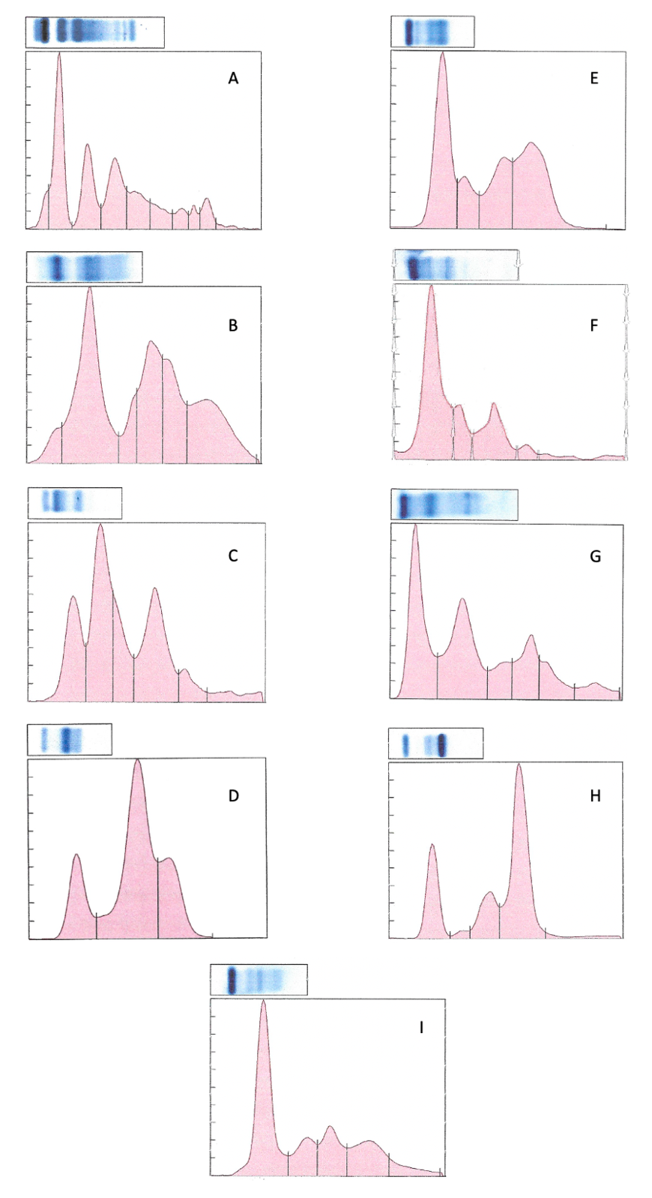
Figure 3.1 Representative agarose gel electrophoresis (AGE) electrophoretograms of heparinized plasma from a Cuban tree frog (A), three-toed amphiuma (B), eastern newt (C), greater siren (D), hellbender (E), a three-lined salamander (F), a spring salamander (G), serum from a canine with multiple myeloma (H), and serum from a human control (I). The y-axis represents the size of each protein fraction, and the x-axis represents the migration distance of each protein fraction from the anode (left) to cathode (right).

CONCLUSION

As amphibian species continue to suffer from devastating declines, disease investigations and health monitoring are now more important than ever. The emerging fungal pathogen Bsal, is causing chytridiomycosis and disease-induced declines in salamander species in Europe and poses a significant threat to North American salamander biodiversity (Basanta et al., 2019; Carter et al., 2021; Grant et al., 2017; Lotters et al., 2020; Richgels et al., 2016; Yap et al., 2015; Yap et al., 2017). However, we know little about the mechanisms of its pathogenesis and disease progression, particularly for North American salamanders. Identifying how, why, and under what conditions Bsal causes disease is a critical foundation for basic disease ecology, more efficient disease surveillance, and the parameterization of predictive models of Bsal spread and population-level impacts. Additionally, investigation into the use of supplementary diagnostic tools for health and disease monitoring in these species is warranted. I addressed the pathogenesis of Batrachochytrium salamandrivorans (Bsal) and compared it to what is known about the related pathogen, Batrachochytrium dendrobatidis (Bd), investigated the effect of environmental temperature and zoospore exposure dose on Bsal infection and disease development, and have set out baseline plasma protein electrophoretograms for clinically normal individuals of one anuran and six urodelan species.
I found that electrolyte imbalances and dehydration secondary to damage to the epidermal cells by Bsal-induced skin lesions are likely the primary factors in disease pathogenesis. Additionally, a systemic immune response is incited in clinically diseased T. granulosa which may be either primarily related to Bsal infection or could be associated with secondary bacterial infection. Future studies should further investigate the role that secondary bacterial infection plays in this disease.
I also found that environmental temperature and Bsal zoospore dose each have a significant effect on disease progression and confirmed that 14°C is the ideal temperature for Bsal to infect its hosts and incite damage to the epidermis. Notophothalmus viridesens exposed at 22°C did not become infected, and N. viridescens exposed at 6°C developed fewer lesions and had longer survival times than those exposed at 14°C. The hindlimbs, cloacal region, and tail had on average the highest number of and most severe skin lesions. This information is important for disease surveillance efforts as it provides knowledge regarding the best anatomic locations to examine and collect diagnostic samples from to have the highest chance of detecting the pathogen in Bsal-infected animals.
Overall, these studies elucidate the pathogenesis of Bsal chytridiomycosis and describe how environmental temperature affects disease progression. Additionally, findings provide support for the use of potential disease mitigation strategies against Bsal chytridiomycosis in captive settings. By knowing that the pathogenesis involves electrolyte imbalances and dehydration, fluid therapy including supplemental electrolytes could be used in disease treatment. Additionally, the incorporation of antibiotics may be useful as the systemic inflammatory response I identified in clinically diseased T. granulosa may have been at least in part due to secondary bacterial infection. Heat treatment is also a viable treatment option in N. viridescens.
In regard to the representative plasma protein electrophoretograms from clinically normal individuals of various amphibian species, these can be used as a baseline example for future studies. These investigations should involve the development of reference intervals in multiple species and across different sexes, environmental conditions, and disease states. This information will aid in the understanding of disease processes, as well as monitor health status, especially in critically endangered species.
Through combining multiple diagnostic modalities including both clinical and anatomic pathology tools, I have strengthened our understanding of amphibian health as well as the pathogenesis of an important emerging infectious disease in these species. Future studies can use this work as an example of the advantages to this multimodal approach. By utilizing techniques that investigate different aspects of amphibian health, we can work towards improving our conservation efforts for these important and declining species.

REFERENCES
Basanta, M. D., Rebollar, E. A., & Parra-Olea, G. (2019). Potential risk of Batrachochytrium salamandrivorans in Mexico. Plos One, 14(2), e0211960. doi:10.1371/journal.pone.0211960
Carter, E. D., Bletz, M. C., Le Sage, M., LaBumbard, B., Rollins-Smith, L. A., Woodhams, D. C., Miller, D. L., & Gray, M. J. (2021). Winter is coming-Temperature affects immune defenses and susceptibility to Batrachochytrium salamandrivorans. PLoS Pathog, 17(2), e1009234. doi:10.1371/journal.ppat.1009234
Grant, E. H. C., Muths, E., Katz, R. A., Canessa, S., Adams, M. J., Ballard, J. R., Berger, L., Briggs, C. J., Coleman, J. T. H., Gray, M. J., Harris, M. C., Harris, R. N., Hossack, B., Huyvaert, K. P., Kolby, J., Lips, K. R., Lovich, R. E., McCallum, H. I., Mendelson, J. R., Nanjappa, P., Olson, D. H., Powers, J. G., Richgels, K. L., Russell, R. E., Schmidt, B. R., Spitzen-van der Sluijs, A., Watry, M. K., Woodhams, D. C., & White, C. L. (2017). Using decision analysis to support proactive management of emerging infectious wildlife diseases. Frontiers in Ecology and the Environment 15(4), 214-221.
Lotters, S., Veith, M., Wagner, N., Martel, A., & Pasmans, F. (2020). Bsal-driven salamander mortality pre-dates the European index outbreak. Salamandra, 56, 239-242.
Richgels, K. L., Russell, R. E., Adams, M. J., White, C. L., & Grant, E. H. (2016). Spatial variation in risk and consequence of Batrachochytrium salamandrivorans introduction in the USA. R Soc Open Sci, 3(2), 150616. doi:10.1098/rsos.150616
Yap, T. A., Koo, M. S., Ambrose, R. F., Wake, D. B., & Vredenburg, V. T. (2015). Averting a North American biodiversity crisis. Science, 349(6247), 481-482. doi:10.1126/science.aab1052
Yap, T. A., Nguyen, N. T., Serr, M., Shepack, A., & Vredenburg, V. T. (2017). Batrachochytrium salamandrivorans and the Risk of a Second Amphibian Pandemic. Ecohealth, 14(4), 851-864. doi:10.1007/s10393-017-1278-1

VITA

Wesley Sheley received her Bachelor of Science degree in Animal Science at the University of Tennessee, Knoxville. She then attended the University of Tennessee College of Veterinary Medicine where she received her Doctor of Veterinary Medicine degree. After this, she traveled to the University of California, Davis and San Diego Zoo Global to complete her anatomic pathology residency training with an emphasis in zoo and wildlife pathology. Wesley received board certification in veterinary anatomic pathology from the American College of Veterinary Pathologists (ACVP) in the fall of 2019. At this time, she began to pursue a Doctor of Philosophy degree in Comparative and Experimental Medicine with a concentration in Infectious Disease at the University of Tennessee College of Veterinary Medicine under the guidance of Dr. Debra Miller. Her research focus includes studying the pathogenesis of Batrachochytrium salamandrivorans (Bsal) and exploring diagnostic tools for use in amphibians.

