The Longitudinal Relationship between Power Processes and Intimate Partner Violence in Dating College Students

A Dissertation Presented for the
Doctor of Philosophy
Degree
The University of Tennessee, Knoxville

Heather Christine Zapor
August 2017

Copyright © 2017 by Heather Christine Zapor
All rights reserved.

Acknowledgements

My sincerest thanks to the Stuart Lab at the University of Tennessee for their support and guidance on this project. To my lab sisters, past and present, you are each an inspiration and have played an intricate role in my development throughout graduate school. To Dr. Gregory L. Stuart, whose unwavering belief in his students is instrumental to our success and is forever appreciated. I am also appreciative of Drs. Moore, Olmstead, and Welsh for providing insightful suggestions and guidance in the development and implementation of this project. To my husband, family, and dearest friends whose presence by my side through every endeavor provides me with strength that is invaluable and enduring.

Abstract
Power and the abuse of such power is an important mechanism through which intimate partner violence (IPV) occurs and a major tenant of many theories that purport to explain IPV. While some research has examined the links between aspects of relational power and IPV, the examination of power processes has been limited to mostly self-report measures. The current study assesses power processes through observational interactions of direct communication between (n = 150) college student dating partners. In general, the hypotheses that observed power processes would be related to IPV over time were only partially supported, suggesting that although relationships between power processes and psychological and physical aggression have been found in cross-sectional studies, these relationships may not be as robust over time. Additionally, when relationships between power processes and psychological and physical aggression perpetration and victimization did emerge, these relationships were more often related to women’s perpetration and victimization than they were to men’s aggression. Finally, across all models of psychological and physical aggression perpetration and victimization, self-reported aggression perpetration and victimization at baseline and three-month follow up predicted additional aggression perpetration and victimization over time for both men and women. Implications for future research and treatment are discussed.

Table of Contents
Chapter 1 Introduction and Literature Review 1
Intimate Partner Violence in College Dating Relationships 1
Theoretical Basis of IPV 2
Power and IPV 3
Measuring Power Processes 9
The Current Study 12
Chapter 2 Method 14
Participants 14
Procedure 14
Measures 16
Data Analytic Strategy 19
Chapter 3 Results 23
Preliminary Analyses 23
APIM Models 24
Chapter 4 Discussion 33
Power Processes and Psychological Aggression Perpetration 34
Power Processes and Physical Aggression Perpetration 36
Power Processes and Psychological Aggression Victimization 37
Power Processes and Physical Aggression Victimization 39
Observed Demand-Withdrawal 39
Clinical Implications 40
Limitations 42
Future Directions 43
Conclusion 44
List of References 45
Appendix 59
Vita 98

List of Tables

Table 1. Mean, standard deviation, median, and range for all study variables 60
Table 2. Bivariate correlation tables for Psychological Aggression Perpetration 62
Table 3. Bivariate correlation tables for Psychological Aggression Victimization 63
Table 4. Bivariate correlation tables for Physical Aggression Perpetration 64
Table 5. Bivariate correlation tables for Physical Aggression Victimization 65
Table 6. Unstandardized (Standard Errors in Parentheses), Standardized, and Significance Levels for Partner Gender Effects of Coerciveness on Psychological Aggression Perpetration and Correlations among Variables 66
Table 7. Unstandardized (Standard Errors in Parentheses), Standardized, and Significance Levels for Partner Gender Effects of Attempts to Control on Psychological Aggression Perpetration and Correlations among Variables 67
Table 8. Unstandardized (Standard Errors in Parentheses), Standardized, and Significance Levels for Partner Gender Effects of Self-Reported Demand-Withdrawal on Psychological Aggression Perpetration and Correlations among Variables 68
Table 9. Unstandardized (Standard Errors in Parentheses), Standardized, and Significance Levels for Partner Gender Effects of Coerciveness on Physical Aggression Perpetration and Correlations among Variables 69
Table 10. Unstandardized (Standard Errors in Parentheses), Standardized, and Significance Levels for Partner Gender Effects of Attempts to Control on Physical Aggression Perpetration and Correlations among Variables 70
Table 11. Unstandardized (Standard Errors in Parentheses), Standardized, and Significance Levels for Partner Gender Effects of Self-Reported Demand-Withdrawal on Physical Aggression Perpetration and Correlations among Variables 71
Table 12. Unstandardized (Standard Errors in Parentheses), Standardized, and Significance Levels for Partner Gender Effects of Coerciveness on Psychological Aggression Victimization and Correlations among Variables 72
Table 13. Unstandardized (Standard Errors in Parentheses), Standardized, and Significance Levels for Partner Gender Effects of Attempts to Control on Psychological Aggression Victimization and Correlations among Variables 73
Table 14. Unstandardized (Standard Errors in Parentheses), Standardized, and Significance Levels for Partner Gender Effects of Self-Reported Demand-Withdrawal on Psychological Aggression Victimization and Correlations among Variables 74
Table 15. Unstandardized (Standard Errors in Parentheses), Standardized, and Significance Levels for Partner Gender Effects of Coerciveness on Physical Aggression Victimization and Correlations among Variables 75
Table 16. Unstandardized (Standard Errors in Parentheses), Standardized, and Significance Levels for Partner Gender Effects of Attempts to Control on Physical Aggression Victimization and Correlation among Variables 76
Table 17. Unstandardized (Standard Errors in Parentheses), Standardized, and Significance Levels for Partner Gender Effects of Self-Reported Demand-Withdrawal on Physical Aggression Victimization and Correlations among Variables 77
Table 18. Unstandardized (Standard Errors in Parentheses), Standardized, and Significance Levels for Observed Demand-Withdrawal on Psychological Aggression Perpetration and Correlations among Variables 78
Table 19. Unstandardized (Standard Errors in Parentheses), Standardized, and Significance Levels for Observed Demand-Withdrawal on Physical Aggression Perpetration and Correlations among Variables 79
Table 20. Unstandardized (Standard Errors in Parentheses), Standardized, and Significance Levels for Observed Demand-Withdrawal on Psychological Aggression Victimization and Correlations among Variables 80
Table 21. Unstandardized (Standard Errors in Parentheses), Standardized, and Significance Levels for Observed Demand-Withdrawal on Physical Aggression Victimization and Correlations among Variables 81

List of Figures

Figure 1. Partner Gender Effects of Coerciveness on Psychological Aggression Perpetration 82
Figure 2. Partner Gender Effects of Attempts to Control on Psychological Aggression Perpetration 83
Figure 3. Partner Gender Effects of Self-Reported Demand-Withdrawal on Psychological Aggression Perpetration 84
Figure 4. Partner Gender Effects of Coerciveness on Physical Aggression Perpetration 85
Figure 5. Partner Gender Effects of Attempts to Control on Physical Aggression Perpetration
86
Figure 6. Partner Gender Effects of Self-Reported Demand-Withdrawal on Physical Aggression Perpetration 87
Figure 7. Partner Gender Effects of Coerciveness on Psychological Aggression Victimization
88
Figure 8. Partner Gender Effects of Attempts to Control on Psychological Aggression Victimization 89
Figure 9. Partner Gender Effects of Self-Reported Demand-Withdrawal on Psychological Aggression Victimization 90
Figure 10. Partner Gender Effects of Coercion on Physical Aggression Victimization 91
Figure 11. Partner Gender Effects of Attempts to Control on Physical Aggression Victimization 92
Figure 12. Partner Gender Effects of Self-Reported Demand-Withdrawal on Physical Aggression Victimization 93
Figure 13. Effects of Observed Demand-Withdrawal on Psychological Aggression Perpetration 94
Figure 14. Effects of Observed Demand-Withdrawal on Physical Aggression Perpetration 95
Figure 15. Effects of Observed Demand-Withdrawal on Psychological Aggression Victimization 96
Figure 16. Effects of Observed Demand-Withdrawal on Physical Aggression Victimization 97

Chapter 1

Introduction and Literature Review

Intimate Partner Violence in College Dating Relationships
The rate and impact of intimate partner violence (IPV), which includes acts of physical, psychological, and/or sexual violence, is widespread (Centers for Disease Control, 2010). The prevalence and consequences of IPV among college students in different sex dating relationships are particularly concerning; annually, approximately 22-37% of college students perpetrate and/or are the victims of physical aggression (Bell & Naugle, 2007; Chan, Straus, Brownridge, Tiwari, & Leung, 2008). Even more prevalent and frequent than physical aggression, research shows that psychological aggression occurs in 80-90% of college student dating relationships (Bell & Naugle, 2007; Carney & Barner, 2012; Cercone, Beach, & Arias, 2005). Accompanying these alarming rates of IPV perpetration and victimization are various negative outcomes, including poor health (Coker et al., 2002), somatic complaints (Kaura & Lohman, 2007), substance use (Coker et al., 2002), suicidal ideation (Randle & Graham, 2011), and chronic mental illness, including symptoms of depression and anxiety (Coker et al., 2002; Harned, 2001; Randle & Graham, 2011).
In addition to the negative consequences and high prevalence of IPV in college student dating relationships, recent research suggests that IPV peaks during emerging adulthood, which extends from the late teens to the mid-to-late- 20s, making it imperative to understand the mechanisms and factors related to IPV during this time period (Capaldi, Knoble, Shortt & Kim, 2012; Johnson, Giordano, Manning, & Longmore, 2015). Furthermore, violence in dating relationships has been shown to be primarily bidirectional and is a risk factor for similar experiences in later relationships (Cui, Ueno, Gordon, & Fincham, 2013; Gómez, 2011; Renner & Whitney, 2012; Shortt et al., 2012). During emerging adulthood, IPV related injuries are more likely to occur in couples that experience bidirectional aggression than in couples who report one-sided perpetration (Capaldi & Owen, 2001; Capaldi, Kim, & Shortt, 2007). Further, emerging adults are still learning how to effectively regulate their emotions and resolve conflict in relationships appropriately, which may place them at higher risk for engaging in violence (Norona, Roberson, & Welsh, in press; Zimmerman & Iwanski, 2014). Additionally, relational shifts that take place during the transition from adolescence to emerging adulthood, including increases in relationship length and time spent with a romantic partner, have been linked to increased odds of experiencing IPV (Giordano, Soto, Manning, & Longmore, 2010). These findings highlight the importance of studying IPV in emerging adulthood, as this would be an optimal time for prevention and intervention work to be implemented. Over the past few decades increasing numbers of emerging adults have been going to college, and it is likely that this trend will continue (Arnett, 2015).
Given the devastating rate and impact of IPV in emerging adult relationships, researchers have become increasingly interested in examining the predictors and consequences of IPV perpetration and victimization during this time frame (e.g., Chan et al., 2008; Eshelman & Levendosky, 2012; Shorey, Brasfield, Febres, & Stuart, 2011; Shorey et al., 2012). While research on IPV in dating relationships has increased exponentially, such research has outpaced theory and construct development. Indeed, there is still disagreement regarding the theoretical basis and operational definitions of key constructs related to IPV.

Theoretical Basis of IPV
Many competing theories on the etiology of IPV exist. For instance, sociological theories (e.g., Resource Theory; Allen & Straus, 1979) view IPV as a function of social structures rather than individual pathology, while psychological theories (e.g., Social Learning Theory; Bandura, 1977; Bowen, 1978) focus on individual-level characteristics or experiences that may lead to IPV (Lawson, 2012). Further, family violence theories view conflict as a normative and inevitable part of family life and suggest that IPV may be used as a maladaptive means to end familial conflict (Gellas & Maynard, 1987; Murray, 2006). Finally, other theories have created typologies based on differences in the forms, frequency, and functions of IPV as well as psychopathology of IPV perpetrators (Holtzworth-Munroe & Stuart, 1994; Johnson, 1995; Johnson, 2008). Despite the development of these theories of IPV, controversy remains regarding what model best describes the etiology and topography of IPV (Langhinrichsen-Rohling, 2010).

Power and IPV
One common thread across several theories regarding the etiology of IPV is the relationship between power and violence. Broadly, the aforementioned theories suggest that the desire for relational power contributes to IPV (Caldwell, Swan, & Woodbrown, 2012; Murphy & Meyer, 1991). Each theory provides an explanation for the origins of relational power (e.g., societal vs. individual characteristics) and how these origins may facilitate efforts to seek and maintain power within an intimate relationship. For instance, feminist theories propose that IPV originates from the patriarchal and socially sanctioned domination of women by men (DeKeseredy & Dragiewicz, 2007; Dobash & Dobash, 1979). State and federal policies, as well as the majority of prevention and treatment interventions, are derived from this feminist perspective of IPV which purports that IPV occurs out of a need for men to have power and control over women (Babcock, Green & Robie, 2004; Babcock & Taillade, 2000; Feder and Wilson, 2005). Similar to the feminist perspective of IPV, the theory of gender and power suggests that imbalances in power on both the societal and interpersonal level exist. More specifically, men desire more power within a romantic relationship because men hold more power within society (Connell, 1987). Physical violence and psychological aggression are two of several mechanisms that may be used to preserve such gender inequalities within romantic relationships (Connell, 1987). On the other hand, social exchange theory explains that the partner who has more power within the relationship, regardless of gender, will make more of the decisions and have more control over his or her partner’s actions (Emerson, 1976). Similarly, the theory of imbalance of power suggests that regardless of gender, when power within a relationship is out of balance it can ultimately lead to the use of IPV to regain power (Germain, 2001). In sum, although each theory attributes the origin of power to different sources (e.g., societal and individual pressures to regain or retain power), all theories suggest a strong relationship between power and IPV.
Because power is a central tenant of several IPV theories, it is important to clearly define the manner in which power is being conceptualized for the current study. Further, it is important to note that the origin of relational power (e.g., society or related to individual characteristics) is not a consideration of the current study. Instead, the present study focuses on the existence of such power within romantic relationships and how it functions to impact IPV perpetration and victimization. The construct of relational power can be defined as the expression and exertion of influence of one partner over another, with the most extreme manifestation of such power expressed as violence against one’s partner (Kelly & Johnson, 2008; Pulerwitz, Gortmaker, & DeJong, 2000).
Within the framework of relational power fall three subdomains, including power bases, power processes, and power outcomes (Cromwell & Olson, 1975; Raven, 1992). Power bases refer to personal resources or assets that each partner brings to the relationship (McDonald, 1980). Power bases intertwine cultural norms, individual attributes, and personality characteristics and include constructs such as education, beliefs about who has status in society, and material wealth which may be used to impute authority or status (Gray-Little & Burks, 1983; Malik & Lindahl, 1998; McDonald, 1980). Power processes refer to observable interactional techniques an individual may use in order to gain control within an interaction and can be measured through maladaptive communication (e.g., persuasion, demandingness, or coercion; Cromwell & Olson, 1975; Malik & Lindhal, 1998; McDonald, 1980). Finally, power outcomes are defined as the result of the use of power bases and power processes and manifests in the decision maker or dominant member of a dyad (Cromwell & Olson, 1975; Gray-Little & Burks, 1983).
In general, research finds that couples who share power and decision-making equally report higher levels of satisfaction and lower levels of IPV overall, whereas couples who do not share power and decision-making report higher levels of IPV (Giordano et al., 2010; Lopez, Chesney-Lind, & Foley, 2012). Further, IPV is more likely to occur when couples disagree regarding who should have the influence and power in making a certain decisions (Pulerwitz, Gortmaker, & DeJong, 2000). General imbalances in power and decision-making within relationships are well-established correlates of IPV. Existing research on power and IPV commonly uses self-report measures of perceived power from one partner’s perspective to examine its relationship to IPV. In a review of recent literature, Capaldi and colleagues (2012) noted the lack of research including both members of the dyad, highlighting that only 5% of adolescent research and 22% of adult studies included data from both partners. Research that examines power and how it manifests within dating relationships through observational methods with both partners is needed and could provide helpful information for the treatment and prevention of IPV. To further elucidate the nature of power within intimate relationships the current study focuses on the specific subdomain of power processes. However, to provide a greater understanding of the literature on power in general the other subdomains of power are reviewed.
Power bases and IPV. Much of the early research examining relational power focused on power bases and was assessed by asking one partner to report on his or her perception of the others’ ability to give or withhold resources (Gray-Little & Burkes, 1983). Recent research has examined power bases more directly and has found mixed results. In one study of adolescent relationships, status discrepancy (i.e., an individual’s perception of his or her own desirability as a relationship partner relative to his or her partner’s desirability) was related to an increase in aggression perpetration for girls, but not for boys (Bentley, Galliher, & Ferguson, 2007). Other studies found links between higher income and education level—other proxies of power bases—and perpetration of IPV (Claes & Rosenthal, 1990; Anderson, 1997; Sagrestano, Heavey, & Christensen, 1999). For instance, researchers discovered that married men who have lower economic, educational, or occupational status than their wives were more likely to use IPV (Hornung, McCullough, & Sugimoto, 1981; Pan, Neidig, & O’Leary, 1994). In contrast, Babcock, Waltz, Jacobson and Gottman (1993) found no relationship between power bases, as measured by education, socioeconomic status, income, and communication skill level, and IPV. In sum, empirical data on power bases are equivocal regarding its relationship with IPV.
Power outcomes. Research on power outcomes, the balance of power in the relationship, has primarily examined individual perceptions of, or satisfaction with, power within a relationship. When there is a perception of unequal power within a relationship, IPV is likely to increase (Giordano et al., 2010; Worell & Remer, 2003). Some evidence supports that perpetration of IPV increases as the perception of being controlled by a partner increases and feelings of autonomy within a relationship decrease (Ehrensaft & Vivian, 1999; Sagrestano et al., 1999). In adolescent dating relationships, boys reported a less favorable power balance relative to girls, and these boys had increased odds of violence perpetrations (Giordano et al., 2006; Giordano et al., 2010). One possible explanation for these findings suggest that the increase in IPV may be a reactionary attempt to regain or establish a sense of power or independence within the relationship. On the other hand, another study examining adolescent relationships found that boys possessing greater decision-making authority were more likely to perpetrate IPV (Bentley et al., 2007). Similarly, other studies have found that those who perceive themselves as having more power or being more dominant were more likely to perpetrate IPV, suggesting that power may be maintained through physical and psychological aggression (Ehrensaft, 1996; Straus, 2008). Taken together, these studies suggest that IPV may be used both to regain and retain power in a relationship.
Additional power outcome research has considered the connection between satisfaction with power in one’s relationship and IPV. Dissatisfaction with power in one’s relationship has been linked to the use of IPV in dating relationships for both men and women (Kaura & Allen, 2004; Ronfeldt, Kimerling, & Arias, 1998). Rogers and colleagues (2005) replicated and extended the findings on satisfaction and relational power, revealing satisfaction with relational power predicted partner’s use of physical aggression when the partner had an avoidant attachment style. Although these studies are few and limited methodologically, they support a relationship between power outcomes and IPV.
Power processes. While power bases and power outcomes have been linked to IPV perpetration and victimization, power processes, partners’ techniques to gain control within an interaction, have received less attention. Bartholomew and Cobb (2010) suggest that IPV is likely a dyadic process that occurs within a certain relationship context and the most effective way to examine the context in which violence may occur is through observational interactions. Further, Giordano and colleagues (2010) suggest more research on direct observations of couple interactions that examine power dynamics specifically is warranted. Examining power processes may help researchers to better understand the interactional or contextual mechanisms of power that lead to IPV. Babcock and colleagues (1993) found that power processes, as measured by self-report of the demand/withdrawal communication pattern, were more important than other subdomains of power in predicting IPV, suggesting that more research should be directed towards understanding power processes. Moreover, power processes may be the most targetable areas for intervention, as it may be difficult, if not impossible, to change certain power domains in treatment such as power bases (e.g., income and educational differentials) between members of a couple.
Two power processes that have been examined extensively through self-reports include coercion and controlling behavior. Coercion can be defined as the use of threatening or manipulative behavior to influence another individual and can be subtle or forthright (Dutton & Goodman, 2005; Malik & Lindhal, 2000). Coercive behavior as measured by self-report was positively linked to physical violence and psychological aggression in nationally representative and college student samples (Felson & Messner, 2000; Próspero, 2008). Additionally, controlling behavior, another power process, can be used across several domains including finances, time, resources, and appearance, and has also been linked to physical aggression perpetration and victimization for both men and women in both marital and dating relationships (Felson & Outlaw, 2007; Katz, Carino, & Hilton, 2002; Swan, Gambone, Caldwell, Sullivan, & Snow, 2008; Thompson et al., 2006). While the self-report literature supports a link between power processes of controlling behavior and coercion and physical and psychological aggression perpetration and victimization, this literature is limited in that it assumes one that partner’s report of past behavior is accurate and unbiased. Further, self-report measures from one member of the dyad are unlikely to fully capture the dyadic process and context that occurs within couples.

Measuring Power Processes
Due to the substantial measurement challenges faced by researchers, the majority of research that examined power process relied on use of self-report measures from one partner. However, a better approximation of power processes may be captured through observational coding of couple interactions as they mirror interactions that occur in the real world (Gottman, 1999; Heyman, 2001; Kerig & Baucom, 2004). Within the past few decades, a proliferation of research examining couple interactions has provided useful findings regarding communication and dyadic processes as they relate to couple functioning. Much of this work compared distressed to non-distressed couples and found that distressed couples are more likely to be hostile, escalate negatively, reciprocate hostility, and emit less positive behavior (Heyman, 2001). Further, negative communication patterns during conflict discussions have been linked to relationship dissatisfaction (Gottman, 1999; Punyanunt-Carter, 2004).
Only a small amount of work considered dyadic processes as they relate to IPV, and even less examined power processes at all. One study found that less facilitative, more aversive, and greater negative reciprocity of communication was related to physical aggression (Cordova et al., 1993). Longitudinal, observational research that examines IPV in adolescence and emerging adulthood has found that during emerging adulthood women were more likely than men to initiate physical aggression, although both men and women reciprocated physical aggression at a similar rate (Capaldi et al., 2007). Additional research on IPV using couples interactions suggests that internalized negative affect moderates the relationship between IPV and relationship satisfaction (Shortt, Capaldi, Kim, & Laurent, 2010).
While some observational research has examined IPV in adolescent and emerging adult relationships, the majority of observational research concerning IPV has focused on one aspect of negative communication, that is, the demand-withdrawal pattern in married couples. Many studies have found a link between the demand-withdrawal communication pattern and psychological and physical aggression perpetration (Berns et al., 1999; Feldman & Ridley, 2000; Fournier, Brassard, & Shaver, 2011; Holtzworth-Munroe, Smutzler, & Stuart, 1998; Schrodt, Witt, & Shimkowski, 2014). While it is clear that demand-withdrawal is related to IPV in married couples, there is debate regarding whether or not the demand-withdraw is a power process. For instance, some research shows demand-withdrawal does not correlate with other power domains (Babcock et al., 1993; Sagrestano et al., 1999). Further, power contributes unique variance above and beyond the demand-withdrawal interaction pattern suggesting the two may be separate, although related, constructs (Sagrestano et al., 1999). Therefore, uncertainty remains regarding whether demand-withdrawal is a power process and more research is needed to examine demand-withdrawal within the context of power processes, especially within dating relationships given that no observational work has considered the connection between this pattern and IPV in this population. Beyond examining negative communication patterns, researchers who have used behavioral interactions to examine power processes have also used the number of times a partner interrupted the other or the total amount of time a partner spent speaking to operationalize the construct. Studies using these methods have found mixed results, which may be attributed to a failure to accurately assess power processes occurring within the relationship (Gray-Little, 1982; Gray-Little & Burks, 1983). Taken together, these findings suggest that more research on power processes using observational interactions and improved operationalization of the power process constructs is desperately needed.
Defining Power Processes. Despite the proliferation of observational research, there has been no consistent definition or operationalization of power processes across studies. Thus, past researchers have had to fit established observational codes to preexisting theories of power and IPV, a flawed practice (Bakeman & Gottman, 1997). Acknowledging such problems within the field, Malik and Lindhal (2000) created an observational coding system based on the theories of relational power and past research on IPV and power. Specifically, they operationalized power processes as interactional processes that capture partners’ attempts to obtain power in an interaction. Malik and Lindhal (2000) more specifically identified coerciveness, defined as threatening or manipulative behavior used to influence a partner, and attempts to control, defined as direct commands used to influence a partner’s thoughts, feelings, or behavior, as two constructs that appropriately capture power processes within a dyad. Although these constructs have been studied extensively in the self-report literature, little work has examined them observationally and longitudinally in dating couples. Further, the demand-withdrawal pattern is cited as another power process that can be observed through couple interactions (Malik & Lindhal, 2000); however, no literature to date has considered this pattern observationally in college student dating couples. The function, expectations, and demands of relationships change as individuals progress through adolescence to adulthood. For instance, in the Oregon Youth Study—Couples Study, the problems identified within the relationship were found to change across time (Kim, Shortt, Tiberio, & Capaldi, 2016). Whether or not power processes and patterns function the same across time is still unclear, supporting the rationale to investigate such patterns in college students.

The Current Study
Power and the abuse of such power is an important mechanism through which IPV occurs and more research examining relationship dynamics and processes is needed (Bartholomew & Cobb, 2010; Caldwell et al., 2012; Giordano et al., 2010). While some research has examined the links between aspects of relational power and IPV, the examination of power processes has been limited to mostly self-report measures. An ideal method for assessing power processes is through observational interactions between couples, such that power processes can be observed in real time through direct communication between partners. Although research examining couple interactions has burgeoned to contribute unique information regarding communication patterns, little research has considered the use of power processes, especially in college dating couples. The external validity afforded by this research has yielded important information regarding the manner in which couples interact and communicate with one another (Gottman, 1999), and thus has the potential to provide compelling information regarding the power processes at work within couples.
In light of the measurement difficulty and scant amount of research examining the relationship between power processes and IPV in college students, the objective of the current study is to examine the relationship between power processes (i.e., coercion, attempts to control, and demand-withdrawal) and psychological and physical aggression perpetration and victimization over time. Coercion and attempts to control will be operationalized using observational interactions. The demand-withdrawal pattern will be operationalized through both observational interactions and a self-report measure. The hypotheses are as follows:
H1: One’s own power processes (i.e., one’s own use of coercion, attempts to control, and self-reported demand-withdrawal) will be positively related to one’s own psychological and physical aggression perpetration over time.
H2: Partner’s power processes (i.e., partner’s use of coercion, attempts to control, and self-reported demand-withdrawal) will be related to one’s own psychological and physical aggression victimization over time.
H3: Couple power process of demand-withdraw will be related to psychological and physical aggression perpetration and victimization over time.
In order to examine the hypotheses for the current study, actor-partner interdependence modeling (APIM; Cook & Kenny, 2005; Kenny, Kashy, & Cook, 2006) will be used controlling for IPV at baseline as it is likely that IPV perpetration and victimization will be related over time.

Chapter 2

Method

Participants
A total of 100 different-sex couples (N = 200) in a dating relationship participated in the larger study. The sample for the current study is a subset of the couples who remained together through 6-month follow-up (N = 75). At the initial assessment, the mean age of participants was 19.6 years (SD = 1.9, range = 18 - 29). The majority of participants were freshman (47.3%), followed by sophomores (24.7%), juniors (11.3%), seniors (10.0%), and other (6.7%) at the start of the study. In terms of race/ethnicity, 82.7% identified as non-Hispanic Caucasian, 2.0% as African American, 8.7% as Asian American, 1.3% as Hispanic/Latino, 0.7% as Middle Eastern and 4.7% as two or more racial/ethnic identities. The majority of couples (87.3%) reported that they were not currently living together, and the mean length of participants’ current dating relationship was 1.4 years (SD = 1.5, range = 0.08 – 5.50).

Procedure
Recruitment and eligibility. Participants for the current study were recruited through psychology courses and flyers posted on campus at a large university. Eligible participants were required to be at least 18 years of age or older, in a dating relationship of one month or longer, and at least one member of the dyad had to be a student at the university. If one member of the dyad was not a student at the university, the non-student partner was required to live within 100 miles of the university in order to participate. All procedures were approved by the Institutional Review Board.
Baseline procedure. At baseline, eligible couples came to the laboratory and were separated upon arrival. They began completing self-report questionnaires and were then reunited to complete videotaped interactions. Videotaped interactions included 4 topics of discussion, including two discussions regarding personal problems (e.g., desire to lose weight or time management issues) that are not relevant to the current study and two discussions regarding relationship problems that were used for the current study.
Following the procedure of Holtzworth-Monroe, Smutzler, and Stuart (1998), prior to reuniting partners for the discussion, each partner completed the Desired Change Questionnaire (Christensen & Heavey, 1990), which lists 20 areas in which partners may desire change (e.g., communication, use of time). Additionally, three blank spaces were provided for participants to indicate additional areas of desired changes. Participants then rated the extent to which he or she desired change in each area from 1 (no change) to 7 (much more change), and then rank ordered the top three areas in which he or she desired relationship change. The assessor then reviewed the responses, and the area ranked highest for each partner was chosen for the discussion. Importantly, different areas of change had to be identified for each partner and the two topics chosen had to be rated similarly by each partner (i.e., within 2 points on the 7-point scale). If the discrepancy between the highest ranked topics was greater than two points, the other topics were examined until two topics were found that were rated within two points of one another.
Prior to being reunited, each participant was informed of the chosen topic privately to ensure he or she was comfortable discussing the topic chosen and to reduce the potential risk of an increase in aggression after the interaction. Commonly discussed topics included asking a partner to express his/her emotions more clearly, asking a partner to pay more attention sexual needs, and asking a partner to show appreciation for things he/she does well. If a participant was uncomfortable discussing a chosen topic, another topic was chosen in consultation with the participant. The order of the discussion (i.e., male or female partner’s topic) was randomly selected. The couple was then reunited and asked to discuss one topic for 8 minutes and to try and reach a resolution. Next, the couple was asked to discuss the other topic for 8 minutes, trying to reach a resolution. After completion of these discussions, couples were again separated and finished completing self-report questionnaires. At the end of the initial appointment, partners were independently assessed for any residual negative feelings and concerns regarding leaving with their partner. Each participant had the option to receive partial course credit (n = 89) or monetary compensation (n = 111) for the initial assessment.
Follow-up procedure. At 3-, 6-, 9-, and 12-month follow-ups, participants were contacted by email and sent a secure link where they could complete questionnaires assessing psychological and physical aggression within their relationship across the previous three months. After completion of each follow-up survey, each participant had the option to receive partial course credit or monetary compensation.

Measures
Demographic questionnaire. Participant age, gender, sexual orientation, academic status, ethnicity, cohabitation with current partner, and duration of current dating relationship were assessed with a demographic questionnaire at baseline. At each follow-up assessment participants were asked to complete a modified version of the demographic questionnaire that assessed academic status, sexual orientation, and relationship status regarding the individual with whom they completed the baseline measures.
Dating violence. The Revised Conflict Tactics Scales (CTS2; Straus et al., 1996), a self-report measure, was used to examine dating violence perpetration and victimization at each time point in the current study. The CTS2 is the most widely used scale for assessing IPV. For the present study, only the physical assault and psychological aggression subscales were used. On the CTS2, participants indicate how many times they and their partner engaged in several physically and psychologically aggressive behaviors within their current relationship in the past year. Items were rated on a 7-point scale (0 = never; 1 = once; 2 = twice; 3 = 3-5 times; 4 = 6-10 times; 5 = 11-20 times; 6 = more than 20 times). Scores were obtained by taking the mid-point for each response (e.g., a response of “11-20 times” was scored as a frequency of 15 times), items were then summed to obtain a total score. Previous studies indicate that the psychological aggression and physical assault subscales of the CTS2 have adequate internal consistency and are widely used as measures of IPV perpetration and victimization (Straus et al., 1996; Straus, Hamby, & Warren, 2003). Internal consistency for psychological aggression subscales in the current study was adequate at baseline (perpetration, α = .72; victimization, α = .73), three-month follow up (perpetration, α = .70; victimization, α = .69), and six-month follow up (perpetration, α = .82; victimization, α = .76). For the physical assault subscales the internal consistency was modest at baseline (perpetration, α = .63; victimization, α = .60), and adequate at three-month follow up (perpetration, α = .82; victimization, α = .76) and six-month follow up (perpetration, α = .85; victimization, α = .82).
Power processes. The System for Coding Interactions in Dyads (SCID; Malik & Lindahl, 2000) is a global coding system that captures dyadic and individual communication between couples during problem discussions. The SCID was primarily designed to capture the dynamics of power within couple relationships (Malik & Lindahl, 2004). Both individual and dyadic, couple-based ratings are based on the overall quality of the entire interaction, and the system has shown adequate reliability and validity (Malik & Lindahl, 2004). I served as the primary coder for the current study. Twenty percent of videos were chosen at random to be double coded by another graduate student coder for the purpose of a reliability analyses. Inter-rater reliability was adequate across all codes (κ > .70). After all videos were coded and inter-rater reliability was calculated, any discrepancies were discussed by the primary coder and other graduate student coder until a consensus was reached.
Two individual level codes from the SCID—coerciveness and attempts to control— and one couple level code—demand-withdrawal—were used as measures of power processes. Each partner was rated separately on the individual level variables and rated as a dyad for the demand-withdrawal variable. Coerciveness assessed the frequency with which an individual made threatening or manipulative statements or gestures to his or her partner (e.g., “I’m going to slap you.” “ I want to punch you in the face.” “You getting jealous makes me want to find another girl.” “I’m psycho because you’re a f*cking liar.”). Attempts to control assessed the frequency with which an individual made controlling or demanding statements to his or her partner (e.g., “From now on I’m going to do it whether you like it or not.” “I don’t want you around guys that talk about girls all the time, make new friends.” “F*cking shut up!”). Demand-withdrawal assessed the extent to which the partners engaged in a communication pattern in which one partner pressed or pursued the other to discuss an issue, while the other partner avoided discussing the problem by withdrawing or shutting down. All codes were rated using a 5-point Likert type scale, ranging from 1 (very low, e.g., the individual made no coercive or controlling statements; no evidence of demand-withdrawal pattern) to 5 (high, e.g., the individual made four or more coercive or controlling statements; more than half of the interaction is characterized by a demand-withdrawal pattern). Given the global nature of SCID and the research question, the two 8-minute interactions were combined and thus coercion, attempts to control, and demand-withdrawal were coded across the total 16-minute interaction. Separate codes were not given for each 8-minute interaction.
Additionally, the Communication Patterns Questionnaire-Short Form (CPQSF; Christensen & Heavey, 1990), a self-report questionnaire, was used to assess partner perceptions of the manner in which discussions with their partner are generally conducted. Each participant rates the likelihood that the couple interacts in a specific manner (e.g., woman pressures, nags, or demands, while the male becomes silent, or refuses to discuss the matter further) from 1 (very unlikely) to 9 (very likely). The total demand-withdrawal subscale was used for the current study. It is calculated by summing two other subscales that measure the likelihood that the male is demanding, while the female withdrawals and the likelihood that the female is demanding while the male withdrawals. Higher scores on the subscale indicate the couple participates in more of the demand-withdrawal pattern. Reliability for the CPQSF has been shown to be adequate (Christensen & Heavey, 1990). Internal consistency for the total demand-withdrawal subscale for the current study was adequate (α = .77).

Data Analytic Strategy
Actor-partner interdependence modeling (APIM; Cook & Kenny, 2005; Kenny, Kashy, & Cook, 2006) was employed to examine the hypotheses for the current study. Research suggests that both relationship partners have active roles in shaping the interactional pattern of a couple (Capaldi et al., 2003; Capaldi, Shortt, & Kim, 2005; Kim et al., 2016). APIM modeling allows for the examination of the relationship between a partner’s behavior and his/her own outcomes and the outcomes of his/her partner, specifically allowing researchers to examine the possible impact of one partner’s influence on the other’s behavior. Two dyad members and at least two variables for each dyad member are needed in order to use APIM. Given that the dyad members are distinguishable by gender in the current sample of different sex dating couples, there are two potential actor effects, one for the effects of the male partner’s predictor on the male partner’s outcome and one for the effect of the female partner’s predictor on the female partner’s outcome. Similarly, there are two potential partner effects, one for the male partner’s predictor on the female partner’s outcome and one for the female partner’s predictor on the male partner’s outcome. Finally, there are at least two correlations in an APIM model, as the partners’ predictor variables (e.g., male coerciveness and female coerciveness) may be correlated and the error terms of the outcome variables may be correlated (e.g., male psychological aggression perpetration and female psychological aggression perpetration). The correlated error terms of the outcome variables are included to account for the nonindependence not explained by the actor and partner paths in the APIM.
The hypotheses for the current study were tested using path analysis techniques in Mplus software (Muthén & Muthén, 2012). Path analysis allows for simultaneous estimation of all the paths in the model thus reducing type I error associated with multiple analyses and allowing each path estimate to take into account all other variables in the model. Additionally, this method provides the flexibility to account for the interdependence of the data. Full-information maximum likelihood (FIML) estimation was used to address missing data, which uses all of the available information in the dataset to calculate parameter estimates without excluding cases with missing values (Kline, 2010). This method is less biased and more efficient than other strategies such as pairwise and listwise deletion (Arbuckle, 1996). In addition to log transformation of skewed variables, maximum likelihood estimation robust was also used to account for study variables (i.e., psychological aggression and physical aggression) being non-normally distributed, as this estimate is robust to issues of non-normality (Kline, 2010). The parameters are estimated once the model is deemed to fit the data adequately. An estimated covariance matrix is generated by simultaneously estimating several regression equations, which is then compared to the covariance matrix of the observed data in order to determine the overall fit of the model. The following goodness-of-fit indices were used to evaluate model fit: root mean square error of approximation (RMSEA), Comparative Fit Index (CFI), Tucker-Lewis Index (TLI), and standardized root mean square residual (SRMR). Model fit for the current study was considered acceptable if the following criteria were met: RMSEA < .08, CFI and TLI > .90, and SRMR < .08 (Bentler, 1990; Hu & Bentler, 1999; Little, 2013).
A separate model for each form of aggression and each power process was run, resulting in a total of 12 models (i.e., coercion and psychological aggression perpetration; attempts to control and psychological aggression perpetration; demand-withdrawal and psychological aggression perpetration; coercion and psychological aggression victimization; attempts to control and psychological aggression victimization; demand-withdrawal and psychological aggression victimization; coercion and physical aggression perpetration; attempts to control and physical aggression perpetration; demand-withdrawal and physical aggression perpetration; coercion and physical aggression victimization; attempts to control and physical aggression victimization; demand-withdrawal and physical aggression perpetration). Importantly, in order to test the couple’s level process of demand-withdrawal, four slightly modified models were used as there was only one couple level variable. To account for non-independence due to repeated measures, baseline levels of psychological and physical aggression were controlled for in each model.
A total of 100 couples completed the initial baseline assessment and only couples that remained together through follow-up were used in analyses. Ten couples reported that their relationship had ended by the 3-month follow-up; 25 couples reported that their relationship had ended by the 6-month follow-up; 32 couples reported that their relationship had ended by the 9-month follow-up; and 37 couples reported that their relationship had ended by the 12-month follow-up. In order to balance concerns regarding statistical power and missing data, data analyses focused on the 3- and 6-month follow-up assessments. Thus, a total of 75 couples (N =150) were used in the final analyses.

Chapter 3

Results

Preliminary Analyses
Couple completion rates were adequate for the entire sample (3 month follow up = 92.5%, 6 month follow up = 84.5%), as well as for the sample from the current study (3 month follow up = 94%, 6 month follow up = 86%). A total of 12 videos (12%) across the entire sample were not available for coding due to technological challenges or errors, and 8 videos (10.7%) for the current sample were not included due to technological challenges or errors (e.g., interactions were not recorded and errors in downloading recordings). Independent samples t-tests were conducted to examine whether there were any significant differences at baseline between the couples who remained in a relationship at 6-month follow up and those that had broken up. The two samples were significantly different with regards to men’s psychological aggression victimization at baseline, such that those that had broken up reported more psychological aggression victimization than those who had not broken up (t(98) = -2.78, p < .05). The effect size of this difference was medium (d = 0.44). The two samples were not different with regards to men’s and women’s psychological aggression perpetration at baseline, men’s and women’s physical aggression perpetration at baseline, women’s psychological aggression victimization, men’s and women’s physical aggression perpetration, men’s and women’s coerciveness, men’s and women’s attempts to control, men’s and women’s self-reported demand-withdrawal, and observed demand-withdrawal. Additionally, no significant differences were found between those who had broken up and those who stayed together at six-month follow up on the demographic variables of participant age, relationship length, and whether or not the couple was living together.
The means, standard deviation, median, ranges, skew, and kurtosis for all study variables are presented in Table 1. For those couples included in current study, results demonstrated that at baseline, three-month follow-up, and six-month follow-up 85%, 68% and 63% of men and 85%, 77%, and 79% reported committing at least one act of psychological aggression respectively and 24%, 27% and 24% of men and 32%, 23% and 23% of women reported committing at least one act of physical aggression respectively. Further, results indicated that 84%, 72%, and 61% of men and 77%, 67%, and 68% of women reported being the victim of at least one act of psychological aggression respectively and 35%, 39%, and 23% of men and 19%, 11% and 16% of women reported being the victim of at least one act of physical aggression respectively. Bivariate correlations among all study variables are presented in Tables 2-5 and each table represents a different form of aggression (e.g., psychological aggression perpetration, psychological aggression victimization). Due to positive skewness and kurtosis of the aggression data, natural log transformations were used when examining correlations.

APIM Models
To evaluate the hypotheses for the current study 16 APIM models were run and results are displayed in Figures 1-16. For organizational purposes, results are presented for each form of aggression (e.g., psychological aggression perpetration, physical aggression perpetration), followed by the slightly modified models for observed demand-withdrawal. In the interest of brevity, relationships that are shared across models are only reported in text once (i.e., the relationship between aggression at three- and six-month follow up).
Psychological aggression perpetration. First, I examined whether men’s and women’s observed coerciveness predicted their own and their partner’s perpetration of psychological aggression over time, controlling for psychological aggression perpetration at baseline. The final model fit for the data was acceptable (χ²(4) = 6.82, p = 0.15, CFI = .98, TLI = .90, RMSEA = .10 [90% confidence interval [CI] = .00, .22], and SRMR = .03). Results indicated women’s coerciveness was significantly negatively related to men’s psychological aggression perpetration at six-month follow up (β = -.25, S.E. = 0.10, p < .05) and men’s coerciveness trended toward significantly predicting women’s psychological aggression perpetration at three-month follow up (β = .17, S.E. = 0.09, p < .10; see Figure 1 and Table 6). Results indicated a significant path between men’s psychological aggression perpetration at three-month follow up and men’s psychological aggression perpetration at six-month follow up (β = .35, S.E. = 0.11, p < .01). Men’s psychological aggression perpetration at baseline trended toward significantly predicting men’s psychological aggression perpetration at six-month follow up (β = .27, S.E. = .14, p < .10). Men’s psychological aggression perpetration at baseline significantly predicted men’s psychological aggression perpetration at three-month follow up (β = .65, S.E. = .14, p < .01). Results also indicated significant paths between women’s psychological aggression perpetration at three-month follow up and women’s psychological aggression perpetration at six-month follow up (β = .60, S.E. = 0.09, p < .01). A significant partner effect was found between men’s psychological aggression perpetration at three-month follow up and women’s psychological aggression perpetration at six-month follow up (β = .20, S.E. = 0.08, p < .05). Results also indicated a significant path between women’s psychological aggression perpetration at baseline and women’s psychological aggression perpetration at three-month follow up (β = .61, S.E. = 0.08, p < .01).
Next, I examined whether men’s and women’s observed attempts to control at baseline predicted their own and their partner’s perpetration of psychological aggression over time, controlling for psychological aggression perpetration at baseline. Across all of the fit indices, the final model fit was acceptable (χ²(4) = 6.97, p = 0.14, CFI = .98, TLI = .89, RMSEA = .09 [90% CI = .00, .22], and SRMR = .03). Notable results indicated no significant paths for men’s attempts to control; however, women’s attempts to control significantly predicted women’s psychological aggression perpetration at three-month follow up (β = .19, S.E. = 0.09, p < .05; see Figure 2 and Table 7).
I then examined whether men’s and women’s self-report of demand-withdrawal predicted their own and their partner’s perpetration of psychological aggression over time, controlling for psychological aggression perpetration at baseline. The final model fit the data well (χ²(4) = 4.44, p = 0.35, RMSEA = .04 [90% CI = .00, .18], CFI = 1.00, TLI = .98, and SRMR = .02). Notable results indicated no significant paths for men’s self-reported demand-withdrawal (see Figure 3 and Table 8). A significant actor effect was found between women’s self-reported demand-withdrawal and women’s psychological aggression perpetration at three-month follow up (β = .17, S.E. = 0.08, p < .05).
Physical aggression perpetration. I then examined whether men’s and women’s coerciveness predicted their own and their partner’s perpetration of physical aggression over time, controlling for physical aggression perpetration at baseline. The final model fit the data poorly (χ²(4) = 9.96, p = 0.04 CFI = .88, TLI = .35, RMSEA = .14 [90% CI = .03, .25], and SRMR = .05. Results indicated a partner effect that trended toward significance for women’s coerciveness on men’s physical aggression perpetration at three-month follow-up (β = .32, S.E. = 0.18, p < .10) and women’s coerciveness significantly predicted women’s physical aggression perpetration at six-month follow up (β = .31, S.E. = 0.12, p < .01; see Figure 4 and Table 9). Men’s coerciveness was significantly negatively related to men’s physical aggression perpetration at three-month follow up (β = -.27, S.E. = 0.10, p < .01). Results further indicated a significant negative path between men’s physical aggression perpetration at three-month follow up and their perpetration at six-month follow up (β = -.11, S.E. = 0.05, p < .05). Men’s physical aggression perpetration at baseline significantly predicted men’s physical aggression perpetration at six-month follow up (β = .28, S.E. = 0.14, p < .05). Results also indicated a significant negative path between women’s physical aggression perpetration at baseline and women’s physical aggression perpetration at six-month follow up (β = .43, S.E. = 0.11, p < .01). A significant partner effect was found between men’s physical aggression perpetration at three-month follow up and women’s physical aggression perpetration at six-month follow up (β = -.34, S.E. = 0.16, p < .05). Women’s physical aggression perpetration at baseline significantly predicted women’s physical aggression perpetration at three-month follow up (β = .47, S.E. = 0.13, p < .01).
Next, I examined whether men’s and women’s attempts to control predicted their own and their partner’s perpetration of physical aggression over time, controlling for physical aggression perpetration at baseline. The final model fit the data poorly (χ²(4) = 9.76, p = 0.04 CFI = .90, TLI = .46, RMSEA = .14 [90% CI = .02, .25], and SRMR = .05). Notable results indicated men’s attempts to control were significantly negatively related to women’s physical aggression perpetration at six-month follow up (β = -.17, S.E. = 0.07, p < .05) and men’s attempts to control trended toward significantly predicting men’s physical aggression perpetration at six-month follow up (β = .14, S.E. = 0.08, p < .10; see Figure 5 and Table 10). Women’s attempts to control were significantly related to women’s physical aggression perpetration at three-month follow up (β = .23, S.E. = 0.11, p < .05) and women’s attempts to control trended toward significantly predicting men’s physical aggression perpetration at six-month follow up (β = .15, S.E. = 0.08, p < .10).
I examined whether men’s and women’s self-reported demand-withdrawal predicted their own and their partner’s perpetration of physical aggression over time, controlling for physical aggression perpetration at baseline. The final model fit the data poorly (χ²(4) = 13.63, p = 0.01 CFI = .80, TLI = -.10, RMSEA = .18 [90% CI = .08, .29], and SRMR = .05. Notable results indicated no significant paths for men’s self-reported demand-withdrawal, however women’s self-reported demand-withdrawal significantly predicted men’s physical aggression perpetration at six-month follow up (β = .25, S.E. = 0.11, p < .05; see Figure 6 and Table 11).
Psychological aggression victimization. I then examined whether men’s and women’s coerciveness at baseline predicted their own and their partner’s psychological aggression victimization over time, controlling for psychological aggression victimization at baseline. The final model fit the data well (χ²(4) = 5.08, p = .27, CFI = .99, TLI = .95, RMSEA = .06 [90% CI = .00, .19], and SRMR = .03). Results indicated no significant paths for women’s coerciveness, however men’s coerciveness significantly predicted women’s psychological aggression victimization at three-month follow up (β = .24, S.E. = 0.10, p < .05; see Figure 7 and Table 12). Results indicated significant paths between men’s psychological aggression victimization at baseline and men’s psychological aggression victimization at six-month follow up (β = .41, S.E. = 0.14, p < .01) and men’s psychological aggression victimization at three-month follow up and six-month follow up (β = .27, S.E. = 0.10, p < .01). A significant path was found for men’s psychological aggression victimization at baseline and three-month follow up (β = .44, S.E. = 0.14, p < .01). Results also indicated significant paths between women’s psychological aggression victimization at baseline and women’s psychological aggression victimization at three-month follow up (β = .63, S.E. = 0.08, p < .01) and women’s psychological aggression victimization at three-month follow up and women’s psychological aggression victimization at six-month follow up (β = .64, S.E. = 0.12, p < .01).
Next, I examined whether men’s and women’s attempts to control predicted their own and their partner’s psychological aggression victimization over time, controlling for psychological aggression victimization at baseline. The final model fit the data well (χ²(4) = 6.16, p = 0.19, CFI = .98, TLI = .90, RMSEA = .09 [90% CI = .00, .21], and SRMR = .04). Notable results indicate no significant paths for men’s or women’s observed attempts to control (see Figure 8 and Table 13).
Next, I examined whether men’s and women’s self-report of demand-withdrawal predicted their own and their partner’s psychological aggression victimization over time, controlling for psychological aggression victimization at baseline. The final model fit the data well (χ²(4) = 4.41, p = 0.35, CFI = 1.00, TLI = .98, RMSEA = .04 [90% CI = .00, .18], and SRMR = .03). Notable results indicated no significant paths for women’s self-reported demand-withdrawal, however men’s self-reported demand withdrawal significantly predicted men’s psychological aggression victimization at three-month follow up (β = .32, S.E. = 0.12, p < .01; see Figure 9 and Table 14).
Physical aggression victimization. I examined whether men’s and women’s observed coerciveness at baseline predicted their own and their partner’s physical aggression victimization over time, controlling for physical aggression victimization at baseline. The final model fit was acceptable (χ²(4) = 6.72, p = 0.15, CFI = .93, TLI = .59, RMSEA = .10 [90% CI = .00, .22], and SRMR = .04). Results indicated no significant paths for men’s or women’s coerciveness (see Figure 10 and Table 15). Results indicated a path that trended toward significance for men’s physical aggression victimization at baseline and men’s physical aggression victimization at six-month follow up (β = .23, S.E. = 0.13, p < .10) and men’s physical aggression victimization at baseline predicted men’s physical aggression at three-month follow up (β = .27, S.E. = 0.12, p < .05). Results indicated women’s physical aggression perpetration at baseline and three-month follow up was significantly related to women’s physical aggression victimization at six-month follow up (β = .37, S.E. = 0.14, p < .01, and β = .42, S.E. = 0.15, p < .01, respectively).
Next, I examined whether men’s and women’s attempts to control predicted their own and their partner’s physical aggression victimization over time, controlling for physical aggression victimization at baseline. The final model fit the data well (χ²(4) = 4.68, p = 0.32, CFI = .98, TLI = .91, RMSEA = .05 [90% CI = .00, .19], and SRMR = .04). Notable, results indicated no significant paths for men’s attempts to control, however women’s attempts to control significantly predicted their physical aggression victimization at three-month follow-up (β = .23, S.E. = 0.11, p < .05; see Figure 11 and Table 16).
Then, I examined whether men’s and women’s self-reported demand-withdrawal predicted their own and their partner’s physical aggression victimization at three- and six-month follow up, controlling for physical aggression victimization at baseline. The final model fit the data poorly (χ²(4) = 26.48, p < 0.001, CFI = .67, TLI = .08, RMSEA = .18 [90% CI = .10, .25], and SRMR = .09). Notable, results indicated a significant partner effect such that men’s self-reported demand-withdrawal predicted women’s physical aggression victimization at six-month follow up (β = .38, S.E. = 0.12, p < .01; see Figure 12 and Table 17). Men’s self-reported demand-withdrawal was trending toward significantly predicting women’s physical aggression victimization at three-month follow up (β = .30, S.E. = 0.15, p < .10). Women’s self-reported demand-withdrawal significantly negatively predicted women’s physical aggression victimization at six-month follow-up (β = -.19, S.E. = 0.08, p < .05) and significantly predicted men’s physical aggression victimization at six-month follow up (β = .28, S.E. = 0.11, p < .05).
Observed demand-withdrawal. I also examined whether observed demand-withdrawal predicted one’s own and partner’s perpetration of psychological aggression over time, controlling for psychological aggression perpetration at baseline. Across all of the fit indices, the final model fit was acceptable (χ²(6) = 9.49, p = 0.15, RMSEA = .09 [90% CI = .00, .20], CFI = .97, TLI = .90, and SRMR = .09). Notable results indicated no significant paths for observed demand-withdrawal (see Figure 13 and Table 18).
Then, I examined whether observed demand-withdrawal predicted men and women’s own and their partner’s perpetration of physical aggression over time, controlling for physical aggression perpetration at baseline. The final model fit the data poorly (χ²(6) = 27.55, p < 0.001 CFI = .60, TLI = -.20, RMSEA = .23 [90% CI = .15, .32], and SRMR = .11). Notable results indicated a path that trended toward significance for observed demand-withdrawal and women’s physical aggression perpetration at three-month follow up (β = .19, S.E. = 0.11, p < .10;) and a negative path that trended toward significance for observed demand-withdrawal and men’s physical aggression perpetration at 6-month follow-up (β = -.25, S.E. = 0.13, p < .10; see Figure 14 and Table 19).
Next, I examined whether observed demand-withdrawal predicted psychological aggression victimization over time, controlling for psychological aggression victimization at baseline. Across all the fit indices, the final model fit was mediocre (χ²(6) = 11.02, p = 0.09, CFI = .96, TLI = .88, RMSEA = .11 [90% CI = .00, .21], and SRMR = .10). Results indicated no significant paths for observed demand withdrawal (see Figure 15 and Table 20).
Finally, I examined whether observed demand-withdrawal predicted men and women’s own and their partner’s physical aggression victimization over time, controlling for physical aggression victimization at baseline. The final model fit the data poorly (χ²(6) = 20.09, p < 0.01 CFI = .65, TLI = -.06, RMSEA = .19 [90% CI = .10, .28], and SRMR = .10). Notable results indicated a significant negative relationship for observed demand-withdrawal and men’s physical aggression perpetration at six-month follow up (β = -.26, S.E. = 0.10, p < .01; see Figure 16 and Table 21).

Chapter 4

Discussion
The current study examined the relationship between power processes (i.e., coercion, attempts to control, and demand-withdrawal) and psychological and physical aggression perpetration and victimization over time in college student dating relationships. In an attempt to fill a gap in the research of relationship dynamics and processes (Bartholomew & Cobb, 2010; Caldwell et al., 2012; Giordano et al., 2010), power processes were assessed through observation of couple interactions at baseline. The hypotheses for the current study were only partially supported. Cross-sectional studies have suggested a strong relationship between power processes and aggression, and despite the restricted range in the current study, the results demonstrated numerous significant bivariate correlations among many power processes and psychological and physical aggression. However, when power processes were examined controlling for the aggression of both partners over time, results showed only weak or nonsignificant relationships. Additionally, when relationships between power processes and psychological and physical aggression perpetration and victimization did emerge, these relationships were more often related to women’s perpetration and victimization than they were to men’s aggression. These relationships were more likely to emerge between baseline and three-month follow up than between baseline and six-month follow up. Finally, across all models of psychological and physical aggression perpetration and victimization, self-reported aggression perpetration and victimization at baseline and three-month follow up predicted additional aggression perpetration and victimization over time for both men and women. This finding is consistent with past research (Lohman, Neppl, Senia, & Schofield, 2013; Shortt et al., 2012), and suggests that IPV perpetration and victimization is likely to continue across a relationship.

Power Processes and Psychological Aggression Perpetration
It was hypothesized that one’s own power processes at baseline (i.e., coercion, attempts to control, and self-reported demand-withdrawal) would be positively related to one’s own psychological aggression perpetration over time. There were mixed findings for this hypothesis. Men’s power processes were not related to their own psychological aggression perpetration over time; however women’s power processes of attempts to control and self-reported demand-withdrawal were related to their own perpetration over time, while men’s coerciveness was marginally related to women’s psychological aggression perpetration at three-month follow up. Women’s coerciveness was negatively related to men’s psychological aggression at six-month follow up.
The trend in men’s coerciveness predicting women’s psychological aggression perpetration supports a potential link between men’s use of power processes and women’s psychological aggression perpetration over time. This finding also provides evidence suggesting that psychological aggression perpetration may be an attempt by women to balance or otherwise alter the power within a relationship, supporting the argument made by Schnurr and colleagues (2013) that IPV may be the result of coercive conditions. Additionally, past research has noted an increase in perpetration when there is a less than favorable power balance within a relationship (Giordano et al., 2010; Volpe, Hardie, Cerulli, Sommers, & Morrison-Beedy, 2013). Thus, men’s use of coerciveness may lead women to perceive a change in the balance of power within the relationship and react with the use of psychological aggression to obtain more balance.
Further, past research supports that women’s tendency to be violent increases when they experience violence from a male partner; however, men do not experience the same level of influence from women (Herrera, Wiersma, & Cleveland, 2008), potentially explaining the nonsignificant partner effect for women’s coerciveness. Further, this may explain the partner effect found for men’s psychological aggression perpetration at three-month follow up predicting women’s psychological aggression perpetration at six-month follow up. Interestingly, the hypothesis that both men’s and women’s coerciveness would predict their own psychological aggression over time was not supported. Taken together, these findings build on past research that suggests the use of power processes may not be a straightforward reflection of dominance or privilege as suggested by feminist theory, but rather an attempt at asserting power within one’s relationship (Felson & Outlaw, 2007; Kaura & Allen, 2004; Stets, 1991). The findings also extend this body of research, suggesting that men’s coercive behavior may lead to more psychological aggression perpetration from women over time.
Further supporting the interpretation that women may use psychological aggression to balance power in the relationship, women’s attempts to control and self-reported demand-withdrawal were both related to their own psychological aggression perpetration over time, while men’s was not. Consistent with self-report, cross-sectional studies that indicate a relationship between controlling behavior and psychological aggression perpetration specifically for women (Schnurr et al., 2013), the more controlling statements a woman made, the more likely she was to use psychological aggression over time. Women may use both power processes and psychological aggression as means to balance power within their relationships and thus, their own power processes would predict their use of other mechanisms (e.g., psychological aggression) to gain more power or within their relationship. Interestingly, these results are in contrast to the result found with coerciveness—a more indirect and implicit power process—suggesting there may be a different relationship for direct and indirect power processes.
Contrary to past research (Fincham, Cui, Braithwaite, & Pasley, 2008), no relationship was found between men’s self-reported demand-withdrawal and their own psychological aggression perpetration. Further, men’s additional power processes were not related to their own psychological aggression perpetration although there were a few significant bivariate correlations. Taken together, these results suggest a more complicated picture of men’s use of power processes than simply the desire to have power over women.

Power Processes and Physical Aggression Perpetration
The models examining power processes and physical aggression perpetration did not fit the data well, suggesting that power processes may not adequately explain physical aggression perpetration in college dating relationships as hypothesized in this study. Additional explanations for the inadequate model fit include lack of variance and relatively small sample size (Kline, 2010). Further, the discussion task used for the current study may not have provided the best means to assess power processes within a relationship. Another reason for the poor fitting models may be related to the use of both researcher observational data and participant self-reports. Whereas past research has suggested that observer and self-reported communication patterns are similar and have the same predictive power (Sanford, 2010), social desirability may lead to greater disparity in reports of aggression, suggesting researchers and participants may perceive this particular behavior differently. For example, there were several instances during the interactions when participants would slap one another and then jokingly suggest changing their responses to self-report measures. Although it appeared to the researchers that the slapping had an aggressive nature to it, the participants did not appear to assess such behavior as aggressive. Research examining the attributions of partner behavior specifically during these instances is warranted. Additionally, given the negative view and implications of physical aggression perpetration, it is possible that participants underreported their own physical aggression perpetration. Past research has suggested that individuals’ self-report of hostility, including physical aggression perpetration, is significantly lower than that reported by a partner or observer (Cui, Lorenz, Conger, Melby, & Bryant, 2005), thus leading to the potential for underreporting and less variability in self-reported aggression perpetration, as well as, inconsistency across observer and participant reports. Future research should examine the manner in which researchers and participants may understand and encode an act as violent. Despite the aforementioned limitations, it is noteworthy that ten of the 28 bivariate correlations between the power processes and three- and six-month follow-up physical aggression perpetration were significant in the expected direction, which does suggest the possible importance of power processes and physical violence in college students.

Power Processes and Psychological Aggression Victimization
Generally, the hypothesis concerning power processes and psychological aggression victimization was not supported. Specifically, women’s power processes were not related to their own or men’s psychological aggression victimization over time. However, men’s coerciveness was related to women’s psychological aggression victimization over time, and men’s self-reported demand-withdrawal was related to their own victimization at three-month follow-up. Both men’s and women’s attempts to control were unrelated to psychological aggression victimization over time.
Men’s coerciveness was related to women’s victimization over time, but women’s coerciveness was not related to men’s victimization suggesting there may be gender differences in the way men and women interpret coercive behavior. One study found that women are more influenced by aggression from a partner than are men (Herrera et al., 2008) suggesting that women may be more likely to interpret coercive behavior as aggressive or more threatening and thus will be more likely to report victimization; however, men may not interpret coercive behavior from women to have the same manipulative or threatening tenor. Additionally, this finding could suggest that men who are coercive are more likely to use psychological aggression over time, which would explain the connection to increased reports of victimization by women over time. However, it is noteworthy that we did not see a relationship between men’s coerciveness and their own report of psychological aggression perpetration over time, which could be the result of underreporting of one’s own perpetration. Contrary to feminist theory, men’s self-report of demand-withdrawal was related to their own victimization over time, suggesting that when men perceive this pattern in their relationship, they are more likely to be the victims of psychological aggression, while women’s report of this pattern was related to their own perpetration. Collectively, these findings may suggest that the demand-withdrawal pattern may indeed lead women to perpetrate more psychological aggression, which would ultimately lead to more victimization reported by their partners.
The null findings on attempts to control may be due to the coding system that was used. Phrases such as “shut up” were coded as attempts to control the conversation; however, it appeared that even when said with a harsh tone, many partners were not phased, despite the phrase being jarring to researchers and falling in line with the code. Emerging adulthood is a time of prolonged emotional insecurity related to role status and development (Arnett, 2001) and has been characterized by new and often challenging developmental tasks (Roisman, Masten, Coatsworth, & Tellegen, 2004), which is likely related to low emotional stability and poorer emotion regulation skills (Zimmerman & Iwanski, 2014). These factors may help to explain why partners at this stage in their relationship, may use more direct and harsh tones when speaking. Additionally, partners at this stage do not seem to make negative or hostile interpretations in these interaction which may be due to the common and expected use, whereas different interpretations may be made as a couple matures into adulthood and potentially develops more sophisticated communication styles. More research is needed to understand the function and interpretation of such behavior and the ways in which it may be related to aggression during emerging adulthood.

Power Processes and Physical Aggression Victimization
The hypothesis that partner’s power processes at baseline would be positively related to one’s own physical aggression victimization at three-month follow-up was not supported. Both men’s and women’s coerciveness was unrelated to physical aggression victimization over time. Women’s attempts to control were related to their own physical aggression victimization at three-month follow up. The model for self-reported demand-withdrawal fit poorly, further suggesting that power processes inadequately explain physical aggression victimization.
There was a significant relationship between women’s attempts to control and their physical aggression victimization. It is possible that controlling statements may reflect shifts in the power experienced within the couple, and as a result of such a shift increases in physical aggression perpetration may occur. Although attempts to control were not related to physical perpetration, it may be that underreporting of perpetration lead to this null finding, as individuals may be more comfortable reporting physical violence victimization.

Observed Demand-Withdrawal
No significant relationships were found for observed demand-withdrawal and any type of aggression, indicating the hypotheses were not supported. Further, model fit for both physical aggression perpetration and victimization were poor. Although past research has suggested a strong relationship between demand-withdrawal and IPV (Feldman & Ridley, 2000; Schrodt et al., 2014), the results of this study are inconsistent with these findings. It is possible that the nonsignificant findings and poor fitting models could be attributed to the lack of variability in demand-withdrawal for the observed interactions in this sample,. Further, given the global nature of the coding system used, only a broad score of demand-withdrawal was coded for each video. Given the findings of past research (Fournier et al., 2011), it is possible that the gender of the individual demanding may be important to consider, as aggression may be another manner of attempting to reengage a withdrawn partner. Interestingly, men’s self-reported demand-withdrawal was positively correlated with observed demand-withdrawal; however, there was no relationship for women’s self-reported demand-withdrawal and observed demand-withdrawal, suggesting potential gender differences in the perceptions of researchers and participants. Alternatively, these differences could be the result of participants managing their behaviors during the interaction while being more forthcoming when self-reporting behaviors, as past research has suggested significant differences between self and observer report (Cui et al., 2005). More interactional research is needed in college students to examine the relationship between demand-withdrawal and IPV perpetration and victimization.

Clinical Implications
Despite the emphasis of feminist theory in prevention and intervention work for IPV, the results of the current study suggest that other theories may be more relevant in understanding and treating intimate partner violence. Given the bidirectional nature of aggression in college students, the use of power processes, and the potential for different interpretations to be made by participants and researchers, the social information processing theory (Farc, Crouch, Skowronski, & Milner, 2008) may be one clinically useful way of understanding IPV. This theory suggests that both judgments made by perpetrators of aggression and their limited ability to respond to frustration, disappointment, and negative emotions may lead to aggression. Further, individuals whose thinking is often dominated by hostility-related schemas will be more likely to make hostile interpretations of others’ behaviors, leading to a greater likelihood of aggression use. Thus, it is likely that the manner in which a situation is perceived is largely relevant to whether or not the use of power processes would lead to future instances of IPV. Much like in the coded videos, there were many instances during which aggression (e.g., hitting, slapping, aggressive name-calling) would occur, but appeared to have little influence on the other partner and was interpreted as playful. These individuals did not seem to judge or perceive such behaviors as aggressive in nature and therefore would be less likely to respond with aggression, which may explain many of the null results and further suggest that behavior is only one aspect of IPV. Given these results, it would be important for clinicians to understand the perception of each member of the couple and the function of such behavior within a relationship. Clinicians could work to change the judgments or interpretation of the perpetrator (i.e., helping them to create alternative narratives) in addition to increasing skills such as distress tolerance and emotion regulation.
Further, these results highlight the importance of including communication skills training in partner aggression prevention and intervention work. Helping couples to use less controlling and coercive language would help couples to better communicate in a manner that would be less likely to escalate to violence. Additionally, it would be important to consider the potential for violence in couples where the demand-withdrawal pattern is present and work to develop strategies for more positive interactions. Clinicians working with couples should also pay attention to potential power processes used by both members of the dyad as well as the any imbalances in power that may increase the potential risk for aggression, particularly psychological aggression by women.

Limitations
Limitations of the present study include the possibility that the videotaped interactions in the lab are not an accurate reflection of the true communication skills and patterns of the couple outside of the lab. It is possible that given the unfamiliar setting and knowledge of being recorded, couples may have altered their behavior to be more socially desirable. Additionally, the global nature of the coding system used poses several limitations. For instance, due to the global nature of the coding system we coded power processes across both partner topics; however, it may be beneficial to examine each partner’s topic separately as this could allow for a closer examination of ways in which gender and power may interact to lead to the use of aggression. Further, the coding system assessed for global demand-withdrawal, not examining which partner was the demander and which was withdrawing, which is an important consideration. Psychological and physical aggression may be better measured through daily diary techniques, as retrospective self-report measures are susceptible to impression management and faulty memories. The exclusion of couples who ended their relationship, as well as, the size of the current sample could have impeded our ability to find significant relationships between power processes and IPV. Additionally, given that couples came to the lab together, and although separated upon arrival, each member knew that his/her partner was completing the same survey and this may have impacted reports of violence. The sample was limited in its diversity, as it included primarily Caucasian college students in opposite-sex relationships. It is possible that the findings from this study will not generalize to more diverse groups including non-white college students.

Future Directions
Future research should consider using qualitative work that seeks to understand the manner in which relationship aggression is understood for college students in dating relationships. It was clear through this examination of couple interactions that researchers’ definition of violence may be different from the aggression definition of those engaging in such behavior or that researchers may not be skillful in determining the difference between playful and aggressive acts during interactions. Research examining men’s and women’s perceptions of the meaning of violent acts within the context of their relationship is warranted. Given the relationship between aggression and power processes at baseline and that problems identified within adolescent and young adult relationship change across time (Kim et al., 2016) additional longitudinal research is needed to examine the way aggression and power may change over time in dating relationships. Given that 37% of the couples ended their relationship before 12-month follow-up, researchers may wish to examine the relationship between power processes, psychological and physical aggression, and relationship dissolution. As suggested by Capaldi and Kim (2007), violence tends to be relationship-specific during young adulthood and thus may function differently in couples who break up and those that remain together. More research examining relationship dynamics and power processes between couples and their relationship with IPV is needed. Specifically, the relationship between power processes and IPV should be examined in couples where there are imbalances or struggles of power, as these relationships are the ones in which violence will most likely occur. Moreover, as noted in this study and suggested by other researchers, it is likely that across data collection methods (e.g., self-report or observation), each assessment captures the unique understanding of the person making the rating, whether it is the participant or observer (Baker-Fulghum & Sandford, 2015). Thus, researchers should attempt to more fully understand the experience and nature of aggression and its related mechanisms as understood by college students in order to better inform prevention and intervention work.

Conclusion
In summary, the current study contributes to and extends research on IPV and observational power processes in college student dating relationships. Overall, results suggest that power processes are not consistently related to psychological and physical aggression perpetration and victimization over time. The significant paths that were found indicated that power processes are more likely to influence women’s IPV perpetration and victimization over time. These findings highlight the importance of examining gender and its interaction with power processes and IPV perpetration and victimization. Continued research using observational methods to assess relational dynamics that may be related to IPV over time is needed, specifically on how partner interpretations may influence the manner in which power processes are related to IPV in college students.

List of References

Allen, C. & Straus, M.A. (1979). Resources, power, and husband-wife violence. In M.A. Straus & G. Hotaling (Eds.), Social causes of husband-wife violence. Minneapolis: University of Minnesota Press.
Anderson, K. L. (1997). Gender, status, and domestic violence: An integration of feminist and family violence approaches. Journal of Marriage and the Family, 59, 655-669.
Arbuckle, J. L. (1996). Full information estimation in the presence of incomplete data. Advanced structural equation modeling: Issues and techniques, 243-277.
Arnett, J. J. (2015). College students as emerging adults: The developmental implications of the college context. Emerging Adulthood. Advanced online publication. doi: : 10.1177/2167696815587422
Arnett, J. J. (2001). Conceptions of the transition to adulthood: Perspectives from adolescence through midlife. Journal of Adult Development, 8, 133-143.
Babcock, J. C., Green, C. E., & Robie, C. (2004). Does batterers’ treatment work? A meta-analytic review of domestic violence treatment. Clinical Psychology Review, 23, 1023–1053.
Babcock, J. C. & Taillade, J. (2000). Evaluating interventions for men who batter. In J. Vincent & E. Jouriles (Eds.), Domestic violence: Guidelines for research-informed practice (pp. 37-77). Philadelphia: Jessica Kingsley.
Babcock, J. C., Waltz, J., Jacobson, N. S., & Gottman, J. M. (1993). Power and violence: The relation between communication patterns, power discrepancies, and domestic violence. Journal of Consulting and Clinical Psychology, 61(1), 40-50.
Backer-Fulghum, L. M., & Sanford, K. (2015). The validity of retrospectively reported conflict interactions in couples. Journal of Family Psychology, 29(2), 253-262.
Bakeman, R., & Gottman, J. M. (1997). Observing interaction: An introduction to sequential analysis. New York, NY: Cambridge University Press.
Bandura, A. (1977). Social learning theory. Englewood Cliffs, NJ: Prentice-Hall.
Bartholomew, K., & Cobb, R. J. (2010). Conceptualizing relationship violence as a dyadic process. In L.M. Horowitz & S. Strack (Eds.), Handbook of interpersonal psychology: Theory, research, assessment, and therapeutic interventions (pp. 233-248). Hoboken, NJ: Wiley & Sons, Inc.
Bentley, C., Galliher, R., & Ferguson, T. (2007). Associations among aspects of interpersonal power and relationship functioning in adolescent romantic couples. Sex Roles, 57(7-8), 483-495.
Bell, K. M. & Naugle, A. E. (2007). Effects of social desirability on students’ self-reporting of partner abuse perpetration and victimization. Violence and Victims, 22, 243-256.
Berns, S. B., Jacobson, N. S., & Gottman, J. M. (1999). Demand–withdraw interaction in couples with a violent husband. Journal of Consulting and Clinical Psychology, 67(5), 666-674.
Bentler, P. M. (1990). Comparative fit indexes in structural models. Psychological Bulletin, 107(2), 238-246.
Bowen, M. (1978). Family therapy in clinical practice. New York, NY: Jason Aronson.
Caldwell, J. E., Swan, S. C., & Woodbrown, V. D. (2012). Gender differences in intimate partner violence outcomes. Psychology of Violence, 2(1), 42-57.
Capaldi, D. M., & Kim, H. K. (2007). Typological approaches to violence in couples: A critique and alternative conceptual approach. Clinical Psychology Review, 27(3), 253-265.
Capaldi, D. M., Kim, H. K., & Shortt, J. W. (2007). Observed initiation and reciprocity of physical aggression in young, at-risk couples. Journal of Family Violence, 22(2), 101–111.
Capaldi, D. M., Knoble, N. B., Shortt, J. W., & Kim, H. K. (2012). A systematic review of risk factors for intimate partner violence. Partner Abuse, 3(2), 231-280.
Capaldi, D. M., & Owen, L. D. (2001). Physical aggression in a community sample of at-risk young couples: gender comparisons for high frequency, injury, and fear. Journal of Family Psychology, 15(3), 425-440.
Capaldi, D. M., Shortt, J.W., & Crosby, L. (2003). Physical, and psychological aggression in at-risk young couples: Stability and change in young adulthood. Merrill-Palmer Quarterly, 49, 1-27.
Capaldi D. M., Shortt J. W., Kim H. K. (2005). A life span developmental systems perspective on aggression toward a partner. In W. Pinsof & J. Lebow (Eds.), Family psychology: The art of the science (pp. 141-167). New York, NY: Oxford University Press.
Carney, M., & Barner, J. (2012). Prevalence of partner abuse: Rates of emotional abuse and control. Partner Abuse, 3(3), 286-335.
Cercone, J. J., Beach, S. R. H., & Arias, I. (2005). Gender symmetry in dating intimate partner violence: Does similar behavior imply similar constructs? Violence and Victims, 20, 207-218.
Centers for Disease Control and Prevention. (2010). Intimate partner violence: Definitions.
Retrieved from
http://www.cdc.gov/violenceprevention/intimatepartnerviolence/definitions.html
Chan, K. L., Straus, M. A., Brownridge, D. A., Tiwari, A., & Leung, W. C. (2008). Prevalence of dating partner violence and suicidal ideation among male and female university students worldwide. Journal of Midwifery & Women's Health, 53, 529-537.
Christensen, A., & Heavey, C. L. (1990). Gender and social structure in the demand/withdraw pattern of marital conflict. Journal of Personality and Social Psychology, 59(1), 73-81.
Claes, J., & Rosenthal, D. (1990). Men who batter women: A study in power. Journal of Family Violence, 5(3), 215-224.
Coker, A. L., Davis, K. E., Arias, I., Desai, S., Sanderson, M., Brandt, H. M., & Smith, P. H. (2002). Physical and mental health effects of intimate partner violence for men and women. American Journal of Preventive Medicine, 23(4), 260-268.
Connell, R. W. (1987). Gender and power: Society, the person and sexual politics. Stanford, CA: University Press.
Cook, W. L., & Kenny, D. A. (2005). The actor–partner interdependence model: A model of bidirectional effects in developmental studies. International Journal of Behavioral Development, 29(2), 101-109.
Cordova, J. V., Jacobson, N. S., Gottman, J. M., Rushe, R., & Cox, G. (1993). Negative reciprocity and communication in couples with a violent husband. Journal of Abnormal Psychology, 102, 559–564.
Cromwell, R. E., & Olsen, D. H. (1975). Power in families. New York: Wiley.
Cui, M., Lorenz, F. O., Conger, R. D., Melby, J. N., & Bryant, C. M. (2005). Observer, self‐, and partner reports of hostile behaviors in romantic relationships. Journal of Marriage and Family, 67(5), 1169-1181.
Cui, M., Ueno, K., Gordon, M., & Fincham, F. D. (2013). The continuation of intimate partner violence from adolescence to young adulthood. Journal of Marriage and Family, 75(2), 300-313.
DeKeseredy, W. S., & Dragiewicz, M. (2007). Understanding the complexities of feminist perspectives on woman abuse. Violence Against Women, 13(8), 874-884.
Dobash, R. E., & Dobash, R. (1979). Violence against wives: A case against the patriarchy. New York, NY: Free Press.
Dutton, M. A., & Goodman, L. A. (2005). Coercion in intimate partner violence: Toward a new conceptualization. Sex Roles, 52(11-12), 743-756.
Ehrensaft, M. K., & Vivian, D. (1999). Is partner aggression related to appraisals of coercive control by a partner? Journal of Family Violence, 14(3), 251-266.
Emerson, R. M. (1976). Social exchange theory. Annual Review of Sociology, 2, 335-362.
Eshelman, L. & Levendosky, A.A. (2012). Dating violence: Mental heath consequences based on type of abuse. Violence and Victims, 27(2), 215-228.
Farc, M. M., Crouch, J. L., Skowronski, J. J., & Milner, J. S. (2008). Hostility ratings by parents at risk for child abuse: Impact of chronic and temporary schema activation. Child Abuse & Neglect, 32(2), 177-193.
Feder, L., & Wilson, D. B. (2005). A meta-analytic review of court-mandated batterer
intervention programs: Can courts affect abusers' behavior? Journal of Experimental
Criminology, 1, 239-262.
Feldman, C. M., & Ridley, C. A. (2000). The role of conflict-based communication responses and outcomes in male domestic violence toward female partners. Journal of Social and Personal Relationships, 17, 552-573.
Felson, R. B., & Messner, S. F. (2000). The control motive in intimate partner violence. Social Psychology Quarterly, 86-94.
Felson, R. B., & Outlaw, M. C. (2007). The control motive and marital violence. Violence and Victims, 22(4), 387-407.
Fincham, F. D., Cui, M., Braithwaite, S., & Pasley, K. (2008). Attitudes toward intimate partner violence in dating relationships. Psychological Assessment, 20, 260-269.
Fournier, B., Brassard, A., & Shaver, P. R. (2011). Adult attachment and male aggression in couple relationships: The demand-withdraw communication pattern and relationship satisfaction as mediators. Journal of Interpersonal Violence, 26, 1982-2003.
Gelles, R. J., & Maynard, P. E. (1987). A structural family systems approach to intervention in cases of family violence. Family Relations, 36(3), 270-275.
Germain, J. L., & Sandhu, D. S. (2001). Faces of violence: Psychological correlates, concepts, and intervention strategies. In D.S. Sandhu (Eds.), Faces of violence: Psychological correlates, concepts, and intervention strategies (pp. 337-353). Huntington, NY: Nova Science.
Giordano, P. C., Longmore, M. A., & Manning, W. D. (2006). Gender and the meanings of adolescent romantic relationships: A focus on boys. American Sociological Review, 71(2), 260-287.
Giordano, P. C., Soto, D. A., Manning, W. D., & Longmore, M. A. (2010). The characteristics of romantic relationships associated with teen dating violence. Social Science Research, 39(6), 863-874.
Gómez, A. M. (2011). Testing the cycle of violence hypothesis: Child abuse and adolescent dating violence as predictors of intimate partner violence in young adulthood. Youth & Society, 43, 171-192.
Gottman, J. M. (1999). The marriage clinic: A scientifically-based marital therapy. New York: Norton.
Gray-Little, B. (1982). Marital quality and power processes among black couples. Journal of Marriage and the Family, 44, 633-646.
Gray-Little, B., & Burks, N. (1983). Power and satisfaction in marriage: A review and critique. Psychological Bulletin, 93(3), 513-538.
Harned, M.S. (2001). Abused women or abused men? An examination of the context and outcomes of dating violence. Violence and Victims, 16, 269-285.
Herrera, V. M., Wiersma, J. D., & Cleveland, H. H. (2008). The influence of individual and partner characteristics on the perpetration of intimate partner violence in young adult relationships. Journal of Youth and Adolescence, 37, 284-296.
Heyman, R. E. (2001). Observation of couple conflicts: Clinical assessment applications, stubborn truths, and shaky foundations. Psychological Assessment, 13(1), 5–35.
Holtzworth-Munroe, A., & Stuart, G. L. (1994). Typologies of male batterers: three subtypes and the differences among them. Psychological Bulletin, 116(3), 476-497.
Holtzworth-Munroe, A., Smutzler, N., & Stuart, G. L. (1998). Demand and withdraw communication among couples experiencing husband violence. Journal of Consulting and Clinical Psychology, 66, 731-743.
Hornung, C. A., McCullough, B. C., & Sugimoto, T. (1981). Status relationships in marriage: Risk factors in spouse abuse. Journal of Marriage and the Family, 675-692.
Hu, L. T., & Bentler, P. M. (1999). Cutoff criteria for fit indexes in covariance structure analysis: Conventional criteria versus new alternatives. Structural Equation Modeling: A Multidisciplinary Journal, 6(1), 1-55.
Johnson, M. P. (1995). Patriarchal terrorism and common couple violence: Two forms of violence against women. Journal of Marriage and the Family, 57(2) 283-294.
Johnson, M. P. (2008). A typology of domestic violence: Intimate terrorism, violent resistance, and situational couple violence. Lebanon, NH: Northeastern University Press.
Johnson, W. L., Giordano, P. C., Manning, W. D., & Longmore, M. A. (2015). The age–IPV curve: Changes in the perpetration of intimate partner violence during adolescence and young adulthood. Journal of Youth and Adolescence, 44(3), 708-726.
Katz, J., Carino, A., & Hilton, A. (2002). Perceived verbal conflict behaviors associated with physical aggression and sexual coercion in dating relationships: A gender-sensitive analysis. Violence and Victims, 17(1), 93-109.
Kaura, S. A., & Allen, C. M. (2004). Dissatisfaction with relationship power and dating violence perpetration by men and women. Journal of Interpersonal Violence, 19(5), 576-588.
Kaura, S.A., & Lohman, B.J. (2007). Dating violence victimization, relationship satisfaction, mental health problems, and acceptability of violence: A comparison of men and women. Journal of Family Violence, 22, 367-381.
Kelly, J. B., & Johnson, M. P. (2008). Differentiation among types of intimate partner violence: Research update and implications for interventions. Family Court Review, 46, 476-499.
Kenny, D. A., Kashy, D. A., & Cook, W. L. (2006). Dyadic data analysis. New York: Guilford Press.
Kerig, P. K., & Baucom, D. H. (2004). Couple observational coding systems. Mahwah, New Jersey: Lawrence Erlbaum Associates, Inc.
Kim, H. K., Shortt, J. W., Tiberio, S. S., & Capaldi, D. M. (2016). Aggression and coercive behaviors in early adult relationships: Findings from the Oregon Youth Study–Couples Study. In T. J. Dishion & J. J. Snyder (Eds.), The Oxford handbook of coercive relations (pp. 169-181). New York, NY: Oxford University Press.
Kline, R. B. (2010). Principles and practice of structural equation modeling. New York: Guilford Press.
Langhinrichsen-Rohling, J. (2010). Controversies involving gender and intimate partner violence in the United States. Sex Roles, 62(3-4), 179-193.
Lawson, J. (2012). Sociological theories of intimate partner violence. Journal of Human Behavior in the Social Environment, 22(5), 572-590.
Lohman, B. J., Neppl, T. K., Senia, J. M., & Schofield, T. J. (2013). Understanding adolescent and family influences on intimate partner psychological violence during emerging adulthood and adulthood. Journal of Youth and Adolescence, 42(4), 500-517.
Lopez, W. Chesney-Lind, M., & Foley, J. (2012). Relationship power, control, and dating violence among Latina girls. Violence Against Women, 18, 681-690.
Malik, N. M., & Lindahl, K. M. (1998). Aggression and dominance: The roles of power and culture in domestic violence. Clinical Psychology: Science and Practice, 5(4), 409-423.
Malik, N.M., & Linddahl, K.M. (2000). System for coding interactions in dyads (SCID). Unpublished manual, University of Miami, Miami.
Malik, N. M., & Lindahl, K. M. (2004). System for coding interactions in dyads (SCID). Couple observational coding systems, 173-188.
McDonald, G. W. (1980). Family power: The assessment of a decade of theory and research, 1970-1979. Journal of Marriage and the Family, 42, 841-854.
Muthén, L. K., & Muthén, B. O. (1998-2012). Mplus user’s guide. Seventh Edition. Los Angeles, CA: Muthén and Muthén.
Murphy, C. M., & Meyer, S. L. (1991). Gender, power, and violence in marriage. Behavior Therapist, 14, 95-100.
Murray, C. E. (2006). Controversy, constraints, and context: Understanding family violence through family systems theory. The Family Journal: Counseling and Therapy for Couples and Families, 14(3), 234-239.
Norona, J. C., Roberson, P. N. E., & Welsh, D. P. (in press). “I learned things that make me happy, things that bring me down”: Lessons from romantic relationships in adolescence and emerging adulthood. Journal of Adolescent Research. Advanced online publication. doi: 10.1177/0743558415605166
Pan, H., Neidig, P., & O'Leary, K. (1994). Predicting mild and severe husband-to-wife physical aggression. Journal of Consulting and Clinical Psychology. 62, 975-981.
Próspero, M. (2008). The effect of coercion on aggression and mental health among reciprocally violent couples. Journal of Family Violence, 23(3), 195-202.
Pulerwitz, J., Gortmaker, S. L., & DeJong, W. (2000). Measuring sexual relationship power in HIV/STD research. Sex Roles, 42, 637-660.
Punyanunt-Carter, N. M. (2004). Reported affectionate communication and satisfaction in marital and dating relationships. Psychological Reports, 95, 1154–1160.
Randle, A. A., & Graham, C. A. (2011). A review of the evidence on the effects of intimate partner violence on men. Psychology of Men & Masculinity, 12(2), 97-111.
Raven, B. H. (1992). A power/interaction model of interpersonal influence: French and Raven thirty years later. Journal of Social Behavior & Personality, 7(2), 217-244.
Renner, L. M., & Whitney, S. D. (2012). Risk factors for unidirectional and bidirectional intimate partner violence among young adults. Child Abuse & Neglect, 36(1), 40-52.
Rogers, W., Bidwell, S., & Wilson, J. (2005). Perception of and satisfaction with relationship power, sex, and attachment styles: A couples level analysis. Journal of Family Violence, 20(4), 241-251.
Roisman, G. I., Masten, A. S., Coatsworth, J. D., & Tellegen, A. (2004). Salient and emerging developmental tasks in the transition to adulthood. Child Development, 75(1), 123-133.
Ronfeldt, H., Kimerling, R., & Arias, I. (1998). Satisfaction with Relationship Power and the Perpetration of Dating Violence. Journal of Marriage and Family, 60(1), 70-78.
Sagrestano, L. M., Heavey, C. L., & Christensen, A. (1999). Perceived power and physical violence in marital conflict. Journal of Social Issues, 55(1), 65-79.
Sanford, K. (2010). Assessing conflict communication in couples: comparing the validity of self-report, partner-report, and observer ratings. Journal of Family Psychology, 24(2), 165-174.
Schnurr, M. P., Mahatmya, D., & Basche III, R. A. (2013). The role of dominance, cyber aggression perpetration, and gender on emerging adults' perpetration of intimate partner violence. Psychology of Violence, 3, 70-83.
Schrodt, P., Witt, P. L., & Shimkowski, J. R. (2014). A meta-analytical review of the demand/withdraw pattern of interaction and its associations with individual, relational, and communicative outcomes. Communication Monographs, 81(1), 28-58.
Shorey, R. C., Brasfield, H., Febres, J., & Stuart, G. L. (2011). An examination of the association between difficulties with emotion regulation and dating violence perpetration. Journal of Aggression, Maltreatment & Trauma, 20(8), 870-885.
Shorey, R.C., Temple, J.R., Febres, J., Sherman, A.E., & Stuart, G.L. (2012). The consequences of perpetrating psychological aggression in dating relationships: A descriptive investigation. Journal of Interpersonal Violence, 27(15), 2980-2998.
Shortt, J. W., Capaldi, D. M., Kim, H. K., Kerr, D. C., Owen, L. D., & Feingold, A. (2012). Stability of intimate partner violence by men across 12 years in young adulthood: Effects of relationship transitions. Prevention Science, 13(4), 360-369.
Shortt, J. W., Capaldi, D. M., Kim, H. K., & Laurent, H. K. (2010). The effects of intimate partner violence on relationship satisfaction over time for young at-risk couples: The moderating role of observed negative and positive affect. Partner abuse, 1(2), 131-152.
Straus, M. A. (2008). Dominance and symmetry in partner violence by male and female university students in 32 nations. Children and Youth Services Review, 30(3), 252-275.
Straus, M.A., Hamby, S.L., Boney-McCoy, S., & Sugarman, D.B. (1996). The revised conflict tactics scales (CTS2): Development and preliminary psychometric data. Journal of Family Issues, 17(3), 283-316.
Straus, M. A., Hamby, S. L. & Warren, W. L. (2003). The Conflict Tactics Scales Handbook. Los Angeles, CA: Western Psychological Services.
Stets, J. E. (1991). Psychological aggression in dating relationships: The role of interpersonal control. Journal of Family Violence, 6, 97-114.
Swan, S. C., Gambone, L. J., Caldwell, J. E., Sullivan, T. P., & Snow, D. L. (2008). A review of research on women’s use of violence with male intimate partners. Violence and Victims, 23(3), 301-314.
Thompson, R. S., Bonomi, A. E., Anderson, M., Reid, R. J., Dimer, J. A., Carrell, D., & Rivara, F. P. (2006). Intimate partner violence: Prevalence, types, and chronicity in adult women. American Journal of Preventive Medicine, 30(6), 447-457.
Volpe, E. M., Hardie, T. L., Cerulli, C., Sommers, M. S., & Morrison-Beedy, D. (2013). What’s age got to do with it? Partner age difference, power, intimate partner violence, and sexual risk in urban adolescents. Journal of Interpersonal Violence, 28(10), 2068-2087.
Worell, J., & Remer, P. (2003). Feminist perspectives in therapy: Empowering diverse women. Hoboken.
Zimmermann, P., & Iwanski, A. (2014). Emotion regulation from early adolescence to emerging adulthood and middle adulthood. International Journal of Behavioral Development, 38(2), 182-194.

Appendix

Table 1. Mean, standard deviation, median, and range for all study variables
 | Mean (SD) | Median | Range | Skewness (S.E.) | Kurtosis (S.E.)
Self-Reported Demand Withdrawal
Men | 16.36 (7.59) | 16.00 | 6-34 | 0.32 (.28) | -0.83 (.55)
Women | 17.21 (10.01) | 14.00 | 6-54 | 1.48 (.28) | 2.86 (.55)
Couple Observed Demand-Withdrawal | 1.60 (0.82) | 1.00 | 1-4 | 1.22 (.29) | 0.69 (.58)
Coerciveness
Men | 1.37 (0.81) | 1.00 | 1-5 | 2.51 (.29) | 6.63 (.58)
Women | 1.79 (1.21) | 1.00 | 1-5 | 1.47 (.29) | 1.08 (.58)
Attempts to Control
Men | 1.94 (1.31) | 1.00 | 1-5 | 1.31 (.29) | 0.62 (.58)
Women | 2.40 (1.38) | 2.00 | 1-5 | 0.83 (.29) | -0.57 (.58)
Male Psychological Aggression Perpetration
T1 | 8.08 (10.37) | 5.00 | 0-52 | 2.49 (.28) | 7.30 (.55)
T2 | 5.24 (10.72) | 2.00 | 0-72 | 4.27 (.29) | 22.85 (.57)
T3 | 3.40 (7.86) | 1.00 | 0-55 | 5.05 (.30) | 30.97 (.60)
Female Psychological Aggression Perpetration
T1 | 12.07 (18.82) | 5.00 | 0-100 | 2.72 (.28) | 8.23 (.55)
T2 | 5.34 (7.66) | 2.00 | 0-47 | 2.96 (.28) | 12.03 (.56)
T3 | 5.87 (9.01) | 3.00 | 0-41 | 2.55 (29) | 6.56 (.58)
Male Psychological Aggression Victimization
T1 | 8.43 (9.91) | 5.00 | 0-46 | 1.81 (.28) | 3.47 (.55)
T2 | 6.94 (12.71) | 2.50 | 0-84 | 3.85 (.29) | 19.85 (.57)
T3 | 4.02 (8.38) | 1.00 | 0-55 | 4.20 (.30) | 22.54 (.60)
Female Psychological Aggression Victimization
T1 | 10.63 (19.59) | 4.00 | 0-110 | 3.23 (.28) | 11.50 (.55)
T2 | 5.37 (8.81) | 1.00 | 0-37 | 2.06 (.28) | 3.33 (.56)
T3 | 3.90 (6.07) | 1.00 | 0-32 | 2.45 (.29) | 7.27 (.58)
Male Physical Aggression Perpetration
T1 | 1.39 (4.03) | 0.00 | 0-25 | 4.37 (.28) | 21.25 (.55)
T2 | 2.15 (11.42) | 0.00 | 0-93 | 7.77 (.29) | 62.36 (.57)
T3 | 1.19 (6.75) | 0.00 | 0-50 | 6.70 (.30) | 47.08 (.60)
Female Physical Aggression Perpetration
T1 | 2.43 (7.28) | 0.00 | 0-46 | 4.42 (.28) | 21.14 (.55)
T2 | 1.21 (3.48) | 0.00 | 0-17 | 3.48 (.28) | 12.27 (.56)
T3 | 0.60 (2.55) | 0.00 | 0-17 | 5.54 (.29) | 31.77 (.58)
Male Physical Aggression Victimization
T1 | 1.92 (4.07) | 0.00 | 0-25 | 3.30 (.28) | 13.95 (.55)
T2 | 3.25 (12.16) | 0.00 | 0-96 | 6.89 (.29) | 52.15 (.57)
Table 1. Continued.
 | Mean (SD) | Median | Range | Skewness (S.E.) | Kurtosis (S.E.)
T3 | 1.39 (6.71) | 0.00 | 0-50 | 6.64 (.30) | 47.24 (.60)
Female Physical Aggression Victimization
T1 | 1.45 (5.40) | 0.00 | 0-36 | 5.22 (.28) | 29.05 (.55)
T2 | 0.92 (4.04) | 0.00 | 0-23 | 4.97 (.28) | 24.77 (.56)
T3 | 0.19 (1.13) | 0.00 | 0-9 | 7.44 (.29) | 57.88 (.58)
Note: T1 = baseline; T2 = three-month follow up; T3 = six-month follow up.

Table 2. Bivariate correlation tables for Psychological Aggression Perpetration
 | N | 1 | 2 | 3 | 4 | 5 | 6 | 7 | 8 | 9 | 10 | 11 | 12 | 13 | 14
1. Men’s Demand-Withdrawal Self Report | 74 | --- | --- | --- | --- | --- | --- | --- | --- | --- | --- | --- | --- | --- | ---
2. Women’s Demand-Withdrawal Self Report | 75 | .26* | --- | --- | --- | --- | --- | --- | --- | --- | --- | --- | --- | --- | ---
3. Couple Observed Demand-Withdrawal | 67 | .31** | .22 | --- | --- | --- | --- | --- | --- | --- | --- | --- | --- | --- | ---
4. Men’s  Coerciveness | 67 | .23 | .28* | .23 | --- | --- | --- | --- | --- | --- | --- | --- | --- | --- | ---
5. Women’s Coerciveness | 67 | .17 | .05 | .01 | .23 | --- | --- | --- | --- | --- | --- | --- | --- | --- | ---
6. Men’s Attempts to Control | 67 | .15 | .09 | .03 | .31 | -.03 | --- | --- | --- | --- | --- | --- | --- | --- | ---
7. Women’s Attempts to Control | 67 | -.07 | .11 | .12 | .22 | .36** | .16 | --- | --- | --- | --- | --- | --- | --- | ---
8. Men’s Psych Aggression Perp TI | 75 | .37** | .33** | .25* | .38* | .08 | -.01 | -.16 | --- | --- | --- | --- | --- | --- | ---
9. Women’s Psych Aggression Perp T1 | 75 | .28* | .45** | .21 | .31* | .22 | .00 | .09 | .63** | --- |  | --- | --- | --- | ---
10. Men’s Psych Aggression Perp T2 | 68 | .37** | .10 | .31* | .07 | -.07 | -.17 | -.15 | .59** | .39** | --- | --- | --- | --- | ---
11. Women’s Psych Aggression Perp T2 | 73 | .31** | .46** | .27* | .39** | .20 | -.02 | .23 | .49** | .68** | .37** | --- | --- | --- | ---
12. Men’s Psych Aggression Perp T3 | 62 | .35** | .13 | .24 | .12 | -.20 | -.18 | -.15 | .52** | .45** | .56** | .33** | --- | --- | ---
13. Women’s Psych Aggression Perp T3 | 67 | 27* | .31* | .19 | .27* | .22 | -.11 | .15 | .56** | .66** | .50** | .77** | .52** | --- | ---
14. Relationship Length | 75 | -.10 | -.07 | .08 | -.22 | -.30* | -.01 | -.00 | -.02 | .00 | .05 | -.04 | .02 | .05 | ---
Note: T1 = baseline; T2 = three-month follow up; T3 = six-month follow up; *p<.05 **p<.01

Table 3. Bivariate correlation tables for Psychological Aggression Victimization
 | N | 1 | 2 | 3 | 4 | 5 | 6 | 7 | 8 | 9 | 10 | 11 | 12 | 13 | 14
1. Men’s Demand-Withdrawal Self Report | 74 | --- | --- | --- | --- | --- | --- | --- | --- | --- | --- | --- | --- | --- | ---
2. Women’s Demand-Withdrawal Self Report | 75 | .26* | --- | --- | --- | --- | --- | --- | --- | --- | --- | --- | --- | --- | ---
3. Couple Observed Demand-Withdrawal | 67 | .31** | .22 | --- | --- | --- | --- | --- | --- | --- | --- | --- | --- | --- | ---
4. Men’s  Coerciveness | 67 | .23 | .28* | .23 | --- | --- | --- | --- | --- | --- | --- | --- | --- | --- | ---
5. Women’s Coerciveness | 67 | .17 | .05 | .01 | .23 | --- | --- | --- | --- | --- | --- | --- | --- | --- | ---
6. Men’s Attempts to Control | 67 | .15 | .09 | .03 | .31* | -.03 | --- | --- | --- | --- | --- | --- | --- | --- | ---
7. Women’s Attempts to Control | 67 | -.07 | .11 | .12 | .22 | .36** | .16 | --- | --- | --- | --- | --- | --- | --- | ---
8. Men’s Psych Aggression Vict TI | 75 | .36** | .31** | .20 | .38** | .15 | -.07 | -.08 | --- | --- | --- | --- | --- | --- | ---
9. Women’s Psych Aggression Vict T1 | 75 | .30** | .46** | .26* | .33** | .15 | .08 | .03 | .64** | --- | --- | --- | --- | --- | ---
10. Men’s Psych Aggression Vict T2 | 68 | .44** | .13 | .22 | .08 | .08 | -.03 | -.02 | .41** | .33** | --- | --- | --- | --- | ---
11. Women’s Psych Aggression Vict T2 | 73 | .35** | .40** | .33** | .46** | .07 | .00 | .09 | .59** | .58** | .32** | --- | --- | --- | ---
12. Men’s Psych Aggression Vict T3 | 62 | .36** | .13 | .26 | .13 | -.13 | -.13 | -.14 | .54** | .39** | .47** | .35** | --- | --- | ---
13. Women’s Psych Aggression Vict T3 | 67 | .17 | .37** | .19 | .38** | .11 | .02 | .11 | .39** | .46** | .36** | .72** | .50** | --- | ---
14. Relationship Length | 75 | -.10 | -.07 | .08 | -.22 | -.30* | -.01 | -.00 | -.01 | .01 | .00 | -.08 | .01 | -.05 | ---
Note: T1 = baseline; T2 = three-month follow up; T3 = six-month follow up; *p<.05 **p<.01

Table 4. Bivariate correlation tables for Physical Aggression Perpetration
 | N | 1 | 2 | 3 | 4 | 5 | 6 | 7 | 8 | 9 | 10 | 11 | 12 | 13 | 14
1. Men’s Demand-Withdrawal Self Report | 74 | --- | --- | --- | --- | --- | --- | --- | --- | --- | --- | --- | --- | --- | ---
2. Women’s Demand-Withdrawal Self Report | 75 | .26* | --- | --- | --- | --- | --- | --- | --- | --- | --- | --- | --- | --- | ---
3. Couple Observed Demand-Withdrawal | 67 | .31** | .22 | --- | --- | --- | --- | --- | --- | --- | --- | --- | --- | --- | ---
4. Men’s Coerciveness | 67 | .23 | .28* | .23 | --- | --- | --- | --- | --- | --- | --- | --- | --- | --- | ---
5. Women’s Coerciveness | 67 | .17 | .05 | .01 | .23 | --- | --- | --- | --- | --- | --- | --- | --- | --- | ---
6. Men’s Attempts to Control | 67 | .15 | .09 | .03 | .31* | -.03 | --- | --- | --- | --- | --- | --- | --- | --- | ---
7. Women’s Attempts to Control | 67 | -.07 | .11 | .12 | .22 | .36** | .16 | --- | --- | --- | --- | --- | --- | --- | ---
8. Men’s Physical Aggression Perp TI | 75 | .24* | .22 | .28* | .35** | -.09 | .11 | -.18 | --- | --- | --- | --- | --- | --- | ---
9. Women’s Physical Aggression Perp T1 | 75 | .32** | .38** | .33* | .15 | .22 | -.01 | .26* | .16 | --- | --- | --- | --- | --- | ---
10. Men’s Physical Aggression Perp T2 | 68 | .17 | -.01 | -.08 | -.13 | .30* | -.08 | .12 | .04 | .15 | --- | --- | --- | --- | ---
11. Women’s Physical Aggression Perp T2 | 73 | .25* | .13 | .29* | .34** | .26* | -.04 | .34** | .08 | .54** | .14 | --- | --- | --- | ---
12. Men’s Physical Aggression Perp T3 | 62 | .00 | .36** | -.07 | .29* | .03 | .24 | .10 | .33** | .33** | -.10 | .05 | --- | --- | ---
13. Women’s Physical Aggression Perp T3 | 67 | .15 | .14 | .28* | .08 | .32* | -.15 | .24 | -.05 | .49** | .05 | .36** | .06 | --- | ---
14. Relationship Length | 75 | -.10 | -.07 | .08 | -.22 | -.30* | -.01 | -.00 | -.09 | -.02 | -.16 | -.13 | -.16 | -.15 | ---
Note: T1 = baseline; T2 = three-month follow up; T3 = six-month follow up; *p<.05 **p<.01

Table 5. Bivariate correlation tables for Physical Aggression Victimization
 | N | 1 | 2 | 3 | 4 | 5 | 6 | 7 | 8 | 9 | 10 | 11 | 12 | 13 | 14
1. Men’s Demand-Withdrawal Self Report | 74 | --- | --- | --- | --- | --- | --- | --- | --- | --- | --- | --- | --- | --- | ---
2. Women’s Demand-Withdrawal Self Report | 75 | .26* | --- | --- | --- | --- | --- | --- | --- | --- | --- | --- | --- | --- | ---
3. Couple Observed Demand-Withdrawal | 67 | .31** | .22 | --- | --- | --- | --- | --- | --- | --- | --- | --- | --- | --- | ---
4. Men’s Coerciveness | 67 | .23 | .28* | .23 | --- | --- | --- | --- | --- | --- | --- | --- | --- | --- | ---
5. Women’s Coerciveness | 67 | .17 | .05 | .01 | .23 | --- | --- | --- | --- | --- | --- | --- | --- | --- | ---
6. Men’s Attempts to Control | 67 | .15 | .09 | .03 | .31* | -.03 | --- | --- | --- | --- | --- | --- | --- | --- | ---
7. Women’s Attempts to Control | 67 | -.07 | .11 | .12 | .22 | .36** | .16 | --- | --- | --- | --- | --- | --- | --- | ---
8. Men’s Physical Aggression Vict TI | 75 | .31** | .24* | .34* | .24* | -.02 | .06 | -.08 | --- | --- | --- | --- | --- | --- | ---
9. Women’s Physical Aggression Vict T1 | 75 | .29* | .50** | .29* | .21 | .05 | -.05 | .16 | .28* | --- | --- | --- | --- | --- | ---
10. Men’s Physical Aggression Vict T2 | 68 | .28* | -.05 | -.01 | -.07 | .22 | -.06 | .13 | .21 | -.02 | --- | --- | --- | --- | ---
11. Women’s Physical Aggression Vict T2 | 73 | .16 | .06 | .17 | .34** | .15 | -.07 | .27* | -.03 | .32** | -.01 | --- | --- | --- | ---
12. Men’s Physical Aggression Vict T3 | 62 | .00 | .33** | -.10 | .25 | .02 | .20 | .06 | .28* | .17 | -.01 | .08 | --- | --- | ---
13. Women’s Physical Aggression Vict T3 | 67 | .20 | .06 | .20 | .04 | -.01 | -.15 | .13 | -.08 | .48** | -.04 | .51** | -.08 | --- | ---
14. Relationship Length | 75 | -.10 | -.07 | .08 | -.22 | -.30* | -.01 | -.00 | -.02 | -.04 | -.18 | -.07 | -.10 | .06 | ---
Note: T1 = baseline; T2 = three-month follow up; T3 = six-month follow up; *p<.05 **p<.01

Table 6. Unstandardized (Standard Errors in Parentheses), Standardized, and Significance Levels for Partner Gender Effects of Coerciveness on Psychological Aggression Perpetration and Correlations among Variables (N = 75)
Path Coefficients | B (SE) | β
T3 Men’s Psychological Aggression Perpetration
Men’s Coerciveness | -0.11 (0.12) | -0.05
Women’s Coerciveness | -0.43* (0.10) | -0.25*
T2 Men’s Psychological Aggression Perpetration | 0.31** (0.11) | 0.35**
T2 Women’s Psychological Aggression Perpetration | 0.16 (0.13) | 0.17
T1 Men’s Psychological Aggression Perpetration | 0.25^{ϯ} (0.14) | 0.27^{ϯ}
T3 Women’s Psychological Aggression Perpetration
Women’s Coerciveness | 0.08 (0.07) | 0.42
Men’s Coerciveness | -0.04 (0.07) | -0.02
T2 Women’s Psychological Aggression Perpetration | 0.62** (0.09) | 0.60**
T2 Men’s Psychological Aggression Perpetration | 0.20* (0.08) | 0.20*
T1 Women’s Psychological Aggression Perpetration | 0.13 (0.10) | 0.15
T2 Men’s Psychological Aggression Perpetration
Men’s Coerciveness | -0.32 (0.10) | -0.12
Women’s Coerciveness | -0.16 (0.08) | -0.08
T1 Men’s Psychological Aggression Perpetration | 0.67** (0.14) | 0.65**
T2 Women’s Psychological Aggression Perpetration
Women’s Coerciveness | 0.05 (0.09) | 0.03
Men’s Coerciveness | 0.41^{ϯ} (0.09) | 0.17^{ϯ}
T1 Women’s Psychological Aggression Perpetration | 0.49** (0.08) | 0.61**
---------------------------------------------------------------------------- | ---------------- | -----------------
Correlations | r(S.E.)
T1 Men’s Psychological Aggression Perpetration
T1 Women’s Psychological Aggression Perpetration | .63** (0.06)
Men’s Coerciveness | .43** (0.08)
Women’s Coerciveness | .12 (0.10)
T1 Women’s Psychological Aggression Perpetration
Men’s Coerciveness | .35** (0.11)
Women’s Coerciveness | .27* (0.11)
Men’s Coerciveness
Women’s Coerciveness | .24^{ϯ} (0.13)
T2 Men’s Psychological Aggression Perpetration
T2 Women’s Psychological Aggression Perpetration | .18* (0.09)
T3 Men’s Psychological Aggression Perpetration
T3 Women’s Psychological Aggression Perpetration | .28** (0.10)
Note. T1 = baseline; T2 = three-month follow up; T3 = six-month follow up; *p < .05 **p < .01 ^{ϯ}p < .10
Table 7. Unstandardized (Standard Errors in Parentheses), Standardized, and Significance Levels for Partner Gender Effects of Attempts to Control on Psychological Aggression Perpetration and Correlations among Variables (N = 75)
Path Coefficients | B (SE) |  | β
T3 Men's Psychological Aggression Perpetration
Men’s Attempts to Control | -0.15 (0.12) |  | -0.09
Women’s Attempts to Control | -0.04 (0.12) |  | -0.05
T2 Men's Psychological Aggression Perpetration | 0.33** (0.12) |  | 0.37**
T2 Women's Psychological Aggression Perpetration | 0.11 (0.15) |  | 0.12
T1 Men's Psychological Aggression Perpetration | 0.21 (0.16) |  | 0.23
T3 Women's Psychological Aggression Perpetration
Women’s Attempts to Control | 0.00 (0.09) |  | 0.16
Men’s Attempts to Control | -0.12 (0.07) |  | -0.07
T2 Women's Psychological Aggression Perpetration | 0.60** (0.09) |  | 0.58**
T2 Men's Psychological Aggression Perpetration | 0.18* (0.08) |  | 0.19*
T1 Women's Psychological Aggression Perpetration | 0.15* (0.09) |  | 0.18*
T2 Men's Psychological Aggression Perpetration
Men’s Attempts to Control | -0.30 (0.09) |  | -0.16
Women’s Attempts to Control | -0.01 (0.08) |  | -0.01
T1 Men's Psychological Aggression Perpetration | 0.60** (0.14) |  | 0.58**
T2 Women's Psychological Aggression Perpetration
Women’s Attempts to Control | 0.14* (0.09) |  | 0.19*
Men’s Attempts to Control | -0.14 (0.08) |  | -0.08
T1 Women's Psychological Aggression Perpetration | 0.53** (0.07) |  | 0.66**
---------------------------------------------------------------------------- | ---------------- | -----------------
Correlations | r(S.E.)
T1 Men’s Psychological Aggression Perpetration
T1 Women’s Psychological Aggression Perpetration | .63** (0.06)
Men’s Attempts to Control | .03 (0.12)
Women’s Attempts to Control | -.15 (0.11)
T1 Women’s Psychological Aggression Perpetration
Men’s Attempts to Control | .00 (0.14)
Women’s Attempts to Control | .09 (0.12)
Men’s Attempts to Control
Women’s Attempts to Control | .14 (0.13)
T2 Men’s Psychological Aggression Perpetration
T2 Women’s Psychological Aggression Perpetration | .13 (0.10)
T3 Men’s Psychological Aggression Perpetration
T3 Women’s Psychological Aggression Perpetration | .24* (0.10)
Note. T1 = baseline; T2 = three-month follow up; T3 = six-month follow up; *p < .05 **p < .01 ^{ϯ}p < .10
Table 8. Unstandardized (Standard Errors in Parentheses), Standardized, and Significance Levels for Partner Gender Effects of Self-Reported Demand-Withdrawal on Psychological Aggression Perpetration and Correlations among Variables (N = 75)
Path Coefficients | B (SE) | β
T3 Men's Psychological Aggression Perpetration
Men’s Self-Reported Demand-Withdrawal | 0.02 (0.09) | 0.12
Women’s Self-Reported Demand-Withdrawal | 0.03 (0.12) | 0.02
T2 Men's Psychological Aggression Perpetration | 0.34** (0.11) | 0. 38**
T2 Women's Psychological Aggression Perpetration | 0.07 (0.16) | 0.07
T1 Men's Psychological Aggression Perpetration | 0.18 (0.13) | 0.19
T3 Women's Psychological Aggression Perpetration
Women’s Self-Reported Demand-Withdrawal | 0.01 (0.08) | 0.01
Men’s Self-Reported Demand-Withdrawal | 0.00 (0.09) | 0.00
T2 Women's Psychological Aggression Perpetration | 0.61** (0.09) | 0.59**
T2 Men's Psychological Aggression Perpetration | 0.19* (0.08) | 0.20*
T1 Women's Psychological Aggression Perpetration | 0.14^{ϯ} (0.09) | 0.17^{ϯ}
T2 Men's Psychological Aggression Perpetration
Men’s Self-Reported Demand-Withdrawal | 0.02 (0.11) | 0.15
Women’s Self-Reported Demand-Withdrawal | -0.16 (0.10) | -0.08
T1 Men's Psychological Aggression Perpetration | 0.58** (0.13) | 0.56**
T2 Women's Psychological Aggression Perpetration
Women’s Self-Reported Demand-Withdrawal | 0.32* (0.08) | 0.17*
Men’s Self-Reported Demand-Withdrawal | 0.01 (0.09) | 0.09
T1 Women's Psychological Aggression Perpetration | 0.46** (0.08) | 0.56**
---------------------------------------------------------------------------- | ---------------- |  | -----------------
Correlations | r(S.E.)
T1 Men’s Psychological Aggression Perpetration
T1 Women’s Psychological Aggression Perpetration | .63** (0.06)
Men’s Self-Reported Demand-Withdrawal | .37** (0.11)
Women’s Self-Reported Demand-Withdrawal | .36** (0.10)
T1 Women’s Psychological Aggression Perpetration
Men’s Self-Reported Demand-Withdrawal | .28* (0.12)
Women’s Self-Reported Demand-Withdrawal | .48** (0.09)
Men’s Self-Reported Demand-Withdrawal
Women’s Self-Reported Demand-Withdrawal | .25* (0.12)
T2 Men’s Psychological Aggression Perpetration
T2 Women’s Psychological Aggression Perpetration | .14 (0.10)
T3 Men’s Psychological Aggression Perpetration
T3 Women’s Psychological Aggression Perpetration | .27** (0.10)
Note. T1 = baseline; T2 = three-month follow up; T3 = six-month follow up; *p < .05 **p < .01 ^{ϯ}p < .10
Table 9. Unstandardized (Standard Errors in Parentheses), Standardized, and Significance Levels for Partner Gender Effects of Coerciveness on Physical Aggression Perpetration and Correlations among Variables (N = 75)
Path Coefficients | B (S.E.) | β
T3 Men's Physical Aggression Perpetration
Men’s Coerciveness | 0.18 (0.12) | 0.11
Women’s Coerciveness | 0.07 (0.10) | 0.06
T2 Men's Physical Aggression Perpetration | -0.09 (0.05) | -0.11*
T2 Women's Physical Aggression Perpetration | -0.02 (0.06) | -0.02
T1 Men's Physical Aggression Perpetration | 0.23^{ϯ} (0.14) | 0.28*
T3 Women's Physical Aggression Perpetration
Women’s Coerciveness | 0.32* (0.12) | 0.31**
Men’s Coerciveness | -0.15 (0.09) | -0.11
T2 Women's Physical Aggression Perpetration | 0.09 (0.15) | 0.12
T2 Men's Physical Aggression Perpetration | -0.24^{ϯ} (0.16) | -0.34*
T1 Women's Physical Aggression Perpetration | 0.27* (0.11) | 0.43**
T2 Men's Physical Aggression Perpetration
Men’s Coerciveness | -0.53** (0.10) | -0.27**
Women’s Coerciveness | 0.46* (0.18) | 0.32^{ϯ}
T1 Men's Physical Aggression Perpetration | 0.17 (0.11) | 0.17
T2 Women's Physical Aggression Perpetration
Women’s Coerciveness | 0.16 (0.10) | 0.12
Men’s Coerciveness | 0.36 (0.15) | 0.20
T1 Women's Physical Aggression Perpetration | 0.38** (0.13) | 0.47**
---------------------------------------------------------------------------- | ----------------- | ----------------
Correlations | r(S.E.)
T1 Men’s Physical Aggression Perpetration
T1 Women’s Physical Aggression Perpetration | .16 (0.13)
Men’s Coerciveness | .36* (0.15)
Women’s Coerciveness | -.05 (0.10)
T1 Women’s Physical Aggression Perpetration
Men’s Coerciveness | .16 (0.15)
Women’s Coerciveness | .23^{ϯ} (0.13)
Men’s Coerciveness
Women’s Coerciveness | .23^{ϯ} (0.13)
T2 Men’s Physical Aggression Perpetration
T2 Women’s Physical Aggression Perpetration | .09 (0.09)
T3 Men’s Physical Aggression Perpetration
T3 Women’s Physical Aggression Perpetration | -.11 (0.10)
Note. T1 = baseline; T2 = three-month follow up; T3 = six-month follow up; *p < .05 **p < .01 ^{ϯ}p < .10
Table 10. Unstandardized (Standard Errors in Parentheses), Standardized, and Significance Levels for Partner Gender Effects of Attempts to Control on Physical Aggression Perpetration and Correlations among Variables (N = 75)
Path Coefficients | B (S.E.) | β
T3 Men's Physical Aggression Perpetration
Men’s Attempts to Control | 0.15 (0.08) | 0.14^{ϯ}
Women’s Attempts to Control | 0.07 (0.08) | 0.15^{ϯ}
T2 Men's Physical Aggression Perpetration | -0.09 (0.05) | -0.11*
T2 Women's Physical Aggression Perpetration | -0.01 (0.07) | -0.01
T1 Men's Physical Aggression Perpetration | 0.28 (0.16) | 0.34*
T3 Women's Physical Aggression Perpetration
Women’s Attempts to Control | 0.05 (0.10) | 0.13
Men’s Attempts to Control | -0.16^{ϯ} (0.07) | -0.17*
T2 Women's Physical Aggression Perpetration | 0.07 (0.16) | 0.10
T2 Men's Physical Aggression Perpetration | -0.14 (0.17) | -0.21
T1 Women's Physical Aggression Perpetration | 0.26* (0.12) | 0.43**
T2 Men's Physical Aggression Perpetration
Men’s Attempts to Control | -0.18 (0.09) | -0.13
Women’s Attempts to Control | 0.10 (0.11) | 0.16
T1 Men's Physical Aggression Perpetration | 0.09 (0.10) | 0.08
T2 Women's Physical Aggression Perpetration
Women’s Attempts to Control | 0.12* (0.11) | 0.23*
Men’s Attempts to Control | -0.09 (0.08) | -0.07
T1 Women's Physical Aggression Perpetration | 0.38** (0.12) | 0.47**
---------------------------------------------------------------------------- | ----------------- | ----------------
Correlations | r(S.E.)
T1 Men’s Physical Aggression Perpetration
T1 Women’s Physical Aggression Perpetration | .16 (0.13)
Men’s Attempts to Control | .15 (0.12)
Women’s Attempts to Control | -.17* (0.09)
T1 Women’s Physical Aggression Perpetration
Men’s Attempts to Control | -.03 (0.13)
Women’s Attempts to Control | .27^{ϯ} (0.14)
Men’s Attempts to Control
Women’s Attempts to Control | .15 (0.12)
T2 Men’s Physical Aggression Perpetration
T2 Women’s Physical Aggression Perpetration | .02 (0.10)
T3 Men’s Physical Aggression Perpetration
T3 Women’s Physical Aggression Perpetration | -.06 (0.11)
Note. T1 = baseline; T2 = three-month follow up; T3 = six-month follow up; *p < .05 **p < .01 ^{ϯ}p < .10
Table 11. Unstandardized (Standard Errors in Parentheses), Standardized, and Significance Levels for Partner Gender Effects of Self-Reported Demand-Withdrawal on Physical Aggression Perpetration and Correlations among Variables (N = 75)
Path Coefficients | B (S.E.) | β
T3 Men's Physical Aggression Perpetration
Men’s Self-Reported Demand-Withdrawal | -0.01 (0.17) | -0.15
Women’s Self-Reported Demand-Withdrawal | 0.28 (0.11) | 0.25*
T2 Men's Physical Aggression Perpetration | -0.08 (0.05) | -0.10*
T2 Women's Physical Aggression Perpetration | 0.03 (0.11) | 0.03
T1 Men's Physical Aggression Perpetration | 0.26 (0.19) | 0.31^{ϯ}
T3 Women's Physical Aggression Perpetration
Women’s Self-Reported Demand-Withdrawal | -0.03 (0.06) | -0.03
Men’s Self-Reported Demand-Withdrawal | 0.01 (0.12) | 0.11
T2 Women's Physical Aggression Perpetration | 0.10 (0.16) | 0.13
T2 Men's Physical Aggression Perpetration | -0.13 (0.18) | -0.19
T1 Women's Physical Aggression Perpetration | 0.25* (0.13) | 0.42**
T2 Men's Physical Aggression Perpetration
Men’s Self-Reported Demand-Withdrawal | 0.02 (0.19) | 0.16
Women’s Self-Reported Demand-Withdrawal | -0.03 (0.09) | -0.02
T1 Men's Physical Aggression Perpetration | 0.00 (0.10) | 0.00
T2 Women's Physical Aggression Perpetration
Women’s Self-Reported Demand-Withdrawal | -0.06 (0.08) | -0.05
Men’s Self-Reported Demand-Withdrawal | 0.01 (0.09) | 0.13
T1 Women's Physical Aggression Perpetration | 0.40** (0.14) | 0.50**
---------------------------------------------------------------------------- | ---------------- |  | -----------------
Correlations | r(S.E.)
T1 Men’s Physical Aggression Perpetration
T1 Women’s Physical Aggression Perpetration | .16 (0.13)
Men’s Self-Reported Demand-Withdrawal | .23^{ϯ} (0.13)
Women’s Self-Reported Demand-Withdrawal | .12 (0.15)
T1 Women’s Physical Aggression Perpetration
Men’s Self-Reported Demand-Withdrawal | .36** (0.13)
Women’s Self-Reported Demand-Withdrawal | .39** (0.09)
Men’s Self-Reported Demand-Withdrawal
Women’s Self-Reported Demand-Withdrawal | .27* (0.12)
T2 Men’s Physical Aggression Perpetration
T2 Women’s Psychological Aggression Perpetration | .05 (0.11)
T3 Men’s Physical Aggression Perpetration
T3 Women’s Physical Aggression Perpetration | -.06 (0.12)
Note. T1 = baseline; T2 = three-month follow up; T3 = six-month follow up; *p < .05 **p < .01 ^{ϯ}p < .10
Table 12. Unstandardized (Standard Errors in Parentheses), Standardized, and Significance Levels for Partner Gender Effects of Coerciveness on Psychological Aggression Victimization and Correlations among Variables (N = 75)
Path Coefficients | B (S.E.) | β
T3 Men's Psychological Aggression Victimization
Men’s Coerciveness | -0.21 (0.12) | -0.08
Women’s Coerciveness | -0.40 (0.12) | -0.21
T2 Men's Psychological Aggression Victimization | 0.24* (0.10) | 0.27**
T2 Women's Psychological Aggression Victimization | 0.12 (0.13) | 0.13
T1 Men's Psychological Aggression Victimization | 0.39** (0.14) | 0.41**
T3 Women's Psychological Aggression Victimization
Women’s Coerciveness | -0.01 (0.10) | -0.01
Men’s Coerciveness | 0.04 (0.11) | 0.02
T2 Women's Psychological Aggression Victimization | 0.58** (0.12) | 0.64**
T2 Men's Psychological Aggression Victimization | 0.07 (0.11) | 0.08
T1 Women's Psychological Aggression Victimization | 0.07 (0.12) | 0.09
T2 Men's Psychological Aggression Victimization
Men’s Coerciveness | -0.11 (0.13) | -0.04
Women’s Coerciveness | -0.01 (0.11) | -0.01
T1 Men's Psychological Aggression Victimization | 0.47** (0.14) | 0.44**
T2 Women's Psychological Aggression Victimization
Women’s Coerciveness | -0.17 (0.07) | -0.09
Men’s Coerciveness | 0.66* (0.10) | 0.24*
T1 Women's Psychological Aggression Victimization | 0.56** (0.08) | 0.63**
---------------------------------------------------------------------------- | ---------------- |  | -----------------
Correlations | r(S.E.)
T1 Men’s Psychological Aggression Victimization
T1 Women’s Psychological Aggression Victimization | .64** (0.06)
Men’s Coerciveness | .42** (0.09)
Women’s Coerciveness | .20^{ϯ} (0.10)
T1 Women’s Psychological Aggression Victimization
Men’s Coerciveness | .36** (0.12)
Women’s Coerciveness | .19^{ϯ} (0.11)
Men’s Coerciveness
Women’s Coerciveness | .23^{ϯ} (0.14)
T2 Men’s Psychological Aggression Victimization
T2 Women’s Psychological Aggression Victimization | .03 (0.11)
T3 Men’s Psychological Aggression Victimization
T3 Women’s Psychological Aggression Victimization | .39** (0.13)
Note. T1 = baseline; T2 = three-month follow up; T3 = six-month follow up; *p < .05 **p < .01 ^{ϯ}p < .10
Table 13. Unstandardized (Standard Errors in Parentheses), Standardized, and Significance Levels for Partner Gender Effects of Attempts to Control on Psychological Aggression Victimization and Correlations among Variables (N = 75)
Path Coefficients | B (S.E.) | β
T3 Men's Psychological Aggression Victimization
Men’s Attempts to Control | -0.16 (0.11) | -0.09
Women’s Attempts to Control | -0.04 (0.11) | -0.05
T2 Men's Psychological Aggression Victimization | 0.26* (0.11) | 0.29**
T2 Women's Psychological Aggression Victimization | 0.11 (0.12) | 0.12
T1 Men's Psychological Aggression Victimization | 0.29* (0.14) | 0.31*
T3 Women's Psychological Aggression Victimization
Women’s Attempts to Control | 0.072 (0.09) | 0.02
Men’s Attempts to Control | -0.03 (0.09) | -0.02
T2 Women's Psychological Aggression Victimization | 0.58** (0.11) | 0.65**
T2 Men's Psychological Aggression Victimization | 0.07 (0.11) | 0.08
T1 Women's Psychological Aggression Victimization | 0.07 (0.11) | 0.09
T2 Men's Psychological Aggression Victimization
Men’s Attempts to Control | -0.01 (0.12) | -0.01
Women’s Attempts to Control | 0.03 (0.12) | 0.03
T1 Men's Psychological Aggression Victimization | 0.45** (0.13) | 0.42**
T2 Women's Psychological Aggression Victimization
Women’s Attempts to Control | 0.07 (0.10) | 0.08
Men’s Attempts to Control | -0.16 (0.08) | -0.08
T1 Women's Psychological Aggression Victimization | 0.63** (0.06) | 0.71**
---------------------------------------------------------------------------- | ---------------- |  | -----------------
Correlations | r(S.E.)
T1 Men’s Psychological Aggression Victimization
T1 Women’s Psychological Aggression Victimization | .64** (0.06)
Men’s Attempts to Control | -.03 (0.12)
Women’s Attempts to Control | -.07 (0.11)
T1 Women’s Psychological Aggression Victimization
Men’s Attempts to Control | .09 (0.14)
Women’s Attempts to Control | .03 (0.14)
Men’s Attempts to Control
Women’s Attempts to Control | .14 (0.13)
T2 Men’s Psychological Aggression Victimization
T2 Women’s Psychological Aggression Victimization | .00 (0.12)
T3 Men’s Psychological Aggression Victimization
T3 Women’s Psychological Aggression Victimization | .38** (0.13)
Note. T1 = baseline; T2 = three-month follow up; T3 = six-month follow up; *p < .05 **p < .01 ^{ϯ}p < .10
Table 14. Unstandardized (Standard Errors in Parentheses), Standardized, and Significance Levels for Partner Gender Effects of Self-Reported Demand-Withdrawal on Psychological Aggression Victimization and Correlations among Variables (N = 75)
Path Coefficients | B (S.E.) | β
T3 Men's Psychological Aggression Victimization
Men’s Self-Reported Demand-Withdrawal | 0.02 (0.12) | 0.11
Women’s Self-Reported Demand-Withdrawal | -0.08 (0.11) | -0.04
T2 Men's Psychological Aggression Victimization | 0.22* (0.11) | 0.25*
T2 Women's Psychological Aggression Victimization | 0.09 (0.12) | 0.09
T1 Men's Psychological Aggression Victimization | 0.31* (0.13) | 0.32*
T3 Women's Psychological Aggression Victimization
Women’s Self-Reported Demand-Withdrawal | 0.29^{ϯ} (0.08) | 0.16
Men’s Self-Reported Demand-Withdrawal | -0.02 (0.08) | -0.12
T2 Women's Psychological Aggression Victimization | 0.60** (0.10) | 0.66**
T2 Men's Psychological Aggression Victimization | 0.12 (0.11) | 0.13
T1 Women's Psychological Aggression Victimization | 0.01 (0.11) | 0.01
T2 Men's Psychological Aggression Victimization
Men’s Self-Reported Demand-Withdrawal | 0.05** (0.12) | 0.32**
Women’s Self-Reported Demand-Withdrawal | 0.10 (0.11) | 0.05
T1 Men's Psychological Aggression Victimization | 0.30* (0.13) | 0.28*
T2 Women's Psychological Aggression Victimization
Women’s Self-Reported Demand-Withdrawal | 0.11 (0.08) | 0.06
Men’s Self-Reported Demand-Withdrawal | 0.02 (0.08) | 0.13
T1 Women's Psychological Aggression Victimization | 0.57** (0.07) | 0.64**
---------------------------------------------------------------------------- | ---------------- |  | -----------------
Correlations | r(S.E.)
T1 Men’s Psychological Aggression Victimization
T1 Women’s Psychological Aggression Victimization | .64** (0.06)
Men’s Self-Reported Demand-Withdrawal | .36** (0.11)
Women’s Self-Reported Demand-Withdrawal | .32** (0.10)
T1 Women’s Psychological Aggression Victimization
Men’s Self-Reported Demand-Withdrawal | .30** (0.10)
Women’s Self-Reported Demand-Withdrawal | .46** (0.10)
Men’s Self-Reported Demand-Withdrawal
Women’s Self-Reported Demand-Withdrawal | .25* (0.12)
T2 Men’s Psychological Aggression Victimization
T2 Women’s Psychological Aggression Victimization | -.05 (0.12)
T3 Men’s Psychological Aggression Victimization
T3 Women’s Psychological Aggression Victimization | .44** (0.13)
Note. T1 = baseline; T2 = three-month follow up; T3 = six-month follow up; *p < .05 **p < .01 ^{ϯ}p < .10
Table 15. Unstandardized (Standard Errors in Parentheses), Standardized, and Significance Levels for Partner Gender Effects of Coerciveness on Physical Aggression Victimization and Correlations among Variables (N = 75)
Path Coefficients | B (S.E.) | β
T3 Men's Physical Aggression Victimization
Men’s Coerciveness | 0.22 (0.18) | 0.13
Women’s Coerciveness | -0.02 (0.09) | -0.01
T2 Men's Physical Aggression Victimization | -0.04 (0.07) | -0.06
T2 Women's Physical Aggression Victimization | 0.05 (0.18) | 0.05
T1 Men's Physical Aggression Victimization | 0.19 (0.13) | 0.23^{ϯ}
T3 Women's Physical Aggression Victimization
Women’s Coerciveness | -0.01 (0.06) | -0.02
Men’s Coerciveness | -0.09 (0.09) | -0.12
T2 Women's Physical Aggression Victimization | 0.21^{ϯ} (0.15) | 0.42**
T2 Men's Physical Aggression Victimization | -0.02 (0.07) | -0.06
T1 Women's Physical Aggression Victimization | 0.16^{ϯ} (0.14) | 0.37**
T2 Men's Physical Aggression Victimization
Men’s Coerciveness | -0.44 (0.12) | -0.18
Women’s Coerciveness | 0.38 (0.15) | 0.21
T1 Men's Physical Aggression Victimization | 0.31* (0.12) | 0.27*
T2 Women's Physical Aggression Victimization
Women’s Coerciveness | 0.11 (0.08) | 0.10
Men’s Coerciveness | 0.31 (0.20) | 0.20
T1 Women's Physical Aggression Victimization | 0.21 (0.24) | 0.26
---------------------------------------------------------------------------- | ----------------- | ----------------
Correlations | r(S.E.)
T1 Men’s Physical Aggression Victimization
T1 Women’s Physical Aggression Victimization | .29^{ϯ} (0.15)
Men’s Coerciveness | .28* (0.13)
Women’s Coerciveness | .02 (0.12)
T1 Women’s Physical Aggression Victimization
Men’s Coerciveness | .27* (0.12)
Women’s Coerciveness | .10 (0.09)
Men’s Coerciveness
Women’s Coerciveness | .23^{ϯ} (0.13)
T2 Men’s Physical Aggression Victimization
T2 Women’s Physical Aggression Victimization | .05 (0.06)
T3 Men’s Physical Aggression Victimization
T3 Women’s Physical Aggression Victimization | -.14 (0.10)
Note. T1 = baseline; T2 = three-month follow up; T3 = six-month follow up; *p < .05 **p < .01 ^{ϯ}p < .10
Table 16. Unstandardized (Standard Errors in Parentheses), Standardized, and Significance Levels for Partner Gender Effects of Attempts to Control on Physical Aggression Victimization and Correlation among Variables (N = 75)
Path Coefficients | B (S.E.) | β
T3 Men's Physical Aggression Victimization
Men’s Attempts to Control | 0.19 (0.10) | 0.15
Women’s Attempts to Control | 0.02 (0.12) | 0.03
T2 Men's Physical Aggression Victimization | -0.05 (0.08) | -0.06
T2 Women's Physical Aggression Victimization | 0.10 (0.13) | 0.09
T1 Men's Physical Aggression Victimization | 0.22 (0.15) | 0.27^{ϯ}
T3 Women's Physical Aggression Victimization
Women’s Attempts to Control | 0.00 (0.11) | 0.00
Men’s Attempts to Control | -0.06 (0.09) | -0.11
T2 Women's Physical Aggression Victimization | 0.19 (0.16) | 0.38*
T2 Men's Physical Aggression Victimization | -0.03 (0.07) | -0.08
T1 Women's Psychological Aggression Victimization | 0.14^{ϯ} (0.15) | 0.35*
T2 Men's Physical Aggression Victimization
Men’s Attempts to Control | -0.15 (0.10) | -0.09
Women’s Attempts to Control | 0.11 (0.12) | 0.15
T1 Men's Physical Aggression Victimization | 0.25^{ϯ} (0.12) | 0.22^{ϯ}
T2 Women's Physical Aggression Victimization
Women’s Attempts to Control | 0.11 (0.11) | 0.23*
Men’s Attempts to Control | -0.11 (0.09) | -0.10
T1 Women's Physical Aggression Victimization | 0.23 (0.19) | 0.27
---------------------------------------------------------------------------- | ---------------- |  | -----------------
Correlations | r(S.E.)
T1 Men’s Physical Aggression Victimization
T1 Women’s Physical Aggression Victimization | .29^{ϯ} (0.15)
Men’s Attempts to Control | .06 (0.12)
Women’s Attempts to Control | -.06 (0.11)
T1 Women’s Physical Aggression Victimization
Men’s Attempts to Control | -.06 (0.11)
Women’s Attempts to Control | .16 (0.15)
Men’s Attempts to Control
Women’s Attempts to Control | .14 (0.13)
T2 Men’s Physical Aggression Victimization
T2 Women’s Physical Aggression Victimization | -.02 (0.08)
T3 Men’s Physical Aggression Victimization
T3 Women’s Physical Aggression Victimization | -.12 (0.10)
Note. T1 = baseline; T2 = three-month follow up; T3 = six-month follow up; *p < .05 **p < .01 ^{ϯ}p < .10
Table 17. Unstandardized (Standard Errors in Parentheses), Standardized, and Significance Levels for Partner Gender Effects of Self-Reported Demand-Withdrawal on Physical Aggression Victimization and Correlations among Variables (N = 75)
Path Coefficients | B (S.E.) | β
T3 Men's Physical Aggression Victimization
Men’s Self-Reported Demand-Withdrawal | -0.02 (0.14) | -0.18
Women’s Self-Reported Demand-Withdrawal | 0.36^{ϯ} (0.11) | 0.28*
T2 Men's Physical Aggression Victimization | -0.02 (0.08) | -0.03
T2 Women's Physical Aggression Victimization | 0.13 (0.15) | 0.12
T1 Men's Physical Aggression Victimization | 0.21 (0.15) | 0.25^{ϯ}
T3 Women's Physical Aggression Victimization
Women’s Self-Reported Demand-Withdrawal | -0.11* (0.08) | -0.19*
Men’s Self-Reported Demand-Withdrawal | 0.01* (0.12) | 0.38**
T2 Women's Physical Aggression Victimization | 0.14 (0.15) | 0.28^{ϯ}
T2 Men's Physical Aggression Victimization | -0.07^{ϯ} (0.08) | -0.21**
T1 Women's Physical Aggression Victimization | 0.13 (0.11) | 0.30**
T2 Men's Physical Aggression Victimization
Men’s Self-Reported Demand-Withdrawal | 0.02 (0.16) | 0.20
Women’s Self-Reported Demand-Withdrawal | -0.16 (0.11) | -0.09
T1 Men's Physical Aggression Victimization | 0.19 (0.12) | 0.17
T2 Women's Physical Aggression Victimization
Women’s Self-Reported Demand-Withdrawal | -0.09 (0.08) | -0.08
Men’s Self-Reported Demand-Withdrawal | 0.02^{ϯ} (0.15) | 0.30^{ϯ}
T1 Women's Physical Aggression Victimization | 0.18 (0.18) | 0.21
---------------------------------------------------------------------------- | ---------------- |  | -----------------
Correlations | r(S.E.)
T1 Men’s Physical Aggression Victimization
T1 Women’s Physical Aggression Victimization | .29^{ϯ} (0.15)
Men’s Self-Reported Demand-Withdrawal | .24^{ϯ} (0.13)
Women’s Self-Reported Demand-Withdrawal | .17 (0.14)
T1 Women’s Physical Aggression Victimization
Men’s Self-Reported Demand-Withdrawal | .45* (0.16)
Women’s Self-Reported Demand-Withdrawal | .43** (0.10)
Men’s Self-Reported Demand-Withdrawal
Women’s Self-Reported Demand-Withdrawal | .29* (0.11)
T2 Men’s Physical Aggression Victimization
T2 Women’s Psychological Aggression Victimization | -.04 (0.10)
T3 Men’s Physical Aggression Victimization
T3 Women’s Physical Aggression Victimization | -.07 (0.08)
Note. T1 = baseline; T2 = three-month follow up; T3 = six-month follow up; *p < .05 **p < .01 ^{ϯ}p < .10
Table 18. Unstandardized (Standard Errors in Parentheses), Standardized, and Significance Levels for Observed Demand-Withdrawal on Psychological Aggression Perpetration and Correlations among Variables (N = 75)
Path Coefficients | B (SE) | β
T3 Men's Psychological Aggression Perpetration
Observed Demand-Withdrawal | 0.14 (0.12) | 0.07
T2 Men's Psychological Aggression Perpetration | 0.27** (0.12) | 0.34**
T2 Women's Psychological Aggression Perpetration | 0.02 (0.15) | 0.03
T1 Men's Psychological Aggression Perpetration | 0.30* (0.16) | 0.36*
T3 Women's Psychological Aggression Perpetration
Observed Demand-Withdrawal | -0.03 (0.09) | -0.01
T2 Women's Psychological Aggression Perpetration | 0.61** (0.09) | 0.57**
T2 Men's Psychological Aggression Perpetration | 0.17* (0.08) | 0.19*
T1 Women's Psychological Aggression Perpetration | 0.15^{ϯ} (0.09) | 0.19*
T2 Men's Psychological Aggression Perpetration
Observed Demand-Withdrawal | 0.35 (0.10) | 0.14
T1 Men's Psychological Aggression Perpetration | 0.58** (0.15) | 0.55**
T2 Women's Psychological Aggression Perpetration
Observed Demand-Withdrawal | 0.28 (0.10) | 0.13
T1 Women's Psychological Aggression Perpetration | 0.50** (0.08) | 0.65**
---------------------------------------------------------------------------- | ---------------- |  | -----------------
Correlations | r(S.E.)
T1 Men’s Psychological Aggression Perpetration
T1 Women’s Psychological Aggression Perpetration | .60** (0.07)
T2 Men’s Psychological Aggression Perpetration
T2 Women’s Psychological Aggression Perpetration | .08 (0.11)
T3 Men’s Psychological Aggression Perpetration
T3 Women’s Psychological Aggression Perpetration | .23* (0.11)
Note. T1 = baseline; T2 = three-month follow up; T3 = six-month follow up; *p < .05 **p < .01 ^{ϯ}p < .10

Table 19. Unstandardized (Standard Errors in Parentheses), Standardized, and Significance Levels for Observed Demand-Withdrawal on Physical Aggression Perpetration and Correlations among Variables (N = 75)
Path Coefficients |  | B (S.E.) | β
T3 Men's Physical Aggression Perpetration
Observed Demand-Withdrawal |  | -0.39 (0.13) | -0.25^{ϯ}
T2 Men's Physical Aggression Perpetration |  | -0.12 (0.05) | -0.14**
T2 Women's Physical Aggression Perpetration |  | 0.10 (0.10) | 0.10
T1 Men's Physical Aggression Perpetration |  | 0.32 (0.17) | 0.36*
T3 Women's Physical Aggression Perpetration
Observed Demand-Withdrawal |  | 0.17 (0.10) | 0.13
T2 Women's Physical Aggression Perpetration |  | 0.07 (0.17) | 0.09
T2 Men's Physical Aggression Perpetration |  | -0.10 (0.21) | -0.14
T1 Women's Physical Aggression Perpetration |  | 0.30^{ϯ} (0.18) | 0.46*
T2 Men's Physical Aggression Perpetration
Observed Demand-Withdrawal |  | -0.14 (0.08) | -0.08
T1 Men's Physical Aggression Perpetration |  | 0.05 (0.09) | 0.04
T2 Women's Physical Aggression Perpetration
Observed Demand-Withdrawal |  | 0.31 (0.11) | 0.19^{ϯ}
T1 Women's Physical Aggression Perpetration |  | 0.38** (0.15) | 0.45**
 | ---------------------------------------------------------------------------- | ---------------- |  | -----------------
 | Correlations | r(S.E.)
 | T1 Men’s Physical Aggression Perpetration
 | T1 Women’s Physical Aggression Perpetration | .19 (0.14)
 | T2 Men’s Physical Aggression Perpetration
 | T2 Women’s Physical Aggression Perpetration | .14 (0.11)
 | T3 Men’s Physical Aggression Perpetration
 | T3 Women’s Physical Aggression Perpetration | -.04 (0.16)
Note. T1 = baseline; T2 = three-month follow up; T3 = six-month follow up; *p < .05 **p < .01 ^{ϯ}p < .10

Table 20. Unstandardized (Standard Errors in Parentheses), Standardized, and Significance Levels for Observed Demand-Withdrawal on Psychological Aggression Victimization and Correlations among Variables (N = 75)
Path Coefficients |  | B (S.E.) | β
T3 Men's Psychological Aggression Victimization
Observed Demand-Withdrawal |  | 0.24 (0.12) | 0.11
T2 Men's Psychological Aggression Victimization |  | 0.22* (0.11) | 0.27*
T2 Women's Psychological Aggression Victimization |  | -0.03 (0.13) | -0.03
T1 Men's Psychological Aggression Victimization |  | 0.43** (0.14) | 0.48**
T3 Women's Psychological Aggression Victimization
Observed Demand-Withdrawal |  | -0.10 (0.09) | -0.05
T2 Women's Psychological Aggression Victimization |  | 0.60** (0.10) | 0.66**
T2 Men's Psychological Aggression Victimization |  | 0.12 (0.10) | 0.14
T1 Women's Psychological Aggression Victimization |  | 0.11 (0.11) | 0.13
T2 Men's Psychological Aggression Victimization
Observed Demand-Withdrawal |  | 0.36 (0.12) | 0.14
T1 Men's Psychological Aggression Victimization |  | 0.40** (0.15) | 0.37*
T2 Women's Psychological Aggression Victimization
Observed Demand-Withdrawal |  | 0.35 (0.10) | 0.15
T1 Women's Psychological Aggression Victimization |  | 0.60** (0.07) | 0.68**
 | ---------------------------------------------------------------------------- | ---------------- |  | -----------------
 | Correlations | r(S.E.)
 | T1 Men’s Psychological Aggression Victimization
 | T1 Women’s Psychological Aggression Victimization | .61** (0.07)
 | T2 Men’s Psychological Aggression Victimization
 | T2 Women’s Psychological Aggression Victimization | -.08 (0.14)
 | T3 Men’s Psychological Aggression Victimization
 | T3 Women’s Psychological Aggression Victimization | .18 (0.12)
Note. T1 = baseline; T2 = three-month follow up; T3 = six-month follow up; *p < .05 **p < .01 ^{ϯ}p < .10

Table 21. Unstandardized (Standard Errors in Parentheses), Standardized, and Significance Levels for Observed Demand-Withdrawal on Physical Aggression Victimization and Correlations among Variables (N = 75)
Path Coefficients | B (S.E.) | β
T3 Men's Physical Aggression Victimization
Observed Demand-Withdrawal | -0.46^{ϯ} (0.10) | -0.26**
T2 Men's Physical Aggression Victimization | -0.06 (0.09) | -0.08
T2 Women's Physical Aggression Victimization | 0.19 (0.12) | 0.15
T1 Men's Physical Aggression Victimization | 0.32^{ϯ} (0.15) | 0.36*
T3 Women's Physical Aggression Victimization
Observed Demand-Withdrawal | 0.03 (0.08) | 0.04
T2 Women's Physical Aggression Victimization | 0.18 (0.17) | 0.36*
T2 Men's Physical Aggression Victimization | -0.02 (0.08) | -0.06
T1 Women's Physical Aggression Victimization | 0.15 (0.16) | 0.35*
T2 Men's Physical Aggression Victimization
Observed Demand-Withdrawal | -0.17 (0.11) | -0.07
T1 Men's Physical Aggression Victimization | 0.26^{ϯ} (0.12) | 0.22^{ϯ}
T2 Women's Physical Aggression Victimization
Observed Demand-Withdrawal | 0.20 (0.09) | 0.14
T1 Women's Physical Aggression Victimization | 0.21 (0.24) | 0.24
---------------------------------------------------------------------------- | ---------------- |  | -----------------
Correlations | r(S.E.)
T1 Men’s Physical Aggression Victimization
T1 Women’s Physical Aggression Victimization | .24 (0.16)
T2 Men’s Physical Aggression Victimization
T2 Women’s Physical Aggression Victimization | .05 (0.07)
T3 Men’s Physical Aggression Victimization
T3 Women’s Physical Aggression Victimization | -.11 (0.10)
Note. T1 = baseline; T2 = three-month follow up; T3 = six-month follow up; *p < .05 **p < .01 ^{ϯ}p < .10

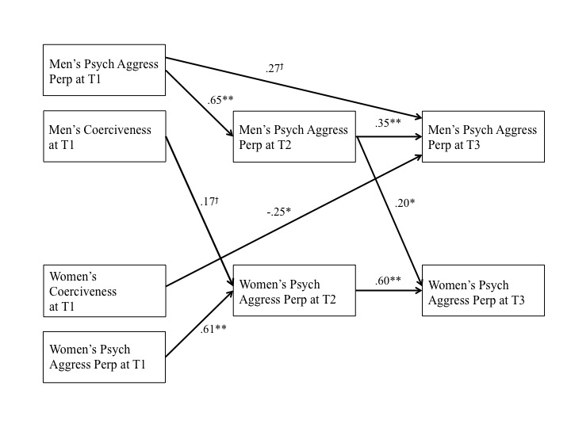
Figure 1. Partner Gender Effects of Coerciveness on Psychological Aggression Perpetration. Non-significant paths are not depicted to ease interpretation. For readability of the model, correlations for variables included in the model can be found in Table 6.
T1 = bseline; T2 = three-month follow up; T3 = six-month follow up; *p< .05 **p< .01 ^{ϯ}p < .10

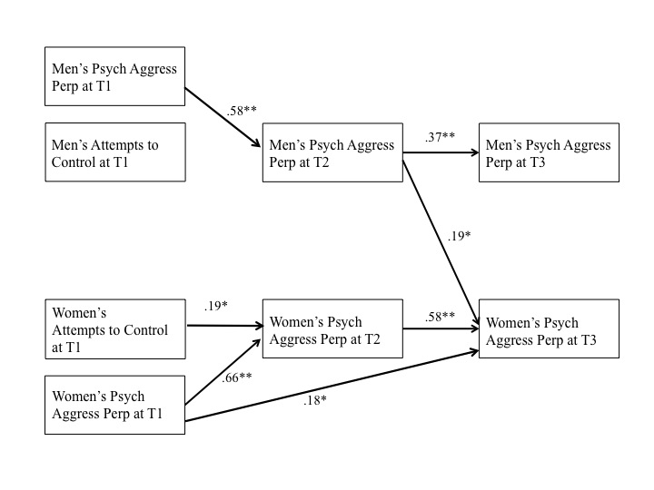

Figure 2. Partner Gender Effects of Attempts to Control on Psychological Aggression Perpetration. Non-significant paths are not depicted to ease interpretation. For readability of the model, correlations for variables included in the model can be found in Table 7.
T1 = baseline; T2 = three-month follow up; T3 = six-month follow up; *p< .05 **p< .01 ^{ϯ}p < .10
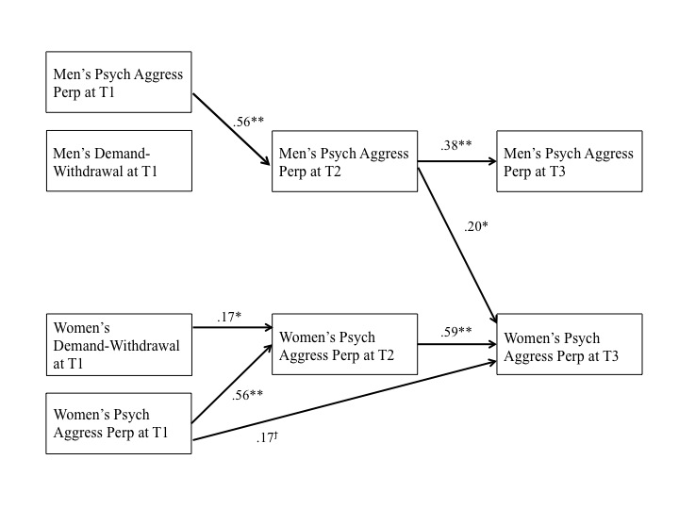
Figure 3. Partner Gender Effects of Self-Reported Demand-Withdrawal on Psychological Aggression Perpetration. Non-significant paths are not depicted to ease interpretation. For readability of the model, correlations for variables included in the model can be found in Table 8.
T1 = baseline; T2 = three-month follow up; T3 = six-month follow up; *p< .05 **p< .01 ^{ϯ}p < .10

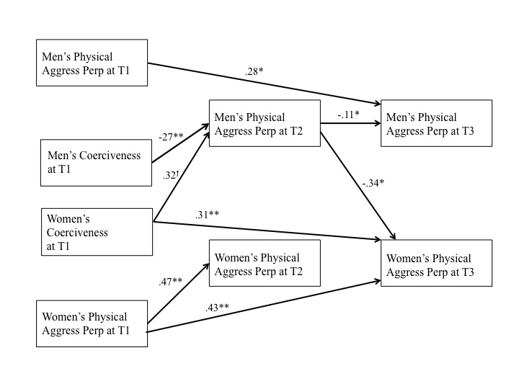
Figure 4. Partner Gender Effects of Coerciveness on Physical Aggression Perpetration. Non-significant paths are not depicted to ease interpretation. For readability of the model, correlations for variables included in the model can be found in Table 9.
T1 = baseline; T2 = three-month follow up; T3 = six-month follow up; *p< .05 **p< .01 ^{ϯ}p < .10
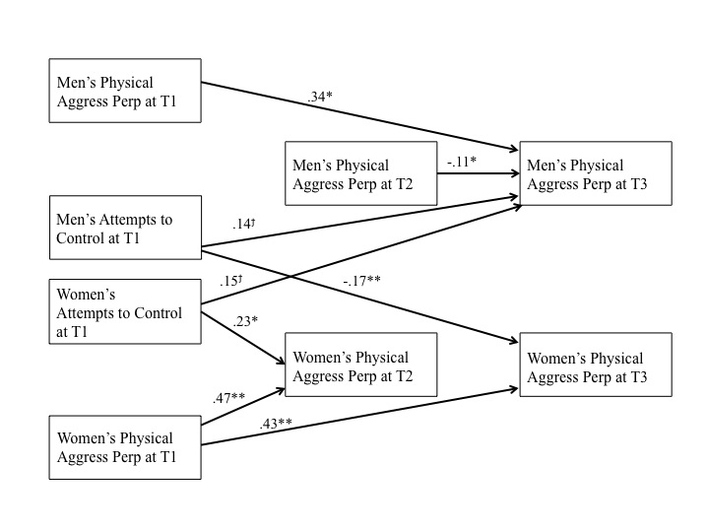
Figure 5. Partner Gender Effects of Attempts to Control on Physical Aggression Perpetration. Non-significant paths are not depicted to ease interpretation. For readability of the model, correlations for variables included in the model can be found in Table 10.
T1 = baseline; T2 = three-month follow up; T3 = six-month follow up; *p< .05 **p< .01 ^{ϯ}p < .10
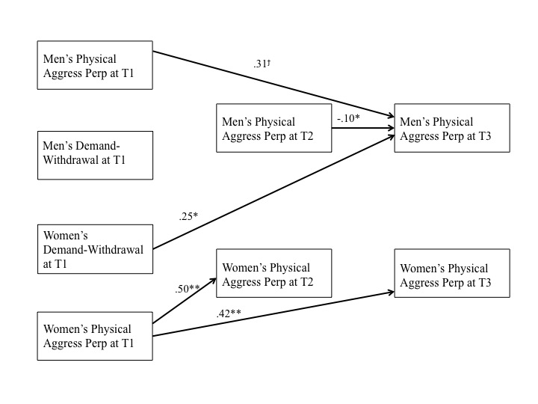
Figure 6. Partner Gender Effects of Self-Reported Demand-Withdrawal on Physical Aggression Perpetration. Non-significant paths are not depicted to ease interpretation. For readability of the model, correlations for variables included in the model can be found in Table 11.
T1 = baseline; T2 = three-month follow up; T3 = six-month follow up; *p< .05 **p< .01 ^{ϯ}p < .10
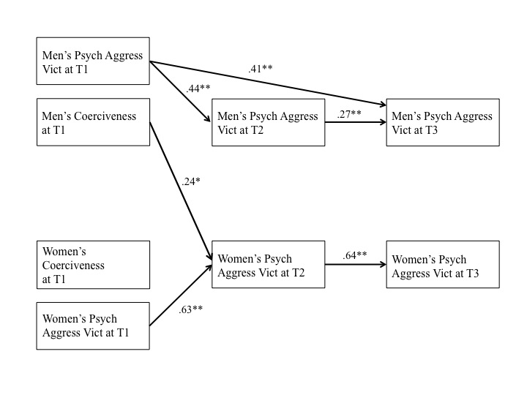
Figure 7. Partner Gender Effects of Coerciveness on Psychological Aggression Victimization. Non-significant paths are not depicted to ease interpretation. For readability of the model, correlations for variables included in the model can be found in Table 12.
T1 = baseline; T2 = three-month follow up; T3 = six-month follow up; *p< .05 **p< .01 ^{ϯ}p < .10
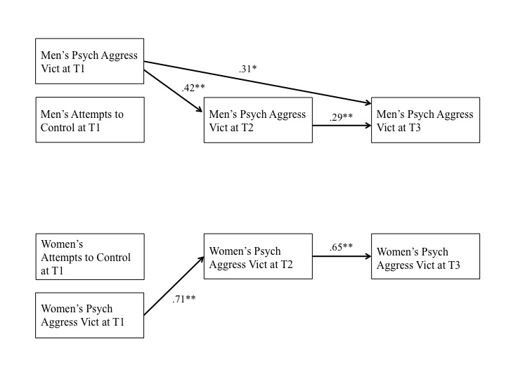
Figure 8. Partner Gender Effects of Attempts to Control on Psychological Aggression Victimization. Non-significant paths are not depicted to ease interpretation. For readability of the model, correlations for variables included in the model can be found in Table 13.
T1 = baseline; T2 = three-month follow up; T3 = six-month follow up; *p< .05 **p< .01 ^{ϯ}p < .10
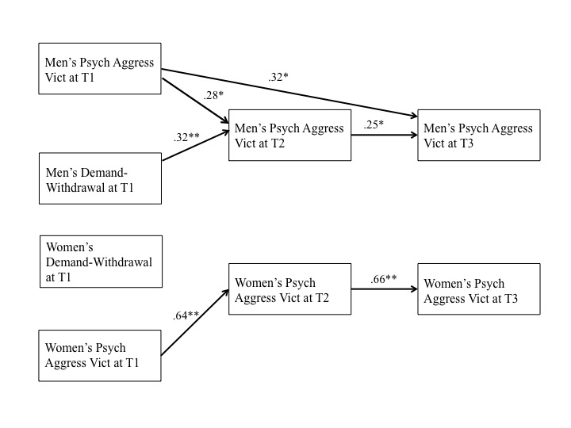
Figure 9. Partner Gender Effects of Self-Reported Demand-Withdrawal on Psychological Aggression Victimization. Non-significant paths are not depicted to ease interpretation. For readability of the model, correlations for variables included in the model can be found in Table 14.
T1 = baseline; T2 = three-month follow up; T3 = six-month follow up; *p< .05 **p< .01 ^{ϯ}p < .10
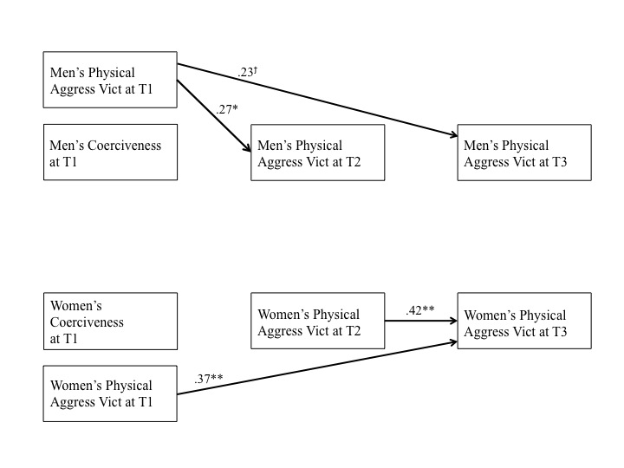
Figure 10. Partner Gender Effects of Coercion on Physical Aggression Victimization. Non-significant paths are not depicted to ease interpretation. For readability of the model, correlations for variables included in the model can be found in Table 15.
T1 = baseline; T2 = three-month follow up; T3 = six-month follow up; *p< .05 **p< .01 ^{ϯ}p < .10
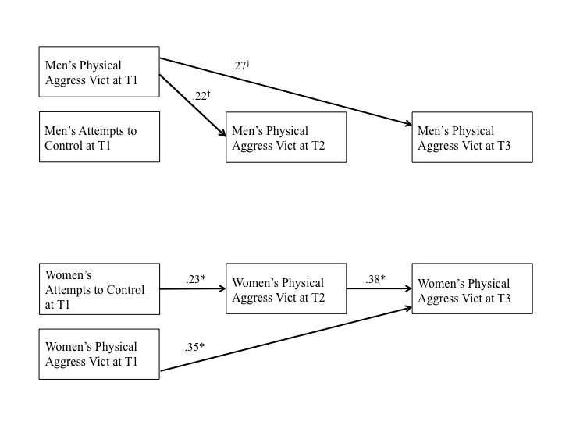
Figure 11. Partner Gender Effects of Attempts to Control on Physical Aggression Victimization. Non-significant paths are not depicted to ease interpretation. For readability of the model, correlations for variables included in the model can be found in Table 16.
T1 = baseline; T2 = three-month follow up; T3 = six-month follow up; *p< .05 **p< .01 ^{ϯ}p < .10
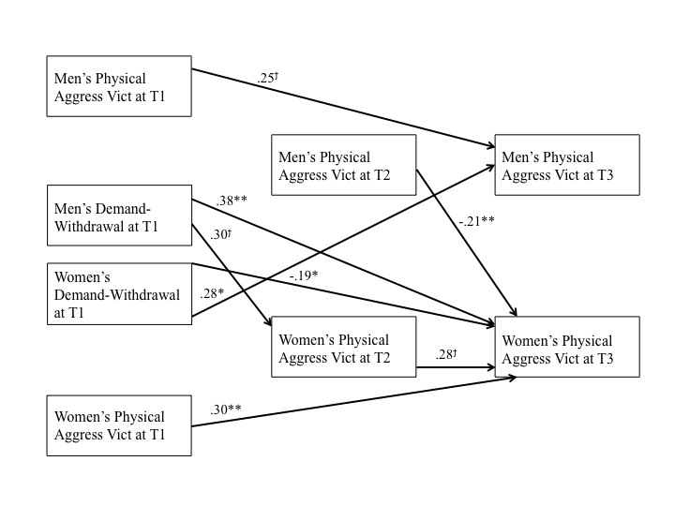
Figure 12. Partner Gender Effects of Self-Reported Demand-Withdrawal on Physical Aggression Victimization. Non-significant paths are not depicted to ease interpretation. For readability of the model, correlations for variables included in the model can be found in Table 17.
T1 = baseline; T2 = three-month follow up; T3 = six-month follow up; *p< .05 **p< .01 ^{ϯ}p < .10
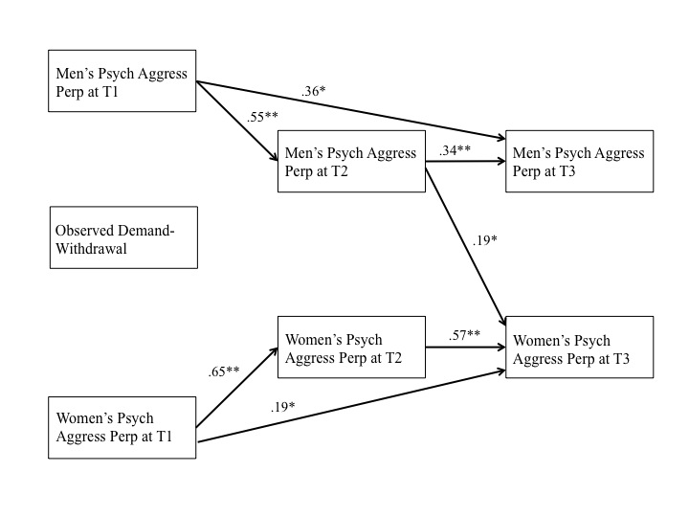
Figure 13. Effects of Observed Demand-Withdrawal on Psychological Aggression Perpetration. Non-significant paths are not depicted to ease interpretation. For readability of the model, correlations for variables included in the model can be found in Table 18.
T1 = baseline; T2 = three-month follow up; T3 = six-month follow up; *p< .05 **p< .01 ^{ϯ}p < .10
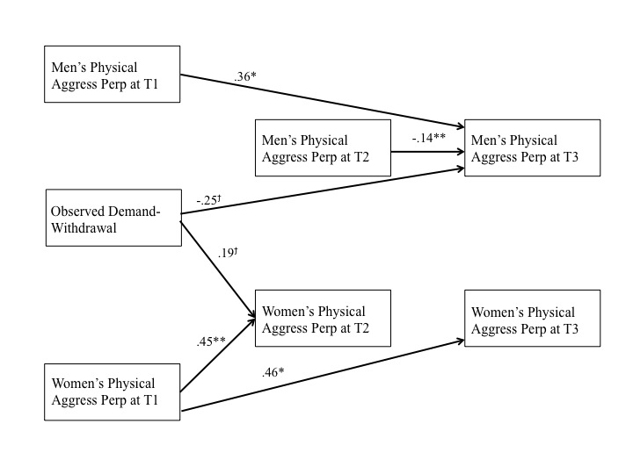
Figure 14. Effects of Observed Demand-Withdrawal on Physical Aggression Perpetration. Non-significant paths are not depicted to ease interpretation. For readability of the model, correlations for variables included in the model can be found in Table 19.
T1 = baseline; T2 = three-month follow up; T3 = six-month follow up; *p< .05 **p< .01 ^{ϯ}p < .10
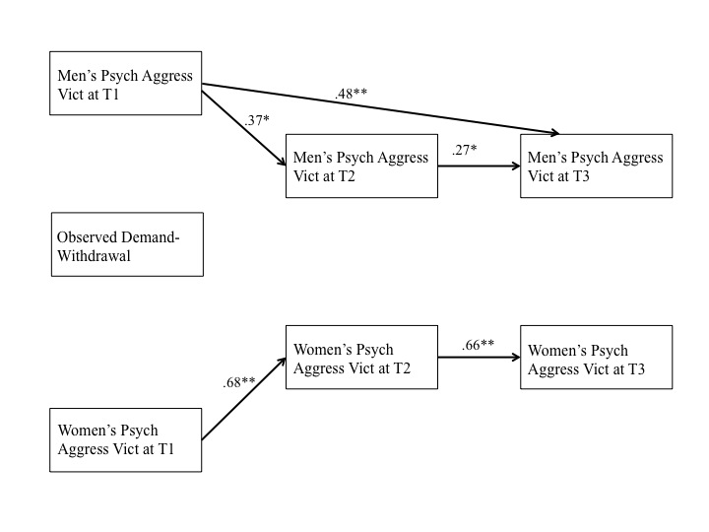
Figure 15. Effects of Observed Demand-Withdrawal on Psychological Aggression Victimization. Non-significant paths are not depicted to ease interpretation. For readability of the model, correlations for variables included in the model can be found in Table 20.
T1 = baseline; T2 = three-month follow up; T3 = six-month follow up; *p< .05 **p< .01 ^{ϯ}p < .10
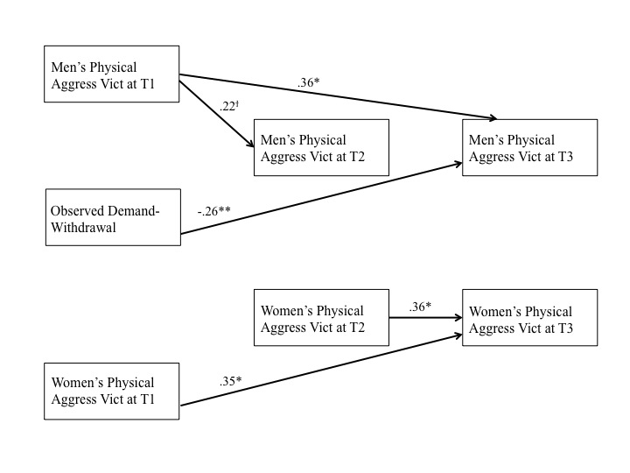
Figure 16. Effects of Observed Demand-Withdrawal on Physical Aggression Victimization. Non-significant paths are not depicted to ease interpretation. For readability of the model, correlations for variables included in the model can be found in Table 21.
T1 = baseline; T2 = three-month follow up; T3 = six-month follow up; *p< .05 **p< .01 ^{ϯ}p < .10

Vita

Heather received her Bachelor of Arts in Psychology from the University of Akron in May 2011. She received her Masters of Arts in Psychology in 2014, en route to her doctoral degree. Her current research interests are in the area of intimate partner violence including risk and protective factors, with a specific focus on aggression occurring via technology.

