The Role Of Hydropower In An Energy Stable, Economically Viable, and Environmentally Sustainable Future

A Dissertation Presented for the Doctor of Philosophy Degree
The University of Tennessee, Knoxville

Kyle McKinley Weiss
May 2025
Acknowledgements
Thank you to my advisors, Dr. Brenda Pracheil and Dr. Kristine Moody, for providing guidance, feedback, and support through the process of writing this dissertation.
Abstract
Hydropower’s ability to quickly adapt to the variable generation of wind and solar can allow the electricity grid to integrate more renewable capacity. However, changing hydroelectric output to increase or decrease generation in response to solar or wind output changes the quantity of water flowing through the generators. Rapid flow fluctuations, required to closely correlate with changes in solar wind output can negatively impact downstream aquatic ecosystems. Additionally, the dispatch of hydroelectric generation must consider other uses for the water and storage provided by the facility such as recreation and flood control. This dissertation explores the energy-environmental-economic nexus of five case study conventional hydropower facilities when operating in a range of run-of-river conditions. We also analyze pumped storage hydropower’s ability to meet future short-term energy dispatch needs, and the feasibility of converting non-powered dams to power producing ones using Archimedes screw turbine technology. Findings from this dissertation demonstrate operation of five case study facilities (without considering non-power license restrictions included within a project’s operating license) within a discharge range of 140% to 200% of inflow supports both environmental sustainability and energy system stability. Additionally, modeling pumped storage hydropower to assume increased conventional hydropower demands reveals that pumped storage can meet at least 91% of required demands, if output was not restricted by the project’s operating license. This need for pumped storage to meet demands is influenced by variable renewable energy generation and battery capacity within the same balancing area. Lastly, this dissertation identifies the potential of using Archimedes screw turbines as a dual-purpose technology, offering fish passage and energy generation. However, projected changes in precipitation trends from 2024 to 2050 are expected to reduce the number of viable sites for such implementations. Our result suggests hydropower operations can aid in increasing renewable energy generation while limiting environmental impacts because pumped storage in the region can make up for the potential generation loss. We also present a framework for considering social, environmental and economic impacts of non-powered dam conversions using Archimedes screw turbines in future changing precipitation trends.
Table of Contents
Chapter 1 Introduction 1
1 Introduction 3
2 Chapter 2 5
2.1 Chapter key takeaways: 5
3 Chapter 3 8
3.1 Chapter key takeaways: 8
4 Chapter 4 10
4.1 Chapter key takeaways: 10
5 Summary 13
Works Cited 14
Chapter 2: Energy, Economic, and Environmental Tradeoffs at Run-of-River Hydropower Facilities 17
1. Introduction 19
2.0 Methods 22
2.1 Cambium Dataset 22
2.2 Case study site descriptions 23
2.2.2 Pit 3, CA 26
2.2.3 Bartletts Ferry, GA 27
2.2.4 High Rock, NC 27
2.2.5 Smith Mountain, VA 28
2.3 Data curation and equations 29
2.3.1 Facility Demand Data 29
2.3.2 Power pricing data 31
2.3.3 Inflow Data 31
2.4 Analysis 32
2.4.1 Discharge Allowed: 34
2.4.2 Volume calculations 34
2.4.3 Revenue Calculation 40
2.4.4 Environmental Impact Calculation 40
2.5 Statistical Analyses 42
2.6 Sensitivity Analysis 43
3.0 Results 44
3.1 Environmental Results 44
3.2 Economic Results 48
3.3 Grid Stability Results 48
3.4 Sensitivity Analysis 49
3.5 Predictors of Richard Baker Index, Revenue, and Grid Stability Correlation 49
4.0 Discussion 55
4.1 Future Renewable Generation Makeup 56
4.2 Operational Practices 60
4.3 Balancing Priorities 62
5.0 Conclusion 63
Works Cited 65
Appendices 72
Chapter 3: Pumped Storage Optimization for Short Term Energy Dispatch 91
1 Introduction 93
2 Methods 95
2.1 Case study site descriptions 96
2.1.1 Balancing Area 03 96
2.1.2 Balancing Area 09 99
2.1.3 Balancing Area 94 100
2.1.4 Balancing Area 97 100
2.1.5 Balancing Area 99 101
2.2 Datasets 102
2.2.1 Cambium Dataset 102
2.2.2 Hydrologic Data 105
2.3 Data curation and equations 107
2.3.1 Facility Demand Data 107
2.3.2 Discharge Allowed 109
2.3.3 Volume calculations 111
2.3.4 Revenue Calculation 113
2.3.5 Environmental Impact Calculation 113
2.4 Pumped Storage Short-Term Energy Dispatch Optimization 115
2.4.1 Constraints 118
2.5 Statistical Analysis 120
3 Results 124
3.1 Optimization modeling 124
3.1.1 Resource adequacy 124
3.1.2 Economics 125
3.2 LASSO Regression Modeling 128
3.2.1 National LASSO Regression Results 128
3.2.2 Pumped Storage Hydropower Percent of Demand Met 131
3.2.3 Pumped Hydropower Storage Revenue 132
3.2.4 Richard-Baker Flashiness Index 133
3.3 Balancing Area LASSO Regression Results 134
3.3.1 Pumped Storage Hydropower Percent of Demand Met 134
3.3.2 Pumped Hydropower Storage Revenue 135
3.3.3 Richard-Baker Flashiness Index 136
4 Discussion 137
4.1 Environmental Impacts 138
4.2 Economic Implications 140
4.3 Coordinated Energy Systems 140
4.4 Correlated Factors 141
4.5 Future Research 142
4.6 Policy Implications 144
5 Conclusion 145
Works Cited 146
Appendix 152
Appendix A: 152
Appendix B 170
Appendix C 171
Appendix D 177
Appendix E 182
Chapter 4: Contextualizing Non-Powered Dam Site Selection for Archimedes Screw Turbines 183
1 Introduction 185
2 Methods 189
2.1 Data Curation 189
2.2 Analysis 190
2.2.1 AST Site Parameters 190
2.2.2 Cost Evaluation 191
2.2.3 Environmental Evaluation 194
2.2.4 Social Impact Evaluation 195
3 Results 196
3.1 Precipitation Trends Impact 196
3.2 Capacity and Costs 197
3.3 Ecological and Social Impacts 197
4 Discussion 206
4.1 Climate impacts on NPDs conversions 209
4.2 Economics 209
4.3 Social implications of NPD conversions with ASTs 211
4.4 Environmental implications of NPD conversions With ASTs 212
4.5 Comparison To Other Turbines 214
4.6 Broader Impacts 215
5 Conclusion 216
Works Cited 218
Chapter 5: Conclusion 224
1 Introduction 225
2 Key Takeaways 226
3 Summary 227
Works Cited 229
Vita 230

List of Tables
Table 1 Description of Variable Renewable Energy (VRE) Generation Use Percent and Hydropower Generation Use Percent in 2024 and 2050 in each Balancing Area (BA), and the associated case study site. The data for this table comes from the Cambium data set which relies on the2016 Hydropower Vision report (Gagnon, et al., 2023) (U.S. DOE, 2016). The decrease in hydropower is likely from the aging hydropower asset infrastructure which reaches the end of its 100-year lifetime before 2050. 24
Table 2 Percent of MWh each Case Study makes up of the total Balancing Area 30
Table 3 Characteristics of the five case study hydropower facilities used in this study including (columns) project name (ReEDs balancing area number), and FERC docket number, and (rows) state where facility is located, nameplate capacity of conventional hydropower at the facility (MW), generation capacity given as average annual net generation since 2002(MWh), National Electricity Reliability Corporation (NERC) region, USGS gauge number for first gauge upstream of the project, and projected average annual discharge (m³/s) for 2024-2050 based on USGS gauge site location projections from ORNL CMIP6-based Multi-model Streamflow Projections, specifically using the Australian Community Climate and Earth System Simulator (ACCESS) US (Kao et al., 2022). All case study projects used in this study were classified as peaking by the Existing Hydropower Assets Database (Johnson et al., 2022). 33
Table 4 Inputs into the constrain analysis for each hydropower facility, a description of each input and the corresponding reference for the information. 35
Table 5 Description of peak hours specific to each region broken down by season with each corresponding BA and Facility. 38
Table 6 Statistically significant correlations with variable renewable energy generation percent and hydropower generation percent 47
Table 7 Average % Demand Met across All Years and IEO Cases for each case study facility 51
Table 8 Sensitivity analysis piecewise regression results between the three response variables and eight independent variables 52
Table 9 All significant correlation results (P-value < 0.05) across all BAs and variables. 72
Table 10 Top Ten Models 82
Table 11 Balancing areas with their associated case study site name, VRE Generation Use Percent, and Hydropower Generation Use Percent in 2024 and 2050, BA PSH capacity, PSH efficiency, BA conventional hydropower capacity, percent of MWh each case study makes up of the total BA, conventional hydropower capacity in the BA given in GW (1,000 MW) 98
Table 12 Constrain analysis model inputs for each hydropower facility, a description of each input, and the corresponding reference source. 103
Table 13 The five BAs (columns) and their case study site characteristics (rows) used in this study: state where facility is located, FERC docket number, nameplate capacity of conventional hydropower at the facility (MW), National Electricity Reliability Corporation (NERC) region, USGS gage number for first gage upstream of the project, and projected average annual discharge (m³/s) for 2024-2050 based on USGS gage site location projections from ORNL CMIP6-based Multi-model Streamflow Projections using the Australian Community Climate and Earth System Simulator (ACCESS) U.S. (Kao et al., 2022). All case study projects used in this study were classified as peaking by the Existing Hydropower Assets Database (Johnson et al., 2022). 108
Table 14 Description of peak hours specific to each region broken down by season with each corresponding BA and facility. 110
Table 15 PSH optimization constraint model variables and definitions. 117
Table 16 Independent and Response variables used for the linear regression analysis based on the PSH optimization results. 121
Table 17 The maximum PSH demand change year by year across all IEO cases. 125
Table 18 National LASSO regression coefficient results for combined balancing area, inflow equals outflow, and year analysis. A negative correlation coefficient indicates an inverse relationship while a positive value indicates a direct relationship. The larger the absolute value of the coefficient the larger the impact the corresponding independent variable has on the response variable, however these magnitude comparisons can only be made within each model. For example, comparing the BA magnitude in the Revenue and Demand Met columns would be comparing across two different models and are thus not comparable. 130
Table 19 This appendix lists the hydropower and pumped storage sites within each of the considered balancing areas. The table lists facility name, state, conventional hydropower (CH) capacity, PSH capacity, and the ReEDS balancing area. 152
Table 20 This appendix contains a table showing the end-use energy price and profit changes at each balancing area, and the associated case study facility. 170
Table 21 This appendix gives a table with economic results of optimized PSH dispatch including revenue, charge cost, and net profit for each BA, IEO, and year combination. These economic results do not include maintenance or other associated expenditures. 171
Table 22 This appendix presents the results of the National and BA specific LASSO regression model. The Best Alpha value shows how closely the model represents a linear model, with linear being 0, RMSE is the real mean squared error, and Adj R^2 is the adjust r- squared for the model. 177
Table 23 Balancing Area Specific LASSO Regression Model Results 178
Table 24 BAs and their respective conventional hydropower and PSH generation capacity in 2022 and the percent of generation from conventional hydropower in 2024 from the 2022 Cambium model (Johnson, et al., 2022). (Gagnon, et al., 2023) (U.S. DOE, 2016). 182
Table 25 Cost Comparison of Example AST Conversion Studies where the Index value is the cost factor applied within each state. The national average is 1.0, an index factor greater than 1.0 means the location is more expensive for construction than the national average and an Index factor below 1.0 is less expensive than the national average. 192
Table 26 Median Hydropower Observed Energy Prices from 2006 to 2020 194
Table 27 Viable NPDs for AST conversion and their associated mean capacity, mean cost of installation, mean ROI, and mean $/kW 198
Table 28 Top five states with the most viable NPDs for AST conversion showing number of NPDS, mean capacity in 2024, mean total installation cost, mean ROI, and mean $/kW for each state. 200
Table 29 Five states within the continuous United States with the lowest median distance to a substation showing the median distance and mean distance for each state. 203
Table 30 Species and the number of NPDs viable for AST conversion in 2024 they exist at. 204
Table 31 Biodiversity land status of viable NPD conversion sites using AST technology, across the three studied years: 2024, 2037, and 2050. 207

List of Figures
Figure 1 Balancing Areas in the continental US with Case Study Sites: ReEDS balancing areas and case study facilities labeled in the CONUS. 24
Figure 2 RB-Index vs Demand for all BAs: Case Study Sites RB-Index values vs Demand with four points per IEO percent value representing analysis years (2024, 2034, 2044, or 2050). Both the y-axis and x-axis for these graphs vary by case study. The scale of the x- and y-axis vary by site due to the variability in the RB-Index and Total Demand (MW) between sites. 45
Figure 3 Demand met, Hydro, VRE, and Total Demand vs Year for all BAs: Case study sites Year vs Demand Met for all IEO percent values. Both the y-axis and for the percent of demand met and the y-axis for the Demand (GW) vary by case study. 50
Figure 4 Occurrences in Top Ten Models: Number of times each independent variable and response variable combination occurs aggregated across all balancing areas. 54
Figure 5 Map showing the contiguous United States divided into the Regional Energy Deployment System balancing areas as defined by the National Renewable Energy Lab (NREL). Gray areas white numbers denote balancing areas used for the case studies, and the red stars are conventional hydropower facility locations. 97
Figure 6 Workflow of constrained analysis performed for each combination of case study facility, year, and IEO %. 106
Figure 7 Workflow of PSH short-term energy dispatch optimization across all five considered ReEDs BAs, constrained for each combination of case study facility, year (2024, 2034, 2044, 2050), and IEO percentage (100, 120, 140, 160, 180, 200). The energy deficits from the constrained analysis are added to the preexisting Cambium Dataset PSH demands, the optimization is then constrained, and results are reported in percent of demand met and revenue. 116
Figure 8 The percent of demand met across all balancing areas, years, and inflow equals outflow conditions. In all cases the difference in the demand met in a year across the inflow equals outflow conditions was less than 0.3% making it difficult to see in this figure. 126
Figure 9 Total revenue vs year for each balancing area, year, and inflow equals outflow combination. The total revenue is the sum of revenue from the Cambium projected demand and revenue from the optimization dispatch. The super imposed black line is the total demand, which is the sum of the Cambium projected demadns and the carryover demand. 127
Figure 10 Energy prices for each year averaged across the entire year for each hour of the day. Displaying clear pricing peaks and off-peaks. This chart is specific to Cambium projected energy prices across all studies BAs. 129
Figure 11 Heat Map of All NPD Sites Across the Continental United States. 186
Figure 12 Viable NPDs for AST conversions across the United States with the associated year. 199
Figure 13 Installation costs for viable NPD conversions with ASTs across the continuous United States, and the ROI within the continuous United States. 201
Figure 14 Distance to Substation for viable NPD conversions within the continuous United States in 2024. 202
Figure 15 Viable NPD sites for AST conversions in 2024 with maps showing the sites with specific species present 205
Figure 16 Three map figure showing viable NPD conversion sites using ASTs and their population density by size and color, density of whitewater paddling sites, and density of daily fishing trips per year. 208

Chapter 1 Introduction

Abstract
Hydropower’s ability to quickly adapt to variability from wind and solar generation by fluctuation flow rates can allow the electricity grid to integrate more renewable capacity. However, these rapid flow fluctuations, required to meet variability needs, can negatively impact aquatic ecosystems. In this study, we quantified energy-economic-environment tradeoffs at five conventional hydropower facilities (i.e. hydropower produced ad a dam on a river channel) across the United States to identify a mix of operational regimes that can provide flexibility to support variable renewable energy integration and environmental protections. Model results show a range of ability to meet demand from 4.7% to 97.8% depending on which case study is considered. Additionally, when modeling the case study facilities on a range of RoR conditions, allowing a % of inflow as discharge, we found the range of 140% to 200% of inflow allowed as discharge lead to lowest environmental impact while meeting the highest amount of demand. Our sensitivity analysis results demonstrated the Richard-Baker Flashiness Index, used to measure flowrate changes, and Revenue, were negatively correlated with the percent of hydropower generation within the defined Regional Energy Deployment System balancing area (i.e. region in which energy demand and energy supply is balanced based on the Regional Energy Deployment System model) yet positively correlated to the variable renewable energy generation percentage in the defined balancing area. Our results suggest hydropower operations can aid in increasing renewable energy generation while limiting environmental impacts when considering a holistic analysis of energy-economic-environment tradeoffs.

Introduction
As the global push for decarbonization accelerates, the energy sector is undergoing a profound transformation from fossil fuel generated electricity to variable renewable energy (VRE) sources, such as wind and solar. These VREs offer decreased greenhouse gas emissions when generating power as compared to fossil fuel generation. However, the output of VREs charges wind speeds, and solar irradiance throughout the day requiring other tools to be utilized to produce a stable flow of power in all time periods Electrical reliability issues related to VREs are expected to increase in the coming years; for example, the installation of solar capacity grew by 44% between 2009 and 2022, wind generation surpassing hydropower generation as the largest source of renewable generation (EIA, 2023); (EIA, 2020). To address the variability of wind and solar generation output, flexible and dispatchable generation sources, like hydropower, are essential.
To understand the role hydropower plays as a flexible dispatch generation asset it is helpful to understand how the electricity markets are structured in the United States (U.S.). Prior to 1992 United States (U.S.) utilities were vertically integrated, meaning they owned the generation and transmission that brought their customers electricity. However the National Energy Policy Act of 1992 and Order 888 in 1996 allowed for more market competition by making it easier for other entities to enter the market (102nd Congress, 1992); (FERC, 2020); (109th Congress, 2005).
The present-day United States (U.S.) energy grid is divided into three major power grids: Eastern Interconnection, Western Interconnection, and Electric Reliability Council of Texas (U.S. DOE). The Western and Eastern Interconnections include parts of Canada and balance electricity supply and are further divided into balancing authorities who ensure supply and demand is balanced and maintained. A sizeable portion of the US is composed of Regional Transmission Operators (RTOs) or Independent Systems Operators (ISOs) who act as balancing authorities in their respective regions. Outside of RTO and ISO regions there are several other players who act as balancing authorities: vertically integrated utilities, federal agencies, and electric cooperatives.
Understanding the role of balancing areas requires understanding for the energy services they provide. Their services can be divided into two categories: day-ahead commitment and rea-time system dispatch (DOE). The day ahead commitment considers what generation is needed to meet demands over the next 24 hours, whereas real-time dispatch focuses on matching generation and demand with an operating hour. When there are unexpected deviations from scheduled output and demand ancillary services are deployed by the balancing authority area to match output with demand. Some ancillary services include spinning reserves, non-spinning reserves, and supplemental reserves.
The integration of VRE sources can cause the need for these ancillary services due to their variable energy production (Chuang, et al., 2009). Hydropower has historically been able to provide these ancillary services and compensate for VRE variability because generation can quickly be increased or decreased (referred to with the industry as ramping) (Forrest, et al., 2018); (Rand, 2018). However, this ramping of hydropower facilities can have negative impacts on downstream aquatic environments (Halleraker, et al., 2022); (Kenawi, 2020).
Optimizing existing and emerging hydropower technologies to balance variability of VRE sources and meet economic, environmental and social needs is challenging. This dissertation investigates how hydropower operations – through Run-of-River (RoR) operations, Pumped Storage hydropower (PSH), and the conversion of Non-Powered Dams (NPDs)- can be optimized to address the growing need for grid flexibility in an energy landscape increasingly dominated by VRE sources. By exploring the intersection of energy production, economic viability, and environmental sustainability, this research offers a comprehensive framework for enhancing hydropower’s role in supporting the renewable energy transition, ensuring grid stability, and minimizing ecological impacts.
Some prior research has reviewed RoR operations by considering hydropower operations and their impacts on generation operational costs, and environmental impacts (Singh, et al., 2017). Whereas other research focuses on integration of VRE sources using PSH assets (Bhimaraju, et al., 2022), and NPD conversions with greater than 1MW capacity (Calderon, et al., 2023). our analysis goes a step further by quantifying and comparing economic, energy, and environmental factors in each. By systematically evaluating these factors, our analysis exposes correlations between key operational variables and their outcomes, providing deeper insights into how different hydropower strategies affect grid reliability, revenue generation, and environmental impact. Moreover, the multi-faceted approach to NPD conversions using ASTs offers a novel framework integrating social, economic, and environmental conidiations into the decision-making process.

Chapter 2

Chapter key takeaways:
- Hydropower facilities can operate in RoR mode to minimize environmental impacts while meeting energy demands.
- Increased VRE generation is linked to higher environment stress.
- Hydropower flows can be optimized to balance the environment needs, energy demands, and generation revenue.
- Meeting energy demands while mitigating environmental impacts requires a site-specific approach to hydropower operations.
There are two types of operational methods deployed at hydropower facilities: peaking and run-of-river (RoR). Peaking facilities can discharge high volumes of water during peak energy demand times and capitalize on high energy prices, a practice known in the industry as “peaking” or “load following”. Rapid flow fluctuations, resulting from following demand cycles while beneficial for balancing intermittent generation from VRE sources, can result in fish stranding, impeded fish reproduction, and alter downstream dissolved oxygen levels among having other detrimental environmental impacts (Moreria, et al., 2019); (Bejarano, et al., 2017); (Bondar-Kunze, et al., 2016). The other type of operation, RoR, operates by discharging water, for energy generation, at the same rate as inflow (Kuriqi A. et al., 2020). It is important to note hydropower operational regimes can change depending on license requirements and that peaking facilities can operate as in RoR conditions at certain times. The intention of RoR operations is to mimic the natural hydrologic cycle however, this removes the ability of the RoR facility to meet instantaneous demands as easily as the peaking facility.
Specifically, five case studies are modeled under a gradient of RoR operational conditions ranging from allowing 100% to 200% of inflow as discharge. We also consider future projections of VRE and hydropower generation as well as climate change impacts in each facilities grid region to analyze the relationships between the energy-economic-environment nexus and the penetration of VRE integration in each region. Previous work typically compared two of the three variables: energy, economics, and environmental factors. Our approach to exploring the multifaceted relationships between energy, economics, and environmental variables; and how they associate with future energy generation builds on this previous work through expanding considerations for energy regulatory policy and development plans. This chapter’s analysis highlights the complexities involved in managing these often-competing priorities, setting the stage for broader discussion on how hydropower can evolve to meet modern demands.
The findings from this study underscore the critical role of hydropower in balancing the energy-economic-environment nexus amid increasing integration of VRE sources. We find the threshold of 140%-200% of inflow allowed as discharge minimizes environmental impacts while also meeting energy demands across three of our five sites. The broader implications of this finding are that hydropower flows could be optimized to balance environmental, energy, and revenue needs. Additionally, the regression analysis showed balancing areas with greater hydropower generation percentages had more stable downstream flow regimes, and regional VRE generation percent was linked to higher environmental stress as measured by RB-Index values. This positive correlation is interpreted as the greater amount of VRE generation the higher flashiness those case studies experience. While these findings show promise for arriving at mutual energy, environment, and economic beneficial outcomes, our work also reiterates the site-specific nature of conventional hydropower with a range of 4-100% of demands met along at each site.
Conventional hydropower facilities, as flexible generation sources, play a crucial role in ensuring grid stability is maintained while meeting carbon emission reduction goals. This flexibility requires reconciling competing priorities, to ensure meeting demands does not exacerbate environmental impacts. Our findings hold implications for hydropower operations in the context of future VRE integration. By finding there is a balance between energy and environmental factors and that these conditions are not always competing interests. This research can also be applied in the policy space where nuanced regionally tailored approaches could leverage our site-specific and regional correlations to guide discussions during the licensing process.

Chapter 3

Chapter key takeaways:
- Pumped Storage Hydropower can mitigate conventional hydropower hydropeaking impacts while supporting increasing VRE penetration in energy markets.
- Increasing regional energy demands is linked to higher environmental stress.
- Variable renewable energy generation impacts revenue and grid stability.
The benefit of hydropower generation extends beyond conventional hydropower generation and includes maintaining energy grid stability, economic viability, and environmentally conscious operations. As VRE integration grows, energy storage technologies will become increasingly vital in this balancing act. Battery facilities can charge during the middle of the day when solar production outpaces demand and discharged as solar production falls at the end of the day; this can also be applied to wind generation that cycles insistently up and down as the wind blows. There are two types of battery storage: short-duration, and long-duration. Short-duration stores energy for less than 10 hours and is better for rapid deployment but lacks the ability to meet demands overnight (Viswanathan, et al., 2022). Long-duration storage provides at least 10 hours of energy storage is most beneficial for supply power during larger dips in power production and providing ancillary services (Tuttman, et al., 2020) (Castillo, et al., 2014). Pumped storage hydropower (PSH) is a long-duration storage type that accounts for 96% of utility-scale energy storage in the United States, and studies show PSH can offer supply and demand balancing capacity (DOE) (Hunt, et al., 2020).
Optimizing PSH while addressing short-term deficits and determining if correlations exist with PSH capacity, energy demand, revenues, and environmental factors could provide long-term grid stability and decarbonization implications. This chapter explores the optimization of PSH, maximizing revenue, to meet these short-term demands, and further analyze energy landscape factors (hydropower generation and VRE integration), and how they could relate to economic and environmental impacts.
The analysis in this study optimizes PSH revenue while dispatching to meet short term energy deficits from the same five case study facilities chapter one considered. Our goal is to evaluate the ability of PSH facilities to meet facility energy deficits from chapter one, and determine if correlations exist between response variables, PSH capacity meeting demands and revenues, and environmental and grid build out factors. We again consider future renewable energy build out and how this impacts our response variables. This analysis contributes to the ongoing conversation about scalability and economic feasibility of PSH in a grid with high renewable penetration, evaluating its role in meeting the future grids balancing needs.
The results of this analysis found, PSH met 91-100% of all required demand including those demands from the five-case study conventional hydropower facilities operating in various inflow-equals-outflow operational scenarios. These results suggest PSH capacity could meet additional demands from conventional hydropower helping reduce environmental stress and hydropeaking. Specific economic assessments found site-specific metrics (carryover demand) and broader regional metrics (VRE generation percentage) impacted revenue generation. Beyond solely, economics the VRE generation percent was strongly correlated with the ability of PSH facilities to meet demands.
Our findings highlight the economic and environmental advantages of integrating PSH with conventional hydropower operations, as PSH consistently absorbs at least 91% of the conventional carryover demands across all operational scenarios. This means conventional hydropower facilities can be operated in the most environmentally beneficial scenario observed in this study with the knowledge PSH can make up for the unmet demands from doing so. This underscores the importance of implementing regionally tailored strategies to optimize coordination between PSH and conventional hydropower coordination. Additionally, the results emphasize the need for policies that establish clear regulations to quantify VRE integration requirements, flexible generation capacity, and energy-environment trade-offs.

Chapter 4

Chapter key takeaways:
- Archimedes Screw Turbine (AST) viable sites see a rise in potential energy generation from 2024 to 2050 due to changing precipitation trends.
- Archimedes Screw Turbine number of viable sites decreases from 2024 to 2050 due to changing precipitation trends.
- Archimedes Screw Turbine can be used for dual energy and fish passage purposes.
In parallel with optimizing existing hydropower resources, the untapped potential of NPDs conversion to energy-generating assets is considered in the third chapter. Unlike large dams, which are becoming increasingly controversial for their environmental and social impacts, NPD conversions retrofit an existing structure which could offer reduced environmental impact during construction. The potential of NPD energy generation has been widely studied and one study from the Department of Energy (DoE) found there is 12GW of energy generation potential in existing NPDs across the US (U.S. Department of Energy, 2012) (U.S. Department of Energy, 2023).
Finding environmental, economic, and social implications of NPD conversion using ASTs contributes to the broader understanding of NPD conversions impacts on VRE generation and balancing ecological and social obligations. This chapter explores the potential of converting NPDs with ASTs by analyzing environmental, economic, and social factors associated with NPD conversions.
Specifically, we investigate the environmental, economic, and social factors involved in retrofitting NPDs with ASTs. ASTs are an environmentally friendly turbine type, that can minimize ecological disruption by acting as a fish ladder for previous severed ecosystems, while providing steady, reliable power. We seek to quantify economic opportunities through consideration of the longevity of each site to produce power based on climate change precipitation trends, evaluate each site based on its proximity to protected species and waterways, and consider the social impacts on recreational users of the water way. Our final product presents potential conversion sites across the US considering economic opportunity, environmental impacts, and social factors to guide future decision-making.
The study identified 89,274 existing NPDs across the U.S., of which 2,783 sites were mechanically feasible using AST technology for conversions in 2024. This number decreased to 2,777 in 2037, and to 2,773 in 2050 due to projected changes in precipitation trends. While the number of viable sites declined the hydropower energy capacity per site increased from 45.97kW to 76.01kW in the same period. The average return on investment across all viable sites remained the same across all three years (9.44 years), attributed to these parallel increases in capacity and costs. Regionally, states like Massachusetts and Texas, offered the greatest number of viable sites and lowest return on investment (ROI).
From an ecological perspective, 67% of NPD sites identified as mechanically viable in 2024 had one or more protected fish species present, potentially requiring ecological impact considerations and compliance. Additionally, 95% of identified NPD sites in 2024 were not located on protected lands which would lend itself to minimizing environmental disruptions at these sites. While presence of both endangered fish and protected lands could preclude certain sites, ASTs are considered more fish-friendly and may serve the dual purpose of energy generation and fish-passage.
Social impacts, measured by recreational daily fishing trips and the number of whitewater sites, can impact public acceptance of NPD conversion projects. These recreational activities often hold economic, and community significance, with areas of high fishing and whitewater access serving as potential economic and social focal points. Projects disrupting these activities could be met with public resistance, particularly if local economies rely heavily on these activities.
The installation of ASTs is typically on a diverted stream from the main river channel and AST generation is consistent without output only varying based on flow rates. Our analysis underscores the potential of ASTs as an environmentally compatible technology, potentially offering fish-passage. By enabling fish migration and maintain aquatic ecosystems, ASTs can mitigate some of the environmental concerns tied to hydropower development. These findings advocate for region-specific strategies to maximize AST hydropower potential while accessing ecological, economic, and social challenges.

Summary
This dissertation’s holistic approach to hydropower management provides new insights into the delicate balancing act required to sustain hydropower’s role in a clean energy future. By uniting three critical themes - RoR operations, PSH optimization, and NPD conversions – our analysis advances the understanding of how hydropower can adapt within a rapidly transforming energy generation landscape. By exploring the intersections of energy production, economic viability, and environmental protection, this work provides a framework to optimizing hydropower’s role in renewable energy future.
As energy systems continue to integrate higher levels of VRE, the insights gained here will be critical for informing policy, guiding infrastructure investments, and ensuring hydropower remains a key player in the global energy transition. For example, policies constraining construction to tourist season would limit disruption on local fishing and whitewater economies. Additionally, consideration of using the AST as fish passage and hydropower generation could lead to designs that pass local migratory fish and generate energy. This work highlights the potential for hydropower to balance renewable energy variability and demonstrates how data driven management can balance hydropower’s economic and environmental sustainability long term.

Works Cited
102nd Congress H.R.776 - Energy Policy Act of 1992 [Online] // Congress.gov. - 10 24, 1992. - https://www.congress.gov/bill/102nd-congress/house-bill/776/text.
109th Contress H.R.6 - Energy Policy Act of 2005 [Online] // Congress.Gov. - 8 8, 2005. - https://www.congress.gov/bill/109th-congress/house-bill/6.
Bejarano María Dolores [et al.] Characterizing effects of hydropower plants on sub-daily flow regimes [Journal] // Journal of Hydrology. - 2017.
Bhimaraju Ambati, Mahesh Aeidapu and Joshi Sukhdev Nirbheram Techno-economic optimization of grid-connected solar-wind-pumped storage hybrid energy system using improved search space reduction algorithm [Journal]. - [s.l.] : Journal of Energy Storage, 2022. - Vol. 52.
Bondar-Kunze Elisabeth [et al.] Antagonistic and synergistic effects on a stream periphyton community under the influence of pulsed flow velocity increase and nutrient enrichment [Journal] // Science of The Total Environment. - 2016.
Calderon Gallego [et al.] Non-Powered Dam Hydropower Development and Ranking Opportunity Tool [Report]. - Idaho Falls, ID : Idaho National Lab, 2023.
Castillo Anya and Gayme Dennice F Grid-scale energy storage applications in renewable energy integration: A survey [Journal] // Energy Conversion and Management. - 2014. - pp. 885-894.
Chuang A S and Schwaegerl C Ancillary services for renewable integration [Conference] // Ancillary services for renewable integration. - Calgary, AB, Canada : IEEE, 2009.
DOE How it works: The Role of a Balancing Authority [Online] // U.S. Department of Energy. - https://www.energy.gov/sites/default/files/2023-08/Balancing%20Authority%20Backgrounder_2022-Formatted_041723_508.pdf.
DOE How Pumped Storage Hydropower Works [Online] // Water Power Technologies Office. - https://www.energy.gov/eere/water/how-pumped-storage-hydropower-works#:~:text=Pumped%20storage%20hydropower%20(PSH)%20is,capacity%20in%20the%20United%20States..
EIA EIA expects U.S. annual solar electricity generation to surpass hydropower in 2024 [Online]. - November 7, 2023. - 2023. - https://www.eia.gov/todayinenergy/detail.php?id=60922.
EIA Wind has surpassed hydro as most-used renewable electricity generation source in U.S. [Online]. - February 26, 2020. - 2023. - https://www.eia.gov/todayinenergy/detail.php?id=42955.
FERC Order No. 888 [Online] // FERC Federal Energy Rgulatory Comission. - 8 05, 2020. - https://www.ferc.gov/industries-data/electric/industry-activities/open-access-transmission-tariff-oatt-reform/history-oatt-reform/order-no-888.
Forrest Kate [et al.] Assessing climate change impacts on California hydropower generation and ancillary services provision [Journal] // Climate Change. - 2018. - pp. 395-412.
Halleraker Jo Halvard [et al.] Assessment of flow ramping in water bodies impacted by hydropower operation in Norway – Is hydropower with environmental restrictions more sustainable? [Journal]. - [s.l.] : Science of the Total Environment, 2022. - Vol. 832.
Hunt Julian David a [et al.] Existing and new arrangements of pumped-hydro storage plants [Journal] // Renewable and Sustainable Energy Reviews. - 2020.
Kenawi Mahmoud Flow Ramping from Hydropower Operation [Report]. - [s.l.] : Norwegian University of Science and Technology, 2020.
Moreria Miguel [et al.] Ecologically-based criteria for hydropeaking mitigation: A review [Journal] // Science of The Total Environment. - 2019.
Rand Joseph Overlooked trade-offs of environmentally protective hydropower operation: Impacts to ancillary services and greenhouse gas emissions [Journal] // River Researh and Applicaitons. - 2018.
Singh Vineet Kumar and Singal S K Operation of hydro power plants-a review [Journal]. - [s.l.] : Renewable and Sustainable Energy Reviews , 2017. - Vol. 69.
Tuttman Max and Litzelman Scott Why Long-Duration Energy Storage Matters [Online] // Blog Post | arap-e.energy.gov. - 2020. - https://arpa-e.energy.gov/news-and-media/blog-posts/why-long-duration-energy-storage-matters#:~:text=ARPA%2DE's%20Duration%20Addition%20to,5%20cents%2FkWh%20or%20less..
U.S. Department of Energy An Assessment of Energy Potential at Non-Powered Dams in the United States [Report]. - Oak Ridge, TN : Wind and Water Power Program, 2012.
U.S. Department of Energy Power Market Report (2023 Edition) [Report]. - Springfield : US Department of Energy, 2023.
U.S. DOE Learn More About Interconnections [Online] // U.S. Department of Energy. - https://www.energy.gov/oe/learn-more-about-interconnections.
Viswanathan Vilayanur [et al.] 2022 Grid Energy Storage Technology Cost and Performance Assessment [Report]. - Richland : PNNL, 2022.

Chapter 2: Energy, Economic, and Environmental Tradeoffs at Run-of-River Hydropower Facilities

Abstract
Hydropower’s ability to quickly adapt to variability from wind and solar generation by fluctuation flow rates can allow the electricity grid to integrate more renewable capacity. However, these rapid flow fluctuations, required to meet variability needs, can negatively impact aquatic ecosystems. In this study, we quantified energy-economic-environment tradeoffs at five conventional hydropower facilities (i.e. hydropower produced ad a dam on a river channel) across the United States to identify a mix of operational regimes that can provide flexibility to support variable renewable energy integration and environmental protections. Model results show a range of ability to meet demand from 4.5% to 97.8% depending on which case study is considered. Additionally, when modeling the case study facilities on a range of RoR conditions, allowing a % of inflow as discharge, we found the range of 140% to 200% of inflow allowed as discharge lead to lowest environmental impact while meeting the highest amount of demand. Our sensitivity analysis results demonstrated the Richard-Baker Flashiness Index, used to measure flowrate changes, and Revenue, were negatively correlated with the percent of hydropower generation within the defined Regional Energy Deployment System balancing area (i.e. region in which energy demand and energy supply is balanced based on the Regional Energy Deployment System model) yet positively correlated to the variable renewable energy generation percentage in the defined balancing area. Our results suggest hydropower operations can aid in increasing renewable energy generation while limiting environmental impacts when considering a holistic analysis of energy-economic-environment tradeoffs.

Introduction
The growth of variable renewable energy sources is accompanied by the need for flexible generation sources, like hydropower, leveraged to balance the energy grid’s power production, economics, and environmental protection. Hydropower is a major source of renewable energy, generating 6.2% of total US electricity and 28.7% of all US renewable generation (EIA, 2023). Operating hydropower to balance the energy grid will require rapid and frequent flow fluctuations that can impact aquatic ecosystems (He, et al., 2024); (Graf, 2006); (Smokorowski, 2022). Flow requirements, established to protect ecosystems from harmful flow fluctuations, may limit hydropower operators’ flexibility to meet grid demands. Unless the effects of these fluctuations are mitigated, hydropower’s capacity to balance the grid could be limited by necessary environmental protections.
Variable renewable energy (VRE) sources are expected to continue on a rapid growth trajectory, including solar that had installed capacity growth of 44% between 2009 and 2022, and wind which surpassed hydropower in 2019 as the top renewable generation source (EIA, 2023); (EIA, 2020). This push for VRE integration is largely driven by observed climate change trends, primarily resulting from fossil fuel emissions (IPCC, 2023). As the energy landscape evolves in response to these environmental concerns, it is crucial to incorporate climate change considerations into hydropower operational models. Precipitation patterns, a key factor in hydropower generation, are undergoing significant shifts due to climate change; some regions are experiencing intense, frequent precipitation trends, while others face prolonged drought (Ostad-Ali-Askari et al. 2020; Konapala, Mishra et al. 2020). These alterations in hydrologic cycles directly impact hydropower operations at the same time hydropower’s balancing services become even more crucial to grid stability (Valavi, et al., 2018).
There are two major conventional hydropower operational types: peaking (energy storage within a reservoir) and run-of river (limited or non-storage) (IHA, 2022). Peaking facilities dispatch during high energy demand times of the day and may cause negative ecological impacts from rapid changes in discharge rates (Moreria, et al., 2019; Bejarano et al. 2017; Bondar-Kunze et al. 2016). Impacts linked to changes to the natural flow regime include altering the seasonal thermal regime of upstream and downstream reaches and decoupling environmental triggers for life history events by offsetting flow timelines (Bunn, et al., 2002). Run-of-river (RoR) operations, facilities with inflow approximately equal to outflow (IEO), are commonly used to mimic natural flow patterns through limited storage and discharging based on inflow rates (Kuriqi A. et al., 2020). However, RoR operational strategies may limit flexibility and, potentially, revenue, although it is not clear whether that flexibility is required for the facility to meet demands of the electric grid even as more VRE is integrated (Haghighi, et al., 2019).
Grid flexibility via hydropower flow ramping presents a multifaceted challenge at the intersection of energy production, economic viability, and environmental stewardship. Existing research shows environmental flows, like minimum flows, prescribed flows, and ramp rate restrictions, can limit important grid services that hydropower provides like load-following, firm capacity, and frequency regulation (Pracheil, et al., 2024). On the other hand, operating hydropower for grid services can make satisfying some environmental flow conditions all but impossible. For example, ramp-rate restrictions can make load-following operations of a hydropower plant difficult as the quick up and down-ramping, critical to grid response, may be limited (Pracheil, et al., 2024). Studies often focus on subsets of these energy, economic, and environmental factors, such as the relationships between grid flexibility and environmental impacts, or the economic implications of various operational strategies.
Exploring the intricate relationships between energy, economics, and environmental factors is the logical next step in advancing hydropower research and management. The understanding of hydropower operations in the context of increasing VRE integration can be furthered by comparing measures of these three aspects side by side. This approach protects the interest of all three domains, allows for the identification of potential regulatory pinch points, and the development of strategies to avoid them. A holistic analysis ensures hydropower operations can remain financially viable while meeting both environmental requirements and power generation obligations, crucial to long-term stability of hydropower as a key provider of flexible generation in the renewable energy mix. Finally, a comprehensive examination could lay the groundwork for site specific considerations where the relative importance of each factor may vary based on local conditions, regulations, and priorities. Establishing a framework that allows for flexible weighting of these factors, can lead to tailored solutions that optimize hydropower operations across diverse geographical and regulatory landscapes.
In this study we evaluate energy-economic-environment tradeoffs in line with methods from other research. A previous study considering historical stream-gage data from 2003-2018 and applies a Flexible Releases for Economics and Environment framework when optimizing economics with environmental objectives (Richard-Baker Flashiness index) on the Connecticut River (Pfeifle, et al., 2024). We build on this by focusing on five case study sites from across the U.S. with varying degrees of VRE, hydropower generation, and a gradient IEO operational conditions to: 1) evaluate the ability of these five plants to meet the energy demands, 2) determine relative environmental impact of RoR scenarios on downstream reaches using the Richard-Baker Flashiness Index (RB-Index), 3) quantify projected revenue for each plant based on the percent demand met, and 4) determine factors associated with energy (MW), environment (RB-Index), and economic (end-use cost) response variables using multiple linear regression. While Pfeifle et al. (2024) examine IEO deviations between 0% and 15% alongside energy price targets, we instead utilize future price predictions from the Cambium 2022 dataset and considering IEO cases ranging from 100% to 200% IEO, within a prospective VRE buildout scenario. The broader IEO range assumes increased hydropower use will be necessary in the future to support VRE integration. Using Cambium prices as-is enables us to explore relevant VRE integration relationships without increasing the potential error inherent in future projections (Gagnon, et al., 2023).
Several other works have concentrated on optimization of energy, and environmental considerations (Opperman, et al., 2023; Ziv, et al., 2012; Winemiller, et al., 2016; Almeida, et al., 2019; Jager, Efroymson, Opperman, & Kelly, 2015; Jager & Smith, 2008; Cardwell, Jager, & Sale, 1996). However, we incorporate future projections of VRE build out and climate change precipitation at each of the five case studies in the contiguous U.S. (CONUS). By quantifying energy, economic, and environmental metrics and analyzing their interdependencies, we provide a novel approach to understanding the tradeoffs and potential synergies as they relate to hydropower operations.

Methods

Cambium Dataset
The Cambium 2022 dataset published by the National Renewable Energy Labs (NREL) Grid Planning and Analysis Center, provides a variety of timesteps for potential futures of the U.S. electricity sector, extending to 2050 (Gagnon et al., 2023). The Cambium model produces multiple datasets representing various future scenarios. Each scenario differs in their assumptions about the rate of technology adoption, the duration of energy tax credits, and both magnitude and timeline for carbon reduction efforts. The Cambium model builds on the Regional Energy Deployment System (ReEDS) which divides the CONUS into 134 Balancing Areas (BA) used within these models; these BAs designations are used within the context of this analysis. The BAs, in the ReEDS model, are regions derived from a representation of the energy grid, like balancing areas, but do not follow the exact same boundaries as the traditional balancing areas. Actual and ReEDS BAs don’t exactly replicate each other because these regions may be reassigned in the future due to changes in energy demand, changes in energy storage such as batteries or pumped storage hydropower, or new/decommissioned generation assets. Within each BA energy supply and demand is balanced. The datasets provide metrics like wind and solar generation, battery and energy storage availability balancing supply and demand based on corresponding BA characteristics (Ho, et al., 2021). Each of the variables in the Cambium dataset are unique to each BA, such as demands, and energy prices.
Our analysis uses the Cambium Standard Scenarios Mid Case 95% of carbon reduction by the year 2050 as measured against 2005 levels. Of specific interest to this analysis is the information provided on hourly energy prices, total BA demand (MW), hour of the day, year, hourly hydropower generation (MW), and hourly VRE generation (MW) for years 2024, 2034, 2044, and 2050. These variables are used as inputs in our analysis.

Case study site descriptions
The following sections describe each of the five hydroelectric case study facilities from across the U.S. The information includes specific facility metrics and BA wide metrics (Figure 1). Case study locations were chosen based on four parameters: operation type, location, and current pumped storage hydropower capacity in the BA. Only one facility was selected per BA, to allow for a variation of VRE generation mix (Table 1).
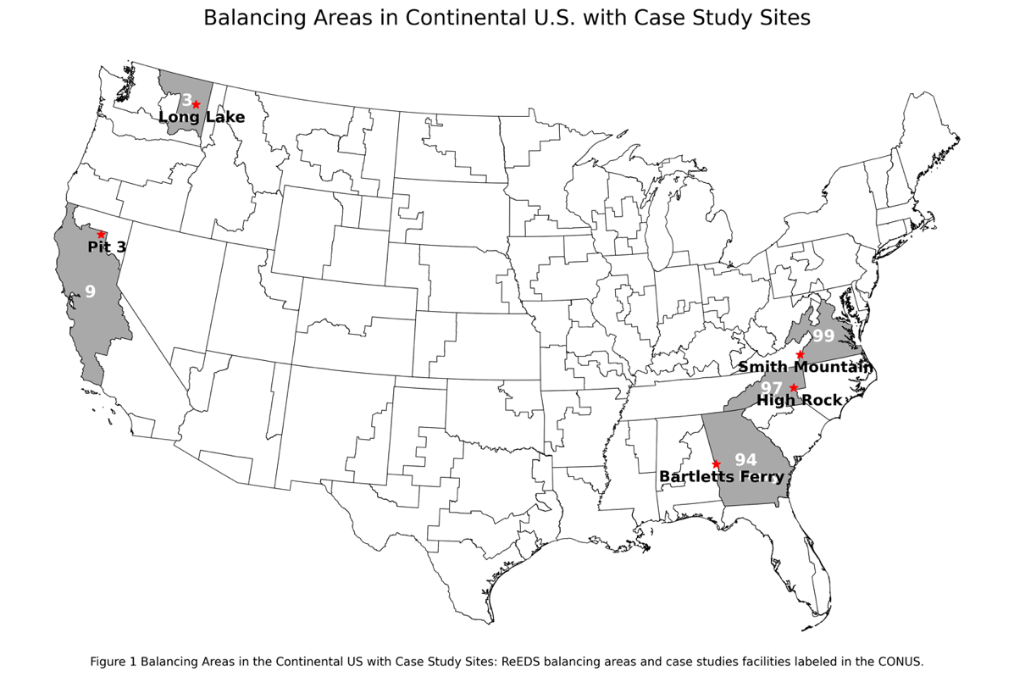
Figure 1 Balancing Areas in the continental US with Case Study Sites: ReEDS balancing areas and case study facilities labeled in the CONUS.
Table 1 Description of Variable Renewable Energy (VRE) Generation Use Percent and Hydropower Generation Use Percent in 2024 and 2050 in each Balancing Area (BA), and the associated case study site. The data for this table comes from the Cambium data set which relies on the2016 Hydropower Vision report (Gagnon, et al., 2023) (U.S. DOE, 2016). The decrease in hydropower is likely from the aging hydropower asset infrastructure which reaches the end of its 100-year lifetime before 2050.
Case Study Site | VRE % 2024 | VRE % 2050 | Hydro % 2024 | Hydro % 2050
Bartletts Ferry | 4.7 | 47.2 | 2.6 | 2.7
High Rock | 4.3 | 19.9 | 4.8 | 4.3
Long Lake | 6.9 | 5.8 | 63.2 | 62.6
Pit 3 | 22.6 | 61.3 | 24.0 | 18.3
Smith Mountain | 9.1 | 65.9 | 0.5 | 0.4

Site information such as facility max discharge rate, total usable reservoir volume, minimum flow requirements, seasonal elevation requirements, and normal reservoir operation range was obtained from FERC licenses and ORNL’s Hydropower Energy Storage Capacity Dataset, Version 2 (FERC, 2023), (Hansen, et al., 2023).
    - Long Lake, WA
Located in ReEDS BA 3, the Long Lake facility operates on the Spokane River. This facility is one of five in the Spokane River Hydroelectric Project (Spokane River Project) (FERC, 2009). The Spokane River Project totals 138MW and is owned by Avista Corporation. The total nameplate capacity of the Long Lake facility is 70MW with four operating units. This project was most recently licensed in June 2009. This project is on land owned by the U.S. and held in trust for the Coeur D’Alene Indian Tribe.
Important environmental issues at this project site include water quality, healthy of recreationally important fish (rainbow trout, bass, and yellow perch), controlling noxious weeds, protection of riparian habitats, and aesthetic appearance at the Upper Falls development.
The Long Lake facility generation from 2002 to 2022 was 495,070 MWh (Johnson et al., 2022). In BA 3, the Long Lake facility makes up 1.2% of total hydropower generation in BA 3.

Pit 3, CA
Located in ReEDs BA 9, the Pit 3 facility operates on the Pit River. This facility is one of three on a license that also includes Pit 4 and Pit 5; Pit 3 is the farthest upstream along the Pit River (FERC, 2007). These facilities have a combined capacity of 312MW and are operated by Pacific Gas and Electric Company (PG&E). The total capacity nameplate of Pit 3 is 80MW with three operating units.
The license for this project was most recently renewed in July 2007. Important environmental issues at this project site include water quality, and special status species (species listed or proposed to be listed on the threatened or endangered species list) including the yellow warbler and willow flycatcher. The Pit 3 average annual generation from 2002 to 2022 is 312,238 MWh (Johnson et al., 2022). In BA 9, Pit 3 makes up 1.2% of total hydroelectric generation.

Bartletts Ferry, GA
Located in ReEDS BA 94, the Bartletts Ferry facility operates on the Chattahoochee River. The Bartletts Ferry facility is the only facility on this license (FERC, 2014). The entirety of the Chattahoochee River system contains 11 dams operated by US Army Corps of Engineers and Georgia Power; five of these dams are downstream of Bartletts Ferry. The total capacity of Bartletts Ferry is 173MW with six operating units, make it the smallest, by capacity, of the case studies. The facility is along the Alabama, Georgia line, is operated by Georgia Power Company, and not on federally owned land. Most recently the Bartletts Ferry hydroelectric facility was issued a FERC license in 2014 which also details a minimum daily discharge of 1,350cfs. Important environmental issues at this project site include water quality, soil resource management including erosion mitigation, and the incorporation of a Bald Eagle Management plan.
The Bartletts Ferry average annual generation from 2002 to 2022 is 119,612 MWh. In BA 94. The Bartletts Ferry facility makes up 10.1% of total hydropower generation.

High Rock, NC
Located in ReEDS BA 97, the High Rock facility operates on the Yadkin River. There are four facilities under this license that are operated by Alcoa Power Generating, Inc (FERC, 2016) with a total capacity of 210MW. The High Rock facility is the farthest upstream on this license. The total capacity at the High Rock facility is 33MW with three operating units. This project was most recently licensed in 2016 and is owned by Duke Energy Carolinas, LLC. Important environmental issues at this site include water quality protections, and a Rare, Threatened, and Endangered Species Management Plan (freshwater mussels, Schweinitz’s sunflower, Yadkin River goldrod, and bald eagle).
The average annual MWh generation at the High Rock facility from 2002 to 2022 is 370,076 MWh. The High Rock facility makes up 2.7% of the conventional hydropower generation in BA 97.

Smith Mountain, VA
Located in ReEDS BA 99, the Smith Mountain facility operates along the Roanoke River. This facility is one of two facilities on this license and has both conventional and pumped storage capabilities; the Leesville Development creates the lower reservoir for the Smith Mountain facility (FERC, 2009). Only the hydroelectric capacity is considered in this analysis. The total capacity of the Smith Mountain conventional hydropower facility is 300MW with five generating units. The facility is owned by Appalachian Power Company. Most recently the Smith Mountain hydroelectric facility was FERC licensed in 2009. Environmental factors important at this facility pertain to the Roanoke Logperch, an endangered species known to live in the vicinity of the Smith Mountain facility. While the relicensing in September 2009 was not prohibited due to the presence of this species, the Appalachian Power Company implemented the Roanoke Logperch Enhancement Plan in coordination with the Virginia Department of Game and Fisheries and US Fish and Wildlife Service.
The average annual MWh produced by the Smith Mountain facility from 2002 to 2022 is 342,973 MWh. Smith Mountain makes up 40.7% of the conventional hydro generation in this BA.

Data curation and equations

Facility Demand Data
Hourly facility demand is the amount of energy demand put on the given facility from the Cambium dataset and was established based on the fraction of annual BA MWh produced by the facility. Both the facility annual energy generation and the balancing areas annual energy generation can be found in the Existing Hydropower Assets database (Johnson et al., 2022). The hourly facility demand is this fraction, expressed as a percent, multiplied by the given hour’s generation found in Cambium (Gagnon et al., 2023). Table 2 shows the name of each facility, associated BA, and the site-specific power generation expressed as a percentage of total hydropower power generation in the BA (Facility %). The percentages range from 1.2% (Pit 3 and Long Lake) to 40.2% (Smith Mountain) and are used to find the facility demand at each hour for each analyzed year. In each studied year (2024, 2034, 2044, 2050) the ability of the facility to meet the demand is assessed on an hourly basis.
The hydropower case study facility power generation (MWh) is used instead of the energy capacity because generation measured in MWh accounts for the hours of use in a year instead. For example, the Long Lake facility has a smaller capacity of 70.0 MW, as compared to other case studies, but the capacity in MWh exceeds all others regardless of MW capacity (Johnson et al., 2022).
The facility demand is the demand passed to the specific case study hydroelectric facility based on the calculation in Equation 1.
Table 2 Percent of MWh each Case Study makes up of the total Balancing Area
Hydropower Facility Name | Balancing Area | Facility %
Long Lake, WA | 03 | 1.2
Pit 3, CA | 09 | 1.2
Bartletts Ferry, GA | 94 | 10.1
High Rock, NC | 97 | 2.7
Smith Mountain, VA | 99 | 40.2

Equation 1 shows the calculation of $\left(Power_{h}\right)$ as hydropower demand within an hour, $Facility Capacity$ as MWh produced by the facility and $∑\left(BA Capacity\right)$ as MWh during the same time period reported by the EHA database (Johnson et al., 2022).
Equation 1 Facility Demand (MW)
$(Facility Demand_{h})=(Power_{h})* (Facility Capacity_{max})/(∑(BA Capacity)$

2.3.2 Power pricing data
The Cambium 2022 dataset provides eight cost metrics: four for busbar and four for end-use costs with all values expressed in real-time prices. Busbar is the point where the generation enters the grid, and the end-use is the point of consumption; the difference in value between these two costs is the distribution loss rates (the lost value from transporting energy from generation to consumption) (Gagnon, et al, 2023). The Cambium model calculates these costs as estimations of marginal costs derived from shadow prices in the PLEXOS model. The derivation includes consideration of BA specific load, fuel costs, and variable costs, but does not account for start-up, fixed operational, or maintenance costs. Our analysis considers only the end-use costs when calculating revenue.

Inflow Data
Inputs include inflow from U.S. Geological Survey (USGS) stream gauges, hourly energy prices, total balancing area demand, hour of day, season, year, location of facility, hourly projected variable renewable energy generation, hourly projected hydropower generation, facility capacity, and FERC licenses (flow requirements, reservoir operational limits, etc.) and can be found in Table 3 below. Results reported for each given set of conditions are revenue (USD), percent of demand met by the facility under the given conditions, and RB-Index. All data sets used in this analysis are publicly available.
Climate adjusted inflow projections for each facility were obtained from the Coupled Models Intercomparison Project phase 6 (CMIP6) Multi-model Streamflow Projections over the Coterminous U.S. dataset (Kao et al., 2022a; Kao, et.al, 2022b).This dataset simulates future hydrologic responses across the coterminous U.S. based on statistically and dynamically downscaled streamflow projections which were then bias corrected using two meteorological reference observations (Daymet, Livneh) and driven through two calibrated hydrologic models (VIC, PRMS). The resulting dataset provides an ensemble of hydroclimate projections for baseline (1980-2019) and future periods (2020-2059) under a variety of emissions scenarios at approximately 4-km spatial resolution for 2.7 million NHDPlusV2 stream reaches. This dataset also provides daily, monthly, and annual timescale projections for certain locations of interest including all hydropower facilities in the Existing Hydropower Assets Plant Database (Johnson et al. 2023).

Analysis
Five case studies located in BAs with varying amounts of VREs and use of hydropower were analyzed for energy demand, economic, and environmental metrics associated with a range of RoR and peaking operations (Pfeifle, et al., 2024). This analysis considers only RoR outflow regulations, their impacts on energy-economic-environmental tradeoffs in a future renewable energy buildout scenario based on hourly projections over a variety of generation types, energy incentive and policy scenarios (e.g., Low and High Renewable Energy and Battery Costs with the same base assumptions but renewable energy and battery costs are assumed to be lower or higher and improvement performance greater or lesser, and High Demand Growth with the same base assumptions but demand growth is assumed to average 2.8% from 2024 through 2050) (Gagnon, et al., 2023).
Table 3 Characteristics of the five case study hydropower facilities used in this study including (columns) project name (ReEDs balancing area number), and FERC docket number, and (rows) state where facility is located, nameplate capacity of conventional hydropower at the facility (MW), generation capacity given as average annual net generation since 2002(MWh), National Electricity Reliability Corporation (NERC) region, USGS gauge number for first gauge upstream of the project, and projected average annual discharge (m³/s) for 2024-2050 based on USGS gauge site location projections from ORNL CMIP6-based Multi-model Streamflow Projections, specifically using the Australian Community Climate and Earth System Simulator (ACCESS) US (Kao et al., 2022). All case study projects used in this study were classified as peaking by the Existing Hydropower Assets Database (Johnson et al., 2022).
 | Long Lake (3) P-2545 | Pit 3 (9) P-233 | Bartletts Ferry (94) P-485 | High Rock (97) P-2197 | Smith Mtn (99) P-2210
State | WA | CA | AL, GA | NC | VA
Capacity (MW) | 70.0 | 80.1 | 173.0 | 33.0 | 300.2
Generation (2002-2022) (MWh) | 495,070.5 | 312,238.4 | 119,612.3 | 370,076.0 | 342,973.3
NERC Region | WECC | WECC | SERC | SERC | RF
Gauge 1 | 12426000 | 11355010 | 2339500 | 2116500 | 2056000
Gauge 2 | 12431500 | 11361000* | NA | 2120780 | 2056900
Gauge 3 | N/A | 11355500 | NA | 2121500 | NA
Avg Inflow (m3/s) | 247.3 | 31.9 | 197.3 | 117.5 | 22.1
NA = Not Applicable
*Average Monthly flows were used for this USGS gauge site because there were no daily flows available.

Facility mode of operation as categorized by McManamay et al. (2016), facility capacity, and ReEDS balancing area for the case studies was collected from the Existing Hydropower Assets (EHA) Plant Database from Oak Ridge National Lab (Johnson, et al., 2022). All inputs are defined in Table 4 below.

Discharge Allowed:
The allowable discharge of a facility is dependent on the hour of the day, the season, and the location of the facility. Table 5 below gives the peak hour definitions for each region.

The determination of peak hour is made on an hourly basis is based on Energy Information Administration (EIA) regional and seasonal peak hours (EIA, 2020). When it is a peak hour, the model maximizes the demand met with only mechanical restrictions. When it is an off-peak hour, the model maximizes the demand met while staying within the RoR discharge for generation scenario. Each RoR scenario represents a percent of inflow allowed as discharge ranging from 100% to 200% at 20% increments. Volume calculations
To calculate the volume required (Volume_{req}) to meet a given hourly demand, the ratio of demand (Facility Demand_{h}) (MW) and facility capacity (Capacity_{max})(MW) are multiplied by the max flow rate (Q_{max}) and added to the minimum flow rate (Q_{min}) (Equation 2). This assumes the maximum flow rate is possible regardless of the reservoir height.
Equation 2 Volume Required to Meet Demand (m³/hr)
$$Volume_{req}=Facility Demand_{h}/Capacity_{max}* Q_{max}+ Q_{min}$$

Table 4 Inputs into the constrain analysis for each hydropower facility, a description of each input and the corresponding reference for the information.
Inputs | Description | Source
USGS Stream Gage Discharge (cfs) | Discharge measured in cfs for USGS stream gages on an hourly basis. | (USGS, 2022)
Hourly Energy Prices (USD) | Hourly energy prices for the given BA projected by the Cambium model. | (Gagnon, et al., 2023)
Total BA demand (MW) | Hourly total energy demand for the given BA. | (Gagnon, et al., 2023)
Hour of Day | Hour at the current analysis time as it correlates in the Cambium dataset. | (Gagnon, et al., 2023)
Year | Year corresponding to the Cambium dataset | (Gagnon, et al., 2023)
VRE Generation (MW) | Total MW of VRE generation in the given BA for the given hour from the Cambium dataset. | (Gagnon, et al., 2023)
Hydro Generation (MW) | Total MW of hydropower generation in the given BA for the given hour from the Cambium dataset. | (Gagnon, et al., 2023)
Season | Season of the year defined as:  Winter = December, January, February  Spring = March, April, May  Summer = June, July, August  Fall = September, October, November | (EIA, 2020)
Table 4 Continued
Facility Region | Region of the facility according to the EIA, to correlate peak times. | (EIA, 2020)
Facility Capacity (MW) | Capacity in MW of the given facility. | (Johnson, et al., 2022)
FERC License | The FERC license provided additional license requirements such as minimum flows, reservoir levels, and reservoir operating range. | (FERC, 2023)

Volume calculations are used to track the power capacity from hour to hour. The volume, elevation, and usable power are initiated in the model at their respective maximums on the first hour of the year. The usable power at any given hour is determined by the ratio of present reservoir elevation to the maximum reservoir elevation multiplied by the power max (facilities maximum capacity); in the hydropower power generation equation height (h), flow (Q), gravitational acceleration (g), efficiency ($η$), water density ($ρ$), and power (Power_{h}) are directly proportional, Equation 3:
Equation 3 Hydropower Power Generation
$$\left(Power_{h}\right)=Q*g*h*η* ρ$$
The model calculates water volume released each hour considering total reservoir storage and whether the hour is defined as peak or off-peak. During peak hours, the facility meets demand without flow restrictions (but still adheres to reservoir height), releasing the minimum of either the required volume or the maximum flow rate. In off-peak hours, maximum release volume follows one of six run-of-river conditions allowing discharge to deviate from inflow by 100-200% at 20% increments. The 100% case is often portrayed as 0% indicating it is allowing 0% beyond the natural flow projection; this is true for all other inflow equals out flow conditions like 120% to 20%. The off-peak releases must be equal to the maximum of either the existing minimum flow or the inflow rate.
The volume remaining in the reservoir at the end of each hour equals the previous ending volume minus volume released. To determine end-of-hour water height, volume released is converted to a height change using a simplified height-to-volume ratio that divides total reservoir storage by the reservoir’s maximum height. This linear approximation does not consider detailed reservoir geometry.
Table 5 Description of peak hours specific to each region broken down by season with each corresponding BA and Facility.
Region | Facilities (BA) | Season | Peak Hour (24-hr)
California | Pit 3 (09) | Summer | 1100-1600
California | Pit 3 (09) | Spring-Fall | 1500-2000
California | Pit 3 (09) | Winter | 0600-0900, 1700-2000
Northwest | Long Lake (03) | Summer | 1200-1700
Northwest | Long Lake (03) | Spring-Fall | 1500-1900
Northwest | Long Lake (03) | Winter | 0700-1000, 1800-2200
Southeast | Bartletts Ferry (94), High Rock (97), Smith Mountain (99) | Summer | 1300-1800
Southeast | Bartletts Ferry (94), High Rock (97), Smith Mountain (99) | Spring-Fall | 1400-1800
Southeast | Bartletts Ferry (94), High Rock (97), Smith Mountain (99) | Winter | 0500-0900, 1700-2100

If available, more precise morphology data could inform a higher-fidelity storage-height model. To avoid over topping the dam a spill metric (Spill) is calculated using the volume at the end of the hour (Volumne_{end}), maximum volume that can pass through the hydropower facility (Volume_{max}), maximum flow rate through the facility (Q_{max}), and maximum power generation at the facility (Power_{max}) and is measured in MW (Equation 4):
Equation 4 Spill (MW)
$$Spill=\left(Volume_{end}\right)-Volume_{max}/\left(Q_{max}\right)*\left(Power_{max}\right)$$
The spill penalty represents the lost revenue from the spill at a given hour. The spill penalty calculation by hour is the end-use cost (E_{h}) multiplied by the (Spill_{h}) within the hour (Equation 5):
Equation 5 Spill Penalty (MW)
$$\left(Spill Penalty_{h}\right)=\left(E_{h}\right)*\left(Spill_{h}\right)$$
The discharge power is the amount of energy the hydropower facility puts to the grid in each hour and is based on the volume released (Volume_{released}), the volume required to meet that hour’s demand (Volume_{required}), and the facility demand at given hour h (Facility Demand_{h}) (Equation 6).
Equation 6 Discharge At Hour h (MW)
$${Discharge}_{h }\left(MW\right)={Volume}_{release}{/Volume}_{required}* {Facility Demand}_{h}$$
The power put into the grid by each facility is determine by the proportion of required volume met multiplied by the facility demand. In this analysis the difference between the power out and the facilities demand is tracked. If this this is negative it indicates the facility has not met all the demand under the RoR scenario during that hour.

Revenue Calculation
To estimate generation revenue, we assigned peak hours and off-peak hours for each facility based on the region and season as assigned by the U.S. Energy Information Administration (EIA) (EIA, 2020). The revenue generation by hour (R_{h}) is calculated by considering the end-use cost (E_{h}) the of the Cambium data set and multiplying it by the power output (Power); the power output of a modeled hydroelectric facility will be capped based on the capacity of the facilities found in Table 3. The second term in this equation will always be negative and incorporates the spill penalty within the hour (h), Equation 7.
Equation 7 Revenue At Hour h (USD)
$$R_{h}= \sum{\left(E_{h}*{Power}_{h}\right)- \sum{{Spill Penalty}_{h}}}$$

Environmental Impact Calculation
United States Geological Survey (USGS) stream gauge sites upstream of each hydro facility were chosen to determine the inflow rate of each facility (USGS, 2022). In some cases, the hydropower facility has more than one USGS stream gauge; Table 3 shows the USGS stream gauges to be used for inflow calculation at the corresponding facility. These inflows were restricted off-peak hour volume discharges to provide quantitative measures of ecological impact from hydrologic alteration. We calculated two established ecologically relevant flow alteration metrics to quantify flow rate of change, and periodicity (Richter et al., 1996): (1) Hourly Richard-Baker Flashiness Index (RB-Index) and (2) the number of flow reversals calculated hourly.
The RB-Index was designed to quantify rate of change in daily flows compared to mean annual flows (Baker et al., 2004); Equation 8. We adapted the RB-Index for this study to reflect rate of change between hours to reflect the previous (change between t = 0 and t = 1) and following (change between t = 1 and t = 2) hour before between t = 0 and t = 1 and t = 1 and t = 2; Equation 9:
Equation 8 Richard-Baker Flashiness Index (Original)
$$R-B Index= \sum_{h=1}^{n}{\frac{1}{2}\left(\left|q_{h+1}-q_{h}\right|+\left|q_{h}-q_{h-1}\right|\right)}/\sum_{h=1}^{n}{q_{h}}$$
Equation 9 Richard-Baker Flashiness Index (Hourly)
$$R-B Index= \frac{1}{2}\left(\left|\left(q_{h+1}\right)-\left(q_{h}\right)\right|+\left|\left(q_{h}\right)-\left(q_{h-1}\right)\right|\right)/q_{h}$$
Where q_{h} = present hours discharge volume, q_{h+1} = next hours discharge volume, and q_{h-1} = previous hours discharge volume. Lower RB-Index values represent slower hourly rates-of-change in flows, and presumably, lower ecological impacts, and higher RB-Index values represent faster hourly rates-of-change in flows, and presumably, higher ecological impacts. The summation in the numerator and denominator is dropped because n = 1. The absolute value of the (q_{i} – q_{i-1}) term then represents the change in outflow from the previous hour to the present hour. Specifically, the changes made to the original RB-Index equation (Equation 8) are removing the summation terms, calculating across one hour instead of one day, and the denominator was removed to avoid the case where the RB-Index is infinity (Equation 9).
The number of hourly flow reversals is calculated as the number of times hourly discharge increases between t = 0 and t = 1 and decreases between t = 1 and t = 2 or decreases between t = 0 and t = 1 and increases between t = 1 and t = 2. A reversal is defined in Equation 10 below:
Equation 10 Reversals
$$Reversal= Q_t<Q_(t-1) \& Q_t<Q_(t+1)$$
$$or$$
$$Q_t>Q_(t-1) \& Q_(t+1)>Q_t$$
Where Q_{t} is the discharge at hour t. This equation identifies when the discharge trend switches between an increasing pattern and decreasing pattern. A higher number of annual reversals indicates more frequent cycling between rising and falling hydrograph limbs. This fluctuating flow regime can disrupt aquatic species life cycles that rely on seasonal flow patterns. Together, with RB-Index values, the number of reversals can link key components of the flow regime alteration to revenue and grid stability.

Statistical Analyses
We used a linear regression approach to understand relationships between three response variables (percent of demand met, revenue, and RB-Index) and nine independent variables that we hypothesized were independently significantly related to the response variables (IEO percent of inflow allowed as discharge, total demand on facility, RB-Index, hydro generation percent, VRE generation percent, Inflow, volume released, ratio of volume released to maximum volume possible from the facility, and reversals). The hydropower and VRE generation percent are the amount of generation from each of these sources as a percent of total generation in the balancing area, the average inflow is the average projected inflow to the facility by hour over that year, the IEO percent is the amount of deviation from the inflow rate allowed during off peak times, the total demand is the amount of MW of demand placed on the facility, the average flow release is the average hourly flow release by the facility, and the ratio of flow release to maximum flow allowed denotes how much of maximum possible flow is used during each hour. We tested the assumption that dependent and independent variables were related by calculating the Pearson’s Product-Moment correlation coefficient for each pairwise relationship between dependent and independent variables. Correlations with p-values < 0.05 were retained for further analysis.
We then used the statistical approach outlined by (Gagne, et al., 2014) to gain an understanding of the relative importance of each independent variable on dependent variables. Values were calculated from this analysis or gathered from the appropriate Cambium model dataset from across all balancing areas and years presented in a linear best subsets model to offer insight into the regression analysis between these variables. Independent variables were tallied for the number of times they appeared in the top one through nine variable models and then ranked by the number of times each appeared. Variables appearing more frequently in top models were interpreted as having greater influence over dependent variables. Additionally, the p-values, f-values, model and residual degrees of freedom are reported in Appendix A and Appendix B.
The RB-Index and reversals were only used as independent variables in analyses with revenue and percent of demand met as the response variables. All analyses were conducted in pandas, numpy, scipy, and statsmodels packages in Python v3.11 and used an α = 0.05 (McKinney et al., 2010; Harris et al., 2020; Virtanen, et al., 2020; Seabold & Perktold, 2010).

Sensitivity Analysis
To evaluate the sensitivity of the quantitative tradeoff assessment to changes in environmental, power system, and revenue outcomes, we conducted, a sensitivity analysis that modified two input parameters: flow deviation percentages and hourly electricity demand. This approach reveals how robust the analysis results are to uncertainties in key inputs like percent of hydropower capacity in a BA, IEO flow conditions, and electricity demand forecasts. The peak operating hours were the same as previously determined for each region and season. In total, we evaluated 18 sensitivity test scenarios examining revenue, RB-Index and percent of total BA demand met. We then compared across scenarios to quantify the magnitude of change resulting from each adjusted parameter.
We examined results of two facilities for this sensitivity analysis: Smith Mountain due to having the highest percent of hydropower capacity in the associated BA and Long Lake due to having the lowest percent of hydropower capacity in the associated BA (Table 2).

Results

Environmental Results
Pearson’s correlations (p-value) between RB-Index and the independent variables varied across facilities indicating some variables were statistically significant as some sites and not others. It was found at the Smith Mountain facility that only the IEO percent had a statistically significant correlation with RB-Index (p-value < 0.05; r = -0.91) (Appendix A). One commonality was the relationship between RB-Index, and total demand; when total demand increased, RB-Index decreased (Figure 2). This could be due to fluctuating flowrates higher to meet demands. The statistically significant correlations between VRE generation percent and hydropower generation percent can be found in Table 6, with p-values in Appendix A and B.
The RB-Index at Long Lake has a statistically significant positive correlation with reversals (p-value < 0.05, r²=0.45). The RB-Index trends at Long Lake reveal the 0% IEO variation consistently achieves the highest RB-Index while also having the highest percent of demand met in all years except 2050. The 80% and 100% IEO variations alternated between the lowest RB-Index values depending on year. The highest and lowest percent of demand met varies greatly at this site. In 2024 the 0% IEO variation has the lowest and the 40%, 60%, 80%, and 100% IEO variations have the highest when considering out to three significant figures.

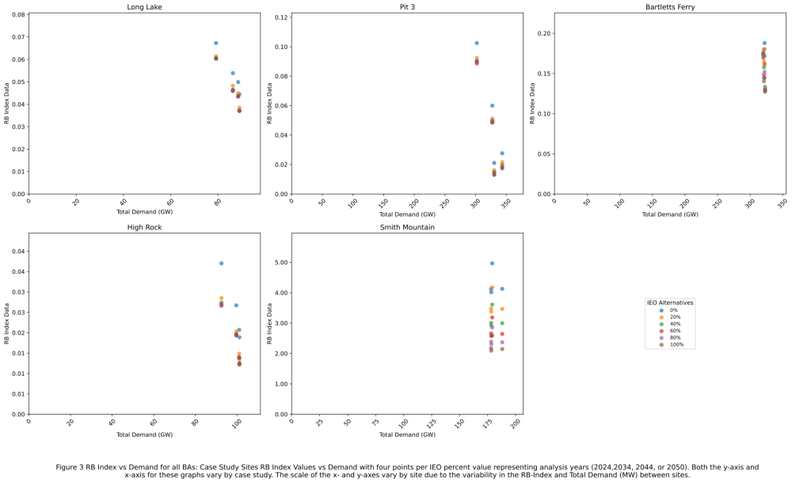
Figure 2 RB-Index vs Demand for all BAs: Case Study Sites RB-Index values vs Demand with four points per IEO percent value representing analysis years (2024, 2034, 2044, or 2050). Both the y-axis and x-axis for these graphs vary by case study. The scale of the x- and y-axis vary by site due to the variability in the RB-Index and Total Demand (MW) between sites.

This trend is the same in 2034 and 2044 except the 0% and 20% are tied for the lowest. Finally, in 2050 all IEO variations have the same percent of demand met (percent of demand met in 2050 63.5%).
The RB-Index at Pit 3 has a statistically significant positive correlation with reversals (p-value < 0.05, r² = 0.77). The RB-Index trends at Pit 3 reveal the 0% IEO variation consistently achieves the highest RB-Index, while the 100% IEO variation attains the lowest RB-Index values in all years except 2050 when the 60% IEO variation has the lowest. All IEO variations have the same percent of demand met when considering three significant figures (percent of demand met in 2050 = 4.46%). The RB-Index at Bartletts Ferry does not have a statistically significant correlation with reversals. The RB-Index trends at Bartletts Ferry reveal the 0% IEO variation with the highest RB-Index across all years except 2050 when the 60% IDE variation has the highest. The 100% IEO variation always has the lowest RB-Index value across all years. All IEO variations have the same percent of demand met for 2024, and 2034 when considering three significant figures. In 2044 the 80% and 100% IEO variation have the highest and the same percent of demand met and 0%, 20%, 40%, 60% the lowest; finally in the remaining years (2044, and 2050) the 100% IEO variation has the highest percent of demand met (percent of demand met by 100% IEO variation in 2050 = 99.7%) and 0% IEO variation has the lowest. The RB-Index at High Rock has a statistically significant positive correlation with reversals (p-value < 0.05, r² = 0.75). The RB-Index trends at High Rock reveal the 0% IEO variation with the highest RB-Index across all years and the 100% IEO variation with the lowest RB-Index except in 2044 when the 60% IEO variation has the lowest. All variations have the same percent of demand met across all years when considering three significant figures (percent of demand met in 2050 = 42.9%).
Table 6 Statistically significant correlations with variable renewable energy generation percent and hydropower generation percent
Case Study Facility | Independent Variable | P-value | r²
Long Lake | VRE Generation % | < 0.05 | -0.51
Pit 3 | VRE Generation % | < 0.05 | 0.92
Pit 3 | Hydro Generation % | < 0.05 | -0.91
High Rock | VRE Generation % | < 0.05 | 0.67
High Rock | Hydro Generation % | < 0.05 | -0.42
Bartletts Ferry | VRE Generation % | < 0.05 | 0.69

Finally, the RB-Index at Smith Mountain has a statistically significant negative correlation with reversals (p-value < 0.05, r² = -0.91). The RB-Index trends at Smith Mountain reveal the 0% IEO variation with the highest RB-Index across all years and the 100% IEO variation with the lowest.

Economic Results
The correlation between revenue and the nine independent variables varied by facility. In all five facilities total demand (MW) was correlated with revenue explaining up to 89% of revenues variability at Pit 3 and as low as 60% of revenues variability at the Bartletts Ferry facility. Total Demand (MW) has a negative impact on the revenue at all facilities except for Smith Mountain. The number of reversals was positively correlated with revenue at two facilities Pit 3 (p-value < 0.05, r² = 0.58) and High Rock (p-value < 0.05, r² = 0.44)

Grid Stability Results
The facility able to meet the highest average percentage of demand was the Bartletts Ferry facility in BA 94 meeting 98.88% of all demand across all years and IEO cases. The facility meeting the least amount of demand is the Pit 3 facility in BA 09 meeting 4.28% of all demand across all years and IEO cases (Table 7; Figure 3). At the Long Lake facility, all IEO scenarios were within less than 0.05% during 2050 when the facility met the highest percent of demand across all years, 63.5%. There were positive correlations in BA 3 between percent of demand met and RB-Index (p-value < 0.05, r² = 0.92), and percent of demand met and the average inflow (p-value < 0.05, r² = 0.45) (Appendix A).
In the BA associated with Pit 3 (BA 09), there is a lower share of conventional hydropower generation compared to BA 3, associated with the Long Lake facility, indicating different market dynamics. Across the inflow scenarios, Pit 3 hydropower facility consistently met 4.13% in 2034, to 4.46% in 2050 of demand. The average inflow rate for Pit 3 in 2024 was 20.85 m³/s (75,069 m³/hr) as compared to Long Lake with 315.02 m³/s (1,134,066.7 m³/hr) during the same period. The smaller inflow, the total volume of water change between the IEO cases resulted in a smaller operational band (Kao, et al., 2022).
In BA 94, associated with the Bartletts Ferry facility, performance revealed strong capabilities in meeting electricity demand, with average peak fulfillment of 98.9% and a minimum peak fulfillment of 96.3% across all modeled inflow scenarios and years. The IEO case meeting the most demand is the 100% IEO case, and the case meeting the least demand is the 0% IEO case. In BA 97, assessing performance across IEO scenarios reveals High Rock has limited flexibility with a 0.01% variation from the highest to the lowest percent demand met across all years and IEO cases. Finally, in BA 99, the Smith Mountain hydroelectric facility, the 100% IEO meets the highest percentage of demand while the 0% IEO case meets the demand the least, ranging from 52.03% to 72.69%.

Sensitivity Analysis
Comparing the three response variables (revenue, RB-Index, and percent of demand met) to eight independent variables revealed 14 statistically significant correlations (Table 8). The revenue generation was most positively correlated with the total demand placed on the facility (p-value < 0.005, r² = 0.96). RB-Index was most negatively correlated to the inflow (p-value < 0.005, r² = 0.82). The percent of demand met was positively correlated with reversals (p-value = 0.03, r² = 0.88) but negatively correlated with the volume released (p-value < 0.005, r² = 0.35).

Predictors of Richard Baker Index, Revenue, and Grid Stability Correlation

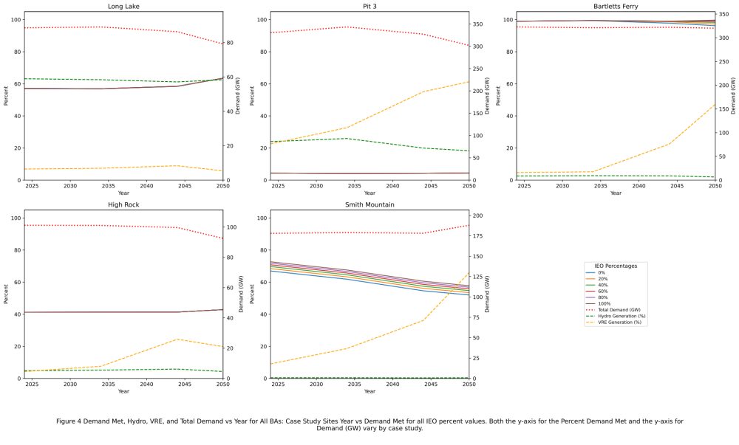
Figure 3 Demand met, Hydro, VRE, and Total Demand vs Year for all BAs: Case study sites Year vs Demand Met for all IEO percent values. Both the y-axis and for the percent of demand met and the y-axis for the Demand (GW) vary by case study.

Table 7 Average % Demand Met across All Years and IEO Cases for each case study facility
Hydropower Facility Name | % Demand Met
Long Lake | 58.9%
Pit 3 | 4.5%
Bartletts Ferry | 97.8%
High Rock | 42.2%
Smith Mountain | 61.0%

Table 8 Sensitivity analysis piecewise regression results between the three response variables and eight independent variables
Response Variable | Independent Variable | r² | P-value | F-value | Direction of Association
Revenue Data Summation | Total Demand (MW) | 0.96 | 4.1E-09 | 22000 | positive
Revenue Data Summation | RB-Index | 0.79 | 5.4E-05 | 32000 | positive
Revenue Data Summation | Inflow | 0.84 | 1.2E-05 | 45000 | negative
Revenue Data Summation | Hydro% | 0.89 | 1.6E-06 | 68000 | negative
Revenue Data Summation | VRE % | 0.66 | 7.1E-04 | 17000 | positive
Revenue Data Summation | Volume Release | 0.73 | 2.1E-04 | 23000 | negative
RB-Index | Total Demand (MW) | 0.68 | 5.4E-05 | 18000 | positive
RB-Index | Inflow | 0.82 | 5.6E-04 | 39000 | negative
RB-Index | Hydro % | 0.79 | 2.2E-05 | 34000 | negative
RB-Index | VRE % | 0.62 | 4.4E-05 | 14000 | positive
RB-Index | Volume Release | 0.66 | 1.4E-03 | 17000 | negative

Table 8 Continued
Percent of Demand Met | Reversals | 0.88 | 7.3E-04 | 61000 | positive
Percent of Demand Met | Volume Release | 0.35 | 2.7E-06 | 4700 | negative

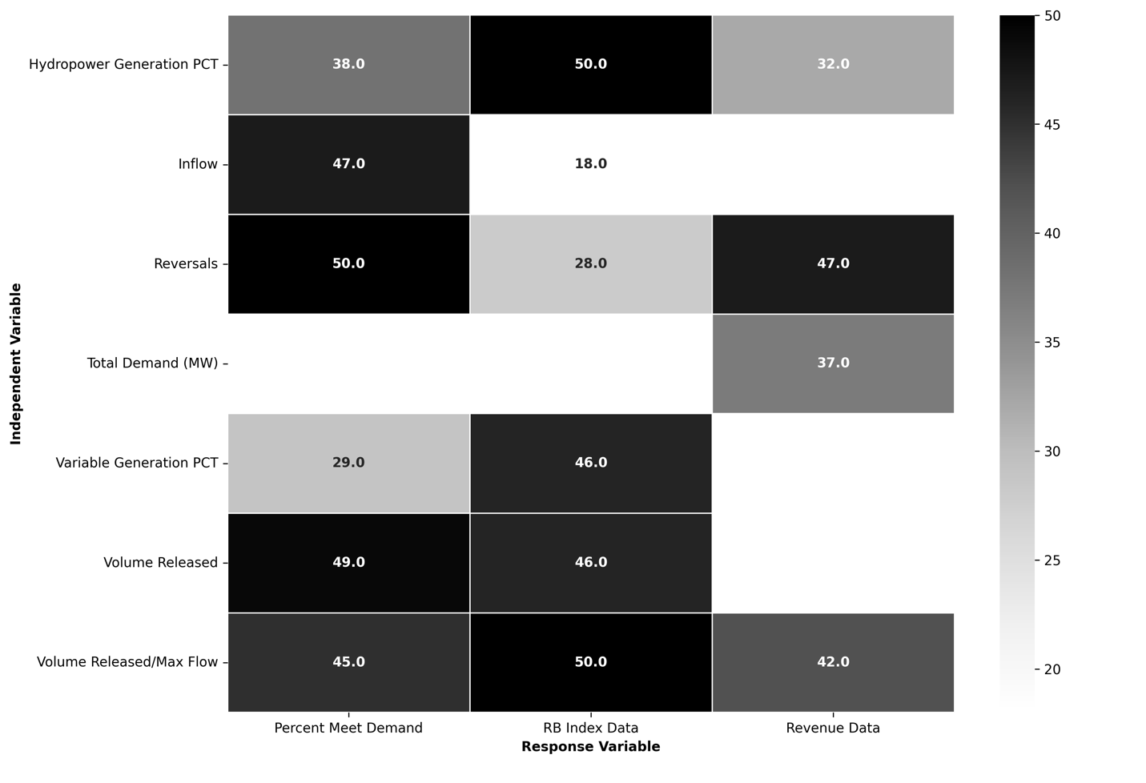
Figure 4 Occurrences in Top Ten Models: Number of times each independent variable and response variable combination occurs aggregated across all balancing areas.

Of the nine independent variables tested, eight were in at least one of the top ten model lists across all balancing areas and response variables, whereas inflow was not in any of the top ten lists (Figure 4; Appendix B). The maximum number of occurrences is 150 for any one variable which is 50 per independent variable.
Since the RB-Index serves as both a response and independent variable the maximum for the RB-Index is 100 all case study facilities and response variables. There were two categories of variables that occurred in the top ten models: future renewable generation makeup, and operational practices. The future renewable generation makeup consisted of the hydropower generation percent and VRE generation percent with 125 and 120 occurrences, respectively, across all case study facilities and response variables.
Within the operational practices category there were three tiers of variables based on how often they occurred in the top ten models. Tier one with greater than 140 occurrences (94% or more of top ten models) consisted of total demand (MW), the volume released by hour, and volume released to maximum flow ratio; tier two with greater than 80 but fewer than 141 occurrences (54% to 93% of top ten models) consisted of RB-Index average inflow, and number of reversals; tier three had 80 or fewer occurrences (53% or less of top ten models) consisted of the IEO percentages.

Discussion
Navigating energy-economic-environment license and regulatory requirements can be supported with evidence-based guidance on policy targets and facility capabilities. From this analysis it was found run-of-river allowances of 140-200% of inflows as discharge has more environmentally protective results while meeting the same level of demands as the 100-120% allowances. These findings provide initial scientific grounding for setting discharge variance allowances and represent meaningful progress for quantifying sustainable hydropower solutions for both operators and regulatory agencies.
Previous studies focus on hydropower operations from an economic, environmental, or energy perspective and often combine two of these objectives for comparison. Our analysis considered all three, quantifying each metric for a side-by-side comparison across five hydropower case studies. Our analysis of energy-economic-environment tradeoffs, using five case study hydropower facilities, considered how future renewable generation makeup, and operational practices, impact meeting energy demands, RB-Index, and Revenue. Even with regionally specific results this analysis brought to light common inputs to consider, when developing future energy-economic-environment tradeoffs. Our approach underscores the necessity of integrating diverse metrics to inform sustainable hydropower management and policy decisions.

Future Renewable Generation Makeup
Flexible generation sources play a crucial role in supporting grid stability by accommodating increasing VRE generation. These sources, including hydropower, energy storage systems, and natural gas, can accommodate fluctuations in VRE output. Currently, natural gas is the most widely used flexible generation source, however, its carbon emissions hindering progress toward meeting clean energy and carbon emission reduction goals.
Hydropower offers a promising alternative as a flexible energy source without carbon emission from generation in areas with hydroelectric generation (natural gas or other dispatchable generation continue to be needed in areas with insufficient quantities of hydroelectric generation). Its ability to adjust output based on water resources availability allows it to match energy demands without direct carbon emissions during generation. However, the environmental impacts of flow variability associated with load following must be considered because of their negative impact on local aquatic environments. Balancing environmental health factors with energy demand will be essential for the successful widespread adoption of flexible, carbon-free sources to support VRE integration
The need for balancing these variable renewable energy sources is a recognized issue, and steps have been taken to mitigate the potential for grid instability. The Infrastructure Investment and Jobs Act, passed into law in 2021, reauthorizes, expands, and establishes programs supporting clean energy sources and names hydroelectric power specifically (117th Congress (2021-2022), 2021). The Energy Act of 2020 further reinforces these efforts by promoting the deployment of solar, wind, and energy storage technologies through tax credits.
Hydropower’s role in addressing grid instability is particularly significant due to its inherent flexibility. Its rapid ramping capabilities make it an asset for grid reliability and may mitigate potential grid stability shortfalls as the proportion of VRE in the energy mix increases. Other research also acknowledges the need for flexible generation and considers environmental impacts as hydropower generation continues. Development of hydropower facilities can impact fish biodiversity by creating impassable barriers and impact fish biomass (Ziv, et al., 2012). Furthermore, evaluating dam development sites for their impact to fish biomass reduction can then be related to environmental and social impacts of dam development. Our study uses the RB-Index and flow variations to evaluate the operational impacts on local aquatic environments. These calculated RB-Index values are then analyzed for correlations with other response variables, percent of demand met and revenue. In doing so our research finds RB-Index values correlations with future hydropower and VRE generation in BAs across the U.S. Building on previous work by relating environmental metrics with future renewable energy development allows for improved projections of environmental impacts resulting from future hydropower and VRE generation changes.
Consideration of economic and environmental impacts of hydropower operations in RoR regimes helps evaluate often competing values at these facilities. Optimization of three hydropower facilities on a section of the Connecticut River with the objective function maximizing revenues, finds seasonal flexible operations could be used for a range of systems (Pfeifle, et al., 2024). Our analysis, builds on the framework laid out in this paper, adding on the additional consideration of power generation requirements in a future renewable energy build out scenario. Additionally, we consider a variety of geographically diverse hydropower facilities to account for different amounts of VRE and hydropower generation percentages in varied markets. From the framework laid out in Pfeifle et al., and our additional considerations of power generation requirements, future scenarios, and geographically diverse markets, we progress the hydropower operational evaluations of often competing values.
Our models uncover a hydro generation percent decreased and VRE generation percent increase in four of the five BAs (9, 94, 97, 99) in all studied years (2024, 2034, 2044, 2050) based on the Cambium projections. This is concerning because in two of the BAs, hydropower generation percent was negatively correlated with RB-Index, indicating a higher percentage of hydropower generation in the balancing area decreases the environmentally detrimental rapid flow fluctuations. While the Cambium model makes the hydropower and VRE generation projections, the statistically significant correlations between hydropower generation percentage and our response variables in every BA highlights a need for an energy- economic- environmental evaluation of flexible power generation sources as VRE generation percent continues to grow.
As is the case with any analysis, assumptions were made that can be tailored to specific regions of interest for future work. Specifically, the Cambium model scenario, 95% Carbon Reduction by 2050, is used to project hydropower use and VRE build out. While this approach provides valuable insights, it has limitations that may limit our results. Inputs of VRE growth designated to a specific region would likely incorporate local policies and building requirements that would impact VRE development and give a more accurate prediction of hydropower demand. Our findings, based on a non-specific regional non-specific regional VRE growth model, should be viewed as broad indications rather than precise forecasts for a particular area. Even with these limitations to our study, our results underscore the need for nuanced region-specific solutions to navigating the evolving energy generation landscape.
In our analysis we consider future flowrates at each site under climate change conditions for RoR modeling however a significant limitation of our study is that the Cambium model does not consider hydrologic nuances of each facility. Hydropower generation availability inherently depends on local water resources and incorporating hydrologic modeling would provide a more realistic outcome for decision-making. Since we use Cambium model data as inputs to our model our results could be enhanced by the incorporation of a hydrologic model into Cambium’s projections. Such integration would allow for a more nuanced understanding of the complex interplay between water availability, energy, generation, and environmental factors. By incorporating detailed hydrologic data and models, we could better account for seasonal variations in water flow, the impacts of extreme weather events, and long-term climate change effects on water resources. This would lead to more precise predictions of hydropower generation potential and its variability.
While our current analysis does consider climate changes’ impact on future flow rates when modeling RoR conditions, a fully integrated hydrological-energy model would offer even greater insights. It would allow for more robust scenario planning, helping policy makers and energy planners develop strategies resilient to both energy market fluctuations and changes in water availability. This enhanced modeling approach could lead to more sustainable and efficient hydropower operations, better grid integration strategies for VRE sources, and more effective policies for managing water resources in the context of energy production.
In future research, incorporation hydrological processes into energy modeling, like Cambium would improve accuracy of hydropower generation forecasts and provide a more comprehensive tool for sustainable energy and water resources management. Additionally, future research focused on regionally specific VRE buildout and generation projections from each plant would be valuable for identifying energy grid strains at the local level. Moreover, these localized analyses will be aid in increasing specificity for critical infrastructure needs to those facilities enabling decision-making that meets future energy demands.

Operational Practices
Operational practices in hydropower facilities are crucial in balancing the energy- economic-environment nexus. As the energy landscape evolves with increasing integration of VRE sources, understanding the impactful factors in these practices becomes even more critical. Hydropower operational practices could mitigate challenges posed by VRE integration while maximizing benefits of hydropower’s flexibility. Operational decisions, such as the timing and volume of water releases, flow reversals, and load following strategies, directly impact not only the facility’s ability to meet energy demands but also its environmental footprint and economic performance (Halleraker et al., 2022). Well-designed operational strategies can help maintain grid stability, reduce supply deficits, and optimize revenue generation. Moreover, they can minimize negative environmental impacts by managing flow regimes in ways that support aquatic ecosystems.
As the energy grid continues to incorporate VRE generation, refining these hydropower operational practices based on empirical evidence and predictive modeling is essential for balancing the energy-economic-environment nexus. To better understand influential factors, we developed models to analyze key operational variables and their relationships with facility metrics. Our findings have categorized variables into tiered groups. Tier one variables from our models, include volume released hourly, volume released to maximum flow ratio, and total demand, were significant in 94% or more of the top ten models. The prominence of these operational factors highlights the crucial role of hydropower operations management, particularly the rate of water release, in developing strategies aimed at balancing the energy-economic-environment tradeoffs with increasing VRE integration.
While tier one variables were the most important factors in our models, the tier two variables included, reversals, average inflow, and RB-Index, and were consistently identified as key predictors in 54% to 93% of the top ten models across all case study sites and response variables. Reversals, which represents the changes in flow direction calculated hourly, was positively correlated with revenue. This may be reflective of load following practices, where power generators gauge their power output based on the demand of the grid in very small-time increments, leading to constant adjustments of flow in the case of hydropower facilities.
While these correlations indicate relationships between revenue, supply deficits and dam functions, translating these into action requires further regionally specific investigation: integrating climate models, electricity demand forecasts, and reservoir operations systems. This can further illuminate tradeoffs between revenue optimization, local energy demand growth, and ecological sustainability. Solutions likely involve balancing reservoir functions through predictive algorithms and incentives promoting flexibility with other renewables. These correlations can begin to shape our understanding of how to navigate the complex relationships between environmental considerations, grid stability, and generating plat economics.

Balancing Priorities
Hydropower regulators and operators consistently balance environmental, economic, and technical factors (Opperman, et al., 2023). Our tradeoff analysis reveals this delicate balance remains a necessity. Allowing greater flexibility through increased flow deviations enables meeting more projected electricity demand and earning higher revenue as found in our models. However, this benefit comes at a cost of ecological impact from hydrologic alteration (Bejarano, et al., 2017). Our analyses support this dichotomy and demonstrated that as demand met increased so did RB-Index values translating to greater flow fluctuations in the environment occur when the more of demand needs are met. If operations strictly limited flow deviations enabling more natural flow regimes aquatic ecosystem would be less impacted but reduces critical system capacity for grid reliability (Kuriqi A., et al., 2020; Stoll, et al., 2017). Conversely, the inverse relationship between IEO percentages and RB-Index values across all BAs illustrated that if hydropower facilities allowed increased discharge the RB-Index generally decreases. This pattern suggests increased operational flexibility might, in some cases, lead to more stable downstream flow regimes.
The variability in RB-Index correlation strength can be attributed to site specific, ecological, and hydrological influences as well as external influences such as climate variability, power market demands, and model structure. These factors can either mask or amplify the effects of hydropower operations. Notably, both inflow and volume released showed negative relationship with RB-Index values when analyzed in the sensitivity analysis. This inverse relationship likely occurs because as inflow or volume released approaches the volume needed to meet the demand, the difference between peak and off-peak flows decreases, potentially resulting in a lower RB-Index value.
Grid-scale metrics correlated with RB-Index in the sensitivity analysis revealed contrasting relationships: hydropower generation percentage showed a negative correlation, while VRE generation percentage displayed a positive one. Increasing VRE generation necessitates more flexible demand, leading to the requirement of rapid flow changes. Conversely, higher hydropower generation percentages allow this flexibility to be distributed across multiple facilities and river reaches, potentially reducing rapid flow fluctuations at any single site.
Recent analysis of hydropower balancing priorities aligns with the current findings, indicating run-of-river license and regulation requirements, provide more sustainable outcomes with varying degrees of tradeoffs (Pfeifle et al., 2024; Valavi, Nysveen, 2018). Investigations using multi-criteria decision frameworks also point toward run-of-river modes of operation incorporating environmental flows as optimal for balancing power, economic, and ecological objectives. It is worth mentioning run-of-river regimes are often still argued to perpetuate environmental impacts (Kuriqi A., et al., 2021).

Conclusion
Meeting energy demands and positive environmental outcomes for hydropower systems in the high VRE grid may be mutually exclusive without creating innovative solutions that quantify and value energy-environment tradeoffs. Recognizing regulations and operational decisions are unique to each facility, our study provides the underpinnings for predicting expected demands of flexible sources, considering how those demands will be met, and the economic impacts meeting demands. This research builds on scientific frameworks that consider the environmental, economic and grid stability tradeoffs (Pfeifle, 2024; Valavi, Nysveen, 2018) by looking at explicit tradeoffs between environmental, energy (MW), and revenue (USD) outcomes under future renewable energy buildout scenarios. Results from our study identify one way of projecting future regional resource adequacy based on VRE capacity growth, consumer electrical demand, and quantifying the role of hydropower in meeting generation demands within a BA. Future studies examining how interactions between and among other BAs in meeting electricity generation and environmental needs are needed to further understand how quantifying energy-environment tradeoffs can be used in the future to identify potentially confounding or ameliorating factors for the grid and the environment.

Works Cited
117th Congress (2021-2022) H.R.3684 - Infrastructure Investment and Jobs Act [Online] // Congress.Gov. - November 15, 2021. - https://www.congress.gov/bill/117th-congress/house-bill/3684.
Almeida R. M [et al.] Reducing greenhouse gas emissions of Amazon hydropower with strategic dam planning [Journal] // Nature Communication. - 2019. - p. 4281.
Baker David B [et al.] A New Flashiness Index: Characteristics And Applications Tp MidWestern Rivers And Streams [Journal] // Journal of the American Water Resources Association. - 2004.
Bejarano María Dolores [et al.] Characterizing effects of hydropower plants on sub-daily flow regimes [Journal] // Journal of Hydrology. - 2017.
Benjarano M D [et al.] Tradeoff between economic and environmental costs and benefits of hydropower production at run-of-river-diversion schemes under different environmental flows scenarios [Journal] // Journal of Hydrology. - 2019. - pp. 790-804.
Bondar-Kunze Elisabeth [et al.] Antagonistic and synergistic effects on a stream periphyton community under the influence of pulsed flow velocity increase and nutrient enrichment [Journal] // Science of The Total Environment. - 2016.
Bunn S E and Arthington A H Basic principles and ecological consequences of altered flow reimes for aquatic biodiversity. [Journal] // Environmetnal management. - 2002. - pp. 492-507.
Cardwell H., Jager H. I. and Sale M. J. Designing Instream Flows to Satisfy Fish and Human Water Needs [Journal] // Journal of Water Resources Planning and Management. - 1996.
Cube Hydro Carolinas High Rock [Online] // High Rock - Cube Hydro Carolinas. - July 24, 2024. - https://cubecarolinas.com/high-rock/.
EIA EIA expects U.S. annual solar electricity generation to surpass hydropower in 2024 [Online]. - November 7, 2023. - 2023. - https://www.eia.gov/todayinenergy/detail.php?id=60922.
EIA Glossary [Online] // Glossary - US Energy Information Administration. - https://www.eia.gov/tools/glossary/index.php?id=Ancillary%20services#:~:text=Ancillary%20services%3A%20Services%20that%20ensure,replacement%20reserve%2C%20and%20voltage%20support..
EIA Hourly electricity consumption varies throughout the day and across seasons [Online]. - February 21, 2020. - 2023. - https://www.eia.gov/todayinenergy/detail.php?id=42915.
EIA Hydropower explained [Online]. - April 20, 2023. - 2023. - https://www.eia.gov/energyexplained/hydropower/.
EIA Wind has surpassed hydro as most-used renewable electricity generation source in U.S. [Online]. - February 26, 2020. - 2023. - https://www.eia.gov/todayinenergy/detail.php?id=42955.
FERC Georgia Power: ORDER ISSUING NEW LICENSE [Report]. - [s.l.] : FERC, 2014.
FERC Alcoa Power: ORDER ISSUING NEW LICENSE [Report]. - [s.l.] : FERC, 2016.
FERC Applachian Power Company: ORDER ISSUING NEW LICENSE [Report]. - [s.l.] : FERC, 2009.
FERC Avista Corporation: ORDER ISSUING NEW LICENSE AND APPROVING ANNUAL CHARGES FOR USE OF RESERVATION LANDS [Report]. - [s.l.] : FERC, 2009.
FERC eLibrary [Online]. - February 21, 2023. - 2023. - https://www.ferc.gov/ferc-online/elibrary.
FERC PG&E: ORDER ISSUING NEW LICENSE [Report]. - [s.l.] : FERC, 2007.
Gagne Roderick B [et al.] Spread of an introduced parasite across the Hawaiian archipelago independent of its introduced host [Journal] // Freshwater Biology. - 2014. - pp. 311-322.
Gagnon Pieter, Cowiestoll Brady and Schwarz Marty Cambium 2022 Scenario Descriptions and Documentation [Report] : Technical Report: NREL/TP-6A40-84916. - Golden, CO : National Renewable Energy Lab, 2023.
Graf William L Downstream hydrologic and geomorphic effects of large dams on American rivers [Journal] // Geomorphology. - 2006. - pp. 336-360.
Haghighi Ali Torabi [et al.] A power market-based operation support model for sub-daily hydropower regulation practices [Journal] // Applied Energy. - 2019.
Halleraker Jo Halvard [et al.] Assessment of flow ramping in water bodies impacted by hydropower operation in Norway – Is hydropower with environmental restrictions more sustainable? [Journal] // Science of the Total Environment. - 2022.
Hansen H Carly, Ghimire R Ganesh and Matson G Paul Hydropower Energy Storage Capacity Dataset, Version 2 [Online] // HydroSource, Oak Ridge National Laboratory. - 2023. - https://doi.org/10.21951/HESC/1972462.
Harris C R, Milman K J and van der Walt S J Array programming with NumPy [Journal] // Nature. - 2020. - pp. 357-362.
He Fengzhi [et al.] Hydropower impacts on riverine biodiversity [Journal] // Nature Reviews Earth & Environment. - 2024. - pp. 755-772.
Heggenes Jan [et al.] Hydropower-driven thermal changes, biological responses and mitigating measures in northern river systems [Journal] // River Research and Applicaitons. - 2021.
Ho Jonathan [et al.] Regional Energy Deployment System (ReEDS) Model Documentation: Version 2020 [Report] : Technical Report: NREL/TP- 6A20-78195. - Golden, CO : National Renewable Energy Lab, 2021.
IHA Types of Hydropower [Online] // Internation Hydropower Association. - 2022. - https://www.hydropower.org/iha/discover-types-of-hydropower.
IPCC Summary for Policymakers. In: Climate Change 2023: Synthesis Report. Contribution of Working Groups I, II and III to the Sixth Assessment Report of the Intergovernmental Panel on Climate Change [Report]. - Geneva, Switzerland : IPCC, 2023.
Jager H. I [et al.] Spatial design principles for sustainable hydropower development in river basins [Journal] // Renewable and Sustainable Energy Reviews. - 2015. - pp. 808-816.
Jager H. I. and Smith B. T. Sustainable reservoir operation: can we generate hydropower and preserve ecosystem values?† [Journal] // River research and Applications. - 2008. - pp. 340-352.
Johnson Megan M, Kao Shih-Chieh and Uria-Martinez Rocio Existing Hydropower Assets [Online] // HydroSource| ORNL. - 2022. - https://doi.org/10.21951/EHA_FY2022/1865282.
Kao S C [et al.] The Third SECURE Water Act Section 9505 Assessment [Report]. - Oak Ridge, TN : Oak Ridge National Lab, 2022.
Kao Shihi-Chieh, Ghimire Ganesh R and Gangrade Sudershan CMIP6-based Multi-model Streamflow Projections over the Conterminous US [Report]. - Oka Ridge, TN : HydroSource. Oak Ridge National Laboratory, 2022.
Konapala Goutam [et al.] Climate change will affect global water availability through compounding changes in seasonal precipitation and evaporation [Journal] // Nature Communications. - 2020.
Kuriqi Alban [et al.] Water-energy-ecosystem nexus: Balancing competing interests at a run-of-river hydropower plant coupling a hydrologic–ecohydraulic approach [Journal] // Energy Conversion and Management. - 2020.
Kuriqi Alban A [et al.] Ecological impacts of run-of-river hydropower plants—Current status and future prospects on the brink of energy transition [Journal] // Renewable and Sustainable Energy Reviews. - 2021.
McKinney Wes and others Data structures for statistical computing in python [Conference] // Proceedings of the 9th Python in Science Conference. - 2010. - pp. 51-56.
McManamay R A [et al.] Classification of US hydropower dams by their modes of operation [Journal] // River and Research Applications. - 2016. - pp. 1450-1468.
Moreria Miguel [et al.] Ecologically-based criteria for hydropeaking mitigation: A review [Journal] // Science of The Total Environment. - 2019.
North Carolina Emergency Management Spatial Data Download [Online] // North Carolina Spatial Data Download. - April 25, 2024. - https://sdd.nc.gov/.
North Carolina Flood Risk Information System FRIS| North Carolina Flood Risk Information System [Online] // Flood Risk Information System. - https://fris.nc.gov/fris/Home.aspx?ST=NC.
Opperman Jeffrey J. [et al.] Balancing renewable energy and river resources by moving from individual assessments of hydropower projects to energy system planning [Journal] // Environmental Sience. - 2023.
Ostad-Ali-Askari Kaveh [et al.] Effect of Climate Change on Precipitation Patterns in an Arid Region Using GCM Models: Case Study of Isfahan-Borkhar Plain [Journal] // Natural Hazards Review. - 2020.
Pfeifle Sarah, Kennedy Katie and Palmer Richard Timing is everything: Rethinking flexible hydropower operations for the economy and environment [Journal] // River Research and Applications. - 2024.
Pracheil [et al.] Fisheries Biologists Play An Important Role in Improving Hydropower Environmental and Electric Grid Outcomes in the Clean Energy Transition [Journal] // Fisheries. - 2024.
Pracheil Brenda M [et al.] Designing Hydropower Flows to Balance Energy and Environmental Needs [Report]. - Oak Ridge, TN : U.S. Department of Energy, 2022.
Richter B D [et al.] A method for assessing hydrologic alteration within ecosystems [Journal] // Conservation biology. - 1996. - pp. 1163-1174.
Seabold S. and Perktold J statsmodels: Econometric and statistical modeling with python [Conference]. - [s.l.] : In 9th Python in Science Conference, 2010.
Smokorowski K E The ups and downs of hydropeaking: a Canadian perspective on the need for, and ecological costs of, peaking hydropower production [Journal] // Hydrobiologia. - 2022. - pp. 421-441.
Stoll Brady [et al.] Hydropower Modeling Challenges [Report]. - Golden, CO : National Renewable Energy Lab, 2017.
The Engineering Toolbox Hydropower [Online]. - 2008. - 2023. - https://www.engineeringtoolbox.com/hydropower-d_1359.html.
US Army Corps of Engineers HEC-RAS Documentation [Online] // Hydrologic Engineering Center. - 2024. - https://www.hec.usace.army.mil/software/hec-ras/documentation.aspx.
USGS USGS Current Water Data for the Nation [Online] // Waterdata | USGS. - 12 7, 2022. - https://waterdata.usgs.gov/nwis/rt.
USGS Vertical Accuracy Assessment Using Ground Points [Online] // Vertical Accuracy Assessment Using Ground Points| U.S Geologic Survey. - July 24, 2024. - https://www.usgs.gov/ngp-standards-and-specifications/vertical-accuracy-assessment-using-ground-points.
Valavi Mostafa and Nysveen Arne Variable-Speed Operation of Hydropower Plants: A Look at the Past, Present, and Future [Journal] // IEEE Indusrty Applications Magazine. - 2018. - pp. 18-27.
Virtanen Pauli [et al.] SciPy 1.0: Fundamental Algorithms for Scientific Computing in Python [Journal] // Nature Methods. - 2020. - pp. 261-272.
Winemiller K O [et al.] Balancing hydropower and biodiversity in the Amazon, Congo, and Mekong [Journal] // DEVELOPMENT AND ENVIRONMENT. - 2016. - pp. 128-129.
Zimmerman Julie K. H. [et al.] DETERMINING THE EFFECTS OF DAMS ON SUBDAILY VARIATION IN RIVER FLOWS AT A WHOLE-BASIN SCALE [Journal] // River Research and Applications. - 2009.
Ziv G [et al.] Trading-off fish biodiversity, food security, and hydropower in the Mekong River Basin [Journal] // Proceedings of the National Academy of Sciences. - 2012. - pp. 5609-5614.

Appendices
Table 9 All significant correlation results (P-value < 0.05) across all BAs and variables.
BA | Variable 1 | Variable 2 | r | P-value | F-value | Degrees of Freedom Model (num) | Degrees of Freedom Residual (den) | Direction
3 | RB Index Data | Total Demand (MW) | -0.93 | 3.2E-11 | 1.5E+02 | 1 | 22 | Negative
3 | RB Index Data | Variable Generation PCT | -0.51 | 1.1E-02 | 7.7E+00 | 1 | 22 | Negative
3 | RB Index Data | Reversals | 0.45 | 2.8E-02 | 5.6E+00 | 1 | 22 | Positive
3 | RB Index Data | vol_release_avrg | -0.91 | 1.0E-09 | 1.0E+02 | 1 | 22 | Negative
3 | RB Index Data | vol_release/QMax | -0.91 | 1.0E-09 | 1.0E+02 | 1 | 22 | Negative
3 | Revenue Data | Total Demand (MW) | -0.61 | 1.5E-03 | 1.3E+01 | 1 | 22 | Negative

Table 9 Continued
3 | Revenue Data | RB Index Data | 0.54 | 6.6E-03 | 9.0E+00 | 1 | 22 | Positive
3 | Revenue Data | Hydro PCT | 0.71 | 1.1E-04 | 2.2E+01 | 1 | 22 | Positive
3 | Revenue Data | Variable Generation PCT | -0.99 | 2.5E-21 | 1.4E+03 | 1 | 22 | Negative
3 | Revenue Data | Inflow Avrg | 0.68 | 3.0E-04 | 1.8E+01 | 1 | 22 | Positive
3 | Percent Meet Demand | Total Demand (MW) | -1 | 9.1E-30 | 8.2E+03 | 1 | 22 | Negative
3 | Percent Meet Demand | RB Index Data | 0.92 | 1.9E-10 | 1.2E+02 | 1 | 22 | Positive
3 | Percent Meet Demand | Variable Generation PCT | -0.59 | 2.4E-03 | 1.2E+01 | 1 | 22 | Negative
3 | Percent Meet Demand | Inflow Avrg | 0.46 | 2.4E-02 | 5.8E+00 | 1 | 22 | Positive
3 | Percent Meet Demand | vol_release_avrg | -0.75 | 2.0E-05 | 2.9E+01 | 1 | 22 | Negative

Table 9 Continued
3 | Percent Meet Demand | vol_release/QMax | -0.75 | 2.0E-05 | 2.9E+01 | 1 | 22 | Negative
9 | RB Index Data | Total Demand (MW) | -0.91 | 7.7E-10 | 1.1E+02 | 1 | 22 | Negative
9 | RB Index Data | Hydro PCT | -0.91 | 5.1E-10 | 1.1E+02 | 1 | 22 | Negative
9 | RB Index Data | Variable Generation PCT | 0.92 | 2.3E-10 | 1.2E+02 | 1 | 22 | Positive
9 | RB Index Data | Reversals | 0.77 | 1.2E-05 | 3.2E+01 | 1 | 22 | Positive
9 | Revenue Data | Total Demand (MW) | -0.89 | 3.8E-09 | 8.8E+01 | 1 | 22 | Negative
9 | Revenue Data | RB Index Data | 0.9 | 1.5E-09 | 9.8E+01 | 1 | 22 | Positive
9 | Revenue Data | Hydro PCT | -0.71 | 8.8E-05 | 2.3E+01 | 1 | 22 | Negative
9 | Revenue Data | Variable Generation PCT | 0.71 | 1.0E-04 | 2.2E+01 | 1 | 22 | Positive

Table 9 Continued
9 | Revenue Data | Reversals | 0.58 | 3.1E-03 | 1.1E+01 | 1 | 22 | Positive
9 | Revenue Data | Inflow Avrg | 0.62 | 1.2E-03 | 1.4E+01 | 1 | 22 | Positive
9 | Revenue Data | vol_release_avrg | 0.62 | 1.2E-03 | 1.4E+01 | 1 | 22 | Positive
9 | Revenue Data | vol_release/QMax | 0.62 | 1.2E-03 | 1.4E+01 | 1 | 22 | Positive
9 | Percent Meet Demand | Total Demand (MW) | -0.95 | 3.3E-12 | 1.9E+02 | 1 | 22 | Negative
9 | Percent Meet Demand | RB Index Data | 0.73 | 4.6E-05 | 2.6E+01 | 1 | 22 | Positive
9 | Percent Meet Demand | Hydro PCT | -0.74 | 3.3E-05 | 2.7E+01 | 1 | 22 | Negative
9 | Percent Meet Demand | Variable Generation PCT | 0.47 | 2.1E-02 | 6.2E+00 | 1 | 22 | Positive
9 | Percent Meet Demand | Reversals | 0.45 | 2.6E-02 | 5.7E+00 | 1 | 22 | Positive

Table 9 Continued
94 | RB Index Data | Total Demand (MW) | -0.66 | 5.1E-04 | 1.7E+01 | 1 | 22 | Negative
94 | RB Index Data | Hydro PCT | -0.42 | 4.0E-02 | 4.8E+00 | 1 | 22 | Negative
94 | RB Index Data | Variable Generation PCT | 0.67 | 3.7E-04 | 1.8E+01 | 1 | 22 | Positive
94 | RB Index Data | Inflow Avrg | 0.42 | 3.9E-02 | 4.8E+00 | 1 | 22 | Positive
94 | RB Index Data | vol_release_avrg | -0.54 | 6.4E-03 | 9.1E+00 | 1 | 22 | Negative
94 | RB Index Data | vol_release/QMax | -0.54 | 6.4E-03 | 9.1E+00 | 1 | 22 | Negative
94 | Revenue Data | Total Demand (MW) | -0.6 | 1.8E-03 | 1.3E+01 | 1 | 22 | Negative
94 | Revenue Data | RB Index Data | 0.78 | 7.9E-06 | 3.4E+01 | 1 | 22 | Positive
94 | Revenue Data | Hydro PCT | -0.61 | 1.5E-03 | 1.3E+01 | 1 | 22 | Negative

Table 9 Continued
94 | Revenue Data | Variable Generation PCT | 0.89 | 4.7E-09 | 8.6E+01 | 1 | 22 | Positive
94 | Revenue Data | vol_release_avrg | -0.5 | 1.2E-02 | 7.5E+00 | 1 | 22 | Negative
94 | Revenue Data | vol_release/QMax | -0.5 | 1.2E-02 | 7.5E+00 | 1 | 22 | Negative
94 | Percent Meet Demand | pct | 0.52 | 1.0E-02 | 7.9E+00 | 1 | 22 | Positive
94 | Percent Meet Demand | Hydro PCT | 0.46 | 2.4E-02 | 5.9E+00 | 1 | 22 | Positive
94 | Percent Meet Demand | Variable Generation PCT | -0.49 | 1.5E-02 | 6.9E+00 | 1 | 22 | Negative
94 | Percent Meet Demand | Reversals | 0.45 | 2.7E-02 | 5.6E+00 | 1 | 22 | Positive
94 | Percent Meet Demand | vol_release_avrg | 0.94 | 1.4E-11 | 1.6E+02 | 1 | 22 | Positive
94 | Percent Meet Demand | vol_release/QMax | 0.94 | 1.4E-11 | 1.6E+02 | 1 | 22 | Positive

Table 9 Continued
97 | RB Index Data | Total Demand (MW) | -0.86 | 6.0E-08 | 6.4E+01 | 1 | 22 | Negative
97 | RB Index Data | Variable Generation PCT | 0.69 | 1.7E-04 | 2.0E+01 | 1 | 22 | Positive
97 | RB Index Data | Reversals | 0.75 | 2.4E-05 | 2.8E+01 | 1 | 22 | Positive
97 | RB Index Data | vol_release_avrg | -0.66 | 4.3E-04 | 1.7E+01 | 1 | 22 | Negative
97 | RB Index Data | vol_release/QMax | -0.66 | 4.3E-04 | 1.7E+01 | 1 | 22 | Negative
97 | Revenue Data | Total Demand (MW) | -0.85 | 1.3E-07 | 5.8E+01 | 1 | 22 | Negative
97 | Revenue Data | RB Index Data | 0.88 | 2.0E-08 | 7.3E+01 | 1 | 22 | Positive
97 | Revenue Data | Variable Generation PCT | 0.9 | 2.1E-09 | 9.4E+01 | 1 | 22 | Positive
97 | Revenue Data | Reversals | 0.44 | 3.2E-02 | 5.2E+00 | 1 | 22 | Positive

Table 9 Continued
97 | Revenue Data | vol_release_avrg | -0.58 | 2.8E-03 | 1.1E+01 | 1 | 22 | Negative
97 | Revenue Data | vol_release/QMax | -0.58 | 2.8E-03 | 1.1E+01 | 1 | 22 | Negative
97 | Percent Meet Demand | Total Demand (MW) | -0.99 | 7.7E-21 | 1.2E+03 | 1 | 22 | Negative
97 | Percent Meet Demand | RB Index Data | 0.82 | 8.0E-07 | 4.6E+01 | 1 | 22 | Positive
97 | Percent Meet Demand | Hydro PCT | -0.71 | 8.8E-05 | 2.3E+01 | 1 | 22 | Negative
97 | Percent Meet Demand | Variable Generation PCT | 0.44 | 3.2E-02 | 5.3E+00 | 1 | 22 | Positive
97 | Percent Meet Demand | Inflow Avrg | 0.59 | 2.5E-03 | 1.2E+01 | 1 | 22 | Positive
97 | Percent Meet Demand | vol_release_avrg | -0.82 | 1.1E-06 | 4.4E+01 | 1 | 22 | Negative

Table 9 Continued
97 | Percent Meet Demand | vol_release/QMax | -0.82 | 1.1E-06 | 4.4E+01 | 1 | 22 | Negative
99 | RB Index Data | pct | -0.91 | 7.4E-10 | 1.1E+02 | 1 | 22 | Negative
99 | Revenue Data | Total Demand (MW) | 0.79 | 4.3E-06 | 3.7E+01 | 1 | 22 | Positive
99 | Revenue Data | RB Index Data | -0.52 | 9.4E-03 | 8.1E+00 | 1 | 22 | Negative
99 | Revenue Data | Variable Generation PCT | 0.62 | 1.2E-03 | 1.4E+01 | 1 | 22 | Positive
99 | Percent Meet Demand | Total Demand (MW) | -0.64 | 7.5E-04 | 1.5E+01 | 1 | 22 | Negative
99 | Percent Meet Demand | Hydro PCT | 0.6 | 2.0E-03 | 1.2E+01 | 1 | 22 | Positive
99 | Percent Meet Demand | Variable Generation PCT | -0.88 | 9.5E-09 | 7.9E+01 | 1 | 22 | Negative
99 | Percent Meet Demand | Reversals | 0.76 | 1.4E-05 | 3.1E+01 | 1 | 22 | Positive

Table 9 Continued
99 | Percent Meet Demand | vol_release_avrg | 0.98 | 7.9E-18 | 6.5E+02 | 1 | 22 | Positive
99 | Percent Meet Demand | vol_release/QMax | 0.98 | 7.9E-18 | 6.5E+02 | 1 | 22 | Positive

Table 10 Top Ten Models
BA_code | Response Variable | Independent Variable | Times Occurred in Top 10 Models
3 | RB Index Data | vol_release_avrg | 10
3 | RB Index Data | vol_release/QMax | 10
3 | RB Index Data | Hydro PCT | 10
3 | RB Index Data | pct | 10
3 | RB Index Data | Variable Generation PCT | 8
3 | RB Index Data | Reversals | 6
3 | RB Index Data | Inflow Avrg | 6
3 | RB Index Data | Total Demand (MW) | 5
3 | Revenue Data | Total Demand (MW) | 10
3 | Revenue Data | Variable Generation PCT | 10
3 | Revenue Data | Inflow Avrg | 10
3 | Revenue Data | vol_release_avrg | 10
3 | Revenue Data | vol_release/QMax | 8
3 | Revenue Data | RB Index Data | 6
3 | Revenue Data | Hydro PCT | 6
3 | Revenue Data | Reversals | 5

Table 10 Continued
3 | Percent Meet Demand | Total Demand (MW) | 10
3 | Percent Meet Demand | RB Index Data | 10
3 | Percent Meet Demand | Inflow Avrg | 10
3 | Percent Meet Demand | vol_release_avrg | 10
3 | Percent Meet Demand | Hydro PCT | 10
3 | Percent Meet Demand | vol_release/QMax | 8
3 | Percent Meet Demand | Variable Generation PCT | 6
3 | Percent Meet Demand | Reversals | 5
3 | Percent Meet Demand | pct | 4
9 | RB Index Data | vol_release_avrg | 10
9 | RB Index Data | vol_release/QMax | 10
9 | RB Index Data | Hydro PCT | 10
9 | RB Index Data | pct | 10

Table 10 Continued
9 | RB Index Data | Total Demand (MW) | 8
9 | RB Index Data | Variable Generation PCT | 8
9 | RB Index Data | Reversals | 6
9 | RB Index Data | Inflow Avrg | 6
9 | Revenue Data | Total Demand (MW) | 10
9 | Revenue Data | Variable Generation PCT | 10
9 | Revenue Data | Inflow Avrg | 10
9 | Revenue Data | vol_release_avrg | 10
9 | Revenue Data | vol_release/QMax | 10
9 | Revenue Data | RB Index Data | 8
9 | Revenue Data | Hydro PCT | 6
9 | Revenue Data | Reversals | 4
9 | Percent Meet Demand | Total Demand (MW) | 10
9 | Percent Meet Demand | RB Index Data | 10
9 | Percent Meet Demand | Inflow Avrg | 10
9 | Percent Meet Demand | vol_release_avrg | 10

Table 10 Continued
9 | Percent Meet Demand | vol_release/QMax | 10
9 | Percent Meet Demand | Hydro PCT | 10
9 | Percent Meet Demand | Variable Generation PCT | 6
9 | Percent Meet Demand | Reversals | 6
9 | Percent Meet Demand | pct | 2
94 | RB Index Data | Total Demand (MW) | 10
94 | RB Index Data | vol_release_avrg | 10
94 | RB Index Data | vol_release/QMax | 10
94 | RB Index Data | Hydro PCT | 10
94 | RB Index Data | pct | 10
94 | RB Index Data | Reversals | 9
94 | RB Index Data | Variable Generation PCT | 7
94 | RB Index Data | Inflow Avrg | 6
94 | Revenue Data | Total Demand (MW) | 10
94 | Revenue Data | RB Index Data | 10

Table 10 Continued
94 | Revenue Data | Variable Generation PCT | 10
94 | Revenue Data | Inflow Avrg | 10
94 | Revenue Data | vol_release_avrg | 10
94 | Revenue Data | vol_release/QMax | 10
94 | Revenue Data | Hydro PCT | 4
94 | Revenue Data | Reversals | 4
94 | Percent Meet Demand | Total Demand (MW) | 10
94 | Percent Meet Demand | RB Index Data | 10
94 | Percent Meet Demand | Inflow Avrg | 10
94 | Percent Meet Demand | vol_release_avrg | 10
94 | Percent Meet Demand | vol_release/QMax | 10
94 | Percent Meet Demand | Hydro PCT | 10
94 | Percent Meet Demand | Reversals | 9

Table 10 Continued
94 | Percent Meet Demand | Variable Generation PCT | 6
94 | Percent Meet Demand | pct | 3
97 | RB Index Data | Total Demand (MW) | 10
97 | RB Index Data | Reversals | 10
97 | RB Index Data | vol_release_avrg | 10
97 | RB Index Data | vol_release/QMax | 10
97 | RB Index Data | Hydro PCT | 10
97 | RB Index Data | pct | 10
97 | RB Index Data | Variable Generation PCT | 8
97 | RB Index Data | Inflow Avrg | 6
97 | Revenue Data | Total Demand (MW) | 10
97 | Revenue Data | RB Index Data | 10
97 | Revenue Data | Variable Generation PCT | 10
97 | Revenue Data | Inflow Avrg | 10
97 | Revenue Data | vol_release_avrg | 10
97 | Revenue Data | vol_release/QMax | 10
97 | Revenue Data | Hydro PCT | 4
97 | Revenue Data | Reversals | 2

Table 10 Continued
97 | Percent Meet Demand | Total Demand (MW) | 10
97 | Percent Meet Demand | RB Index Data | 10
97 | Percent Meet Demand | Inflow Avrg | 10
97 | Percent Meet Demand | vol_release_avrg | 10
97 | Percent Meet Demand | vol_release/QMax | 10
97 | Percent Meet Demand | Hydro PCT | 10
97 | Percent Meet Demand | Reversals | 10
97 | Percent Meet Demand | Variable Generation PCT | 6
97 | Percent Meet Demand | pct | 2
99 | RB Index Data | Total Demand (MW) | 10
99 | RB Index Data | Variable Generation PCT | 10
99 | RB Index Data | Reversals | 10

Table 10 Continued
99 | RB Index Data | vol_release_avrg | 10
99 | RB Index Data | vol_release/QMax | 10
99 | RB Index Data | Hydro PCT | 10
99 | RB Index Data | pct | 10
99 | RB Index Data | Inflow Avrg | 5
99 | Revenue Data | Total Demand (MW) | 10
99 | Revenue Data | RB Index Data | 10
99 | Revenue Data | Variable Generation PCT | 10
99 | Revenue Data | Inflow Avrg | 10
99 | Revenue Data | vol_release_avrg | 10
99 | Revenue Data | vol_release/QMax | 10
99 | Revenue Data | Hydro PCT | 5
99 | Percent Meet Demand | Total Demand (MW) | 10
99 | Percent Meet Demand | RB Index Data | 10
99 | Percent Meet Demand | Inflow Avrg | 10
99 | Percent Meet Demand | vol_release_avrg | 10

Table 10 Continued
99 | Percent Meet Demand | vol_release/QMax | 10
99 | Percent Meet Demand | Hydro PCT | 10
99 | Percent Meet Demand | Reversals | 10
99 | Percent Meet Demand | Variable Generation PCT | 5

Chapter 3: Pumped Storage Optimization for Short Term Energy Dispatch

Abstract
Pumped storage hydropower has the potential to alleviate stressors placed on conventional hydropower facilities as variable renewable energy sources (i.e., solar and wind) increase. The use of pumped storage hydropower can enable conventional hydropower facilities to operate in an inflow gradient based on discharge conditions by taking on additional demands. This additional load can help balance energy production, grid stability, and environmental conditions in a future renewable energy buildout scenario. In this study, we quantify energy-economic-environment tradeoffs of pumped storage capacity in five balancing areas across the United States by applying unmet conventional hydropower demands on pumped storage capacities and identify pumped storage’s ability to provide flexible support to variable renewable energy integration and environmental protections. Model results show pumped storage capacities can meet greater than 75% of all energy demands depending on balancing area. Additionally, using regression modeling, we found the percent of generation from variable renewable energy sources was the predominant explanatory factor across all balancing areas and response variable combinations. Correlation analysis between revealed the total balancing area demand was positively correlated with our environmental metric, Richard-Baker Flashiness index, indicating demand increases with hourly flow fluctuations increase. Overall, our results demonstrate that pumped storage hydropower can aid conventional hydropower facilities and limit environmental impacts as renewable energy increases.

Introduction
Variable renewable energy (VRE) sources like wind and solar have expanded their contribution to energy generation as part of meeting decarbonization targets, but these increases create potential for electric grid instability and drive a need for energy storage (Valavi, et al., 2018). For example, solar energy installed capacity increased by 44% between 2009 and 2022 and wind energy surpassed hydropower in 2019 to become the leading renewable generation source (EIA, 2023); (EIA, 2020). These increases in VRE generation also drive a need for increases in flexible generation that can quickly ramp up or down as wind and solar availability change throughout the day. Conventional hydropower facilities are one of the few renewable generation sources that can provide this flexible generation because of their ability to quickly dispatch needed energy. However, rapid ramping and peaking generation can negatively impact riverine ecosystems downstream of hydropower facilities by increasing fish stranding risk, destabilizing habitats, and decreasing fish production biodiversity (Bipa et al. 2023; Bozeman et al. in press). One approach to mitigating these environmental impacts is for hydropower plants to operate in run-of-river (RoR) mode; however, this may impact the power system by leaving demand unmet from a reduced hydropower dispatch capacity (Kuriqi, et al., 2020); (Stoll, et al., 2017).
Pumped storage hydropower (PSH), in which water is pumped from a lower elevation reservoir to an elevated reservoir during periods of low electricity demand, then released back down through turbines, generating electricity, during periods of high demand, can mitigate downstream hydropeaking impacts of conventional hydropower. PSH facilities can shift peaking impacts to a lower reservoir with a larger volume of water where discharges account for a smaller percentage of water than they would in riverine areas downstream of a dam or to a lower reservoir that is disconnected from the river. Currently PSH accounts for 96% of utility-scale energy storage in the United States and as facilities expand, PSH can serve as a long-term energy storage solution to balance increased VRE generation (DOE). While studies suggest PSH can offer substantial balancing capacity (Hunt, et al., 2020), significant gaps remain in understanding economic optimization and quantified performance for high renewable scenarios. Analyzing the potential for regional PSH to compensate for curbed hydropower availability and maintaining grid reliability is essential for long-term energy planning. Further, connections between conventional hydropower facilities RoR operations and in turn environmental impacts, PSH revenue, and ability to meet energy demands, we can better anticipate future grid balancing needs under future VRE buildout.
Evaluation of existing PSH capacity to meet additional energy demands and the relationships that exist between facility operations, energy generation, and environmental factors can offer policymakers and energy planners guidance for energy infrastructure planning and expansion. This study examines the energy and revenue implications of using PSH as a hydropeaking mitigation technique for individual hydropower facilities through five case studies across the U.S. with differing VRE and PSH capacity within a balancing area (BA) region. We quantify PSH’s ability to meet demands across a gradient of inflow-equals-outflow (IEO; aka RoR) conditions in a projected future VRE generation scenario. Specifically, we: 1) evaluate the ability of the existing PSH capacity to meet the additional energy demands in each BA, 2) evaluate economic performance across BAs, IEO and year combinations, and 3) quantify associations between facility, BA, scenario characteristics, Richard-Baker Flashiness Index (RB-Index) at the conventional hydropower site, percent of demand met by PHS capacity, and revenues produced by PHS meeting demands. This research provides some initial insight into how PSH may serve to fill hourly energy gaps that may result from RoR hydropower operations, an aspect with minimal attention in previous research.

Methods
This study models energy-economic-environment tradeoffs at conventional hydropower facilities under RoR conditions and optimizes PSH dispatch to meet unmet demands from these facilities. The energy-economic-environment conventional hydropower model incorporates five case study facilities based in different energy BAs of the U.S. under RoR conditions, exploring scenarios from 100% of inflow allowed as outflow (IEO) to 200% IEO. When the conventional hydropower facilities cannot meet all the demand placed on them in these scenarios, this unmet demand is passed on to PSH capacity within the same BA. The PSH optimization (PSH Op) model maximizes revenue and identifies the ability of PSH to meet short-term energy needs by addressing unmet conventional hydropower demand and projected PSH load. This is analyzed within the context of a future renewable energy build-out scenario between 2024-2050, incorporating RB-Index values from BA-associated case study sites. We employ the Cambium 2022 dataset for both models for the demands placed on different generation types and use that information to examine energy stability, economic, and environmental outcomes in 2024, 2034, 2044, and 2050 (Gagnon et al. 2023). These analyses allow us to assess the energy-economic-environment tradeoffs at the chosen conventional hydropower sites and determine if existing PSH capacity is sufficient for reliably supplementing conventional hydropower under IEO operations.

Case study site descriptions
The following sections describe each of the five BAs and the associated hydroelectric case study facilities from across the U.S. Case study locations were chosen based on four parameters: operation type, geographic diversity, and current pumped storage hydropower capacity in the Regional Energy Deployment System (ReEDS) BA (Figure 1). Only one facility was selected per BA, to allow for a variation of VRE generation mix (Table 11)
Site information, including facility max discharge rate, total usable reservoir volume, minimum flow requirements, seasonal elevation requirements, and normal reservoir operation range, was obtained from Federal Energy Regulatory Commission (FERC) licenses and Oak Ridge National Laboratory’s (ORNL) Hydropower Energy Storage Capacity Dataset, Version 2 (Hansen, et al., 2023). All FERC licenses were obtained from the FERC eLibrary (FERC, 2023). Each BA’s PSH capacity and efficiencies vary and are displayed in Table 11 (Johnson, et al., 2022).

Balancing Area 03
BA 03 in eastern Washington state, borders Canada to the north and Idaho to the east (Figure 5). This BA is in the Western Electricity Coordinating Council (WECC) Pacific Northwest region. There is 11,989 MW of conventional hydropower capacity, and 314MW of PSH capacity in this region (Johnson, et al., 2022). Appendix A lists all the conventional hydropower and PSH facilities with their associated BA and capacity. The Spokane River Hydroelectric Project has a capacity of 138MW and is owned by Avista Corporation (FERC license Spokane River Project: P-2545) (FERC, 2009). This project is located on land owned by the U.S. Federal Government and held in trust for the Coeur D’Alene Indian Tribe.

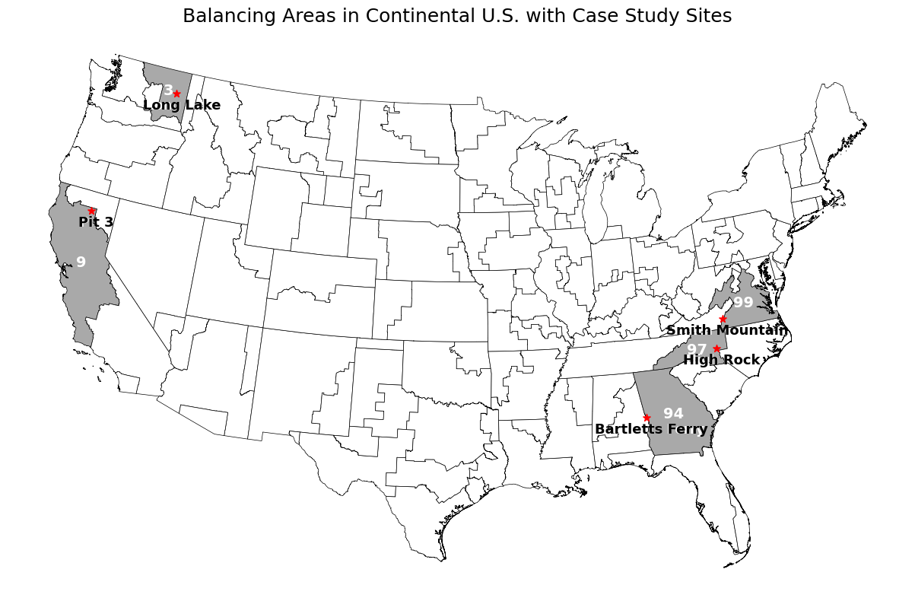
Figure 5 Map showing the contiguous United States divided into the Regional Energy Deployment System balancing areas as defined by the National Renewable Energy Lab (NREL). Gray areas white numbers denote balancing areas used for the case studies, and the red stars are conventional hydropower facility locations.

Table 11 Balancing areas with their associated case study site name, VRE Generation Use Percent, and Hydropower Generation Use Percent in 2024 and 2050, BA PSH capacity, PSH efficiency, BA conventional hydropower capacity, percent of MWh each case study makes up of the total BA, conventional hydropower capacity in the BA given in GW (1,000 MW)
 | BA 3 | BA 9 | BA 94 | BA97 | BA99
Case Study Site | Long Lake | Pit 3 | Bartletts Ferry | High Rock | Smith Mountain
VRE % 2024 | 6.9 | 22.6 | 4.7 | 4.3 | 9.1
VRE % 2050 | 5.8 | 61.3 | 47.2 | 19.9 | 65.9
Hydro % 2024 | 63.2 | 24.0 | 2.6 | 4.8 | 0.5
Hydro % 2050 | 62.6 | 18.3 | 2.7 | 4.3 | 0.4
BA PSH Generation Capacity (MW) | 3.14 | 2077.6 | 1306.6 | 95 | 3109.3
PS Efficiency (%) | 80.2 | 79.6 | 81.3 | 81.5 | 81.7
BA Conventional Hydro Generation Capacity (GW) | 11.99 | 8.72 | 2.21 | 1.68 | 0.65
Facility % | 1.2 | 1.2 | 10.1 | 2.7 | 40.2

Important environmental issues at this project include water quality, health of recreationally important fishery resources (rainbow trout Oncorhynchus mykiss, largemouth bass Micropterus salmonoids, smallmouth bass M. dolomieu, and yellow perch Perca flavescens), controlling noxious weeds, protection of riparian habitats, and aesthetic appearance at the Upper Falls development. The case study in this BA is Long Lake with a capacity of 70MW and four operating units. This project was most recently licensed in June 2009. The Long Lake facility generation from 2002 to 2022 was 495,070 MWh (Johnson et al., 2022). In BA 3, the Long Lake facility makes up 1.2% of total hydropower generation.

Balancing Area 09
BA 09 encompasses the majority of northern and central California bordering Oregon, Nevada, and the Pacific Ocean and is in the Western Electricity Coordinating Council (WECC) California region. There is 8,723MW of conventional hydropower capacity, and 2,077MW of PSH capacity in this region.
The Pit project is operated by Pacific Gas and Electric Company and have a combined capacity of 312.33 MW. This project (FERC license Pit 3, 4, 5; P-233) is the upstream most facility on the Pit River in northern California and is on a license issued in 2007 with the Pit 3, 4, and 5 facilities. The case study in this BA is Pit 3 with a capacity of 80MW and three operating units. This project was most recently licensed in July 2007. Important environmental issues at this project site include water quality, and special status species (species listed or proposed to be listed on the threatened or endangered species list) including the yellow warbler (Setophaga petechia) and willow flycatcher (Empidonax traillii). The Pit 3 average annual generation from 2002 to 2022 is 312,238 MWh (Johnson et al., 2022). In BA 9, Pit 3 makes up 1.2% of total hydroelectric generation.

Balancing Area 94
BA 94 encompasses the state of Georgia boarding Tennessee, South Carolina, Florida, and Alabama. This BA is in the Southeastern Reliability Council Reliability Corporation’s (SERC) Southeast region. There is 2,211MW of conventional hydropower power capacity, and 1,307MW of PSH capacity in this region.
The Chattahoochee River system contains 11 dams operated by U.S. Army Corps of Engineers and Georgia Power. The case study facility in BA 94 is Bartletts Ferry and is operated by Georgia Power with a capacity of 173 MW and six operating units. This project was most recently licensed in December 2014 and is the only hydropower facility on this license. This most recent license details a minimum daily discharge of 1,350cfs and includes important environmental issues such as water quality, soil resource management including erosion mitigation, and the incorporation of a bald eagle, scientific name, management plan. Bartletts Ferry average annual generation from 2002 to 2022 is 119,612 MWh. In BA 94 the Bartletts Ferry facility makes up 10.1% of total hydropower generation.

Balancing Area 97
BA 97 encompasses the western half of North Carolina bordering Tennessee, Virginia, South Carolina, and Georgia. This BA is in the SERC East region. There is 1,676MW of conventional hydropower capacity, and 95MW of PSH capacity in this region.
The Yadkin River Hydroelectric Project operates on the Yadkin River and consists of four facilities under this license that are operated by Alcoa Power Generating, Inc. with a total capacity of 210.31MW. Outside of this license there are three other dams operated by the U.S. Army Corps of Engineers and Duke Energy. The case study in this BA is High Rock with a capacity of 33MW and three operating units. This project was most recently relicensed in September 2016 and implemented enhanced water quality protections, a Rare, Threatened, and Endangered Species Management Plan (freshwater mussels (bivalved mollusk), Schweinitz’s sunflower (Helianthus schweinitzii), Yadkin River goldrod (Solidago plumosa), and bald eagle (Haliaeetus leucocephalus)), and a plan to enhance recreation opportunities along the project. The average annual MWh generation at the High Rock facility from 2002 to 2022 is 370,076 MWh. The High Rock facility makes up 2.7% of the conventional hydropower generation in BA 97.

Balancing Area 99
BA 99 encompasses the eastern half of Virginia bordering Maryland, South Carolina, and the Atlantic Ocean. This BA is in the Pennsylvania-New Jersey-Maryland Interconnection (PJM) East region. There is 653MW of conventional hydropower capacity, and 3,109MW of PSH capacity in this region.
This license consists of two facilities operating along the Roanoke River, both with conventional and pumped storage capabilities; the Leesville Development creates the lower reservoir for the Smith Mountain facility (FERC, 2009). The case study for this BA is Smith Mountain with a capacity of 300.2MW and five operating units. This project was most recently licensed in December 2009 to the Appalachian Power Company which included a Roanoke Logperch (Percina rex) Enhancement Plan in coordination with the Virginia Department of Game and Fisheries and U.S. Fish and Wildlife Service. The average annual MWh produced by the Smith Mountain facility from 2002 to 2022 is 342,973 MWh. Smith Mountain makes up 40.7% of the conventional hydropower generation in this BA.

Datasets
We obtained hourly locational marginal pricing (LMP) data for PSH and conventional hydropower from the Cambium dataset Mid Case 95% carbon reduction scenario (Gagnon, et al., 2023). In addition to the projections provided by Cambium, case study specific estimates of generation capacity were obtained from the Existing Hydropower Assets Database (Johnson et al. 2023). By integrating data from Cambium, which relies on the Regional Energy Deployment System Model (ReEDS) for BAs, we can observe the impacts from operating conventional hydropower case studies in a range of IEO conditions and the role PSH capacity plays in meeting unmet conventional hydropower demands (Ho, et al., 2021). Table 12 details each constrain analysis model input, description, and source. All data sets used in our analyses are publicly available.

Cambium Dataset
We used the Cambium 2022 dataset to obtain power pricing, generation, storage, and other power system metrics that were used as inputs in our optimization and regression models. The Cambium 2022 dataset provides electricity information for 134 BAs such as cost, locational marginal prices, long-run marginal emissions, wind and solar generation, battery and energy storage availability for a variety of timesteps (e.g., hourly, daily) for potential future U.S. grid buildout scenarios extending to 2050 (Gagnon et al., 2023). Each scenario differs in assumptions of generation rate and storage technology adoption, tax incentives and other energy policies, and magnitude and timeline for carbon reduction efforts. The BAs used in the Cambium 2022 dataset are regions derived from a representation of the energy grid that are like actual BAs in function, but do not follow the same boundaries.

Table 12 Constrain analysis model inputs for each hydropower facility, a description of each input, and the corresponding reference source.
Inputs | Description | Source
U.S. Geological Survey (USGS) Stream Gage Discharge (cfs) | Discharge measured in cfs for USGS stream gages on an hourly basis. | (USGS, 2022)
Hourly Energy Prices (USD) | Hourly energy prices for the given BA projected by the Cambium model. | (Gagnon, et al., 2023)
Total BA demand (MW) | Hourly total energy demand for the given BA. | (Gagnon, et al., 2023)
Hour of Day | Hour at the current analysis time as it correlates in the Cambium dataset. | (Gagnon, et al., 2023)
Year | Year corresponding to the Cambium dataset | (Gagnon, et al., 2023)
VRE Generation (MW) | Total MW of VRE generation in the given BA for the given hour from the Cambium dataset. | (Gagnon, et al., 2023)
Hydro Generation (MW) | Total MW of hydropower generation in the given BA for the given hour from the Cambium dataset. | (Gagnon, et al., 2023)

Table 12 Continued
Season | Season of the year defined as:  Winter = December, January, February  Spring = March, April, May  Summer = June, July, August  Fall = September, October, November | (EIA, 2020)
Facility Region | Region of the facility according to the EIA, to correlate peak times. | (EIA, 2020)
Facility Capacity (MW) | Capacity in MW of the given facility. | (Johnson, et al., 2022)
FERC License | The FERC license provided additional license requirements such as minimum flows, reservoir levels, and reservoir operating range. | (FERC, 2023)

Because future BAs may be reassigned due to changes in energy demand, changes in energy storage such as batteries or pumped storage hydropower, or new/decommissioned generation assets, differences between actual and Cambium BAs are not problematic for interpreting our analyses.
Our analyses use the Cambium Standard Scenarios Mid Case 95% of carbon reduction by the year 2050 as measured against 2005 levels scenario. Figure 6 shows the progression of how data is used in the methods. Of specific interest to this analysis is the information provided on hourly energy prices, total BA demand (MW), hour of the day, year, hourly hydropower generation (MW), and hourly VRE generation (MW) for years 2024, 2034, 2044, and 2050.

Hydrologic Data
Hydrologic inputs for our models came from two sources: historic inflow data from USGS stream gage data and future precipitation and climate-adjusted inflow projection data from the Coupled Models Intercomparison Project phase 6 (CMIP6) Multi-model Streamflow Projections (Kao et al., 2022a; Kao, et.al, 2022b). Data from USGS stream gage sites upstream of each hydro facility were chosen to determine the inflow rate of each facility (USGS, 2022). In cases where the hydropower facility has more than one USGS stream gage, Table 13 shows the USGS stream gages used for inflow calculations at each facility. The CMIP6 dataset simulates future hydrologic responses across the conterminous U.S. based on statistically and dynamically downscaled and bias corrected streamflow projections. The resulting dataset provides an ensemble of hydroclimate projections for baseline (1980-2019) and future periods (2020-2059) under a variety of emissions scenarios at approximately 4 km spatial resolution for 2.7 million NHDPlusV2 stream reaches.

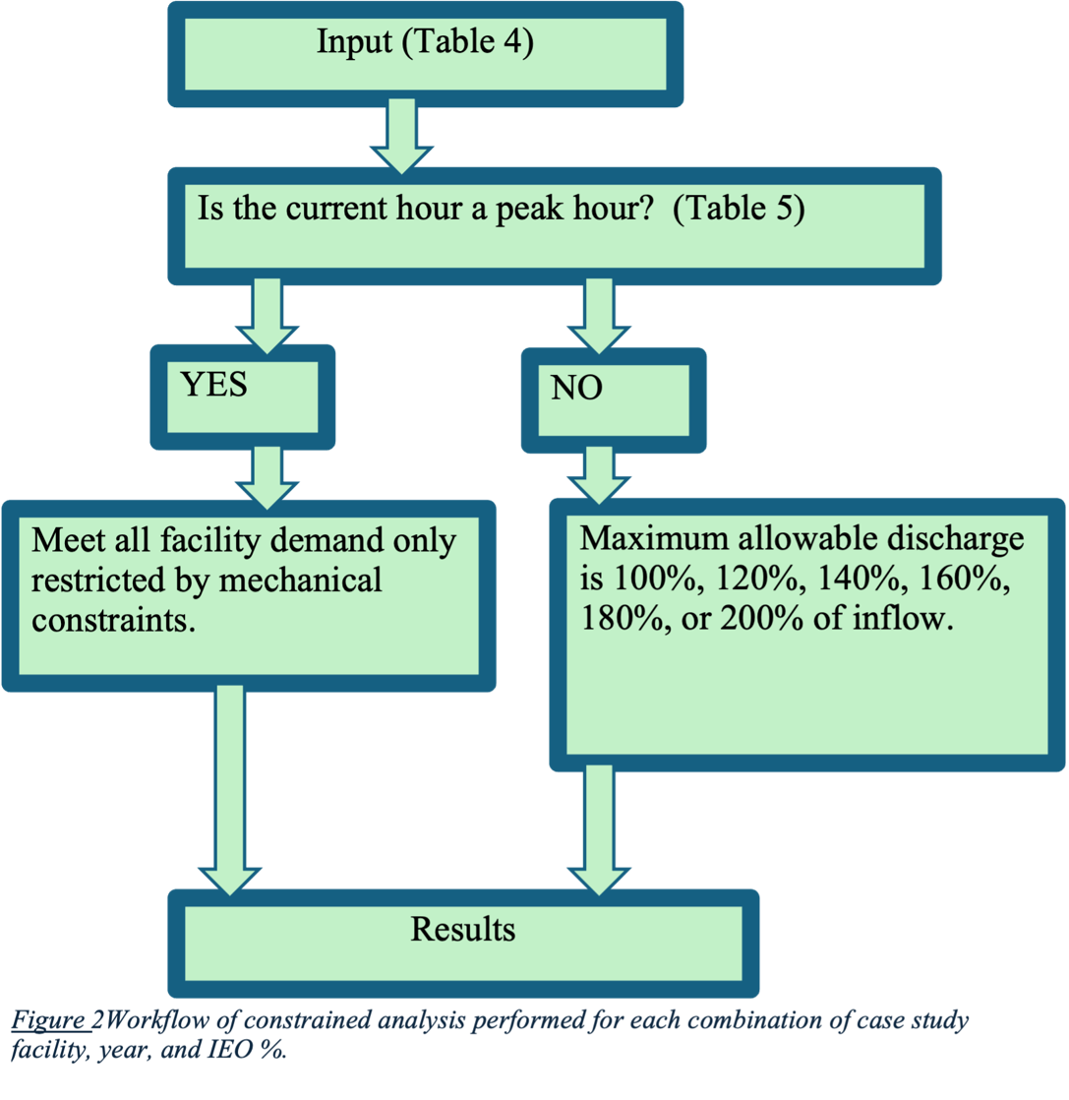
Figure 6 Workflow of constrained analysis performed for each combination of case study facility, year, and IEO %.
This dataset also provides daily, monthly, and annual timescale projections for certain locations of interest including all hydropower facilities in the Existing Hydropower Assets Plant Database (Johnson et al. 2023).

Data curation and equations
Five case studies located in BAs with varying amounts of VREs and use of hydropower were analyzed for energy demand, economic, and environmental metrics associated with a range of IEO and peaking operations (Pfeifle, 2020). This analysis considers only IEO outflow regulations, their impacts on energy-economic-environmental tradeoffs in a future renewable energy buildout scenario. This analysis is based on hourly projections over a variety of generation types, energy incentive and policy scenarios (e.g., Low and High Renewable Energy and Battery Costs with the same base assumptions but renewable energy and battery costs are assumed to be lower or higher and improvement performance greater or lesser, and High Demand Growth with the same base assumptions but demand growth is assumed to average 2.8% from 2024 through 2050) (Gagnon, et al., 2023). Facility mode of operation as categorized by McManamay et al. (2016), facility capacity, and ReEDS BA for the case studies was collected from the Existing Hydropower Assets (EHA) Plant Database from ORNL (Johnson, et al., 2022).

Facility Demand Data
Hourly facility demand is the amount of energy demand put on the given facility from the Cambium dataset and was established based on the fraction of annual BA MWh produced by the facility. Both the facility annual energy generation and the BAs annual energy generation can be found in the Existing Hydropower Assets database (Johnson et al., 2022). The hourly facility demand is this fraction, expressed as a percent, multiplied by the given hour’s generation found in Cambium (Gagnon et al., 2023).
Table 13 The five BAs (columns) and their case study site characteristics (rows) used in this study: state where facility is located, FERC docket number, nameplate capacity of conventional hydropower at the facility (MW), National Electricity Reliability Corporation (NERC) region, USGS gage number for first gage upstream of the project, and projected average annual discharge (m³/s) for 2024-2050 based on USGS gage site location projections from ORNL CMIP6-based Multi-model Streamflow Projections using the Australian Community Climate and Earth System Simulator (ACCESS) U.S. (Kao et al., 2022). All case study projects used in this study were classified as peaking by the Existing Hydropower Assets Database (Johnson et al., 2022).
 | BA 3 | BA 9 | BA 94 | BA 97 | BA 99
Case Study Site | Long Lake | Pit 3 | Bartletts Ferry | High Rock | Smith Mtn
State | WA | CA | AL, GA | NC | VA
FERC License # | P-2545 | P-233 | P-485 | P-2197 | P-2210
Capacity (MW) | 70.0 | 80.1 | 173.0 | 33.0 | 300.2
Generation (2002-2022) (MWh) | 495,070.5 | 312,238.4 | 119,612.3 | 370,076.0 | 342,973.3
NERC Region | WECC | WECC | SERC | SERC | RF
Gage 1 | 12426000 | 11355010 | 2339500 | 2116500 | 2056000
Gage 2 | 12431500 | 11361000* | NA | 2120780 | 2056900
Gage 3 | N/A | 11355500 | NA | 2121500 | NA
Avg Inflow (m3/s) | 247.3 | 31.9 | 197.3 | 117.5 | 22.1
NA = Not Applicable
*Average Monthly flows were used for this USGS gage site because there were no daily flows available.

The percentages range from 1.2% (Pit 3 and Long Lake) to 40.2% (Smith Mountain) (Table 11). These percentages were used to find the facility demand at each hour for each analyzed year. The hydropower case study facility power generation (MWh) is used instead of the energy capacity because generation measured in MWh accounts for the hours of use in a year instead. For example, the Long Lake facility has a smaller capacity of 70.0 MW, as compared to other case studies, but the capacity in MWh exceeds all others regardless of MW capacity (Johnson et al., 2022).
The facility demand is the demand passed to the specific case study hydroelectric facility based on the calculation in Equation 1. Equation 1 shows the calculation of $\left(Power_{h}\right)$ as hydropower demand within an hour, $Facility Capacity$ as MWh produced by the facility and $∑\left(BA Capacity\right)$ as MWh during the same period reported by the EHA database (Johnson et al., 2022).
Equation 1 Facility Demand (MW)
$(Facility Demand_{h})=(Power_{h})* (Facility Capacity_{max})/(∑(BA Capacity)$

Discharge Allowed
The allowable discharge of a facility is dependent on the hour of the day, the season, and the location of the facility. The determination of peak hour is made on an hourly basis is based on Energy Information Administration (EIA) regional and seasonal peak hours (EIA, 2020). Peak hour definitions for each region are given in Table 14. When it is a peak hour, the model maximizes the demand met with only mechanical restrictions. When it is an off-peak hour, the model maximizes the demand met while staying within the IEO discharge for generation scenario. Each IEO scenario represents a percent of inflow allowed as discharge ranging from 100% to 200% at 20% increments.
Table 14 Description of peak hours specific to each region broken down by season with each corresponding BA and facility.
Region | Facilities (BA) | Season | Peak Hour (24-hr)
California | Pit 3 (09) | Summer | 11-16
California | Pit 3 (09) | Spring-Fall | 15-20
California | Pit 3 (09) | Winter | 6-9, 17-20
Northwest | Long Lake (03) | Summer | 12-17
Northwest | Long Lake (03) | Spring-Fall | 15-19
Northwest | Long Lake (03) | Winter | 7-10, 18-22
Southeast | Bartletts Ferry (94), High Rock (97), Smith Mountain (99) | Summer | 13-18
Southeast | Bartletts Ferry (94), High Rock (97), Smith Mountain (99) | Spring-Fall | 14-18
Southeast | Bartletts Ferry (94), High Rock (97), Smith Mountain (99) | Winter | 5-9, 17-21

Volume calculations
To calculate the volume required to meet a given hourly demand, the ratio of demand (MW) and facility capacity (MW) are multiplied by the max flow rate and added to the minimum flow rate (Equation 2). This assumes the maximum flow rate is possible regardless of the reservoir height.
Equation 2 Volume Required to Meet Demand (m3/hr)
$$Volume_{req}=Facility Demand_{h}/Capacity_{max}* Q_{max}+ Q_{min}$$
Volume calculations are used to track the power capacity from hour to hour. The volume, elevation, and usable power are initiated in the model at their respective maximums on the first hour of the year. The usable power at any given hour is determined by the ratio of present reservoir elevation to the maximum reservoir elevation multiplied by the power max (facilities maximum capacity); in the hydropower power generation equation height and power are directly proportional, Equation 3:
Equation 3 Hydropower Power Generation
$$\left(Power_{h}\right)=Q*g*h*η* ρ$$
The model calculates water volume released each hour considering total reservoir storage and whether the hour is defined as peak or off-peak. During peak hours, the facility meets demand without flow restrictions (but still adheres to reservoir height), releasing the minimum of either the required volume or the maximum flow rate. In off-peak hours, maximum release volume follows one of six run-of-river conditions allowing discharge to deviate from inflow by 100-200% at 20% increments. The 100% case is often portrayed as 0% indicating it is allowing 0% beyond the natural flow projection; this is true for all other inflow equals out flow conditions like 120% to 20%. The off-peak releases must be equal to the maximum of either the existing minimum flow or the inflow rate.
The volume remaining in the reservoir at the end of each hour equals the previous ending volume minus volume released. To determine end-of-hour water height, volume released is converted to a height change using a simplified height-to-volume ratio that divides total reservoir storage by the reservoir’s maximum height. This linear approximation does not consider detailed reservoir geometry. If available, more precise morphology data could inform a higher-fidelity storage-height model. To avoid over topping the dam a spill metric is calculated and measured in MW (Equation 4):
Equation 4 Spill (MW)
$$Spill=\left(Volume_{end}\right)-Volume_{max}/\left(Q_{max}\right)*\left(Power_{max}\right)$$
The spill penalty represents the lost revenue from the spill at a given hour. The spill penalty calculation by hour is the end-use cost (E_{h}) multiplied by the (Spill_{h}) within the hour (Equation 5):
Equation 5 Spill Penalty (MW)
$$\left(Spill Penalty_{h}\right)=\left(E_{h}\right)*\left(Spill_{h}\right)$$
The discharge power is the amount of energy the hydropower facility puts to the grid in each hour and is based on the volume released, Equation 6:
Equation 6 Discharge At Hour h (MW)
$${Discharge}_{h }\left(MW\right)={Volume}_{release}{/Volume}_{required}* {Facility Demand}_{h}$$
The power put into the grid by each facility is determine by the proportion of required volume met multiplied by the facility demand. In this analysis the difference between the power out and the facilities demand is tracked. If this this is negative it indicates the facility has not met all the demand under the IEO scenario during that hour.

Revenue Calculation
To estimate generation revenue, we assigned peak hours and off-peak hours for each facility based on the region and season as assigned by the U.S. Energy Information Administration (EIA) (EIA, 2020). The revenue generation by hour (R_{h}) is calculated by considering the end-use cost the of the Cambium data set and multiplying it by the power output (Power); the power output of a modeled hydroelectric facility will be capped based on the capacity of the facilities found in Table 13. The second term in this equation will always be negative and incorporates the spill penalty (lost revenue from the spill at a given hour where spill is excess water volume over maximum reservoir height) within the hour (h), Equation 7.
Equation 7 Revenue At Hour h (USD)
$$R_{h}= \sum{\left(E_{h}*{Power}_{h}\right)- \sum{{Spill Penalty}_{h}}}$$

Environmental Impact Calculation
We calculated two established ecologically relevant flow alteration metrics to quantify flow rate of change, and periodicity (Richter et al., 1996): (1) hourly Richard-Baker Flashiness Index (RB-Index) and (2) the number of flow reversals calculated hourly. The RB-Index was designed to quantify rate of change in daily flows compared to mean annual flows (Baker et al., 2004; Equation 8). We adapted the RB-Index for this study to reflect rate of change between hours to reflect the previous (change between t = 0 and t = 1) and following (change between t = 1 and t = 2) hour before between t = 0 and t = 1 and t = 1 and t = 2; Equation 9:
Equation 8 Richard-Baker Flashiness Index (Original)
$$R-B Index= \sum_{h=1}^{n}{\frac{1}{2}\left(\left|q_{h+1}-q_{h}\right|+\left|q_{h}-q_{h-1}\right|\right)}/\sum_{h=1}^{n}{q_{h}}$$
Equation 9 Richard-Baker Flashiness Index (Hourly)
$$R-B Index= \frac{1}{2}\left(\left|\left(q_{h+1}\right)-\left(q_{h}\right)\right|+\left|\left(q_{h}\right)-\left(q_{h-1}\right)\right|\right)/q_{h}$$
Where q_{h} = present hours discharge volume, q_{h+1} = next hours discharge volume, and q_{h-1} = previous hours discharge volume. Lower RB-Index values represent slower hourly rates-of-change in flows, and presumably, lower ecological impacts, and higher RB-Index values represent faster hourly rates-of-change in flows, and presumably, higher ecological impacts. The summation in the numerator and denominator is dropped because n = 1. The absolute value of the (q_{i} – q_{i-1}) term then represents the change in outflow from the previous hour to the present hour. Additionally, in the case where the volume released is zero the denominator is removed from Equation 9 to avoid a case where the RB-Index is equal to infinity.
The number of hourly flow reversals is calculated as the number of times hourly discharge increases between t = 0 and t = 1 and decreases between t = 1 and t = 2 or decreases between t = 0 and t = 1 and increases between t = 1 and t = 2. A reversal is defined in Equation 10:
Equation 10 Reversals
$$Reversal= Q_t<Q_(t-1) \& Q_t<Q_(t+1)$$
$$or$$
$$Q_t>Q_(t-1) \& Q_(t+1)>Q_t$$
Where Q_{t} is the discharge at hour t. This equation identifies when the discharge trend switches between an increasing pattern and decreasing pattern. A higher number of annual reversals indicates more frequent cycling between rising and falling hydrograph limbs. This fluctuating flow regime can disrupt aquatic species life cycles that rely on seasonal flow patterns. Together, with RB-Index values, the number of reversals can link key components of the flow regime alteration to revenue and grid stability.

Pumped Storage Short-Term Energy Dispatch Optimization
The pumped storage optimization considers the conventional hydropower model and adds unmet demand from each facility onto PSH demand in that BA (Figure 5). Specifically, the unmet demand is added to the BA’s PSH demand (Figure 5). The objective function of the PSH Op model maximizes the difference between revenue and charge costs treating PSH capacity in a BA as one facility; this is specifically important in BA 9, 94 and 99 where more than one PSH facility exist. The optimization is performed using the Sequential Least Squares Programming (SLSQP) algorithm implemented through SciPy’s minimize function (Virtanen, et al., 2020). This algorithm is intended to minimize the scalar function of one or more variables. Results are reported as percent of demand met by PSH capacity and PSH Op revenue (revenue from only the optimized dispatch) for each of IEO condition, BA, and year. The optimization analysis will determine if there is enough PSH capacity to meet the demand when optimizing for revenue. All data sets used in this optimization are publicly available. Figure 7 shows a diagram of this process and Table 15 shows the variables used in the optimization model.
The objective function aims to maximize the difference between dispatch (x) and charging costs decisions, Equation 11:
Equation 11 Objective Function
$$maximize(revenue-charge_cost )$$

Energy deficits from constrained analysis
Summation of Cambium and energy deficit demands
Establish constraints:
- Charge constraints.
- Capacity constraints
- Discharge constraints.
Results
Figure 7 Workflow of PSH short-term energy dispatch optimization across all five considered ReEDs BAs, constrained for each combination of case study facility, year (2024, 2034, 2044, 2050), and IEO percentage (100, 120, 140, 160, 180, 200). The energy deficits from the constrained analysis are added to the preexisting Cambium Dataset PSH demands, the optimization is then constrained, and results are reported in percent of demand met and revenue.
Table 15 PSH optimization constraint model variables and definitions.
Variable | Definition
$$revenue$$ | $$x_{optimized} * price$$
$$charge_cost$$ | $$charge * price$$
$$x_{optimized}$$ | $$Optimized power dispatch of PS at hour h (MW)$$
$$price$$ | $$Cambium reported price for hour h (\$)$$
$$charge$$ | $$calculate_charge function (Equation 3)$$
$${demand}_{h}$$ | $$Energy demand not met from conventional hydropower$$  $$constrained analysis at hour h (MW)$$
$$\max{charge rate}$$ | $$\frac{maximum capacity (Table 1)}{24}$$
$$remaining capacity$$ | $$maximum({demand}_{h}+{system demand}_{h}-{ system charge}_{h }, 0)$$
$${system demand}_{h}/{charge}_{h}$$ | $$Cambium determined at hour h$$
$$efficiency$$ | $$Efficiency of PSH within given BA \left(Table 1\right)$$
$$maximum dispatch$$ | $$\frac{maximum capacity (Table 1)}{10}$$
$$starting capcity$$ | $$starting_capacity_constraint (Equation 6)$$
$${end}_{h}$$ | $$ending capacity at hour h (Equation 5)$$

The PSH capacity in each BA was modeled as one facility and assumed to be a 10-hr storage facility and have a rechargeability of 1/24th of the MWh capacity per hour.

Constraints
The PSH Op model has six constraints: dispatch constraint, charge constraint, non-negativity constraint, max discharge constraint, ending capacity constraint, and starting capacity constraint. These constraints consider capacity conditions, dispatch conditions, prescribe demand, and charging to track PSH available dispatch at a given hour. The PSH maximum capacity within each BA remains the same through all years. The Cambium model has pre-determined PSH demand (system demand) and charging (system charging). The efficiency percentage for each BA was calculated based on the system demand and system charge (Table 11) and applied to the charge variable in the optimization model.
The dispatch constraint ensures the dispatch of PSH does not exceed the demand during a given hour, Equation 12:
Equation 12 Dispatch Constraint
$$dispatch constraint={demand}_{h}-x_{optimize}$$
The charge constraint considers whether the hour is a peak hour, the maximum charging rate, efficiency of the system and the remaining PSH capacity (Equation 13). The facility only charges, beyond the Cambium prescribed system charge, during off-peak hours at a rate of 1/24th of maximum capacity (Equation 13). This is because on-peak hours have the highest prices and PSH facilities are charged when energy prices are lowest to keep operational costs down. Equation 13 Charge Constraint
$$charge=minimum(\max{charge rate, remaining capacity/efficiency) }$$
The non-negativity constraint simply ensures the dispatch value (x_{optimize}) is not negative. The maximum discharge constraint accounts for the maximum dispatch by the facility, starting capacity, and system demand (Equation 14).The maximum dispatch is calculated as 1/10th the BAs maximum capacity. Since BA maximum capacities are assumed to be a 10-hour facility, Equation 4 calculates the hourly maximum discharge.

Equation 14 Maximum Discharge Constraint
$$maximum discharge allowed=minimum(maximum dispatch, starting capcity-system demand)$$
The ending capacity constraint ensures the storage capacity at the end of each time step is recorded (Equation 15). This constraint also acts as a condition for transmission capacity. It is assumed the maximum dispatch from PHS facilities within each BA is incorporated into the Cambium 2022 model. The maximum dispatch is determined based on Cambium’s estimated maximum hourly demand. The number of instances where the maximum capacity is exceed is recorded and could be used to assess the need for transmission expansion across each BA, year and IEO combination.
Equation 15 Ending Capacity Constraint
$$ending capacity= maximum capacity-{system demand}_{h}-x_{optimize}-{system charge}_{h}+{charge}_{h}$$
The starting capacity constraint sets the storage level at the beginning of each hour by pulling from the previous hours ending capacity (Equation 16); if it is the first hour of the year the starting capacity is set to the maximum capacity. In these capacity and dispatch conditions the end capacity is not bounded; in the case the ending capacity falls outside the bounds of the start capacity, the starting capacity will be either 0, if ending capacity is negative, or equivalent to the maximum capacity, if the previous hours ending capacity is greater than the maximum capacity.
Equation 16 Starting Capacity Constraint
$${starting capacity}_{h}= \left\{\begin{aligned}if h=0, start=maximum capcity; \\ if h>1, start={end}_{h-1} \\ if {end}_{h-1}<0, start=0 \\ if {end}_{h-1}>maximum capacity, start=maximum capacity\end{aligned}\right\}$$

Statistical Analysis
We conducted a LASSO regression on combined BA, IEO, and year conditions (national), and on each BA with all IEO, and year conditions (BA specific) to examine the relationships between three response and nine independent variables we hypothesized were independently significantly related to the response variables (Table 16).
The hydropower and VRE generation percent are the amount of generation from each of these sources as a percent of total generation in the BA, the inflow is the projected inflow to the facility by hour, the BA demand is the Cambium model projected demand on PSH facilities in MW on an hourly time step, the PSH carryover demand is the demand not met by a case study facility under the given IEO operational condition on an hourly time step, the RB-Index is the measurement of ramping on an hourly bases from the conventional hydropower case study facilities on an hourly basis, the percent of demand met is the percent of PHS demand that BA PHS capacity meets, revenue is the amount of revenue generated from Cambium demands and optimization dispatch, the battery MWh is the battery (non-PHS) usage in a given hour, reversal magnitude is the magnitude of change in flow when a reversal occurs, the IEO is the inflow equals outflow condition imposed on the conventional hydropower facility when in off peak hours, and the BA is the ReEDS balancing area number.
Table 16 Independent and Response variables used for the linear regression analysis based on the PSH optimization results.
Variable | Definition
Demand Met % | Percent of demand PSH capacity in each BA meets; Response Variable.
PSH Op Revenue | Total revenue generated from the Cambium projected demand and the optimization dispatch; Response Variable.
RB-Index | The Richard-Baker Flashiness index measures the rate of change of discharge for each conventional hydropower case study facility and is used to assess downstream riverine ecological impacts; Response Variable.
VRE Generation % | Percent of total BA demand generated by solar and wind generation sources; Independent Variable.
Hydro Generation % | Percent of total BA demand generated by hydropower generation sources; Independent Variable.
BA demand | Total demand projected on the balancing area by the Cambium model; Independent Variable.
PSH Carryover Demand | Demand not met by the case study facility in the given BA that is then added to the existing PSH demand; Independent Variable.
Battery MWh | Generation from non-PSH battery storage facilities in the balancing area (MWh); Independent Variable.
Table 16 continued
Reversal Magnitude | When a reversal of increasing flow to decreasing flow or vice-versa out of a conventional hydropower facility is recorded, this metric calculates the magnitude of the change; Independent Variable.
Inflow | The amount of inflow coming into the conventional hydropower facility; Independent Variable.
IEO | Inflow equals outflow; the percent of inflow allowed as discharge. A condition imposed on conventional hydropower facilities during off peak hours; Independent Variable.
BA | Balancing area; the number of the balancing areas based on the ReEDS model. This is only used in the national LASSO regression model; Independent Variable.

We use a LASSO regression approach to understand relationships between three response variables (percent of demand met, revenue, and RB-Index) and independent variables that we hypothesized were independently significantly related to the response variables. We run two LASSO regression models, one combining all BAs, years and IEOs resulting in three models, one regression model for each response variable, and the other for each balancing area combining all years, and IEO results resulting in 15 models one for each response variable and BA combination. In the combined LASSO regression, there are eight independent variables (Carry over demand, battery dispatch, BA demand, Hydropower generation percent, VRE generation percent, reversal magnitude, inflow, IEO, and BA) and the BA specific LASSO regression has seven independent variables because the BA independent variable is removed. Each regression model was run on hourly optimization data derived by the Cambium 2022 dataset or our optimization model described above
The carry over demand is the demand not met by the conventional hydropower facilities in that balancing area, the battery dispatch is non-pumped storage hydropower battery generation, the total demand is the amount of MW of demand placed on the facility, the hydropower and VRE generation percent are the amount of generation from each of these sources as a percent of total generation in the balancing area, the reversal magnitude is the absolute value of the flow rate change when a reversal occurred, the average inflow is the average projected inflow to the facility by hour over that year, the IEO percent is the amount of deviation from the inflow rate allowed during off peak times, and the BA is the balancing area code. We evaluate these independent variables in three categories: demand and storage variables, generation and flow variables, and operational and market constraints.
The LASSO regression model generates coefficient values for each independent variable. The higher the absolute value of the coefficient the larger the impact on the predictive capabilities of the model for the response variable. In cases where the independent variable plays no role in predicting the response variable the coefficient is equal to zero (Tibshirani, 1996); (Cook, et al., 2018). In our analysis the LASSO regression results are interpreted both by their coefficients, to define the most impactful factors for each model, and by their adjusted r-squared value, to determine how much of the variance of the model is defined by the coefficients. All LASSO regression were conducted in pandas, numpy, and sklearn packages in Python v3.11 (McKinney et al., 2010; Harris et al., 2020; Pedregosa, et al., 2011).

Results

Optimization modeling

Resource adequacy
This analysis evaluates the ability of PSH to meet additional energy demands, by summing those unmet by the chosen conventional hydropower facility and the Cambium projected PSH demand, under various operational conditions. The assessment spans the short term (2024), mid-term (2034, 2044) and long term (2050), while considering the difference across IEO cases. Notably, within each BA and year combinations, the percent of demand met varies by less than 0.3% across all IEO cases, indicating minimal impact of IEO variations, within a year, on the overall demand met. Table 17 shows the maximum percent PSH demand change for each BA, year, and IEO conditions.
In the short term, all balancing areas show a stable trend across all IEO cases, with BA 3, 97, and 99 having a less than .1% change between all IEO cases.
Table 17 The maximum PSH demand change year by year across all IEO cases.
BA | 2024-2034 (%) | 2034-2044 (%) | 2044-2050 (%)
03 | 79.2 | 9.2 | 25.1
09 | 358.6 | 18.3 | 3.8
94 | -1.2 | 7.4 | 25.5
97 | -3.3 | 8.8 | -25.1
99 | -9.5 | 15.1 | -24.1

The minimum amount of demand met in this period is 91.7% in BA 3. In contrast BA 9 and 94 meet 100% of demand across all IEO cases.
In the mid-term, BA 3 shows the biggest change meeting 99% of all demand in all IEO cases and maintains this level in 2044. This is an increase from the short term where ~92% of demands were met. In all other balancing areas and IEO cases the remain between 99% and 100% of demands met in both 2034, and 2044 across all IEO cases.
In the long-term, a dip of 1% in percent of demand met in BA 3, and BA 97 is observed across all IEO cases from the previous year. This same dip also occurs in BA 99 in five out of the six IEO cases with the 200% of IEO case being the only one to maintain the 100% of demand met from the previous year. In BA 9, and BA 94 100% of demands are met across all IEO cases. Figure 8 below shows the changes in percent of demand met by BA, year and IEO condition.

Economics
The economic analysis summed the total revenues of each BA, IEO, and year combination. The IEO ranged from 100% to 200% of inflow allowed as discharge, are shown in Figure 9 scaled by 100, meaning 100% is the equivalent to 0% in a figure by superimposing the black demand line over the revenue generated for each BA, year, and IEO combination.
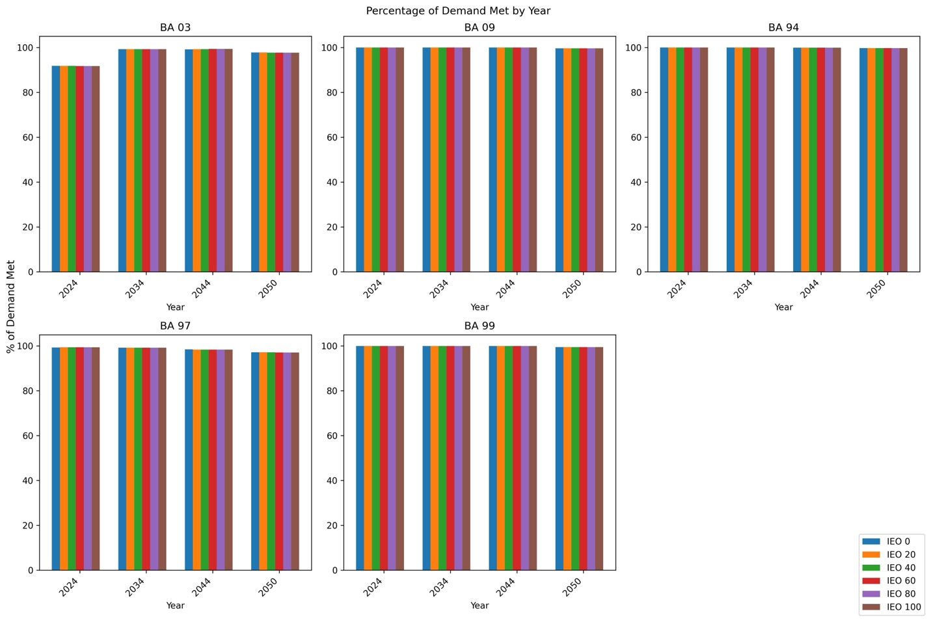
Figure 8 The percent of demand met across all balancing areas, years, and inflow equals outflow conditions. In all cases the difference in the demand met in a year across the inflow equals outflow conditions was less than 0.3% making it difficult to see in this figure.

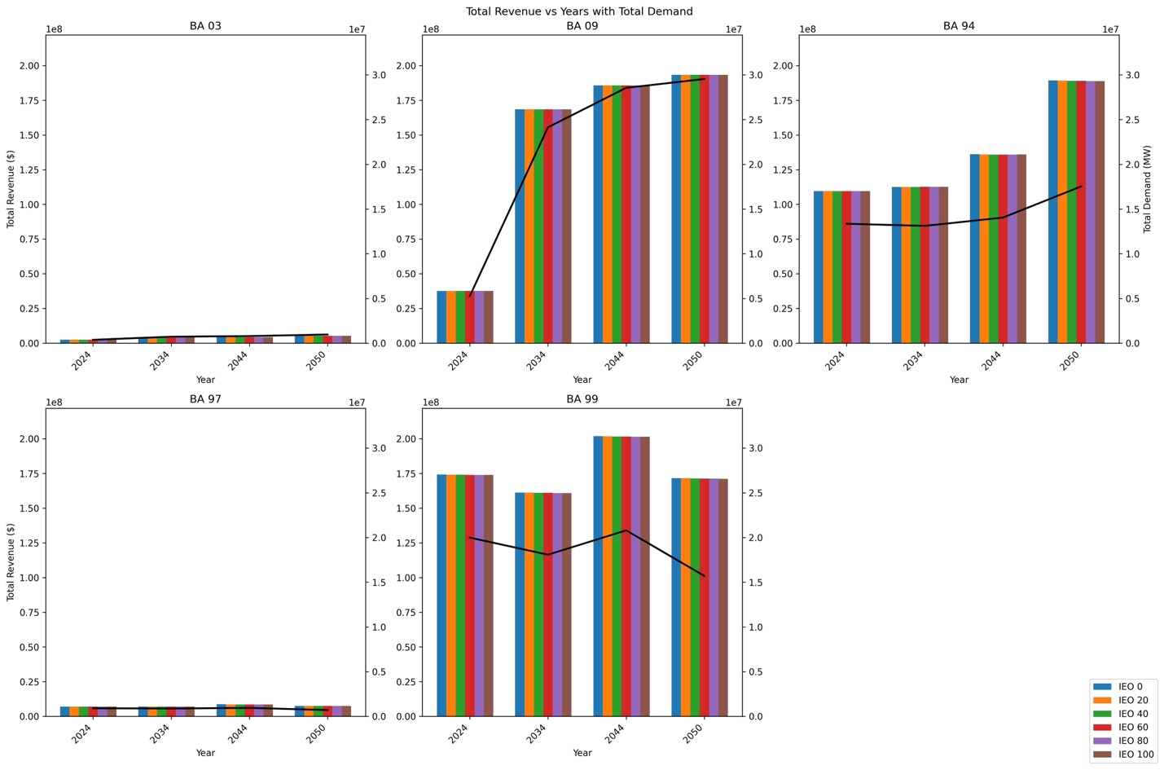
Figure 9 Total revenue vs year for each balancing area, year, and inflow equals outflow combination. The total revenue is the sum of revenue from the Cambium projected demand and revenue from the optimization dispatch. The super imposed black line is the total demand, which is the sum of the Cambium projected demadns and the carryover demand.

Based on the Cambium model’s energy cost predictions we found the average hourly energy price range increased from 2024 to 2044 (Figure 10). While comparing price growth and revenue growth, we observed hourly price trends vary by BA without showing a strong correlation (Figure 10).
In addition to rising energy cost ranges, the sum of demand placed on the PSH facilities was not consistent across years as shown by the black line in Figure 9. Revenue for each year accounted for the increasing or decreasing amount of demand placed on each facility and the national LASSO regression model shows demand metrics, BA demand, and carryover demand being two of the top three factors having the largest impact on revenue generation (Table 18).

LASSO Regression Modeling

National LASSO Regression Results
This LASSO regression analysis was run across all BA, IEO, and years to determine factors impacting the identified response variables across all sites, operational conditions and future time frames. The response variables were the PHS revenue (revenue), PSH percent of demand met (demand met), and Richard Baker Flashiness Index (RB-Index) shown in Table 18. The independent variables are the balancing area number (BA), balancing area demand (BA demand), battery generation in MWh (battery gen), hydropower generation percent (hydro pct), inflow equals outflow (IEO), inflow, PHS carryover demand (carryover demand), reversal magnitude, and variable renewable energy generation percent (VRE PCT)(Table 16). The correlation coefficients were used to determine how impactful each independent variable is on the response variable and the inverse or direct correlation between variables. The alpha value in a LASSO regression can indicate how close the model is to a linear model. An alpha value of 0 indicates a linear model.
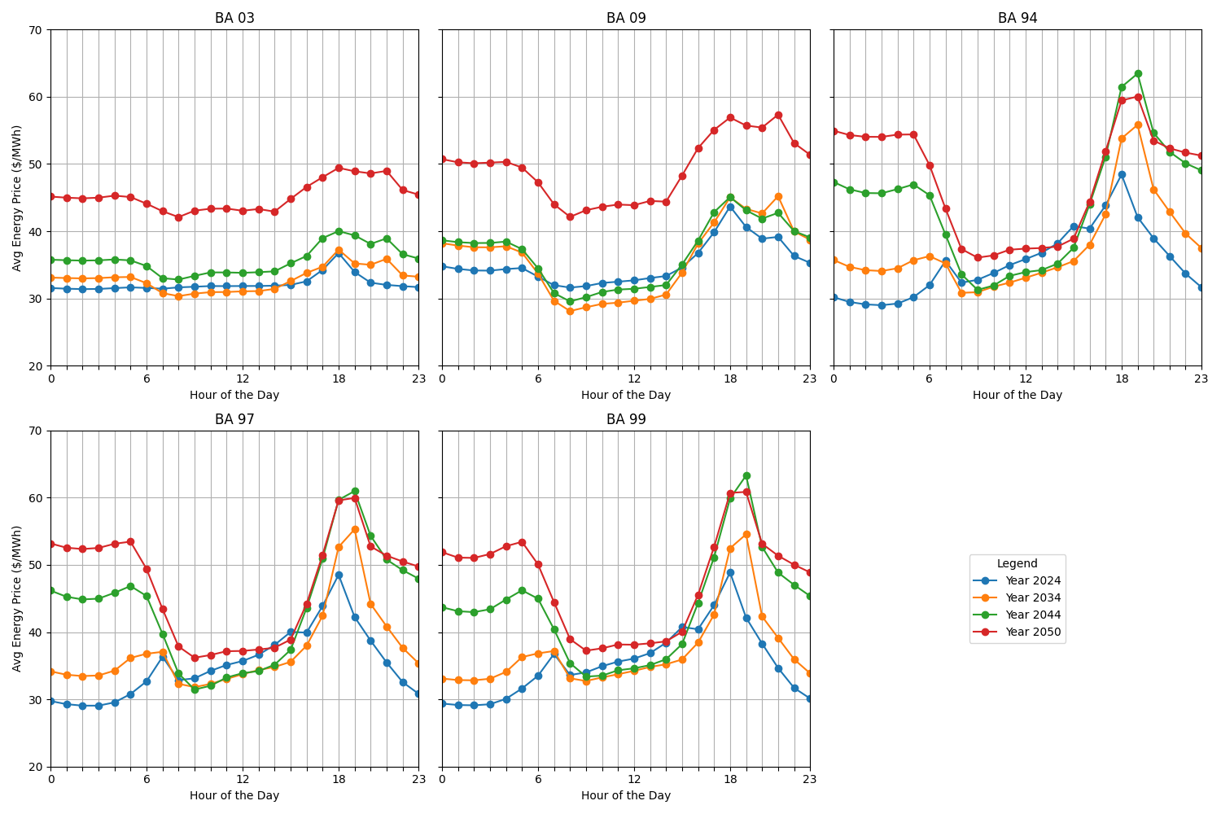
Figure 10 Energy prices for each year averaged across the entire year for each hour of the day. Displaying clear pricing peaks and off-peaks. This chart is specific to Cambium projected energy prices across all studies BAs.

Table 18 National LASSO regression coefficient results for combined balancing area, inflow equals outflow, and year analysis. A negative correlation coefficient indicates an inverse relationship while a positive value indicates a direct relationship. The larger the absolute value of the coefficient the larger the impact the corresponding independent variable has on the response variable, however these magnitude comparisons can only be made within each model. For example, comparing the BA magnitude in the Revenue and Demand Met columns would be comparing across two different models and are thus not comparable.
 | Revenue | Demand Met | RB-index
BA | -470.39 | -6.79 | 0.62
BA Demand | 6164.54 | -16.90 | -0.88
Battery Gen | 7110.05 | 2.11 | 0.20
Hydro PCT | -1239.13 | 0.14 | -0.51
IEO | 33.73 | -0.50 | -0.11
Inflow | -363.97 | -22.48 | 0.04
Carryover | 10583.65 | 11.87 | 1.23
Reversal Magnitude | -3046.07 | 0.58 | -2.57
VRE PCT | -5613.54 | -2.83 | 0.38

Across all three models, one for each response variable, none of the models were linear. The results of the national LASSO regression model in full are seen in Appendix D.

Pumped Storage Hydropower Percent of Demand Met
In the demand and storage variables category we evaluate the carryover demand, battery
generation, and BA demands independent variables. We find the BA demand has the largest impact from this category with a coefficient of -16.9. The negative sign indicates there is an inverse relationship between the PSH percent of demand met and the BA demand; more demand in the balancing area less demand met by PSH capacity within the balancing area and vice versa.
In the generation and flow variables category we evaluate the hydropower generation percent, VRE generation percent, reversal magnitude, and inflow independent variables. We find the inflow has the largest impact from this category with a coefficient of -22.5. The negative sign indicates there is an inverse relationship between the PSH percent of demand met and the inflow; lower inflow lower percent of demand met and vice versa. The VRE generation percent and hydropower generation percent were non-zero with the absolute value of the VRE generation percent being higher than the hydropower generation percent indicating VRE generation percent plays a larger role in PSH capacities ability to meet demands.
In the operational and market constraints category we evaluate the IEO and BA response variables. We find the BA has the largest impact from this category with a coefficient of -6.79. The negative sign is not significant here as the BA is a categorical variable and the non-zero value of the coefficient indicates the BA does impact the ability of PSH capacity to meet demands.
Across all categories the inflow had the largest impact on the PSH capacity ability to meet demands and the hydropower generation percent had the lowest impact on the PSH ability to meet demands. There were five variables that were inversely correlated to PSH capacities ability to meet demands and four variables that were directly correlated to PSH capacities ability to meet demands. The entire results can be seen in Table 18.

Pumped Hydropower Storage Revenue
In the demand and storage variables category we evaluate the carryover demand, battery generation, and BA demands independent variables. We find the carryover demand has the largest impact on the PHS revenue with a coefficient of 10583.6. The positive sign indicates the carryover demand and PSH revenue are directly correlated; increased carryover demand results in increased PHS revenue and vice versa.
In the generation and flow variables category we evaluate the hydropower generation percent, VRE generation percent, reversal magnitude, and inflow independent variables. We find the VRE generation percent has the largest impact on the PSG revenue with a coefficient of -5,613.5. The negative sign indicates the VRE generation percent and the PHS revenue are inversely correlated; increased VRE generation percent decreased PSH revenue and vice versa. The VRE generation percent and hydropower generation percent were non-zero with the absolute value of the VRE generation percent being higher than the hydropower generation percent indicating VRE generation percent plays a larger role in PSH revenue.
In the operational and market constraints category we evaluate the IEO and BA response variables. We find the BA has the largest impact from this category with a coefficient of -470.4. The negative sign is not significant here as the BA is a categorical variable and the non-zero value of the coefficient indicates the BA does impact the PSH revenue.
Across all categories the carryover demand had the largest impact on the PSH revenue and the IEO had the lowest impact on the PSH revenue. There were five variables that were inversely correlated to PSH revenue and four variables that were directly correlated to PSH revenue. The entire results can be seen in Table 18.

Richard-Baker Flashiness Index
In the demand and storage variables category we evaluate the carryover demand, battery generation, and BA demands independent variables. We find the carryover demand has the largest impact on the RB-Index with a coefficient of 1.23. The positive sign indicates the carryover demand and RB-Index are directly correlated; increased carryover demand results in increased RB-Index and vice versa.
In the generation and flow variables category we evaluate the hydropower generation percent, VRE generation percent, reversal magnitude, and inflow independent variables. We find the reversal magnitude has the largest impact on the PSG revenue with a coefficient of -2.57. The negative sign indicates the reversal magnitude, and the RB-Index are inversely correlated; increased reversal magnitude decreased RB-Index and vice versa. The VRE generation percent and hydropower generation percent were non-zero with the absolute value of the hydropower generation percent being higher than the VRE generation percent indicating hydropower generation percent plays a larger role in RB-Index.
In the operational and market constraints category we evaluate the IEO and BA response variables. We find the BA has the largest impact from this category with a coefficient of -0.621. The positive sign is not significant here as the BA is a categorical variable and the non-zero value of the coefficient indicates the BA does impact the ability of RB-Index.
Across all categories the carryover demand had the largest impact on the RB-Index and the inflow had the lowest impact on the RB-Index. There were three variables that were inversely correlated to RB-Index and four variables that were directly correlated to RB-Index. The entire results can be seen in Table 18.

Balancing Area LASSO Regression Results
This LASSO regression analysis was modeled for each BA and response variable combination by merging all IEO, and years to determine factors impacting the identified response variables at all each site, operational conditions and future time frames. The response variables were the PHS revenue (revenue), PSH percent of demand met (demand met), and Richard Baker Flashiness Index (RB-Index) shown in Table 18 below. The independent variables are balancing area demand (BA demand), battery generation in MWh (battery gen), hydropower generation percent (hydro pct), inflow equals outflow (IEO), inflow, PHS carryover demand (carryover demand), reversal magnitude, and variable renewable energy generation percent (VRE PCT) shown below in Table 18. The correlation coefficients were used to determine how impactful each independent variable is on the response variable and the inverse or direct correlation between variables. The alpha value in a LASSO regression can indicate how close the model is to a linear model. An alpha value of 0 indicates a linear model. None of the models were had an exactly zero alpha value.

Pumped Storage Hydropower Percent of Demand Met
In the demand and storage variables category we evaluate the carryover demand, battery generation, and BA demands independent variables. We find the carryover demand has the largest impact on PSH percent of demand met in the Long Lake, Pit3, and Smith Mountain balancing areas. We find the BA demand has the largest impact on PSH percent of demand met in the Bartlets Ferry, and High Rock balancing areas.
In the generation and flow variables category we evaluate the hydropower generation percent, VRE generation percent, reversal magnitude, and inflow independent variables. We find the hydropower generation percent has the highest impact on the PSH percent of demand met in the Bartlets Ferry balancing area. We find the inflow has the largest impact on the PSH percent of demand met in the Long Lake, High Rock, and Smith Mountain balancing areas. We find the VER generation percent has the largest impact on the PSH percent of demand met in the Pit 3 balancing area. The VRE generation percent and hydropower generation percent were non-zero across all balancing areas. The VRE generation percent was inversely correlated with the PHS percent of demand met in all balancing areas. The hydropower generation percent was inversely correlated with the PHS percent of demand met in the Long Lake, Pit 3 and Smith Mountain balancing areas, and directly correlated with the PHS percent of demand met in the Bartlets Ferry, and High Rock balancing areas.
In the operational and market constraints category we evaluate the IEO response variable. In the Bartlets Ferry and Pit 3 balancing areas the IEO was directly correlated with the PHS percent of demand met. A direct correlation with the IEO independent variable means as the amount of inflow allowed as discharge increases the PSH percent of demand decreases and vice versa. In the Long Lake, High Rock, and Smith Mountain balancing areas the IEO was inversely correlated with the PHS percent of demand met.

Pumped Hydropower Storage Revenue
In the demand and storage variables category we evaluate the carryover demand, battery generation, and BA demands independent variables. We find the carryover demand has the largest impact on PSH revenue in the Long Lake, Pit 3, and High Rock balancing areas. We find the battery generation has the largest impact on PSH revenue in the Smith Mountain balancing area. We find the BA demand has the largest impact on the PSH revenue in the Bartlett Ferry balancing area.
In the generation and flow variables category we evaluate the hydropower generation percent, VRE generation percent, reversal magnitude, and inflow independent variables. We find the VRE generation percent has the largest impact on the PSH revenue in the Pit 3, Bartlets Ferry, High Rock, and Smith Mountain balancing areas. We find the hydropower generation percent has the largest impact on the PSH revenue in the Long Lake balancing area. The VRE generation percent and hydropower generation percent were non-zero across all balancing areas. The VRE generation percent was inversely correlated with the PSH revenue across all balancing areas. The hydropower generation percent was directly correlated with the PHS revenue in the Bartlets Ferry and Smith Mountain balancing areas and inversely correlated with the PSH revenue in the Long Lake, Pit 3, and High Rock balancing areas.
In the operational and market constraints category we evaluate the IEO response variable. In the Pit 3, Bartlets Ferry and Smith Mountain balancing areas the IEO was directly correlated with the PHS revenue. A direct correlation with the IEO independent variable means as the amount of inflow allowed as discharge increases the PSH revenue decreases and vice versa. In the Long Lake balancing area, the IEO was inversely correlated with the PSH revenue, and in the High Rock balancing area the IEO was not correlated with the PSH revenue.

Richard-Baker Flashiness Index
In the demand and storage variables category we evaluate the carryover demand, battery generation, and BA demands independent variables. We find BA demand has the largest impact on RB-Index in Long Lake and Bartlets Ferry balancing areas. We find carryover demand has the largest impact on PSH percent of demand met in the Smith Mountain, High Rock, and Pit 3 balancing areas.
In the generation and flow variables category we evaluate the hydropower generation percent, VRE generation percent, reversal magnitude, and inflow independent variables. We find reversal magnitude has the largest impact on RB-Index in the Pit 3, Bartlets Ferry, High Rock and Smith Mountain balancing areas. We find the inflow has the largest impact on RB-Index in the Long Lake balancing area. The VRE generation percent and hydropower generation percent were non-zero across all balancing areas. The VRE generation percent was directly correlated with RB-Index in the Pit 3, and High Rock balancing areas and inversely correlated with RB-Index in the Long Lake, Bartlets Ferry, and Smith Mountain balancing areas. The hydropower generation percent was directly correlated with RB-Index in the Pit 3, High Rock and Bartlets Ferry balancing areas and inversely correlated with RB-Index in the Long Lake, and Smith Mountain balancing areas.
In the operational and market constraints category we evaluate the IEO response variable. In all balancing areas the IEO is inversely correlated with the RB-Index. This means as the amount of inflow allowed as discharge increases the RB-Index decreases and vice versa. A lower RB-Index indicates a lower flashiness and increased environmentally friendly conditions.

Discussion
Our study highlights the potential of PSH as a potential pathway for ameliorating some of the impacts of flexible hydropower operations on downstream communities by using PSH as a renewable source of flexible generation. PSH was able to consistently meet between 91% and 100% of demand, emphasizing its role in stabilizing grids with growing VRE penetration like solar and wind. While PSH offers substantial benefits, economic implications, operational tradeoffs, and environmental impacts should also be considered for future policy and system development.
Studying the effectiveness of large energy storage facilities, like PSH, to meet energy deficits from IEO hydropower facilities can aid in understanding the potential benefit of pairing conventional hydropower facilities IEO operations with battery storage facilities.
Battery systems enable the integration of VRE sources by allowing energy produced at low demand periods to be saved and released during periods of high demand, which is one form of peak shaving, that is, supplying additional energy generation into the grid during high demand times, to reduce costs through the economic principle of supply and demand; (Zheng, et al., 2015) (Yang, et al., 2022). When comparing peak shaving to meet demands as opposed to peaking operational practices, peak shaving was more cost effective than peaking operations at the generation plants (Das, et al., 2015). In many cases the use of bulk energy storage, like PSH also reduces system CO₂ emissions allowing for regions to reach their carbon reduction goals. The consensus is VRE sources are beneficial in reducing carbon emissions but coupling them with battery storage adds additional value, through flexibility, to VRE generation (Toledo, et al., 2010).

Environmental Impacts
By incorporating carryover demand from our hydropower case study facilities, we evaluated tradeoffs between the environment (RB-Index), PSH ability to meet BA demands, and economic generation impacts. The RB-Index, determined by flows at each case study conventional hydropower facility, was most impacted in its LASSO regression analysis by BA demand and carryover demand. In the BA specific LASSO regression analysis BA demand has a positive correlation with the RB-Index across all BAs. This positive correlation means as demand in the BA increases so does the RB-Index (the higher the RB-Index the more environmentally detrimental the conditions). This correlation between demand and RB-Index can tell us as demands for generation across the country increase our environments are near conventional hydropower facilities are increasingly at risk.
Another dimension to this dynamic is considering the carryover demand in the national LASSO regression model where there is a negative correlation between carryover demand and RB-Index. This means when the conventional hydropower facility meets less of its demand and passes more demand on to PHS capacity (carryover demand) the RB-Index decreases, indicating increasingly desirable environmental conditions. With demands for energy continuing to grow and these results showing demand factors have the largest impact on the RB-Index means we could see more detrimental impacts on aquatic environments as conventional and PHS facilities try to keep up with these demands. Future work could focus on shifting limiting the flashiness of conventional hydropower operations and shifting PHS dispatch to meet more load-following demands with the goal of optimizing conventional dispatch for environmental metrics while meeting all required demands.
While the national LASSO regression model showed a negative relationship between carryover demand and RB-Index, on a BA scale BA 99 was unique in that it was the only BA where carryover demand and RB-Index were positively correlated. Balancing area 99 contains the Smith Mountain conventional hydropower case study facility which is a dual PSH and conventional hydropower facility on the upper bound of Leesville Lake. Leesville Lake serves as a PSH reservoir bounded by Leesville Dam on the downstream side. This unique hydrologic and operational configuration likely impacts independent variables relationships with RB-Index because our model treats the PSH and conventional hydropower aspects of Smith Mountain as separate facilities. This decoupling of PSH and conventional hydropower at Smith Mountain likely changes relationships with RB-Index values that are otherwise observed at conventional hydropower facilities without PHS capabilities. Additionally, BA 99, where Smith Mountain is located, has the lowest amount of generation percent from hydropower further reducing the impact on RB-Index, since it is a product of BA hydropower generation percent.

Economic Implications
The economic implications varied significantly due to differences in VRE integration time frames, BA hydropower generation levels, and site-specific natural flow conditions. The independent variables in the demand and storage category (BA demand, carryover demand, and battery generation) were the independent variables with the largest impact on PHS revenue. In both the national and BA specific LASSO regression models all variables in the demand and storage category were directly correlated with PHS revenue, which follows with the understanding that increased demand generates more revenue producing opportunities. The relationship with the battery generation could be explained by battery generation being an indicator of increased demand as demand is increased more demand is placed on PHS facilities as well as on the other battery storage technologies within the BA. Further research could consider relationships between independent variables to avoid redundant findings.

Coordinated Energy Systems
Our findings show PSH can play a critical role in coordinated energy storage and generation infrastructure by leveraging PSH’s flexibility to take on additional demand from one conventional hydropower facility in a BA operating in IEO mode. In all balancing areas PHS capacity meets 91% or more of the demand, including additional demands from a range of operational conditions imposed on a conventional hydropower facility within the BA. Specifically, in three out of five BAs (9, 94, 99) PSH capacity was able to cover >99% of the demand in the BA across all years and IEO conditions. The three BAs meeting less than 99% of demand were 3, 97 and ranged from meeting 91% to 98% of PSH demands dependent on the year and imposed IEO condition. One reason these two BAs could be meeting less of the demand than the other BAs is because the BA specific LASSO regression reveals the VRE generation percent has plays the second largest role in impacting the percent of demand met and is inversely correlated with the percent of demand met in these BAs. With a growing reliance on VRE sources, VRE generation is increasing which and may increase demands on PHS capacity making more difficult to meet both these increased demands and the carryover demands from conventional hydropower facilities. Coordination of VRE, conventional hydropower and PSH resources could help reduce energy supply and demand imbalances.

Correlated Factors
The LASSO regression analyses on both a national and BA scale revealed key insights into the interplay between renewable energy integration, grid stability, and revenue generation. In all models the coefficient for VRE generation percent was non-zero indicating it was an impactful factor across all response variables. This likely reflects VRE generation percents influence on the variability and intermittency of energy supply, which PSH systems are suited to manage. Specifically, higher levels of VRE generation could cause greater fluctuations in grid stability, requiring PSH to respond more dynamically to balance supply and demand.
Hydropower generation percent also had a non-zero coefficient across all BA, IEO and year combinations in both the national and BA level LASSSO regression analysis. In three BAs (3, 97, 99) VRE generation percent had a larger impact on the percent of demand met by PHS capacity. Specifically, BA 3 has which the highest percent of generation from conventional hydropower (62.3%) (Appendix G). With conventional hydropower making up a larger amount of generation, conventional hydropower could account for grid fluctuations without needing to impact PSH operations. With no reliance from conventional hydropower sources on PSH capacity, PSH and conventional hydropower could be operating as completely independent systems. The existence of VRE generation sources and battery MWh having larger absolute values of their coefficients mean they have a greater influence on economic, environmental, and grid stability outcomes compared to the contribution of conventional hydropower generation.
If we consider the site-specific metric PSH carryover demand against regional metrics we find the localized operational factors exert less influence on revenue generation, the ability to meet demand, and environmental factors, compared to broader system-wide metrics in BA 94 and 97 (i.e. BA demand, battery generation VRE generation percent, hydropower generation %). These findings suggest that VRE generation and demand requirements play a larger role in economics, environmental impacts, and grid stability than do site specific metrics. In other balancing areas (3, 9, 99) local variables like carryover demand have a larger impact on the response variables. In this case site specific approaches are more important and independent variable metrics may need to be varied depending on the location to gain better understanding of economic, energy and environmental at the local sites.

Future Research
This analysis takes steps in outlining a proposed framework that focuses on PSH capacity and its ability to meet demands, economic impacts, and correlations between variables. These findings quantitatively link PSH performance with environmental and economic outcomes in multiple regions. Future research quantifying flow fluctuation links to sediment transportation, as well as other environmental impacts of hydropower (dissolved oxygen, fish stranding, and water temperature), could bridge grid stability metrics with ecological outcomes. This dual focus on ecosystem health and energy resiliency would provide a clearer understanding of trade-offs, and the role energy storage, like PSH, could play in the integration of carbon free generation sources.
Coordinating energy storage and generation infrastructure is needed for electric reliability amid the nationwide transition to renewable energy (Zhang, et al., 2021), (Dini, et al., 2022), (Brown, et al., 2018). By optimizing existing PSH capacity dispatch in our analysis we found storage and generation assets working together could meet additional energy demands passed on by operating a conventional hydropower facility in IEO conditions but is very site specific when looking at how much of that demand is met. This coordination effort could be especially impactful if conventional plants are in a cascade. A cascade configuration has the outflow from one conventional hydropower plant flowing into the next facility downstream, resulting in the upstream plants impacting downstream facilities by dictating flows. If the upstream facility mimics natural flows, then downstream facilities operating in IEO would also be mimicking natural flow regimes. With PSH facilities likely to be larger than the conventional facilities, PSH capacity can absorb some of the flexibility given up by operating in IEO conditions. This is supported by PSH capacity meeting a minimum of 91% of additional demands across the gradient of IEO operational conditions across all BAs considered.
Combining both RB-Index results and PSH Op results reveals that conventional hydropower facilities can operate in IEO conditions with the lowest RB-Index (i.e., least environmental impact), while PSH capacity could compensate for at least three quarters unmet energy demand regardless of location. Transferring the unmet demand to PSH facilities energy could help operators balance environmental preservation and reliable power generation. The framework of this analysis lays the foundation for combing grid stabilization and environmental protection, which could be beneficial to balance the integration of VRE sources with environmental river management plans but complete. However, the remaining quarter of demand not met by PSH must supplied by other sources, highlighting the need for research into coordinating solar, wind, or battery storage technologies to ensure demand is consistently met while enabling conventional hydropower facilities to maintain environmentally friendly flows.
Water management and river management plans in energy and environmental fields can sometimes present opposing views but there should be more crossover. On the energy side, the concern of changing climates due to climate change focuses water management on the most effective management practices for generation (Hidalgo, et al., 2020) (Li, et al., 2020). On the environmental side, climate change impacts are also considered but focuses on sustaining ecosystems surrounding these water resources and the impacts from hydropower facilities (CHEN, et al., 2020) (Mello, et al., 2021) (U.S. DOE, 2023). Bridging the priorities of energy generation and environmental sustainability through collaborative water management plans that quantify grid stability impacts of flow rate fluctuations, sediment transportation, and other environmental impacts of hydropower, is essential for adapting to climate change while preserving ecological integrity.

Policy Implications
Our results show PSH can absorb 91% or more of demand brought about by projected VRE integration, and carryover demands from conventional IEO facilities. However, this study does not address the reallocation of economic opportunity intrinsic in shifting demands from conventional hydropower to PSH facilities. Maintaining both PSH and conventional hydropower generation is essential for a resilient energy system, as their combined operation helps balance VRE integration and ensures reliable power generation. Policies should look to quantify the amount of VRE generation to meet carbon reduction goals, the flexible generation needed to sustain this level of VRE integration, and energy-economic-environment nexus tradeoffs observed in this analysis. The goal of these quantifications is to understand the generation needed to assess the tradeoffs discussed in this paper. This analysis and previous research have identified the importance of region-specific strategies, now we need policies, based on research, to ensure grid stability, economic viability, and environmental sustainability.

Conclusion
Use of energy storage is needed for the integration of VRE sources to meet decarbonization goals. Previous research found PSH Op can be used for storing excess energy production from these sources then releasing during times of low production (Nasab, et al., 2022) (Abdelshafy, et al., 2020). This research is in line with previous research in the understanding that regulations and operational decisions are unique to each facility, but we specifically focus PSH’s capacity to meet additional demands while maintaining economic viability, and the specific relational impacts between grid wide metrics (VRE generation demand, and hydropower generation demand), and localized metrics (RB-Index, and Carry over demand from a conventional hydropower facility). Results from our study show PSH capacity can meet between 91% and 100% of projected and additional demands reinforcing PSH investments paralleling renewables expansion could aid reliable zero-carbon electricity generation.

Works Cited
Abdelshafy Alaaeldin M [et al.] Optimized energy management strategy for grid connected double storage (pumped storage-battery) system powered by renewable energy resources [Journal]. - [s.l.] : Energy, 2020. - Vol. 192.
Baker David B [et al.] A New Flashiness Index: Characteristics And Applications Tp MidWestern Rivers And Streams [Journal] // Journal of the American Water Resources Association. - 2004.
Brown T W [et al.] Response to ‘Burden of proof: A comprehensive review of the feasibility of 100% renewable-electricity systems’ [Journal] // Renewable and Sustainable Energy Reviews. - 2018. - pp. 834-847.
Castillo Anya and Gayme Dennice F Grid-scale energy storage applications in renewable energy integration: A survey [Journal] // Energy Conversion and Management. - 2014. - pp. 885-894.
CHEN Qiuwen [et al.] Effects of hydropower development on aquatic eco-environment and adaptive managements [Journal]. - [s.l.] : Advances in Water Science, 2020. - Vol. 31.
Cook J A and Ranstam J LASSO regression [Journal]. - [s.l.] : British Journal of Surgery, 2018. - 10 : Vol. 105.
Das Trishna, Krishnan Venkat and McCalley James D Assessing the benefits and economics of bulk energy storage technologies in the power grid [Journal]. - [s.l.] : Applied Energy, 2015. - 104-118.
Dini Anoosh [et al.] A flexible-reliable operation optimization model of the networked energy hubs with distributed generations, energy storage systems and demand response [Journal] // Energy. - 2022.
DOE How Pumped Storage Hydropower Works [Online] // Water Power Technologies Office. - https://www.energy.gov/eere/water/how-pumped-storage-hydropower-works#:~:text=Pumped%20storage%20hydropower%20(PSH)%20is,capacity%20in%20the%20United%20States..
EIA EIA expects U.S. annual solar electricity generation to surpass hydropower in 2024 [Online]. - November 7, 2023. - 2023. - https://www.eia.gov/todayinenergy/detail.php?id=60922.
EIA Hourly electricity consumption varies throughout the day and across seasons [Online]. - February 21, 2020. - 2023. - https://www.eia.gov/todayinenergy/detail.php?id=42915.
EIA Wind has surpassed hydro as most-used renewable electricity generation source in U.S. [Online]. - February 26, 2020. - 2023. - https://www.eia.gov/todayinenergy/detail.php?id=42955.
EPA U.S. Electricity Grid & Markets [Online] // US Electricity Grid & Markets| Green Power Partnership| US EPA. - June 26, 2020. - https://19january2021snapshot.epa.gov/greenpower/us-electricity-grid-markets_.html.
FERC Georgia Power: ORDER ISSUING NEW LICENSE [Report]. - [s.l.] : FERC, 2014.
FERC Alcoa Power: ORDER ISSUING NEW LICENSE [Report]. - [s.l.] : FERC, 2016.
FERC Applachian Power Company: ORDER ISSUING NEW LICENSE [Report]. - [s.l.] : FERC, 2009.
FERC Avista Corporation: ORDER ISSUING NEW LICENSE AND APPROVING ANNUAL CHARGES FOR USE OF RESERVATION LANDS [Report]. - [s.l.] : FERC, 2009.
FERC eLibrary [Online]. - February 21, 2023. - 2023. - https://www.ferc.gov/ferc-online/elibrary.
FERC PG&E: ORDER ISSUING NEW LICENSE [Report]. - [s.l.] : FERC, 2007.
Gagne Roderick B [et al.] Spread of an introduced parasite across the Hawaiian archipelago independent of its introduced host [Journal] // Freshwater Biology. - 2014. - pp. 311-322.
Gagnon Pieter, Cowiestoll Brady and Schwarz Marty Cambium 2022 Scenario Descriptions and Documentation [Report] : Technical Report: NREL/TP-6A40-84916. - Golden, CO : National Renewable Energy Lab, 2023.
Global X ETFs Short- and Long-Duration Energy Storage Essential to the Clean Energy Transition | NASDAQ [Online] // Nasdaq. - 2022. - https://www.nasdaq.com/articles/short-and-long-duration-energy-storage-essential-to-the-clean-energy-transition.
Hansen H Carly, Ghimire R Ganesh and Matson G Paul Hydropower Energy Storage Capacity Dataset, Version 2 [Online] // HydroSource, Oak Ridge National Laboratory. - 2023. - https://doi.org/10.21951/HESC/1972462.
Hidalgo Ieda Geriberto [et al.] Hydropower generation in future climate scenarios [Journal]. - [s.l.] : Energy for Sustainable Development, 2020. - Vol. 59.
Ho Jonathan [et al.] Regional Energy Deployment System (ReEDS) Model Documentation: Version 2020 [Report] : Technical Report: NREL/TP- 6A20-78195. - Golden, CO : National Renewable Energy Lab, 2021.
Ho Jonathan [et al.] Regional Energy Deployment System (ReEDS) Model Documentation: Version 2020 [Report]. - Golden, CO : NREL, 2021.
Hunt Julian David a [et al.] Existing and new arrangements of pumped-hydro storage plants [Journal] // Renewable and Sustainable Energy Reviews. - 2020.
Johnson Megan M, Kao Shih-Chieh and Uria-Martinez Rocio Existing Hydropower Assets [Online] // HydroSource| ORNL. - 2022. - https://doi.org/10.21951/EHA_FY2022/1865282.
Kao Shihi-Chieh, Ghimire Ganesh R and Gangrade Sudershan CMIP6-based Multi-model Streamflow Projections over the Conterminous US [Report]. - Oka Ridge, TN : HydroSource. Oak Ridge National Laboratory, 2022.
Kuriqi Alban [et al.] Water-energy-ecosystem nexus: Balancing competing interests at a run-of-river hydropower plant coupling a hydrologic–ecohydraulic approach [Journal] // Energy Conversion and Management. - 2020.
Laborde A [et al.] Strategic methodology to set priorities for sustainable hydropower development in a biodiversity hotspot [Journal] // Science of The Total Environment. - 2020.
Li Jun [et al.] Evident response of future hydropower generation to climate change [Journal]. - [s.l.] : Journal of Hydrology, 2020. - Vol. 590.
McManamay R A [et al.] Classification of US Hydropower Dams by their Modes of Operation [Journal] // River Research and Applications. - 2016. - pp. 1450-1468.
Mello Carlos R [et al.] Climate Change Impacts on Water Resources of the Largest Hydropower Plant Reservoir in Southeast Brazil [Journal]. - [s.l.] : Water, 2021. - Vol. 13.
Nasab Morteza Azimi [et al.] An efficient, robust optimization model for the unit commitment considering renewable uncertainty and pumped-storage hydropower [Journal]. - [s.l.] : Computers and Electrical Engineering, 2022. - Vol. 100.
Pfeifle Sarah L A Framework for Meeting Economic and Ecological Objectives in Hydropower Operations [Journal]. - Amherst : University of Massachusetts Amherst, 2020.
Pfeifle Sarah L A Framework for Meeting Economic and Ecological Objectives in Hydropower Operations [Journal]. - 2020.
Pfeifle Sarah L A Framework for Meeting Economic and Ecological Objectives in Hydropower Operations [Journal]. - 2020.
Rahman Mustafizur [et al.] Assessment of energy storage technologies: A review [Journal] // Energy Conversion and Management. - 2020.
Savin Olivian [et al.] Effect of start and stop cycles on hydropower plants: modelling the deterioration of the equipment to evaluate the cycling cost [Conference] // Effect of start and stop cycles on hydropower plants: modelling the deterioration of the equipment to evaluate the cycling cost. - [s.l.] : IOP Conference Series: Earth and Environmental Science, 2023.
Stoll Brady [et al.] Hydropower Modeling Challenges [Report]. - Golden, CO : National Renewable Energy Lab, 2017.
The Engineering Toolbox Hydropower [Online]. - 2008. - 2023. - https://www.engineeringtoolbox.com/hydropower-d_1359.html.
Tibshirani Robert Regression Shrinkage and Selection Via the Lasso [Journal]. - [s.l.] : Journal of the Royal Statistical Society: Series B (Methodological), 1996. - 1 : Vol. 58.
Toledo Olga Moraes, Filho Delly Oliveira and Alves Cardoso Diniz Antônia Sônia Distributed photovoltaic generation and energy storage systems: A review [Journal]. - [s.l.] : Renewable and Sustainable Energy Reviews, 2010.
Tuttman Max and Litzelman Scott Why Long-Duration Energy Storage Matters [Online] // Blog Post | arap-e.energy.gov. - 2020. - https://arpa-e.energy.gov/news-and-media/blog-posts/why-long-duration-energy-storage-matters#:~:text=ARPA%2DE's%20Duration%20Addition%20to,5%20cents%2FkWh%20or%20less..
US Energy Information Administration Hourly electricity consumption varies throughout the day and across seasons [Online]. - February 21, 2020. - 2023. - https://www.eia.gov/todayinenergy/detail.php?id=42915.
USGS USGS Current Water Data for the Nation [Online] // Waterdata | USGS. - 12 7, 2022. - https://waterdata.usgs.gov/nwis/rt.
Valavi Mostafa and Nysveen Arne Variable-Speed Operation of Hydropower Plants: A Look at the Past, Present, and Future [Journal] // IEEE Indusrty Applications Magazine. - 2018. - pp. 18-27.
Virtanen Pauli [et al.] SciPy 1.0: Fundamental Algorithms for Scientific Computing in Python. [Journal] // Nature Methods. - 2020. - pp. 261-272.
Viswanathan Vilayanur [et al.] 2022 Grid Energy Storage Technology Cost and Performance Assessment [Report]. - Richland : PNNL, 2022.
Yang Yuqing [et al.] Modelling and optimal energy management for battery energy storage systems in renewable energy systems: A review [Journal] // Renewable and Sustainable Energy Reviews. - 2022.
Zhang Chengming [et al.] Frequency-constrained Co-planning of Generation and Energy Storage with High-penetration Renewable Energy [Journal] // Journal of Modern Power Systems and Clean Energy. - 2021. - pp. 760-775.
Zheng Menglian, Meinrenken Christoph J and Lackner Klaus S Smart households: Dispatch strategies and economic analysis of distributed energy storage for residential peak shaving [Journal] // Applied Energy. - 2015. - pp. 246-257.
Zimmerman Julie K. H. [et al.] DETERMINING THE EFFECTS OF DAMS ON SUBDAILY VARIATION IN RIVER FLOWS AT A WHOLE-BASIN SCALE [Journal] // River Research and Applications. - 2009.

Appendix

Appendix A:
Table 19 This appendix lists the hydropower and pumped storage sites within each of the considered balancing areas. The table lists facility name, state, conventional hydropower (CH) capacity, PSH capacity, and the ReEDS balancing area.
Facility Name | State | CH Capacity (MW) | Pumped Storage Capacity (MW) | ReEDS Balancing Area
San Joaquin 1A | CA | 0.425 |  | 9
Crane Valley | CA | 0.99 |  | 9
Little Bear Creek Diversion | CA | 0.01 |  | 9
Lewiston | CA | 0.35 |  | 9
W R Gianelli | CA |  | 424 | 9
ONeill | CA |  | 25.2 | 9
Bell Powerhouse | CA | 0.1 |  | 9
Mud Creek Diversion | CA | 0.3 |  | 9
Burgess Creek Diversion | CA | 0.025 |  | 9
McFadden Farm Diversion | CA | 0.562 |  | 9
Bell Powerhouse | CA | 0.05 |  | 9
Stone Drop | CA | 0.6 |  | 9
Papazian (Fairfield) | CA | 0.9 |  | 9
Reta (Canal Creek) | CA | 0.9 |  | 9
Weber Flat No. 1 | CA | 0.75 |  | 9

Table 19 Continued
Eckert Powerhouse | CA | 0.0009 |  | 9
Jackson Creek | CA | 0.5 |  | 9
Tunnel Hill, Buckeye Powerhouses | CA | 0.945 |  | 9
Slab Creek | CA | 0.482 |  | 9
Hell Hole | CA | 0.725 |  | 9
CPUD Pipeline | CA | 0.27975 |  | 9
T & G Hydro | CA | 0.35 |  | 9
Fleming Hill Powerhouse | CA | 0.3 |  | 9
Baker-Kosk | CA | 0.27 |  | 9
Salmon Creek Diversion | CA | 0.6 |  | 9
Virginia Ranch | CA | 1 |  | 9
Helms Pumped Storage | CA |  | 1053 | 9
Hammeken Powerhouse | CA | 0.305 |  | 9
Rock Creek Powerhouse | CA | 0.7 |  | 9
Boulder Creek Diversion | CA | 0.00055 |  | 9
Gansner | CA | 0.25 |  | 9
CPUD Middle Fork | CA | 0.23 |  | 9
Canyon Creek Diversion | CA | 0.615 |  | 9
Clover Leaf Ranch | CA | 0.224 |  | 9
Mill and Sulphur Creek | CA | 0.995 |  | 9
San Luis Obispo Powerhouse | CA | 0.68 |  | 9

Table 19 Continued
Wolfsen Bypass Powerhouse | CA | 1 |  | 9
San Luis Bypass Powerhouse | CA | 0.6 |  | 9
Combie North | CA | 0.45 |  | 9
Arbuckle Mountain | CA | 0.4 |  | 9
Camp Creek Diversion | CA | 0.995 |  | 9
Fish Power | CA | 0.15 |  | 9
Madera Canal Mile 24.2 Powerhouse | CA | 0.424 |  | 9
Yellowjacket | CA | 0.1 |  | 9
Power Canal Diversion | CA | 0.4 |  | 9
Silver Springs Powerhouse | CA | 0.6 |  | 9
Picay Powerhouse | CA | 0.149 |  | 9
Anderson | CA | 0.754 |  | 9
J S Eastwood | CA |  | 199.8 | 9
Graeagle Diversion | CA | 0.36 |  | 9
High Line | CA | 0.53 |  | 9
Five Bears Diversion | CA | 0.935 |  | 9
Lost Creek No. 2 Diversion | CA | 0.455 |  | 9
Kings River Siphon Powerhouse | CA | 1.294 |  | 9
Wolf Creek Powerhouse | CA | 0.00225 |  | 9
Friant Fishwater Release Powerhouse | CA | 0.51 |  | 9

Table 19 Continued
Columbia Water Supply Powerhouse | CA | 0.375 |  | 9
WTP Powerhouse No. 2 | CA | 1.25 |  | 9
Peter Ranch Powerhouse | CA | 0.037 |  | 9
Vermilion | CA | 0.003 |  | 9
La Grange | CA | 4.5 |  | 9
R C Kirkwood | CA | 115.5 |  | 9
Moccasin | CA | 100 |  | 9
Dion R Holm | CA | 156.8 |  | 9
Lime Saddle | CA | 2 |  | 9
Baker Creek Diversion | CA | 1.5 |  | 9
Three Forks Water Power Project | CA | 1.3 |  | 9
Gibraltar Conduit Hydroelectric Project | CA | 0.82 |  | 9
Bidwell Ditch Project | CA | 1.8 |  | 9
Lincoln Metering Station | CA | 0.38 |  | 9
Tank 4 In-Conduit | CA | 0.11 |  | 9
Tanner In-Conduit Hydroelectric Project | CA | 0.16 |  | 9
Cove Hydroelectric | CA | 5 |  | 9
Nelson Creek | CA | 1.2 |  | 9
Burney Creek | CA | 3 |  | 9

Table 19 Continued
Olsen | CA | 5 |  | 9
Ponderosa Bailey Creek | CA | 1.1 |  | 9
Muck Valley Hydroelectric | CA | 29.9 |  | 9
Roaring Creek Water Power | CA | 2 |  | 9
Kanaka | CA | 1.1 |  | 9
Kekawaka Power House | CA | 4.9 |  | 9
Big Creek Water Works | CA | 5 |  | 9
Forks of Butte Hydro Project | CA | 14.5 |  | 9
Deadwood Creek | CA | 2 |  | 9
Nacimiento Hydro Project | CA | 4.4 |  | 9
Haypress Creek | CA | 5 |  | 9
Lower Haypress Creek | CA | 5 |  | 9
Hatchet Creek Project | CA | 6.8 |  | 9
Scott Flat | CA | 1 |  | 9
Nichols | CA | 3.2 |  | 9
Moccasin Low Head Hydro Project | CA | 2.9 |  | 9
Indian Valley Dam Hydro Project | CA | 2.9 |  | 9
Clear Lake Hydro Project | CA | 2.5 |  | 9
Lost Creek I | CA | 1.1 |  | 9
Slate Creek | CA | 4.2 |  | 9
Montgomery Creek Hydro | CA | 2.6 |  | 9

Table 19 Continued
R.W. Matthews | CA | 2 |  | 9
Rock Creek LP | CA | 3 |  | 9
Upper Dawson | CA | 4.4 |  | 9
Frankenheimer Power Plant | CA | 5.3 |  | 9
Woodward Power Plant | CA | 2.8 |  | 9
Parker | CA | 2.7 |  | 9
Camp Far West | CA | 7.2 |  | 9
Sand Bar Power Plant | CA | 16.2 |  | 9
Combie South | CA | 1.5 |  | 9
Camanche | CA | 10.8 |  | 9
Pardee | CA | 23.6 |  | 9
Drop No. 9 | CA | 1 |  | 9
Drop No. 1 Powerhouse (Turlock Lake) | CA | 3.3 |  | 9
29 Mile Creek Diversion | CA | 0.03 |  | 9
Shadybrook Powerhouse | CA | 0.0262 |  | 9
Wright Ranch Diversion | CA | 0.02 |  | 9
Angels | CA | 1.4 |  | 9
Pit 1 | CA | 69.2 |  | 9
Vanjop Powerhouse No. 1 | CA | 0.35 |  | 9
Hat Creek 2 | CA | 10 |  | 9
Hat Creek 1 | CA | 10 |  | 9

Table 19 Continued
Charcoal Ravine | CA | 0.058 |  | 9
Water Wheel Ranch | CA | 0.999 |  | 9
Tetrick Powerhouse | CA | 0.1 |  | 9
Spellenberg | CA | 0.022 |  | 9
Goose Valley Powerhouse | CA | 0.224 |  | 9
Cedar Flat Diversion | CA | 0.32 |  | 9
Merced Falls | CA | 3.4 |  | 9
Nikola I Powerhouse | CA | 0.03 |  | 9
Collierville Powerhouse | CA | 253 |  | 9
Spicer Meadow Project | CA | 5.9 |  | 9
Hat Creek Diversion | CA | 0.1 |  | 9
Digger Creek Diversion | CA | 0.675 |  | 9
Sutter's Mill Diversion | CA | 0.15 |  | 9
Bailey Creek Diversion | CA | 0.64 |  | 9
Fire Mountain Lodge No. 2 | CA | 0.05 |  | 9
Alta | CA | 1 |  | 9
Deer Creek | CA | 5.5 |  | 9
Wise | CA | 16.4 |  | 9
Halsey | CA | 13.6 |  | 9
Dutch Flat | CA | 22 |  | 9
Drum 2 | CA | 53.1 |  | 9
Drum 1 | CA | 49.2 |  | 9

Table 19 Continued
Spaulding 2 | CA | 3.7 |  | 9
Spaulding 1 | CA | 7 |  | 9
Spaulding 3 | CA | 6.6 |  | 9
Newcastle | CA | 12.7 |  | 9
Don Pedro | CA | 170.8 |  | 9
Rollins | CA | 12.1 |  | 9
Chicago Park | CA | 44 |  | 9
Dutch Flat 2 | CA | 27.3 |  | 9
Bowman | CA | 3.6 |  | 9
Narrows 2 | CA | 46.7 |  | 9
Colgate | CA | 315 |  | 9
Exchequer | CA | 94.5 |  | 9
McSwain | CA | 9 |  | 9
Big Creek 2 | CA | 66.6 |  | 9
Big Creek 1 | CA | 88.4 |  | 9
Portal | CA | 10.8 |  | 9
Chili Bar | CA | 7 |  | 9
Spring Gap | CA | 6 |  | 9
Stanislaus | CA | 81.9 |  | 9
Poe | CA | 142.8 |  | 9
Pit 7 | CA | 109.8 |  | 9
Pit 6 | CA | 79.2 |  | 9

Table 19 Continued
James B Black | CA | 168.6 |  | 9
Oak Flat | CA | 1.4 |  | 9
Belden | CA | 117.9 |  | 9
Caribou 2 | CA | 117.9 |  | 9
Caribou 1 | CA | 73.8 |  | 9
Butt Valley | CA | 40 |  | 9
Jones Fork | CA | 10 |  | 9
White Rock/Slab Creek | CA | 269.2 |  | 9
Camino | CA | 157.8 |  | 9
Jaybird | CA | 161.6 |  | 9
Union Valley | CA | 38.6 |  | 9
Robbs Peak | CA | 25.5 |  | 9
Loon Lake | CA | 74.1 |  | 9
Thermalito | CA | 32.6 | 82.5 | 9
Thermalito Diverson Dam | CA | 3.4 |  | 9
Edward C Hyatt | CA | 351 | 293.1 | 9
Sly Creek | CA | 12.1 |  | 9
Woodleaf | CA | 67.2 |  | 9
Forbestown | CA | 41.9 |  | 9
Kelly Ridge | CA | 10 |  | 9
Mammoth Pool | CA | 190 |  | 9
Oxbow | CA | 6.1 |  | 9

Table 19 Continued
Ralston | CA | 79.2 |  | 9
Middle Fork | CA | 122.4 |  | 9
French Meadows | CA | 15.3 |  | 9
Cox Station | CA | 0.11 |  | 9
Tulloch | CA | 29.9 |  | 9
Murphys | CA | 3.6 |  | 9
Big Creek 4 | CA | 100 |  | 9
Donnells | CA | 72 |  | 9
Beardsley | CA | 10 |  | 9
Los Vaqueros Pipeline Energy Recovery | CA | 1 |  | 9
Kings River | CA | 48.6 |  | 9
Haas | CA | 135 |  | 9
Rock Creek | CA | 126 |  | 9
Cresta | CA | 73.8 |  | 9
A G Wishon | CA | 12.8 |  | 9
San Joaquin 2 | CA | 2.8 |  | 9
San Joaquin 3 | CA | 4 |  | 9
Coleman | CA | 12.1 |  | 9
Inskip | CA | 7.6 |  | 9
South | CA | 6.7 |  | 9
Volta 2 | CA | 1 |  | 9

Table 19 Continued
Volta 1 | CA | 8.5 |  | 9
Phoenix | CA | 1.6 |  | 9
Toadtown | CA | 1.8 |  | 9
De Sabla | CA | 18.4 |  | 9
Bucks Creek | CA | 66 |  | 9
Grizzly | CA | 22 |  | 9
Cow Creek | CA | 1.4 |  | 9
Kilarc | CA | 1.5 |  | 9
Pit 5 | CA | 141.6 |  | 9
Pit 4 | CA | 103.4 |  | 9
Pit 3 | CA | 80.1 |  | 9
Centerville | CA | 6.4 |  | 9
El Dorado | CA | 20 |  | 9
Balch 2 | CA | 97.2 |  | 9
Balch 1 | CA | 31 |  | 9
Electra | CA | 102.5 |  | 9
West Point | CA | 13.6 |  | 9
Tiger Creek | CA | 52.2 |  | 9
Salt Springs | CA | 42 |  | 9
Big Creek 3 | CA | 174.5 |  | 9
Kerckhoff 2 | CA | 139.5 |  | 9
Kerckhoff | CA | 22.6 |  | 9

Table 19 Continued
Potter Valley | CA | 9.4 |  | 9
Big Creek 8 | CA | 75 |  | 9
Big Creek 2A | CA | 110 |  | 9
Pine Flat | CA | 165 |  | 9
Warm Springs | CA | 2.7 |  | 9
Black Butte | CA | 6.1 |  | 9
New Hogan | CA | 3 |  | 9
Lake Mendocino | CA | 3.5 |  | 9
Graeagle Golf Course Powerhouse | CA | 0.09 |  | 9
Narrows | CA | 10.2 |  | 9
Stony Gorge | CA | 5 |  | 9
Madera Canal (Site 980 65) | CA | 2.1 |  | 9
Friant Hydro Facility | CA | 37.5 |  | 9
Whiskeytown | CA | 3.5 |  | 9
Monticello | CA | 11.5 |  | 9
Trinity | CA | 140 |  | 9
Stampede | CA | 3.6 |  | 9
Spring Creek | CA | 180 |  | 9
Shasta | CA | 714 |  | 9
Nimbus | CA | 13.4 |  | 9
New Melones | CA | 300 |  | 9
Keswick | CA | 117 |  | 9

Table 19 Continued
Judge F Carr | CA | 154.4 |  | 9
Folsom | CA | 198.6 |  | 9
Riverview | GA | 0.48 |  | 94
Porterdale Hydro | GA | 3 |  | 94
Dalesmoore Plantation | GA | 0.096 |  | 94
King Mill | GA | 2.2 |  | 94
Rocky Mountain PS | GA |  | 847.8 | 94
Milstead | GA | 1 |  | 94
Tallassee Shoals | GA | 2.3 |  | 94
Sibley Mill | GA | 2.1 |  | 94
High Shoals Hydro | GA | 1.4 |  | 94
Enterprise | GA | 1.2 |  | 94
Stevens Creek | GA | 17.6 |  | 94
Wallace Dam | GA | 112.4 | 208.8 | 94
Burton | GA | 6 |  | 94
Nacoochee | GA | 4.8 |  | 94
Terrora | GA | 16 |  | 94
Tallulah Falls | GA | 72 |  | 94
Tugalo | GA | 44.8 |  | 94
Yonah | GA | 22.5 |  | 94
Lloyd Shoals | GA | 14.4 |  | 94
Morgan Falls | GA | 16.8 |  | 94

Table 19 Continued
Goat Rock | GA | 38.6 |  | 94
Oliver | GA | 60 |  | 94
Sinclair | GA | 45 |  | 94
Flint River | GA | 5.4 |  | 94
Lake Blackshear | GA | 17.2 |  | 94
Bartletts Ferry | GA | 173 |  | 94
Nottely | GA | 15.9 |  | 94
Blue Ridge | GA | 23.5 |  | 94
West Point | GA | 73.3 |  | 94
Walter F George | GA | 168 |  | 94
Hartwell Lake | GA | 420 |  | 94
Carters | GA | 250 | 250 | 94
Buford | GA | 131.2 |  | 94
Allatoona | GA | 86.6 |  | 94
Spencer Mountain | NC | 0.64 |  | 97
Bryson | NC | 0.98 |  | 97
Sharp Falls | NC | 0.2 |  | 97
Long Shoals | NC | 0.9 |  | 97
Mcadenville | NC | 1.04 |  | 97
Capitola | NC | 3 |  | 97
Coleridge | NC | 0.48 |  | 97
Cox Lake | NC | 0.375 |  | 97

Table 19 Continued
Coolemee | NC | 1.346 |  | 97
Lake Lure | NC | 3.6 |  | 97
Tuxedo | NC | 5 |  | 97
Turner Shoals | NC | 5.4 |  | 97
Avalon/Mayo Hydropower | NC | 1.1 |  | 97
Avalon/Mayo Hydropower | NC | 0.203 |  | 97
Ivy River Hydro | NC | 1.2 |  | 97
Craggy Dam | NC | 2.4 |  | 97
High Shoals Hydro | NC | 1.8 |  | 97
Cedar Cliff | NC | 6.4 |  | 97
Bear Creek | NC | 9 |  | 97
East Fork | NC | 10.8 |  | 97
Queens Creek | NC | 1.4 |  | 97
Nantahala | NC | 43.2 |  | 97
Thorpe | NC | 21.6 |  | 97
Tuckasegee | NC | 3 |  | 97
Mission | NC | 1.8 |  | 97
Franklin | NC | 1 |  | 97
Hardins | NC | 0.72 |  | 97
Marshall | NC | 5 |  | 97
Bridgewater | NC | 27.7 |  | 97
Rhodhiss | NC | 25.5 |  | 97

Table 19 Continued
Oxford | NC | 36 |  | 97
Lookout Shoals | NC | 25.8 |  | 97
Cowans Ford | NC | 350 |  | 97
Mountain Island | NC | 60 |  | 97
Tillery | NC | 84 |  | 97
Blewett | NC | 24.6 |  | 97
High Rock | NC | 33 |  | 97
Tuckertown | NC | 42 |  | 97
Narrows | NC | 108.8 |  | 97
Cheoah | NC | 140 |  | 97
Santeetlah | NC | 45 |  | 97
Walters | NC | 108 |  | 97
Hiwassee Dam | NC | 70.6 | 95 | 97
Fontana Dam | NC | 254.7 |  | 97
Chatuge | NC | 13.2 |  | 97
J Strom Thurmond | SC | 361.9 |  | 94
Apalachia | TN | 93.6 |  | 97
Shenandoah | VA | 0.862 |  | 99
Chapman | VA | 0.35 |  | 99
Rapidan Mill | VA | 0.105 |  | 99
Bath County | VA |  | 2862 | 99
Lakeview | VA | 0.4 |  | 99

Table 19 Continued
South Rivanna | VA | 1.07 |  | 99
Brasfield | VA | 2.9 |  | 99
Halifax | VA | 1.6 |  | 99
Lake Anna | VA | 1 |  | 99
Emporia | VA | 2.5 |  | 99
Moomaws | VA | 0.52 |  | 99
Whittles Mill Dam | VA | 0.17 |  | 99
Schoolfield Dam | VA | 4.5 |  | 99
Burnshire | VA | 0.232 |  | 99
Smith Mountain | VA | 300.2 | 247.3 | 99
Leesville | VA | 40 |  | 99
John H Kerr | VA | 296.8 |  | 99
Calispel | WA | 0.6 |  | 3
Deep Creek | WA | 0.411 |  | 3
Little Falls | WA | 43.2 |  | 3
Big Sheep Creek | WA | 1.6 |  | 3
Upriver Dam Hydro Plant | WA | 17.6 |  | 3
Long Lake | WA | 70 |  | 3
Nine Mile | WA | 37.6 |  | 3
Upper Falls | WA | 10 |  | 3
Monroe Street | WA | 14.8 |  | 3
Meyers Falls | WA | 1.6 |  | 3

Table 19 Continued
Boundary | WA | 1118.6 |  | 3
Box Canyon | WA | 90 |  | 3
Esquatzel | WA | 0.9 |  | 3
Lower Monumental | WA | 810 |  | 3
Lower Granite | WA | 810 |  | 3
Chief Joseph | WA | 2456.2 |  | 3
Potholes East Canal 66.0 | WA | 2.3 |  | 3
Eltopia Branch Canal 4.6 | WA | 2.2 |  | 3
Russell D Smith | WA | 6.1 |  | 3
Grand Coulee | WA | 6495 | 314 | 3

Appendix B
Table 20 This appendix contains a table showing the end-use energy price and profit changes at each balancing area, and the associated case study facility.
Hydropower Facility Name | Balancing Area | 2024-2034 (%) |  | 2034-2044 (%) |  | 2044-2050 (%)
Hydropower Facility Name | Balancing Area | Price | Profit | Price | Profit | Price | Profit
Long Lake, WA | 03 | 2.2 | 3.7 | 8.6 | 11.4 | 26.6 | 32.2
Pit 3, CA | 09 | 2.2 | 9.5 | 2.0 | -2.8 | 34.5 | 33.8
Bartletts Ferry, GA | 94 | 6.4 | 29.2 | 17.8 | 31.6 | 7.8 | 15.2
High Rock, NC | 97 | 5.8 | 6.4 | 17.3 | 21.1 | 7.7 | 15.2
Smith Mountain, VA | 99 | 4.6 | 38.3 | 17.3 | 43.5 | 9.0 | 22.3

Appendix C
Table 21 This appendix gives a table with economic results of optimized PSH dispatch including revenue, charge cost, and net profit for each BA, IEO, and year combination. These economic results do not include maintenance or other associated expenditures.
BA | IEO | Year | Revenue (USD) | Charge Cost (USD) | Net Profit (USD)
3 | 2024 | 100 | 1246649.94 | 48692.2274 | 1246649.94
3 | 2024 | 80 | 1246549.35 | 48737.4575 | 1246549.35
3 | 2024 | 60 | 1246698.54 | 48816.6068 | 1246698.54
3 | 2024 | 40 | 1247437.09 | 48929.7785 | 1247437.09
3 | 2024 | 20 | 1249021.24 | 49216.041 | 1249021.24
3 | 2024 | 0 | 1252886.98 | 49895.9643 | 1252886.98
3 | 2034 | 0 | 1434887.48 | 81050.357 | 1434887.48
3 | 2034 | 100 | 1432738.07 | 80001.6805 | 1432738.07
3 | 2034 | 80 | 1432761.14 | 80043.7866 | 1432761.14
3 | 2034 | 60 | 1433210.22 | 80095.5722 | 1433210.22
3 | 2034 | 40 | 1433433.15 | 80246.5217 | 1433433.15
3 | 2034 | 20 | 1434038.08 | 80478.6252 | 1434038.08
3 | 2044 | 0 | 1647216.18 | 95877.7379 | 1647216.18
3 | 2044 | 20 | 1644929.9 | 95156.733 | 1644929.9
3 | 2044 | 40 | 1644431.31 | 94874.2231 | 1644431.31
3 | 2044 | 60 | 1645560.86 | 94690.2725 | 1645560.86
3 | 2044 | 80 | 1645438.96 | 94594.0175 | 1645438.96
3 | 2044 | 100 | 1645288.72 | 94557.3687 | 1645288.72

Table 21 Continued
3 | 2050 | 100 | 1990483.58 | 113092.046 | 1990483.58
3 | 2050 | 80 | 1990752.43 | 113136.173 | 1990752.43
3 | 2050 | 60 | 1990861.06 | 113224.996 | 1990861.06
3 | 2050 | 40 | 1991029.54 | 113436.647 | 1991029.54
3 | 2050 | 20 | 1991549.81 | 113708.252 | 1991549.81
3 | 2050 | 0 | 1989148.51 | 114585.202 | 1989148.51
9 | 2024 | 0 | 11535515.7 | 520773.525 | 11535515.7
9 | 2024 | 20 | 11535532.8 | 520725.049 | 11535532.8
9 | 2024 | 40 | 11535533.2 | 520718.784 | 11535533.2
9 | 2024 | 60 | 11535538.6 | 520712.53 | 11535538.6
9 | 2024 | 80 | 11535544.6 | 520706.275 | 11535544.6
9 | 2024 | 100 | 11535550.7 | 520700.02 | 11535550.7
9 | 2034 | 0 | 12632136.1 | 2664860.7 | 12632136.1
9 | 2034 | 20 | 12632114.7 | 2664811.87 | 12632114.7
9 | 2034 | 40 | 12632172.9 | 2664804.15 | 12632172.9
9 | 2034 | 60 | 12632235.1 | 2664796.72 | 12632235.1
9 | 2034 | 80 | 12632256 | 2664798 | 12632256
9 | 2034 | 100 | 12632254.6 | 2664793.12 | 12632254.6
9 | 2044 | 0 | 12248962.1 | 3168167.07 | 12248962.1
9 | 2044 | 20 | 12249086.2 | 3168089.68 | 12249086.2
9 | 2044 | 60 | 12249060.1 | 3168072.15 | 12249060.1
9 | 2044 | 80 | 12249037 | 3168064.95 | 12249037

Table 21 Continued
9 | 2044 | 100 | 12249008.3 | 3168056.7 | 12249008.3
9 | 2044 | 40 | 12249065.1 | 3168079.8 | 12249065.1
9 | 2050 | 0 | 15305031 | 2991716.3 | 15305031
9 | 2050 | 20 | 15305127.6 | 2991610.02 | 15305127.6
9 | 2050 | 40 | 15305116.8 | 2991578.87 | 15305116.8
9 | 2050 | 60 | 15305150.9 | 2991553.79 | 15305150.9
9 | 2050 | 80 | 15305228.7 | 2991543.07 | 15305228.7
9 | 2050 | 100 | 15305269.2 | 2991533.51 | 15305269.2
94 | 2024 | 0 | 4214106.61 | 634506.856 | 4214106.61
94 | 2024 | 20 | 4245793.31 | 633384.614 | 4245793.31
94 | 2024 | 40 | 4259688.5 | 632442.996 | 4259688.5
94 | 2024 | 60 | 4271238.43 | 631654.525 | 4271238.43
94 | 2024 | 80 | 4281886.02 | 630893.358 | 4281886.02
94 | 2024 | 100 | 4287932.56 | 630241.714 | 4287932.56
94 | 2034 | 0 | 4417298.96 | 1141927.79 | 4417298.96
94 | 2034 | 20 | 4412259.06 | 1141081.77 | 4412259.06
94 | 2034 | 40 | 4405587.12 | 1140500.24 | 4405587.12
94 | 2034 | 60 | 4444005.81 | 1139957.29 | 4444005.81
94 | 2034 | 80 | 4451302.26 | 1139506.42 | 4451302.26
94 | 2034 | 100 | 4479843.63 | 1139026.48 | 4479843.63
94 | 2044 | 100 | 5292388.2 | 1455690.75 | 5292388.2
94 | 2044 | 80 | 5192655.94 | 1456360.89 | 5192655.94

Table 21 Continued
94 | 2044 | 60 | 5144029.86 | 1457208.23 | 5144029.86
94 | 2044 | 40 | 5166506.12 | 1458184.16 | 5166506.12
94 | 2044 | 20 | 5263425.43 | 1459216.09 | 5263425.43
94 | 2044 | 0 | 5420812 | 1460887.95 | 5420812
94 | 2050 | 0 | 6030336.77 | 2332862.71 | 6030336.77
94 | 2050 | 20 | 5858163.71 | 2328340.97 | 5858163.71
94 | 2050 | 40 | 5708515.06 | 2324631.33 | 5708515.06
94 | 2050 | 60 | 5584857.45 | 2321639.62 | 5584857.45
94 | 2050 | 80 | 5505470.72 | 2319341.3 | 5505470.72
94 | 2050 | 100 | 5432189.8 | 2317756.76 | 5432189.8
97 | 2024 | 0 | 2320797.41 | 54106.827 | 2320797.41
97 | 2024 | 20 | 2326291.18 | 53895.7195 | 2326291.18
97 | 2024 | 40 | 2329081.99 | 53802.5907 | 2329081.99
97 | 2024 | 60 | 2329818.61 | 53756.9578 | 2329818.61
97 | 2024 | 80 | 2329970.3 | 53730.0991 | 2329970.3
97 | 2024 | 100 | 2330156.67 | 53702.9038 | 2330156.67
97 | 2034 | 40 | 2467716 | 70481.6298 | 2467716
97 | 2034 | 60 | 2467796.4 | 70446.0006 | 2467796.4
97 | 2034 | 80 | 2467921.33 | 70418.9219 | 2467921.33
97 | 2034 | 100 | 2467954.44 | 70394.2911 | 2467954.44
97 | 2034 | 0 | 2465949.37 | 70805.3167 | 2465949.37
97 | 2034 | 20 | 2467342.94 | 70550.5017 | 2467342.94

Table 21 Continued
97 | 2044 | 100 | 2916797.24 | 92522.3916 | 2916797.24
97 | 2044 | 80 | 2917325.15 | 92547.6515 | 2917325.15
97 | 2044 | 60 | 2917928.43 | 92559.9955 | 2917928.43
97 | 2044 | 40 | 2918661.16 | 92608.7272 | 2918661.16
97 | 2044 | 20 | 2920609.32 | 92685.5826 | 2920609.32
97 | 2044 | 0 | 2927506.45 | 92975.2761 | 2927506.45
97 | 2050 | 100 | 3332849.77 | 80023.0197 | 3332849.77
97 | 2050 | 80 | 3331307.19 | 80059.5166 | 3331307.19
97 | 2050 | 60 | 3328952.92 | 80116.2048 | 3328952.92
97 | 2050 | 40 | 3331049.27 | 80141.575 | 3331049.27
97 | 2050 | 20 | 3332153.96 | 80254.3821 | 3332153.96
97 | 2050 | 0 | 3333296.7 | 80706.9532 | 3333296.7
99 | 2024 | 0 | 2260482.35 | 986938.732 | 2260482.35
99 | 2024 | 20 | 2178412.96 | 984565.272 | 2178412.96
99 | 2024 | 40 | 2108270.08 | 982554.466 | 2108270.08
99 | 2024 | 60 | 2047494.69 | 980811.122 | 2047494.69
99 | 2024 | 80 | 1993351.91 | 979267.239 | 1993351.91
99 | 2024 | 100 | 1944277.42 | 977828.898 | 1944277.42
99 | 2034 | 0 | 3123064.22 | 1286717.09 | 3123064.22
99 | 2034 | 20 | 3031906.56 | 1284415.29 | 3031906.56
99 | 2034 | 40 | 2954182.43 | 1282498.81 | 2954182.43
99 | 2034 | 60 | 2885966.5 | 1280850.77 | 2885966.5

Table 21 Continued
99 | 2034 | 80 | 2825089.18 | 1279390.59 | 2825089.18
99 | 2034 | 100 | 2769253.9 | 1278045.38 | 2769253.9
99 | 2044 | 0 | 4379973.19 | 2158033.7 | 4379973.19
99 | 2044 | 20 | 4272357.39 | 2155832.28 | 4272357.39
99 | 2044 | 40 | 4179190.89 | 2153969.24 | 4179190.89
99 | 2044 | 60 | 4096263.24 | 2152357.17 | 4096263.24
99 | 2044 | 80 | 4019737.38 | 2150921.01 | 4019737.38
99 | 2044 | 100 | 3949119 | 2149601.42 | 3949119
99 | 2050 | 0 | 4807312.02 | 1739931.35 | 4807312.02
99 | 2050 | 20 | 4692878.43 | 1737517.88 | 4692878.43
99 | 2050 | 40 | 4592942.95 | 1735407.11 | 4592942.95
99 | 2050 | 60 | 160905280.67 | 1733562.33 | 4502955.61
99 | 2050 | 80 | 201525675.18 | 1731922.29 | 4422152.17
99 | 2050 | 100 | 171830341.44 | 1730373.23 | 4346283.59

Appendix D
Table 22 This appendix presents the results of the National and BA specific LASSO regression model. The Best Alpha value shows how closely the model represents a linear model, with linear being 0, RMSE is the real mean squared error, and Adj R^2 is the adjust r- squared for the model.
Response Variable | Independent Variable | Best Alpha | RMSE | Adj R^2
PSH % of Demand Met | ['PSH Carryover Demand', 'battery_MWh', 'BA_demand', 'Hydro PCT', 'VRE PCT', 'Reversal Magnitude', 'Inflow', 'IEO', 'BA_code'] | 0.01589 | 37.28221 | 0.354477
PHS Revenue | ['PSH Carryover Demand', 'battery_MWh', 'BA_demand', 'Hydro PCT', 'VRE PCT', 'Reversal Magnitude', 'Inflow', 'IEO', 'BA_code'] | 13.22071 | 36806.7 | 0.181242
RB_index | ['PSH Carryover Demand', 'battery_MWh', 'BA_demand', 'Hydro PCT', 'VRE PCT', 'Reversal Magnitude', 'Inflow', 'IEO', 'BA_code'] | 0.00272 | 12.48604 | 0.049424

Table 23 Balancing Area Specific LASSO Regression Model Results
Response Variable | BA_code | Independent Variable | Best Alpha | RMSE | Adj R^2
PSH % of Demand Met | 03 | ['PSH Carryover Demand', 'battery_MWh', 'BA_demand', 'Hydro PCT', 'VRE PCT', 'Reversal Magnitude', 'Inflow', 'IEO', 'BA_code'] | 0.028429 | 33.02676 | 0.484873
PHS Revenue | 03 | ['PSH Carryover Demand', 'battery_MWh', 'BA_demand', 'Hydro PCT', 'VRE PCT', 'Reversal Magnitude', 'Inflow', 'IEO', 'BA_code'] | 0.688645 | 2031.563 | 0.107626
RB_index | 03 | ['PSH Carryover Demand', 'battery_MWh', 'BA_demand', 'Hydro PCT', 'VRE PCT', 'Reversal Magnitude', 'Inflow', 'IEO', 'BA_code'] | 4.94E-05 | 0.174158 | 0.143848
PSH % of Demand Met | 09 | ['PSH Carryover Demand', 'battery_MWh', 'BA_demand', 'Hydro PCT', 'VRE PCT', 'Reversal Magnitude', 'Inflow', 'IEO', 'BA_code'] | 0.012215 | 24.18896 | 0.237863

Table 23 Continued
PHS Revenue | 09 | ['PSH Carryover Demand', 'battery_MWh', 'BA_demand', 'Hydro PCT', 'VRE PCT', 'Reversal Magnitude', 'Inflow', 'IEO', 'BA_code'] | 15.87473 | 43460.58 | 0.213315
RB_index | 09 | ['PSH Carryover Demand', 'battery_MWh', 'BA_demand', 'Hydro PCT', 'VRE PCT', 'Reversal Magnitude', 'Inflow', 'IEO', 'BA_code'] | 0.000145 | 0.44128 | 0.122836
PSH % of Demand Met | 94 | ['PSH Carryover Demand', 'battery_MWh', 'BA_demand', 'Hydro PCT', 'VRE PCT', 'Reversal Magnitude', 'Inflow', 'IEO', 'BA_code'] | 0.023501 | 36.12814 | 0.35613
PHS Revenue | 94 | ['PSH Carryover Demand', 'battery_MWh', 'BA_demand', 'Hydro PCT', 'VRE PCT', 'Reversal Magnitude', 'Inflow', 'IEO', 'BA_code'] | 19.14399 | 35993.58 | 0.329695

Table 23 Continued
RB_index | 94 | ['PSH Carryover Demand', 'battery_MWh', 'BA_demand', 'Hydro PCT', 'VRE PCT', 'Reversal Magnitude', 'Inflow', 'IEO', 'BA_code'] | 0.000123 | 0.434499 | 0.129446
PSH % of Demand Met | 97 | ['PSH Carryover Demand', 'battery_MWh', 'BA_demand', 'Hydro PCT', 'VRE PCT', 'Reversal Magnitude', 'Inflow', 'IEO', 'BA_code'] | 0.017931 | 28.54936 | 0.339036
PHS Revenue | 97 | ['PSH Carryover Demand', 'battery_MWh', 'BA_demand', 'Hydro PCT', 'VRE PCT', 'Reversal Magnitude', 'Inflow', 'IEO', 'BA_code'] | 0.972183 | 1353.344 | 0.408594
RB_index | 97 | ['PSH Carryover Demand', 'battery_MWh', 'BA_demand', 'Hydro PCT', 'VRE PCT', 'Reversal Magnitude', 'Inflow', 'IEO', 'BA_code'] | 1.87E-05 | 0.088537 | 0.072754

Table 23 Continued
PSH % of Demand Met | 99 | ['PSH Carryover Demand', 'battery_MWh', 'BA_demand', 'Hydro PCT', 'VRE PCT', 'Reversal Magnitude', 'Inflow', 'IEO', 'BA_code'] | 0.018766 | 41.10473 | 0.232085
PHS Revenue | 99 | ['PSH Carryover Demand', 'battery_MWh', 'BA_demand', 'Hydro PCT', 'VRE PCT', 'Reversal Magnitude', 'Inflow', 'IEO', 'BA_code'] | 26.33428 | 46132.78 | 0.35561
RB_index | 99 | ['PSH Carryover Demand', 'battery_MWh', 'BA_demand', 'Hydro PCT', 'VRE PCT', 'Reversal Magnitude', 'Inflow', 'IEO', 'BA_code'] | 0.008706 | 26.46628 | 0.123634

Appendix E
Table 24 BAs and their respective conventional hydropower and PSH generation capacity in 2022 and the percent of generation from conventional hydropower in 2024 from the 2022 Cambium model (Johnson, et al., 2022). (Gagnon, et al., 2023) (U.S. DOE, 2016).
Balancing Area | CH Capacity (MW) | PSH Capacity (MW) | Hydro 2024 (%) | Hydro 2050 (%) | VRE 2024 (%) | VRE 2050 (%)
3 | 11,988.71 | 314.00 | 63.2 | 62.6 | 6.9 | 5.8
9 | 8,723.15 | 2,077.60 | 24.0 | 18.3 | 22.6 | 61.3
94 | 2,210.68 | 1,306.60 | 4.8 | 4.3 | 4.3 | 19.9
97 | 1,676.08 | 95.00 | 2.6 | 2.7 | 4.7 | 47.2
99 | 653.21 | 3,109.30 | 0.5 | 0.4 | 9.1 | 65.9

Chapter 4: Contextualizing Non-Powered Dam Site Selection for Archimedes Screw Turbines: A Methodology for Responsible Archimedes Screw Turbine Conversion at Existing Dams

Abstract
Non-powered dams represent most of the dams in the United States and their energy generation potential has yet to be full realized. The use of Archimedes screw turbines to convert non-powered dams to power producing ones presents a unique opportunity to use a turbine technology that has also been used in fish ladders to generate power and reconnect previously severed ecosystems. In this study, we evaluate technical, environmental, social, and economic factors at all non-powered dam sites across the United States by applying mechanical constraints of AST turbines, social impact factors, relative closeness of sites to existing infrastructure, and environmentally sensitive areas to identify sites where non-powered dams could produce power using Archimedes screw turbines. Results of our analysis consider future precipitation trends to ensure analyzed sites could continue to produce energy through 2050. The results show between 2024 and 2050 the number of sites where Archimedes screw turbines are viable will decreases, but overall generation capacity will increase due to increased flow rates across persisting locations. Our analysis identifies 2,783 non-powered dam sites that meet the mechanical requirements for Archimedes screw turbine technology in 2024, and 2,540 of these sites are not located within protected areas. Our analysis presents a framework for considering social, environmental, and economic impacts of specific turbine technologies to convert non-powered dams to generate power.

Introduction
Hydropower is a major source of renewable energy, generating 6.2% of total electricity and 28.7% of all renewable generation in the United States (U.S.) (EIA, 2023). The largest hydropower facility in North America, the Grand Coulee dam, has a capacity of 6,809 megawatts (MW). It is unlikely new dams will be built in the U.S. due to environmental impacts, high capital costs, and the cost-effective sites having been developed already (US Army Corps of Engineers, 2023); (IRENA, 2023); (IRENA, 2023). This highlights the importance of leveraging existing infrastructure, such as non-powered damns (NPDs), to expand hydropower capacity sustainably and cost-effectively without the environmental and financial burdens of building new large-scale facilities.
There is significant untapped hydropower potential that can be developed at NPD sites. A Department of Energy (DOE) study estimates there is around 12GW of energy generation potential, equivalent to 15% of current hydropower generation, at the NPD sites across the U.S (U.S. Department of Energy, 2012) (U.S. Department of Energy, 2023) (Figure 11). Converting NPDs could provide steady power production called baseload, which is independent of the variability associated with other renewable sources. Baseload power is generated to meet continuous electricity demand, typically provided by large, efficient plants such as nuclear or hydroelectric facilities that operate constantly at full capacity (U.S. EIA, 2011). Non-powered dams are best suited for providing baseload power, because they often have smaller reservoirs compared to current conventional hydropower facilities. This limits their load following capabilities, but enables Run-of river operations, operations that mimic natural flow regimes by using the same inflow rate as the discharge rate for power generation, to provide predictable power generation.
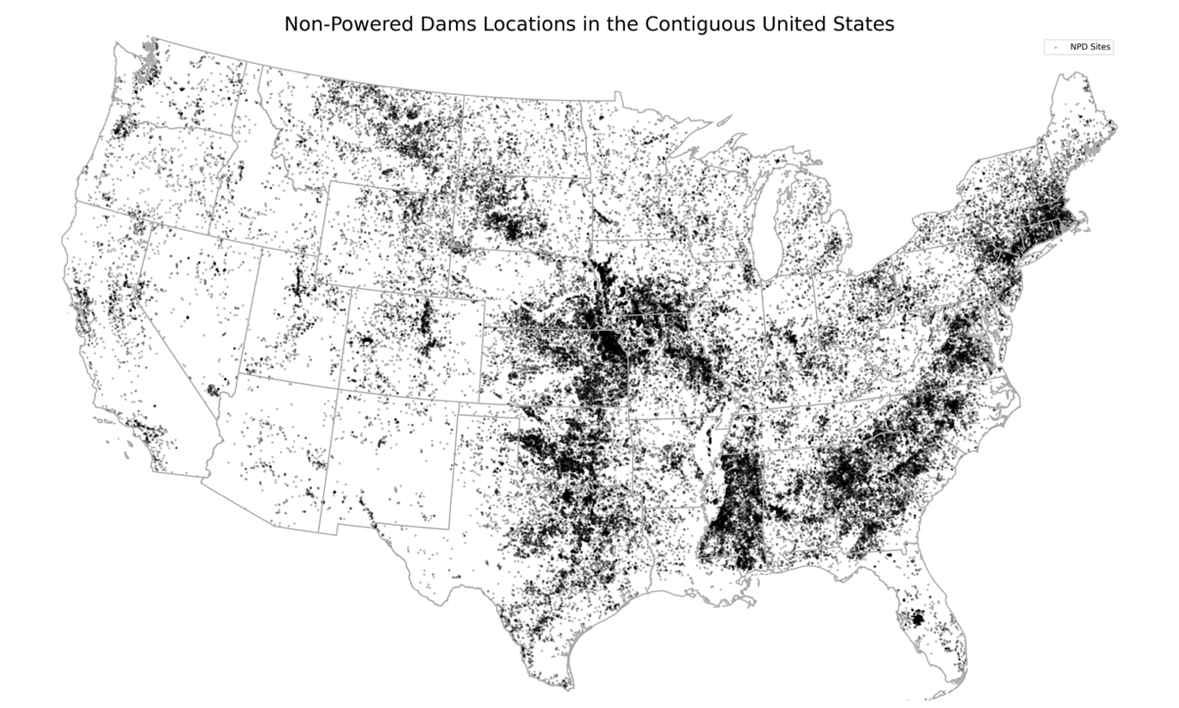
Figure 11 Heat Map of All NPD Sites Across the Continental United States.

In cases where an NPD still functions for flood control, irrigation, recreation, or other purposes, retrofitting hydropower at NPDs offers an alternative for increasing renewable energy generation with fewer environmental impacts compared to conventional hydropower because one of the most severe impacts, reduced river connectivity, has already occurred. From an environmental perspective, adding generation to a NPD provides environmental opportunities by bringing the dam under U.S. Federal Energy Regulatory Commission (FERC) regulation where environmental impacts caused by hydropower construction and operation must be mitigated. Mitigation requirements imposed by FERC change depending on site location but could include fish screens, hiking trails, boat ramps, nesting boxes for birds, and fish habitat improvements. Additionally, retrofitting NPDs can result in ecosystem restoration through recovered connectivity enabling upstream fish passage via Archimedes screw turbines (AST). From an owner-operator perspective, powering a NPD creates an additional revenue stream and power system benefits with a limited set of environmental mitigations on the table. For example, the environmental benchmark for hydropower mitigation is the condition of the surrounding environment at the time of licensing. Therefore, retrofitting an NPD almost never results in upstream fish passage mitigation requirements because impacts to connectivity existed before the hydropower was installed (Pracheil et al. 2022).
The conversion of these sites is heavily dependent on site-specific metrics such as river flow rates and variability, and additional infrastructure requirements (Oladosu, et al., 2021). However, the diversity and volume of data and publications can make it difficult to combine and develop solutions (Hansen, et al., 2021). The selection of a turbine for converting an NPD involves trade-offs between power density, capital costs, and environmental impact. For instance, turbines like the Kaplan and Francis turbine offer reduced construction impact but may have lower efficiencies (Oladosu, et al., 2021). In our analysis we consider ASTs because they are more fish friendly than alternatives and can serve to reconnect previously split aquatic ecosystems (Simmons, et al., 2021); (Weber, et al., 2002). ASTs are particularly well-suited for low-head dams between 1-10m, with their smaller dimensions contributing to lower construction costs (Dragomirescu, 2021). Moreover, their modular, low-impact designs help minimize wildlife and habitat disruptions often associated with conventional turbine installations (YoosefDoost, et al., 2020).
Here, were consider all potential NPDs locales based on their proximity to protected areas, use by boaters, and mechanical practicalities and consider environmental, economic and social factors when evaluating ASTs for NPD conversions sites. Specifically, this study 1) quantifies economic opportunity while considering precipitation trends; 2) evaluates the environmental impacts at each perspective NPD site; and 3) evaluates social impacts on surrounding communities.
This study will provide insights on the viability and potential impacts of using ASTs for converting low-head NPDs into power generators and specify how effectively an AST can be installed at identified locations and regulations surrounding NPD to powered dam conversions. Regulatory considerations include recent federal energy subsidies and local regulations. Policymakers will find the reported findings provides guidance on potential strategies and policies that can facilitate the wider adoption of ASTs for powering low-head dams.

Methods

Data Curation
The U.S. Non-Powered Dam Characteristics Inventory developed by the Oak Ridge National Lab (ORNL), includes dam identifiers, number of whitewater access points and number of daily fishing trips per year used to quantify the social impact of each NPD facility in our analysis. The National Inventory of Dams (NID) developed by the Army Corps of Engineers (USACE) contains information on dam height, location, and flow rates was used to calculate the number of mechanically feasible sites in (Hansen, et al., 2022), (Army Corp of Engineers, 2020).
Percent change of precipitation from 1901-2000 across all defined climate regions within the continental U.S. (CONUS) was obtained from the National Atmospheric and Oceanic Administration (NOAA) published precipitation trends (Environmental Protection Agency, 2024). The average percent change per year for each climate region was then calculate (Equation 1) and applied to each facilities flow rate within that region.
$$Equation 1:Annual Percipitation Change= \frac{Precipitation Change (\% per 99 years)}{99}$$
The average daily flow at each facility was obtained from the NID dataset from 1985-2014. Projected flow rates for 2024, 2037, and 2050 were determined using the average precipitation change percent per year and the known average flow rate between 1985-2014 (Equation 2). This helped determine candidate sites for NPD conversion across all three studied years: 2024, 2037, and 2050. All datasets used for our analysis are publicly available.
$$Equation 2:{Streamflow}_{year}= Current Streamflow+(Annual Percipitation Change*\left(year-2000\right))$$

Analysis

AST Site Parameters
The NID database was used to determine NPD’s that could be converted to powered facilities using an AST in the years 2024, 2037, and 2050 based on given head height and flowrates. As precipitation trends change, water availability in river reaches could vary leading to site falling below the desirable AST operating range in future years. Considering not only present but future potential of NPD conversions ensures installed infrastructure will continue to work as designed even with the impacts of changing climate.
The mechanical parameters for an AST include hydraulic height between 1m and 10m and flows between 0.1m³/s and 15m³/s with a maximum efficiency of 70% (Dragomirescu, 2021). When considering flowrate, only the minimum flow rate is an exclusive requirement because ASTs can be installed on a side stream where inflows can be controlled, whereas artificially increasing minimum flow rates is not a feasible solution. Other studies have explored enhancing efficiency by testing tilt angle, diameter, and flow rates and have find efficiencies range from 60-80% (YoosefDoost, et al., 2020); (Thakur, et al., 2022); (Rohmer, et al., 2016). Here, we holistically consider the AST as a unit and do not vary these input parameters. To ensure a balanced representative analysis, we use an efficiency of 70% which falls at the midpoint of the reported range and apply that across NPD to AST conversion sites (Equation 3).
$$Equation 3:Site Capacity= 0.7*\min\left({Streamflow}_{year},15\right)*9.8*Head Height$$
Where 0.7 is the 70% efficiency rate used across all sites, the flow rate is limited to the minimum between the stream flow for that given year and 15m³/s, the maximum an AST installation can handle, 9.8m/s/s is the acceleration due to gravity, and the head height is the total height of the fall of the water.

Cost Evaluation
To evaluate the cost of installed ASTs, a cost adjustment factor was needed for pricing across regions. The U.S. Environmental Protection Agency uses U.S. Army Corps of Engineers (USACE) published cost factors for each state when reporting cost estimates in feasibility studies. For our analysis we used the state price indices from the USACE 2022 report to estimate capital costs, operations, and maintenance costs (US Environmental Protection Agency, 2000) (US Army Corp of Engineers, 2021). These construction index values are reported in the Index Value column in Table 25.
Two case studies were used for estimating AST installation costs: one from Canyon Hydro commissioned by DOE, and the other from the Oak Ridge National Laboratory (ORNL). In Canyon Hydro’s technical report, a reference site with a power capacity of 841kW, costing and a cost of $3.4 million located in Lodi, California was cited (Canyon Hydro, 2017). An ORNL report focusing on cost analysis of power conversion options for NPDs and identifies a screw turbine as one option (Oladosu, et al., 2021). The case study for the screw turbine, located Chouteau L&D in Oklahoma, uses two turbines with a generation a capacity of 4,300 kW combined, costing $7,995/kW for capital costs and $369/kW for development costs. Together, the Lodi and Chouteau case study sites are well-defined examples that illustrate a range of generation capacities, costs, and geographic contexts for AST installations. These factors are considered representative for evaluating the applicability of AST technology across a diverse array of NPD conversion sites. Capital costs are defined as the construction and materials costs (Equation 4), whereas development costs are licenses and permits. Table 25 gives a side-by-side comparison between these two cases studies and compares them using the USACE cost index.
$$Equation 4:Capital Cost= Capacity*4,286.05*(\frac{Index Value Desired Location}{Index Value Current Location})$$
Table 25 Cost Comparison of Example AST Conversion Studies where the Index value is the cost factor applied within each state. The national average is 1.0, an index factor greater than 1.0 means the location is more expensive for construction than the national average and an Index factor below 1.0 is less expensive than the national average.
Site Name | State | $/kW (one turbine) | Index Value | Year Estimated | $(USD 2020)/kW (national conversion) *
Lodi | California | 4,042.81 | 1.23 | 2017 | 3,755.82
Chonteau L&D | Oklahoma | 3,997.5 | 0.83 | 2020 | 4,816.27
*The national conversion uses Equation 4 below to account for the index value and national average inflation rate from 2017 to 2020 (US Inflation Calculator, 2024).

Equation 4 calculates the adjusted cost from the current location to the desired location using the USACE index values and the initial cost of the location. Equation 4 does not account for inflation rates. The national average $/kW is $4286.05/kW calculated by the average of the $/kW from the above case studies and used to calculate capital costs of potential NPD conversion sites (Equation 4).
When calculating the return on investment of each NPD conversion location the operations and maintenance (O&M) costs are estimated at 4% of installed costs (IRENA, 2022). The price hydropower was sold at varies by region across five regions: Northwest (NW), Southwest (SW), Midwest (MW), Southeast (SE), and Northeast (NE). The prices for each of these regions was gathered from the DOE 2023 Hydropower Market Report; the median prices of energy were used and can be found listed by region in Table 26. (U.S. Department of Energy, 2023).
Additionally, the relative closeness to other grid infrastructure is important can impact costs and is reported as distance to nearest substation in our analysis (U.S. Department of Homeland Security, 2023). While infrastructure is not directly incorporated into our economic calculations of NPD conversions with ASTs, population density, which is considered in the social impact analysis, can serve as an approximation of grid infrastructure in each area. The assumption being a larger population means more grid infrastructure and less expensive integration of new power generation however there can also be larger congestion within these areas which needs to be accounted for as well.
The calculation of return on investment (ROI) is also included in our cost analysis (Equation 5).
Table 26 Median Hydropower Observed Energy Prices from 2006 to 2020
Region | $/MWh
Midwest | 46.97
Northeast | 61.36
Northwest | 54.67
Southeast | 58.43
Southwest | 47.83

This calculation considers the cost of installation in the given year, the estimated kW capacity of the facility and the cost of hydropower within each region (Table 26).
$$Equation 5:ROI= \frac{Cost to build (yr)}{(8,760 (\frac{hrs}{yr})*Capacity \left(kW\right)*Hydropower Regional cost (\frac{\$}{kWh})}$$

Environmental Evaluation
Several factors at potential NPDs, including wildlife and permitting restrictions, could complicate or preclude deployment of ASTs for hydroelectric generation (Army Corp of Engineers, 2020). While ASTs are considered a more fish-friendly alternative to other turbine types, relative closeness to protected areas (areas designated and managed for the purpose of maintaining biological diversity, recreation, historical, and cultural significance (U.S. Geological Survey, 2021). One metric for environmental evaluation is quantifying the presence of sensitive species, including inland/oceanic sturgeon, paddlefish, clupeid, salmonoid, eel, and lamprey, which could trigger fish passage requirements or tighter operating constraints on flow regimes at hydropower facilities. The biodiversity protections surrounding the dam also weigh heavily, as installations proposed for sites situated on public park or wildlife sanctuaries would likely face prohibition or strict regulation limiting construction and operating conditions. Biodiversity designations of the site include five options: “Dam is not on protected land”, “Disturbance events may occur”, “Disturbance events suppressed”, “Managed for multiple uses- subject to extractive or off-highway vehicle use”, and “No biodiversity protection”. The designation of “No biodiversity protection” is the least restrictive whereas, “disturbance events” considers whether management of natural disturbances is allowed (U.S. Geological Survey, 2021). Our environmental assessment considers the status of each mechanically viable NPD site. Sites with above listed fish species will still be considered as feasible for conversion but each fish species will be listed with its associated NPD facility.
Dams with restrictions or protected fish species present are not precluded from an NPD conversion but should be the subject of future studies including a site-specific review. This screening approach categorizes candidate sites based on readily accessible indicators of likely wildlife effects and permitting/construction constraints. Sites showing no signs of elevated sensitivity can proceed more directly to AST development pathways, while others need further evaluation clarifying feasibility and conditions for responsible installation in future work. This method provides an efficient structure matching information need and analytical to the potential NPD to power production conversions.

Social Impact Evaluation
To evaluate potential community effects of adding ASTs to NPDs for hydroelectric generation, we examined local population density, daily fishing trips per year, and whitewater access points from the NID dataset (Army Corp of Engineers, 2020). Only data reported from the NID data set were used and not projected into the future. Local population density, measured by the total residents with the hydrologic unit code (HUC) 12 watershed, signifies the approximate size of the community situated adjacent to the candidate facility. Daily fishing trips per year and whitewater access points are considered recreational usage metrics and quantify disruption to recreation and tourism economies reliant on preservation of aquatic environments and water flows surrounding dams slated for retrofitting.
Together these indicators characterize the scale of communities and their dependence on amenities potentially impacted by repurposing NPDs. Decisions whether to move forward or not with implementing an AST at one of these sites can be in part be evaluated as the number of residents served, the revenue streams from fishing and rafting, and whether alternative nearby sites incur fewer social trade-offs. Outreach around AST proposals can also be customized based on population and recreational affiliations.
While not encapsulating all recreational and tourism intricacies, screening sites using publicly available population and recreation data enables contextualization of AST decision processes with visibility into lifestyle and economic activities linked to local dams. By targeting installations projected to require less community disruption, the methodology provides a filter for identifying socially viable NPD conversions candidates.

Results
We identified an initial 89,274 NPDs across the contiguous U.S. that currently do not have hydroelectric generation capabilities. After applying mechanical restrictions of hydraulic height and flow rates, the data set was reduced to 2,783 NPDs in 2024. We considered NPD sites in the 48 continuous U.S. states when considering sites viable for AST conversion.

Precipitation Trends Impact
We assessed the potential of each NPD site (89,274) to meet future AST minimum discharge requirements in 2024, 2037, and 2050 based on changing precipitation trends. In 2024 2,783 NPDs. This number decreased to 2,777 NPDs in 2037, and the again decreased to 2,773 NPDs in 2050 (Table 27 and Figure 12). This trend reflects the anticipated changing hydrologic patterns, which influence water flow availability and in turn conversion viability.

Capacity and Costs
The average potential hydropower capacity per NPD was 45.97kW in 2024, 61.02kW in 2037, and 76.01kW in 2050 (Table 27). The average cost of installation was $200,353.27 in 2024, $265,768.09 in 2037, and $330,930.46 in 2050 (Table 27). The mean national ROI was 9.44 years respectively across all three studied years (Table 27). The unchanged ROI across all the years is likely from the increase in the simultaneous increase in build cost and capacity as seen in the ROI calculation (Equation 5). These values were also evaluated on a state-by-state level and Table 28 shows the five states with the most AST convertible NPDs located in them. Figure 13 shows the gradient of installation costs by year and the ROI for 2024.
The proximity to substations was considered as an indicator for the ease of integration into the grid for each site. The proximity is not factored into the cost estimation metrics. Figure 14 below shows a heat map of how close each NPD is to a substation on a gradient and Table 29 gives the median and mean distance for the five states with the lowest median distance to a substation.

Ecological and Social Impacts
The analysis identified all potential NPD sites with mechanical viability for ASTs as having at least one protected species existing at that location (Table 30), This means all sites potentially require special considerations for NPD conversion due to the impact on sensitive ecological areas. The analysis of fish species revealed the presence of multiple species varied across potential NPD conversion sites (Table 30 and Figure 15).

Table 27 Viable NPDs for AST conversion and their associated mean capacity, mean cost of installation, mean ROI, and mean $/kW
Year | NPDs | Mean Capacity (kW) | Mean National Cost (USD) | Mean National ROI (yrs)
2024 | 2,783 | 45.97 | 200,353.27 | 9.44
2037 | 2,777 | 61.02 | 265,768.09 | 9.44
2050 | 2,773 | 76.01 | 330,930.46 | 9.44

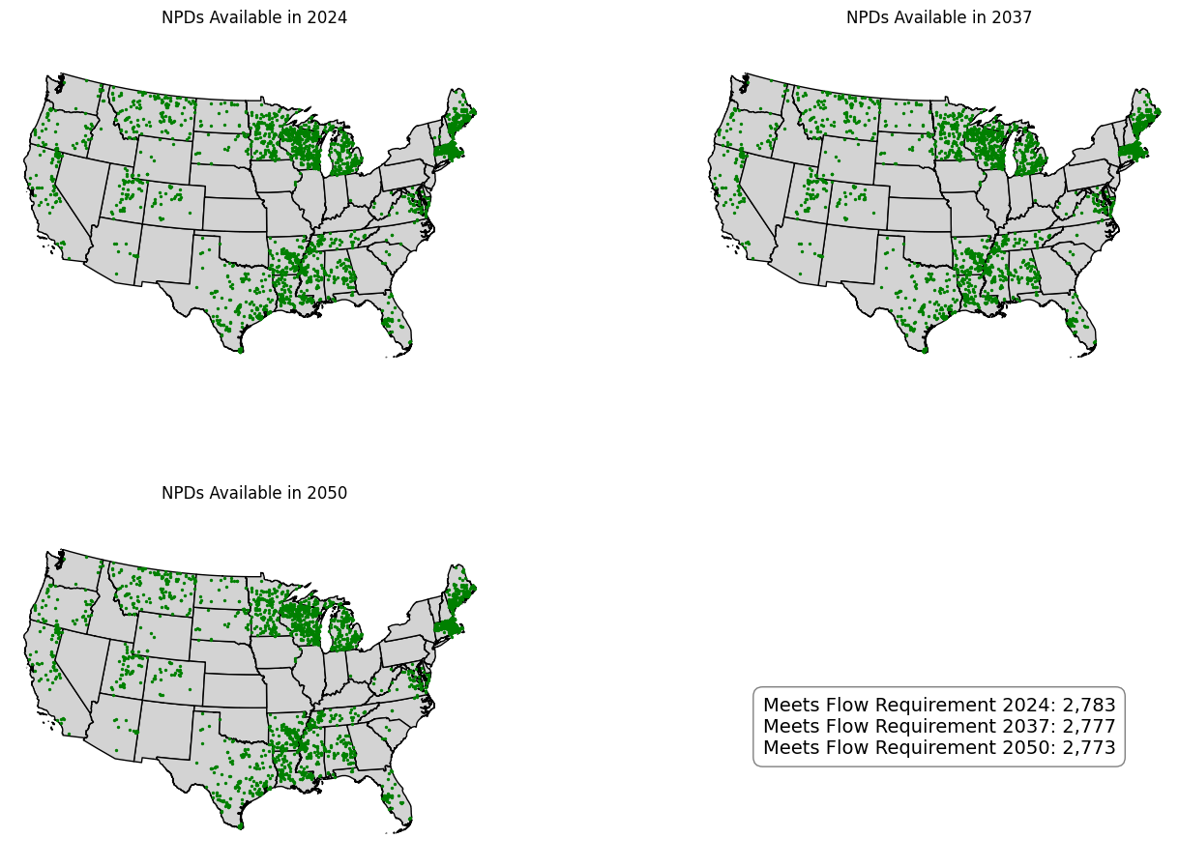
Figure 12 Viable NPDs for AST conversions across the United States with the associated year.

Table 28 Top five states with the most viable NPDs for AST conversion showing number of NPDS, mean capacity in 2024, mean total installation cost, mean ROI, and mean $/kW for each state.
State | # NPDS | Mean Capacity 2024 (kW) | Mean Cost (USD) | Mean ROI (USD) | Mean $/kW
Massachusetts | 471 | 48.8 | $ 259,351.31 | 9.89 | $ 5,314.70
Wisconsin | 405 | 27.87 | $ 136,171.11 | 11.88 | $ 4,886.10
Michigan | 217 | 56.22 | $ 238,555.20 | 10.31 | $ 4,243.19
Texas | 189 | 58.36 | $ 220,115.56 | 7.37 | $ 3,771.72
Maine | 169 | 67.22 | $ 285,244.19 | 7.89 | $ 4,243.19
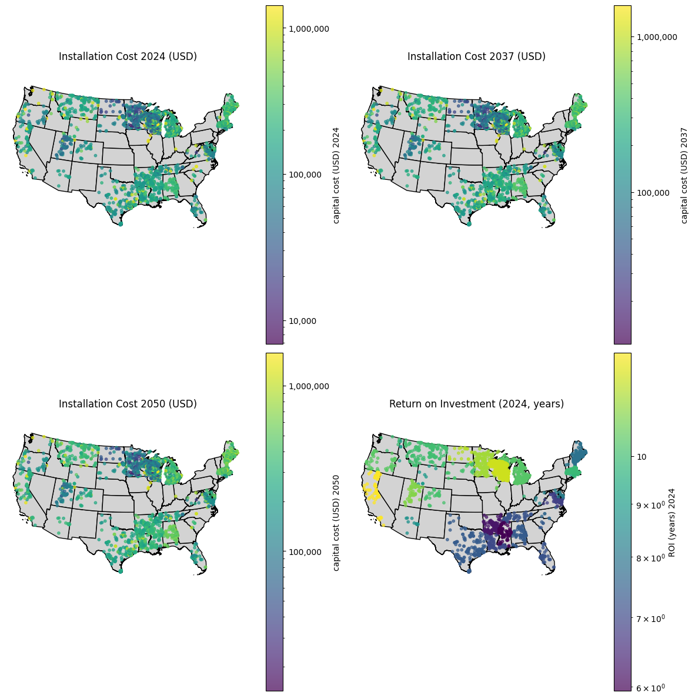
Figure 13 Installation costs for viable NPD conversions with ASTs across the continuous United States, and the ROI within the continuous United States.

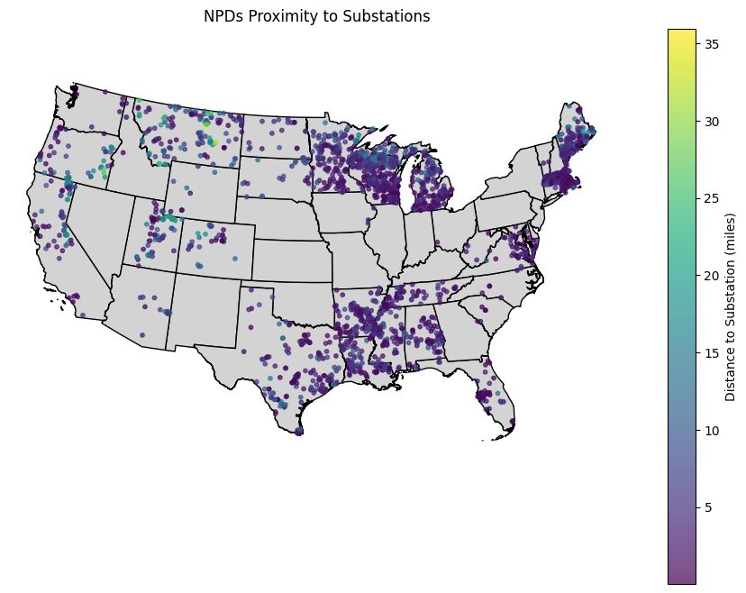
Figure 14 Distance to Substation for viable NPD conversions within the continuous United States in 2024.

Table 29 Five states within the continuous United States with the lowest median distance to a substation showing the median distance and mean distance for each state.
State | Median Distance (miles) | Mean Distance (miles)
South Carolina | 0.53 | 0.53
Ohio | 0.82 | 0.82
Washington | 1.18 | 2.05
Florida | 1.28 | 1.98
North Carolina | 1.38 | 1.69

Table 30 Species and the number of NPDs viable for AST conversion in 2024 they exist at.
Species | NPD Count
Sturgeon species | 677
Inland sturgeon/paddlefish species | 887
Ocean clupeid species | 811
Ocean eel/lamprey species | 1913
Ocean salmonid species | 404
Inland salmonid species | 2006
Other inland species | 1546
No Fish Recorded | 929

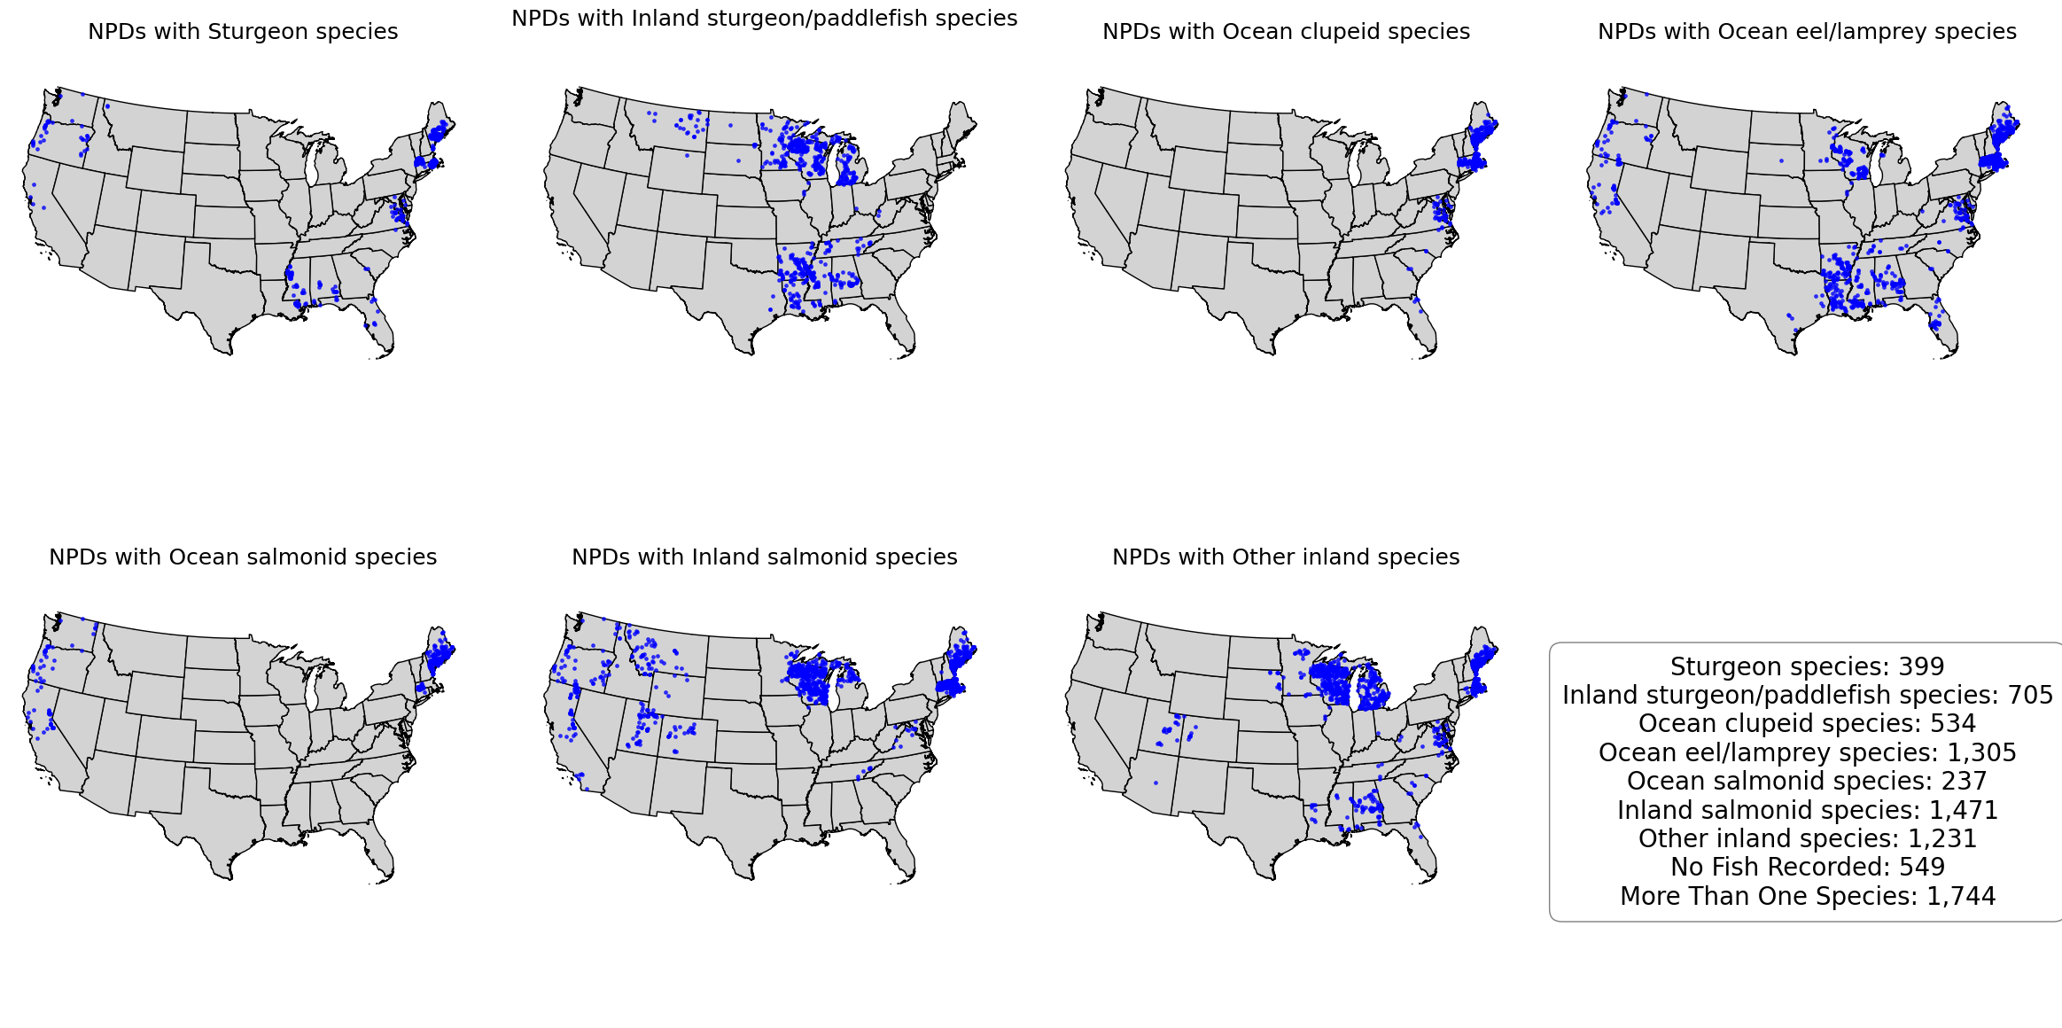
Figure 15 Viable NPD sites for AST conversions in 2024 with maps showing the sites with specific species present
There was one land designations considered for this analysis, Biodiversity land status, and is evaluated on a year-by-year basis, across all studied years, most of the NPD sites are not located on protected land (Table 31). The next most common land designation in the biodiversity land is the “Managed for multiple uses – subject to extractive of OHV use” designation with 97 sites across all years holding that designation.
In addition to ecological impacts, the social benefits and impacts of these NPD conversions were assessed. The median number of daily fishing trips across all viable NPD sites in 2024 was 7,829, while the average number of whitewater paddling sites was 0.43. Figure 16 shows the population density by size and color of the circles representing NPDs, and a heat map for number of daily fishing trips per year and number of whitewater access points for viable NPD sites in 2024.

Discussion
Previous studies of NPD conversion focused on comparison of turbine types for use during conversions and consider the economic or environmental reasons to pursue each (Oladosu, et al., 2021). Conversely, our study considered only AST turbines for NPD conversion enabling us to consider a wider range of factors that could impact decisions to install a turbine at an NPD site: future hydrological conditions, aquatic species impacts, mechanical feasibility, economics, and social impacts. Our analysis indicated significant potential for converting existing NPDs across the contiguous U.S, into hydroelectric facilities using AST systems. After filtering over 80,000 NPDs based on mechanical constraints, we identified over 2,500 dams that could feasibly support AST conversions. This approach provides a wholistic framework that can be applied beyond AST compatible sites, when considering other NPD conversion technologies.

Table 31 Biodiversity land status of viable NPD conversion sites using AST technology, across the three studied years: 2024, 2037, and 2050.
Biodiversity Land Status | 2024 | 2037 | 2050
Dam is not on protected land | 2648 | 2643 | 2639
Managed for multiple uses - subject to extractive or OHV use | 97 | 97 | 97
Disturbance events may occur | 25 | 25 | 25
Disturbance events suppressed | 11 | 11 | 11
No biodiversity protection | 2 | 1 | 1
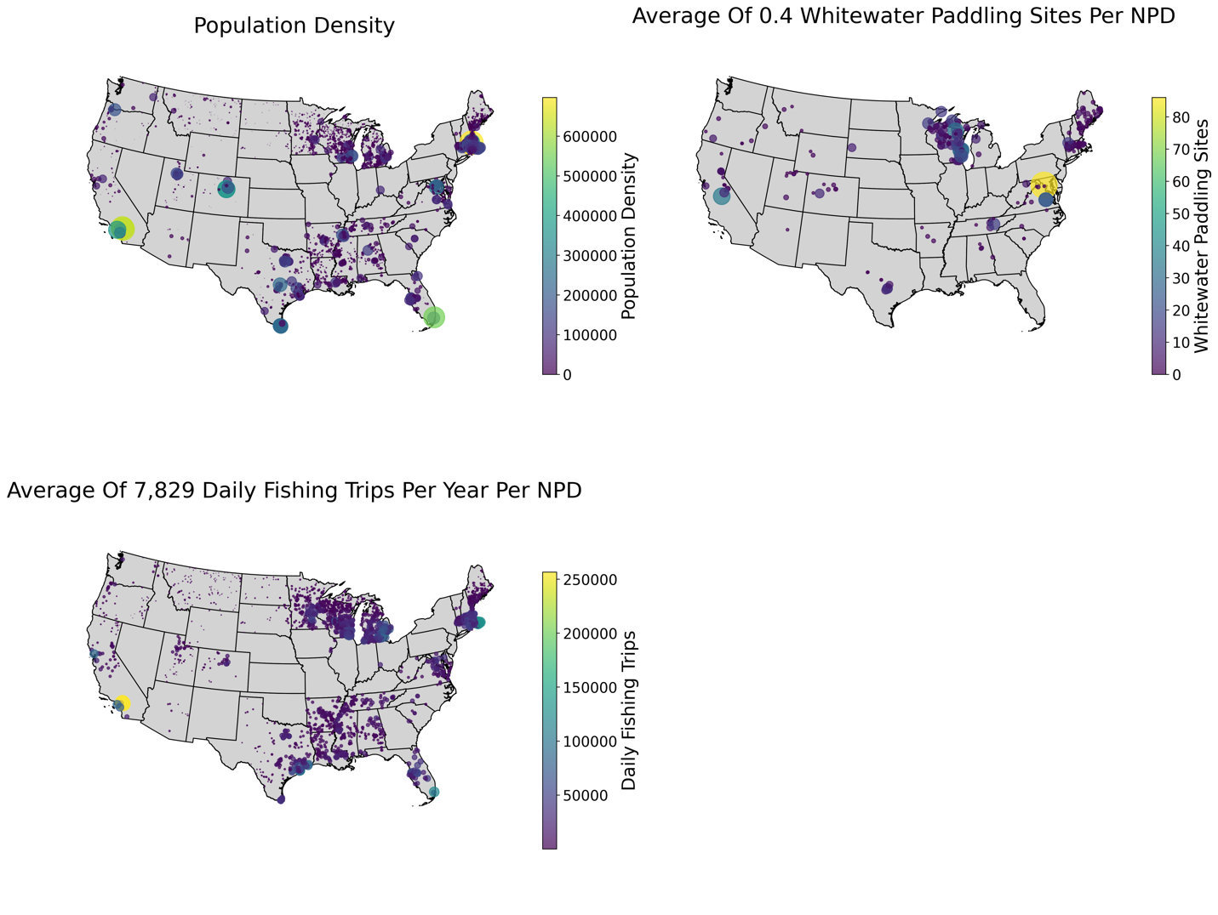
Figure 16 Three map figure showing viable NPD conversion sites using ASTs and their population density by size and color, density of whitewater paddling sites, and density of daily fishing trips per year.

Underscoring the necessity to account for multiple conditions when considering NPD conversions informs sustainable policy decisions.

Climate impacts on NPDs conversions
Conventional hydropower is a site-specific energy generation source because it must be developed on a river where favorable conditions are met. Our precipitation projections account for regional hydrological changes in years 2024, 2037, and 2050, ensuring selected potential NPDs sites remain viable under future climate conditions. While these changing precipitation patterns reduce the number of quality sites over time, the potential generation capacity increases, reaching 210MW across 2,773 sites in 2050. This represents a 165% increase from the 2024 generation capacity of 127MW across 2,783 sites. This phenomenon of fewer feasible sites but greater generation output arises from the remaining sites experiencing substantial increases in precipitation, which significantly boosts their generation capacity and offsets the loss of other sites. Since this type of hydropower generation is confined to rivers, the reduction in viable locations indicates that climate change is narrowing the geographic range where hydropower generation remains feasible. Highlighting this shirking availability of viable hydropower locations is crucial, as future research could investigate expanding transmission infrastructure to ensure efficient electricity transfer from high-output hubs to areas with lower production. Future work could use climate models in place of historical trends to predict precipitation changes under a gradient of model scenarios and would provide additional information on different climate scenarios.

Economics
Analyzing the regional data reveals significant variations in capacity, cost, and ROI for the potential NPD conversion sites. Specifically, considering the five states with the most NPD sites viable for conversions with ASTs (Table 28), Wisconsin has the smallest average capacity among the studied regions and the highest average ROI at 11.88 years. Conversely, Texas has the lowest average ROI at 7.37 years despite not having the largest average capacity. This implies factors beyond capacity and economies of scale, contribute to driving average ROI of NPD conversions with ASTs. Texas also has the lowest $/kW construction cost of any of these top five states with the most NPD conversion sites suggesting cost of construction per kW and capacity could both be contributing to ROI.
A regional pattern in the Midwest emerges when visually considering Figure 13. States in the Midwest, including Minnesota, North Dakota, and South Dakota have lower installation costs than other areas of the country. These states are often characterized as having colder climates, and ice freezing on rivers could severely impact flow rates and seasonal operations that are not considered in this analysis. Future work considering, coordination of changing river ice freeze-thaw cycles and the impacts on small hydropower generation by season.
The findings emphasize the need for region-specific strategies in hydropower development and installation cost considerations alongside capacity generation potential because as we observed the states with the largest average generation do not always have the lowest average ROI. Additionally, other climate change factors such as river ice impacts could hold implications for viability of NPD sites considered in this analysis. Future research on the economics of NPD conversions with ASTs could investigate regulatory frameworks, ice formation, and climate changes impacts on seasonal operations to gain further knowledge of state and region-specific development considerations.

Social implications of NPD conversions with ASTs
The social impact analysis considered impacts to local populations by quantifying the number of daily fishing trips per year, and number of whitewater access sites near each potential NPD site, offering a lens into the recreational value and usage patterns associated with these locations. The average of 0.43 whitewater access points and 7,289 annual fishing tips per viable NPD conversion site in 2024 highlights the intensity of recreational engagement and the diversity of how communities interact with these natural resources. Consideration of the impact NPD development could have on recreation is crucial to the projects public acceptance and can weigh heavily on if the project is approved for construction (Mussehl, et al., 2021); (Harwood, et al., 2018). Sites with higher levels of recreational use might face strong public resistance to development due to perceived threats to cherished activities or economic benefits from outdoor recreation. Conversely, sites with little less recreation activities may present a better opportunity for development because of the minimal disruption and greater public acceptance.
When comparing the maps in Figure 16, there appears to be a stronger correlation between areas of high population density and the frequency of daily fishing trips compared to whitewater access points. Notable population centers such as southern Florida, southern California, and the New England area near Maryland exhibit this pattern. These observations support the notion that daily fishing trips are a broadly accessible activity requiring only a water source, where as whitewater rafting is inherently more site-specific, limited to locations with suitable river conditions. Future research could include identifying specific types of fish being targeted by fishing in the area and assess the impact installation of an AST would have on those populations. This could provide further understanding of ecological, economic, and recreational impacts on an NPD conversion.
Dam removal is another factor to consider when assessing NPD conversion sites and has gained popularity with 76% of dam removals occurring since 1999 (American Rivers Connect Us, 2022). Reconnecting ecosystems by removing dams supports the recovery of native species that declined after dam construction (Duda, et al., 2021). Beyond ecological restoration, such dam removal efforts carry social implications. Removing obsolete dams can advance environmental justice by restoring Native American and indigenous communities, who experiences disproportionate harm from disrupted cultural practices, loss of fisheries, and limited water access (Fox, et al., 2022). Future work should consider NPD removal as a viable alternative to AST conversion by weighing ecological, and social implications of each option.
Given the dynamics of analyzed recreational, social, and population density, our analysis suggests strategically siting NPD conversions with ASTs can leverage proximity to population centers as an indicator of recreational fishing demand, should consider each site’s cultural significant, and impact on recreational activities. This approach aligns with the broader goal of working to ensure projects are both socially and environmentally sustainable. Future work could additionally, prioritize sites in low-income communities, where residents often allocate up to 30% of their income to energy costs (U.S. DOE), to address historic energy injustices by providing localized, affordable energy generation. By integrating considerations of both recreational impacts this approach aligns with broader efforts to maximize recreational benefits while considering mechanical feasibility challenges posed by climate change.

Environmental implications of NPD conversions With ASTs
When considering sensitive wildlife habitats and preservation of protected lands, ASTs are more fish friendly than other turbine types, however, their suitability varies depending on the fish size. For smaller fish species, ASTs could facilitate safe passage in previously severed river reaches, but larger species might face the challenge of not fitting between screw blades which could complicate permitting processes and increase project timelines (Pracheil, et al., 2022). Archimedes screw turbines can be designed for their specific location by adjusting distance between the screw blades, and rotational speed. This suggests screws can be fit to allow passage of fish of varying sizes, however one study found no correlation between fish size and mortality rates (Pauwels, et al., 2020). The potential for fish strikes and injury from using AST exist but is generally less than other technologies and fish passage studies are likely to be required in permitting and licensing of hydropower NPD conversion sites.
When considering the biodiversity land status across all years and potential NPD conversion sites, 95% of sites are not on protected land across all years. The designation of protected vs non-protected land can indicate challenges a development may face at each site. These designations are from the protected areas data base of the U.S. which considers biological diversity, natural, cultural, recreation, and historical significance when giving an area a designation. A disturbance is something causing a change to the local ecology or ecosystem and was found to be allowed in 25 sites across all years and suppressed in 11 sites (Code of Federal Regulations). This is important to note when considering conversion sites because suppressed disturbance events could mean no retrofitting of NPDs can occur at this location. Future work could consider these designations closer and incorporated other designations like impairments. Impairment designations for connected water bodies introduce further scrutiny; assessment of factors spurring degraded conditions like nutrient loading, sedimentation, or thermal pollution could inform required impact prevention measures.
The presence of protected fish species and protected land status underscores the need for early engagement of involved parties for ecological assessments, mitigation of risks, and ensuring compliance with environmental regulations. Early engagement with parties involved also has been shown to increase public and political acceptance of the project (Mussehl, et al., 2021). Additionally, adding generation to these locations may bring them under FERC jurisdiction which may include the need of fish passage and additional assessments including an environmental impact assessment. While hydropower is often thought as not fish-friendly there are potential benefits from additional FERC oversite at converted sites. These benefits could include increased environmental monitoring and may lead to the installation of fish passage at previously severed river sections. This analysis considers both fish species presence and protected land status, but future research could conduct a trade-off analysis between impacts of FERC jurisdiction, dam removal, and taking no action.

Comparison To Other Turbines
Development of small hydropower systems, such as those using ASTs, has several benefits over solar and wind such as higher efficiency and more consistent power supply (Uhunmwangho, et al., 2009). Additionally, small hydropower projects, those below 10,000 kW in size, can apply for certain waivers of licensing requirements (113th Congress, 2013). While ASTs are often considered novel turbines as compared to other types such as Kaplan and Francis turbines, which allow for higher efficiencies (up to 95%) and are widely used, ASTs excel in their environmental compatibility, particularly concerning fish passage (Kougias, et al., 2019).
ASTs often receive a higher fish-friendly ranking, with studies showing higher survival rates for species like juvenile salmon and eels compared to Kaplan turbines (Piper, et al., 2018) (Lubitz, et al., 2013) (U.S. Department of Energy, 2012). Specific studies considering the use of ASTs as a mode of fish passage found less than 1% of fish had effects from using this mode of passage (McNabb, et al., 2001). However, the trade-off of using an AST is its reduced ability to operate under conditions beyond low-flow and low-head conditions, which can limit its energy generation capacity compared to other turbines (Dragomirescu, 2021). Additionally, the existing infrastructure and global expertise available for installing Kaplan and Francis turbines make them more accessible in certain contexts (Sari, et al., 2018) (Kougias, et al., 2019).
Ultimately, each turbine technology has tradeoffs to consider. ASTs clearly offer environmental benefits, while Kaplan and Francis turbines enable greater energy conversion efficiencies and their potential power output. Additionally, more existing infrastructure and expertise are available for installing the mainstream Kaplan and Francis turbines globally. Understanding each sites conditions and regulations is paramount in determining the correct conversion type.

Broader Impacts
This study demonstrated AST systems can match well with existing dam infrastructure across an array of locations to unlock flexible, low-impact hydropower. The layering of precipitation forecasting provides added confidence in long-term generation potential amidst climate shifts (EPA, 2022) (EPA). Future efforts could implement similar layered filtering techniques at state and utility, levels, incorporating factors such as drought tolerance, seasonal flow fluctuations, and flood control to prioritize sites capable of consistent power generation.
However, it is important to acknowledge the limitations inherent in this high-level resource assessment. Site-specific ecological details that can significantly impact project feasibility, especially for original licenses, should be specifically denoted in future work by focusing on sites with no endangered species, fish passage requirements, and ultimately low environmental complexity. While this study considers presence of endangered fish species, and presence of protected lands, future work could also account for terrestrial endangered species impacts and if AST technology is suitable for fish passage at each site.
Additional considerations related to tribal and culturally significant lands introduce an additional layer of considerations for NPD conversions. Non-powered dams located on tribal lands are subject to tribal regulations, which may be different from federal or state processes, as tribes are sovereign nations. Many areas of cultural importance are confidential to prevent desecration, and cultural importance is often difficult to discern on a map. For many tribes, natural resources such as fish, animals, plants, and water hold significance placing the need for additional NPD conversion considerations.
Like tribal lands, dams located within National Parks or Forest Service land, where jurisdictional complexities could pose additional regulatory considerations, highlight the need for future studies to incorporate all involved parties to ensure the project considers environmental and cultural impacts on the same level as technical practicalities. These considerations have been central to the FERC decision in recent years and are equally relevant for AST projects.

Chapter 5 Conclusion
This study provides a layered and quantitative methodology for evaluating low-head, NPD sites across the CONUS for conversion to power production through installation of ASTs. Integrating publicly available environmental, social, and engineering data initially across all NPDs limits the mechanically possible facilities to over 2,500 sites in 2024. The analysis reveals potential to expand renewable energy production through responsible retrofitting of existing dam infrastructure.
Careful site prioritization and selection allows avoidance of most sensitive ecological regions and habitats. Similarly, focusing on lower-profile locations limits community impacts to electricity rates or recreational access. With precipitation modeling decreasing the number of available sites only marginally as projected to 2050, ASTs align well with local dam contexts and changing regional climates to maximize renewable generation.
This research meets a critical need for responsible strategies to transition aging infrastructure into distributed, low-impact clean energy resources. Frameworks and findings contribute to policy, planning and project decisions that could shape sustainable electricity production for local communities and on a national scale. NPD conversions utilizing AST installations are shown to be achievable and supplying another generation asset for a decarbonized grid.

Works Cited
113th Congress H.R.267 - Hydropower Regulatory Efficiency Act of 2013 [Online]. - 08 09, 2013. - 01 2024. - https://www.congress.gov/bill/113th-congress/house-bill/267#:~:text=Hydropower%20Regulatory%20Efficiency%20Act%20of%202013%20%2D%20(Sec.,exempt%20from%20its%20license%20requirements..
American Rivers Connect Us Free Rivers The State of Dam Removal In the United States [Report]. - [s.l.] : American Rivers Connect Us, 2022.
Army Corp of Engineers National Inventory of Dams [Online] // National Inventory of Dams. - 2020. - https://nid.sec.usace.army.mil/#/.
Boyé Henri and de Vivo Michel The environmental and social acceptability of dams [Journal] // Field Actions Science Reports. - 2016.
Canyon Hydro Optimization of Archimedes Screw for Use in Hydroelectric Projects [Report]. - Deming, WA : Canyon Hydro, 2017.
Code of Federal Regulations Definitions [Online] // Code of Federal Regulations. - 2024. - https://www.ecfr.gov/current/title-36/chapter-II/part-219/subpart-A/section-219.19.
Dragomirescu Andrei Design considerations fo an Archimedan screw hydro turbine [Journal] // Earth and Environmental Science. - [s.l.] : IOP Conference Series: Earth and Environmental Science, 2021. - p. 664.
Duda Jeffery J [et al.] Reconnecting the Elwha River: Spatial Patterns of Fish Response to Dam Removal [Journal] // Frontiers in Ecology and Evolution. - 2021.
EIA Hydropower explained [Online]. - April 20, 2023. - 2023. - https://www.eia.gov/energyexplained/hydropower/.
Environmental Protection Agency National Time Series [Online]. - January 2024. - January 2024. - https://www.ncei.noaa.gov/access/monitoring/climate-at-a-glance/national/time-series.
EPA Climate Change Indicators: U.S. and Global Precipitation [Online] // Climate Change Indicators: U.S. and Global Precipitation | US EPA. - 2022. - https://www.epa.gov/climate-indicators/climate-change-indicators-us-and-global-precipitation.
EPA Watershed Assessment, Tracking and Environemntal Results System [Report]. - [s.l.] : EPA.
Fox Coleen A [et al.] Native American Tribes and Dam Removal: Restoring the Ottaway, Penobscot and Elwha Rivers [Report]. - [s.l.] : Water Alternatives, 2022.
Hansen Carly [et al.] Hydropower development potential at non-powered dams: Data needs and research gaps [Journal] // Renewable and Sustainable Energy Reviews. - 2021.
Hansen Carly H [et al.] U.S. Non-Powered Dam Characteristics Inventory [Report]. - Oak Ridge, TN : Oak Ridge National Lab, 2022.
Harwood Andrew J [et al.] Critical Factors for Water Policy to Enable Effective Environmental Flow Implementation [Journal]. - [s.l.] : Frontiers , 2018.
Idaho National Lab Non-powered dams offer opportunity for clean energy [Online]. - October 25, 2023. - August 7, 2024. - https://inl.gov/feature-story/non-powered-dams-offer-opportunity-for-clean-energy/#:~:text=Most%20are%20used%20for%20flood,%2C%20navigation%2C%20recreation%20and%20irrigation..
IRENA The changing role of hydropower: Challenges and opportunities [Report]. - Abu Dhabi : International Renewable Energy Agency, 2023.
IRENA Global landscape of renewable energy finance [Report]. - Abu Dhabi : International Renewable Energy Agency, 2023.
IRENA Renewable Power Generation Costs in 2022 [Report]. - Abu Dhabi : International Renewable Energy Agency, 2022.
Kougias Ioannis [et al.] Analysis of emerging technologies in the hydropower sector [Journal] // Renewable and Sustainable Energy Reviews. - 2019.
Lubitz William and Lyons Murray Archimedes Screws for Microhydro Power Generation [Conference] // ASME 2013 7th International Conference on Energy Sustainability & 11th Fuel Cell Science, Engineering and Technology Conference. - Minneapolis, MN : ESFuelCell 2013, 2013.
McNabb C D, Liston C R and Borthwick S M Passage of Juvenile Chinook Salmon and other Fish Species through Archimedes Lifts and a Hidrostal Pump at Red Bluff, California [Journal] // Transactions of the American Fisheries Society . - 2001. - pp. 326-334.
Mussehl Meghan L [et al.] Purposeful Stakeholder Engagement for Improved Environmental Flow Outcomes [Journal] // Frontiers in Environmental Science. - 2021.
Oladosu Gbadebo, George Lindsay and Wells Jeremy 2020 Cost Analysis fo Hydropower Options at Non-Powered Dams [Report]. - Oak Ridge, TN : Oak Ridge National Lab, 2021.
Pauwels Ine S [et al.] settingsOrder Article Reprints Open AccessArticle Multi-Species Assessment of Injury, Mortality, and Physical Conditions during Downstream Passage through a Large Archimedes Hydrodynamic Screw (Albert Canal, Belgium) [Journal]. - [s.l.] : Sustainabiliity, 2020.
Piper Adam T [et al.] The impact of an Archimedes screw hydropower turbine on fish 2 migration in a lowland river [Journal] // Ecological Engineering. - 2018.
Pracheil Brenda M [et al.] Influence of project characteristics, regulatory pathways, and environmental complexity on hydropower licensing timelines in the US [Journal] // Energy Policy. - 2022.
Rohmer Julien [et al.] Modeling and experimental results of an Archimedes screw turbine [Journal]. - [s.l.] : Renewable Energy, 2016. - Vol. 94.
Safari Amir [et al.] Natural gas: A transition fuel for sustainable energy system transformation? [Journal] // Energy Science & Engineering. - 2019.
Sari Mutiara Ayu [et al.] Recent innovations and trends in in-conduit hydropower technologies and their applications in water distribution systems [Journal] // Journal of Environmental Management. - 2018. - pp. 416-428.
Schmutz Stefan and Moog Otto Chapter 6 Dams: Ecological Impacts and Management [Book Section] // Riverine Ecosystem Management / book auth. Schmutz Stefan and Sendzimir Jan. - Amsterdam : SpringerOpen, 2018.
Simmons Scott Christopher and Lubitz William David Archimedes screw generators for sustainable micro-hydropower production [Journal] // International Journal of Energy Research. - 2021.
Thakur Neeraj Kumar [et al.] Efficiency enhancement in Archimedes screw turbine by varying different input parameters – An experimental study [Journal] // Materials Today. - 2022. - pp. 1161-1167.
U.S. Department of Energy An Assessment of Energy Potential at Non-Powered Dams in the United States [Report]. - Oak Ridge, TN : Wind and Water Power Program, 2012.
U.S. Department of Energy Power Market Report (2023 Edition) [Report]. - Springfield : US Department of Energy, 2023.
U.S. Department of Energy U.S. Hydropower Market Report [Report]. - Oak Ridge : Oak Ridge National Lab, 2023.
U.S. Department of Homeland Security Homeland Infrastrucutre Foundation-Level Data (HIFLD) [Report]. - [s.l.] : U.S. Department of Homeland Security, 2023.
U.S. DOE Energy Justice Dashboard [Online]. - 2024. - https://www.energy.gov/justice/energy-justice-dashboard-beta.
U.S. EIA Electric generators' roles vary due to daily and seasonal variation in demand [Online]. - Junue 8, 2011. - October 28, 2024. - https://www.eia.gov/todayinenergy/detail.php?id=1710.
U.S. GAO Electricity: Information on Peak Demand Power Plants [Online]. - May 21, 2024. - October 28, 2024. - https://www.gao.gov/products/gao-24-106145#:~:text=Natural%20gas%20fuels%20most%20of,but%20have%20higher%20emission%20rates..
U.S. Geological Survey Protected Areas Database of the United States (PAD-US) 2.1 [Report] : Submission. - [s.l.] : World Database on Protected Areas (WDPA), 2021.
Uhunmwangho R and Okedu E K Small Hydropower for Sustainable Development. [Journal] // The Pacific Journal of Science and Technology. - 2009.
US Army Corp of Engineers Area Cost Factors [Online]. - May 21, 2021. - January 2024. - https://www.usace.army.mil/Cost-Engineering/Area-Cost-Factors/.
US Army Corps of Engineers Gand Coulee Dam [Online]. - August 7, 2023. - August 7, 2024. - https://www.nwd.usace.army.mil/Fact-Sheets/Article/3485377/grand-coulee-dam/.
US Environmental Protection Agency A Guide to Developing and Documenting Cost Estimates During the Feasibility Study [Report]. - [s.l.] : US Environmental Protection Agency, 2000.
US Inflation Calculator Current US Inflation Rates: 2000-2024 [Online]. - January 11, 2024. - January 15, 2024. - https://www.usinflationcalculator.com/inflation/current-inflation-rates/.
Weber Edward D and Borthwick Sandra M Plasma Cortisol Stress Response of Juvenile Chinook Salmon to Passage through Archimedes Lifts and a Hidrostal Pump [Journal] // North American Journal of Fisheries Management. - 2002. - pp. 385-702.
YoosefDoost Arash and Lubitz William David Archimedes Screw Turbines: A Sustainable Development Solution for Green and Renewable Energy Generation—A Review of Potential and Design Procedures [Journal] // Sustainability. - 2020. - pp. 12-18.

Chapter 5: Conclusion

Introduction
There has been an increase in solar and wind generation to replace carbon-emitting fossil fuel sources in the U.S. energy grid. However, integrating these variable renewable energy (VRE) sources causes increased variability in energy supply, requiring flexible sources, like hydropower, to stabilize the grid. This dissertation explored hydropower’s role in balancing environmental considerations, grid reliability and renewable energy integration in a future scenario considering VRE buildout and climate change trends. By considering conventional hydropower (CH) facilities, pumped storage (PSH) facilities, and non-powered dams our research provides a comprehensive understanding of hydropower’s capacity to address energy-economic-environment challenges.
Chapters one and two focus on the ability of hydropower to compliment VRE soruces and trade-offs when balancing energy stability, economic viability, and environmental sustainability in CH and PSH operations. Chapter one evaluates operation scenarios for CH facilities, emphasizing the goals of minimizing environmental impacts while ensuring reliable energy generation. Chapter two investigates the optimization of PSH, highlighting its capacity to absorb unmet demand from CH operations and support VRE integration. Chapter three shifts the focus to non-powered dam conversions using Archimedes screw turbine (AST) technology by considering ecological, social, and economic impacts of converting mechanically viable sites. While this chapter is specific to ASTs the methods we deploy, and the metrics can be applied to other NPD conversion technologies. Below we outline the key takeaways from this work and discuss their implications for the future of hydropower development and policy.

Key Takeaways
Conventional hydropower RoR operations can balance environmental needs and energy demands.

Hydropower’s ability to provide rapid and flexible energy generation makes it an asset for integrating VRE sources like wind and solar. As grid stability increasingly depends on managing the intermittency of VREs, hydropower offers a reliable solution through its capacity to ramp generation up or down swiftly. However, this rapid ramping of flow rates can increase environmental stress on downstream ecosystems.
When modeling five CH case studies in a gradient of RoR conditions, we found the threshold of 140% to 200% of inflows allowed as discharge balanced environmental stressors and energy demands. Finding this RoR range, catering to both environmental and energy stability outcomes, has potential for impacting hydropower operational practice to meet both ecological and energy demands simultaneously.
Future work could compare hydropower and VRE generation capacity changes alongside battery capacity growth within the region. Battery storge can also serve the purpose of providing additional energy but lacks the ability to provide some ancillary services. A consideration of battery storage alongside hydropower and VREs would give additional insight into the viability of meeting carbon reduction goals.
Pumped storage hydropower can reduce conventional hydropower hydropeaking.
Our analysis optimizing PSH dispatch demonstrated PSH capacity can consistently meet a minimum of 75% of all demands placed on PSH. These demands included both modeled PSH usage and unmet demands from CH facilities operating in RoR conditions (Gagnon, et al., 2023). By compensating for these conventional hydropower deficits, PSH allows conventional facilities to reduce environmental stress and hydropeaking while taking on those additional demands. This establishes PSH as a crucial component in reducing the environmental impacts of hydropower operations and highlights a potential to shape the coordination of CH and PSH systems.
Archimedes screw turbine development could serve dual ecological and energy purposes.
Converting non-powered dams to hydropower using ASTs presents the opportunity to balance ecological restoration with renewable energy production. ASTs can facilitate fish passage, reconnecting previously severed ecosystems while providing low-impact energy generation. We identified a decrease in viable sites from 2024-2050 but an increase in capacity generation from the persisting sites that made up for this sites which dropped out of the operating range. In 2024 95% of viable sites were not on protected lands and 33% of these sites did not have any protected fish species present. While the AST is considered a more fish-friendly turbine, as compared to other turbine technology, the presence of protected lands and fish at the site could impact construction and permitting. The combination of persisting sites with an increasing trend of generation capacity along with the potential for AST to reconnect ecosystems make these turbines a viable option for NPD conversions.

Summary
This research highlights the crucial role of hydropower as a flexible energy source in balance the variability introduced by the growing integration of solar and wind power in the U.S. energy grid. By evaluating CH facilities, PSH capacity, and NPD conversion potential, we demonstrate hydropower’s ability to meet demands while mitigating environmental impacts. Findings such as, the impact VRE integration has on PSH ability to meet demand, and the range of 140% to 200% of inflow serving both environmental and energy dispatch needs emphasize the potential of balancing multiple priorities. As the U.S. energy landscape evolves, hydropower will remain a cornerstone of renewable energy development, offering the flexibility and reliability required to meet future carbon reduction goals.

Works Cited
Gagnon Pieter, Cowiestoll Brady and Schwarz Marty Cambium 2022 Scenario Descriptions and Documentation [Report] : Technical Report: NREL/TP-6A40-84916. - Golden, CO : National Renewable Energy Lab, 2023.

Vita
Kyle M Weiss was born in Seattle, Washington on September 26, 1994, and is a dual American and Canadian citizen. He graduated from Mercer Island High School in 2013. He received his Bachelor’s of Science in Environmental Engineering from Northern Arizona University. Kyle worked in the water infrastructure, design, and treatment industry between 2018 and 2021 at Entellus Inc, and Garratt-Callahan. He entered the University of Tennessee, Knoxville campus, in August 202. Kyle received his PhD in Energy Science and Engineering, with research focusing on Hydropower, in May 2025 from the University of Tennessee.

