Adopting 3D Time-of-Flight Sensing Technology for Design Information Verification in International Safeguards

A Dissertation Presented for the
Doctor of Philosophy
Degree
The University of Tennessee, Knoxville

Matthew Stephen Duchene
May 2016
Copyright © 2016 by Matthew Stephen Duchene
All rights reserved.
This work is dedicated to my parents for giving me the best start in life
and to Lindsay for helping me continue the journey.
Acknowledgements

This work was not possible without the generous support and guidance of so many people. My fiancé, Lindsay, is first and foremost for her dedication and patience throughout this entire journey. To my family for all of their love and support. To my dearest friends and colleagues in all parts of the country for all of their encouragement, both in this pursuit and in life.
I want to thank my advisor, Howard Hall, my committee members, the Institute for Nuclear Security, and the Department of Nuclear Engineering staff. Their efforts make it possible for all of us to pursue our dreams and passions.
Lastly I want to thank William (Bill) Strunk and all of the staff in the Nuclear Security & Isotope Technology Division and the Enrichment Science & Engineering Program at Oak Ridge National Laboratory. They took me in and gave me the opportunity of a lifetime to learn, grow, and explore a brave new world.
O, do not pray for easy lives. Pray to be stronger men!
Do not pray for tasks equal to your powers. Pray for powers equal to your tasks!
Then the doing of your work shall be no miracle. But you shall be a miracle.

Phillips Brooks

Abstract

International safeguards inspectors periodically perform examinations at sensitive nuclear facilities to verify that the facilities’ designs, layouts, and functions are identical to information declared to the International Atomic Energy Agency (IAEA). Such design information verification (DIV) relies on tools and techniques—such as 3D laser range-finding (3DLR) with light detection and ranging (LIDAR) instruments—that are resource intensive. This research explores 3D Time-of-Flight (TOF) sensors as a possible alternative technology to LIDAR systems for performing spatial change-detection to enhance the DIV process.
This research uses the Microsoft Kinect Version 2 (Kinect v2) camera system, one of several commercial depth-sensing instruments that is available off-the-shelf, as a candidate system capable of accurately sensing depth in an indoor environment as a potential replacement to expensive 3DLR systems. The Kinect v2 is built with TOF technology and can generate accurate point cloud images with open-source software. Test data collected in this research proves that the Kinect v2, coupled with the Point Cloud Library software, is capable of detecting spatial changes at the centimeter level.
This research also compares the capabilities of the Kinect v2 with those of a 3DLR system, assessing scans taken by both instruments of a piping assembly which was intended to represent process piping found in a nuclear facility. A second set of scans was made after the assembly was modified in several ways. Both the Kinect v2 and 3DLR identified multiple changes made to the piping, demonstrating that the Kinect v2 has a limited change-detection standoff capability. This dissertation also addresses additional factors for exploring TOF as an alternative to 3DLR for IAEA inspections, including the potential for substantial cost savings and the wider adoption of depth sensing to support DIV.

Table of Contents

Chapter 1: Background and Motivation 1
The Challenge 1
The Potential Solution 2
Statement of Thesis 3
Chapter 2: Current State of Nuclear Facility Safeguards 5
Nuclear Processes of Concern 5
Uranium Enrichment 5
Spent Nuclear Fuel Reprocessing 9
Current ENR Safeguards Techniques 12
Material Accountancy 12
Destructive and Non-Destructive Analysis Techniques 13
Containment and Surveillance 17
Facility Design Information Verification 18
Current Spatial Mapping Tools Supporting DIV 18
Three-Dimensional Laser Range-Finder 19
Point Clouds and Change Detection 20
3DLR Costs and Limitations 22
Chapter 3: Spatial Change Detection Through New Tools and Methods 24
Select 3D Sensing Methods 24
Stereo Vision 25
Structured-Light 26
Time-of-Flight 28
Comparison of Techniques 31
Current Commercial-off-the-Shelf Tools 32
SR4000 & SR4500 33
Structure Sensor 33
Xbox Kinect 34
Computational Solutions 36
Point Cloud Library 36
Robot Operating System 37
IAI_Kinect2 37
Other Solutions 38
Chapter 4: Experimental Setup and Initial Results 39
Initial System Testing 39
Hardware Configuration and Concept of Operation 39
Post-Processing Workflow 44
Point Cloud Processing Overview 44
Filtration 46
Registration 48
Change Detection 50
Initial Characterization of Sensor/Software Performance 51
Detected Changes 54
Error Propagation 56
Chapter 5: Experimental Validation 57
Head-to-Head Comparison 57
Experimental Setup 57
Performance Assessment 60
Scanning Time Comparison 69
Chapter 6: Discussion and Future Work 70
Discussion and Conclusions 70
Future Work 72
Sensor and Software Improvements 72
Inclusion of Other Sensors 73
Unique CONOPS Approaches 73
List of References 75
Appendices 82
Angular Point Cloud Sampling Rate 83
Image Down-sampling 84
Maximum Correspondence Distance 85
Parametric Test Results and Analysis 86

List of Tables

Table 2.1 Destructive analysis techniques used by the IAEA and its Network of Analytical Laboratories [7] 16
Table 3.1 Comparison of 3D sensing techniques based on various parameters 32
Table 3.2 Comparison of down-selected depth sensors 35
Table 5.1 Comparison of RMS values for registering scenes from Position 1 to Position 2 at two separate times 62
Table 5.2 Measured time for various sensor activities, in minutes. 69
Table 6.1 Comparison of assessed depth sensors 71
Table A.1 Select registration comparison 90

List of Figures

Figure 2.1 Schematic of a gas centrifuge (original credit: U.S. Department of Energy) [19] 6
Figure 2.2 An example of an enrichment cascade [20] 7
Figure 2.3 Gas centrifuge cascade (Photo originally from URENCO) [8] 8
Figure 2.4 Spent nuclear fuel reprocessing methods [21] 10
Figure 2.5 Example PUREX process flow diagram [23] 11
Figure 2.6 Overview of IAEA-used NDA systems, sorted by properties and capabilities [7] 15
Figure 2.7 An IAEA metal “E-Cup” seal with unique identification number [25] 17
Figure 2.8 The Mark II 3DLR system [28] 20
Figure 2.9 A point cloud of Neyland Stadium taken with LIDAR (courtesy of the University of Tennessee, Dept. of Geography) 21
Figure 2.10 3DLR scan of a complex space with automated change detection [28] 22
Figure 3.1 Positioning systems based on accuracy and coverage [32]. 25
Figure 3.2 Depth measurement principle for stereo vision systems [33]. 26
Figure 3.3 Principle behind structured-light depth-sensing [36]. 27
Figure 3.4 Time-of-flight measurement [45] 28
Figure 3.5 Comparison of TOF measurement techniques with associated equations [45]. 30
Figure 3.6 The Structure Sensor with connection cable and tablet mounting bracket. 34
Figure 3.7 Average absolute error of various sensors examining a green planar surface [51] 36
Figure 3.8 Example pipeline of independent functions used to perform object detection [68] 37
Figure 4.1 Kinect v2 equipment setup with tripod, stepper motor, and Arduino. 40
Figure 4.2 Block diagram of the experimental hardware configuration 41
Figure 4.3 Block diagram of the experimental software solution for capturing point clouds 42
Figure 4.4 Calibration curve for the Kinect v2 42
Figure 4.5 Spatial layout of UT radiochemistry laboratory with approximate camera locations identified 43
Figure 4.6 Three of the imaging modes of the Kinect v2 sensor/software: depth (upper left), depth with RGB overlay (upper right), and point cloud (below). 44
Figure 4.7 Point cloud processing workflow 45
Figure 4.8 Registration process diagram 50
Figure 4.9 Diagram of octree data structure [77] 51
Figure 4.10 Single image point cloud (above) and its corresponding scene after registration (below) 52
Figure 4.11 Fully registered radiochemistry laboratory scene. Above: point cloud with color overlay; below: distance represented by change in color. 54
Figure 4.12 Spatial changes (highlighted) compared to a prior reference scan, taken from two different viewpoints and with two different settings. 55
Figure 5.1 3DLR system registration target 58
Figure 5.2 Experimental piping setup for change detection 58
Figure 5.3 Top-down view of the test setup with scanning locations identified. Segment A was rotated as one of the configuration changes. 59
Figure 5.4 Highlighted portions of the test assembly that were removed between completed scans. 60
Figure 5.5 Various point clouds from scan location #1; Left: a single Kinect v2 image; Right: registered Kinect v2 point cloud consisting of 32 separate images; Below: 3DLR scan from the same position. 61
Figure 5.6 Completed point cloud scenes from all four scanning locations; Left: Kinect v2; Right: 3DLR 62
Figure 5.7 Side view of the observed changes (red points) between the two scenes as scanned by the 3DLR (left) and the Kinect v2 (right) with the “cap change” circled in red and enlarged (below). 64
Figure 5.8 Top-down view of the observed changes (red points) between the two scenes as scanned by the 3DLR (left) and the Kinect v2 (right) with the “cap change” circled in red. 64
Figure 5.9 3DLR images registered with the PCL-based program (above) show visible registration inaccuracies compared to the proprietary registration software (below). 66
Figure 5.10 Volumetric point density maps of the 3DLR scene (above) and the Kinect v2 scene (below) 68
Figure A.1 Comparison of a dense (left) and sparse (right) scene angular sampling rate 84
Figure A.2 Two point clouds being registered (upper left) with various down-sampling voxel sizes: 7 cm (upper right), 3 cm (lower left), and 1 cm (lower right). 85
Figure A.3 The average RMS (left) and standard deviation (right) for the laboratory scene with 21 images. 87
Figure A.4 The average RMS (left) and standard deviation (right) for the laboratory scene with 41 images. 87
Figure A.5 Poor registration near the door in over half of the 21-image runs (left) as compared to a proper registration in the remainder (right). 88
Figure A.6 Comparison of two 41-image scenes: (above) 25 cm maximum correspondence distance with 3 cm down-sample voxel, and (below) 20 cm distance with 1 cm voxel. 91

List of Abbreviations

List of Symbols

Background and Motivation

The Challenge
Technological advancement is essential for providing timely and accurate information to policy makers in areas of national security. This is particularly true in efforts to monitor and verify compliance with international arms control and nuclear safeguards agreements, which Member States provide in support of the International Atomic Energy Agency (IAEA), the United Nation's established agency tasked with monitoring global nuclear activities for compliance with the Treaty on the Nonproliferation of Nuclear Weapons (NPT).
In order to verify the peaceful use of special nuclear materials (SNM), Member States enter into bilateral agreements with the IAEA known as Comprehensive Safeguards Agreements (CSA). CSAs sets forth limitations that the IAEA must adhere to in conducting inspections at identified nuclear facilities within the Member State and requirements that the Member State must meet in declaring all of its nuclear facilities, processes, and SNM holdings. Part of the IAEA's requirement for monitoring CSAs is to verify the “correctness and completeness” of the member state's declaration as established under Information Circular #153 (INFCIRC/153) [1]. Under this provision, the IAEA must ensure that all of the nuclear material under the control of the Member State is correctly identified and that there are no additional, unreported sources of SNM or methods for producing SNM. The IAEA categorizes the amount of SNM that is great enough that its use in a nuclear weapon cannot be ruled out as a “significant quantity.” Compliance with the IAEA is based on the assertion that significant quantities of SNM—25 kilograms (kg) of uranium (U) enriched to 20 percent ²³⁵U or higher or 8 kg of plutonium (Pu)—and the processes used to produce SNM are identified and placed under safeguards through the CSA. This is a difficult task for the IAEA in a resource-constrained environment.
In 2013, the IAEA’s budget for its Department of Safeguards was €122.5 million (approximately $160 million) [2], which was used to conduct 1,969 inspections at 699 nuclear facilities worldwide [3]. Funding for the IAEA to develop state-of-the-art technology for detecting potential clandestine nuclear processes is principally limited to support and contributions provided by the Member States. Compounding the difficulties of applying new technology to support safeguards are budget constraints and limited inspection times at nuclear facilities. These restrict the use of certain technologies that might be used to detect changes or alterations at nuclear facilities that may allow a facility to operate in ways that are undeclared to the IAEA, including undeclared production or diversion of SNM.
To verify the design and process layout of certain facilities [4]–[7], the IAEA currently uses near infrared (NIR) light detection and ranging (LIDAR) systems—referred to by the IAEA as 3-D laser range finder (3DLR) systems—which are capable of easily identifying physical changes in complex environments. Physical change detection is part of a systematic process that the IAEA uses to ensure the layout of a nuclear site is consistent with its declarations, a process known as design information verification (DIV). To date, however, the IAEA has only used 3DLR systems in a limited capacity at select nuclear sites, largely because they are costly and not very portable [8].

The Potential Solution
The IAEA receives support from Member States to develop new tools and techniques that are more robust, inexpensive, and easier to deploy. New changes in 3D-imaging are being researched and developed for a myriad of applications [9]–[17] by academia, industry, and commerce which creates a new opportunity to replace the IAEA’s current 3DLR systems. 3D sensing for robot vision is an area of research that is receiving particular attention, and this has led to the wide-spread use of several methods for remotely measuring depth: stereo-vision, structured-light, and time-of-flight (TOF). This dissertation provides in-depth discussion of each of these techniques, but the 3D TOF tool was ultimate selected as the best sensing technique that can be readily implemented to accurately perform spatial change detection at modest ranges.
The Xbox One Kinect, made by Microsoft, is a consumer product that consists of a camera and 3D TOF range-finding system to sense the movement of people in an indoor environment. The Kinect camera represents an excellent commercial, off-the-shelf (COTS) tool for this research to examine the utility of TOF sensing for performing treaty monitoring and verification missions.

Statement of Thesis
Adapting COTS 3D TOF technology capable of accurate depth-sensing will result in significant improvements in the costs, deployment feasibility, and ease-of-use associated with performing spatial change-detection for international safeguards and treaty monitoring compared to currently used 3DLR systems. This research expects to demonstrate that 3D TOF sensing can be widely deployed as a tool to assist IAEA inspectors in verifying the design and process layout of nuclear facilities.
This dissertation will highlight and discuss a number of research applications for 3D sensing and tools used in international safeguards. However, at the time of this research, the author could not locate nor obtain information concerning current or prior research conducted on the potential application of TOF sensors for supporting treaty monitoring/verification through change-detection.

Current State of Nuclear Facility Safeguards

Nuclear Processes of Concern
Civilian nuclear energy relies on a series of individual processes that can be peacefully used to produce the fuel necessary for nuclear reactor operations. Many of these processes, however, could also be adapted to produce SNM for a nuclear weapon program. Countries seeking to produce nuclear energy typically develop their own unique nuclear fuel cycle (NFC) based on a combination of desired goals, cost-benefit factors, and political decisions. Given the dual-use nature of SNM, however, there are several processes in any state's NFC that are particularly safeguards sensitive, specifically uranium enrichment and spent nuclear fuel reprocessing, abbreviated to enrichment and reprocessing (ENR).

Uranium Enrichment
The fissile component of uranium ore, ²³⁵U, has a typical isotopic ratio of only 0.7%. The majority constituent of natural uranium is ²³⁸U. In order to be used to fuel a commercial light water reactor, uranium must be enriched to increase its percentage of ²³⁵U from its natural level to 3-5%. This can be achieved through a wide variety of physical processes. Today gas centrifuge enrichment is the most common method for commercially enriching nuclear fuel for power production. Other methods, such as gaseous diffusion or electromagnetic isotope separation, were more commonly used in past decades but are not currently used in any commercial plant still in operation.
The gas centrifuge was originally designed and engineered in the 1950s by Austrian-born engineer Gernot Zippe [18, p. 849]. Uranium is introduced into the gas centrifuge as the molecule uranium hexafluoride (UF₆), and the two primary isotopes of uranium—²³⁵U and ²³⁸U—are separated through an exploitation of their different atomic masses. Specifically, all gas centrifuges based on Zippe's original design (Figure 2.1) use a high-speed rotating cylindrical body to separate the lighter ²³⁵U from the heavier ²³⁸U, which preferentially gravitates towards the edge of the rotor by centrifugal force.

Figure 2.1 Schematic of a gas centrifuge (original credit: U.S. Department of Energy) [19]

The amount of separation, or enrichment, achieved by a single centrifuge is not sufficient to reach the assays needed for light water reactor fuel, so this process is made more effective by connecting centrifuges together in a formation known as a cascade. In a cascade, centrifuges are connected in parallel to form stages, and multiple stages are connected in series to reach the desired material assay (Figure 2.2). The UF₆ gas is fed from one stage to the next to gradually increase its enrichment to the desired target and achieve the desired plant throughput. The feed stage—where gas is introduced to the cascade—contains the greatest number of centrifuges of any stage of the cascade. UF₆ that is increased in ²³⁵U (enriched) or decreased (depleted) is fed into subsequent stages in the cascade until the desired enrichment assay is achieved.

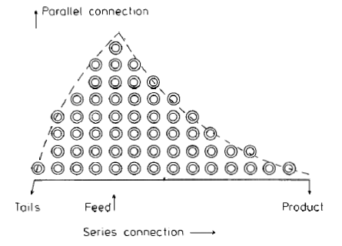
Figure 2.2 An example of an enrichment cascade [20]

To achieve economies-of-scale, a commercial enrichment plant may, depending on the centrifuge design, contain on the order of 100,000 centrifuges in numerous cascades. Uranium used to fuel commercial nuclear power plants (CNPP) is generally enriched to 3-5% ²³⁵U, but the same gas centrifuge technology can be used to increase the percentage of ²³⁵U well beyond this level to values in excess of the 20% ²³⁵U threshold considered significant by the IAEA.
Cascade modification involves adjusting the piping of a gas centrifuge cascade in order to produce an assay or an overall plant throughput that is different from the facility's declared value. Physical relocation of centrifuges is unnecessary; the cascade only needs to be re-plumbed to change its configuration so that additional stages may be added or subtracted. Adding stages reestablishes gas flow to produce a higher assay. Alternately, cascades can be modified to allow material to be diverted from the main process, thus creating enriched product that goes undeclared. A cascade piping change is difficult to detect with the naked eye, given the vastness and complexity of a typical cascade (Figure 2.3). If the change is subtle enough, a cascade modification can go unnoticed for extended periods of time. It may be detected, however, through spatial change detection tools and techniques.

Figure 2.3 Gas centrifuge cascade (Photo originally from URENCO) [8]

Spent Nuclear Fuel Reprocessing
When fuel is unloaded from a nuclear reactor, regardless of its initial enrichment or the thermal power of the reactor, it is discharged into a temporary cooling pool. Depending on a state’s NFC, the spent fuel may then be sent to a reprocessing plant to separate desired transuranics from the fission products. This process enables states to reduce the quantity of high-level radioactive waste that requires final disposition, as well as recover the still-usable fissile uranium, plutonium, and other valuable isotopes. Because reprocessing is the NFC step in which plutonium is separated—directly or in combination with other elements—and recovered from spent nuclear fuel, this step is also inherently sensitive in nuclear safeguards. Figure 2.4 illustrates the various ways spent fuel can be reprocessed. Reprocessing may be performed by numerous means, depending on the desired material separation stream and the physical/chemical method of separation.
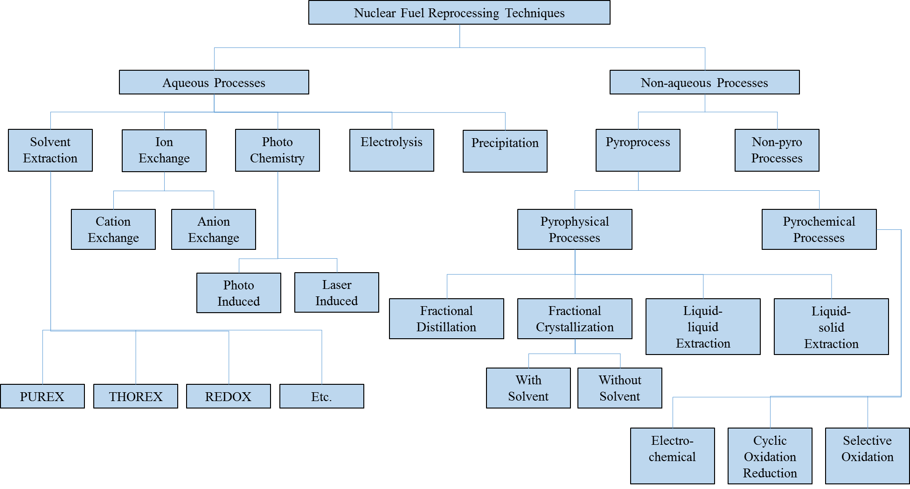
Figure 2.4 Spent nuclear fuel reprocessing methods [21]
Most spent fuel reprocessing conducted world-wide uses the plutonium/uranium reduction extraction process, PUREX (Figure 2.5) [18, p. 461]. PUREX was originally developed in the early days of the United States nuclear weapons program as an aqueous chemical separation method [22]. In PUREX spent nuclear fuel is moved from an onsite cooling pool to a hot cell, where it is chopped into piece by a mechanical sheer. The chopped spent fuel is then dissolved in nitric acid to place the bulk of the fuel rod’s constituents into solution. The fuel cladding is not dissolved, though, and is captured as waste. The nitric acid solution containing the spent fuel’s actinides and fission products is then flowed past an organic solvent, typically a mixture of tributyl-phosphate and kerosene.

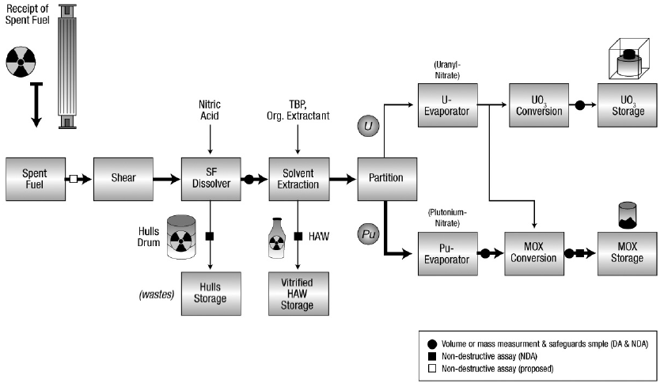
Figure 2.5 Example PUREX process flow diagram [23]

In the solvent extraction phase, uranium and plutonium streams are separated first from the fission products and other transuranics, then from each other based on their oxidation states. The separated uranium and plutonium can then remain separated or be recombined in select quantities to produce mixed oxide (MOX) fuel, which contains both low-enriched uranium (LEU) and plutonium. Because plutonium is directly separated in PUREX, and because the IAEA considers a mere 8 kg to be a significant quantity of plutonium, the design and operation of all aspects of a PUREX facility garner significant safeguards focus so that potential pathways might be detected.

Current ENR Safeguards Techniques
Nuclear safeguards is applied to each nuclear facility under a Member State’s CSA, but the uniqueness of each CSA, facility, and facility processes forces the IAEA to adopt unique safeguards plans at each facility. The IAEA’s vast suite of safeguards tools and techniques includes material accountancy, destructive assaying (DA), non-destructive assaying (NDA), containment and surveillance (C&S), and design information verification (DIV).

Material Accountancy
Material accountancy is part of a larger practice utilized in the nuclear community, known as material control and accountability (MC&A), whereby a nuclear facility is divided into material balance areas (MBAs), and the movement of material between MBAs is tracked and accounted for. A proper MBA may be established around a particular process in a facility, or it can be defined as particular physical space in the facility with a limited number of entry and exit points. SNM moving between MBAs is characterized to determine its mass and the composition of its various transuranic constituents. In the case of reprocessed fuel, this material can include uranium and plutonium isotopes, ²³⁷Np, ²⁴¹Am, ²³³Pa, curium, and californium. At regular intervals, facility operators conduct SNM inventories of the various MBAs based on the recorded material transfers to and from each MBA.
Material accountancy is further complicated because each measurement of mass or assay has an associated error and SNM is constantly decaying into different isotopes. Measurement errors occur from inherent inaccuracies in radiation measurement (background source and instrument noise) or random statistical bias. This type of measurement error in material accountancy is known as material unaccounted for (MUF). MUF is often expressed as the summation of inventory values from the start of an accounting period to the end of that period, including all material transfers [24]. The statistical uncertainty of MUF is based on the propagation of errors associated with the individual measurements made on nuclear material passing through MBAs. When completing an assessment of MUF, the propagation-of-uncertainty in measurement values (Equation 2.1) from DA and NDA measurements (discussed below) is taken as the standard deviation for a normal distribution. MUF values outside of two standard deviations (${2σ}_{MUF}$) indicate a diversion of SNM. Because MUF is a statistically random occurrence, an increasing value of cumulative MUF over time can also indicate diversion of material.
$$σ_{MUF}=\sqrt{\sum_{i=1}^{n}{σ_{i}^{2}}}$$
(2.1)

Destructive and Non-Destructive Analysis Techniques
Methods for measuring SNM values are divided into two categories based on whether or not the sample is consumed in the analysis process. Destructive analysis (DA) involves the collection and analysis of process samples to determine their chemical composition and assays and is generally more precise than non-destructive analysis (NDA) methods, but at much greater cost and preparation time. DA sampling includes the use of swipes and smears to detect trace elements inside or near a nuclear facility and can be used to sample difficult-to-access environments, such as high-radiation areas. Table 2.1 lists DA techniques that the IAEA currently uses.
In contrast, NDA is performed primarily through radiation detection and spectroscopy, which characterize nuclear material without destroying the sample or analysis target. NDA is better suited for stand-off or automated applications, or for when the nuclear material in question is not homogeneous. NDA systems may be present in a facility to provide process monitoring, or the instrumentation may be part of an on-site inspection. NDA measurements generally are also less expensive than DA measurements. The IAEA has a comprehensive list of current DA and NDA tools and techniques in use [7]. Figure 2.6 provides overview of currently used NDA tools.
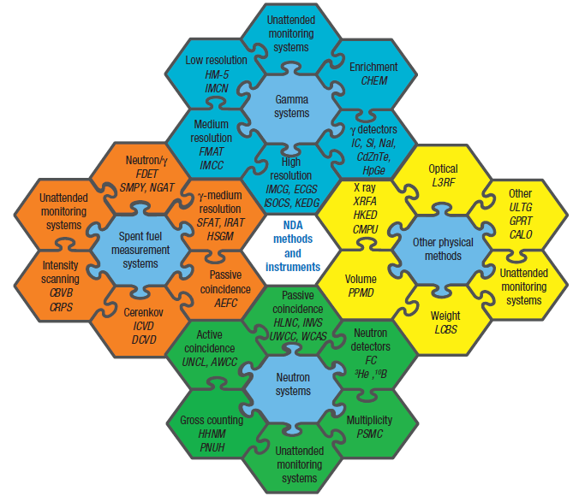
Figure 2.6 Overview of IAEA-used NDA systems, sorted by properties and capabilities [7]

Table 2.1 Destructive analysis techniques used by the IAEA and its Network of Analytical Laboratories [7]
Analytical Technique | Element Analyzed | Material Type | Uncertainty (% rel.)
Analytical Technique | Element Analyzed | Material Type | Random | Systematic
 | Elemental Analysis
Alpha spectrometry | Np, Am, Cm | High active liquid waste (HALW), Spent fuel input | 5.0 | 5.0
Controlled potential coulometry | Pu | Pure Pu solutions | 0.10 | 0.10
Ignition gravimetry | U, Pu | U, Pu oxides | 0.05 | 0.05
Isotopic dilution mass spectrometry (IDMS) | U, Pu | Spent fuel input solutions, Pu and U-Pu materials, HALWª | 0.20 | 0.20
Hybrid K-edge densitometry (HKED) | U, Pu, U:Pu ratio | Spent fuel solutions^{b} | 0.60 | 0.30
K-edge densitometry (KEDG) | U, Pu | U, U-Pu solutions | 0.20 | 0.15
New Brunswick Laboratory Davies and Gray titration | U | U (pure compounds) | 0.10 | 0.05
Plutonium (VI) spectrophotometry | Pu | Pu process solutions | 2.0 | 2.0
 | Isotopic Analysis
Alpha spectrometry | ²³⁸Pu | Pu materials | 0.2 | 0.3
Gamma ray spectrometry (NaI detector) | ²³⁵U | Low enriched U materials | 0.3 | 0.3
High resolution gamma ray spectrometry (Ge detector) | Pu isotopes, Am, Np | U and Pu materials, spent fuel solutions | 0.5-2.0 | 0.5-2.0
Thermal ionization mass spectrometry | U and Pu isotopes | All Pu and U materials, Spent fuel input solutions | 0.10^{c} | 0.05^{c}
ª Hot cell conditions.
^{b} Typically 150-250 g/L uranium with U:Pu 80-150.
^{c} For the major ratios of uranium and plutonium.

Containment and Surveillance
To reduce the burden on inspectors, the IAEA sometimes deploys additional capabilities to monitor facilities that reduce the amount of time an inspector needs to be on site. For example, the IAEA deploys cameras, tags and seals, and tamper-indicating/tamper-resisting devices to ensure the authenticity of information being collected from their persistent monitoring systems. Such containment and surveillance (C&S) tools allow inspectors to determine if a facility operator accessed monitored nuclear material between inspections. Unique tags and seals are placed on SNM containers (e.g. UF₆ cylinders, waste drums, casks, etc.) so that an inspector can quickly identify if the container was accessed since the last inspection. Figure 2.7 gives an example of a common IAEA seal. Containers still under seal can be quickly counted and recorded in a facility’s MC&A ledger, saving the inspector significant time and effort from having to re-characterize the material within that container. Cameras and other surveillance measures are also used to provide persistent monitoring of a facility process space between visits.

Figure 2.7 An IAEA metal “E-Cup” seal with unique identification number [25]

Facility Design Information Verification
SNM assaying and MC&A record-keeping are incomplete safeguards methods, forcing inspectors to examine other aspects of a facility to identify potential material diversion pathways. Design information verification (DIV) is a special type of IAEA inspection undertaken that seeks to determine if a facility and its process equipment are designed, installed, and being operated as declared by the Member State. The DIV process may start during facility construction, beginning with a detailed examination of existing declared information about the facility. The Member State provides this design information in the form of a detailed design information questionnaire (DIQ), which can include architectural drawings, blueprints, and engineers' notes. IAEA inspectors then measure the physical layout of the plant—which is informed by the nature and operational requirements of the facility's processes—and compare their measurements to the information provided in the full DIQ. The DIV process gives the IAEA confidence in their understanding of the facility and its capabilities and limitations. It also gives the IAEA an opportunity to determine if adjustments need to be made to the location(s) of their monitoring equipment or the frequency of their inspections.
DIV is an essential tool for the IAEA because it can be used to identify changes to MBAs, such as the presence of previously unidentified wall-penetrations in process cells, new equipment or enhanced equipment that is inconsistent with the declared site’s capabilities, or entirely new facility spaces. However, there is considerable room to improve the DIV process.

Current Spatial Mapping Tools Supporting DIV
DIV inspection teams typically use a combination of tools to determine if the information provided to them on a DIQ matched the physical layout of a plant. Global Positioning Satellite (GPS) measurements, for example, may be used to verify rough building layouts, but interior space measurements cannot rely on GPS localization. Thus, inspectors will use everything from tape-measures to laser range-finders to sketches and digital photographs from previous inspections to perform DIV [26], [27]. Durst et al. [8] provides an excellent discuss the current state-of-the-art in DIV technology and the present needs to enhance the DIV process.
IAEA inspectors can also use a more sophisticated automated NIR range-finding tool, the 3DLR, to generate point clouds of nuclear facilities’ interior spaces. The point clouds produce 3D renderings of a facility that can be compared at different points in time to detect changes that may have not been declared to the IAEA. The nature of ENR processes is such that a subtle change can have significant implications for safeguards enforcement.

Three-Dimensional Laser Range-Finder
The IAEA and its Member States use a number of advanced tools in DIV that are in various stages of development and deployment, but the potential application of laser range-finding in safeguards is widely recognized and researched through the efforts of Goncalves and Sequeira [28]–[31]. Their research helped facilitate the eventual development and adoption of the 3DLR system that the IAEA uses for DIV today [6], [28]. The 3DLR is an instrument package that comprises a terrestrial LIDAR system, batteries, stand-alone computer, and change-detection software. The IAEA uses only a handful of 3DLR instruments at permanent locations—most notably at the Japanese Rokkasho Reprocessing Plant—where it has proven to be highly effective at detecting facility changes [8, p. 15]. The Mark-II model (Figure 2.8) is capable of scanning interior and exterior environments at an accuracy of one millimeter. The 3DLR is still a somewhat expensive tool for the IAEA, however, at $150 thousand per instrument in 2009 [8, p. 17] plus the cost of training operators.

Figure 2.8 The Mark II 3DLR system [28]

Point Clouds and Change Detection
The 3DLR system produces a series of discrete laser returns plotted in 3D-space. The rendered image formed by these discrete returns is called a point cloud, which can be used in post-processing applications to determine accurate distances between objects in the scene, create reconstructions or models, and perform change detection. Point clouds are particularly unique, compared to 2D images, for the level of perspective they can captured in complex environments (Figure 2.9).

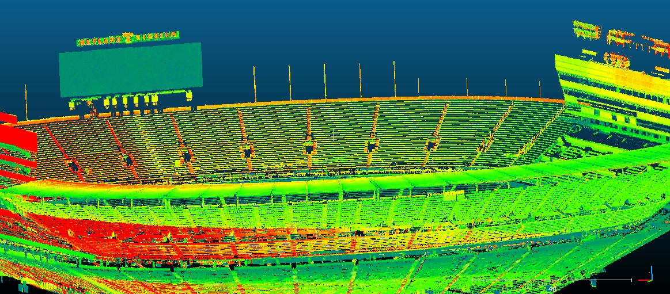
Figure 2.9 A point cloud of Neyland Stadium taken with LIDAR
(courtesy of the University of Tennessee, Dept. of Geography)

The IAEA uses the 3DLR to generate point clouds for change detection. As previously discussed, ENR facilities have complex environments, and seemingly subtle changes are difficult to detect, particularly in such spaces as the gas centrifuge enrichment cascade shown in Figure 2.3. Change-detection software digitally compares scans of the same space taken at different times, ideally to a verified reference scan performed on a prior inspection. Change-detection software is presently capable of observing changes at the sub-centimeter level, spotting adjustments that may be difficult for the naked eye to detect (Figure 2.10). Detectable changes can include minor, protracted changes taking place over a period of time (months/years) as well as abrupt system changes as long as scans from both times are available for comparison. Change-detection algorithms are discussed in greater depth in the next chapter.

Figure 2.10 3DLR scan of a complex space with automated change detection [28]

3DLR Costs and Limitations
The 3DLR recognized for its ability to perform in complex environments, particularly at the Rokkasho Reprocessing Plant [8, p. 12]. However, the same workshop discussed the limitations of wider 3DLR use, including the lack of instruments in use, the cost of these instruments, the training required to operate them, and the possibility of the instruments capturing proprietary information and details in the facility scans.
As of 2008, only three 3DLR units were in use at IAEA inspection sites. This is attributable to several factors, including the per-instrument cost of about $150 thousand, not including the cost of a dedicated workstation, software licenses, and training for the inspector [8, p. 17]. The scanner itself is a delicate piece of equipment and requires extra care for transporting between facilities.
Another common problem associated with 3DLR instruments is their tendency to collect information that a facility operator may consider proprietary, which cannot be removed from the facility for fear of mishandling. Because 3DLR scans produce point clouds with incredible clarity, many facility operators are reluctant to allow their use. However, many of these limitations can be addressed in part or in whole by looking to new solutions being developed in 3D sensing for application in robotics, machine vision, and medicine.

Spatial Change Detection
Through New Tools and Methods

Many different technologies and techniques are capable of measuring an indoor space. This chapter details and compares three physical methods for performing 3D sensing. It also discusses several currently available commercial-off-the-shelf (COTS) alternatives to LIDAR for spatial mapping and introduces the Point Cloud Library software with change-detection capabilities.

Select 3D Sensing Methods
Depth-sensing can be performed by numerous physical phenomenon. Several methods, as shown in Figure 3.1, can be readily eliminated from practical consideration because they are incapable of accurately measuring spaces in the range of tens of meters or because their underlying technology may be restricted from operating inside a nuclear facility. Other techniques that may be eliminated from consideration include interferometry techniques, which are useful only at very slight distances (on the order of micrometers). Microwaves are better for much longer-range applications and cannot be considered for indoor applications where they might cause electrical interferences to process equipment or be harmful to people. Ultrasonic waves—like microwaves—can adversely impact a nuclear facility’s processes environment. For the purposes of this research, in exploring alternatives to LIDAR techniques, the remaining candidate techniques for optical depth measurement are triangulation (also known as stereo vision), structured-light, and time-of-flight.

Figure 3.1 Positioning systems based on accuracy and coverage [32].

Stereo Vision
Stereo vision systems usually involve two cameras examining the same object in space. The relative distance between the two cameras is used to triangulate the distance to a common object. Physically, the phenomenon is similar to ocular depth-perception of human eyes. Figure 3.2 shows the basic trigonometric relationship for cameras located at positions A and B to determine the distance to the object, z. It can be very powerful in short-range applications.

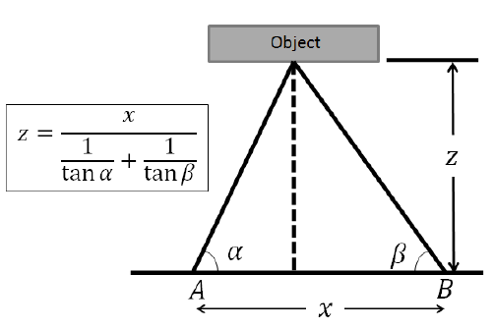
Figure 3.2 Depth measurement principle for stereo vision systems [33].

Stereo vision is very powerful in short range applications, but the nature of the triangulation technique poses two substantial drawbacks for this technology: error propagation and computational intensity. Depth-resolution error increases as a quadratic of the range of the image, limiting the practical range of a stereo vision sensor to approximately one meter. Triangulation is also difficult and computationally intensive in complex scenes because it requires corresponding common points observed in each camera to one another for accurate distance determination [33]–[35].

Structured-Light
Structured-light is an active illumination technique that uses a pulsed, diffused NIR laser to project a known light pattern. An imaging camera uses the distortion of the light pattern reflected off the surface of the object being observed to determine its surface depth. Each point detected by the camera has a corresponding speckle illuminating the surface (Figure 3.3). Structured-light sensors can be impacted by strong sources of NIR and thus is generally only suitable for indoor applications. There are also questions about their ability to operate accurately at distances greater than 3.5-5 m.

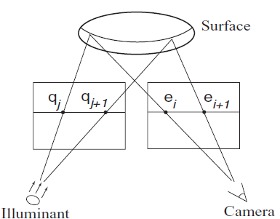
Figure 3.3 Principle behind structured-light depth-sensing [36].

A commonly used structured-light sensor is the Microsoft Xbox Kinect. Originally marketed as an entertainment product, the Kinect has been the subject of numerous R&D studies [9]–[13], [37]–[44] because of its structured-light capabilities and easy adoption for use with computers. The Kinect projects multiple speckle patterns, of different size speckles, to accurately measure distortion in three different range zones, with a maximum effective range of approximately 3.5 m [9].

Time-of-Flight
Similar in concept to structured-light, time-of-flight (TOF) sensors pulse an NIR illumination source through a diffuser and observes the light that is reflected back to a pixilated camera. TOF differentiates itself because it measures the raw light returns to the pixelated sensor as opposed to observing the distortion of a previously established light pattern (Figure 3.4).

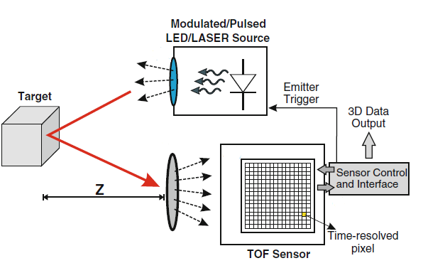
Figure 3.4 Time-of-flight measurement [45]

A TOF signal can be measured through one of four different methods, based on the sensor’s design and electronics. The simplest is the direct measurement of the timing between when the pulse is emitted and when it is received by the sensor, $τ_{TOF}$. Equation 3.1 is a simple equation based on the round-trip travel time of light with c, the speed-of-light constant, and measured depth, z.
$$z=\frac{c}{2}τ_{TOF}$$
(3.1)
This is known as a direct, pulsed TOF measurement [45, p. 4]. Because the response of the detector’s electronics factors in the accuracy of the TOF measurement, $τ_{TOF}$ is susceptible to limitations based on the speed of the electronics [33].
A continuous-wave, or modulated, method is an alternative to pulsed measurements in which range is determined by the difference in the phase angle, $φ_{TOF}$, between the emitted and received light pulses. The relation between detected depth and $φ_{TOF}$ is then based on the modulation frequency, f_{m}, of the illumination source (Equation 3.2).
$$z=\frac{c}{4πf_{m}}φ_{TOF}$$
(3.2)
Accurate measurement of the phase change, or $τ_{TOF}$, is very difficult by direct methods and can be susceptible to error from environmental variables and electronic limitations. An indirect method of measurement involves the use of time-gates (TG), during which the collected charge in each sensor pixel is measured to produce a time-averaged value for $τ_{TOF}$ and $φ_{TOF}$. Equation 3.3 and 3.4 are the indirect measurement methods for pulsed and modulated TOF, respectively, where C is the charge for a given TG and T_{p} is the time duration of the emitted pulse [33], [45], [46]. Figure 3.5 graphically compares the various TOF measurement techniques.
(3.3)
$$z=\frac{cT_{p}}{4}\left(1+\frac{C_{3}-C_{1}}{C_{2}-C_{4}}\right)$$
(3.4)
$$z=\frac{c}{4πf_{m}}arctan\left(\frac{C_{3}-C_{1}}{C_{4}-C_{2}}\right)$$

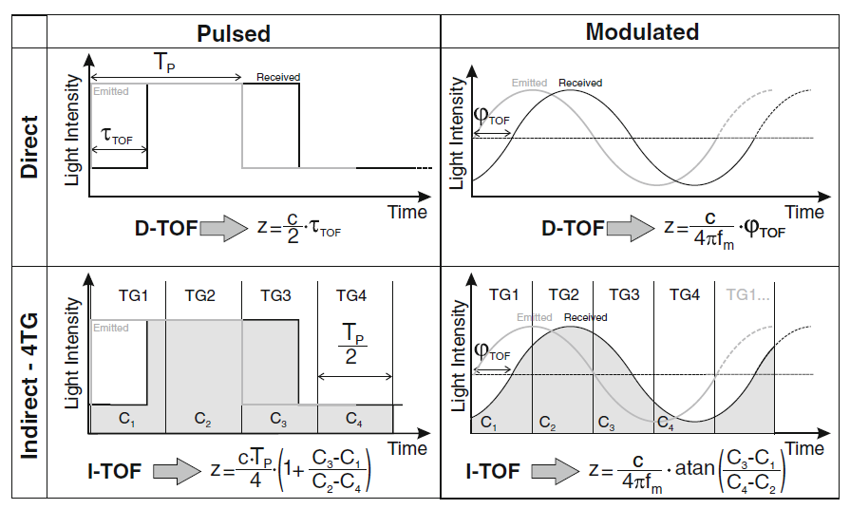
Figure 3.5 Comparison of TOF measurement techniques with associated equations [45].

Error associated with TOF measurements is based partially on the measured signal amplitude, A, and the offset, B, as described in Equation 3.5 and 3.6, respectively [47]. The variance in the depth measurement, $σ_{TOF}$, is thus given in Equation 3.7 where $c_{d}$ is the demodulation contrast, a sensor-specific parameter [46]–[48].

$$A=\frac{\sqrt{{\left(C_{3}-C_{1}\right)}^{2}+{\left(C_{4}-C_{2}\right)}^{2}}}{2}$$
(3.6)
(3.5)
$$B=\frac{C_{1}+C_{2}+C_{3}+C_{4}}{4}$$

$$σ_{TOF}=\frac{c}{4\sqrt{2}πf_{m}}\frac{\sqrt{A+B}}{c_{d}A}$$
(3.7)

Comparison of Techniques
For short-range applications, stereo vision provides better resolution than TOF [34, p. 192], but its depth-measurement error increases quadratically as distance increases. Stereo vision is also very computationally intensive because individual scene points have to be correlated between the two cameras in the system, often requiring interpolation between pixels [17, p. 39]. This can cause problems in scenes with little or no change in color or intensity—which can be experienced in repetitive or empty environments.
Structured-light has better accuracy at increased ranges than stereo vision techniques, can presently achieve a higher resolution than TOF, and is excellent for scanning objects in indoor environments. However, structured-light also has a high computational cost and can therefore be somewhat difficult to operate in real-time [49]. This can result in a decreased frame rate. The TOF technique produces the greatest theoretical range of the three techniques; reducing the modulation frequency will increase range while still maintaining a tolerable depth accuracy. TOF can also perform in a large, dynamic range of ambient light conditions, and its sensors do not require complex algorithms to determine depth.
A summary comparison of techniques is shown in Table 3.1. This research explored structured-light and TOF-based sensing methods in depth to determine a suitable instrument for comparison testing of the IAEA’s 3DLR system. Both techniques are capable of providing accurate spatial resolution in indoor environments.

Table 3.1 Comparison of 3D sensing techniques based on various parameters
Parameterª | Stereo Vision | Structured-Light | Time-of-Flight
Depth Accuracy | mm to cm | μm to cm | mm to cm
Distance Range | Mid-range | Very short to mid-range/  Scalable | Short to long-range/  Scalable
Software Complexity | High | Medium | Low
Low-Light Performance | Poor | Good | Good
Bright-Light Performance | Good | Poor | Good
Power Consumption | Low | Medium | Medium/Scalable
Response Time/  Scanning Speed | Medium | Low | High
ª Information compiled from [17], [33], [49].

Current Commercial-off-the-Shelf Tools
This research’s examination of alternative methods of spatial measurement yielded two possible sensing methods for consideration, as discussed in the previous section. Further assessment of potential COTS instruments that might compete with 3DLR was based on several criteria: maximum calibrated range, cost, scan time, ease-of-use, adaptability, and research interest. Because this research is not examining sensors to be used in international in their present form, rather just an examination of their present capability to perform a proposed mission, several criteria were not examined as part of this study—such as instrument reliability or tamper-resistance.
For this research, the data produced from scanning results also needed to be easy to extract and manipulate in order to generate point clouds and perform change detection. The instruments initially considered for this research were the SwissRanger 4000 (SR4000) and the SwissRanger 4500 (SR4500) systems manufactured by MESA Imaging, the Structure Sensor manufactured by Occipital, and Microsoft’s Xbox Kinect—manufactured for the Xbox 360 and the Xbox One and herein referred to as Kinect v1 and Kinect v2, respectively. The qualities of each instrument were considered for further study as part of this research.

SR4000 & SR4500
Operating with the TOF sensing technique, the SR4000 was initially considered for this research because it has a calibrated range of 0.1-10.0 m at an imaging rate of 50 frames per second (FPS) [50]. The SR4000 was also researched in depth [10], [38], [51]–[54] in order to provide a basis of comparison to other instruments. However, the SR4000 had the lowest depth resolution and the highest cost of all of the instruments considered. It also required a 40-minute warm-up period to eliminate an observed error caused by temperature [55, p. 129].
The SR4000 and its wide-angle companion, the SR4500, were discontinued as of November, 2015 [56]. While the instruments are no longer a viable option for future research or implementation as part of a 3DLR-alternative, the fundamental nature of their operation will likely be adapted for use in the next generation of sensors. Thus, previous research with this instrument is still very relevant and informative.

Structure Sensor
The Structure Sensor is a compact, structured-light system marketed as a tool for scanning people and objects, generating maps of interior spaces, and performing augmented reality. The Structure Sensor (Figure 3.6) is a handheld, self-powered instrument with a range of 3.5 m and a resolution of 640 x 480 pixels at 30 FPS. Among the instruments considered, the Structure Sensor is commercially the most mature sensor, and it can be fairly readily adopted for use with most operating systems and platforms.

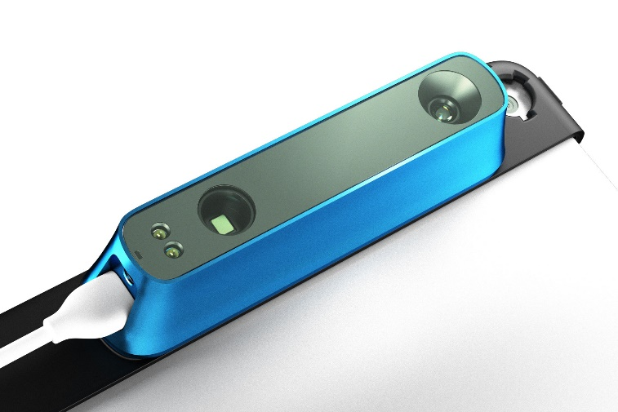
Figure 3.6 The Structure Sensor with connection cable and tablet mounting bracket.

Xbox Kinect
The Kinect v1 sensor was first marketed in 2010, uses structured-light, and was instantly adopted as an inexpensive tool for robot vision applications [9], [37]–[43], [51], [57]–[60]. Kinect v2 is based on TOF technology and has been the subject of more recent research [15], [51], [61]–[64]. Both sensors are capable of operating at or near 5 m range. Despite its age, the Kinect v1 sensor is still a capable instrument because of its superior depth resolution, comparable operating distance, and low power requirements. Table 3.2 compares all four sensors considered for this research.
The Kinect v2 was ultimately selected because of its low cost, good depth resolution, co-located high-definition camera, and its use of TOF, which provides better error statistics [51], [64] (see Figure 3.7). The Kinect v2 also has open-source software support for capturing point-cloud images. It is important to note that this dissertation does not suggest that the Kinect v2 is ideally suited to perform DIV missions as described in Chapter Two, but rather that it represents the present state-of-the-art in deployable TOF technology that can be purposefully adapted to perform the described mission. Ideas for how a new instrument design might be approached are discussed in Chapter Six.

Table 3.2 Comparison of down-selected depth sensors
Instrument | Kinect v1 | Structure Sensor | SR4000 | Kinect v2
Sensing Technique | Structured-Light |  | Time-of-Flight
Range (m) | 0.5-5 | 0.4-3.5 | 0.8-8 | 0.5-8ª
Field of View (WxH) | 58 x 40 | 58 x 45 | 69 x 56 | 70.6 x 60.0
Depth Resolution (pixels) | 320 x 240 | 640 x 480 | 176 x 144 | 512 x 424
Frame Rate (FPS) | 30 | 30 | 30 | 30
Connection Type | USB 2.0  w/ Adaptor | USB 2.0 | USB 2.0/  Ethernet | USB 3.0  w/ Adaptor
Voltage (V) | 12 | 5 | 12 | 12
Cost (USD) | 100 | 380 | 4,000 | 150
Reference | [38] | [65] | [38] | [63], [66]
ª Many references claim a max range of 4.5 m, but this is only for motion tracking purposes.

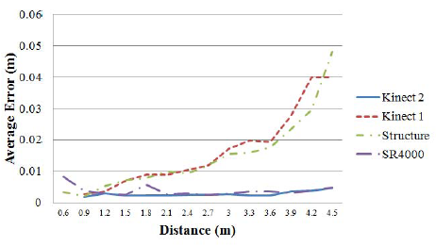
Figure 3.7 Average absolute error of various sensors examining a green planar surface [51]

Computational Solutions
Sensor selection was also influenced by the availability of open source software that could support this research. Software is required to record point clouds, combine images into a single reference frame—a technique known as “registration”—and perform appropriate change detection of scanned scenes. Three independent software solutions were utilized for this effort: the Point Cloud Library (PCL), Robot Operating System (ROS), and IAI_Kinect2 [67]. A general overview of each software is presented here, and a detailed discussion of specific functions within these codes is provided in Chapter 4.

Point Cloud Library
PCL is an open source, C++ based suite of tools developed for commercial and research use [60]. PCL is capable of capturing, filtering, registering, concatenating, and visualizing depth information. Another benefit of PCL is that it operates independent of the sensor used to collect the initial point clouds. PCL is powerful in that it is capable of performing many functions in a single, streamlined process (Figure 3.8). This research used PCL version 1.7 built for ROS, which uses Linux-based libraries from Boost, Eigen, FLANN, VTK, Qt, QHull, and OpenNI2. Cmake is used to link these libraries and PCL-specific software libraries, segmented into functional modules.

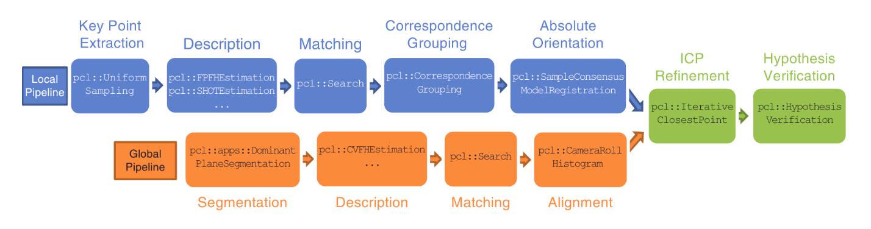
Figure 3.8 Example pipeline of independent functions used to perform object detection [68]

Robot Operating System
The ROS is a widely-used middleware platform for developing software for robots. ROS can operate in C++ and Python environments, and it provides tools, libraries, and common modes that allow independent components to communicate. The ROS Indigo platform was used for this research, and it was essential for combining other software components such as PCL and IAI_Kinect2.

IAI_Kinect2
IAI_Kinect2 allows users to easily engage the Kinect v2 camera in multiple visual modes. It runs in ROS, and the IAI_Kinect2 Bridge function allows ROS to communicate with a commonly used open-source Linux variation of the driver “Kinect for Windows v2,” known as libfreenect2 [69]. Users can view and save point clouds formatted for PCL with the IAI_Kinect2 Viewer, and the program has an instrument calibration tool. The nature of how all of these components are integrated is discussed below.

Other Solutions
The community of experts developing new tools for robotic applications is extensive, allowing for the adoption of specially modified instruments and tools to creating new avenues and affordable alternatives for addressing the challenge problem. It is recognized that these software solutions are unlikely to be used for the final development of a new DIV solution, but the use of these tools is essential to discovering if their baseline capabilities can provide an effective alternative to the current 3DLR solution.

Experimental Setup and Initial Results

The motivation for this research was to provide tangible improvements to the process of detecting spatial changes in ENR facilities in support of international treaty monitoring. This chapter discusses the detailed hardware and initial testing environments, the nature of the post-processing workflow with algorithm discussions, and an overview of initial results.

Initial System Testing

Hardware Configuration and Concept of Operation
The hardware configuration used in this research was designed and assessed so that any instrument testing and post-processing conducted would implement as many known or anticipated conditions that a DIV inspection team may encounter. Among these considerations were the fact that ENR facilities are strictly controlled environments, facility operators may only agree to authorize the use of a scanning instrument in particular spaces, and the IAEA has requirements for guaranteeing the authenticity of collected data.
To address some of these issues, the Kinect v2 sensor was tested on a tripod with a single-axis rotation stepper motor (Figure 4.1). The Kinect v2 was attached to the NEMA-17 stepper motor with a piece of ¼-20 threaded rod and a threaded spacer modified to hold a set-screw on the motor armature face. By positioning the sensor on a tripod, its operating conditions were made more comparable to those of a 3DLR, both in its concept of operations (CONOPS) and in the limitations of its use. Several ideas for hand-held sensors were explored, but these were not pursued.

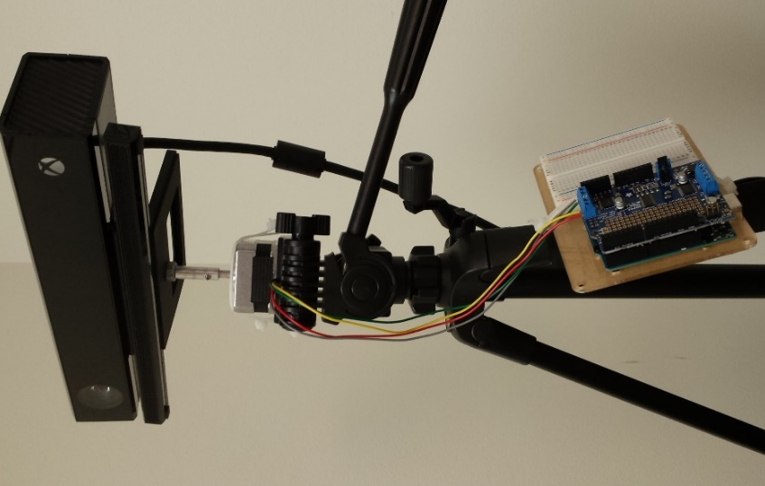
Figure 4.1 Kinect v2 equipment setup with tripod, stepper motor, and Arduino.

The stepper motor was added to the experimental configuration in order to further mimic the tripod-based 3DLR system and to reduce the variability in sample collection. Used to rotate the Kinect v2 on the yaw-axis, the stepper motor was connected to an Arduino with a motor-control circuit board. Figure 4.2 is a block-diagram layout of the hardware configuration along with cabling, and Figure 4.3 is the software integration scheme. The IAI_Kinect2 Viewer and the Bridge are operated simultaneously in ROS to allow images viewed through the libfreenect2 driver to be saved in a PCL-friendly file format. When image-capture commands are sent in the Viewer program, a serial command is received by the Arduino to actuate the stepper motor by a 5 degree increment through its integrated development environment (IDE).
As already noted, the IAI_Kinect2 software has a Kinect v2 sensor calibration tool that aligns the sensor’s red-green-blue (RGB) camera with its depth camera. This alignment was conducted by taking a series of images, at multiple distances, of a checker-board sign of known size. The resulting calibration output was factored into the Kinect v2 “bridge” program to libfreenect2 (Figure 4.4). The maintainer of the IAI_Kinect2 program [70] reports a consistent static offset of 24 mm on Kinect v2 sensors, and Figure 4.4 supports this assertion.

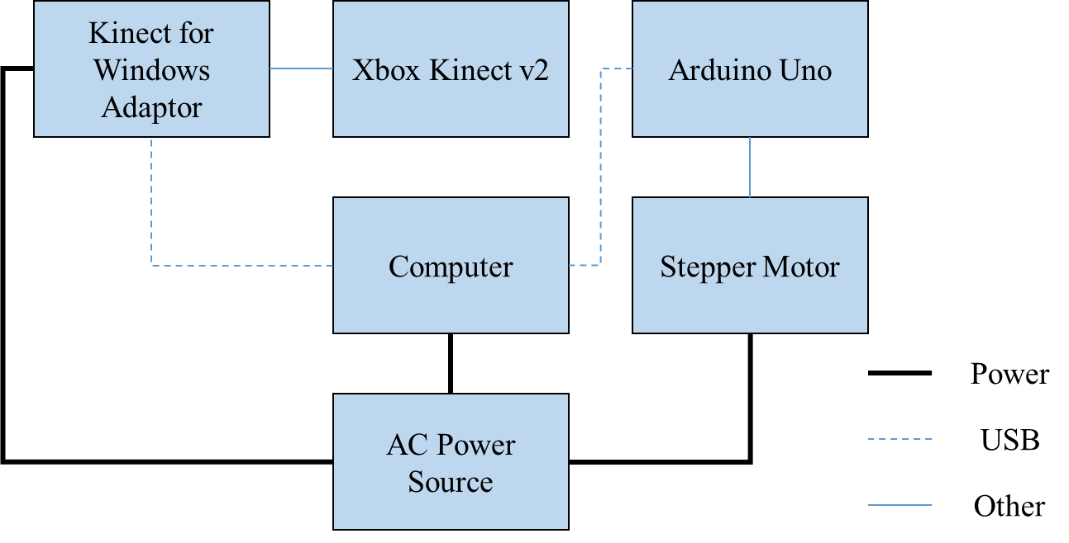
Figure 4.2 Block diagram of the experimental hardware configuration

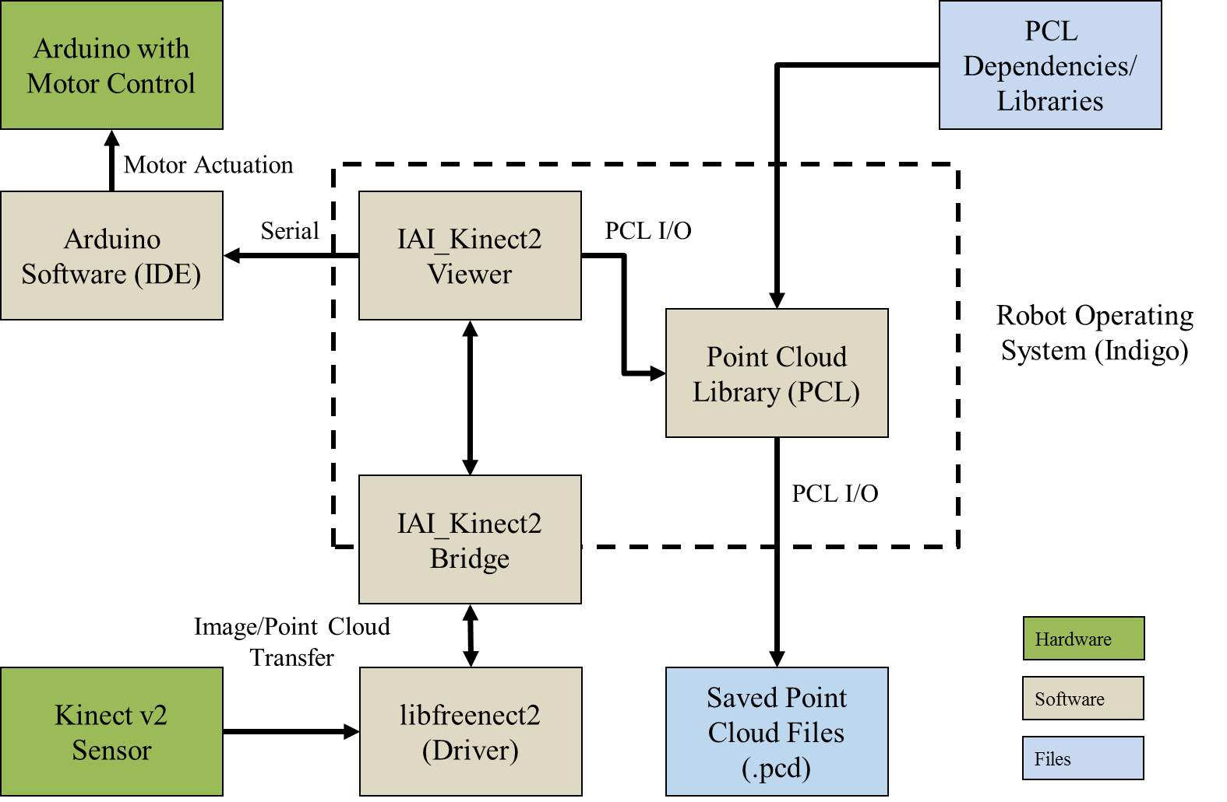
Figure 4.3 Block diagram of the experimental software solution for capturing point clouds

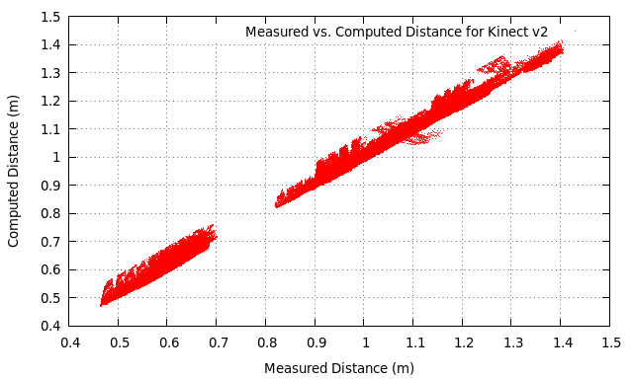
Figure 4.4 Calibration curve for the Kinect v2

The system components were initially tested in a scan of a Radiochemistry Center-of-Excellence (RCoE) laboratory at the University of Tennessee. The radiochemistry laboratory work space is a complex environment with lots of clutter, including some components that are representative of a nuclear facility test-case. Being constantly in use, the laboratory experiences constant spatial changes. Based on the physical layout of the laboratory, a CONOPS was developed to image the environment in four independent segments. Figure 4.5 is a representative diagram of the physical space and the approximate positions and observation-angles of the Kinect v2 sensor, and Figure 4.6 is a pair of sample images from the Kinect v2 through multiple output modes.

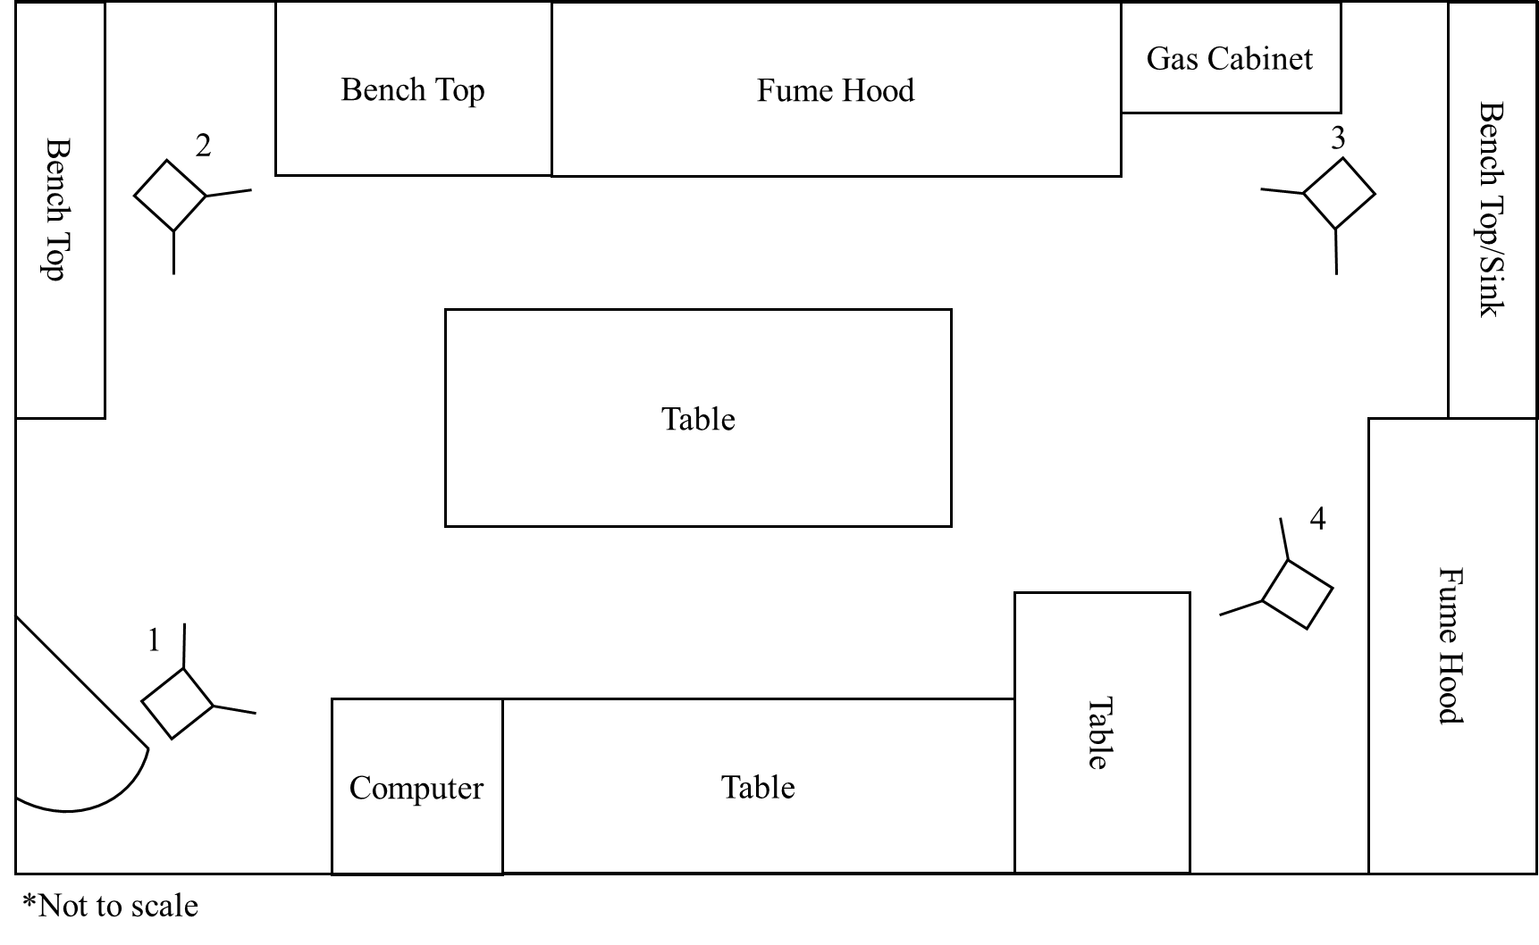
Figure 4.5 Spatial layout of UT radiochemistry laboratory with approximate camera locations identified

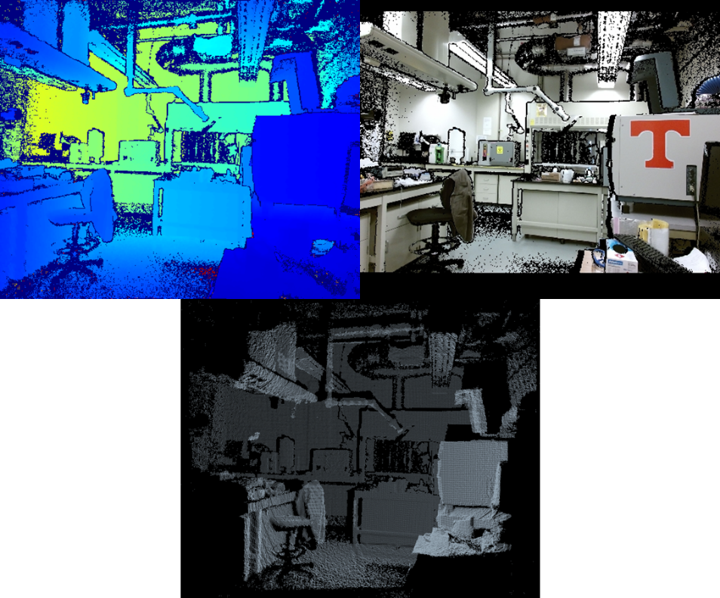
Figure 4.6 Three of the imaging modes of the Kinect v2 sensor/software:
depth (upper left), depth with RGB overlay (upper right), and point cloud (below).

Because the entire space could not be fully and accurately scanned from a single location—imaging a space from multiple angles is required to measure behind objects—multiple reference frames need to be aligned into a single frame for registration. This fact, and others, are implemented as part of the overall programming workflow.

Post-Processing Workflow

Point Cloud Processing Overview
For nomenclature, a scene will specifically refer to a registered group of individual point cloud images. The image registration routine was divided into two parts. First, the images collected from a single physical location were batch processed together in a step-wise fashion to form a single scene. By not processing two images that are not collocated, the registration routine is inherently prevented from linking together features that are not within a specified proximity of each other, thus reduced the possibility for error. The second part of the image registration routine was the final registration of scenes taken from multiple points for the formation of a comprehensive 3D point cloud. Figure 4.7 is an overview diagram of the processing work flow in PCL.

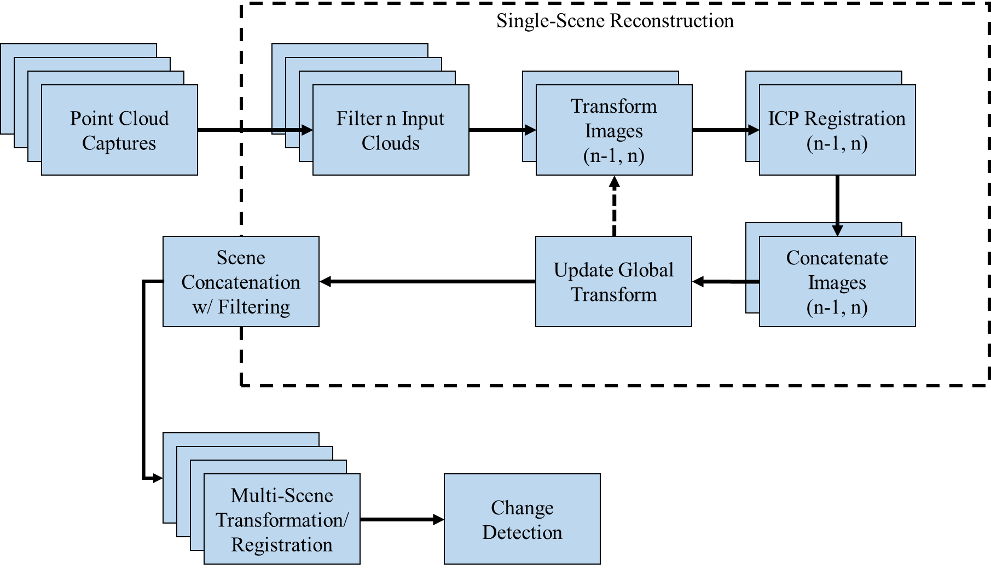
Figure 4.7 Point cloud processing workflow

The raw point-cloud images scanned from a given location are loaded into the registration program and filtered in several stages (discussed below). After filtering, the images were registered using an iterative closest point (ICP) routine. ICP registers two point clouds by comparing the distance between corresponding points in each cloud, performing a matrix transformation to better align them based on a mean squared error cost function, and iterating [71]. Point clouds were down-sampled prior to being registered to eliminate repetitive data points and increase computational efficiency. The transformed cloud was then concatenated with the adjoining cloud, and a global transform was updated to reflect the position of the scene. Appendix A provides a sensitivity analysis of ICP registration. Multiple ICP runs may be conducted to increase accuracy of the registration at the expense of processing time. Once the images were registered with their neighboring clouds, they were concatenated to form a single scene. The concatenated image was then again run through a statistical filter to remove spurious points.
Multiple scenes of the same environment were then registered and concatenated together using a combination of user-directed transformations and ICP to form a completed scene of the space under examination. Because the size and shape of the application environment was never consistent, this step is designed to require the user to maneuver individual scenes—with appreciable overlap between them—into an initial alignment. The ICP routine will then combine each scene and create a comprehensive image. It is important to note that the original data files loaded into the registration routine are not altered or saved over; an important consideration when it is important to maintain the original authenticity of the data such as in treaty verification.

Filtration
Point cloud images are loaded into the registration program as a batch of concurrent images to form a point cloud scene from the given vantage point. Point cloud files recorded from the Kinect v2 sensor/IAI_Kinect2 software are glorified text documents produced in either binary or ASCII characters containing each recorded point’s Cartesian coordinates and RGB-alpha (RGBA) information. An ASCII format will display the information on each point as a series of four values per line—x-, y-, and z-coordinates, and RGBA.
Files are filtered as they are loaded into the program. Erroneous points that were measured by the sensor as “Not a Number” (NaN)—typically measurement errors or inaccuracies returned to the pixel and assessed as null points—are removed first. This process is a simple file search. A pass-through filter is also implemented because the Kinect v2 sensor has a maximum recommended measurement range of only 8.0 m. Therefore points “measured” beyond this depth are likely to be erroneous or inaccurate.
A Gaussian statistical filter was also used to remove outlier points. The outlier-removal tool is intended to remove spurious points that are observed within the point cloud image (e.g. points cast as shadows from edges, or points that are “floating” within an open room). This portion of the code works by querying the distance to the nearest neighboring points, for every point, as specified by the users. Then the code removes those points whose mean distance to its neighbors is outside of a user-defined number of standard deviations of the global mean distance for the cloud. Algorithm 4.1 is a truncated filtering routine example. The filtered cloud is output as a new point cloud object for further manipulation.

Algorithm 4.1: Sample filtration function
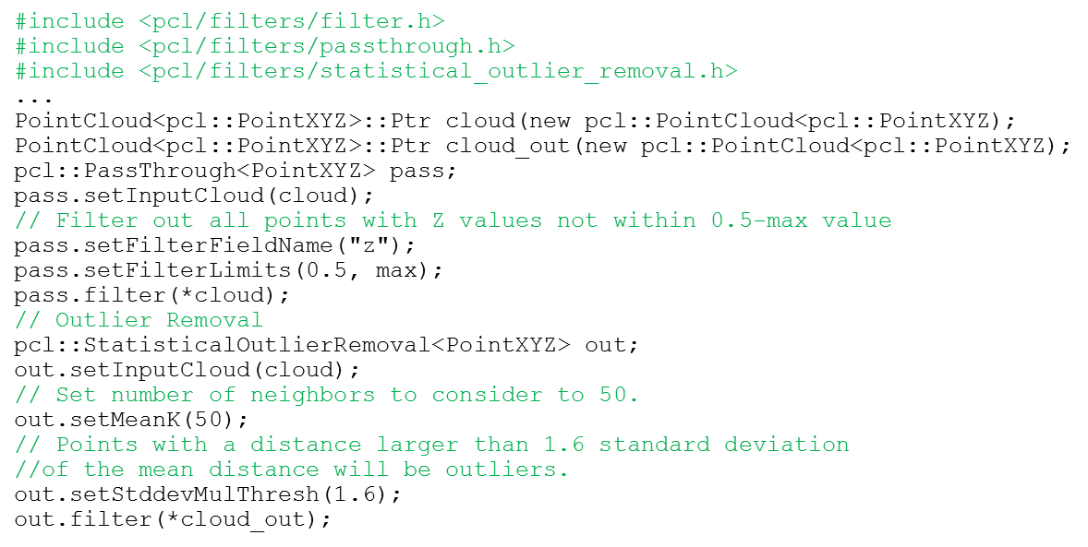

Registration
Before the ICP routine is called, the now filtered cloud is down-sampled to remove repetitive points in the cloud while providing uniquely identifiable points for the registration process. This process removes points based on a specified size of 3D pixel—more commonly known as a “voxel.” Thousands of extra points are removed by reducing the number of points in the cloud such that there only exists a point every few cubic centimeters with a user-specified voxel radius. Down-sampled clouds improve processing time, ideally, without disrupting the accuracy of the registration (see Appendix A for discussion). The down-sampled indices are used to generate another point cloud which eventually becomes the input for registration. The result of the down-sampling algorithm (Algorithm 4.2) is then queried to find the local normal surface information for every remaining point.

Algorithm 4.2: Sample down-sampling function
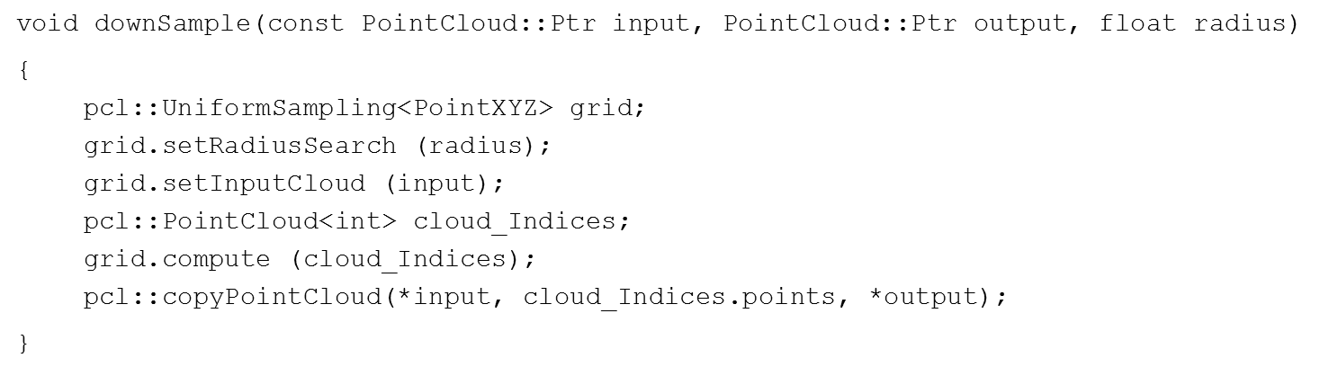

The normal information is used by PCL and the ICP registration function to perform a point-to-plane error minimization in the final processing of the ICP routine. More information on ICP variants and how they operate is discussed by Rusinkiewicz and Levoy [72]. Normal estimation can be simplified to a least-square plane fitting estimation problem using the nearest neighbor search, similar to that carried out by the filtering routine in Algorithm 4.1 [73]. Rusu [74, pp. 45–49] provides a detailed discussion of the normal estimation process, as it is used by PCL. The normal estimation information is then paired onto the down-sampled point cloud’s indices to make a point cloud containing the normal-vector information (Algorithm 4.3).

Algorithm 4.3: Example normal estimation function
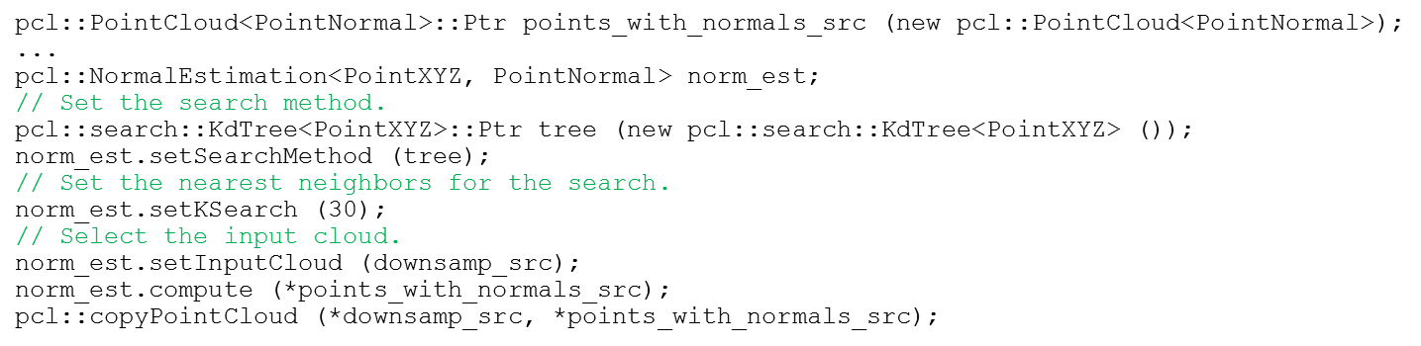

The down-sampled point clouds with their normal information are then loaded into the ICP routine to find the transformation matrix that best aligns the two input point clouds. Because ICP relies on observations and comparison between corresponding points in two clouds, a limit is placed on the distance that the routine will search for correspondences. This maximum correspondence distance is defined by the user (see Appendix A for more discussion). The ICP routine will terminate based on user-defined criteria, specifically when the maximum number of iterations is reached or the difference between consecutive iterative transforms is sufficiently low. Algorithm 4.4 is an example of the ICP routine and Figure 4.8 is a diagram showing how the various algorithms interconnect.

Algorithm 4.4: Example of ICP registration function
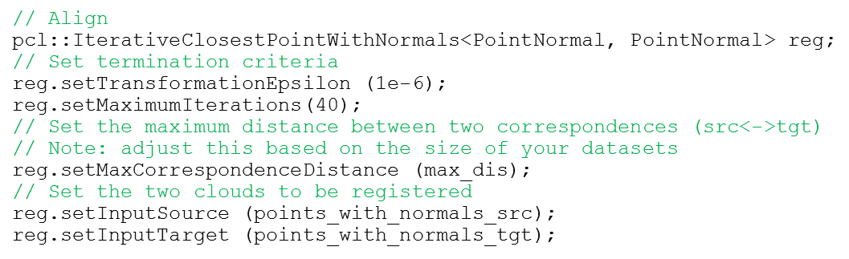

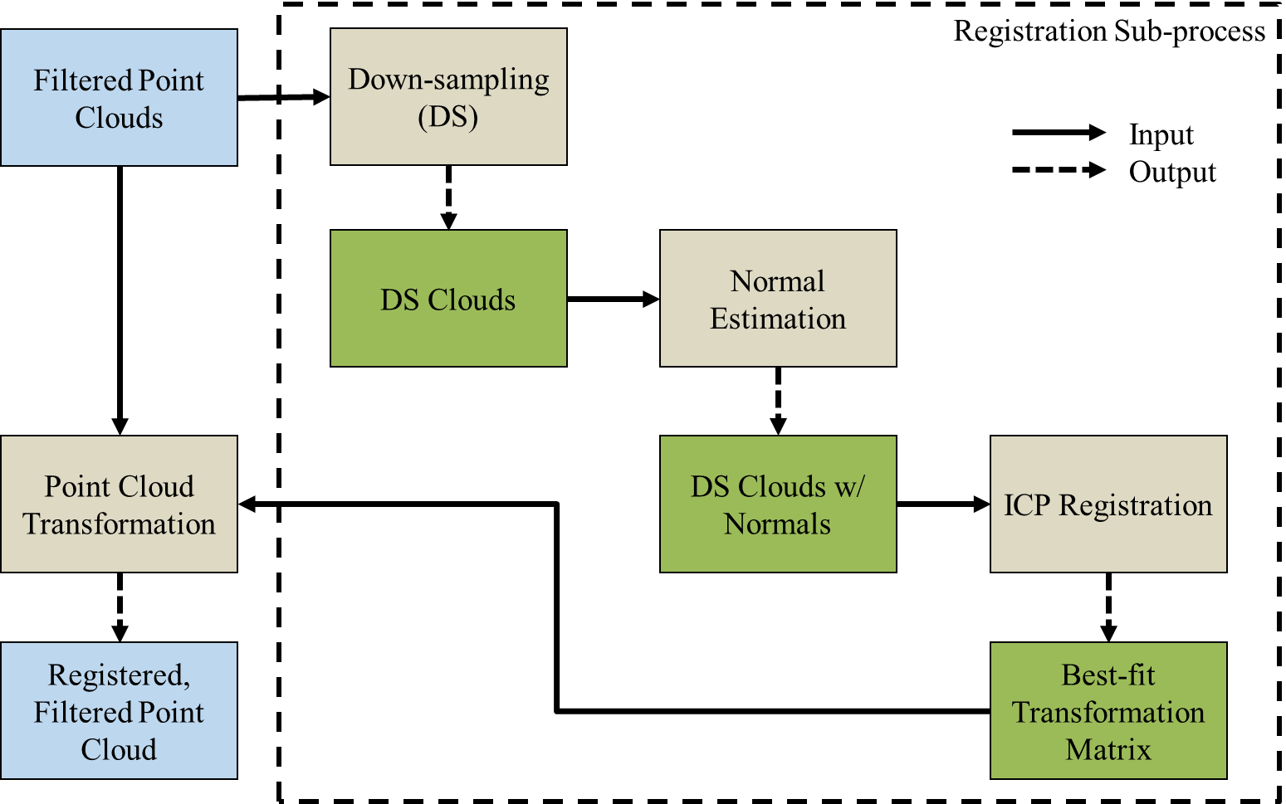
Figure 4.8 Registration process diagram

Change Detection
After spatial scanning and registration is complete, change detection is performed on two point clouds taken from the same location at different times. PCL has a tool for performing change detection based on a commonly used data structure called an octree. An octree uses voxels that can be further subdivided into either eight, equally-sized nodes or not at all (Figure 4.9). The subdivided parts of a voxel provide increased resolution to areas where it is necessary but preserve a larger voxel size for areas that do not require enhanced resolution [75]. The PCL octree module [76] allows the user to buffer between multiple point clouds to identify points present in a source cloud that are not found in an initial reference scan. This feature uses the fully registered scenes—placed in the same reference frame—to identify point indices that appear in one point cloud, but not the other.

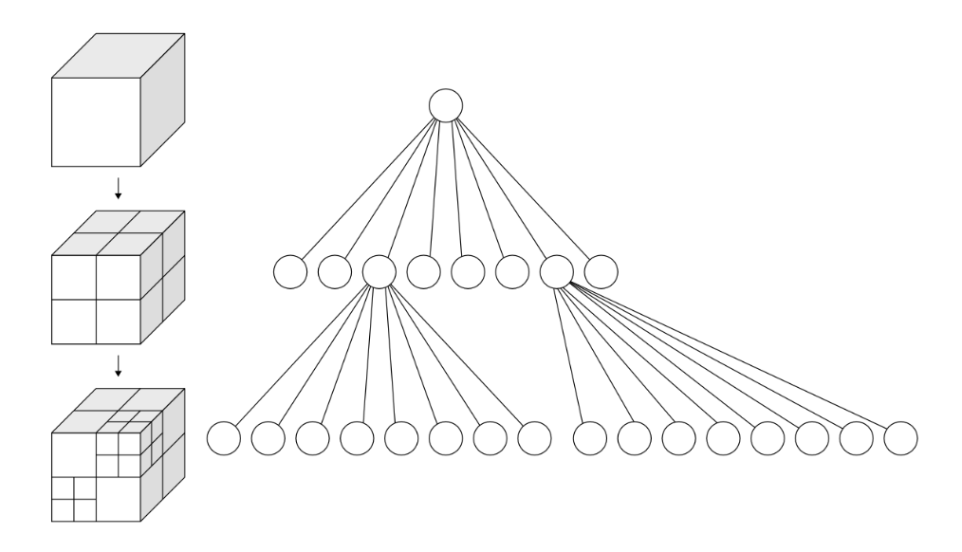
Figure 4.9 Diagram of octree data structure [77]

Initial Characterization of Sensor/Software Performance
To scan the RCoE laboratory—using Figure 4.5 as a guide—the sensor was used to take successive images in a counter-clockwise fashion through approximately 90 degrees of rotation at each of four positions. The Kinect v2 sensor and stepper motor configuration recorded the point cloud data with only limited issues with the stepper motor rotation, mostly due to the cable occasionally becoming entangled. Individual raw data streams (see Figure 4.6) aligned well with the HD camera and could collect information at the far end of the laboratory space.
The field-of-view of the sensor prevented it from recording points on the floor immediately beneath and up to approximately 2 feet away. Similarly, large areas of the ceiling were not observed. This lack of vertical imaging could be corrected with a modified scanning approach, but these imaging gaps are presently tolerated because they were deemed non-essential for demonstrating the sensor performance and the change detection capability. There were isolated instances of images incorrectly registering in several locations where there was substantial change from image-to-image (e.g. the start of a new wall), but these issues were rectified with minor adjustments to the ICP parameters in the programming (see Appendix A). Figure 4.10 compares a single image and the scene to which it was registered.

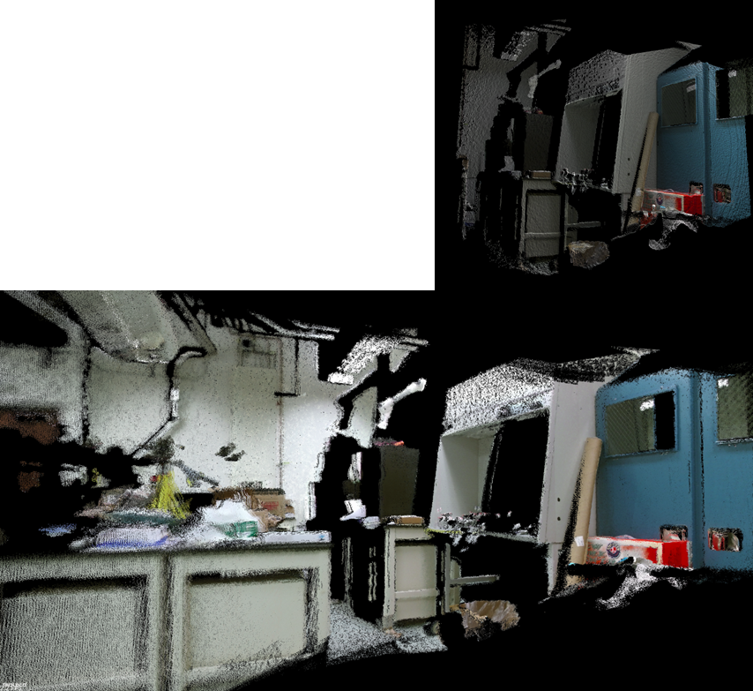
Figure 4.10 Single image point cloud (above) and its corresponding scene after registration (below)

The Kinect v2 sensor and software components imaged and correctly registered the interior of the RCoE laboratory using 89 discrete scans taken at differing angles from four independent positions. Figure 4.11 shows the completed scene taken from one of the camera positions shown in Figure 4.5. The scene has very clearly defined planar surfaces, such as cabinets and walls, and the color overlays provide the user with an opportunity to visually observe the registration accuracy.

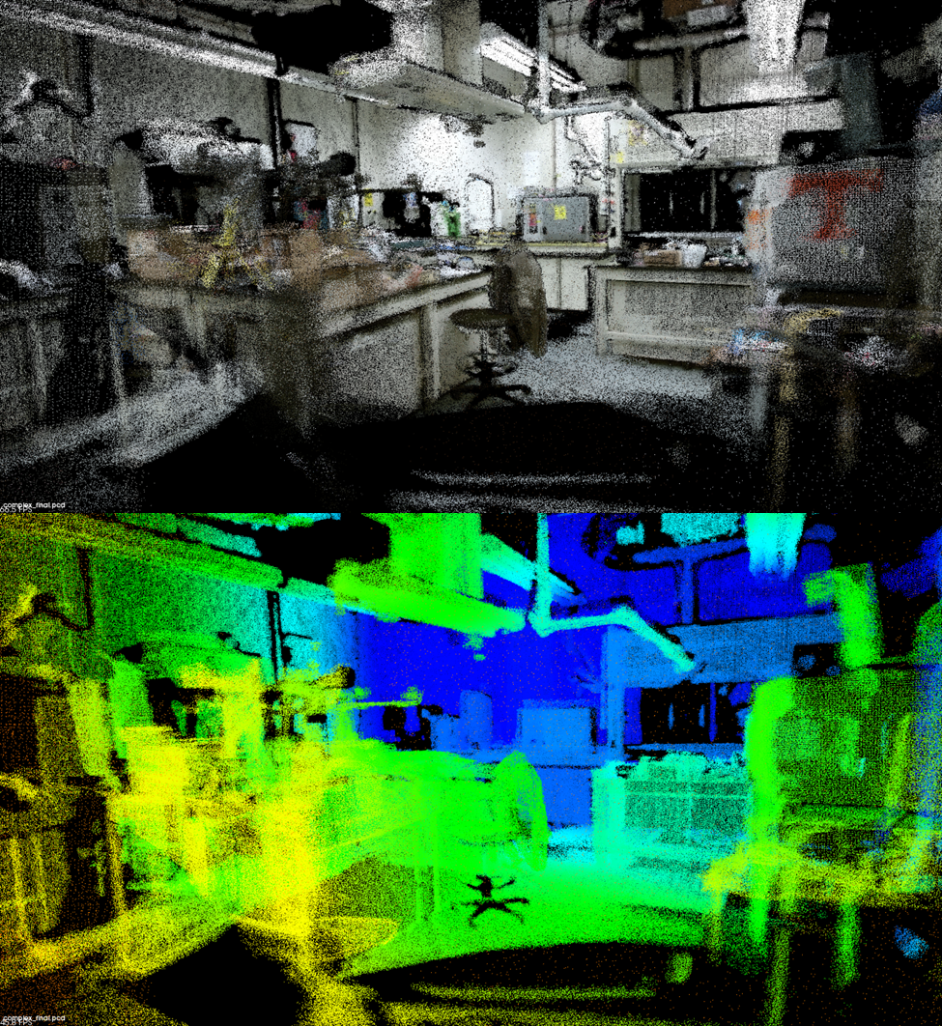
Figure 4.11 Fully registered radiochemistry laboratory scene. Above: point cloud with color overlay;
below: distance represented by change in color.

Detected Changes
Two scans of the RCoE lab space were conducted three weeks apart without any prior knowledge of what changes occurred in the physical space. The two scans were registered, but not concatenated, to provide a common reference frame. The PCL change detection program does not specify a minimum detection limit for comparing two point clouds, but there are practical limits based on the presence of errors in the scene, the density of points, and available computing power.
The scans revealed a number of changes in the laboratory (Figure 4.12) that could be readily identified in 2D digital images. The red highlighted areas are instances where a “new” object is identified compared to the reference scan. The sensitivity to change can be adjusted in the PCL programming by changing the minimum-size of the voxel resolution and by implementing a noise filter. The noise filter sets a threshold requirement so that a voxel found to contain a potential “change” must meet the threshold number of new points to be considered valid.

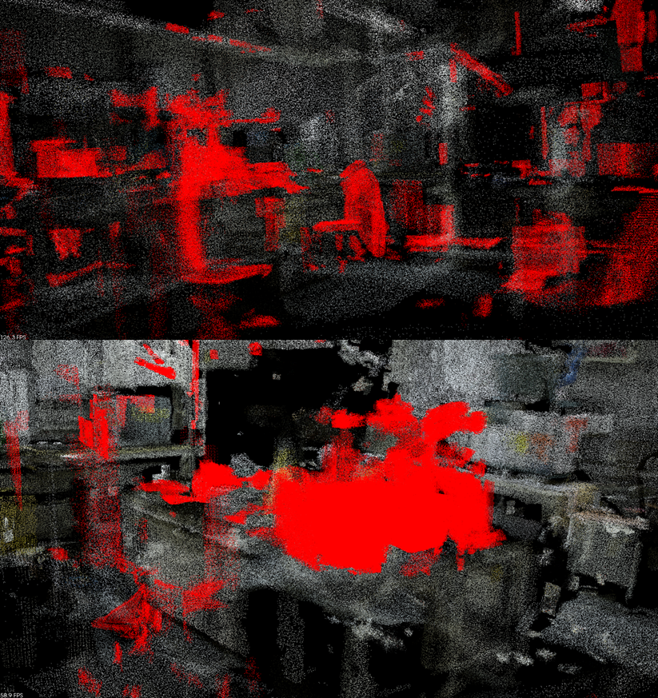
Figure 4.12 Spatial changes (highlighted) compared to a prior reference scan, taken from two different viewpoints and with two different settings.

Error Propagation
Even with manipulation of both the voxel resolution and the noise filter, it was still possible to detect false changes or miss true changes. There were several reasons for this. A sparse reference or comparative scan might have introduced gaps in the point cloud that, if filled by one scan but not the other, responded as a potential change (i.e. false positive). Registration errors might have also produced spurious, artificial points between scans. These issues emphasize the importance of thorough scanning. It is also possible that genuine changes were not observed because too few cloud points were recorded at the region of interest, or too few points survived the filtering routines (i.e. false negative).
There were also clear indications of errors formed in multiple locations, as seen in Figure 4.10 and Figure 4.11, the source of which was most likely due to error propagation in the registration process and random error from the Kinect v2 depth measurements. Registration errors might have been further reduced through better implementation of the PCL programming or other software solutions. See Appendix A for additional discussion.

Experimental Validation

While the Kinect v2 and PCL components were able to produce, filter, and register point clouds of complex scenes, this capability does not, in itself, prove the Kinect v2’s suitability for performing DIV. To help determine that suitability, researchers from Oak Ridge National Laboratory assisted in an experiment to compare several performance factors of the Kinect v2 to those of a Mark II 3DLR instrument. This comparison of TOF technology performance against a deployed IAEA tool further validated TOF as a possible technology for performing DIV.

Head-to-Head Comparison

Experimental Setup
The performances of the Kinect v2 and the 3DLR with its registration targets (Figure 5.1) were compared in a controlled test featuring a configuration of pipes and duct work on a mobile framework (Figure 5.2). This environment was intended to simulate the interior piping of an unspecified nuclear facility process. The piping was interwoven to increase the complexity of the scene.
The validation test was designed to compare practical elements in the performances of the two sensors: overall mission performance, setup time, scan time, and post-processing time. Mission performance was defined simply as the ability to step through the complete sequence of image capture, registration, and change detection between the two sets of scans. Setup time was measured as the time it took to unpack and setup a sensor and its associated equipment to be ready to scan. The time it took to move the sensors and support equipment between scans was not measured. Scan time was the length of time it took the sensors to collect data, and post-processing time was measured as the length of time required to register and concatenate the images/scenes to form a single point cloud of the test frame.

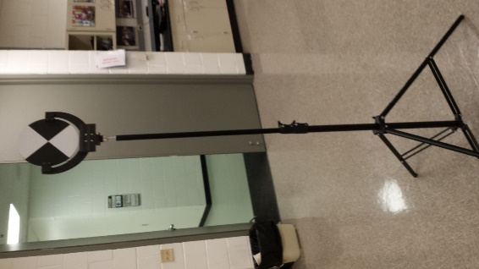
Figure 5.1 3DLR system registration target

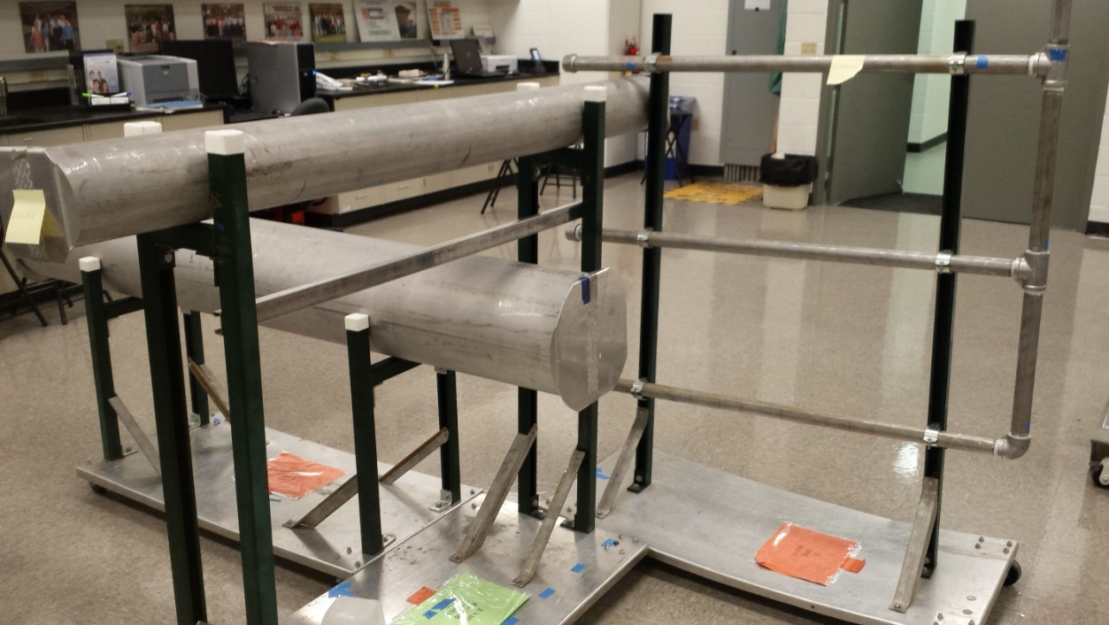
Figure 5.2 Experimental piping setup for change detection

The test frame was set up to be sufficiently complex to make point cloud registration challenging for the Kinect v2. Each series of scans consisted of four separate positions around the test frame for approximately 120 degrees of coverage. The distance from each sensor position to the far side of the piping assembly was less than 5 m. Both sensors were positioned at each scan location in turn, as illustrated in Figure 5.3. The test rig support structure also added clutter to the scene to make it sufficiently challenging for the instruments to scan.

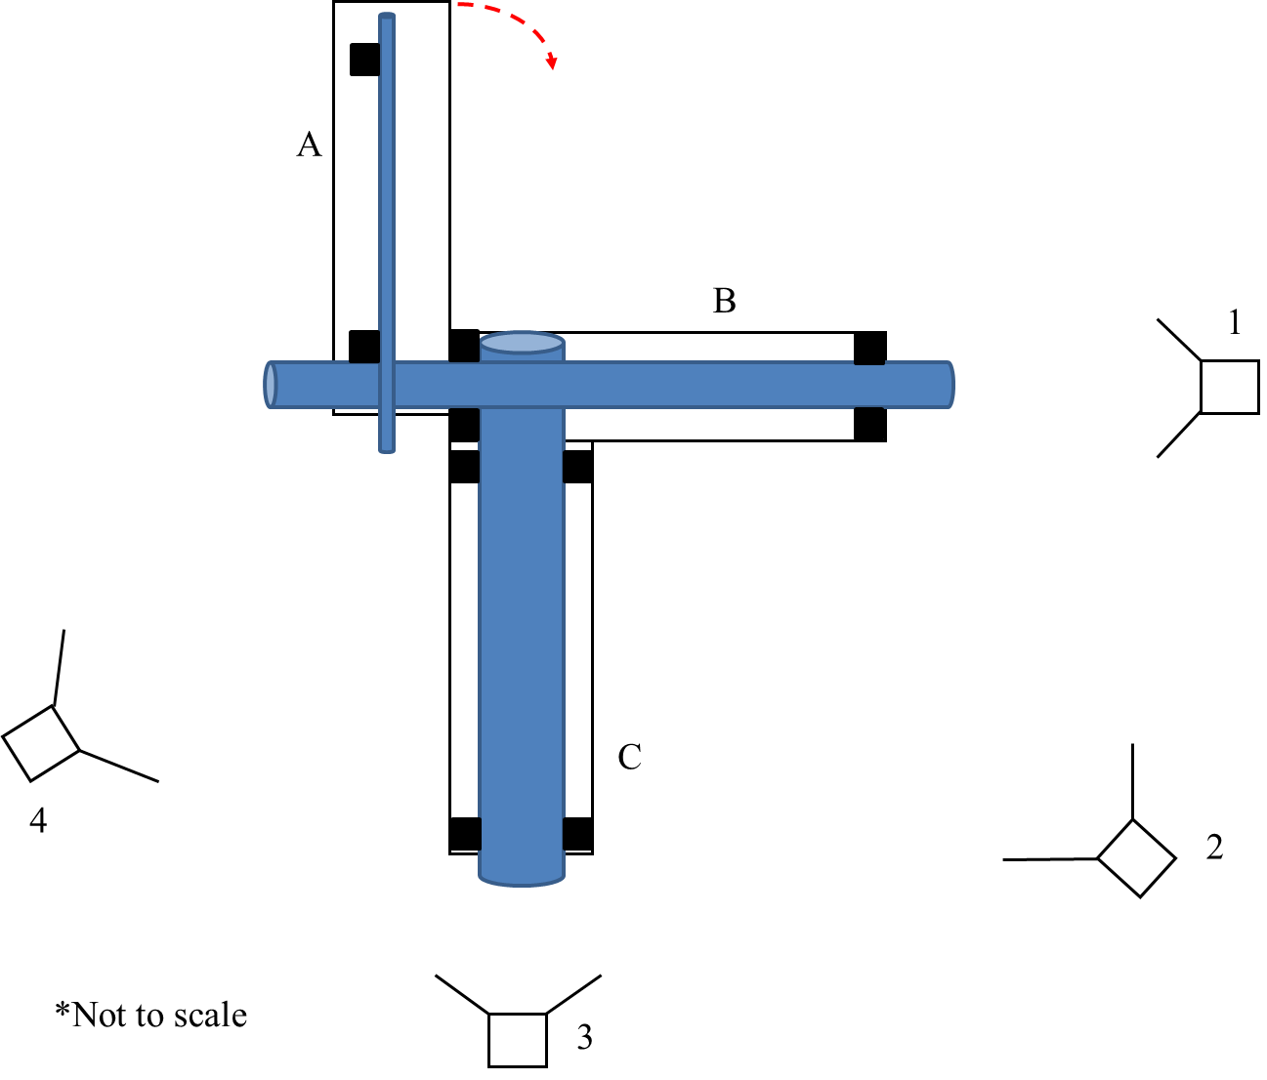
Figure 5.3 Top-down view of the test setup with scanning locations identified.
Segment A was rotated as one of the configuration changes.

After the first set of scans, researchers made multiple changes to the test rig with varying degrees of subtlety. A portion of the assembly—Segment A in Figure 5.3—was rotated approximately five degrees out of alignment, and three separate sections of piping were also removed from Segment A. These sections include an entire horizontal pipe, a short vertical segment of pipe at the top of the assembly, and one of the pipe endcaps. Figure 5.4 highlights the segments removed from the test assembly. A second scan of the scene was then conducted from each of the same locations noted in Figure 5.3.

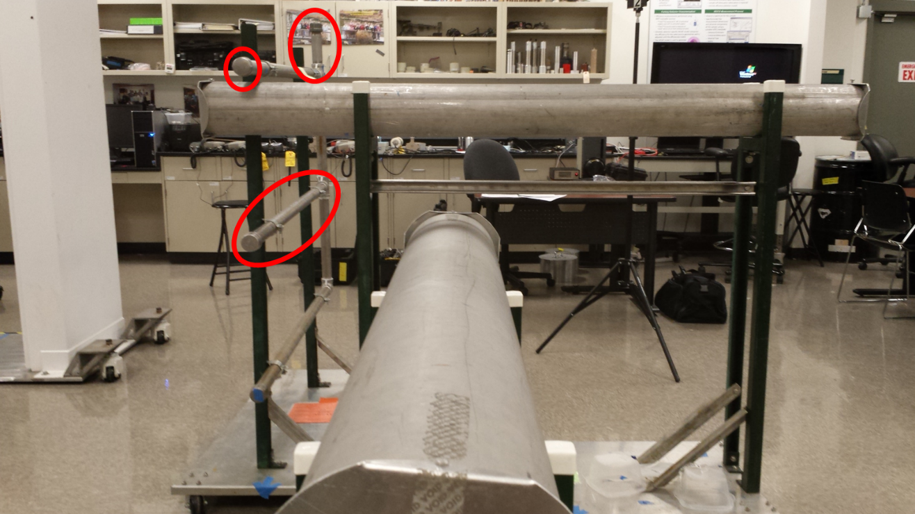
Figure 5.4 Highlighted portions of the test assembly that were removed between completed scans.

Performance Assessment
The criteria for success in this research is whether or not the Kinect v2 system with the PCL-based software solution can capture and register point cloud scenes and identify the appropriate changes made at two different times by visually highlighting clusters of changed points. Both the Kinect v2 and the 3DLR collected and correctly registered—on the basis that all of the images were used and aligned into a single reference frame—their scan data to form comprehensive point cloud scenes of the pipe assembly. The 3DLR sensor produced correctly registered point cloud scenes, both when registered with the sensor’s proprietary software and when registered with PCL. By comparison the Kinect v2 scenes, despite also being correctly registered, are less sharp than the 3DLR. Figure 5.5 and Figure 5.6 compares registered Kinect v2 and 3DLR scenes from scan location #1 (as identified by Figure 5.3) and for the completed scene incorporating all scan locations, respectively. Table 5.1 provides a series of root-mean-square (RMS) values from linking scenes imaged at positions 1 and 2 with both instruments at both times. All four sets of scenes were registered with PCL. These RMS values provide a basis of statistical comparison for how accurately the point cloud scenes taken at those positions were registered together. Lower relative RMS values for the same scene indicate better registration. Because of inherent differences between individual images, RMS values cannot be zero. See Appendix A for additional information on RMS-value comparison.

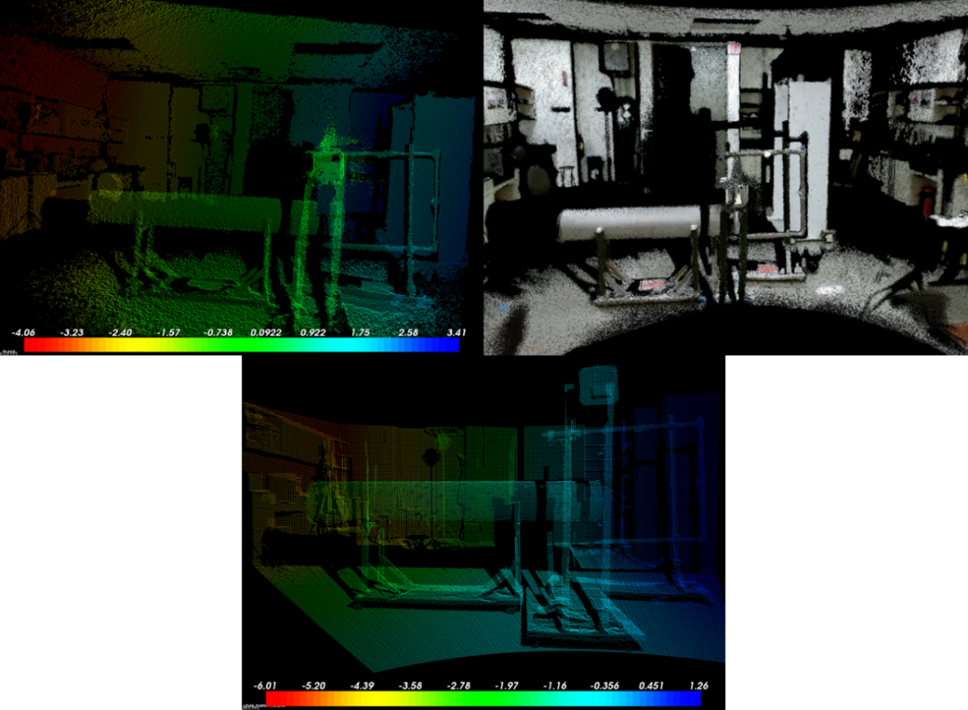
Figure 5.5 Various point clouds from scan location #1; Left: a single Kinect v2 image; Right: registered Kinect v2 point cloud consisting of 32 separate images; Below: 3DLR scan from the same position.

Multiple parameter changes were made in an attempt to find better solutions for each set of images, and there was some observed change in each variation. Ultimately, both sets of point clouds were registered with the same PCL parameters (i.e. down-sampling, maximum correspondence distance). The reduction in final scene quality for the Kinect v2 compared to the 3DLR was expected given the intrinsic difference of each instruments’ capabilities, but the Kinect v2 was, in-fact, capable of constructing the same scenes of the target area as the 3DLR.

Table 5.1 Comparison of RMS values for registering scenes from Position 1 to Position 2 at two separate times
 | Kinect v2 |  | 3DLR
 | Time 1 | Time 2 | Time 1 | Time 2
RMS (cm) | 98.16 | 86.36 | 31.83 | 79.48

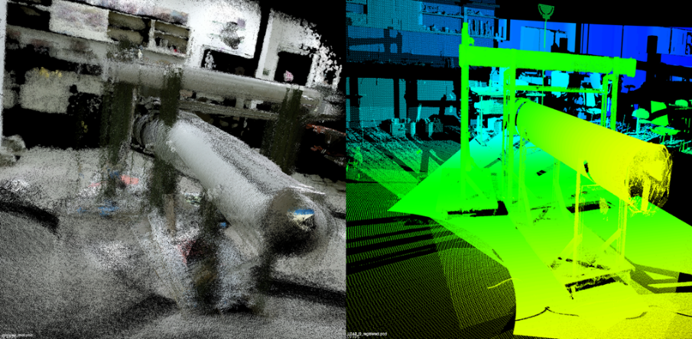
Figure 5.6 Completed point cloud scenes from all four scanning locations; Left: Kinect v2; Right: 3DLR

Using the PCL change detection algorithm discussed in Chapter Four, both sets of point clouds were compared using minimum octree voxel resolutions ranging from 10-30 cm. Identified change points are highlighted in red for visualization purposes. The registered point clouds generated by both sensors identified and highlighted multiple locations on the piping assembly where changes were made to the system. Both the 3DLR, using the proprietary registration software and the PCL-based software, and the Kinect v2 system highlighted points at all four of the changes made to the piping system (Figure 5.7 and Figure 5.8). The removed horizontal pipe, the removed vertical pipe segment, and the Segment A rotation were all visibly distinguished for both sensors. The fourth change—the removal of the top horizontal pipe cap, and circled in Figure 5.7 and Figure 5.8—was also highlighted for both instruments. However, the number of highlighted points returned for the Kinect v2 “cap change” is very slight compared to the 3DLR scene (Figure 5.7).
It is important to note that because there are changes being highlighted for various reasons—poor registrations or features that were not imaged in the initial scan because of difference in the view angle of the sensor as well as changes—not all highlighted points can be assessed as intentional changes made to the piping system. Therefore, while the Kinect v2/PCL system successfully observed an event and highlighted the cluster of points associated with the cap change, the number of points observed is too slight to conclusively identify this observation as a “change.” The difference between a highlighted observation and a detected change is an important distinction in the context of DIV inspections where an inspector will need to make judgments based on gathered information. However, the fact that the change detection system is a tool designed to assist an inspector in identifying potential changes—not to make judgments for the inspector—correctly highlighted the cluster of points associated with the cap change, this observation is considered a success based on the criteria highlighted above.

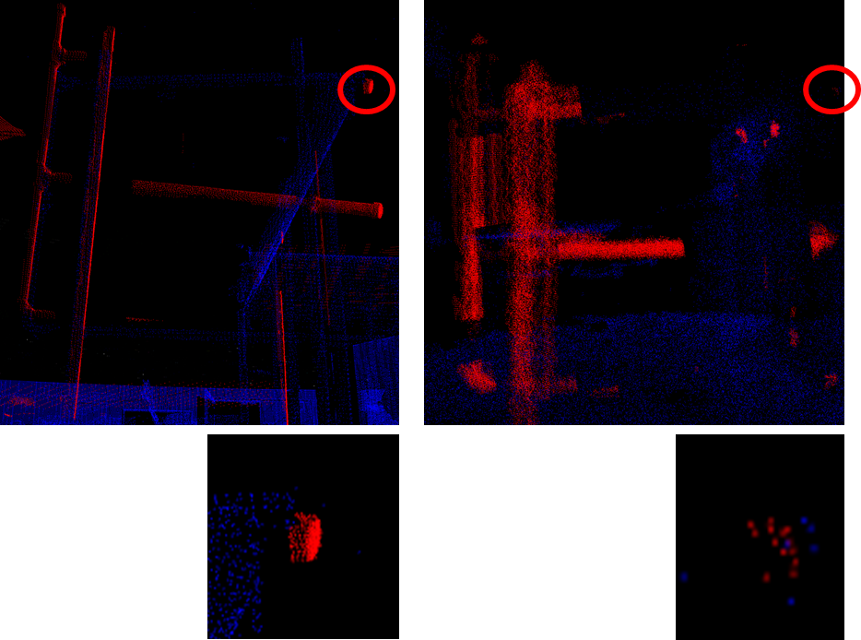
Figure 5.7 Side view of the observed changes (red points) between the two scenes as scanned by the 3DLR (left) and the Kinect v2 (right) with the “cap change” circled in red and enlarged (below).

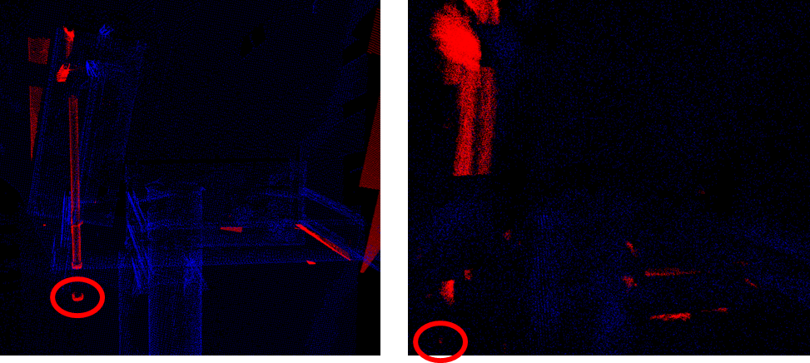
Figure 5.8 Top-down view of the observed changes (red points) between the two scenes as scanned by the 3DLR (left) and the Kinect v2 (right) with the “cap change” circled in red.

The lack of a robust detection for the “cap case” with the Kinect v2 sensor may be explained by several factors. One such possibility is that the post-processing workflow used in this research contains inaccuracies and inefficiencies. This research necessitated the writing of original codes with PCL software because there is no other system known to be available in the open source that is capable of readily collecting and manipulating point clouds independent of source. Therefore, it is possible that this thesis’ ICP routine, when compared to the 3DLR system’s proprietary software, is presently not as capable and is thus causing enough of a reduction in the accuracy of the registration that it limits the observable potential of the Kinect v2 system. Evidence of this effect is seen in Figure 5.9, which compares the point cloud images registered by the 3DLR’s proprietary software and the PCL-based registration routine developed for this study. Using the CloudCompare open-source software [78] as a visualization tool, a triangle was plotted from the edge points the horizontal piping section to quantify the area being consumed by the piping section for both the proprietary and PCL registration methods. Figure 5.9 is strong visual evidence that that the images did not register to the same degree of precision in each program—the area consumed by the pipe in the PCL registration program is a factor of two greater. This comparison is particularly useful given that RMS values for the scenes registered with the proprietary 3DLR solution could not be made available for comparison.

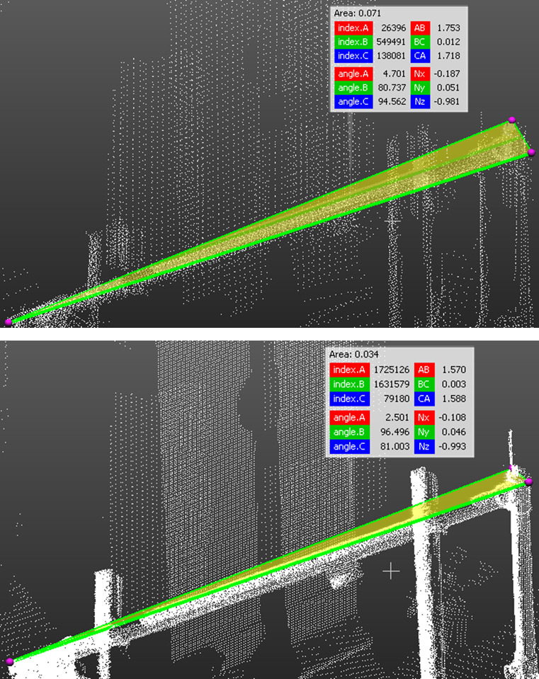
Figure 5.9 3DLR images registered with the PCL-based program (above) show visible registration inaccuracies compared to the proprietary registration software (below).

Ultimately, the primary factor for why the Kinect v2 system may have had difficulty seeing the cap change is that the TOF sensor does not provide the same resolution and accuracy as LIDAR, and this specific change may not be readily observable with the present capabilities of the Kinect v2 system. Further controlled studies will be necessary to fully explore the possible limitations of TOF instruments and specifically the Kinect v2 in detecting changes. However, because there is a dependence on the quality of the post-processing algorithms, as discussed above, there are challenges in experimentally determining the absolute detection threshold based solely on an instrument’s intrinsic capabilities.
Relative comparisons between TOF and LIDAR system capabilities are also difficult because both systems capture spatial points in different ways: LIDAR will scan a target area on a continuously-rotating basis while adding discrete data points, and TOF captures batches of points simultaneously on a pixilated sensor. This makes direct comparison of each system’s resolution and accuracy difficult when multiple TOF images—registered with some statistical error—are being compared with a single LIDAR scan. However, by comparing the volumetric density of points for both systems, it may be possible to at least determine if the number of registered Kinect v2 images in this study created a comparable number of points in the area of interest.
Figure 5.10 is a visual comparison of the density of points in one of the fully registered 3DLR and Kinect v2 scenes. Despite the difference in scales between the two visualizations, the point densities of the piping assembly are very similar for both instruments. Therefore the number of points collected is not assessed as a factor in the change detection algorithm’s performance in this thesis. This is particularly useful information if there is an unknown effect that volumetric point density has on the change detection algorithm.
Despite the possible effects from imprecise registration, information from this head-to-head comparison of the two 3D sensing instruments suggests that the TOF technology used by the Kinect v2 is capable of performing change detection on the centimeter scale in a manner that is comparable to a 3DLR system used by the IAEA. While further work is necessary to quantify the exact difference in detection limits for various instrument ranges, it is clear that TOF-based sensors provide a demonstrable potential to perform change-detection.

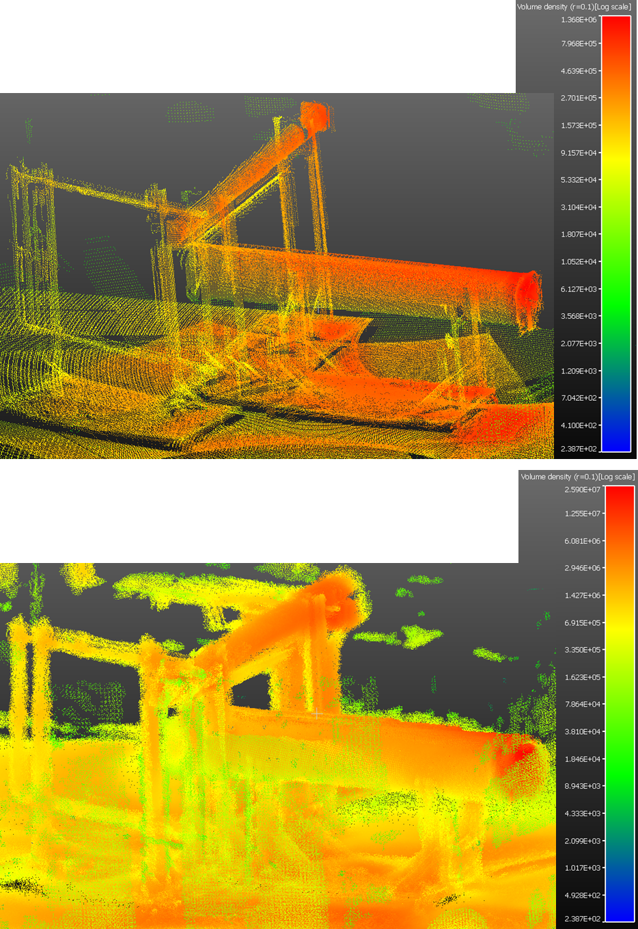
Figure 5.10 Volumetric point density maps of the 3DLR scene (above) and the Kinect v2 scene (below)

Scanning Time Comparison
IAEA inspectors have limited time at facilities being assessed for DIV. Thus, additional information was collected in this validation test to compare the speed with which the two sensors could set up, scan their target environments, and process the collected data to draw a change-detection conclusion. Each step was timed with a stopwatch. Reported values were rounded up to the next minute (Table 5.2). By this comparison, scanning that requires 3DLR will take significantly less time to process. However, differences in total time are based on the assumption that the entire process from setup to change detection is serial. Recommended changes to the sensor deployment CONOPS would be recommended to adjust and optimize a TOF system. Registration times can be further reduced with improved software workflow and computer hardware.

Table 5.2 Measured time for various sensor activities, in minutes.
 | Hardware Setup Time | 180° Scan Time | Registration Timeª | Change Detection Time | Total Time
3DLR | 17 | 7 | 2-5 | 4 | 29-32
Kinect v2 | 10 | 1 | 10-25 | 4 | 25-40
ª Time varies based on software settings

Discussion and Future Work

Discussion and Conclusions
The primary motivation for exploring TOF sensors as a DIV tool was to demonstrate their potential to perform the same mission as the current 3DLR while enabling the IAEA to save significant resources. The TOF sensor used in the Microsoft Kinect v2 was found to be capable of imaging complex scenes and detecting spatial changes when used in limited-range applications. In one test, it was able to readily detect three of four spatial changes made to a mock-up assembly designed to simulate a complex scanning environment. The most challenging change to detect was observed at a 1 cm voxel resolution, but given the inability to readily distinguish a true detection from the additional noise present in the change-detection results, this point was not scored as a “success.” Overall, the Kinect v2 demonstrated considerable capability when compared to the advanced, LIDAR-based 3DLR system that scanned from the same locations and observed all four of the spatial changes. TOF change detection was also demonstrated in the complex environment presented by the University of Tennessee laboratory. Table 6.1 compares of the two systems based on both researched and experimentally determined variables.
Of particular note, the cost of the sensor equipment used to operate the TOF sensor for this research is three orders-of-magnitude less than the cost of a 3DLR system; $250 as compared to $150,000. In fact, the potential cost-savings seen by scanning with TOF sensors is significant enough that 3D sensing could be done in high-radiation environments where the sensor cannot be recovered once it is introduced. Additionally, the Kinect v2 is more portable, easier to set up for data collection, and does not require independent targets to register point clouds.

Table 6.1 Comparison of assessed depth sensors
 | 3DLR | Kinect v2
Resolution | < mm | mm
Maximum Reliable Range (m) | 79ª | 8.0
Technology Maturity | High | Moderate
Post-processing Computational Intensity | Low | High
Support Equipment Demand | Moderate | Low
Instrument Ease-of-Use | Moderate | High
Portability | Moderate | High
Cost/Unit ($) | 150,000^{b} | 250
ª From Zollen-Froehlich [79]
^{b} From Durst et al [8, p. 17]

The Kinect v2’s overall performance deficiency is derived from its post-processing times, which are significantly higher than those of the 3DLR. The Kinect v2 also required PCL to run ICP routines for every collected image and needed 88 point cloud images to completely characterize the “before” scenes, compared to four images needed for the 3DLR. Improvements in the registration workflow can achieve better computational times in PCL, but possibly at the expense of accuracy, which is critical for the proposed DIV CONOPS for the TOF sensor. The Kinect v2’s ability to pair with open-source software allows for continuous image registration and computation time improvements.
This research ultimately demonstrates that TOF sensors can provide significant cost-savings to the IAEA, facilitating greater collection of DIV information. TOF is not mature enough to replace 3DLR in the near-term, and further development is needed before a TOF-based sensor can be used for a safeguards mission. However, the highly successful change-detection performance of the Kinect v2—compared to current methods—suggests that future work should be pursued to create a new system capable of fully realizing the goal of making 3D sensing inexpensive and easy to implement on a large scale for treaty monitoring.

Future Work
Future improvements to TOF sensors, the post-processing workflow, the inclusion of different sensors, and the exploration of new/unique sensor CONOPS will drive potential future work in this research. Several safeguards-specific developments are also necessary before TOF can be implemented on a large scale for the IAEA.

Sensor and Software Improvements
Unlike the 3DLR system, the Kinect v2 was not purpose-built to survey and perform the change detection mission demonstrated in this research; the Kinect is a consumer electronic product intended for use in the average living room. But the potential for its use in DIV justifies future work to design and develop a purpose-built instrument. A new sensor designed for performing DIV should have higher resolution, a stronger NIR illumination source, and reduced modulation frequency to increase range. New TOF sensors will likely be developed for industry and commerce with superior performance, but their development will take place alongside competing technologies, such as structured-light and stereo vision. This implies the likely need for future work to develop TOF sensors specifically intended to support IAEA missions. Radiation hardening techniques should also be examined if TOF sensors are to be considered for use in high-radiation environments.
Purpose-built software solutions will also advance inexpensive 3DLR alternatives. The ICP algorithm used heavily in the PCL programs coded for this research represent a brute-force approach to point cloud registration. Other methods of registering point clouds were attempted—such as random sample consensus model fitting, Euclidean segmentation, feature histograms, and normal distribution transforms—but these could not be reliably implemented for this project. Future development could find a solution for implementing some of these processes into the post-processing workflow to substantially reduce the time required to register point Kinect v2 generated images.

Inclusion of Other Sensors
Additional instruments could also improve the performance and registration of TOF instruments. Accelerometers, gyroscopes, or magnetometers—used independently or in combination through an inertial measurement unit (IMU)—could provide improved sensor performance by recording point clouds with pre-programmed sensor orientation information [40]. IMUs could also improve camera tracking and speed up registration, making it easier to perform real-time sensing and scanning. TOF can also be paired with other sensing modalities, such as pixelated radiation sensors, to overlay radiation fields with spatial information.

Unique CONOPS Approaches
While this research explored TOF technology for DIV, TOF can support safeguards in other ways. For example, inexpensive TOF sensors can supplement unattended monitoring systems and cameras used by the IAEA to provide additional confidence in its standard C&S assessments.
Because the intended end-use of the TOF sensor is to perform treaty monitoring and verification, data authenticity must be ensured before the information can be used to help the IAEA reach safeguards conclusions. The physical TOF instrument itself will require a design that includes tamper-indicating and tamper-resisting features on the hardware. The information recorded from the sensor will also require a unique form of authentication to provide confidence to the IAEA and the facility operator that the sensor’s information is true.

List of References
[1] International Atomic Energy Agency, “The Structure and Content of Agreements between the Agency and States Required in Connection with the Treaty on the Non-Proliferation of Nuclear Weapons.” Jun-1972.
[2] “IAEA by the Numbers,” 26-May-2014. [Online]. Available: https://www.iaea.org/about/by-the-numbers. [Accessed: 02-Apr-2015].
[3] International Atomic Energy Agency, “The Safeguards Implementation Report for 2013.” Apr-2014.
[4] S. Poirier, M. Moeslinger, M. Zendel, S. Haslam, and K. Hughes, “The Use of 3D Laser based Systems for IAEA SG Design Information Verification (DIV),” presented at the 50th Annual Meeting of the Institute of Nuclear Materials Management 2009, Tucson, AZ, 2009.
[5] R. S. Bean, R. R. Metcalf, and P. C. Durst, “Design Information Verification for Nuclear Safeguards,” Idaho National Laboratory (INL), INL/CON-09-16395, 2009.
[6] J. G. M. Goncalves, S. Abousahl, Y. Aregbe, W. Janssens, and K. Luetzenkirchen, “The European Commission Cooperative Support Programme: 30 Years of Activities,” ESARDA Bull., vol. 46, Dec. 2011.
[7] International Atomic Energy Agency, “Safeguards Techniques and Equipment: 2011 Edition.” 2011.
[8] P. C. Durst, R. Metcalf, R. Bean, T. Bjornard, B. Boyer, M. Burks, A. Dougan, M. Ehinger, D. Few, D. Hanks, and others, “Report of the Workshop on Nuclear Facility Design Information Examination and Verification for Safeguards,” Idaho National Laboratory, INL/EXT-09-15744, 2009.
[9] V. Castaneda and N. Navab, “Time-of-flight and kinect imaging,” Kinect Program. Comput. Vis., 2011.
[10] C. Plagemann, V. Ganapathi, D. Koller, and S. Thrun, “Real-Time Identification and Localization of Body Parts from Depth Images,” in 2010 IEEE International Conference on Robotics and Automation (ICRA), Anchorage, Alaska, 2010, pp. 3108–3113.
[11] L. Schwarz, D. Mateus, V. Castaneda, and N. Navab, “Manifold Learning for ToF-based Human Body Tracking and Activity Recognition,” 2010, p. 80.1-80.11.
[12] J. Penne, C. Schaller, J. Hornegger, and T. Kuwert, “Robust Real-Time 3D Respiratory Motion Detection using Time-of-Flight Cameras,” Int. J. Comput. Assist. Radiol. Surg., vol. 3, no. 5, pp. 427–431, Jul. 2008.
[13] J. J. M. Monteserin, “Multi Sensor System for Pedestrian Tracking and Activity Recognition in Indoor Environments,” Thesis, University of South Florida, 2014.
[14] J. Hyyppae, A. Jaakkola, H. Hyyppae, H. Kaartinen, A. Kukko, M. Holopainen, and L. Zhu, “Map Updating and Change Detection Using Vehicle-Based Laser Scanning,” presented at the 2009 Joint Urban Remote Sensing Event, 2009.
[15] T. Butkiewicz, “Low-Cost Coastal Mapping using Kinect v2 Time-of-Flight Cameras,” in Oceans-St. John’s, 2014, St. John’s, NL, 2014, pp. 1–9.
[16] J. A. Curro, “Automated Aerial Refueling Position Estimation using a Scanning LIDAR,” Thesis, Air Force Institute of Technology, Wright-Patterson Air Force Base, Ohio, 2012.
[17] C. Schaller, “Time-of-Flight - A New Modality for Radiotherapy,” Universitaet Erlangen, Nuernberg, 2011.
[18] M. Benedict, T. H. Pigford, and H. W. Levi, Nuclear Chemical Engineering, 2nd ed. McGraw-Hill, 1981.
[19] D. R. Olander, “The Theory of Uranium Enrichment by the Gas Centrifuge,” Prog. Nucl. Energy, vol. 8, no. 1, pp. 1–33, 1981.
[20] S. Whitley, “The Uranium Ultracentrifuge: The Story of the Development of the Gas Centrifuge for Separation of Isotopes of Uranium,” Phys. Technol., vol. 10, pp. 26–33, 1979.
[21] G. Selvaduray, M. K. Goldstein, and R. N. Anderson, “Survey of Nuclear Fuel Reprocessing Technologies,” Conserv. Recycl., vol. 3, no. 2, pp. 93–134, 1979.
[22] R. Lemon and D. Reid, “Experience with a Direct Maintenance Radiochemical Processing Plant,” presented at the International Conference on the Peaceful Uses of Atomic Energy, Geneva, 1955, vol. 9, pp. 532–545.
[23] P. D. R. Wallace, I. Therios, M. H. Ehinger, R. Bean, D. N. Kovacic, A. D. K. Tolk, and B. Boyer, “Advanced Safeguards Approaches for New Reprocessing Facilities,” Pacific Northwest National Laboratory, PNNL-16674, Jun. 2007.
[24] International Atomic Energy Agency, Ed., IAEA Safeguards Glossary, 2001 ed. Vienna: International Atomic Energy Agency, 2002.
[25] M. Schanfein, “IAEA: Unattended Monitoring Systems: A Brief Overview,” presented at the NGSI Student VTC Series, Jul-2011.
[26] R. Bean and P. C. Durst, “A Future Tool for Design Information Examination and Verification for Nuclear Safeguards,” presented at the 51th Annual Meeting of the Institute of Nuclear Materials Management, Baltimore, MD, 2010.
[27] G. F. Flanagan, “The DIQ and DIV Process for Research/Power Reactors,” presented at the Modeling and Simulation for Nuclear Safeguards for the Next Generation Safeguards Initiative Human Capital Development Workshop, Oak Ridge, TN, 15-Dec-2014.
[28] J. G. Gonçalves, S. Abousahl, and P. Frigola, “The European Commission Cooperative Support Programme: Activities and Achievements,” in Proc. IAEA Symposium on International Safeguards, Vienna, 2010.
[29] J. G. M. Goncalves and V. Sequeira, “Application of Laser Range Images to Design Information Verification,” in Proceedings of a Symposium on International Nuclear Safeguards, Vienna, Austria, 1994, vol. 2, pp. 219–230.
[30] V. Sequeira, J. G. Gonçalves, and M. I. Ribeiro, “3D Reconstruction of Indoor Environments,” in International Conference on Image Processing, 1996., 1996, vol. 1, pp. 405–408.
[31] J. G. M. Goncalves, V. Sequeira, and F. Sorel, “Application of 3D Models to Training and Design Information Verification Safeguards,” presented at the 38th Institute of Nuclear Materials Management Annual Meeting, Phoenix, AZ, 1997.
[32] T. K. Kohoutek, R. Mautz, and A. Donaubauer, “Real-time Indoor Positioning Using Range Imaging Sensors,” in Proceedings of SPIE Photonics Europe, Real-Time Imaging and Video Processing, 2010, vol. 7724.
[33] L. Li, “Time-of-Flight Camera - An Introduction.” Texas Instruments, May-2014.
[34] C. D. Mutto, P. Zanuttigh, and G. M. Cortelazzo, “TOF Cameras and Stereo Systems: Comparison and Data Fusion,” in TOF Range-Imaging Cameras, F. Remondino and D. Stoppa, Eds. Heidelberg, New York, Dordrecht, London: Springer, 2013, pp. 177–202.
[35] T. Oggier, “Image Sensor Technologies for 3D Time-of-flight Range Imaging,” presented at the Proc. of 2009 International Image Sensor Workshop, Bergen, Norway, Jun-2009.
[36] L. Zhang, B. Curless, and S. M. Seitz, “Rapid Shape Acquisition Using Color Structured Light and Multi-pass Dynamic Programming,” in Proceedings of the First International Symposium on 3D Data Processing Visualization and Transmission (3DPVT’02), Padova, Italy, 2002.
[37] Williem, Y.-W. Tai, and I. K. Park, “Accurate and Real-Time Depth Video Acquisition using Kinect–Stereo Camera Fusion,” Opt. Eng., vol. 53, no. 4, Apr. 2014.
[38] K. D. Mankoff and T. A. Russo, “The Kinect: a Low-Cost, High-Resolution, Short-Range 3D Camera,” Earth Surf. Process. Landf., vol. 38, no. 9, pp. 926–936, Jul. 2013.
[39] P. Manojkumar and G. R. M. Reddy, “Parallel Implementation of 3D Modelling of Indoor Environment Using Microsoft Kinect Sensor,” presented at the 2013 Fourth International Conference on Computing, Communications and Networking Technologies (ICCCNT), Tiruchengode, India, 2013.
[40] M. Niessner, A. Dai, and M. Fisher, “Combining Inertial Navigation and ICP for Real-time 3D Surface Reconstruction,” Eurograhpics Assoc., 2014.
[41] Y. Taguchi, Y.-D. Jian, S. Ramalingam, and C. Feng, “SLAM using Both Points and Planes for Hand-Held 3D Sensors,” in 2012 IEEE International Symposium on Mixed and Augmented Reality (ISMAR), Atlanta, Georgia, 2012, pp. 321–322.
[42] O. M. Mozos, H. Mizutani, R. Kurazume, and T. Hasegawa, “Categorization of Indoor Places Using the Kinect Sensor,” Sensors, vol. 12, pp. 6695–6711, May 2012.
[43] K. Kamarudin, S. Mamduh, A. Shakaff, and A. Zakaria, “Performance Analysis of the Microsoft Kinect Sensor for 2D Simultaneous Localization and Mapping (SLAM) Techniques,” Sensors, vol. 14, pp. 23365–23387, Dec. 2014.
[44] T. Gill, J. M. Keller, D. T. Anderson, and R. H. Luke III, “A System for Change Detection and Human Recognition in Voxel Space using the Microsoft Kinect Sensor,” in 2011 IEEE Applied Imagery Pattern Recognition Workshop (AIPR), 2011, pp. 1–8.
[45] D. Piatti, F. Remondino, and D. Stoppa, “State-of-the-Art of TOF Range-Imaging Sensors,” in TOF Range-Imaging Cameras, F. Remondino and D. Stoppa, Eds. Heidelberg, New York, Dordrecht, London: Springer, 2013, pp. 1–9.
[46] R. Lange and P. Seitz, “Solid-State Time-of-Flight Range Camera,” IEEE J. Quantum Electron., vol. 37, no. 3, pp. 390–397, Mar. 2001.
[47] “Introduction to the Time-of-Flight (ToF) System Design: User’s Guide.” Texas Instruments, May-2014.
[48] T.-Y. Lee, J.-K. Jung, D.-K. Min, Y. Park, K. Bae, and T.-C. Kim, “Perspectives on 3D ToF Sensor SoC Integration for User Interface Application,” presented at the 2012 International SoC Design Conference (ISOCC 2012), Jeju Island, Republic of Korea, 2012.
[49] M. Brading, K. Salsman, M. Somayaji, T. Dorz, D. Van Nieuwenhove, P. Gelabert, and B. Dipert, “Using 3D Sensors to Bring Depth Discernment to Embedded Vision Apps,” Embedded, Apr-2013. [Online]. Available: http://www.embedded.com/design/real-world-applications/4411991/Using-3D-sensors-to-bring-depth-discernment-to-embedded-vision-apps. [Accessed: 15-Mar-2016].
[50] “SR4000 Data Sheet.” MESA Imaging, Aug-2011.
[51] A. M. Pinto, P. Costa, A. P. Moreira, L. F. Rocha, G. Veiga, and E. Moreira, “Evaluation of Depth Sensors for Robotic Applications,” presented at the 2015 IEEE International Conference on Autonomous Robot Systems and Competitions, 2015, pp. 139–143.
[52] Y. Cui, S. Schuon, D. Chan, S. Thrun, and C. Theobalt, “3D Shape Scanning with a Time-of-Flight Camera,” in 2010 IEEE Conference on Computer Vision and Pattern Recognition (CVPR), 2010, pp. 1173–1180.
[53] F. Remondino and D. Stoppa, Eds., TOF Range-Imaging Cameras. Heidelberg, New York, Dordrecht, London: Springer, 2013.
[54] F. Chiabrando, R. Chiabrando, D. Piatti, and F. Rinaudo, “Sensors for 3D Imaging: Metric Evaluation and Calibration of a CCD/CMOS Time-of-Flight Camera,” Sensors, vol. 9, no. 12, pp. 10080–10096, Dec. 2009.
[55] N. Pfeifer, D. Lichti, J. Boehm, and W. Karel, “3D Cameras: Errors, Calibration and Orientation,” in TOF Range-Imaging Cameras, F. Remondino and D. Stoppa, Eds. Heidelberg, New York, Dordrecht, London: Springer, 2013, pp. 117–138.
[56] “Heptagon: Industrial Products.” [Online]. Available: http://hptg.com/industrial/. [Accessed: 16-Mar-2016].
[57] S. Izadi, D. Kim, O. Hilliges, D. Molyneaux, R. Newcombe, P. Kohli, J. Shotton, S. Hodges, D. Freeman, A. Davison, and A. Fizgibbon, “KinectFusion: Real-Time 3D Reconstruction and Interaction using a Moving Depth Camera,” in Proceedings of the 24th annual ACM symposium on User interface software and technology, Santa Barbara, CA, 2011, pp. 559–568.
[58] C. R. Popescu and A. Lungu, “Real-Time 3D Reconstruction Using a Kinect Sensor,” Comput. Sci. Inf. Technol., vol. 2, no. 2, pp. 95–99, 2014.
[59] P. Beno, F. Duchon, M. Tolgyessy, P. Hubinsky, and M. Kajan, “3D Map Reconstruction with Sensor Kinect: Searching for Solution Applicable to Small Mobile Robots,” in 2014 23rd International Conference on Robotics in Alpe-Adria-Danube Region (RAAD), 2014, pp. 1–6.
[60] R. B. Rusu and S. Cousins, “3D is Here: Point Cloud Library (PCL),” in 2011 IEEE International Conference on Robotics and Automation (ICRA), 2011, pp. 1–4.
[61] T. Pałys and W. Żorski, “Enhanced Movement Tracking with Kinect Supported by High-Precision Sensors,” in Proceedings of the Federated Conference on Computer Science and Information Systems, 2015, pp. 883–888.
[62] L. Yang, L. Zhang, H. Dong, A. Alelaiwi, and A. E. Saddik, “Evaluating and Improving the Depth Accuracy of Kinect for Windows v2,” IEEE Sens. J., vol. 15, no. 8, pp. 4275–4285, Aug. 2015.
[63] P. Fankhauser, M. Bloesch, D. Rodriguez, R. Kaestner, M. Hutter, and R. Siegwart, “Kinect v2 for Mobile Robot Navigation: Evaluation and Modeling,” presented at the 2015 International Conference on Advanced Robotics (ICAR), 2015, pp. 388–394.
[64] D. Pagliari and L. Pinto, “Calibration of Kinect for Xbox One and Comparison between the Two Generations of Microsoft Sensors,” Sensors, vol. 15, no. 11, pp. 27569–27589, Oct. 2015.
[65] “Structure Sensor Support Center | What are the Structure Sensor’s technical specifications?” [Online]. Available: http://structure.io/support/what-are-the-structure-sensors-technical-specifications. [Accessed: 16-Mar-2016].
[66] “Kinect V2 Maximum range,” Sep-2014. [Online]. Available: https://social.msdn.microsoft.com/Forums/en-US/c95d3e40-6ed6-47a1-a206-5ff26c889c29/kinect-v2-maximum-range?forum=kinectv2sdk. [Accessed: 26-Mar-2016].
[67] T. Wiedemeyer, IAI Kinect2. University Bremen: Institute for Artificial Intelligence, 2014.
[68] A. Aldoma, Z.-C. Marton, F. Tombari, W. Wohlkinger, C. Potthast, B. Zeisl, R. Rusu, S. Gedikli, and M. Vincze, “Tutorial: Point Cloud Library: Three-Dimensional Object Recognition and 6 DOF Pose Estimation,” IEEE Robot. Autom. Mag., vol. 19, no. 3, pp. 80–91, Sep. 2012.
[69] F. Echtler, L. Xiang, C. Kerl, T. Wiedemeyer, Lars, R. Gordon, hanyazou, and et al., libfreenect2. .
[70] T. Wiedemeyer, Kinect2 Calibration. University Bremen: Institute for Artificial Intelligence, 2014.
[71] P. J. Besl and N. D. McKay, “A Method for Registration of 3-D Shapes,” IEEE Trans. Pattern Anal. Mach. Intell., vol. 14, no. 2, pp. 239–256, Feb. 1992.
[72] S. Rusinkiewicz and M. Levoy, “Efficient Variants of the ICP Algorithm,” in Third International Conference on 3-D Digital Imaging and Modeling, 2001. Proceedings., Quebec City, Quebec, 2001, pp. 145–152.
[73] “Documentation - Point Cloud Library (PCL): Estimating Surface Normals in a Point Cloud.” [Online]. Available: http://www.pointclouds.org/documentation/tutorials/normal_estimation.php#normal-estimation. [Accessed: 08-Apr-2016].
[74] R. B. Rusu, “Semantic 3D Object Maps for Everyday Manipulation in Human Living Environments,” Dissertation, Institut für Informatik der Technischen Universität München, 2009.
[75] D. Meagher, “Geometric Modeling using Octree Encoding,” Comput. Graph. Image Process., vol. 19, no. 2, pp. 129–147, Jun. 1982.
[76] “Point Cloud Library (PCL): Module Octree,” Mar-2016. [Online]. Available: http://docs.pointclouds.org/trunk/group__octree.html. [Accessed: 21-Mar-2016].
[77] “Octree.png - Robótica - ULE,” Wikimedia Commons. [Online]. Available: http://robotica.unileon.es/mediawiki/index.php/File:Octree.png.
[78] CloudCompare. .
[79] “Technical Data Z+F IMAGER 5006i.” Zoller+Froehlich, 2009.

Appendices

Registration Sensitivity Analysis

Multiple program variables discussed in Chapter Four can have an effect on how accurately point cloud images are registered. The most appropriate registration settings will reduce unnecessary processing time and increase the user’s confidence in the eventual change-detection determination. In the interest of discovering the most appropriate settings for each parameter, this sensitivity analysis examines three variables and their impact on an example set of images: the number of point cloud images per angle of rotation, the extent to which an image is down-sampled, and the maximum correspondence distance (MCD) sought by the Iterative Closest Point (ICP) algorithm.

Angular Point Cloud Sampling Rate
Each point cloud image sampled with the Kinect v2 system will provide a point cloud with approximately 217,000 individual points. Thus, the total number of point cloud images taken in a given scene will directly affect the number of individual points captured and eventually concatenated. It is important to note, however, that while the angular scan rate will impact the density of points in the final scene, the number of points in the final scene does not impact the registration process because each image is registered to the next adjacent image. Rather, registration between two images may be impacted by the angular scan rate on the premise that two adjacent images must have a sufficient number of overlapping features to be accurately registered. An extreme example of this is two images taken 90 degrees apart from each other may not overlap at all, or the number of true correspondences between the two images will be insufficient to make an accurate registration. The other extreme considers a situation where a disproportionately large number of point cloud images is taken per degree of rotation, and thus unnecessarily straining computing resources.
As discussed in Chapter Four, the Kinect v2 system was tested in a laboratory setting using a series of images taken from four separate locations within the laboratory. The camera was rotated approximately 90 degrees at each location and captured between 20-41 images. The location where 41 images were collected was selected for this research because half of the images—every other one—could be removed to determine the effect on registration from the sampling frequency. Figure A.1 is an illustration of differences in angular sampling.

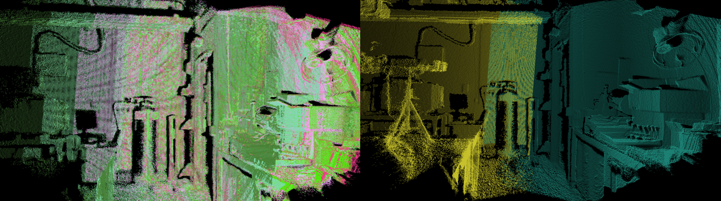
Figure A.1 Comparison of a dense (left) and sparse (right) scene angular sampling rate

Image Down-sampling
Prior to registration, the point cloud images are down-sampled. The effect that down-sampling has on the registration process is explored at 1, 2, 3, 5, and 7 cm³ voxel sizes; the smaller the voxel size, the greater the number of points remaining in the cloud. Voxel sizes greater than 7 cm³ proved to eliminate too much detail from the images to provide an effective registration, and voxel sizes less than 1 cm³ do not provide sufficient down-sampling to effectively reduce computing time. Figure A.2 is a comparison of several down-sampled point clouds.

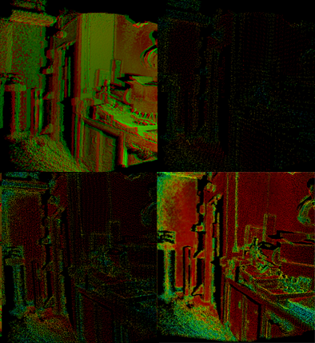
Figure A.2 Two point clouds being registered (upper left) with various down-sampling voxel sizes: 7 cm (upper right), 3 cm (lower left), and 1 cm (lower right).

Maximum Correspondence Distance
Because ICP relies on performing linear matching to the nearest corresponding point in the neighboring cloud, the Point Cloud Library (PCL) allows the programmer to specify the maximum distance that ICP will carry out its search for a corresponding point. This is particularly important because it restricts the number of points sampled on each iteration—if no restrictions are placed then a pair of images with 150,000 points each would require 2.25x10¹⁰ calculations, per iteration. The MCDs sampled in this research are 20, 25, 35, 40, 50 cm. Earlier performance testing demonstrated that values within this range are appropriate, particularly for scenes with maximum scan ranges of up to 10 m and a modest angular imaging rate.

Parametric Test Results and Analysis
The full sequence of 41 images and the subset of 21 images of the same laboratory scene were registered with the aforementioned down-sampling and MCD values. The measured root-mean-square (RMS) distance of each point with its corresponding point in the registered, adjacent point cloud is determined for each cloud pair and the average value for each fully registered scene was found. With the exclusion of six specific cases because of their computational intensity—40 and 50 cm maximum correspondence distance at 1 cm and 50 cm MCD at 2 cm for both 21 and 41 image scenes—44 test case results are shown below. The difference in average RMS values between two concatenated point cloud scenes of the same number of images is shown Figure A.3, and Figure A.4, along with their respective standard deviations.

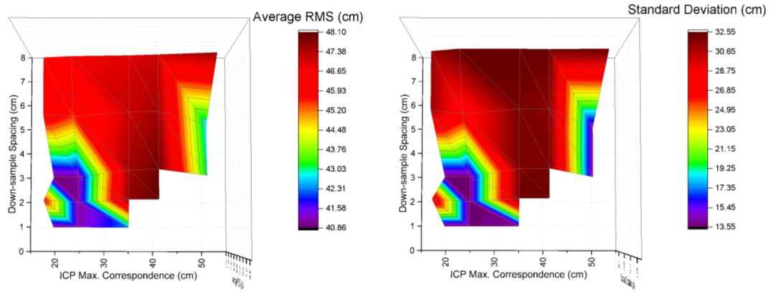
Figure A.3 The average RMS (left) and standard deviation (right) for the laboratory scene with 21 images.
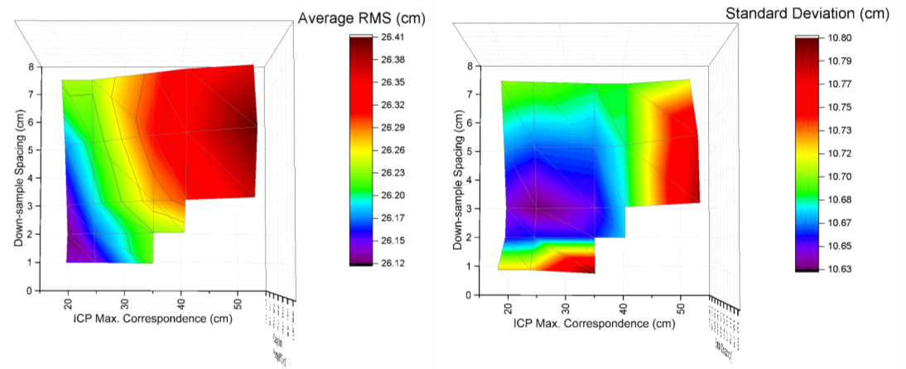
Figure A.4 The average RMS (left) and standard deviation (right) for the laboratory scene with 41 images.
The 21-image point cloud scene is more prone to errors than the 41 image scene in most of the test-cases. This is primarily caused by a very poor registration (Figure A.5) at the same location in 14-of-22 of the 21-image test case. This localized registration error is a significant contribution to the elevated averages in Figure A.3. The sharp change in the visible planes—the new image introduced the back wall into the field-of-view, and the plane of the door is not very visible—is a possible contributing factor that could not be correctly adopted under so many parameter combinations.

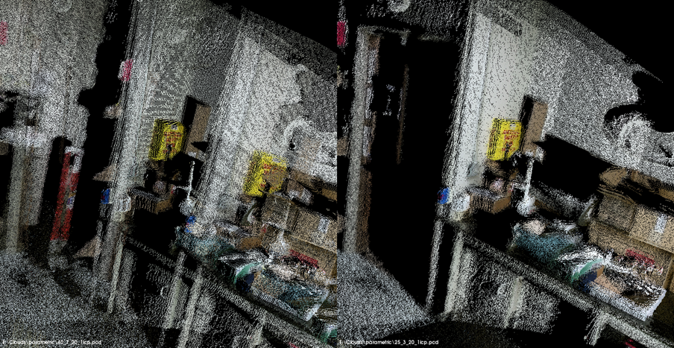
Figure A.5 Poor registration near the door in over half of the 21-image runs (left) as compared to a proper registration in the remainder (right).

The absolute RMS values for the 21-image case and the 41-image case are not comparable to each other due to the inherent offset in the RMS values from changing differing the angle between adjacent point cloud image captures, but, as predicted, a smaller angular change between two concurrent images will reduce registration errors. The 41-image scene did not exhibit any severe registration errors similar to Figure A.5 for any of the tested scenarios, and changes to the registration parameters had much smaller impact on the average RMS in the 41-image case. It is clear from both cases that too large of a down-sampling voxel (> 5 cm) produces less precise results. Understanding the effect that the MCD has is less certain because of the improved performance at with a correspondence distance of 50 cm for the 21-image case. However, there is generally better performance if the MCD is less than 35 cm. These interpretations can be confirmed by visual examination of several of the concatenated point clouds generated from each registration. Figure A.6 shows the results of two registered scenes from the 41-image sample set. The upper and lower scenes represent 25 cm and 20 cm MCDs, respectively, and 3 cm and 1 cm voxel sizes, respectively. The color overlay helps assess the differences between the two point clouds at individual points on the cloud, but the differences between the two clouds is very slight. A tabular comparison of these two clouds (Table A.1) is also provided with the difference between the RMS for each two clouds being linked. The initial, negative difference values show that the 25 cm MCD/3 cm voxel case had a better registration than the 20 cm MCD/1 cm voxel case in the first third of the scene as compared to the remaining two thirds.
This suggests that there are scene-specific factors that are not included in this research. The makeup of the scene being recorded (e.g. repetitive features and colors, complex detail in the foreground versus the background, lighting conditions, etc.) may have an unspecified impact in the accuracy and precision in automated registration which requires further research. The computational time to complete each series of registrations also was not measured but play an important factor in future algorithm development.

Table A.1 Select registration comparison
Registered Scene Pairing | RMS (cm) |  | RMS Delta (cm)
 | 25 cm MCD/3 cm Vox. | 20 cm MCD/1 cm Vox.
1 | 10.52 | 10.29 | 0.23
2 | 24.85 | 24.90 | -0.05
3 | 49.09 | 48.93 | 0.16
4 | 43.67 | 43.86 | -0.20
5 | 55.28 | 55.53 | -0.25
6 | 28.56 | 28.56 | 0.00
7 | 40.08 | 41.05 | -0.97
8 | 17.01 | 17.02 | -0.01
9 | 31.44 | 31.52 | -0.08
10 | 51.12 | 51.21 | -0.09
11 | 40.29 | 40.30 | -0.02
12 | 20.06 | 20.07 | -0.01
13 | 19.52 | 19.82 | -0.30
14 | 29.79 | 30.31 | -0.52
15 | 18.89 | 18.86 | 0.04
16 | 14.17 | 14.15 | 0.02
17 | 25.20 | 24.99 | 0.21
18 | 23.75 | 23.63 | 0.12
19 | 23.81 | 23.81 | 0.00
20 | 22.74 | 22.51 | 0.23
21 | 24.38 | 24.23 | 0.15
22 | 26.46 | 26.12 | 0.35
23 | 26.85 | 26.55 | 0.30
24 | 26.01 | 25.88 | 0.13
25 | 16.52 | 16.51 | 0.01
26 | 27.34 | 27.19 | 0.15
27 | 27.45 | 27.36 | 0.09
28 | 24.43 | 24.34 | 0.09
29 | 19.75 | 19.74 | 0.01
30 | 43.49 | 43.33 | 0.16
31 | 15.43 | 15.44 | 0.00
32 | 24.99 | 24.97 | 0.03
33 | 24.67 | 24.33 | 0.33
34 | 20.38 | 19.82 | 0.57
35 | 18.83 | 18.45 | 0.38
36 | 18.49 | 18.21 | 0.28
37 | 13.36 | 13.31 | 0.05
38 | 24.39 | 23.84 | 0.55
39 | 17.68 | 17.65 | 0.03
40 | 16.88 | 16.85 | 0.03
Scene Average | 26.19 | 26.14 | 0.06
Scene Standard Deviation | 10.63 | 10.72 | -0.09
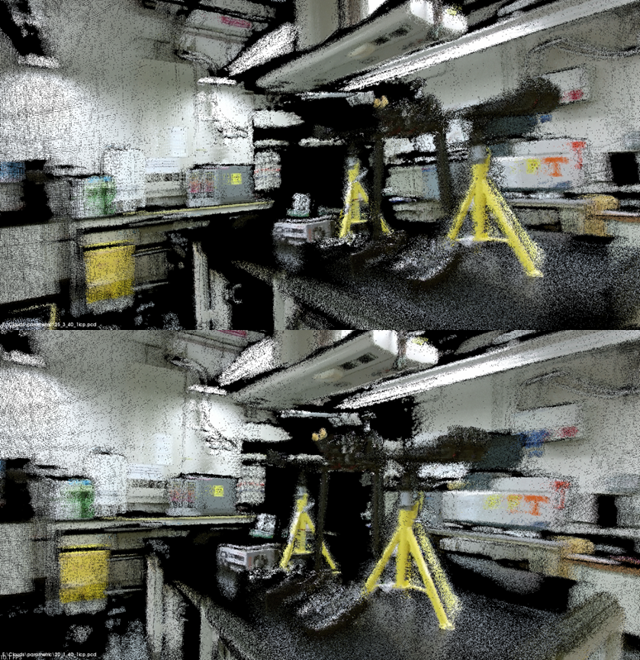
Figure A.6 Comparison of two 41-image scenes: (above) 25 cm maximum correspondence distance with 3 cm down-sample voxel, and (below) 20 cm distance with 1 cm voxel.

The Xbox Kinect was introduced in 2010 for the Xbox 360 gaming system. It is referenced in this report as “the Kinect.”
Visit www.pointclouds.org for more information.
Visit www.rog.org for more information
See the PCL registration module for details on other registration methods: http://docs.pointclouds.org/1.7.2/a02415.html

