An Archaeological and Historical Investigation of a 19th Century Leprosarium at Hassel Island, St. Thomas, U.S. Virgin Islands

A Thesis Presented for the
Master of Arts
Degree
The University of Tennessee, Knoxville

Amanda Marie Barton
December 2012

Acknowledgements

There are many people who have helped during this five-year journey. First off, thank you to Dr. Judy Sichler, who suggested my name when she found out about this project. Thank you to Ken Wild, the Virgin Islands National Park Service, and the Friends of the Virgin Islands National Park, for allowing (and funding) me to work in one of the most beautiful places on Earth. Thank you to Holly Norton, Susanna Pershern, Lauran Riser, Vibe Martens, and Andreas Latif for all your help with this project, and companionship while in the Virgin Islands. Thank you to Rune Winfield, Vibe Martens, and Andreas Latif for spending time researching and translating documents in Denmark. The historical background on this site would not have been possible without you.
Thank you to my committee members, Drs. Barbara Heath, Elizabeth Kellar-DeCorse, and David Anderson, for all your help and patience during this journey. Thank you to Dr. Gerald Schroedl for advice and suggested reading material. Thank you to Dr. Kandi Hollenbach for giving me suggestions on where to go with my thesis research whenever I got stuck in a rut. Thank you to Dan Marcel for making my site map look professional and for keeping me laughing throughout this project. A big thank you to Chad Caswell and Howard Cyr for showing me how to make a distribution map in ArcGIS.
Finally, thank you to Jessica Vavrasek, for constantly telling me to work on my thesis, and to my husband, Colby Brooks, thank you for your patience, and I know you are very happy that I am done with this project.

Abstract

Located on Hassel Island, a small island off the coast of Charlotte Amalie, in St. Thomas, USVI, a small leprosarium, or quarantine hospital for those affected with leprosy, was in operation from 1833 to 1861 as a way to isolate those with leprosy from the general population. Surface and sub-surface excavations took place over the spring and summer of 2008 in preparation for proposed National Park Service hiking trail that would be laid parallel to the site remains.
Firstly, this thesis provides a historical background on leprosy, as well as a background on how leprosy and disease has been studied by anthropologists and archaeologists. Secondly, a historical background is provided on Hassel Island and its leprosarium along with a description of the archaeological investigation performed there. Finally, an analysis of the recovered artifacts and spatial analysis is used to understand what life would have been like at the leprosarium. Results of this analysis, based on the historical and archaeological record, suggests that conditions at the leprosarium were less than ideal. A high occurrence of container glass fragments attributed to liquor bottles suggests that drinking was a form of medicating, especially with the lack of patent medicine bottles recovered. The ceramics recovered were mostly utilitarian stoneware and coarse earthenwares, and inexpensive refined earthenwares. The lack of personal items implies that patients were unable financially or were not allowed to express much in the way of culture or individuality.

Table of Contents
Chapter Page

Chapter 1 Introduction 1
Chapter 2 Leprosy and Treatment in Western Europe and the Tropics 4
Chapter 3 The Anthropology and Archaeology of Disease and Confinement 15
Chapter 4 St. Thomas and Hassel Island Description and Historical Background 24
A Brief Introduction to St. Thomas 24
Historical Archaeology in the Virgin Islands 27
Hassel Island’s Economic Importance 29
National Park Service Acquisition and National Register Status 31
Disease and Quarantine on Hassel Island 32
Chapter 5 Fieldwork on Hassel Island 44
Prior Fieldwork at Leprosy Hospital 44
Fieldwork: May-June 2008 45
Site Cleanup and Walkover 45
Systematic Grid Collection 55
Test Units 62
General Surface Collection 66
Site Formation 66
Chapter 6 Artifact Analysis 69
Lab and Analysis Methods 69
Results of Artifact Analysis 69
Artifacts that Date to and Possibly Date to the Leprosy Hospital 71
Ceramics Types 71
Porcelain 73
Stoneware 73
Refined Earthenware 76
Coarse Earthenware 100
Container Glass 103
Black or Dark Olive Glass 104
Dip Mold 104
Applied Finish 107
Three-piece/Ricketts Mold 108
Cracked Off Finish 108
Dr. J.G.B. Siegert Aromatic Bitters 111
“P.Herrink” or P.F. Heering Cherry Liqueur 113
Pipes 117
Personal Items 124
Metals 131
Conclusions 134
Chapter 7 Artifact Distributions and Analysis 137
Methods Background 137
Results 138
Chapter 8 Summary, Conclusions, and Future Research 160
Summary 160
Conclusions 160
Future Research 164
List of References 167
Appendix I 178
Appendix II 179
Vita 180

List of Tables

Table 2-1. Condensed table of some of the key points about leprosy listed by island physicians in the Report on Leprosy (1867). 9
Table 4-1. English Translation of Figure 4-4. 38
Table 6-1. Count and percentages of all artifacts collected during the 2008 excavation and surface collection. 70
Table 6-2. Counts and percentages of all artifacts included in this study. 72
Table 6-3. Pearlware decorative techniques. 78
Table 6-4. Whiteware decorative techniques. 80
Table 6-5. Breakdown of transfer-print colors on sherds recovered from the leprosarium. Dates come from Samford (1997). The sherds recovered from the leprosarium are believed to be whiteware, therefore they would all date after 1820. 85
Table 6-6. Counts and percentages for manufacturing techniques on the container glass dating to the leprosarium. 103
Table 6-7. Counts and percentages for glass color. 105
Table 6-8. A list of Dutch makers who used the crown and '54' symbol. It is uncertain why some of the dates are left blank. (Meulen 2003). 122
Table 6-9. All personal items recovered during excavation. 125
Table 6-10. Personal items that could be dated to the leprosarium. 125
Table 6-11. List of sites, taken from Good (1982:166), in which this type of compound, blue bead was found. 127

List of Figures

Figure 4-1. Map of the U.S. Virgin Islands (Courtesy of worldatlas.com) 25
Figure 4-2. Map showing the harbor at Charlotte Amalie and Hassel Peninsula in the early 1800s. It is unknown what the building near the location of the future leprosarium is (black arrow). (Lundbye 1800). 28
Figure 4-3. Cropped 1873 Revised (original map 1851) Admiralty Chart of Hassel Peninsula. The ‘X’ marks the spot of the leprosarium (Lawrance 1851). 35
Figure 4-4. List of leprosy patients undergoing treatment for leprosy on St. Thomas in 1855 (Sager vedr. folketælling [Census] 1841 – 1855). 37
Figure 4-5. 1904 Landholding Map. The ‘L’ on the west coast of Hassel Island represents that the land was owned by “Hassell’s Arvinger[heirs]” (Aamodt 1904). Also notice that the red is overlaid on Lawrance’s 1951 Admiralty map. 43
Figure 5-1. Leprosy hospital site facing southeast. The highlighted area in the foreground shows the remnants of the isthmus. Behind that, slightly upslope, the site’s cistern is visible (red arrow). Photo taken by the author in 2008. 47
Figure 5-2. Topographic map of Hassel Island, showing elevations of the island (USGS 1982). The red circle marks the approximate location of the leprosarium. 48
Figure 5-3. Clearing of brush from the cistern. Photo taken by the author in 2008. 49
Figure 5-4. Facing northwest towards the east wall of the cistern. Photo taken in 2008 by the author. 50
Figure 5-5. View of the interior of the cistern. Note the dead iguana in the center. Photo taken in 2008 by the author. 50
Figure 5-6. Aerial photograph of Hassel Island with the site map and 1851 admiralty map overlayed to show the relation of the current cistern to the historic image of the cistern. The red circle marks the location of the cistern remains overlayed with 52
Figure 5-7. Foundation A, facing southwest. Photo taken in 2008 by the author. 53
Figure 5-8. Foundation B, facing southwest towards the cistern. Photo taken in 2008 by the author. 54
Figure 5-9. Foundation C, facing north towards the cistern. Photo taken in 2008 by the author. 55
Figure 5-10. Facing WNW looking at a gravesite. The large piece of coral (red arrow) marks the top of the grave, while the pile of rocks would have covered the body. Photo taken by the author in 2008. 56
Figure 5-11. Leprosarium site map. 57
Figure 5-12. Detail, northeast portion of site map. 58
Figure 5-13. Detail, northwest portion of site map. 59
Figure 5-14. Detail, center portion of the site map. 60
Figure 5-15. Detail, southern portion of site map. 61
Figure 5-16. Laying grid, facing southwest. Photo taken in 2008 by Holly Norton. 62
Figure 5-17. Base of Test Unit 1. Facing East. Taken by the author in 2008. 64
Figure 5-18. Base of Test Unit 2. Facing South. Taken by the author in 2008. 65
Figure 5-19. Base of Test Unit 3. Facing southeast. Taken by the author in 2008. 65
Figure 6-1. Porcelain sherd with gilding and molded design. 74
Figure 6-2. Stoneware vessel sherds from N512 E504 with interior Albany slip (1805-1920). 75
Figure 6-3. Stoneware bottle base from N516 E502. 77
Figure 6-4. Bristol glazed ginger beer bottle sherds from N506 E506. 77
Figure 6-5. Possible pearlware sherd. Note the blue pooling. 78
Figure 6-6. Seriation graph of refined earthenware designs 81
Figure 6-7. Seriation graph of refined earthenware designs 82
Figure 6-8. "[ROCKI]NGHAM" maker's mark on whiteware sherd from general surface collection FS#90 82
Figure 6-9. "[OPA]QUE DE S[ARREGUEMINES]" maker's mark on whiteware sherd from N500 E502. 83
Figure 6-10. Unidentifiable maker's mark on a whiteware sherd from N516 E504. 83
Figure 6-11. The variety of colors found on transfer printed wares at the leprosy hospital. 85
Figure 6-12. Blue Willow transfer print sherd recovered from N500 E502. 86
Figure 6-13. Examples of red chinoiserie transfer print patterns. 86
Figure 6-14. Examples of landscape or pastoral transfer-print designs. 88
Figure 6-15. Dark blue, continuous floral border. 89
Figure 6-16. Brown, continuous floral borders. 90
Figure 6-17. Blue transfer printed and sponged whiteware sherd recovered from N502 E500. 91
Figure 6-18. Large, cut sponged bowl recovered from N502 E502. 93
Figure 6-19. Cut sponged and banded whiteware sherd from N510 E498. 93
Figure 6-20. Cat's eye design on an industrial slipware fragment from N512 E500. 94
Figure 6-21. Engine turned industrial slipware fragment from FS#91. 94
Figure 6-22. Annular industrial slipware fragment from N504 E506. 96
Figure 6-23. Polychrome, handpainted whiteware sherd from N514 E502. 96
Figure 6-24. Blue shell edged whiteware 97
Figure 6-25. Banded whiteware fragment. 99
Figure 6-26. Whiteware fragment with stenciled design. 99
Figure 6-27. Large, earthenware basin sherds recovered from general surface collection. 101
Figure 6-28. Black, lead glazed earthenware. 102
Figure 6-29. A sample of some of the dark olive glass recovered. 105
Figure 6-30. Dip molded vessel bases. 107
Figure 6-31. Applied finish. 108
Figure 6-32. Dr. J.G.B. Siegert and Hijos (post-1870) Ricketts molded bottle. 109
Figure 6-33. Cracked off finish. 111
Figure 6-34. Dr. J.G.B. Siegert bitter bottle fragments 112
Figure 6-35. P.F. Heering Cherry Liqueur bottle fragments. The two on the left are imitations. 114
Figure 6-36. Possible medicine bottle fragment. Molded graduated markings and the letters "poons" [spoons]? are molded onto the vessel. 117
Figure 6-37. W. White and Sons pipe stem fragment. 119
Figure 6-38. Scottish pipe with steam powered locomotive and paddle steamer design. 120
Figure 6-39. Dutch pipe with crown and '54' stamp. 120
Figure 6-40. Another Dutch pipe with crown and number stamp. Full number is not legible. 123
Figure 6-41. French and English gunflints. 123
Figure 6-42. Compound, blue bead recovered from N516 E504. 127
Figure 6-43. Prosser button recovered from the trail surface collection. 129
Figure 6-44. Ceramic marble recovered from N504 E506. 130
Figure 6-45. Slate pencil recovered from N506 E504. 131
Figure 6-46. Heavily rusted cut nail from test unit 3. 132
Figure 6-47. Metal lamp part recovered from N502 E502. 133
Figure 7-1. Cropped image of the site map showing Foundations A and B, the cistern, and the 2 x 2 meter units used in this study. The foundations and cistern are circled in red. 139
Figure 7-2. Cropped image from an 1851 map showing the four structures located at the leprosarium. The smallest structure is the cistern. 140
Figure 7-3. 1851 map with the site map overlayed. The two maps do not fit perfectly together, which is probably the result of both site map error and errors with historic map accuracy. 141
Figure 7-4. Distribution map of artifacts that date to the leprosarium. 144
Figure 7-5. Distribution map of artifacts that post-date the leprosarium. 145
Figure 7-6. Distribution map of all bottle glass fragments that could be dated to the leprosarium. 147
Figure 7-7. Distibution map of porcelain artifacts. 148
Figure 7-8. Distribution map of stoneware artifacts. 149
Figure 7-9. Distribution map of coarse earthenware artifacts. 150
Figure 7-10. Distribution map of refined earthenware artifact 151
Figure 7-11. Map of the general surface collections near the cistern and Foundation C. The counts for ceramic ware types recovered from each surface collection are circled in red. 153
Figure 7-12. Distribution map of undecorated wares. 154
Figure 7-13. Distribution map of minimally decorated wares. 155
Figure 7-14. Distribution map of hand painted wares. 157
Figure 7-15. Distribution map of transfer-printed wares. 158

List of Attachments

File 1: Artifact Data (Excel File)…………………………………Appendix I-Artifact Data.xlsx
File 2: Full Size Size Map (PNG Image)………………………........Leprosarium Site Map.png

Chapter 1
Introduction

From 1833 to 1861, a small leprosarium, or quarantine hospital for those afflicted with leprosy, was in operation on a 135-acre peninsula, known at the time as Orcanhullet (now called Hassel Island), located in the harbor of Charlotte Amalie, St. Thomas, in then Danish West Indies. The leprosarium was referred to in the historic documents as the Lazaretto, the Hospital for Lepers, and the Scrofula Hospital (a different disease that can be mistaken for leprosy), and served as a way to segregate those afflicted by leprosy from the rest of the population, thereby easing the fear that the disease would spread through the island’s population. The 16th through the late 18th centuries were a time of decline in leprosy occurrences throughout the Western world, but by the last quarter of the 18th century sailors and explorers, seeking new lands to conquer, began observing increased cases of leprosy among the islands located in the Pacific and Atlantic Oceans (Edmund 2006:24-26). Studies during the 19th century in the Caribbean (see Royal College of Physicians 1867) showed leprosy being common on most Caribbean islands, but the concern to contain those infected seemed to be minimal. Most Caribbean physicians believed the disease to be hereditary instead of contagious. Those suffering from leprosy were often viewed as more of an irritant to society, because of street begging, than a danger to public health. While some poor houses existed to keep lepers off the streets, very few establishments existed to help treat or quarantine lepers in the Caribbean during the early and mid-19th century (Royal College of Physicians 1867).
Leprosy did not appear to discriminate between class, race, age, or sex, although certain groups had the ability of hide their disease from public knowledge. Physicians reported that their ability to treat leprosy was almost non-existent, in that a case had never been cured and that most medical treatments did not help the disease. Therefore, leprosy sufferers were often limited to local or non-medicinal “treatments” which helped mask the symptoms or pain of the disease rather than help to cure it.
During the summer of 2008, fieldwork was conducted by the National Park Service (NPS) on Hassel Island at the leprosarium’s former location. The site, along with its remaining foundations and cistern, was mapped, photographed, and GPS points were taken. Artifactual remains believed to be associated with the leprosarium were collected using controlled and general surface collections and subsurface excavations. All collected materials were counted, weighed, and analyzed at the Virgin Islands NPS archaeology laboratory on St. John.
This study presents an analysis of the leprosarium on Hassel Island using the historical record and the recovered artifacts to assess the conditions of life for the patients living in isolation. It also uses spatial analysis to understand the relationships between artifacts and building locations. The artifacts and the historical record will be used to assess the kinds of medical treatments, if any, the patients received. This study will also examine the historical and artifactual remains to determine the economic status of the hospital residents. Spatial analysis will be used to determine if any association exists between artifacts and building locations. This study hopes to provide a greater understanding on how disease and quarantine were dealt with in the Caribbean during the 19th century, before scientific and medical research provided the answers.
The historical background on Hassel Island and the leprosarium came from police, medical, and government documents mostly found in the Danish National Archives in Copenhagen. These sources were translated by Rune Winfield, contracted by the National Park Service to help in the background research and translating needed for this study.
- This study will be organized in the following fashion. Following this introduction, Chapter 2 includes a background on leprosy and how it has been viewed and treated from Biblical times through the present. Chapter 3 is a background on the anthropology and archaeology of disease and how this study will fit into that framework. Chapter 4 will present a brief introduction to St. Thomas, the history of Hassel Island, from its beginnings as land for grazing, to its economic importance with careening and shipping businesses, its military significance, and its ultimate economic decline in the 20th century, resulting in its purchase by the National Park Service in 1978. This chapter will also discuss Hassel Island’s use as a mechanism for quarantine of those infected with smallpox and leprosy. Chapter 5 describes prior fieldwork at the leprosarium and the methods used to conduct fieldwork for this study. Chapter 6 will include a discussion on the laboratory analysis methods used in this study, along with issues encountered regarding the time available to analyze the artifacts, and how constraints of time and access affected the study. Important artifacts will be described in further detail. This chapter also includes an analysis of artifact types and their importance in inferring information about the site’s occupants. Chapter 7 describes spatial analysis and how it was used to find associations between the site’s artifacts and building remnants. Chapter 8 summarizes the results of this study and provides suggestions for future research conducted at this site or other leprosaria from this time period.

Chapter 2
Leprosy and Treatment in Western Europe and the Tropics

Leprosy can be defined by modern science as a chronic disease, caused by the bacillus Mycrobacterium leprae which, left untreated, can cause permanent damage to the skin, limbs, nerves, and eyes. It is now known that leprosy is not highly contagious, and if detected early and with the proper medical treatment, can be successfully treated (WHO 2010). Before Gerhard Armauer Hansen’s 1873 discovery of the pathogen, Mycrobacterium leprae, that causes leprosy, physicians throughout the world were uncertain of how to characterize or treat leprosy patients (WHO 1988:6). Leprosy has been recognized among human populations since ancient times in Egypt, China, and India. Mentions of leprosy in the Bible’s Old Testament book of Leviticus told priests to label those infected with the disease as “unclean” and cast them out of society (Moran 2007:4-5). Interestingly, many scholars now believe that the Hebrew word, tsara’ath, which was translated to lepra in Latin and Greek, may have been translated incorrectly. It is believed to have been a term referring to any number of dermatological diseases, but not leprosy as we know today (Gould 2005:3).
Medieval physicians believed that diseases resulted from disparities in the four humors, blood, phlegm and yellow and black bile, which ran throughout the body. Several symptoms of leprosy, including lesions and bleeding, were associated with problems and diseases with the blood, which physicians believed were caused by lust (Hays 2005:36-37). According to an early Christian historian in the first century, any sexual intercourse on the Christian Sabbath that resulted in a pregnancy would produce offspring with epilepsy or leprosy. Jewish belief held the notion that a child born of a mother who had sex and became pregnant while menstruating would be leprous (Zias 1989: 27-31). By the 14th century, physicians began to relate leprosy to problems with black bile, which associated the disease with melancholia and depression (Hays 2005:37).
Leper houses were established during the Middle Ages in Western Europe as a way to contain and care for those infected. Laws of the time stated that those with leprosy could lose their property and rights of citizenship. Despite the leper houses built to separate lepers from society, the afflicted were still allowed to roam the streets of Medieval Europe as a reminder to the rest of the populations of God’s punishment for sinful behavior. In 1179, the Catholic Church’s Third Lateran Council linked the disease to disregard of sexual restraints and instructed those with leprosy be further segregated from society in housing provided specifically for the diseased (Moran 2007:4-5).
These leper homes varied in terms of size and wealth. Most were probably small and dismal, although larger, more elaborate ones existed. Some of the facilities required a fee to be paid, but most ran on charitable donations. The earliest leper homes were controlled by the church, but the later centuries of the Middle Ages saw a shift to government-controlled facilities (Hays 2005:37). Leper houses in England had features similar to those of a small hospital. The afflicted formed a self-governing community with buildings, a chapel, a graveyard, and received small donations for support. Most had a patron, a local lord or council, who was in charge in choosing the hospital head and even who could and could not live there (Orme and Padel 1996:102).
Leper houses were usually located on a main road near town so the lepers could seek
donations from local residents and passing travelers. A 1258 document from a leper house in Cornwall, England, called Lamford Hospital, suggests a definite institutionalized structure to the community. The hospital’s patron reserved the right to decide who was admitted to the hospital. Social standing among the lepers was determined by the goods they brought and the dinner which they had to provide when they arrived. A certain degree of wealth was probably required in order to gain entrance to Lamford. Those less fortunate had to live on the fringes of society without any support (Orme and Padel 1996: 102-104).
A sharp decline in the number of leper homes by the 14th century suggests that infection was decreasing. The decrease in leprosy cases may be attributed to the second plague pandemic that killed off large segments of Europe’s population. There was also a rise in the diagnosis of pulmonary tuberculosis, which is caused by microorganisms similar to leprosy, and is also more contagious. Someone who is infected by pulmonary tuberculosis may be immune to leprosy, and vice versa; therefore leprosy outbreaks may have decreased because more people were infected with tuberculosis (Hays 2005: 39). By the beginning of the 16th century, leprosy is almost non-existent in Western Europe, except for outbreaks in remote areas of Scandinavia (35). Although leprosy would fade out of the limelight for the next couple of centuries, the end of the leprosy outbreak of the Middle Ages left behind a reminder that leprosy should be associated with persecution and disassociation with society (Moran 2007:5).
By the late 18th century, Western European sailors and explorers began writing of their increasing observances of leprosy on the islands located in the Pacific and Atlantic Oceans. Scientist Johann Reinhold Forster wrote in 1778 of his observations of leprosy while on a voyage to Tahiti. He noticed that skin diseases were common on European ships arriving on the island. Forster suggested that leprosy was being brought to Tahiti via slaves being transported to the islands, but he was quick to change his accusation once he realized that placing the blame on his European shipmates may not have been the best idea. Forster ultimately concluded that leprosy was indigenous to the island and had no linkage to the arrival of Europeans (Edmond 2006:24-26). Forster’s original conclusion was most likely correct as modern medicine has concluded that leprosy is a mildly contagious, bacterial disease, transmitted via droplets, from the nose or mouth, if frequent or close contact occurs with infected persons (WHO 2010). Genomic research shows that leprosy has moved throughout populations based on migrations of people. Explorers and colonialists of either European or Northern African decent introduced leprosy to West Africa, and the transatlantic slave trade introduced the disease to the Caribbean (Monot et al. 2005: 1040-1042).
Slave medical manuals of the late 18th-to-early 19th centuries began focusing on leprosy in the West Indies. Grainger (1764) wrote that while leprosy appeared most commonly among the slave population, “…the White people in the West-Indies are not exempted from this dreadful calamity…” (53). Grainger expressed his concerns on whether the disease was contagious or not, since children and spouses of those with leprosy did not always contract the disease. He noted that leprosy often arises from being over-heated, then cooling down too suddenly, but it can also occur without any visible cause. He noted that many treatments such
as sarsa, sassafras, lingnum-vitea, and China root irritated that disease rather than helped alleviate its symptoms (53-54).
English physician Thomas Bateman’s 1836 medical text A Practical Synopsis of Cutaneous Diseases, differentiated three types of leprosy: Lepra vulgaris, Lepra alphoides, and Lepra nigricans (36). Bateman classified leprosy as a scaly disease that was chronic and not easy to cure, but not contagious and rarely dangerous (34-35).
Further research on leprosy was conducted in the early 19th century after leprosy was rediscovered among the Norwegian peasantry. The Norwegian government funded an investigation and the 1847 report became the definitive European medical account of leprosy until Hansen’s discoveries in the 1870s. The reports divided leprosy into two types: tubercular and anaesthetic. The report argued that leprosy was not contagious. Instead it was predominately hereditary, although it could sometimes erupt due to environmental factors. Unlike other publications on leprosy during this time, researchers in Norway used remote, ethnically homogenous populations as their study group, not mixed populations like those in the West Indies and Pacific (Edmond 2006:45).
Even with its known existence in colder climates, such as Norway, leprosy was considered to be a tropical disease because of its presence in the warmer climates of Asia, Africa, the Americas, and the Pacific. Countries that had imperial, military, or economic aspirations with tropical locations were very concerned with tropical diseases because of the effect they could have on their people who were being sent to these locations (Bynum 1994:147). The mid-19th century saw the creation of the field of tropical medicine. The rise of tropical medicine was brought about by Europe and North America’s increasing presence in tropical locations and by the ability of medicine to help dominate, by Christianizing and “civilizing,” these locations (148).
The 1867 Report on Leprosy, prepared by the Royal College of Physicians in London, is a compilation of responses to questions about the prevalence of leprosy in colonies of the Empire. Data from thirteen islands in the Caribbean were included in the report, including: Jamaica, Tortola (Virgin Islands), St. Kitts, Nevis, Montserrat, Antigua, Dominica, St. Lucia, St. Vincent, Barbados, Grenada, Tobago, and Trinidad. The occurrence of leprosy and the understanding of the disease throughout the West Indies varied from island to island (Table 2-1). In Jamaica, for example, leprosy was common and physicians described the disease in terms similar to those used in the report released by the Norwegian government two decades earlier.

Table 2.1. Condensed table of some of the key points about leprosy listed by island physicians in the Report on Leprosy (1867).
Island | Age of onset | More Common in Males or Females? | Race/Ethnicity Most Infected | Rich or Poor? | Hereditary or Contagious? | Restrictions on Public Interactions | Leper-home/Hospital
Jamaica | 20 - 40 | Males | Jews/Black/Colored | Both | Hereditary | None | None
Tortola | 20 - 50 | Females | No Information | Poor | Hereditary | None | None
St. Kitts | 10+ | Males | No Information | Both | Hereditary | None | None
Nevis | Uncertain | Same in both sexes | Black/Colored | Poor | Hereditary | None | None
Montserrat | All ages | Males | Colored (mixed race) | Poor | Hereditary | None | Yes
Antigua | All ages | Same in both sexes | Does not affect one race over another | Both | Hereditary | None | Yes
Dominica | 7+ | Same in both sexes | Does not affect one race over another | Both | Hereditary | None | Yes
St. Lucia | All ages | Females | Black | Poor | Hereditary | None | None
St. Vincent | All ages | Same in both sexes | Black/Colored | Poor | Hereditary | None | None
Barbados | All ages | Same in both sexes | Black | Both | Hereditary | None | Yes
Grenada | 10+ | Same in both sexes | Colored (mixed race) | Poor | Hereditary | None | None
Tobago | 10+ | Males | Black | Poor | Hereditary | None | None
Trinidad | All ages | Males | Black/Colored | Poor | Hereditary | None | Yes

Jamaican physicians noted that the disease seemed to appear more commonly in men than in women, with the black, colored (mixed race), and Jewish populations affected the most. They noted that there was no class distinction in who came down with the disease, but that the disease appeared to be hereditary. Jamaica had no laws or restrictions banning lepers from living among the non-infected and there was no leper asylum/home. With the increasing occurrence of the disease, the legislature had recently passed an act to build a leper asylum, but as of 1867, this had yet to be accomplished.
On Tortola, the closest island in this study to St. Thomas, the island physician stated that leprosy was rare in the Virgin Islands. The physician had very little information on the disease itself. He had only seen three mild cases of the disease, all in adult females and among the poor. There were no restrictions against those with leprosy and no leper asylum in the British Virgin Islands.
On Antigua, the physician, like his colleagues in Jamaica, followed the Norwegian medical report in describing the disease. Leprosy did not appear more frequently in one sex than the other, nor did it affect one race more than another. Leprosy was believed to be hereditary. Antigua had no restrictions on lepers but there was a lepers’ hospital to help those who had become destitute. The hospital was run by the poor law guardians and their medical officer. There was a twelve-room building for the lepers, a house for the superintendent, and a chapel. Each room in the hospital could hold three to four patients, although in the 1867, the hospital only housed 22 lepers. Built in 1838 by The Daily Meal Society, this hospital, known as the Lazaretto, consisted of six rooms for females and six rooms for males. Each room could hold three patients. The enclosed yard around the Lazaretto kept chickens inside and had space for a garden. Bamboo was planted to make baskets, since one of the patients was skilled in
the task and the sales of his work were used to purchase clothes for himself. The patients are noted as being content and happy, as well as receiving “scriptural instruction” (Lanaghan 1844: 256). The Daily Meal Society also built an infirmary on the island and it is noted that “The best medical attention is procured for them; wine and other strengthening nourishment administered to the sick…” (257). The practice of giving alcohol to patients may explain the large amount of bottle glass from alcoholic beverages recovered at the leprosy hospital on Hassel Island discussed in Chapter 6.
The Report on Leprosy shows varying opinions among doctors in the West Indies about which race was afflicted with leprosy most frequently. While some of the islands’ doctors reported no difference between races afflicted, others reported seeing the majority of leprosy cases among the black and colored populations. Interestingly, a few doctors made the observation that the white population did not necessarily suffer less from the disease, but had the capability to hide it. Those who had affluent lifestyles could keep hidden at home or make sure doctors never reported their disease. The less affluent sufferers, who were usually members of the non-white population, were often reported because they were the destitute on the streets asking for money or receiving money from government and religious charities.
The report also shows that very few hospitals or asylums dedicated to leprosy patients existed in the West Indies during the 1860s. For the majority of the 13 Caribbean nations included in this report, leprosy sufferers had few, if any, restrictions keeping them from roaming freely among the non-afflicted. A few islands reported having poor houses that took in lepers and provided a monthly pittance for leprosy sufferers in order to keep them from begging on the streets. The lack of restriction or quarantine may be attributed to the general acceptance that leprosy was a heredity disease and not highly contagious. Lepers were viewed as more of a nuisance than a threat to public health.
The Report on Leprosy asked doctors to report on how medicine had been used in treating leprosy and if any cures had been found. No doctor in the West Indies reported ever seeing a patient cured of leprosy and many stated that medical treatments provided no relief to the sufferer. Doctors reported using iodine, arsenic, or other “treatments” such as liquor to help with symptoms, but none helped stop the disease from progressing. Several doctors suggested that an improvement in diet and hygiene could possibly help reduce symptoms and lengthen lifespans. An article in an 1834 issue of the Virgin Island newspaper, Saint Thomas Tidende, included an account by a man named Count Segur, who told the story of a woman in Guatemala, who suffered from leprosy and was driven from her home. While wandering through the woods, she was taken in by a tribe, who had her swallow a raw lizard, cut into pieces, every day for three weeks. After doing this, the woman was said to have been cured of leprosy. Count Segur wrote of trying lizard himself and said that “The property of this animal, is the cause at the end of a few days such abundant perspiration and salivation as to carry off the disease in a very short time.” Unfortunately for Count Segur, the physicians he told of this “cure” paid little attention and carried on no further research. The newspaper editor went on to say that eating lizard was often spoken of around the Virgin Islands as a cure and the type of lizard required for treatment was found commonly around the islands (Segur 1834).
In 1873 Norwegian physician Gerhard Armauer Hansen identified the bacterium, Mycobacterium leprae, that causes leprosy. This discovery was one of the first identifications of a microbial pathogen in humans (WHO 1988: 6). Despite this discovery, Hansen remained mostly unknown outside of Norway and the medical community and the debate continued throughout the rest of the 19th century and into the early 20th century on whether leprosy was contagious or hereditary. During the same year of Hansen’s discovery, a Belgian Catholic missionary name Father Damien began work at a Hawaiian leprosy settlement, and his sixteen- year service at the settlement garnered worldwide attention, especially when he contracted the disease and died from it. His death helped further the idea that leprosy was definitely contagious, despite medical claims that it was not dangerously contagious, and those with the disease needed to be separated from society. In the 1920s, the common practice of segregating those with leprosy began to fall out of practice. A promising treatment, using an injection of chaulmoogra (see Parascandola 2003), an old Asian remedy, corresponded to the decrease in forced segregation (Gould 2005: 16-18).
Modern medicine has determined that M. leprae is most likely transmitted via skin lesions and the nasal mucous of those infected. M. leprae enters the body of a host either through broken skin or the respiratory tract, with the respiratory tract being the main portal of entry. Those who have frequent contact with leprosy patients, such as those within the household, are more likely to contact the disease than those with less frequent contact (WHO 1988:6-7). Leprosy can take on two different forms depending on how one’s body responds to the bacteria. If the body’s immune system goes into overdrive in order to fight the bacteria, the result is tuberculoid, or paucibacillary leprosy, which is the more belign, less infectious form of leprosy. If the body does not fight the bacteria at all, the result is lepromatous, or multibacillary leprosy, the most serious and contagious form of leprosy. It is also possible to come in contact with the bacteria and never develop leprosy (Gould 2005:14-15). All ages can be afflicted with leprosy, although it is rarely found in infants. The highest rates occur between the ages of 10 and 20, and then decline (WHO 1988:7). Leprosy, in modern times, is treated using a multiple drug therapy, consisting of dapsone, rifampicin, and clofazimine, which can kill 99.9 percent of the bacteria causing leprosy within in a few days (Gould 2005:16).
While the moral stigma associated with leprosy mostly died out as leprosy waned during the late Middle Ages, a negative social stigma is still attached to those with the disease (Gilbert 1987:598). Communities often still view leprosy as a punishment from God and are often unsympathetic to those who are afflicted. It can be hard for the afflicted to find jobs and along with the physical deformation that can occur and the social isolation, leprosy sufferers are often destitute, which makes treating the disease more difficult (WHO 1988:72).
According to a 2011 report by the World Health Organization on the prevalence of leprosy during the first quarter of 2011, no data were submitted by the United States or British Virgin Islands on their counts of leprosy cases. Most Caribbean islands did not submit information. Of those that did, Cuba reported 282 cases, Haiti reported 26, Dominica reported zero cases, the Dominican Republic reported 321, Saint Kitts and Nevis reported 1, Saint Lucia reported 6, and Trinidad and Tobago reported 46 cases (WHO 2011b:396-397). The prevalence of leprosy in the Caribbean, within the countries who submitted information is less than one per 10,000 people (WHO 2011a).

Chapter 3
The Anthropology and Archaeology of Disease and Confinement

The World Health Organization defines infectious diseases as those “…caused by pathogenic microorganisms, such as bacteria, viruses, parasites, or fungi; the diseases can be spread, directly or indirectly, from one person to another” (WHO 2012). An outbreak of an infectious disease can have major effects on a society, not only at the psychological and social levels, but also on the broader political and economic levels. Infectious diseases and the resulting cultural changes provide an excellent opportunity for anthropological studies, from the biological perspective to the historical (Inhorn and Brown 1990:89-90).
Inhorn and Brown (1990) provide a framework of different theoretical perspectives of how disease has been studied in anthropology and related fields. From a biological perspective, theoretical approaches to diseases have focused on evolutionary studies (90). From the microevolutionary standpoint, infectious diseases have played a major role in natural selection throughout the past 5000 years. Individuals who were more resistant to disease in areas where disease was rampant, were more likely to help continue populating the area and creating offspring that would also be more disease resistant. Those who were susceptible to disease died off (91-92). The macroevolutionary approach studies prehistoric and historic populations to gain an understanding of the epidemiological patterns of disease transmission. Using osteological techniques, anthropologists map the antiquity and evolutionary patterns of infectious diseases, and these findings help bring an understanding of the physical and cultural environments of the population involved (93-95). From the ecological perspective, or disease ecology, the focus is on the environment, both physical and sociocultural, and how this affects infectious disease. The sociocultural approach focuses on the link between human behavior and infectious diseases. Human behavior has been shown to both deter and provoke the risk of spreading infectious diseases throughout history (95-97).
For leprosy, studies have typically focused on the biological, looking at how to identify leprosy in skeletal remains, and the sociocultural, which focuses on how the stigma of leprosy and the isolation from quarantining have affected past and current populations. Skeletally, leprosy causes characteristic and permanent changes to the bone in various regions of the body such as the skull, long bones, hands, and feet (see MØller-Christensen 1967:295-306). Examining skeletal remains for evidence of leprosy has helped in tracking the earliest movements of the disease throughout Western Europe, Africa, and Asia. For this study, at the leprosarium on Hassel Island, biological methods provide no input, since no skeletal remains were uncovered during excavation. While a small cemetery is believed to be associated with the hospital, it was not included as part of this project.
The stigma associated with leprosy is said to be worse than the disease itself (see Anderson 2005 for a cultural study of leprosy on St. Kitts and Nevis). Leprosy has often been associated with Biblical references and efforts have been made to adopt the name “Hansen’s disease,” in order to disassociate it with the Biblical leprosy. The stigma that leprosy is a consequence of sinful behavior still exists, even outside Judeo-Christian societies. Those afflicted with leprosy have been and still are in some areas outcast from society. They are unable to find employment, and receive government support or beg on the streets. Those forced into isolation, historically, have had to live in deplorable conditions (see chapter 2) or as in China in 1912, have been rounded up, placed in a pit, and shot (Helman 2007:419-423; Gould 2005: 8-9,20).
Since leprosy is known as a skin disorder, individuals have been stigmatized if they have any sort of discoloration or problems with their skin, because people have mistaken them for lepers. Modern organizations, such as the World Health Organization, have worked to create programs for areas where leprosy is still a problem that deal not only with the physical components of the disease, but also the social issues, such as educating communities about how diseases are contracted and how they are treated (Helman 2007:419-423; Gussow and Tracy 1970:425-449; Gould 2005:8-10). At the leprosarium on Hassel Island, patients were possibly being admitted involuntarily, unless they had monetary means of supporting themselves. The conditions at the leprosarium were not good (see chapter 4); therefore, as well the physical impacts of the disease, the stigma of being isolated from society probably had quite a negative impact on the patient socially and psychologically. Archaeologically, the social impacts of stigma and isolation can be seen on the site, from the isolated location of the leprosarium itself to the types of artifacts recovered, such as the prevalence of alcohol bottles, the lack of medicine, few expensive ceramics, and few personal items.
The isolation and confinement that has accompanied leprosy throughout history may not have existed had the disease not been associated with immorality and had populations understood how leprosy was contracted. Much of the confusion surrounding leprosy in the past has involved physicians and government officials not knowing whether the disease was contagious or hereditary. Leprosy can often take several years to show symptoms, so physicians were often confused as to why someone might have be in contact with lepers but not show immediate symptoms, which led to questioning on how contagious the disease was. While leprosy sufferers were sometimes confined in leper homes or hospitals, they were typically allowed to still mingle with the general population. Following Hansen’s 1873 discovery of the bacterium causing leprosy and the worldwide attention garnered by the death of Father Damien, the belief that lepers should be isolated intensified until a proper treatment was discovered in the early-mid 20th century (See Chapter 2).
Anthropologists and historians often focus on the development, design, and the operation of institutions, which reflected peoples’ ideas about illness or the treatment of “deviant” behavior. For the context of this study, an institution can be defined as, “an organization providing residential care for people with special needs” (Oxford Dictionaries 2012). Historically, institutional confinement, whether for criminals, the sick, or the poor, took a turn in the 16th century when typically religious institutions became institutions based on the idea that those incarcerated could be transformed from non-productive members of society into individuals that were hard-working and contributed to the economy of their area (Casella 2007: 8). Before this transformation, hospitals in the Middle Ages focused on communal movement between interior spaces. Residences were shared and arranged along a long hall with a chapel at one end. There were multiple access points for the structure. During the 16th century, when the transformation of institutional confinement began, these types of structures began being organized around the idea of segregation and limited access to the outside. Occupants were segregated into different living units and constantly under surveillance (9). By the 17th century, these institutions also began creating jobs for the inmates to do and the resulting goods that they produced could be sold (9-10). Documents pertaining to the leprosarium suggest that while patients may have been admitted involuntarily, there was a lack of security and there is no evidence the patients had to work. During the 1830s, the police force was in charge of committing lepers to the leprosarium, although a report by the Landfysikus, the royal appointed physician, in 1842 mentions that not all lepers on St. Thomas were admitted to the hospital. This disparity is also evident on the 1856 patient list (see Table 4-1), which suggests that two lepers had the ability to pay for their expenses and possibly stay at home instead of being committed to the hospital. By 1860, the Landfysikus was reluctant to admit anyone to the leprosarium because of its deplorable conditions. While the leprosarium was located on a slope isolated from the main town, it was easily visible from the western side of Charlotte Amalie. The facility was said to be surrounded by a fence, but it is doubtful that this fence kept patients in. The strip of land connecting Hassel to St. Thomas was not cut until three years after the leprosarium ceased operations in 1861, so it is quite possible that patients still roamed the streets of St. Thomas as they pleased (St. Thomas politikontor (St. Thomas Police Office) 1788-1905; St. Thomas og St. Jan guvernement (St. Thomas and St. John Government) 1711-1917; St. Thomas borgerråd (St. Thomas Burgher Council) 1776-1865; Medicinalindberetninger, Vestindien (Medical Reports from Danish West Indies) 1823-1910).
Studying the archaeological remains of an institution provides the opportunity to explore living conditions, cultural practices, and labor practices that occurred at the location. The earliest archaeological investigations into institutionalized life began in the early-to-mid 20th century and focused on Spanish mission sites in the Southwest. These excavations focused mainly on locating the structures associated with the missions and allowed for research on landscape and community designs (Baugher 2009: 5-6). As the theoretical perspective known as New Archaeology or processualism took hold in the second half the 20th century, research as the Spanish mission sites shifted to answering social questions involving the material remnants at the sites (6). Archaeological investigations with a post-processual focus began concentrating on how institution design and material remains can answer questions about class, race, gender, ethnicity, and the ideology of the institutionalized (6-7).
While the study of the artifactual remains of leprosaria has been minimal, most archaeological studies have involved the analysis of the skeletal remains of leprous individuals (see Roberts 1995; MØller-Christensen 1967). Studying the architecture of medieval leprosaria has revealed that they were isolated outside the main town and all had attached churches and cemeteries, while hospitals for non-leprosy sufferers were located within the town (Farley and Manchester 1989:88; Meyers 2011).
Archaeological investigations conducted at the Peel Island Lazaret, located in Queensland, Australia, found four separate dumping areas associated with the hospital’s operation during the first half of the 20th century. Archaeologists found that each dumping area was unique. The first dumping area contained items of everyday use for the patients, such as bottles, ceramics, and leather fragments. The second dump consisted of items related to hospital use, such as bedpans, urine bottles, and kitchen items. The third dump, located further from the site, contained metal drums, glass, ceramics, and a Ford truck. The fourth dump contained items from during and post-lazaret operations. Only one personal item, a clock, was found in association with the hospital, and dumps of D-cell batteries were the only indications of recreational activities occurring at the hospital (Pragnell 2002:31-38).
The archaeological remains recovered from a late-19th century through the mid-20th century leprosarium located in Kalawao, Hawaii (Flexner 2010; 2012) revealed how material objects played an important role in social identity. Nearly half of the artifacts recovered were glass, with 40 percent of the glass assemblage being bottle glass. Of the identified bottle glass, beer bottles were common; especially beer bottles that post-date the operation of the leprosarium. Flexner believes that beer was an important socialization tool for the patients, and that even after the leprosarium was not in operation, former patients would return to the site, have a beer, and socialize. Excavations also recovered glass artifacts with conchoidal fractures from retouch and use as cutting or scraping tools. Ceramics recovered were varied in color and decoration. Flexner suggests that while plain wares might be expected in an institutional or controlled context, the wide variety of color and decoration on the wares at Kalawao may represent donations of used, non-matched ceramics by charitable organizations or individuals. Patients may have expressed their identities by choosing colorful wares to use during meals. Flexner concludes that while the leprosarium was built as an institution meant to confine and isolate a population, the patients were able to express their individuality and form their own community through the use of material culture.
In the Caribbean, on the Isla de Cabras in Puerto Rico, a maritime quarantine station was in operation from 1878 to 1898, and then a leper colony replaced the quarantine station and was in use from 1900 to 1926 (Schiappacasse 2011:2). Officials in Puerto Rico took a strict stance on quarantining those with leprosy. Those believed to be suffering from leprosy or those known to have the disease, where sent to the Isla de Cabras permanently, unless it was discovered that they were misdiagnosed, they were cured, or they escaped (165-166). While up to 40 patients resided at the hospital at a time, the government refused to provide an adequate amount of money to the colony to provide building maintenance or decent living conditions for the patients (169). Artifacts pertaining both to the operation of the quarantine station and the leper colony were often found in the same archaeological context. Schiappacasse was able to associate some artifacts the leper colony exclusively, including items such as fragments from a jar of cream for irritated skin, and game pieces which could be associated with the hospital based on historical descriptions of activities available to patients (334). Interestingly, Schiappacasse believes that the container glass fragments from liquor bottles are not associated with the leper colony, because patients, who were not provided basic living essentials by the government, would have not been provided liquor. She does concede that there was a slight possibility that patients were somehow acquiring liquor with their own funds. Also, more expensive ceramics or glasswares, such as porcelain, or wine goblets, were associated with the quarantine hospital, because wealthy maritime travelers were still fed quality food even though they were quarantined (336). Schiappacasse’s research provides a Caribbean comparison of leprosaria even though this leprosarium post-dates the opening of the Hassel Island leprosarium by almost 70 years. Like the leper colony on Isla de Cabras, the leprsarium on Hassel Island was underfunded and living conditions were dismal. Interestingly, alcohol consumption, which was not believed to be easily accessible to patients on Isla de Cabras, appears to have been commonplace on Hassel Island (see Chapter 6).
From a sociological/anthropological standpoint, the Hassel Island leprosarium has provided an opportunity to examine, through historical documents, how the government attempted to deal with leprosy in the Danish West Indies. It is evident from the documents that the government wanted to get lepers off the streets and isolated from the main town area, but was not willing to put a lot of money towards their upkeep. From an archaeological standpoint, the
leprosarium provides the opportunity to examine how the disease was dealt with in everyday life (medically or with other means).
The following study of the mid-19th century Hassel Island leprosarium in the Virgin Islands will provide a history of St. Thomas and Hassel Island, a historical background on the leprosarium through what the government and island physician wrote on why it was needed, what was built, who was sent there, and living conditions. Following the site history will be a description of the archaeological excavation carried out at the leprosarium, the results of the artifact analysis, and a discussion of what the artifactual remains revealed about life at the leprosarium.

Chapter 4
St. Thomas and Hassel Island Description and Historical Background

A Brief Introduction to St. Thomas

The island of St. Thomas, part of the United States Virgin Islands, is part of the Greater Antilles in the Caribbean Sea (Figure 4-1). Located 40 miles east of Puerto Rico, St. Thomas is 13 miles long and two to three miles wide. The terrain is mostly hilly, with the highest ridge topping out at 1500 feet above sea level. St. Thomas has a sub-tropical climate, with temperatures remaining in the 70s most of the year and rainfall average is around 41 inches. Soils on the island are typically shallow and rocky, with erosion due to the hilly land. Terracing is often necessary to deal with the slope when agricultural items are being produced (Dookhan 1994:1-6).
St. Thomas has a variety of indigenous and non-indigenous flora and fauna. Dookhan considers the division of between indigenous and non-indigenous flora and fauna to be the arrival of Europeans, so it is likely that some of this indigenous flora and fauna were brought in by Indian tribes. Indigenous food to the island include: coconuts, grapes, sour-sop, mamee, custard-apple, sugar-apple, cashew, papaua, cassava, arrowroot, sweet potato, corn, pepper, squash, beans, and cacao. Dookhan also lists cotton and tobacco as native to the islands, and were later further cultivated by Europeans. Food such as sugarcane, star-apple, okra, sorrel, tamarind, mango, and plantain were brought to the island by Europeans. Native animals include bats, lizards, snakes, iguanas, and the land tortoise. Horse, cattle, sheep, goats, and pigs were brought in by European settlers (9-12).
Before the arrival of Europeans, the earliest human inhabitants of the Virgin Islands were the Ciboney (between 300 and 400 B.C.), who arrived either from Florida, South America,

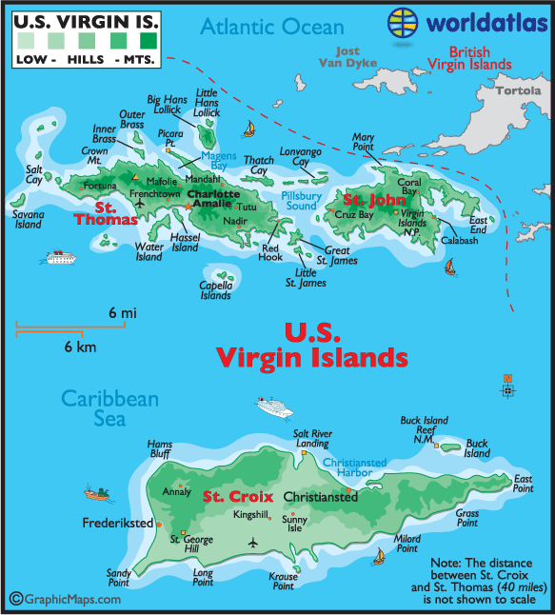
Figure 4-1. Map of the U.S. Virgin Islands (Courtesy of worldatlas.com)

or Central America. The Arawaks arrived from South America between 100 and 200 A.D. The Caribs, who also came from South America, arrived about 100 to 150 years before Columbus. The Ciboney were driven out or possibly eliminated by the Arawaks. Upon European arrival in 1493, the Caribs had taken over Arawak settlements on St. Croix, but both Arawak and Carib groups would not survive long after the arrival of the Spaniards. They were killed off by European disease and died in large numbers from lack of food and grueling labor forced on them by the Spaniards. It is also possible that some of the Indians fled to other islands in the Lesser Antilles (Dookhan 1994:15-16,28).
Christopher Columbus landed on St. Croix, in the Virgin Islands, in November 1493, during his second voyage to the New World. While Spain immediately took ownership of the islands as well as many other islands in the West Indies, other European countries demanded rights to the islands as well, in order acquire territory and trade. As Spain’s power declined in the 17th century, Spanish ability to protect the islands in the West Indies diminished, and invasions by the English, French, and Dutch further weakened their control. By the 1670s, the Danish has set up their first colony on St. Thomas after a failed first attempt a decade before (Dookhan 1994:31-37). The Danes regarded St. Thomas as an excellent location for trade with neighboring foreign islands and for cultivation. St. Thomas was known most for its trade, while the production of sugar cane became St. Croix’s specialty.
Slavery and the slave trade were common on St. Thomas since the first colonization by the Danish until Emancipation in 1848, with enslaved individuals making up 90 percent of the population during the slavery era. Denmark remained neutral during the many wars of the late 17th and 18th centuries, therefore becoming a very important port for neutral trade with various colonies. St. Thomas also became a market for the sale of captured ships and cargo. The economy of the Virgin Islands declined throughout the 19thcentury due to the growing competition for sugar production and the decline in trading on St. Thomas. St. Thomas, along with St. John and St. Croix were bought by the United States in 1917 for 25 million dollars (vii-ix).

Historical Archaeology in the Virgin Islands

Historical archaeology research in the Virgin Islands has focused on a variety of topics and areas around the islands (see Kellar 2004; Armstrong 2003; Anderson 2000, 2003). Archaeological Investigations on Hassel Island, in particular, have been few (see Jameson 1992; Latif and Martens 2009), but studies such as this one, and others will hopefully be forthcoming as the trails being cut across the island by the National Park Service for visitors (see Chapter 5) will surely lead to more artifact collection and analysis involving the former industries and residences of the island.
Hassel Island
Located in the harbor of Charlotte Amalie off the southern coast of St. Thomas, Hassel Island is a small body of land that covers approximately 135 acres (Jameson 1992:6). Originally a peninsula of St. Thomas (Figure 4-2), Hassel became an island in 1864, when the Danish government cut the isthmus connecting the land to St. Thomas (1992:22). The isthmus was cut so that small barges and boats, with less than a six foot draft, could pass through the harbor directly into Gregerie Channel to the west of the island, as well as to help promote the flow of water and remove the trash accumulating in the harbor from dumping (Gjessing 1980-1981:17-18). Shortly after the United States purchase of the Virgin Islands in 1917, the cut was deepened so that larger vessels could pass through (Jameson 1992:22).

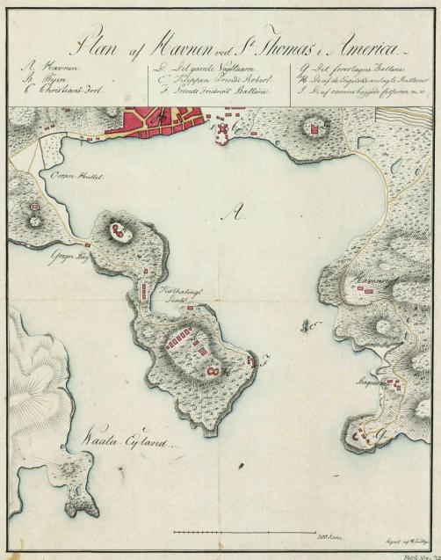
Figure 4-2. Map showing the harbor at Charlotte Amalie and Hassel Peninsula in the early 1800s. The function of the building near the location of the future leprosarium is unknown (black arrow) (Lundbye ~1800).

Hassel Island’s Economic Importance

The first mention of Hassel Island occurred in a Danish land registry dated 1688. The then peninsula was referred to as Orcanhullet, which translated means Hurricane Hole (Latif and Martens 2009:14). In 1672 the Danish West India Company established permanent settlement around the harbor of Charlotte Amalie on St. Thomas, and Hassel Island was used initially as grazing grounds for livestock (Gjessing 1980-1981:4). The earliest owner of Hassel Island under Danish rule was John Hatch, a surgeon from the British Isles, who owned the island from 1688 to approximately 1693, though the records show that the Hatch family owned an inn in Charlotte Amalie and did not actually live on the peninsula. There was a plantation on the peninsula during John Hatch’s ownership, but production on this plantation was believed to be very small considering the soil of the peninsula was not of a quality to produce worthwhile amounts of cotton or sugar, and any sort of food production by the plantation was probably in the form of keeping goats. After Hatch’s death, his widow took over ownership of the island until her death, when the land was transferred to her son in 1710 (Latif and Martens 2009:14-18). Ownership changed several more times over the next few decades and further plantation efforts were initiated by plantation owners, but agricultural production during the early 18th century continued to be minimal. The peninsula did not begin to find its true importance until 1755, when Jacob Magens bought the land. Around 1770, records begin to show an increase in enslaved laborers on the peninsula with another note that Magens had been given the privilege of careening, or cleaning and repairing, the bottom of ships (Latif and Martens 2009:25). During the late 1700s, the success of the careening business appeared to skyrocket on the peninsula during ownership of James Hassel (for whom the island is named) and his son James Hassel Junior. There were an increasing number of slaves reported on the island during this time, peaking in 1790, with 23 slaves listed in the land registry. Careening would have been very popular in the harbor of St. Thomas in the late 18th century due to Charlotte Amalie being used as a free port during the American and French Revolutionary Wars (2009:29-30).
Hassel Peninsula became important for more than just careening ships. During the Napoleonic War in 1801, British forces occupied the Danish West Indies. British Lieutenant Colonel Charles Shipley directed the construction of fortifications on both the north and south ends of Hassel Peninsula. The area became a strategic center for military operations, since the eastern and southern sides of the peninsula have excellent views of the harbor and ocean. Occupation by the British forces on Hassel Island, as well as the rest of the Danish West Indies, was brief. British control ended a year later, in 1802, and the fortifications on Hassel Peninsula were abandoned. The British occupied the Danish West Indies again from 1807 to 1815. They repaired the fortifications built during the first occupation, expanded them, and re-populated them with approximately 1500 British soldiers (Gjessing 1980-1981:7-12). During the mid-to- late 19th century, a guardhouse of the abandoned Fort Shipley was converted into a smallpox hospital and quarantine station (54). Between and after these occupations, the Hassel family continued to own Hassel Peninsula and its prospering careening business. In 1833, Hassel leased an area of land on the northwest portion of the peninsula for the construction of a small leper hospital. This will be discussed in more detail further below.
In 1841, construction began on a depot for the Royal Mail Steam Packet Company on the northeastern end of Hassel Peninsula. This company shipped passengers and mail around the eastern and western Caribbean, as well as to the north coast of South America. In that same year, the St. Thomas Marine Railway Company purchased land on the northeast end of Hassel Peninsula, in an area called Small Careening Cove, in order to construct a marine railway and repair slip. This marine railway remained an important part of services for ships coming into the harbor through World War II (Gjessing 1980-1981:15-16). After several years of threats to the Danish government about relocating their offices, the Royal Mail Steam Packet Company moved its services to Barbados in 1888. When the Royal Mail Company originally announced its plan to move in 1871, the Hamburg-America Line came to establish its services on St. Thomas. They bought eight acres on Hassel Island (the isthmus was cut in 1864), in the area known as Careening Cove, and set up several warehouses, a coaling dock, catchments, and water storage tanks. These facilities were able to perform minor ship repair. Major ship repairs were still sent to the St. Thomas Marine Railway Company on the northeast end of the island (1980-1981:21-22).
Devastated by their financial losses in World War I, Denmark sold the Danish Virgin Islands to the United States in 1917. The US took control of all Hamburg-America Line properties on the islands, and those on Hassel Island were converted to a US Naval station, which remained there until the end of World War II. After World War I, the commerce that was once so great in the Charlotte Amalie harbor never returned. Only the marine railway in Small Careening Cove remained, doing a steady amount of work, until it shut down after World War II (1980-1981:24).

National Park Service Acquisition and National Register Status
Hassel Island’s economic ties to Charlotte Amalie’s harbor were gone by the mid-20th
century. The once prosperous careening and shipping businesses had disappeared from the island. In 1978, the National Park Service purchased 95 percent of the island from a family that had owned it since the 1930s (Campos 2008). Hassel Island was named a historic district on the National Register of Historic Places in 1976, with a boundary extension added in 1978 (Wright et al. 1976; Hillary et al. 1978). Today, Hassel Island is being cleared of brush, and structures are being stabilized so the island can be made accessible to tourists who would like to explore the rich history of this small island.

Disease and Quarantine on Hassel Island

Although Hassel Island is known historically as an important center for marine repair and military stationing, the island has also served as a home for those being quarantined for diseases. Two disease quarantine hospitals existed on Hassel Island during the 19th century. One is located on the northern peak of the island at the area known as Fort Shipley. Sometime after abandonment by British forces, a smallpox quarantine was built at Fort Shipley. Lawrence’s 1851 Admiralty map (Figure 4-3) shows the hospital existing as early as 1851, although Gjessing (1980-1981:54) says the area was not converted into a smallpox hospital until sometime between 1865 and 1881.
Located northwest, down slope from Fort Shipley, is the site of another former quarantine hospital. The leprosarium was placed in a relatively isolated location, facing away from the harbor of Charlotte Amalie. The Marine Railway Company on the northeast portion of the island was not built till 1841, and Fort Shipley had not yet been converted to smallpox quarantine and was probably not occupied in the early 1830s. Therefore, the leprsarium would have avoided being seen by most of inhabitants, at least in its early years, of Hassel Island and St. Thomas, except for those who may have resided directly on the other side of the land bridge connecting Hassel to the St. Thomas.
According to Danish police records, on April 13, 1833 a proposition was sent by the commissioner of police to the governor’s office in Charlotte Amalie requesting permission to build a Lazarettet, also called a leprosarium, or a quarantine hospital for those afflicted with leprosy, on Orcanhullet (Hassel Peninsula) (St. Thomas politikontor [St. Thomas Police Office] 1788-1905). This proposition was put together after police found a woman in Charlotte Amalie taking care of four children with leprosy. They feared the disease would begin spreading around the island and that lepers would be roaming around the town, unless the disease could be isolated from the general population. The King’s physician, or Landfysikus, likely did not believe the disease was completely contagious, but believed that the condition was mostly hereditary, although there could be a chance of contracting the disease if a lesion were touched (Lochmann 1871). The proposition was approved by the King’s physician and the Citizen Council before it was approved by the governor on April 20, 1833. The owner of the peninsula, James Hassel Jr., built a single house, with his own money, near the isthmus of the peninsula that was ready for occupation on July 18, 1833. There is very little information on the physical appearance of the building, except that in an 1860 medical report, mention was made of a boy who contracted leprosy after sleeping underneath and inside the building (St. Thomas politikontor [St. Thomas Police Office] 1788-1905; St. Thomas og St. Jan guvernement [St. Thomas and St. John Government] 1711-1917; St. Thomas borgerråd [St. Thomas Burgher Council] 1776-1865; Medicinalindberetninger, Vestindien [Medical Reports from Danish West Indies] 1823-1910). This suggests that the building may have, at least partially, been raised off the ground, if a boy was able to sleep underneath it. Since the hospital site resides on a slope, a raised building, along at least one end, would have been necessary to create a level floor. It is doubtful that the building was made of stone or coral if it were raised off the ground. It is also likely that there would still be remnants of the building(s) if they were made of stone or coral, since the cistern is still standing, and other historic buildings on the island made of stone and/or coral are still, at least partially, standing.
A letter to the governor from the Chief of Police shows that the hospital already had ten patients by the time a cistern and fence were built for the property in October 1833. The Chief of Police also let the governor know, in a letter dating to 1833, that more patients would be incoming once they were found (St. Thomas politikontor [St. Thomas Police Office] 1788-1905; St. Thomas og St. Jan guvernement [St. Thomas and St. John Government] 1711-1917).
An 1852 historical report on St. Thomas, by Pastor John P. Knox, made a brief mention of the leprosarium when describing the good sanitary conditions that Danish officials kept on the island. He said, “Persons afflicted with the leprosy are to be immediately removed to a house out of town provided for that purpose” (Knox 1852:203). This single sentence, along with the Chief of Police stating that more patients would be incoming once they were found, suggests that admittance to the leprosarium was involuntary during this time.
The Chief of Police estimated, at the time of the hospital’s construction, that its capacity would be 20 patients. During the first few years of operation, the hospital accommodated anywhere between 18 and 20 patients. By September of 1836, the patient count had risen to 23 (St. Thomas politikontor [St. Thomas Police Office] 1788-1905). Historical documents only make mention of one structure to house patients being constructed, along with the cistern, but an 1851 map (Figure 4-3), shows four structures at the site. Archaeological excavations at the site during 2008 revealed a still standing cistern, and three building foundations. While one of the foundations could represent the patient housing, it is unknown what the possible second and third foundation could have been. It is possible that a second building to house the patients was constructed when the patient population began to rise, or this may have represented housing for the caretaker, although the documents made no mention of where the caretaker resided.
From 1837 to 1838, the number of patients dropped from 23 to 12. During these two
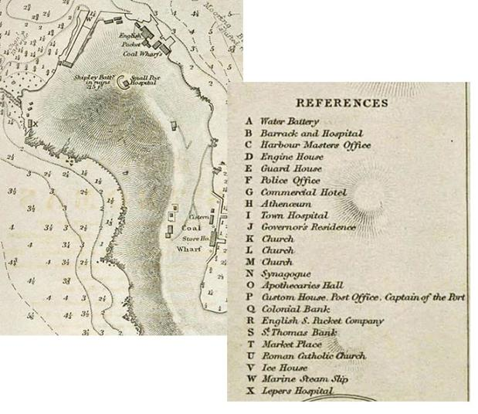
Figure 4-3. Cropped 1873 Revised (original map 1851) Admiralty Chart of Hassel Peninsula. The ‘X’ marks the spot of the leprosarium (Lawrance 1851).

years, police reports show that three women and six men died at the hospital and were buried using public funds. It is unknown what happened to the other patients who left the hospital during this time, although if they had died and their families had paid for burial, their deaths would not have shown up in the police records. No causes of death are listed in the police records, but it is unlikely that leprosy was the cause. Leprosy is not typically fatal, and there were no known epidemics sweeping through the islands until the smallpox epidemic in 1843 (Knox 1852:197). It is possible that patients were dying from poor medical treatment or poor living conditions within the hospital. Studies at the leprosarium at Moloka’i, Hawaii show that dismal conditions, rather that leprosy, were more likely the cause of the institutions 15 percent average mortality rate, between the years 1865 and 1897 (Amundson 2010). Police reports from St. Thomas show that only three new patients were committed to the hospital during these two years, including one case that involved the King’s physician coming to examine two slaves for leprosy (St. Thomas politikontor [St. Thomas Police Office] 1788-1905). After 1838, the hospital’s population settled at around 12 patients. The patients at the hospital were likely all from the lowest classes of society as an 1842 report from the Landfysikus describes the hospital’s patients as “sentina populi,” which is Latin for the scum of society (Medicinalindberetninger, Vestindien [Medical Reports from Danish West Indies] 1823-1910).
A patient list entitled “Those undergoing treatment for leprosy in Charlotte Amalie on the island of St. Thomas, 9 October 1855” [translation], recorded eight patients, six of whom
were placed at the leprosy hospital (Figure 4-4, Table 4-1). Along with patient names, the document lists patient age, location, and marital status. The document is signed by the sheriff’s department on 20 January 1856 (Sager vedr. folketælling [Census] 1841 - 1855). While the list did not record sex, it can be assumed from the names that both males and females were equally
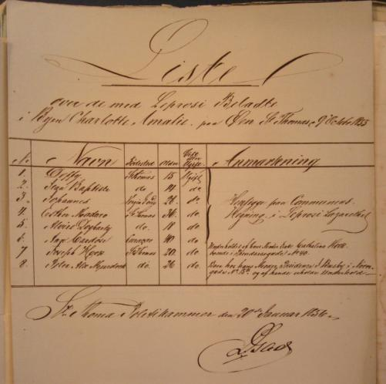
Figure 4-4. List of leprosy patients undergoing treatment for leprosy on St. Thomas in 1855 (Sager vedr. folketælling [Census] 1841 – 1855).

Table 4-1. English Translation of Figure 4-4.

List
Those undergoing treatment for leprosy in Charlotte Amalie on the island of St. Thomas 9 October 1855
Name
Birthplace
Age
Married or Unmarried
1
Deffy
St. Thomas
15
Unmarried
2
Jean Baptiste
St. Thomas
14
Unmarried
3
Johannes
Virgin Gordo
28
Unmarried
They are all placed at the leprosy lazaret
4
Esther Madaro
St. Thomas
36
Unmarried
5
Marie Dogharty
St. Thomas
18
Unmarried
6
Ann Cardore
Curacao
40
Unmarried
7
Joseph Hook
St. Thomas
20
Unmarried
Any costs he has to pay are paid on behalf
of his mother, the widow Catharina Hook,
who lives in Prindsessegade no 40
8
Peter Alex Murdock
St. Thomas
26
Unmarried
He lives with his mother Prudence and
Betsy at Nørregade no 15b and she also
pays his bills for him
Signed by the Sheriff's Department on 20 January 1856
affected by leprosy. The two patients without last names may represent former slaves (emancipation was declared in 1848), which means it can also be assumed that there was a mixture of races at the hospital. The patient born in Curaçao may have been of South American origin since Curaçao is located off the cost of Venezuela. St. Thomas was a mixture of ethnicities during this time because it was a popular trading port, so a variety of ethnic backgrounds among the patients would not be unexpected. It can also be seen from this list that the patients were all relatively young. According to the 1867 Report on Leprosy, many of the doctors reported that leprosy can be found across all age groups. Sufferers tend to live upwards of 20 or 30 more years before succumbing to complications from leprosy or other ailments.
Evidence that the patients who were sent to the leprosy hospital were probably poor can be seen from this census list. The bottom two patients on the list were not noted as having been sent to the hospital, and their expenses were paid by their mothers. These clues suggest that they had enough wealth to stay at home to be treated, and possibly to keep the disease hidden from the rest of the population (see chapter 2 for more).
Catharine Bolas served as the primary caretaker and cook for the patients from 1833 to 1835. She spent between 75 to 124 rigsdalers per month on food for the patients. The Citizen’s Council on St. Thomas thought this amount was too high, as they wanted the hospital costs to be about 800 rigsdalers a year. According to Keller (1908), one rigsdaler was worth $1.11 in 1908, which using an inflation calculator would equal .05 cents in 2010. Therefore, the cost of 800 rigsdalers would equal approximately $44.40 in the present day. James Hassel, who built the hospital at his own expense and who was receiving two rigsdalers per month from the government for each patient for rent, agreed, in 1835, to take a 50 percent cut in rent paid per patient to help contain costs. In 1835 the Citizen’s Council hired a new caretaker, Mary Heiliger, who dropped the food purchases to 63 rigsdalers per month. This meant that in 1836, when the patient population was at 23, each patient had the equivalent of approximately 2.70 rigsdalers per month of food. Mary Heiliger made a complaint to the governor that this was not enough money to provide an adequate amount of food to the patients, so the Citizen’s Council raised the monthly allowance to 3.50 rigsdalers per month for each patient. Due to the decrease in the number of patients after 1838, the Chief of Police requested that food allowances be raised again. This request was approved and each patient subsequently received 4.50 rigsdalers per month. Due to an increase in food prices in 1847, the monthly food allowance was temporarily raised to 6.50 rigsdalers, and in 1848 this amount was made permanent. Catharine Bolas was rehired as caretaker in 1847 (St. Thomas politikontor [St. Thomas Police Office] 1788-1905; St. Thomas og St. Jan guvernement [St. Thomas and St. John Government] 1711-1917; St. Thomas borgerråd [St. Thomas Burgher Council] 1776-1865; Medicinalindberetninger, Vestindien [Medical Reports from Danish West Indies] 1823-1910).
Considering the Citizen’s Council desire to reduce food costs to a bare minimum and the high mortality rate from 1837 to 1838, the conditions in which the patients lived were probably less than satisfactory. The Landfysikus in his 1853 medical report to the Copenhagen Ministry of Health said:

On the leprosarium, which is located west of the town and rather isolated, are seven patients. The care is poor since the house is in a miserable condition, the food is bad, and even the most basic furniture like mattresses is missing. I have reported these shortcomings to the local authorities and proposed improvements to better the living standards of these unfortunate outcasts from society, and I hope I have not pleaded their cause in vain. (Medicinalindberetninger, Vestindien [Medical Reports from Danish West Indies] 1823-1910).

There appears to have been no response to this letter from the Ministry of Health since conditions at the leprosarium did not seem to improve, and it would be several more years before it was shut down. The Landfysikus, who composed the report for the ministry, wrote another letter in 1861 after he was no longer in office, which further stated his unhappiness with the condition of the patients at the leprosarium. He reported that the lepers

…are living a miserable life, they are trying to avoid human contact just as much as people try to avoid them. Sadly it is not in the power of science to throw light on the reasons for this hereditary disease which skips generations and then reappears.
An old law is in power here which bans the infected from the habitations of the other citizens and banishes them to an isolated existence in a secluded place where, as far as I know, all necessities are lacking. In my time (as Landfysikus) I have pointed this out and have applied for improvements. This precaution (to isolate the lepers) was taken in the interest of the common well – the individual had to suffer for the community -.
I should presume that the Landfysikus has visited these outcasts and I dare believe that he has called attention to their needs, like I have done myself, and I hope that better times will come for those who are unable to help themselves.
… If the local authority believes that it has to protect itself against a disease, then the authorities must also accept the expenses, and pay abundantly, and take care of the unfortunate people who are cast out from society. At the very least it should be seen to that the unfortunates have a roof over their heads and their daily bread
(Medicinalindberetninger, Vestindien [Medical Reports from Danish West Indies] 1823-1910).

In 1859, the King’s Physician and the Commissioner of Police sent a proposition to the president of St. Thomas that proposed that the leprosarium be closed and the remaining patients be moved to the new public hospital on St. Thomas. The leprosarium was dilapidated and its close proximity to the marine railway meant it was not isolated anymore. There were some concerns from the Burgher Council (similar to a city council) about the possibility of spreading the disease, but after much discussion with the King’s Physician, it was decided that it would be safe to isolate the few remaining lepers in the public hospital. The Burgher Council ultimately agreed to the move, mostly because it would reduce costs. On October 24, 1859, the burger council wrote a letter to the presidency which stated:

The Policemaster and the Landsphysician at that time suggested that a place for such patients should be arranged in the new public Hospital, to which however the Council was opposed, but as it seems impossible to carry out the measure of having all such unfortunate subjects placed in the scrofula Hospital, not one having since been introduced there, and there being at present only two inmates in that Hospital, at an annual expense of $384, besides which the amount paid for their support cannot hold out any encouragement for the person charged with them, to afford that care and comfort which they may require, the Council has come to the conclusion that those two individuals, being brought nearer to the town, where there are so many cases of that disease, will not tend much to enhance the danger of contagion, if such exists, and would therefore most respectfully recommend that they be removed to the present public Hospital, where every care will be taken to keep them from coming in contact with the other inmates; they will be more comfortable, and the Country Treasury will save a considerable sum of expenditure for Hospital rent etc.” (St. Thomas borgerråd [St. Thomas Burgher Council] 1776 -1865).

In October 1861, the local authorities in Charlotte Amalie were given the go ahead to move the remaining two leprosy patients on Hassel Peninsula to the public hospital on St. Thomas. No longer rented by the local authorities, the site of the leprosarium and its buildings were returned to the land’s owner, who by this time was James Hassel Junior (St. Thomas og St. Jan guvernement [St. Thomas and St. John Government] 1711-1917; St. Thomas borgerråd [St. Thomas Burgher Council] 1776-1865).
Use of the leprosarium’s land and buildings post-1862 is mostly unknown. The land records through the early 20th century show all but a couple of acres of Hassel Island’s land were owned by the Hassel family and heirs. The documents make no mention of what the leprosarium’s land was used for except that it remained in the Hassel family (Figure 4-5).
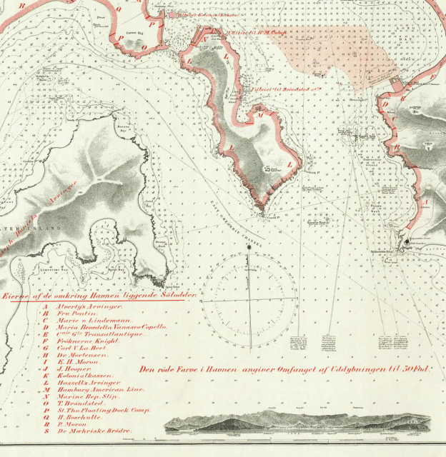
Figure 4-5. 1904 Landholding Map. The ‘L’ on the west coast of Hassel Island represents that the land was owned by “Hassell’s Arvinger[heirs]” (Aamodt 1904). Also notice that the red is overlaid on Lawrance’s 1851 Admiralty map.

Chapter 5

Fieldwork on Hassel Island

Prior Fieldwork at Leprosy Hospital

An archaeological survey and assessment, totaling 135 acres, was carried out on Hassel Island in 1990 by John Jameson and the National Park Service. The purpose of this survey was to determine if potential construction projects on the island would damage any existing archaeological sites (Jameson 1992:11). The project included pedestrian survey and the excavation of 24 shovel tests (1992:7). The report makes brief mention of a leprosarium/hospital area and a cistern. There was one shovel test dug in this area, though no mention is made in the report as to where, exactly, on the site the shovel test was dug. The single shovel test was dug to 20 centimeters below surface and the cultural material recovered included pearlware, whiteware, and stoneware ceramic fragments (decorated and undecorated), iron and brass nails, white ball clay pipe bowl fragments, dark green bottle glass, and a brass box key. These artifacts were not included in this study, since the provenience information is unknown. The report concluded that the materials recovered reflect the time period of the site, although nothing is mentioned pertaining to a history of either the site or where Jameson received his information that the area was a hospital (1992:65-66).
During February 2008, a small crew of National Park Service employees, including the park archaeologist, and interns went to Hassel Island to flag a proposed trail that would be leading up to Shipley’s Battery, located at the top of the ridge on the northern portion of the island. They began cutting the trail at the base of the slope on the northwest portion of the island. At this point, a scattering of 19th-century glass bottles was noted and GPS points were taken using a handheld Trimble GeoExplorer with sub-meter accuracy. As the crew began moving up the slope, more glass bottles, as well as a scattering of ceramics and a white ball clay pipe bowl, molded with a steam-powered locomotive (Figure 6-38), were noted along the northwest slope. At this point, no controlled surface collection was carried out, but the pipe bowl was collected, photographed, and its location was given a GPS point. In April 2008, before the trail was cut, the crew returned to Hassel Island to conduct a surface collection along the proposed trail in the vicinity of the leprosy hospital site. This collection yielded ceramics, bottle glass fragments, metal, the remains of a crab, and the pipe bowl, which had been collected in February. Noticing the density of artifact scatter west of the cut trail, around the cistern/hospital area, park archaeologist Ken Wild concluded that research and recovery of these artifacts should be done as soon as possible, before more clearing of this part of the island took place (NPS 2008).

Fieldwork: May-June 2008
A systematic collection and excavation of the site began in May 2008 and continued over the next four weeks. Goals for this fieldwork included mapping, photographing, and taking GPS points of the cistern and any foundation remains, recovery of as much of the surface material as possible, and excavating three test units to see if any subsurface material remained. This project was done in coordination with the Virgin Islands National Park Service and was funded by the NPS and the Friends of the Virgin Islands National Park. I worked with a crew consisting of the Virgin Islands NPS archaeologist Ken Wild, and a total of seven interns who helped at varying points during the project. I was in charge of leading the excavation at the site, with input from the park archaeologist, as well as analyzing the artifacts recovered.

Site Cleanup and Walkover

The site is located on a slope on the northwestern corner of Hassel Island, south of the

former land bridge (Figure 5-1). While the historic boundaries of the site are unknown at this time, the site is bounded on the western and southern sides by the ocean and/or steep slope; northern areas of the site are bounded by the trail and dense vegetation; and the eastern portion of the site was decided on based on lack of surface artifacts and structural remains (Figure 5-2). Before an archaeological investigation could begin at the site, some clearing of brush was needed in order to get a better view of the ground surface. The only remaining structure on the site, a cistern, was covered and surrounded by a variety of plants, including cactus, mother-in-law’s tongue, and other thorny and vine-like plants. The remainder of the area that was being tested was covered mostly in guinea grass, which according to the park archaeologist had been planted there in the past after the slope had caught on fire several times from 4th of July fireworks being shot from St. Thomas. No visible remnants of fire were evident on the site except for carbonized material found at FS#87, but it is unknown whether this material was related to the firework fires. Cleanup of the site involved clearing the brush from the cistern and cutting as much of the guinea grass as possible, so ground visibility would be improved (Figure 5-3). Once the brush was cleared, the boundaries of the test area were determined based on landform, structure and foundation locations, and artifact densities. Approximately 1800 meters of area was designed as possible testing area, although only portions of this area had visible artifacts and was tested.
The cistern, located on a slope, measured 5x3.3 meters and on its tallest side the height measured 2.61 meters. The cistern was constructed of undressed stone and brick with mortar. The top of the cistern has a dome made of brick and an opening for collecting water (Figure 5-4). The interior walls were parged and the floor appeared to be rubble (Figure 5-5). The cistern was constructed in October 1833, not long after the leprosarium’s opening. While the images do not line up exactly, it is believed that the small, squarish building on the 1851 admiralty map is
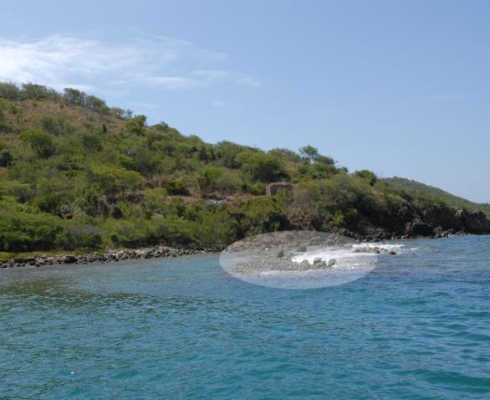
Figure 5-1. Leprosy hospital site facing southeast. The highlighted area in the foreground shows the remnants of the isthmus. Behind that, slightly upslope, the site’s cistern is visible (red arrow). Photo taken by the author in 2008.

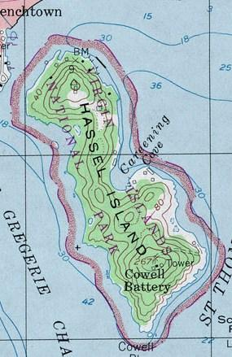
Figure 5-2. Topographic map of Hassel Island, showing elevations of the island (USGS 1982). The red circle marks the approximate location of the leprosarium.

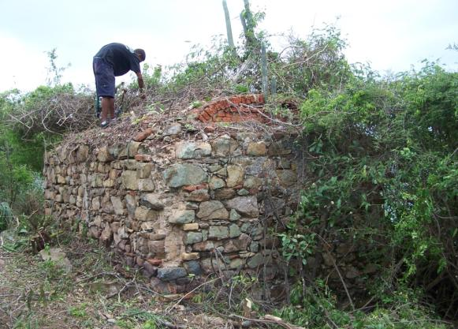
Figure 5-3. Clearing of brush from the cistern. Photo taken by the author in 2008.

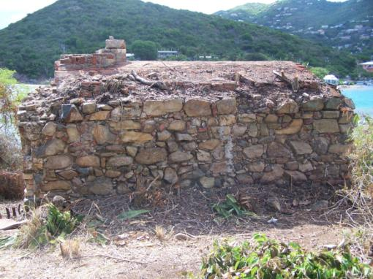
Figure 5-4. Facing northwest towards the east wall of the cistern. Photo taken in 2008 by the author.
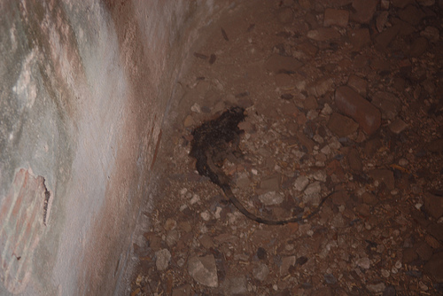
Figure 5-5. View of the interior of the cistern. Note the dead iguana in the center. Photo taken in 2008 by the author.

the cistern seen in the 2011 aerial of Hassel Island with the site map overlain (Figure 5-6).
After the site area was cleared, a random walkover was completed by four people over varying intervals around the site area to look for any foundations or other structural materials. Three possible foundations (see Figure 5-11) to the east and south of the cistern were flagged and photographed (Figure 5-7 – 5-9). These foundations were made of undressed stone, and were labeled Foundation A-C. Foundation C shows evidence of mortaring. Measurements were taken of foundation length and width. Foundation A measured 9.25 x 1 meters. Foundation B was more scattered, but the length measured approximately 6 meters. Foundation C measured 13 x 3 meters. Figure # shows the overlay of the site map with the 1851 admiralty map and a Google Earth aerial. Foundation C, the longest of the foundations, appears to match up with the long building on the 1851 map. While the proximity is not as close, Foundations A and B could match up with the two buildings to the east of the cistern on the 1851 map. The artifact scatter was most densely clustered to the northeast of the cistern and west of the cut trail. Located in this area of dense artifact scatter were two metal rods extending approximately 30 centimeters out of the ground. The purpose of these rods, when they were placed in the ground, and if they are associated with the site, is presently unknown. One suggestion was that they may mark utility lines, but that does not seem very logical since the only still-occupied residences are located on the opposite side of the island from the site.
Heading south of the noted foundations, artifacts become sparser and then completely disappear as the slope becomes very steep. The only artifact noted east of the cut trail, a coarse earthenware basin, discussed more in Chapter 6, was located very near the trail before the vegetation and terrain worsened. The area east of the trail was far too dense with vegetation to look for artifacts and the slope of this area begins to steepen more dramatically.
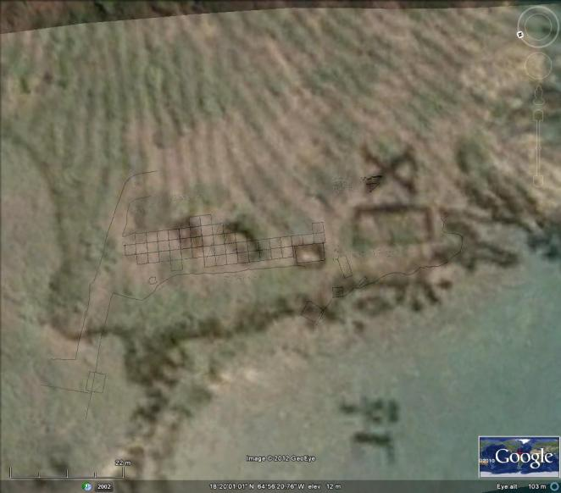
Figure 5-6. Aerial photograph of Hassel Island with the site map and 1851 admiralty map overlayed to show the relation of the current cistern to the historic image of the cistern. The red circle marks the location of the cistern remains overlayed with the site grid.

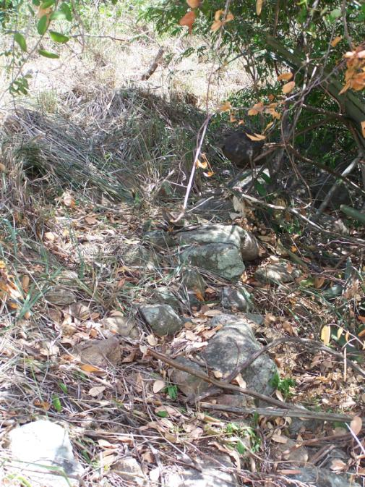
Figure 5-7. Foundation A, facing southwest. Photo taken in 2008 by the author.

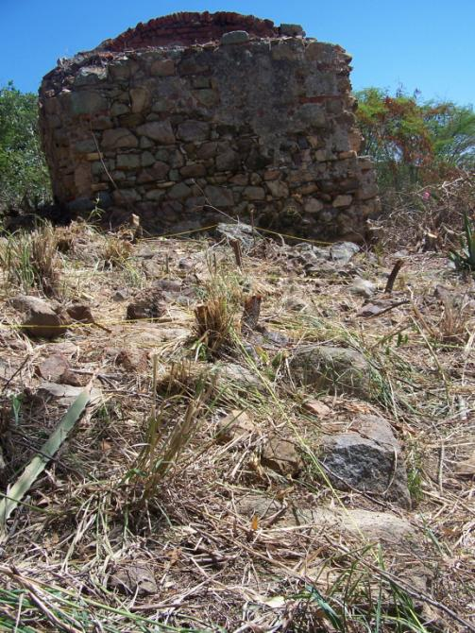
Figure 5-8. Foundation B, facing southwest towards the cistern. Photo taken in 2008 by the author.

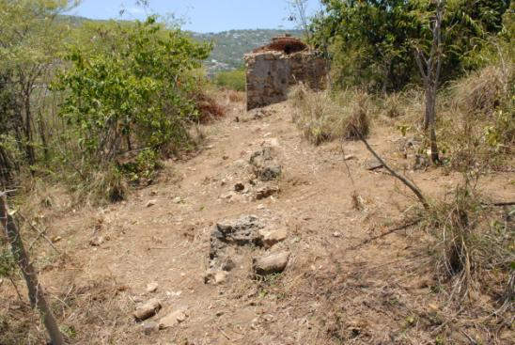
Figure 5-9. Foundation C, facing north towards the cistern. Photo taken in 2008 by the author.
Also located at the base of the slope, just south of the former land bridge connecting Hassel Island to St. Thomas, is a small cemetery that is assumed by the park archaeologist to be associated with the hospital. While the exact number of burials is unknown at this time, there are at least five or six present. These burials are what are considered to be traditional Caribbean burials for this region. Since the soil is so shallow it is impossible to dig a grave deep enough to bury a body, so what can be dug, is dug, then the body is covered in rocks and a marker, usually a conch shell, in placed at the head of the grave (Figure 5-10). While the discovery of cemetery records maybe helpful in learning who was at the hospital, researching the cemetery was not one of the goals of this project, so only a few photographs and a GPS point were taken of the area.

Systematic Grid Collection
Due to the rockiness and shallowness of the soil, most of the artifacts associated with the hospital reside on the ground surface. It was determined that the most systematic way to collect these
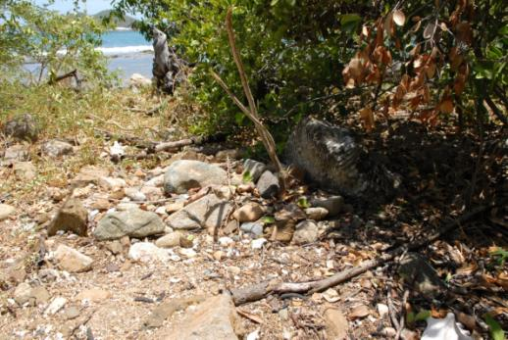
Figure 5-10. Facing WNW looking at a gravesite. The large piece of coral (red arrow) marks the top of the grave, while the pile of rocks covered the body. Photo taken by the author in 2008.
artifacts would be to lay out a grid over the area that contained the greatest artifact density that would allow for a complete surface collection of artifacts while giving each artifact a relatively small provenience area (Figures 5-11 – 5-15 or see Appendix II for full size site map). This gridded area comprised approximately 360 meters, or 20 percent of the 1800 meters of site area. The datum point, given an arbitrary position of 500N/500E, was established east of the cistern and the eastern side of the cistern was used to establish Grid North, which was 38 degrees east of true North. Extending from the datum west to the southern end of the cistern and east to the cut trail, 49 2x2 meter blocks were laid out using triangulation with measuring tape, string, and nails, which resulted in 3 to 4 rows of 2x2 meter blocks covering the area between the cistern and trail, covering 196 square meters of surface area (Figure 5-16). GPS points were taken at the edges of the gridded area. The southwest corner of each block was given a northing and easting and photographs were taken of each block before artifacts were collected. Cultural material was

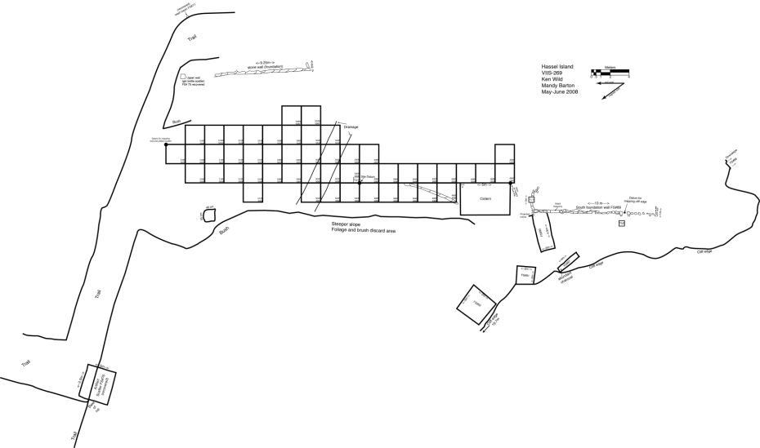
Figure 5-11. Leprosarium site map.

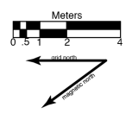
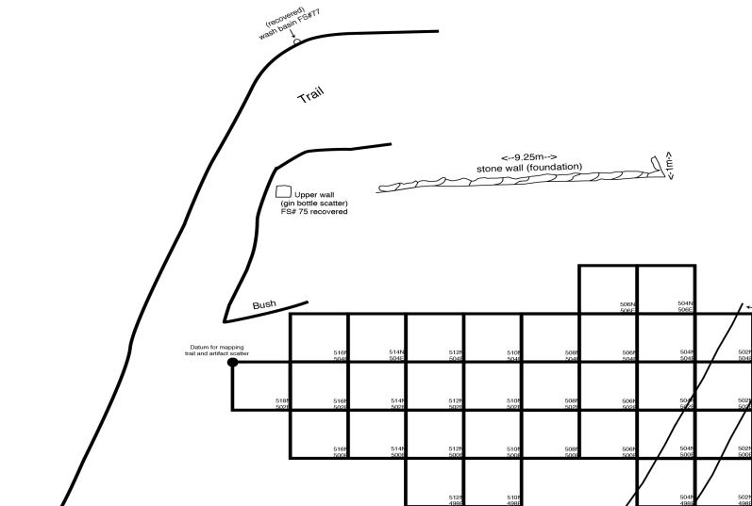
Foundation A
Figure 5-12. Detail, northeast portion of site map.
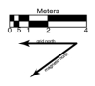
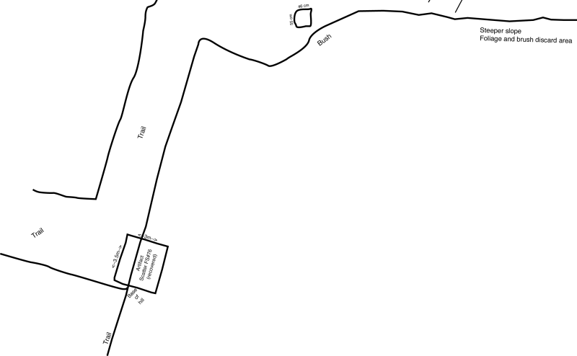
Figure 5-13. Detail, northwest portion of site map.

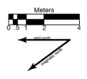
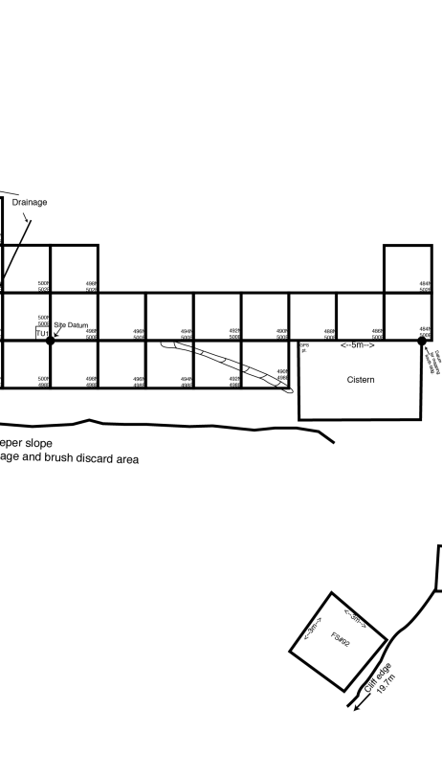
Foundation B

Figure 5-14. Detail, center portion of the site map.
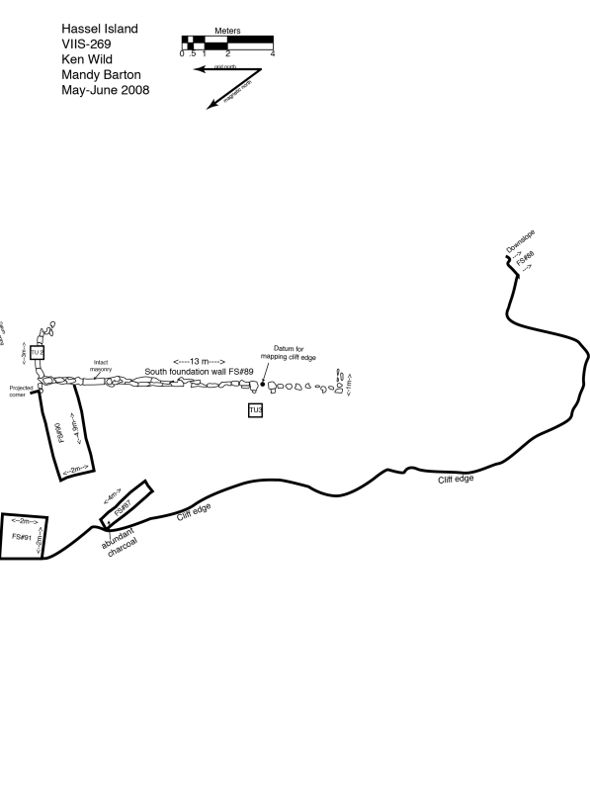
Foundation C
Figure 5-15. Detail, southern portion of site map.
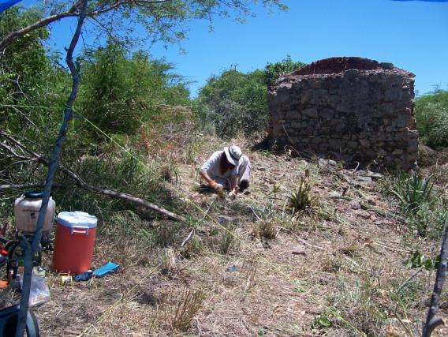
Figure 5-16. Laying grid, facing southwest. Photo taken in 2008 by Holly Norton.

collected from the surface within each block and placed within a plastic bag marked with northing and easting information from the block. Surface collection forms were completed for each unit and included information such as the coordinate number for the unit’s southwest corner, unit picture number, field specimen number, date of collection, and comments.

Test Units

Despite the rocky and shallow soil, three 50x50 centimeter test units were excavated in order to determine if any subsurface material existed. Test units were excavated using shovel and trowel in arbitrary 10 centimeter levels until the soil became too rocky to continue. The soil
was screened using ¼ inch mesh, soil color was determined using the Munsell color system, and all cultural material was placed in a plastic bag with the appropriate provenience information. Excavation forms were completed for each level of each unit and included southwest corner elevations, description of material collected, soil descriptions, field specimen number, photo number, method of excavation, excavators, date of excavation, and comments.
Unit 1. Test unit 1 was located at the datum point, with a southwest coordinate of 500N/500E (Figure 5-14). This location was selected because it was the site’s datum point and it was in close proximity to a dense scatter of cultural material. Level 1, 0-10 centimeters below surface (cmbs), revealed the only artifacts of the unit. The artifacts came from the top five centimeters and were a few brown and green bottle glass fragments and a partial bottle base (See Appendix). All had unknown dates of manufacture. The northwest corner of this unit ended at 10 cmbs because of rocks. Level 2, 10-20 cmbs, contained no cultural material. The soil was a rocky, sandy silt with a Munsell 10 YR 4/4, dark yellowish brown soil color. The unit was terminated at 20 cmbs because it could not be dug any further (Figure 5-17).
Unit 2. Test unit 2 was located outside the laid grid so it did not receive a coordinate. This unit was located south of the cistern between a break in the northern facing portion of a foundation wall (Foundation C), where a possible doorway could have been (Figure 5-15). Level 1, 0-10 cmbs, was difficult to dig because the rocky soil was combined with part of the foundation being located within the test unit. Only the northeastern and eastern portions of the unit went to 10 cmbs. Cultural material recovered from this level included whiteware and stoneware, glass, nails, and mortar (See Chapter 6) Level 2, 10-14 cmbs, contained only the eastern portion of the unit, since that was the only area able to be dug past 10 cmbs. Cultural material was recovered from this level and included porcelain, glass, nails, wood, and faunal remains (See Appendix I). The artifacts recovered from this test unit are mostly likely directly associated with the structure that once stood in this area, which was possibly the structure that housed the leprosy patients.
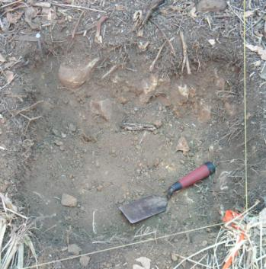
Figure 5-17. Base of Test Unit 1. Facing East. Taken by the author in 2008.
The soil was a rocky sandy silt with a Munsell 10 YR 4/4, dark yellowish brown soil color. The unit was terminated at 14 cmbs because it could not be dug any further (Figure 5-18).
Unit 3. Test unit 3 was located outside the laid grid so it did not receive a coordinate. This unit was located south of the cistern, and 50 centimeters west of a break in the western facing portion of a foundation wall (Foundation C), where another possible doorway may have been located (Figure 5-15). Level 1, 0-10 cmbs, contained brick, nails, a ceramic, glass, pipe fragments, and shell. Level 2, 10-20 cmbs, contained light green glass fragments, a button made out of metal, copper, a nail, and a pipe stem (See Chapter 6 and Appendix). Bed rock was hit at the base of the Level 2 and the unit was terminated. This unit was a rocky sandy silt with a Munsell 10 YR 4/3, dark brown soil color. At the base of the unit, 20cmbs, where bed rock was hit, the soil color changed to a yellowish brown (Figure 5-19).

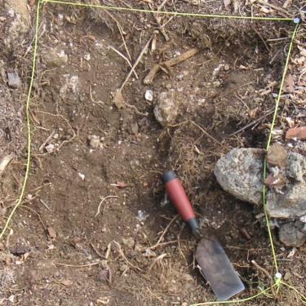
Figure 5-18. Base of Test Unit 2. Facing South. Taken by the author in 2008.
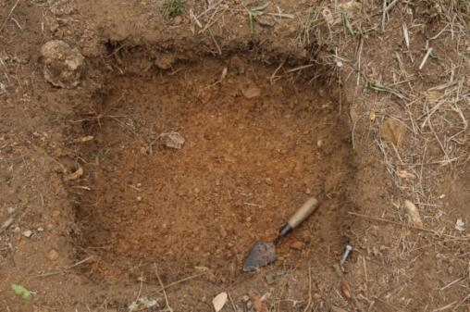
Figure 5-19. Base of Test Unit 3. Facing southeast. Taken by the author in 2008.

General Surface Collection
Due to time constraints, a grid could not be laid over the entire area of site that included artifacts on the surface, so areas of the site were surface collected if there was a concentration of artifacts. Each of these surface collections was marked on the site map with a Field Specimen number, and the approximate size of the collection area, if it was more than a collection of a single item. These collections occurred to the west and south of the cistern, south of the laid grid area near the cut trail, and north of the site at the base of the slope where a scatter of cultural material had been observed during the initial visit to the area in February 2008, which encompassed approximately 60 meters, or three percent, of the 1800 meters of site area (Figure 5-11 – 5-15). Not included in this study is the surface collection at the base of the slope (FS #76), located below the site area due to uncertainty as to whether all the artifacts are associated with the site.

Site Formation

As seen in Figure 5-2, most of the site area has some slight sloping, which becomes steeper downslope of the cistern, before it flattens out at the waterline. There is also some thick vegetation surrounding the site area, which could not be cleared. These topographic and vegetative features helped provide boundaries for the survey area, since the historic boundaries were not
known, but they, along with some other factors, may have obscured some of the archaeological remains. The steep slopes and cliffs around the western and southern portions of the site area may have been a convenient way for patients to get rid of their trash. Trash that may have been tossed into the ocean would not be easily recoverable, and artifacts found at the base of the western slope (near the waterline) were not included in this study because of uncertainty with their association with the site, even though there is a possibility that they could be related. Dense vegetation, especially some cacti and bush that was left within the site area, may have masked some archaeological remains. Post-site destruction also must be taken into consideration when determining what has affected the archaeological record. The lack of structural remnants (besides the cistern and foundations), suggests that the area was cleared at some point, which resulted in the not only the loss of the structures, but also artifacts associated with the structures (such as nails, window glass, etc.). The clearing of structures would have also affected the artifacts on the surface. They may have been crushed, kicked around, or moved out of the site area entirely. Post-site activity has also allowed for artifacts to be deposited, along with the site’s artifacts, which can make the dating of materials difficult. Finally, considering the majority of the artifactual remnants are on the surface, looting is a possibility, although, the isolated location away from the main island, as well as from the more visible and known structures on Hassel Island (Fort Shipley and the marine railway), would have helped shield the site from looters.
Using a controlled surface collection for the majority of the artifact collection has allowed for a large area to be completely collected, while giving each artifact a 2x2 meter area for its provenience. Recovering a large amount of artifacts within a controlled area has allowed for a detailed artifact analysis of the materials recovered from the site, which will give a thorough description of life at the leprosarium, despite possibility artifact loss due the issues discussed in the previous paragraph.
Five thousand one hundred and four artifacts were collected during this survey. This was by no means a complete collection of the site area. More artifacts exist on the surface in areas not covered by the controlled and general surface collections, and while the excavation units were shallow, more artifacts could be recovered by excavations. Any future fieldwork at the site would benefit from using historic maps which may help locate structures and exploring areas that were too dense with foliage to be surveyed for this project.

Chapter 6
Artifact Analysis

Lab and Analysis Methods

Five thousand one hundred and four artifacts were collected during fieldwork conducted in 2008 at the Hassel Island leprosy hospital (Table 6-1). All artifacts collected at the site were bagged upon collection in plastic bags labeled with provenience, date of collection, and initials of collector(s). Artifacts were taken to the NPS archaeology laboratory, located at Cinnamon Bay, St. John, where they were washed and rebagged before analysis. After analysis was complete, all artifacts, site forms, photographs, and data files, including artifact descriptions, were sent to the NPS curatorial facility at Cruz Bay, St. John to be catalogued in the NPS database and stored in a temperature controlled environment.
Initial artifact analysis took place over five and a half weeks during the summers of 2008 and 2009. Analysis involved counting and weighing all material, identifying what could be identified, and photographing a variety of the more significant finds. Using photographs and sources to help date the artifacts, artifact analysis was further refined once the author returned to the University of Tennessee in Knoxville, Tennessee. All artifacts were entered in an Excel file and sorted by provenience, where they were further sorted by type of artifact and artifact date range. Artifact count, weight, description, and photograph number were also included in the Excel file.

Results of Artifact Analysis

Approximately 92 percent (N=4726) of the artifacts recovered from the leprosy hospital were either fragments of ceramic vessels or of glass containers. The other seven percent of recovered artifacts included non-container glass, beads, bricks and mortar, buttons, metals, smoking pipes,
Table 6-1. Count and percentages of all artifacts collected during the 2008 excavation and surface collection.
Artifact Fragment Type | Count | Percentage of Assemblage
Glass
Beads | 2 | <.1
Container | 3877 | 76
Flat | 20 | 0.4
Tableware | 39 | 0.7
Misc. | 19 | 0.4
Ceramic
Stoneware | 127 | 2.4
Coarse Earthenware | 138 | 2.7
Refined Earthenware | 542 | 10.6
Porcelain | 42 | 0.8
Smoking Pipes | 35 | 0.7
Brick/Mortar/ | 60 | 1.1
Button | 1 | <.1
Doll's Arm | 1 | <.1
Marble | 1 | <.1
Stone/Mineral
Gunflint | 5 | <.1
Slate | 1 | <.1
Stone | 3 | <.1
Coal | 1 | <.1
Metal
Button | 3 | <.1
Clothing Hook | 1 | <.1
Hook | 1 | <.1
Pot Handle | 2 | <.1
Lamp Part | 1 | <.1
Gutter | 1 | <.1
Nails | 7 | 0.1
Misc. | 48 | 0.9
Organic/Faunal
Crab Shell | 48 | 0.9
Bone | 8 | 0.2
Shell | 45 | 0.9
Coral | 22 | 0.4
Carbonized Material | 3 | <.1
Total | 5104 | 100

a doll’s arm, a stylus, a marble, and faunal material. All artifacts were separated into one of four groups after analysis: artifacts that date to the leprosy hospital, artifacts that possibly date to the leprosy hospital, artifacts that post-date the leprosy hospital, and indeterminate artifacts. This section will focus on artifacts that date or possibly date to the hospital’s occupation.

Artifacts that Date to and Possibly Date to the Leprosy Hospital

The leprosy hospital was in operation on Hassel Island from 1833 to 1861. According to the historic records, a single building and cistern, along with a fence, were the earliest buildings constructed for the hospital. The 1851 admiralty map (see Figure 4-3) shows four structures at the site. It is possible that one of these buildings could have been a caretaker residence or as population grew at the hospital, additional buildings could have been added to support the increasing population, although it is unknown at this time which buildings were constructed first, except for the cistern.
Of the 5,104 artifacts analyzed, 3,138 either date to the hospital occupation or possibly date to the hospital occupation (Table 6-2). Those that possibly date to the hospital have date ranges of production that fit into the hospital’s occupation but either were being manufactured before 1830 and/or continued to be manufactured after 1861. These artifacts will be treated the same as the artifacts that date directly to the hospital’s occupation on the basis that the hospital’s occupation is the most likely reason for their presence at the site. The remaining 1,965 artifacts either had manufacture dates that post-dated 1861, or manufacture dates could not be determined. These artifacts will not be included in this study, but can be found in Appendix I.

Ceramics Types

Ceramic vessels constituted 25 percent (N=782) of 3,138 artifacts in the analyzed
Table 6-2. Counts and percentages of all artifacts included in this study.
Artifact Fragment Type | Count | Percentage of Assemblage
Glass
Bead | 1 | <.1
Container | 2296 | 73.1
Misc. | 1 | <.1
Ceramic
Stoneware | 127 | 4.1
Coarse Earthenware | 138 | 4.4
Refined Earthenware | 478 | 15.2
Porcelain | 39 | 1.2
Smoking Pipes | 35 | 1.1
Mortar | 10 | 0.3
Button | 1 | <.1
Marble | 1 | <.1
Stone/Mineral
Gunflint | 5 | 0.2
Slate | 1 | <.1
Metal
Lamp Part | 1 | <.1
Nails | 4 | 0.1
Total | 3138 | 100

assemblage. The ceramics were divided into four categories based on material and firing temperature: porcelain, stoneware, refined earthenware, and coarse earthenware. Further subdivisions were made, if possible, based on decorative techniques or makers’ marks. A few non-tableware ceramics were also recovered from the hospital. These include clay pipes and an earthenware wash basin, which will be discussed in further detail later.

Porcelain

Porcelain constituted five percent (N=39) of the 782 ceramic vessels relating to the hospital. Originating in China, porcelain consists of a hard, non-porous paste that is white to pale gray in color. Porcelain typically has a clear glaze, although some dolls or figurines can be unglazed. Porcelain is typically thin and often found in the forms of table and tea wares, dolls, or figurines. Thicker and heavier porcelain can be found in the form of sanitary wares, such as sinks or toilets (Brown 1982:8). Porcelain sherds recovered from the leprosy hospital were not analyzed beyond the category of porcelain (i.e. they were not categorized as being Chinese porcelain, European hard paste, soft paste, or bone china) due to time restraints and access to documents and sources during the initial analysis in the Virgin Islands. Future research of the hospital’s artifacts should include further analysis of these porcelain sherds. Thirty-nine porcelain sherds were recovered from the hospital. Twenty-seven of these sherds were undecorated and unmolded. The other 12 sherds either had a molded design, gilded design, or a combination of both (Figure 6-1).

Stoneware

Stoneware sherds account for 16.3 percent (N=127) of the ceramic vessels recovered. Stoneware typically consists of utilitarian wares, used for storage, although refined stonewares were also used for table and teawares. Stoneware consists of a hard, non-porous paste that can
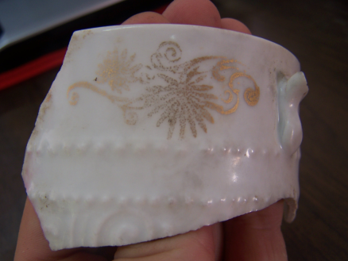
Figure 6-1. Porcelain sherd with gilding and molded design.
range in color from gray or white to red or black. Stoneware is usually salt-glazed and can have a variety of decorations or be plain. The earliest European stonewares date to the 13th century, but they continue to be produced through the present (Gaimster 1997:7).
Of the 127 stoneware sherds recovered, 46.5 percent (N=59) of them belonged to undecorated utilitarian vessels (Figure 6-2). These types of vessels would have typically been used for food storage or as chamber pots, although stoneware can also be found in the form of table and tea wares (Brown 1982:9).
The remaining 53.5 percent (N=68) of stoneware sherds were from stoneware bottles, either brown slipped or Bristol glazed. These types of vessels were common from the 18th through the early 20th centuries as a way to store beer, ale, and other non-alcoholic beverages that needed to be kept out of the light. Despite problems with closures and weight, stoneware bottles are common on 19th-century historic sites (Lindsey 2011). Brown stoneware bottles are
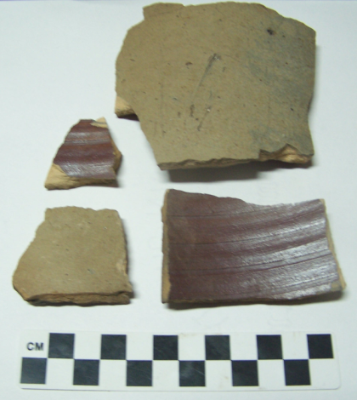
Figure 6-2. Stoneware vessel sherds from N512 E504 with interior Albany slip (1805-1920).

typically a gray paste with a brown glaze (Figure 6-3). They can be found in a variety of shapes and sizes. They have a date of manufacture from approximately 1820 to 1900 (Brown 1982:10). The other type of stoneware bottle recovered was a Bristol glazed ginger beer bottle (Figure 6-4). Developed in 1835 in Bristol, England, it soon replaced brown salt-glazed stonewares. While Bristol glazing is most commonly found on stoneware bottles, it can also be found on crocks, jugs, or other utilitarian stoneware (Noël Hume 2001:324).

Refined Earthenware

Refined white-firing earthenwares, such as creamware, pearlware, and whiteware, were developed beginning in the 18th century as a means of imitating Chinese Export porcelain (IMACS 1992:473). Refined earthenwares typically appear in the form of either tablewares or teawares, although they can be found in toiletwares as well (IMACS 1992: 9). No creamware was found at the leprosarium. Four hundred and eighty-three refined earthenware sherds dated to the leprosarium.
Pearlware, which dates from 1775 to 1830, has a soft, cream-colored paste and the glaze contains cobalt which gives it its typically blue tinge, although it can also appear white. Blue pooling can sometimes be found on the base of vessels. A variety of decorative motifs can be found on pearlware vessels (Brown 1982:17-18; Miller 2000:12).
Pearlware was not common at the leprosy hospital (Table 6-3). Only six sherds, or less than one percent of the hospital’s ceramics, are possible pearlware (Figure 6-5). The hospital would have been opened during the transitional period between pearlware and whiteware. During this time pearlware often appears so white that it is almost impossible to distinguish from whiteware. It is likely that some sherds could be pearlware, or whiteware, but the difference is
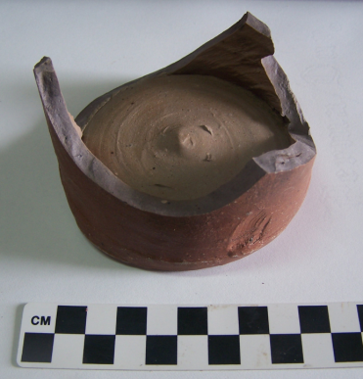
Figure 6-3. Stoneware bottle base from N516 E502.
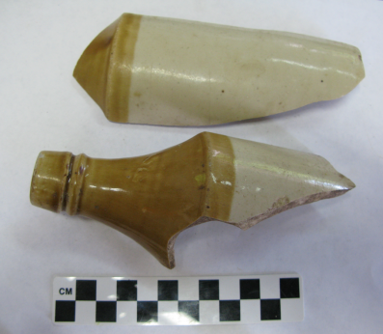
Figure 6-4. Bristol glazed ginger beer bottle sherds from N506 E506.

Table 6-3. Pearlware decorative techniques.
Decorative Motifs | N=
Plain | 4
Shell Edged | 1
Polychrome | 1

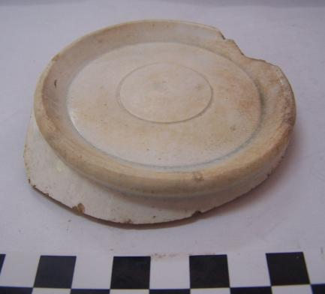
Figure 6-5. Possible pearlware sherd. Note the blue pooling.

impossible to tell due to their similarities during the transitional period.
Whiteware, which evolved from pearlware, first appears around 1820 and continues to be produced until the present day. Whiteware has a white paste that is harder than pearlware’s paste. Whiteware has a clear lead glaze which gives it the white appearance, and a variety of decorations may appear on the vessel (Brown 1982:19-20; Miller 1980:2).
Whiteware was, by far, the most common ceramic type recovered from the site. Sixty percent (N=470) of the total ceramics that date to the leprosarium were whiteware. Whiteware accounted for 96.7 percent of the total refined earthenwares that dated to the leprosarium. These sherds possess a variety of decorative motifs that helped to define more concise date ranges for them (Table 6-4, Figure 6-6).
Undecorated/Plain whiteware made up 38.8 percent (N=182) of the whiteware assemblage. Partial maker’s marks were present on four of these plain sherds. One sherd (Figure 6-7) has a partial maker’s mark that reads “AND & GA.” This partial mark is believed to have been produced by English potters, Copeland and Garrett, who operated from 1833 to 1847. They became owners of the Spode pottery franchise after Josiah Spode II’s death. Copeland and Garrett produced a variety of porcelain, earthenwares, and Parian wares (Hayden 1925:180-181; Godden 1964:173). Another sherd (Figure 6-8) has the lettering “NGHAM” visible. While its identification is not certain due to the small amount of visible mark, this sherd could be from a Rockingham whiteware vessel. Rockingham Works ceramics date from 1745 to 1842, but since this a whiteware sherd, the date range would be narrowed down to 1820 to 1842. Rockingham Works was a British earthenware and porcelain producer, but their wares were often imitated by other ceramic manufacturers who would stamp the name Rockingham onto their vessels (Godden 1964:545-546; Claney 2004:34). A partial French maker’s mark on a sherd, reading “QUE DE S” with a small dotted design (Figure 6-9) was identified. The complete mark would have been composed of a crown with the Lorraine coat-of-arms located below the crown. Surrounding the coat-of-arms would have been the words “OPAQUE DE SARREGUEMINES.” This pottery was manufactured from 1850 to 1950 (Musées de Sarreguemines 2006). The fourth sherd displaying a partial, blue, oval-shaped maker’s mark with the visible lettering “IT” on the top of the mark, and “ET CO” on the bottom of the mark. The maker of this mark was unidentifiable (Figure 6-10).

Table 6-4. Whiteware decorative techniques.
Decorative Motifs | N= | Percent of Whiteware Assemblage
Plain | 182 | 38.8
Transfer Printed | 81 | 17.2
Sponged | 59 | 12.5
Industrial Slipware | 42 | 8.9
Hand Painted | 32 | 6.8
Shell Edged | 19 | 4
Banded | 17 | 3.6
Stencil | 11 | 2.3
Unknown Decoration | 27 | 5.7
Total | 470 | 100

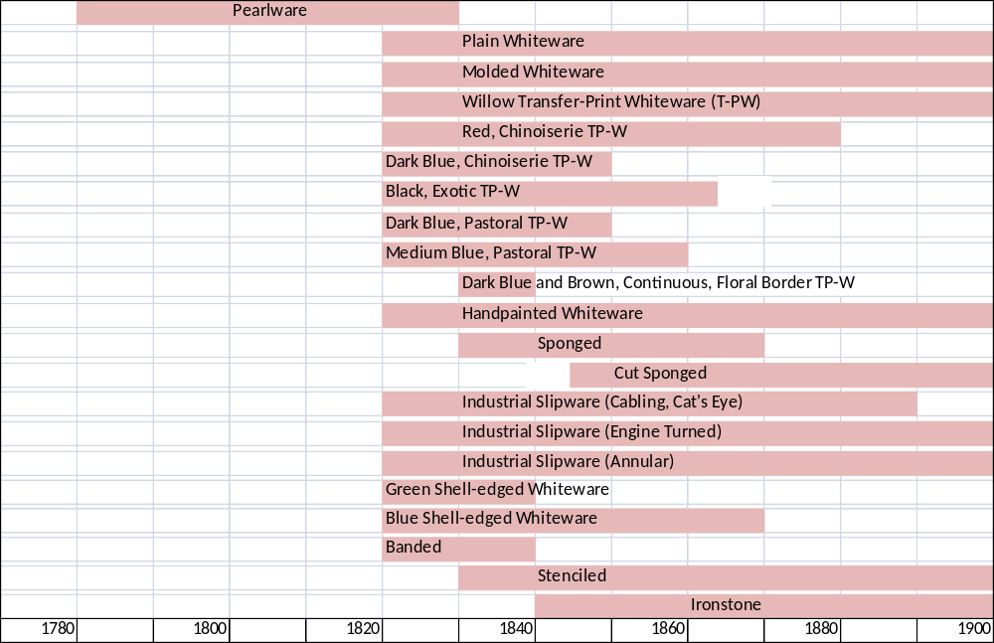
Figure 6-6. Seriation graph of refined earthenware decorative techniques

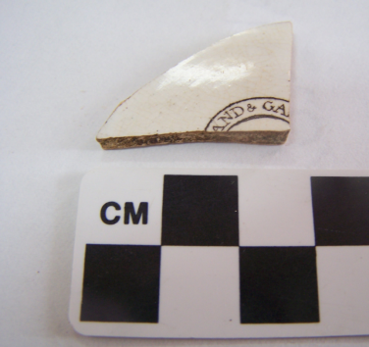
Figure 6-7. “[COPEL]AND & GA[RRETT]” maker’s mark on whiteware sherd from N504 E504.

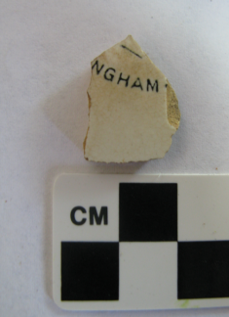
Figure 6-8. "[ROCKI]NGHAM" maker's mark on whiteware sherd from general surface collection FS#90

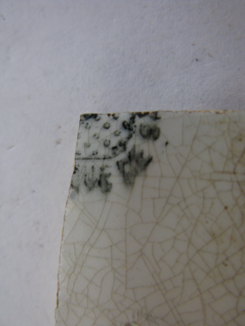
Figure 6-9. "[OPA]QUE DE S[ARREGUEMINES]" maker's mark on whiteware sherd from N500 E502.

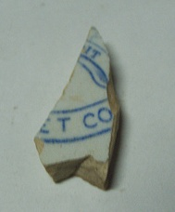
Figure 6-10. Unidentifiable maker's mark on a whiteware sherd from N516 E504.

The remainder of the whiteware ceramic assemblage lacked maker’s marks, but most did have some sort of identifiable decoration (61.7 percent; N=290). The most common decorative technique was transfer printing, which appeared on 27.6 percent (N=80) of the decorated sherds. According to Miller (1980; 1991) transfer printing was one of the most expensive decorative techniques on ceramics. During the 1790s, wares decorated by transfer printing were three to five times more expensive than undecorated wares but began to decrease in cost dramatically during the first half of the 19th century. The consumption of transfer printed wares greatly increased as cost went down. The sherds primarily had a dark blue print, but lighter shades of blue, along with red, brown, black, green, and purple printed sherds were also recovered (Figure 6-11). Color was the main component used in this analysis to date the hospital’s transfer-printed wares since many sherds were small and designs were difficult to distinguish (Table 6-5), but some of the larger sherds with identifiable designs will be discussed.
A blue transfer-printed sherd, which is the lid to a tableware vessel, was recovered from N500 E502. There is a notch located on one corner of the sherd for a long-handled spoon or ladle. The lid is broken but the diameter of the lid would have been greater than ten centimeters, defining the sherd as a larger vessel such as a tureen. This sherd has a blue Willow transfer-print pattern (Figure 6-12). Introduced by Josiah Spode in 1790, blue Willow became the most popular pattern of its time. Chinese prints, such as Willow, were produced beginning in 1790 and are still in production today (Samford 1997:6-8), giving this whiteware sherd with a Willow pattern a date range of 1820 to present.
Five red and three dark blue transfer-printed, whiteware sherds were recovered that have chinoiserie designs (Figure 6-13). Chinoiserie patterns were the Western attempt at imitating the Chinese-made patterns and became very popular within the English market (Neale 2005:73).
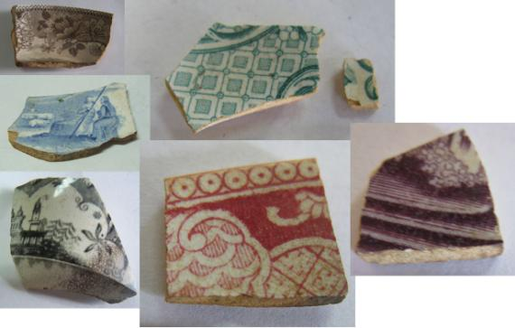
Figure 6-11. The variety of colors found on transfer printed wares at the leprosy hospital.

Table 6-5. Breakdown of transfer-print colors on sherds recovered from the leprosarium. Dates come from Samford (1997). The sherds recovered from the leprosarium are believed to be whiteware, therefore they would all date after 1820.
Transfer-Print Color | Count
Light Blue (1818-1867) | 1
Medium Blue (1784-1859) | 5
Dark Blue (1802-1846) | 55
Green (1818-1859) | 7
Red (1818-1880) | 7
Purple (1814-1867) | 1
Brown (1818-1869) | 3
Black (1785-1864) | 1

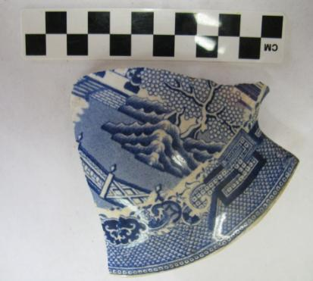
Figure 6-12. Blue Willow transfer print sherd recovered from N500 E502.
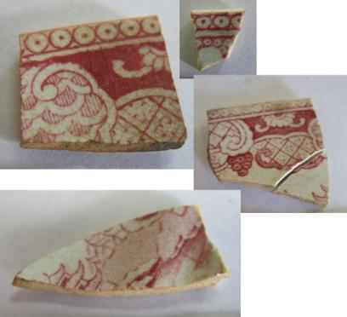
Figure 6-13. Examples of red chinoiserie transfer print patterns.

The red printed sherds were found within fairly close proximity to each other (although not in the same 2 x 2 meter unit), so there is the possibility that these sherds may be from the same vessel. Samford (1997) gives a date of manufacture for red transfer-print of 1818 to 1880 and 1802 to 1846 for dark blue transfer-print, and a date of manufacture for chinoiserie design of 1783 to 1873, giving the five red, chinoiserie sherds a date range of 1820 to 1880, and the three dark blue, chinoiserie sherds a date range of 1820 to 1846.
Two medium blue, two dark blue, and one black transfer-printed whiteware sherds have pastoral or landscape designs (Figure 6-14). Non-chinoiserie based designs became popular in the early 19th century, and featured rural scenes, with farms and animals, or European or Eastern views, with ancient buildings and castles (Neale 2005: 111). The design on the black transfer-printed sherd is believed to be an exotic or Eastern view, and Samford (1997) gives a date of manufacture of 1793 to 1868 for these types of views. Combined with the 1785 to 1864 date of manufacture for the black color of the print, and the fact that it is on a whiteware body, this piece dates from 1820 to 1864. Samford (1997) gives a date of manufacture of 1781 to 1859 for pastoral views, with the dark blue color dating between 1802 and 1846, and the medium blue color dating between 1784 and 1859. Therefore, the two dark blue sherds with pastoral/landscape designs would date between 1820 and 1846, and the two medium blue sherds would date between 1820 and 1859.
Border designs can also help with dating transfer-printed wares. Five sherds, three dark blue and two brown in color, had enough border, of all floral designs, present that a date range could be determined, once combined with print color. Floral border patterns can fall into one of two categories, the first being a repeating floral pattern that runs continuously around the border, unbroken (1829 – 1843), and the second type being floral motifs with areas of white or light
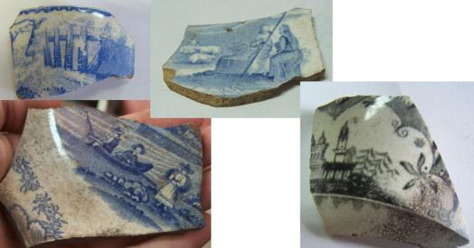
Figure 6-14. Examples of landscape or pastoral transfer-print designs.

colors in between (1820 – 1836) (Samford 1997:20-21). Three dark blue, floral borders, appear to be continuous patterns (Figure 6-15), and therefore would date between 1829 and 1843 (dark blue dates between 1802 and 1846). Two brown sherd have a continuous floral pattern (Figure 6-16), dating from 1829 to 1843 (brown dates between 1818 and 1869).
A sherd recovered from N502 E500, combines transfer-print decoration with sponging (Figure 6-17). This sherd has a blue transfer-printed design as its central motif and a red, sponged border. The type of transfer-print design is unidentifiable due to the limited scene visible on the sherd, but the dark blue color has a date of manufacture from 1820 to 1846 (for whiteware), while sponging was common from 1840 to 1870. Therefore, this sherd would date to the 1840s.
Cost may explain the popularity of transfer printed wares at the leprosy hospital despite its low economic status, but with transfer print still being more expensive than undecorated or other decorated wares, why would the government buy transfer-print? It is possible that patients
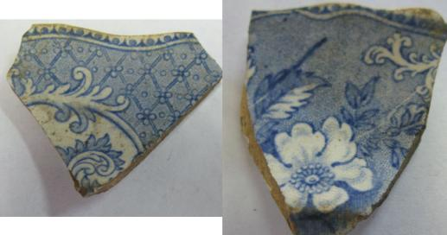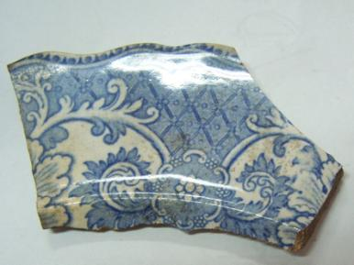
Figure 6-15. Dark blue, continuous floral border.
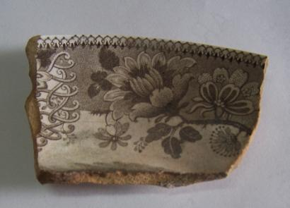
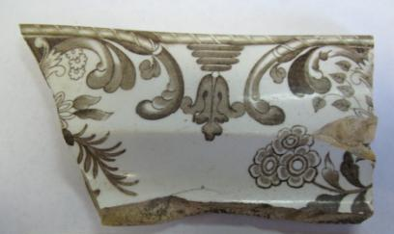
Figure 6-16. Brown, continuous floral borders.

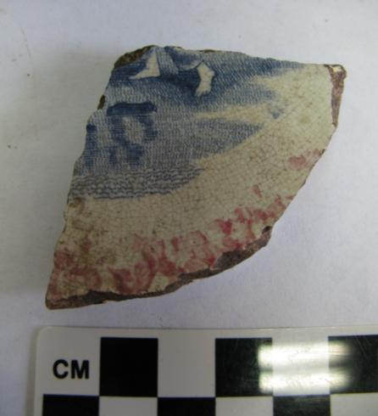
Figure 6-17. Blue transfer printed and sponged whiteware sherd recovered from N502 E500.

were bringing their personal wares with them to the hospital, which is supported by the lack of matched sets of patterns in the assemblage. If this were the case, these ceramics suggest that at least some patients had access to more costly consumer goods than others, and brought pieces with them to the leprosarium. Alternatively, as Flexner (2012) noted in his study at the Kalawao leprosarium in Hawaii, used pieces may have been donated by charities to the leprosarium (156). It is also possible, and will be discussed further in Chapter 7, that the transfer-printed wares belonged to the caretaker based on their distribution and proximity to Foundation A. Further research into hospital patients’ lists and patient backgrounds would be required to examine this topic, as well as more archaeological investigations at the site to test for the validity of the surface distributions.
Cut sponged and sponged/spatter whitewares composed 19.5 percent (N=61) of the assemblage. These sherds usually combined one or two colors of sponge decoration, and as mentioned earlier, some were found in combination with hand painted or banded designs (Figure 6-18 – 6-19). Cut sponging with simple patterns became common in the late 1840s. Prior to this time sponging or spattering were commonly combined with painting (Miller 1991:6). Sponged decorations required minimal artistic skill, therefore their cost was low compared to other decorated vessels (Miller 1991:6).
Dipped wares, or industrial slipwares (also known as annular/mocha) were the third most common decorative technique found in the assemblage (14.5 percent; N=42). Eight of the 42 sherds had cabling or “Cat’s eye” design (Figure 6-20). This decorating technique began around 1810 or 1811 when a multi-chambered slip pot began being used to create tri-color cable design or cat’s eye design on ceramics (Rickard 2006:63). Six of the sherds had engine turned designs of varying colors (Figure 6-21). Engine turned dipped wares first appeared in the 1770s (34).
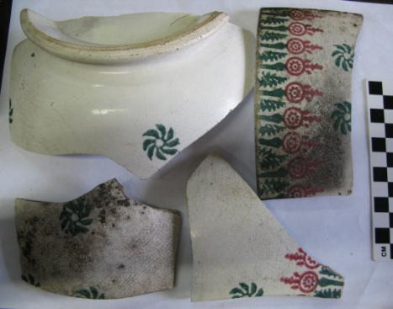
Figure 6-18. Large, cut sponged bowl recovered from N502 E502.
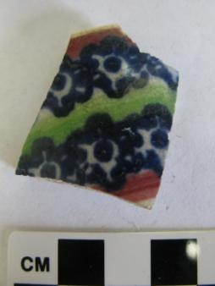
Figure 6-19. Cut sponged and banded whiteware sherd from N510 E498.

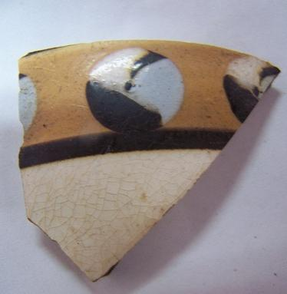
Figure 6-20. Cat's eye design on an industrial slipware fragment from N512 E500.
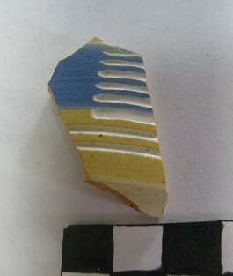
Figure 6-21. Engine turned industrial slipware fragment from FS#91.

Essentially the vessel was placed on a device to hold it in place while placed parallel to the vessel was a device that had a blade which incised or shaved the surface of the vessel in a particular pattern. The slip was applied either before or after incising or shaving was done (34-39). The remaining 28 sherds had annular bands of varying colors, ranging from dark colors to brighter colors (Figure 6-22). Engine turned wares continued being made into the 20th century, but since the slipwares in this study are all whitewares, they would post-date 1820 (76-81).
Industrial slipware was an inexpensive decorated earthenware, with mocha, banded, and cabled decorations being the cheapest of the industrial slipwares. Industrial slipwares were most commonly made in the forms of bowls, mugs, or jugs, and found in cottage or tavern settings. They were not made as dinner sets to be used in formal dining (Sussman 1997:74-75). Their low cost and “humble” role, as Sussman (1997) wrote, would explain why they were relatively common at the leprosarium.
Polychrome, hand painted wares comprised 10.3 percent (N=30) of the decorated assemblage. The sherds were usually painted with a floral design (Figure 6-23). Some sherds combined hand painting with cut sponged, sponged, or stenciled designs (N=11). Prior to the 1830s, common colors used on hand painted wares were blue, brown, mustard yellow, and olive green, with blue painted tea wares more popular than the polychrome wares. During the 1830s, red, black, and lighter shades of blue and green were introduced on polychrome painted wares. During the 1840s, hand painting was often combined with cut sponge decoration (Miller 1991:8). Hand painted decorations on vitreous, white-bodied wares were at their peak from 1840 to at least 1860, when they were being replaced in popularity by hand painting on porcelains (Majewski and O’Brien 1987:159). Miller (1980) ranks the expense of hand painted
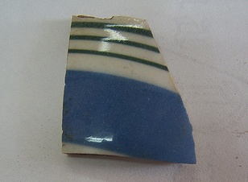
Figure 6-22. Annular industrial slipware fragment from N504 E506.
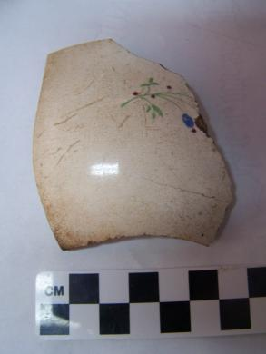
Figure 6-23. Polychrome, hand painted whiteware sherd from N514 E502.

wares in between minimally decorated wares and transfer print wares. Whoever was painting the vessel needed to have enough skill at duplicating patterns that matching sets could be made, but the motifs on most vessels required minimal artistic skill to paint. This made most hand painted wares fairly inexpensive.
Shell-edged whitewares made up 6.6 percent (N=19) of the assemblage. Blue or green in color, these sherds mostly had scalloping and impressed edged designs (Figure 6-24). Green shell edged wares became rare by the 1840s, while blue shell edged remained popular into the 1860s. Edged wares were the cheapest decorated tableware for the majority of the 19th century (Miller 1991: 5-6).

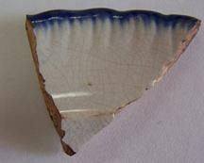
Figure 6-24. Blue shell edged whiteware

Banded whitewares comprised 3.6 percent (N=17) of the assemblage. Banded wares are typically hand painted and the bands appear around the rim or with a series of bands around the body of the vessel (Figure 6-25). This type of design became popular during the early 19th century and is often found on hand painted floral wares (Majewski and O’Brien 1987:160).
Stenciled whitewares comprised 2.3 percent (N=11) of the assemblage. Stenciling, where a design was created by placing a stencil on the vessel before painting (Figure 6-26), was often used along with hand painted floral decoration and with spatter and sponging before cut sponges came into use in 1845 (Majewski and O’Brien 1987:157,161). Stenciling continued to be used throughout the 19th century, and into the 20th century, as it was used in combination with decal design (147).
Approximately 77 percent of the whiteware sherds dating to the leprosarium were relatively inexpensive wares. Seventeen percent of the whiteware sherds were the more expensive, and elaborate transfer-printed wares. The remaining six percent had unidentifiable decorations. A large number of inexpensive ceramics versus a small number of expensive ceramics, like transfer-printed wares, would be expected as a site like a leprosy hospital where care and treatment were poor and most of the patients were probably of low economic status. The small numbers of more expensive ceramics present may be explained by patients buying or bringing their personal ceramics to the hospital or pieces that were donated to the patients. It could also be that the transfer-printed wares belonged to the caretaker, who would have possibly had more access and funds to purchase these wares. Since Miller (1980; 1991) used vessel type and vessel count to aid in his economic scaling, further research would have to be conducted on the hospital’s ceramics to obtain a more detailed look at what the ceramic cost could say about the hospital’s social status. Furthermore, Miller’s work only examined British- made
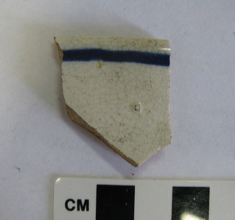
Figure 6-25. Banded whiteware fragment.
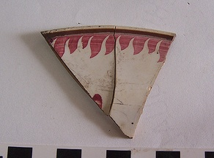
Figure 6-26. Whiteware fragment with stenciled design.

ceramics, so it is unknown how the non-British ceramics fit into his economic scaling.
Ironstone, while similar in appearance to whiteware, has a much harder paste than whiteware and is partially vitrified. Ironstone is heavier and thicker than whiteware. The paste is often tinted blue, gray or white. If blue or gray paste is used, the ware can appear slightly blue or gray in color. Ironstone can be found with a variety of decorative techniques, which can make it hard to distinguish from whiteware, but ironstone is commonly found as a plain ware with a molded design. Ironstone was popular during the second half of the 19th century (Brown 1982:20). Only three sherds of an ironstone, hollowware vessel were recovered from the leprosy hospital. All three sherds were found in the same 2x2 meter surface collection block (N508 E502). These sherds could represent the late occupation of the hospital or even post-date the hospital since ironstone was most popular later in the 19th century rather than during the time frame of the hospital’s use. According to Miller (1980), the mid-1850s saw a shift in ceramic prices and taste. While undecorated wares had been the cheapest wares available before this time, suddenly undecorated ironstone cost around the same amount as transfer printed wares. Sales of transfer print decreased from the 1850s to the 1870s, while undecorated ironstone became popular.

Coarse Earthenware

Coarse earthenware, like stoneware, typically consists of utilitarian vessels. Coarse earthenware vessels types include those used in the preparation, cooking, and storage of food. Coarse earthenware is a porous, low-fired ceramic. Paste color can range from buff to orange or red. The bodies are typically lead glazed to contend with the porosity (Jordan 2000: 116).
Coarse earthenware vessel sherds account for 17.6 percent (N=138) of the ceramics
recovered from the leprosy hospital. These sherds are undecorated and vary in the amount of glazing appearing on each sherd. Two sherds to a large basin were recovered from the extreme northeast corner of the site (Field Specimen # 77; see Figure 6-27; initially labeled as a wash basin). These sherds have a red-orange paste. The interior has a clear glaze but the exterior of the vessel has no glazing (Figure #). Beaudry et. al (1983) describes large (10 inches or more in diameter) vessels, like this one, found on 17th-century sites as milk pans, which would have been used to cool milk, but she also uses the term milk pan to refer to wash basins and cooking pans (28). There has been no evidence (archaeological or historical) that there were cows at the leprosarium, so it is most likely that this vessel would have been used for washing or cooking.

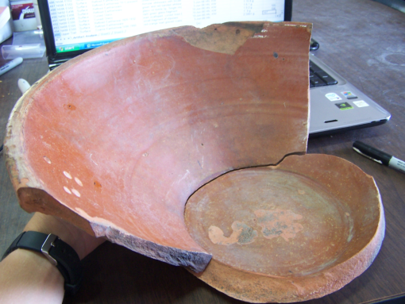
Figure 6-27. Large, earthenware basin sherds recovered from general surface collection.

These sherds were located away from the concentration of artifacts and behind the rest of the site, this could possibly mark the location of food preparation or a washing area.
Four fragments from a black, lead glazed redware vessel (Figure 6-28) were recovered from three different surface collection blocks (N514 E502, N510 E504, N512 E500). Redware is a coarse earthenware with a redish paste and can be unglazed or covered in an opaque glaze. Redwares can be decorated or undecorated. They date from the 16th century through the 19th century (L. Megan 2011; Texas A & M University [no date]). The sherds illustrated in Figure 6-28 has a molded decoration around the rim and is a type common in the late 18th century and early 19th century tableware.

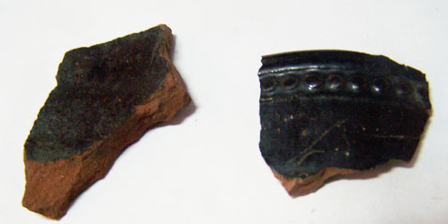
Figure 6-28. Black, lead glazed earthenware.

Container Glass

Container glass represents 73.1 percent (N=2296) of the 3139 artifacts in the analyzed assemblage. Container glass was dated using bottle manufacturing technique, finish types, and/or base markings, although some sherds were dated based upon glass color and their inferred connection to other bottles with diagnostic characteristics (Table 6-6). Below is a description of different diagnostic techniques found on vessels dating to the leprosy hospital and what these vessels can say about life at the hospital.

Table 6-6. Counts and percentages for manufacturing techniques on the container glass dating to the leprosarium.
Manufacturing Technique (or diagnostic feature for dating) | Count | Percentage of Assemblage
Applied Finish | 123 | 5.3
Cracked-Off Finish | 1 | 0.04
Flared Finish | 1 | 0.04
Laid-On Ring Finish | 3 | 0.13
Sand Pontil | 1 | 0.04
Glass Pontil | 6 | 0.3
Iron Pontil | 1 | 0.04
Post Mold Base | 2 | 0.09
Two-Piece Mold | 1 | 0.04
Three-Piece/Ricketts Mold | 14 | 0.61
Dip Mold | 137 | 6
Unknown | 2006 | 87.4
Total | 2296 | 100

Black or Dark Olive Glass

Black or dark olive glass bottles date to the mid-17th century and remained common until the 1880s. The majority of black/dark olive glass bottles made during the 19th century were made for liquor, wine, and ale products, since the contents needed to be protected fromlight (Lindsey 2011). Using glass color as a method of dating artifacts should be approached with caution (Jones and Sullivan 1989:12-14), but the amount of dark olive glass recovered from the site versus other glass colors, combined with the use of other diagnostic features, when available, strongly suggests this glass dates to the hospital’s occupation. Of the site’s 3877 fragments of container glass count, 2155 (55.6 percent) of these curved glass shards were dark olive in color (Table 6-7). These black or dark olive shards are associated with cylindrical and square (case) bottles (Figure 6-29). The remaining 1722 sherds of curved glass were placed as being indeterminate and having an unknown relationship to the hospital occupation unless they had diagnostic manufacturing features that placed them within the hospital’s dates of occupation.
Caution must be taken when using glass color as a means of assuming what contents a bottle held. While it is often implied that black or dark olive bottles contained some sort of liquor, in reality it is impossible to know what liquid exactly the bottle held unless the bottle has manufacturer marks. Some bottles were shipped empty to their destination and then later filled with various liquids upon arrival. In addition, bottles were often reused, therefore making the identification of their original purpose difficult (Smith 2008:19-20).

Dip Mold
While English dip molded bottles were being made as early as the beginning of the 1700s (Dutch case bottles are dip molded and were made in the 17th century), they are most commonly given a date range of 1730s to the 1820s, when the Rickett’s mold replaced dip technology.
Table 6-7. Counts and percentages for glass color of container glass dating to the leprosarium.
Glass Color | Count | Percentage of Assemblage
Light Blue/Green or Clear | 66 | 2.9
Green | 23 | 1
Blue/Green | 26 | 1.13
Brown/Amber | 24 | 1
Dark Green | 2155 | 93.9
Unidentified | 2 | 0.1
Total | 2296 | 100

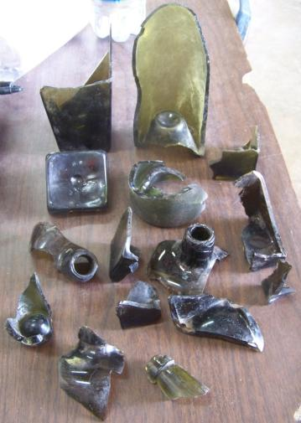
Figure 6-29. A sample of some of the dark olive glass recovered.

After the 1820s, dip molded vessels were gradually replaced until their almost complete disappearance by 1870 (Jones 1986:84-86). A dip molded vessel was made using an open top mold that gave the bottle body and base a uniform appearance. The molded vessel would taper from top to bottom to allow the glass to be removed from the mold. Dip molded vessels can be found in a variety of forms. They can be rounded or multisided. Early dip molded vessels may have pontil scars or a push-up base, while later vessels have a molded/embossed symbol on the base (Figure 6-30) (Lindsey 2011). There should be no mold seams on the body or base of the bottle due to it being blown into a mold to shape it, then pulled from that mold without the mold opening. There may be a slight horizontal seam apparent where the top of the mold ended and the shoulders of the vessel begin. The rest of the bottle would have been shaped using a free-blown technique (Lindsey 2011; Jones and Sullivan 1989: 26).
Most of the dip molded vessels recovered from the hospital were identified based on square bases or larger bottle sherds where tapering could be identified. These are all black/dark olive in color and almost all of the sherds of this glass color are associated with dip molded, case gin bottles. While the name suggests that they held gin, they also held other liquors or wine. The square shape helped them be packaged for shipping more effectively than round bottles (Lindsey 2011). Over 130 square base sherds (some were complete bases) were recovered during excavation. It is uncertain how many bottles this represents since a minimum vessel count was not conducted due to time constraints, but it does suggest that alcohol consumption at the hospital was high. Since the hospital was in such poor condition food was often scarce and there was and with no effective treatment for leprosy known at the time, patients probably treated their condition with whatever could help numb the pain.
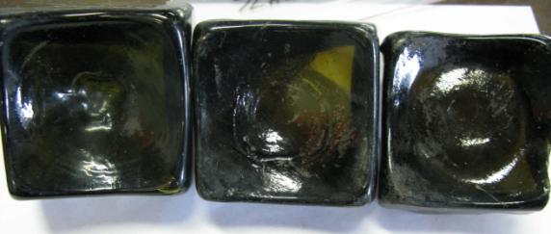
Figure 6-30. Dip molded vessel bases.

Applied Finish
Applied finishes are most commonly found on bottles dating from 1830 to 1885. These finishes were made by applying additional glass onto the vessel where the blowpipe was removed. This applied glass was then shaped using a finishing tool, which could form a variety of bottle finishes (Figure 6-31). Applied finishes are usually distinguished from the more sophisticated tooled finish by the appearance of excess glass below where the finish was applied. If a mold seam was found on the neck of the vessel, it will abruptly end where the finish begins. A line or ridge may also be felt inside the bore where the finish was applied (Lindsey 2011).
Applied finishes were the most common finish type found at the site. Approximately 123 broken and complete applied finishes were recovered. Ninety-nine of these finishes were a dark olive green in color and most were found in the same context as dip molded vessel sherds, therefore it is likely this finish was common on dip molded vessels at the site. The remaining 24 applied finishes were found on vessels of a different glass color.

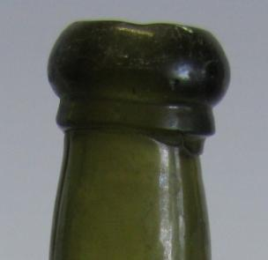
Figure 6-31. Applied finish.

Three-piece/Ricketts Mold

A three-piece, or Ricketts mold, consists of a dip mold to shape the body and two hinged mold halves to shape the shoulders and/or neck of the bottle, leaving distinctive mold seams (Figure 6-32). The bottle’s finish was shaped by hand or a finishing tool. Bottles made with the Ricketts mold continued to be produced into the early 20th century. Ricketts molded bottles made of dark green glass were almost exclusively used for liquor between 1821 and 1840 (Jones and Sullivan 1989:29-30).
Fourteen Ricketts molded vessel fragments were recovered. Seven of these fragments possess no other diagnostic features that would help in determining their date of use or
if they contained liquor. The other seven fragments are believed to be part of Dr. J.G.B. Siegert bottles.

Cracked Off Finish

Cracked off finishes can be found on a variety of bottle types made prior to the 1870s. This finish is formed when the blowpipe is removed from the neck of the bottle, but no
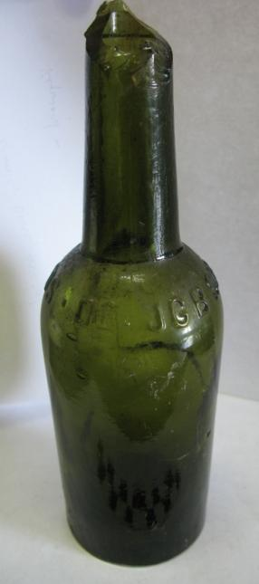
Figure 6-32. Dr. J.G.B. Siegert and Hijos (post-1870) Ricketts molded bottle.
additional glass or shaping is added (Lindsey 2011). A single cracked off finish was recovered. The fragment is made of clear glass and is broken at the shoulder region (Figure 6-33).
Pontil Scars
Pontil scars appear on bottle bases as early as Roman times, but they virtually disappear by the 1860s or 1870s due to the development of the snap case for holding hot bottles during manufacture.
A glass pontil scar is formed when molten glass is applied to the pontil rod and then fused to the base of the vessel. When the rod is removed, excess glass may be left on the base or glass may have been chipped from the base, which results in an uneven surface (Lindsey 2011). Six vessel fragments with glass pontil scars were recovered. All of these fragments came from dark green colored vessels
A sand pontil scar is formed when the hot glass on the tip of an iron pontil was dipped in sand before being applied to the bottle base. This was done in an attempt to keep the pontil from adhering too closely to the bottle base, which would result in easier removal. When the rod is removed, the base may feel rough, like sandpaper, where the sand created a rough texture. Some sand particles may even be left in the base of the bottle (Lindsey 2011). One dark green vessel fragment with a sand pontil base was recovered.
An iron pontil scar appears when a bare iron pontil rod is heated then applied directly to the base of the vessel. When the pontil rod is removed, iron deposits are left in the glass on the vessel’s base. Iron pontil scars can date as early as the 1830s and as late as the 1870s, although most date between 1845 and the mid-1860s (Lindsey 2011). Only one vessel fragment with iron empontiling was recovered. It was found on a fragment made of clear glass, with no other
.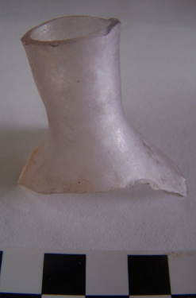
Figure 6-33. Cracked off finish.
diagnostic features.

Dr. J.G.B. Siegert Aromatic Bitters

Seven green Ricketts molded fragments were recovered that had molded lettering telling what the bottles once contained. These fragments were once part of bottles that contained Dr. J.G.B. Siegert aromatic bitters (Figure 6-34). Dr. Johann Gottlieb Benjamin Siegert, originally from Germany, took up the job of Surgeon-General in the Military Hospital in Venezuela during the fight against the Spanish in 1820. In hopes of being able to bring relief to his patients and “wrest a cure from nature itself,” Siegert created a unique blend of tropical herbs and plants, which he called aromatic bitters. These bitters became popular not only among hospital patients and local residents, but among the sea-sick sailors coming into port. In 1830, Siegert began exporting his bitters to England and Trinidad, and by 1850 he had resigned from his army
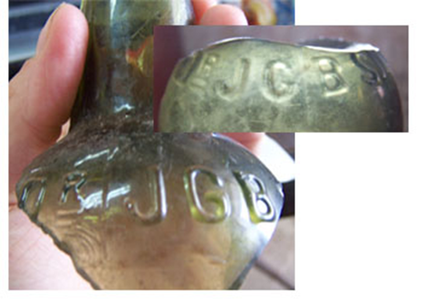
Figure 6-34. Dr. J.G.B. Siegert bitter bottle fragments
position to concentrate fully on his aromatic bitter production. Siegert partnered with his son in 1867, and the product name changed to Dr. J.G.B. Siegert and Hijo [son]. Two years after Siegert’s death in 1870, his other son joined the company and the name became Dr. J.G.B. Siegert and Hijos [sons]. These bitters became popular around the world and son Alfredo became purveyor to the King of Prussia in 1904, the King of Spain in 1907, and in 1910 to King George V. It was during this time that the company went public and the official name became Angostura Bitters (Dr. J.G.B. Siegert & Sons) Limited. Angostura Bitters are still popular today as a flavoring in international and Caribbean cuisine (Angostura Bitters [2008]).
Four (two from the same vessel) of the aromatic bitter bottle fragments contain only enough remnants to see the Dr. J.G.B. name, so it is unknown whether these bottles contain the “and Hijo(s)” addition which would date them post 1860. Therefore, these fragments could date anytime from 1830 to 1907. If these fragments date to the hospital’s occupation it would suggest that patients had access to some medicinal treatments to help treat common ailments, although this treatment would not have helped with treating leprosy. These fragments were recovered to the north/northeast of the drainage in units N504 E498, N506 E506, and N508 E502.
Three (two from the same vessel) other Dr. J.G.B. vessel fragments were recovered. These fragments, while still broken, contain enough of the molded name to conclude that these fragments were from bottles of the Dr. J.G.B. Siegert and Hijos era, which dates from 1872 to 1907. These fragments would post-date the hospital’s occupation. These fragments were found in a separate area from the other bitter fragments. They were found south from the drainage, closer to the site datum, in units N500 E502 and N498 E500.

“P.Herrink” or P.F. Heering Cherry Liqueur

Two brown/amber and one greenish cylindrical bottle fragments of unknown manufacturing technique were recovered with applied glass labels that either read “P. Herrink”, “Herrink”, or “[missing]ering” (Figure 6-35). In 1818, Peter Frederk Suhm Heering was a successful grocer when he began producing his liqueur, “Heering’s Cherry Cordial,” in Copenhagen. Until around 1880, the bottles were believed to have been given an applied label, or ribbon seal, that read “P.F. Heering.” After this date all Heering bottles were embossed with the label, since this was a cheaper method than handmade ribbons. Heering’s liqueur was often copied and ribbon sealed with names like “P. Haering”, “P.F. Hering”, or “P. Herrink.” It is believed that these copies were made by grocers in the Virgin Islands imitating Heering’s liqueur (Petersen 2011).
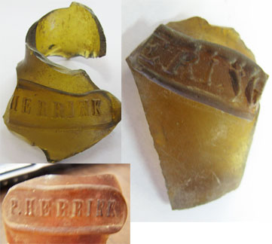
Figure 6-35. P.F. Heering Cherry Liqueur bottle fragments. The two on the left are imitations.

The two bottles fragments with the labels “P. Herrink” and “Herrink” are obviously the local copies of P.F. Heering’s liqueur. It is not clear whether third fragment, which only had “ering” still present, is a copy or the actually liqueur. The presence of these liqueur bottles at the hospital site further suggests that alcohol was a common consumption item for the patients.
Windy Hill and Pleasant Lookout, Creole communities located on the East End of St. John, have archaeological components that date during the same time period as the leprosarium. While these sites were not hospitals, a comparison of the artifact assemblage may help in understanding whether the lack of medicines and large alcoholic beverage assemblage was typical in the West Indies during the 19th century or unique to the leprosarium. The use of gin bottles at the Windy Hill site only appeared in small quantities from 1810 to 1870 (see Table 6.10 in Armstrong 2003). Most bottle glass was found in the form of wine bottles, which were often reused over time to hold water or other non-alcoholic liquids. It is mentioned that the use of gin bottles increased after 1810 among the enslaved population, when it has previously been found almost exclusively among the planters, suggesting that gin had become more easily accessible to those of lower class (Armstrong 2003: 154-156). The Windy Hill site saw an increase in the use of health and hygiene items, such as patent medicines, after 1810. Most of these medicines were believed to be associated with a cholera outbreak on the East End during the 1850s and 1860s (159, 245). Pleasant Lookout was not affected by the cholera outbreak, and while there were not as many medicine bottles recovered as Windy Hill, over 50 percent of artifacts related to personal use were pharmaceuticals (245). The presence of medicines on these two sites, especially related to the treatment of a disease outbreak, suggests that more medicine bottles should have been recovered from the leprosarium, since this was a group of people who probably constantly needed to treat the pains associated with leprosy.
Archaeological investigations at the post-1800 laborer villages of Adrian Estate on St. John, found that while container glass was the most common artifact recovered, most of these container are believed to have been associated with the reuse of wine bottles as containers for water, although gin case bottles were found but in smaller quantites. Only small quantities of patent medicines were found associated with the laborer villages. A larger quantity was found associated with the overseer quarters (Kellar 2004: 139-160). Perhaps the overseer had easier access to medicines than the laborers, which may help in explaining the lack of medicines at the leprosarium. If the government was not providing enough money for basic needs, which would have included medicines for patients with a painful disease, the lack of medicine at the site might then be expected. It could have possibly been cheaper to buy liquor than medicine. The cost of liquor and medicine in the Danish West Indies during this time is not known.
The average per capita ingestion of ethyl alcohol (the name for the type of alcohol that is found in alcoholic beverages) has been shown to be correlated with the incidence of pathologies (Staski 1984:40). As discussed in Chapter 2, there was no effective treatment for leprosy during the early-to-mid 19th century, when the leprosarium was in operation, and sufferers often treated themselves with whatever they found to ease the pain. The high occurrence of container glass fragments attributed to liquor bottles suggests that drinking was a form of medicating, especially when compared to the lack of patent medicines bottles found at the site. Only three container glass fragments were recovered that could possibility be attributed to patent medicine bottles (Figure 6-36), but they were too fragmented to identify what type of medicine was in the container. It is not known why there was a lack of patent medicines at the site. It is possible that liquor was more easily accessible and less expensive to the patients, and a more effective “treatment” than the patent medicines.
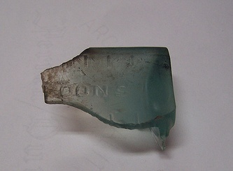
Figure 6-36. Possible medicine bottle fragment. Molded graduated markings and the letters "poons" [spoons]? are molded onto the vessel.

Pipes

Ceramic pipes were a rare find among the items recovered from the hospital site. Only 35 fragments (less than 1% of the artifact assemblage) were recovered. None were found completely intact and only four had maker’s marks that could be attributed to a maker(s) and/or date range. A count of the stem and bowl junctures suggests that the minimum number of pipes deposited at the site was six.
Clay tobacco pipes rose in popularity in Western Europe during the 16th century as the publics’ fascination with tobacco smoking increased. Europeans acquired the knowledge of pipe making from Native Americans who used pipes for medicinal and religious purposes (Ayto 1994:4). The most basic ceramic pipes, with little or no decoration, were inexpensive and often given away. Molded ceramics pipes were common by the 19th century and the molded designs were sometimes in reference to an event or product popular during that time (6). Non-specific molded designs, though, were very common and made by a variety of manufacturers, so determining a date range or manufacturer is often impossible unless the pipe has a maker’s mark. It is not surprising that pipes were found at this site since pipes were very common during the 19th century. The small numbers recovered could be due to them being washed away over time, since they are small and light weight, or hospital patients may not have had easy access to tobacco or pipes if they were confined to the hospital premises.
Clay tobacco pipes can be dated using a variety of methods, including bowl shape and size, stem bore diameter (if English or Chesapeake-made), and maker’s makers, although the same maker’s mark may have been used by a variety of individuals over time (as seen on an example below) (see Harrington 1954; Binford 1962; Bradley 2000). Most of the pipes recovered from the hospital were either unmarked stems, too fragmented, or had no visible markings that would allow for the pipes to be dated or place of manufacture to be determined.
A broken pipe stem was recovered from the controlled surface collection (N496 E500) with stamped words on both sides of the stem (Figure 6-37). While neither of the stamps is completely visible, enough of the lettering was still available to figure out the manufacturer. The stamps, unbroken, would have read “Glasgow” and “White.” William White was a Scottish pipe manufacturer from 1805-1955 (Oswald 1975:206). This pipe would date before 1891 since the McKinley Tariff Act required exports to be marked with country of manufacture (Sudbury 2006:35).
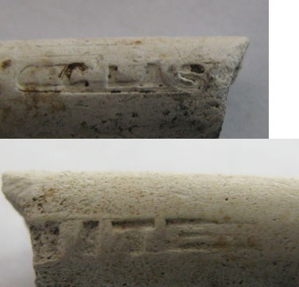
Figure 6-37. W. White and Sons pipe stem fragment.
Another Scottish pipe was recovered from the site during the initial visit to the area when the trail was being cleared. This pipe has a complete bowl and a small amount of stem remaining (Figure 6-38). The bowl had a molded steam powered locomotive on one side, while the other side had a molded paddle steamer. The broken stem has a stamped “T 73” on one side and a partial stamp of the word “Glasgow” on the other side. The “Glasgow” stamping on the pipe’s stem would date the pipe before the 1891 McKinley Tariff Act. The steam powered locomotive and the paddle steamer that are molded on the pipe would give the pipe a date after, at least, the early 1800s, as the first railway steam locomotive was used in 1804, with commercially used steam locomotives not coming along until 1825 (Klooster 2009:74). The paddle steamer slightly pre-dates the steam locomotive.
A Dutch pipe bowl was recovered from the controlled surface collection (N516 E504) which has no decoration besides rouletting around the rim of the bowl (Figure 6-39). The base

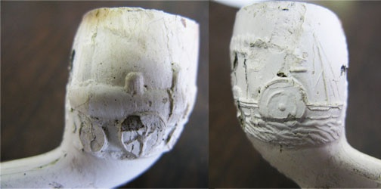
Figure 6-38. Scottish pipe with steam powered locomotive and paddle steamer design.

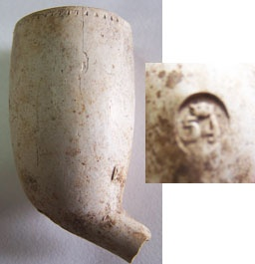
Figure 6-39. Dutch pipe with crown and '54' stamp.

of the bowl is stamped with a circle which has the number “54” and a crown inside. This type of maker’s mark is Dutch in origin but the mark was used by several makers, with production spanning from the 18th century to the 20th century (Table 6-8).
Another Dutch pipe with a similar design was recovered from the FS# 89 (refer to site map for location). This pipe also has a circular stamp with a crown and number inside (Figure 6-40). While the first number is legible (‘5’), the second number is not legible, therefore the maker(s) of this pipe are uncertain.
Flints
Five flints were recovered from the hospital site. Four of the flints were recovered in the controlled surface collection (N512 E504, N510 E504, N506 E504), which was located near a structure foundation. The other flint was recovered from FS#92, which was located near the cliff edge, west of the cistern (Figure 6-41). These flints could have been used with guns or could have been strike-a-lights, used to light fires, but distinguishing between the two can be difficult.
Gunflints were used in flintlock muskets from the 17th century until around 1880 when repeating rifles replaced the flintlock. Gunflint is a “small, sub-rectangular, wedge-shaped artifact manufactured from flint or chert” (Kenmotsu 1990: 93). Gunflint was used to strike a spark in order to ignite the charge in flintlock guns. The shape of gunflints changed over the course of the 18th century, which is why they can be difficult to distinguish from strike-a-lights. Gunflints from the first half of the 18th century were made from flint flakes and, in cross-section, have the wedge shape. Flints used for strike-a-lights were also made from flakes and have the similar wedge shape as these early gunflints and continue to be made in this fashion through the19^{tn} century, which can make telling the two apart difficult. Gunflints from the latter half of
Table 6-8. A list of Dutch makers who used the crown and '54' symbol. It is uncertain why some of the dates are left blank, but possibly dates of manufacture were unknown. (Meulen 2003).
Maker  | Date Range
Jan Janse Volkert | 1732-46
Hermanus van Keulen
Leendert van den Bos
Cornelis van der Starre
Comelis de Hoop | 1771-
Jan Valkenburg
Alida Versnel, wed. J. Valkenburg | -1775
Pieter Stomman | 1775-
Johannes Marinus van der Want | 1838-
Gerrit Cornelis Pzn van der Want | 1865-1881
Fa. P. Gzn van der Want | -1930

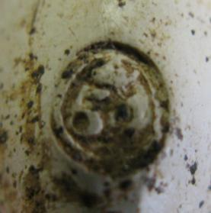
Figure 6-40. Another Dutch pipe with crown and number stamp. Full number is not legible.

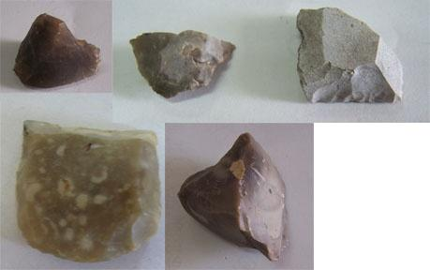
Figure 6-41. French and English gunflints.

the 18th century take on a more square/rectangular shape, and were made from flint blades (Woodall 2004:3).
Three of the flints recovered from the site are believed to be of English origin. English flints are typically gray or black in color. One of the English flints appears to be a core and another takes on the typically square/rectangular shape of gunflints developed in the second half of the 18th century. The other two flints recovered are believed to be French in origin, since French flints are typically honey-colored, blonde, or brown (Noël Hume 1969:220). One of the French flints appears to be a small core, while the other French flint is either a gunflint or a strike-a-light. The possible presence of gunflints at a leprosy hospital is interesting because it is doubtful that the patients would have been allowed to carry firearms. Possibly the caretaker had a firearm for protection or in case a patient attempted to leave their quarantine without permission, although the historic documents did not mention there being any problems with patients’ behavior. The one British flint with the square/rectangular shape is very typical of what a gunflint would look like, but the other two non-core flints could be either gunflints or flints used for strike-a-lights. Future research examining the flints under a microscope to look for use wear could possibly help distinguish between gunflint and strike-a-light.

Personal Items

Personal items are an important find during an excavation because these artifacts can reveal a lot of information about a society’s or individuals’ cultural and social beliefs. Personal items were a rare find at the leprosarium. Of the 5,104 total artifacts recovered from the excavation, only ten of these artifacts were personal items (Table 6-9). Out of these ten, only four could be dated to the leprosarium’s operation (Table 6-10). The remaining six artifacts did
Table 6-9. All personal items recovered during excavation.
Artifact Type | Location | Count
Bead | N516 E504; FS 87 | 2
Button | FS 89; FS 92; Trail, Test Unit 3 Level 2 | 4
Doll's Arm | N510 E498 | 1
Marble | N504 E506 | 1
Slate Pencil | N506 E504 | 1
Clothing Hook | Test Unit 3 Level 1 | 1

Table 6-10. Personal items that could be dated to the leprosarium.
Artifact Type | Location | Count
Bead | N516 E504 | 1
Prosser Button | Trail | 1
Ceramic Marble | N504 E506 | 1
Slate Pencil | N506 E504 | 1

not have diagnostic features to cause them to post-date the hospital, but neither did they have diagnostic features that could allow them to be dated to the hospital.
One compound blue bead was recovered from N516 E504 (Figure 6-42). Good (1983) described this type of bead as: “faceted drawn beads of compound construction include a tubular, cornerless hexagonal variety composed of transparent cobalt blue over translucent light blue (Kidd Type IIIf). The glass is sometimes a translucent cobalt blue over opaque light blue, depending on the relative thickness of the glass layers” (166). While Good does not give exact manufacturing dates for this type of bead, she does list several sites and in which this type of bead was found and their dates of occupation (Table 6-11). Karklins (1983) also mentions that this type of bead was recovered from a site in Battle Point, Michigan, that dated from 1800 to 1825 (111-117). Based on Good’s and Karklin’s data, the bead recovered from the leprosarium most likely dates within the 1833 to 1861 date range for the hospital’s operation.
While beads are initially thought of as being items worn as decorations on clothing or persons, the deeper meaning behind why someone chose a specific color or type of bead, may reveal information about an individual’s or a group of individuals’ beliefs or cultural practices. Beads, especially blue beads recovered from slavery sites within the United States, have been the focus of much research. Studying modern-day West and Central African societies, researchers have noted the important role glass trade beads have played in the Africans’ spiritual lives. Beads are often used as part of charms or amulets to ensure success in life, success in acquiring material goods, and to ward off sickness and evil (Stine et al. 1996: 54; Russell 1997:68-71). Europeans, during the 15th through the 19th centuries, observed that certain blue beads were highly valued among West Africans (55). Reports from the 18th century mention slaves arriving from Africa with beads on their necks and arms (Heath 1999: 56). Stine et al. (1996) reported

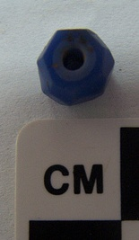
Figure 6-42. Compound, blue bead recovered from N516 E504.

Table 6-11. List of sites, taken from Good (1982:166), in which this type of compound, blue bead was found.
Site | Site Date(s)
Guebert | 1719-1833
Wichita sites | 1780
Posey | 1823-1833
Devil’s Canyon | 1820-1836
Wealthy Indian Site | 1830-1840
Kipp’s Post | 1826-1830
Fort Laramie | 1834-1875

that while the color blue was important among African-Americans in the south, and while it is not certain why this color was so popular, psychologists have indicated that the color blue has curative properties and has been used worldwide in curing and preventing disease (65).
With only two beads recovered, and only one of which to be shown to date to the leprosarium, conclusions on their use or purpose cannot be made, although historic documents did show that slaves and former slaves were interred at the hospital. It is also possible, considering many West Indians were of African descent, that the meaning behind the color blue and the use of beads may have moved from the enslaved population into the general population by this point in time. Further research into other such institutions and their populations, and whether beads have been recovered, could provide new information on how beads were used in settings involving disease.
Four buttons were recovered during excavations. Three were made of a copper alloy, but could not be dated. One porcelain, or Prosser-made, white button with four holes was recovered from the trail surface collection (Figure 6-43). Prosser pressed buttons began being produced in 1840 and are manufactured by mixing a small amount of moisture with fine clay and either quartz or finely ground ceramic wasters. This mixture was then pressed into a cast-iron mold. The molded button was then fired at a high temperature. The button could be glazed with any color or luster before being fired again. Prosser buttons could also be stenciled or have transfer-printed designs (Sprague 2002: 111-112). This button is relatively small (slightly over a cm in diameter), and was probably used to fasten a shirt, waistcoat, or underclothing (Lindbergh 1999: 51). This type of button could have been used by either man or woman, from any social class (56). While only one example cannot reveal much about life at the leprosarium, the lack of decoration on this button, and the lack of buttons recovered from the site (possibly due to the use
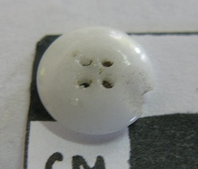
Figure 6-43. Prosser button recovered from the trail surface collection.
of bone, seed, or wood fasteners that would deteriorate over time), may suggest that the clothing worn by patients would have been very basic and inexpensive.
One ceramic marble was recovered from N506 E504 (Figure 6-44). Low fired, earthenware marbles were made as early as colonial times and were still being used into the 1920s. These marbles remained popular, despite the introduction of glass marbles in the mid-19th century, especially among the lower class, because they were inexpensive. This type of marble is nearly impossible to date (Carskadden and Gartley 1990: 56). Marbles are generally believed to be attributed to children (55). The presence of this marble at the leprosarium leads to the possibility that children were present at the hospital. Although the historic documents do not mention any children being sent to the hospital, an 1860 medical report did report that a boy contracted leprosy after sleeping underneath and inside of the hospital’s structures (Medicinalindberetninger, Vestindien [Medical Reports from Danish West Indies] 1823-1910). The possibility that children resided at the leprosarium may be further substantiated by the doll’s
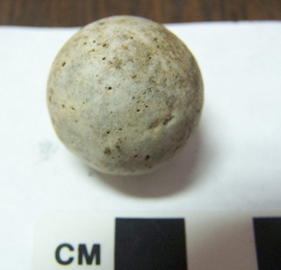
Figure 6-44. Ceramic marble recovered from N504 E506.
arm that was collected from N510 E498, but this ceramic doll’s arm could not be dated or definitely attributed to the hospital’s operation, and has been left out of this analysis.
A single gray, slate pencil was recovered from N506 E504 (Figure 6-45). Slate pencils were made by forcing square sections of soft slate down a series of tubes which produced the cylindrical shape (Davies 2005: 64). Writing slates have been in use for centuries, although the popularity of using slates for writing purposes did not being until the late 18th century, when improvements in land and sea transport allowed for slate quarried in Wales to be exported in greater quantities (63). Slate pencil and writing tablets were inexpensive which caused them to remain popular even after the development of lead pencils and writing papers, because of the latter’s greater cost (64). Slate pencils are generally associated with schools and domestic sites, archaeologically speaking, and are therefore often attributed to children (65). The slate pencil recovered from the leprosarium was recovered from a 2 x 2 meter area adjacent to the 2 x 2

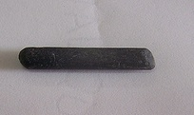
Figure 6-45. Slate pencil recovered from N506 E504.
meters area from which the ceramic marble was recovered, which further suggests the possibility of children at the leprosarium.

Metals

Metal was not a common find at the leprosarium, and accounted for less than two percent of the entire artifact assemblage (N=5,104) recovered during excavations. Of the material that dated to the leprosarium, only four cut nails and a lamp part dated to this time period, or about 0.1 percent of the 3,139 artifacts in this study.
Four cut nails were recovered during test unit excavations around Foundation C. The earliest cut nails were made beginning in the late 18th century with a machine made shaft and a head hammered by hand. By the early 19th century, machines had been made that could both cut and head the nail. Cut nails are still made today (Wells 1998: 323-324). Three nails were recovered from Test Unit 2, located on the north side of Foundation C, and one nail was recovered from Test Unit 3, on the west side of Foundation C (Figure 6-46). All four nails are very corroded and details about the nails, which may have helped with narrowing down a date range, are impossible to discern. What is interesting about these nails is that they were only
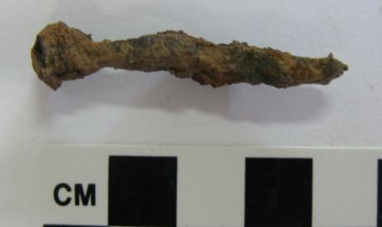
Figure 6-46. Heavily rusted cut nail from test unit 3.
found in these two test units, around Foundation C. Historic documents did not mention what the buildings at the leprosarium were constructed of, and besides the cistern, which is still standing, the construction of the other buildings is uncertain. If the other buildings at the leprosarium were made of the same stone/brick/coral construction as the cistern, the buildings would probably have still been standing, at least partially. If the buildings were made of wood, which the presence of these nails suggests, then the buildings may have burned or been torn down at some point, or destroyed in a storm, which is why they are no longer standing. There was no evidence that the area had been burned, so it seems more likely that the buildings either fell apart or were tore down and removed for the area at some point in the past, and the nails and lumber may have salvaged. It is also possible that these nails are associated with furniture that would have been inside the structures, although the type of furnishings provided to the patients is unknown. Future excavations at the site may want to include subsurface testing around the other two foundations to see if any nails are found.
One metal lamp fragment, from the lamp burner of a wick lamp, was recovered from
N502 E502 (Figure 6-47). This part would have set around the wick area with the glass chimney in between the two. The earliest modern, vertical wick lamps date the late 18th century and are made of a chamber which was used to hold liquid fuel, an opening at the top of this chamber to holda burner, where the wick resides, and a chimney to contain the flame (Woodhead et. al 1984: 38). Dating this specific fragment would be difficult, but it is possible that this fragment could date to the hospital. If so, it would suggest a more expensive form of lighting, as compared to candles or simple wick burners, which were set directly in fuel. Lightning would have been an important component to life at the leprosarium, in that the location of the hospital, isolated from the rest of the town and population, would have been very dark at night and a light source would have been needed for the patients and/or caregiver to get around.

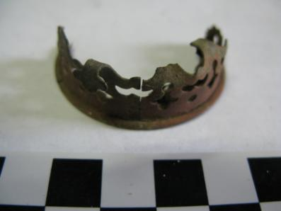
Figure 6-47. Metal lamp part recovered from N502 E502.

Conclusions

Three thousand one hundred and thirty-eight artifacts that have dates of manufacture between 1833 and 1861 were recovered from surface collections and sub-surface excavations at the leprosarium. Seventy-three percent of these artifacts were container glass fragments from mostly alcoholic beverages. The lack of medicine bottles at the leprosarium suggests that formal medical treatment was minimal for the patients and alcohol was used as a way to deal with pain and symptoms. Future research regarding the bottle glass should include a minimum vessel count in order to obtain an estimate of the number of vessels at the site, along with reconstructing the vessels since the large concentration of fragments within some of the 2 x2 meter surface collection units may suggest the vessels broke upon contact with the ground and could be reconstructed.
Ceramics accounted for 25 percent of the artifacts dating the leprosarium. The ceramics recovered were mostly utilitarian stonewares and coarse earthenwares, and inexpensive refined earthenwares. Historic documentation tells of the poverty of the patients at the hospital and the deplorable conditions in which they lived, so expensive ceramics would not be expected in this context. The more expensive transfer-printed wares and porcelain wares could have been used wares donated to patients (no matching sets were found of these wares) or they could have been brought the leprosarium by patients who were somehow able to afford such wares before being quarantined. Future research with the ceramic assemblage should include a more detailed analysis of form frequencies and mean ceramic dating for decoration types. It would also be of interest to attempt to mend and cross-mend any ceramic sherds to determine if any of the decorated refined earthenwares had matching pieces or if the decorated sherds were part of a single vessel.
While tobacco pipe fragments were recovered from the site, the small count (n=35) suggests that either tobacco was not easily accessible or that smoking was not a common practice among patients. Five flints were recovered, with two being cores, two being either gunflints or strike-a-lights, and one being a gunflint. Historic documentation makes no mention of reason why guns would have existed at the leprosarium. Use wear analysis on the flints may help reveal, with more certainty, what use the flints had.
While the small quantity of personal items recovered from the leprosarium suggest that patients did not possess many items of personal value, either because they were not allowed to bring personal items with them when they came to the hospital or because they could not afford or allowed to purchase such items, the few that were recovered during excavation reveal some interesting details about hospital life. The presence of the blue bead suggests that some patients at the hospital may have held beliefs that this type of bead had special healing or protective properties. The white, Prosser button suggests that the clothing worn at the hospital was simple and not elaborate. Finally, the ceramic marble and slate pencil suggests that a child or children may have lived or visited the leprosarium.
The presence of nails in test units near Foundation C suggests that the habitation building(s) at the site were made of wood, which would explain why they are no longer standing, or that the structures had wooden furnishings. No nails were found during the surface collection.
The artifacts recovered from the Hassel Island leprosarium are similar to the types of artifacts recovered from other leprosaria (see Disease chapter), with the majority of the artifacts being food and beverage consumption items with few to no personal items. Patients most likely arrived at Hassel Island with nothing but the clothes on their backs, either because they had nothing to bring with them or they were not allowed to bring personal items. Life at the leprosarium was a day-to-day existence, with little medical treatment to deal with the symptoms of leprosy and few material distractions.

Chapter 7
Artifact Distributions and Analysis

Distribution analysis is used in archaeological studies as a means of examining the spatial relationship between artifacts and/or structures to discern cultural activities within or between site location(s). For this study, distribution analysis was conducted using the artifacts recovered that dated to the hospital’s occupation and were collected from the systematic surface collection, to detect any grouping of materials that may signal centers of patient occupation or activities. This analysis was designed to answer several questions about the hospital patients’ activities and whereabouts. Did clusters of artifacts appear near known or possible structures? Could buildings’ purposes be discerned from artifact type distribution?

Methods Background

The artifacts used in this analysis were collected from the 49 2x2 meter collection blocks that were placed over the areas of major surface artifact concentrations. Most of the artifacts recovered were bottle glass fragments and ceramic fragments. A small minority of clay pipes and flints were recovered. From these 2 x 2 meter block, 562 ceramic and 1,869 bottle glass fragments that had dates of manufacture which could place them within the occupation of the leprosy hospital (1833-1861) were used in this analysis.
For part of the analysis, the ceramics were separated into four initial categories: stoneware, coarse earthenware, refined earthenware, and porcelain. The refined earthenware fragments were then separated into four further categories: undecorated, minimally decorated, painted wares, and transfer-printed wares. Those that had an unknown decoration (N=14) or were categorized as ironstone (N=3), were not included in the analysis because an unknown decoration would have no impact on ceramic cost and because the sample of ironstone was a very small. The four remaining categories were decided upon in reference to Miller’s work on ceramic values based on decoration (1980; 1991). The bottle glass included in the study was not divided into categories because there was not much variability between vessel types. The majority of the bottle glass fragments are from dark green/olive, dip-molded, liquor bottles.
Distribution maps were made using the artifact count within each 2 x 2 meter block, which was determined during initial excavation of the site to be a size of unit large enough to get a decent sample size of artifacts while keeping the area small enough to examine artifact distributions. Artifact counts were overlayed onto the site map using ArcGIS 10.

Results

Two possible building foundations and a standing cistern were present either within or in close proximity to the systematic surface collection included in this analysis (Figure 7-1). A third building foundation was located outside the systematic surface collection and will not be directly influenced by its results, although there will be a brief discussion on the types of artifacts found near Foundation C.
Historic documents concerning the leprosarium note the construction of an initial building to house the patients in July 1833, when the hospital opened. By October 1833, a cistern and a fence were constructed. An 1851 map (Figure 7-2) of the island shows four structures at the leprosy hospital and excavation of the site revealed remnants of three possible structures and a standing cistern. Using the 1851 map and the site map as a guide (Figure 7-3), it is believed that the small, square structure on the 1851 map represents the cistern. Foundation C is the long, rectangular structure to the south of the cistern (represented by the X on the 1851 map, and may be the original structure built in 1833). Foundation B may represent the structure
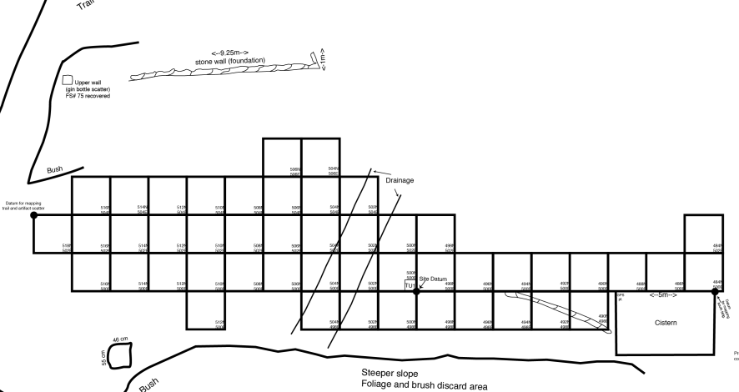
Foundation B
Foundation A
Figure 7-1. Cropped image of the site map showing Foundations A and B, the cistern, and the 2 x 2 meter units used in this study. The foundations are circled in red.
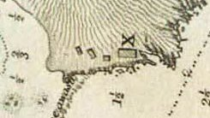
Figure 7-2. Cropped image from an 1851 map showing the four structures located at the leprosarium. The smallest structure is the cistern.

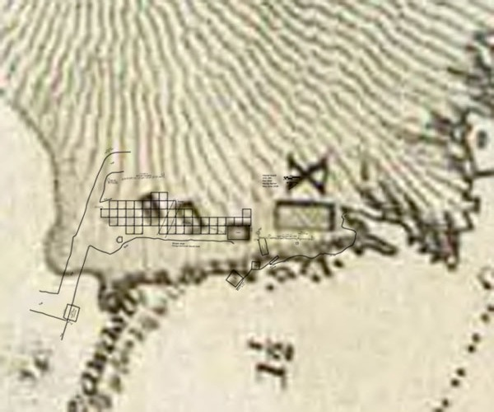
Figure 7-3. 1851 map with the site map overlayed. The two maps do not fit perfectly together, which is probably the result of both site map error and errors with historic map accuracy.

located just north of the cistern, and Foundation A would be the structure to the north of Foundation B, which appears to be similar in shape and size. The use of these buildings is not known for certain. It is possible that one may have been used as a residence by the hospital’s caretaker, though these buildings may have been added at a later date to house patients as the population at the hospital outgrew the original building. Considering the decrepit conditions in which the hospital was reported to be in, it is doubtful extra money would have been spent to ease overcrowding.
Foundations A and B, along with the cistern, are located within the study area for this analysis. Foundation A is located approximately three meters grid east of the surface collection, Foundation B is located adjacent to the cistern within the surface collection, and the cistern is located on the grid south edge of the surface collection area. The close proximity of these two structures may suggest that they were connected together, although this has not been proven. Foundation C is located approximately two meters grid south of the surface collection and is not included in this spatial study, although the results of the study may help determine what this structure may have been used for since similar artifacts were recovered in its vicinity.
Two thousand six hundred and five artifacts, recovered from the 2 x 2 meter blocks, that could be accurately dated to 1833-1861, that have a date of manufacture that includes the operation of the hospital, or could be dated to after the hospital’s occupation (post 1861), were used during this part of the analysis. The artifacts that post-dated the hospital were included to determine if they were located in proximity to the earlier artifacts, and may represent continued use of the site area after the leprosarium closed in 1861. Artifacts that post-dated the 1861 hospital closing were recovered in highest density in relationship to, but downslope of, Foundation A, and they overlap the highest density of artifacts that date to the hospital’s use (Figure 7-4 – 7-5). In contrast, Foundation B has a very low density of artifacts (less than nine per unit) within its vicinity. This high density of artifacts located down slope of Foundation A suggests that this was possibly a dumping area for refuse from this structure, and possibly the structure that was located at Foundation B as well. The artifacts recovered that post-date 1861, date mostly to the late 1800s and early 1900s. While it is unknown at this time what the hospital site was used for post-1861, the location of late 19th century/early 20th century artifacts in the same region as mid-19th century artifacts suggests that the building or at least the building area was reused after the hospital closed. The smallpox hospital located at Fort Shipley was in operation during and possibly post-leprosarium (using Lawrence 1851 map and Gjessing 1980-1981 report), so it is possible that some of these artifacts are affiliated with that operation. It is also possible, since the land remained in control of the Hassel family, that the family used the area for personal purposes, although why they would have used an area where they may have come in contact with leprosy is questionable. It could be argued that vagrants from Charlotte Amalie were using the abandoned area as shelter, but the isthmus connecting Hassel to St. Thomas was cut in 1864, so it would have been difficult to reach the abandoned leprosarium. Flexnor (2010; 2012), in his work on the leprosarium in Kalawao, Hawaii, found evidence that patients returned to the leprosarium to socialize after the institution had closed down. When the leprosarium on Hassel Island closed in 1861, only two patients remained, and they were sent to the general hospital on St. Thomas. Historic documents did not reveal what happened to all the other patients prior to 1861, whether they died at the leprosarium, escaped, or were allowed to leave. As previously mentioned, the isthmus was cut in 1864, so returning to the island to socialize would have been difficult, but this possibility cannot be ruled out completely. A deeper search into the Danish government records may be the only way to solve this mystery.

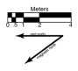
Figure 7-4. Distribution map of artifacts that date to the leprosarium.
Figure 7-5. Distribution map of artifacts that post-date the leprosarium.

Figures 7-6 – 7-10 shows the distribution of bottle glass, porcelain, stoneware, refined earthenware, and coarse earthenware, which date to the leprosarium, over the area of analysis. One thousand eight hundred and sixty-nine bottle glass fragments were recovered from the 2x2 meter units. While the highest density of bottle glass was found down slope of the southern portion of Foundation A, bottle glass was found scattered all over the area of analysis, in fairly an even distribution, except around the drainage area. Refined earthenware was the most common ceramic type recovered from the study area (n=316). Like bottle glass, refined earthenware was found all over the study area, but the highest density of artifacts was found to the north of the bottle glass fragments which is located down slope of the central and northern portions of Foundation A. A low density area of refined earthenware was also recovered around Foundation B. One hundred and seven coarse earthenware fragments were recovered, and the highest density of fragments was recovered down slope of the central and northern portions of Foundation A. No coarse earthenware was found west of the drainage area. One hundred and five stoneware fragments were recovered within the area of analysis, with the fragments being found mostly north of the drainage. The highest density of stoneware occurs down slope of the central portion of Foundation A. Only 34 fragments of porcelain were recovered, and with four fragments being the highest number recovered within a unit, it is possible that the fragments recovered from each unit are from a single vessel. Interestingly, the highest density areas of porcelain are down slope from the central portion of Foundation A, and directly to the north of Foundation B.
If the ceramic artifact distribution is approached in terms of function, it could be suggested that the clustering of utilitarian wares, such as coarse earthenware and stoneware, mostly north of the drainage, could mean that Foundation A belonged to a structure used for food
Figure 7-6. Distribution map of all bottle glass fragments that could be dated to the leprosarium.
Figure 7-7. Distibution map of porcelain.
Figure 7-8. Distribution map of stoneware.
Figure 7-9. Distribution map of coarse earthenware.
Figure 7-10. Distribution map of refined earthenware.

preparation or storage, even though the high concentration of artifacts in this area may suggest a primary dumping ground for the entire site. While table- and tea wares, such as refined earthenwares and porcelain, were found mostly to the north of the drainage, they are also found scattered to the south of the drainage, towards Foundation B and the cistern. Furthermore, if the types of ceramics recovered from the general surface collections to the west and south of the cistern, near Foundation C, are examined, it can be seen that a higher proportion of table/teawares to utilitarian wares were recovered (Figure 7-11). Therefore, Foundation C may have been the main habitation building, as suggested by the 1851 with the ‘X’ beside the structure. The lower concentration of artifacts near Foundation C may be explained by its location close to the ocean cliff. Patients may have dumped trash directly into the ocean. The low density of artifacts found around Foundation B and the cistern suggest that this area was not used much for discard, or that it was kept clean. It is uncertain what Foundation B was used for.
The final part of this analysis examined the distribution of identifiable refined earthenware types, since they were found all across the study area. Undecorated refined earthenwares (Figure 7-12) and minimally decorated refined earthenwares (n=107 for both) were the most common types recovered. Undecorated wares were found in highest density down slope from the central and northern portions of Foundation A and almost entirely to the north of the drainage. One hundred and seven minimally decorated wares were also recovered (Figure 7-13). These wares were a bit more scattered across the survey area. The highest densities of minimally decorated wares were found within the drainage area and around and down slope of the central portion of Foundation A. There was also a low density of minimally decorated wares around Foundation B. Hand painted wares were not a common refined earthenware found in the survey area (n=29). They appear almost entirely either within the drainage area or to the north of
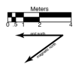
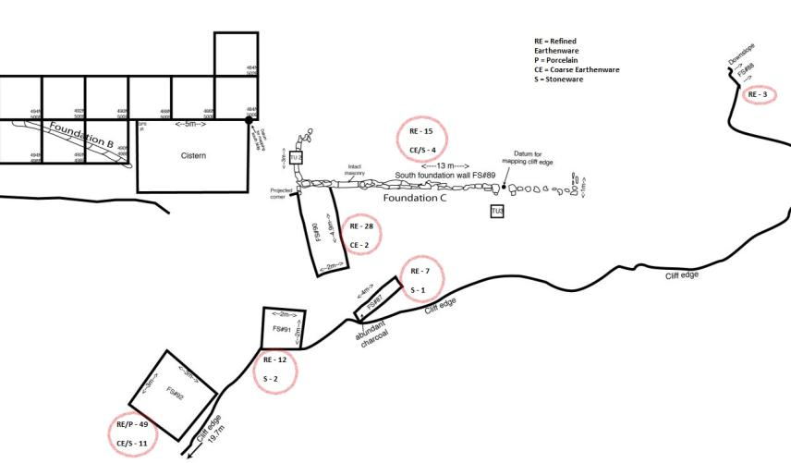
Figure 7-11. Map of the general surface collections near the cistern and Foundation C. The counts for ceramic ware types recovered from each surface collection are circled in red.

Figure 7-12. Distribution map of undecorated wares.
Figure 7-13. Distribution map of minimally decorated wares.

the drainage (Figure 7-14). Their highest density equaled three fragments per unit. They were found down slope of Foundation A, with the highest densities in two areas, down slope from the northern portion of the foundation, and down slope of the southern portion of the foundation. Fifty-four transfer-printed wares were recovered (Figure 7-15), and while most were recovered north of the drainage, a few were recovered near Foundation B.
Seventy-two percent (n=214) of the refined earthenwares recovered were either undecorated or minimally decorated, which were the least expensive wares to purchase. Hand painted wares and transfer-printed would have been more expensive and they accounted for only 28 percent of the wares in this study, but as mentioned in the chapter 6, the ceramics do not appear to belong to any matched sets, which suggests that either patients were bringing some pieces they possessed with them to the leprosarium, or pieces may have been donated by outside groups or individuals. There is no real separation in the distribution of refined earthenware types that would suggest that the more expensive wares were used in a different area than the less expensive. The abundance of inexpensive wares also supports the historic documents that mention the poorness of patients who lived at the leprosarium.
The distribution analysis of bottle glass and ceramic artifacts recovered from the surface collection of 49 2 x 2 meter units at the leprosarium suggest that the structure once located at Foundation A was probably some sort of residence building. Refuse was most likely tossed down slope, away from the structure. The low density of artifacts recovered from around Foundation B and the cistern area suggest that the structure once located at Foundation B may not have been a residence. It possibly may have been some sort of storage building associated with the cistern, but there is no evidence for this assertion other than the low artifact densities associated with it. The 1851 map of the area shows that the structures located near the
Figure 7-14. Distribution map of hand painted wares.
Figure 7-15. Distribution map of transfer-printed wares.

current location of Foundations A and B, were approximately the same size and shape, which would suggest they served a similar purpose. If so, it is also possible they shared a refuse-disposal area, or even that the refuse from Foundation B was tossed in another location entirely, such as into the ocean.

Chapter 8
Summary, Conclusions, and Future Research

Summary

Archaeological investigations were carried out over the summers of 2008 and 2009, at a leprosarium, or leprosy hospital. The hospital operated from 1833 to 1861, on Hassel Island, off the coast of St. Thomas, in the U.S. Virgin Islands (the islands were owned by Denmark until 1917). Little was known about the leprosarium when excavations began, and besides a random shovel pit test dug in 1990 (see Jameson 1992), this site had not been researched or excavated. The construction of a hiking trail by the National Park Service within close proximity to the site, created a need to perform a data recovery at the site before heavy foot traffic from park visitors would leave the site at risk for looting, especially since most artifacts rested on the ground surface. This study presented a history of the leprosarium, based mostly on translations of the Danish historic records, an analysis of 5,104 artifacts recovered during the excavations carried out at the site, an interpretation of which artifacts dated to the leprosarium, and a discussion about hospital life and about how this site fits into the larger framework of disease and institution studies in the field of archaeology.

Conclusions

Physicians of the early-to-mid 19th century did not yet know what caused leprosy or how it was spread between individuals, nor how to treat it, but the disease was gaining the attention of Western Europeans by the late 18th century as explorers in the Atlantic and Pacific oceans noted seeing leprosy outbreaks among the populations of the islands they were seeking to control, and among the enslaved Africans they were bringing with them to the islands (see Grainger 1764). Increasing European and North American presence in the tropics led to the creation of the field of tropical medicine, in order to study diseases, such as leprosy, since outbreaks posed a threat to individuals seeking to take control or set up businesses in these locations (Bynum 1994:147-148). The 1867 Report on Leprosy by the Royal College of Physicians displayed how confusing this disease was to physicians around the Caribbean during the mid-19th century. Isolating individuals with leprosy was not common during this time, as the disease did not seem to be highly contagious, and some physicians believed the disease to be hereditary. The leprosarium on Hassel Island began operation in 1833 after the island’s physician and police department saw a need to get infected individuals away from the general population. It was not a place for relaxation and recovery for the people living there. The money given by the government for upkeep and food was kept to a minimum, and the island’s physicians wrote several times of the dilapidated conditions at the hospital, even refusing to send new patients there at one point. This study provided the opportunity to study the material remains of a rarely studied (at least within archaeology) institutionalized and isolated population, and what the historical, structural, and material remains revealed about this population.
Of the 5,104 artifacts recovered during excavations, 3,139 dated to the hospital. The remaining artifacts either post-dated the hospital or a date of manufacture or association could not be determined. Seventy-three percent of the artifacts dating to the hospital were bottle glass fragments, attributed to mostly alcoholic beverages, and 25 percent of the artifacts were ceramic utilitarian and table/tea wares (again including some bottle forms that likely held alcoholic beverages). The remaining two percent of artifacts were made up of gunflints, a lamp part, structural materials, such as nails, and personal items, such a tobacco pipes, a bead, a marble, and a stylus. The high proportion of alcohol bottles, and almost complete lack of medicine bottles, suggests that patients tried to treat their symptoms with whatever seemed to dull the pain. A treatment for leprosy was not known at this time, and physicians even noted that medical treatments did nothing to help the symptoms of the disease. The ceramic assemblage was composed of mostly of utilitarian stonewares and coarse earthenwares, and inexpensive refined earthenwares. The presence of more expensive transfer-printed whitewares and porcelain at the site suggest the possibility that not all patients were from the lower class, although it is also possible these pieces were second-hand donations by charitable organizations or individuals. The small number of personal items recovered suggest that patients either did not have the ability to purchase such items or that the hospital controlled access to items. The ceramic marble and stylus recovered suggest the presence of children at the hospital.
Structurally, three foundations and one standing cistern were located at the leprosarium. These structures are believed to be the remnants of the buildings shown on historic maps of the area. The historic records only mention the cistern, a shed, and one residence being constructed at the site. The distribution analysis of the artifacts at the site suggested that while Foundation C was probably the main residence, Foundation A may have been a kitchen, due to the utilitarian wares clustering near it, although there is the possibility this may have a been a residence for the caretaker since it is unknown where she lived, or the building could have performed both functions. Most of the artifacts clustered downslope of Foundation A, suggesting this area to be a general dumping ground for the site. Foundation B had very few artifacts, in comparison to the other foundations, which may mean, along with its close proximity to the cistern, that it may have been a building associated with the cistern. It is also possible that this area was just kept clean, which may explain the lack of artifacts.
Besides the study of the history and material culture of the patients the leprosarium, this study also allowed for a more anthropological and sociological examination of an institutionalized population. During the 16th century, the idea of institutionalization shifted from a more shared, communal, although still isolated, experience, to one of segregation from within and from the outside. During the 1700s, institutions exercised increased control and structuring to the patients’ lives, even forcing inmates to work so their goods could be sold (Casella 2007:8-10). The lack of personal items recovered from the leprosarium suggests that patients were not allowed to express their own identities either due to hospital regulations or to impoverishment, and there is no indication that the hospital gave them recreational items. There was also no evidence that patients were forced to work. A patient list from the hospital suggested that those who had money were able to avoid being sent to the hospital, since their family could afford to keep them at home, and even hide their disease (as mentioned in the Report on Leprosy). The placement of the leprosarium, on a (then) peninsula away from St. Thomas, and the mention in the historic documents of a fence being built adjacent to it suggests an emphasis on isolation. However, there was no direct evidence, either archaeological or historically, that patients were confined to the hospital. While the hospital was separated from St. Thomas, the isthmus connecting Hassel to St. Thomas was still present during the hospital’s operation, and located in close proximity to the hospital, so patients could have easily walked over to the main town of Charlotte Amalie. It also seems to have been common, at least in the Caribbean, for lepers to mix with the general population, due to the low chance of spreading leprosy. Leprosy has had a negative stigma associated with it since Biblical times, and people with leprosy have always been shunned and stigmatized, affecting their ability to work or be productive members of society. Reports from the Caribbean on leprosy seemed to characterize lepers as more of a nuisance with their begging, than a threat to the health of the population.
In conclusion, the historical and archaeological investigation at the leprosarium at Hassel Island revealed a population mostly forced to live in isolation, although maybe not kept completely away from the general population. The patients at the hospital were most likely of the lower classes, as suggested by the material cultural recovered, and the historic record that suggests some leprosy sufferers were not sent to the leprosarium. This same document also shows that there was a mixture of men and women, and while race was not mentioned on the record, the presence of individuals without last names, suggests that slaves or former slaves were interred at the leprosarium. The lack of personal items implies that patients were unable financially or were not allowed to express much in the way of culture or individuality.

Future Research

Due to time constraints, my lack of access to the artifacts once I left the Virgin Islands, and the inability to translate documents in Danish, I was unable to complete several aspects of research which hold the potential to further increase the understanding of life at the leprosarium. Most of the historical research was conducted by a Danish individual, contracted by the National Park Service, to research and translate documents at the National Archives in Denmark. His work focused mostly on the police records and medical documents. The one census record that was found regarding leprosy patients was stumbled upon by accident by another Danish individual at the archives, which may mean that other patient lists or hospital information may exist in other areas of the archives. Further research is also necessary in trying to determine what the site was used for after the hospital closed, since there were artifacts recovered that date to the turn of the 20th century. Also, further research into the St. Thomas newspaper from the 19th century, which can be found on microfilm at the historic archives on St. Thomas, could reveal news articles pertaining to the hospital. This newspaper was written in English, along with Danish and French, so knowledge of the Danish language would not be necessary to scan through the newspapers.
Further research at the leprosarium itself would involve conducting more subsurface excavations, especially around Foundations A, B, and even the cistern, to see if more items associated with building construction or material culture could be recovered that would expose the function of structures associated with Foundations A and B. Historic maps, and the higher density of table- and tea wares over utilitarian wares, suggests that Foundation C was the original patient housing built in 1833, but more testing around this structure would be beneficial in supporting this hypothesis. It may be necessary to also return to the site to surface collect more artifacts as heavy rains tend to led to site erosion.
There are several areas involving the artifacts that could be expanded on. Minimal vessel counts for the bottle glass and ceramics need to be done in order to get a better estimate of the number of vessels and wares at the site. Ceramic form (such as flatwares versus hollowares) would be useful in helping to determine the proportion of tablewares to teawares (which may not be expected among a poor population), and to further identify vessel function and decoration. It was noted during the analysis that some ceramic fragments had the same designs across the site area, so cross-mending would not only help with vessel counts but also help to determine whether these fragments belonged to the same vessel or whether sets of matched vessels existed at the site. Finally, further investigations into the unidentified or undatable artifacts, and determinations of whether they are associated with the hospital, are needed. Assigning dates to some objects is difficult when dealing with surface collections, but this would help in separating the artifacts that date to the site and post-date the site.
It is hoped that this project and thesis will help in the study of disease and confinement during the 19th century, where studies involving this sort of topic, are lacking. Through the study of a population who were mostly hidden and shunned, our modern society can learn how to better deal with and treat the victims on stigmatized diseases.

List of References

Amundson, Ron
2010 A Wholesome Horror: The Stigmas of Leprosy in 19th Century Hawaii. Disability Studies Quarterly 30(3/4) <http://dsq-sds.org/article/view/1270/1300>. Accessed 1 Oct 2012.

Anderson, David G., David Knight, and Emily M. Yates
2003 The Archaeology and History of Water Island, U.S. Virgin Islands. Southeast Archeological Center, National Park Service, Tallahassee, Florida.

Anderson, David G., Steven Kidd, and Emily M. Yates
2000 The Water Island Archaeological Project: Archaeology and History in the Eastern Caribbean. Antiquity 75:513-514

Anderson, Nancy Rebecca
2005 “It’s Not Catching”: Hansen Home and the Local Knowledge of Leprosy in the Federation of St. Kitts and Nevis, West Indies. Master’s Thesis. University of Tennessee, Knoxville.

Angostura Bitters
[2008] Angostura Bitters-History <http://www.angosturabitters.com/history.htm>. Accessed 28 March, 2009.

Armstrong, Douglas V.
2003 Creole Transformation from Slavery to Freedom: Historical Archaeology of the East End Community, St. John, Virgin Islands. University Press of Florida, Gainesville.

Ayto, Eric G.
1994 Clay Tobacco Pipes, 3rd edition. CIT Printing Servies Ltd, Pembrokeshire, Great Britain.

Bateman, Thomas
1836 A Practical Synopsis of Cutaneous Diseases, According to the Arrangement of Dr. Willan; Exhibiting a Concise View of the Diagnostic Symptoms and the Method of Treatment, 8th Edition. Printed for Longman, Rees, Orme, Brown, Green, and Longman, London.

Baugher, Sherene
2009 Historical Overview of the Archaeology of Institutional Life. In The Archaeology of Institutional Life, April M. Beisaw and James G. Gibb, editors, pp. 5-13. The University of Alabama Press, Tuscaloosa, Alabama.

Beaudry, Mary C., Janet Long, Henry M. Miller, Fraser D. Neiman and Garry Wheeler Stone
1983 A Vessel Typology for Early Chesapeake Ceramics: The Potomac Typological System. Historical Archaeology 17(1):18-43.

Binford, L.R.
1962 A New Method for Calculating Dates from Kaolin Pipe Stem Samples. Southeastern Archaeological Conference Newsletter 9(1):19-21.
Bradley, Charles S.
2000 Smoking Pipes for the Archaeologist. In Studies in Material Culture Research, Karlis Karklins, editor, pp. 104-133. The Society for Historical Archaeology, Tuscon, AZ.

Brown, Ann R.
1982 Historic Ceramic Typology With Principal Dates of Manufacture and Descriptive Characteristics for Identification. Delaware Department of Transportation, Archaeology Series 15.

Bynum, W.F.
1994 Science and the Practice of Medicine in the Nineteenth Century. Cambridge University Press, New York.

Campos, Gabriela
2008 Restoration of Hassel Island Planned in Near Future. Our National Parks Student Journalism Project, School of Communication, University of Miami <http://com.miami. edu/parks/usvihassel.htm>. Accessed 14 March, 2010.

Carskadden, Jeff and Richard Gartley
1990 A Preliminary Seriation of 19th-Century Decorated Porcelain Marbles. Historical Archaeology 24(2): 55-69.

Casella, Eleanor Conlin
2007 The Archaeology of Institutional Confinement. University Press of Florida, Gainesville, Florida.

Claney, Jane Perkins
2004 Rockingham Ware in American Culture, 1830-1930: Reading Historic Artifacts. University Press of New England, Lebanon, NH.

Davies, Peter
2005 Writing Slates and Schooling. Australasian Historical Archaeology 23: 63-69.

Dookhan, Isaac
1994 A History of the Virgin Islands of the United States. Canoe Press, Jamaica.

Edmond, Rod
2006 Leprosy and Empire: A Medical and Cultural History. Cambridge University Press, New York.

Farley, Michael and Keith Manchester
1989 The Cemetery of the Leper Hospital of St. Margaret, High Wycombe, Buckinghamshire. Medieval Archaeology 32: 82-89.

Flexner, James Lindsey
2010 Archaeology of the Recent Past at Kalawao: Landscape, Place, and Power in a Hawaiian Hansen’s Disease Settlement. Doctoral dissertation, University of California, Berkeley.

2012 An Institution that was a Village: Archaeology and Social Life in the Hansen’s Disease Settlement at Kalawao, Moloka’I, Hawaii. International Journal of Historic Archaeology 16: 135-163.

Gaimster, David
1997 German Stoneware 1200-1900, Archaeology and Cultural History, Containing a Guide to the Collections of the British Museum, Victoria and Albert Museum and Museum of London. British Museum Press, London.

Gilbert, Lewis
1987 A Lesson from Leviticus: Leprosy. Man, New Series 22(4):593-612.

Gjessing, Frederik C.
1980-1981 Historic Resource Study, Hassel Island, U.S. Virgin Islands.

Godden, Geoffrey A.
1964 Encyclopedia of British Pottery and Porcelain Marks. Crown Publishers, Inc., New York.

Good, Mary Elizabeth
1983 Glass Beads from Upper Creek Indian Town. In Proceedings of the 1982 Glass Trade Bead Conference, Charles F. Hayes III, editor, pp. 159-166. Research Records No. 16, Rochester Museum and Science Center, Rochester, New York.

Gould, Tony
2005 Don’t Fence Me In: Leprosy in Modern Times. Bloomsbury Publishing, London.

Grainger, James
1764 An Essay On the More Common West-India Disease; and the Remedies Which That Country Itself Produces. To Which are Added, Some Hints On the Management, Etc. of Negroes. Printed for T. Becket and PA DeHondt, London.

Gussow, Zachary and George S. Tracy
1970 Stigma and the Leprosy Phenomenon: The Social History of a Disease in the Nineteenth and Twentieth Centuries. Bulletin of the History of Medicine XLIV(5): 425-449.

Harrington, J.C.
1954 Dating Stem Fragments of Seventeenth and Eighteenth Century Clay Tobacco Pipes. Quarterly Bulletin of the Archaeological Society of Virginia 9(1):10-14.

Hayden, Arthur
1925 Spode & His Successors: A History of the Pottery Stoke-on-Trent 1765-1865. Cassell & Company, Ltd., London.
Hays, J. N.
2005 Epidemics and Pandemics: Their Impacts on Human History. ABC-CLIO, Inc., Santa Barbara, CA.

Heath, Barbara J.
1999 Buttons, Beads, and Buckles: Contextualizing Adornment Within the Bounds of Slavery. In Historical Archaeology, Identity Formation, and the Interpretation of Ethnicity, Maria Franklin and Garrett Fesler, editors, pp. 47-69. Dietz Press, Richmond, Virginia.

Helman, Cecil G.
2007 Culture, Health and Illness, 5th edition. Hodder Arnold, London.

Hillary, Annie, Russell Wright and Thomas Richards
1978 Northern Hassel Island Historic District. National Register of Historic Places Inventory—Nomination Form. United States Department of the Interior, National Park Service.

Inhorn, Marcia C., and Peter J. Brown
1990 The Anthropology of Infectious Disease. Annual Review of Anthropology 19: 89-117.

Intermountain Antiquities Computer System (IMACS)
1992 Historic Ceramics. Intermountain Antiquities Computer System (IMACS) User’s Guide, Instructions and Computer Codes for Use with The IMACS Site Form. Prepared by the University of Utah, Bureau of Land Management, and the U.S. Forest Service of Salt Lake City, Utah.

Jameson, John H., Jr.
1992 Cultural Resource Reconnaissance and Assessment of Hassel Island, U.S. Virgin Islands. Report to Virgin Islands National Park, St. Thomas, VI, from Interagency Archaeological Services Division, Atlanta,GA.

Jones, Olive and Catherine Sullivan
1989 The Parks Canada Glass Glossary for the Description of Containers, Tableware, Flat Glass, and Closures. Studies in Archaeology, Architecture, and History. National Historic Parks and Sites Branch, Parks Canada, Ottawa, Ontario.

Jones, Olive R.
1986 Cylindrical English Wine and Beer Bottles, 1735-1850. National Historic Parks and Sites Branch, Parks Canada, Ottawa, Ontario.

Jordan, Stacey C.
2000 Coarse Earthenware at the Dutch Colonial Cape of Good Hope, South Africa: A History of Local Production and Typology of Products. International Journal of Historical Archaeology 4(2):113-143.
Karklins, Karlis
1983 Dutch Trade Beads. In Proceedings of the 1982 Glass Trade Bead Conference, Charles F. Hayes III, editor, pp. 111-117. Research Records No. 16, Rochester Museum and Science Center, Rochester, New York.

Kellar, Elizabeth Joan
2004 The Construction and Expression of Identity: An Archaeological Investigation of the Laborer Villages at Adrian Estate, St. John, USVI. Doctoral Disseration, Syracuse University, Syracuse, NY.

Keller, Albert Galloway
1908 Colonization: A Study of the Founding of New Societies. Ginn & Company, Boston.

Kenmotsu, Nancy
1990 Gunflints: A Study. Historical Archaeology 24(2): 92-124.

Klooster, John W.
2009 Icons of Invention: The Makers of the Modern World from Gutenburg to Gates. ABC-CLIO, LLC, Santa Barbara, CA.

Knox, John P.
1852 A Historical Account of St. Thomas, W.I., with its Rise and Progress in Commerce; Missions and Churches; Climate and its Adaptation to Invalids; Geological Structure; Natural History and Botany; and Incidental Notices of St. Croix and St. Johns; Slave Insurrections in these Islands; Emancipation and Present Condition of Laboring Classes. Charles Scribner, New York.

L., Megan
2011 Cataloging 101: Lead Glazed Redware vs. Jackfield. Northeast Museum Services Center Archaeology Blog < http://nmscarcheologylab.wordpress.com/2011/11/16/cataloging-101-lead-glazed-redware-vs-jackfield/>. Accessed 31 Aug, 2012.

Lanaghan, Frances
1844 Antigua and the Antiguans: A Full Account of the Colony and Its Inhabitants From the Time of the Caribs to the Present Day, Interspersed With Anecdotes and Legends. Also, an Impartial View of Slavery and the Free Labor Systems; the Statistics of the Island, and Biographical Notices of the Principal Families, Volume I. Saunders and Otley, London.

Latif, Andreas and Vibe Maria Martens
2009 Hassel Island 1688-1800: An Unusual Plantation. Report to National Park Service, U.S. Virgin Islands, from University of Copenhagen, Denmark.

Lindbergh, Jennie
1999 Buttoning Down Archaeology. Australasian Historical Archaeology 17: 50-57.

Lindsey, Bill
2011 Historic Glass Bottle Identification & Information Website. Contained within the Society for Historical Archaeology Website, University of Montana, Missoula, MT <http://www.sha.org/bottle/index.htm>. Accessed 11-27 Sept, 2011.

Lochmann, F.
1871 Om Spedalskheden [About Leprosy]. Det Skeenske Bogtrykkeri, Christiania, Denmark.
Meyers, Katy
2011 Leprosy in the High Middle Ages: Part IV Archaeology <http://bonesdontlie.wordpress.com/2011/02/20/leprosy-in-the-high-middle-ages-part-iv-archaeology/>. Accessed 20 June, 2012.

Majewski, Teresita and Michael J. O’Brien
1987 The Use and Misuse of Nineteenth-Century English and American Ceramics in Archaeological Analysis. In Advances in Archaeological Method and Theory, Volume 11, Michael B. Schiffer, editor, pp. 97-209. Academic Press, London.

Miller, George L.
1980 Classification and Economic Scaling of 19th Century Ceramics. Historical Archaeology 14: 1-40.

1991 A Revised Set of CC Index Values for Classification and Economic Scaling of English Ceramics from 1787 to 1800. Historical Archaeology 25(1): 1-25.

2000 Telling Time for Archaeologists. Northeast Historical Archaeology 29: 1-22.

MØller-Christensen, Vilhelm
1967 Evidence of Leprosy in Earlier Peoples. In Diseases in Antiquity: A Survey of the Diseases, Injuries, and Surgery of Early Populations, Don B. Rothwell and A. T. Sandison, editors, pp. 295-306. Charles C. Thomas, Springfield, Illinois.

Monot, Marc, Nadine Honoré, Thierry Garnier, Romulo Araoz, Jean-Yves Coppée, Céline Lacroix, Samba Sow, John S. Spencer, Richard W. Truman, Diana L. Williams, Robert Gelber, Marcos Virmond, Béatrice Flageul, Sang-Nae Cho, Baohong Ji, Alberto Paniz-Mondolfi, Jacinto Convit, Saroj Young, Paul E. Fine, Voahangy Rasolofo, Patrick J. Brennan, and Stewart T. Cole
2005 On the Origin of Leprosy. Science 308(5724): 1040-1042.

Moran, Michelle T
2007 Colonizing Leprosy: Imperialism and the Politics of Public Health in the United States. The University of North Carolina Press, Chapel Hill, NC.

Musées de Sarreguemines
2006 Le petit manuel du chineur <http://www.sarreguemines-museum.com/ressources/manuelchineur.asp>. Accessed 15 June, 2011.

National Park Service (NPS)
2008 Archaeological Field Notes, Hassel Island, Feburary-June 2008. Manuscript, National Park Service, St. John, Virgin Islands.

Neale, Gillian
2005 Miller’s Encyclopedia of British Transfer-Printed Pottery Patterns 1790-1930. Octopus Publishing Group Ltd, London.

Noël Hume, Ivor
1969 A Guide to Artifacts of Colonial America. University of Pennslyvania Press, Philadelphia.

2001 If These Pots Could Talk: Collecting 2000 Years of British Household Pottery. Chipstone Foundation, Milwaukee, WI.

Orme, Nicholas and Oliver Padel
1996 The Medieval Leper-house at ‘Lamford,’ Cornwall. Historic Research 69(168):102-107.

Oswald, Adrian
1975 Clay Pipes for the Archaeologist. British Archaeological Reports No. 14, Oxford.

Oxford Dictionaries
2012 Institution, Oxford University Press <http://oxforddictionaries.com/definition/english/institution?q=institution>. Accessed 28 Sept.

Parascandola, John
2003 Chaulmoogra Oil and the Treatment of Leprosy. Pharmacy in History 45:47-57.

Peterson, Vagn
2011 The history of the P. F. Heering Cherry liquor. Vagn Peterson’s Danish Bottles <http://danish-bottles.dk/heeringarticle.htm>. Accessed 12 Aug, 2011.

Pragnell, Jonathan
2002 The Archaeology of the Peel Island Lazaret: Part I: Survey. Recent Archaeological Research in Southwest Queensland 13: 31-38.

Rickard, Jonathan
2006 Mocha and Related Dipped Wares 1770-1939. University Press of New England, Hanover and London.

Roberts, Charlotte A.
1995 The Archaeology of Disease, 2nd edition. Cornell University Press, Ithaca, New York.

Royal College of Physicians
1867 Report on Leprosy by the Royal College of Physicians, Prepared For Her Majesty’s Secretary of State For the Colonies; With an Appendix. George Edward Eyre and William Spottiswoode, London.

Russell, Aaron E.
1997 Material Culture and African-American Spirituality at the Hermitage. Historical Archaeology 31:63-80.

Samford, Patricia M.
1997 Response to a Market: Dating English Underglaze Transfer-Printed Wares. Historical Archaeology 31(2):1-30.

Schiappacasse, Paola
2011 Archaeology of Isolation: The 19th Century Lazareto de Isla de Cabras, Puerto Rico. Doctoral Dissertation, Syracuse University, Syracuse, NY.

Smith, Fred H.
2008 The Archaeology of Alcohol and Drinking. University of Press of Florida, Gainesville.

Sprague, Roderick
2002 China or Prosser Button Identification and Dating. Historical Archaeology 36(2): 111-127.

Sussman, Lynne
1997 Mocha, Banded, Cat’s Eye, and Other Factory-made Slipware. Studies in Northeast Historical Archaeology, Number 1. Boston University, Boston.

Staski, Edward
1984 Just What Can a 19th Century Bottle Tell Us? Historical Archaeology 18(1):38-51.

Stine, Linda France, Melanie A. Cabek, and Mark D. Groover
1996 Blue Beads as African-American Cultural Symbols. Historical Archaeology 30(3): 49-75.

Sudbury, J. Byron
2006 Historic Clay Tobacco Pipe Studies Volume I. Phytolith Press, Ponca City, OK.

Texas A & M University
[no date] Evolution of English Household Tableware
< http://nautarch.tamu.edu/class/313/ceramics/period-1.htm>. Accessed 31 Aug, 2011.

U.S. Geological Survey (USGS)
1982 Central St. Thomas Quadrangle, Virgin Islands [map]. 1:24,000. 7.5 Minute Series. Reston, Virginia.

Wells, Tom
1998 Nail Chronology: The Use of Technologically Derived Features. Historical Archaeology 32(2): 78-99.

Woodall, J. Ned
2004 Gunflints and Other Lithic Artifacts from 31CR314 Queen Anne’s Revenge Site. Research Report and Bulletin Series, QUR-B-04-01, Underwater Archaeology Branch, Office of State Archaeology, Department of Cultural Resources, State of North Carolina.

Woodhead, E. I., C. Sullivan, and G. Gusset
1984 Lighting Devices in the National Reference Collection, Parks Canada. Parks Canada, Ottawa.

Worldatlas
2012 Map of US Virgin Islands
< http://www.worldatlas.com/webimage/countrys/namerica/caribb/vi.htm>. Accessed 11 Sept.

World Health Organization (WHO)
1988 A Guide to Leprosy Control, 2nd Edition. World Health Organization, Geneva.

2010 Leprosy, World Health Organization <http://www.who.int/mediacentre/factsheets/fs101/en/>. Accessed 3 November, 2010.

2011(a) Leprosy prevalence rates, as reported to WHO as of beginning January 2011 [map].
<http://www.who.int/lep/situation/Leprosy_PR_2010.pdf>.

2011(b) Leprosy Update, 2011. Weekly Epidemiological Record 86(36): 389-400.

2012 Infectious Diseases <http://www.who.int/topics/infectious_diseases/en/>. Accessed 10 June.

Wright, Russell, Thomas W. Richards, Annie Hillary, and V.I. Historic Survey
1976 Hassel Island. National Register of Historic Places Inventory—Nomination Form. United States Department of the Interior, National Park Service.

Zias, Joseph
1989 Lust and Leprosy: Confusion or Correlation? Bulletin of the American Schools of Oriental Research 275: 27-31.

Archival Sources:

Aamodt, Axel E.
1904 St. Thomæ Havn. Landholding Map. The Royal Library and Copenhagen University Library.

Segur, Count
1834 Leprosy. St. Thomas Tidende 4 June, 18(180.5). Microfilm, Enid M. Baa Public Library & Archives, St. Thomas, USVI.

Lawrance, G.B., Lt.
1851 Harbour of St. Thomas. Admiralty Chart. The Royal Library and Copenhagen University Library.

Lundbye, H.C.
~1800 Plan af Havnen ved St. Thomas i America, tegnet af H.C. Lundbye. The Royal Library and Copenhagen University Library.
Rigsarkivet (The National Archives, Denmark)
Den Vestindiske Regering, series 678. Gruppeordnede sager: sociale og kulturelle formål, 1744-1911. Sager vedr. folketælling [Census] 1841 - 1855. Box no. 3.81. 561.

Medicinalindberetninger, Vestindien (Medical Reports from Danish West Indies) 1823-1910. Box no. 1-8.

St. Thomas borgerråd4, series 705 (St. Thomas Burgher Council) 1776-1865.

St. Thomas og St. Jan guvernement, series 693 (St. Thomas & St. John Government) 1711-1917.

St. Thomas politikontor, series 698 (St. Thomas Police Office) 1788-1905.

Appendix I

Artifact Data

Appendix II

Full Size Site Map

Vita
Amanda Marie Barton was born in McMinnville, Tennessee, on November 21, 1983. Amanda graduated from Warren County High School in 2002, and received her Bachelor of Arts in Anthropology, from the University of Tennessee, Knoxville, in December 2005. From May to October 2006, she worked as an Archaeological Aid for the Great Smoky Mountains National Park. From October 2006 to October 2008, Amanda worked as an Archaeological Technician for MACTEC Engineering and Consulting, Inc., in Knoxville, Tennessee. In the fall of 2007, she began the Masters program in Anthropology at the University of Tennessee, Knoxville. From April 2009 to April 2011, she worked at the University of Tennessee’s Archaeological Research Laboratory as a Student Assistant and a Graduate Research Assistant. She also took time during the summer of 2008 and 2009 to intern at the Virgin Islands National Park in order to complete the fieldwork and artifact analysis related to her thesis. Amanda graduated from the University of Tennessee with her Master of Arts degree in Anthropology in December 2012.

