Jesus in Man’s Image: Influence of Gender Role Identity on Identification with Warmer Images of Jesus
Melinda A. Reed
The University of Tennessee-Knoxville

Abstract

Previous research supports the idea that people tend to see God as possessing similar traits to those that they themselves possess, including stereotypically masculine and feminine traits. This research has focused primarily on attitude checklists and has not extended to physical images. Participants on MTurk completed the Bem Sex Role Inventory (BSRI) and were presented with 9 images of Jesus in a series of pairs, from which they selected the portrait that most closely matched their image of Jesus. Feminine gender role identity was found to slightly correlate with a preference for warmth and to partially mediate the effects of gender.
Keywords: BSRI, gender, God image, experiential representation

Jesus in Man’s Image: Influence of Gender Role Identity on Perception of Jesus as Warm
Throughout recorded history, humans have sought understanding about the world around them. Belief in the supernatural explained the mysteries of nature for many early civilizations. For some, belief in the supernatural manifested in the form of gods or God (Hitchens, 2007). Devotion empowered devotees in a chaotic world. Today belief and devotion continue to explain the unexplained. While true knowledge of any God or gods lies outside the capabilities of science, it is possible to measure individuals’ perceptions of their god. The vast majority of research on divine attachment figures has worked within the assumption that understandings of god are internally constructed and understood, as opposed to an external and objective reality (Kunkel, Cook, Meshel, Daughtry, & Hauenstein, 1999). According to Zahl and Gibson (2012), individuals’ understandings of god cannot be explained by a single, unified concept. Rather, representations of god may contain distinct characteristics as well as variations that are sometimes contradictory to currently accepted social constructions. These classifications of god may be broken down into two subtypes: doctrinal and experiential representations.
Doctrinal Representations
Doctrinal representations of god can be understood as individuals’ perceptions of what god should be like. This dimension captures a person’s theological beliefs about god, as learned from religious texts and instructors. The extent to which doctrinal perceptions of god are rated as positive is predicted exclusively by reported levels of orthodoxy (Zahl & Gibson, 2012). Orthodoxy was assessed using the Christian Orthodoxy Scale, which assesses the extent to which individuals agree with Christian doctrine and includes measures such as “Jesus was crucified, died, and was buried but on the third day He arose from the dead” (Hunsberger, 1989). This suggests that variability in doctrinal representations is related to differences at the denominational and theological levels of understanding by the devotee.
Experiential Representations
In addition to this doctrinal understanding of god, some conceive of god as having a direct influence in their individual lives. This view can lead people to see god as one of many personalities that shape their worldview. God’s influence is part of the person’s experience and can deviate from theological explanations of god’s nature. Experiential representations of god are the more affect-laden, personal experience-based understandings of the ways individuals perceive god to actually be. On average, participants rate their doctrinal representation of god as more positive than their experiential representation of god. In addition, positive ratings of the experiential representation are predicted by orthodoxy, self-esteem, and religious commitment (Zahl & Gibson, 2012). According to Watts and Williams (1988), individuals that identify as religious are more likely to be influenced by their understanding of god based on personal experience than by their intellectual knowledge of god. These findings suggest that experiential representations of god are more likely to reflect individual differences in beliefs and life experiences as they pertain to god image.
Projection Theory
Once it became apparent that there was significant variability in individuals’ experiential perceptions of god, research began to focus on the sources of variability in beliefs. The General Social Survey has included twelve image-of-God items since the 1970s as one such measure of variability (Kunkel et al., 1999). Durkheim (1912) posited that man has created god in his own image, an inverse of the biblical statement that man was created in God’s own image (as cited by Lambert & Robinson Kurpius, 2004). This idea has been expressed in projection theory, which holds that individuals see god as they see themselves (Lambert & Robinson Kurpius, 2004).
Previous studies have found that individuals will project their own self-assigned personality traits on to their perception of god. While people tend to reason egocentrically about the beliefs of all others, research suggests that peoples’ beliefs regarding important ethical and social issues are more strongly correlated with their estimates of god’s beliefs than with their estimates of others’ beliefs (Epley, Delbosc, Monteleone, & Cacioppo, 2009). Additionally, manipulating an individual’s beliefs had a stronger impact on that person’s beliefs about god than on his or her beliefs about another person (Epley et al., 2009). Participants that label themselves as generous, sincere, and forgiving identify with a nurturing image of god, while those that label themselves as suspicious identify with a disciplining god (Roberts, 1989). Work focusing on the Five-Factor Model of Personality found that participants who score high on agreeableness tend to perceive god as supportive, while those that score high on neuroticism express feelings of anxiety towards god (Braam, Mooi, Jonker, van Tilburg, & Deeg, 2008). This research supports the belief that individuals see god as a projection of their own personality, rather than as some constant, independent entity.
Gender and Gender Roles
In addition to differences mediated by personality traits, gendered differences in god representations have been observed. Nelsen, Cheek, and Au (1985) found that women were significantly more likely to identify with god as a “healer” and men were more likely to view god as “king”. In a study of 5th through 9th graders and their parents, females in both age groups were significantly more likely to see god as love and males to see god as authoritarian (Hertel & Donahue, 1995). While examining simple sex differences in god images may yield significant results, these findings measure only the impact of a binary, socially assigned identity and not the extent to which individuals identify with stereotypically masculine and feminine traits.
Prior to the 1970s gender roles were viewed as mutually exclusive, falling along a single bipolar dimension (Lambert & Robinson Kurpius, 2004). Constantinople (1973) was the first to conceive of masculinity and femininity as two separate entities, measured independently on their own dimensions. The development of measures of gender role identity revealed that identifying as male or female does not necessarily predict an individual’s gender role identity (Luhaorg & Zivian, 1995). From this perspective, an individual may demonstrate a feminine gender role identity (high on feminine and low on masculine characteristics), a masculine gender role identity (low on feminine and high on masculine characteristics), an androgynous gender role identity (high on feminine and high on masculine characteristics), or an undifferentiated gender role identity (low on feminine and low on masculine characteristics) (Bem, 1974). Characteristics of the feminine gender role identity include constructs such as warmth and compassion (Bem, 1974). Lambert and Robinson Kurpius (2004) found that a feminine gender role identity was the primary predictor of identifying with images of god with feminine characteristics, although a masculine gender role identity did not significantly correlate with a god image with masculine characteristics.
Therefore, according to projection theory, the extent to which individuals identify with a feminine gender role identity will positively correlate with the warmth of their image of Jesus.
Method
Participants
Three hundred and twenty four participants participated in this study through MTurk, a website through which interested individuals can voluntarily participate in studies for a small stipend. MTurk users may not be representative of the general population as they tend to be younger (with an average age of 30), underemployed, more educated, more liberal, and less religious than the population on average (Berinsky, Huber, & Lenz, 2012). For this experiment all participants were compensated 50 cents per worker and IP addresses were used to ensure that all participants were from the United States and that each participant completed the study only once. Of the participants, forty-nine did not indicate their gender and were therefore excluded from this analysis (n=275). Participants included 136 women and 139 men, of which 175 identified as Christians and 100 as non-Christians. All participants were between 18 and 75 years of age (M=37.14, SD= 12.56).
Measures
Bem Sex-Role Inventory (BSRI)
According to Bem (1974) the BSRI measures respondents’ agreement with stereotypically male and female traits. The 30-item short-form of the BSRI tends to yield more reliable coefficients scores on the feminine measure than the 40-item long-form (α_{F}=0.84-0.87 versus α_{F}=0.75-0.78) (Bem, 1981; as cited by Campbell & Arthur, 1997). This short-form also has good internal consistency and test-retest reliability (Lambert & Robinson Kurpius, 2004). In this study, the feminine scale showed strong reliability (α_{F}=0.93). This version of the BSRI contains ten measures of masculine gender role identity (i.e., assertive, dominant, aggressive), ten measures of feminine gender role identity (i.e., warm, sympathetic, compassionate), and ten filler traits (i.e. conscientious, moody). Participants are asked to rate the extent to which each trait describes them on a 7-point Likert scale. Responses are summed and scored for each subscale.
Procedure
Participants were presented with nine portraits of Jesus, chosen from a larger sample in a pilot study, in a series of pairs. These images were presented in Qualtrics, an Internet-based research software program that can be tied to MTurk using a cross-platform script for participant validation. In the pilot study using MTurk and Qualtrics, participants were asked to rate a series of 40 images of Jesus on dominance and warmth, using separate scales for each measure. Nine images that had consistent warmth ratings and that spanned the scale from very little warmth to very warm were selected as stimuli for this study (see figure 1 for examples). Every possible pair was randomized and presented for a total of 36 trials. Following the model of Thurstone’s (1927) law of comparative judgment, participants were asked to select the portrait that most closely matched their image of Jesus for each pairing. Participants also completed the Bem Sex-Role Inventory either before or after the images of Jesus task. In addition, they completed a number of measures that are unrelated to the current study.
Results
In order to determine the extent to which each participant holds a warm image of Jesus, preference for warmth was calculated as the proportion of the time they selected the warmer image of Jesus from each pairing. As shown is figure 2, participants showed a general preference for warmth and the distribution was skewed to the right (M= 0.63, SD=0.175). As predicted, masculine gender role identity was not correlated with preference for warmth (p=0.599). When women were coded as 0 and men as 1, women showed a stronger tendency to select the warmer image (r=-0.181, p=0.003). As shown in figure 3, identifying with a feminine gender role identity also predicted the proportion of the time participants selected the warmer image (r=0.165, p=0.006). In order to investigate the potential mediating effects of gender role identity, a bootstrap analysis was performed. The results revealed that the influence of gender on preference for warmth is partially mediated by feminine gender role identity (p=0.0011). This means that women and those with a feminine gender role identity are more likely to select the warmer image of Jesus from each pairing and that part of the reason that women tended to select the warmer image was due to their feminine gender role identity.
Discussion
As predicted, the results show that individuals with a feminine gender role identity tend to see Jesus as warmer. While this relationship is significant, it is smaller than predicted. Previous studies have examined the relationship between gender role identity and perceptions of god, often with stronger correlations than those obtained here. Lambert and Robinson Kurpius (2004), for example, found of correlation of 0.41. This study differed from the methodology of the present study in that they asked participants to select the traits that best described god from an adjective checklist containing traditionally masculine, feminine, or neutral traits. Many of these traits overlapped with those assessed by the BSRI and as a result these studies measured self-god overlap in a more explicit way. The present study extended this concept to physical portraits of Jesus, each of which may have been perceived to be expressing numerous traits.
Any of a number of factors could have influenced participants’ preferences for certain images. They may have selected an image that resembled those from their religious tradition or one that matched their beliefs regarding the physical features that Jesus possessed. The portraits came from a variety of religious traditions and varied in characteristics such as ethnicity. If, for example, a participant sees Jesus as being Arabic he or she may have selected the portraits in which Jesus has features more consistent with this ethnic group, regardless of the warmth of the images.
Another factor that could have influenced the results relates to the nature of the deity being studied. Unlike God, Jesus is seen by many as a concrete person, which may limit the extent to which people project their own traits onto him. For example, Lambert and Robinson Kurpius (2004) found that a feminine gender role identity and positive attitudes toward women account for a significant amount of variability in the tendency to see God as a woman (R² = .037, F (2, 279) = 5.99, p = .003). Since Jesus is viewed as physical person, it is unlikely that people would perceive him as a woman, regardless of their gender role identities. Additionally, Epley et al. (2009) found that participants were more likely to project their own beliefs on to god than on to a warmly regarded person with unknown beliefs. If Jesus is viewed more as a concrete person than as an unknown deity then it makes sense that people report less self-other overlap with him than with god.
This was one of the first studies to assess individuals’ physical perceptions of Jesus using images as opposed to adjective checklists or other inventories of traits. These results suggest an exciting area for future research testing the validity of projection theory with regards to its extension both to visual media and to perceptions of Jesus.
Acknowledgements
The author would like to extend her sincere thanks to Dr. Jeff T. Larsen for his mentorship and guidance throughout this process. She would also like to thank Mr. Chris Silver for his support and assistance.




Figure 1. Two sample images from the set of nine included in the study.
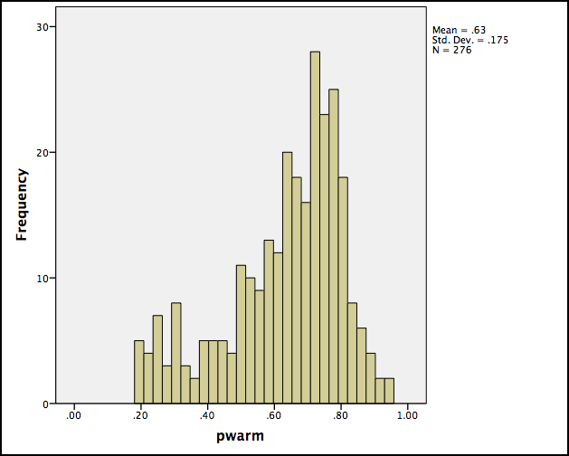
Proportion of Times Warmer Image Selected
Frequency

Figure 2. Frequency of Proportion of Times Warmer Image Selected
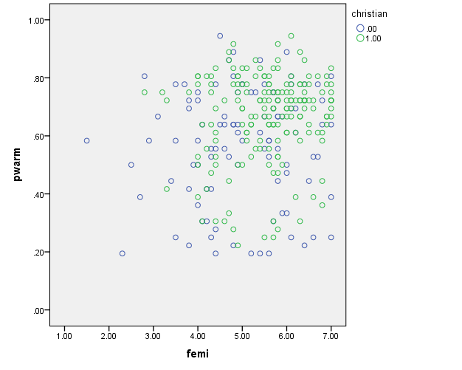
Feminine Gender Role Identity
Proportion of Times Warmer Image Selected

Figure 3. Relationship Between Proportion of Times Warmer Image Selected and Feminine Gender Role Identity

References
Bem, S. L. (1974). The measurement of psychological androgyny. Journal of Consulting and
Clinical Psychology, 42(2), 155-162.
Berinsky, A. J., Huber, G. A., & Lenz, G. S. (2012). Evaluating online labor markets for
experimental research: Amazon.com’s Mechanical Turk. Political Analysis, 20, 351–368.
Braam, A. W., Mooi, B., Jonker, J. S., van Tilburg, W., & Deeg, D. J. H. (2008). God image and five-factor model personality characteristics in later life: A study among inhabitants of Sassenheim in the Netherlands. Mental Health, Religion & Culture, 11(6), 547-559.
Campbell, T., & Arthur, J. (1997). BEM sex-role inventory: Educational tests and measurements. Educational & Psychological Measurement, 57(1), 118-125.
Constantinople, A. (1973). Masculinity-femininity: An exception to the famous dictum. Psychological Bulletin, 80, 389-407.
Epley, N., Converse, B. A., Delbosc, A., Monteleone, G. A., & Cacioppo, J. T. (2009). Believers’ estimates of God’s beliefs are more egocentric than estimates of other people’s beliefs. PNAS Proceedings of the National Academy of Sciences of the United States of America, 106(51), 21533-21538. doi:http://dx.doi.org/10.1073/pnas.0908374106
Hitchens, C. (Ed.). (2007). The Portable Atheist: Essential Readings for the Non-Believer. Da
Capo Press.
Hertel, B. R., & Donahue, M. J. (1995). Parental influences on god images among children: Testing Durkheim's metaphoric parallelism. Journal for the Scientific Study of Religion, 34(2), 186-199.
Hunsberger, B. (1989). A short version of the Christian Orthodoxy Scale. Journal for the
Scientific Study of Religion, 28, 360–365.
Kunkel, M. A., Cook, S., Meshel, D. S., Daughtry, D., & Hauenstein, A. (1999). God images: A
concept map. Journal for the Scientific Study of Religion, 38(2), 193-202.
Lambert, C. D., & Robinson Kurpius, S. E. (2004). Relationship of gender role identity and
attitudes with images of God. American Journal of Pastoral Counseling, 7, 55-75.
Luhaorg, H. & Zivian, M. T. (1995). Gender role conflict: The interaction of gender, gender role, and occupation. Sex Roles, 33(9-10), 607-620.
Nelsen, H. M., Cheek, N., & Au, P. (1985). Gender differences in images of god. Journal for the
Scientific Study of Religion, 24(4), 396-402.
Roberts, Carl W. 1989. Imagining God: Who is created in whose image? Review of Religious
Research 30(4), 375-386.
Thurstone, L. L. (1927). A law of comparative judgment. Psychological Review, 34(4), 273-286.
Watts, F. N., & Williams, J. M. G. (1988). The psychology of religious knowing. Cambridge,
England: Cambridge University Press.
Zahl, B.P. & Gibson, N.J.S. (2012). God representations, attachment to God, and satisfaction
with life: A comparison of doctrinal and experiential representations of God in christian
young adults. International Journal for the Psychology of Religion, 22(3), 216-230.

