Ultrafast Laser Micromachining Studies of Borosilicate Substrates Using Various Fluid Immersion Media to Characterize Cavitation Damage

A Thesis Presented for the
Master of Science
Degree
The University of Tennessee, Knoxville

John Allman
August 2024
Copyright © 2024 by John Allman.
All rights reserved.

ACKNOWLEDGEMENTS

I would like to thank Dr. Trevor Moeller, Dr. Brian Canfield, Dr. Lino Costa, and Alexander Terekhov for their guidance through my master’s program. I would also like to thank the Army Research Lab for their funding for my research under the title Master Cooperative Agreement Unique Technology & Engineering for Novel (UTEN) Materials Research for Army Modernization. Finally, I am thankful for my family, friends, and colleagues who helped me finish my degree.
ABSTRACT

The discovery of fluid cavitation and the invention of the laser changed their respective fields of study permanently. Over the past 70 years, cavitation has become more widely understood, and laser technology has advanced drastically. The combination of these two is a narrow field of study, and an even more-focused concept is the tailoring of specific laser-machining immersion fluids to enhance or suppress cavitation damage on a substrate. In this work, a study involving low vapor pressure fluids (LVPFs) such as ionic liquids (ILs) for ultrafast laser immersion micromachining was performed. ILs are conductive, molten salts. These chemicals exhibit exceptionally low vapor pressure, which is theorized to make them good candidates for immersion machining. The results of the experiments conducted in this Thesis suggest that LVPFs help to mitigate damage from fluid cavitation during ultrafast laser machining. More specifically, it was determined that LVPFs in general appear to mitigate the damage to a substrate surface. Other physical properties of the immersion fluids tested in these experiments were also considered, including density and viscosities (both kinematic and dynamic), and how these properties also affect cavitation damage to a substrate surface. A total of eight fluids were tested in this paper, whereby the surface roughness of a borosilicate glass substrate was examined, as well as the cross section of the features made by laser ablation. Additionally, the ability of each fluid to modify the effective focal range relative to the substrate surface, where material may still be removed from the substrate, was studied. It was determined from these experiments that ILs may offer specialized, functional immersion alternatives to the most commonly used fluids (water or air) due to their ability to reduce surface damage from cavitation and, compared to air, reduce the amount of ejecta that resolidifies onto the substrate surface during laser machining.
TABLE OF CONTENTS

Chapter 1: Introduction 1
1.1 Overview 1
1.2 Cavitation and its Inception 1
1.3 Ultrafast Laser Micromachining 2
1.4 Motivation 2
Chapter 2: Technical background 4
2.1 A More In-depth Look at Cavitation 4
2.2 Ultrafast Laser Ablation 7
2.2.1 Laser Ablation Plasma and its Expansion into a Fluid 10
Chapter 3: Materials and Methods 15
3.1 Fluid Physical Properties 15
3.2 Materials and Setup 16
3.3 Z-Step Array 16
3.3.1 Immersion Machining 19
3.3.2 Pulse Energy Selection 21
3.4 Surface Focus Damage and Cross Section Experiment 21
3.5 Sample Imaging 22
Chapter 4: Results and Discussion 25
4.1 Z-Step Array Results 25
4.2 Surface Focus Damage 31
4.3 Cross Section 39
Chapter 5: Conclusions and Recommendations 47
References 49
Appendix 54
Vita 55

LIST OF TABLES

Table 3.1. Fluid physical properties 17
Table 4.1. Translational machining speed for each immersion fluid and its kinematic viscosity. 40

LIST OF FIGURES

Figure 2.1. Equilibrium forces on the bubble interface. Forces are displayed using solid blue arrows. The lamina is the solid purple semicircle spanning the top half of the bubble. R is the bubble radius and P_{b} is the pressure inside of the bubble. 6
Figure 2.2 Approximate time scales of ultrafast laser ablation processes [12]. 11
Figure 2.3. A diagram of the temporal evolution of cavitation bubbles, (a) The definition of γ; (b) γ > 1; (c) γ < 1 [25]. 13
Figure 3.1. Laser machining setup with coordinate axes. 18
Figure 3.2. Z-step array machining with immersion fluid. 20
Figure 3.3. Z-step array example for H2O. Surface damage for both 2.5 µJ and 5 µJ pulse energies starts approximately −10 µm below apparent surface focus. 20
Figure 3.4. A sample being sputter coated in platinum. 24
Figure 3.5. Left: an example of a hole created using H2O as an immersion fluid with a single 5 µJ pulse. Right: the superimposed red outer circle denotes the brittle fracturing region, while the yellow inner circle denotes the filamentation region. 24
Figure 4.1. Range of features for each fluid with 2.5 µJ pulse energy (a, c, e) and 5 µJ pulse energy (b, d, f). Each fluid is sorted by ascending: vapor pressure (a,b), kinematic viscosity (c, d), and density (e, f). 26
Figure 4.2. High-magnification SEM images of holes created by cavitation using (a) AIR, (b) H2O, (c) IPA, and (d) GLY as the immersion media. Each hole was made with a single 2.5 µJ pulse. 28
Figure 4.3. High-magnification SEM images of holes created by cavitation using (a) EMI, (b) BMI, (c) TA, and (d) TB as the immersion media. Each hole was produced using a single 5 µJ pulse. 30
Figure 4.3. Variation in arithmetical mean height for all fluids tested over the five test areas. 32
Figure 4.4. Variation in maximum height for all fluids tested over the five test areas. 32
Figure 4.5. Averaged Sa sorted by vapor pressure in ascending order. 34
Figure 4.6. Optical and laser confocal images combined (left) and subsequent 3D surface roughness plots (right) for (a), (b) TA; (c), (d) H2O; and (e), (f) IPA. 36
Figure 4.7. Averaged Sa sorted by density of the fluids in ascending order. 37
Figure 4.8. Averaged Sa sorted by the kinematic viscosity of the fluids in ascending order. 37
Figure 4.9. Cross-sectional view of EMI (a), (c) and BMI (b), (d). Images (c) and (d) were acquired at a lower magnification so that the filament depth can be observed. 40
Figure 4.10. Cross-sectional views of TA (a), (c) and TB (b), (d). Minimal surface modification is seen in both samples. 42
Figure 4.11. Cross-sectional views of H2O (a), (c) and AIR (b), (d). 43
Figure 4.12. Cross-sectional view of IPA (a), (c) and GLY (b), (d). 45
Figure 4.13. Optical images of fracture propagation between hole locations of (a) H2O and (b) IPA. The red ovals encapsulate examples of localized fracture propagation between holes. 45

Nomenclature

In order of appearance:

Nomenclature | Verbiage | Units / Value
$ρ$ or $ρ_{L}$ | Density | $$\frac{\text{kg}}{{\text{m}}^{\text{3}}}$$
v | Velocity | $$\frac{\text{m}}{\text{s}}$$
$$p$$ | Pressure | $$\frac{\text{N}}{{\text{m}}^{\text{2}}}$$
fs | Femtosecond | $\text{1×}{\text{10}}^{\text{-15}}$s
$$R_{b}$$ | Radius of Cavitation Bubble | m
t | Time | s
$$T_{∞}$$ | Ambient Temperature | K
$$p_{B}$$ | Interior Bubble Pressure | Pa
$$p_{∞}$$ | Ambient Pressure | Pa
$$ν_{L}$$ | Kinematic Viscosity | cSt
$$σ$$ | Surface Tension | $$\frac{\text{N}}{\text{m}}$$
$$µ_{L}$$ | Dynamic (absolute) Viscosity | $$\text{Pa∙s}$$
m | Number of Photons | -
h | Planck’s Constant | $$\text{6.62×}{\text{10}}^{\text{-34}}\text{ J∙s}$$
f, ω | Frequency (of Light) | Hz, s⁻¹
E_{g} | Bandgap Energy | J
nm | Nanometer | $\text{1×}{\text{10}}^{\text{-9}}$ m
ω_{p} | Plasma Frequency | Hz, s⁻¹
q | Fundamental Electric Charge | $1.60×{10}^{-19}$ C
n_{e} | Number Density of Electrons | -
λ | Electromagnetic Wavelength | m
$$ε_{0}$$ | Vacuum Permittivity | $\text{8.85×}{\text{10}}^{\text{-12}}$ $\frac{\text{F}}{\text{m}}$
m_{e} | Electron Mass | $9.11×{10}^{-31}$ kg
c | Speed of Light (in a Vacuum) | $3.00×{10}^{8}$ $\frac{\text{m}}{\text{s}}$
χ | Electric Susceptibility | -
$$\overset{⃑}{P}$$ | Electric Polarization | $$\frac{\text{C}}{{\text{m}}^{\text{2}}}$$
$$\overset{⃑}{E}$$ | Electric Field | $$\frac{\text{V}}{\text{m}}$$
n | Index of Refraction | -
I | Optical Intensity (of a Laser) | $$\frac{\text{W}}{{\text{m}}^{\text{2}}}$$
γ | Ratio of Distance Between Laser Focal Point and Maximum Bubble Radius | -
NA | Numerical Aperture | -
Sa | Arithmetic Mean Height | m
Sz | Maximum Height | m
P_{vp} | Vapor Pressure | Pa

Chapter 1: Introduction

1.1 Overview
In this thesis, the concept of cavitation will be discussed as well as how ultrafast laser machining creates it. Chapter 1 is a brief overview of cavitation and lasers and a small amount of history regarding these topics. Chapter 2 will discuss in more detail the mechanisms which dictate the dynamics of cavitation bubbles and their formation, in addition to how laser ablation works. The end of Chapter 2 ties these two concepts together. Chapter 3 discusses the experimental set-up and data-collection methods. In Chapter 4 the results of all experiments are discussed in detail, and the main ideas and take-aways are given in the conclusion, Chapter 5.

1.2 Cavitation and its Inception
The birth of the term “cavitation,” in reference to fluids, may date back to as early as the 1890’s, when the phenomenon was first investigated by Barnaby and Parsons, but may even be attributed to Euler in 1754 [1]. In 1917, Lord Rayleigh developed the theoretical work to describe the process, from which Milton Plesset expanded his work to derive the Rayleigh-Plesset equation in 1949 [1,2]. Since then, the research on fluid cavitation has increased, and more models have been developed to depict the process of cavitation.

Fluid cavitation occurs when the static pressure in a localized volume of the fluid drops below the fluid’s vapor pressure at the current ambient temperature and pressure. Cavitation is widely studied in an inertial reference frame, where a fluid or an object is moving relative to the other. This is of particular importance for fluid engineering, where one must consider the pressure drop over surfaces such as propellers, pump blades, pipes, and hydrofoils to prevent cavitation from occurring. Cavitation causes surface damage, which can reduce the useful life of the object. In accordance with Bernoulli’s principle (Eq. 1.1), as a fluid increases its velocity at a constant depth, the static pressure must decrease to maintain continuity [3]:

$\frac{1}{2}ρv^{2} +p=const.$, (1.1)

where $ρ$ is the fluid density, $v$ is the fluid velocity, and $p$ is the fluid pressure. If $p$ decreases to a value below the fluid’s vapor pressure, the fluid will spontaneously change phase into a vaporous form, causing vapor pockets or ‘cavities’ to form. These vapor cavities may grow until the fluid static pressure causes the bubble to collapse on itself. In such cases where cavitation is present, surface damage caused by cavitation to the object immersed in the fluid is usually detrimental.

This is a simplified explanation of inertial cavitation, and a more in-depth review of laser-induced cavitation will be explored in the literature review; however, the main ideas remain the same: a vapor bubble is created, expands, and finally, collapses, causing damage to the surface of a nearby substrate.

1.3 Ultrafast Laser Micromachining
In 1916, Albert Einstein predicted the process of stimulated emission, by which a photon of sufficient energy, and some arbitrary phase and frequency, will pass by an excited atom’s electron orbital causing this atom to spontaneously release its excess energy as a photon [4,5]. This emitted photon will have the same frequency, phase, and propagation direction as the photon which passed by the electron orbital [4]. In most materials, the vast majority of atoms are not in an excited state, however, if they are excited such that the vast majority of atoms are in the excited state, then the spontaneous emission of a photon can cause a cascading effect whereby all of the excited atoms will release a photon (or multiple) simultaneously. This is the premise on how lasers work, where ‘laser’ was originally an acronym—Light Amplification by Stimulated Emission of Radiation (LASER)—that has now become a commonplace term. In mid-1960, Theodore H. Maiman demonstrated the first successful operation of a laser [4]. A short time later in 1964, the first picosecond-pulsed laser was demonstrated [6]. Since then, the field of lasers and laser optics has grown dramatically, and lasers are used in everyday applications from laser pointers to medical devices.

Ultrafast lasers are pulsed lasers that emit ultrashort pulse lengths, usually on the order of nanoseconds (ns, ${10}^{-9}$ s) to femtoseconds (fs, ${10}^{-15}$ s) [7]. This incredibly short temporal pulse length gives rise to a very steep electric field gradient, which, when focused, enables nonlinear optical effects, such as Kerr self-focusing, multiphoton absorption, and filamentation [8]. With picosecond (ps, ${10}^{-12}$ s) to fs pulse lengths, laser ablation can be achieved without melting the substrate, and causing what is known as a heat affected zone (HAZ) [9,10]. A HAZ results from longer (tens of ps or greater) pulses which continue to couple energy into an excited, under-dense plasma while it expands outward around the focal region [11]. This greater amount of absorbed energy will then be transferred to the lattice during electron recombination, leading to thermal gradients appearing as discolored annular bands covering a much wider radial region centered around an ablated crater, where melting and splatter traces are often visibly apparent. In contrast, sub-ps pulse lengths are too short to interact with the plasma on long-enough time scales to induce such large-area thermal effects [8,12]. In some cases with laser machining, reducing the excess damage to the surrounding affected area is ideal, and ultrafast lasers excel in this field. Another use for ultrafast laser micromachining is the use of an immersion fluid to produce cavitation bubbles. These bubbles can then either be studied or perhaps used in laser peening, a technique to work harden the surface of steels [13]. In Chapter 2.2 and 2.3, the processes of laser ablation and cavitation will be discussed in greater detail.

1.4 Motivation
Fluid cavitation is typically detrimental wherever it is present. Cavitation is known to cause damage to the surface of materials and is of concern for engineers designing ship screws (propellers), hydraulic pumps, impellers, piping, and nearly all applications where fluids flow over a surface. In the work outlined in this Thesis, different immersion fluids are used to enhance or suppress cavitation damage done to a substrate during immersion laser machining. The goal is to determine if a specific fluid (or fluids) may be used in conjunction with ultrafast lasers to produce better laser-machined surfaces, or at least categorize the effects of the different liquid immersions. To define “better laser-machined surfaces,” the intent is to produce smooth final products whereby the ejected material from laser ablation does not redeposit onto the surface, leaving clean regions between ablation events. This may be of use for work in microfluidics, medicine delivery devices, and biological work or study, where smooth surfaces surrounding ablated pits or holes are desired. Other work at the University of Tennessee Space Institute (UTSI) involves the development of an electrospray thruster. This device uses a dielectric material with specifically located holes to aid in directing and accelerating a propellant to produce thrust in a CubeSat [14,15]. For this project, deep, smooth, symmetrical holes are desired. The author believes there are many other potential uses from the results outlined in this Thesis, but future work should be conducted to further this research.

Chapter 2: Technical background

2.1 A More In-depth Look at Cavitation
Consider a bubble of radius $R_{B}$ as a function of time t inside a bulk fluid. The bulk fluid will have an ambient temperature $T_{∞}$ and pressure $p_{∞}$. The matter in the interior of the bubble is assumed to be uniform and thus will be assigned a pressure and temperature of $p_{B}(t)$ and $T_{B}(t)$, respectively. Assuming the bubble boundary is not stagnated, it will have some velocity $u(r,t)$, where $r$ is the distance the bubble boundary is from the center of the bubble. Assuming negligible mass transfer across the bubble boundary, conservation of mass yields [16,17]

$4πR_{B}^{2}\frac{dR_{B}}{dt}=4πr^{2}u(r,t)$, (2.1)

which simplifies to

$u\left(r,t\right)= \frac{R_{B}^{2}\frac{dR_{B}}{dt}}{r^{2}}$. (2.2)

Substituting some arbitrary function, $F(t)$, for the kinematic boundary condition $\left(R_{B}^{2}\right)×\left(\frac{dR_{B}}{dt}\right)$, Eq. (2.2) will further simplify to

$u\left(r,t\right)= \frac{F(t)}{r^{2}}$. (2.3)

The Navier-Stokes equation for conservation of momentum in spherical coordinates in the $\hat{r}$ direction is [16,17]

$-\frac{1}{ρ_{L}}\frac{∂p}{∂r} = \frac{∂u}{∂t}+u\frac{∂u}{∂r}-v_{L}\left(\frac{1}{r^{2}}\frac{∂}{∂r}\left[r^{2}\frac{∂u}{∂r}\right]-\frac{2u}{r^{2}}\right)$. (2.4)

Substituting Eq. (2.3) and simplifying yields

$\frac{1}{r^{2}}\frac{dF(t)}{dt}+\frac{{F(t)}^{2}}{r^{2}}\left(-\frac{2}{r^{3}}\right)=-\frac{1}{ρ_{L}}\frac{∂p}{∂r}+v_{L}\frac{F(t)}{r^{2}}\left(\frac{d}{dr}\left[r^{2}\left(-\frac{2}{r^{3}}\right)\right]-\frac{2}{r^{2}}\right)$, (2.5)

where $ν_{L}$ is the kinematic viscosity, and $ρ_{L}$ is the density (of the liquid). The second term on the right-hand-side (attached to $v_{L}$) equals zero upon simplifying the derivative, thus removing it from the equation. This implies that kinematic viscous stresses cancel out in spherical symmetry [16,17]. Eq. (2.5) then simplifies to

$-\frac{1}{ρ_{L}}\frac{∂p}{∂r}=\frac{1}{r^{2}}\frac{dF}{dt}-\frac{2{F(t)}^{2}}{r^{5}}$. (2.6)

Integrating both sides with respect to $r$ from $r$ to ∞ after application of the condition $P→P_{∞}$ as $r→∞$ yields

$\frac{p-p_{∞}}{ρ_{L}}=\frac{1}{r}\frac{dF}{dt}-\frac{1}{2}\frac{{F(t)}^{2}}{r^{4}}$. (2.7)

Note the differential pressure with respect to r changes to the difference between pressure inside the bubble and the liquid static pressure as r approaches infinity. To apply a dynamic boundary condition, consider the bubble-bulk fluid interface. The interface between the vaporous interior of the bubble and liquid exterior of the bulk fluid will be assumed to be an infinitely thin lamina. The net force radially outward per unit area on a small segment of this lamina is [16,17]

${\left(σ_{rr}\right)}_{r=R_{b}}+P_{b}-\frac{2σ}{R_{b}}=0$, (2.8)

where ${\left(σ_{rr}\right)}_{r=R}$ is the normal pressure force from surface tension on the bubble interface and σ is the surface tension force on the lamina. The forces must be equivalent because the mass of the lamina is zero. Figure 2.1 is a free-body diagram that displays the forces on the interface to form the equilibrium balance equation: Eq. (2.8) [16,17]. Rearranging Eq. (2.8), and recognizing ${\left(σ_{rr}\right)}_{r=R}$ is equivalent to:

${\left(σ_{rr}\right)}_{r=R}=-P_{r=R}+2µ_{L}\frac{∂u}{∂r}$. (2.9)

Thus, the force per unit area (Eq. (2.8)) can be rewritten as [16,17]

${\left(σ_{rr}\right)}_{r=R}=-P_{∞}-\frac{1}{R}ρ_{L}\frac{dF}{dt}+\frac{1}{2R^{4}}ρ_{L}F^{2}\left(t\right)+2µ_{L}\left(\frac{-2F(t)}{R_{b}^{3}}\right)$. (2.10)

So, the boundary condition equation is [16,17]:

$P_{b}-P_{∞}=\frac{2σ}{R_{b}}+\frac{1}{R_{b}}ρ_{L}\left[2R_{b}{\left(\frac{dR_{b}}{dt}\right)}^{2}+R_{b}^{2}\frac{d^{2}R_{b}}{dt^{2}}\right]-\frac{1}{2R_{b}^{4}}ρ_{L}R_{b}^{4}{\left(\frac{dR_{b}}{dt}\right)}^{2}+4µ_{L}\frac{R_{b}^{2}\frac{dR_{b}}{dt}}{R_{b}^{3}}$. (2.11)

Assuming no condensation or evaporation across the lamina, the force (Eq. 2.10) must be zero. Solving for ${\left(P\right)}_{r=R}$, substituting this value into $P$ in Eq. (2.7), and simplifying the boundary condition yields the generalized Rayleigh-Plesset (RP) equation [16,17]:

$\frac{p_{b}\left(t\right)-p_{∞}\left(t\right)}{ρ_{L}}=R_{b}\frac{d^{2}R_{b}}{dt^{2}}+\frac{3}{2}{\left(\frac{dR_{b}}{dt}\right)}^{2}+\frac{4ν_{L}}{R_{b}}\frac{dR_{b}}{dt}+\frac{2σ}{ρ_{L}R_{b}}$. (2.12)

If the left-hand side and the physical properties of the fluid are known, Eq. (2.12) describes the motion of the cavitation bubble radius R with respect to time. The excitation term $p_{∞}\left(t\right)$ describes an external force acting on the bubble, and how this changes the bulk fluid static pressure. For example, this force could be an ultrasonic sound wave generated by an ultrasonic cleaner, or a laser pulse focused into the liquid. The internal environment

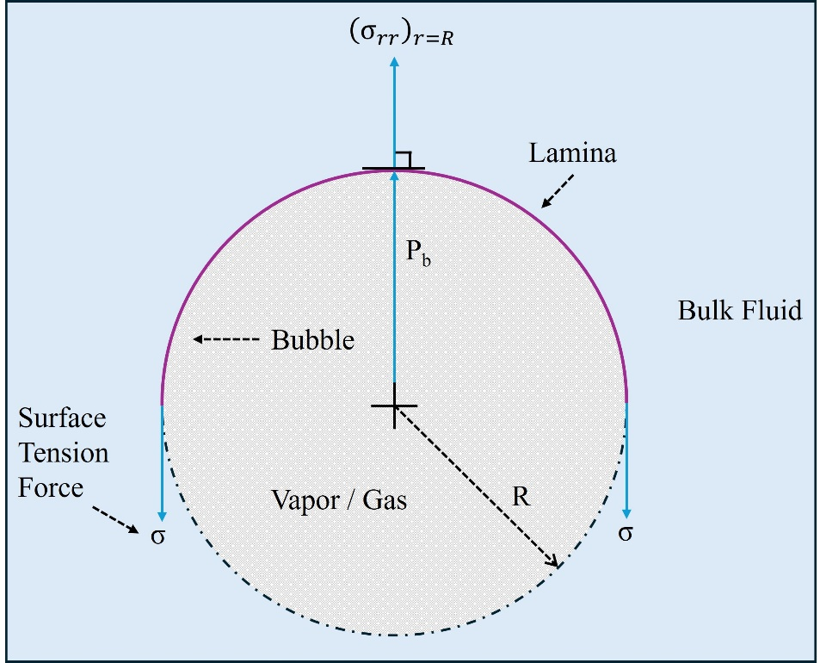

Figure 2.1. Equilibrium forces on the bubble interface. Forces are displayed using solid blue arrows. The lamina is the solid purple semicircle spanning the top half of the bubble. R is the bubble radius and P_{b} is the pressure inside of the bubble.

of the bubble is described by the $p_{b}\left(t\right)$ term and is the polytropic expansion of vapor inside the bubble [16,17].

The generalized RP equation (Eq. (2.12)) is a highly idealized depiction of the seemingly chaotic events that happen during cavitation expansion and collapse. The assumptions used in this derivation are as follows: there is a single bubble in an infinite media, the internal conditions of the bubble are uniform, there are no additional external forces such as gravity or electromagnetism which effect the bubble, bulk fluid viscosity effects are negligible during bubble dilation, the density of the liquid is far greater than the density of the vapor inside the bubble and its compressibility is negligible, there is no mass transfer across the boundary (the mass of the vapor is constant), and finally, the vapor pressure is constant during any oscillations of the cavitation bubble [16,17]. In reality, one may not be able to use one or any of these assumptions for an exact description of a cavitation bubble, but for simplicity, this Thesis will follow to the generalized RP equation which was derived using these assumptions.

2.2 Ultrafast Laser Ablation
The ultrashort pulse duration of fs lasers produces a unique ablation method compared with longer-pulse laser machining. Since the pulse time of the laser is so short, melting of the substrate is not the main ablation method for fs lasers, as it is with ns or longer pulse lengths. Instead, for dielectric materials, nonlinear absorption of the photons occurs [12]. For this process to happen, the electric field of the incident light must be approximately equal to the electric field strength that binds the valence shell electrons to their parent atom [12]. Wavelengths in the visible spectrum and near infrared do not have enough energy to be linearly absorbed by dielectrics such as glass [8]. For valence band electrons to be excited to the conduction band, multiple photons must simultaneously be absorbed by the electrons to gain enough energy to jump to the bandgap. The number of photons required is dependent on the wavelength of the laser light used and the relationship is shown in Eq. (2.13):

$mhf= E_{g}$, (2.13)

where m is the number of photons, h is Planck’s constant, f is the frequency of light, and $E_{g}$ is the bandgap energy [8]. Photon energy is typically reported in terms of electron volts, or eV, where from Eq. (2.13) it can be shown that 1 eV is equivalent to a photon of $λ=1240$nm. Glass, which has a bandgap ~9 eV, therefore clearly requires a multiphoton-absorption process to excite from the valence to conduction band [18].

For laser pulses longer than ~10 fs, electrons excited into the conduction band can continue to absorb the incoming photons [12]. Linear absorption of multiple photons by an electron in the conduction band will lead to the already-excited electron gaining additional energy (more than $E_{g}$) and allowing it to impact-ionize an electron in a lower energy state [8]. The impact of the energized electron with another lower-energy electron can thus create two electrons at the bandgap minimum energy level. This process may continue as long as the laser field (i.e., the pulse) exists and is of sufficient intensity. This is called avalanche photoionization [8].

The electron in the conduction band that is excited is called a seed electron. These seed electrons can come from multiphoton absorption or tunneling ionization, or even a combination of the two [8]. Tunneling ionization is a process in which a high-intensity electric field skews the bandgap of the atomic potential and allows an electron to tunnel from the valence band to the conduction band without the absorption of photon energy [8]. For fs laser pulses, photon absorption happens faster than the lattice relaxation time, which occurs on the time scale of approximately 1 ps (${\text{10}}^{\text{-12}}\text{s}$) [6,8,12]. This means that thermal effects from electron recombination occur long after photoionization has occurred. Thus, with no time for relaxation of the electrons, the number of electrons in the focal volume of the laser pulse will increase until a critical number density is reached; at this point, the electrons in the plasma will start oscillating with the same frequency as the laser light [8,12]. For light with a wavelength of 515 nm, this frequency is about 582 THz, and its photon energy is 2.41 eV.

If the plasma response time is shorter than the period of an external electromagnetic (EM) field, the incident radiation will be shielded from the plasma. This shielding can be quantitatively observed by developing a relationship between the two frequencies [19]:

$\frac{ω_{p}^{2}}{ω^{2}}=\frac{q^{2}n_{e}}{ε_{0}m_{e}}×\frac{λ^{2}}{4π^{2}c^{2}}$, (2.14)

where $ω_{p}$ is the plasma frequency, $ω$ is the EM frequency, $q$ is the fundamental electric charge, $n_{e}$ is the electron number density, $ε_{0}$ is the permittivity of free space, $m_{e}$ is the mass of an electron, $λ$ is the EM wavelength, and $c$ is the speed of light.

If the frequencies match, the left side of Eq. (2.14) can be set equal to unity and the expression solved for $λ$. To find $λ$, $n_{e}$ is replaced with $n_{c}$: the critical number density of electrons required for optical breakdown. In glass, $n_{c}$ is on the order of 10²¹ electrons per cubic centimeter, and the corresponding optical intensity to achieve this is about 10¹³ W/cm², a value easily achieved by tightly focusing sufficiently energetic (µJ) fs pulses [8,19]. The exact numeric value depends on the wavelength of light, but the order of magnitude remains largely the same over the visible spectrum. It can then be noted that any wavelength greater than this critical value for $λ$ will be reflected and, indeed, this fact can be used to transmit long-wave RF signals beyond the horizon by bouncing the radio signal off the ionosphere [19]. Reiterated, plasmas with a frequency greater than an external EM field frequency are “over-dense” and will reflect the incident EM radiation. Conversely, plasma with a frequency that is less than incident EM radiation is “under-dense” and will act as a nonlinear refractive medium [19].

When light propagates through a dielectric material, such as glass, it induces microscopic displacement of bound charges in the lattice. The displacement of these charges forms transient electric dipoles [8,20]. The polarization of the dipoles is dependent on the electric susceptibility ($χ$) of the material and can be expanded in a power series of the polarization vector. For low electric field intensities, only the first-order (linear) susceptibility term is considered, since this term contributes the most to the polarization. However, when the electric field strength is high, processes such as Kerr self-focusing and plasma defocusing can occur, and the higher-order terms cannot be neglected because the electric field intensity for these processes to occur is so large. These processes are inherently nonlinear and thus cannot be described purely by linear terms. Kerr self-focusing and plasma defocusing may both occur during fs laser ablation because the electric field intensity is so high, thus the nonlinear terms are no longer negligible. Kerr self-focusing occurs under high-intensity irradiation conditions because the refractive index of a transparent material can exhibit a nonlinear dependence on light intensity and result in a lensing effect that causes a laser pulse to focus in the absence of a curved lens, hence “self-focusing” [8,12,21]. Plasma defocusing, as the name suggests, causes a dispersal of the laser pulse by the generated plasma. A delicate balance between these two processes can cause microscopic “filaments,” plasma channels that propagate much deeper into the substrate material than would otherwise be possible without these effects [22]. Note that these and other nonlinear optical effects generally require exceptionally concentrated light intensities enabled by focusing ultrafast laser pulses to manifest. To numerically describe how these processes are related to the electric field intensity, the polarization vector must first be defined.

In amorphous glass the polarization vector can be described with the following equation:

$\vec{P}=ε_{0}\left[χ^{(1)}+\frac{3}{4}χ^{(3)}{\left|\vec{E}\right|}^{2}\right]\vec{E}$, (2.15)

where the first nonlinear term, $χ^{\left(2\right)}$, is equal to zero because glass is an amorphous solid. Second-order nonlinear optical interactions can only occur in non-centrosymmetric crystals, a crystal structure which does not exhibit symmetry about central-point reflections, or inversion centers. Because glass generally does exhibit inversion symmetry in its bulk, $χ^{\left(2\right)}$ is zero (although the symmetry is broken at surface interfaces, but that topic is beyond the scope of this Thesis) [23]. Subsequent nonlinear terms past 3rd-order will here be considered negligibly small (4th-order and higher) [8]. As seen in Equation 2.15, for low intensities of the electric field, the $χ^{(3)}$ term (which is typically very small for most materials) is negligible. For example, BK-7 glass has an $n_{0}$ of about 1.51 (unitless), but $n_{2}$ has a value on the order of $\sim {10}^{-20}$ m²/W for 515 nm light. However, as the electric field intensity increases, the nonlinear electric susceptibility term begins to impact the polarization of the material. With some substitutions and rearranging, the refractive index ($n$) can then be defined as:

$n=\sqrt{1+χ^{(1)}+\frac{3}{4}χ^{(3)}{\left|\vec{E}\right|}^{2}}=n_{0}+n_{2}I$, (2.16)

where $n_{0}=\sqrt{1+χ^{(1)}}$ is the linear refractive index term, and $n_{2}$ is the nonlinear, or intensity-dependent refractive index (with subscript ‘2’ even though it depends on $χ^{(3)}$) [8]. In Equation 2.16, it is seen that the nonlinear refractive index term is dependent on the laser intensity, $I$. In most materials, this nonlinear term is positive and will increase the total refractive index as the laser intensity increases [8]. If the intensity profile changes spatially or temporally, the refractive index also changes accordingly. This equivalently forms a positive lens which focuses the light towards the center of the highest intensity region, the origin of self-focusing. Consequently, a positive feedback loop is formed between optical intensity and refractive index until the optical intensity reaches the optical breakdown threshold. At this point, nonlinear photoionization occurs, and a free electron plasma is formed [8]. This plasma has a negative refractive index change (compared to self-focusing) and acts as a diverging lens that defocuses the incident laser pulse [8,24]. These two processes may come to an equilibrium with each other to form a region of high optical intensity and plasma density that reaches deep into the target medium. This dynamic balance is called intensity clamping [24]. A diagram of the temporal evolution of laser ablation is shown in Figure 2.2 [12].

2.2.1 Laser Ablation Plasma and its Expansion into a Fluid
Although much research has been done separately on the dynamic processes of fs laser ablation and laser-induced cavitation, there is little research process during the time between these two phenomena. The time domain for fs laser ablation begins and ends well before the fluid cavitation process starts. With respect to the time scales, a relatively large temporal gap resides in the region between these two processes. Electron-matter interactions occur much faster than liquid inertial effects. Lattice heating effects from electron-matter recombination occur on the order of 10 ps, whereas cavitation processes may begin to occur around 10 µs [8,25].

After the fs laser pulse has ended, no additional external energy will be added to the plasma. Therefore, any processes that happen after the end of the fs laser pulse will transfer energy (either kinetic or potential) between the fluid, plasma, and/or solid substrate, and the entire thermodynamic system will have a constant total energy with respect to time. If enough energy was originally deposited into the substrate and plasma during the laser pulse, the ionized atoms in the lattice of the solid substrate will have a large charge imbalance due to the severe deficit of electrons in their valence shells. As a result, the bond strength between atoms or molecules in the solid substrate will be severely weakened. This enables the Coulombic repulsion of like charges to overcome the lattice bond energy, causing a rapid dissociation of the substrate lattice. This process is called a Coulomb explosion and is a form of non-thermal laser ablation [26]. The resulting expulsion of material from the lattice expands outward into the plasma and fluid medium.

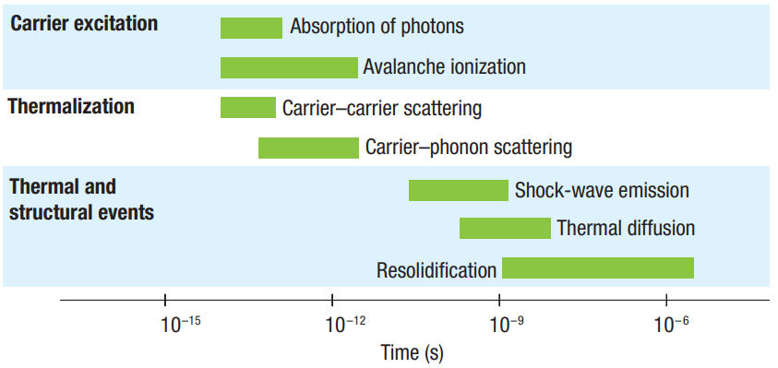
Figure 2.2 Approximate time scales of ultrafast laser ablation processes [12].

When the plasma is created during fs laser ablation, the pressure and temperature of the ionized material are of extreme magnitudes. The temperature and pressure may be on the order of 10⁴ K and 10¹⁵ MPa respectively (as observed by Zhao et al.), but the exact values are heavily dependent on the amount of energy deposited, and atomic constituents of the plasma [27]. For example, Gou et al. observed a plasma pressure and temperature of 430 atm (~43 MPa) and 22,000 K at 50 µJ pulse energy using a regeneratively amplified Ti:sapphire laser with a central wavelength of 800 nm and pulse duration of 50 fs with a 5×, 0.15 NA lens [28]. Their target substrate was a gallium phosphide (GaP) crystal situated in air (the ambient environment). Zhao et al. used very similar laser parameters, but with 2.3 mJ pulse energy and a different target medium, thus demonstrating the dependence of atomic constituents of the plasma and pulse energy on the thermodynamic state of the plasma.

Such high temperatures and pressures cause the plasma to expand radially at extreme hypersonic velocities, up to ~Mach 70 (Mach refers to velocity relative to the speed of sound in a dense medium, where Mach 1 ≈ 350 m/s for room-temperature air), in the first ns in the case of the GaP experiment [28]. For instances where the ambient fluid is not of gaseous form, the expansion of the plasma will be more inertially confined, as a denser immersion medium (like a liquid) will require more energy from the plasma to expand. As such, the expansion rate may be limited to a more modest supersonic regime (>Mach 1) [25]. In either case, the rapid expansion rate causes shockwaves to form that propagate both through the immersion medium and the substrate material. Rapid and continual cooling of the plasma while it expands dramatically decreases its radial velocity, which leads to a shockwave decoupling from the plasma expansion wavefront [25]. The shocks will continue through the substrate and immersion medium, but the now shock-separated expansion wavefront will be continually retarded by the immersion medium at an increasing rate.

Depending on the laser’s focal distance from the substrate surface, two possible outcomes arise, with one special case for each. Zhang et al. describe the outcomes being γ > 1, and γ < 1, where γ is the dimensionless ratio of the distance of the laser focal point to the substrate surface divided by the maximum radius of the bubble. A diagram of this is shown in Figure 2.3 [25]. Discussing first the possible outcomes, for γ > 1, the initial bubble expansion remains spherical until the maximum radius is achieved (Figure 2.2b). If γ < 1, the initial expansion phase will contact the surface of the substrate causing a nonspherical bubble to form (Figure 2.3c) [25]. Special cases are γ = 0 and γ >> 1 (not shown in Figure 2.3). If the laser focal point is situated on the substrate surface (γ = 0), the expanding plasma will contact the surface of the substrate and the expansion will be hemispherical, with the flat part of the hemisphere being the boundary of the substrate. If the focal point is far from the surface of the substrate (γ >> 1), the growth and collapse of the bubble will be spherically symmetric. This special case is very similar to the generalized Rayleigh-Plesset equation discussed in Chapter 2.1, Eq. (2.12).

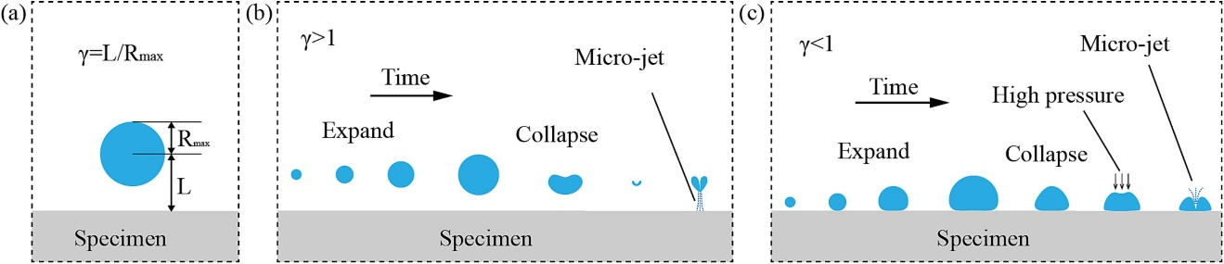
Figure 2.3. A diagram of the temporal evolution of cavitation bubbles, (a) The definition of γ; (b) γ > 1; (c) γ < 1 [25].

Before proceeding to discuss the total collapse of the bubble, the energy depletion of the bubble should be mentioned. No matter the location of the focal point of the laser in the fluid, the bubble will expand radially outward until the pressure inside of the bubble is equal to the pressure outside of the bubble. The inertia of the plasma expansion forces the bubble boundary to continue to grow, and thus the pressure inside of the bubble will decrease below the static pressure of the surrounding fluid [25].

It should be noted that at some point during the entire expansion and collapse process, the plasma encased in the bubble will recondense into a vapor/gas. Without perfect thermodynamic knowledge of the state of the matter in this region, it becomes difficult to determine precisely when the plasma stops behaving as such and transforms into a vapor. Whether this happens prior to the bubble even reaching its maximum radius or sometime during collapse varies between sources. Thus, from this point onward the matter inside of the bubble will be referred to as a vapor to fit the Rayleigh-Plesset equation narrative.

Upon initial collapse of the bubble, the vaporous matter inside the bubble boundary will be forced into a continually decreasing volume. This causes the pressure and temperature of the vapor to increase. When the pressure inside of the bubble becomes equivalent to the fluid static pressure, the internal pressure will resist the collapsing motion of the bubble. Due to the inertia of the liquid forcing the bubble collapse, the bubble boundary will overshoot this equilibrium point and continue to collapse the bubble [25]. Continual compression of the vapor inside the bubble will thus increase the pressure beyond the equilibrium point and cause the vapor-bubble interface to expand outwards once again. The high rate of pressure increase from collapse causes secondary shockwaves to form, which propagate through the immersion medium and into the substrate material [25]. The bubble will expand once again to a point where the internal pressure is less than the external pressure, and the collapse and rebound process may repeat. This expansion, collapse, and then rebound process may occur as long as there is sufficient energy in the vapor to promote an imbalance in pressure inside the bubble [25].

Eventually, the static pressure of the bulk fluid will force a full collapse inward. The increase in pressure as the bubble collapse will not be enough to stop the collapsing vapor-bubble interface, and the bubble will be dissolved into the surrounding liquid medium. Unless γ >> 1, the collapse of the bubble will be nonspherical, meaning that one side of the bubble will collapse faster than the other. The nonsymmetrical collapse leads to a liquid microjet forming, which bisects the bubble [25]. This liquid microjet may impact the surface of the substrate and cause additional damage, if the pressure of the microjet impact exceeds the yield strength of the substrate material [25,29,30].

Chapter 3: Materials and Methods

3.1 Fluid Physical Properties
Eight fluids were carefully selected based on their varying physical properties to be used as the immersion media. The fluids and their properties are listed in Table 3.1. Air, being the ambient environment and only gas tested in this experiment, was chosen to be a control. In addition to air, water was also chosen to be a control, as much research has already been done using water as an immersion fluid for laser machining [31]. The two ionic liquids (ILs) used, BMI [1-butyl-3-methylimidazolium trifluoromethanesulfonate] and EMI [1-ethyl-3-methylimidazolium bis(trifluoromethanesulfonyl)imide], were chosen for their exceptionally low vapor pressures and intermediate viscosities, densities, and refractive indices compared to the other fluids [32,33]. The ILs’ values for viscosity, density, and refractive index are not as low as for air or water, but in the case of viscosity, not as high as some of the other fluids. For the other physical properties, the ILs are in the same neighborhood as most of the other fluids; this makes them a good comparator for testing the theory of whether low vapor pressure fluids (LVPFs) can decrease cavitation damage and in helping to determine how viscosity can impact laser immersion machining. The microscopy immersion oils (Type A and Type B) have identical physical properties outside of viscosity, making it easier to determine how viscosity will change the effectiveness of immersion laser machining. Finally, glycerol and isopropyl alcohol were chosen for their stark contrast in viscosities and vapor pressures. Glycerol has a high viscosity and low vapor pressure, while isopropyl alcohol is opposite: having low viscosity and is volatile.

The physical property values in Table 3.1 were collected from manufacturers’ data or published literature. However, published vapor pressure data for glycerol, EMI, and BMI at room temperature could not be located. Therefore, these fluids were all tested in-house using thermogravimetric analysis (TGA) to determine their vapor pressures. To measure the vapor pressure, each fluid was run for 2 hours at 100 °C. This boiled off any absorbed water that was present in the fluids. The TGA measures the weight of the sample as time advances, thus when all water content is removed from the sample, the mass decrease (from evaporation of the sample) will stabilize and form a linear decrease. The slope of the mass decrease with time allows for the vapor pressure of the test fluid to be compared to a known vapor pressure at a similar temperature. Conveniently, data for glycerol’s vapor pressure at 100 °C was able to be sourced. In this case, GLY was used to check the validity of the method. Eq. 3.1 shows how the vapor pressure can be calculated with TGA data: [34]

$P_{s}={\left(\frac{M_{ref}}{M_{s}}\right)}^{0.5}P_{ref}\frac{{\left(dm/dt\right)}_{s}}{{\left(dm/dt\right)}_{ref}}$, (3.1)

where, $P_{s}$ is the vapor pressure of the sample, $M_{ref}$ is the molecular mass of the evaporating reference substance, $M_{s}$ is the molecular mass of the evaporating sample, $P_{ref}$ is the reference vapor pressure, ${\left(dm/dt\right)}_{s}$ is the mass change of the sample substance with time, and ${\left(dm/dt\right)}_{ref}$ is the mass change of the reference material with time (GLY). Because these fluids have exceptionally low vapor pressures and are hygroscopic, it was necessary to run a TGA analysis at 100 °C to remove any absorbed water and more accurately determine the vapor pressures. Due to the nature of very low vapor pressure liquids, it is difficult to determine a room temperature vapor pressure, but the vapor pressure is expected to decrease in magnitude with a decrease in temperature, in accordance with the Clausius-Clapeyron relation [35].

3.2 Materials and Setup
Ultrafast laser pulses were produced using a Tangerine 20 W ultrafast pulsed laser by Amplitude. This laser system produces laser pulses at 1030 nm, which are frequency-doubled to 515 nm using second-harmonic generation in a nonlinear crystal external to the laser system. The pulse width was set to 0.37 ps (370 fs, the minimum) and single pulses were used for machining with a pulse energy of either 2.5 µJ or 5 µJ. Pulse energy selection will be discussed in the next section. The laser pulses were focused by a Leitz Wetzlar 160×, 1.2 numerical aperture (NA, for water) microscope objective. The pulses were focused onto a Corning borosilicate glass slide (BK7) that is 22×22 mm² and nominally 170 µm thick. The glass slide was held in place electrostatically using a polydimethylsiloxane (PDMS) slab on a stainless-steel mounting chuck with pores [36]. The pores allowed a small wafer vacuum pump to be used, should additional fastening force be needed. The vacuum pump was specifically used for the air samples. The chuck assembly was fixed onto an Aerotech ANT95-3-V and ANT95-50-XY nano-positioning stage combination for precise and accurate positioning in the x-, y-, and z-directions. With the laser outputting low optical power and continuous pulses (200 kHz), the top surface of the glass could be brought into focus with the laser spot. Sweeping the stage laterally in the x-direction and noting the change of focus, the surface of the glass can be leveled using a tilt stage. Next, the y-direction was leveled using the same process. A diagram of the machining setup is shown in Figure 3.1. Commands to move the stage setup and fire the laser are generated by a custom LabVIEW virtual instrument (VI) program.

3.3 Z-Step Array
This experiment aimed to determine the machinable range of each fluid, that is, the z-range over which material is removed by the ablation process, thus forming pits/holes in the glass substrate. To do this, a series of pulse locations was designed in the VI program. These pulse locations were laid out in a rectangular array of 5×100 (5 rows, 100 columns). Each row and column were separated by 20 µm spacing (y- and x-directions, respectively). Additionally, each firing event was set with a time delay of 500 ms. Thus, each pulse location was separated both temporally and spatially to prevent any residual cavitation bubbles from interfering with the next laser pulse and any subsequent surface damage to the glass from effecting the cavitation process on the next pulse. With 20 µm between each point, the entire array is 2000 µm in length along the x-direction. At the beginning of the array, the focus of the laser is set to 50 µm below the surface of the glass (z = −50 µm), z = 0 µm being the surface position of best apparent focus (the process of determining this position is described in the following section). Each additional point in the array is then raised by 1 µm in the z-direction, e.g., the first point’s relative (x, z) coordinates are (in
Table 3.1. Fluid physical properties
Name | Shorthand | Dynamic Viscosity [cP] | Vapor Pressure [mmHg] | Density $\left[\frac{g}{{cm}^{3}}\right]$ | Refractive Index
Air [37] | AIR | 0.018 | 760 | 1.20E−03 | 1.00
Water [37] | H2O | 0.89 | 23.7 | 1.00 | 1.33
†1-butyl-3-methylimidazolium trifluoromethanesulfonate [32] | BMI | 80.0 | ††1.03E−03 | 1.29 | 1.44
†1-ethyl-3-methylimidazolium bis(trifluoromethanesulfonyl) imide [33] | EMI | 35.6 | ††2.30E−03 | 1.52 | 1.42
Type A Immersion Oil [38,39] | TA | 139 | < 0.10 | 0.92 | 1.51
Type B Immersion Oil [38,39] | TB | 1160 | < 0.10 | 0.92 | 1.51
Glycerol [34,40,41] | GLY | 1410 | 0.17 | 1.26 | 1.47
Isopropyl Alcohol [42] | IPA | 2.40 | 40.0 | 0.79 | 1.38
†Ionic Liquid |  | †† These values were experimentally derived using thermogravimetric analysis at 100 °C  [34,41].

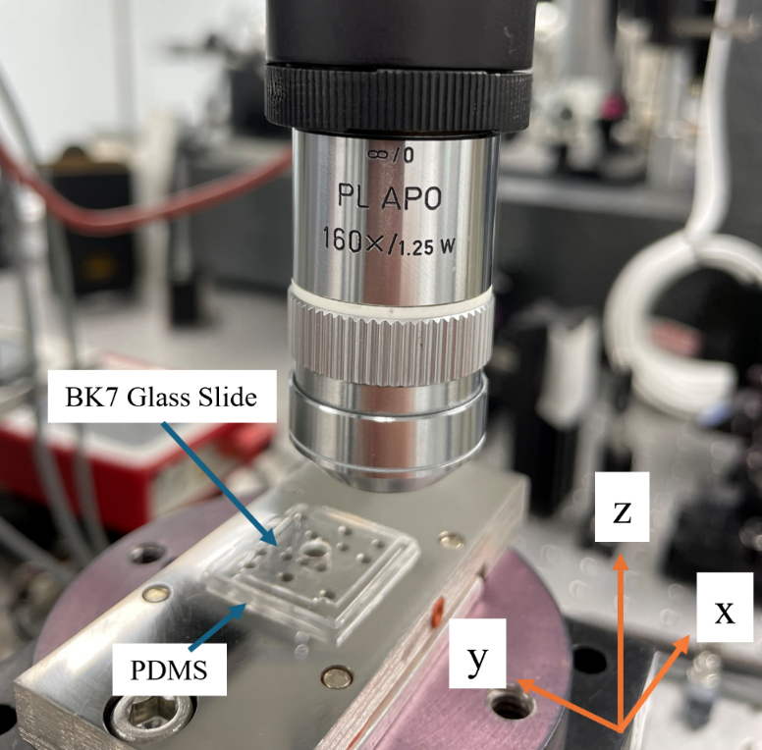
Figure 3.1. Laser machining setup with coordinate axes.

µm): (0, −50) and the second point’s coordinates are: (20, −49). This continues to the end of the array at (2000, +50). A diagram of this process is shown in Figure 3.2.

To aid in discerning the z-position at any point along the array, vertical division markers were set at every 200 µm along the array. Each vertical division denotes a set of 10 pulse locations. These vertical division markers were accompanied by a horizontal line that spanned the entire array length: 2000 µm. Both the vertical division markers and the horizontal line were offset below the array to avoid interference with the machining process. Finally, to denote which array belongs to a specific fluid, a marker was inscribed onto the glass beside the array (along x), as seen in Figure 3.3. Each marker uses the shorthand notation outlined in Table 3.1 to describe which fluid was used.

The lens of the objective was cleaned between each new fluid to ensure no cross contamination occurred. This was done by using Thorlabs lens cleaning tissues soaked with organic solvents like acetone or isopropyl alcohol. After the lens was cleaned with these wet tissues, the lens was washed with deionized water (while still attached to the microscope turret), sprayed from a clean 3 mL pipet. The water was collected in a plastic cup to ensure no water accidentally spilled onto the machining setup. After washing, the lens was dried with a new lens tissue. This process was repeated for all fluid samples across all experiments.

3.3.1 Immersion Machining
Air, the only gas tested, required a flow of dry nitrogen over the surface to help clear any debris from the laser machining process and protect the objective from contamination because of its short working distance (~100 µm). The industrial nitrogen was supplied by a pressurized tank and fed through tubing to a valve where the nitrogen flow could be turned on or off. The valve fed to a thin metal pipe that directed the flow onto the surface of the glass under the objective. For the liquid immersion media, 3 mL disposable plastic pipets were used to transfer a few drops of each liquid onto the surface of the substrate. The objective was then positioned using the microscope turret adjustment to immerse the objective tip in the liquid, and then the surface was brought into focus by observing when the visible but dim laser spot appeared most concentrated. This step is necessary because each liquid has a higher refractive index than air, which changes the z-location of the focus. In the case of the immersion oils, this proved to be a difficult process, because the oils have a very similar refractive index to the borosilicate glass substrate, making reflectance from the glass surface very weak. However, by using the burst mode operation of the laser, in which individual pulses are subdivided into an envelope of a user-selected number of subpulses with 25 ns separations, the intensity of the spot could be increased to aid in visualization but without initiating cavitation or damaging the substrate surface. This result was possible because the pulse energy dispersed among the individual subpulses did not reach the ablation or cavitation threshold, and the comparatively longer timing between subpulses precluded accumulative energy absorption, as discussed in Section 2.2.

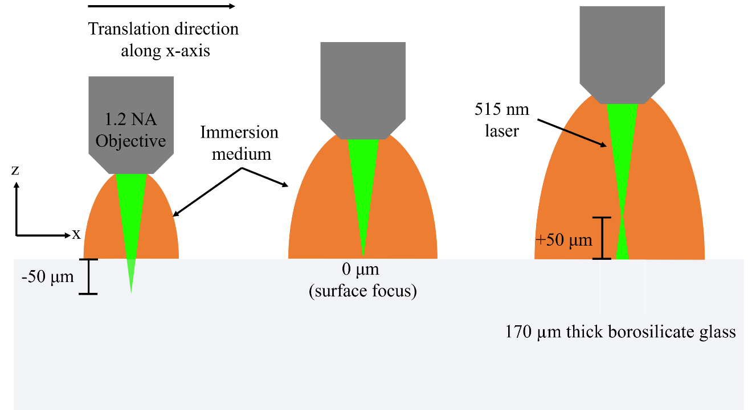
Figure 3.2. Z-step array machining with immersion fluid.

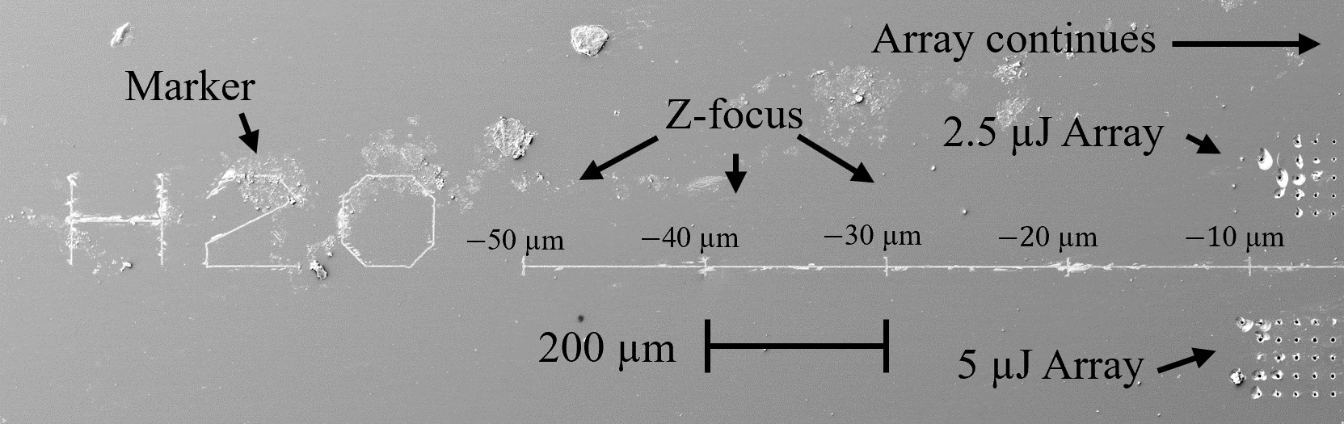
Figure 3.3. Z-step array example for H2O. Surface damage for both 2.5 µJ and 5 µJ pulse energies starts approximately −10 µm below apparent surface focus.

It should be noted that the mirror directing the laser beam through the objective to the sample is a dual-wavelength, dielectric mirror designed to reflect both 1030 nm and 515 nm light. Because of its dual-wavelength coating, its reflectance is not perfect at either wavelength, and a very small percentage of light reflected from the sample surface is transmitted through the mirror, allowing for optical observation through the stereo eyepiece of the machining microscope, but only when the incident laser intensity is low enough to be eye-safe, as during the surface-location part of experimental setup. Care was taken during these measurements when using the higher machining pulse energies not to view the focused laser either through the eyepiece or external to the machining area without appropriate laser safety eyewear.

For each new fluid tested, a new location well-separated from already-irradiated areas on the glass substrate was chosen. The order in which the fluids were tested was arbitrary, so long as each fluid had a unique marker and was sufficiently distant from another fluid array. All experiments applied the fluids in a similar manner to the description given in this section.

3.3.2 Pulse Energy Selection
Two pulse energies were selected for use during the Z-step experiment, 2.5 µJ and 5 µJ. The power of the laser beam was measured with a Thorlabs S425C-L thermal sensor and PM100D power meter. Pulse energy was calculated by dividing the measured wattage by 200,000 (the pulse rate during measurement was 200 kHz) to obtain the pulse energy in joules. The choice of pulse energies was arbitrary, although it was decided that the lower value should be above the ablation threshold in air (~633 nJ) for the 160× objective to ensure localized single-pulse ablation damage, but not so high as to cause massive disruption over a large surface area. The choice simply to double the selected energy this provided a convenient option for direct comparison of the machining results.

The two different pulse energies required two separate arrays for each fluid. The method described in this section was used for both pulse energies. For the case of 2.5 µJ pulses, this array was set above (in +y) the previously mentioned vertical divisions and horizontal line. The 5 µJ pulse energy array was placed below (−y) the vertical divisions and horizontal line. The 5 µJ array was created in the same manner as the 2.5 µJ array, with the only differences being the location of the array and the pulse energy. With two pulse energies, a larger data set could be collected, as well as possibly outlining how pulse energy would also affect the machining range of the fluids. For the other two experiments (discussed in the next section), the pulse energy for immersion machining was set to 5 µJ.

3.4 Surface Focus Damage and Cross Section Experiment
For this experiment a 3×3 mm² array of holes at a constant z-height was laser-machined into the glass substrate. Each hole was drilled by a single pulse and separated in the x- and y-directions by 5 µm spacings. The intent was to create a dense, uniform, and square array of holes such that a transverse fracture could be made in the glass to enable the observation of the cross-section of the holes. To make this fracture, first the machined glass substrate was flipped upside down. Next, the top surface (surface closest to the microscope objective) of the flipped array was brought into focus. A scribe line was lasered using pulses at 200 kHz repetition rate, traversing at 2000 µm/s, and 3 µJ pulse energy across an oblique angle to the array. After machining, the substrate was removed from the chuck and placed on the surface of a work bench where the scribe line was aligned with the edge of the bench. Pressure was applied to the suspended corner of the glass while securing the supported corner, until the glass slide broke apart. Because glass is an amorphous solid, it is difficult to break along linear planes; however, by using the dense population of holes on one surface and adding a scribe line on the opposite face to the array, a high-enough stress concentration should exist to ideally propagate a fracture along through the slide starting along the scribe line, and thus revealing a diametrical split across some holes in the array. In practice, this result is challenging to achieve for thin glass, like the cover slips used in these experiments, which frequently end up fracturing into several irregular pieces, and with non-orthogonal or even multifaceted z-planes. However, even a few holes lining up along an edge are enough to reveal the profiles in the cross section. Each sample was cleaned with compressed air after fracturing to remove any loose debris that may have collected on the surface.

For the surface profile data, each of the eight substrates were sampled five times at random locations on the 3×3 mm² array to create a larger data set for each trial. Each area (~130×130 µm²) was chosen to be sufficiently distant from another area to avoid overlap in the surface roughness data collection. Four out of five sampled locations resided respectively in the four corners of the array, and one sample was collected from the middle of the array. The areas were scanned using a Keyence VK-X3000 3D Surface Profiler in laser confocal mode. This mode uses the intensity of reflected laser light (emitted from the microscope) to detect height information about the surface of the substrate. The microscope lens is moved axially to gather information over the entire field of view [43].

A final note about samples and fluid testing: for each experiment, eight fluids were tested (8 samples). For each sample, five separate trials were completed. Each trial comprised five data collection locations, whether that be five rows of pulse locations for the z-step array experiment, or five scanned areas for the surface roughness experiment. This brought the total number of data points for each sample (each fluid) to 25, reducing the likelihood of inaccuracies of each experiment’s data. The only exception for this is the TA and TB samples for the surface focus (and cross section) experiment, where only a single sample was able to be obtained for each fluid (but still had 5 trails per sample).

3.5 Sample Imaging
Most sample imaging was done with a JSM-IT700HR scanning electron microscope (SEM). For quick imaging, the SEM could be set to a low-vacuum mode, which enabled backscattered electron imaging (BED). This allows samples to be scanned without being coated in a conductive material, which is typically needed for non-conductive sample imaging, and adds additional time and complexity. Low-vacuum settings can be used for topographical and compositional SEM imaging. Some images gathered in the cross-section experiment were captured using backscattered electron topographic or compositional imaging (BED-T or BED-S). For most other SEM imaging, samples must be electrically conductive to prevent the sample surface from being electrically charged by the electron beam. To prevent charge build-up (a process in which electrons are added to the sample at a rate faster than the sample can discharge them), the sample can be sputter coated. This is a process that places a thin layer of conductive material onto the sample surface. An example of a sample being sputter coated is shown in Figure 3.4. In the case of the cross-section experiment samples, the substrate was mounted to a 45° angle chuck, 38 mm in diameter for coating and imaging of the broken surface of the glass. Additionally, the SEM sample stage can rotate a sample 45° about the x-plane (in z), and 360° in the xy-plane. This means that the sample cross section can appear normal to the incident electron beam should the 45° angled chuck and the x-plane rotation be additively used. Allowing for the sample to be rotated a maximum of 90° allows for the cross section of each sample to be viewed. Some of the images discussed in the results section are taken at an 85° angle (sample stage was tilted by 40 degrees, plus the 45° chuck), respective to the SEM origin. Other images are taken at ~80° angle respective to the incident electron beam to add a depth of field to the image, as well as showing the surface surrounding the hole.

In the case of all experiments discussed in this paper, all samples were sputter coated using platinum as a sputtering material. For sample sputter coating, each glass slide was secured to an aluminum SEM stud with carbon tape which wrapped around the back of the sample and onto the top surface of the glass. During sputtering, the platinum would form an electrical connection with the carbon tape. This tape grounded the samples to the SEM during imaging, aiding in reducing charging of the sample.

For higher-resolution images, coated samples were imaged using secondary election detection mode (SED). An example of a typical sample SED image is shown in Figure 3.5, where high resolution imaging of the ablated substrate can be observed in detail. Other images of the samples were with optical microscopes such as the VK-X3000 3D Surface Profiler. This microscope allowed for 3D profiles of the sample surface to be scanned and mapped. The scans used a Nikon 150×, 0.95 NA lens on the VK-X3000.

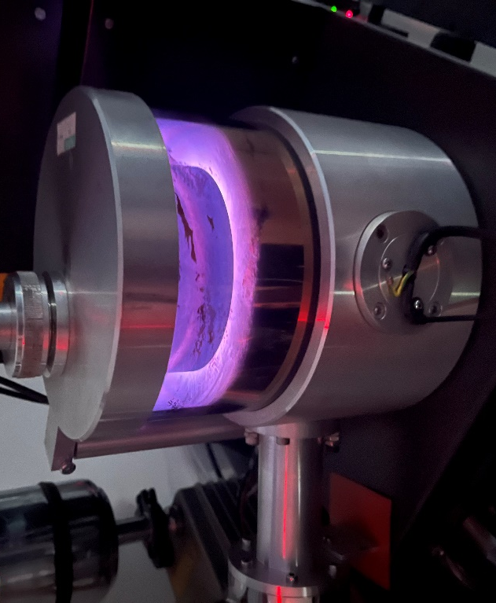
Figure 3.4. A sample being sputter coated in platinum.

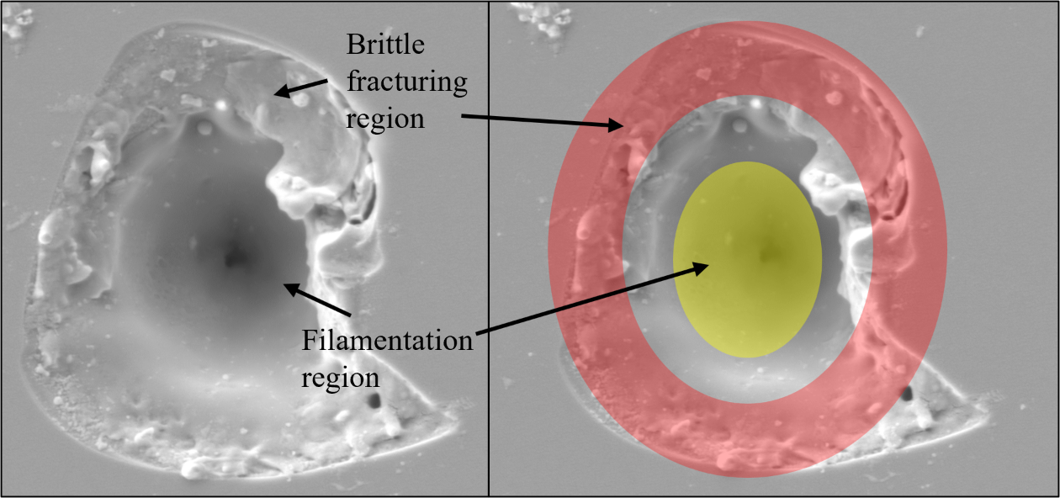
Figure 3.5. Left: an example of a hole created using H2O as an immersion fluid with a single 5 µJ pulse. Right: the superimposed red outer circle denotes the brittle fracturing region, while the yellow inner circle denotes the filamentation region.

Chapter 4: Results and Discussion

4.1 Z-Step Array Results
To record the location at which surface modification is done to the substrate, each sample was sputter coated usings platinum as a sputtering material. This enabled the use of secondary electron detection (SED) for imaging with the SEM. SED was used to collect high-resolution images such that the location of any surface modification could be observed and recorded. For each fluid sample, five total experiments were conducted. The positive and negative ranges over which surface damage was observed were recorded and averaged. Negative values denote a laser focal point below the substrate surface, while positive values are above the substrate surface. Figure 4.1 displays the focal ranges over which surface modification was observed for each immersion fluid at 2.5 µJ pulse energy (a, c, e) and 5 µJ pulse energy (b, d, f). Figure 4.1a and 4.1b are sorted by ascending vapor pressure of the fluids. Figures 4.1c and 4.1d are sorted by ascending kinematic viscosity, and Figures 4.1e and 4.1f are sorted by ascending fluid density. The maximum range tested in this experiment was ±50 µm. The purpose of comparing the vapor pressure, kinematic viscosity, and density between liquids was to highlight specific constants that are used in the generalized Rayleigh-Plesset (RP) equation (Eq. (2.12)) that may dictate cavitation bubble dynamics. For this experiment, the aim was to determine if specific fluids enhance or suppress machining by allowing the focus to have an increased or decreased range through which material removal was still observed.

In Figures 4.1a and 4.1b a steady decrease in the relative range is observed in the first three fluids. The −z machinable range remains mostly the same for BMI, EMI, and GLY, while the +z machinable range decreases with each increment of vapor pressure. The two immersion oils (IOs, TB and TA) produced the largest +z machining range, with TB exhibiting the maximum of the two. H2O produced the minimum total range, having the smallest overall machining range. IPA’s machining range is similar to EMI for both pulse energies, and finally, AIR produced the largest −z machining range of all fluids. AIR’s subsurface range reached –50 µm for 5 µJ pulse energy, and nearly –50 µm for 2.5 µJ pulses.

Figures 4.1c–4.1f display the same sets of data shown in Figures 4.1a and 4.1b but reordered based on other physical properties to highlight any noticeable trends that might be associated with other fluid physical properties. Figures 4.1c and 4.1d are an ascending sort based on the kinematic viscosity, $ν_{L}$. The kinematic viscosity is the dynamic viscosity ($µ_{L}$) divided by the density ($ρ$), shown in Eq. 4.1. It can be obtained for each fluid by the data given in Table 3.1

$ν_{L}= \frac{µ_{L}}{ρ}$. (4.1)

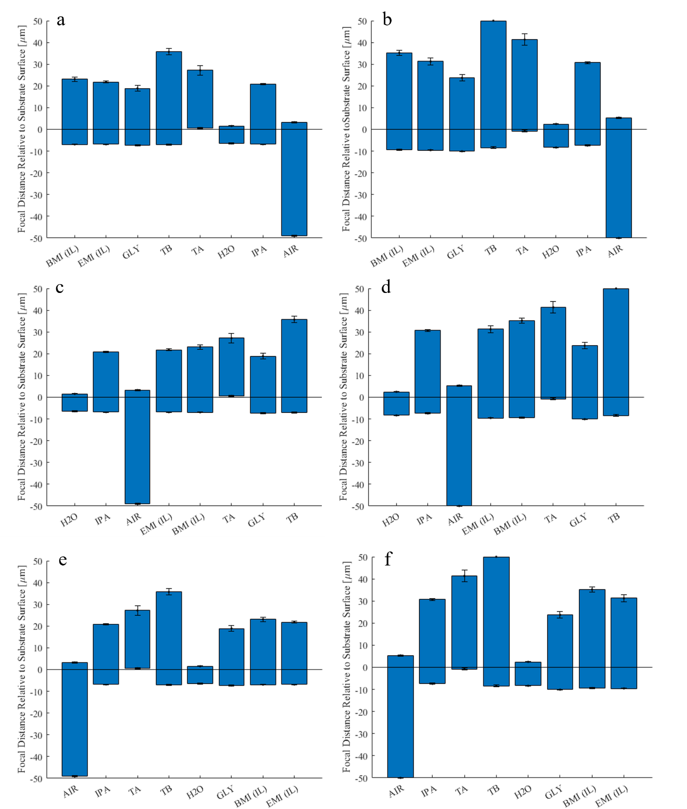
Figure 4.1. Range of features for each fluid with 2.5 µJ pulse energy (a, c, e) and 5 µJ pulse energy (b, d, f). Each fluid is sorted by ascending: vapor pressure (a,b), kinematic viscosity (c, d), and density (e, f).

In Figures 4.1c and 4.1d, (ascending kinematic viscosity), the data suggests that increasing the kinematic viscosity of the immersion fluid will also increase the +z machining range, with two exceptions being AIR and GLY.

The ascending density sort (Figures 4.1e and 4.11f) seems to identify an oscillation in +z machining range. The point of inflection is H2O, which has a density of approximately 1 g/cm³. This result suggests that density may play a stronger role in extending the machinable +z range for immersion liquids, but more research on this topic is likely necessary, covering and expanded range of densities about H2O’s to verify the trend.
As for differences between pulse energies, increasing the pulse energy from 2.5 µJ to 5 µJ increased the total machining distance across all fluids, but with varying amounts between fluids. The subsurface machining range for most fluids, remains largely the same at around –10 µm below surface focus except for TA and AIR. A peculiar observation is that for pulse energy of 5 µJ, TB reached the maximum +z range of +50 µm, while AIR reached the maximum −z range of –50 µm. The exact reason for this is unknown, but perhaps may be attributed to the refractive index of the immersion medium, although TA did not demonstrate the same machining range as TB despite nearly identical physical properties besides the viscosity. Another possibility is that the 160× objective was designed for water immersion, and thus its focusing ability may be significantly modified when used with other immersion media, which might include focal aberrations not occurring with H2O.

In Figure 4.2, examples of the hole geometry created in this experiment are shown for AIR (Figure 4.2a), H2O (Figure 4.2b), IPA (Figure 4.2c), and GLY (Figure 4.2d). Each hole was created using a single 2.5 µJ pulse. In Figure 4.2a and 4.2b, the control fluids are shown. AIR has a small central hole, approximately 500 nm in diameter. Surrounding the hole location, solidified recast material and leftover debris is seen, which partially obscures the hole entrance. For H2O, the hole geometry is very large and irregularly shaped compared to AIR or GLY, and approximately 2.5–3 µm in diameter. The brittle fracturing region appears to be more than double this, about 7 µm in diameter. With the IPA sample, brittle fracturing of the substrate surface is also seen. The central hole diameter for IPA appears to be approximately the same diameter as H2O. Finally, with the GLY sample, the central hole diameter is much smaller, approximately half the size of IPA or H2O. Again, brittle fracturing surrounding the hole is seen, but appears to be less severe than the higher vapor pressure liquids. From this limited data set, it may appear that LVPFs may inhibit the damage done by cavitation, and hence, reduce brittle fracturing of the substrate. This will be explored more in the following experiments. Each image was taken at approximately the same z-position. Because each fluid may not have produced a hole exactly in the same z-location, the range for these images varies from z = –2 µm to about z = –6 µm. Comparison of these holes is only to exemplify the typical behavior of substrate ablation using different immersion media. The magnifications for each image are 15,000×, 10,000×, 10,000×, and 20,000× for 4.2a–4.2d respectively.

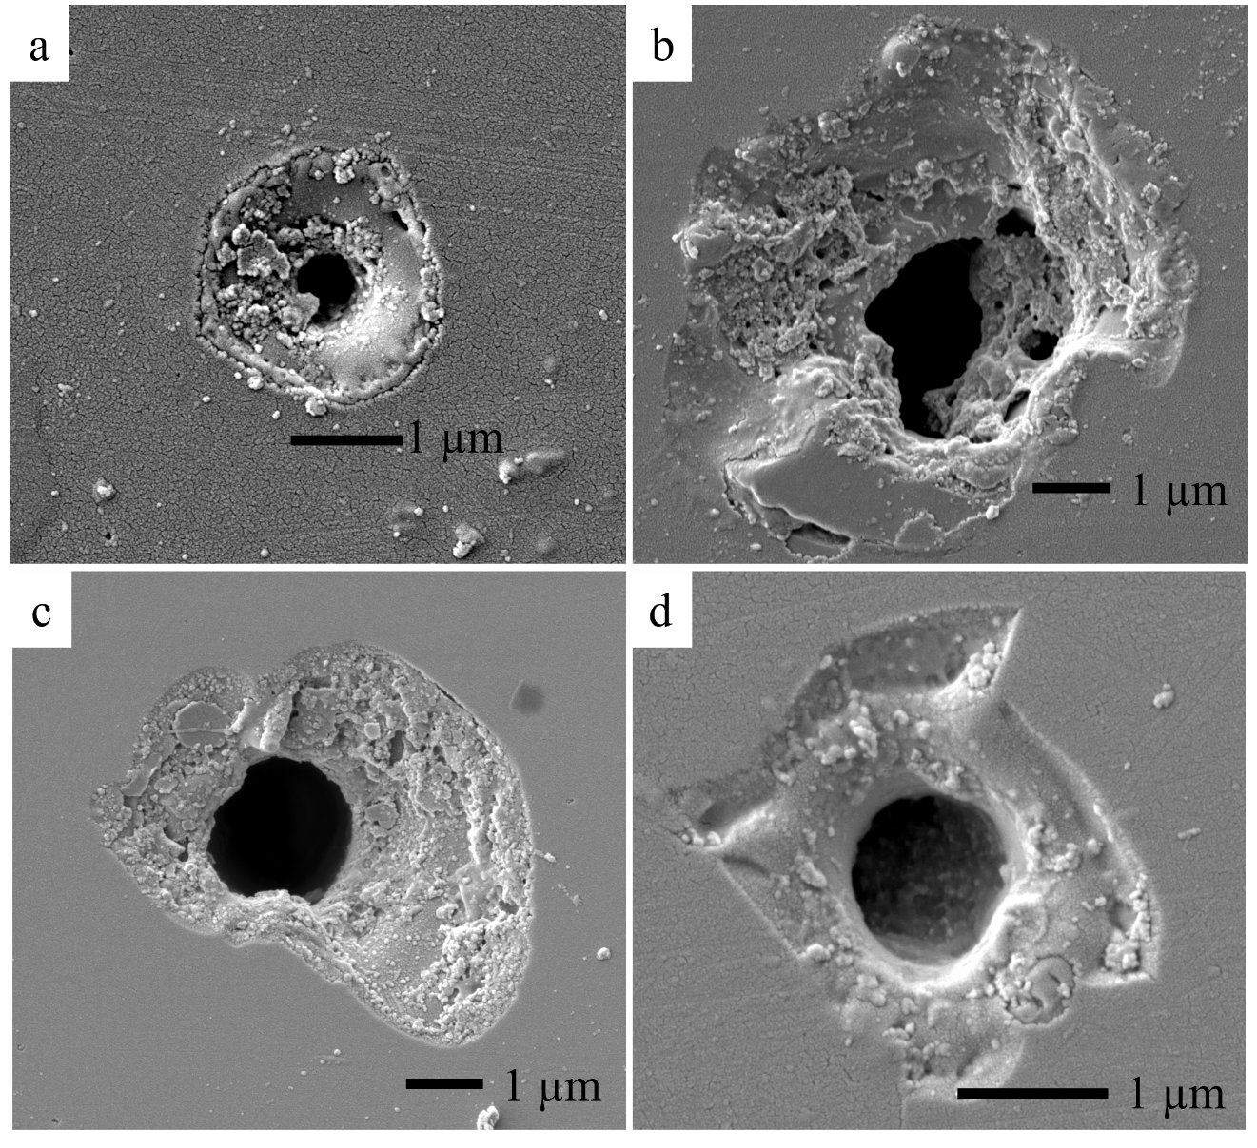
Figure 4.2. High-magnification SEM images of holes created by cavitation using (a) AIR, (b) H2O, (c) IPA, and (d) GLY as the immersion media. Each hole was made with a single 2.5 µJ pulse.
Figure 4.3 displays a collection of typical holes created using the two ILs and IOs as immersion medium for laser machining. EMI is shown in Figure 4.3a, followed by BMI in Figure 4.3b. The IOs are TA in Figure 4.3c and TB in Figure 4.3d. With the ILs and IOs more recast material is seen on or around the hole locations than in the previous samples, but little to no brittle fracturing. EMI (Figure 4.3a) appears to have a similar amount of recast surrounding the hole location as BMI (Figure 4.3b), forming the “torus”-like mounds seen as the smooth exterior tori around the central holes. The source of these features is not known at present, but two possible causes can be offered. First, because the temporal evolution of the cavitation process was not observed, some property (or properties) of these fluids could have altered the dynamics of the laser-fluid interaction that coupled more energy into the substrate and inducted thermal melting. However, given the ultrafast nature of the pulses used here, it does not seem likely that the laser-matter dynamic would be so significantly affected. A stronger possibility is that these fluids, having higher dynamic viscosities, heated up more during the cavitation bubble collapse, to the point of locally melting the substrate material (thermal parameters such as diffusivity, conductivity, and specific heat were not considered in this Thesis). Again because of the higher viscosities, this melted glass could not easily flow away from the ablation region and essentially cooled and solidified in place, while the collapsing bubble’s fluid jet punched the central hole of the torus. Central hole diameters of about 1 µm are seen for both IL immersion fluids.

For the TA sample (Figure 4.3c), the surface experienced a brittle fracturing around the pulse location which evacuated the surrounding substrate material, revealing a small-diameter hole. It is possible the remaining diametrically small hole is the beginning of the filament made by the laser ablation process, and the hole entrance was completely removed by the brittle fracturing of the sample surface. As for the TB sample, the pulse location is completely covered by recast material ejected from the pulse location during laser machining. A majority of the TB sample’s pulse locations were of this nature, making it difficult to examine the interior of the holes and immediate surrounding areas. However, upon close inspection of the image, it is likely there is a partially covered hole in the center of the recast material, seen as the black region in the torus-shaped recast material. This may also merely be a lack of electron bombardment in this location. This sample appears to have some charging effects, seen by the dim but frequent horizontal lines across the substrate surface (the background of the image), and the bright contrast of the recast material versus the dim substrate surface. Typically, these effects are indicative of sample charging in SEM images [44]. Despite these negative effects, it may be observed that the recast material appears to be of similar size to the TA sample ablation region (Figure 4.3c). This, in turn, may imply the surface characteristics of machining with the IOs are similar, assuming the brittle fracturing of the TA sample had not occurred. The sample machining characteristics and surface damage will be discussed more in-depth in the next section. The images in Figure 4.3 were all taken at 10,000× magnification, and approximately at surface focus (z = 0 µm) to remain mostly consistent Figure 4.2.

Possible sources of error for this experiment include inconsistent surface focus between

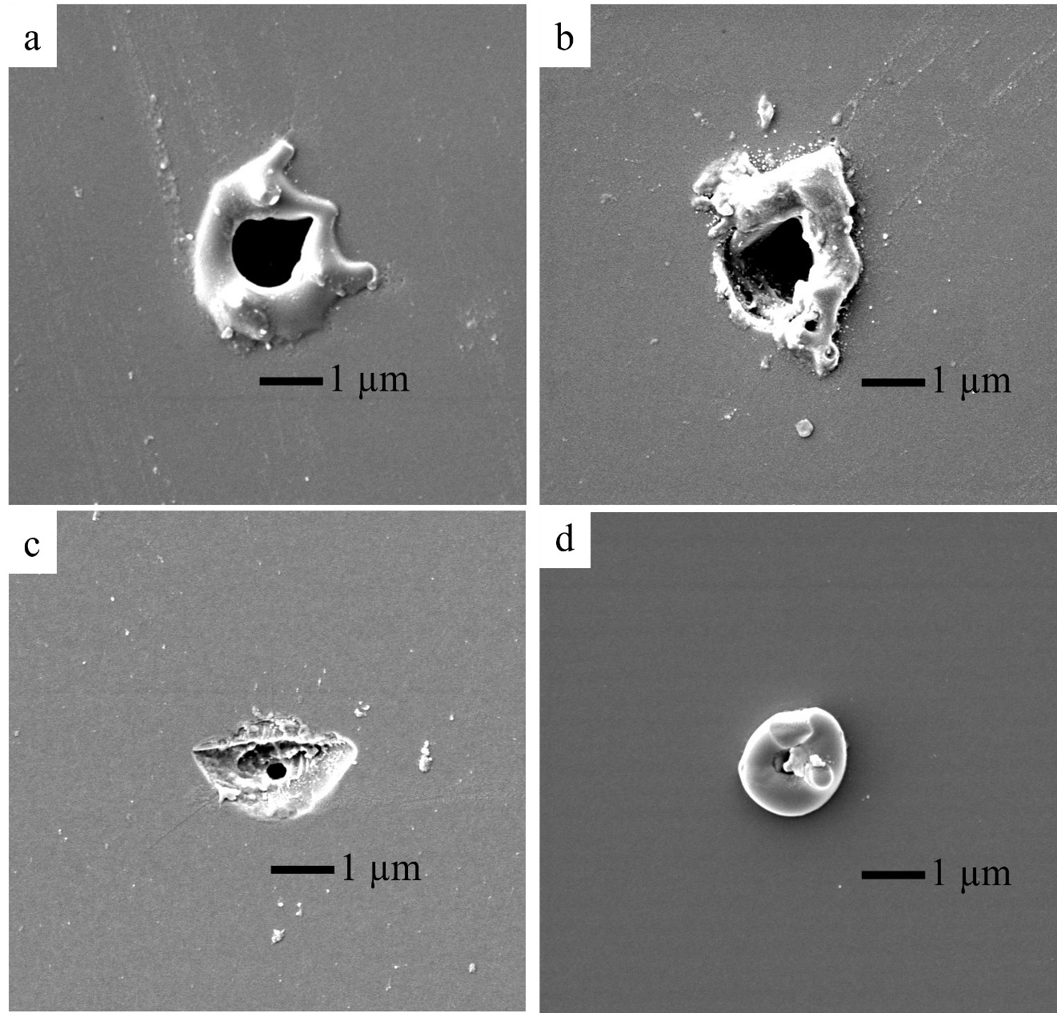
Figure 4.3. High-magnification SEM images of holes created by cavitation using (a) EMI, (b) BMI, (c) TA, and (d) TB as the immersion media. Each hole was produced using a single 5 µJ pulse.

samples. Because the surface focus is determined by manually finding the point where the laser spot size appears smallest, the surface focus may vary slightly from sample to sample, as this judgment is user specific.

4.2 Surface Focus Damage
In this experiment, the surface of each machined array was analyzed by determining the arithmetic mean height (Sa) and the maximum height (Sz). Arithmetic mean height is the difference between each point measured compared to the arithmetical mean of the evaluated surface [45-47]. Sa is expressed as an absolute value and is widely used to measure surface roughness. The maximum height is the sum of the highest peak and the deepest valley over the analyzed area [45-50]. Each fluid is discussed relative to one another because Sa is measured using the entire surface; the spacing between each hole would affect the value of Sa. A more densely packed array (hole spacing smaller than 5×5 μm) would increase the value of Sa, whereas increasing the hole spacing would decrease the value of Sa, since damage to the surface would be more/less concentrated, respectively. This section discusses the observed damage and recorded data from these measurements. Any significant findings in regard to Sa will be discussed on the basis that an order of magnitude decrease in the Sa value from H2O is significant. Sz is excluded from this because it is a measure of absolute height range. While it is still important to consider the Sz of the samples, Sz can be skewed by outlier data easily.

Figures 4.3 and 4.4 display the averaged Sa and Sz (respectively) of each fluid plotted on a logarithmic y-scale. Each fluid was investigated over five trials, where trials were conducted at five separate locations in an array, 25 recorded points in total. The numbered areas from each trial were averaged to produce the mean values graphed below. In other words, areas #1 from trials 1 through 5 were averaged together, then areas #2 from trials 1 through 5 were averaged together, etc., producing 5 mean-data sets. This was the case for all fluids except TA and TB. The IOs proved difficult to create repeated data sets of, most likely due to their index-matching properties with borosilicate glass interfering with surface location. Index- matching immersion fluids strongly inhibit reflectance from the surface of a substrate of closely matched refractive index, so it can be very difficult to discern where the surface of the glass is. Without a proper focus on the substrate surface, modification of the glass may be minimal, or even non-existent. However, one trial run proved successful, and this data is included in the graphs, but the values for the IOs were not averaged like for the other 6 fluids.

Figure 4.3 displays the mean Sa of each fluid tested. Notably, H2O and IPA have significantly higher average surface variation compared to the other 6 fluids. These two liquids share a common physical property: a relatively high vapor pressure compared to the other fluids tested (except for AIR). The increased variation in the substrate surface may be attributed to the high vapor pressures of H2O and IPA, which allow for the fluids to more readily cavitate during lasing. High vapor pressure fluids may cavitate more easily because less energy is required to be absorbed by the fluid to initiate a phase change in the fluid. With the experimental parameters mentioned previously, the laser pulse will cause

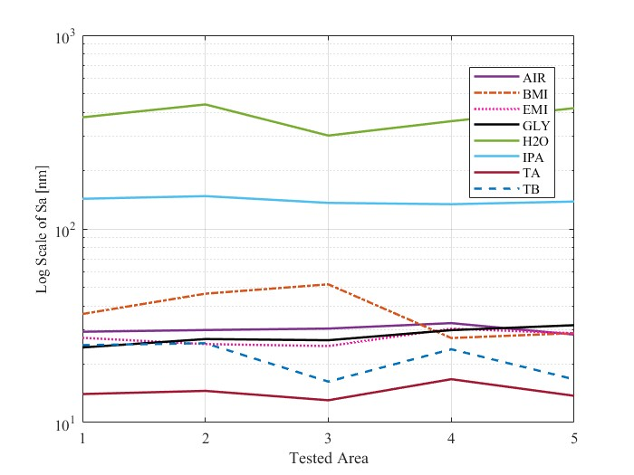
Figure 4.3. Variation in arithmetical mean height for all fluids tested over the five test areas.

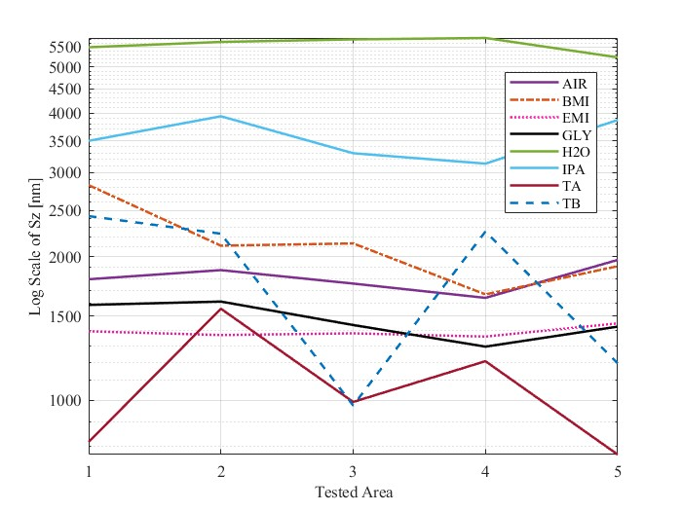
Figure 4.4. Variation in maximum height for all fluids tested over the five test areas.
fluid cavitation no matter the vapor pressure of the fluid tested.

The remaining 6 fluids in Figure 4.3 are more closely packed and have lower variations (smaller Sa values) over their substrate surfaces. This means that less physical damage has been done to the surface of the substrate using these fluids. Physical damage includes chipping and cracks that propagate across the surface, causing excess material removal that would otherwise not occur from non-liquid-immersed laser machining alone. This provides evidence that cavitation damage occurred and increased the surface modification to the sample. This can be corroborated with the AIR sample, which does not undergo cavitation. In Figure 4.3 it is shown that the AIR sample does have a lower Sa than IPA and H2O. For the other fluids (TA, TB, GLY, EMI, and BMI), the arithmetic mean height is of similar numeric value to the AIR sample. This implies that these fluids suppress the additional damage done by cavitation. These five fluids all share the same physical property: low vapor pressures.

In Figure 4.4, the Sz for each sample is shown. Again, a similar trend is seen, where IPA and H2O have the largest differences between their highest peak and deepest valley compared to the other 6 fluids. It might be expected that a fluid which can cavitate more easily, and thus cause more severe cavitation damage (perhaps due to a low vapor pressure), would produce deeper features in the substrate. These features are evidently created from the fracturing of the substrate during cavitation bubble collapse. However, recalling that the xy-spacing between laser pulses in this set of experiments is only 5 µm compared with 20 µm in the z-arrays, it makes sense that the glass surface would experience more stress from closely spaced events than from more-isolated shots, and thus would be more prone to suffer additional fracturing in this set of experiments.

The data for TA, TB, and BMI depict more variation over the 5 test areas than seen previously in Figure 4.3 on a per-fluid basis. This implies that these liquids can still cause brittle fracturing of the substrate surface from bubble collapse and, possibly, do not fully suppress fluid cavitation and its adverse effects. On the contrary, it is shown that GLY and EMI have a uniform Sz across the tested areas and are less likely to produce random variations in the substrate topography. This provides further evidence that these two liquids suppress cavitation damage. AIR also has relatively uniform Sz, but with no liquid to cause cavitation, the surface variation can instead be attributed to recast material on the substrate. In an immersion liquid, this ejected material would tend to be captured in the fluid before it redeposits on the surface and rinsed off during cleaning.

In Figure 4.5 the fluids are sorted by ascending vapor pressure value and plotted against Sa. The fluids show a descending trend in the Sa value until H2O, where the value spikes, before the trend continues downwards again. From this downward trend with increasing vapor pressure, it can be interpreted that lowering the vapor pressure of the fluid past a threshold does not proportionally decrease Sa, and in part, suppress cavitation damage. In fact, from ordering the vapor pressures, a minimum Sa is found for IO TA, which falls in the middle of the sorted fluids. This oil has a vapor pressure of less than
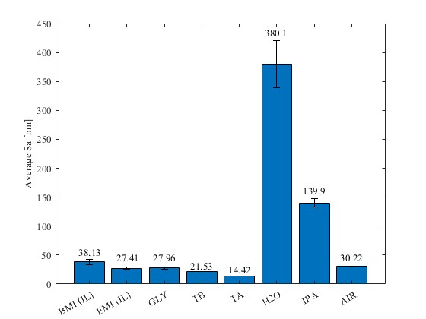
Figure 4.5. Averaged Sa sorted by vapor pressure in ascending order.

0.10 mmHg (the exact room temperature vapor pressure is unknown), while H2O has a vapor pressure of 23.7 mmHg at room temperature. TB has a similar vapor pressure as TA, and GLY is one order of magnitude below TA and TB. Using the KDB correlation equation for GLY, the vapor pressure of GLY can be calculated at 25 °C [51-53]:

$ln\left(P_{vp}\right)=Aln\left(T\right)+ \frac{B}{T}+C+DT^{2}$. (4.2)

In Eq. 4.2 $T$ is the temperature in kelvins, $P_{vp}$ is the vapor pressure of the fluid in kPa, and A, B, C, D are coefficients whose values are listed in Table A1 in the Appendix. At 25 °C (298.15 K), GLY therefore should have a vapor pressure of 1.6×10⁻⁴ mmHg, according to Eq. 4.2. The vapor pressure boundaries which sandwich TA are now established; it seems plausible that a fluid with a vapor pressure within the limits of 1.6×10⁻⁴ mmHg and 23.7 mmHg will suppress cavitation damage the best and reduce the Sa.

In Figure 4.6, the laser and optical images used to calculate the Sa are shown for TA, H2O, and IPA (Figures 4.6a, 4.6c, and 4.6e respectively). The generated surface maps are shown as well (Figures 4.6b, 4.6d, and 4.6f). Figures 4.6b and 4.6f are inverted in z to more easily display the locations of the holes drilled by the laser. Comparing Figures 4.6b and 4.6d, it is seen that the H2O sample experienced much more fracturing of the surface compared to TA. Deep, localized fracture regions can be seen in Figure 4.6d; these are the blue-colored locations on this 3D map. Note that the color scale for each image is relative and based on the sample’s own data, and the color scale does not translate between images. These aforementioned fracture locations are absent on the TA sample (Figure 4.6b), and much less severe on the IPA sample (Figure 4.6f). The TA sample also has much smaller diameter holes than the H2O or IPA samples. The array for TA is more uniform and consistent in diameter and surface roughness than H2O or IPA. The holes made in the IPA sample are of similar diameter to the H2O sample, but with less severe (but still substantial) surface damage from cavitation. This specific example is contrary to the previous section’s conclusion that LVPFs suppress cavitation damage. IPA will be discussed in more detail in Section 4.3.

Recalling the generalized Rayleigh-Plesset equation (Equation 2.12), bubble dynamics are dictated by the kinematic viscosity, density, surface tension, and pressures inside and outside of the bubble. While it is difficult to measure the pressure inside the bubble and the surface tension between the bubble-liquid interface, the density and kinematic viscosity can more easily be measured or are known values. Thus, it is important to also consider the impact of fluid density and kinematic viscosity on cavitation dynamics and bubble suppression. In Figures 4.7 and 4.8, the Sa values for the tested fluids are sorted in ascending order for density and kinematic viscosity, respectively.

In Figure 4.7 it is seen that H2O is surrounded by fluids which yield a low Sa value. The IOs have a density slightly less than H2O, at 0.92 g/cm³ while GLY is approximately 25% more dense than H2O at 1.25 g/cm³. Regarding Eq. 2.12, the density of the fluid is found in the denominator of the pressure, surface tension, and (by definition of kinematic
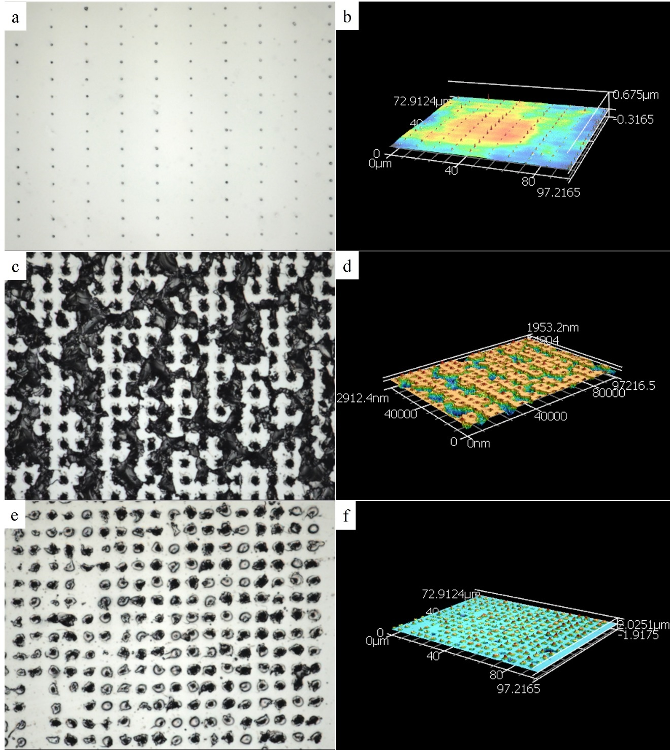
Figure 4.6. Optical and laser confocal images combined (left) and subsequent 3D surface roughness plots (right) for (a), (b) TA; (c), (d) H2O; and (e), (f) IPA.

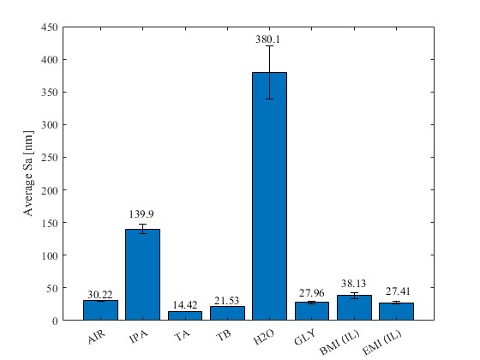
Figure 4.7. Averaged Sa sorted by density of the fluids in ascending order.

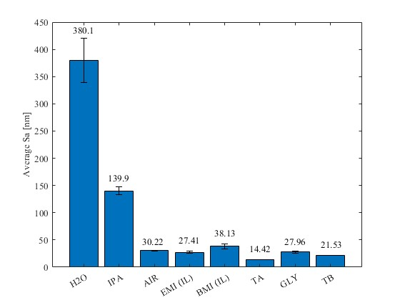
Figure 4.8. Averaged Sa sorted by the kinematic viscosity of the fluids in ascending order.

viscosity) viscosity terms. This, then, would decrease the values of these coefficients with an increase in density. From Figure 4.7, it is difficult to pinpoint any specific trend with an increasing density sort; however, it is observed that all other fluids yield less surface damage than H2O. Most fluids appear clustered close together in Sa magnitude, with the exceptions of IPA and H2O. From this limited data set, it may be concluded that density plays some role in cavitation suppression but may not be a dominant factor.

In Figure 4.8, H2O is the least viscous fluid (with respect to kinematic viscosity) tested, then IPA, which precedes AIR. This graph displays a trend of similar shape to an exponential decay, with some small oscillations towards the tailing end, though it is not a perfect fit. It may be inferred that a fluid which exhibits a larger kinematic viscosity will suppress cavitation damage. Caveats to this claim are also shown in the graph. One example is there is not a strict decrease in Sa with each increment of a fluid. BMI is ranked fifth out of eight on this figure but possesses the third highest Sa value. Similarly, TA is ranked sixth, but has the smallest Sa value.

EMI is the first liquid to exhibit an order of magnitude reduction in the Sa value when compared to the control (H2O). AIR displays approximately the same Sa value as the higher kinematic viscosity fluids (like EMI). Additionally, the higher kinematic viscosity fluids produced similar Sa values, implying there may be a diminishing decrease in the Sa value as kinematic viscosity increases. The sharpest change in Sa value occurred between the range of H2O and AIR (0.90 and 15.0 cSt respectively), but only a single fluid tested in these experiments fell within this region: IPA, which has a kinematic viscosity of 3.03 cSt. It appears likely that fluids with kinematic viscosity lower than ~15.0 cSt may increase the Sa value. However, only two liquids tested in this series of experiments had kinematic viscosities lower than 15.0 cSt (H2O and IPA). Future work should explore Sa values from more fluids in this lower kinematic viscosity range (<15 cSt) to verify the apparent exponential-like decay in Sa observed with these experiments.

From Figure 4.8 it can be inferred that a liquid which possesses a kinematic viscosity between those of IPA and TB may suppress cavitation damage. The empirically determined numerical values are 3.03 cSt < ν ≤ 1260 cSt for IPA and TB, respectively, where 1260 cSt is just the highest kinematic viscosity tested in these experiments, but by no means an absolute upper limit.

Sources of error for this experiment include the lack of repeated data for TA and TB. Due to difficulties in locating the surface of the glass substrate, only one array sample was able to be machined properly for each of these two fluids. Therefore, only 5 data points were collected each for TA and TB, instead of 25 data points as with the other fluids. While the 5 data points will help reduce the probability of statistical anomalies, such as artificially increased/decreased Sa values from machining inconsistencies, a larger data pool would decrease the uncertainty of these measurements. Examples of machining errors include no damage at a pulse location, which may occur due to cavitation bubble interference from a previous shot. Should the machining speeds chosen for this experiment be inadequate to properly allow for the lifetime of the cavitation bubble to elapse, the bubble may defocus the laser, and thus no damage would be done to the substrate. Without knowledge of the exact time each fluid takes to cavitate, these machining speeds may be too slow and interference from the next laser pulse with the previous cavitation bubble may occur. To remedy this, a slower translation speed may be beneficial, which would allow for more time to pass between shots and reduce the chance for defocusing.

Table 4.1 displays the machining speeds for each fluid used in this experiment and each fluid’s kinematic viscosity. These machining speeds were chosen as a “best guess” for which the fluid is believed to be allowed to finish the process of cavitation as well as being close to the upper limit whereby the microscope objective would not cause voids to form upon lateral translation due to the viscosity of the testing fluid.

4.3 Cross Section
This experiment used the same samples discussed in Chapter 4.2. The goal of this experiment was to observe how each fluid physically changed the geometry of the ablation region as well as to profile resulting internal (subsurface) modification. Beginning with the ILs, in Figure 4.9 the cross section for both EMI (Figures 4.9a, 4.9c) and BMI (Figures 4.9b, 4.9d) are shown. In Figures 4.9a and 4.9c, the surface of the EMI sample is relatively smooth with little recast material on or around the pulse locations. In Chapter 4.2 it was determined that the average Sa of the EMI sample was 27.41 nm. Visual inspection of the incident laser surface in Figure 4.9 appears to agree with surface profile measurements that EMI has only small-scale surface variation after immersion machining. Little brittle fracturing caused by cavitation on the surface surrounding the pulse locations has occurred. The cross section of the pulse locations shows some small “cupping” around the impact zone slightly below the surface. These cup-like divots are formed from the laser ablation process. Inside each divot, a thin long region of ablated material is seen. These are the filaments formed from self-focusing, which was discussed in Chapter 2.2. In Figure 4.9c, the filaments are seen to propagate at least ~30 µm into the substrate. The exact depth is undetermined because the fracture angle of the glass is likely not perpendicular to the laser incidence surface, and therefore does not clearly bisect a filament. For the BMI sample, more erupted material from the laser ablation process can be seen on the surface (Figure 4.9b) compared to EMI (Figure 4.9a). The higher surface irregularities found on the BMI sample agree with the data collected in the previous chapter where BMI was calculated to have an overall average Sa of 38.13 nm (across all samples), about 10 nm more than EMI. Recall the definition of Sa, which accounts for all areas on the sample in the scan location. This includes those unaffected by laser ablation, such as the area between two pulse locations. So, the value of Sa will be affected by the flatness of the glass. An unmachined location on the glass substrate may have a Sa value of a few nm. This explains why the recast material on the surface of the BMI sample appears to be on the order of ~0.5 µm in height, but the Sa value is measured in just tens of nm.

Table 4.1. Translational machining speed for each immersion fluid and its kinematic viscosity.
Immersion Fluid | Machining Speed $\left[\frac{µm}{s}\right]$ | Kinematic Viscosity [cSt]
AIR | 2000 | 15.0
H2O | 500 | 0.90
BMI | 200 | 62.0
EMI | 200 | 23.4
TA | 200 | 151.1
TB | 50 | 1260.9
GLY | 50 | 1128.0
IPA | 500 | 3.0

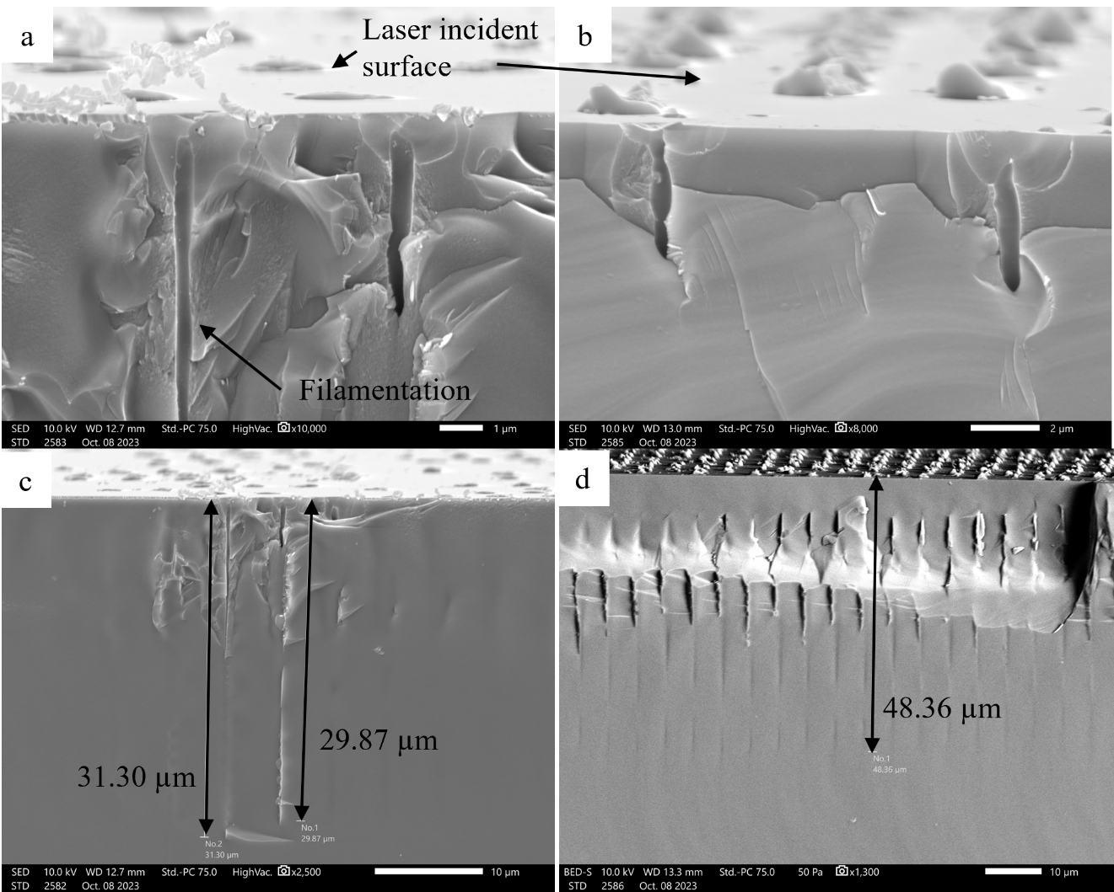
Figure 4.9. Cross-sectional view of EMI (a), (c) and BMI (b), (d). Images (c) and (d) were acquired at a lower magnification so that the filament depth can be observed.

In Figure 4.9b the same cup-like divots are seen as in the EMI sample. However, the filament depth for BMI was found to travel at least ~48 µm below the surface of the glass. Again, the fracture angle of this cross section may not be perpendicular to the glass surface, so the exact depth remains undetermined. An example can be seen in Figure 4.9d, where the filament appears to start some distance below the surface of the glass, stop, and then continue. The start and stop process of filamentation may also be caused by self-focusing and plasma defocusing in the material as the laser pulse propagates through the transparent glass, so it is unknown which case is present in Figure 4.9d or if both are. Either way, the surface of the BMI sample is seen to have more recast build up on the surface of the substrate when compared to the EMI sample.

Figure 4.10 shows the cross section of both TA (Figures 4.10a, 4.10c) and TB (Figures 4.10b, 4.10d). Both immersion oils produced the lowest values for Sa at 14.42 nm (TA) and 21.53 nm (TB). Very little surface modification was produced by these fluids during laser machining. For TB (Figure 4.10b), the recast material is of similar size seen on the surface of the BMI sample (Figure 4.9b). The only difference between the two IOs is their viscosity, with TA being the less viscous.

The TB sample (Figures 4.10b, 4.10d) produced deep and broad subsurface modification. These areas may be where the laser vaporized the substrate, but the vaporized material was unable to escape to the surface and was recrystallized inside the substrate. This phenomenon has been observed and recorded in fused silica, where the vaporized material is quenched from a high temperature, which changes the density of the quenched material compared to the surrounding, unaltered material [8].

In the control samples (H2O and AIR), there is a stark difference in the surface modification between these fluids, as seen in Figure 4.11. The H2O sample (Figures 4.11a, 4.11c) underwent heavy cavitation erosion during laser machining. Severe brittle fracturing of the H2O sample surface is seen in these two images. For ductile materials (like metals), the microjet impact on the surface is generally what is considered to be the main destructive process in cavitation erosion. However, for hard and brittle materials, the microjet impact may not be the main cause of cavitation erosion and could be attributed to the shockwaves generated upon expansion and collapse [54]. Indeed, with hard/brittle materials the impact of the microjet may not produce a high-enough pressure to destroy the surface. That is to say, the microjet impact may happen over a long enough time to distribute the impact force such that the stress experienced by the substrate does not reach the fracture threshold. The impulsive pressure produced by cavitation collapse is of higher magnitude than the microjet impact [54]. The impulse loading of the surface from these shockwaves may be the cause of the damage during cavitation erosion of a brittle material, although the microjet impact is still believed to contribute to cavitation erosion in conjunction with these shocks [54].

In direct contrast to the fluid cavitation damage shown in Figures 4.11a and 4.11c, very little surface damage is seen in the AIR sample (Figures 4.11b, 4.11d). The laser
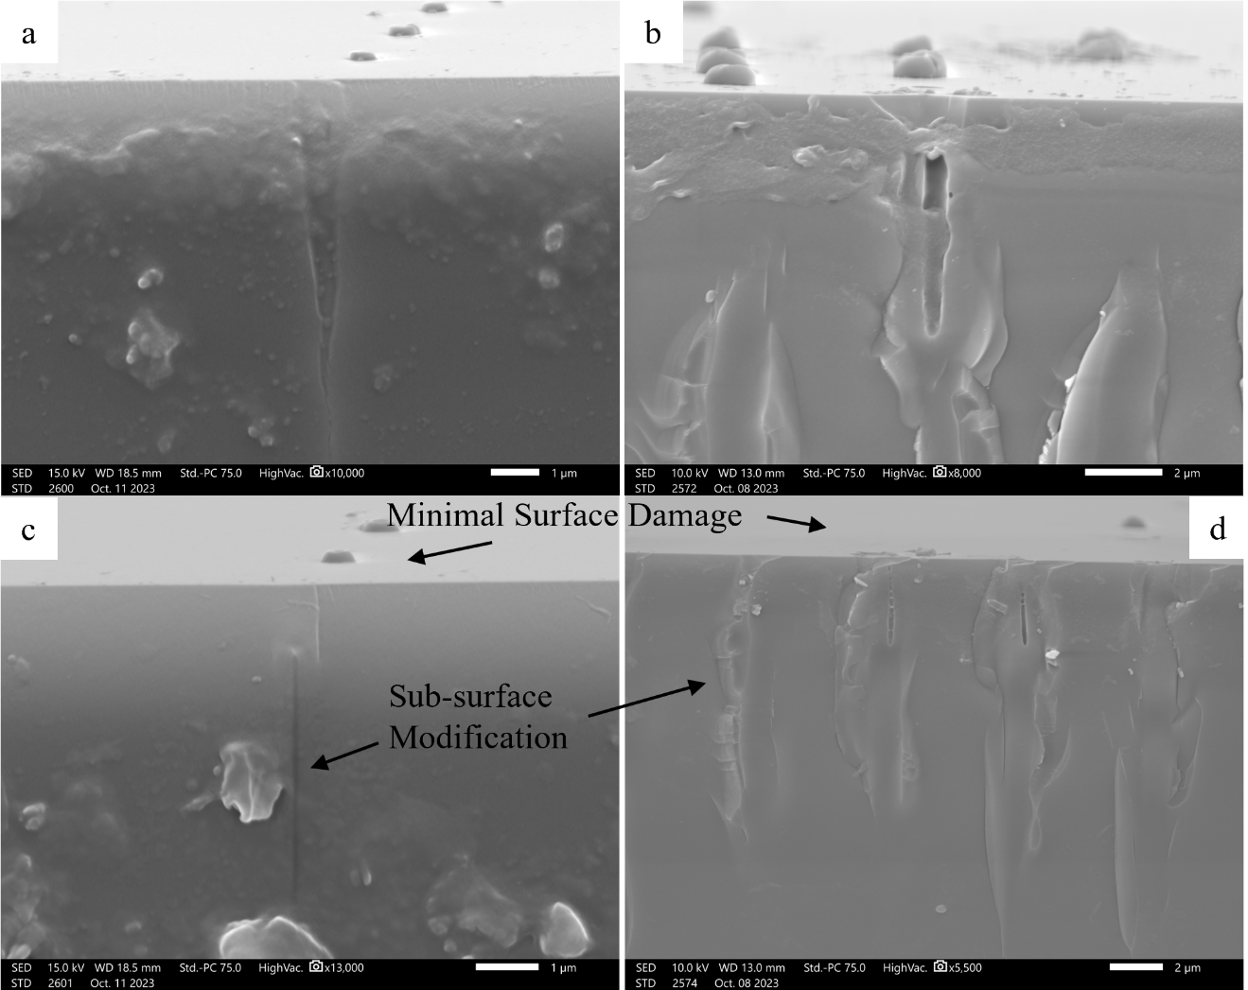
Figure 4.10. Cross-sectional views of TA (a), (c) and TB (b), (d). Minimal surface modification is seen in both samples.
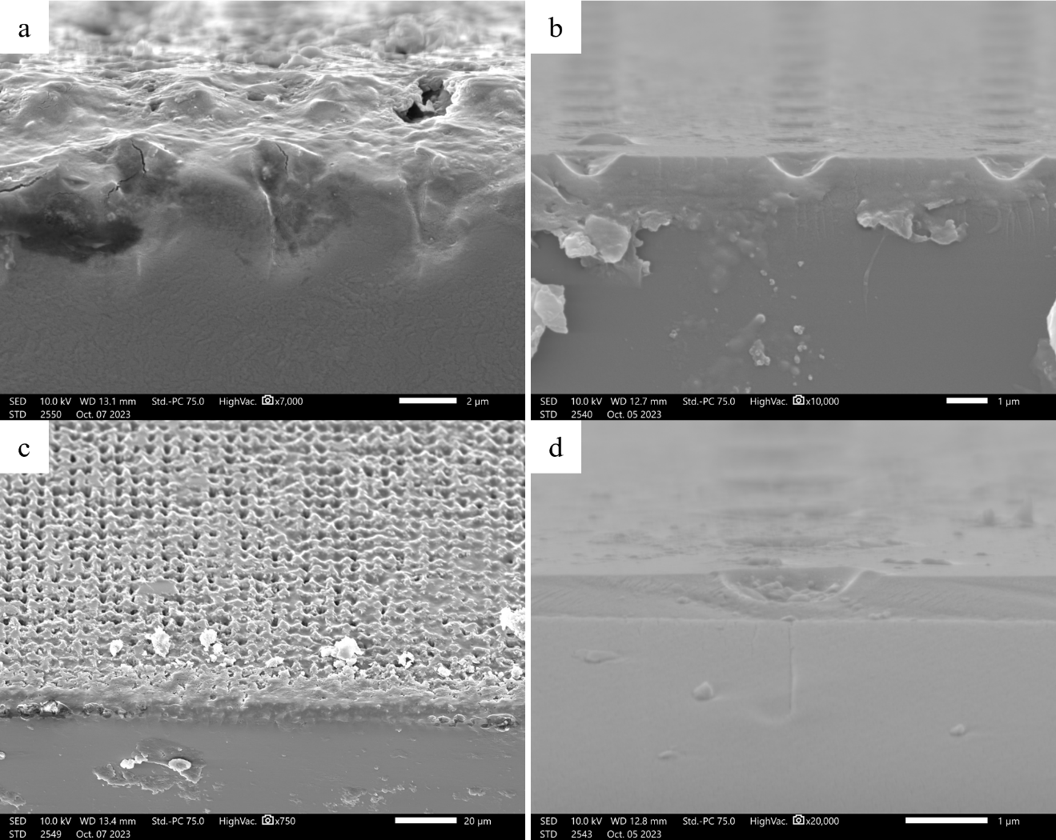
Figure 4.11. Cross-sectional views of H2O (a), (c) and AIR (b), (d).

ablation process in ambient air does produce shockwaves because the optical breakdown threshold of air is similar to that of glass: approximately 10¹³ W/cm² [8,55]. When the laser ionizes the air above the substrate surface, the rapid expansion and collapse of the air causes shocks to form. An analogous process is thunder, which is the formation of shockwaves during the collapse/recombination of the atmosphere after a lightning strike. For shockwaves in rarified matter, however, there may be little or no damage to the solid substrate surface.

A final note on these samples, the surface of the AIR sample, seen in Figure 4.11b, has much more deposited ejecta from laser machining than the H2O sample, or previous samples like the ILs (Figure 4.9) and IOs (Figure 4.10). In liquid immersion laser machining, the ejected material from laser ablation is mostly cast into the liquid medium and suspended in the liquid before it is allowed to congeal onto the surface. No such liquid existed for the AIR sample; so, some of the recast material settled on the surface of the substrate despite the flow of nitrogen gas over the surface during the machining process which was meant to blow small debris away from the objective.

A question may arise of why the other liquids do not have such significant damage to their surfaces compared to H2O. To come to a possible conclusion, consider the final two fluids tested: IPA and GLY, which are shown in Figure 4.12. The cross section of the IPA sample is shown in Figures 4.12a and 4.12c. GLY is shown in Figures 4.12b and 4.12d. Beginning with the GLY sample, a smooth surface with little recast material is seen in Figure 4.12b. This is similar to what is seen in the previous non-control samples: the ILs and IOs. Comparing the physical properties of GLY with the ILs and IOs, it is seen that the only common physical property these fluids all closely share is a low vapor pressure. Conversely, IPA has a relatively high vapor pressure compared to these fluids and is of similar magnitude to H2O. The IPA cross sections display deep and diametrically wide filaments. The surface of the IPA sample also has a large amount of recast material deposited on its surface. Not pictured in Figure 4.12 is fracture propagation between hole locations that occurred frequently across the IPA sample. This process also occurred in the H2O sample, but on a larger scale. In Figure 4.13 an example of this is shown. In nearly all other samples, with almost no exceptions, there were no fracture propagations between holes. Thus, leaving a possible answer to the previously mentioned question that, a liquid which has a (relatively) high vapor pressure will enhance the damage produced from cavitation, while a liquid with a low vapor pressure fluid will inhibit cavitation damage. Recalling the estimated range of vapor pressures that reduce cavitation damage established in Section 4.2 (1.6×10⁻⁴ mmHg to 23.7 mmHg), IPA falls outside of this range with a vapor pressure of 40 mmHg. It was stated previously that no matter the vapor pressure of the fluid used, the laser will induce cavitation due to the laser fluence, and it was established that high vapor pressure fluids require less additional energy to undergo a phase change from a liquid to a vapor. One of the assumptions of Eq. 2.12 is that there is no heat or mass transfer across the bubble boundary, meaning that no vaporous material condenses inside the bubble, or no liquid is vaporized from heat transferred from the plasma to the liquid.
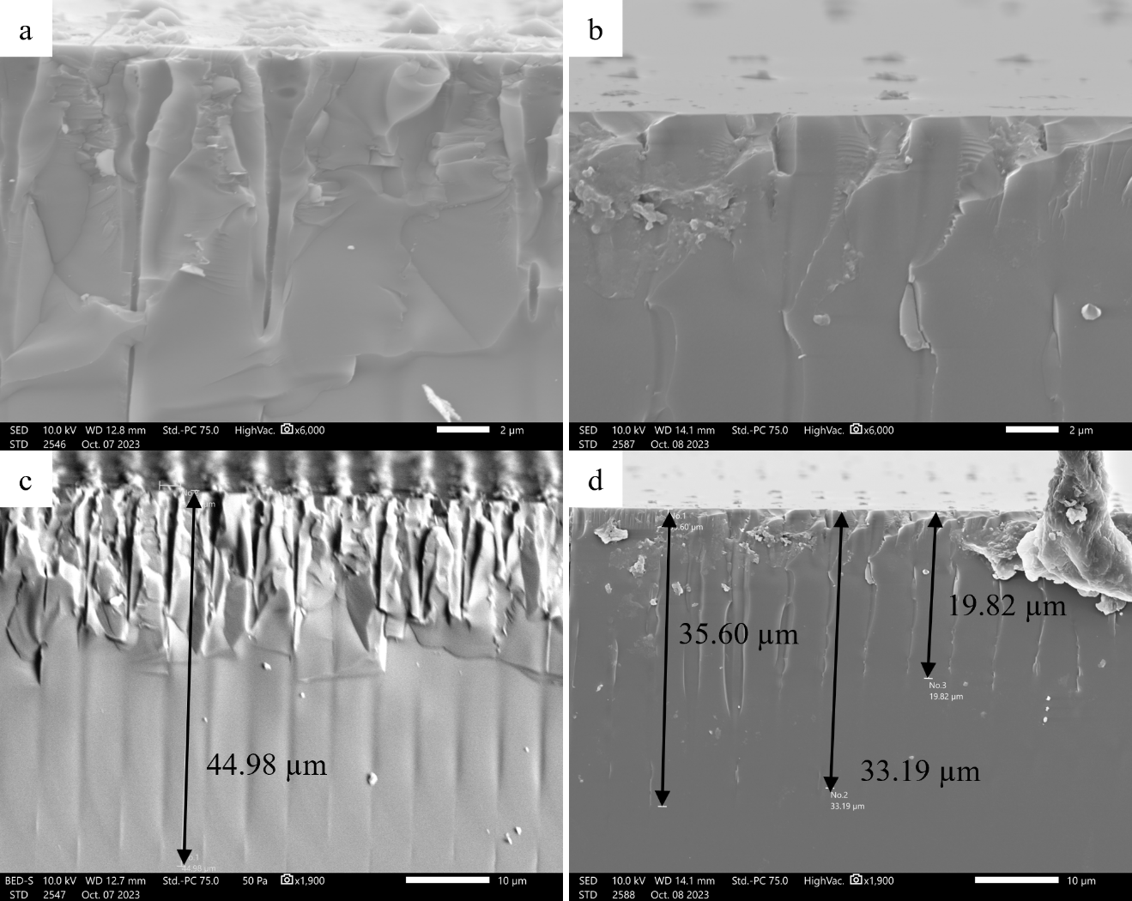
Figure 4.12. Cross-sectional view of IPA (a), (c) and GLY (b), (d).

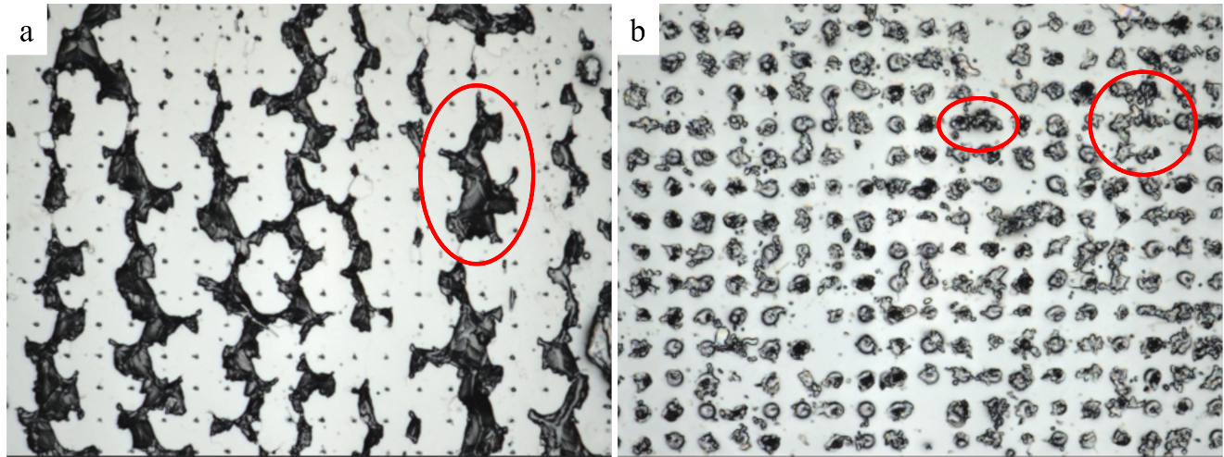
Figure 4.13. Optical images of fracture propagation between hole locations of (a) H2O and (b) IPA. The red ovals encapsulate examples of localized fracture propagation between holes.

Therefore, the RP equation may not be sufficient to fully describe the process of cavitation, and alternative models that consider heat and mass transfer, like used by Akhtov et al. (and discussed by Zhang et al.), may be more accurate [25,56]. Furthermore, Zhang et al. discussed how different physical properties of a fluid affect cavitation and determined that the surface tension of the fluid is an important physical property that dictates how large a bubble can grow [25]. For water, Long et al. discussed how cavitation bubbles can be compressed into a tiny size, thus causing a large increase in the temperature and pressure that produce a secondary shock [25,57]. Long et al. also tested n-butanol and ethanol and found that cavity-induced reactions are created in the two alcohols which produce gaseous products that inhibit cavitation collapse [57]. IPA has a vapor pressure of similar magnitude to these alcohols, so it is possible that during cavitation of the IPA sample, gaseous products were produced that inhibited the collapse of the cavitation bubble, and thus reduce the damage to the substrate surface despite having a higher vapor pressure than H2O.

Chapter 5: Conclusions and Recommendations
The work outlined in this paper has focused on the impact of different immersion fluids on femtosecond laser micromachining, and the effect these fluids have on cavitation damage on the surface of a borosilicate glass slide. More specifically, the use of eight different fluid immersion mediums for micromachining has been studied to explore the possibility of enhancing the focal distance at which material removal by fs laser ablation occurs. The names of the fluids (followed by their shorthand names in brackets) that were tested in these series of experiments are: air [AIR]; water [H2O]; ionic liquids 1-butyl-3-methylimidazolium trifluoromethanesulfonate [BMI]; and 1-ethyl-3-methylimidazolium bis(trifluoromethanesulfonyl)imide [EMI]; immersion oils Type A [TA] and Type B [TB]; glycerol [GLY]; and isopropyl alcohol [IPA]. Of these fluids, EMI and BMI are the only novel fluids where (to the author’s knowledge) little-to-no research has been done on the effects of immersion laser machining with them. These two ILs were determined to have exceptionally low vapor pressures. The effects of vapor pressure on liquid cavitation are well known. As such, this research aimed to investigate whether ILs may be good candidates for use in fs laser micromachining.

From the data collected for the z-step experiment, the ILs were shown to exhibit better machining properties than the two control fluids, H2O, and AIR. The ILs reduced the brittle fracturing of the glass substrate, which was abundant on the H2O sample. AIR, however, did not produce brittle fracturing because no liquid cavitation was present during machining. The AIR and H2O samples were unable to produce damage features for focal distances beyond a few microns above the surface of the sample, whereas the low vapor pressure ionic liquids were able to. Additionally, the other LVPFs like the IOs and GLY were also able to increase the positive focal distance machining range. Of interesting note, machining in AIR caused surface defacement even while the focus of the laser was located deep inside the substrate material. From the results of this experiment, it seems plausible that LVPFs like ILs may reduce the cavitation damage done to a substrate surface during liquid immersion fs laser micromachining.

For the surface damage experiment, the surfaces of the samples were empirically compared using a surface profilometer. With the laser focus positioned at the surface of the substrate, it was determined that H2O causes the most damage by brittle fracture of the glass surface. The arithmetic mean height (Sa) and maximum height (Sz) of the samples were recorded and compared over 25 total samples, with the exceptions of the IOs. It proved to be difficult to achieve a proper focus at the surface of the substrate with these fluids due to their index-matching properties with the borosilicate glass. As such, only 5 data points were collected for each of these fluids. The ILs produced surface roughness data on par with other LVPFs like GLY, the IOs, and the only non-liquid immersion medium used, AIR. An overall conclusion may be drawn from the results of the experiment that, for roughening of the surface of a glass substrate, H2O appears to be the best fluid to do so. For minimizing the surface roughness, IOs may be a good choice, however, due to their index-matching properties with glass, it can be difficult to work with these fluids. The ILs produce similar surface roughness to the IOs, and have a different refractive index than glass, making them easier to work with. The high viscosities of GLY or TB also reduce the speed at which machining can occur. This makes these fluids potentially undesirable for rapid machining applications, at least at ambient temperatures.

The cross-section experiment allowed the viewing of the interiors of holes, whereby the geometry of the modified material could be closely compared between fluids. It was determined that LVPFs again showed less surface deposition of the ejected material than higher vapor pressure fluids. Additionally, the side profile allowed the viewing of the approximate heights of the ejected masses which redeposited onto the surface of the substrate. EMI showed very little build-up on the surface of the substrate. Subsurface modification of the substrate, which appears to be melted and resolidified material, was observed in the IOs which are LVPFs. The IPA sample displayed diametrically wide cone-shaped filaments which extended further into the substrate sample than for the other immersion fluids. IPA and H2O are the only samples to experience brittle fracture propagation across hole locations, giving evidence that high vapor pressure fluids may enhance the damage to a substrate by cavitation damage.

From the results of these experiments, it was determined that a fluid which exhibits a vapor pressure in the range of 1.6×10⁻⁴ mmHg (GLY, at RT) to 23.7 mmHg (H2O, at RT) is likely to reduce cavitation damage. Fluids with vapor pressures less than 1.6×10⁻⁴ mmHg appear to have a minimal reduction in the cavitation damage upon further reduction in the vapor pressure. Fluids above this vapor pressure range are conjected to enhance the damage of cavitation on a substrate to a point (40.0 mmHg, the vapor pressure of IPA), whereby the damage may be reduced by reactions inside the vaporous material in the bubble which inhibit the collapse of the cavitation bubble. The density appeared to have no distinguishable impact on the surface damage of the substrates from the surface roughness data, as both low-density and high-density fluids were found to be capable of producing the same Sa values on the substrate. Increasing the kinematic viscosity decreased the surface damage to the substrate.

For future work on this topic, it is recommended that fluids which exhibit other physical properties be tested, such as a fluid with a higher vapor pressure than IPA, one example being heptane. In the fluids tested in these experiments, there remains a large gap between H2O and the IOs for the values of vapor pressure. Other physical properties should also be explored more, like density and viscosity, or perhaps different atmospheric pressures may be explored (higher/lower ambient pressure). Additionally, different substrate materials should also be tested. These may include other glasses like fused silica, or metals and alloys like aluminum or steels. A more accurate model of cavitation may also be used to evaluate which physical properties dominate in the cavitation process. Thermophysical properties were conveniently ignored in this paper but do play a part in cavitation bubble dynamics. As such, it is recommended in the future that the thermal conductivity of each fluid be considered, as well as thermal diffusivity, like how the dynamic and kinematic viscosities of each fluid were considered.

References
1. Li, S., Brennen, C.E. and Matsumoto, Y., Introduction for amazing (cavitation) bubbles. Interface Focus, 2015. 5.
2. Plesset, M.S., The Dynamics of Cavitation Bubbles. Journal of Applied Mechanics, 2021. 16(3): p. 277-282.
3. Wilson, J.D. and Buffa, A.J., College Physics. 2000, Saddle River, NJ: Prentice Hall.
4. Hecht, E., Optics. 5 ed. 2017, United States: Pearson.
5. Straumann, N., Einstein in 1916:" On the Quantum Theory of Radiation". arXiv preprint arXiv:1703.08176, 2017.
6. Phillips, K.C., Gandhi, H.H., Mazur, E. and Sundaram, S.K., Ultrafast laser processing of materials: a review. Advances in Optics and Photonics, 2015. 7(4): p. 684-712.
7. Paschotta, R. Ultrafast Lasers. RP Photonics Encyclopedia 2024/02/28 [cited May 22, 2024; Available from: https://www.rp-photonics.com/ultrafast_lasers.html.
8. Osellame, R., Cerullo, G. and Ramponi, R., Femtosecond Laser Micromachining. 1 ed. Topics in Applied Physics. Heidelberg, German: Springer Berlin, Heidelberg.
9. Hodgson, N., Heming, S., Steinkopff, A., Haloui, H. and Lee, T. Ultrafast Laser Ablation at 1035 nm, 517 nm and 345 nm as a Function of Pulse Duration and Fluence. in Proceedings of the Lasers in Manufacturing Conference. 2019.
10. Paschotta, R. Laser Ablation. RP Photonics Encyclopedia 2024/02/28 May 22, 2024]; Available from: https://www.rp-photonics.com/laser_ablation.html.
11. Ikeda, Y., Soriano, J.K., Ohba, H. and Wakaida, I., Laser ablation plasma expansion using microwaves. Scientific Reports, 2023. 13(1): p. 13901.
12. Gattass, R.R. and Mazur, E., Femtosecond laser micromachining in transparent materials. Nature Photonics, 2008. 2(4): p. 219-225.
13. Cheng, J., Liu, C.-s., Shang, S., Liu, D., Perrie, W., Dearden, G. and Watkins, K., A review of ultrafast laser materials micromachining. Optics & Laser Technology, 2013. 46: p. 88-102.
14. Howell, J.H., A Numerical Optimization Study of a Novel Electrospray Emitter Design. 2022, University of Tennessee Space Institute: Knoxville Tennessee. p. 137.
15. Jones, J.M., The Effects of Geometry and Material Variations on the Onset Voltage of Electrospray Emitters. 2020, University of Tennessee Space Institute: Knoxville Tennessee. p. 88.
16. Aliseda, A., Bubble Dynamics, The Raleigh-Plesset Equation.
17. Brennen, C.E., Fundamentals of Multiphase Flow. 2005, Cambridge: Cambridge University Press.
18. Hussain, Z., Optical Band Gap, Oxidation Polarizability, Optical Basicity and Electronegativity Measurements of Silicate Glasses Using Ellipsometer and Abbe Refractometer. New Journal of Glass and Ceramics, 2021. 11(1): p. 33.
19. Gibbon, P. Introduction to Plasma Physics. in CAS-CERN Accelerator School: Plasma Wake Acceleration. 2014. Geneva, Switzerland: CERN.
20. Griffiths, D.J., Introduction to Electrodynamics. 4 ed. 2013, Cambridge, United Kingdom: Pearson.
21. Paschotta, R. Self-focusing. RP Photonics Encyclopedia 2024/02/28 [cited May 22, 2024; Available from: https://www.rp-photonics.com/self_focusing.html.
22. Canfield, B., Terekhov, A., Costa, L. and Davis, L., High-aspect ratio damage and modification in transparent materials by tailored focusing of femtosecond lasers. SPIE Laser Damage, 2019. 11173.
23. Boyd, R.W., Nonlinear Optics. 1992, San Diego, CA: Academic Press, Inc.
24. Yan, T. and Ji, L., Ultrafast Laser Filamentation in Transparent Solids. Ultrafast Science, 2023. 3: p. 0023.
25. Zhang, Z., Wei, S., Wang, P., Qiu, W. and Zhang, G., Progress in applications of laser induced cavitation on surface processing. Optics & Laser Technology, 2024. 170: p. 110212.
26. Hashida, M., Mishima, H., Tokita, S. and Sakabe, S., Non-thermal ablation of expanded polytetrafluoroethylene with an intense femtosecond-pulse laser. Optics Express, 2009. 17(15): p. 13116-13121.
27. Zhao, S., Song, C., Gao, X., Guo, K., Hao, Z. and Lin, J., The plasma characteristics of femtosecond-nanosecond dual-pulse laser ablated soil. Results in Physics, 2020. 19: p. 103601.
28. Guo, J., Wang, M., Guo, Q., Zhu, T., Du, M., Zhao, P. and Feng, L., Lifetime visualization of femtosecond laser-induced plasma on GaP crystal. Optics Express, 2023. 31(4): p. 6877-6889.
29. Hermant J. Sagar and Moctar, O.e., Dynamics of a cavitation bubble near a solid surface and the induced damage. Journal of Fluids and Structures, 2020. 92.
30. Dular, M., Požar, T., Zevnik, J. and Petkovšek, R., High speed observation of damage created by a collapse of a single cavitation bubble. Wear, 2019. 418-419: p. 13-23.
31. Wang, Y., Zhang, Z., Zhang, G., Wang, B. and Zhang, W., Study on immersion waterjet assisted laser micromachining process. Journal of Materials Processing Technology, 2018. 262: p. 290-298.
32. 1-butyl-3-methylimidazolium trifluoromethanesulfonate. 2022 4/11/2022 [cited 2024 May 2, 2024]; MSDS No. 711772]. Available from: https://www.sigmaaldrich.com/US/en/product/aldrich/711772.
33. 1-Ethyl-3-methylimidazolium bis(trifluoromethylsulfonyl)imide. 3/02/2024 May 22, 2024]; MSDS No. 711691]. Available from: https://www.sigmaaldrich.com/US/en/product/aldrich/711691.
34. Aschenbrenner, O., Supasitmongkol, S., Taylor, M. and Styring, P., Measurement of vapour pressures of ionic liquids and other low vapour pressure solvents. Green Chemistry, 2009. 11(8): p. 1217-1221.
35. Turns, S.R., An Introduction to Combustions: Concepts and Applications. 3rd ed. 1996, New York, NY: McGraw-Hill.
36. Miranda, I., Souza, A., Sousa, P., Ribeiro, J., Castanheira, E.M.S., Lima, R. and Minas, G., Properties and Applications of PDMS for Biomedical Engineering: A Review. Journal of Functional Biomaterials, 2022. 13(1): p. 2.
37. Bergman, T.L., Lavine, A.S., Incropera, F.P. and DeWitt, D.P., Introduction to Heat Transfer. 6th ed. 2011, Hoboken, NJ: John Wiley & Sons.
38. Cargille Immersion Oil Type A & B. 09/08/2016 May 22, 2024]; MSDS]. Available from: https://cargille.com/wp-content/uploads/2018/06/Cargille-Immersion-Oil-Type-A-B-USA.pdf.
39. Cargille™ Immersion Oils: Type A, B, NVH. 9/22/2015 May 22, 2024]; MSDS]. Available from: https://www.2spi.com/catalog/documents/Cargille_a_b_nvh.pdf.
40. Christoph, R., Schmidt, B., Steinberner, U., Dilla, W. and Karinen, R., Glycerol, in Ullmann's Encyclopedia of Industrial Chemistry.
41. Price, D.M., Vapor pressure determination by thermogravimetry. Thermochimica Acta, 2001. 367-368: p. 253-262.
42. Isopropyl Alcohol. 2020 May 22, 2024]; MSDS No. 1219]. Available from: https://cameochemicals.noaa.gov/chemical/946.
43. KEYENCE, Using the VK-X3000 Series for the First Time, in 3D Surface Profiler Quick Start Guide - Gathering New Data using Laser Confocal. 2021. p. 2-3.
44. Charging Phenomenon, Charging. May 22, 2024]; Available from: https://www.jeol.com/words/semterms/20121024.054158.php#gsc.tab=0.
45. KEYENCE. Sa (Arithmetical Mean Height) | Area Roughness Parameters. 2024 May 22, 2024]; Available from: https://www.keyence.com/ss/products/microscope/roughness/surface/parameters.jsp#:~:text=Sa%20is%20the%20extension%20of,arithmetical%20mean%20of%20the%20surface.
46. Corporation, O. Surface Roughness Measurement—Evaluating Parameters. May 22, 2024]; Available from: https://www.olympus-ims.com/en/metrology/surface-roughness-measurement-portal/evaluating-parameters/#!cms[focus]=01.
47. Olympus. Surface Roughness Measurement—Parameters. May 22, 2024]; Available from: https://www.olympus-ims.com/en/metrology/surface-roughness-measurement-portal/parameters/#!cms[focus]=022.
48. Standardization, I.O.f. Geometrical product specifications (GPS) — Surface texture: Areal — Part 6: Classification of methods for measuring surface texture. 2010 May 22, 2024]; Available from: https://www.iso.org/obp/ui/en/#iso:std:iso:25178:-6:ed-1:v1:en.
49. KEYENCE. Surface Roughness Standards: ISO 25178 vs. JIS B 0601-2001. 2024 May 22, 2024]; Available from: https://www.keyence.com/ss/products/microscope/roughness/surface/roughness_standards.jsp.
50. KEYENCE. Sz (Maximum Height) | Area Roughness Parameters. 2024 May 22, 2024]; Available from: https://www.keyence.com/ss/products/microscope/roughness/surface/sz-maximum-height.jsp.
51. Technology, N.I.o.S.a. Glycerin. 2023 May 22, 2024]; Available from: https://webbook.nist.gov/cgi/cbook.cgi?ID=C56815&Mask=4%20for%20the%20enthalpy%20of%20vaporization%20of%20GLY.
52. CHERIC. Glycerol. 2024 May 22, 2024]; Available from: https://www.cheric.org/research/kdb/hcprop/showprop.php?cmpid=912.
53. CHERIC. KDB Correlation Equation. 2024 May 22, 2024]; Available from: https://www.cheric.org/research/kdb/hcprop/showcoef.php?cmpid=912&prop=PVP.
54. Brennen, C.E., Cavitation and Bubble Dyanmics. 1995, New York, NY: Oxford University Press.
55. Paschotta, R. Laser-induced Breakdown. RP Photonics Encyclopedia 2024/02/28 [cited May 22, 2024; Available from: https://www.rp-photonics.com/laser_induced_breakdown.html.
56. Akhatov, I., Lindau, O., Topolnikov, A., Mettin, R., Vakhitova, N. and Lauterborn, W., Collapse and rebound of a laser-induced cavitation bubble. Physics of Fluids, 2001. 13(10): p. 2805-2819.
57. Long, J., Eliceiri, M.H., Wang, L., Vangelatos, Z., Ouyang, Y., Xie, X., Zhang, Y. and Grigoropoulos, C.P., Capturing the final stage of the collapse of cavitation bubbles generated during nanosecond laser ablation of submerged targets. Optics & Laser Technology, 2021. 134: p. 106647.

Appendix

Table A1. KDB Coefficients [53].

Coefficient | Value
A | -2.125867E+1
B | -1.67262E+4
C | 1.655099E+2
D | 1.100480E-5

Vita
John Allman has always been interested in physics, engineering, and rockets. His senior year in college he joined the University of North Carolina at Charlotte’s (UNCC) rocketry team which participates in NASA’s University Student Launch Initiative. His team won first place. The same year, he graduated from UNCC with a Bachelor of Science in both mechanical engineering and physics. He went on to continue his education at the University of Tennessee Space Institute (UTSI), where he pursued a Master of Science in aerospace engineering. John worked under Dr. Trevor Moeller and Dr. Brian Canfield where he focused his research on ultrafast laser micromachining. He graduated from UTSI in August 2024.

